 | Chemistry

Downstream processing of microalgae: harvesting and disruption technologies

By
Thomas Alexander Sydney

A thesis submitted in partial fulfilment of the requirements for the degree of Doctor of Philosophy
The University of Sheffield
Faculty of Science
Department of Chemistry

November 2016

Summary
The main focus of the research presented in this thesis is on improving the downstream processing of algae, specifically the harvesting and disruption technologies. The algae based fuel industry faces an economic feasibility problem when compared with the petroleum industry because of the high processing costs of harvest, disruption, extraction and conversion to biodiesel. This problem extends into the algal biotechnology industry as the harvest, disruption and extraction steps are often economic bottlenecks in production of high quality commercial products that are derived from algae.
To this end, novel technologies were experimented with aimed at combating these problems. One such novel technology that emerged from the research was the use of ultraviolet light for the disruption of microalgae. Ultraviolet light reduced cell disruption energy costs by approximately 13 times when compared to the literature. Furthermore, this idea was expanded upon by designing and constructing a solar tracker to concentrate sunlight and utilise its ultraviolet region. The solar tracker was effective in concentrating the ultraviolet region of sunlight to disrupt algae and provides a cheap disruption method for algal cells in sunny climates.
Harvesting and extraction steps were also addressed with the development of a novel recyclable magnetic flocculant nanoparticle that can be switched from flocculation/deflocculation by changing pH. Due to the flocculant’s ability to harvest and concentrate algae directly from the culture media it may reduce the reliance on centrifuges in industrial processing of microalgae. The synthesis method developed also provides a platform for the possible development of a recyclable nanoparticle capable of extracting specific chemicals.
As well as addressing the bottlenecks of the algal biotechnology/fuel industry, research also looked at the quality of biodiesel than can be produced from microalgae. Specifically, its storage and stability properties and the conclusion arose that increased concentration of unsaturated fatty acid methyl ester in biodiesel reduced stability. However, careful species selection may help reduce this concentration and hence increase biodiesel stability.
Additionally, hydrogen production using algae was investigated as a means to produce fuel continuously without harvesting a culture. Wavelength tuning was used to selectively enhance hydrogen production rate and indicated a wavelength region that may allow for continuous photohydrogen production. However, additional experiments are required to conclude that continuous photohydrogen production from algae is possible.

Acknowledgements
I’d like to thank various people who have assisted me during the course of this research. Firstly, a big thank you to the technical and support staff across the Chemistry, Chemical and Biological Engineering, Mechanical Engineering and Physics departments. More specifically thank you to the members of the Algal Biotechnology Sheffield network and Farapack polymers who have always provided encouraging support. Dr Andrew Pryke was particularly helpful in my first year.
Thanks to Sam Davison, a 2nd year Mechanical Engineering student, who aided in physical construction of the tracker and performed the majority of workshop tasks (i.e. drilling, screwing, sawing etc.). Also thanks to Jo-Ann Marshall, a masters student who assisted with some of the cell counts and for minor experimental contributions thanks go to Feng Li and Mohamed Rafik.
Additionally, I need to thank the members of my research group, specifically Babs Latham, Ryan Seabright, Ste Knox and Dr Christine Fernyhough.
I’d also like to thank my close family, Paul, Maureen, Mark and Laura Sydney. As well as close friends and my partner, Emily Hounslow, who has been very supportive, particularly over the last year.
Finally, thanks to my supervisor Professor Patrick Fairclough, who over the last few years has provided support and encouragement, whilst still continually pushing me as a scientist.

Table of contents
Summary 1
Acknowledgements 3
Abbreviations 7
1 Literature review - Algal biofuel processing 9
1.1 What are algae? 9
1.2 Downstream processing of algae 19
1.3 Algae harvesting and disruption 27
1.4 Harvesting, dewatering and drying techniques 29
1.5 Drying 37
1.6 Disruption 39
1.7 What are polymers? 45
1.8 Polymer synthesis 45
1.9 What are magnetic nanoparticles? 50
1.10 Synthesis methods for magnetic nanoparticles 50
1.11 Conclusion 52
1.12 Objective of this research 54
2 Experimental methods 55
2.1 Materials 55
2.2 Algae strains and cultivation 56
2.3 Culturing of Micractinium inermum in a 50 L bioreactor 57
2.4 Ultraviolet light irradiation of algae 57
2.5 Lipid extraction 58
2.6 Transesterification 59
2.7 Solar tracker design and manufacture 60
2.8 Oil extraction methods 65
2.9 Magnetic Iron Oxide Nanoparticle synthesis 68
2.10 Surface functionalisation of nanoparticles 68
2.11 Magnetic functionalisation of ionic exchange beads. 70
2.12 Polymer synthesis 70
2.13 Polymer coating of nanoparticles 71
2.14 Flocculation of microalgae 72
2.15 Bioreactor harvesting and biodiesel production 75
2.16 Hydrogen synthesis 77
3 The effect of high intensity ultraviolet B (UVB) light in eliciting microalgae cell lysis and enhancing lipid extraction 80
3.1 Summary 80
3.2 Introduction 81
3.3 Results and discussion 85
3.4 Cellular signalling after ultraviolet irradiation 89
3.5 Ultraviolet light compared to conventional disruption 93
3.6 UV radiation as a disruption method for biodiesel production 93
3.7 Lipid peroxidation and biodiesel yield 97
3.8 Ultraviolet light cell disruption energy efficiency 98
3.9 Conclusion 99
4 The use of concentrated solar light for biodiesel production from microalgae 101
4.1 Summary 101
4.2 Introduction 101
4.3 Ultraviolet light from the sun 102
4.4 Concentrating sunlight 104
4.5 Concentrated solar irradiation of algae 107
4.6 Results and discussion 110
4.7 Ultraviolet light irradiation from solar tracker 110
4.8 Ultraviolet light irradiation from curer compared with concentrated solar irradiation 117
4.9 The effect of ultraviolet light to disrupt cells and increase lipid extraction 125
4.10 Conclusion 127
5 A recyclable magnetic flocculant for algal dewatering and lipid extraction 129
5.1 Summary 129
5.2 Introduction 129
5.3 Results and discussion 133
5.4 Oil extraction technology 134
5.5 Why nanoparticles? 140
5.6 Polymer coated nanoparticle design 145
5.7 Polymer coating of nanoparticles 147
5.8 Polymer design 150
5.9 Flocculation of algae using magnetic nanoparticles 157
5.10 Recyclable nanoparticles 162
5.11 Conclusion 167

6 Accelerated aging of algal biodiesel: a macroscopic approach 169
6.1 Summary 169
6.2 Introduction 169
6.3 Results and discussion 171
6.4 Flat plate air lift bioreactor design and manufacture 171
6.5 Bioreactor harvesting and biodiesel production 177
6.6 Aging of biodiesel 181
6.7 Viscometer setup and calibration 185
6.8 Viscosity of algal biodiesel 186
6.9 Viscosity increase over time 189
6.10 Conclusion 190
7 Light wavelength tuning for hydrogen production from Chlamydomonas reinhardtii 191
7.1 Summary 191
7.2 Introduction 191
7.3 Results and discussion 194
7.4 Light wavelength selection for manipulation of photosynthetic apparatus 194
7.5 Light wavelength tuning 196
7.6 Mass spectrometry to measure hydrogen production 198
7.7 The effect of intensity on hydrogen production rate 201
7.8 The effect of wavelength of light on hydrogen production rate 202
7.9 Tuning light wavelengths for partial activation of PSII 207
7.10 Hydrogen production with an improved optical setup 208
7.11 Conclusion 211
8 Research conclusions 212
9 Future work 216
10 References 219
11 Appendix 230
11.1 TGA of unsuccessful MNP-P synthesis 230
11.2 Polymer coating calculations 230
11.3 Schematic of algal culture irradiation using curer 232

Abbreviations
3N-BBM+V Bold Basal Medium with 3-fold Nitrogen and Vitamins
ADP Adenosine diphosphate
AIBN Azobisisobutyronitrile
APTES (3-Aminopropyl)triethoxysilane
ASTM American Society for Testing and Materials
ATP Adenosine triphosphate
ATRP Atom transfer radical polymerization
BB Bead beating
CCAP Culture Collection of Algae and Protozoa
CPTES (3-Chloropropyl)triethoxysilane
DC Direct current
Deta Diethylenetriamine
DIPAM Diisopropylaminomethyl
DLS Dynamic light scattering
DMAPAA N,N-dimethylaminopropyl acrylamide
DMSO Dimethyl sulfoxide
DNA Deoxyribonucleic acid
DSC Differential scanning calorimetry
EGDMA Ethylene glycol dimethacrylate
EN European standard
FAME Fatty acid methyl ester
FT-IR Fourier transform infrared spectroscopy
GC Gas chromatography
GC-FID Gas chromatography flame ionisation detection
IEC Ionic exchange chromatography
IR Infra-red
LDR Light dependant resistor
MNP Magnetic nanoparticle
MNP-P MNP-Polymer
MRI Magnetic resonance imaging
NADPH Nicotinamide adenine dinucleotide phosphate
NMP 1-methyl-2-pyrrolidone
OD Optical density
PSI Photosystem I
PSII Photosystem II
PTFE Polytetrafluoroethylene
PVDF Polyvinylidene fluoride
RAFT Reversible addition-fragmentation chain transfer
RNA Ribonucleic acid
RuBisCO Ribulose 1,5-bisphosphate carboxylase
SEM Scanning electron microscopy
TAG Triglyceride
TEM Transmission electron microscopy
TGA Thermogravimetric analysis
UV Ultraviolet light
XPS X-ray photoelectron spectroscopy

Literature review - Algal biofuel processing
Climate change teaches us that the decisions we make today, will have effects for generations to come. One such decision is to reduce our carbon emissions to mitigate climate change. The current infrastructure of developed and developing countries does not adequately support this vision and thus research must come up with solutions to provide renewable energy and a means to sequester waste carbon dioxide. Research into algal biotechnology may provide suitable solutions.

What are algae?
Algae are a diverse group of generally autotrophic organisms [1]. They exist in uni and multi cellular forms and typically carry out photosynthesis to produce energy from sunlight and water; two resources in abundance in their environment [1]. Algae are similar to plants but they have no leaf or root structures which generally characterise plants.
In the past, especially during the 20th century, the mass culture of algae has received much scientific interest as a means of meeting food production demands of the increasing world population [2]. Whilst providing some success, the dietary supplements manufactured from algae weren’t particularly palatable and in the latter part of the 20th century, food agriculture production rates boomed through the use of pesticides and chemical fertilisers [3].
In the 1970s the idea of using algae to develop biofuel was first proposed in order to combat dwindling oil supplies [4]. Shortly afterward, oil deposits were discovered and the research declined. More recently, algae have been of great interest in the scientific community as a means of producing biofuel for renewable energy and reducing carbon dioxide emissions [5]. Algae don’t require agricultural land that could be used for growing food and have faster growth rates compared with plants that produce first generation biofuels e.g. biodiesel from oilseed rape [6]. With the eventual depletion of fossil fuels and the continual increase in carbon emissions, strategies need to be implemented to ease the transition to renewable energy resources. Algal biofuels allow solar energy to be stored and transported via liquids, which is a huge advantage when compared to other forms of renewable energy (solar panels, wind farms, tidal etc.). In addition, current industrial infrastructure supports liquid biofuels with little alteration [6].

Species selection
Selecting the correct species of algae to use adds an additional layer of complexity to the hunt for economical, environmental and energy productive biofuel. It is not as straightforward as selecting the species that produces the largest amount of oil. Several factors are involved, including growth rates, oil variety produced, growth requirements, survival rates, ability to colonise, biomass per litre of culture and dry weight oil percentage. Various species have been researched in the hope of producing large quantities of oil for biofuel with a quick turnaround from growth to harvest.
One species of note is Botryococcus braunii (B. braunii); a green microalgae which forms colonies and synthesises a large amount of hydrocarbons (up to 86% of its dry weight has been reported) [7]. Its tough cell wall makes extraction troublesome; fortunately the majority of the hydrocarbons are located extracellularly in the colony. It is of particular interest due to the hydrocarbons it produces which vary depending on its race which can be A, B or L; A producing alkadienes and alkatrienes, B producing triterpenoid hydrocarbons and L produces lycopadiene [8]. It is exclusively race B which produces triterpenes that can be cracked to produce octane and kerosene; feeding into current industrial fuel production easily. Because not all the carbon dioxide the algae sequester is used for hydrocarbon production this mechanism of conventional fuel production could be environmentally positive.
However, the percentage of hydrocarbons produced by a specific race of B. braunii varies between different sources of the race; most likely due to genetic differences imposed by the environments. Meaning a suitable strain would have to be sourced that produces the correct hydrocarbons, grows quickly and has a high survival rate. In general B. braunii has slow growth, approximately doubling every 72 hours. Qin showed by optimising growth conditions, a doubling rate of 48 hours can be achieved [9].
B. braunii is a good example of a microalgae species with a high amount of diversity even between its own races. Many algal species share this level of diversity and often differ vastly from one another by morphology, physiology and habitat. Adding the fact approximately 300,000 species are known, the selection of a species becomes challenging [6].
This work focusses on three species of note, as follows. Chlamydomonas reinhardtii (C. reinhardtii) (wild type CCAP 11/32A) is a well studied algal species that possesses a robust multi layered glycoprotein cell wall [10]. Dunaliella salina (D. Salina) (wild type CCAP 19/30) is another well studied species and lacks a cell wall. Micractinium inermum (M. inermum) is a species with a strong thick cell wall which is similar to Chlorella [11]. The cell wall strength of these species is important as a large part of this work looks as cell disruption, which is often effected by cell wall strength. C. reinhardtii has a cell wall of similar thickness to Chlorella however is much weaker due to its lack of covalent cell wall bonding [11]. D. Salina is strongly effected by osmotic pressure due to its lack of a rigid cell wall and is therefore likely to be the easiest to disrupt [12]. Thus, the cell wall structural differences between these three species provides an effective means to measure cell disruption across a range of cell wall strengths.

Growth conditions
Algae often behave differently in the lab, or on a mass culture scale, than in their natural habitat; presumably this is due to differences between nutrient availability and growth environment compared with artificial conditions. If natural environmental conditions are mimicked via growth vessel design and nutrient availability there should be no reason why growth rates similar to nature cannot be achieved. This may even be enhanced if any limiting factors were removed to improve conditions.

Growth vessel design
The two common routes for the mass production of algae are open pond systems and photobioreactors. Open ponds can be natural water sources (ponds, lakes, sea) or artificial (shallow ponds, tanks, raceway ponds) [5]. The main argument against open pond systems is that whilst they are simple and require little energy input or maintenance they produce very low concentrations of biomass per litre of culture [5]. They have no method of temperature regulation, have low growth rates and are susceptible to contamination [5]. In addition, unless the pond is very shallow, light does not penetration to all algae and unfortunately shallow ponds are more susceptible to contamination. Whilst shallow ponds are easy to operate and construct they also have high evaporation rates, carbon dioxide losses and land requirements [5].
Photobioreactors can effectively regulate and control all growth factors and produce much higher growth rates with little chance of contamination [5,13]. They can also be used to sequester waste carbon dioxide and other atmospheric pollutants in waste flue gas from power plants [5,13]. However heating, aeration, vessel production, light optimisation/intensity and growth medium optimisation cause additional energy and economic costs. Whether the enhanced growth and biomass rates offset the increased costs is a difficult judgement to make.

Closed photobioreactor
Photobioreactors are generally classified into three types; tubular, flat plates and columns [13]. Due to the higher concentrations of biomass in a culture mediums compared to open pond systems, harvesting costs are reduced. Photobioreactors with internal lighting have also been studied, however for the mass culture of algae; utilising sunlight seems the most economically logical route.

Tubular photobioreactors
Tubular photobioreactors are well suited for outdoor applications. They provide a large surface area for illumination, are fairly inexpensive and have relatively good biomass productivities [13]. Unfortunately they can develop gradients of pH which can lead to slow growth and algae can foul against the walls [13]. They also require large amounts of land. Mixing and aeration is often through airlift systems but unfortunately oxygen build up is a problem which leads to slow growth due to inhibition of photosynthesis [13].

Flat plate photobioreactors
Flat plate photobioreactors have the largest surface areas available for illumination and like tubular photobioreactors are suitable for outdoor applications [13]. They are cheap, easy to maintain, relatively quick to construct and have low oxygen build up [13]. Wall growth can occur to an extent and temperature control can be a problem; a large surface area for light also means greater heat loss [13]. Flat plate bio reactors are known for high photosynthetic efficiencies and are suitable for mass cultures of algae [13].

Column photobioreactors
Bubble column and airlift photobioreactors have been reported to have algal biomass concentrations comparable to tubular photobioreactors [13]. They allow good mixing, have low energy requirements, scale well and have low levels of photoinhibition [13]. Unfortunately, unlike other photobioreactors, they have small surface areas for illumination and require more complex materials for construction [13].

Mixotrophic and autotrophic growth
Algae generally obtain the energy they require for growth autotrophically from photosynthesis. However some species of algae are capable of mixotrophic, autotrophic and heterotrophic growth. Tanoi et al. examine the effects of different sugars on growth and morphology of B. braunii under different light conditions [14]. They concluded that B. braunii can grow under mixotrophic, autotrophic and heterotrophic growth [14]. Glucose promoted growth in dark and light conditions, increases the size of the cells, colonies and quantity of hydrocarbons [14]. Whilst this mixotrophic phenomenon is interesting, it is important to note the use of photosynthesis in algal biofuel production is essential. In order to produce renewable energy and to sequester carbon dioxide, photosynthesis must be the energy source for growth of algae. It is worth noting that this phenomenon could be useful for symbiotic relationships, especially if another microorganism is capable of producing an organic carbon source from B. braunii waste.

Photosynthetic efficiency
Algae are currently being heralded as the leading biomass to convert into biofuel. This is partly due to their higher photosynthetic efficiency compared with land plants. Singh et al. review the literature on photosynthetic efficiencies of various microalgae [15]. Different research groups have reported differing efficiencies even for the same species, most likely due to different growing conditions or genetic diversity [15]. Of the species reviewed, there is a spread of 6-20% in photosynthetic efficiencies [15]. It is to be expected that different species will have large differences in efficiencies [15]. Most importantly the photosynthetic efficiencies are much greater than typical plants and crops which usually have efficiencies around 1%.

Photoinhibition and adaptation
Algal photosynthesis can actually be inhibited if the culture is exposed to high intensities of light for prolonged periods; this is often characterised by reduced photosynthetic capability and alteration in pigment concentration [16]. This is linked to the reduced activity of photosystem I and II; protein complex’s that absorb light and transport the necessary electrons for the reaction. Whilst the exact mechanism of photoinhibition is debated, the main conclusion is that high irradiance decreases electron passage through photo system II and causes a significant increase in the turnover rate of the D1 protein; D1 turnover is directly related to the requirement of photosystem II repair following photoinhibition [16]. Thus the intensity of photoinhibition is related to the rate of D1 protein damage and repair [16].
Photoinhibition is an important phenomenon which occurs in algae. In order to mass grow cultures for the production of biofuel, its effect must be diminished as photoinhibition causes low photosynthetic rates and thus slow growth. Photoinhibition could be overcome through genetic engineering, species selection, vessel design (shading/filtering) or through natural photo adaption of the algae.
Photo adaptation of algae is another phenomenon which is linked to photoinhibition. Photo adaptation is the ability of an organism to alter its physiology (cellular composition and structures alter) based on the variety of light in its environment. This physiological response varies between the environment and the species in question; a general effect is that the composition/quantity of chlorophyll within the culture alters. It is also worth noting that smaller cultures more readily adapt than larger ones, potentially through a form of cell signalling (perhaps similarly to bacterial colonies) that is faster in smaller cultures. Guy et al. grew Spirulina cultures with different levels of irradiance and, as expected, cultures under full sunlight had greater resistance to photoinhibition [17]. However at midday those grown with 50% shading had greater photosynthetic activity; biomass growth rates were also higher in cultures protected from photoinhibition [17].
Photoinhibition and photo adaptation are two processes which must be kept in mind when attempting the mass culture of algae; you cannot simply put them in a high irradiance environment.

Oxygen inhibition of photosynthesis
Photosynthesis is inhibited by high concentrations of oxygen; instead a reaction known as photorespiration occurs. The key enzyme in photorespiration RuBisCO, is also the key enzyme in the Calvin cycle (photosynthesis); thus oxygen and carbon dioxide compete for binding to RuBisCO. If the oxygen concentration is too high, photorespiration takes over photosynthesis, which actually results in carbon dioxide and ammonia production which is a disadvantage for the algae [18].
Shelp et al. studied photosynthesis inhibition by oxygen in Chlorella pyrenoidosa and noted 12% and 24% inhibition of photosynthesis under 50% and 100% oxygen respectively [19].
Zimmerman et al. demonstrated that microbubbles can be used to prevent oxygen inhibition of photosynthesis by removing oxygen from the culture [20]. Higher growth rates and gas monitoring analysis led to the conclusion microbubbles strip oxygen from the cultures [20]. Alongside this effect, microbubbles provide good mixing, accessible carbon dioxide for enhanced growth and prevent fouling of bioreactor walls.

Carbon dioxide sequestration
Sequestration of carbon dioxide from the atmosphere and flue gas is an important research field for combating climate change. Whilst catalytic processes can be designed to reduce carbon emissions, plants and algae contribute to this sequestration naturally through photosynthesis.
Thus, an obvious partnership between sequestering carbon dioxide in flue gas and biofuel production was inevitable. Ge et al. studied the effects of varying carbon dioxide concentration (2, 5, 10 and 20% CO₂, 600 mL min⁻¹) on B. braunii growth to understand the application of flue gas in biofuel production [21]. B. braunii grew under all conditions and increasing carbon dioxide concentration had no detrimental effect on culture pH. 20% carbon dioxide aeration resulted in the largest biomass and colonies, and led to greater hydrocarbon and lipid products. 2% produced similar growth rates but had the lowest lipid and hydrocarbon content [21]. Unfortunately, the study didn’t record the concentration of carbon dioxide sequestered from each treatment.
Singh et al. noted the carbon dioxide concentration various species can tolerate and their useful products, from fuel to pigments to glycerin [15]. Interestingly they also review the state of algal industry from multiple angles and note there is a distinct lack of expertise; no research group has demonstrated an optimal route for biofuel production [15].
Kumar et al. reviewed developments in carbon dioxide ﬁxation and biofuel production using algae [22]. From the literature they note the rate of sequestration of carbon dioxide from several species and find there are differences in fixation rates between species. [22]. They come to the conclusion that harvesting processes, dewatering and extraction, are challenges that must be overcome because they consume large amounts of energy [22].

Waste water growth
In additional to sequestering waste carbon dioxide, growing algae in waste water is another important industrial challenge that must be met. Algal growth requires large amounts of water and nutrients. Wastewater often contains these nutrients necessary for algal growth as demonstrated by accidental eutrophication of rivers, lakes etc.
Singh et al. reviewed the current literature on waste water algal growth [15]. They include several literature reports of using waste water from several sources such as a steel plant, hazardous wastewater, a refinery and a municipal treatment plant [15]. Waste water is useful for increasing algal growth through the nitrogen, phosphorus and trace metals it contains [15]. In addition the algae actually remove pollutants from waste water, cleaning it for human use [15].
Órpez et al. grew B. braunii in secondarily treated sewage to remove nitrogen and phosphorus contaminants [23]. They conclude that using only wastewater and a low supply of carbon dioxide could be a feasible method to grow algae [23]. In addition the method showed notably good lipid and biomass yields [23].

Downstream processing of algae

Producing fuel from microalgae
Once an algal culture has been grown sufficiently they can be processed to produce fuel. Various biofuels can be developed from algae; biodiesel from lipid transesterification, bioethanol and bio butanol from carbohydrate fermentation, bio gasoline from algal biomass and methane/bio oil from gasification or pyrolysis [24]. Unfortunately, these methods require numerous steps to convert the biofuel into conventionally usable fuel which adds cost. The energy input into these processes is also intensive which is somewhat counterproductive in fuel production [25–27].
Various technologies exist that allow the production of fuel from microalgae and these are briefly reviewed.

Transesterification
Algae often contain large amounts of lipids. These lipids can be converted into fuel using a process known as transesterification. Lipids used in biodiesel production generally consist of triglycerides (TAGs) or fatty acids. TAGs are reacted with methanol in a transesterification reaction forming fatty acid methyl esters (FAMEs), which are the main constituents of biodiesel. It is a stepwise reaction in which one molecule of methanol reacts with a TAG to form a diglyceride and so on until only FAMEs and glycerol remain as shown in Figure 1 [28].
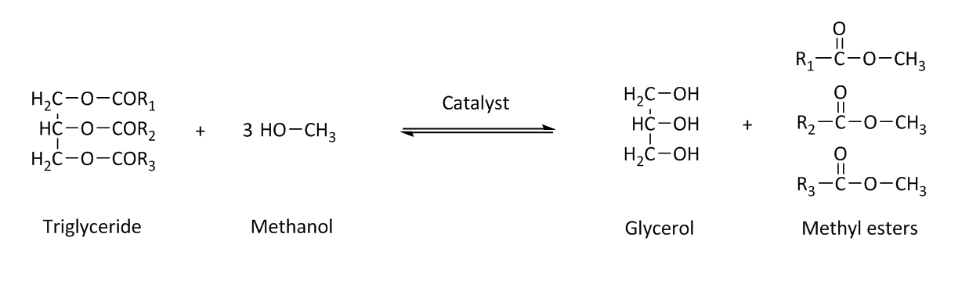
Figure 1- Transesterification of a triglyceride (TAG) to fatty acid methyl esters (FAME). Adapted from Chisti et al.[28]

Transesterification is regarded by the research community as a feasible technique to convert algal oils to biodiesel, especially considering that various species of algae grow quickly and have a high dry weight oil percentage [29]. However, the extraction of the oils from algae isn’t always a straightforward process and adds energy and monetary costs to fuel production. Another problem is that the alcohol and catalyst must also be obtained from chemical processes, adding to the total cost.

Carbohydrate fermentation
Aside from lipids, another high energy product from algae is carbohydrates [29]. Algal biomass can be fermented to produce bioethanol. Usually the carbohydrates from green algae come from starch residing in chloroplasts and the polysaccharide cell walls; prior to fermentation these polymeric sugars must be broken down into their monomers [30]. The fermentation reaction is shown below.
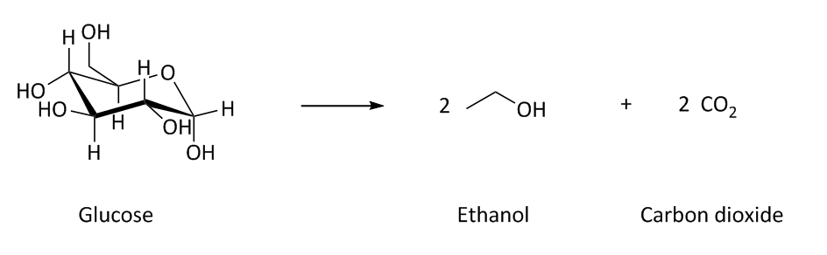

Figure 2 Fermentation of glucose to ethanol and carbon dioxide.

Cell wall breakdown has two main methods; acid hydrolysis and enzyme hydrolysis. Acid hydrolysis is a faster and easier method though it may inhibit fermentation [30]. The alternative is enzyme hydrolysis which is environmentally friendly but slower, more costly than acid hydrolysis and may require expensive chemical pre-treatment [30].
Whilst most systems require the breakdown of the algal cellulose cell walls prior to fermentation, certain species of bacteria can breakdown cellulose and ferment it into ethanol and hydrogen. When plant matter decays in an anaerobic environment the cellulose undergoes decomposition by microorganisms in the environment [31]. Due to the fact the organisms (bacteria, fungi) cannot absorb cellulose, its degradation occurs exocellularly through association with the cell wall or just extracellularly [31].
Cellulose degradation research in the past has often focussed on thermophiles such as Clostridium thermocellum however in reality these strains require a temperature too high to be the main source of cellulose degradation in nature. Mesophilic strains are more likely to be the main organisms involved in cellulose degradation and also fermentation of cellobiose, glucose, xylan and pentoses [31]. The main products of their fermentation are acetates, ethanol, carbon dioxide and hydrogen.
For use in biotechnology, however, thermophiles may be the preferred organisms due to their ability to withstand high temperatures and temperature fluctuations.
C. thermocellum and most cellulolytic bacteria carry out cellulose fermentation through a large extracellular multi enzyme known as a cellulosome which is comprised of approximately 20 catalytic subunits [32]. Unfortunately the organism often produces low yields of ethanol due to multiple fermentation pathways, resulting in the synthesis of not only ethanol but also acetate, formate and lactate [32]. Advances need to be made in ethanol/hydrogen yield from fermentation to make these processes commercially feasible, perhaps through species selection or genetic engineering.
It may be feasible to devise a protocol encompassing lipid extraction, carbohydrate fermentation of the remaining biomass and transesterification using the ethanol and extracted algal lipids thus producing biofuel from algae using a holistic approach.

Gasification
Instead of utilising cellular high energy compounds for fuel production, gasification is a technique used to fully extract stored energy in algal biomass. To this end, the process of gasification converts organic carbon matter into a mixture of gases known as syngas which is comprised of carbon monoxide, hydrogen, nitrogen, carbon dioxide and varying levels of methane [33]. During the reaction carbon is reacted with controlled levels of oxygen and steam at temperatures often exceeding 800 °C; with combustion not permitted [33]. Syngas can be burned directly in gas engines or even further processed to a synthetic fuel source via the Fischer-Tropsch process [34]. If biomass is used as the carbon source, gasification can be considered a source of renewable energy.
Lv et al. studied the optimisation of syngas production from biomass gasification and attempted to determine economic viability [35]. They detailed yield ratios of hydrogen to carbon monoxide against different operating conditions and concluded that a temperature of 750 °C and high levels of nickel catalyst were required for high ratios [35]. Several gasifiers are used for commercial means and this study was conducted with a fluidized bed gasifier and a downstream fixed bed. The fluidized bed gasifier is useful for fuels with high levels of corrosive ash, such as biomass fuels. The downstream fixed bed gasifier produces fuel with low amounts of tar and an air-steam mixture was used as the gasifying agent. Overall they conclude gasification is applicable for processing biomass ready for liquid fuel synthesis [35].
Whilst an effective method to convert biomass to useable fuel, algae biomass must also be dewatered and dried prior to gasification, increasing costs. However, Aziz et al. demonstrated high energy efficiency with a power generation efficiency of 40% [36].

Thermochemical liquefaction
Wet biomass is a problem inherent in many algae derived fuel processes. Even after dewatering, the resulting algal slurry may need to be dried which adds to the energy and economic cost. In the case of thermochemical liquefaction wet algal biomass can actually be converted into liquid fuel. Typically temperatures of around 300 °C and system pressures in the range of 5–20 MPa are required for biomass to fuel conversion [33,37]. Under these conditions using a catalyst and hydrogen, bio-oil production is achieved. Whilst the reactors are complex and thus expensive, a huge benefit to the technology is its ability to produce liquid fuel straight from wet algal biomass; alleviating the need for a time consuming and expensive drying process. This process’s ability to ignore the water content is believed to be due to its similarities to the natural geological processes thought to be the original source of fossil fuels [37].
Dote et al. performed thermochemical liquefaction on B. braunii and achieved 57-64 wt.% oil which was equivalent in quality to petroleum oil [38]. A positive energy output input ratio of 6.67:1 was reported. Experimentally 30 g of algal cells underwent thermochemical liquefaction at 300 °C in a 300 mL autoclave [38]. Whether this result will scale to larger quantities is yet to be seen.
This energy ratio seems promising, but unfortunately the algal cultures must still be concentrated via filtration or another dewatering technique and solvents must be used to enhance oil extraction from the product mixture. Taking the production of solvents and concentration step into account, the energy ratio becomes less favourable. Additional monetary costs on top of the already expensive reactors may make the technology economically unfavourable.

Pyrolysis
Another technique that attempts to capture all chemical energy stored within algal biomass for conversion into useable fuel is Pyrolysis. Pyrolysis is used to produce fuel from biomass via its thermochemical decomposition at high temperatures in the absence of oxygen. Products of the reaction include bio char, bio oil and syngas; syngas can be further processed to liquid fuels as previously mentioned [33]. Currently, conventional diesel cannot be produced from pyrolysis of plant and algal biomass, bio oil is the main product of pyrolysis and can still be used as a fuel. In order to achieve higher efficiencies flash pyrolysis is the preferred method. During flash pyrolysis, biomass is finely ground and rapidly heated to approximately 500 °C for less than 2 seconds [33].
Thangalazhy-Gopakumara et al. studied the use of the catalyst H+ZSM-5 to improve bio-oil yield and composition from the pyrolysis of algae [39]. Fixed-bed pyrolysis was performed on Chlorella vulgaris giving a bio-oil yield of 52.7 wt.% [39]. Pyrolysis without and with the catalyst had hydrocarbon content of 0.9 and 25.8 wt.% respectively, confirming bio-oil composition was altered; reducing the nitrogen and oxygen content [39].
As with gasification, pyrolysis requires a large input of thermal energy, again lowering the overall energy gain of the process; biomass dewatering and drying is also required. Thus pyrolysis may not be the optimum method of biofuel production if a more energy efficient process is possible.

Hydrogen synthesis
Along with the various methods to produce liquid biofuel from microalgae, certain species can be manipulated to photosynthetically produce hydrogen gas. Chlamydomonas reinhardtii (and other species) possesses an enzyme known as hydrogenase which synthesises hydrogen gas under specific conditions. The reaction is shown below where “D” is an electron carrier which donates its electrons received from photosynthesis.

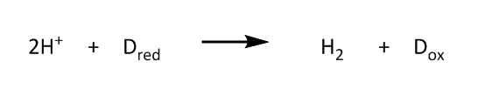
Figure 3 - Hydrogen synthesis by hydrogenase. Adapted from Melis et al. [40].

Hydrogenase is irreversibly inhibited in the presence of oxygen. Thus it is rare hydrogen gas is evolved under natural conditions. A method of continuous hydrogen production has been developed by removing sulphur from the growth medium [40]. This causes repair of structural proteins in the photosystem II (PSII) complex to be inhibited, causing the degradation of PSII and resulting in the suppression of oxygen generation via photosynthesis.
Inhibiting PSII but allowing photosystem I (PSI) to function is key to hydrogenase synthesis and hydrogen production; oxygen production halts but electron passage from PSI to hydrogenase occurs. However, in practice removing sulphur is a troublesome task which on a large scale becomes a problem. Sulphur deprivation also causes slow growth and repair and may inhibit other intracellular processes, often resulting in sulphur reintroduction to keep a culture viable.

Microalgae fuel production technology
The above bioengineering techniques, as well as other less prominent methods to produce biofuel from algae, unfortunately do not currently provide a platform for an industry to replace fossil fuels or to sequester sufficient carbon dioxide to prevent climate change. These competing technologies are still in their infancy and various challenges must be overcome before economic, environmental, energy productive biofuel from algae is a reality. Whilst these challenges have not been met despite years of research, that does not mean they are insurmountable, primarily as too little attention has been focussed on the downstream processing of the algae; more specifically harvesting and processing the fuel. In the recent past, much of the focus has centred on how to increase the growth/fuel production rates of the algae through growth vessel design, growth conditions, photosynthesis optimisation and genetic engineering. These aspects are important but such research is unlikely to override other inherent issues with the biotechnology.
More focus should instead be on the highly energy intensive processes needed to disrupt the algae cells to harvest and purify the biofuel. If that energy requirement was lowered, biofuel production from microalgae will have the potential to become a more attractive avenue of renewable energy.

Algae harvesting and disruption
Prior to fuel production, microalgal cells generally have to be harvested from a liquid medium. This process can be costly depending on the method and species used. In addition, in the case of biodiesel production, harvested cells generally need to be broken apart before lipids can be extracted. Lee et al. discuss the energy consumption of current cell disruption methods (homogenisation, cavitation, sonication, microwaves etc.) on microalgal cells and noted that those considered were highly energy inefficient [41]. Whilst the energy requirements may be optimised by selecting relatively efficient disruption processes (and optimising them), for example by using high cell concentrations and adding solvents assisting disruption and lipid extraction; they also incorporate further energy costs and may not overcome the energy deficit [41].
The energy consumption of current disruption methods requires a specific energy consumption of at least 33 MJ kg⁻¹ of dry biomass [41]. This specific energy consumption actually surpasses the energy recoverable from the microalgae; though surprisingly it is a factor of 10⁵ greater than the estimated minimum theoretical energy consumption [41]. The average force and energy required for the indentation and disruption of a single Tetraselmis suecica (a typical algae species) is approximately 17.43 pJ cell⁻¹ (673 J kg⁻¹ for a kg of dry microalgal biomass); a value that is actually very small [41].
Therefore, the energy required to harvest the biofuel need not be a limiting factor to the efficacy of algal biofuels as a renewable energy source. Developing a process to disrupt the algal cells and extract the lipids therein may not need to be so sophisticated or energy intensive as that of the present technology.
Large amounts of energy is wasted in conventional disruption techniques through the culture medium i.e. the dissipation of energy in the water. Thus if disruption energies were focussed more directly on cells rather than the culture medium, the required energy would be markedly lower than conventional disruption. Disruption techniques may lyse cells following dewatering (or before), though often the algae slurry remaining still contains a large amount of water unless completely dried. Removing the water from the culture is another energy intensive process and complete drying compounds this problem. Thus a technique that disrupts cells directly without dissipating energy in the surroundings would be preferential.
Regardless of how the cells are lysed the useful product oil/chemicals must generally be extracted from the mixture. In some cases, such as carbohydrate fermentation, the culture may not always need oil extraction (though generally favourable to remove oil as a useful product before the fermentation). In certain processes such as thermochemical liquefaction the cells may not even need to undergo cell lysis or complete drying.

Harvesting, dewatering and drying techniques
As previously discussed, before algal biofuel can be produced, algal cells must first be harvested from the culture medium. This generally involves a process where the majority of the water is removed from the culture in order to concentrate the algae cells ready for lipid extraction, pyrolysis or fermentation etc.
These techniques are diverse in mechanism of action and their efficacy is described below.

Centrifugation
Centrifugation is a technique heavily used in multiple industries and is incorporated into most lab based algal processing as well as in industry. Centrifugation for the harvesting of algae has high recovery yields but generally also high energy requirements and low flow rates [42]. Efficient centrifugation systems do allow continuous dewatering which is a benefit to industrial processing for time and cost. Kothandaraman et al. noted an 84% efficiency of algal dewatering at 3000 rpm for a 0.2 g/L algal culture at a 379 L/min [43]. Looking at the energy cost associated with centrifugation, Sim et al. notes that approximately 1.3 kWh is required to concentrate a culture from 0.04% to 4% dry weight for each m³ of pond water [44]. In fact, for efficient drying (dewatering to at least 20% dry weight) centrifugation has been shown to use approximately 8 kW h/m³ [42]. Unfortunately, under these conditions, the use of centrifuges for algal dewatering often isn’t a feasible route due to costs.

Flocculation
During flocculation, biomass is concentrated together allowing for easier removal of the culture medium. Flocculation involves the formation of “flocs” by the aggregation of particles in a solution. Essentially smaller particles aggregate into bigger flocs. During the process particles adhere to one another upon collision; chemical flocculants are usually added which promote the effect [45]. This phenomenon can also be applied to microalgal cells in order to cause algae sedimentation ready for removal of the excess water.
Generally flocculation works through three mechanisms, charge neutralisation, electrostatic patching and chain bridging [46]. Charge neutralisation involves the absorption between positively and negatively charged particles, cancelling the overall charge and causing particles to aggregate due to loss of electrostatic repulsion [46]. Electrostatic patching is where a polymer binds to a particle of opposite charge and locally reverses the charge of the particle surface (causing an opposite charge) [46]. This in turn causes particles to connect to each other through patches of opposite charge, resulting in flocculation. Chain bridging involves a polymer binding to at least two particles causing a bridging effect between particles which leads to flocculation [46].
Mass cultured Chlorella vulgaris has been shown to be effectively flocculated by a microbial ﬂocculant from Paenibacillus sp.; the flocculent AM49 has an increased efficacy with increased pH from 5–11 [47]. Its flocculation effectiveness was 83%- higher than the 72% and 78% produced by aluminium sulphate and polyacrylamide respectively, two commercial flocculants [47].
Occasionally algae spontaneously form flocs through an interesting phenomenon known as autoflocculation [48]. It is thought to be due to an increase in culture pH from carbon dioxide removal through consumption by the photosynthetic activity of the algae. The alkaline conditions cause precipitation of ions which can bond together such as calcium and magnesium. These inorganic precipitates are said to act as chemical flocculants and aid the flocculation of algae [48].
Vandamm et al. report that pH induced autoflocculation of Chlorella vulgaris requires a medium change to pH 11 via the addition of a base [49]. They also reported that only magnesium (less than 0.15mM) and not calcium appeared to be crucial to induce flocculation of the algae [49].

Gravity sedimentation
Flocculation often involves the addition of chemicals whereas gravity sedimentation has no such requirement. Instead this simple technique relies on gravity alone and is used to separate algae cultures into sediments; with a top layer of clear liquid mostly comprised of water and a bottom layer that consists of thick algae slurry. Depending on the algae strain the efficacy of this technique varies but sedimentation using just gravity can be enhanced using specialised separation tanks. Lamella separators are often used as further enhancements to provide an increased surface area for settling (due to lamella plate orientation) [50].
In addition, the slurry sediment can be continuously removed whilst more unsedimented material is added. It is possible to add chemical flocculants to the mixture to aid sedimentation rates and often is a requirement as without flocculants the procedure is unreliable.
Depending on the strain flocculation sedimentation may not be possible. Some microalgal particles have a low density and a specific gravity close to water resulting in poor settling [50].

Flotation
Flotation separation can be loosely compared to sedimentation separation; where a top layer of product forms on the water surface which can be skimmed from the water. Bubbles are introduced into the mixture which rise to the surface on which the product adheres (oil, protein, algae cells etc.).
The size of the separating particles and the bubbles are important factors in the separation. Smaller particles more readily rise to the surface and smaller bubbles reduce product collision probabilities. Hydrophobicity often plays a role in flotation separation [51].

Dissolved air flotation
Dissolving air in pressurised water can create the bubbles necessary for flotation separation; the air saturated pressurised water is injected into the culture causing depressurisation and thus formation of air bubbles which cause flotation through the usual mechanism [50,52]. The bubbles range in diameter between 10 and 100 μm and their size depends on pressures used, air saturation levels and injection rate [50]. High pressures and injection rates lead to small bubble size. Similarly, to sedimentation, flotation can be combined with flocculation to achieve higher biomass percentages in the skimmed product slurries.

Suspended Air Flotation
An interesting variation on dissolved air flotation is suspended air flotation; where bubbles are generated using surfactants rather than an air saturator and compressor [52]. Wiley et al. compared suspended and dissolved air flotation concluding that under certain conditions, suspended air flotation could separate larger volumes than dissolved air flotation with higher rates and less energy consumption [52].

Foam fractionation
Foam fractionation is a process similar to froth flotation and is a method used for the extraction of chemicals or solids from water mixtures; it is also known as dispersed air flotation or protein skimming. First researched in the 60s by Levin et al. the process is fairly simple; a surfactant is added to a mixture (though not always required) which is then aerated to form surface foam [53,54]. Rising bubbles provide a surface for hydrophobic solids to adsorb on to escape the water and form a suspension in the foam on the water surface [54]. Water readily drains from the foam due to gravity and the suspension can be skimmed from the surface to recover the solids [54].
More recently the use of ozone and peroxone in dispersed air flotation has been investigated and is discussed later in this chapter.

Electrolytic separation
Algal cell surfaces have a negative charge due to cell wall functional groups [55]. Similarly, to how flocculants utilise the surface chemistry of algae, many electrophoresis techniques have been developed using this knowledge to aid in harvesting.

Electrolytic coagulation
One such technique that relies on the surface charge of algae is electrolytic coagulation. To initiate coagulation an electric current is passed through electrodes (iron, aluminium etc.) to produce metal ions (coagulants) in the algal solution that induce aggregation of algal cells [50]. The ion concentration depends on the current of electricity passed through the system. The metal cations electrostatically bind to the negatively charged algal cells which then travel together to the anode.
Uduman et al. conducted a study on the potential of electrocoagulation for the recovery of marine microalgae [56]. At 60°C electrocoagulation allowed recovery of 96% of Chlorococcum sp. and 94% of Tetraselmis sp. [56]. Interestingly at 5 °C recovery was markedly different, 5% for Chlorococcum sp. and 68% for Tetraselmis sp. [56].

Electrolytic flotation
Uduman et al. also demonstrated electrolytic flotation during the same experiment [56]. Hydrolysis occurred at the cathode producing hydrogen bubbles which led to additional separation from a flotation effect known as electrolytic flotation; the rising bubbles assist microalgal floc movements to the surface. As with flotation techniques, flocculation of the algal cells through flocculants, autoflocculation etc. prior to the electroflotation assists algae recovery [50].

Electrolytic flocculation
Electroflocculation relies solely on the negative charge of algal cell walls and an electric current passed through electrodes [50]. The negative charge causes a migration of the algae cells to the anode and, upon arrival, cell aggregation [50]. Flotation can also be incorporated if hydrolysis occurs within the electrochemical cell. Poelman et al. achieved 95% recovery of several algae species with varying concentrations between 2.7 and 36.1 mg dry mass/L, which required a reasonable cost of 0.3 kWh/m³ [57]. However, recovery for one algal suspension was only 50%, surmising the species used is important and may reduce the efficiency of technique [57].
Electrolytic separation techniques convey certain benefits such as removing the need for chemical flocculants, high recovery yields, reasonable electrical cost and simple operation. Unfortunately, scaling the electrochemical cells is difficult and they require regular electrode replacement or cleaning due to fouling. It is also important to note, drying of the algal slurry is still often necessary after electrolytic concentrating.

Filtration
Moving away from complex systems, filtration seems the obvious choice to separate algae due to its relative simplicity and non-reliance on chemicals. However, the nature of algae cells can result in fouling and flow rate problems.
Microstraining and screening are simple filtration processes but vary from modern conventional filtration in that no direct pressure is applied to the system, to force the fluid through the filter pores [58]. Instead they operate through gravity, vibration or centrifugation. Microstrainers are fine mesh filters which rotate with a constant backwash. Flow rate is determined by filter pore size which, as expected, depends on the size of the algae species you are filtering; the smaller the species, the smaller the flow rate. High concentrations of algae can block the pores resulting in poor efficiency. Vibrating screen filters is another traditional technique and involves vibrating sieves which often have high harvesting yields [58].
However, modern systems can provide superior scalability as well as additional advantages, the preferred method for harvesting algae using filtration is now through membrane filters. Higher flow rates, better efficiency and consistency are some of the benefits micro and ultra filtration provide over microstrainers and vibrating screens.

Membrane filtration
Membrane filtration technology has become an important industrial technique to harvest algae and to purify the metabolites they produce. Filtration conveys benefits over other conventional separation mechanisms due to its simple operation, its isothermal nature and requiring no addition of chemical agents [59]. In particular, cross ﬂow microﬁltration and ultraﬁltration are ideally suited for the separation of algae. Rossignol et al. show that an ultraﬁltration membrane made from polyacrylonitrile, is very effective in the continuous separation of micro algae and only requires a low pressure of 0.5×10⁵ Pa [59]. As with all filtration technology there is a risk of membrane fouling halting production. Membranes also tend to require regular replacement to ensure efficiency is maintained.
Vacuum filtration is also possible for algal harvesting; the driving force arising from suction from the filtrate side of the system. An interesting variation on filtration techniques is through the use of magnetic particles. Magnetic filtration utilises magnetic particles (e.g. Fe₃O₄) that coagulate with algal cells. The medium is then passed through a filter with a magnetic field, to retain the cells. Yadidia et al. harvested pond grown algae Scenedesmus obliquus using a magnetic filter with Fe₃O₄ as a coagulant in the presence of ferric chloride [60]. They reported lab and pond algae recovery rates greater than 90% under low magnetic fields and reasonable coagulant agent dosing [60].
The most sensible usage of filtration is selecting a process that highly concentrates algae and requires no or little addition of chemicals with low energy input. Membrane filters are likely the best option because they are tuneable, simple, reliable and fast operating.

Drying
The algal slurry produced from the dewatering processes described previously is usually still very wet. Depending on the method of fuel production, dewatered algae often need to be dried. The simplest method is heating (i.e. oven) the algae slurry directly to evaporate off the water; whilst useable in a lab, it is obviously far too expensive to be scaled to an industrial level. The processes below represent more efficient, commonly used procedures.

Solar heat
Using the heat energy of the sun is a simple and free method to dry algae. In areas where electricity is unavailable it is the only realistic option [61]. It is highly dependent on the weather and thus unreliable at times. Using direct solar radiation also can also cause product and algae damage. Thus the preferred method is by designing a solar water heating system [61]. If designed correctly, higher drying rates can be achieved without causing damage to the algal biomass.
Becker et al. designed a solar dryer, painted black internally with a glass cover [62]. In approximately 6 hours, the temperature was between 60-65ºC and the algae were dried to approximately 4-8% water content [62].

Drum rotary dryer
A more industrially viable method is drying using a rotary dryer. A rotating sloped cylinder moves the algal slurry from one side to the other. Drum dryers are heated and when rotated form a thin film on the inner surface, allowing faster evaporation of water. In order to fully evaporate the water, a large amount of energy is required. Becker et al. reported drying a 30% dry weight Scenedesmus algal slurry amounted to 52 kWh [62].
This helps depict the magnitude of energy consumed during algal biofuel production. Even after dewatering a large amount of energy is required to dry the slurry, which then must be processed into fuel; adding more energy and monetary costs.

Spray dry
A slightly more complex method known as spray drying involves rapidly drying a slurry/liquid by a hot gas. It is often used in the pharmaceutical industry as a method to dry drugs [61]. It is particularly useful for manufacturing a product to a consistent particle size; hot air is the drying gas often used. The slurry undergoes atomisation (using a spray nozzle/atomiser) to create a fine spray before drying using the hot air [63]. Essentially the surface area for evaporation is maximised using a spray. Spray drop size can be altered to meets product needs. Spray drying algae is unfortunately an expensive process and may not be best suited industrially.

Freeze dry
A common lab scale drying method is freeze drying and is useful when requiring an especially dry sample. Freeze drying involves the freezing of the algal slurry usually at around -70ºC, though possibly colder if liquid nitrogen is used. The frozen water then undergoes sublimation to water vapour by lowering the surrounding pressure using a vacuum. If the slurry is allowed to freeze slowly, large ice crystals form intracellularly which cause cell disruption. Freeze drying is a well understood technique which is quite expensive and does not scale well to industry.

Vacuum dry
Vacuum drying is another method to effectively dry algae slurries. It is used widely across various fields of science and engineering on a lab and industrial scale. Under vacuum water boils at a lower temperature due to the lower pressure and thus drying rates are enhanced with lower temperatures [63,64]. Heating by radiation or conduction is usually used for simplicity. Becker et al. compared cross flow air drying and vacuum drying [62]. They dried Spirulina using a vacuum shelf dryer (50-65°C, 0.06atm) or using crossflow air drying at 62°C for 14h. Both procedures produced dried matter with approximately 4% water remaining. They conclude that vacuum drying had higher capital and running costs than cross flow air drying [62].

Disruption
Whether an algae culture is dewatered then dried or not for biofuel or chemical extraction, the cells often have to be lysed. The methods for disruption are generally done through the techniques described below.

Chemicals
There are a variety of different chemicals that can be used to disrupt algal cells. Surfactants or detergents can be used to lyse algal cells by disrupting lipid interactions and thus generally cannot be used for biodiesel production although can be used for bioethanol production.
Osmotic shock has also been used to disrupt algal cells. Yoo et al. induced osmotic shock and cell lysis using NaCl and sorbitol [65]. Subsequent solvent extraction showed a twofold lipid recovery compared with no cell disruption [65]. Prior to osmotic shock the culture was concentrated using flocculation [65].
Solvents are often used in the disruption of algae as well as the extraction of useful lipid/compounds from the algae. Occasionally it has been observed that some species of algae can survive lipid extraction by solvents, resulting in no cell disruption. Frenz et al. extracted hydrocarbons from B. braunii using hexane [66]. The algae were first concentrated using filtration and then hexane was added for a short period; the algae recovered and continued to grow and produce hydrocarbons even after several extractions [66].
Generally, solvents are used once the cells have been already disrupted in order to extract the lipids. Lee et al. compare several methods of disruption and conclude microwaves were the most efficient disruption technique for lipid extraction; a methanol chloroform (1:1) solvent mixture was used for the extraction [67]. They confirm disruption prior to solvent extraction is beneficial for higher lipid extraction yields compared with no disruption [67].
Solvents have different efficiencies for lipid extraction and this differs between species. Liu et al. compared different solvent oil recoveries, concluding that 1,2-dimethoxyethane is the most effective solvent for B. braunii (cells disrupted prior to solvent extraction) [68].
Solvent lipid extraction generally requires dewatering of algae and cell disruption. The solvent must firstly be obtained and when the lipid is finally purified transesterification can occur. Overall many steps are involved which offset the value of biofuel produced and from a net energy viewpoint there is a large loss from processing.

Enzymes
A less common method of cell disruption is through the use of enzymes that can be used to digest the cell walls of algae. However, due to the difficulty and expense of extraction or synthesis they may not be the best choice. Ehimen et al. compare mechanical and enzymatic pre-treatment of Rhizoclonium for anaerobic digestion and note that enzymatic pre-treatment (multiple enzymes used) improved methane yields from anaerobic digestion by over 20% [69].

Homogenisation
A more traditional method of disruption is homogenisation. Homogenisers are used in the dairy industry to emulsify milk; they are useful in creating uniform consistency in a liquid. The forces involved in the process also cause the disruption of microorganisms. The algal slurry is forced through a small orifice at high pressure and collides against an impact ring. Various theories attempt to explain the exact mechanism of cellular disruption but the main point is that the disruption is primarily caused by the high pressure and impact.
Balasundaram et al. measured cell disruption via homogenisation of S. cerevisiae (yeast) by enzyme release [70]. At 4000psig for 15.4 minutes they observed 90% efficiency for enzyme release (and thus 90% cell disruption can be inferred) [70]. This required 2.09kW which scales to approximately 96.6 MJ for a kilogram of algal dry mass; a large energy requirement which may reduce its feasibility industrially [70].

Cavitation
Another physical method to disrupt cells is cavitation which refers to the implosion of bubbles formed from large changes in pressure in a liquid. This implosion releases a significant amount of energy and often in engineering processes causes wear to machinery.
Balasundaram et al. also measured disruption of S. cerevisiae (yeast) by enzyme release via hydrodynamic cavitation [70]. Whilst hydrodynamic cavitation showed to be more effective in cell disruption compared with homogenisation, it consumed over a third more energy with only a slight gain in specific yield of enzyme [70].

Sonication
Sonication works via the same mechanism as hydrodynamic cavitation whereby the collapse of bubbles on a cells surface causes disruption. It differs from hydrodynamic cavitation because bubbles are formed from sonic waves rather than the effect of high pressure on liquid.
Balasundaram et al. compared sonication against hydrodynamic cavitation and homogenisation [70]. Whilst only consuming 54KJ it should also be noted that very little cell disruption occurred; certainly far too little for any industrial applications [70].

Bead beating/milling
Bead milling is another physical technique for cell disruption. Beads are added to the culture medium which is then shaken causing collisions between cells and beads; the beads erode the cell surface and cause disruption. Lee et al. used bead beating as one of the methods compared for cell disruption. Interestingly it was only slightly less effective than microwaves but cost even more energy; 504 MJ per kilogram of algal dry mass [67].

Microwaves
Microwave disruption uses radiation to lyse cells. Microwaves induce molecular rotation and vibration which result in heat [67]. This means microwaves can heat intracellular water causing cell disruption.
Lee et al. compared different methods for cell disruption and concluded microwaves were the most effective method as it led to the largest lipid content extraction [67]. Unfortunately the energy consumed amounted to 420 MJ per kilogram of dry algal mass which is a factor of over 4 times that of homogenisation [67]. It would be difficult to optimise this process due to the fact that most of the microwaves are wasted on extracellular water in the culture medium. The efficiency has, however, been improved by dewatering the algae into a concentrated slurry ready for microwaves and its subsequent solvent extraction though additional energy for dewatering is required.

Ozone flotation
An interesting mechanism of algae lysis and separation has been devised using ozone through dispersed air flotation. Nguyen et al. showed that ozone and peroxone can induce cell lysis, and cause the release of organic intracellular compounds and mineralise organic compounds [71]. After 30 minutes of ozone flotation 95% of the algal cells were separated [71]. Prior to flotation algae were flocculated using the surfactant cetrimonium bromide, which assists flotation separation [71].
Whilst a good mechanism for incorporating lysis and separation steps into one, ozone must be generated from pure oxygen. Recently groups have worked on cold plasma for energy efficient ozone generation with some success but generation of pure oxygen also adds an energy deficit [72].
The above is a short summary of the conventional processes involved in producing biofuel from microalgae; from harvesting to fuel production. These methods are far from perfect but do show promising developments in biomass renewable energy. Unfortunately, the majority of papers effectively demonstrate good processing steps but are lacking in detailing the energy constraints and rarely discuss total energy requirements and background costs.

Using ultraviolet light for disruption?
Subsequent chapters in this thesis look at the efficacy of ultraviolet light for disruption of microalgae. However, currently ultraviolet light (UV) is already heavily used in wastewater treatment by damaging the DNA and RNA of microorganisms in order to disinfect water for safe consumption; Paris uses UV to disinfect 170000 kl of water per day [73]. The infrastructure for large scale usage of ultraviolet light is already well established and thus is one of the reasons research into its potential as a disruption method for microalgae was explored.

What are polymers?
Polymers can be used as flocculants and have other useful properties to assist in the harvesting of microalgae or extraction of useful chemicals. Later chapters in this thesis detail the use of polymers in such capacities. Polymers are long molecules formed from repeated monomer units covalently linked together [74]. They have a diverse range of applications from everyday plastics to highly specialised purposes such as chemical coatings. In fact, DNA and proteins are examples of natural polymers, which show the complexity and functionality that polymers can exhibit.
Key physical properties include average molar mass and dispersity, both of which can be controlled by the synthetic method [74]. Average molar mass is generally defined as the average of the molar mass of all polymer chains and can be thought of as the average chain length from polymerisation. The dispersity refers to the distribution from the average polymer chain length. A dispersity of 1 indicates uniform chain length; hence as dispersity increases differences between chain lengths increase [74].
Average molar mass and dispersity can have a huge impact on the polymers properties such as tensile strength and toughness [74]. Degree of branching is a measurement of chains growing from the polymer backbone and can have a significant impact on polymer characteristics [74]. The efficacy of a polymer’s function may be affected by average molar mass, dispersity and degree of branching for example solubility or binding capacity [74].

Polymer synthesis
The properties of a polymer depend on their method of synthesis. In general polymers are produced via step growth or chain polymerisation mechanisms. Later chapters include the synthesis of novel polymer flocculants thus their synthesis method is important.

Step growth polymerisation
Step growth polymerisation typically involves a condensation reaction (or similar) whereby a small molecule such as water or hydrochloric acid is a leaving group [74]. Step growth polymerisation involves mechanisms where monomer groups react together to form dimers, then trimer and higher oligomers and finally a polymer [74]. This is contrary to chain polymerisation whereby individual monomers are sequentially added during polymerisation [74].

Chain polymerisation
Chain polymerisation involves the growth of a polymer chain through the sequential addition of monomers. The simplest and most utilitarian polymerisation is free-radical polymerisation, however there are numerous alternatives [74].
Free radical polymerisation typically involves three steps [74,75]. Firstly, an initiation step where a reactive species is created. A chemical initiator is used to create a reactive species with free radicals, which then transfers radicals to the monomer to begin polymerisation. Once a monomer has been activated chain growth begins and the propagation step occurs. The free radical on the activated monomer attacks a vinyl group in another monomer which leads to bond formation between the two monomers and results in free radical formation on the new monomer [74,75].
This new end group can react with another monomer thus beginning chain growth. During this step the chain grows until no monomer is left or termination occurs. The termination step occurs once the reactive end group is deactivated and polymerisation ends. This commonly occurs through combination of two growing chains which form a single polymer molecule or through disproportionation [74,75]. Two unreactive polymer chains are formed, one with a vinyl end group and the other a methylene.

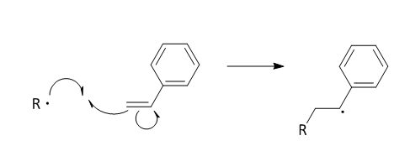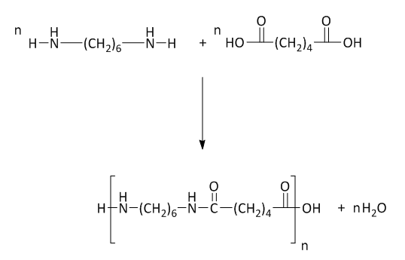
A
B

Figure 4 - Polymerisation example reactions. A - Step growth polymerisation reaction of hexamethylene diamine and adipic acid to form nylon (6,6). B - Free radical chain polymerisation initiation reaction of radical initiator R and styrene to form polystyrene. Product will carry on to the propagation step by attacking styrene monomers and increasing chain length.

Living polymerisation or more accurately reversible-deactivation radical polymerization is another form or chain polymerisation where a polymer chains capacity to terminate is almost entirely prohibited. Living polymerisation offers superior control over average molar mass and dispersity because termination is unlikely to occur [75]. This can also be applied to free radical polymerisation and the most common methods are atom transfer radical polymerization (ATRP) and reversible addition-fragmentation chain transfer (RAFT) [75].

Atom transfer radical polymerization
Atom transfer radical polymerization involves reversible end capping of a growing chain in order to prevent termination. Initiators are usually organic halides which react with a metal catalyst to form a radical and begin the initiation step [75]. The growing chain is capped by a halide atom via a metal catalyst throughout the reaction (causing the catalysts oxidation) and reactivation of the chain is via the oxidised metal catalyst. This deactivation/reactivation is in an equilibrium [75]. The equilibrium is controlled so that capping is preferable and exchange is rapid, and monomer concentration is kept low to ensure probability of termination is unlikely [75]. Due to the low probability of termination and ability to initiate all polymer chain growth simultaneously, average molar mass and dispersity can be well controlled. In addition, copolymers can be produced such as block copolymers by polymerising two different monomers one after another [75].

Reversible addition-fragmentation chain transfer
Reversible addition-fragmentation chain transfer is another method of free radical living polymerisation and is essentially a normal free radical polymerisation with the inclusion of a RAFT agent that greatly reduces the chances of termination [75]. The RAFT agent is a thiocarbonylthio compound such as a dithioester which reacts with a growing polymer chain to stabilise the radical on the end group and then subsequently fragments to generate a new free radical on a leaving group [75].
The growing chain is thus capped by the RAFT agent until reactivation by another fragmentation event with the capping RAFT fragment and another growing chain radical [75]. As with ATRP, the low probability of termination and quasi-living state of polymer chain growth means that average molar mass and dispersity can be well controlled [75].

Polymers uses in algal biotechnology
Polymers are often currently used as flocculants for algae. Many synthetic polymer flocculants have been used in the processing of algae to reduce harvesting time and costs. Lam et al. studied various commercial polymers for harvesting microalgae and concluded that due to the algae’s negatively charged cell wall cationic polymers were most suited [76]. The negative charge was neutralised by a positively charged polymer and facilitated the formation of polymeric bridging between algal cells resulting in flocculation [76].
Polymers have also been used as an anti-fouling coatings to prevent algae from fouling surfaces [77]. Wan et al. grafted poly(3-sulfopropyl methacrylate) to a replica surface of a leaf to determine its anti-fouling properties and concluded anti-fouling was improved by modification with the polymer brushes. Interestingly they utilised a surface initiated ATRP method for polymerising off the replica leaf surface.

What are magnetic nanoparticles?
Magnetic nanoparticles (MNPs) are often defined as solid particles that are in the size range of between 1-100nm and exhibit superparamagnetism (when around 20nm); meaning they have no magnetic memory and are single domain particles (no variation in magnetism in the particle) [78]. The literature often describes nanoparticles above 100nm and this disparity has led to the term nanoparticle representing sizes from 1-1000nm [78]. Recently magnetic nanoparticles have been of great interest to the scientific community due to their high surface area to volume ratio, non-toxicity, non-immunogenicity, cheap production and rapid synthesis [78,79].
Additionally MNPs can functionalised for many applications such as drug delivery, biological labelling, protein detection and molecular/cell separation to name a few [80,81].

Synthesis methods for magnetic nanoparticles
The synthesis method for magnetic nanoparticles often depends on the desired application as different methods can produce nanoparticles with varying size and stability. Common methods include co-precipitation, thermal decomposition and microemulsion, and are described below [78,82].

Co-precipitation
Co-precipitation is a simple method to synthesise iron oxide nanoparticles from solutions of salt such as ferrous and ferric chloride [78]. Base is added to the mixture of salt solutions under an inert atmosphere and causes the precipitation of iron oxide nanoparticles from the solution [78]. Salt type, temperature, pH, ionic strength and stirring speed can affect the size and shape of the nanoparticles production [78].

Thermal decomposition
Thermal decomposition of organometallic compound such as iron pentacarbonyl followed by oxidation can produce monodisperse iron oxide nanoparticles smaller than 20nm [83]. Hyeon et al. synthesised MNPs smaller than 16nm via thermal decomposition of iron pentacarbonyl at 100 ºC [84]. Oleic acid was present during the reaction as a surfactant to stabilise formed MNPs and is often used to prevent agglomeration in various synthesis methods. The oxidation was facilitated using trimethylamine oxide [84].

Microemulsion
Microemulsions are thermodynamically stable emulsions of two immiscible phases such as oil and water and a surfactant. They can be used to synthesise nanoparticles by containing the nucleation and growth within an emulsion droplet and thus can lead to the production of small nanoparticles often in the range of 3.5nm [83]. In a general synthesis two microemulsions are mixed, both of which contain a different reactant within the dispersed emulsion droplets [83]. During mixing the droplets collide and begin the reaction, leading to a dispersion of nanoparticles in the mixture [83].

Functionalisation of magnetic nanoparticles
Often following nanoparticle synthesis, it may be necessary to modify the nanoparticle surface to provide increased stability or provide chemical functionality. For instance, simple ligand exchange of the surfactant layer around a nanoparticle with another ligand can transform the nanoparticles from hydrophobic or hydrophilic [83]. It may also involve more complex functionalisation such as silanization of the surface and polymerising from it using ATRP [83].
The literature has an abundance of different nanoparticle surface functionalisations, usually highly specific to the area of research specified. For example, Lunov et al. use carboxydextran functionalised iron oxide nanoparticles to model endocytosis by human macrophages. In many cases surface modifications involve a silanization step or ligand exchange before further functionalising to prepare the surface for polymerisation, for example [83].

Magnetic nanoparticle use in algae biotechnology
Magnetic nanoparticles have previously been used to harvest microalgae. In fact Prochazkova et al. magnetically separated Chlorella vulgaris from medium with 95% efficiency [85]. There are many examples of magnetic nanoparticle technology being used in the scientific literature for harvesting microalgae. However, the majority of them do not re-use the nanoparticles following harvesting. Some methods do involve regeneration or recycling but usually this entails multiple steps/chemicals and would not scale well to industrial levels.

Conclusion
This review aims to summarise the current understanding and methodologies of biofuel production from algae. This is in the hopes of widening the scientific community’s research focus to combat and overcome the real difficulties in algal renewable energy. Unfortunately, in order to alter the world’s reliance on fossil fuels to renewable energy, considerable scientific breakthroughs will be required. This is largely due to fossil fuels being so inexpensive currently, although this is based on over 100 years’ research to optimise the process. Steady progress down a route of research in renewable energy is beneficial, but realistically, renewable energy will not replace fossil fuels until it is economically viable (governmental financial backing can promote this) and of course actually produces net energy.
The burning of fossil fuels is a large contributor to climate change, if that wasn’t the case, steady slow progress in renewable energy research would be acceptable. Unfortunately, we cannot afford to wait until fossil fuels are exhausted as the planet may become uninhabitable for human life; in the meantime, algal biofuel is a critical research area to prevent this scenario. It is especially important for the transport industry as other sources of renewable energy do not produce liquid fuels (which fits into current infrastructure).
However, whilst algal biofuel is crucial, it is important that research is to be focused and funded on many key aspects of renewable energy such as solar, wind, hydrodynamic or geothermal energy. It is likely we will eventually use a combination of these multiple sources.
Presently the literature doesn’t lean towards any one process as the most effective route to produce algal biofuel. As previously discussed, there seems to be a lack in coherent expertise in the overall field, especially in an industrial setting. Much work needs to be undertaken to improve biofuel feasibility, this may require the development of new technology or the adaptation of existing but doesn’t necessarily mean a complex solution is required. In fact, simple key aspects need to be kept in mind throughout designing biofuel processes.
These key aspects can be summarised into three factors. Firstly, the environmental impact of biofuel production must be a positive one else we hasten the effects of climate change. Secondly, production must be economically favourable; to the extent that an investor’s sole goal is to make profit from the enterprise. Finally, it is absolutely crucial that the process involved in biofuel production has a large net energy gain. Every energy cost from the materials to growth to harvesting must be counted into calculating the energy worth of the biofuel produced. Speaking plainly, unless there is a large energy gain and sufficient financial incentive fossil fuels will continue to dominate the market. All three factors, the environment, economy and energy must be met for sustainable production of biofuel at an industrial scale.

Objective of this research
The work presented in this thesis explores the possibility of producing biofuel from microalgae with novel technology that has not been previously explored by the scientific community. To this end five experimental chapters discuss various technologies. The first chapter explores the use of ultraviolet light as a method for disruption of algae to enhance lipid extraction. In keeping with this idea the second chapter explores the use of sunlight as a source of ultraviolet light for microalgae disruption. The third chapter addresses another problem of downstream processing of microalgae, the energy cost of harvesting, thus a novel recyclable magnetic flocculant was developed. The fourth chapter looks at the quality of biodiesel that can be produced from microalgae. Therefore, a novel 50L bioreactor for growth of microalgae was designed and built, before accelerated aging was performed on biodiesel produced from the bioreactors algae. Finally, the fifth experimental chapter explores tuning wavelengths of light to improve the generation of hydrogen from microalgae, with an aim to allow continuous production.

Experimental methods

Materials
The following lists comprises the materials used in experimentation, these are discussed individually in the relevant method sections. Ferric chloride hexahydrate, ferrous chloride tetrahydrate, sodium hydroxide, azobisisobutyronitrile, ethylene glycol dimethacrylate, acrylic acid, bold-Basal medium, chromatography silica gel (60738), squalene, tween80, iron pentacarbonyl, general purpose viscosity standards N2/N10, trimethylamine N-oxide, octyl ether, ammonium persulfate, StratoSpheres™ PL-DIPAM, StratoSpheres™ PL-Deta, Aniline polymer-bound, 1-methyl-2-pyrrolidone, piperazine, urea, (3-Chloropropyl)triethoxysilane, methyl iodide, (3-Aminopropyl)triethoxysilane, methanol, dimethoxydimethylsilane, trimethoxymethylsilane, cetyltrimethylammonium chloride, Poly(acrylamide-co-diallyldimethylammonium chloride), 10% BF₃ in methanol, lugol’s solution, triethylamine, potassium iodide, dimethyl sulfoxide, magnesium sulphate, sodium carbonate, potassium bromide powder and toluene (reagent grade) were purchased from Sigma Aldrich.
18MΩ water was obtained from an ELGA PURELAB Option-Q ultrapure water system. N,N-dimethylaminopropyl acrylamide was purchased from Fluorochem Ltd. 1H,1H,2H,2H-Perfluorodecyltrichlorosilane was purchased from Alfa Aesar. Hydrochloric acid (12M, 37%) ethanol, acetone, sulphuric acid and 1,4 dioxane were purchased from VWR Chemicals. Acetic acid, ethyl acetate and n-hexane were obtained from fisher scientific. PVDF powder was obtained from Solvay. Oleic acid was obtained from Tokyo Chemical Industry UK LTD. Tungsten spare filaments for eVision II were purchased from MKS Instruments UK Ltd. Optical components used for hydrogen gas experiments were purchased from Thorlabs, including longpass filters FGL665, FGL695 and FEL0700 (dielectric filter). Trypan blue was obtained from Beckman Coulter.
The Arduino mega 2560 R3 microcontroller and light dependant resistors were purchased from Rapid Electronics Ltd and the Pololu Dual VNH5019 Motor Driver Shield from Technobots Ltd. The Fresnel lens was purchased and custom made from Knight Optical (UK) Ltd. Cut sheet glass was purchased from Central Glass Ltd, Sheffield, and the Point four 100 MBD diffusers from Sterner Aqua Tech UK Ltd. The carbon dioxide canister and aluminium flow meters (models 846021, 246027) were purchased from BOC. The aluminium profile was purchased from KJN Automation Ltd and the linear actuator from Gimson Robotics Ltd. The geared DC motor was purchased from Premier Farnell UK Limited.

Algae strains and cultivation
Micractinium inermum (M. inermum) was cultivated phototrophically in Bold-Basal Medium from algae originally obtained from Dr Gilmour’s lab in the Department of Molecular Biology and Biotechnology at University of Sheffield. The original source was a local pond.
Chlamydomonas reinhardtii (C. reinhardtii) (wild type CCAP 11/32A) and Dunaliella salina (D. Salina) (wild type CCAP 19/30) were grown in 250 mL conical flasks with TAP medium and Vonshak’s medium (1986) respectively at 25 °C under magnetic stirring and positioned approximately 10 cm from 36 W fluorescent tube light sources [86,87]. Cells were grown up to approximately 0.7 mg/mL. These species were selected as suitable organisms for UV irradiation studies. Their broad background literature and contrasting cell wall characteristics give good insight into the effectiveness of UV radiation to lyse cells regardless of cell wall strength.
Nitrate stressing when necessary was performed by reinoculating a late log phase culture in nitrogen free TAP medium, which was made by omitting ammonium chloride from the TAP medium recipe [88].

Culturing of Micractinium inermum in a 50 L bioreactor
M. inermum was cultivated phototrophically at 25ºC in Bold-Basal Medium in a 50L flat plate air lift bioreactor. The 3-fold Nitrogen and Vitamins (3N-BBM+V) variety was not used in order to observe limiting growth through nitrogen starvation. Algae undergo lipid storage under nitrogen stressing and thus limiting nitrogen and adding nitrates throughout growth was deemed useful in order to harvest a culture that had accumulated lipids for efficient biodiesel production [89].
The bioreactor was inoculated with M. inermum with a 180 times dilution and grown for 3 weeks prior to harvesting; this was when the optical density reached a suitable value. Daily optical density measurements were taken with a Perkin Elmer UV/Visible spectrometer at 595nm. Optical density samples had to be diluted with culture medium before measuring as the culture became denser.

Ultraviolet light irradiation of algae
Various 3 mL samples of C. reinhardtii/ D. salina/ M. inermum cultivated using the method in Section 2.2 in a quartz cuvette were exposed to a series of irradiation periods ranging from 15s to 300s with 9 W/cm² UVA (320-395 nm) and 1.5 W/cm² UVB (280-320 nm) using a BlueWave 75 UV Curing Spot Lamp, as shown in Figure 50, Section 11.4. The area of irradiation was approximately 1cm². In this case of using a solar tracker for the UV source, quartz cuvette algae samples were taped in place at the 1cm² focal point of the Fresnel lens for given irradiation periods, under water cooling from a hose placed to have a stream of water onto the cuvette. Following this the samples were left for 24 hours in the dark. A cell count distinguishing between viable and non-viable cells was then undertaken using trypan blue as detailed below by means of an Olympus BX50 microscope and a Neubauer haemocytometer as described by Wu et al. [90]. Briefly 5 µL trypan blue stained samples (1:1 ratio) of control (unirradiated cells) and UV irradiated samples were loaded into the haemocytometer. Cells were observed for morphological changes by counting live and dead cells in 16 small squares within each of the 4 large squares and averaging the live and dead cells before comparing the total live to dead ratio to calculate the percentage viability, with each experiment repeated in triplicate. Disruption efficiency was then calculated for each irradiation duration.
Trypan blue vitality stain was used to stain C. reinhardtii cells, but could not be used with D. salina as the stain had poor miscibility in the saline media. However distinct morphological changes in D. salina following irradiation meant determining cell viability was possible without a stain. Additionally, Lugol’s solution was applied to D. salina to inhibit their motility during counting [91].

Lipid extraction
As described above, samples of C. reinhardtii or M. inermum were irradiated with UV from the curer or solar tracker. Additional control (where only a solvent extraction was performed with no method of cellular disruption) and bead beated samples were prepared. Samples were then centrifuged (8500 rpm) and pellets retained in Eppendorf’s with a 1.2 mL methanol:chloroform mixture (1:2), supernatants were also collected to determine free lipid content.
UV exposure and control samples were kept on ice and bead beating samples were bead beaten using a cell disruptor (Genie, VWR, U.K.) for 15 cycles (1 minute in ice after each cycle). This bead beating protocol was developed and optimised by Rahul Kapoore at the University of Sheffield, Department of Chemical and Biological Engineering. 400 µL chloroform and 400 µL ultrapure water were added to each sample before centrifuging (8500 rpm). Bottom organic phases were retained in Eppendorf’s. Samples were then evaporated to dryness with nitrogen gas and reconstituted with 250 µL of methanol:chloroform mixture (1:1).

Transesterification
Following this samples were transferred to glass vials and 100 µL of 10% BF₃/methanol added before incubation at 80 ºC for 90 minutes. Samples were cooled for 10 minutes before addition of 300 µL of ultrapure water and 600 µL hexane then vortexed for one minute. The aqueous top layers were discarded before evaporating the remaining organic phase to dryness under inert nitrogen gas using six port mini-vap evaporator (Sigma-Aldrich, Dorset, U.K.). Samples were reconstituted in 100 µL hexane and submitted for gas chromatography flame ionisation detection (Thermo Finnigan TRACE 1300 GC-FID System, Thermo Scientific, Hertfordshire, UK) coupled with a TRACE™ TR-FAME GC column (25 m × 0.32 mm ID × 0.25 µm film, Thermo Scientific, UK). The experiment was repeated in duplicate.

Statistical methods
A students t-test was applied to the data in Figure 9, assuming unpaired data and unequal variances using Microsoft Excel Spreadsheets.

Solar tracker design and manufacture
A dual axis (x,y) solar tracker was designed in order to facilitate the concentration of ultraviolet light from the sun using a Fresnel lens at any time of daylight. The lens must be perpendicular to the incoming parallel light from the sun in order to concentrate solar wavelengths to a focal point. To accommodate this, the tracker has four parallel light dependant resistors (LDRs) linked to an Arduino microcontroller that responds to changes in light intensity by the moving x and y axis motors of the tracker until all four LDRs are in equal light intensity, see Figure 5 for wiring schematics and Figure 14 Section 4.5 for a solar tracker diagram and schematic.
A 2nd year Mechanical Engineering student, Sam Davison, assisted with the construction of the solar tracker. He performed the majority of workshop tasks, in particular the milling and cutting of aluminium sheet. Overall design, part sourcing, electronics and programming was performed by Thomas Sydney. Final construction was performed together. The project was over a 6 week summer period and by the end of the fifth week, the solar tracker was completed.
The tracker frame was made of aluminium sheet combined with aluminium profile that was screwed together at right angles with fittings (KJN Automation Ltd Aluminium Profiles). A hole with a milled groove was cut into an aluminium sheet to accommodate the lens.
A Fresnel lens with an area of 0.164 m² was utilised to concentrate sunlight into an area of 0.0001 m². The lens is in a fixed position with respect to the base platform, so that the sample can be mounted onto the platform. The lens plate is able to slide up and down its support rails, so that the focal point of the lens can be controlled. In Sheffield the maximum tilt angle required is 57° as this corresponds to the highest solar altitude angle that the sun reaches [92]. Thus the tracker was designed to accommodate an angle of 60° to ensure it could be used anywhere in the UK. The tracker was made weatherproof by sealing the electrical components in a plastic container lined with silicon sealant. The power supply was also sealed in a separate waterproof box and armoured cable was used to ensure long term durability. The motors and LDRs were also sealed in plastic sheeting. The overall design was made as simple and cheap as possible, costing less than £500 (not including the lens) which demonstrates that it could be used in a variety of locations with little expertise and expense. The lens cost £1287.78, however future lenses would cost much less as a mould had to be specially made to produce the lens. This adds a large cost to the overall design but should a project utilise multiple lenses the price per lens would be greatly reduced as the lens material (polymethyl methacrylate) is relatively inexpensive.
The tracker was designed to be future proof experimentally so it could be adapted and is lightweight, transportable and weatherproof. The Y axis movement is driven by a geared DC motor with low output speed (2.9rpm). This is attached to a pulley that moves around a timing belt which is adhered to the outer race of a lazy Susan bearing. This was a simple solution to enable Y axis movement (360º of freedom) as well as being cheap and have low power requirements, see Figure 14 Section 4.5.
The X axis movement is driven by a 12 V DC linear actuator to tilt the lens and algae sample to the desired position. It can take a maximum load of 4000 N of which approximately 3000 N is required at maximum. This over specification was necessary to allow for later expansion and increased load from wind.
The tracker is controlled from an Arduino mega 2560 microcontroller board with a motor shield adapter (Pololu Dual VNH5019 Motor Driver Shield) that allows a 12 V output across each motor and a maximum current of 12 amps. A shield was required to pull the necessary power requirements for the motors without damaging the Arduino. The board is connected to the 4 LDRs with appropriate resistors (see Figure 5) and using their resistance calculates where the sun is and moves the motors appropriately to align the Fresnel lens perpendicularly to the sun. The programming code was partially based on [175], see Figure 13, Section 4.4.2, for a simple flowchart of the programming loop.

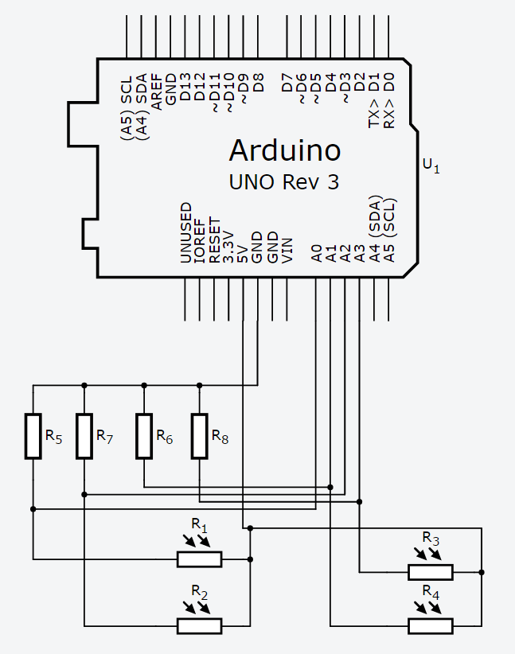
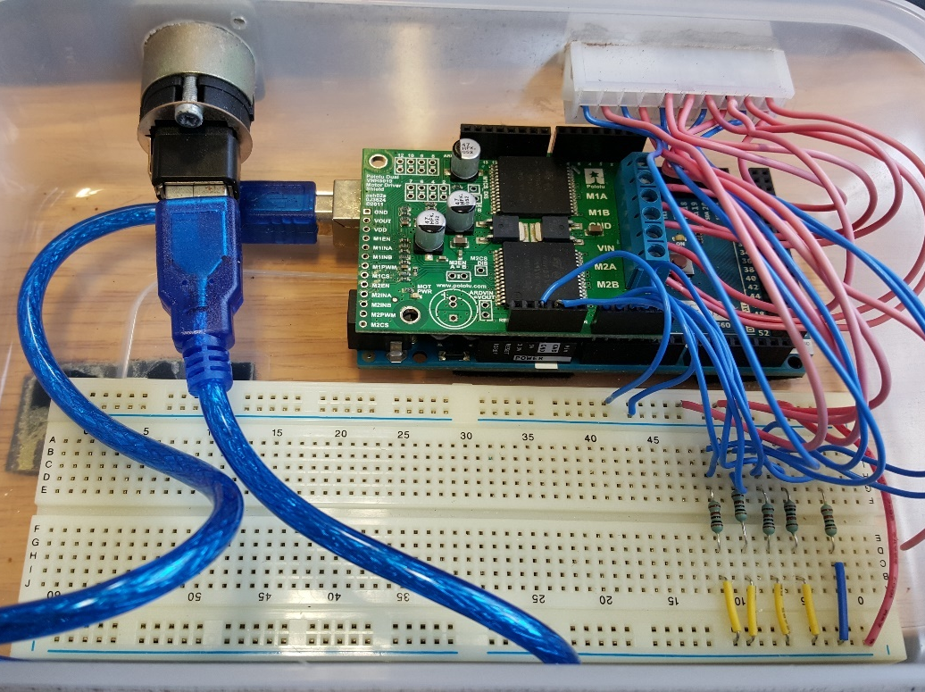
B
A

Figure 5 A - Arduino, motor shield and breadboard electronic wiring that are used to control the motors and monitor voltages of light dependant resistors. B - Wiring schematic of Arduino with four parallel light dependant resistors with corresponding resistors to form potential dividers to allow voltage monitoring. Schematic designed on Autodesk Circuits.

Design improvements
Following successful manufacture of the tracker several improvements became apparent that would be useful if the tracker was scaled or mass produced.
By installing the actuator at a position further from the pivot point of the tilting platform, a mechanical advantage would allow for a reduction in power consumption. In the current design, the actuator position compromised efficiency and ensured that in the summer months the platform could rest low enough to align perpendicularly with the sun. The smallest tilt angle is currently 30º and the sun has a maximum altitude angle of 60º in the UK, resulting in the tracker being fit for use all year in the UK.
Should the tracker need to be used in other countries where the platform would need to be at 0º, another square frame could be added below the current base which would house both motors. In this way, the actuator could be positioned to allow for the platform to rest flat and be moved all the way to 90º to accommodate any angle of the sun.
If the tracker was to be used intensively or for commercial purposes extra support may be required for the tilting platform. This would help reduce power required from the actuator and increase its durability in harsh conditions such as high winds. Gas struts were considered as a viable option to provide the additional support.
Additionally, the rotating mechanism would need to be redesigned to be more durable for intensive usage as the current design is susceptible to wear.

Oil extraction methods

Preparation of oil-in-water emulsions
Oil-in-water emulsions were prepared to test the ability of various separation techniques. A squalene emulsion (10% in water, sonicated for 10 minutes) and a surfactant stabilised emulsion (10% squalene in water with 0.2% Tween80) were used as model emulsions [93]. Algal emulsions consisting of disrupted (bead beating, UV, sonication) algae (0.7 mg/mL in media) were also used. Various oils were also used as models such as castor oil, mineral oil and vegetable oil.

Oil-Water separation membrane synthesis
Superhydrophobic-superoleophilic polyvinylidene fluoride (PVDF) membranes were prepared via phase inversion as described by Zhang et al. [94]. PVDF powder (0.5 g, Solef 1015, Solvay) was dissolved into 1-methyl-2-pyrrolidone (9.5 mL) and stirred to form a solution. Various aliquots (50 μL, 100 μL, 150 μL, 200 μL, and 400 μL) of 25–28% ammonia in ultrapure water were added to separate samples of the above PVDF solution and left to stir for 6 hours. The solutions were then cast onto a clean PTFE substrate. The substrate was then immersed in a water bath at 60 ºC for approximately 24 hours to undergo phase inversion. Following this, the substrate was dried in an oven at 180 ºC for 4 hours before peeling off the resulting PVDF membrane. This method was based on Zhang et al.’s work but their original method did not explain key details such as water bath duration, temperature and drying method. After much trial and error involving the water bath duration and drying method a functional membrane was produced as detailed above. The various aliquots of ammonia give rise to different mechanical strengths of a resulting membrane [94].

Superhydrophobic-superoleophilic sponge synthesis
Superhydrophobic-superoleophilic sponges were synthesised by mixing dimethoxydimethylsilane (0.014 mol), trimethoxymethylsilane (0.021 mol), urea 5 g and n-hexadecyltrimethylammonium chloride 0.8 g in 15 mL dilute aqueous acetic acid (5 mM) under a nitrogen atmosphere, magnetic stirring for 60 min at room temperature (for hydrolysis) before gelation at 80 °C in an oven for several hours [95]. The obtained gels were then washed with ethanol and chloroform before drying at room temperature over several hours. The experiment was based on Hayase et al.’s work but had to be adapted by experimenting with pH conditions and alkoxysilane ratios to obtain structurally sound sponges; using the original experimental procedure produced brittle sponges that easily broke up upon squeezing. Functional sponges still generally had poor durability. Upon querying the authors as to why, they offered some experimental suggestions such as increasing the ratio of trimethoxymethylsilane and increasing the amount of acetic acid solution which were taken into account but did not improve sponge quality sufficiently [95].

Oil absorbing polymers (Kraton)
Kraton is a block copolymer and depending on its polymer constituents can absorb oil and was provided by Farapack polymers, a company based in The University of Sheffield. Weighed quantities of Kraton were added to an aliquot of an algae stock culture and a bead beated aliquot, stirred for 24 h with a magnetic stirrer at 200 rpm, removed, dried and then re-weighed to determine if any oil had been retained.

Superoleophilic surface fabrication
Superoleophilic surfaces were prepared as follows [96]. Glass microscope slides and Pasteur pipettes were ultrasonicated for 30 minutes in Decon 90 before washing with ultrapure water and drying in an oven for 20 min at 120 ºC. Following this 50% of the glass substrates were placed in piranha solution (H₂SO₄:H₂O₂ - 7:3 by volume) for 2 h. Substrates were then washed with ultrapure water and oven dried as before. The dried substrates were immersed in a solution containing toluene 4 mL (hydrous toluene:anhydrous toluene - 3:2 by volume). Immediately upon immersion of glass substrates 0.005 mL 1H,1H,2H,2H-Perfluorodecyltrichlorosilane was added to the solution [96].
Following this the glass substrates were washed in sequence with toluene, ethanol, ethanol:water (1:1) and water and repeated for several cycles. The glass substrates were then oven dried as before.

Polyelectrolyte emulsion breakers
Poly(acrylamide-co-diallyldimethylammonium chloride) solution (10 wt. % in H₂O) was used as a cationic polyelectrolyte in the emulsion breaking experiments. Three 10 mL samples of C. reinhardtii were taken and mixed on a magnetic stirrer table at 200 rpm. Two of the sample tubes had 1 µL of the polyelectrolyte added whilst the other tube had 1 drop (approximately 50 µL) added. The samples were left to stir for 2 hours at 200 rpm before reducing the speed to 120 rpm for 48 hours. This experiment was repeated in duplicate.

Magnetic Iron Oxide Nanoparticle synthesis
Nanoparticles were prepared via the following method [97]. Sodium hydroxide (11.54 g, 0.28 mol) was added to 500 mL of water and deoxygenated for 30 minutes through purging with nitrogen gas. This solution was heated to 80 °C. Separately, into 40 and 60 mL of water, ferric chloride (2.7 g, 10 mmol) and ferrous chloride (2.0 g, 10 mmol) were dissolved respectively and deoxygenated as before. The two solutions were then combined using a cannula, to ensure deoxygenated conditions were maintained, before dropwise addition into the hot sodium hydroxide solution under vigorous mechanical stirring. The resultant magnetic black precipitate was washed twice with water, then twice with acetone and dried under nitrogen. A permanent magnet was employed to aid in the washing process.

Iron pentacarbonyl synthesis route
An alternative MNP synthesis route based on the work of Park et al. was also undertaken [98,99]. Here, 1.28 g of oleic acid was added to 10 mL of dioctyl ether and heated to 100 ºC under nitrogen. Subsequently 0.2 mL [Fe(CO)₅] was then added and refluxed for 1 h. The solution was then cooled to room temperature before addition of 0.34 g Trimethylamine oxide and heating to 130 ºC for 2 h under a nitrogen atmosphere. The reaction was then slowly heated to reflux, and refluxed for 1 h. The solution was subsequently cooled to room temperature and washed twice with ethanol before magnetic separation and drying.

Surface functionalisation of nanoparticles
Uncoated MNPs were surface functionalised with piperazine, amine or quaternary ammonium groups.

Amine or quaternary ammonium
Amine or quaternary ammonium end groups were synthesised as follows [97]. 0.5 g of MNPs were dispersed into 100 mL of ethanol/water (1:1, v/v) before addition of 2 mL APTES and heating to 70 ºC under nitrogen with a mechanical overhead stirrer. The APTES binds to the surface, with an amine end group. The obtained product is washed with ethanol and distilled water twice before magnetic separation and drying. This product can then be functionalised to quaternary ammonium end groups via an amine methylation step [100]. Briefly the APTES coated MNPs were dispersed via mechanical stirring (overhead mechanical stirrer) in 100 mL of ethanol and 4 mL of methyl iodide and left at 41 ºC for 24 h. The obtained product was washed as before.

Piperazine
Piperazine functionalisation was as follows [101]. 0.5 g of uncoated MNPs were dispersed into 100 mL of anhydrous toluene before addition of 0.5 mL CPTES and mechanical stirring under reflux for 20 h. The product was washed with toluene three times before magnetic separation and drying. The MNPs now have chlorine end groups susceptible to nucleophilic substitution. The CTPES functionalised MNPs were then dispersed in 100 mL of anhydrous toluene before addition of 0.9 g piperazine, 0.7 mL triethylamine and 0.83 g potassium iodide. The solution was then mechanically stirred using an overhead stirrer under reflux and nitrogen for 48 h. The obtained product now has piperazine surface functionalisation. The product was washed with ethanol and distilled water three times before magnetic separation and drying.

Magnetic functionalisation of ionic exchange beads.
Anion exchange resins were magnetically functionalised using a polymer swelling process. Resins used were StratoSpheres™ PL-DIPAM (Diisopropylaminomethyl), StratoSpheres™ PL-Deta and Aniline, polymer-bound [102]. The method was based on the work of Lin et al. [103].
0.25 g of resin was placed into solution of 1-methyl-2-pyrrolidone/water (3:4, v/v) and left for 24 h at room temperature under stirring (200 rpm). 2.5 mL of MNPs (5 mg/mL in toluene) was added to the resin NMP/water solution and the pH was increased to 12 via the addition of sodium hydroxide. The solution was then left at 30 ºC for 48 h to allow MNPs to enter the resin. Subsequently the resins were washed with water and air dried at room temperature. The resins showed magnetic properties due to the influx of MNPs into the particles.

Polymer synthesis
The polymer coated on the nanoparticles was designed based on work of Morrissey et al [104]. The polymer described in their paper was separately synthesised for comparison with this system. A complete synthesis method can be seen in their paper but in brief, the monomers acrylic acid and DMAPAA, and the initiator ammonium persulfate, were dissolved in deionised water. This mixture was then heated to 70ºC and stirred for 48 hours. Following polymerisation, the mixture was precipitated into ice cold acetone. The obtained polymer product was then washed repeatedly with acetone.

Polymer ligand exchange
0.25 g of MNPs synthesised by thermal decomposition or precipitation (plus oleic acid) methods were dispersed in 10 mL of 1,4 dioxane. 0.24 g of polymer was added to the mixture and left under overhead stirring for 48 h at 60ºC [97,98,105]. The polymer was not fully dissolved by the solvent which resulted in a swelled polymer gel containing magnetic nanoparticles. This gel subsequently dissolved in water but polymer did not remain bound to MNP meaning ligand exchange did not occur.

Polymer coating of nanoparticles
Coating of nanoparticles involved an in situ dispersion polymerisation as follows [104]. 250 mg of uncoated MNP and 450 µL oleic acid were added to 250 mL of toluene. Oleic acid was added to act as a weak surfactant before dispersing using a sonicator at 40ºC. The solution was then placed in a water bath at 65ºC with vigorous overhead mechanical stirring and deoxygenated with nitrogen gas for an hour. Two 10 mL toluene solutions were then prepared for free-radical polymerization; a monomer cross linker solution containing 12 µL acrylic acid, 115 µL DMAPAA, 4.4 µL EGDMA and an initiator solution containing 6 mg AIBN.
These solutions were deoxygenated with nitrogen (via sparging 100% nitrogen from the fume hood supply attached to plastic tubing with a syringe needle and fitted into a Suba-Seal within the neck opening of a flask) for an hour before drop wise addition to the MNP solution using syringe pumps and metal luer lock glass syringes at a feed rate of 1 mL per hour, for five hours. At the five hour mark (i.e. 5 mL added) the monomer solution was swapped out for another 10 mL toluene solution containing 12 µL acrylic acid and 115 µL DMAPAA but with the omission of EGDMA crosslinker. The feed rate was maintained for another 5 hours until the initiator feed was completed with 5 mL of the second monomer feed remaining. The polymerisation was left to progress overnight for another 24 hours to ensure completion. A nitrogen atmosphere, vigorous stirring and 65ºC temperature was maintained throughout the polymerisation.
Following polymerisation, the solution was stored under nitrogen and aliquots were removed and rotary evaporated for testing.

Alternative method for polymer coating of nanoparticles
An alternative MNP-P synthesis method is as follows based on the work of Robinson et al. [99]. 0.04 mmol of polymer was dissolved in 10 mL of DMSO at 100ºC. 3.56mmol of iron pentacarbonyl was added to the solution under nitrogen with vigorous mechanical stirring. Following this the solution was refluxed for 30 minutes then cooled to room temperature. MNPs were then separated via a permanent magnet. The MNPs were then washed in water and ethanol to remove excess polymer. Unfortunately, this synthesis method failed to produce MNPs with coated polymer.

Flocculation of microalgae
5 mL aliquots of MNP-Polymer (MNP-P) solution were taken and rotary evaporated at 30 ºC to dryness. Following this they were washed with water twice, then acetone before redispersion in 1 mL of water. 1 mL of algae was then added to the 1 mL solution of MNP-P made up to 10 mL with water before rapid shaking and 30 seconds of sonication. Within seconds flocs begin to form and are immediately drawn to a magnet when placed next to the vial.
Any unflocculated MNP are magnetically decanted from the vial, leaving the algal MNP-P flocs behind. Using an Olympus BX50 microscope it was observed that algal cells were coated in MNP-P.

Flocculant recycling
Following flocculation, recyclability was demonstrated by pH switching. Algal MNP-P flocs were dispersed in water and sodium hydroxide solution (1M) was added drop wise until pH was approximately 14. Immediate deflocculation occurs given slight agitation and the MNP-P disperse into solution (solution turns a brown colour). This is best seen in Figure 30 or by video on the supplementary material CD. Following this hydrochloric acid is added drop wise until the pH is approximately 3 and upon light agitation flocculation occurs once again (solution becomes clear with large flocs). This cycle can be repeated multiple times. The supporting video demonstrates reflocculation 3 times, each step adding excess acid or base. As salt builds up reflocculation became increasingly difficult, to mitigate this more precise control of pH, by using weak acids and weak bases could be applied as well as multiple washes with water.

Thermogravimetric analysis (TGA)
Samples of pure polymer, uncoated MNP and MNP-P underwent thermogravimetric analysis (TGA) under nitrogen from 25-800ºC. By monitoring mass loss with increasing temperature, it is possible to determine the mass fraction of the coating materials.

Light microscopy
An Olympus BX50 microscope was used with various magnification lenses to observe binding MNP-P and binding to algae.

Transmission electron microscopy (TEM)
Samples of coated and uncoated nanoparticles were prepared for TEM as follows, a MNP and MNP-P were dispersed in ethanol and toluene respectively until dilute and 20 µL of each were placed on carbon coated grids. Solvent was allowed to evaporate and the grids were loaded into the TEM for imaging (FEI Tecnai BIotwin 120Kv, Gatan Orius 1000c camera, Gatan Digital Micrograph software). TEM imaging was performed by Chris Hill at the Electron Microscopy Unit of the Department of Molecular Biology and Biotechnology at The University of Sheffield.

Scanning electron microscopy (SEM)
Samples of coated and uncoated nanoparticles were prepared for SEM as follows, a MNP and MNP-P were dispersed in toluene respectively until dilute and 20 µL was evaporated and placed onto an SEM stubs using a Leit-C adhesive tab. The samples were then sputter coated in gold and loaded into the SEM (Philips XL-20 SEM). SEM imaging was performed by Chris Hill, Electron Microscopy Officer in Department of Biomedical Science at the University of Sheffield.

Infra-red spectroscopy
Dried iron oxide nanoparticles samples were mixed with dried KBr powder in a pestle and mortar before being pressed into a disk and left under vacuum for approximately 15 minutes. Disks were then measured using a Perkin Elmer Spectrum Two.

Zeta potential and dynamic light scattering
Samples of MNP and MNP-P were diluted in toluene or water for size and zeta potential measurements. 1 mL dilutions were placed in the appropriate cuvette and then size and Zeta potential was measured using a Malvern Zetasizer Nano ZS.

X-ray photoelectron spectroscopy
Samples of surface functionalised MNPs were placed onto carbon tape using a spatula and measured using a VG Escalab250 with a high intensity monochromated Al K-alpha source focussed to a 500 µm diameter spot size (electron take-off angle is 90°). The CasaXPS software package was used for data analysis. X-ray photoelectron spectroscopy data was converted to elemental composition percentages by Dr Kellye Curtis at the Leeds EPSRC Nanoscience and Nanotechnology Facility at the University of Leeds.

Bioreactor harvesting and biodiesel production
The 50 L bioreactor was sequentially drained into six 500 mL tubes for centrifugation (J-25, Beckman Coulter, UK) at 8500 rpm for 5 minutes (approximately 250 mL per tube). The supernatant was discarded and the pellet reconstituted with more algal solution. This was repeated until the tank was drained (5 L was retained in the tank as an inoculant for the next batch).
The algae concentrate was collected into a 1 L flask before freezing with liquid nitrogen and undergoing lyophilisation. This process had to be performed batch wise and thus after each round of lyophilisation more concentrate was added (stored in a 4ºC fridge). The resultant freeze dried powder had approximately 600 mL of methanol added for lipid extraction. The solution was stirred for 2 hours using a magnetic stirrer bar at 200 rpm (a second lipid extraction with methanol was performed to maximize extraction).
The solution was then filtered to remove any solids ready for transesterification. 10% sulfuric acid was added (by weight) before refluxing at 100ºC for 2 hours with constant stirring (200 rpm) [106]. The resultant product is crude biodiesel in methanol. Methanol was stripped from the crude product using a rotary evaporator. The remaining product was run through a paper filter (Grade 315, 24cm, cat. number 28331-081, VWR-UK) with hexane.
100 mL of aqueous sodium carbonate was added to neutralise any excess sulfuric acid. Magnesium sulphate was added under stirring to remove any water and filtered. The crude product was then rotary evaporated to constant weight before storage in a 4ºC fridge. A small sample in dichloromethane with a 1:250 dilution ratio was and submitted for gas chromatography flame ionisation detection (Thermo Finnigan TRACE 1300 GC-FID System, Thermo Scientific, Hertfordshire, UK) coupled with a TRACE™ TR-FAME GC column (25 m × 0.32 mm ID × 0.25 µm film, Thermo Scientific, UK).

Biodiesel aging and viscosity measurements
A biodiesel sample was heated to a constant temperature of 95ºC in an oven over the course of two and a half months. Viscosity measurements were taken at various time points (days 0,3,5,7,14,21,27,33,42,50,59,69) using an Ostwald viscometer in a temperature controlled water bath at various lower temperatures.
Operation of the viscometer was as follows; a sample was drawn up to the line above the bulb in the right hand tube (as shown in Figure 37, Section 6.7).The sample was then released permitting flow and the time taken to reach the line below the bulb was measured. Time taken was then converted to kinematic viscosity based on calibration curves obtained by measuring oils with known viscosities at various temperatures with the same method.

Biodiesel column separation
Crude biodiesel was also columned to obtain a pure product using a glass gravity separation column. The glass separation column was filled with a solid phase consisting of a bottom layer of sand followed by flash chromatography silica gel and a small top layer of sand. The liquid phase consisted of 9 extractions with hexane followed by 5 extractions with a 4:1 hexane:ethyl acetate mixture and thereafter ethyl acetate until no more elutions were obtained. Samples were rotary evaporated and pure FAME elutions combined. Pure FAME obtained was a sweet smelling viscous yellow oil. Samples of biodiesel underwent differential scanning calorimetry (DSC) under nitrogen from 25-300ºC and a TGA as previously described.

Hydrogen synthesis
80 mL aliquots of magnetically stirred C. reinhardtii in aluminium foil covered flasks were sealed with a Suba-Seal and sparged with pure nitrogen gas for 30 minutes in the dark before being left in the dark for a further 2 hours prior to irradiation [107]. This protocol was based on the work of Hoshino et al. [107]. The flasks were then irradiated using a high power fibre optical light source through a small hole in the foil. The light was filtered using glass filters. Initially just coloured glass was used before using a dielectric filter. A dielectric filter can be made to alter the wavelengths of light it permits by changing the angle of incidence of incoming light. Filters used were purchased from Thorlabs and included longpass filters FGL665, FGL695 and FEL0700 (dielectric filter).
A specialised optical setup, integrating the variable long pass filter, was also built to provide precise alteration of wavelength as seen in Figure 47, Section 7.8. By altering the angle of the filter, the wavelengths of light it permits can be shifted downward to a desired cut off, see Figure 41, Section 7.6.

Mass spectrometry for measurement of hydrogen production
Samples of C. reinhardtii in flasks were irradiated with filtered light and the hydrogen produced was continuously measured using a mass spectrometer as seen in Figure 42, Section 7.6. A small bore metal tube (attached to the mass spectrometer) was inserted into the Suba-Seal of the flask. The vacuum on the mass spectrometer continuously sampled gas from the headspace of the flask through the metal tube; this flow was controlled with a needle valve. Additionally, the nitrogen partial pressure was used to calibrate partial pressures of the other gases thus had to be kept at approximately the same pressure. To accommodate this, as the vacuum displaced gas from the headspace of the flask, lost nitrogen was replaced through another tube that was attached to the flask which fed into a liquid nitrogen Dewar.
The mass spectrometer used was an e-Vision 2 residual gas analyser supplied by MKS UK and both tungsten and thoriated filaments were used. Easyview software was used to analyse the spectra of the sampled gas.

Gas chromatography for measurement of hydrogen production
Samples of C. reinhardtii which had been previously irradiated for a given duration had their headspace measured using a Perkin-Elmer Autosystem XL gas chromatograph (GC) coupled to a thermal conductivity detector. The headspace gas was displaced into the sampling needle by injection of fresh media into the sealed flask. The hydrogen content of the gas was then measured using the GC, which has been previously calibrated with a hydrogen standard as seen in Figure 40.

The effect of high intensity ultraviolet B (UVB) light in eliciting microalgae cell lysis and enhancing lipid extraction

Summary
Optimisation of algal cell disruption is often overlooked when processing algae for biochemical extraction, especially in biofuel applications. The primary focus of the scientific community has been on the cultivation of algae and the enhancement of biochemical synthesis. Current disruption methods do not effectively scale to industrial levels and this creates a bottleneck on downstream processing [108]. The use and efficiency of ultraviolet light as a method to disrupt algal cells for extraction of intracellular biochemicals has not previously been investigated. This chapter explores the use of UVB as a method of disruption. Following UVB irradiation, the effectiveness of disruption by lipid extraction for biodiesel production was determined and after 232 seconds of ultraviolet light exposure at 1.5 W/cm², cultures of C. reinhardtii showed 90% cell disruption. This correlates to an energy consumption of 5.6MJ/L algae (based on the power of the light source). Biodiesel yields following irradiation and lipid extraction demonstrate UVB as a potential method for large scale disruption of algae (bead beating achieving 45.3 mg/L culture and UV irradiation achieving 79.9 mg/L culture). These results indicate that ultraviolet light could prove useful as a scalable technique in the production of biofuel from algae that is simple, effective and economic.

Introduction
Algal biofuels are the subject of large investment and a great deal of interest due to the promise of renewable, affordable, sustainable energy. Thus far, no company has achieved the full commercial potential that algae promise as a fuel source. Current processes to produce conventionally usable fuel from algae require numerous conversion steps. In particular, the energy input required for fuel production is intensive and can be greater than the energy derived from the fuel which is counterproductive to commercialisation [25]. Accessing intracellular biochemical products that are useful in a low energy and economic manner has proved difficult and remains a challenge.
Conventional disruption techniques used to lyse algal cells ready for processing such as homogenisation, microwave, sonication and bead milling have a high associated energy cost and remain expensive [41]. Techniques that disrupt algal cells must rupture the rigid cell wall in order to extract the commercially interesting compounds such as lipids and proteins. Additionally, the traditional techniques do not have the same disruption efficiencies on all species. Algae such as Chlorella possess a thick cell wall which is highly resistive to mechanical stress.
Lee et al. compare different methods for cell disruption and concluded microwaves were the most effective method as it led to the largest lipid content extraction [41]. Unfortunately, the energy consumed amounted to 420 MJ per kilogram of dry algal mass which is a factor of over 4 times that of homogenisation. This technique also proves difficult to optimise as the microwave energy is wasted on heating the extracellular water in the culture medium. Lee et al. also compare bead milling, a simple technique for cell disruption [41]. Beads are added to a culture which is then vigorously shaken causing collisions between cells and beads; the beads erode the cell surface and cause lysis. This is slightly less effective than microwaves and higher in energy at 504 MJ per kilogram of algal dry mass [41].
Whilst these methods achieve cell disruption they scale poorly on an industrial level. A low cost scalable method for disruption is still sought. Such a technique would need to be low energy, low cost, continuously operable and importantly maintain the quality of the desired compounds extracted.
Current disruption methods do not adequately fit these parameters and thus this chapter explores development of a low energy method to disrupt algal cells using ultraviolet (UV) light. UV light can lead to cell lysis and its usage as a method of cell disruption for algae has not been investigated by the scientific community. UV radiation is not photosynthetically active apart from a small part of the UVA region and often has a negative impact on a cells health [109]. Therefore, algal species which are exposed to high intensity UV irradiation often develop defensive mechanisms to reduce injury. This high intensity may lead to a decrease in photosynthesis, growth and cell division through damage to DNA, lipids and proteins. If exposure duration is low enough that it does not result in irreparable damage or death, the cell may repair upon being returned to normal growth conditions such as light and temperature.
Much of the research on UV radiation in algal cells focuses on the long term effects of low dosages of UVB and UVA from sunlight on growth and morphology [110]. Masi et al. looked at the effect of UVB radiation during growth of Dunaliella salina and concluded that UV radiation caused damage to photosystem II [111]. Cells were also larger when grown under UVB and had lower growth and photosynthesis rates.
Researchers have looked at the ability of UV to induce lipid accumulation as reviewed by Sherma et al. with varying results of success across different species, again at low dosages [110]. It is not unexpected that a stress such as UV could lead to an increase in lipid, similarly to nitrogen or salt stress [110]. However, few if any studies have looked at effect of high intensity UV radiation for cell lysis, especially for extraction of chemicals. Moharikar et al. do look at the effect of UVC to induce apoptotic or necrotic pathways, but not from a biotechnological viewpoint [112]. They conclude that UVC causes apoptotic and necrotic pathways in C. reinhardtii following sufficient exposure to UVC, which correlates with findings presented here in the case of UVB/UVA radiation.
Algal cells also exhibit defence mechanisms to UV radiation. Hartmann et al. show species of algae and cyanobacteria upregulate amino acids and nucleosides following UV irradiation as a defence mechanism, effectively acting as a “algal sunblock” [113].
However, as irradiation dosage increases, cells cannot cope and defence mechanisms are overwhelmed which leads to cell lysis. The short wavelength, high energy photons of UVB/UVC can lead to significant cell damage and are the most damaging wavelengths of UV light [114,115]. UVA is less effective causing indirect damage to cells through the production of reactive oxygen species that may damage DNA, proteins and lipids [115].
UVB and UVC cause direct DNA damage through absorption of photons by DNA bases resulting in chemical quenching and the formation of pyrimidine dimers in the sequence [116]. Irradiation of algae cells followed by a dark cycle to prevent photorepair can produce the desired lysis [117,118].
The use of ultraviolet light as a method of cell disruption on algal cells for downstream biofuel production has been poorly reviewed by the scientific community and thus the possibility is explored here. Chlamydomonas reinhardtii (C. reinhardtii) and Dunaliella salina (D. salina) were irradiated with UV light at various durations to determine cell disruption efficiency via microscopy. Lipid extraction and transesterification on various irradiated samples was also undertaken to determine effectiveness as a disruption method for biodiesel production.

Results and discussion

Cell counting
Irradiated samples of C. reinhardtii and D. salina were examined for morphological differences between control samples using an Olympus BX50 microscope. Disruption efficiencies were calculated using microscopy and a Neubauer haemocytometer.

C. reinhardtii irradiation
Following irradiation, morphological changes to C. reinhardtii cells were apparent and showed that the majority of cells were no longer viable at the longer exposure durations. In particular, loss of a well-defined cell wall at the boundary between cell and extracellular media indicated cells were not viable and damaged beyond repair. Often cells appeared as clusters of beads which is most likely an indication of the formation of apoptotic bodies. Trypan blue was used as a stain, thereby identifying cells with compromised walls, though sometimes cells were not stained but were obviously no longer viable due to fragmentation.
A
In fact, the task of counting viable and non-viable cells was difficult due to the stain not always binding to cells. Thus effort was made to only count cells as non-viable if it was unmistakable as not to overestimate the efficacy of UV disruption. Additionally, most intact cells were swollen, indicating a loss of osmotic control leading to an influx of surrounding media, perhaps due to cell wall damage or even a critical mutation in the cells homeostatic regulatory genes.
Highly bleached cells indicative of a loss of the chlorophyll complex were also present. Both swollen and bleached cells were likely non-viable due to imminent cell lysis through accumulation of damage beyond repair. However, it should be noted that in general, morphological changes were distinct enough to rule out any concern over bias reporting.
At higher exposure times of 150s and more so at 300s, a large amount of cell debris was present which indicated many cells had broken apart completely. This is likely due to cells undergoing necrosis or apoptosis as can be seen in Figure 8.
Experiments with C. reinhardtii in stationary phase showed an exponential decrease in cell viability as exposure time increases as shown in Figure 6. Lysis of 50% of the cells occurred at 71s and 90% occurred after 232s (equivalent to 348 J/cm² UVB).
A log phase C. reinhardtii culture under UV irradiation had a severe decline in cell viability with increasing exposure time. In this case there was a prompt initial decline in cell viability as seen in Figure 6. Here 50% of algae cells were non-viable after 34s and 90% after 127s (equivalent to 190.5 J/cm² UVB).
Figure 6 - Relative Cell viability of C. reinhardtii at various exposure times to ultraviolet light in the stationary and active growth phases. Stationary phase n = 1, log phase n = 3. Error bars represent the range for log phase. Control at 0 seconds of irradiation. UVB intensity at 1.5 W/cm². Carried out as in materials and methods Section 2.4.

The more severe decline of log phase cells compared to stationary phase may be due to increased vulnerability of algal DNA during cellular fission. In the process of fission, DNA has a larger surface area and because DNA injury is implicated as the overall damaging effect of UV, there is a greater chance that the DNA will be damaged during fission.

D. salina irradiation
Viable and non-viable cells of D. salina were more distinguishable between one another than C. reinhardtii cells. Once again clusters of apoptotic bodies, swollen cells and a loss of a well-defined cell wall were visible, as seen in UV exposed C. reinhardtii. However, it was not possible to use trypan blue as a stain as it became apparent it had low miscibility with the saline media and unfortunately caused non-viable cells to aggregate.
Fortunately, the lack of a suitable stain proved insignificant as the cellular markers for viability were evident. D. salina cells are typically bright green and resemble a tear drop. They also are highly motile and possess large flagella. These marked characteristics are easy to recognize and any changes due to UV radiation were distinct. After exposure cells were more spherical and at high exposures there was a discernible reduction in motility, often rendering them non-motile. An increase in motility over the control was noted at lower exposure times when not treated with Lugol’s solution.
This is likely a defence mechanism to help the cells to quickly evacuate an area of high irradiance. Holzinger et al. noted that cyanobacteria which regularly endure UV radiation have evolved such defence mechanisms as directed gliding motility to escape areas of high UV radiation [119].
However, in this case the cells could not escape and sustained irradiation was overwhelming leading to motility declining over time. Increased cell debris was present at high exposure times as in the case of C. reinhardtii, indicating many cells have been completely destroyed and thus do not show up in cell counts.
D. salina was irradiated in its stationary phase and Figure 7 shows the relationship between UV exposure and cell viability. Viability was similar to that of C. reinhardtii, with D. salina appearing marginally more susceptible to UV radiation.

Figure 7 - Relative Cell viability of D. salina at various exposure times to ultraviolet light in the stationary phase. n = 3. Error bars represent the range. Control at 0 seconds of irradiation. UVB intensity at 1.5 W/cm². Carried out as in materials and methods Section 2.4.
It was anticipated that D. salina would be far more susceptible to UV radiation than C. reinhardtii due to the difference in cell wall chemistry. The former lacking a cell wall and the latter having a reasonably durable multi-layered glycoprotein based cell wall [10].
However, due to the mechanism of UV disruption, cell wall characteristics may not affect its disruption efficacy. UV light does not need to interfere with the cell wall to cause DNA damage (although it can damage cell wall lipids and proteins as well) which can cause death through necrosis or apoptosis. This may mean that even thick cell walled genera such as Chlorella could be candidates for algal biotechnology or biodiesel production using UV radiation as a disruption method [10].

Cellular signalling after ultraviolet irradiation
On the biochemical level DNA, RNA, protein and lipids can all absorb UV radiation which can lead to structural damage and signalling/metabolic disorder [114]. DNA replication may be defective following UV exposure if correct repair does not take place, and may lead to mistakes in transcription and translation which result in protein synthesis with incorrect sequencing and misfolds [116]. DNA damage can be repaired after initial exposure, photorepair will occur if the algae are placed back into natural light through the enzyme cyclobutane pyrimidine dimer photolyase [116]. In these experiments algae were stored in the dark following irradiation in order to reduce photorepair and maximise disruption. At low UV doses this repair mechanism can prevent lysis [116]. Additionally, other DNA repair methods such as excision repair and recombination repair are possible but cannot be prevented by dark storage [114].
The cellular signalling cascade that leads to cell death following UVB exposure is both incredibly complex and fascinating and has not been fully investigated in algae. UVB radiation causes the formation of pyrimidine dimers in DNA which often lead to mutation of a cell’s genome. In mammalian cells if sufficient mutations are caused the cell may lyse through necrosis or apoptosis (see Figure 8); two pathways that operate differently but ultimately lead to cell death [120]. It has been previously shown that algae have a similar process [121]. Under intense trauma the cell undergoes necrosis, the uncontrolled release of intracellular components. Cells which undergo this premature death rupture and this is usually caused by mutations in genes which regulate key cellular processes. In contrast, apoptosis involves the regulated release of intracellular components and DNA fragmentation. It is often called programmed cell death due to its highly regulated nature and is activated if sufficient DNA mutations occur in particular genes. During apoptosis cells “pack” intracellular components into apoptotic bodies which are then released into the culture medium; some of which have high lipid content and can be referred to as lipid bodies.
In this work, the structural markers of apoptosis, necrosis and lipid bodies can be visualised using light microscopy and were present during cell counting experiments. Mutations arising from UV radiation can elicit both necrotic and apoptotic pathways due to the random nature of base mutation. Importantly the mechanism of cell death initiated by UV radiation should work consistently with any species of algae as it attacks an organisms DNA. There will be varying degrees of effectiveness due to different cellular characteristics and some species may have developed more complex defences to UV. However, given a sufficiently high enough intensity these defences can be overcome.
Borderie et al. look at the effects of high doses of UVC on Chlorella and determined UVC induces chlorophyll bleaching, metabolic inactivity, oxidative stress and programmed cell death [122]. This evidence supports the theory that algae do undergo apoptosis and that cell death pathways may have been transferred to early eukaryotes through ancient viral infections prior to the evolution of multicellular organisms [121,122]. Whilst the mechanism for DNA damage induced by ultraviolet light is well understood, this is not the only causal factor for cell death. Ultraviolet light can cause intracellular generation of harmful reactive oxygen species that chemically attack lipid membranes, proteins and DNA [123]. It is likely that the random distribution of cell morphology and destruction following irradiation is not only due to differences in which genes are inactivated but also the effect of oxidative stress on chemical signalling and cell membrane chemistry within an individual cell. It should also be noted that extracellular reactive oxygen species may attack the cell wall and contribute to cell death. Damage to biomolecules other than DNA may eventually cause sufficient damage to elicit necrosis as seen in Figure 8.

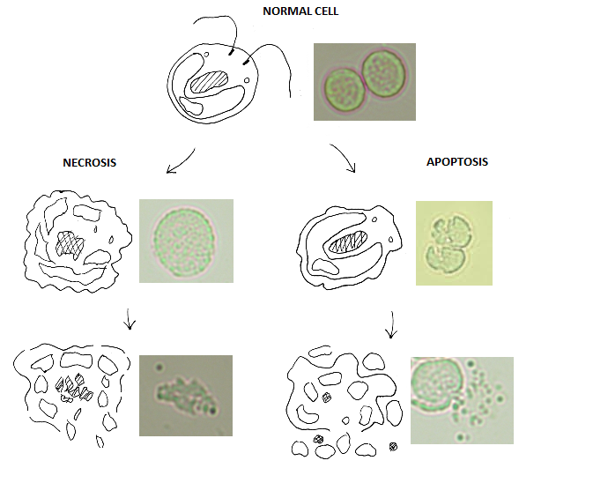

Figure 8 - A representation of cellular morphology of C. reinhardtii during necrosis and apoptosis with corresponding microscope images. Control image of no irradiation of normal cell. UVB intensity at 1.5 W/cm² for 300s (equivalent to 450 J/cm² UVB) for both necrosis and apoptosis. Irradiation and microscopy carried out as in materials and methods Section 2.4.

Ultraviolet light compared to conventional disruption
Ultraviolet light as a method for algal cell disruption is a non-mechanical technique which differs from most conventional methods. There are other disruption techniques that utilise non mechanical means such as chemicals, enzymes or microwaves but ultraviolet light is particularly effective because it targets DNA specifically; effectively shutting off an organism’s ability to function [120]. Additionally, water is highly transparent to UVB and hence no energy is wasted in treating the water, only the algae are affected [124]. Measuring UV absorption during irradiation of the culture to calculate the efficiency of UV absorption of the culture would have been advantageous in order to optimise cuvette path length or culture density. However, unfortunately this was not possible with standard equipment and the required instrument is prohibitively expensive.
However, the magnitude of cellular damage depends on what sections of DNA have been affected. The biochemical pathway a cell enters following random DNA damage may have a large variance and thus the effect on morphology and the cell wall will also vary. It is also important to consider the secondary effects of UVB radiation; such as reactive oxygen species generation and their effect on intracellular biomolecules. The resultant damage either to DNA or other biomolecules differs from conventional cell disruption and thus a method was devised to determine if sufficient damage occurs for effective biodiesel production.

UV radiation as a disruption method for biodiesel production
Samples of C. reinhardtii were irradiated with UVB radiation (1.5 W/cm²) alongside bead beaten samples as a control before lipid extraction and transesterification to determine efficacy of UV radiation as a disruption method for biodiesel production. A detailed explanation of the experiment is within the methods section. Samples of C. reinhardtii were irradiated for 300s or bead beated. The samples were then solvent extracted with methanol:chloroform mixture (1:2) before heating at 80ºC for 90 minutes with 10% BF₃/methanol. Following this the samples were submitted for TR-FAME GC column FID analysis in hexane.
Fatty acid methyl esters (FAMEs) produced from C. reinhardtii samples that underwent lipid extraction and transesterification are shown in Figure 9, demonstrating that the new UVB radiation method was more effective than bead beating, bead beating having 45.3 mg/L culture and UV irradiation having 79.9 mg/L culture (approximately 0.7 mg/ml algal culture density). Meaning an approximate lipid extraction of 7.7% and 11.3% for bead beating and UV irradiation respectively. This indicates ultraviolet light is an effective method to disrupt algal cells for biodiesel production. The simplicity of using light for disruption has great potential for scaling the technology to an industrial level. In fact, flowing a culture past an ultraviolet bulb could be a simple continuous way to disrupt a culture. It may even be possible to recycle growth medium afterward.
Additionally, a t-test was run on the data in Figure 9 between bead beating and UV irradiation FAME yields and came out to a significance of p = 0.31, as described in Section 2.6.1. Whilst this is not below the confidence threshold of 95%, care must be taken when interpreting this information as it does not indicate that the method is not suitable for the disruption of algae or enhancement of lipid extraction. It does however point out that additional data is required in order to ascertain for certain how effective ultraviolet light is when compared to bead beating. The trends indicated in this data and additional data in chapter 4 show that UV irradiation has promise as a method for cell lysis and enhancing lipid extraction from algae. Ideally in the future it would be tested on a larger scale with multiple repeats to give a more thorough statistical investigation.

Figure 10 - Comparison of biodiesel yield from disruption methods of nitrate rich C. reinhardtii culture. Fatty acid methyl ester yields from both bead beating and ultraviolet light irradiation disruption is shown above. Yields represent transesterified lipids from 1L of culture. UVB intensity at 1.5 W/cm² for 300s (equivalent to 450 J/cm² UVB). Irradiation and bead beating carried out as in materials and methods Section 2.4. n = 1 for bead beading, n= 2 for UV irradiated samples. Error bars represent the range. The legend indicates different FAME chain lengths.
Figure 9 - Comparison of biodiesel yield from disruption methods of nitrate stressed C. reinhardtii. Fatty acid methyl ester yields from both bead beating and ultraviolet light irradiation disruption is shown above. Yields represent transesterified lipids from 1L of culture. UVB intensity at 1.5 W/cm² for 300s (equivalent to 450 J/cm² UVB). Irradiation and bead beating carried out as in materials and methods Section 2.4. n =2. Error bars represent the range. The legend indicates different FAME chain lengths.

Lipid peroxidation and biodiesel yield
Prior to experimentation on the effect of high intensity ultraviolet light on algae, it was hypothesised intracellular compounds such as lipids and proteins may be damaged and thus there is the possibility they will no longer be commercially valuable. The effect of UV on proteins requires further investigation, however the effect on lipids was less than anticipated and in fact proved a better extraction method than bead beating. UVB/A irradiation promotes formation of reactive oxygen species which is indicated to be the major cause of lipid peroxidation [123]. However, when compared to bead beaten samples from a lipid rich culture FAME production was higher (see Figure 9); UV irradiated samples have higher yields. The major difference between the lipid yield was an increase in C:8 and particularly C:10 chain lengths. Interestingly this difference is not the same in Figure 10, though as the FAME levels detected in Figure 10 were so low it is difficult to draw any conclusions. Typically FAME produced from algae is high in the C16 and C18 chains and are the most suitable chain lengths for biodiesel [125]. Future FAME profiles in this thesis follow this trend as shown in Figure 16-B where the majority FAME peaks are C16 and C18. Nevertheless due to an increase in overall FAME without a significant decrease in any particular FAME chain length this led to the conclusion that the lipids were not damaged sufficiently by UV radiation to reduce the yield of biodiesel.
In Figure 10 UV irradiation and bead beating have similar FAME profile intensities, however this is most likely due to low intracellular lipid content. Work et al. looked at FAME yield of Chlamydomonas following a simple in situ thermal lysis and transesterification [126]. Whilst not industrially scalable this does give a good indication of a total lipid yield following nitrogen starvation, with their Chlamydomonas strain producing approximately 40 mg FAME/L culture (approximately 2.5 × 10⁶ cells/mL). Comparing to Work et al. FAME yield from C. reinhardtii grown in nitrate rich media was approximately half as seen in Figure 10 [126]. This highlights harvest time as crucial for maximum biodiesel yield.

Ultraviolet light cell disruption energy efficiency
In order to determine the efficacy of a cellular disruption technique the energy cost must be weighed against the disruption efficiency, especially for a biofuels application. The Bluewave dymax curer light source draws 75W of power to function. Approximately 225s of irradiation results in 90% cell lysis of a 3 mL aliquot of C. reinhardtii; this translates to an energy consumption of 5.6MJ/L algae or 8 KJ/mg algae. It should be noted this is for a UV irradiation path length of only 3 mL with an approximate culture density of 0.7 mg/mL. Should a culture be concentrated through centrifugation, it is probable that higher efficiencies could be achieved using appropriate intensity, duration and path length. Eventually a limit will be received where path length or culture density becomes too great for UV to pass through the culture, and this needs to be determine in future to allow scale up of the technique.
This is considerably lower energy (approximately 13 times) than other methods as shown by McMillan et al. such as microwave treatment, which achieved 94.92 ± 1.38% lysis with an energy consumption of 74.6 MJ/L algae (1.8 × 10⁸ cells/mL) [127]. Though it should be noted that the above 95% disruption efficiency was achieved with Nannochloropsis oculata; a smaller algae with a resistive cell wall. However, the fact that UV irradiation does not need to mediate the cell wall to cause disruption suggests disruption efficiencies will be similar across many species. Disruption efficiencies for D. salina and C. reinhardtii are comparable in their stationary phase and support that theory. This energy efficiency could further be improved upon through the use of reflective surfaces, more efficient bulbs or balancing irradiance intensity against duration.

Conclusion
This chapter was aimed at demonstrating that ultraviolet light can be used as a method for algal cell disruption and can enhance lipid extraction. Through techniques of microscopy, transesterification and gas chromatography flame ionisation detection it has been shown that UV irradiation causes cell death/disruption and enhances lipid extraction by solvents and subsequent biodiesel production. When compared to a traditional cell disruption method such as bead beating, UV disruption was more efficient. More specifically approximately 225s of irradiation (equivalent to 335.7 J/cm² UVB) resulted in 90% cell lysis of a 3 mL aliquot of C. reinhardtii; this translates to an energy consumption of 5.6MJ/L algae (UVB intensity at 1.5 W/cm²). In turn bead beating has similar efficiencies to other methods of cell disruption such as sonication or microwaves [67].
Furthermore, GC-FID data indicates that the new UVB radiation method was more effective than bead beating for lipid extraction (measured with FAME yield), bead beating having 45.3 mg/L culture and UV irradiation having 79.9 mg/L culture. This coupled with the presented evidence indicates UV irradiation is a viable method of cell disruption and to enhance lipid extraction and requires deeper investigation across multiple species.
Future research should be aimed at scaling up this process to determine the efficacy of ultraviolet light for processing large volumes of algae for biodiesel production. In addition, the effect of UV light for extraction of other chemicals of commercial value from microalgae should be investigated.

The use of concentrated solar light for biodiesel production from microalgae

Summary
This chapter builds on the previous chapter’s investigation into the use of ultraviolet light to disrupt algal cells and enhance lipid extraction. To this end, research was conducted to determine if sunlight could be used as the source of ultraviolet light to lyse microalgae. This involved the design and construction of a solar tracker that housed a Fresnel lens to concentrate solar energy onto a small area to irradiate cells. The experimental results in this chapter suggest that solar light can be used as a source for ultraviolet light disruption of microalgae cells. In fact, lipid extraction was enhanced in many cases when using ultraviolet light for disruption. Additionally, this technology could be utilised in sunny climates as a method for cell disruption of algae to aid in biofuel production. Excess heat energy generated from solar concentration could also be exploited for growth of cultures or heating water to reduce carbon impact from fossil fuels.

Introduction
The use of solar energy is common in the generation of renewable fuel; for example solar panels, solar collectors, photo-hydrogen, and biofuels all make use of the suns energy to yield fuel. Production of algal biofuel often relies on the visible spectrum of sunlight for growth rather than artificial light from photo-bioreactors, thus reducing costs and energy requirements [128]. Following growth, the algal cells must be lysed to facilitate efficient extraction of their intracellular lipids which can then be converted to biodiesel. The method for lysis varies from several techniques such as sonication, microwave, ultrasound and bead milling, all of which have a high associated energy cost and are expensive to scale up [41].
In a previous chapter the use of ultraviolet light as a method for cell disruption which is effective, easily scalable, has a low energy cost and is cheap was demonstrated. Here the use of the ultraviolet portion of sunlight (UVB/UVA) to lyse algal cells is shown. To achieve this solar light was concentrated using a Fresnel lens which was positioned perpendicularly to the sun using a solar tracker designed for this specific purpose.

Ultraviolet light from the sun
Following the success of utilising ultraviolet light for cell disruption using an ultraviolet curer, the next logical step was to determine if sunlight could be used as the ultraviolet light source to further reduce energy consumption. The UV curer reduced cell disruption energy costs by approximately 13 times, when compared to one literature source, as demonstrated in the previous chapter. However, if the light from the sun could be used as a source of UV to disrupt cells, perhaps further reductions in energy usage could be achieved.
The UV spectrum of the sun is almost entirely made up of UVB and UVA after passing through earth’s atmosphere. UVB is capable of causing direct DNA damage and was the part of sunlight of greatest interest in this hypothesis. However, UVA also causes indirect DNA and cellular damage through the production of free radicals and reactive oxygen species [115].
Sunlight has approximately 59.6 W/m² UVA and 1.8 W/m² UVB based on spectral data from ASTM (American Society for Testing and Materials) recorded as an average across America, as seen in Figure 11. The original idea was to concentrate 1m² of sunlight to 1cm² using a lens, thus using a curer with approximately 1.8 W/cm² seemed appropriate for initially testing ultraviolet light as a method for disrupting cells. Prior to testing the hypothesis of using ultraviolet light as a method for cell disruption, the idea of using sunlight as the UV light source was conceived. For this reason, the experiment was designed so that if the hypothesis proved true, it would be simple to compare to the results of testing concentrated UV light from sunlight as a method for cell disruption. In fact, using a curer with UVC would most likely be more effective due to increased DNA damage. The DNA absorption spectrum has an absorption maximum around 254nm, which is similar to the spectral maximum of most UVC bulbs, thus it’s likely a UVC bulb source would be more effective [129]. However, in this case the aim was always to eventually use sunlight as the UV source.
A UV curer that mimicked the suns wavelengths was used for experimentation. The intensity of the UV is approximately 9 W/cm² UVA (320-395 nm) and 1.5 W/cm² UVB (280-320 nm). The intensity of 1m² UVA in sunlight concentrated to 1cm² is considerably greater than this, however finding a light source with the exact requirements proved difficult. The curer was chosen as it was decided that UVB was the more important variable as it can damage DNA directly and as it was freely available.
Figure 11 - Solar spectral irradiance. Data from reference spectra ASTM G173-03.

Concentrating sunlight
Concentrating such a large area of sunlight proved to be a difficult challenge, especially when keeping the costs reasonably low. Initial ideas included parabolic mirrors with a flow cell at the focal point to irradiate the algae and using a giant lens. Problems arose when designing a system that was robust enough to concentrate the UV portion of sunlight safety as well as efficiently. Parabolic mirrors have the obvious problem of keeping the mirrors clean. Mirrors of sufficient quality and size are also expensive.
Whereas the problem with using a conventional lens is that the material would have to be made of either quartz or a UV transmitting plastic. The size, weight and cost of a conventional lens were also a problem.

Fresnel lens
Following the realisation that using a conventional lens was too complex, a Fresnel lens appealed as a simple solution. French physicist Augustin-Jean Fresnel first integrated the lens into lighthouses to collimate light; allowing light transmission over long distances [130]. Fresnel lenses can also be used to concentrate large areas of light to a focal point with a short focal length. Additionally, they can be easily manufactured from plastic (polymethyl methacrylate in this case with a UVB cut off of 270nm) and require much less weight and volume than a traditional lens for a given area [131].
Initially a Fresnel lens of 1m² was decided to be the optimum size to collect the required sunlight. However, the largest a supplier could cast a lens with suitable UV transmitting polymethyl methacrylate was 0.164m², which is approximately 6 times smaller than originally desired. However, given this was the only option and a reasonably large area could still be concentrated it was concluded that the investigation was worth continuing.
Experiments began with simply holding the Fresnel lens in place perpendicularly to the sun and irradiating a culture in water cooled quartz cuvette for 30 seconds. Microscopy showed it had a negative effect on the viability of cells but a more precise method for irradiation was required for further experimentation.
The lens as seen in Figure 12 has a circular design with a diameter of 470mm with 143 grooves per inch. These concentric grooves act as prisms, all refracting light to the same focal point [130].
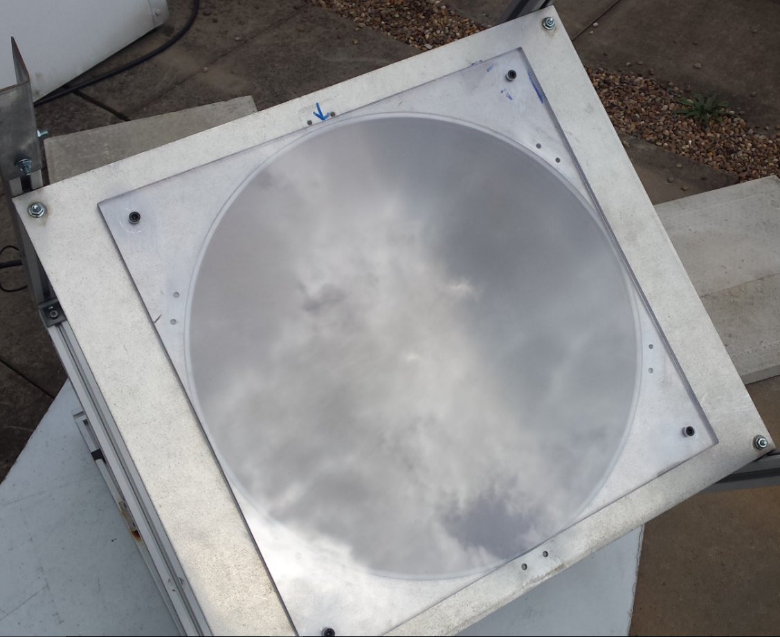
Figure 12 - Circular Fresnel lens covered with square polycarbonate sheet.

Solar tracker
A solar tracker which held the lens in place and followed the path of the sun across the sky was chosen as a suitable method for precisely irradiating cultures with some repeatability. The inherent nature of the sun’s varying irradiance and earth’s atmospheric conditions means that the irradiance a culture experiences is not always the same. Additionally, the weather and time of day have a huge impact on the irradiance so it is almost impossible to perform experiments that are true replicates. However, human error can be eliminated using a solar tracker.
The tracker was able to hold the Fresnel lens in place and align it perpendicularly to the sun. This was achieved by constructing an aluminium frame to hold the Fresnel lens that has two motors to control angle of elevation and rotation. This allowed the sun’s path to be followed throughout the day. The methods chapter explains the construction and operation of the device in detail. An Arduino microcontroller was programmed to move the motors based on the light intensity of 4 light dependant resistors (LDRs). The four LDRs were positioned in parallel in the four corners of the tracker. Their resistance varies with light intensity; thus a potential divider circuit was used to convert the varying resistance to voltage for the Arduino to measure, see Figure 5 Section 2.7.
A simple program controls the motors to move the lens to sit perpendicularly to the sun. If the lens isn’t in its correct position the LDRs don’t have equal resistances due to the different light intensities; only when they’re all perpendicular to the sun is the light
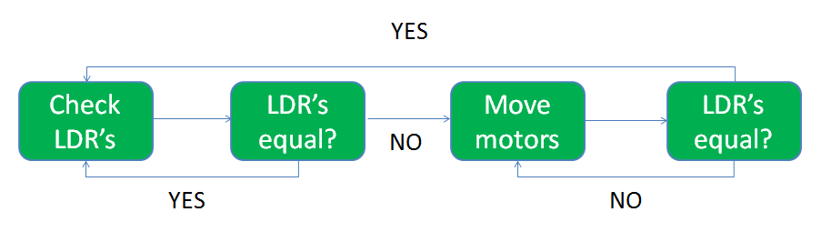
intensity equal. Differences in resistance result in differences in voltages the Arduino reads. Thus the motors move to realign the tracker until the voltages are equal (within a given tolerance). The programming code was partially based on [175]; however, Figure 13 displays the basic loop.

Figure 13 - Basic programming loop logic used to control the solar tracker.

Concentrated solar irradiation of algae
The solar tracker was successfully built and waterproofed before installation onto the University of Sheffield’s Department of Physics and Astronomy roof. This location was ideally suited as there are few adjacent buildings and the sun is not blocked at any point during the day. The waterproofing ensured the tracker was still functional a year after installation.
Unfortunately, a quartz cuvette filled with algae could not simply be placed at the focal point of the Fresnel lens because of the risk of overheating. The sealed cuvette would likely explode due to the rapid boiling of water and resultant steam explosion. There is far more infra-red and visible energy present than in the curer. To put this energy into perspective, during testing of the lens, a wooden plank was ignited in under a second in full summer sunlight. Also too much heat would likely damage the lipids within cells. In addition, the quartz cuvette sat in a water bath for cooling during UV curer irradiation, whereas this is not possible on the tracker due to the angle of the bottom plate, the restricted space and limited mass the motors could move.
To tackle this problem a quartz flow cell with water cooling was constructed using quartz sheets and silicon sealant, however the algae aggregated as the dimensions were not well suited for a low flow rate. A 3rd year student’s project then looked at developing an aluminium flow cell with dimensions suitable for algae flow and also incorporated a IR-Visible filter that blocked the majority of wavelengths of light other than UV. This flow cell was designed to dissipate heat quickly and allow for maximum algae irradiation using reflective surfaces. Unfortunately, upon testing the dimensions did not allow for a slow enough flow and algae aggregated once more. In addition to this the IR filter shattered under the irradiance.
A more suitable design could be achieved, however, in the interest of time and expense a simpler approach was opted for. Aliquots of algae were irradiated in a quartz cuvette at the lenses focal point and cooled using water from a hose that was taped in place with a high flow rate to dissipate heat. Whilst laborious this did mean a sample could be quickly irradiated ready for the next.
The summer of 2015 had exceptionally few days with clear sky and UV light is mainly present between the hours of 11am and 1pm in the UK, meaning this research had to be carried out quickly with little time to preplan. The unpredictably of the weather also meant several attempts yielded no significant data due to cloud cover. Previous attempts in other seasons showed no increase in lipid extraction as detailed later in this chapter.

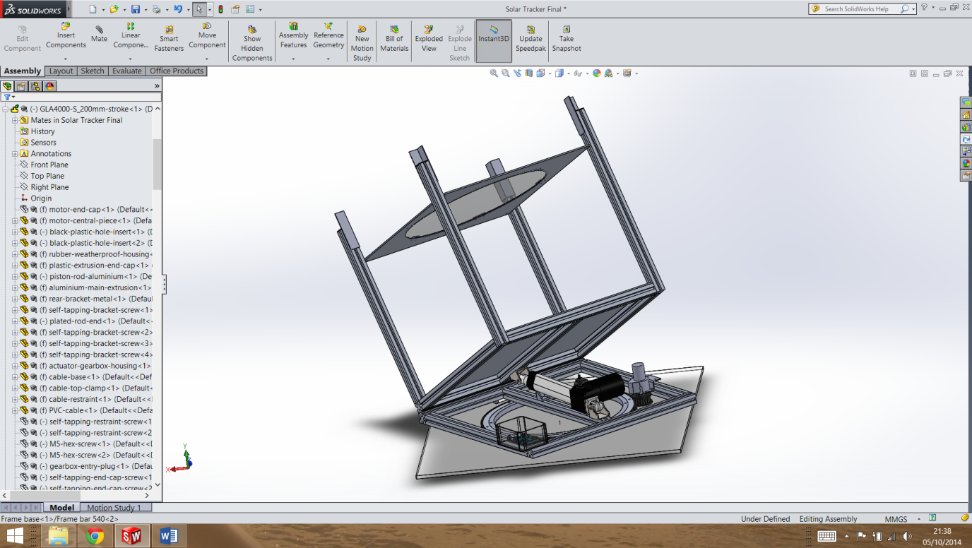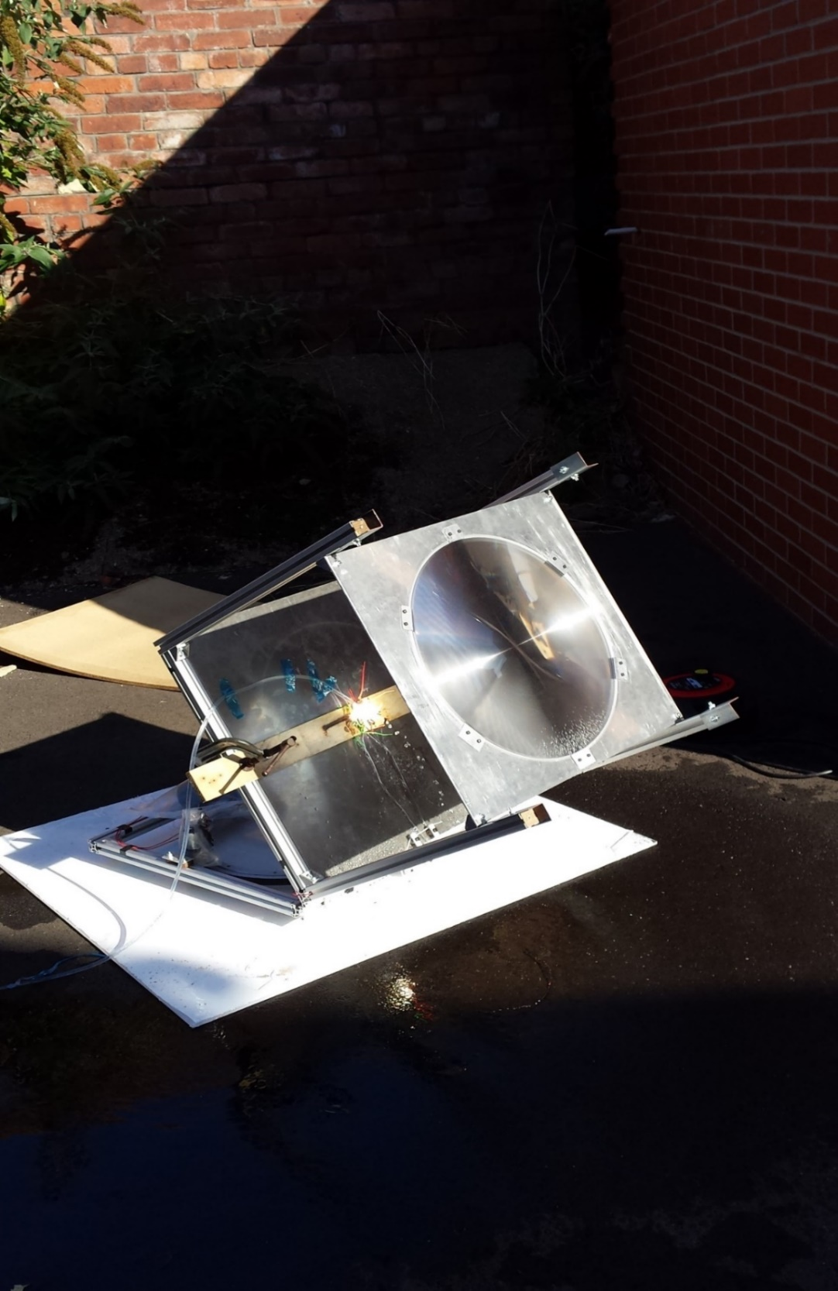
B
A

Figure 14 - A. Schematic representations of solar tracker in Solidworks ®Dessault systems.
B. Built solar tracker demonstrating solar concentration.

Results and discussion

Ultraviolet light irradiation from solar tracker
As seen in Figure 15, concentrated solar irradiance of aliquots of C. reinhardtii yielded little FAME following lipid extraction and transesterification. Previous attempts in winter months to utilise UV from sunlight produced similar results, indicating that UV light levels were too low to cause any cell disruption. It is interesting to note that FAME concentrations are lower in irradiated samples than even control samples where no concentrated light exposure has occurred. A likely explanation of this is that the intense IR/visible energy caused damage to any extracellular lipids present [132].

Figure 15 - Comparison of biodiesel yield from concentrated light exposed growth phrase Chlamydomonas reinhardtii. Fatty acid methyl ester yields from both bead beating and concentrated solar irradiation disruption is shown above at various treatment durations. Vast majority of FAMEs are C16 AND C18 chain lengths. Yields are scaled to represent transesterified lipids from 1L of culture. UVB intensity at 1.5 W/cm². BB = Bead beating, Con = Control. Irradiation, bead beating and control carried out as in materials and methods Section 2.4. n = 1 for bead beading and control, n= 2 for UV irradiated samples. Error bars represent the range.
Given the lack of success in winter or during low UV light levels it was determined that a clear sunny day with high UV levels was required to test the hypothesis that algae can be disrupted using UV from sunlight. A preliminary experiment can be seen in Figure 16-A. A trend of increasing FAME extracted from C. reinhardtii can be seen until after 45 seconds where FAME yield begins to decrease. This is again assumed to be due to intense radiation on the lipids, causing oxidation and eventual oligomerisation [132]. It is also important to note that FAME yield was actually higher than bead beating. Whether this is due to improved disruption and thus improved lipid extraction or a cellular mechanism such as sequestration of membrane lipid or conversion of lipids usually unable for transesterification is unclear.
In fact, P. antarctica has been shown to increase total lipid fatty acid and TAG concentrations upon exposure to UVB light by Skerratt et al [133]. Sharma et al. review methods for inducing increased lipid production through stressing microalgae [110]. Interestingly they show UV light can increase lipid production. The time scale and intensity for irradiance in the reviewed studies is much lower than the experimental work presented here but it is still significant. They note that UV light has been suggested for lipid induction in large scale cultivations systems. The cellular mechanisms are unclear with conflicting literature reports of both structural and storage lipids being shown to increase and decrease concentrations upon UV irradiation depending on the species [133,134]. However, oxidation from UV was speculated to be the reason for decreases. It is clear that the effect of UV radiation at these lower dosages on microalgae is species dependant [110].
Regardless, it is clear that the increase in ultraviolet light in the summer has played a key role in increasing lipid extraction from cells irradiated using the solar tracker. Microscopy also confirmed that cells were disrupted and showed necrotic and apoptotic cells. Maintaining a balance between UV light and IR/visible is evidently important and in future an infra-red/visible filter would be preferential for any large scale operation. However, for research purposes this became too expensive to further query.
Figure 16-B shows a follow up experiment to scope repeatability of using UV from sunlight, this time repeats were possible due to clear skies and sunny weather. It can be seen that a similar trend is present though at a larger general FAME concentration than in Figure 16-A because the culture was now in late stationary phase. The FAME profile also shows again the fact that the concentrated solar radiation may be causing damage to lipids, which may come about from peroxidation through IR radiation.
The unpredictable weather meant it was difficult to predict when the experiment would be possible. In this case there is a larger variance in FAME yields and less of a clear trend. This is presumably due to the huge variability of solar radiation that a given sample will be exposed to. Experimentally it was difficult to remove any of these variables due to weather and atmospheric conditions. Attempts were made to measure UV light using a light meter for normalisation; however the instrument was not sufficiently sensitive to measure the variance and did not have the correct absorption range to obtain a full absorption spectrum. Additionally, given the lack of clear sunny days in the UK, these experiments were carried out whenever possible which meant sampling had to be performed rapidly with little warning. There was very little chance of repeat measurements due to the unreliability of the weather, but the data shows a similar trend even with the large variance. To gain further insight into the effects of concentrated sunlight on algae for lipid extraction a more thorough experiment would need to be performed. Namely where intensities of wavelengths of light could be measured and blocked if necessary. Moreover, a location with more predictable weather patterns and high solar irradiance levels would be preferred.

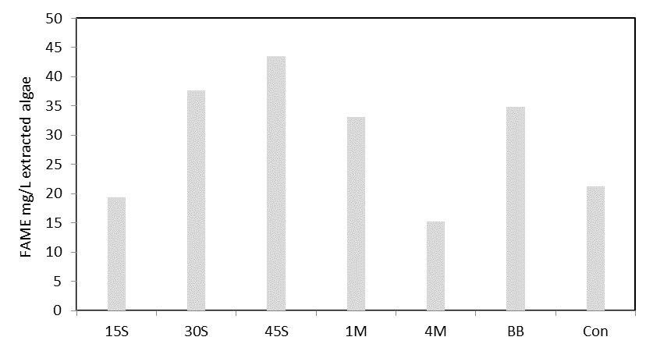
A
B

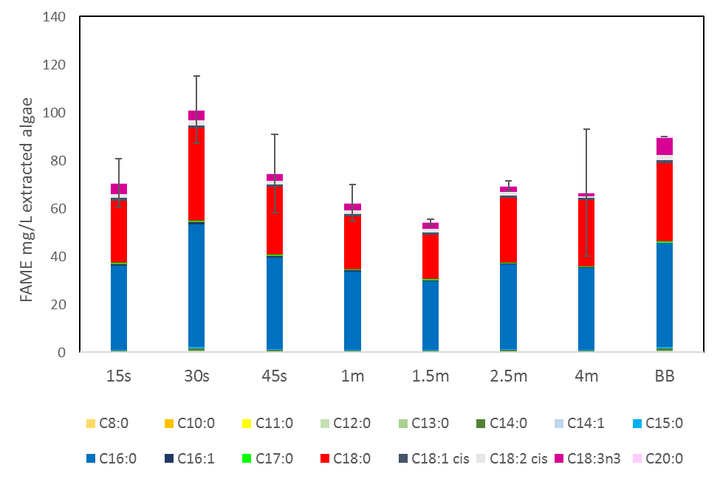

Figure 16 - Comparison of biodiesel yield from concentrated ultraviolet light exposed Chlamydomonas reinhardtii. Fatty acid methyl ester yields from both bead beating and concentrated solar irradiation disruption is shown above at various treatment durations. Vast majority of FAMEs are C16 AND C18 chain lengths. Yields are scaled to represent transesterified lipids from 1L of culture. UVB intensity at 1.5 W/cm². BB = Bead beating, Con = Control. Irradiation, bead beating and control carried out as in materials and methods Section 2.4. Error bars represent the range. A. Preliminary test of biodiesel yield from C. reinhardtii under solar concentrated UV light. n = 1. B. Repeat experiment of biodiesel yield from C. reinhardtii under solar concentrated UV light. n = 1 for bead beading, n = 2 for UV irradiated samples. The legend indicates different FAME chain lengths.

Infra-red and visible irradiation from solar tracker
In order to fully ascertain that the UV portion of sunlight was the key factor in increasing FAME yield a polycarbonate sheet was placed on top of the lens to block UV light. The sheet was 12mm thick in order to fully block ultraviolet light but transmitting visible and infra-red as seen in Figure 12. The effect of concentrated UV filtered sunlight on FAME yield from C. reinhardtii is shown in Figure 17. The experiment was performed on a sunny day with clear sky with high UV. As predicted the data is similar to the FAME yield on a day with low UV, suggesting the key part of sunlight responsible for the increase in FAME yield in Figure 16 A and B is the UV range. Intense thermal radiation has previously been shown to be detrimental to lipid integrity as well as in these data sets [132]. Due to UV light being the only variable that was absent when FAME yield was low indicates it is responsible for the increase in FAME yield. Using the data in Figure 17, Figure 16-B and the evidence in Section 3.7 is can be concluded that IR radiation is responsible for the decrease in FAME yield following the maximum yield at 30s in Figure 16-B. It appears that the C16:0 chains are the most susceptible to lipid degradation from IR radiation.

Figure 17 - Comparison of biodiesel yield from concentrated light exposed Chlamydomonas reinhardtii. Fatty acid methyl ester yields from both bead beating and ultraviolet light irradiation disruption is shown above at various treatment durations. Vast majority of FAMEs are C16 AND C18 chain lengths. Yields are scaled to represent transesterified lipids from 1L of culture. A polycarbonate sheet was fitted on top of the lens to block UV light. UVB intensity at 1.5 W/cm². BB = Bead beating, Con = Control. Irradiation, bead beating and control carried out as in materials and methods Section 2.4. Error bars represent the range. n = 1 for bead beading, 15s and control, n = 2 for other UV irradiated samples.

Ultraviolet light irradiation from curer compared with concentrated solar irradiation
In the previous chapter ultraviolet light from a curer was demonstrated to disrupt algal cells and increase FAME yield beyond that of a typical lysis method, bead beating. An experiment was designed to compare the efficacy of UV light from concentrated sunlight and the UV curer to increase FAME yield. To this end aliquots of C. reinhardtii were irradiated for various durations at 1.5 W/cm² UVB before lipid extraction and transesterification.
Figure 18-A shows the effect of ultraviolet light irradiation from the curer at various durations on FAME yield from C. reinhardtii. A trend of increasing FAME yield with increased irradiance duration is evident. This was expected and reinforces previous data that a sufficiently large dosage of ultraviolet light leads to cell disruption and thus increased lipid extraction.
However, another experiment was performed to determine the effect of ultraviolet light on a nitrogen stressed stationary phase culture of C. reinhardtii. As seen in Chapter 3, log and stationary phases have a huge impact on a cells viability following a given dose of UV radiation.
An experiment to determine the effect of ultraviolet light on a culture that undergoes stationary phase and is then nitrogen stressed was the next logical step. However, the results were unexpected and brought about various questions.
Figure 18-B shows the effect of ultraviolet light irradiation from the curer at various durations on FAME yield of nitrogen stressed stationary phase culture of C. reinhardtii. The trend is the opposite of what would be expected. The highest FAME yield resulted from the lowest irradiance duration and with increasing duration FAME yield decreases until levelling off approximately equal to bead beating and the control samples. This immediately raises the question as to why bead beating (approximate total lipid) and the control have similar yields yet low dosages of UV appear to have higher yields. The only probable explanation appears to be that the cells are in a state of high solvent permeability. Meaning solvent easily penetrates into cells and extracts the majority of intracellular lipids.
This could be due to multiple reasons and likely not a single one alone. Firstly, the cells may have only just left the log phase and entered their stationary phase; cells during log phase are more vulnerable as their intracellular “machinery” are preparing for fission or the cell may require motility. Cells may also still be vulnerable from increased DNA exposure due to recent fission.
In fact, Blackwell et al. showed that the alga Chlorococcum submarinum increase cell wall thickness during stationary phase, a trait likely shared across many species [135]. It is probable C. reinhardtii behaves similarly and thus may not have increased cell wall thickness in their earlier stationary phase [135].
The culture may have been under high shear during mixing or be unhealthy due to a nutrient deficiency which can lead to cell damage or osmotic stresses. However, in this case both scenarios seem unlikely as fresh media was made up and the subculture was from a healthy stock. The culture was also under only continuous light stirring.
It may also be due to gamete formation during sexual reproduction. During sexual reproduction cells fuse and at one point the cell wall is partially digested accommodate this, which would allow solvent to permeate a cell more easily [2,136]. Nitrogen stress can also initiate autophagy which may limit the cells ability to elicit defence mechanisms [137].
However, this doesn’t address the increased FAME yield from low irradiances. A possible explanation is that exposure to short dosages of UV radiation causes the cell to undergo a defence mechanism similar to that in salt or nitrogen stress [138]. Nitrogen stress can cause cells to sequester lipids from the cell membrane for conversion to triacylglycerol which may increase solvent permeability [139]. In fact Hu et al. note that under various stresses algae can increase lipid concentration through de novo synthesis or conversion of existing membrane polar lipids into triacylglycerols [138]. UV stress may also cause cells to undergo a similar mechanism.
Therefore the cell could be storing lipids for survival or convert cell membrane lipids into a more useable forms [138,139]. However, as irradiation duration continues this response is mitigated as the cell abandons long term defence strategies in order to survive.
The overall effect being that the solvent extracts the majority of intracellular lipids due to a more permeable cell wall and low dosages of UV cause cells to increase free lipid content as a defence mechanism.

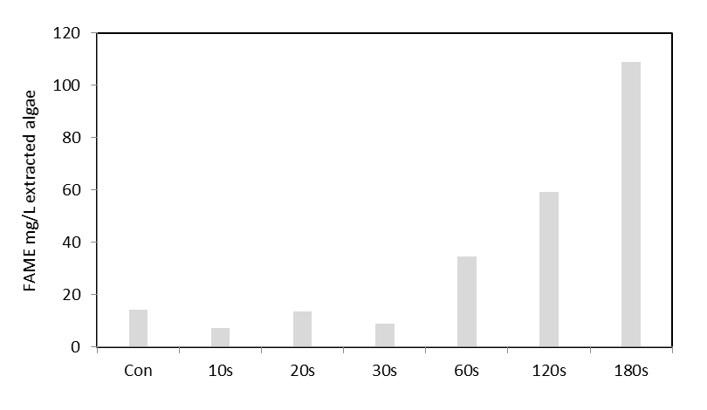
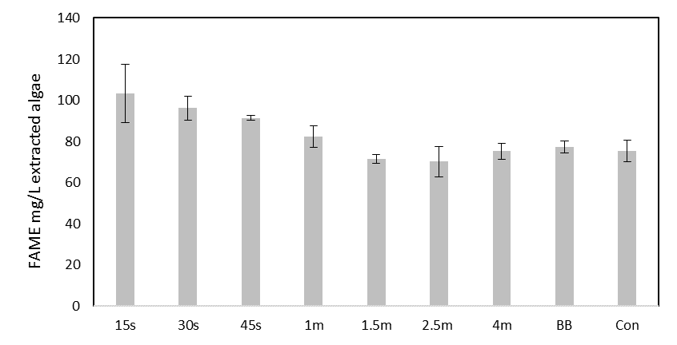
A
B
Figure 18 - Comparison of biodiesel yield from ultraviolet light exposed Chlamydomonas reinhardtii. Fatty acid methyl ester yields from both bead beating and ultraviolet light irradiation disruption is shown above at various treatment durations. Vast majority of FAMEs are C16 AND C18 chain lengths. Yields are scaled to represent transesterified lipids from 1L of culture. UVB intensity at 1.5 W/cm². BB = Bead beating, Con = Control. Irradiation, bead beating and control carried out as in materials and methods Section 2.4. Error bars represent the range. A. Yields from UV exposed stationary phase C. reinhardtii. n = 1 B. Yields from 72 hours of nitrate stressed UV exposed C. reinhardtii, nitrate stressing carried out as in Section 2.2. n = 2.

Lipid extraction efficiency
In order to test the hypothesis that the cell wall may be more vulnerable during early stationary phase or when under nitrogen stress a simple experiment was conducted. A nitrate stressed C. reinhardtii culture was irradiated with UV light and subjected to lipid extraction. Cells were exposed to 45 seconds of UV radiation or no radiation as a control. Following this lipid extraction was undertaken on the samples for different times; either a normal solvent extraction or a quick solvent extraction, both with 1.2 mL methanol:chloroform mixture (1:2) as previously described in the materials and methods Section 2.5. Under normal circumstances the cells are exposed to solvent for approximately 15 minutes. A quick solvent extraction was approximately 5 minutes. Figure 19 shows the difference in FAME yield between the two extraction methods.

Figure 19 - Comparison of biodiesel yield from UV light exposed Chlamydomonas reinhardtii with different solvent extraction durations. Fatty acid methyl ester yields from both bead beating and ultraviolet light irradiation disruption is shown above. Vast majority of FAMEs are C16 AND C18 chain lengths. Yields are scaled to represent transesterified lipids from 1L of culture. Nitrate stressed 72 hours, N (15 min) and Q (5 min) denote normal and quick solvent extraction respectively as detailed above. Nitrate stressing carried out as in Section 2.2. UVB intensity at 1.5 W/cm². Con = Control. Irradiation and control carried out as in materials and methods Section 2.4. n = 1.

The experiment highlights the fact that the control and UV samples under normal solvent extraction have almost the same FAME yields. However, quick solvent extraction exhibits that FAME yield in the control is not as high as UV. Meaning lower solvent exposure resulted in a smaller lipid extraction in non-disrupted cells. UV exposed cells that underwent quick solvent extraction had a FAME yield almost as high as normal solvent extraction. This shows that the cells likely have increased permeability to solvent during early stationary phase/nitrogen stressing because a normal extraction resulted in similar yields between control and UV samples. However, during quick extractions the solvent was unable to fully permeate cells to extract lipids but had increased lipid extraction when cells were disrupted after UV radiation.
A more in depth study of the effects of cell cycle and health is clearly needed to understand its full effects on lipid extract efficiency. The data presented here shows the interaction between solvent and cells for intracellular extraction is complex. In fact in the majority of cases, research is focussed on maximising extraction yield through mechanisms such as nitrate stress and little focus is placed on how the cell biology may impact physical extraction processes.

Ultraviolet light irradiation of Micractinium inermum
Following the irradiation of stationary phase C. reinhardtii it became apparent that whilst it is a useful species for study due to its growth characteristics and lipid yields, its electrostatically linked glycoprotein cell wall is not as strong as other more resilient species of algae [10]. In particular species such as Chlorella which possess a thick covalently linked cell wall that often has to be freeze thawed several times to lyse [10]. Micractinium inermum is another species which is similar to Chlorella and has a thick cell wall. Previous chapters demonstrate that ultraviolet light is capable of disrupting both C. reinhardtii and D. salina, however both lack thick cell walls that are difficult to disrupt. Therefore M. inermum was exposed to ultraviolet light at various dosages to determine its efficacy for cell disruption and FAME yield following lipid extraction and transesterification.
Figure 20 shows that with increasing UV irradiance, FAME yield from M. inermum increases. The duration of exposure required to fully extract lipids is much longer than seen with C. reinhardtii. This is likely due to the increased cell wall thickness and covalent nature. Bead beating was performed for 2min cycles fifteen times as opposed to 1min to ensure the cells were sufficiently disrupted.
As expected the irradiation duration required was much higher but ultimately successful due to the mechanism by which UV light causes cell disruption; primarily though DNA damage. Even with the thick cell walls and smaller cells UV light successfully disrupted the cells given a high enough duration.
This approach is far quicker and has fewer steps involved than using a traditional freeze thaw or many bead beats, as well as scaling more easily to industrial applications using a flow cell.

Figure 20 - Comparison of biodiesel yield from UV light exposed Micractinium inermum. Fatty acid methyl ester yields from both bead beating and ultraviolet light irradiation disruption is shown above. Vast majority of FAMEs are C16 and unsaturated C18 chain lengths. Yields are scaled to represent transesterified lipids from 1L of culture. UVB intensity at 1.5 W/cm². BB = Bead beating, Con = Control. 20 min over 30 min represents 40 seconds of irradiation per minute for 30 minutes. Irradiation, bead beating and control carried out as in materials and methods Section 2.4. Error bars represent the range. n = 2.
Bead beaten samples that underwent lipid extraction and transesterification had a smaller FAME yield. Perhaps as in the case of C. reinhardtii this could be due to a UV stress effect causing the cell to undergo de novo synthesis or conversion of existing membrane polar lipids into triacylglycerols. However, it is possible that UV radiation allows for enhanced lipid extraction due to cells packaging lipids into apoptotic bodies or simply that necrotic cell rupture causes more catastrophic cell wall damage than the physical process of bead beating. Regardless of the mechanism, in the cases of both C. reinhardtii and M. inermum, UV radiation has been shown to be a more effective cell disruption method than bead beating for lipid extraction.

The effect of ultraviolet light to disrupt cells and increase lipid extraction
The FAME yields from both C. reinhardtii and M. inermum following UV radiation demonstrate this technique as a viable alternative for cell disruption for algal biofuel. In fact, further research may conclude that UV radiation could be used as a possible downstream processing tool for microalgae in many algal biotechnological applications. The fact that UV radiation is already used for sterilisation of drinking and waste water means the infrastructure is already present to support this [140].
Using a UV curer is the optimal choice for a biotechnological application due to its ease of use and reliability (though a specific UV irradiation system would likely be developed for industry). However, the data presented on the use of a solar tracker for UV light concentration show it is possible to use sunlight as the UV source to disrupt algal cells for lipid extraction. Using sunlight in a biofuel application would be the preferred choice due to the cost and energy savings; however this would only work in a prevalently sunny climate. Additional research needs to be performed to conclude the ideal conditions for UV concentration such as wavelength selection and irradiance duration. However, the work presented here confirms its possibility as a low energy disruption method for algal cells, which would be particularly useful for algal biofuel production.
The data presented on the UV irradiation of C. reinhardtii shows a complex relationship between cell cycle/health and lipid extraction efficacy. Whether or not cell disruption occurs, the cell cycle and health of the cells clearly plays a huge role in susceptibility to solvents, as the data suggests. The variance between lipid extraction efficiency of C. reinhardtii across the figures presented indicates differences in solvent extraction efficiency, especially in the control samples. It would be expected that beat beating would always have a far larger lipid extraction that the control (where no disruption occurs). However, in some cases (including omitted data) the control samples had a similar efficiency to BB and UV. The only explanation to this (given its repeated occurrence) is that a cultures health and in particular its cell cycle phase is important, and impacts solvent permeability of cells. This is further shown by the difference in lipid extraction efficiency depending on solvent contact time in Figure 19. A shorter contact time leading to smaller FAME yield.
The effect of cell cycle on solvent permeability has not been previously reported in the literature but as mentioned a possible explanation is that cells in log phase or early stationary phase cells may not have cell wall thickness at optimal levels [135]. Cultures were grown using fresh media and the subculture was from a healthy stock meaning it is unlikely the cells were unhealthy. Again as previously mentioned sexual reproduction can cause cell wall partial digestion leading to increased solvent permeability.
Regardless of the mechanism of increased solvent permeability due to a cultures cell cycle phase, it is clearly important in a biotechnological application and more research is required to ascertain its impacts on extraction of valuable chemicals from microalgae. Whether this effect is conserved across many species is unknown. However, the data presented here is sufficient to confirm that of UV radiation is an effective method to disrupt algal cells for enhanced lipid extraction. In fact, it may even be superior to other methods due to its scalability, high efficacy, low cost, low energy and transmission through water [124].

Conclusion
Putting the magnitude of this work into perspective, approximately 30 experiments were performed which include UV irradiation, lipid extraction, transesterification and GC-FID on multiple samples, which is by no means trivial and takes several days. Much of this data has been omitted due to the cells having too few lipids (possibly due to cell cycle) or low UV levels during summer months. Data that has been presented shows the most coherent depiction of the effect of UV radiation on algal cells for lipid extraction.
This chapter was aimed at determining if solar radiation could be concentrated in order to provide the necessary ultraviolet light to lyse cells in a similar manner to that of the previous chapter. An additional aim was to determine if M. inermum, a thicker cell walled species than C. reinhardtii could be lysed using ultraviolet light.
The ability of UV radiation to disrupt algal cells for lipid extraction has been shown using an ultraviolet curer and solar tracker. UV radiation has been shown as a more effective method for cell disruption and lipid extraction than bead beating, UV radiation (30s) achieving a FAME yield following transesterification of extracted lipid of 101 mg/L extracted algae and 89 mg/L extracted algae for bead beating. Ultraviolet light was also successful in enhancing lipid extraction of M. inermum, UV radiation (30 min) achieving a FAME yield following transesterification of extracted lipid of 226 mg/L extracted algae and 208 mg/L extracted algae for bead beating. A designed and manufactured solar tracker effectively demonstrated the usage of sunlight as a source of UV light for cell disruption. This adds an additional method of algal cell disruption for biofuel production in sunny climates which is cheap and simple.
Future research should focus on using UV for cell disruption on multiple species for extraction of many valuable chemicals produced by microalgae. Additionally, the solar tracker design should be improved upon to select only wavelengths of importance, and utilise the other wavelengths as a method for heating cell cultures.

A recyclable magnetic flocculant for algal dewatering and lipid extraction

Summary
A large bottle neck in algal downstream processing is the harvesting step; where the algal biomass is separated from the culture medium. This generally involves an industrial centrifuge which due to high energy and monetary costs causes this bottleneck to hold back the industry. This chapter explores the use of a novel recyclable magnetic flocculant. This flocculant is comprised of magnetic nanoparticles which are coated with a polymer flocculant and has successfully flocculated algae, with flocculation/deflocculation switchable by altering pH. The novel synthesis method presented allows for industrial scale up, which using traditional synthesis methods would not be possible. The flocculant is capable of concentrating algae and with additional research may reduce the need for large centrifuges in industrial processing of microalgae. Furthermore, the method provides a platform for the synthesis of polymer coated magnetic nanoparticles with many novel properties that could potentially be used for extraction of specific chemicals or species.

Introduction
Microalgae have been used for a wide range of purposes throughout history. In the last century a great deal of research effort has been applied aimed at utilising algae for food and fuel production. They are in fact remarkable micro factories for a variety of useful chemicals and their biology can be manipulated to great benefit. For example, algae have been used in producing vaccines, pharmaceuticals and in a recent publication even to combat cancer [141].
Regardless of the application the algal biomass must generally be harvested before use. This is especially true in the case of biofuel or high value chemicals production. The procedure generally involves an industrial centrifuge. This presents a problem as the high energy and monetary cost associated with centrifuging imposes financial and energy constraints in the downstream processing of microalgae. This has proven to be a difficult problem to solve, even with extremely high biomass and product yield, harvesting proves too costly. This constraint is a major factor holding up development of the industry preventing it from fulfilling the promise the technology holds.
In the case of producing biofuel this is such a bottleneck it often results in a net negative energy production, effectively meaning any advancement in growth, product yield or extraction has negligible impact on the overall viability.
Polymers may be able to provide solutions to this problem as they have applications in many fields and a wide range of practical uses and properties as detailed in Section 1.7 onward. Such applications include packaging material or casing; the polymer polystyrene is often used in such circumstances as it is a cheap thermoplastic that can be used as both in solid form or foamed to fit a desired application.
Many polymers are now used in everyday applications for household commercial needs, however speciality polymers are also useful. Such speciality polymers include pH sensitive polymers which can increase size via swelling upon a pH change and thermoresponsive polymers which respond to temperature changes. Thermoresponsive polymers have promise in the field of biomedicine for drug and gene delivery where a polymer may be able to carry a chemical for release given a stimulus at the necessary site [142]. Polymers are also excellent flocculants due to their repeating unit nature and capacity to have electrostatic groups on monomer residues; they are often used in wastewater treatment [143].
Here the development of a magnetic flocculant that is effective at concentrating microalgae is reported. An important and unique aspect of this work is the fact that the flocculant can be recycled by altering the solution pH or salt concentration. This recyclable nature means the flocculant can be used multiple times and, by pH switching, release bound algae as desired. The magnetic properties allow facile recovery, separation and transport. Once extracted from growth media the algae can be processed for chemical extraction by normal methods or reconstituted into a smaller volume as desired.
The flocculant may also be designed to bind more specifically to one species or chemical group. The concept is based on ionic exchange chromatography (IEC), to obtain specificity, whilst at the same time the discrete nature of the particles allow facile addition of the flocculant to a culture and its subsequent retrieval. Then similarly to IEC, reuse the particles afterward, this being aimed at a quicker, more scalable and cheaper process.
At the chemical level the flocculant is a magnetic iron oxide nanoparticle (MNP) that is coated in polymer with a cross linking agent to ensure the polymer remains fixed around the nanoparticle. The polymer can be tuned to the desired range of binding properties by selecting the appropriate monomers. The synthesis method is rapid, cheap and simple. In brief, the co-precipitation method is utilised for the synthesis of the uncoated iron oxide nanoparticles. The coating is formed through an in situ dispersion polymerisation; the polymer forms around the nanoparticles with crosslinker to form a shell. This requires no surface modification of the nanoparticle, as the polymer is only held around the nanoparticle due to crosslinking.
There is great potential for this flocculant to alleviate the need for a centrifuge in industrial processing of microalgae. Removing this bottleneck in downstream processing would allow the microalgal industry to grow and fulfil its expectations. The ultimate goal for this technology is to lyse an algal culture using ultraviolet light, add flocculant to the media and extract the desired species or chemical. Additional research needs to go into investigating the efficiency of this magnetic flocculant for the extraction of algae. It was unfortunately not possible due a lack of flocculant produced as well as time to produce more in order to perform the necessary experiments to calculate the efficiency. With that in mind this work is a more qualitative approach toward providing a solution, though is promising due to its mechanism of action and focus to provide an inexpensive solution that utilises a magnetic capacity, recyclability and large surface area for extraction.

Results and discussion

Lipid extraction
One of the largest problems in downstream processing of microalgae is the reliance on using a centrifuge, which is costly and consumes a large amount of energy. Compounded to the problem of centrifugation, is once harvested, the cells must be lysed and then the chemicals extracted.
Previously an effective method was developed to lyse cells cheaply with little energy cost that is scalable through the use of UV light as seen in chapter 3. Conventional lysis methods have a high energy and financial cost associated. Once lysed the desired chemical can be extracted using solvents. Solvents can be hazardous to health, expensive and particularly important in the case of biofuel, have a large energy input. Unfortunately, these factors add to the difficulty faced with downstream processing of algae.
Originally the focus was on providing a solution to the harvest and extraction problems without the use of a centrifuge by extracting directly from the lysed cells in aqueous media. To accomplish this a fresh approach was taken rather than optimising previous technologies, initially taking inspiration from polymers and their ability to extract proteins, lipids and DNA. Thus various solutions were synthesised and tested including oil-water separation membranes, superhydrophobic-superoleophilic sponges, oil absorbing polymers (Kraton) and superoleophilic surfaces.

Oil extraction technology
As discussed in Section 1.7 polymers have a wide range of useful applications across many sectors of academia and industry including oil separation and capturing technologies. Thus prior to the design of the nanoparticle flocculant, many of these technologies were investigated below. They are also of particular interest in fields of oil spillage clean-up.

Oil-Water separation membranes
In an attempt to develop a new methodology to extract lipids from the culture, the literature was reviewed on the current polymer membrane technology available for oil-water separation. A superhydrophobic-superoleophilic polyvinylidene fluoride (PVDF) membrane was selected for its ability to separate oil-water emulsions with oil as the permeate [94]. After much trial and error in attempt to recreate the membrane as described in the paper, a suitable membrane with the correct properties was produced [94]. The membrane effectively separated multiple oil types (castor oil, mineral oil, vegetable oil) from water with a high flux and low backpressure as described by the paper [94]. However, when attempting to separate oil-in-water surfactant stabilised emulsions such as the case in algal emulsions (lipids surfactant stabilised by either a single phospholipid layer or by various proteins) there was no success [144]. No material permeated the membrane using a model emulsion of squalene-in-water with tween80 as a surfactant or using an algal emulsion. Presumably this is due to a lack of oil coalescence at the membrane surface as there is no driving force for surfactant-oil micelle breakdown.

Oil absorbing polymers
After the failure of the membrane separation oil absorbing polymers were investigated. Certain formulations of Kraton ® (tri-block copolymer, e.g. styrene-butadiene-styrene) spontaneously absorb oil upon contact, even absorbing to over ten times their own weight. A new hypothesis was formed that Kraton could be placed into a lysed algal solution to extract useful oils. The Kraton would then be removed, dried and pressed or heated/chilled to isolate the pure oil. Unfortunately, this was attempted with various lysing methods such as boiling, bead beating and sonication but each time the Kraton gained no weight after drying. It was concluded that perhaps an oil absorbing sponge that has been designed for oil spillage remediation could be a more suitable method for oil capture.
To this end superhydrophobic-superoleophilic sponges were synthesised [95]. After experimenting with pH conditions and alkoxysilane ratios, structurally sound and functional sponges were synthesised, though still having poor durability. Sponges were tested with a variety of model oils as mentioned in the methods section. The sponges spontaneously absorbed all oils upon contact and upon subsequent squeezing released absorbed oils; all in a timescale of seconds. They were also able to extract oil from a sonicated oil and water mixture without absorbing water.
Figure 21 shows two beakers; the left containing water and the right a Nile red and castor oil soaked sponge. Water and oil were mixed with Nile red added as a lipid stain. The sponge was placed in the solution removing the oil/Nile red and immediately improving the clarity of the solution. The sponge was removed to a separate beaker, leaving only water behind as no red dyed oil was observed in the left beaker.
Following confirmation of the sponge’s ability to extract oil in simple mixtures, more experiments were performed to determine its ability to extract oil from an emulsion. A fresh sponge was immersed for 24 hours in a disrupted algal solution under slight magnetic stirring. The sponge was then removed and squeezed. Unfortunately, the sponge had simply absorbed the algal emulsion and had not absorbed oil preferentially over water. This experiment was repeated with a squalene model emulsion with the same outcome.
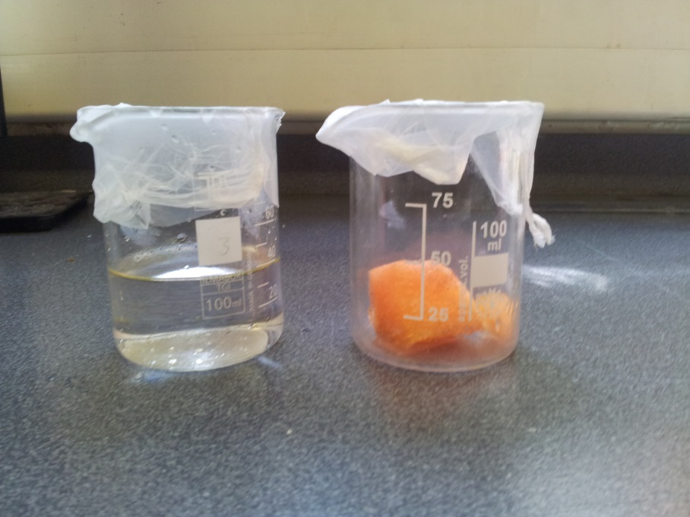

Figure 21 - Superhydrophobic-superoleophilic sponges following a Nile red/oil and water mixture separation test. The left beaker contains only water and the right a Nile red and oil soaked sponge. The image shows the sponge was successful in absorbing the Nile red/oil from the mixture.

Oil-in-water emulsion stability
As concluded before with the oil-water membrane separation experiments, it is presumed there is no driving force for oil coalescence at the superhydrophobic-superoleophilic sponge surface. Emulsion stability relies on the free energy of coalescence, a function of oil droplet surface area [145]. Upon two droplets coalescing, total oil surface area decreases and thermodynamically this is favoured due to the resultant negative free energy change. Demulsification is a spontaneous process in systems containing only two components. However in biological systems or commercial products such as mayonnaise, emulsifying agents are present which reduce interfacial tension between the two phases resulting in the formation of a stable emulsion [145].
In the case of the algal emulsion, the lipids are emulsified by phospholipids and proteins [144]. The phospholipids form a single layer around the lipids with their hydrophilic heads contacting the aqueous phase and hydrophobic tails maintaining the lipid environment in the core. This creates a “shielding” effect between the lipids and the aqueous phase. It also reduces lipid coalescence due to the negative charge on the phospholipid head groups, resulting in lipid droplet electrostatic repulsion.

Superoleophilic surfaces
After noting the inability of Kraton, the separation membrane and sponges to extract oil from a surfactant stabilised emulsion due to a lack of driving force for lipid droplet coalescence, attempts were undertaken to create a system that promoted droplet coalescence.
This time the hypothesis was that by providing a strongly oleophilic environment through surface functionalization, droplet coalescence may occur. Thus a glass surface was functionalised based on Jin et al.’s work; using a pipette and glass microscope slides [96]. The experimental protocol was successful in functionalising the glass surfaces. They were oleophilic in water and amphiphobic (hydrophobic and oleophobic) in air. They were tested for their oleophilic capacity under immersion in an oil water mixture with success. Subsequent removal from the mixture also caused the oil to quickly run off the glass surfaces, demonstrating their amphiphobicity in air.
Following this they were tested for the ability to separate oil from water in an algal emulsion and model emulsion. Both the slides and pipettes failed to instigate a droplet coalescence effect. Even when placing a droplet of each emulsion on the functionalised slides, no separation occurred. Unfortunately, there was no driving force for oil coalescence at the superoleophilic surface.

Breaking algal emulsions
The hypothesis is that the above approaches proved ineffective due a lipid stabilised emulsion forming in the aqueous media (assuming stabilisation in phospholipids vesicles). This emulsion prevented the various polymer technologies from interacting with the desired chemical. In systems with a large percentage of lipids or chemicals, agglomeration of emulsion droplets may occur leading to the formation of a surface oil phase but for most systems product yield will be too low to rely on this method.
At this point it was decided a fresh approach was necessary and thus the literature was reviewed again with a broader scope. Polyelectrolytes appealed as a method for removing low concentrations of contaminants from wastewater; a biological emulsion [145]. Polyelectrolytes are excellent for emulsion breaking in wastewater to remove many chemical contaminants and are used for oil-in-water demulsification by facilitating oil droplet coalescence.

Polyelectrolyte flocculation
A cationic polyelectrolyte was used for emulsion breaking experiments. As described in the methods section polyelectrolyte solutions were added to algae under stirring. Samples tubes containing 1 µL of polyelectrolyte caused algae to aggregate on the solutions surface as seen in Figure 22. In this case the polyelectrolyte neutralised the negative charge on the algae cell walls, allowing flocculation of the cells. Various salts such as aluminium sulphate were also tested which successfully caused flocculation of algae.
Upon lysing the cells with UV and addition of polyelectrolyte, an algal floc formed. The polyelectrolyte worked as an effective flocculant but didn’t cause an oil phase to form. It was not expected that the flocculants would break the emulsion, rather just flocculate the algae, however the emulsion breaking was possible thus an oil phase was checked for. Whilst flocculants are excellent methods for recovery of cells/chemicals, their one time usage adds a large cost to harvest at scale. This solution was not ideal but it was decided to investigate this avenue further by attempting to design recyclable flocculants, initially attempting to surface modify magnetic iron oxide nanoparticles with simple functional groups.

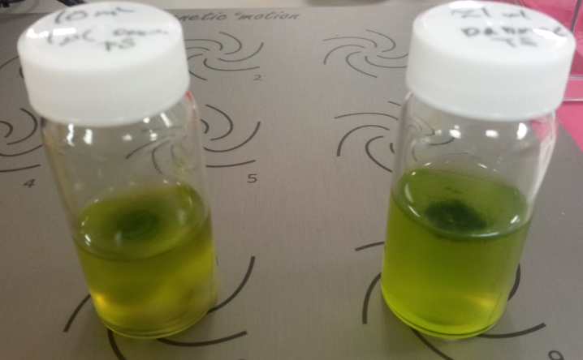
Figure 22 - Aggregated Chlamydomonas reinhardtii. Both sample vials contain 10 mL Chlamydomonas reinhardtii samples and 1 µL of the cationic polyelectrolyte, Poly(acrylamide-co-diallyldimethylammonium chloride) solution (10 wt. % in H₂O) under low magnetic stirring. Aggregation of algae is visible on the solution surface.

Why nanoparticles?
Designing a recyclable flocculant seemed to be the next logical step and nanoparticles were well suited for this purpose. In fact, their usage in biomedical science for a wide range of precise applications demonstrates their potential. For instance protein targeting or drug delivery [146]. Their production is cheap and scalable, they have a large surface area to interact with and they can have magnetic properties which would aid in separation from aqueous media.
Jones et al. used ionic exchange columns with diisopropylaminomethyl, piperazine and aniline functional groups to bind and release algae, thus attempts to functionalise nanoparticles accordingly were taken as described in the methods section [102]. The hypothesis being that synthesising nanoparticles which had surface groups analogous to ionic exchange resins would be the simplest way to achieve the desired properties. Upon testing, the nanoparticles were correctly functionalised following synthesis and bound to algae but did not release upon a pH or salt change. After considerable attempts to understand the surface chemistry of the nanoparticles using zeta potential and X-ray photoelectron spectroscopy (XPS), the conclusion arose that whilst electrostatic interactions play a role in algae-nanoparticle binding it is likely ligand formation or even covalent linkages are present. XPS, infra-red spectroscopy and zeta potential supported that the surface was functionalised with the desired chemical group, however the assumption was made that the layer was too thin to obstruct iron oxide algae interactions. Ultimately meaning dissociation of the algae and nanoparticle would be unlikely to ever work with that system upon a pH change or adding salt.

Infra-red spectroscopy of MNPs
Dried MNP samples were pressed into a KBr pellet to measure infra-red absorption (Kbr has very few IR peaks). FT-IR spectrums of unmodified, piperazine functionalised and (3-Chloropropyl)triethoxysilane functionalised MNPs are shown in Figure 23. Several peaks were present in all three spectras, a peak at around 594 cm⁻¹ was attributed to Fe-O stretching vibrations and the broad peak around 3200-3600 cm⁻¹ to an O-H stretching vibration.
Peaks around 1100 cm⁻¹ in Figure 23-B and C are indicative of O-Si-O stretching vibrations, confirming the succesful functionalisation of via CPTES on the MNPs. This is further confirmed by the C-H stretching vibration at around 2960 cm⁻¹. Piperazine functionalisation is confirmed with the N-H stretching vibration peak around 3220 cm⁻¹ in Figure 23-C but absence in B. The spectras obtained were similar to those of Mobinikhaledi et al. who fuctionalised MNPs with similar end groups [101].
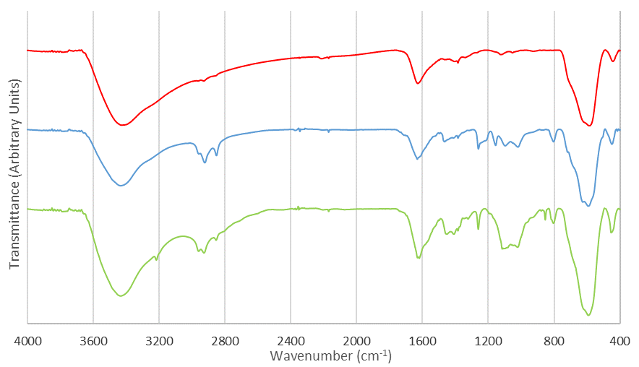
Figure 23 - Infra-red spectroscopy of magnetic nanoparticles samples. A - Unmodified nanoparticles.
B - Piperazine functionalised nanoparticles. C - (3-Chloropropyl)triethoxysilane functionalised nanoparticles.
A
C
B

X-ray photoelectron spectroscopy of MNPs
X-ray photoelectron spectroscopy is a technique used to characterise the top 100 Å layer of a material’s surface and was used in attempt to understand the surface chemistry of functionalised MNPs [147]. Typically, a sample is irradiated with X-rays and the kinetic energy and number of the electrons that are emitted are measured. This information can be used to determine the elemental and chemical nature of the surface of a material. XPS was performed at the Leeds EPSRC Nanoscience and Nanotechnology Facility at the University of Leeds. Unmodified iron oxide and piperazine, amine and quaternary ammonium functionalised MNPs were measured using XPS. The elemental compositions of the surfaces are shown in Table 1 below.
Functionalisation | Element
Functionalisation | Carbon | Oxygen | Iron | Nitrogen | Silicon | Chlorine
Unmodified | 15.4% | 58.6% | 26.1%
Piperazine | 35.3% | 42.6% | 14.7% | 3.5% | 3.4% | 0.5%
Amine | 70.0% | 25.7% | 2.7% | 0.1% | 1.6% | 0.1%
Quaternary ammonium | 42.4% | 41.2% | 14.1% | 0.1% | 2.3%

Table 1 – Percentage functionalisation of MNP by element.

XPS suggests the successful functionalisation of piperazine on the surface of the MNPs due to the presence of nitrogen and increase in carbon and decrease of iron compared to the unmodified sample. However, amine and quaternary ammonium samples have little nitrogen present indicating functionalisation was incomplete or the end groups were unstable following synthesis. The presence of silicon, increase in carbon and decrease in oxygen indicates that the amine functionalisation was most likely successful. Therefore, it’s likely the amine group was not stable on the surface of the MNP.
Though the XPS data was inconclusive, it lead to the assumption that the amine and piperazine were functionalised to the MNPs. Additionally, MNPs bound to algae following functionalisation, whereas unmodified nanoparticles did not. Electrostatic repulsion between unmodified MNP and algae has been suggested to be the reason [148].

Zeta potential of MNPs
The zeta potential of MNPs was also tested to understand their surface chemistry. Zeta potential is a measurement of the electrostatic interaction between particles (repulsion or attraction) and gives an indication of the stability of a colloidal system [149]. Unmodified MNPs had a zeta potential of -22.6 mV as would be expected due to their negative surface charge. Following amine functionalisation, zeta potential increased to 29.6 mV, suggesting that functionalisation was successful as the amine group caused an overall positive charge on the MNP. Following quaternary ammonium functionalisation zeta potential further increased to 36.1 mV, again indicating functionalisation was successful.
As previously discussed the conclusion arose that the functionalisation of MNP with various end groups was successful. However, whilst the electrostatic interactions play a role in algae-nanoparticle binding and may facilitate the initial attraction between algal cells and MNPs, it is likely that ligand formation or covalent linkages that form result in permanent binding to cells. Unfortunately, this meant that altering pH or salt would not cause dissociation of MNPs designed with a small surface layer.

Magnetising ionic exchange beads
Surface functionalised nanoparticles with functional groups that were known to bind to algae unfortunately failed to release algae upon pH change or salt addition. Thus the investigation led to directly magnetising the resins, to aid in separation from media. StratoSpheres™ PL-DIPAM (diisopropylaminomethyl), StratoSpheres™ PL-Deta and Aniline, polymer-bound were the chosen resins due to their functional groups and were magnetically functionalised using a polymer swelling process. The method was based on the work of Lin et al. and the resins were chosen based on the work of Jones et al. due to their success with binding and releasing Neochloris oleoabundans and Chlorella [102,103].
Magnetic functionalisation of the resins was successful. Upon application of a magnetic field the resins could be manipulated and extracted from algal samples. Unfortunately, neither M. inermum nor C. reinhardtii bound to the any of the resins before or after magnetisation. Given Chlorella’s similarity to M. inermum, this discovery was difficult to explain. In fact, M. inermum has been mistaken for Chlorella in the past and many strains of Chlorella are often misidentified [11].
Regardless of this, it was decided that designing another system was required. This time by using a polymer which has been known to bind and release algae upon a pH change and then conceive a method to add a magnetic property to the polymer.

Polymer coated nanoparticle design
The lack of success using a conventional nanoparticle designed around surface modification or magnetising ionic exchange beads led back to polyelectrolytes that could bind and release algae following a pH change.
Morrissey et al. concluded that a copolymer of N,N-dimethylaminopropyl acrylamide and acrylic acid can bind to and release algae when pH is changed due to its polyampholytic nature [104]. The copolymer was synthesised for testing and both C. Reinhardtii and M. inermum flocculated upon addition of copolymer and deflocculated upon changing pH.
However, following deflocculating, the algae solution must be centrifuged to recover the flocculant. Whilst this system does work it seems counterproductive to have to centrifuge the mixture to recover the flocculant. Thus it was decided to combine the magnetic nature of iron oxide nanoparticles and the recyclable nature of the polymer.

Ligand exchange and polymer stabilising methods
Prior to the development of a successful synthesis method for coating MNP with the polymer, ligand exchange and polymer stabilising methods were attempted. Ligand exchange involves the exchange between a surface stabilising oleic acid molecule on the MNPs and the polymer [150]. This method is common in creating stable water soluble MNPs for biomedical applications that require functionalised MNPs. For example as MRI contrast agents [151]. This typically involves the direct biphasic replacement of oleic acid with a ligand that has a higher affinity for iron [151]. In this case the aim was to replace the oleic acid with the synthesised polymer as described in the methods section.
However, the result was a polymer lump that contained MNPs. While the lump was water soluble, the MNPs did not remain attached to the polymer and ligand exchange did not take place. Given the difficultly in driving ligand exchange with oleic acid, stabilising the MNPs with polymer during their synthesis instead of oleic acid seemed a suitable route. This has been previously demonstrated by Robinson et al. but unfortunately for the desired polymer this synthesis method was ineffective [99]. In the work presented by Robinson et al the polymer is thermally responsive and its hydrophilic/phobic nature can be changed with temperature, meaning that the polymer stabilises MNP synthesis during thermal decomposition of iron pentacarbonyl. Then upon cooling the stabilised MNPs precipitate out due to the polymer surface.
Attempts were made to solubilise the polymer into a range of solvents such as dioctyl ether, 1,4 dioxane and DMSO at high temperature. DMSO successfully dissolved the polymer and iron pentacarbonyl due to it being a polar aprotic solvent. However, following synthesis it was clear the MNPs were not stabilised by the polymer and instead formed a black mass of particles, separate to the polymer. The assumption was that this is due to the polymer not completely dissolving into solution or the MNPs themselves being partially soluble in DMSO.

Polymer coating of nanoparticles
With the lack of success attempting to coat MNPs with preformed polymer, it was decided to perform the polymerisation in the presence of the nanoparticle to gain more control over the process.
It was hypothesised that two designs are possible; growing polymer off the nanoparticle via surface-initiated atom transfer radical polymerisation (ATRP) and encapsulating polymer around a nanoparticle using in situ dispersion polymerisation. Surface initiated ATRP involves immobilisation of a polymerisation initiator on a surface from which polymer chains can be grown [152]. The ATRP method provides a stable platform to control molecular weight and dispersity which is useful when designing a particle that has specific binding to a chemical species and will prove advantageous in future when the precise control of binding is important. In this first proof of concept the decision was to use an in situ dispersion polymerisation method as ATRP can be costly and is not as scalable or simple to perform.
In situ polymerisation involves encapsulating the nanoparticles within a polymer shell using a crosslinking agent during polymerisation. The iron oxide nanoparticles are dispersed in a non solvent for the polymer, during polymerisation polymer chains grow until they crash out around the nanoparticles as this is entropically favourable. The growing polymer chains also prefer the oleic acid phase on the nanoparticles than the solvent which promotes polymer coating around the nanoparticles. The crosslinking agent causes the polymer chains to crosslink around each nanoparticle and form a shell. Additional monomers are also added after crosslinking to form free polymer chains on the surface of the shell that can more easily interact with algae. Toluene was chosen as a non solvent as reagents were readily soluble but polymer insoluble. Oleic acid was added as a surfactant to disperse nanoparticles in solution.
Originally the monomers, initiator and crosslinker were added to the nanoparticles at once under rapid mixing but this proved ineffective and no shell particles formed. Instead polymerisation occurred so rapidly that the polymer crashed out in large particles without any interaction with the nanoparticles.
Thus reactants were added slowly dropwise over 24 hours. This proved an effective synthesis route as TEM and light microscopy demonstrate as seen in Figure 27. In addition, the particles behave as intended, akin to the pure polymers ability to flocculate and deflocculate but with magnetic properties which allow for quick and easy separation. In situ dispersion polymerisation also has the added benefits of scalability, ease of operation, low cost and rapid synthesis. Certainly for large scale extraction of algae or chemicals this method is the preferable option over ATRP, however ATRP may be more suitable for designing particles for a specific purpose before scaling up the process with in situ dispersion polymerisation.

Polymer coating calculations
In order to synthesise particles with the sufficient polymer coatings, the amount of reactants necessary to add for a given polymer thickness was approximated. Detailed calculations can be found in the appendix, however in brief by calculating the volume and surface area of an uncoated nanoparticle, estimates can be made on the volume of the polymer layer at a given thickness and number of nanoparticles, and hence can calculate the volume of monomers to add. Crosslinker volume was estimated simply as a small fraction of the monomer volume and is still subject to alteration to improve synthesis. A balance between forming a tight shell and overcrosslinking must be maintained in order to not cause crosslinking between shell particles resulting in a stiff unresponsive gel.
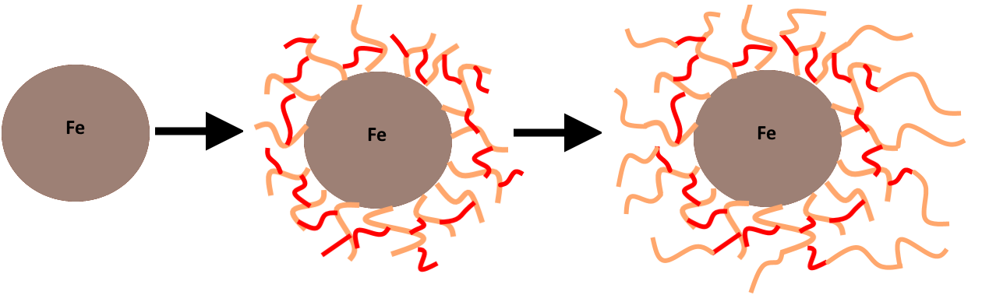
Figure 24 - Schematic of polymerisation around MNP. Cross linker in red, copolymer in peach.

Polymer design
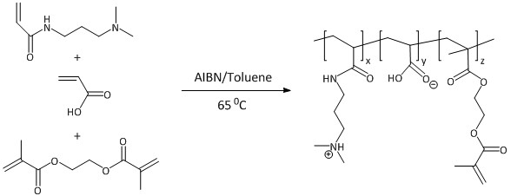
The copolymer chosen to coat nanoparticles with was based on the work of Morrissey et al. [104]. They found a copolymer of N,N-dimethylaminopropyl acrylamide (DMAPAA) and acrylic acid (75:25) was effective at binding to C. vulgaris cells and releasing them upon a pH increase to 13 with 10M NaOH. The polyampholytic nature of this copolymer is the reason used for the coating; increasing pH to 13 causes the net flocculant charge to change from positive to negative. They also tested a range of other copolymer compositions including the addition of a neutral monomer and each one successfully flocculated and released algae. The copolymer coating used herein is comprised of the both negative and positively charged monomers in order to maintain a recyclable capacity for a more diverse range of species with differing cell wall chemistry. A reaction scheme of the polymerisation can be seen in Figure 25.
Figure 25 - Reaction scheme. Polymerisation of monomers DMPAA and acrylic acid, and cross linker EGDMA. Adapted from Morrissey et al.

Polymer and MNP TGA
TGA of polymers and MNPs provide evidence that polymer is bound around MNPs. Figure 26-C shows TGA of pure MNP and Figure 26-B shows TGA of MNP-P. The stark difference of B to C is due to the presence of polymer in the MNP-P sample, and in fact Figure 26-A (pure polymer) confirms that polymer is present due to the similarities in mass loss trace to B. The majority of the MNP-P appears to be polymer due to a larger mass loss when compared to pure MNP.
A TGA of unsuccessful MNP-P synthesis (see appendix, Figure 49) showed a mass loss trace similar to Figure 26-A, however it lost approximately 25% mass rather than 80% of Figure 26-B. Indicating much less polymer was present, presumably because the polymer wasn’t bound around the nanoparticles in a crosslinked shell. This synthesis route involved adding monomers, initiator and cross linker at once rather than overtime. The assumption was that synthesis failed due to polymerization occurring too fast. Resulting in polymer micelle formation rather than polymerization around a nucleating site (i.e. MNP). Blobs of polymeric material were present which collected on the walls of the flask after synthesis rather than a suspension of MNP-P following correct synthesis. These are likely large random clusters of crosslinked polymer chains. The lack of successfully coated MNP and large crosslinked clusters of polymer is likely the reason they were unsuccessful in flocculating algae.

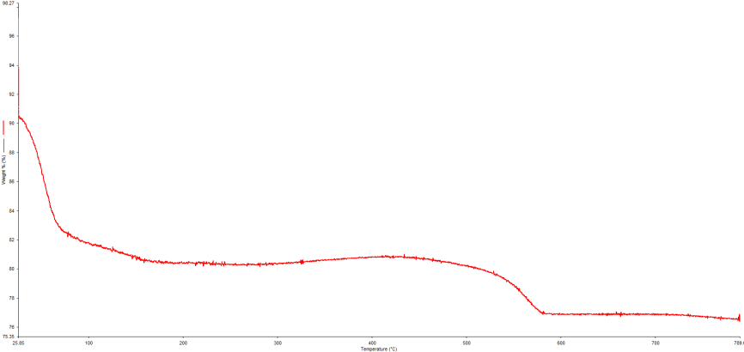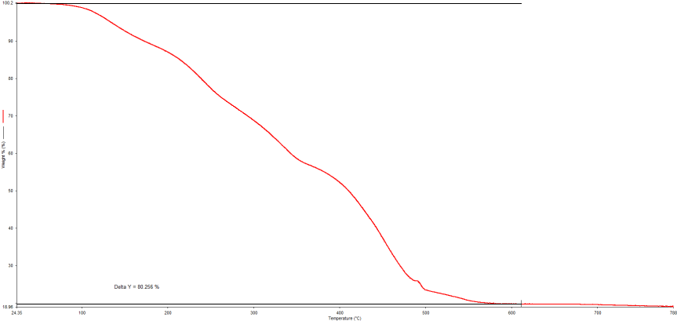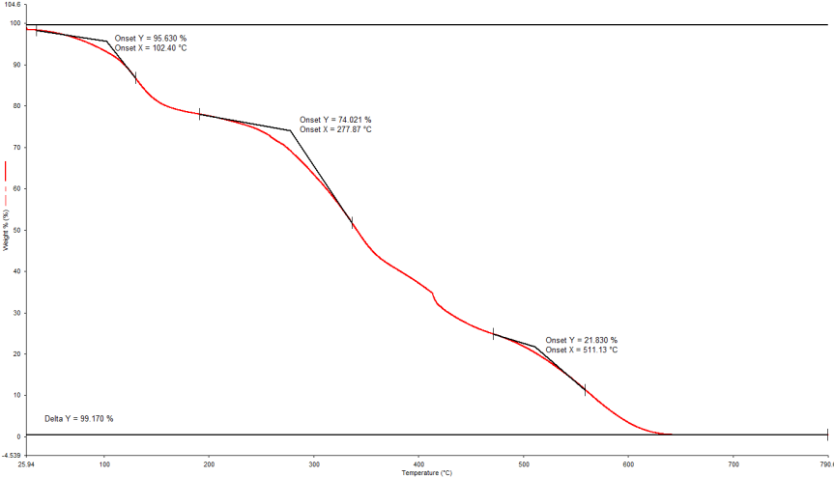
Figure 26 - TGA of polymer and MNPs. A - Pure polymer. B - MNP-P. C - Pure MNP. Samples of MNP and polymer underwent thermogravimetric analysis under nitrogen from 25-800ºC.
C
B
A

TEM and optical characterization
TEM images of MNPs before and after polymerisation in Figure 27-A and B respectively show polymer is present around the nanoparticles. The contrast difference in various areas of B, are areas with polymer present. Individual MNPs also have less defined edges indicating a bundle of nanoparticles coated in a crosslinked polymer; darkened areas with large clumps of nanoparticles that have been coated in polymer are also present.
Polymer MNP coating is further supported by optical microscopy images in Figure 27-D and E. Fibrous polymeric material with MNPs scattered throughout is visible. It’s clear that polymer is around the nanoparticles due to the difference in refractive index; edges and regions of varied contrast are well defined. In this case the refractive index difference isn’t sufficient to fully visualise the polymer. Additionally, it is important to note that individual MNP-P particles/clumps are likely to be much smaller, in these images polymer coagulated together as the toluene evaporated. MNP-P was put on microscope slides in toluene rather than water because the polymer is not distinguishable when imaged in water due to polymer chains being partially in solution.

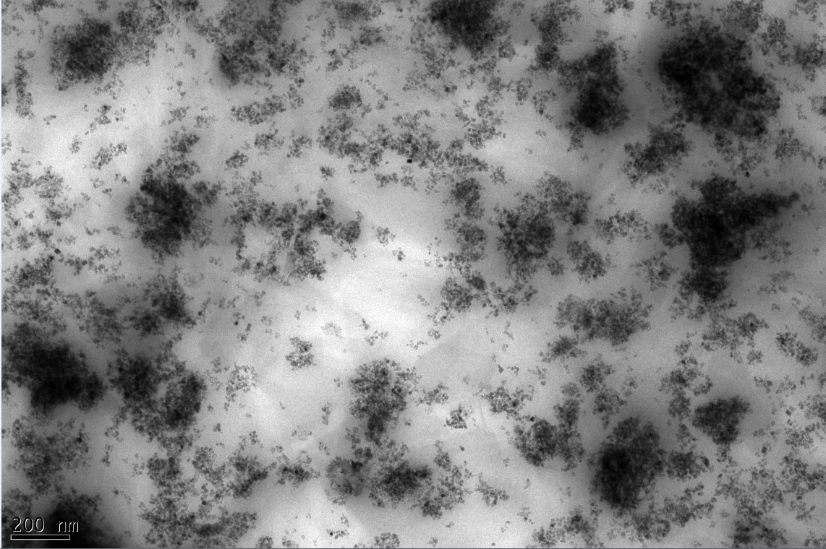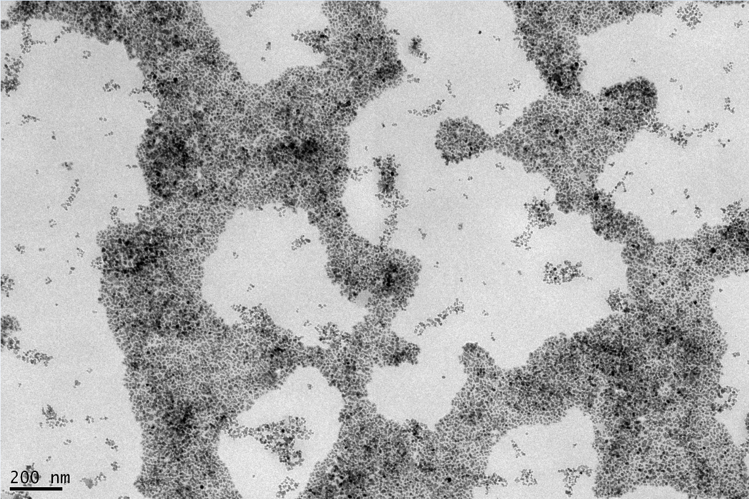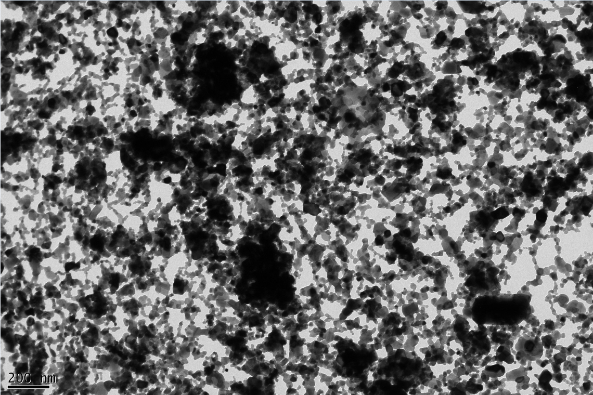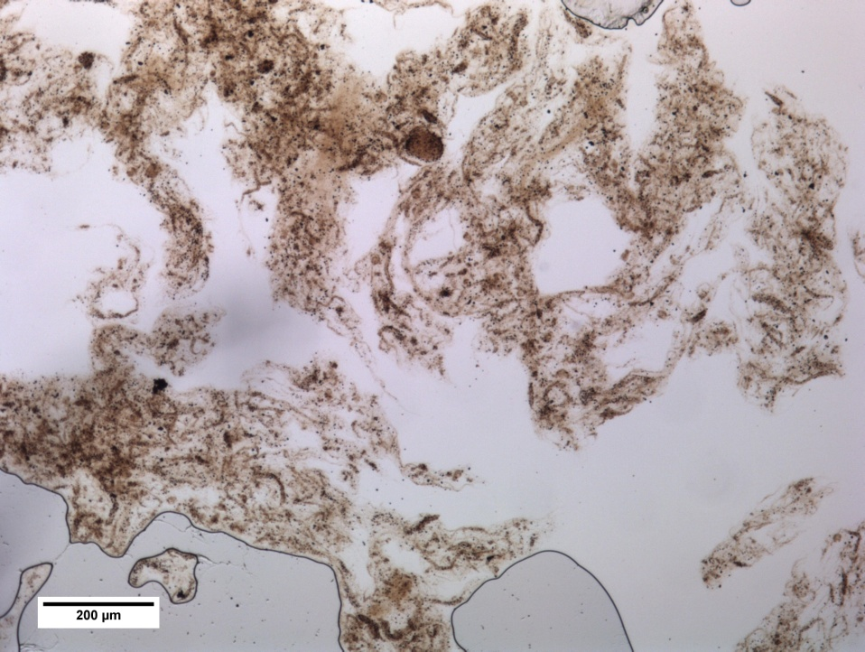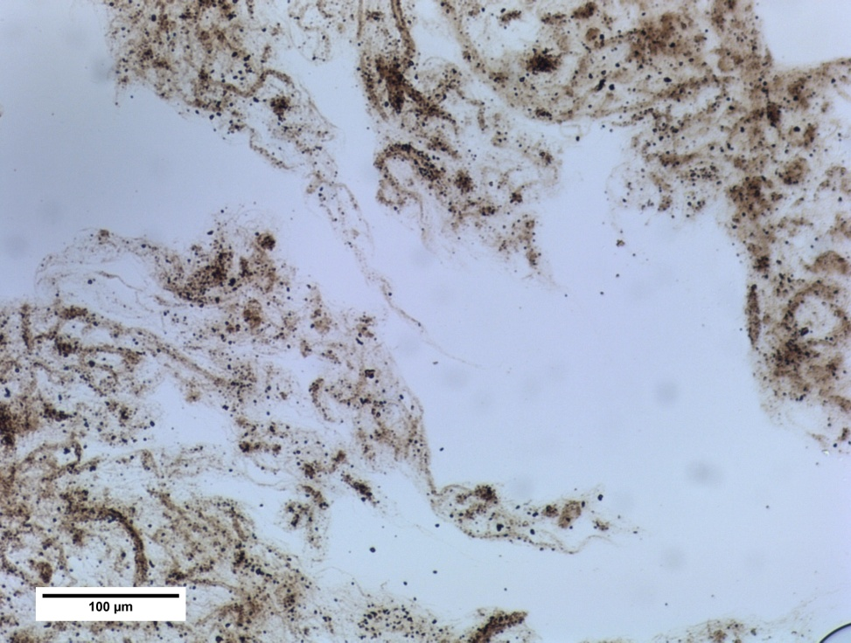
A
C
B
D
E

Figure 27 - TEM images (A-C). A - Naked MNP. B - MNP-P. C - MNP-P after TGA to remove polymer. Optical microscopy images (D-E). MNP-P. 20 times magnification for image D. 40 times magnification for image E.

MNP size characterisation and zeta potential
Prior to polymer coating, dynamic light scattering (DLS) using a Malvern Zetasizer Nano ZS determined that the MNPs were approximately 246 nm in diameter and 374 nm following polymerisation. TEM images show a large dispersity in particle size as the majority of particles aggregate into clumps around 200-400 nm, individual MNPs appear to be around 10nm but generally form large aggregates. As previously discussed monomer volumes used during synthesis were approximated for a given thickness. These volumes were approximated using a coating thickness of 100nm. DLS gave a particle size increase of 128nm following polymerisation, which is in the same order of magnitude and given the rough approximation is a sensible value. This further indicates coating of the nanoparticles was successful.
The zeta potential of the MNP-P was measured at -86 mV at neutral pH (2mV at pH 3.7), which was unexpected as the polymer should be positively charged overall at neutral pH. This indicates that some nanoparticles are uncoated or voids present in the polymer shell mean that the iron oxide nanoparticle cores (which are negatively charged) cause an overall negative zeta potential. Indicating determining surface charge of the MNP-Ps would be difficult using zeta potential. In either case, the MNP-P work as intended thus it is not a problem from a practical viewpoint.

Algal flocculation
Flocculation of M. inermum using the synthesised copolymer based on work of Morrissey et al. can be seen in Figure 28 [104]. The polymer behaved as expected, flocculating M. inermum within seconds of agitation. Following addition of sodium hydroxide to pH 13, the algae deflocculated. The algae then flocculated again upon addition of hydrochloric acid to pH 3. Following deflocculating the polymer could also be separated via centrifuge. This confirmed that the polymer was suitable for use as a coating for nanoparticles. C. reinhardtii could also be flocculated though the solution pH had to be lowered to 2. Upon increasing to pH 8 the solution fully deflocculated.

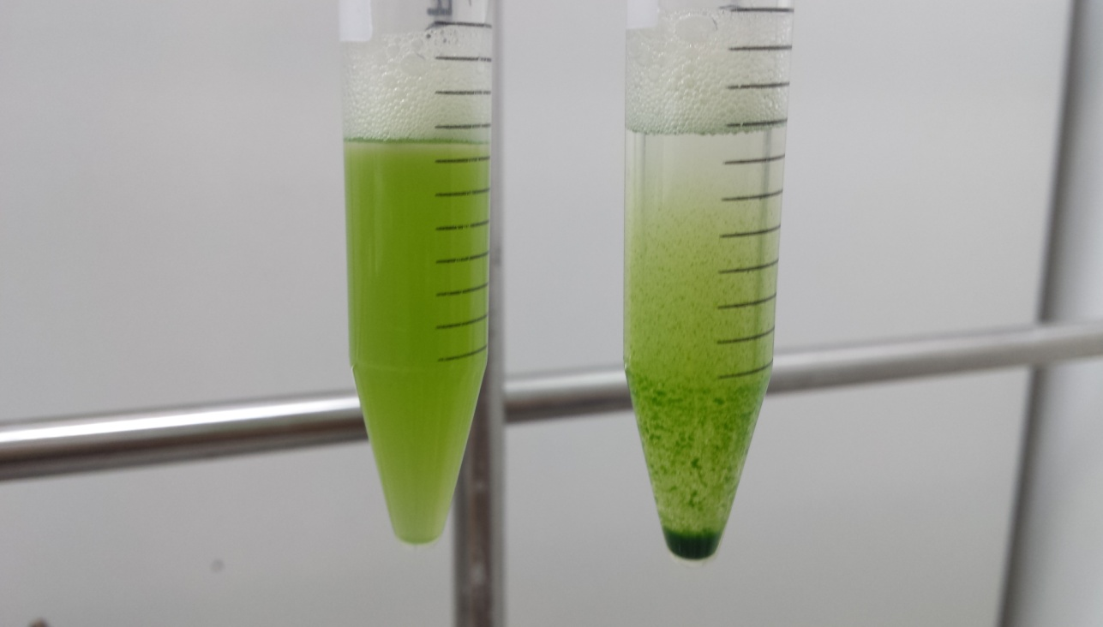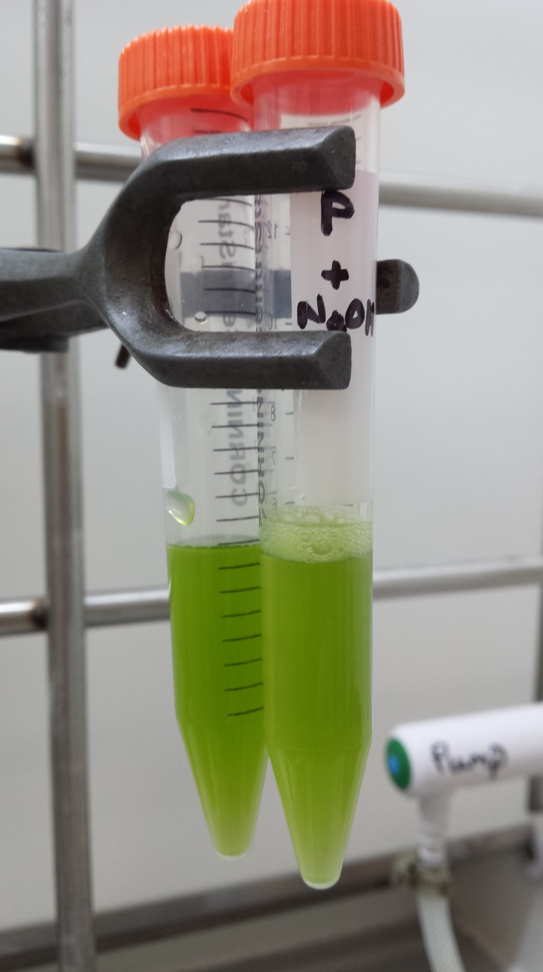

Culture with flocculant
Culture with no flocculant
Deflocculation with NaOH
Figure 28 - Polymer flocculation. Flocculation of Micractinium inermum using synthesised copolymer based on work of Morrissey et al. Left image aliquot of culture control. Middle image shows algae with polymer flocculant. Right image shows deflocculation with addition of NaOH.

Flocculation of algae using magnetic nanoparticles
Following successful synthesis of magnetic nanoparticles coated in the polymer flocculant they were tested for their ability to flocculate algae and release upon a pH change as well as their magnetic capability.
As explained in the methods section, a 5 mL sample of MNP-P in toluene was rotary evaporated (1 mg/mL toluene). Following a wash with water twice, then acetone they were redispersed in 1mL of water and 1 mL of M. inermum was added. This was made up to 10 mL with ultrapure water and mixed for 30 seconds. Flocs form in seconds and can be immediately drawn to a magnet when placed next to the vial.
The solution can be deflocculated with the addition of sodium hydroxide to pH 13 and reflocculated with the addition of hydrochloric acid, exactly the same as with the pure polymer. It is of note that when dried, the MNP-P are similar in nature to the pure polymer; both a sticky gelatinous solid, though not to the same degree with MNP-P. MNP-P also successfully flocculated C. reinhardtii, as before the solutions pH had to be lowered to initiate flocculation (deflocculation also occurred at pH 8).
Figure 29 shows the flocculation of M. inermum cells under a microscope. Cells are covered with MNP-P and can be seen in clumps. Initially the flocs formed from MNP-P appeared under the microscope as large dark brown masses and individual cells are difficult to discern. These images have been taken after a flocculation-deflocculation-flocculation cycle in order to observe smaller clumps of cells. The salt concentration had increased drastically due to the large swings in pH, which is why the flocculant was less effective during a second flocculation. The flocculant could be washed to remove salt for further uses if required. On a larger scale precise amounts of acid/base would be added to improve repeat usage without another step. In this case for ease and to test stability, imprecise amounts were added to alter pH.

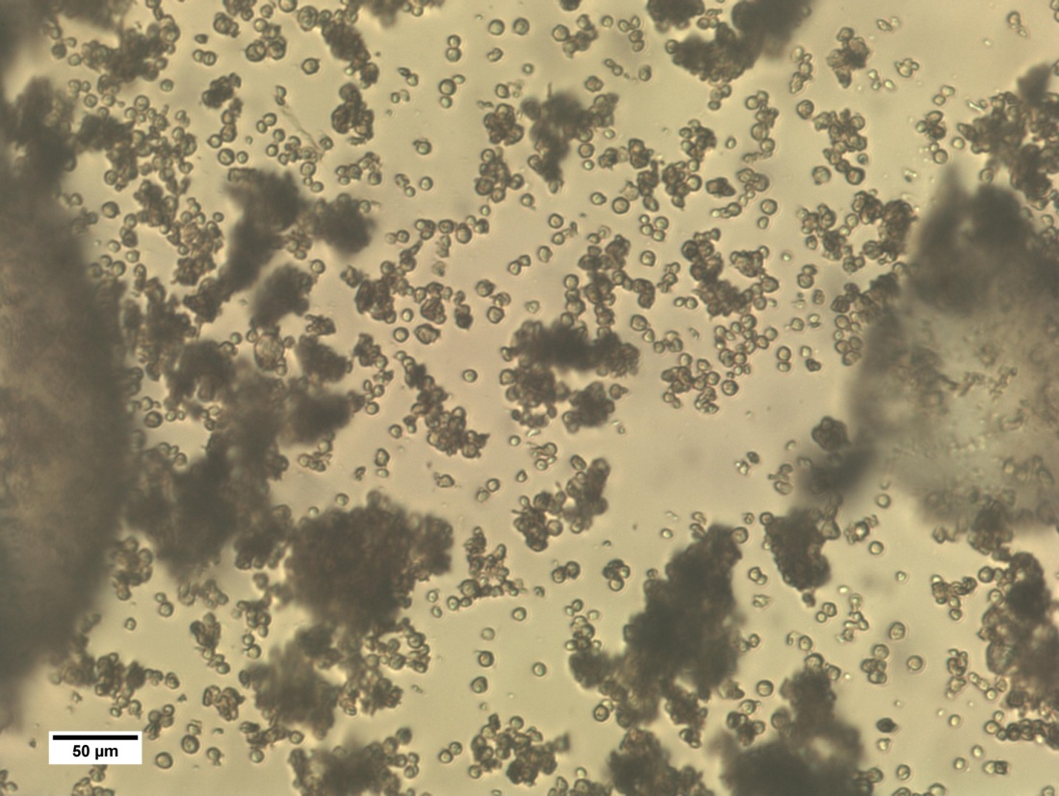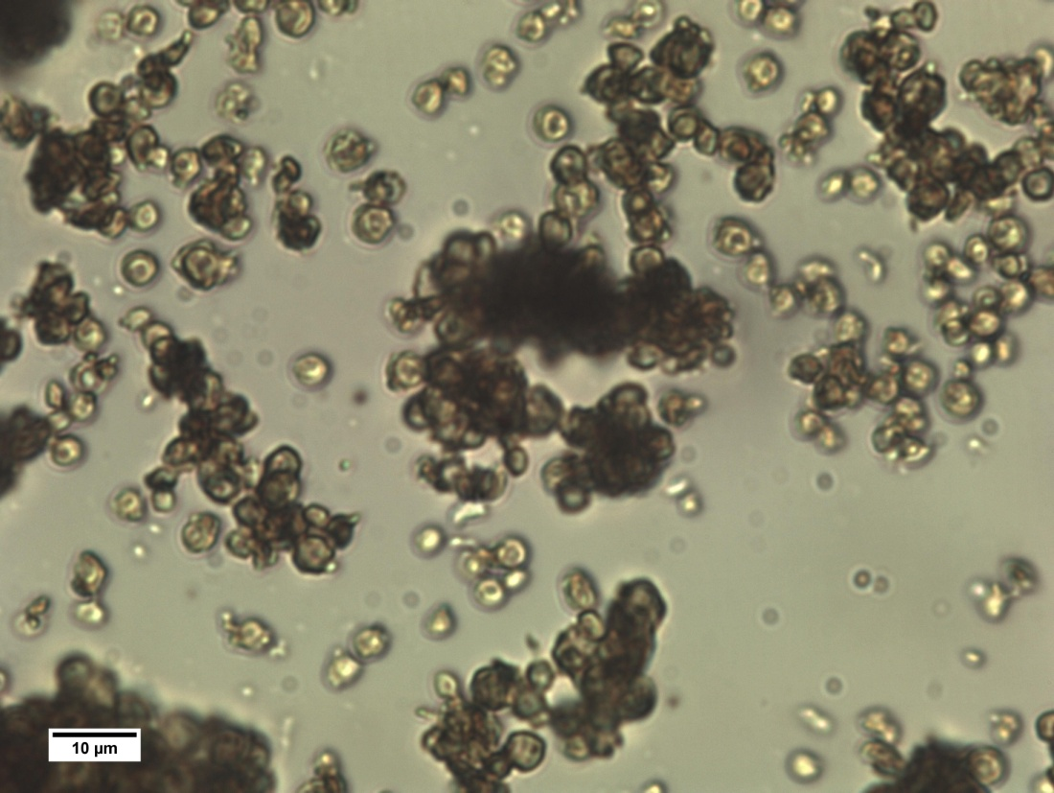

Figure 29 - Optical microscopy images of MNP-P and algae. Flocculation of Micractinium inermum cells using MNP-P can be seen. The MNP-P coats the algal cells and can be seen in clumps. This image is following a flocculation-deflocculation-flocculation cycle, thus some cells are not flocculated as salt concentration has increased. Top image 20 times magnification, bottom 40 times.

Jar MNP-P flocculation cycling
A video of MNP-P flocculation of M. inermum cells is provided on the supplementary material CD; however Figure 30 shows the overall processing steps of flocculation cycling. After initial flocculation of the cells the floc is magnetically separated and ultrapure water is added before deflocculation using sodium hydroxide. The cells are then cycled between flocculation and deflocculation twice using acid/base. The final flocculation took slightly longer due to the increase in salt concentration and its effect on negating electrostatic interactions. As previously mentioned more accurate salt/base addition would result in more cycles being possible.

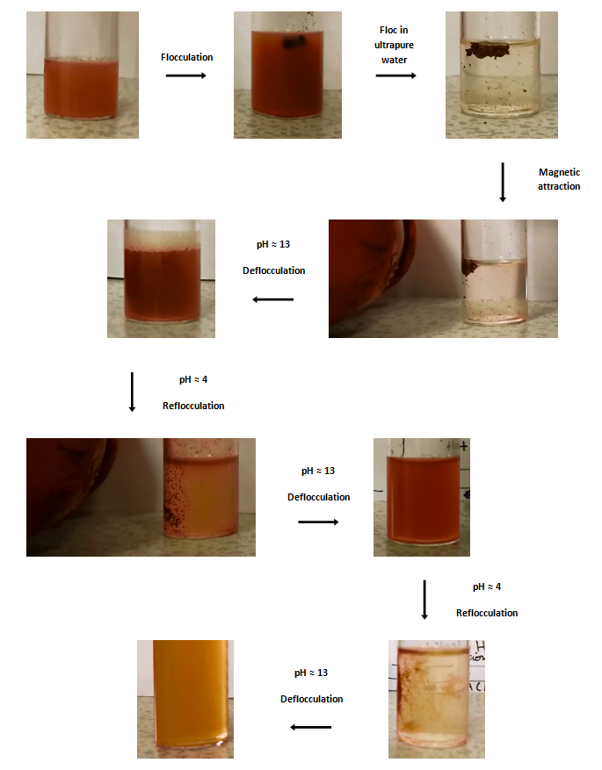

Figure 30 - MNP-P flocculation. An aliquot of Micractinium inermum is flocculated using MNP-P. Reversible nature of the MNP-P can be seen as flocculation and deflocculation occur upon switching pH from basic to acidic. pH switching using NaOH and HCl.

Recyclable nanoparticles
Using nanoparticles to harvest algae is not a new idea; however a review of the literature did not reveal a system whereby the nanoparticles can be recovered for multiple uses without significant losses in efficiency or another reconstitution/coating step. This technology adds a significant tool to the available methods for downstream processing of algae commercially. It also has the potential to reduce the bottleneck that downstream processing has been on algal biotechnology. Whilst it may not completely alleviate the need for a centrifuge, it does reduce the overall volume required for centrifugation which in turn lowers the energy and economic cost. In many cases such as extracting high value chemicals or lipid extraction, centrifugation may not even be required.
Hu et al. harvested Nannochloropsis maritima using naked Fe₃O₄ nanoparticles with a 95% efficiency rate in only 4 min at a 120 mg/L dosage [153]. They review traditional flocculation and membrane filtration methods and note that their method had a superior harvesting efficiency and shorter processing time. Indicating the advantages that magnetic separation gives. However, they also conclude that they can reuse the culture medium multiple times following separation with similar efficiency to using recycled medium from centrifugation. Whilst there is promise in the technology due to the efficiency, low cost and scalability, the obvious problem is the requirement of great quantities of nanoparticles at scale. Their system is also inflexible and may not work with many species. Once bound the algae cannot be released and will eventually die, meaning this process could not be used for selectively removing a species from a consortium for further growth.
In contrast, the technology described herein has the possibility to reuse MNP-P and cells, a vast benefit over a single use flocculant. Lim et al. use MNPs and a polyelectrolyte flocculant for magnetophoretic separation of Chlorella sp. [154]. Whilst effective, no covalent linkages take place between flocculant and MNP, stabilisation is through electrostatic interactions meaning the flocculant will need to be replaced on a regular basis. Additionally, this method does not have potential for high species/chemical selectivity as reported later in this chapter.
Cerff et al. use a commercial silica coated magnetic nanoparticle and unmodified iron oxide nanoparticles to magnetically separate four species of algae including C. reinhardtii [155]. They show some partial reusability of nanoparticles with pH change. They also conclude that the adsorption mechanism of their MNPs cannot be electrostatic due to measured zeta potentials, meaning pH must be having a different effect on binding capacity. However, based on their data is seems unlikely that complete recyclability could be achieved and whilst feasible for the algae studied, may not apply to all species. Additionally, like with other reviewed literature this method does not have potential for high species/chemical selectivity.

Extraction of different species
Given the nature of algae grown naturally, sources often contain a consortium of species which may have symbiotic or rival relationships [156]. This MNP-P extraction system may be able to provide a method extract specific species from a meta culture. Already this polymer is capable of flocculating M. inermum and C. reinhardtii at different pHs. Altering monomers for polymer synthesis could potentially allow for tuning to a species’ cell wall chemistry. The simplicity of synthesis and design mean production of MNP-P for a particular task could be tailored. In fact the abundance of water soluble monomers with different charged groups illustrates the diversity of polymers that could be produced [157]. In addition, by varying molecular weight, degree of cross linking and dispersity a polymer could potentially be tuned to a more definite purpose.
In fact, Šafařı́k et al. looked at the use of magnetic techniques for the isolation of cells as well as purification of organelles and other cellular compounds [158]. They show that commercial magnetic particles are capable of isolating cells and valuable compounds. However, the method reported in this chapter provides a platform for high selectivity of magnetic nanoparticle surface properties whilst keeping synthesis rapid, cheap and simple. By alleviating the need for covalent linkages of polymer to nanoparticle, this new method may reduce costs and allow for more complex MNP surface functionalisations.

Extraction of specific chemicals
Beyond the extraction of specific species, it may be possible to extract specific chemicals through altering the polymer coated on the MNP. This idea once again draws from ionic exchange chromatography and by using suitably charged monomers, proteins or other charged molecules, specific chemicals could be extracted. Additionally, water insoluble polymers could also be coated around the MNPs in a similar manner which dramatically increases the range of applications.
Furthermore, using a system similar to affinity chromatography, highly specific chemical extraction may be possible. One such example typically used in a biochemical application is the immobilisation of a ubiquitin binding protein onto Sepharose beads [159]. A solution of proteins containing ubiquitin can then be passed through the beads. The ubiquitin binds to the beads and other proteins pass through unaffected. Ubiquitin can then be eluted off with a suitable salt solution. This system or a similar idea could be adapted to be used with MNPs.
In fact, Franzreb et al. review the use of magnetic absorbent particles for protein purification and conclude that in order for methods of purifying proteins using magnetic absorbents to reach full commercial viability, advances need to be made in magnetic absorbent synthesis methods [160]. The work presented here could provide a method to rapidly synthesise MNPs that are cheaper and allow for new functionalisations in many research fields, not just algal applications.
The large surface area and magnetic properties of the MNP-Ps lend themselves well to chromatography applications. The suitability named in situ magnetic chromatography method described herein has prospects for improving extraction of specific chemicals on a large scale or to speed up difficult lab extractions. Interestingly Šafařı́k et al. review the use of magnetic techniques for protein purification looking at the advantages such techniques provide over traditional chromatography methods [161]. Some advantages include removing the need for centrifuges, filters and other expensive equipment. Proteins can actually be extracted to higher concentration and aren’t subjected to high shear forces that can cause breakage during traditional chromatography. Again, the new synthesis method presented in this chapter may provide benefits to these existing technologies.

Possibilities for the technology
The method for synthesising polymer coated magnetic nanoparticles described in this chapter has significant benefits over traditional routes. Specifically, because of its potential to lower costs and complexity, reduce steps and scale to large production far more easily.
With reference to algae, the extraction of specific species and chemicals as previously mentioned are obvious possibilities for biotechnology. The MNP-P synthesised has the potential to remove a large bottleneck in algal harvesting due to its rapid effect, recyclable nature and design/synthesis simplicity.
There is also the possibility that the polymer coating could be designed to flocculate both lysed algal cells and lipid by breaking the emulsion. The negative charge on the phospholipids vesicles (containing the lipids) may cause agglomeration of vesicles around the positively charged polymer flocculant, thus cause the algal cells and lipids to be contained in the magnetic flocs.
An experiment was conducted that combined UV lysis and extraction with MNP-P to investigate any demulsifying properties the polymer may already exhibit. The cells were readily flocculated by the MNP-P following lysis and the magnetic floc was subjected to lipid extraction and transesterification for GC-FID. Both the supernatant and magnetic floc were collected for lipid extraction and transesterification in order to determine where the large proportion of the lipid fraction was. Bead beating was also performed which used traditional centrifugation to collect the pellet before lysis.
Unfortunately, because oleic acid was used as the surfactant during MNP-P synthesis, residual amounts remained during algal flocculation and caused a large overestimation of FAME present in the samples. In future experiments, MNP-P will have to be washed thoroughly after synthesis or just synthesised with a different surfactant such as oleylamine or oleyl alcohol (or a more traditional commercial non-ionic surfactant). It was only after using high pressure liquid chromatography to rule out polymer contamination and transesterification of a MNP-P only sample, that it became apparent some oleic acid had remained attached to the MNPs. This oversight meant this data was unfortunately unusable.

Conclusion
This chapter was aimed at developing a novel solution to harvest algae, specifically by synthesising a novel recyclable magnetic flocculant, with the goal of reducing a bottleneck in the downstream processing of algae. The original aim was to develop a method to extract lipids directly from lysed algae, though a recyclable flocculant to harvest algae (which could possibly be redesigned to extract lipids) came out of that idea. The data presented in this chapter confirms the successful synthesis of this flocculant; polymer coated magnetic iron oxide nanoparticles synthesised via a new method. This may provide benefits to existing technologies in many fields to reduce costs, allow for industrial scaling and offer new surface functionalisation designs.
In the field of algal biotechnology, the MNP-P synthesised here can flocculate algae, with binding switchable on pH change and is recyclable. It has the potential to lower costs, energy consumption and remove a bottleneck in the downstream processing of microalgae by reducing the need for a centrifuge. By altering the polymer coating on the MNP, there is the possibility to selectively extract species or chemicals.
This new technology holds a great deal of promise and future research should focus on improving the synthesis process to improve yield. This will likely be accomplished by altering crosslinker concentration to improve the shell around the nanoparticles to produce more defined particles. Crosslinker concentration could also be reduced over time to produce a gradually looser polymer network, with free polymer at the surface layer able to interact with algal cells. Additionally, different polymer coatings should be synthesised around the nanoparticles with functionalisations aimed at extracting useful biochemicals. Unfortunately, due to a lack of time it was not possible to synthesise enough MNP-P in order to calculate flocculation efficiency; future research needs to address this.

Accelerated aging of algal biodiesel: a macroscopic approach

Summary
This chapter looks at the quality of biodiesel that can be produced from microalgae. To this end a novel bioreactor was designed and built. The bioreactor was successful in cultivating microalgae and algae biomass was concentrated before lipid extraction and transesterification to biodiesel. Produced biodiesel was then aged in an oven at 95ºC for two and a half months with viscosity measurements taken at various intervals using an Ostwald viscometer at controlled temperatures to determine its change in viscosity over time. Thermogravimetric analysis and differential scanning calorimetry of biodiesel was undertaken to give insight into its oxidation properties. Gas chromatography also gave insight into the percentage of unsaturated and saturated FAMEs before and after aging. Overall, experimental data indicated that the species used and growth parameters have a large impact on the quality of diesel produced, and supports the theory that oxidation and thermal stability decrease as concentration of unsaturated FAME increases.

Introduction
Microalgal biofuel is often credited as a potential solution to the growing problem of fuel demand and a means to offset climate change. Like all liquid fuel, long term storage of biodiesel is problematic due to increases in viscosity and changes in volatility [162]. This is generally caused by the formation of oligomers through oxidation of the fuel over time [162,163]. This oxidation also occurs in engines due to high temperatures or lack of use and the result is a dramatic increase in the viscosity of the fuel, the product slurry causing engine damage [162]. Commercially available fossil fuel and biodiesel both contain antioxidants to mitigate this, indicating it can be controlled to an extent but it is particularly concerning for biodiesel which typically has a higher viscosity than fossil fuel [162]. Traditional engines would have to be adapted to use highly viscous fuel, which is expensive and prohibitive for the development of biodiesel as a replacement for fossil fuels. Stable low viscosity biodiesel is what many research groups are currently attempting to produce.
The mechanism of biodiesel oxidation is through free radical attacks on hydrocarbon chains which then go onto form peroxides [162,163].
R₁H  R₁.
R₁. + O₂ R₁OO.
Subsequently aldehydes and ketones form which can lead to resin formation. At this stage cross linking and oligomerisation has occurred to such an extent that fuel viscosity is so high the fuel is unusable [163].
R₁OO. + R₂H R₁O-R₂
Upon reviewing the literature, it was observed that few if any studies have taken a macroscopic view of biodiesel production from algal growth, lipid extraction/transesterification through to biodiesel viscosity and viability as a fuel. Thus an experiment was undertaken to determine algal biodiesel viability.
A flat plate air lift bioreactor was designed and built to optimise algal growth and provide sufficient biomass to extract a quantity of biodiesel for viscosity experiments. A recently isolated culture of M. inermum was chosen as a species due to their high growth rate and large lipid production. Biodiesel produced was then aged in an oven over several weeks and viscosity measured to give an idea of oxidation and viability as a fuel.
Prior to beginning the experiment, the biodiesel viscosity was to be measured using a rheometer at various time points of aging. Following isolation and purification of the biodiesel it was decided to use an Ostwald viscometer instead to achieve appropriate consistency; upon using a rheometer large inconsistency with repeat measurements was encountered even with several different geometries of varying shape, size and material type. This also ensured the measured volume is fixed and sufficient biodiesel was available to complete the experiment.

Results and discussion

Flat plate air lift bioreactor design and manufacture
The 50L bioreactor was designed and built to provide experimental data for its efficiency as a growth vessel but also as a means to manufacture large quantities of algae for biodiesel production. The design focus being on a large surface area and short width allowing light to penetrate the vessel more equally.
Similar bioreactors have been designed in the past as shown by Hu et al., who demonstrate high photosynthetic efficiencies using their flat inclined modular photobioreactor [164]. In fact, the large surface area, light path, low cost and easy cleaning are some of the advantages flat plate bioreactors have over other systems [165]. Disadvantages include difficulty in controlling temperature, scale up and cause of hydrodynamic stress to certain strains [165].
Prior to the design and manufacture of the 50 L bioreactor, a 2.5 L prototype reactor was assembled out of Perspex. This underwent several reassemblies until a functional tank was produced with suitable mixing. The scaled up reactor with a 50 L capacity was then designed and built using cut sheet glass (Central Glass Ltd, Sheffield) and aquarium grade silicon sealant (Arbosil 1081). The paddles were locked into place by housing them around two glass supports which were fixed to the wall with silicon and two diffusers (Point Four MBD 100 diffusers) fixed to the base.
Prior to this tubing for gas was fitted to the diffusers and threaded out of the tank. A carbon dioxide canister with a backflow stop valve and an air tap with pressure regulator were used as gas sources. These were fed into flow meters to control carbon dioxide concentration and then the tubing joined for mixing before attachment to each diffuser’s tubing. The diffusers evolve micro bubbles (diameter 100 to 500 microns) consisting of a 1% carbon dioxide and 99% air mixture; the carbon dioxide allows enhanced carbon fixation and microbubbles strip oxygen from a culture which promotes photosynthesis [20]. The microbubbles and positioning of the inner paddles cause a current that provides constant mixing of a culture. Two fluorescent tubes were placed adjacent to the bioreactor on each side approximately 10 cm away, totalling four. Three magnetic stirrers were also placed at the base of the tank, each one adjacent to a ceramic diffuser to eliminate mixing dead zones. If the tank was to be redesigned a diffuser that covers the length of the tank would be used to remove this issue.

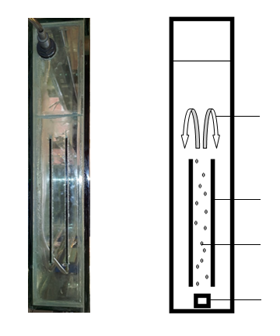
B
A

Microbubble current

Glass paddle
Microbubbles

Diffuser
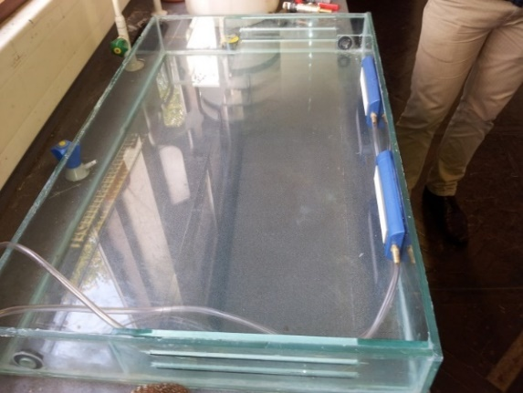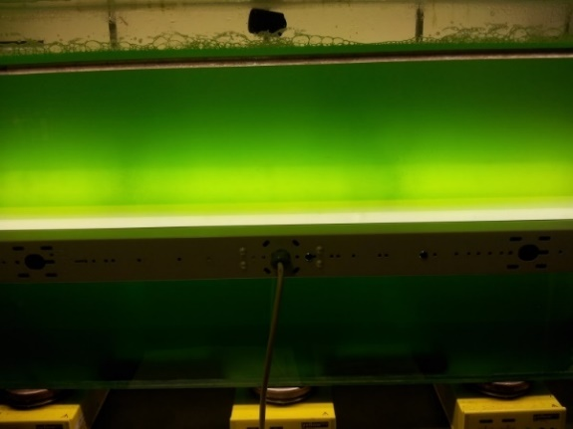
A
B
Figure 31 - (A) Side image of the bioreactor. The two glass paddles fitted against the bioreactor side which run along the length of the bioreactor are shown. (B) Schematic representation of the bioreactor from the side. The microbubble passage and current generated due to the glass paddles and bubbles to provide mixing are shown. Gas mixtures comprised 1% carbon dioxide and 99% air.

Figure 32 - (A) 50L bioreactor assembly. At this stage in assembly the bioreactor has the paddles and diffusers fitted and is being cleaned before sealing the lid on. (B) Culture growth in the bioreactor. The bioreactor is successfully culturing algae. This is approximately 2 weeks into growth.

B
A
A

Flat plate air lift bioreactor efficiency
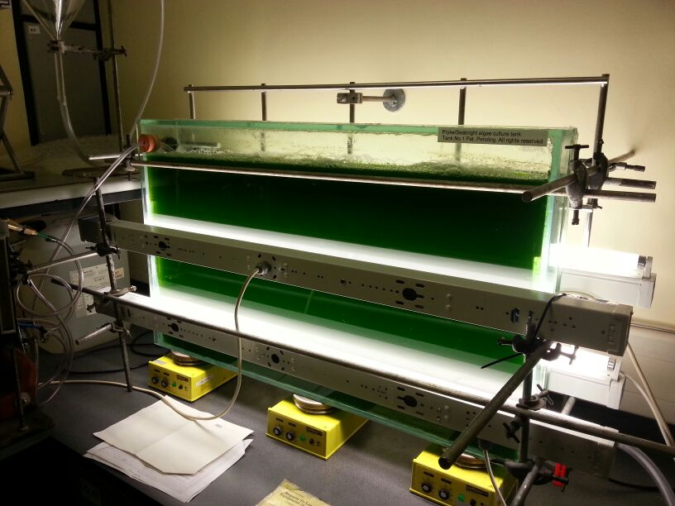
The 50L bioreactor facilitated the growth of 79.4g of M. inermum (dry weight) over 3 weeks giving a final density of approximately 2 g/L of algal culture; only 40L of culture was extracted from the tank, 5L was retained for the next batch and the headspace is approximately 5L. However, based on previous optical density data from the Department of Molecular Biology and Biotechnology this density is lower than expected; the algal culture density should be closer to 5 g/L. This is believed to be due to a problem with the centrifuge tubes when on two occasions the seal became loose and small quantities of algal concentrate was lost. This may mean the actual algal culture density is marginally higher than the data suggests but still below the 5 g/L expected.
Figure 33 - Flat plate airlift bioreactor approximately 2 weeks into growth of Micractinium inermum. Lighting is positioned around the bioreactor to provide optimal lighting within the bioreactor. Yellow magnetic stirrers are positioned below the bioreactor to eliminate dead spots where algae can settle between the diffusers. Magnetic stirrer bars are on the bioreactor base. 24-hour continuous light.

Limiting growth factors – Nitrates
Based on the optical density data shown in Figure 34 nitrogen starvation began to occur around days 8, 15 and 19. At days 9 and 15 additional nitrates (37.5 g) were added to increase growth, bringing the final nitrate concentration to that of Bold-Basal Medium with 3-fold Nitrogen and Vitamins (3N-BBM+V). The effect of nitrate addition on growth is apparent, especially at days 15 and 16, where perhaps nitrates should have been added on day 14 rather than 15. Growth begins to slow at day 19 and the culture was harvested on day 22 due to time restrains within the lab. Ideally the culture could have been monitored for nitrogen starvation and left for an additional week for lipid accumulation but this was not possible at the time.

Growth efficiency
As seen the in Figure 34 the growth curve generated from the optical density data resembles a relatively smooth curve. Had the total nitrates been supplied from the start it is expected the curve would have no slowing in growth as seen around day 15, where the nitrogen supply has been all but exhausted by the culture. As shown by OD and total biomass harvested after growth (79.4 g) the bioreactor provided a suitable vessel for algal growth.

Figure 34 - Growth curve of Micractinium inermum in the 50L bioreactor over 21 days. Growth increases throughout the 21 days though nitrogen starvation is apparent at days 8, 15 and 19. Additional nitrate added at red diamond markers, days 9 and 15. n =1. Optical density measured at 595nm. Measurements taken indicated at blue/red diamond markers. Culture grown at 25ºC in Bold Basal Medium.

Bioreactor harvesting and biodiesel production
Harvested M. inermum underwent lipid extraction and transesterification. After various purification steps crude biodiesel was obtained as detailed in the methods chapter. Table 2 shows the FAME data from GC-FID analysis. Approximately 6.8 mL of crude biodiesel was obtained from 79.4 g of algae with a FAME purity of 91%. Thus every gram of dry algae had approximately 68.8 mg of lipids (6.88%). The Molecular Biology and Biotechnology department at the University of Sheffield has demonstrated this strain can produce up to 40% of dry weight lipids under nitrogen stress [166]. Thus a substantially larger volume of biodiesel would have been obtained had the algae been allowed to accumulate lipids through prolonged nitrogen starvation. Interestingly the main FAMEs present were C16:0, C17:0 and C18:2 chains which are suitable lengths for biodiesel (C18 denotes an 18 carbon length chain, and :2 having two double bonds) [125].

FAME chain length | Percentage of FAME in crude
C10:0 | 0.11%
C11:0 | 0.13%
C13:0 | 0.02%
C14:0 | 0.55%
C14:1 | 0.14%
C15:0 | 0.80%
C15:1 | 0.09%
C16:0 | 23.39%
C16:1 | 1.24%
C17:0 | 14.56%
C17:1 | 0.27%
C18:0 | 0.19%
C18:1 cis | 3.27%
C18:2 cis | 41.75%
C18:3n3 | 4.26%
C20:3n6 | 0.08%
C23:0 | 0.03%
C24:0 | 0.14%
Total FAME in crude | 0.803 g/mL
Crude density | 0.883 g/mL
Total purity of crude | 91%

Table 2 - FAMEs produced by transesterification of lipids from harvested Micractinium inermum. The table shows the various FAME percentages in the crude biodiesel, as well as the purity of FAMEs in the crude.

Thermogravimetric analysis and differential scanning calorimetry of biodiesel
Prior to accelerated aging of the biodiesel, thermogravimetric analysis (TGA) and differential scanning calorimetry (DSC) were run to determine phase transitions, decomposition temperatures and possible oxidation temperatures. TGA measures mass loss as a function of increasing temperature and DSC measures the difference in heat necessary to increase temperature between a sample and a reference sample. Figure 35 shows the TGA and DSC of a crude biodiesel sample. A vaporisation peak around 100ºC is present during TGA which may be attributed to water loss and a possible slight oxidation peak is visible during DSC. Mostafa et al. also use TGA and DSC to measure oxidation stability of biodiesel [167]. They indicate that the weight loss represented by their TGA curve is in three steps, volatilization at 280ºC, boiling of unsaturated FAMEs at 420ºC and finally vaporization of non-transesterified algal oil at 480ºC [167]. The TGA of biodiesel reported in this chapter resembles their TGA curve here but with an earlier onset. Volatilization at approximately 150ºC, boiling at 176ºC and vaporization at 270ºC. Biodiesel reported by Mostafa et al. contained approximately 90% saturated FAMEs, which they indicate may be the reason it has a large thermal and oxidative stability (double bonds in unsaturated FAMEs being more reactive). The biodiesel reported in this chapter contained 51.09% unsaturated FAME, which explains why TGA demonstrated an earlier onset of degradation. This supports their explanation that an increased concentration of unsaturated FAME in biodiesel leads to a decrease in thermal and oxidative stability.

A
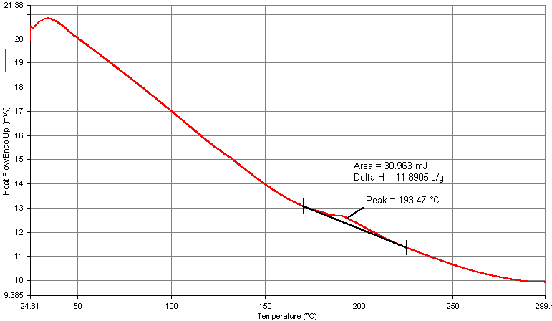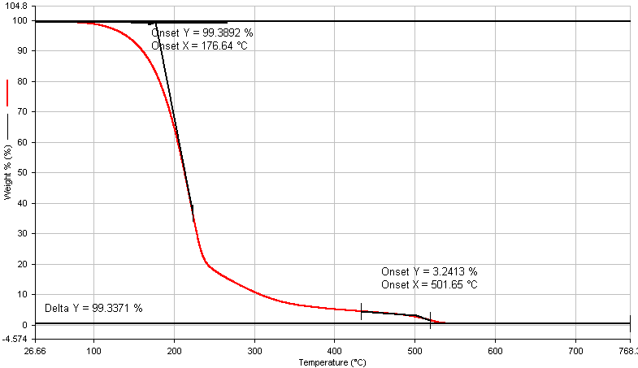

B

Figure 35 - (A) Biodiesel DSC. A sample of biodiesel underwent differential scanning calorimetry under nitrogen from 25-300ºC (B) Biodiesel TGA. A sample of biodiesel underwent thermogravimetric analysis under nitrogen from 25-800ºC. These techniques indicate decomposition temperatures and possible oxidation temperatures.

Aging of biodiesel
Whilst only 6.8 mL of crude biodiesel was produced this proved to be ample crude biodiesel available for experimentation. An Ostwald viscometer was used for accelerated aging experiments, whereby the biodiesel sample was heated to a constant temperature of 95ºC in an oven before viscosity measurements at various lower temperatures (controlled by a temperature controlled water bath) at time points over the course of two and a half months, carried out as described in materials and methods Section 2.15.1. Aging was performed in order to accelerate the natural oxidation and degradation processes that occur during biodiesel storage, and hence give an insight into how the composition of the biodiesel affects these processes over time via the measurements of viscosity and GC-FID. The hypothesis was that if the biodiesel consisted of mainly saturated fatty acids, only slight chemical crosslinking will occur and the viscosity won’t greatly increase. In contrast if the biodiesel contains many unsaturated fatty acids the viscosity will dramatically increase due to significant crosslinking between FAMEs. The nature of this fatty acid saturation in algae is heavily reliant on the species in question with different species able to produce an array of different fatty acids. Thus species selection is important for any large scale production of biodiesel.
As expected, with increasing temperature biodiesel oxidation rates increase and thus viscosity increases due to oligomer formation, as seen in Figure 38. Figure 36 indicates that the composition of the biodiesel i.e. the fatty acid methyl esters (FAMEs) play a big role in oxidation rates. Typically, biodiesel containing more unsaturated FAMEs leads to increased oxidation rates and higher viscosities [163]. Zuleta et al. detail that linoleate and linolenate methyl esters have very low oxidative stability at 100 ºC and in fact the biodiesel reported in this chapter contained a large concentration of linoleate methyl esters. This likely contributed significantly to biodiesel oxidation and in turn led to an increase in viscosity.
It is apparent that the ratios of FAMEs in the biodiesel produced from M. inermum changed due to oxidation over the course of the aging experiment. Figure 36 shows the FAME composition before and after aging with respect to the original crude composition. Prior to aging 51.09% and 39.92% of the crude was unsaturated and saturated FAME respectively, whereas afterward only 22.67% and 22.35%. Indicating that as the literature suggests, the unsaturated FAMEs were more oxidised [163]. Zuleta et al. discuss the increased susceptibility of unsaturated FAMEs [163]. They conclude that the hydrogen abstraction by free radicals during the propagation step of lipid oxidation occurs preferentially at hydrogen sites that are between two double bonds due to a lower binding energy [163]. This also is also supported by the increased susceptibility of linoleate and linolenate methyl esters to oxidation over other FAMEs due to them containing 2 and 3 double bonds respectively [163]. Furthermore, they also demonstrate decreased oxidative stability as number of double bonds in a methyl ester increases.
Comparing M. inermum biodiesel to literature reports of algal biodiesel produced from Chlorella vulgaris by Al-lwayzy et al. the FAMEs produced are of similar chain length [168]. Their main FAMEs being 23.74% Palmitic acid (C16:0), 16.48% Palmatoleic acid (C16:1), 21.84% Stearic acid (C18:0), 24.64% Linoleic acid (C18:2) and 13.29% α-Linoleic acid (C18-3). Whereas M. inermum mainly produced 23.39% C16:0, 14.56% Margaric acid (C17:0) and 41.75% C18:2. The biodiesel reported here meets the methyl ester chain percentages criteria from the European Committee for Standardization (EN 14214) for biodiesel, though due to the lack of replicate data is difficult to draw any solid conclusions [169]. However, due to the high content of α-Linoleic acid (C18-3), the biodiesel reported by Al-lwayzy et al. does not meet the EN 14214 criteria for methyl ester chains. Therefore, it is clear that the species used is important when manufacturing biodiesel in order to produce a fuel with the correct quality for engines.

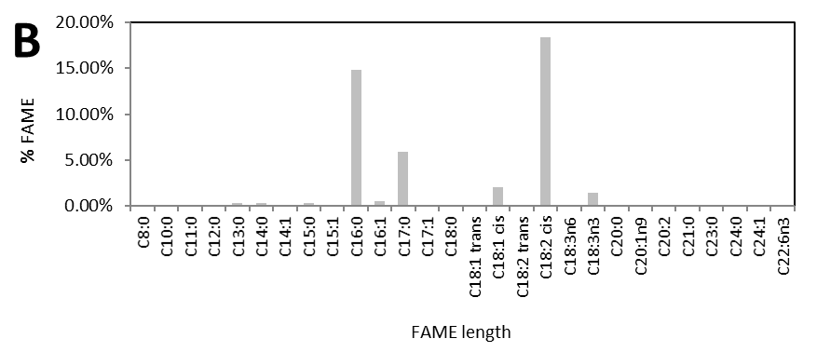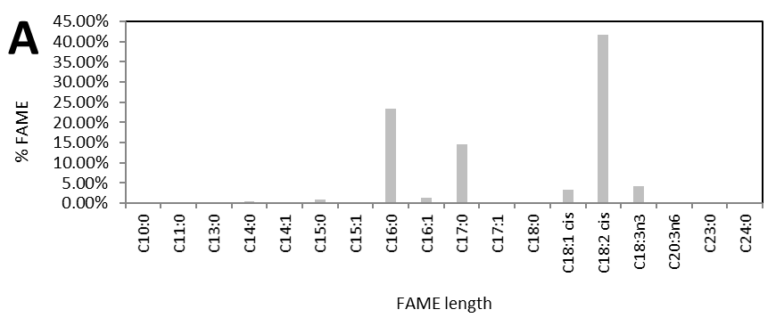

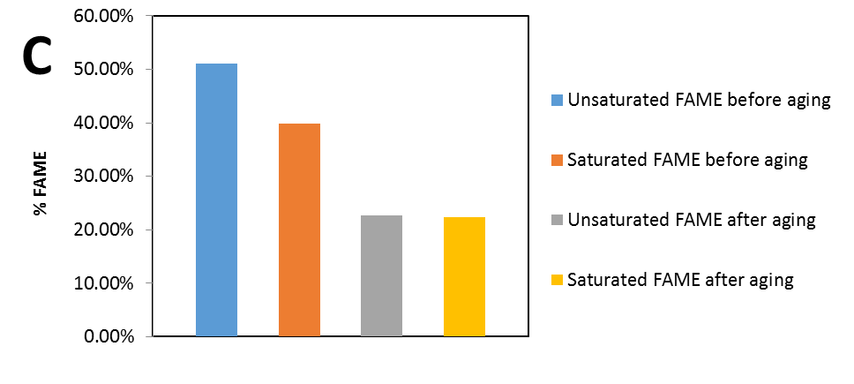

Figure 36 - Fatty acid methyl ester profiles. (A) Before aging of biodiesel. (B) After aging of biodiesel. (C) Before and after aging of biodiesel. Aging performed by heating biodiesel in an oven at 95ºC for 69 days. Ratios of saturated and unsaturated fatty acids alter after aging, indicating unsaturated FAMEs are more susceptible to oxidation. FAME percentages are given with respect to the original crude.

Viscometer setup and calibration
As seen in Figure 37 viscosity is measured using an Ostwald viscometer. The viscometer is held in place with a clamp in a temperature controlled water bath which was set to the appropriate temperature for each viscosity measurement. This was carried out as described in the materials and methods Section 2.15.1.

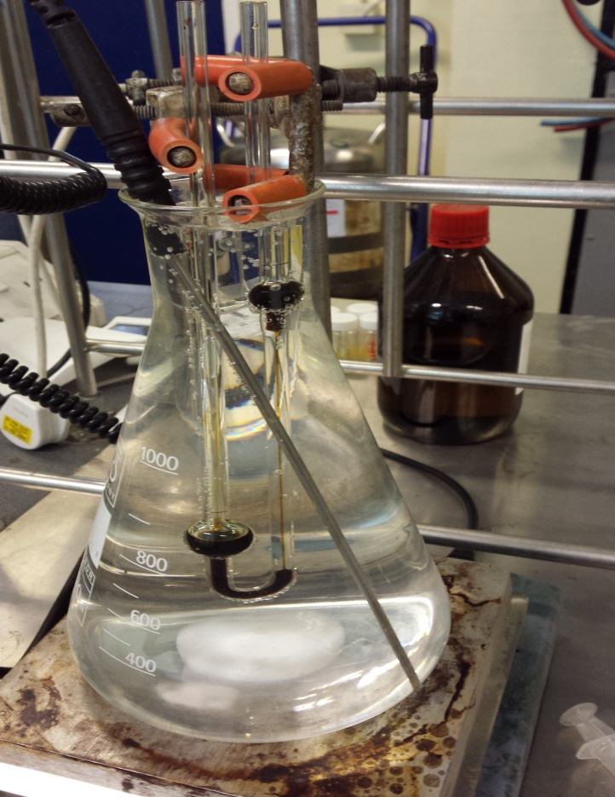

Figure 37 - Setup of Ostwald viscometer in a temperature controlled water bath. Here it can be observed crude biodiesel viscosity is being measured.

Accuracy of the viscometer
Variation between measurements of viscosity were negligible; often differences in flow were less than a second and as seen in Figure 38, the error bars are small. This indicated that whilst this method of viscosity measurement was time consuming, it was reliable enough to produce quality data given calibration with ASTM international viscosity standards.

Viscosity of algal biodiesel
The viscosity change is apparent in Figure 38, the biodiesel exceeded the acceptable ASTM international kinematic viscosity limit (6.0 mm²/s) at 40ºC even before aging; 6.95 mm²/s at 40ºC [163]. In this case the fuel would not be suitable for commercial use though it has to be noted that blending with diesel may provide a way to use the biodiesel without increasing the viscosity of a fuel to a detrimental level [167]. Mostafa et al. blended algal biodiesel with diesel to determine its feasibility as an additive and conclude that with a 20% biodiesel in diesel blend, the blend is within the standard specifications as outlined by ASTM international [167].
In fact, their algal biodiesel has a high viscosity of 12.7 mm²/s and is considerably over the ASTM limit, which is what led them to use it as a blend with diesel [167]. Therefore, it is conceivable that the biodiesel reported in this chapter may also be suitable as a blend for use with diesel, perhaps even at a high concentration due to it only slightly exceeding the ASTM limit.
Johnson et al. reported biodiesel produced from S. limacinum (heterotroph) with a viscosity of 3.87 mm²/s. This viscosity complies with ASTM standards, again indicating that species or energy source (heterotrophic or autotrophic) impacts biodiesel quality due to the differences in fatty acids synthesised. They also note that the biodiesel produced met most of the other ASTM specifications, which indicates that large scale production biodiesel from algae could be possible if the species and growth parameters are optimised.
Additionally, as the biodiesel viscosity reported here was measured/aged for the crude product (91% purity of FAME), the viscosity may be lower in the pure product. Crude biodiesel was measured as too little pure product was produced from the algae and initially rheometry studies were performed with the biodiesel, resulting in small amounts available for measurement with the Ostwald viscometer. Time restraints and lab relocation ultimately meant that producing more biodiesel would have been difficult, thus the crude was used instead.

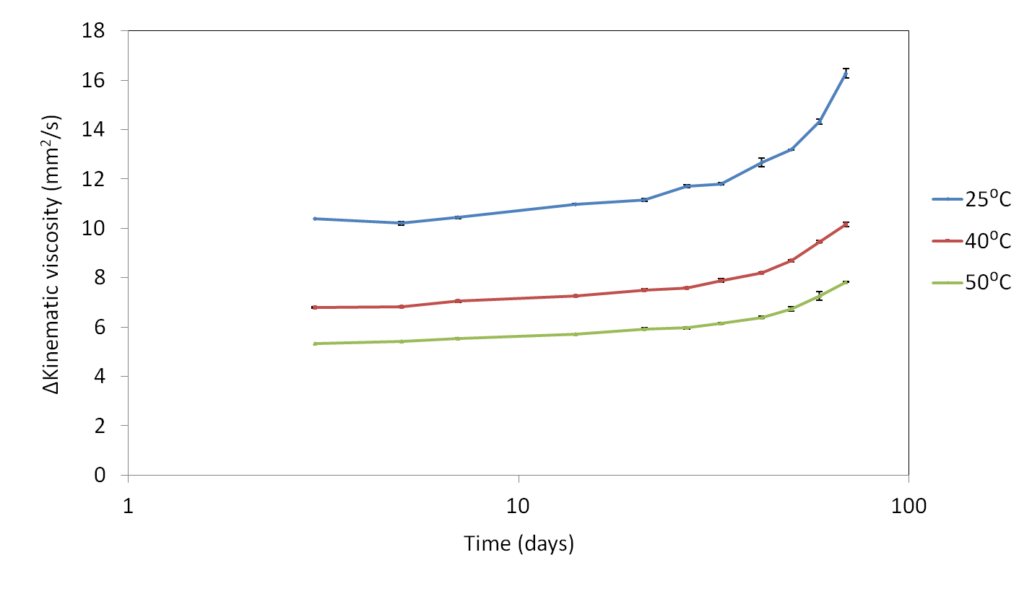
Figure 38 - Kinematic viscosity of accelerated aging biodiesel. A biodiesel sample was heated to a constant temperature of 95ºC in an oven over the course of two and a half months. Viscosity measurements were taken at various time points (days 0,3,5,7,14,21,27,33,42,50,59,69) using an Ostwald viscometer in a temperature controlled water bath at various lower temperatures. n = 3. Error bars represent the standard deviation.

Viscosity increase over time
As previously discussed it was expected that biodiesel viscosity would increase over the time of the aging experiment due to oxidation, which was confirmed by the increase in viscosity shown in Figure 38. Often accelerated aging studies bubble air into a biodiesel sample at a high temperate for a fixed period of time. Dunn et al. aged biodiesel at various temperatures for 6 hours whilst bubbling dry air at a constant flow rate [170]. The results demonstrated that viscosity increases are heavily dependent on temperature, but that under air bubbling at increased temperature viscosities drastically increase to the point of the fuel being unusable.
The accelerated aging experiment presented in this chapter shows a much slower increase in viscosity as air was not bubbled into the biodiesel. This and the aforementioned paper highlight oxidation reactions reliance on temperature and oxygen concentration, an obvious conclusion but important nonetheless. Care must be taken during storage to ensure fuel is kept to low temperatures and free of oxygen. The dramatic increase in viscosity toward the end of the aging experiment indicates that the oligomerisation rate is exponential. As oxidation occurs increasing numbers of FAMEs are attacked and go onto the propagation step of oxidation, increasing the number of chains that undergo oligomerisation.
These results were expected outcomes from the accelerated aging of algal biodiesel. However, it is important to confirm the effects of unsaturated FAMEs on oxidative stability in algal biodiesel and the effects of high temperature on viscosity. Future research should keep these phenomena in mind when producing biodiesel from algae, as well as when storing commercial fuel.

Conclusion
In conclusion, the aim of this work was to take a macroscopic view of biodiesel production; specifically by producing biodiesel from algae in a bioreactor, aging it in an oven and measuring its change in viscosity over this aging process. To this end a flat plate airlift bioreactor was designed and built; firstly, on a 2.5L prototype scale before scaling up to 50L. The bioreactor was effective at culturing M. inermum though improvements could be made to remove mixing dead zones by using a larger diffuser.
6.8 mL of crude biodiesel was obtained from 79.4 g of algae cultured in the bioreactor with a FAME purity of 91%. This converts to every gram of dry algae containing approximately 68.8 mg of lipids (6.88%).
The biodiesels viscosity exceeded the acceptable ASTM international kinematic viscosity limit (6.0 mm²/s) at 40ºC even before aging; 6.95 mm²/s at 40ºC [163]. With aging the viscosity increased dramatically overtime to 10.1 mm²/s at 40ºC by day 69. The GC-FID indicated that the biodiesel produced from cultured M. inermum contained a large percentage of unsaturated FAME. This coupled with the viscosity increase and the TGA data all support the theory that oxidation and thermal stability decrease as concentration of unsaturated FAME increased, when data here was compared to the literature.
The overall message of the experiment was that producing biodiesel from algae at scale is definitely possible, however, the species used and growth parameters have a large impact of the quality of biodiesel. On the other hand, even if the biodiesel produced is not up to the standards required for the petrochemical industry, blending biodiesel with diesel provides an option to sell biodiesel commercially.

Light wavelength tuning for hydrogen production from Chlamydomonas reinhardtii

Summary
Algae have been shown to evolve small amounts of hydrogen gas under anaerobic conditions via their photosynthetic apparatus and the enzyme hydrogenase [171]. Research led to the manipulation of algae to allow for continuous evolution by using sulphur deprived medium [171]. However, laborious medium changing on a regular basis is required in order to culture algae to constantly evolve hydrogen gas and this does not scale well industrially. Recent research explored the concept of filtering light to inhibit photosystem II (the first complex involved in light dependent reactions during photosynthesis), thus stopping oxygen synthesis and allowing hydrogen production to occur without breaking down hydrogenase [107]. This chapter explores this concept further by tuning the wavelengths of light that allow hydrogen synthesis, with the aim of partially restoring photosystem II to allow for healthy cells that evolve hydrogen.

Introduction
Algae can evolve hydrogen gas photosynthetically under certain conditions by using the enzyme hydrogenase to catalyse the reaction. One such species is Chlamydomonas reinhardtii and the reversible reaction mechanism for hydrogen production is shown in Figure 39.
Figure 39 - Hydrogen synthesis by hydrogenase. “D” is an electron carrier which donates its electrons received from photosynthesis. Adapted from Melis et al. [40]
Under normal conditions algae do not generate hydrogen as the enzyme hydrogenase is irreversibly inhibited by oxygen. Mutant hydrogenases have been developed that have reduced oxygen sensitivity during hydrogen consumption, however during hydrogen generation the mutant enzymes were just as oxygen sensitive as the wild type [172]. The enzyme nitrogenase can also generate hydrogen, though is generally much less efficient, and also is irreversibly inhibited by oxygen.

Sulfur deprivation for hydrogen synthesis
In order to allow hydrogenase synthesis and thus hydrogen generation, researchers developed a strategy to reduce the amount of oxygen in a cell. It was successfully shown continuous hydrogen production can be achieved by manipulation of photosynthetic apparatus. Removing sulphur from the culture inhibits structural repair of key proteins in the photosystem II (PSII) complex. PSII and I (photosystem I) generate a proton gradient during photosynthesis resulting in ATP (adenosine triphosphate) generation through ATP synthase [173]. Light is absorbed by PSII, exciting proteins within PSII and causing electrons to be passed onto PSI, which leads to replenishment of lost electrons through the splitting of water [173]. This passage of electrons through the photosystems ultimately results in a culmination of reducing power that is used to generate ATP (the primary “fuel” molecule of a cell) from ADP (adenosine diphosphate) [173].
The proteins in PSII are regularly repaired and recycled within a cell, thus by removing sulphur which is a requirement for their repair, degradation of PSII occurs. This in turn results in the suppression of oxygen generation from photosynthesis.
Therefore, by inhibiting PSII thus promoting anaerobic conditions, hydrogenase expression is promoted. PSII inactivity inhibits photosynthetic oxygen production and instead electrons are passed from PSI to hydrogenase; leading to synthesis of hydrogen. Unfortunately removing sulphur from a culture on a large scale is difficult and its deprivation causes slow growth and repair. Sulphur must eventually be reintroduced to keep a culture viable.
This chapter explores the idea of inhibiting PSII by filtering the wavelengths of light a culture receives. This has been previously shown to work by Hoshino et al. and they demonstrated that hydrogen production was possible by simply filtering the light to deactivate PSII [107]. However, this chapter expands this idea by tuning light to specific wavelength cut-offs. With this in mind it was hypothesised it may be possible to ensure complete shut off PSII or even partially activate it to allow oxygen generation to keep a culture viable, but not inhibit hydrogenase to a significant degree that would halt hydrogen production.

Results and discussion

Light wavelength selection for manipulation of photosynthetic apparatus
As previously discussed it is possible to inhibit PSII through altering the wavelengths of light a culture receives. Both photosystems accept light at different wavelengths due to their pigment structures and thus providing PSI light only, results in PSII inhibition, permitting hydrogen evolution [107]. Oxygen generation is halted and to keep a culture viable white light must be provided at some point, thus the generation cannot be continuous.
This phenomenon has the potential to be further manipulated to generate hydrogen on a constant basis. Partial activation of PSII could be achieved to create a low cellular oxygen concentration, permitting low levels of respiration to keep cells viable. Under partial PSII activation, hydrogenase might not be inhibited. With a low cellular oxygen concentration, it was hypothesised that respiration will occur and thus “free” oxygen won’t be available to bind to and irreversibly inhibit hydrogenase. This could keep cells viable as well as allow continuous hydrogen production.

Gas chromatography to measure hydrogen production
Based on Hoshino et al.’s work, experiments were performed to confirm their experiment was successful in producing hydrogen gas from C. reinhardtii [107]. Following their experimental procedure hydrogen gas was successfully produced, confirmed with GC as seen in Figure 40. Here C. reinhardtii (80 mL of approximately 0.7 mg/mL) was irradiated with light filtered through a FGL695 filter for 30 hours.

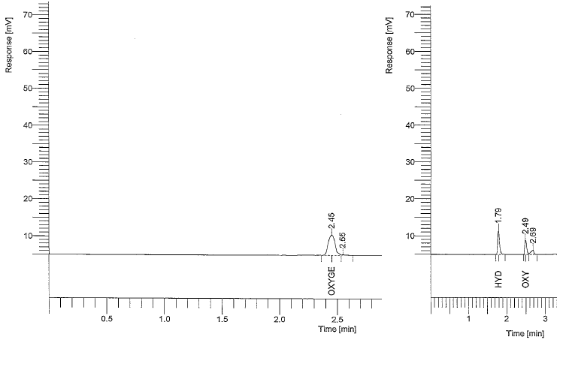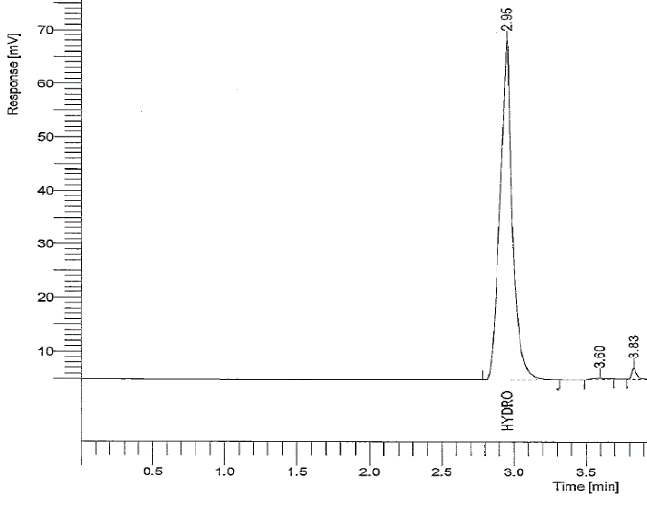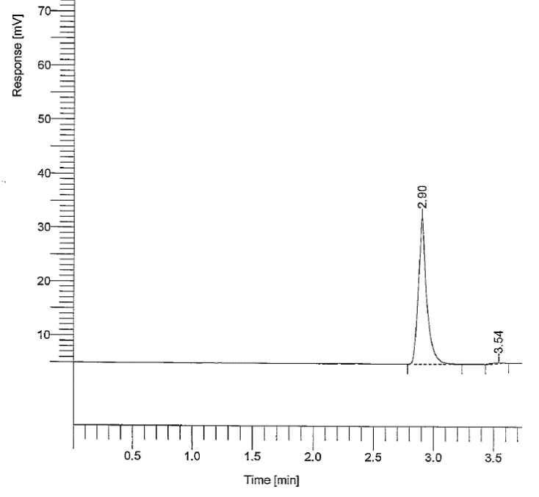
A
C
B

Figure 40 - Gas chromatography of samples. A - GC air standard. B - GC hydrogen standard. C - Hydrogen gas produced by Chlamydomonas reinhardtii. Sample taken after 30 hours of filtered light treatment.

Producing hydrogen gas continuously
Additional experiments were performed with the aim of producing hydrogen gas on a more continuous basis by partial activation of PSII. As discussed by Hoshino et al., they used a bandpass filter which cuts off any PSII activating light and does allow for hydrogen production as Figure 40 shows, albeit not continuously.
However, if a small amount of light was provided to PSII by allowing a slight overlap into the PSII absorption wavelengths then partial oxygen production may occur. This could allow partial respiration whilst maintaining hydrogenase stability and hydrogen production. Rumpel et al. show the passage of electrons from PII to PII which leads to either NADPH (Nicotinamide adenine dinucleotide phosphate) or hydrogen production (NADPH is involved in the last steps in photosynthesis to produce glucose from carbon dioxide) [174]. With this electron passage in mind, in addition to keeping cells healthy, partially restoring PSII activity would provide more electrons, increasing hydrogen production.

Light wavelength tuning
Experimentally, wavelength tuning was achieved by altering the angle of incident light on the optical filter in order to tune the wavelengths the flask receives to a specific cut-off. This was previously explained in the methods chapter. The filter used was an FEL0700 interference filter purchased from Thorlabs. Interference filters are made up of multiple layers with different refractive indexes with specific thicknesses and number of layers. By controlling these parameters, the wavelengths permitted can be tuned for. Due to the nature of the wavelength selection resulting from the effect of interference of light between layers, by changing the angle of incident light on the filter, the wavelengths of light permitted shift downward. This effect can be seen in Figure 41.
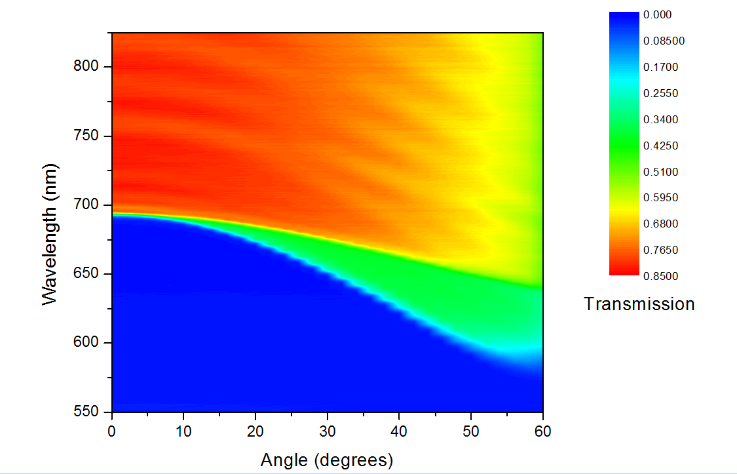

Figure 41 - Wavelength tuning of FEL0700 interference filter. As angle of incidence of the light is increased from zero the wavelength of light the filter permits decreases. Transmission in arbitrary units measured using an Andor Shamrock spectrograph. Red indicates high transmission, green medium, and blue low/none.

Problems using gas chromatography
Using a GC, it was demonstrated that Hoshino et al.’s novel method to produce hydrogen from C. reinhardtii was effective. However, the GC setup was only capable of measuring hydrogen produced at set time points and could not give real time measurements of change in hydrogen production rate. To this end it was decided another instrument would be required in order to get real time feedback of wavelength tuning. Otherwise too many experiments would be necessary to confirm any effects from wavelength tuning and other variables such as chlorophyll density would have to be carefully accounted for; which would likely be troublesome. Therefore, it was decided that a mass spectrometer was suitable for measuring hydrogen gas produced in real time. Additionally, other gases could be measured at the same time, perhaps giving further insight to what is occurring within the cells during the reaction.

Mass spectrometry to measure hydrogen production
A discussed in the method chapters, C. reinhardtii in flasks were irradiated with filtered light and hydrogen was continuously measured using a mass spectrometer as seen in Figure 42. Initially a mass spectrometer which had to be reassembled due to a lab move was used. However, after approximately 12 months of repairs and fine tuning a mass spectrometer in physics was used instead as the original was unfit for use. The mass spectrometer in physics was not quite as accurate but was fully functional.
A preliminary experiment determined the ability of the mass spectrometer to detect hydrogen by irradiating an aliquot of C. reinhardtii as previously discussed; in this case wavelength tuning was not used. As Figure 43 shows the mass spectrometer was accurate in detecting hydrogen. Throughout experiments measuring hydrogen production, the change in rate was considered rather than the total partial pressure as this unit is essentially arbitrary in this case. As changes in wavelength elicited immediate changes in rate, this also meant that data sets didn’t have to be directly compared in order to determine if wavelength tuning was successful.

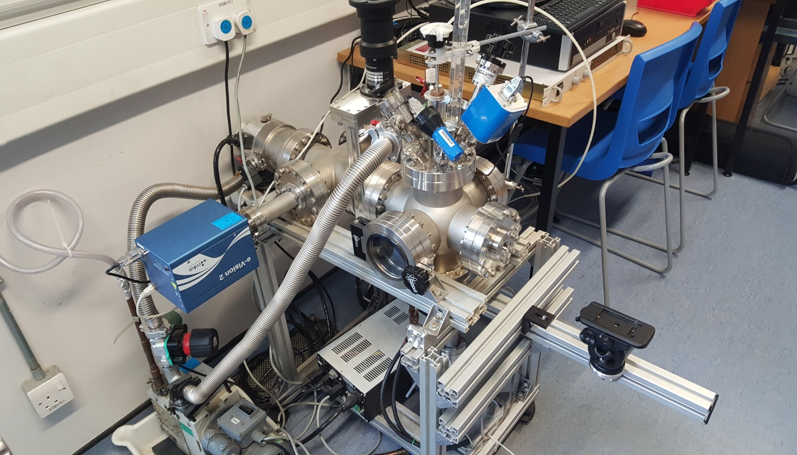

Figure 42 - Mass spectrometer used to measure hydrogen produced by C. reinhardtii under filtered light irradiation.

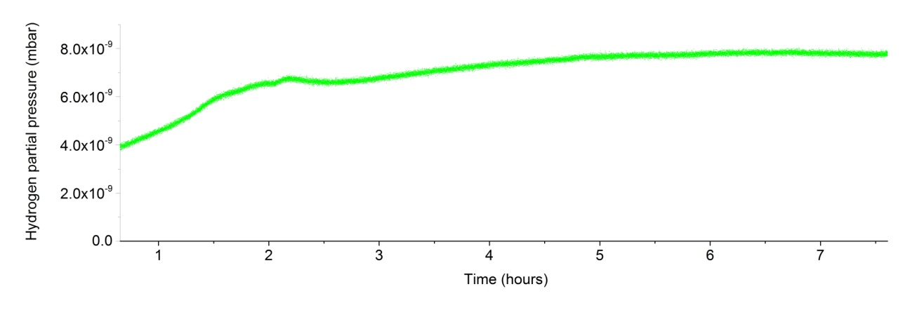

Figure 43 - Mass spectrometry of C. reinhardtii under filtered light irradiation. Preliminary experiment. Partial pressure of hydrogen corresponds to the signal for mass = 2. 150W high power fibre optic light source.

The effect of intensity on hydrogen production rate
Following the successful detection of hydrogen another experiment was performed to determine the viability of measuring hydrogen production rate in real time during wavelength tuning. To determine this, the wavelength was initially kept the same during irradiation as seen in Figure 44 (A0 denoting angle of incident light as 0 degrees). The intensity was then altered to see the effect on hydrogen production rate (I5, denoting 50% of the maximum light intensity of the fibre optic light source). As Figure 44 shows, altering intensity from I5 to I10 resulted in an increase in hydrogen production rate, and conversely decreasing it back to I5 caused a decrease.
Given the immediate effect of intensity on hydrogen production rate, the intensity was increased to maximum and the angle of incidence was changed to 20 degrees which resulted in a rapid decline in the hydrogen production rate. To demonstrate that this angle of incidence was too high it was reduced to 10 degrees and the rate once again increased. Finally, the angle was increased to 15, indicating that at 15 and 20 degrees the wavelengths of light permitted activate PSII and prevent photo hydrogen production. Thus based on the wavelength tuning of Figure 41 it was determined during irradiation below approximately 680nm (A15), photohydrogen production is prevented.

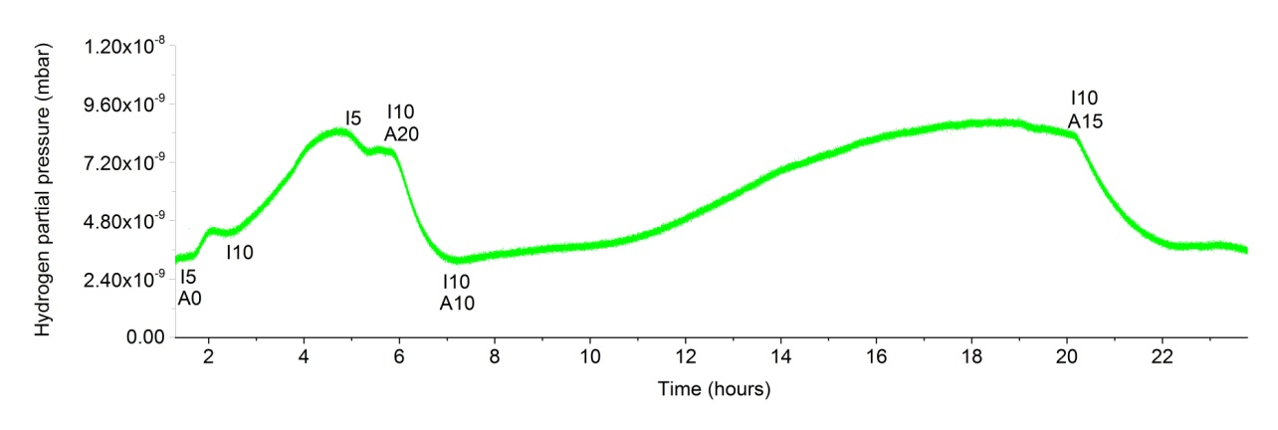
Figure 44 - Mass spectrometry of C. reinhardtii under filtered light irradiation. Intensity experiment. Partial pressure of hydrogen corresponds to the signal for mass = 2. A denotes the angle (A10 = 10 degree angle of incidence). I denotes the intensity (I5 = 50% maximum light intensity of the 150W high power fibre optic light source).

The effect of wavelength of light on hydrogen production rate
The effect of changing angle became apparent in the previous experiment as shown in Figure 44. Thus an experiment was performed were the angle of incident light was changed to determine the optimal wavelength for hydrogen production rate as shown in Figure 45.
Initially, 0 degrees with maximum intensity was used to begin photohydrogen production. The intensity was then lowered which showed a minor rate decreased. However, the angle was then moved to 10 and sequentially increased by 2 degrees approximately every hour until 16 degrees. The result was a decrease in production rate, until angle 16 where the rate began to increase and then switched between increasing and decreasing in a cycle over approximately 18 hours.
This result was unexpected and indicated that around angle 16, photohydrogen production is possible but PSII may be partially activating causing a cycling of oxygen concentration due to oxygen production and consumption within the cell; thereby periodically reducing the activity of hydrogenase available for hydrogen generation. Oxygen partial pressure measured did not change at this time which is possibly due to the produced oxygen being contained within cells and being used for respiration before it can be released. Interestingly, carbon dioxide rate increased from the start of the experiment until approximately hour 25.
Given the fact most electrons are likely leading to hydrogen production rather than NADPH, a build-up of carbon dioxide could be explained by a lack of NADPH available for the Calvin cycle [174]. Hence oxygen from water splitting is being respired and the carbon dioxide produced is not being used in the Calvin cycle as much as usual [174]. These results whilst promising were difficult to derive any firm conclusions from. It should also be pointed out that at this stage of experimentation the optical setup was aligned manually without an optical table thus, there is a possibility the actual angle of incident light was slightly offset (the filter was in a rotational stage but the optical light source was not clamped in place as in Figure 47). This may explain the discrepancy that angle 15 caused a decrease in rate in Figure 44 but angle 16 caused an increase in Figure 45.

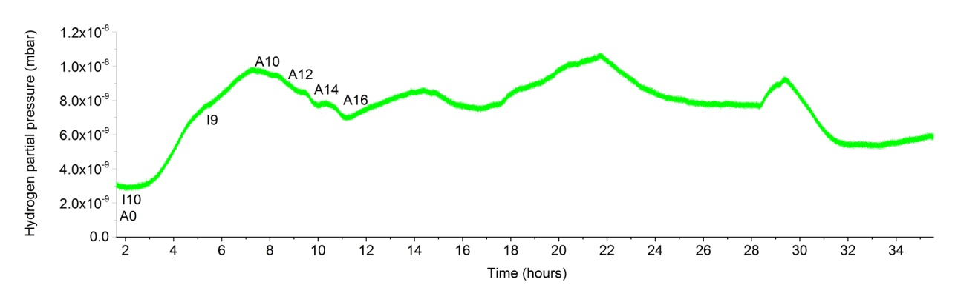
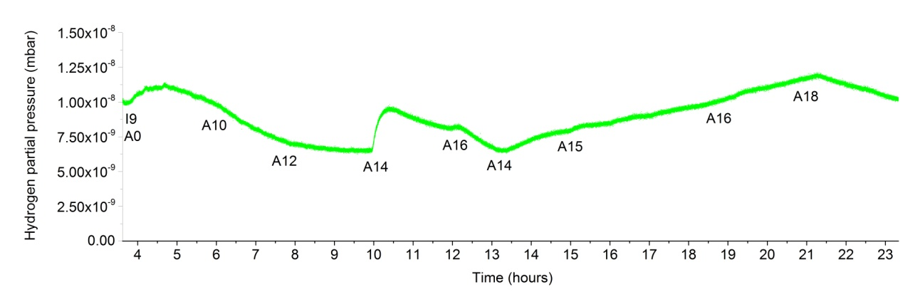
Figure 45 - Mass spectrometry of C. reinhardtii under filtered light irradiation. Wavelength tuning. Partial pressure of hydrogen corresponds to the signal for mass = 2. A denotes the angle (A10 = 10 degree angle of incident light). I denotes the intensity (I5 = 50% maximum light intensity of the 150W high power fibre optic light source). After A16 the rate began to increase and then switched between increasing and decreasing in a cycle over approximately 18 hours.

Figure 46 - Mass spectrometry of C. reinhardtii under filtered light irradiation. Wavelength tuning continued. Partial pressure of hydrogen corresponds to the signal for mass = 2. A denotes the angle (A10 = 10 degree angle of incident light). I denotes the intensity (I5 = 50% maximum light intensity of the 150W high power fibre optic light source).

As the previous experiment was difficult to interpret, another similar experiment was performed but this time with longer intervals between changing angles to give a clearer insight into the effect on wavelength tuning as seen in Figure 46. Initial hydrogen production was omitted as the needle valve became loose and had to be reset (otherwise overestimation of pressure could have occurred). However, as in the previous experiment the angles were moved from 10 to 16 and a similar trend is present. Following an increase in hydrogen production rate at angle 14, the angle was increased to 16 which caused a decrease in rate. Moving back to angle 14 reversed this decrease.
At this point it was assumed that the region of angles 14-16 is approximately the cut off for photohydrogen production (and possibly partial PSII activation) thus the filter was rotated accordingly to 15 degrees. This resulted in an increase in rate over several hours. This filter was then moved to angle 16 to see a decrease in rate again, however an increase occurred instead. Moving to angle 18 then caused the expected decrease.
This led to the conclusion that the angle of incidence required was around 15, however the source of error and discrepancy in measurements was likely due to improper optical alignment of filter and light source. Therefore, an optical system was designed to reduce human error as seen in Figure 47.

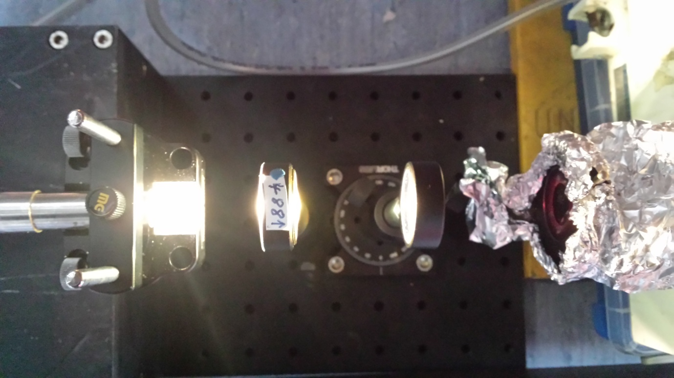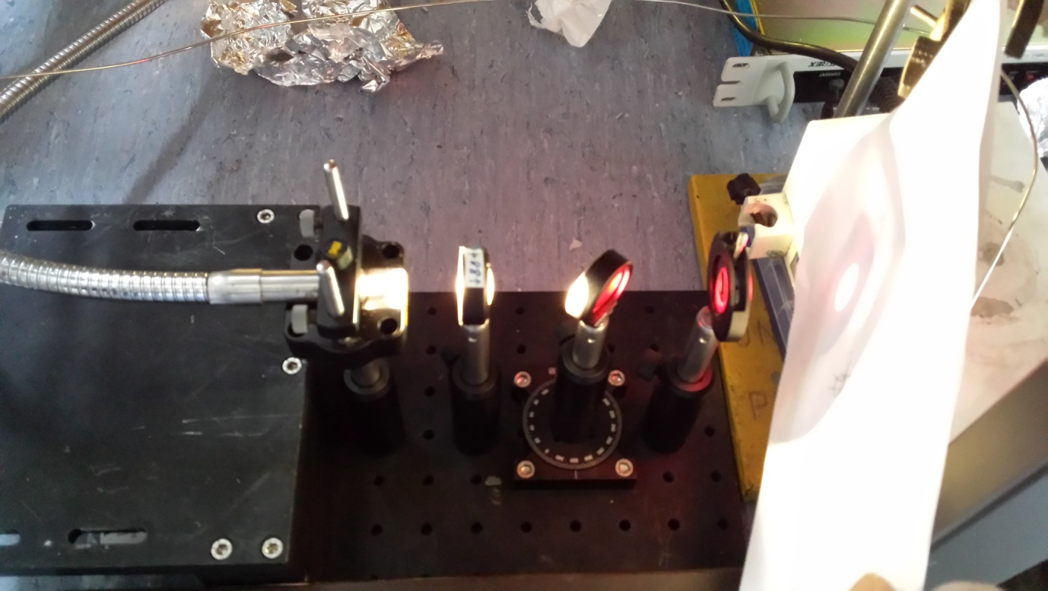

Figure 47 - Aligned optical table for wavelength tuning of light. Light from the 150W high power light source fibre optic cable is collimated using a lens before passing through the FEL0700 filter (which can be rotated to given set angles to vary the wavelengths of light that are allowed through). The light then goes through an iris to reduce stray light and into the culture flask covered in aluminium foil.

Tuning light wavelengths for partial activation of PSII
The data suggests that as the angle is increased from 0 to 16, the rate of hydrogen production decreases slightly, however there is region around 14-16 that causes an increase in hydrogen production rate. The angle of incident light in this region is likely causing the filter to permit light which partially activates PSII and allows for an increase in rate of hydrogen production due to the advantage of a more efficient flow of electrons [107].
A possible explanation for this initial decrease is that partial activation of PSII has already began to occur at 10 degrees thus small amounts of oxygen are produced which reduces the activity of hydrogenase available for hydrogen production. However, as oxygen generation increases up to angle 16 so does the amount of electrons available for hydrogen production and thus the rate increases due to increased absorption of light by PSII. Thus more hydrogen is produced at wavelengths angle 16 corresponds to because more electrons are available. This also helps to explain the cyclic nature of hydrogen production rate seen in Figure 46. It is possible as chloroplast oxygen generation rate increases, hydrogenase is inhibited and hydrogen production rate decreases. Cellular mitochondrial oxygen consumption rate then begins to exceed this rate, which causes anaerobic conditions and promotes hydrogenase expression which once again increases hydrogen production rate. This cycle occurs three times over 18 hours and indicates that the cells could be manipulated to produce hydrogen on a continuous basis given further refinement of wavelength in this cyclic manner.
It was also theorised that the reduction in hydrogen production rate at angles below 16 could be due to a decrease in light intensity from surface reflections of the glass filter, or due to fluctuations in the light sources spectra. However, this was dismissed as the sources spectra had little fluctuations and the effect of reflections was thought to be minimal.
The 14-16 angle region corresponds to a wavelength cut-off of approximately 678-683nm as shown by Figure 41. This approximately lies around the spectral peak of PSI, and thus allows photohydrogen production [107]. PSII’s spectral peak lies at approximately 670nm but the wavelengths around 680nm have small absorption by PSII which results in partial activation [107].

Hydrogen production with an improved optical setup
Following the assembly of an improved optics setup an experiment was performed to confirm the wavelength cut-offs that prevents photohydrogen production and potentially allow for partial PSII activation as seen in Figure 48. Initially the rate of hydrogen production increased as usual, confirming the new setup worked. Unfortunately, the fibre optic light source malfunctioned at this point and subsequently the mass spectrometer required repairs and tuning. In fact, the mass spectrometer often had to have its fittings and filaments replaced. Thus it was decided to abandon this experiment, which was frustrating considering this data set may have provided crucial information regarding manipulating C. reinhardtii to improve photohydrogen production. However, due to equipment malfunction and time restraints this was the only option.

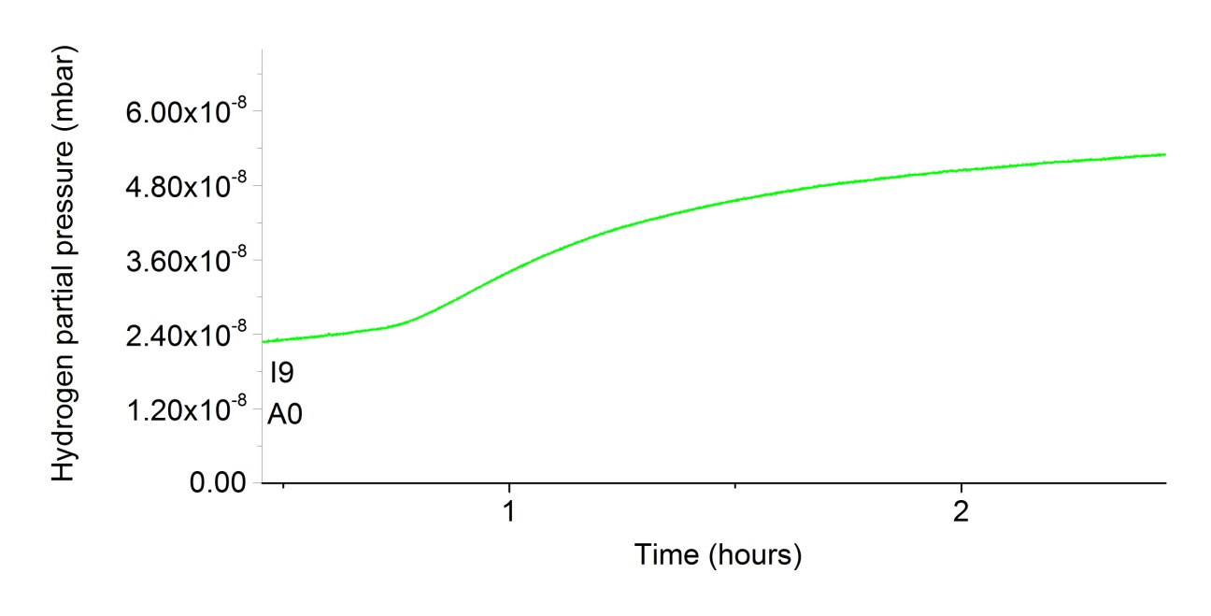
Figure 48 - Mass spectrometry of C. reinhardtii under filtered light irradiation. New optical setup. Partial pressure of hydrogen corresponds to the signal for mass = 2. A denotes the angle (A10 = 10 degree angle of incident light). I denotes the intensity (I5 = 50% maximum light intensity of the 150W high power fibre optic light source).

Problems with the mass spectrometer
Unfortunately, many experiments carried out with this mass spectrometer failed due to a loss of vacuum pressure, filament burn out, bulb burn out or failure to detect hydrogen. In fact, over the course of a year the mass spectrometer was for the most part not functional. In future, a more robust system would be required to provide a reliable setup to perform the necessary experiments.

Improvements to the setup
This experiment was successful in measuring changes in production hydrogen rate during tuning the wavelengths of light in real time. However, improvements could be made to the setup in order to improve the accuracy and ease of experimentation. A better vacuum and needle valve would allow for finer tuning of the flow rate of gas into the mass spectrometer, which would in turn allow for more accurate measurements. Occasionally the needle valve became stuck or became difficult to control the flow rate. In addition to this problem, improving the seals on the vacuum system or simply reducing the number of seals (to reduce chances of losing vacuum pressure) may assist in allowing finer control of the flow rate. Metal fittings for gas sampling on the culture flask may improve accuracy to ensure the sampled gas cannot escape and reduce the chance of oxygen getting into the flask.

Measuring hydrogen production using Raman spectroscopy
A novel technique using Raman spectroscopy to measure hydrogen was also investigated in collaboration with a group in the Department of Chemistry and would have allowed for calculating the amount of hydrogen produced in real time. This involved a very long path length with highly reflective mirrors to improve sensitivity (as the Raman hydrogen signal is not strong). Unfortunately, the hydrogen concentration was too low to measure using this method. A sample of gas was taken following this experiment and sampled on the mass spectrometer, which detected hydrogen, indicating the sensitivity was too low for this system.

Conclusion
This chapter was aimed at adapting the concept of filtering light to inhibit photosystem II, which in turn allows the synthesis of hydrogen through hydrogenase. By inhibiting photosystem II, oxygen synthesis is stopped which causes hydrogen production to occur without breaking down hydrogenase.
By adapting this existing system through fine tuning the wavelengths of light that allow hydrogen synthesis, it was hypothesised that partial restoration of photosystem II would allow partial oxygen synthesis. Thereby resulting in healthy cells that could produce hydrogen as the intracellular oxygen concentration would be too low to completely inhibit hydrogenase.
The experiments presented in this chapter indicate that wavelength tuning may be a useful tool for selectively enhancing hydrogen production rate in C. reinhardtii. The data also suggests that the 678-683 nm cut-off wavelength region may cause partial activation of PSII, which may increase hydrogen production rate and allow for continuous photohydrogen production. Ultimately additional experiments are required to draw any specific conclusions regarding the effects of tuning wavelength on C. reinhardtii cells, but these experiments provide a basis for future experimental design as well as some interesting insights into the mechanisms of photohydrogen production in C. reinhardtii.

Research conclusions
This main objective of this research was to develop technologies to improve the downstream processing of algae, with specific reference to the harvesting and disruption steps. Two novel technologies emerged that provide new methods to process microalgae for the production of both biofuel and high quality commercial products. Namely, using ultraviolet light for the disruption of microalgae and a recyclable magnetic flocculant for the harvesting of microalgae. Additional research needs to be undertaken in order to refine these technologies to achieve their full potential and maximum efficacies. However, the work presented in this thesis provides an excellent starting point to begin using these technologies to reduce the bottlenecks in the algae industry.
The first experimental chapter of this thesis hypothesised that algae could be disrupted using ultraviolet light and that this cell disruption may enhance lipid extraction beyond that of conventional techniques for the production of biodiesel. The data generated supported this hypothesis as 225s of ultraviolet irradiation (equivalent to 335.7 J/cm² UVB) resulted in 90% cell lysis of a 3 mL aliquot of C. reinhardtii. This translates to 5.6MJ/L algae (approximately 0.7 mg/mL, UVB intensity at 1.5 W/cm²). Additionally, GC-FID data demonstrated that UV irradiation achieved a FAME of yield 79.9 mg/L culture and bead beating 45.3 mg/L culture. Indicating that UV irradiation has the potential to enhance lipid extraction over conventional methods.
Furthermore, this research was expanded upon in Chapter 4 by the design and manufacture of a solar tracker which was used to concentrate solar radiation to harness the UV spectrum of sunlight for algal cell lysis. Data demonstrated that the UV spectrum of solar radiation was capable of lysing algal cells for lipid extraction and showed potential for an enhanced lipid yield. Additionally, it was concluded that IR radiation was responsible for any damage to lipids that appeared during longer concentrated solar irradiation periods than the maximum FAME yield extraction period (30-45s). M. inermum was also irradiated with ultraviolet light to determine the effectiveness of lysing thicker covalently bonded cell walled algae. A longer irradiation period was required but 30 min of UV radiation achieved a FAME yield of 226 mg/L extracted algae; which was slightly higher than the 208 mg/L extracted algae for bead beating.
Following the success of disrupting algal cells with a novel technique it was also important to develop a method for harvesting algal cells in order to provide another necessary solution to reduce the downstream processing bottleneck in algal biotechnology. Chapter 5 looked at developing a solution to this harvesting problem through polymers. Initially experiments involved polymer technologies that focussed on the extraction of lipids following disruption, however the research moved more toward an algal cell flocculant which would appeal to a wider range of applications. The data indicated that a flocculant composed of polymer coated magnetic iron oxide nanoparticles was successfully synthesised and was able to flocculate algae reversibly through pH change. Unfortunately, it was not possible to calculate flocculation efficiency with the data collected, however this technology shows great promise for industrial uses.
Alongside these chapters aimed at downstream processing, experiments into the quality of biodiesel that can be produced from algae resulted in the conclusion that species used and growth parameters have a large impact on the quality of biodiesel produced. A 50 L bioreactor was designed and built in order to facilitate the growth of algae to be harvested and converted into biodiesel. This resulted in a yield of 6.8 mL of crude biodiesel (91% purity) from 79.4 g of algae cultured (6.88% lipid w/w in biomass). This biodiesel was aged in an oven for two and a half months and its viscosity was measured over this time. The viscosity dramatically increased from 6.95 mm²/s at 40ºC to 10.1 mm²/s by day 69. This coupled with the GC-FID data which showed the unsaturated FAMEs were more oxidised and the TGA data support the theory that oxidation and thermal stability decrease as concentration of unsaturated FAME increases. This chapter highlighted the importance of species selection and growth parameters. These factors greatly affect the quality of biodiesel produced and must be taken into consideration when producing biodiesel and care should be taken to not simply find a suitably high lipid, fast growing species.
The final chapter was aimed at developing a method of fuel production that kept the culture healthy and was as non-intrusive as possible. Thus, a method of producing hydrogen using only filtered light and an anaerobic culture was adapted. Photohydrogen production from algae was possible using a wavelength tuning method adapted from Hoshino et al.’s work [107]. Data indicated that increased hydrogen production on a continuous basis may be possible via wavelength tuning but no firm conclusions could be derived due to experimental problems prohibiting additional testing. The hypothesis being that partial restoration of photosystem II may permit both partial oxygen synthesis and hydrogen synthesis as the intracellular oxygen concentration would be low enough to not inhibit hydrogenase from catalysing hydrogen production. The experiments suggested that around 678-683 nm partial activation of PSII may occur and result in increased hydrogen production, though additional experiments are necessary to make more solid conclusions.
Overall, the research presented in this thesis gives fresh insights into processing microalgae into biofuel and high quality commercial products as well as documents the development of two new technologies. The overall aim of this research was to investigate ideas that do not currently exist within the scientific community but could be developed into technologies for integration into industry or academia to bolster the potential of algal biotechnology. In particular, the development of ultraviolet light as a cell disruption method and the magnetic flocculant are the most promising.
Currently, two chapters of this thesis are under review for publication, specifically 3 and 6, the work on ultraviolet disruption and investigation into biodiesel properties respectively. Additionally, Unilever are interested in continuing the research of chapter 5, the recyclable magnetic flocculant, with the possibility of patenting or licensing the technology.

Future work
Whilst the novel technologies presented in this thesis are promising, future research needs to provide further insight into their efficacies. Ultraviolet light for the disruption microalgae needs to be tested with a larger selection of species with varying cell wall thicknesses as well as scaling up the process, initially to litres then kilolitres per day. Optimisation of light path length, intensity, duration and reflective surfaces also need to be investigated to reduce energy consumption whilst providing effective disruption. Solar energy as the source for UV light must be further investigated to provide information regarding its feasibility at scale as well as filtering wavelengths other than UV and potentially utilising the excess heat generated for culture growth. Additionally, the UV stability of extracted chemicals needs to be addressed and if any problems arise, experiments should determine how to mitigate them.
It would also be useful to design an optimised solar tracker which can lyse a culture from an open pond during daylight hours automatically. Such a system should flow a culture through the irradiation focal point during appropriate solar light intensities during the day, calculating the effective flow rate based on ultraviolet light intensity in order to maximise culture lysis. To achieve this an ultraviolet spectrophotometer should be connected to the Arduino which performs the necessary calculations. The Arduino should also be connected to the internet to record solar data using a WiFi shield. A spectrophotometer would also be needed to measure the OD of the algal culture to assist in flow rate calculations. It may also be useful to measure lysis using a camera and cell counting software following solar irradiation. The solar tracker should also utilise solar panels to provide electricity for its operation.
Furthermore, the novel recyclable magnetic flocculant nanoparticles require synthesis optimisation; specifically focussing on product yield and increasing surface coverage of polymer. The surface could also be adapted to different polymers with surface charge selectivity. Experiments also should be undertaken to determine the binding efficiency of the particles, recyclability limitations and scalability to industry.
Furthermore, should future research conclude that the flocculant is efficient enough for use in algal biotechnology, it would be interesting to integrate that into an optimised solar tracker. Following irradiation, it may be possible to flocculate lysed algal cells and debris to aid in lipid extraction.
The feasibility of biodiesel as a replacement for petroleum based fuel must also be analysed, specifically looking at stability and the variance of biodiesel properties between the species it is derived from.
With regard to algal photohydrogen production, further experiments should focus on providing a reliable method to quantify hydrogen produced from microalgae. Wavelength tuning using an improved optical setup should then be optimised to investigate the possibly of partially activating photosystem II during photosystem I activation to allow for continuous photohydrogen production. An efficiency rating of amount of hydrogen produced per incident photon should also be calculated by accurately measuring both light intensity and hydrogen produced in real time.
Future work should continue the ideas developed in this work via the above mentioned experiments with the overall aim of advancing the scientific knowledge on how to convert algae into biofuel, be it through hydrogen production or biodiesel. This work provides a basis for future research to take the field of algal biofuel into a potentially industrially viable field. Research into fields such as algal biofuel is important to ensure it is an economically and energetically viable replacement for fossil fuels in the future, particularly in the automotive and aviation industries.

References
[1] Bhattacharya D, Medlin a. L. Algal Phylogeny and the Origin of Land Plants. Plant Physiol 1998;116:9–15. doi:10.1104/pp.116.1.9.
[2] Andersen RA. Algal Culturing Techniques. Academic Press; 2005.
[3] Ulrich Kuck NF. Biotechnology. De Gruyter; 2015.
[4] Dahiya A. Bioenergy: Biomass to Biofuels. vol. 10. Academic Press; 2014.
[5] Brennan L, Owende P. Biofuels from microalgae—A review of technologies for production, processing, and extractions of biofuels and co-products. Renew Sustain Energy Rev 2010;14:557–77. doi:10.1016/j.rser.2009.10.009.
[6] Scott SA, Davey MP, Dennis JS, Horst I, Howe CJ, Lea-Smith DJ, et al. Biodiesel from algae: challenges and prospects. Curr Opin Biotechnol 2010;21:277–86. doi:10.1016/j.copbio.2010.03.005.
[7] Brown AC, Knights BA, Conway E. Hydrocarbon content and its relationship to physiological state in the green alga Botryococcus braunii. Phytochemistry 1969;8:543–7. doi:10.1016/S0031-9422(00)85397-2.
[8] Banerjee A, Sharma R, Chisti Y, Banerjee UC. Botryococcus braunii: A Renewable Source of Hydrocarbons and Other Chemicals. Crit Rev Biotechnol 2002;22:245–79.
[9] Qin J. Bio-hydrocarbons from algae. RIRDC Publ 2005.
[10] The Structure, Biosynthesis, and Degradation of Wood. Springer Science & Business Media; 2012.
[11] Hoshina R, Fujiwara Y. Molecular characterization of Chlorella cultures of the National Institute for Environmental Studies culture collection with description of Micractinium inermum sp. nov., Didymogenes sphaerica sp. nov., and Didymogenes soliella sp. nov. (Chlorellaceae, Tr. Phycol Res 2013;61:124–32. doi:10.1111/pre.12010.
[12] Oren A. A hundred years of Dunaliella research: 1905-2005. Saline Systems 2005;1:2. doi:10.1186/1746-1448-1-2.
[13] Ugwu CU, Aoyagi H, Uchiyama H. Photobioreactors for mass cultivation of algae. Bioresour Technol 2008;99:4021–8. doi:10.1016/j.biortech.2007.01.046.
[14] Tanoi T, Kawachi M, Watanabe MM. Effects of carbon source on growth and morphology of Botryococcus braunii. J Appl Phycol 2010;23:25–33. doi:10.1007/s10811-010-9528-4.
[15] Singh UB, Ahluwalia AS. Microalgae: a promising tool for carbon sequestration. Mitig Adapt Strateg Glob Chang 2012;18:73–95. doi:10.1007/s11027-012-9393-3.
[16] Han B-P. Effect of photoinhibition on algal photosynthesis: a dynamic model. J Plankton Res 2000;22:865–85. doi:10.1093/plankt/22.5.865.
[17] VONSHAK A, GUY R. Photoadaptation, photoinhibition and productivity in the blue-green alga, Spirulina platensis grown outdoors. Plant, Cell Environ 1992;15:613–6. doi:10.1111/j.1365-3040.1992.tb01496.x.
[18] Bauwe H. Photorespiration. Encyclopedia of Life Sciences. John Wiley & Sons, Ltd; 2010. doi:10.1002/9780470015902.a0001292.pub2.
[19] Shelp BJ, Canvin DT. Photorespiration and Oxygen Inhibition of Photosynthesis in Chlorella pyrenoidosa. Plant Physiol 1980;65:780–4.
[20] Zimmerman WB, Zandi M, Hemaka Bandulasena HC, Tesař V, James Gilmour D, Ying K. Design of an airlift loop bioreactor and pilot scales studies with fluidic oscillator induced microbubbles for growth of a microalgae Dunaliella salina. Appl Energy 2011;88:3357–69. doi:10.1016/j.apenergy.2011.02.013.
[21] Ge Y, Liu J, Tian G. Growth characteristics of Botryococcus braunii 765 under high CO2 concentration in photobioreactor. Bioresour Technol 2011;102:130–4. doi:10.1016/j.biortech.2010.06.051.
[22] Kumar A, Ergas S, Yuan X, Sahu A, Zhang Q, Dewulf J, et al. Enhanced CO(2) fixation and biofuel production via microalgae: recent developments and future directions. Trends Biotechnol 2010;28:371–80. doi:10.1016/j.tibtech.2010.04.004.
[23] Órpez R, Martínez ME, Hodaifa G, El Yousfi F, Jbari N, Sánchez S. Growth of the microalga Botryococcus braunii in secondarily treated sewage. Desalination 2009;246:625–30. doi:10.1016/j.desal.2008.07.016.
[24] Demirbas A. Use of algae as biofuel sources. Energy Convers Manag 2010;51:2738–49. doi:10.1016/j.enconman.2010.06.010.
[25] Slade R, Bauen A. Micro-algae cultivation for biofuels: Cost, energy balance, environmental impacts and future prospects. Biomass and Bioenergy 2013;53:29–38. doi:10.1016/j.biombioe.2012.12.019.
[26] Mu D, Min M, Krohn B, Mullins KA, Ruan R, Hill J. Life cycle environmental impacts of wastewater-based algal biofuels. Environ Sci Technol 2014;48:11696–704. doi:10.1021/es5027689.
[27] Bennion EP, Ginosar DM, Moses J, Agblevor F, Quinn JC. Lifecycle assessment of microalgae to biofuel: Comparison of thermochemical processing pathways. Appl Energy 2015;154:1062–71. doi:10.1016/j.apenergy.2014.12.009.
[28] Chisti Y. Biodiesel from microalgae. Biotechnol Adv 25:294–306. doi:10.1016/j.biotechadv.2007.02.001.
[29] Schlagermann P, Göttlicher G, Dillschneider R, Rosello-Sastre R, Posten C. Composition of algal oil and its potential as biofuel. J Combust 2012;2012. doi:10.1155/2012/285185.
[30] Ho S-H, Huang S-W, Chen C-Y, Hasunuma T, Kondo A, Chang J-S. Bioethanol production using carbohydrate-rich microalgae biomass as feedstock. Bioresour Technol 2012. doi:10.1016/j.biortech.2012.10.015.
[31] Leschine SB. Cellulose degradation in anaerobic environments. Annu Rev Microbiol 1995;49:399–426. doi:10.1146/annurev.mi.49.100195.002151.
[32] Freier D, Mothershed CP, Wiegel J. Characterization of Clostridium thermocellum JW20. Appl Environ Microbiol 1988;54:204–11.
[33] Demirbaş A. Biomass resource facilities and biomass conversion processing for fuels and chemicals. Energy Convers Manag 2001;42:1357–78. doi:10.1016/S0196-8904(00)00137-0.
[34] Unruh D, Pabst K, Schaub G. Fischer−Tropsch Synfuels from Biomass: Maximizing Carbon Efficiency and Hydrocarbon Yield. Energy & Fuels 2010;24:2634–41. doi:10.1021/ef9009185.
[35] Lv P, Yuan Z, Wu C, Ma L, Chen Y, Tsubaki N. Bio-syngas production from biomass catalytic gasification. Energy Convers Manag 2007;48:1132–9. doi:10.1016/j.enconman.2006.10.014.
[36] Aziz M, Oda T, Mitani T, Kurokawa T, Kawasaki N, Kashiwagi T. Enhanced Energy Utilization System of Algae: Integrated Drying, Gasification and Combined Cycle. Energy Procedia 2015;75:906–11. doi:10.1016/j.egypro.2015.07.229.
[37] Patil V, Tran K-Q, Giselrød HR. Towards sustainable production of biofuels from microalgae. Int J Mol Sci 2008;9:1188–95. doi:10.3390/ijms9071188.
[38] Dote Y, Sawayama S, Inoue S, Minowa T, Yokoyama S. Recovery of liquid fuel from hydrocarbon-rich microalgae by thermochemical liquefaction. Fuel 1994;73:1855–7. doi:10.1016/0016-2361(94)90211-9.
[39] Thangalazhy-Gopakumar S, Adhikari S, Chattanathan SA, Gupta RB. Catalytic pyrolysis of green algae for hydrocarbon production using H+ZSM-5 catalyst. Bioresour Technol 2012;118:150–7. doi:10.1016/j.biortech.2012.05.080.
[40] Melis A, Zhang L, Forestier M, Ghirardi ML, Seibert M. Sustained photobiological hydrogen gas production upon reversible inactivation of oxygen evolution in the green alga Chlamydomonas reinhardtii. Plant Physiol 2000;122:127–36.
[41] Lee AK, Lewis DM, Ashman PJ. Disruption of microalgal cells for the extraction of lipids for biofuels: Processes and specific energy requirements. Biomass and Bioenergy 2012;46:89–101. doi:10.1016/j.biombioe.2012.06.034.
[42] Dassey AJ, Theegala CS. Harvesting economics and strategies using centrifugation for cost effective separation of microalgae cells for biodiesel applications. Bioresour Technol 2013;128:241–5. doi:10.1016/j.biortech.2012.10.061.
[43] Kothandaraman V. Removal of algae from waste stabilization pond effluent-- a state of the art. Illinois State Water Survey; 1972.
[44] Sim T-S, Goh A, Becker EW. Comparison of centrifugation, dissolved air flotation and drum filtration techniques for harvesting sewage-grown algae. Biomass 1988;16:51–62. doi:10.1016/0144-4565(88)90015-7.
[45] Gregory J, O’Melia CR. Fundamentals of flocculation. Crit Rev Environ Control 1989;19:185–230. doi:10.1080/10643388909388365.
[46] Vandamme D, Foubert I, Muylaert K. Flocculation as a low-cost method for harvesting microalgae for bulk biomass production. Trends Biotechnol 2013;31:233–9. doi:10.1016/j.tibtech.2012.12.005.
[47] Oh,Hee-Mock. Harvesting of Chlorella vulgaris using a bioflocculant from Paenibacillus sp. AM49. Biotechnol Lett n.d.;23:1229–34.
[48] Sukenik A, Shelef G. Algal autoflocculation?verification and proposed mechanism. Biotechnol Bioeng 1984;26:142–7. doi:10.1002/bit.260260206.
[49] Vandamme D, Foubert I, Fraeye I, Meesschaert B, Muylaert K. Flocculation of Chlorella vulgaris induced by high pH: role of magnesium and calcium and practical implications. Bioresour Technol 2012;105:114–9. doi:10.1016/j.biortech.2011.11.105.
[50] Uduman N, Qi Y, Danquah MK, Forde GM, Hoadley A. Dewatering of microalgal cultures: A major bottleneck to algae-based fuels. J Renew Sustain Energy 2010;2:12701. doi:10.1063/1.3294480.
[51] Bulatovic SM. Handbook of Flotation Reagents: Chemistry, Theory and Practice: Volume 1: Flotation of Sulfide Ores. Elsevier; 2007.
[52] Wiley PE, Brenneman KJ, Jacobson AE. Improved algal harvesting using suspended air flotation. Water Environ Res 2009;81:702–8.
[53] Levin G V., Clendenning JR, Gibor A, Bogar FD. Harvesting of Algae by Froth Flotation. Appl Envir Microbiol 1962;10:169–75.
[54] Coward T, Lee JGM, Caldwell GS. Development of a foam flotation system for harvesting microalgae biomass. Algal Res 2013;null. doi:10.1016/j.algal.2012.12.001.
[55] Liu J, Zhu Y, Tao Y, Zhang Y, Li A, Li T, et al. Freshwater microalgae harvested via flocculation induced by pH decrease. Biotechnol Biofuels 2013;6:98. doi:10.1186/1754-6834-6-98.
[56] Uduman N, Bourniquel V, Danquah MK, Hoadley AFA. A parametric study of electrocoagulation as a recovery process of marine microalgae for biodiesel production. Chem Eng J 2011;174:249–57. doi:10.1016/j.cej.2011.09.012.
[57] Poelman E, De Pauw N, Jeurissen B. Potential of electrolytic flocculation for recovery of micro-algae. Resour Conserv Recycl 1997;19:1–10. doi:10.1016/S0921-3449(96)01156-1.
[58] Show K-Y, Lee D-J, Chang J-S. Algal biomass dehydration. Bioresour Technol 2012. doi:10.1016/j.biortech.2012.08.021.
[59] Rossignol N, Vandanjon L, Jaouen P, Quéméneur F. Membrane technology for the continuous separation microalgae/culture medium: compared performances of cross-flow microfiltration and ultrafiltration. Aquac Eng 1999;20:191–208. doi:10.1016/S0144-8609(99)00018-7.
[60] Yadidia R, Abeliovich A, Belfort G. Algae removal by high gradient magnetic filtration. Environ Sci Technol 1977;11:913–6. doi:10.1021/es60132a013.
[61] Mujumdar AS, editor. Handbook of Industrial Drying, Third Edition. CRC Press; 2006.
[62] Becker EW, Venkataraman L V. Biotechnology and exploitation of algae. The Indian approach, German Agency for Technical Cooperation. J Environ Sci 1982;1.
[63] Shelef G. Microalgae harvesting and processing: A literature review a subcontract report. For sale by the National Technical Information Service]; 1984.
[64] Chen XD, Mujumdar AS. Drying Technologies in Food Processing. Wiley-Blackwell; 2008.
[65] Yoo G, Park W-K, Kim CW, Choi Y-E, Yang J-W. Direct lipid extraction from wet Chlamydomonas reinhardtii biomass using osmotic shock. Bioresour Technol 2012;123:717–22. doi:10.1016/j.biortech.2012.07.102.
[66] Frenz J, Largeau C, Casadevall E. Hydrocarbon recovery by extraction with a biocompatible solvent from free and immobilized cultures of Botryococcus braunii. Enzyme Microb Technol 1989;11:717–24. doi:10.1016/0141-0229(89)90120-8.
[67] Lee J-Y, Yoo C, Jun S-Y, Ahn C-Y, Oh H-M. Comparison of several methods for effective lipid extraction from microalgae. Bioresour Technol 2010;101 Suppl:S75-7. doi:10.1016/j.biortech.2009.03.058.
[68] Liu C-Z, Zheng S, Xu L, Wang F, Guo C. Algal oil extraction from wet biomass of Botryococcus braunii by 1,2-dimethoxyethane. Appl Energy 2013;102:971–4. doi:10.1016/j.apenergy.2012.08.016.
[69] Ehimen EA, Holm-Nielsen J-B, Poulsen M, Boelsmand JE. Influence of different pre-treatment routes on the anaerobic digestion of a filamentous algae. Renew Energy 2013;50:476–80. doi:10.1016/j.renene.2012.06.064.
[70] Balasundaram B, Pandit AB. Selective release of invertase by hydrodynamic cavitation. Biochem Eng J 2001;8:251–6. doi:10.1016/S1369-703X(01)00114-0.
[71] Nguyen TL, Lee DJ, Chang JS, Liu JC. Effects of ozone and peroxone on algal separation via dispersed air flotation. Colloids Surf B Biointerfaces 2013;105:246–50. doi:10.1016/j.colsurfb.2012.12.017.
[72] Lozano-Parada JH, Zimmerman WB. The role of kinetics in the design of plasma microreactors. Chem Eng Sci 2010.
[73] Large Scale UV Disinfection System Treats Paris Drinking Water - WaterWorld n.d. http://www.waterworld.com/articles/wwi/print/volume-23/issue-2/editorial-spotlight/municipal-water-systems/large-scale-uv-disinfection-system-treats-paris-drinking-water.html (accessed April 25, 2016).
[74] Walton DJ, Lorimer JP. Polymers. Oxford University Press; 2000.
[75] Young RJ, Lovell PA. Introduction to Polymers, Third Edition. CRC Press; 2011.
[76] ’t Lam GP, Vermuë MH, Olivieri G, van den Broek LAM, Barbosa MJ, Eppink MHM, et al. Cationic polymers for successful flocculation of marine microalgae. Bioresour Technol 2014;169:804–7. doi:10.1016/j.biortech.2014.07.070.
[77] Wan F, Pei X, Yu B, Ye Q, Zhou F, Xue Q. Grafting polymer brushes on biomimetic structural surfaces for anti-algae fouling and foul release. ACS Appl Mater Interfaces 2012;4:4557–65. doi:10.1021/am300912w.
[78] Lu A-H, Salabas EL, Schüth F. Magnetic nanoparticles: synthesis, protection, functionalization, and application. Angew Chem Int Ed Engl 2007;46:1222–44. doi:10.1002/anie.200602866.
[79] Yadollahpour A, Rashidi S. Magnetic Nanoparticles: A Review of Chemical and Physical Characteristics Important in Medical Applications. Orient J Chem 2015;31:25–30.
[80] Barratt G. Colloidal drug carriers: achievements and perspectives. Cell Mol Life Sci 2003;60:21–37. doi:10.1007/s000180300002.
[81] Salata O. Applications of nanoparticles in biology and medicine. J Nanobiotechnology 2004;2:3. doi:10.1186/1477-3155-2-3.
[82] Hasany SF, Rehman A, Jose R, Ahmed I. Iron oxide magnetic nanoparticles: A short review. J. Appl. Phys., vol. AIP Conf., 2012, p. 298–321. doi:10.1063/1.4769153.
[83] Wu W, He Q, Jiang C. Magnetic iron oxide nanoparticles: synthesis and surface functionalization strategies. Nanoscale Res Lett 2008;3:397–415. doi:10.1007/s11671-008-9174-9.
[84] Hyeon T, Lee SS, Park J, Chung Y, Na H Bin. Synthesis of Highly Crystalline and Monodisperse Maghemite Nanocrystallites without a Size-Selection Process. J Am Chem Soc 2001;123:12798–801. doi:10.1021/ja016812s.
[85] Prochazkova G, Safarik I, Branyik T. Harvesting microalgae with microwave synthesized magnetic microparticles. Bioresour Technol 2013;130:472–7. doi:10.1016/j.biortech.2012.12.060.
[86] Media for Chlamydomonas: TAP medium n.d. http://www.chlamycollection.org/TAP.html (accessed May 1, 2016).
[87] Vonshak A. Laboratory Techniques for the cultivation of microalgae. Handb Microalgal Mass . 1986.
[88] Boyle NR, Page MD, Liu B, Blaby IK, Casero D, Kropat J, et al. Three acyltransferases and nitrogen-responsive regulator are implicated in nitrogen starvation-induced triacylglycerol accumulation in Chlamydomonas. J Biol Chem 2012;287:15811–25. doi:10.1074/jbc.M111.334052.
[89] Betenbaugh M, Bentley W, Rosenberg JN, Oyler GA, Wilkinson L, Betenbaugh MJ. A green light for engineered algae: redirecting metabolism to fuel a biotechnology revolution. Curr Opin Biotechnol 2008;19:430–6.
[90] Wu Z, Shen H, Ondruschka B, Zhang Y, Wang W, Bremner DH. Removal of blue-green algae using the hybrid method of hydrodynamic cavitation and ozonation. J Hazard Mater 2012;235–236:152–8. doi:10.1016/j.jhazmat.2012.07.034.
[91] Preetha K, John L, Subin CS, Vijayan KK. Phenotypic and genetic characterization of Dunaliella (Chlorophyta) from Indian salinas and their diversity. Aquat Biosyst 2012;8:27. doi:10.1186/2046-9063-8-27.
[92] Gronbeck C. Sunangle calculator n.d. http://www.susdesign.com/sunangle/index.php (accessed April 26, 2016).
[93] Fox CB. Squalene emulsions for parenteral vaccine and drug delivery. Molecules 2009;14:3286–312. doi:10.3390/molecules14093286.
[94] Zhang W, Shi Z, Zhang F, Liu X, Jin J, Jiang L. Superhydrophobic and superoleophilic PVDF membranes for effective separation of water-in-oil emulsions with high flux. Adv Mater 2013;25:2071–6. doi:10.1002/adma.201204520.
[95] Hayase G, Kanamori K, Fukuchi M, Kaji H, Nakanishi K. Facile synthesis of marshmallow-like macroporous gels usable under harsh conditions for the separation of oil and water. Angew Chem Int Ed Engl 2013;52:1986–9. doi:10.1002/anie.201207969.
[96] Jin M, Wang J, Yao X, Liao M, Zhao Y, Jiang L. Underwater oil capture by a three-dimensional network architectured organosilane surface. Adv Mater 2011;23:2861–4. doi:10.1002/adma.201101048.
[97] Liu Y, Li Y, Li X-M, He T. Kinetics of (3-aminopropyl)triethoxylsilane (APTES) silanization of superparamagnetic iron oxide nanoparticles. Langmuir 2013;29:15275–82. doi:10.1021/la403269u.
[98] Park J, Lee E, Hwang N-M, Kang M, Kim SC, Hwang Y, et al. One-nanometer-scale size-controlled synthesis of monodisperse magnetic iron oxide nanoparticles. Angew Chem Int Ed Engl 2005;44:2873–7. doi:10.1002/anie.200461665.
[99] Robinson I, Alexander C, Lu LT, Tung LD, Fernig DG, Thanh NTK. One-step synthesis of monodisperse water-soluble “dual-responsive” magnetic nanoparticles. Chem Commun (Camb) 2007:4602–4. doi:10.1039/b713528a.
[100] Yudovin-Farber I, Golenser J, Beyth N, Weiss EI, Domb AJ. Quaternary Ammonium Polyethyleneimine: Antibacterial Activity. J Nanomater 2010;2010:1–11. doi:10.1155/2010/826343.
[101] Mobinikhaledi A, Khajeh-Amiri A. N-propylpiperazine sulfonic acid immobilized on Fe3O4 magnetic silica nanoparticles: an efficient and heterogeneous catalyst for the one-pot synthesis of 9H-xanthene or methylenediphenol derivatives under solvent-free conditions. React Kinet Mech Catal 2014;112:131–45. doi:10.1007/s11144-014-0686-2.
[102] Jones J, Beran C, Beach J, Poenie M. Resins that reversibly bind algae for harvesting and concentration. Environ Prog Sustain Energy 2013;32:1143–9. doi:10.1002/ep.11697.
[103] Lin Y-Z, Wang T-H, Lin Y-S, Kuan W-C, Lee W-C. A novel method to prepare magnetic polymer-based anion exchangers and their application. J Appl Polym Sci 2014;131:n/a-n/a. doi:10.1002/app.40725.
[104] Morrissey KL, He C, Wong MH, Zhao X, Chapman RZ, Bender SL, et al. Charge-tunable polymers as reversible and recyclable flocculants for the dewatering of microalgae. Biotechnol Bioeng 2015;112:74–83. doi:10.1002/bit.25340.
[105] Robinson I, Alexander C, Tung L, Fernig D, Thanh N. Fabrication of water-soluble magnetic nanoparticles by ligand-exchange with thermo-responsive polymers 2009.
[106] E Halvorsen K, L Selfa T, R Becker D, Hinrichs C, D’Oca MGM, Viêgas C V., et al. Production of FAMEs from several microalgal lipidic extracts and direct transesterification of the Chlorella pyrenoidosa. Biomass and Bioenergy 2011;35:1533–8.
[107] Hoshino T, Johnson DJ, Cuello JL. Design of new strategy for green algal photo-hydrogen production: Spectral-selective photosystem I activation and photosystem II deactivation. Bioresour Technol 2012;120:233–40.
[108] Kim J, Yoo G, Lee H, Lim J, Kim K, Kim CW, et al. Methods of downstream processing for the production of biodiesel from microalgae. Biotechnol Adv 2013;31:862–76. doi:10.1016/j.biotechadv.2013.04.006.
[109] Larkum AW, Wood WF. The effect of UV-B radiation on photosynthesis and respiration of phytoplankton, benthic macroalgae and seagrasses. Photosynth Res 1993;36:17–23. doi:10.1007/BF00018071.
[110] Sharma KK, Schuhmann H, Schenk PM. High Lipid Induction in Microalgae for Biodiesel Production. Energies 2012;5:1532–53. doi:10.3390/en5051532.
[111] Masi A, Melis A. Morphological and molecular changes in the unicellular green alga Dunaliella salina grown under supplemental UV-B radiation: cell characteristics and Photosystem II damage and repair properties. Biochim Biophys Acta - Bioenerg 1997;1321:183–93. doi:10.1016/S0005-2728(97)00054-6.
[112] Moharikar S, D’Souza JS, Kulkarni AB, Rao BJ. APOPTOTIC-LIKE CELL DEATH PATHWAY IS INDUCED IN UNICELLULAR CHLOROPHYTE CHLAMYDOMONAS REINHARDTII (CHLOROPHYCEAE) CELLS FOLLOWING UV IRRADIATION: DETECTION AND FUNCTIONAL ANALYSES1. J Phycol 2006;42:423–33. doi:10.1111/j.1529-8817.2006.00207.x.
[113] Hartmann A, Albert A, Ganzera M. Effects of elevated ultraviolet radiation on primary metabolites in selected alpine algae and cyanobacteria. J Photochem Photobiol B 2015;149:149–55. doi:10.1016/j.jphotobiol.2015.05.016.
[114] Karentz D. Ecological considerations of Antarctic ozone depletion. Antarct Sci 1991;3:3–11. doi:10.1017/S0954102091000032.
[115] Kuluncsics Z, Perdiz D, Brulay E, Muel B, Sage E. Wavelength dependence of ultraviolet-induced DNA damage distribution: Involvement of direct or indirect mechanisms and possible artefacts. J Photochem Photobiol B Biol 1999;49:71–80.
[116] Rastogi RP, Richa, Kumar A, Tyagi MB, Sinha RP. Molecular Mechanisms of Ultraviolet Radiation-Induced DNA Damage and Repair. J Nucleic Acids 2010;2010:1–32. doi:10.4061/2010/592980.
[117] Hannen EJ van, Gons HJ. UVC-induced lysis and detritus production of Oscillatoria limnetica in a two-stage continuous-flow system. J Plankton Res 1997;19:723–33. doi:10.1093/plankt/19.6.723.
[118] Seckbach J. Algae and Cyanobacteria in Extreme Environments. Cell Orig Life Extrem Habitats Astrobiol , Vol 11 2007:814.
[119] Holzinger A, Lütz C. Algae and UV irradiation: effects on ultrastructure and related metabolic functions. Micron 2006;37:190–207. doi:10.1016/j.micron.2005.10.015.
[120] Fink SL, Cookson BT. Apoptosis, pyroptosis, and necrosis: mechanistic description of dead and dying eukaryotic cells. Infect Immun 2005;73:1907–16. doi:10.1128/IAI.73.4.1907-1916.2005.
[121] Segovia M, Haramaty L, Berges JA, Falkowski PG. Cell death in the unicellular chlorophyte Dunaliella tertiolecta. A hypothesis on the evolution of apoptosis in higher plants and metazoans. Plant Physiol 2003;132:99–105. doi:10.1104/pp.102.017129.
[122] Borderie F, Alaoui-Sehmer L, Bousta F, Alaoui-Sossé B, Aleya L. Cellular and molecular damage caused by high UV-C irradiation of the cave-harvested green alga Chlorella minutissima: Implications for cave management. Int Biodeterior Biodegradation 2014;93:118–30. doi:10.1016/j.ibiod.2014.05.014.
[123] He Y-Y, Häder D-P. UV-B-induced formation of reactive oxygen species and oxidative damage of the cyanobacterium Anabaena sp.: protective effects of ascorbic acid and N-acetyl-l-cysteine. J Photochem Photobiol B Biol 2002;66:115–24. doi:10.1016/S1011-1344(02)00231-2.
[124] Wozniak B, Dera J. Light absorption in sea water. vol. 33. 2007. doi:10.1007/978-0-387-49560-6.
[125] Selvarajan R, Felföldi T, Tauber T, Sanniyasi E, Sibanda T, Tekere M. Screening and Evaluation of Some Green Algal Strains (Chlorophyceae) Isolated from Freshwater and Soda Lakes for Biofuel Production. Energies 2015;8:7502–21. doi:10.3390/en8077502.
[126] Work VH, Radakovits R, Jinkerson RE, Meuser JE, Elliott LG, Vinyard DJ, et al. Increased lipid accumulation in the Chlamydomonas reinhardtii sta7-10 starchless isoamylase mutant and increased carbohydrate synthesis in complemented strains. Eukaryot Cell 2010;9:1251–61. doi:10.1128/EC.00075-10.
[127] McMillan JR, Watson IA, Ali M, Jaafar W. Evaluation and comparison of algal cell disruption methods: Microwave, waterbath, blender, ultrasonic and laser treatment. Appl Energy 2013;103:128–34. doi:10.1016/j.apenergy.2012.09.020.
[128] Chisti Y, Yan J, Demirbas MF. Biofuels from algae for sustainable development. Appl Energy 2011;88:3473–80.
[129] Sutherland JC, Griffin KP. Absorption Spectrum of DNA for Wavelengths Greater than 300 nm. Radiat Res 1981;86:399–410.
[130] Appleton’s dictionary of machines, mechanics, engine-work, and engineering. 2nd ed. New York: New York, Appleton; 1869.
[131] Knight Optical. Material Specification: PMMA acrylic transmission n.d. http://www.knightoptical.com/_public/documents/1372681801_plasticspmmaacrylicplmpmma.pdf (accessed October 1, 2016).
[132] Nawar WW. Thermal degradation of lipids. J Agric Food Chem 1969;17:18–21. doi:10.1021/jf60161a012.
[133] Skerratt JH, Davidson AD, Nichols PD, McMeekin TA. Effect of uv-b on lipid content of three antarctic marine phytoplankton. Phytochemistry 1998;49:999–1007. doi:10.1016/S0031-9422(97)01068-6.
[134] Guihéneuf F, Fouqueray M, Mimouni V, Ulmann L, Jacquette B, Tremblin G. Effect of UV stress on the fatty acid and lipid class composition in two marine microalgae Pavlova lutheri (Pavlovophyceae) and Odontella aurita (Bacillariophyceae). J Appl Phycol 2010;22:629–38. doi:10.1007/s10811-010-9503-0.
[135] Blackwell JR, Cox EJ, Gilmour DJ. The morphology and taxonomy of Chlorococcum submarinum (Chlorococcales) isolated from a tidal rockpool. Br Phycol J 1991;26:133–9. doi:10.1080/00071619100650101.
[136] Matsuda Y, Saito T, Yamaguchi T, Kawase H. Cell wall lytic enzyme released by mating gametes of Chlamydomonas reinhardtii is a metalloprotease and digests the sodium perchlorate-insoluble component of cell wall. J Biol Chem 1985;260:6373–7.
[137] Cakmak T, Angun P, Ozkan AD, Cakmak Z, Olmez TT, Tekinay T. Nitrogen and sulfur deprivation differentiate lipid accumulation targets of Chlamydomonas reinhardtii. Bioengineered 3:343–6. doi:10.4161/bioe.21427.
[138] Hu Q, Sommerfeld M, Jarvis E, Ghirardi M, Posewitz M, Seibert M, et al. Microalgal triacylglycerols as feedstocks for biofuel production: perspectives and advances. Plant J 2008;54:621–39. doi:10.1111/j.1365-313X.2008.03492.x.
[139] El-Kassas HY. Growth and fatty acid profile of the marine microalga Picochlorum Sp. grown under nutrient stress conditions. Egypt J Aquat Res 2013;39:233–9. doi:10.1016/j.ejar.2013.12.007.
[140] Hijnen WAM, Beerendonk EF, Medema GJ. Inactivation credit of UV radiation for viruses, bacteria and protozoan (oo)cysts in water: a review. Water Res 2006;40:3–22. doi:10.1016/j.watres.2005.10.030.
[141] Delalat B, Sheppard VC, Rasi Ghaemi S, Rao S, Prestidge CA, McPhee G, et al. Targeted drug delivery using genetically engineered diatom biosilica. Nat Commun 2015;6:8791. doi:10.1038/ncomms9791.
[142] Ward MA, Georgiou TK. Thermoresponsive Polymers for Biomedical Applications. Polymers (Basel) 2011;3:1215–42. doi:10.3390/polym3031215.
[143] Brostow W, Hagg Lobland HE, Pal S, Singh RP. POLYMERIC FLOCCULANTS FOR WASTEWATER AND INDUSTRIAL EFFLUENT TREATMENT. J Mater Educ Pal Singh J Mater Educ 2009;31:3–4.
[144] Fröhlich H, Gasser K, Gaul S, Grützner T, Strube J. Development of Purification Concepts for Nutraceuticals from Algae - Part I: Characterization of Emulsifying Components. Chem Eng Technol 2015;38:2025–34. doi:10.1002/ceat.201400619.
[145] Goldblatt AME, Gucciardi JM, Huban CM, Vasconcellos SR, Liao WP. New Polyelectrolyte Emulsion Breaker Improves Oily Wastewater Cleanup at Lower Usage Rates 2014.
[146] Mahmoudi M, Sant S, Wang B, Laurent S, Sen T. Superparamagnetic iron oxide nanoparticles (SPIONs): development, surface modification and applications in chemotherapy. Adv Drug Deliv Rev 63:24–46. doi:10.1016/j.addr.2010.05.006.
[147] Chusuei CC, Goodman DW. Reference Module in Chemistry, Molecular Sciences and Chemical Engineering. Elsevier; 2013. doi:10.1016/B978-0-12-409547-2.05460-3.
[148] Toh PY, Ng BW, Chong CH, Ahmad AL, Yang J-W, Chieh Derek CJ, et al. Magnetophoretic separation of microalgae: the role of nanoparticles and polymer binder in harvesting biofuel. RSC Adv 2014;4:4114–21. doi:10.1039/C3RA46298F.
[149] Atkins P, Paula J De. Atkins’ physical chemistry. 2009. doi:10.1021/ed056pA260.1.
[150] Wang X, Tilley RD, Watkins JJ. Simple ligand exchange reactions enabling excellent dispersibility and stability of magnetic nanoparticles in polar organic, aromatic, and protic solvents. Langmuir 2014;30:1514–21. doi:10.1021/la404757q.
[151] Smolensky ED, Park H-YE, Berquó TS, Pierre VC. Surface functionalization of magnetic iron oxide nanoparticles for MRI applications - effect of anchoring group and ligand exchange protocol. Contrast Media Mol Imaging 6:189–99. doi:10.1002/cmmi.417.
[152] Morse AJ, Edmondson S, Dupin D, Armes SP, Zhang Z, Leggett GJ, et al. Biocompatible polymer brushes grown from model quartz fibres: synthesis, characterisation and in situ determination of frictional coefficient. Soft Matter 2010;6:1571. doi:10.1039/b921218c.
[153] Hu Y-R, Wang F, Wang S-K, Liu C-Z, Guo C. Efficient harvesting of marine microalgae Nannochloropsis maritima using magnetic nanoparticles. Bioresour Technol 2013;138:387–90. doi:10.1016/j.biortech.2013.04.016.
[154] Lim JK, Chieh DCJ, Jalak SA, Toh PY, Yasin NHM, Ng BW, et al. Rapid magnetophoretic separation of microalgae. Small 2012;8:1683–92. doi:10.1002/smll.201102400.
[155] Cerff M, Morweiser M, Dillschneider R, Michel A, Menzel K, Posten C. Harvesting fresh water and marine algae by magnetic separation: screening of separation parameters and high gradient magnetic filtration. Bioresour Technol 2012;118:289–95. doi:10.1016/j.biortech.2012.05.020.
[156] Hena S, Fatimah S, Tabassum S. Cultivation of algae consortium in a dairy farm wastewater for biodiesel production. Water Resour Ind 2015;10:1–14. doi:10.1016/j.wri.2015.02.002.
[157] Kadajji VG, Betageri G V. Water Soluble Polymers for Pharmaceutical Applications. Polymers (Basel) 2011;3:1972–2009. doi:10.3390/polym3041972.
[158] Šafařı́k I, Šafařı́ková M. Use of magnetic techniques for the isolation of cells. J Chromatogr B Biomed Sci Appl 1999;722:33–53. doi:10.1016/S0378-4347(98)00338-7.
[159] Long J, Gallagher TRA, Cavey JR, Sheppard PW, Ralston SH, Layfield R, et al. Ubiquitin recognition by the ubiquitin-associated domain of p62 involves a novel conformational switch. J Biol Chem 2008;283:5427–40. doi:10.1074/jbc.M704973200.
[160] Franzreb M, Siemann-Herzberg M, Hobley TJ, Thomas ORT. Protein purification using magnetic adsorbent particles. Appl Microbiol Biotechnol 2006;70:505–16. doi:10.1007/s00253-006-0344-3.
[161] Safarik I, Safarikova M. Magnetic techniques for the isolation and purification of proteins and peptides. Biomagn Res Technol 2004;2:7. doi:10.1186/1477-044X-2-7.
[162] Kołodziejczyk MO and K. Storage Stability of Fuels. InTech; 2015. doi:10.5772/59798.
[163] Zuleta EC, Baena L, Rios LA, Calderón JA. The oxidative stability of biodiesel and its impact on the deterioration of metallic and polymeric materials: a review. J Braz Chem Soc 2012;23:2159–75. doi:10.1590/S0103-50532012001200004.
[164] Hu Q, Guterman H, Richmond A. A flat inclined modular photobioreactor for outdoor mass cultivation of photoautotrophs. Biotechnol Bioeng 1996;51:51–60. doi:10.1002/(SICI)1097-0290(19960705)51:1<51::AID-BIT6>3.0.CO;2-#.
[165] Ugwu CU, Aoyagi H, Uchiyama H. Photobioreactors for mass cultivation of algae. Bioresour Technol 2008;99:4021–8. doi:10.1016/j.biortech.2007.01.046.
[166] Smith R. Personal Communication via email - r.t.smith@sheffield.ac.uk 2013.
[167] Mostafa SSM, El-Gendy NS. Evaluation of fuel properties for microalgae Spirulina platensis bio-diesel and its blends with Egyptian petro-diesel. Arab J Chem 2013. doi:10.1016/j.arabjc.2013.07.034.
[168] Al-lwayzy S, Yusaf T, Al-Juboori R. Biofuels from the Fresh Water Microalgae Chlorella vulgaris (FWM-CV) for Diesel Engines. Energies 2014;7:1829–51. doi:10.3390/en7031829.
[169] Kumar P, Suseela M, Toppo K. Physico-chemical characterization of algal oil: a potential biofuel. Asian J Exp Biol Sci 2011.
[170] Dunn RO. Effect of oxidation under accelerated conditions on fuel properties of methyl soyate (biodiesel). J Am Oil Chem Soc 2002;79:915–20. doi:10.1007/s11746-002-0579-2.
[171] Chochois V, Dauvillée D, Beyly A, Tolleter D, Cuiné S, Timpano H, et al. Hydrogen production in Chlamydomonas: photosystem II-dependent and -independent pathways differ in their requirement for starch metabolism. Plant Physiol 2009;151:631–40. doi:10.1104/pp.109.144576.
[172] Bingham AS, Smith PR, Swartz JR. Evolution of an [FeFe] hydrogenase with decreased oxygen sensitivity. Int J Hydrogen Energy 2012;37:2965–76. doi:10.1016/j.ijhydene.2011.02.048.
[173] Berg JM, Tymoczko JL, Stryer L. Biochemistry. 2010.
[174] Rumpel S, Siebel JF, Farès C, Duan J, Reijerse E, Happe T, et al. Enhancing hydrogen production of microalgae by redirecting electrons from photosystem I to hydrogenase. Energy Environ Sci 2014;7:3296–301. doi:10.1039/C4EE01444H.
[175] Bruce G. Arduino Solar Tracker Programming n.d. http://www.instructables.com/id/Arduino-Solar-Tracker/?ALLSTEPS#more-anchor (accessed May 30, 2016).

Appendix

TGA of unsuccessful MNP-P synthesis
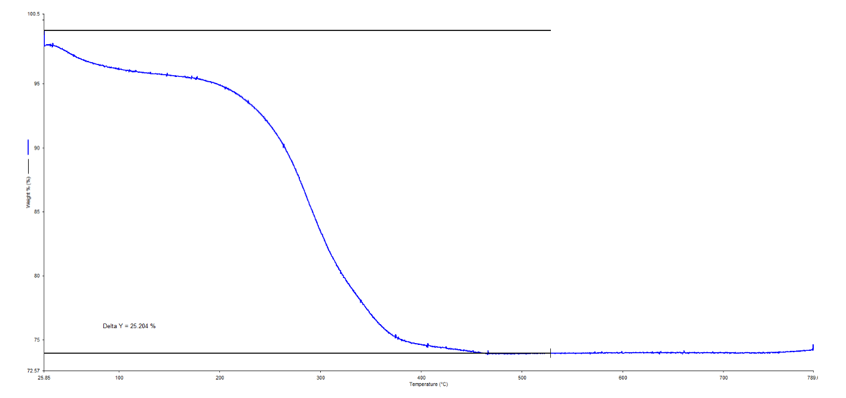
Figure 49 - TGA of unsuccessful MNP-P synthesis

Polymer coating calculations

Estimation of monomer to add
For a given mass, radius and polymer coating thickness of nanoparticles
Mass of iron oxide particles = 0.25g, Density (ρ) of Iron oxide = 5g/cm³
Approximate particle diameter from DLS = 250nm, Radius = 125nm, Desired thickness of polymer coating t = 100nm
Volume of a particle (V_{P}), mass of a particle (M_{P}), number of particles (N_{P}), approximate volume of polymer coating layer (V_{L}), total volume of monomers required (V_{M}).

V_{P} = $\frac{4}{3}$ × π × r³
M_{P} = V_{P} × ρ
N_{P} = $\frac{Mass of iron oxide particles }{M_{P}}$
V_{L} = 4π × r² × t
V_{M} = N_{P} × V_{L} = 0.12cm³

Thus total volume of monomers required is approximately 0.12ml, which was added in an 80:20 DMAPAA:Acrylic acid molar ratio.

Schematic of algal culture irradiation using curer
A schematic of ultraviolet irradiation of a 3 mL algal sample in a cuvette in a water bath is shown below. The arrow shows direction of ultraviolet light coming from the curer.

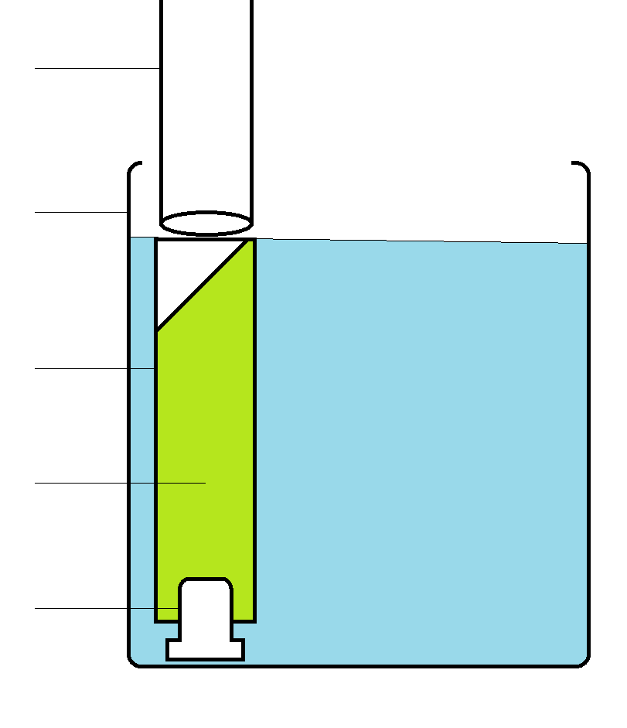
Fibre optic cable – arrow
Plug
Glass beaker containing water
Algal culture
Quartz cuvette
Figure 50 - Schematic of algal culture irradiation using curer

