Introduction
  - Praying the Passion in Late Medieval England
Three particular lay and vernacular-based activities, centred around the Passion and death of Jesus, were inaugurated in England during the mid-fourteenth to early fifteenth centuries. They constituted a form of participation in the liturgy of the Latin Church services that until then had not ordinarily been open to laypeople. One of these activities was the widespread creation of vernacular Mass Prayers for the laity as a vehicle for accessing the mystery of the Mass. The sacrament of the Mass was always performed by a priest but the Mass Prayers, most probably translated by the clergy specifically for the laity, helped bridge some of the gaps between the priestly and lay roles during the Eucharistic service.
A second activity associated with the Mass was the establishment of semi-liturgical Corpus Christi processions in English cities in the mid-fourteenth century. The processions, events in which the laity could participate fully in their own language and setting, were sanctioned by the Church. The processions were held on the Thursday after Trinity Sunday every year, and they coincided with the liturgical Corpus Christi feast
day which had been devised in the thirteenth century in commemoration of the wounds
and body of Christ. Mass was celebrated early in the morning in a local parish church, before the laity and clergy proceeded with the consecrated host on display through the public and secular domain of the towns. The procession usually ended with the depositing of the consecrated host inside a parish church or cathedral.
A third innovation was the multiple translating of an early fourteenth-century Latin hymn to the cross into the vernacular languages by the mid-fourteenth century. This seven-stanza hymn focusing on the final seven stages of the Passion of Christ was sometimes incorporated into the seven canonical Hours of the Virgin and called the Hours of the Cross; at other times it formed a separate hymn to the cross. The hymn to the cross could be prayed in private as well as in public up to seven times a day and was a means by which laypeople could, in a personal act of remembrance, commemorate the wounds of Christ for a set time each day outside the confines of a church and without the need for a priest. Thus it could be said that the recital of the hymn to the cross constituted an informal celebration of Christ’s sacrifice by the laity, and was therefore a devotional activity that complemented the official Mass.
In combination, these three vernacular activities comprised an important means of access to the liturgy by the laity. The vernacular Mass Prayers assisted the laity in public liturgical worship; the Corpus Christi processions were a semi-liturgical means of participation in the Passion of Christ; and the hymn to the cross enabled the laity privately to contemplate Christ’s death without the necessity of a priest or formal liturgical service.
My discussion focuses primarily, although not exclusively, on lay practices within York, based on some of its manuscripts. The city provides us with an excellent context for examining lay piety in the late fourteenth to mid-fifteenth centuries because of the importance of its archbishops and pastoralia, its vigorous and well-documented lay communities, and the survival of its medieval architecture, especially its medieval churches. One of these has recently commissioned the reconstruction of a Lady Mass of the York Use. During the fourteenth and fifteenth centuries, liturgy for the Use of York was second in importance only to that of Sarum (from Salisbury Cathedral, which was under the jurisdiction of Canterbury). At the same time, the city of York was second in ecclesiastical importance only to Canterbury, and second in size and commercial importance only to London. Like London, York had a large middle class, comprised largely of crafts and trades people, from makers and sellers of local produce to rich merchants dealing in books, linens, spices and other luxurious goods from the Low Countries and the Far East. Some of the source texts consulted for the purposes of this thesis were privately owned by York merchants, while others were regularly used by both priests and laypeople in local parish churches. The English translation of the catechism (termed The Lay Folks’ Catechism by its nineteenth-century editors) was composed in York as a direct result of Archbishop John of Thoresby’s injunctions (1357), and the contents of The Lay Folks Mass Book, including the vernacular Mass Prayers, were compiled in the province of York.
0.2 The Medieval Mass and the Laity
Medieval laypeople had a rich devotional vocabulary for use in private prayer, but they also participated actively in the most central liturgical act of the Church, the Mass. The Mass was repeatedly celebrated in public in accordance with Christ’s command to eat bread and drink wine “in remembrance of me” (Luke 22:19). The Eucharist was a public act of Christian worship, incorporating the performative, visual, textual and mnemonic aspects of praying the Passion. As the priest stood in for Christ in his re-enactment of the Last Supper, he recalled Christ’s words and actions in the words of institution: “Hoc est enim corpus meum... Hic est enim calix sanguinis mei...Haec quotiescumque feceritis, in mei memoriam facietis” (“For this is my body... This is the chalice of my blood...As often as you shall do these things, do so in remembrance of me” (see figs. 0.1 and 0.2). The occasion was at once oral (hearing the words), visual (seeing the preparation and elevation of the elements), mnemonic (remembering a past event) and performative (re-enacting that event). The celebration was also sensual for the partakers of the Eucharistic bread and wine; they could smell the incense and candles around the altar, hear the ringing of the sacral bell before the moment of elevation and see the elevation of the consecrated host and chalice of wine.
The elevation of the host was the most sacred part of the Mass, marking the moment of consecration, and most extant vernacular Mass Prayers are centred on this moment. Laypeople could not physically touch or taste the host except on high feast days, and so the witnessing of this event, rather than the receiving of the elements, had come by this stage to be considered the key aspect of partaking in the mystery of Christ’s death, and of being assured of salvation. As the congregation gazed upon the scene they were encouraged metaphorically to feast upon it and assimilate its meaning and mystery through the act of prayer. This form of imaginative participation in the Mass was the most significant act of remembrance for lay Christians.
Scholarship has focused on evidence such as rood screens that implies increasing control of the Mass by the clergy and increasing exclusion of the laity. However, vernacular Mass Prayers suggest a different and more complicated picture. There are extant fifteen English and twelve Anglo-Norman versions of Mass Prayers and/or instructions for lay use, present in over forty late fourteenth to mid-fifteenth-century manuscripts. Much work has been done on the elevation prayers, which are the most ubiquitous, but little attention has been given to the other vernacular Mass Prayers that are provided for each stage of the Latin Mass. The complete sets of Mass Prayers were designed to help lay devotees navigate their way through the entire Latin service, and they often include instructions in English or Anglo-Norman – the two vernaculars of late medieval devotion - for the exact point in the liturgy at which they should be recited: the name or opening line of the Latin prayer and/or a description of the priest’s gestures are provided as a cue.

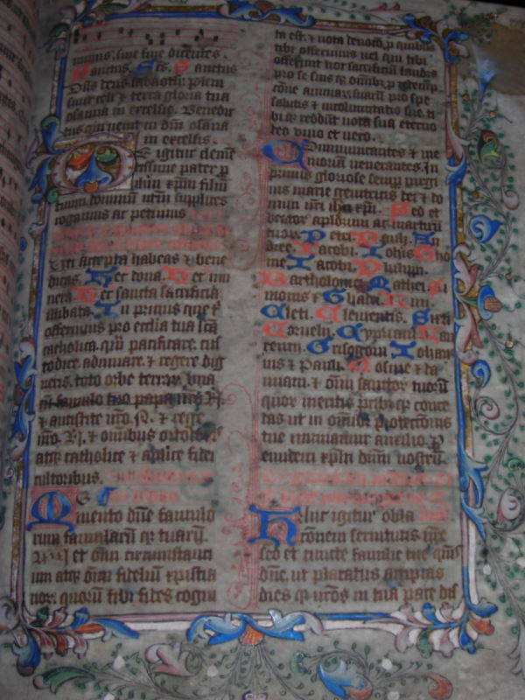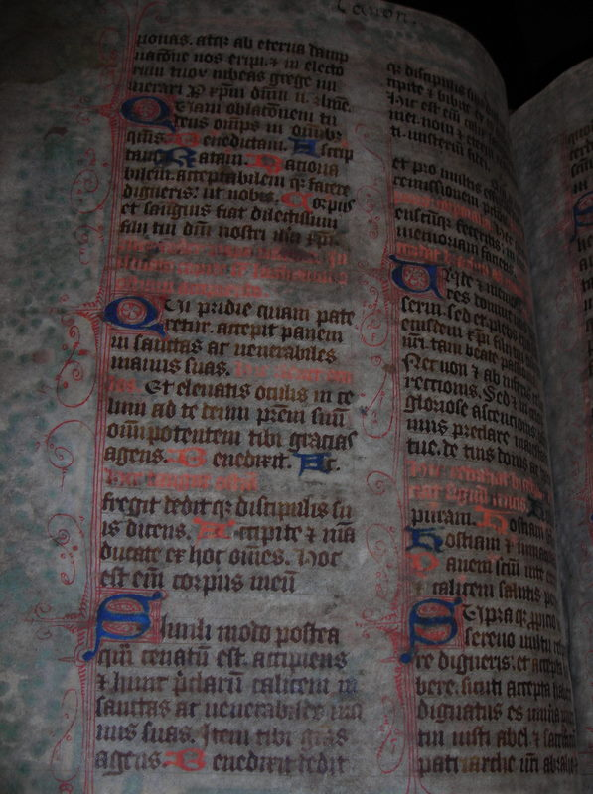
Fig. 0.1 YML, MS XVI.A.9, fol. 128r Fig. 0.2 YML, MS XVI.A.9, fol. 128v
The Canon of the Mass, beginning ‘Te Igitur’ The Canon of the Mass, ‘Hoc est enim corpus meum’

Priests were keen that the laity should be able to participate actively in the most sacred of church rites, and they instructed laypeople to recite the prayers specially written for them either audibly, or softly with lips moving (‘loude’), or silently, under their breath (‘stille’) during the Mass itself. For example, the Lord’s Prayer is accompanied by the words:
Thanne the prest seith...the Pater Noster...
herkene him with gode wile,
And answere him, loude or stille.
The reiteration of these prayers alongside the liturgy required the laity to pay attention to the service. They needed to listen out for the Latin cues in the form of antiphons or first lines of set prayers and creeds in order to recite the corresponding vernacular prayers at the appropriate place. When laypeople performed these prayers, learned from memory and/or read from a prayer book, they were complementing the Latin Mass as part of a collective social and public experience.

0.3 Praying the Passion through Corpus Christi Processions
Related to the formal, liturgical Mass were the semi-liturgical Corpus Christi processions associated with the Passion, an event in which all people, lay and clerical, could participate. By the mid-fourteenth century, the Corpus Christi feast had been established as a fourth occasion during the Church calendar when the laity could partake of the elements, and it allowed for lay agency in the public and private arena. The feast of Corpus Christi was closely connected, not only with the wounds and body of Christ, but also with the Holy Trinity. It was held on the Thursday after Trinity Sunday every year, and was a moveable feast that could occur anytime between 23 May and 24 June. The feast was established in 1264 and first brought to England before 1318. Processions were introduced to the cities within the next few years (for example, in York by 1325). The processions were solemn affairs, and as they became established, they were attended by laypeople in groups according to confraternities or guilds, which were connected both with particular trades or crafts and with local parish churches.
There was some hierarchy in the ranking of confraternities according to their social status, and these were evident in their positioning in the annual Corpus Christi processions. The humbler craftspeople processed first, then the wealthier traders and merchants, and local dignatories took up the rear. The mayor walked alongside the attendant clergy and next to the host. In York, laymen held up a canopy with staves, under which the priest walked while holding an elaborately decorated monstrance containing the consecrated host. Thus, while the processions symbolically linked the marketplace with the parish church or cathedral, they also served to highlight the paradox of Christ’s body as both a separating and unifying force: “The body of Christ thus serves as a symbol of the unity of the community. It also serves to reinforce social hierarchy, ritualizing it and sanctifying it.” Despite the social ordering of groups, the occasion as a whole was a means whereby laypeople and clergy could process together through the towns and cities and actively engage with the visually present symbols of Christ’s wounded body within the secular domain.
Although the York Corpus Christi Guild was directly involved with the annual Corpus Christi processions, it did not have any formal links with the Corpus Christi cycle of plays based on biblical narratives, otherwise known as the mystery plays, which evolved over time towards the end of the fourteenth century. Individual members could, however, participate in the plays under their own auspices or as members of other guilds. By the late fourteenth century, mystery plays were performed on the feast of Corpus Christi, although these had evolved separately from the processions. In York, for example, the processions began in 1325, but the first record of the Corpus Christi plays was in 1376. In this city, the processions and performances started at the same place, outside the gates of Holy Trinity Priory on Micklegate, but whereas the plays were performed at several locations en route through the town and occupied most of the day, the processions were continuous and shorter.
At some point after 1426, the York Corpus Christi procession took place on the Friday after Trinity Sunday, so that individual members of the Corpus Christi Guild could participate in both the procession and the mystery plays. By this stage, the guild had taken on responsibility for performing the Creed play, a didactic play separate from the mystery plays, and one which replaced them every ten years. The Creed Play may have been specifically performed in order to reinforce biblical teachings, in response to Thoresby’s 1357 injunctions that the laity be instructed in Christian doctrines in the vernacular.
In York, the Corpus Christi processions came to have specific political connotations, associated with the execution of Archbishop Richard Scrope outside the York city walls on 8 June, 1405. The emblem of Christ’s five wounds had been chosen as Scrope’s standard during a 1405 rebellion against Henry 1V, which Scrope had led with 8,000 men. When he was taken to his place of execution, Scrope recited a prayer linking his suffering and death with the five wounds of Christ. Scrope was shortly afterwards hailed a martyr by the people of York and his name became associated with the five wounds of Christ.

0.4 Praying the Passion through the Hours of the Cross
So far, I have demonstrated the importance of the Mass as a formal liturgical commemoration of Christ’s death, and of the Corpus Christi processions as more informal ways for laypeople to take part in a liturgical feast devoted to the body of Christ. If laypeople could absorb the mystery of the Mass through vernacular translations of the liturgy every week and street processions on annual Corpus Christi feast days, the hymn to the cross may have provided a supplement to the Mass that could be daily recited by the laity during their private devotions without the presence of a priest. This short Latin hymn to the cross beginning ‘Patris Sapiencia’, was disseminated by the mid-fourteenth century in a range of European vernacular languages, including Anglo-Norman and English. The seven verses correspond with the final stages of Christ’s Passion and with the seven canonical hours which were marked daily by the Church. It made its way into horae and primers as part of the Hours of the Cross, and also provided the basis for freer responses to the Passion of Christ in a range of manuscript contexts.
I will examine the adaptations of the hymn to the cross in a variety of forms for both private and public use, as well as ways in which it was meant to be used as a visual and devotional artefact alongside images of the Crucifixion (see fig. 0.3). English translations of the hymn to the cross retold the Passion narrative, and they were often recited in conjunction with a fixed image of Christ’s wounds. These images could be present on a nearby wall, or in a window or on the page of a prayer book. Illuminations surrounding the page acted as a framing device for the written text. The performance of the Passion prayer by the devotee gave agency to the framed page (see fig. 0.4). The framed texts were not only vehicles for prayer but, like the visual images within buildings, they could be regarded as objects of prayer themselves.

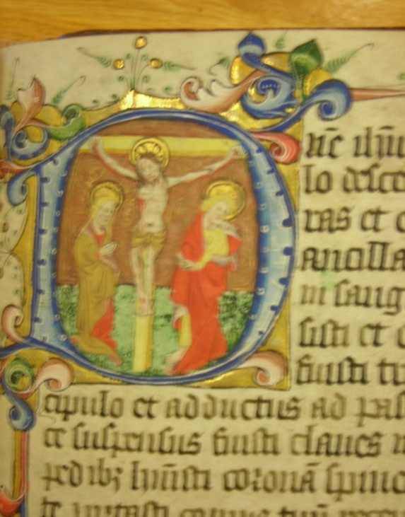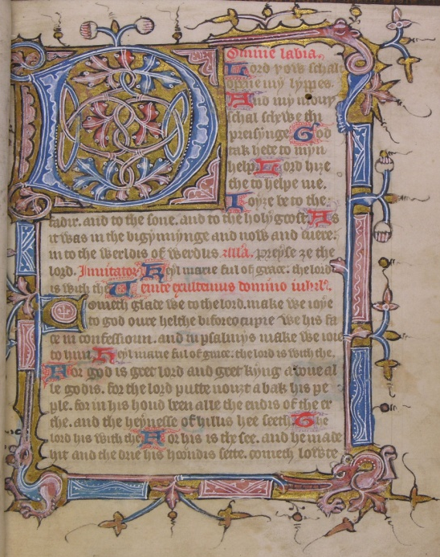
Fig. 0.3 YML, MS XVI. K. 6, fol. 81r Fig. 0.4 Cambridge, St. John’s College, MS G. 24, fol. 9r
(The Pavement Hours) Image of the Crucifixion The opening page of the Hours of the Virgin

The Hours of the Cross, when contained within the Hours of the Virgin in horae and primers, reiterated on a smaller scale the Eucharistic commemoration of Christ’s death. Just as vernacular prayers were used by the laity during the Mass to enable them to focus on Christ’s death, so was each stanza of the hymn to the cross used during private recitations of the Hours of the Virgin. While the Hours of the Virgin are centred on the set Psalms for each canonical hour plus prayers to the Virgin, the hymn to the cross focuses on the Passion events as recorded in the Gospels. They thus have the effect of encouraging devotees to pause and ‘remember’, or to reflect upon Christ’s suffering for a few moments throughout the day. Where the hymn to the cross is set out in its entirety, it may have provided a cue for devotees to recite the entire prayer on one or more occasion during the day as part of an indulgence. This informal act of imaginative lay participation in the Crucifixion was, like the Mass, a means by which laypeople could engage with the mystery of Christ’s death.

0.5 Praying the Passion through Vernacular Lyrics and Prayers
Increasing vernacular literacy in England, and increasing lay participation in both public and private devotion from the mid-fourteenth to mid-fifteenth centuries, generated a variety of affective prayers on the Passion for both lay and clerical use. These prayers were often emotive and personal, and they encouraged devotees to imagine themselves at the very foot of the cross, on which the wounded human Christ was hanging in anguish to atone for humanity’s sins. Late medieval prayers on the Passion have their roots in Anselm’s (d. 1109) personal and affective Latin prayers to Christ and the cross, and I argue that they constitute a form of the monastic lectio divina, transmitted via Anselm and adapted for late medieval lay audiences. The vernacular prayers are often accompanied by images of the Crucifixion or the Pietà in manuscripts, and they sometimes carry instructions to look and think about the image as part of the meditative process. In a similar way that meditating on a scriptural text as part of the Benedictine lectio divina had led to inner contemplation in monastic culture, by the late Middle Ages the act of gazing at an image while reciting a prayer also enabled lay devotees to recall imaginatively the Passion and enter into the scene as if they were physically present.
Using the evidence of lyrics and prayers, this thesis will attempt to establish the case for a very rich lay devotion to the wounds of Christ between the mid-fourteenth and the early-fifteenth century that complemented and supplemented formal liturgical worship, including Eucharist celebrations. Some Passion prayers, such as the hymn to the cross, may also have supplemented the Mass outside the confines of the local church, as a means of leading the penitent to contemplation on the cross. This is not to say that the vernacular recitations usurped the need for participation in the formal Eucharist, particularly during the four obligatory feast days, but rather that they constituted a parallel and informal means of enhancing the experience of the Mass. The vernacular Passion lyrics and prayers and their associated images within manuscript contexts also formed an instrumental part of wider movements such as the Cults of the Wounds, the Sacred Heart, and the Name of Jesus.
Many of the lyrics under investigation have been largely ignored by scholars and are hence unedited, or were edited without much subsequent comment for the Early English Text Society (EETS) and the Surtees Society over one hundred years ago. This thesis will place these lyrics and prayers at the centre of a discussion on late medieval lay participation in the liturgy, demonstrating ways in which they shed light on religious practices in the late Middle Ages. Pertinent to the discussion is the question of the ways in which manuscripts with both vernacular and Latin prayers may trouble our assumptions about a normative Latin versus a vernacular readership. Vernacular prayers, in English, Anglo-Norman, or both, were often placed within Latin manuscripts and all three languages were used in the promotion of lay participation in the liturgy. I will focus mostly on English adaptations of the Hours of the Cross since these are the most prolific in late medieval English manuscripts, but I will also incorporate discussion of Anglo-Norman Passion lyrics and Mass Prayers where they help to expand my argument for this rich lay devotion to the Passion.
The lyrical form is used as a performative and mnemonic device in the liturgy and, conversely, the liturgy influenced the vernacular lyrical form. Recent research has ascertained that the English religious lyric is indebted to the liturgy and that certain vernacular lyrics which adhere closely to their Latin source can rightly be termed “paraliturgical”. Other vernacular Passion prayers do not have a Latin source but were nevertheless written as a means of complementing the liturgy, such as the Mass Prayers and lyrics devoted to the Wounds of Christ. Together, the paraliturgical and non-liturgical prayers form part of the corpus of Passion prayers and lyrics that will be the focus of my investigation. Both types of prayer have their roots in the Passion narrative and were utilised in a range of similar contexts, both private and public, by the laity in the late Middle Ages.
In the context of scholarship by Bradshaw, Henderson, Littlehales, Simmons, and others for editions of medieval manuscripts published by the Surtees and Early English Text Societies at the turn of the twentieth century, Christopher Wordsworth concluded that there was no essential difference in the histories of the primer and horae, and that both terms were used interchangeably by the late fourteenth century:
We have treated the history and genesis of the “Prymer” as being identical with that of the “Horae,” not only as a matter of historical inference and induction, but also because we have become more and more convinced, from the study of wills and other old time literature, that long before 1536 the same books of devotion as were named Horae (or “Horae B. Mariae Virginis”) in Latin, were also called primaria or “libri primarii” or “primarii libri” in the Latin of those days; i.e. from the fourteenth century onwards. We find further that about the same time the peculiarly English word “Prymer”…first comes into notice in our language.

Wordsworth went on to say that scholars could not make enough of a distinction between the Latin and English breviaries to term them respectively “Horae” for those in Latin and “Prymers” for those in English, and so they use the two terms interchangeably. Although Wordsworth and others felt that there was no substantive distinction between horae and primers, manuscript evidence suggests that a distinction can be made between the two. For my purposes, I wish to differentiate between the uses of the two terms “primer” and “horae”, not on linguistic grounds but because of what we now understand about prayer books now termed “books of hours” or “horae”. These popular books were for the most part owned by the laity and, besides containing a shortened form of the Divine Office - the Hours of the Blessed Virgin Mary - they often contained extra-liturgical material in the form of family memorabilia. These included coats of arms and registers of births, marriages and deaths as well as non-liturgical prayers, poems, treatises, drawings, coloured illuminations and even recipes and medicinal remedies. The modern treatment of the term ‘horae’ is therefore more expansive than that of the late nineteenth and early twentieth-century editors, who were chiefly concerned with the liturgical form and contents of medieval manuscripts. They therefore specifically applied the term ‘horae’ to the hours of the shortened Divine Office for lay use, regardless of the physical nature of the manuscripts in which they were transcribed. They were not concerned with the placement of the Hours of the Cross as a literary object within the illuminated page, and they would not therefore have had any cause to make a distinction between “horae” and “primers” since both contained the shorter Divine Office.
I use the term “horae” interchangeably with what we have come to call “books of hours”, and the term “primer” to refer to the fourteen extant English private service books whose main function was to allow their users to follow a shortened form of the daily liturgy. These English primers are fairly uniform in their compilations and include little extraneous material apart from prayers, creeds and short treatises for instructive purposes. They tend to have enlarged or illuminated initials but no pictures, perhaps largely due to their mainly utilitarian function of following the shorter Divine Office in English, at home or at church. Latinate books of hours, on the other hand, may contain historiated initials and miniatures, as well as illuminated initials and border decorations. Since they are household, or family, books with functions other than following the liturgical lessons, the owners of books of hours may have ensured that they were as elaborately decorated as could be afforded. Because there are only fourteen extant primers containing both the Hours of the Virgin and the Hours of the Cross in English, there is no way of ascertaining whether all service books in English followed a similar format. The English primers are a subset of the numerous extant Latin horae in that their main component, like horae, is the shorter Divine Office. For the purposes of exploring their mostly uniform renderings of the Hours of the Cross, however, I shall call them English primers throughout, and in this way separate them from the Latin-based horae that contain separate English adaptations of the Hours of the Cross.
A distinction can be made between the English translations of the Hours of the Cross in the eleven extant English primers listed under NIMEV 3499 and those in bilingual or trilingual horae and religious anthologies or miscellanies. While the first group of texts appears to follow one of two English translations of the Latin hymn, suggesting two scribal networks, there is quite a lot of variation in the English translations of the hymn in religious miscellanies and horae. Thus, while English primers and Latin horae both contain the shorter Divine Office and to this extent could be regarded as similar and interchangeable, their treatment of the Hours of the Cross, as well as of extraneous material and illustrations, is distinct. Since all of these features are central to the discussion of this thesis, I therefore consistently term the bilingual and trilingual books with extensive material other than the Divine Office as horae, and the shorter, less well illustrated English translations of the shorter Divine Office as primers.
Little attention has been paid to vernacular Passion prayers, which are regarded as having little literary worth, and as poor cousins of more sophisticated moral lyrics such as the so-called “Vernon Refrains” and the Digby 102 lyrics. However, upon examination, it would appear that these “marginal” prayers devoted to the Passion, often placed alongside and thus used in conjunction with the more celebrated lyrics in medieval manuscripts, demonstrate an in-depth theological understanding of and affective participation in the redemptive story by laity and clergy alike. Far from being a poor cousin, they can be regarded as a sister means of devotional expression. Furthermore, given their use alongside the liturgy, the boundaries between what constitutes “liturgical”, “paraliturgical” and solely “lyrical” become permeable.
In exploring vernacular adaptations of the Latin hymn to the cross, I question the binary distinctions that have often been made between what has been considered the sparse theological merit of private lyrical devotions for a non-Latin literate laity and the Latin liturgical prayers accessible only by the educated elite. Many of the manuscripts under consideration include both the Hours of the Virgin in Latin and translations of the Hours of the Cross in English or Anglo-Norman, as well as non-liturgical prayers to the Cross in the vernacular or in Latin, suggesting that individuals utilised a variety of forms of prayer in multiple languages as part of their devotions. Often, as I will argue, the translations give a more in-depth doctrinal explication than their Latin source. Moreover, by the end of the fourteenth century both English and Latin breviaries were in circulation, indicating that even lay people and lesser orders of the clergy who could not read Latin could gain access to the Divine Office. On occasion the English text was placed before its Latin counterpart in manuscripts, suggesting that the two languages had a comparable status, at least in recitational literacies, by this stage.
These observations raise questions about the role of vernacular Passion lyrics in the movement towards greater lay involvement and empowerment within the Church. There were a number of attempts in the fourteenth and fifteenth centuries to legitimise the translation of the whole Bible into English, and greater accessibility to unofficial renderings of the liturgy in English may have been a step towards legitimising its public performance within churches. It may have been the intention of some pre-Reformation clergy sympathetic to liturgical reform to press for official public performances of the liturgy in English, and their attempts may have been silenced as a result of the 1407-9 constitutions issued by Archbishop Arundel at the Oxford Synod. Arundel’s Constitutions stipulated that no portion of the Bible could be translated into English (Constitution VII) and preachers or teachers (including writers and transmitters of English treatises) had to be licensed (Constitution I). However, that many manuscripts produced in the years immediately following Arundel contained prayers and treatises in the vernacular and were considered orthodox by the Church authorities suggests that the issue was not so much whether they were written in English as the perceived intention behind them. Following Arundel’s constitutions, Nicholas Love’s Mirror of the Church was considered orthodox while Bishop Reginald Pecock’s English works were eventually declared heretical, despite his anti-Lollard polemic. The manuscripts with which we are concerned were compiled against the background of Thoresby’s reforms, and some of them were written post-Arundel. We will now turn to these reforms for an inquiry into ways in which vernacular writings, whether encouraged by or written in defiance of the Church, helped enhance both public and private devotion to the Cross.

0.6 Ecclesiastical Reforms and Questions of Orthodoxy
The Fourth Lateran Council of 1215, presided over by Pope Innocent III, was among other things an occasion to protect the Church against heresy. Making provision for the education of the laity by translating important theological treatises into vernacular languages was deemed an important aspect of the Church’s movement towards greater uniformity. John Peckham (1240-1292), who studied in Paris under Bonaventure before being ordained into the Franciscan Order and becoming a lecturer in divinity, was consecrated Archbishop of Canterbury in 1279. Peckham was particularly concerned with ecclesiastical reform, and as part of his mission he instigated a constitution at the Council of Lambeth in 1281 requiring the clergy to explain the central tenets of the Christian faith to the laity in the vernacular four times a year. These tenets included the learning of the fourteen Articles of Faith, the Ten Commandments, the Two Commandments of Christ to love God and one’s neighbour, the Seven Works of Mercy, the Seven Deadly Sins, the Seven Cardinal Virtues and the Seven Sacraments of Grace. If they learned these basic elements of Christian doctrine properly, parishioners were issued with a pardon of forty days. In having to teach basic church precepts the clergy, whom he termed “ignorantia sacerdotum”, were also obliged to become more versed in Christian dogma. However, Peckham did not provide any guidance for the delivery of these ordinances by the priests and so the measures were only partly successful.
In 1357, Cardinal John of Thoresby, Archbishop of York from 1352-1373, issued an injunction to every archdeacon in the York Province in both English and Latin, insisting that they ensure the education of the laity on the Articles of Faith, which should be passed on to them through parish priests. These injunctions for the “comyn puple”, according to one of the twelve extant manuscripts with a copy of the injunctions in full, “conteyned þe articulis of þe feiþ, seuene dedli synnes, þe werkes of mercy, and þe ten comandementes”, which were to be sent “in smale pagynes to þe comyn puple to lerne þis and to knowe þis, of wiche ben 3it manye a componye in Englond”. Thoresby’s injunction, based on Peckham’s earlier constitution, was designed to have further consequences in that the parishioners were to be taught and examined in English by their curates and should perform a penance if they failed to learn the theological precepts. Moreover, the laity were compelled to teach their children, thus ensuring that the whole Church, lay and religious, young and old, would be involved in the renewed programme of doctrinal instruction.
Thoresby’s injunctions were issued in the form of a catechism. It was written in Latin and translated into English by John Gaytrick, a Benedictine monk from St Mary’s Abbey, York, and was also entered into the Archbishop’s Register in both Latin and English. This was the first entry to the register in English, confirming its increasing status, as well as its importance as an educational tool accessible to the general populace. The catechism contained the fourteen Articles of Faith, the Ten Commandments, the two laws of the Church to love God and one’s neighbour, the Seven Works of Mercy, the Seven Deadly Sins, the Seven Cardinal Virtues and the Seven Sacraments of Grace - in short, the original recommendations of Peckham - in English. Their purpose was to correct the ignorance, not only of the laity but also of the parish priests, as well as providing them with an accessible means of confession and penitence. The precepts were written in verse form to aid memorisation, and they, like Peckham’s orders, carried with them an indulgence of forty days. They circulated at around the same time as dramatisations of the Creed and Pater Noster were forming part of the York Corpus Christi plays and when the shorter Divine Office appeared in English. This indicates a shared commitment to promote Thoresby’s injunctions. Most primers and horae from the late fourteenth century onwards include the Articles of Faith as well as the Hours of the Virgin, and so could be regarded as having the dual purpose of instruction and penitential devotion.
A further interesting development is the connection of John Wyclif (c. 1325-1384) with Thoresby and his programme of reform. Wyclif was ordained deacon at St Mary’s Abbey, York, in 1350 and served as priest at York Minster in 1351. Both men were from the North Riding and both were involved in controversies with mendicant friars. Both were educated at Oxford and had connections with Balliol College; Archbishop Thoresby was a patron of the college while Wyclif was a probationary fellow, and Wyclif was a contemporary of Thoresby’s nephew John Waltham while studying there. The two men must have known each other, especially given their movements in the same geographical location at the same time, combined with their shared interests and the fact that they embarked on related reform programmes to make church doctrines accessible to everyone in English. Wyclif was also involved in the dissemination of the catechism within the Province of York, and the EETS edition of The Lay Folks’ Catechism, produced in the York diocese, includes a version with Wycliffite sentiments.
Lollards were later responsible for the circulation of catechisms in the southern province, which they saw as furthering their own drive for radical church reform. In his Actes and Monuments (1563), Foxe records that the Lollards printed two amended editions of the catechism as late as 1530 and 1538. If there was a joint enterprise by the clergy and laity towards greater lay understanding of and participation in the liturgy, it is probable that any text or treatise deemed to further that goal would have been given some measure of approval by the ecclesiastical authorities. This may have included even those that are now understood to have had sympathies with the Wycliffite movement. Thus, I am wary of separating texts into strict ‘orthodox’ or ‘heterodox’ categories, but rather allow for some fluidity between the terms, and for “adaptive tolerance” on the part of the compilers within the decision-making processes. I will collectively examine the Passion lyrics and prayers within the context of the overall endeavour towards greater lay involvement in the liturgy.

0.7 Aims and Purposes
This thesis will focus on a range of vernacular Passion lyrics and prayers during the few decades between and proceeding from Thoresby and Arundel’s reforms (from c. 1350-1420) and will argue for widespread lay participation in the liturgy by means of these prayers. They will be examined within their manuscript contexts as both textual and visual vehicles for lay devotion to the cross. Each chapter will have a particular focus on one type of manuscript, namely English primers, horae and religious anthologies. Special attention will be paid to a York-based book of hours, The Pavement Hours (c. 1408-20), and a religious anthology, the Vernon Manuscript, compiled towards the end of the fourteenth century, because of recurring themes that may be associated with them. The Pavement Hours opens with a unique vernacular version of the hymn to the cross, placed immediately before the Latin Hours of the Virgin. The book is also important for its associations with the cults of the sacred heart and wounds of Jesus, which are in turn connected with the Corpus Christi processions and the death of Archbishop Richard Scrope (executed 1405).
The Vernon Manuscript may have been written in the Lichfield diocese during Bishop Scrope’s incumbency, before he took up the archbishopric of York. It provides an important record of the many types of treatises and prayers that laypeople as well as clergy were reading or listening to and circulating by the end of the fourteenth century. These include the English Hours of the Cross, English prayers for the feast of Corpus Christi and vernacular Mass Prayers. They are interspersed among English translations of much better known works such as Aelred of Rieveaulx’s De Institutione Inclusarum and the Speculum Ecclesiae, as well as the English Pricke of Conscience and treatises by Walter Hilton and by Richard Rolle, who was the initiator of devotions to the Holy Name. Archbishop Scrope was especially interested in devotion to the Holy Name and the related Cult of the Wounds (also associated with Rolle), and he may have been a friend of Hilton’s. Thus some of the themes of the two very different types of manuscript – a private book of hours and an anthology for a wide readership – are recurrent and inter-related.
Much important scholarship of the 1980s and 1990s focused on the body of Christ as a dominant medieval symbol. Sarah Beckwith (1993) examined the role of Christ’s body within its political and social context, stating that “Christ’s body was the arena where social identity was negotiated, where the relationship of self and society, subjectivity and social process found a point of contact and conflict.” She went on to propose that since Christ’s body was a meeting place between two oppositions such as the material and divine, it could therefore be a locus for negotiation and, more often, for conflict and polarisation: “Yet it is arguable that Christ’s body is less the forum for integration and social cohesion than the forum for social conflict, the very arena and medium of social argument”.
Caroline Walker Bynum (1982, 1987) was the first to emphasise the feminized suffering body of Christ as a means of female and lay empowerment: “women drew from the traditional notion of the female as physical an emphasis on their own redemption by a Christ who was supremely physical because supremely human”. David Aers and Lynn Staley (1996) argued against the notion of private devotion to Christ’s suffering body as empowering for the laity, and in particular against Bynum’s idea that women were empowered in their identification with Christ’s wounds. Rather, for Aers and Staley, affective piety is a means whereby ecclesiastical control is maintained:
...the project to dissolve the sacralised hierarchy of the Church, of divisions between priesthood and laity, women and men, did not come from any “feminization” of Christ’s humanity, nor from the dominant figuration of Christ’s humanity and the conventional affective languages of suffering, abjection, and pathos...the conventional suffering body, together with its “imitation” was one of the effects of power, of an identifiable historical power.

Miri Rubin likewise emphasises the reinforcement of the ecclesiastical hierarchy during the Corpus Christi feast and its processions:
The feast which celebrated the eucharist, the most powerful symbol of Christian culture, and which came to be associated with public processional modes, in which the eucharist was venerated at the heart of a hierarchical display, spoke an idiom of privilege and lordship.

Beckwith and others did much to highlight the power struggle, particularly between the Church and laity, surrounding Christ’s body. For Beckwith, Christ’s body is “a fundamentally unstable image, a site of conflict where the clerical and the lay meet and fight it out, borrowing from each other’s discourses”. It is clear that the Church as an institution at times abused its position of power, hence the call for reform, and that there was some resistance and conflict between clergy and laypeople, often centred on the Mass. However, I wish to reassess and partially undo some of the binary oppositions between the ‘power’ of the church and, by implication, the ‘subjugation’ or ‘suppression’ of the laity. My research suggests a more nuanced picture, consisting not only of conflict and the need for negotiation, but also of cooperation between laypeople and clerics as part of a practical and mutually beneficial means of increased participation in the Mass. This shared enterprise is evident both in terms of parish life and in the compilation of devotional manuscripts.
There is much evidence that the Church was content for the laity to be involved in many aspects of parochial life. Eamon Duffy has written on the power of the wealthy laity taking responsibility for the fabric of churches, such as ornamentation and decoration, often provided through bequests. More recently, Nicole Rice has commented on the role of the laity in the administration of local parish churches in terms of church wardens and vestry committees by the fourteenth century: laypeople were responsible for books, vestments and the Eucharistic vessels. She argues that through the sharing of books such as the catechism, collaboration between priests and laity was more likely than opposition: “Although The Lay Folks’ Catechism implies that potential for lay-clerical antagonism was certainly present, I contend that the use of actual clerical books by laity suggests more strongly the possibility for practical cooperation and identification among parishioners and their priests.” In this thesis, I further demonstrate that cooperation between priests and laity was present at many levels, not only in the shared circulation of religious texts, but also in shared participation in the liturgy through the use of vernacular lyrics and prayers, as well as Latin texts.
I take issue with Aers and Staley’s dismissal of the power of private affective devotions as a tool for negotiating between the laity and clergy, in favour of teaching and preaching as the main means of empowerment. Vernacular affective devotions and instructive treatises are often present in the same manuscripts, and together they contributed to lay participation. This form of lay empowerment could be more readily regarded as a two-way conversation between the clergy and laity than as a subversive act. The vernacular was not necessarily used in opposition to Latin but, like Thoresby’s 1357 injunctions, could be used interchangeably with Latin as a means of dissolving boundaries and divisions, and of educating both priests and laity.
I also make a case for flexibility concerning what constitutes literacy. Until the twelfth century, literacy (litteratus) was commonly taken to mean the ability both to read Latin and to have a working knowledge of it; this skill was largely confined to the religious orders. The rise, however, of the written vernaculars in England between the twelfth and fourteenth centuries troubled the definition of literacy. In the twelfth and thirteenth centuries, the lay nobility, and in particular women, were reading, owning and circulating books in Anglo-Norman. By the end of the thirteenth century, many people were reading and writing in English, and by the middle of the fourteenth century, the demand for books in all three languages of England (Latin, English and French) was enough to generate commercial interest and establish a book trade. By this stage, literacy had come to mean the ability to read and write in French or English or both. Some laypeople could also read Latin and had some knowledge of Latin grammar. Many other laypeople did not study Latin grammar but could understand church Latin to some degree through exposure and could recognise some Latin phrases in prayer books; they may also have been considered literate, even though they could not formally read or write Latin. They may or may not also have been able to read English or Anglo-Norman.
Visual and textual cultures were so closely intertwined in the one hundred and fifty years or so before the English Protestant Reformation that laypeople did not need specifically grammatical literacy in order to have a devotional and even liturgical literacy. When prayer books were taken to church, the visual impact of the text and images, mises-en-page, could have been juxtaposed with the visual impact of stained glass windows, wall paintings, statues and carvings adorning the internal spaces (see figs. 0.3 and 0.4). And when images, borders and decorations were placed alongside the written text on the manuscript page, they became a powerful mnemonic device. Rubrics containing the first line of a Psalm or well-known prayer also served as cues to help the reader recite the whole text, often learned by heart. For example, the opening words of the Hours of the Virgin (at Matins) were “Domine labia mea aperies et os meum anunciabit laudem tuam” (“Lord, open my lips and my mouth shall proclaim your praise”) (see fig. 0.3). The first letter of the Latin text was usually illuminated and the initial lines highlighted in red. Even those who could not read fluently may have recognised the rubrics and illuminated ‘D’ through repeated use. The act of remembering liturgical prayers laid out on the manuscript page was further reinforced through hearing them said or sung by the priest during church services. The images were accessed as part of the ritual alongside the words of confession spoken or sung by priests and laity in at least two languages. With music and smells of incense, they stimulated the senses, creating a rich and sensuous feast that at once enhanced the mystery of the Mass and, paradoxically, made it more accessible.
While wealthy merchants were more likely to own and to read private prayer books and catechisms than more modest trade or craftspeople, those who could not afford their own books could assimilate doctrines and liturgy through a variety of means that were potentially available to everyone regardless of economic status. As well as aurally absorbing church liturgy and visually absorbing images within parish churches, laypeople could sometimes access public and private texts as part of a shared reading experience.
The written word on the illuminated and framed manuscript page could be regarded as an image as much as a text (see figs. 0.1 and 0.3). The medieval reader would have regarded the images, illuminations and written prayers as an integrated unit, rather than as separate items. Often the text and images ran into each other, and the illuminated initials provide instances of text and illustration working together in guiding the reader towards understanding and meditation. The act of engaging with the manuscript page was not only a visual experience, but also a sensual one. Sensation was regarded as the seat of cognition, and devotees would have employed all of their senses during the processes of reading and meditation. First, they would have read audibly, using their mouth, and they would have ruminated upon the words in the lectio divina manner, thus metaphorically tasting and inwardly digesting them. They would also have touched the slightly rough pages, perhaps lingering over the different textures, and smelling the animal hide from which they were made. They may have kissed images of the crucifix contained within the pages. The manuscript pages could therefore be considered “material things, potent and physically present performative signs that act upon our senses”. As they were viewed and touched, they gave agency to the complex processes of linking the prayer on the page (visual image or written text or both) with devotees and with the object of their attention, that is, the crucified Christ.
Because of my argument for the fluidity of what constitutes literacy, and because of the ability of people from all levels of society to gain some access to textual and visual material, a large cross section of late medieval society falls within the scope of my investigation of lay piety. By the late Middle Ages, the boundaries between clerical and lay positions were becoming increasingly blurred. Many mayors and aldermen took on leadership roles in the religious sphere, for example, in the forming of guilds connected with parish churches and feast days, and walking alongside priests in religious processions. Some widows chose to become religious recluses or vowesses, while secular priests and mendicant friars represented categories of the institutional Church that engaged with the laity. The term ‘clerk’, or ‘clerc’, is even more problematic, and could mean any number of things, including a member of the clergy, a person in minor orders, an ordained scholar or a writer. Laypeople who engaged with theological treatises, such as those of the Vernon Manuscript, were deemed to have “clerical understanding”. I further argue for some shared reading and devotional participation between priests and laity, thus rendering the boundaries between devotional practices of the laity and clergy even more fluid.
I guard against making value judgements about the extent to which the performance of prayers by late medieval devotees indicated their depth of religious sincerity. In the late Middle Ages, involvement with religious practices was not necessarily a measurement of one’s level of inner piety. There was social pressure to conform to the Church’s demands; indeed, each day was structured around the ringing of the bells of each of the local churches as a reminder to its parishioners to pray during the canonical hours; these hours were also the chief means of marking the time. Some people may have inwardly eschewed religious belief while outwardly going through the motions of practising the Church rites for a variety of reasons, including social, political, commercial or familial affiliations. Conversely, others who doubted the Christian precepts may have taken sanctuary in the liturgy as a means of procuring greater faith. My concern is with the types of prayers people used, and some of the ways in which they helped enhance lay understanding of and participation in the liturgy. I cannot measure the depth of sincerity of the individual medieval devotee. However, based on my examination of vernacular Passion prayers that were widely circulated among a large cross-section of society, I can comment on some of the conventions of late medieval devotional life, and the nature and extent of the evidence for these. What is clear, moreover, as a result of my investigations is the - until now largely overlooked - depth of lay understanding of the Christian doctrine of the atonement centred around the Eucharist, and the wide range of lay access to meditative processes in the late Middle Ages.

0.8 Chapter Contents
The thesis examines vernacular devotion in a range of manuscript contexts. The four chapters focus, in turn, on bilingual horae, English primers, English religious anthologies, and an Anglo-Norman Psalter. The first chapter examines vernacular lyrics associated with the Corpus Christi annual processions as a largely collaborative creation of laity and clergy. At its centre are case studies on the Pavement Hours and the Bolton Hours, two early fifteenth century books of hours compiled for use by a York-based lay readership. The studies have a historical approach and provide a context for the readership of the two books of hours, and for the other books considered in this thesis. The York books of hours contain evidence of Corpus Christi devotions based in York in the early fifteenth century, which are associated with the Cult of the Sacred Heart surrounding the execution of Archbishop Scrope in 1405.
The second chapter examines the paraliturgical hymn to the cross in the fourteen extant English primers compiled towards the end of the fourteenth century in conjunction with Thoresby’s catechism for lay people (The Lay Folks’ Catechism), translated into English in York. This second chapter argues that the vernacular hymn to the cross was considered an important visual and textual vehicle for lay devotion by the scribal circles responsible for the compilation and dissemination of the English primers.
The third chapter explores vernacular Passion and Penitential lyrics that are more loosely based on the hymn to the cross, mainly in part 2 of the Vernon anthology and in the miscellaneous Bodl., MS Douce 322. This chapter investigates ways in which Passion prayers that formed part of the Dulcis Memoria recension, devoted to the sweetness of Jesus, were part of a broader penitential genre, and argues that they complement the more widely researched Vernon Refrain Lyrics in part 5 of the manuscript, and those of Bodl., MS Digby 102. The chapter also investigates the role of the liturgical Office of the Dead as a form of commemoration of the death of Christ that is used in conjunction with the Passion and Penitential lyrics and Corpus Christi processions.
The last chapter focuses on the Mass as the central sacrament in the medieval church. It explores the conjunction of the vernacular Mass Prayers with the Latin liturgy. The prayers are examined within their medieval contexts in English prayer books and the Anglo-Norman Tyrwardreath Psalter, and – in the conclusion - as reconstructed by the present author for a York-Use Mass for Our Lady. This modern recreation was conducted at All Saints Church, North Street, York, on July 18, 2009, and again to coincide with performances of some of the York Mystery Plays, on July 19, 2010 (see appendix 5).

Chapter 1 Corpus Christi and the Cult of the Wounds

1.1 Introduction
Two York prayer books, the Bolton Hours (YML, MS Additional 2), and the Pavement Hours (YML, MS XVI.K.6), help to shed light on local lay piety and commercial and political concerns at the turn of the fifteenth century. The possible owners may have been connected with the Corpus Christi Guild, which was founded in 1408; the books were likely compiled soon afterwards. Even though they share many recurrent themes and images, only the Bolton Hours has been well researched; relatively little has been written on the Pavement Hours. In this chapter I examine the themes, images and vernacular prayers of both manuscripts as they relate to lay religious and social practices in York at the turn of the fifteenth century and, in particular, the Corpus Christi Guild and processions. Together the two York books of hours provide visual examples of devotion to the body and wounds of Christ, and vernacular examples of Levation Prayers for use during the Mass and of the Hours of the Cross for use during private devotions. I will specifically examine ways in which the Hours of the Cross, with which the Pavement Hours opens, may have been used as a supplement to liturgical prayers centred on the body of Christ during the Corpus Christi Mass and processions. I will first provide a context for the forming of the Corpus Christi Guild as it relates to the two York-based horae.

1.2 The Founding of the York Corpus Christi Guild
Many guilds were established in towns and cities in the late fourteenth to early fifteenth centuries. The Corpus Christi Guild in York was, as its name suggests, dedicated to the commemoration of the body of Christ during the Eucharist, yet it always had political dimensions. It was partly formed in order to promote the annual Corpus Christi processions, which had been established about eighty years before the guild’s foundation in 1408 as a civic occasion. The first Eucharistic shrine for the processions was constructed in the year of the guild’s inauguration, and this act established closer links between the city leaders and the guild. From 1431 onwards, a new shrine that was carved by members of the fraternity was carried by them during the processions. In the same year the guild and city agreed to house the shrine in the civic chapel of St William on Ouse Bridge, and to reorder the procession. In 1458 the guild received a royal charter and in the same year the shrine was covered in silver gilt. The guild was also, from its inception, strongly linked with the memory of Archbishop Richard Scrope (archbishop, 1398-1405). Alice Wyman, a founding member of the guild, presented Scrope’s pardon cup to the guild in 1413 and it may have been used in the Corpus Christi processions.
The Corpus Christi Guild had no formal connections with any one church but many of its first members were parishioners of All Saints Pavement, which was one of the wealthiest churches in York. The guild was dedicated to St Helen, a York saint who according to legend, discovered the true cross and was the mother of Constantine, proclaimed emperor during a visit to York in 306. The guild was not tied to any one profession or trade, but given its close affiliation with the Corpus Christi processions, many of its members were from the upper strata of society, including, during its one hundred and fifty years or so of existence, the archbishop of York, bishops, abbots, priors, lords, dukes, viscounts, kings’ justices and mayors. Some of the middle class lay members were mercers and similar shopkeepers who supplied local woollen textiles or, at the higher end, imported fine linens, silks and fustian. Connected with the mercers were drapers and merchants who cut and finished, bought and sold these same products. Most of the merchants operating in York in the early-mid fifteenth century either lived in Fossgate near the Merchants’ Guild Hall, or in the parishes of St Crux and All Saints Pavement.
When the York Corpus Christi Guild was founded in 1408, it consisted of a confraternity of a priest as master, six chaplains as keepers of the guild and twelve assisting chaplains, and, arguably, thirty-three lay founder members. It was unusual for guilds to have priests as masters, but the Corpus Christi Guild did so because of its direct link with the central Christian rite – the displaying of the consecrated host during the processions, a task which had to be performed by a priest. The priests most often came from the churches of All Saints Pavement or the nearby St Saviour’s. The guild initially met at the Holy Trinity Hospital hall, but in 1478 St Thomas of Canterbury Hospital came under its jurisdiction and henceforth was presided over by the master and keepers of the guild. The deed of transfer states that the guild should provide seven beds plus clothing and food “for the ease, refresshyng, and harberyng of pore indigent travailing people commyng unto the saide hospital”. The initial close links between the Corpus Christi processions and St Leonard’s Hospital (where the procession ended and the host was delivered), and later between the Corpus Christi Guild and Holy Trinity and St Thomas’s Hospitals, underscored the charitable dimension of the feast of Corpus Christi. This was in keeping with Christ’s warning in Matthew 25:34 that people would be judged by how far they practised the seven corporal acts of mercy: feeding the hungry, giving drink to the thirsty, clothing the naked, providing hospitality to strangers, visiting prisoners, attending to the sick and burying the dead.
The first register of the guild, in 1408, begins with a sermon on the body of Christ, entitled “Hoc est corpus meum” (“This is my body”), in which it discusses the meaning of the sacrament of the Eucharist and emphasises the importance of participation in the elevation of the host. The sermon then details the seven rules of charity – recalling Matthew 25:34 – for its members. These include the procession of the masters and chaplains through the city of York on Corpus Christi day; the maintenance of the feast of Corpus Christi on the Sunday within its octave; the receiving of members by the chaplains; the daily praying for living and dead members and attendance at their funerals by the chaplains; the annual praying for dead members from the Psalter of the Virgin by lay members; the attendance of the Corpus Christi Mass by all members, combined with a payment of 2d towards the upkeep of the guild, and the observance of obits for the dead on this day; and the bearing of ten large candles before the sacrament during the procession on Corpus Christi day. All members thus had a religious as well as a social requirement to uphold the ideals of the Corpus Christi Guild.

1.3 The Corpus Christi Guild and Patronage of the York Books of Hours
1.3.i Bolton Hours Patronage
There are some internal indications that the original owners of the Bolton and Pavement Hours may have been directly involved with the Corpus Christi Guild. The guild was devoted to the Holy Trinity as well as the body of Christ, since the feast day was always celebrated on the Thursday (and later the Friday) after Holy Trinity Sunday. The annual Corpus Christi procession began outside the gates of Holy Trinity Priory, Micklegate, where the Eucharistic shrine was kept, and, from 1431 onwards, ended at All Saints Pavement. The Pavement Hours contains an illuminated initial with the Holy Trinity (fig. 1.1), marking the beginning of a set of prayers in Latin to the Trinity. In the Bolton Hours a full-page miniature is devoted to a depiction of the Holy Trinity (fig. 1.2). It is flanked by two sets of donors, seemingly a father and son on the left, with the mother and daughter on the right. Their pose recalls a window in All Saints North Street, York (fig. 1.3). It shows Nicholas Blackburn Junior with his wife Margaret kneeling on the left, before an image of the Holy Trinity; the donor Nicholas Blackburn Senior and his wife, also called Margaret, are kneeling on the right. Both women are holding Psalters opened at the Penitential Psalms. We know that the St Anne’s donors were the Blackburns, but we can only surmise who the people kneeling in front of the Bolton image might have been.
Until recently it was largely accepted that the Bolton Hours was commissioned for the Bolton family, mainly because of a list of obits inserted towards the end of the fifteenth century for some deceased members of the Bolton family and, more circumspectly, the image of the kneeling donors (fig. 1.2). However, this theory has recently been challenged by Pamela King (1996), and Patricia Cullum and Jeremy Goldberg (2006), who suggest alternative ownership, including by the Blackburn family. King asserts that the older donors in the Bolton image could not have been John and Alice Bolton (née Blackburn), as was previously thought, since at this stage (c.1410) Alice would not have been old enough to have children of the age depicted in the miniature.
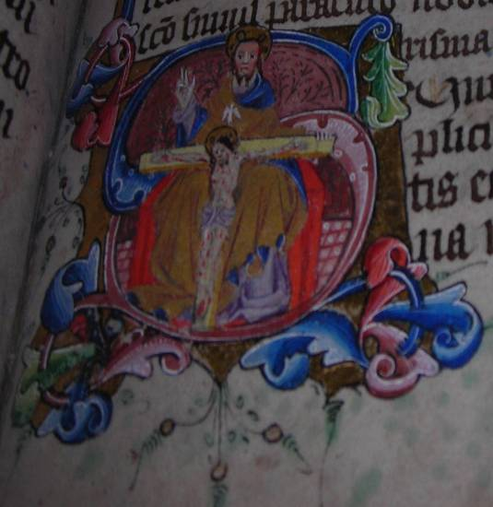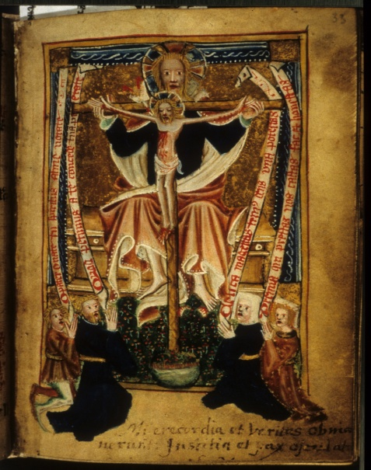
Fig.1.1 The Pavement Hours, fol. 86r Fig. 1.2 The Bolton Hours, fol. 33r
The Holy Trinity The Holy Trinity

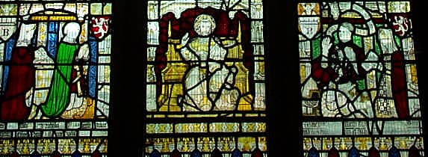
Fig. 1.3 St Anne’s Window, Church of All Saints North Street, York
Kneeling donors in side panels, with Holy Trinity in the centre (restored)

Cullum and Goldberg argue that books of hours were most often handed down through the female line of families, in which case Alice Bolton may eventually have owned the hours, given by her mother Margaret Blackburn, the older of the two Blackburn wives in the All Saints window and perhaps the original owner. They convincingly pinpoint the similarities in familial relations between the donors of the two images in All Saints North Street and the Bolton Hours. This observation supports their argument that the patrons represented in the Bolton image may have been the older Nicholas and Margaret Blackburn with one of their three young daughters, whether Alice or one of her siblings. Thus, the Blackburns may well have had as much, or more, claim to the book as the Boltons. The Bolton Hours may therefore initially have circulated among the two families, who were strongly connected through marriage, business and associations with the Corpus Christi Guild and processions at this time.
The two generations of Bolton and Blackburn men operating in the early-mid fifteenth century were all wealthy merchants and sometime mayors of the city of York. They joined the Corpus Christi Guild soon after its inception, with John Bolton Senior and Nicholas Blackburn Junior becoming members in 1412, and Nicholas and Margaret Blackburn Senior in 1414. The younger John and Alice Bolton (née Blackburn) joined in 1430. The commitment of both families to the feast of Corpus Christi is evident in their bequests. Nicolas Blackburn Senior left sixteen wax torches to be burned at the Eucharist, including two for the high altar of Holy Trinity Priory in Micklegate, where the shrine of the Corpus Christi was kept, and four for carrying in the Corpus Christi procession for as many years as they would last. John Bolton II left twenty shillings to the Corpus Christi Guild.
It has been established that both families were dedicated to the feast of Corpus Christi, and that the Bolton Hours may have circulated among members of both families. These factors indicate that the Bolton Hours exemplifies lay devotion to the body of Christ and its related processions and Mass at the beginning of the fifteenth century. These York-based lay devotions are what we are going to consider next.

1.3.ii The Bolton Hours: Charity and Judgement
The Corpus Christi Guild was particularly concerned that its members fulfil the seven acts of mercy in accordance with Christ’s exhortation in Matthew 25:34, which forms part of the parable of the Sheep and Goats (Matthew 25: 31-46) and concerns the Last Judgement. Those who support the needy will inherit the Kingdom of Heaven, whereas those who neglect to care for others will be damned. The Corpus Christi sermons focus on the second part of this prediction. Severe warnings are addressed to usurers and mockers (“Mokereres”) as, for example, in the Vernon Manuscript sermon composed for the Feast of Corpus Christi:
Ffor þis is þe word þat God wol say
To þe Mockerere at Domes-day,
And Certeynliche to non oþur mon
But to þe wrecche Mockerere þon:
“I hungred whon þou wernedest me mete;
I was a-ffurst, I coude not gete;
Herborweles, þou me forsoke;
Seek, in prison, þou ne come me to loke;
A-Cold, Cloþeles also,
Naked þou me lette go:
Þerfore, Mockerere, þou wende to helle,
Wiþ alle þe deuelen þer euere to dwelle.” (lines 75-86)

The seven acts of mercy and the Last Judgement were closely linked in medieval theology and iconography. The Bolton Hours ends with a full-page miniature of the Last Judgement (fig. 1.4) and with an extended vernacular confession for having neglected the seven acts of mercy, inserted into the final folios by a later fifteenth-century hand (folios 209r-210v). Nicholas Blackburn Senior may have paid for a window in the north side of the nave at All Saints North Street depicting the Seven Works of Mercy (fig. 1.5), which would have been readily viewed by the congregation, and which helped reinforce the Corpus Christi sermons. Another All Saints North Street image of the Last Judgement is the unique early fifteenth-century Pricke of Conscience window (fig. 1.6) that depicts the final fifteen days of the world as described in The Pricke of Conscience. This vernacular treatise was the most widely circulated text after the Bible and was a likely source for Christ’s speech on mercy in the York mystery play The Last Judgement, performed by the Mercers’ Guild outside All Saints Pavement every year.

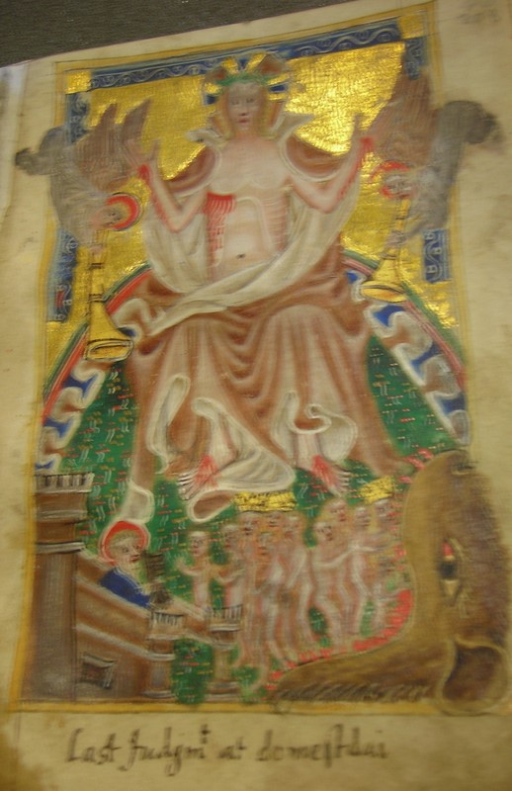
Fig. 1.4 The Bolton Hours, fol. 208r
The Last Judgement

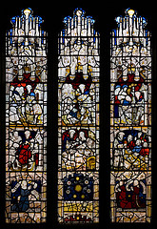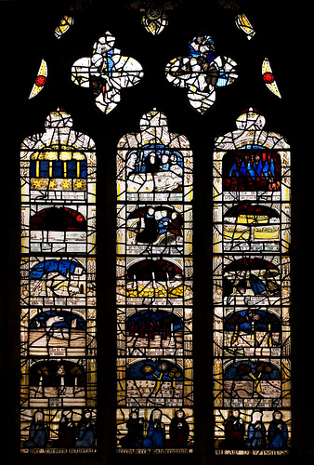
Fig. 1.5 The Acts of Mercy Window Fig. 1.6 The Pricke of Conscience Window
All Saints North Street, York All Saints North Street, York

The Mercers’ Guild evolved from the religious confraternity of Holy Trinity, which was closely associated with the Corpus Christi Guild. Even though the history of The Last Judgement play is separate from the Corpus Christi Guild and the processions, it came to be connected with them because of its preoccupation with right living in response to Christ’s warning in Matthew 25:34. The play “works as an enacted Host miracle: corpus Christi does descend among the people and those who are saved are those who, like the members of the Corpus Christi guild, have endeavoured to perform significant corporal acts of mercy”. Thus, as we have established, the themes of judgement and charity which formed core ideals of the Corpus Christi Guild are also present in the Bolton Hours.

1.3.iii The Pavement Hours Patronage
So far, we have examined the probable patronage of the Bolton Hours, and the importance of certain families and places in York for determining the intersection of lay piety and social affiliations to the Corpus Christi cult. All Saints Pavement was one such important location, and we will now turn our attention to the Pavement Hours in order to establish a context for the types of people the original owner(s) may have been. We can surmise that the patron of the Pavement Hours was a member of the parish church of All Saints Pavement, given that the feast of its dedication on the 15th March is included in the calendar. The documentation of a 1411 court case in York gives an insight into the lives of two women who may have typified owners of such a book.
Agnes Grantham was a brewer of independent means who had recently been widowed. She was the defendant in an action for the enforcement of marriage brought against her by a man named John Dale, to whom she was contracted. Grantham claimed she had been abducted by him and forced into betrothal. A short time later, before the court case was held, she married John Thornton, a well-to-do draper who lived at no. 28 Coppergate, across from All Saints Pavement. Grantham won the case and continued to reside in the spare upper room of Thornton’s next door neighbour, lifelong friend and business associate, William Pountfret (at no. 26), where she had been living since immediately after she had been contracted to Thornton. She regularly attended All Saints Pavement and may have chosen to remain chaste as an act of piety, rather than live with the well-connected Thornton. As a woman of independent means, Grantham could well have supported herself. While living in the Pountfret household, she shared a chamber with a vowess named Dame Christina Pountfrete, also a parishioner of All Saints Pavement and founding member of the Corpus Christi Guild.
Dame Christina and Agnes Grantham are possible patrons of the Pavement Hours because of their economic means and religious devotion. Many books of hours were owned by middle-class laypeople with pretensions to piety, and Grantham was certainly one such person. Dame Christina is an even more likely contender because she had chosen a devout life, and may have been consciously practising an act of mercy by lending out her room to Grantham. There is no way of knowing whether either of these women did in fact own the Pavement Hours, but their situations provide a context for the kind of household where it might have been found. The book could have been owned by any number of families, and perhaps even one of the households clustered round All Saints Pavement. It could have been shared with all the members of the household and perhaps read collectively and taken to church services.
N. R. Ker states that the Pavement Hours was composed for male use but does not substantiate his comment. However, it is just as likely that the Pavement Hours was owned by a woman, or shared by a family. Flemish miniatures were later sewn into the prayer book, indicating that the owner(s) had access to merchants involved in the international book trade and the means to purchase these luxury items. Both Grantham and Dame Christina moved in such circles: Pountfret and Thornton were both well-connected wealthy drapers, and Pountfret was a founding member of the Corpus Christi Guild. It is likely that the owners of the Pavement Hours and the Bolton Hours moved in the same circles and knew each other. Given the similarity of certain themes and illustrations, as we shall see, the books may even have been commissioned and compiled by the same group of scribes and artists, with one artist sketching in the outline of paintings in both books and two others separately filling in the details.

1.4 York Images and the Cult of the Wounds

1.4.i The Wounds and Archbishop Richard Scrope

Devotion to the wounds of Christ had a long history, but reached its height in England during the fourteenth and fifteenth centuries. The cult included devotions to the Holy Name of Jesus, inspired by the writings of the Yorkshire hermit Richard Rolle of Hampole (1290-1349), and devotions to the sacred heart. Although these three strands of devotion - to the wounds, the holy name and the sacred heart - were initially quite separate, by the late fourteenth century they shared common features and so have all been considered aspects of the Cult of the Wounds by modern scholars.
The Bolton Hours and Pavement Hours are among the first extant manuscripts to provide visual evidence of the convergence of these three strands of devotion. It is highly probable that this came about partly as a result of the political and religious events surrounding York Minster and its archbishop, Richard Scrope (archbishop, 1398-1405). As mentioned in the introduction (see page 25, above), Scrope took part in a rebellion against King Henry IV in 1405, and chose for his battle standard an emblem bearing the five wounds of Christ. He was captured during the rebellion and later beheaded in a field outside the city walls on 8 June, 1405. According to a chronicler at the time of his death, Scrope uttered the words, “Lat vs suffre deth mekely, for we shul this nyghte, be Goddis grace, be in paradis” and “For his loue that suffrid v woundes for alle mankynde, yeue me v strokis, and I foryeve the my dethe”. Soon after his death, Scrope was hailed a martyr and a local cult arose, associating his name with the five wounds of Christ.
Scrope had links with the developing Cult of the Wounds and its different strands, and so it could be said that he was partly responsible for connecting his name with the cult. If the account is correct, his desire to be struck five times was, it would appear, a deliberate attempt on his part to be remembered as an imitator of Christ in willingly sacrificing himself for his people. As well as this, Scrope’s Yorkshire-based family was well-known for promoting the cult of Rolle. As bishop of Coventry and Lichfield, Scrope established a chantry to the Name of Jesus by the altar of Jesus in Lichfield Cathedral. The Mass of the Name of Jesus, which was inaugurated in England by 1388, was liturgically associated with the Five Wounds, and Scrope would therefore have been an innovator of both the cult and the Mass.

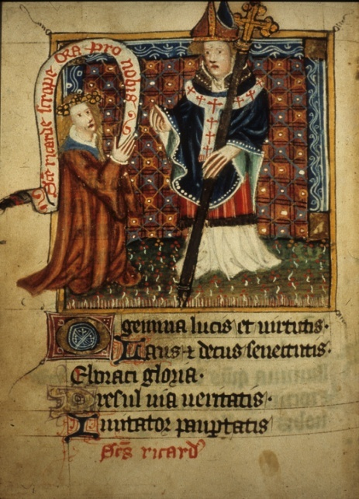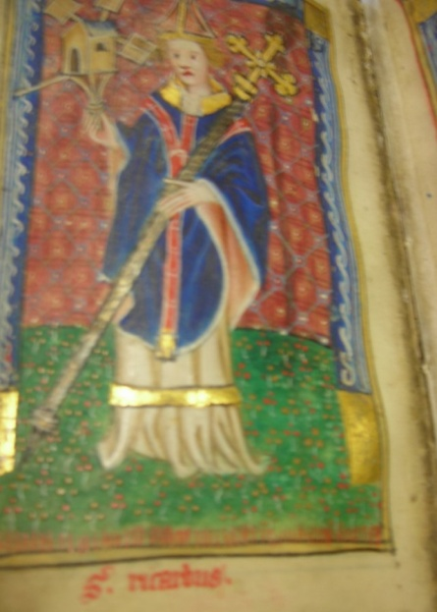
Fig. 1.7 The Bolton Hours, fol. 100v Fig. 1.8 The Bolton Hours, fol. 202v
Richard Scrope with kneeling woman Richard Scrope as Archbishop

The Bolton Hours contains four references to Scrope. He is depicted in a miniature on folio 100v (fig. 1.7) alongside a woman who invokes him with a scroll on which is written “Sancte ricarde scrope ora pro nobis” (“Saint Richard Scrope, pray for us”), and on folio 101v a suffrage to him links him with Thomas à Becket’s martyrdom. This is followed by another Latin prayer devoted to the five wounds of Christ, beginning “Ave dextera manus Christi. Perforata plaga triste...” (“Behold the right hand of Christ. The pierced unhappy wound...”), which juxtaposes Scrope’s reference to the five wounds at the scene of his execution with the details of Becket’s martyrdom on folio 101v. In a second miniature Scrope, as archbishop, is viewed in a quire alongside some saints, on folio 202v (fig. 1.8). This quire is placed immediately before an English Levation Prayer devoted to the wounds of Christ (folios 206r-207r).
The prayer is prefaced by an indulgence of two thousand years if recited during the Mass at the elevation of the host: “Als ofte as men says þis orison / Betwen agnus dei and þe leuacion / twa thousand winter of pardon / Mon þai haue to þe cron” (foilo 206r). It incorporates devotion to the five wounds and to the Trinity, themes which are associated with the York-based Corpus Christi processions:
And so þu died as me say
And rayse ogayne þe third day,
An þis same flesch with woundes fyfe
Þow rayse ogayne fra deed to ly[f]e.
...
Ih[es]u criste, þat it so be,
Lorde, þu grant p[ar] charite,
And euer þu do mercy witt me
In worschipe of Trinite. (lines 13-16; 35-8).

The Pavement Hours includes a small 3-line heart within a square which has been glued onto folio 27r, covering some words in black ink, which can be seen under the vellum. Inside the red heart is the holy name “IHC” (“Jhesu Christe”) in gold letters. It would appear that the heart was inserted after the writing of the words, because the vellum on which the heart is painted overlies the tips of the letters. It is clear that a space was left either for an illuminated initial or for a small image, about the size of the heart. The owner may have chosen to place the heart with the sacred monogram here because it fits well both physically into the space provided, and thematically with the surrounding Levation prayer dedicated to the Holy Name. This activity suggests direct lay intervention and control over the devotional material. The sacred names for Jesus are repeated: “Ave Jesu Christe, verbum Patris, Filius virginis, agnus Dei, salus mundi, hostia sacra, verbum caro, fons pietatis...” (Hail Jesus Christ, Word of the Father, Son of the Virgin, Lamb of God, Savour of the world, Sacred Host, Precious Word, Fountain of Pity...”).

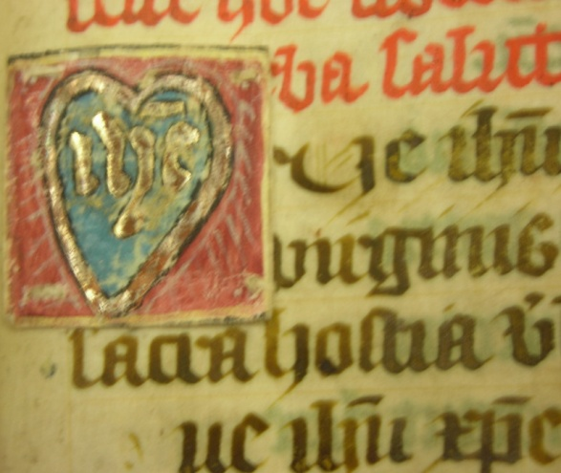
Fig. 1.9 The Pavement Hours, fol. 27v
The sacred monogram

The prayer to the Holy Name combines biblical names for Jesus with Eucharistic motifs – Christ’s body is the ‘hostia sacra’ and his blood the ‘fons pietatis’. A Latin prayer in memory of Scrope immediately follows the Levation Prayer, on folio 27v. The placement of the heart enclosing the Holy Name alongside prayers dedicated to the Mass and to Scrope serves to demonstrate that the then-owner of the Pavement Hours was not only devoted to the Cult of the Wounds, incorporating the Holy Name and the sacred heart, but was also connecting it with the memory of Archbishop Scrope.
1.4.ii The Sacred Heart
Both the Bolton and Pavement Hours contain rare illustrations of the sacred heart containing the five wounds of Christ. In the Pavement Hours the image is placed towards the beginning of the manuscript and immediately after the Hours of the Virgin Mary, on folio 25v (fig 1.10). The sacred heart depicted in the Bolton Hours is placed near the end of the manuscript, on folio 175v (fig. 1.11). The Pavement Hours’ version is the more detailed of the two, with explanatory inscriptions accompanying it. The pale red heart takes up six lines and is centred at the top of the page. Inside the heart five red splashes with lines denote the flowing streams of Christ’s blood emanating from his five wounds. To the left are the Latin inscriptions “Fili” and “Michi” (“my son”), with “Da” and “Cor tuum” (“give your heart”) to the right. Below the heart is a Latin Levation Prayer beginning “Salue plaga lateris nostri redemptoris / Ex te enim profluit fons rosei coloris /Et uera medicina tocius doloris...” (“Behold, the wound in the side of our Saviour / Out of you flows forth the rose coloured fountain / And a true medicine for all sorrows...”). The prayer combines the metaphor for the blood pouring from Christ’s wounded side as a rose-coloured fountain with the theological implication that it is a salvific cure for pain and sin.
As in the Pavement Hours, the heart is pale red, with five horizontal lines denoting the five wounds of Christ. In both instances, green foliage denoting the tree of life protrudes from the top of the heart. The Bolton heart is embossed with gold, serving to highlight its importance as a sacred image, as well as the wealth of its patrons. The gold surround, however, perhaps unintentionally creates the impression that it is separate from the written text. The Pavement heart lacks this frame. In Pavement, the inscriptions to the sides of the heart link the image with the prayer below; both invocations, “salue” (“behold”) and “da” (“give”) invite the reader to respond to the visually and textually integrated page on an emotional level.

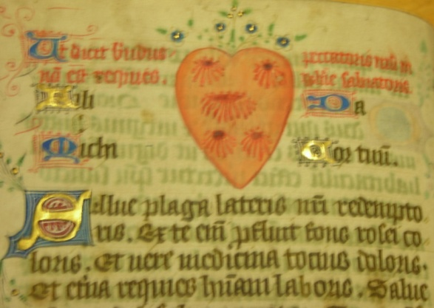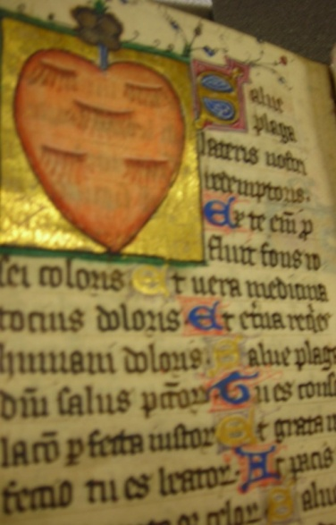
Fig. 1.10 The Pavement Hours, fol. 25v Fig. 1.11 The Bolton Hours, fol. 175v
The Sacred Heart and Wounds and ‘Salue plaga lateris nostri redemptoris’

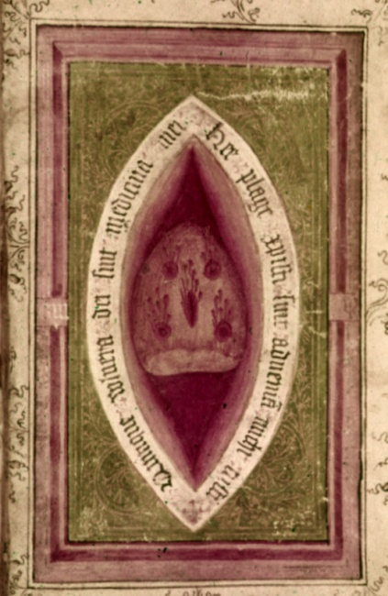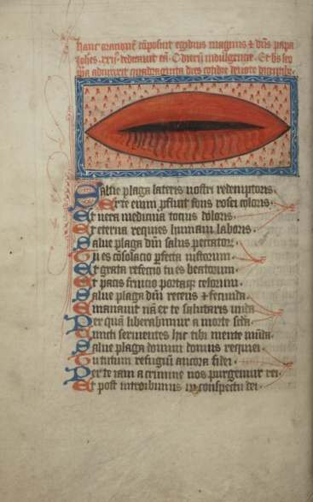
Fig. 1.12 The Scrope Hours: Fig. 1.13 The York Psalter:
Oxford, Lat. Liturg. f.2, fol. 4v Cambridge, Trinity College, MS O. 3.10, fol. 12v
The Sacred Heart and Wounds The Wounds and ‘Salue Plaga...’

As suggested above, these images may be two of the first visual instances in English manuscripts of the fusion of the two separate but related strands of medieval devotion to Christ, that of the sacred heart and of the five wounds. The only other known contemporary extant example of a sacred heart bearing the five wounds is in Bodl. MS Lat. Liturg. f. 2 (c.1405-13) of York provenance, known as the Scrope Hours (fig. 1.12). This sacred heart image reverses the order of those of the Pavement and Bolton Hours. It gives the appearance of a hollow three-dimensional almond-shaped side-wound with a heart inside, bearing in its turn five distinct wounds. On the edges of the outer wound is inscribed the phrase “Quinque vulnera Dei sint medicina mei” (“The five wounds of God are my medicine”), a phrase similar to that of the Latin Levation prayer: “Et uera medicina tocius doloris” (“And a true medicine for all sorrows”). An early fifteenth-century York Psalter, Trinity College, Cambridge MS O.3.10, contains an image of an isolated wound accompanying the same Latin prayer to the name of Jesus as in the Pavement and Bolton Hours, beginning “Salue plaga lateris...” (fig. 1.13) Thus the Bolton, Pavement and Scrope Hours, written around the same time for York Use, combine images of the heart and wounds, and the Pavement and Bolton Hours and the York Psalter contain an image of the wound accompanying the Latin Levation Prayer. This prayer may have evoked the memory of Scrope for its devotees, indicating that the merging of devotions to the wounds and sacred heart may have first occurred in York in response to the political events of 1405 and the ensuing cult surrounding Scrope’s martyrdom. It is therefore reasonable to suggest that the extant York books of hours provide the first evidence for the conflation of these different strands of devotion.

1.4.iii The Arma Christi and the Instruments of the Cross
The arma Christi, or the shield of Christ, is an image depicting the instruments of torture used during Christ’s Passion, contained within a shield. They first appear in English art in the first half of the fourteenth century. The Pavement Hours contains a woodcut of the arma Christi, sewn onto one of its pages in the mid-late fifteenth century. The Bolton Hours and the York Psalter both contain an image of the Instruments of the Passion, but without the framing shield. The images, often filling a full page of their manuscripts, were utilised as visual aids to prayer to the wounded Christ as part of a mental process (‘ars memoria’) of re-enacting the Passion. Devotees would focus on the implements one at a time and imaginatively re-live the stages of Christ’s torment and Crucifixion. The representations of the instruments of the Passion first accompanied a vernacular lyric, also termed the arma Christi, towards the end of the fourteenth century. There are extant fifteen examples of the arma Christi lyric, and in most cases each stanza is separately illustrated by the instrument it describes. Seven of the extant lyrics are written on parchment rolls and it is likely that they were first used as preaching aids during sermons, when they would be unrolled and held by the preacher, or perhaps hung on a church ledge or pulpit. Some of the other lyrics, contained within small books, are more likely to have been intended for private use. All the extant lyrics carry indulgences with instructions for the devotee to ‘see’ the arms of Christ. Thus the emphasis was placed upon looking at the image rather than on hearing the prayer read out by the preacher or, in the case of private devotions, reciting the prayer aloud. The illustrations may therefore originally have been included with the lyric to guide all devotees towards meditation upon the wounds of Christ, including those who may not have been textually literate.
By the early fifteenth century, the individual weapons of the Passion were conflated into one pictorial image, which sometimes carried an indulgence. The Bolton Hours (fig. 1.14) and the York Psalter (fig. 1.15) both contain a full-page miniature of the Instruments of the Passion (but not the arma Christi, or shield of Christ). The York Psalter carries an indulgence in Latin, and both manuscripts include a list in Latin of the individual instruments. These are set out in couplets with guidelines for devotees on how to prayerfully reflect on the instruments as they focus on them. The Psalter version is extremely detailed and even depicts the crucified Christ; hence there is no need to portray the sacred heart or a separate image of the wounds. In any case, the image is paired, on folio 13r, (fig. 1.15), with the individual side-wound, on folio 12v (fig. 1.13). The Bolton Hours includes most of the same instruments as the Psalter, and in a similar position, but not the sacred heart or Christ on the cross. However, the Holy Face is depicted just below the left side of the cross, plus the hands that struck Christ.
The instruments of the cross contained within the heraldic shield, or the arma Christi, are not known in English manuscripts before the middle of the fifteenth century. In the Bolton Hours and the York Psalter there are conflated images of the Instruments of the Cross, but neither has an arma Christi. However, an arma Christi woodcut, likely dating from towards the end of the fifteenth century, is inserted in the Pavement Hours (fig. 1.16). Perhaps a later owner supplemented the book with an arma Christi because this important visual form of late medieval devotion to the sufferings of Christ was lacking. The image has been sewn onto the top of folio 44v, at the end of the Fifteen Gradual Psalms and before the Psalms of the Passion.
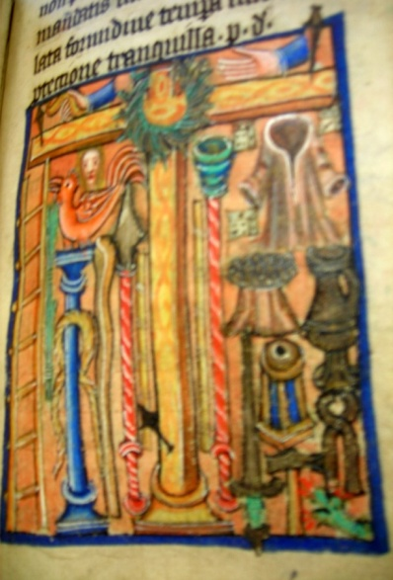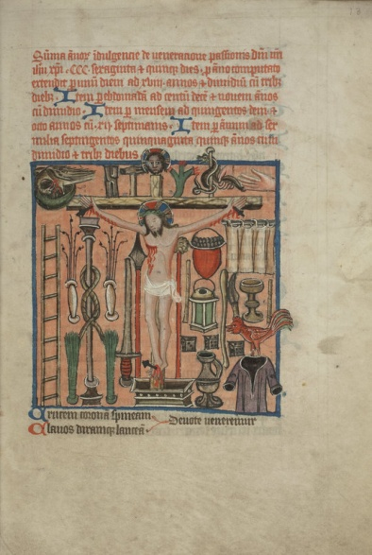
Fig.1.14 The Bolton Hours, fol. 181r Fig.1.15 The York Psalter, fol. 13r
The Instruments of the Passion The Instruments of the Passion

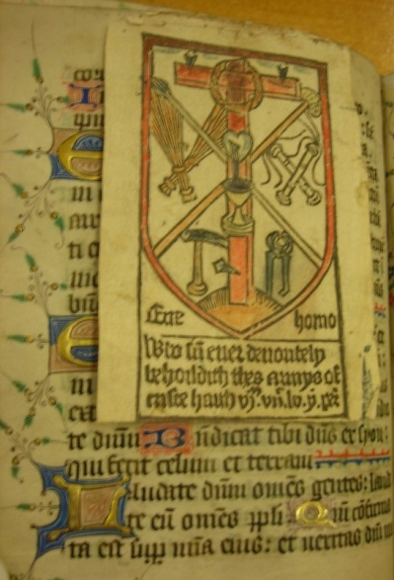
Fig.1.16 The Pavement Hours, fol. 44v
The Arma Christi
The Pavement woodcut contains the symbols typical of the arma Christi. The instruments are framed by a shield, representing that of the Christ-knight who, in religious-love literature of the period, is depicted as lovingly doing battle on the cross for his bride the Christian soul. A red Tau-shaped cross takes up the majority of the space inside. The cross bears a ring representing the crown of thorns, and a heart is depicted on its vertical beam. Black lines represent blood flowing from the heart into a Eucharistic chalice, and the blood, in turn, symbolises the piercing of Christ’s side. To the left of the cross, a hammer and two bundles of reeds represent the whips with which Christ was scourged. To the right are displayed the lance of Longinus and a pair of pliers which were used by the soldiers to take the nails out of Jesus’ feet and hands during the deposition. The implements serve as visual reminders of the suffering to which Christ was subjected, and the display of the wounded heart in the centre of the cross, combined with the pictorial representation of the Eucharist, indicates that the woodcut was utilised as a visual form of devotion to the wounds and sacred heart of Jesus.
The Pavement arma Christi carries an indulgence in English, which reads: “Who sum euer deuoutely / behoildeth thes armys of / Criste haith vim viic lv yer per[don]” (“Whoever devoutly beholds these arms of Christ has 6755 years’ pardon”). The indulgence, like those accompanying the vernacular arma Christi prayers, instructs the devotee to ‘behold’ the arms of Christ, indicating that the image of Christ’s sufferings was used as a form of prayer in itself as well as a visual aid to meditation. The indulgence attached to the vernacular Levation prayer in the Bolton Hours, on the other hand, instructs the devotee to “say(s) þis orison”. However, the Bolton prayer is placed within a few pages of the Instruments of the Passion and, given that visual representations of the weapons often carried an indulgence, it is likely that the Bolton devotees would have used both the prayer and the image as part of the indulgence requirements during their private devotions to the wounds of Christ.

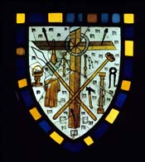
Fig. 1. 17 All Saints Pavement Church
The Arma Christi

The placement of the arma Christi before the Psalms of the Passion in the Pavement Hours underpins its use as a vivid devotional tool. The book would have been used both at home and in church, and the owners would have made ready connections with similar visual images in the windows of local churches. All Saints Pavement has a sequence of mid fourteenth-century panels depicting the Passion of Christ, and a little arma Christi, which may be of a later date (fig.1. 17). The window was originally in St Saviour’s, very close to All Saints Pavement, and the local inhabitants would have known of its existence. Together, these same images in buildings and in books would have reinforced an experience of the suffering of Christ for the Pavement devotees.

1.4.iv The Sacred Rose

Both the Pavement Hours and the Bolton Hours contain an image of the sacred rose that is associated with the Cult of the Wounds and, by association, with the memory of Archbishop Scrope. The depiction of a sacred rose is unusual in English manuscripts and that it occurs in two contemporary horae of York provenance would suggest a localised form of devotion and artistic representation of that devotion. While the details of the two roses are different, their outline is similar. The same could be said of the two images of the sacred heart, suggesting that similar designs were circulating among those producing books at this time in York. The owners of the books may also have commissioned the same artist to sketch in the outlines of the paintings, but then chose separate ones to fill in the details and colour. The detail and colour are generally more elaborate in the Bolton Hours, suggesting that while the owners moved in similar devotional and social circles and hence requested similar images, the Bolton owner was able to afford a more expensive product.
The sacred rose is the first illustration in the Pavement Hours, at the bottom of folio 25r (fig. 1.18). This page marks the end of the Hours of the Blessed Virgin Mary (folios 2v-24v), and the rose alludes both to Mary and to the wounds of Christ. The painting takes up eight lines of text and consists of an inner rose of five petals and an orange centre with yellow dots, with a surrounding rose of five petals. There is no background colouring but each petal contains a thick blue line on its outer edges, and both the inner and outer roses have a red border. The roses are encircled by furls of a banner bearing the Latin inscription “Hic fons ortorum: puteus et aqua uiuorum. Hic iubilus morum: hic lotrix umorum” (“This [is] the fountain of origin: the well and water of life. This [is] the joy of character: This [is] the cleansing of the humours”). The furls protrude from the top and bottom left and right of the circle, with those to the left enclosing the words “hic sanguis” (“this blood”), and the ones to the right displaying the phrase “hec aqua” (“this water”).
The rose was not only a courtly symbol, denoting the love of a knight for his lady, but the white rose was also applied to Mary, the purest of women, or the “rose without thorns”. Additionally, she was the bearer of Christ, the source of cleansing and healing, the fountain of life (‘fons vitae’). The inner rose with its touches of blue most obviously symbolises the other colour for Mary, although it may also allude to the fact that Scrope wore a blue cloak rather than his ecclesiastical vestments on his way to execution. The choice of colour in the Pavement image may have evoked a connection between Scrope’s martyrdom and “the traditional colour of the Virgin’s garb, innocence, purity and virginity”. The cult of Scrope idealised him as a virgin saint, and two contemporary accounts explicitly refer to his own confession of virginity at his death. In 1401, Scrope established the Feast of 11,000 Virgins, and the hyperbolic number would indicate the importance he attached to the status of virginity. And, just as the outer rose with its five petals and touches of red symbolises both the five wounds of Christ and the blood of martyrdom, it may also have evoked the memory of Scrope in the minds of the original owners.

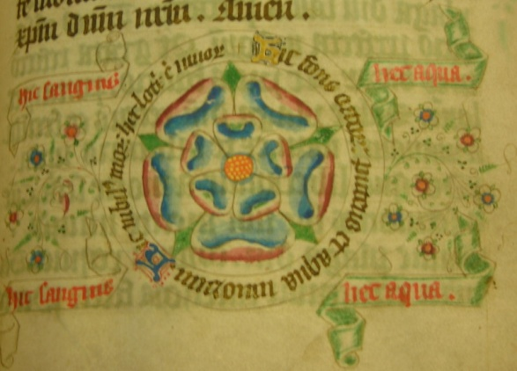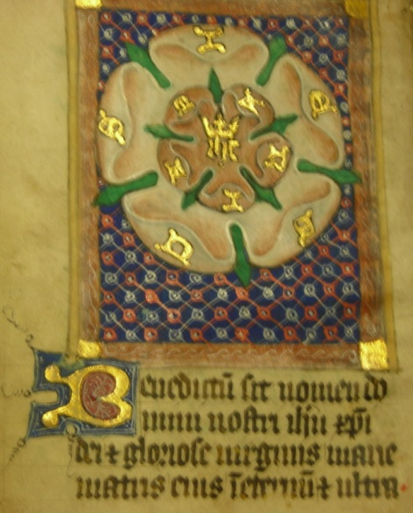
Fig. 1.18 The Pavement Hours, fol. 25r Fig. 1.19 The Bolton Hours, fol. 4v
The Sacred Rose

The sacred rose is appropriately placed at the end of prayers to Mary and before the Levation prayer on the wounds of Christ (“Salue plaga lateris”), and the artist combines Marian and Christological devotion in the enfolding of the white rose within the red one. In the words on the banner, the powerful theological symbols of blood and water are stressed: just as Christ’s blood was mingled with water while on the cross, water is the source of physical life and Christ’s blood is the source of spiritual cleansing. The emphasis on water and blood, symbols of Baptism and the Eucharist, also alludes to an English phrase quoted as part of the Hours of the Cross in the first section of the Pavement Hours: “lord out of þi syd ran a ful fayre flude / As clere as well water our rannson be þi blode.”
A similar example of the sacred rose is present in the Bolton Hours. It marks the beginning of the book of hours proper, on folio 4v, and comprises the top two thirds of the leaf (fig. 1.19). Like the Pavement Hours example, it also consists of two sets of five petals, with the letters “IHC” for Jesus inscribed in gold below a golden crown in the centre of the rose. The inscription resembles that of the little heart sewn into folio 27r in Pavement, accompanying the prayer to Scrope. The inner circle of faded red petals in the Bolton rose contain the letters MARIA written in gold while the outer petals bear the name IESUS. Each petal is separated by green leaves, representing Christ as the source of life (as with the Pavement illustration), and in both cases, the inner petals replicate the outer ones. Below the Bolton illustration are the Latin words “Benedictum sit nomen domini nostri ihu xpi dei et gloriose virginis matris eius in eternum et ultra” (“Blessed is the name of our Lord God Jesus Christ and of his glorious virgin mother forever and ever”). Then follows a prayer to the name of Jesus in Latin: “O bone ihesu, o dulcissime ihesu. O piissime ihesu. O ihesu, Fili virginis Marie, plenus misericordia et pietate... (“O good Jesus, o sweetest Jesus, o most holy Jesus. O Jesus, son of the Virgin Mary, full of mercy and pity...”). Similar versions of this common Rollean prayer are recited on folios 84r-85v of the Pavement Hours, the first of which is accompanied by an illustrated initial depicting the Pietà, directly linking it with the suffering and sorrowing of Christ and his mother (fig.1.20).

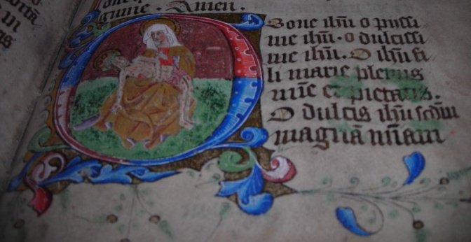
Fig. 1.20 The Pavement Hours, fol. 84r
The Pietà and Prayer to the Holy Name

It is clear that both depictions of the rose combine veneration of Mary and Jesus; however, whereas the focus in the Bolton Hours is on devotion to the name of Jesus, in the Pavement Hours it is more explicitly on sacramental theology. The placement of the sacred rose on the page preceding the sacred heart indicates a pairing on the part of the Pavement artist. The description of the ‘fons rosei coloris’ as part of the Levation Prayer accompanying the sacred heart also links the two medieval symbols of the Crucifixion. It would appear that the overt intention was to guide the devotee towards meditation upon the atoning power of Christ’s wounds with the emphasis on “nostri redemptoris”. The Bolton Hours gives prominence to the sacred rose by placing it at the beginning of the book, perhaps with the aim of emphasising devotion to Christ and Mary. The Pavement Hours, on the other hand, gives precedence to meditation on the death of Jesus through the placement of the English Hours of the Cross in its first folios, 1r-2v.

1.5 Devotion to the Wounds and the Hours of the Cross

The Pavement Hours opens with a nearly complete vernacular version of the hymn to the cross, beginning Patris Sapiencia (see appendix 1). The hymn may have been placed at the beginning of the book to complement private devotions to the Holy Name and sacred heart and wounds of Christ. It follows the usual canonical pattern of the daily Hours of the Virgin. The first stanza corresponds with Matins, recited just before dawn or “at morne tyde” (line 13), and typically commemorating the first event of Christ’s last day, that of his betrayal by Judas. Prime records his trial, while his scourging is combined with his carrying of the cross in accordance with the usual commemorative event of Tierce. Sext then recounts Christ’s Crucifixion, None, his death and Evensong his Deposition. The stanza for Compline, which ordinarily focuses on the preparation of Christ’s body for burial, is missing from the Pavement version of the Hours of the Cross.
The Pavement version of the Hours of the Cross is unusual for three main reasons. Firstly, the English hymn marks the opening of an otherwise mostly Latin manuscript. In the opening section of Matins, folio 1r, the English couplets are, atypically, placed before the Latin prayer (fig. 1.21). For instance, the first two lines written in black ink, “Lorde un-do my lippis, iesu, heuen kyng / And my mouthe sall say þi loueyng” (lines 1-2), are immediately followed with the opening one and a half lines of the penitential Psalm 51, written in red ink: “Domine labia mea aperies: / Et os meum: et ce[tera]” (line 3). After a one-line space, Psalm 70 is introduced in English, again in rhyming couplets: “God þu be my help at my begynnyng, /And me to help þu þe hy, at my ending” (lines 4-5). This is followed by the Vulgate version, “Deus in adiutorium meum intende/Domine ad, et ce” (line 6). As is usual with the Latin York Hours of the Cross, these two psalms are followed by the refrain “Gloria patri et filio et spiritu sancto: / Sicut erat (et cetera)” (line 9), and the scribe gives an English translation beforehand: “Ioy un-to fadyr and þe sonn and þe haly gast in heuen/þat was at þe begynnyng and euer es in heuen” (lines 7-8).
It would appear that the scribe gives precedence to the English by placing it first in order of sequence, although the use of the more prominent red ink for the Latin inscriptions also highlights their importance. The scribe appears to assume comprehensive knowledge of the Latin text on the part of the original owners and/or readers, since he includes only the opening lines of each psalm or liturgical prayer. The marker “et ce” (et cetera) implies an expectation that the readers can recite the remainder of the prayer without guidance. Yet, on the other hand, the inclusion of the English translation suggests that even though the readers may have been able to recite the Latin liturgy, they needed help with deciphering its meaning. Another plausible reason for the inclusion of English is that it was the original patron’s personal penitential response in his or her own tongue to the liturgical hours.
The second unusual feature is that the manuscript begins with an almost continuous version of the hymn as part of the Hours of the Cross, rather than with the fuller Hours of the Blessed Virgin Mary; in this case, the Latin Hours of the Virgin follow on from the English Hours of the Cross, on folios 2v-24v. The optional Hours of the Cross are usually either interspersed with the Hours of the Virgin, or placed afterwards and, even then, are interspersed with set prayers in Latin or English. However, the Pavement version is interrupted only once, between the stanzas corresponding with the Hours of Matins and Prime, with a Passion Prayer in English in response to Christ’s death, beginning “Lorde iesu cryste, leuand god sone, / Þu set þi deyd, þi cros, and þi passione...” (fig. 1.22).
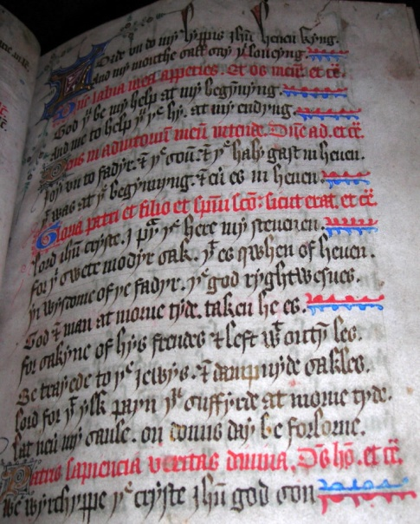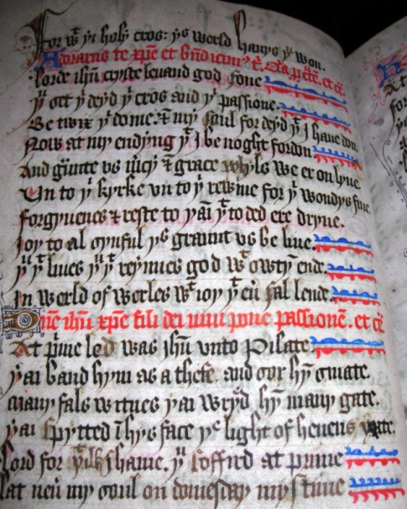
Fig. 1.21 The Pavement Hours, fol. 1r Fig. 1.22 The Pavement Hours, fol. 1v
The Opening page of the Hours of the Cross Passion Prayer and Prime

The placement of the Prayer on the Passion at the end of Matins is usual in the English Hours of the Cross, but the scribe makes significant changes in the translation from the original Latin version. Compare the English transcription with the Latin exemplar for the Use of York – first the English:
Lorde iesu cryste, leuand god sone,
Þu set þi deyd, þi cros, and þi passione
Be-twix þi dome & my saul, for deyd þat I haue don,
Now [and] at my ending þat I be noght fordon.
And graunte us mercy, & grace whyls we er on lyue
Un-to þi kyrke, un-to þi rewme, for þi wondys fiue;
Forgyuenes & reste to þaim þat to ded ere dryue,
Joy to al sinful: þis graunt us be-liue.
Þu þat liues, þu þat reynnes, god wit-owtyn ende
In werld of werles with ioy þat euer sal lende. (lines 22-31)

In the following line in the Pavement Hours, we are given the opening line of the prayer in Latin, “D[omi]ne ihu [Christe] fili dei uiui pone passione[m]. et ce[tera]” (line 32). In the York office, the Latin prayer, denoted by “et ce” in Pavement, continues thus:
…crucem et mortem tuam inter iudicium tuum et animas nostras, nunc et in hora mortis nostre et largiri digneris uiuis misericordiam et gratiam, defunctis veniam et requiem, ecclesie regnoque pacem et concordiam, infirmis sanitatem, et nobis peccatoribus vitam et gloriam sempiternam. Qui vivis et regnas [deus, Per omnia secula seculorum. Amen].

In the Latin prayer, the plural form of the personal pronoun is used (“nostras”/”nobis”), indicating a prayer for corporate public use. In the English version, however, the translator chooses a more personal penitential response to Christ’s passion: “my saul, for deyd þat I haue don, / Now [and] at my ending þat I be noght fordon” (lines 24-5), before giving a universal theological application to the five wounds – a reference not found in the Latin source – “for þi wondys fiue; / Forgyuenes & reste to þaim þat to ded ere dryue, / Joy to al sinful” (lines 27-9). The prayer resonates with the vernacular Bolton Levation Prayer on the wounds.
The unusual placement of the English Hours of the Cross in the first few folios of the Pavement Hours marks it out as of particular importance for the original owners of the manuscript. It may indicate that the compiler sought to elicit an immediate emotive response in a language that could be understood and internalised by its readers. The continuous Hours of the Cross may have constituted an indulgence prayer that the owners could readily find when taking time out of their daily schedule in order to reflect on the Good Friday events.

Table 1 Added couplet refrains in the Pavement Hours of the Cross

Lord for þat ylk payn þu suffyrde at morne tyde (Matins)
Lat neuer my saule on domis day be forlorne.

Lord for þat ilk shame. þu soffird at prime, (Prime)
Lat neuer my saul on domesday mystime.

Lord for þat ilk shame, þu sofyrd in Þat place, (Terce)
Of deydly sunne me to shryue, þu gyue grace.

Lord for þat ilk shame þat was þi body neghe (Sext)
Scheld me fro my il fays, þe world, fend & fleshe

Lord out of þi syd ran a ful fayre flude (None)
As clere as well water our rannson be þi blode.

Lord for þat ilk shame þat þu doun was tane (Evensong)
Lat neuer my saul wit deydly syn be sclayne.

The third unusual aspect of the Pavement Hours of the Cross is that the text is unique to this manuscript, indicating that the scribe may have followed a no-longer extant English translation. Alternatively, he may have written his own version of the hymn, loosely following the Latin source and composing his own refrains in response to the liturgy. In the Latin exemplar of the hymn to the cross (‘Patris Sapiencia’), not included in the Pavement Hours, four lines are devoted to each section (see appendix 1). Each of these quatrains corresponds with a factual account of the events leading up to the Crucifixion and, in the Pavement Hours, is loosely translated into English in pairs of rhyming couplets. However, the Pavement translator ends each section with an emotive personal response to Christ’s suffering in the form of an additional rhyming couplet (table 1). Four of the five additional rhyming couplets begin with the words “Lord for þat ilke shame” and continue with a plea that Christ deliver the speaker from some form of sin. For example, at Sext or the hour of the Crucifixion, the speaker requests, “lord for þat ilke shame þat was þi body neghe / Scheld me fro my il fays, þe world, fend & fleshe”.
As well as adding refrains, the scribe also makes some significant changes in his translation of the Latin hymn to the cross. In the stanza corresponding with None, or the hour of Christ’s death, the translator adds a personal comment on the piercing of Christ’s side. While the Latin source gives a factual account of the piercing of Jesus with a lance - “Latus eius lancea miles perforauit;/terra tunc contremuit, et sol obscurauit” - the English author goes on to describe the knight’s response to his striking of Jesus: “A knyght smat him to þe hert, had he no mercy; / þe sone be-gane to wax myrk quen iesu gun dy” (lines 56-7). The language is also more emotive than the Latin, with references both to the smiting of Christ’s heart and to his death. The final two lines of this section break, too, with the refrain pattern of the other additional couplets in that they do not focus on the sinner (“lord for þat ilk shame”) but on Christ’s suffering: “lord out of þi syd ran a ful fayre flude / As clere as well water our rannson be þi blode” (lines 58-9). The response to Christ’s flowing wounds is at once affective and theological with an emphasis on their atoning power, as well as an allusion to the waters of Baptism and the Eucharistic wine. The added refrain also links the vernacular Hours of the Cross with the Latin prayers surrounding the sacred rose and heart in the following section of the Pavement Hours.
In the last section of the Hours of the Cross, corresponding with Evensong or Christ’s deposition, the translation is very free. The poet inserts an additional reference not found in the Latin source to Christ’s blood, and again provides a theological application: “þe meydcyne of his paynes, þe schedyng his blod, / Be noryschyng to us of o[u]r gastly fod” (lines 63-4). Christ’s suffering has become the believer’s medicine through their partaking of the Eucharist.
Although there is no known source for the English refrains, it is possible that the scribe used a source text, now lost, both for the translations and for the extra-liturgical material. The four couplets beginning “lord for þat ilke shame” may have originally been part of a single lyric that the scribe chose to separate. He may then have added his own response to the hour commemorating Christ’s death, that is, None, and he may have had recourse to similar emotive responses to the Passion event such as those present in the York plays, performed during the feast of Corpus Christi, or in other vernacular responses to the liturgy. Indeed, the written version of The Last Judgement performed by the Mercers’ Guild of York contains similar sentiments, also written in rhyming couplets. In this dramatic rendering, the resurrected Christ speaks of his ordeal. For example, the theological import of the Pavement lines “lord for þat ilk shame, þu sofyrd in þat place, / of deydly synne me to shryue, þu gyue grace” are picked up in The Last Judgement: “The whilke I tholed for youre mysdede. / Thurgh harte and heed, foote, hande and hide, / Nought for my gilte, butt for youre nede” (lines 246-9). Both lyrical responses to the Crucifixion make mention of the guilt of the Jews and the treatment of Christ as of a thief. Compare the Mercers’ recital with that of the Pavement Hours:
Mi body was scourged withouten skill,
As theffe full thraly was I thrette…
The Jewes spitte on me spitously,
Thei spared me no more than a theffe.
(The Last Judgement, lines 253-4, 261-2)

At prime led was iesu unto Pilate
Þai band hym as a thefe, and sor hym smate;
Many fals witness, þai wryed hym many gate,
Þai spytted iesuys face, þe light of heuens yate.
(The Pavement Hours, lines 33-6 [None])

Both literary genres dramatise the same historical event so there is naturally an overlap of themes. That said, however, it is highly probable that the Pavement Hours scribe and the performers of the York Plays were inspired by similar cultural and theological influences, given the mutual connection with York as an important commercial, political and religious centre and, in particular, with All Saints, Pavement. Close to Pavement Square, a mid-fourteenth century stained glass window with fourteen panes of glass depicting scenes from the Passion narrative graced St Saviour’s Church, in St Saviour’s Square, before being moved to its present location in the west window of All Saints, Pavement (fig.1. 22). The scenes may have partially inspired some of the Crucifixion tableaux in the York cycle and may themselves have been inaugurated in response to the liturgical Hours of the Cross. None of this is to say that any one artistic medium directly influenced the others, but rather, that “each is a complex response to a shared vision of sacred history”. It stands to reason that if dramatists, poets and painters had access to similar liturgical, biblical and socio-political influences then their responses would be separate but inter-connected artistic expressions of those same sources within a localised devotional culture.

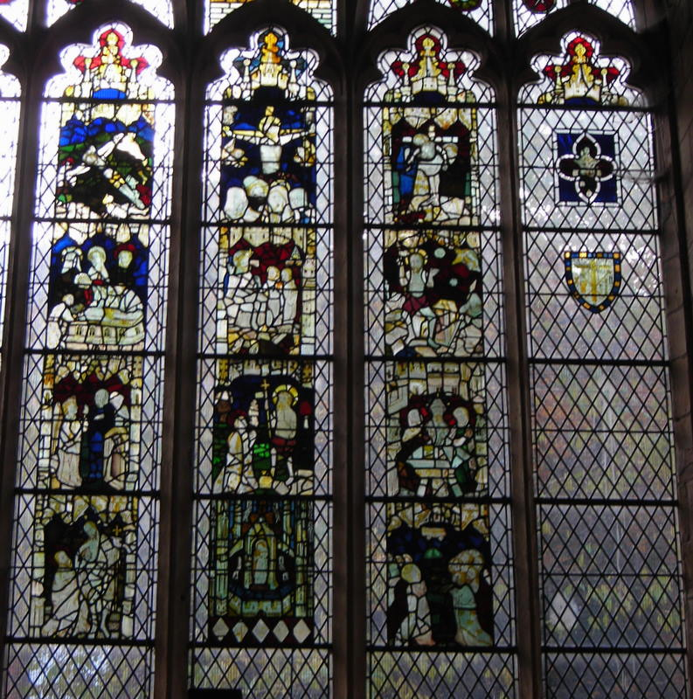
Fig. 1. 23 All Saints Pavement Church Passion Window
(with arma Christi on the right-hand panel)

Although we cannot ascertain its direct influences, we can conclude that the use of English at the beginning of the Pavement Hours sets the tone for the rest of the manuscript. Perhaps the commissioner wanted to ensure that the users of the prayer book could be guided through the liturgy, even with minimal knowledge of Latin. Moreover, she or he may have been particularly keen to reinforce devotion to the sacred wounds, both in the emotive language of the vernacular and in the illustrations of the Pavement Hours.

1.6 Vernacular Prayers and Devotion to the Saints
The Pavement Hours begins with an English adaptation of the Hours of the Cross. Towards the end of the prayer book is another English lyric written in rhyming couplets and dedicated to St Helen, who was believed to have found fragments of the true cross during a pilgrimage to the Holy Land aged around 78. She was particularly venerated in York in the Middle Ages for being the mother of the Emperor Constantine, who was declared emperor during a visit to the city in AD 306. As mentioned in the introduction to this chapter, St Helen was the patron saint of the Corpus Christi Guild and for this reason it is striking that the compiler of the Pavement Hours should choose to end with a prayer dedicated to her memory. The six-line prayer inscribed on folios 98v-99r forms part of the Memoriae which includes prayers to various saints. Even though the prayer is ostensibly to St Helen, it lies within the tradition of devotion to the wounds of Christ. The penitent pleads that St Helen help her (or him) focus on the cross of Christ in her final hours:
Seint elene j þe pray
To helpe me at my last day
To sette þe crosse and his passione
Betwix my synfull saule and dome
Now and in þe houre of my dede
And bring my saule to requied (The Pavement Hours, folios 98v-99r).

Hence the prayer book closes with reflection on the speaker’s own mortality as it began with reflection on Christ’s death, creating a symbiosis between the object of devotion and devotee. The prayer is a compression of the paraliturgical Passion Prayer accompanying the Hours of the Cross, beginning “Lorde iesu cryste, leuand god sone, / Þu set þi deyd, þi cros, and þi passione...” on folio 1v of the Pavement Hours (see appendix 1 and fig. 1.22). In choosing to end with a prayer reflecting on the penitent’s death and impending judgement, but addressing it to the patron saint of the Corpus Christi Guild, the compiler creates a strong link between the Pavement Hours and York-centred devotions surrounding the Cult of the Wounds and corpus Christi.
It is fitting that the Pavement Hours, written at a time when English was becoming increasingly established as an alternative language to Latin, should begin and end with English lyrical prayers devoted to the wounds of Christ. The vernacular lyrics constitute a personal affective response to Latin prayers written for corporate use. And the prayers, both vernacular and Latin, are placed close to visual images of the sacred heart and the wounded Christ. The images and prayers thus work together, reinforcing and enhancing affective devotion to the wounded Saviour.
Taken all together, the devotions of the Pavement and Bolton Hours, and their mises-en-page, give a detailed and vivid account of the devotional and para-liturgical lives of their owners. Middle class York households at the turn of the fifteenth century, such as those of Dame Christina Pountfrete and Alice Grantham and of the Boltons and Blackburns, seem to have functioned as miniature devotional communites, as well as in the secular spheres of York. Such communities were neither conventual nor anchoritic but operated both within the household, and in the local parish church and business circles. The households, like the other owners and readers of religious books, may have brought their horae and primers with them to church, and even to the guildhall or places of business. Often these personalised books, such as we have seen with the Bolton and Pavement Hours, contain lyrics and illustrations that cannot be divorced from their socio-political context. Devotion to the wounds of Christ, while an expression of affective piety, was also bound up with a wider political agenda, possibly including that of safeguarding private and public prayers from worldly powers, or indeed of using them to subvert or neutralise those powers, and to promote local leaders such as Archbishop Scrope. Whether expressed in their stained glass, lyrics, plays or prayers, it is clear that devotion to the wounds of Christ in York at the turn of the fifteenth century was firmly embedded in both public and private devotions centred on the Corpus Christi commemorations.

Chapter 2 The Hours of the Cross in English Primers
2.1 Introduction
This chapter will explore the English Hours of the Cross in order to build a case for the flourishing of a rich and diverse vernacular devotion that complemented and informed formal public worship in Latin. The Hours of the Cross are the translation of an early fourteenth-century Latin hymn beginning ‘Patris Sapiencia’ and attributed to a Pope. They consist of seven quatrains in rhyming couplets corresponding with the liturgical hours of Christ’s Passion and death. They are extant in fourteen English primers that were chiefly compiled at the turn of the fifteenth century to provide the laity with a shortened version of the Divine Office as prayed by priests and monks. They were also written in response to Archbishop Thoresby’s injunctions of 1357, which were devised in order to instruct the laity in the basic tenets of the Church. Many of the primers contain such items as the Pater Noster, the Creeds and the Ten Commandments as well as short treatises on the seven virtues and vices, the seven deadly sins and the seven gifts of the Spirit.
The Hours of the Cross are often broken up and interspersed through the Hours of the Blessed Virgin Mary (which is a shortened version of the Divine Office composed specifically for the laity). Although the Hours of the Cross comprise only a brief section of each of the Hours of the Virgin, they were ubiquitous by the end of the fourteenth century. They were transmitted throughout Western Europe and translated into several European languages, including Dutch, German, Anglo-Norman and English. One of the most interesting aspects of the English translations of the hymn is that they range from fairly literal and uniform renderings in the English primers, to unique versions that maintain the quatrain form in some books of hours, and also to much freer lyrical adaptations in religious anthologies and miscellanies. Yet, despite their proliferation in a variety of late medieval manuscripts, they have only been edited or listed as part of the contents of the Hours of the Virgin, and they have never been focused on as a discrete study.
This chapter will argue that an examination of the placement of the Hours of the Cross within primers provides a valuable insight into ways in which late medieval devotees integrated their understanding of Christian doctrines and faith through the performance of prayer. It will be argued that readership of the English primers cannot easily be separated into lay versus clerical and public versus private, but that translations of the liturgical hours into English were accessed by a diverse and overlapping cross-section of late medieval society in a range of contexts. As well as exploring the significance of the translations of the Hours of the Cross for understanding some of the ways in which they informed the liturgy, this chapter will also investigate their mise-en-page in relation to their glosses, decorations, illuminations and framing as a further means of enhancing devotion to the cross.
One of the main reasons why the Hours of the Cross were so popular and diverse in the late Middle Ages is that, in essence, they are a compression of the Good Friday narrative as recounted in the Gospels. This day, commemorating Christ’s last few hours, was, with Easter Sunday, the most important in the medieval Church calendar. The Latin hymn of the cross includes the doctrinal message of redemption through the death of Christ, and it was likely composed in rhyming couplets and set to music so that it could be easily remembered and reflected upon, both by the clergy and the Latinate laity. Since English primers were compiled in order to condense the liturgy into a form suitable for laypeople with various levels of Latin comprehension, it stands to reason that the most significant biblical passages recounting the Passion narrative would be the ones that were condensed into an easily repeatable form. Because the Hours of the Cross represent an even briefer form of the canonical hours than those of the Virgin, they could be even more readily performed at certain points in the day by busy people. That they were adapted from a hymn believed to have been written by one of the Popes may be another reason why they became a popular model for a variety of prayers devoted to the Cross.

2.2 The Good Friday Liturgy
Since Anselm of Canterbury (1053-1109) had emphasised the perfect atonement of a suffering saviour who completely identified with mortals by laying aside his majesty, the Church had focused on the most human aspects of the god-man: his birth and death. The Hours of the Blessed Virgin Mary incorporate the two emphases. The Virgin Mary is the most blessed among women because of her role in the Incarnation, and part of the shorter Divine Office is devoted to her. The Hours of the Cross provide a reinforcing focus on the Passion events. These are told both from the perspective of the biblical witnesses and of contemporary penitents recalling the events through active and imaginative participation in the prayer many centuries later. Therefore the repetition of the liturgical hours, not only on Good Friday but during every day of the Church calendar, helped the devotees to feel part of a community of participants in the liturgy reaching back through the centuries to the first Good Friday.
If Good Friday was one of the most important days of the Church year, the most important season was Lent, culminating in Easter. Throughout Holy Week the Passion narratives were read in Church, and sermons connected to the events were preached in the vernacular. The sequence of events was also portrayed in stained glass windows and paintings in churches and in solemn processions through the streets, pausing at the alabaster statues or Stations of the Cross, which visually depicted Christ’s ordeal. A special liturgical hymn known as the Improperia, or Reproaches, was designated for Good Friday. In this hymn, Christ, quoting from the Hebrew Scriptures, makes a complaint to his people, the Children of Israel, in response to their misunderstandings which have led to his death. This haunting liturgy was set in the form of versicle and response antecedal refrains and would have reverberated through the hearts and minds of the penitents as they commemorated Christ’s final hours. The hymn was processional and the choir would begin each section by chanting the refrain of Micah 6:3 in plainsong: “Popule meus, quid feci tibi? Aut in quo constristavi te? Responde mihi” (“My people, what have I done to you? How have I offended you? Answer me!”). The response would be given in the form of a rebuke in antithetic parallelisms by Christ. A Middle English lyrical translation of the Latin hymn (in quatrains) maintains the parallel pattern of the Latin hymn in alternate, first and third, lines:
Mi folk, nou ansuere me…wat miht I mor ha don for þe,

Out of Egipte I brouthte þe…and wikkedliche þu nome me,

Ouer al abouten I ledde þe…and no frenchipe fond I in þe,

Fourti wenter I sente þe…and þu heng me in rode tre,

Heilsum water I sente þe…and eysil and galle þu sentist me,

Þe see I partid o-sunder for þe…And þe herte blod to sen of me,

Alle þi fon I slou for þe…and þu heng me in rode tre,

A kingges 3erde i þe be-tok…and þu heng me in rode tre,

I made þin enemies and þe…and on an hey hil þu henge me.

The Crucifixion scene was further evoked in the Good Friday sermons, with the imagination of the listener being evoked through the detailed portrayal of incidents from apocryphal literature or the Gospels, such as the cutting off of the soldier’s ear and the adornment of the purple robe. The sermons may also have included an address by Mary or Jesus from the cross, and perhaps a refrain from one of the Middle English lyrics or dialogic treatises with a similar treatment of the Passion events. Therefore, the liturgical services and religious processions, with their recounting and re-enactment of the Crucifixion, would have combined to evoke both a cognitive and emotional response on the part of the lay and clerical participants, one which engaged their minds, senses, bodies and hearts. The events of this very important day in the liturgical year would have been remembered throughout the year in the Hours of the Cross, reiterated at two or three-hourly intervals during each week day, as the devotees paused for a few moments of reflection.

2.3 The Page as a Devotional Image
This section will focus on how the English primers were compiled and possibly used by their readers to enhance devotions to the wounds of Christ. The translations of the Hours of the Cross as recorded in NIMEV 3499 mostly accord with Littlehales’ listing in The Prymer or Prayer Book, 1892. In all but one of the primers under investigation, English is the dominant language throughout the Office, apart from the Latin rubrics used in some cases to mark the beginning of each section. Perhaps it was because the main intention was to provide the laity and lower clerical orders with a standardised written text for prayer that none of the manuscripts contains the miniatures or elaborate historiated initials that are common in horae compiled for well-off mercantile or noble families. Nevertheless, the primers show evidence of having been carefully compiled; in most cases, neat handwriting is punctuated at key points in the liturgy with illuminated initials, and some primers even display decorated borders. In terms of levels of standardisation, the primers fall somewhere between the formal liturgical missals produced for the clergy and the horae that contain private prayers, memorabilia and the paraliturgical Hours of the Virgin. The primers include the shorter Divine Office and set prayers, creeds and exhortations for instructional purposes. However, the extraneous prayers and petitions of horae are mostly absent from the primers, as are the missal instructions and prayers of clerical books.
Owners of paraliturgical manuscripts would have had a high regard for their property. They would have read and re-read the contents over a lifetime, and they would have committed both the textual and visual aspects to memory. Indeed, the separate pages within primers could be viewed as devotional artefacts similar to the arma Christi or the crucifix. The pages are illuminated in order to mark significant parts of the liturgical text such as the Hours of the Blessed Virgin Mary, of which the Hours of the Cross forms an integral part. Depending on their layout on the page, the enlarged or illuminated initials may serve both as an aid to memorising particular sections of the liturgy and as a means of integrating text, rubrics and initials within the frame of the page. The text and image thus often work together both aesthetically and mnemonically, each illuminating the other. For these reasons it is important to understand the visual layout of the pages within the books, and the relationship between text and image.

2.3.i Case Study: Cambridge, Emmanuel College, MS 246
This section will pay attention to the placement of the Hours of the Cross on the page, and to the relationship between the written and illuminated text as part of the meditative process. Littlehales used CUL MS. Dd. xi. 82 as his base text in The Lay Folks’ Prymer because “it contains only the indispensable contents of the book itself, with no additions of any kind; and…because there is every reason to believe the text is a good one”. However, since my concern is with the visual as well as textual aspects of the primers, I will use as my base text Cambridge, Emmanuel College, MS 246, which contains both a full edition of the Hours of the Cross and illuminations. The English translation of the Hours of the Cross in this manuscript is for the most part very similar to that in other English primers. However, it is one of the most elaborately decorated. A close examination of the manuscript will demonstrate the relationship between word and decorative image as a means of devotion.
Emmanuel 246 has been dated towards the end of the fourteenth century. It contains the English Hours of the Blessed Virgin Mary, beginning on folio 7r, interspersed with the English Hours of the Cross, beginning on folio 15r (see figs. 2.1 and 2.2). The quatrain for each of the Hours of the Cross is placed towards the end of each corresponding hour of the Virgin - after a prayer to the Trinity and the Virgin, and before a prayer on the Passion (see fig. 2.2). All the manuscript pages of Emmanuel 246 are void of border decoration or illuminated initials, except for the pages marking the beginning of each of the seven Hours of the Virgin (folios 7r, 15v, 17v, 19r, 21r, 22v, 25r) and of the Hours of the Cross (folios 15r, 17r, 19r, 20v, 22r, 24v, 26v), one page marking the beginning of the Seven Penitential Psalms (folio 27v) and another the beginning of the Office for the Dead (folio 35r) (for a selection of these pages, see appendix 2.2). It would appear that for the compiler(s) and/or owners of this manuscript, the Seven Penitential Psalms, the Office for the Dead and the Hours of the Virgin with the interspersed Hours of the Cross were considered the most important part of the liturgy. Given that each of the seven liturgical hours is highlighted twice, once at the beginning of each section of the Hours of the Virgin, and once for each quatrain of the hymn to the cross, the Hours of the Virgin and Cross were probably considered most significant of all.
Throughout the primer, there is an obvious contrast between those pages with border decorations and those with none. Even though the latter contain enlarged initials to guide the readers through the liturgical sections, they are less immediately visually appealing (e.g., compare figs. 2.1 and 2.2 with fig. 2.3). The borders and illuminations invite the reader into the text and provide natural pauses between each prayer, thereby enhancing the meditative process. The eight-line initials also have a mnemonic purpose in that they help the devotee visually to recall the text that occurs alongside them. The reader is encouraged, not only to read from left to right and from top to bottom, but also from the text on the right to the image on the left.

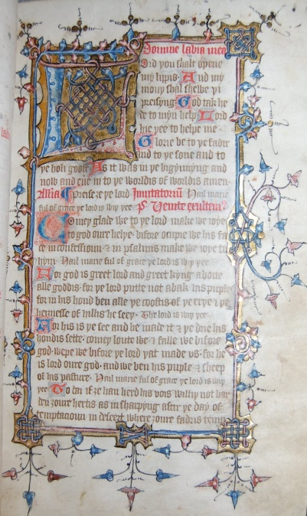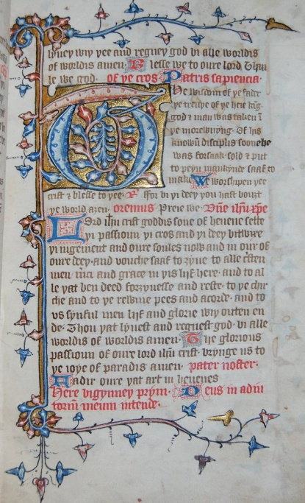
Fig. 2.1 Camb., Emmanuel Coll., MS 246, fol. 7r Fig. 2.2 Camb., Emmanuel Coll., MS 246, fol. 15r
The Hours of the Virgin (Matins) The Hours of the Cross (Matins)

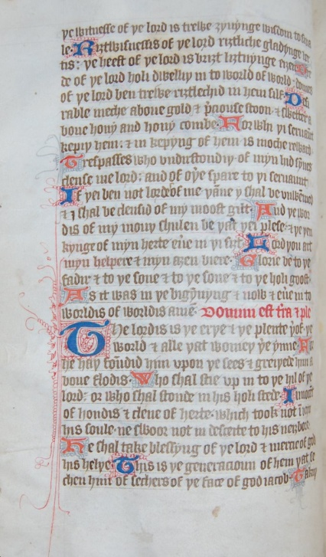
Fig. 2.3 Camb., Emmanuel Coll., MS 246, fol. 8v
Page without borders (Matins)

By permission of the Master and Fellows of Emmanuel College, Cambridge.
Each of the liturgical Hours of the Virgin begins with a Latin rubric across the page, taking up a complete line and acting as a boundary between one section and the next. A gold embossed 8-line square with a large red and blue initial takes up the left half of the space immediately below. In each case it is filled with interlacing designs, reminiscent of those present in insular manuscripts such as the books of Durrow and Kells (see figs. 2.1 and 2.4). These much earlier texts were beautifully illuminated with intricate interlocking patterns; the initials often formed the centre of the page and were themselves regarded as symbolic and sacramental images within the text.
Each Hour of the Virgin, except Matins, opens with the refrain “God tak hede to myn help” and so, the initial is always a ‘G’ and is always filled with the same interlocking arrangement (for example, fig. 2.4). Matins, however, begins on folio 7r with the initial ‘L’ for “Lord you shalt opene my lippis”, and it too is filled with an interweaving design (fig. 2.1). Moreover, on this first page, which opens the Hours of the Virgin, each of the other three corners is connected by a miniature version of the same square frame, but without the letter. The letter ‘L’ itself forms a frame as the tail at the end is drawn vertically to meet the top of the letter; therefore, in this way too, the illuminated initial represents a devotional artefact within the frame of the page as a whole.
This first page marking the Hours of the Virgin, folio 7r (fig. 2.1), is also fully framed. This feature has the effect of drawing the reader completely into the page. The page is on the right hand side of the opening and acts as a form of introduction to the shorter Divine Office as a whole, before going on to the individual sections. The full frame gives prominence to the Hours of the Virgin, and the opening page is the most important of all. The framing of the initial page also serves as an entrance-way into the hours, and so may be compared with other kinds of entrance, such as those in a Gothic church. The portals and pillars of parish churches and cathedrals often incorporate foliage. Here too, they form boundaries and frames, contributing to the definition of sacred space.
The ball-flower ornamentation, so popular in fourteenth-century English constructions, is similar in design to the floral knots and ball-shapes of the illuminated corners of the fully framed folio 7r, and the design impresses upon its devotees the sense of entering into a miniature sanctuary. As in churches, the flowers of the manuscript page are naturalistic, yet they are still structural in that they are vertical and controlled, and they help define the frames. As the devotees turn the pages and continue meditating, they once again periodically engage with a framed page. At the same time, the lack of boundaries to the right of each of the other pages helps them move easily through the Passion narrative.
The pages marking the beginning of each of the other hours of the Virgin have a thick straight gold and blue border down the left-hand side denoting the trunk of a tree, with curved thinner lines serving as branches, bearing red and blue acorn-like vine leaves that protrude across the top and bottom of the page (for example, figs. 2.4 and 2.5). The illuminated initials are formed as a continuation of the trunk and are placed entirely within the border, which serves as a very clear and uniform frame for each of the pages. The letter ‘G’ for “God tak hede to myn help” also forms its own interlocking pattern as the tail and tip are wrapped around each other, thus creating a miniature frame within the page (fig. 2.4; appendix 2.2.A: figs. 1-3).
To the right of each initial, the opening refrain of the corresponding hour of the Virgin is neatly rendered in black ink. The placing of the text and initials within the frame indicates a deliberate intention on the part of the artist to guide the reader towards viewing the text and visual image as an integrated whole and to regard the page itself as a meditative icon. The borders act as a definite boundary, with the leaves pointing outwards into the margins and away from the frame. In all but one of the decorated pages, the text merges with the blank margin to the right of the page. This shared open-endedness perhaps suggests to the reader that while each page functions as a separate entity, it also works in unison with the others in creating part of the whole shorter Divine Office.
The depiction of page borders as trunks with branches and vine leaves is common in medieval manuscripts. They are a symbol of life and growth in contrast with the inorganic words and images on the page, with the implication that the words and images are brought to life through the readers’ engagement with and imaginative re-enactment of them. In religious manuscripts the vine leaf may be representative of Christ the ‘True Vine’, as recorded in John 15:1, as well as of spiritual rebirth and new life through the Resurrection. Each of the illuminated initials denoting the Passion narrative of the Hours of the Cross in this manuscript is decorated with vine leaves, reinforcing the doctrinal import of the Crucifixion, culminating in new life through the Resurrection. Again, the gold-embossed square background for each initial acts as both a frame and a border and could therefore be regarded as an enhancement to the devotional meaning of the text. Some English manuscripts such as this one depict the leaves as acorn-like, perhaps because they are germane to England, although the implications of growth and rebirth remain the same.
Even though border decorations of this nature are prevalent in both primers and horae, they are not often so consistently wrought as in Emmanuel 246. In most of the other English primers, as we shall see, some pages are placed within a decorative border acting as a frame while others have no border, and the length of the trunks and branches may vary from one page to the next. In this primer, however, not only are the borders visually consistent but so too are the size and placing of the illuminated initials.
Another unusual aspect of the Emmanuel 246 version of the Hours of the Cross is that its illuminated initials are given the same prominence as the beginning of each Hour of the Virgin. In most other manuscripts, while the beginning of each liturgical Hour of the Cross is denoted in some way, usually by an enlarged or even an illuminated initial, it is not as grand as the initial that denotes the beginning of each Hour to the Virgin of which the hymn to the cross forms a part. The reason for this may be that in most cases, the compilers of the primers regarded the hymn to the cross as one of many integral parts of the Hours of the Virgin, along with set prayers, but not more important than them. The fact that such care was taken over the marking of the Hours of the Virgin and, equally, the Hours of the Cross in Emmanuel 246 reinforces their special importance for the users of this particular primer.

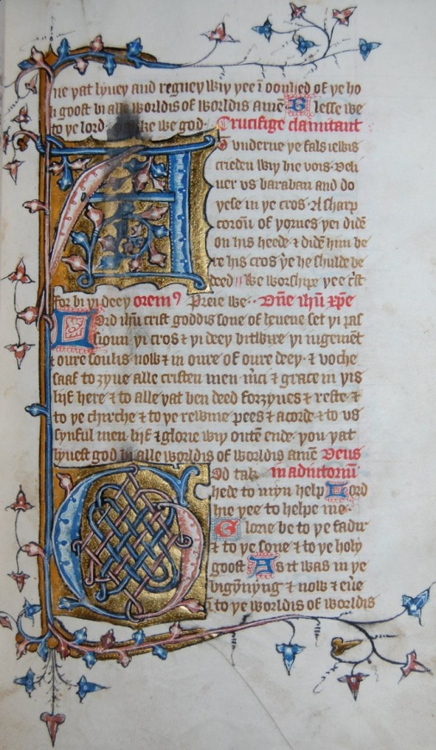
Fig. 2.4. Cambridge, Emmanuel College, MS 246, fol. 19r
The Hours of the Cross (Tierce) / The Hours of the Virgin (Sext)

By permission of the Master and Fellows of Emmanuel College, Cambridge

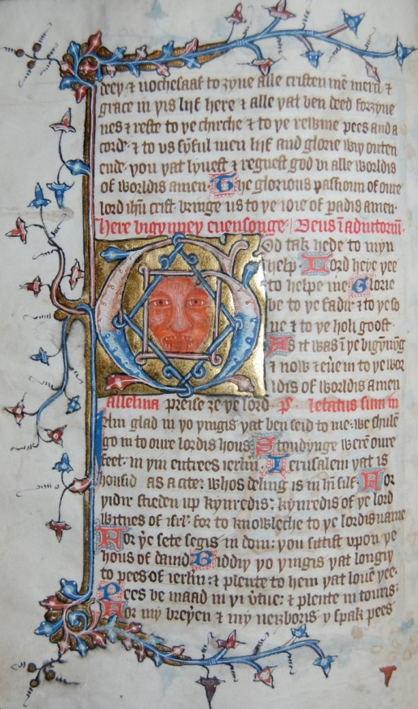
Fig. 2.5. Cambridge, Emmanuel College, MS 246, fol. 22v
The Hours of the Virgin with illustration

By permission of the Master and Fellows of Emmanuel College, Cambridge

The Latin rubric denoting the beginning of each stanza of the hymn to the cross takes up the first line to the right of the initial. The quatrains are neatly written below the rubric, taking up exactly eight lines and, together with the rubric, they match the length of the illuminated initial. It would appear that eight lines were planned for each portion of the text, at half a full line width, but that for the stanzas of the Hours of the Cross, the words had to be squeezed into the space provided. One clear instance is to be found on folio 19r, where there are two eight-line illuminated initials marking the hours of Tierce and Sext (fig. 2.4). The first one, marking the Tierce Hour of the Cross, appears to have the accompanying text squeezed into the right-hand side of the page. Conversely, the prayer marking the beginning of the Sext Hour of the Virgin and accompanying the illuminated initial at the bottom of the page is written in larger size; this is the same size as the remainder of the text. It would appear that the words were written first, in the spaces marked out for them, and that the initials were painted in later. The initials occasionally run over the text, such as in the first and seventh lines of the stanza beginning ‘At Underne’. The first word ‘At’ is partially painted over, as is the letter ‘r’ on the seventh line. Although unintentional, the overall effect is that the hymn to the cross, already standing out in importance by the size of the initial dedicated to it, is further highlighted by its diminutive lettering in relation to the rest of the page.
If we consider each illuminated page as a whole, it draws the reader in, not only because of its beautifully decorated borders providing a clear frame, but also because of its neatness and use of colour. As well as being pleasing to the eye, the colour guides the reader through the liturgical text. Along with the illuminated initials already discussed, one and two-line enlarged initials in either blue or red are interspersed through each page, indicating a new line or section of the liturgy; for example a two-line versicle plus response refrain beginning “We worshippe þee” (fig. 2.2). Often a Latin rubric will also serve as a cue for a liturgical change, such as “oremus” or “Deus in adiutorium”. The Latin headings and directions are always written in red whereas the English prayers and Psalms are in black. The consistent pattern guides the reader; it also helps her find the appropriate text for the hour. When she is focusing on one section of the hours with her book open in front of her, she can engage with the whole page as an image and allow it to lead her into imaginative participation in the Passion narrative.
Emmanuel 246 is the only extant English primer to contain an historiated initial that forms part of the Hours of the Virgin, on folio 22v (see fig. 2.5). The image is doubly noteworthy in that it includes a figurative element within a symbolic frame. Like the illuminated initials, the historiated initial is eight lines long. It denotes the beginning of Evensong, with the rubric in the line directly above it stating “here bigynneþ euensonge. Deus in adiutorium”. The Latin phrase is taken from Psalm 69:2 and is the cue for the following sets of refrains in English to the right of the image:
God take hede to myn help. Lord heye þee to helpe me.

Glorie be to þe fadir & to þe sone & to þe holi goost.
As it was in þe bigyn[n]y[n]g is now & euer into þe
Worldis of worldis. Amen.

Immediately beneath the initial and to the left of the text is the rubric “Alleluia preise 3e þe lord”, and this is followed in the next line with an English translation of Psalm 121, beginning “I am glad in þo[s] þingis þat ben seid to me”, etc. At first glance the image itself is puzzling in that it does not seem to bear any direct association with the written text. It consists of the red face of a man baring his teeth and sticking out his tongue, which in this context may represent the devil. The face is contained within an interlaced square and a blue and gold diamond. The whole shape is contained within an initial ‘G’ marking the beginning of the line “God take hede”, etc. This prayer forms the opening part of the liturgy as part of a versicle and response refrain, and it is followed by the Gloria, which is recited at the end of each Psalm.
The diamond, or lozenge, shape of the image traditionally represents the boundaries of the cross and its universal salvific significance, here fitting neatly within the letter ‘G’ for ‘God’, to which it is shown to be bound. It would appear that the artist wished to demonstrate the medieval belief that between Christ’s death and resurrection, he descended into hell to release captive souls. In this process the devil was defeated and bound by the power of the cross. It is now Evensong, the hour of Christ’s deposition and the beginning of the Harrowing of Hell. The words ‘God take hede’ further emphasise the necessity of arming oneself against the wiles of the devil through reiterating the prayer at the beginning of each canonical hour, while the recitation of the Gloria reminds the devotee of the ultimate power of the triune God. The symbolic significance of the historiated initial would have been very powerful for its original audience. The careful pairing of text and image is consistent with the thoughtful planning to be found on the part of the scribe(s) and artist throughout the Hours of the Virgin.
2.3.ii Physical Layout of the Hours of the Cross in Other Manuscripts
We have paid close attention to the illuminations in Cambridge, Emmanuel College, MS 246. Even though this primer is the only one under investigation that contains a historiated initial, all the others display decorative elements, some more elaborate than others. Some of the remaining primers contain decorations and borders almost as impressive as those of Emmanuel 246, although the choice of page selected for illumination is less consistent. A study of some of the salient physical features of the remaining English primers is important for establishing the extent to which the visual and textual elements may be integral components of vernacular devotion accompanying the liturgy, and for drawing some conclusions as to why there may be differing emphases within manuscripts.

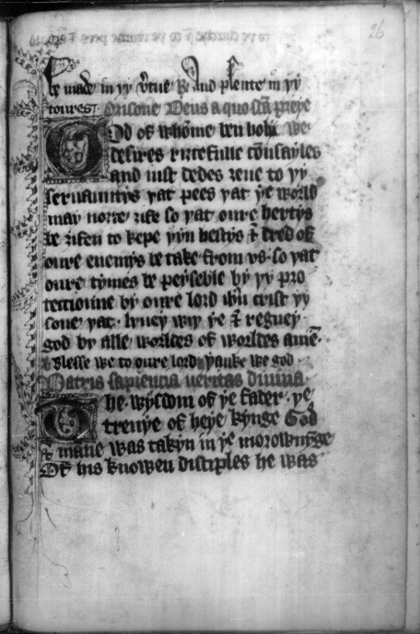
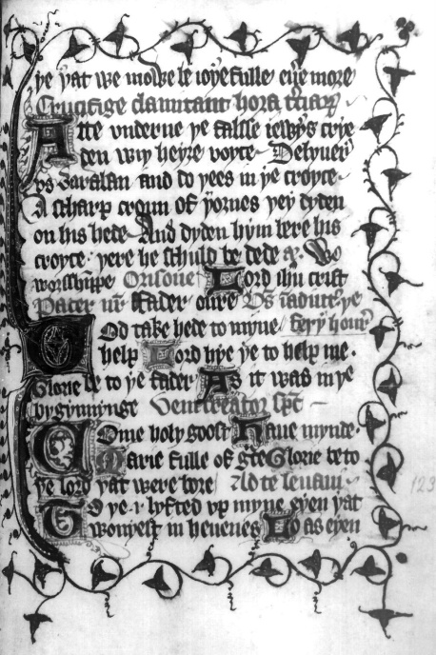
Fig. 2.6 Bodl., MS Douce 246, fol. 26r Fig. 2.7 Bodl., MS Douce 246, fol. 33r
The Hours of the Cross (Matins) The Hours of the Cross (Tierce)
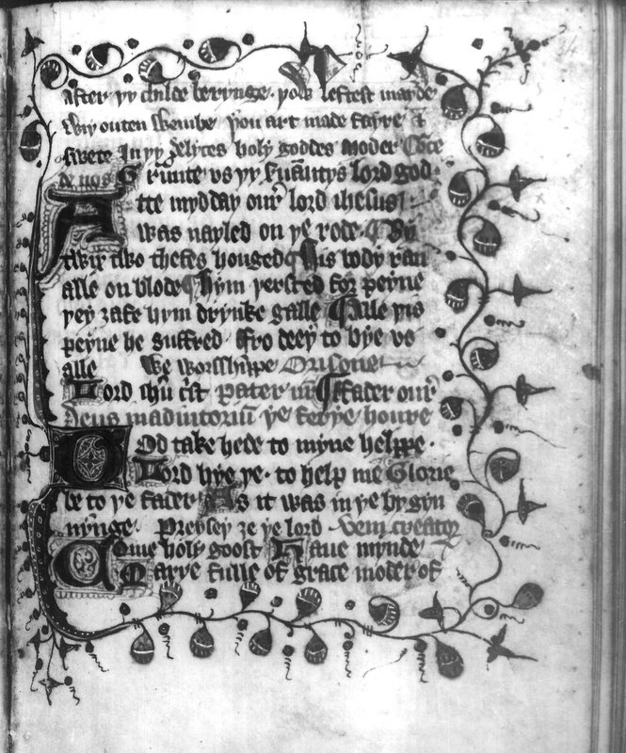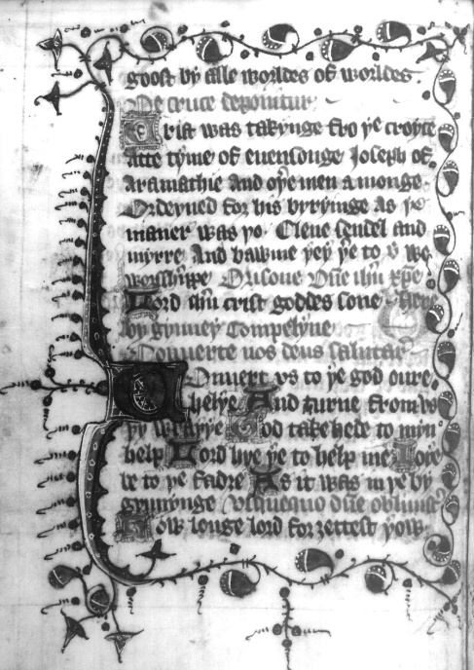
Fig. 2.8 Bodl., MS Douce 246, fol. 34v Fig. 2.9 Bodl., MS Douce 246, fol. 38v
The Hours of the Cross (Sext) The Hours of the Cross (Evensong)

Two other primers that are noteworthy for their illuminations are Cambridge, St John’s College MS G.24, and Bodl. MS Douce 246. Together they provide examples of some of the earlier primers in English, written towards the end of the fourteenth century. The Douce manuscript is fairly small, measuring 190 x 150mm, and was likely compiled for personal use. Some of its most beautifully illuminated pages, with elaborate border decorations depicting red and green acorn-like leaves and illuminated initials in gold, are reserved for the pages marking the Hours of the Cross, indicating that the hymn was particularly significant for the original owners and may have been regularly recited as part of their daily prayers (for a selection of pages marking the Hours of the Cross, see figs. 2.6-2.9). On most of these pages the text is enclosed within borders of foliage stems and/or ivy leaves or acorns, and is further illuminated with two and three-line initials marking the beginning of each liturgical section. The initials are continuous with the left-hand border, so that the text and image are interwoven.
Unlike Emmanuel 246, the Douce 246 illuminations for the Hours of the Cross are inconsistent in form. For instance, the first hour of the cross, which begins towards the bottom of the page with the opening line of the Latin hymn in rubrics - ‘Patris Sapiencia’ - has only one illuminated margin, along the left-hand side of the page (fig. 2.6). On some pages the fern leaves form only part of the border of the left-hand margin, with acorn-like leaves filling the remainder (for example, figs. 2.8 and 2.9), while in others fern and ivy leaves fill the whole of the border (for example, fig. 2.7). The writing too is inconsistent across the hours. There appears to be more than one scribal hand and at times the script size is shrunk to fit into the space left for the written text (see, for example, fig. 2.8).
The borders are often continuous around the pages of the Hours of the Cross, representing a boundary, yet the curving foliage stems create a sense of fluidity which offsets the formal structure of the written liturgical office, thus inviting the reader into the text. The continuous frame combined with the outwardly protruding stems perhaps lead the gazer simultaneously to look inwards to the text and outwards to the margins beyond, suggesting that the outer world of the devotee and the inner world of the sacred text meet and merge through the act of prayer.
Like Douce 246, Cambridge, St John MS G.24 is small enough for personal use, measuring 181 x 126 mm. It has very large, ten-line illuminated initials marking the beginning of each liturgical section of the Hours of the Virgin with an enlarged two-line initial for the beginning of each stanza of the Hours of the Cross. The difference in size would suggest that, while the hymn to the cross was significant enough to be included and also highlighted, it was considered an integral aspect of the Hours of the Virgin rather than a hymn standing apart from the other prayers. That said, however, the enlarged initial at the start of each stanza would have helped the readers to find their way easily to this part of the office.
Like Emmanuel 246, the St John G. 24 initials take up at least half the width of the page, and the same colours of gold, red and blue are employed in their composition. In this case, solid straight lines along the four sides form a substantial Gothic border at the beginning of each liturgical hour of the Virgin, on folios 9r (Matins), 20r (Prime), 24v (Tierce), 26r (Sext), and 36r (Compline), as well as at the beginning of the Penitential Psalms (folio 40v) and the Office for the Dead (folio 56r). Conversely, the other pages have no borders and are illuminated solely by enlarged initials in red and blue for the beginning of each prayer or refrain, thus generating a stark contrast between those pages with borders and those with none, in a manner similar to that observed in Emmanuel College, MS 246 (compare figs. 2.10 and 2.12 with 2.11). The solid borders are an intentional framing device, and so it is likely that the artist wished to provide visual signposts within the manuscript page to indicate the special significance of the prayers for the devotee. Their elaboration, uniform structure and consistent blue and gold colouring, both for the borders and illuminated initials, establish a serious tone in keeping with the importance of the text.

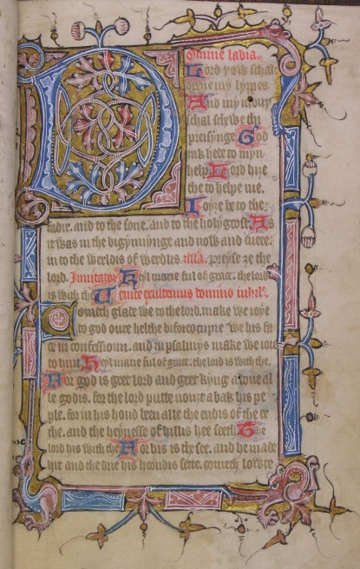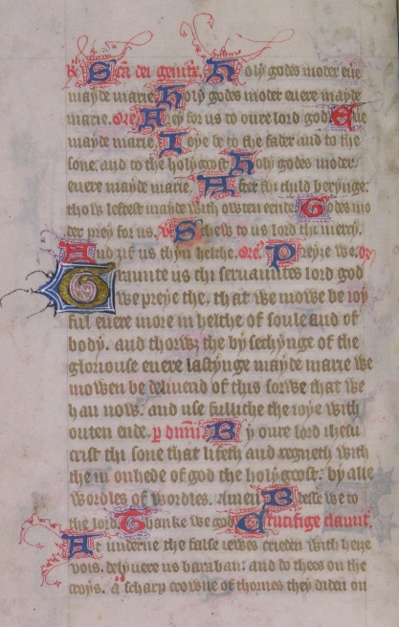
Fig. 2.10 Camb., St John’s Coll., MS G. 24 Fig. 2. 11 Camb., St John’s Coll., MS G. 24
Fol. 9r The Hours of the Virgin (Matins) Fol. 25v The Hours of the Cross (Tierce)

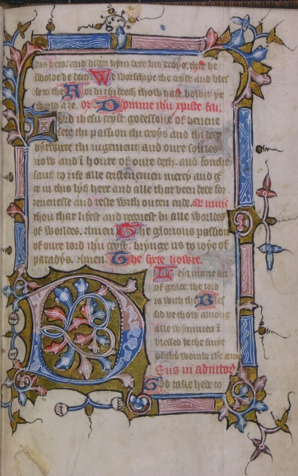
Fig. 2.12 Camb., St John’s Coll., MS G. 24, fol. 26r
The Hours of the Virgin (Sext)
The Hours of the Cross are not singled out by the artist; instead slightly enlarged initials indicate the beginning of each section of the hymn (fig. 2.11). In this sense, the St John’s primer is more representative of the placement of the Hours of the Cross within the extant English primers than Emmanuel 246; this is the only one of the sample where the Hours of the Cross are given equal status in their illumination with the Hours of the Virgin. This divergence in distribution of ornamented pages indicates differing priorities between the scribes and/or patrons. If the books were made to order, perhaps that difference could have been the result of particular requests. All three primers hitherto examined provide examples of the care taken over their making, and especially of the importance of the liturgical hours for their readers.
Three of the more richly illuminated primers have been selected for special attention. There are, nevertheless, a few others that are not so well illuminated, probably because of costs and purpose of production. At the bottom end of the spectrum sits one of the primers that contains a prose version of the Hours of the Cross: London, BL MS Add. 17011. This pocket-sized manuscript was very likely compiled for individual use. Although the handwriting is very neat, it contains no decoration and no material other than the shorter Divine Office and the Psalms. These factors combined would suggest that the primer was utilized at home as a vehicle for private devotion by its owner and perhaps even taken to church so that s/he could follow the liturgical offices in English.
GUL, MS Hunter 512 provides us with yet another variation. Although red and blue enlarged initials occur throughout this very substantial manuscript of 226 folios, it contains only one fully framed page of text, marking the beginning of the Hours of the Virgin on folio 37r (fig. 2. 13). Yet, despite the fact that obvious importance is attached to the Hours of the Virgin, they occur only after a series of treatises and tenets mostly in English, and near a vernacular lyrical prayer devoted to the love of Jesus. That the manuscript is bilingual and that it contains so much extraneous doctrinal material may indicate that it was compiled as a compendium for self-improvement and may have been disseminated among those literate in Latin as well as in English. The lack of illumination elsewhere, in this case, suggests that the visual elements of devotion were of less concern for the commissioners of the manuscript than the circulation of verbal exhortations and prayers in two languages.
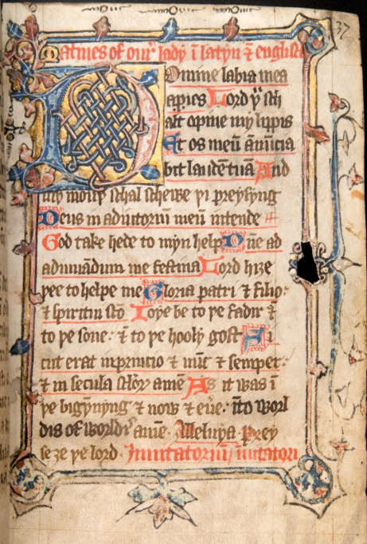
Fig. 2.13 Glasgow, GUL, MS Hunter 512, fol. 37r
Page marking the beginning of the Hours of the Virgin (bilingual)

2.4 English Translations of the Hours of the Cross
Thus far we have considered the physical layout of the Hours of the Cross. We will now turn to the hymn itself as presented in the fourteen extant English primers (using the Emmanuel 246 manuscript as a base text) in order to establish how it was translated from the original source and utilised by laypeople as a devotional and doctrinal tool that helped enhance their understanding of the liturgy (see appendices 2.3.i - 2.3.iii).
Although there is a variety of English adaptations of the Latin hymn to the cross in horae and religious miscellanies, for the most part the hymn is fairly literally and uniformly translated in the primers, all of which have been loosely dated between the end of the fourteenth and the middle of the fifteenth centuries. There is only one major difference between the manuscripts, at the Hour of Evensong, where they follow one of two translations. This consistency would suggest that the scribes had access to two English exemplars and that they worked closely together as part of one or two scribal circles dedicated to compiling primers.
As well as close correspondences between the versions of the Hours of the Cross, there are other textual similarities between the manuscripts (for a list of contents, see appendix 2.1). For example, three of the primers make a reference to Richard II’s coronation in 1377 and to the earthquake of 1382 in their calendar, although Maskell points out that the references do not necessarily mean that the manuscripts were compiled soon afterwards. The hymn to the cross is followed by another prayer of the Passion in most cases and this, too, is fairly consistently translated by the primer scribes, whereas in horae and religious anthologies and miscellanies there is a much greater degree of variation. Four of the primers include treatises which are associated with Wycliffe, a contemporary of Thoresby, who was likewise concerned to disseminate vernacular works to enhance doctrinal understanding on the part of the laity and lower clerical orders. Apart from the one substantial departure in the translations, at Evensong, there are some minor variations between the Latin and English sources, and in most cases, the English renditions indicate a fuller doctrinal and/or emotive appreciation of the Passion narrative on the part of the translators than the text of the original hymn. The discrepancies in meaning serve to demonstrate that the English translations were primarily used in order both to teach the laity and enhance their affective response to the Crucifixion.
The first instance of a divergence from the Latin original occurs in the first stanza. Using MS Emmanuel 246, we will compare the English with the Latin source, MS Hunter 512, to highlight the differences. The first hour of Matins in the English and Latin versions reads respectively:
Þe wisid[o]m of þe fader þe treuþe of þe heie ki[n]g Patris Sapiencia, veritas diuina,
God & man was taken in þe morewnyng Deus homo captus est hora matutina,
Of his known disciplis soone he was forsaak. A notis discipulis cito derelictus,
Sold & put to peyn Mankynde saaf to make. A iudeis traditus, venditus, afflictus.

The English version comments on the universal doctrinal significance of Christ’s torture, “mankynde saaf to make”, a reference not present in the original. It also chooses not to follow the routine anti-Semitic formula whereby the Jews are blamed for betraying, selling and afflicting Jesus, and instead departs from the Latin source by omitting mention of them. That the last line is so different from the original and that it is repeated in all but one of the verse versions within English primers would suggest that the scribes copied from one English translation of the Latin source. The one exception to the rhymed verse versions is present in the bilingual primer, Hunter 512, which renders a much more literal translation, “Of þe iewis bitraed, sold and turmentyd”. This translation also occurs in the three prose versions and indicates that these scribes may have had recourse to another source from which they all copied. Alternatively, the three prose scribes may have followed an alternative exemplar from the verse translations but the Hunter 512 scribe may have chosen to follow closely the Latin text with which he was simultaneously working. The latter explanation is more likely since in the case of the other substantial departure from the Latin source, at Evensong, the Hunter 512 scribe follows one translation while the prose authors choose another, much looser, translation of the Latin text.
The Latin exemplar for Evensong reads:
De cruce deponitur hora uespertina,
Fortitudo latuit in mente diuina:
Talem mortem subiit vite medicina,
Heu corona glorie iacuit supina.

Three of the lyrical editions and the three prose editions adopt a fairly close transliteration of the Latin source; all six texts agree in the first two lines of the translation, as follows:
Fro cros, crist was takun doun at euesong tyme, we fynde
Power of resureccioun was hid in goddis mynde.
(CUL, Dd. xi. 82, lines 1-2)

There is, however, some variation in the third and fourth lines. Of the six manuscripts Rawl. C. 699 and BL Add. 36683 agree, and the three prose versions are also similar, while Dd.xi.82 departs in its choice of words in the last two lines, as can be seen below:
Þe medicyne of lyf & lisse took such a deeþ for ri3t
Alas þe crowne of glorie lai cast doun ri3t.
(lines 3-4, Rawl. C. 699 [and BL, Add. 36683])

suche a deeþ undir3ede þe medicyn of liif
Alas þe corowne of glorie lay byneþe.
(lines 3-4, prose BL, Add. 17010 [and BL, Add.17011/Bodl., Ash. 1288])

Þe medicyne of liyf, bi storie, took sithe deeþ out of toun
Allas! Þe coroun of glorie was þus cast vpsedoun.
(lines 3-4, CUL, Dd. xi. 82)

Nevertheless, the sentiment is the same in all six versions and accords with the paradoxical expression in Latin of the seeming defeat of death over life as Christ’s power is temporarily laid low in the grave or hidden, awaiting the Resurrection. The English versions also encourage participation in the Gospel narrative with the use of the personal “we fynde” (line 1), and the reminder to the devotee of the biblical “storie” in line 3 of the Cambridge version. The words “we fynde” further assume a community of devotees with some access to the texts, even if they were not themselves all Latin literate. The unique rendering of the last two lines in the Cambridge version, “Þe medicyne of liyf, bi storie, took sithe deeþ out of toun. / Allas! Þe coroun of glorie was þus cast vpsedoun” may also indicate scribal deviation from the exemplar, perhaps because it was muddled and so the scribe had to reconstruct it, or because the scribe chose to provide his or her own translation, the last line of which is close to the original but more colloquial. In all three variants of the second couplet, the first line strays from the original in order to be made to rhyme with the second: “such a deeþ for ri3t/…lay cast doun ri3t” / “þe medicyn of liif/…corowne of glorie lay byneþe” and “took sithe deeþ out of toun./…was þus cast vpsedoun”.
The other eight primers follow a different translation of the Latin source from the example just given in their version of Evensong. I will cite the Emmanuel 246 version as a point of comparison:
Crist was takun fro þe cros at tyme of euensonge
Joseph of armathie and oþe[r] men amonge
Ordeynede for his biriyng as the mane[r] was þo
Clene sendel and mirre and bawme þei token þer to.

It is very clear that this translation which recounts the burial process as recorded in the Gospel narratives is totally different from the other Evensong prayer. There is no attempt to give a theological account of Christ’s death, unlike the Latin exemplar and English translations, as explained above. That these eight English manuscripts depart so radically from the other six and are yet so similar to each other in other respects may point to a lost Latin variant of the stanza corresponding with Evensong or, more probably, to an English adaptation of the hymn used by the scribes of all six manuscripts adhering to this version. While a lost Latin source is possible, it is unlikely because there is no mention of more than one version in the studies and editions by Julian, Maskell or Littlehales, or in versions of the hymn within breviaries and horae, which are sometimes placed alongside an English version.
The translations for the other canonical hours of Prime, Tierce, Sext, None and Compline are consistent in content in all of the eleven rhyming versions, apart from a few minor spelling variations. As with the first stanza corresponding with the Hours of Matins quoted above, however, there are some departures from the Latin source in these five stanzas. For example “kyng of grace” replaces “lumen deo gratum” in the Hour of Prime and the Gospel accounts are filled in, such as the naming of Barabas in Tierce (although in this same section the purple robe is not mentioned). An anti-Semitic reference to “þe fals iewes”, not in the original, is supplied in the English translations of the Hour of Tierce. Other additional comments include “Alle þis peyne he suffride, fro deeþ to bie us alle” at the Hour of Sext, and “þat was of my3tes moost” during None, as an allusion to Christ’s divine powers while on the cross. For the hour of Compline the English translation is fairly literal; however, the addition of the emotive word “sadli” with its serious overtones and the universal application of “Þenke we sadli on his deeþ þat shal saue us from helle”, instead of the more personal and less severe “Jugis sit memoria mortis michi cure” (“May the memory of his death by the spear be continual to me”) drive home the significance of the Crucifixion. Both versions, however, emphasize the importance of serious reflection upon the Passion events.
All of these deviations suggest that the scribes were not as intent upon keeping to a close translation of the Latin hymn as upon vividly recounting the Passion narrative and its doctrinal significance for the devotees, while maintaining the aabb rhyme scheme. Despite the scribal variations, the translations are, for the most part, theologically conversant and consistent. Perhaps one or two groups of scribes were specifically assigned to primers since there is considerable uniformity in their translations of the hymn to the cross compared to horae, which are all unique transliterations.
That the English versions of the Hours of the Cross within books of hours (such as the Pavement Hours, discussed in chapter 1) are individualised adaptations of the original would suggest that they were largely compiled for individuals and/or their families, and were hence highly personalised. Conversely, the primers were probably written as a much more uniformly doctrinal and devotional tool for a larger audience. Even if the primers were individually owned, they may have been passed around many church members and the contents learned so that they could be recited from memory.
Moreover, it could be argued that as an additional prayer, the hymn to the cross encourages lay participation in the Passion events extending beyond the basic Christian precepts as outlined in Thoresby’s injunctions. As a compression of the Easter narrative, the hymn can be utilised in a variety of ways: in paraliturgical recountings of the events through the recital of the canonical hours in primers; and in the performance of the much freer vernacular lyrics and prayers devoted to the cross and wounds of Christ in horae and anthologies, often occurring alongside the paraliturgical Hours of the Virgin. For instance, the placement of a vernacular lyrical prayer in MS Hunter 512 almost immediately before the Hours of the Virgin suggests that there was an overlapping of readership and usage of the devotional prayers in both primers and horae. The prayers point towards a deep understanding of the meaning of the Crucifixion and resurrection, one which enhanced the doctrinal precepts recommended by the Church hierarchy. There is every reason to suppose that these multivalent expressions of devotion to the cross were largely encouraged by the Church.

2.5 Paraliturgical Refrains and Associated Prayers to the Cross
It is widely acknowledged that the religious lyric is indebted to the liturgy, and thus far we have examined some lyrical English translations of a Latin liturgical hymn. The versicle plus response refrain, as used repeatedly during the liturgy, likewise finds its way into English translations of liturgical prayers. During church services, refrains mark the end of liturgical sections such as the recitation of psalms and specific prayers, and in this way serve as an oral/aural counterpart to the rubrics and illuminated initials that visually indicate the relevant section of manuscripts (although in manuscripts rubrics also appear at the beginning, as do antiphons in church services). Like the illustrated page, the sung refrains have a performative as well as a mnemonic function. In the Middle Ages they were often separated from the rest of the chanted prayer by a higher tonal pitch, thereby serving as a doubly-recognizable cue for a largely Latin-illiterate congregation. At the same time, vernacular lyrical prayers with refrains were widely circulated in primers and horae and would have been memorised by the laity. Some of these prayers may have replaced the Latin refrains, at least in the conscious commitment of them to memory. Just as the laity were encouraged to recite vernacular prayers, whether from memory or the written page (for those who owned a book), during the celebration of the host, they may also have mumbled other vernacular refrains while the choir and clergy chanted the Latin versicles and responses. These English refrains would have been reinforced through the preaching of sermons; often preachers summed up key points in short verse form, consisting of either rhyming couplets or even parallelisms in three lines with an end rhyme, usually to illustrate a group of three important themes.
The versicle plus response refrain of the Latin hymn Patris Sapiencia is closely and consistently translated in rhyming couplets by the scribes of each of the primers so far examined, with the rubric ‘V’ to the left of the first line and ‘R’ to the left of the second serving as visual cues for the reader (see appendices 2.3.i - 2.3.iii, after Matins). Some versions abbreviate the refrain to “We worschipe þee, crist etc.,” indicating that it was well-known and could be readily recited from memory, even though the written text was at hand. The full version, repeated at the end of each section of the hymn from Matins to Compline, points the devotee to the doctrine of the Atonement as the reason for their worship with the use of the word ‘a3enbou3t” (redimisti):
We worschipe þee, crist, & blesse to þee; Adoramus te Christe et benedicimus tibi:
Ffor bi þi deeþ þou hast a3enbou3t þe world. Quia per sanctam crucem tuam redimisti mundum.

Another example of the overlapping of lyric and liturgy in the English primers is a prayer on the Passion of Christ, which has at least two Latin exemplars and is often placed after the translations of the Hours of the Cross (see the last section of appendices 2.3.i - 2.3.iii). Looser English adaptations of the Latin prayer also occur either as part of a vernacular lyric or as a very free adaptation of the Hours of the Cross in horae such as the Pavement Hours and religious anthologies such as the Vernon manuscript. The versions transcribed in the primers are very similar, apart from a few minor departures in phrasing. In some manuscripts a line or two may be omitted, perhaps indicating a degree of carelessness on the part of the scribe. For instance, the St John’s manuscript omits a line and a half, which Emmanuel retains and which reads “to þe churche and to þe rewme pees and acorde /Ande to us sinful men lyf and glorie”, in keeping with the Latin source. The line is also similar to a note placed in the top margin of folio 26r of Bodl., MS Douce 246, at the Matins section of the Hours of the Cross, and which reads “to þe church and to þe reume pees and acoord”. That only one line of the prayer is given here and that the first line serves as a cue in rubrics in some of the other primers, indicates that it was memorised by devotees. Therefore, even though the whole prayer may sometimes be omitted from the Hours of the Cross, it was well-enough known to be recited as part of the commemoration of the Passion with the aid of a short mnemonic device. The abbreviations may also point to the reason for the minor variations; the scribes themselves may have known the prayer so well that they had committed it to memory and copied it out without an exemplar in front of them.
The fact that the prayer on the Passion is so ubiquitous in various guises in a variety of manuscript genres supports the idea that there may have been strong scribal links between them in terms of source sharing and even the production process. Their placement at the end of each section of the Hours of the Cross demonstrates that the hours were not recited in isolation from other prayers, but rather were part of a rich devotion that included set paraliturgical prayers as well as freer renditions composed from memory by scribes. These different manuscript versions were in turn committed to memory by the readers and, like the hymn to the cross, may have been included in the indulgence prayers that were recited in front of visual images of the dying Christ-figure.

2.6 Devotions to the Cross as a Means of Empowerment
Upon examination of the English primers as a group, certain conclusions can be drawn regarding their broad uniformity. With one exception, none of them contains images but all are illuminated in ways that convey meaning and direct reading. Another point in common is that their additional material consists mainly of items such as the Ten Commandments, exhortations on the Seven Deadly Sins and Seven Acts of Mercy, and so on, all of which are included in the literature recommended by the Church as doctrinal aids in educating the laity, in keeping with Thoresby’s reforms. Furthermore, they were all most likely compiled between the late fourteenth and mid-fifteenth century and are thus illustrative, on the one hand, of the efforts of the Church in this period to ensure that the laity were theologically conversant and, on the other, of a desire on the part of the laity to participate more fully in liturgical acts, which prior to this period had been mostly the domain of the ecclesiastical elite. Those primers that were compiled after the Arundel reforms, beginning in 1407, were likely done so with the approval of the local bishops, indicating that the circulation of paraliturgical material was part of a combined lay and clerical enterprise. Thus the Arundel years must be seen in the larger context of the sweeping reforms of the thirteenth and fourteenth centuries that produced such a great output of primers and breviaries, as well as horae and religious anthologies, and were for the most part sanctioned by the Church. Primers are more uniform than horae and have less elaborate illuminations, so could probably be afforded by a greater range of people, and some may have been commissioned and owned by priests.
The primers could be regarded as companion texts to religious miscellanies such as the Vernon Manuscript, or to horae, which contain the shorter Divine Office as well as extraneous material. Some devotees would have had recourse to all three types of manuscript and the wealthier ones may even have owned both a book of hours and a primer. Likewise, both could have been carried to church and used as part of public worship, as well as private devotions within the home. GUL, MS Hunter 512 provides us with an example of the overlapping contents of primers with horae and anthologies. As well as being bilingual, as with many horae and miscellanies, this primer contains a vernacular lyric devoted to the love and pity of Jesus. A similar prayer, “The Sweetness of Jesus” occurs in Vernon and in the Bodl., MS Douce 322 book of hours, and a similar Anglo-Norman lyric is present in London, MS Add. 44949, otherwise known as the Tyrwardreath Psalter. The presence of comparable lyrics in a variety of religious texts demonstrates their complementary nature and use by clergy and laypeople alike.
The prayers to the Cross in primers are considered paraliturgical in that they operate in conjunction with the official Divine Office. The translations of the Latin hymn to the cross led to the adaptation of other formulaic prayers, such as the prayer on the Passion and those to the wounds of Christ. The cults of the wounds and of the name of Jesus combined with the endorsement of Thoresby’s injunctions and the circulation of vernacular works such as The Pricke of Conscience led, in turn, to the writing and re-writing of ubiquitous lyrics with similar themes until they became part and parcel of common prayer life. The vernacular prayers were not only performed alongside the formal liturgy but in a sense became liturgical themselves, as we have seen in the lyrical refrains imitating the versicle/response form of the Divine Office. Thus it could be said that the lyrical prayers dedicated to the sufferings of Christ became a form of vernacular liturgy, not only operating alongside the formal ecclesiastical performances, but perhaps even overtaking them in the devotions of a wide cross-section of late medieval people.

Chapter 3 Passion and Penitential Lyrics in Religious Anthologies
3.1 Introduction
In the introduction to the Vernon Manuscript (Bodl., MS Eng. Poet. a.1), the compiler states that the purpose of the anthology is to bring ‘sowlehele’ to its readers. The Middle English term derived from the Latin ‘salus anime’ (‘the health of the soul’) incorporates the medical concept of wholeness with spiritual wellbeing as a means of salvation. In the Passion lyrics there are recurring references to the Name of Jesus as a medicinal remedy for sickness or sin, and as a means of procuring good spiritual health or ‘sowlehele’. Yet, paradoxically, it was the pain or bitterness of the cross which obtained that remedy, as the lyric beginning “Jhesu for thy holi name / And thy bitter passioun” reminds us. For this reason, Passion lyrics embrace the themes of both sweetness and bitterness. In many religious manuscripts, such as Vernon, Passion lyrics are also meant to be read alongside moral poems and treatises as part of a balanced diet for the serious Christian.
Both sensory and moral connotations concerning sweetness and tasting are combined in Psalm 33:9: “O taste, and see that the Lord is sweet”. Yet those activities that are inherently good and lead to salvation, such as meditating on the Word of God, require much discipline and self-denial or purgation. Just as honey or sugar is often mixed with bitter herbs as a medicine to restore the body’s balance, the digesting of didactic literature combined with affective hymns and prayers on the cross becomes a form of purgation or cleansing, leading eventually to health and wholeness or, as the Vernon compiler terms it, ‘sowlehele’.
In this chapter we will explore how Passion prayers (such as the affective lyrics in part 2 of Vernon) and moral or penitential lyrics (such as the Refrain Lyrics in part 5 of Vernon) were used in conjunction with each other by the laity as a means of complementing the liturgy. The two types of lyrics are closely connected, both in terms of their placement in groupings within more than one manuscript (see appendices 3.4 and 3.5), and of their commitment to encouraging an integrated response, intellectual and emotive, to the Crucifixion and to the command to live out the Christian faith through charitable acts. The lyrics sometimes share a common language of penitence and of devotion to the cross, or even a refrain in Latin or English that is closely connected with sermon refrains as preached during church services, including the Mass. Some of the lyrics are based on liturgical hymns and services such as the hymn to the cross, the Office for the Dead and the Seven Penitential Psalms, further reinforcing their close relationship with vernacular prayers and lyrics on the Passion.
Passion and penitential lyrics comprise a large corpus. Carleton Brown and Rossell Hope Robbins identified some two hundred extant Middle English ones, most of which have been edited, and all of which are now listed in the NIMEV. Ruth Dean and Maureen Boulton likewise list nearly three hundred Anglo-Norman texts devoted to the cross. Many of the lyrics, in both vernacular languages, deal with similar themes which are often expressed using set phrases and topoi. One such grouping is a set of passionate prayers devoted to the Name of Jesus that are based on Anselm’s Meditations and Prayers and often begin with the words “O, sweet Jesus”. Another closely related grouping is a set of lyrics derived from a fifty-stanza Latin poem in rhyming quatrains entitled ‘Ihesu Dulcis Memoria’ and attributed to St Bernard of Clairvaux. While many of the lyrics under discussion in this chapter are connected with both Anselmian and Bernardine spirituality, they have not yet been comprehensively examined in their manuscript and liturgical contexts as vehicles for understanding the complexities and range of late medieval lay piety.
Following on from Robbins’ scholarship and that of others working on the religious lyrics in the same period, I wish to establish that Passion and penitential lyrics are important, not only because of their ubiquity and literary merit, but also because they constitute an important aspect of lay devotion, complementing the theological treatises and sermons alongside which they are sometimes placed within manuscripts. When examined as a whole, the Passion and penitential lyrics provide evidence of an intricate overlapping of spiritual themes and genres, and of the depth and range of late medieval devotional practice. This chapter will focus on the themes of sweetness and bitterness in the Hours of the Cross and the Passion prayers of part 2 of the Vernon Manuscript. It will also explore two religious compilations with a similar network of lyrics, the English Bodl., MS Douce 322, and the Anglo-Norman MS Add. 44949, otherwise known as the Tyrwardreath Psalter (c. 1360). It will then analyse the penitential refrain lyrics in part 5 of Vernon, and in Bodl., MS Douce 322 and Bodl., MS Digby 102. Before analysing these prayers and lyrics, we will set the context for their associations with sweetness and the lectio Divina.

3.2 Sweetness and the Lectio Divina
The late medieval Passion lyrics on the sweetness of Jesus are partly derived from the monastic lectio divina method of meditating upon the Scriptures. Both Anselm and Bernard, writing in the tradition of the Church Fathers, were concerned to combine theological truths of the Bible with their experience of the love of God. For them, reading the Scriptures consisted of actively ruminating upon and savouring the words, not only with their eyes, but with their ears, their lips, their hearts, their minds and their will: in short, with their whole being. Spiritual wisdom (‘sapiencia’) was a process of both tasting and knowing, and of making the three-fold Benedictine method of lectio divina - oratio, meditatio and contemplatio - a lifelong habit. The meditative method of slowly internalising the Scriptures is spoken of in the sensual language of tasting and sucking by Anselm in the Meditation on Human Redemption:
Consider again the strength of your salvation and where it is found. Meditate upon it, delight in the contemplation of it. Shake off your lethargy and set your mind to thinking over these things. Taste the goodness of your Redeemer, be on fire with love for your Saviour. Chew the honeycomb of his words, suck the flavour which is sweeter than sap, swallow their wholesome sweetness. Chew by thinking, suck by understanding, swallow by loving and rejoicing. Be glad to chew, be thankful to suck, rejoice to swallow.

Most laypeople of the late Middle Ages, unlike the monks of the eleventh and twelfth centuries, would not have had the Scriptures readily at hand, or in memory. They may not have been directly aware of the lectio divina as practised by the monks, but in adapting its later modifications as a form of devotion and applying them to images and emotive prayers, they were nevertheless using some of its tropes. As they recited memorized parts of the liturgy with the aid of a visual image of the Crucifixion they were imaginatively entering into Christ’s suffering. The gaze of the eye upon an image was meant to lead to contemplation on the love of God, and meditating on the meaning of sweetness in the Passion lyrics was a complementary way of visualising the cross and internalising its meaning.
Some Passion prayers are dedicated to Anselm and/or Bernard, mainly to give credence to their work. The more intense and sensual dimensions of these lyrics have sometimes been dismissed as being un-Anselmian or un-Bernardine. However, the highly charged and even erotic metaphors of tasting the love of God through contemplation on his wounds, developed over time, have their roots in Anselm’s descriptions of the lectio divina as an oral, sensory experience. The honey metaphor, with its associated theme of sweetness, was often employed by Bernard and other medieval mystics to express the property both of the heart and of the intellect. Later lyrics dedicated to the sweetness of Jesus combine ardent adoration with reflection on the theological significance of his wounds. The vividly expressive and emotive language of the lyrics helps to create an image of the wounded yet compassionate Jesus in the mind of the devotees as they gaze upon the cross. Thus the words on the page become transposed into a type of mental image as they are metaphorically tasted and internally digested in the process of contemplating the Passion.

3.3 Sweetness and the Hours of the Cross
The hymn to the cross is associated with the tradition of the sweet memory of Jesus – Jhesu Dulcis Memoria – which can be traced back to the theme of tasting and inwardly digesting the sweetness of the word of God as part of the monastic lectio divina. The hymn to the cross often contributes both doctrinally and to the performance of later vernacular expressions of this tradition. Interweaving as it does the themes of sweetness and bitterness in the crucifixion, the devotion uses what is counter-intuitive at a sensory level – sweetness and bitterness mingled – to enact the transformative power of the crucifixion in the devotee’s experience. The primer editions of the hours of Sext and Evensong contain some of these associated themes and images. At Sext the reader is reminded that Jesus was given gall:
At middai oure lord ihesu was nailed on þe rood,
Bitwene twei þeeues hangid, his bodi ran al on blood.
Hi þerstide for peyne, þey 3af him drynke galle
Al þis peyne he suffrid fro deeþ to bie us alle.
(Bodl., MS Rawl.C. 699; transcription mine)

The Gospel sources are Matthew 27:48, where it is recounted that Jesus was offered vinegar mixed with gall, but after tasting did not drink it; Mark 15:23, which states that vinegar or sour wine was mixed with myrrh; and John 29:30, where Jesus was offered wine vinegar on a sponge placed on a hyssop plant. In this version he drank it, after saying “I thirst” and before uttering his last of seven phrases from the cross: “It is finished”. Gall is a form of bile and, as well as being bitter, can have a healing property. Myrrh is an aromatic resin from the gum tree, and it was often mixed with wine in the ancient Near East to relieve pain. When its leaves are bruised, hyssop releases an essential oil with both a bitter and sweet aroma, and it was often applied to relieve respiratory problems. Jesus was given the sour wine mixed with either bitter herbs or gall in order to relieve his physical anguish.
As well as providing physical relief, myrrh and hyssop were believed by the ancients to help cure anxieties, and in the Old Testament hyssop was also used to purify homes and temples, and even as a remission from sin. The bitter medicine that Jesus was offered would therefore have been considered by medieval Christians as providing some solace for his sense of despair and abandonment by God. The bruising and torment he endured was a form of punishment, and yet it was also a process of purification which he underwent for humanity’s sake, to cure them from sin and make them fit for paradise. As the hymn to the cross states at the hour of Evensong, through his death, Christ himself became ‘þe medicyne of lyf & lisse’ (Bodl., MS Rawl. C. 699; see appendix 2.2).
According to the doctrine of the atonement, it is because of Christ’s suffering that humanity is redeemed, or to use the medieval English term, ‘a3enbou3t’, as repeated in the refrain of the hymn to the cross. For this reason Jesus’ name was considered sweet to the medieval penitent. Like the hyssop plant, in medieval devotions to the cross the sweetness of Jesus can never be separated from its opposite associations of bitterness and pain. While it is seemingly incongruous that the sweetness of Jesus could be so intricately connected with his suffering, this paradox is the final outworking in terms of Christian theology of the sensory and moral associations with tasting and sweetness.
We will now examine part 2 of the Vernon Manuscript, which contains a vernacular adaptation of the Hours of the Cross. This section also contains some Passion lyrics, vernacular Mass Prayers and two Psalters, and it could be argued that it comprises a kind of vernacular book of hours for corporate devotional use.

3.4 Case Study: The Vernon Manuscript
3.4.i Part 2: A Book of Hours?
The well-known and much studied Vernon Manuscript was mostly written in English and compiled towards the end of the fourteenth century. The manuscript has been singled out for special attention because of its importance for vernacular devotion in late medieval England. Measuring 544 x 393mm and weighing 22 kilos, with 355 leaves, it is one of the largest extant religious anthologies of the Middle Ages. Due to its immense size and weight, it may have been commissioned as a ledger book, possibly to be placed on a church lectern or table, or in a religious community’s library. The book is divided into five parts, the first three and the last of which contain lyrical poems and prayers with the remaining one (part 4) written largely in prose. Part 2 is a kind of book of hours. Consisting of 62 numbered leaves (folios 103-207), it includes some miniatures and a vernacular rendition of the Hours of the Cross as well as many other lyrics devoted to the Virgin Mary, Jesus and the Cross (see table 3.1). The lyrics in this section of Vernon have been largely neglected, perhaps on account of their relative lack of sophistication when compared to the twenty-seven moral refrain lyrics comprising part 5. They are, nonetheless, important both for their placement within a larger anthology of religious texts and for how they may have been used by the laity as part of their theological formation and devotional practice.

Table 3.1 List of Contents in Part 2 of the Vernon Manuscript

Folio nos. | Title of Lyric/Prayer | EETS pages
105r-v | La Estorie del Evangelie | 1-11
106r-113v | (missing)
114r | Psalm 51 | 12-16
114r-v | Prayer to the Trinity | 16-19
114v | Confession to Jesus Christ | 19-21
114v | Prayer to the Five Wounds | 22
114v | Prayer to Our Lady | 22-4
115r | Two Levation prayers | 24-5
115r | Five Joys of Our Lady | 25-6
115r | An Orison to God | 26-9
115r-v | An Orison to Our Lord Jesus | 29-30
115v | An Orison to Our Lady | 30-32
115v | A Confession of Worship | 32
115v | (Another) prayer to the Virgin Mary | 33
115v | Prayer for Seven Gifts of the Holy Ghost | 34
115v-116r | Confession for Negligence of the Deeds of Mercy | 34-5
116r | An Orison for the Saying of the Five Wits | 35
116r | An Orison for Negligence of the 10 Commandments | 36
116r-v | ‘Patris Sapiencia’ – Hours of the Cross | 37-43
116v | Veni Creator Spiritus (English) | 43-5
116v | The Sweetness of Jesus | 45-8
117r | A Prayer to Jesus | 48-9
117r-121v | Psalterium B. Mariae (Albertus Magnus) | 49-105
121v-122v | Mayden Modur and Comely Queen | 121-31
122v | Jhesus þat didest upon þe tre | 131-2
122v | Marie Modur (An Orison to the 5 Joys) | 133-4
122v-123r | Heil beo þow Marie, modur & may | 134-7
123r-124r | Another Hail Mary (Psalterium Ave Virgo Virginem) | 106-20
124r-126v | Miracles of Our Lady and 9 miniatures | 138-166
127r-166v | (missing)

Part 2 begins with a fragment of La Estorie del Evangelie and was originally followed by prayers with miniatures, since lost. In the entire manuscript, only two texts contain miniatures, placed at the beginning and towards the end of part 2, perhaps emphasising the significance of the contents of this section for devotional practice. A picture at the beginning of La Estorie has been cut out, but seven others depicting the Annunciation and nativity scenes, corresponding with the biblical narrative, are still intact (figs. 3.1 and 3.2). Another text towards the end of part 2, “Miracles of Our Lady”, is accompanied by nine miniatures illustrating some of the miracles recounted in the tales (fig. 3.3). The incomplete La Estorie is now followed by an English paraphrase of the penitential Psalm 51, along with Latin inscriptions of each verse of the biblical passage. Part 2 also includes two versions of the Psalter of the Blessed Mary, where the initial verse of each Psalm is written in Latin rubrics and is followed by a Latin prayer invoking Mary, and then an English lyrical paraphrase of the same prayer. The first Psalter includes the initial verse of the first 148 Psalms of the Vulgate and the biblical Canticles adopted by the Church for use during services. The second Psalter, which ends at Psalm 50, is separated from the first by some salutations to Mary and a prayer on the Five Wounds.
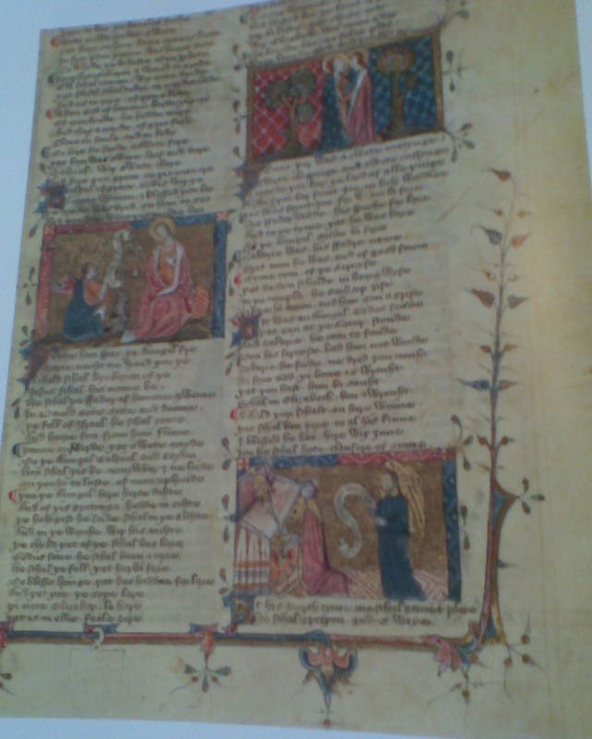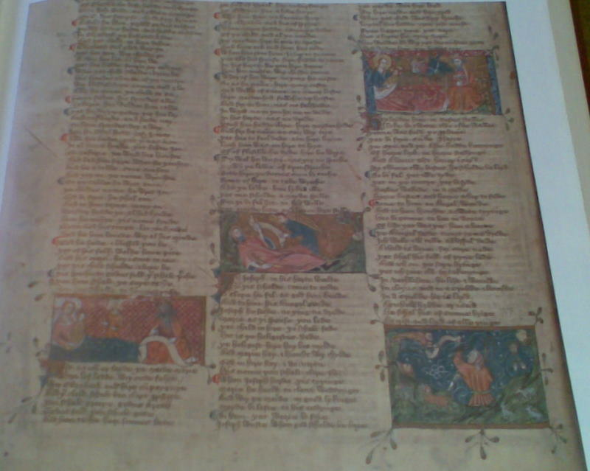
Fig. 3.1 The Vernon Manuscript, fol. 105r Fig. 3.2 The Vernon Manuscript, fol. 105v
Illuminated Gospel Narrative Illuminated Gospel Narrative

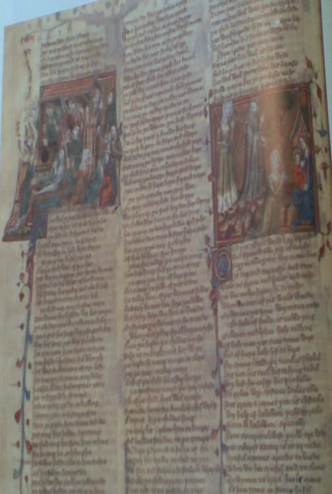
Fig. 3.3 The Vernon Manuscript, fol. 124v
Miracles of Our Lady

Whereas the vernacular response to Psalm 51 in the early section of part 2 follows the theme of the biblical text, the prayers to Mary in the two Vernon Psalters of the Blessed Mary, all of which begin with the invocation ‘Ave’, include only occasional reference to the Psalms, and not necessarily to the corresponding Psalm rubric. This curiosity suggests that the Aves, already encouraged by the Church as forms of prayer to be recited along with the Pater Noster for those who could not follow the Psalms in Latin, were placed alongside the Psalm rubrics in order to give them liturgical status. The pattern of interspersing Latin and English, and liturgical with non-liturgical prayers, is repeated on several occasions in part 2 of the Vernon Manuscript, and serves to emphasise the point that this large religious anthology was meant to be accessible to people with varying degrees of Latin and/or English reading abilities.
These additions were probably intended to accompany the liturgy. The Latin version of the prayers to Mary is placed before the English renditions, and they, along with the other vernacular prayers of the section and the lyrical translation of the Gospel narrative, may have been recited during private reiterations of the Office at home, or during public recital at church. A typical church service corresponding with the canonical hours would have included a Gospel reading (on which La Estorie del Evangelie is based), recitations of some of the Psalms, and prayers to Mary and Jesus - all in Latin and recited by the clergy. Furthermore, some of the other prayers in this section of Vernon, such as the Levation and confession prayers, were obviously written for recitation by the laity during the Latin Mass. By the end of the fourteenth century, several horae compiled for an English audience included vernacular Mass Prayers with instructions for personal yet audible prayer by the laity. Given the size and weight of the Vernon Manuscript, it is highly probable that it was meant to be used in a communal setting such as a church or library; and given the nature of its contents, including didactic treatises translated into English, it was likely compiled for a mostly lay audience or for a community of nuns. Yet the consistent use of Latin rubrics, including Latin versions of the initial verses of the Psalms in part 2, indicates that the manuscript was also designated for a Latinate readership, including religious and secular clergy or nuns. The rubrics may also have been provided for those laypeople who had some textual familiarity with Latin and could use it as a cue for when to recite their prayers, in English or Latin, either as they were listening to the priest, or as they were privately saying their devotions, at church or at home.
The inclusion of the Vulgate version of the Psalms alongside very loose personal paraphrases, and of emotive vernacular Levation prayers to be read alongside the Mass, indicates that the Vernon Manuscript was written for an audience with varying degrees of literacy in both Latin and the vernacular languages, and that there were no clear boundaries between what constituted private, public and corporate prayer. In the light of the contents of part 2 of the Vernon Manuscript, which resemble a book of hours, the boundaries that used to exist between what was considered a private prayer book and a public religious anthology must also be challenged. Moreover, that a section containing some contents typical of books of hours was placed within a large and impressive religious anthology, complete with English translations of didactic treatises such as The Prick of Love, The Pricke of Conscience and two English verse versions of St Edmund’s Speculum Ecclesiae (all included in part 3), indicates that it was deemed to have devotional merit, and that it was considered an important means of doctrinal instruction by its commissioners and/or compilers.

3.4.ii An Analysis of the Vernon Hours of the Cross
The Vernon version of the Hours of the Cross helps us to see some of the ways in which this hymn enhanced doctrinal understanding of the Passion events and how it may have been used in private and public devotions. The Hours of the Cross occupies part of folios 116r-v (see figs 3.4 and 3.5). The whole of part 2 is laid out on the page in three columns, with a one-line space marking the transition from one prayer to the next. The Hours of the Cross are no exception, following on with a one-line break from a prayer of confession for neglecting the Ten Commandments. Initials of two lines in depth mark the beginning of each stanza of the Latin hymn, and each of these initials includes three protruding leaves. The English hours are likewise marked with enlarged two-line initials. Such markers are typical for the prayers in part 2; the Hours of the Cross are not privileged over any of the other prayers in terms of illumination, except insofar as each stanza is specially highlighted. There is no line space between each stanza, and so the Hours of the Cross constitute one continuous prayer, as in the Pavement Hours. Like the Pavement text, the Vernon translation is unique to the manuscript. It is also unusual in that each English verse of the hymn is preceded by the corresponding verse of the original Latin hymn. This occurrence provides further evidence that the anthology was compiled for a partially Latinate as well as a vernacular-literate audience.
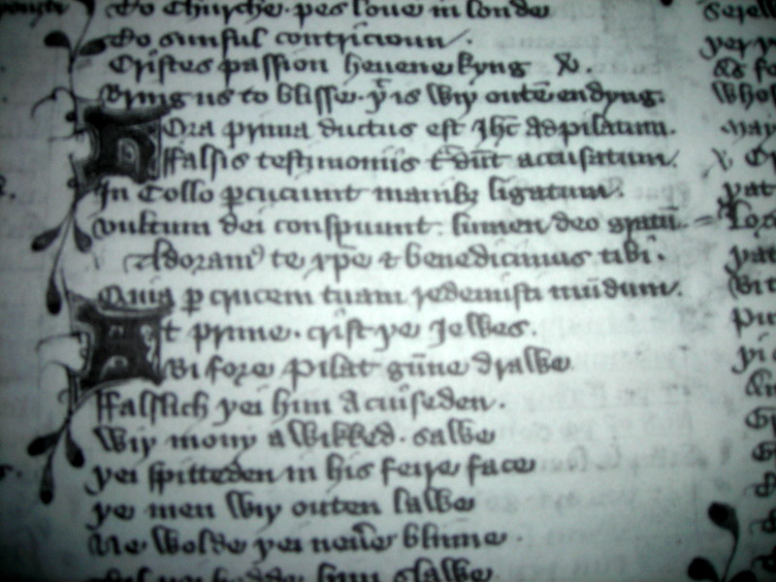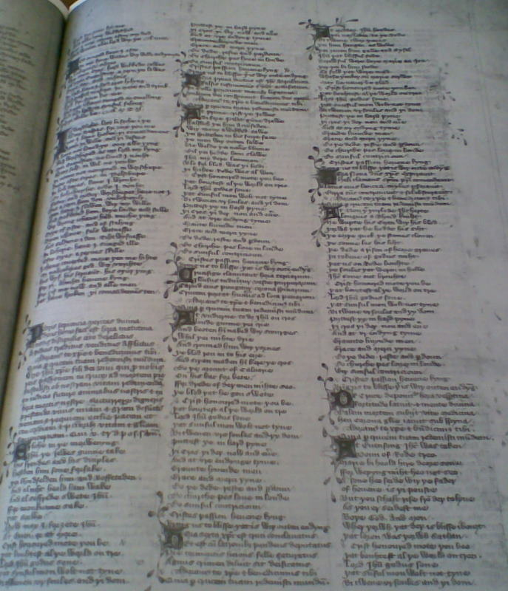
Figure 3.4 The Vernon Manuscript, fol. 116r Figure 3.5 The Vernon Manuscript, fol. 116r
‘Hora Prima’ / ‘At Prime...’ The Hours of the Cross (full page view)

Although many of the vernacular prayers and Psalms of this section can also be found within private prayer books, making Vernon appear very similar to a book of hours, Vernon does not contain the remainder of the Hours of the Virgin. (The two versions of the Psalter of the Blessed Mary contain some prayers in common with the Hours of the Virgin, but they follow the order of the biblical Psalter rather than the Divine Office corresponding with the seven liturgical hours.) It could be said that the first Vernon Psalter, with 148 initial verses of the Psalms and the same number of prayers to Mary, is more comprehensive than the Hours of the Virgin, which selects a few Psalms and prayers to Mary for recital during each of the seven canonical hours. With the inclusion of both the Latin and English versions of the Ave, Vernon’s paraliturgical Psalter would have appealed to both a lay and priestly audience, whereas the omitted Hours of the Virgin were designed mostly for a lay audience. That the compilers of the manuscript should have inserted a continuous version of the Hours of the Cross, and before the two Psalters, is an indication that they privileged these prayers over the rest of the Hours of the Virgin (which were omitted). Moreover, that they should be in both English and Latin highlights their prominence as paraliturgical prayers to be recited in either or both languages by a cross-section of religious and laypeople.
The Vernon Hours of the Cross, beginning ‘Patris Sapiencia’, constitutes one continuous prayer, unique to the manuscript (see appendix 3.2).. It is placed in a section along with affective verse prayers and lyrics dedicated to the wounds and sweetness of Jesus in the Jhesu Dulcis Memoria tradition. Vernon’s adaptation of the hymn to the cross suggests that throughout the Passion events are vividly portrayed, including phrases not found in the Latin source. The stanza corresponding with Matins is a fairly literal translation of the Latin verse, except for an added expression of affective piety in the last line: “And al soffrede swete Ihesu” (line 4). Other additions include “þei spitteden in his feire face” (at Prime, line 12), “blod ron in to his ei3e” (at Tierce, line 21), and “He wupte his ei3en wiþ is blod: þorwh þat he hedde his siht” (at None, line 38). None also includes a specific reference to “Longi[n]us, a Blynd kniht” (at None, line 37), as well as a reference to the sorrowing Mary and John at the foot of the Cross - “serewful were boþe Marie and Ion: þere þei bi him stod” (at Sext, line 31). One relatively extensive addition is a prophesy by Mary as she beholds her dead son, at Evensong:
At Euensong Ihesus was taken: Doun of Rode-treo.
Marie bi-heold hire deore sone: ffor wepyng miht heo not seo;
“A, Sone,” heo seide, “wiþ þe fader: of heuene is þi pouste,
But þou schalt rise from deþ to lyue: As þou er seidest me. (lines 46-9)

It is common in religious love lyrics for Mary or Christ to give an appeal or lament from the cross. This has the effect of leading the reader to the Crucifixion scene, thereby creating a sense of immediacy that reduces the temporal distance between the reader and the historical narrative event. The appeal is unexpected in a transliteration of the paraliturgical Latin hymn. Yet Vernon’s adaptation, combined with courtly references to Jesus as “swete” (Matins) and “feire” (Prime) and to both Longinus (at None) and the guards (at Compline) as “knihtes”, demonstrates the influence of Dulcis Memoria and courtly-love lyrics upon the writer, creating a prayer within the meditative literary tradition. As a literary artefact, the hymn to the cross is meant to accompany the affective verse prayers and lyrics dedicated to the wounds and sweetness of Jesus in part 2 of the Vernon Manuscript.

3.4.iii The Vernon Hours of the Cross Refrain
In the last chapter we observed that the versicle plus response refrain of the Latin Hymn to the Cross (Patris Sapiencia) was translated into English in the fourteen English primers. This type of refrain, as used repeatedly during the liturgy, also finds its way into the English Hours of the Cross in horae such as the Pavement Hours and religious anthologies such as the Vernon Manuscript (see appendix 3.2). Unlike the primers, which are consistent in their translations of the Hours of the Cross refrain, the miscellaneous manuscripts give freer renditions of the versicle and response, while retaining both the original meaning and the rhymed couplets. For example, the Vernon Manuscript reads “Crist, honoured mote þu be, / þat bou3test al þe world on tre” (with The Pavement Hours phrasing it slightly differently: “We wyrchyppe þe cryste iesu, gode son, / For wit þi holy cros þis world haues þu won”). The meaning of the Latin word redimisti is maintained in the English translations ‘a3enbou3t’, ‘bou3test’ and ‘won’, reiterating the importance of the atonement.
As well as providing a translation of the Latin refrain, some horae and miscellanies include an extra response in couplets or in three-line parallelisms, perhaps indicating their shared usage with sermon refrains (for Vernon’s additional 3-line refrains, see appendix 3.2). Often preachers summed up key points in short verse form consisting of parallelisms in three lines with end rhyme. This was a mnemonic device used to illustrate groups of three important themes that the preacher wished his congregation to remember. The Vernon Manuscript includes an extra response at the end of each hour in the form of a three-line parallelism with an aba rhyming scheme. The lyricist focuses both on the narrative events of each hour of the Passion and on its significance, and in some instances the refrain is personalised with the use of the first person singular as, for instance, “Jhesu, mi dere lemmon, / Blo for-bled was þi bodi: / Þi briht Rode was al won” (lines 14-16), in response to Christ’s scourging at Prime. The language is associated with the love-language of the Rollean lyrics and the emotive lyrical prose treatise A Talkyng of the Love of God, which is included in part 4 of the manuscript, as well as with “The Sweetness of Jesus” lyric in part 2. The latter lyric is separated from the Hymn to the Cross only by an English and Latin rendering of the liturgical prayer Veni Creator Spiritus. In this context for the Hours of the Cross, the Vernon Manuscript suggests that the prayer could be utilised in conjunction with other devotional prayers and doctrinal treatises.

3.4.iv The Vernon Prayer on the Passion
The Vernon Manuscript includes a prayer on the Passion of Christ as part of the hymn to the cross (see appendix 3.2). This English adaptation of the Latin prayer is present in both English primers and bilingual horae as part of the Hours of the Virgin, indicating that there is shared source material for the two types of manuscript. While focusing on Christ’s Passion, the penitent asks that he or she, along with all Christians, may receive mercy and grace. The sentiments are personal, but devoid of excessive emotion. The prayer was probably memorised, especially since only the first line is given as a cue in some of the English primers. It is sometimes placed either before, alongside, or after the translations to the Hours of the Cross. Looser English adaptations of the Latin prayer also occur as parts of vernacular lyrics or as very free adaptations of the Hours of the Cross in miscellaneous manuscripts. Both the Vernon Manuscript and the bilingual primer Hunter 512 contain a Latin and English version of the prayer. In Vernon, the Latin version is recited after the Matins section of the Latin hymn. It is then translated into English and repeated after the English versicle and response refrain at the end of each section of the Hours (see appendix 3.2).
The choice of words in this English version of the prayer is often interestingly different from the uniform primer versions (chapter 2, above, and appendix 2.3iii), even though the meaning is similar. The Vernon scribe also includes a more obviously penitential phrase in the second and fourth lines: “þat synful mon wolt not tyne... Puttest þe in hard pyne”. The phrase is not present in either the Latin original or the primer versions. That the syntax differs while maintaining the overall meaning suggests that the prayer was well-known, yet perhaps adapted into English according to individual tastes. The Vernon scribe may have chosen this version because of its emphasis on the salvific value of Christ’s sufferings, which accord with the other vernacular prayers of part 2, or he may have resorted to a version he had learned from memory.
Given that both primers and horae contain English versions of the Hours of the Cross and prayers on the Passion, it would appear that these prayers were well-known to scribes and owners. However, since the primer translations are uniform whereas each of the horae is unique, it may be safe to assume that there was a scribal network for the
primers, as shown in chapter 2.4, but that the individual scribes and compilers of horae and miscellanies adapted well-known prayers for their manuscripts, perhaps committing them to memory and recording them as they remembered them. Alternatively, they may have chosen to give a more personal rendition of the prayer, perhaps with the aim of encouraging the devotee to pause and ponder anew the theological significance of the prayer, rather than reciting it by rote.

3.4.v The Vernon Indulgence Prayer
The Vernon Manuscript places the Hours of the Cross in the context of a large anthology for probable public use, yet enables them to be used as a private indulgence prayer. Uniquely, they are accompanied by an indulgence prayer claiming to have been authorised by Pope John XXII (1316-34) (table 3.2). That this is the only indulgence present in the 355-leaf Vernon anthology underpins the importance of the Hours of the Cross as a set prayer forming part of the Daily Office. Because the Hours of the Cross are separated from the rest of the Hours of the Virgin, the recital of a stanza, or even of the entire hymn, at the seven canonical hours may have sufficed as part of the seven recommended indulgence prayers to ensure some remission from Purgatory.

Table 3.2 The Vernon Indulgence Prayer, fol. 116v
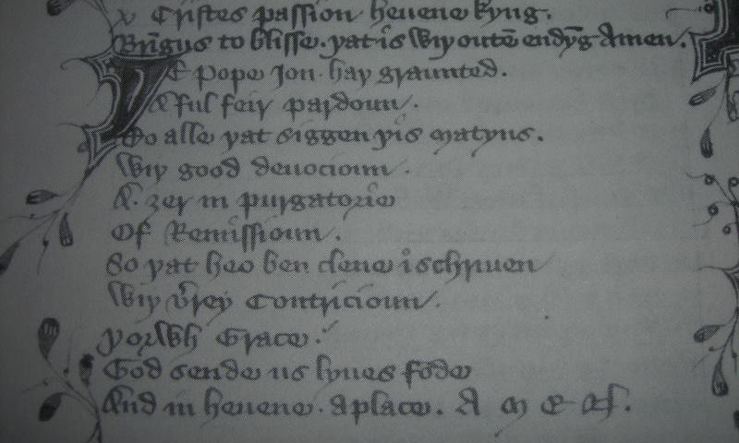 | þe Pope Ion haþ graunted a ful feir pardoun  To alle þat siggen þis Matyns wiþ good deuocion:  A 3er in purgatorie of Remissioun,  So þat heo ben clene i-schriuen,  Wiþ verrey Contricioun, Þorwh Grace.  God sende us lyues fode. And in heuene a place. AMEN.

Some indulgence prayers are placed close to an image within their manuscripts, and they may include a command to ‘behold’ or look. In Vernon, however, the devotee is instructed to “siggen” (say) recite this form of the hymn during Matins, and there is no indication of the need for an image as part of the indulgence. Yet, the command to speak is linked with other mnemonic processes such as looking and reflecting, and it implies that the penitent will gaze at an image of the Crucifixion, whether in a book or a church, or even from memory. The Vernon devotees may have been encouraged to use the only extant image of the Crucifixion in Vernon (fig. 3.6) as a visual aid in their recitals of the Hours of the Cross.
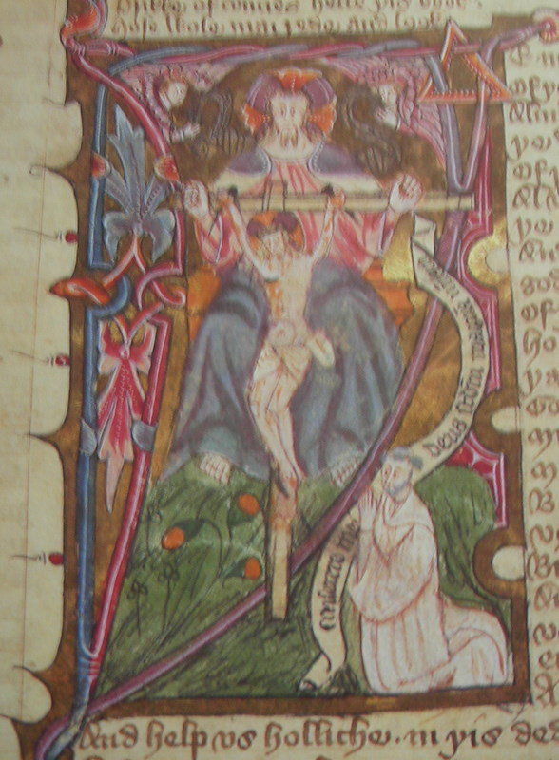
Fig. 3.6 The Vernon Manuscript, fol. 265r
God the Father with Christ on the Cross

3.5 Passion Lyrics
3.5.i Cantione Amorie Passion Lyrics
Some of the manuscripts containing versions of the Hours of the Cross also include vernacular lyrics on the five wounds, and the name, or ‘sweetness’, or ‘pity’ of Jesus. These lyrics constitute emotive responses to the Passion narrative and, while they have their basis in the Gospel accounts of the Crucifixion, in many cases they bear only a faint resemblance to the Latin hymn to the cross, Patris Sapiencia. However, since the lyrics are often placed in manuscripts alongside paraliturgical devotions to the Cross, they are illustrative of ways in which the laity made sense of the liturgy and even devised their own prayers in their responses to the Cross. We will turn to some of these lyrics in the Vernon Manuscript and in two manuscripts in which the same network of lyrics appear: Bodl., MS Douce 322 and GUL, MS Hunter 512. (For a table of manuscripts in which similar lyrics appear, see appendix 3.4)
A ubiquitous and profoundly emotive Middle English lyric devoted to the sweetness of Jesus is entitled Cantione Amorie, or The Sweetness of Jesus (“Jhesu thy swetnesse, who myght hit se”, see appendix 3.3.1). Something of its significance for the original readers is revealed by the fact that there are nineteen extant versions, one of which is in part 2 of Vernon and another in the late fifteenth-century devotional miscellany, Bodl., MS Douce 322. The lyric is reminiscent of the thirteenth-century Ancrene Wisse and Wooing Group devotions addressed to women and referring to Jesus as “my swete”, which were later transmitted through fourteenth-century writers such as Richard Rolle and the anonymous Talking of the Love of God writer (extant only in Vernon). In Douce 322, “Jhesu thy swetnesse” is transcribed on folio 8, two leaves before some chapters from a Rollean treatise entitled “How a man should live in contemplation, in meditation, and in other virtuous living” (folio 10r). In Vernon, the lyric appears on folio 116v, separated from the vernacular Hours of the Cross (folios 116r-v) only by a bilingual (English and Latin) version of the hymn Veni Creator Spiritus.
“Jhesu thy swetnesse” is written in quatrains with an abab rhyme scheme, with some interlocking stanzas where a phrase from the last line of one stanza is reiterated in the following. The composer makes use of alliteration and repetition of key words associated with both courtly love and spiritual love based on the Song of Songs, such as “longyng”, “lyking” and “loue”. The love of Jesus as “kyng of loue” (line 12) is set against “erthely loue” which is bitter (line 3). Jesus is also referred to in human relational terms as father, brother and sister (lines 23, 33, 37) and as a nourishing mother (lines 25-32). Vernon gives an additional reference to Jesus as spouse, associated with the Song of Songs wherein Christ is identified with the bridegroom (line 43). The lyric also contains a theme shared with the Ancrene Wisse and with bridegroom imagery based on the Song of Songs of a king who left his heavenly kingdom in order to pursue his wayward bride (lines 49-56).
The central section of “Jhesu thy swetnesse” consists of three stanzas, lines 65-88, which provide an extended description of Christ’s suffering on the cross combined with a consideration of the atonement. Recourse is given to two theories of atonement prevalent in the late fourteenth century: Anselm’s Satisfaction theory, wherein Jesus willingly gives up his life in order to repay the debt owed him by humanity (lines 70, 76-8), and the ‘Devil’s Right’s’ theory in which Jesus heroically does battle against the powers of darkness in order to pay a ransom for the souls of humanity (lines 69 and 82).
Christ’s suffering is described in terms of a knightly battle, and it elicits a response of pity on the part of the poet-penitent (line 73). The motifs are common in such lyrics devoted to the Passion, and in this poem the response of the penitent is interwoven with her recollection of the Crucifixion as a jousting scene, with the piercing of Christ’s heart by a spear (line 67), and with the triumphant display of his banner after his paradoxically victorious death (lines 81-4). The banner is reminiscent not only of the chivalrous displays of knights during battle, but also of the arma Christi wherein the instruments of torture used during the Crucifixion are displayed within a shield, both to commemorate Christ’s Passion and as an indulgence prayer. In this lyric on the sweetness of Jesus, textual and visual elements work together in the imaginative recapturing of the Crucifixion, and in the emotive response of the penitent to her “trewelove…for his trauayle” (line 88).
In the lyric, the penitent’s response to Christ’s sacrificial love is deeply moving, and it captures the other major theme of sweetness lyrics, that of pity:
Hys dolful dethe shuld do me dere.
And perse myn herte for pure pyte.
For pyte myn hert shuld breke in two. (lines 71-3)
In Middle English, the term ‘pyte’ is a conflation of pity and piety. The MED states that its most usual meaning is “a disposition towards mercy, compassion, kindness, charity and tenderness”. The second and third meanings are closely related and include “a feeling of pity aroused by the suffering, distress, grief, etc., of another; sympathy, commiseration”. The fourth meaning in the MED applies to the concept of piety, and is defined as “godliness, reverent and devout obedience to God, righteousness; devotion (to duty); piety”. The last MED category links the term with visual expression, defining ‘pyte’ as a representation or image in a painting, or a sculpture of the Pietà. In the lyric “Jhesu thy swetnesse”, all the MED definitions are combined: the worshipping penitent is aroused by her mental image of Christ’s suffering and responds in the mode of affective piety or “extravagant expression of emotion”. As she envisages his ordeal, it awakens feelings of love and pity, or compassion, in response to Christ’s initial love and compassion for her. The penitent moves, however, from a position of passive identification with Christ’s suffering to one of active participation; her imaginative recollection of the Passion has the effect of rupturing her heart, just as his was pierced while on the cross. The mode of affective piety by definition demands a response of ‘pyte’ on the part of the devotee. As an expression of worship, ‘pyte’ and affective piety are never far removed; one follows as the result of the other. The lyric, then, contains all the necessary elements of a prayer in the affective piety mode; reminders of the paradoxical sweetness and suffering of Jesus arouse feelings of pity or compassion on the part of the initial penitent and of later devotees, quickening their love and leading them on to renewed passion for God.
The lyric “Jhesu thy swetnesse” is both formulaic and particularised. It effectively combines many elements of Passion lyrics to create an individual artefact. It ends conventionally with a version of the prayer on the Passion that we have already frequently encountered in the paraliturgical Hours of the Cross (lines 113-20). That the poem should end with a formulaic stanza indicates that it may have been recited as an indulgence prayer, complementing paraliturgical devotions to the cross.

The mid-late fourteenth-century manuscript, Bodl., MS Add. 44949, or the Tyrwardreath Psalter (c. 1360), contains an Anglo-Norman lyrical Passion prayer, beginning “Marie mere, douce ihu crist” (for text and translation, see appendix 3.3.2). This lyric, placed in a manuscript close in dating to Vernon, illustrates the crossover of lay devotion in the two vernacular languages of England at the time. The lyric is addressed in alternate 8-line stanzas to Mary and Jesus. It is inserted in folios 7r-10v, immediately following seven pairs of miniatures corresponding with the Hours of the Cross, with Latin prayers below and an introductory indulgence rubric in Anglo-Norman above (folios 3r-6v). The lyric is followed by eight private prayers for the Mass in Anglo-Norman (folios 10v-16r).
“Marie mere” combines the attributes of both Jesus and Mary with penance before the cross. The female speaker of the lyric adopts conventional terms for herself as a sinner; she is a “traitre trouant, chaitive retru” (line 13) – a wretch, or catiff, who does not deserve God’s grace and mercy but nonetheless asks for them: “Trop fausement vous ai servi / Pur mon desert jeo sui perdu / Si en ta grace ne trove merci” (lines 14-16). Throughout the poem there is an echoing of titles and attributes for Jesus and Mary. The speaker first addresses Mary, the mother of sweet Jesus, as “Marie mere, douce ihu crist” (line 1), while the second stanza begins with a plea to “oiez seigneur, tres douce Jesu / Et pité preignez” (lines 9-10). This petition is echoed in the penultimate stanza, producing a measure of symmetry: “Seignour vailant / Pité pregnez de ta semblaunce” (lines 117-8). In the opening line of the third stanza, Mary is addressed as “pucele plesaunte, sovereigne refu” (line 17), and Jesus is later referred to as “seignour severeyn” (line 50). The virtues of pity, grace and mercy are attributed to both Jesus and Mary. Stanzas concerning Mary begin with phrases highlighting her virtues of mercy and grace: “Mere de merci” (line 57), “noble dame de grace garnye” (line 73) and “Pleyne de grace virge pure” (line 105). Christ’s pity is linked with his mercy, as he forgives the repentant sinner: “Merci seignour, jeo me repent / De mon pecche jeo voil lesser” (lines 85-6). The word ‘pité’ is further utilized in the linking of one of the stanzas addressed to Mary with the next, addressed to Jesus, with the phrase ‘par pité’ repeated twice:
Et tut n’eie jeo dame grace merci
Par pité deignez faire l’accord.
…
Par pité grace mon quoer attent
Et par pité merci trover (lines 79-82).

The lyric also addresses courtly themes. Jesus is described as being owed great honour in line 41: “A vous seignur grant honour doi”, and the penitent asks Mary to appeal to help her serve God with honour (lines 105-108). Christ is the valiant gentleman, or “seignour vailant” (line 117). Mary is also described as a noble woman, “Pucele plesaunte sovreigne refu” (line 9), unto whom the penitent pays service, “de vostre servaunt” (line 10). She is both the “Noble dame de grace garnye” (line 73), and “de haut empire” (line 33).
The themes of mercy and grace, recurring throughout the lyric, also frame a short penitential meditation on the cross (lines 25-32). In the process of praying, the cross may be mnemonically present to the devotee or it may be visually present in the form of a painted crucifix in a private home or in a church. Later in the prayer, the penitent asks Mary to “Eider moi / Metez la crois vers ma partie” (lines 76-77). Again, the cross could be brought to mind through the process of meditation and/or the penitent could be holding or viewing a crucifix while praying.
In the last few lines of the lyric, Mary is regarded as the one who applies medicine to the penitent’s grievances (lines 121-2). Through her prayers to her Son, the forgiven penitent can live in peace, without pain or burdens (lines 124-8). The words are, again, similar in both tone and diction to the formulaic English prayer on the Passion, beginning “Lorde Ihesu crist, sette thi passion and thi deth…” attached to the end of the Hours of the Cross. They serve to show the prevalence of prayers in both English and Anglo-Norman made to help safeguard the penitent’s passing from death to everlasting life. In the two lyrics hitherto examined, the sweetness of Jesus is not divorced from the bitterness and pain of the cross, nor from the guilt of the penitent; the themes of sweetness as both a medicinal and a moral balm for the sinner are thus combined.

3.5.ii Ihesu Dulcis Memoria Passion Lyrics
So far, we have examined two Passion lyrics that could be considered part of the ‘Sweetness of Jesus’, or ‘Cantione Amorie’ tradition. Another closely related group of lyrics is the ‘Ihesu Dulcis Memoria’ recension, so termed because of their intense meditation on the sweetness of Jesus, following the manner of Bernard of Clairvaux’s expression of love in his commentaries on the Song of Songs (see appendix 3.4). Three inter-related Middle English lyrics derived from Bernardine hymns on the love of Jesus form part of this group, the longest of which is attributed to Rolle. There are eight extant versions of the Rollean lyric, one of which is placed in part 3 of the Vernon Manuscript, under the title “Swet Ihesu, now wol I synge”. A shorter version, consisting of an intensely meditative prayer on the sweetness of Jesus, beginning “Ihesu, swete is þe loue of þee” is contained in the bilingual primer, GUL, MS Hunter 512 (examined in chapter 2), on folios 33r-35r (see appendix 3.3.3). It is placed immediately before the Latin and English Hours of the Virgin, and is the only English lyric in this manuscript, perhaps indicating its importance as a private devotional prayer for its original fifteenth-century owners. The theme of the sweetness, suffering and love of Jesus is repeated so often that it resonates with Latin litanies on the Name of Jesus present in many books of hours, such as the Anselmian prayer beginning ‘O bone Ihesu’ (lines 1-12). Although there is no direct reference to contrition, the penitent alludes to redemptive theology in her vivid descriptions of Christ’s ordeal on the cross. The verbal repetition is strongly and carefully supported by the manuscript’s use of standard devices in the visual placement of the poem on the page as a pattern. In this context, the words become vigorous and performative as they are verbally repeated by the devotee (see figs. 3.7 and 3.8).

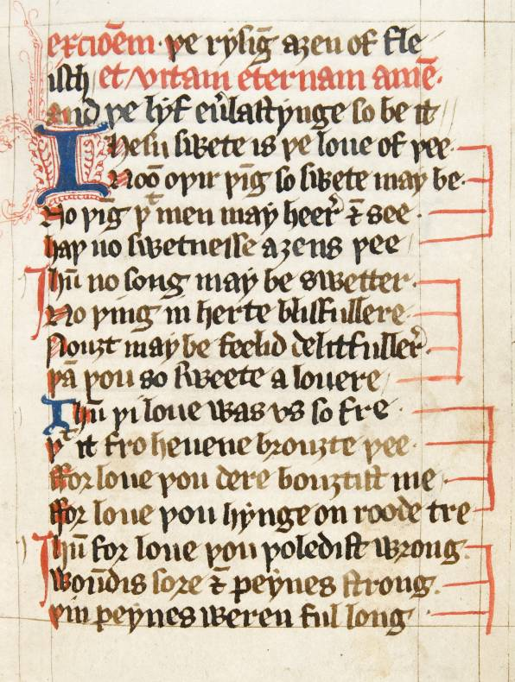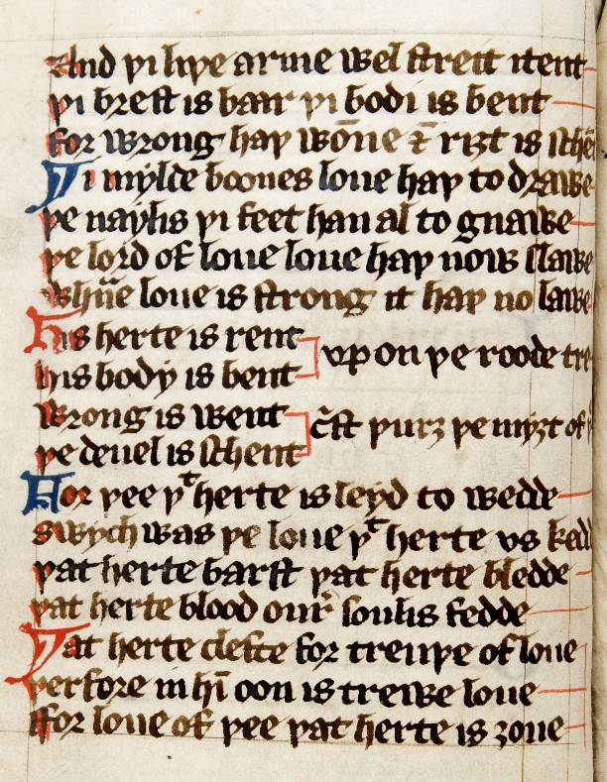
Fig. 3.7 GUL, MS Hunter 512, fol.33r Fig. 3.8 GUL, MS Hunter 512, fol.34v
Extracts from “Ihesu, swete is þe loue of þee”

This prayer is typical of many of the vernacular personal prayers present within primers and books of hours in the late fourteenth and fifteenth centuries, and there is much overlapping of the themes associated with Ihesu Dulcis Memoria and Cantione Amorie Passion lyrics. Its initial mention of the sweetness of Jesus further links it with Anselm’s sensuous descriptions in relation to the lectio divina. Another lyric that could be considered part of the Ihesu Dulcis Memoria recension is placed in part 2 of Vernon, on folio 114v, immediately after the lyric beginning “Swete Ihesu crist, to þe”, and is the first of two stanzas entitled “A Preyer to þe Fiue woundes”. As well as focusing on the Passion, it repeatedly uses the term ‘lemmon’ or ‘lover’ for Jesus. The last stanza, which is a compression of the themes hitherto looked at in this chapter, reads thus:
Ihesu crist, my lemmon swete,
Þat dy3edest on þe Rode-tre,
Wiþ al my miht I þe bi-seche
Ffor þyne woundes two and þre,
Þat as depe into myn herte
Mot þi loue i-stiked be
As was þe spere in to þin herte,
Whon þou soffredest deþe for me. (lines 249-256)

So far, we have explored some Passion lyrics related to the sweetness of Jesus, with sensual and moral meanings, and as a healing and saving property. These lyrics may be considered quite different in style, tone and genre from moral and penitential refrain lyrics based on sermons. However, both types form part of the genre of meditative prayers, and are common to manuscripts such as Bodl., MS Douce 322 and the Vernon Manuscript. We will now turn to some penitential prayers to illustrate some of the ways in which they complement the more affective prayers on the sweetness of Jesus as vehicles for meditative prayer. We will begin with a brief example of how adaptations of the Hours of the Cross were used for didactic purposes.

3.6 Penitential Lyrics
3.6. i Penitence and the Hours of the Cross
In recounting the Passion narrative, from the trial of Christ before Pilate through to his Crucifixion and burial, the hymn to the cross is very versatile and forms the basis of other penitential devotions associated with the Good Friday events. For example, one such loose adaptation of the hymn to the cross can be found in Passus XVIII of the B-Text of Piers Plowman. In this well-known passage, Langland recalls the Passion events as recorded in the Gospels. Although he gives an individual account of the Crucifixion based on the biblical narrative, he employs phrases reminiscent of English translations of the hymn. Langland’s words “the lord of lif and of light” and “derk bicam the sonne” can be compared with a typical primer description of Christ’s death as “þe medicyne of lyf & lisse” (life and peace/joy/delight) and “þe sune wiþdrow his li3t”. In both texts, the words for life (‘lif’/’lyf’) and light (‘light’/’li3t’) are employed. Compare the Piers Plowman version with the English primer, Bodl., MS Rawlinson C. 699:

Pitousliche and pale as a prison that deith;
The lord of lif and of light tho leide hise eighen togideres.
The day for drede withdrough and derk bicam the sonne.
The wall waggede and cleef, and al the world quaved.
(Piers Plowman, Passus XVIII, lines 58-61)

At noon deide oure lord ihesu þat was of my3tis moost.
He criede hely to his fadir and so he lefte his goost.
A spere into his side was þirlid of a kny3t
And þanne þe erþe quakide þe sune wiþdrow his li3t.

From cros crist was taku[n] doun at eue[n]song tyme we fynde.
Þe power of þe resurreccioun was hid in goddis mynde.
Þe medicyne of lyf & lisse took such a deeþ for ri3t
Alas þe crowne of glorie lai cast doun ri3t.
(Bodl., MS Rawl. C. 699, fols. 34v, 36v)

These vivid yet solemn depictions of the Crucifixion indicate the degree to which English renditions of the Gospel narrative had permeated through late medieval society and were given individual treatments, whether in devotional manuscripts such as primers and horae, or in didactic verse like Piers Plowman. We will now explore ways in which lyrics and sermons were used in conjunction with each other for both devotional and didactic purposes.

3.6.ii Penitential Lyrics and Sermons
The medieval sermon and lyric were two complementary vehicles for imparting doctrine and exhorting the hearer towards meditation. There was much borrowing between the two genres since they both helped direct the listeners’ hearts and wills as part of the integrative meditation process. Preachers often appealed to their congregations’ emotions by inserting refrains from well-known lyrics into their sermons. Similarly, lyric poets often borrowed some sermon devices in order to direct their audience towards good works: “the medieval religious lyric owed a very great debt to the creative impulse and delight which preachers took in using verses in their sermons”. One example of such cross-fertilisation can be seen in the Song of Songs 2:5 and 5:2 refrain - ‘quia amore langueo’ (‘because I languish in love’). At least two extant sermons are based on this passage, and two late medieval lyrics use the refrain at the end of each stanza. One of the lyrics is Christological and begins with the line “In a Valey of þis Restles Mynde” (two extant versions), and the other is Marian, beginning “In a tabernacle of a tour” (six extant versions, incl. Douce 322). Both the lyrics integrate meditative and devotional reflections with moral exhortations. While for the most part deeply meditative, ‘In a Valey’ becomes quite explicitly didactic and almost sermon-like in the last two stanzas, where the listener is warned that her love will be tested with adversity – “I wole preve thi love with adversité” (line 119).
Sermons and lyrics functioned well together in combining didactic and affective material. If the highest goal of meditation was the integration of heart and mind, then the exhortation to both reflection and action was necessary for the soul’s good health, or ‘sowlehele’ (spiritual wellbeing).

3.6.iii Penitence and Prayers for the Dead
In this section we will investigate lyrics based on sermons or on parts of the liturgy other than the hymn to the cross. We will begin our exploration with a short poem based on the liturgical Office for the Dead, present in all horae. The Office for the Dead was a vital component of daily liturgical worship in that it provided a continual reminder of one’s mortality and the need to be prepared in the event of sudden death. Medieval Christians were well aware that in order to be assured of redemption they must have confessed their sins (‘schriven’), received communion (‘houseled’) and been granted absolution (‘aneheled’) from a priest immediately before dying. One of their greatest fears was to die suddenly without receiving the last rites, and so they would recite a prayer of confession each time they prayed in the hope that, in the absence of a priest, this would absolve them of their sins before God. Apart from the set prayers beginning “Lord Jhesu Crist, sette thi passion and thi deth”, often recited at the end of the Hours of the Cross, and individual prayers at the end of some Passion lyrics, there is another group of confessional prayers extant in twenty manuscripts and devoted to the Holy Name of Jesus. One of these prayers forms the only vernacular entry in an otherwise Latin book of hours, Oxford, New College, MS 310. It reads:
Jhu for thy holy name
And thy bitt[er] passion,
Save me from sin and shame
And endless dampnacio[u]n,
And bring me to the blis
That nev[er] schal mys, Amen.

Strictly speaking, this verse is not so much devoted to the Name of Jesus as to ensuring the avoidance of hell. That the vernacular verse is incorporated in a Latin manuscript may indicate the degree of seriousness with which it was treated. The original owners of the manuscript may not have had a comprehensive understanding of the Latin liturgy, but their ability to recite this confessional prayer with conviction lest they die suddenly and be deprived of the sacrament of the last rites by a priest was paramount to their assurance of a place in paradise. The inclusion of this type of prayer here, as in all the religious manuscripts examined, serves to illustrate the point that for the medieval Christian, penitence for sins committed and meditation on the cross were as closely related as the fear of hell with the love of God.
Three late medieval lyrical poems take their refrain from the first line of the main section of the Office for the Dead, “Parce michi, Domine”. These words form the opening phrase of the first lesson of the Dirige, from Job 7: 16-21. The Dirige combined Matins and Lauds and, as well as the set Psalms for the hours, it included nine lessons from Job, three for each of three nocturns. Two of the three lyrics with the “Parce michi, Domine” refrain are present in Douce 322, both with an initial illustration, and one in Bodl., MS Digby 102. The first Douce lyric is also known by the title “The Bird with Four Feathers” and it follows the Dirige only in its refrain. The second Douce lyric begins each stanza with a verse from Job before paraphrasing it and adding some commentary. The Digby lyric mostly paraphrases the English version of the Dirige, with a few additions from the poet.
“The Bird with Four Feathers” is not directly related to Job. It is more similar to a chanson d’aventure with a didactic intention, and therefore is more akin to the Vernon Refrain lyrics than liturgical prayers. The poem is illustrated with a picture of a man lying under a tree within a pastoral landscape, listening to a bird that bears a banner with the words ‘Parce michi’ (see fig 3.9). The choice of a pastoral setting over the public liturgical setting of the Office for the Dead, which is often accompanied in horae by an illustration of a coffin being prayed over by priests and mourners, emphasises the chanson d’aventure genre of the poem. Nevertheless, the poet chose a refrain that was a popular motif for sermons, thereby linking it with the Office for the Dead and also with reminders of the need for repentance, because death may overtake anyone at any time. That the poet chose a refrain familiar from the Bible and sermons, even though his text is not directly related to this context, again illustrates the cross-borrowing of refrains from sermons and lyrics. The poem is crafted like a sermon with four main points. Its overall message, resonating with many of the Vernon refrains, is that youth, beauty, strength and riches are transitory, whereas wisdom borne of God has lasting value. Job is passingly referred to in the lyric as an example of someone who, like the bird-narrator, had accumulated much wealth but lost it all (stanzas 17 and 18).
The second Douce lyric, sometimes known as “Pety Job” is a paraphrase of the biblical story of Job. It is falsely attributed to Rolle in the manuscript, but the mis-attribution is important in that it demonstrates that the scribe or compiler was keen to link the penitential poem with affective piety and mystical or meditative writings. Similarly, three of the five extant manuscripts preface the lyric with a prose dedication to Richard Hampole, and with a reminder to the reader that the lyric “ys full profitable to stere synners to compunccioun”. The implication is also that public attendance at services such as the Office for the Dead, as well as personal reflection on the vernacular lyric, can lead to compunction, or to a stirring of the soul towards the love of God, in the Anselmian / Rollean strain.
An illustrated initial ‘P’ accompanying the opening word ‘Parce’ and depicting the despondent Job lying in a dunghill and being visited by God reinforces the idea that the lyric was to be meditated upon with the aid of a visual image (see fig 3.10). The “Pety Job” illustrator may have consciously been echoing the images accompanying the liturgical Office for the Dead in horae such as the Pavement Hours (see fig. 3.11). An image bearing a personification of death also accompanies a lyric entitled ‘Death’s warning’ from Lydgate immediately after “Parce Michi, Domine”, on fol.19v (see fig 3.12). The inclusion of this other poem on the theme of death, replete with a miniature, demonstrates careful pairing of texts by the compiler; the theme of death is continued throughout the set of lyrics, and Lydgate’s lyric is in turn followed by a treatise on the seven deadly sins, thus reinforcing the need for meditation upon one’s sins and for repentance.
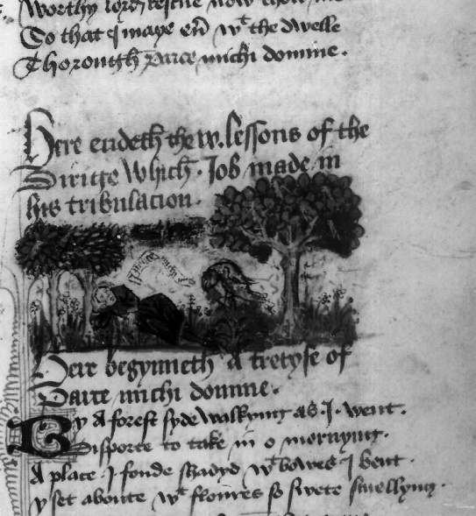
Fig. 3.9 Bodl., MS Douce 322, fol. 15r
Image for ‘The Bird with Four Feathers’

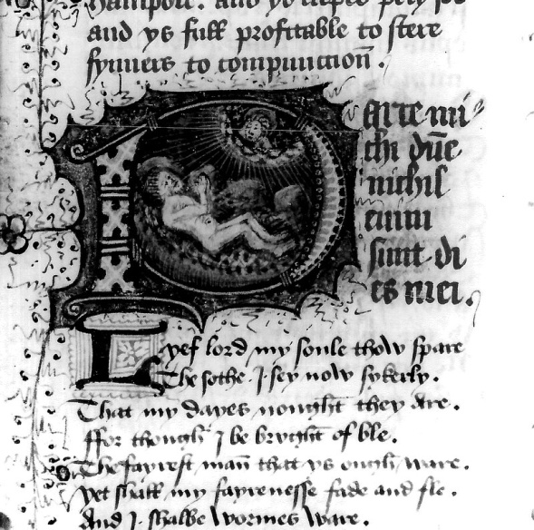
Fig. 3.10 Bodl., MS Douce 322, fol. 17r
Historiated ‘P’ for ‘Parce Michi, Domine’

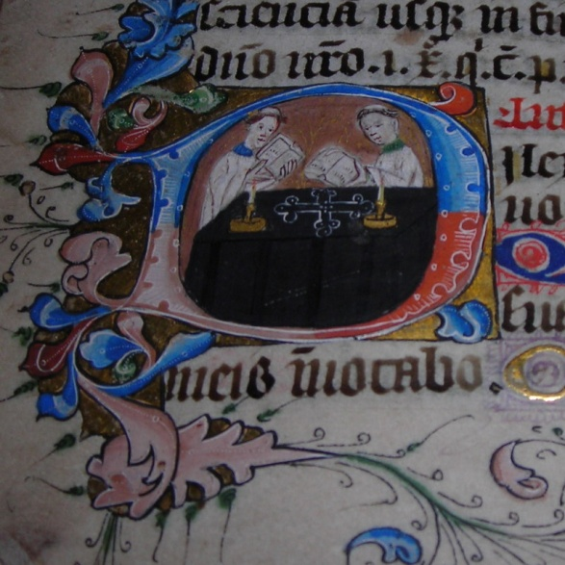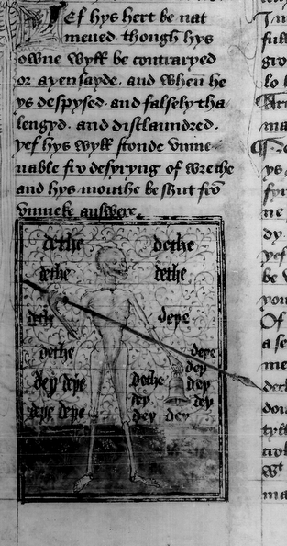
Fig. 3.11 The Pavement Hours, fol. 52v Fig. 3.12 Bodl., MS Douce 322, fol.19v
The Office for the Dead Image of ‘Death’s Warning’

“Pety Job” closely follows the nine sections of the Job narrative that correspond with the Dirige. It is evidently liturgical (drawing on the Office for the Dead) and penitential (following Job’s lament and eventual acceptance of his condition), yet it also consists of the personal lyrical outpourings of the man, Job, who has lost everything. This lyric, therefore, represents the juncture of two religious lyric genres: the moral/penitential and the personal, affective vernacular lyrics. It is placed in a section of the Douce manuscript immediately following three lyrics that form part of the Cantione Amorie cycle, including “Jhesu thi swetnesse” and a Marian lyric with the refrain ‘Quia Amore Langueo’ (and in this case given the title ‘Canticus Amoris’), and then “The Bird with Four Feathers”. This structure indicates a gradual progression through the deeply personal and emotive lyrics towards the more liturgical / penitential ones, with “Pety Job” bringing the various strands together. The lyrics may have been meant to be read as a unified whole, and together they constitute the different components of affective meditative prayer and listening. God’s word is heard and understood through sermons, treatises and lyrics, such as “The Bird with Four Feathers”, and the devotee enters into Christ’s sufferings through personal meditative prayer with the aid of images and lyrics. The sermons and lyrics in turn become a balm or cure for sickness and sin. This process combines Anselm’s emphasis on compunction with personal ejaculations, and yet it is also present in the corpus of moral refrain lyrics, such as “Pety Job”.
“Pety Job” is at once personal and penitential. Its tone is restrained and yet it is a heartfelt response to the speaker’s situation. The speaker moves, both within each stanza and through the poem as a whole, from a position of complaint through to contrition and finally to an acceptance of his condition and of God’s love (compunction). The lyric could therefore be considered Psalmodic in tone rather than sermonic, and the direction of the movement is upwards, from despair to hope. Each stanza begins with internal gazing on the speaker, Job, and ends (anachronistically) with a petition to God, Jesus or Mary. The Psalms, too, often begin with a note of bitterness, reproach or anger, but end with the acknowledgement and acceptance of one’s condition before God. In the Douce lyric, the speaker oscillates between speaking with the voice of Job and of the medieval penitent, with his interjectory pleas to Mary and Jesus. Each stanza begins with a Latin rubric corresponding with a verse in sequence from the appropriate lesson. The opening line of two is a direct paraphrase of the Latin verse, and then the speaker expounds its meaning and application. The speaker also includes such themes as the wounds and compassion, or ‘pyte’ of Christ (lines 262, 394, 526). For example, in stanza 4, he combines a confessional prayer with an appeal to the five wounds:
I have The gylt and grevyd sare,
For synne with me hathe ben to ryve;
But, Lord, now lere me with Thy lare
That dedly synne fro me may dryve.
And, Jhesu, for Thy woundes fyve,
As Thow becammest man for me,
When I shall passe oute of lyve,
Than Parce michi, Domine. (lines 41-8)

In a clever juxtaposition, the speaker’s sin is described as bitter in an allusion to the gall mixed with vinegar that Christ was offered on the cross: “My syn ys bytterer than eysell or gall, / And stynketh, Lorde, in syght of The” (lines 441-2). The poet also inserts a penitential prayer, itself associated with the Office of the Dead, in the eighth stanza:
“Now, good Jhesu, Kynge of Blysse,
Dampne me nat at Domesday!”
And, good Jhesu – to The I pray! –
Telle how thus Thow demest me.
Nowe yeve me mercy, and say nat nay,
Wyth Parce michi, Domine! (lines 91-6)

Some stanzas dwell on the themes typical of moral lyrics and sermons, such as the transience of life and the need to repent, as in stanza 29, corresponding with Job 14:5: “The days of man are short, and the number of his months is with Thee”. The theme of humanity’s sinfulness before God dominates the poem, as with the biblical text, and yet the medieval Christian’s hope of forgiveness of sins and a place in God’s kingdom wins through. In the biblical sequence, Job’s dialogue ends with a confident tone: “For I know that my Redeemer liveth; and on the last day I shall rise out of the earth. And I shall be clothed again with my skin, and in my flesh I shall see God. Whom I myself shall see, and my eyes shall behold, and not another” (Job 19:25-7). Yet, the compilers of the liturgy chose to place the lessons out of sequence, thereby ending the nocturnal hours with a description of the horrors of hell, presumably to compel or even frighten the congregation into examining their souls. The ninth lesson, Job 10:18-22, ends with the words, “A land of misery and darkness, where the shadow of death, and no order, but everlasting horror dwelleth”. Despite this note of despair, the speaker manages to sound a more hopeful tone, ending the poem with the words “Worthy Lord, rescue now Thow me, / So that I maye ever with The dwelle / Thorough Parce michi, Domine!” (lines 682-4). The Douce 322 poet’s ability to incorporate positive Christian themes such as the love, mercy and compassion of Jesus into an otherwise despondent text indicates that, despite the contemporary preoccupation with dying and fear of Judgement, it was possible to channel fear and temper it with hope.
As Helen Barr points out, the Digby lyric (no. 24) is similar to the English translation of the Office for the Dead in The Lay Folks’ Prayer Book. Like the Douce 322 version, each stanza in turn is a paraphrase of the corresponding passage from Job. Yet, while Digby is almost as long as Douce, with fifty-two stanzas to Douce’s fifty-seven, it makes very few additions to the biblical text, apart from some short phrases that help illuminate the scriptural passage and retain the voice of the biblical Job. For example, the beginning of stanza 16, lines 121-8, corresponds with Job 10:11-12 – “Thou hast clothed me with skin and flesh: Thou hast put me together with bones and sinews. Thou hast granted me life and mercy. And thy visitation hath preserved my spirit”. In the last four lines, the speaker-poet gives a short amplification of the biblical rendition and ends with a focus on his own sin:
From worldis worshipe Y am shoue,
And bro3t abas from al astat;
My skyn is cloþed al on roué,
In pouerte and peyne my wyt is mat.
Lord, chastice me wiþ 3rde of loue,
Þou3 Y haue seruyd þe swerd of hat.
Wherto nyltou þy maystry proue
With suchon as I to make debat? (lines 121-8)

In Digby, as in Douce, the Scriptures are vernacularised, personalised and absorbed by the poet, and so, again, the boundaries between vernacular and liturgical prayers are rendered permeable. The interpolations consist mainly of paraphrases of the liturgical responses during the relevant parts of the Nocturn, such as lines 94-6 and lines 161-7, as well as stanzas 42-8 (lines 331-386). Unlike the Douce lyric, there are no direct references or pleas to Christ or Mary. The overall effect of this much tighter paraphrasing is that the voice of the Job-persona is much more controlled and distant than that of the Douce lyric. The speaker is very much the Old Testament Job, rather than the medieval penitent. The main innovation to the Digby text is in the final stanzas, 49-52, which are a moral reflection on the need to be prepared for Judgement Day. As a lyric, the Digby poem belongs more properly with the moral refrains of Vernon. The poet’s craft lies in his ability to convert the biblical text into lyrical form and combine it with a miniature sermon.
Lyrical prayers based on the liturgy, and particularly on the theme of death, may initially seem to have very little in common with prayers based on the sweetness of Jesus. However, as has been demonstrated, common motifs can be present in both, and all the medieval penitential prayers are dedicated to enabling the devotee to meditate on the love and death of Christ. The Digby, Douce and Vernon prayers provide examples of penitential lyrics based on the Bible and the medieval liturgy that can also be adapted for private meditations on the cross. We will now turn our attention to the Vernon Refrain lyrics for a final exploration of how the Passion and penitential lyrics are linked and complement each other as part of an integrated approach to Christian meditation.

3.7 The Vernon Refrain Lyrics
The Vernon refrain lyrics comprise the last section of the Vernon Manuscript, appearing in a final quire of six leaves (for a more detailed comparison of motifs, language and themes, see appendix 3. 5). When considered as a whole, the refrain lyrics share many stylistic and thematic features. They all have stanzas of eight or twelve lines with an abab(abab)bcbc rhyme scheme, which is characteristic of the balade form introduced from France towards the end of the fourteenth century. Most of them, except for lyrics 4, 17 and 21, have a refrain in the last line of each stanza. In three cases, the refrain is in Latin (lyrics 2, 5 and 26), and in lyric 4 there is some inconsistent use of Latin inscriptions. However, in each case the Latin consists solely of a liturgical insertion, such as Deo Gracias (2, 5), Deus Caritas Est (4) and Mane Nobiscum Domine (26), and these insertions also form the titles of the lyrics. These sparse instances of Latin refrains contrasted with the large number of English ones may indicate that the poets were especially concerned with teaching the laity or with evoking their experience of the liturgy in an easily memorable rhythmic and rhyming form. Each poem deals either with the Christian virtues of love, grace, mercy, wisdom and charity and / or with the need for confession (“schrift”) and repentance (“schent”) within the context of the Church.
Judging by the didactic and moral content of many of the lyrics, it is clear that they were intended as a theological teaching tool by poets familiar with sermons and homilies. The first and longest lyric, Mercy Passes All Things, is itself a carefully crafted sermon framed by a chanson d’aventure narrative, with a pastoral setting. The speaker uses the occasion of a walk in the woods, where he observes the activity of birds of prey to reflect on the nature of God’s mercy. Within this narrative frame, he gives a moving account of Christ’s death and ends with a theological reflection on the actions of a falcon that has let its victim go free. The final stanza consists of a prayer, asking God to “Graunt vs repentaunce and respizt” (line 187). This lyric, like the other chanson d’aventure lyrics, ends with a prayer. These factors may suggest that the majority of the poets were clerical rather than lay and were not afraid to adapt the features of courtly lyrics for their purposes. Franciscan friars in particular were noted for their ability to draw from popular culture and courtly literature in their story telling. Furthermore, some of the refrain lyrics depict theological themes with which the Franciscans were especially concerned, such as the emphasis on Christ’s humanity and on his choosing to pay the price for sin by dying in agony.
When considered together, the Vernon refrains complement the Passion and penitential lyrics in part 2 of the Vernon Manuscript. The lyrics of both parts 2 and 5 make use of Church liturgy. The poems of part 2 include the paraphrases of the penitential Psalm 51, A Prayer to the Trinity and the Virgin, A Confession to Jhesu Crist and the Hours of the Cross immediately following the Gospel narrative, L’Estorie del Evangelie. Their tone is not unlike that of the later liturgical poems in part 5, such as Mane Nobiscum Domine and A Prayer to the Trinity, and neither would be out of place in part 2 of Vernon. In terms of its emotive account of Christ’s death on the cross, the refrain lyric Mercy Passes All Things would make a good counterpart to The Sweetness of Jesus in part 2. The following lines of The Sweetness of Jesus -
His sides blo and blodi were,
Pat sum-tyme were ful briht of ble;
His herte was perced wiþ a spere;
His wyde woundes were reuþe to se.
My raunsoun, I-wis, he payed þere
And 3af his lyf for gult of me.
His deþ most beo to me ful dere
And perce myn herte for pure pite. (lines 65-72)

- strike a chord with these lines from Mercy Passes All Things:

And hou I quenched al þi care,
Lift vp þin ei3e and þou mai3t se
My woundes wete, blodi, al bare,
As I was rau3t on Roode-tre.
Pou seze me for defaute forfare,
In seknes and in pouerte;
3it of þi good woldestou not spare,
Ne ones come to visyte me; (lines 61-68)

Although Jesus speaks directly from the cross in Mercy Passes All Things, but not in The Sweetness of Jesus, the sentiments are similar. Yet, whereas The Sweetness of Jesus is purely devotional, the poet of Mercy Passes All Things uses the occasion of Christ’s death as an opportunity to berate those who do not show mercy towards the less fortunate. In fact, this exhortation is an example of the main difference between the lyrics of parts 2 and 5. While sowlehele is expressed in part 2 through personal meditation, it is emphasised in part 5 through universally applicable homiletic appeals to follow Christ’s commands in practical works of charity.
The refrain lyrics of Vernon include a mixture of political, moral and penitential lyrics, encompassing the affective and intellectual faculties and reflecting on many aspects of everyday life. We can conclude from their theological themes that they were compiled with an overall concern to extol the importance of right living within the context both of the Church and of God’s grace. For the mature medieval Christian, the religious and secular could no more be separated than the matters of the heart and intellect.
All the prayers we have focused on in this chapter, whether part of the Passion cycle or sermonic in tone, are framed within the medieval understanding of the need for repentance and redemption. The prayers were mostly prayed by the individual as part of their own confession or indulgence, or as in the case of ‘Pety Job’, on behalf of a dead relative, friend or benefactor. Whether liturgical or non-liturgical, Latin or vernacular, together they demonstrate a comprehensive understanding of the doctrine of atonement, coupled with a recognition of its bitter-sweet aspects: the need for contrition and compunction on the one hand, and acceptance of the provision of God’s grace and compassion on the other. The manuscripts explored in this chapter contain a range of liturgical and non liturgical lyrics and prayers. Together, they demonstrate that devotion cannot easily be separated into lay versus clerical or vernacular Latin, but that late medieval piety consisted of a rich diet of didactic and affective literature in all three languages that could be accessed by a large cross-section of society.

Chapter 4 Praying the Mass in English and Anglo-Norman
4.1 Lay Recital of Mass Prayers
So far we have examined some Passion prayers within their manuscript contexts and explored some of the ways in which they were used by laypeople to enhance their experience of the liturgy and affective devotion to the cross. I have argued that the vernacular paraphrases of the Hours of the Cross and the Office for the Dead constituted informal versions of the liturgy, wherein the laity could take some responsibility for their own spiritual wellbeing. In this concluding chapter we will investigate how vernacular Mass Prayers, performed in conjunction with the liturgy during church services, may have complemented the formal Mass. We will focus on a set of English Mass Prayers edited in The Lay Folks Mass Book and a set of hitherto unedited Mass Prayers from the Tyrwardreath Psalter. (See appendix 4.2 for a transcription of the Anglo-Norman prayers. They have been placed by the author alongside the English editions and the Latin Mass for ease of comparison.)
There are extant fifteen English and twelve Anglo-Norman versions of Mass Prayers and/or instructions for lay use (see appendix 4.1 for NIMEV and ANL listings). They were written almost exclusively in the mid-fourteenth to mid-fifteenth centuries and coincide with increasing vernacular literacy, coupled with a demand for participation in the liturgy by the laity in response to Thoresby’s injunctions. The presence of sets of Mass Prayers in English and Anglo-Norman suggests that the two languages may have been used interchangeably even at this late stage, and that all three languages, including Latin, were considered important modes of lay piety. Prayers are provided for each stage of the Latin Mass, and they often include instructions in English or Anglo-Norman for the exact point in the liturgy at which they should be recited: the name or opening line of the Latin prayer and/or a description of the priest’s gestures are provided as a cue. Some manuscripts contain the instructions or prayers alone, while others provide both the instructions and the prayers. The vernacular Mass Prayers directly translated from the Latin liturgy include the General Confession (Confiteor), the Gloria in Excelsis, the set response at the Oratio and the Lord’s Prayer (Pater Noster), plus the Nicene, or Mass, Creed (Credo). During the other parts of the Mass, vernacular prayers that bear little relation to the liturgy are provided for recital by the laity. They are devised as personal expressions of devotions to the Passion, as, for example, the ubiquitous levation prayer beginning “Welcome Lorde in form of brede / for me þou suffered herd deede”. The informal vernacular prayers complement the solemnity of the Mass, as they are juxtaposed with the formal Latin words of institution: “Hic est enim calix sanguine is mei, novi et aeterni testamenti: mysterium fidei: qui pro vobis et pro multis effundetur in remissionem peccatorum” (see appendix 4.2).
Vernacular Mass Prayers were mostly commissioned by the clergy for the laity. Priests were keen that the laity should understand the most sacred of church rites, and they instructed laypeople to recite the prayers specially written for them in a low or audible voice during the Mass itself: “Thanne the prest seith…herkene him with gode wile, / And answere him, loude or stille”. The reiteration of these prayers alongside the liturgy required the laity to pay attention to the service. They needed to listen out for the Latin cues in the form of antiphons or first lines of set prayers and creeds in order to recite the corresponding vernacular prayers at the appropriate place. When laypeople performed these affective prayers, learned from memory and/or read from a prayer book, they were creating their own contribution to the Mass as part of a collective social and public experience.
Those who owned prayer books were encouraged to take them to Mass. In response to Archbishop Thoresby’s directive in his 1357 injunctions that mothers transmit the basic doctrines and creeds of the Church to their children, it is conceivable that by the turn of the fifteenth century whole families clustered around the family prayer book and collectively recited vernacular prayers during the liturgical Mass. As mentioned in chapter 1 (see above, page 43), the central panel of an early fifteenth-century window at All Saints North Street in York shows St Anne teaching the Virgin to read from a Latin Psalter. The words constitute the opening line of Psalm 143 – ‘Domine exaudi orationem meam’ (O Lord, hear my prayer’). In the left and right panels below, the two Margaret Blackburns (wives of the patrons of the window) are kneeling with their husbands in an attitude of prayer and reading from the penitential Psalms 6 and 51 (see figs. 4.1 and 4.2).

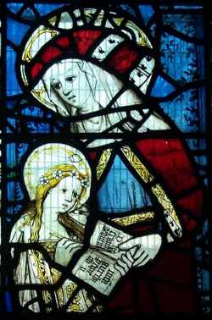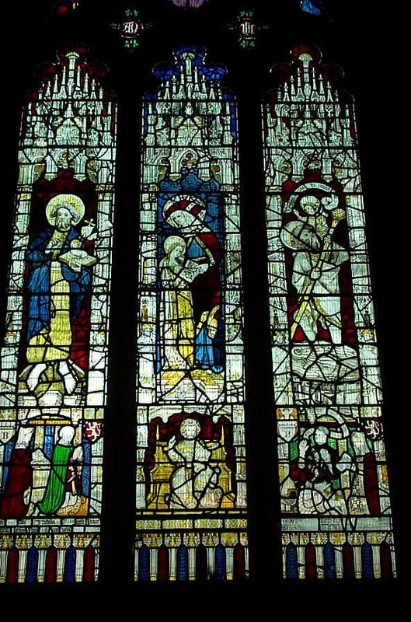
Fig. 4.1 The Blackburn Window Fig.4.2 The Blackburn Window
All Saints North Street, York All Saints North Street, York
St. Anne reading to the Virgin The Blackburn wives kneeling with a Psalter

The window highlights the importance of reading both publicly and within families. Many people, including extended family and servants, could have comprised a late medieval middle-class household, and they may well have attended church together and recited in unison the vernacular prayers specially devised for lay use during the Mass. Visual images and vernacular and Latin languages worked together within the church setting to enhance lay understanding of the liturgy and affective responses to it.

4.2 The Institution of the Mass
Both the Anglo-Norman and English prayers begin with comments on the validity of the Mass (‘The worthyest thynge…In all þe werlde’ [text C, lines 1-2]; ‘[la chose] la plus digne del mound’ [The Tyrwardreath Psalter, line 2]). These comments are based upon the instructions given during Christ’s Institution of the Eucharist. Christ’s performance during the Last Supper consisted of breaking bread, pouring wine and saying to his disciples: “This is my body, which is given for you. Do this for a commemoration of me…This is the chalice, the new testament in my blood, which shall be shed for you”.﻿ In commanding his disciples to remember his death by partaking of the bread and wine, Christ was instituting a re-enactment of his death through imaginative and visual participation in the Eucharistic celebration. The medieval Mass consisted of a performance by the priest, who stood in for Christ in the blessing of the sacraments. At Mass, the congregation sometimes watched this performance taking place behind the rood-screen, and they were, by implication, invited imaginatively to participate in the first Good Friday events. The solemn words of Institution were heard as the elements were blessed by the priest, the bread and wine were viewed by the congregation as they were raised above the priest’s head during the Levation prayer, and the bread was (occasionally) tasted. In the re-enactment of Christ’s initial command to ‘eat’ and ‘drink’ is an implied command to ‘hear’ the words, to ‘see’ the raised elements and to ‘think’ or ‘reflect’ upon Christ’s sacrificial act. Just as the priest was standing in for Christ each time he repeated the words of Institution, laypeople were also participating in the event when they recited the paraliturgical prayers as part of a process of remembering the Passion.

4.3 Vernacular Instructions for Hearing and Saying the Mass
The English and Anglo-Norman Mass Prayers cited in appendix 4.2 carry instructions for hearing and/or saying the Mass. While in English the penitent is reminded of the virtues of hearing the Mass being sung (C, lines 9-10), the Anglo-Norman instructions state that they should say or hear it: “quant hom la dit / Ou escoute par bon delit/…Ou escoute de tyel profit” (lines 3-4, 6; italics mine). The placing of ‘dit’ before ‘escoute’ indicates general acceptance of lay participation in the Mass through recitation as well as hearing the words of the priest by the mid-late fourteenth century. The Anglo-Norman text emphasises the importance of participating in the Mass, not only for one’s benefit, but also for their delight or pleasure (‘delit’, line 4); it is an experience to be enjoyed as part of the process of spiritual wellbeing, or ‘sowlehele’.
It would appear, given the number of variants of vernacular Mass Prayers, that initially people recited different versions at their own volume and pace. On the one hand, the laity were reminded of the set form of praying the Latin liturgy, passed down through the centuries: “For hit is wretyn what þou shalt say, / Whane þow schalt rest, whane þou schalt pray…As þow fyndest wryte…” (F, lines 5-7) / “Trestouz les poins ap[er]tement / Coment hom se doyt aver / A la messe pur Deu server” (lines 29-31). However, those who owned prayer books may have had different versions of the vernacular prayers from other members of their congregation. Thus while the recommended postures during certain parts of the liturgy and the attitude towards prayer “with clene herte and gode intent” (F, line 24) were maintained, the instructions for reciting the vernacular reconstructions of the Mass were much freer. One of the Levation prayers of the mid-fifteenth century comes complete with a loose set of procedures:
Swylke prayere þan þou take,
As the likes best forto make.
Many men prayes sere,
Ilke man prayes on his manere.
Schorte prayer soulde be, with-owten drede.
And þere-with a pater-noster and crede.
I set here and [ane] may be sayde,
If þou be vnpuruayde; (C, lines 227-234)

These guidelines indicate that those who wrote the prayers for the benefit of the laity encouraged them to say the prayers boldly, without fear, and in their own way. Compilers of instructions and prayers seem to have allowed for some agency in the manner in which the vernacular prayers were to be uttered. The lack of order and unison in the recital of the Mass Prayers suggests that the laity were empowered to take responsibility for devotions in their own tongue and own manner.
The instructions attached to manuscripts at the turn of the fifteenth century indicate that initially there was no rigid form for reciting vernacular Mass Prayers; the only stipulations were for posture and when to pray. However, as more people owned prayer books and learnt vernacular prayers, the prayers became fairly standardised and were prayed in unison by the congregation. Rossell Hope Robbins provides evidence that by the end of the fifteenth century the recital of vernacular prayers at Mass was so common that some people were praying set vernacular prayers alongside the Latin liturgy. In a visit to London in 1496, the Venetian ambassador remarked of devout laypeople:
They all attend Mass every day and say many Pater nosters in public, the women carrying long rosaries in their hands, and any who can read taking the Office of Our Lady with them, and with some companion reciting it in the church in a low voice, verse by verse after the manner of churchmen.

As well as vernacular versions of the Mass, there was limited use of English translations of the liturgy during some late fifteenth-century services, including at the bidding prayers, the introductory to the Mass, marriage services, confession during extreme unction and in emergencies during baptismal services. The English prayers for these occasions were likely devised because it was important that the laity understood the import of the ceremonies, particularly when they were expected to declare vows. We will now turn to a consideration of the placement of Mass Prayers within some other manuscripts in order to explore their possible use and significance for their readers.

4.4 Manuscript Contexts for Mass Prayers
Mass Prayers are often placed near the Hours of the Cross and other Passion prayers, indicating their close relationship with each other and their cross-usage by the viewers of the manuscripts. The Vernon Manuscript includes the English Hours of the Cross, Corpus Christi prayers, lyrics on the sweetness of Jesus, a lyric with instructions for the laity on how to hear the Mass and some Levation prayers. The Anglo-Norman Mass Prayers in the Tyrwardreath Psalter, transcribed in appendix 4.2, are on folios 10v-16r, immediately after an illustrated Latin Hours of the Cross with Anglo-Norman rubrics (folios 3v-6v), a miniature of Christ on the cross between Mary and John (folio 7r), and a Passion prayer on the sweetness of Jesus (folios 7v-10r). The vernacular Mass Prayers were considered significant enough to be placed towards the beginning of the Psalter and before the Latin Hours of the Virgin.
A Passion prayer written for the occasion of the Mass - “Ih[es]u my lord, welcome þu be / In flesch & blode I þe see” - also had special significance for the compilers and/or owners of the Bolton Hours, considered in chapter 1. The prayer is one of only two English prayers in this manuscript (figs. 4.3 and 4.4). The prayer is personal and affective, and could be considered part of the Dulcis Memoria cycle of Passion prayers examined in chapter 3. It also has connections with the Anglo-Norman term ‘delit’ (which, along with the English word ‘sweetness’ could indicate spiritual delight or pleasure). The blending of sweetness themes with a vernacular Mass Prayer in a Latin book of hours indicates the widespread use and acceptance of many types of prayer by any one group of people. As is typical with penitential prayers, the Bolton prayer combines devotion to Christ’s wounds with the penitent’s preoccupation with her impending death and judgement:
…And þis same flesch with woundes fyfe
Þou rayse ogayne fra deed to lyue;
And eft[er]ward til heuen þu stegh
To mak us sitt with þe on hegh;
And sone heraft[er] þu sall come
To þe dredefull day of dome,
All man kynde to deme sone
Efter þai hafe sayed or done (lines 15-22)

This particular vernacular Mass Prayer is placed towards the end of the manuscript, and is followed by a full-page miniature on the Last Judgement (folio 208r, see fig. 1.2), driving home the importance of preparation for death through participation in the Mass.

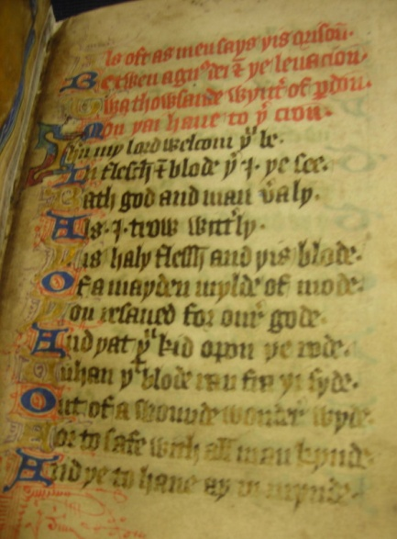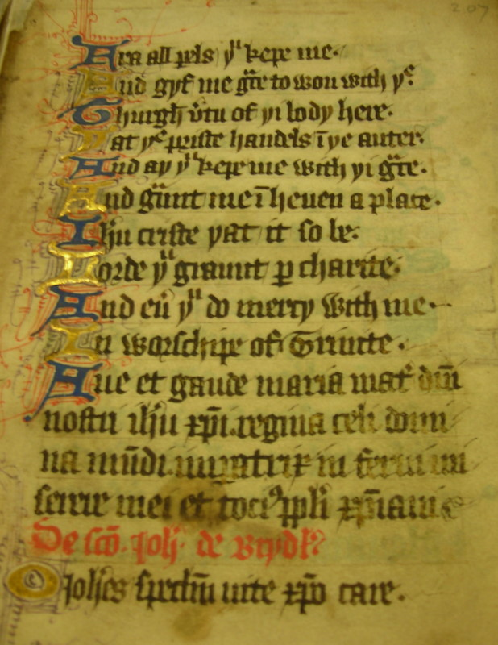
Fig. 4.3 The Bolton Hours, fol. 206r Fig 4.4 The Bolton Hours, fol. 207r
Beginning of Vernacular Mass Prayer End of Vernacular Mass Prayer

Mass Prayers form part of the corpus of both public and private prayers for a wide range of class and occupational groups. The Bolton Hours was a private prayer book, yet the English confession and Mass Prayers were probably meant to be said during church services. The Vernon Manuscript was most likely compiled for an audience consisting of both laity and clergy. The Tyrdwardreath Psalter may have been executed in the diocese of Durham, perhaps for a group of nuns. Even though the three manuscripts, the Bolton Hours, the Vernon Manuscript and the Tyrwardreath Psalter were compiled for different audiences, lay and religious, they contain the same cycle of Passsion and Mass Prayers in English, Anglo-Norman and Latin. Together they make up a collection of prayers that were actively performed by people who wanted to take control of their own devotional lives.

4.5 Text and Image: Mass Prayers Mises-en-Page
4.5.i Illustrated Mass Prayers
An early fourteenth-century set of Latin Mass Prayers with miniatures carries a set of Anglo-Norman instructions on how to conduct oneself during the Mass. The manuscript, Paris, Bibliothèque Nationale fonds français 13342 (folios 45v-48v), which has been edited by Francis Wormald, contains twelve miniatures in total. They pictorially represent the actions of the priest at each stage of the Mass, from the Introit at the beginning until the Communion Proper, which is sung after the Agnus Dei. The folios consist of one or two miniatures per page, and corresponding Anglo-Norman instructions on how to respond to the different stages of the Mass are placed directly below each image (see fig. 4.5). Where there is a Latin prayer to be intoned by the priest, it is placed immediately beside the short Anglo-Norman cues. The miniatures give a clear idea of the priestly gestures, with the laity sitting or standing behind, as appropriate, and imitating the priestly gestures.
Each Anglo-Norman instruction begins with a command to ‘pense[t]z’, ‘dites’, ‘responetz’, ‘levez’, ‘loez’ or ‘prierez’ / ‘devez prier’. The commands are direct, and they are linked with the words of the Institution of the Mass. They also pertain to actions that assist with the assimilation of the Mass through the senses, intellect and bodily gestures. The images accompanying the Mass Prayers are closely connected with the Anglo-Norman instructions and pictorially explain how the laity should hear, say, think and pray the Mass, partly to enhance the meaning of the text and perhaps to aid those with limited textual literacy. For example, at the Elevation of the Host (fig. 4.5), the priest lifts up his hands containing the elements, as Christ’s hands are raised on the Cross. The lay congregation’s hands are also raised in reverence. It is at this moment – the Elevation of the Host - that Christ’s sacrifice becomes efficacious for the communicants. Both their acts of gazing at the elements and of raising their hands denote their participation in the mystery of the Mass and ensure the forgiveness of sins. By imitating the priest in their vernacular prayers as well as their gestures, laypeople were by this stage more fully able to enter directly into the events of the Last Supper.

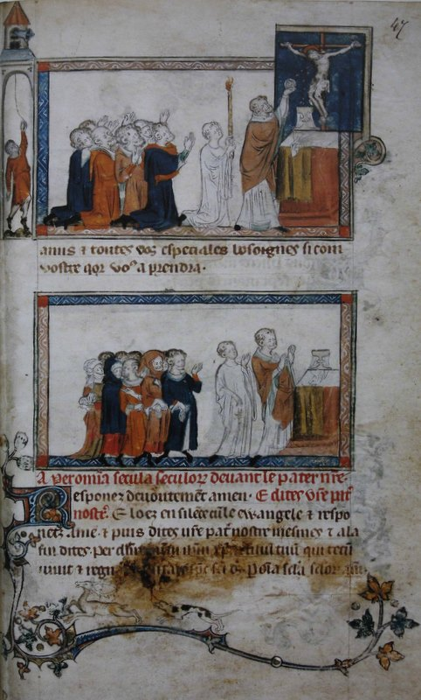
Fig. 4.5 Paris, Bibliothèque Nationale fonds français 13342, fol. 47r
Elevation of the Host, with bell

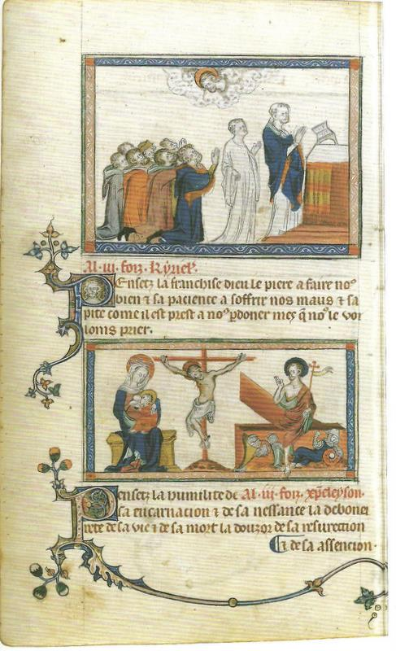
Fig. 4.6 Paris, Bibliothèque Nationale fonds français 13342, fol. 45v
Christe Eleyson, with Instructions
The only miniature that does not depict the priest and the lay congregation is the fourth one, on folio 45v (fig. 4.6). In this image, Christ is on the cross, with the Virgin Mary suckling the Christ-child to his left and the Resurrection scene on the right. The miniature corresponds with the Christeleyson (Christ, have mercy), and the inscription below reads: “Pensetz la humilité de sa encarnacion e de sa nessance / la deboneirete de sa vie e de sa mort / la douzor de sa resurrection e de sa assencion”. This image has no Latin prayer attached. The absence of spectators draws attention away from the church service and towards contemplation on the biblical events of Christ’s birth, death, resurrection and ascension.

4.5. ii Unillustrated Instructions for the Mass
We have just considered a set of Mass Prayers with accompanying illustrations as visual aids for contemplating the Crucifixion. The devotee did not need to pray in front of an actual image as part of the process of visualising the Crucifixion. It was sufficient to bring the image to mind through a textual prompt, in much the same way as Latin rubrics within primers and horae served as a mnemonic cue for the reciting of a Psalm or memorized liturgical prayer. As we have already explored in the Tyrwardreath Psalter and English editions of Mass Prayers in the Lay Folks Mass Book, some Mass Prayers carry instructions for the penitent actively to visualise the cross without the aid of an image on the manuscript page. In these instances, devotees are encouraged to use their imagination and memory in order to recollect an image of the Crucifixion that they have seen in a book and committed to memory, and/or one that they behold in front of them on a church wall or stained glass window.
In a set of instructions for laypeople entitled “The Interpretation and Virtues of the Mass”, Lydgate emphasises the central doctrinal importance of the Eucharist as an act of remembrance of Christ’s Passion. He exhorts his audience to use their eyes as an instrument for contemplative gazing on the cross.
Furst, with your eyen verray contemplatyfe,
Calleth to mynde, of hooly affeccioun,
Howe the Masse here in thys present lyfe
Of gostly gladnesse ys chyef direccioun,
To haue memory of Crystes passioun,
As doctors remember in theyr doctrine,…

The instructions to look with the eye and assimilate with the mind the meaning of the cross are applicable to all types of Passion prayers. The processes of imaginatively entering into the Passion become vital vehicles for effective participation, as they are taken on board by the devotee and used in conjunction with the instructions and/or visual images accompanying the prayers. It can be argued that in time the Passion and Mass Prayers themselves became a form of vernacular liturgy, as lay people took control of their devotional lives through the recitation of vernacular prayers using a range of literary and visual vehicles.

4.6 Mass Prayers and Lay Empowerment
The Mass Prayers blend the liturgical themes of confession and supplication with those of devotion to the Wounds and Name of Jesus that are more reminiscent of the Passion lyrics. As with the Latin prayers, the vernacular Mass Prayers set out in order the liturgical stages of the Mass, from the initial office (Introit) to the post-communion prayer. In the preface to the Mass when the priest prays for the living and dead, the corresponding vernacular prayers encourage lay devotees to do likewise. The vernacular prayers are also interpolated with affective evocations of the doctrine of atonement, such as “Thu bought me dere with thi blode, / And deiede Fore me on the rode:” (F, lines145-6) and “iesu, al my ioying, /Þat for me spilt þi blode, and dyed opon þo rode…” (B, lines 432-4). Christ is addressed as “Douz sire” (line 36), “Verroy deu et enfaunt tender” (line 70), “Swet lord” (F, line 242) and “prince of pese” (B, line 549). The same sets of Mass Prayers include precepts directed by Thoresby, such as Christ’s threefold commandment to love God, one’s neighbour and oneself in the prayer of peace. That these prayers, written for collective public occasions, contain personal and penitential themes, as well as renditions of litanies and doctrines, reinforces the argument that Passion prayers could be used interchangeably; they could be performed in public or private settings, and in company or alone. Over time many laypeople came to own printed prayer books and to recite vernacular Mass Prayers in partial unison during the services, bearing testimony to their crucial role in the empowerment of the laity. The vernacular Mass Prayers formed part of the cycle of Passion prayers, including the Hours of the Cross, Corpus Christi prayers and prayers for the dead, all of which originated in the Latin liturgy but were adapted for the laity as a means of a lay complement to the Mass itself.
A fifteenth-century prayer on the merits of the Mass by John Audelay - who was blind - makes provision for those who do not go to Mass:
3if þou may not þi Masse here,
Þen þis lesson Y rede þou lere.
When þai to Masse do knyle;
Pray God of his gret grace
To send þe part of þat Masse,
3if hit be His wylle.

The words constitute a means of participating in the Mass without actually going to church, and were originally devised for sick people who could not attend Mass. The devotee could read a lesson from the church liturgy as an alternative to attending Mass. This arrangement suggests that those who owned a book of hours or primer and could not attend Mass may have substituted the liturgical lesson for one of their favourite prayers, including the Hours of the Cross. The Pavement Hours, for example, opens with the Hours of the Cross (see chapter 1, above), and this may have been the most convenient and even most cherished prayer for the owners.
An issue to be addressed is whether the Mass could eventually have become redundant for the laity if it could be supplemented by a lesson or an indulgence prayer. The theological response is that the Mass was and continues to be the most central sacrament of the Church, instituted by Christ and modelled on his words. The sacrament is considered both a mystery and a miracle, and while liturgical lessons and vernacular Mass Prayers can suffice both as a means of enhancing understanding of this central rite, and of empowering the laity, they can never become a substitute for participation in the Mass itself. Nevertheless, Mass Prayers supplemented the formal liturgical Mass, and helped give agency both to priests and the laity. Through greater participation, the laity could potentially share more fully in the mystery of the Mass, and, by implication, the priestly blessing and administering of the sacrament would have taken on an even greater significance for both the priests and the communicants.
It has been demonstrated that Passion lyrics and Mass Prayers were a rich and effective means of devotion whereby the laity could take responsibility for their devotional lives. Vernacular prayers could be recited during church services, including the Mass, but they were also often recited at home. As households gathered together and prayed from the household prayer book, they were creating their own form of worship within the domestic sphere. This manner of praying not only supplemented church services but also by association linked the families with the first Christians who met in their homes. The possession of, or access to prayerbooks, then, potentially enabled the laity to become increasingly responsible for their own devotional lives, and less beholden to the demands of the Church.

Conclusion
This thesis has investigated a selection of fourteenth and fifteenth-century manuscripts containing adaptations of the understudied Hours of the Cross and other vernacular Passion Prayers, including the Mass Prayers. The manuscripts range from private prayer books to anthologies for a public audience, from books commissioned for the laity to those for religious communities, and from elaborate manuscripts to modest ones. This thesis has argued that these prayers are important for uncovering some of the ways in which late medieval laypeople meditated upon and participated in the Passion of Christ, in both public and private worship. The placement of the Hours of the Cross in a range of manuscripts, together with lyrics on the sweetness of Jesus, penitential refrain lyrics and vernacular Mass Prayers, reveals the sharing of devotional material among the clergy and laity. Some of the lyrics and prayers under investigation are present in manuscripts that may have been compiled by monks and clergy, and some of these manuscripts were likely disseminated among both enclosed and laypeople. Similar types of prayers may have been shared by extended families and / or religious communities or, as in the case of large anthologies such as the Vernon Manuscript, within a public setting, where they may have been read aloud for the benefit of the wider community.
This thesis has selected a few manuscripts for particular focus in order to demonstrate ways in which liturgical and paraliturgical prayers function together. Chapter 1 explored two York books of hours within their cultural and religious contexts, and argued that they illustrate particularised local devotion to the body and wounds of Christ. Chapter 2 examined the relation of text and image in the fourteen extant English primers, and in particular, Cambridge, Emmanuel College, MS 246. This manuscript is typical in its placement of the Hours of the Cross within the Hours of the Virgin, yet has been singled out for special attention because of its elaborate and uniform borders and illuminated initials. Chapter 3 focused on the Vernon Manuscript, both because of its importance as the largest religious compilation in English in the late fourteenth century, and its inclusion of both liturgical and affective prayers for edification and reflection. It compared the themes of the Passion Lyrics in part 2 of the manuscript with the penitential Refrain Lyrics of part 5, and also explored ways in which similar types of prayers and lyrics in other manuscripts may have been used in conjunction with each other. Chapter 4 considered Mass Prayers in both English and Anglo-Norman, and argued that prayers for the laity helped them to participate more fully in the Mass.
This thesis has demonstrated that from the mid-fourteenth century onwards, some movements were working side by side that combined to enhance lay participation in the liturgy. First, formal public liturgy was undergoing processes of reform, when laypeople were encouraged to take their private prayer books to church services, and even to recite prayers in the vernacular alongside the Latin liturgy, including the Mass. Priests were instructed to teach the basic creeds as a minimum to the laity, but laypeople also pressed for such measures. Many devotional and doctrinal works seem to have been written in response to demand by the laity, and not only as didactic or programmatic tools for the Church.
Second, as part of Thoresby’s mandate for reform, many versions of set prayers on the Passion were placed within personal and private prayer books, which meant that there was a shared collective devotional experience both inside and outside the confines of church buildings. Catechisms, primers and books of hours were regarded as the initial means of teaching the Christian creeds and prayers, especially once they had been translated into the vernacular languages in the mid-late fourteenth century. Women had large spheres of influence and as they met to read together, they may also have recited their devotions with their extended households, using the family prayer book. Even more significantly, they taught primary literacy to their children and extended households.
Third, laypeople could hear sermons in English, and they had access to visual representations of the Passion and Crucifixion, whether in statues and Stations of the Cross, or in paintings, stained glass windows and books of hours. In many towns and cities such as York, laypeople watched and participated in dramatic performances of religious lyrics and Biblical narratives in town squares, including annual Corpus Christi performances, processions and the Mass. Laypeople were also founding members of the Corpus Christi Guild, and they were responsible for the upkeep of much of the fabric of church buildings.
One question which has often been posed is whether the movement towards religious expression in the vernacular and the empowering of the laity, coupled with Wycliffism, constituted the beginnings of a “premature Reformation”, and if Arundel’s injunctions of 1407-9 posed a sudden halt to the process. Many people argue strongly one way or the other. I think the answer lies in both directions. In terms of books of hours, the most popular books of that era, it would appear that not much changed. It is quite difficult to decide in terms of religious content whether a book was compiled pre- or post-Arundel. Some fifteenth-century English primers, as we have seen, include Wycliffite material. Duffy argues that the reason why there are extant fewer than “a dozen-and-a-half” primers in English is because they were considered heretical at the time. Yet this may be too simple a conclusion to draw; the other material within them is orthodox enough. English primers were being produced at the same time as the English Catechism, and the catechism includes a parallel version with Wycliffite sentiments. The pre-Arundel Vernon Manuscript contains similar material to the post-Arundel Bodl., MS Douce 322 manuscript.
In terms of religious reading material, perhaps Arundel’s reforms were minor. However, in terms of the bigger picture, they may have had more far-reaching consequences. Lollardy was suppressed, and English Bibles were hidden, burned or confiscated, partly because of the threat they posed to the ecclesiastical authorities. Peckham and Thoresby had both been reformers and enablers, keen to empower the laity. But the laity, by reading parts of the Bible for themselves and devising their own prayers, and even by saying a form of the Mass in public or in private, could potentially call into question the power of the Church. Arundel was threatened by Lollards and by their power to destabilise or undermine the role of the priest acting as intermediary or intercessor between the laity and the Divine. With an English Bible, people could have direct access to God.
In chapter 4, I explored vernacular Mass Prayers and speculated on how they may have been used during church services. In transcribing Anglo-Norman Mass Prayers from the Tyrwardreath Psalter and placing them alongside English versions of the same prayers and the Latin Mass, I was in a sense reconstructing a template for the medieval services. And yet, any attempt to place ourselves within the medieval mindset is at best partial, and any attempt to recreate a medieval Mass can achieve only a loose approximation of how late medieval church services were conducted and how laypeople participated in them. Is there, then, any value in attempting to recreate a sense of how late medievals may have worshipped through the reconstruction of the medieval Mass?
I was commissioned by the wardens and priest in charge of the parish church of All Saints North Street, York, to reconstruct a medieval Lady Mass as it may conceivably have been celebrated in the fifteenth century (see appendix 5 for the Order of Service). The Mass was celebrated at the church by local clergy in July 2009, and again by the Bishop of Whitby in July, 2010. I reconstructed the Mass from fourteenth and fifteenth-century missals and breviaries of the York-Use. I included medieval music, both plainchant and polyphony, from a York-based Gradual and Processional, as well as some Mass Prayers from the Lay Folks Mass Book, inserted at the appropriate points of the service. The clergy and I decided that baptised laity could partake of the consecrated host if so desired since we used the liturgy for the Assumption of the Blessed Virgin Mary, and the occasion marked a double feast day. The reconstructed Mass could never have been more than an approximation of an actual medieval service, separated as we are by culture, time, sensibilities, belief systems and different levels of assimilation of the Latin liturgy. However, the re-enactment of a medieval Mass helped recreate a sense of its impact on the original lay congregation.
During the performance of the Mass, my initial impression was of its solemnity. The Latin words combined with the music were awe-inspiring, and the polyphony lifted the atmosphere to a higher level again. The separation of the clergy from the laity, both in terms of clerical audibility in Latin versus lay silence, and in the elaborate priestly consecration of the Mass behind the wooden rood screen, was very apparent. The divisions of language and space helped create a sense of the mystery of the Mass – as was the original intention - yet I felt like an onlooker, gazing at the spectacle from an outsider’s perspective, rather than a participating member of the Church. Sitting or standing in virtual silence for the whole of the service meant that I was absorbed with the music, words, gestures and incense, but also served to emphasise my inability actively to engage with the ceremony. I received the host, but this one participatory act seemed incongruous, as if I were intruding on a staged performance. Although the partaking of the Eucharist was an invitation, I felt like a guest who had been grudgingly invited, rather than properly welcomed. On reflection, the discomfort may have been due to the fact that many people had gone to the service as spectators, not expecting, nor even knowing how, to participate; in this sense the Mass replicated a concert more than a religious ceremony. Thus any invitation actively to engage with the performance would have felt strange, even for people accustomed to receiving the Eucharist.
The silence I have described is very different from what may have taken place during a typical medieval parish Mass. Although some forms of portable seating, such as pews, began to appear by the early thirteenth century, seating was not widespread until at least the late fourteenth century. Instead, the congregations would have clustered together in groups, perhaps leaning against pillars or walls and talking among themselves. Laypeople are chastised in the English introduction to the Mass Prayers for “iangelynge” (appendix 4.2, C, line 22), and in the Anglo-Norman version they are instructed “Qe a la messe n’eist parlement” (That there is not to be any talking together at the Mass) (appendix 4.2, line 26). Many laypeople, whether through distraction or lack of comprehension, would not have caught the entirety of the Latin liturgy, although they would have been able to pick out the main prayers and creeds that they had learnt by rote or assimilated through time. The most important part of the Mass was the Elevation of the Host and the chalice; at this point a bell was rung to alert the laity to the sacred moment, when they received remission for their sins. They would have crowded around the rood screen, hoping to catch a glimpse of the elements raised above it. At other points in the service, some of the lay congregation may have been inattentive and easily distracted. Therefore, even though the laity were onlookers at the spectacle of the raised sacramental elements, their sense of awe may have been dimmed over time. They created their own form of informal participation, even if it clashed with the serious intention behind the celebration of the Mass.
The introduction of vernacular prayer books during church services from the mid- fourteenth century onwards would have lessened the distance between the laity and clergy and in some aspects would have helped bring some order to the services. In being encouraged to participate verbally, the laity were empowered, and in being empowered, they were more fully able to grasp the meaning of the Mass. Through engagement with their eyes, mouth and ears as they listened and watched out for cues and recited their vernacular prayers, they would have gained an increased awareness of the significance, and even the mystery of the ceremony.
The insertion of vernacular Mass Prayers in the reconstructed Mass of 2009 was meant to encourage the congregation to participate in the service. However, the congregation remained silent throughout, perhaps because of the beauty of the music, or because of the unfamiliarity of the Latin liturgy and the formal seating arrangements. The vernacular prayers were translated into modern English, but no-one ventured to start uttering them aloud. It may have taken someone to direct the congregation over a few services for people to start feeling comfortable in breaking the silence. Likewise, it may have taken a while for medieval audiences to start engaging with vernacular Mass Prayers, unaccustomed as they were to praying aloud at church. For this reason, the instructions accompanying the original prayers would have been very important. Once the congregations became used to participating verbally, they began to have a voice in what had hitherto been an inaccessible ceremony. Conversely, for a modern audience accustomed to relentless sound and activity, part of the attraction of the medieval Mass was its invitation to reflect in silence and to remain passive, even if it did create a sense of powerlessness.
Another reason why the 2009 congregation may not have joined in the vernacular Mass Prayers was because the phrases seemed jarring alongside the Latin words and polyphonic music. The English prayers are not direct translations of the Latin liturgy, and so they represent a disjuncture between the priestly rituals, which were deemed important by the ecclesiastical authorities, and what may have been considered the less important personal sentiments of the laity. They were meant to be recited in conjunction with the liturgy, but because they were not direct translations they did not assist the laity in comprehending exactly what was said by the priest, especially when he prayed ‘in secret’ at the consecration of the host. Over time, however, as late medieval laypeople became more comfortable with praying in their own tongue, they may have taken more control of their devotional lives, and the priestly rituals may even have become subordinate to the ability of the laity to express their devotion to the cross, using a range of literary and visual vehicles. Equally, the clergy may have enforced uniform texts as a means of attempting to control the services.
The attempt to reconstruct a medieval Mass was useful for testing some of the claims of this thesis. There is much manuscript evidence that laypeople blended liturgical and non-liturgical prayers in their devotions both at home and church. Yet the All Saints Mass performance revealed that, in practice, it may initially have been impractical for laypeople to recite their own versions of Mass Prayers alongside the performance of the liturgy. Thus, while the vernacularisation of the liturgy was potentially empowering, the extent to which laypeople were able to participate in the liturgy through vernacular prayers is not clear. As ownership of books increased it may have become standard practice to include some vernacular prayers in the liturgy. Yet, by implication, this standardisation also may have become a means of controlling rather than empowering the laity.
One limitation of this thesis, due to time constraints, has been the reliance upon catalogues of manuscripts for information on their location and dating, and on possible first commissioners and/or owners of many books. Further research should include investigation into the scribal circles that produced manuscripts containing the vernacular Hours of the Cross and Passion prayers, and the possible connections between those centres of production. For example, an enquiry into the compilers of manuscripts of the religious community of Lichfield, where the Vernon Manuscript was likely compiled, and of the extant English primers, may yield some potentially fruitful results which may further substantiate the claims of this thesis regarding lay/clerical cooperation in the dissemination of liturgical and devotional materials. Another useful enquiry, building on research to date, would include an examination of the textual history of the Hours of the Cross in Latin, English and Anglo-Norman. This may also help to shed more light on the extent to which the three languages were used interchangeably by the laity in their devotions.
A question that has grown out of my enquiry into the inter-relation of word and image, and the performative and sensual aspects of the Mass, concerns the significance of the aesthetics of the Eucharist for lay worship, particularly in the decades surrounding the English Reformation. The English Reformation focused particularly on the doctrine of the Eucharist. Much has already been written on the differing theological positions, yet comparatively little on the aesthetics. Laypeople appreciated the performative aspect of the Eucharist, and they arguably paid at least as much attention to the visual and sensual rituals surrounding the liturgy as to its theology. Shifts in what constituted doctrinal orthodoxy and heresy may have been of less significance for the layperson than changes in attitudes and practice surrounding visual, sensual and textual cultures.
A further question is the extent to which laypeople’s experience and perceptions of the Eucharist as ritual were modified as a result of the Reformation. This issue could be addressed through the examination of prayer books, sermons and books of hours (both in manuscript and early printed form) and visual artefacts produced in the period. As the Reformation (combined with the printing press, rising literacy and greater attention paid to individual reading and interpretation of the Bible) helped create a word-dominated culture, to what extent did it affect the layperson’s experience of the liturgy? Was the destruction of images, as Duffy argues, imposed from above, or was it also a localised lay movement? Conversely, were there legitimate means by which opposers of iconoclasm could openly make use of images as a devotional tool (for example, in woodcuts accompanying printed prayer books and in decorations within the domestic sphere)?
Does the medieval emphasis on sense and image help shed light on some of the impulses behind the recent resurgence of interest in the liturgy and sacrament (as evidenced by the high turnout to my reconstruction of the medieval Mass)? What implications does such emphasis have for how we understand pre- and post-Reformation cultures, including modern expressions of faith? As our culture is increasingly image dominated, perhaps for the first time since the Reformation, how does this impact the believer’s experience of the liturgy and sacrament? Investigation into these issues may point to some fascinating conclusions regarding commonalities between medieval and current expressions of Eucharistic worship as an aesthetic experience.

This thesis has re-examined the role of the laity in medieval devotion, and argued that careful tracing of manuscript evidence reveals a much more active grasp of and participation in the liturgy by laypeople in late medieval England than is commonly supposed. Through a close examination of specific manuscripts, this thesis has questioned and partially undone previously held assumptions concerning educated clergy and cloistered communities versus uneducated and semi-literate laypeople. These manuscripts instead reveal multi-layered levels of understanding and approaches to doctrine and the liturgy across lay and religious communities.

Appendix 1 Patris Sapiencia Latin source, with English adaptation

 | Glasgow, MS Hunter 512  (Transcription mine) | Latin Translation  (Translation mine) | The Pavement Hours (YML, MS XVI.K.6) (FMBL, 82-7)
(Antiphona)  Matins/Lauds  Additional refrain | Patris Sapiencia, veritas diuina,  Deus homo captus est hora matutina,  A notis discipulis cito derelictus,  A iudeis traditus, venditus, afflictus.  (versicle/response) | The wisdom of the father, the divine truth,  God and man was taken in the morning hour  By his known disciples he was soon forsaken.  Betrayed by the Jews, sold, afflicted. | Þi wysdome of þe fadyr, þe god ryghtwesnes.  God and man, at morne tyde, taken he es,  For-sakyne of hys frendes & left – witoutyn les.  Be-trayede to þe jewys & dampnyde sackles. (ll. 12-15)  Lord for þat ylk payn þu suffyrde at morne tyde  Lat neuer my saule on domis day be forlorne. (ll. 16-17)
Prime  Additional refrain | Hora prima ductus est ihesu ad pilatum  Falsis testimoniis multum accusatum  In collo percutiunt, manibus ligatum,  Vultum Dei conspuunt, lumen deo gratum.  (versicle/response) | At the hour of prime Jesus was led to Pilate,  Many accused him with false testimonies  They struck him in the neck, they bound him by his hands  They spat in the face of our lord, light of grace. | At prime led was iesu unto pilate  Þai band hym as a thefe, and sor hym smate;  Many fals witnes, þai wryed hym many gate,  Þai spytted iesuys face, þe light of heuens yate. (ll. 33-6)  Lord for þat ilk shame þu soffird at prime,  Lat neuer my saul on domesday mystime. (ll. 37-8)
Tierce  Additional refrain | Crucifige clamitant hora terciarum,  Illusus induitur veste purpurarum:  Caput eius pungitur corona spinarum,  Crucem portat humeris ad locum penarum  (versicle/response) | At the hour of Terce they cry ‘crucify’  Mocked, he is dressed in a purple robe  His head is pierced with a crown of thorns  He carries the cross with his  arms to the place of punishment. | At þe tyme of oudron þai gun cry & call,  For hethyng þai hym cled in purper & in pall,  Þai set on his heyde a cron of thorn wit-all,  And gerte hym bere on his bak þe cros to þe pynstal. (ll. 40-3)  Lord for þat ilk shame, þu sofyrd in þat place,  Of deydly synne me to shryue, þu gyue grace. (ll. 44-5)
Sext  Additional refrain | Hora sexta iesus est cruci conclavatus,  Et est cum latronibus pendens deputatus:  Pre tormentis sitiens felle saturatus,  Agnus crimen diluit sic ludificatus. (versicle/response) | At the sixth hour Jesus was crucified with nails  And was hanged between two thieves  As a torment his thirst was satisfied with gall  The lamb of accusation weakened by derision | At þe tyme of myd-day þai dyd hym on þe rode  Betwix two theues þat had spylt manys blode;  For þe panys he threstyd il, þai gaue him drynk ungod,  Bytter gall (…) he wald not of þat fod. (ll. 47-50)  Lord for þat ilk shame þat was þi body neghe  Scheld me fro my il fays, Þe world, fend & fleshe (ll. 51-2)
None  Additional refrain | Hora nona dominus iesus expirauit,  Heli clamans animam patri commendauit:  Latus eius lancea miles perforauit;  Terra tunc contremuit, et sol obscurauit.  (versicle/response) | At the hour of noon the Lord Jesus died  Crying ‘holy’, he commended  his soul to the father  A soldier pierced his side with a spear  The earth quaked and the sun hid (its light). | At þe tyme of none iesu gun cry;  He wytte his saul to his fadyr, [Eli].  A knight smat him to þe hert, had he no mercy;  Þe sone be-gane to waxe myrk qwen iesu gun dy. (ll. 54-7)  Lord out of þi syd ran a ful fayre flude  As clere as well water our rannson be þi blode. (ll. 58-9)
Evensong  Additional refrain | De cruce deponitur hora uespertina,  Fortitudo latuit in mente diuina:  Talem mortem subiit vite medicina,  Heu corona glorie iacuit supina.  (versicle/response) | They took him from the cross at the hour of Vespers  The power (of resurrection) was in God’s mind  The medicine of life submitted to such a death  Alas, the crown of glory was thrown down. | At þe tyme of euen-sang þai tok hym fro þe rod  His myght was in his godhede, so gracius & god,  Þe meydcyne of his paynes, þe schedyng his blod,  Be noryschyng to us of or gastly fod. (ll. 61-4)  Lord for þat ilk shame þat þu doun was tane  Lat neuer my saul wit deydly syn be sclayne. (ll. 65-6)
Compline | Hora completorii datur sepulture  Corpus Christi nobile, spes vite future;  Conditor aromate, complentur scripture,  Jugis sit memoria mortis michi cure. | At the hour of Compline they laid him in the tomb  The noble body of Christ, the hope of future life  The conductor of spices, the fulfiller of Scripture  May the memory of his death by the spear be continual to me.
Versicle  Response | Adoramus te Christe et benedicimus tibi:  Quia per mortem tuam redimisti mundum. | We worship you Christ and bless you  For by your death you have redeemed the world. | We wyrchyppe þe cryste iesu, god son.  For wit þi holy cros: þis world haues Þu won

Appendix 2.1

List of Contents of Fifteen Extant English Primers

1. Bodl., MS Bodley 85
NIMEV 3499/5.1; end C14; fols. 123 (SC 2289)

fol. 1r - Sarum calendar in English
fol. 7r - Hours of the Virgin
fol. 26 - Hours of the Cross
fol. 51 – Seven Penitential Psalms with litany
fol. 68v - ‘Placebo and Dirige’, the service for the dead
fol. 99r - Commendation of Souls (fol. 99, wanting two leaves after fol. 101 and one after 102).
fol. 110r - A treatise on the Decalogue, perhaps based on Wycliff’s similar work, beginning “Thes ben the Ten Hestis. Alle manere of men shuld holde Goddis biddyngis” and ends “ bryngith in deth to mannis soul”, followed by passages from Scripture; imperfect at the end.
fol. 122r - Words of St Paul (wordis of Poul)

2. Bodl., MS Rawl. C. 699
NIMEV 3499/5.2; Maskell dates it after1460; fols. 179 (SC 12543/ WD McCray/Quarto, 199)
Inserted note in inside front cover in much later hand – “This very fair ms (I take it) contains Wycliff’s translation of the ancient Hora Canonica – many copies in public hands as well as in private libraries…”

fol.1r - Calendar in English
fol. 7r - Hours of the Virgin
fol. 24r – Hours of the Cross
Seven Penitential Psalms
Fifteen Gradual Psalms
Litany
fol. 52r – Calendar
fol. 56v – The Office for the Dead
fol. 81v – Seven Words from the Cross
fol. 82r – commentary on the Seven Words from the Cross
fol. 84r – Orison of Our Lady
fol. 88v – Confession
fol. 93r – commentary on the Apostles’ Creed (part of ‘Pore Caitiff’ collection)
fol. 113r – commentary on The Lord’s Prayer (part of ‘Pore Caitiff’)
fol. 137r – “þe Charter of Heuene” (part of ‘Pore Caitiff’)
fol. 146v – ‘Hors eþir armer of heuene’ (part of ‘Pore Caitiff’)
fol. 159r – “Of Mekenesse”
fol. 162v - Confession/prayer of St Brendan
fol. 167v - 10 commandments
fol. 173v - Five bodily Wits
fol. 176r - Seven Works of Bodily Mercy
fol. 178v - Seven deeds of Goostly Mercy.

3. Bodl., MS Douce 246 (SC 21820)
(Prymer; listed in Scott, II)
NIMEV 3499/5.3; early C15 (Maskell, c. 1420; vol ii, xxxiv); fols. 110 (SC 21820)
In calendar, ref. to crowning of Richard in 1377.

fol. 1r – Calendar for March and April
fol. 3v – Creed in English
fol. 5r – Calendar in English
fol. 11r – Hours of the Virgin
fol. 26r – Hours of the Cross
fol. 43v – Penitential Psalms and Litany
fol. 58r – Office for the Dead
fol. 81r – Commendation
fol. 93v – Psalms of the Passion
fol. 100v – Prayers to saints
fol .101v – Wycliffe commentary on the Ten Commandments
fol. 103v – Sermon on Luke 5:27, ‘Thou shalt loue þi lord þe god of alle’ etc.
fols. 106r-107v - fiffe wittes Seuen dedeliche synes , seuene 3iftes of þe holy gost, Seuen workys of m[er]cy, six man of cosnesne etc., Seuene workes of gostly m[er]cy.

4. Bodl., MS Douce 275
NIMEV 3499/5.4; late C14 (although Maskell dates it at 1420, vol II, xxxiv); fols. 77 (SC 21849)

Iv-x – Calendar
fol. vi - July 14, “Medeldride maide and martir’ – probably Mildred of Kent, often honoured on 13 July. ‘Anno 1596 Roger Wright me jure tenet’
fol. 1r – Hours of the Virgin, interspersed with Hours of the Cross, the Seven Penitential Psalms and the Seven Gradual Psalms
fol. 15r – Hours of the Cross
fol. 30v – Litany
fol. 37r – Last three gradual Psalms in full
fol. 43r – Office for the Dead
fol. 69v - Commendations

5. Oxford, Queen’s College, MS 324
NIMEV 3499/5; early C15; fols. 80

fol. 1r - Hours of the Virgin
fol. 14v – Hours of the Cross
fol. 31r – Seven Penitential Psalms
fol. 37v – Fifteen Gradual Psalms (1st 12 by cue only)
fol. 40r - Litany and collects
fol. 43r – Office for the Dead
fol. 66r – Commendation of souls
fol. 78v – Excerpt from Mirror of Holy Church (transl. of Edmund Rich’s Speculum Ecclesiae)

6. CUL, MS Dd. xi. 82 (see LFPB, 15-36)
NIMEV 3499/5.6; c. 1420-30; fols. 96

fol. 1r – Hours of the Virgin
fol. 16v – Hours of the Cross
The Seven Penitential Psalms
The Fifteen Gradual Psalms
The Litany
fol. 54r - The Office for the Dead
Commendations

7 Cambridge, Emmanuel College MS 246
NIMEV 1499/5.7; late C14 ; fols., 67+3,

fol. 1r - Calendar in English
fol. 3r – 21st May, “There was þe erthe quake þe 3eer of oure lord m. ccc. lxxvij.” (1382)
fol. 4r – 16th July, “King Richard was crowned þe 3eer of oure lord m. ccc. lxxvij.” (1377)
fol. 7r - Hours of the Virgin
fol. 14v – Hours of the Cross
fol. 27v - Seven Penitential Psalms and Litany
fol. 31r – ‘John Comber Shermanbury’ inscribed
fol. 35r - Office of the Dead
fol. 54r – Psalms of the Passion
fol. 58v – Seven Deadly Sins and Ten Commandments
fol. 61v – Seven Gifts of the Holy Ghost
fol. 62v – Seven Words on the Cross
fol. 63v – Precepts with references
fol. 65r – Macabeorum
fol. 65r – An orison of our lady
fol. 66v – Sixteen propertees of charity

8. Cambridge, St John’s College, MS G. 24 (192) (ed. Littlehales, The Prymer, or Prayer-book of the Lay People in the Middle Ages [1892]; c. 1400)
NIMEV 1499/5.8; Maskell dates it before 1400; St John’s dates it late C14; fols. 95.

fol. 1r – Calendar in English
fol. 7r – Table to find Easter
fol. 9r – Hours of the Virgin
fol. 20r – Hours of the Cross
fol. 40r – Seven Penitential Psalms
fol. 45v – Fifteen gradual Psalms
fol. 51r – Litany
fol. 56r – Office of the Dead
fol. 79r – Commendations
fol. 79v – Beati Immaculati – ‘Blessid be the unwemmed in the weye’
fol. 87v – Psalms of the Passion
fol. 94v – ‘O’s – ‘O intemerata’; ‘O unwemmed and wiþ owten eende blessed.’

9. London, BL, MS Add. 36683
NIMEV 1499/5.9; fols. 175; likely c. 1380

Calendar and Psalter agree with Wycliffite version but with some variants.
On inside leaf, 3v, note in Latin, then another note in different hand, with a more recent insertion below: “this ms was written about the year 1340, being the translation of Richard Rolle, an hermit of hampole in Yorkshire, who died in 1349; or else was written by Wicliff’s followers’ about 40 years after. See Lewis’s history of the English Translation of the Bible, prefix to his folio edition of Wicliff’s New Testament, 1371, Page A.”

fol. 4r – Calendar; on 10 Jan (4r), A Aysrombe in different, later, hand, then ‘papa’ at side; in
fol. 10r – Hours of the Virgin
fol. 18v Hours of the Cross
fol. 29v – Litany
fol. 45v – last of additional notes on 2/3 blank paper, at end of Hours of BVM: “Wm vaysroghe sone of Edward ayscoughe the seconde sone to Sir franceis aysoohe knyghte whas borne in the year of owre lord god qm: owned by (?) mii. & the day of hundered threescore & four & the syxte day of January betwe xi & xii – at noon Saturday (Anne Ayscough, daughter of Sir Wm Ayscough, in Lincolnshire, burnt for heresy in 1546, at 25 years of age, 38th (?) of Henry VIII, in Smithfield, after being twice Racht (?) to defect other court ladies of her opinion - by Lord Worschesby and Richard II, succeeding Lord Chancellors after she had been condemned”.
fol. 46r – Seven Penitential Psalms, but first few leaves torn out plus two pages from tierce so we have no idea how Psalms originally illuminated.
Fifteen Gradual Psalms
fol. 163r – Verses from Bible with commentaries, e.g. Isaiah 12, 38, 1 Sam 2, Habbakuk 3, Deut 32, then Apocrypha, Song of the three children
fol. 171r – Te Deum
fol. 172r – Luke 1
fol. 173r – Athanasius Creed
fol. 175v - Litany.

10. GUL, MS Hunter 472
NIMEV 1499/5. 10; acc. Glasgow, c. 1382 (earthquake and crowning of King Richard mentioned,so presumably a little later) fols. 90 (originally, 92)

Fol. 1r - begins with all letters of the alphabet written out over two and ½ lines, and then the Lord’s Prayer, ‘heil Marie ful of grace’ and the Apostles Creed; at bottom of page, in large handwriting, Sam Woodeforde, 1682 (same signature as in flyleaf ).
fol. 1v – Confession
fol. 5v - List of seven sacraments of holy church.
fol. 6r- Table for Easter
fol. 8r – Calendar
fol. 10r – 21st May – ‘here was þe erthe quake of 3er of oure lord of m. ccc. lxxx ij (1382)
fol. 11r – 16th July – ‘þe 3ere of god king Richard was crowned’ (1377)
fol. 14r – Hours of the Virgin
fol. 25r - Hours of the Cross
fol. 36v – Seven Pentitential Psalms
fol. 43v – Litany
fol. 47r – Office for the Dead
fol. 50r – Additional prayers - ‘Here bigynneþ alle þes orisons seiþ aft[er] S verba mea (all in red)
fol. 72r Ten Commandments
fol. 76v – Seven Deadly Sins
fol. 78r - Treatise on the Ten Commandments
fol. 80v – Seven Gifts of the Holy Ghost
fol. 81v - A series of sayings from the Bible with the name of the book, chapter and verse in Latin rubrics on right side of the line
fol. 84v – Seven Words from the Cross
fol. 85v – Sixteen Acts of charity.

11. GUL, MS Hunter 512
NIMEV 1499/5.11; C. 15 (Easter table probably compiled but not copied in 1386); fols. 226 (originally 232)

fol. 1r – Latin preface; prose
fol. 4r – Calendar in English
fol. 10r - Easter Table with English prefix
fol. 11r –In English rubrics, ‘Here bigynen þe ten comandements’. Autograph – Samuel Woodforde with same circle and cross inside, and XVI as in MS Hunter 472 – below beginning of 10 Commandments
fol. 12v- Seven Deadly Sins
fol. 21r – Seven Works of Bodily Mercy
fol. 21v – Seven ‘goostly’ works of mercy
fol. 22v – Three Principle virtues (feith, hope and charity) –
fol. 25r – Five Bodily Wits
fol. 25r – Five Ghostly Wits listed (Mynde, Undirstondynge, Wille, Resoun, and ymagynacioun)
fol. 25r – Seven Gifts of the Holy Spirit
fol. 26r – Four Cardinal Virtues listed (Temperaunce or sobreness, Prudence or warnesse, Iustness or rightwysnesse, Strengthe or myghtinesse) –
fol. 26r – Seven Sacraments (Baptysm, Confirmacion, Penaunce, the sacred oost of the auter, ordre, wedlok, and anelyng)
fol. 26r - þese ben þe sixe maner consentyng to synne –
fol. 26r – ‘Ffour thingis neden to ech man if the word of god schal profite to hym’ –
fol. 26v – Creed
fol. 28v – Seven Sayings on the Cross
fol. 29r – Conditions of Love
fol. 30r – Sayings of Moses
fol. 31r - Pater Noster in English and Latin
fol. 31v- Ave Maria in English and Latin
fol. 32r - Creed in English and Latin
fol. 33r – Lyric in English – ‘Ihesu swete is þe loue of þee’ (NIMEV 611) partially edited by Brown and by Gray
fol. 35v- Oracio ad sanctam crucem – title in rubric and then text in Latin also
fol. 36v - De sancta Katerina antiphona. Text in Latin.
fol.37v – Hours of the Virgin in Latin and English
fol. 66r – Hours of the Cross in Latin and English
fol. 99r – Seven Psalms in Latin and then English
fol. 118v - Litany – in Latin on left side and English on right side of each leafol.
fol. 130v – Placebo in English and Latin
fol. 192v –Fifteen gradual Psalms
fol. 193r – Prayers and commendations
fols. 218r-221v – Treatise in Latin and English (different hand)
fols. 221v-224r – Prayers in Latin (original hand)

Prose Hours of the Cross in English

12 BL, MS Add. 17010 (printed with intro and notes in Maskell’s Monumenta Ritualia
Ecclesiae Anglicanae, vol. iii)
c. 1410 (Maskell, xxxiii); fols. 81.
(Complete manuscript edited in Maskell’s Monumenta Ritualia, vol. II)

fol. 3r – Hours of the Virgin
fol. 18r – Hours of the Cross
fol. 34r - Penitential Psalms
fol. 42v - Litany
fol.47v – Office for the Dead
fol. 67v – The fifteen Psalms of Commendation
fol. 77v – The Lord’s Prayer
fol. 78r – The Ten Commandments.
fol. 79r –Seven Deadly Sins, then a different and seemingly later hand with a note at bottom.
fols. 80r-81r - Last two pages a different hand and then on inside back leaf, an imprint of lamb (lamb of God) with a spear and a cross, and seemingly the seal and signature of the scribe – Scribber Domino Willimo hora faded) Millet Jn Bocksimmes (?).

13 London, BL MS Add. 17011
c. 1410 (Maskell, vol. II); fols. 108

fol. 1r – Hours of the Virgin
fol. 17v – Hours of the Cross
fol. 41r – Seven Penitential Psalms

14 Bodl., MS Ashmolean 1288 (see J. Hennig, ‘Primer-Versions of Liturgical Prayers’, MLR 39, [1944], 328-9; MLR 40 [1945], 131).
Dated as later C14 in Catalogue of the Ashmolean Manuscripts, OUP), fols.131.

fols. 2r - Calendar
fol. 9r –Hours of the Virgin
fol. 29v – Hours of the Cross
fol. 54r – Seven Penitential Psalms
fol. 65v – Litany
fol. 74v – Office for the Dead
fol. 100v - Commendation
fol. 112v – ‘A christen mans confessioun to his Lord God:’
fol. 126v – ‘Here bigynen þe vii werkis of bodily merci’
fol. 129r – ‘Here bigynen þe vii deedis of goost’

15 London, BL MS 27592
c. 1400. One of the fifteen extant English primers, containing the Hours of the Virgin but not the Hours of the Cross.
Facsimile of manuscript, Henry Littlehales, A XIVth Prayer-Book (London, 1890)

In inside flyleaf, later note stating that was written after 1377, in the reign of Rich. II as appears in the calendar. Fol. 9r, 16 July, King Richard was`crowned 3er of god 1377. On fol. 8r- 21st May – earthquake (as with other primers). “There was þe erthe quake þe 3er of oure lord Me IIIc l xxx ii (1382) in later scribal hand on side margin (A.D. 1382).

fol. 4r – Table of Easter dates
fol. 6r – Calendar
fol. 12r – Seven Penitential Psalms
fol. 13v- Lord’s Prayer and Prayers to Mary
fol. 25v –Hours of the Virgin
fol. 42r - The Ten Commandments
fol. 45v - ‘Þe VII dedly sinnes,
fol. 46v - Þe V wittis outward and inward
fol. 47v - Wiþ VII werkes of mercy bodily and gostly
fol. 48v - Þe VII giftes of þe holi gost and on ‘þe seuene wordes’ from the cross
fol. 50r –Seven Words on the Cross
fol. 51r – Sayings of St Augustine
fol. 52v - ‘Þe sixteen propirtees of charite’
fol. 54r – Verses from Scripture on sin and punishment

Appendix 2.2

Images in Cambridge, Emmanuel College, MS 246

A: The Hours of the Virgin

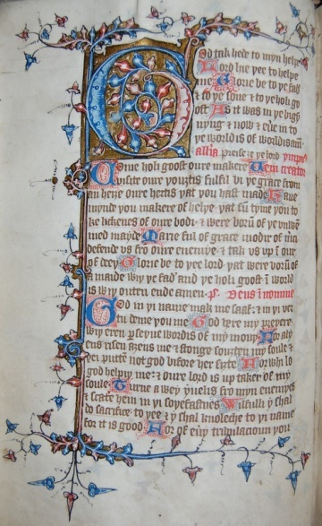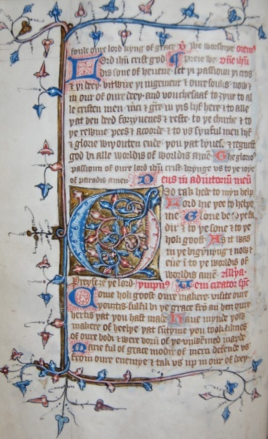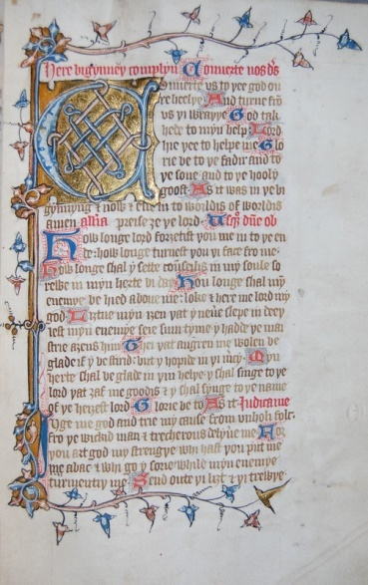

Fig. 1 Fol. 15v (Prime) Fig. 2 Fol. 17v (Tierce) Fig. 3 Fol. 25r (Compline)

B: The Hours of the Cross

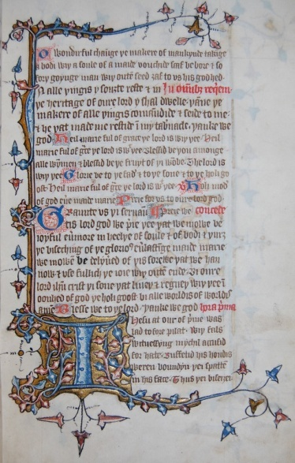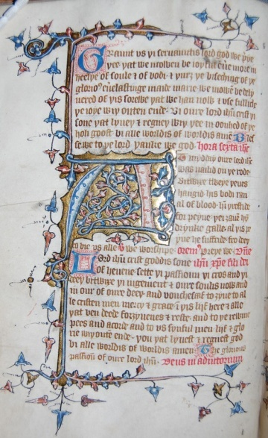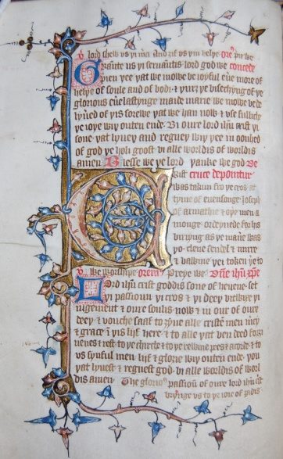

Fig. 4 Fol. 17r (Prime) Fig. 5 Fol. 20v (Sext) Fig. 6 Fol. 24v (Evensong)
C: The Seven Penitential Psalms D: The Office for the Dead

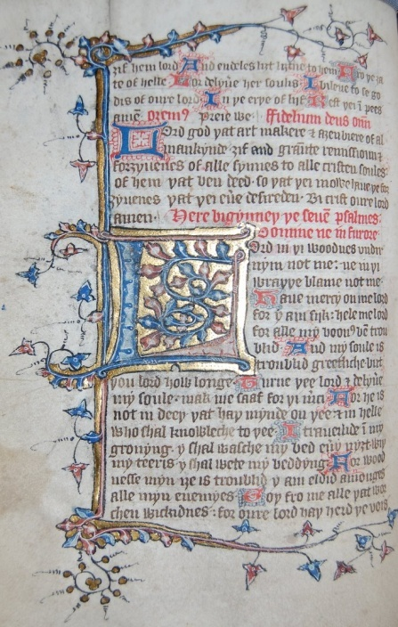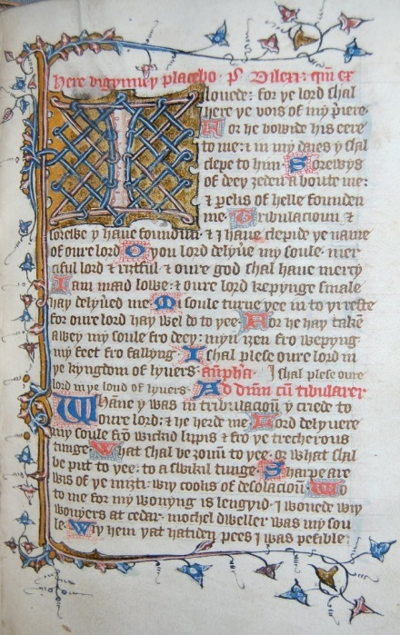

Fig. 7 Fol. 27v Fig. 8 Fol. 35r
By permission of the Master and Fellows of Emmanuel College, Cambridge

Appendix 2.3.iii
Prose Hours of the Cross

Liturgical Hour | London, BL MS Add. 17010, fols. 18r ff. | London, BL MS Add. 17011, fols. 17v ff. | Oxford, Bodl. Ashmolean, MS 1288, fols. 29v ff.
Matins  Versicle  Response  (and at end of each section) | The wisdom of þe fadir goddis sothfastnesse  God man was takyn in þe morwe tyid  And of his knowen discyplis  Soone he was forsaken  Of þe iewis he was betide  Soold i turnementid  We worschepen þe[e] crist blessyn to þe.  Ffor bi þin holi passioun þou hast a3enbou3t þe world. | The wisdom of þe fadir, goddis sothfastnesse  God man was takun in þe morwe tyde  And of his knowen disciples soone he was forsakun  Of the iewes he was betrayed, sold, and turmentid.  We worshipen þee crist, and blessen to þe  For bi þin hooli passioun þou hast a3en bou3t þe world. | Þe wysdom of þe fadir, goddis sooþfastnesse  God man was taken in þe morewend  And of his knowen disciples soone he was forsaken  Of iewis he was bitraied sold and turmentid  We worschipen þee crist, and blessen to þe  For bi þi[n] hooli passion þou hast a3enbou3t þe world. Preie we.
Prime | In the hour of prime iesus was ledde to pilat  hugeli accusid wiþ fals witnessis  Þei smyten him in þe necke  while hise hondes were bounden  Þe face of God þei bispatten  Þe cleere li3t of heuene. | In þe hour of prime ihesu was lad to pilat  Hugely accusyd wiþ fals witnessis  Þei smiten (þerfineten?) him in þe necke  While hys hondis were bownden  Þe face of god þei bespettyn  Þe cleer li3t of heuene. | In þe hour of pryme ihesu was led to pilat  Hougely accusid wiþ fals witnessis  Þei smyten hym in þe necke  While hys hondis were bownden  Þe face of god þei bispatten  Þe cleer li3t of heuene.
Tierce  (‘Underne’) | Crucifie him þei crieden in þe þridde hour  He is skornyd and clothid wiþ þe cloþ of purpure  His heed is pricked wiþ a corowne of þornes  Berynge þe crosse on hise shuldris to þe places of peynes. | Crucifie him þei cryeden in þe þrid our.  He is scornyd and cloþed wiþ þe cloþ of ipur.  His heed is pricked wiþ a croune of þornes  Berynge þe cros on his schuldres to þe place of peynes. | Crucifie hym þei crieden in þe þridde hour.  He is scorned and cloþid wiþ þe clooþ of purpur.  His heed is prickid wiþ a crowne of þornes  Beringe þe cros on his schuldris to þe place of peynes.
Sext | In þe sexte oure iesus is nailed to þe cross  And is ordeyned to honginge among þeues  For turmentis þristinge fillid wiþ galle  Þus is þe lombe of god turmentide þat dide awei synne. | In þe sixte hour ihesu is nayled to þe crosse  And is ordeyned to hongyng among þeves  Ffor turmentis þerstynge filled wiþ galle  Þus is þe lambe of god turmentid  Þat deede awey synne. | In þe sixte our ihesu is nailid to þe cros  And is ordeyned to hongynge amonge þeues  For turmentis þirstinge filled wiþ galle  Þus is þe lomb of god turmentid  Þat dide awei synne.
Nones | At þe hour of noon þe lord iesus 3eldide þe goost  Hely criynge he comendide his soule to þe fadir  A kny3t þurlide his side wiþ a spere  Þanne þe erþe quakide togider and þe sunne derknede. | At þe hour of noon þe lord ihus 3eeldede þe goost  Hely criynge he comendide his soule to þe fader  A kny3t þurlede his side wiþ a spere  Þan þe erþe quakede togidere and þe sune derknede. | (missing)
Evensong | He is don doun of þe cros at þe oure of euensong  Þe stryngþe of him was hid in mynde of þe godhede  suche a deeþ undir3ede þe medicyn of liif  Alas þe corowne of glorie lay byneþe. | He is don down of þe cros at þe hour of evensonge  Þe stringþe of him is hid in myndes of þe godhead  suche a deeþ under 3ede þe medicine of lyf  Alas þe crowne of glorie lay byneþe. | He is don down of þe cros at þe our of evensong  Þe strenkye of hym is hid in mynde of þe godheed  suche a deeþ undir3ede þe medicyn of lyf  Allas þe crowne of glorie lai byneþe.
Compline | At þe hour of cumplyn is 3ouun to þe sepulture  Þe noble bodi of crist hope of liif to come  Dy3t he is wiþ sweete gumme þe scripturis ben fillid  Continuel my[n]de of anguish be þis deeþ to me. | At þe houre of cumplyn is 3oun to þe sepulture  Þe noble bodi of crist hope of ly3f to come  Dy3te he is wiþ swete gume þe scriptures ben filled  Continuel mi[n]de of angwische be þis deeþ to me. | At þe our of cumplyn is 3ouen to þe sepulcrre  Þe noble body of crist hope of lyf to come  Di3t he is wiþ swete gumme þe scripturis ben filled  Contynuel mynde of anguisch be þis deeþ to me.
(Eighth stanza of Hymn to the Cross) | This houre is canonysid wiþ devocioun  To þee crist I recommende wiþ meek resoun  Þat þou of brennyng loue suffrist for me  Be to me solace of deeþ and of anguish. | This ho[ur]e is canonisyd wiþ devocion  to þee crist I recomende wiþ meke reson  Þou þat of brenynge luoue suffredist for me  Be to me solace of deeþ and of angwische. | Þese houris canonysid wiþ devoscioun  To þee crist I recomende wiþ meke resoun  Þou þat of brenynge loue suffredist for me  Be to me solace of deeþ and of anguische.
Prayer of the Passion | Lord iesu crist, sone of god lyuynge,  Putt þi passioun, þi crosse, and þi deþe  Bitwixe þi doom and oure soulis now and in our of oure deeþ  Fouche þou saaf to 3yue to þe quyke merci and grace  To þe deede reste and for3yuenes  And to þe chirche and þe kingdom pees and concorde  To þe syke heelthe and counfort  To oure frendis and enemyes verri charite  And to us sinful liif and endeles glorie  The whiche lyuest and regnest god bi alle worldis of worldis. So be it.  The glorious passioun of oure lord iesu crist delyuere us fro dreri sorwe  And brynge us and alle þe soulis of trewe deede to the ioies of paradiis. So be it.  (transcription mine) | Ihu crist sone of god lyvinge  Putte þi passion þi cros and þi deþ  Betwyxe þi doom and our sowlis  Now and in hour of oure deeþ  Fowchesaf þou to 3eve to þe quyke mercy and grace  To þe deed reste and for3yvenes  To þe churche and þe kingdom pees and concord  To the sike hele and comforte  to our frendis and enemyes  Þei charyte and to us synful lyf and endeles glorie  Þe whiche lyfest and regnyst god be alle worldis of worldis. So be it.  The gloryus passioun of oure lord ihesu crist  Delyvere us from dreri sorwe  And brynge us and alle þe soulis of trewe deede to þe joye of paradis. So be it.  (transcription mine) | Lord ihu crist sone of God lyvynge  Putte þi passion þi cros and þi deeþ  Bitwixe þi doom and oure soulis  Now and in hour of oure deeþ  Fouche saaf to 3eve to þe quike merci and grace  To þe dede reste and for3euenesse  To þe chirche and þe kingdom pees and concord  To the syke helþe and comfort  to our freendis and enemyes  v[er]ri charite and to us sinful  lyf and eendelees glorie  Þe which lyvest and regnest (this word written in margin)  god bi alle worldis of worldis. Amen. So be it.  The glorious passioun of oure lord ihesu crist  Delyvere us fro dreri sorowe  And brynge us and alle þe soulis of trewe dede to þe joies of paradis. So be it.  (transcription mine)

Appendix 3.1 Adaptations of the Hymn to the Cross (sources in Appendix 2.1)

Primer lyrical versions: NIMEV 3499 | Adaptations of hymn to the cross, in horae and anthologies
1. Bodl., MS Bodley 89 (SC 2289), fols. 26 etc.  2. Bodl., MS Rawl. C. 699 (SC 12543), fols. 24 etc.  3. Bodl., MS Douce 246 (SC 21820), fols. 26 etc.  4. Bodl., MS Douce 275 (SC 21849), fols. 15 etc.  5. Oxford, Queen’s College, MS 324, fols. 14v etc.  6. CUL, MS Dd. i.l. 82 fols. 16v etc. (see LFPB)  7. Cambridge, Emmanuel College, MS 246, fols. 14v etc.  8. Cambridge, St John’s College, MS G. 24 (192), fols. 14 etc.  9. BL, MS Add. 36683, fols. 18v etc.  10. GUL, MS Hunter 472, fols. 25 etc.  11. GUL, MS Hunter 512, fols. 66 etc. | - GUL, MS NLS Adv. 18. 7. 21, fol. 2r; NIMEV 1318  - GUL, MS NLS Adv. 19. 2. 1, fols. 70-73; NIMEV 1760  - CUL, MS Add. 4120, fols. 50-55; NIMEV 1155  - CUL, MS Dd. 8.2, fol. 6; NIMEV 241  - Camb., St. John’s Coll., MS 237 (L.10), 35-8; NIMEV 1664  - BL, MS Add. 17376, fols. 182-185v; NIMEV 3681  - BL, MS Add. 37049, fol. 68v; NIMEV 2075  - BL, MS Royal 2.B.X, fol.1; NIMEV 1770  - Bodl., MS Douce 302 ; EETS 184 (1931), 101-4 – by John Audelay (no NIMEV no. - part of longer lyric)  - Bodl., MS English Poet. a. 1(Vernon), fols. 116r-v; NIMEV 701  - Bodl., MS Laud. Misc. 683, fols.15v-17r; NIMEV 702  12. Bodl., MS. Miscell. Liturg. 104, fols. 49v- 88v, 14; NIMEV 3230  13. YML, MS XVI. K. 6 (The Pavement Hours), fols.1r-2r; NIMEV 1963
Primer Prose versions: | Manuscripts with the Latin hymn, ‘Patris Sapiencia’
1. BL, MS Add. 17010  2. BL, MS Add. 17011  3. Bodl., MS Ashmolean 1288 | 1. GUL, MS Hunter 512, fols. 66 etc. (bilingual primer)  2. Bodl.. MS Eng. Poet. A.1 (Vernon MS)  3. YML, MS Add. 67  4. YML, MS XI.0.28

Appendix 3.2

The Vernon Hours of the Cross (Bodl., MS Eng. Poet. a. 1, folios 116r-v)

(Ed.Carl Horstmann, The Minor Poems of the Vernon MS, EETS, OS 98 (1892), 37-43.)

Erliche in þe morwenyng: Ihesu þe Iewes gunne take,
His frendes and his disciples hidden him sone forsake;
Þei blyndfelden him and boffeteden, and al niht heold him wake:
And al soffrede swete Ihesu, 4

ffor monkunne sake þat sorwe.
How may I for-3ete Ihesu:
At euen or at Mor[w]e?

Crist, honoured mote þou be, 8
Þat bouhtest al þe world on tre!

At prime crist þe Iewes, bi-fore Pilat gunne drawe,
Ffallich þei him a-cuiseden, Wiþ mony a wikked sawe;
Þei spitteden in his feire face: þe men wiþ-outen lawe, 12
Ne wolde þei neuere blinne: Til þei hedde him slawe.

Ihesu, my dere lemmon,
Blo for-bled was þi bodi:
Þi brihte Rode was al won. 16

Crist, honoured mote þou beo,
Þat bou3test al þe world on treo.

At vndurne to do Ihesu on cros: loude gunne þei crie,
And beoten him naked wiþ scourges, wil þei mihte drie, 20
And crouned him wiþ þornes, þe blod ron in to his ei3e;
And siþen maden him bere þe cros, to the Mount of Calvarie.

On his bac for-bete.
Ffor drede of deþ men mihte seo: 24
þe blod he gon swete.

Crist, honoured mote þou be,
Þat bou3test al þe world on tre.

At midday Ihesu hondes: þei nayleden to þe Rode, 28
Bi-twene twey þeues: þei him hengen as wode;
Þei 3euen him galle and Eysel: Ihesu þat blissful fode.
Serewful were boþe Marie and Ion: þere þei bi him stode,

As folk were mad. 32
Whose þenkeþ on Marie serwe:
May he neuer be glad.

Crist, honoured mote þou beo,
Þat bouhtest al þe world on treo. 36

At Non þer þurlede Ihesus herte: Longius, a Blynd kniht;
He wupte his ei3en wiþ is blod: þorwh þat he hedde his siht.
Þe eorþe quok, þe stones clouen:
Þe sonne les his liht, 40

Þe dede a-risen of heore graues: In token of godus miht
Þat us on Rode bouhte.
Þe soules þat weren in helle: Ihesus sone out brouhte.

Crist, honoured mote þou be, 44
Þat bou3test al þe world on tre.

At Euensong Ihesus was taken: Doun of Rode-treo.
Marie bi-heold hire deore sone: ffor wepyng miht heo not seo;
“A, Sone,” heo seide, “wiþ þe fader: of heuene is þi pouste, 48
But þou schalt rise from deþ to lyue: As þou er seidest me.

Boþe God and Mon;
Þorwh þat deþ is blisse ibou3t:
Þat loren was þorwh Sathan.” 52

Crist, honoured mote þou beo,
Þat bouhtest al þe world on treo.

At Complin Crist was enoynt: And buried in a ston.
Pilat bad his frendes: þer scholde leue non; 56
He sette knihtes him to kepen: þat he a-wey nere don:
And 3ut he ros to lyue: ffor hem euerichon.

Of þo,
And schewede hem to þe Maudeleyn: 60
To peter and mony mo

Crist, honoured mote þou beo,
Þat bouhtest al þe world on treo.

Prayer on the Passion (repeated at the end of each section of the Hours of the Cross)
Lord Ihesu, godus sone,
Þat synful mon wolt not tyne,
Bi-twenen vr soules and þi dom,
Puttest þe in hard pyne:
Þi cros, þi Deþ now and euere, and at vre endyng-tyme
Graunte liuynde men
Grace and merci þyne.
To dede, reste and pardoun;
To Churche, pes, loue in londe;
To sunful, contricioun.
Cristes passion, heuene kyng,
Bring us to blisse þat is wiþ-outen ending.

At end of Hours to the Cross the following words:
þe Pope Ion haþ graunted : A ful feir pardoun
To alle þat siggen þis Matyns:
wiþ good deuocion:
A 3er in purgatorie: of Remissioun,
So þat heo ben clene i-schriuen: Wiþ verrey Contricioun,
Þorwh Grace.
God sende us lyues fode: And in heuene a place. AMEN.
Appendix 3.3 Unedited Passion Lyrics

3.1.1 (from Bodl., MS Douce 322, fol. 8r) NIMEV 1781/7 (19 versions incl. Vernon, fols. 116v-117, ed. in The Minor Poems of the Vernon Manuscript, part 1, 45-8)

Cantione Amorie
Jhesu thy swetnesse who myght hit se. And thereof had a dere knowing. Al erthely loue bytter shulde be.
But thyne alone withoute lesyng. 4
I pray the lorde that lore lere me.
After thy loue to haue longyng.
And sadly set myne hert in the.
And in thy loue to haue lyking. 8

So lykyng loue in erthe noon is.
In soule who coude hym sadly se.
To loue that lord were myche blys.
Ffor kyng of loue called he ys. 12
Wyth trew loue I wolde ywys.
So harde to hym ybounden be.
So that myn herte were only hys.
And other loue lyked noon me. 16

Yef I for kyndenes shuld love my kyn.
That me thynketh in my thoughte.
By kyndely skyll I shuld be gyn.
At hy(m) that hath me made of nought. 20
Hys sylence he set my soule withynne.
And all thys worlde for me he wrought.
As fader he fondeth my love to wynne.
To the heritage of heuen he hath me bought. 24

As moder of hym I make mynde.
That before my byrthe to me toke hede.
And syth with bapteme wasshed that strynde.
That syled was with Adame dede. 28
Wyth nobly mete he norishet my kynde.
Ffor with his flessh he dothe me fede.
A better food may no man fynde.
To lastyng lyfe hit woll me lede. 32

My brother and syst[er] he ys by skyll.
Ffor himself seyed and lered that lore.
That whose wyrketh hys fadres wyll.
Brother and suster to hym they wore. 36
My kynde also he toke ther tyll.
Fful trewly in hym I trust therefore.
That he wyll neuer suffer me spyll.
But with hys mercy hele my sore. 40

Loue of that lord passeth ywys.
All erthely loue that may be here.
God and man my lorde he ys.
Wel aught me, wreche, to loue hy[m] dere, 44
Bothe heuen and erthe holy ys hys.
He ys a lorde of grete powere.
And called he ys the kyng of blys.
Hys loue me longeth ful sore to lere. 48

After his loue me shuld long.
Ffor he hathe me full dere y bought.
Wan I was goon from hy[m] with wronge.
Ffro heuen to erthe he me sought. 52
My wreched kynde for me to fonge.
And all hys nobylley he set at nought.
Pouert he suffrid and penance stronge.
Til blys ayene or he me brought. 56

Whan I was thrall to make me fre.
My loue fro heuen to erthe hym ledde.
My loue alone haue wolde he.
Therefore he leyde hys lyfe in wedde. 60
Wyth me foo he faught for me.
Wounded he was and bytterly bledde.
Hys piteous blode full grete plente.
Full pituosly for me he shedde. 64

Hys sides full blo and blody were.
That somtyme were ful bryght of ble.
Hys hert was percyed with a spere.
Hys widly woundes was rathe to se. 68
My raunsom payde he for me there.
And gafe hys lyfe for the gylt of me.
Hys dolful dethe shuld do me dere.
And perse myn herte for pure pyte. 72

For pyte myn hert shuld breke in two.
To hys kyndenes yef I toke hede.
Encheson was of all hys woo.
He suffrid all for my mysdede. 76
Tyl lasting dethe for I shuld go
The dethe he suffered in hys manhede.
Wan hys wyll was to ryse also.
He rose ageyne thorough hys godhede. 80

To heuen he wente with mykel blys.
When he had endyd thys grete batayle.
Hys baner ful brode displayed ys.
When so my foo wyll me assayle. 84
Wele aught myn herte to be hys.
Ffor he ys the frende that neii [never] will fayle.
No thynge he wol of me ywys.
But trewe loue of me for his trauayle. 88

Thus wold my lord for me fyght.
And wonded he was for me ful sore.
Ffor my loue his deth was dyght.
What kyndenes myght he to me syþe more. 92
To yelde hy(m) hys loue haue I no myght.
But love hym truly I shuld therefore.
And werke hys wyl with werks right.
That he me lered with louely lore. 96

Hys louely lore with werk fulfyll.
Wel aught me werke yf I were kynde.
Nyght and day to wyrk hys wyll.
And euermore to haue hym in my mynde. 100
But gostly foos greuen me yll.
My frele flesh maketh me all blynde.
Therefore hys mercy I take me tyll.
A better bote can I none fynde. 104

Better bote ys none to me.
But to hys mercy treuly me take.
That with hys blode hath bought me fre.
And of me wreche hys frende wyl make. 108
And by that lord for hys pyte.
Ffor my synnes me nat forsake.
But yeve me grace fro synne to fle.
And in hys loue late me neuer slake. 112

A Jhesu for that swetnes that in the[e] ys.
Haue mynde on me when I hense wende.
With stedfast feythe my witnes thou wys.
Defende me fro the wyked fende. 116
For thy grete mercy foryeue me my mys.
That wyked werkes my soule ne shende.
And brynge me to thyne endles blys.
With the to dwell withoutyn ende. Amen. 120

3.3.2 (from BL, MS Add. 44949, folios 7b-10a; The Tyrwardreath Psalter) ANL 982

Marie, mere douce Iesu crist Mary, mother of sweet Jesus Christ
Que par sa mort venqui la guere Who through his death conquered the battle,
Verroi home et dieu parfit True man and perfect God,
A moi, ma dame, voilez requere To me, my lady, may it please you to bestow 4
Grace en quoer d’estre parfit Grace in heart to be perfect,
Penaunce et vertu a moi attrere Penance and virtue to draw me
Pecché avoir en despit. To hold my sin in contempt
Et haier ceo qu vo[s] poet desplere. And to hate that which may displease you. 8
Oiez seigneur, tres douce Jesu Hear, Lord, very sweet Jesus,
Et pité preignez, pluraunt vo[us] pri And take pity, crying I beg you,
De moi puaunt et foi mentu On me, stinking, and of fake faith
Qe repentaunt vous merci cri. Who, repenting, cries to you for mercy. 12
Traitre trouaunt, chaitive retru A traitor uncovered, a wretch degraded,
Trop fausement vous ai servi Too falsely have I served you,
Pur mon desert jeo sui perdu. Because of my conduct ; I am lost
Si en ta grace ne trove merci. If in your grace I do not find mercy. 16

Pucele plesaunte, sovereigne refu Delightful maiden, sovreign refuge,
En ta priere soulement me fi In your prayer alone I put my trust,
Donez confort, vigour, vertu Give comfort, strength, virtue,
Qe jeo pecchere ne soie peri So that I, a sinner, may not perish. 20
Vers le feloun soiez escu Against the devil be my shield,
Et ne mettes pas en oubli And do not forget,
A mon bosoigne q[u]e ne soie vencu So that in my need I am not vanquished
Par les engines del enemi By the tricks of the enemy. 24

Mercis et graces rendre et dire Mercies and graces I ought to give back and say
Jeo doy a dieu et bien servir Thanks and gratitude to God and to serve him well,
Qui pur moi soeffri martire Who for me suffered to die,
De gré, deigna al crois morir Of his free will, on the cross he deigned to die 28
Faitez moi pecche despire Make me despise my sin
Et pur mon preu touz mals hair And for my profit all sins to hate
Et al graunte iour de cruel ire And at the great day of cruel anger
Ne moi soeffrez chaitive perir Do not allow me, a wretch, to perish. 32

Voilez dame de haut empire Would you, lady, of high power
De vostre servaunt souvenir Remember your servant?
Tastez mon mal et la martire Examine my wrongdoing and the torment
Et moi facez merci merir And cause me to deserve mercy 36
Pur moi priaunt lui puissaunt mire Praying for me to him, the powerful doctor
Qui me voil de tut garir Who wishes to heal me from everything
Ke puisse le tiraunt desconfire So that I may defeat the tirant
Apres en joie a vous venir. Afterwards in joy, to come to you. 40

A vous Seignur, g[ra]nt honour doi To you, Lord, I owe great honour,
Kar tut ma joie en vo[us] remaint Because all my joy remains in you
Qe char et corps preistes pur moi For, flesh and body, you took on for me
L’estoit al crois de cher sank teynt. Which was stained with precious blood on the cross. 44
Allas, allas, pecche por quoi Alas, alas, sin, why have you
M’alme avez si dure destreynt ? So strongly oppressed my soul?
Ceo qe jeo ay fis countré ma foi That which I have done against my faith
Par v[ost]re merci soit refreynt. By your mercy is restrained. 48

Priaunt pardoun de moun pecché Praying pardon for my sin
A vo[us] me renk seignour sovereyn To you I give myself, sovreign Lord,
Reconissaunt qe jeo ay erré. Acknowledging that I have strayed.
Et despendu mon temps en veyn And spent my time in vain 52
Jesu, por moi, al crois perié Jesus, who died for me on the cross,
De mes pecchez moi facez seyn Make me whole from my sins;
Quaunt si chier m’avez rechaté When so dearly you have redeemed me.
De moi saluer neiez dedeyn. Do not disdain to save me. 56

Mere de merci, renomé Mother of mercy, of renown,
Saphir vailaunt de noble grayn Powerful sapphire of noble grain,
A moi chaitife descounceile To me a helpless sinner
De vil pecché qu[e] sui si playn That am so full of vile sins 60
Querez la funte ( ?) de pite You wish, the fount of pity,
Et a mon mal mettez ta mayn And on my sickness to place your hand
Tut soie jeo de grace desperé Although I have despaired of grace,
Si vo[us] priez moi ferrez certayn If you pray, you will make me secure. 64

Pecchez q[u]e totes vostres flestrie Sins which have cmpletely withered you
M’ad mys vers deu a tiel descord Have put me in such discord towards God
Q[u]e m’alme est de tut perie That my soul is in such danger
Si par la merci nient resort. If by your mercy it is not reprieved. 68
Sire, ta m[er]ci touz mals maistrie Lord, your mercy has power over all ills
Me dampnez p[ar] mon mesport You condemn me because of my misbehavour.
Mes redresser ma folie But to set aright my foolishness
Par merci metez al quoer confort. By mercy you comfort my heart 72

Noble dame, de grace garnye Noble lady, by grace adorned
En tristour solace, en perile port In sadness solace, in danger a port
Countre la malice que m’alme espié Against the malice that looks out of my soul
Eider me voilez a la mort You wish to help me in death 76
Metez la crois vers ma partie Place the cross on my breast
Ke triacle est a chescun tort That remedy is for every wrong
Et tut n’eie jeo dame grace merci. And although I may not have, lady, grace, mercy
Par pité deignez faire l’acord. For pity, deign to bring harmony 80

Par pite gr[ac]e mon quoer attent For pity, my heart waits for grace,
Et par pite merci trover And for pity, grace to find,
Allas qe frai chaitive dolent Alas, what shall I do, a suffering wretch ?
Q[u]e taunt a servi ly aduler. So much has he served to suffer for me. 84
Merci seignour, jeo me repent Mercy, Lord, I repent
De mon pecche jeo voil lesser Of my sin; I wish to leave behind
Ceo q[u]e le corps vers vo[s] mesprent The wrong which my body committed against you
Mi alme voillez relesser. Please release my soul. 88

Ma dame, pensez p[or] quoi e coment My lady, think how and why
Jesu soeffri soun corps pener Jesus suffered his body to have pain
Por taunt li priez tendrement On this account pray tenderly to him
Mes defautes deigne excuser That my faults he may deign to excuse 92
Et estre propre al jugement And to be clean on Judgement Day
M’alme de peyne deliverer My soul from punishment to deliver
Ke ne perde par maltalent So that it may not lose through malice
Qe p[ur] sa mort gaigne fichier. That which through his death secured gain. 96

Pecche prenaunt q[uan]t crest y mure Sin taking when it grows and ripens
Peril port et brief douzour Dangerous port and brief sweetness
Kar penaunce ou peyne dour Then through penance or hard labour
Ailours est al chef de tour. Or else at the end of the tower 100
Sir gentil juge ou ta dreiture The Lord (is) gentle judge, or with righteousness
Merci mellez fesaunt favour Mix mercy, giving support
Ou alme q[u]e feistes a ta feture. (In) the soul that you have made in your likeness
Et pardoun gr[a]ntez, mon salveour. And pardon grant, my Saviour. 104

Pleyne de grace, virge pure Pure Virgin, full of grace,
Soul saunz peer (par) des femmes flour. Alone without peer, flower of women,
Aforcez ma frele nature Strengthen my frail nature
De deu servir a soun honour To serve God to his honour 108
Par ta request mettez cure Through your request carry out a cure
A moun meschief mettre socour. Giving help to my misfortune
Qe m’alme sort nette q[ uan]te y seure So that my soul will be clean when it is certain
De trouer joie a mon derrayn jo[ur]. To find joy on my last day. 112

Ma char la mond si vielz tira[u]nt My flesh, the world, its old tirant
Mes sens ount p[ri]s en retenaunce My senses have been made dependent
Countre moi foi faus recreaunt It is a false coward against me
Dounte je me doute de g[ra]nt) vengeaunce. From whence I fear great vengeance. 116
Merci, merci, Seignour vailant Mercy, mercy, valiant Lord
Pité pregnez de ta semblaunce Take pity on someone who looks like you
Salvez le vers (?) treschier marchaunt Save the ( ?) dear merchant
Q[u]e rechatez a grief penaunce. That you have redeemed at a heavy cost 120

Reyne, refu a repentaunt Queen, refuge to a penitent,
Medicine mettez a ma grevaunce Apply medicine to my hurt
Pur moi soiez toun fitz priaunt For me please be pleading to your son,
Ke de merci eie alleggeaunce Out of mercy he may give alleviation 124
Et grace de prover son besaunt And grace, to prove his talent
En dit en fait a sa plesaunce In speech, in deed, pleasing to him,
En pees vivere, desore en avaunt, In peace to live, from now on
Saunz peyne, dolour et encombraunce. Without pain, sorrow and trouble. 128
Amen. Amen.

3.3.3 (from GUL, MS Hunter 512, folios 33r-35r) NIMEV 1747

Ihesu swete is þe loue of þee
Noon oþir þing so swete may be
No þing þat men may heer and see
Haþ no swetnesse a3ens þee 4

Jh[es]u no song may be swetter
No þing in herte blisfullere
Nou3t may be feelid delitfullere
Þa[t] þou so sweete a louere 8

Jh[es]u þi loue was us so fre
Þat it fro hevene brou3te þee
Ffor loue þou dere bou3tist me
Ffor loue þou hynge on roode tre 12

Jhu for loue þou þoledist wrong
Woundis sore and peynes strong
Þin peynes weren ful long
No man may hem telle ne song 16

Jhu for loue þou blod so wo
Þat blody stremys runne þe fro
Þi whyte sydes woxen blw and blo
Our synnes it made so wolawo 20

Jhu for loue þou stei3 on roode
Ffor loue þou 3af þin herte blode
Loue þee made my soules foode
Þi loue us bou3te til al goode 24

Ihu my loue þou were so fre
All þat þou didest for loue of me
What schal I for þat 3elde þee
Þou arist nou3t but loue of me 28

Ihu my god ihu my kyng
Þou axist me noon oþir þing
But trewe loue and herte 3ernyng
And loue teeris wiþ swete morning 32

Ihu mi loue ihu my ly3[t]
I wole þee loue and þat is ri3t
Do me loue þee wiþ al my mi3t
And for þee moorne boþe day and ni3t 36

Jhu to me so 3erne þee
Þat my þou3t evere upon þee be
Wiþ þin y3e loke to me
And myldely my nede se 40

Ihu þi loue be al my þou3t
Of oþer þing ne recche me nou3t
Þane haue I þi wille al wrou3t
Þat hauest me ful dere bou3t 44

Crist makiþ to man a fair plent
His blody body wiþ loue brent
Þat blisful body his lyf haþ lent
Ffor loue of man þat synne haþ blent 48

O loue, loue, what hast þou ment
Ore þinkeþ þat loue to wraþþe is went
Þi loueliche ho[n]dis loue haþ to rent
And þi liþe (?) arme wel streit itent 52
Þi brest is bear þi bodi is bent
For wrong haþ wonne and ri3t is it hent

Þi mylde boones loue haþ to drawe
Þe naylis þee feet han al to gnawe 56
Þe lord of loue loue haþ now stawe
Whene loue is strong it haþ no lawe
His herte is rent
Upon þe roode tre
His body is bent 60
Wrong is went
Cr[is]t þur3 þe my3t of þee
Þe devel is schent

For þee þat herte is leyd to wedde
Swych was þe loue þat herte us kedde 64
Þat herte barst Þat herte bledde
Þat herte blod our soulis fedde

Þat herte clefte for treuþe of loue
Þerfore in him alone is trewe loue 68
Ffor loue of þee þat herte is 3oue
Kepe þou þat herte and þou art aboue

Loue loue where schalt þou wone
Þou wonyng stede is þee bi nome 72
Ffor cr[is]tis herte þat was þin hoome
He is deed now hast þou noon

Loue loue whi doist þou so
Loue þat brekist myn herte a two 76

Loue haþ schewid his greet my3t
Ffor loue haþ maad of day þe ny3t
Loue haþ slawe þe kyng of ri3t
And loue haþ endid þe strong fi3t 80

So inliche loue was neuer noon
Þat witiþ wel marie and soon
And also witte þei eurychon
Þat loue wiþ hym is maad at oon 84

Loue makiþ crist þi herte myn
So makiþ loue myn herte þin
Þan schulde myn be trewe al tym
And loue and loue schal make it fyn. 88

Appendix 4.1 Manuscript Listings of Vernacular Mass Prayers

NIMEV no. /no. of mss | Middle English Mass Prayers  (incipits as cited in NIMEV) | ANL no./  no. of mss | Anglo-Norman Mass Prayers  (incipits as cited in ANL)
1052/1  1071/1  1323 (part of 3507)  1368/1  1372/6  1372 (variant /1)  1729/5 (c.f. 961, 4149)  1734/1  2512/1  3507 /9  3882/2  3883/6  3884/1  4052/1  4249/3 | Hayle Iesu Godys Sone in forme of bred  Heyl my lord in wom ich leue / sothfastliche god & man  I knowe to the god ful of myght  I þank þe ihesu of al þy goodnesse  I þe honoure wiþ al my miht/In forme of bred as I þe see  Welcome be þu soule fode  Ihesu lord welcom þow be / In forme of bred as I þe see  Ihesu my lord welcom þou be/In flesch & blode I þe see (York Add.2/Bolton Hours)  O merciful ihesu for merci to the I crie  Þe worthyest þing most of godnesse (LFMB)  Welcome lord in forme of bred  Welcome lord in fourme of Bred  Wolcome loured in likninge of bred  When þu seyst þe sacrement (Audelay/Douce 302)  Ye holy prestes remembreth in your herte (Lydgate) | 720/4  721/1  722/1  723/1  724/3  725/3  726/3  727/3  728/3  729/3  730/3  731/6 | Nostre seygnur Ihesu Crist quant il voleit partir de ceste siecle… (meditation)  Au primer Agnus Dei dites vostre Pater Noster e puis ensuant pensez de prier… (instructions)  Ceo que vous devez fere e penser a chascon point de la messe… (AN instructions accompanying Latin Mass – Paris, Bibl. Nat., franç. 13342 [see Wormald])  De toutes les choses qe sount/cest la plus digne del mound  Douz sire al commencement /de ceste Mass en present  Beau sire Dieu com il est voyr/que ly treis rois par un voloir  Seynt Espirit en vous descende /de tous pecchez si vous defende  Verrai Dieu jeo vous aour / que muster mavez grant amur  Sire Dieu roy omnipotent / si come jeo croi fermement  Moun douz seignur uncore vous pri / pur les almes qe sount parti  Soverain seignur sur tretouz / jeo ai entendu que treis amurs  Beau sire Deu omnipotent / merci vous cri mult humblement (levation prayer)

ME Prayers on the manner and merits of the Mass:
1986/2 – ‘Lordyngis & 3e wyl lythe’ (Audelay)
3424/2 - ‘The Masse is of so high Dignytee’ (a C-15 carol)
3426.55/1 - ‘the meedes and graces of þe Masse beholde’
3427/1 - ‘The merites of mas who can expresse’
4246/10 – ‘Yhe folks alle whiche han devocioune’ (Lydgate)
4276/1 – ‘3ong and olde, more and lasse’ (from Vernon MS, f. 302b)

Appendix 5 Reconstruction of a Medieval Mass (Use of York)

All Saints North Street Church, York

A Feast for Our Lady of North Street: Order of Service, Saturday, 18th July, 2009

1 Procession Deacon  Choir  2 Choir sings Antiphon  Prayer - Priest  Choir  3 Introit:  (Vernacular Mass Prayer for congregation to say during Introit)  A Office and Psalm, Proper for the Feast of the Assumption  B Kyrie : Rex Virginum (York and Hereford Use)  C Gloria  Priest  Choir  Priest  Server  D Collect  Priest  Choir  4 Reading of the Epistle:  Revelation 11:19a; 12:1-6a, 10ab  (by the subdeacon)  5 Gradual  6 Sequence  Deacon  Server  Deacon  Server  At this point, the congregation stands, making a sign of the cross, and can say the English prayer) (During the reading of the Gospel, the congregation is encouraged to meditate on the redeemer and to pray silently for the strength to do his will)  7 Reading of the Gospel (Luke 1: 39-56)  (by the deacon)  8 Creed  (the congregation is encouraged to say the Nicene Creed in Latin or English to themselves)  Priest  Server  Priest  9 Offertory (priest says it to himself, while the choir sing in plainchant)  Priest to people, (low but audible voice)  (At this point, the congregation could say a prayer of confession in English)  10 Secret  (priest says the special prayer for the feast to himself,  …ending in audible voice:  with hands raised and turned towards the people)  Priest  Server  Priest  Server  Priest  Server  11 Proper Preface for the Feast of the Assumption:  Priest  Sanctus and Benedictus  Server/Choir  12 Canon of the Mass:  13 Elevation prayer of the people  (the congregation can recite one of the English levation prayers, such as written here)  14 Words of Institution  Priest  Priest  Priest  15 The Lord’s Prayer  Priest  (Again, the congregation is encouraged to pray in Latin or in English)  Choir  Priest (silently)  16 Embolism  Priest  Priest  Server  Priest  Server  17 Agnus Dei  Choir  18 Communion Proper  Priest and Choir  (to be intoned)  19 Communion of  the People  Priest  All  Priest  All  Priest  Server  Priest  (The congregation can say a final prayer in English)  Post-Communion Prayer  Priest sings  Final dismissal  Priest  Server  Deacon  Server | Procedamus in pace  In nomine Christi. Amen.  Ad nutum domini nostrum ditantes honorem,  Sicut spina rosam , genuit Judea Mariam  Ut vitium virtus operiret, gratia culpam  Sicut spina rosam , genuit Judea Mariam  Gloria Patri et Filio et Spiritui Sancto  Sicut spina rosam , genuit Judea Mariam  Exaltata es sancta dei genetrix : super choros angelorum ad celestia regna.  Sicut spina rosam , genuit Judea Mariam  Oremus. Famulorum tuorum quesumus domine delictis ignosce: ut qui tibi placere de actibus nostris non valemus genitricis filii tui domini dei nostri intercessione saluemur. Per eundem christum dominum nostrum.  Stirps Jesse virgam produxit, virgaque florem: Et super hun florem Requiescit Spiritus almus.  Virgo Dei genitrix virga est flos Filius ejus  Gloria Patri et Filio et Spiritui Sancto  Ascendit Christus super celos et preparavit sue castissime matri immortalitatis locum : et hec est illa preclara festivitas omnium sanctorum festivitatibus incomparabilis : in qua gloriosa et felix mirantibus celestis curie ordinibus : ad ethereum pervenit thalamum : quo pia sui memorum immemor nequaquam existat.  Exaltata es, sancta Dei genetrix.  Oremus. Veneranda nobis, domine, hujos diei festivitas opem conferat sempiternam, in qua sancta Dei genitrix mortem subiit temporalem, nec tamen mortis nexibus deprimi potuit; quae Filium tuum Dominum nostrum de se genuit incarnatum. Qui tecum vivit et regnat in unitate Spiritus Sancti, Deus, Per omnia saecula saeculorem.  Now lord god, for thi godenesse,  At the begynnynge of this messe,  Thou graunte to alle that hit schal here,  That in concience thei may be clere;  Lord, thu saue the prest, þat hit schal say,  Fram gret temtacioun this ilke day,  That he be clene in dede and thought,  That yuel spirit noy him nought  To fulfylle this sacrament  With clene herte and gode entent;  First princypaly to thyn honoure,  That souereyn ert and socoure,  And to thyy modere, maiden clene,  And to thyne seyntes alle bi-dene,  And alle that hit hereth to here soules helthe,  Thu help hem with thi grace and thi welthe,  And alle that we haue in mynde,  Sib or any frend bi any kynde;  And, lorde, graunt ham for this messe,  Of alle hare synnes forgifnesse,  And rest and pes that lasteth ay,  To cristene soules that beth passyd away;  And bring us to ioie with-outen ende  And to us alle thi socoure sende. Amen.  Gaudeamus omnes in Domino, diem festum celebrantes sub honore Mariae Virginis: de cujus assumptione gaudent angeli, et collaudant Filium Dei. (Psalm) Eructavit cor meum verbum bonum; dico ego opera mea Regi.  Alleluia. Hodie Maria Virgo coelos ascendit: gaudete, quia cum Christo regnat in aeternum.  Rex virginum amator, Deus, Mariae decus, eleyson. Qui de stripe regia clara producis Mariam, eleyson. Preces ejus suscipe dignas pro mundo fusas, eleyson. Christe, Deus de Patre, homo natus Maria matre, eleyson. Quem ventre beato Maria edidit mundo, eleyson. Sume laudes nostras Mariae almae dicatas, eleyson. O Paraclite, obumbrans corpus Mariae, eleyson.  Qui dignum facis thalamum pectrus Mariae, eleyson. Qui super caelos spiritum levas Mariae eleyson. Fac nos post ipsam scandere tua virtute, Spiritus alme, eleyson.  Gloria in excelsis Deo,  Et en terra pax hominibus bonae voluntatis. Laudamus te. Benedicimus te. Adoramus te. Glorificamus te. Gratias agimus tibi propter magnam gloriam tuam. Domine Deus, Rex caelestis, Deus Pater omnipotens. Domine Fili unigenite, Iesu Christe. Domine Deus, Agnus Dei, Filius Patris. Qui tollis peccata mundi, miserere nobis. Qui tollis peccata mundi, suscipe deprecationem nostram. Qui sedes ad dexteram Patris, miserere nobis. Quoniam tu solus Sanctus. Tu solus Dominus. Tu solus Altissimus, Iesu Christe. Cum Sancto Spiritu, in gloria Dei Patris. Amen.  (V) Dominus vobiscum  (R) Et cum spiritu tuo  Oremus. Veneranda nobis, domine, hujos deie festivitas opem conferat sempiternam, in qua sancta Dei genitrix mortem subiit temporalem, nec tamen mortis nexibus deprimi potuit ; quae Filium tuum Dominum nostrum de se genuit incarnatum. Qui tecum vivit et regnat in unitate Spiritus Sancti, Deus, Per omnia saecula saeculorem.  Amen  Et apertum est templum Dei in caelo et visa est arca testamenti eius in templo eius.  Et signum magnum paruit in caelo mulier amicta sole et luna sub pedibus eius et in capite eius corona stellarum duodecim et in utero habens et clamat parturiens et cruciatur ut pariat et visum est aliud signum in caelo et ecce draco magnus rufus habens capita septem et cornua decem et in capitibus suis septem diademata et cauda eius trahebat tertiam partem stellarum caeli et misit eas in terram et draco stetit ante mulierem quae erat paritura ut cum peperisset filium eius devoraret et peperit filium masculum qui recturus erit omnes gentes in virga ferrea et raptus est filius eius ad Deum et ad thronum eius et mulier fugit in solitudinem ubi habet locum paratum a Deo.  Et audivi vocem magnam in caelo dicentem nunc facta est salus et virtus et regnum Dei nostri et potestas Christi.  Benedicta et venerabilis es, virgo Maria; quae sine tactu pudoris inventa es mater Salvatoris.  Virgo Dei genetrix, quem totus non capit orbis : in tua se clausit viscera factus homo.  Alleluia  Post partum virgo inviolata permansisti; Dei genetrix intercede pro nobis.  Alleluia  Alleluia. Assumpta est Maria in caelum; gaudent angeli et collaudantes benedicunt. Dominum.  Ave Maria, gratia plena, Dominus tecum, benedicta tu in mulieribus,  et benedictus fructus ventris tui.  Hac clara die turma festiva dat praeconia,  Mariam concrepando symphonia nectarea ;  Mundi domina quae es sola, castissima virginum regina,  Salutis causa, vitae porta, atque caeli referta gratia.  Nam ad illam sunt nuntia olim facta angelica,  Ave, Maria, gratia Dei plena per saecula,  Mulierum pia agmina inta semper benedicta;  Virgo, et gravida, mater intacta prole gloriosa.  Cui contra Maria haec reddit famina:  In me quomodo tua iam fient nuntia?  Viri novi nullam certe copulam;  Ex quo atque nata sum incorrupta.  Diva missus ita reddit affata;  Flatu sacro plena fies, Maria,  Nova referens gaudia a caelo terrae nati per exordia:  Intra tui uteri claustra portas qui gubernat aethera,  Omnia qui dat tempora pacifica.  Dominus vobiscum  Et cum spiritu tuo  Sequentia sancti evangelii secundum Lucam:  Gloria tibi Domine  In the name of the fadir, the sone, and þe holigost,  On sothfast god of myghtes most,  Wel-come, lorde, thi worde to me,  As, ihesu, lowynge be to the.  Ihesu, myne, graunt me þi grace,  And of amendment might and space,  Þi word to kepe and do þi wille,  Þo gode to chese and leeue þo ille,  And þat hit so may be,  Gode ihesu, graunt hit me. Amen.  Exsurgens autem Maria in diebus illis abiit in montana cum festinatione in civitatem Iuda, et intravit in domum Zacchariae et salutavit Elisabeth. Et factum est ut audivit salutationem Mariae, Elisabeth exultavit infans in utero eius et repleta est Spiritu Sancto Elisabeth, et exclamavit voce magna et dixit, benedicta tu inter mulieres et benedictus fructus ventris tui et unde hoc mihi ut veniat mater Domini mei ad me. Ecce enim ut facta est vox salutationis tuae in auribus meis exultavit in gaudio infans in utero meo. Et beata quae credidit quoniam perficientur ea quae dicta sunt ei a Domino. Et ait Maria, magnificat anima mea Dominum, et exultavit spiritus meus in Deo salutari meo quia respexit humilitatem ancillae suae. Ecce enim ex hoc beatam me dicent omnes generationes, quia fecit mihi magna qui potens est et sanctum nomen. Eius et misericordia eius in progenies et progenies. Timentibus eum fecit potentiam in brachio suo, dispersit superbos mente cordis sui deposuit potentes de sede et exaltavit humiles esurientes, implevit bonis et divites dimisit inanes suscepit Israhel puerum, suum memorari misericordiae, sicut locutus est ad patres nostros, Abraham et semini eius in saecula. Mansit autem Maria cum illa quasi mensibus tribus et reversa est in domum suam.  Credo in unum Deum, Patrem omnipotentem, factorem coeli et terrae, visibilium omnium et invisibilium. Et in unum Dominum Jesum Christum, Filium Dei unigenitum. Et ex Patre natum ante omnia saecula. Deum de Deo, lumen de lumine, Deum verum de Deo vero. Genitum, not factum, consubstantialem Patri: per quem omnia facta sunt. Qui propter nos homines, et propter nostram salutem descendit de coelis.  Et incarnatus est de Spiritu Sancto ex Maria Virgine:et homo factus est. Crucifixus etiam pro nobis; sub Pontio Pilato passus, et sepultus est. Et resurrexit tertia die, secundum Scripturas. Et ascendit in coelum: sedet ad desteram Patris. Et iterum venturus est com gloria judicare vivos et mortuos. cujus regni non erit finis. Et in Spiritum Sanctum, Dominum et vivificantem: qui ex Patre Filioque procedit. Qui cum Patre, et Filio simul adoratur et conglorificatur: qui locutus est per Prophetas. Et unam, sanctam, catholicam et apostolicam Ecclesiam. Confiteor unum baptisma in remissionem peccatorum. Et exspecto resurrectionem mortuorum. Et vitam ventura saeculi. Amen.  Dominus vobiscum.  Et cum spiritu tuo.  Oremus.  Felix namque es, beata virgo Maria, et omni laude dignissima: quia ex te ortus est sol justiciae Christus Deus noster.  Orate fratres, et meum ac vestrum sacrificium acceptabile fiat apud Deum Patrem omnipotentem. Suscipiat Dominus sacrificium de manibus tuis ad laudem et gloriam nominis sui, ad utilitatem quoque nostram, totiusque Ecclesiae suae sanctae.  I know to god ful of myght,  And to his moder, mayde bright,  And to alle his halwes dere,  In many synnes of diuerse manere,  And to the, fader gostely,  That I haw synned largely.  In thought, in speche, in delite,  In worde, in werke, I am to witte,  And worthi I am to blame,  For falsly I haw take goddys name.  There-fore I pray seynte mari  And alle halwes specialy,  And the preste [to] pray for me,  That god haw merci and pitte  Of mi mysdede þat mochel is,  For his manhode and his godnys,  And of me wreche that sinful is,  And 3ew me grace of for-3euenys.  Oremus…  …Per omni saeculi saeculorum.  Dominus vobiscum.  Et cum spiritu tuo.  Sursum corda.  Habemus ad Dominum.  Gratias agamus Domino Deo nostro.  Dignum et justum est.  Vere dignum et justum est, aequum et salutare, nos tibi semper et ubique gratias agere, Domine, sancte Pater, omnipotens aeterne Deus; et te in assumptione beatae et gloriosae semper Virginis Mariae exsultantibus animis laudare, benedicere, et praedicare : Quae et Unigenitum tuum Sancti Spiritus obumbratione concepit, et, virginitatis gloria permanente, hic mundo lumen aeternum effudit Jesum Christum nostrum : Per quem majestatem tuam laudant angeli, adorant dominationes, tremunt potestate, caeli, caelorumque virtutes ac beata Seraphin socia exsultatione concelebrant.Cum quibus et nostras voces ut admitti jubeas deprecamur, supplici confessione dicentes :  Sanctus, Sanctus, Sanctus, Dominus.  Pleni sunt coeli et terra gloria tua.  Hosanna in excelsis.  Benedictus Mariae filius qui venit in nomine Domini.  Hosanna in excelsis.  Hoc est enim Corpus meum  Welcome, lorde, in fourme of brede  For me þou suffered herd deede;  Als þou bare the crowne of thorne  Þou suffer me noghte be forlorne  Or  Loued be þou, kyng,  and blessed be þou, kyng;  Of alle þi gyftes gode,  and þanked be þou kyng,  iesu, al my ioying,  þat for me spilt þi blode,  and dyed opon þo rode,  þou gyue me grace to sing  þo song of þi louing  Hic est enim calix sanguinis mei, novi et aeterni testamenti: mysterium fidei: qui pro vobis et pro multis effundetur in remissionem peccatorum.  Haec quotiescumque feceritis, in mei memoriam facietis.  Per omnia saecula saeculorum  Amen  Oremus.  Praeceptis salutaribus moniti, et divina institutione formati, audemus dicere:  Pater noster, qui es in coelis. sanctificetur nomen tuum: adveniat regnum tuum: fiat voluntas tua, sicut in coelo, et in terra. Panem nostrum quotibianum da nobis hodie, et dimitte nobis debita nostra, sicut et nos dimittimus debitoribus nostris. Et ne nos inducas in tentationem:  Sed libera nos a malo.  Amen.  Libera nos, quaesumus, Domine, ab omnibus malis, praeteritis, praesentibus, et futuris, et intercedente beata et gloriosa semper Virgine Dei Genitrice Maria, cum beatis Apostolis tuis Petro et Paulo, atque Andrea, et omnibus Sanctis.  Da propitius pacem in diebus nostris, ut ope misericordiae tuae adjuti, et a peccato simus semper liberi, et ab omni perturbatione securi.  Per eumdem Dominum nostrum Jesum Christum Filium tuum.  Qui tecum vivit et regnat in unitate Spiritus Sancti Deus.  Per omnia saecula saeculorum.  Amen.  Pax Domini sit semper vobiscum.  Et cum spiritu tuo.  Agnus Dei, qui tolis peccata mundi, misere nobis.  Agnus Dei, qui tollis peccata mundi, misere nobis.  Agnus Dei, qui tollis peccata mundi, dona nobis pacem.  Beatae viscera Mariae virginis quae portaverunt aeterni Patris Filium.  et beata ubera, quæ lactaverunt Christum Dominum:  qui hodie pro salute mundi de Virgine nasci dignatus est  Ecce Agnus Dei, ecce qui tollit peccata mundi:  Domine, nom sum dignus et intres sub tectum meum; sed tantum dic verbo, et anabitur anima mea.  Corpus Domini nostri Jesu Christi custodiat animam tuam in vitam aeternam.  Amen.  Dominus vobiscum.  Et cum spiritu tuo.  Oremus  God be thanked of alle his werkes,  And thankede of prestes and clerkys;  God be thankede of eche man,  I thanke my lord, as hertly as I can;  I thanke him hertli of his kyndenesse,  And namely now of this holi messe;  Of alle the praierys that here ben praied,  I pray my swete lord that he be paied.  In mynde of god I me blesse,  With my blessynge god sende me his.  Sumptis, Domine, salutis nostrae subsidiis, da, quaesumus, beatae Dei genetricis semperque virginis Mariae nos patrociniis ubique protege, in cujus veneratione haec tuae obtulimus majestati.  Amen  Dominus vobiscum.  Et cum spiritu tuo.  Ite, Missa est.  Deo gratias. | Let us proceed in peace  In the name of Christ. Amen.  According to the will of the Lord, enriching our honour  Just as the thorn brings forth the rose, so Judea brought forth Mary.  So that virtue might cover vice and grace might cover sin  Just as the thorn brings forth the rose, so Judea brought forth Mary.  Glory be to the Father, and to the Son, and to the Holy Spirit  Just as the thorn brings forth the rose, so Judea brought forth Mary.  You are exalted, holy mother of God  above the choirs of angels to the kingdom of heaven  Just as the thorn brings forth the rose, so Judea brought forth Mary.  Let us pray. We thy servants beseech thee, O Lord: forgive us our offences, that we who by our deeds are not worthy to please thee, may by the intercessions of the mother of thy Son, our Lord and God, find salvation.  The root of Jesse produced a branch and the branch produced a flower: and the bountiful Spirit rests over the flower.  The Virgin mother of God is the branch; the flower is her Son  Glory to the Father and to the Son and to the Holy Ghost  Christ ascended above the heavens and prepared an everlasting place for his most chaste mother. And this is that distinguished festival, incomparable with the festivals of all other saints, on which day the glorious and happy one reaches the eternal marriage bed among  the marvelling ranks of the heavenly court: so that the holy woman might appear, ever remindful of her memorial.  You are exalted, holy mother of God  Let us pray. Let the honoured festival of this day, O Lord, bring us perpetual aid; on which the holy Mother of God underwent temporal death, yet could not be held by the bonds of death, because she bore incarnate of herself thy Son, our Lord, Who liveth and reigneth in the unity of the Holy Spirit, God, for ever and ever.  Now Lord, God, of your goodness,  At the beginning of this Mass,  May you grant to all who it shall hear,  That of conscience they may be clear;  Lord, save the priest who it shall say,  From great temptation this very day,  That he be clean in deed and thought,  That an evil spirit will prevent him not  From fulfilling this sacrament  With a clean heart and good intent.  First, we appeal to your honour,  You who are sovereign, and ask for succour  From your mother, a maiden pure,  And from all your saints who have gone before.  And to all who hear the Mass for their souls’ health,  May you help them by your grace and your wealth,  And all whom we have in mind,  Family or friends of any kind;  And Lord, grant them before this Mass,  For all their sins forgiveness,  And everlasting rest and peace,  To Christian souls who have passed away;  And bring us to joy without end  And to all of us your succour send.  Amen.  Let us rejoice in the Lord, celebrating a feast-day in honour of the Blessed Virgin Mary, at whose assumption the angels are rejoicing and praising the Son of God.  (Psalm)My heart hath uttered a good word: I tell my works to the king.  Alleluia. Today the Virgin Mary ascended into heaven; rejoice, for she reigns with Christ forever.  King, lover of virgins, God, Mary’s glory: have mercy upon us; who brought forth Mary from royal stock, have mercy upon us.  Receive her prayers, worthy offerings on behalf of the world, have mercy upon us.  Christ, God of the Father, born as man of the mother Mary, have mercy upon us; whom Mary gave forth to the world from her holy womb, have mercy upon us. Accept our praises, consecrated to thy beloved Mary: have mercy upon us. O Paraclete, sheltering the body of Mary: have mercy upon us; who made the body of Mary a worthy chamber, have mercy upon us; whose spirit lifted Mary to the heavens, have mercy upon us. Make us ascend after her through your power, beloved spirit: have mercy upon us.  Glory be to God on high,  And on earth peace, good will towards men. We praise you, we bless you, we worship you, we glorify you, we give thanks to you for your great glory, O Lord God, heavenly King, God the Father Almighty. O Lord, the only-begotten Son, Jesus Christ; O Lord God, Lamb of God, Son of the Father, who takes away the sins of the world, have mercy upon us, who takes away the sins of the world, receive our prayer. Who sits at the right hand of God the Father, have mercy upon us. For you alone are holy; you alone are the Lord, you alone are most high, O Christ, with the Holy Ghost, in the glory of God the Father. Amen.  The Lord be with you  And also with you  Let us pray. Let the honoured festival of today, O Lord, bring us perpetual aid; on which the holy Mother of God underwent temporal death, yet could not be held by the bonds of death, because she bore incarnate of herself your Son, our Lord. Who lives and reigns in the unity of the Holy Spirit, God, for ever and ever.  Amen  God's temple in heaven was opened, and the ark of His covenant could be seen in the temple. A great sign appeared in the sky, a woman clothed with the sun, with the moon beneath her feet, and on her head a crown of twelve stars. She was with child and wailed aloud in pain as she laboured to give birth.Then another sign appeared in the sky; it was a huge red dragon, with seven heads and ten horns, and on its heads were seven diadems. Its tail swept away a third of the stars in the sky and hurled them down to the earth. Then the dragon stood before the woman about to give birth, to devour her child when she gave birth. She gave birth to a son, a male child, destined to rule all the nations with an iron rod. Her child was caught up to God and His throne. The woman herself fled into the desert where she had a place prepared by God. Then I heard a loud voice in heaven say: "Now have salvation and power come, and the kingdom of our God and the authority of His Christ."  (R) Blessed and venerable are you, O Virgin Mary, who with purity unstained was found to be the Mother of our Saviour.  (V) Virgin Mother of God, He whom the whole world was unable to contain enclosed Himself in your womb, being made man.  (R) Alleluia  (V) After birth you remained an untouched virgin; Mother of God, intercede for us.  (R) Alleluia  (V) Alleluia. Mary has been taken up into heaven. A host of angels rejoice and praise and bless the Lord.  Hail Mary, full of grace, our Lord is with you, blessed are you among women, and blessed is the fruit of your womb.  On this bright day the throng offers public laudations, Proclaiming Mary in a sweet-sounding symphony: “O, mistress of the world, the most chaste queen of virgins,  The source of salvation, the gate of life, and filled with the grace of heaven.”  For once angelic announcements were made to her:  “Hail Mary, full of the grace of God, throughout eternity, forever blessed among the saintly ranks of women,  Both virgin, and with child, a chaste mother with glorious offspring”  In reply to whom Mary speaks these words:  “How can your proclamations now come to pass in me? Assuredly, I have never known a man,  And I was born incorrupt from one also.”  When the saintly woman had addressed him in this manner, the angel declared: “You shall become filled with the sacred breath, Mary,  Bearing from heaven to earth the joys of the Son through a new beginning. You carry within the enclosures of your womb the one who governs the heavens, and who confers peaceful times upon all.”  The Lord be with you  And with thy spirit  A continuation of the Holy Gospel according to Luke:  Glory to you, O Lord  In the name of the Father, and the Son, and the Holy Ghost,  One steadfast God full of might,  Lord, your word is welcome to me,  So, Jesus, praise be to Thee.  My Jesus, grant me your grace,  And by correction, the strength and space,  To keep your word and do your will,  To chase after good and forsake evil,  And so that it may be,  Good Jesus, grant it to me. Amen.  In those days Mary arose and went with haste into the hill country, to a city of Judah, and she entered the house of Zechariah and greeted Elizabeth. And when Elizabeth heard the greeting of Mary, the babe leaped in her womb; and Elizabeth was filled with the Holy Spirit and she exclaimed with a loud cry, "Blessed are you among women, and blessed is the fruit of your womb! And why is this granted me, that the mother of my Lord should come to me? For behold, when the voice of your greeting came to my ears, the babe in my womb leaped for joy. And blessed is she who believed that there would be a fulfilment of what was spoken to her from the Lord." And Mary said, "My soul magnifies the Lord, and my spirit rejoices in God my Saviour, for He has regarded the low estate of his handmaiden. For behold, henceforth all generations will call me blessed; for He who is mighty has done great things for me, and holy is His name. And His mercy is on those who fear Him from generation to generation. He has shown strength with His arm, He has scattered the proud in the imagination of their hearts, He has put down the mighty from their thrones, and exalted those of low degree; He has filled the hungry with good things, and the rich He has sent empty away. He has helped His servant Israel, in remembrance of His mercy, as He spoke to our fathers, to Abraham and to His posterity for ever." And Mary remained with her about three months, and returned to her home.  I believe in one God, The Father Almighty, Maker of heaven and earth, and of all things visible and invisible. And in one Lord, Jesus Christ, the Only-begotten Son of God. Born of the Father before all ages. God of God, Light of Light, true God of true God. Begotten, not made, of one substance with the Father. By whom all things were made. Who for us men and for our salvation came down from heaven.  (congregation kneels)  And became incarnate by the Holy Spirit of the Virgin Mary: and was made man. (congregation rises)  He was also crucified for us, suffered under Pontius Pilate, and was buried. And on the third day He rose again according to the Scriptures. He ascended into heaven and sits at the right hand of the Father. He will come again in glory to judge the living and the dead and His kingdom will have no end. And in the Holy Spirit, the Lord and Giver of life, Who proceeds from the Father and the Son. Who together with the Father and the Son is adored and glorified, and who spoke through the prophets. And one holy, Catholic and Apostolic Church. I confess one baptism for the forgiveness of sins and I await the resurrection of the dead and the life of the world to come. Amen.  May the Lord be with you.  And with your spirit.  Let us pray  For you are happy, O blessed Virgin Mary, and most worthy of all praise; since out of you has arisen the Sun of Justice, Christ our Lord.  Pray brothers, that my Sacrifice and yours may be acceptable to God the Father Almighty.  May the Lord receive the Sacrifice from your hands to the praise and glory of His Name, for our good, and that of all His holy Church.  I know to God full of might,  And to his mother, a maiden bright,  And to all his dear saints,  In many sins of a diverse manner,  And to Thee, spiritual Father,  That I have sinned greatly  In thought, in speech, in worldly pleasure,  In words, in deeds, I am aware,  And fully I am to blame,  For I have taken God’s name in vain.  Therefore, I pray to Saint Mary,  And to all the saints especially,  And ask the priest to pray for me  That God will have mercy and pity  For my misdeeds, which are many,  For the sake of his humanity and divinity,  And that to me, a wretch who sinful is,  He may grant the grace of forgiveness.  Let us pray…  …For ever and ever, Amen  May the Lord be with you.  And with your spirit.  Lift up your hearts.  We have lifted them up to the Lord.  Let us give thanks to the Lord our God.  It is fitting and right to do so.  It is indeed fitting and right, our duty and our salvation, always and everywhere to give thanks to You, Lord, Holy Father, almighty and eternal God, and you, on the Assumption of the blessed and glorious ever Virgin Mary ought we with exulting souls to praise, to bless and to proclaim. Who by the overshadowing of your Holy Spirit did both conceive your only-begotten One, and in the enduring glory of virginity did shed upon the world eternal light, Jesus Christ our Lord. By whom angels praise your majesty, dominions adore, powers tremble, the heavens, and the heavenly hosts, and the blessed Seraphim unite in one glad voice exalting you. Together with whom, we pray that you would command entrance to our voices, humbly confessing you and saying:  Holy, Holy, Holy Lord.  Heaven and earth are filled with your glory.  Hosanna in the highest.  Blessed is the Son of Mary Who comes in the Name of the Lord.  Hosanna in the highest  For this is my body  Welcome, Lord, in the form of bread  For me you suffered terrible deeds  You also bore the crown of thorns  You do not wish me to be damned  Or  Praised be you, king  And blessed be you, king  For all your good gifts,  And thanked be you, king,  Jesus, all my joy,  Who for me spilt your blood  And died upon the rood,  You give me the grace to sing  This song of your love.  “This is the chalice of my blood of the new and eternal covenant: the mystery of faith, which is being shed for you and for many for the forgiveness of sins.”  “As often as you shall do these things, do so in remembrance of Me.”  For ever and ever  Amen  Let us pray:  Taught by our Saviour's command and formed by the word of God, we dare to say:  Our Father, Who art in heaven, hallowed be Thy Name; Thy Kingdom come; Thy will be done on earth as it is in heaven, Give us this day our daily bread; and forgive us our trespasses as we forgive those who trespass against us; and lead us not into temptation.  But deliver us from evil.  Amen.  Deliver us, we beg You, Lord, from every evil, past, present, and to come; and by the intercession of the blessed and glorious ever-Virgin, Mother of God, Mary, and of the Blessed Apostles Peter and Paul, of Andrew, and all Saints.  Grant of Your goodness, peace in our days, that aided by the riches of Your mercy, we may be always free from sin and safe from all disturbance.  Through the same Jesus Christ, Your Son, our Lord,  Who lives and reigns with Thee, in the unity of the Holy Spirit, God,  World without end.  Amen.  May the peace of the Lord be always with you.  And with your spirit.  Lamb of God, that taketh away the sins of the world, have mercy on us.  Lamb of God, that taketh away the sins of the world, have mercy on us.  Lamb of God, that taketh away the sins of the world, grant us peace.  Blessed is the womb of Mary, the Virgin, who bore the Son of the eternal Father, and blessed are the breasts which gave suck to Christ the Lord:  Who as on this day did vouchsafe to be born of the Virgin for the salvation of the world.  Behold the Lamb of God, behold Him that taketh away the sins of the world.  Lord, I am not worthy that You should come under my roof. But say the word and my soul will be healed.  May the Body of our Lord Jesus Christ preserve your soul unto everlasting life.  Amen.  May the Lord be with you.  And with your spirit.  Let us pray  May God be thanked for all his works,  And thanked by priests and clerks,  May God be thanked by every man,  I thank my Lord as heartily as I can;  I heartily thank him for his kindness,  And especially now at this holy Mass.  For all the prayers that here have been prayed,  I pray that my sweet Lord be satisfied.  Mindful of God I bless myself,  With my blessing may God send me his.  Lord, with the offering of our salvation having been taken up, we beseech you to furnish us with the protection of the Blessed Mother of God, the perpetual Virgin Mary, and shield us from danger everywhere, in whose veneration we have presented this offering to your majesty.  Amen  May the Lord be with you.  And with your spirit  Go, you are sent forth.  Thanks be to God.

Notes accompanying the Service:
1 Procession
Before the service, there is a fore-Mass, when the priest and deacons prepare for the ceremony. They go to the altar and robe themselves. The subdeacon puts on his alb, amice and tunicle, and then the deacon puts on his alb, amice and dalmatic. They then help the priest with his alb, amice and cope of pall. During this time, the priest says the preparation, which includes Psalm 42, the Kyrie, the Gloria, the Lord’s Prayer, and the Collect for the day. The priest is flanked by the deacon and subdeacon, with the clerks, thurifers and cerofers, who have come to the altar already vested, in front. The deacon turns to the congregation and calls them to procession with the words ‘procedamus in pace’, and the church bells are rung.
2 Antiphon
The ministers move down from the altar in procession. The clerk(s) proceed(s) in front, carrying (a) tall cross(es), with cerofers behind carrying candles, and thurifers behind them, carrying censors. The subdeacon carries the Gospel, and the deacon follows behind with the priest behind him. A surpliced clerk carrying a banner follows the priest. The robed choir follows behind, singing the Introit, and the congregation follows. The bells stop tolling and the priest says the Collect on the chancel steps while the deacon and attendants put the ornaments on the altar.
3 Introit:
A Office and Psalm,
The procession enters the chancel, and while the Office is being sung by the choir, the ministers go to the sedilia, in order to prepare for the High Mass. The priest takes off his cope and puts on his chasuble. The celebrants leave the sacristry, preceded by deacons, sub-deacons, thurifers and vergers. As they return to the altar step, the priest, deacon and subdeacon confess their sins privately to each other and the priest gives a general absolution. A cerofer brings the bread and wine to a side altar where they are prepared, and another cerofer brings basins and a towel. The deacon puts incense into the thurible, and it is blessed by the priest, who then sprinkles the altar. The deacon then censes the priest, and the priest kisses the Epistle and Gospel presented by the subdeacon.
B Kyrie
At this point the priest goes to the south side of the altar and repeats the Introit and Kyrie, while the choir chants the Kyrie. The subdeacon also goes to the south side of the altar and prepares the reading of the Epistle from the pulpit. (The second subdeacon carries the book.)
C Gloria
When the choir finishes singing the Kyrie, the priest returns to the altar with the deacon and subdeacon on either side and sings the first line of the Gloria. The choir sings the rest of the Gloria while the priest says it quietly to himself. At the end of the Gloria, the priest makes a sign of the cross and sings: (‘The Lord be with you’/response by choir – ‘And with your spirit.’) He then sings the special collect and the choir responds with ‘Amen’.
D Collect
During the Collect the subdeacon goes down the south side of the aisle and prepares the reading of the Epistle from the pulpit. The second subdeacon carries the book.
4 Reading of the Epistle
After the reading, the subdeacon returns to the south end of the altar by the north side and the book is taken off him by the thurifer and carried to the (principal) deacon, who reads the Gospel to himself.
5 Gradual
While the Gradual is being sung by the choir, the priest says it to himself, still sitting on the sedilia, followed by the Alleluiah and Sequence. Meanwhile, the subdeacon(s) go(es) to the vestry, where they are handed the chalice with a corporas-cloth and the bread. The second sub-deacon cleanses the chalice and hands it to the sub-deacon to carry, with a sudary, to the altar while second sub-deacon walks alongside, carrying the corporas-cloth. On reaching the upper step, the subdeacons say an Ave, and then together they place the chalice on altar for a moment.
6 Sequence
During the Sequence the priest reads the Epistle to himself and to his near attendant at the altar. He then goes back to the sedile and continues saying prayers. The subdeacon carries the chalice to the priest, and the second sub-deacon follows with cruets with wine and water. The priest, still at the sedile, blesses the water and then pours wine then water into the chalice. He then places a corporal on top of the chalice and puts it behind the altar. The (second) deacon unfolds the corporas-cloth upon the altar. He then censes the burse and Gospel book.
During the final part of the sequence, the deacon takes the Gospel book to the priest, and the priest blesses it. The deacon carries the Gospel book in his left hand through the quire, with the clerk with the cross, cerofers, thuribers and subdeacon(s) preceding him. He takes it to the pulpit, and the subdeacon holds the gospel book while the deacon sings (‘Dominus Vobiscum’) with the choir responding (‘Et cum Spiritu tuo’). Then he makes the sign of the cross on the book, his forehead and his breast, and sings: (‘Sequentia Sancti…), with the choir responding (‘Gloria tibi Domine’). The deacon then sings the Gospel.
7 Reading of the Gospel
After the reading of the Gospel, the subdeacon gives the Gospel to the deacon to kiss. The priest, standing in the middle of the altar, begins the Nicene Creed in a loud voice.
8 The Creed
While the choir sings the remainder of the Creed, the deacon and subdeacon return to the altar, with the deacon carrying the Gospel book upright on his breast, and a thurifer carries the censor. The deacon then presents the Gospel book to the priest, who kisses it and replaces it to the altar. At the end of the Creed, he turns to the people and sings (‘Dominus vobiscum’) with the choir responding (‘Et cum spiritu tuo’).
9 Offertory
The priest then turns back to the altar and sings the offertory to himself while the choir sing it in plainchant. Meanwhile, the deacon presents the chalice and paten to the priest, kissing his hand. The priest raises them and prays a silent prayer of offering to the Trinity. He then covers the chalice with the corporas-cloth and censes them. The deacon(s) cense the altar and the choir, and then the altar, the images and relics. The priest returns to the altar with the deacon and subdeacon following behind. He kisses the altar and makes a sign of the cross. He then turns to the people and asks ofr their prayers (‘Orate, fraters et sorores…’). The choir responds silently and the priest, turning to the altar, says his secret prayers (‘Oremus’).
10 Secret
While the priest prays the ‘secret’ silently to himself, the deacon hands the offertory veil to the subdeacon who places it on the shoulders of the clerk. The paten is passed from deacon to subdeacon to clerk. The clerk stands behind the subdeacon, who holds the paten and napkin until the Lord’s Prayer at the end of the Canon of the Mass.
11 Proper Preface
Once the priest has sung the Preface, the deacon and subdeacon go to the altar and stand beside him as he says the Sanctus and Benedictus. They all bow and cross themselves at the beginning of the Benedictus.
12 Canon of the Mass
While the choir is singing the Benedictus, the priest begins the Canon of the Mass. The Canon is said quietly by the priest on behalf of the people. He bows with his hands together and prays that God will accept and bless the sacrifice. He then rises, kisses the altar and makes a sign of the cross over the chalice. He prays for the Church, the Pope, the bishop, the king and the faithful. He makes a special mention of the congregation, in whose name the sacrifice is offered in thanksgiving for redemption and the hope of glory. He prays for the intercession of the Virgin Mary and the saints departed. He then presents the oblations again and prays that God will accept them for the purpose of the sacrament. He then takes up the host and makes the sign of the cross, saying (‘Hoc est enim Corpus meum’).
At this point, the bread is transformed into the body of Christ. This is the most sacred moment of the ceremony. The priest then bows to the host and raises it above his head for the whole congregation to see. This is called the first ‘sacring’. The deacon and subdeacon kneel on either side of the priest holding elevation torches. At the moment of elevation the acolyte rings a small ‘sacring’ bell and the thurifer censes the host.
13 Elevation Prayer of the People
At this point, the laity will sometimes say a private prayer in the vernacular.
14 Words of Institution
The priest replaces the host in front of the chalice, making a sign of the cross. He then uncovers the chalice and, bowing, says the words of institution while making a sign of the cross over the chalice. He then gives the second sacring as he elevates the chalice for the people to see, and says to the people (‘Haec quotiescunque…’). The ‘sacring’ bell is rung again and the deacon and subdeacon raise the torches a second time.
The priest rubs his hands round the chalice to ensure there are no crumbs before covering the chalice. He then raises his hands in the manner of the cross and asks that God will accept the sacrifice and fill all who partake of the Mass with God’s grace and blessings. He then makes three crosses over the host and chalice while praying that God will accept the offerings made. He then kisses the sacrifice and the altar, and uncovers the chalice, making a sign of the cross over it with the host. Covering the chalice again, he sings (‘Per omnia saecula…’).
15 The Lord’s Prayer
The priest raises his hands and sings the Lord’s Prayer (Paternoster). When he says ‘Amen’, the deacon takes the paten from the subdeacon, and he holds it until the words ‘da propitious pacem’ of the Embolism.
16 Embolism
At the end of the embolism, the deacon gives the paten to the priest, kissing his hand. The priest kisses the paten and makes a sign of the cross with it over his face and breast, from the crown of his head to his breast, and then from the right across to the left, saying (‘Da propitious pacem…’).
The priest then breaks the host into three pieces, saying at the first fraction (‘Per eundem…’),
At the second (‘Qui tecum vivit’),
At the third, he holds two broken portions in his left hand and the third in his right over the chalice and sings (‘Per omnia…)
After the choir sings ‘amen’, the priest makes three crosses inside the chalice with the third portion of the host, saying (‘Pax Domini…’)
The deacon and subdeacon approach the priest to his right and they privately say the Agnus Dei together while the choir sings it
17 Agnus Dei
After the Agnus Dei, the priest kisses the corporals on the right side and then touches the top of the inside of the chalice with the host. He then kisses the chalice and gives the kiss of peace to the deacon. The deacon receives the peace from the priest, and then he kisses the subdeacon and other ministers. Afterwards, the priest prays that all participants will receive Christ’s body and blood and remission of sins. He also prays that they be filled with the Holy Spirit, and for protection of soul and body.
The priest then receives the body and blood. Afterwards, he goes to the right hand corner of the altar with the chalice in his hands. The thurifer approaches and hands the subdeacon the cruet with the wine in it, so that he may pour it into the chalice. The priest rinses his hands so that no traces of the Body and Blood remain on his fingers or in the chalice. The subdeacon pours wine into the chalice. The priest then goes to the middle of the altar and replaces the chalice on the paten. After praying, the priest goes to the right hand corner of the altar so that the thurifer may give water to the priest in the sacarium. Meanwhile the deacon folds the corporals and carries the book to the right corner of the altar. The deacon takes the chalice and checks that there is no remaining infusion. He then covers up the chalice, replaces the corporals and hands the chalice to the subdeacon. The priest then turns to the people and says the communion proper.
18 Communion Proper
The priest then says and the choir sings the Communion Proper (‘Beata viscera…’)
19 Communion of the People
This phrase is said three times; communion is distributed at this point to those who wish to receive. The priest administers Holy Communion to the faithful saying to each as a Host is placed on his or her tongue (‘Ecce Agnus Dei…’)

At the end of the service, the priest bows and, standing before the altar, says a private collect. He rises and makes a sign of the cross on his face. All the ministers bow and the altar party leave the altar. The priest says the first fourteen verses of John’s Gospel as he leaves.

Bibliography

Unpublished Primary Sources

Cambridge, Emmanuel College
MS 246

Cambridge, St John’s College
MS 192 (G.24)

Cambridge, Trinity College
MS 0.3.10

Cambridge, Cambridge University Library
MS Dd. 8.2
xi.82

Glasgow, Glasgow University Library
MS Hunter 472
512

London, British Library
MS Add. 17010
17011
27592
36683
44949
MS Harley 2253
MS Yates Thomson 13

London, Lambeth Palace Library
MS 182
MS 522

Oxford, Bodleian Library
MS Ashmolean 1288
MS Bodley 85
MS Bodley, Fairfax 14
MS Digby 102
MS Douce 275
322
MS e Mus. 126
MS Eng. Poet. a.1
MS Lat. Liturg. b.5
e. 17
MS Laud Misc. 683
MS Misc. Liturg. 104
MS Rawl. C. 699

Oxford, New College
MS 310

Oxford, Queen’s College
MS 324

Paris, Bibliothèque Nationale fonds français
MS 13342

York, York Minster Library
MS Add. 2
67
MS XI.0.28
MS XVI.A.9
I.3
K.6
O.9

Published Primary Sources

Aelred of Rievaulx, De Institutione Inclusarum: Two English Versions. Eds. John Ayto and Alexandra Barratt. EETS, OS 287. London: OUP, 1984.

Ancrene Wisse. Ed. Robert Hasenfratz. Kalamazoo, Michigan: Medieval Institute Publications, 2000.

Ancrene Wisse: A Guide for Anchoresses. Trans. Bella Millet. Exeter: Exeter University Press, 2009.

Anchoritic Spirituality: Ancrene Wisse and Associated Works. Trans. Anne Savage and Nicholas Watson. Newark: Paulist Press, 1991.

The Anglo-Norman Lyric: An Anthology, edited from the Manuscripts with Translations and Commentary. Eds. David Lyle Jeffrey and Brian J. Levy. Toronto: Pontifical Institute of Medieval Studies, 1990.

Anselm, Saint. The Prayers and Meditations of St. Anselm with the Proslogion. Trans. Sister Benedicta Ward, S.L.G. London: Penguin Books Ltd., 1973, 1986.

Audelay, John. The Poems of John Audelay. Ed. Ella Keats Whiting. EETS, OS 184. London: OUP, 1931.

Blake, N. F. and Helen Cottrell. Middle English Religious Prose. London: Edward Arnold, 1972.

Bodl., MS e. Mus. 126: The York Processional. A Facsimile. Ed. David Hiley. Ottawa, Canada: Institute of Medieval Music, 1998.

Bodl., MS Lat. Liturg. b. 5: The York Gradual. A Facsimile. Ed. David Hiley. Ottawa, Canada: Institute of Medieval Music, 1995.

Boffey, Julia, A. S. G. Edwards, and BL. A New Index of Middle English Verse. London: BL, 2005.

British Library Catalogue of Illuminated Manuscripts. http://www.bl.uk/catalogues/illuminatedmanuscripts/welcome.htm.

British Library Manuscripts Catalogue. http://www.bl.uk/catalogues/manuscripts/INDEX.asp.

Brown, Carleton. A Register of Middle English Religious and Didactic Verse, 2nd ed. Oxford: Printed for the Bibliographical Society at the University Press, 1920.

———, and Rossell Hope Robbins. The Index of Middle English Verse. NY: Columbia University Press, 1943.

Cambridge University Library, Medieval Manuscripts. http://www.lib.cam.ac.uk/deptserv/manuscripts/medieval.html.

A Catalogue of the Manuscripts Preserved in the Library of the University of Cambridge. 6 vols. Ed. Henry Richards Luard for the Syndics of the University Press, 1825-1891.

Coxe, H. O. Catalogue of the Manuscripts in the Oxford Colleges, with an Introduction by K. W. Humphreys, vol. 1. Wakefield: E. P. Publishing, 1972.

Dean, Ruth J, and Maureen Boulton. Anglo-Norman Literature: A Guide to Texts and Manuscripts. Anglo-Norman Text Society. Occasional Publications Series 3. London, 1999.

The Digby Poems: A New Edition of the Lyrics. Ed. Helen Barr. Exeter: University of Exeter Press, 2009.

English Lyrics of the XIIIth Century. Ed. Carleton Brown. Oxford: OUP, 1932.

English Medieval Religious Lyrics. Ed. Douglas Gray. Oxford: OUP, 1975.

Foedera, conventiones, litterae, et cujuscunque generis acta publica inter reges Angliae et alios quosvis imperatores, reges, pontifices, principes, vel communitates (1101-1654). Ed. Thomas Rymer. London, 1704-35. Transcribed by Katherine Zieman. www.umilta.net/arundel.html. Accessed 20/01/2011

A XIVth Century Prayer-Book: Pages in Facsimile from A Layman’s Prayer-book in English, about 1400 A.D. Ed. Henry Littlehales from the original in the British Museum, MS 27, 592. London: Rivington’s, 1890.

Hall, James. Dictionary of Subjects and Symbols in Art. Colorado: Westview Press, 1979.

Hartung, Albert E, John Edwin Wells, and Peter J Beidler. A Manual of the Writings in Middle English, 1050-1500. New Haven, Conn.: Connecticut Academy of Arts and Sciences, 1967.

Horae Eboracenses: the Prymer or Hours of the Blessed Virgin Mary, according to the use of the illustrious church of York, with other devotions as they were used by the lay-folk in the Northern Province in the XVth and XVIth centuries, Ed. Christopher Wordsworth. Surtees Society, vol. 132. Durham: St Andrews and Co., 1920.

Iowa, University of. Calendar of the Patent Rolls, 1216-1452. Henry IV., Vol. 1. Online Source for Medieval Genealogical Research. http://sdrc.lib.uiowa.edu/patentrolls/search.html.

James, M. R. A Descriptive Catalogue of the Manuscripts in the Library of Lambeth Palace. Cambridge: CUP, 1932.

———. A Descriptive Catalogue of the Manuscripts in the Library of St. John’s College, Cambridge. Cambridge: CUP, 1913.

Julian, J. Dictionary of Hymnology, setting forth the origin and history of Christian hymns of all ages and nations etc., London: J. Murray, 1892; 2nd ed., 1907; 3rd ed., 1957.

Ker, N R, and Alan J Piper. Medieval Manuscripts in British Libraries. Extract from vol. 4, P-Y: York Minster Library. Durham: A. J. Piper, 1989.

Långfors, Arthur. “Notice et extraits du manuscrit Additional 44949 du Musée Britannique.” Neuphilologische Mitteilungen 49 (1948): 97-123.

Langland, William. Piers Plowman. Ed. A.V.C. Schmidt. London: J.M. Dent & Sons Ltd., 1984.

The Lay Folks’ Catechism, or The English and Latin Versions of Archbishop Thoresby's Instruction for the People. Eds. Thomas Frederick Simmons, and Henry Edward Nolloth. EETS, OS 118. London: Truebner, 1901.

The Lay Folks Mass Book, or the Manner of Hearing Mass with Rubrics and Devotions for the People in Four Texts and Offices in English According to the Use of York. Ed. Thomas Frederick Simmons. EETS, OS 71. London: Truebner, 1879.

Legends of the Holy Rood: Symbols of the Passion and Cross-Poems in Old English of the Eleventh, Fourteenth, and Fifteenth Centuries, edited from mss in the British Museum and Bodleian Libraries. Ed. Richard Morris. EETS, OS 46. London: Truebner, 1871; 1969.

Love, Nicholas. Mirror of the Blessed Life of Jesus Christ. Ed. Michael G. Sargent. Garland Medieval Texts 18, Garland Reference Library of the Humanities 1233. New York, 1992.

________, The Mirror of the Blessed Life of Jesus Christ. Ed. Michael G. Sargent. Exeter: University of Exeter Press, 2004.

Lydgate, John. The Minor Poems of John Lydgate. Eds. John H. N. MacCracken and Merriam Sherwood. EETS, ES 107. London: OUP, 1911.

Medieval Manuscripts Catalogue. The Queen’s College, University of Oxford. http://www.queens.ox.ac.uk/library/medieval-manuscripts/

Medieval Manuscripts Image Index. St John’s College Library, University of Cambridge. http://www.joh.cam.ac.uk/library/special_collections/manuscripts/medieval_manuscript/image_index/

A Meditation of the Five Wounds of Jesus Christ. Ed. Carl Horstmann. In Yorkshire Writers, vol.2. London: Swan Sonnenschein, 1896. Pp. 440-41.

The Minor Poems of the Vernon MS, part 1. EETS, OS 98. Eds. Carl Horstmann, and Frederick James Furnivall. London: Truebner, 1892.

The Minor Poems of the Vernon MS, part 2. EETS, OS 117. Eds. Carl Horstmann, and Frederick James Furnivall. London: Truebner, 1901.

Mone, Franz Joseph. Lateinissche Hymnen des Mittelatters, aus Handschriften Herausgegeben und Erklärt. Freiburg im Breisgau: Herder, 1853.

Monumenta Ritualia Ecclesiae Anglicanae or occasional offices of the Church of England according to the Ancient Use of Salisbury, the Prymer in English and other prayers and forms with dissertations and notes, vol. II. Ed. Rev. William Maskell. London: William Pickering, 1846.
Moral Love Songs and Laments. Ed. Susanna Greer Fein. Published for TEAMS. Kalamazoo, Michigan: Western Michigan University, 1998.

National Church Institutions Database of Manuscripts and Archives. London, Lambeth Palace Library, London. http://archives.lambethpalacelibrary.org.uk:8080/archives.

Norwich, Julian of. The Shewings of Julian of Norwich. Ed. Georgia Ronan Crampton. Kalamazoo, Michigan: Medieval Institute Publications, 1994.

Online Catalogues of Western Manuscripts. Bodleian Library, University of Oxford. http://www.bodley.ox.ac.uk/dept/scwmss/wmss/online.htm.

The Prymer or Prayer-book of the Lay People in the Middle Ages in English Dating about 1400 A.D., vol. 2. Edited with intro. and notes from the manuscript (G.24) in St. John’s College, Cambridge. Ed. Henry Littlehales. London: Longmans, Green and Co., 1892.

The Prymer or Lay Folks' Prayer Book, with Several Facsimiles. Ed. Henry Littlehales. EETS, OS 109. London: Truebner, 1895.

The Register of the Guild of Corpus Christi in the City of York, with an Appendix of Illustrative Documents, Containing some Account of the Hospital of St Thomas of Canterbury without Micklegate-Bar, in the Suburbs of the City. Ed. R. H. Skaife. Surtees Society, vol. 57. Durham: St Andrews and Co., 1872.

Religious Lyrics of the XIVth Century. Ed. Carleton Brown. Oxford: OUP, 1924.

Religious Lyrics of the XVth Century. Ed. Carleton Brown. Oxford: OUP, 1939.

Summary Catalogue of the Additional Medieval Manuscripts in Cambridge University Library acquired before 1940. Woodbridge, 2009.
A Summary Catalogue of Western Manuscripts in the Bodleian Library at Oxford. Ed. R. W. Hunt. Oxford 1895- 1953, 7 Vols in 8. Oxford: Clarendon Press, 1895-1953, repr. 1980.
Trexler, Richard C. Ed. The Christian at Prayer: An Illustrated Prayer Manual Attributed to Peter the Chanter (d. 1197). NY: Medieval and Renaissance Texts and Studies, 1987.

University of Glasgow. Special Collections. http://special.lib.gla.ac.uk/manuscripts/search/
The Vernon Manuscript: A Facsimile of Bodl., Oxford, MS. Eng. Poet. a. 1. Introd. and ed., A. I. Doyle. Cambridge; Wolfeboro, N.H.: D.S. Brewer, 1997.
York Memorandum Book, MS A/Y. Ed. Maud Sellers. Surtees Society, vols. 120, 125. London, 1912, 1915.

The York Plays: A Critical Edition of the York Corpus Christi Play as recorded in the BL Additional MS 35290, vol. 1. Ed. R. Beadle. EETS, SS 23. Oxford: OUP, 2009.

Yorkshire Writers, vol. 2. Ed. Carl Horstmann. London: Swan Sonnenschein, 1896.

Unpublished Secondary Sources

Adams, Amelia. “Evolution of a Manuscript: Text and Image in the Pavement Hours.” Unpublished MA Dissertation. Centre for Medieval Studies, University of York, 2004.

Allen, Valerie. “Diamonds Round the Neck of Our Lady: The Will and the Gift.” Paper presented at The International Medieval Congress, Leeds, July 7-10, 2008.

Bynum, Caroline Walker. “The Wound in Christ's Side in Late Medieval Devotion.” Notes from a lecture: The University of Oxford, February 21, 2008.

Cole, Gavin. “Stones in Sermons: Nature Turned Upside Down in the Vernon Lyrics.” Paper presented at The International Medieval Congress, Leeds, July 7-10, 2008.

Duncan, John Robert. “The Textual Context of the Vernon Manuscript.” In Dissertation Abstracts International, Section A: The Humanities and Social Sciences: University of Saskatchewan, 2002.

Dutton, Anne Marie. “Pious Books for Pious Women: the Vernon Manuscript and Women's Devotional Reading in Late Medieval England.” Unpublished MA Dissertation. Centre for Medieval Studies, University of York, 1990.

Morris, J. A. “Lay Devotional Themes in Late Medieval York: The Pavement Hours in Context.” Unpublished MA Dissertation. Centre for Medieval Studies, University of York, 1999.

Wheatley, Louise. “The Mercers in Medieval York 1272/3-1520: Social Aspirations and Commercial Enterprise.” Unpublished Ph.D Thesis (History). University of York, 2008.

Woollam, Angela. “The Rhetorical Art of Some Vernon Refrain Lyrics.” In Dissertation Abstracts International, Section A: The Humanities and Social Sciences: University of Ottawa, 2002.

Published Secondary Sources

Aers, David. “The Sacrament of the Altar in Piers Plowman and the Late Medieval Church in England.” In Images, Idolatry and Iconoclasm in Late Medieval England. Eds. Jeremy Dimmick, James Simpson, and Nicolette Zeeman. Pp. 63-80.

________, and Lynn Staley. The Powers of the Holy: Religion, Politics and Gender in Late Medieval English Culture. University Park, Pennsylvania: Pennsylvania State University Press, 1996.

Alexander, Jonathon, J. G. Medieval Illuminators and their Methods of Work. New Haven; London: Yale University Press, 1992.

Alford, John A., and James Simpson. Eds. The Yearbook of Langland Studies 8. East Lansing, Michigan: Colleagues Press, 1995.

Andersson, Roger. Constructing the Medieval Sermon. Turnhout: Brepols, 2007.

Ayers, Tim. Ed. The History of British Art, 600-1600. London: Tate Publishing, 2008.

Barnwell, Paul S., Claire Cross and Ann Rycraft. Mass and Parish in Late Medieval England: the Use of York. Reading: Spire Books, 2005.

Barnwell, Paul S. “Seating in the Nave of the pre-Reformation Parish Church.” Ecclesiology Today, 42 (Jan. 2010): 1-18.

________, and Ann M. Hutchison. Eds. Text and Controversy from Wyclif to Bale: Essays in Honour of Anne Hudson. Turnhout: Brepols, 2005.

Barratt, Alexandra. “The Prymer and its Influence on Fifteenth-Century English Passion Lyrics.” Medium Aevum 44 (1975): 264-279.

Beal, Peter, and Jeremy Griffiths. Eds. English Manuscript Studies 1100-1700, vol. 1. Oxford: OUP, 1989.

Beckwith, Sarah. Christ’s Body: Identity, Culture and Society in Late Medieval English Culture. London; NY: Routlege, 1993.

Belting, Hans. The Image and its Public in the Middle Ages: Form and Function of Early Paintings of the Passion. New Rochelle, N.Y.: A.D. Caratzas, 1990.

Berliner, R. “Arma Christi.” Munchener Jahrbuch, 3. Folge (sic), 6 (1955): 35-152.

Binski, Paul. Becket’s Crown: Art and Imagination in Gothic England 1170-1300. New Haven and London: Yale University Press, 2004.

Blake, N. F. “Vernon Manuscript: Contents and Organisation.” In Studies in the Vernon Manuscript. Ed. Derek A. Pearsall. Pp. 45-59.

Boffey, Julia. “Women Authors and Women’s Literacy in Fourteenth- and Fifteenth-Century England.” In Women and Literature on Britain 1150-1500. Ed. C.M. Meale. Pp. 159-182.

Bornstein, George, and Theresa Tinkle. Eds. The Iconic Page in Manuscript, Print, and Digital Culture. Michigan: The University of Michigan Press, 2001.

Brantley, Jessica. Reading in the Wilderness: Private Devotion and Public Performance in Late Medieval England. Chicago; London: University of Chicago Press, 2007.

Brown, Sarah. “The Stained Glass.” In Tewkesbury Abbey: History, Art and Architecture. Eds. Richard K. Morris and Ron Shoestring. Pp. 183-196.

Bryan, Jennifer. Looking Inward: Devotional Reading and the Private Self in Late Medieval England. Philadelphia, Pa.: University of Pennsylvania Press, 2008.

Buckton, David, and T. A. Heslop. Eds. Studies in Medieval Art and Architecture Presented to Peter Lasko. London: Alan Sutton Publishing Limited, 1994.

Burrow, John. “The Shape of the Vernon Refrain Lyrics.” In Studies in the Vernon Manuscript. Ed. Derek A. Pearsall. Pp. 187-99.

Bynum, Caroline Walker. Jesus as Mother: Studies in the Spirituality of the High Middle Ages. Berkeley: University of California Press, 1982.

________ . Holy Feast and Holy Fast: The Religious Significance of Food to Medieval Women. Berkeley: University of California Press, 1987.

________ . “Seeing and Beyond: The Mass of St Gregory in the Fifteenth Century.” In The Mind's Eye: Art and Theological Argument in the Middle Ages. Eds. Jeffrey F. Hamburger and Anne-Marie Bouché. Pp. 208-240.

Camille, Michael. Image on the Edge: The Margins of Medieval Art, Essays in Art and Culture. London: Reaktion Books, 1992.

_______. “Sensations of the Page: Imaging Technologies and Medieval Illuminated Manuscripts.” In The Iconic Page in Manuscript, Print, and Digital Culture. Eds. George Bornstein and Theresa Tinkle. Pp. 33-54.
Carruthers, Mary. The Book of Memory: A Study of Memory in Medieval Culture. Cambridge; NY: CUP, 1990; 2nd edition, 2008.

_______. The Craft of Thought: Meditation, Rhetoric and the Making of Images, 400-1200. Cambridge: CUP, 2000.

_______. “Moving Images in the Mind’s Eye.” In The Mind's Eye: Art and Theological Argument in the Middle Ages. Eds. Jeffrey F. Hamburger and Anne-Marie Bouché. Pp. 287-304.

_______. “Sweetness.” Speculum: A Journal of Medieval Studies, vol. 81, no. 4 (2006): 998-1013.

Caviness, Madeline Harrison. Visualizing Women in the Middle Ages: Sight, Spectacle, and Scopic Economy. The Middle Ages Series. Philadelphia, Pa.: University of Pennsylvania Press, 2001.

Chewning, Susannah Mary. Intersections of Sexuality and the Divine in Medieval Culture: The Word Made Flesh. Aldershot, Hants, U.K.; Burlington, Vt.: Ashgate, 2004.

Clanchy, M. T. From Memory to Written Word: England 1066-1307. Oxford: Blackwell, 1993; 2006 rep’d.

Clark, Linda, Maureen Jurkowski and Colin Richmond. Eds. Image, Text and Church, 1380-1600. Essays for Margaret Aston. Toronto, Canada: Pontifical Institute of Medieval Studies, 2009.

Connolly, Margaret, and Linne R. Mooney. Eds. Design and Distribution of Late Medieval Manuscripts in England. Woodbridge, Suffolk: York Medieval Press in association with Boydell Press, 2008.

Copeland, Rita. Pedagogy, Intellectuals, and Dissent in the Later Middle Ages. Cambridge: CUP, 2001.

Crouch, David J. F. Piety, Fraternity and Power: Religious Guilds in Late Medieval Yorkshire 1389-1547. York Medieval Press, 2000.

Cullum, P. H. “Vowesses and Female Lay Piety in the Province of York, 1300-1530.” In Northern History: A Review of the North of England and the Borders, vol. 32. Ed. G. C. F. Forster. Pp. 21-41.

_______. “Virginitas and Virilitas: Richard Scrope and his Fellow Bishops.” In Richard Scrope: Archbishop, Rebel, Martyr. Ed. P. J. P. Goldberg. Pp. 86-99.

_______, and Jeremy Goldberg. “How Margaret Blackburn Taught her Daughters: Reading Devotional Instruction in a Book of Hours.” In Medieval Women: Texts and Contexts in Late Medieval Britain: Essays for Felicity Riddy. Eds. Jocelyn Wogan-Browne, et al. Pp. 217-236.

Davidson, Clifford. “The Realism of the York Realist and the York Passion.” Speculum: A Journal of Medieval Studies, vol 50 (1975): 270-283.

———. The Corpus Christi Mass According to the Use of York. Kalamazoo, Michigan: The Medieval Institute. 1976.

———. “Suffering and the York Plays.” Philological Quarterly, 81, 1 (2002): 1-31.

Dimmick, Jeremy, James Simpson, and Nicolette Zeeman. Eds. Images, Idolatry and Iconoclasm in Late Medieval England. Oxford: OUP, 2002.

Doyle, A.I. “The Shaping of the Vernon and Simeon Manuscripts.” In Studies in the Vernon Manuscript. Ed. Derek A. Pearsall. Pp. 1-13.

Drake, Francis. Eboracum: or, The History and Antiquities of the City of York, from its Original to the Present times. Together with the history of the Cathedral Church, and the lives of the Archbishops of the See…Collected from Authentick Manuscripts, Publick Records, Ancient Chronicles, and Modern Historians. London: William Bowyer, 1736.

Duffy, Eamon. The Stripping of the Altars: Traditional Religion in England c.1400-c.1580. New Haven, Conn.; London: Yale University Press, 1992; 2nd ed., 2005.

_______. Marking the Hours: English People and their Prayers, 1240-1570: The Riddell Lectures 2002. New Haven: Yale University Press, 2006.

_______. Ed. A Companion to the Middle English Lyric. Cambridge: D.S. Brewer, 2005.

Erler, Mary C. “Devotional Literature.” In The Cambridge History of the Book in Britain. Ed. Lotte Hellinga and Joseph B. Trapp. Pp. 495-525.

Fadda, Luiselli, A. M., and E. O. Carragáin. Eds. Le Isole Britanniche e Roma in Età Romanobarbarica. Roma: Herder Editrice e Libreria, 1998.

Fincham, Kenneth, and Nicholas Tyacke. Altars Restored: The Changing Face of English Religious Worship, 1547-1700. Oxford: OUP, 2007.

Fletcher, Alan J. Late Medieval Popular Preaching in Britain and Ireland: Texts, Studies and Interpretations. Turnhout, Belgium: Brepols, 2009.

Forster, G. C. F. Ed. Northern History: A Review of the North of England and the Borders. Vol. 32. School of History: University of Leeds, 1996.
Gayk, Shannon. Image, Text, and Religious Reform in Fifteenth-Century England. Cambridge: CUP, 2010.

Gee, Eric. The Painted Glass of All Saints Church, North Street, York. Oxford: Vivian Ridler for the Society of Antiquaries of London, 1969.

Gee, Loveday Lewes. Women, Art and Patronage from Henry III to Edward III, 1216-1377. Woodbridge, Suffolk: The Boydell Press, 2002.

Gertsman, Elina. Ed. Visualising Medieval Performance: Perspectives, Histories, Contexts. Hampshire: Ashgate, 2008.

Glasscoe, Marion, et al. Eds. The Medieval Mystical Tradition in England: Exeter Symposium 4; Papers Read at Dartington Hall, July 1987. Cambridge: D.S. Brewer, 1987.

________. Ed. The Medieval Mystical Tradition in England, Ireland and Wales: Exeter Symposium 6; Papers Read at Charney Manor, July 1999. Cambridge: Brewer, 1999.

Goldberg, P. J. P. “Lay Book Ownership in Late Medieval York: The Evidence of Wills.” The Library, Sixth Series, vol 16, no. 3 (Sept. 1994): 181-9.

________. “Performing the Word of God: Corpus Christi Drama in the Northern Province.” In Life and Thought in the Northern Church c. 1100-c.1700: Essays in Honour of Claire Cross. Ed. Diana Wood. Pp. 145-170.

________. Communal Discord, Child Abduction, and Rape in the Later Middle Ages. England; NY: Palgrave MacMillan, 2008.

________. Ed. Richard Scrope: Archbishop, Rebel, Martyr. Donington, Lincolnshire: Shaun Tyas, 2007.

Gougaud, Louis. Devotional and Ascetic Practices in the Middle Ages. London: Burns, Oates and Washbourne, 1927.

Gray, Douglas. “The Five Wounds of our Lord, 1-IV.” Notes & Queries (February, 1963): 50-1; (March, 1963): 82-9; (April, 1963): 127-34; (May, 1963): 163-8.

Grounds, Amelia. “Evolution of a Manuscript: The Pavement Hours”. In Design and Distribution of Late Medieval Manuscripts in England. Eds. Margaret Connolly, and Linne. R. Mooney. Pp. 118-138.

Guddat-Figge, Gisela. Catalogue of Manuscripts Containing Middle English Romances. Munich: W. Fink, 1976.

Hamburger, Jeffrey F, and Anne-Marie Bouché. The Mind's Eye: Art and Theological Argument in the Middle Ages. Princeton, N.J.: Department of Art and Archaeology Princeton University in association with PUP, 2006.

Hamburger, Jeffrey F. “The Medieval Work of Art: Wherein the Work? Wherein the Art?” In The Mind's Eye: Art and Theological Argument in the Middle Ages. Eds. Jeffrey F. Hamburger and Anne-Marie Bouché. Pp. 374-412.
Hamling, Tara. “To See or Not to See?” Art History 30, no. 2 (2007): 170-197.

Hammerling, Roy. Ed. A History of Prayer: The First to the Fifteenth Century. Leiden; Boston: Brill, 2008.

Harper, John. The Forms and Orders of Western Liturgy from the Tenth to the Eighteenth Century: A Historical Introduction and Guide for Students and Musicians. Oxford; NY: Clarendon Press; OUP, 1991.

Harthan, John P, and Cedric Edward Pickford. Books of Hours and their Owners. London: Thames & Hudson, 1977.

Haug, Andreas. “Ritual and Repetition: The Ambiguities of Refrains.” In The Appearances of Medieval Rituals: The Play of Construction and Modification. Ed. Nils Holger Petersen. Pp. 83-96.

Heffernan, Thomas J. and E. Ann Matter. Eds. The Liturgy of the Medieval Church. Kalamazoo, Michigan: TEAMS, 2001.

Hellinga, Lotte, and Joseph B. Trapp. Eds. The Cambridge History of the Book in Britain. Cambridge: CUP, 1999.

Hennig, John. “Primer-Versions of Liturgical Prayers.” Modern Language Review, vol 39, no. 4 (1944): 325-332.

_______. “Primer-Versions of Liturgical Prayers: A Correction.” Modern Language Review, vol 40, no. 2 (1945): 131.

Hilmo, Maidie. Medieval Images, Icons, and Illustrated English Literary Texts from Ruthwell Cross to the Ellesmere Chaucer. Aldershot, Hampshire, England; Burlington, VT: Ashgate, 2004.

Hoeppner, Jo Ann. The Growth of English Schooling 1348-1548. Princeton, NJ: PUP, 1985.

Hoy, James F. “On the Relationship of the Corpus Christi Plays to the Corpus Christi Processions at York.” Modern Philology, vol. 71, no.2 (1973): 166-8.

Hudson, Anne. “Lollardy: The English Heresy?” Studies in Church History, 18 (1982): 261-83.

_______. Lollards and their Books. London: Hambledon Press, 1985.

_______. “A New Look at the Lay Folks’ Catechism.” Viator 16 (1985): 243-58.

_______. “The Lay Folks’ Catechism: a Postscript.” Viator 19 (1988): 307-9.

_______. The Premature Reformation: Wycliffite Texts and Lollard History. Oxford: Clarendon Press, 1988.

Hughes, Andrew. Medieval Manuscripts for Mass and Office: A Guide to their Organisation and Terminology. Toronto: University of Toronto Press, 1982.

Hughes, Jonathon. Pastors and Visionaries: Religion and Secular Life in Late Medieval Yorkshire. Woodbridge, Suffolk: Boydell Press, 1988.

Hunt, Tony. ‘Cher alme qe ceste escrit lirez’: Anglo-Norman Piety (forthcoming).

James, Mervyn. “Ritual, Drama and Social Body in the Late Medieval English Towns.” Past and Present, no. 98 (Feb., 1983): 3-29.

Johnston, A. F. “The Plays of the Religious Guilds of York: The Creed Play and the Pater Noster Play.” Speculum 50 (1975): 55-90.

Jones, Sarah Rees, and Felicity Riddy. “The Bolton Hours of York: Female Domestic Piety and the Public Sphere.” In Household, Women and Christianities in Late Antiquity and the Middle Ages. Eds. J. Wogan-Browne and Anneke B. Mulder-Bakker. Pp. 215-54.

Jungmann, Josef A, and Francis A Brunner. The Mass of the Roman Rite: its Origins and Development; Missarum Sollemnia. NY: Benziger, 1951.

Kauffmann, C M. Romanesque Manuscripts, 1066-1190, A Survey of Manuscripts Illuminated in the British Isles; vol. 3. London: H. Miller, 1975.

Kaufmann, T. D. The Mastery of Nature: Aspects of Art, Science and Humanism in the Renaissance. Princeton, NJ: PUP, 1993.

Kay, Sarah. Ed. Cultural Performances in Medieval France: Essays in Honour of Nancy Freeman Regalado. Gallica, vol. 5. Cambridge: D. S. Brewer, 2007

Kelly, Stephen, and Ryan Perry. “Devotional Cosmopolitanism in Fifteenth-Century England.” In ‘Diuerse Imaginaciouns of Cristes Life’: Devotional Culture in England 1300-1560. Eds. Stephen Kelly and Ryan Perry. Pp. 1-21.

________. Eds. ‘Diuerse Imaginaciouns of Cristes Life’: Devotional Culture in England 1300-1560. Turnhout: Brepols (forthcoming), 2012.

Koerner, Joseph Leo. The Reformation of the Image. London: Reaktion Books, 2004.

King, Pamela M. “Corpus Christi Plays and the 'Bolton Hours’ 1: Tastes in Lay Piety and Patronage in Fifteenth-Century York.” In Medieval and English Theatre, vol. 18. Lancaster: Lancaster University (1996): 46-62.

________. “The York Plays and the Feast of Corpus Christi: A Reconsideration.” In Medieval and English Theatre. Vol. 22. Lancaster: Lancaster University (2000): 13-32.

________. The York Mystery Cycle and the Worship of the City. Westfield Medieval Studies, vol. 1. Cambridge: D. S. Brewer, 2006.

Knowles, John Alder, T. P. Cooper, Nancy A. Macfarlane, and A. Thompson. The York Glass-Painters, York Minster Historical Tracts no. 21. London: S.P.C.K., 1927.

Krug, Rebecca. Reading Families: Women’s Literate Practice in Late Medieval England. Ithaca; London: Cornell University Press, 2002.

Leclercq, Jean, OSB. The Love of Learning and the Desire for God: A Study of Monastic Culture. NY: Fordham University Press, 1961; 1982 rep’t.

Lentes, Thomas. “‘As far as the eye can see…’: Rituals of Gazing in the Late Middle Ages.” In The Mind's Eye: Art and Theological Argument in the Middle Ages. Eds. Jeffrey F. Hamburger and Anne-Marie Bouché. Pp. 360-373.

________. “The Wound in Christ's side and the Instruments of the Passion: Gendered Experience and Response.” In Women and the Book: Assessing the Visual Evidence. Eds. J. H. Taylor and L. Smith. Pp. 204-29.

Lewis, Robert E., and Angus McIntosh. A Descriptive Guide to the Manuscripts of the ‘Prick of Conscience’. Medium Aevum Monographs, New Series, 12. Oxford: Society for the Study of Mediaeval Languages and Literature, 1982.

MacGregor, Neil, with Erika Langmuir. Seeing Salvation: Images of Christ in Art. New Haven & London: Yale University Press, 2000.

Manion Margaret M., and Bernard J. Muir. Eds. The Art of the Book: Its Place in Medieval Worship. Exeter: University of Exeter Press, 1998.

Marks, Richard. Image and Devotion in Late Medieval England. Gloucester: Sutton, 2004.

________. Stained Glass in England During the Middle Ages. London: Routledge, 1993.

________. “Picturing Word and Text in the Late Medieval Parish Church.” In Image, Text and Church, 1380-1600. Essays for Margaret Aston. Eds. Linda Clark, Maureen Jurkowski and Colin Richmond. Pp. 163-202.

Marx, C. W. The Devil’s Rights and the Redemption in the Literature of Medieval England. Cambridge: D. S. Brewer, 1995.

Matsuda, Takami. “Death and Transience in the Vernon Refrain Series.” English Studies: A Journal of English Language and Literature 70 (1989): 193-205.

McCullough, Eleanor. “‘Loke in: How weet a wounde is here!’: The Wounds of Christ as a Sacred Space in English Devotional Literature.” In Through a Glass Darkly: Suffering, the Sacred, and the Sublime in Literature and Theory. Eds. Holly Faith Nelson, Lynn R. Szabo, and Jens Zimmermann. Pp. 25-38.

McDonald, Nicola. “A York Primer and its Alphabet: Reading Women in a Lay Household.” In The Oxford Handbook of Medieval Literature in English. Eds. Elaine Treharne and Greg Walker. Pp. 181-199.

McSheffrey, Shannon. “Heresy, Orthodoxy and English Vernacular Religion 1480-1525.” Past and Present, no. 186 (Feb 2005): 47-80.

Meale, C. M. Ed. Women and Literature on Britain 1150-1500. Cambridge: CUP, 1993.

Millett, Bella. “Ancrene Wisse and the Book of Hours.” In Writing Religious Women: Female Spiritual and Textual Practices in Late Medieval England. Eds. Denis Renevey and Christiania Whitehead. Pp. 21-40.

Mills, Robert. “Monsters and Margins: Representing Difference.” In The History of British Art, 600-1600. Ed. Tim Ayers. Pp. 205-225.

Minnis, Alastair James. Ed. Late-Medieval Religious Texts and their Transmission: Essays in Honour of A. I. Doyle, York Manuscripts Conferences: Proceedings Series Vol. 3. University of York. Centre for Medieval Studies, and Hutchinson Trust Sheldon. Cambridge: Brewer, 1994.

Moran, Jo Ann Hoeppner. The Growth of English Schooling, 1340-1548: Learning, Literacy and Laicization in Pre-reformation York Diocese. Princeton: PUP, 1985.

Morgan, Nigel J. Early Gothic Manuscripts (1190-1250). A Survey of Manuscripts Illuminated in the British Isles, vol. 4. London: Harvey Miller, 1982.

_______. “Longinus and the Wounded Heart.” Wiener Jahrbuch Fur Kunstgeschic 46-7 (1993): 507-18.

_______. “An SS Collar in the Devotional Context of the Shield of the Five Wounds.” In The Lancastrian Court: Proceedings of the 2001 Harlaxton Symposium. Ed. Jenny Stratford. Pp. 147-162.

Morris, Richard K., and Ron Shoesmith. Eds. Tewkesbury Abbey: History, Art and Architecture. Almeley, Herefordshire: Logaston Press, 2003.

Muessig, Carolyn. “Performance of the Passion: The Enactment of Devotion in the Later Middle Ages.” In Visualising Medieval Performance: Perspectives, Histories, Contexts. Ed. Elina Gertsman. Pp. 129-142.

Muir, Bernard, J. “The Early Insular Prayer Book Tradition and the Development of the Book of Hours.” In The Art of the Book: Its Place in Medieval Worship. Eds. Margaret M. Manion and Bernard J. Muir. Pp. 9-19.

Mulder-Bakker, Anneke B. “The Household as a Site of Civic and Religious Instruction: Two Household Books from Late Medieval Brabant.” In Household, Women and Christianities in Late Antiquity and the Middle Ages. Eds. J. Wogan-Browne and Anneke B. Mulder-Bakker. Pp. 191-214.

Nelson, Holly Faith, Lynn R. Szabo, and Jens Zimmermann. Eds. Through a Glass Darkly: Suffering, the Sacred, and the Sublime in Literature and Theory. ON, Canada: Wilfred Laurier University Press, 2010.

Norton, Christopher. “Richard Scrope and York Minster.” In Richard Scrope: Archbishop, Rebel, Martyr. Ed. P. J. P. Goldberg. Pp. 138-213.

O’Reilly, Jennifer. “Patristic and Insular Traditions of the Evangelists: Exegesis and Iconography.” In Le Isole Britanniche e Roma in Età Romanobarbarica. Eds. Luiselli Fadda, A. M., and E. O. Carragáin. Pp. 49-94.

Pächt, Otto, and W. G. Alexander. Illuminated Manuscripts in the Bodleian. Vol III. (4 vols.) Oxford: OUP, 1969-74.

_________. Book Illumination in the Middle Ages. Oxford: OUP, 1986.

Parkes, M. B. Scribes, Scripts and Readers: Studies in the Communication, Presentation and Dissemination of Medieval Texts. London: Hambledon Press, 1991. Pp. 275-299.

Pearsall, Derek Albert. Ed. Studies in the Vernon Manuscript. Cambridge, England; Rochester, NY: D.S. Brewer, 1990.

_________. Ed. Leeds Studies in English, New Series, vol. 14. Leeds: University of Leeds, 1983.

Petersen, Nils Holger. The Appearances of Medieval Rituals: The Play of Construction and Modification. Turnhout: Brepols, 2004.

Pfaff, R.W. New Liturgical Feasts in Later Medieval England. Oxford: Clarendon Press, 1970.

________. The Liturgy in Medieval England: A History. Cambridge: CUP, 2009.

Piroyanski, Danna. ‘“Martyrio pulchro finitus’: Archbishop Scrope’s Martyrdom and the Creation of a Cult.” In Richard Scrope: Archbishop, Rebel, Martyr. Ed. P. J. P. Goldberg. Pp. 100-113.

Powell, Sue. “The Transmission and Circulation of ‘The Lay Folks' Catechism.’” In Late Medieval Texts and their Transmission: Essays in Honour of A. I. Doyle. Ed. A. J. Minnis. Pp. 67-84.

Renevey, Denis. “Name Above All Names: The Devotion to the Name of Jesus from Richard Rolle to Walter Hilton’s Scale of Perfection 1.” In The Medieval Mystical Tradition in England, Ireland and Wales: Exeter Symposium 6; papers read at Charney Manor, July 1999. Ed. Marion Glasscoe. Pp. 103-122.

_________, and Christiania Whitehead. Eds. Writing Religious Women: Female Spiritual and Textual Practices in Late Medieval England. Cardiff: University of Wales Press, 2000.

Rice, Nicole R. Lay Piety and Religious Discipline in Middle English Literature. Cambridge: CUP, 2008.

Riddy, Felicity. “Mother Knows Best: Reading Social Change in a Courtesy Text.” Speculum, vol. 71 (Jan. 1996): 66-86.

Robbins, Rossell Hope. “The ‘Arma Christi’ Rolls.” Modern Language Review, vol 34 (1939): 415-421.

________. “Two Fourteenth-Century Mystical Poems.” Modern Language Review, vol 35 (1940): 320-329.

________. “Levation Prayers in Middle English Verse.” Modern Philology, vol. 40, no. 2 (Nov. 1942): 131-146.

Robinson, P. R. “The Vernon Manuscript as a ‘Coucher Book.’” In Studies in the Vernon Manuscript. Ed. Derek A. Pearsall. Pp. 15-28.

Rubin, Miri. Corpus Christi: the Eucharist in Late Medieval Culture. Cambridge: CUP, 1991.

Saenger, Paul. “Books of Hours and the Reading Habits of the Later Middle Ages.” In The Culture of Print: Power and the Uses of Print in Early Modern Europe. Ed. Roger Chartier. Pp. 141-173.

Sandler, Lucy Freeman. Gothic Manuscripts, 1285-1385. A Survey of Manuscripts Illuminated in the British Isles, vol. 5. London; NY: Harvey Miller; OUP, 1986.

________. “The Office of the Cross in the Lichtenthal Psalter.” In Cultural Performances in Medieval France: Essays in Honour of Nancy Freeman Regalado. Gallica, vol. 5. Ed. Sarah Kay. Pp. 153-162.

Sauer, Michelle. “Cross-Dressing Souls: Same-sex Desire and the Mystic Tradition in ‘A Talkynge of the Loue of God.’” In Intersections of Sexuality and the Divine in Medieval Culture: The Word Made Flesh. Ed. Susannah Mary Chewning. Pp. 157-182.

Schechner, Richard. Performance Theory. NY: Routledge, 1988.

Scott, Kathleen L. Later Gothic Manuscripts, 1390-1490. A Survey of Manuscripts Illuminated in the British Isles, vol. 6. London: Harvey Miller, 1996.

Scott-Stokes, Charity. Ed. Women's Books of Hours in Medieval England: Selected Texts Translated from Latin, Anglo-Norman French, and Middle English with Introduction and Interpretive Essay. Library of Medieval Women. Woodbridge, UK; Rochester, NY: D. S. Brewer, 2006.

Sheingorn, Pamela and Kathleen Ashley. Eds. Interpreting Cultural Symbols: St Anne in Late Medieval Society. Athens, Georgia: University of Georgia, 1990.

Sheingorn, Pamela. “Performing the Illustrated Manuscript: Great Reckonings in Little Books.” In Visualising Medieval Performance: Perspectives, Histories, Contexts. Ed. Elina Gertsman. Pp. 57-82.

Simpson, James. Reform and Cultural Revolution. The Oxford English Literary History, vol. 2: 1350-1547. Oxford: OUP, 2002.

Smith, Kathryn A. Art, Identity and Devotion in Fourteenth-Century England: Three Women and their Books of Hours. London: BL and University of Toronto Press, 2003.

Somerset, Fiona, Jill C. Havens, and Derrick G. Pitard. Eds. Lollards and their Influence in Late Medieval England. Woodbridge, Suffolk, UK; Rochester, NY: Boydell Press, 2003.

Stanbury, Sarah. “Vernacular Nostalgia and the Cambridge History of Medieval English Literature.” Texas Studies in Literature and Language 44 (2002): 92-107.

________ . “The Vivacity of Images: St Katherine, Knighton’s Lollards, and the Breaking of Idols.” In Images, Idolatry and Iconoclasm in Late Medieval England. Eds. Jeremy Dimmick, James Simpson, and Nicolette Zeeman. Pp. 131-150.

________ . The Visual Object of Desire in Late Medieval England. Philadelphia, Pa.: University of Pennsylvania Press, 2008.

Stevens, Martin. “The Intertextuality of Late Medieval Art and Drama.” New Literary History 22 (1991): 317-337.

Stratford, Jenny. Ed. The Lancastrian Court. Proceedings of the 2001 Harlaxton Symposium. Harlaxton Medieval Studies, vol. 13. Donington, Lincolnshire: Shaun Tyas, 2003.

Strickland, Debra Higgs. Saracens, Demons and Jews: Making Monsters in Medieval Art. Princeton: PUP, 2003.

Suckale, R. “Arma Christi.” Stadel-Jahrbuch, neue folge, 6 (1977): 177-208.

Swanson, R. Indulgences in Late Medieval England: Passports to Paradise? Cambridge: CUP, 2007.

Tadmor, Naomi. The Social Universe of the English Bible: Scripture, Society and Culture in Early Modern England. Cambridge: CUP, 2010.

Taylor, Andrew. “Manual to Miscellany: Stages in the Commercial Copying of Vernacular Literature in England.” Yearbook of English Studies, 33 (2003): 1-17.

Taylor, J. H., and L. Smith. Eds. Women and the Book: Assessing the Visual Evidence. Toronto: University of Toronto Press, 1996.

Thompson, John J. “The Textual Background and Reputation of the Vernon Lyrics.” In Studies in the Vernon Manuscript. Ed. Derek A. Pearsall. Pp. 201-224.

Thurston, Herbert S. J. The Stations of the Cross: An Account of their History and Devotional Purpose. London: Burns and Oates, 1906.

Treharne, Elaine, and Greg Walker. Eds. The Oxford Handbook of Medieval Literature in English. Oxford: OUP, 2010.

Waldron, Ronald. “The Vernon Refrain Poems: Didacticism into Art.” Unisa English Studies: Journal of the Department of English 31 (1993): 1-10.

Walters, Barbara R, Vincent Corrigan and Peter T. Ricketts. The Feast of Corpus Christi. University Park, Pa.: The Pennsylvania State University Press, 2006.

Ward, Sister Benedicta. “‘Inward Feeling and Deep Thinking’: The Psalms and Meditations of St Anselm Revisited.” Anselm Studies 1 (1983): 177-183.

Watson, Nicholas. “Censorship and Cultural Change in Late-Medieval England: Vernacular Theology, the Oxford Translation Debate, and Arundel's Constitutions of 1409.” Speculum 70 (1995): 822-864.

Wenzel, Siegfried. Verses in Sermons: 'Fasciculus Morum' and its Middle English Poems, Publications no.87. Cambridge, Mass.: Mediaeval Academy of America, 1978.

_______. Preachers, Poets and the Early English Lyric. Princeton, NJ: PUP, 1986.

_______. Macaronic Sermons: Bilingualism and Preaching in Late-medieval England, Recentiores. Ann Arbor: University of Michigan Press, 1994.

Wickham, Glynne. Early English Stages, 1300-1660, 3 vols. in 4. London: Routledge and Kegan Paul, 1959-81.

Wieck, Roger S. Painted Prayers: The Book of Hours in Medieval and Renaissance Art. NY: George Braziller, 1997.

_______. “Prayer for the People: The Book of Hours.” In A History of Prayer: The First to the Fifteenth Century. Ed. Roy Hammerling. Pp. 389-416.

Wood, Diana. Ed. Life and Thought in the Northern Church c. 1100-c.1700: Essays in Honour of Claire Cross. Ecclesiastical History Society. Woodbridge, Suffolk: Boydell Press, 1999.

Wogan-Browne, Jocelyn. Ed [et al]. Medieval Women: Texts and Contexts in Late Medieval Britain: Essays for Felicity Riddy. Turnout, Belgium: Brepols, 2000.

_______, and Anneke B. Mulder-Bakker. Eds. Household, Women and Christianities in Late Antiquity and the Middle Ages. Turnhout, Belgium: Brepols, 2006.

_______. Language and Culture in Medieval Britain: The French of England, c. 1100-c. 1500. Woodbridge, Suffolk: York Medieval Press in association with Boydell Press, 2009.

Woolf, Rosemary. The English Religious Lyric in the Middle Ages. Oxford: Clarendon Press, 1968.

_______. “The Theme of Christ the Lover-Knight in Medieval English Literature.” Review of English Studies, New Series XIII, no. 49 (1962): 1-16.

Woolgar, C. M. The Senses in Late Medieval England. New Haven and London: Yale University Press, 2006.

Wormald, Francis. Ed. “Some Pictures of the Mass in an English XIVth-Century Manuscript.” The Walpole Society, vol. 42 (1966-8): 39-51.

Zeeman, Nicolette. “The Idol of the Text.” In Images, Idolatry and Iconoclasm in Late Medieval England. Eds. Jeremy Dimmick, James Simpson, and Nicolette Zeeman. Pp. 43-62.
Zieman, Katherine. Singing the New Song: Literacy and Liturgy in Late Medieval England. Philadelphia: Philadelphia University Press, 2008

Thomas Frederick Simmons surmises that the prayers may have originally been composed in Anglo- Norman in the twelfth century by a certain Dan Jeremias who was a canon at Rouen from c. 1157 and the archdeacon of Cleveland (in the diocese of York) from c. 1171-1189, and then translated into several English versions by the late thirteenth century. See LFMB, xxxi-xliii. Recently, R.W. Pfaff has questioned Simmons’ theory without proffering an alternative one in The Liturgy in Medieval England: A History (Cambridge: CUP, 2009), 460-1. While most of the Mass Prayers were for general use, a few were written for monastic communities (LFMB, xxviii).
The liturgy for the feast was devised, possibly by Aquinas, in response to a series of visions by Juliana of Mount Cornillon, c. 1208. For a history, see Miri Rubin, Corpus Christi: The Eucharist in Late Medieval Culture Cambridge: CUP, 1992), 170-4; and Barbara R Walters et al., The Feast of Corpus Christi (Pennsylvania: The Pennsylvania State University Press, 2006), 3-24.
In York the host was deposited at St Leonard’s hospital rather than the Minster. See York Memorandum Book, MS A/Y, ed. Maud Sellers, Surtees Society, vols. 120, 125 (London 1912, 1915), fol. 16b, April 27, 1399. Translated from the Latin by James F. Hoy, “On the Relationship of the Corpus Christi Plays to the Corpus Christi Procession at York”, Modern Philology, vol. 71, no. 2 (Nov., 1973), 167; and Mervyn James, “Ritual, Drama and Social Body in the Late Medieval English Towns”, Past and Present, no. 98 (Feb., 1983), 5.
Due to increasing lay demands in the thirteenth century, a shortened form of the daily office as prayed by priests and monks was provided for private devotional lay use during the seven canonical hours of the day, the Hours of the Blessed Virgin Mary. The canonical hours coincided with the seven stages of Christ’s last day, from his trial by Pilate, through his mocking, scourging, nailing to the cross, death, deposition and burial in the tomb. Christ’s suffering and death were also commemorated daily in the official Mass or Eucharist.
All Saints North Street Church, in conjunction with the University of York, awarded a research grant to the author for reconstructing a late medieval Lady Mass (Use of York) from missals held at York Minster Library. The Mass was performed in July 2009 and 2010.
From the Canon of the Mass (the Use of York). The quotation is taken from YML, MS XVI.A.9, fol.128v, and edited in LFMB, 106, 108, with translations, 107, 109.
Rubin, Corpus Christi, 55.
I. e., Christmas, Easter, Pentecost and, in the fourteenth century, Corpus Christi.
Rubin, Corpus Christi, 58; Pamela King, The York Mystery Cycle and the Worship of the City, Westfield Medieval Studies, vol.1 (Woodbridge, Suffolk: D. S. Brewer, 2006), 19.
Rubin, Corpus Christi, 155.
E.g., Caroline Walker Bynum argues extensively for the control of the priests during the Eucharist, Jesus as Mother (Berkeley: University of California Press, 1982), 57: “As the role of the priest was exalted, the gap between priest and people widened. By the late Middle Ages in Northern Europe, elaborate screens were constructed to hide the priest and the altar. Thus, at the pivotal moment of his coming, Christ was separated and hidden from the congregation in a sanctuary that enclosed together priest and God”. Eamon Duffy, on the other hand, highlights the complex relation of the rood screen to the laity, regarding it both as “a barrier and no barrier…not a wall but rather a set of windows, a frame for the liturgical drama” in The Stripping of the Altars: Traditional Religion in England c.1400-c.1580. 2nd ed. (New Haven, Conn.; London: Yale University Press, 2005), 112.
For a list, see appendix 5.1.
See, e.g., Rossell Hope Robbins, “Levation Prayers in Middle English Verse”, in Modern Philology, Vol. 40, No. 2 (Nov. 1942): 131-146; Rubin, Corpus Christi, 100-105, 156-162; King, York Mystery Cycle, 19-21; and Duffy, Stripping of the Altars, 117, 118-20.
For a complete set of prayers in English and Anglo-Norman, and the corresponding sections of the Latin liturgy, see appendix 5.2.
LFMB, text F, 47, 49. The laity would have been able to recite the Pater Noster in Latin and English. They may have recited the prayer in either language alongside the priest, or simply answered ‘Amen’ at the end of the priest’s reiteration of the prayer.
The Creed and Pater Noster were set prayers, whereas vernacular prayers were especially written for the other sections of the Mass.
Rubin, Corpus Christi, 213.
Ibid., 199-200. James, “Ritual, Drama and Social Body”, 4, also states that the practice may already have been widespread by this time, citing Glynne Wickham, Early English Stages, 1300-1660, 3 vols. in 4 (London, 1959-81), 1, 1300-1576, 2nd edn. (London: Routledge and Kegan Paul, 1980), 130.
Rubin, Corpus Christi, 261.
James, “Ritual, Drama and Social Body”, 5.
Rubin, Corpus Christi, 206-7.
Sarah Beckwith, Christ’s Body: Identity, Culture and Society in Late Medieval English Culture (London; NY: Routledge, 1993), 33.
Ibid., 34.
James was the first to speak of the Corpus Christi processions as an occasion for the display of social connections on one hand, and hierarchy on the other. See James, “Ritual, Drama and Social Body”, 10-11.
King, “York Plays”, 15.
E.g., Davidson, “Suffering and the York Plays”, 1. (From York Memorandum Book, Lettered A/Y, in the Guildhall Muniment Room, ed. Maud Sellers, 2 vols., Surtees Society, 120, 125 (Durham: St Andrews and Co., 1912-15], 1.i.)
Hoy, “On the Relationship of the Corpus Christi Plays”, 168.
The change of day for the procession was first suggested in a sermon preached by Friar William Melton in 1426. See Alexandra F. Johnston, “The Plays of the Religious Guilds of York: The Creed Play and the Pater Noster Play” in Speculum, vol. 50, no.1 (Jan. 1975), 57. Johnston later suggests that the change did not actually occur until sometime after 1476. See “The Guild of Corpus Christi and the Procession of Corpus Christi in York”, Medieval Studies 38 (1976), 373. King, “The York Plays and the Feast of Corpus Christi: A Reconsideration”, Medieval English Theatre, vol. 22 (Central Printing Unit, Lancaster University, 2000), 14, accepts this dating.
The first record of the Creed Play is in William Revetour’s will dated 1446. He was a chantry priest of St William’s chapel, where the shrine for the Corpus Christi processions was kept, and he became a member of the guild in 1424 and was made warden in 1440. He left a written version of the play to the Corpus Christi Guild, and may well have been responsible for compiling and/or writing it. See Johnston, “The Creed Play and the Pater Noster Play”, 57-8. The first record of the performance of the play on Corpus Christi day was in 1483, with subsequent performances in 1495, 1505, 1525 and 1535 (Johnston, 64). See further, Johnston, 55-70, for a fuller history of the Creed Play and its associations with the Corpus Christi Guild.
More will be said on this event in connection with the Pavement Hours in chapter 1.
Clifford Davidson, “Suffering and the York Plays”, Philological Quarterly, 81, 1 (Winter 2002), 17-18. A similar banner was used in protest to the ecclesiastical reforms of Henry VIII during the Pilgrimage of Grace in 1536.
Pamela King, “Corpus Christi Plays and the 'Bolton Hours’ 1: Tastes in Lay Piety and Patronage in Fifteenth-Century York,” in Medieval and English Theatre, Vol. 18 (Lancaster: Lancaster University, 1996), 50.
The hymn was attributed to two Popes and a bishop, which was important for indulgence reasons for medieval Christians.
I use the term ‘cult’ because these types of devotions became part of the stock of English forms of worship in this period, and they were also associated with political events, as I shall argue in chapter 1.
In her seminal work on the religious lyric, Rosemary Woolf traces its reliance upon Latin prayers as far back as Bede and Anselm. See The English Religious Lyric in the Middle Ages (Oxford, Clarendon Press, 1968). Recent discussions on the lyric as paraliturgy include Katherine Zieman, Singing the New Song: Literacy and Liturgy in Late-Medieval England (Philadelphia, 2008), and a round table discussion at the International Medieval Congress Conference in Leeds, July, 2008, presided over by Sarah M. Hamilton.
Alexandra Barratt makes a similar distinction between paraliturgical prayers and lyrics and freer responses to the cross in her article entitled “The Prymer and its Influence on Fifteenth-Century English Passion Lyrics”, Medium Aevum 44 (1975), 272.
C. Wordsworth, ed., Horae Eboracenses, the Prymer or Hours of the Blessed Virgin Mary, according to the use of the illustrious church of York…XVth and XVIth centuries, Surtees Society, 132 (Durham: Andrews and Co., 1920), xxxvii.
See further, e.g., Duffy, The Stripping of the Altars; John P, Harthan, and Cedric Edward Pickford, Books of Hours and their Owners (London: Thames & Hudson, 1977); Roger S. Wieck, Painted Prayers: The Book of Hours in Medieval and Renaissance Art (NY: George Braziller, 1997); and Roger S. Wieck, “Prayer for the People: The Book of Hours”, in A History of Prayer: The First to the Fifteenth Century, ed. Roy Hammerling (Leiden; Boston: Brill, 2008), 389-416.
C.f., Duffy, Stripping the Altars, 7-8, who uses the terms ‘primer’ and ‘books of hours’ interchangeably. My definition of a primer is subsumed within his descriptions of books of hours.
There is one exception: Cambridge, Emmanuel College, MS 246 contains one historiated initial.
There are also three prose versions of the Hours of the cross in three primers. They are very similar, suggesting yet another scribal circle for the three prose versions.
As a result, they are either hitherto unedited or else were edited for series such as EETS and the Surtees Society in the mid-late nineteenth century without much subsequent comment. Others are included in Carleton Brown (1824, 1938) and Douglas Gray’s (1975) editions of the twentieth century but, again, have not been extensively studied.
Alexandra Barratt’s article of 1975, “The Primer and its Influence”, 264-79, is the only late twentieth century article discussing the poetic form of the Hours of the Cross that I have come across to date. While there has been considerable interest in the moral refrains of part 5 of Vernon, the affective lyrics of part 2 have been largely neglected.
I say “whole” because the Psalms were already legitimately translated as part of the shorter Divine Office for lay devotional purposes. Other sections of the Bible as quoted in theological treatises and sermons, often originally written in Latin, were translated in response to the Lateran Council reform of 1215.
For a fuller discussion, see Nicholas Watson’s seminal article on the impact of Arundel’s Constitutions on vernacular theology, “Censorship and Cultural Change in Late-Medieval England: Vernacular Theology, the Oxford Translation Debate, and Arundel's Constitutions of 1409”, Speculum, Vol. 70, No. 4 (Oct., 1995): 822-864.
Constitutions VII and I (I: ‘Quod nullus praedicet absque licentia, nisi persona fuerit in jure privilegiata’; VII: ‘Ne quis texta S. scripturae transferat in linguam Anglicanam’). Thomas Rymer, Foedera, conventiones, litterae, et cujuscunque generis acta publica inter reges Angliae et alios quosvis imperatores, reges, pontifices, principes, vel communitates (1101-1654) (London 1704-35), transcribed by Katherine Zieman, and accessed on 30th December, 2009, via the internet www.umilta.net/arundel.html.
Anne Hudson, The Premature Reformation: Wycliffite Texts and Lollard History (Oxford: Clarendon Press, 1988), 55; also cited in Shannon McSheffrey, “Heresy, Orthodoxy and English Vernacular Religion 1480-1525” in Past and Present, no. 186 (Feb 2005), 56.
This was partially ensured by forbidding the inauguration of new religious orders and by establishing the doctrine of Transubstantiation and the practice of annual confession by everyone over the age of seven. For further details of the background to English liturgical reforms, see Sue Powell, “The Transmission and Circulation of the Lay Folks’ Catechism”, in Late Medieval Texts and Their Transmission: Essays in Honour of A.I. Doyle, ed. A.J. Minnis (York: University of York, CMS, 1994), 67-84; and the introduction to LFC, ix-xxvii.
LFC, 98, ll. 566-7.
Ibid., xii.
Jonathan Hughes, Pastors and Visionaries: Religion and Secular Life in Late Medieval Yorkshire (Southampton: The Boydell Press, 1988), 146.
Powell, “Transmission and Circulation”, 73.
The quotation is taken from Cambridge, Trinity College MS B. 14.50, fol. 28v, and is cited in Powell, “Transmission and Circulation”, 75-6. The ‘smale pagynes’ refer to the single pages that originally contained the English versions of the creeds and prayers. These, along with Thoresby’s injunctions, form a separate quire in the Register and would have made for relatively easy circulation among the archdeacons. See Powell, “Transmission and Circulation”, 76. The prayers and creeds became the basis for LFC.
Powell comments that because the letter in English does not bear a name it is not authoritative; also, it is not clear whether the letter was the original or a copy. See Powell, “Transmission and Circulation”, 71-2. See also Hughes, Pastors and Visionaries, 150-1.
LFC, xv; Hughes, Pastors and Visionaries, 151.
Hughes, Pastors and Visionaries, 156-61; LFPB, xxxvii. Littlehales mentions that English primers started making their appearance by the end of the fourteenth century, while Hughes mentions a close relationship between the catechism and the Corpus Christi plays, which were partially overseen by the York Minster clergy (160-161).
Hughes, Pastors and Visionaries, 163-5.
In “A New Look at the Lay Folks’ Catechism”, Viator 16 (1985), 243, Anne Hudson refutes Simmons and Nolloth’s claim (LFC, ix) that the parallel text, from London, Lambeth Palace Library, MS 408, was a revision made by Wyclif himself of the original catechism. She instead argues that the text is an eclectic mix of both Lollard and orthodox texts compiled from a variety of sources (254-7).
Powell, “Transmission and Circulation”, 77.
At least three of the extant English primers examined in chapter 2 include Wycliffite treatises on the Ten Commandments, though there is no evidence that the compilers of the manuscripts would have known this.
Anne Hudson first cautioned against too close a linkage of the term ‘heresy’ with vernacularisation of religious texts in “Lollardy: The English Heresy?” Studies in Church History, 18 (1982): 261-83. See also her books: Lollards and their Books (London: Hambledon Press, 1985); The Premature Reformation, esp. ch.9, The Context of Vernacular Wycliffism”, 390-445, which includes a discussion of certain texts occupying a ‘grey area’ between orthodoxy and heterodoxy, 434-5; and her summary of current scholarship in the introduction to Fiona Somerset, Jill C. Havens, and Derrick G. Pitard, eds., Lollards and their Influence in Late Medieval England (Woodbridge, Suffolk, UK; Rochester, NY, 2003), 1-8. Recently, Stephen Kelly and Ryan Perry have termed this type of flexible negotiation between ‘orthodox’ and ‘heterodox’ texts within the same manuscripts “hospitable reading”. E.g., see Stephen Kelly and Ryan Perry, “Devotional Cosmopolitanism in Fifteenth-Century England” in the forthcoming ‘Diuerse Imaginaciouns of Cristes Life’: Devotional Culture in England 1300-1560, eds. Stephen Kelly and Ryan Perry (Turnhout: Brepols, 2012). (The term is mentioned on page 3 in the article’s current numbering). In dealing with the early sixteenth-century situation, McSheffrey likewise speaks of “the relationship between heterodoxy and orthodoxy as characterized by porosity, plasticity and relativity” (“Heresy, Orthodoxy and English Vernacular Religion 1480-1525”, 79).
For the term “adaptive tolerance”, see Kelly and Perry, “Devotional Cosmopolitanism”, 14.
A. I. Doyle makes a case for close connections between the Vernon Manuscript and the Yorkshire-based Bodl., MS Rawl. A.389. The latter is a collection of Rollean works produced at Lichfield while Scrope was bishop there. See A. I. Doyle, “The Shaping of the Vernon and Simeon Manuscripts”, in Derek Pearsall, ed., Studies in the Vernon Manuscript (Cambridge: CUP, 1990), 8.
Jeremy Goldberg in the introduction to Richard Scrope: Archbishop, Rebel, Martyr, ed. J.P. Goldberg (Donington, Lincolnshire: Shaun Tyas, 2007), 5.
Beckwith, Christ’s Body, 23.
Ibid., 25.
Ibid., 35.
Caroline Walker Bynum, Holy Feast and Holy Fast: The Religious Significance of Food to Medieval Women (Berkeley: University of California Press, 1987), 263. See also Jesus as Mother (1982).
David Aers and Lynn Staley, The Powers of the Holy: Religion, Politics and Gender in Late Medieval English Culture (University Park, Pennsylvania: Pennsylvania State University Press, 1996), 58.
Rubin, Corpus Christi, 240.
I.e., Beckwith, Bynum, Rubin, Aers and Staley.
Beckwith, Christ’s Body, 32.
The most obvious example is the Wycliffite debate on transubstantiation.
Duffy, Stripping the Altars, e.g., 328-32.
Nicole Rice, Lay Piety and Religious Discipline in Middle English Literature (Cambridge: CUP, 2008), 15.
Ibid., 15.
Aers and Staley, Powers of the Holy, 45.
The role of the vernacular as a practical endeavour resonates with Rebecca Krug’s comments on women’s participation in writing and reading as “a practical response to social changes and not a revolutionary act”. See Rebecca Krug, Reading Families: Women’s Literate Practice in Late Medieval England (Ithaca and London: Cornell University Press, 2002), viii.
M.B. Parkes, “The Literacy of the Laity” in Scribes, Scripts and Readers: Studies in the Communication, Presentation and Dissemination of Medieval Texts (London, and Rio Grande: The Hambledon Press, 1995), 275-6; M. T. Clanchy, From Memory to Written Record: England 1066-1307, 2nd ed. (Oxford: Blackwell Publishing, 2006), 226-7.
Parkes, “The Literacy of the Laity”, 276-8. See also a collection of essays relating to the subject in Jocelyn Wogan-Browne, ed., Language and Culture in Medieval Britain: The French of England, c. 1100-c. 1500 (York Medieval Press: Woodbridge, in association with Boydell Press, 2009).
Parkes, “The Literacy of the Laity”, 278-86.
Jo Ann Hoeppner, “Literacy and the Laicization of Education,” in The Growth of English Schooling 1348-1548 (Princeton, NJ: PUP, 1985), 150.
Ibid., 150.
Clanchy, From Memory to Written Record, 186.
For further discussion on this complex issue, see, e.g., Clanchy, From Memory to Written Record, 185-96; 224-40; Mary C. Erler, “Devotional Literature” in The Cambridge History of the Book in Britain, ed. Lotte Hellinga and Joseph B. Trapp (Cambridge: CUP., 1999), 497-8; and Bella Millett, “Ancrene Wisse and the Book of Hours”, in Writing Religious Women: Female Spiritual and Textual Practices in Late Medieval England, ed., Denis Renevey and Christiania Whitehead (Cardiff: University of Wales Press, 2000), 21-2.
Nicola McDonald makes the point that wealthy households were often large, including the extended family and servants. The female head of the household may have read regularly with her companions and employees as part of Thoresby’s mandate that women teach their children to read. See Nicola McDonald, “A York Primer and its Alphabet: Reading Women in a Lay Household”, in The Oxford Handbook of Medieval Literature, eds. Elaine Treharne and Greg Walker (Oxford: OUP, 2010), 193. Felicity Riddy similarly argues that the female head of bourgeois households often had the responsibility of training their female servants, who may have come to urban centres from the country. This training may have included teaching them to read, and involving them in household devotions. See “Mother Knows Best: Reading Social Change in a Courtesy Text”, Speculum, vol. 71 (Jan. 1996), 67-9, 83.
Mary Carruthers, The Book of Memory: A Study of Memory in Medieval Culture, 2nd ed. (Cambridge: CUP, 2008), 60-73; Paul Saenger, “Books of Hours and the Reading Habits of the Later Middle Ages” in The Culture of Print: Power and theUse of Print in Early Modern Europe (Cambridge: Polity Press, 1989), 145.
A role model for how the lay devotee is to pray in the manner of the lectio divina is St Cecilia, who, according to Nicholas Love, selected parts of the Gospels for repeated meditation on the life of Christ: “In þe which she set her meditacion & her þouht ni3t & day with a clene & hole herte. And when she hade so fully alle þe manere of his life ouer gon, she began a3ayne. And so with a likyng & swete taste gostly chewyng in þat manere þe gospell of crist; she set & bare it euer in þe priuyte of her breste.” See Watson, “Censorship and Cultural Change”, 853, citing Nicholas Love’s Mirror of the Blessed Life of Jesus Christ, ed. Michael G. Sargent, Garland Medieval Texts 18, Garland Reference Library of the Humanities 1233 (New York, 1992), 11, lines 24-38.
Michael Camille, “Sensations of the Page: Imaging Technologies and Medieval Illuminated Manuscripts” in The Iconic Page in Manuscript, Print, and Digital Culture, ed. George Bornstein and Theresa Tinkle (Michigan: The University of Michigan Press, 1998, 2001), 37-41.
Ibid., 37.
Rice, Lay Piety, 50.
Ibid., 50.
This disclaimer comes about partly in response to a discussion with Stephen Kelly during the Mapping Medieval Lives of Christ International Conference at Queen’s University Belfast, June 2010. Kelly warned against ‘over-sentimentalising’ the devotional lives of the late medieval laity by assuming that participation in the liturgy meant adherence to the Church’s creeds and doctrines.
At the Mapping Medieval Lives of Christ International Conference, Stephen Kelly brought to my attention the fact that some instances of non-participation can also be measured (for example, records of people attending Mass but not receiving the host). Coversely, however, there is much documentation that laypeople went in their droves to see the elevation of the host during the Mass. See Rubin, Corpus Christi, 59, 152.
There are eleven lyrical versions of the Hours of the Cross in English primers, listed under NIMEV 3499, and three prose versions (see appendix 2:1).
It is difficult to pin down exact dates for either of the books. They were certainly compiled after Archbishop Scrope’s execution in 1405, and possibly also in response to the forming of the Corpus Christi Guild (1408). Pamela King dates the Bolton Hours around 1408 because of their strong associations with the very recently developed Cult of Scrope. (See King, “Corpus Christi Plays and the 'Bolton Hours’, 52.) She also dates the Pavement Hours to 1420 according to its calendar but does not say how she reaches this conclusion. An inscription in a modern hand in the flyleaf of the Pavement Hours dates it around 1420, but again, with no justification for the dating.
To date, two MA dissertations have been written on the Pavement Hours at the Centre for Medieval Studies, University of York: J. A. Morris, “Lay Devotional Themes in Late Medieval York: The Pavement Hours in Context” (1999); and Amelia Adams, “Evolution of a Manuscript: Text and Image in the Pavement Hours” (2004). Adam’s dissertation has been published as a chapter. See Amelia Grounds (née Adams), “Evolution of a Manuscript: The Pavement Hours”, in Design and Distribution of Late Medieval Manuscripts in England, eds. Margaret Connolly, and Linne. R. Mooney (York Medieval Press: Woodbridge, in association with Boydell Press, 2008), 118-138.
Crouch, Piety, Fraternity and Power, 161.
Ibid., 164, 194-5.
Rubin, Corpus Christi, 255.
Crouch, Piety, Fraternity and Power, 161.
Ibid, 161.
Crouch, Piety, Fraternity and Power, 313-4. Alice was the wife of Henry Wyman, who was a founding member of the guild and mayor of York from 1407-10.
R. H. Skaife (ed.), The Register of the Guild of Corpus Christi in the City of York...in the Suburbs of the City, Surtees Society, vol. 57 (Durham: St Andrews and Co., 1872), xii. From its founding in 1408 until its dissolution in 1547, the guild consisted of more than 16, 850 people, including the future Richard III (Skaife, xii).
Fustian was a mixture of cotton and linen, and was popular because it was softer than wool. It was imported from France and the Low Countries, and its finishing was what gave it its quality. Mercers often imported the raw materials, which were then finished by local drapers before being sold by local merchants. The dealing in cloths was a lucrative enterprise and those involved were often among the wealthiest merchants. For further information, see Louise Wheatley, “The Mercers in Medieval York 1272/3-1520: Social Aspirations and Commercial Enterprise” (unpublished Ph.D thesis [History], University of York, 2008), 42-4; for inventories of linen and fustian, 246-51.
Even though generally well-off themselves, mercers and drapers would have provided for a range of customers, not only the very wealthy. See P. J. P. Goldberg, Women, Work and Life Cycle in a Medieval Economy: Women in York and Yorkshire, c. 1300-1520 (Oxford: Clarendon Press, 1992), 69.
Ibid., 69.
David Crouch, presumably citing the original Latin introduction of ‘xxx cyphos ordinaverunt’, erroneously gives the number as thirty in Piety, Fraternity and Power, 169. The records in fact list thirty- three lay and secular clerical people, not including a Katherine Threpeland, wife of John Threpeland, whose name was later inserted. See Skaife, The Register of the Guild of Corpus Christi, 10-12. The number may well have had symbolic significance for a guild which specifically commemorated Christ’s body and death. This was suggested to the author by Jeremy Goldberg.
Crouch, Piety, Fraternity and Power, 177. According to Crouch, the clergy from these churches held office on eight occasions.
Skaife, The Register of the Guild of Corpus Christi, xi.
Burying the dead is not among the other exhortations in this parable, but it was a major preoccupation in medieval society, when it was believed that one had to be absolved of their sins by a priest before death in order to ensure safe passage to heaven, via purgatory. The seven acts of mercy had been enumerated as Christian virtues by St Thomas Aquinas (1225-74).
The emphasis on the Eucharist would have helped promote the guild as orthodox, partly in response to Lollardy, and would also have neutralized the effects of its associations with Archbishop Scrope, who was executed for insurrection against King Henry IV.
Skaife, The Register of the Guild of Corpus Christi, 1-9.
See the paraphrase of the sermon in Skaife (ed.), The Register of the Guild of Corpus Christi, vi-vii. The ten candles would have called to mind the Ten Commandments.
Crouch, Piety, Fraternity and Power, 161.
The Pavement prayers also contain small 2-line illustrated initials depicting the Father (fol.86v), Christ as an infant (fol.87r), and the Holy Spirit as a flame (fol.87r).
E.g., by Crouch, Piety, Fraternity and Power, 314.
The obits are for John Bolton III (d.1445), Alice Bolton née Blackburn (d.1472), Agnes Lond (d. 1472), and Thomas Scauceby (d. 1482) (1472 acc. Cullum and Goldberg). See King, “The 'Bolton Hours’”, 52; Patricia Cullum and Jeremy Goldberg, “How Margaret Blackburn Taught Her Daughters: Reading Devotional Instruction in a Book of Hours”, in Medieval Women: Texts and Contexts in Late Medieval Britain: Essays for Felicity Riddy, ed. Jocelyn Wogan-Browne (Turnhout, Belgium: Brepols, 2000), 221.
See Pamela M. King, “The 'Bolton Hours’”, 46-62; and Cullum and Goldberg, “Reading Devotional Instruction in a Book of Hours”, 217-36.
King, “The Bolton Hours”, 52. If the dating of the manuscript were later, however, (e.g., c. 1420), it would be feasible that the images are of John and Alice Bolton.
Cullum and Goldberg, “Reading Devotional Instruction”, 221, 225.
Ibid., 222-25.
Ibid., 225. Goldberg and Cullum give other arguments against initial Bolton ownership: i) the assumption that the people in the obits are connected with the original patrons / owners; on stylistic grounds the manuscript is too early for any of these people, so they are immediate ancestors; ii) the overlap between known Blackburn devotions and some of the devotions highlighted in the hours, notably St Anne, whose devotion in the early fifteenth century was still primarily aristocratic, and the Holy Trinity; iii) the saints depicted in the manuscript include a few for whom there is little or no obvious evidence for particular York devotions, but which may have been significant in Richmond, Nicholas Blackburn’s immediate previous place of residence; iv) the probable Dominican associations: Dominic and Peter Martyr are present, and a Felix is associated with the writing. The Blackburns have proven close ties with the Dominicans, as can be seen in individual bequests in wills.
John Bolton II became mayor in 1410, Nicholas Blackburn Senior in 1412, Nicholas Blackburn Junior in 1429 and John Bolton III in 1431. As mayors, they would have led the Corpus Christi processions.
The Blackburns may have joined the guild once it had been legalized by Henry V sometime after his enthronement in 1413; until then they may have felt, given their position and the fact that Nicholas Blackburn Senior had advised Henry IV, that it was dangerous to be seen to be associated with the memory of Scrope. See Crouch, Piety, Fraternity and Power, 165-6.
For a list of their names in the guild’s register, see Skaife, The Register of the Guild of Corpus Christi, 14-16, 30.
Christopher Norton, “Richard Scrope and York Minster”, in Richard Scrope: Archbishop, Rebel, Martyr, ed., P. J. P. Goldberg (Donington: Shaun Tyas, 2007), 181.
The Latin Project, The Blakburns in York: Testaments of a Merchant Family in the Later Middle Ages (York: The King’s Manor, 2006), 15; also King, “The York Plays and the Feast of Corpus Christi”, 15.
King, “The York Plays and the Feast of Corpus Christi”, 15. Unfortunately, there is no surviving record of John and Alice Bolton’s wills.
Carl Horstmann, ed., The Minor Poems of the Vernon Manuscript, part 1, EETS, OS 98 (London: Truebner, 1892), 172 (from folio 196v [erroneously given as 195v in the edition]).
Eric Gee states that the St Anne window was originally where the Acts of Mercy is now and the Acts of Mercy window was placed to its left. It originally had the figure of Blackburn in one light and his achievement of arms in the other. The donors who represent Bawtre and his wife originally belonged to the St Thomas window, which is the one that Bawtre left money for. See Eric Gee, The Painted Glass of All Saints Church, North Street, York (Oxford: Vivian Ridler for the Society of Antiquaries of London, 1969), 162, 164. In many stained glass windows, as with this one, only six works are shown so that they can fit neatly into six panels. In this case, the burying of the dead – not one of Christ’s exhortations in this parable but implied elsewhere in his teachings - is omitted.
Unique because the captions are in English and taken directly from the treatise.
There are 115 extant English manuscripts, dating from 1350. The Vernon Manuscript contains a version of the poem. See R. E. Lewis, and K. A. McIntosh, A Descriptive Guide to the Manuscripts of The ‘Prick of Conscience’ (Oxford: OUP, 1982), 1-5.
Hoy, “On the Relationship of the Corpus Christi Plays”, 166.
King, The York Mystery Cycle, 11, 13.
The Last Judgement was recorded in the 1415 Ordo Paginarum before the incorporation of the Mercers’ Guild, and it is therefore unlikely that mercers helped initiate it. See King, “Corpus Christi Plays and the ‘Bolton Hours’”, 48.
King, “Corpus Christi Plays and the ‘Bolton Hours’”, 27.
Jeremy Goldberg, Communal Discord, Child Abduction, and Rape in the Later Middle Ages (Hampshire, England; NY: Palgrave MacMillan, 2008), ch.8, “Brewing Trouble: The Devout Widow’s Tale”, 129-146. I am grateful to Jeremy Goldberg for telling me this story, and for pointing me to the contenders for ownership of the Pavement Hours during two discussions with him in 2009 and 2010.
Goldberg, Communal Discord, 131, makes a convincing argument that Thornton, who may have known Agnes through business connections, agreed to become betrothed to her in order to save her from an unwanted second marriage to the young and penniless John Dale. To be lawfully married, a couple did not have to have a sexual relationship unless they wanted to. Mary and Joseph provided the model.
Goldberg, Communal Discord, 135. A servant in the Pountfret household, Alice Kyrkeby, and the parish priest, John Watton, both testified that Agnes was a devout and regular attender of All Saints Pavement.
Ibid., 131-3.
Vowesses were usually women from wealthy or noble families, and were often widows who took a vow of chastity after their husbands’ deaths. Christina may have been a dame (‘domina’) because she had been married to a mayor or, more likely, because she was known in the community as a vowess, whether or not she formally took her vows before a bishop. See further, P. H. Cullum, “Vowesses and Female Lay Piety in the Province of York, 1300-1530,” in Northern History: A Review of the North of England and the Borders, Vol. 32, ed., G. C. F. Forster (Leeds School of History: University of Leeds, 1996), 21, 31.
Skaife, The Register of the Guild of Corpus Christi, 12. Dame Christina may have been a relative of William Pountfret.
She may, however, have deliberately promoted herself as a devout person in order to have a sympathetic hearing in the court.
N. R. Ker, and Alan J. Piper, Medieval Manuscripts in British Libraries. Extract from vol.4, P-Y: York Minster Library (Durham: A. J. Piper, 1989), 730.
Even if Thornton and Pountfret did not deal directly with books, they would likely have circulated among people who did. Grounds, “Evolution of a Manuscript” (2008), 127 (citing T. D. Kaufmann, The Mastery of Nature: Aspects of Art, Science and Humanism in the Renaissance [Princeton, NJ: PUP, 1993], 33), argues that the inserted images may have been acquired as souvenirs while on pilgrimage. Equally, the images could have been bought at a local fair and collected as part of a virtual, or spiritual, pilgrimage. For more information on virtual pilgrimages in conjunction with the Stations of the Cross, see Herbert S. J. Thurston, The Stations of the Cross: An Account of their History and Devotional Purpose (London: Burns and Oates, 1906), 2-3.
Skaife, The Register of the Guild of Corpus Christi, 12.
Devotion to the wounded Christ had its theological impetus in Anselm’s (1033-1109) Satisfaction Theory of Atonement, which stressed the sacrifice of a perfect human saviour for the sins of humanity. While the Church Fathers had previously emphasised the Incarnation of the divine Logos as the medium and agent of divine revelation, the central historical event for Anselm and for the Cistercians and Franciscans of the twelfth and thirteenth centuries became the Crucifixion. The receiving of the stigmata or the five wounds of Christ by St. Francis of Assisi in 1224 also helped establish the Cult of the Wounds. Identification with Christ’s suffering by the laity in the fourteenth and fifteenth centuries was partly as a result of great social and political upheaval, including the bubonic plagues of 1348-50 and their re-occurrences, the Hundred Years’ War with France (1337-1453), and domestic political turmoil, some of which was centred around York and Archbishop Scrope at the turn of fifteenth century.
Devotion to the name of Jesus has its roots in the prayers of Anselm and was popularised through Bernard of Clairvaux’s sermons on the Song of Songs. It became associated with the Feast of Corpus Christi in the thirteenth century, and Richard Rolle and Walter Hilton helped establish the cult in fourteenth-century England. See further Denis Renevey, “Name Above Names: The Devotion to the Name of Jesus from Richard Rolle to Walter Hilton’s Scale of Perfection I”, in The Medieval Mystical Tradition, Exeter Symposium, 1999, ed. Marion Glasscoe (Cambridge: D. S. Brewer, 1999), 103-22.
Devotions to the sacred heart began initially in response to St Bernard’s commentaries on the love of Christ in the Song of Songs. By the late Middle Ages, sacred heart veneration became more explicitly linked with the wounds. The contemplative approached the bleeding heart of Christ by mystically entering his side wound. See further, Dom Louis Gougaud, Devotional and Ascetic Practice in the Middle Ages (London: Burns, Oates and Washbourne, 1927), 75-109.
An English Chronicle of the Reigns of Richard II, Henry IV, Henry V, and Henry VI written before the year 1471…, ed. Rev. John Sylvester Davies (Camden Society 64: 1856), 33; cited in King, “The Bolton Hours”, 50.
King, “The Bolton Hours”, 50-52; Cullum and Goldberg, “Reading Devotional Instruction”, 217.
A.I Doyle, “The Shaping of the Vernon and Simeon Manuscripts,” in Studies in the Vernon Manuscript, ed. Derek A. Pearsall (Cambridge: CUP, 1990), 8.
Goldberg, ed., Archbishop, Rebel, Martyr, 6.
Ibid., 7.
Ibid., 6.
Patricia Cullum argues that the daughter of the patronal family kneeling in supplication before him would have been a model for the unmarried woman. Scrope was especially concerned to promote virginity and himself as a virgin. See “Virginitas and Virilitas: Richard Scrope and his Fellow Bishops”, in Archbishop, Rebel, Martyr, 96.
Scrope is depicted holding the Clementhorpe windmill - the site where he was executed (see Norton, “Richard Scrope and York Minster”, 177).
RLXVC, 181-3. Scrope was never officially sanctified, but he was venerated as a saint by his followers.
My transcription.
The prayer is edited in Horae Eboracenses, 181. The prayer, beginning “Salve presul inclite, speculum fulgoris / Felix pastor ouium, celici fons roris. / Plagas quinque gladii moriens subiste, / Vnus ut pro populo morietur Christi” directly links the five wounds and death of Christ with those of Scrope, the ‘felix pastor’.
The hymn is transcribed from Cambridge, Trinity College MS O.3.10 in Horae Eboracenses, 175.
The tree or the cross of Christ was considered a sign of new life because of its atoning power. St Bonaventure (1217-74) wrote an allegorical treatise on the Tree of Life (Lignum Vitae), which was subsequently conveyed diagrammatically with the branches alluding to such popular topics as the seven works of mercy, the seven vices and the seven virtues, etc.
The manuscript constitutes an expansion of a c.1400 Franco-Flemish book of hours, which was lavishly illustrated in England about 5-10 years later. The last of its images is a miniature of the martyrdom of Scrope (fol. 146v) with a suffrage to him on the facing page (fol. 147r) (see Norton, “Archbishop Scrope and York Minster”, 188). Norton suggests that the manuscript was originally owned by Henry, 3rd Lord Scrope of Masham, a relative of Scrope’s who succeeded to the title in 1406, and his wife Philippa. His brother Stephen was an archdeacon and a key figure in the cult of Scrope (ibid., 189-90). For further discussion of this manuscript in relation to images of the wounds and their associations with Scrope, see Nigel Morgan, “An SS Collar in the Devotional context of the Shield of the Five Wounds”, in The Lancastrian Court: Proceedings of the 2001 Harlaxton Symposium, ed. J. Stratford (Donington, Lincolnshire: Shaun Tyas, 2003), 156-8.
Kathleen L. Scott, Later Gothic Manuscripts, 1390-1490, A Survey of Manuscripts Illuminated in the British Isles, vol. 6. (London; NY: Harvey Miller; OUP, 1996), no. 22. For a reference to its York provenance, see Clifford Davidson, “Suffering and the York Plays”, 18. It is likely no accident that the shape of the wound is vagina-like, thus providing an instance of devotion to the eroticised / feminised wounds of Christ. Not only is the wound three-dimensional, inviting visual (and imaginative) entry into it, but there is also a double framing of the page, which likewise gives a three dimensional aspect. Further discussion of the topic is outside the scope of this thesis but see my chapter, “‘Loke in: How weet a wounde is here!’: The Wounds of Christ as a Sacred Space in English Devotional Literature”, in Through a Glass Darkly: Suffering, the Sacred, and the Sublime in Literature and Theory, ed. Holly Faith Nelson, Lynn R. Szabo, and Jens Zimmermann (ON, Canada: Wilfred Laurier University Press, 2010), 25-38; and Flora Lewis, “The Wound in Christ’s Side and the Instruments of the Passion: Gendered Experience and Response,” in Women and the Book: Assessing the Visual Evidence, eds. J. H. Taylor and L. Smith (Toronto, 1996), 204-29. The much later London, BL MS Add. 37049 (c. 1460-70), which was compiled for the Carthusian monastery at Mount Grace near York, contains many instances of wounds contained within a heart sketched onto the manuscript pages, e.g. fols. 20r, 24r, and 46v. See further Jessica Brantley, Reading in the Wilderness: Private Devotion and Public Performance in Late Medieval England (Chicago; London: University of Chicago Press, 2007); and Nigel Morgan, “Longinus and the Wounded Heart”, Weiner Jahrbuch Für Kunstgeschichte , 1993, V, 514-5.
There are a few other instances of an isolated wound in English manuscripts. As well as the Bolton Hours and the Oxford and Cambridge wounds, Nigel Morgan cites the Boulogne Bibliothèque Municipale, MS 93 (c. 1400) for the Use of York; the latter instance is one of the earliest examples of the wounded heart pierced by a spear, and is similar to later woodcut depictions (see Morgan, “Longinus and the Wounded Heart”, 508). Morgan does not mention the Pavement Hours wound. The only other extant examples of a detached wound in English manuscripts that I have come across to date are in the Bohun Hours (Bodl., MS Auct. D.4.4, c. 1380), forming one of the panels displaying the Instruments of the Passion; and in the Talbot Hours (Cambridge, Fitzwilliam Museum 40-1950, mid-fifteenth century), in which an oblong red wound is centred within an elongated diamond-shaped border below the imago pietatis emerging from a wooden coffin, wounds dripping from his side and hands.
York continued to adopt the motif of the sacred heart and wounds of Christ as a means of protest into the Reformation. The Pilgrimage of Grace took place in York in October 1536 in protest against the break with Rome, and its supporters bore a shield with the sacred heart and the Holy Name (“IHC”) with the wounded hands and feet of Christ appearing above and below. The execution of the pilgrimage’s leader Robert Aske, in 1537, evoked that of Scrope 130 years previously, and his suffering was also linked with the wounds of Christ. An image of the Pilgrimage of Grace shield is depicted on a window of around the same date in St Michael le Belfrey Church, York. See further, Davidson, “Suffering and the York Plays”, 18.
The foundations for study of the arma Christi were laid by R. Berliner, “Arma Christi”, Munchener Jahrbuch, 3. Folge (sic), vi, 1955: 35-152; and R. Suckale, “‘Arma Christi’”, Stadel-Jahrbuch, neue folge, 6, 1977, 177-208. The earliest extant English example is in a manuscript of the De Secretis Secretorum, c.1326-27 (BL, Add.MS 47680, f.14r): Lucy Freeman Sandler, Gothic Manuscripts. A Survey of Manuscripts Illuminated in the British Isles, vol. 5 (London; NY: Harvey Miller; OUP, 1986), cat. no. 85.
R. N. Swanson, Indulgences in Late Medieval England: Passports to Paradise? (Cambridge: CUP), 2007, 258; and Neil MacGregor, with Erika Langmuir, Seeing Salvation: Images of Christ in Art (New Haven & London: Yale University Press, 2000), 160.
Rossell Hope Robbins, “The ‘Arma Christi’ Rolls”, in Modern Language Review, 34 (1939), 415.
NIMEV, no. 2577.
Robbins, “The ‘Arma Christi’ Rolls”, 416.
Ibid., 416, 419-20.
Ibid., 416.
E.g., London, BL MS Royal, 17.A.XXVII, fol.78b, which states “Wat man þes armes ouer-3aith”, and “For sy3t of þe vernacul hath graunt” (edited in Legends of the Holy Rood: Symbols of the Passion and Cross-Poems in Old English of the Eleventh, Fourteenth, and Fifteenth Centuries, edited from manuscripts in the British Museum and Bodleian Libraries, ed. Richard Morris (EETS, OS, 46, London: Truebner, 1871; 1969), 192-3, and cited in Robbins, “The ‘Arma Christi’ Rolls”, 417.
For example, the first two lines read: “Crucem, coronam spineam / Clavos, diramque lanceam” with the cue “devote veneramur” (“the cross, the crown of thorns / nails, and the cruel lance”; “we devoutly revere you”). For a full transcription, see Horae Eboracenses, 176-7.
For a detailed description of the elements of the image, see Horae Eboracenses, 176.
Morgan, “An SS Collar in the …Context of… the Five Wounds”, 158. There is, however, a lost example in the glass at Tewkesbury Abbey, c.1340, with only a fragment of the original shield depicting the handles of the two scourges. This is the earliest surviving example in English stained glass. See S. Brown, “The Stained Glass”, in Richard K. Morris and Ron Shoesmith, eds., Tewkesbury Abbey: History, Art and Architecture (Almeley, Herefordshire: Logaston Press), 2003, 192-3.
Woodcuts with indulgences were often sold in markets and by itinerant preachers, or they were produced and sold by charterhouses. See Duffy, Stripping of the Altars, 214, 246-7; and Grounds, “Evolution of a Manuscript”, 129, 132 (citing Duffy, 214).
The Christ-knight motif is drawn from a combination of sources including Anselm’s Satisfaction theory of the Atonement, part VII of the Ancrene Wisse, and mystical commentaries on the Song of Songs. Contemporary examples of the Christ-knight include Langland’s depiction in Piers Plowman, B-Text, Passus XVIII, and the religious love lyric “In a Valey of Þis Restles Mynde”. See further, Rosemary Woolf, “The Theme of Christ the Lover-Knight in Medieval English Literature,” RES New Series XIII, no. 49 (1962):1-16.
According to medieval theology, the Pope held the power to grant sinners some remission of the temporal punishment in Purgatory, or an indulgence, as a means of cleansing the soul and making it fit for heaven. One such means of pardon was to regularly recite prayers. The typical amount of time was forty days, but some indulgences like Pavement carried much more. See further, Duffy, Stripping of the Altars, 288-91; Swanson, Indulgences, 4, 8.
Devotees were expected to pray up to seven times a day using both visual and textual prayers as indulgences. See further Alexandra Barratt, “The Prymer and its Influence”, 269.
The white rose was chosen as an emblem by Edmund of Langley (1342-1401) when he became the first Duke of York in 1385, and the red rose was adopted by the first Earl of Lancaster, Edmund of Crouchback (1245-96). However, there is no evidence that they were widely used as symbols until the fifteenth- century civil wars between the Houses of York and Lancaster (1455-87). Even in these battles, the Yorkists fought under an emblem of the white boar while the Lancastrians fought under a red dragon. Henry VII adopted the red and white Tudor Rose as a symbol of the reunification of the houses at the end of the wars, several decades after the compilation of the Bolton and Pavement Hours. See further, Sarah Rees Jones and Felicity Riddy, “The Bolton Hours of York: Female Domestic Piety and the Public Sphere” in Household, Women and Christianities, eds. J. Wogan-Browne and Anneke B. Mulder-Bakker (Turnhout, Belgium: Brepols, 2006), 229, footnote 72.
Ker erroneously transcribes the last word as ‘criminorum’ in Medieval Manuscripts in British Libraries, 727. Grounds provides the correct transcription in “Evolution of a Manuscript”, 125.
The most famous poetic depiction of the rose as a symbol of courtly love and of a lady is the thirteenth-century allegorical dream-vision, the Roman de la Rose by Guillaume de Lorris and Jeun de Meun.
So-called because she was conceived without original sin. See James Hall, Dictionary of Subjects and Symbols in Art (Colorado: Westview Press, 1979), 268. A typical refrain to Mary as part of the liturgy included the phrase “Sicut spina rosam, genuit Judea Mariam” (“Just as the thorn brings forth the rose, so Judea brought forth Mary”). See the York-Use medieval Mass reconstructed for All Saints North Street, appendix 5.3.
Danna Piroyanski, “‘Martyrio pulchro finitus’: Archbishop Scrope’s Martyrdom and the Creation of a Cult”, in Richard Scrope: Archbishop, Rebel, Martyr, 105.
Cullum, “Virginitas and Virilitas”, 93-5.
Ibid., 96.
By the early fifteenth century, the five wounds were also called fountains of life or fons vitae. Rings were sometimes engraved with the phrase “The well of piti; the well of merci; the well of grace; the well of comfort; the well of everlasting lyff”. See Gougaud, Devotional and Ascetic Practice, 88.
Pächt, Book Illumination, 78-81.
Horae Eboracenses, 179.
Lauds, as the name suggests, was initially a service of praise and thanksgiving celebrated by monks at the dawning of the day. However, in the shorter Divine Office, compiled in the thirteenth century for ease of use by the laity, this service was merged with Matins.
LFMB, 85. All subsequent references to the Latin source are from this text, 82-7.
Henceforth termed the ‘Prayer on the Passion’ to distinguish it from the hymn to the cross.
LFMB, 85. The editor does not state which printed manuscript he takes the Latin prayer from.
Italics mine.
The Vernon hymn to the cross carries an indulgence.
According to Patristic legend, the blind soldier, later named Longinus, was converted to Christianity upon the healing of his sight by the blood flowing from Jesus’ side. In this version, however, Christ is mocked by the knight. Perhaps the writer wished to focus explicitly at the pain and ridicule Jesus endured while on the cross. In the York cycle, the Butchers’ Play, The Death of Christ, gives a dramatic account of the legend which is more sympathetic to Longinus and in keeping with tradition. In this version, Longinus gains his sight and praises God for the salvation of humanity: “O maker vnmade, full of myght, / O Jesu so jentill and jente, / That sodenly has sente me my sight,/Lorde, louyng to þe be it lente. /On rode arte thou ragged and rente, /Mankynde for to mende of his mys. /Full spitously spilte is and spente /Thi bloode, lorde, to bringe vs to blis /Full free” (The York Plays: A Critical Edition of the York Corpus Christi Play as recorded in the BL Additional MS 35290. Vol. 1, ed. R. Beadle, EETS, SS 23 [Oxford: OUP, 2009], 350-1, lines 300-308).
The theme of medicine as both a sweet and bitter cure will be further examined in chapter 4 of this thesis.
The York Plays, 449.
Ibid., 449-50.
Martin Stevens, “The Intertextuality of Medieval Art and Drama”, New Literary History 22 (1991), 333.
Also LFMB, 350.
The Bolton Hours likewise ends with an image of Doomsday and a vernacular confession, as discussed.
In the Dictionary of Hymnology, setting forth the origin and history of Christian hymns of all ages and nations etc., (London: J. Murray, 1892; 2nd ed. 1907; 3rd ed. 1957), no. 886, J. Julian cites two manuscripts which contain the original Latin hymn: BL, MS Harley 2951, fol. 132, fifteenth century; and Bodl., MS Liturg. Misc. 251, fol. 151v, c. 1400. I have edited the hymn from the only English primer which also contains the Latin hymn, GUL, MS Hunter 512. There is also a Latin edition in YML MS XI.0.28, edited in LFMB, 82-7. The four versions are almost identical with only slight variations in phraseology. See appendix 1 for the Latin versions and my translation.
J. Julian states that the hymn was ascribed to Pope Benedict XII (Pope, 1334-1342), while C. Wordsworth lists Egidius (Gilles), Archbishop of Bourges, who died in 1316, and Pope John XXII (Pope, 1316-34) as other possible contenders. See Horae Eboracenses, xxiv. The Vernon manuscript attributes an indulgence prayer connected with the hymn of the cross to Pope John XXII (folio 116v), while Audelay mentions Pope John XXII in St John’s Passion, lines 1-4.
Although there were initially eight liturgical hours, by this stage the first two hours of Lauds and Matins were compressed into one; in Julian’s edition of the hymn, he adds a final stanza, which is included in some Latin and English sources and consists of a recommendatio or offering of the hymn to God.
For a full list of extant English primers and their contents, see appendix 2.1.
Numbers were an important mnemonic device by this stage, and seven was regarded as the perfect number.
In all of the primers, the Hours of the Cross are interspersed; however, in some horae, such as the Pavement Hours, they appear in their complete hymn format, and can be placed either at the beginning (as with the Pavement Hours) or afterwards.
LFMB, 347.
Nigel Morgan states that many additions to books of hours in the thirteenth century reflect changing patterns of reading with a tendency towards short offices and abbreviated Psalters as a substitution for reading the Psalms themselves. See Nigel J. Morgan, A Survey of Manuscripts Illuminated in the British Isles: Early Gothic Manuscripts (1190-1250) (London: Harvey Miller, 1982), 13.
Alexandra Barratt, “The Prymer and its Influence”, 265.
By the late fourteenth century, two-day pilgrimages were conducted within the Holy Land by Franciscan friars, but these were inaccessible to most people (see Thurston, The Stations of the Cross, 20-1). However, penitents were able to participate in a virtual pilgrimage through local towns and cities in imitation of the “Via Dolorosa” or Christ’s final walk through Jerusalem and up the hill of Golgotha to Mount Calvary, where he was crucified. Many churches had alabaster or wooden statues depicting the “Way of the Cross” or the “Stations of the Cross” or paintings and stained glass windows, which penitents visited in sequence, stopping to pray at each point. For example, the fourteenth-century stained glass window depicting the Passion in fourteen frames used to adorn St Saviour’s Church in the centre of York; it is currently placed on the western wall of All Saints, Pavement Square in York (see fig. 1.22, in chapter 1). In The Stations of the Cross, Thurston states that “as the Hours of our Lady were a miniature Office, so the Stations of the Cross constituted a miniature pilgrimage to the Holy Land”, 2.
The hymn was attributed to the 6th-century poet Venatius Fortunatus and was presumably well-known because of its intensive use in the vernacular lyric and in the Corpus Christi dramas. See Andreas Haug, “Ritual and Repetition: The Ambiguities of Refrains”, in The Appearances of Medieval Rituals: The Play of Construction and Modification, ed. Nils Holger Petersen et al (Turnhout: Brepols, 2004), 84.
Bodl. MS Mus. e. 26, fols. 312v-32r; and Oxford, Lat. Liturgy. B.5, fol. 26v contain musical notation versions of the Improperia. For a discussion of the chant form, see Haug, 84. Bynum comments that in the Good Friday Reproaches scorners were an important theme, and would have included both Jews and those who are not moved to contrition in the vein of Psalm 1. The hymn may have reinforced the attitude of medieval Christians to “þe fals iewes” in the Hours of the Cross. See Bynum, “Seeing and Beyond: The Mass of St Gregory in the Fifteenth Century”, in The Mind's Eye: Art and Theological Argument in the Middle Ages (Princeton: PUP, 2002), 220.
From MS Advocates Lib. 18. 7. 21, fol. 125r (1372), ed. in Brown, RLXIVC, no. 72. The transliteration consists of nine quatrains, with an abab rhyming scheme. There are three extant Middle English versions of the Good Friday hymn, listed under NIMEV 2240. Brown has also edited an earlier and shorter adaptation of the Latin into Middle English by Friar William Herebert, in RLXIVC, no. 15.
Siegfried Wenzel, Preachers, Poets, and the Early English Lyric (PUP, 1986), 146.
One of the three extant Middle English versions of the Improperia, the fifteenth-century Cambridge, Jesus College MS 13, part iv, fol. 84r, forms part of a Good Friday sermon. It is cited and partially quoted in Wenzel, Preachers, Poets, and the Early English Lyric, 153, and mentioned also by Brown, RLXIVC, 268. It is close to the MS Advocates Lib. 18. 7. 21 version, partially quoted above, with seven identical stanzas and four additional ones.
Littlehales edited two of these texts, from the Cambridge, St John’s College MS G.24, and also the CUL MS. Dd. xi. 82, which he used as his base text in the 1895-7 edition of LFPB. Littlehales did not include BL Add. 36683, presumably because it is incomplete with Prime and Tierce missing, or Glasgow, MS Hunter 512, giving as his reason the fact that it is in both Latin and English. However, he adds the prose versions of the hymn, which NIMEV, being an index of ME verse, omits. These are: London, BL MS 17010 (which is fully edited with an intro. and notes in Maskell’s Monumenta Ritualia Ecclesia Anglicanae); London, BL MS Add. 17011; London, BL MS Add. 27592 (although the Hours of the Cross are missing, and so they are excluded from my study); and Bodl., MS Ashmolean 1288. For a list of primers recorded by Littlehales, see Henry Littlehales, ed., The Prymer or Prayer Book of the Lay People in the Middle Ages in English Dating about 1400 A.D., Part II (London, 1892), 2-10.
Although Littlehales omits Glasgow, MS Hunter 512 specifically because the primer is in Latin and English, the manuscript is important for my purpose of investigating the placement of the English Hours of the Cross within primers.
There is one exception: Cambridge, Emmanuel College, MS 246 contains one historiated initial.
Duffy, The Stripping of the Altars, 217.
Kathryn A Smith, Art, Identity and Devotion in Fourteenth-Century England: Three Women and their Books of Hours (London: BL and University of Toronto Press, 2003), 168.
LFPB, part II, vii.
For a list of contents, see appendix 2.1, no. 7.
Rev. William Maskell, ed., Monumenta Ritualia Ecclesiae Anglicanae or occasional offices of the Church of England according to the Ancient Use of Salisbury, the Prymer in English and other prayers and forms with dissertations and notes, vol. II (London: William Pickering, 1846), xxxiv.
Otto Pächt, Book Illumination in the Middle Ages (Oxford: OUP, 1982), 51, 60-63.
Pächt states of the Chi-Rho or holy monogram that “as magical sign the word replaces the picture, becomes itself a ‘picture’”. This notion could also be applied to the illuminated initials of later religious manuscripts such as the primers under investigation. See Book Illumination, 68-9.
Pächt links the straight trunks denoting the framing of manuscript pages with the columns of Gothic architecture. See Book Illumination, 147.
The exception is fol.7r which, being the opening page of the Hours of the Virgin, has a four-sided frame.
Vulgate numbering; 122 in modern Psalmody.
See, for example, D.H. Strickland, Saracens, Demons and Jews: Making Monsters in Medieval Art (Princeton: PUP, 2003), 68, 73.
For an account of the significance of the lozenge as a symbol of the cross, see Jennifer O’Reilly, “Patristic and Insular Traditions of the Evangelists: Exegesis and Iconography”, in Le Isole Britanniche e Roma in Età Romanobarbarica, eds. Luiselli Fadda, A. M., and E. O. Carragáin (Roma: Herder Editrice e Libreria, 1998), 85-90.
The belief comes from an account in the Gospel of Nicodemus, a popular apocryphal text, and it is reiterated in the words of the Apostles’ Creed: “…crucified, dead and buried, he descended into hell. On the third day he rose again from the dead…”.
Folio 31r, marking the beginning of Evensong, is missing.
Because the manuscript is bilingual and begins with the Latin prayer, the illuminated initial is a ‘D’ for ‘Domine labia mea aperies’, as opposed to the usual ‘L’ for ‘Lord, opene þou my lippis’.
It would appear that bilingualism is not assumed by the compilers, with the placement of the English rubric at the top of fol. 37r announcing “Matines of our lady i[n] latyn & english”.
I have followed datings which are provided for each of the primers by manuscript cataloguers and editors, such as J. Julian, Dictionary of Hymnology; Henry Littlehales, ed., A XIVth Century Prayer-Book: Pages in Facsimile from A Layman’s Prayer-book in English, about 1400 A.D. Edited from the original in the British Museum, MS 27, 592 (London: Rivington’s, 1890); Littlehales, ed., The Prymer or Prayer-book of the Lay People; LFPB; Rev. William Maskell, Monumenta Ritualia Ecclesiae Anglicanae; and SC.
I.e., Emmanuel 246, Hunter 472 and BL Add. 27592. See Maskell, Monumenta Ritualia Ecclesiae Anglicanae, xxxiv.
This is not to say, however, that the compilers of the primers were Wycliffites, but rather that they had access to some of his more ‘orthodox’ writings, and / or they may not have known about the Wycliffite connection. That many of the prayers of the shorter Divine Office are dedicated to Mary would indicate that they were not sanctioned by Wycliffe’s followers. Nevertheless, there seems to have been some overlap between writings that may have been considered Wycliffite or suspect by the Church and those that were permitted by the Church as part of both Wycliffe’s and the Church’s intentions to educate the laity in basic Christian doctrine and in the vernacular. All this suggests that the boundaries between what was considered ‘orthodox’ and ‘heterodox’ writings were fluid. The four manuscripts containing Wycliffite writings are the three Bodl. manuscripts: Bodley 85 / Rawl. C. 699 /and Douce 246; and London, BL Add. 36683.
I have transcribed the Latin exemplar from Glasgow, MS Hunter 512 and translated it as “The wisdom of the father, the divine truth, / God and man was taken in the hour of Matins, / By his known disciples he was soon forsaken, / Betrayed to the Jews, sold, afflicted”.
The other versions have a very similar translation of this stanza, apart from a few spelling variations, and the translation is close to the original except for the last line.
I have translated it as: “They took him from the cross at the hour of Vespers / The power (of resurrection) was in God’s mind / The medicine of life submitted to such death / Alas, the crown of glory was thrown down.
I.e., CUL, Dd.xi.82 / Oxford, Rawl. 699/ and London, BL Add. 36683 (verse); London, BL, Add. 17010 / BL, Add. 17011 / Oxford. Bodl. MS Ash. 1288 (prose).
I.e., Oxford, Bodley 85 / Bodl. MS Douce 246 / Bodl. MS Douce 275 / Oxford, Queen’s College MS 324 / Cambridge, Emmanuel College, MS 246 / Cambridge, St John’s College MS G.24 / Glasgow, MS Hunter 472 / and Glasgow, MS Hunter 512.
Haug, “Ritual and Repetition: The Ambiguities of Refrains”, 84.
During the medieval church service, the versicle/response form was for the recital of the choir and clergy only; the congregation remained silent. This practice still exists in some High Anglican and Roman Catholic services.
See Siegfried Wenzel, Preachers, Poets, and the Early English Lyric (Princeton, NJ: PUP, 1986), 61.
See Appendix 2.3, fig. 1. The prayer was sometimes recited only once, at the end of Matins.
The rubric at the beginning of the index states “Here begynnen þe tytles off þe book þat is called in latyn tonge Salus Anime, and in englyhs tong Sowlehele”. The word is often repeated within the manuscript, particularly in the prose works of part 4.
The MED defines “soulehele” as (a) spiritual well-being; the health of the soul; the good of the soul; (b) healing of the soul, salvation…; (c) that which brings health to the soul; one who brings salvation; (d) pastoral care, cure of souls. Throughout the Bible, moral and physical sickness (and healing) are linked, and the Church Fathers often spoke of the cure for moral sickness in medical terms.
The benefits of calling on the Name of Jesus included protection from sickness, enemies and death as well as moral reform and a deeper mystical relationship with Christ. (Notes from a paper given by Rob Lutton, “‘O Helthful Name’: The Benefits of Devotion to the Name of Jesus in Late Medieval England” [International Medieval Congress, University of Leeds, July, 2010].)
Oxford, New College, MS 310, folio 115r (NIMEV 1703/5).
D-R version (Psalm 34:8 in modern English versions.) For an in-depth account of the classical roots of the term, and of the inherent ambiguities and paradoxes, see Mary Carruthers, “Sweetness” in Speculum, Vol. 81(2006): 998-1013. See also Woolgar, The Senses in Late Medieval England, 5, 104-13.
E.g., Psalm 118:103: “How sweet are thy words to my palate! more than honey to my mouth!” (D-R; Psalm 119:103 in modern versions).
Carruthers, “Sweetness”, 1010.
E.g., Bodl., MS Douce 322 includes two lyrics with a refrain from the first of nine lessons forming the Office for the Dead, ‘Parce Michi Domine’. Bodl., MS Digby 102 contains a lyric with rubrics corresponding with all nine lessons of the Office for the Dead. Helen Barr contends that Digby 102 also contains a sequence of lyrics based on the Lenten and Easter liturgy, nos. 9-12. See Helen Barr, The Digby Poems: A New Edition of the Lyrics (Exeter: University of Exeter Press, 2009), 15. The monograph contains an edition with extensive notes and glossaries on all 24 moral and penitential lyrics, placed in sequence in accordance with the manuscript (fols. 98a-127b ). They are followed by an English paraphrase of the Seven Penitential Psalms by the Carmelite friar Richard of Maidstone (fols. 128a-136a). See Barr, 1.
Rossell Hope Robbins, “Two Fourteenth-Century Mystical Poems”, Modern Language Review, 35 (1940), 320. Robbins and Carleton Brown were among a group of people working on the religious lyrics in the 1920’s and 30’s, following on from Furnivall and Horstmann in the nineteenth century. Brown first listed them in A Register of Middle English Religious and Didactic Verse (Oxford: Printed for the Bibliographical Society at the University Press, 1920), and both Brown and Robbins in the IMEV (1943). Many of them are edited in Brown’s three volumes of religious lyrics of the C13 (1932), C14 (1924), and C15 (1939). Julia Boffey and A.S.G. Edwards have since updated the original index in the NIMEV (2005).
ANL. The index includes both verse and prose, and the devotional texts are listed under nearly 300 headings, from nos. 720-984. Like the NIMEV listings, they include adaptations of the hymn to the cross, Passion lyrics, moral and penitential lyrics, and prayers for recital during the Mass.
Robbins, “Mystical Poems”, 327; Robbins, “Private Prayers in Middle English Verse”, in Studies in Philology, 36 (1939), 426-7. For other groupings, see Brown in his three editions of C13, C14 and C15 religious lyrics; and Woolf, The English Religious Lyric (1968). In his article of 1939, Robbins identifies seventeen prayers that are preserved in four manuscripts and “appear to constitute the nucleus of the stock English extra-liturgical devotions” (469), although he does not list the manuscripts. One of these prayers is “Swete Ihesu now wol I synge” (NIMEV 3238), which will be examined in this chapter. Another is the prayer I have termed the ‘prayer on the Passion’ in chapter 2, mostly accompanying English adaptations of the hymn to the cross. Some vernacular prayers to be recited by the laity during the elevation of the host are also included in Robbins’ grouping, and these will be further discussed in chapter 5 of this thesis.
Anselm’s prayers and meditations are deeply personal , penitential and emotive. Many stanzas begin with the exclamatory ‘O’, and continue with a litany of praise to Jesus, Mary or the saints. The Latin hymn “O bone ihesu, o dulcissime ihesu, o nomen ihesu…” is derived from Anselm’s prayers and is sometimes attributed to him (or to Rolle, writing in the Anselmian tradition).
E.g., NIMEV 1747 (“Ihesu swete is þe loue of þee”); 3236 (“Suete Ihesu, king of blysse”); and 3238 (“Swet Ihesu, now wol I singe”). It is doubtful if Bernard was the composer of the original hymn. Either way, the hymn accords with Bernard’s theology of the love of God for the soul based on the Song of Songs, and with his devotion to the Name and sweetness of Jesus, and it could therefore be firmly placed within the Bernardine spiritual tradition.
In the conclusion of both his 1939 and 1940 articles, Robbins rightly notes the significance of the meditative lyrics for lay and religious devotional life. He states in the first article that “as literature of a high order…these private prayers merit our serious attention” (1939; 475), and in the second: “The inclusion of these English pieces in this Latin volume only emphasizes further the practical use to which verse was put in the devotional life of the pious reader, religious or lay, in the fourteenth and fifteenth centuries (no. 1040; 329)”. However, the main purpose of Robbins’ study was to identify and edit the lyrics, and he did not elaborate on what they may have meant to the original readers and/or hearers.
Jean Leclercq, OSB. The Love of Learning and the Desire for God: A Study of Monastic Culture (NY: Fordham University Press, 1961; 1982 rep’t), 15-17.
St. Anselm, The Prayers and Meditations of St. Anselm with the Proslogion, transl. Sister Benedicta Ward, S.L.G. (London: Penguin Books Ltd., 1973, 1986), 230. Anselm’s unique contribution to the Benedictine method was his emphasis on contrition and compunction; he was also the first to express theological truths in the form of personal, emotive prayers. In like manner, Bernard’s contribution to the lectio divina was his systematic development of a theology of love based on the Song of Songs.
E.g., see Benedicta Ward, ‘“Inward Feeling and Deep Thinking’: The Psalms and Meditations of St Anselm Revisited”, Anselm Studies 1 (1983), 181; and Michelle Sauer, “Cross-Dressing Souls: Same-sex Desire and the Mystic Tradition in ‘A Talkynge of the Loue of God’”, in Intersections of Sexuality and the Divine in Medieval Culture: The Word Made Flesh, ed. Susannah Mary Chewning (Aldergate, Hants: Ashgate, 2004), 169, 171. C.f. Mary Carruthers, “Sweetness”, who warns against the dangers of a modern impulse towards regarding Anselmian / affective piety as ‘emotionalism’, 1007.
The honey metaphor is based on a variety of biblical passages. It is variously used to describe the Promised Land for the Children of Israel (e.g., Ex 3: 8,17, 13:5, 33:3; Lev 20:24; Num 13:27, 14:8, 16:13-14; Dt 6:3, 11:9, 26:9,15, 27:3, 31:20. See also Josh 5:6; Jer 11:5, 32:22), and also to describe the Word of God in the Psalms (Ps 19:9-11; 33:9; 119:103). It is associated with the language of love in the Song of Songs 4:10-11 and 5:1; and in Revelation 10: 9-10, God’s love is considered more satisfying than honey.
Carruthers argues that the word ‘suavis’ is also focused on persuasion and rhetoric, with a shift away from the individual and towards the social. She states that ‘suavis’ cognates with ‘suadeo’/ ‘persuadeo’ – to sweeten/ to persuade; see “Sweetness”, 1008.
The Passion narrative of John was probably most familiar to medieval laypeople, especially given the fact it was read on four of the days during Holy Week, including Good Friday. However, the composer of the hymn cites the reference to gall from Matthew. Luke and John recount that Jesus’ body was embalmed with spices, and in the hymn to the cross for the hour of Compline it states that Jesus body was embalmed in myrrh, a substance which has such embalming properties.
See OED for a 1615 entry stating that it purged choler from meat (Crooke, Body of Man, 43), and for a 1732 entry stating that “gall is the greatest resolvent of curdled milk” (Arbuthnot, Rules of Diet, 405).
E.g., Ex.12:22, where it is recounted that to avoid the angel of death, the Israelites were commanded to dip hyssop in blood and brush the blood on the doorframes of their homes. The penitential Psalm 50 (Vulgate; D-R; modern English versions – Psalm 51) is thought to have been written on the occasion of David confessing his adultery with Bathsheba, saying, v.9, “Thou shalt sprinkle me with hyssop, and I shall be cleansed: thou shalt wash me, and I shall be made whiter than snow.” (D-R). This Psalm was the most well-known and quoted of all the penitential Psalms in the Middle Ages, and the reference to hyssop as a spiritual healing property would not have been lost on medieval Christians.
Carruthers, “Sweetness”, 1011.
There is some debate surrounding the original audience for the manuscript. In the introduction to Studies in the Vernon Manuscript , x, Derek Pearsall argues for production in a religious house due to its high cost, but for designation to people not necessarily in holy orders, and possibly a religious women’s community. N. F. Blake also argues for a religious community as the compilers (“Vernon Manuscript: Contents and Organisation”, in Studies in the Vernon Manuscript, 58). A. I. Doyle states that internal evidence in the form of treatises written for women (e.g., the Ancrene Wisse, Rolle’s Form of Living and Ego Dormio and Hilton’s Scale of Perfection) points to a possible female religious audience, such as anchoresses or vowesses. See A. I. Doyle, The Vernon Manuscript: A Facsimile of Bodl., Oxford, Ms. Eng. Poet. a.1. (Cambridge, 1987), 14. The presence of Mass Prayers for the laity would, however, indicate a more general audience.
My comments on the physical aspects of the manuscript are derived from A.I. Doyle’s introduction to The Vernon Manuscript: A Facsimile, 1-3. Vernon’s near counterpart, the Simeon Manuscript, does not have as many leaves. P.R. Robinson also mentions two missals of similar dimensions: those of Abbot Litlyngton and Sherborne Abbey, Dorset. See ‘The Vernon Manuscript as a “Coucher Book”’ in Studies in the Vernon Manuscript , 17. Vernon is, however, the only ME anthology of such a size.
Another term for this type of large manuscript is a ‘coucher’ book. For a discussion on the history of the terms of usage, see Robinson, ‘The Vernon Manuscript as a “Coucher Book”’, 15-17.
Based on the presence in the only historiated initial at the commencement of The Pricke of Conscience (folio 165r) of a kneeling male religious in a white habit, who may have been a Cistercian monk and a donor of at least this section of the manuscript (Doyle, The Vernon Manuscript: A Facsimile, 9) (see figure 3.6).
They are known as the Vernon Refrain Lyrics. First published by EETS in 1901 and again by Carleton Brown in 1924, they have recently aroused interest, largely for their literary merit. See, e.g., Takami Matsuda, “Death and Transience in the Vernon Refrain Series,” in English Studies: A Journal of English Language and Literature 70 (1989):193-205; Ronald Waldron, “The Vernon Refrain Poems: Didacticism into Art”, Unisa English Studies: Journal of the Department of English 31 (1993), 1-10; two essays by John Burrow (“The Shape of the Vernon Refrain Lyrics”, 187-200), and John J. Thompson (“The Textual Background and Reputation of the Vernon Lyrics”, 201-224), in Pearsall, ed., Studies in the Vernon Manuscript; and a paper given by Gavin Cole from the University of Birmingham entitled: “Stones in Sermons: Nature Turned Upside Down in the Vernon Lyrics” at the International Medieval Congress, Leeds, July, 2008. The editions are Frederick James Furnivall, The Minor Poems of the Vernon MS, part 2, EETS, OS 117 (London: Truebner, 1901), 658-746; and RLXIVC, 125-208.
The lyrics are edited but as far as I am aware, no-one has undertaken a study of them to date. See Horstmann, The Minor Poems of Vernon, part 1, 1-134; and table 3.1, above.
From Horstmann, The Minor Poems of Vernon, part 1.
La Estorie del Evangelie is an English vernacular life of Christ in verse form, extant in seven manuscripts dating from the early C14. The poem (c. 2, 440 lines, although no manuscript contains a complete version) narrates Christ’s birth, childhood, Passion and Crucifixion, as well as the role of Mary. The retelling of the Passion is particularly emotive and the poem as a whole provides an example of affective piety in keeping with the shorter (or as Furnivall and Horstmann term them, the ‘minor’) lyrics in part 2 of Vernon. See Horstmann, The Minor Poems of Vernon, Part 1, 1-11.
Folios 112v-113v. Folios 127-66, originally placed after the Miracles of Our Lady and consisting of penitential Psalms and prayers, are also missing. Given that the remainder of the section consists of prayers, salutations and psalms in verse form, it is likely that they too were in verse. The folios may have been cut out and perhaps placed within the leaves of another manuscript by someone who liked the miniatures, or even kept separately by someone who could not afford their own book.
That the missing leaves were accompanied by miniatures and originally placed in part 2 further accentuates the belief that this section of the manuscript resembles a book of hours. Vernon contains a 22-line historiated initial of God the Father holding a cross with the crucified Christ (sometimes referred to as the ‘Mercy Seat’), which accompanies the most ubiquitous English religious treatise, The Pricke of Conscience (fol. 265r). The manuscript also includes a diagram on the Pater Noster (fol. 231v), which introduces the 17,000-line lyrical treatise, Speculum Vitae.
The canticles include the songs of Ezekias, Anna, Moses and Habbakuk; the Te Deum, the Benedictus, the Magnificat and the Nunc Dimittis, as well as the Athanasian Creed.
All images from the Vernon Manuscript are reproduced from Doyle’s The Vernon Manuscript: A Facsimile.
This tradition of praying the Pater Noster and Aves was established in the preface to the English Ancrene Wisse (c. 1225), a book of rules for female anchorites. See Bella Millett, “Ancrene Wisse and the Book of Hours”, 21-22.
Vernon does not include instructions for when to pray, but some of the other English and Anglo-Norman prayers do, e.g., BL, MS Add. 44949, in Anglo-Norman, and BL, MS Royal MS. 17 B, in Middle English.
The only other instance of the English and Latin versions co-existing that I have come across so far is in the bilingual primer, GUL, MS Hunter 512, which is discussed in chapter 2.
Much of the Divine Office is also based on the Psalms, but they are divided non-consecutively into different liturgical hours so that the entire Psalter is covered within a month. The Divine Office also includes other liturgical prayers and biblical readings. The original Psalters, on the other hand, consisted mostly of illuminated and/or illustrated Psalms, which were written in chronological order.
Also see Horstmann, The Minor Poems of Vernon, 37-43.
So-called because they are linked with prayers on the sweetness of Jesus attributed to St Bernard, e.g., NIMEV 1747 (“Ihesu swete is þe loue of þee”); 3236 (“Suete Ihesu, king of blysse”); and 3238 (“Swet Ihesu, now wol I singe”).
Horstmann, The Minor Poems of Vernon, 41-2.
Carolyn Muessig, “Performance of the Passion: the Enactment of Devotion in the Later Middle Ages” in Visualising Medieval Performance: Perspectives, Histories, Contexts, ed. Elina Gertsman (Hampshire: Ashgate, 2008), 167, drawing upon Richard Schechner (Performance Theory (NY, 1988) makes the point that whereas in theatre there is a distance between the ‘here-and-now’ performance and the ‘there-and-then’ events, in liturgical performances the gap disappears between one moment in salvation history and real time. This occurrence can lead to the display of heightened emotions, and Muessig suggests that the arousal also included strong hatred towards the Jews, as expressed in the English renditions of the Hours of the Cross.
That is, ‘We worschipe þee, crist, & blesse to þee; / Ffor bi þi deeþ þou hast a3enbou3t þe world’ (from the Latin ‘Adoramus te Christe et benedicimus tibi: / Quia per mortem tuam redimisti mundum’).
See Siegfried Wenzel, Preachers, Poets, and the Early English Lyric (Princeton, NJ: PUP, 1986), 67. That the primers do not include this extraneous material reinforces the premise that they shared the same scribal source, which adhered very closely to the Latin hymn.
The three versions of the Latin prayer I have so far come across are in the bilingual Glasgow primer, MS Hunter 512, the Vernon Manuscript and the York-based missal, MS XI. O.28, which is used as a basis for comparison with the English Hours of the Cross from the Pavement Hours in LFMB, 82-7.
A version of the English prayer is included only once in the Pavement Hours, at the end of Matins. The prayer is placed immediately following each section of the Hours of Cross in Emmanuel 246 and immediately preceding the Hour of Sext in the St John’s G.24 primer. In CUL, MS Add. 4120, it is placed at the end of the Hours of the Cross, and a short adaptation is also given at the end of the Hours of the Cross in St John’s L.10. The Bodl., MS Liturg. 104 English Hours of the Cross are preceded by a similar prayer which, along with Pavement, mentions the Five Wounds. See appendix 3.2 for a comparison of the versions.
As mentioned in chapter 1, The Pavement Hours vernacular version is also unique. It makes some additions to the original, such as the substitution of the Latin forms (nobis/nostram/nostris/nostre) with the more personal “I” / “my”: “Be-twix þi dome, & my saul, for deyd þat I haue don, / Now [and] at my ending þat I be noght fordon” (Italics mine). It also includes a specific reference to the Five Wounds, with a theological application: “Un-to þi kyrke, un-to þi rewme, for þi wondys fiue; / Forgyuenes & reste to þaim þat to ded ere dryue”.
The Latin York-based book of hours, YML, MS Add. 67, contains a similar indulgence prayer in Latin, again from Pope John XXII. This indulgence includes instructions for praying the seven prayers which follow (ffol. 102v-104v) ‘ante imaginem pietatis’. See further, Barratt, “The Prymer and its Influence”, 269.
From fol. 116v; also Horstmann, The Minor Poems of Vernon, 43.
E.g., the Pavement Hours of the Cross are placed near the sacred heart and rose (see chapter 1, above).
The instruction is similar to the Bolton Levation prayer indulgence, “Als ofte as men says þis orison” (fols. 206r-207r) but contrasts with “Who sum euer deuoutely / behoildeth thes armys of / Criste” accompanying the image of the arma Christi in the Pavement Hours (see fig. 1.16).
Placed at the beginning of The Pricke of Conscience.
Robbins makes a similar point that, while vernacular prayers are influenced by the liturgy, “rather surprisingly, direct translations of popular Latin prayers are not very common.” See “Private Prayers in Middle English Verse” in Studies in Philology, Vol. 36 (1939), 466.
NIMEV 1781. Cantione Amorie is the title given in Douce 322, and Horstmann gives it the English title. The Vernon editor (Horstmann, The Minor Poems of Vernon, 45-48) was not aware of the MS Douce 322 version. Quotations from the lyric will be based on my transcription of the unedited version from Douce 322.
This book was compiled in the last quarter of the fifteenth century and it contains the Arms of Baron in the top centre of folio 10, while on folio 78 is a Knollys coat of arms. The book was given by William Baron to Pernell Wottesley, a sister in the nunnery of Dartford, Kent. The manuscript includes many lyrics that have been extensively written about, such as the moral refrain “Parce Michi Domine” (eight extant versions), “In a Tabernacle of a Tour” with the refrain “Quia Amore Langueo” (nine extant versions), “Ihesu þi swetnesse” (nineteen extant versions), “Now now Ihesu for thy circumcisioun” (four extant versions), plus a lyric written by John Lydgate as part of The Fall of Princes to accompany an image, beginning “He þat whilom did his diligence” (three extant versions), and another Lydgate lyric, “Ihesu lorde for thy holy cyrcumsicioun” (eight extant versions).
The Vernon Manuscript also contains three of Rolle’s works, including The Form of Perfect Living and Ego Dormio, both of which were written for female recluses. The placing of the lyric “Jhesu thy swetnesse” in the same manuscripts as Rollean works emphasises the common affective spirituality influenced in its turn by vernacular texts written for anchoritic women in the thirteenth century.
Androgynous descriptions of Christ as sister, brother, father and mother were common in medieval mystical writings that emphasised the many ways in which Jesus related to the human soul. Anselm spoke of Christ as a nourishing mother gathering her chickens under her wings in his Prayer to St Paul. The allusion to Jesus as a ‘moder’ (l. 25) who “Wyth nobley mete (he) norrishet my kinde / Ffor with his flesh he dothe me fede / A better food may no man fynde” (ll. 29-32) also resonates with Julian of Norwich’s descriptions of Christ as mother in Showings, chapter 60. Another lyric based on the Song of Songs and with reference to Jesus as mother is “In a Valey of Þis Restles Mynde”. Each stanza ends with a Latin refrain from SS 2:5 and 5:2 – ‘Quia Amore Langueo’. Christ appears in the dream-vision in three guises: as a courtly knight who does battle for his sister, as the bridegroom of the soul, and as a nourishing mother. One of its two extant versions appears in a quire of four lyrics in a fifteenth-century manuscript in London, Lambeth Palace Library, MS 853, fols. 7r-14r. The quire also includes the lyric presently under discussion, “Jhesu thy swetnesse who myght hit se”, as well as “In a Tabernacle” (also in Douce 322) and “Surge mea Sponsa”. All four lyrics have 8-line stanzas and are based on the Song of Songs and devoted to the love, compassion and sweetness of Jesus.
There are some similarities with “In a Valey” (London, Lambeth Palace Library, MS 853), but while in this lyric it is the Christ-figure who tells of his love for the wayward bride, in “Jhesu thy swetnesse” the earthly lover speaks of Christ’s love for her.
According to this atonement theory, which is a version of the “Christus Victor” model put forward by the Church Fathers, Christ the divine Logos adopted human nature and died upon the cross in order to redeem the souls that Satan stole by trickery in the Garden of Eden. Langland alludes to this theory in Passus XVIII, ll.19-34 of Piers Plowman (B-Text, ed. A.V.C Schmidt [London: J. M. Dent and Sons, Ltd., 1978]). See further, C. W. Marx, The Devil’s Rights and the Redemption in the Literature of Medieval England (Cambridge: D. S. Brewer, 1995).
In the lyric “In a Valey”, the wandering dreamer initially goes in search of a ‘trewe love’ (l.3) only to find that the wounded Christ-knight, sitting under a tree is ‘Truelove, that fals was nevere’ (l.17). ‘Trewelove’ was also the medieval name given to a French herb that is cross-shaped and was said to bring good luck. Another late fourteenth-century lyric on the combined medicinal properties and religious symbolism of the trewelove plant, “The Four Leaves of the Truelove”, is edited and commented upon by Susanne Greer Fein in Moral Love Songs and Laments (Kalamazoo, Mi.:TEAMS, 1998), 161-254. Some of the courtly battle motifs and love language are captured in later medieval AN manuscripts, e.g., the thirteenth-century lyric by Nicholas Bozon entitled “Coment le fiz Deu fu armé en la croyz” (Jeffrey and Levy, eds., The Anglo-Norman Lyric, no. 32, 186-191). See further, Ancrene Wisse, part 7; and Woolf, “The Theme of Christ the Lover-Knight”, 1-16.
From a paper given by Valerie Allen (John Jay Criminal Justice, New York) at the IMC in Leeds, July 13-17, 2008, she traces the term 'piety' back to its classical Latin sources. According to her, Virgil defines piety as proper observance of honour due to the gods and one's country and family, and Augustine, writing a few centuries later, as worship of God and duty to one's parents as well as acts of charity. The term later became associated with the Latin term ‘misericordia’, or compassion or mercy towards others. Allen defines affective piety as a mode of religion expressing extravagance of emotion of which pity is a deep expression, as with Mary weeping over her son's dead body. The title of the paper was “Diamonds Round the Neck of Our Lady: The Will and the Gift”.
The high-end manuscript is known as the Tyrwardreath Psalter because of its sixteenth-century-ownership by the Abbey of Tyrwardreath. The second portion of the manuscript comprises a bilingual Latin and AN Psalter, while the first part is made up of a Latin hours of the Virgin, interspersed with AN rubrics and some AN lyrical and prose prayers to Mary and/or Jesus. For more information on the contents, see Arther Långfors, “Notice et extraits du manuscrit Additional 44949”, 97-123; and the BL Manuscripts Catalogue, online (http://www.bl.uk/catalogues/manuscripts/INDEX.asp). The lyric is listed in ANL, no. 982.
The left hand side of each miniature depicts in turn the seven stages of the Passion of Jesus, corresponding with the canonical hours, while the right hand miniatures depict non-sequential Gospel events mostly concerning the Nativity and Resurrection. The pairs consist, in turn, of the Mocking and the Resurrection (folio 3v), Christ before Pilate, and his appearance to Mary Magdalene (folio 4r), the Flagellation, and the Descent of the Holy Spirit (folio 4v), the Crucifixion, and the Annunciation (folio 5r), Christ dead on the cross, and the Ascension (folio 5v), the Deposition, and the Last Supper (folio 6r), the Agony in the Garden, and the Entombment (folio 6v). The AN introduction states that the prayer was written by (Pope) Innocent to save sinners and release them from pain; it carries with it an indulgence of 40 days of pardon. Långfors discovered another version of the prayer, in an Arras book of hours and Psalter, MS B.N. Lat. 1328. The hymn, while following the stages of the Passion, addresses Christ directly. Mone makes no mention of the hymn in his editions of the hymn to the cross in various languages and forms. See Franz Joseph Mone, Lateinissche Hymnen des Mittelatters, aus Handschriften Herausgegeben und Erklärt (Freiburg im Breisgau: Herder, 1853), 106-126. (Unfortunately, due to the fragile nature of the manuscript, I was not able to obtain a reproduction of the images.)
The lyrics have been partially edited by Långfors, “Notice et extraits du manuscrit Additional 44949”, 105-107.
Two later English translations of the Bernardine hymns from the Ihesu Dulcis Memoria group, still sung today, are “Jesus, the very thought of Thee / With sweetness fills my breath” (translated by Edward Cassell, 1849), and “O Sacred Head now wounded, / With grief and shame weighed down” (translated by James Alexander, c. 1830).
The lyric is listed in NIMEV 3238 and edited in Furnival, Minor Poems in Vernon, 449-51. It is placed in fol. 298r, and is immediately followed by a lyrical prayer to Mary and then by a set of instructions for the laity on how to hear Mass (fol. 302r).
NIMEV 1747. For a full list of contents, see appendix 2.1, which lists the contents of all 15 extant English primers.
The first 29 folios contain English prayers and treatises on such typical themes as the seven deadly sins, acts of mercy, spiritual gifts and virtues, the five senses and five bodily and spiritual wits, etc. Then follow the Pater Noster, Creed and Ave Maria in Latin and English (fols. 29r-31r), and then this lyric in English immediately before the bilingual Hours of the Virgin, including the Hours of the Cross. It is unusual in that the first, non-liturgical, section is in English but that the lyric is inserted after the liturgical prayers and before the paraliturgical hours. That an affective English lyric should be placed amidst the paraliturgical prayers and therefore given prominence is noteworthy and may indicate just how important these types of prayers were for laypeople.
The parayer also appears in part 3 of Vernon, on fol. 300r, and was given the title “Þat god is ouer alle þing to be loved” by its compilers.
The stanza also appears later in Vernon, on folio 300r, two folios after “Swet Ihesu, now wol I synge”, and was given the title “Þat god is ouer alle þing to be loved” by its compilers.
William Langland, Piers Plowman, B-Text, ed. A.V.C. Schmitt (Dent: London & Melbourne, 1984), Passus XVIII, ll. 58-61.
In linking meditation with the imaginative processes, Siegfried Wenzel argues that, as well as appealing to the senses and affecting the emotions, meditation channels the will towards certain goals and strengthens the will in its resolve to keep them. See Verses in Sermons: 'Fasciculus Morum' and its Middle English Poems, Publications no.87 (Cambridge, Ma.: Mediaeval Academy of America, 1978), 124-8.
Ibid., 128.
St Bernard first commented on the refrain in his sermons on the Song of Songs, where he allegorised the bride’s lament as an exhortation both to greater devotion and greater faith (sermon 51).
Siegfried Wenzel, Macaronic Sermons : Bilingualism and Preaching in Late-Medieval England (Ann Arbor:University of Michigan Press, 1994), 212-67. The mostly Latin sermon includes some English rhyming couplets based on the Song of Songs. They serve as refrains and are placed at the end of each section of the sermon. One such refrain, based on SS 2:5; 5:2 is: “For loue of Iesu that is mi hert / Y morne and sike wiþ teres smert”. Wenzel mentions an Easter Passion sermon based on ‘quia amore langueo’, in CUL, MS Kk.4.24, fol. 146v (Wenzel, Preachers, Poets and the Early English Lyric, 124, footnote 51).
Both lyrics are bound in the same quire in a small fifteenth-century manuscript which contains only lyrics: London, Lambeth Palace Library, MS 853.
See further Duffy, Stripping of the Altars, 310-27.
Fol. 115r; this version is hitherto unedited.
The other often quoted part of the Office for the Dead was the Placebo, so called after the opening line of the first antiphon in the Office for the Dead at Vespers
The Douce 322 lyrics are present on fols. 15r-17v, immediately after “In a Tabernacle” (fols. 10r-12v), the Cantione Amorie and lyric on the circumcision of Jesus (fols. 13r-14v).
See LFPB for one such version, from CUL, MS Dd.xi.82. Helen Barr refers to this edition in her comparison of the Digby lyric with the Job passages.
Susanna Greer Fein gives a detailed analysis of the structure, likening it to the imagistic typology of the four feathers and the body of the bird, making parallels with the cross or the five wounds of Christ. See Moral Love Songs and Laments, 257-9.
It is so-called because it is an abridged version of the narrative. See Fein, Moral Love Songs, 291-2.
The manuscript includes a Rollean treatise on fol.78r.
A note for the illustrator in the top margin of the blank folio 74v in Oxford. MS Lat. Liturg. e. 17 gives instructions for an illustration of the Office for the Dead to accompany the beginning of the office on folio 75r. See further, Robinson, ‘The Vernon Manuscript as a “Coucher Book”’, 19.
The images are part of the thirteenth-century Vado Mori tradition and of the associated ‘dance macabre’, popularized in the fifteenth-century Desert of Religion. BL, MS Add. 37049 includes a similar image of death, also connected with the Desert of Religion, on fol. 38v.
In Vernon part 2, sweetness lyrics are also combined with the penitential Psalm 51 and confessional prayers (see table 3.1, page 133).
I am using Fein’s parallel translation of the biblical Latin text.
The paraphrasing of biblical texts in lyrical form can also be observed in two Marian paraphrases of the Psalms and a Christological paraphrase of Psalm 51 in part 2 of the Vernon Manuscript. Below each verse rubric is a personal response to the biblical passage by the contrite poet, set in a series of octaves with an abababab rhyme scheme. This simple rhyming pattern is typical of vernacular prayers and is easy to memorise. As with the Douce prayer, the Vernon Psalm begins with the Latin verse and then proceeds to give an emotive application of the Psalm. Like “Parce Michi, Domine”, the speaker starts from a position of despair, lamenting his sins before God, but by the end he has become more confident. The voice of David is intermingled with that of the contemporary penitent, for example in the closing lines: “On Calvarie a calf þer crepte, / Crist on cros, boþe clene and clere. / Ffor teres þat his Moder wepte, / He schylde vs alle from helle fere!” (lines 157-60). The poem is edited in Horstmann, The Minor Poems of Vernon, part 1, 12-16.
LFPB, 54-78.
Barr, The Digby Poems, 311.
So called by Doyle and adopted by others. Two of the lyrics that appear in Simeon but not in Vernon do not have a refrain: nos. 27 and 30. (Numbering according to Furnivall, The Minor Poems of Vernon, part 2.
Other lyrics that adopt a chanson d’aventure narrative are 2, 11, 13 and 24, while those ending with a prayer are lyrics 2, 3, 5, 6, 8, 11, 13, 16, 18, 22, 23, 24, 26 and 28. See John Burrow, “The Shape of the Vernon Refrain Lyrics,” in Studies in the Vernon Manuscript, 198, n. 25.
If we accept the possibility that the 15 lyrics ending in a prayer were coined by clerics, then that would account for the majority of them. Prayer forms alone are not concrete evidence, but when combined with an in-depth knowledge of the daily office and a homily-like structure, they add up to the strong likelihood of clerical authorship.
Robbins, “Levation Prayers”, 131. Robbins lists the 15 extant levation prayers and edits the previously unedited versions (134-9). His list does not fully correspond with NIMEV, which gives the first line of the fuller Mass Prayers, but Robbins’ 15 prayers are included in the NIMEV collation. Three of the four complete sets of Mass Prayers which are edited in LFMB form the base ME prayers in this chapter.
The Anglo-Norman versions are unedited, apart from the opening lines and instructions of a few manuscripts in ANL. I have transcribed a set of AN Mass Prayers from the fullest extant version: BL, MS Add. 44949 (the Tyrwardreath Psalter, c. 1360).
Mass instructions for the laity date back to a synod of Paris in 1215. The Ancrene Wisse contains the first record of English instructions, which accompany a two-line Latin prayer. It is to be prayed standing up while the priest elevates the consecrated host: “I the measse hwen the preost heveth up Godes licome, seggeth this vers stondinde: Ecce salus mundi, verbum Patris, hostia vera, viva caro, deitas integra, verus homo” (Ancrene Wisse, ed. Robert Hasenfratz [Kalamazoo, Michigan: Medieval Institute Publications, 2000], ll. 173-5). The Latin prayer is ascribed to Maurice of Sully, Bishop of Paris, at the end of the twelfth century. See Millett, Ancrene Wisse: A Guide for Anchoresses, trans. Bella Millett (Exeter: University of Exeter Press, 2009), 178, n. I. 93. Simmons gives reasons for believing that the English Mass Prayers were translated from a lost twelfth-century AN source, perhaps by Archdeacon Jeremias of Cleveland in the Cathedral Church of York, and canon of Rouen (LFMB, xxxi-xxxvi). Some of the Mass Prayers mention a ‘Dan Jeremiah’ or, alternatively, St Jerome, citing them as authorities for good conduct at the Mass. The prayers were likely reproduced in Anglo-Norman and English manuscripts at the end of the fourteenth century to coincide with the production of English catechisms and primers. Simmons surmises that there may have been a practice going back as far as the fourth century of laypeople reciting their separate devotions while the priest was officiating at the church service (LFMB, xxi). The prayers compiled in the manuscripts appear to have adopted this ancient practice.
E.g., see appendix 4.2, Text B, ll. 261-3: “Saye pater-noster, 3it vp-standande / al þo tyme þo prest is wasshande,…”.
See appendix 4.2, Text C, ll. 237-40. Levation prayers are the most prevalent and variant Mass Prayers; they focus on the moment when the priest elevates in turn the elements of bread and wine.
An exception is the set of Mass Prayers contained within Oxford, Corpus Christi College, MS 155, written for the monks at Rievaulx. See LFMB, xxviii; 2-60.
See appendix 4.2, Text F, ll. 247-50.
Clanchy, From Memory to the Written Record, 112, argues that literacy for the laity began through families – instigated by the women - praying with prayer books in the home.
This is the central light of the window. St John the Baptist, patron saint of sick weavers, is depicted in the left-hand light, while St Christopher carrying a sick child across a stream and holding the staff of Christ, the light of the world, is depicted in the right-hand light.
Nicholas Blackburn Junior is depicted on the lower-left panel, kneeling before the Holy Trinity (central lower panel), with his wife Margaret behind him reading from Psalm 6; Nicholas Blackburn Senior is on the lower-right panel, and his wife Margaret is reading from Psalm 51.
See McDonald, “A York Primer and its Alphabet”, 193; Riddy, “Mother Knows Best”, 67.
Henceforth only the text reference and line numbers will be given.
Luke 22: 19-20 (D-R).
Spiritual pleasure is expressed as ‘delit’ in Anglo-Norman and ‘swetenesse’ in English.
Robbins, “Levation Prayers”, 145. According to Robbins, they were reciting from printed English primers.
Ibid., 144-5.
See ch. 3, p. 156, no. 315, for an account of the illustrations accompanying the Hours of the Cross. See also ch. 3, pp. 156-8 for an analysis of the Passion lyric beginning ‘Marie mere, douce Jesu Crist’, and appendix 3.3.2 for a transcription.
The other is a prose confession added in the late fifteenth century to the end of the book.
Arthur Långfors, “Notice et extraits du manuscrit Additional 44949”, 97.
See Francis Wormald, “Some Pictures of the Mass in an English XIVth Century Manuscript”, in The Walpole Society, 42 (1966-8): 39-51; Binski, Becket’s Crown: Art and Imagination in Gothic England 1170-1300 (New Haven and London: Yale University Press, 2004), 199, for a reproduction of fol. 45v, and fol. 46v; and ANL, no. 722.
Reproduced from Binski, Becket’s Crown, 159.
Reproduced from Binski, Becket’s Crown, 199.
The Minor Poems of John Lydgate, eds. John H. N. MacCracken and Merriam Sherwood, EETS, ES 107 (London: OUP, 1911), 87, ll. 9-16; NIMEV 4246.
Ella Keats Whiting, ed. The Poems of John Audelay, EETS, OS 184 (London: Truebner, 1931, rep’d 1971), 73.
As in the title of Hudson’s The Premature Reformation.
For example, Nicholas Watson, “Censorship and Cultural Change”, 823-4, argues that Arundel’s Constitutions provided the historical context for a major shift in attitudes to religious vernacular writings. Katherine Zieman terms the constitutions “draconian” (http://umilta.net/arundel.html, accessed 20/01/2011). At the After Arundel Conference, University of Oxford, June 2009, Jeremy Catto and Ann Watson, among others, warned against the dangers of putting too much emphasis on Arundel’s constitutions as the major catalyst for suppression of vernacular religious texts. They instead argue for a variety of approaches to vernacular literature both pre- and post-Arundel. The positive term “multi-coloured” c.f., the more muted “grey” (Hudson, The Premature Reformation”, 434-5), to describe the areas between what was considered orthodoxy and heresy, was used by Michael Reading. Watson also modified his previous views on the Constitutions, calling them “a moment of crisis”.
Arundel did not condemn all Wycliffite material , but he insisted that it be examined before being read. See his Constitution VI (Zieman, http://umilta.net/arundel.html).
Duffy, Stripping the Altars, 213.Duffy deems these service books the English versions of Latin primers or horae; he uses the two terms ‘primer’ and ‘horae’ interchangeably.
The manuscripts consulted include: Bodl., MS e Musaeo 126 (A York Processional); MS Lat. Liturgy.b.5 (a York Gradual); YML, MS XVI.A.9; MS XVI.I.3; MS Add.30 (all are missals); and MS XVI.O.9 (a breviary). All are mid-C14 to mid-C15 manuscripts.
P. S. Barnwell, “Seating in the Nave of the pre-Reformation Parish Church”, Ecclesiology Today, 42 (Jan. 2010), 2.
According to Simmons, the custom of praying aloud during services using the Gallican rite gradually ended from the eighth century onwards, and by the twelfth, it had stopped altogether in most places. See LFMB, xix.
Duffy, Stripping the Altars, 472-4. C.f., for example, Naomi Tadmor, The Social Universe of the English Bible: Scripture, Society and Culture in Early Modern England (Cambridge: CUP, 2010); James Simpson, Reform and Cultural Revolution, The Oxford English Literary History, vol. 2: 1350-1547 (Oxford: OUP, 2002); and a series of essays in Text and Controversy from Wyclif to Bale: Essays in Honour of Anne Hudson, ed. Helen Barr and Ann M. Hutchison (Turnhout: Brepols, 2005).
See, for example, Joseph Leo Koerner’s examination of Lutheran use of images (The Reformation of the Image [London: Reaktion Books, 2004]); Tara Hamling’s study of the Puritan home (“To See or Not to See?”, Art History 30, no. 2 [2007]: 170-197); Kenneth Fincham and Nicholas Tyacke’s investigation of the post-Reformation restoration of Eucharist altars and rails (Altars Restored: The Changing Face of English Religious Worship, 1547-1700 [Oxford: OUP, 2007]); and Shannon Gayk’s work on the decline of images in fifteenth-century England (Image, Text, and Religious Reform in Fifteenth-Century England [Cambridge: CUP, 2010]).
YML, MS XI.O.28 reads ‘hora prima dominum ducunt ad pilatum’.
YML, MS Add. 67 reads ‘celi’.
YML, MS XI.0.28 reads ‘Atque’.
YML, MS XI.0.28 reads deificatus instead of ludificatus.
The York manuscripts read ‘quia per sanctum crucem’.
The primers are listed in same the order as NIMEV 3499/5 with the prose translations of the hymn to the cross comprising nos. 12-15. In nos. 1-14, theEnglish Hours of the Cross are incorporated within the English Hours of the Virgin. In each case, I have indicated the pages where the English hymn to the cross ‘The wisdom of þe fader’ begins.
If this dating is correct, it is probably the earliest extrant example of an English primer. It was not spotted by Littlehales et al, who regard most of the primers as being late C14ff. This manuscript is not one of the ones listed in LFPB.
Vernon – ‘soþly’.
Vernon – ‘semblaunt’.
Vernon – ‘kynde’ but note that ‘strynde’ in MS Thornton.
Vernon – ‘suyled’, meaning soiled.
Vernon - ‘us’.
Vernon – ‘spouse’.
Vernon – “To lastinde lyf þat I schulde go, / He suffrede deþ in his Monhede. / Whon his wille was to lyue also, / He ros a-3eyne þorwh his godhead”.
Vernon - omits ‘of me’.
(Vernon – ‘do’ c.f. syþe)
Vernon - ‘preye’.
I.e., Judgement Day
Edited to here in Brown, RLXIVC, no. 89.)
The three manuscripts in common from ANL 724-730 include BL, MS Add. 44949 (The Tyrwardreath Psalter); BL, MS Yates Thompson 13; and Cambridge, Fitzwilliam Museum, MS 48. There are no editions but I have transcribed Add. 44949, which also includes the prayer cited under ANL 723.
This prayer is similar to ANL 728, according to Dean; the lengths vary from 6-25 lines. Robbins (“Levation Prayers”, 140) has edited the Cambridge, Emmanuel Coll., MS 27 version (f. 162b) as follows: Sire deu omnipotent Si come ieo crey verrement ke li prestere tent en present Vostre seynt cors en sacrament Issi verrement moy donez garrison Et deuant ma mort verreye confession. Amen.
The list is not exhaustive.
This sequence began as a Nativity Sequence in Notre Dame Cathedral, but over time became used for the Feast of the Assumption – specifically on the third day of the octave. It also took the place of the second hymn at Vespers. The hymn ‘Ave Maria, gratia plena’ apparently derives from this sequence.
The special prayer for the Feast of the Assumption is “Tua, Domine, propitiatione et beatae Dei genetricis semper virginis Mariae intercessione, ad perpetuam atque praesentem haec oblatio nobis proficiat prosperitatem et pacem. Amen.”

