Everyday life in older people’s residential homes from a material culture perspective

Melanie Lovatt

A thesis submitted for the degree of Doctor of Philosophy

Department of Sociological Studies
University of Sheffield
May 2016

Table of contents

Table of contents 2
List of photographs 6
Acknowledgements 7
Abstract 8
Chapter 1: Introduction 9
Chapter 2: Home, possessions and identity in later life 18
2.1 Introduction 18
2.2 The importance of home and possessions in later life 19
2.2.1 Personal possessions: a functionalist approach 21
2.2.2 Personal possessions: an interpretivist approach 23
2.2.3 Ageing in Place 23
2.3 Downsizing in older age and ‘breaking the house’ 24
2.4 Possessions and the move to institutional accommodation 27
2.5 Ethnographies of home and living in residential and nursing homes 32
2.5.1 Organisation and staff-focused ethnographies 33
2.5.2 Resident-focused ethnographies 35
2.6 Conclusion 37
Chapter 3: Theorising material culture and identity 39
3.1 Introduction 39
3.2 Theories of social practice 40
3.2.1 The characteristics of practices 41
3.2.2 Practices and material culture 42
3.3 Relationality 43
3.3.1 Relationality and material culture 45
3.4 Summary 47
3.5 Theorising Material Culture 47
3.5.1 The meaning and significance of material culture 47
3.5.2 Material culture and social interactions 49
3.5.3 Agency and affect 50
3.6 Temporality, identity and material culture 53
3.6.1 Identity in older age 53
3.6.2 Understanding ageing as an embodied, narrated and relational process 55
3.7 Conclusion 57
Chapter 4: Methodology 59
4.1 Introduction 59
4.2 Methodological approach 59
4.2.1 Ethnography 60
4.3 The research sites 66
4.3.1 Gaining access and first impressions 67
4.4 Beechview Lodge as case study 70
4.5 Research methods 71
4.5.1 Participant observation and informal conversations 71
4.5.2 Interviews 71
4.6 Ethical considerations 77
4.7 Reflexivity 83
4.8 Writing and representation 85
4.9 Analysis 88
4.9.1 Narrative thematic approach 89
4.9.2 Thematic analysis 90
4.9.3 Visual analysis 91
4.9.4 Pen portraits 91
4.1 Summary 92
Chapter 5: Beechview Lodge: the institutional home? 93
5.1 Introduction 93
5.2 The institutional home 95
5.3 The care culture and built environment of residential homes for older people 97
5.4 Beechview Lodge 101
5.4.1 Built design and tour of the home 101
5.4.2 Care culture and everyday routines 102
5.4.3 Alice 103
5.4.2 Life in the lounge – carving out private space 107
5.4.3 Alice’s room 108
5.5 Conclusion: whose idea of home is this? 116
Chapter 6: Becoming at home in the room 119
6.1 Introduction 119
6.2 Understanding home 119
6.3 The Cedars: a homely institution? 123
6.4 The material home 125
6.4.1 Objects taken into the room 125
6.4.2 Objects already in the room 128
6.4.3 Buying new things and making changes 130
6.5 Practising being at home 134
6.5.1 Cleaning, tidying and sorting 136
6.5.2 Hosting 141
6.5.3 Hobbies 147
6.5.4 Hindrances of the institution 149
6.6 Conclusion 150
Chapter 7: Relationships and material culture in The Cedars 153
7.1 Introduction 153
7.2 Relationships between residents and family outside of the residential home 155
7.2.1 Relatives receiving objects which residents couldn’t take with them into the residential home 157
7.2.2 Gifting, receiving and displaying new gifts between the resident and family members 158
7.2.3 Residents’ plans to bequeath objects 161
7.3 Relationships between residents 163
7.3.1 Activity sessions 167
7.4 Relationships and the circulation of material culture 169
7.4.1 Gifts between residents living at The Cedars 170
7.4.2 Objects which had belonged to other residents 170
7.4.3 The potential for objects to facilitate relationships 173
7.5 Relationships between residents and staff 175
7.5.1 Material culture and relationships with staff 176
7.6 Conclusion 180
Chapter 8: Temporality and materiality in The Cedars 182
8.1 Introduction 182
8.2 Age and materiality in The Cedars 183
8.2.1 Polly: life’s gains and losses 184
8.2.2 The embodiment of ageing and materiality 188
8.2.3 Narratives of memory, materiality and ageing 190
8.2.4 Socio-historical events 194
8.2.5 Summary 197
8.3 Becoming older in the residential home 198
8.3.1 Temporalities of residential homes 199
8.3.2 Living and ageing in The Cedars 200
8.4 Conclusion 204
Chapter 9: Conclusion 206
9.1 Introduction 206
9.2 Research implications 206
9.2.1 Theorising the relationship between people and objects in residential homes 206
9.2.2 Relational homes 207
9.2.3 Conceptualising home in older people’s residential homes 208
9.2.4 Theorising the everyday in older age 209
9.3 Policy and practice implications 209
9.3.1 Built design and care culture 209
9.3.2 Design, maintenance and features of residents’ rooms 210
9.3.3 Facilitating relationships through material culture 210
9.3.4 Helping residents make changes to their rooms 211
9.4 Limitations 211
9.5 Future research 212
9.6 Concluding thoughts 213
Appendix 1: Research questions for older people participants 214
Appendix 2: Participant information sheet for residents 215
Appendix 3: Consent form 217
Appendix 4: Participant information sheet for residential home staff 218
Appendix 5: Pen portrait of Alice 220
Appendix 6: Pen portrait of Annie 221
Appendix 7: Pen portrait of Dorothy 222
Appendix 8: Pen portrait of Frances 223
Appendix 9: Pen portrait of Irene 224
Appendix 10: Pen portrait of Mary 225
Appendix 11: Pen portrait of Michael 226
Appendix 12: Pen portrait of Pam 227
Appendix 13: Pen portrait of Peter 228
Appendix 14: Pen portrait of Polly 229
Appendix 15: Pen portrait of Stan 230
Appendix 16: Pen portrait of Susan 231
Bibliography 232

List of photographs

Photograph 1: Mary's swan plant holder 76
Photograph 2: Alice's wardrobe with photographs on top 111
Photograph 3: Alice's Viking, rehomed on the windowsill 114
Photograph 4: items on Annie's fridge 127
Photograph 5: Dorothy's pipes 128
Photograph 6: Susan's room before redecoration 133
Photograph 7: Susan's room after decoration 134
Photograph 8: Susan's room 137
Photograph 9: Polly's Dust Buster 139
Photograph 10: Frances' room 144
Photograph 11: Polly's room 144
Photograph 12: Pam's pipe cleaner flower 159
Photograph 13: Mary's collection of birds 162
Photograph 14: Dorothy's display of photographs and pictures 168
Photograph 15: Susan's china mugs 172
Photograph 16: Frances' tiger 177
Photograph 17: Polly's sewing box 186
Photograph 18: The table given to Irene as a wedding present 201
Photograph 19: Polly's room, 22 January 2013 202
Photograph 20: Polly's room, 28 February 2013 203

Acknowledgements

First of all I would like to thank Dr Lorna Warren, Dr Katherine Davies and Professor Richard Jenkins. I could not have wished for better supervisors, and they were always on hand to provide me with everything I needed – be it wisdom, advice, or good humour. I would also like to thank Professor Jenny Hockey for being enthusiastic about this thesis from the start, and supportive throughout.
Thanks also to the many colleagues I have had while completing this PhD – particularly to those in the School of Health and Related Research and the Information School at the University of Sheffield. I am grateful for their encouragement and interest in my research.
Thank you to my family for all of their support and special mention to my grandma, Doris Williams, for providing me with a blueprint for how I want to be when I’m 95 and counting.
From the initial germ of an idea that gave rise to this PhD, through to its completion, I have been incredibly fortunate to have benefited from the friendship of many wonderful people, without whom writing this PhD would have been far harder. In particular I would like to thank the following: Alex Sherlock, Natalija Jarosenko, Jennifer Kettle, Katherine Running, Veronica Cano, Rachel Bate and Liz Turner. Thanks also to Jen Kettle, Humaira Saeed, Rachel Shirley and Clare Tebbutt for kindly proof-reading my chapters.
Finally I would like to thank all of the people who participated in my research – particularly the residents of the two homes who were so generous with their time and their stories. I dedicate this thesis to them.

Abstract

This thesis explores how older people in residential accommodation experience home and everyday life through their interactions with material culture. Taking an ethnographic approach, it looks in detail at how residents’ feelings about living in and being at home are revealed through their practices with the things that surround them. It also shows how residents’ attitudes towards home are shaped by new and ongoing social relationships, as reflected in and constituted through the gifting and circulation of objects.
By focusing on the everyday, this thesis emphasises hitherto neglected aspects of residential home culture. Where previous research on residents and their possessions has concentrated on ‘cherished’ or ‘treasured’ belongings, for instance, this study widens the scope to all things, however mundane. In doing so, it argues that homes are continually shaped by materially-mediated social practices, and that ‘becoming at home’ is an ongoing process, where meanings are made through the interactions between residents and objects. Conceptualising home and the nature of the relationship between people and things in this way diverges from studies which suggest that possessions can ‘transfer’ a sense of home or identity when residents move into older people’s homes, essentially rendering them passive repositories of meaning ascribed to them by residents.
While residents’ feelings of home are shaped by institutional features such as the built environment and care culture, those able to exert agency do not just rely on existing belongings to recreate a sense of home, but also turn the spaces of their rooms into places of home through interacting with objects in the present and making plans to buy new things. This thesis therefore argues that becoming at home in residential homes for older people need not be so different from becoming at home in other situations and stages of the life course.

Chapter 1: Introduction

This thesis explores how residents in older people’s residential accommodation experience home and everyday life through their interactions with material culture. By taking an ethnographic approach which focuses on everyday experiences and practices, at its heart my thesis asks, ‘what is it like to live in a residential home for older people?’ and uses the findings to critically engage with theories and attitudes towards ageing, and policies concerning accommodation in older age.
The websites and promotional brochures of long-term care facilities for older people often encourage potential residents to bring belongings with them to help them personalise their room and ‘become at home’. Indeed, when I began this thesis, my original aim was to answer the question, ‘how do older people entering residential accommodation decide what to take with them, and what to leave behind?’ I was fascinated by the prospect of having to move from a house or flat full of items acquired over a lifetime, into a single room in a residential home. I expected that this would be a difficult process for many people, as a result of the meaningful associations which come to be made between a person and their things (Miller, 2009, Csikszentmihalyi and Rochberg-Halton, 1981) and how material culture reflects and forms a person’s identity (Miller, 2010, Belk, 1998). I was also interested in what residents did with the possessions which they took with them. Presuming that they would no longer be the ones who cleaned and dusted, I wondered if their changing (and diminishing) everyday interactions with them would change the way they thought about them. Would their decreasing ability to practise being at home, affect their ability to feel at home? Or would the mere presence of the belongings themselves help to facilitate the ‘successful adaptation’ of the resident to the institution?

In initially focusing on the personal effects brought into the home and their associative memories and links to identity, I assumed the importance of the maintenance and continuation of the resident’s identity on entering residential accommodation. In doing this, I anticipated that the most important issue for residents was continuity in the face of a (most likely) reluctant move in later life. Indeed, much of the existing literature on the relationship between residents of older people’s homes and their belongings focuses on the significance of objects in reminiscence work (Sherman and Dacher, 2005) and identity maintenance (Whitmore, 2001). This emphasises the importance of the residents’ past lives, previous to entering the home. In fact, what I found during my ethnographic research was much more interesting – particularly in The Cedars, the second of the two homes I researched. While the residents I talked to in The Cedars were pleased that they had been able to bring things with them from their previous homes, what was also striking were the ways in which the residents had added to their belongings, how they talked about their future plans for their rooms, and how objects helped to create, reflect and maintain personal and social relationships. As I shall argue in the next chapter, previous research on older people in residential homes and their personal effects focuses on the ways in which objects can assist residents in adapting to life in the residential home, by acting as ‘anchors’ for memories and identities, and helping residents to avoid becoming ‘institutionalised’ by enabling them to maintain their sense of selves on moving into long-term care. While objects have been shown to be very useful in this way, I argue that an emphasis on existing possessions and their role in identity maintenance reinforces an idea that older residents solely look to the past for a sense of who they are. An emphasis on the past and on trying to maintain or continue an identity prior to the move into residential accommodation implies that residents’ identities are fixed before the move, and that any change in identity is inevitably negative.

Rather than only surrounding themselves with materials from their past and looking ‘backwards’, many of the residents I spoke to were quite clearly living in the present and making plans for the future. Rather than sitting passively in their rooms, surrounded by the stationary things which represented past memories, events and relationships, the residents lived out much more dynamic lives through their material possessions than I had imagined would be the case. New items were bought using laptops, presents were brought in by family members, and material circulated throughout the home as a result of gifts bought for birthdays or hand-me-downs from other residents and members of staff. Some residents saw the move into the residential home as an opportunity to try out a new aesthetic, or treat themselves to new furniture. Others decorated their room, moving temporarily into a spare room while walls were freshly papered and new carpets put in.

Older people move into residential homes for a variety of reasons, including physical health, mental health, inability to manage household tasks, and social issues such as isolation (Darton, 2012). The reasons for moving can also affect the extent to which an older person is ‘in control’ of the move. For instance, residents who have moved into residential homes following a period in hospital as a result of a fall or a stroke may be unable to sort through their own belongings, in which case this process may be left to relatives. The financial situation of residents may also influence their decision to move into residential homes. For example, research suggests that those who fund their own care may have moved into residential accommodation because they did not realise that with additional support, they may have been able to continue living in their own home (Miller et al., 2013).

While many of the residents whom I got to know during the course of my research were more actively engaged in making themselves at home and much more positive about their lives within the home than I had expected, it is important to note that other residents were not as happy. Some residents told me that they missed their previous homes and neighbours, and also missed having a greater degree of privacy. Some had been persuaded to leave their homes in a different part of the country, in order to live closer to adult children. For some, the unhappiness at the move was closely bound up with a recent bereavement, and it was difficult to separate a reluctant move into the residential home from a broader grief. As Peace et al. note, people arrive at older age differently, according to their individual ‘repertoires’ of experience and resources. The point in older age at which the material environment may become challenging to an older person, prompting them to reconsider their living situation (what Peace et al. term ‘option recognition') is therefore different for each person (Peace et al., 2011).

While residents differed in their attitudes to living in the home, failure to ‘settle in’ or feel at home was not inevitable. Nor was it unalterable. Over the course of my fieldwork, I witnessed some residents’ attitudes changing as a result of spending more time in the home, or in response to other events or circumstances such as fluctuating health. While some residents move to hospitals or nursing homes at the end of life, residential homes will be, for many, the place of death (Katz and Peace, 2003). Despite this, moving to a residential home does not have to represent such a significant or negative transformation as that suggested by the literature and popular opinion, which sometimes implies that entering a home is at best a move into a liminal phase between life and death (Shield, 1990), and at worst is an ending in itself. Rather, I suggest that the transfer into residential accommodation exists in a continuum of moves made throughout the life course. While some aspects of going to live in a residential home are of course qualitatively different from other moves, other aspects are similar. For example, many changes of house involve downsizing and require difficult decisions to be made about what can, and cannot be taken into the new home. Similarly, not all moves are made willingly or regarded as positive. Children are made to change homes and schools as a result of a parent’s change of job, and the same can also be true of adult partners.

Any house move made during the life course involves changes – some of which may take some getting used to (Cutchin, 2013). These include re-evaluating furniture and possessions to ensure they fit in the new space; getting to know new neighbours; learning how to navigate around the unfamiliar environment; learning what new local facilities or activities are available; settling in or becoming to feel ‘at home’. I argue that existing literature on residential homes for older people places too much emphasis on the differences from, rather than similarities with, other homes. Similarly, the preference by policy makers for ‘ageing in place’ rather than residential accommodation has overlooked the changes and challenges which older people face when receiving care in their own home (Hillcoat-Nallétamby and Ogg, 2013). In my research I found that while continuity is important to residents, it is not limited to maintaining an identity which was formed prior to the move into the home. This overlooks the ability for identities to change during the life course, and implies that identities towards the end of life are fixed and immutable. During my fieldwork I observed that residents made future plans, acquired new things, and formed new relationships; they did not continue being exactly the same person, or make do with exactly the same things, as they had before.

Central to my inquiry into the experiences of residents living and being ‘at home’ in residential accommodation, is an understanding of the relationship between people and the material objects which surround them. In this thesis I use ‘material culture’ to refer to the material objects which surround the residents, are used by them, and which comprise the built environment. While previous research into material culture in residential homes has foregrounded the cherished, ‘special’ possessions of residents (Chapman, 2006, Sherman and Newman, 1977-78), this thesis also considers the more familiar, less ‘visible’ objects which help to constitute the environment of the residential home. The anthropologist Daniel Miller has written of ‘the humility of things’ (Miller, 1987: 85-108) to explain the way in which some objects shape our behaviour and determine our actions, and yet are so familiar to us that we fail to notice them. People’s lives, experiences and practices – their ways of being in the world – are mediated by material objects, and so by paying attention to the objects, things, possessions, or stuff (terms which I use interchangeably throughout this thesis), which make up the lived environment of the homes, I can gain insight into the lived experiences of the residents.
As well as shining a light on more mundane objects in residential homes, I also foreground how homes are shaped by the ongoing interactions between people and material culture. Using literature on everyday domestic practices (Morgan, 1996, Morgan, 1999, Silva and Smart, 1999) I show that it is not enough for residents to simply have personal possessions with them to feel at home; what matters are the interactions between residents and their material surroundings in habits and routines, which foster a sense of belonging. Furthermore, I use the concept of relationality (Carsten, 2004, Mason, 2004, Smart, 2007) to argue that a sense of home is not developed solely through the interactions of individual residents and their belongings, but emerges from relationships with other people – family members, other residents and staff members – which are reflected in and constituted through the gifting and circulation of material culture.
Theories of practice and relationality illuminate the sometimes overlooked ‘everydayness’ of life. While a focus on the everyday is gaining ground in the social sciences as a whole (Neal and Murji, 2015), I suggest that it has been somewhat overlooked in social gerontological literature where there has been a tendency to hone in on what is different or unfamiliar in older age. Gerontological studies which have explored the everyday lives of older people in the contexts of their homes and routines (Percival, 2002) or kitchen spaces (Maguire et al., 2014) have revealed what matters to older people in the course of their day to day lives. Such studies are important in that they avoid reifying older age and reveal the continuities as well as the changes of ageing. They are also helpful in identifying some of the more mundane challenges of performing daily tasks in older age, such as struggling to lift heavy pans (Maguire et al., 2014) or having accessible space in which to conduct housework (Percival, 2002) – activities which, while banal, can nevertheless make an enormous difference to the lives of older people who wish to remain as independent as possible.
My research takes place in a context where older people’s residential homes continue to be seen negatively by policy makers, the media, and members of the public. They are regarded as a ‘last resort’, and as less desirable alternatives to living in the community. In the United Kingdom (UK) and other developed economies, governments have tended to favour policies of ‘ageing in place’ (Means, 2007), which emphasise enabling older people to live as independently and for as long as possible in their own homes, over a move into residential accommodation. Residential homes only tend to be mentioned by the media when scandals of neglect or abuse come to light. Exceptions to this still emphasise the undesirability of residential homes, and question why anybody would voluntarily choose to live in one. For example when the editor and author Diana Athill wrote an account of her decision to move into a residential home, many national newspapers (Athill, 2010a, Athill, 2010b, Athill, 2010c) devoted considerable space to the story. The newspapers’ interest seemed to spring from a curiosity at what would make a successful, apparently well-off woman voluntarily decide to move into a care home. (The Daily Mail underlined this point with the headline: ‘Agonising choice: In a poignant testimony, Diana Athill describes why she CHOSE [sic] to move into a home’). The media’s portrayal of residential homes reflects and helps to sustain a collective, negative public attitude towards them which has been present since the first residential homes were formed from the ashes of the Poor Law era workhouses. In contrast to this, there is a more recent trend whereby new residential accommodation targeted at older people and offering degrees of supported living is marketed as ‘luxury retirement villages’. Such developments seek to tap into a market of ‘independent, actively ageing retirees’ who are active consumers of gyms and restaurants. These opposing poles of pessimism and optimism imply that moving home in later life can never be an ‘ordinary’ experience.
Previous studies into residents and material culture have researched care homes without nursing (residential care homes) and those with nursing (nursing homes). According to recent figures from the charity Age UK, there are approximately 5,153 nursing homes and 12,525 residential homes in the UK (Age UK., 2016: 16). The two settings I use in my research are residential care homes without nursing. Residential homes range in size from the very small, containing just a few rooms, to larger homes containing over a hundred residents. While between 2010 and 2015 there was a decline in the overall number of residential homes, the number of residential homes with 50 or more beds increased during the same period (Care Quality Commission, 2015: 57). Residential homes may be run by local authorities or independent providers from both private and voluntary sectors. Well over half of the population of residential homes are over 85, and approximately two-thirds are women, although the proportion of male residents is rising (Office for National Statistics, 2014). Around 80% of residents of care homes have severe memory problems or a form of dementia (Alzheimer's Society, 2014).

Attitudes towards residential homes and their residents have varied amongst academic researchers over the past few decades. Peter Townsend’s seminal report on the state of residential care in England and Wales in the 1950s, published in 1962 as The Last Refuge: A Survey of Residential Institutions and Homes for the Aged in England and Wales concluded that residential homes were isolating, disempowering institutions, which resulted in residents losing their privacy, identity and self-determination (Townsend, 1962: 434). Researchers since then have offered more balanced assessments of residential care, suggesting that by improving the built design of care homes and fostering care cultures which afford residents privacy and respect, and which foster compassionate relational practices between staff and residents (Nolan and Allan, 2011), residential homes are not inevitably awful, depersonalised places (Jack, 1998, Johnson et al., 2010, Willcocks et al., 1987). Nevertheless, there remains a strong discourse of residential homes as undesirable, unfamiliar and unknowable places, which are home to older people who are themselves seen as ‘other’ and abject (Gilleard and Higgs, 2011, Hazan, 2002, Hazan, 2011). The cultural imagination of residents of older people’s homes as ‘abject’ and ‘unknowable’ strengthens our reluctance to enter the institutions where they are housed, which has led to a situation where residential homes for older people are all but invisible within our communities (something which is implied by the very distinction of ‘residential care’ from ‘community care’). Yet, while residential homes are not regarded as part of the community, they are physically present, and my decision to conduct ethnographic research stemmed from my interest in wanting to know what residential homes are like and what it is like to live in one.

Currently, there seems to be a vicious circle with respect to attitudes towards residential homes for older people. In a society which has a prevailing negative and suspicious attitude towards them, residential homes are not seen as genuinely viable, attractive choices for older people who find themselves unable to live independently in their own homes. This attitude leads to residential homes becoming ‘invisible’ within our communities, and they are places where nobody wants to visit or enter. This in turn leads to a situation where, when all other options have been ruled out, people move into homes with great reluctance and little planning, neither of which lay the foundation for a ‘successful’ or happy move.

A move into residential care will not be the best choice for everyone, and certainly of the two homes I conducted my fieldwork in, one was far more successful than the other in fostering an environment in which the residents were able to live in relative independence, control, and cultivate a sense of feeling at home. However, I argue that it is imperative to make residential homes ‘knowable’ and familiar sites, in order to make a move into residential accommodation a viable option, rather than a last resort. In this thesis I argue that by focusing on the everyday lives, experiences, practices and relationships of residents, and how these are mediated through the material objects which surround them, the unfamiliar environment of the residential home is made familiar, and knowable.

In the following chapter, I position my research in relation to previous studies concerning home and material culture in older age, focusing in particular on research on downsizing in later life and moves into residential and nursing accommodation. In Chapter 3, I outline my theoretical framework which incorporates processual theories of practice and relationality. I use this framework to critique existing research and explain how these theoretical approaches helped me to make sense of my fieldwork data. In Chapter 4, I explain my methodological approach and reflect on the research process, including my positioning as a researcher, the ethical dimensions of my research and how I analysed the data.
In the next four chapters I present my findings. Chapter 5 is a case study of one resident in Beechview Lodge – the first of the two residential homes I researched. I critically examine conceptualisations of ‘home’ and ‘institution’ to argue that while these concepts are not in binary opposition to each other, the more institutional elements of Beechview Lodge, such as the built design of the building and the staff care culture, influenced how one resident engaged with her belongings and affected how she experienced home.
In Chapters 6, 7 and 8, I present findings from my second research site, The Cedars. In Chapter 6, I focus on the spatial dimensions of home, and consider the processes by which residents turned the spaces of their rooms into places of home. I consider how residents’ rooms incorporated material aspects of their pasts, presents and futures, and how ‘becoming at home’ was an ongoing process, revealed in and constituted through everyday practices such as cleaning, sorting, hosting and taking part in activities.
In Chapter 7, I consider the relational dimensions of home and analyse how personal and social relationships were embedded within the material culture of residents’ rooms and contributed to how residents experienced home. As well as maintaining existing relationships with family members and friends, residents formed new social relationships with other residents and members of staff, and these were made and reinforced through the gifting and circulation of material culture within the residential home.
In Chapter 8, I turn my attention to the temporal aspects of home and consider how the temporal experience of living in later life affected the ways in which residents interacted with their material surroundings and experienced home. I argue that while being ‘old’ did not determine how residents experienced home, the qualitative differences that came with being in their nineties as opposed to, say, their forties, influenced residents’ experiences. I also explore how residents’ attitudes and experiences changed over the time they lived in The Cedars, arguing that in contrast to some conceptualisations of time in long-term care facilities, time did not stop on entering the residential home.
In Chapter 9, I draw together the key findings from my study and argue their relevance and usefulness in contributing to research and practice. I argue that residential homes need not be the static, waiting rooms to death as often conceptualised in academic literature and the popular imagination. Given appropriate design features and care cultures, residents can ‘become at home’ through incorporating material elements from their former homes, buying new objects, engaging in everyday practices, making new plans and forming new relationships. In short, becoming at home in older people’s residential accommodation need not necessarily be all that different from becoming at home in any other setting, at any other stage of the life course.

Chapter 2: Home, possessions and identity in later life

2.1 Introduction
The meanings which homes and personal possessions have for people and the ways in which they relate to people’s identities, have been studied in a range of contexts and at different stages of the life course (Belk, 1998, Cieraad, 2010, Pahl, 2012, Parkin, 1999, Parrott, 2005, Smart, 2007). A growing literature looks specifically at older people and their relationship to their homes and possessions. Much of this is written from the perspective of environmental gerontologists, who are interested in the meaning of place and home to older people as they age, and in different environments such as private, domestic houses, supported living and residential care. Some of this literature concerns how the built design and organisational structures such as institutional or community care practices affect older people’s abilities to interact with, or exert control over their environment, and I review this literature in more detail in Chapter 5. In this chapter, I focus more on previous research which considers how older people make meaningful places through their social relationships, routines, everyday practices and interactions with material culture. I argue that much of this research is informed by the assumption that the relationship between a person, their home and their identity is fundamentally different in older age than it is at other ages, and that change is emphasised over continuity. As I explained in the previous chapter and as I shall argue throughout the course of this thesis, while I believe that there are qualitative differences in how home and identity are experienced and shaped in later life – and how they are mediated by material culture – there are also many similarities to how they are experienced at earlier stages of the life course.
Very often the purpose of these studies is to enhance understanding of how an older person’s relationship to their home and belongings can affect their quality of life or their ability to ‘age well’ (Chapman, 2006, Paton and Cram, 1992), although more recent work has taken a more experiential approach in attempting to understand how older people experience growing old within their environment (Cutchin, 2013, Rowles and Bernard, 2013). Central to this work is an assumption that the relationship between home and identity takes on a greater significance in older age, and that the links between a person’s home, identity and wellbeing are so entwined with each other, that if an older person has to move home in later life they risk being ‘separated’ from their identity, and having their wellbeing threatened (Rowles, 1983).
I begin this chapter by outlining the key arguments as to why the relationship between people, their homes and possessions are considered to be qualitatively different, and perhaps of greater significance in later life. This includes drawing on empirical studies of older people in their homes, and I also briefly discuss how the discourses present in this literature inform and reflect the prevailing policy of Ageing in Place. I follow this by reviewing the literature which concerns the processes by which people downsize and disband their homes in later life, processes which often precede a move into residential or nursing accommodation. Thirdly, I review a number of studies which have considered the ways in which possessions play a part in older people’s moves to residential or nursing homes. For the most part these argue that possessions can help older people transfer a sense of home and maintain a sense of personal identity against a perceived threat of institutionalisation. Finally, I review key ethnographic studies which have taken place within residential and nursing homes, and consider the contributions, but also the limitations of these in shaping understanding of residents’ experiences of home in such institutions.

2.2 The importance of home and possessions in later life
A number of arguments have been made as to why the relationships between a person’s home, personal possessions and identity assume greater significance in older age. I have grouped these into three principal points. Firstly, the relationship between an older person and their home and possessions is seen as more meaningful purely because of the greater time they have lived in their home, assuming they have not moved regularly. Throughout the course of their lives, people turn the spaces they inhabit and spend time in, into places which become invested with personal meaning as a result of everyday routines, shared practices, significant events, and familial and social interactions. The action of time on the spaces we shape into places is evoked in the metaphor of ‘layering’ as described by Rowles and Bernard: ‘[t]he spaces of our life gradually become the places of our life as they become suffused with layer upon layer of meaning, sometimes recalled and sometimes merely latent, but always available as a potential source of self-affirming recollection’ (Rowles and Bernard, 2013: 10). Over time, homes and the things in them become familiar and comforting. The longer you have lived in a place, the more time you have had to develop associations between the people you have shared your home with, the objects within it, and the everyday, domestic practices you carry out (Rowles, 1983, Shenk et al., 2004, Sixsmith, 1990).
Secondly, it has been suggested that homes take on greater meaning as ‘bolsters of identity’ and as influences on the health and wellbeing of older people who find themselves more isolated, both physically as a result of increased frailty and decreased mobility, and socially as friends and relatives also age and die (Kearns and Andrews, 2005, Rubinstein, 1987). Therefore not only are homes important to older people because of the time they have spent interacting with them as meaningful places, the space of home becomes more important once it becomes more difficult, or less necessary, for the inhabitants to leave it. For older people with deteriorating physical and/or cognitive abilities, homes can be sources of power, where residents can use their familiarity with their surroundings to continue to exercise control and agency in a way they are unable to in other, less familiar settings (Willcocks et al., 1987). Whitmore also suggests that as an older person’s world ‘shrinks’, possessions can connect them to aspects of their identity they are no longer able to ‘tap into’ through other people or activities, and that ‘[t]he sheer physicality of possessions creates a mass of evidence supporting a life of experiences’ (Whitmore, 2001: 59). Similarly, Paton and Cram suggest that possessions ‘allow individuals to experience control over their environment … and may therefore act as a buffer for the elderly when they are experiencing loss of control in other areas of their lives’ (Paton and Cram, 1992: 62). In their study of very old Australians living in their own homes, Stones and Gullifer found that their participants valued living at home as it enabled them to ‘be themselves’ and ‘sustained’ their self-identity (Stones and Gullifer, 2014).
Thirdly, and related to the point above, homes are valued by older people for being ‘a warehouse of memories’ (Stones and Gullifer, 2014: 16), and possessions are seen as important mnemonics, providing continuity and serving as ‘the individual’s ‘archive’’ (McCracken, 1987: 209). Researchers interested in the relationship between older people, home possessions and identity have, broadly speaking, tended to take one of two approaches. The first approach, which up until relatively recently has been the more influential, is essentially functionalist and effectively assigns different possessions to fulfilling different emotional or practical ‘requirements’ of people. This approach also tends to emphasise ‘cherished’ or ‘treasured’ possessions, rather than considering people’s possessions in general. The second approach is more interpretive and focuses on how people relate to their possessions – both particularly cherished but also mundane – in the context of their everyday lives. I consider the approaches in turn.

2.2.1 Personal possessions: a functionalist approach
Mihalyi Csikszentmihalyi and Eugene Rochberg-Halton’s study, The Meaning of Things: Domestic Symbols and the Self (Csikszentmihalyi and Rochberg-Halton, 1981) has been influential in later studies which consider people’s relationships with their personal objects principally in terms of the possessions’ assumed functions. In their study, Csikszentmihalyi and Rochberg-Halton interviewed over three hundred people from eighty-two families in urban areas of America, and investigated generational and gendered differences in people’s relationships to the things in their homes. Informants were asked what things in their home they considered to be special to them, and why. The researchers then categorised the chosen objects by function (e.g. what the objects were, and for what they were primarily intended) and by their meaning, for example some objects were considered to be special because they were mementoes, while others were special primarily because they brought enjoyment.
Their study was informed by the theory of ‘cultivation’, which Rochberg-Halton had developed in an earlier study (Rochberg-Halton, 1979). ‘Cultivation’ as they use it, is the process by which meaning is arrived at, through ‘an active process of interpretation oriented towards goals’ (Csikszentmihalyi and Rochberg-Halton, 1981: xi). Applied to their study of objects and people, they use the goal-oriented theory of cultivation to account for differences in meanings which people attach to objects. This theory supports their functionalist approach to the relationship between people and things, and they use it to explain their findings that meanings attached to possessions vary by age and gender. For example, they argue that in youth and middle age, people prioritise personal goals, and so the meanings attached to possessions reflect individual achievements and aspirations, while in later life, after personal goals have already been achieved, people’s ‘special’ belongings are more likely to reflect meanings based on memories, relationships, and families. Similarly, they argue that differences in goals and values among men and women helped to account for gendered patterns in the types of special objects that were chosen. So for example, men tended to select televisions, sports equipment and vehicles, while women chose photographs, plants and furnishings. Based on their findings, Csikszentmihalyi and Rochberg-Halton identify two ‘dimensions of meaning’ in the relationships between people and objects: action-contemplation and self-other (113). While they acknowledge that the dimensions vary between generations, they suggest that the action-self dimension is more prevalent among younger generations, and contemplation-other is more likely to be found in older people.
The approach taken by Csikszentmihalyi and Rochberg-Halton to understand person-object relationships is essentially functionalist and reductive, in that it ‘explains’ the meanings made between people and objects with recourse to dimensions such as age and gender. It is also centred very much on the individual. While they acknowledge that a person’s relationship with the things around them is not merely a matter of personal choice but is influenced by ‘the social milieu into which one is born’ (105), they are primarily interested in the meanings which objects have for individuals, even when the meanings reflect wider family and social ties. As I show later in this chapter, this functionalist and individualistic perspective is present in much of the early work on the relationship between older people and their possessions when moving to residential homes.
Continuing the functionalist approach which characterised Csikszentmihalyi and Rochberg-Halton’s work, Robert Rubinstein, as part of a project called ‘The Meaning and Function of Home for the Elderly’, asked his participants to name the things in their homes that were special to them, and explain their personal significance. The ‘special things’ were coded according to the categories devised by Csikszentmihalyi and Rochberg-Halton, and were found to primarily have meanings relating to personal relationships, selfhood, ‘defences against negative change and events’, heirlooms, and representations of the past (Rubinstein, 1987). While Rubinstein claims that objects can help older people to ‘maintain or alter’ their identities, his emphasis is on the maintenance of identity in the light of (undesirable) change. Rubinstein also asserts that older people do not ‘dwell in the past’, but ‘in a complex way, the past is incorporated into a present-day identity and is pressed into the service of present-day identity needs, these often symbolized by significant personal objects’ (237). The use of terms such as ‘pressed into service’ and ‘identity needs’ perhaps implies more conscious and functional aspects of identity than are actually experienced. Also, despite his assertion that older people do not dwell in the past, Rubinstein’s emphasis is on the ways in which objects can serve as ‘anchors’ or ‘foci’ for meaningful memories. The theory that ‘cherished possessions’ can help a person to ‘maintain their identity’ in the face of loss and decline associated with older age has been applied in particular to moves into residential accommodation, where people are assumed to be at risk of ‘institutionalisation’.

2.2.2 Personal possessions: an interpretivist approach
The second broad approach taken by researchers studying older people, their homes and possessions, is more of an interpretive and relational one. This literature places more of an emphasis on all objects, not just those considered to be ‘special’ or ‘cherished’, and also considers objects in the context of intimate and social relationships, rather than focusing on how objects are considered meaningful by the individuals who own them. Objects, whether they are placed on display or incorporated into mundane routines of everyday life, not only reflect, but also help to constitute people’s sense of who they are, acting as ‘material companions’, acquiring ‘meaning and value by sheer dint of their constancy in a life’ (Kirshenblatt-Gimblett, 1989: 330). As many older people living in their own homes are widowed, their homes and possessions come to symbolise and embody the relationship they shared with their deceased spouse. A few studies have explored how the surviving partner negotiates the home and possessions which belonged to, or are associated with, the deceased partner (Cristoforetti et al., 2011, Gibson, 2008, Hockey et al., 2001, Richardson, 2014). These help to explain the sense of ‘place attachment’ (Shenk et al., 2004, Rubinstein and Parmelee, 1992) felt by older people to their home environments, and also their reluctance to dispose of objects which belonged to their spouse. Holding onto their spouse’s possessions – particularly clothing – allowed the older widows and widowers to continue their relationship with their partner, and some felt that by discarding the object, they were in effect discarding the relationship (Richardson, 2014).
Such literature does not assume that particular objects perform particular functions according to what are believed to be older people’s requirements, but focuses more on the affective qualities of belongings, and the relational interaction between people and things in certain contexts.

2.2.3 Ageing in Place
The powerful associations between an older person’s identity and their home and possessions have informed – and perhaps justified – Western social care policies since the 1990s, which have favoured caring for people in their own homes and enabling older people to live independently in their own homes for as long as possible, with home care being used as required to facilitate this (Hillcoat-Nallétamby and Ogg, 2013, Wiles et al., 2011). The policy of ageing in place reflects the assumption that older people want to live in a home which is familiar to them, in which they feel secure, and where they are surrounded by material reminders of significant relationships and experiences which have taken place there, and which have contributed to a sense of feeling at home. Ageing in place has been critiqued in recent years for failing to take into account the physical and mental changes which people experience when ageing, the physical limitations of people’s homes in being able to accommodate these such that the inhabitant’s quality of life is not significantly reduced, and increasing concern at the ability of home care services to provide adequate support (Hillcoat-Nallétamby and Ogg, 2013, Wiles et al., 2011). Despite these concerns however, ageing in place remains the favoured policy of governments, and of many older people themselves (Sixsmith and Sixsmith, 2008, Gitlin, 2003). While the familiar home, possessions and the positive associations these have for a person’s identity represent ‘pull factors’ for those older people wishing to stay in their own homes, the common desire to ‘age in place’ is also a consequence of a continued and pervasive cultural negative attitude towards residential and nursing homes, and I will discuss this in more detail in Chapter 5.

2.3 Downsizing in older age and ‘breaking the house’
Many older people move into smaller accommodation in later life. For some this is a positive and voluntary decision to declutter and move into a house or flat in which they find it easier to maintain and exercise control. Others move to assisted living or some form of residential accommodation more reluctantly, as the result of a fall or stroke. Regardless of the reason for downsizing, the process entails sorting through the contents of the house and deciding what is to be taken (and will fit) into the new accommodation, and what is to be done with all that is left behind. While the process of moving house often prompts people to reassess and sort through their belongings at any age or part of the life course (Marcoux, 2001b), it can take on more meaning in older age. This can be because of the longer time older people may have spent in their homes accruing possessions and also because a move into smaller accommodation in later life may be seen as confirmation that a person has reached a new – and potentially ‘final’ – stage in life, where moving into a smaller home may reflect their reduced ability to manage a larger home because of frailty or isolation.
In situations where the older person has been unable to sort through their own belongings themselves, studies suggest that family members find the process of clearing their older relatives’ (usually parents) possessions from the home emotionally, as well as physically tiring, as through encountering the objects, the sorters also find themselves encountering the familial relationships which the objects have come to embody (Finch and Hayes, 1994, Lovatt, 2015). The idea that in older age accumulated possessions can be regarded as a burden – both to the older people themselves as well as their younger family members who worry that the belongings will become their responsibility – is explored by Smith and Ekerdt in their analysis of self-help literature advising older people and their family members on how to downsize and declutter (Smith and Ekerdt, 2011). The authors found that texts aimed at family members tended to be practical and unsentimental, urging them to ‘act now’ to help their parents declutter, or face the (unwelcome) possibility that one day the amassed collection of stuff will become their own responsibility. By contrast, texts directed towards older people themselves were gentler in tone, acknowledging that long-held possessions had personal meanings and might be difficult to give away. Nevertheless the texts emphasised the freedom which the older people would feel on disbanding what Smith and Ekerdt refer to as ‘the material convoy’.
Where older people are able to sort through their own belongings, research suggests that the divestment process need not necessarily be negative and associated with loss. The process by which older people prepare to move into smaller care accommodation has been termed ‘casser maison’ by Jean-Sébastien Marcoux (Marcoux, 2001a). Casser maison, or literally ‘breaking the house’, is conceptualised as Marcoux as a ritual in which older people sort through their life’s belongings and decide which objects to take with them when moving into residential accommodation. While divesting themselves of objects which were thought of as constituting or embodying themselves could be seen in terms of loss of personhood as well as the home, Marcoux argues that through the careful placing or gifting of valued possessions with family members, his participants effectively guaranteed the continuity of their selfhood through their belongings. In this way, suggests Marcoux, casser maison is a creative act, even when the constituent components of the home are broken up.
If the placement by older people of certain belongings with family members during the downsizing process is an affirmative act of ‘transcending’ their own mortality – their embodied selfhood continuing in the form of material objects with which they are associated (Ekerdt et al., 2012, Marcoux, 2001a, Price et al., 2000) – it follows that when family members or other chosen recipients decline particular belongings, this can be interpreted as a personal slight to the older person themselves (Marcoux, 2001a). As Finch and Hayes note in their study of inheritance, bequests of objects made by people to their family members are not made simply because of the family relationships, but in themselves help to constitute them (Finch and Hayes, 1994). Gifted or inherited objects effectively come to embody the relationship, such that the rejection or discarding of an object can be interpreted as rejection of the relationship and the person who made the bequest (Lovatt, 2015).
Not all studies which focus on divestment and downsizing concluded that the primary aim on the part of the giver was to continue their self through the gifting of their belongings. In their interviews with older people relocating and downsizing in Midwestern America, Ekerdt, Luborsky and Lysack drew on Catherine Roster’s concept of ‘safe passage’ to argue that the participants were more concerned for the successful transfer of the objects, than of their selves, in placing items (Ekerdt et al., 2012). Roster defines safe passage as the process whereby people wishing to divest themselves of meaningful items seek to find a new owner or destination, where the item will continue to be valued and protected, thus making the divestment process easier (Roster, 2001). Ekerdt et al. found that the narratives told by their participants suggested satisfaction they felt at finding appreciative owners for their belongings, and argued that this indicated the value which the participants placed on being conscientious owners who cared about their material goods. Similarly, other studies have suggested that divestment strategies when downsizing reflect older people’s desire to be ‘responsible consumers’ by ensuring that objects can be reused by gifting them to friends and family, or donating them to charity and other second hand shops; strategies which also suggest continuation of a generational commitment to thrift (Lovatt, 2015, Mansvelt, 2012). In her study of consumption and disposal practices among older New Zealanders, Mansvelt also found that gifting or passing on belongings to adult children were also considered to be the ongoing practices of ‘a good parent’ (Mansvelt, 2012).
The emphasis in the downsizing and disbandment literature on securing continuation of self through successful rehoming of possessions, affirmation of relationships through gifting, and responsible consumption practices, suggests positive aspects to relocating to smaller accommodation in older age. This affirmative take perhaps reflects studies where participants were not yet facing an imminent need to downsize (Mansvelt, 2012), or were in a position where they had made the decision to move themselves, and their health was good enough that they were able to sort through their own belongings in good time (Marcoux, 2001a). By contrast, much of the literature on older people’s moves to residential and nursing accommodation assumes an involuntary or rushed move, or situations where the older person is unable to sort through their own belongings because of ill health. The next section focuses more on this literature which supposes an unwanted or traumatic move to residential accommodation, and the place of objects in these situations.

2.4 Possessions and the move to institutional accommodation
Following on from the assumptions made that the connection between an older person’s identity and their home and possessions is more meaningful than that between people at other stages of the life course and their things, much of the literature regards the move from a person’s ‘own home’ into assisted living or residential care as a potential trauma, where a person is at risk of ‘losing their identity’ (Cram and Paton, 1993, Rowles, 1983, Ryvicker, 2009, Stones and Gullifer, 2014). Graham Rowles has written of how possessions have ‘the potential for the transferability of a sense of place’ (Rowles, 1993: 69) and in order to try to mitigate any erosion of personal identity, independence and control which may result from a move into residential accommodation, researchers have considered the value and utility of objects in helping to ‘transfer’ a sense of home. In this section, I will focus on research conducted in residential and nursing homes and assisted living facilities, which has considered how residents’ personal belongings have influenced the residents’ relationship with the institution.
Much of the earlier research on older people, residential homes and personal possessions is characterised by the functionalist perspective used by Csikszentmihalyi and Rochberg-Halton. Sherman and Newman, in their study The meaning of cherished possessions for the elderly (1977-78) interviewed 94 older people in America – 32 of whom lived in a nursing home and 62 of whom lived in the community – about their cherished possessions. Sherman and Newman theorised that an older person’s cherished possessions could be analogous to the child psychologist Donald Winnicott’s concept of the ‘transitional object’, an object such as a blanket or toy to which children attach as they become more independent from their mothers (Winnicott, 1953). For Sherman and Newman, cherished possessions could help older people ‘successfully transition’ into older age, and into residential homes. In their study they were interested in knowing the proportion of older people who claimed to have a most cherished possession, what these possessions tended to be, whether or not different types of possession had different meanings, and what associations there were between ownership of cherished possessions and life satisfaction. Participants were asked if there was one possession they ‘valued above all others’ and asked to explain why, and this was repeated for ‘second most valued possession’. The researchers then compiled an inventory of cherished possessions, and the objects were categorised according to type of possession, and reason for why they were especially valued. Following this, the interviewer administered a Life Satisfaction Index (Neugarten et al., 1961). Sherman and Newman found that 81% of their sample identified a most cherished possession, and that very few of those who could not identify a cherished possession had a high life satisfaction score, and these people tended to be the oldest in the sample. From this, Sherman and Newman concluded that lack of a cherished possession could be seen as an indication of poor adaptation to older age, while owning cherished possessions was beneficial because they could ‘serve as adaptive objects of reminiscence in the life review process, allowing elderly persons to make a positive adjustment to and come to terms with old age’ (Sherman and Newman, 1977-78: 191). Such a conclusion draws heavily on the individual and their possessions, and includes no reference to the associations between objects and personal and social relationships (or indeed financial circumstances). Rather than the cherished possession being the key to a higher ‘life satisfaction’ rating, an alternative conclusion might be that failure to identify a cherished possession might reflect fewer relationships in a person’s life, which seems plausible given that those unable to identify a most valued possession were the oldest participants in the sample, and perhaps more likely to have experienced the deaths of close friends and family.
In their study ‘Cherished possessions and adaptation of older people to nursing homes’, Wapner, Demick and Redondo also considered the ‘adaptive functions’ of cherished possessions for older people moving into nursing homes in America (Wapner et al., 1990). Like Sherman and Newman, they interviewed residents about their cherished possessions and the meanings which they had (they created an inventory based on that devised by by Csikszentmihalyi and Rochberg-Halton and their own pilot study). They then asked a series of other questions designed to assess the residents’ life satisfaction, stress, extent to which they were able to exert control and their relationship with their environment, and correlated the results against residents who did and didn’t name cherished possessions. The interviewers rated those residents who said that they had cherished possessions as better adapted to life in the nursing home than those without, and concluded that there was therefore some support for the notion that cherished possessions serve a useful role in facilitating adaptation to a new environment’ (Wapner et al., 1990: 231). They also claimed that significantly more women than men had cherished possessions, and that men and women cited their possessions as having different meanings for them, for example women’s possessions were more likely to have meanings related to comfort and relationships with other people, than the more utilitarian functions named by men. Wapner, Demick and Redondo concluded that nursing homes should implement policies and practices which acknowledge the role that cherished possessions can play in helping residents adapt to nursing homes, and that new residents should be encouraged to bring special items with them. They also advocated the establishment of ‘possession-oriented counselling groups’, where residents could discuss their prized objects with each other, to foster interaction. Finally, they suggested that given the gendered differences they found, men in particular should be encouraged to bring cherished items with them.
The potential for personal possessions to aid older people’s moves to residential accommodation has also been discussed by Helen Paton and Fiona Cram in their research into older women and their possessions in different residential settings (own homes, supported living units and a nursing home) in New Zealand. Unlike the studies by Sherman and Newman, and Wapner, Demick and Redondo they did not specifically differentiate between ‘cherished’ and other possessions, and instead asked their participants about their ‘things’, for instance how they were acquired, what they meant to the women, and how they would feel if they no longer had them. Cram and Paton however did focus on the ‘functional’ qualities of the possessions, specifically in terms of how ownership of possessions allowed the women to exert control over their environment (Paton and Cram, 1992) and maintain their sense of identity in the context of declining health and possible move to an institution (Cram and Paton, 1993). Cram and Paton did not find any discernible differences in the meanings attributed by the women to their possessions in different residential settings, although those living in their homes feared the loss of some of their possessions in the future, in the event of a move into a smaller residence. They also found that the women in all settings were able to exert control over their things, although to a lesser extent in the nursing home, where residents complained in particular about not being able to take an active role in the acquisition of their own possessions. Cram and Paton argued that being able to exert control over one’s own possessions may be able to reduce the negative consequences arising from a decline in control in other aspects of an older person’s life, such as losses of relationships and independence. They therefore argued that residential institutions should make provisions for residents to be able to buy their own possessions (or if not directly themselves, then at least through a family member, rather than a member of staff), be flexible about the possessions residents can bring with them, and ensure the privacy and security of the possessions.
The studies described above were characterised by, for the most part, an emphasis on cherished possessions, the functional qualities of possessions, and the meanings which possessions had for individuals. The conclusions drawn by the researchers also emphasise the adaptive properties of the possessions in assisting older people move into residential accommodation by providing them with objectified representations of past achievements and relationships, which helped to maintain their identity in the context of present and future change. It is also notable that, particularly in the cases of Sherman and Newman and Wapner, and Demick and Redondo, the authors drew their conclusions based on their own, ‘objective’ analyses by comparing the meanings attributed to objects to external measurements of life satisfaction, rather than more subjective analyses based on the participants’ own experiences and explanations.
Different emphases can be found in a small number of projects which consider the meanings which personal possessions have for residents in the contexts of their everyday lives, and their feelings about home following a move to institutional or assisted living. Unsurprisingly, some of this literature found that residents regretted the loss of many of their possessions on moving to smaller accommodation, and that this hindered their ability to feel at home in the institution (Johnson and Bibbo, 2014). However, another study found that older women who had voluntarily moved to assisted living emphasised that a willingness to change and adapt was crucial to them becoming at home in the new accommodation; they felt that by taking many of their possessions from their previous home with them, they might be prevented from feeling at home in a new environment (Leith, 2006).
A study by Catharina Nord focused on the everyday lives of Swedish older people living in assisted living (Nord, 2013). Nord’s research differs from earlier studies of possessions in older people’s institutional settings in a number of ways. Firstly, she interviewed a much smaller number of participants – eleven –and talked to them in greater detail about their possessions. Nord did not begin by narrowing her focus to ‘cherished’ or ‘most valued’ possessions, but rather considered all objects, though asked her participants to indicate their most important possession. She later classified the objects into three categories of ‘memorabilia’, ‘representations’ (which symbolised the residents’ different roles across their life course) and ‘mundane things’ which included items such as beds and chairs (Nord does not discuss the potential for these categories to overlap). Nord also appears to have paid more attention to the context of the objects, both temporally, in terms of the meanings which the objects had for the participants throughout the life course, and also spatially, in that the objects were not treated in isolation, but described and analysed in terms of their positioning within the room.
Nord’s interest was in how objects were used by residents as part of their everyday lives, and while acknowledging the importance of the past in the residents’ lives, Nord did not assume that the objects’ functions were primarily to ‘anchor’ the residents to an earlier, more ‘important and positive’ self-identity. By taking a more everyday approach, Nord was able to glean insights from the objects into the residents’ present and everyday lives. For instance, most of the residents cited their most important possessions as being ‘mundane’ items such as telephones, chairs and tables. Nord noted that many of her participants spent the majority of time in their own rooms as a consequence of having disabilities. The importance of these mundane objects lay in their ability to allow the residents to maintain social ties (by talking on the telephone) and enjoy day to day activities (such as watching the television), or in having everything they needed close by. For instance, Nord writes that,
[f]or many of the interviewees, everyday life took place in certain spots in the bed-sitting room. Some had a small, but more or less distinct area in their room where they sat for large parts of the day, an everyday place. This place might be a table where they kept things they needed within reach, such as a magnifying glass, a basket of fruit, a bowl of sweets, different pairs of glasses, a roll of kitchen paper, a mobile phone, a radio, magazines or other practical or things for entertainment’ (139).
Nord argues that although the fact that most of her participants chose to spend most of their time in their own rooms rather than spend time in communal areas might be interpreted as an indication of their passive withdrawal and disengagement from life in the home (and life in general), by focusing on the materiality of their rooms and how their possessions were used in day-to-day life, she was able to gain a fuller understanding of what her participants actually did in their rooms. She writes that her participants ‘lived an active life in their small but quality space, evidenced by the many practical, objects, both large and small, that they kept with them. In this space they pursued both new and old interests’ (141, italics in original). She emphasises that they chose to spend their time in their own rooms, and the activities they engaged in were instigated by themselves, rather than in response to organised activities. In this way, and in contrast to earlier studies, Nord focuses on the relationship between residents and their possessions in their context of the residents’ ongoing lives and environment, such that, while the importance of the past is acknowledged, the emphasis is more on how the objects interact with the residents’ present lives.
These studies are useful in considering how personal possessions relate to residents’ broader contexts of everyday life and perceptions of home. However, by conducting interviews with individuals, the emphasis is on how each resident conceptualises home. While this is affected by the experience of living in close proximity to other people, there is little sense of how the institution as a whole operates as a ‘home’ and how this influences and is influenced by, the practices of the residents and staff who live and work there. In the next section, I review the ethnographic literature which aims to understand and convey the overall cultures of institutional accommodation for older people. While these studies do not always focus on material culture, they are nevertheless helpful in conveying a sense of what day to day life is like in such institutions.

2.5 Ethnographies of home and living in residential and nursing homes
A number of ethnographies have been conducted in residential and nursing homes, and they have attempted to convey a sense of what life is like within the institution. I suggest that there are two broad types within this literature. The first and most common, sets up the institution from the start as a different ‘world’, distinct in place (and often time) from the ‘reality’ of life outside of the physical boundaries of the home. There is an emphasis on how care work is done and residents managed using strategies which order the temporal and spatial dimensions of the institution. While the authors have immersed themselves in the lived experience of the institutions, and in some cases included the perspectives of the residents, the emphasis of such ethnographies is on the organisational structure of care within the institution, and how this influences residents’ lives within the home. For the most part portraying residential and nursing homes in an unfavourable light, these studies tend to emphasise the ‘non ordinary’ (Hockey, 1990: 90) aspects of such institutions.
The second tradition, by contrast, does not emphasise the ‘oddness’ or ‘difference’ of residential and nursing homes. Instead such ethnographies attempt to understand the culture of everyday life in institutions without immediately establishing them as inevitably unfavourable compared to life outside them. Such ethnographies typically focus more on the residents’ perspectives than those of the staff, and convey the ordinariness of everyday life within the homes. These ethnographies have been more influential on my research, both in intent and in writing style.

2.5.1 Organisation and staff-focused ethnographies
The ordering and management of residents and space within institutions, and how these care regimes affect residents’ abilities to maintain a sense of identity and/or feel at home, is a theme of much in-depth research conducted in residential and nursing homes. In her ethnography of a residential home for older people, Jenny Hockey conceptualises the institution as a place which exists primarily to manage death, and examines how the boundaries between life and death, and the transitions between the two states, are organised by staff (Hockey, 1990). She found that the individuality of residents was ‘submerged’ within institutional categories, such that residents were categorised as ‘fit’ or ‘frail’, and staff worked to maintain spatial boundaries between the two states. Hockey found that residents drew on aspects of their ‘former lives’ (i.e. before they entered the residential home) in order to help them make sense of their transition, and maintain a sense of self in the institution. Memories and personal possessions helped residents to retain a personal identity, and Hockey found that residents’ strategies in this varied by gender. For instance, she found that female residents were more likely to talk about relationships, and they were often prompted to do so by the personal possessions such as photographs and jewellery which they had brought with them. Male residents, by contrast, had fewer possessions, and were more likely to locate their identities in their working lives than in their relationships (Hockey, 1989). Hockey argues that much of the work done by residents to maintain their identities was done in order to stave off deterioration which would bring them closer to death, and also to distance themselves from other, frailer residents who were ‘further along’ than they were.
Similar to Hockey’s suggestion that the staff in the residential home in which she conducted her fieldwork actively sought to present the home in a particular way so as to disguise its ‘true function’ – that of a place to manage dying and death – Geraldine Lee-Treweek’s account of care work in residential and nursing homes relates how care workers were concerned with creating an acceptable or appropriate appearance of care (Lee-Treweek, 1994). ‘The aim’, according to Lee-Treweek, ‘was to create residents who had fairly ordered bodies and were visibly happy with, and accepting of, care’ (191). In other words if the residents looked well cared for, then they must be well cared for. The concern with how residents are presented relates to researchers’ interests in how ‘home’ is used as a rhetorical device in residential and nursing accommodation. Residents are told ‘this is your home now’ (Reed-Danahay, 2001), and efforts are made to portray the institutions as homelike environments, partly by encouraging residents to personalise their rooms with possessions. However, Willcocks, Peace and Kellaher argue that, ‘’[i]n reality, the ideal of providing a ‘homely’ setting is a genteel façade behind which institutional patterns, not domestic ones, persist’ (Willcocks et al., 1987: 1).
In his ethnography of American nursing homes, Making Gray Gold: Narratives of Nursing Home Care, Timothy Diamond analysed the economics of nursing home care in the US, and trained and worked as a nursing assistant so that he could see how the economic system of making money out of older age (the ‘making gray gold’ of his title) affected nursing home staff and residents. Diamond found that residents were less passive than he would have assumed them to be, writing that ‘[w]hile there were some people who seemed completely out of consciousness, for many more than I ever imagined, living in the home began to appear less and less like sitting doing nothing’(Diamond, 1992: 91). Rather than just accepting of care being done to them, Diamond found that residents took an active role in their own care, instructing nursing assistants how to care for them. Residents also cared for each other and were attentive to nursing assistants, asking them about their families and worrying when they thought they were being overworked. However, Diamond concluded that ultimately, residents were just colluding with staff in a system which drained them of their financial resources and subjected them to a life of routinised care in which they had little control. Diamond makes it clear that the nursing assistants were also treated badly in this system, where poor pay resulted in many care workers having to take second jobs, and under-resourcing left staff with minimal time to care for patients, resulting in care work being accomplished in a series of tick-box tasks, rather than by attending to the individual needs and preferences of patients.
The care practices of staff are regarded as part of the organisational structure of residential institutions, and therefore influential on residents’ everyday life, personal identities, and experiences of home. Miriam Ryvicker compared contrasting care practices within two American nursing homes, and found that both informal ‘home-like’ as well as more formal ‘institutional’ approaches could both hinder as well as facilitate the acknowledgement and maintenance of residents’ individual identities, although she did not ask residents’ directly about their experiences (Ryvicker, 2009). In her account of life in an American residential unit for people with dementia, Reed-Danahay noted how the physical design and care practices of the institution created ambiguities and confusion over meanings of home for the residents (Reed-Danahay, 2001).
The disjuncture between how staff members talk about creating a home within an institution and how residents experience home, is presented in Gubrium’s ethnography of an American nursing home (Gubrium, 1975). The administrative and managerial staff’s desire for the public areas of the institution to ‘look like home’, meant that they focused more on creating an appearance of home, rather than working to ensure that residents ‘felt at home’. For instance, care staff were instructed to wear coloured, rather than white clinical uniforms, patients were dressed in regular clothes during the day, rather than hospital gowns, and ‘soothing’ music was played on each floor (47). Staff also maintained that patients’ ‘emotional needs’ should be cared for by talking and listening to them, and not just treating their bodies. However Gubrium found that care workers’ main tasks centred on what he called ‘bed-and-body work’, which included getting the patients out of bed, and feeding, toileting and administering medication to patients.
Gubrium emphasises the differences for residents and patients of life inside and outside the nursing home, conceptualising the difference as being located in two different worlds. He begins by recounting the painful experiences for residents of having to leave their own home, writing that although they mourned the loss of possessions, ‘it is their selves that are still clearly at stake’, reinforcing conventional beliefs that the passage from one’s ‘own home’ to a nursing or residential home is a perilous one, where people are at risk of losing their identities. The binary distinction between the two places is made clear: ‘[w]ith two worlds on their minds, one to which they are accustomed and for which they long, and the other an unfamiliar and seemingly final one, patients and residents commonly feel in limbo’ (84).
The ethnographic studies described in this section typically characterise the residents as ‘objects of care’ who lack the abilities or opportunities to exercise agency. Depicted in this way, residents are seen as ‘pitted against’ the institutional culture, rather than existing as part of it. By contrast, the small number of ethnographies which have focused on understanding and conveying residents’ experiences, have emphasised the ways in which residents actively contribute to residential life. I examine these in more detail in the next section.

2.5.2 Resident-focused ethnographies
A few ethnographies of residential and nursing homes have attempted to understand and convey the experience of living in the institution by focusing on the perspectives of the residents. Typically involving several in-depth interviews with residents, as well as informal conversations and participant observation, these studies draw out how residents make sense of their transition to, and everyday life in residential accommodation, within the context of their lifetime experiences. Another feature of these ethnographies is their greater focus on how residents’ possessions affect their experiences of home.
In The Ends of Time: Life and Work in a Nursing Home (Savishinsky, 1991), Joel S. Savishinsky describes life in a nursing home in upstate New York. Savishinsky’s research was originally concerned with evaluating the work of a voluntary organisation which took animals into nursing homes as a form of pet-facilitated therapy for residents. However, Savishinsky found himself drawn into the experiences of the residents, staff members and volunteers, and broadened his study to consider the overall culture of the nursing home. Savishinsky realised that the companion pets in the volunteer programme were very often a catalyst for residents to reminisce about pets they had owned in the past, and this in turn sparked reminiscences of past homes, events and relationships. Savishinsky used case studies of particular residents to explore themes such as relationships, loss and ageing. By focusing in depth on just four residents, he demonstrated how the experience of living in a nursing home is not a universal one, but is deeply affected by the life experiences and perspectives of individual residents, and that ‘personality and history shaped the way residents coped with nursing home life’ (123). This was revealed in the differing attitudes of residents to personalising their spaces. One resident, whose ideal of home was located in the past, with his now deceased wife, had made only minimal attempts to decorate his room. However other residents, for whom a move to the nursing home represented a positive and liberating move from an isolated life in the community, personalised their rooms more enthusiastically. However, staff members acknowledged the limitations of such personalisation, and felt that it could not compensate for the loss of the residents’ former homes. While Savishinsky does not hide the negative effects of the institutional life of the nursing home on residents, such as reduced control and privacy, he also attributes more agency to the residents than is often found in accounts of life in nursing or residential homes.
A similar approach to Savishinsky is taken by Jillian Gould in her ethnography of life in an assisted-living complex for older Jewish people in Toronto (Gould, 2009). Like Savishinsky, Gould conducted participant observation and interviews with many residents, but focused on just four. This, together with her use of life narrative interviews, enabled her to understand the rich, varied life experiences which influenced the perspectives and practices of the residents. Gould effectively uses detailed description of the residence to convey a sense of how the built design and background furnishings such as positioning of lifts, recycling bins, telephones and chairs ‘framed’ the day to day lives of residents.
Gould’s interest was in how residents (re)created Jewish culture and a sense of home within an institution. She argues that the residents created a sense of home in four main ways: negotiating and claiming ownership of public and private space within the institution; using material culture to personalise their rooms; practising and performing activities and rituals in public and private space; and having social relationships and sharing ethnic and cultural identities (Gould, 2009: 222). By immersing herself in the day to day lives of her informants for a year and a half, Gould saw how the residents’ personal possessions were used in their domestic and everyday contexts, often in rituals such as lighting Sabbath candles, and in this way her informants took an active role in performing their Jewish homes (94). Gould argues that it was not the possessions by themselves, but rather how they were incorporated into mundane and ritualistic practices that imbued the residents’ rooms with meaning and enabled them to feel at home. Importantly, Gould also found that home was not just (re)created through interacting with precious items such as photographs which been brought from the residents’ previous homes and which represented the past. Rather, Gould was struck by how objects from ‘the past’ coexisted with objects acquired since moving into the residence. For instance one informant’s flat contained furniture and photographs brought in from her previous home, together with toy animals brought to her current home by a visiting grandchild, and records of her accomplishments since moving into the institution, such as swimming certificates and badges. In this way, Gould emphasised that, contrary to popular assumptions, older people are not ‘stuck in the past’.

2.6 Conclusion
In this chapter I reviewed relevant empirical studies of the relationship between people and their homes and possessions in later life, focusing in particular on residential and nursing home settings. The majority of studies suggest that a move into residential care in later life can potentially lead to disorientation and even trauma, where institutionalisation is seen as threatening to a person’s sense of self. They also suggest that distress can be experienced by residents as a result of leaving their former home, where it is assumed they felt safe and secure, and where they were surrounded by their personal effects. These studies have therefore mainly been concerned with exploring how the cherished possessions which a resident takes with them from their former home can assist them in making a ‘successful transition’ to residential accommodation by helping them to maintain their sense of identity, and enable them to feel at home.
I argue that such studies contain a number of limitations. Firstly, the functional approach used by a majority of studies of older people and belongings in residential and nursing homes limits the potential to understand how people and objects interact with and influence each other. I argue that an approach which matches particular characteristics of belongings to assumed ‘needs’ of people, pays insufficient attention to how the meanings which objects have for people can change over time and in different contexts. Secondly, much of the previous literature on material culture in residential homes has focused on individual residents and their possessions, ignoring the social context within which people interact with their belongings. Thirdly, studies which focus on ‘treasured’ or ‘cherished’ possessions obscure how people’s experiences of everyday life are shaped by all of their material surroundings.
I suggest that these limitations arise from insufficient theorisation of the relationships between people, identity and material culture. Suggestions that older people moving into residential accommodation can mitigate the risks of ‘institutionalisation’ by transferring a sense of home and identity with them in their personal belongings implies that these are concepts which can be stored and transferred, and misunderstands the fluid, processual nature of home and identity. Secondly, such approaches assume that objects are essentially passive, and have meaning stored in and ascribed to them by people. This assumption fails to take into account a growing body of literature which regards the relationship between people and material culture as relational, where meanings arise out of the interactions between humans and objects, and materials are active rather than passive. Finally, in these previous studies selfhood is regarded as essentially individualistic, emerging out of individual residents’ relationships with their belongings. I suggest that this downplays the ways in which a person’s sense of self emerges through social interactions.
In the next chapter I introduce my theoretical framework to critically examine the limitations of previous studies in more detail, and explain the assumptions I draw on in interpreting my own data.

Chapter 3: Theorising material culture and identity

3.1 Introduction
In the previous chapter, I argued that much of the existing literature on older people and material culture in residential homes contains a number of limitations. Firstly, previous studies take a functional approach to the relationship between residents and their possessions, assuming objects to fit predetermined needs in people, such as comfort or control. Secondly, there is a tendency to focus on individual residents and their possessions, rather than the broader social environment of the residential home. Thirdly, studies focus on cherished or treasured possessions, rather than the range of objects which constitute people’s homes. These features underpin the predominant argument of these studies, which is that by taking treasured possessions into residential accommodation, older people can maintain their sense of identity and transfer a sense of home. This argument relies on key theoretical assumptions about personhood, material culture, and how they relate to each other. Firstly, identity is seen as something which is fixed, and which is capable of being transferred, maintained and reclaimed. Secondly, objects are seen as repositories of identity, acted upon by people, and used when required. Thirdly, a person’s sense of self is developed and reinforced through their individual relationship with their belongings. In this chapter I challenge these assumptions and argue instead that identity is never fixed, but is an ongoing process which is constantly in flux. Furthermore, identity is not something that develops in isolation between a person and their belongings, but is negotiated through interactions with other people and objects in a social and material world. Additionally, material culture is not passive and objects have an agency of their own, enabling them to shape people’s sense of self, rather than simply storing or reflecting it. The theoretical approaches which I use to inform my interpretation of my data are practice-based and relational. Both of these approaches take a processual approach to understanding the social world. Rather than seeing concepts such as relationships, home and identity as fixed phenomena which are structurally determined and which can be unproblematically created, transferred or maintained, there is an emphasis on how these concepts are constantly in processes of construction, negotiation and change. As a point of departure for how identity is conceptualised, I follow approaches which see identity as a fluid phenomenon. That is, it is better understood as a process that can incorporate continuities but which is never static, and which is influenced by people’s social relationships, rather than something which a person is or possesses (Degnen, 2012, Hockey and James, 2003, Jenkins, 2008, Laws, 1997).
As approaches which call attention to how things (in this instance I use ‘things’ to include identities, household tasks, relationships) are done rather than simply how things are, practice and relational theories are useful tools in understanding how the everyday gives meaning to people’s lives. As I suggested in Chapter 1, a general neglect of what Peace et al. term ‘the fine grain of day-to-day experience’ (Peace et al., 2006: 24) in social gerontology – particularly studies of the fourth age – have contributed to perceptions of the very old as being somehow unknowable. Practice and relational approaches also show how the social interactions which alter the meanings we give to our identities, relationships and homes according to changing circumstances, are inextricable from our material surroundings. I argue that this is important, as it helps to show that objects are not separate from the human world, such that belongings are merely repositories of meaning given to them by people, but create meaning themselves through our interactions with them. As with relationships and home, our meanings towards particular objects change over time and in different places.
I begin by introducing practice and relational approaches and suggest why they provide a useful theoretical framework for my data. In doing so, I argue that they foreground the importance of material culture in our social interactions and the meanings we give to them. I then build on practice and relationality theories to discuss theories of material culture – specifically what material culture can do, and how meaning is created through our personal and social interactions with it. Finally, as the focus of my research is on older people, I discuss how the processual theories of practice and relationality relate to the temporal experience of ageing and being an older person.

3.2 Theories of social practice
Since the latter part of the twentieth century, an increasing amount of social scientific research has sought to understand human social behaviour by interpreting the everyday practices in which people engage. A focus on practices – what people do, how, when, why and with whom they do it – is useful in understanding changes and continuities in human social life, and a practice approach has been used in various disciplines and contexts including family life (Morgan, 1996, Silva and Smart, 1999, Morgan, 1999), studies of consumption (Gregson and Crewe, 2003) and public health (Blue et al., 2014). Practice approaches emphasise fluidity in human social lives and interactions, and critique deterministic structural interpretations which imply that people’s actions are determined by given structures such as ‘the family’ or ‘the home’. Practice theories do not deny that the existence or influence of structures such as families, and normative values – a sense of the ought or proper thing to be done – give shape to what could otherwise be a set of random, unpredictable and unthinking set of practices underlying how people conduct their everyday lives and relationships (Finch and Mason, 1991). However practice theories argue that this normativity does not just determine people’s actions but is also constituted by them. As Silva and Smart put it, ‘[t]his implies that individuals are doing family, instead of simply passively residing within a pre-given structure’(Silva and Smart, 1999: 5). In this way, practice approaches are a way of understanding the interactions between individuals and structures, and rather than treating them as oppositional binaries, focus on the ways they influence and constitute each other.

3.2.1 The characteristics of practices
David Morgan introduced the concept of family practices to argue that family relationships are not the fixed, inevitable outcome of a given structure of ‘the family’, but processes which are in constant flux (Morgan, 1996). He outlined six key characteristics of his family practices approach, which inform my own theoretical approach to my data. The first point has methodological and epistemological implications, as Morgan notes that when people are engaging in activities such as cooking or gardening, they do not necessarily see this as performing gendered or familial practices, and so there is a difference in perception and understanding of practices from the point of view of those studied, and those observing. Secondly, practices emphasise ‘the active’, in contrast to structures which imply statis. As noted above, this stresses the ‘doing’ rather than the ‘being’ or the ‘thing’ of family. This interpretation is demonstrated in empirical research on what families do, such as the displaying of photographs to reinforce and constitute family relationships (Finch, 2007). Thirdly, practices are rooted and enacted in the everyday. As Morgan writes, ‘[p]ractices are often little fragments of daily life which are part of the normal taken-for-granted existence of the practitioners. Their significance derives from their location in wider systems of meaning’ (Morgan, 1996: 189-190). In other words, while mundane and taken for granted, they are not inconsequential. ‘Big’ concepts such as gender, ethnicity or class are ‘done’ or performed in everyday, routine actions such as looking after children, going to the hairdressers or shopping. The sense of routine or regularity is conveyed in Morgan’s fourth point, which is that practices are not used to describe singular events, but habits. The fifth characteristic emphasises fluidity, and a sense of the non-inevitability of practices, and notes the ‘possibility of tension’ (190) between the constant elements of practices which are implied by their regularity, and the potential for variation. For instance ‘cleaning the house’ will likely incorporate similar elements depending on who is doing it, but also leaves room for change and conflict in the event that one person does it in a different way (perceived as inadequate or wrong) to how their partner does it. Finally, Morgan argues that practices are constitutive links between personal biography and social history: ‘[p]ractices are historically constituted and the linkages and tensions or contradictions between practices are historically shaped. At the same time practices are woven into and constituted from elements of individual biographies’ (Morgan, 1996: 190).

3.2.2 Practices and material culture
In enacting everyday practices, people invariably interact with their material surroundings, and therefore understandings of social practices are enriched by analysing the interactions of people and objects (Rinkinen et al., 2015). Daniel Miller uses Bourdieu’s concept of habitus to explain how the interaction between people and objects is a dialectical process, whereby people use objects to shape their everyday world, and are in turn influenced by objects. Habitus, as defined by Bourdieu in Outline of a Theory of Practice, is ‘an acquired system of generative schemes objectively adjusted to the particular conditions in which it is constituted’ (Bourdieu, 1977: 95). As children, we learn through our experience of the habitus how to behave, move around, communicate, but as Jenkins emphasises, the habitus ‘only exists in, through and because of the practices of actors and their interaction with each other and with the rest of their environment’ (Jenkins, 1992: 75). In other words, the habitus is embodied within people, and as such can be used as a ‘bridge’ between the assumed opposites of subjects and objects (Jenkins, 1992: 74).
Miller points out that the embodied nature of habitus is played out within a material world. Materials both reflect the human cultures which use them, and also shape them. He writes: ‘[m]aterial culture studies derive their importance from this continual simultaneity between the artefact as the form of natural materials whose nature we continually experience through practices, and also as the form through which we continually experience the very particular nature of our cultural order’ (Miller, 1987: 105). Objects are both symbols of the cultures which create them, and also have material qualities which shape those cultures. By way of example, Miller writes that, ‘[o]ur images of the house are continually modified by the actual houses we encounter, and our perceptions of their size, shape, order and limitations’ (105). The ways in which materials are fundamental and instrumental to the reproduction of social life, and yet are overlooked because of their familiarity and taken-for-granted nature is inherent in Miller’s phrase, ‘the humility of objects’ (85-108). Miller’s interest in the more obvious aspects of material culture is reflected in his research into shopping (Miller, 1998), clothes – particularly the ubiquity of denim (Kuechler and Miller, 2005, Miller and Woodward, 2011), and the internet and digital cultures (Horst and Miller, 2012, Miller and Slater, 2000).
In much of the literature on older people in residential homes and their personal possessions which I discussed in the previous chapter, with the exception of Catharina Nord’s research (Nord, 2013), there is little emphasis on how residents interact with their belongings. I argue that without consideration of the ongoing, dialectical interactions between residents and objects as realised in everyday practices, it is difficult to understand how a sense of becoming or being at home is experienced. Previous research focuses on the symbolic or representational qualities of objects, which implies more static, past-oriented characteristics of belongings than is suggested in practice-oriented approaches which emphasise the ongoing, dynamic ways in which humans and objects continuously act on each other in the shaping of everyday life.
Social practices, through their very name, emphasise the collective aspects of human life which are missing from so many previous studies of older people’s residential homes. As I argued in the previous chapter, the majority of existing research discusses individual residents and their individual belongings, and pays insufficient attention to the social interactions experienced by residents. Individual residents are not sealed off from each other, but exist in relational networks of other residents, staff members, and visiting family and friends. Relationality, like theories of social practice, takes a processual approach to understanding interactions between people and other phenomena which make up meaningful human social life, such as animals and objects. In the next section I outline the relevance of relationality to my research.

3.3 Relationality
Relational approaches to understanding human social interactions emerged at a similar time to the practice approach outlined above, with the work of Janet Carsten, Janet Finch and Jennifer Mason (Finch and Mason, 2000, Mason, 2004, Carsten, 2004). Relationality refocuses attention on the ways in which individuals are inseparable from the networks of meaningful social relations within which they are embedded and critiques the overly individualistic account of human selfhood developed by Giddens and Beck and Beck-Gernsheim (Beck and Beck-Gernsheim, 2002, Giddens, 1991). As Carol Smart recounts in Personal Life, the concept of relationality developed from anthropological and sociological attempts to better account for the variety of ways in which people relate to each other (Smart, 2007). Crucially, this entailed a departure from traditional assumptions surrounding kinship and relationships, which emphasised structural interpretations of how people related to each other, and focused on blood ties. For instance, while structural approaches might focus on parent – child relationships, using the assumed roles of ‘mother’ or ‘daughter’ to explain their interactions with each other, relational approaches focus on the people, rather than the positions they occupy (Finch and Mason, 2000). By focusing on people and how they relate to each other, Finch and Mason suggested that ‘kinship is constituted in relational practices, with the privilege that this concept gives to actors’ reasoning, actions and experiences’ (Finch and Mason, 2000: 164) [emphases in original].
As with the characteristics of practices described in the previous section, relational practices stress the actions that constitute relationships, and convey the idea that the ways in which people relate to each other are variable, changeable and fluid (though as mentioned previously, these actions are also influenced, although not determined, by normative values). Thus rather than a structural, reductive approach which might explain that a woman receives a birthday present from her daughter each year because they have a mother-daughter relationship with all that might imply, a relational approach would emphasise how the gift-giving helps to constitute and sustain the mother-daughter relationship. This approach is useful in analysing situations where relationships change, for better or worse, and indeed a relational approach does not assume that meaningful relationships are necessarily warm or friendly (Mason, 2004).
The concept of relationality also widens attention from family relationships, which have traditionally been the focus of kinship studies, to other meaningful social interactions which take place between people, such as friends or acquaintances (Heaphy and Davies, 2012). This is a useful approach for my own research. As I argued in the previous chapter, existing research on residents of older people’s homes and their personal possessions makes little or no mention of ongoing or new relationships with the residential accommodation. The importance of personal and social relationships to the meanings which residents attach to their belongings is limited to discussion of how objects remind residents of relationships with loved ones who have died, or existing relationships with family members such as children and grandchildren. Little or no attention is given to the potential for residents to form new meaningful relationships within the home, with other residents and staff members. I will explore this in more detail in Chapter 7, but relationality is useful in its emphasis on the qualities and characteristics of the relationality between people, rather than on the relationships between people (e.g. staff member and resident or mother and daughter) and the assumptions that go along with this.
As well as relationality being a useful theoretical approach to helping me interpret my data with respect to the social interactions between people who were not previously related to each other (for instance residents and staff members) in residential homes, it is also helpful in foregrounding the relationalities between people and objects. In broadening attention from the given and assumed relationships between people and focusing instead on the relational aspects of people’s social interactions, researchers have started to investigate how people’s meaningful social and personal lives are influenced by their relational interactions with non-humans, such as animals and objects (Gabb, 2011, Rinkinen et al., 2015, Tipper, 2011, Woodward, 2015). Similar to practice approaches which acknowledge that people’s everyday practices are enacted with objects in a material environment, relationality recognises that meanings which humans derive from personal and social relationships are also mediated and conducted through materials. Rather than focusing on the human and/or the object, however, relational approaches to human-object interactions focus on the qualities of the relational interactions themselves. This navigates a path through assumed subject / object distinctions in a similar way to how practice theories negotiate and trouble assumed binaries of agency and structure. In the next section I will explain in more detail how relationality can enhance understanding of the significance of material culture in people’s everyday lives.

3.3.1 Relationality and material culture
Possessions come to have meaning for people through their embeddedness within people’s personal and social lives, and not only represent, but embody relationships (Marcoux, 2001b, Richardson, 2014, Smart, 2007). In his study of the residents of a South London street and their belongings, Daniel Miller found that each resident’s possessions and furnishings were meaningful to them because of the ways in which the belongings were embedded within meaningful relationships. Miller argued that while the term ‘to be materialistic’ has negative connotations and is frequently taken to mean that people are focused on the acquisition of material objects at the expense of having meaningful relationships, in his experience, the acquisition of material possessions comes about because of the presence of meaningful social relationships in a person’s life (Miller, 2009). The embodiment of relationships within objects is exemplified in situations where people feel duty-bound to keep or display objects which they find aesthetically unattractive. In Rachel Hurdley’s study of people’s mantelpieces, for instance, one of her informants displayed a small ball of hard dough on her mantelpiece. Despite it being ‘an aesthetic monstrosity’, the woman felt obliged to keep the dough ball on display because it was a present to her from her young grandson (Hurdley, 2006: 725). Similarly, in their study of the relationship between environment and identity in older age, Peace et al. learned that some objects were displayed to please other people, and not because the participants were particularly attached to them (Peace et al., 2005: 201-202). In such cases, the meaningful relationships between people are mediated through and embodied within material culture, regardless of the physical or aesthetic characteristics of the objects themselves.
Given the inextricable links between possessions and relationships, it is unsurprising that the meanings which our belongings have for us change over time, in different places, and according to different circumstances, in the same way that our relationships with people do (Cristoforetti et al., 2011, Hockey et al., 2001, Miller and Parrott, 2009). For instance our feelings towards objects might change in the event of breaking up with partners, bereavement, or renewing old friendships. Following on from this, it is important to note that the meanings which objects have for us do not reside in the objects themselves, but are brought into being through the (fluid, changing) ways in which ourselves and objects relate to each other.
Reiterating a point I made earlier, theories of relationality highlight ways of relating, and relatedness, rather than the subjects or objects within particular relationships. Jacqui Gabb, for instance, has written of the importance of difference and ‘otherness’ in relationalities between adults and children, humans and animals, and humans and objects (Gabb, 2011). Gabb argues that it is the very difference between humans and non-humans that make the relationships between the two significant and meaningful. Drawing on sociological approaches which emphasise the relationality and connectedness of human lives, rather than their individuality (Smart, 2007, Mason, 2008), Gabb discusses how interactions between humans and non-humans form part of the intimate encounters and practices which are embedded within and constitutive of meaningful social relationships and family life (Gabb, 2011).
Drawing on the concept of an ‘ethics of otherness’ (Lévinas, 1985), Gabb argues that humans and non-humans, such as animals and objects, are not the same, but that it is the distance between them that fosters in humans a sense of care or responsibility to the other. Gabb’s key point seems to be that the irreducible distinction between humans and non-humans (including animals and objects) is crucial to the warmth, care and intentioned empathy felt by people towards non-humans; what is important is how these differences, or gaps, between humans and objects, form part of everyday intimate life.

3.4 Summary
In the first part of this chapter, I introduced the key theories of practice and relationality which form the basis of the theoretical framework which informs the analysis of my own data. I explained how these theories are useful in helping to understand how material culture shapes, and is shaped by, human social interaction. As theories which account for flux and change in people’s habitual behaviours, they show that the meanings which people ascribe to belongings and other objects are not fixed and constant, but shift according to changes in context. In the next section, I use examples from existing literature to discuss in more detail how practice and relational approaches can enhance understandings of material culture.

3.5 Theorising Material Culture
The existing literature on residents of older people’s homes and possessions which I discussed in the previous chapter argues that objects are important components of home, and can assist residents in recreating or transferring meanings of home on entering residential accommodation. By focusing simply on the presence of the objects, rather than how they are used in practice, I suggest that such studies emphasise the ways in which material culture represents or symbolises home. In such conceptualisations of material culture, objects are passive repositories of identity and meaning. However, as I argued earlier in this chapter, objects are not just the backdrop onto which people ascribe meaning, but are actively involved in shaping meaning themselves through their involvement in social interactions. In this section I elaborate on the active qualities of objects which I argue are central to theories of social practice and relationality.

3.5.1 The meaning and significance of material culture
I have argued that the meanings which objects have for people are not stable or inevitable, but emerge, shift, and sometimes fade through people’s everyday practices and fluctuations in how we relate to one other. It follows then, that particular objects are not necessarily significant to us because of the type of object they are, but because of how we use them and how they come to be associated with or embody particular relationships or memories. Viewed in this way, it makes little sense to categorise people’s possessions as ‘cherished’, ‘sentimental’, ‘mundane’, ‘practical’ etc. as previous studies have done (Cram and Paton, 1993, Csikszentmihalyi and Rochberg-Halton, 1981, Nord, 2013, Paton and Cram, 1992, Sherman, 1991, Sherman and Dacher, 2005, Sherman and Newman, 1977-78, Wapner et al., 1990), because objects may be all of these things at the same time, or have different primary meanings over time and in different places. Therefore while I would agree with Daniel Miller’s criticism that previous studies asking informants to pick ‘cherished’ possessions immediately biased the selection towards belongings which tended to objectify meaningful possessions at the expense of more mundane, ‘humble’ items (Miller, 1987: 146-147), I would also argue that such studies ignore how the same object can carry different meanings according to how they are used in different contexts, different times and with different people. Recent research conducted by Sophie Woodward has developed theories concerning the ‘lives of things’ (Appadurai, 1986) to look at how objects become ‘dormant’ in people’s homes, because of changes in how they function (e.g. from ‘working’ to ‘broken’) or according to different circumstances in people’s lives (Woodward, 2015).
The shifting meanings which objects have for people is alluded to by Carol Kidron in her exploration of material remnants of the Holocaust (Kidron, 2012). Kidron found that the descendants of Holocaust survivors portrayed the survivor home as ‘embedding the non-pathological presence of the Holocaust past within silent embodied practices, person-object interaction and person-person interaction’ (7). To illustrate this, Kidron cites the descendant who laughed as she recounted the first time she noticed her father’s tattoo as a child, emphasising a child’s natural curiosity. Another example is the descendant who smiled as she showed Kidron her mother’s spoon, and responded to Kidron’s noncommittal response with ‘[t]his was my mother’s spoon in Auschwitz. This is what she ate with, you know THE SOUP,’ before going onto tell a shocked Kidron that it was kept in the kitchen drawer with all the other utensils, and was used to feed her as a child (11). Kidron also interviewed a descendant who spoke of how her survivor-father kept photographs and artefacts from his life before the war, in a drawer, choosing when to open it and engage with its contents, and when to close it.
Kidron critiques a previous study by David Parkin on people-object relations which suggested that refugees ‘deposit’ their identities in personal possessions which come to be ‘transitional objects’ and then either reclaim their identity by disentangling themselves from their belongings and ‘proceed into the present’ (Kidron, 2012: 4) or fail to do this and remain tied through the object to the past, rendering the object a permanent memorial to all that was lost. (Parkin, 1999). Based on her own research, she argued instead that Holocaust survivors and their descendants were neither tied to the ‘deathworld’ of the Holocaust through objects nor able to successfully live permanently in the present ‘lifeworld’ through relinquishing objects, but instead negotiated both worlds, passing back and forth according to the everyday, discursive practices between people and objects in mundane settings.

3.5.2 Material culture and social interactions
The relational conceptualisation of subject-object interactions outlined by Jacqui Gabb is not the only theoretical approach which emphasises the active and agentic characteristics of objects in social interactions. Actor Network Theory (ANT), for instance, draws attention to the agency of non-humans in social relations (Sayes, 2014, Latour, 2005). However, as the anthropologist Yael Navaro-Yashin argues in her critique of Latour’s use of ANT, in emphasising the agency of objects, proponents of ANT can fail to acknowledge the human or subjective qualities present in human / non-human networks (Navaro-Yashin, 2009). (Navaro-Yashin’s criticism is made as part of a broader complaint at the tendency of ‘turns’ or new paradigms to make obsolete previous paradigms. In this case, she argues that usefully drawing attention to the previously overlooked agency of objects should not result in the ‘downgrading’ of the importance of human subjectivity). In ANT the ‘flattening’ or ‘levelling’ of humans and objects in their networks fails to account for either the importance of the context (for example geographical or historical) in which the networks exist (Navaro-Yashin, 2009) and also the importance of the distinction between humans and objects which Gabb argues is crucial to an understanding of why non-humans matter to people’s intimate and emotional lives (Gabb, 2011). The denial of difference between humans and non-humans, and the absence of context and emotion in ANT renders it inadequate as a theoretical approach to assist me in interpreting my own data. As I shall argue in my empirical chapters, it is the very human, subjective qualities of the residents, and their particular contextual experiences which are located in their biographical experiences and the spatial and temporal experiences of being older people living in a residential home, which inform their relations with their material surroundings.
The ways in which material culture can influence a person’s experiences of and feelings towards home is at the heart of my thesis. In the next section, I will explore the agency of material culture and how its affective qualities influence people’s emotional responses to it.

3.5.3 Agency and affect
The argument that objects do not just reflect people’s identities and tastes, but also constitute them, has been made persuasively by Daniel Miller in Stuff (Miller, 2010). He uses the example of his own house to argue that, rather than his house being an empty shell on which he is free to exert his will, tastes and aesthetic preferences, the style and design of the house requires him to conform to its will:
Theoretically I own the house, and I should be able to do any damn thing I want to it, subject only to the feelings of my family and the laws of the state. But of course I can’t. The wretched house is simply too good-looking and constantly humiliates me. But as long as I am prepared to be humble and respect its original features, I gain a great deal of pleasure from it (94).
Miller argues that the qualities and characteristics of objects – for example what they are made of, how they look, when they were made – compel us to act in accordance not only with our own wishes, but with what we believe the objects require of us. In this way, Miller argues, objects possess a culturally and practically mediated agency of their own.
Miller continues his point with reference to the various meanings of the word ‘accommodating’. The first meaning, he writes, refers to our need to find somewhere that will accommodate or house us, provide us with shelter and a home. The second meaning refers to ‘accommodating’ in the sense of the inhabitants appropriating the house and its features. The house must accommodate to the requirements of the people who now own or live in it. Thirdly, Miller argues that this second meaning of accommodating is also reciprocal. Not only must houses accommodate their inhabitants, but so must the inhabitants accommodate the house. ‘Accommodation’ is therefore an ongoing process of compromise between the house and the inhabitants (96). The agency of a house and its contents is neatly demonstrated in Stephen Collins’s cartoon My stuff chucked me out last year (Figure 1), which highlights an extreme example of a man failing to live up to the standards demanded by his possessions.
The interaction between the agency which material culture exerts, and our subjective responses to it, is captured in the concept of affect. Affect occurs as a result of the coming together of the agentic qualities of objects, and the emotional responses they provoke in people, and is felt differently according to the different biographies and experiences of different people. Affect is similar to emotion, but conveys a sense of a necessary non-human element, be it an object, animal or piece of music which acts on or passes through a person, stimulating an emotional response. Both object and person are necessary for affect to be experienced, and this is captured in the phrase ‘it moved me’, signifying an emotional reaction in a person which has been engendered by an external force. As Navaro-Yashin explains, the necessary involvement of person and object makes affect a relational concept (Navaro-Yashin, 2009: 15) and therefore while I consider affect to be a useful conceptual tool in its own right, I see it as compatible with my broader understanding of the relational approaches which I discussed earlier in this chapter.
I have explored the affective qualities of objects in interviews with adults who sorted through their parent’s house after their parent moved into residential accommodation and in some cases subsequently died (Lovatt, 2015). The affective ‘power’ felt as a result of the informants’ knowledge and experience of particular items which had belonged to their parents, such as clothing and spectacles, resulted in some situations where informants felt unable to dispose of objects even though they did not want to keep them. My interpretation of the relationships between residents (particularly in The Cedars) and their possessions is also informed by the relational concept of affect, as I demonstrate throughout the thesis.
Figure 1: My stuff chucked me out last year
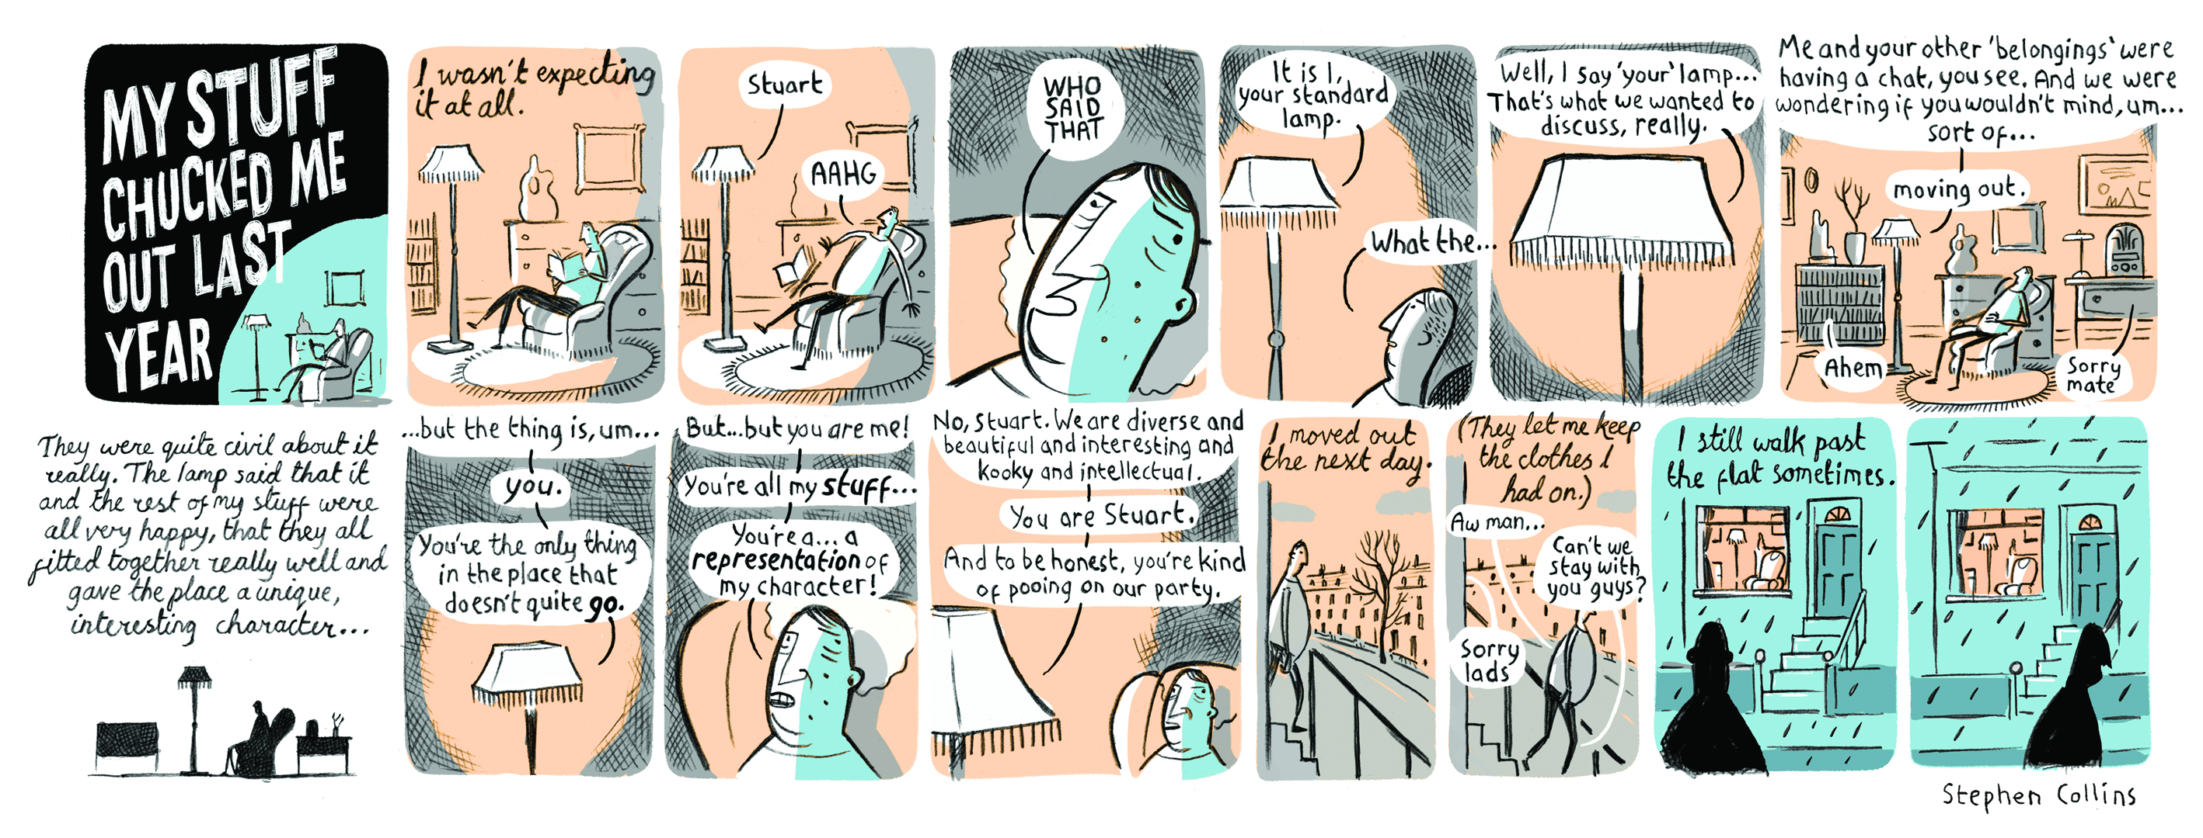

3.6 Temporality, identity and material culture
My research focuses on people in their seventies, eighties and nineties (encompassed within the catch-all term ‘older people’, though as I go on to discuss in Chapter 8, the age range of my participants represents two different generations) and in this final section I consider how the temporal particularities of being ‘older’ intersect with theories of relationality, identity and material culture.
There is a large literature on identity in older age and it is beyond the scope of this study to provide a comprehensive review. I therefore focus on those aspects of identity which are most pertinent to my research, namely how it relates to home and material culture. As a point of departure for how identity is conceptualised, I follow approaches which emphasise identity as a fluid phenomenon, which is better understood as a process that is never settled, and which is influenced by people’s social relationships, rather than something which a person is or possesses (Hockey and James, 2003, Jenkins, 2008){Jenkins, 2008 #26: 5;Hockey, 2003 #223;Jenkins, 2008 #26}. This view of identity is present in environmental and social gerontology, and Glenda Laws argues that identities are ‘fluid and constantly renegotiated’ and are influenced by our material surroundings (Laws, 1997: 93). However, as I argue, this changeable, shifting sense of identity is generally not represented in the literature on residents of older people’s homes and their personal possessions, which tends to imply that identity is something which can be maintained or preserved by taking and displaying familiar objects. I discuss how older age is conceptualised in relation to time and material culture in more detail in Chapter 8, but below I review some key theories concerning identity and age and discuss how they relate to the theoretical framework I use in my thesis.

3.6.1 Identity in older age
Social scientists have developed various theories in attempting to understand questions which ask what older age is, how it is experienced, known and lived. These questions are complex and difficult to answer, because of what Cathrine Degnen suggests is a ‘disjuncture’ between ‘on the one hand, the cultural assertion or knowledge that old age exists as a category and, on the other hand, how the category is applied in actual practice to oneself and to others’ (Degnen, 2004: 70). Most social science theories understand ageing identities to be the result of interactions between a person’s self (often understood to be separate from the body), a person’s body, and broad conceptualisations of societal norms and conventions surrounding what is appropriate for people at particular ages, ranging from the economic (e.g. retirement) to the cultural (e.g. clothing and musical taste). The different emphases and weight given to the different dimensions of self, body and society however, are revealed in different theories. The relationship between the body and the self, for instance, is the subject of theories of ageing identity which consider how a person feels ‘inside’ and how they look on the ‘outside’. The concept of the ‘mask of ageing’ theorises that a ‘younger self’ is effectively ‘trapped’ inside a person by the outward and identifiable marks of ageing on their body (Featherstone and Hepworth, 1989). However, this relationship between the ‘inner youthful’ identity and the ‘outward aged’ identity is reversed in postmodern theories of ageing identities, which suggest that age, like other identities, can be ‘performed’, such that a person can disguise their inner ‘true’ age and become, through appearance and action, whatever age they want to be (Biggs, 1997).
In her exploration of ageing and identity, Sharon Kaufman has argued that many theories concerning adult development imply that during the life course people follow a ‘trajectory’, reaching a ‘height’ (perhaps related to their job, financial success, social status or family life) at some point in middle age, before receding in older age. Kaufman goes on to suggest that this trajectory is the context within which a person’s identity as they age is typically conceptualised, and in much of the literature there is an emphasis on individuals ‘struggling to maintain a positive self-image…in the face of declining health, social status, economic clout, power, and mobility’ (Kaufman, 2000: 104). As I have suggested, this perspective is reflected in literature which suggests that personal possessions relating to a person’s family or career can help residents to ‘maintain’ a sense of identity on entering residential accommodation by the objects acting as ‘repositories of identity’ (Cram and Paton, 1993).
By contrast, Kaufman argues that identities do not follow such a trajectory, but are created, reassessed and rebuilt according to a person’s experiences and what Kaufman terms ‘themes’. According to Kaufman, the older people she interviewed did not self-identify as being old, and their identity was not related to the passing of time or their age. Rather, their identities were centred on themes which had recurred throughout their lives, and which helped to give them a sense of ‘who they were’. Kaufman’s participants did not ignore or deny their older age, but used themes which they associated with themselves – for instance self-determination, religion, family relationships – to help them deal with problematic physical and mental aspects of ageing by providing a continued sense of self which to some extent transcended changes accompanied by ageing. Kaufman interprets her participants’ accounts to construct a concept of ‘the ageless self’ that ‘transcends’ the physical and psychological changes effected by ageing, and provides an ongoing sense of continuity and meaning based on a person’s life experiences and narratives (ibid 109).
Kaufman’s theory of the ageless self, together with theories of ‘masking’ age, relate to an assumption at the heart of inquiries into identities in older age, which is that to become old, or to be categorised as old, is (in many contexts, but certainly contemporary Western ones) socially and culturally undesirable. With such a stigma attached to ageing, it is unsurprising that so many theories concern strategies of hiding or denying age. The problem then, is how to account for ageing and the ways it intersects with a person’s sense of self, without inevitably stigmatising identities associated with older age. Degnen acknowledges this problem in her ethnography of a community of older people living in a South Yorkshire village. She writes that in emphasising the successful ways in which her informants were sometimes able to resist social stereotypes of old age, she does not want to imply – falsely – that her older informants were therefore indistinguishable from younger people (Degnen, 2012: 7). In seeking to negotiate how older people’s sense of self is informed by their experiences of ageing but not necessarily determined by them, Degnen adopts a processual approach to the life course (12-14). This approach, together with an emphasis on the embodied experience of ageing which is also used by Hockey and James in their conceptualisations of the life course (Hockey and James, 2003), informs my own interpretation of how my data relates to identities in older age, and I will conclude this section by discussing what this approach entails, and what it means for understanding the experience of older age.

3.6.2 Understanding ageing as an embodied, narrated and relational process
Following the anthropologist Victor Turner, Degnen argues that ‘[a] processual approach emphasises how meaning and experience emerge in interaction with others and the world, forged through ongoing series of negotiations among social actors’ and reiterates Turner’s assertion that in a processual framework, there is less emphasis on being and more on becoming (Degnen, 2012: 12-14, Turner, 1985). In a processual approach, neither individual agency nor social structures are ascribed privilege in shaping people’s identities. Rather, it is the interaction between the self and others which is important (Degnen, 2012) and which leads to what Hockey and James describe as ‘the tension between the individual’s capacity to make and re-make themselves, to resist the penalties, constraints and imperatives of ‘social structure’ and the ageing body, and their dependence upon ‘the social’ as the sources of who they experience themselves to be’ (Hockey and James, 2003: 199). This emphasis on the constant interaction between the individual and the social gives societal structures a greater role than that allowed by Kaufman’s theory of the ageless self, but also asserts that individuals are not discrete from the society in which they live, and are not passive or helpless victims of negative stereotypes concerning older age.
Degnen foregrounds the ways in which narratives are used in social interaction to construct and reflect a sense of self. The stories we tell about ourselves, and about how we came to be ‘who we are’ are the result of constant interaction with the social world. As Degnen puts it, ‘[n]arrativity is a part and parcel of the ways in which the ageing self is forged dialectically via social interaction with others’ (Degnen, 2012: 13). While narratives shape our sense of self throughout the life course, Degnen argues that in older age, narratives intersect with the particular temporalities experienced by those in later life. For instance she writes that the narratives told by her informants in her ethnographic study displayed certain ‘temporal characteristics’ such as ‘irrelevant information’ and ‘narrative repertoires’ which Degnen suggests reflects the distinct temporal experience of being an older person.
While Degnen uses narrativity as a way of exploring ageing identities, Jenny Hockey and Allison James focus on embodiment (Hockey and James, 2003). Like Jenkins, they stress the fluidity of identity and also, like Kaufman, critique gerontological conceptualisations of identity ‘peaking’ in middle age. However, Hockey and James differ from Kaufman’s concept of the ageless self, and instead advocate the significance of the embodied experience of ageing in understanding the ageing and life course processes. Where Kaufman’s concept transcends physical and mental aspects of ageing, Hockey and James argue that ageing is experienced and played out through the body, and as such, the bodily experience of becoming older cannot be ignored. In considering the relationship between identity and ageing, they argue that this is understood as a ‘triangular relationship between the body, the self and society’ (Hockey and James, 2003: 214). While acknowledging that ageing is in part a social construction, in that meanings of what it is to be old differ according to historical and social contexts, they argue that social constructionist accounts of ageing do not adequately account for individual experience and agency (47-48). Ageing, they argue, is a biological and social process, but it is also experienced and lived out through the body. They write that, ‘[i]dentities are brought into being through embodied action; they are recollected, enacted and imagined by people. And, it is through such practices, we suggest, that ageing is primarily understood, experienced and, finally, ‘known’ (205). Importantly, they argue that while identity is inevitably informed by individuals’ bodily experiences of ageing and society’s conceptualisations of ageing as acted out through norms and conventions, it is not determined by these things.
The emphasis which Degnen and Hockey and James place on ageing as a social process and how this relates to materiality is also reflected in the relational approaches to understandings of the self as discussed by Carol Smart (Smart, 2007). Smart argues that the relationships we have with others and which influence our sense of who we are, continue through time and continue to matter to us even if we have never met those people (in the case of ancestors) or if we outlive them. That the relationships can continue to have meaning for us depends to a large extent on our memories of those relationships, and while memories are fallible, Smart writes that,
biographical methods deploy what might be visualized as little anchors for memory and which give reference points to stories. These may be photographs, objects, diaries or other documentary accounts. Thus, at least where studies of family life are concerned, materiality becomes an important feature of the biographical method (42).
While the metaphor of memory objects as ‘anchors’ perhaps implies a false sense of stability – as I have argued earlier, objects are not stable repositories of meaning but meaning shifts according to the ongoing interplay between people and objects – nevertheless Smart’s argument is useful in highlighting the ways in which material culture relates to temporality, memory and personal and social relationships.
As I demonstrate throughout this thesis, relational, narrative and embodied approaches are useful in understanding how older people’s interactions with their material world shape their everyday experience. People’s interactions with material culture are realised through the stories people tell about their objects, and the ways in which their bodies physically interact with their material surroundings. I develop these arguments further in Chapter 8 where I explore the intersections between older age, memory and materiality.

3.7 Conclusion
In this chapter I introduced the theoretical framework which I use to interpret my data and explained how theories of social practice and relationality can illuminate the relationships between people and material culture. These theories take a processual approach to understanding the social world, and reveal how concepts such as home and identity emerge from and are made meaningful through people’s ongoing social and material interactions. I argued that meanings are made through interactions between people and material culture, and that objects not only reflect meanings ascribed to them by people but also create them, such that things possess and exert an agency of their own. These conceptualisations of home and identity, and of the relationship between people and material culture, are at odds with much of the existing literature on residential homes and possessions, which assumes that meanings related to people’s identity and homes can be stored in and reclaimed from objects. Such assumptions, I argue, both misunderstand home and identity as concepts which can be fixed, and also misunderstand material culture as something which is essentially passive.
As approaches which consider how meanings emerge through people’s social and material interactions, practice and relational theories call attention to the lived experiences of people. By this I mean the things that people do (for example cooking, reading, shopping) and with whom (family members, friends etc.) and what (saucepans, books, clothes) they do it. These experiences are for the most part unspectacular and therefore often overlooked, but occupy a substantial amount of our time and are instrumental in forging meaningful relationships between people and objects. Learning about how such meanings emerge requires detailed, in-depth study of people’s everyday lives. As I argued in this and the previous chapter, the failure of existing studies of material culture in residential homes to do so – relying instead on questionnaires or interviews – has contributed to a sense of residential homes as being unknowable and strange places. In the following chapter I outline my methodological approaches and decisions, and explain how undertaking ethnographic research enabled me to get a sense of the everydayness in residential homes that I argue is lacking in previous research.

Chapter 4: Methodology

4.1 Introduction
In the previous two chapters I discussed the limitations of previous studies on the significance of material culture in older people’s residential homes and what it can tell us about residents’ lives, and set out the theoretical framework which I use in my research. I suggested that the limitations of existing research were partly due to the use of research methods which were not capable of providing a detailed understanding of how residents interacted with their material surroundings to construct feelings of home. In this chapter, I discuss my methodological approaches and decisions, and explain how they enabled me to address my research questions. I also introduce the research settings in which I conducted my fieldwork. I provide a detailed discussion of the ethical considerations which informed my research, and how my positionality as a researcher may have influenced the study. I conclude by explaining my analytical approach.

4.2 Methodological approach
While my research is informed by how social interactions in general constitute the human world and the meaning it has for people, more specifically I pay attention to the embodied and materially constituted nature of interactions. As I explained in the previous chapter, the social practices and relationalities which constitute meaningful lived experiences for humans are played out within a material world. Social interactions are manifested through encounters with material objects, which could include the gifting of birthday presents, cooking dinner with a partner or sharing holiday photographs. In the context of my own research, I argue that people’s interactions with objects – often in mundane, taken-for-granted ways – shape the ways in which homes come to be imbued with meaning. In this way my ontological standpoint extends the boundaries of social constructionist traditions to see material culture, as well as human interactions, as fundamentally part of the social world.
Following on from this, in order to address my principal research questions of how older people in residential accommodation experience everyday life and create meaningful homes, I needed to learn how residents interacted with their personal belongings. Therefore, talking to residents about their possessions, observing them interacting with their things and hearing them relate narratives about the materiality of their rooms was useful knowledge for me. Additionally, remembering the social element in my ontological position, I needed to know how the meanings which possessions and rooms had for individual residents were the product of social relationships over time and in different places. I therefore paid attention to the webs of social relationships in which residents were enmeshed, rather than treating each resident and their room in isolation. From my epistemological perspective then, in order to acquire the knowledge needed to answer my questions, I needed to be able to put myself in a position where I could learn about the everyday life (including routines and less habitual occurrences) of residents in detail and over time. To this end, I decided that qualitative research, specifically ethnographic research, would be an appropriate methodology. In the next section I discuss ethnographies in more detail and explain their advantages for my research.

4.2.1 Ethnography
Ethnography is a research method which requires the researcher to spend a significant period of time closely studying the research subject(s) in their usual environment. Very often, as with my own study, the subject is a group of people who usually have something in common (for instance a culture, sub-group, or organisation) and who may occupy a shared space (e.g. a work place or town), with the purpose of the research being to understand and explain the group’s practices and behaviour within the context of their own culture (Degnen, 2012, Jenkins, 2010, Hodkinson, 2002) .
I felt that the detailed spatial and temporal contexts offered by ethnography would redress some of the gaps which I felt were flaws in existing research on residents of older people’s homes and their personal possessions. Methods such as questionnaires or interviews used in previous studies (Paton and Cram, 1992, Rubinstein, 1987, Sherman, 1991, Sherman and Dacher, 2005, Sherman and Newman, 1977-78, Wapner et al., 1990) could not adequately capture or convey a sense of how the meanings which residents ascribed to their belongings emerged from, influenced, or contributed to their ongoing daily life and ‘at home-ness’ in the residential accommodation. Furthermore, while methods such as photo elicitation interviews are designed to access embodied and sensory elements of participants’ experiences (Mason and Davies, 2009, Harper, 2002), these cannot adequately address the temporal aspects of everyday life in the way ethnographies can.
There were three key advantages to using ethnographic methods. Firstly, through being privy to the mundane, day to day life of residents, I was able to understand how they spent their days, who they spent them with, and how they turned the spaces of their rooms into places of home through their social and material interactions. Being present in the residential settings gave me access to some sense of what it felt like to live in the homes. Beyond questionnaires and interviews which rely on a written or spoken representation of lived experience, spending hours at a time within the residential homes also exposed me to the sensory environment of the settings. Secondly, as a research method which requires the researcher to spend a significant period of time studying the subject(s) of interest, my ethnography conveyed advantages such as enabling me to build up relationships over time with the informants in my study, and also gain a sense of how residents’ lives and attitudes to their rooms changed over time. Thirdly, the immersion of the researcher into the site of the study and the detailed data created by this research method, affords ethnographers the opportunity to challenge assumptions about research settings in a way which is not always possible using other research methods. Specifically, as other ethnographers have argued, it is a research method which can blur and trouble the boundaries of assumed binaries and paradigms (Degnen, 2012, Navaro-Yashin, 2009). I now consider these three aspects in turn.

4.2.1.1 The mundane and sensory home
In order to understand how residents experienced the residential accommodation and a sense of home, it was essential to spend a significant amount of time in the residential homes myself, observing, asking questions, and interacting with the physical buildings and cultures of the homes. The ethnographies of older people’s homes and day centres which I wrote about in Chapter Two, such as those by Jillian Gould, Barbara Myerhoff and Joel Savishinsky, succeeded in placing the reader in the residents’ environment in a way that I suggest would have been impossible using other research methods. In its emphasis on noticing the everyday routines, mundane practices and interactions, and on what actually happens – who does what, where, with whom and at what time – ethnographies are a way of understanding cultures, and how people experience those cultures.
In my research, I wanted to understand the culture of home as experienced and created (or resisted) by the residents, and in order to have knowledge of these homes, I needed more than what the written words of interview transcripts would tell me. As Judith Okely observed, a person’s sense of feeling ‘at home’ cannot be reduced to or communicated via words alone, and a person’s sense of space involves ‘bodily memory and total ambience’ (Okely, 1994: 60). In Okely’s ethnographic exploration of the experiences of older people in rural France, she added to the knowledge she gained through interviews with her older participants by visiting the locations her informants had inhabited in earlier years. In this way, as well as imagining the places as conveyed to her through the words of the older people, Okely also came to have her own sensory knowledge of these places – for instance what they looked and smelled like – based on her own embodied memories of being there. She writes that in her fieldwork, she
drew on knowledge beyond language, less as extra-sensory perception than as that which comes from all the senses, both of the fieldworker and of the subjects. Knowledge was embodied through sight, taste, sound, touch and smell. Bodily movement, its vigour, stillness or unsteadiness, was absorbed. Spoken utterances, especially the brief and seemingly banal, made greater and profounder sense when placed in a broader, learned context (45).
While Okely acknowledged that her experiences will not have been exactly the same as those experienced by her participants, nevertheless in having been to the same places formerly inhabited and visited by them, she had a greater knowledge of what it was like, or might have been like, to be in those environments than she would have had if she had just had to rely on the spoken or written narratives of her research participants.
Similar arguments and methods are used by Sarah Pink in her ethnographic work exploring the gendered domestic practices of men and women in England and Spain. Pink argued that in order to understand the relationship between identity and home, she needed to understand the embodied experiences and sensory knowledge of her participants (Pink, 2004: 138). She argued that homes are experienced, created and maintained through routine sensory practices – which could include smelling clothes to discern if they need washing, touching kitchen surfaces to see if they are sticky and need cleaning, or seeing dirt and removing it – which embody sensory knowledge, and which reveal and reinforce gendered identities associated with the home (ibid). To enable her to understand these sensory practices and ways of knowing, Pink conducted her research in her participants’ homes, enabling her to experience at first hand using her own senses, how her informants experienced home.
Residential homes and the negative assumptions that are often made about them are ripe for invoking the sensory imagination, and ethnographic accounts of older people’s homes abound with the writers’ sensory experiences. Smells in particular are frequently mentioned. For example, in Living and Dying at Murray Manor, Gubrium writes, ‘[s]mells are no small part of the mood of public places on patient floors. There are four well-known ones: urine, stool, decay, and deodorants. Throughout the length of hallways there may be a succession of each, sometimes faint and sometimes pungent’ (Gubrium, 1975: 29). Olfactory and tactile sensory experiences are also highlighted by Diamond in his account of a residential home’s cleaning regime:
Because germs are the enemy of modern medicine, in this institutional order cleanliness ruled with a seemingly moral force. No one took precedence over the cleaning man while he constantly ran his buffing machine up and down the halls, making them slippery and smelly but squeaky clean. Clean prevailed over warm, for example, in the case of the undeviating shower schedule….It was impossible for a staff of three or four nursing assistants to look after the sanitary needs of forty to fifty people, so an intermittent smell of urine hung over the day room and hallways, only to be replaced several times during the day by the smell of cleaning chemicals (Diamond, 1992: 178).
In recent years there has been a surge of interest in visual and sensory methods and ethnographies (Banks and Morphy, 1997, Pink, 2004, Pink, 2009, Pink, 2012), and while these have been useful in highlighting the importance of paying attention to the senses and sensory experiences when conducting research, I did not set out to write an explicitly sensory or visual ethnography. I suggest that there is a long tradition of ethnographers making full use of their senses in the field (as demonstrated by the above examples of Gubrium and Diamond) and that good ethnography is – or at least should be – sensory ethnography. As an embodied researcher who spent many hours watching and listening to residents, drinking cups of tea and eating biscuits, and necessarily physically interacting with the material environment of the home, it was impossible for me not to have a feeling of the sensory experience of being in the home. From the very first visits I made to the homes, my field notes record sensory descriptions of what I experienced. For example, on my first visit to Beechview Lodge, I wrote, ‘It’s light and airy with a pleasant, perfumed smell (not obviously covering up an unpleasant smell)’, and on my first visit to The Cedars I record that while I chatted with a female resident who I soon realised had dementia, ‘I heard a man’s voice singing Christian songs/hymns, and [the resident] asked if I could “hear the kiddies singing”’. The most explicit way in which my methodology was ‘visual’ was in my use of my camera to take photographs of residents’ rooms and possessions. Aside from this, I attempted to be ‘sensorily aware’ and to ‘recognise that the sensory is part of ‘involvement in the world’ (Mason and Davies, 2009: 600).
As well as recording my own sensory experiences, my research also allowed me to get an idea of the sensory experiences of the residents. For instance in the following extract from an interview I conducted with one resident, Irene, she reveals how her awareness of sound in the home affected her movement, in this case her willingness to use the bathroom in the night:
they say you can get up when you like, but I’m always frightened of waking other people, because with this [walking] frame, it’s noisy, and with me bathroom tiles it makes a bit of a racket when you go in. People have said that they don’t hear me when I get up in the night. These are just small things that bother me a bit, but if they say it [noise] doesn’t bother them then I’ve got to forget about it [interview with Irene].
While I cannot know exactly how Irene felt, her description of her experience, together with my personal knowledge of walking on her bathroom floor and seeing her walking with her stick, gave me more of an idea than I would have otherwise had from her words alone.

4.2.1.2 The duration of an ethnography
Ethnographers usually spend a significant amount of time in their research sites, enabling them to get to know the research context and participants in sufficient detail, such that they are able to understand and analyse the culture or subject they are studying. Although not always a stated intention of ethnographies, the period spent in the field also allows researchers to observe changes over time, and this gave me new insights into my data.
As I discussed in the previous chapter, ‘home’ is not a fixed, stable concept, and people’s attitudes towards and feelings of being at home may shift over time. Research methods which use questionnaires or single interviews may provide insights into how a person might feel about their home at a particular time, but are less likely to shed light on how perceptions of home may change. Given that so many older people move into residential homes as a ‘last resort’, or following a crisis such as an illness or bereavement, it would not be surprising if new residents had quite a negative attitude towards the residential accommodation, and rejected it as their home. However, over time, as their surroundings become more familiar and they develop routines and attachments, residents may feel a greater sense of belonging (although this is certainly not inevitable).
I saw evidence of this during my own fieldwork in The Cedars. The residents who professed themselves to feel most at home in their rooms and in the residential home in general, were typically those who had spent the longest time there. By contrast, those residents who had only recently moved in tended to be more pessimistic and more likely to doubt that they would ever feel at home. Making repeat visits however, gave me the advantage of seeing how the newer residents’ attitudes to living in the home could start to change. In the case of one resident, Irene, I noticed how she went from showing no interest whatsoever in how her room was furnished, to asking her daughter to bring in more furniture from her previous house. Initially she had told me that she tried not to think about her previous home, but gradually, it occurred to her that she wanted items such as bookcases bringing in from her former home. My visits to Irene took place over a few weeks, and while I don’t believe that on my last visit to her she finally ‘felt at home’, I do think that the changes which took place in her room, at her behest, were of significance in understanding how feeling at home is an ongoing process, and will not necessarily happen instantly.
The ethnographic methods I chose to conduct my research suggested insights into how residents’ attitudes to their rooms and the home changed over time, but this wasn’t an explicit objective of my research, and I think there is a need for much more research on qualitative, longitudinal research with residents to understand more about how residents become, and can be helped to become, more at home in residential settings.

4.2.1.3 Ethnographies can blur boundaries and paradigms
The final brief point I want to make about how my choice of ethnography as research method contributed to my knowledge and understanding, concerns how ethnographies are able to trouble and blur the boundaries of assumed oppositional paradigms and concepts. Everyday life is rarely experienced in binaries, and is more often understood as nuanced, relative and context-dependent; neither wholly this nor that, but shifting on an ever changing continuum. This was found by Catherine Degnen in her ethnography of older people in a South Yorkshire village. She writes:
[e]thnography further permitted me to juxtapose public and private realms of everyday experience and to consider a wide spectrum of contexts and interactions. It permitted me to consider the ways in which these coalesce and blend, sometimes easily and sometimes uneasily in narrative and personal experience (Degnen, 2012: 141).
I found this in my own research, and as well as the pertinent example of public and private, found that the distinctions which are often made about residential homes and private, domestic homes, are not so clear cut as might be thought.
Similarly, the detail and context inherent in ethnographic research resists being categorised within one particular theory or paradigm at the expense of another. Yael Navaro-Yashin undertook ethnographic research in Northern Cyprus, exploring how the Turkish-Cypriot residents felt about living with the material remnants and reminders of the previous Greek-Cypriot residents who had fled south. She found it helpful to draw on both object-centred theories (such as Actor Network Theory) as well as more humanistic paradigms, and argued that both were important in understanding the meanings which the surroundings had for the inhabitants. Her argument that ‘[e]thnography works against the grain of paradigm-setting; it asks for all scopes of the imagination to be kept on board’ (Navaro-Yashin, 2009: 15) resonates with my own experience of ethnographies and beliefs about how they can contribute to knowledge.

4.3 The research sites
I conducted fieldwork in two residential homes, which I call Beechview Lodge and The Cedars. My original intention had been to adopt approaches taken in earlier comparable ethnographies (Diamond, 1992, Gould, 2009) and conduct research in just one residential home. However as I shall explain in more detail, it became apparent that not enough residents in Beechview Lodge were willing or able to take part in my research, and so I negotiated access to a second home, The Cedars. I don’t present my research as a comparative study, but the serendipity of unexpectedly needing to research two sites nevertheless presented me with an opportunity to study two very different homes where the residents had markedly different experiences, and to analyse, reflect, and offer some explanations as to why this might have been the case.
Beechview Lodge, run by an independent charity, is a large Victorian house which has been converted into a residential home for older people. It is relatively small, accommodating fewer than twenty residents. It is in a relatively affluent area, and is situated on a quiet street, a short walk away from a busy high street.
The Cedars is a more modern, purpose built residential home, run by a not-for-profit care provider and accommodates just over 40 residents. It is located in a residential area which is less affluent than where Beechview Lodge is located, and is set on a quiet street in between two main roads. The home is organised over two floors, with two corridors on each floor. Each corridor contains residents’ bedrooms (all of which are en-suite), a lounge, kitchen and dining room. Unlike Beechview Lodge, the bedrooms at The Cedars are of the same size and layout. On entering each room, there is a short corridor with the bathroom on the left or right before the room opens out into the main bedroom / lounge area. Each bedroom has a large window which overlooks the garden, drive way or the street.
Both homes provide residential care which includes the provision of meals, assistance with washing and dressing, maintenance and cleaning of rooms, laundry services, and administering of medication for residents who require it. Unlike nursing homes there are no in-house nursing services or facilities, although nurses visit regularly to attend to residents who need dressings changed, for example. Both homes cater for residents with and without dementia, although as I explain in more detail in my discussion of ethical issues later on in the chapter, I only included residents without dementia, who I judged to be capable of giving informed consent, in my research. The two residential homes charge similar fees which are consistent with the average cost for the area. The vast majority of residents in both homes are white British, and most residents are female, in keeping with the national population average for residents of older people’s homes (Office for National Statistics, 2014).

4.3.1 Gaining access and first impressions
Originally concerned with identifying just one home, I conducted an internet search of residential homes in the area and made a list of the homes which included residents without dementia, and which specifically encouraged potential residents to bring personal possessions with them. Beechview Lodge met these criteria, and getting access proved to be relatively straightforward. In March 2012 I phoned the manager to explain my research, and after reacting positively, she invited me to meet with her at the home.
When I met the manager and explained my planned research methods in more detail she thought that observing the home would be boring for me, and advised against it. She thought that some residents would be happy to talk to me, and didn’t think any of the residents were likely to get distressed by involvement in my research. Following a chat in her office, she took me a on a tour of the home. She led me into the rooms which weren’t currently occupied by residents (which was most of them, as nearly all of the residents were in the lounge), talking me through the possessions in the rooms. I was uncomfortable with the apparent disregard for the residents’ privacy, but as this was my first visit when I was trying to establish access to the home, I didn’t question the manager’s actions. After the tour, we agreed that on my next visit I would speak to one or two of the residents to explain my research in more detail and identify residents who agreed to participate.
On my next visit one of the care staff took me into the lounge and ‘selected’ one resident. This was an uncomfortable experience for me. The lounge was full of residents sitting in a circle, not looking at each other, with a television on in the corner. Some of the residents were asleep, some were watching television, none were talking to each other. I accompanied the carer into the lounge as she walked up to one resident who she thought might be willing to talk to me, while the other residents looked at me with interest. Straight away this raised ethical concerns for me. The carer was acting as a gatekeeper, and while I was partly expecting this, and welcomed the idea of the staff helping me to choose the residents who were in a position to give informed consent, I felt uncomfortable with the carer apparently picking out this particular resident in front of all the others. In explaining my research in front of everyone, I was also potentially compromising the resident’s anonymity before she had agreed to anything. Nevertheless, the resident smiled and agreed to talk to me, and the carer showed us to the small, quiet room used by visitors at the back of the building.
I explained who I was and what my research was about, but emphasised that as this was our first meeting, I wanted to spend some time chatting and getting to know each other. I noted afterwards that while for the most part she was lucid and easy to talk to, she occasionally seemed forgetful and repeated things. As the conversation went on I became more convinced that I would not feel comfortable asking the woman to agree to take part in the research, as I could not be sure that she would know what she was agreeing to. We walked back into the lounge together. All of the seats in the lounge were now taken, but as we looked around trying to find somewhere for her to sit, one of the care assistants said that one of the other residents, Alice, was going to speak to me, so the other resident could have Alice’s seat. I was not sure how much Alice knew about this, but she got up and walked with me back to the quieter room.
My first impressions of Alice are recorded in my field notes:
Alice is 95, and she tells me that she can’t believe she’s waiting for her 96th birthday. She doesn’t feel that old. She tells me that she gets annoyed when people seem to be overly proud of their age – e.g. when they keep telling people that they’re ninety this or ninety that! Alice can only walk with a mobility aid and has degenerating eyesight, but she tells me that while her body is failing her, her mind isn’t, and indeed she is very sharp.
We chatted for a while, and I enjoyed talking to her about books, films, and life in the home. She seemed to understand my research and said that she would be happy to talk to me in more detail about her possessions, and when I visited her again the following week I left her with an information sheet which she said she would read with her daughter. While I was happy to have met Alice, I continued to feel uncomfortable that our meetings were known to everyone, and that I had to navigate the circle of residents every time we met. More problematically for my research plan, Alice had told me that very few residents in the home didn’t have dementia, and this soon became apparent to me. In the end, Alice was the only resident from Beechview Lodge who took part in my research. After our initial ‘getting to know each other’ chats, I recorded two interviews with her about her possessions. Alice and I got to know each other well and enjoy each other’s company, and so I continued to visit her even after I considered my formal data collection to be over and had started fieldwork at The Cedars. (I discuss our relationship in more detail on page 78, where I consider the ethical aspects of my research). I continued writing field notes at Beechview Lodge until October 2012, although my subsequent, more social visits inevitably continued to contribute to my impression of life in the home. In all, my visits to Beechview Lodge lasted twelve months, from my initial visit in March 2012 until Alice died in Spring 2013.
Realising that I would not be able to conduct all of my research in one residential home, as originally planned, in May 2012 I made contact with a second home, The Cedars. As with Beechview Lodge, I arranged to meet with the manager to explain my research, and after her positive response we agreed that I would begin visiting the home in July 2012. Between July 2012 and June 2013 I visited the home most weeks. In this respect, doing my PhD part-time was an advantage, as while I wasn’t always able to visit more than once a week, by visiting the home over the course of a year I got to know it, and many of the residents, very well over time. I spent the first two months getting to know the residents and the staff – and allowing them to get to know me. While part of the ‘getting to know each other’ process involved talking about many different things, I frequently reminded residents and staff that I was there primarily as a researcher, and during this time I recruited a number of residents who consented to take part in a recorded interview.
I could not help but compare my very different experiences in the residential homes. On my first visit to The Cedars for example, I was immediately struck by the very different reaction I had when I presented myself at reception. Instead of taking me on a tour of the home, the care assistant on the front desk invited me to wander around and introduce myself to residents, only cautioning me that one male resident could sometimes be a bit aggressive. While it is true that the home was short-staffed on that day (I soon learned that this was not uncommon), which may have partly explained the carer letting me roam unaccompanied, at no point during the twelve months I visited the home did I feel that the staff acted as gatekeepers, and the only requirement was that I sign in and out on each visit (this was the same for all visitors). This hands-off approach made it relatively easy for me to approach residents, but I was aware that having unrestricted access to potentially vulnerable older people who were effectively ‘captive’ in the home raised ethical concerns. I did what I could to mitigate the risks posed by me having free licence to approach residents, for instance by seeking the advice of staff members before visiting new residents who I hadn’t met before, so that I could discuss the potential for my presence to cause distress. I discuss the balance involved in protecting older people while not automatically labelling them as ‘vulnerable’ (which has the potential to deny them agency) in more detail later in this chapter.

4.4 Beechview Lodge as case study
The majority of the data I present in this thesis derives from my fieldwork in The Cedars, where I recruited more participants than I was able to do in Beechview Lodge. This presented me with the question of what to do with the research material from Beechview Lodge. It would have been possible for me to have written a thesis based entirely on my findings from The Cedars, and in some ways this would have made for a ‘tidier’ ethnography, based on just one residential home. However I felt that my research findings concerning Beechview Lodge, while largely based on just one resident, were of interest and relevant to my research questions, and furthermore I would have felt ethically uneasy about not including the data drawn from my many visits with Alice. Given the imbalance in recruited participants and the amount of data gathered from both homes, I also didn’t feel comfortable presenting the findings as a comparative study. In the end, I decided to present the findings from Beechview Lodge as a case study.
The case study of Beechview Lodge in Chapter 5 serves two main purposes. Firstly, it as an analysis of a research site in its own right, and as is common in case study research I analyse it within a conceptual framework (which in this instance is the conceptual distinction between institutions and homes), using my empirical research to interrogate key theoretical assumptions (Aaltio and Heilmann, 2010: 71). Secondly, I use it as an analytical tool to provoke questions about my second research site, The Cedars (and vice versa). Given that my findings from both homes were so different, I found it useful for my analysis to consider why this was so, looking in particular at the differences between the two homes. While I didn’t originally intend to include a case study as part of my thesis, this seemed to me to be an appropriate way of analysing and presenting my data (Mason, 1996: 129). As Gould demonstrates in her ethnography of a Jewish residential home in Toronto, presenting case studies of a small number of residents can be an effective way of analysing how the culture of a care home is influenced and experienced by individual residents at an everyday level (Gould, 2009).

4.5 Research methods
The emphasis on detailed observation over a lengthy period of time has led to some equating ethnography with (participant) observation (Hammersley and Atkinson, 1983), although many ethnographies involve a combination of different methods which allow the ethnographer to achieve their aim: that of understanding a culture in its own context. Having already discussed the suitability of ethnographic approaches to my research, in the next section I review and reflect on the individual research methods which, when used in combination with each other, helped to give me an understanding of what life in the residential homes were like.

4.5.1 Participant observation and informal conversations
My main intention on each visit to the residential homes was to observe what went on there, and while ‘observation’ implies a reliance on visual methods, my intention to understand the day-to-day life of the home in as complete a way as possible meant that I paid attention to other sensory experiences. The extent to which I was a participant in my observation varied according to the situation I was in. I felt that as an observer whose presence was always known to the residents and staff in the home, total non-participant observation or a ‘fly-on-the-wall’ perspective was impossible, as my very presence affected the interactions which took place around me (Mason, 1996: 64). Indeed as Mason notes, for a researcher whose intention is to gain understanding of what it is like to inhabit a particular culture or setting, there is little to be gained from trying to distance oneself from that environment anyway (ibid). Situations in which I felt myself to be more of a participant than at other times included taking part in activity sessions where I sang along (self-consciously) with the residents. On another occasion I found myself having to physically support one resident when she became unsteady on her feet, and managed to temporarily prop her against her walking frame while I ran to get help. Neither on this nor any other occasion however did I feel that my role was in danger of being viewed as that of a member of staff.

4.5.2 Interviews
I conducted interviews with one resident and one member of staff at Beechview Lodge, and with eleven residents at The Cedars. In addition to these, I conducted one joint interview with Alice, the resident at Beechview Lodge, and her daughter. It had not been my original intention to interview family members, but after conducting several interviews at The Cedars, it became clear to me that on first moving into the residential home, many residents had left the task of deciding what to take with them and what to leave behind up to another person, most often a son or daughter. As I was interested in the decision making process of sorting through the belongings, I decided it would be of value to talk to residents’ family members, and so I went back to the university ethics committee to get permission to do this. In the end, the only relative of a resident who I spoke to was Alice’s daughter, and I discuss this interview in more detail later in this chapter, when I discuss the ethical issues that were relevant to my research.
I also recruited and interviewed ten adults who had helped an older person move into residential or nursing accommodation. These people weren’t related to any of the residents in either Beechview Lodge or The Cedars, but they provided useful information and reflections on the process of helping someone sort through their belongings and decide what to take and what to leave behind when moving into care. They also talked about the challenges of clearing the home of all the remaining belongings. As the data did not directly relate to the experiences of residents in Beechview Lodge or The Cedars, I decided not to include this material in my thesis, however I have written about it elsewhere (Lovatt, 2015). While it is possible that this supplementary data affected my interpretations of the residents’ experiences, I was not conscious of this.

4.5.2.1 Interviews with residents
I made at least one visit, often more, to each resident before I conducted a recorded interview with them. This was to allow us to get to know each other and establish a relationship before I began asking questions directly relating to my research (Hammersley and Atkinson, 1983: 81-82). It also helped me judge whether or not the resident was capable of giving informed consent. The interviews were loosely structured, and while I had a list of prepared questions (see Appendix 1), I did not necessarily ask them all, and the content and tone of the interview varied according to the resident I was speaking to and the particular nature of our interactions (Mason, 1996: 40). As the participant information sheet (Appendix 2) indicates, I had originally planned conducting at least two interviews with each resident, with the first interview covering aspects of the resident’s biography and the move into residential care, and the second interview focusing on the objects in the room and the resident’s attitudes towards them. I had planned it this way as I anticipated that residents might get tired during a long interview with lots of questions, and for the same reason I emphasised that they could have a rest whenever they wanted, and could break the interview up over several visits. No resident took me up on this offer or appeared tired, and while I conducted a second interview with two residents, this was because they thought that there was still more to be said, rather than wanting to stop the interviews because of fatigue. The shortest interview lasted eighteen minutes and the longest lasted one hour and forty-seven minutes. Most interviews lasted somewhere between forty minutes and an hour.
As the information sheet in Appendix 2 shows, I also gave participants the opportunity to borrow a video recorder, camera, or notebook so that they could film, photograph or write down notes about the objects in their rooms outside of the interview. This was so that they could reflect on their room and the things in it whenever they liked, rather than being restricted to the times when I was present. This method has been used by other studies as a way of accessing mundane aspects of participants’ everyday lives that they might not think to mention during an interview (Day and Hitchings, 2011). None of the participants in my study requested any of these recording devices however, and in retrospect I may have had a more successful uptake of this method had I automatically left a disposable camera etc. with the participants, rather than putting the onus on them to request one.
What usually happened in practice was that we discussed aspects of the resident’s life history and the circumstances of their move into the home during my initial ‘getting to know you’ visits. Knowing the focus of my research, residents would also sometimes reference particular objects in the room, for instance to show me photographs of family members, or to point out items they had brought with them from their previous home. These pre-interview visits helped me to ‘place’ the residents, and provided me with prompts to follow up in the recorded interview. In the interviews I usually began by telling the residents what I knew of them (for instance how long they had lived in the home and where they had lived before), as a way of demonstrating that I had paid attention to them in my earlier visits, and to give them a chance to correct me, or to expand on what they had previously said. I then moved on to ask more targeted questions about their personal possessions, although I was very much led by the participants, and was happy to discuss other topics first if they wished. The interviews varied in nature and tone. In some, the residents answered my questions concisely, did not volunteer more information than I asked them for, and did not ‘veer off topic’. In others, the interviews were closer to conversations. Some residents sought reassurance that what they were saying was useful or interesting, and that they were ‘doing it right’ (van den Hoonaard, 2005). An example of this is shown in the following exchange with Alice, from Beechview Lodge, where she tells me about the objects in her bedroom:
Alice: … I – when I go to bed, I look at them and think where they’d been and what they were and, you know. Where they were or, little things, and then I start to wonder where the other things were that weren’t there. You know, that I haven’t brought, and wondering about them then. I did worry at first but I’m not too bad now. About having things, because a lot that had to be got rid of, given away or sold from my home, my own things. Not much help am I?
Melanie: no that’s fine! You’re doing well!
In other interviews, residents exercised agency by changing the conversation, asking questions of me, or ‘playing the host(ess)’ (Russell, 1999, van den Hoonaard, 2005). During one interview with a resident called Mary, a care assistant brought her a cup of tea and a biscuit. Mary asked if I wanted a cup of tea or coffee and a biscuit, and when I said that I would, she turned to the carer and asked her to bring me a cup. Another resident, Polly, would always get up and walk me to her door after I visited, asking me if I knew the way back to the main entrance. Such instances always left me with the impression that I was being hosted by the resident in their own home, and that the same rules of hospitality and politeness applied there as they would in any other home. They also served as gentle reminders – intentional or otherwise – that assumed conventional ‘power relations’ between the researcher and the researched were not straightforward. Yes, I was researching people who are typically categorised as ‘vulnerable’ (certainly by research ethics committees) and I was mindful of this, but to only perceive them in this light ran the risk of denying them the agency and control which many of them were keen to demonstrate.
In accordance with standard views on reflexive, qualitative interviewing I did not see myself as an interviewer who was somehow independent of, or external to, the interaction, who was ‘extracting’ the data from my interviewees. Rather, I was part of the interaction itself, co-constructing the interview with the informant, and what was revealed or not revealed by the informant was influenced by the nature of our mutual interaction (Holstein and Gubrium, 1995, Hurdley, 2006, Mason, 1996).
A breakdown of the twelve resident informants and their demographic and contextual data is shown in Table 1. I also provide more detailed information on participants in a series of pen portraits, which I discuss on page 90.

Table 1: characteristics of residents
Home (pseudonym) | Name (pseudonym) | Age at interview | Time spent in home at time of interview
Beechview Lodge | Alice | 95 | 7 years
The Cedars | Pam | 88 | 3 years
 | Mary | 93 | 2 years, 6 months
 | Dorothy | 88 | 18 years
 | Susan | 74 | 2 years, 8 months
 | Frances | 85 | 1 year, 6 months
 | Polly | 90 | 4 months
 | Stan | 74 | 4 months
 | Michael | 84 | 4 years
 | Annie | 89 | 5 months
 | Irene | 92 | 2.5 months
 | Peter | 98 | 6 weeks

Immediately following interviews with residents, I asked if I could take pictures of the room, focusing on possessions which the resident had mentioned during the interview. Often we would chat while I did this, which made for an effective way to end the encounter. Taking photographs was one way in which I tried to record the sensory qualities of the residents’ rooms. While the pictures obviously related to the visual aspects of what the room and the objects looked like, I could also use them in combination with data from my other research methods to gain a sense of other sensory elements. For instance, Mary, one of the residents in The Cedars, had an ornament of a swan which also doubled as a plant holder (see Photograph 1). Mary told me that not only did she like to look at the swan, but she also liked to pick it up and stroke its neck. In reflecting on Mary’s room afterwards, and the sensory experience of living in the residential home, the photograph, combined with the interview data, gave me more of a sense of what it felt like to be a resident, than just the interview data would have done. The photographs also acted as useful aide-mémoires when I came to write up my research, helping me to recall my own sensory experiences of conducting fieldwork in the homes.
Photograph 1: Mary's swan plant holder

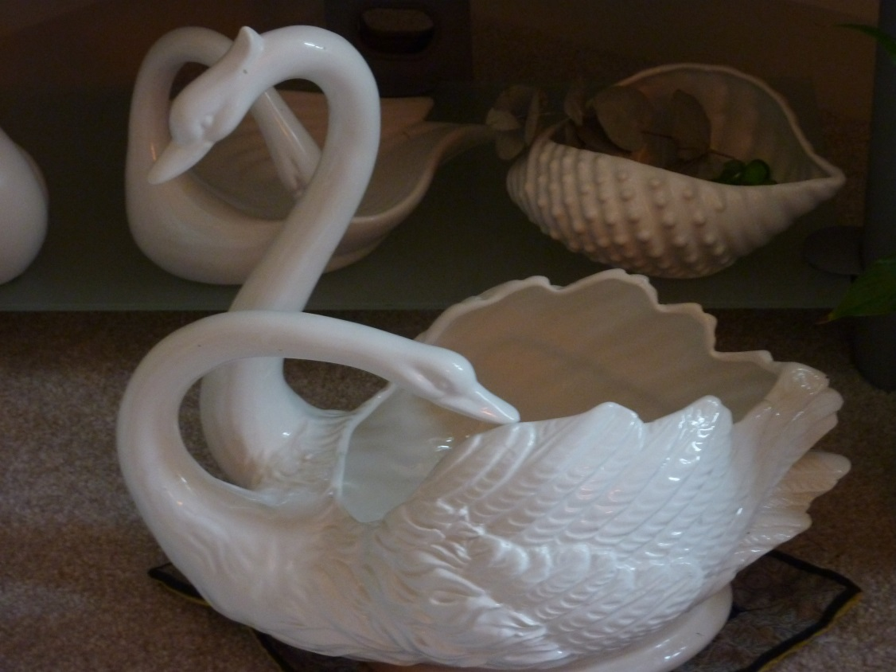

4.5.2.3 Interviews and conversations with residential home staff
I wanted to interview members of staff in the residential homes for two main reasons. Firstly, I wanted contextual information on the homes’ policies on residents’ personal possessions. I anticipated that these might include policies concerning the objects that residents could bring in with them, for instance any restrictions, insurance policies, and procedures on dealing with possessions after a resident’s death in the event of there being no identifiable dependent. Secondly, I was interested in the perspectives of staff members on the objects within the residents’ rooms, and how they and the residents interacted with them. For instance, anticipating that it would be members of staff who cleaned and dusted the residents’ rooms, I wondered if the staff spoke with the residents about the things they owned whilst they were cleaning.
I had planned to conduct recorded interviews with up to five members of staff, including the manager and a range of carers and domestic support staff, but in the end I only managed one interview, with a carer / cleaner in Beechview Lodge. (As with my recruitment of residents, I explained the purposes and nature of my research to this member of staff and left her an information sheet to consult – see Appendix 4. I then returned a week later and she signed a consent form). I approached a number of staff members at The Cedars to ask if they would agree to an interview, but on each occasion I was told – usually regretfully – that they just didn’t have the time in working hours, and were unwilling to be interviewed in their own time. Given that they were low-paid workers, and at least in the case of The Cedars coping with a shortage of staff, it is not surprising that it was difficult to recruit staff to take part in interviews, and other studies have encountered similar problems (Watkinson-Powell et al., 2014). After talking to my supervisors and more senior carers at The Cedars (where I conducted the majority of my research) we agreed that the most practical way of gleaning the staff members’ perspectives would be to find mutually convenient times during their shifts when they could spare a few minutes to talk to me. I would either take notes during the conversation, or later that day. In this way, I was able to have several conversations with different staff members, where I asked them for their perspectives on what the residents brought into the home, and how they interacted with the possessions. In addition to this, I was given access to The Cedars’ Service User Guide, which provided details of the contract of care, including information on what would be provided in each resident’s room, what residents could bring with them, and how these would be insured.
While it would have been preferable to have conducted recorded interviews with care staff at The Cedars, I feel that through a combination of conversations, observation and analysis of the service user guide, I developed a fair understanding of the staff’s perspectives, and the home’s policies concerning residents’ possessions.

4.6 Ethical considerations
I was very aware before starting my research that it could be potentially upsetting for residents to think about and talk about the personal possessions which they had brought into the home and, just as importantly, the possessions which they had been unable to bring with them. I anticipated that some residents might find it difficult to talk about their move into residential accommodation, which they may not have wanted, and by asking them about the circumstances of the move I might be asking them to recall a distressing time in their lives. Personal possessions have associative meanings with people, places and times, and by talking about their personal possessions, I thought that some residents might become upset at recalling deceased loved ones, or beloved previous homes. By being asked in depth about the possessions they chose to bring with them from their previous home, and the possessions which they chose not to bring with them, it was possible that the residents might reconsider and even regret their selection.
To try and mitigate potential distress, I explained my research to each resident at our first meeting, and made it clear that they were under no obligation to participate. Having explained the project to them, I gave them a copy of the information sheet and topic guide (see Appendices 1 and 2) and encouraged them to read them and discuss them with a family member or someone they trusted who worked at the residential home. When I visited them again (typically a week later) they told me whether or not they wanted to be involved, and signed a consent form (Appendix 3) as required.
I decided at the start of my research to not include residents who had, or who showed signs of having, dementia. I felt that a project investigating the personal possessions of care home residents with dementia would be fascinating in its own right – see for example Christina Buse and Julia Twigg’s research on residents with dementia and their handbags in care homes (Buse and Twigg, 2014) – but this was not the focus of my own interest and would add practical difficulties to my fieldwork. Both of the homes I conducted research in had residents with dementia, and while for some residents their dementia was obvious, with others it was more ambiguous. My basic concern was not to include residents in my research who I felt were not in a position to give informed consent. In assessing whether or not a resident had the mental capacity to give informed consent, I used my own judgment and also took advice from the care home staff. We did not always make the same assessment, and in both homes staff suggested that I speak to residents who I subsequently judged to be unable to give informed consent. If I was at all unsure, I did not recruit the resident to my research.
While aware of the potential for distress involvement in the research might cause, I was also mindful of not wanting to construct the residents as vulnerable older people who would inevitably be taking the part of the ‘less powerful’ party in the research. In her reflections on conducting interviews with older people, Cherry Russell has written of the ‘sense of unease’ she initially felt at assuming her research might be ‘“mining the minds” of these disempowered people for our own research purposes’ (Russell, 1999). Russell had worried that the interview process and structure would inevitably reinforce unequal power relations between the interviewer and the interviewee, but she actually found little evidence of this when reading through her transcripts. By interpreting the interviews as discussions constructed by two active agents, Russell and her co-researchers drew alternative conclusions about the power relations in the interviews. Several interviewees made a point of telling the researcher that they felt they could tell her things that they couldn't tell their own family members, and prolonged the interview or shifted it to include items on their own agenda. Russell concluded that this provided ‘a counterpoint to the view that interviewing frail older people needs to be constructed only as a situation with inherent risks to their physical and/or emotional well-being’ (411), although it also raises ethical questions for researchers who may be put in the position of confidante or counsellor.
While not wanting to construct the residents as overly vulnerable, I was also aware that some residents might agree to take part in the research because they were lonely, or were keen to have somebody different to talk to (Kayser-Jones and Koenig, 1994: 19). This may have been the case in some instances, but I worked to ensure that my research was not ‘hit and run’ (Russell, 1999: 404), and indeed my ethnographic methodology which enabled me to make repeat visits over a year allowed me to continue relationships with certain residents by stopping by for a chat. I also tried to make our relationship reciprocal as far as I could, and in recognition of the ways in which the residents were helping me with my research, I tried to help them in small ways too. For instance, I gave one resident information about how to contact British Telecom to try to prevent the marketing calls she received, and I looked up information on the Internet for residents who didn’t have access.
As I mentioned on page 68, in the case of one resident, I continued visiting her long after I had finished viewing our interactions as primarily research. Alice was the only resident who I had interviewed at the first residential home I visited, Beechview Lodge, and I started visiting her in spring 2012. She said on more than one occasion how much she enjoyed my visits and how she hoped that I would continue to see her. She also told me how she had taken part in another student’s research project, but that the researcher had stopped visiting her with no warning, and Alice often wondered what had happened to her. I had grown to enjoy my chats with Alice, and decided to carry on visiting her, albeit less frequently than before, and I explained this to her. So, my visits to Alice continued until her death in the spring of 2013.
My relationship with Alice and my decision to continue visiting her was also influenced by an incident which left me feeling uncomfortable, and which highlighted the way in which my negotiation of ethics in the research was an ongoing process, and which affected my methods and decisions (Edwards and Mauthner, 2002). Alice had often mentioned her daughter to me, and I asked her if she would mind me interviewing her daughter – assuming she consented – about the move into the residential home. Alice told me that she didn’t mind, and when I happened to meet her daughter, Penny, during one of my meetings, I gave her a copy of the information sheet, asked her to think about an interview, and also suggested that she talk with her mother about whether or not to do the interview together, or by herself. Penny agreed, and she and Alice decided they would do the interview together.
During the interview, Penny did most of the talking, inviting her mother to agree with her on certain points. Alice mostly sat with her head looking down, not commenting. Most of the interview concerned how Penny decided what to take into the home for her mother, and her negotiations with the home about what she could bring. Towards the end of the interview, I asked her what advice she would give to other family members in a similar situation, and she emphasised the importance of discussing the possibility of moving into a residential home in good time, as if it happened at the last minute, for instance as the result of a sudden illness, it was incredibly stressful to get everything organised quickly. I recorded what happened next in my field notes:
After I finish recording and Penny stands up to go, she tells me how emotional and what a shock it was (following on from my question of what advice she would give to other people in a similar situation), and also emphasises that she would never have made the decision for her mother to go in a home, as if anything had gone wrong, she wouldn’t have wanted the guilt. She emphasises that it was Alice’s choice.
A couple of minutes after she leaves, Alice tells me that she needs the loo, so I go off to [find] Lucy [a care assistant], who is talking with Penny, and ask her to come and take Alice to the toilet. Lucy nods, and I go back to Alice. Alice stands up and starts to tell me “Penny’s very truthful, but she gets mixed up”. Before I can ask her what she means by this, Alice starts to urinate and is understandably very upset, as she says that this has not happened to her before. I comfort her, fetch a care assistant, and ask Alice if she’d like me to stay until she gets back. She says no.
I leave, feeling wretched for Alice, curious about what she meant about her daughter mixing things up, and worried that the conversation may have led to her incontinence.
I was next able to visit Alice four days later, and wanted to ask how she was, and how sorry I was about what had happened on my previous visit. According to my field notes,
I asked her if she thought the conversation about her move into the home had upset her, or had contributed in any way to what happened afterwards. She said she didn’t think so, but did say that she sometimes got slightly nervous talking to people. She didn’t say anymore and asked me about something completely different. It wasn’t an obvious attempt to change the subject, but I decided not to go back to it by asking about her comments about her daughter.
Alice then went to talk about her relationship with her doctor, telling me, “she’s like you, I can just sit and talk to her and she’s not trying to hurry me up or rush off to the next thing”. This reassured me slightly given her earlier comment about sometimes feeling nervous, and I wondered if the slightly more formal setting created by her daughter being there and me using the recorder had increased her nerves, rather than me or the topic of conversation. Alice went on to say, “you’re not going to drop me, are you?” and I assured her that no, I liked visiting her and I would continue to do so.
I discussed Alice’s instance of incontinence with my supervisors, and while accepting that it was a possibility that Alice had felt upset by the interview, they also pointed out that she could have delayed going to the toilet because she wanted to hear everything her daughter had to say. Alternatively, she may have been reluctant to leave while the recorder was still recording, as she may not have wanted to interrupt a ‘formal’ interview. We also discussed the ‘messiness’ of conflicting narratives, where neither interviewee is deliberately untruthful, but emphasises different elements, leading to differing and apparently contradictory narratives being told (Eisikovits and Koren, 2010). At the time, we agreed that I would read previous literature on conducting joint narratives with family members before deciding how to approach subsequent interviews with family members. However after considering this, I decided that I wouldn’t feel comfortable conducting further interviews with family members of resident participants, and would instead recruit unrelated adults who had helped an older adult move into a residential home. This had the added advantage of not having to ‘match up’ all of my resident participants with their family members, when some of them were unavailable due to their working hours and other commitments.
I had fewer qualms about leaving the field in The Cedars than I had about finishing my visits with Alice, mainly because my overall impression of life in The Cedars was far more positive than it was for Beechview Lodge. With Alice, I felt that she looked forward to my visits as a way of relieving the tedium and loneliness she experienced; as one of the very few residents without dementia, she didn’t have many opportunities for the kinds of chats we had. In contrast I got the sense that even the residents who were not particularly happy living in The Cedars had more opportunities for socialising and spending their time as they chose. Before leaving The Cedars I was careful to explain to residents and staff that while I might pop in from time to time (which I did for a couple of social visits) my research had finished and I now needed to spend my time writing up my findings rather than visiting once or twice a week as I had done before. Residents and staff were understanding of this, and my impression is that I left on good terms.
I obtained ethical approval for my research from the University of Sheffield Research Ethics Committee. While the process of gaining ethical approval was a very useful exercise in requiring me to think through every aspect of my planned research in detail, and anticipate problems or difficulties, I was alert to the ethical implications posed by my research throughout my ethnographic fieldwork. For instance, even though I obtained signed, informed consent from each of my informants, I was careful to remind them of my role as a researcher, as during the course of frequent visits conducted over a year, our relationship in some cases became more that of friends than of ‘researcher and researched’ (Mason, 1996: 166). Similarly, sometimes I would check with the resident that I could include a specific detail or quotation in my research, if I was concerned that they would feel unhappy or embarrassed about it.
On one occasion I refused a request for help from one resident who had asked me to buy a bottle of whisky for her. She offered me the money and said that her daughter wouldn’t buy it for her. In principle I was uncomfortable with the idea that an older person should be unable to drink alcohol as a consequence of their living arrangements and inability to do their own shopping. However in this instance, the resident had told me on another occasion that she probably drank too much as a result of grief at the death of her husband. I sympathised with her, but decided that I would feel uncomfortable and be on ethically dubious ground if I bought the whisky. In these respects, rather than conceptualising the ethical considerations which I brought to my research as fixed, unwavering principles, my approach was closer to that of the ‘feminist ethics of care’. As described by Edwards and Mauthner, a feminist ethics of care is a processual, fluid approach to research ethics, in which the researcher’s skills and values throughout the research process take primacy over any universal or abstract notion of ethics, and where the researcher is reflexive about issues of care and power in her research (Edwards and Mauthner, 2002).
The inclusion of photographs of personal belongings in my thesis presented further ethical considerations, and there is an ongoing debate within the social sciences about how to enable projects which use visual research methods whilst dealing with the added risks of potentially compromising participants’ anonymity through the use of photographs and video recordings (Wiles et al., 2012b). While acknowledging the potential for photographs of individuals to identify participants, Wiles et al. question the ‘anxiety’ surrounding the use of photographs, arguing that, ‘[i]f people know the individual then they are clearly identifiable but if that person is unknown to the viewer then it is currently impossible to find out anything about them on the basis of a visual image alone (although face recognition software may make this possible in the future)’ (Wiles et al., 2012a: 50-51). In the case of my research, while I do not use photographs of people, I suggest that the chance of residents being identified from their objects is less likely than if I had shown their faces. However, I acknowledge that the residents’ objects may be recognisable to people who worked in and visited the residential homes, and therefore that the anonymity of participants in relation to staff and family members may be compromised.
I took several steps to reduce the chances of residents being identified. A photograph I took of one resident’s room showed a cushion displaying the resident’s name in embroidery. I had not noticed the name at the time I took the photograph, but when I uploaded it to my computer I used editing software to remove the name. In photographs which clearly show pictures of people (usually family members) I have blurred the faces to reduce the risks of them being identified. I did this primarily to try and maintain the anonymity of my participants, but also as a way of avoiding tricky issues of seeking the consent of living family members who could potentially be identified in photographs and who had not consented for their images to be used in my research. (See (Wiles et al., 2008) for further discussion of issues of consent when taking photographs of photographs and possible strategies for dealing with this). As well as taking these measures, I made it clear to the participants through the information sheet and in further conversations that by allowing me to take and publish photographs of their personal effects, they risked potentially being identified by their possessions. Finally, as a way of trying to make the research process more reciprocal, I offered to present each participant with an album of the photographs I had taken of their possessions, although none took me up on this offer.

4.7 Reflexivity
Unlike Jillian Gould’s research which is auto-ethnographic (as a Jewish woman who grew up in Toronto, Gould places herself centrally in the story of her research and the impact which it has on her) I do not treat my own positioning as a focus of my research. In common with much qualitative research however, I have been reflexive about my positioning as a researcher, how this relates to the positioning of my informants, and the impact which this has on the research process (Hammersley and Atkinson, 1983, Mason, 1996). As Hammersley and Atkinson note, researchers are inevitably part of the social world they study, but rather than ‘engaging in futile attempts to eliminate the effects of the researcher, we should set about understanding them’ (Hammersley and Atkinson, 1983: 17).
As a regular visitor to the residential homes, yet not a member of staff or family member, I occupied a unique position. This position wasn’t fixed however, but changed over time, according to who I was interacting with, and who else was taking part in the interactions. For instance, when I first met Susan in The Cedars, I introduced myself as a researcher, and it was in this context (whatever she understood my role as a researcher to be) that we first related to each other. Over the course of the following year, we related to each other more as friends, and would share information about each other’s lives that was not restricted to ‘my research’. The way that Susan and I related to each other also depended on who else was present at the time. On one occasion Susan and I were talking to each other when a member of staff who Susan didn’t like walked in, uninvited. Susan quickly reprimanded the care assistant for intruding uninvited on what was a private conversation, and the staff member left the room. This particular interaction was partly the result of a trusting relationship which Susan and I had developed over several months, and the interruption of a disliked care assistant. The incident both reflected the relationship which Susan and I had developed over time, and worked to define it (Finch and Mason, 2000).
More specifically, I was attentive to the ways in which my particular identities as a researcher who happened to be a white British woman in my 30s affected the research process. The difference in ages between myself and the residents undoubtedly shaped our interactions, and the female residents in particular would often talk to me about their grandchildren, often in the context of their studies, jobs, or housing situations, inviting me to offer a perspective as someone who was of a similar age and in a relatable situation. With one informant, Mary, I sometimes got the impression that she viewed me as a representative of ‘a younger generation’, and she would often ask me my opinions on a range of disparate topics, including religion, the role of men in parenting, and the royal family. While I felt that some of the residents identified me with their grandchildren, I was aware at times of consciously playing the role of ‘grandchild’ with the intention of making my presence as a ‘researcher’ seem less potentially threatening. For instance, by referring to my own grandmother and the relationship I had with her, I demonstrated that I could relate to the experiences of my informants, and reassure them that I was a ‘good grandchild’. For instance one resident, Frances, told me in an interview that her brother and sister-in-law always brought her back a fridge magnet when they went on holiday. I replied, ‘yes I do the same for my Grandma whenever I go away. I always bring a magnet back for my Grandma [both laugh]’. The majority of the residents and care staff were female, and this also affected the nature of some interactions, and perhaps my access to some informants. As a woman, I may have been perceived as less threatening (Hammersley and Atkinson, 1983: 84), and this may have influenced some residents to agree to take part in the research.
Apart from when attending the communal activity sessions or in summer when the weather was warm and sunny and it was possible to sit outside in the garden, most residents of The Cedars tended not to leave their own corridors and were even less likely to leave the floor which their room was on. One result of this was that some residents were unlikely to meet each other, and I sometimes found this frustrating if I learned that two residents on different floors shared similar interests and might enjoy each other’s company. Consequently, if I ever felt that particular residents who didn’t already know each other would get along, I sometimes mentioned them to each other, saying which corridor they lived on and gently suggesting they might like to meet up.

4.8 Writing and representation
As I have argued above, the considerable time I spent in the research sites and the attention I paid to my embodied, material and sensory experiences contributed to my knowledge of living in residential homes. However, this presented challenges when it came to writing up my research, as the written ethnography can only be a representation of the ethnographic experience. As Goodall Jr. notes ‘language is symbolic and reality is not’ (Goodall Jr., 2000: 12) and writing an ethnography is not simply a matter of ‘writing up the findings’ from the fieldwork stage of the research, but is an ongoing, reflexive process in which the fieldwork, analysis and writing are interlinked.
Very early on in my fieldwork I became aware of the richness of my data. The narratives which residents told about the objects in the room, and the objects they had not brought with them, were very often emotional and relational, and I wanted to find a way to capture and communicate the ‘aliveness’ of the culture I was researching (Mason and Davies, 2011: 4). In writing this thesis my intentions have been similar to Jacqui Gabb’s in wanting to ‘produce an account that retains the passion, emotions and ‘sense of feeling’ that shape relational lives; to embed fondness, love, sensuality and desire in the words on the page’ (Gabb, 2011: 2). A key text which provided me with an example of what I wanted to achieve, is Jillian Gould’s PhD thesis, which is an ethnography of a residential home for older Jewish people in Toronto (Gould, 2009). Writing of how the Jewish residents (re)created Jewish culture (religious and secular) within an institutional home, Gould’s study is in turn inspired by Barbara Myerhoff’s ‘Number Our Days’, a classic ethnography of older Jewish people in California (Myerhoff, 1978). Both works succeed in capturing the ‘aliveness’ of the cultures under observation, and leave the reader with a sense of having got to know the informants and their practices through the researchers’ respectful representations of their lives and experiences. The following is an excerpt from Gould’s thesis which provides an example of the evocation of a culture which I have attempted in my own writing. In it, Gould describes attending a weekly session at the Baycrest Terraces residential home. The sessions were led by a social worker, Shawn, and residents were invited to contribute stories and memories. Each session usually began with Shawn reading a story on certain theme. Gould writes:
On 19 October 13 2003, I sat in on a session about grieving, healing and mourning. What follows is based on my field notes from that day: “I don’t normally read material like this,” Shawn warned. The story was about a woman who was battling cancer. “It’s sad, but hopeful,” Shawn said somewhat nervously. Nevertheless, he went ahead and read the story – it was sad because she died, and hopeful because facing death helped her to strengthen family and friendship bonds, and to ensure her legacy. The story led into a discussion about what it means to face death, as well as how to cope with losing loved ones. One resident, Tillie Binder wept softly. We sat in a circle in the Fireside Lounge so everyone could see each other.
“You never forget,” said Tillie.
“That’s why we go for yiskor [a Jewish memorial service] – to remember,” Lawrence Sandy said.
I thought about the collective loss in the room. Fourteen residents were sitting around the circle. In addition to being a full-time social worker at the Terraces, Shawn also facilitates the Baycrest Bereavement Group so this is a topic he is familiar with. “We can get stuck in grief,” he says, opening up the discussion to residents. Mrs Rabovsky says it takes longer than two years: “That’s how long it’s been since my husband died, and it still hurts.” Nearly everyone agrees that it takes years. And yet, the group does not linger on any sad stories. They share, they assess, they move on. Next they are discussing Jewish law and the mourning customs that ease the pain of loss. “You have to go on living,” offers Faye Fischler. Shawn points out that while there are prescribed customs for mourning, it is important to recognize that everyone heals at her own pace. One woman recalls finding comfort at her mother’s shiva [a week-long period of mourning in Judaism]. “It helps to grieve in a group,” she says. Mina Lauterpacht, who is blind and brings her knitting with her wherever she goes, agrees, “It helps to be with people.” Nods around the circle. Ann Rosner said after her husband died, she became very ill. Shawn says, “I feel like the mood here is solemn.” To which Judy responds, “We’re all here now, let’s live.” Yes, the group agrees. Fela says many of the Terraces residents come as widows. “We understand each other, we have all lost someone we love, but we continue to live to and to make our lives meaningful,” she says (Gould, 2009: 153-154).
I use this extract as an example of how Gould creates a narrative by effectively interweaving her own observations and reflections with those of the residents and the social worker, as recorded in her field notes. By evoking visual details of the meeting (‘we sat in a circle’) and describing particular residents (‘Mina Lauterpacht, who is blind and brings her knitting with her wherever she goes’), Gould successfully embeds the reader into the action and conveys a sense of warmth for her research subjects.
I recorded my observations in field notes. While I took a note book with me on each visit I rarely made notes while I was there, feeling that it would have been too disruptive and would have inhibited conversation and interaction. Instead, I typed up my recollected field notes as soon after each visit as I was able, usually later that day. In writing my field notes I tried to capture as accurately as possible my observations, feelings and interpretations of what I experienced in the home. In attempting this, I was conscious of how in translating what Goodall Jr. calls the ‘headwork’ of experiences, interactions and observations into a language-based narrative, I was adding another layer of interpretation into the mix (Goodall Jr., 2000: 87).
I transcribed interviews verbatim and tried to produce as detailed a representation of the encounter as possible. To do this I included sounds such as laughter or coughs in square brackets. Sometimes residents referred to personal effects by just saying ‘this’ and pointing; in these instances I tried to remember to say out loud what the resident was pointing at so a description of the item would be on the recording. Failing this, I either jotted down from memory after the interview which objects the resident had referred to and/or double checked this on my next visit. In cases where, despite listening multiple times I was unable to pick out what the interviewee had said, I indicated this in the transcript with a [?]. I represented unfinished, interrupted or broken sentences with a hyphen. The following is an extract from my interview with Pam which illustrates the above points:
Melanie: and was it difficult – was there anything you really wished you could have brought with you that you couldn’t have?
Pam: not really. Not really.
Melanie: did that surprise you? Did you think you’d miss things more than –
Pam: no, I didn’t, I didn’t miss furniture, really. As I say my [?] glass cabinet, that was nice ‘cause I’d got me grandad’s silver tea service in the top, you know, and this [silver dish on cupboard next to armchair] was kept clean ‘cause [name of relative] brought that from Australia.
Melanie: ooh now what is that?
Pam: it wants cleaning! It’s er, it’s just a dish. Sort of thing.
Melanie: and do you keep anything in it now?
Pam: oh there’s all sorts – bits of cotton, bits of [?], bits of elastic. [Laughs] oh dear. I keep clearing things out, day by day.

I downloaded photographs from my camera to my computer as soon after taking them as possible. I had a separate folder on my computer for each resident, where I stored their interviews and the photographs of their room. As well as using the photographs in this thesis to provide a visual representation of the residential homes, I used them throughout the entire writing and analytical process to ‘take me back’ to their rooms and invoke a sense of the residents’ daily material experiences. I believe that this helped me to better communicate my interpretation of the data. As I argue in the next section, writing and recording my data in this way was part of the process of analysis.

4.9 Analysis
Analysis was not a discrete phase of the research process. From my very first visits to the residential homes I attempted to make sense of my experiences in the field and my interactions with the residents, and my field notes and interview transcripts represent my interpretations of research encounters and observations. Field notes, transcripts and photographs are not just forms of data which require analysis, but are themselves interpretations or analyses. Field notes are not ‘true’ reflections of experience, but ‘mediate between lived experience and ethnography’ (Goodall Jr., 2000: 87), through using language to represent a sense of what it was like to be there (as interpreted by myself). Similarly, the transcription of interviews does not comprise ‘objective’ records of ‘what happened during the interview’, but the written account of what the researcher (assuming she is the one transcribing) chooses to write (Riessman, 2008).

As an ongoing, multi-layered process that I was sometimes barely conscious of, providing a comprehensive and ‘accurate’ account of how I analysed the data is difficult. In her article ‘Seeking the analytic imagination: reflections on the process of interpreting qualitative data’ (2013), Allison James calls attention to ‘the creativity that emerges in the spaces and times between the ‘doing’ of research, the coding of data and its subsequent writing up’ (James, 2013: 563), and notes that accounts of how interpretation actually happens are absent from much of the literature. For my part, I remember some of my analytical breakthroughs occurring while I was walking, brushing my teeth or cycling on the way to play tennis. Exactly how and why it was that hitherto confusing aspects of my data suddenly made sense to me is unfathomable, but I suspect I am not alone in experiencing such mundane analytical epiphanies.

Some parts of the analysis process were explicable, however, and in the next section I explain the decisions I made to adopt certain analytical approaches over others, and the specific analytic methods I used.

4.9.1 Narrative thematic approach
In order to make sense of my data, I wanted to identify the key themes from my ethnographic research, without losing a sense of the individual stories of the residents. To this end, I was informed by Catherine Riessman’s approach to thematic narrative analysis, which allows for the identification of overarching themes without the data being fragmented and losing its context within the narratives and biographies of the individual residents (Riessman, 2008). I felt that this was very important, as the stories the residents told about the objects in their room – and indeed the objects they no longer had with them – only made sense within the context of their lives.
There are many narratives contained within this thesis: the narratives which the residents told about their lives, rooms and objects in response to my questions; the narrative which I write about the data produced during my fieldwork – ‘a story about stories’ (Riessman, 2008); and the narrative of my experience as a researcher conducting field work within residential homes. The individual narratives told by each resident about their belongings, rooms and experiences of home, also make up more overarching narratives, and these are reflected in the structure of the three chapters which present findings from my research in The Cedars. In contrast to the case study of Alice in Beechview Lodge in Chapter 5, Chapters 6, 7 and 8 are comprised of the multiple narratives told by residents in The Cedars. Chapter 6 presents narratives of how residents feel about their rooms, and how their interactions with their belongings in everyday practices relate to their sense of home. Chapter 7 concerns narratives of relationality, sociality and material culture, with residents and staff members using objects to facilitate and construct social relationships. In Chapter 8, the narratives about objects and home centre on loss and the experiences of being at home towards the end of life.

4.9.2 Thematic analysis
Once I had completed my fieldwork, typed up my field notes and transcribed my interviews, I inputted all of the data into NVivo 10, a software package that assists with the coding of qualitative data. I then conducted thematic analysis, broadly following the process outlined in Braun and Clarke’s guidelines (Braun and Clarke, 2006). As I go on to explain, I did not strictly adhere to these guidelines, but adopted a looser interpretation, allowing myself more creative freedom in the analytical process.
After reading through the field notes and transcripts a few times to familiarise myself with the material, I open coded the data in NVivo, assigning particular sections of text from field notes or interview transcripts to ‘codes’ which I judged captured the essence of the data (Bryman, 2008). For instance, I named one of my codes ‘deciding what to take’, and assigned the following text, spoken by one resident, to this code:
‘Cause this is what you’ve got to take in mind when you come into places like this, you can’t bring all your furniture, you can’t bring all your belongings. So you’ve got to choose which are most important to you, you know, and it’s same with the clothes, it was horrible having to sort out which I had to send to charity and which to bring with me, which I needed. I’ve got quite a lot, and it took quite a lot of deciding, which to do what with.
Having coded the written data in this way, I then sorted the codes into a smaller number of over-arching themes and sub-themes and also addressed duplication in codes. For example, the theme ‘becoming at home in the resident’s room’ comprised codes including the following: ‘displaying objects’; ‘practising being at home’; and ‘domesticity’. In this way, I also moved back and forth between the empirical data and concepts which I identified as being useful in explaining connections and patterns between different codes. I repeated this process several times until I was happy that my named themes were a faithful representation of my interpretation of the meanings emerging from the data. However, this process also produced more themes than I was able to fit into this thesis, and I had to decide which themes to leave out. These themes included ‘the process of sorting out what to take and leave behind prior to moving into the residential home’, and while I didn’t have the space to include it in my thesis, I intend addressing this data in future publications.
While this process was helpful in making a large amount of data more manageable, and enabled me to identify some of the issues which emerged across narratives with all of the residents, I found the coding process more of a means to an end than an end in itself. Rather than stick rigidly to the codes and themes which I constructed and arrange my chapters according to them, I used the coding process to familiarise myself with the data, and keep in mind some of the cross-narrative themes. In using the coding process loosely as a way to familiarise myself with the data and provide examples of how the data could be interpreted and organised, rather than as a strict template, I retained for myself the freedom of using my imagination and craft (James, 2013) to offer what I believe to be a more faithful, as well as a more alive account of my research.

4.9.3 Visual analysis
The photographs I took of individual objects in the residents’ rooms and the rooms as a whole served two purposes. Firstly, they acted as a memory aid to me, in that they helped me to recall each resident’s possessions and rooms. Secondly, they ‘thickened interpretation’ of the residents’ narratives by allowing for the evocation of ‘emotions and imaginative identification’ which might not be accessed through oral narratives (Riessman, 2008: 179). In using them in this way I do not treat them as if the images are ‘speaking for themselves’ (143). Images, like oral and written texts are subject to interpretation (Rose, 2001). I treat the written narratives and photographs together, and there are several instances in the following empirical chapters where I use the two sets of data in combination, either to show instances where the ‘words and pictures’ act in apparent agreement to ‘tell the same story’, or to demonstrate instances where the spoken and visual data are not so harmonious.

4.9.4 Pen portraits
After I had visited each of my resident informants several times and conducted an interview with them, I produced a ‘pen portrait’ of each one. Pen portraits are a narrative or biographical account of research participants or informants, and can be an effective way of ‘bringing them to life’ within a written account of the research process (King and Horrocks, 2010). Producing the pen portraits was a useful exercise for me while my fieldwork was still ongoing, as it required me to critically engage with my research so far. It was in the process of creating the portraits that I first came to interpret the data in a way that would form the basis of one of my key findings. Namely, how belongings represented residents’ present and future lives in the home, as well as symbolising their pasts.
As well as acting as an analytical device during the fieldwork, the pen portraits also serve as a useful way of introducing my informants, and can serve as a ‘research output’ in effectively humanising and bringing to life my research. I have included the portraits as appendices (see Appendices 5 – 16), and they can be used as references to provide more contextual information on the informants. Each portrait comprises an A4 side of writing, and a photograph of one of their possessions. I do not intend the portraits to be interpreted as definitive, fixed, ‘true’ accounts of the informants, and the photograph I have chosen to include should not be read as an attempt to summarise or encapsulate the informant or their room. As stated before in this chapter, narratives are not immutable. However, in wanting to locate the key themes and findings of my research within the narratives told by my informants, I feel that it is important to convey a sense of who my informants are, and how I interpret certain aspects of their lives and personalities as contributing to how they experience the material environment of the residential home. As such, they should be read as not set in stone, but as biographical and contextual backgrounds to the informants who contributed so much to this research. I hope that the portraits, and indeed the accounts of the informants which follow in the next four chapters, communicate the fondness and respect I developed for them throughout the research.

4.1 Summary
In this chapter I explained why my choice of research methods was an appropriate way of addressing my research questions, introduced my research sites, and reflected on my fieldwork. In the next four chapters I discuss my findings in detail, relating them to my research questions, the existing literature, and my theoretical framework. As I explained, my research is not a comparative analysis of the two residential homes, and three of the four chapters are concerned with The Cedars. However I begin the presentation of my research findings with a case study of one resident, Alice, who lived in Beechview Lodge. I cannot claim that Alice’s experiences were representative of other residents in Beechview Lodge, but I do suggest that Alice’s experiences were very different to those of the residents in The Cedars, and I argue that this is at least partly because of the different cultures in the two homes. I also argue that the case study poses some interesting and important questions about the influences which the built environment and care culture can have on a resident’s experience of home, and ability to exercise agency in the creation of their own home.

Chapter 5: Beechview Lodge: the institutional home?

5.1 Introduction
My interest in what it is like for residents to live in older people’s homes and how they construct, negotiate, or resist feelings of being at home through interactions with material culture, centres on two particularities: the temporal experience of being in older age, and the spatial experience of living in a communal building with other residents, in the presence of paid care workers. The two experiences inevitably inform each other, but in the next two chapters I focus on the spatial and ‘structural’ aspects of residential homes, looking in particular at the built design of the homes and the care cultures, and how these impact on residents’ day to day lives and experiences of being at home.
As I explained in the previous chapter, I did not intend to conduct research in more than one residential home, and I do not frame my research as a comparative study. However, the atmospheres of the two homes and the residents’ everyday experiences of living in the homes were so markedly different that I wanted to incorporate my reflections on why this might be the case in my analysis. Over the course of my fieldwork, I perceived that generally, residents of The Cedars appeared to feel and act much more ‘at home’ than did the residents of Beechview Lodge. It struck me that exploring the reasons for this could be important for care home managers, potential residents and their families, as well as contributing to sociological theory on what makes a home ‘home’.
My initial reflections on the differences in atmosphere in the two homes are recorded in the field notes I wrote after my first visit to The Cedars, where I attributed the difference primarily to a combination of the homes’ built environments and care cultures:
As I walked home, I couldn’t help but compare my experiences at The Cedars to those at Beechview Lodge. It had been far easier for me to approach residents and staff at The Cedars – both because of the attitude of the staff in letting me wander as I pleased, and also because unlike at Beechview Lodge, the residents were not gathered in one space, with the TV on. Perhaps it helps that at The Cedars, there isn’t just one central room, but more communal spaces on each corridor. Perhaps at Beechview Lodge staff members have always automatically helped residents down to the lounge. At Beechview Lodge there seem to be more residents with dementia, so maybe staff are not able to elicit from them preferences as to where they would like to be. Certainly though, my initial impressions of The Cedars were that far from emphasising the loneliness and isolation of residents, the situating of residents in their own rooms gave the impression of them having a control over their lives that seemed absent from the residents of Beechview Lodge. I think the modern design of the The Cedars probably helped this, in that because each of the four corridors contained bedrooms, dining rooms, living rooms and in some cases bathrooms, laundries and kitchens, staff often go down the corridors as part of their work, which means that they are often seen and greeted by residents as they pass by. The corridors are also wider, which allows for conversations to take place there. In Beechview Lodge, however, the fact that it was originally a large Victorian house has limited the socialising potential. While initially I liked the fact that Beechview Lodge was not a modern, purpose built home with uniform rooms, and that rather rooms seemed more individual and tucked away down corridors, the ‘tucked away-ness’ seems to emphasise the isolation of the residents. Many of the rooms are situated on small corridors that are not part of the ‘main thoroughfares’ negotiated by staff or residents, and so there are few, if any, opportunities for unexpected socialising. Of course at Beechview Lodge the rooms are also situated over several floors, with the lounge and dining room being on the ground floor. The immobility of many of the residents means that once you are in the dining room or lounge, it is more trouble than it is worth to go back and forth between the communal rooms and personal bedrooms.
The differences in the built environments and care cultures of the two residential homes seemed significant to me throughout my fieldwork as factors which affected the agency of residents – particularly their interactions with the material culture around them – and their ability to feel at home. I believed them to be important in helping me to understand why I felt that Beechview Lodge was more institutional than The Cedars, and how this related to residents’ experiences of home.
I have so far tried to avoid using the words ‘institution’ or ‘institutional’. Part of the rationale for taking an ethnographic approach was to allow me to explore in depth the everyday experiences of the residents of older people’s homes, and enable me to investigate and, where appropriate, challenge some of the assumptions about what it is like to live as an older person in a residential home. As I explained in Chapter 3, by focusing on relationalities and interactions – both between people and between people and objects – I sidestep the assumed dichotomy of ‘agency and structure’ to some extent, and I don’t assume a residential home to be a given, immutable structure or culture that dictates all behaviour that takes place within its walls. Nevertheless, there are particularities of residential homes that make them distinct from other residences, and which can influence the experience of home for the people who reside within them.
In this and the following chapter, I critically explore concepts of ‘institution’ and ‘home’, arguing that while they are not binary opposites, the built environment and care culture of a residential home can impact on the ability of residents to interact with their belongings and feel ‘at home’, resulting in some residential homes feeling more ‘institutional’ than others. In this chapter I focus on the terms ‘institution’ and ‘institutionalisation’, and how these have been applied to residential homes for older people in existing literature. I then present findings from my own research in the form of a case study of one resident in Beechview Lodge. In doing so I analyse how the design of the home and the organisation of care worked together to influence how she related to her personal belongings, and how this in turn impacted on her experience of home.

5.2 The institutional home
Residential homes are generally understood to be institutions, and literature on the personal possessions which older people take with them, for example, emphasises the potential for personal belongings to help residents maintain their sense of self and identity in the face of the threat of becoming ‘institutionalised’ (Cram and Paton, 1993, Paton and Cram, 1992). Much of this literature however does not define what is meant by institutionalisation and does not critically examine the term.
When discussed in the context of older people’s homes, the terms ‘institution’ and ‘institutionalisation’ usually have negative connotations. To become institutionalised is short hand for having one’s identity unwillingly eroded, and being subjected to an unwelcome routine where individuals are not able to spend their time as they choose, but are obliged to fit in with a strictly scheduled life which is tightly monitored by paid staff. Erving Goffman describes such scenarios of institutionalisation in his research on asylums (Goffman, 1968). However, Goffman distinguishes between institutions in everyday life where particular activities regularly occur and in which membership is voluntary and based on common interests or features, and what he terms ‘total institutions’. I suggest that it is the ‘total institution’ which looms large in the social imagination of what residential homes are like. Goffman defines a total institution as ‘a place of residence and work where a large number of like-situated individuals, cut off from the wider society for an appreciable period of time, together lead an enclosed, formally administered round of life’ (11). He also emphasises that residence in a total institution is involuntary, and that the central feature of a total institution is the removal of the barriers which customarily separate the places where people sleep, play and work (17). Drawing primarily on examples from asylums, he argues that on entering total institutions, inmates are subjected by paid staff to a routinised and often humiliating set of processes whereby aspects of personal identity are stripped away and inmates are instead made to conform to an existing structure of rules and routines.
The popular conception of older people’s homes as ‘total institutions’ where residents’ personal identities are, if not deliberately, then inevitably removed, is reflected and reinforced by what Raymond Jack has termed a ‘literature of dysfunction’ (Jack, 1998: 18). Jack used this term to describe a number of texts published throughout the 1960s and 1970s which strongly criticised residential homes for older people and those with mental health problems (Townsend, 1962, Robb, 1967, Meacher, 1972, Miller and Gwynne, 1974). Key among this literature was Peter Townsend’s influential The Last Refuge: A Survey of Residential Institutions and Homes for the Aged in England and Wales. This book was the result of visits made by Townsend and his research team to 173 local authority, private and voluntary care homes in the late 1950s. Townsend’s research was largely critical of residential homes, and he wrote that the residents tended to experience,
loss of occupation, isolation from family, friends and community, difficulty in forming more than tenuous relationships with members of the staff and other residents, loneliness, loss of privacy and identity and collapse of powers of self-determination. These experiences vary in severity from one type of Home to another but seem to exist in some measure everywhere (434).
Jack challenged the negative attitudes towards residential care, arguing that the term ‘institution’ was too narrowly understood, and had become inextricably linked in the minds of many people with buildings such as old people’s homes, mental hospitals and prisons. Jack suggested that,
[b]ecause this form of service provision – which may be broadly defined as ‘residential’ – has come to be viewed as undesirable…the social processes that go on within them are also viewed as inevitably undesirable. The term ‘institutionalisation’ describes these undesirable processes and briefly put involves symptoms, including apathy, withdrawal, loss of motivation and helplessness – all said to result from depersonalisation caused by block treatment in groups, routinisation and role deprivation (Jack, 1998: 11).
The perceived inevitability of institutionalisation and the assumption that this is an undesirable process deserves some closer examination. To become ‘institutionalised’, particularly in the context of residential homes for vulnerable people, is assumed to be an undesirable process because the homes themselves are perceived as undesirable. Negative assumptions about what it means to be institutionalised are both a consequence and constitutive of negative assumptions about institutions: people don’t want to live in residential homes because of a fear they will become institutionalised. And why is institutionalisation in a residential home to be feared? Because residential homes are horrible places where residents become institutionalised. Such circular arguments which see institutions as inevitably bad places where institutionalisation is therefore an inevitably bad process, reify institutions as structural givens. This doesn’t acknowledge the processes and reasons for them being the way they are. Institutions, Jenkins reminds us, ‘are as much emergent products of what people do, as they are constitutive of what people do. They don’t “exist” in any sense “above the action”. Institutions are perhaps best understood as our collective ideal typifications of continuing processes of institutionalisation’ (Jenkins, 2008: 134). Institutionalisation, argues Jenkins, involves a habitualisation of behaviour, a shared understanding by the people collectively involved in this behaviour that this is what they are doing, and a taken-for-granted sense that their behaviour is ‘the way things are done’ (134).
The routinisation of behaviour is not necessarily unwelcome, and indeed it can bring certain advantages. Not needing to think about why we do things in certain ways frees us from the need to make countless decisions every day, from brushing our teeth to doing the laundry (Jenkins, 2008, Ehn and Löfgren, 2010). This is a way of controlling and ordering our lives and provides us with a sense of ‘how things should be done’ (Jenkins, 2008: 135). Where this becomes problematic in institutions such as residential homes for older people, is when this control and ordering are exerted in such a way and to such an extent, that the quality of life of (vulnerable) members of those institutions are thought to be (unacceptably) compromised. In the next section I consider two central ways in which older people’s homes are organised – the built environment and the care culture – and using examples from previous research explore the impacts which these have on residents’ lives and their experiences of feeling – or not feeling – at home. In doing so, I try to unpick how these forms of control affect residents’ everyday lives, and thus move away from a sense of the inevitability of the deleterious process of institutionalisation.

5.3 The care culture and built environment of residential homes for older people
The extent to which the care culture and built environment of residential homes influence how residential life is experienced by residents – in particular the ways in which residential homes are experienced to a greater or lesser extent as ‘homes’ or ‘institutions’ – is explored by Willcocks, Peace and Kellaher in their 1987 study of life in one hundred local authority residential homes (Willcocks et al., 1987). They argued that while the built design and care regime could not determine the extent to which residents were able to be ‘at home’, these features could make this more or less likely, according to a number of different factors. For instance, the provision of private space, access to and distance from different facilities within the residential home, and the extent to which care was organised at an individual or group level, could all affect residents’ experiences of life in the home. They argued that in order to achieve the ‘alternative model for reconstructing the essence of home within an institutional framework’ which they believed to be necessary to improve residential homes, physical environments and care regimes needed to be reordered to enable residents to have access to more privacy and freedom (141). A similar argument was made by Klaassens and Meijering in their study of a nursing home ward in the Netherlands. Like Peace et al. (Peace et al., 2006: 116) they argued that homes and institutions are not binary opposites but exist at different ends of the same continuum. They recommended various interventions (for example allowing residents to have more control in matters which they considered to be meaningful to them, and facilitating more open communication between care staff and residents about particular inventions) which could ‘shift’ institutions closer to ‘home’ on the continuum (Klaassens and Meijering, 2015).
Willcocks, Peace and Kellaher’s study provides a useful and still-relevant overview of the impact of physical and organisational factors on residents. More in-depth studies have also shown in detail how residents’ experiences of home are influenced by the environment and culture of residential homes. Ethnographies of residential and nursing homes suggest that the organisation and culture of care is very often focused on the control and ordering of residents by the – typically poorly paid and low status – care workers. Geraldine Lee-Treweek conducted ethnographic fieldwork in a residential home and a nursing home, and found that the staff in both adopted a ‘task-oriented’ approach to residents’ and patients’ bodies (Lee-Treweek, 1994). Residents and patients were not treated as individuals and little respect was paid to the different backgrounds they had led before entering the homes. Rather, the purpose of the care culture was to transform the individuals into the ‘accepted and expected format of resident and patient’ (222). ‘The proof of care’, concluded Lee-Treweek, was ‘embodied in the residents’ or patients’ ordered state’ (222).
This was achieved in two main ways. Firstly, space was managed with the intention of creating order – or at least the appearance of order – and routines served to ensure that residents were sited in certain places at certain times ‘in accordance with the type of life that the home defined ‘residents’ or ‘patients’ should live’ (97). In the residential home for instance, this meant that residents spent most of the day in communal areas. In the nursing home however, only patients who were deemed ‘presentable’ were allowed in the lounge. If the patients and residents were seen to be well-ordered, clean and well-presented, then this was proof that care was being performed correctly. The management of space was also evident in the access which residents and patients had to their bedrooms, and their autonomy – or lack of it – within their own rooms. Within the nursing home, patients exercised very little control over their access to, or agency within their own bedrooms, and with the door always unlocked, ‘[t]hey were places that were never their own’ (89).
Secondly, the delivery of care was seen as reciprocal, in that it relied on the patients’ and residents’ acceptance of it. Residents who never complained, participated in social activities and were generally acquiescent were deemed to be ‘lovelies’, and their reward was more (favourable) contact with the care assistants. Similarly, staff liked individuals who were sick because they accepted care unquestioningly (138). The popularity of more dependent residents and patients was also remarked upon by Willcocks et al. who found that the residents who spent most time in their own rooms, only calling for support when they needed it, were not particularly liked by staff (Willcocks et al., 1987). Care within the residential home was described in familial terms to emphasise the positive aspects of caring, but Lee-Treweek observed that this also evoked ‘the darker side of kinship relations such as notions of obligations and the manipulation of love and emotion to gain control’ (Lee-Treweek, 1994: 125). Care could be justified as ‘in the residents’ best interest’ rather than as ‘needing to get the job done’.
Care home staff’s efforts to create familial, home-like environments can also sometimes have unforeseen negative consequences, despite the best of intentions. Miriam Ryvicker compared two nursing homes with contrasting models of care – one broadly medical and institutional, the other more resident-centred and home-like (Ryvicker, 2009). She observed that while the ‘home-like’ approach provided more opportunities for residents to exercise their own agency, and staff provided a more nurturing, one-to-one model of care than that practised in the more ‘institutional’ home, this could result in residents being infantilised and denied adult identities. Interestingly, Ryvicker also found that while the staff in the ‘institutional’ home kept more of a professional distance between themselves and the residents, this resulted in residents relying more on each other and forming the kind of social relationship which other researchers have suggested is lacking in residential and nursing homes (Shield, 1988). Ryvicker argues that different models of care reflect different priorities, but that whichever model is chosen, unforeseen consequences – positive and negative – can result.
Lee-Treweek’s observation that familial metaphors were used to justify the ordering of care and the presentation of orderly bodies is similar to Jenny Hockey’s finding that the rhetoric of ‘home’ and ‘homeliness’ was used in a residential home to obscure the processing of bodies which were close to death (Hockey, 1999). In the residential home in which she conducted her ethnographic research, Hockey observed the ‘cultural strategy’ of managing institutional space, whereby boundaries were established so as to separate the living residents from the dying and deceased (Hockey, 1990: 118). Hockey interpreted the main purpose of the home as being to manage the dying process for the residents, but argued that this was not acknowledged, and that instead an idea of the home as being ‘ordinary’ was fostered: ‘[t]he residential home’s “ordinariness” is the product of a culturally-contrived, socially maintained ignorance of the home’s ‘non-ordinary’ function – the channelling of deteriorating human beings towards their deaths’ (19). As with Lee-Treweek’s research, Hockey found that the staff made efforts to display the home in more pleasant ways than were apparent day to day. On open days, for instance, attempts were made to show that the home was comfortable and lively, to draw attention away from other, more mundane and unsightly aspects (105).
Research suggests that there is a positive association between the built design and physical environment of residential homes, the quality of care provided, residents’ choice and control over where they spend their time, and residents’ quality of life (Parker et al., 2004, Gilloran et al., 1995). In her research into the built design of care settings, Barnes reported four key findings into the relationships between space, residents’ choice, and residents’ quality of life (Barnes, 2003). Firstly, residents who had access to a range of spaces on a private-public continuum were observed to have higher levels of wellbeing and environmental control than those who did not. Secondly, residents who chose to spend more time in their own rooms spent more time engaged in activities and had greater control over their environment than residents who spent more time sitting in communal lounges. Thirdly, residents who were measured as having higher dependency were more likely to spend time in public areas during the day than residents with lower dependency. Fourthly, care homes which had a mixture of clustered and perimeter seating in communal areas had more ‘active behaviour’ than those which had perimeter seating, although Barnes also noted that those residents who lived in care homes with only clustered seating areas took part in fewer ‘pleasant’ activities, than those who lived in care homes with perimeter seating, or a mixture of perimeter and clustered seating.
Barnes also noted that care settings which had been converted from existing buildings were more restricted in their design and the adaptations which they could make, than purpose built care settings, and this was evident in the two homes in which I conducted my research: Beechview Lodge, a converted Victorian house, and The Cedars, a more modern, purpose-built residential home. For the remainder of this chapter I focus on Beechview Lodge and use it as a case study, focusing in particular on how the design and organisational structures of the home affected one resident, Alice. I consider how the built design and care culture affected where and how Alice spent most of her time, her relationship to her own bedroom and her possessions, and her experiences of being at home.

5.4 Beechview Lodge

5.4.1 Built design and tour of the home
Beechview Lodge is arranged over three floors, with the first and second floor comprising mainly residents’ bedrooms and bathrooms – not all of the bedrooms are en-suite. On my first visit the manager, Maxine, took me on a tour of the building. Immediately on entering the building you find yourself in a large hallway, with a wide staircase in front. To the left is a dining room, at one end of which is a serving space which leads onto a kitchen. The first room on the right of the hallway is a lounge, a light and airy room with a large bay window facing on to the front garden and driveway. The room is set up so that several chairs are placed around the perimeter, facing in, and a television is usually on in the corner. Moving further along the hallway, a small corridor on the right leads to a lift and a toilet, and at the rear of the ground floor, overlooking the back garden is a small room containing a couple of bookcases. This room is usually unoccupied but functions as a visiting room where residents can meet family members in relative privacy, away from the main lounge.
Maxine then took me up to the first and second floors to show me the residents’ bedrooms, which were of different shapes and sizes and were decorated with photographs and other personal belongings. If the resident happened to be in the room, Maxine walked past without stopping, but for the rooms which were currently unoccupied – which was most of them – she showed me in and told me about the resident who lived there, and what she knew of their belongings. In one room for instance, she pointed out a rug and, with a slight roll of her eyes, told me that it was technically a trip hazard and would rather it wasn’t there, but said that they had conducted a risk assessment and decided that it could stay. We moved onto another room, where she told me that the woman who lived there frequently changed her mind about the furnishings in the room. ‘She’ll often say to her daughter things like “do you remember those such and such curtains? I’d like them in my room”’, and so explained that the daughter will bring the new curtains in and the staff will put them up and take the old ones down. Maxine seemed mildly exasperated that they had to change things round so many times, but said that it was okay, and they have to do it. Before leaving she pointed to one of the lampshades, shabby, with plasters stuck to it, but emphasised ‘it’s what the resident wants’.
My initial reflections of my first visit perhaps betrayed my expectations – or fears – of what a residential home was like. I recorded in my field notes that I could not discern any unpleasant smells. I also noted that the rooms seemed very personalised, being of different sizes and furnished and decorated with residents’ personal belongings. As I go on to discuss, however, Beechview Lodge’s positive appearance to visitors did not necessarily mean that it was experienced as a home-like atmosphere by its residents.

5.4.2 Care culture and everyday routines
While the built design of a home has been shown to influence residents’ quality of life, the organisation of care, or care culture is also influential in shaping residents’ use of space and facilitating their choice and control over where they spend their time (Barnes, 2003). In the case of Beechview Lodge, it quickly became apparent to me how interlinked the built design and care culture were, and how this influenced the residents’ day to day lives. By care culture, I refer to the practices, attitudes and routine behaviours of the staff, as demonstrated through formal adherence to home regulations and procedures, as well as less formal but habitual behaviours, which together shaped day to day life in the home. The most obvious consequence of the interaction between the design of the home and the culture of the staff could be seen in how and where the residents spent the majority of each day. As all of the bedrooms were on the first and second floors, and all of the communal rooms were on the ground floor, residents who wanted to eat their meals in a communal setting had to descend a floor, either by the stairs or the lift. As many residents were infirm, in practice this meant that staff had to take residents downstairs in ones or twos, from where they were taken into the dining room for breakfast. In theory, residents could then be helped back up to their rooms, but in practice residents were helped into the lounge following breakfast, where they sat in the perimeter seating until lunchtime, when they were taken back into the dining room. This pattern repeated itself, with residents moving between the lounge and the dining room for meals and back again, until the evening, when residents were helped back upstairs into their own rooms where they spent the night.
This arrangement was undoubtedly easier for the staff, who would have otherwise spent much of their time helping each resident move between their bedroom and the communal rooms for meal times. It also meant that staff could monitor the majority of residents in one room at a time, rather than having to move between floors to answer alarm calls from individual rooms. In this respect, the care culture at Beechview Lodge could be interpreted as panoptic, with the residents under constant surveillance. Residents could choose to stay in their rooms, but the narrow corridors and multiple floors effectively confined those who were particularly frail to their bedrooms, as they were reliant on the carers to help them move around the home. In reality therefore, most residents had the choice of either spending the day entirely in the communal rooms with others, or spending it alone in their rooms.
Typically, whenever I visited I would open the front door to find one or two staff members chatting in the hallway that connected the lounge with the dining room, or hovering in the doorways of either room, allowing them to keep one eye on the residents inside the room, and the other on anything that might be happening outside. I saw residents outside of the lounge and dining room relatively infrequently; when this did occur, they were usually being accompanied by a carer to the toilet, which was situated just off the main downstairs corridor. Apart from toilet breaks, residents were usually stationary, and there was little of the ‘wandering’(Reed-Danahay, 2001) that is sometimes associated with residents of older people’s homes – particularly those with dementia. For instance, on my many chats with Alice in the visiting room at the back of Beechview Lodge, the only times another person came into the room was when a member of staff came to offer us a cup of tea. Despite the room being public, on the ground floor and only ten or so metres away from the lounge and dining room, no other residents ever came in while we were talking. While some residents were mobile and capable of walking between rooms, they either chose not to, or the thought that they could move outside of the habitual ‘moving times’ from lounge to dining room did not occur to them.

5.4.3 Alice
Alice was 95 when I first met her, and had lived at Beechview Lodge for seven years. She walked with the aid of a walking frame and had degenerating eyesight, but she told me that while her body was failing her, her mind wasn’t, and indeed she was very sharp. In the many conversations that we had, we talked about politics, family relationships, and the books and films we liked. We also talked about our life histories. Alice had lived locally for many years and used to be a pub landlady, a job which she obviously missed. After retiring from running the pub, she had moved into a flat which was leased to her by the brewery she used to work for. The circumstances of her move into the residential home were typical of many older people. After initially managing by herself, with the help of a cleaner, she had a series of falls and was advised by her doctors and her daughter that she should move into a residential home, and so she ‘sort of went along with it’.
Alice told me that in the seven years she had lived in the home, she had never been in another resident’s room, although she told me that she had never been ‘neighbourly’ and one for ‘sitting in somebody else’s house’, a remark which was also made to me by residents at The Cedars, and was also found to be the case by Catherine Degnen in her study of older working class residents of Dodworth, an ex-mining village in South Yorkshire (Degnen, 2012). Alice’s opportunities for meaningful interactions were limited by the fact that so many of the other residents had dementia, and she was unable to have conversations with them. Tellingly, in response to my question asking her if she felt at home, Alice replied with reference to the other residents:
not at first, no, no. No, not like a, your home. A proper - . I’m not too bad now. ‘Cause I know that – I don’t mix much with the residents. But you know, I talk, well speak I should say, I speak and do little things for, but I don’t go into anything with them at all, ‘cause you can’t talk to them. If you do it goes straight through, you tell them and then they’ve forgot.
Like the other residents, Alice had the option of either spending most of her time in her bedroom by herself, or in the communal rooms. Despite having few opportunities for meaningful conversations with other residents, Alice regarded spending the daytime in the communal rooms as the better option:
I don’t spend a lot of time in my room, no. I have done, probably the first few years when I was more poorly... ‘cause I had quite a big operation just before I came. I was ill, but after that I didn’t spend time there. I think you, I suppose it gets lonely sometimes and you start thinking things, whereas if you mix, if you go in the other room it’s not as bad.
On another occasion, Alice told me that she had been considering moving to a different residential home with fewer residents with dementia, but told me that she would miss Wendy, one of the senior carers to whom she had grown close.
The routine and movement within the home was not only noticeable to me as a researcher, but also affected my research. On my third visit to the home, I entered the lounge, where as usual the residents were sat around the edges of the room, either asleep, or watching or ignoring the television. I wanted to speak to Alice to tell her more about the questions I was interested in asking her about the objects in her room, but found the exchange extremely awkward as I was forced to stand in the circle of residents, no doubt in the way of the television to some, and a private conversation was impossible. The manager had asked if I wanted to talk to Alice in the quieter visitors’ room at the back of the house – this question was directed to me, rather than to Alice – and I declined because I couldn’t stay that long, and I knew that with Alice’s bad leg it would be awkward for her to move, and this would also involve a carer helping her. At this early stage in my fieldwork I was reluctant to ‘put anybody out’, and so I remained in the lounge, chatting to Alice about my weekend, and giving her a copy of the sorts of questions I would be asking her. While I was anxious to ‘do the right thing’, when writing up my field notes later that day I reflected that Alice may have preferred to have gone into the other room for a few minutes, regardless of the effort this caused her, in order to have a more private conversation and to break up the boring time spent in the lounge.
On another occasion, I wanted to talk to Alice in her room, so I could ask her more about her personal possessions. As usual, I phoned the home in advance to let them know when I was planning to come in, and to ask them to check with Alice that this would be okay. When I arrived, I was told by a carer that Alice was already in the back room, waiting for me, and sure enough when I walked into the room she was sitting by herself, expecting my arrival. Again, given how difficult it was for Alice to move, reliant as she was on her walking frame, and knowing that I would have to ask a carer for help, I didn’t mention the possibility of going upstairs to her room. For me this was a minor frustration, and resolved by asking Alice if I could talk to her in her room, and then asking a member of staff if they could help Alice up to her room on my next visit. For Alice, this was a day to day reality. She could not walk anywhere unaided, and so had little choice but to fall in with the daily routine of moving from bedroom to dining room, between dining room and lounge for mealtimes, and then back to her bedroom again in the evening.
Alice was conscious of her own reliance on others to help her, and on one occasion told me that sometimes when a carer took her and another resident in the lift, the carer would leave her in the lift for a minute or two while she took the other resident back to her room. In those couple of minutes, Alice told me, she wondered when, and sometimes if, the carer would return. Like most of the other residents, Alice was unable to go to the toilet unaided. As I recounted in Chapter 4, on one occasion this resulted in the distressing situation of her not making it to the toilet in time, while she was waiting for a carer to help her. Not having a telephone, Alice was also reliant on the residential home staff to take and pass on messages for her. Unfortunately they could not always be relied upon to do this, which irritated me as well as Alice. I would always phone ahead before visiting, both out of courtesy, to give Alice (and the staff) advance warning of my visit, and also to check that Alice was in good health and able to receive visitors. Usually this message would be relayed to Alice, and as I noted above, the staff had very often already moved her into the back visiting room, where she awaited me. On a few occasions, however, I phoned to say that I would be unable to visit, either because of work commitments or illness. Not wanting to leave a large gap between visits that might cause Alice to worry that I had ‘dropped her’, I would phone to explain to staff members the reason for my absence, and ask them to pass it on to Alice. On every visit after these instances, Alice insisted to me that nobody had passed on my message. When I subsequently met Alice’s daughter a few months later, her daughter made a similar complaint about messages not being passed on. Not having personal access to a telephone – a taken-for-granted object – consequently hindered Alice’s autonomy in the home and awareness of events outside it.
My visits to the home followed a regular pattern. After having phoned in advance, I would usually arrive to find Alice already in the back room, sat in one of the chairs, with her bad leg propped up on her walking frame. I would drag another chair up to sit in front of her – close enough so that she could see me, despite her poor eyesight. There was never anything out of place in the visitors’ room – no half-finished cups of tea or discarded newspapers. Containing a couple of bookcases, a few chairs and a table, and decorated with framed photographs of dramatic landscapes, the room resembled and felt like a dentist’s waiting room. Although Alice and I got to know each other well and talked freely with each other about politics and family relationships, these conversations took place in what to me felt like a ‘neutral’ environment. Despite this being a room in a home where Alice had lived for seven years and in which she spent all of her time, there was no sense in which her interactions with the room demonstrated familiarity or control. She was dependent on the carers to enter, leave, go to the toilet and have a cup of tea. At the time I accepted this as ‘how things were done’, and it was only after experiencing the contrasting atmosphere of The Cedars, where even residents with disabilities demonstrated competence in, and familiarity with, the materiality of their surroundings, that I realised the extent to which Alice did not seem ‘at home’ in her home.

5.4.2 Life in the lounge – carving out private space
While Alice spent most of the day in the public space of the lounge, there were ways in which she tried to carve out some privacy and control for herself, although this could be thwarted by other residents. On several occasions, Alice would speak with frustration about ‘chair politics’ in the lounge. Irritation over not being able to sit in a preferred chair might be regarded as trivial, but in a public environment where it is hard to exert personal autonomy, being able to sit where one prefers can become very important. Willcocks et al. have also suggested that for residents who are unable to lock their own bedrooms, ‘the chair in the lounge may become defensible space’ and in their own study of residential homes they observed chairs being ‘claimed’ with blankets and cushions (Willcocks et al., 1987: 91). Claims to particular chairs could also reflect status, and the fact that Alice had lived in the home longer than any other resident (and was also the oldest resident) may have caused her to feel entitled to the pick of the seats. There were also more practical reasons why not being able to sit in ‘her’ chair was extremely annoying – it was arranged especially for her so that she could put her bad leg up. A greater hazard was Alice having her chair occupied by a resident who was incontinent. Alice described one such resident to me:
Alice: Yes, he hasn’t been here long…. And er, he’s incontinent, the chair’s got things on. You see, to me, here again, he goes in one chair and he gets up, goes to wee, comes back and he sits in another chair – and then there’s two wet chairs. [ML – oh dear]. That has to be stripped [ML – yes], cleaned things, but I mean, you know I have my chair – I think I’d been somewhere one day, where was I – it might have been with you – and er, when you’d gone or whatever, I came back and he’s fast asleep in my chair. He’d been there all the time. So then I was thinking, ‘oh what if the chair’s wet?’
Melanie: and was it, or was it ok?
Alice: I don’t think, no I don’t think it were wet but he’s there. And I don’t know how they could just keep one chair for him – but they do for me, so [ML – yes]. You know, one chair. I don’t know whether they could come up with it. A good excuse or not.
Melanie: I mean how is he, would he understand if he was asked just to sit in one chair, do you think?
Alice: Probably. I mean he does go off in a swearing temper.
Spending all day in communal areas and not having an opportunity to return to private bedrooms also presented problems for residents who wanted or needed something from their room. One of Alice’s most important belongings was a small navy bag which she hung around her shoulder at all times. Knowing that she would not usually go back to her room between getting up in the morning and going to bed at night, each evening Alice would sort through her bag, repacking it for the following day with everything that she thought she might need.
Alice: I don’t know whether you realise that there’s no pockets these days in clothing. You know, to keep your hankies or with this case, sprays for my breathing and you know, nowhere to keep, only handbags. I’ve got plenty of, you know, proper handbags. And so [my daughter] brought this, that I can, put my tissues and handkerchiefs and me comb.
Melanie: it’s handy, ‘cause it just goes round your neck, doesn’t it, round your shoulder? And it keeps your hands free.
Alice: yeah, and I can just push things in. I sort of empty [unintelligible] items and do it for next day, make sure what I need or going to need for next day. It’s been ever so handy. ‘Cause there’s nowhere – I don’t like walking around with a big handbag.
Christina Buse and Julia Twigg have written of the importance of handbags for women with dementia in care homes, and how they can effectively become anchors to home which they can use to carve out private space and time for themselves in a public setting over which they otherwise have little control (Buse and Twigg, 2014). By taking key items around with her in her bag, Alice did not have to rely on asking staff to fetch things for her from her room and could exert a degree of autonomy in this respect. The bag may also have afforded her a sense of ownership of, and belonging to, an object in an environment in which she could otherwise exert little agency. This is also perhaps an interesting example of a resident acquiring an object in response to the design and organisational routine of a residential home. Rather than being an entirely passive and helpless recipient of care who was moved around the building according to the staff’s preferred routine, through acquiring and using her bag, Alice was able to exert a small amount of control in accessing her material belongings.

5.4.3 Alice’s room
I conducted one interview with Alice in her bedroom. As she had told me, she rarely spent any time during the day in her room, and the only waking time she spent there was in the evenings, when she might watch television for a while before going to bed. It was striking how quiet her room was. On the ground floor there was a pervasive background noise coming from the television in the lounge, the telephone ringing in the manager’s office, and the chatter of the staff. The upper floors were largely unpeopled throughout the day, and I got an idea of how isolated it would be to spend a day there.
On first glance, the room seemed perfectly homely, but during the course of the interview I noticed a number of clues which indicated that this was perhaps not a space in which Alice felt quite at home. Like the majority of the residents who I got to know in both homes, Alice was not heavily involved in the process of deciding what to take with her when she moved into the residential home. She described it as an ‘upsetting’ time, and left everything for her daughter to sort out. While she was happy with the decisions that her daughter had made over what to bring and what to leave behind, she wished that she had more space which would have allowed her to have more of her personal items in her room.

5.4.3.1The placement of objects and Alice’s (un)familiarity with them
Alice’s room was at the back of the house, overlooking the garden, and the window let in plenty of light. On the windowsill there was a large bouquet of flowers in a glass vase in a crystal bowl, some framed photographs, and more glass and crystal ornaments. In front of the window to the left of the bed was a chair, where Alice sat while I talked to her. The room was not really set up for visiting, and in the absence of any other chairs, I sat on the commode near the door. The walls were decorated with mirrors and pictures, and at the back of the room were a washbasin and a couple of low tables, displaying decorative glasses and other ornaments. The room was dominated by a large wardrobe, on top of which were several framed family photographs which were difficult to see from my height, let alone Alice’s, who was at least a couple of inches shorter than me (see Photograph 2). The placement of the photographs was an indication that while the room may look homely, it was unclear whose idea of home this was. Unable to see the photographs properly and certainly not able to reach them down, it became apparent that Alice was unsure of who was in the photographs, as the following conversation suggests:
Alice: who’s on the other ones [photos] then? On the other side? [On the wardrobe]
Melanie: let’s have a look.
Alice: oh, what am I?
Melanie: so on here –
Alice: oh that’s the one, signing the register is it?
Melanie: yes, so the middle one, that’s your grandson [A – yeah] and his wife in the register. Then we’ve got, this looks like, ooh, was this your 90th birthday? There are ‘90’ balloons [takes the photo over to show Alice].
Alice: oh yes. Oh I didn’t know that was here. I don’t think I’ve seen that before [ML – oh right!]. That’s er, that’s my daughter isn’t it? That’s my daughter. [ML – yes] That’s me grandson, isn’t it [name of grandson], and these are the two little boys [ML – that are in that photo? Yes I can see the resemblance now]. They’re young there. Yes, that’ll be it, yeah. Where does it say [ML – it’s on these two balloons, they say 90] – oh yeah, yeah. That’s here [residential room] [ML – oh is it?]. Yes, I had my ninetieth birthday here. That’s me, in’t it? [ML – yes, that is you!]

Photograph 2: Alice's wardrobe with photographs on top
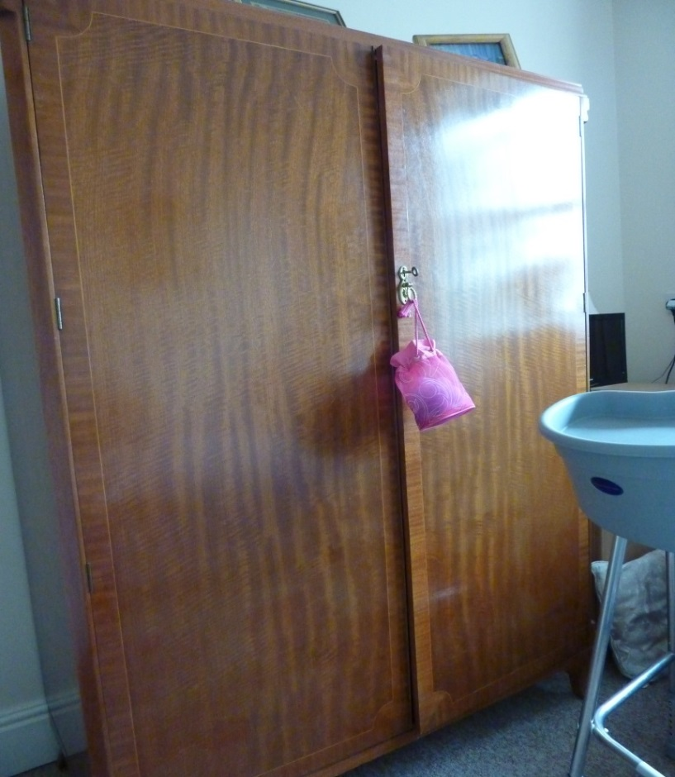
Similarly, Alice was apparently unaware of two bowls placed on top of a bathroom cabinet above her mirror. While she had not known they were there, when I brought them to her attention she recognised them.
Melanie: I was just going to point out as well as above your cabinet, [above the mirror] you’ve got two more, erm, well they look like porcelain bowls. And then one in the middle with again more dried flowers in, in another vase. Shall I bring one over?
Alice: up on the top?
Melanie: yeah.
Alice: have I?
Melanie: yeah. Let me bring one over.
Alice: I’ve never seen, oh. Oh yeah! Oh yes!
Melanie: it’s like you’re rediscovering them for the first time [sic]!
Alice: yeah, oh I’ve had them years and years these ones.
Melanie: yes there’s another one as well.
Alice: yes there were two. Oh, they’d be handy for a plant or [ML – yes] if I had any. Oh, I didn’t know they were there. I know the two little – the lamp near the television [ML – yeah] and that one up there, I’ve had those a long time.
The most striking example of Alice’s unfamiliarity with the objects in her room was the Viking. As I sat talking to Alice about her belongings, I pointed to a glass ornament of a Viking which was placed on a low table at the back of the room.
Melanie: is this a Viking? [there is a glass, Viking ornament on the table] There’s a glass, shall I bring it over? It looks like a Viking! [Picks it up to take over to Alice] Ooh it’s heavy.
Alice: Ooh yes! Ooh, yes I’m glad you’ve found that. Yes my grandson brought me that back from, what country would that be?
Melanie: somewhere in Scandinavia? Norway maybe? Or [A – somewhere when he was younger] Iceland? Denmark? It’s ever so heavy.
Alice: oh yes, I didn’t realise she’d brought me that. Yes [name of grandson] brought it me when he was young. Yeah I do love that.
Melanie: yes it’s lovely. Does it say on it? [Looks underneath the Viking to see if it says where it’s from].
Alice: well it’s out of the way, isn’t it? Don’t you think?
Melanie: Sweden! Sweden it says on it.
Alice: oh, Sweden. [ML – yes]. A bit out of the way there, in’t it [means its position on the table].
Melanie: it is, yeah.
Alice: will it go anywhere, where I can see it?
Melanie: erm. [Looks around the room to look for a more visible place]. You won’t knock it over, will you, because it is quite heavy? What about next to your um, do you use that lamp? [Lamp on bedside cabinet]
Alice: yes.
Melanie: yeah.
Alice: I have that on all night.
Melanie: I mean I can leave it on this table but then I don’t want you knocking it over.
Alice: no.
Melanie: let me see. [Considers the window sill]. I can maybe move [A – yeah], shall I try and move these two over a bit? [Bowl and vase on the window sill] [Laughs] I’m glad I picked this one out now. See if we move these two over [A – yeah]. [ML places Viking on the window sill] [A – it’s only for a time]There! Oh that’s nice. It’s in the light there, as well, isn’t it?
Alice: yeah! Oh yes!
Melanie: it’s been rescued!
Alice: I don’t see it over there [on telephone table]
It astonished me that Alice, a very sharp woman who had lived in the home for seven years, had not realised that an ornament of which she was obviously very fond, was in her room. Presumably her daughter had brought it when Alice had first moved in, or had brought it in since without telling her mother. Placed on a low table at the back of the room, it was not in Alice’s line of sight, and not spending many daylight hours in the room, it had lived there quietly, unbeknownst to Alice. It felt very satisfying to help Alice find it a new home on the windowsill where she could see it, and Alice was clearly very pleased with this too (see Photograph 3) . We returned to the Viking later on in the conversation.
Melanie: but the glass Viking looks lovely there actually, with the light.
Alice: it does, doesn’t it? And I don’t suppose many of the carers would have seen it.
Melanie: probably not, ‘cause it’s, they’ll be just going out the door, won’t they?
Alice: they’ll be asking me where it’s come from or something, I bet you!
Melanie: yeah. Yes. Well you let me know next time if
Alice: I will, yes.
Melanie: you should do that, you should rearrange things and see if they notice!
Alice: yes. Well I bet I have enquiries about that.

However, when I next saw Alice, she was disappointed that none of the carers had asked her about the relocated Viking. Her disappointment may have stemmed from the potential for ‘capital’ which her belongings afforded her. In an environment where Alice was dependent on the staff for much of the day and could exercise only limited agency, her possessions offered an opportunity for her to be complimented and admired. When I commented on one of Alice’s mirrors and admired its frame, Alice responded, ‘one of the carers has put her name on it!’ I queried whether staff were allowed to do this, and Alice replied, ‘no they’re not but, a few more have said “oh that’s nice”, “I wouldn’t mind having that”’. My interpretation of this was that the carers hadn’t been serious about wanting the mirror, and had just been admiring it. However, Alice interpreted these comments as the staff wanting something which she had, and which they did not – an unusual situation for her to be in.
Photograph 3: Alice's Viking, rehomed on the windowsill

5.4.3.2 Objects reflecting past events and people
Apart from clothes and a new television which she bought the previous year when she had to ‘go digital’, Alice couldn’t think of anything which she had bought since moving into the home seven years previously. The small allowance which she received went on ‘everyday things’ such as paying for the hairdresser, chiropodist and toiletries. In general, I got the impression that Alice’s room was oriented towards the past, and that this reflected the limited time she spent there. Alice did not ‘maintain’ or ‘do’ home in the sense of cleaning, rearranging items or acquiring new things, and there was little indication that her room represented a dynamic, ongoing home space in which she could make or realise future plans.
The experience of talking to Alice in her room was not uncomfortable, but it was apparent that Alice was not accustomed to sitting in her room in the daytime. While we talked in her bedroom, she did not give the impression of ‘hosting’ me, and conducting the interview on her ‘home ground’ did not appear to confer on her any sense of confidence or assuredness. For instance, our conversation in her room was quite stilted, in that for the most part, Alice waited for me to ask her a question about an item in her room, and then answered it briefly. The following exchange was typical:
Melanie: so, I’m just looking at that carriage clock, next to your bed. Erm, what’s the history of that, do you know?
Alice: not really, there’s not much history to that.
Melanie: was that in your home before you moved in here?
Alice: yes.
Melanie: so would that have been something that your daughter picked out for you?
Alice: yes it would be. [Thinks] Now how did I come by that? I think, I’m nearly sure it belonged to my sister who died.
Melanie: oh right.
Alice: and I think her daughter gave it to me a long time ago. She’s been dead a long time. I think it did.
Melanie: I mean would you say it had any sentimental value or is it more just for the function of having a clock?
Alice: well both really. If I know it belonged to her, that is the only thing [ML- really, the only thing?], yes. So I know, when I look at it I know it’s been hers, you know that sort of thing.
The personal objects which surrounded her were from her past. Alice could remember where she got items from, or who gave them to her, and invariably these would be people who she had known a long time ago, who had since died.
Alice: this little dish on here [bedside cabinet] is, a friend gave it to me years ago and I do treasure that. That little dish. [The dish contains a couple of sweets and other little things].
Melanie: ooh I see, yeah. [Goes over to have a look]. So it’s a woman, it’s a lady in a red dress.
Alice: yes.
Melanie: ah, lovely. It’s handy as well, it’s a handy shape isn’t it for –
Alice: unusual.
Melanie: yeah, yes it is.
Alice: I think when you’ve had something given you it’s, you treasure them more than if you’ve just gone out and bought them.
As well as her belongings reminding her of past friendships and relationships, Alice also recalled items which she used to own, but which she no longer had, because of the limited space available to her in her room. Talking of a friend who she had known many years ago, Alice said,
She gave me some lovely things. She gave a, my friend, she’s never been married, her sister, the two sisters together, her sister died and she got this big house and a lot of things that she didn’t really want, so she gave me quite a lot. It was a long time ago though. When we were younger, running the pub. I haven’t got those now, only that [the dish] [ML- yes]. I don’t know whether she’s kept any, anything else. She gave me a, er, you know the silver tray and tea pot, silver, she gave me that.
Melanie: where’s that?
Alice: that’s been sold.
Melanie: oh right.
Alice: but er, I kept it and, I think before I came here, and I, then I couldn’t keep it clean, silvered, so [name of daughter] had it in her house. And then er, she got, she couldn’t clean it, you know she didn’t want to, so we sold it. Exchanged money. Quite a few other things like that, she gave me. But had this not have happened [gestures to her bad leg] and I had to come here, I’d have them.
This sense of the past, and of loss, ran through my conversations with Alice when we spoke about her belongings. Her belongings, home, and physical (dis)abilities were all interrelated. Had she been able to remain physically in control, she would have been able to look after the silver properly, and furthermore would have been able to stay in her own house. Moreover, she noted that her daughter was also ageing, and observed this through her daughter’s inability to keep the silver clean.

5.5 Conclusion: whose idea of home is this?
Reflecting later on my conversation with Alice in her room, I remembered my initial tour of the home with the manager. All of the rooms seemed very personalised and homely, full of photographs, furniture and ornaments. However, I began to wonder whose idea of home these rooms reflected? The manager’s, perhaps, who may have been keen for residents to be surrounded by objects, as it implied the home enabled the residents to personalise their space, which would have given a positive impression to potential residents and their family members, and to inspection staff. Perhaps family members’ also, who may already have been feeling uncomfortable at their relative entering a residential home, and who would be keen to make the room as familiar and comforting as possible. But as to whether or not the rooms reflected the residents’ idea of home, I was less sure. Alice may have been surrounded by treasured possessions, but I was left wondering how much this mattered considering she spent so little time in her room that she was not fully aware of what was there. The room was almost museum-like, and there was little evidence that it was a dynamic environment, where Alice interacted with her things, changed them around and actively engaged in developing the room as a home-like space.
As with Hockey and Lee-Treweek’s ethnographies of residential and nursing homes, I observed that the presence of personal possessions did not necessarily reflect a sense of the residents feeling at home (Hockey, 1999, Lee-Treweek, 1994). Rather than acting as ‘anchors’ to the past and helping the residents maintain a sense of continuity and assuredness in the present, on the evidence of Alice and her room, I would suggest that the moorings had come unloosed. Alice’s belongings were still treasured by her, but given the limited time she had to spend with them and interact with them, they represented relics from a previous home, in a previous time, rather than components of a current home in the present. Jenny Hockey wrote movingly about this disconnection between the objects in residents’ rooms, and the absence of a meaningful sense of being at home:
Only the small bedside rugs, the trinket boxes, the remnants of former dinner services or table linen, and the mantelpiece clocks serve as personal reminders – or iconic representations – of entire, lost domestic contexts. Remaining figuratively alive in the memories and the reminiscences of individual residents, the past is embodied in such small inanimate objects. They stand as sad reminders that, just as they have survived the homely spaces where once they were framed, so too they will survive the dwindling physical presence of their individual owners (Hockey, 1990: 99).
In this interpretation, residents’ belongings are not the comforting reminders of the past which they are perhaps assumed to be.
This chapter is a case study of my analysis and interpretation of one resident’s experience. The strengths of this approach lie in the detailed context of Alice’s life and experiences which I use to inform my analysis. I was able to spend more time talking to Alice and learning about her perspectives of being in the home than would have been the case had I recruited more residents to my study. I suggest that by focusing so closely on one resident’s experience, my account and analysis help to address what I have already identified in the existing literature as a lack of knowledge of what it actually like for residents to experience life in residential homes. The flipside to this of course, is that by focusing on just one resident, I am unable to know whether other residents had experiences and perceptions of being at home similar to those of Alice. It is possible that had I been able to include more residents at Beechview Lodge in my research, my interpretation of how residents were (un)able to develop a sense of home within their rooms might differ from the one I present here. However, the day to day routines experienced by Alice were common to most residents, and through the regular visits I made to the home over the course of the year, together with conversations with staff, I learned that residents typically spent most of the daytime hours in the communal rooms, only going back to their bedrooms to sleep at night. At the least, I believe that my analysis poses important questions about the relationship between a residential home’s built design and care culture, and resident’s everyday routines and attitudes towards home which could be addressed by further research on this topic.
Home is not a static place or experience, but a dynamic, active interaction between a person and their surroundings (Cieraad, 2010, Smart, 2007). Within a residential home setting, the ongoing interaction between a person and their environment, in which a space may become transformed into a place, is influenced by the ability of the older person to exert their agency and the affordances offered by the ‘institutional’ aspects of the home, namely the built design and the care culture. In this chapter I have attempted to demonstrate the influence which a residential home’s design, the care culture, and the way in which these intersect, influence the day to day life of residents. Based on the case study of Alice, I suggest that it is not enough to have your personal possessions with you in your room in order to feel at home and have a sense of belonging and control. What is also crucial is the ongoing creation and maintenance of relationships, active engagement with the environment, and ability to ‘perform’ and ‘practice’ being at home. This chapter describes a residential home which is perhaps in keeping with the negative home of the public’s imagination, but I have tried to explain why and how this was the case.
As the following chapters show, Beechview Lodge and Alice’s everyday experiences of living in a residential home are neither inevitable nor universal. In the following three chapters I turn my attention to The Cedars, where the built design and care culture allowed the residents to enjoy greater agency over where and how they spent their time, with the result that residents were much more invested in developing and maintaining a sense of home within their rooms. In the next chapter I focus on how residents of The Cedars were able to create an ongoing sense of home in their rooms, through everyday interactions with their personal belongings, and through activities such as cleaning, sorting and hosting. I argue that through spending time in their rooms, reflecting on and interacting with possessions – crucially new acquisitions, as well as those brought from their previous homes – residents of The Cedars were able to feel at home in their homes in a way that Alice in Beechview Lodge, unfortunately, was not.

Chapter 6: Becoming at home in the room

6.1 Introduction
In the previous chapter, I used Beechview Lodge as a case study to explore how the structural elements of a residential home, such as the built design and the care culture influenced the ways in which residents experienced everyday life and home. Focusing on one resident – Alice – I argued that simply owning treasured possessions was not in itself sufficient to allow for a sense of ‘being at home’ to be experienced. In this chapter, I use the contrasting example of The Cedars residential home to explore how residents were able to ‘become at home’ in their rooms through everyday practices and interactions with their personal possessions, which were facilitated by a more accessible physical environment and a less restrictive care culture.
In Chapter 2 I argued that the majority of previous literature on material culture in residential homes rested on the idea that a sense of home could be stored and transferred in residents’ belongings. My analysis of Alice’s experience of her room and belongings critiques this theory, and suggests that residents simply possessing and displaying their objects is not as important as what they (are able to) do with them. Drawing on the processual theories of practice and relationality, which emphasise the ways in which concepts such as home are in constant states of change and (un)becoming, in this chapter I argue that residents’ experiences of home are better understood as ongoing projects where the meanings of home develop and change over time, through social and material interactions.
I begin by outlining some of the key sociological concepts of home that have informed my understanding of my research, and critically discuss how these are represented in gerontological literature on residential homes. Following this, I will introduce the setting of The Cedars and explain why it was that residents were able to engage more with the process of becoming at home than they were in Beechview Lodge, supporting my analysis with detailed examples of the everyday lives of the residents.

6.2 Understanding home
An increasing amount of scholarly attention has been devoted to the home as an arena where issues of sociological interest including identity, gender, labour, consumption and relationships are realised through everyday, mundane practices (Finch and Hayes, 1994, Gregson, 2007, Mason, 1989, Pahl, 2012, Pink, 2004, Rose, 2003, Smart, 2007, Hurdley, 2013). That home is not a phenomenon which is fixed, stable, or which can be pinned down as containing one or more elements or meanings, seems to be accepted within current sociological discourse (Morgan, 1996, Smart, 2007). Carol Smart, for example, highlights the ways in which our personal and social relationships shape our attitudes towards and understandings of home, and argues that, as we are able to have ambivalent feelings within our relationships, so it is possible to have ambivalent feelings towards home. She continues, ‘[u]ltimately this means that it becomes important not to generalize about the meaning of home but to recognize the concomitant ebb and flow of emotions’ (Smart, 2007: 165). That home is not a fixed constant for its inhabitants is suggested in research into how people’s experiences of home change in accordance with events, or shifting relationships. Experiences such as adult children leaving home, retirement, or the death of a family member can change people’s attitudes towards, and practices within, their homes (Cristoforetti et al., 2011, Hockey et al., 2001, Mason, 1989). Authors have also challenged the pervasive assumption that home is an inherently positive concept and a place of safety and comfort, an attitude that is inherent in ageing policies, care home practices and gerontological literature which emphasise the importance of ‘transferring’ or ‘maintaining’ a sense of home. Rather, for some people, home may be experienced as a place of abuse, or where they feel trapped or lonely (Goldsack, 1999).
As well as attitudes towards home shifting over time according to changes in relationships or events, the fluid dimensions of home are also apparent in research that demonstrates how people can experience home simultaneously as multiple locations in multiple times. For the Dutch university students in Irene Cieraad’s research, different understandings of home coexisted. For instance, home could mean the parental home, which may also have been their childhood home. This home existed for them in the past, as the home where they grew up, but it was also a home of the present and near-future, where they went during weekends and holidays. The accommodation they inhabited in their university towns or cities was also a home, albeit one that existed mainly in the present, as the students were conscious that this was only a temporary home, while they were at university. Consciousness of the temporality of their ‘university home’ also provoked imagination of a future home, where they would live after graduation (Cieraad, 2010). Home may also be conceptualised as located within multiple times and places for children of separated parents, migrants, or owners of holiday homes (Ralph and Staeheli, 2011, McIntyre et al., 2006, Neale et al., 1998).
Acknowledging that a home is ‘more than the sum of its parts’ (Smart, 2007: 163), sociologists, anthropologists and environmental gerontologists have endeavoured to try and understand what those ‘parts’ actually are, and construct useful theoretical frameworks of how best to understand and research home. In their study of young adults leaving the parental home, Holdsworth and Morgan suggest that home can be understood by conceptualising it as a trinity of ‘the practical’ (concerned with the materiality and spatiality of a home, together with aspects such as renting or buying and decorating); ‘the symbolic’ (for instance how home is constructed and understood within discourses which may reference heritage, ancestry, landscape); and ‘the imaginary’ (including how individuals attach meanings to domestic space, and how meanings of home relate to personal identity and autobiography) (Holdsworth and Morgan, 2005: 75). The ‘symbolic’ and ‘imaginary’ dimensions are helpful in conveying the sense that home is not just a visible, tangible ‘thing’ but also an idea that is closely linked to other intangible concepts such as emotion and aspiration. As I go on to discuss, while the ‘imagined’ dimension of home is present in research concerning the home narratives of younger people, it is largely absent from research into home-making in older age, reflecting the assumption that younger people are primarily future-oriented, while older people are primarily past-oriented.
Another conceptual framework of home is offered by Jennifer Mason, who suggests that home comprises five key, intersecting dimensions: material (by which she means ‘location’); spatial (the different areas within a location); temporal; metaphysical (referring to ideologies and values); and social (Mason, 1989: 103). The temporal dimension is, I suggest, a necessary component in understanding how home is not a fixed, stable entity, but a concept which, as Mason points out, shifts over relatively long periods of time, as well as at different times of the day (103). Mason stresses that each dimension does not represent a resource, but rather ‘a dimension of interaction … through which home is constituted, and the dimensions are not independent of one another’ (103). Mason’s description of the material dimension as relating to the location of home is perhaps a rather narrow one, but I suggest that the term is malleable enough that this dimension remains useful, although it could be extended. For instance, I would argue for the material dimension to include the built design of the home, and all of the possessions and furniture. These tweaks notwithstanding, I find Mason’s conceptual framing of home useful in understanding home as a shifting, fluid phenomenon, which is not fixed in meaning.
Within environmental gerontology, the dimension of home which has received most attention is the spatial, and Cutchin argues that while disciplines such as sociology, anthropology and psychology have many useful perspectives on the concept of home, ‘the experience of home is rooted most fundamentally in the geographical nature of home as place’ (Cutchin, 2013: 108). This perspective is borne out in the gerontological literature, which focuses on issues such as ageing in place and turning spaces into places. While place-making in residential homes is important, the lack of emphasis on how this relates to time – and is in fact inseparable from it – is problematic, as it reinforces a sense that a resident can turn the space of a room into a the place of home simply by arranging their prized possessions. This is implied by Joan Higgins who writes that:
[t]he real sense of home is essentially a metaphysical concept which transcends particular sets of physical arrangements designed to foster domesticity. For people to ‘feel at home’ there has to be a meaningfulness about those arrangements which reflects their sense of identity and sense of self. The desire of elderly people in residential care to hold on to a few treasured possessions symbolises their need to make a statement about themselves, their tastes, preferences and personalities as well as a wish to hold on to memories and fragments of the past (Higgins, 1989: 172).
An alternative view is offered by Allan and Crow, who note that to ‘become at home’, ‘is essentially an active process which involves forms of work, “housework” in the broadest sense of that term’ (Allan and Crow, 1989: 11). Some previous research has shown the importance of older people’s mundane routines and everyday practices in facilitating a sense of home. Percival, for instance, interviewed older people in a variety of accommodations, and found that living in spaces which allowed residents to undertake daily routines and responsibilities (for instance hosting visitors and undertaking housework) was central to the spaces becoming meaningful places of home (Percival, 2002). Correspondingly, previous studies suggest that residents of residential homes felt helpless and lacked control over their environment when everything was done for them by care staff (Willcocks et al., 1987).
However, while Percival emphasises the importance of ongoing routines, he does not discuss how this relates to the temporality of home, beyond stating that everyday interactions with objects such as furniture and ornaments ‘keep alive the memories of work, leisure and family’ (Percival, 2002: 747), reinforcing a sense that material culture in the home is principally of value for older people through its ability to preserve a sense of the past. This underestimates the importance of imagining and working towards a future when making a home – a point which is made in research about home-making at earlier stages of the life course (Cieraad, 2010, Holdsworth and Morgan, 2005), but is often overlooked in studies concerning older people. There are notable exceptions to this past-oriented focus on place-attachments in later life. Peace, Holland and Kellaher, for example, note that in the context of ‘decline in their own competence and/or the demand characteristics of environment’, older people will sometimes find new ways to reinforce attachments to place, which could include adapting their behaviour or the environment, or using care services (Peace et al., 2005: 200). Peace notes too that homes can be ‘receptacles’ of change, as well as continuity, implying a future as well as a past orientation’ (Peace, 2015: 452). Malcolm Cutchin also argues that in addition to transferring belongings and engaging in ongoing, place-making routines, habits and activities, residents moving to assisted living facilities must also use their imaginations in order to think about what would allow them to feel more at home (Cutchin, 2013). He writes that, ‘[w]hile much scholarly attention has been focused on the role of memories of older people in establishing a relationship with a new place, it is important to realize that the ability to see possible futures is equally, if not more, important’ (118). Rather than habits and everyday practices being primarily significant because of how they allow new residents in residential homes to ‘recreate’ a sense of the past home, Cutchin conceptualises them as being crucial in enabling residents to make future plans:
[b]ecause habits are the basis of creativity and place-integration, place-making does not need to focus on creating a replica of the former home. Indeed, with the constraints of quasi-institutional settings and policies, the new place cannot be the old one. However, empowering an older person to make a new home in assisted living surely includes the use of artifacts and memories from the past (118-119).
Drawing on Cutchin’s conceptualisation of home-making in residential homes as necessarily involving multiple temporalities – not least a sense of the imagined future – in this chapter I show how residents worked towards the ‘project of becoming at home’ through everyday interactions with their belongings in ways which incorporated multiple and intersecting temporalities.

6.3 The Cedars: a homely institution?
Drawing on the theories of practice and relationality which I introduced in Chapter 3, I continue to trouble the assumed oppositional binaries of ‘institution’ and ‘home’ considered in the previous chapter. In this chapter I focus more on home, and how through spending significant amounts of time in their own rooms during the day, some residents of The Cedars were able to make the spaces of their rooms meaningful places of home. This was achieved through ongoing, everyday interactions with their belongings through activities such as hobbies, cleaning and active reflection on their material surroundings. I argue that home for many of the residents at The Cedars was ‘more than the sum of its parts’ (Smart, 2007: 163, Hecht, 2001: 123). That is, a sense of home was not simply inherent in the physical features and possessions, but was developed through routine practices and encounters with material culture over time.
In this chapter I discuss three component ‘elements’ to the residents’ experiences of home, and suggest that the ways in which these elements overlapped and intersected with each other worked to transform the spaces of their rooms into places of home. The first part is the material culture of the rooms, including personal possessions such as ornaments and photographs as well as more taken-for-granted materials such as carpets and walls. Secondly, I consider the residents themselves, and how their interactions with material culture created a sense of dynamism and activity in their rooms. This could be enacted through mundane activities such as cleaning or tidying, as well as through pastimes such as reading, watching television or crocheting. Importantly, the residents’ bodies mediated the transition of the rooms from spaces into places, and as older people who had in part moved to The Cedars as a result of the limitations of their ageing bodies, what they could and could not do in their rooms and with their own things affected their attitudes towards and experiences of home, but did not necessarily preclude them from ‘becoming at home’. Exercising their own agency and interacting with their objects was important in ‘proving’ their own independence, and in turn the desire to be independent made them determined to continue to exercise agency and interact with their belongings. However independence and dependence were not fixed oppositional concepts but were interpreted differently by each resident, according to their own values and preferences. The third dimension of home I discuss in this chapter is time, and how residents experienced home in their rooms as existing in the past, present and future. These different temporalities were not discrete, but could be experienced simultaneously, and again helped to create a sense of movement and activity in residents’ rooms, whereby their rooms were not just oriented towards the past, but also reflected the residents’ activities in the present and plans for the future. I conclude by suggesting that the ways in which the residents’ rooms became homes were not as different to how people create and experience homes at other stages of their lives and in other types of accommodation, in contrast to what has often been suggested in the existing literature on residential homes for older people.

6.4 The material home
All of the bedrooms in The Cedars were the same size and of a similar design. On entering, there was a short corridor with the bathroom on the left or right before the room opened out into the main bedroom / lounge area. Each bedroom had a large window overlooking the garden, drive way or the street. Despite the uniformity of their design, each room had a completely different atmosphere, reflecting the rooms’ furnishings and other contents, the behaviour of the residents, and the interactions between the two. Accordingly, on entering each room I felt like I was entering a different home. Some rooms projected an atmosphere of comfort and a sense that everything had been put together to achieve a particular aesthetic or idea of home – this could be conveyed through matching furnishings, and photographs and ornaments which looked as if they had been placed with great care. Other rooms gave off the impression of being more of a collection of different objects in the same room, with little sense – to me at least – of them forming a holistic home. Regardless of the overall impression of home, all of the rooms contained a range of objects – both primarily decorative or ornamental, as well as more practical and mundane. Importantly, while some of these were possessions which the residents had brought with them from their previous homes, others were already present in the room when the resident moved in and subsequently became ‘inherited’, and others were acquired gradually over the course of the resident’s occupancy of the room. In this way, the materiality of the home was not reliant on, or purely evocative of, a past, former home, but reflected the residents’ ongoing, everyday lives and future plans.

6.4.1 Objects taken into the room
Most of the residents whom I got to know had not planned to move into a residential home and had only done so as a result of a sudden deterioration in health or change in circumstances. Consequently, the initial move was experienced by some as disorienting. As a result of the crisis situation in which most residents first entered the home, many residents were unable (or unwilling) to sort through their own belongings themselves, and in most cases their children made the decisions of what to take into the home, and what to leave behind. In this sense, the creation of the resident’s home in their room was not solely the work of the resident, but of their families and other personal ties, something I will explore in more detail in the next chapter.
All of the rooms contained objects which could be considered to be of primarily practical use (such as televisions and computers) or more symbolic of memories and relationships (for instance photographs and ornaments). However, I would argue that rather than distinguishing between the two, it is more useful to consider how the objects as a whole contributed to the sense of home in the room through enabling the resident to have a sense of control of and a sense of belonging in their room. Annie, who was the only resident I knew who sorted through her belongings herself, talked me through the things she brought with her and the reasons for doing so:
Annie: all my crystals there [in front of television], they were the first things I [decided to take], and various little ornaments as you can see up there [on chest of drawers to the right of the bed]. And the clock. Small things, things that I did need, or didn’t, well I needed the clock and things like that but, the crystals I did need, because I’d been collecting them, and they meant a lot to me. I had to part with a lot, because I just couldn’t cope with them all, but they went to family, so that was ok.
Melanie: oh good. And so what else besides the crystals? So you collected those yourself.
Annie: I brought my television with me, which was most important, in a sense. And my Skybox and things like that. Photographs, naturally…. I brought this chair [armchair which can recline etc], my electric bed, the little cabinet, the long cabinet there, and drawers, two sets of drawers. That was it. I needed those. So I brought just what was necessary, because I needed that [cabinet that TV is on] with it being sort of cupboard, cum drawers. I needed it for my Skybox and DVD things and the top, I wanted it that wide because of the television. So that was really necessary, and of course drawers, everyone needs lots of drawer room. And I bought the electric bed and brought it with me just in case I ever become bed-bound. It would be much easier for people to look after me.
While Annie emphasised the practical and ‘necessary’ items she brought with her such as her television and drawers, she stated that she also ‘needed’ her collection of crystals because of the meaning they had for her, highlighting the difficulty of distinguishing between items which might be thought of as ‘functional’ and those relating more to ‘identity’ (Miller, 2010).
Annie also explained to me why she valued one photograph – of herself in her nurse’s uniform – in particular:
Well it was the happiest time of my life, because I’d brought five children up, and my life was given to them, their needs, rather, and when I got the two youngest boys to thirteen and eleven, they were advertising this new thing that was coming out, because I was 45. And I thought about it and thought, well, I’ll go and try the entrance exams and see, ’cause it’s such a long time since I went to school, and was most surprised when I passed, and then of course we had to do two years’ training, then I qualified. So from then on in, it was what I’d always wanted to do and couldn’t, because during the year I was married at eighteen, and five children later, you know. So I know very nice, personal memories from there, of course I’ve memories of all the other things as well but, so I just have that there to keep, when I’m feeling a little bit down or sad, and then I can think back how good it was; I really enjoyed it. I got fifteen years out of it, so it was quite a long time.
Annie’s pride in her nursing career was also embodied in a figurine of an owl in a nurse’s uniform, given to her by her granddaughter, which Annie displayed on her fridge. The owl, shown in Photograph 4 is next to other ornaments, but also next to less permanent and decorative items, such as an empty water bottle and plastic containers. The way in which objects which were treasured and displayed for their symbolic meanings and connections to family, places or identities often shared space with or were placed next to more mundane, transitory items was typical of the residents’ rooms. While it may have partly reflected the limited space of the rooms, I would argue that it is similar to most homelike spaces, where shelves or mantelpieces may simultaneously contain relatively permanent display objects such as vases and framed photographs, as well as more temporary fixtures such as postcards, shopping lists or keys (Hurdley, 2013). This material juxtaposition of the mundane with the symbolic suggested movement and life, a sense that home life was going on ‘as normal’, despite ‘home’ being a room within a residential home.
Photograph 4: items on Annie's fridge
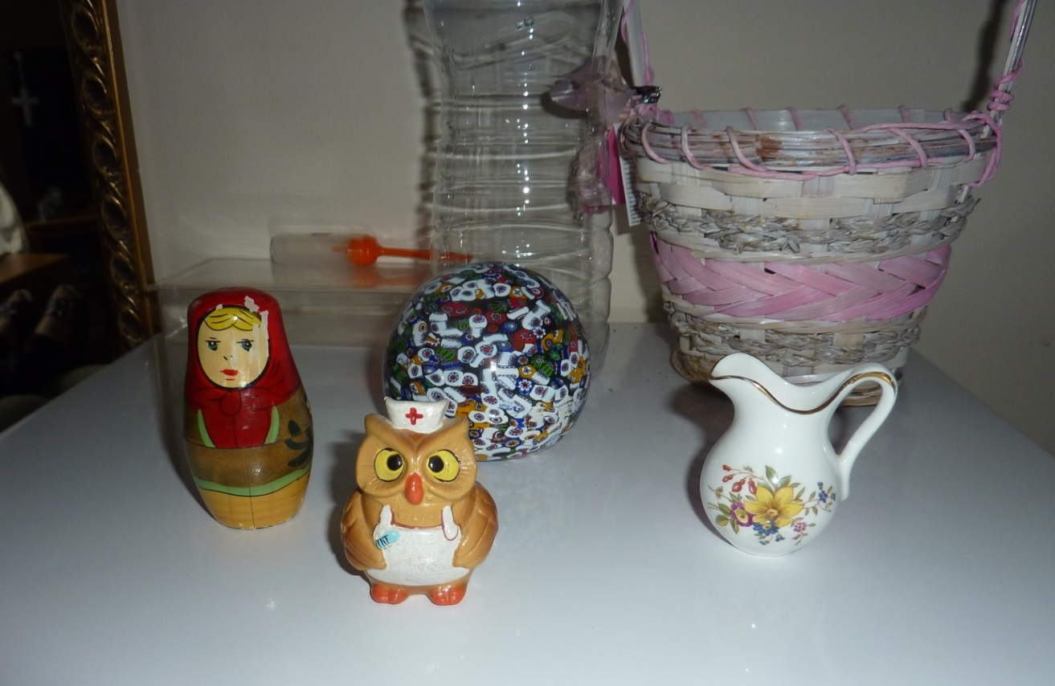

Just as the symbolic and mundane were juxtaposed spatially, the different temporalities associated with or provoked by objects could be hard to disentangle. Some objects were primarily valued for being material, embodied reminders of previous meaningful relationships, and were actively reflected on in the present. Dorothy, who had moved into The Cedars primarily due to loneliness, brought with her a pipe stand and pipes which had belonged to her deceased husband (see Photograph 5), telling me,
[m]y husband smoked lots of pipes, and of course I bought those for him, and I wanted to have something to remember him by, so I brought them with me.
Melanie: that’s a lovely idea.
Dorothy: yes.
Melanie: and, do you think about him when you look at them?
Dorothy: oh yes. I think about him all the time love. Yes, he was a very good husband, a marvellous husband. Yes, I was married 36 years.

Photograph 5: Dorothy's pipes
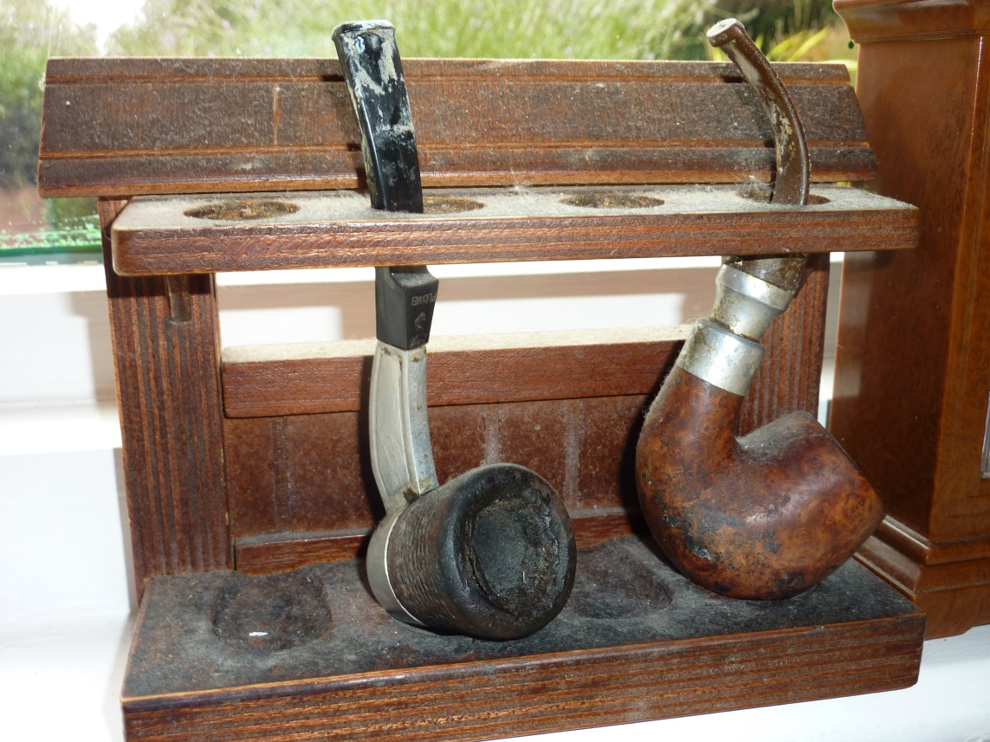

During the course of my visits, residents would point out objects to me which they had brought into the home, and use them to narrate stories about themselves or their families. “I must have told you the story about that photograph,” Polly once said to me, pointing to a framed picture of her and her husband. She went on to tell me that on the evening it was taken, her husband had phoned her to say that he was meeting a colleague and his wife for dinner, and would Polly come as well? Polly said she had nothing to wear, so her husband said “well why don’t you go out and buy a new dress or something?” So she went to Marks and Spencer and bought a pink dress. When she arrived at the restaurant and met her husband’s colleague and his wife, his wife took off her coat and Polly realised that they were wearing the same dress. She laughed and told me that it was embarrassing, but also funny. Polly still acutely mourned her husband’s death and sometimes found it upsetting to talk about him, and I wondered if objects such as the photograph, with the humorous narrative attached to it, provided her with opportunities to talk about her husband in ways that emphasised their happy life together, rather than his absence.
Similarly, Stan would often point to photographs of his deceased wife on my visits to him, using them as material prompts to recount stories about their marriage. He would also bring my attention to photographs of houses that he had ‘done up’ in the past, or objects he had crafted out of wood, taking obvious pride in his practical skills. To me, these photographs did not just represent past achievements; by displaying them, actively bringing my attention to them and telling me stories about them, Stan was also demonstrating the agency he had in the present to ‘own’ the space of his room and the things it contained.

6.4.2 Objects already in the room
The Cedars provided basic furniture and furnishings in the rooms, including a bed, wardrobe, chest of drawers and curtains. While many residents chose to replace these with items from their former homes, some residents were content to use the furniture provided. As well as these generic furnishings, sometimes rooms contained more personal objects which had belonged to the previous resident of the room who had since died. Such items were left in the room because the resident’s family hadn’t wanted to keep them, or there were no family members to offer them too. When Stan moved into The Cedars, his room already contained a number of objects (including a table, desk, chair, clock and picture), which he decided whether or not to keep, according to his preferences. In the end, the only item he decided he didn’t want was a vase of plastic flowers (‘I put that in [the] dining room. I can’t stand artificial flowers! No make believes’). One item struck me as being particularly personal, and I was surprised that no one had claimed it. It was a painting of Ladybower reservoir in Derbyshire – where the squadron of men who were later to carry out the Dambusters mission in World War Two had practised the manoeuvre – and at the back of the picture, stuck into the frame, was a newspaper cutting about one of the men who had taken part in the raid. Stan claimed that the previous resident had been involved in the mission and presumed that he had painted the picture, although despite the story behind it, I got the impression that Stan valued the painting more for its aesthetic qualities than anything else (‘it’s a good picture though’).
I wondered if some of the residents would be sensitive to possessions left from previous inhabitants – material reminders that their time spent in the room would only be temporary – and that the circumstances in which they finally left the room would not require them to take their belongings with them. I found no evidence of this however, and Annie, who had ‘inherited’ some ceramic tulips when she moved into the room told me matter-of-factly, ‘they were in when I came here….yeah. I like them because they’re unusual. So I kept them. I mean when I go, they’ll still stay here, sort of thing’. In this respect, it seems that Annie was quite aware that the tulips would outlive her, and remain a constant presence in the room while residents came and went. Interestingly, one of the ornaments which Annie brought into The Cedars was a vase of plastic daffodils, which had been present in the nursing home room where her husband had died. Despite not having owned the vase, Annie took it with her after her husband’s death, ‘because again, memory’. It seems that the ways in which residents either kept or discarded existing objects were little different to how people moving into a new house or flat might decide what to do with fittings and furnishings that were already present. Either the objects would be discarded on the basis that they were not needed or that they did not match the new inhabitants’ tastes, or alternatively, what had been thought of as the previous inhabitant’s possessions might come to be thought of as their own, as associative memories built up through practices, routines and events.

6.4.3 Buying new things and making changes
As well as bringing items from their former homes and ‘inheriting’ objects that were already in their room at The Cedars, many residents also acquired new things – both on the point of moving in and also in an ongoing way. Several residents told me that they had bought new beds, sofas and tables on moving into the home. This was often because their existing furniture wouldn’t physically fit in the room, or sometimes because they had a grandchild or other younger relative who was moving into a new home and who could benefit from having the resident’s cast off furniture, leaving the resident free to buy new items. For Mary, who had a keen interest in interior design and the aesthetics of home, moving to The Cedars was not a question of attempting to recreate her previous home. Her room in The Cedars was so different to her former flat that, to her, many of her existing belongings simply wouldn’t have ‘gone’ in her room. An example of this was a picture of an owl which had been a prominent feature in her former home:
Mary: I told you, everything has to fit in, and the owl didn’t fit in here ‘cause it’s not in keeping with these colourings, and it’s a bit too strong, where to put it. I’d love it to be in the doorway so it hits you [as a visually striking picture], ‘cause it’s – I might be imagining it but to me it’s got these beautiful eyes. And it’s beautifully painted. No, it’s got to be –it can’t be tucked away!
Later she told me that she couldn’t bring with her some chairs from her previous flat because, ‘they wouldn’t fit here [at The Cedars]. And they wouldn’t go here. And everything has to go [laughs], has to fit in. I’m so mad!’ For Mary, home was something that had to be remade in each new house or flat according to the dimensions, design and aesthetics of the physical space and building, and she had done this throughout her life. Despite putting a lot of thought, effort and money into making a new home every time she moved, when she moved into a new place she often left the former home as it was, because she conceptualised the furnishings and many of the belongings as being part of the home, and she couldn’t bring herself to ‘break it up’. Consequently, when she left her previous flat she left many of the items there:
Mary: so in my flat…I left things that I thought I’d made belong to it. And then when I left my flat… which I’d moved to after, which I thought was going to be my lifetime [final home], is where I left the whole carpets, curtains, plants, everything, hoover, everything. Even the phone! Everything!
While her room at The Cedars did include objects from her former flat, these were carefully chosen (either directly by her or through her children, with her agreement) to match her current surroundings, and while Mary did express some sadness at some objects she no longer had with her, this was tempered by her conviction that they belonged to the former home and could not simply be incorporated into her new room.
Even after residents had ‘settled in’ to their new rooms, many of them continued to actively engage with their home through acquiring new objects. In some cases this was to replace broken or outdated appliances such as clocks or televisions, while others bought things as and when they liked, and when the opportunity presented itself. Inevitably, residents’ ability to acquire new objects was to some extent bounded by their mobility and familial and social connections. For instance, residents who were too frail to leave The Cedars unaccompanied and who had infrequent visits from family and friends had relatively few opportunities to buy new objects – although as I will discuss in the next chapter, objects circulated throughout the residential home through jumble sales, and the deaths of residents. Residents who had computers could order things for themselves online, and I knew of residents who ordered books and jewellery this way. One resident, Stan, still had the use of his car and also a mobility scooter, and went out frequently to the shops. An enthusiastic customer of a local charity shop, he often returned with objects and ornaments which he displayed in his room, or in the case of musical instruments which he could not yet play, stored them in his wardrobe, until he found the time to begin to teach himself. Residents who had only arrived in the home relatively recently would gradually incorporate more items into their rooms. Peter’s wife still lived in the house they had shared together, and so Peter had not needed to move all of his things into The Cedars in one go. There would usually be new objects in his room every time I visited – most often pictures or photographs he had taken, or new books. He would point these out to me, inviting me to comment on them.
Some items were only temporary additions to residents’ rooms. For instance, residents sometimes showed me photograph albums which had been lent to them by relatives, or bouquets of flowers or boxes of chocolates brought by visitors. On moving to The Cedars from the south west, Polly had asked her daughter to bring her some library books about the area in which she now lived, and when I visited I often had to move borrowed local history books from the chair on which I was about to sit down. These, together with newspapers, greetings cards and half-drunk cups of tea, conveyed an atmosphere of normal, everyday, lived-in life that contrasted strongly with my impression of Alice’s life in Beechview Lodge.
Other residents made more fundamental changes to their rooms, for instance by buying new carpets and curtains. When I first met Susan, her room was largely bare because she had decided to have her room decorated (see Photograph 6). Disliking the original magnolia-coloured walls, she made plans to have her walls painted pink and grey, and bought new curtains and a carpet (see Photograph 7). She paid for the work, which was carried out by a contractor hired by The Cedars. The time taken between the work being commissioned and actually carried out dragged on for several weeks, and became something of a saga that Susan mentioned whenever I visited. First the work was postponed because the contractor had a chest infection, then again when he hurt his shoulder. Finally Susan lost patience and asked for another contractor to be hired. During this time, when Susan had had her walls removed of their decorative plates and other ornaments, she dissuaded her sisters from visiting her as she didn’t want them to come while her ‘house was such a mess’. It occurred to me that Susan’s desire to have her room decorated and new curtains and carpet put in, her grumbling at the delay of the work due to the contractor, and the resulting disruption caused to her everyday life and socialising were no different to the ways in which other people, of all ages and in any accommodation relate narratives about decorating. For Susan, life in The Cedars was much the same in essence as life outside it.
Photograph 6: Susan's room before redecoration
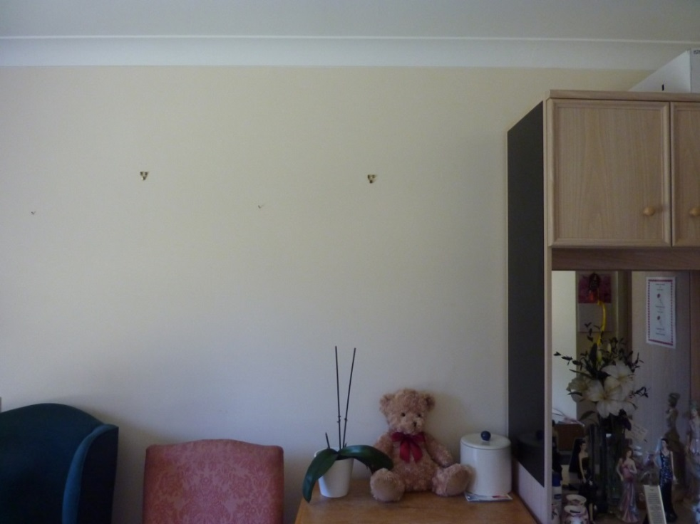
Photograph 7: Susan's room after decoration
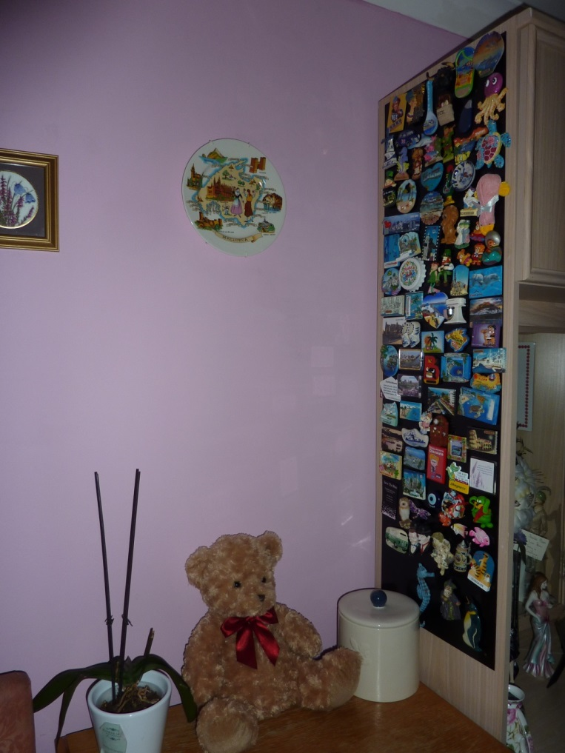

6.5 Practising being at home
Homes were not instantly created by the residents’ transference of objects from their previous homes into their rooms in The Cedars, and many residents spoke of how the initial weeks and months were difficult, and that it took time for them to ‘settle in’. However, over time, most residents I spoke to cultivated and experienced a sense of home in their individual rooms through the establishment of regular practices, routines and interactions with their material surroundings. Over the course of my visits I became accustomed to the typical routines of individual residents, and my field notes chart my growing familiarity with particular habits and behaviours. On my visits to one resident, for instance, I often noted that ‘as usual when I arrive, she has a book in her hand’, or ‘as ever, Susan is in the middle of cleaning’, and I also recorded instances of apparent mundanity which nevertheless struck me as unusual, for instance a closed door where usually it would be open. While banal, such details in The Cedars could also indicate more serious happenings; an unexpected closed door sometimes forewarned me of a resident’s illness, which I would later confirm with a member of staff.

As I explained in the previous chapter, the built design and care culture of The Cedars, in contrast to Beechview Lodge, allowed residents much more choice and control over where, how, when, and with whom to spend their time. This influenced how I interpreted residents’ routines. Whenever I visited Alice in Beechview Lodge, she was either in the communal lounge with the other residents, or had already been helped into the visitors’ room at the back of the building to await my visit. Either way, she exercised little agency in the matter and was acting predominantly in response to the institutional routines of the home, or to my wish to visit her. In contrast to this, while residents of The Cedars practised routinised behaviour, such that I was often not surprised to come across particular residents engaged in certain activities when I arrived – be it cleaning, reading or crocheting – I formed the impression that these habits reflected how they chose to spend their time. Putting it another way, when I visited Alice I could not help but feel that my visit was injecting some much needed life into her day. When visiting most of the residents in The Cedars, on the other hand, I felt that while my visits were welcomed, they were merely another element to a life that residents had shaped themselves and with which they were by and large content.
One particular visit to The Cedars early on in my field work made me realise that life in the home was not a passive experience, where residents waited for me to arrive so that they had something to do, or someone to talk to. On the way to another resident’s room, I noticed that Susan’s door was open, so popped in to say hello. Cloth in hand and cleaning, she told me that she could not chat for long as later that morning she and a few others (residents and staff) were going to a funeral of a resident who had died the previous week. While Susan carried on cleaning we talked for a few minutes about Susan’s health, before Susan reminded me that she had ‘better get on’ with preparing for the funeral. As I left, I reflected that while I had assumed that I could just turn up to the home at any time and expect that residents would be willing and able to talk to me, this was not necessarily the case. Residents had appointments, received other visitors, and had other activities to fit into their lives, and sometimes my visits were not convenient for them.
Following this realisation, I always tried to let residents know the next day I would be in the home, and check whether or not they would be free that day. For residents such as Susan and Annie this was not so much of an issue, for as long as their doors were open (and they nearly always were on my visits) they never minded me calling in unprompted, sometimes en route to visit another resident further down the corridor. Mary, on the other hand, preferred more formal appointments.
Most residents chose to spend most of their time in their own rooms, but went to the communal dining rooms for meals and an opportunity to socialise with other residents. Some residents demonstrated control over and responsibility for their rooms through domestic tasks such as cleaning, tidying and sorting their things, although the extent to which they did this depended partly on their physical abilities. There was also some evidence that it was influenced by the gender of the resident. While my sample size is too small to be representative, it struck me that none of the three male residents who participated in my research showed any signs of actively maintaining the room through domestic tasks, and while most female residents owned fridges and sometimes kettles, the three male residents did not as far as I was aware have a sense of being ‘house proud’ in a way that many of the female residents did. This is perhaps not surprising, given that the residents were of a generation where it would have been commonplace for women to stay at home, look after children and, as Mason puts it, make the home fit for ‘public scrutiny’ (Mason, 1989: 120), while the men would have been largely responsible for paid work outside the home. Despite this evidence of gendered differences, all residents, male and female, involved themselves in shaping their rooms into homes, whether it be through assuming domestic responsibilities, or investing time in their rooms through hobbies and activities.

6.5.1 Cleaning, tidying and sorting
None of the residents had to undertake any cleaning in their rooms, and many were physically unable to do so, or preferred to let the care staff do this for them. However, some of the female residents chose to clean, tidy and sort their rooms, to varying degrees. Aged 74 when I first met her, Susan was one of the youngest residents in The Cedars, but a combination of Parkinson’s Disease, a stroke and a bad foot meant that she had limited mobility and could only walk with the aid of a walking frame. Despite this, Susan took an active role in maintaining her room, and when I visited her she was invariably cleaning. She cleaned her carpet everyday by manoeuvring around the room with a CarpetMate cleaner in one hand and her walking frame in the other. I asked her why cleaning her own room was so important to her:
Susan: I don’t like untidiness and I don’t like dirt. And that’s the reason. I like to be clean, and I think, well anybody can come into my house and they’ll find it clean and tidy. And I’m not afraid of anybody coming in – [the] queen can come in.
Melanie: and would it bother you if somebody else were to do the cleaning?
Susan: yes because they wouldn’t do it like I do it!
Susan’s use of the word ‘house’ to describe her room was striking, and I heard many other residents refer to their rooms as ‘my flat’ or ‘my home’. For Susan, her room was not simply the one relatively private place to which she could retreat after spending time in the communal areas, but a space that she had actively turned into a place through the time she spent there, the effort she put in to making it how she wanted, and maintaining it to her high standards. Photograph 8 shows Susan’s room, with a blue cleaning cloth drying on the radiator and the handle of her CarpetMate cleaner just visible to the right of the window, leaning against the curtain.
Photograph 8: Susan's room
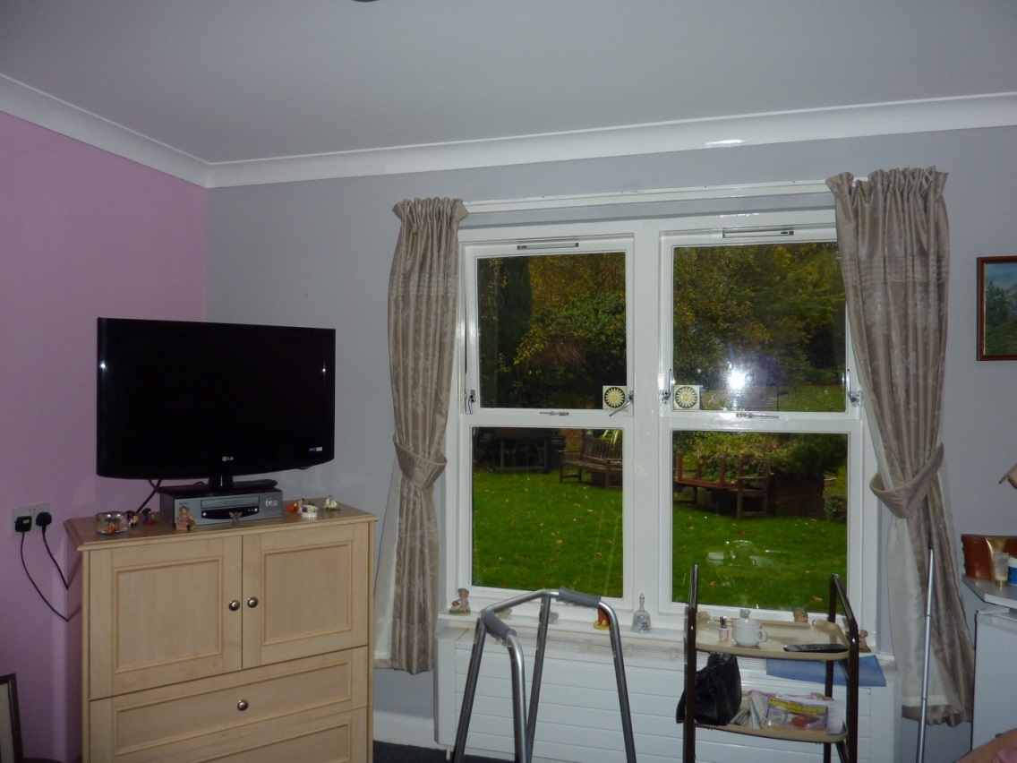

My visits to Susan usually involved me sitting in one of her chairs whilst she chatted away, busying herself with cleaning. If she did sit down, this was never for very long, and mentioning particular objects in her room such as photographs would cause her to stand up and walk over to the item in question, so she could bring it to me for a closer look. She told me that she didn’t like to stay still for too long, and despite her physical limitations she usually managed to move around her room quite skilfully with her walking frame. One afternoon, however, she got into difficulties. Susan was telling me that she had taken down her collection of fridge magnets as she was shocked when she realised how dirty they were, and pointed to where they were currently being stored in two carrier bags on the floor, waiting to be cleaned by Susan and a staff member who had offered to help her. As she was talking, Susan walked around the perimeter of the room, supporting herself by leaning against the walls and clinging to larger items of furniture, rather than using her walking frame. She had nearly made it back to her chair when she overreached and found herself in an awkward position. I tried to help her into her chair but was unable to support her weight, and Susan told me to run and fetch one of the carers. I did so, and watched as the senior carer adeptly helped Susan sit down and gently but firmly chastised her for not using her walking frame. Besides demonstrating Susan’s insistence on trying to remain as mobile and independent as possible, this incident suggested two ways in which the materiality of her room reflected and enabled Susan’s relatively active life. Firstly, the two carrier bags of fridge magnets on the floor were evidence of the ongoing nature of cleaning in Susan’s room; they were not sterile, unmoving ornaments, but had to be monitored and maintained like all of the other material elements of the room. Secondly, Susan’s use of the room’s infrastructure and furniture to help her move – albeit on this occasion perilously – around the room, brings to the fore more ‘humble’ material items and how they can influence a person’s everyday interactions.
While none of the other residents cleaned their own rooms to the extent that Susan did, some maintained their rooms in other, less physically exerting ways. Polly, for instance, was 90 and had lived in The Cedars for four months when I first got to know her. Like Susan, Polly’s room contained visual evidence of her pride in having a clean room – in this case in the form of a Dust Buster which was ever-present on a table, next to more decorative objects (see Photograph 9).
Photograph 9: Polly's Dust Buster
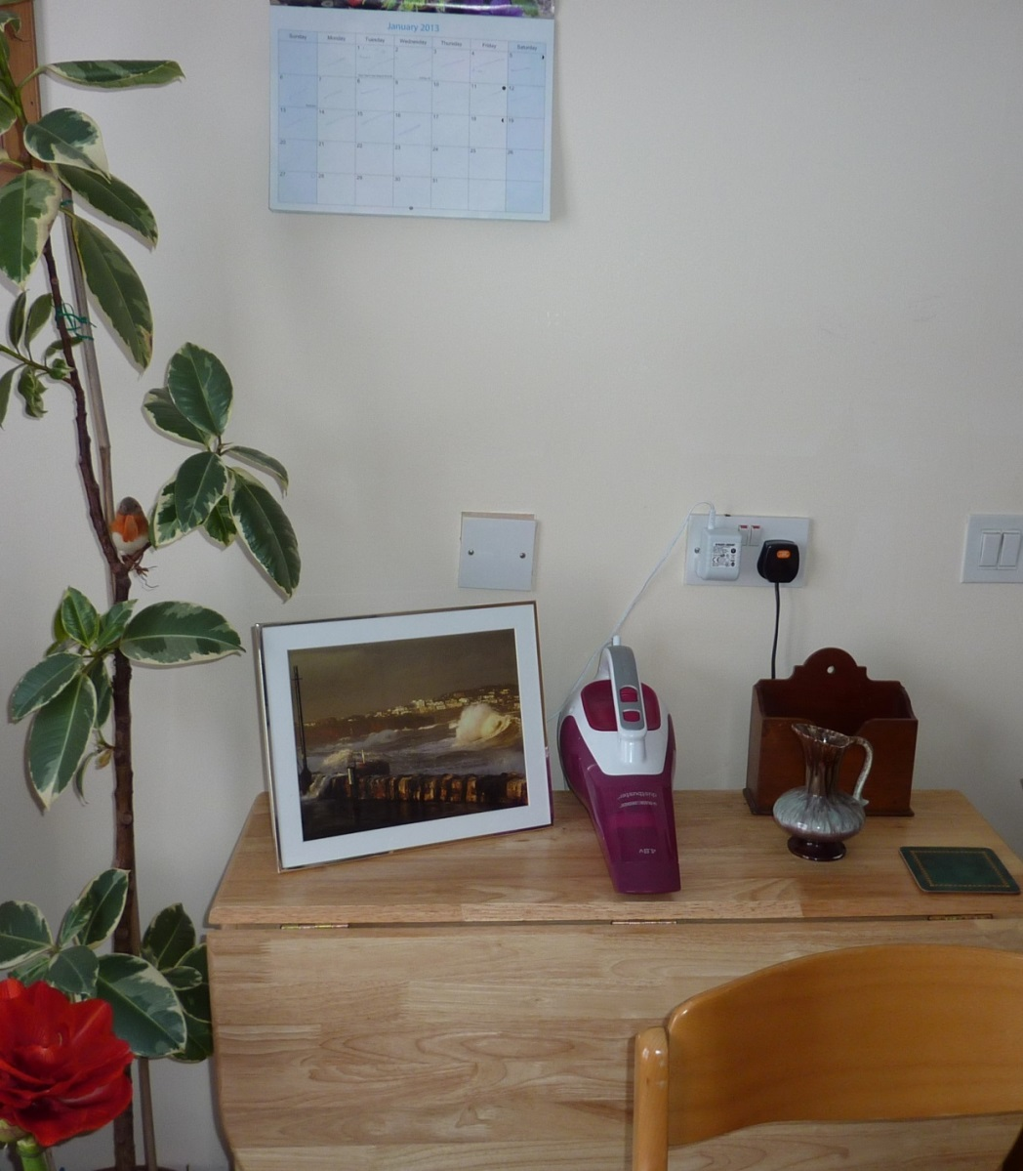
While Polly had been too ill to sort through her belongings herself on moving into The Cedars, she specifically asked her daughter to make sure that she would have a Dust Buster in her new ‘flat’.
Like Susan, some residents told me that they carried out some domestic tasks because they believed that the staff did not perform them as well as they could do so themselves. Pam, for instance, who was 88 and limited in what she could do on account of chronic obstructive pulmonary disorder, told me that she always made her own bed in the morning, because in her opinion the staff did not do this properly. During one of my visits, a care assistant popped in and, catching sight of the bed, told Pam that she should get one of the cleaners to make it up for her. The bed had actually been made up by Pam in accordance with her own preference, and knowing this, Pam and I smiled at each other. Until she became too ill, Pam also used to do her own dusting, telling me with laughter that the cleaners ‘dust round things, you know!’ Despite being limited in what she could do to actively maintain her room herself, Pam was nevertheless very house proud, and regarded having a clean, well-presented room as very important. Indeed, she judged other residents on the state of their rooms, telling me on one occasion:
You know, you get some shocks. Some people have got – I know a lady, I know her ever so well, she’s 97 mind you. She’s got two daughters and they’re all quite well off and everything, and she’s got a pair of curtains up that they’ve brought and they’re fairly – they don’t meet straight, you know they look right – and I keep thinking to myself, “why on earth? ” You know, because there are curtains up in the room when you come, there’s everything that, you know there’s a chair. You know there was a chair in here but it were mucky! [Laughs] No, no, didn’t want that! You know for anybody that’s real hard up, but I don’t think anybody is to that extent. You know, there’s some lovely rooms, and there’s some that are, you know. But I mean some people are very untidy, aren’t they, and others are tidy? I mean it makes all difference that, don’t it?

In some cases I interpreted the ways in which the residents actively maintained their rooms as them balancing the value they placed on being responsible for their own homes and remaining independent and active as far as possible, with the physical limitations of their ageing bodies. Annie, who lived on the same corridor as Susan, told me that she sometimes jokingly scolded Susan, telling her ‘you’ll put cleaners out of a job, you!’ It was clear however that Annie approved of Susan’s attitude, saying ‘but she’s always been a hard worker by the looks of it’. Annie told me that after bringing up five children, she felt that she had done more than her share of housework in her lifetime and said that while she sometimes missed it, ‘it’s not a bad miss, because I’m idle now [laughs] and I wouldn’t want to go back to it’. However, while Annie was content to let the care home staff cook for her and do most of the cleaning, she also made it clear that regardless of being 89 and reliant on a wheelchair to get around, she regarded it as important to do what she could to remain active.
I’ve tried to think of everything that keeps me independent, because the carers are, I mean having incontinent ones, and older ones who are not able to think for themselves, they do need much more care than I do. And I want to be independent; I think it’s a sort of therapy, because you’re proving to yourself you can still do it. And I think Susan across there that you’ve met, she has that attitude as well.
Annie regarded her independence as providing a crucial distinction between herself and other residents at The Cedars. To become unnecessarily dependent was to capitulate to ‘old age’ and therefore Annie treated her capabilities with vigilance and monitored the abilities of fellow residents. Like other residents I spoke to, it frustrated her when the design of the room prevented her from carrying out small tasks herself, forcing her instead to ask for the assistance of carers:
And I don’t believe, well I do, if I see that it’s not clean then, but it’s getting round in my chair that’s – I can’t reach up on those drawers. I couldn’t get into the wardrobe to take anything out, because the rail was so high, but they’ve had the rails lowered but unfortunately it’s sent the doors out of gear, so I’m waiting for him to come and do that. I mean it’s little things like that, that make me cross, that I could do meself and I just can’t reach. But I manage quite well in the bathroom, and then they come and they wash from my waist down, and then I do all the upper part, you know. But it annoys me sometimes that I’ve got to depend on them to even take my socks off, but it’s not a lot to worry about, really. As long as I can be as independent as possible. And there’s one or two people like that. Some of them like being carried about, sort of thing, but it doesn’t appeal to me, really. And I dread the day, however it’s got to happen, I dread it, but I’m living for today, not tomorrow. ‘Cause anything could happen tomorrow. So and I’ll deal with it when it happens. No good crossing the bridge before you come to it, as they say. But that’s the attitude I have, and it’s keeping me going, sort of thing.
In this passage, Annie illustrates how her dependence on the staff was not the inevitable result of the ‘failings’ of her physical body, but was also a consequence of poorly designed features in the room, such as the wardrobe doors and rails. She accepted that she could not do certain things anymore, like take her socks off, but for her the priority was to remain as independent as possible, with independence existing on a continuum, depending on what she valued, rather than being a binary opposite to ‘dependence’. Furthermore, despite saying that she lived ‘for today, not tomorrow’, it was by focusing on managing in the present that increased Annie’s chances of remaining as independent as possible in the future.

6.5.2 Hosting
In addition to cleaning and tidying, many residents demonstrated their control of and belonging in their rooms through performing the role of host. Though there were aspects to living in The Cedars that meant that the privacy of residents was sometimes compromised – most obviously through care staff having access to the bedroom and bathroom of the residents, areas of a home which are normally considered to be the most private – privacy was negotiable, and again, private and public aspects of life in the home existed on a continuum, rather than in binary opposition. A simple but important example of this was that care staff nearly always knocked on residents’ doors before entering, and also tried to interpret the meaning of an open or a closed door – knowledge that was also useful to me. In the case of Susan, who nearly always had her door open to visitors at any time, a closed door meant that she wanted to sleep or have some time to herself, and this was respected as long as there was no reason to suspect that she might have fallen ill. For residents who always had their doors closed, staff advised me to knock and wait to be invited in. If I wasn’t, it probably meant that the resident was asleep. The significance of doors on the private-public continuum in nursing homes has been observed in research which suggests that doors are features of control which can weight power either towards care staff and visitors, or towards residents, depending on their design and the agreed rules of how to use them (Kaup, 2011). As I got to know residents better, some of them who had private phones in their rooms gave me their number, and encouraged me to phone in advance to arrange visits. Occasionally, a resident would also phone me to ask to rearrange a planned appointment. The difference which such a taken-for-granted and mundane object as a phone could make to a resident’s control over their life in the home struck me as huge, when I compared it to Alice in Beechview Lodge, who relied on messages being relayed to her through the care home staff while she was in a public lounge, surrounded by other residents.
On my first visit to a resident, I would wait to be invited to sit in a particular place, which was usually a chair or on the bed, according to what furniture they had. As I got to know residents, I adapted my behaviour in accordance with their hosting practices. For instance with most residents, I felt that my visits were largely informal affairs, where it didn’t particularly matter if I was expected or not. Residents would invite me to sit down, or wordlessly gesture me towards my usual perch. In most rooms, I felt like a visitor to a home environment that the resident had made their own. One of the ways in which the residents demonstrated familiarity with their rooms during my visits, was through their routine and mundane interactions with the materiality of their surroundings. For instance, I noticed that many residents did not need to look round when setting their mugs of tea or coffee down, as they knew exactly where the table was in relation to them. Similarly, they would instruct me where to sit, place my bag, or place my mug, with the assuredness of people who were used to receiving visitors.
The one exception to this was Michael. As I explain in the next chapter, Michael was more comfortable in the presence of staff members than he was with other residents. Consequently, his preferred haunts in the home were either on a chair in the foyer, or outside the office of Jayne, a senior carer with whom he was friendly. Most of my interactions with Michael were therefore not actually in his room, and usually consisted of humorous exchanges either on my way in or out of the building (“Did you see Usain Bolt win the 200m last night, Michael?” “I can run faster than him!”) On the only occasion I spoke to him in his room, I got the impression that this was not a place where Michael spent much time. This was partly because the room was relatively bare, compared to the rooms of some of the other residents, but mainly because Michael seemed uncertain as to where we should both sit, and what we should talk about. With other residents, I would usually turn up when they were watching television, cleaning, or reading a newspaper, and our conversations would follow a rough script, where they might begin by asking me about my job and family, and I would ask about their health, or if they had seen a particular television programme the evening before. In Michael’s room, however, we did not have a set routine, and he did not have an easy familiarity with the furniture and other objects around him. He appeared much more at home in his chair in the foyer, where he greeted visitors and bade them goodbye, exchanging banter and teasing staff as they walked past. In this case, then, Michael conducted hosting practices in the area of the home in which he was most at ease, despite this being a communal, transitory area.

Some residents had rooms that were clearly set up for visitors, and included comfortable settees and chairs. Such rooms gave the impression of being more living rooms than bed rooms, and in some cases furniture had been artfully arranged to subtly demarcate the bedroom area from the lounge area, even though it was the same room. The clearest example of this was in Frances’ room, where the armchair where Frances sat for most of the day faced away from the bed, and a prominent sofa and coffee table gave off an initial impression that this was a room for visiting, rather than sleeping (see Photograph 10). In other rooms, such as Polly’s, the chairs faced the bed, so that visitors were much more aware that this was a bedroom, as well as a lounge (see Photograph 11).

Photograph 10: Frances' room
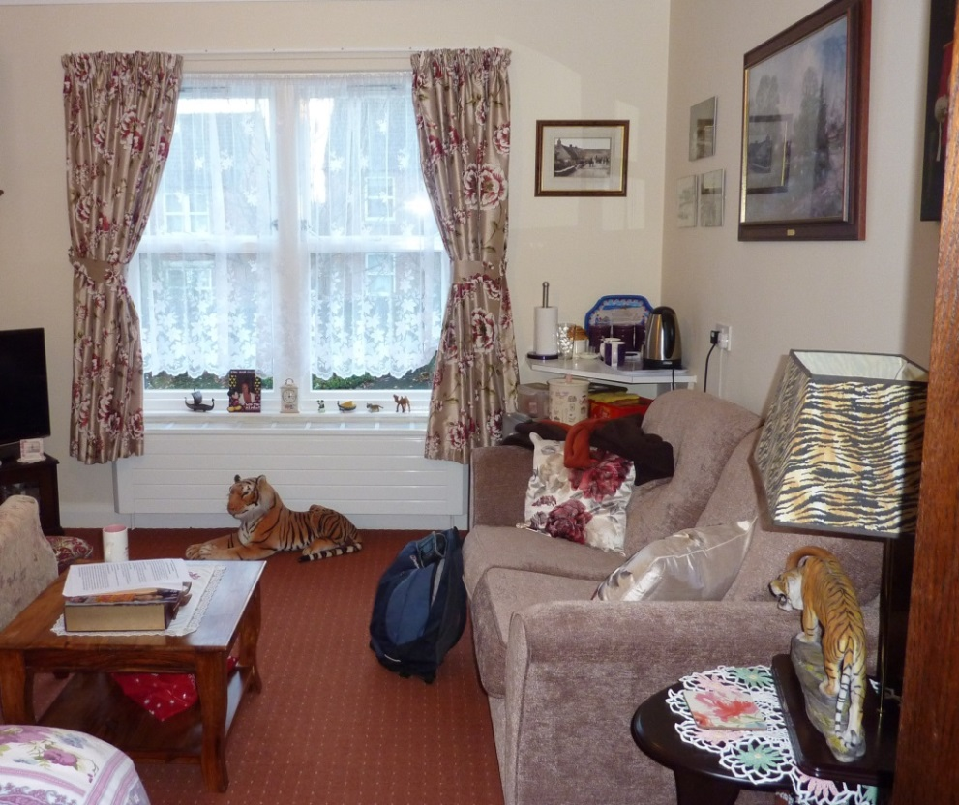
Photograph 11: Polly's room
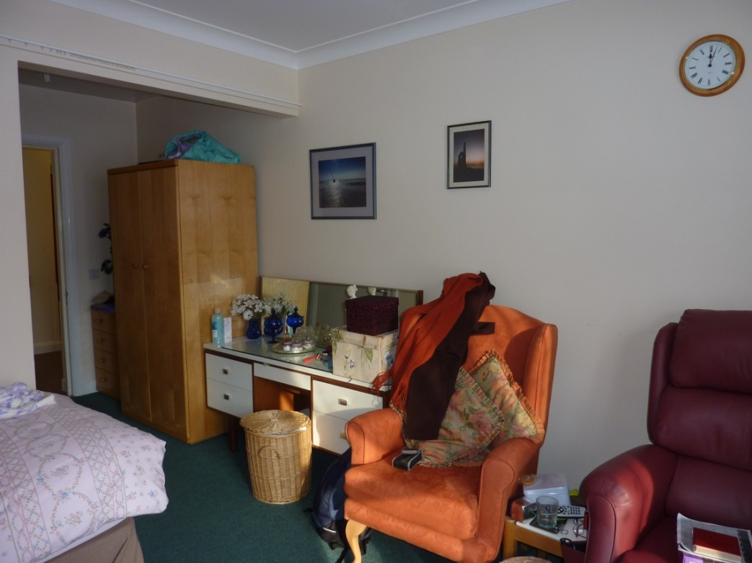

Not all of the rooms were furnished with sofas or chairs which enabled the resident to easily host visitors. This did not necessarily reflect the sociability of residents, but the limitations of the size of the room and the differing physical needs and priorities of residents. Annie, for example, often received visits from her son and other family, but because of her limited mobility and her need for a wheelchair and furniture that allowed her to keep everything she might need during the day close at hand, she didn’t have any more room for a sofa. She regretted this, telling me:
the resident who was here before, she left a chair like this with a settee to it. And that looks quite nice. And I wish I’d got a settee, because when people come to visit me they either have to fetch a chair or sit in there [wheelchair] or on the bed, you know. I could do with a little bit more space. But everything is, you know, where I can grab hold of, keeps me safe, sort of thing. I can switch from one thing to another quite easily.

Despite not having a spare chair however, Annie was able to actively host visitors in other ways. Like many of the other female residents she had a fridge and kettle, and was able to offer visitors a cup of tea (even if they actually made it themselves).
Residents could also practise hosting skills through skilfully and engagingly guiding conversations with their visitors. Susan and Annie were very accomplished at this, and so, to my initial surprise, was Peter. The first time I walked past Peter’s door, I saw him sat in darkness, in a room which contained very little furniture, in a chair with his back to the door, apparently looking out of the window. Many of the residents with dementia in the home sat staring in front of them, and so I assumed, erroneously, that Peter also had dementia. As I later discovered, Peter habitually read in front of the window, with his back to the rest of the room, and far from having dementia, he was one of the sharpest residents in The Cedars. His room was partly bare because he had only been living in the home for a few weeks, but unlike Michael, he displayed a familiarity and competence in the material elements in the room, knowing where everything was. His room wasn’t obviously set up for visitors – the only spare chair was often draped with ironed clothes, and, not wanting to disturb them, I usually dragged a footstool over to Peter’s chair instead. However Peter was a lively and engaging host, and once he learned of my then job as a research associate in a public health section of the university, initiated many conversations about his lifelong interests in dental health, pollution, and anti-smoking campaigns. Like Susan, he would not sit still for long, and would slowly but enthusiastically walk over to his bookcase with the aid of his walking frame, where he kept folders of leaflets and pamphlets on public health guidance. While crouching on the footstool was not the most comfortable of positions for me to be in, I always felt that Peter was a consummate host in his ability to keep the conversation flowing, and the things he had selected for his room – his books and articles – facilitated this.
Care staff went round all the residents’ rooms in the morning and afternoon with a trolley, to ask residents if they would like tea or coffee and a biscuit. This often coincided with one of my visits, and on many occasions after being asked by care staff if they would like a cup of tea, residents would then turn to me and ask if I would also like tea or coffee. It was always the resident, never the care assistant who would offer me tea. I wasn’t sure if this was because it was the residential home’s policy to not offer refreshments to visitors without being invited to by the residents, or out of a policy of respect to let the residents take the lead in their own rooms whenever possible. Whatever the reason, as I explained in Chapter 4, such instances reminded me that ‘the power’ in our encounters was not solely with me, and that by assuming otherwise I was in danger of denying residents the very aspects of control, agency and belonging which I perceived as positive demonstrations of them being at home in their rooms. One resident, Polly, also performed this assuredness in and ownership of her material surroundings outside her room. On more than one occasion as I left her room after a visit she would stand up, kiss me on the cheek and accompany me to the stairwell along the corridor, ‘in case you don’t know where you’re going’, demonstrating both concern for her visitor as well as her own knowledge of her material home.
Although most of my visits to residents were informal affairs, I was conscious of ‘making more of an effort’ with Mary. On one of my first visits to her she had hinted that she thought it ‘proper’ to make appointments before visiting someone, and subsequently I always ended my visits by agreeing with her the date and time of my next one. Mary’s preference for more formal appointments may have partly been the result of her upbringing and background, but I think also reflected her ill health and frailty. On my first (unannounced) visit to her, Mary was dressed in a silk dressing gown and said that she did not always get dressed as her bad back made it difficult for her. On my next (scheduled) visit, Mary had obviously made a considerable effort, and was wearing a smart cream blouse, black skirt, black shoes and a necklace. By changing the materiality of her person in this way, I felt that Mary was performing the role of host. In my field notes I noted my reaction to Mary’s more formal appearance:
I felt quite scruffy in my t-shirt and jeans (despite wearing my yellow owl t-shirt which I had worn especially as on my last visit M had mentioned that she liked owls). I did take Guylian chocolates, which I think went down well, but I do get the impression that I have been invited to an ‘at home’ and M is definitely the host (she is careful to ask the staff to get tea/coffee for me as well) and in control.
Thereafter, Mary nearly always dressed smartly when I visited, unless she was feeling particularly unwell, and I would find her sat in her chair, apparently unoccupied, awaiting my arrival. Like Peter, the furnishings of her room were not particularly set up for visitors, and I always sat on a chest near the window; given that my visits to Mary usually lasted no less than an hour, this could be quite uncomfortable. Again, as with Peter though, I appreciated Mary’s hosting skills, as demonstrated through the care she took with choosing what to wear, and her offerings of refreshments.

6.5.3 Hobbies
As well as residents performing home through cleaning and hosting, a large part of their days was spent engaging in leisure activities and hobbies in their rooms. In some cases these provided an opportunity to socialise with other residents and staff members, which I will discuss in the next chapter, but often residents were happy to spend time by themselves, albeit knowing that company was never far away (spatially and also temporally in terms of communal meals) should they want it. Typical activities included reading, doing crosswords and watching television. Both Mary and Peter usually had a stack of newspapers in their rooms which they worked their way through, and sometimes they started conversations with me by asking my opinion on recent articles. In the case of Peter, who read The Guardian, our conversations would centre on international current affairs. In the case of Mary, who read The Daily Mail, we would discuss the latest happenings of the royal family. The build-up of several days’ worth of newspapers also helped to give their rooms a ‘lived-in’ feel, without ever tipping over into an atmosphere of neglect or untidiness.
With the exception of Mary, who, as I explained in the earlier section, would be sitting waiting for me in anticipation of my visit, most residents were usually engaged in activities when I called in. Quite often residents would be watching television, and they would say “I’ll just switch this off – I don’t know why I’ve got it on”. Annie would usually be crocheting when I turned up, working on the next item to add to the pile of clothes next to her chair, which her church would send to Africa. Depending on the time of my visit, Susan would usually either be cleaning or watching television – Countdown was a particular favourite. I would typically find Peter and Irene reading a book or a newspaper, and Stan would often either be on his laptop or practising the electric organ in his room.
Some residents would set up their rooms in such a way as to make it easier to accomplish their plans for the day. Annie, for instance, spent much of her time in her room crocheting and watching television, and had arranged her room accordingly. As she explained:
Annie: I brought my crocheting basket and these little folding tables. If I have a meal in here I can just go and get the folding, well, they can get the folding table out for me, and then this [table to the right of her chair] holds all me
Melanie: day-to-day things.
Annie: yeah, for television, drugs, and as you see telephone books and various telephones. Everything’s at hand, so I don’t have to move about too much.
Melanie: and you’ve got that plastic bin with all your wool.
Annie: yes, I bought that after – when I started knitting to send them abroad [Annie sent some of the clothes she crocheted to a church in Africa], I need lots of wool, and I’d nowhere – that basket [next to window] didn’t hold, so I bought that [plastic bin], and it’s been quite good. Holds quite a lot of wool.
Mary also arranged her room according to how she wanted to spend her time, but in a way that facilitated contemplation rather than activity. She had a curtain which she could draw to separate the main living space from what might be called the hall – the short passage between the door and the point at which the room opened out – and on the occasions when she drew the curtain to create a more enclosed, private space, she referred to this arrangement as her ‘nest’. She told me once that when the curtain was drawn, and she sat in her chair with the birds singing outside, she couldn’t be happier. Mary also told me that she had written a note for the person who moved in to her room after she died, which said that she hoped that they would be as happy as she had been in her little nest’. This struck me at the time as remarkable for its calm acknowledgement of mortality, its affirmation that Mary clearly enjoyed being in her room, and her awareness that the room would outlast her to become a home to someone else.
Not all residents were quite so content to spend so much time in their own rooms. Over the course of my fieldwork, there was a period of time when there was no activity coordinator to organise communal activities such as bingo or singing, and during this time Frances confessed to me that she was bored having so much time to herself. She told me that she had knitting to do but that she ‘couldn’t bring herself’ to do it. During this time I usually found her watching programmes, or drinking tea staring at the switched off television. Another resident, Michael, spent very little time in his own room, and preferred to sit in the foyer where he could keep an eye on what was going on and chat to people as they came and went. On the whole though, most residents spent the majority of time by themselves in their rooms, but crucially, they were able to access company relatively easily should they wish.

6.5.4 Hindrances of the institution
Despite the residents being able to exercise considerable agency in their own rooms, there were nevertheless ‘institutional’ elements which also influenced (and sometimes hindered) the ways in which they were ‘at home’. On moving to the residential home, residents found themselves in a different sensory environment, and had to negotiate how to control this according to their own preferences. For instance Pam preferred to have her windows open to let in fresh air, but this went against the residential home’s policy. Pam told me,
I mean I’m a bit claustrophobic, I never close me curtains. At first they[staff] used to come round, they’d be shutting ’em. I’d say “eh” I’d say “don’t shut my windows whatever you do”. “Well, we’re supposed to.” “I don’t care what you’re supposed to – leave ’em open – I shan’t be able to breathe.” Which I can’t if windows are shut. At home I used to have ’em open, winter, summer. Yeah. Fact, when I lived in my house, I used to have me dressing gown on, didn’t matter if it was frosty, I used to walk up and down garden two or three times, fresh air!
Pam found the home’s prioritisation of safety over residents’ wishes irritating. As previous studies have noted, being overly risk averse can come at the expense of allowing residents to have a sense of control and independence (Taylor, 2006).
Similarly, Polly found the temperature of her room warmer than she would have liked. While she told me that she had asked the staff to adjust the settings of her radiator, the fact that they had apparently still not done this was of considerable annoyance. Furthermore, her temporary ‘fix’ of the problem – opening the window – provoked interference by her daughter:
‘Cause when I first came here it was damned hot. Are we allowed to swear on that [recorder]? But, erm, it was so hot that I couldn’t breathe in here. And I keep asking them [staff] can they come and do something with the radiator, but it’s like talking to the wall. And they haven’t done anything yet and, well if they have I’m not aware of it, it’s still hot. So how I’m going to get on in the – I mean I’ve got the window open. And you know how cold it is? My daughter came in the other night and said, “mother, I’m going to close that window, it’s cold in here”. I said, “I can’t breathe”. I can’t, I can’t, it’s just stifling. But er, I don’t know.
Polly was also dependent on the residential home staff to make adjustments to her furniture, which would allow her more control, and found this dependence frustrating – particularly when she had to establish who she actually needed to speak to for this, and then wait for the staff to make the changes:
And I’ve asked them [the home] could they, I’ve had my shelf, no, I had the rail in the wardrobe lowered, because I couldn’t reach – by the time I’d got it on the coat hanger I couldn’t reach the rail. And so I’ve had it lowered to suit my, I’m not as tall as I used to be, and so I’ve said, “could I have a shelf put on the top so I can get all these bits and bobs [on the floor] on the shelf?” [Makes an exasperated face] So I’m still waiting. “Can you give me permission to have it done?” I don’t know who to ask. You know, you’re fighting a losing battle all the time. But I’ll get there.

All of the residents were bound by the size of their rooms, and while one or two commented on items of furniture they wished they had space for, for the most part residents felt that the dimensions of their rooms were adequate. However, a couple of residents told me that they found the lack of storage space problematic. For instance, Susan told me that she could do with another cupboard in which to store things that she didn’t necessarily want to display, and said ‘that’s the problem with this place, there’s nowhere to store things’. Most people’s homes involve a considerable amount of space in which to store items that are not intended for display, which are not currently in use, or that people can’t quite bring themselves to get rid of (Woodward, 2015). Some people have attics full of such items. While not usually visible, these objects are still part of the home, and periodically sorting through such things and deciding what is to be thrown out and what is to be ‘rehabilitated’ into a more prominent place is part of the practice of ‘moving things along’ (Gregson et al., 2007) which is itself part of being at home. The lack of adequate storage space in residents’ rooms therefore prevented some residents from ‘practising home’ in this way.

6.6 Conclusion
In this chapter, I argued that residents in The Cedars were engaged in an ongoing process of turning the spaces of their rooms into places of home through the ongoing, everyday interactions with their belongings. The materiality of rooms comprised possessions brought by residents into the home, objects already in the room, and things acquired since the move. While some belongings were perhaps treasured more for their embodiment of relationships with deceased spouses or work-related identities, others were valued more for their practicality and for how they allowed residents to develop a sense of ownership and/or belonging in their rooms. I suggest that any categorisation of objects into ‘cherished’ or ‘mundane’ however, ultimately matters less than how, as a whole, they helped to create an atmosphere of home in each room.
The creation of home did not rely on transferring a past conceptualisation or manifestation of home. Material elements of the past, present and future were incorporated into residents’ rooms and woven into a multi-temporal, dynamic, changeable reality of home through residents’ daily practices. Following previous work on how family is ‘done’ (Silva and Smart, 1999, Morgan, 2011), the doing of home by residents in the form of domestic tasks and leisure activities was vitally important to their sense of ease in their surroundings. ‘Home’ could not be provided for them – it had to be made by them. The doing of home may have been different to how they did home in their earlier years, and in The Cedars the doing was mediated by the (dis)abilities of their bodies and the design affordances of the residential home. Nevertheless, most residents possessed and enacted an agency that is too often denied to older people in residential homes.
As Joan Higgins notes, for older people moving into a residential home ‘it is often a case of a transition from ‘doing for’ to ‘being done for’, as well as a transition from independence to dependence’ (Higgins, 1989: 171). Based on my research, I would suggest that this is neither inevitable nor as oppositional as Higgins implies. Residents of The Cedars – Annie being a case in point – were certainly less independent than they used to be in earlier years, but rather than moving to total dependence, they effectively picked their battles, relinquishing independence in some areas, but retaining it in others. Furthermore, there was evidence that by moving to residential accommodation, some residents were able to maintain a greater degree of independence than they would have otherwise been able to. Navigating themselves around and tidying a single room was certainly easier than maintaining a larger house over two or more floors, as some residents had struggled to do before moving to The Cedars. Higgins continues by asserting that:
[i]n their own homes even the frail and housebound have some areas of life over which they exercise control, perhaps in relation to eating, dressing or sleeping or in whom they choose to admit through their front door. This is a very real contrast with life in a residential home (Higgins, 1989: 171-172).
Again, this is not necessarily the case, and I would argue that many residents at The Cedars were able to exercise more control over aspects of their home life than they would have been able to do had they remained in their own homes, which would have necessitated several visits from home care assistants. Furthermore, the under-resourcing of home care has led to situations where older people are visited by many different care assistants (hindering them from developing meaningful relationships with them), for inadequate periods of time, at inconvenient hours (CQC, 2013), all of which recall Raymond Jack’s questioning of the assumed ‘dualistic view of residential and community care…which perceives residential care as “bad” and community care as “good”’ (Jack, 1998: 12). While I reject this binary, I have shown in this and the previous chapter how some residential homes can be more ‘institutional’ or ‘homely’ than others, and the ways in which these characteristics can affect residents’ feelings and practices of home.
The ways in which residents’ interactions with the material culture with which they furnished their rooms incorporated different temporalities were in essence not so different from how people at any age, in any form of accommodation, ‘do home’. Homes involve familiarity but also innovation and aspiration, whether the home-maker is a teenager moving to university for the first time, or a newly-retired person who finally has the time to make the renovations to their house that they have been planning for years. Participants’ plans for their rooms recall previous research into older people’s attitudes to the future, which suggests that looking forward may be ‘intrinsic to the human condition’ and not just the preserve of younger people (Clarke and Warren, 2007: 474).
In this chapter I focused on individual residents in their own rooms in order to emphasise how residents fashioned their own senses of home through their material interactions and practices. In the next chapter, I turn my attention to how these interactions and practices were never solely individual, but were embedded in personal and social relationships within and without the residential home.

Chapter 7: Relationships and material culture in The Cedars

7.1 Introduction
In the previous chapter my focus was on individual residents and how they transformed their rooms into homes through their everyday practices and interactions with the material culture in their rooms. While this helped to show the agency of residents in shaping their own homes, homes are never just the work of individuals, and in the previous chapter I described how residents’ family members were often primarily responsible for choosing what objects to take into the home and also helped residents to maintain or buy new objects. In this chapter I develop this theme and look beyond individual residents and their rooms to consider the personal and social relationships of residents, and analyse how these were manifested in, and constituted through, material objects. I was struck not only by how the material culture in residents’ rooms embodied and evoked previous and existing relationships (for instance with spouses and children), but more unexpectedly by what it said about new relationships in the home. Objects circulated, were gifted and inherited, and formed part of the webs of meaning and connectedness that developed between residents, and between residents and staff members. This contrasted with the literature on material culture in residential homes which treats the relationship between residents and their possessions as individualised and in isolation from other residents and members of staff.
As Cathrine Degnen has noted, much of the literature on place-attachment in older age has emphasised this as an individual process of belonging between an older person and their home, overlooking the ways in which ‘relations with and through place are not only personal – they are powerfully social’ (Degnen, 2016: 4). In order to understand how residents’ sense of home related to dimensions of sociality and materiality within The Cedars, I find it useful to draw on the concept of relationality which I introduced in Chapter 3. As a processual, rather than structural approach to understanding how people relate to each other, it emphasises firstly that people’s relationships are actively constituted through the ways in which people relate to each other (i.e. relational practices), and secondly that meaningful relationships are not necessarily located in the kinship structures of ‘mother’, ‘sister’ and so on (Carsten, 2004, Finch and Mason, 2000, Smart, 2007).
Relational practices could include the whole variety of ways in which people actively work at and shape how they relate to people. For instance making time to have coffee with a friend, or taking a niece to the park. For the purposes of this research, I am most interested in the ways in which relational practices are mediated and played out through material culture. As I outlined in Chapter 3, previous research has shown how meaningful relationships are made and reinforced through the display, gifting and bequeathing of things (Finch, 2007, Finch and Hayes, 1994, Hurdley, 2013, Miller, 2009). While most of these studies focus on how material culture mediates how we relate to family and friends – people conventionally understood as being of significance to us – relational practices as realised through material culture are perhaps thrown into sharper relief when they take place between people who do not have a traditional or structured relationship. As an example, the gifting of a bottle of homemade sloe gin by a socially isolated older couple living in the country to their post (wo)man suggests an appreciation and conceptualisation of a relationship that is more personally meaningful than a formal ‘service – customer’ relationship, and indeed changes the nature of the relationship.
This leads onto a second key element of relationality – its flexibility in accounting for meaningful relationships outside of conventionally understood kinship or friendship relations. As suggested in the example above, people relate meaningfully to all manner of people who they might not be related to or consider to be friends. That we don’t have a conventional or convenient way of labelling all of these people doesn’t mean that they don’t matter to us. As Carol Smart writes, ‘relatedness…takes as its starting point what matters to people and how their lives unfold in specific contexts and places’ (Smart, 2007: 47). In the specific context of The Cedars, I found that the objects with which residents furnished their rooms provided insights into what mattered to them, and importantly who mattered to them and why. As I shall argue, examination of the material culture of The Cedars revealed that fellow residents and members of staff mattered to residents. I suggest that a relational approach makes more sense of understanding social relationships within residential homes than literature which assumes deterministic and oppositional relationships between members of staff and residents (Kontos, 2000, Lee-Treweek, 1994).
In this chapter I reflect on three types of relationship: 1) relationships between residents and family and friends outside the residential home; 2) relationships between residents in The Cedars; 3) relationships between residents and staff members in The Cedars. I argue that residents’ meaningful relationships were not all situated in the past, and that the move to The Cedars did not necessarily signal the end of or a weakening of personal and social ties. Many residents were able to maintain existing relationships and importantly form new ones in the residential home, and these relationships were reflected in, maintained through, and in part constituted by material culture and its circulation within The Cedars.

7.2 Relationships between residents and family outside of the residential home
Most of the residents who lived at The Cedars had either lived for most of their lives in the local area or had moved from a different part of the country in order to be closer to a relative – usually a son or daughter – who lived in the area. Nearly all of the residents therefore had family members living nearby who visited frequently, and I learned enough about some of them to ask after them when I visited, for instance enquiring as to whether a grandchild had got the job they were applying for, or how the house that a son was refurbishing was coming along. Sometimes my visits to residents overlapped with those of other visitors, and on separate occasions I met Pam’s daughter and son-in-law, and granddaughter and newly arrived great-granddaughter. I sometimes found Polly sitting on a chair in a small communal area at the top of the stairs, waiting for her daughter to come and take her shopping.
I never met the family members of some residents, as my visits coincided with the times when they were at work or school, but through conversations with residents and staff members I built up a picture of each resident’s relational network, in terms of who mattered to them. Very often anecdotes about visitors would either prompt, or be prompted by, references to the material culture of residents’ rooms. For instance Pam always brought my attention to the latest photographs of her grandchildren and great-grandchildren and would then tell me how the children were doing at school or how spoiled she thought they were compared to her own experience of childhood. Once when visiting Irene she told me about a visit from the minister of her church. She had just pointed out to me a table that wasn’t there on my previous visit, and said that she had told the minister that the table was handmade by a neighbour, and had been a wedding present for her and her husband. “Oh”, the minister said, “in that case I’ll put my cup on that”. Irene told me that she was then worried that he would spill his tea on it, so was relieved when he put a serviette down first. Once when I visited Mary, she pointed out to me the two red roses remaining from the bouquet bought for her by her family. She asked me if I would like one and I thanked her and said I would be delighted. Originally material manifestations of the ongoing relationships between Mary and her family, the flowers now also helped to constitute the friendly relationship between Mary and myself.
Susan had a low, immaculately polished table in her room, on top of which were two photographs, two candlesticks, a vase which usually contained fresh flowers, and a fruit bowl which was regularly replenished. The flowers and the fruit were evidence of ongoing relationships, as Susan rarely left The Cedars herself. One of the photographs was of two black Labradors that belonged to one of her sons. Her son brought the dogs to visit, and Susan told me that one of the dogs always made a beeline for the jar of biscuits she kept. “I know what you’re after”, she’d tell the dog, “you only want me for my biscuits”. Susan also told me about the latest developments in her son’s life. He was renovating a house before intending to sell it at a higher price, and Susan couldn’t understand how he could bear to sell it after investing so much time and energy into it.
Occasionally, the anecdotes told by relatives in response to objects were less mundane. Visiting Peter, our conversations would usually begin with, or be drawn to, current affairs, with Peter picking up one of the copies of the Guardian from the pile on the floor to bring something to my attention, or jog his memory of an article. One afternoon we were discussing ongoing tensions in South Africa, and he told me about his brother, who had taught Black schoolchildren during Apartheid. He had later drowned trying to save a child who had got into difficulties during a trip to a beach. I was shocked to hear about the tragic event, on what to me was a routine visit, but Peter remained calm as he spoke, telling me about the high esteem in which his brother had been held. This occasion highlighted how an interaction with an ordinary object such as a newspaper in the present, could provoke an associative memory of an extreme event decades previously.
The staff perspectives could be interesting. Staff members tended to speak of residents’ relatives in either neutral or positive language, for instance noting approvingly if a family member visited regularly, or complimenting the photographs of residents’ relatives. Only once did I hear a carer comment disparagingly about a relative. I had been visiting Dorothy, who had suggested that I phone her in advance of my next visit, to check that it was convenient for her to meet me. Dorothy then realised that she did not know her phone number and suggested that I ask at reception. I did so on my way out, but the carer did not have the number either. She said forcefully, “I’d ask her daughter but she’s a cow and wouldn’t tell me,” before breezily adding that Dorothy didn’t answer her phone anyway because she was plagued by cold callers. I interpreted the largely positive – and the unusual negative – opinions by staff as evidence that far from treating residents in the home as isolated inhabitants of a different, cloistered world, staff acknowledged and cared about the relational networks of residents.
The family relationships were reflected and reinforced in the gifting and display of material possessions and these manifested in several ways: family members taking ownership of, or looking after valued possessions which the residents could not take with them on entering the residential home; gifts between the residents and their families and the residents’ display of these; plans made by the resident to bequeath certain items to family members after they died.

7.2.1 Relatives receiving objects which residents couldn’t take with them into the residential home
All of the residents spoke of being unable to take all of their possessions with them on moving into the residential home. Several residents told me that while they had found it difficult to leave certain things behind, they felt much better when relatives were able to keep items, as it comforted them that objects which had been meaningful to them were kept in the family, a finding reported in previous studies of household disbandment (Ekerdt et al., 2012, Mansvelt, 2012). For some residents, their move into The Cedars had coincided with grandchildren setting up home, or other family members’ changing circumstances, which resulted in practical items such as white goods and kitchen equipment being kept within the family and put to good use. At a time in the residents’ lives when they might have been feeling particularly vulnerable and dependent, it is possible that they appreciated this opportunity to be able to help out younger family members and ‘be useful’. Susan told me that she was pleased that her niece took a lot of her baking items and other kitchen appliances that she would no longer need herself:
Melanie: And how did you feel when you had to, what happened to all your kitchen stuff? Did you give that to family or did you
Susan: Yes, [my niece] took it.
Melanie: ... And do you like the fact it’s still in the family?
Susan: Oh yes, I didn’t fancy throwing it away. Because there were some, I mean all my baking stuff was pyrex plates and dishes and basins – it was all pyrex. And then I’d got all me cutlery, loads of cutlery, and a steamer, everything. I’d got loads, I’d got three cupboards, full, of catering stuff, what I used to do. And [our niece] took the lot…Anyway, she come down and she says “what about your baking stuff?” I says “you can take that”. And your icing, I’ve got all icing equipment, because I used to ice cakes. So I says “you can take everything you want, anything you want in here, you can take.” … She says “Nan, I’ve nearly got all your stuff”, I says “it don’t matter love, as long as you’re happy and you’re gonna use it”. She says, “ooh, it’ll save me pounds”. And she took a fridge freezer, a washer and a dryer. Took ‘em all. [ML: wow]. So she says, “oh, I thank you ever – how much do you want for it?” “I don’t want anything for it.” I says, “as long as you use them and you look after them”. “I will”, she says, “it’s lovely”.
Similarly, Annie was able to give most of her furniture to her grandson, which gave her peace of mind at not having to worry about what was going to happen to it:
Annie: because I was fortunate, well, fortunate or unfortunate [depending on] the way you look at it. My grandson had just been separated from his wife and he’d got a flat and no furniture, so everything went straight, he had a full home. It went straight across to him so I had no worries about it being moved, or you know, where it was going or anything, so I was quite lucky in that respect.
Melanie: and did that make it easier for you in a way, knowing it was going to someone in the family?
Annie: exactly, exactly, because I mean some of the, that I was really fond of, the possessions I had, I knew he would cherish them as much as I had, you know.
Polly’s response to her granddaughter’s appropriation of her belongings was more ambivalent, expressing not so much pleasure at her kitchen appliances and utensils staying in the family, but more regret at the fact that she could no longer use them herself:
A lot of the things, my granddaughter has bought a flat and she has half-inched them [laughs]. “Ooh I could do with that, I could do with that”. Well it’s no good to me, I mean let’s face it. What do I want [with them]?
Family members also provided safe-keeping for expensive items such as jewellery, which the residents did not want to risk keeping themselves and housed items which the resident did not have space for in their room, but which they still wanted to see, such as photograph albums. In this way, despite the residents’ move to the residential home, they did not necessarily become more isolated from family members. Material culture played a meaningful part in reinforcing family ties – such as through giving away objects to family members who needed them – and reciprocally family members were able to keep objects in safe-keeping until the resident wanted to look at them.

7.2.2 Gifting, receiving and displaying new gifts between the resident and family members
As well as looking after or receiving items which the resident was unable to take with them into the residential home, family members added to the material culture of residents’ rooms through gifts. Following Morgan’s concept of ‘doing family’, such actions worked to affirm that the resident was still part of the family, despite their conceptual move from ‘the community’ to ‘an institution’ (Morgan, 1996). Similarly, residents’ display of items given to them by family members demonstrated to observers that the resident was still an active member of a family. ‘Displaying families’, a concept developed by Janet Finch, is the ‘process by which individuals, and groups of individuals, convey to each other and to relevant audiences that certain of their actions do constitute ‘doing family things’ and thereby confirm that these relationships are ‘family relationships’ (Finch, 2007: 67). ‘Relevant audiences’ in this context included fellow residents, staff members and visitors such as myself, and I sometimes got the impression that residents were keen to point out new gifts as a way of demonstrating (to themselves, as well as to others) that although they found themselves in the (once unthinkable) position of being in an older people’s home, they still mattered to the people who mattered to them. Frances, for instance, told me that a framed picture on her wall had been given to her that year by her daughter on Mother’s Day, emphasising and reinforcing the familial relationship.
Residents found homes for new gifts in amongst the existing materiality of their rooms. Pam was 88 and had lived in The Cedars for three years. She had a son with learning difficulties who lived in supported accommodation. On one occasion when he visited Pam with his carer, he brought a present of a flower made out of pipe cleaners and card which he had made during a craft session (see Photograph 12). Pam had placed it amongst ornaments which she had brought with her when she first moved into the residential home, and when she pointed it out to me she told me that her son had come in with it saying, ‘it won’t need much water!’

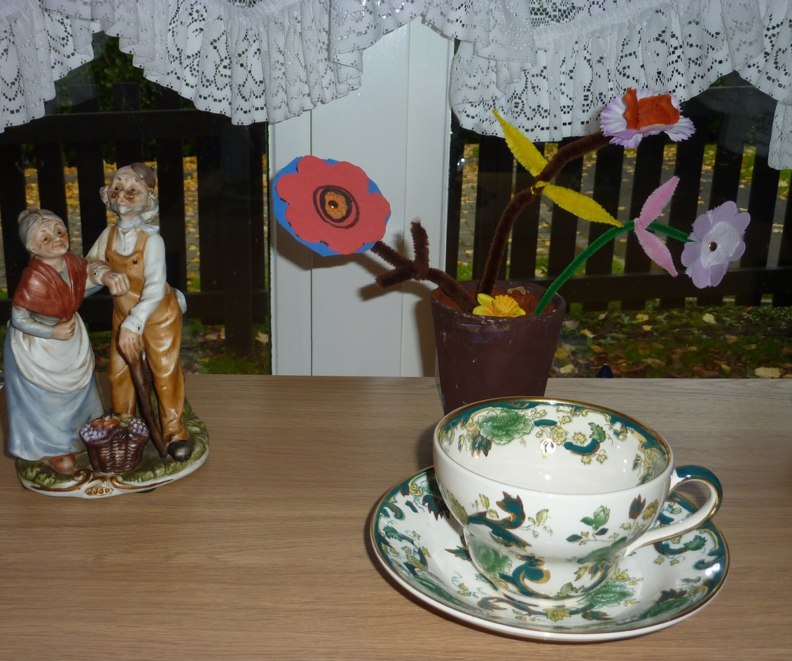

Photograph 12: Pam's pipe cleaner flower
Not all gifts from family members were necessarily valued for what they were, but were displayed more out of obligation or for fear of offending the person who had given it to them. Irene was a 92 year old woman who had lived at The Cedars for two and a half months when I first met her. On one occasion when I visited her, I pointed out a child’s drawing of three mermaids which was stuck to a cupboard. I commented that I hadn’t seen that before, and Irene grimaced, ‘it’s revolting, but as the grandchildren gave it to me I suppose I’ve got to put it up!’ Contrastingly, Pam deliberately chose not to display certain photographs so as to avoid potential offence. Pam had a large family with many great-grandchildren, and rather than run the risk of not displaying everyone’s photograph in a suitably prominent position, she decided to display hardly any at all, telling me, ‘well you’ve got to be careful haven’t you really? I mean you can soon cause offence!’
As many of the residents had difficulty walking and so did not often leave The Cedars, it was not always straightforward for them to buy gifts for family and friends for birthdays and Christmas, particularly for the majority of residents who did not own a computer. It was often easier to give money to another family member and ask them to buy a present on their behalf. However, The Cedars had a way in which residents could buy presents without having to leave the home. Once or twice a year, before Christmas and sometimes in the summer, the staff would set out a table in the entrance foyer, displaying objects which had been donated by members of staff, given by residents and their families when they downsized and moved into the home, or donated by family members after a resident had died. Residents and visitors to the home could buy the objects for small amounts of money, which then went into a fund which was used by The Cedars to fund outings, or buy objects for residents who otherwise wouldn’t have been able to afford them. Residents could also buy Christmas cards, wrapping paper and decorations. This was similar to the arrangement in the day centre studied by Haim Hazan, which held jumble sales where attendees could get rid of their own things and buy other people’s. Hazan interpreted this as an act of ‘self-sufficiency and independence of the outside world’, further evidence of what he took to be the centre’s ‘autonomous isolated character’ (Hazan, 1980: 84). In The Cedars however, the arrangement helped residents to maintain relationships with family members and arguably make any perceived boundaries between the ‘inside’ and ‘outside’ worlds less distinct.
When I visited one resident, Dorothy, in November 2012, she already had her Christmas tree up (which she kept underneath her bed during the rest of the year) and a mound of wrapped Christmas presents which she had bought from the stall. One of the care assistants later told me that she thought Dorothy must have spent about £70. The stall and the residents’ use of it was an example of how The Cedars facilitated the circulation and movement of material culture in unexpected ways, such that the personal possessions of a recently deceased resident could become Christmas presents for the family members of other residents.

7.2.3 Residents’ plans to bequeath objects
I asked all the residents who I got to know well whether they had made plans for bequeathing their objects after they died. None of them were upset or offended by this question, and many had already given it some thought. In a similar way to when they initially moved into The Cedars and preferred for their belongings to stay in the family and be appreciated, some residents had already ‘matched up’ particular items with particular family members, either at the request of the family member or because the resident felt certain relatives liked, or would appreciate certain things. For instance, Annie expected that her oldest son would take her collection of crystals, ‘[b] ecause he’s very much, he thinks very much like I do, you know, and different things I’ve given him, especially collectable items, he’s hung on to’. Susan’s youngest son had requested her favourite clock, and she was happy for him to have this.
As well as wanting to ensure that particular items went to particular family members, some residents were keen to sort this out while they were still alive as they did not want to ‘make any more work’ for their children after they had died. Mary, who was 93 and in poor health for much of the time that I knew her, was in the process of sorting out her cupboards. She told me that she didn’t want to cause any trouble for anybody after she had died by failing to leave instructions as to what should be done with certain objects. In the weeks before Mary was due to have a hernia operation, which she admitted to me that she wasn’t sure she would survive, sorting through her belongings became of greater importance. She told me that she sometimes repeated the words ‘must get up to tidy up’ as a kind of mantra before she went to sleep, as she did not want to die without putting her affairs in order. She told me this in a very matter-of-fact way and was careful to ask me whether or not I found her discussions about her death upsetting. I assured that I didn’t and that I appreciated her honesty, and I wondered if she appreciated being able to talk to me frankly in a way in which she perhaps could not have done with her family. As well as not wanting to make any work for her children, Mary’s insistence on wanting to sort out her own belongings may have stemmed from wanting to ensure that some things did not end up in the ‘wrong’ hands. For instance, one of Mary’s most treasured possessions was her collection of decorative birds which she displayed on a wicker fan on her wall (Photograph 13).
And these, I don’t think Kate [Mary’s daughter-in-law], I said to my son the other day, they were expensive. It’s not the expense but I said “I love them” and he said “I know you do”. So I said “well don’t get giving them to the, her”, not me being nasty but her children, because she gives everything to her grandchildren – Kate, his wife, his second wife.
Photograph 13: Mary's collection of birds
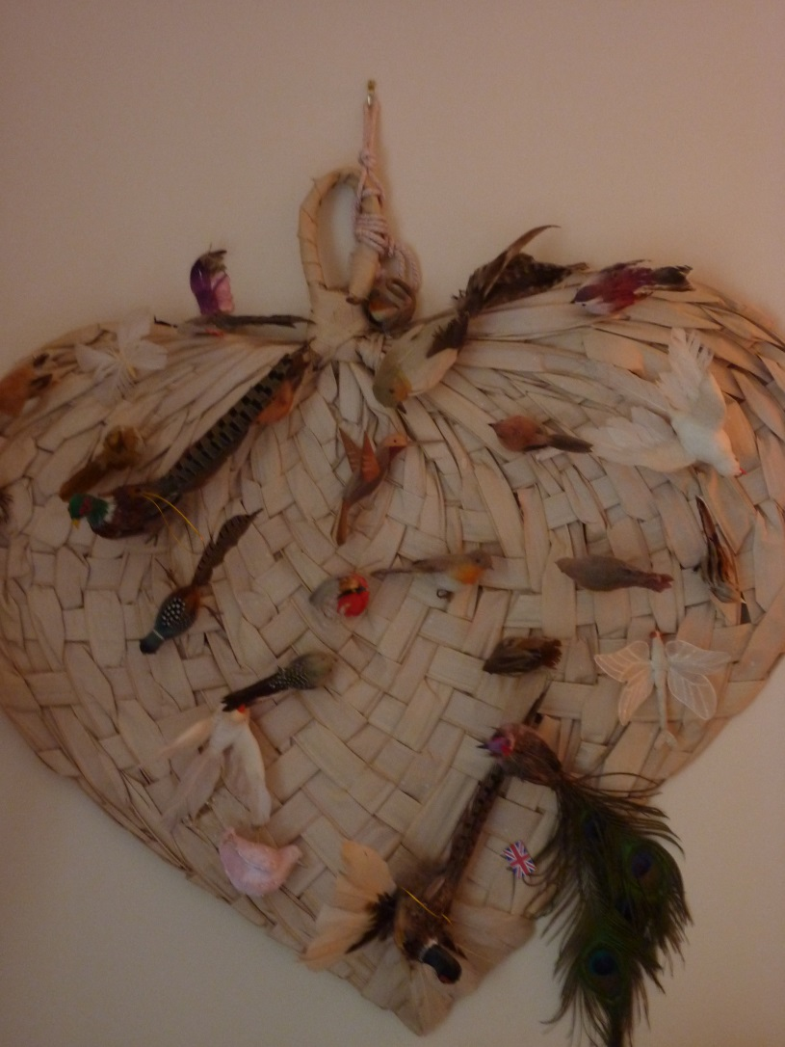
By not wanting her daughter-in-law’s children from a previous marriage to have the birds, Mary was actively shaping the ways in which she related to her family members (Finch and Mason, 2000).
Other residents were happy to let their adult children share out their belongings after their death, unless they had had any specific requests. For instance Pam told me,
Me grandson said he liked the tramp [ornament] so I says “right, I’ll put on bottom ‘this is David’s’[Pam’s grandson]” and that’s what. Oh no I let ‘em sort it between ‘em. ‘Cause they’re all very, they’re not like that, you know. No, no. Our Claire [daughter] will sort it between ‘em.
While Mary didn’t want to leave the ‘work’ of dividing up her belongings to others, Frances took the opposite view, telling me cheerily, ‘oh they’ll sort them out round family, I think. You know. Yeah. I mean there’s one or two vases, you know, that are all right and everything. One thing I shan’t have to worry about love, isn’t it? [laughs]’.

7.3 Relationships between residents
Before looking in detail at the exchange and circulation of material culture between residents, I will provide some context on the general nature of social interactions in The Cedars, and how the built design of the residential home influenced this.
The design of The Cedars makes it relatively easy for residents to spend time with each other, should they wish to. Most of the residents who participated in my research spent the majority of time in their own rooms, but enjoyed meeting up in communal rooms for meal times and for the group activity sessions which usually took place twice a week. With the exception of Susan and one of the residents further down the corridor who visited Susan’s room most afternoons to watch Countdown together, few residents spent much in each other’s rooms, although they occasionally popped in if there was something in particular they wanted to talk about. Annie’s description of her socialising with other residents was fairly typical:
I’ve never been a person for going in and out of homes. Susan, you know, you’ve seen her, she’ll sometimes come and sit on the bed and have a little chat, and then if there’s something we’ve talked about and you know I can find an answer, I’ll go and I’ll sit with her for ten minutes or so. And of course I see the seven of us that are at our dining table, so we communicate then. And I like my own space, and I can always find something to do with crocheting, code breaker [puzzle] and the television. So everything’s fine, you know.

Annie’s assertion that she has ‘never been a person for going in and out of homes’ echoes the comment Alice made to me in Beechview Lodge about never being one for ‘sitting in somebody else’s house’. This corresponds with broader traditions of sociality among northern and/or working class communities, where visiting neighbours’ homes is not as common as might be assumed. In her study of older people living in a South Yorkshire ex-mining community, Cathrine Degnen also found that her informants tended not to visit each other [Degnen 2012]. Daniel Miller has written of norms of English sociality in working class communities, where neighbours would socialise in public spaces, but rarely visit each other’s homes (Miller, 2015).Set in this context, it is not surprising that residents of both Beechview Lodge and The Cedars tended to keep to their own rooms, socialising mainly in the communal areas of the lounge and dining room.

I felt that the four corridors had different atmospheres and identities. For instance, some corridors were more sociable than others, and this was mainly attributable to the personalities of particular residents. The ground floor corridor to the left of Reception, for instance, housed Susan – probably the most sociable and certainly one of the most popular residents – and her friendliness and inclusive nature was, I believe, central to that corridor’s sociable atmosphere. If my visits coincided with Countdown, then she would invite me to pull up a chair next to her and Rose, and Rose and I laughed along to Susan’s ongoing commentary (“I like that Nick Hewer [the presenter] – he’s the man for me”.) Rose once told me that she had ‘never been one for the television’, but that she enjoyed watching television with Susan (“we like to sit and criticise everything.”) In this example, Rose used the materiality of the television – to which she was not especially attached – to facilitate her social relationship with Susan. The affection between the two women was touching. By far the more talkative of the two, Susan would nevertheless always try and draw Rose into conversation, breaking off from talking to me to ask Rose a question, or habitually saying “didn’t we, Rose?” even if Rose would only smile and nod in response. At four o’clock, Rose would leave to go to the dining room for tea, saying “I’ll tell them you’re on your way”, as Susan liked to arrive at ten past four.
The other main factor which appeared to affect the character of particular corridors and the degree to which residents socialised with each other, was the number of residents with dementia, and how the symptoms of the disease manifested themselves. A few residents mentioned to me how the people with dementia on their corridors affected their use of space in the home and their interactions with others. Residents without dementia, for instance, spoke of how they found meal times in the dining rooms off putting because of some of the behaviour of the residents with dementia, and told me that they preferred to eat their meals in their own room as a result of this. The residents in my study who seemed most affected by this lived on the top right corridor. Pam told me that the situation had changed since she moved in three years previously, and while she had tried eating in the dining room on the next corridor, that too started to become increasingly used by residents with dementia. As Rachel Hurdley has noted, as openings and closings to private and public spaces, corridors in institutions possess a ‘power’ that can be overlooked in their primary function of enabling transit from place to place (Hurdley, 2010). In The Cedars, depending on which corridor you lived on, corridors could be welcomed as spaces where it was likely that you would happily bump into another resident or member of staff with whom you were friendly, or they could be feared as ambiguous, ‘unsafe’ spaces which might be frequented by ‘wandering’ residents with dementia.
Pam also told me that she was disturbed by the shouting of the man opposite her and seemed generally distracted by him, although I think this was partly down to her wanting to know what was going on in the home. When I visited her she kept her door open, and from her vantage point in her arm chair, she periodically turned her head so that she could see into the male resident’s room. She would intersperse our conversations with commentary on the resident’s activities: “oh, he’s getting up again” or “he’s going to the bathroom by himself – he knows he shouldn’t be doing that”. She had arranged her room in such a way that she was able to not only exercise control in her own room, but monitor another resident in his. On one occasion when a cleaner came in to Pam’s room, she told him that the male resident was in the bathroom by himself, so the cleaner went off to fetch a carer. Pam observed that the other resident got a lot of attention and fuss made of him, and seemed a bit resentful of this. Finally, having complained to the manager about other residents on her corridor, she took up the manager’s suggestion of moving to an available room on the ground floor corridor, where Susan and Annie lived. Pam later commented that she enjoyed herself much more now that she could socialise at meal times with her friends. The difference in atmospheres and sociability between the two corridors was striking, and Annie’s perception of life in The Cedars was noticeably different to that of Pam before her move to the ground floor corridor, partly because of their different degrees of interaction with residents with dementia. Annie explained that the reason she had moved from the residential home in which she had lived previously was mainly because of her perception that the prevalence and behaviour of residents with dementia were affecting her ability to socialise, use space as she pleased and her quality of life in general:
Melanie: you do have contact with other people, don’t you?
Annie: yeah, well that was a big asset when I came from [previous residential home]. ‘Cause at the end, the last six months as I say I was locked away in my room. Through my own choice, not that they locked me away or anything like that, and the [carers] did come in constantly and sit and chat to me, you know. But it wasn’t the situation that we liked, either [my son] or I … I think there was five of us that were compos mentis, and wherever we sat, because it wasn’t purpose built, we couldn’t get a – I mean it is their home, as well as it was mine, or was their home, and if we found a little, in the little lounge and started having a chat, they’d all be wandering in, you know. So there’s nothing that we could really have a good old natter about. But up to now that has not happened here. There’s one or two of them pretty forgetful, but there’s no dementia, so that’s a good thing. As I say, it’s no good me putting dementia down, because there’s every possibility I could [get it], ‘cause everybody’s open to it now.
Annie recognised that the residential home was the home of all of the residents, including those with dementia, but implied that the actions of the residents with dementia affected her attitudes towards the accommodation as her home. This corresponds to other studies which have suggested that ‘disturbance caused by other residents negatively affects feelings of home’ (Klaassens and Meijering, 2015: 98).
On another occasion Annie elaborated on her comment about her previous residential home not being ‘purpose built’. She told me that it was an old house which had been converted into a residential home. She said that the dining room was on the ground floor and all the residents tended to congregate in the dining room or the lounge, ‘for the carers’ convenience, not ours’. To avoid the residents with dementia, Annie tended to spend lots of time in her own room, but this wasn’t completely out of choice or preference. By contrast, Annie enthused about the purpose built, wide corridors of The Cedars which made it easy to get around, and the smaller dining rooms and lounges on each corridor. While she was happy in her own space and to spend time on her own, crocheting or tidying, she had the option of seeing other residents. The residential home in which Annie lived previously was not Beechview Lodge, where I first started my fieldwork, but Annie’s description of how her quality of life was negatively impacted by the number of residents with dementia, the built design of the home and the culture of the caring staff resonated with my own perceptions of life at Beechview Lodge, and how it negatively affected the everyday life of Alice, a resident of the Beechview Lodge.
Annie’s comment that her previous residential home was home to all residents, not just her, highlights the difficulty that residential homes have in enabling a sense of home for a disparate group of residents. Homes are such personal places which are experienced differently by individuals, that it is arguably impossible to create an environment in a public space that will be amenable to everyone who uses it. By providing easy access to and from residents’ own rooms, I believe that The Cedars was relatively successful in allowing residents to develop their own sense of home within their individual rooms, whilst allowing them to access communal spaces and so not become isolated.

7.3.1 Activity sessions
When I first began visiting The Cedars, activity sessions were run twice a week by Elsie, the activity coordinator. Activities included music and movement, singing, bingo, craft sessions and quizzes. Not all of the residents who I knew participated in these sessions, and a couple were somewhat contemptuous of what they perceived as infantilising or unimaginative exercises, but the sessions I attended typically attracted around ten residents. The sessions were held in one of the first floor lounges, and residents from the ground floor who wanted to take part were helped up in the lifts by the carers. Apart from the activities themselves, the sessions provided opportunities for residents from different floors to get together, and also to go to different parts of the building. Helping Susan back to her room after one activity session, I smiled as she called out greetings to everyone she encountered along the way.
My first impression of the activity sessions was that some of the activities were infantilising or condescending, and I initially felt uncomfortable watching the residents colour in pictures. However, the residents clearly enjoyed what they were doing, and I later saw that Dorothy had displayed some of her pictures in her room, next to more established ornaments and photographs (see Photograph 14). In their study of a secure nursing home ward in the Netherlands, Mirjam Klaassens and Louise Meijering observed that one resident had furnished his room with pictures that he won in the bingo games in the facility, and similarly to Dorothy, displayed these next to personal possessions which provided more of a connection with the past (Klaassens and Meijering, 2015: 99). In this way, residents were able to draw on the resources available to them to change their rooms, rather than preserving them in a static way.
Photograph 14: Dorothy's display of photographs and pictures
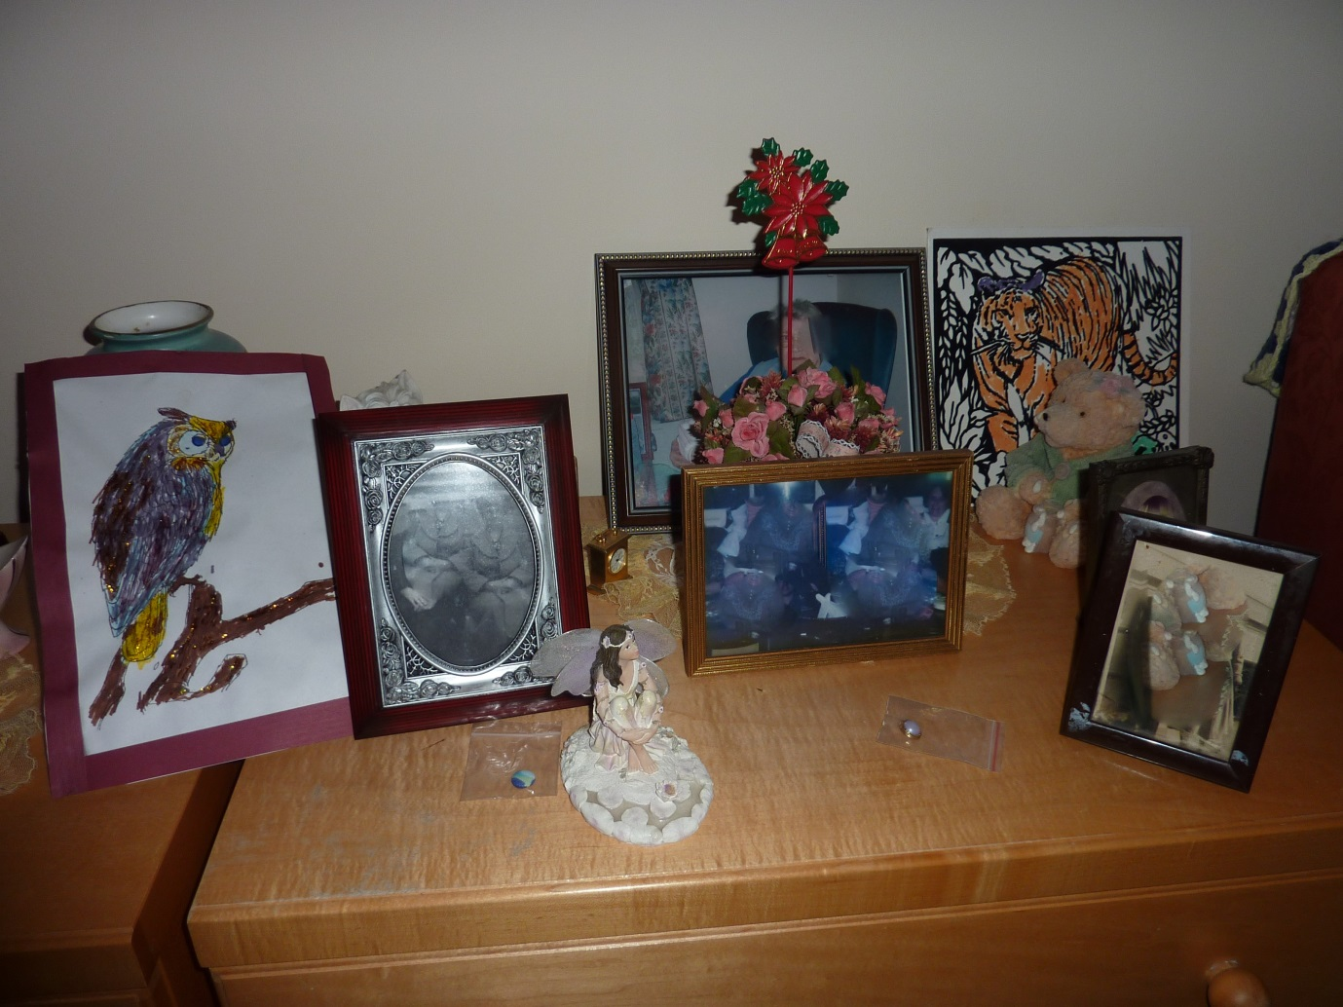
I also came to believe that while many of the residents appeared to genuinely enjoy the activities, what was just as, if not more important for them, was the opportunity to chat to each other in a different setting, while taking part in an activity that did not necessarily require their full attention. My field notes from one activity session reflect this:
Pam isn’t in her room and when I hear music from further down the corridor I wonder if there is an activities session going on. Sure enough, in the small lounge on [the first floor corridor to the right of the stairs], Elsie, the activities’ coordinator is seated with around six residents who are using felt-tip pens to colour in a variety of pictures, while Doris Day sings in the background.
I ask Susan how the decorating is coming along, and she looks exasperated and says ‘don’t ask’. While work has begun and she is staying in a spare room, the work is taking much longer to complete than anticipated. As Susan has already paid the painter, she is anxious that he does a good, quick job, and she has been to [the manager] to express her concerns. [The manager] told her not to worry. Pam listens on with interest and joins in from time to time. It occurs to me that Susan’s concerns are no different to if she was living in her own home.
It’s a very friendly, comfortable environment, and all of the women are happy to chat or sing along while colouring in. Rose isn’t colouring as she can’t see well enough, though she is having a cataract operation the next morning. Ida is also sitting in her wheelchair away from the table, but seems to enjoy the company. I tell Rose about my trip to Whitby, Robin Hood’s Bay and Scarborough the previous week.
At one point all the women (Elsie included) have a long conversation about knitting, crocheting, sewing and embroidery – they all have something to contribute, and discuss previous fashions. It’s a world away from the atmosphere at Beechview Lodge, or indeed any stereotyped portrayal of a residential home.
On another occasion, during one of the tea breaks Pam brought photographs of her new great-grandchild and passed them around.
The friendly, chatty atmosphere which I partly attributed to the residents’ partial absorption in other tasks, recalls community-based interventions such as Men’s Sheds, which are designed to improve the mental and physical health of older men through workshops such as woodworking (Milligan et al., 2015). Research into these interventions suggests that part of the workshops’ appeal for the men is that they provide opportunities for socialising while the men can engage in practical tasks, rather than meeting new people being the sole aim of the programme (Ballinger et al., 2009). My impressions of the activity sessions at The Cedars suggested that the real value of these were not the organised activities themselves, but the backdrop they provided to facilitate relaxed conversation, companionship, and opportunities to catch up. A few months after I started visiting The Cedars, Elsie left to take up a new position, and in the months it took to replace her, many of the residents told me how much they missed the sessions, and how they found everyday life more boring without them.

7.4 Relationships and the circulation of material culture
The relationships between residents were reflected, maintained and in part constituted by material culture and its movement within the home. Objects travelled between residents both as a result of gifts between living residents, but also as a consequence of residents dying and their possessions being offered to surviving residents with whom they had been friendly. Residents’ belongings also afforded the opportunity for friendships to develop between residents. Sometimes this happened in very taken-for-granted ways, for instance possessing a spare chair allowed residents to visit and spend time in each other’s rooms. In other cases, a particular possession might act as a conscious prompt to seek out another resident in order to show them something of interest and discuss it with them. I will explore each of these themes in the following section.

7.4.1 Gifts between residents living at The Cedars
I didn’t come across many instances of residents gifting objects to each other, but it was unsurprising that as a very popular resident, Susan had received presents from other residents on her corridor. When I visited her shortly after her 75th birthday she showed me the necklace and two pairs of earrings which had been given to her by a resident who lived further down the corridor (I wasn’t sure if the other resident had bought these – she had a computer so could have ordered these off the Internet – or had given away some of her own jewellery). On seeing these and other presents I told Susan that it showed that she was held in high regard, and she replied ‘it must do’. The close friendship between Susan and Annie was also realised in the gifting of presents. Susan had once remarked that her legs were cold, and Annie had responded by crocheting her a blanket. Annie had also made Susan two hats, and told me that she was trying to teach Susan how to crochet, although when I later asked Susan about this she laughed and said ‘I’m trying!’

7.4.2 Objects which had belonged to other residents
As well as living residents gifting items to each other, close relationships were also acknowledged by staff, residents and family members when residents died and their rooms were cleared. Objects which were not wanted by surviving family members were sometimes offered by the families or staff members to residents who were thought to have been particularly close to the deceased person.
As well as being very sociable with residents, Susan also seemed to be on friendly terms with many of the family members of residents who lived on her corridor. If they had to pass her room on the way to their relative’s room, family members would sometimes stop for a chat. Reflecting these relationships, Susan possessed some items which had previously belonged to now deceased residents with whom she had been close. When describing the objects, Susan spoke of the previous residents with warmth. For instance, Susan told me about a teddy bear she had:
Susan: That’s come from one of the residents. Lucy, did you know Lucy?
Melanie: No, I don’t think I do.
Susan: She was in number 9. She made me laugh, I used to laugh at her, she was so funny. But yet she was a very determined woman. And she was a hundred and three, and she’d still got it all up here [points to head]. She was, oh she used to wake up in middle of night – “I want a cup of tea”. “I want a cup of tea”. “I want a cup of tea and a slice of toast!” So we used to make it her, they used to make it her. I’ve been up all hours with her shouting and, ‘cause she used to shout at top of her voice ‘til somebody went into her. And then she’d have, next day, next time she woke up she had bacon and egg. And this is at three or four o’clock in the morning. Oh, she could eat. She’d got the appetite of a horse, I used to say. She could eat. She always turned up for her meals, and she really enjoyed her food did Lucy, and she never put an ounce of weight on.
Melanie: Really?
Susan: But we had some laughs with her. You know my wheel – you know wheelchairs?
Melanie: Yeah.
Susan: She used to get in one of them, and she used to come whizzing down this corridor, right through to the bottom! Oh she did, she was so, I used to laugh at her. And one day I went in [to her room] to see how she was – she could get about, she used to walk about, some days she were, some days she was off colour and she didn’t bother coming out. And I went in one day and she said “you can get out because you’re a witch”. “Oh”, I says, “am I? Thank you Lucy, that’s very good of you!” She says, “that’s alright, get away!” [laughs]. Next time I went in, later on, I says “are you alright Lucy?” She says, “yes love I am”. She’d forgotten what she’d said to me!
Melanie: And how come she gave you the teddy bear?
Susan: Well she didn’t give it me, it was her daughter. They were going to throw it away, I said “don’t throw that teddy away”, “do you want it?”, I says “if you don’t want it”. She says “I don’t want it”, “I’ll have it, I’ll put it up there”.
Melanie: Oh was that after she died?
Susan: After she died. And I had, I’ve had him ever since. And he’s a lovely teddy. My granddaughter… likes nursing him when she comes. ‘Cause she’s fond of teddy bears.
Similarly, Susan told me the story of how she acquired the china mugs on her dressing table (see Photograph 15) and of how she was still visited by the family of the resident to whom they used to belong:
Susan: I was given them from the death of an old lady.
Melanie: In here?
Susan: In here… It was, she came in, she was a lovely lady, she was a proper lady, really spoke nicely, but she was very ordinary with people, she didn’t put on any airs and graces. And she was um, she came in, and she’d been in a few months and she felt poorly. And she was ninety – ninety four I think she was, ninety five – she was in her nineties anyway. And we made friends, ‘cause she sat at my table, and we made friends and she used to come and sit down here and have a natter, and I’d go to her place, or sit outside if the weather was nice. And then she became really ill, and she died here, she died in here, and I think it was cancer. But her daughter – she had two daughters and two sons, and they were ever such nice people. And one of them, Donna, she took her daughter to see me – she came yesterday morning, and she’s ever so nice, and she brought me, when her mother died and they were clearing flat out, she brought me them six cups. And she said, “Susan, do you want these?” I says “why?” So she said, “well if you don’t want them we’re going to throw them away because we don’t want ‘em”. I says, “don’t throw them away!” I says, “I’ll have them, they’ll look nice on there”. So she brought them in and I’ve had them ever since.

Photograph 15: Susan's china mugs
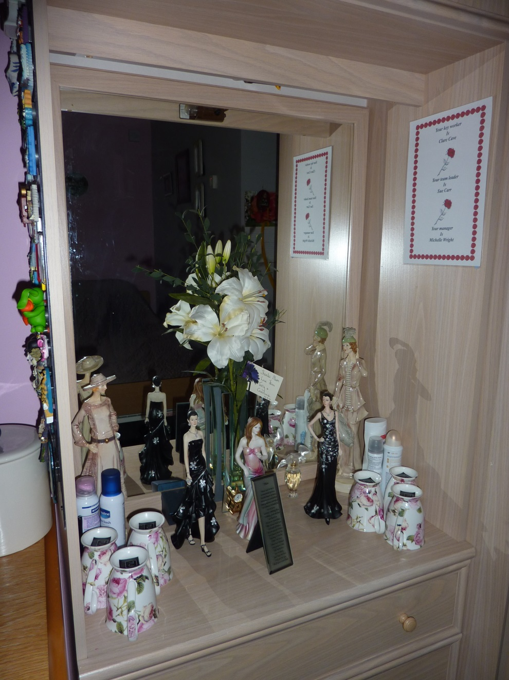
In cases where it was left for the staff to sort through the rooms of residents who had died, they would sometimes offer items to residents who they knew had been particularly close to the deceased resident. Dorothy told me that a doll on her bed had once belonged to another resident:
One of the lady’s that’s died, when she died they asked me if I’d have it. Because she made it herself, you see. And she [staff] said “would you want it? We don’t want to throw it away”. So I said yes, because I knew her, and I said “no don’t throw it away”, so that’s how I’ve got that one.
Both Susan and Dorothy emphasised that they knew the residents whose objects they now owned, and this implied that their acceptance of the items wasn’t purely down to wanting the object or not wanting it to be thrown away, but to how they felt about the resident to whom it had once belonged.

7.4.3 The potential for objects to facilitate relationships
The material culture of residents’ rooms facilitated the development and maintenance of meaningful relationships between residents at The Cedars, often in ways that were so mundane and taken for granted that residents would not have been aware of them. For instance, Rose spent most afternoons in Susan’s room sitting next to her in a chair, watching Countdown on the television, with a cup of tea placed on a table next to her. The television, chair and table which made these valued interactions possible ‘framed’ (Miller, 2010) the encounter without taking centre stage. However, one resident was aware of the potential for objects to facilitate relationships in a more prominent way. Peter was 98 and four months (as he always proudly told me) when he came to live at The Cedars, and despite being the oldest of the residents who took part in my research, he was one of the sharpest and most curious. Peter’s wife still lived in the house they shared nearby, and while his wife had looked after him, as he became more frail it had become clear to them both that she could not continue to do this, so he had moved into the residential home. Because he was under no pressure to sort through his belongings and move in one go, his room was quite sparsely furnished while he decided what he wanted to bring with him and what he wanted to leave in the marital home.
The objects which he had brought with him were mainly photographs, which reflected his long-standing interest in photography, and books and paperwork relating to his lifelong interest in public health. He normally had a stack of Guardian newspapers which he worked his way through, and whenever we met we had very in-depth conversations on current affairs and particularly global issues.
Peter admitted that he had never intended to move into a residential home, but was very matter-of-fact in his attitude that he could not have stayed living with his wife, and now that he was at The Cedars he saw it as an opportunity to meet new people, rather than as a symbolic ending of previous relationships. Peter told me that his priority was to find ways of socialising with fellow residents, but unfortunately this was proving difficult for three main reasons. Firstly, Peter’s room was on the top right corridor, where the number of residents with dementia caused most residents without dementia to stay in their own rooms, thus making socialising difficult. Secondly, the new activities coordinator had still not started, and so no-one had responsibility for bringing the residents together. Thirdly, Peter had been profoundly deaf since childhood and found it difficult to enter into group conversations; given that most residents were not in the habit of regularly visiting each other’s rooms, Peter had not had much opportunity to get to know residents individually. I shared his frustration, and told him that when I visited residents in their rooms I often thought that they would get on with a resident who they didn’t know very well, usually because they lived on a different corridor. If a resident expressed an interest in something which I knew another resident was also interested in, I often tried to gently encourage them to meet up, and in this respect I told Peter that I felt like a bee which travelled between individual flowers, sharing conversational pollen in the hope that new friendships would bloom!
I saw the potential for friendship between Peter and Stan, due to their shared interest in photography, and when I told Peter that Stan had a new camera which he was trying to get to grips with, Peter was interested and asked me for Stan’s phone number (Stan lived on the bottom right corridor). After checking with Stan that he was happy for me to pass on his number, I gave this to Peter, who said that he would get in touch with him. Peter was also very conscious of the opportunities for socialising which were afforded by his possessions and his interests. He wondered whether residents would be interested in talking to each other about the photographs in their rooms, and whether the staff would help him in setting up a slide show event in the home. He used to give similar talks and slide shows at a local wildlife group, and thought this would be a good way of getting to know people and sharing interests. I told Peter that I thought this was a wonderful idea and offered to help him if he wanted me to, but by the time my fieldwork at The Cedars ended the following month I had not heard any more about it. Of all the residents I got to know, Peter was the only one who told me that he saw his possessions as an active catalyst in forming relationships, and I wondered if staff could be more proactive in encouraging residents to talk about their possessions to each other as a way of facilitating social contact.

7.5 Relationships between residents and staff
Staff members were very important in the day to day lives of residents, and as well as relying on them for basic care, residents valued the friendly relationships they developed with the carers and cleaners, echoing other research which has found that staff and residents can become close (Brown-Wilson and Davies, 2009, McGilton and Boscart, 2007). Liking the staff and feeling that the staff were friendly and helpful were often cited by residents as key reasons why they liked living at The Cedars, and with a couple of exceptions, most of the encounters I witnessed between residents and staff were warm and seemed genuinely good-natured. Residents appeared to value the staff as much, if not more for the emotional labour (Hochschild, 1983) which they provided, as well as the more practical aspects of their role, and I saw numerous instances of carers stopping for a prolonged chat while delivering tea, or calling in to see residents to chat about events such as family weddings or holidays.
While some existing literature has highlighted how differences and power imbalances between staff and residents in residential and nursing homes and supported living accommodation impact negatively on residents’ quality of life (Kontos, 2000, Lee-Treweek, 1994), I saw little evidence of this at The Cedars. Rather than acting in opposition to each other, I saw residents and carers expressing sympathy and solidarity with each other against what they perceived as matters from which they all suffered and yet were out of their hands, such as the ongoing problems of the home being short-staffed. On one of my visits to Pam, a carer who Pam assumed to be new came in, offering a cup of tea. The carer explained that she wasn’t new and usually worked on the other floor, only she was having to cover for the usual cleaner on Pam’s corridor. When Pam said that she thought there were supposed to be two cleaners on each corridor, the cleaner laughed and said “chance would be a fine thing”, causing Pam to shake her head in solidarity. On another occasion I was chatting to Susan when a care assistant came in. After updating Susan with details about her brother’s forthcoming wedding, the care assistant announced that the staff were going to have to work longer shifts, to which Susan responded with sympathetic tuts.
While the young, male caring staff might have been assumed to be the more powerful party in their relationships with older, female residents, Susan gleefully recounted to me instances when she had subverted this. On one occasion it was August and Susan had been complaining to me about how humid it was. She told me that she had to ‘peel her bra off’ the previous night, and having difficulty taking it off, she joked that she was tempted to walk out onto the corridor and ask ‘one of the young boys’ (i.e. male care assistants) to help her. She told me that she enjoyed ‘tormenting’ the young male staff, especially one who she knew found it embarrassing. That morning, she told me, she was in the bathroom when one male carer came into her room and asked if she was all right. ‘I’m just in here with my clothes off’ she called out to him, ‘you can come in if you like!’
Having a good relationship with staff was particularly important for residents who tended to spend most of their time in their rooms and did not eat in the communal rooms, but were nevertheless friendly with some other residents. With these residents, I was initially surprised at how despite apparently never leaving their rooms, they knew details about other residents’ lives, for instance if they had been ill. However the residents told me that they used trusted members of staff to ask about each other, and to pass on messages, even if they thought that staff shouldn’t really do this. For instance, Mary told me,
[The staff] mustn’t really tell you things…and you mustn’t really talk. Justin [cleaner] and I, he tells me little things. ‘Cause I say ‘how are the girls?” ‘Cause he knows if anybody’s ill or back [from hospital]. And he will say. Now [about] Pam I say, ‘give her my, send my love’, so he, you know, that’s little things we do and I write little notes but apart from that.
On another occasion when I visited Mary I saw her pass a note onto one of the care assistants when she brought tea.

7.5.1 Material culture and relationships with staff
Like the relationships between residents, relationships between residents and staff members were manifest in the interaction with, and discussion, acquisition and gifting of material culture. One of the most touching examples was the case of Michael, an 84 year old man who had lived at The Cedars for four years. He was born in Jamaica and moved to England in the 1950s, taking with him only one suitcase which he still had with him on top of his wardrobe. Michael’s only relative in England was a niece who lived in London, and when he moved into The Cedars as a result of ill health his doctor arranged the move, and he didn’t bring many things with him. Michael’s room still seemed quite bare and sparsely furnished – partly because the carpet had been removed as a potential trip hazard.
Michael told me that he chose his room at the end of the corridor so that he wouldn’t be bothered by other residents walking past him to get to their own room, and while he was friendly to other residents he didn’t go out of his way to get to know them. He did most of his socialising at a community centre, and was picked up by a minibus a few times a week to go there for meals and to meet other members. When he wasn’t at the community centre, Michael either sat in the foyer, talking to people as they came and went, or sat on a chair outside the office of one of the senior carers, Jayne, of whom he was particularly fond. This relationship was reciprocal, and Jayne had given Michael some of her own furniture, such as a sofa, and presented him with a cushion displaying the name of a local football team that they both supported. Michael told me, ‘[m]e and some of the people who live [work] here move very close. Like Jayne, downstairs, she move very close’. Other examples of staff members giving gifts to residents included Helena, a care assistant who bought Susan a fridge magnet as a souvenir following a trip to Poland to visit her family. Another care assistant, Josh, was a skilled artist and cartoonist, and he made birthday cards for residents, and also donated one of his drawings as a prize for the Christmas raffle. This was won by Annie, and she put the picture up on her wall.
Interactions between staff and residents about material culture occurred in other ways. Staff and residents would talk or share a joke about some of the things in residents’ rooms, such as the toy tiger in Frances’ room which had been given to her by her brother (see Photograph 16). In his customary spot by the radiator, the large tiger was immediately noticeable on entering the room. ‘I bet [the staff] ask you about the tiger as well, don’t they?’ I asked Frances. ‘Ooh aye. When they first came in and saw him down [there] it half frightened ‘em to death!’ she replied, laughing.
Photograph 16: Frances' tiger
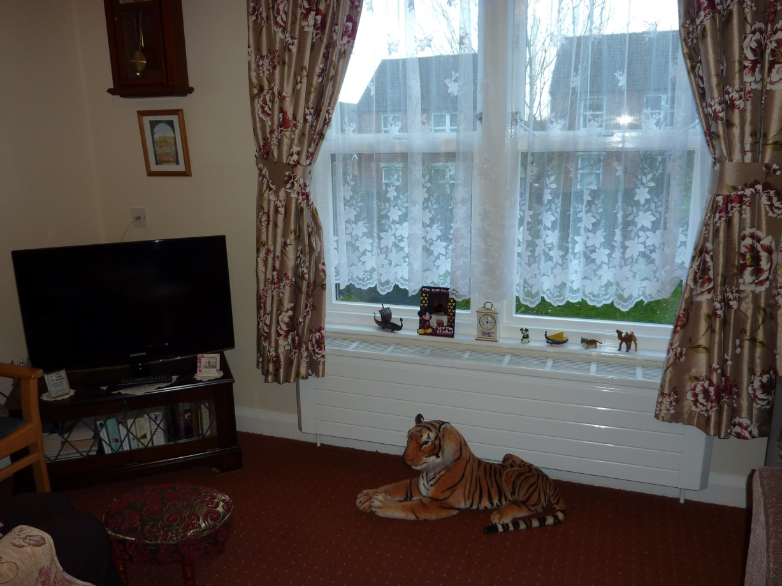

On my visits to residents, it was usual for members of staff to pop in, either to offer tea or coffee, or to empty bins and do some cleaning. I therefore developed a sense of the usual routine interactions between residents and staff in the context of the residents’ rooms. In Mary’s room, where surfaces were covered with newspapers and plates of food left over from the previous meal (which Mary was still gradually picking at), carers had to do a bit of work before finding a safe place to leave a cup of tea. Quite often, staff members would ask residents if a picture was new, or ask who had brought them flowers. When visiting Pam, knowledge of her appreciation of cleanliness made me more alert than usual if a cleaner entered the room while we talked. My field notes record my observation of the cleaner’s work: “[he] wipes down the surfaces, cleans the trays in the fridge. He doesn’t wipe under all the ornaments, but does lift some things.”
A couple of weeks after my birthday, I was incredibly surprised and touched when Mary presented me with a scarf ring in the shape of an owl. I remembered that several months before she had asked me when my birthday was, but I had assumed she was just making conversation and had no idea that she had stored that information away. Not in the habit of leaving the home herself, Mary had given some money to one of the care assistants, instructed them that I liked owls, and asked them to buy me something suitable. This was beyond the remit of the staff’s responsibilities, and attests to the close relationship between Mary and the carer. I still have the scarf ring, and it reminds me of Mary.
As well as realising the potential for objects to facilitate relationships with other residents, Peter also used the things in his room to spark conversations with members of staff, particularly in the case of his framed photographs on the wall, of which he was very proud:
Melanie: What about staff members? Carers or cleaners? Do they comment on pictures, or -
Peter: Well partially I’ve taken the initiative myself, for saying “have you seen the fox? Do you know who took the photograph?” So, I’m not shy!
Staff also sometimes helped residents to buy new items when it would have been difficult for them to do this themselves. Dorothy told me that she had chosen a new clock with the help of one of the senior carers, who had sat and gone through the Argos catalogue with her until she found one she liked.
Dorothy also received help – though she may not have appreciated this as much – from staff who intervened when they felt that her room was becoming too cluttered. Isabel, one of the care assistants told me that two years previously, staff had to persuade Dorothy to throw out some things as they felt it was becoming a health and safety issue. Dorothy agreed to let some things go, and the staff compromised by agreeing to store some of her things in the basement. Isabel told me that if she could, Dorothy would buy and keep many more items if the staff didn’t keep an eye on her. Staff also monitored other residents’ accumulation of possessions, particularly in the case of residents whose families didn’t visit them as frequently, or take an active role in sorting out clutter and piles of newspapers. Half fondly, half despairingly, Isabel told me about the challenges they faced with persuading some residents to get rid of things: ‘”why won’t you throw that away, it’s broken?” “Yes, but I’ve had it 18 years”’.
While most of the interactions with material culture contributed to or reflected positive relationships between staff and residents, I witnessed one incident where a care assistant appeared to transgress what the resident judged to be appropriate behaviour towards her possessions and privacy. I was visiting Susan shortly after her 75th birthday and she was showing me some of the presents which she had received, including a pink box given to her by her son which contained gourmet delicatessen foods. Susan then showed me a couple of sketchbooks made by Josh – the care assistant who was a talented artist – and while I was flicking through them and discussing them with Susan, a care assistant, Nicola walked in. My interpretation of what happened next is recorded in my field notes:
Nicola walks in, says hello, heads straight for the pink box on the chest of drawers and looks inside. I am a little taken aback at her presumption, and wonder how Susan will react. “You’re very nosy, you,” says Susan, and I can tell she is annoyed. Without being invited, Nicola then sits down on the bed, and I wait for her to ask what I am looking at and wonder how Susan will take this. Susan doesn’t let Nicola get that far. “We were actually having a private conversation,” says Susan, and “you’re not welcome.” Nicola leaves, and Susan tells me that this is not the first time she has told Nicola off for looking at her things without being asked. Susan says Nicola goes through her drawers, opens her cupboards, and whenever Susan gets something new or comes back with shopping, Nicola will start to go through it or ask what she’s got. Susan clearly has no qualms about telling Nicola to stop it, but there are many residents who would not be able to do this.
Not long after Susan dismissed Nicola, a different senior carer came into the room and she and Susan chatted for a few minutes. Susan then invited the carer to look in the box and told her that it was a birthday gift from her son. The contrast with the encounter with Nicola was striking. Susan gave short shrift to a staff member who she (and I) felt was rude and presumptuous, while she was quite happy to welcome another member of staff who did not act inappropriately around Susan’s personal belongings.

7.6 Conclusion
In this chapter I have shown how residents not only maintained existing relationships with family and friends, but also formed new social relationships within the residential home, with other residents and members of staff. All of these relationships were reflected in, and partly constituted by, interactions with material culture. Furthermore, material culture did not necessarily stay within individual residents’ own rooms, but circulated as gifts and bequests.
That material culture facilitates and reinforces meaningful social relationships is not a new idea (Miller, 2009, Smart, 2007), but it has been under-developed in research on older people in general and in residential homes in particular, where studies have focused more on individuals and their belongings. This has practice and research implications. Regarding practice implications, the relative lack of social engagement and interpersonal relationships within residential homes has been identified as problematic, and a number of studies have researched how increasing social interaction might enhance the quality of life and wellbeing of residents (Bergland and Kirkevold, 2008, Higgins, 1989, Hubbard et al., 2003, Reed and Roskell, 1997, Willcocks et al., 1987). The findings in this chapter suggest that material culture can help to form social relationships between residents and staff, and therefore residential home managers could look to identify more opportunities where residents’ possessions could be used in this way. These could be as simple as encouraging cleaners and care assistants to take an active interest in residents’ belongings, or facilitating one-to-one or group sessions where residents could talk about their things to each other, thus providing the opportunity to learn more about shared interests. Additionally, while my findings suggest that material culture in residential homes can help to foster close relationships between residents and staff, they also demonstrate that failure by staff members to treat residents’ possessions with respect can undermine relationships, and this could be made explicit in care home policies.
Using theories of relationality, the findings in this chapter also shed light on how the ways in which people relate to each other – and how these are made manifest through material culture – shape people’s material homes. Scholars of home and family have rightly acknowledged the importance of family relationships to the formation of homes (Allan and Crow, 1989), and studies have shown how family members help to shape the nature of residents’ home spaces in residential and nursing care (Rowles and High, 2003, Bowers, 1988, Zarit and Whitlatch, 1992). However, insufficient attention has been paid to how meaningful relationships with other people – staff members, fellow residents and their family members – can influence older residents’ experiences of home.
Importantly, this chapter has also shown that residents’ belongings do not just reflect significant relationships with existing family members, or function primarily as mementoes which provoke reminiscences about deceased loved ones. They provide evidence of how residents continue to make meaningful relationships with people. As with the previous chapter, this challenges the assumption that residents of older people’s homes (and older people in general) are purely oriented to the past, and use their belongings primarily as ways of trying to ‘maintain’ their identity or relationships. Rather, the findings presented here suggest that residents used material culture to facilitate, reflect and reinforce relationships in much the same way as people do at any other stage of their life course.
In some ways then, while the residents’ experiences of their material homes were not markedly different to other people’s experiences of home in earlier stages of life and in other forms of accommodation such as privately-owned or rented flats and houses. However, it is important to note that as older people living towards the end of their lives in a residential home, there were qualitative differences about the participants in this study which I explore in the next chapter. In the next chapter then, I discuss the particularities about being an older person in a residential home, and consider what this means for how residents conceptualise their change of accommodation in later life and their attitudes towards and experiences of home and their material belongings.

Chapter 8: Temporality and materiality in The Cedars

8.1 Introduction
In the previous two chapters I have focused on how the spatial and relational experiences of being a resident in The Cedars are played out through material culture. In both chapters I have emphasised how the residents of The Cedars experienced their homes and lived their lives in ways not so dissimilar to how other people do so in earlier stages of the life course, and in non-institutional housing. In this chapter, I turn my attention to the temporality of older age, and explore how the temporal experience of being in their later years affected residents’ relationships with material culture and their attitudes towards living in the residential home. Where Chapters 6 and 7 emphasised the similarities between residents and non-residents, in this chapter I bring out the qualitative differences in experiences of home and material culture that come with living in residential homes in older age.
In previous chapters I have challenged assumptions about ageing that suggest that because of their age, older people are inevitably past-oriented, and I have demonstrated that through their interactions with material culture, the residents of The Cedars also live in the present and future. However in doing so, I do not want to deny the influences that being older in years can have on people’s lives and experiences. Because of the stigma attached to older people – particularly those living in residential homes – it is tempting to try and underplay the ways in which being older affects one’s experiences. This would however involve flattening and ironing out the differences in how being older affects conceptualisations of home and relationships to people and objects. Instead, I draw out the wrinkles of difference in how being in their seventies, eighties and nineties affected the residents’ experiences in The Cedars. I do not start from an assumption that it is a terrible thing to be ninety and living in a residential home, but I do acknowledge and understand how the residents’ ages affected their experiences.
In this chapter I consider temporality in The Cedars in two main ways. Firstly, I discuss the ways in which the age of the residents and their life experiences affected their attitudes towards home and their relationships with the material culture around them. I consider the residents’ life experiences in terms of both their biographies and the socio-cultural contexts in which they aged. In doing so I will argue that the residents had experienced the losses that come with ageing (both physical in the loss of bodily abilities, and the emotional loss of loved ones) but also gains in the form of experience and learned resourcefulness. Both the losses and gains affected their interactions with material culture and their feelings towards home.
Secondly, I discuss how residents’ experiences in The Cedars changed over time as they got to know the staff and other residents, became accustomed to existing routines and developed their own. These changes were reflected in and lived out through the materiality of their rooms. This second aspect of temporality relates to the first in that, just as the residents’ ages and life experiences influenced them when they moved into the home, so they continued to influence them during the number of months and years they continued to live in the home. Contrary to some conceptualisations of time in residential and nursing homes, time did not ‘stop’ for residents when they entered The Cedars. While the residents may have been old when they first moved into the home, they became older during their time there, and their experiences of the home were influenced by the length of time they had spent there – for better or worse.

8.2 Age and materiality in The Cedars
In Chapter 3 I outlined my approach to ageing as a relational and social process which is realised in a material world through the narratives we tell about things, and the ways in which our ageing bodies interact with objects. Ageing has been conceptualised as a gradual process of loss (Higgs and Gilleard, 2015: 2, Savishinsky, 1991: 55), and the age of the residents alongside their experiences of loss, influenced their relationships with their belongings. Their being ‘old’ had practical implications for what they could and could do not do. As I discussed in Chapter 6, residents practised being at home through the activities they undertook in their rooms, which included tidying and reading. Many of these activities relied upon certain physical and sensory capabilities, which were deteriorating and rendered some residents unable to continue practising home as they used to. These practical losses were also bound up with the emotional losses of no longer being able to – or needing to – use particular items which had sentimental as well as practical value. The age of the residents also made it more likely that they had suffered the loss of loved ones – partners, siblings and friends – and this also affected their relationships to particular objects and attitudes towards making a new home in later life.
As well as the current ‘oldness’ of the residents, the ways in which they had become old affected the manner in which they related to their belongings and their attitudes towards being at home in The Cedars. The process of becoming old was influenced by biographical and life course events such as marriage, parenthood and employment, and also socio-cultural and historical events such as the Second World War. All of these concepts and themes were interwoven within the narratives told by residents about their objects, as the following case study demonstrates.

8.2.1 Polly: life’s gains and losses
Polly was 90 and had lived in The Cedars for two months when I interviewed her. Polly’s husband had died three years previously, and in increasingly ill-health, Polly no longer felt that it was fair for her daughter, who was now in her sixties, to make an eight-hour round trip to visit her in her flat in Dorset, and so Polly had agreed to move north to where her daughter lived, and moved into The Cedars.
Polly was one of two residents I interviewed who flatly rejected the notion of The Cedars as being their home. While she sometimes spoke wistfully of wanting to go back to her former home, Polly understood that part of what had made her former home home were the meaningful relationships she had had there with people such as her husband, friends and neighbours, many of whom were now dead. While ‘going back home’ was therefore still possible in a geographical sense, it was not possible in a temporal sense, because the relationships which had made her home meaningful were now in the past. The unhappiness that Polly had felt after her husband died, and the knowledge that her friends were slowly dying as well, meant that the sadness she felt when I got to know her was not just at being separated from a familiar place, but a familiar time which she had spent with loved ones.
And er, I mean I had a lot of friends, but of course I’m 90, just, and they’re all getting on that way, and I mean my very oldest friend is 88 ... And erm, so let’s face it, they’re not going on for ever, are they? So even if I stay [in Dorset] I shall have nobody soon. And I mean, they all say, ‘oh of course you will Polly, you know’, but I know sod’s law, it is what it is. And you can’t put the clock back, so. So that’s it.
As well as feeling the loss of her (former) home in a temporal sense, Polly also frequently mentioned missing the place and location of this home. While she had decorated her room at The Cedars with visual reminders of her former home by the sea, these did not always provide unequivocal comfort but evoked bittersweet memories of what she had lost. I asked her about one prominently displayed photograph of the sea and Polly told me that the care staff, on seeing the photograph asked her ‘do you miss it?’ Polly rolled her eyes at this and said bitterly, ‘do I miss it? Of course I miss it. Bloody stupid question’. Her love for the sea was expressed as a sensory experience when she told me, ‘the noise as well, the noise, when the waves were rough, wonderful. Do you know, when you live there, you don’t appreciate it quite so much as when you’re not there.’ Later on when I asked her if she felt at home, or whether she thought that it was possible for her to feel at home in The Cedars, she answered:
No. I shall never get used to it. That sounds very selfish and very rude but I’ve always had my own house. So I’ve been very lucky. But it’s not quite the same as your own front door. I know it seems daft and silly and probably petty, but no, I shall never, ever, and I’ll never, ever say, ‘ooh, I like it better here than I did in Dorset’. Never, never, never, never. And I do miss Dorset’.

Polly had brought other possessions with her which were simultaneously records of a life’s worth of achievements, as well as reminders of activities such as cake decorating and sewing which she could no longer perform, either because of lack of access to equipment, or as a result of her deteriorating eyesight. Polly proudly showed me several photograph albums she had of all the cakes she had decorated over the years, recalling their associated memories and the biographical occasions for which they were made, but also emphasising her own skill:
But I made all the flowers. I made all the frills and all the flowers. And the shell, I made the shell. And then I did all that. Yeah. No I found, anything artistic I found – I wouldn’t call myself artistic, but of course everybody else says, “ooh, well you can do anything Polly”. If I do it, I’ve got to do it properly… And I mean for instance, there’s a cake there that my nephew – course I’ve made all their wedding cakes, all the people’s wedding cakes. I mean actually it used to be nice ‘cause you used to give them to them as wedding presents, and of course you know how much wedding cakes cost, so they were quite happy to have them.
Similarly, Polly showed me her sewing box (see Photograph 17) which she had had for years. Despite not being able to sew anymore, she had specifically asked for her daughter to bring the box to her, and she talked of how the sewing box had accompanied her and her family throughout their lives, describing it as ‘part and parcel’ of her daughter’s life:
And these are all me needles and sewing needles and all that sort of thing. See? And then of course this pulls open. And all my cottons and – I’m tidy with this, very tidy with this – scissors and all my cottons and needles for my machine. My machine is still in the house – we haven’t decided what we’re going to do with that yet. But I had cataracts. And so of course I couldn’t even thread a needle. I couldn’t even see the eye of the needle. I mean we were that bad. And I mean this is sod’s law, if you really are keen on doing things and your sight goes, that is terrible. And er, I couldn’t thread a needle or anything so of course I’ve not done – but I had to sew my curtains, so I had this [sewing box] brought up, ‘cause there wasn’t, they could get that in the car, so they brought me that up. But, well it’s just useful. My daughter borrows things out of it, and everybody borrows things out of it. ‘Cause I’ve got all sorts of tape measures and whatever. And so of course it’s part and parcel of [my daughter’s] life as well, ‘cause I’ve always made her clothes and everything, and turned her Brownie uniform up and you name it, I’ve done it. We had to do our own thing during the war. I mean during the war, if you didn’t make things, you didn’t have any fashionable clothes. And I was a really fashion-conscious little girl. I used to design my dresses and I had a dressmaker who used to copy them.
Polly regretted being unable to thread a needle now due to her deteriorating eye sight and missed being able to continue her hobby at which she was very accomplished, but was happy to have the box with her, so that her daughter could continue to use it and borrow things from it.
Photograph 17: Polly's sewing box
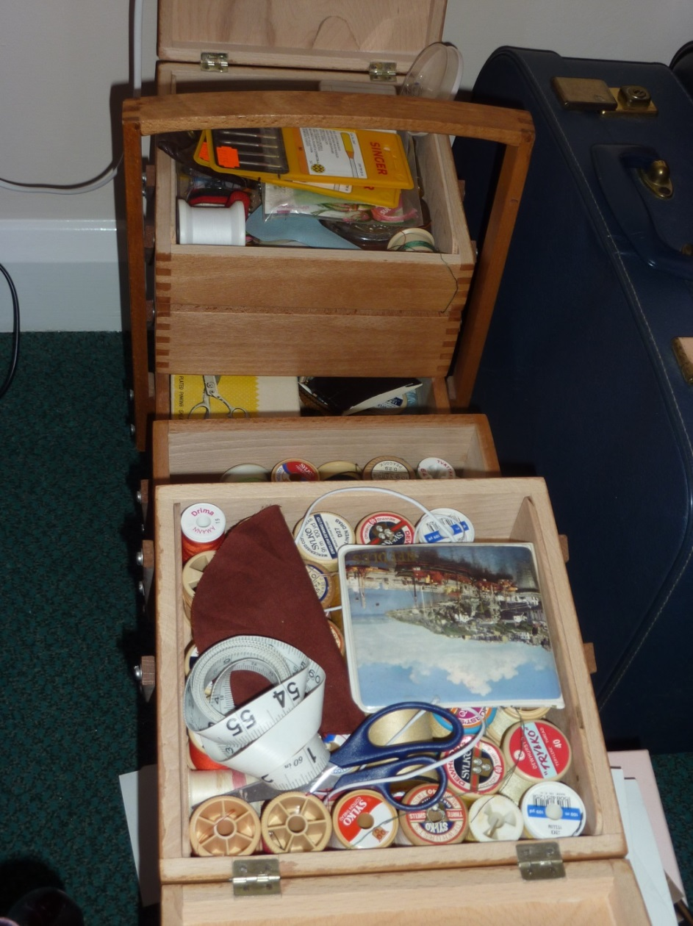

In the above passage Polly interweaves the material narrative of the sewing box into temporal narratives of her personal biography of parenthood as well as the socio-historical narrative of living during the Second World War. Her narration of these intersecting themes also shed light on one of the reasons she gave for conceptualising The Cedars as being ‘somewhere to live’, rather than as her home. As well as referencing the Second World War as a life-changing event which required her and her peers to be resourceful, Polly also spoke of her need to be independent from a young age:
But there’s nothing like – well, because I’ve always been independent, I’ve had to be. My mother was ill when I was a little girl, she had TB [tuberculosis]. Because my father was a prisoner-of-war in the First World War, and she got measly money to look after herself and two daughters. And my grandfather used to subsidise her, she used to get about ten bob a week, to look after them, to live off. And my grandfather used to subsidise her but she would spend it on the girls and not herself, and of course she got TB. And of course when Pa came home from being a prisoner of war and she had a son and then a daughter – me – the daughter, and she was always either convalescent or recovering. You know, so of course you learn to be independent, you have to be independent. And you have to learn to do things for yourself, which I did. With my grandmother’s help, because she was wonderful.
The independence which Polly learned to exercise during the Second World War contrasted with the frustration she felt – as I described in Chapter 6 – at being reliant on care home staff to make basic adjustments to the heating and furniture in her room.
Polly’s case study highlights the ways in which the different temporalities of ageing and her relationship to her possessions intersect. Growing up as a young child with a sick mother, and then living through the years of rationing during the Second World War, Polly had learned to be independent and resourceful, qualities of which she was proud, but which served to highlight her relative dependence in The Cedars. While possessions such as her photograph albums of the cakes she had decorated and her sewing box may have reminded her of her physical and sensory losses, she was proud of them and how they symbolically represented her skills, accomplishments and independence. The sewing box had been a ‘material companion’ (Kirshenblatt-Gimblett, 1989) throughout her life, and represented a continuity with aspects of her earlier life. However, while Polly was glad to have such objects with her, her main losses were felt in her bereavement at the death of her husband and friends, and her relocation from a beloved part of the country. The intersecting spatial and temporal elements of home are movingly conveyed in Polly’s awareness that even if she were to go back to her beloved Dorset, it would not be the same without the loved ones who had helped to make it a home for her, who were now dead.
Next, I explore some of the themes in Polly’s case study in more detail, drawing on the experiences of other residents and considering how they relate to existing literature on temporality, materiality and home.

8.2.2 The embodiment of ageing and materiality
Just as Polly’s deteriorating eyesight rendered her unable to interact with her sewing box as she once had, so did the age-related physical and sensory impairments of other residents affect their interactions with the material culture of their rooms. While in Chapter 6 I emphasised the ways in which residents were in some respects able to overcome their physical limitations, for instance through cleaning with the aid of a walking frame, or adjusting their furniture so as to have everything to hand, there were some activities which they had had to forego altogether. The sensory impairments of some residents, for example, meant that they could no longer read books or watch television. Peter had been deaf since childhood, and so this sensory impairment was not a consequence of ageing. However he experienced his deafness differently in The Cedars than he had done when living in his own home, with his wife. Peter found it more difficult to communicate in The Cedars, where as I explained in the previous chapter, socialising tended to occur between groups of residents in communal areas, rather than between two residents in each other’s rooms. On many of my visits to him, he expressed regret at not having made more meaningful friendships in the home. It was easier for Peter to communicate one-on-one, where he could partially lip-read and focus on what one person was saying, than in a group setting where people were sat all over the room and talking over each other. During my visits I could see him ‘tuning in’ to my speech, and he would often ask apologetically if I wouldn’t mind dragging the footstool I sat on a bit closer, so that he could hear me better. When a cleaner or care assistant entered the room, Peter had to readjust his position and concentrate on the new voice coming from a different part of the room.
Irene was the other resident who, besides Polly, seemed to me to be the least happy at living in The Cedars. Irene was 92 and needed a walking frame, which meant that she was unable to bake as she used to. She located the loss of her ability to bake within the greater loss of her own home. Like Polly, she described how her home was lost to her not just in terms of being in a different location, but also a different time.
Irene: I try to do what I used to do, but that’s not always possible. ‘Cause I keep thinking, you know I still see recipes on the telly, and read about them in a magazine, then I think “oh dear, I shan’t be able to make my flapjack anymore, and I shan’t be able to do this”. But somebody once said, “well they’ll let you do them, there’s a kitchen”, but it’s different, I can’t, ‘cause I can’t use, when you do something like baking you’ve to use two hands. I can’t, because I can’t stand without that frame[without having both hands on the zimmer frame].
Melanie: I see.
Irene: I can use one hand, but you can’t do much baking with one hand, can you? I just don’t know. I’m sounding very, I don’t know, very pessimistic, I don’t mean to sound like that because as I say, I’ve accepted this as my home and on the whole I’m quite happy here. And it’s no good looking back, because you can’t do anything about what’s gone in the past.
In the above exchange, Irene interweaves elements of her embodied experience of ageing and how this relates to her interactions with her material surroundings, with her understandings of home as a temporal as well as a spatial experience. Irene understands that her inability to bake is related to the temporal experience of ageing; that is, her unhappiness at not being able to bake is not just her current inability to do something which she wants to do, but her knowledge that she can no longer do something which she used to enjoy doing in the past. Furthermore, the broken connection between her body and the activity of baking is realised in the ways in which her age has changed the ways in which she interacts with the materiality of her surroundings. Her reliance on the materiality of the walking frame means that Irene is unable to manipulate the materiality of a mixing bowl and spoon. In this way, while Irene’s body is the site at which ageing occurs (Hockey and James, 2003: 214), ageing is also understood as an embodied experience through the body’s changing encounters with material objects.
The residents’ changing interactions with things as a consequence of their age were not necessarily experienced as a loss. Stan, for example, was extremely competent at using his mobility scooter, and he would skilfully manoeuvre his way out of his room, along the corridors and out to his car. Polly was adept at using her walking stick to add greater emphasis to the points she made in conversation, and would frequently jab her stick into the empty space in front of her arm chair, or bang it on the floor to ensure she was making herself understood. She was suspicious of the male residents, and disliked one in particular who she felt was too friendly. On one visit she told me that she had once cautioned him with the words, “I have a walking stick and I am not averse to using it!” Residents could therefore use materials to their advantage, and incorporated them into their routine social interactions.

8.2.3 Narratives of memory, materiality and ageing
As the previous section shows, objects could make manifest the age of residents through the ways in which the residents’ changing bodies affected their ability to interact with the materials around them. The fact of the residents being in older age was also revealed through the narratives that they told about their objects, and particularly the relationship between objects and memories. Memories become associated with certain things throughout the life course, but in older age the relationships between objects and memories arguably take on different characteristics. Firstly, this is simply because the older people are the more past they have, and the more time there is for memories to become associated with particular things. As I have argued in Chapters 6 and 7, the residents’ ages did not determine that they ‘lived in the past’, but the certainty of having already lived more years than they had yet to live did influence their experiences of time and how these related to their material surroundings and conceptions of home. Secondly, the longer a person lives, the more likely it is that they will have experienced emotional losses such as bereavements. Again, I have shown in previous chapters that experiencing the bereavement of partners did not preclude some residents from interacting with the materiality of their rooms to become at home in The Cedars. However, the experiences of being bereaved and moving home in one’s eighties and nineties are qualitatively difference from those in one’s twenties and thirties, for example, when it is more likely that future homes can be established with a new partner. For the residents, a move to The Cedars meant not only moving to a new place, but also represented a new marker in the temporal experience of ageing, hence the dislocation from their homes being experienced by Polly and Irene as temporal, as well as spatial.
As I described in Chapter 6, certain objects in residents’ rooms provoked particular memories of careers or relationships. In some cases these possessions were comforting reminders of deceased loved ones – as with the pipes that Dorothy displayed on her windowsill as a reminder of her husband. In other cases however, objects were more painful reminders of bereavements and former homes that now existed in the past, to which it was not possible to return. Some residents dealt with such objects by keeping them in the room but not displaying them, only looking at them occasionally. Stan, for instance, kept some of his late wife’s jewellery shut away in a box:
Stan: I’ve got her jewellery box locked away there with all her little knick-knacks in, and rings, and brooches and earrings and that. Some of the stuff, necklaces, I didn’t bother keeping those because she very seldom wore them anyway. So I weren’t bothered about them, but all the other bits of jewellery I’ve kept.
Melanie: and do you ever take them out to look at them?
Stan: occasionally yeah, but it only upsets me so I don’t get them out a great lot. ‘Cause we were never parted, we didn’t believe, neither of us believed in having holidays away from one another. We was always together.
Similarly, Polly had a large box of photographs that she told me that her daughter had asked her to sort through, in order to decide which she wanted to keep and which she wanted to throw out. Polly said that although she was being pressured by her daughter to sort through them, she was reluctant to do so, as she knew that the box contained photographs of her husband that she would find upsetting to look at.
I was also conscious that residents might have objects in their room that they did not want to talk about, and if these were not on display, then I would be unaware of their existence. Over the course of my visits I became very familiar with the objects in residents’ rooms and felt comfortable asking residents to remind me of the origins of a particular item, or I might ask “you know, I don’t think I’ve ever noticed that before, what can you tell me about it?” The exception was in Frances’ room, where on a table near the door was a framed photograph of a young man, next to which was always a vase of fresh flowers. There was also a piece of paper which had been slotted into the photograph frame, on which were two dates, which I took to be a birth date and a date of death. I noticed this on my first visit when Frances talked me through the things in her room. Despite pointing out to me most things which were on display, she never mentioned this photograph, and I did not ask. On subsequent visits she mentioned that she had a son, and also that he had been a solder, but I noticed that she used the past tense. This was the only instance where I made a deliberate decision to not ask a resident about something in their room, as I suspected – rightly or wrongly – that my question might cause distress.For Irene, even the thought of many of the objects in her (former) home was upsetting to her. The house she had lived in before moving to The Cedars was only a few streets away and it was still full of her possessions. Irene still referred to this house as ‘my home’, and was reluctant to take any items out of it as these would only serve to remind her that she no longer lived there. I asked her if there was anything from her home that she wanted with her in The Cedars. She replied:
Irene: no because, I don’t know why but I try not to think too much about it. Because I start to get, wanting to be out, and go to my own home if I start thinking about what’s there. It gets a bit upsetting, and if I think about things that are there, material things like clothing – not clothing, I mean they bring me some clothing when I need it – but I haven’t thought about furniture. I mean I’ve been told I can have what I like in this room, because it’s my home, but I don’t know, I’ve not thought about it a lot. It’s just, I just think I live here, and that’s that. I can’t live anywhere else.
Melanie: and can you think of anything that would make you feel better about the situation?
Irene: I can’t think. I don’t know, it seems, you know those drawers and that wardrobe?
Melanie: yeah.
Irene: they belong here. So now that I live here, it’s just part, I just regard them as part of my home. As I say I try not to think about my own home too much. It’s just something that I’ve left behind.
Melanie: so do you think, whatever your children bring for you, you’ll be happy with what they bring, and are you happy just to leave it up to them to sort out?
Irene: oh yes, yes. If I said I needed this or needed that, they would bring it, but I don’t know, I just leave it, ask them to bring things as I think about them. But as I say I try not to think too much about it. Sometimes I think, you know in my mind, I think “oh I’ll get that book”, and then I realise it’s not here. All me books are in the bookcase at home.

As with Irene’s earlier comments, I found these lines incredibly sad, because I got the impression that not only was her home ‘left behind’ in the sense of being in a different physical place to where Irene now lived, but it was also left behind in time.
The sadness evoked by particular objects contrasts with much of the literature on possessions in residential homes which assumes that the memories associated with belongings are uncomplicatedly good ones, which reinforce in residents a sense of their own identity and belonging (Cram and Paton, 1993, Paton and Cram, 1992, Sherman, 1991, Sherman and Dacher, 2005, Wapner et al., 1990). Related to this, objects in older age have been thought of as facilitators of togetherness and stability during the changes and losses that occur in older age. Rubinstein for instance has argued that objects can act as ‘anchors’ which are able to hold fast identity during periods of change such as ageing (Rubinstein, 1987: 230). In this sense, the immutable materiality of objects is perceived as an advantage – something fixed to hold on to during the period of decline and loss in older age. Similarly, William Christian conceptualises objects in older age as ‘bridges and physical contacts between the living and the dead’ (Christian, 2009: 238-239). In this way, the material affordances of things are perceived as a way of maintaining stability and togetherness as the mortal human body declines and loved ones die.
The examples I outline above of residents finding belongings too painful to look at or even contemplate, challenge this literature. In these instances, the material stability of the objects did not induce feelings of togetherness with deceased loved ones, but cruelly reminded residents that they would never be reunited. For residents who still acutely mourned dead partners and homes left behind, objects could not act as bridges because there was nowhere to go. This limitation of objects was also found by Savishinsky in his ethnography of an American nursing home. For one resident in particular, belongings from his former home were of little comfort to him, because to him, home was inextricable from his now-deceased wife. For the resident, writes Savishinsky,’ the objects seemed almost foreign, drawn from another person’s lifetime or household’(Savishinsky, 1991: 113). The reluctance of some residents to furnish and decorate their rooms with personal belongings is reminiscent of Fiona Parrott’s research on the residents of a medium security psychiatric unit (Parrott, 2005). Parrott found that many of the patients refused to decorate their rooms, as to do so would be to accept the unit as their home, thus by extension rejecting their ‘real’ home outside the institution. However, as the theme of this chapter emphasises, the significant distinction between Parrott’s research and my own is that Parrott’s participants were aged between their late teens to early forties, and the average length of stay in the unit at the time was two years. For them, a future home outside of the institution was viable; for the residents of The Cedars, time was not on their side, and forming a home outside of the institution in a way in which they had done so earlier in their lives was no longer possible.
In her research on family photographs in the home, Gillian Rose argues that while previous work has emphasised how photographs represent and constitute ‘connectedness’, ‘family photos articulate absence, emptiness and loss as well as togetherness’ (Rose, 2003: 7) both temporally as well as spatially. She describes how the photographs were ‘present absences’, in that they were materially present, yet represented family members who were absent, both in the sense that they were in a different place in the country or world, but also in that while the photograph might depict them as a young child, they were now a grown adult. For Stan, the jewellery belonging to his deceased wife was a ‘present absence’, in that he had the jewellery in his room, but it was hard for him to look at because it reminded him of her absence. As well as loss being articulated through ‘present absences’, it was also evoked by the ‘absent presence’ of objects. When Irene told me that she sometimes went to get a book, ‘and then I realise it’s not here. All me books are in the bookcase at home’, the absence of the book in the room evoked the presence of it in her ‘real’ home, which was not now accessible to her.
In Gillian Rose’s research, she argues that the absence induced in her participants by the photographs produced ‘regret…but little more’ (Rose, 2003: 15). She attributes this in part to the family absences being the result of free choice and ‘cushioned by money’, as many family members were working in highly-paid jobs around the world. More crucially, her participants were middle aged women, and while they might have expressed fleeting regret at the passing of time in which their children grew up all too quickly and they themselves aged, they still looked forward to a future family life. This obviously contrasts with the very different temporal situation in which the residents of The Cedars found themselves. For Polly and Irene in their nineties, the emotions they felt at the absence of their husbands and homes as articulated through their belongings were experienced as more than a little regret, because they were not tempered by the knowledge that the absences were made through choice or were temporary. In this way, the fact that the residents were living towards the end of their lives meant that there were particular characteristics in how they related to their belongings and their move to new accommodation than they might have experienced as younger women.

8.2.4 Socio-historical events
Through experiences during their lives, residents gained skills such as resourcefulness and attitudes of independence, and while some residents such as Polly bitterly contrasted these with their perceived loss of independence in The Cedars, others continued to draw on them in moving to the residential home. Therefore, while the residents were affected by loss, in some cases the gains of their life experiences were still useful to them in older age, and were relevant to them as they related narratives about the materiality of their rooms in The Cedars and their feelings of being at home. I found it telling that although I did not explicitly ask the residents to reflect on how their experiences during their lives related to their current situation in The Cedars, many of them related such reflections to me unprompted. Such spontaneous reflections were also found by Sixsmith et al. in their study of older people’s attitudes to healthy ageing at home (Sixsmith et al., 2014). Despite not being the focus of their research, they found that the participants in their study made associations between their wartime experiences and current everyday lives, for example relating narratives such as how during the war they had learned to be independent and resilient. The authors concluded that these earlier experiences contributed to the participants’ sense of who they were, and that the participants ‘mobilised’ characteristics of their identity to ‘cope with present-day life and circumstances’ (Sixsmith et al., 2014: 1477).
While the residents in The Cedars did not always make explicit how their wartime and other lifetime experiences informed their attitude to their current situations, when describing the objects in their room to me, they would often interweave narratives relating to their biographical experiences of living during a particular socio-historical time. An example of this is shown in the following excerpt from an interview with Stan:
Melanie: and what about this picture, here?
Stan: that one I bought here at the jumble sale.
Melanie: oh, at Christmas?
Stan: just before Christmas, yes. In fact I bought that one, and I bought that Shire horse, that little clock, there, musical clock. There’s a sewing basket in me wardrobe there I bought.
Melanie: do you use it?
Stan: oh I can sew. I can knit and darn and all.
Melanie: good grief!
Stan: when I was at school we lived in [the] country you see… [a]nd we was at them village schools there, we was only three lads, and we had to join in with girls when they had cookery and knitting and sewing, we had to go as well.
Melanie: quite right!
Stan: so that’s how we learned it. Come in handy when I was in forces. I got this phone at jumble sale as well, big keyboard one.
These apparently throwaway comments connected the contemporary material contents of his room to his education at a particular time, and how this teaching in domestic skills was later useful to him while serving in the armed forces during the Second World War.
Mary spoke more explicitly about how her biographical experiences of growing up in the first half of the twentieth century, and her experiences of marriage and parenthood during the Second World War related to her current living arrangements. While Mary for the most part expressed contentment with living in The Cedars, she had initially found it difficult and explained this in ways that referenced earlier life experiences. She described the circumstances of her move to The Cedars and her first impressions:
Mary: So, without me knowing, [my son] and my daughter got together, with my sister, the whole family got together, and between them they decided – I was a little bit cross at first, not cross but a little bit upset – and he said “well it’s one way or another”. I don’t think perhaps what I appreciated when I got here first, I thought, I did think “oh dear, what have I come to?”…. And um, but now I’m very happy.
Melanie: And why did you have the initial reaction that you did?
Mary: Well, first of all [hesitates].
Melanie: Do you want me to stop recording? But I will change your name.
Mary: No, first of all, I thought “I’ve come to one room”, and there were people going up and down at the time….Although they’d done this [room] beautifully, I liked that, but I think it was because I thought my father ... I got married and got a house when I shouldn’t have done, three bedroom house ... I was so determined that I wouldn’t be under anybody’s jurisdiction. And I wanted a garden for my daughter… It was a lot of rent, it took nearly all my money. But I was so determined I would start my life independently. And that I did with nothing.
Mary told me how she set up her first home, for herself and her new born daughter by herself, as her husband was at war. She also described her resourcefulness at having to create a material home at a time when furniture was scarce. In the following extract she describes these experiences and relates them to her emotions on moving to The Cedars:
Mary: And I had a Morrison shelter which we had to sleep under, and I had to stay in the same room to keep the heat for my daughter – brought her out of hospital ill. But I can tell you, no person like they do now came to visit you. No, what do you call them? District nurse. Nobody came near me. And yet they made my father sign a thing saying if she died – she was under five pounds and they made you sign it. But the thing is, if she’d have died, nobody would have helped me, nobody ever came near me, from the time I took her out. I took her back once to be weighed, or twice… And then I was on my own. And I didn’t see my friends. Anyway, we got by, I don’t know how, don’t know how, ‘cause we used to have to sleep under this Morrison shelter, it was like a table, metal, and you slept underneath.
And apart from that, when I first went into my house I can tell you, I had nothing. Except my greatcoat from my army, my clothes that I was wearing, and my previous clothes of when I’d gone into the army, I thought I was going to be in there for a while, or when you come back you’d get clothes, I never thought they’d go rationed, so my younger sister had my whole wardrobe. Everything. Every conceivable thing. And when I said I was coming out, could I have this back, she said ‘no’!
…
And I made furniture out of boxes. You know the big cheese box, we used to have a big cheese box, round, years ago, and I used to cut that in half and make a stool out of it. Oh, it was quite funny, I made a lot of furniture, out of apple boxes – break them up, get the wire, get the wood. And these apple boxes from South Africa were shiny, they bevelled the edges, so it was like a little panel of wood, shiny. And I survived. I survived. You couldn’t buy second hand furniture, it was very expensive for rubbish. I remember buying a wardrobe that used to topple over, it cost me a lot of money.
Anyway, when you, I tell you what I can’t really remember it properly but the joke of it was you gradually got one knife and fork, which was your army knife and fork. And cups, I don’t quite know where I got cups from. But I can’t quite remember that bit of getting china bits.
…
Melanie: I can see how you might have been a bit put out then, when it was first suggested to you that you move up into a place like this.
Mary: Well, after that you see, I moved twice – I moved into a house and then to another house, and my last house was what I told you, was really nice, I told you. ... This [room in The Cedars] was too cramped, by far. I really thought I was going to die overnight, to be honest…. And then I landed in one room. That’s how I put it.
In this way, Mary viewed her move to and her life in The Cedars in the context of her lifetime of experiences. She resented the loss of resources she had gained and used in the Second World War, such as her independence and ability to cope on her own. However, at other times she told me how her experience of moving home and starting afresh with new belongings during her lifetime had helped her come to terms with moving into residential care, echoing suggestions made in existing literature that older people may draw on earlier experiences of making and unmaking homes in adjusting to moves in residential homes (Granbom et al., 2014).

8.2.5 Summary
In this section I have shown how the ages of the residents influenced their experiences of living in The Cedars as manifested through the ways in which they interacted with and told narratives about the material culture in their rooms. Age-related physical and sensory impairments meant that some residents had to give up particular activities such as reading or sewing, preventing them from ‘being at home’ in the ways in which they had been at home in earlier years. The advanced age of residents also meant that most of them had suffered the emotional loss of bereavements, which were revealed through the objects they had in their rooms and the narratives they told about them. The sheer fact of being in their seventies, eighties and nineties also influenced residents’ attitudes towards home, and for Polly and Irene in particular, their ‘real’ homes were not just experienced as being in another place, but another time, when they still lived with their now-deceased husbands.
The intersections between the temporality and materiality of residents’ lives were also revealed through the narratives residents told of growing up during the first half of the twentieth century and living during the Second World War. In this period of rationing and material deprivation, residents learned to be independent and resourceful, and although they may have mourned their relative loss of independence in The Cedars, residents were still proud of their resourcefulness.
I have also shown how, for residents mourning the loss of homes and loved ones, objects were not necessarily welcome reminders of former times. Similarly, in contrast to how they have been conceptualised in existing literature on older people and possessions, objects cannot always ‘transport’ residents to former times, or bridge the gap between residents and their former homes and absent loved ones. Instead, these objects can be perceived as existing ‘out of time’, no longer congruous with the space and time which gave them meaning. However, as I shall show in the next section of this chapter, such objects do not necessarily remain ‘out of time’ forever, but can take on different meanings due to changing interactions between residents and their belongings over time.
In this first section of my discussion on temporality and materiality, I focused on how residents’ interactions with their material surroundings and belongings were affected by their chronological age, biographical narratives and experiences of living through particular socio-historical events. In the second section, I consider the temporality of The Cedars in terms of how residents’ material interactions changed over time in the residential home, and rather than time ‘stopping’, it continued to pass and influence the residents’ lives.

8.3 Becoming older in the residential home
Much of the existing literature on personal possessions in older people’s residential homes focuses on the role of belongings in helping residents adapt during the transition to institutional life. This emphasis on transition draws attention to the period during and immediately after the resident’s move, and pays relatively little attention to what happens for the rest of the resident’s life in the home. As I showed in Chapters 6 and 7, the routines, everyday practices and social interactions that were played out by residents in their material surroundings were processes, not one-off events. Furthermore, while the residents were ‘old’ when they moved into The Cedars, they became older the longer they lived there. This may seem an obvious point to make, but as I shall argue in the next section, there is a tendency in earlier studies to conceptualise older people’s homes as ‘timeless’, ‘liminal’ spaces which exist outside of ‘normal’ chronological time as it is experienced elsewhere. As I showed in Table 1 in Chapter 3, the time which residents had spent living in The Cedars on the date I interviewed them ranged from six weeks to eighteen years, and six of the eleven residents I interviewed had lived in The Cedars for longer than one year. I suggest that this is important, because just as people’s attitudes to their homes change over time during other stages of the life course, so they changed during the time residents lived at The Cedars. As I shall demonstrate, these changing attitudes were reflected in the transformations which residents made to their material surroundings. Before discussing my own findings, in the next section I analyse how previous studies have conceptualised time in institutions for older people, arguing that such studies pay insufficient attention to longitudinal changes in residents’ experiences.

8.3.1 Temporalities of residential homes
Previous studies of older people’s residential institutions have often argued that there is something different about the way in which time operates for ‘institutionalised’ older people than for others. One pervading theme is the idea that residential and nursing homes are experienced as liminal states (Hockey, 1989, Shield, 1990). Drawing on the concept of liminality developed by Arnold van Gennep (van Gennep, 1960), such literature argues that residents of older people’s homes are stuck in a perpetual ambiguous, liminal phase, where they are no longer part of ‘normal’ time as experienced by adults outside of the institution, but have not yet ‘resolved’ their liminal status by dying. In her study of an American nursing home, Shield argued that the liminal phase was exacerbated by the institution’s active avoidance of discussion of death, thereby discouraging residents from preparing for the ‘next stage’ (Shield, 1990: 333). Conceptualising residential and nursing homes as liminal phases or ‘waiting rooms to death’, implies that any notion of future time is inevitably associated with increased proximity to death.
In her ethnography of a residential home, Jenny Hockey argued that residents existed within an ‘institutional present’ (Hockey, 1989: 213) time within which their individuality was not acknowledged. She argued that as a way of maintaining and asserting their identity within the de-personalising institutional present, residents relied on recreating ‘salient fragments of the past’ (213) and also distancing themselves from other, ‘undesirable’ residents. Hockey suggested that these objectives ‘reflected not just a sustained commitment to the past, but also an urgent shielding of the self from the prospect of deterioration, of which the presence of other, 'frailer' residents constituted a constant reminder’ (213). In these studies by Shield and Hockey, future time exerts no meaningful influence on the daily lives of residents, other than as something which is to be avoided as much as possible as it is synonymous with death. Furthermore, although the researchers spent several months in the institutions, it does not appear that the experiences of individual residents were traced over time, perhaps reinforcing a sense of overall stasis in the home.
The conceptualisation of the residential home as a liminal phase, or a state in which the future has little relevance, does not, I argue, account for the lived experiences of the residents in The Cedars. In Chapters 6 and 7 I demonstrated how they carried on living and made future plans, in some cases over several years. During this time, although residents might have experienced ageing in the form of increased physical and sensory impairments, it is too simplistic to interpret the time they spent living in The Cedars as one of inevitable and irreversible decline. In the next section, I reflect on the ways in which residents and their attitudes towards The Cedars changed over time, and how this was manifested in their interactions with the materiality of the residential home.

8.3.2 Living and ageing in The Cedars
During my fieldwork in the residential home I cannot say that I witnessed any resident change from a position of generally rejecting The Cedars as their home to an attitude of happiness or contentment with their living environment, but I did gain insights into changes in attitude among the residents over time. Firstly, some residents who had lived in The Cedars for over a year told me how they had initially found living in the residential home to be difficult, and just as Mary told me that on first moving into The Cedars she thought that she was ‘going to die overnight’, so did other residents tell me that they did not feel at home straight away, even with their belongings around them. Secondly, while Polly and Irene (who had moved into The Cedars four months and two and a half months earlier, respectively) still expressed unhappiness at their situation and a longing to be in their former or ‘real’ home, there were indications during my later visits to them that as they spent more time in The Cedars, so they started the processes of turning the spaces of their rooms into the places of home as I discussed in Chapter 6.
For instance, despite Irene’s initial reluctance to have her furniture and possessions moved into her room in The Cedars, on subsequent visits I made to her there was some evidence that her attitude was changing slightly. On a visit a couple of weeks after I interviewed her, without prompting, Irene pointed out a table that had not been there on my previous visit. She told me that it was a wedding present for her and her husband and had been handmade by a neighbour. She told me that she had asked her daughter to bring it for her. She also told me that she had asked her daughter to bring a small bookcase, inlaid with engravings, that was currently in her bedroom at home. She said that it had ‘only come to her recently’ that she had that bookcase, and she realised it would go in her room at The Cedars. However, she followed this up by saying again that she didn’t like to think about her things too much because it upset her. She told me that the bookcase formed part of her complete home, and emphasised that her home was complete with everything she needed in it. Despite her continued ambivalence however, Irene was gradually adding to the things in her room. While I was taking a photograph of her table, she pointed out that behind it were a framed photograph and painting from her home, which were ready to hang in her room (see Photograph 18).
Photograph 18: The table given to Irene as a wedding present
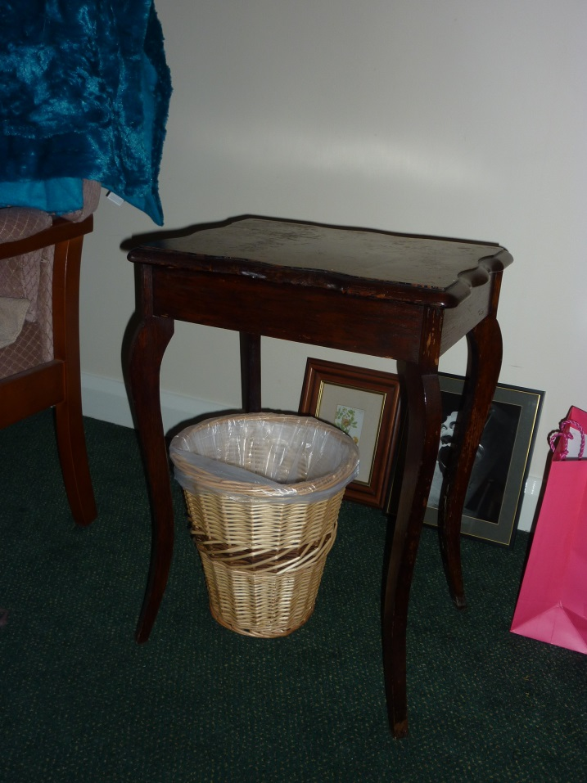

Similarly, despite rejecting her room at The Cedars as ‘home’, Polly nevertheless took an interest in arranging it, and gave the impression that her room was a work in progress. She told me that she kept changing things around, and had plans to put new things in:
Polly: I keep moving things round myself. They [daughter and son-in-law] brought me in a table, a little side table, but it was that little bit bigger than those tables [nest], and I said to her [daughter] – at Christmas I went to her house at Christmas and I said, ‘ooh, you’ve got my coffee table’. And it was a round table with a glass top, and three tables that went underneath it. And er, ‘ooh you’ve got my coffee table’, ‘yes’, she says, ‘and I’ve got another set of tables that you didn’t want because you had that one’. So I said, ‘ooh’. So she brought me that, but that’s originally mine. So I’ve got it, and this bigger table. I don’t know how to put it in one of the rooms, it was theirs [The Cedars] anyway. [Lowers voice] But all the furniture [belonging to the home] is so heavy. And er, God knows where it’s from. I had lighter things that I could pick up. Which you do, don’t you?...I mean I’m all for putting them here, there and everywhere, you know. Never leave anything in one place.
Melanie: And what provokes that need to move things around? Will you be just be sitting thinking, ‘ooh, that would look better there?’
Polly: Or I think to myself, ‘I’d like a little table to the side of me’. I mean, I can see all this going and the tables coming in here [next to her armchair, once she’s sorted through / moved boxes and cases off the floor] when I’ve got rid of it, but I need to get rid of it first.
Melanie: So have you got things how you want them for now?
Polly: Yes.
Polly still had boxes and cases of photographs and other objects to sort through, and gradually worked her way through these over the course of my visits. I took Photograph 19 and Photograph 20 a month apart, and in that time Polly had sorted through one or two cases, installed a foldout table in the space where some of the cases had been, and rearranged some of the photographs and ornaments on her corner shelf.
Photograph 19: Polly's room, 22 January 2013
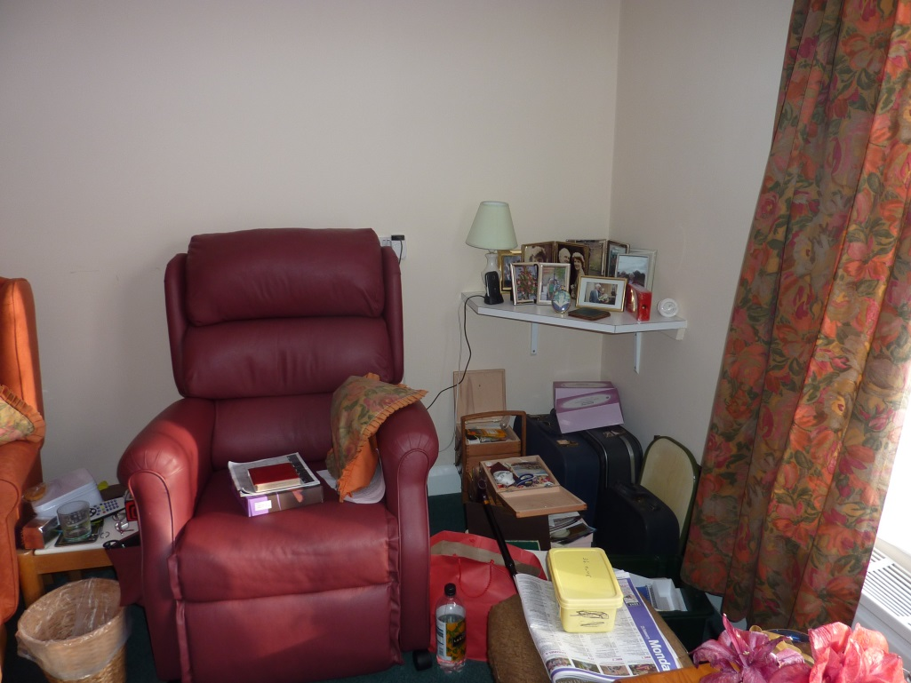
Photograph 20: Polly's room, 28 February 2013
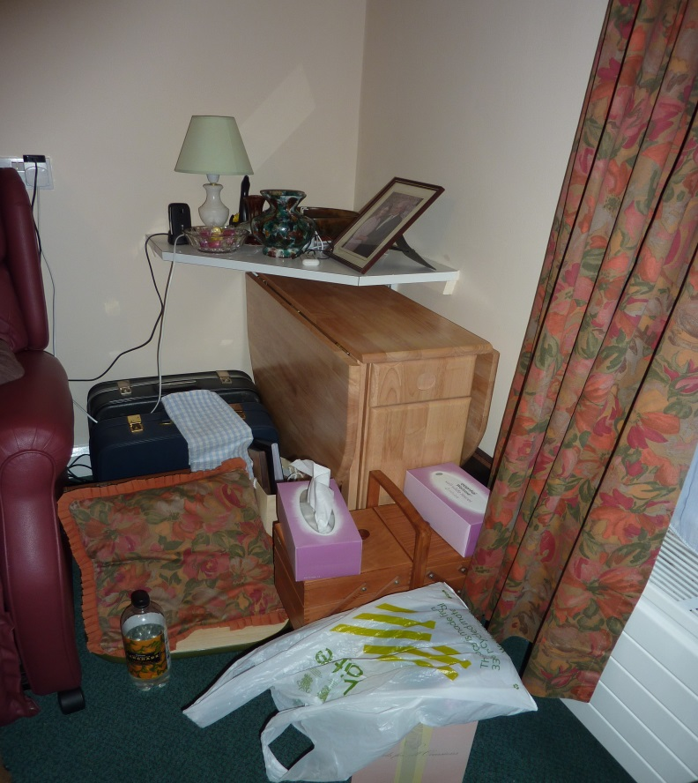

In this way, although Polly continued to express unhappiness at living in The Cedars, she took an active, ongoing interest in developing the materiality of her room to her satisfaction.
While I would not want to draw too definitive a conclusion from these examples of Irene and Polly, the ways in which they started to take more of an interest in the material culture of their rooms is possibly indicative of a change in attitudes and a gradual ‘thawing’ of their initial rejection of The Cedars as home. As well as being the two unhappiest residents that I knew in The Cedars, Polly and Irene were also two of the most recently arrived residents in the home, and it seems likely that these may have been connected. Just as the more established residents in the home had told me that they had been unhappy on initially moving to The Cedars but were now satisfied and settled, so over time Polly and Irene may have grown fonder of their surroundings. The bounded nature of my fieldwork meant that I did not discover whether or not this proved to be the case, and more longitudinal research in residential homes is needed to learn more about residents’ long-term experiences, rather than just their initial transition.
Visiting The Cedars over the course of a year, however, did shed light on how residents’ lives and attitudes changed over this time, and how this was reflected in their material surroundings. Given that my visits to the home encompassed twelve months from July 2012 to June 2013, I witnessed changes in residents’ rooms over Christmas and Easter. I observed residents displaying Christmas cards, and was invited to admire new presents, or bunches of daffodils bought by residents’ relatives over Easter. In January, some residents put up new calendars. These material manifestations of the calendar year were not in themselves remarkable – after all most people I knew did the same – but were further indications to me that time in The Cedars had neither stopped, nor operated somehow differently from time outside of the home.

8.4 Conclusion
In this chapter I discussed the intersections between the temporality and materiality of the residents’ lived experiences in The Cedars. I argue that the sheer fact of being old – in their seventies, eighties and nineties – affected the ways in which residents interacted with their belongings and surroundings. Physical and sensory losses meant that residents had to forego hobbies which they had previously enjoyed, because they could no longer use particular items. Emotional losses associated with older age, such as bereavements, also meant that objects which were associated with particular people or places were not necessarily comforting reminders of former times, but anachronistic and dissonant, not so much portals or anchors to other times, but troubling reminders of what had been lost. I argue that the inability of objects to always provide uncomplicated comfort are important to acknowledge, and are not sufficiently recognised in existing research on material culture in older people’s homes, which emphasises the potential for belongings to provide a sense of belonging and control for older people who move into long-term residential accommodation. I would also argue that this point is of potential relevance for family members who help older relatives move into residential homes, and care home staff, who may be unaware of the potential for distress which could be caused by particular objects. Sensitivity is clearly needed when discussing certain possessions in residents’ rooms, and caution exercised in assuming that all of the belongings are comforting and have positive associations.
I have also discussed how, while categorically old when entering The Cedars, residents continued to age and time continued to pass in the home. Attitudes which residents had on entering The Cedars were not necessarily held by them months or years after their arrival, and these changing outlooks were reflected and manifested in material changes which residents made to their rooms. Again, such acknowledgements of how time continues and futures are acknowledged in residential and nursing homes are not sufficiently represented in existing literature, which emphasises the static, liminal, ever-present or past-oriented nature of older people’s homes.
While in this chapter I acknowledged and investigated how the distinctive qualities of being older people in a residential home intersected with residents’ material experiences of being in the world, here, as in earlier chapters, I do not conclude that the temporal experience of being old determined how the residents of The Cedars experienced life in the home. In the next chapter, I discuss the implications of this and the conclusions of earlier chapters, for research and practice concerning older people’s residential homes and material culture.

Chapter 9: Conclusion

9.1 Introduction
In this thesis I have explored how residents in older people’s residential accommodation experience home and everyday life through their interactions with material culture. I have argued that ‘becoming at home’ is an ongoing process which is in continual flux as residents engage in mundane practices, develop and maintain personal and social relationships, and become older in the residential home – all of which are mediated through the material culture which surrounds them. While moving to and experiencing home in a residential home for older people is qualitatively different from other experiences of home, it is not necessarily experienced as a binary opposite to living in one’s own, private home, and it exists on a continuum of moves made throughout the life course, to a variety of settings. By focusing attention on the ways in which residents actively turned the spaces of their rooms into places of home – and how these processes were facilitated or hindered – I have argued that residential homes can be conceptualised not as inevitably awful places which determine the experiences of older people who live there, but as settings where it is possible for older people to continue to create meaning and a sense of belonging in their everyday lives.

9.2 Research implications
This thesis makes a number of original contributions to knowledge in the fields of ageing and material culture and I outline these below.

9.2.1 Theorising the relationship between people and objects in residential homes
In Chapters 5 and 6, I demonstrated that a sense of home in older people’s residential accommodation cannot simply be transferred, maintained or created through the presence of belongings taken from the residents’ former homes, as previous literature has assumed. This assumption misunderstands the nature of the relationship between people and material culture. Objects are not passive repositories which are filled with meanings of identity and home by people, who then ‘reclaim’ such meanings as and when required. Instead, meanings emerge and change through ongoing interactions between people and the things around them. Taking a practice-based approach to residents and their material surroundings, I found that a sense of home was not experienced simply through the display of belongings, but in everyday activities such as cleaning, hosting, watching television or crocheting. Through these practices, residents exercised agency in their surroundings and actively turned the spaces of their rooms into places of home. Where residents were not able to exercise such agency – as with Alice in Beechview Lodge – the display of objects was not in itself sufficient to convey a sense of home and belonging.
A practice-based approach also reveals the importance of mundane, as well as more obviously cherished or treasured belongings. While the significance of mundane objects has been emphasised in material culture studies (Miller, 1987), research on material culture in residential homes has concentrated on ‘special’ possessions, and has tended to overlook more everyday, taken-for-granted materials. My research has shown how interactions with mundane objects such as televisions, cleaning materials and tables are as instrumental to residents in feeling a sense of home in their rooms in residential accommodation as they are to anyone, regardless of age or residential setting.
Finally, while previous research has focused on how belongings from their former homes help residents become at home by facilitating continuity with their pasts, my research demonstrates the importance of residents engaging in ongoing, everyday activities with their material surroundings, and also being able to acquire new things and having aspirations to change their rooms, thus revealing how homes are also experienced in the present and future. Again, while this conceptualisation of home as comprising multiple temporalities has been discussed in literature on the home (Cieraad, 2010, Mason, 1989), it is largely absent from research on older people’s experiences of home in residential and nursing homes.

9.2.2 Relational homes
My research shines a light on how a sense of home in The Cedars emerged through existing relationships with friends and family members, and also new relationships with other residents and members of staff. These relationships were revealed in and constituted through the gifting and circulation of material culture within the residential home. Previous research on material culture in older people’s homes has focused on the relationship between individual residents and their belongings in facilitating a sense of home. While such research recognises the value of belongings which are associated with existing or former relationships, such as family photographs or objects which belonged to deceased partners, there is little acknowledgment of the possibility of how residents might furnish their rooms with material culture associated with new relationships. The fact that residential homes accommodate many people in close proximity is usually regarded negatively, in contrast to how halls of residence at university are assumed to be positive environments where first year students can easily make friends. Again, this is not to iron out the qualitative differences of having social relationships in one’s late teens or in one’s late eighties, but my research shows that residential homes for older people can be places where new, meaningful relationships are formed. I suggest that such findings are of relevance in the context of increasing concerns about the prevalence and impact of loneliness among older people (Victor et al., 2005).

9.2.3 Conceptualising home in older people’s residential homes
Two very different conceptualisations of home emerged from my research in Beechview Lodge and The Cedars – both in terms of how I experienced the atmospheres of home, and the extent to which residents themselves experienced home. I have suggested that two of the main factors in the ways in which the residential homes were experienced more or less as institutions or homes, were the built design and care culture. Crucially, this suggests that residential homes for older people are not inevitably places where residents do not feel at home, but that there are particular reasons which may influence residents’ everyday home lives. I argue that Beechview Lodge represents a residential home which is familiar to us in our collective cultural imagination of older people’s homes as sterile, static environments where residents have little control over their day to day lives, and where they sit in a circle in a lounge, not talking to each other, while a television blares out in the background. The Cedars, on the other hand, took me by surprise as a home where there was evidence of residents exercising agency in their rooms, taking pride in their homes, making plans and making friends; in short, carrying on with the business of being at home and living their lives in much the same way as anybody else does, of any age and in any form of dwelling. I do not know how representative The Cedars is of residential homes for older people, but I argue that its apparent success in enabling older people to live at home is important in two key ways. Firstly, it serves as an important reminder that cultures emerge in part out of the things that people do and are not deterministic givens; in this way, residential homes are not inevitably bad places which are the binary opposite of ‘homes in the community’, but exist on a continuum of homes experienced in various settings throughout the life course. Secondly, The Cedars helps to offer an alternative imaginary of residential homes as places where it is possible, given the right conditions, for residents to feel at home. These discourses, I suggest, are largely overlooked in both academic literature on residential homes and in popular conceptualisations of what older people’s homes ‘are like’.

9.2.4 Theorising the everyday in older age
My research also builds on the work conducted by previous studies into the ‘everydayness’ of older age (Maguire et al., 2014, Percival, 2002) and in so doing contributes to how we conceptualise older people – particularly the ‘oldest old’. My research demonstrates that through in-depth study into the everyday lives of older people, it is possible to make their lives known and familiar. Through studying their mundane material and social interactions, I have suggested that the residents – including those in their nineties – made and experienced homes in ways that were not so dissimilar to how people of all ages and in different residential circumstances do so. This is an important distinction from conceptualisations of older age as unknowable, unfamiliar, imagined and abject (Gilleard and Higgs, 2011, Hazan, 1980, Hazan, 2002, Higgs and Gilleard, 2015).

9.3 Policy and practice implications
The original impetus for this research came more from intellectual curiosity than a social policy angle. However as my thesis makes clear, during my research I encountered aspects of residential home practices which I considered to be influential on how residents experienced life in the residential homes, and their attitudes towards being at home.

9.3.1 Built design and care culture
My findings contribute to existing research which has considered how the built design and care or staff cultures affect the quality of life within residential homes (Barnes, 2003, Gilloran et al., 1995, Parker et al., 2004). My research suggests that having one’s personal possessions in one’s room is of little use in facilitating a sense of belonging and home if the design and/or institutional routines of the home mean that residents are not able to control their access to their rooms. The Cedars, with its wide corridors with a mix of residents’ rooms, communal rooms and staff rooms, enabled residents to exercise agency concerning where, when, how and with whom they chose to pass the time. This resulted in residents mainly occupying their time by interacting with their own belongings in their own rooms, safe in the knowledge that due to the proximity of other residents and members of staff, and regular mealtimes in nearby communal rooms, they would not be isolated for much of the day. This contrasted with the situation in Beechview Lodge, where the choice for residents seemed to be either to spend the whole day in close proximity to others, or by themselves.
It may be difficult to amend the built design of residential homes to facilitate greater access for residents to and from their own rooms, and adequate resourcing among staff is also an ongoing issue. However, there may be opportunities where care home staff can foster a greater sense of belonging between residents and their material environment. These could include staff members being proactive in asking residents who pass most of their time outside their rooms, if they would like anything fetching from their own rooms, such as books or knitting materials. Where staff resources allow, residents could also be offered more choice over where they choose to occupy their time – and assistance in enabling this.

9.3.2 Design, maintenance and features of residents’ rooms
My findings suggest a number of ways in which residents’ sense of belonging and control in their rooms could be enhanced. Firstly, residential and care homes ought to offer more storage space in residents’ rooms. A number of my participants regarded the amount of storage space in their rooms as inadequate, and those that had relatives nearby relied on them to bring in objects which belonged to them, but which they were unable to keep in their own rooms. I also found that some residents kept valuable items such as jewellery, and even irreplaceable items such as the ashes of deceased partners in their rooms, and therefore I would suggest that rooms ensure that some storage areas are lockable. Secondly, participants were sometimes irritated at having to rely on staff members to carry out minor adjustments and repairs to their rooms, such as altering wardrobe rails. Again, I write in the knowledge that staffing in the care home sector is poorly resourced, with low wages and a high staff turnover, but I suggest that carrying out such adjustments and repairs are relatively minor tasks in terms of staff resources, but can make a significant difference to how residents feel about their rooms. Thirdly and on a similar note, residents should be able to exercise agency – or at the very least be consulted – about environmental factors such as temperature settings on radiators and opening windows. Again, these might be considered minor factors in the context of a move to residential care, but I argue that not having control over these issues is annoying, contributes to a sense of discomfort and alienation in one’s own room, and is ultimately disempowering.

9.3.3 Facilitating relationships through material culture
My finding that material culture helped to foster and maintain social relationships within The Cedars could be of potential value to residential and care home practitioners who want to encourage friendships between residents. In The Cedars the sharing and exchange of material culture sometimes happened spontaneously and was instigated by residents. There were some instances of staff being proactive in trying to initiate contact between residents who they knew to have similar interests – for instance in cameras and photography – but I argue that there was more scope for staff to use material culture to encourage friendships. As I wrote in Chapter 7, one resident, Peter, was keen to establish a means by which residents could talk to each other about the photographs in their rooms. In helping to establish such schemes, where residents could take it in turns to talk about some of their belongings, staff could play a vital part in bridging contact between residents.

9.3.4 Helping residents make changes to their rooms
I have argued that the ways in which residents engaged in ongoing practices and made future plans to their rooms positively influenced the ways in which they experienced ‘being at home’. These were often dependent on the assistance of staff members – from providing catalogues and second opinions on what new televisions or clocks to buy, to arranging for contractors to decorate rooms – whose help was of particular value to residents with no family members who could help them in such matters. Staff also helped by running initiatives such as the Christmas and summer jumble sales, which enabled residents to buy things such as presents for family members or ornaments for themselves. All of this helped to provide residents with opportunities to make changes to their rooms and I suggest that such initiatives could be held up as instances of good practice from which other residential homes could benefit. In addition to these practices and initiatives, residential homes could be more open in general to the idea that residents might want to buy new things and make changes to their rooms, rather than recreate previous homes. Accordingly, websites and brochures for residential homes could frame the move to residential care as an opportunity for buying new furniture and trying out new aesthetics. Staff members could also make it clear to residents that they were happy to help with buying new items for their rooms. Such initiatives might not be welcomed by all residents, but might help to provide a more positive, forward looking message to the dominant narrative that a move to residential care represents an ending.

9.4 Limitations
This was a small-scale study involving research in just two residential homes in northern England and I cannot claim that the homes are representative of those in the UK. Furthermore my sample size of participants was small – particularly in Beechview Lodge where I focused on just one resident. As I explained in Chapter 4, I took the decision early on to only include residents who I judged capable of giving informed consent, and this limited the sample of potential residents who I could include in my research. Furthermore, as an in-depth, ethnographic study I was interested in yielding rich, detailed data on the experiences of residents living in the homes, and as such was more concerned with spending more time with a relatively small number of participants than less time with a greater number of participants. Had I had more resources I could have researched a third residential home to increase the number of my participants and investigate another setting, but the time and financial limitations of a doctoral research study meant that this was not possible.
I would have liked to have had a greater involvement of staff members in my research, as I believe that working in such intimate and close proximity to residents could yield valuable insights into residents’ experiences, particularly how residents’ experiences change over time. From a practice point of view, having a greater staff involvement in the research from the start could also assist with implementing recommendations for how residential homes could better help residents to feel a sense of home. While I would have liked to have conducted more interviews with staff members, given the under-staffed conditions in which they often worked, I was not surprised that they found it difficult to find time to sit down for a recorded interview. Indeed other studies have observed the difficulties of recruiting low-paid, under-resourced front line care workers to research projects (Watkinson-Powell et al., 2014). That said, the vast majority of staff members were friendly, helpful and took an interest in my research, and were happy to chat to me while going about their work.

9.5 Future research
This research has challenged some of the assumptions that we make about residential homes for older people, and raises questions about how the nature of ‘being at home’ and the meanings of material culture differ – or cohere – throughout the life course and in a variety of residential settings. There are many opportunities for how the findings of this research might be taken forward in future studies. Firstly, given the small sample size of my research, similar projects could be undertaken in other residential homes of various built designs (e.g. converted buildings, purpose-built homes) in order to explore how typical my findings are. Secondly, future projects could focus on the experiences of residents with dementia, or investigate the material and spatial interactions between all residents, including those with and without dementia. Thirdly, I would argue that there is a need for more longitudinal research in residential homes. Existing research has tended to focus on the transition to residential accommodation and/or cross-sectional studies. Such research doesn’t adequately account for potential changes in how residents experience and feel towards residential homes over time. As I suggested in Chapter 8, this gap in the literature possibly reflects assumptions that because residents are ‘old’ when they enter residential homes, they simply remain ‘old’ throughout the time they live there. This homogenising attitude towards those in older age doesn’t allow space for reflecting on how attitudes towards home and feelings of belonging change over time and according to different circumstances – even in very old age. This gap in the literature may also reflect difficulties in recruiting residents in very old age to a longitudinal study. However many of my participants had lived in the residential home for over a year – in some cases much longer – and I suggest that while challenging, it would not be impossible to explore residents’ experiences over at least a year, and how physical, emotional and relational changes might affect their attitudes towards home. Finally, future research could involve life histories with older people, to explore how their relationships to their belongings and homes changed over their life course, in a variety of residential settings. This would shed light on how and why the meaning of home and material culture changes or remains constant at different ages and in different circumstances.

9.6 Concluding thoughts
To conclude, this thesis has argued that by paying attention to how the everyday practices of residents of older people’s homes are manifested in and enacted through routine interactions with the material culture which surrounds them, we can gain insights into how residents experience feelings of being at home, and what matters to them in residential homes. Such in-depth, ethnographic research cuts through assumed binaries of ‘homes in the community’ and ‘institutions’ and suggests that while there are qualitative differences in how older people experience home in a residential home to how they experience homes in other settings, these differences emerge out of particular features such as the design of the building, how care is organised, and the personal circumstances of residents. Furthermore these features do not determine how residents experience life in the home, but influence it. Similarly, while there are qualitative differences in the meanings which objects and homes have for people in very old age, these differences don’t dictate how older people feel towards their belongings and homes. Within a research and policy context which endeavours to understand what matters to people in very old age and learn how the quality of older people’s lives can be improved, I argue that research such as this which helps to make the everyday lives of older people familiar and ‘knowable’ is of great value.

Appendix 1: Research questions for older people participants

- How long have you been living here (in residential home)?
- Can you remember packing to move to [name of residential home]?
- Did anybody help you?
- What objects/personal possessions did you bring with you? Can you explain why you wanted to bring them with you?
- Are there any objects you brought with you that you haven’t displayed? I.e. are they hidden away? Why?
- Were there any things you wanted to bring with you but couldn’t? Why? How does that make you feel?
- How do you engage with the objects in your room now? Do you touch them? Do you think about them at certain times?
- Do you talk to other people (staff/other residents) about the personal possessions in your room?
- Would you miss your personal possessions if you didn’t have them with you? Why?
- Would you say that having your personal possessions with you has helped you settle in to the residential home?
- Has your relationship with your personal possessions changed since moving into the residential home?
- What advice would you give to other people preparing to move into a residential home?
- Have you given any thought to bequeathing your personal possessions? What would you like to happen to your personal possessions after you have died?

Appendix 2: Participant information sheet for residents

The objects older people choose to take with them on moving into residential accommodation
Participant Information Sheet (residents)
My name is Melanie Lovatt and I am a postgraduate research student at the University of Sheffield. I am inviting you to take part in a research project. Before you decide whether or not to take part it is important for you to understand why the research is being done and what it will involve. Please take time to read the following information carefully and discuss with others if you wish. Please ask me if there is anything that is not clear, or if you would like further information.
What is the research project about?
I am interested in the personal objects which older people choose to take with them when they move into residential accommodation. I would like to know more about how people decide what to take with them and what purpose the objects serve in the residential home.
Why have you been invited?
You have been invited to take part in the study because you live in a residential home for older people and you have personal possessions with you which you brought from your previous home.
Do you have to take part?
No, you do not have to take part, and if you would prefer not to take part you do not have to give a reason.
What does participation involve?
If you would like to take part, I would like to talk to you about the objects you brought with you to the residential home, and why you brought them. I would like to audio-record some interviews with you. It is up to you how long you would like to talk for, and how many times you would like to talk to me. In the first interview(s) I will ask you a bit about your life, why you moved into the residential home, how you felt about moving, and how you decided what to take with you. In the second interview(s), I would like to talk to you about the objects which you brought with you, and how having them in your room makes you feel. If you would like, I will lend you a video recorder, camera or notebook so that you can film, take pictures of or write down any thoughts you have about your possessions.
Will anybody else know you have taken part in the research?
It is up to you if you want to tell anybody that you are taking part in the research. As I will be talking to you in your room, it is likely that members of staff and possibly other residents may be aware that you are participating in the research. You can decide whether you want your own name to be used in my research, or if you would prefer to remain anonymous. If you would prefer to remain anonymous I will give you a false name. You should also consider that if you give me permission to use photographs of your possessions in my research, it is possible that you could be identified by these. I will give the residential home a false name, so it will be not identified in my research.
In the event that you reveal information that indicates poor practice in the residential home, I will have to follow this up with the appropriate authorities. I will talk to you before I do this though, and your name will not be used in the complaint.

What will happen to the results of the research project?
I will use the results to write my PhD thesis, and will also use them to write articles and presentations for academic journals and conferences. I will write a shorter report including the key findings for the residential home. I can also produce an album containing photographs of your personal possessions if this is something that you would like.
What next?
I will be more than happy to answer any other questions you may have. If you would like to take part, please complete the reply slip and post it to me using the stamped addressed envelope. I will then contact you to arrange a convenient time to meet. When we first meet, I will answer any questions you may have, and will then ask you to sign a consent form. If you do not want to take part, you do not need to do anything.
Please remember that you can withdraw from the study at any time.
Contact details
Melanie Lovatt
Tel: 07731 872956
University of Sheffield
Department of Sociological Studies
Elmfield, Northumberland Road
Sheffield S10 2TU
Dr Lorna Warren (supervisor)
Tel: 0114 222 6468
University of Sheffield
Department of Sociological Studies
Elmfield, Northumberland Road
Sheffield S10 2TU

Thank you for thinking about taking part in this study.

Appendix 3: Consent form

Title of Research Project: The objects that older people take with them on moving into residential accommodation
Participant Identification Number:
Please initial box

- I confirm that I have read and understand the information sheet
explaining the above research project. I have had the opportunity to ask questions
about the project and have had these answered satisfactorily.

- I understand that my participation is voluntary and that I am free to withdraw
at any time without giving any reason and without there being any negative
consequences. In addition, should I not wish to answer any particular question
or questions, I am free to decline.

- I understand that any information I give will be used for research purposes only,
including research publications, presentations and reports. I understand and
am happy with how the researcher will protect my rights to anonymity and
confidentiality.

- I agree for the interview to be audio-recorded and transcribed and for the data
collected from me to be used in future research.

- I agree for the use of any photographs or video-recorded material
to be used in this research.

- I agree to take part in the above research project.

________________________ ________________ ____________________
Name of participant Date Signature

_________________________ ________________ ____________________
Name of person taking consent Date Signature

Appendix 4: Participant information sheet for residential home staff

The objects older people choose to take with them on moving into residential accommodation
Participant Information Sheet (residential home staff)
My name is Melanie Lovatt and I am a postgraduate research student at the University of Sheffield. I am inviting you to take part in a research project. Before you decide whether or not to take part it is important for you to understand why the research is being done and what it will involve. Please take time to read the following information carefully and discuss with others if you wish. Please ask me if there is anything that is not clear, or if you would like further information. Thank you for reading this.
What is the research project about?
I am interested in the personal objects which older people choose to take with them when they move into residential accommodation. I would like to know more about how people decide what to take with them and what purpose the objects serve in the residential home.
Why have I been invited?
You have been invited to take part in the study because you work in a residential care home which allows and encourages its residents to bring personal possessions with them. I will talk to residents about the possessions they chose to bring with them, but I would also like to talk to staff about their observations of the personal possessions which residents bring with them, and how residents interact with their possessions in the residential home.
Do I have to take part?
No, you do not have to take part, and if you would prefer not to take part you do not have to give a reason.
What does participation involve?
If you would like to take part, I would like to talk to you about your observations of the personal possessions which residents bring with them, and how residents interact with their possessions in the residential home. I would also like to ask questions about the residential home’s policies or attitudes towards residents’ personal possessions, for instance whether or not staff are encouraged to talk to residents about their objects.
Are there any benefits to taking part?
While taking part may not benefit you directly, you may like the experience of reflecting on your work, and sharing your observations.
Are there any disadvantages or risks to taking part?
I do not anticipate any significant risk or disadvantage to taking part in the research, other than the time taken to conduct the interview.
Will my taking part in this study be kept confidential?
It is up to you if you want to tell anybody that you are taking part in the research. You can decide whether you want your own name to be used in my research, or if you would prefer to remain anonymous. If you would prefer to remain anonymous I will give you a false name. I will give the residential home a false name, so it will be not identified in my research.
What will happen to the results of the research project?
I will use the results to write my PhD thesis, and will also use them to write articles and presentations for academic journals and conferences. I will write a shorter report including the key findings for the residential home. I can also produce an album containing photographs of the possessions belonging to the residents who are participating in my research, if this is something they would like.
Who is organising and funding the research?
I am the only person working on this research project, but I have two experienced supervisors at the University of Sheffield. As well as support from the University of Sheffield, I have received funding from the Folklore Society which allowed me to buy my audio-recording equipment.
What if there is a problem or I want to make a complaint?
You can always contact me using the phone number at the end of this information sheet. You can also contact my supervisor using the contact details provided.
Who has reviewed the project?
The project has been reviewed and approved by the University of Sheffield Research Ethics Committee.
What next?
If you would like to take part, please complete the reply slip. You can then return it to me in person or post it to me using the stamped addressed envelope. I will then contact you to arrange a convenient time to meet. When we first meet, I will answer any questions you may have, and will then ask you to sign a consent form. If you do not want to take part, you do not need to do anything.
Please remember that you can withdraw from the study at any time.
Contact details
Dr Lorna Warren (supervisor)
Tel: 0114 222 6468
University of Sheffield
Department of Sociological Studies
Elmfield, Northumberland Road
Sheffield S10 2TU
Melanie Lovatt
Tel: 07731 872956
University of Sheffield
Department of Sociological Studies
Elmfield, Northumberland Road
Sheffield S10 2TU

Thank you for thinking about taking part in this study.

Appendix 5: Pen portrait of Alice

Alice is 95 and moved into Beechview Lodge seven years ago. She moved into the home after having a number of falls, and while she had originally planned to move in with her daughter, this became unfeasible when her daughter became unwell.
Like most other residents in the home, Alice spends the majority of her time in the communal rooms on the ground floor (lounge and dining room) and only goes to her room to sleep. She helps out in the home where she can, and sets the tables in the dining room three times a day.
Alice left her daughter to sort through her belongings from her previous flat, and was satisfied that her daughter knew her well enough to know what to bring. A lot of her furniture, jewellery and other possessions are now at her daughter’s house, which Alice is pleased about. Some of the furniture which is too big to go in Alice’s room, including a bedroom suite, is stored in the basement of the home, a second wardrobe is in the corridor round the corner from Alice’s room, and a dressing table is now in the hallway of the home, with items such as the visitors’ book kept on it.
Despite having lived in the same room for seven years, Alice is unaware of some of the items in her room, and expresses surprise when I bring her attention to them. I think this reflects a number of factors: Alice’s failing eyesight and poor mobility; the placement of some of the objects in the room, which makes it difficult to access them; the tendency for residents to spend only limited periods of time in their rooms. On one occasion, I hold up a glass ornament in the shape of a Viking which sits on top of a low table by the door. Alice did not know that it was there, but knows that it was a present from her grandson, and she is pleased that it is in her room. She asks me if I can find a better place for it to go, so we agree to place the Viking on the windowsill, where she has a better view of it. Similarly, while Alice has many photographs in the room, some of them are placed on top of the wardrobe, making it impossible to see them clearly, and she is not sure which photographs are there.
Although she doesn’t spend much time in her room, Alice finds it comforting that she has some possessions with her, and before she goes to bed she looks at them and thinks of where they’ve been, and how she has been happy with them. She then gets to wondering about other things that she’s had over the years, and wonders where they are now. When she first moved into the home she used to worry about some of the things that she couldn’t take with her, but she’s “not too bad now”.
While Alice thinks that most of her possessions will go to her daughter after she dies, she thinks that one of the care assistants would like one of her mirrors, as she has commented on how lovely it is. Alice doesn’t mind this, as the care assistant is one of her favourites.

Appendix 6: Pen portrait of Annie

Annie is 89 and has lived at The Cedars for five months. Before that, she lived in another residential home for eighteen months, but felt that as the number of residents with dementia increased, her own quality of life decreased. She had fewer people to talk to, and found mealtimes difficult, with the behaviour of the residents with dementia causing her to spend more time in her room. She decided to move to the current home after a fellow resident told her about it.
Unlike other residents I have spoken to, Annie sorted through her possessions herself, and decided what to take and leave behind with the help of a good friend. It wasn’t easy for Annie to leave things behind, and she says, “when you get to this age you get sentimental about things”, but she also emphasised the importance and necessity of being practical, and said “at the end of the day it’s just drapes and furniture.” The items in her room reflect the consideration she gave to ‘sentimental’ and ‘practical’ belongings. At the time of her move, her grandson was separating from his wife and was moving into an unfurnished flat, and Annie felt glad that she could give lots of her furniture and other belongings to him.
Annie is sociable, and is happy to spend time with other residents at mealtimes and for short visits, but is also comfortable in her own company, and keeps herself busy by crocheting, doing puzzles, and tidying her things. She has a big plastic bucket full of wool by her armchair, and most of her crocheting is sent by a church to Zimbabwe. She does however crochet for other people, and when one of the other residents mentioned to her that she had cold legs, Annie made her a blanket.
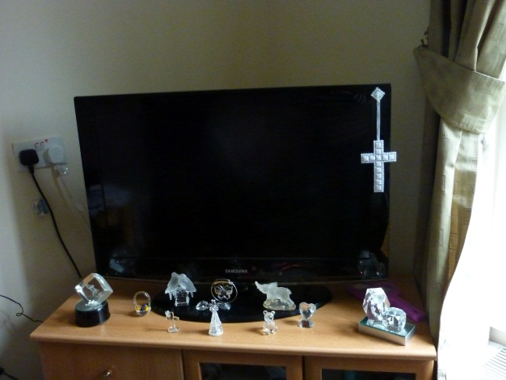
In addition to the family photographs that Annie displays, she has a photograph of herself in her nurse’s uniform, which is particularly important to her because, after marrying and bringing up five children, she trained as a nurse and finally felt as if she was doing something for herself, and not for her family. She says that when she’s feeling a bit down or sad, she looks at her photograph and remembers how much she enjoyed her occupation.
There is a small, stitched cross attached to the corner of the television. Annie says that while she isn’t deeply religious, she is a Christian, and the cross reminds her both of her own Christianity, and of the good friend who bought it for her.
Annie also has a laptop, which she uses for various things, including internet banking. She values her independence and recognises that her computer helps with this. She also describes the space where she keeps a fridge, kettle, mugs and tea as her ‘little kitchen’ and likes to be able to make her own hot drinks.
On the chest of drawers are various small ornaments that people have given to her over the years. There is also a vase of plastic daffodils, which was already in the nursing home room that her husband moved into. While the vase didn’t belong to them, Annie took it home with her after her husband died, “because again, memory.”

Appendix 7: Pen portrait of Dorothy

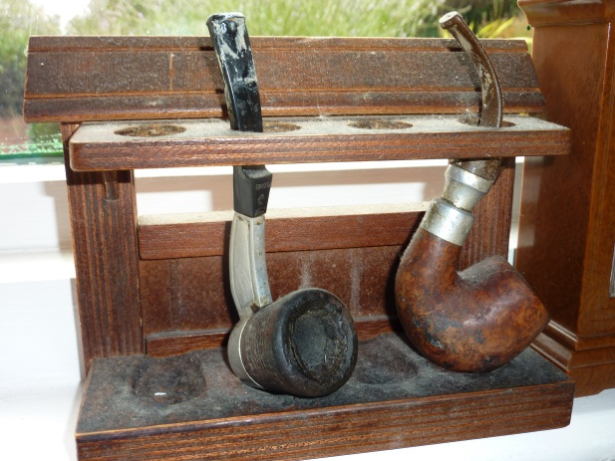
Dorothy is 88 and moved to The Cedars when she was 70 – she has been at the home longer than any other resident or staff member. Her armchair is in the middle of the room, facing the television, and on entering the room it is striking how little floor-space, and how much furniture there is. As well as a bed, there are three chairs, a wheelchair, two wardrobes, two chests of drawers, a bedside cabinet and at least three tables, and every surface is covered in objects which include dolls, photographs and plants. At one time, the staff asked Dorothy to clear away some of her belongings as they judged it was becoming a health and safety issue, and staff members helped Dorothy to throw away some items, and put other objects in storage, in the basement. One staff member tells me that they still have to ‘keep an eye’ on the amount of objects in Dorothy’s room.
Dorothy wanted to move to the home because she had lived by herself for five years after her husband died, and was very lonely. Her daughter, acting on Dorothy’s instructions, sorted through her belongings and brought a few items into the home, but the majority of the objects in the room either belong to the home, or are things that Dorothy has acquired since moving in. Of the few items that Dorothy brought with her from her previous home, the most valued is a pipe stand, with two pipes, which belonged to her husband. She brought this with her because she wanted to have something that reminded her of her husband. Dorothy also brought four pictures with her from her previous home – one painting of a house, and three paintings of flowers. She was a housekeeper for much of her life, and on the death of the ‘master of the house’, she was invited to take what she wanted from the house. Dorothy chose these four paintings, and proudly tells me that they are well over a hundred years old.
There are three clocks in the room – only one of which works. Dorothy brought one clock with her which was given to her by her husband. It stopped working some years ago, but she keeps it on a chest of drawers and wouldn’t throw it away. Another clock, which sits on the windowsill, was bought by Dorothy in the home some years ago, and when that stopped working, she had to buy another new one. The newest clock, which works, was picked out from the Argos catalogue with the help of a care assistant. It has a prominent position on a table by the window, and plays a theme from Handel’s Water Music every hour.
When I visit Dorothy towards the end of November 2012, she has a huge pile of Christmas presents, neatly wrapped, underneath a plastic Christmas tree. Several times a year the home has a ‘fair’, where residents can buy small ornaments or other items, which have been donated by staff, are the results of downsizing when a resident moves in, or are donated by families when a resident dies. The Christmas fair gives residents who find it difficult to leave the home, the opportunity to buy presents. Dorothy makes full use of these fairs, and many of the objects in her room have been bought at these events.

Appendix 8: Pen portrait of Frances

Frances is 85 and has lived in The Cedars for about a year and a half. She used to live in a block of flats, but she and her daughter were becoming increasingly concerned about the drinking and drug-taking that took place there, and so Frances decided to move into the residential home. Her husband had died the previous year.
While she describes the move into the home as “a big thing, I mean, all your possessions, and you’re not going back to use them,” Frances says that many of her possessions (furniture and white goods) went to her nephew and his wife who needed them, and this made the move easier for her.
Frances appears to be in good health, eats her meals in the communal dining room and regularly takes part in the organised activities. Most mornings after breakfast she is visited by the woman next door, who has recently moved into the home.
Frances’s room is set up for visitors, and with an armchair, two piece settee, large corner cabinet and assorted other items of furniture and possessions, looks very much like a lounge, rather than a bedroom. The most striking object in the room is a large cuddly toy tiger, which is placed below the window, in front of the radiator and next to the television. The tiger was a present from her youngest brother, who has since died. While Frances says that she had little to do with moving her things from her flat to the residential home and was happy to let her daughter make the arrangements and decide what to take, she told her daughter “don’t forget I want that tiger.” Frances has always liked tigers, and as well as the toy, she has a lamp which has a lampshade decorated in a tiger-skin pattern and a tiger on the stand, four decorative tiger plates, and a plastic toy tiger which her granddaughter bought her from Chester Zoo when she was three years old.
Many of the items in the room are souvenirs of holidays – there is a Viking ship from a trip to Norway, another miniature boat bought in Malta, and there are framed photographs of Whitby – a favourite destination for Frances and her husband.
On the wall is a large photograph taken at Trooping the Colour, showing a member of the Household Cavalry carrying the Royal Standard, and Princess Diana. The soldier is her son, and the photograph was originally on the cover of a magazine. Her daughter had the image enlarged and put on a fabric backing, and gave it to Frances for Mother’s Day in 2012. Frances laughs and says she and the staff in the home joke about the picture, because Princess Diana is walking behind her son and looking slightly down, and they say it looks as if Diana is looking at her son’s backside, “’cause it looks as though she’s having a good look!” Frances talks about her son in the past tense, and though she doesn’t mention it, there is a photograph of a man on a table in the hallway, by the door. There is an inscription below the photograph which bears the name of her son and the words ‘rest in peace’, and behind the photograph there is a small vase with a couple of incense sticks.

Appendix 9: Pen portrait of Irene

Irene is 92 and has been in The Cedars for two and a half months. She has officially been staying as a respite resident, and has only very recently made the decision to stay in the home permanently, rather than go back to her own house. When I first meet her, there are relatively few items of furniture and possessions in the room. The armchair she is sitting in was brought by her children from her house, because the chair already in the room was “a bit of a wreck,” but apart from that the only things which belong to her are the television, some family photographs, and a couple of paintings of flowers which were painted by her daughter-in-law. She admits that the paintings brighten the room up a bit, but didn’t ask for her family to bring them or the photographs.
Irene says that she will leave her children to sort through her belongings and decide what to bring into the home for her. She has decided not to go back to her home to sort through things herself because she wouldn’t be able to bear it, and she tries not to think about her previous home because she finds it upsetting. She speaks eloquently about the difference between her previous home and her room in the residential home: “I’m glad that I’ve been able to settle here, but nowhere’s like your own home, is it? No matter how it is. Best hotel isn’t like your own home, is it? Sometimes I think people don’t realise that, you know when they say “oh you’ve got a nice room”, and you’ve got this, that and the other, and I say well, I’ve got to accept it as, you’ve got to accept it as your home. But at the back of your mind you know it isn’t like your own, like your own home.”
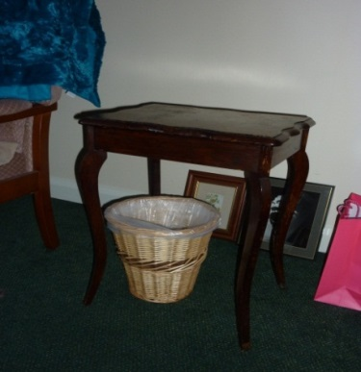
Irene says that she doesn’t need or want anything from her house, apart from a bookcase with lots of her books, but thinks the bookcase would be too big for the room. She likes to read, and every now and again goes to pick up a particular book before remembering that it is at her old house. As well as reading, she does crosswords, and meets other residents in the dining room at mealtimes. While she has no complaints about the food, she feels the mealtimes are a bit rushed; while she considers meals should be a relaxing experience to take your time over, she is conscious of the staff picking up plates as soon as they are empty. She has also asked the staff to let her know if a room becomes available on the other side of the corridor, as it gets more sun.
When I visit Irene two weeks’ later, she points out a table that wasn’t there on my previous visit. She tells me that her daughter brought it for her from her house, and that it was handmade made by a neighbour for her wedding. She tells me that earlier that day she had a visit from the minister of her church. She told him about the table, and he said, “oh, in that case I’ll put my cup on that,” causing Irene to worry that he would spill his tea on it, though fortunately he put a serviette down first, she laughs.
Behind the table, propped up against the wall are two framed photographs, one of which is of a gargoyle. Irene tells me that the gargoyle was made by her son-in-law, who is a stone mason, and it is now on Lincoln Cathedral. Irene also told me that she had recently remembered a small bookcase in her bedroom in her house, and has asked her daughter to bring it for her, as she thinks it will fit in the room. Originally her daughter had offered to buy her a new bookcase, but then Irene remembered that one. She seemed pleased that the thought of the bookcase suddenly came to her, but says again that she tries not to actively think about her home, as it upsets her.

Appendix 10: Pen portrait of Mary

Mary is 93 and moved into The Cedars between two and three years ago. She has lived in London for most of her life, but her children persuaded her to move to Sheffield – where her son lives – a few years ago. She originally moved to a different retirement home in Sheffield, but didn’t like it and so moved to Home 2. She says that she had little involvement in the move from London, and while most of the furniture and objects in the room are from her previous homes, she left it up to her children to decide what to bring.
Mary spends most of her time in her room. She takes meals in her room, doesn’t attend the social activities, and while she does know some of the other residents on her corridor she doesn’t often see them. Instead, she will sometimes write notes to the other residents and ask the care assistants or cleaners to pass them on. When she first moved to the home she implies that it took some getting used to, but now feels that she could not be in a better place. She loves her room, which she sometimes refers to as her ‘nest’, and she has written a note to whoever moves into the room after she dies, hoping that they will be as happy in her little nest as she has been.
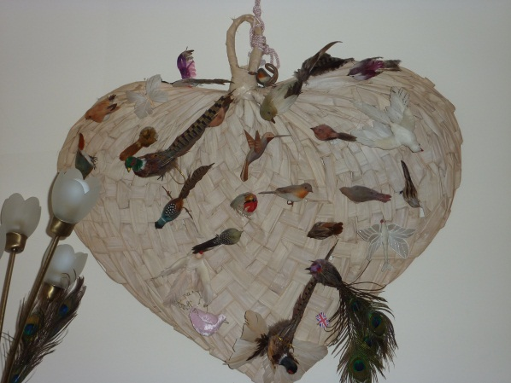
On the one hand Mary’s room gives the impression of sophistication and elegance, probably a result of the expensive-looking ornaments and furnishings. On the other hand, the bed is invariably unmade, there is always a pile of newspapers under the table by her arm chair, and when care assistants arrive with a cup of tea there is often little space to put it down, due to the table being covered in newspapers, envelopes, and plates containing food from the previous meal which Mary is still picking at.
One of Mary’s most prized possessions is an unusual display of a heart-shaped wicker frame, upon which several handmade birds are arranged. She bought the birds gradually, over a number of years from several different shops in London. She didn’t have to ask her son to take her birds to the home – he knew that she would want them.
Mary is very interested in fashion and design, and she took great pleasure in redecorating and furnishing new homes when she moved into them. She is able to describe in great detail how she decorated and furnished houses and flats she has lived in in Bloomsbury and Hampstead, talking of Queen Anne furniture, chandeliers and parquet floors. While she does have regrets at not being able to bring everything with her, (“I sit and weep sometimes at the things that went, because they were my precious things in a glass cabinet”) for the most part she takes the pragmatic point of view that many of her possessions simply wouldn’t have fitted, or wouldn’t have ‘gone’ in her new room – “you must have the appropriate surroundings”. During some house moves, she has even left some objects and items of furniture behind, not because they wouldn’t be appropriate in the new surroundings, but because she took such care at furnishing and decorating the previous flat, she didn’t want to ‘break up’ the appearance and design of the home.

Appendix 11: Pen portrait of Michael

Michael is 84 and has lived in The Cedars for about four years. He says he moved into the home when he was unwell, and thinks his doctor helped to arrange the move. He didn’t bring many things with him when he moved into the home, and most of the furniture in his room either belonged to the home, or was given to him by members of staff. One of the items he did bring with him from his flat is a mirror, which he says was given to him by the relatives of a former neighbour after she died, in gratitude for him allowing her to use his phone whenever she wanted to.
Michael was born in Jamaica and moved to England in 1957, where he worked in the railway industry. When he left Jamaica he says the only thing he took with him was one suitcase (which is still on his wardrobe) full of clothes. He says he didn’t take anything else to remind him of the island, and while he used to visit his family, most of them have died now and he hasn’t been back for many years. His only family member in England is his niece, who lives in London.
While there are some photographs and decorative items, the room seems quite bare, partly as a result of the absence of carpet, which was removed when Michael tripped a couple of times, and partly because of the plain, basic furniture provided by the home. The sofa was given to him by a member of staff, and on the sofa is a cushion indicating allegiance to a local football team, given to him for his birthday by a senior carer to whom he has grown close. He chose the room because it was at the end of the corridor and he didn’t want to be disturbed by people passing outside, but he doesn’t tend to spend much time in his room. He often sits downstairs, either in the foyer, where he can chat to people coming and going, or outside the office of one of the senior carers. Twice a week a minibus arrives to take him to a local community centre for people of African-Caribbean heritage, where he takes the opportunity to eat food which he prefers to that which is served in the home.
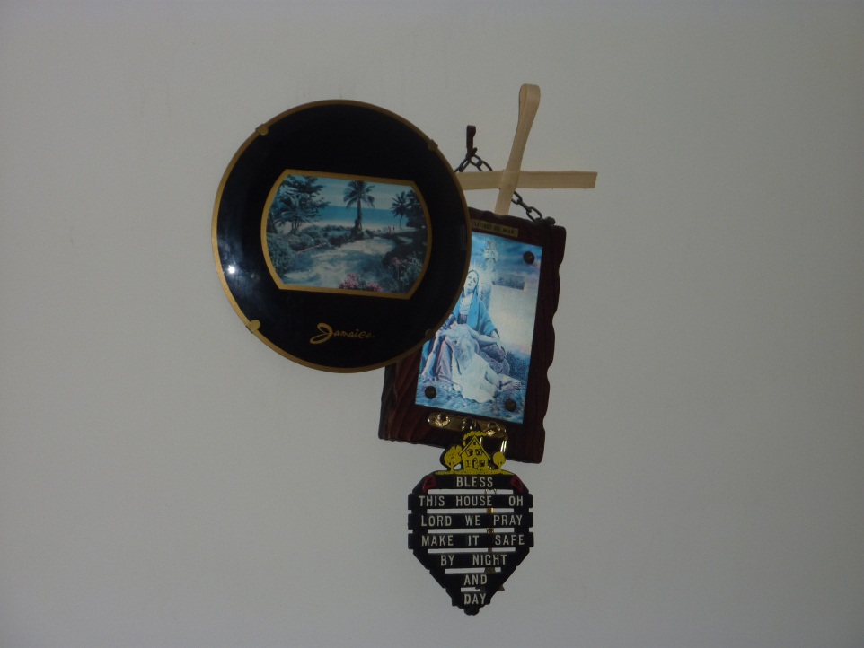
The walls are decorated with various plates, pictures and other items, some of which Michael bought himself – for instance a souvenir plate of Jamaica, which he bought in England – and some of which were bought for him, though he can’t always remember who by.
Michael goes to church, and his faith is indicated by a cross, religious picture and prayer which hang on the wall. When I ask Michael if he feels at home in his room, he replies, “yes. I serve the good Lord. He’s my Lord and King.”

Appendix 12: Pen portrait of Pam

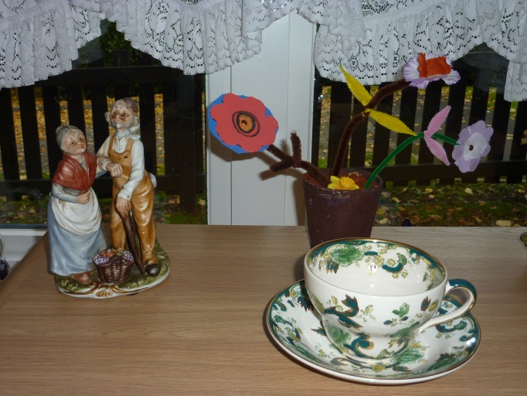
Pam, 88, has lived at The Cedars for three years, though she attended the home’s day care centre for four years before moving in. She left her daughter and son-in-law to sort through her belongings when she moved into the home, and says that she “didn’t want to know” about it. She has some items of furniture with her from her previous home, including the comfortable-looking leather armchair and matching footrest, numerous ornaments and a few paintings. She would have liked to have had more paintings, but she is restricted by the fact that the largest wall in the room has lots of wiring behind it, and she has been told by the home that she can’t put any nails in.
Pam says that she doesn’t really miss anything from her previous home, but is able to describe some objects which are now at her daughter’s house in great detail. It is important to her that as many of the objects as possible have stayed in the family.
There are several boxes on top of the wardrobe – one of which contains a large amount of family photographs. There are relatively few photographs displayed in the room, and Pam explains this by saying that she has to be careful about displaying family photographs, because she doesn’t want to cause any jealousy by missing some people out, or placing some photographs more prominently than others. An exception to this is a photograph of her son that he gave to her, in a frame which says, I my Mum. Her son has cerebral palsy, and Pam has cared for him for most of his life. He now lives in supported housing, and she often speaks of him. On one of his recent visits to Pam he brought with him a flower pot with flowers made out of pipe cleaners, and presented it to Pam saying “it won’t need much watering!”
While Pam doesn’t pick out any objects in her room as being of particular value to her, when prompted she is able to relate the circumstances in which she acquired each one. What is apparent, is how important tidiness and cleanliness are to her. Before moving in to the room, she bought a new carpet, and she brought her own bed linen. She insists on making her own bed each morning as she doesn’t believe the cleaners do it properly, and she talks disparagingly of another resident who, despite being apparently well off, has curtains which don’t meet in the middle.
Pam is resourceful, and one of the items she brought with her into the home is an old Ferrero Rocher box which she was given some years ago. She thought “that’s too nice to throw away”, so she lined it with paper and now keeps her needles and thread in there. Similarly, one of the boxes on top of the wardrobe has been kept – it originally contained a Christmas present, and Pam thought “I can’t throw that away – that’ll come in handy”. Pam is well known and liked in the home, by residents and staff, and despite having chronic obstructive pulmonary disease, lung cancer and arthritis, attends most of the social activities and visits other residents.

Appendix 13: Pen portrait of Peter

Peter is 98 and has been in The Cedars less than a month. Prior to moving into the home he lived with his wife, and while up until recently he was in good health, after Christmas a urinary infection caused his health to worsen and he realised that his wife could no longer look after him. His wife lives nearby and visits regularly.
The room is very sparsely furnished – having only been there for a few weeks Peter hasn’t yet had chance to sort through what he would like to have with him, and given that his wife still lives in their home, there is no urgency about having to clear the home to sell it, unlike with other residents. Peter’s room is a work in progress, and he is remarkably upbeat about his situation, regarding it as an opportunity to explore a new environment and get to know new people. The furniture in the room belongs to the home, and while Peter has bought some belongings with him, the room does not, as yet, feel particularly personalised or homely, in the way that other rooms do.
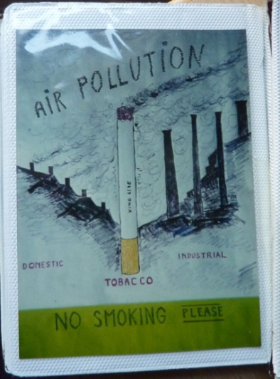
There are a few framed photographs on the wall – three of them pictures of wildlife, and two of them photographs taken on a holiday to India. Peter is most proud of a photograph he took of a fox, and points it out to staff members when they come into his room. He is very interested in wildlife, and has a pair of binoculars in a cupboard by his bed, as well as his camera. As well as allowing him to take new photographs, his digital camera also holds an image of an item he would like to bring into the home, but does not know if he can. At home he has a large framed painting of the German countryside where he grew up, and while he would like to hang it in his room, he thinks the picture and frame might be too heavy. Before he moved, he photographed the picture, and so can at least look at the image on his camera. If he can’t bring the picture with him, he will print out an enlarged photograph of the picture, so he can display that instead.
Peter has long had an interest in public health – particularly fluoride in water, and he has brought with him a lot of literature relating to this, including many pamphlets from the World Health Organisation and British Medical Association. He has highlighted the particularly relevant sections, and is able to quote many sentences from memory. He brought the texts with him because he is inviting a member of the Pure Water Association to meet with him in his room, and he wants to have the relevant literature to hand.
Unsurprisingly for a keen photographer, Peter has brought many photograph albums with him, but while some of them contain family photographs, many relate to his interest in public health. For instance, he shows me photographs of fluoride factories and waste disposal sites, and also a photograph of an anti-smoking poster he made some years earlier.
Peter recognises the potential of his possessions – especially photographs – to facilitate encounters with other residents. He used to put on slide shows for a local wildlife group he was a member of, and is considering doing something similar in the home.

Appendix 14: Pen portrait of Polly

Polly is 90 and moved to The Cedars from her flat in Dorset two months ago. Her husband had died three years previously and she was in increasing ill-health, so she decided to move across the country to where her only child lives. Polly didn’t think that it was fair for her daughter, who was now in her sixties, to have to make an eight hour round trip to see her, and while she doesn’t feel as if she had any other option but to move, she misses Dorset terribly. She misses her flat, the sea, and her friends. She has two prominently displayed, framed photographs of the sea near where she lived. She tells me that one of the staff members saw them and said, “do you miss it?” Polly rolled her eyes at me and said bitterly, “do I miss it? Of course I miss it. Bloody stupid question”.
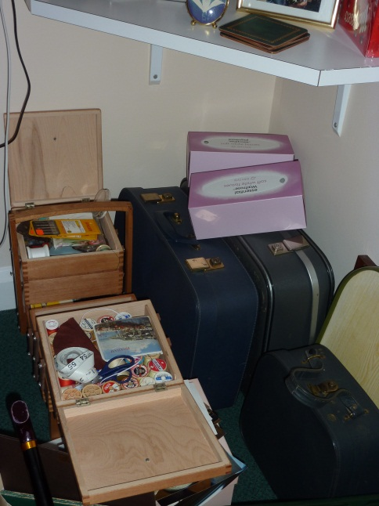
Her flat in Dorset has not been sold yet, and her daughter is in the process of fetching things from it, and sorting through the furniture and belongings. Polly would like to go back and sort through the things herself, but says her daughter won’t let her, as she thinks she wouldn’t come back. The only things Polly has asked her daughter to bring are her plants, including a rubber plant which was given to her by a friend who has since died. Polly is very pleased to have the plant with her, and says that it is doing well, as the room is warm and there is a large window. She would like to have her bureau with her, but her daughter has told her that it is too large to transport.
Many of the things from her flat, such as furniture and kitchen utensils have gone to her granddaughter, who has recently bought a flat. Her daughter has also said that she would like various items. Polly is mock-indignant about this, but says that she doesn’t mind as long as they look after them as well as she has done.
The room is in a state of transition, as Polly has suitcases full of photographs and papers that she needs to sort through, so that she can make space for more items of furniture from her flat. On one of my visits, there is a new large box full of photographs which Polly says her daughter has told her to sort through, to work out what she wants to keep and what she wants to throw out. Polly says that her daughter visits and asks “haven’t you sorted through those yet?” but Polly says that she can’t be rushed. Many of the photographs in the box are of her late husband, and Polly says that looking through them will make her very upset.
Not all of the photographs are of family. Polly shows me one small album which contains photographs of all the cakes she has decorated – an activity which she misses. She also has a sewing box with her, even though she very rarely sews anymore. The sewing box is important to her, because she used to be very fashion conscious and make clothes for herself and her daughter. Her daughter and other people borrow items such as tape measures from it, and she describes the box as being part and parcel of her and her daughter’s life.

Appendix 15: Pen portrait of Stan

Stan is 74 and has lived in The Cedars for four months. Prior to that, he lived in another residential home. He lived there for five months but moved due to financial reasons. Before that he lived in a bungalow in a different part of the country, but decided to move to be closer to one of his sisters. He gave most of the furniture from his bungalow to his brothers and sisters, and they gave him some money in return.
The most striking object in the room is a large electric organ, which Stan plays twice a day. He has received no complaints about his playing, and sometimes other residents will come and listen to him play. He was originally looking for a piano so that he could accompany the choir that he formed in the previous home, but found the organ on Freecycle. He is teaching himself how to read music. As well as the organ, he also has a keyboard, which he bought off his sister and stores in the wardrobe, a guitar which he bought for £5 in a local charity shop, which he stores on top of the wardrobe, and three harmonicas. He cannot play guitar or harmonica, but would like to teach himself.
Stan’s wife died two years ago, and he has a photograph of her prominently displayed on a chest of drawers, next to a figure of an angel which he bought off a television auction channel. He keeps his wife’s ashes in a casket in his room, and while he has made arrangements that after his cremation, his wife’s ashes will be placed next to his in a larger casket, he does not know what will happen to them after that. He and his wife had no children, and while his wife has children from a previous relationship, they are not close. He has also kept some of his wife’s jewellery, but finds it upsetting to look at.
Stan has a laptop which he uses every day to go on the internet, write letters to people, and keep in contact with friends and family using Skype. Skype is particularly useful to allow him to talk to his brother in Australia, and most evenings he also Skypes his brother-in-law who lives in a different nursing home. They are both religious, and take it in turns to read each other verses from the Bible. Stan also uploads photographs to his laptop, and owns an expensive camera which he still hasn’t completely mastered yet. However a care assistant has told him that another resident on the floor above is interested in photography, so he might ask him for help.
Most of the furniture in the room belongs to the home, and some items, such as a clock and paintings were already in the room when Stan moved in. The only item already in the room that Stan chose not to keep, was a vase of plastic flowers which he has put in the dining room. He says that one of the paintings, of a dam in the Peak District, was painted by the previous resident of the room, who was apparently involved in the Dambusters raid.
Stan has bought many of the items in the room from local charity shops, and also from the home’s Christmas Fair. When he dies, he says that he will leave the organ to his sister, and the rest can go to charity.

Appendix 16: Pen portrait of Susan

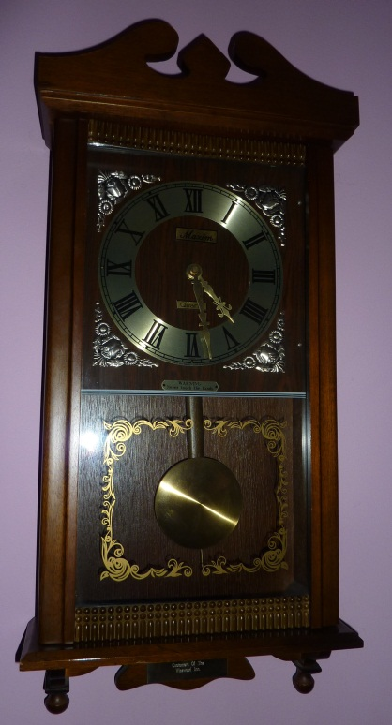
Susan is 74 and moved into The Cedars in February 2011. She describes her reasons for moving in as being a combination of loneliness (her husband had died 22 years previously) and deteriorating physical health – she has Parkinson’s Disease. She has two sons who helped her move, and she says that her sons looked around several residential homes in Sheffield before suggesting that she look at Home 2.
While she says that she immediately liked the room and the residential home, for the first month or so she felt like a lodger and didn’t feel comfortable. When she told one of her sons this, he brought in more items of furniture and personal possessions from her previous home, and Susan said that this helped enormously.
Susan is extremely sociable and places great value on her relationships with friends, relatives, and with the members of staff and other residents of the home. The objects in her room – both those which she brought with her from her previous home, and those she has acquired since – reflect and maintain these social relationships.
She and her husband used to manage pubs, and she loved being a landlady. The possession which she values most in her room is a clock which was presented to her and her late husband when they retired from managing one of their pubs. The inscription on the clock reads “to Susan and Bob in appreciation from friends and customers of the [name of pub]”. The clock hangs on the wall opposite her arm chair, where she has a good view of it, and while she has tried putting it in other positions, it just ‘doesn’t work’ anywhere else.
Susan attends all of the social activities in the home, and is friendly with many residents, particularly those on her corridor. She eats all of her meals in the corridor’s communal dining room. Her door is always open, and very often I will walk past to see her in conversation with a member of staff, or, in the afternoon, watching Countdown with one of the residents to whom she is particularly close. She has a large collection of fridge magnets, many of which have been brought back for her by care assistants and cleaners in the home, when they go on holiday. Her favourite is a magnet in the shape of a pastry cutter, which is also a bottle opener. This was a present from a Polish care assistant who was visiting home.
While the Parkinson’s Disease makes it increasingly difficult for Susan to control her actions, she still does her own dusting and vacuuming, and is determined to do so for as long as she can. She takes great pride in keeping a clean room (or ‘flat’ as she sometimes calls it), and has recently had her room decorated. She paid for a new carpet and curtains, while the home hired its regular contractors to repaint the walls from magnolia, which Susan disliked, to a new colour scheme of pink and grey.

Bibliography

AALTIO, I. & HEILMANN, P. 2010. Case Study as a Methodological Approach. In: MILLS, A. J., DUREPOS, G. & WIEBE, E. (eds.) Encyclopedia of Case Study Research. Thousand Oaks: Sage Publications Inc.

AGE UK. 2016. Later Life in the United Kingdom.

ALLAN, G. & CROW, G. 1989. Introduction. In: ALLAN, G. & CROW, G. (eds.) Home and family: Creating the domestic sphere. Basingstoke: MacMillan.

ALZHEIMER'S SOCIETY. 2014. Dementia 2014 report statistics [Online]. [Accessed 07.09.2016 2016].

APPADURAI, A. 1986. Introduction: commodities and the politics of value. In: APPADURAI, A. (ed.) The Social Life of Things: Commodities in Cultural Perspectives. Cambridge: Cambridge University Press.

ATHILL, D. 2010a. Agonising choice: In a poignant testimony Diana Athill describes why she CHOSE to move into a home. The Daily Mail.

ATHILL, D. 2010b. Diana Athill: Why I moved into an old people's home. The Guardian.

ATHILL, D. 2010c. Why I love living in a retirement home. Diana Athill on why she loves her new life in a retirement home. The Telegraph.

BALLINGER, M. L., TALBOT, L. A. & VERRINDER, G. K. 2009. More than a place to do woodwork: a case study of a community-based Men’s Shed. Journal of Men's Health, 6, 20-27.

BANKS, M. & MORPHY, H. (eds.) 1997. Rethinking Visual Anthropology, New Haven: Yale.

BARNES, S. 2003. Space, Choice and Control, and Quality of Life in Care Settings for Older People. PhD, University of Sheffield.

BECK, U. & BECK-GERNSHEIM, E. 2002. Individualization, London, Sage.

BELK, R. 1998. Possessions and the Extended Self. Journal of Consumer Research, 15, 139-168.

BERGLAND, Å. & KIRKEVOLD, M. 2008. The significance of peer relationships to thriving in nursing homes. Journal of Clinical Nursing, 17, 1295–1302.

BIGGS, S. 1997. Choosing Not To Be Old? Masks, Bodies and Identity Management in Later Life. Ageing & Society, 17, 553-570.

BLUE, S., SHOVE, E., CARMONA, C. & KELLY, M. P. 2014. Theories of practice and public health: understanding (un)healthy practices. Critical Public Health.

BOURDIEU, P. 1977. Outline of a Theory of Practice, Cambridge, Cambridge University Press.

BOWERS, B. J. 1988. Family perceptions of care in a nursing home. The Gerontologist, 28, 361–368.

BRAUN, V. & CLARKE, V. 2006. Using thematic analysis in psychology. Qualitative Research in Psychology,, 3, 77-101.

BROWN-WILSON, C. & DAVIES, S. 2009. Developing relationships in long term care environments: the contribution of staff. Journal of Clinical Nursing, 18, 1746–1755.

BRYMAN, A. 2008. Social Research Methods, Oxford, Oxford University Press.

BUSE, C. & TWIGG, J. 2014. Women with dementia and their handbags: negotiating identity, privacy and 'home' though material culture. Journal of Aging Studies, 30, 14-22.

CARE QUALITY COMMISSION 2015. The state of health care and adult social care in England 2014/15.

CARSTEN, J. 2004. After Kinship, Cambridge, Cambridge University Press.

CHAPMAN, S. A. 2006. A 'new materialist' lens on aging well: Special things in later life. Journal of Aging Studies, 20, 207-216.

CHRISTIAN, W. A. 2009. The presence of the absent; transcendence in an American Midwest household. In: VARGYAS, G. (ed.) Passageways: from Hungarian Ethnography to European Ethnology and Sociocultural Anthropology. Paris: L'Harmattan France.

CIERAAD, I. 2010. Homes from home: memories and projections. Home Cultures, 7, 85-102.

CLARKE, A. & WARREN, L. 2007. Hopes, fears and expectations about the future: what do older people's stories tell us about active ageing? Ageing & Society, 27, 465-488.

CQC 2013. Not just a number: home care inspection programme. Newcastle-upon-Tyne: Care Quality Commission.

CRAM, F. & PATON, H. 1993. Personal possessions and self-identity: the experiences of elderly women in three residential settings. Australasian Journal on Ageing, 12, 19-24.

CRISTOFORETTI, A., GENNAI, F. & RODESCHINI, G. 2011. Home sweet home: the emotional construction of places. Journal of Aging Studies, 25, 225-232.

CSIKSZENTMIHALYI, M. & ROCHBERG-HALTON, E. 1981. The Meaning of Things: Domestic Symbols and the Self, Cambridge, Cambridge University Press.

CUTCHIN, M. P. 2013. The complex process of becoming at-home in assisted living. In: ROWLES, G. D. & BERNARD, M. (eds.) Environmental Gerontology: Making meaningful places in old age. New York: Springer Publishing Company.

DARTON, R. 2012. Great expectations: feedback from relatives and residents. Nursing and Residential Care, 14, 534-538.

DAY, R. & HITCHINGS, R. 2011. ‘Only old ladies would do that’: Age stigma and older people’s strategies for dealing with winter cold. Health & Place, 17, 885–894.

DEGNEN, C. 2004. Minding the gap: The construction of old age and oldness amongst peers Journal of Aging Studies, 21, 69-80.

DEGNEN, C. 2012. Ageing selves and everyday life in the North of England: Years in the making, Manchester, Manchester University Press.

DEGNEN, C. 2016. Socialising place attachment: place, social memory and embodied affordances. Ageing & Society.

DIAMOND, T. 1992. Making Gray Gold: Narratives of Nursing Home Care, Chicago, The University of Chicago Press.

EDWARDS, R. & MAUTHNER, M. 2002. Ethics in feminist research: theory and practice. In: MAUTHNER, M., BIRCH, M., JESSOP, J. & MILLER, T. (eds.) Ethics in Qualitative Research. London: Sage.

EHN, B. & LÖFGREN, O. 2010. The secret world of doing nothing, University of California Press.

EISIKOVITS, Z. & KOREN, C. 2010. Approaches to and Outcomes of Dyadic Interview Analysis. Qualitative Health Research, 20, 1642-1655.

EKERDT, D. J., LUBORSKY, M. & LYSACK, C. 2012. Safe passage of goods and self during residential relocation in later life. Ageing & Society, 32, 833 - 850.

FEATHERSTONE, M. & HEPWORTH, M. 1989. Ageing and old age: reflections on the postmodern lifecourse. In: BYTHEWAY, B., KEIL, T., ALLAT, P. & BRYMAN, A. (eds.) Becoming and being old: sociological approaches to later life. London: Sage.

FINCH, J. 2007. Displaying Families. Sociology, 41, 65-80.

FINCH, J. & HAYES, L. 1994. Inheritance, death and the concept of the home. Sociology, 28, 417-433.

FINCH, J. & MASON, J. 1991. Obligations of Kinship in Contemporary Britain: Is There Normative Agreement? The British Journal of Sociology, 42, 345-367.

FINCH, J. & MASON, J. 2000. Passing on: kinship and inheritance in England, London, Routledge.

GABB, J. 2011. Family Lives and Relational Living: Taking Account of Otherness. Sociological Research Online, 16.

GEORGE, R. 2013. Deep Sea and Foreign Going: Inside Shipping, the Invisible Industry That Brings You 90% of Everything, London, Portobello Books Ltd.

GIBSON, M. 2008. Objects of the Dead, Melbourne, Melbourne University Press.

GIDDENS, A. 1991. Modernity and Self-Identity: Self and Society in the Late Modern Age, Cambridge, Polity.

GILLEARD, C. & HIGGS, P. 2011. Ageing abjection and embdiment in the fourth age. Journal of Aging Studies, 25, 135–142.

GILLORAN, A., ROBERTSON, A., MCGLEW, T. & MCKEE, K. 1995. Improving work satisfaction amongst nursing staff and quality of care for elderly patients with dementia: some policy implications. Ageing & Society, 15, 375-391.

GITLIN, L. 2003. Conducting research on home environments: Lessons learned and new directions. The Gerontologist, 43, 628–637.

GOFFMAN, E. 1968. Asylums: essays on the social situation of mental patients and other inmates, Harmondsworth, Middlesex, Penguin Books Ltd.

GOLDSACK, L. 1999. A Haven in a Heartless Home? Women and Domestic Violence. In: CHAPMAN, T. & HOCKEY, J. (eds.) Ideal homes?: Social change and domestic life. London: Routledge.

GOODALL JR., H. L. 2000. Writing the New Ethnography, Oxford, AltaMira Press.

GOULD, J. 2009. Heimish and Home-ish: Ageing, Jewishness and the Creation of "Home" at a Toronto Assisted-Living Residence, the Terraces of Baycrest. PhD, Memorial University of Newfoundland.

GRANBOM, M., HIMMELBACH, I., HAAK, M., LÖFQVIST, C., OSWALD, F. & IWARSSON, S. 2014. Residential normalcy and environmental experiences of very old people: changes in residential reasoning over time. Journal of Aging Studies, 29, 9-19.

GREGSON, N. 2007. Living with things: ridding, accommodation, dwelling, Wantage, Sean Kingston Publishing.

GREGSON, N. & CREWE, L. 2003. Second-hand Cultures, Oxford, Berg.

GREGSON, N., METCALFE, A. & CREWE, L. 2007. Moving things along: the conduits and practices of divestment in consumption. Transactions of the Institute of British Geographers, 32, 187-200.

GUBRIUM, J. F. 1975. Living and Dying at Murray Manor, New York, St Martin's Press.

HAMMERSLEY, M. & ATKINSON, P. 1983. Ethnography: principles in practice, 1990, Routledge.

HARPER, D. 2002. Talking about pictures: A case for photo elicitation. Visual Studies, 17, 13-26.

HAZAN, H. 1980. The limbo people: a study of the constitution of time universe among the aged, London, Routledge & Kegan Paul.

HAZAN, H. 2002. The home over the hill: towards a modern cosmology of institutionalization. Journal of Aging Studies, 16, 323-344.

HAZAN, H. 2011. Gerontological autism: terms of accountability in the cultural study of the category of the Fourth Age. Ageing & Society, 31, 1125-1140.

HEAPHY, B. & DAVIES, K. 2012. Critical Friendships. Families, Relationships and Societies, 1, 311-326.

HECHT, A. 2001. Home sweet home: tangible memories of an uprooted childhood. In: MILLER, D. (ed.) Home Possessions. Oxford: Berg.

HIGGINS, J. 1989. Homes and Institutions. In: ALLAN, G. & CROW, G. (eds.) Home and family: Creating the domestic sphere. Basingstoke: MacMillan.

HIGGS, P. & GILLEARD, C. 2015. Rethinking old age: theorising the fourth age, London, Palgrave.

HILLCOAT-NALLÉTAMBY, S. & OGG, J. 2013. Moving beyond 'ageing in place': older people's dislikes about their home and neighourhood environments as a motive for wishing to move. Ageing & Society.

HO, K. 2009. Liquidated: An Ethnography of Wall Street, Durham, North Carolina, Duke University Press.

HOCHSCHILD, A. 1983. The managed heart: the commercialization of human feeling, Berkeley, University of California Press.

HOCKEY, J. 1989. Residential care and the maintenance of social identity: negotiating the transition to institutional life. In: JEFFREYS, M. (ed.) Growing Old in the Twentieth Century. London: Routledge.

HOCKEY, J. 1990. Experiences of Death: An Anthropological Account, Edinburgh, Edinburgh University Press.

HOCKEY, J. 1999. The ideal of home: domesticating the institutional space of old age. In: CHAPMAN, T. & HOCKEY, J. (eds.) Ideal Homes? Social Change and Domestic Life. London: Routledge.

HOCKEY, J. & JAMES, A. 2003. Social Identities Across the Life Course, Basingstoke, Palgrave MacMillan.

HOCKEY, J., PENHALE, B. & SIBLEY, D. 2001. Landscapes of loss: spaces of memory, times of bereavement. Ageing & Society, 21, 739-757.

HODKINSON, P. 2002. Goth. Identity, style and subculture,, Oxford, Berg.

HOLDSWORTH, C. & MORGAN, D. 2005. Transitions in context: leaving home, independence and adulthood, Maidenhead, Open University Press.

HOLSTEIN, J. F. & GUBRIUM, J. A. 1995. The Active Interview, Thousand Oaks, CA, Sage.

HORST, H. A. & MILLER, D. (eds.) 2012. Digital Anthropology, London: Berg.

HUBBARD, G., TESTER, S. & DOWNS, M. G. 2003. Meaningful social interactions between older people in institutional care settings. Ageing & Society, 23, 99-114.

HURDLEY, R. 2006. Dismantling Mantelpieces: Narrating Identities and Materializing Culture in the Home. Sociology, 40, 717-733.

HURDLEY, R. 2010. The Power of Corridors: connecting doors, mobilising materials, plotting openness. The Sociological Review, 58, 45-64.

HURDLEY, R. 2013. Home, materiality, memory and belonging: keeping culture, Basingstoke, Palgrave Macmillan.

JACK, R. (ed.) 1998. Residential Versus Community Care: the role of institutions in welfare provision London: MacMillan.

JAMES, A. 2013. Seeking the analytic imagination: reflections on the process of interpreting qualitative data. Qualitative Research, 13, 562-577.

JENKINS, R. 1992. Pierre Bourdieu, London, Routledge.

JENKINS, R. 2008. Social Identity, Abingdon, Routledge.

JENKINS, R. 2010. Being Danish: paradoxes of identity in everyday life, Copenhagen, Museum Tusculanum.

JOHNSON, J., RALPH, S. & SMITH, R. 2010. Residential Care Transformed? Revisiting 'The Last Refuge', Basingstoke, Palgrave Macmillan.

JOHNSON, R. A. & BIBBO, J. 2014. Relocation decisions and constructing the meaning of home: a phenomenological study of the transition into a nursing home. Journal of Aging Studies, 30, 56-63.

KATZ, J. & PEACE, S. 2003. Introduction. In: KATZ, J. & PEACE, S. (eds.) End of life in care homes: A palliative care approach. Oxford: Oxford University Press.

KAUFMAN, S. R. 2000. The ageless self. In: GUBRIUM, J. F. & HOLSTEIN, J. A. (eds.) Aging and Everyday Life. Oxford: Blackwell Publishing Ltd.

KAUP, M. L. 2011. The Significance of the Door in Nursing Homes: A Symbol of Control in the Domestic Sphere. Home Cultures, 8, 25-42.

KAYSER-JONES, J. & KOENIG, B. A. 1994. Ethical Issues. In: GUBRIUM, J. F. & SHANKAR, A. (eds.) Qualitative Methods in Aging Research. Thousand Oaks, CA.: Sage Publications.

KEARNS, R. A. & ANDREWS, G. J. 2005. Placing ageing: positionings in the study of older people. In: ANDREWS, G. J. & PHILLIPS, D. R. (eds.) Ageing and place: perspectives, policy, practice. Oxford: Routledge.

KIDRON, C. A. 2012. Breaching the wall of traumatic silence: Holocaust survivor and descendant person - object relations and the material transmission of the genocidal past. Journal of Material Culture, 17, 3-21.

KING, N. & HORROCKS, C. 2010. Interviews in Qualitative Research, London, Sage.

KIRSHENBLATT-GIMBLETT, B. 1989. Objects of Memory: Material Culture as Life Review. In: ORING, E. (ed.) Folk Groups and Folklore Genres: A Reader. Logan, Utah: Utah State University Press.

KLAASSENS, M. & MEIJERING, L. 2015. Experiences of home and institution in a secured nursing home ward in the Netherlands: a participatory intervention study. Journal of Aging Studies, 34, 92-102.

KONTOS, P. C. 2000. Resisting Institutionalisation: Constructing Old Age and Negotiating Home. In: GUBRIUM, J. F. & HOLSTEIN, J. A. (eds.) Aging and Everyday Life. Oxford: Blackwell Publishing Ltd.

KUECHLER, S. & MILLER, D. 2005. Clothing as Material Culture, Oxford, Berg.

LASLETT, P. 1989. A fresh map of life: the emergence of the third age, London, Weidenfeld & Nicolson.

LATOUR, B. 2005. Reassembling the Social: an Introduction to Actor-Network-Theory, Oxford, Oxford University Press.

LAWS, G. 1997. Spatiality and age relations. In: JAMIESON, A., HARPER, S. & VICTOR, C. (eds.) Critical approaches to ageing and later life. Buckingham: Open University Press.

LEE-TREWEEK, G. 1994. Discourse, care and control: an ethnography of residential and nursing home elder care work. PhD, University of Plymouth.

LEITH, K. H. 2006. “Home is where the heart is…or is it?” A phenomenological exploration of the meaning of home for older women in congregate housing. Journal of Aging Studies, 20, 317-333.

LÉVINAS, E. 1985. Ethics and Infinity. Conversations with Philippe Nemo, Pittsburgh, Duquesne University Press.

LOVATT, M. 2015. Charity Shops and the Imagined Futures of Objects: How Second-Hand Markets Influence Disposal Decisions when Emptying a Parent’s House. Culture Unbound, 7, 13-29.

MAGUIRE, M., PEACE, S., NICOLLE, C., MARSHALL, R., SIMS, R., PERCIVAL, J. & LAWTON, C. 2014. Kitchen Living in Later Life: Exploring Ergonomic Problems, Coping Strategies and Design Solutions. International Journal of Design, 8, 73-91.

MANSVELT, J. 2012. Consumption, ageing and identity: New Zealander's narratives of gifting, ridding and passing on. New Zealand Geographer, 68, 187-200.

MARCOUX, J.-S. 2001a. The 'Casser Maison' Ritual : Constructing the Self by Emptying the Home. Journal of Material Culture, 6, 213-235.

MARCOUX, J.-S. 2001b. The Refurbishment of Memory. In: MILLER, D. (ed.) Home Possessions: Material Culture Behind Closed Doors. Oxford: Berg.

MASON, J. 1989. Reconstructing the public and the private: the home and marriage in later life. In: ALLAN, G. & CROW, G. (eds.) Home and family: Creating the domestic sphere. Basingstoke: Macmillan

MASON, J. 1996. Qualitative Researching, London, SAGE.

MASON, J. 2004. Personal narratives, relational selves: residential histories in the living and telling. Sociological Review, 52, 162-179.

MASON, J. 2008. Tangible Affinities and the Real Life Fascination of Kinship. Sociology, 42, 29-45.

MASON, J. & DAVIES, K. 2009. Coming to our senses? A critical approach to sensory methodology. Qualitative Research, 9, 587-603.

MASON, J. & DAVIES, K. 2011. Introduction to the special issue. Methodological Innovations Online, 6, 1-4.

MCCRACKEN, G. 1987. Culture and consumption among the elderly: three research objectives in an emerging field. Ageing & Society, 7, 203-224.

MCGILTON, K. S. & BOSCART, V. M. 2007. Close care provider–resident relationships in long-term care environments. Journal of Clinical Nursing, 16, 2149–2157.

MCINTYRE, N., WILLIAMS, D. & MCHUGH, K. 2006. Multiple Dwelling and Tourism: Negotiating Place, Home and Identity Wallingford, CABI Publishing.

MEACHER, M. 1972. Taken for a ride, Prentice Hall Press.

MEANS, R. 2007. Safe as Houses? Ageing in Place and Vulnerable Older People in the UK. Social Policy and Administration, 41, 65-85.

MILLER, C., BUNNIN, A. & RAYNER, V. 2013. Older people who self fund their social care: A guide for health and wellbeing boards and commissioners. London: OPM and SITRA.

MILLER, D. 1987. Material Culture and Mass Consumption, Oxford, Basil Blackwell Ltd.

MILLER, D. 1998. A Theory of Shopping, Cambridge, Polity Press.

MILLER, D. 2009. The Comfort of Things, Cambridge, Polity Press.

MILLER, D. 2010. Stuff, Cambridge, Polity Press.

MILLER, D. 2015. The tragic denouement of English sociality. Cultural Anthropology, 30, 336-357.

MILLER, D. & PARROTT, F. 2009. Loss and material culture in South London. Journal of the Royal Anthropological Institute, 15, 502-519.

MILLER, D. & SLATER, D. 2000. The Internet: an Ethnographic Approach, Oxford, Berg.

MILLER, D. & WOODWARD, S. 2011. Global Denim, Berg.

MILLER, E. V. & GWYNNE, G. V. 1974. Life Apart: Pilot Study of Residential Institutions for the Physically Handicapped and the Young Chronic Sick, Tavistock Publications.

MILLIGAN, C., NEARY, D., PAYNE, S., HANRATTY, B., IRWIN, P. & DOWRICK, C. 2015. Older men and social activity: a scoping review of Men's Sheds and other gendered interventions. Ageing & Society.

MORGAN, D. 1996. Family connections, Cambridge, Polity.

MORGAN, D. 1999. Risk and family practices: accounting for change and fluidity in family life. In: SILVA, E. B. & SMART, C. (eds.) The New Family? London: Sage.

MORGAN, D. 2011. Locating 'Family Practices'. Sociological Research Online, 16.

MYERHOFF, B. 1978. Number Our Days, New York, Simon and Schuster.

NAVARO-YASHIN, Y. 2009. Affective spaces, melancholic objects: ruination and the production of anthropological knowledge. Journal of the Royal Anthropological Institute, 15, 1-18.

NEAL, S. & MURJI, K. 2015. Sociologies of Everyday Life: Editors’ Introduction to the Special Issue. Sociology, 49, 811-819.

NEALE, B., WADE, A. & SMART, C. 1998. “I just get on with it”: Children’s Experiences of Family Life following Parental Separation or Divorce. Centre for Research on Family, Kinship & Childhood.

NEUGARTEN, B. J., HAVIGHURST, R. J. & TOBIN, S. S. 1961. The Measurement of Life Satisfaction. Journal of Gerontology, 16, 134-143.

NOLAN, M. & ALLAN, S. 2011. The 'Senses Framework': a relationship centred approach to care In: KATZ, J., PEACE, S. & SPURR, S. (eds.) Adult lives: a life course perspective. Bristol: Policy Press.

NORD, C. 2013. A day to be lived. Elderly people's possessions for everyday life in assisted living. Journal of Aging Studies, 27, 135-142.

OFFICE FOR NATIONAL STATISTICS 2014. Changes in the Older Resident Care Home Population between 2001 and 2011.

OKELY, J. 1994. Vicarious and sensory knowledge of chronology and change: ageing in rural France. In: HASTRUP, K. & HERVIK, P. (eds.) Social experience and anthropological knowledge. London: Routledge.

PAHL, K. 2012. Every Object Tells a Story: Intergenerational Stories and Objects in the Homes of Pakistani Heritage Families in South Yorkshire, UK. Home Cultures, 9, 303 - 328.

PARKER, C., BARNES, S., MCKEE, K., MORGAN, K., TORRINGTON, J. & TREGENZA, P. 2004. Quality of life and building design in residential and nursing homes for older people. Ageing & Society, 24, 941-962.

PARKIN, D. 1999. Mementoes as transitional objects in human displacement. Journal of Material Culture, 4, 303-320.

PARROTT, F. R. 2005. "It's not forever": The Material Culture of Hope. Journal of Material Culture, 10, 245-262.

PATON, H. & CRAM, F. 1992. Personal possessions and environmental control: the experiences of elderly women in three residential settings. Journal of Women & Aging, 4, 61-78.

PEACE, S. 2015. Meanings of home and age. In: TWIGG, J. & MARTIN, W. (eds.) Routledge Handbook of Cultural Gerontology. London: Taylor and Francis Group.

PEACE, S., HOLLAND, C. & KELLAHER, L. 2005. Making space for identity. In: ANDREWS, G. J. & PHILLIPS, D. R. (eds.) Ageing and place: perspectives, policy, practice. Oxford: Routledge.

PEACE, S., HOLLAND, C. & KELLAHER, L. 2006. Environment and Identity in Later Life, Maidenhead, Open University Press.

PEACE, S., HOLLAND, C. & KELLAHER, L. 2011. ‘Option recognition’ in later life: variations in ageing in place. Ageing & Society, 31, 734-757.

PERCIVAL, J. 2002. Domestic spaces: uses and meanings in the daily lives of older people. Ageing & Society, 22, 729-749.

PINK, S. 2004. Home truths: gender, domestic objects and everyday life, Oxford, Berg.

PINK, S. 2009. Doing Sensory Ethnography, London, Sage.

PINK, S. (ed.) 2012. Advances in Visual Methodology, London: Sage.

PRICE, L. L., ARNOULD, E. J. & CURASI, C. F. 2000. Older consumers' dispostition of special possessions. Journal of Consumer Research, 27, 179-201.

RALPH, D. & STAEHELI, L. A. 2011. Home and Migration: Mobilities, Belongings and Identities. Geography Compass, 5, 517-530.

REED-DANAHAY, D. 2001. 'This is your home now!': conceptualizing location and dislocation in a dementia unit. Qualitative Research, 1, 47-63.

REED, J. & ROSKELL, V. 1997. Understanding the dynamics of life in care homes for older people: implications for de-institutionalizing practice. Health and Social Care in the Community, 5, 261-268.

RICHARDSON, T. 2014. Spousal bereavement in later life: a material culture perspective. Mortality, 19, 61-79.

RIESSMAN, C. K. 2008. Narrative Methods for the Human Sciences, London, Sage Publications Ltd.

RINKINEN, J., JALAS, M. & SHOVE, E. 2015. Object relations in accounts of everyday life. Sociology, 49, 870-885.

ROBB, B. 1967. Sans Everything, Nelson.

ROCHBERG-HALTON, E. 1979. The meaning of personal art objects. In: ZUZANEK, J. (ed.) Social Research and Cultural Policy. Waterloo: Otium Publications.

ROSE, G. 2001. Visual methodologies: an introduction to the interpretation of visual materials, Thousand Oaks, CA., Sage.

ROSE, G. 2003. Family Photographs and Domestic Spacings: A Case Study. Transactions of the Institute of British Geographers, 28, 5-18.

ROSTER, C. A. 2001. Letting Go: the process and meaning of dispossession in the lives of consumers. Advances in Consumer Research, 28, 425-430.

ROWLES, G. D. 1983. Place and personal identity in old age: observations from Appalachia. Journal of Environmental Psychology, 3, 299-313.

ROWLES, G. D. 1993. Evolving images of place in aging and 'aging in place'. Generations, 17, 65-70.

ROWLES, G. D. & BERNARD, M. 2013. The meaning and significance of place in old age. In: ROWLES, G. D. & BERNARD, M. (eds.) Environmental Gerontology: making meaningful places in old age. New York: Springer Publishing Company.

ROWLES, G. D. & HIGH, D. M. 2003. Family involvement in nursing home facilities: A decision-making perspective. In: STAFFORD, P. B. (ed.) Gray areas: Ethnographic encounters with nursing home culture. Santa Fe: School of American Research Press.

RUBINSTEIN, R. L. 1987. The Significance of Personal Objects to Older People. Journal of Aging Studies, 1, 225-238.

RUBINSTEIN, R. L. & PARMELEE, P. A. 1992. Attachment to place and the representation of the life course by the elderly. In: ALTMAN, I. & LOW, S. M. (eds.) Place attachment. New York: Plenum.

RUSSELL, C. 1999. Interviewing vulnerable old people: ethical and methodological implications of imagining our subjects. Journal of Aging Studies, 13, 403-317.

RYVICKER, M. 2009. Preservation of self in the nursing home: contradictory practices within two models of care. Journal of Aging Studies, 23, 12-23.

SAVISHINSKY, J. S. 1991. The ends of time: life and work in a nursing home, New York, Bergin & Garvey.

SAYES, E. 2014. Actor–Network Theory and methodology: Just what does it mean to say that nonhumans have agency? Social Studies of Science, 44, 134–149.

SHENK, D., KUWAHARA, K. & ZABLOTSKY, D. 2004. Older women's attachments to their home and possessions. Journal of Aging Studies, 18, 157-169.

SHERMAN, E. 1991. Reminiscentia: cherished objects as memorabilia in late-life resminiscence. International Journal of Aging and Human Development, 33, 89-100.

SHERMAN, E. & DACHER, J. 2005. Cherished Objects and the Home: Their Meaning and Roles in Later Life. In: ROWLES, G. D. & CHAUDHURY, H. (eds.) Home and Identity in Late Life. New York: Springer Publishing Company.

SHERMAN, E. & NEWMAN, E. S. 1977-78. The Meaning of Cherished Personal Possessions for the Elderly. International Journal of Aging and Human Development, 8, 181-192.

SHIELD, R. R. 1988. Uneasy endings: daily life in an American nursing home, Ithaca, Cornell University Press.

SHIELD, R. R. 1990. Liminality in an American Nursing Home: the Endless Transition. In: SOKOLOVSKY, J. (ed.) The Cultural Context of Aging: Worldwide Perspectives. New York: Bergin & Garvey Publishers.

SILVA, E. B. & SMART, C. 1999. The 'new' practices and politics of family life. In: SILVA, E. B. & SMART, C. (eds.) The New Family? London: Sage.

SIXSMITH, A. & SIXSMITH, J. 2008. Ageing in place in the United Kingdom. Ageing International, 32, 219-235.

SIXSMITH, A. J. 1990. The meaning and experience of 'home' in later life. In: BYTHEWAY, B. & JOHNSON, J. (eds.) Welfare and the ageing experience. Aldershot: Avebury.

SIXSMITH, J., ANDREW., S., MATTHEW., C. & CORR, S. 2014. Wartime experiences and their implications for the everyday lives of older people. Ageing & Society, 34, 1457-1481.

SMART, C. 2007. Personal Life, Cambridge, Polity Press.

SMITH, G. V. & EKERDT, D. J. 2011. Confronting the material convoy in later life. Sociological Inquiry, 81, 377-391.

STONES, D. & GULLIFER, J. 2014. 'At home it's just so much easier to be yourself': older adults' perceptions of ageing in place. Ageing & Society.

TAYLOR, B. J. 2006. Risk Management Paradigms in Health and Social Services for Professional Decision Making on the Long-Term Care of Older People. British Journal of Social Work, 36, 1411–1429.

TIPPER, B. 2011. Pets and Personal Life. In: MAY, V. (ed.) Sociology of Personal Life. Basingstoke: Palgrave.

TOWNSEND, P. 1962. The Last Refuge: A Survey of Residential Institutions and Homes for the Aged in England and Wales, London, Routledge & Kegan Paul.

TURNER, V. 1985. On the edge of the bush: anthropology as experience, Tucson, University of Arizona Press.

VAN DEN HOONAARD, D. K. 2005. "Am I doing it right?": Older widows as interview participants in qualitative research. Journal of Aging Studies, 19, 393-406.

VAN GENNEP, A. 1960. The Rites of Passage, London, Routledge.

VICTOR, C., SCAMBLER, S., BOWLING, A. & BOND, J. 2005. The prevalence of, and risk factors for, loneliness in later life: a survey of older people in Great Britain. Ageing & Society, 25, 357-375.

WAPNER, S., DEMICK, J. & REDONDO, J. P. 1990. Cherished possessions and adaptation of older people to nursing homes. The International Journal of Aging and Human Development, 31, 219-235.

WATKINSON-POWELL, A., BARNES, S., LOVATT, M., WASIELEWSKA, A. & DRUMMOND, B. 2014. Food provision for older people receiving home care from the perspectives of home-care workers. Health and Social Care in the Community, 22, 553-560.

WHITMORE, H. 2001. Value that Marketing Cannot Manufacture: Cherished Possessions as Links to Identity and Wisdom. Generations, 25, 57-63.

WILES, J. L., LEIBING, A., GUBERMAN, N., REEVE, J. & ALLEN, R. E. S. 2011. The meaning of 'aging in place' to older people. The Gerontologist, 52, 357-366.

WILES, R., COFFEY, A., ROBINSON, J. & HEATH, S. 2012a. Anonymisation and visual images: issues of respect, 'voice' and protection. International Journal of Social Research Methodology, 15, 41-53.

WILES, R., COFFEY, A., ROBINSON, J. & PROSSER, J. 2012b. Ethical regulation and visual methods: making visual research impossible or developing good practice? Sociological Research Online, 17.

WILES, R., PROSSER, J., BAGNOLI, A., CLARK, A., DAVIES, K., HOLLAND, S. & RENOLD, E. 2008. Visual Ethics: Ethical Issues in Visual Research.

WILLCOCKS, D., PEACE, S. & KELLAHER, L. 1987. Private Lives in Public Places: a research-based critique of residential life in local authority old people's homes, London, Tavistock Publications.

WINNICOTT, D. W. 1953. Transitional Objects and Transitional Phenomena—A Study of the First Not-Me Possession. International Journal of Psycho-Analysis, 34, 89-97

WOODWARD, S. 2015. The Hidden Lives of Domestic Things: accumulations in Cupboards, Lofts and Shelves. In: CASEY, E. & TAYLOR, Y. (eds.) Intimacies, Critical Consumption and Diverse Economies. Basingstoke: Palgrave Macmillan.

ZARIT, S. H. & WHITLATCH, C. J. 1992. Institutional placement: Phases of transition. The Gerontologist, 32, 665–672.

Self-funders account for 45% of residents in residential care homes without nursing, and 47.6% of care homes with nursing (MILLER, C., BUNNIN, A. & RAYNER, V. 2013. Older people who self fund their social care: A guide for health and wellbeing boards and commissioners. London: OPM and SITRA).
As this was exploratory research and I did not set out knowing what I would find, I undertook an initial narrative literature review, rather than a systematic review. I used Google Scholar and the database Web of Science to assist me in this, using search terms such as ‘older people’ and ‘objects’, ‘possessions’, or ‘material culture’. I also read widely on the two key themes of my research – ‘older people’ and ‘material culture’. For instance I researched the history of residential homes in the United Kingdom, and read studies of material culture in different home environments and societies. This provided me with initial literature which I then used, via the references and citations information in Google Scholar, to tack back and forth, identifying earlier and more recent relevant literature. In addition to this subscribed to content alert emails from relevant journals such as Ageing and Society and Journal of Material Culture to keep abreast of the latest relevant publications.
The conceptual categories of ‘third age’ and ‘fourth age’ were introduced by Peter Laslett as a way of demarcating between older people, based on age, illness and disability LASLETT, P. 1989. A fresh map of life: the emergence of the third age, London, Weidenfeld & Nicolson.
Reproduced by kind permission of Stephen Collins
There are many examples of ethnographies which are not limited to a particular bounded geographical space and which focus on industries, phenomena or consumption, rather than people. See for example MILLER, D. & SLATER, D. 2000. The Internet: an Ethnographic Approach, Oxford, Berg, GEORGE, R. 2013. Deep Sea and Foreign Going: Inside Shipping, the Invisible Industry That Brings You 90% of Everything, London, Portobello Books Ltd, HO, K. 2009. Liquidated: An Ethnography of Wall Street, Durham, North Carolina, Duke University Press..
Average regional fees provided by http://www.payingforcare.org/care-home-fees. Paying for Care is a not-for-profit company which provides advice on long term care.
Perimeter seating describes seats which are placed around the perimeters of a room, facing inwards, where residents sit side by side, rather than face-to-face. Clustered seating describes a seating arrangement where small groups of seats are placed together in inward-facing circles.
I struggle with this interpretation as it ascribes an ‘heroic’ element to my visits which I do not intend. Nevertheless, I believe my visits to Alice relieved some of the boredom she otherwise experienced.
Some members of staff might have disagreed with me on this. One care assistant once told me that some – particularly male – residents used to keep newspapers for days and wouldn’t let cleaners throw them out as there was always some section that they hadn’t yet read. I acknowledge that what for me was a ‘lived-in’ room might have been unnecessarily messy room to cleaners whose job was hindered by having to navigate piles of newspapers.
A British television quiz programme
See Reed-Danahay (2001) for a fuller description of how the term ‘wandering’ has been applied to residents with dementia.
The location has been changed

