The Roles of Ciliary Kinesins, and the functions of Intraflagellar Transport Proteins

PhD Thesis submitted to The University of Sheffield

Niedharsan Pooranachandran

The Bateson Centre, Department of Biomedical Science

The University of Sheffield

April 2016

Acknowledgements

I would like to thank my supervisor Dr. Jarema Malicki for providing the opportunity to work in his laboratory and for the supervision. I would like to thank my advisors Dr. Fredericus Van Eeden and Dr. Kai Erdmann for their valuable advices. I would also like to thank Dr. Andrew Furley for all the support during my PhD.
I am very grateful to the members of the Electron Microscope facility, The Wolfson Light Microscopy Facility, and the aquarium staff for all their advice and help provided.

I must thank my friends and family for all their support. My fiancé Magdalena for all her support, and encouragement even with the distance. My sister, Vivetha, for all the care and support from my childhood. My friend Paweł for support and keeping things lively, both in and outside of the lab.
Finally, a very special Thank you to my mother Anandi for supporting me throughout my entire life journey, and bringing me to this stage. All this would be impossible without her, thanks a lot!!

Abstract
Microtubule-dependent motors, kinesins, drive transport of proteins in the ciliary shaft. Prior studies suggested that the heterotrimeric ciliary kinesin may be dispensable for certain aspects of transport in specialized cilia of vertebrate photoreceptor cells. To test this possibility further, we analyzed the mutant phenotype of the zebrafish kif3a gene, which encodes the common motor subunit of heterotrimeric ciliary kinesins. Cilia are absent in almost all organs examined, leading to the conclusion that kif3a is indispensable for ciliogenesis in all cells, including photoreceptors. Unexpectedly, kif3a function precedes ciliogenesis as ciliary basal bodies are mispositioned in mutant photoreceptors. This phenotype is much less pronounced in IFT mutants and reveals that kif3a has a much broader role than previously assumed. Despite the severity of their basal body phenotype, kif3a mutant photoreceptors survive longer compared to these in IFT mutants, which display much weaker basal body mispositioning. This effect is absent in kif3a;IFT double mutants, indicating that IFT proteins have ciliary transport-independent roles, which add to the severity of their photoreceptor phenotype. kif3a is dispensable for basal body docking in otic vesicle sensory epithelia and, surprisingly, short cilia form in mechanosensory cristae even in the absence of kif3a. In contrast to Kif3a, the functions of the Kif3c-related protein, encoded by the kif3c-like (kif3cl) gene, and the homodimeric ciliary kinesin, kif17, are dispensable for photoreceptor morphogenesis. In addition to this, double mutants of different combinations of kinesins were generated: klp-6, kif17, kif3b, kif3cl. However, the double mutants did not display any obvious defects. These studies demonstrate unexpected new roles for both ciliary heterotrimeric kinesins and IFT particle genes, and clarify the function of kif17, the homodimeric ciliary kinesin gene.

Abbreviations
AWC | Amphid olfactory neuron wing
BBS | Bardet-Biedl syndrome
Bp | Base pairs
BSA | Bovine Serum Albumin
CaCl₂ | Calcium chloride
CaCl₂●2H₂O, | Calcium Chloride Dihydrate
CC2D2A | Coiled-Coil And C2 Domain Containing 2A
CRISPR | Clustered, regularly interspaced, short palindromic repeats
DAPI | 4’,6-diamidino-2-phenylindole
DMSO | Dimethyl sulfoxide
DPF | Days post fertilisation
EDTA | Ethylenediaminetetraacetic acid
ER | Endoplasmic Reticulum
EtOH | Ethanol
FGFR-1 | Fibroblast growth-factor receptor
GCL | Ganglion cell layer
GFP | Green Fluorescent protein
gRNA | Guide RNA
HH | Hedgehog
HPF | Hours post fertilization
HSP | Heat shock protein
IFT | Intraflagellar transport
ILM | Inner limiting membrane
INL | Inner nuclear layer
IPL | Inner plexiform layer
JBST | Joubert Syndrome
KCl | Potassium chloride
kD | Kilo Dalton
kif3cl | kif3c-like
M | Molar
mg | Milligrams
MgCl | Magnesium chloride
Min | Minutes
MKS | Meckel syndrome
ml | Milliliter
mM | Milimolar
mm | Millimeter
MO | Morpholino
MT | Microtubule
NaCl | Sodium chloride
NaHCO3 | Sodium bicarbonate
NaOH | Sodium hydroxide
NEB | New England Biolabs Inc.
NFL | Nerve fibre layer
ng | Nanogram
NGS | Normal goat serum
NINL | Ninein-like protein
nm | Nanometers
nM | Nanomolar
NPHP | Nephronophthisis
NS | Not significant
ºC | Centigrade
OCT | Optimal Cutting Temperature compound
OLM | Outer limiting membrane
ONL | Outer nuclear layer
OPL | Outer plexiform layer
OS | Outer segment
OsO4 | Osmium tetroxide
PBS | Phosphate buffered saline
PCR | Polymerase Chain Reaction
PFA | Paraformaldehyde
PMC | Periciliary membrane complex
PRC | Periciliary ridge complex
Ptch1 | Patched 1
RNA | Ribonucleic Acid
RPE | Retinal pigment epithelial
Rpm | Revolution per minute
RT | Room Temperature
RVD | Repeat variable domain
SDS | Sodium dodecyl sulfate
SDS-PAGE | Sodium dodecyl sulfate polyacrylamide gel electrophoresis
Sec | Seconds
Smo | Smoothened
SPAG | Sperm associated antigen
STORM | Stochastic optical reconstruction microscopy
T2R receptors | Taste receptors
TALEN | Transcription activator-like effector nucleases
TCA | Trichloroacetic acid
TEM | Transmission Electron Microscopy
Tris | Tris(hydroxymethyl)aminomethane
Tris-HCL | Tris(hydroxymethyl)aminomethane-Hydrochloride
TRPP1 | Transient Receptor Potential Polycystic
TRPV | Transient Receptor Potential Cation Channel, Subfamily V, Member
TZ | Transition zone
μg | Microgram
μl | Microliter
μM | Micromolar
μm | Micrometer

Contents
Acknowledgements 4
Abstract 5
Abbreviations 7
Chapter 1 16
Introduction 16
1.1. Cilia 16
1.1.1. Functions of the cilium 18
1.1.2. Structure of the cilium 21
1.1.3. Transition zone 22
1.1.4. Intraflagellar Transport (IFT) 24
1.2. Ciliary kinesins 26
1.3 Retina and the photoreceptor cilium 28
1.4 Alternative transport 31
1.5 Zebrafish as a model organism 31
1.6 Aims 33
Chapter 2 34
Material and Methods 34
2.1 Zebrafish Strains and maintenance 34
2.1.2 Maintenance 34
2.1.3 Strains 34
2.2 Mutagenesis techniques 35
2.2.1 TALEN system 35
2.2.2 CRISPR/CAS9 system 38
2.3 Plasmids and Morpholinos 40
2.4 RNA Transcription 40
2.4.1 T7 RNA transcription 40
2.4.2 SP6 RNA transcription using mMESSAGE mMACHINE SP6 41
2.5 Solutions 41
2.5.1 Methylcellulose 41
2.5.2 Immunostaining and fixation solutions 41
2.5.3 Electron microscope sample preparation solutions 42
2.5.4 STORM microscopy buffer 42
2.5.5 Stocks/reagents: 42
2.5.6 Western Blot Solutions 42
2.5.7 Protein extraction solutions 43
2.6 Injection of DNA/RNA constructs 43
2.6.1 Preparing needles 43
2.6.2 Preparation of agarose plates for injection 43
2.6.3 Injection set up 43
2.7 Opsin trafficking assay using GFP-opsinCT44 44
2.7.1 Injection 44
2.7.2 Heat shock and fixation 44
2.8 RNA extraction, purification and cDNA synthesis 44
2.8.1 RNA extraction 44
2.8.2 RNA purification 46
2.8.3 cDNA synthesis 46
2.9 Antibodies 47
2.10 Screening for zebrafish mutants 47
2.10.1 Stage 1 - Screening for mosaics 47
2.10.2 Stage 2 – Screening for Heterozygotes 49
2.11 PCR and sequencing 50
2.12 T7 assay 50
2.13 Western Blot 50
2.13.1 Protein extraction from zebrafish embryos 50
2.13.2 Detection of protein 51
2.14 Cryosection and immunohistochemistry 52
2.14.1 Cryosection 52
2.14.2 Immunohistochemistry 52
2.15 Whole mount Immunohistochemistry 55
2.15.1 Triton-X permeabilized 55
2.15.2 Acetone treated protocol 55
2.16 Stochastic optical reconstruction microscopy 56
2.16.1 Sample preparation 56
2.16.2 Imaging 56
2.17 Confocal imaging 56
2.17.1 Whole mount imaging 57
2.17.3 Cryosection imaging 57
2.18 Transmission Electron Microscopy (TEM) 57
2.18.1 Sample preparation 57
2.18.2 Semi-thin and Ultra-thin sections 58
2.20 Quantification and image analysis 60
2.21 Statistical analysis 60
2.21.1 T-test 60
2.21.2 Mann Whitney U-test 60
Chapter 3 62
Role of Kif3a in ciliogenesis 62
3.1. Introduction 62
3.2 Results 64
3.2.1 Kif3a is required for ciliogenesis. 64
3.2.2 Photoreceptor phenotype of kif3a-/- mutants. 67
3.2.3 Functions of Kif3a and IFT particle proteins in photoreceptors 72
3.3 Discussion 83
3.3.1 kif3a phenotypes 83
3.3.2 Additional roles for IFT proteins 88
Chapter 4 90
Additional kinesins in vertebrate cilia 90
4.1 Introduction 90
4.2 Results 91
4.2.1 kif3c-like is not required for ciliogenesis. 91
4.2.2 Kif17 Does Not Contribute To Photoreceptor Morphogenesis 95
4.2.3 Generation of kif3c zebrafish mutants 98
4.2.4 klp-6;kif3b double mutants 99
4.3 Discussion 100
4.3.1 kif17 function in photoreceptors 101
4.3.2 Additional kinesins with specialised functions in cilia 102
Chapter 5 104
Overall Discussion 104
5.1 Role of kif3a in ciliogenesis and photoreceptors 104
5.2 Alternative kinesins in ciliogenesis 105
6. References 107

Chapter 1

Introduction

1.1. Cilia
Cilia are organelles that protrude from the surface of almost all eukaryotic cells (Carvalho-Santos et al., 2011; Sung and Leroux, 2013). They fall within two categories, motile and non-motile cilia. The latter are also known as primary cilia. The cilium emanates from one of the two centrioles, the mother centriole, also termed the basal body. A cilium is typically characterised by its nine-fold symmetry of microtubular doublets forming a ring-like supporting structure (Figure 1). Furthermore, the majority of motile cilia feature an additional pair of microtubules (MT) at the centre, thought to aid motility (Lindemann and Lesich, 2010; Hirokawa et al., 2012) (Figure 1). Primary cilia function by housing components of signalling pathways involved in processes as diverse as morphogenesis, cell growth and proliferation, neuromodulation, mechanosensation, olfaction, vision, and metabolism (Kennedy and Malicki, 2009; Goetz and Anderson, 2010; Louvi and Grove, 2011; Basten and Giles, 2013). On the other hand, the motility of motile cilia is essential for processes such as, left-right asymmetry formation, mucus clearance in the respirator system, and the propulsion of sperm cells (Satir and Christensen, 2006; Lindemann and Lesich, 2010; Hirokawa et al., 2012).

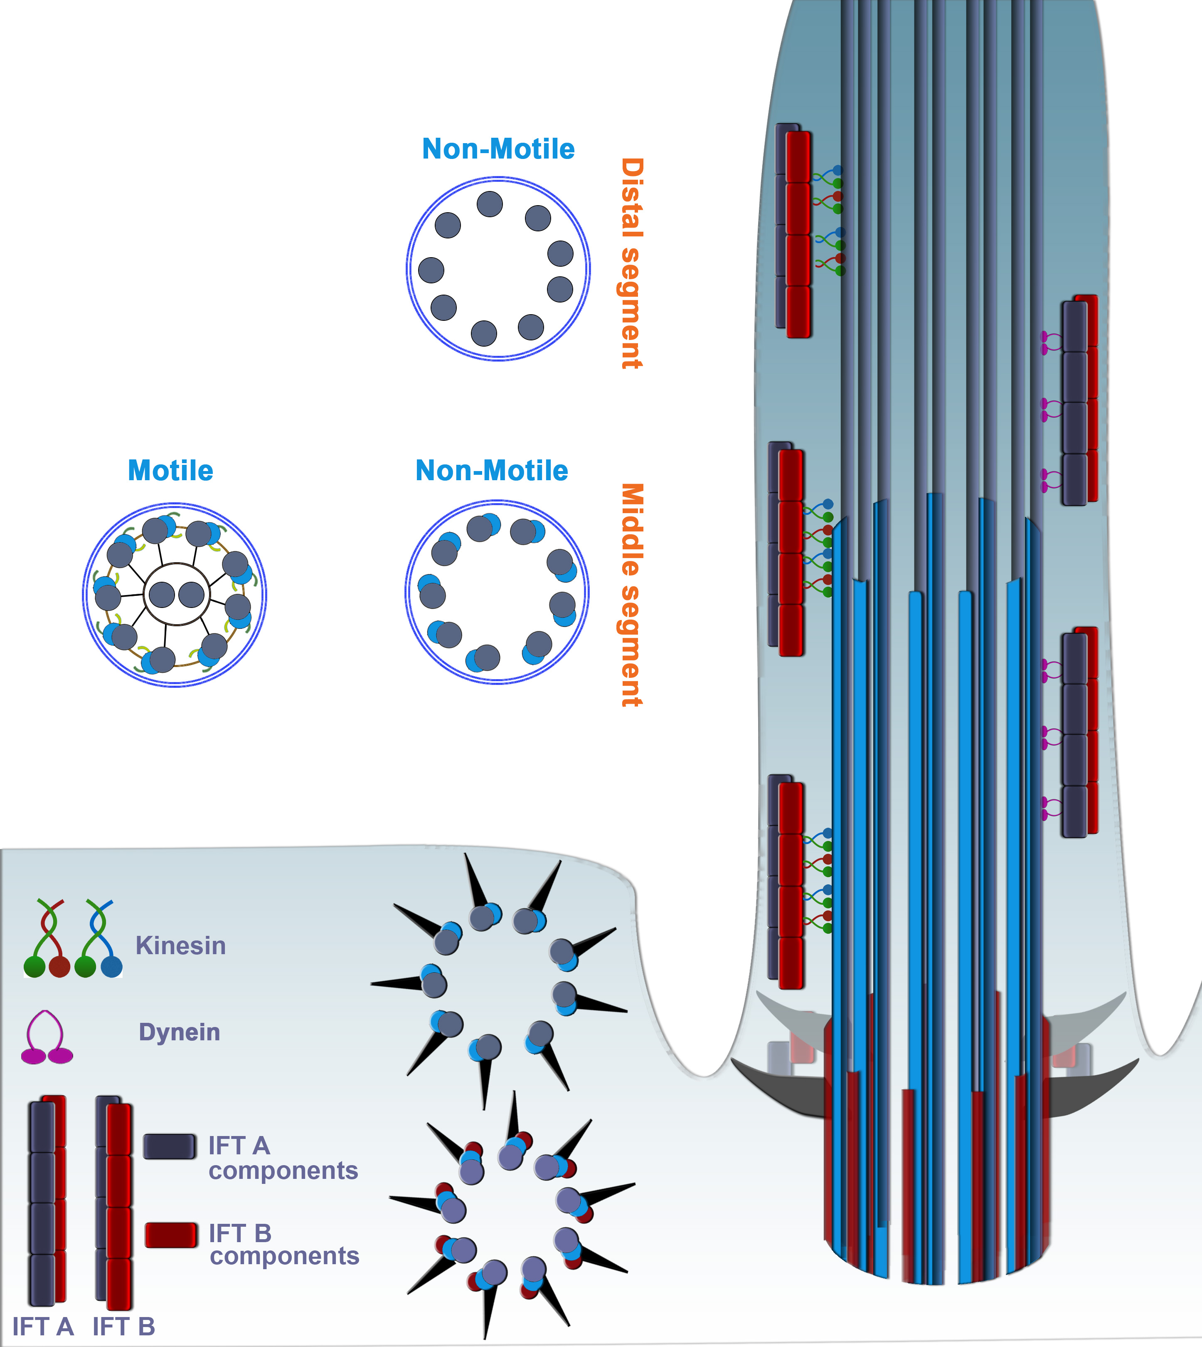
Figure 1. Schematic of a cilium. Cross-section of a cilium at the base of the cilium (basal body), represented by microtubule triplets with transition fibres in black. IFT particles are loaded onto the transition fibres and form IFT trains that transverse the microtubule based axoneme. Cross section in the middle/proximal segment of cilia is represented by microtubule doublets. Motile cilia contain additional components; radial spokes (black lines), nexin links (brown), dynein arms (green) and a central microtubule pair. The distal segment cross section is characterized by microtubule singlets. The kinesins are responsible for the anterograde transport, whereas as the Dyneins are responsible for retrograde transport.

1.1.1. Functions of the cilium
One of the major functions of primary cilia is signalling, an essential process for numerous tasks such as mechanosensation, chemosensation, olfaction, and phototransduction (Singla and Reiter, 2006; Hu and Nelson, 2011). An example of a signalling cascade crucial for embryonic developmental is the hedgehog-signalling (HH) pathway (Huangfu et al., 2003). In vertebrates, the main components of the HH pathway are enriched within the cilium such as the transmembrane proteins Patched 1 (Ptch1) and Smoothened (Smo) (Corbit et al., 2005; Rohatgi et al., 2007; Kim et al., 2009). Proper maintenance of the HH signalling pathway is crucial for appropriate embryonic development, and defects in this pathway have been associated with severe developmental abnormalities and even result in the development of cancers (Mullor et al., 2002; Williams et al., 2003). Other studies have shown that cilia may function in Wnt signalling, although it appears that the cilium is not required during the early stages of embryogenesis for both canonical and non-canonical Wnt signalling (Ocbina et al., 2009; VanHook, 2012). In addition, there are numerous other signalling pathway components localised within the cilium such as; polycystins, platelet-derived growth factor receptors (PDGFRA), angiopoetin receptors, tyrosine kinases, melanin concentrating hormone receptors, cyclic-nucleotide-gated (CNG) channels and GTPases (Yoder et al., 2002; Schneider et al., 2005; Teilmann and Christensen, 2005; Jenkins et al., 2006; Nachury et al., 2007; Berbari et al., 2008). Each of these component plays a role in modulating different functions, such as the polycystins associated with mechanosensation in the kidney. They are important for detecting fluid flow and pressure for proper functioning of the kidney. Another example is the PDGFRA signalling pathway, important for cell migration and development of neural crest-derived craniofacial structures (Klinghoffer et al., 2002). Cilia is also crucial for olfaction, through using the CNG channels to modulate calcium levels (Flannery et al., 2006). Another receptor, thought to be important for energy homeostasis, is somatostatin receptors, enriched in cilia of several regions in the brain (Hilgendorf et al., 2016). As the cilium is highly enriched with numerous receptors, it allows for rapid response to a number of signalling pathways.
As a consequence, many ciliary gene mutations are associated with a number of different disorders, collectively termed ciliopathies. Examples of this include, Bardet–Biedl syndrome, nephronophthisis, and Senior–Løken syndrome (Waters and Beales, 2011). Ciliopathies display a range of defects that include retinal degeneration, mental retardation, skeletal abnormalities, situs inversus and many others (Waters and Beales, 2011). Therefore, studying ciliogenesis is crucial to better understand the causes, and develop possible interventions to treat patients with ciliopathies (Tobin and Beales, 2009).

Initially, the primary cilium was believed to function mainly in signalling, and the motile cilia’s function was primarily believed to be motility. Evidence now suggests that motile cilia have functions outside motility and have been associated with sensory functions as well. For example, there are numerous receptors located along the ciliary membrane. These include TRPV4, TRPP1, TRPP2 channels, T2R receptors, fibroblast growth-factor receptor (FGFR-1), progesterone receptor, oestrogen receptor-β and interleukin-6 receptor (Evans et al., 2002; Shao et al., 2007; Nutu et al., 2009; Shah et al., 2009; Shao et al., 2009). These channels and receptors contribute to important functions, such as mucus clearance, chemosensation, oocyte transport and many others (Bloodgood, 2010).

Mechanosensation is another major function of cilia, and it has been associated with several different pathways depending on the tissue requirements. For instances, the ear, consisting of the auditory system and the vestibular system, posses hair cells with cilia. The vestibular system is responsible for balance and motion perception and it consists of three sensory patches, cristae, which are important for balance perception. In addition to this, there are two maculae that are responsible for detecting accelerations of both linear and angular directions, gravity and sound (Haddon and Lewis, 1996; Magarinos et al., 2012). All 5 sensory patches contain hair cells bearing cilia, named kinocilia. However, the cilia in cristae and maculae differ structurally and most likely have different functional roles as well, presumably owing to the differences in the level of sensitivity requirements in the different patches (Li et al., 2008). Cilia of the cristae, for example, are much longer in comparison to cilia of the maculae (Kikuchi et al., 1989). Their function in mechanotransduction is mediated by a well orchestrated and complex machinery located on the surface of mechanosensory hair cells and its supporting cells. The hair cells each consist of a bundle of stereocilia associated with a kinocilium, located at the apical surface (Hudspeth, 1989). The kinocilium is much longer in comparison to its adjacent stereocilia, which are closer in resemblance to microvilli as they consist of actin-based filaments (Flock and Duvall, 1965). The main function of the kinocilium is thought to be the formation of the hair bundle at the lateral edge of the cell surface during the differentiation of the hair cell. Subsequently, the stereocilia form a V-shaped bundle around the kinocilium, whereby the stereocilia are organised from tallest to shortest to form a staircase-like arrangement (Axelrod, 2008; Falk et al., 2015). The migration of kinocilia is an important determinant for the development of the hair cells as their polarity is determined by the orientation of the kinocilium (Axelrod, 2008; Jones et al., 2008). Furthermore, displacement of the hair cell cilium results in the extracellular tip links, connecting the kinocilium and the adjacent stereocilium, to either build or relieve tension, as a consequence opening or closing the mechanosensitive channels, respectively (Kindt et al., 2012). This is thought to result in a signalling cascade responsible for mechanosensation, although this has to be further investigated.

To perform all the complex functions outlined above, the large amount of proteins localized within the cilium has to be regulated efficiently to maintain a functional cilium. To aid this, the cilium is compartmentalised into segments that each regulate a different aspect of the ciliary function. Thus, it is important to appreciate the structure of the cilium to fully understanding how it maintains normal functionality of the tissue.

1.1.2. Structure of the cilium
Cilia are compartmentalised into several broad segments, starting with the basal body, the transition zone, the proximal/middle segment and the distal segment (Figure 1)(Fisch and Dupuis-Williams, 2011). The basal body consists of microtubule triplets which transitions into microtubule doublets within the cilium (Gilula and Satir, 1972) (Figure 1). These doublets further transition into singlets in the distal segment of the cilium (Satir and Christensen, 2007; Fisch and Dupuis-Williams, 2011). The basal body contains appendages that later become the transition fibres that attach to the pre-ciliary vesicle in the cytoplasm (Garcia-Gonzalo and Reiter, 2012; Avidor-Reiss and Leroux, 2015). This complex then migrates to the apical surface of the cell and anchors, whereby the distal appendages attach to the plasma membrane. However, this is not always the case, as some cilia do not dock to the plasma membrane such as in the case of Drosophila sperm cilia (Avidor-Reiss and Leroux, 2015). Unlike primary cilia, motile cilia often have an additional central pair of microtubules (9+2 arrangement) and host a number of additional structural components for their motility. These include the force generating motors dynein arms, radial spokes linking to the central MT pair, and nexin links connecting neighbouring outer doublets (Figure 1) (Lindemann and Lesich, 2010; Fisch and Dupuis-Williams, 2011). The dynein arms appear to be a more prominent determinant of motility than the central pair of microtubules, as mouse nodal cilia have dynein arms with a 9+0 arrangement, yet demonstrate motility (Nonaka et al., 1998). The motility of the cilium is achieved by the sliding of the microtubules induced by the dynein arms (Kamiya and Yagi, 2014).
Although the cilium is one continuous membrane with the plasma membrane, all the ciliary proteins are separated from the plasma membrane. Some studies have indicated that the lipid composition of the ciliary membrane itself may be different. However, due to difficulties in manipulating the ciliary lipid content, it is challenging to address this question (Chailley and Boisvieux-Ulrich, 1985; Jacoby et al., 2009; Emmer et al., 2010). The transition zone on the other hand is thought to be the main location where the bulk of the protein trafficking occurs through, both into and out of the cilia (Reiter et al., 2012). The transition zone is generally regarded to start at the changeover from the nine-microtubule triplets, present in the centriole, to MT doublets found in the ciliary axoneme (Figure 1). It is characterised by the presence of Y-links that consists of a number of proteins where mutations in them lead to a number of ciliopathies, such as Meckel syndrome (MKS), Joubert Syndrome (JBST) and nephronophthisis (NPHP) (Gilula and Satir, 1972; Tobin and Beales, 2009; Dowdle et al., 2011; Garcia-Gonzalo et al., 2011; Sang et al., 2011; van Reeuwijk et al., 2011).

1.1.3. Transition zone

The transition zone acts as the ciliary gate with multiple components restricting ciliary entry and exit at the initial stages of ciliogenesis. However, the different mechanisms that restrict the entrance of membrane and soluble proteins are still unclear. Various immunofluorescence studies have shown that many intraflagellar transport (IFT) complex components assemble at or near the ciliary base (Deane et al., 2001; Zhao and Malicki, 2011; Reiter et al., 2012). Thus, the transition zone may be important in recruiting components of the IFT complex and in the assembly of the complexes for the downstream processes of extending the axoneme. Although, other studies have shown normal levels of IFT proteins in the absence of the transition zone (Garcia-Gonzalo et al., 2011; Williams et al., 2011; Prevo et al., 2015). The transition zone consists of different modules, each consisting of a number of components, where at least one mutation in each module has to occur for a strong ciliary defect (Williams et al., 2011). In C. elegans these modules form a hierarchical structure whereby each level is the foundation for the next. Hence disruption of the lowest level would collapse the entire transition zone (Williams et al., 2011). Presumably a similar network forms in vertebrates. Several studies have attempted to characterise the size-exclusion barrier at the base of the cilium for soluble proteins. As transmembrane proteins are thought to be hindered by septins found in the transition zone, it was questioned whether soluble proteins freely diffused into the cilium (Chih et al., 2011). Several studies have attempted to address this by monitoring the trafficking of multiple monomers of fluorescent proteins through the connecting cilium (transition zone) of the photoreceptor cells (Kee et al., 2012). This demonstrated that proteins of size 40 kD and above in size did not localise into the cilium, although another study reported that much larger proteins traverse the transition zone (Najafi and Calvert, 2012). More recently, an exclusion barrier of approximately 100 kD for soluble proteins was determined, and anything above would require active transport into the cilium (Breslow et al., 2013).

Interestingly, there is evidence suggesting that the base of the cilium may be structurally similar to the nuclear pore complex. This was indicated based on the identification of several nuclear pore complex proteins (nucleoporins) at the base of the cilium (Kee et al., 2012; Breslow et al., 2013; Kee and Verhey, 2013). Some of the nuclear pore components have been shown to traffic into the cilia, possibly facilitating the trafficking of other ciliary proteins into the cilium (Dishinger et al., 2010). Hence a similar gateway system similar to the nuclear pore may also be present at the base of the cilium. The active transportation of the ciliary proteins through these barriers is thought to be mediated by the intraflagellar transport system.

1.1.4. Intraflagellar Transport (IFT)
The intraflagellar transport machinery is essential for the extension of the cilium, by transporting all the constituents of the cilium to the tip of the axoneme (Qin et al., 2004). There are two IFT complexes, IFT-A and IFT-B necessary for retrograde and anterograde transport, respectively (Pedersen and Rosenbaum, 2008). There are six members within IFT-A complex and 16 members within the IFT-B complex (Lechtreck, 2015)(Table. 1). The trafficking of the IFT complexes is mediated by molecular motor proteins named kinesins which associates with IFT-B for anterograde, and Dynein-2 (Dync2h1) that associates with IFT-A for retrograde trafficking (Garcia-Gonzalo and Reiter, 2012). The IFT particles form trains consisting of a double row of IFT-A/B complex associated with its respective motor protein (Figure 1)(Pigino et al., 2009). The main cargo of IFT is tubulin and axonemal proteins for building the cilium, and in many cases IFT still functions to maintain the ciliary structure after the formation of the cilium (Davenport et al., 2007; Hao et al., 2011; Wren et al., 2013; Craft et al., 2015). The importance of these complexes for the formation of cilia has been demonstrated through numerous studies such as the in vivo mutagenesis of the IFT-B complex proteins that often results in the inability to assemble the cilium (Pazour et al., 2000; Pathak et al., 2007; Omori et al., 2008). This is most likely attributed to the lack of transportation of the components required to build the cilium itself. Whereas mutations in the IFT-A complex frequently results in bulges at the tip of the cilium or/and the truncation of the cilium such as in the case of ift139, ift122 and ift121 mouse mutants (Pedersen and Rosenbaum, 2008; Tran et al., 2008; Qin et al., 2011). Further to this, human mutations that result in the failure to fully assemble cilia results in multi-organ defects, while a complete loss of cilia is usually lethal (Bisgrove and Yost, 2006).
The recycling of the IFT particles at the ciliary tip is thought to be mediated by the Bardet-Biedl syndrome complex (BBSome) that consists of 8 proteins (Jin et al., 2010; Wei et al., 2012). At the ciliary tip both IFT complexes are bound together through the BBSome complex, which dissociates at the ciliary tip and then reassembles the IFT complexes for retrograde transportation (Wei et al., 2012). Although the BBSome complex is primarily associated with its function at the tip of the cilium, many of the BBS proteins have been implicated in other ciliary functions such as planar cell polarity and organising the microtubule network (Ross et al., 2005; Loktev et al., 2008). The recruitment and assembly of the BBSome complex at the ciliary base is dependent on some of the BBS proteins interacting with proteins within the centriolar satellite. Multiple centriolar proteins have been implicated in interacting with the BBS proteins such as, BBS1, BBS4 and BBS8 (Soares et al., 2011; Stowe et al., 2012; Hall et al., 2013; Klinger et al., 2014). Furthermore, BBS proteins are implicated in functions outside the cilium, such as the functions of BBS4 and BBS6 in cell cytoskeleton (Kim et al., 2004; Kim et al., 2005). Another example is BBS5, thought to function in the release of Arrestin1 in the retina (Smith et al., 2013). Interestingly, IFT proteins are not restricted to its canonical role of protein trafficking in cilia, either. Several members of the IFT complex have been implicated in roles outside of cilia such as in the immune response (Yen et al., 2006; Finetti et al., 2011; Finetti et al., 2014).

Table 1. IFT Components
IFT-A Retrograde | IFT-B Anterograde
IFT43 | IFT20
IFT121 | IFT22
IFT122 | IFT25
IFT139 | IFT38
IFT140 | IFT46
IFT144 | IFT52
 | IFT54
 | IFT56
 | IFT57
 | IFT70
 | IFT74/IFT72/IFT71
 | IFT80
 | IFT81
 | IFT88
 | IFT172

The components of the Intraflagellar transport machinery. IFT-A consists of 6 IFT particles and IFT-B has 15 particles, responsible for either anterograde or retrograde transportation, respectively.

1.2. Ciliary kinesins
The molecular motors that drive anterograde trafficking along the microtubules are kinesins. Currently the kinesin superfamily consists of 14 families, classified by the presence of the kinesin motor domain (Table. 2) (Miki et al., 2005; Hirokawa et al., 2009). The motor domain is a high homology ATP-binding domain shared between all kinesins, however the location of this motor domain in the sequence varies between different types of kinesins. There are three categories, which the kinesins fall into: N-kinesins, C-kinesins, and M-kinesins, whereby the motor domain is located either at the N-terminus, C-terminus or in the middle flanked by other domains on both sides, respectively (Marx et al., 2009). The other domains are more variable and specific to the class they belong to.
However, not all kinesins contribute to motility (Dagenbach and Endow, 2004; Hirokawa et al., 2009). The anterograde kinesins function by associating with the microtubule via its head domain, either by forming a monomer or dimer. Dimerization of kinesins is achieved through their coiled coil domain. Finally the tail domain is responsible for attaching to their respective cargoes. Different kinesins function in trafficking in different organelles and tissues such as in the mitochondria, dendrites, Golgi-ER transport and transport of lysosomes (Hirokawa et al., 2009). One example is several kinesins functioning together in organising the mitotic spindles and chromosome segregation (Cross and McAinsh, 2014). In the axons, the N-kinesins play an important role in neurite elongation and polarisation by transporting synaptic vesicle precursors and other membrane organelles (Hirokawa et al., 2009). The main role of the ciliary kinesin is to drive anterograde transport, performed primarily by members of the kinesin-2 family (Cole et al., 1998). It is believed that the kinesin-2 family members are the core kinesins required for trafficking all the building bocks of the cilium.

As cilia are found in a wide variety of tissues, with different functional requirements, specialised kinesins are believed to function in transporting specific subsets cargoes. Examples include members of the kinesin-3 and kinesin-4 families (Peden and Barr, 2005; He et al., 2014). In addition to this, some kinesins confer functions other than transportation such as regulation of the ciliary structure by depolymerising microtubule at the tip of the cilium to control ciliary length (Niwa et al., 2012).

Table 2. Kinesins and their functions
Family | Sub-Family | Function
Kinesin 1 | KIF5 | Cytoplasmic transport, Dendritic transport
Kinesin 2 | KIF3, KIF17 | Intraflagellar transport, cytoplasmic transport
Kinesin 3 | KIF1, KIF13, KIF14, KIF16, KIF28 | Organelle and cytoplasmic transport, intraflagellar transport
Kinesin 4 | KIF4, KIF7, KIF21, KIF27 | Chromosome movement, organelle transport
Kinesin 5 | KIF11 | Spindle
Kinesin 6 | KIF20, KIF23 | Cytokinesis, spindle polarity, cytoplasmic transport
Kinesin 7 | KIF10 | Mitosis – kinetochore microtubule capturing.
Kinesin 8 | KIF18, KIF19 | Nuclear and mitochondrial transport functions
Kinesin 9 | KIF6, KIF9 | Uncertain
Kinesin 10 | KIF22 | Chromosome segregation
Kinesin 11 | KIF26 | Signal transductions
Kinesin 12 | KIF12, KIF15 | Organelle transport
Kinesin 13 | KIF2, KIF24 | Microtubule depolarizing activity.
Kinesin 14 | KIFC1, KIFC2/3, KIF25 | Chromosome segregation, Organelle, Dendritic and cytoplasmic transport,

List of kinesin superfamily members, their sub-family members and current knowledge regarding their functions. Modified from (Miki et al., 2005; Hirokawa et al., 2009)

1.3 Retina and the photoreceptor cilium
The retina is a complex neuronal network with 5 classes of neuronal cells that function to transmit visual information to the brain through the optic nerve (Hoon et al., 2014). These layers are categorised within 2 broader layers named the inner nuclear layer (INL) and the outer nuclear layer (ONL) with the retinal pigment epithelial (RPE) cells covering the outer nuclear layer (Figure 2). The photoreceptor cells of the ONL contain large highly differentiated cilia. The photoactivated photoreceptors initiate a signalling cascade transmitting it through the neuronal layers of the retina to the retinal ganglion cells. The processes of the retinal ganglia cells form the optic nerve and transmit the signal to the relevant regions of the brain (Erskine and Herrera, 2007).
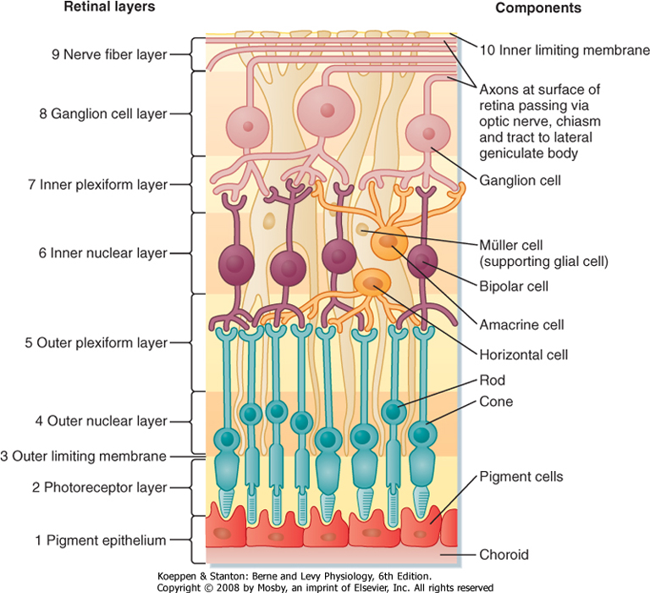

Figure 2. The different layers of the retina and cell types. The retina is composed of three layers, which are the outer nuclear layer (ONL), inner nuclear layer (INL) and the ganglion cell layer (GCL). The ONL is comprised of photoreceptor cell bodied, the INL consist of amacrine cells, horizontal cells, Muller glial cells, and bipolar cells, whereas the GCL contain ganglion cells. The outer plexiform layer (OPL) is where the synapses between photoreceptor cells and neurons of the INL. The inner plexiform layer (IPL) is where the synapses between neurons of the INL and GCL take place. The retinal pigmented epithelium (RPE) are in contact with the photoreceptor cells (Goldman, 2014). NFL= never fibre layer, ILM = inner limiting membrane, OLM = outer limiting membrane.

The photoreceptor cilia, also known as outer segments are one of the most complex and differentiated cilia known, and have been shown to contain approximately a billion opsin molecules at any given time (Pugh and Lamb, 2000). Opsin is the main constituent of the phototransduction pathway and for this purpose it is highly concentrated in the photoreceptor axoneme. Mutations in opsin or transportation defects of opsin, often lead to photoreceptor degeneration resulting in a number of retinal dystrophies (Mendes et al., 2005; Rakoczy et al., 2011). Structurally the photoreceptor cilium consists of multiple disk-shaped membrane folds disks, stacked on top of each other and it is thought to be supported by the cilium (Liu et al., 2003). A major difference between cones and rods is that rod discs are entirely membrane enclosed, whereas cone disks are open and remain as membrane folding. Furthermore, the photoreceptor outer segments are constantly renewed by the removal of the most apical membrane and synthesis of new outer segment membranes (Young, 1967). This process is commonly termed disk shedding, and is thought to be aided by RPE cells (Young and Bok, 1969). These membranes are enriched with GPCRs and transmembrane proteins to accommodate for its rapid phototransduction cascade (Palczewski, 2006; Arshavsky and Burns, 2012; Rajala et al., 2013). In addition to this, there is an elaborate structure at the base of the cilium known as the periciliary ridge complex (PRC), or periciliary membrane complex (PMC) in mammals (Peters et al., 1983). The opsin molecules that are delivered to the base of the cilium fuse with the PRC for subsequent transport along the cilium (Papermaster et al., 1986). To accommodate for the high concentration of visual proteins in the outer segment, a large amount of trafficking occurs through the connecting cilium found between the inner segment and the outer segment of the photoreceptor cell. The connecting cilium resembles the transition zone of cilia and is thus generally regarded as the transition zone of the photoreceptor cilium (Insinna and Besharse, 2008; Malicki and Besharse, 2012). In mouse 100s of opsin molecules are trafficked per second whereas in Xenopus as much as ten times more opsin molecules are transported per second, to accommodate for the much larger outer segment (Malicki and Besharse, 2012). Thus, it is questionable whether the standard core kinesin members and transport mechanisms are sufficient for driving such large quantities of opsin trafficking into the photoreceptor cilium. To investigate this, there were several studies performed, although it is still unresolved as to whether the core transport machinery is sufficient to drive outer segment formation (Marszalek et al., 1999; Jimeno et al., 2006a; Avasthi et al., 2009). An example of an alternative transport mechanism that may function in the photoreceptor cells is the actin-myosin transport machinery.

1.4 Alternative transport
Given the unusual features of photoreceptor cilia, an alternative myosin-mediated ciliary transport mechanism has been proposed to exist in photoreceptors (Wolfrum and Schmitt, 2000; Avasthi et al., 2009). This is supported by observations that myosin VIIa and actin are found in the connecting cilium and some of the rhodopsin molecules co-localize with myosin VIIa in the connecting cilium membrane (Wolfrum and Schmitt, 2000). Furthermore, Myosin VIIa mouse mutants display some opsin mislocalization (Liu et al., 1999). This led to the hypothesis that parallel actin filaments form along the connecting cilium microtubules and support myosin-mediated transport of membrane proteins along the axoneme (Wolfrum and Schmitt, 2000; Williams, 2002). One has to note, however, that the Myosin VIIa phenotype is rather weak, which suggests that actin-mediated transport does not play a major role in photoreceptors (Wolfrum and Schmitt, 2000). Speculative scenarios that myosin-mediated transport first requires that some ciliary components are transported by the core kinesin 2 complexes are possible but not supported by evidence so far.

1.5 Zebrafish as a model organism
In this PhD, zebrafish was used as a model organism for all experimental work. There are several advantages in the usage of zebrafish for studying the function of kinesins in ciliogenesis, particularly the photoreceptor cells. First, in other model organisms such as mice, disruption of the core kinesin complex is embryonic lethal, resulting in the need to generate conditional knockout mutants (Nonaka et al., 1998; Marszalek et al., 1999; Yang et al., 2001; Avasthi et al., 2009). This can often pose technical difficulties, and increase the difficulty of interpreting the outcomes. On the other hand, zebrafish mutant embryos often survive several days post fertilisation, most likely due to maternal contribution. Maternal contribution provides the necessary RNA and proteins for embryonic development and survival until the embryos switch to activating their own genes. This enables embryos with mutations in essential genes to be studied in more detail during the early stages of development. This is different to the Cre-Lox system, often employed in other model organisms, as it is difficult to uniformly delete the gene of interest at an appropriate stage, which is neither too early, to be lethal, or too late to understand the gene’s function. Secondly, the zebrafish retina more closely resembles the human retina in respect to the ratio of Rods and Cone photoreceptor cells, as both organisms are diurnal (Bilotta et al., 2001). Moreover, zebrafish has been used as a model for many ciliary genes. A typical characteristic of a zebrafish ciliary mutant is its curved body axis. Thus, it is often very easy and quick to identify homozygote mutants. In addition to this, the transparency of the zebrafish embryos greatly improves imaging of immunostained individuals. Advances in genetic manipulation of zebrafish provided the necessary tools to quickly generate the desired mutants. Moreover, the rapid development time allows for mutants and double mutants of multiple kinesins to be generated in a relatively short period of time. Furthermore, the small size of the embryos meant that staining procedures could be performed on multiple embryos simultaneously in a single eppendorph tube. All of this provided a number of technical advantages for this particular project that predominantly involves immunostaining, and analysis of the photoreceptors in ciliary mutants.

1.6 Aims
The aim of this PhD is to investigate and resolve the function of the kinesin 2 family members, particularly its role in the photoreceptor cilium. The heterotrimeric kinesin II are believed to be the core kinesins to drive all ciliogenesis, however, their function in some specialised cilia such as photoreceptor cilia is less clear. As kif3a is a common component for both heterotrimeric kinesin II, the loss of kif3a should disrupt both heterotrimeric kinesins II complex. For this purpose, first, the kif3a zebrafish mutant was used as a model organism to evaluate the ciliary defects in multiple organs, specifically the photoreceptor cilium. Second, we investigated whether kif3a has any additional functions outside the cilium. Then, we also investigated the role of IFT particles in the photoreceptor cell. Furthermore, other members of the kinesin-2 family were examined to understand their roles in cilia. Apart from the core ciliary kinesins, other potential ciliary kinesins were also examined to discern whether they have roles in modulating the functions of the cilium. For this purpose, mutants of these kinesins were generated including double mutants of different kinesin combinations. Especially to identify whether different combinations of kinesins are required for the function of a subset of cilia. Presumably by transporting a select number of cargoes required for a specific function of a tissue. This idea stems from the fact that cilia are found in many different tissues, thus potentially having different functional roles depending on the tissue it belongs to. Therefore, a mechanism to selectively transport the proteins only necessary for the functions of a particular tissue may be present.

Chapter 2

Material and Methods

2.1 Zebrafish Strains and maintenance

2.1.2 Maintenance
Zebrafish were maintained in accordance with UK Home Office regulations, UK Animals (Scientific Procedures) Act 1986, under the project licence issued to Dr. Jarema Malicki: 40/3624 and my personal licence: 40/10811. Both adult and embryonic zebrafish were maintained at 28ºC, the adult zebrafish were in 14:10 hours light/dark cycle. Adults were fed with live artemia or dry food twice daily.
To obtain homozygote embryos and wild type embryos the parent fish were incrossed by pair mating. This was performed through the use of a cage that is permeable for embryos to flow through the gaps but small enough to prevent the parents from ingesting the embryos. The collected embryos were sorted into petri dishes, containing E3 (5 mM NaCl, 0.17 mM KCl, 0.33 mM CaCl2, 0.33 mM MgCl2, pH 7.2) medium with methylene blue, of approximately 40 embryos per plate. The embryos are kept at 28ºC and monitored regularly for any developmental abnormalities. Dead embryos are removed to prevent contamination.

2.1.3 Strains
kif3a^{sa1617} and kif17^{sa18340} mutant alleles were obtained from the Sanger Institute. Kif3b^{jj203}, elipsa^{tp40}, fleer^{ca1} mutants were from Dr. Malicki (Doerre and Malicki, 2002; Tsujikawa and Malicki, 2004; Omori et al., 2008; Zhao et al., 2012). Several kif3cl mutant alleles, kif3cl^{sh348}, kif3cl^{sh349}, kif3cl^{sh350} were generated using the TALEN method (Yao Zu et al., 2013). Klp-6 allele was generated by TALEN. Kif3c mutants were generated using the CRISPR method. Double mutant strains were generated through incrossing single mutants: kif3a^{sa1617}+/-;elipsa^{tp40}+/-, kif3a^{sa1617}+/-;fleer^{ca1}+/-, kif3b^{jj203}+/-;kif3cl^{sh348}+/-, kif3b^{jj203}+/-;kif3cl^{sh348}-/-, kif3b^{jj203}+/-;klp-6^{sh369}+/-, kif3b^{jj203}+/-;klp-6^{sh369}-/-, kif17^{sa18340}+/-;klp-6^{sh369}+/-, kif3b^{jj203}+/-;kif3c+/-.

2.2 Mutagenesis techniques
There are several site directed mutagenesis techniques for generating zebrafish mutants, the following two were employed in this PhD; TALEN, CRISPR.

2.2.1 TALEN system
Transcription activator-like effector nucleases (TALEN) are restriction enzymes that can be targeted to cleave a DNA sequence of interest. It consists of the TAL DNA binding domain fused to a DNA cleavage domain, FokI cleavage domain in the case. The DNA binding domain is designed to consist of repeat variable domain (RVD) units, ranging from 15 to 21. Each RVD will target a specific nucleotide. TALEN functions as a heterodimer, as the FokI nucleases function by heterodimerising to cleave the target site. Thus a TALEN for the left and the right side of the target sequence was designed. Once both TALENs bind, then the FokI nuclease will dimerise and cleave the target site. The TALENs are assembled using the golden gate reaction where up to 10 RVD constructs are cloned into one vector in a single reaction. As TALENS range between 15 to 21 RVDs, each TALEN is made in two parts. Then a final reaction is performed to combine both parts into one construct. This is then transcribed into RNA and injected into embryos to generate mutants.
The left subunit and the right subunit are each initially constructed in two halves that are then joined together along with the last RVD. So there will be a Left part A and part B and also a Right part A and part B. Then add together part A, part B, the last RVD and the destination vector.

Assemble each of the four golden gate reactions in 0.2ml tubes on ice
For each A part:
1µl each RVD plasmid at 100ng/µl
1µl pFusA (F5) at 100ng/µl
4µl H2O
2µl T4 ligase buffer NEB
2µl T4 ligase NEB
1µl Bsa1 NEB

For each B part:
H2O to 20µl
1µl each RVD plasmid at 150ng/µl
1µl appropriate pFusB at 150ng/µl
2µl 10x T4 DNA ligase buffer NEB
2µl T4 DNA ligase NEB
1µl Bsa1 NEB

Mix each reaction by gently pipetting up and down and cycle using the program:
10 x (37ºC for 5min + 16ºC for 10min) + 50ºC for 5min + 80ºC for 5min.

When complete, add 0.3µl 25mM rATP (thawed and mixed) and 1µl plasmid safe nuclease. Mix each golden gate reaction by gently pipetting up and down and incubate for 1 hour at 37ºC. For each golden gate reaction, transform into NEB10Beta competent cells. Streak 50µl of each transformation over a spectinomycin Xgal LB agar plate and grow at 37ºC overnight. For each reaction, pick three well-separated white colonies and grow each colony in 6ml of LB spectinomycin in a 25ml universal, grow at 37ºC shaking overnight.
Transfer the overnight culture tubes to ice then spin down entire tube and pour off LB from the bacterial pellet. For each of the four components, perform a qiagen miniprep for one of the clones and freeze the other two. Elute the qiagen minipreps into 50µl of distilled water.
Combine the A part and B part for each subunit using a golden gate reaction:
5µl H2O
4µl A miniprep
4µl B miniprep
1µl 150ng/µl the appropriate final RVD plasmid
1µl 75ng/µl pCAGT7TALEN
2µl 10x T4 DNA ligase buffer NEB
2µl T4 DNA ligase NEB
1µl Esp3I
Mix each reaction by gently pipetting up and down and cycle using the program:
10 x (37ºC for 5min + 16ºC for 10min) + 50ºC for 5min + 80ºC for 5min.
Check the A part and B part plasmids with an NheI+XbaI digest. The expected band sizes are 266bp, 2132bp and 500bp-1100bp (depending on the RVD number). Use the band intensities to check the DNA concentration. The intention is to have concentrations such that about 150ng of each plasmid has been added to the golden gate reaction.
For each golden gate reaction, transform into NEB10Beta competent cells. Streak 50µl of each transformation over a carbenecillin Xgal LB agar plate and grow them at 37ºC overnight. For each subunit, pick one well-separated white colony and grow up in 100ml of LB carbenecillin in a baffled flask shaking overnight at 37ºC. Do a nucleobond midiprep. The final precipitation is performed in six 1.5ml eppendorph tubes. Remove all supernatant after the spin down, pulse spin, remove traces of liquid, wash with 1ml of 70% ethanol, spin, remove liquid, pulse spin, remove last trace of liquid, and finally air dry with open tubes on bench for one minute only. Resuspend each tube in 20µl of water. Vortex and pool the 120µl prep. Measure concentration then make a 30µl stock of 100ng/µl. Submit 20µl for sequencing using TAL_R2: ggcgacgaggtggtcgttgg and SeqTALEN_5-1 catcgcgcaatgcactgac primers and then check if it matches the electronic sequence.

Also tested with BamHI+XbaI digest assembled on ice:
7µl H2O
1.5µl 100ng/µl DNA
1µl 10x NEB3 buffer
0.1µl 100x BSA
0.5µl BamHI
0.5µl XbaI
Mix by gently pipetting up and down. Incubate 1 hour at 37ºC

Prepare your linearized pCAGT7TAL constructs with NotI digest assembled on ice:
H2O to 300µl
6ug L construct
6ug R construct
30µl 10x NEB3 buffer
3 µl 10mg/ml BSA
10µl NotI

Mix by gently pipetting up and down. Incubate 1 hour at 37ºC in a water bath. Purify with two qiagen PCR clean up columns but use the 30µl eluate from one to elute the other such that the total elution is 30µl. Elute with water. Run the BamHI+XbaI digests and the purified NotI digests on a 0.7% seakem agarose gel. The BamHI+XbaI digest should give 4346bp and 3669bp, and the NotI digest should produce a 9kb band (depending on number of RVDs). Synthesise RNA from the NotI linearized plasmid using the Epicentre T7 MessageMax ARCA kit, and then inject the RNA into one-cell stage embryos.

2.2.2 CRISPR/CAS9 system
CRISPR - The prokaryotic clustered, regularly interspaced, short palindromic repeats. This involves the use of a single nucleotide sequence of 20 base pairs, complementary to the genomic site of interest. The tertiary structure formed by the RNA sequence, adjacent to the targeting sequence, recruits the CAS9 protein, a nuclease, which will cleave the DNA sequence around the region of interest (Hwang et al., 2013).

The Ultramer CRISPR method:
For CRISPR gRNA synthesis, first oligonucleotides are ordered containing the T7 and target (N₂₀) site (target complementary to target strand). In addition to this a Protospacer Adjacent Motif (PAM) sequence is required for target binding. Whereby the “X” represents the sequence complementary to the target site:
AAAGCACCGACTCGGTGCCACTTTTTCAAGTTGATAACGGACTAGCCTTATTTTAACTTGCTATTTCTAGCTCTAAAACxxxxxxxxxxxxxxxxxxxxCTATAGTGAGTCGTATTACGC
Table 3. The target sequence that was affected in the mutants generated in this work.
Target Gene | CRISPR/TALEN | Guide Sequence
kif3c-like | TALEN | Left:  TTTGCTCGGGTTCAATGG  Right:  GCAAACTGGCACAGGCAA
Kif3c | CRISPR | GGCCCTGCGGAACGCCAAGG
Klp6 | TALEN | Left: GTTTTTTCCAGAGGGAGCGT  Right: ATTATCTCTATGACCTCC

Three genes were mutated using either TALENs or CRISPR as indicated in the table. The guide sequence is the site that was targeted by the TALEN/CRISPR to induce the damage.

The site selection for CRISPR is designed in such a way so that it preferably targets a restriction site directly, allowing for easier screening in later stages as outlined in the founder screening section. The target site was designed using the ZiFiT website Then primers were designed to amplify the region of interest where the cleavage would take place.

Once the CRISPR was designed, it is annealed in a reaction consisting of 5 µM of CRISPR oligonucleotide and 5 µM of T7 primer in linker buffer; linker buffer: 50 mM Tris-HCl pH 8, 100 mM NaCl, 1 mM EDTA. This reaction involved the incubation of this solution for 5 min at 95ºC and then allowing it to cool down slowly at room temperature for several hours. This DNA is then transcribed into RNA with the MEGAshortscript T7 kit from Life Technologies as described in the RNA transcription section. The RNA produced is then diluted to make a solution with the final concentration of 2.4 µg/µl gRNA and 0.5 µg/µl Cas9 mRNA, which is then injected into one cell stage embryos.

2.3 Plasmids and Morpholinos
The GFP-opsinCT44 plasmid was used to analyse opsin trafficking, previously made by Dr. Malicki lab (Zhao and Malicki, 2011). Cas9 plasmid (Adgene) optimised for zebrafish was used for CRISPR injection. The following CRISPR was used to generate the kif3c mutant:
AAAGCACCGACTCGGTGCCACTTTTTCAAGTTGATAACGGACTAGCCTTATTTTAACTTGCTATTTCTAGCTCTAAAACCCTTGGCGTTCCGCAGGGCCCTATAGTGAGTCGTATTACGC.
Morpholino knockdown experiments were performed using:
GTCCAGCTTATTGCTCGGCATTATC for kif3a (Translational blocker), and CCTCTTACCTCAGT TACAATTTATA as the control morpholino.

2.4 RNA Transcription

2.4.1 T7 RNA transcription
Transcription was performed using the MEGAshortscript T7 kit, with 1 µg of DNA. The tube with the DNA is mixed and pulse centrifuged to collect the mixture at the bottom of the tube. Followed by incubation of the mixture in a PCR machine set at 37ºC for 4 hour. After which, TURBO DNase is added to the PCR tube and incubated for another 15 min at 37ºC. The sample is then transferred to an RNase-free eppendorph and precipitated by adding 2 volumes of ethanol, mixed well and then incubated for at least 15 min at -20ºC. Finally, the eppendorph is centrifuged at 4ºC for 15 min with max speed, the supernatant is carefully removed, and the pellet is resuspended in 20 µl of RNase free water. The RNA is stored in -80ºC until later use. For more pure RNA, the synthesised RNA is purified using the mirVana kit described in the RNA purification section below.

2.4.2 SP6 RNA transcription using mMESSAGE mMACHINE SP6
This procedure was mainly used to synthesis the CAS9 RNA as it has an SP6 promoter. For this protocol, 1 μg of linearized plasmid is mixed with 10 μl of 2x NTP/CAP, 2 μl of 10X reaction buffer, 2 μl of enzyme mix and the rest filled up to 20 μl with nuclease free water. After mixing this reaction thoroughly, it is incubated for 2 hours at 37ºC. Then 1 μl of TURBO DNase is added, mixed and incubated for another 15 min at 37ºC to remove the template DNA. Subsequently the RNA is further purified using the RNeasy Mini purification kit.

2.5 Solutions

2.5.1 Methylcellulose
Methylcellulose (12% w/v) Place (tape firmly) the bottle to a shaker and leave it overnight. If not dissolved by next morning remove the bottle from the shaker and place it into 60ºC water bath for 2 hours. Then place it on a shaker again until the next day. Repeat the process as many times as necessary until all the methylcellulose powder dissolves completely and then freeze it in -20^{O}C.

2.5.2 Immunostaining and fixation solutions
4% PFA: paraformaldehyde PBS.
2% TCA: Trichloroacetic acid in PBS.
0.1% PBST: Tween-20 in PBS.
PBDT: 1% BSA + 1% DMSO + 0.1% Triton X-100 in PBS.
PDT: 1% DMSO + 0.1% Triton X-100 in PBS.

2.5.3 Electron microscope sample preparation solutions
Karnovsky’s fixative: 2.5% Aqueous glutaraldehyde, 2% Aqueous paraformaldehyde, 0.2 M cacodylate buffer, 0.25 M CaCl2 in distilled water adjusted to pH 7.4.
0.1 M Cacodylate buffer wash solution: Sodium cacodylate trihydrate diluted in distilled water, adjusted to pH 7.4. Solution stored in 4ºC.
Osmium tetroxide: 2% OsO4 in distilled water.
Uranyl acetate: 6% (w/v) in distilled water

2.5.4 STORM microscopy buffer
STORM imaging requires a specific buffer, an oxygen scavenger (GLOX) that optimizes the signal. The buffer is prepared as follows: 0.5 mg/mL glucose oxidase, 40 μg/mL catalase, 10% glucose, 50 mM TRIS, 10 mM NaCl (to pH 8).

2.5.5 Stocks/reagents:
TRIS buffer 50 mM with 10 mM NaCl, adjust pH to 8 (store at 4°C)

4 mg/ml catalase (using TRIS buffer) – needs to be prepared fresh
5 mg/ml glucose oxidase (using TRIS buffer)- needs to be prepared fresh
1 M cysteamine/MEA (using TRIS buffer, stored at -20°C for up to one month or prepare fresh, avoid contact with air when opening bottle)

2.5.6 Western Blot Solutions
10x RUNNING BUFFER: 25 mM Tris, 190 mM glycine, 0.1% SDS

10x TRANSFER BUFFER: 25 mM Tris, 190 mM glycine, 0.1% SDS
1x TRANSFER BUFFER with 20% methanol
1x PBST: 1x PBS, 0.05% Tween 20
1x TBST: 50 mM Tris, 150 mM NaCl, 0.1% Tween 20, pH 7.6
PONCEAU S: 2% Ponceau, 30% TCA

2.5.7 Protein extraction solutions
Deyolking buffer: 56 mM NaCl, 1.8 mM NaHCO₃.
Wash buffer: 110 mM NaCl, 3.5 mM KCl, 2.7 mM CaCl₂●2H₂O, 10 mM Tris-HCl pH 8.5.
(-) Lysis buffer: 10 mM PIPES, 3 mM MgCl, 1 mM EDTA, 400 mM NaCl.
(+) Lysis buffer: 10 mM PIPES, 3 mM MgCl, 1 mM EDTA, 400 mM NaCl and 1% of NP40.

2.6 Injection of DNA/RNA constructs

2.6.1 Preparing needles
Set a glass capillary (World Precision Instruments) to a needle puller. Pull the glass capillary using the needle puller, and make a glass needle. Break the tip of the needle by forceps using a microscope, so that there is a small opening at the narrow end of the needle tip.

2.6.2 Preparation of agarose plates for injection
Mix 1% agarose (Invitrogen) in E3 media. Heat it up in a microwave oven for 5 min. Pour hot agarose into 10 cm Petri dishes to fill them up to half way and place a plastic imprinting tool on top of it. The tool will float on the surface of molten agarose. Once the agarose has cooled down to room temperature, remove the plastic mold and there should be grooves where embryos can be placed for injection. This plate can be used up to a month if kept at 4ºC

2.6.3 Injection set up
Turn on the microinjector, load the needle with the RNA or DNA to be injected and place the needle in the needle holder. Injections are performed on embryos within 30 min after fertilisation (1 cell stage) for generating mutants or transient expression of constructs. For morpholino injection embryos of 1-2 cell stage are injected.

2.7 Opsin trafficking assay using GFP-opsinCT44

2.7.1 Injection
For analysing the opsin trafficking speed in photoreceptor outer segments, the heat shock promoter driven GFP-opsinCT44 is injected into embryos at 1 cell stage. The injection solution consisted of 60 ng/μl of transposase mRNA and 1x phenol red dye together with GFP-opsinCT44 (final concentration of 10 ng/μl).

2.7.2 Heat shock and fixation
Injected embryos are raised in the 28ºC incubator. Starting at 24 hpf, before the onset of pigmentation, change E3 media with one containing 0.1 mM of PTU. This is to prevent pigmentation, to facilitate easier analysis of retinal sections that would normally be covered in retinal pigmented epithelial cells. At 72 hpf, embryos are heat shocked at 37ºC for 30 min by transferring the embryos to pre-heated PTU-containing E3 media and transferred back to 28ºC E3 media after heat shock. Embryos with fluorescence in the eye are collected at 4, 9 and 24 hours after heat shock and fixed in 4% PFA overnight at 4ºC. Subsequent analysis involves cryosectioning of the retina of the fixed fish and adding DAPI (4’,6-diamidino-2-phenylindole) to the slides for 15 minutes to stain the nuclei. The sections are then imaged using a confocal microscope, specifically the photoreceptor cells.

2.8 RNA extraction, purification and cDNA synthesis

2.8.1 RNA extraction
RNA extraction from zebrafish was performed using TRIzol. For the TRIzol method approximately 50 embryos at 5 dpf were anaesthetised using 160 mg/L MS-222 (Sigma-Aldrich). Then the E3 media is removed and replaced with 10 μl of TRIzol per embryo. The embryos are homogenised using a handheld homogeniser for 2 min. Once the lysate appears uniform, another equal volume of TRIzol is added and then mixed by pipetting several times. The lysate is incubated at room temperature for 5 min and then 1/5 volume of chloroform is added, followed by vigorous shaking for 15 seconds. The mixture is left at RT for another 2-3 min followed by centrifugation for 15 min at 4ºC top speed in a pre-cooled centrifuge. The upper aqueous phase is removed, without contacting the interphase, and placed in a new eppendorph tube. At this point either a standard RNA isolation procedure is performed or using the mirVana total RNA isolation procedure. For the standard procedure, add an equal volume of 2-propanol to the supernatant and mixed by pipetting several times. The mix is kept in ice for 10 min, and then centrifuged for 30 min at 4ºC at top speed. The supernatant is discarded and the remaining pellet is washed using 1ml of 75% EtOH. A final spin is performed for 5 min at 4ºC at top speed, and the supernatant is discarded carefully without losing the pellet. The pellet is air dried at RT until clear, however it should not be over dried. The pellet is resuspended in 50 μl of nuclease-free water, by flicking the tube and letting it stand on the bench for another 5 min. Finally the extracted RNA is stored at -80ºC or proceeded to the next step of purification.
The mirVana total RNA isolation procedure was used when higher purity of RNA was required, which involved first the addition of 1.25 volumes of RT 100% ethanol to the aqueous phase. The lysate/ethanol mixture was passed through a filter cartridge by centrifuging for ~15 sec at 8000 x g. Spinning harder than this may damage the filters. Discard the flow-through, and repeat until all of the lysate/ethanol mixture is through the filter. The collection Tube was reused for the washing steps. The filter was then washed with 700 μl of wash solution 1, followed by two washes with 500 μl of 2/3 wash solution, in each case they were pulse centrifuged for approximately 10 seconds. Then the filter cartridge was placed in a new collection tube and centrifuged at maximum speed with 50 μl of RNA free water to elute the RNA. The RNA was then frozen in -80ºC

2.8.2 RNA purification
For even higher purity of RNA, the RNeasy Mini kit or the mirVana miRNA isolation kit was used. The RNeasy Mini kit was performed to purify RNA larger than 500 nucleotides, whereas the mirVana kit was used to purify RNA less than 500 nucleotides long, such as in the case of the CRISPR gRNA.
The mirVana miRNA second procedure allows for enrichment of small RNA. This involves first the addition of 1/3 volume of 100% ethanol to the aqueous phase of the extracted solution of the CRISPR RNA synthesised. This is mixed via vortex and then passed through a filter cartridge by centrifugation for 15 seconds at 8000 x g. Subsequently the lysate is then transferred to a fresh tube and 2/3 volume of RT 100% ethanol is added and mixed. This mixture is passed through another filter cartridge through centrifugation for 15 seconds at 8000 x g. Then the filtrate is washed using 700 μl of wash solution 1 followed by two washes with 500 μl of wash solution 2/3 each, all by pulse centrifugation for 10 seconds. Then the flow through is discarded and the filter cartridge centrifuged for another minute to remove residual liquid before elution with 50 μl of RNA free water, centrifuged at maximum speed for 30 seconds. This was frozen in -80ºC.

2.8.3 cDNA synthesis
cDNA synthesis was performed using the SuperScript™ II Reverse Transcriptase (Invitrogen). cDNA is synthesized by mixing 1 μg of template RNA, 1 μl of Oligo(dT)15 (500 μg/ml), 1 μl of dNTP mix (10 nM each), and then sterile water up to 12 μl. This mixture is then heated at 65ºC for 5 min and then chilled on ice, followed by brief centrifugation to collect the contents of the tube. Subsequently, 4 μl of 5X First-strand buffer, 1 μl of 0.1 m DTT is added and mixed, then heated for 2 min at 42ºC. Finally 1 μl of the SuperScript™ II RT is added and mixed by pipetting gently up and down, followed by incubation for 50 min at 42ºC. This is then inactivated by 10 min of incubation at 72ºC. The cDNA is then stored in -20ºC until further usage.

2.9 Antibodies
The antibodies used in this PhD are: anti-acetylated-α-tubulin (1:500; Sigma), zpr3 (1:500; Zebrafish International Resource Center), zpr1 (1:500; Zebrafish International Resource Center), anti-IFT88 (1:200; gift from Brian Perkins), anti-γ-Tubulin (1:200; Sigma), anti-α-tubulin (1:1000; GeneTex), anti-BBS4 (1:400; gift from Nicholas Katsanis), anti-CC2D2A (1:20; gift from Ruxandra Bachmann-Gagescu), and anti-Kif17 (1:1000, Abcam). Alexa Fluor 488- and 647-conjugated secondary antibodies (Life technologies) were used for all staining procedures. Actin staining was performed using Phalloidin-conjugated to 563.

2.10 Screening for zebrafish mutants

2.10.1 Stage 1 - Screening for mosaics
The initial step of screening for mutants is after approximately 3 months from the date of birth of injected embryos. These G0 zebrafish have mosaic genotype, whereby some individuals may contain a germline mutation. These fish are termed founders hereafter. To screen for founders, the G0 zebrafish are pair mated with Nacre WT zebrafish to reduce chances of mixing strains of fish. The Nacre fish were used as they have a mutation in the mitfa gene resulting in the complete loss of melanocytes, except for the retinal pigment epithelium, which is largely unaffected. The embryos from each pair are collected and transferred to a 96 well plate. Whereby an entire column (8 wells) is used per G0 fish, with 3 embryos per well. Essentially 24 embryos are tested per G0 fish. The DNA from these embryos is extracted (outlined below), and genotyped using either restriction digest or sequencing (outlined below). G0 fish that transferred the mutation to their progenies are named founders, as they must have a germline mutation. The identified founders are outcrossed again to Nacre WT fish and their progenies are raised to adulthood.

2.10.1.1 Fin clip

Tail clipping zebrafish embryos
Tail clipping of embryos involves anaesthetising the embryos first. The subsequent steps involve using a petri dish lid with an autoclave tape attached on to the inside of the lid. Embryos are placed on the autoclave take and any excess E3 media is removed. Then a scalpel is used to cut the tail portion past the blood circulation with the aid of a dissecting microscope. The tail portion is then collected with forceps and placed into a well of a 96 well plate and the embryos are either placed into a 24 well plate with fresh E3 media or fixed for subsequent experiments.

Fin clipping of zebrafish adults
Fin clipping of adult zebrafish was performed by first adding 4.2% of tricaine to aquarium water. The adult zebrafish is then placed in this solution until the zebrafish is anaesthetised. Then the zebrafish is picked up using a spoon and orientated in such a way so that the fin portion is exposed. Using a pair of clean scissors a portion of the tail is clipped (smaller than a third of the entire tail) and then the fish is placed into fresh aquarium water by itself to recover. Meanwhile, the clipped tail is collected using a pair of tweezers and then placed into a well of a 96 well plate. The fin clipped fish is kept in separate tanks and labelled in such a way that it can be traced back to the corresponding well.

2.10.1.2 DNA extraction from fins or whole embryos
For DNA extraction from embryos, the embryos must be anaesthetised, the subsequent steps are the same for both embryos and zebrafish fins. First, as much liquid as possible is removed from the wells containing the fins or embryos. Then 50 μl of 50 mM NaOH is added to the wells followed by sealing the 96 well plate and incubating the plate in a PCR machine for 10 min at 98ºC. Once complete, the seal from the plate is removed and 1/10 volume of 1 M Tris-HCL (pH 8) is added to neutralise the effects of NaOH. This now contains DNA, which can be frozen for later use for subsequent procedures such as PCR amplification.

2.10.1.3 Genotyping by restriction digest or sequencing
Genotyping of embryos or adult zebrafish using their fins can be achieved by first performing a standard PCR amplification of the DNA extracted. Subsequently, restriction digest can be performed to identify a particular genotypic variation. For instance if screening for mutations that result in deletions or single nucleotide variations that disrupt a restriction site. Then a restriction digest using an enzyme that recognises this site would result in a single DNA band in a homozygote mutant representing uncut PCR amplicon. As the enzyme cannot recognise the disrupted recognition site anymore. Thus, after the initial sequencing to determine the nature of the mutation, the mutants kif3cl, kif3c and klp-6 were genotyped using the restriction enzymes: MWOI or SSPI.

2.10.2 Stage 2 – Screening for Heterozygotes
The second stage of this procedure involves the fin clipping of adult zebrafish (F1) that are progenies of the founders. The DNA is extracted and PCR amplified as outlined above and then genotyped using restriction digest on half of the PCR amplified product. Once potential heterozygotes are identified, based on electrophoresis, the remainder of the PCR amplified product is sent for sequencing. Based on the sequencing result, it is possible to determine the nature of the mutation. Only mutants that had a nonsense mutation or a frameshift mutation were maintained, and usually three different alleles are maintained for each mutant.

2.11 PCR and sequencing
PCR amplification was performed by using the ReddyMix PCR Master Mix (2x concentration). Final concentration of the reaction is: 1x reddymix, 0.5 μM of each primer, 0.5 – 125 ng of DNA, diluted in nuclease free water. The PCR reaction cycle is as follows: 94ºC 2 min, 94ºC 20 sec, 55ºC 20 sec, 72ºC 45 sec, go to (step 2) 34x cycles, 72ºC 3 min, 10ºC hold. The annealing temperature of 50-55ºC depended on the primers used. Electrophoresis of the PCR amplification was performed either on 1% seaken agarose gel, or on a 2% 2:1 ratio of mataphore:seakem gel to allow for better resolution of smaller bands, particularly in the case of screening for heterozygotes after restriction digest. All sequencing was performed by the Core Genomic Facility using a Biosystems' 3730 DNA Analyser.

2.12 T7 assay
For genotyping CRISPR generated mutants that do not have a restriction site, T7 assay was used using the T7 endonuclease I. The T7 enzyme will resolve any crosslinks formed due to mismatches, resulting in multiple bands, In WT there should not be any mismatches. First the DNA extracted from the fins or embryos are PCR amplified and then, the product is denatured at 95ºC for 5 min, prior to cooling it to 85ºC at a rate of -2ºC per second. Upon reaching 85ºC, the product is further cooled at a rate of -0.1ºC per second until reaching 25ºC. This slow re-annealing of the amplicon causes the mismatches, if any present, which is then resolved by restriction digest of the re-annealed amplicon with the T7 endonuclease I and NEB2 buffer. The product is then checked through electrophoresis on a 2-2.5% agarose gel to resolve any small differences between the bands.

2.13 Western Blot

2.13.1 Protein extraction from zebrafish embryos
For sufficient protein extraction from zebrafish embryos, approximately 50 5 dpf embryos are anaesthetised. First fresh 100x protease inhibitor solution is added to lysis buffer and kept in ice. The anaesthetised embryos are transferred to an eppendorph and allowed to settle to the bottom before removal of as much E3 media as possible. Then add 1 ml of deyolking buffer (56 mM NaCl + 1.8 mM NaHCO3) to each eppendorph. Then the embryos are carefully pipetted up and down using a P1000 until yolk sacs become detached. After deyolking, add 1 ml of wash buffer, then centrifuge sample at 13000 x g for 2 min. Following this, remove the wash buffer while avoiding disturbance to the pellet. Once the buffer is removed add the (-) lysis buffer to the pellet (approximately 1-1.5 μl per embryo used), then homogenise the pellet in the buffer using a handheld homogeniser. After homogenising, add an equal volume of the (+) lysis buffer, and leave samples to lyse over ice for 30 min. After 30 min, centrifuge samples at max rpm for 20 min at 4ºC. Following centrifugation, a small pellet should be present. Transfer supernatant into a clean eppendorph without touching the pellet, and freeze the supernatant in -80ºC or proceed to western blotting.

2.13.2 Detection of protein
Fifty whole embryos at 5 dpf were homogenised in lysis buffer. The lysate was diluted in 4x SDS buffer and boiled at 95ºC for 5 min. Proteins were resolved by SDS-PAGE, transferred to nitrocellulose membrane (Amersham GE Healthcare) and incubated with specific antibodies. The primary antibodies used were mouse anti-alpha tubulin (1:5000; GeneTex), rabbit anti-kif17 (1:1000; Abcam) and the secondary antibodies used were, Goat anti-mouse DyLight 800 4X PEG conjugate (1:5000; ThermoFisher), goat anti-rabbit Alexa Fluor 680 conjugate (1:5000; ThermoFisher). Proteins were visualised with the Odyssey SA Infrared Imaging System (LI-COR Bioscience) and signal intensity was measured using Image Studio Lite program (LI-COR Bioscience). Signal intensity was then calculated by normalising Kif17 band intensity to the loading control, alpha tubulin. The normalised value of kif17-/- protein was divided by the WT normalised value, to calculate the percentage of Kif17 protein remaining in the mutant.

2.14 Cryosection and immunohistochemistry

2.14.1 Cryosection
Cryosections were performed on embryos from the ages of 3 dpf to 7 dpf. The embryos are first anaesthetised and fixed in 4% paraformaldehyde (PFA) for the visualisation of the majority of antigens. For the antigen CC2D2A, the embryos must be fixed in 2% Trichloroacetic acid (TCA). The embryos are fixed on an orbital shaker either 4 hours at RT or overnight at 4ºC. After fixation, the embryos are washed once with 0.1% PBST and then replaced with 30% sucrose for overnight at 4ºC on an orbital shaker. The sucrose is removed and then embryos are placed in the cryosection-embedding medium (OCT) for an hour at least while shaking on a rotator. During this time a 1 ml Pasteur pipette is cut using a razor blade to obtain ¼ inch cylindrical rings. This is placed on a glass slide and filled with OCT medium, as long as the ring is flat the medium will be held within the cylinder. Transfer the embryos (maximum 10) into the OCT containing cylinders with head facing down for transverse sections. Once the embryos are positioned appropriately, the slide is transferred to either a block of dry ice or placed into the -20ºC/-80ºC freezer, to solidify the medium. Once the medium has frozen the plastic cylinder is cut and removed and the block is then attached to a cryostat chuck using more OCT medium. This should be performed within the cryostat chamber so that the OCT solidifies quickly and to prevent the frozen block to melt. Sections were taken at 10-15 μm thickness depending on the tissue examined, and collected on superfrost slides. The slides are dried at RT for at least 2 hours before storage at 4ºC, or continuation using the immunostaining protocols listed below.

2.14.2 Immunohistochemistry

2.14.2.1 Antigen Retrieval
The slides containing the sections are rinsed in 0.1% PBST two times 5 min each at RT. Using a coplin jar, Immerse the slides into near-boiling 10 mM sodium citrate solution for 10 minutes at 90-100ºC (sodium citrate should be brought to boiling point in a microwave and then immediately used to immerse sections for 10 min). Then wash the slides in PBST for two times 3 min at RT and block in blocking solution (0.1% PBST + 10% Normal goat serum (NGS) + 0.5% Triton X-100) for 30 min at RT. Apply 250 μl of primary antibody diluted in the blocking solution overnight at 4ºC, kept in a humidified chamber to prevent drying. Wash the primary antibody with 2 washes of 0.1% PBST, 5 min each. Then add 250 μl of the secondary antibody diluted in blocking solution for 2 hours at RT or overnight at 4º C. Following this 250 μl of DAPI was added for another 15 min before the cover slip was added and sealed before imaging using a fluorescent microscope.

2.14.2.2 Acetone Treatment
The slides with sections are placed on a hot plate at 80ºC for 15 seconds, followed by air-drying for 30 min. PBS is then added to the slides for 5 min. In the subsequent step the slides are placed in a coplin jar filled with acetone that has been pre-chilled at -20ºC, and placed in -20ºC for 5 min. Then the slides are rinsed twice with PBS, followed by another PBS wash for 5 min. The slides are blocked with 200 μl of blocking solution (10% NGS in PBS + 0.5% Triton X-100) for 1 hour at RT. Rinse with PBS once and then add 250 μl of primary antibody diluted in 0.5% triton X-100/PBS for 2 hours at RT or overnight at 4ºC. Subsequently the slides are placed in a coplin jar again containing High salt PBS (0.4M NaCl in PBS) for 5 min. Followed by two 5 min washes with PBS before adding secondary antibody diluted in 0.1% Triton X-100/PBS for 2 hours at RT or overnight at 4ºC. Washes were performed the same way as for the primary antibody washes, and then 200 μl of DAPI is added for 15 min at RT. The slides are cover slipped and then sealed using nail polish and imaged using a fluorescence microscope.

2.14.2.3 Standard Immunostaining
If the slides were stored at 4ºC, then first the slides are thawed at RT for 10 minutes. A grease ring is drawn along the edges of the slide using nail polish, and left to dry for 5 min. This will act a hydrophobic layer preventing the solutions in the subsequent steps to flow out. Once dry, rehydrate the slides with PBS for 5 min, then add 200 μl of block solution (10% NGS, 0.5% Triton X-100, in 0.1% PBST) to block for 45 min at RT. Then wash three times using 0.1% PBST, 5 min each, and add 250 μl of primary antibody in blocking solution for 3 hours at RT or overnight at 4ºC. The slides should be kept in a humidified chamber to prevent the solution from evaporating. The slides are then washed 3 times, 5 min each, with 0.1% PBST and then secondary antibody, diluted in blocking solution, is added for another 3 hours at RT or overnight at 4ºC. A final set of 3 washes is performed followed by the addition of 200 μl of DAPI to counterstain. The slides are left to incubate in DAPI for approximately 15 min at RT before cover slipping and sealing with nail polish. The slides are then imaged using a fluorescence microscope

2.14.2.4 Trichloroacetic acid (TCA) fixed protocol
This protocol is specific for a subset of antigens that are difficult to stain using the protocols outlines above. This protocol was used for immunostaining of the CC2D2A antigen. The embryos need to be fixed in 2% TCA/PBS for 3 hours at RT, followed by transferring of the embryos into 30% sucrose/0.1% PBST at 4ºC overnight. The slide with the sections are air dried for a minimum of 30 min at RT and then the slides are washed with PBS twice, each for 5 min at RT. Subsequently the slides are washed twice with 0.5% Triton X-100 PBS, 10 min each wash. Then the slides are blocked with 500 μl of blocking solution PBDT (PBS + 1% BSA + 1% DMSO + 0.1% Triton) + 10% Goat serum (GS) for 30 min at RT. After blocking, 250 μl of primary antibody, diluted in PBDT + 2% GS, is applied for 2 hours at RT or overnight at 4ºC, kept in a humidified chamber. The slides are then washed with 500 μl of PDT (PBS + 1% DMSO + 0.1% Triton X-100) 4 times, each for 15 min at RT. Following this, 250 μl of secondary antibody, diluted in PBDT, is applied for another 2 hours at RT, kept in a humidified chamber. A final four set of washes are performed with PDT for 15 min each at RT before proceeding to adding 200 μl of DAPI for an additional 15 min at RT. Then the slides are cover slipped and sealed with nail polish and imaged using a fluorescence microscope.

2.15 Whole mount Immunohistochemistry

2.15.1 Triton-X permeabilized
Whole mount immunostaining was performed on embryos from the age range of 24 hpf to 7 dpf. For all the whole mount immunostaining protocols outlined below, the embryos were fixed in 4% PFA for 4 hours at RT or overnight at 4ºC. The embryos are then wash in 0.1% PBST for 5 min and then incubated in 1% Triton X-100/PBST at RT for 8 hours to dissolve the otolith. Following this they are blocked in the blocking buffer (0.5% triton-X, 10% normal goat serum in 0.1% PBST) at RT for 2 hours. Then they are incubated with primary antibody diluted in the blocking buffer for a minimum of 2 hours or overnight at 4ºC. The embryos are then washed in 0.1% PBST for three times for 2 min each, then another three times for 30 min each on a rotator. Subsequently, the embryos are incubated in secondary antibody diluted in blocking buffer at RT for 2 hours. Finally they are washed with 0.1% PBST 3 times for 10 min each. The embryos are either mounted in agarose for using the water-dipping lens or on slides for normal lens imaging.

2.15.2 Acetone treated protocol
In this protocol there is an additional step of acetone treatment to enhance the permeability of the embryos for antigen access. The fixed embryos are first rinsed in PBS for 5 minutes, two times. Followed by 5 min wash in distilled water. Thereafter the water is replaced with pre-cooled acetone in -20ºC for 15 min in -20°C freezer. Then the acetone is replaced with PBD (1% BSA, 1% DMSO, 0.5% Tween with 2% NGS in PBS) for 1 hour in RT. Subsequently, add primary antibody diluted in PBD for 3 hours at RT or overnight at 4ºC. Then rinse the embryos in 1ml PBD for at least four times for 30 min each at RT. Then replace with secondary antibody diluted in PBD and leave in the dark for overnight at 4°C on a slow shaker. Finally, rinse in 1ml PBD for at least four times for 30 min each at RT and then wash with 1 ml 0.1% PBST three times at 5 min each. Add DAPI for another 15 min for counterstaining the nucleus and then mount for imaging (outlined below).

2.16 Stochastic optical reconstruction microscopy

2.16.1 Sample preparation
Storm microscopy was performed on 10 μm cryosections of the retina. The sections are collected on 0.01% polylysein-coated cover slips instead of the superfrost slides, to overcome the working distance issue associated with the lens. The sections were immunostained using the standard cryosection immunostaining protocol, except the final step involves additional three washes of 5 min each with 0.1% PBST.

2.16.2 Imaging
During imaging the cover slip with the sections are placed on a slide, with the side with sections touching the slide. On the slide itself a drop of GLOX buffer is added to optimize the signal for imaging. Once the cover slip is placed on to the slide with the GLOX solution, the cover slip is sealed with nail polish to prevent leakage of the GLOX solution. Images were collected using the N-STORM system installed on a Nikon Eclipse Ti-E microscope, equipped with an Apo TIRF 100X 1.49 oil lens and processed using Nikon elements software package.

2.17 Confocal imaging
Confocal imaging was performed using one of three microscopes: Olympus FV1000 confocal microscope, the Perkin Elmer spinning disk system or the Nikon confocal microscope. Confocal images on the Olympus or Spinning disk system were taken using 20x, 40x or 60x lens, whereas only the 60x lens was used on the Nikon microscope. Images of immunostained whole embryos were collected using the Olympus FV1000 confocal microscope with either 40x or 60x water dipping lens.

2.17.1 Whole mount imaging
For whole mount imaging the embryos are either mounted on a glass slide or on an agarose mold. For glass slide mounting two rectangular shaped electrostatic tapes are taped on the slide and a small window is cut out using a razor blade, leaving enough space to fit an embryo. Before mounting the embryo, the fins, yolk and eyes of the embryos are dissected out using forceps under a dissecting microscope. The embryos are then sealed within this window with a cover slip with mounting media filled in between. The cover slip is sealed using nail polish and then imaged using any of the three confocal microscopes. In the case of mounting on agarose for water dipping lens imaging. A 1% agarose solution is made and poured into a 9 mm petri dish, and an imprinting tool with multiple grooves is placed on top. Once solidified, the imprinting tool is removed and several grooves would be present to embed the embryos into. Once the embryos are positioned appropriately, a thin layer of 0.5% low melting agarose is added onto the embryos to fix them in place. Then the petri dish is filled with E3 media, and subsequently used for imaging using the water-dipping lens.

2.17.3 Cryosection imaging
Cryosection imaging was performed either on the Olympus microscope or the Nikon confocal microscope. Using either the 40X lens for full retina image or 60X lens for higher magnification photoreceptor imaging.

2.18 Transmission Electron Microscopy (TEM)

2.18.1 Sample preparation
TEM was performed on both 3 dpf and 5 dpf zebrafish embryos. First embryos are fixed in Modified Karnovsky’s fixative for 5 hours at RT or overnight at 4ºC. The embryos must be kept still as any movement will cause the cytoplasm to be fixed with artefacts, as a result of damage to tissue during movement. The embryos are then washed with 100 mM of cacodylate buffer for three washes of 10 min each. The embryos are then transferred into a glass vial with a plastic top and as much cacodylate buffer as possible is removed. Then 2% OsO4 is added to the vial and left for 90 minutes at RT. Next the embryos are washed in distilled water for 5 min, followed by replacement with 6% Uranyl acetate for 30 min at RT. Subsequently the embryos are washed again in distilled water for 5 min before proceeding to the dehydration steps. The dehydration of the embryos are performed by replacing the water with 25% EtOH initially for 5 min followed by 50% EtOH for 7 min, 70% EtOH for 10 min, 95% EtOH for 5 min, 95% EtOH for 10 min, 100% EtOH for 5 min, 100% EtOH for 10 min and finally 100% EtOH for 15 min. Then the ethanol is replaced with propylene oxide for 5 min followed by fresh propylene oxide for 10 min. During this time the Epon should be prepared and 1:2 mixture of Epon and propylene oxide is made. The embryos are placed in this mixture for 3 hours at RT and then placed in a 2:1 mixture of Epon and propylene oxide overnight on the rotator at RT. The following day the mixture is replaced with fresh 100% Epon for 6 hours at RT on the rotator. Then the embryos are removed with a stick and any Epon is drained away as much as possible. After which they are transferred into a mold containing Epon, and the embryos are arranged in such a way that their head are touching one end of the mold. This would provide transverse sections of the retina. The mold is then placed into a 60ºC oven for at least 2 days for the Epon to solidify.

2.18.2 Semi-thin and Ultra-thin sections

2.18.2.1 Semi thin sections
After the blocks with embryos are ready they are mounted onto the microtome and cut using a razor blade until the tissue is reached. Upon reaching the tissue, glass knives are made for taking ultra thin sections until the region of interest is reached. The glass knives are made by using the knife maker, LKB 78000. This glass knife is then mounted onto the ultra microtome, Riechart-Jung ultracut E, and used to take semi-thin sections of the tissue.

Retina semi thin sections
For retinal semi thin sections the embryo is aligned in such a way that the sections produced will contain both retina of the zebrafish, and sections are collected until the central region of the retina is reached. This is to reduce the risk of variation due to the location or angle of the section between the retina of different mutants and WT.

Ear semi thin sections
For ear sections the tissue analysed was mainly the lateral cristae. As the lateral crista is a very small tissue compared to the eye, the glass knife was only used to reach the general ear structure. Once reached, the glass knife was switched to a diamond knife and 0.3 μm sections were obtained and checked until the lateral cristae was reached.

2.18.2.2 Ultra-thin sections
Ultra thin sections were performed using the same microtome, but with a diamond knife. Sections of 80nm thickness were collected. Sections were collected onto grids that were either 400 or 200 mesh copper grids, which are more stable and were used for retinal sections. However, for the lateral cristae sections, 2 mm x 500 μm slot copper grids, coated with formvar film (prepared at the EM facility), were used as the standard mesh copper grids often obstruct this small tissue. Alternatively, 2 mm x 1 mm slot grids (Agar Scientific cat no S138-5) were also used for lateral cristae. The slot grids are unstable, however the entire tissue can be observed due to the larger area. Images were collected on a FEI Tecnai G2 microscope using a Gatan Orius SC1000B camera and Gatan Digital Micrograph Software.

2.20 Quantification and image analysis
Distance between basal body and RPE layer was measured by first drawing a line in Adobe Photoshop along the margin between the RPE layer and extracellular region to mark its boundary. Subsequently, FIJI software was used to measure the distance from the docked end of the basal body to the RPE boundary. In the case of basal bodies that were not obviously docked, the centriole closest to the RPE layer was used to measure the distance to the RPE. To avoid bias in basal body position measurements due to sectioning angle, we only imaged sections through the center of the retina that were perpendicular to the body axis. In addition, we evaluated the ratio between the long and short axes of photoreceptor nuclei and found no significant differences between mutant and wild-type samples.
To evaluate photoreceptor survival, the number of photoreceptor cells was counted within a defined region of the photoreceptor cell layer. This region was delineated by using a 30-degree angle on either side of a straight line drawn from the center of the lens to the midpoint of the photoreceptor cell layer. Photoreceptor cells that fall within this area were counted.

2.21 Statistical analysis

2.21.1 T-test
Statistical significance was calculated using two-tailed t-test where p values of < 0.05 were deemed significant.

2.21.2 Mann Whitney U-test
This test was performed to test the difference in the localisation pattern of basal bodies between the WT and the different mutants in the photoreceptors. Statistical significance was calculated using two-tailed Mann Whitney U test. p values of < 0.05 were deemed significant.
Chapter 3

Role of Kif3a in ciliogenesis

3.1. Introduction
The formation and function of the cilium requires intraflagellar transport (IFT), a crucial mechanism for delivering both structural and functional components into the cilium (Cole et al., 1998; Scholey and Anderson, 2006). The bidirectional movement of IFT along the axoneme requires microtubule dependent motors, kinesins and dyneins for anterograde and retrograde transport, respectively. Members of the kinesin 2 family are the main motors for anterograde IFT (Kozminski et al., 1995; Nonaka et al., 1998; Sarpal et al., 2003; Snow et al., 2004; Evans et al., 2006; Zhao et al., 2012). Two motors belong to this family: the homodimeric kinesin which functions as a dimer of a single subunit, and the heterotrimeric one (kinesin II), which contains two divergent motor subunits and an ancillary KAP subunit (recently reviewed in Scholey, 2013).
In vertebrates, the heterotrimeric kinesin II is thought to exist in two forms, Kif3A/Kif3B/KAP3 and Kif3A/Kif3C/KAP3, which differ by one motor subunit (Figure 3) (Muresan et al., 1998; Yang and Goldstein, 1998; Marszalek et al., 1999; Zhao et al., 2012). Mouse mutations in kif3a or kif3b cause embryonic lethality, whereas kif3c mutants are viable and fertile, suggesting that this subunit is of secondary importance (Nonaka et al., 1998; Marszalek et al., 1999; Yang et al., 2001). In zebrafish, kif3c and kif3b function redundantly in certain tissues including the photoreceptor cell layer in the retina and auditory cristae (Zhao et al., 2012). The homodimeric kinesin, Kif17, on the other hand, appears to carry out more specialized functions, as its loss affects morphology only in olfactory cilia (Zhao et al., 2012).
Although ciliary kinesins have been studied for many years now, their functions are not fully understood. The role of photoreceptor ciliary kinesins, in particular, appeared difficult to interpret (Avasthi et al., 2009). Photoreceptor cells are unusual in that they differentiate cilia of exceptionally large size and complex morphology (Rodieck, 1973; Steinberg et al., 1980; Kennedy and Malicki, 2009). Using the zebrafish as a model organism, we show that kif3a is required for cilia formation in nearly all cells, including photoreceptors. Unexpectedly, however, a subset of mechanosensory hair cells differentiates short cilia even in the absence of kif3a gene function. Similar to wild-type cilia, these rudimentary kif3a-/- cilia are supported by microtubule cytoskeleton. Moreover, kif3a function extends beyond IFT and is also necessary for basal body docking in photoreceptors but not in hair cells. Although basal bodies dock improperly, transition zone appears to form, at least in part, in kif3a-/- mutant photoreceptors. IFT genes may also be necessary for basal body positioning, although to a lesser degree. In contrast to the basal body phenotype, photoreceptor degeneration is markedly stronger in IFT particle mutants, compared to kif3a mutant animals. Double mutants of kif3a and IFT particle genes display similar degree of photoreceptor degeneration as IFT single mutants but similar extent of basal body displacement to kif3a single mutants. These observations demonstrate that kif3a and IFT particle genes display both common and independent functions.
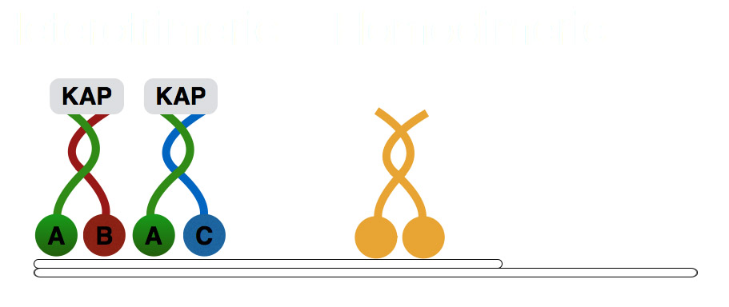

Figure 3. Schematic of the kinesin 2 family members. There are two heterotrimeric II complexes consisting of Kif3A (green), Kif3B (red) and KAP3 (grey) subunits, or Kif3A (green), Kif3C (blue) and KAP3 (grey) subunits. The heterotrimeric complexes are thought to function at the proximal region of the ciliary axoneme, on microtubule doublets. Whereas, the homodimeric complex Kif17 (yellow), is thought to function in the middle/distal segment, on microtubule doublet and singlets.

3.2 Results

3.2.1 Kif3a is required for ciliogenesis.
Mutations in kif3a kinesin cause early embryonic lethality in the mouse (Marszalek et al., 1999). Consequently, the analysis of kif3a function at later stages of development requires the use of conditional mutant alleles (Marszalek et al., 2000; Jimeno et al., 2006b; Avasthi et al., 2009). This is sometimes challenging due to the lack of appropriate tissue-specific promoters. To determine kif3a function at later stages of vertebrate development, we analysed its mutant phenotype in zebrafish using a truncating mutant allele, kif3a^{sa1617}, which contains a nonsense codon at position 409 of the open reading frame. This mutation eliminates the C-terminal portion of the motor domain as well as both the stalk and the tail domains resulting, in all likelihood, in a null phenotype (Figure 4A). It was not possible to perform immunostaining for KIF3A due to the lack of antibodies for this protein in zebrafish. The mutant displays phenotypes typical of ciliogenesis defects: curved body axis by 2.5 days post fertilisation (dpf) and kidney cyst by 5 dpf (Figure 4B). Initial experiments consisted of examining for the presence of cilia in different tissues of the zebrafish at different embryonic stages, using whole mount immunofluorescence with anti-acetylated-α-tubulin. Anti-acetylated-α-tubulin has been widely used as a marker for cilia as it marks long lived microtubule that accumulates acetyl moieties over time. However, this is not restricted to ciliary microtubules, but also extends to long lived microtubules found at the apical surfaces of cells. Another complication in using acetylated-α-tubulin staining is the possibility that only the microtubule is present and that the ciliary membrane is not present, or vice versa in these mutants. An alternative ciliary marker that could have been used to further support our findings, would be Arl13b, a small GTPase, highly enriched in ciliary membranes (Larkins et al., 2011). We did not find left-right asymmetry defects, however. Future work would involve further analysis to observe whether the cilia of kupffer’s vesicle are affected, as it is a specialised organ responsibility for left-right asymmetry in zebrafish. Consistent with these phenotypes, the loss of kif3a function results in the absence of cilia in the nasal pit (Figure 4D, D’), spinal canal (Figure 4F, F’), kidney (Figure 4G, G’) and the lateral line (Figure 1E, E’). Furthermore, we investigated cilia in the sensory patches of the auditory system. Cilia were largely absent in both cristae (Figure 4H - J’) and maculae (Figure 4K - L’). We did, nonetheless, observe short cilia stumps in auditory cristae (Figure 4H’, I’, J’, insets). In zebrafish, wild-type cristae differentiate particularly long cilia of about 20-25 μm at 5 dpf. In the mutant, these cilia average ~2.5 μm and ~3 μm at 3 and 5 dpf, respectively, and reach up to 5.4 μm in length. Although much shorter than wild-type cilia, they are nonetheless longer than many primary cilia in animal models or in tissue culture cells (Kramer-Zucker et al., 2005; Wilson et al., 2012; Lu et al., 2015a). The presence of cilia in kif3a^{sa1617}-/- mutant cristae suggests that another motor contributes to ciliogenesis in this tissue.
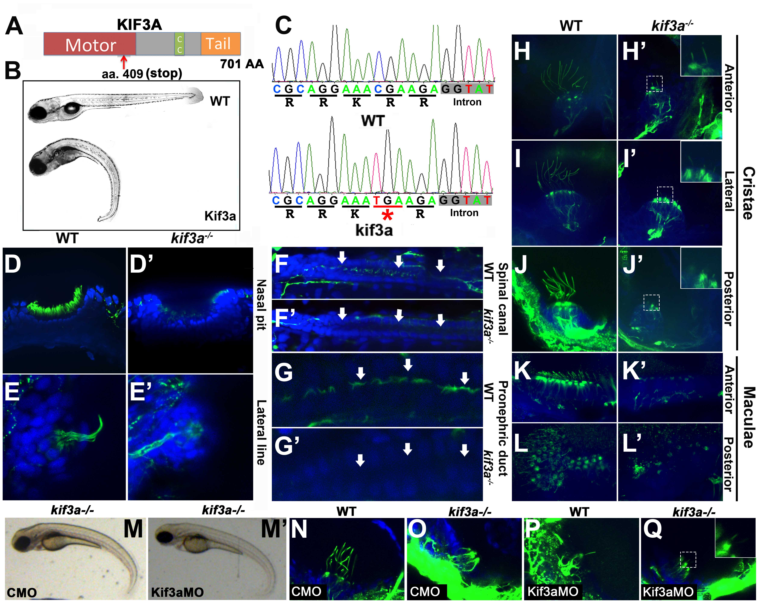
Figure 4. Cilia phenotype in kif3a mutants. (A) Schematic of the Kif3a protein domain structure. CC, coiled coil domain. Red arrow indicates approximate site of the stop codon in the sa1617 allele. (B) Phenotypes of wild-type (top) and kif3a-/- (bottom) zebrafish larvae at 5 dpf. (C) Sequences of wild type and mutant kif3a^{-/-} protein. The mutation (underlined in red and indicated with an asterisk) is in the motor domain and results in a premature stop codon. (D - L’) Whole mount immunostaining of wild-type and kif3a-/- mutant embryos at 5 dpf in several tissues as indicated. Cilia are labelled with anti-acetylated-α-tubulin antibody in green and cell nuclei are counterstained with DAPI in blue. (D, D’) nasal pit, (E, E’) lateral line, (F, F’) spinal canal, (G, G’) kidney, (H - L’) sensory patches of the ear. For kidney examination, kif3a-/- mutants in Nacre background were used to remove the pigmentation that normally obscures the kidney tubule. Arrows indicate kidney and spinal canal lumen. Insets in H’, I’, J’ and Q show stubs of cilia in cristae. (M’) Morpholino knockdown of kif3a in kif3a-/- mutants do not exacerbate the body curvature at 3 dpf compared to (M) control morpholino knockdown. (N-Q) Whole mount immunostaining of lateral cristae with anti-acetylated-α-tubulin antibody (in green) at 3 dpf. (N) The phenotype of control morpholino (CMO) treated WT embryos. (O) CMO treated kif3a-/- embryos. (P) kif3aMO treated WT embryos, (Q) Kif3aMO treated kif3a-/- embryos.

To assess whether the kif3a^{sa1617}-/- mutant allele is null, we performed morpholino knockdown experiments (Figure 4M-Q). If the severity was enhanced then this would suggest that kif3a is not a complete null allele. The external body curvature of kif3a-/- embryos was not exacerbated by kif3a morpholino (kif3aMO) knockdown in the kif3a^{sa1617}-/- mutant background, compared to control morpholino (CMO) knockdown (Figure 4M, M’). Similarly, the ciliary stubs observed in lateral cristae of kif3a-/- embryos remained even after kif3aMO knockdown (Figure 4N-Q). These data provide further evidence that kif3a^{sa1617}-/- mutants are amorphic.

3.2.2 Photoreceptor phenotype of kif3a-/- mutants.
Vertebrate photoreceptor cells feature an unusually bulky cilium. Their membranes form hundreds of disks containing the visual pigment, opsin, and other component of the phototransduction apparatus (Rodieck, 1973; Kennedy and Malicki, 2009). It is estimated that the photoreceptor cilium of some species contains 10⁹ of opsin molecules (Pugh and Lamb, 2000), and opsin appears to be transported into the cilium at the rate of 100-1000 molecules per second (Malicki and Besharse, 2012). Given this unusually intense stream of ciliary traffic, photoreceptor cilia may require additional motors. Genetic analysis in the mouse suggested, in fact, that this is the case: conditional mouse kif3a-/- mutants differentiate abnormal but nonetheless fairly bulky cilia in both rods and cones (Avasthi et al., 2009). These experiments suggested that protein transport sufficient for outer segment formation is present in cilia even in the absence of the kif3a. Another study in drosophila photoreceptors, reported the importance of kinesin II in recruiting Bazooka and Armadillo to adherens junction for proper photoreceptor morphogenesis and polarity (Mukhopadhyay et al., 2010). To test this further, we investigated the photoreceptor phenotype of kif3a-/- mutant zebrafish. Staining with anti-acetylated-α-tubulin antibody revealed that photoreceptor cilia are absent in kif3a-/- mutant homozygotes at 3 dpf (Figure 5A, A’).
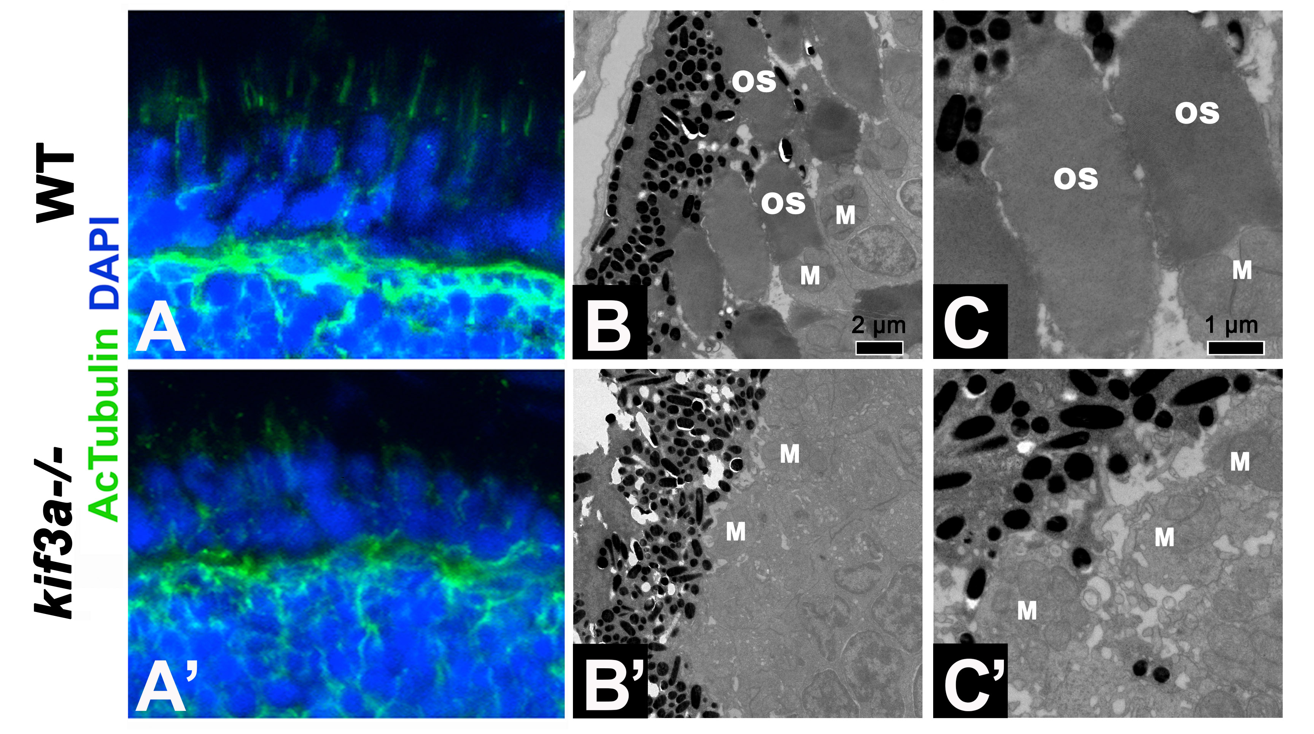
Figure 5. Photoreceptor phenotype in kif3a mutants. (A, A’) Cryosections through the wild-type (A) and kif3a-/- mutant (A’) retina immunostained with anti-acetylated-α-tubulin in green and counterstained with DAPI in blue. Cilia are absent in (A’) kif3a-/- embryos at 3 dpf. (B - C’) Transmission electron microscopy of photoreceptors in wild-type (B, C) and kif3a-/- (B’, C’) retinae at 5 dpf. Outer segments are missing in the mutant. Scale bars, 1 µm (B, B’) and 2 µm (C, C’). OS, outer segment; M, mitochondrial clusters. LWT background fish strains used in all experiments

To investigate this phenotype further, we performed ultrastructural analysis. kif3a-/- mutant photoreceptors differentiate fairly robust inner segments as evidenced by the presence of apical clusters of mitochondria (Figure 5B’-C’). The cilia (outer segments) of the same cells are, however, completely absent. These results indicate that similar to IFT mutants, kif3a-/- animals do not differentiate apical photoreceptor outer segments (Doerre and Malicki, 2002; Pazour et al., 2002; Tsujikawa and Malicki, 2004). Unexpectedly, a closer inspection of basal bodies in kif3a-/- mutant photoreceptors at 5 dpf revealed that they frequently do not localize to the apical surface of inner segments (Figure 6A-D, Table. 3), even though some appear to dock to intracellular membranes (Figure 6C). Many basal bodies are found deep in the inner segment cytoplasm surrounded by mitochondria (Figure 10A-A’). Although in one case we observed a photoreceptor cell that differentiated a rudimentary cilium, the basal body of this cilium localized basally to the mitochondrial cluster of the inner segment and the cilium itself extended away from the retinal pigment epithelium (RPE) and the apical terminus of the cell (Figure 6D). This further illustrates the role of kif3a in the positioning of basal bodies. Although mislocalized, kif3a-/- basal bodies appear to form normal transition fibres and on occasion are found associated with a vesicle (Figure 6B-C). Such docking of basal bodies to a cytoplasmic vesicle has been described at early stages of ciliogenesis in several cell types including the photoreceptors (Sorokin, 1962; Sorokin, 1968; Sedmak and Wolfrum, 2010; Lu et al., 2015b). Thus kif3a does not appear to function in basal-body docking to the membrane, but is necessary for basal body localization in the apical cytoplasm in photoreceptors.
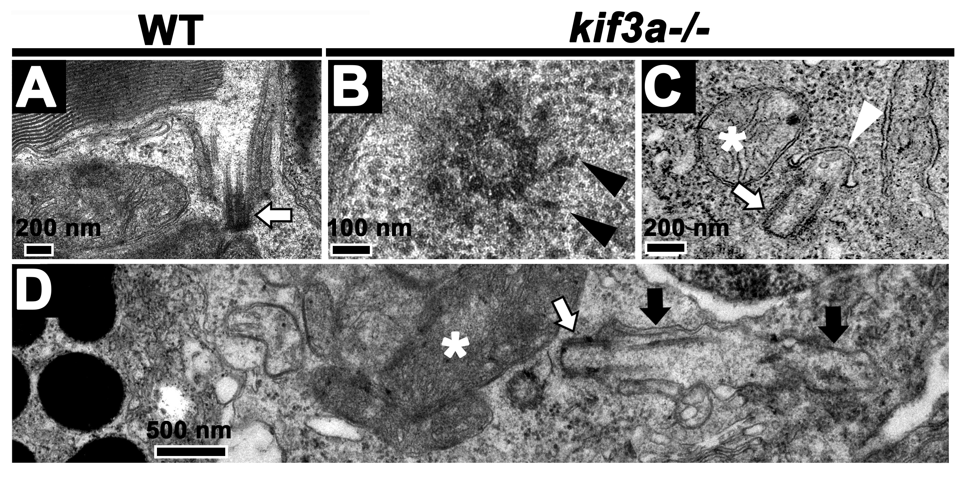
Figure 6. Basal body of photoreceptors in kif3a mutants. (A-D) Transmission electron microscopy of the basal body in wild-type (D) and kif3a-/- (B-D) embryos at 5 dpf. (B) Transverse cross section through kif3a-/- mutant basal body. Transition fibers (arrowheads) differentiate on at least some basal bodies. Scale bar, 100 nm. (C) An example of a basal body (arrow) attached to a pre-ciliary vesicle (arrowhead). Scale bar, 200 nm. (D) An example of a membrane-docked basal body (arrow). Note that although it forms axonemal microtubules, it does not assemble outer segment membrane folds. Scale bar, 0.5 µm. White arrows, basal body; black arrows, ciliary microtubules; asterisks, mitochondrial clusters.

In contrast to photoreceptor cells, kif3a is not required to dock basal bodies in mechanosensory hair cells and, as described above, short cilia differentiate in mechanosensory cristae of kif3a-/- animals (Figure 4H-J’). To further assess ciliogenesis in kif3a-/- mutants, we investigated the ultrastructure of cristae and maculae (Figure 7A-C). In nearly all cases examined (36/37), we found that basal bodies of these tissues are anchored to the apical surface (Figure 7A, arrow). Similar to wild-type cilia, they are supported by microtubules both at 3 and 5 dpf (Figure 7B-C).
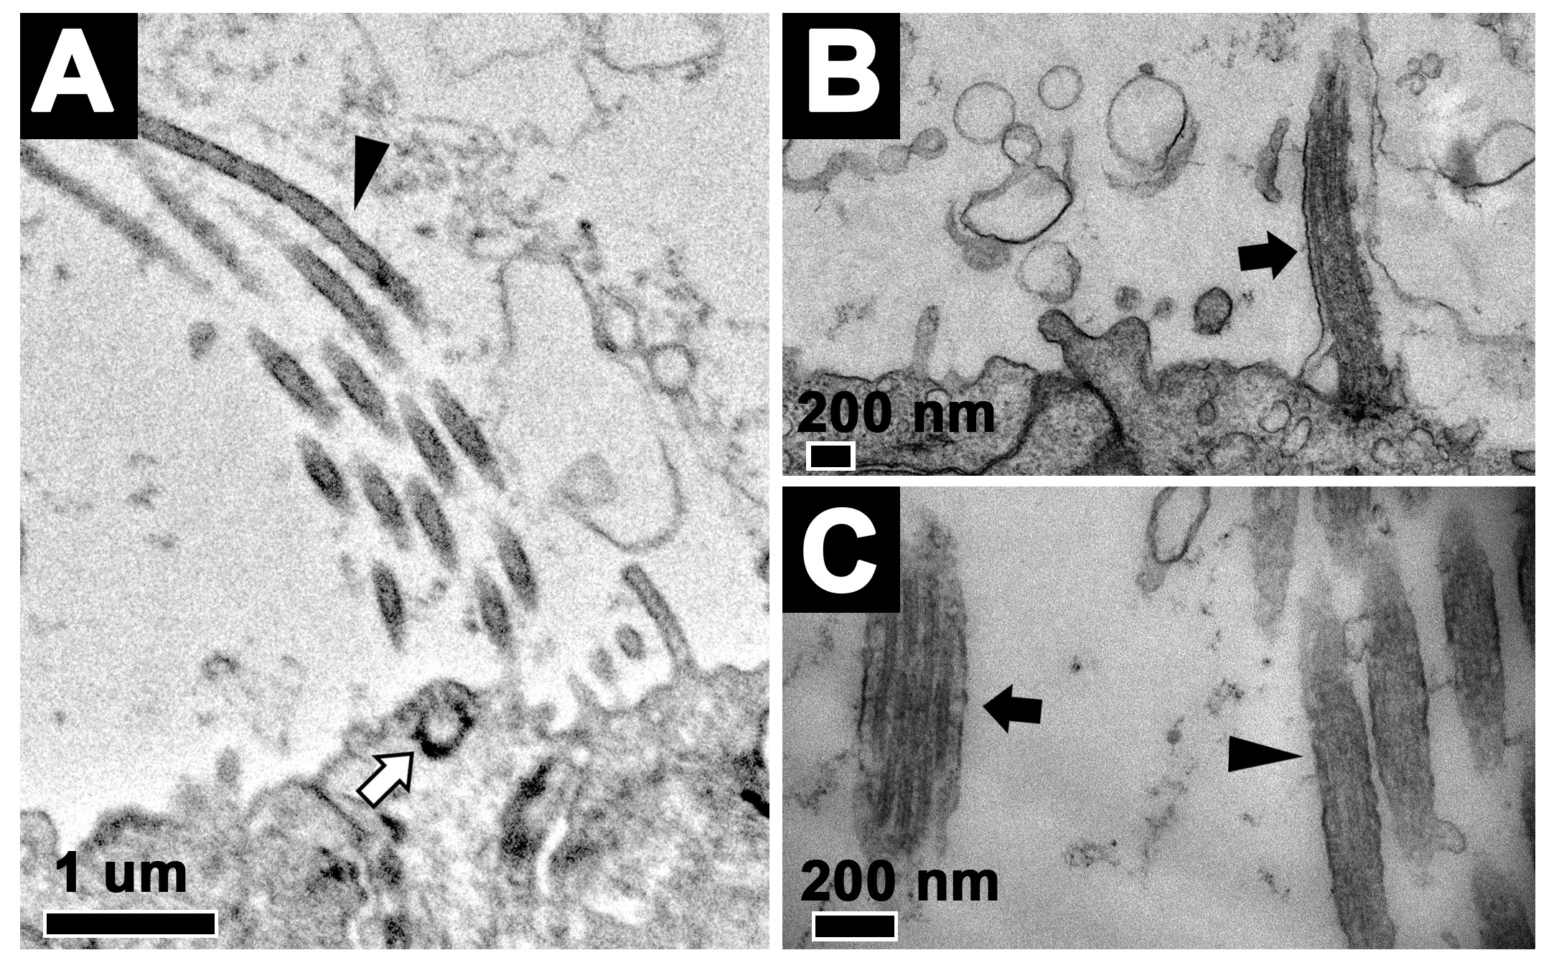
Figure 7. Basal body and cilia of hair cells in kif3a mutants. (A) Transmission electron microscopy of stereocilia in the lateral cristae of kif3a-/- embryos at 3 dpf. White arrow indicates docked basal body, black arrowhead indicates stereocilia. Scale bar, 1 um. (B) Transmission electron microscopy of cilia in the lateral cristae of kif3a-/- embryos at (B) 5 dpf and (C) 3 dpf. Black arrows indicate cilia and black arrowheads stereocilia.

It is noteworthy that multilayered membrane structures reminiscent of outer segments are observed ectopically in the retinae of kif3a-/- mutants at both 3 (5 out of 26 sections analyzed) and 5 (13 out of 27 sections analyzed) dpf (Figure 8A-B). Such structures were previously found in the zebrafish oval/ift88 mutant (Tsujikawa and Malicki, 2004), and we have now also observed them in fleer/ift70 mutants (Figure 5H). In both fleer-/- and kif3a-/- mutants, these ectopic membrane arrays differentiate on the lateral surface of photoreceptors and most of them do not contact RPE cells. In some cases (n=5), it was clear that basal bodies are positioned away from these ectopic membrane arrays in the same cell, and in a few instances when mutant basal bodies extended short axoneme, these were not associated with membrane folds that characterize the outer segment (Figure 6D). These observations reveal that the assembly of outer segment membrane folds does not require kif3a and at least some IFT genes and that these structures form in a cilia-independent manner.
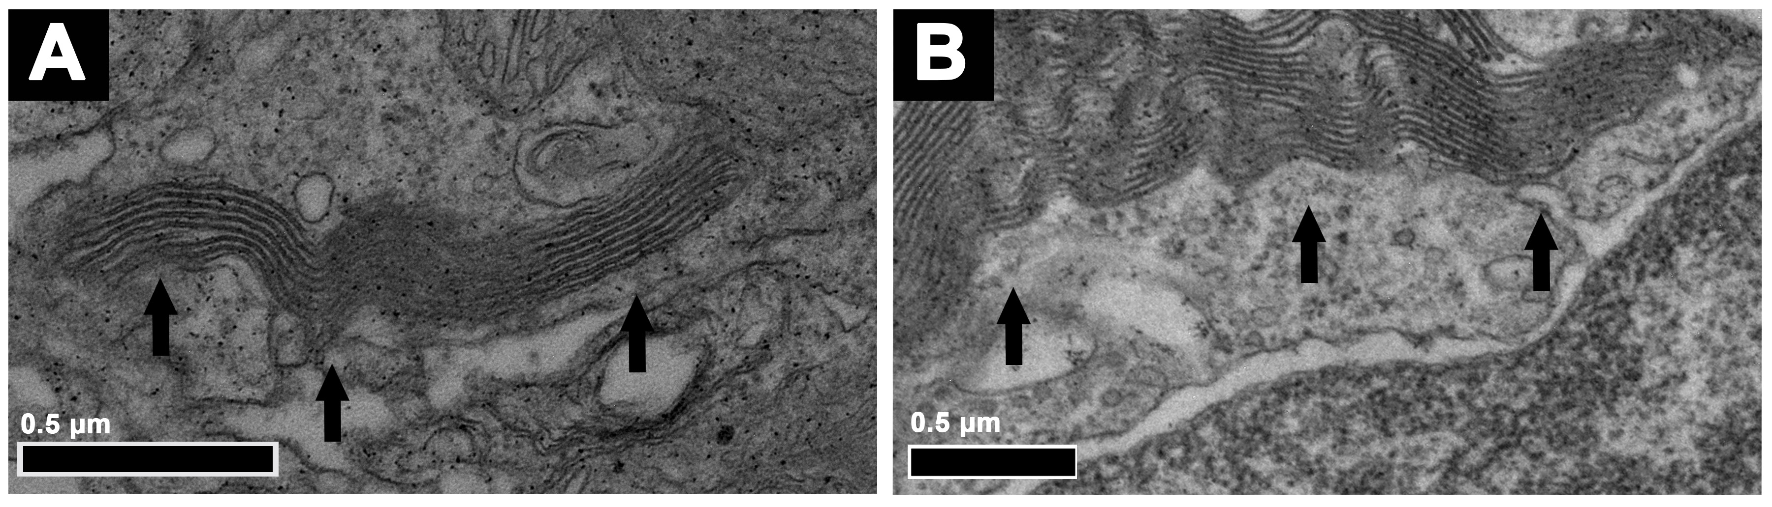 Figure 8. Ectopic membranes in kif3a mutants. (A, B) Ectopic membranes are found in kif3a-/- (A) and fleer-/- (B) at 5 dpf. In (A-B) apical is left; black arrows, ectopic membrane folds.

3.2.3 Functions of Kif3a and IFT particle proteins in photoreceptors
Rapid degeneration of both cones and rods is observed in IFT mutants, including oval, elipsa and fleer (Doerre and Malicki, 2002; Tsujikawa and Malicki, 2004). Because both the heterotrimeric kinesin 2 and IFT particle components are parts of the same intraflagellar transport protein complex, it is expected that loss of the motor should result in photoreceptor degeneration similar to that observed in IFT particle mutants. This, however, is not the case. Photoreceptor degeneration rate is slower for both cones and rods in kif3a-/- embryos, compared to elipsa, oval and fleer mutants of IFT particle components (Figure 9A-K).
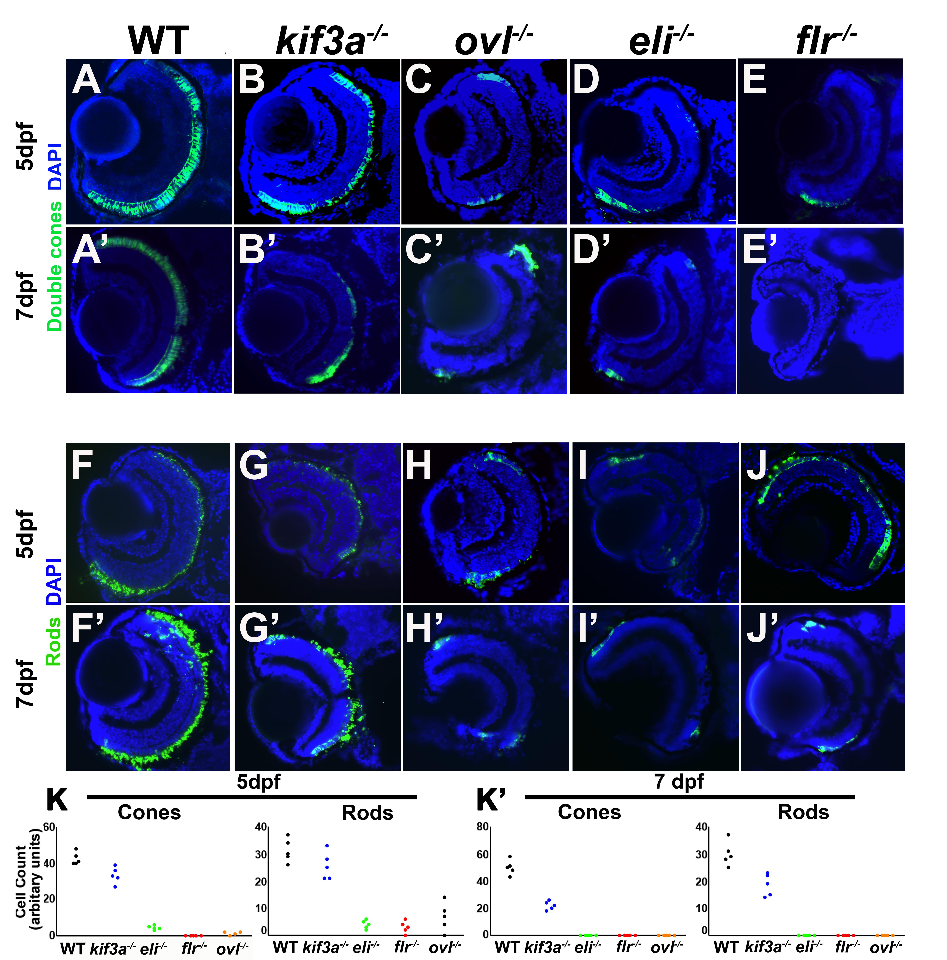
Figure 9. Photoreceptor survival and basal body phenotype in kif3a-/- and IFT mutants. (A, E’) Transverse cryosections through wild-type, kif3a-/-, oval-/-, elipsa-/-, and fleer-/- retinae as indicated, stained for double cones using ZPR-1. Some loss of cones is observed in kif3a-/- (B) mutant compared to the wild-type (A) at 5 dpf. A much more pronounced photoreceptor loss is seen in IFT mutants (C-E). Similar phenotypes are observed at 7 dpf (A’, E’). (F-J’) Similar effect in rods staining using ZPR-3. (K-K’) Graphs illustrating the survival rates of cones and rods in wild type, kif3a-/-, oval-/-, elipsa-/-, and fleer-/- at 5 dpf and 7 dpf, as indicated. Method of counting number of cells explained in methods. LWT background fish strains used in all experiments

To test whether the severity of photoreceptor degeneration in kif3a-/- and IFT mutants correlate with basal body mispositioning, we compared kif3a-/-, elipsa-/-, and fleer-/- phenotypes using transmission electron microscopy. As the majority of photoreceptors have degenerated in IFT mutants by 5 dpf, we examined photoreceptor basal bodies at 3 dpf. In contrast to kif3a-/-, in mutants of two IFT genes, elipsa-/- (ift54) and fleer-/- (ift70), the majority of basal bodies were docked to the apical surface of the inner segment or localized close to the RPE (Figure 10A-E). Detailed analysis of basal body localization revealed that kif3a-/- basal bodies localize with approximately equal frequencies apical 33%, basal 26%, or lateral 19% to the inner segment mitochondrial cluster at 3 dpf (Table. 3). Equally frequently, they are also found in the middle of mitochondria 22% (Figure 10D, Table. 3). In contrast to that, 67% (16/24) and 70% (16/23) of basal bodies localize apically in elipsa-/- and fleer-/-, respectively (Figure 10D, Table. 3). Measurements of the distance from basal bodies to the RPE revealed similarly pronounced differences between mutant phenotypes of kif3a and IFT genes (Figure 10E). These data show that kif3a functions in the apico-basal polarity of photoreceptors by positioning the basal body to the apical terminus of the cell. IFT proteins may also contribute to this process, although their role is less pronounced. Moreover, as basal body mislocalization is considerably more severe in kif3a-/- photoreceptors compared to elipsa-/- and fleer-/- mutant cells, which degenerate faster, it is not a non-specific consequence of photoreceptor degeneration.

Table 4. Localization and membrane docking of basal bodies.
Genotype | Basal Body Localization |  |  |  | n | Docked | n
 | Apical | Basal | Central | Lateral
kif3a-/- | 9 (33%) | 7 (26%) | 6 (22%) | 5 (19%) | 27 | 10(59%) | 17
elipsa-/- | 16 (67%) | 2 (8%) | 2 (8%) | 4 (17%) | 24 | 9 (60%) | 15
Fleer-/- | 16 (70%) | 3 (13%) | 4 (17%) | 0 (0%) | 23 | 14 (61%) | 23
kif3a-/-; eli-/- | 5 (38%) | 6 (23%) | 9 (35%) | 6 (23%) | 26 | 4 (40%) | 10
Kif3a-/- 5 dpf | 9 (39%) | 5 (22%) | 2 (9%) | 7 (30%) | 23 | 10 (50%) | 20

Localization of basal bodies in photoreceptor cells relative to mitochondrial clusters for the following genotypes: kif3a-/-, elipsa-/-, fleer-/-, kif3a-/-;elipsa-/- at 3 dpf and for kif3a-/- at 5 dpf. Apical - basal bodies located above the mitochondrial cluster, basal – basal body located below the mitochondrial cluster, central – basal body found within the mitochondrial cluster, lateral – basal body located on either sides of the mitochondrial cluster in the photoreceptor cells. Docking of basal bodies to the membrane, including membranes of intracellular vesicles, was also evaluated. Only sections that included the long axis of either the mother or the daughter centriole were considered in counts of docked basal bodies. The basal bodies were counted from all the photoreceptor cells of the entire retina, that fit the criteria described above. If all centrosomes dock to the membrane, this analysis is expected to show 50% of centrioles as attached to the membrane.

The difference between kif3a-/- and IFT mutant phenotypes is open to several interpretations. One possibility is whether kif3a have additional roles independent of the cilium in signalling photoreceptor degeneration in the presence of damage to photoreceptors. Such as a role in a checkpoint like mechanism, then the severity of elipsa or fleer mutation would be reduced in the absence of kif3a. We also considered a possibility that Kif3a accumulation in the cytoplasm of photoreceptors mutant for IFT genes is toxic to the cell. Alternatively, IFT proteins may have intraflagellar transport-independent functions in the cell. To distinguish between these possibilities, we constructed double mutants of kif3a and IFT genes. kif3a-/-;elipsa-/- or kif3a-/-;fleer-/- double mutants have similar photoreceptor degeneration rates as single IFT mutants (Figure 11A-I). As cilia and ciliary outer segments are missing in both kif3a and IFT gene mutants, which implies that intraflagellar transport is absent, the simplest interpretation of these observations is that IFT proteins have intraflagellar transport-independent function in photoreceptors.

As discussed above, kif3a is necessary for basal body localization to the apical surface in photoreceptor cells. This phenotype of kif3a-/- may be mediated by an ectopic function of IFT proteins in the basal body area. To test this possibility, we investigated basal body localization in kif3a-/-;elipsa-/- double mutants and found that kif3a is necessary for basal body localization even in the absence of elipsa-/- (Figure 10D-E, 10J-J’, Table. 3). These results show that kif3a basal body positioning defect is not caused by an ectopic activity of the IFT particle.
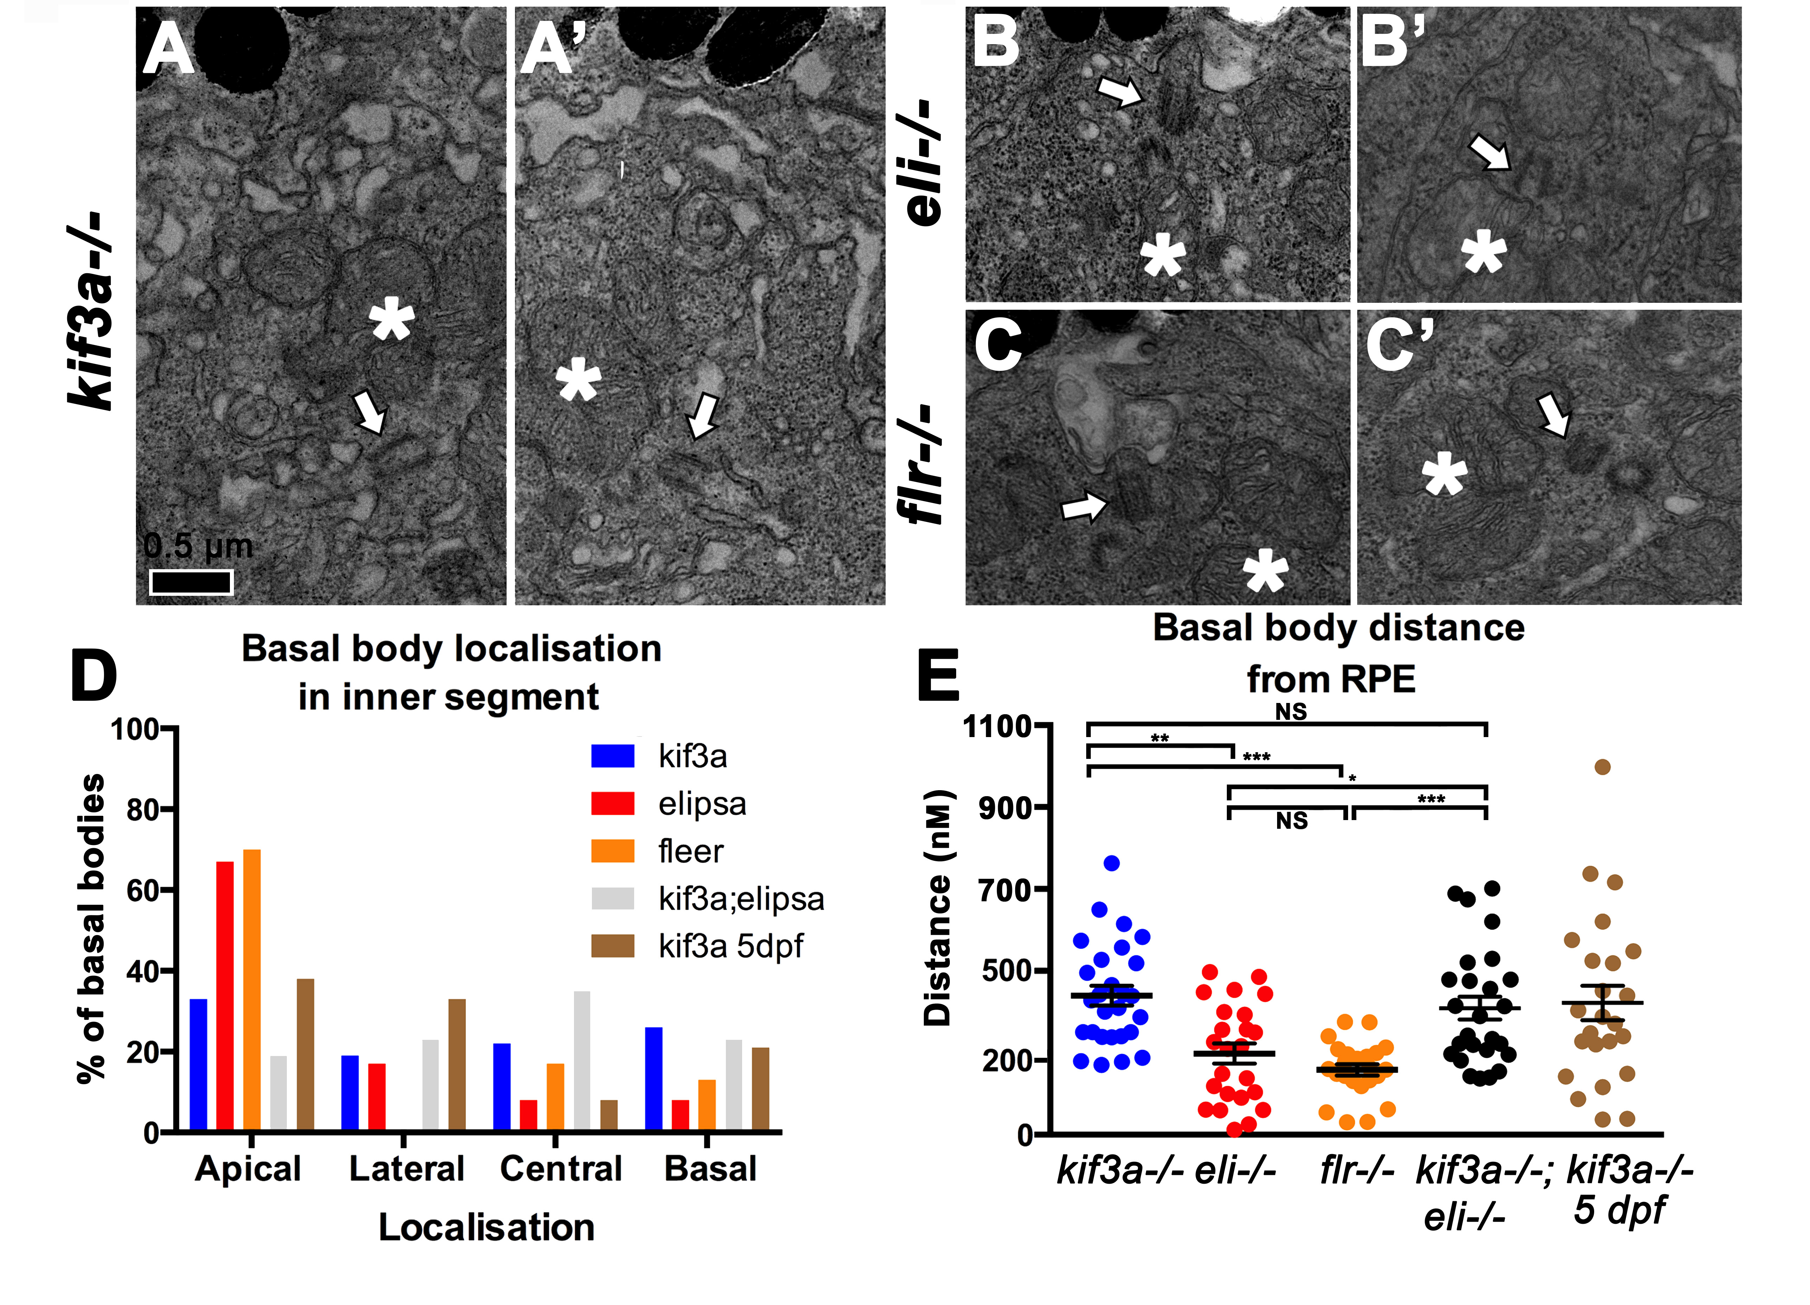
Figure 10. Basal body localisation in kif3a mutants. (A, C’) Transmission electron microscopy of basal bodies in kif3a-/- (A-A’), elipsa-/- (B-B’) and fleer-/- (C-C’) at 3 dpf. Scale bar, 0.5 µm. (D) Graph illustrating the percentage of basal bodies that localize to the apical, basal, lateral, or central (i.e. in the middle of the mitochondrial cluster) regions of the inner segment, in kif3a-/-, elipsa-/-, fleer-/-, and kif3a-/-;elipsa-/- double mutant at 3 dpf, and in kif3a-/- at 5 dpf as indicated. Localisation of basal bodies were scored relative to the mitochondrial clusters in photoreceptor cells. (E) Graph illustrating the distance between basal bodies and the RPE in kif3a-/-, elipsa-/-, fleer-/- and kif3a-/-;elipsa-/- double mutants, at 3 dpf, and in kif3a-/- at 5 dpf. Distance of basal bodies measured through drawing a straight line from basal body to the RPE layer on FIJI. The mean and standard error bars are indicated. For each experimental group, ≥ 23 basal bodies from 3-4 retinae were evaluated. P < 0.05 = *; P < 0.01 = **; P ≤ 0.001 = ***; NS, not significant, based on Mann-Whitney U-test. In (A-C’) apical is up. Asterisks, mitochondrial clusters; white arrows, basal bodies. LWT background fish strains used in all experiments.
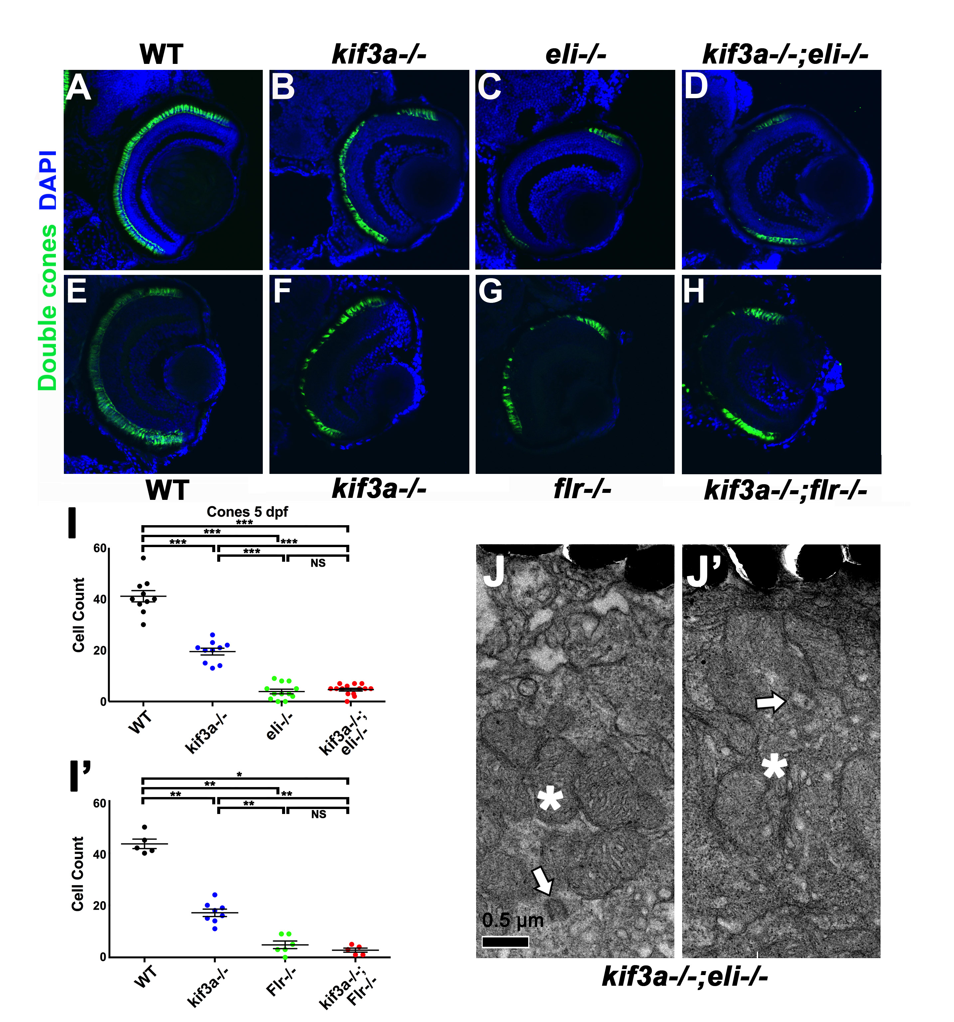
Figure 11. Double mutant phenotypes of kif3a and IFT genes. (A-H) Cryosections of wild-type, kif3a-/-, elipsa-/-, fleer-/-, kif3a-/-;elipsa-/-, kif3a-/-;fleer-/- double mutants at 3dpf, as indicated. Sections were immunostained with ZPR-1 to visualize cones, and counterstained with DAPI to visualize nuclei. No significant differences are found in photoreceptor survival between elipsa-/- single mutants and kif3a-/-;elipsa-/- double mutants. Similarly, fleer-/- single mutants and kif3a-/-;fleer-/- double mutants display very similar photoreceptor degeneration rates. (I – I’) Graphs illustrating cone survival rates in single and double mutants at 5 dpf as indicated. The mean and standard error bars are indicated. All experimental groups include data from ≥ 5 animals. P ≤ 0.05 = *; P ≤ 0.01 = **; P ≤ 0.001 = ***; NS, not significant, based on Mann-Whitney U-test. (J, J’) Transmission electron microscopy of basal bodies in kif3a-/-;elipsa-/- double mutant embryos at 3 dpf. Scale bar, 0.5 µm. Apical is up. Arrows, basal body; asterisks, mitochondrial clusters. LWT background fish strains used in all experiments.
The centrosome acts as the microtubule-organizing center (MTOC). Centrosome defects in kif3a-/- mouse fibroblasts lead to microtubule disorganization (Kodani et al., 2013). As centrosomes and basal bodies are closely related, and the MTOC in photoreceptor cells are the basal bodies, located at the base of the connecting cilium, kif3a may also function in organizing photoreceptor microtubules. To investigate this, we immunostained kif3a-/- retinal sections with alpha tubulin, and evaluated the microtubule network in the photoreceptor cells (Figure 12A-A’). We did not observe any defects at the confocal resolution, however, it is possible that subtle defects may be apparent at higher resolutions. To test this possibility, we used super-resolution microscopy on kif3a-/- retinal cryosections stained with anti-α-tubulin antibodies to visualize microtubules. This allowed us to observe individual microtubule filaments within the photoreceptor cell. We did not detect, however, any obvious abnormalities in microtubule arrangement of kif3a-/- mutant photoreceptor cells (Figure 12B-C’’). Similar to kif3a-/-, BBS4 loss of function results in microtubule disorganization (Kim et al., 2004). BBS4 is mislocalized in photoreceptors of zebrafish mikre oko/dynactin p150 mutants (Tsujikawa et al., 2007), and kif3a is required to localize p150 to subdistal appendages of centrioles (Kodani et al., 2013). These observations suggest that kif3a may be required to localize BBS4 in photoreceptor cells. This was not, however, the case as we observed no differences in BBS4 localization between WT and kif3a-/- photoreceptors (Figure 12D-D’). In addition to this, kif3a is also known to localise to ribbon synapses and vesicles (Heidelberger et al., 2005). It could potentially have a role in transporting vesicles to the active zone of the synapse, which requires further investigation in the future.

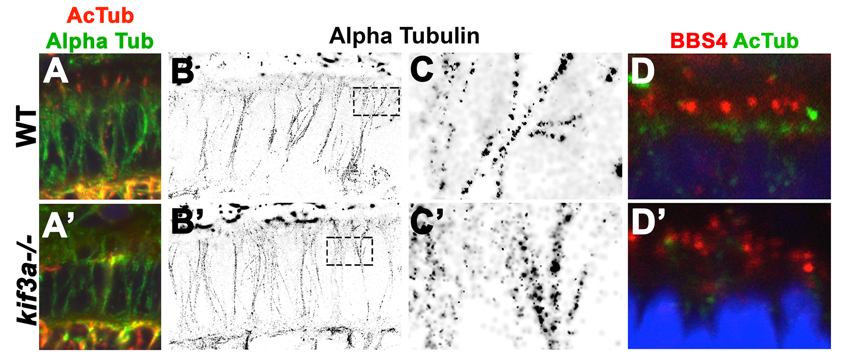 Figure 12. Microtubule related defects in kif3a mutant photoreceptors. (A-A’) Confocal imaging of cryosections through WT and kif3a-/- mutant retinae, immunostained for acetylated--tubulin (in red – labelling cilia), and α-tubulin (in green – labelling microtubules) at 3 dpf. No obvious difference between WT and mutant (B-B’) STORM imaging of cryosections through WT and kif3a-/- mutant retinae, immunostained with anti-α-tubulin antibody to visualize microtubules at 3 dpf. RPE layer is at the top. No obvious differences between WT and mutants are found. (C-C’) Enlargements of areas indicated by dashed boxes in B, B’. (D-D’) Transverse cryosections of WT and kif3a-/- mutant retinae immunostained for BBS4 (in red), and acetylated-α-tubulin (in green) 3 dpf. No obvious differences are found between WT and mutants. LWT background fish strains used in all experiments.

As kif3a-/- basal bodies dock to the membrane (Table. 3), we asked whether transition zone assembly proceeds normally in kif3a-/- mutants. To address this, we determined the localization of a transition zone protein, CC2D2A/MKS6, which genetically localizes downstream of several other transition zone components (Williams et al., 2011). Surprisingly, CC2D2A puncta are still present in the same quantity (on average 15 per an arbitrary unit of length for both WT and mutant, n≥9) suggesting that the transition zone forms at least partially in kif3a-/- mutants (Figure 13A-A’). This finding is consistent with EM data showing that basal bodies differentiate transition fibers and attach to vesicles in the cytoplasm (Fig. 5B,C). kif3a is, however, required for IFT particle assembly at photoreceptor basal bodies as Ift88 protein is absent from basal bodies of kif3a^{sa1617}-/- mutants visualized with antibodies to γ-tubulin (Figure 13B-B’). These results show that kif3a acts after the initial steps of transition zone assembly but prior to basal body anchoring at the apical membrane and IFT particle assembly. The γ-tubulin staining, marking the basal bodies, does not seem to be mislocalized, as seen on electron microscopy. However, this may be due to the lower resolution of confocal microscopy at distinguishing localisation of basal bodies.

We also tested Crumbs known to be important for apical-basal polarity and have been shown to localize to the apical surface of photoreceptor cells. In addition to this, in Drosophila, kif3a plays an important role in adherens junction for proper polarity and junction formation in the retina. Thus, it is possible that in the absence of KIF3A, Crumbs may not correctly localize to the apical surface of photoreceptors, as a result affecting the localization of basal bodies. However, the antibody did not work effectively. Another marker used to observe the apical polarity was phalloidin that marks F-actin. There was no difference in actin labelling, suggesting that the OLM and apical polarity is unaffected in kif3a-/- (Figure 13C-C’).
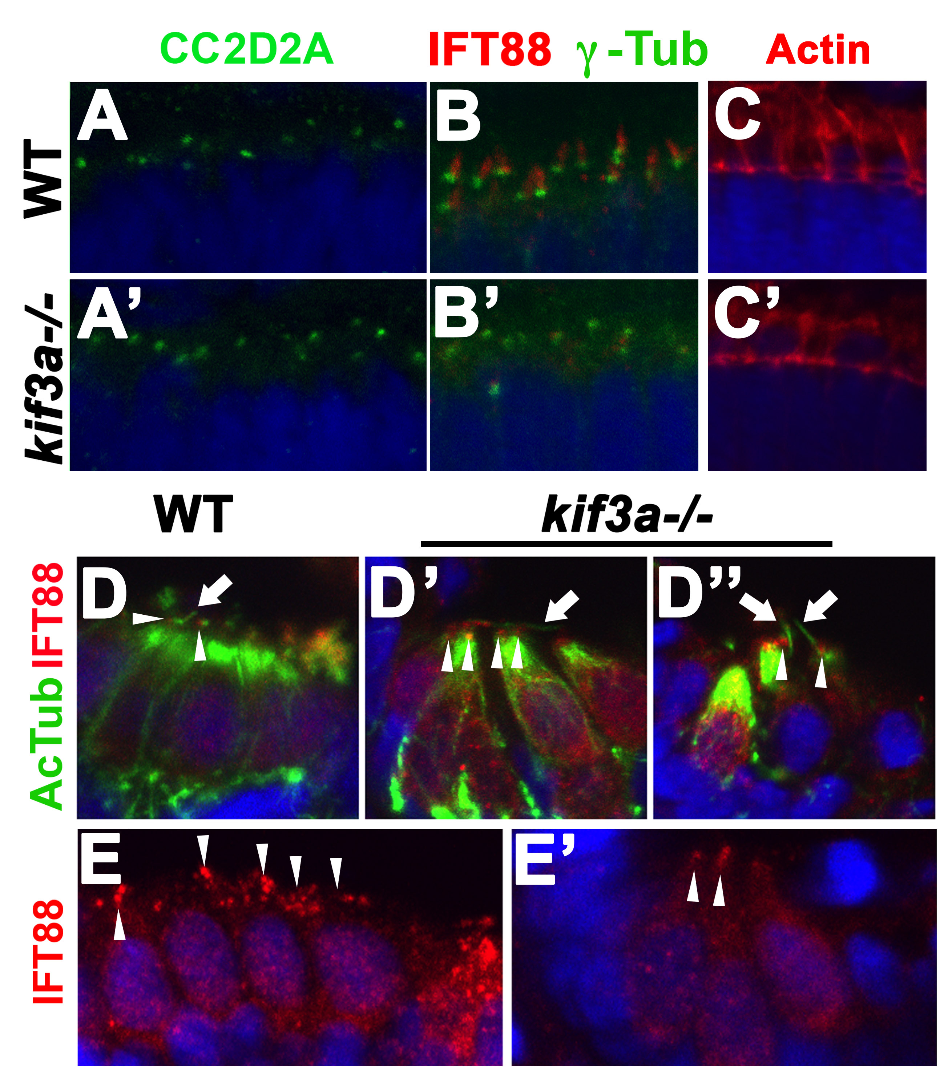
Figure 13. (A-A’) Transverse cryosections through the retina in WT and kif3a-/- mutants immunostained for the transition zone marker, CC2D2A (in green) at 3 dpf. No obvious difference between WT and mutants are observed. (B-B’) Transverse cryosections of WT and kif3a-/- mutant retinae immunostained for IFT88 (in red) and γ-tubulin (in green – labelling basal body) at 3 dpf. IFT88 localizes apical to γ-tubulin in WT, but is strongly reduced in kif3a-/- mutants. (C-C’) Transverse cryosections of WT and kif3a-/- mutant retinae stained with Phalloidin to stain actin, with no obvious difference. (D-D’’) Transverse cryosections of lateral cristae stained for IFT88 (in red) and anti-acetylated-α-tubulin (in green) at 5 dpf. Ift88 signal persists in mutant cristae. (E-E’) Transverse cryosections of the lateral cristae stained for IFT88 (in red) at 5 dpf. IFT88 localization to the apical surface of hair cells is not affected in kif3a-/- mutants. In (E-E’), sections are counterstained with DAPI (in blue) to visualize nuclei. LWT background fish strains used in all experiments.

In addition to IFT88, we attempted to use other IFT markers such as the markers for Ift57, Ift122 and Ift52, to test whether a similar outcome is observed with other IFT markers. However, they failed to work properly using standard immunostaining protocol, most likely due to the age of the antibodies resulting in loss of their activity. Nevertheless, in an attempt to improve the staining of these antibodies, several alternative protocols were used such as the antigen retrieval procedure, acetone treatment and TCA fixed embryos. Unfortunately, none were effective in improving the staining of these antibodies. Future experiments to determine whether other IFT proteins are also diminished at the basal body in the kif3a-/- mutants would further support the idea of IFT complex recruitment requires kif3a.
The presence of cilia in kif3a-/- mutants suggested the possibility that an kif3a-independent transport mechanism operates in cilia of cristae. To test whether this mechanism involves intraflagellar transport, we stained kif3a^{sa1617}-/- mutant cristae with antibodies to IFT88 (Figure 13D-D’’). In kif3a-/- photoreceptors IFT88 is absent by 3 dpf (Figure 13B-B’). In contrast to that, IFT88 puncta are present at the cilia base in cristae of kif3a-/- mutants even at 5 dpf (Figure 13D-E’). Thus, surprisingly, unlike in other tissues, kif3a is not required to localize IFT proteins in cristae cilia, suggesting that IFT may be functioning in this tissue with the aid of another motor.

3.3 Discussion

3.3.1 kif3a phenotypes
Our data show that a heterotrimeric kinesin 2 motor subunit, kif3a, is required for the formation of cilia in almost all tissues examined, including photoreceptor cells. The absence of photoreceptor outer segments is often associated with rapid photoreceptor degeneration. Unexpectedly, kif3a-/- photoreceptors degenerate at a slower pace, compared to IFT protein mutants. This is surprising as kif3a-/- and IFT mutants, such as oval-/-, elipsa-/-, and fleer-/- involve complete absence of photoreceptor cilia (Doerre and Malicki, 2002; Tsujikawa and Malicki, 2004). Consequently, a similar level of photoreceptor degeneration is expected in heterotrimeric kinesin and IFT mutants. Contrary to this expectation, kinesin and IFT mutations have different impacts on photoreceptor survival. kif3a-/-;elipsa-/- and kif3a-/-;fleer-/- double mutants and IFT single mutants display similar rates of photoreceptor loss, indicating that IFT proteins display a cilia-independent function in photoreceptors. Equally unexpected is the observation that kif3a-/- functions in the polarity of photoreceptor inner segments and its absence causes mispositioning of photoreceptor basal bodies. Finally, stubs of cilia persist in the cristae of kif3a-/- mutants at 3 and 5 dpf, suggesting that partial ciliogenesis does not require kif3a in this tissue. Taken together, this analysis reveals new functions for both ciliary kinesins and genes encoding IFT particle components.
Several attempts to conditionally remove kif3a in mouse photoreceptor cells produced inconsistent results. Initially it was shown that opsin mislocalises in mouse photoreceptor inner segments when kif3a is specifically deleted in photoreceptors using the IRBP-Cre or RHO-Cre drivers (Marszalek et al., 2000; Jimeno et al., 2006a). In contrast to that, another Cre driver, iCre75 that conditionally removes kif3a in mouse rods had very little effect on rhodopsin localization (Avasthi et al., 2009). Regardless of the driver used, rod outer segments differentiated in mutant photoreceptors. When RHO-Cre driver was used to eliminate kif3a function, rod outer segments formed normally and remained normal up to P10 (Jimeno et al., 2006b). Similarly, when the iCre75 driver was applied, rod connecting cilia and outer segments remained well differentiated until at least P13 (Avasthi et al., 2009). Cones also differentiated fairly robust, although not entirely normal, outer segments when conditional knockdown of kif3a was generated using human red/green opsin promoter to drive cre (Avasthi et al., 2009). This led to the idea that kif3a may not be the only motor required to transport rhodopsin as well as other transmembrane proteins in rod photoreceptors and that rod degeneration is due to causes other than opsin mislocalization in this mutant line (Avasthi et al., 2009). In contrast to these reports, a study of opsin-GFP trafficking in kif3a-deficient photoreceptor cells, demonstrated a role for kif3a in opsin transport (Trivedi et al., 2012).
We show that kif3a is essential for outer segment differentiation in both cones and rods of zebrafish. The difference between mouse and zebrafish data is most likely due to difficulties in conditionally removing kif3a in mouse rods at an appropriate stage so that it is early enough to prevent sufficient Kif3a protein remaining for driving formation of outer segments, while at the same time avoiding lethality due to a loss of kif3a function during early embryogenesis (Marszalek et al., 1999). In the case of the iCre75 transgene, the deletion of kif3a is completed by P14 (Li et al., 2005; Avasthi et al., 2009), which is most likely too late to eliminate kif3a from mouse photoreceptors (Avasthi et al., 2009).
Interestingly, we also found that kif3a is required for basal body localization to the apical surface of inner segments. Although kif3a-/- mutant basal bodies extend transition fibers and are frequently found associated with vesicles or membrane invaginations and thus are capable of docking to membranes, they are clearly displaced from photoreceptor apical termini. This demonstrates that kif3a functions in localizing the basal body to the apical area of the photoreceptor inner segment cytoplasm. Double mutants of kif3a and elipsa display the same phenotype as kif3a single mutants, indicating that kif3a basal body mislocalization is not caused by ectopic function of Elipsa protein, which may accumulate at the basal body when cilia are not formed. Basal body mislocalization is also observed in IFT mutants but is much weaker. This suggests that IFT proteins may act along kif3a to localize basal bodies, although their contribution is smaller.
What is the mechanism of kif3a action in basal body positioning? Previously it has been reported that kif3a associates with the mother centriole and is necessary for the assembly of subdistal appendage proteins on the mother centriole (Kodani et al., 2013). Furthermore, the same study demonstrated that while microtubules of wild-type cells emerge from the centrosome in a radial pattern, microtubules of kif3a-/- mutant cells are disorganized. These findings suggest that basal body mislocalisation in kif3a-/- photoreceptors could be due to the lack of microtubule organization necessary to anchor basal bodies to the apical surface. Kif3a, could, not only anchor the basal body to microtubules but also translocate the basal body along microtubules towards the apical surface. Although our super resolution microscopy imaging did not reveal obvious defects in microtubule organization in kif3a-/- mutants, it remains possible that we were unable to detect a small population of subapically localized microtubules. To investigate the mechanism of basal body localization further, we tested several markers of cilia assembly, one of which was CC2D2A/MKS6, a transition zone protein that is thought to function in a docking mechanism at the base of the photoreceptor cilium for cilia-targeted vesicles (Bachmann-Gagescu et al., 2015). A number of elegant studies in C. elegans demonstrated a hierarchy in the assembly of transition zone proteins and found that MKS6 localizes to the transition zone downstream of several other proteins (Williams et al., 2011; Lambacher et al., 2015). Thus the presence of MKS6 in kif3a-/- mutants indicates that kif3a functions downstream or in parallel to the early steps in transition zone formation (summarized in Figure 18). It remains to be determined whether other transition zone proteins also localize correctly in kif3a-/- mutants. In addition to this, Kif3a has been shown to localise in other regions of the retina such as OLM, and adherens junction, for recruitment of proteins for appropriate polarity and junction formation. This is another factor that needs further investigation in the future.
The function of kif3a in basal body positioning is, nonetheless, confined to a subset of cells, as basal bodies appear to localize correctly in mechanosensory hair cells of cristae, for example This would explain the correct apical surface anchoring of basal bodies in kif3a-/- mutant fibroblasts (Kodani et al., 2013). In addition to this, hair cells of cristae form cilia. Although substantially shorter than those in wild-type cristae, these cilia are nonetheless longer than primary cilia of many tissues: mouse brain ventricle cilia are approximately 0.75 μm at E12.5, the zebrafish spinal canal cilia ~2.1 μm, and cilia of zebrafish somites are ~1.8 μm at 15 hpf (Kramer-Zucker et al., 2005; Wilson et al., 2012; Lu et al., 2015a). Similarly in tissue culture, the cilia of NIH3T3 and IMCD3 measure ~2 μm, and ~1.5 μm, respectively (Lu et al., 2015a). To further investigate whether IFT trafficking is likely to take place in the ciliary stubs of kif3a-/- cristae, we examined the localization of IFT88. In contrast to kif3a-/- photoreceptors, IFT88 localizes to cilia of kif3a-/- mutant cristae. This suggests that an unconventional IFT particle-dependent transport mechanism functions in the cilia of cristae. The cilia of cristae are unusual in that they are long and rigid (see for example, Zhao et al., 2012). They may thus rely on additional kinesins for their formation. This is in agreement with our earlier findings that kif3b and kif17 function redundantly in the cilia of cristae but not maculae (Zhao et al., 2012).
The differences in the photoreceptor phenotype could be attributed to several factors in addition to alternative motors, such as differential roles of IFT in the different tissue or structural differences of the cilium itself. Interestingly, Ift81 and Ift74 have been demonstrated to posses the ability to bind tubulin, in addition to this Ift81/74 module can bind microtubules in vitro (Bhogaraju et al., 2013; Bhogaraju et al., 2014). Whether IFT can contribute to tubulin delivery for the initial stages of ciliogenesis in cristae is unclear, however, it is an interesting subject to investigate further. Whereas in photoreceptors, candidates that may interact with kif3a to mediate the docking of basal bodies, are the ninein-like protein (NINL) and sperm associated antigen (SPAG) 5 proteins. SPAG5 and NINL are both centrosomal and microtubule binding proteins, whereby SPAG5 is targeted to the centrosome by NINL (Cheng et al., 2007; Thein et al., 2007). Both components are necessary for appropriate mitotic spindle formation and are implicated in ciliogenesis (Cheng et al., 2007; Kersten et al., 2012). Thus, kif3a perhaps functions upstream of these centrosomal components to target the basal body to the apical membrane. Furthermore, Usher proteins that localise to the periciliary ridge complex and the basal body associate with NINL (van Wijk et al., 2009; Sorusch et al., 2014). This interaction could mediate the basal body docking in kif3a-/- mutant photoreceptors. The retinal and ear specific defects observed in patients with Usher syndrome, further supports the concept that the Usher complex may function downstream of kif3a (Mathur and Yang, 2015). Furthermore, USH proteins bind to actin and microtubules, two possible mechanisms of physically transporting the basal body to the apical membrane (Reiners et al., 2006; Overlack et al., 2011). In photoreceptors, the microtubule network itself is not sufficient to mediate basal body docking based on our findings; therefore an actin-based network could mediate basal body docking. Interestingly the first USH protein discovered is myosin VIIa (USH1B), an actin based motor protein (Weil et al., 1995). Thus, it is possible that the loss of kif3a leads to the disruption of the Usher complex leading to a failure in actin based targeting of the basal body to the apical surface. Indeed, actin polymerisation is required for basal body docking in at least some cells such as in quail oviduct epithelium and Xenopus multi-ciliated cells (Boisvieux-Ulrich et al., 1990; Antoniades et al., 2014). In summary, kif3a functions in photoreceptor basal body localization downstream or in parallel to the initial steps of transition zone formation. It also acts upstream of IFT particle assembly (Figure 18). It is, however, not required for partial ciliogenesis in specialized cilia of mechanosensory cristae.

3.3.2 Additional roles for IFT proteins
In photoreceptors, disruption of the IFT complex results in the mislocalisation of opsin followed by rapid cell degeneration as shown by several zebrafish mutants for different IFT proteins (Doerre and Malicki, 2002; Tsujikawa and Malicki, 2004). As the heterotrimeric kinesin II is the main or perhaps the only motor that translocates the IFT particle in photoreceptors, disrupting the heterotrimeric kinesin should, in theory, result in a similar rate of photoreceptor degeneration as that seen in IFT mutants. Surprisingly, IFT mutants, oval/ift88, elipsa/ift54 and fleer/ift70, display faster photoreceptor degeneration rates, compared to kif3a-/- mutants. Double mutants of kif3a and IFT genes phenocopy IFT single mutants. The most likely explanation for this observation is that at least some IFT proteins have intraflagellar transport-independent roles in photoreceptors. An alternative but less probable scenario is that IFT protein accumulation in the cytoplasm of kif3a mutants improves photoreceptor survival. Such a function would also be cilia-independent, however.
Consistent with non-ciliary functions, IFT proteins have been found in non-ciliary compartments of the photoreceptor cell (Sedmak and Wolfrum, 2010). For example, IFT88 appears to localize to photoreceptor cell perikarya, whereas IFT20, IFT52 and IFT57 were detected in the synaptic terminals of photoreceptor cells (Sedmak and Wolfrum, 2010). The roles of IFT proteins in these compartments remain, however, unclear. More recently, IFT proteins have been implicated in regulating autophagy, and, equally, autophagy regulates ciliogenesis by controlling the levels of ciliary or centriolar proteins (Pampliega et al., 2013; Tang et al., 2013). In this study, autophagy components localise to the base of the cilium in an IFT dependent manner. However, when autophagy is defective, cilia grow longer in length (Pampliega et al., 2013; Tang et al., 2013). As autophagy in many retinal cells such as the lens, the cornea and the RPE contributes to the maintenance of a healthy retina (Frost et al., 2014), it is plausible that a subset of IFT proteins functions separately from their canonical transport role to regulate autophagy in photoreceptors. A loss of this function would likely further deteriorate photoreceptor health and speed up degeneration. Such additional roles of IFT proteins are intriguing and require further studies.

Chapter 4

Additional kinesins in vertebrate cilia

4.1 Introduction
The core kinesins thought to drive ciliogenesis in vertebrates are the heterotrimeric complex, as disruption to this complex leads to the loss of almost all cilia. Studies have demonstrated that loss of either kif3a or kif3b results in lethality in both mice and zebrafish, whereas ciliary analysis revealed that in the kif3b-/- zebrafish mutants, all cilia except the cristae cilia are lost (Zhao et al., 2012). The outer segments of the zebrafish kif3b-/- embryos were not completely removed either. This suggested that kif3c may function redundantly with kif3b in the formation of cristae and photoreceptor cilia, or other kinesins may also have complementary roles in these tissues. Indeed, several studies have indicated the presence of multiple other ciliary kinesins other than the kinesin 2 family members that, although not essential for ciliogenesis, may contribute to more specialised functions.
A number of these additional kinesins have demonstrated the ability to contribute to ciliary cargo transport. Studies in C. elegans revealed a role for the kinesin-like protein 6 (klp-6) in transporting Polycystin in a subset of cilia (Peden and Barr, 2005). Klp-6 interacts genetically with the kinesin 2 family members and affects the velocity of both the homodimeric and the heterotrimeric kinesin 2 during transport (Morsci and Barr, 2011). Another kinesin that may contribute to transport in cilia is the kinesin-4 family member, kif7. A single homolog of kif7, kif27 is essential for ciliogenesis in planarians (Rink et al., 2012). Vertebrate kif7 does not, however, appear to function in IFT (He et al., 2014). The main function of kif7 is to localise to the tip of the cilium and control cilium length by preventing tip growth. The creation of a compartment at the ciliary tip allows for the HH components, Gli-Sufu activity, to be appropriately regulated. Moreover, in zebrafish there is an additional gene with high homology to kif3c, named kif3c-like (kif3cl) that may contribute to ciliary cargo transport in conjunction with kif3c. Thus, these additional kinesins may have a more specialised function in a subset of cilia, depending on the tissue they belong to. Furthermore, studies in C. elegans reported that the loss of different combinations of kinesin exerted varying degrees of effect on the ciliary length (Morsci and Barr, 2011). This supports the concept of a combinatorial kinesin code in regards to tissue-specific functionality. To further investigate this, zebrafish mutants of kif3cl and klp-6 were generated and a kif17 mutant was obtained from Sanger to evaluate their roles in cilia formation and function. Adult kif3cl-/- mutants are viable and fertile, and the cilia displayed WT appearance in all tissues examined with no defects in opsin trafficking either. Likewise neither klp-6 nor kif17, the homodimeric kinesin, displayed differential phenotype compared to WT, unlike that found in C. elegans. Furthermore, Kif17 does not seem to be required for the differentiation of photoreceptors either. To investigate whether there is a kinesin combinatorial code for cilia in different tissues, double mutants of kif3cl;kif3b, kif17;klp-6 and kif3b;klp-6 were generated, however, this did not reveal any developmental defects either.

4.2 Results

4.2.1 kif3c-like is not required for ciliogenesis.
We previously showed that the zebrafish genome contains two kif3c-related genes, which we named kif3c and kif3c-like (kif3cl) (Zhao et al., 2012). The function of kif3cl was previously studied using antisense oligonucleotides and did not reveal phenotypic abnormalities. To determine kif3cl function at late developmental stages and in adult individuals, we mutated it using TALEN nucleases. Three alleles were generated: kif3cl^{sh348}-/-, kif3cl^{sh349}-/-, and kif3cl^{sh350}-/-, which contain 2-, 11-, 25-bp deletions, respectively, within the motor domain resulting in a frameshift. The kif3cl^{sh348}-/- allele was used in subsequent studies (Figure 14A, C). kif3cl^{sh348}-/- mutant homozygotes survive to adulthood, do not display phenotypic abnormalities and are fertile (Figure 14B). The analysis of kif3cl^{sh348}-/- via anti-acetylated-α-tubulin staining did not reveal cilia abnormalities in the nasal pit or in the sensory patches of the ear (Figure 14D-H’). Similarly, kif3cl^{sh348}-/- staining with antibodies to rod and cone photoreceptors at 5 dpf did not exhibit any abnormalities (Figure 15A-B’). To evaluate whether there is a defect at later stages of development we examined cone photoreceptors at 7 dpf, and did not observe any abnormalities either (Figure 15G-G’). Ultrastructural analysis of the photoreceptors also showed normal outer segments with no obvious abnormalities at 5 dpf (Figure 14I-I’).
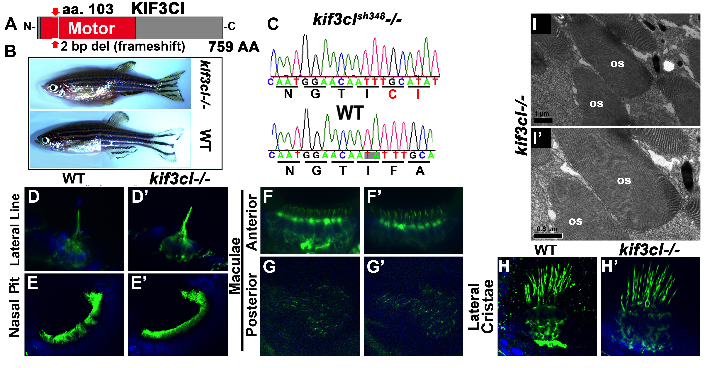
Figure 14. kif3cl mutant phenotype. (A) Schematic of Kif3cl protein domain structure. The sh348 mutant allele contains a 2 bp deletion (red arrow) in the motor domain that results in a frameshift. (B) Phenotype of wild type (bottom) and kif3cl-/- homozygous mutant (top) adult female zebrafish. (C) Sequences of kif3cl-/- mutant and the wild type gene. The 2 bp deletion (shaded) and the resulting frame shift are indicated. (D - H’) Whole mount immunostaining of wild type and kif3cl-/- zebrafish with anti-acetylated-α-tubulin antibody to visualize cilia at 5 dpf (in green). Tissue is counterstained with DAPI in blue. No obvious differences are found between wild-type and mutant cilia. (D, D’) lateral Line; (E, E’) nasal pit; (F – H’) sensory patches of the ear. (I) Transmission electron microscopy of outer segments in kif3cl-/- mutant retina at 5 dpf. Apical is up. OS, outer segment. LWT background fish strains used in all experiments.
It has previously been shown that the rate of opsin transport increases in the presence of stress such during elevated temperature (Young, 1967). This study, performed on Xenopus, revealed that a 10-degree increase in the environmental temperature resulted in a 2-fold increase in opsin trafficking, as judged by radiolabelled amino acid transport. To accommodate for such an increase in the transport volume, additional kinesins may be required. Thus, the effect of kif3cl absence may be more apparent under stress conditions. To test this, we maintained kif3cl-/- embryos at elevated temperatures of either 32°C or 36°C for 2.5 days starting at 2.5 dpf and stained photoreceptors with anti-rod opsin antibodies at 5 dpf. This treatment did not seem to affect opsin trafficking, as antibody staining did not reveal opsin mislocalisation to inner segments of photoreceptor cells (Figure 15E-E’). In addition to this, we tested constant light exposure on embryos for 2.5 days starting from 2.5 dpf. However, this did not appear to affect the opsin trafficking either (Figure 15F-F’). To observe for any subtle transportation defects we decided to more directly assess the trafficking speed of opsin itself in these mutants. For this purpose, we used a construct previously made by our lab consisting of GFP fused to the C-terminal 44 amino acids of opsin, driven by HSP70 heat shock promoter. The C-terminal 44 amino acids is sufficient for translocation of the protein from the inner segment of the photoreceptor to the outer segment (Tam et al., 2000). Our lab has previously shown that by 24 hours post heat shock, all GFP was localised to the outer segment, whereas mutants with opsin trafficking defects displayed mislocalized GFP signal in the inner segment (Zhao and Malicki, 2011). To see if there is a similar trafficking defect whereby transport is impaired in the mutants, this construct was injected into embryos. Thereafter, the injected embryos were collected at 3 separate stages post heat shock. Heat shock was performed at 3 dpf and embryos were collected and fixed at 4 hours, 9 hours and 24 hours post heat shock. This did not reveal any trafficking defects as the rate of GFP translocation into the outer segment was found to be similar to WT (Figure 15C-D’). However, there may be more opsin localisation in the OPL of mutants, as the intensity appears higher at 4 and 9 hours post heat shock. Thus, further analyses would have to be performed in the future to analyse whether this is the case and investigate trafficking in more detail.
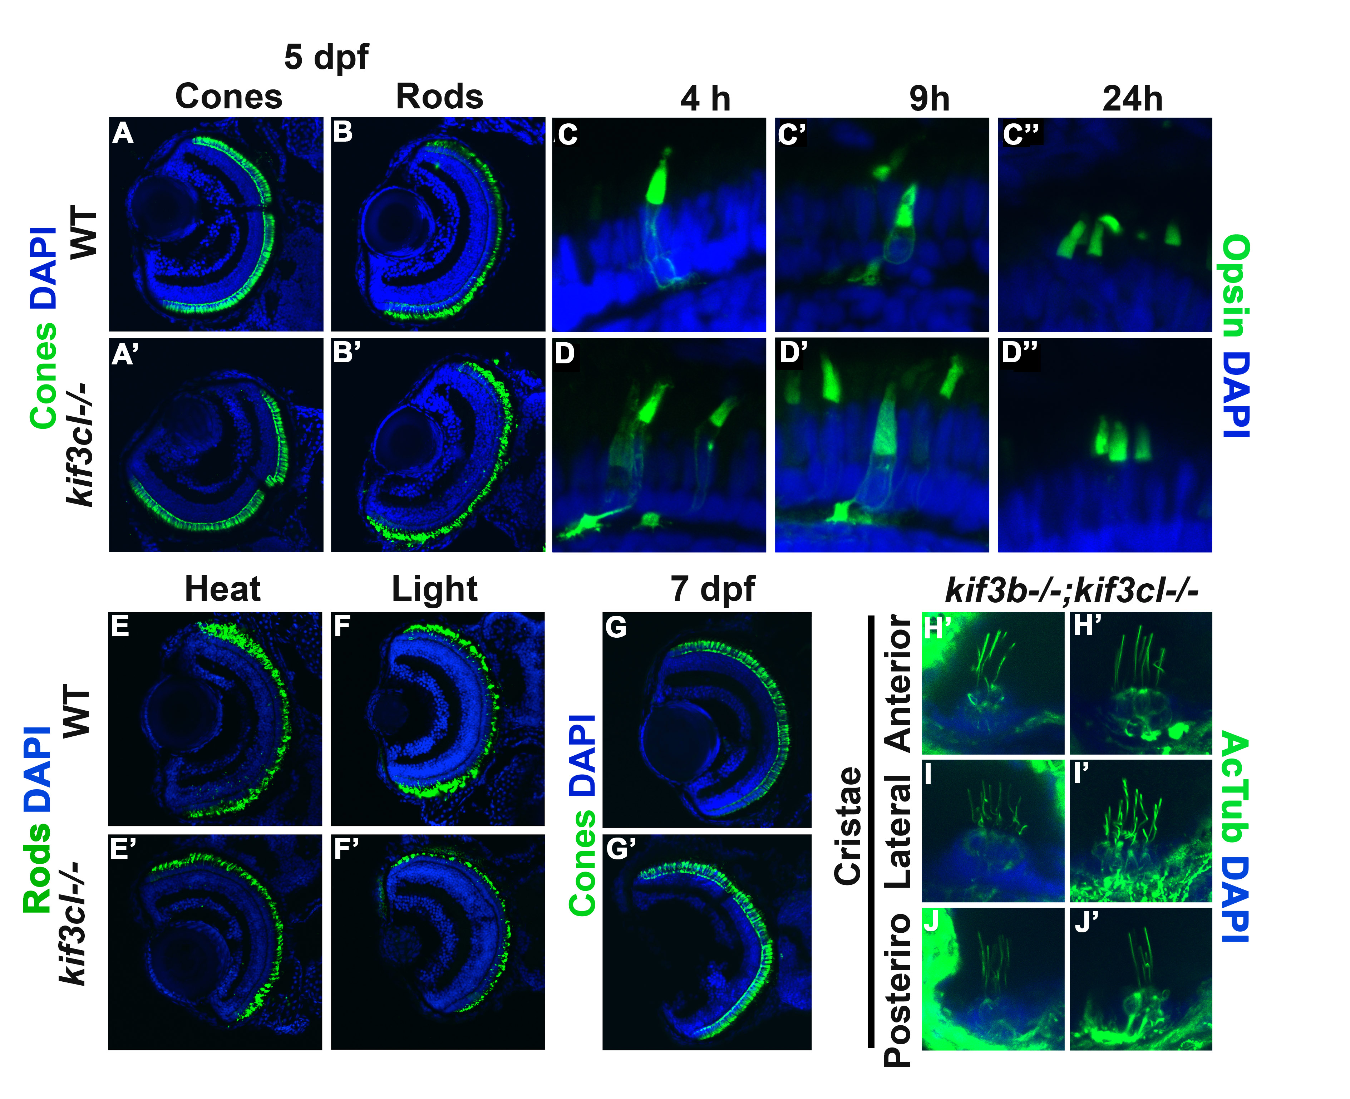
Figure 15. kif3c-like and kif3b-/-;kif3cl-/- double mutant phenotype. (A-B’’) Transverse cryosections of the retina of 5 dpf WT and kif3cl-/- mutants stained for cones (A-A’) or Rods (B-B’) in green and DAPI in blue. No obvious difference between WT and mutants. (C-D’’) Transverse cryosection of 3 dpf WT and kif3cl-/- embryos, that were injected with HSP70-GFP-CT44 construct, at 4 hours, 9 hours and 24 hours post heat shock. (E-E’) Transverse cryosection of 5 dpf fish that were maintained at elevated temperature of 30ºC or (F-F’) constant light from the age of 2.5 dpf to 5 dpf, stained for cones (ZPR-1) and rods (ZPR-3) (in green). (G-G’) transverse cryosection of 7 dpf fish stained for cones with ZPR-1 (in green) and nucleus (in blue). (H-J’) Whole mount immunostaining of wild-type and kif3b;kif3cl-/- mutant embryos at 5 dpf in auditory cristae. Cilia are labelled with anti-acetylated-α-tubulin (in green) and cell nuclei are counterstained with DAPI (in blue). LWT background fish strains used in all experiments.
To further assess the role of kif3cl in photoreceptor ciliogenesis, we generated double mutants with kif3b and investigated the outer segments of kif3b-/-;kif3cl-/-. Outer segment defects of these double mutants did not appear to be obviously more severe, compared to those in kif3b-/- single mutants. In addition to this, ciliary structures of the double mutants were also investigated. As the kif3b-/- single mutant lose all cilia except for the cristae cilia, and morpholino knockdown of kif3c in the kif3b-/- mutant background resulted in loss of cilia in cristae. It is possible that kif3cl may also have a role in the formation of cristae cilia, similar to that of kif3c. To test this, we investigated the cristae of kif3b-/-;kif3cl-/- double mutant. However, the double mutant phenocopied the kif3b-/- single mutant (Figure 15H-J’). The lack of phenotype in kif3cl-/- mutants may be due to compensation by kif3c, as kif3cl may only be upregulated in the absence of kif3c. This possibility will require further genetic and phenotypic analysis, through the generation of kif3c mutants.

4.2.2 Kif17 Does Not Contribute To Photoreceptor Morphogenesis
The gene encoding the homodimeric kinesin 2 in C. elegans, osm-3, has been previously shown to be required for the formation of amphid cilia (Evans et al., 2006; Mukhopadhyay et al., 2007). The role of its vertebrate homolog, kif17, is, however, less clear. Morpholino knockdown of kif17 in zebrafish was reported to cause outer segment loss at 3 dpf (Insinna et al., 2008). Additional studies on kif17 involving the fusion of kif17 protein to GFP and live imaging in photoreceptor cells in zebrafish revealed trafficking of kif17 through the connecting cilium to the outer segment. Further supporting a role of kif17 in the trafficking of proteins in the photoreceptors (Bader et al., 2012). However, In contrast to that, a study of a kif17-/- mutant allele kif7^{sa0119}, whereby the mutation causes a stop codon in the tail domain, did not reveal any photoreceptor defects and homozygous adults displayed normal opsin trafficking to the outer segment (Zhao et al., 2012). As the mutation in this allele is located to the c-terminal it is believed that it may be a hypomorphic allele and the majority of the protein still remains with sufficient function to drive transport of proteins into the outer segment. Thus to clarify kif17 function, we obtained an alternative kif17 mutant allele, kif17^{sa18340}, which contains a stop codon within the motor domain (Figure 16B). The resulting protein is truncated at the amino acid residue 92, effectively losing 90% of its sequence (Figure 16C). Western blot analysis confirmed the loss of Kif17 protein in kif17^{sa18340}-/- animals, although a small amount of wild-type length protein (ca. 1%) remained detectable in the mutant upon blot overexposure. A possible explanation for this is exon skipping whereby the exon with the stop codon is skipped resulting in a shorter protein. In this case, exon 2 could be skipped, resulting in a protein that is approximately 50 amino acids shorter. Another possibility is readthrough of the stop codon, resulting in a small amount of full-length protein being produced. Although a small portion of the full-length protein is still present, it is insufficient to drive outer segment formation as the studies reporting the severe loss of outer segments in the morphant had considerably higher levels of Kif17 protein remaining (Insinna et al., 2008).
The adult kif17^{sa18340} homozygotes are viable, fertile and do not display any overt developmental defects (Figure 16A). Cilia are also morphologically normal in the lateral line, the nasal pit and the spinal canal of kif17^{sa18340}-/- homozygotes (Figure 16D-F’). To investigate kif17^{sa18340} phenotype further, we immunostained kif17^{sa18340}-/- mutants for rods or cones at 3 (data not shown) and 5 dpf (Figure 16G-H’). This analysis did not reveal any abnormalities in either cone or rod photoreceptors either. To further investigate potential defects in mutant photoreceptors, we examined the ultrastructure of kif17^{sa18340}-/- photoreceptor cells at 3 and 5 dpf (Figure 16I-L’). Again, no obvious differences were found compared to wild-type siblings. We conclude that kif17 is not necessary for outer segment morphogenesis in vertebrate photoreceptors.
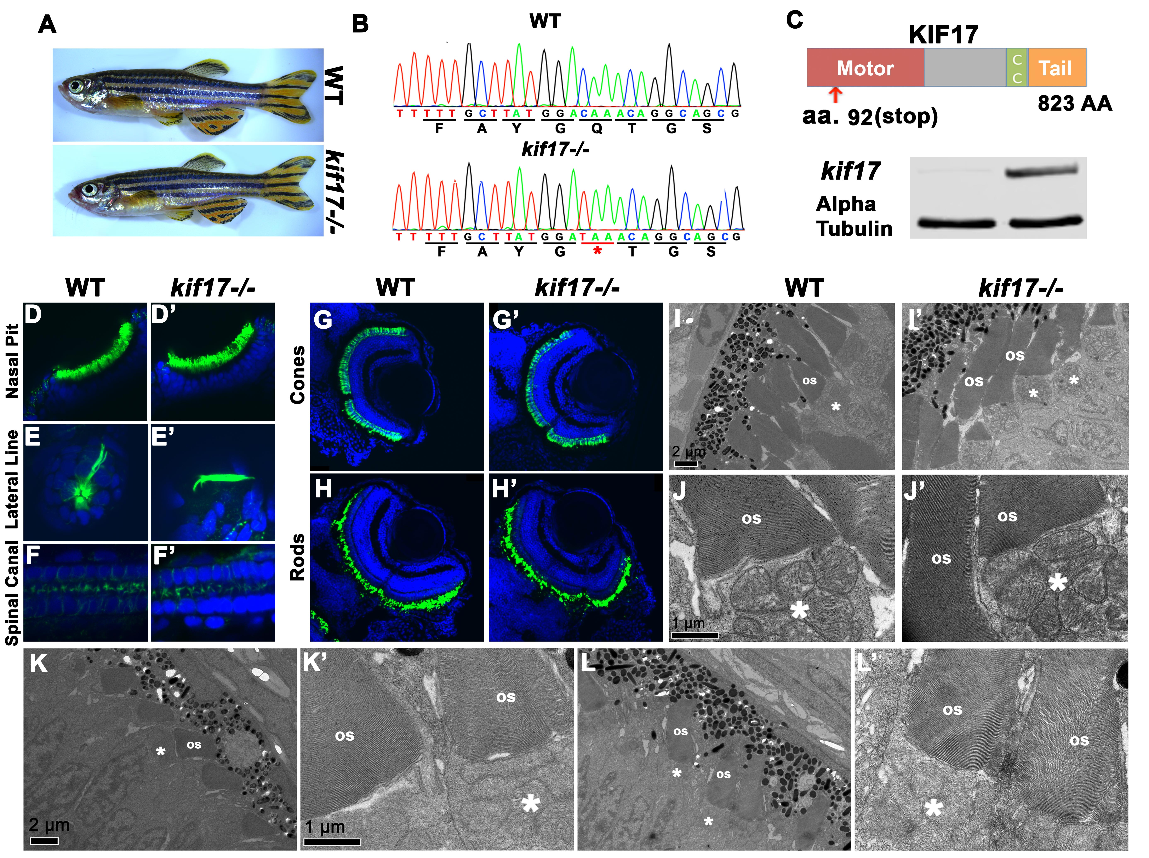
Figure 16. kif17 mutant phenotype. (A) Phenotypes of wild-type (top) and kif17-/- homozygous mutant (bottom) adult male zebrafish. (B) Sequences of kif17-/- mutant and wild-type alleles. (C, Top) Schematic of Kif17 protein domain structure. Red arrow indicates the approximate site of the stop codon at position 92. The mutation site is indicated with an asterisk and underlined in red. (C, bottom) Western blot for Kif17 in WT and kif17-/- embryos.  tubulin is included as a control. (D-F’) Whole mount immunostaining of wild-type and kif17-/- mutant zebrafish with anti-acetylated-α-tubulin antibody to visualize cilia at 5 dpf (in green). Tissue is counterstained with DAPI to visualize nuclei (in blue). No differences in cilia morphology are seen between mutant and wild-type animals. (D, D’) the nasal pit; (E, E’) the lateral line; (F, F’) the spinal canal. (G-H’) Cryosections through retinae of wild-type and kif17-/- mutant animals at 5 dpf immunostained for cones using ZPR-1 (G, G’) or rods with ZPR-3 (H, H’), and counterstained with DAPI to visualize nuclei. No significant differences are found in photoreceptor survival between wild-type and kif17-/- mutants. (I-L’) Transmission electron microscopy showing outer segments in kif17-/- mutant and wild-type animals at 3 (I-J’) and 5 (K-L’) dpf. Scale bars are 1 µm for high magnification images and 2 µm for low magnification ones. Apical is up. OS, outer segment; asterisks indicate mitochondrial cluster. LWT background fish strains used in all experiments.

4.2.3 Generation of kif3c zebrafish mutants
It has previously been shown that kif3c may function redundantly with kif3b. This was investigated by morpholino knockdown of kif3c in homozygote mutants of kif3b, that resulted in the loss of all cilia including the cristae cilia (Zhao et al., 2012). This suggested that kif3c functions redundantly with kif3b in the cilia of the ear. In addition to this, kif3c appears to function redundantly in outer segments after 3 dpf as morphants displayed slower opsin trafficking at 5 dpf and not at 3 dpf (Zhao et al., 2012). To investigate this further we generated mutants of kif3c using the CRISPR technology and identified mutants that have a 46-nucleotide deletion resulting in a frameshift. The mutation is located in the motor domain of the protein, effectively disrupting the majority of the protein. As kif3b mutant fish had delayed photoreceptor outer segment formation, kif3b most likely drives the initial formation of outer segments in photoreceptors. Subsequently, either kif3c by itself, or kif3c and kif3b both working redundantly, may function in the later stages of outer segment development. Thus it is plausible that in kif3c mutants there may be a photoreceptor defect that is apparent during the later stages of photoreceptor ciliogenesis. In addition to this, there is also the possibility that kif3c loss, results in the upregulation of the kif3cl protein to compensate for kif3c when it is absent. This is a prevalent event in many zebrafish mutants, whereby mutants do not recapitulate the morphant phenotype, and display upregulation of alternative genes (Kok et al., 2015). Presumably these genes participate in compensatory mechanisms that do not occur in the morphants. For this purpose, we generated double mutants of kif3c and kif3cl to examine these fish in scenarios whereby single mutants of kif3c and kif3cl on its own do not display any noticeable defects. In addition to this, kif3b;kif3c double mutants were also generated. This would allow us to test whether cilia of cristae, normally retained in kif3b-/- mutants, are removed in the absence of kif3c in the kif3b-/- mutant background. Furthermore, the switching of the kinesin repertoire at different stages of embryonic development in the photoreceptor will also be investigated in these mutants. Future work will involve the analysis of these kif3b-/-;kif3c-/- double mutants and potentially, triple mutants of kif3b;kif3c;kif3cl to determine the compensation effect by kif3cl in the absence of the other two kinesins.

4.2.4 klp-6;kif3b double mutants
An additional kinesin that has been associated with ciliary protein trafficking is klp-6. As studies on klp-6 in vertebrate models is limited, we generated mutants of klp-6 using TALENs. The homozygote adults are viable and fertile, with no obvious developmental defects. To further characterise its ciliary functions, we analysed the ciliary phenotype using immunohistochemistry. However, this did not reveal any abnormalities (Figure 17A-C’’, D-E’). To further investigate its functional relevance in cilia we generated double mutants of klp-6 with either kif3b or kif17. As previously published work demonstrates that kif3b only display cilia in the auditory cristae. We investigated whether the absence of klp-6 would exacerbate the observed kif3b-/- phenotype, specifically within the ear. However, this was not the case as the cristae cilia appear similar to WT and to kif3b-/- single mutants (Figure 17A-C’’’). This result suggests that Klp-6 does not have a structural role at least in ciliogenesis, but may have more specialised functions that are not obvious under basal conditions. For this, more detailed analysis must be performed in the future, one of which would involve generating multiple combinations of kinesin mutants.
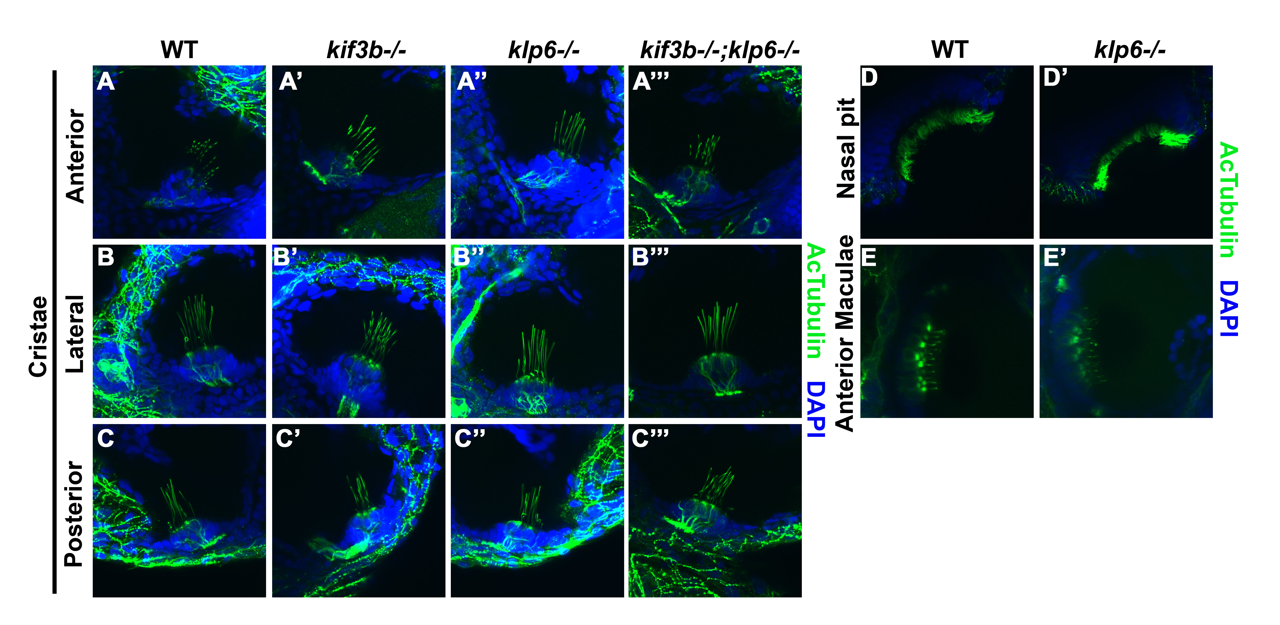
Figure 17. klp-6 and kif3b;klp-6 double homozygote phenotype. (A, B, C) Whole mount immunostaining of cristae in wild-type, (A’, B’, C’) klp-6-/-, (A’’, B’’, C’’) kif3b-/- and (A’’’, B’’’, C’’’) kif3b-/-;klp-6-/- mutant embryos at 5 dpf. Whole mount immunostaining of (D-D’) nasal pit and (E-E’) anterior maculae in WT and klp-6 mutant embryos. Cilia are labelled with anti-acetylated-α-tubulin antibody (in green) and cell nuclei are counterstained with DAPI (blue). LWT background fish strains used in all experiments.

4.3 Discussion
Our data show that in contrast to kif3a, the homodimeric kinesin 2, kif17, does not play a role in vertebrate ciliogenesis in most tissues, including the photoreceptor cell layer. The kif3c-like gene, one of the two kif3c homologs, does not appear to be required for ciliogenesis either. The lack of obvious developmental defects in the kif3cl mutant could be attributed to compensatory mechanisms by kif3c. To clarify this, mutants of kif3c and double mutants of kif3b and kif3c were generated. The kif3c gene is the most likely candidate to compensate in the absence of kif3b, particularly in regards to the auditory cristae and the photoreceptor cilia. In addition to this, specialised motors for trafficking a subset of cargoes could fulfil the variation in the functional requirements of different cilia. For this, mutants of the accessory kinesin klp-6 and double mutants of klp-6;kif17, klp-6;kif3b, kif3b;kif17 were generated. Although, the klp-6;kif3b double homozygote mutants still retain cilia in cristae similar to kif3b-/- mutants, there may be more subtle defects that will require further analysis. In addition to this, the other double mutants will require further investigation on developmental and ciliary defects, which is not apparent in the single mutants.

4.3.1 kif17 function in photoreceptors
Studies in C. elegans have shown that the homodimeric kinesin 2, osm-3, plays a major role in ciliogenesis. In this model organism, the amphid channel cilia require the kif17 homolog osm-3 for the formation of the distal microtubule singlets, whereas, in the middle segment of the same cilia the heterotrimeric and homodimeric kinesins function redundantly (Snow et al., 2004; Evans et al., 2006). A recent study of phasmid cilia showed that kinesin II primarily functions in the import of IFT through the transition zone, whereas long distance transport is mainly driven by osm-3 (Prevo et al., 2015). A related functional relationship exists between homo- and heterotrimeric kinesins in amphid olfactory neuron wing (AWC) cilia. There the heterotrimeric and homodimeric kinesin were thought to function redundantly to build the entire cilium (Snow et al., 2004; Evans et al., 2006). Although functional relationships between C. elegans ciliary kinesins are well characterized, the function of vertebrate osm-3 homologue, kif17, remained less clear. Morpholino knockdown of kif17 in zebrafish was reported to block photoreceptor outer segment morphogenesis, whereas kif17 zebrafish mutants differentiate normal outer segments (Insinna et al., 2008; Zhao et al., 2012). The kif17^{sa0119}-/- allele contains a stop codon in the tail domain, and although this is unlikely, it has been suggested that this allele may retain some rudimentary function (Bader et al., 2012). To rule out this possibility we obtained an alternative kif17 mutant allele that carries a stop codon in the motor domain, resulting in a truncation of the protein to approximately 1/10th of its full size. Further to this, although we detected a minute amount of the full-length Kif17 even in the kif17^{sa0119}-/- mutant strain, this amount is much lower compared to that observed in the kif17 knockdown studies that reported outer segment loss (Insinna et al., 2008). This is most likely an artefact largely due to a developmental delay of embryos that occurs following morpholino injections. Analysis of this allele corroborated previous findings that vertebrate kif17 does not have a major role in ciliogenesis, and does not contribute to photoreceptor outer segment differentiation. The discrepancies with previous findings may be attributed to technical shortcomings of the morpholino knockdown approach. This approach is increasingly deemed difficult to interpret based on observations that morphant phenotypes are frequently not reproduced in mutants (Kok et al., 2015).

4.3.2 Additional kinesins with specialised functions in cilia
Additional kinesins such as klp-6 from the kinesin 3 family and kif7 from the kinesin 4 family have been thought to have accessory functions mediating specialised functions in cilia. These functions may be specific to cilia of specific tissue to accommodate for the diverse functional requirements of different tissues. Such as that found in the peculiar photoreceptor cilium that is highly differentiated or cilia of the cristae that has exceptionally long cilium. The majority of work on klp-6 has been primarily conducted in C. elegans where it functions in Polycystin targeting to the cilium rather than in ciliogenesis itself (Peden and Barr, 2005). Polycystins are thought to form ion channels and are associated with a range of sensory functions (Igarashi et al., 2002). In mammals, these Polycystin receptors are found in cilia of the kidney (Yoder et al., 2002). In addition to this, double mutants of klp-6 with klp11 (kif3b) in C. elegans have been shown to increase the length of the cilium (Morsci and Barr, 2011). Conversely, simultaneous loss of klp-6, klp11 and osm-3, resulted in a dramatic shortening of the cilium (Morsci and Barr, 2011). These combinatorial mutations between different kinesins in the C. elegans revealed how the size of the cilium can be affected depending on the different combinations involved. However, in vertebrates this does not appear to be the case, as the klp-6 single mutants did not reveal any obvious phenotypic defects. Moreover, the klp-6-/-;kif3b-/- double mutants did not exhibit a more severe phenotype than the single kif3b-/- mutants and finally klp-6-/-;kif17-/- were also viable and fertile. However, the possibility of subtle ciliary defects in the klp-6-/-;kif17-/- double mutants still remain to be tested in finer detail. Apart from these kinesins, there are several additional accessory kinesins that function in an IFT-independent manner. Example include klp1 of the kinesin-9 family that regulates the dynein dependent beating frequency by localising to the central pair of microtubules in Chlamydomonas (Yokoyama et al., 2004). Another example is a member of the kinesin-13 family that localises to the tip of Giardia and Leishmania flagella, and may facilitate depolymerisation of the microtubule end to modulate the ciliary length (Blaineau et al., 2007; Dawson et al., 2007; Piao et al., 2009). Alternatively, kif19a of the kinesin-8 family is another microtubule-depolymerising kinesin that controls motile ciliary length, whereby loss of kif19a results in phenotypes resembling ciliary mutants in mice (Niwa et al., 2012). Future work would entail a more detailed analysis of the ciliary defects in these mutants at the functional level as well as under different stress conditions. In addition to this, generation of further combination of mutants with additional kinesins would provide a more comprehensive insight onto the requirements of different cilia in the context of tissue-specificity.

Chapter 5

Overall Discussion

5.1 Role of kif3a in ciliogenesis and photoreceptors
The main aim of this project was to investigate whether the loss of kif3a would abolish all cilia, as it would essentially disrupt the heterotrimeric complex, the core complex thought to drive ciliogenesis of all cilia. Furthermore, we aimed to clarify the discrepancies regarding its function in the photoreceptor cilium. For this purpose we obtained the kif3a mutant and examined for cilia in all tissue. As expected, ciliogenesis was perturbed in all tissue including the photoreceptor cilium. Surprisingly, however, the photoreceptor cells still survived far longer than in mutants of intraflagellar transport protein. This was an unexpected finding as the kinesin II drives intraflagellar transport, hence the severity of photoreceptor cell death should at least be equivalent to IFT mutants. The first major finding is that IFT most likely has additional functions within the photoreceptor cells, independent of its canonical transport function, hence the increased severity in the IFT mutant. The second major finding is the additional function of kif3a in mediating localisation of basal bodies in the photoreceptor cells. This function is most likely downstream from the formation of transition zone, but prior to docking to the plasma membrane and recruitment of IFT components (Figure 18). Finally, we show that kif3a is not required for basal body docking or partial formation of cilia in the cristae of the auditory system. Suggesting that an alternative transport mechanisms or additional motor proteins may exist to drive ciliogenesis in the absence of kif3a in the cristae.
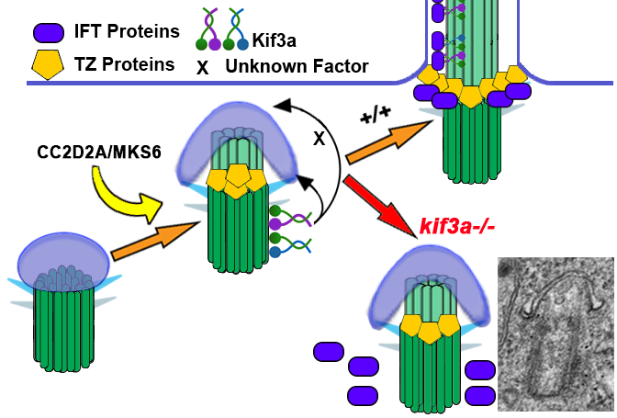
Figure 18. A summary of Kif3a protein function in photoreceptor ciliogenesis. Kif3a functions at very early stages of ciliogenesis by mediating the anchoring of the basal body to the apical surface. This occurs after the formation, either partial or complete, of the transition zone, but before the assembly of IFT particles. Electron micrographs show examples of wild-type and mutant photoreceptor basal bodies at the same magnification. Arrows point to the basal body. OS, outer segment.

5.2 Alternative kinesins in ciliogenesis
Although kif3a is part of the core kinesin complex there are other accessory kinesins for more specialised functions, yet not fully characterised in vertebrates. Kif3cl is, on the other hand, a gene that was formed through the duplication of the kif3c gene, and to test whether this gene has functions, we performed a series experiments to examine cilia in all tissue as well as detailed analysis of the photoreceptor cells including trafficking in the outer segments. However, kif3cl does not seem to be important for ciliogenesis or opsin trafficking. In addition to this, kif17 and klp-6 are not essential for the formation of cilia in vertebrates, but significantly affect either functionality or structure of cilia in C. elegans. Removing klp-6 or kif3cl in a kif3b-/- mutant background did not exacerbate the kif3b-/- phenotype either. A likely explanation is that their functions are only apparent under particular stress conditions, furthermore it may only be apparent in a subset of cilia. Therefore, additional detailed experiments must be performed, investigating the effects of different stress loads on the cilium, lacking particular combinations of these accessory kinesins.

References

Antoniades I, Stylianou P, Skourides PA (2014) Making the connection: ciliary adhesion complexes anchor basal bodies to the actin cytoskeleton. Developmental cell 28:70-80.
Arshavsky VY, Burns ME (2012) Photoreceptor signaling: supporting vision across a wide range of light intensities. J Biol Chem 287:1620-1626.
Avasthi P, Watt CB, Williams DS, Le YZ, Li S, Chen CK, Marc RE, Frederick JM, Baehr W (2009) Trafficking of membrane proteins to cone but not rod outer segments is dependent on heterotrimeric kinesin-II. J Neurosci 29:14287-14298.
Avidor-Reiss T, Leroux MR (2015) Shared and Distinct Mechanisms of Compartmentalized and Cytosolic Ciliogenesis. Curr Biol 25:R1143-1150.
Axelrod JD (2008) Basal bodies, kinocilia and planar cell polarity. Nat Genet 40:10-11.
Bachmann-Gagescu R, Dona M, Hetterschijt L, Tonnaer E, Peters T, de Vrieze E, Mans DA, van Beersum SE, Phelps IG, Arts HH, Keunen JE, Ueffing M, Roepman R, Boldt K, Doherty D, Moens CB, Neuhauss SC, Kremer H, van Wijk E (2015) The Ciliopathy Protein CC2D2A Associates with NINL and Functions in RAB8-MICAL3-Regulated Vesicle Trafficking. PLoS Genet 11:e1005575.
Bader JR, Kusik BW, Besharse JC (2012) Analysis of KIF17 distal tip trafficking in zebrafish cone photoreceptors. Vision research:1-7.
Basten SG, Giles RH (2013) Functional aspects of primary cilia in signaling, cell cycle and tumorigenesis. Cilia 2:6.
Berbari NF, Lewis JS, Bishop GA, Askwith CC, Mykytyn K (2008) Bardet-Biedl syndrome proteins are required for the localization of G protein-coupled receptors to primary cilia. PNAS 105:4242-4246.
Bhogaraju S, Weber K, Engel BD, Lechtreck KF, Lorentzen E (2014) Getting tubulin to the tip of the cilium: one IFT train, many different tubulin cargo-binding sites? Bioessays 36:463-467.
Bhogaraju S, Cajanek L, Fort C, Blisnick T, Weber K, Taschner M, Mizuno N, Lamla S, Bastin P, Nigg EA, Lorentzen E (2013) Molecular basis of tubulin transport within the cilium by IFT74 and IFT81. Science (New York, NY) 341:1009-1012.
Bilotta J, Saszik S, Sutherland SE (2001) Rod contributions to the electroretinogram of the dark-adapted developing zebrafish. Dev Dyn 222:564-570.
Bisgrove BW, Yost HJ (2006) The roles of cilia in developmental disorders and disease. Development 133:4131-4143.
Blaineau C, Tessier M, Dubessay P, Tasse L, Crobu L, Pages M, Bastien P (2007) A novel microtubule-depolymerizing kinesin involved in length control of a eukaryotic flagellum. Curr Biol 17:778-782.
Bloodgood RA (2010) Sensory reception is an attribute of both primary cilia and motile cilia. J Cell Sci 123:505-509.
Boisvieux-Ulrich E, Laine MC, Sandoz D (1990) Cytochalasin D inhibits basal body migration and ciliary elongation in quail oviduct epithelium. Cell Tissue Res 259:443-454.
Breslow DK, Koslover EF, Seydel F, Spakowitz AJ, Nachury MV (2013) An in vitro assay for entry into cilia reveals unique properties of the soluble diffusion barrier. J Cell Biol 203:129-147.
Carvalho-Santos Z, Azimzadeh J, Pereira-Leal JB, Bettencourt-Dias M (2011) Evolution: Tracing the origins of centrioles, cilia, and flagella. The Journal of cell biology 194:165-175.
Chailley B, Boisvieux-Ulrich E (1985) Detection of plasma membrane cholesterol by filipin during microvillogenesis and ciliogenesis in quail oviduct. Journal of Histochemistry & Cytochemistry 33:1-10.
Cheng CL, Gan KJ, Flamarique IN (2007) The ultraviolet opsin is the first opsin expressed during retinal development of salmonid fishes. Invest Ophthalmol Vis Sci 48:866-873.
Chih B, Liu P, Chinn Y, Chalouni C, Komuves LG, Hass PE, Sandoval W, Peterson AS (2011) A ciliopathy complex at the transition zone protects the cilia as a privileged membrane domain. Nature cell biology 14:61-72.
Cole DG, Diener DR, Himelblau AL, Beech PL, Fuster JC, Rosenbaum JL (1998) Chlamydomonas kinesin-II-dependent intraflagellar transport (IFT): IFT particles contain proteins required for ciliary assembly in Caenorhabditis elegans sensory neurons. J Cell Biol 141:993-1008.
Corbit KC, Aanstad P, Singla V, Norman AR, Stainier DY, Reiter JF (2005) Vertebrate Smoothened functions at the primary cilium. Nature 437:1018-1021.
Craft JM, Harris JA, Hyman S, Kner P, Lechtreck KF (2015) Tubulin transport by IFT is upregulated during ciliary growth by a cilium-autonomous mechanism. J Cell Biol 208:223-237.
Cross RA, McAinsh A (2014) Prime movers: the mechanochemistry of mitotic kinesins. Nat Rev Mol Cell Biol 15:257-271.
Dagenbach EM, Endow SA (2004) A new kinesin tree. J Cell Sci 117:3-7.
Davenport JR, Watts AJ, Roper VC, Croyle MJ, van Groen T, Wyss JM, Nagy TR, Kesterson RA, Yoder BK (2007) Disruption of intraflagellar transport in adult mice leads to obesity and slow-onset cystic kidney disease. Curr Biol 17:1586-1594.
Dawson SC, Sagolla MS, Mancuso JJ, Woessner DJ, House SA, Fritz-Laylin L, Cande WZ (2007) Kinesin-13 regulates flagellar, interphase, and mitotic microtubule dynamics in Giardia intestinalis. Eukaryot Cell 6:2354-2364.
Deane JA, Cole DG, Seeley ES, Diener DR, Rosenbaum JL (2001) Localization of intraflagellar transport protein IFT52 identifies basal body transitional fibers as the docking site for IFT particles. Curr Biol 11:1586-1590.
Dishinger JF, Kee HL, Jenkins PM, Fan S, Hurd TW, Hammond JW, Truong YN-T, Margolis B, Martens JR, Verhey KJ (2010) Ciliary entry of the kinesin-2 motor KIF17 is regulated by importin-β2 and RanGTP. Nature cell biology 12:703-710.
Doerre G, Malicki J (2002) Genetic analysis of photoreceptor cell development in the zebrafish retina. Mechanisms of Development 110:125-138.
Dowdle WE, Robinson JF, Kneist A, Sirerol-Piquer MS, Frints SG, Corbit KC, Zaghloul NA, van Lijnschoten G, Mulders L, Verver DE, Zerres K, Reed RR, Attie-Bitach T, Johnson CA, Garcia-Verdugo JM, Katsanis N, Bergmann C, Reiter JF (2011) Disruption of a ciliary B9 protein complex causes Meckel syndrome. American journal of human genetics 89:94-110.
Emmer BT, Maric D, Engman DM (2010) Molecular mechanisms of protein and lipid targeting to ciliary membranes. Journal of Cell Science 123:529-536.
Erskine L, Herrera E (2007) The retinal ganglion cell axon's journey: insights into molecular mechanisms of axon guidance. Dev Biol 308:1-14.
Evans JE, Snow JJ, Gunnarson AL, Ou G, Stahlberg H, McDonald KL, Scholey JM (2006) Functional modulation of IFT kinesins extends the sensory repertoire of ciliated neurons in Caenorhabditis elegans. J Cell Biol 172:663-669.
Evans MJ, Fanucchi MV, Van Winkle LS, Baker GL, Murphy AE, Nishio SJ, Sannes PL, Plopper CG (2002) Fibroblast growth factor-2 during postnatal development of the tracheal basement membrane zone. Am J Physiol Lung Cell Mol Physiol 283:L1263-1270.
Falk N, Losl M, Schroder N, Giessl A (2015) Specialized Cilia in Mammalian Sensory Systems. Cells 4:500-519.
Finetti F, Paccani SR, Rosenbaum J, Baldari CT (2011) Intraflagellar transport: a new player at the immune synapse. Trends Immunol 32:139-145.
Finetti F, Patrussi L, Masi G, Onnis A, Galgano D, Lucherini OM, Pazour GJ, Baldari CT (2014) Specific recycling receptors are targeted to the immune synapse by the intraflagellar transport system. J Cell Sci 127:1924-1937.
Fisch C, Dupuis-Williams P (2011) Ultrastructure of cilia and flagella - back to the future! Biol Cell 103:249-270.
Flannery RJ, French DA, Kleene SJ (2006) Clustering of cyclic-nucleotide-gated channels in olfactory cilia. Biophys J 91:179-188.
Flock A, Duvall AJ (1965) The Ultrastructure of the Kinocilium of the Sensory Cells in the Inner Ear and Lateral Line Organs. The Journal of Cell Biology 25:1-8.
Frost LS, Mitchell CH, Boesze-Battaglia K (2014) Autophagy in the eye: implications for ocular cell health. Exp Eye Res 124:56-66.
Garcia-Gonzalo FR, Reiter JF (2012) Scoring a backstage pass: mechanisms of ciliogenesis and ciliary access. The Journal of cell biology 197:697-709.
Garcia-Gonzalo FR, Corbit KC, Sirerol-Piquer MS, Ramaswami G, Otto EA, Noriega TR, Seol AD, Robinson JF, Bennett CL, Josifova DJ, García-Verdugo JM, Katsanis N, Hildebrandt F, Reiter JF (2011) A transition zone complex regulates mammalian ciliogenesis and ciliary membrane composition. Nature genetics 43:776-784.
Gilula NB, Satir P (1972) The ciliary necklace. A ciliary membrane specialization. J Cell Biol 53:494-509.
Goetz SC, Anderson KV (2010) The primary cilium: a signalling centre during vertebrate development. Nat Rev Genetics 11:331-344.
Goldman D (2014) Muller glial cell reprogramming and retina regeneration. Nat Rev Neurosci 15:431-442.
Haddon C, Lewis J (1996) Early ear development in the embryo of the zebrafish, Danio rerio. J Comp Neurol 365:113-128.
Hall EA, Keighren M, Ford MJ, Davey T, Jarman AP, Smith LB, Jackson IJ, Mill P (2013) Acute versus chronic loss of mammalian Azi1/Cep131 results in distinct ciliary phenotypes. PLoS Genet 9:e1003928.
Hao L, Thein M, Brust-Mascher I, Civelekoglu-Scholey G, Lu Y, Acar S, Prevo B, Shaham S, Scholey JM (2011) Intraflagellar transport delivers tubulin isotypes to sensory cilium middle and distal segments. Nature cell biology 13:1-11.
He M, Subramanian R, Bangs F, Omelchenko T, Liem J, Karel F, Kapoor TM, Anderson KV (2014) The kinesin-4 protein Kif7 regulates mammalian Hedgehog signalling by organizing the cilium tip compartment. Nature cell biology 16:663-672.
Heidelberger R, Thoreson WB, Witkovsky P (2005) Synaptic transmission at retinal ribbon synapses. Prog Retin Eye Res 24:682-720.
Hilgendorf KI, Johnson CT, Jackson PK (2016) The primary cilium as a cellular receiver: organizing ciliary GPCR signaling. Curr Opin Cell Biol 39:84-92.
Hirokawa N, Tanaka Y, Okada Y (2012) Cilia, KIF3 molecular motor and nodal flow. Current opinion in cell biology:1-9.
Hirokawa N, Noda Y, Tanaka Y, Niwa S (2009) Kinesin superfamily motor proteins and intracellular transport. Nat Rev Mol Cell Biol 10:682-696.
Hoon M, Okawa H, Della Santina L, Wong RO (2014) Functional architecture of the retina: development and disease. Prog Retin Eye Res 42:44-84.
Hu Q, Nelson WJ (2011) Ciliary diffusion barrier: the gatekeeper for the primary cilium compartment. Cytoskeleton (Hoboken) 68:313-324.
Huangfu D, Liu A, Rakeman AS, Murcia NS, Niswander L, Anderson KV (2003) Hedgehog signalling in the mouse requires intraflagellar transport proteins. Nature 426:83-87.
Hudspeth AJ (1989) How the ear's works work. Nature 341:397-404.
Hwang WY, Fu Y, Reyon D, Maeder ML, Tsai SQ, Sander JD, Peterson RT, Yeh J-RJ, Joung JK (2013) Efficient genome editing in zebrafish using a CRISPR-Cas system. Nature biotechnology.
Igarashi P, Somlo S, Feature E (2002) Genetics and Pathogenesis of Polycystic Kidney Disease. Journal of the American Society of Nephrology 13:2384-2398.
Insinna C, Besharse JC (2008) Intraflagellar transport and the sensory outer segment of vertebrate photoreceptors. Dev Dyn 237:1982-1992.
Insinna C, Pathak N, Perkins B, Drummond I, Besharse JC (2008) The homodimeric kinesin, Kif17, is essential for vertebrate photoreceptor sensory outer segment development. Dev Biol 316:160-170.
Jacoby M, Cox JJ, Gayral S, Hampshire DJ, Ayub M, Blockmans M, Pernot E, Kisseleva MV, Compère P, Schiffmann SN, Gergely F, Riley JH, Pérez-Morga D, Woods CG, Schurmans S (2009) INPP5E mutations cause primary cilium signaling defects, ciliary instability and ciliopathies in human and mouse. Nature genetics 41:1027-1031.
Jenkins PM, Hurd TW, Zhang L, McEwen DP, Brown RL, Margolis B, Verhey KJ, Martens JR (2006) Ciliary targeting of olfactory CNG channels requires the CNGB1b subunit and the kinesin-2 motor protein, KIF17. Curr Biol 16:1211-1216.
Jimeno D, Lillo C, Roberts EA, Goldstein LS, Williams DS (2006a) Kinesin-2 and photoreceptor cell death: requirement of motor subunits. Exp Eye Res 82:351-353.
Jimeno D, Feiner L, Lillo C, Teofilo K, Goldstein LSB, Pierce EA, Williams DS (2006b) Analysis of kinesin-2 function in photoreceptor cells using synchronous Cre-loxP knockout of Kif3a with RHO-Cre. Investigative ophthalmology &amp; visual science 47:5039-5046.
Jin H, White SR, Shida T, Schulz S, Aguiar M, Gygi SP, Bazan JF, Nachury MV (2010) The conserved Bardet-Biedl syndrome proteins assemble a coat that traffics membrane proteins to cilia. Cell 141:1208-1219.
Jones C, Roper VC, Foucher I, Qian D, Banizs B, Petit C, Yoder BK, Chen P (2008) Ciliary proteins link basal body polarization to planar cell polarity regulation. Nat Genet 40:69-77.
Kamiya R, Yagi T (2014) Functional diversity of axonemal dyneins as assessed by in vitro and in vivo motility assays of Chlamydomonas mutants. Zoolog Sci 31:633-644.
Kee HL, Verhey KJ (2013) Molecular connections between nuclear and ciliary import processes. Cilia 2:11.
Kee HL, Dishinger JF, Blasius TL, Liu CJ, Margolis B, Verhey KJ (2012) A size-exclusion permeability barrier and nucleoporins characterize a ciliary pore complex that regulates transport into cilia. Nature cell biology 14:431-437.
Kennedy B, Malicki J (2009) What drives cell morphogenesis: a look inside the vertebrate photoreceptor. Dev Dyn 238:2115-2138.
Kersten FF, van Wijk E, Hetterschijt L, Baubeta K, Peters TA, Aslanyan MG, van der Zwaag B, Wolfrum U, Keunen JE, Roepman R, Kremer H (2012) The mitotic spindle protein SPAG5/Astrin connects to the Usher protein network postmitotically. Cilia 1:2.
Kikuchi T, Takasaka T, Tonosaki A, Watanabe H (1989) Fine Structure of Guinea Pig Vestibular Kinocilium. Acta Oto-laryngologica 108:26-30.
Kim J, Kato M, Beachy PA (2009) Gli2 trafficking links Hedgehog-dependent activation of Smoothened in the primary cilium to transcriptional activation in the nucleus. Proc Natl Acad Sci U S A 106:21666-21671.
Kim JC, Ou YY, Badano JL, Esmail MA, Leitch CC, Fiedrich E, Beales PL, Archibald JM, Katsanis N, Rattner JB, Leroux MR (2005) MKKS/BBS6, a divergent chaperonin-like protein linked to the obesity disorder Bardet-Biedl syndrome, is a novel centrosomal component required for cytokinesis. J Cell Sci 118:1007-1020.
Kim JC, Badano JL, Sibold S, Esmail MA, Hill J, Hoskins BE, Leitch CC, Venner K, Ansley SJ, Ross AJ, Leroux MR, Katsanis N, Beales PL (2004) The Bardet-Biedl protein BBS4 targets cargo to the pericentriolar region and is required for microtubule anchoring and cell cycle progression. Nat Genet 36:462-470.
Kindt KS, Finch G, Nicolson T (2012) Kinocilia mediate mechanosensitivity in developing zebrafish hair cells. Dev Cell 23:329-341.
Klinger M, Wang W, Kuhns S, Barenz F, Drager-Meurer S, Pereira G, Gruss OJ (2014) The novel centriolar satellite protein SSX2IP targets Cep290 to the ciliary transition zone. Mol Biol Cell 25:495-507.
Klinghoffer RA, Hamilton TG, Hoch R, Soriano P (2002) An Allelic Series at the PDGFαR Locus Indicates Unequal Contributions of Distinct Signaling Pathways During Development. Developmental Cell 2:103-113.
Kodani A, Salome Sirerol-Piquer M, Seol A, Garcia-Verdugo JM, Reiter JF (2013) Kif3a interacts with Dynactin subunit p150 Glued to organize centriole subdistal appendages. EMBO J 32:597-607.
Kok FO, Shin M, Ni C-W, Gupta A, Grosse AS, van Impel A, Kirchmaier BC, Peterson-Maduro J, Kourkoulis G, Male I, DeSantis DF, Sheppard-Tindell S, Ebarasi L, Betsholtz C, Schulte-Merker S, Wolfe SA, Lawson ND (2015) Reverse genetic screening reveals poor correlation between morpholino-induced and mutant phenotypes in zebrafish. Developmental cell 32:97-108.
Kozminski KG, Beech PL, Rosenbaum JL (1995) The Chlamydomonas kinesin-like protein FLA10 is involved in motility associated with the flagellar membrane. J Cell Biol 131:1517-1527.
Kramer-Zucker AG, Olale F, Haycraft CJ, Yoder BK, Schier AF, Drummond IA (2005) Cilia-driven fluid flow in the zebrafish pronephros, brain and Kupffer's vesicle is required for normal organogenesis. Development 132:1907-1921.
Lambacher NJ et al. (2015) TMEM107 recruits ciliopathy proteins to subdomains of the ciliary transition zone and causes Joubert syndrome. Nature cell biology 18:122-131.
Larkins CE, Aviles GD, East MP, Kahn RA, Caspary T (2011) Arl13b regulates ciliogenesis and the dynamic localization of Shh signaling proteins. Mol Biol Cell 22:4694-4703.
Lechtreck KF (2015) IFT-Cargo Interactions and Protein Transport in Cilia. Trends Biochem Sci 40:765-778.
Li A, Xue J, Peterson EH (2008) Architecture of the mouse utricle: macular organization and hair bundle heights. J Neurophysiol 99:718-733.
Li S, Chen D, Sauv Y, McCandless J, Chen Y-J, Chen C-K (2005) Rhodopsin-iCre transgenic mouse line for Cre-mediated rod-specific gene targeting. Genesis (New York, NY : 2000) 41:73-80.
Lindemann CB, Lesich KA (2010) Flagellar and ciliary beating: the proven and the possible. Journal of cell science 123:519-528.
Liu Q, Lyubarsky A, Skalet JH, Pugh EN, Jr., Pierce EA (2003) RP1 is required for the correct stacking of outer segment discs. Invest Ophthalmol Vis Sci 44:4171-4183.
Liu X, Udovichenko IP, Brown SD, Steel KP, Williams DS (1999) Myosin VIIa participates in opsin transport through the photoreceptor cilium. J Neurosci 19:6267-6274.
Loktev AV, Zhang Q, Beck JS, Searby CC, Scheetz TE, Bazan JF, Slusarski DC, Sheffield VC, Jackson PK, Nachury MV (2008) A BBSome subunit links ciliogenesis, microtubule stability, and acetylation. Developmental Cell 15:854-865.
Louvi A, Grove EA (2011) Cilia in the CNS: the quiet organelle claims center stage. Neuron 69:1046-1060.
Lu H, Toh MT, Narasimhan V, Thamilselvam SK, Choksi SP, Roy S (2015a) A function for the Joubert syndrome protein Arl13b in ciliary membrane extension and ciliary length regulation. Developmental Biology 397:225-236.
Lu Q, Insinna C, Ott C, Stauffer J, Pintado PA, Rahajeng J, Baxa U, Walia V, Cuenca A, Hwang Y-S, Daar IO, Lopes S, Lippincott-Schwartz J, Jackson PK, Caplan S, Westlake CJ (2015b) Early steps in primary cilium assembly require EHD1/EHD3-dependent ciliary vesicle formation. Nature cell biology 17:228-240.
Magarinos M, Contreras J, Aburto MR, Varela-Nieto I (2012) Early development of the vertebrate inner ear. Anat Rec (Hoboken) 295:1775-1790.
Malicki J, Besharse JC (2012) Kinesin-2 family motors in the unusual photoreceptor cilium. Vision research 75:33-36.
Marszalek JR, Ruiz-Lozano P, Roberts E, Chien KR, Goldstein LS (1999) Situs inversus and embryonic ciliary morphogenesis defects in mouse mutants lacking the KIF3A subunit of kinesin-II. Proc Natl Acad Sci U S A 96:5043-5048.
Marszalek JR, Liu X, Roberts EA, Chui D, Marth JD, Williams DS, Goldstein LS (2000) Genetic evidence for selective transport of opsin and arrestin by kinesin-II in mammalian photoreceptors. Cell 102:175-187.
Marx A, Hoenger A, Mandelkow E (2009) Structures of kinesin motor proteins. Cell Motil Cytoskeleton 66:958-966.
Mathur P, Yang J (2015) Usher syndrome: Hearing loss, retinal degeneration and associated abnormalities. Biochim Biophys Acta 1852:406-420.
Mendes HF, van der Spuy J, Chapple JP, Cheetham ME (2005) Mechanisms of cell death in rhodopsin retinitis pigmentosa: implications for therapy. Trends Mol Med 11:177-185.
Miki H, Okada Y, Hirokawa N (2005) Analysis of the kinesin superfamily: insights into structure and function. Trends Cell Biol 15:467-476.
Morsci NS, Barr MM (2011) Kinesin-3 KLP-6 Regulates Intraflagellar Transport in Male-Specific Cilia of Caenorhabditis elegans. Curr Biol 21:1239-1244.
Mukhopadhyay B, Nam SC, Choi KW (2010) Kinesin II is required for cell survival and adherens junction positioning in Drosophila photoreceptors. Genesis 48:522-530.
Mukhopadhyay S, Lu Y, Qin H, Lanjuin A, Shaham S, Sengupta P (2007) Distinct IFT mechanisms contribute to the generation of ciliary structural diversity in C. elegans. Embo J 26:2966-2980.
Mullor JL, Sánchez P, Altaba ARi (2002) Pathways and consequences: Hedgehog signaling in human disease. Trends in Cell Biology 12:562-569.
Muresan V, Abramson T, Lyass A, Winter D, Porro E, Hong F, Chamberlin NL, Schnapp BJ (1998) KIF3C and KIF3A form a novel neuronal heteromeric kinesin that associates with membrane vesicles. Mol Biol Cell 9:637-652.
Nachury MV, Loktev AV, Zhang Q, Westlake CJ, Peranen J, Merdes A, Slusarski DC, Scheller RH, Bazan JF, Sheffield VC, Jackson PK (2007) A core complex of BBS proteins cooperates with the GTPase Rab8 to promote ciliary membrane biogenesis. Cell 129:1201-1213.
Najafi M, Calvert PD (2012) Transport and localization of signaling proteins in ciliated cells. Vision research 75:11-18.
Niwa S, Nakajima K, Miki H, Minato Y, Wang D, Hirokawa N (2012) KIF19A is a microtubule-depolymerizing kinesin for ciliary length control. Dev Cell 23:1167-1175.
Nonaka S, Tanaka Y, Okada Y, Takeda S, Harada A, Kanai Y, Kido M, Hirokawa N (1998) Randomization of left-right asymmetry due to loss of nodal cilia generating leftward flow of extraembryonic fluid in mice lacking KIF3B motor protein. Cell 95:829-837.
Nutu M, Weijdegard B, Thomas P, Thurin-Kjellberg A, Billig H, Larsson DG (2009) Distribution and hormonal regulation of membrane progesterone receptors beta and gamma in ciliated epithelial cells of mouse and human fallopian tubes. Reprod Biol Endocrinol 7:89.
Ocbina PJR, Tuson M, Anderson KV (2009) Primary Cilia Are Not Required for Normal Canonical Wnt Signaling in the Mouse Embryo. PLoS ONE 4:e6839.
Omori Y, Zhao C, Saras A, Mukhopadhyay S, Kim W, Furukawa T, Sengupta P, Veraksa A, Malicki J (2008) Elipsa is an early determinant of ciliogenesis that links the IFT particle to membrane-associated small GTPase Rab8. Nature Cell Biology 10:437-444.
Overlack N, Kilic D, Bauss K, Marker T, Kremer H, van Wijk E, Wolfrum U (2011) Direct interaction of the Usher syndrome 1G protein SANS and myomegalin in the retina. Biochim Biophys Acta 1813:1883-1892.
Palczewski K (2006) G protein-coupled receptor rhodopsin. Annu Rev Biochem 75:743-767.
Pampliega O, Orhon I, Patel B, Sridhar S, Díaz-Carretero A, Beau I, Codogno P, Satir BH, Satir P, Cuervo AM (2013) Functional interaction between autophagy and ciliogenesis. Nature 502:194-200.
Papermaster DS, Schneider BG, DeFoe D, Besharse JC (1986) Biosynthesis and vectorial transport of opsin on vesicles in retinal rod photoreceptors. J Histochem Cytochem 34:5-16.
Pathak N, Obara T, Mangos S, Liu Y, Drummond IA (2007) The zebrafish fleer gene encodes an essential regulator of cilia tubulin polyglutamylation. Mol Biol Cell 18:4353-4364.
Pazour GJ, Dickert BL, Vucica Y, Seeley ES, Rosenbaum JL, Witman GB, Cole DG (2000) Chlamydomonas IFT88 and its mouse homologue, polycystic kidney disease gene tg737, are required for assembly of cilia and flagella. J Cell Biol 151:709-718.
Pazour GJ, Baker SA, Deane JA, Cole DG, Dickert BL, Rosenbaum JL, Witman GB, Besharse JC (2002) The intraflagellar transport protein, IFT88, is essential for vertebrate photoreceptor assembly and maintenance. J Cell Biol 157:103-113.
Peden EM, Barr MM (2005) The KLP-6 kinesin is required for male mating behaviors and polycystin localization in Caenorhabditis elegans. Curr Biol 15:394-404.
Pedersen LB, Rosenbaum JL (2008) Chapter Two Intraflagellar Transport (IFT) Role in Ciliary Assembly, Resorption and Signalling. Curr Top Dev Biol 85:23-61.
Peters KR, Palade GE, Schneider BG, Papermaster DS (1983) Fine structure of a periciliary ridge complex of frog retinal rod cells revealed by ultrahigh resolution scanning electron microscopy. J Cell Biol 96:265-276.
Piao T, Luo M, Wang L, Guo Y, Li D, Li P, Snell WJ, Pan J (2009) A microtubule depolymerizing kinesin functions during both flagellar disassembly and flagellar assembly in Chlamydomonas. Proc Natl Acad Sci U S A 106:4713-4718.
Pigino G, Geimer S, Lanzavecchia S, Paccagnini E, Cantele F, Diener DR, Rosenbaum JL, Lupetti P (2009) Electron-tomographic analysis of intraflagellar transport particle trains in situ. J Cell Biol 187:135-148.
Prevo B, Mangeol P, Oswald F, Scholey JM, Peterman EJG (2015) Functional differentiation of cooperating kinesin-2 motors orchestrates cargo import and transport in C. elegans cilia. Nature cell biology 17:1536-1545.
Pugh E, Lamb T (2000) Phototransduction in Vertebrate Rods and Cones:. In: Handbook of Biological Physics, pp 183-255: Elsevier Science B. V. .
Qin H, Diener DR, Geimer S, Cole DG, Rosenbaum JL (2004) Intraflagellar transport (IFT) cargo: IFT transports flagellar precursors to the tip and turnover products to the cell body. J Cell Biol 164:255-266.
Qin J, Lin Y, Norman RX, Ko HW, Eggenschwiler JT (2011) Intraflagellar transport protein 122 antagonizes Sonic Hedgehog signaling and controls ciliary localization of pathway components. Proc Natl Acad Sci U S A 108:1456-1461.
Rajala A, Dighe R, Agbaga MP, Anderson RE, Rajala RV (2013) Insulin receptor signaling in cones. J Biol Chem 288:19503-19515.
Rakoczy EP, Kiel C, McKeone R, Stricher F, Serrano L (2011) Analysis of disease-linked rhodopsin mutations based on structure, function, and protein stability calculations. J Mol Biol 405:584-606.
Reiners J, Nagel-Wolfrum K, Jurgens K, Marker T, Wolfrum U (2006) Molecular basis of human Usher syndrome: deciphering the meshes of the Usher protein network provides insights into the pathomechanisms of the Usher disease. Exp Eye Res 83:97-119.
Reiter JF, Blacque OE, Leroux MR (2012) The base of the cilium: roles for transition fibres and the transition zone in ciliary formation, maintenance and compartmentalization. EMBO Rep 13:608-618.
Rink JC, Gurley KA, Elliott SA, Sánchez Alvarado A (2012) Planarian Hh signaling regulates regeneration polarity and links Hh pathway evolution to cilia. Science (New York, NY) 326:1406-1410.
Rodieck RW (1973) The Vertebrate Retina. Principles of Structure and Function. San Francisco, California: W. H. Freeman & Co.
Rohatgi R, Milenkovic L, Scott MP (2007) Patched1 regulates hedgehog signaling at the primary cilium. Science Signalling 317:372.
Ross AJ et al. (2005) Disruption of Bardet-Biedl syndrome ciliary proteins perturbs planar cell polarity in vertebrates. Nat Genet 37:1135-1140.
Sang L et al. (2011) Mapping the NPHP-JBTS-MKS protein network reveals ciliopathy disease genes and pathways. Cell 145:513-528.
Sarpal R, Todi SV, Sivan-Loukianova E, Shirolikar S, Subramanian N, Raff EC, Erickson JW, Ray K, Eberl DF (2003) Drosophila KAP interacts with the kinesin II motor subunit KLP64D to assemble chordotonal sensory cilia, but not sperm tails. Curr Biol 13:1687-1696.
Satir P, Christensen ST (2006) Overview of Structure and Function of Mammalian Cilia. Annu Rev Physiol.
Satir P, Christensen ST (2007) Overview of structure and function of mammalian cilia. Annu Rev Physiol 69:377-400.
Schneider L, Clement CA, Teilmann SC, Pazour GJ, Hoffmann EK, Satir P, Christensen ST (2005) PDGFRalphaalpha signaling is regulated through the primary cilium in fibroblasts. Curr Biol 15:1861-1866.
Scholey JM (2013) Kinesin-2: A Family of Heterotrimeric and Homodimeric Motors with Diverse Intracellular Transport Functions. Annual review of cell and developmental biology.
Scholey JM, Anderson KV (2006) Intraflagellar transport and cilium-based signaling. Cell 125:439-442.
Sedmak T, Wolfrum U (2010) Intraflagellar transport molecules in ciliary and nonciliary cells of the retina. The Journal of cell biology 189:171-186.
Shah AS, Ben-Shahar Y, Moninger TO, Kline JN, Welsh MJ (2009) Motile cilia of human airway epithelia are chemosensory. Science 325:1131-1134.
Shao R, Weijdegard B, Fernandez-Rodriguez J, Egecioglu E, Zhu C, Andersson N, Thurin-Kjellberg A, Bergh C, Billig H (2007) Ciliated epithelial-specific and regional-specific expression and regulation of the estrogen receptor-beta2 in the fallopian tubes of immature rats: a possible mechanism for estrogen-mediated transport process in vivo. Am J Physiol Endocrinol Metab 293:E147-158.
Shao R, Nutu M, Karlsson-Lindahl L, Benrick A, Weijdegard B, Lager S, Egecioglu E, Fernandez-Rodriguez J, Gemzell-Danielsson K, Ohlsson C, Jansson JO, Billig H (2009) Downregulation of cilia-localized Il-6R alpha by 17beta-estradiol in mouse and human fallopian tubes. Am J Physiol Cell Physiol 297:C140-151.
Singla V, Reiter JF (2006) The primary cilium as the cell's antenna: signaling at a sensory organelle. Science 313:629-633.
Smith TS, Spitzbarth B, Li J, Dugger DR, Stern-Schneider G, Sehn E, Bolch SN, McDowell JH, Tipton J, Wolfrum U, Smith WC (2013) Light-dependent phosphorylation of Bardet-Biedl syndrome 5 in photoreceptor cells modulates its interaction with arrestin1. Cell Mol Life Sci 70:4603-4616.
Snow JJ, Ou G, Gunnarson AL, Walker MR, Zhou HM, Brust-Mascher I, Scholey JM (2004) Two anterograde intraflagellar transport motors cooperate to build sensory cilia on C. elegans neurons. Nat Cell Biol 6:1109-1113.
Soares DC, Carlyle BC, Bradshaw NJ, Porteous DJ (2011) DISC1: Structure, Function, and Therapeutic Potential for Major Mental Illness. ACS Chem Neurosci 2:609-632.
Sorokin S (1962) Centrioles and the formation of rudimentary cilia by fibroblasts and smooth muscle cells. The Journal of cell biology 15:363-377.
Sorokin SP (1968) Reconstructions of centriole formation and ciliogenesis in mammalian lungs. Journal of Cell Science 3:207-230.
Sorusch N, Wunderlich K, Bauss K, Nagel-Wolfrum K, Wolfrum U (2014) Usher syndrome protein network functions in the retina and their relation to other retinal ciliopathies. Adv Exp Med Biol 801:527-533.
Steinberg RH, Fisher SK, Anderson DH (1980) Disc morphogenesis in vertebrate photoreceptors. J Comp Neurol 190:501-508.
Stowe TR, Wilkinson CJ, Iqbal A, Stearns T (2012) The centriolar satellite proteins Cep72 and Cep290 interact and are required for recruitment of BBS proteins to the cilium. Mol Biol Cell 23:3322-3335.
Sung C-H, Leroux MR (2013) The roles of evolutionarily conserved functional modules in cilia-related trafficking. Nature cell biology 15:1387-1397.
Tam BM, Moritz OL, Hurd LB, Papermaster DS (2000) Identification of an outer segment targeting signal in the COOH terminus of rhodopsin using transgenic Xenopus laevis. J Cell Biol 151:1369-1380.
Tang Z, Lin MG, Stowe TR, Chen S, Zhu M, Stearns T, Franco B, Zhong Q (2013) Autophagy promotes primary ciliogenesis by removing OFD1 from centriolar satellites. Nature 502:254-257.
Teilmann SC, Christensen ST (2005) Localization of the angiopoietin receptors Tie-1 and Tie-2 on the primary cilia in the female reproductive organs. Cell Biol Int 29:340-346.
Thein KH, Kleylein-Sohn J, Nigg EA, Gruneberg U (2007) Astrin is required for the maintenance of sister chromatid cohesion and centrosome integrity. J Cell Biol 178:345-354.
Tobin JL, Beales PL (2009) The nonmotile ciliopathies. Genet Med 11:386-402.
Tran PV, Haycraft CJ, Besschetnova TY, Turbe-Doan A, Stottmann RW, Herron BJ, Chesebro AL, Qiu H, Scherz PJ, Shah JV, Yoder BK, Beier DR (2008) THM1 negatively modulates mouse sonic hedgehog signal transduction and affects retrograde intraflagellar transport in cilia. Nat Genet 40:403-410.
Trivedi D, Colin E, Louie CM, Williams DS (2012) Live-Cell Imaging Evidence for the Ciliary Transport of Rod Photoreceptor Opsin by Heterotrimeric Kinesin-2. Journal of Neuroscience 32:10587-10593.
Tsujikawa M, Malicki J (2004) Intraflagellar transport genes are essential for differentiation and survival of vertebrate sensory neurons. Neuron 42:703-716.
Tsujikawa M, Omori Y, Biyanwila J, Malicki J (2007) Mechanism of positioning the cell nucleus in vertebrate photoreceptors. PNAS 104:14819-14824.
van Reeuwijk J, Arts HH, Roepman R (2011) Scrutinizing ciliopathies by unraveling ciliary interaction networks. Hum Mol Genet 20:R149-157.
van Wijk E, Kersten FF, Kartono A, Mans DA, Brandwijk K, Letteboer SJ, Peters TA, Marker T, Yan X, Cremers CW, Cremers FP, Wolfrum U, Roepman R, Kremer H (2009) Usher syndrome and Leber congenital amaurosis are molecularly linked via a novel isoform of the centrosomal ninein-like protein. Hum Mol Genet 18:51-64.
VanHook AM (2012) Wnt Signaling and Cilia Intertwined. Sci Signal 5:ec22-.
Waters AM, Beales PL (2011) Ciliopathies: an expanding disease spectrum. Pediatr Nephrol 26:1039-1056.
Wei Q, Zhang Y, Li Y, Zhang Q, Ling K, Hu J (2012) The BBSome controls IFT assembly and turnaround in cilia. Nature cell biology 14:950-957.
Weil D, Blanchard S, Kaplan J, Guilford P, Gibson F, Walsh J, Mburu P, Varela A, Levilliers J, Weston MD, et al. (1995) Defective myosin VIIA gene responsible for Usher syndrome type 1B. Nature 374:60-61.
Williams CL, Li C, Kida K, Inglis PN, Mohan S, Semenec L, Bialas NJ, Stupay RM, Chen N, Blacque OE, Yoder BK, Leroux MR (2011) MKS and NPHP modules cooperate to establish basal body/transition zone membrane associations and ciliary gate function during ciliogenesis. The Journal of cell biology 192:1023-1041.
Williams DS (2002) Transport to the photoreceptor outer segment by myosin VIIa and kinesin II. Vision Res 42:455-462.
Williams JA, Guicherit OM, Zaharian BI, Xu Y, Chai L, Wichterle H, Kon C, Gatchalian C, Porter JA, Rubin LL, Wang FY (2003) Identification of a small molecule inhibitor of the hedgehog signaling pathway: effects on basal cell carcinoma-like lesions. Proc Natl Acad Sci U S A 100:4616-4621.
Wilson SL, Wilson JP, Wang C, Wang B, McConnell SK (2012) Primary cilia and Gli3 activity regulate cerebral cortical size. Developmental neurobiology 72:1196-1212.
Wolfrum U, Schmitt A (2000) Rhodopsin transport in the membrane of the connecting cilium of mammalian photoreceptor cells. Cell Motility and the Cytoskeleton 46:95-107.
Wren KN, Craft JM, Tritschler D, Schauer A, Patel DK, Smith EF, Porter ME, Kner P, Lechtreck KF (2013) A differential cargo-loading model of ciliary length regulation by IFT. Curr Biol 23:2463-2471.
Yang Z, Goldstein LS (1998) Characterization of the KIF3C neural kinesin-like motor from mouse. Mol Biol Cell 9:249-261.
Yang Z, Roberts EA, Goldstein LS (2001) Functional analysis of mouse kinesin motor Kif3C. Mol Cell Biol 21:5306-5311.
Yen HJ, Tayeh MK, Mullins RF, Stone EM, Sheffield VC, Slusarski DC (2006) Bardet-Biedl syndrome genes are important in retrograde intracellular trafficking and Kupffer's vesicle cilia function. Hum Mol Genet 15:667-677.
Yoder BK, Hou X, Guay-Woodford LM (2002) The polycystic kidney disease proteins, polycystin-1, polycystin-2, polaris, and cystin, are co-localized in renal cilia. J Am Soc Nephrol 13:2508-2516.
Yokoyama R, O'Toole E, Ghosh S, Mitchell DR (2004) Regulation of flagellar dynein activity by a central pair kinesin. Proc Natl Acad Sci U S A 101:17398-17403.
Young RW (1967) The renewal of photoreceptor cell outer segments. J Cell Biol 33:61-72.
Young RW, Bok D (1969) Participation of the Retinal Pigment Epithelium in the Rod Outer Segment Renewal Process. The Journal of Cell Biology 42:392-403.
Zhao C, Malicki J (2011) Nephrocystins and MKS proteins interact with IFT particle and facilitate transport of selected ciliary cargos. EMBO J 30:2532-2544.
Zhao C, Omori Y, Brodowska K, Kovach P, Malicki J (2012) Kinesin-2 family in vertebrate ciliogenesis. PNAS 109:2388-2393.

