

An Isothermal Titration Calorimetry Study: Complex Binding Isotherms obtained from the Interaction between Phytate and Tannins with Proteins

Samuel James Darby

A Dissertation Submitted for the Degree of Doctor of Philosophy

Department of Chemical and Biological Engineering
University of Sheffield
February 2016

Publications
Kilmister, R.L., Faulkner, P., Downey, M.O., Darby, S.J. and Falconer, R.J., 2016. The complexity of condensed tannin binding to bovine serum albumin–An isothermal titration calorimetry study. Food chemistry, 190, pp.173-178.
Darby, S.J., Platts, L., Daniel, M.S., Cowieson, A.J. and Falconer, R.J., 2016. An isothermal titration calorimetry study of phytate binding to lysozyme. Journal of Thermal Analysis and Calorimetry, pp.1-8.

Acknowledgments
I’d like to thank Dr Robert Falconer who always had his door open. I’d also like to thank Dr Jon Howse and Professor Catherine Biggs for their help.
I would also like to acknowledge the financial support provided by the EPSRC and to thank both the departments of chemical and biological engineering and molecular biology and biotechnology at the University of Sheffield.
I am grateful to Dr Jordan Bye and Lauren Platts for their valuable contributions to my work. I’d also like to thank Kimberly Anderson and Richard Archer for their technical assistance. I’d also like to thank my best friend Robyn for proofreading some of my literature review.
Finally, a special thanks to all my friends in Sheffield that made this time what it is.
I’d like to thank my Grandparents for their unwavering emotional support.

Summary
In a single Isothermal Titration Calorimetry (ITC) experiment, the Gibbs free energy (∆G), the enthalpy (∆H), entropy (∆S), specific heat capacity (ΔC_{p}) and stoichiometry of binding (n) can be identified. Non-sigmoidal binding isotherms are particularly difficult to interpret, yet these are routinely found in ITC studies.
ITC binding studies at 25 °C between tannins and bovine serum albumin (BSA) produced biphasic binding isotherms that were suggested to be indicators of positive cooperative binding. However, reducing the temperature to 10 °C produced monophasic binding isotherms, which raised questions regarding the validity of these binding isotherms being classified as positively cooperative binding. The biphasic binding isotherm had two separate temperature dependences, with the initial stage producing a positive ΔC_{p} and the second stage a negative one. Subsequently, this binding isotherm was suggested to essentially be a composite of two crosslinking events.
This idea of two different crosslinking events rather than positive cooperativity was supported by an ITC study on a phytate-lysozyme interaction. The ITC study showed that n became lower with decreasing temperature suggesting a crosslinking process became more extensive. Consequently, phytate may be less able to impair protein bioavailability at lower temperatures.
Continuous Isothermal Titration Calorimetry (cITC) is a technique based on a continuous slow injection of titrant. The cITC binding isotherms obtained from the lysozyme-phytate interaction indicated that positive binding cooperativity was not occurring.
To determine how phytate can be transported around the blood, an ITC study was performed using phytate and BSA in phosphate buffered saline pH 7.4. No binding was detected meaning that BSA does not transport phytate around the blood. However, in 10 mM ammonium acetate at pH 4 binding between BSA and phytate occurred. Conclusively, this reinforces earlier work that binding assays should be done in physiological conditions otherwise findings could be spurious.

Contents
Publications i
Acknowledgments ii
Summary iii
Contents v
1 Chapter 1: A Literature Review: A View of Binding Interactions from Water 1
1.1 Literature Review Summary 2
1.2 Introduction to Concepts Associated with Free Energy Changes 3
1.3 Thermodynamics and Drug Design 6
1.4 The Thermodynamics of Water-Organic Molecule Interactions 8
1.5 The Role of Water in Binding Affinity 10
1.5.1 Entropy Enthalpy Compensation Phenomena and Water 24
1.6 Techniques used to study Water around Proteins 26
1.6.1 Cryogenic Crystallography 26
1.7 Terahertz Spectroscopy 27
1.8 Dielectric Spectroscopy 31
1.9 NMR Magnetic Relaxation Dispersion (NMR-MRD) 32
1.10 Extended Frequency Range Depolarised Light Scattering (EDLS) 34
1.11 Techniques Used to Study Water around Small Molecules 36
1.11.1 NMR-MRD 36
1.11.2 Pump Probe Spectroscopy 37
1.11.3 Terahertz Spectroscopy 37
1.12 Extract the Role of Water in Binding Interactions 39
1.12.1 Methods of Changing the Hydrophobic Effect 39
1.13 Techniques Used to Study Ion Solvation 42
1.14 Modes of Cooperativity Identified Using Isothermal Titration Calorimetry 52
1.15 Circular Dichroism 57
1.16 Focus of Work in this Thesis 58
2 Chapter 2: Methodology for Isothermal Titration Calorimetry, Circular Dichroism and Nanoparticle Tracking Analysis 60
2.1 Circular Dichroism 61
2.1.1 Introduction 61
2.1.2 Instrumentation 61
2.1.3 Method 62
2.1.4 Data Collection 62
2.1.5 Theory 63
2.2 Isothermal Titration Calorimetry 65
2.2.1 Instrumentation 65
2.2.2 Method 66
2.2.3 Analysis of the Isothermal Titration Calorimetry Data 67
2.3 Nanoparticle Tracking Analysis 70
2.3.1 Instrumentation 71
2.3.2 Sizing of the Nanoparticles 71
2.3.3 Method 72
3 Chapter 3: Modes of Binding for Tannic Acid and Proanthocyanidins to Biopolymers 73
3.1 Summary 74
3.2 Introduction 76
3.2.1 Binding modes 81
3.3 Materials and Methods 86
3.3.1 Chemicals and Materials 86
3.3.2 Isothermal Titration Calorimetry (Fatty Acid Free BSA-Tannic Acid Interactions) 86
3.3.3 Isothermal Titration Calorimetry (Polyproline-Tannic Acid Interactions) 87
3.3.4 Isothermal Titration Calorimetry (Polyproline-Proanthocyanidin Interactions) 87
3.3.5 Isothermal Titration Calorimetry (BSA-Proanthocyanidin Interactions) 88
3.3.6 Isothermal Titration Calorimetry (BSA–Fatty Acid Interactions) 88
3.3.7 Circular Dichroism Spectroscopy 89
3.3.8 Nanoparticle Tracking Analysis 89
3.4 Results and Discussion 91
3.4.1 Tannic Acid Interactions with Bovine Serum Albumin 91
3.4.2 Tannic Acid Interactions with Polyproline 96
3.4.3 Arguments against Positive Cooperativity 105
3.4.4 Possible Mechanisms for the Change in the Thermodynamic Parameters at 10 and 25 °C 106
3.4.5 Tetrameric Proanthocyanidin Interactions with Polyproline 110
3.4.6 Octomeric Proanthocyanidin Interactions with Bovine Serum Albumin 115
3.4.7 Probing Hydrophobic Interaction with Salts 120
3.5 Conclusion 131
4 Chapter 4: An Isothermal Titration Calorimetry Study of a Multisite – Electrostatic Binding Interaction between Lysozyme and Phytate 133
4.1 Summary 134
4.2 Introduction 136
4.2.1 Phytate 136
4.2.2 Binding Modes 139
4.3 Materials and Methods 140
4.3.1 Chemicals and Materials 140
4.3.2 Isothermal Titration Calorimetry 141
4.3.3 Nanoparticle Tracking Analysis 141
4.4 Results and Discussion 143
4.5 Conclusion 167
5 Chapter 5: A Continuous Isothermal Titration Calorimetry (cITC) Study of the Interaction between Phytate and Lysozyme 168
5.1 Summary 169
5.1 Introduction 170
5.2 Materials and Methods 175
5.2.1 Chemicals and Materials 175
5.2.2 Isothermal Titration Microcalorimetry 175
5.3 Results and Discussion 177
5.3.1 Isothermal Titration Calorimetry Binding Studies between Lysozyme and Potassium Phytate 185
5.4 Conclusion 192
6 Chapter 6: Determining the Specificity of Phytate-Protein Interactions 193
6.1 Summary 194
6.2 Introduction 196
6.2.1 Structure of Human Serum Albumin and Drug Binding Interactions 197
6.2.2 Phytate 198
6.3 Materials and Methods 203
6.3.1 Chemicals and Materials 203
6.3.2 Isothermal Titration Calorimetry 203
6.4 Results and Discussion 205
6.5 Conclusion 215
7 Chapter 7: Conclusions and Future Work 216
7.1 Main Conclusion 216
7.2 Modes of Binding for Tannic Acid and Proanthocyanidins to Biopolymers 216
7.3 An Isothermal Titration Calorimetry Study of a Multisite – Electrostatic Binding Interaction between Lysozyme and Phytate 218
7.3.1 Future work 219
7.4 A Continuous Isothermal Titration Calorimetry (cITC) Study of the Interaction between Phytate and Lysozyme 220
7.4.1 Future Work 220
7.4.2 Determining the Specificity of Phytate-Protein Interactions 221
8 References 223

Chapter 1: A Literature Review: A View of Binding Interactions from Water

Literature Review Summary

Thermodynamics underpins the driving forces behind protein folding, protein-ligand binding and biosynthesis. This review sets out an introduction to enthalpy (∆H) and entropy T∆S) and how these qualities relate to the Gibbs free energy of binding (∆G). This is then put into the context of ligand-protein interactions as this also allows for a review of advances in isothermal titration calorimetry (ITC). Many ITC studies also suggest that water is one of the driving forces of protein-ligand interactions and a lack of a complete understanding of water is why studying entropy-enthalpy compensation, ligand binding and protein conformational changes are particularly challenging. The subsequent part of this review sets out new theories of molecular water and how the hydration layers around both proteins and ligands can be altered using simple solutes. The last part of the review provides information on different modes of binding cooperativity identified by ITC. The literature review is set out in such a way that the reader gains an appreciation of the role of water in protein-ligand interactions and binding cooperativity, as both are critical to gaining an insight into tannin/phytate interactions with proteins.

Introduction to Concepts Associated with Free Energy Changes

One of the main objectives of physical biochemistry is the explanation of driving forces for biological interactions. A related problem for medicinal chemists is how to design compounds with high affinity for biological receptors. At the root of both problems is an incomplete understanding of the factors that determine how strong these interactions are. Thermodynamics, originally formulated to increase the efficiency of steam engines, can be applied to understand the driving forces behind biological interactions in what is known as biothermodynamics.
Enthalpy (ΔH) is the change in heat arising from a change in internal energy (ΔU) and a change in pressure, volume or some combination of these factors (p$Δ$V) (Equation 1.1).¹ In a chemistry context, it is the net heat produced in the breakage and the formation of bonds. A process in a system which releases heat into the surroundings is termed exothermic. A process in a system that absorbs heat in the surroundings is termed endothermic.
$ΔH= ΔU+ pΔV$ | (1.1)
ΔH differs from the ΔU by the addition of the product of the pressure (p) and the volume (V) of the system. Examples from chemistry of exothermic reactions are combustion reactions in which organic compounds are completely oxidised by molecular oxygen to carbon dioxide and water. The thermodynamic driving force can be explained by a favourable reduction in ΔH meaning a negative value. Endothermic reactions cannot be explained by a favourable reduction in ΔH as they have a positive value. This means a secondary factor has to be invoked as some endothermic reactions are spontaneous.¹ This is entropy.
The expansion of a perfect gas in a vacuum is an example of a spontaneous reaction that occurs with no ΔH.² The key feature is the dispersal of energy (and matter) so that it becomes more evenly distributed throughout the area. The measure of dispersal of energy or matter is called entropy, S (Equation 1.2).
$$∆S=\frac{q_{rev}}{T}$$ | (1.2)
This means that the ΔS of a substance is equal to the energy transferred to it as heat reversibly divided by the temperature (q_{rev}/T).² Since S is the change in dispersal of energy it should be proportional to the amount of heat in the system as there is a proportional effect on the random motion of molecules. Temperature in the denominator takes into the account the amount of heat already present in the system. The concept of reversibility refers to the capacity of an infinitesimal change in a variable such as pressure to change the direction of the process.
More recently, the long term definition of entropy has been challenged. Lambert argued that entropy is a measure of the dispersal of motional molecular energy rather than disorder.³ This interpretation is more in line with the quantum mechanical definition of entropy (Equation 1.3).
$$S= k_{B}InW$$ | (1.3)
Equation 1.3 demonstrates entropy (S) is logarithmically proportional to the number of microstates where k_{B} is the Boltzmann constant and W is the number of microstates corresponding to a given macrostate. Increasing the temperature increases the dispersal of energy among these microstates. A microstate represents a way of distributing energy at the quantum level. A number of microstates can make up a macrostate which is typically observable though perturbing the temperature, pressure or volume of the system.³
The second law of thermodynamics is concerned with S, which states that “in a closed system, spontaneous processes occur in the direction of increasing entropy”, a rule which is sustained by physical and chemical experimentation. S normally increases during dissociative processes such as the breaking of bonds and, equally, decreases during associative ones such as bond formation. This does not mean association cannot occur spontaneously, which would be in contradiction to many processes in biochemistry such as some instances of ligand-receptor binding. It does however mean that a favourable ΔH must drive these interactions. Historically, it has been theorised that a combination of both T∆S and ∆H is required to bring about a spontaneous change. This is known as the Gibbs function or Gibbs free energy (Equation 1.4).
$$∆G= ∆H-T∆S$$ | (1.4)
ΔG gives a numerical measure of how spontaneous a reaction is. Positive values of ΔG mean the reaction is thermodynamically unfavourable, whilst negative values mean the reaction is favourable. ΔG is related to the equilibrium constant K, a value that determines how stable the products are from the reactants. In the context of biological interactions, K is a measure of affinity of a small molecule for a macromolecule (Equation 1.5).
$$∆G= -RT InK$$ | (1.5)
Where R is the gas constant 8.314 in J/ (mol·K) and T is the temperature of the reaction in Kelvin. Table 1.1 gives the relationship between ΔG, K and equilibrium composition for equilibria between equal numbers of reactant and product molecules.

Table 1.1:The relationship between ΔG and K for A ⇄B at 298 K. Reproduced from Isaacs⁴
ΔG kJ/mol  - | K | Equilibrium percentage of more stable species
0 | 1 | 50
1 | 1.5 | 60
2.1 | 2.33 | 80
5.4 | 9.0 | 90
17.0 | 999 | 99.9
22.8 | 9999 | 99.99

Thermodynamics and Drug Design

The science of drug design has progressed rapidly since the advent of biochemistry and molecular biology, which gave us an initial understanding of ligand-receptor relationships. Advances in the –omics sciences has improved our awareness of how drugs are absorbed, distributed, metabolised and excreted (ADME), which has helped in efforts to discover and design drugs with better treatment profiles.
The goal of drug design is to select a disease target and find a compound capable of binding to this target. 3D structural information of the target from X-ray crystallography or Nuclear Magnetic Resonance (NMR) spectroscopy can be integrated into a computer model to show how a compound could interact with said target. This approach is known as structure-based drug design and utilises two key techniques: docking and molecular dynamic simulations (MDS). MDS is a molecular mechanics program created to simulate the movement of atoms within a molecule. This can be used to understand how a ligand binds to a target. The aim of docking is to predict how a ligand will interact with the target.⁵ Examples of targets include receptors, enzymes and membrane channels.
Other methods rely on producing a structure of both the ligand and the receptor. This can also be done using NMR spectroscopy and x-ray crystallography. Although a high resolution structure of a protein ligand complex is undeniably intriguing in the milieu of drug design, it is very unlikely an effective drug can be composed from structural information alone.^{6,7} Thermodynamics is the missing component, as it determines the affinity a ligand has for a receptor.
Theoretically, a drug with a higher affinity for a proposed target should have less affinity for other biological macromolecules. This should mean a drug with a high binding affinity should have fewer side effects if said side effects are brought about by promiscuous binding to other biological molecules such as enzymes vital for metabolism.⁸ However, in many cases, increasing affinity is far more complex and drugs which have been optimised may not always bind to their targets due to ADME processes.⁹ For example, some inhibitors of a tumour necrosis factor α converting enzyme could not penetrate the cell membrane as effectively after optimisation meaning the level of inhibition decreased.⁹
Protease inhibitors of the Human Immunodeficiency Virus (HIV) are a success story in regards to thermodynamic optimisation of small molecules.¹⁰ The first inhibitors approved in the mid-1990s had nanomolar affinity whilst those approved in 2005 and 2006 were in the picomolar range. Analysis showed that the affinity increase was due to improved binding enthalpy. Increasing binding enthalpy is much more difficult to optimise than increasing binding entropy.¹¹ Firstly, it is difficult to engineer a new hydrogen bonding interaction between two binding partners. This is in comparison to increasing the hydrophobicity, which would increase the binding entropy. Secondly, removing water from amino acids capable of hydrogen bonding prior to a binding interaction carries an enthalpic penalty valued at around 29–37 kJ/mol at 25 °C. ¹⁰ These groups are termed polar as they carry a dipole, a measure of separation between two opposing charges. The value for desolvation of an apolar group is less at around 4 kJ/mol at 25 °C. ¹⁰ Apolar groups in proteins are normally aromatic rings and aliphatic chains of amino acids; they typically cannot hydrogen bond with water explaining the lower enthalpic penalty paid upon desolvation in comparison to polar groups. However, there are strategies to help reduce the drop in affinity due to polar desolvation. A favourable gain in entropy will increase the binding energy if the ligand makes the same interactions with the amino acids from which the coordinated water was lost. An example of this is where ligands containing cyclic urea groups displaced a bridging water molecule between two protein isoleucines making favourable interactions with the binding site of the HIV protease as shown by crystallography. ¹²
Solvation also seems to be at the root of other problems in designing better ligands such as enthalpy-entropy compensation (EEC).¹³⁻¹⁵ This is where any functional group modifications do not engender better binding affinity. For example, increasing the binding enthalpy may increase conformational restriction of the binding partners leading to a compensating drop in binding entropy. Conversely, reducing the number of binding interactions will lead to an unfavourable change in enthalpy and an increase in entropy. This example does not lend itself to the role of water in EEC phenomena but this will be explained after the role of water has been clarified.

The Thermodynamics of Water-Organic Molecule Interactions

The low solubility of apolar organic molecules at room temperature is characterised by a favourable enthalpy and an unfavourable entropy resulting in an unfavourable Gibbs free energy. This suggests that water around apolar groups has stronger bonds and a higher degree of order in comparison to water in the bulk. Frank and Evans interpreted this as water having a higher degree of tetrahedral order and termed it “ice like” or as “icebergs” (Figure 1.1.) ¹⁶
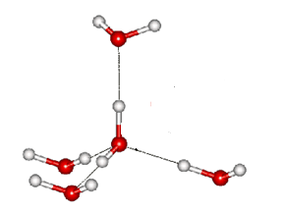
Figure 1.1: Tetrahedral water adapted from Chaplin.¹⁷
At low temperatures, (≤ 15 °C) the creation of this network is exothermic with decreasing solubility at increased temperature. The favourable enthalpy stems from water adopting a structure with stronger bonds than the bulk, overriding the endothermicity of creating a cavity in the water network.¹⁸ There is a solubility minima between 18 to 35 °C ¹⁹ (Figure 1.2)
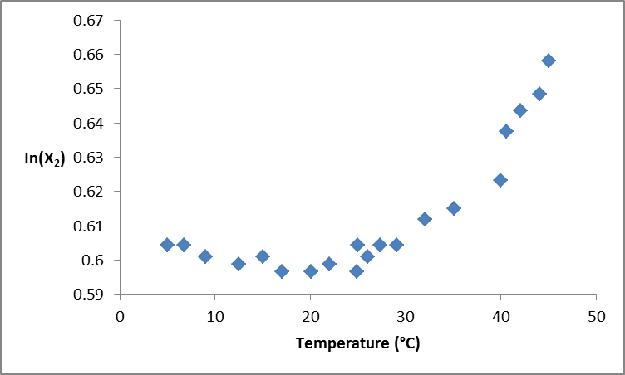
Figure 1.2: Natural logarithm of the mole fraction solubility of benzene against temperature adapted from Baldwin ¹⁸
Here the solubility switches from being enthalpy and entropy driven to just entropy driven.¹⁸ It has been suggested this is due to bulk water having less conformational freedom than the water neighbouring apolar groups.¹⁹ Recent temperature-dependent Raman scattering measurements reinforce this observation. The work suggests that around apolar compounds, larger than 1 nm, water has slower dynamics and stronger bonds, whilst at higher temperatures this water has faster dynamics than the bulk and weaker bonding.²⁰

The Role of Water in Binding Affinity

The driving force behind the hydrophobic effect in aqueous solution is the exclusion of water from apolar surfaces. It can be used to explain why proteins fold or why oil droplets form in water. The hydrophobic effect is used in medicinal chemistry to drive ligand-protein interactions with the idea being the hydrophobic component of the ligand binds to the hydrophobic surface of the protein, releasing energetically unfavourable water from the binding site to the bulk. The water associated with the apolar part of the protein is disfavoured entropically and so its return to the bulk is entropically favoured. ²¹ However, in line of increasing evidence of enthalpy paying a major or minor role in the hydrophobic effect, these explanations are often too simplistic. In fact, it had been recognised by Frank and Evans who suggested that for water to be around apolar groups is entropically unfavourable, that the enthalpic contribution to this had been underestimated. ²²
In order to understand the hydrophobic effect on a molecular level, Klebe et al. analysed a high resolution binding pocket of the bacterial zinc metalloprotease from Bacillus thermoproteolyticus.²³ Using a series of ligands Klebe et al. showed that the hydration network has a significant effect on structure-activity relationships displaying extreme enthalpy-entropy compensation with ligand amino acids of comparable sizes. Similar thermodynamic parameters were seen for amino acid side chain pairs that allowed for similar patterns of hydration in the complex.
The Mouse Urinary Protein I (MUP-I) has been used frequently to understand the thermodynamics between small molecules and this protein. The crystal structure MUP-I was determined by Böcskei and co-workers in 1991. An eight-stranded β-barrel and a single α-helix makes up the lipocalin fold with a hydrophobic cavity forming the interior of the barrel where small hydrophobic molecules can bind. ²⁴ This makes it an ideal model system to understand thermodynamic binding interactions specifically entropy contributions to binding affinity and specificity.
Using two pyrazine based ligands (Figure 1.3) Bingham et al. showed through NMR that the protein backbone and side-chain residues in the location of the binding site were contributing unfavourably to the entropy of the binding reaction, but this was counterbalanced by other residues distal from the binding pocket becoming more mobile.²⁵ Despite the pyrazine ligands being hydrophobic, the principal driving force behind the reaction derived from isothermal titration calorimetry (ITC) was a favourable enthalpic contribution with 2-methoxy-3-isopropylpyrazine (IPMP) and 2-methoxy-3-isobutylpyrazine (IBMP) being -44.54 kJ/mol and -47.89 kJ/mol respectively (Table 1.2). NMR and MDS showed that the entropic penalty of -10 kJ/mol arose from the ligand losing flexibility rather than the amino acids in the binding pocket. The authors concluded the source of the favourable enthalpy was primarily through enthalpic effects associated with desolvation of the binding pocket since there is only one strong bond for both ligands, which can be seen from the X-ray structures. However, since no X-ray structures exist with the protein showing these water molecules, the authors suggested this based on a molecular modelling programme called PRO-ACT which approximated a maximum of six water molecules being transferred to the bulk upon ligand binding.
Figure 1.3: 2-methoxy-3-isopropylpyrazine (IPMP) on the right and 2-methoxy-3-isobutylpyrazine (IBMP) on the left are the two ligands used by Homans to show that despite being largely hydrophobic, binding reactions can be largely enthalpy driven.
To see how much this strong bond contributed to the enthalpy of binding, site directed mutagenesis was used on Tyr120 which reduced the enthalpy of binding by 24%. However, the binding reaction was still largely enthalpy driven (Table 1.2). ²⁶ Solvent contribution upon ligand binding was found to be negligible based on substituting the solvent with D₂O meaning desolvation is essentially enthalpically neutral. However, the authors stipulate this approach is vulnerable to significant error. Molecular modelling of the binding site identified 3 and 4 water molecules for the wild type (WT) and the Tyr120Phe variant respectively. Based on this, it was assumed breaking the solvent-ligand bonds counteracted the favourable contribution to enthalpy from protein desolvation which means the enthalpic gains from van der Waals’ interactions between the ligand and the protein are larger than expected in poorly solvated binding pockets.
Another class of lipocalin proteins are the histamine binding protein from Rhipicephalus appendiculatus. This aptly named “hydrophilic binder” can be compared to the structurally related mouse urinary protein, a so-called “hydrophobic binder.” Despite this being a good model system, a mutant had to be engineered to abolish binding at one site reducing the binding stoichiometry to 1. ²⁷ This allowed for a better analysis of the thermodynamic data and it seemed both the WT and the Asp24Arg variant ligand-protein crystal structures superimposed well, meaning no change in the overall structure. Global thermodynamic analysis through ITC showed the Asp24Arg variant exhibits unfavourable entropic contributions at - 9.3 kJ/mol with binding being strongly enthalpy driven at -58.3 kJ/mol showing similar binding thermodynamics to the MUP-IPMP complex (Table 1.2). NMR relaxation times showed the entropy over the backbone amides to be 12.4 (± 9.8) kJ/mol, with increased and decreased flexibility over the entire structure upon ligand binding. ¹³C relaxation times, which can be employed to investigate the entropic contributions of a protein, were thought to be unobtainable due to the difficulty in discerning entropic contributions from both the methyl groups on the protein and the ligand. To determine the entropic contributions, MDS were used with explicit inclusion of the solvent waters to determine side chain entropies, with the entropy value for the amide backbone comparing well with the molecular dynamic simulation 16.4 (± 1.0) kJ/mol. The MDS estimated the protein component of the ligand-protein complex contributed favourably by 33 kJ/mol. The entropic and enthalpic contribution of ligand desolvation was computed by Conductor-Like Screening Model (COSMO) and were both found to be favourable. This molecular modelling software showed good agreement with 2 reference compounds and so the authors decided the calculation was accurate. MDS showed the rotational and diffusional dynamics of water within the protein binding site were much like the dynamics found in the bulk. In conjunction with the MDS data and the crystal structure showing the presence of three water molecules in the protein-ligand complex, the authors assumed these water molecules were contributing to the unfavourable entropy of the complex. It would seem from the crystal structures that water molecules are much more easily expelled from hydrophobic surfaces than hydrophilic.²³
This idea that water molecules are more easily expelled from hydrophobic surfaces than hydrophilic is one that has been used to successfully design HIV protease inhibitors. ²⁸ It has been articulated by Freire that achieving favourable enthalpies of desolvation from polar groups is much more difficult than attaining favourable desolvation enthalpies from apolar groups. ¹⁰
Human carbonic anhydrase II (HCA II) is an excellent model system due to its heavy biophysical characterisation.²⁹ Crystallography of a series of HCA II complexes with benzenesulfonamides substituted with alkyl and ﬂuoroalkyl chains in the para position showed that all ligands exhibited a similar binding geometry with the chains against the “hydrophobic wall”, a motif of hydrophobic amino acids within the binding site (Figure 1.4 and Figure 1.5). ³⁰ ITC showed both an increase in entropy and enthalpy with increasing chain length. The Whitesides’ group believed this increase in enthalpy was due to the release of water from both the tails and perhaps suboptimal hydrated areas of the “hydrophobic wall” which were not found in the crystal structure. Those ligands substituted with ﬂuoroalkyl chains had lower dissociation constants with marginally more favourable entropy and enthalpy terms in comparison to the unsubstituted derivatives. The group suggested this was to do with the larger Solvent-Accessible Surface Area (SASA) of the fluorine substituent being able to dislodge more water from the binding site. With both the fluorine and hydrogen substituted ligands the binding reaction was largely enthalpy driven at around –40 kJ/mol with a minor entropic component of approximately 5 kJ/mol (Table 1.3).

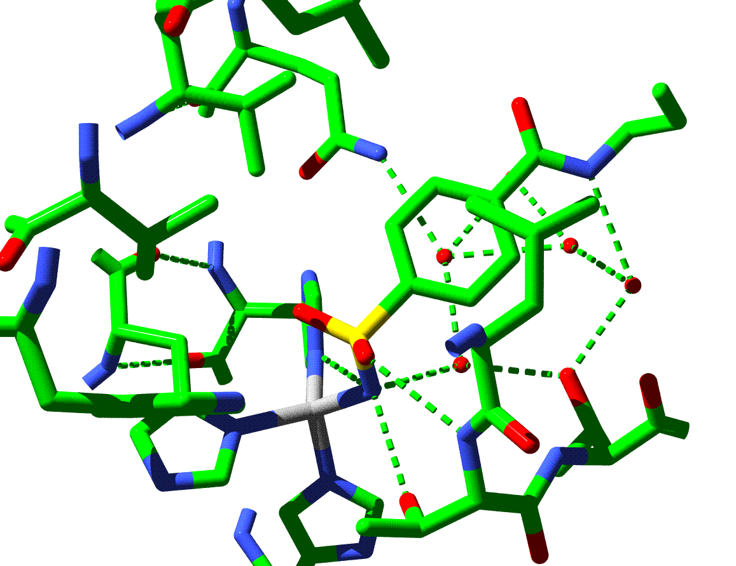
Figure 1.4: Crystal structure of human carbonic anhydrase 1 complexed with a benzenesulfonamide with a hydrophobic tail (highlighted in purple).^{30,31}
Using a series benzoarylsulfonamide ligands, the Whitesides’ group reinforced their previous conclusion that the hydrophobic effect is not necessarily driven by contact between the protein binding site and the ligand, but can be from structure of water around the complex(Figure 1.6).³² However, with these particular ligands, fluorination actually increased the number of water molecules found in the protein-crystal complex. In addition to this, the difference in the heat capacity of binding (ΔC_{p}) was more negative for fluorine substituted ligand by -184 kJ/ (mol∙K) Whitesides et al. believed this supported the idea that there is a mixture of hydrophobic driving forces that are dependent on the structure of water around the ligand and in the binding site.

Figure 1.5: The benzenesulfonamide ligands used by Whitesides et al. to show enthalpy has a large component to the hydrophobic effect where n = 0–4, X = H or F. Increasing the size of the alkyl or ﬂuoroalkyl chains otherwise known as the “greasy tail” made the entropy and the enthalpy more favourable.
Based on this, the group proposed a possible improvement to designing new inhibitors involving substituents with larger SASA to displace any water within the region. ³² Incorporation of fluorine instead of hydrogen could be one way to attain a larger SASA. In addition to this, fluorine has been known to decrease the metabolic susceptibility of drugs and assist in membrane permeability. ³³ Perhaps, replacement of hydrogen atoms with fluorine could be a future method of improving drug-binding thermodynamics. Many would argue changes in thermodynamics due to substituting hydrogen with fluorine would be in part caused by the increased hydrophobicity of the fluorine atom. However, Lockett et al. argued that some measures of hydrophobicity, when corrected for the differences in surface area, are very similar if not identical.^{30,34} When measuring the partitioning coefficient of fluorine and hydrogen substituted benzoarylsulfonamide ligands between buffer and octanol they found the surface area-corrected hydrophobicity increases by 4.6 kJ/mol ∙A² upon fluorine substitution.

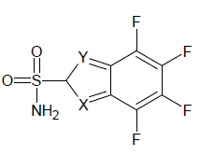
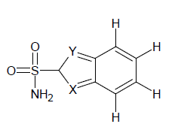

Figure 1.6: The benzoarylsulfonamide ligands used by Whitesides et al. to reinforce his previous conclusion that the hydrophobic effect can be enthalpy dominated. X and Y are one combination of X = CH and Y = S, X = N and Y = S, X = CH₃ and Y = NH and X = CH and Y = NCH₃
The thermodynamic data discussed here is summarised in Table 1.2. From this, it can be seen that hydrophobic interactions can be largely enthalpy driven, whilst being marginally entropically favoured or disfavoured. Table 1.3 shows thermodynamic data for a binding pocket and ligand which are more polar in comparison to the MUP-1 and its hydrophobic ligand.
The suggestion that water plays a major role in drug-protein interactions means that it could be involved in molecular mechanisms of drug resistance and this has been indeed shown to be the case. Equipped with an understanding of how water behaves around a protein should enable a better understanding of how to meet future challenges in medicinal chemistry. The erythroblastic leukemia viral oncogene homolog (ErbB) family contains several therapeutic targets for anticancer treatments. The members of this family are highly homologous and include ErbB4, epidermal growth factor receptor (EGFR) and human epidermal growth factor receptor 2 (HER2). Despite being highly homologous, lapatinib binds fairly weakly to ErbB4 compared to EGFR and HER2. Crystallographic studies of both EGFR and ErbB4 have not offered a reason for the different binding strengths. MDS based on homology templates of the proteins identified three distinct sites with high water occupancies, defined as S1, S2 and S3, for both EGFR and HER2. With ErbB4, there was a lower level of water at S1, but similar levels of occupancy at S2 and S3. It should be noted these water molecules were identified through MDS, as no crystallographic water molecules were included in the original setups. It seemed that in both EGFR and HER2 water played a “bridging role” between the ligand and the receptor, whilst such an interaction was missing in ErbB4 explaining the lower binding affinity. Using MDS the authors believed drug resistance could be brought about by changes in the water network located around the proteins through amino acid mutations.³⁵
A substantial impediment to the efficacy of drugs used against HIV and some other viruses is their high rate of mutation in the targeted biomolecules.³⁴ The HIV proteases retain a good catalytic activity required for viral reproduction with increased resistance to inhibitors. Preferably, a HIV protease inhibitor should have a binding affinity in the picomolar range against the WT and be impinged by mutations of a factor of 100 or less. Vega et al. believes this high level of activity can only be attained if both TΔS and ΔH are optimised to achieve a favourable ΔG of binding. ³⁶ This can be begun to be achieved with an understanding of water on the molecular level.
ITC revealed indinavir, nelfinavir and saquinavir binding to the WT protease, Val82Tyr/Ile84Val and Leu101Ile/Gly48Val/Ile54Val/Val82Ala was entropically driven and enthalpically disfavoured. However, binding of amprenavir, atazanavir, and darunavir to WT and Leu101Ile/Gly48Val/Ile54Val/Val82Ala is both enthalpically and entropically favoured. However, with the Val82Tyr/Ile84Val variant, the binding becomes entropically driven. The large negative change in ΔC_{p} shows the source of this favourable entropy could be due to desolvation effects rather than increased protein or ligand flexibility upon binding.³⁷ In many cases, ligand binding causes a decrease in both protein and ligand flexibility, so this supports the authors’ speculation. However, it must be stated that drug binding thermodynamics varies between cases because of the differing nature of the interactions. King et al. felt they could not speculate on the source of the unfavourable enthalpy based on the crystal structure and so did not provide an explanation.³⁴
Both KNI-10033 and KNI-10075 are HIV protease inhibitors both show favourable binding entropies and enthalpies. ²⁸ Both inhibitors are identical in structure apart from a single substitution; a SO₂CH₃ group in KNI-10075 replaces the –S-CH₃ group in KNI-10033. Binding of KNI-10033 to WT protease buries a total of 985 Å² of apolar surface area and 682 Å² of polar surface area with a ΔC_{p} value of -1926.28 J/(mol ∙K). For KNI-10075 the amount of buried apolar and polar surfaces are 953 Å² and 704 Å² respectively with a much more positive ΔC_{p} value of -1274.9 J/(mol ∙K) reflecting the smaller apolar surface burial than the previous inhibitor. From the crystallographic and thermodynamic data, Lafont et al. suggested the desolvation accounts for only 35% of the total entropy compensation, while 65% originated from structuring both the drug and the protein, caused by the SO₂CH₃ forming a hydrogen bond with Asp 30. ²⁸ The authors further speculated that the source of the apparent structuring could have occurred from the freezing of three bonds or the restriction of two amino acids.
KNI-764 and KNI-577 have ΔG of binding of -59.8 kJ/mol and -55.2 kJ/mol respectively.³⁶ The entropic and enthalpic components calculated through ITC are -28 kJ/mol and -31.8 kJ/ mol for KNI-764 respectively. Whilst for KNI-577 the entropic contribution is slightly more at 35.5 kJ/mol and the enthalpic contribution slightly less at -19.6 kJ/mol. These contributions change for the Val82Phe/Ile84Val mutant, with KNI-764 being -22.2 kJ/mol and 29.8 kJ/mol and for KNI-577 being -8.7 kJ/mol and 32.6 kJ/mol for the enthalpy and entropy values respectively. KNI-764 had a more favourable Gibbs free energy of binding for the mutant in comparison to KNI-577. The ΔC_{p} value for KNI-764 becomes more favourable while the ΔC_{p} value for KNI-577 becomes less so for the mutant. This shows the malleability of KNI-764 being able to go deeper into the mutant binding pocket, which is demonstrated by increase in apolar surface area burial reflected in the ΔC_{p} value. ³⁶ Both KNI-577 and KNI-764 have the same molecular structure with the exceptions of KNI-577 having a t-butylamide group, whereas in KNI-764 a larger methylbenzylamide group occupies the position.
Studies revealed tipranavir-WT HIV protease binding had a large entropic component of 58.1 kJ/mol, and a small enthalpic component of -2.9 kJ/mol.³⁸ All inhibitors lost potency against the Val82FPhe/lleI84Val protease variant showing less favourable values for the Gibbs free energy of binding. However, tipranavir gained binding enthalpy when binding to that mutant protease. Against the Ile13Val/Val32Ile/Leu33Phe/Lys45Leu/Val82Leu/Ile84Val protease variant, tipranavir showed a favourable change in binding enthalpy, whilst for all the other inhibitors, the binding enthalpy became less favourable. However, against the HIV protease variant Leu10Ile/Leu33Ile/Met46Ieu/Ile54Val/Leu63Ile/Val82Ala/Ile84Val/-
Leu90Met tipranavir lost binding enthalpy, although it was by far the smallest decrease in enthalpy compared to the other inhibitors. The authors speculated the favourable binding entropy came from burying less water molecules upon ligand binding compared to the other inhibitors. This was based on the entropy value of tipranavir binding being more favourable than based on hydrophobic burial upon binding alone. The favourable binding enthalpy also stems from this, as more favourable van der Waals’ contacts were made as due to fewer water molecules being present in the binding site.³⁸ All the inhibitors display a form of EEC phenomena as the Gibbs free energy of binding changes little despite the large changes in entropy and enthalpy (Table 1.4).
The studies performed by these authors’ shows that a drug could overcome resistance mutations by means of a thermodynamic mechanism. Although the mechanism needs further elaboration, the idea that future drug resistance can be overcome through thermodynamic optimisation is an interesting one and should be further investigated. As can be seen from the previous studies, water plays a role in viruses and cancer becoming resistant to small molecules.^{35,38}
Many proteins, including those involved in cell cycle and cancer such as the protein tyrosine kinases, have two binding pockets that have Src homology 2 (SH2). One pocket binds the phosphotyrosyl side chain of the ligand whilst the other more dynamic binding pocket binds the residue 3 residues down from the phosphotyrosyl side chain. Using a range of differing ligands containing the phosphotyrosyl head group, the Ladbury group observed a favourable increase in entropy, which they suggested reflected the release of water molecules upon binding. ³⁹ In the X-ray structure of a Src SH2 domain bound to a peptide, a network of water molecules was identified around the drug-protein complex which was held together due to the hydrogen bonding properties of the glutamate on the drug. The peptides used by Ladbury do not have this side chain and so do not interact with these water molecules. This also reduced the enthalpy term of the Gibbs free energy of binding due to the loss of hydrogen bonding contacts. The authors also speculated the favourable entropy may be also due to the lower flexibility of the ligands used to probe the effects of water during the binding reaction.³⁹

Table 1.2. Drug, protein, the number of water molecules in the crystallographic complex, the specific heat capacity, Gibbs Free Energy of Binding, enthalpy of binding, entropy of binding and the respective reference. With the benzenesulfonamides ligands these have been abbreviated to the number of repeating units of the polymer and if the element either being F or H where H₂NSO₂C₆H₄-CONHCH₂(CX₂)_{n}CX₃, n = 0–4, X = H, F). It has been noted where molecular modelling (MM) has been used to ascertain the number of water molecules within the binding site. NR = not reported
Drug | Protein | Solvation (Number of water molecules in the crystallographic complex) | - ∆C_{p}  (J/(mol∙K)) | -∆G  (kJ/mol) | -∆H  (kJ/mol) | T∆S  (kJ/mol) | Ref
n= 0 X=H | Human carbonic anhydrase 1 | None found in the complex | 292 | 40.1 | 38.5 | 1.7 | ³⁰
n=1  X=H | Human carbonic anhydrase 1 | None found in the complex | 342.7 | 42.6 | 39.3 | 3.3 | ³⁰
n=2  X=H | Human carbonic anhydrase 1 | None found in the complex | 367.8 | 43.5 | 39.3 | 4.18 | ³⁰
n=-0  X=F | Human carbonic anhydrase 1 | None found in the complex | 301 | 44.3 | 40.5 | 3.8 | ³⁰
n=1  X=F | Human carbonic anhydrase 1 | None found in the complex | 334.4 | 46.4 | 41.8 | 4.6 | ³⁰
n=2  X=F | Human carbonic anhydrase 1 | None found in the complex | 380.4 | 48.3 | 43.0 | 6.27 | ³⁰
IPMP | MUP-I | None found in the complex – MM suggested 6 | NR | 33.9 | 44.54 | -10.65 | ²⁵
IBMP | MUP-I | None found in the complex – MM suggested 6 | NR | 38.5 | 47.89 | -9.39 | ²⁵
IBMP | MUP-I Y120F (288 K) | None found in the complex – MM suggested 3 to 4 | 510 | 34.89 | 25.76 | 9.12 | ²⁶
IBMP | MUP-I Y120F (298 K) | None found in the complex – MM suggested 3 to 4 | 510 | 35.31 | 31.44 | 3.87 | ²⁶
IBMP | MUP-I Y120F (308K) | None found in the complex – MM suggested 3 to 4 | 510 | 33.61 | 35.90 | -2.29 | ²⁶
IBMP | MUP-I Y120F (298 K) D₂O | NR | NR | 33.82 | 34.21 | -0.4 | ²⁶

Drug | Protein | Solvation (Number of water molecules in the crystallographic complex) | - ∆C_{p}  (J/(mol∙K)) |  | -∆G  (kJ/mol) | -∆H  (kJ/mol) | T∆S  (kJ/mol) | Ref
Histamine | rRaHBP2(D24R) (278K) | 3 |  | 780 | 49.2 | 42.7 | 6.5 | ²⁷
Histamine | rRaHBP2(D24R) 288K | 3 |  | 780 | 48.8 | 48.3 | 0.4 | ²⁷
Histamine | rRaHBP2(D24R) 298K | 3 |  | 780 | 49.1 | 58.3 | 9.3 | ²⁷
Table 1.3: Drug, protein, the number of water molecules in the crystallographic complex, the specific heat capacity, Gibbs Free Energy of Binding, enthalpy of binding, entropy of binding and the respective reference.

Table 1.4: Drug, protein, the number of water molecules in the crystallographic complex, the specific heat capacity, Gibb’s Free Energy of Binding, enthalpy of binding, entropy of binding and the respective reference. NR = not reported
Drug | Protein | Solvation (Number of water molecules in the crystallographic complex) | - ∆C_{p}  (J/(mol∙K)) | -∆G  (kJ/mol) | -∆H  (kJ/mol) | T∆S  (kJ/mol) | Ref
TPV | HIV-1 protease | 17 | NR | 61.6 | 2.9 | 58.1 | ³⁸
ATV | HIV-1 protease | 29 | NR | 59.8 | 17.6 | 42.2 | ³⁸
LPV | HIV-1 protease | 21 | NR | 59.8 | 10.0 | 49.7 | ³⁸
KNI-764 | HIV-1 protease Q7K/ L33I/ L63I | 6 | 1504.8 | 59.8 | 31.8 | 28.0 | ³⁶
KNI-764 | HIV-1 protease Q7K/ L33I/ L63I/V82F/I84V | 5 | 1630.2 | 51.8 | 22.2 | 29.7 | ³⁶
KNI-577 | HIV-1 protease Q7K/ L33I/ L63I | 5 | 1755.6 | 55.2 | 19.6 | 35.5 | ³⁶
KNI-577 | HIV-1 protease Q7K/ L33I/ L63I/ V82F/I84V | 5 | 1588.4 | 41.4 | 8.8 | 32.6 | ³⁶
KNI-10033 | HIV-1 protease Q7K/L33I/L63I | 7 | 1927 | 62.2 | 34.3 | 27.9 | ^{28,40}

Much of this work on interpreting the role of water in ligand protein interactions is done through crystallography. However, crystallography is ill-suited for investigating protein hydration. Crystallography done at ambient temperatures only shows water molecules that interact strongly with polar atoms.⁴¹ Therefore, in many cases, solvation found using crystallographic structures solved at ambient temperatures is much smaller than it naturally would be. In addition to this, the crystal itself can perturb water molecules.
Resolution is another problem when trying to interpret water in crystallographic structures. ⁴² Ladbury states that although water molecules can be seen at resolution of 2 Å, the bond angles and assignment of the exact position is uncertain.⁴² Ladbury further states that in some cases water molecules may be added to help the statistics of the structure, therefore, caution must be taken when interpreting crystal structures.

Entropy Enthalpy Compensation Phenomena and Water

Originally, the isoequilibrium relationship and compensation effect were considered to be equivalent.⁴³ An isoequilibrium relationship means that there is a temperature when the equilibria (where one parameter is varied) are fairly close together. A compensation effect means that the either entropy or enthalpy compensates the other parameter. Plotting the Gibbs free energy of binding against temperature in many examples shows an intersection point where the reactions all have the same equilibrium constant displaying an isoequilibrium point. Plotting entropy versus enthalpy yields entropy-enthalpy plots and where linearity occurs, this is assumed to be proof of EEC. However, there may be cases where in the latter there is no correlation due to both large and small opposing changes in both entropy and enthalpy that may overall lead to an isoequilibrium effect.⁴³
In their seminal work, Lumry and Rajender proposed that protein processes, such as binding substrates, are coupled to water via conformational rearrangements of the protein and that EEC phenomena is a consequence of this. ¹³ Grunwald and Steel advocated the idea of solute-induced molar shifts when the solvent consists of two or more isomeric forms being responsible for EEC phenomena.¹⁴ This idea that water around solutes has differing spatial and thermodynamic properties than that of the bulk is supported by numerous techniques. Terahertz time domain spectroscopy has shown in conjunction with MDS that both hydrophobic and hydrophilic groups increase the hydrogen bond lifetime within a distance of 5 Å compared to that of bulk water.⁴⁴ Davis et al. used Raman multivariate curve resolution spectroscopy to probe the hydration layer around the apolar chains of alcohols. The group showed the water surrounding the apolar main chains of these alcohols adopted more tetrahedral structures with fewer weak hydrogen bonds in comparison to water found in the bulk.²⁰ Privalov showed that the partial ∆C_{p} of the apolar groups is positive at 5 °C and decreases with increasing temperature, while for the polar and charged groups it is negative at 5 °C, becomes zero at room temperature, and increases with increasing temperature.⁴⁵
The thiazole-based sulphonamide ligands used by Breiten et al. bind to HCA with an enthalpy dominated hydrophobic effect, which increases with increasing hydrophobicity of the ligand. ⁴⁶ The structural rigidity of both the ligand and the protein means that the changes in binding thermodynamics due to ligand functional group changes most likely come from solvent reorganisation. The binding affinities of these ligands to HCA, despite changes in fluorination configuration were difficult to tell apart; they nevertheless showed changes in both binding entropy and enthalpy. The work suggested water networks identified by WaterMap were responsible for EEC phenomena.
Despite work supporting the idea of EEC phenomena, there are many that simply believe it is erroneous. For many years it was described as an artefact caused by the error in calculating entropy values from linear regression using the Arrhenius plot over small temperature values and perhaps inaccurate calorimetric equipment.⁴⁷ Although ITC is an extremely accurate technique and gives reliable entropy, enthalpy values and association constants, mistakes in calculating the concentration of the ligand or the protein will lead to errors in the thermodynamic parameters. ⁴⁸ A large scale interlaboratory evaluation showed the main source of error was a failure to precisely measure the ligand concentration used in ITC experiments. The enthalpy data produced by 14 different laboratories varied by 24% for the binding of bovine carbonic anhydrase to 4-carboxy-benzenesulfonamide.^{49,50} Fitting data when the concentration is wrong will lead to apparent EEC due to any error in ΔH producing a compensating change in TΔS. ⁴⁸
It seems that without a complete understanding of water on the molecular level, determining if EEC is a true phenomenon seems challenging. Increasingly though, techniques are being used to investigate how water behaves around proteins.

Techniques used to study Water around Proteins

Cryogenic Crystallography
Cryogenic crystallography can be used to investigate the magnitude of hydration but again this can be unreliable much like crystallography performed under ambient conditions. ⁴¹ Nakasako used several different crystal structures to better overcome the problem of crystal structures perturbing the hydration layer. He found no water around polar flexible side chains, but did find water in the hydrophobic patches of the protein. The flexibility around polar side chains makes it difficult to assign hydration sites.
A method to overcome the problem of assigning hydration sites around polar flexible regions of proteins is to use MDS; a procedure used by Higo. The crystal structure analysis at a resolution of 1.4 Å showed 405 crystal water molecules around lysozyme. Based on the crystallography data and MDS, Higo believed these water molecules separated out into four distinct layers totalling 10 Å and that these hydration layers would play a role in molecular recognition events. ⁵¹
Yokomizo et al. used MDS trajectories based on cryogenic X-ray data to find that water around and inside the active site of lysozyme tend to have slower reorganisation times than that of the bulk water. This has been shown to be the case with dielectric spectroscopy and is generally held to be true.^{52,53} Yokomizo speculated that these slow reorganisation times would lead to hydration structures which could be vast enough to hinder ligand access to the active site, due to the time and energy it would take to rearrange these water structures and the effect it could have on protein dynamics. ⁵³

Terahertz Spectroscopy

Terahertz time domain spectroscopy is a relatively new technique used to understand protein-solvent interactions. Hydrogen bonding, which is most likely accountable for the complexity of water, displays its vibrational resonances in the frequency range 1 to 6 THz. This means any change in the hydrogen bond population should be detected. However, there are no sharp peaks in a THz spectrum. This differs from the classical spectra obtained by NMR or infrared studies of chemical groups in a compound. Much like crystallography, it is primarily used to understand the spatiality of water rather than its dynamics, though there are some important exceptions. However, unlike crystallography, proteins can be investigated freely in solution and do not have to go through any precipitation conditions which could remove water.
Hayden and Havenith, proponents of Terahertz spectroscopy, found that increasing the amount of λ*_{6–85}-repressor protein to 0.65 mM led to an increase in THz absorbance (Table 1.5). ⁵⁴ This increase was due to two effects: the rising protein concentration and the growth of the hydration layers. In fact, the increased protein concentration only leads to a marginal rise in the spectra. It is the growth of the hydration layers leads to a strong absorption in this spectrum. After 0.75 mM, the peak stops levelling and begins to decrease. The authors hypothesised that this was due to the hydration layers overlapping which would cause them to reduce in size. Based on this, they calculated the hydration layers to be approximately 22 Å in size. Using MDS based on the THz information, the hydrogen bond life times were shown to be around 2.9 picoseconds (ps) for the bulk water and 4.1 ps for the hydration layers. MDS conducted by Hayden and Havenith also found hydrogen bond life times around hydrophilic residues were 4.2 ps, this half-life was increased to 5.5 ps if the water was around hydrophobic residues. Denaturation studies of λ*_{6–85}-repressor showed no increase in THz absorption with rising protein concentration. This could show water behaves differently around apolar residues which would be exposed upon denaturation. However, Markelz et al. found that water associates with alanine peptides using THz spectroscopy. ⁵⁵ This may mean the denatured proteins precipitated out of solution in the Hayden and Havenith study, which Falconer believed would lead to such a spectra witnessed by that group. ⁵⁶
Xu et al. found that absorbance for lysozyme plateaued after 2 THz , whilst BSA absorbance increased with increasing THz frequency. ⁵⁷ The authors speculated from charge distribution within the protein or particular interactions with the water. A distance decomposed infra-red absorption spectra allowed the Havenith group to suggest a solvation shell absorbs most strongly at 2 THz. ⁵⁸ It was proposed this could be understood as two tetrahedral waters connected along a hydrogen bond axis. Consequently, based on this model, solutes would be expected to alter this absorption by changing the vibrational motion of these two connected water molecules. ⁵⁸
The Moon group carried out an intermolecular vibrational study of liquid water and ice over varying temperatures using far infrared spectroscopy with synchrotron radiation. ⁵⁹ They found a peak at 1.3 THz did not depend on the temperature range between 10.0 °C and 70.0 °C, however, this mode was not detected in the ice spectrum.⁵⁹ The authors suggested this band was caused by collective larger motions specific to the dynamic structure of liquid water. Using a short intense electron source at Stanford University, Woods and Wiedemann found that some bands between 1.2 and 3 THz exhibited a red shift with increasing temperature.⁶⁰ The authors suggested this was consistent with the lengthening or softening of hydrogen bonds.

Table 1.5: Protein, hydration shell dynamics, size of the apparent hydration shell, protein concentration, buffer, temperature and the particular technique used to determine these values. Please note single dipole auto correlation and hydrogen bond auto correlation functions are molecular modelling techniques. NR = Not Reported.
Protein | Hydration shell Dynamics | Size of apparent hydration shell  (Å) | Protein concentration | Buffer | Temp  (°C) | Technique | Ref
λ*_{6–85}-repressor protein | 5.5 ps for water solvating hydrophobic residues (Hydrogen bond auto-correlation functions) | 22 | Range used to determine the size of the hydration layer 0 to 1.75 mM | NR | NR | Terahertz time domain spectroscopy | ⁵⁴
λ*_{6–85}-repressor protein | 4.2 ps for water solvating hydrophilic residues (Hydrogen bond auto-correlation functions) | 22 | Range used to determine the size of the hydration layer 0 to 1.75 mM | NR | NR | Terahertz time domain spectroscopy | ⁵⁴
λ*_{6–85}-repressor protein | 9.6 ps for water solvating hydrophobic residues (single dipole auto-correlation functions) | 22 | Range used to determine the size of the hydration layer 0 to 1.75 mM | NR | NR | Terahertz time domain spectroscopy | ⁵⁴
λ*_{6–85}-repressor protein | 7.7 ps for water solvating hydrophilic residues (single dipole auto-correlation functions) | 22 | Range used to determine the size of the hydration layer 0 to 1.75 mM | NR | NR | Terahertz time domain spectroscopy | ⁵⁴
λ*_{6–85}-repressor protein | 4.1 ps for the protein (Hydrogen bond auto-correlation functions) | 22 | Range used to determine the size of the hydration layer 0 to 1.75 mM | NR | NR | Terahertz time domain spectroscopy | ⁵⁴

Dielectric Spectroscopy

Dielectric spectroscopy can be used to investigate both the spatiality and dynamics of water around proteins. Oleinikova et al. used this technique to discern the time scales of different populations of water. However, this technique has to be complementary, to say NMR studies, as interpretation of the data is difficult. For example, Oleinikova et al., Nandi et al. and Pethig all interpreted the population of water around ribonuclease A at 2 ns as protein-water interactions, water exchange and tightly bound water, respectively.⁵²
Typically, dielectric spectroscopists have used the δ relaxation time to look at hydration water. It shows bimodal distribution with assignment of loosely bound and tightly bound water. Oleinikova et al. disagrees with this, noting a 3 modal distribution, with δ3 and δ1 corresponding to hydration water and protein-water interactions. δ2 was interpreted as the movement of polar side chains.
Wolf et al. found lysozyme with a hydration shell of 1.96 nm for the 5 mmol solution and 1.91 nm for the 3 mmol sample. ⁶¹ This contradicts terahertz spectroscopy work that shows the hydration layers shrink upon addition of protein beyond a certain concentration. The work done by Wolf et al. is supported by Vinh et al. who also found the protein hydration layers were independent of protein concentration using dielectric spectroscopy in the GHz range. ⁶² Several explanations were put forward by Vinh et al. for this discrepancy, including the THz frequencies used by Havenith group and the proteins lysozyme and the λ*_{6–85}-repressor being structurally distinct. However, it is not untypical for experimental results regarding the nature of protein solvation using different techniques or sometimes with the same one to contradict each other. Another possible reason for the inconsistencies is the differing buffers used in the experiments. Salts are known to interact with the protein and alter both the bulk taking on their own hydration shells, removing water from the protein hydration layer or adding to it. ⁶³ Additionally, using protein concentrations higher than around 0.5 mM may be too high to measure hydration shells. According to THz spectroscopy the onset of hydration layers begin at much lower concentrations, above 0.75 mM for λ*_{6–85}-repressor protein. Therefore, interpretation of protein hydration spatiality at the concentrations done by Wolf and Vinh et al. respectively may be prone to significant error. Anyone of these scenarios could cause disparities between two sets of experiments with two different buffers and protein concentrations. Temperature would also have an effect on both the dynamics and spatiality of the hydration shells. Where it has been made obviously apparent both the temperature and the buffer used has been noted.

NMR Magnetic Relaxation Dispersion (NMR-MRD)

NMR magnetic relaxation dispersion (MRD) is a technique primary used to investigate water which occupies protein crevices on a nanosecond or longer time scale.⁶⁴ This approach works by measuring the ¹⁷O relaxation rate of water rather than measuring that of protons, which is in contrast to regular NMR.
Qvist et al. used site-directed mutagenesis to change six lysines to found on the protein surface of Protein L from Streptococcus magnus to glutamate to understand the effect of charge, chemical structure and polarity of the amino acids on the hydration layer (Table 1.6). Using NMR-MRD Qvist et al. showed the rotational time of the hydration layer waters does not appreciably change between the WT and the mutant when the differences in the perturbation caused by the change in accessible surface area and the number of methyl groups between the two amino acids. Qvist et al. reasoned the surface topography of proteins, rather than the chemical nature, polarity or charge of the amino acids, was the major factor in determining the dynamics of the hydration layer. ⁶⁵ The mutant was unfolded and it was found the rotational time of the hydration layer water increased. If the isoelectric point of the protein or the chemical nature of the amino acids contributed to the hydration layer, it would be expected some level of the hydration layer would be identified for the unfolded state, which it was not. ⁶⁵ This is in contradiction with fluorescence spectroscopy experiments which found a reduction of 40 ps to 10 ps from changing an isoleucine to the larger, more hydrophobic surface exposed homoisoleucine for a coiled-coil protein. ⁶⁶
Table 1.7: Protein, hydration shell dynamics, size of the apparent hydration shell, protein concentration, buffer, temperature, reference and the particular technique used to determine these values. NR= Not Reported.
Protein | Hydration shell Dynamics | Size of apparent hydration shell | Protein concentra-tion  (mM) | Buffer | Temp  (°C) | Technique | Ref
Protein L | 3.83 ns | NR | NR | water  enriched to 21% in  ¹⁷O  phosphate buffer  2 mM NaN₃ | 26.85 | NMR-MRD | ⁶⁵
Protein L  (Kx6E) | 2.26 ns | NR | NR | water  enriched to 21% in  ¹⁷O  phosphate buffer  2 mM NaN₃ | 26.85 | NMR-MRD | ⁶⁵
Protein L  (Kx6E) | 2.26 ns | NR | NR | water  enriched to 21% in  ¹⁷O  phosphate buffer  2 mM NaN₃ | 26.85 | NMR-MRD | ⁶⁵

In line with the findings by Whitesides’ and Homans’ groups that it is highly unfavourable for water to be found in apolar cavities Qvist et al. used MRD NMR to show there was no water present with nanosecond residence times or longer for the 315 Å³ bovine apo β-lactoglobulin binding cavity. Using MDS they argued that it was entropically unfavourable for water to be present within this binding site due to the highly linear hydrogen bonds formed between the proposed waters. ⁶⁷

Extended Frequency Range Depolarised Light Scattering (EDLS)

The extended frequency range depolarised light scattering (EDLS) technique can give information about hydration dynamics and spatiality on a picosecond time scale. ^{68,69} Comez et al. investigated the hydration dynamics caused by molecules with differing chemistry and structure to argue that using peptides, amino acids, hydrophobic particles and sugars is insufficient to understand protein hydration. The suggestion put forward was that the interaction of water with proteins is a summation of all its parts; and so cannot be simply be broken down into simple systems. ⁶⁸ The results found by Comez et al. on protein hydration can be seen in Table 1.7, whilst the work done with small molecules can be seen in Table 1.8.
Grunwald’s and Steel’s idea that EEC could be explained by solute induced molar shifts of water could be partly correct given that numerous techniques show that the physical and chemical properties of water are affected by protein structure and amino acid composition. But using a two state model to explain hydration seems inaccurate. The hydration shell represents a complex interplay of water molecules. It seems that drug design efforts could therefore be improved with a better knowledge of the protein hydration layers.

Table 1.8: Protein, hydration shell dynamics, size of the apparent hydration shell, protein concentration, buffer, temperature, reference and the particular technique used to determine these values. NR = Not Reported
Protein | Hydration shell Dynamics | Size of apparent hydration shell  (Å) | Protein concentration  (mM) | Buffer | Temp  (°C) | Technique | Ref
λ*_{6–85}-repressor protein | NR | >  10 | protein concentration range 0 to 3 | 50 mM magnesium acetate | 21.85 | Terahertz time domain spectroscopy | ⁷⁰
Lysozyme | NR | 9 | NR | NR | 19.85 | Extended Frequency Range Depolarized Light Scattering | ⁶⁸
Lysozyme | 0.2 -2 ns | 19.6 | 5 | Water | 3.85-59.85 | Dielectric spectroscopy | ⁶¹
Lysozyme | 1.5-3 ns | 19.1 | 3 | Water | 59.85 | Dielectric spectroscopy | ⁶¹

Techniques Used to Study Water around Small Molecules

To fully untangle thermodynamic signatures it is vital the hydration of the ligand as well as the protein is fully understood. In addition to revealing the nature of hydration around the small molecule something may also be learned regarding the hydrophobic or hydrophilic hydration. This can then be applied to what is known about protein solvation chemistry.

NMR-MRD

In regards to water around hydrophobic patches, water around these areas was always thought to resemble “icebergs” at room temperature.^{16,71} Such thinking was used by Edwin Haslam to describe how water behaves around apolar groups with tannins, referring to the partially ordered water as “icebergs”, a popular term originating from the work by Frank and Evans.⁷² However, Qvist and Halle showed water does not behave as an “iceberg” around apolar molecules. It has been speculated that it might not exist at all. Using NMR-MRD and MDS Qvist and Halle showed that water has a faster rotation time below 255 K than the bulk water for simple peptides. ⁷³ Qvist and Halle believed the water in the bulk was becoming more tetrahedral on cooling. Whilst, water near apolar peptides has a different structure which is not an “iceberg” but altered by the apolar surface area. They believed the water near apolar peptides could participate in the hydrogen bond network which would affect the configurational freedom of the surrounding water molecules slowing down their reorganisation time by a factor of three.

Pump Probe Spectroscopy

Mazur et al. used a Non-Resonant Pump Probe spectroscopy to discern the effect of temperature and concentration on water dynamics by two osmolytes trimethylamine N-oxide (TMAO) and tert-Butyl alcohol (TBA). ⁷⁴ Both compounds could be considered hydrophobic due to the large number of methyl groups, however TBA has a hydroxyl whilst TMAO contains a charged nitrogen oxygen bond. TMAO solutions were found to slow down water dynamics at increasing concentrations, whilst TBA slowed down water dynamics above 2 M. TMAO showed minor changes in hydration dynamics at increasing temperature, whilst with TBA it was found to be temperature dependent, a possible sign of temperature dependent aggregation. From this, they believed that hydrophobic groups have a negligible contribution on water, with polar groups having a larger effect. Backulin et al. found similar hydration shell dynamics for both TBA and TMAO using 2D vibrational spectroscopy and Polarization-Resolved Pump−Probe spectroscopy. In addition to this, they found tetramethylurea, a compound with an additional methyl group slowed down hydration dynamics more than TBA and TMAO which both contain 3.⁷⁵ The work done opposes that done by Mazur et al. and was used to suggest that hydrophobic methyl groups slow down hydration dynamics more and that previous experiments had underestimated the contribution made by methyl groups. A possible reason could be that TBA was aggregating at the high concentrations used by Backulin et al.

Terahertz Spectroscopy

MDS based on THz information led Niehues et al. to believe that both hydrophobic and hydrophilic groups increased the hydrogen bond lifetimes within a distance of 5 Å compared to water within the bulk. ⁴⁴ However, hydrophobic hydration was found to have a shorter lifetime of that of hydrophilic hydration by 10% on a ps timescale. With hydrophobic groups it was suggested that no solute-hydrogen bonds could form, but with hydrophilic groups it was found that solute-water hydrogen bonds have appreciably higher lifetimes which reduce the rotational mobility of water within the hydration shell.
Table 1.9: Small molecule, hydration shell dynamics, size of the apparent hydration shell, small molecule concentration, buffer, temperature, reference and the particular technique used to determine these values. NR*= Although the hydration shell dynamics have not been reported, the Hydration/Bulk Retardation Factor ξ has been which yields how much the water is retarded around proteins.
Small molecule | Hydration shell Dynamics | Size of apparent hydration shell  (Å) | Small molecule concentration  (mg/ml) | Buffer | Temp  (°C) | Technique | Ref
TBA | NR* | 2.2 | 90 | Water | 19.85 | EDLS | ⁶⁸
TMAO | NR* | 2.1 | 130 | Water | 19.85 | EDLS | ⁶⁸
Lysine | NR* | 3.1 | 130 | Water | 19.85 | EDLS | ⁶⁸
N-acetyl-glycine-methylamide | NR* | 4.1 | 100 | Water | 19.85 | EDLS | ⁶⁸
N-acetyl-leucinemethylamide | NR* | 4.3 | 100 | Water | 19.85 | EDLS | ⁶⁸
N-acetylleucine-  amide | NR* | 4.2 | 100 | Water | 19.85 | EDLS | ⁶⁸

It seems that based on these studies ligand solvation could be as important in understanding the role of water in binding interactions as studying proteins. The binding of four peptides to thermolysin was studied by ITC and crystallography. ⁷⁶ Addition of a carboxylate group and a methyl group to the peptide lead to favourable changes in the Gibbs free energy of binding. Crystallography suggested the increase in binding affinity was due to favourable interactions with the ligand and the water network within the binding site. Addition of just either the methyl or the carboxylate group led to EEC phenomena with minor changes in affinity. This example demonstrates non-additivity and yields a possible method of circumventing EEC. ⁷⁶

Extract the Role of Water in Binding Interactions

The existence of EEC usually means that the parameter being varied (solvent, structure, ect) is operating on one type of interaction.⁴³ It is a manifestation of the presence of a single source of additivity.¹³ In the case of examples where water could be the source of compensation changing the temperature at which the titration is performed, addition of salts, osmolytes or organic solvents can test this. In addition to this, the contribution of water to binding thermodynamics can be understood. This section will outline possible methods of measuring water displacement during binding interactions.

Methods of Changing the Hydrophobic Effect

The hydrophobic effect can be decreased by the addition of substances called “antihydrophobic agents.” Chaotropic agents such as urea and guanidinium and small chain alcohols solvate hydrophobic areas and interact with water.⁷⁷ Hydrophobic reactants can dissolve to a greater extent by the addition of alcohols reducing the free energy of the interacting partners. This can be used to study the transition state. If hydrophobic surface areas are less exposed and the transition state is effectively more polar the rate of the reaction will decrease. This gives a method of studying complex formation and has been used in a number of experimental studies. Nucleophilic addition/elimination of N-methylaniline with sodium 4-(chloromethyl) benzoate was slowed by 10% ethanol. This was believed to be due to the overlap of phenyl groups occluding the solvent in the transition state.⁷⁸ There was no change in rate when ethanol was added to the nucleophlic addition/elimination reaction of sodium 4-(chloromethyl) benzoate with sodium phenoxide acting as a nucleophile. The authors suggested that the phenyls of both compounds do not overlap in the transition state.⁷⁹
Hydrophobicity in enzyme catalysed reactions have also been probed using organic solvents. Maurel suggested that the higher the solubility of apolar compounds in water-organic solvent mixtures, the lower the affinity for apolar sections of the active site. ⁸⁰
Experiments in the presence of glycerol, ethylene glycol and betaine with an antibody and an avian lysozyme caused a decrease in the association constants measured by ITC which was attributed to a change in the hydration layer and correlated with the water activity of these osmolytes.⁸¹ Kornblatt et al. found with the addition of 40% glycerol the dissociation constant of porphyrin cytochrome c and cytochrome c oxidase changed from 0.4 × 10⁻⁷ molal to 1.83 × 10⁻⁷ molal.⁸² The authors put forward a range of possible suggestions including ordering of water around the proteins or glycerol preferentially binding. Kornblatt et al. suggested binding could play a role, although there was no correlation between Gibbs free energy and glycerol concentration, which there should be if glycerol was preferentially interacting with the proteins. ⁸² It could also be argued the ordering of water, another suggestion put forward by the group, would lead to some measure of enthalpy-entropy compensation and the same association constant. A better explanation put forward was that water was assisting in binding by acting as a bridge or lubricant between functional groups of the two proteins and so removing this water increased the dissociation constant. Water acting as a molecular lubricant or bridge has been invoked before to explain changes in association constants and is used to explain the “sloppy fit” mode of binding which is somewhat at odds with conventional theories of binding such as the “lock and key” and “induced fit”.¹⁵ To probe the role of “bound water” in EcoR1 in the recognition of DNA a series of compatible and non-compatible osmolytes were used. ⁸³ With increasing osmotic pressure there was a correlated drop with specificity which the authors assumed was the water being drawn out of the active site.
It was later found the dissociation rate was correlated with water activity for the binding of EcoR1 to DNA. ⁸⁴ For example, the half-life of the DNA-protein complex was about 20 times larger in 3 molal betaine in comparison to 1.6 molal betaine. It could be argued viscosity and not water activity was contributing to the increased stability of the protein-DNA complex. Though, the very similar effect of both betaine and sucrose on the half-life of the complex and the similar amount of water ($≈$65) taken up by the complex after dissociation, arguments regarding viscosity are less of an experimental caveat since sucrose is 6 times more viscous than betaine at the concentrations used.
Using a series of osmolytes with an assay to measure the stability of a BamHI-DNA complex and non-specific DNA cleavage Sidorova et al. measured the differences in sequestered water between specific and non-specific BamH1-DNA complexes. ⁸⁵ They found 135 more water molecules revisited in the non-specific BamH1-DNA complex compared with the specific DNA protein-complex using osmolytes with MWs larger or similar to methyl sulphate (126 g/mol). In addition to this, they found smaller osmolytes such as methanol and those of a similar MW caused less water to return (≤100), which in the case of methanol was less than 21 water molecules. The authors suggested this was due to these small osmolytes possibly interacting with the surface of the protein which complicated the analysis. ⁸⁵
Changing the experimental temperature remains a highly used method of studying the role of water in binding interactions. The hydrophobic effect increases with increasing temperature and in many cases switches from being endo-to exothermic.⁸⁶⁻⁸⁸ This means that many binding interactions have a negative change in ∆C_{p} due to the burial of apolar surface area.^{88,89} Changing the temperature also remains a way of identifying true EEC as it has been suggested to be extra thermodynamic and does not respond to normal statistical thermodynamics. ^{90,91} Sharp suggested that the temperature should be varied more than 25% of the experimental temperature to reveal EEC.⁹⁰

Techniques Used to Study Ion Solvation

The dynamics and spatiality of water around ions is not fully understood. Ions having electronic and steric effects on water produce populations of water with differing dynamics and spatiality yielding differing thermodynamics and kinetics to that of the bulk. These populations of water – so called hydration layers are a complex pattern of hydrogen bonding which have been detected by numerous techniques. The issue is contentious because data on the dynamism and spatiality of water populations around ions conflict. The reasons for these discrepancies are put forward in this literature review.
In 1888, Hofmeister discovered the effects of ions on the precipitation of proteins in purified egg white. According to the precipitative efficiency of the different ions, they can be ordered and are known as the Hofmeister series. It has only been relatively recently that a molecular understanding of how ions affect water has begun to be realised. Kim et al. used a combined experimental and simulated Infrared spectroscopy approach to show that increasing anion concentration from 1 to 6 M disrupted the hydrogen bond network. This was found to be independent of the kosmotrope - chaotrope classification. Amide I and II frequencies of N-methylacetamide in D₂O did not show any changes in the hydration layer which precludes direct bonding. The results were used to suggest that the ions used in this study did not interact with the peptide backbone. ⁹²
The high surface tension of water (72 mN/m at 25 °C) is caused by a number of cohesive forces between water molecules. The water molecules on the top layer are thought to bond more strongly to those underneath. This top layer is primarily thought to be responsible for surface tension. The addition of most inorganic salts to water increases the surface tension of the air/water interface with an approximate linear increase in salt concentration above 0.01 M.⁹³ The central insight into this work was the realisation of an induced surface charge at the air-water interface caused by the strong dielectric discontinuity between the two phases. It was suggested the increase in surface tension was due to depletion of ions from the interfacial area indicated by a negative value for the Gibbs adsorption equation.^{94,95} Mechanistically, salt is removed from the surface and drawn into the bulk creating a new surface. This was in part believed to be due to the image field created by the interface that acted to repulse ions. ⁹⁶ As the concentration of salt increases it becomes more challenging to draw the salt into the bulk and therefore less energetically favourable to make a new surface. However, this theory breaks down at concentrations approximately above 1 M. ⁹⁴
Pegram and Record studying concentrations between 0 to 1.5 M proposed that most anions that favour protein denaturation accumulate at the air-water interface such as SCN⁻. ⁹⁷ Whilst those ions that favour the bulk over the air-water interface such as F⁻ reduce the exposure of the protein surface to water by aggregation, precipitation or protein folding. Acetate is an exception as it accumulates at the air- water interface but it decreases protein exposure to water. Pegram and Record believed this was due to the poor solvation of the methyl group leading to the hydrophobic effect expelling this to the surface. ⁹⁷
Various models have been proposed for the action of Hofmeister salts at the air-water interface for differing concentrations of salts.⁹⁸ Schmutzer’s model seems to hold for the concentration region between 0-1 mol/kg. The model details that below 0.25 mol/kg electrostatics dominate surface tension effects whilst at higher concentrations hydration becomes dominant. This is due to screening with increasing concentration meaning that image forces no longer repel ions at the surface, whilst the hydration shell around the ion stays constant. Although able to give approximate simulations to the surface tension effects, the model does deviate from the experimental data. Slavchov and Novev detailed some observations pertinent to the deviations. All the ions that deviate from the model have ionic radii larger than 2 Å, with larger ions yielding larger deviations. Partial dehydration of the ions led to a better agreement between the model and experimental data, but failed in some cases particularity with ions larger than 2.1 Å. Marcus also found no correlation between ions and the Gibbs free energy of hydration (Δ_{hyd}G_{i}°) concluding that ion dehydration does not play a major role in the desorption of ions from the surface.⁹⁹ It was suggested that as water is supposedly less dense at the air-water interface and so subsequent accumulation of ions that disturb the structure of bulk water is entropically favoured. As this effect is missing from the models, it was suggested to be a reason behind the discrepancies.
Molar refractivity yields a measure of the polarisability of an ion and details information regarding the size and charge.⁹⁹ There is a good correlation with excess molar refractivity and the change in surface tension with anions having smaller molar refractivity values producing larger increases in incremental surface tension, however with the larger ClO₄⁻ and SCN ions this breaks down yielding similar surface tension values. This is due to the larger bulk water structure breaking effect of ClO₄⁻ than that of SCN causing the former ion to be pushed towards the surface. ⁹⁹
In 1937, Jones and Ray discovered a surface tension decrease upon addition off KCl, CsNO₃ and K₂SO₄ solutions using the capillary rise method ¹⁰⁰. However, this was later on refuted as an experimental artefact until further work done by Dole, Jones and Ray. More recently, Petersen et al. has used resonance enhanced femtosecond second harmonic generation spectroscopy to investigate the Jones-Ray effect on a molecular level. ¹⁰⁰ The Gibbs adsorption isotherm was negative yet the surface tension decreased despite the accumulation of iodide ions at 1 milimolar. ¹⁰⁰
The enthalpy of surface formation decreases in the concentration regime between 0.1 mol/kg to 2.00 mol/ kg showing no enthalpic temperature dependence.¹⁰¹ Surface tension was found to be temperature dependent diverging at higher concentration. This implies that the capacity of the bulk to hold ions beneath the surface decreases with increasing kinetic energy leading to an excess surface concentration and decreased surface tension. The behaviour of entropy with concentration was found to be dependent on the nature of the salt. KCl, LiCl and NH₄Cl showed an increase in entropy with increasing concentration with the KCl showing the largest increase. NH₄NO₃ exhibited both increases and decreases in entropy with increased concentration. Lastly, NaBr KNO₃ and KBr showed decreases in entropy with increased concentration.
Jungwirth and Tobias reported a series of MDS using polarizable forcefields for a series of 1.2 M sodium chloride, bromide, iodide and fluoride solutions at air interfaces. ¹⁰² They reported that Br⁻ and I⁻ accumulated in the interfacial region, F⁻ remained in the bulk whereas Cl⁻ seemed to have affinity for both layers.
Five M NaCl was suggested to reduce the hydrogen bond strength at the air-water interface using Vibrational Sum Frequency Generation (VSFG) spectroscopy due to a decrease at 3200 cm⁻¹. ¹⁰³ Similar findings were found for a 2 M NaBr solution. More polarisable cations were found to increase the absorbance around 3400 cm⁻¹ in NO₃⁻ solutions but the authors failed to give an explanation for this phenomena. The blue shifting of the 3180 cm⁻¹ peak in the cation-nitrate solutions was attributed to weakening of the hydrogen bond strength.¹⁰³ It was later put forward that the reduction of the 3200 cm^{–1} region and enhancement at the 3400 cm^{–1} region could be attributed to an increase of the nitrate at the air-water interface. Again, these absorbencies become more enhanced with increased polarisability of the cation. ¹⁰⁴
A combined VSFG spectroscopy MDS study found that hydronium ions penetrate the interfacial area whereas the smaller less polarisable cation Na⁺ cannot. ¹⁰⁵ It was suggested that at low concentrations there is a net negative surface ion excess leading to a depletion of ions from the surface as the hydronium ions can no longer accumulate at the surface leading to a decrease in surface tension. At higher concentrations, HSO₄⁻ becomes the dominant anion being more polarisable allows a net accumulation of ions at the surface resulting in a decrease in surface tension.
Infrared Visible Sum Frequency spectroscopy was used to probe hydrogen bond dynamics of SCN⁻ in water finding a diminishing ice-like feature at 3200 cm⁻¹ and an increase in the absorption at 3450 cm⁻¹ that accounts for the disordering of interfacial water with increasing concentration from 1 to 7 M. ¹⁰⁶ A minor change in the absorbance at 3700 cm⁻¹ representing the top layer of water molecules showed little change at low SO₃²⁻ concentrations. Increasing concentration increased the signal between 3100−3400 cm⁻¹ indicating possible water-ion interactions a couple of angstroms from the surface. Similar findings were reported for NaHCO₃, and Na₂CO₃.¹⁰⁷
Heterodyne Detected Phase-Sensitive Sum Frequency Generation (PS-SFG) spectroscopy is more sensitive to dipole moments of water in the presence of solutes than VSFG. ¹⁰⁴ Work done with PS-SFG spectroscopy on sodium carbonate solutions revealed that carbonate ions are at the bottom layer of the interfacial region whist Na⁺ ions are nearer the surface. ¹⁰⁴ Since there was no change in the sodium bicarbonate spectra it was suggested these ions are accommodated within the hydrogen bond network at the interface.
The excess interfacial tension for ions at the electrolyte-oil interface was calculated based on a modified Poisson−Boltzmann by Santos and Levin. ⁹⁶ Large polarisable, weakly hydrated ions were found to absorb onto the interface lessening the surface tension. Small less polariable cations were found to be repelled from the interface. The theory predicted I⁻ and ClO₄⁻ was absorbed into the interfacial area which corresponds with the experimental data.⁹⁶
The number of tightly bound water molecules around ions was calculated based upon the elution time from a Sephadex® G-10 size exclusion column.¹⁰⁸ The small non-polarisable ions such as F⁻ and Na⁺ flow through the column with their hydration shells. The large more polarisable ions such as Rb⁺ and I⁻ absorb onto the gel by losing thermodynamically unfavourable water that can then return to the bulk. ¹⁰⁹ The larger ions binding to the column also showed temperature dependence, which along with the suggested mechanism of binding, is evocative of the hydrophobic effect. ¹¹⁰ Elution time followed the Hofmeister series with F⁻ fractionating first and I⁻ last. ¹¹⁰ SO₄²⁻ was found to increase the hydrodynamic radii of isotopically labelled SO₄²⁻ .The authors presumed that SO₄²⁻ was salting in labelled SO₄²⁻ which had already bound to the column. ¹¹⁰
Collins et al. put forward the law of matching water affinities to explain the solubility of salts.¹¹¹ This theory explains that ions with matching water affinities will form contact ion pairs in solution whilst those with differing water affinities will be soluble. However, the examples put forward by Collins et al. can be explained using the mismatch rule which offers an alternate explanation for solubility. Ions with a similar polarisabilities form strong ionic bonds meaning they are less soluble than ions with differing polarisabilities. In addition to this, Collins et al. suggested from a range of gel chromatography experiments that the hydration size of simple ions was no larger than 5 Å. ¹¹¹
Poly(N-isopropylacrylamide) (PNIPAM) has been used to study the Hofmeister effects. At its lower critical solution temperature (LCST), the polymer precipitates meaning this can be quantified by any techniques which measure light scattering. This polymer mimics the cold denaturation of proteins, an unfolding process due to enthalpically more favourable bonds being made between the unfolded protein and the solvent. ¹¹² Compared with proteins, the cold denaturation would correspond to the globule to coil transition occurring at the LCST, at temperatures above the LCST the polymer mimics a globular folded protein, but as it is cooled the polymer unfolds. ¹¹³ The molecule has hydrophobic isopropyl and hydrophilic amide groups. Zhang et al. investigated the effects of Hofmeister salts with PNIPAM finding that chaotropic behaviour could be modelled by two distinct mechanisms.¹¹⁴ At low concentrations, the salts could be fitted to a binding isotherm with binding constants in the order of ClO₄⁻ > SCN⁻ > Br⁻ > NO₃⁻ > Cl⁻ leading to Zhang et al. to suggest direct binding leading to decreased LCST with increased surface tension.¹¹⁴ At higher concentrations the change in LCST correlated with the ions’ surface tension effect. With kosmotropes, there was a correlation with the entropy of hydration and the LCST in the order of F⁻ < < H₂PO₄⁻ , < S₂O₃²⁻, < SO₄²⁻ , < CO₃²⁻ with CO₃²⁻ having the most negative entropy of hydration and decreasing the phase transition temperature by the most at the low concentrations studied.¹¹⁴ At higher concentrations, the change in LCST was best correlated with the change in surface tension increment. Zhang et al. suggested that the kosmotropic anions lower the LCST by polarising solvation water around the amide on PNIPAM and at higher concentrations remove the water around hydrophobic groups. ¹¹²
Chen et al. adsorbed PNIPAM onto the air-water interface and used VSFS to measure the change in interfacial water structure in the presence of salts. ¹¹⁵ It was reported that the change in interfacial region was both dependent of the identity and concentration of the salt. Furthermore, the changes followed the Hofmeister series with NaSCN > NaClO₄ > NaI > NaNO₃ ≈NaBr > NaCl > pure water ≈ NaF ≈Na₂SO₄.
To better model the effect of the Hofmeister salts on anions on polypeptides, the adjustment of the LCST of two elastin-like polypeptides (ELPs) which serve as better models of the polypeptide backbone than PNIPAM was investigated. Unlike PNIPAM, these polypeptides undergo hot denaturation and form secondary structures not hydrophobic collapse. LCST in the presence of kosmotropic salts did not show two stages. The authors suggested the decrease in the LCST was due to the polarisation of water molecules in the polypeptide solvation shell. ¹¹⁶
The work done with PNIPAM and the ELPs led Xie to conclude that kosmostropes strengthen protein hydrophobic interactions by affecting water dynamics. Whereas chaotropic anions denature proteins by direct binding. ¹¹⁷
The specific binding of Hofmeister ions with an uncharged 600 residue ELP was discerned using NMR and MDS. ¹¹⁸ NaSCN, and to a lesser extent NaCl was find to associate with the methylene units of the polymer. Additionally, NaSCN was found to associate to some extent with the amine group. Methylation of the amine increased the electron pull felt by the methyl groups leading to tighter binding of NaSCN. This is in good agreement with the work done by Cho et al. that found weakly hydrated ions lead to salting out of generic alkyl chains. ¹¹⁶ Additionally, this shows that hydrogen bonding capability of the amine is not required to bind soft polarisable ions.¹¹⁸ Rembert argued this mechanism on thermodynamic grounds that binding to the amide group would break hydrogen bonds with water, which would be enthalpically unfavourable. It was argued that binding to the methylene units would be enthalpically more favourable.
MDS showed that the affinities for terminated triglycine followed a direct Hofmeister series, SO₄²⁻< Cl⁻ < Br⁻ < I⁻ < SCN⁻ at 1 M salt concentration.¹¹⁹ This is agrees with standard salting out behaviour. Using a preferential interaction model, SO₄²⁻ shows very little affinity for the amide or methylene units. Cl⁻and Br⁻ showed no binding, whilst I⁻ showed some affinity and SCN⁻ had the greatest affinity for the methylene units and the amide. With the uncapped triglycine, SO₄²⁻ binds strongly to the charged N terminus. The halides also demonstrated some affinity for the polypeptide, whilst SCN showed more affinity for the charged N-terminus. Fitting chemical shift data to a binding equation showed that I⁻ and SCN⁻ had affinity for the methylene group nearer the N-terminus, whilst Cl⁻ and Br⁻ showed no detectable affinity for any group. However, the K_{D} values were greater than 1000 mM precluding true association. The negative binding curvature SO₄²⁻ revealing by the fitting led the authors to preclude binding and suggest solvation of the peptide was being perturbed. Fitting the chemical shift data for the uncapped triglycine in the presence of the five salts demonstrated a reversed Hofmeister series in the order of SO₄²⁻ ˃Cl⁻ ˃Br⁻ ˃SCN⁻ ≈I⁻ which is in disagreement with the MDS conducted. ¹¹⁹
Zhang and Cremer found the Hofmeister series followed two distinct changes using cloud-point temperature for lysozyme solutions at around pH 9. ¹²⁰ Protein molecules aggregate below the cloud point temperature whilst above this temperature the molecules disperse into solution. The higher the temperature at which the cloud point occurs, the better able the salt to neutralise the charges on the protein. Zhang and Cremer found an inverse Hofmeister series at low concentrations (< 300 mM) NaClO₄ > NaSCN > NaI > NaNO₃ > NaBr > NaCl. ¹²⁰ By solving the modified Poisson-Boltzmann equation using non-electrostatic potentials gave a possible explanation for the reversal of the Hofmeister series at low and high salt concentrations. More polarisable anions bind to lysozyme via non-electrostatic interactions more strongly quenching the positive charge on the protein resulting in less repulsive forces causing aggregation. As the concentration of the sodium salts increases, sodium begins to accumulate near the protein-iodide complex giving rise to the direct Hofmeister series.
In all cases the binding between the elastin-like polypeptides and the chaotropes is very weak. This is reinforced by the work done by Flores et al. who looked at interfacial water populations around octadecyltrichlorosilane (OTS) covered quartz, which is representative of a hydrophobic surface using Vibrational Sum Frequency spectroscopy. The results were used to suggest that SCN⁻ and ClO₄⁻ were less excluded by the hydrophobic surface than Cl⁻ which could be indicative of binding. ¹²¹ Gibb and Gibb demonstrated that NO⁻₃, ClO₃⁻, I⁻, SCN⁻, and ClO₄⁻ compete against adamantane carboxylic acid for binding to a hydrophobic concavity. ¹²² Gokarn et al. using capillary zone electrophoresis and sedimentation velocity analytical ultracentrifugation demonstrating that the effective charge of hen-egg white lysozyme decreased in the order of F⁻ ˃ Cl⁻ ˃ Br⁻ ˃ NO⁻₃ ˃ I⁻ ˃ SCN⁻ ˃ ClO₄⁻ ˃˃ SO₄²⁻ which led the authors to suggest that binding was taking place. ¹²³ Rankin and Amotz revealed that I⁻, unlike F⁻ and Na⁺ could disrupt the hydration layer around tetramethylammonium using Raman multivariate curve resolution (MCR) hydration shell spectroscopy. The association constant was found to be weak and so it was suggested that I⁻ rather than having affinity for tetramethylammonium was less excluded by the hydration layer in comparison to other ions. ¹²⁴ This cut-off was proposed to be K_{A} < 1 M^{–1}. The basis for this being that for genuine affinity association constants should be higher than 1 M^{–1}. This would mean that only ClO₄⁻ with an association constant of 1.3 and 1.5 M^{–1} for the more hydrophobic and hydrophilic ELPs would be considered to have true affinity.
10 mM KCl saturated the Poly(N-isopropylacrylamide) binding sites with an endothermic component to binding identified by ITC. ¹²⁵ Binding of Ca²⁺ ions to PAA poly(sodium acrylates) is also entropically driven and endothermic. The authors suggested electrostatic interactions were only partly responsible, with the release of water molecules from their solvation shells driving the binding of Ca²⁺ onto polyelectrolytes.¹²⁶
It has been recently evidenced that buffers do interact with the binding partners. Francisco et al. suggested that interactions between p-sulfonatocalix[4]arene and cations in the presence of Na⁺ meant that instead of direct host–guest titrations, competitive ones are actually being executed but analysed according to a direct binding model meaning that the thermodynamic data is wrong. ¹²⁷ This has huge ramifications for experiments that have buffers present in solution, specifically those who are measuring weak interactions.

Modes of Cooperativity Identified Using Isothermal Titration Calorimetry

The activity of protein must be regulated so they meet the demands of the organism at a given time. One method of control is protein allostery. Allosteric proteins contain distinct regulatory sites and ligand binding sites. The binding of the same ligands to both regulatory and non-regulatory binding sites to bring about alterations in the protein structure which change affinity are referred to as homotropic effects. The effects of two different ligands on allosteric proteins are referred to as heterotrophic effects.¹²⁸⁻¹³⁰
Most types of protein allostery can be explained by either the sequential KNF model described by Koshland, Nemethy and Filmer, the concerted MWC model put forward by Monod, Wyman and Changeux or a combination of the two.^{128,130} Both models describe enzyme subunits with relaxed or tense with the tense state always having lower affinity for ligand than the relaxed state. The MWC model suggests that the ligand stabilises certain preformed conformations of the protein at equilibrium. That is there is a concerted change between the two states. The KNF model involves a progressive change of protein structure as it binds ligand excluding any conformational change in its absence. That is there is a sequential change from the tense state to the relaxed state with increasing concentration of ligand.
Both the concerted and sequential models describe cooperativity, because the subunits cooperate with each other. Negative cooperativity is a state where the subunits have less affinity for the ligand whereas with positive cooperativity the subunits have more affinity for the ligand. This can be induced by either homotropic or heterotrophic effectors. The KNF model is thought to describe negative cooperativity better as it pertains that a ligand can decrease affinity. However, an extended MWC model which includes a super S state is thought to be able to explain negative cooperativity.¹³¹
It is well known haemoglobin binds oxygen cooperatively.¹³² A plot of the fractional saturation against oxygen concentration yields an S shaped illustrating that the binding of oxygen at one site within the haemoglobin increases the affinity that oxygen binds at the other sites. Asparate transcarbamoylase (ATCase) is a well understood allosteric enzyme.¹³³ This enzyme catalyses the condensation between aspartate and carbamoyl phosphate to form N-carbamoylaspartate, the first committed step in the biosynthesis of pyrimidines. The end product of this pathway, cytidine triphosphate (CTP) was shown to slow down the rate of product formation of this ATCase catalysed condensation producing a downward curvature in the plot. This inhibition is an example of feedback inhibition providing another level of metabolic control. This acts to ensure that bioactive precursors and future intermediates are not needlessly formed when pyrimidines are copious.
Conversely, the rate of N-carbamoylaspartate formation against aspartate concentration produced a sigmoidal binding curve. This showed the binding of substrate to one active site increased the activity of other sites. Therefore, this enzyme provides good examples of both negative and positive control. The results of studies of a number of allosteric proteins suggest that most behave according to some amalgamation of both models.¹³³
Although kinetics and thermodynamics sometimes correlate with each other it is wrong to think that this occurs every time. The magnitude of the equilibrium constant and the time required to reach the equilibrium are not related. Catalysts for example, increase the rate of reaction but they do not change the position of equilibrium. Consequently, there must be a difference between thermodynamic and kinetic cooperativity and one may not imply the other.
The thermodynamic aspects of cooperativity has been dissected by William Jencks. ¹³⁴ Jencks suggested that the Gibbs free energy of binding of A-B (ΔG_{AB}) (where A and B are ligands attached to a linker) is a total of parts A and B plus an extra term, the Gibbs free energy of connection (ΔG_{S}). A positive ΔG_{S} shows positive cooperativity and a negative ΔG_{S} shows negative cooperativity. Further delineation of the equation revealed that a positive enthalpy of connection (ΔH_{S}) designates the binding enthalpy as more favourable than just the ligands A and B separately.¹³⁵ Whereas a negative entropy of connection (TΔS_{s}) means that the binding entropy is more favourable than when the ligands bind separately.
Jencks suggested that positive cooperativity would normally arise due to favourable entropy. Specifically, tethering two ligands reduces their translational and rotational entropy and most of the entropic penalty of immobilising the macromolecule only has to be paid once. Experimentally it has been shown in some instances however, that enthalpy can be the dominating factor in positive cooperativity whilst entropy makes a disfavourable contribution.¹³⁶
Negative cooperativity has been shown to arise from disfavourable entropy. The binding of a series of acetate based ligands to a copper containing metallo-host exhibited negative cooperativity due to an increased entropic penalty thought to derive from reduced solvent/ion release in comparison to the ligands not linked together. ¹³⁷
Jencks view of cooperativity is not the same as that proposed by the KNF and MWC models. Jencks makes no mention of a sequential or concerted transition between low or high affinity states, merely that tethering two ligands together can induce a more favourable ΔG. The linking of two ligands together precludes the KNF and MWC models because it is the linker assisting or hindering binding thermodynamics not solely alterations in the protein structure. If cooperativity is occurring according to the KNF or MWC model then presumably it should occur without the linker.
Jencks view of cooperativity is more analogous to avidity than cooperativity addressed by the KNF and MWC models. Avidity is the summation of multiple association constants. It has been used to measure the strength of multivalent interactions such as large molecular weight sugars binding to bacterial toxins. Avidity is routinely engineered by addition of linkers between large functional groups to increase the number and consequently strength of the interactions.¹³⁸ KNF and MWC types of cooperativity cannot be engineered via the ligand.
It should be noted that Jencks view of positive cooperativity characterises the ideal mode of binding that exceed the summation of all the individual Gibbs free energies of binding. Negative cooperativity does not necessary mean that the summation is weaker than the individual components. It just means that the optimal mode of binding judging from the ΔG_{S} has not been reached.¹³⁷ Usually polyvalent interactions are far stronger than the individual binding interactions.
Normally the concept of cooperativity in terms of protein chemistry is expressed in free energy changes. Fisher and Tally reported a phenomena where sequential binding events were characterised by differences in enthalpy instead of Gibbs free energy.¹³⁹ This idea originated from ITC studies on the binding of ADP to bovine liver glutamate dehydrogenase and with NADPH with or without the presence of glutamate. All the binding energetics were different for all the titrations. Fitting the binding isotherms to a sequential binding site model identified three different binding sites each with the same association constant but different enthalpy and entropy values. Fisher and Tally suggested this was due to EEC phenomena between the binding sites. Inspection of the binding isotherms suggests the assumptions behind the model were inaccurate. For example, there are clearly two stages in the binding isotherm for the NADPH-glutamate-enzyme interaction suggesting two different Gibbs free energy values. In addition to this, there is no clear change in enthalpy at any stage within the binding isotherms with or without NADPH.
Cholera toxin is a multisubunit protein consists of an A subunit surrounded by a ring of five identical subunits that bind to a cell surface receptor ganglioside G_{M1}.¹⁴⁰ In the presence of ganglioside G_{M1}, the thermal stability of the pentamer increases by 20 °C and unfolds in a single unfolding event which is shown as a sharp peak in the DSC scan. In its absence, the DSC scan is broad suggesting a lack of cooperative interactions. Schön and Freire used ITC to probe the nature of this cooperativity further.¹⁴¹ The sigmoidal shape of the curve indicated that the enthalpy could not be shared individually among the five binding sites which was suggested to be attributable to positive cooperative binding. This then led to the assumption that binding of B-subunit alters the binding affinity of the adjacent subunits. According to this model, the intrinsic binding energy, (∆G), between a subunit and the ligand, and a cooperative free energy (∆g), make up the summation of the Gibbs free energy of binding (∆G_{TOTAL}) for that system. Plots of enthalpy versus (∆G_{TOTAL}) were analysed using this model to best determine (∆G), (∆g), the intrinsic binding enthalpy (∆H) and the enthalpy of cooperativity (∆h). According to this model, the binding constant between a subunit and G_{M1}, was 1.05×10⁶ M and this increases by a factor of four if an adjacent binding site is occupied.

Circular Dichroism

Circular Dichroism is technique suitable for determining biological macromolecule structural changes. These biological macromolecules include both proteins and chiral ligands. Chirality is a requirement for CD spectroscopy as it measures the difference between left and right polarised light. Since secondary structure is affected by pH, buffer, solvent and thermal changes, CD spectroscopy provides useful information for providing a mechanistic rational for thermodynamic and kinetic data from other studies such as DSC. In fact CD spectroscopy can provide thermodynamic information through the Van’t Hoff equation which relates the change in the binding constant with temperature (Equation 1.6).
$$\frac{ΔInK}{∆T}= \frac{ΔH}{{RT}^{2}}$$ | (1.6)
Plotting the inverse of the change in equilibrium constant against temperature as a reciprocal can be used to determine both the enthalpy and entropy of the reaction.
CD spectroscopy has been used in medicine and the drug design. Protein aggregation is the cause of many neurodegenerative diseases such as Alzheimer’s disease. α- synuclein is a protein abundant in the human brain and is believed to have a role in maintaining a supply of synaptic vesicles in chemical synapses. Aggregation of this protein is suggested to be the cause of Alzheimer’s disease and furthermore, CD spectroscopy identified that the structural transformation from a random coil to a β-sheet structure could be responsible.¹⁴² CD spectra of therapeutic antibodies showed that some local disulphide conformations are perturbed by lyophilisation. This provided a mechanistic rationale for the drop in therapeutic efficacy.¹⁴³

Focus of Work in this Thesis

Binding cooperativity is a phenomena routinely used to describe non-sigmoidal binding isotherms identified by ITC. Positive cooperativity is typically identified as a bell shaped binding isotherm with an increasingly exothermic enthalpy at low molar ratios. ^{144,145} In the case of polyphenols, Poncet-Legrand et al. suggested that the initial increase in enthalpy at low molar ratios was due to the bound tannin having a favourable effect on the next binding interaction. The mechanism was further elaborated by Frazier et al. who suggested the cause maybe due to tannin-protein crosslinking, a process where tannin bound to a macromolecule binds other free macromolecules in solution.¹⁴⁶ Additionally, Pascal et al. reported a bell shaped binding curve for the interaction between epigallocatechin gallate and a human salivary proline rich peptide.¹⁴⁷ The tannin-peptide molar ratios corresponded to metastable colloids detected via dynamic light scattering leading the authors to suggest aggregation, a process where tannin-macromolecule complexes associate into larger complexes, was occurring in the ITC study.¹⁴⁷ There are differences between crosslinking and aggregation. Normally, crosslinking produces complexes with two or so macromolecules bridged by one or more tannins. This stage is prior to the aggregation stage. The aggregation state produces complexes or “aggregates” containing hundreds or so macromolecules and many more tannins (See section 3.2.1 for more details).¹⁴⁸ However, classifying these binding isotherms as positively cooperative on the basis on an increasingly exothermic enthalpy at low molar ratios implies that enthalpy is equal to Gibbs free energy, which is not true as there could be an opposing change in entropy. In addition to this, an example of negative cooperativity with increasingly endothermic enthalpy at low molar ratios has yet to be identified.
Rather than suggesting that enthalpy is symptomatic of cooperativity, others suggest that if the affinity at site 2 is stronger than site 1 in a biphasic isotherm then that is indicative of positive cooperativity. ¹⁴⁹ Negative cooperativity is the opposite of this, the affinity at site 1 is stronger than the affinity at site 2.^{149,150} Téllez-Sanz et al. suggest conformational changes within the glutathione transferase are responsible for the positively cooperative binding of S-nitrosoglutathione meaning this idea of cooperativity is closer to the KNF and MWC models rather than Jenck’s definition.¹⁴⁹
The change in ΔC_{p} provides useful information regarding the change in hydration upon binding. This can then be used to infer what forces are driving the binding interaction. A negative ΔC_{p} is an indication that water is being removed from apolar groups whereas a positive ΔC_{p} is an indication that water being removed from polar groups.⁴⁵ Edwin Haslam, remarked that “the presence of water is intuitively accepted and invariably tacitly ignored, but the role of water and water solubility is one of the key factors in the phenomenon of polyphenol complexation.”⁷² Although this was stated twenty years ago, there still needs to be work done in this area. There still is a major lack of ΔC_{p} experiments performed by ITC for polyphenol-protein interactions. In addition to this, as originally outlined, salts can also be used to perturb water involved in binding interactions.
Apart from gaining an understanding of how molecular water around tannins and proteins changes when they associate, this work also sets out to investigate non-sigmoidal binding isotherms. This will be investigated by using Circular Dichroism (CD), Isothermal Titration Calorimetry and Nanoparticle Tracking Analysis (NTA). CD spectroscopy provides a useful technique to determine changes in protein secondary structure. NTA provides useful information regarding aggregation. Both could be responsible for non-sigmoidal binding isotherms.

Chapter 2: Methodology for Isothermal Titration Calorimetry, Circular Dichroism and Nanoparticle Tracking Analysis

Circular Dichroism

Introduction

Circular Dichroism (CD) spectroscopy is used to study chiral biological macromolecules such as DNA, proteins and carbohydrates. It is a spectroscopic technique that uses polarised light. Chiral molecules absorb polarised light in different ways. Different secondary structures give characteristic CD signals. Analysis of these CD signals can provide an indication of the conformation of the biological macromolecule.
A light source generates unpolarised light which becomes monochromated and linearly polarised by a series of mirrors known as a monochromator. The monochromatic linearly polarised light is then modulated into right and left circularised polarised beams of light by a photo-elastic modulator (PEM).¹⁵¹ A basic layout of a CD spectrophotometer is shown in Figure 2.1

Instrumentation
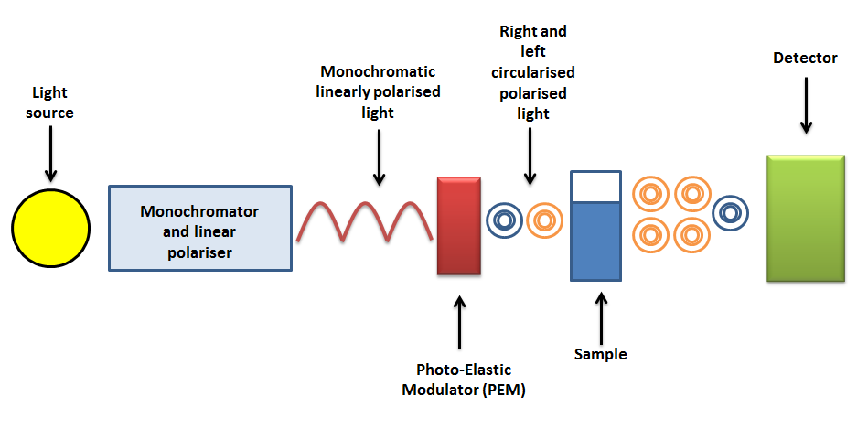
Figure 2.1 Schematic of a CD spectrophotometer ¹⁵²
The light detector will detect different amounts of left and right circularly polarised light that has passed through the sample. This will produce a signal that varies with the frequency of the PEM. This is termed vAC. The average light intensity over time is also measured and this is termed vDC. Dividing vAC by vDC yields a signal which can be converted into absorbance or millidegrees using a calibration factor G (Equation 2.1).
$$CD=\frac{vAC}{vDC} G$$ | (2.1)

Method

Before the machine is turned on, the optics compartment must be flushed with nitrogen. This is to prevent the ionisation of oxygen to ozone by the lamp, which can damage the machine. The macromolecule concentration required for a good CD spectrum is dependent on the amount of amino acids, the cell volume and the pathlength. Typically, concentrations of 1 mg/ml to 50 µg/ml of protein are used. If the protein concentration is too high the CD signal will be too high and will not reach the photomultiplier. A solution of buffer should be run as a baseline to which to subtract the absorbance of the protein. Running the buffer also provides an effective control to check if the buffer is compatible with UV absorbance.

Data Collection

The time constant is the time in which the data is averaged. When the signal is strong compared to the noise, the time constant does not need to be that large. For example, a signal of 10 mdeg would require a time constant of 0.8, whilst a signal that is 500 only needs a time constant of 0.25.
The scan rate is the rate at which the wavelength is changed. There is an interdependent relationship between scan speed and time constant. Faster scan rates mean the time constant will have to be smaller. Once the buffer and protein CD spectra have been produced, the CD spectra of the buffer can subtracted from the protein CD spectra.

Theory

Lineally polarised light is made up of oscillations that are confined to a single plane. It is composed of two lineally polarised states at right angles to each other. To generate circularly polarised light the two polarisation states must be out of phase. Chirality is property of many biological molecules. The lack of symmetry occurring in these molecules makes them chiral. Chiral molecules display circular birefringence, which means that a solution of chiral material presents an anistropic medium through with left circularly polarised light and right circularly polarised light pass through at different speeds. The anisotropy in absorption is called dichroism.¹⁵³ This is represented by Equation 2.2
$$∆A=A_{L}-A_{R}$$ | (2.2)
Where L is left circularised light and R is right circularised light. ΔA is absorbance by the sample. Fitting cell pathlength and compound concentration into the equation, molar circular dichroism (Δε) is obtained Equation 2.3. ¹⁵³
$∆ε= εLCP- εRCP= ∆A/(C×l$) | (2.3)
Where εLCP and εRCP are the molar extinction coefficients for LCP and RCP light respectively, C is the molar concentration, and l is the pathlength in centimeters. Degrees of ellipticity (θ) is a common measure in CD spectroscopy. It is related to ΔA by Equation 2.4. ¹⁵³
$$∆A= θ/32.982$$ | (2.4)
Combing equations Equation 2.3 and Equation 2.4 with introduction of a concentration term yields the equation for molar ellipticity [θ]:
$$\left[θ\right]= \frac{θ ×100 ×M}{C ×l ×n}$$ | (2.5)
Where C is the concentration in mg/ml, M is the molecular mass of the molecule, θ is the ellipticity in degrees, l us the optical path length in cm and in the case of proteins, n is the number of amino acid residues. Equation 2.5 allows for easy comparison of results if other protein concentrations are used. Effectively this equation standardises the results. ¹⁵³
Electronic transitions are responsible for the characteristic absorptions in CD spectra. The peptide bond is responsible for the absorption below 250 nm. Lone pairs of electrons found in oxygen, sulphur and nitrogen when in the excited state transit into antibonding orbitals yielding negative bands at ≈ 222 nm for the α-helix and 216-218 for the β-pleated sheet. ¹⁵⁴ Electrons, when excited leave the π orbital and go into the π antibonding orbital. For the α-helix this produces a positive band at ≈ 190 nm and a negative band at ≈ 208 nm. For the β-pleated sheet there is a positive band at ≈ 198 nm. The characteristic negative absorption at 200 nm for random coil peptides is due to electron coupling between the carbonyl α-carbon and the peptide bond.¹⁵⁵ The electronic transition thought to be responsible are electrons moving from the π orbital to the antibonding π orbital. A negative band necessitates absorption of left circularly polarised light, and a positive band necessitates absorption of right circularly polarized light.¹⁵⁶ The derivation of the equations used for CD spectroscopy were taken from Kelly et al.¹⁵³

Isothermal Titration Calorimetry

Isothermal Titration Calorimetry (ITC) is technique capable of measuring the heats absorbed or realised when molecules interact in solution at a constant temperature. The reaction is started by the titration of one chemical species into a solution of a different chemical species. If the chemical species interact the direct thermodynamic observable is the heat associated with the reaction. Therefore, the independent variable is the total concentration of reactant.

Instrumentation

The TA instruments Nano calorimeter uses two matched 197 µL gold reaction vessels: a reference cell and a sample cell. The calorimeter uses a differential compensation design where the production of heat (μJ) in the sample cell is monitored through power consumption (μWatts) to the sample cell to maintain it as the same temperature as the reference cell. Semiconducting thermoelectric devices (TED) are used for temperature control and to detect temperature changes between the two cells. To match the thermal properties of the sample cell, the reference cell is built to match it as close as possible. To help with this, a reference needle is entered into the reference cell as the sample cell contains the syringe in addition to filling the reference cell with a solution of a similar heat capacity to that of the sample. Therefore, if the sample buffer contains an organic solvent or is high in ionic strength the reference cell should contain the buffer rather than water.
The burette handle fixes the syringe into the sample cell. Appropriately fitted, and once the titration has begun, the syringe can mix the chemical species together producing a homogeneity within the cell.

Method

The sample cell contains the molecule of interest in solution. Invariably it is the host, for instance a protein or DNA. However, in the case of reverse titrations, the sample cell will contain the ligand. In an incremental titration, one of the reactants (the ligand in case of normal titrations) is placed in the syringe. The syringe is inserted into the burette handle. This is then fixed into the calorimeter. The heat signal i.e. the baseline, is then left to stabilise to below 0.1 μWatts whilst the syringe is rotating within the cell. This will ensure that the ligand and the host are mixed effectively during the course of the titration. The baseline is used to calculate the area of the heat from each pulse in the reaction vessel from the titration forming a thermogram. During the course of the titration the amount of heat will decrease as the host becomes saturated with ligand. Eventually, the macromolecule will become saturated and the detected heats will represent ligand dilution. A schematic of an ITC is shown in Figure 2.3.
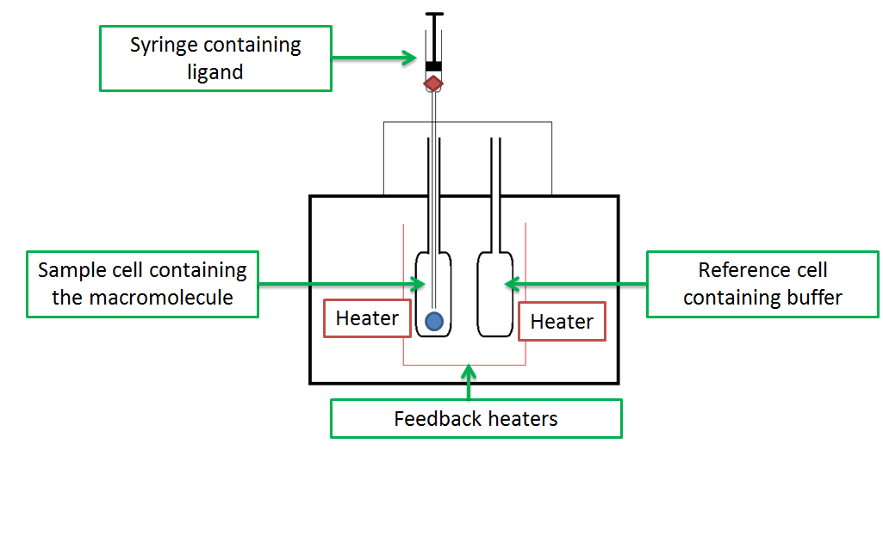
Figure 2.3: Schematic of an isothermal titration calorimeter. The ligand is represented by a red diamond and the macromolecule is represented by a blue circle. Adapted from Pierce et al. ¹⁵⁷

Analysis of the Isothermal Titration Calorimetry Data

Binding equilibrium is the state at which both the concentrations of the host (H) and guest (G) individually and host-guest complex (H:G) no longer change with time (Equation 2.6). Since this work investigates how ligands interact with macromolecules, this terminology will be used instead. In the case presented here, the host is the macromolecule (M) and the guest is the ligand (X)(Equation 2.7).
$$H+G →H:G$$  $$M+ X →M:X$$ | (2.6)  (2.7)
Where in many biological processes, there exists a particular mixture of products and reactants. The binding constant (K) is a ratio of the concentration of the products to the concentration of the reactants. If the K value is less than 1 the reaction will move towards the reactants and if the K value is greater than one the reaction will move towards the products.
The Gibbs free energy of binding (ΔG) gives a numerical value of the affinity of the macromolecule for the ligand. It is related to K by Equation 2.8 where R is the gas constant 8.314 J(/mol∙K) and T is the temperature of the reaction.
$$∆G= -RT InK$$ | (2.8)
Since ITC binding isotherms yield a value for the binding constant, ΔG can be derived using Equation 2.8.
ITC measures the heat of all possible interactions within the cell such as the heats of ionisation, ligand and macromolecule dilution. Both the heats of ligand and macromolecule dilution can be corrected for. To determine the heats of ligand dilution, the ligand solution is titrated into the buffer. To determine the heats of macromolecule dilution, the buffer is titrated into a solution of macromolecule. Normally the heats of ligand dilution are larger than the heats of macromolecule dilution and so this is subtracted from the heats produced from the ligand being titrated into the macromolecule. Due to this, only the buffer into ligand titration is done as a control. However, in this work, both controls have been done. Since it is not possible to effectively separate out the heats of binding from the heats of macromolecule conformational change, desolvation or solvation the enthalpy measured by ITC should be termed the observed enthalpy (${ΔH}_{observed }$) since it measures global (all heat changes in the cell) heat changes.
Since ITC cannot directly measure entropy changes it has to be calculated from the subtraction of ΔG from ΔH, meaning it is TΔS_{calculated(} (Equation 2.9)
$${ΔS}_{calculated}= \frac{{ΔG}_{system}- {ΔH}_{observed }}{T}$$ | (2.9)
In order to derive the binding constants (K) and the enthalpy changes (ΔH) the heat has to be modelled. The simplest model is where one ligand binds to one protein with a single binding enthalpy and binding constant yielding the association constant (Equation 2.10) or by taking the inverse the dissociation constant (2.11).
$$K_{A}=\frac{\left[MX\right]}{\left[M\right][X]}$$  $$K_{D}=\frac{\left[M\right][X]}{\left[MX\right]}$$ | (2.10)  (2.11)
Where M indicates the macromolecule and X is the ligand. This leads to the expressions for the total amount of macromolecule (Equation 2.13) and ligand (Equation 2.14).
$M_{TOT}$= $\left[M\right]+\left[MX\right]=\left[M\right]\left(1+K\left[X\right]\right)$  $X_{TOT}$= $\left[X\right]+\left[MX\right]= \left[X\right] (1+K\left[M\right])$ | (2.13)  (2.14)

When two molecules interact heat will be absorbed (endothermic) or produced (exothermic). For each injection, the heat released or absorbed is given by Equation 2.15
$$Q=V ∆H ∆\left[MX\right]$$ | (2.15)
Where Q is the heat accompanying the change in the ligand bound concentration, $∆\left[MX\right]$ is the change in macromolecule-ligand complex, $∆H$ is the enthalpy of binding and $V$ is the reaction volume.
Taking into account how the MX concentration changes over the course of the titration leads to Equation 2.16.¹⁵⁸
$$\frac{∆\left[MX\right]}{{∆X}_{tot}}=0.5+\frac{1-(1+r)/2-X_{r}/2)}{X_{r}^{2}-2X_{r}\left(1-r\right)+(1+r)^{2})^{0.5}}$$ | (2.16)
Where r is equal to 1/KM_{tot} and X_{r} is equal is to X_{tot}/M_{tot}. The parameters n, ΔH and K are then estimated from the integrated binding curve. K is the slope of the curve and ΔH is calculated from integrating the curve.
In a system where two ligands can bind to a macromolecule with differing thermodynamics, the one site model is no longer appropriate. A simple binding model for both the association constant (Equation 2.17) and the dissociation constant (Equation 2.18)
$$K_{A}=\frac{\left[M_{1}X\right]}{\left[M_{1}\right][X]}\frac{\left[M_{2}X\right]}{\left[M_{2}\right][X]}\frac{\left(M_{1+2} [{X]}^{2}\right)}{\left(\left[M_{1+2}\right][{X]}^{2}\right)}$$  $$K_{D}=\frac{\left[M_{1}\right][X]}{\left[M_{1}X\right]}\frac{\left[M_{2}\right][X]}{\left[M_{2}X\right]}\frac{\left(\left[M_{1+2}\right][{X]}^{2}\right)}{\left(M_{1+2}[{X]}^{2}\right)}$$ | (2.17)  (2.18)
The subscript coefficient indicates that particular binding site on the macromolecule. In this case, the ligand and macromolecule can exist in a number of ways and not just bound or free. The ligand can bind to one site on the macromolecule and leave the other site on the macromolecule exposed${[M}_{1 }X$]. Alternatively, the ligand could bind to the second site and leave the other site on the macromolecule exposed$\left[M_{2}X\right]$. The other situation is when two ligands bind to two binding sites on the macromolecule$\left[M_{1+2} {[X]}^{2}\right]$. If this is expressed as concentrations (Equation 2.19).
$$M_{TOT}=\left[M\right]+\left[M_{1 }X\right]+\left[M_{2}X\right]+\left[M_{1+2} {[X]}^{2}\right]$$ | (2.19)
The total heat released or absorbed is proportional to the amount of ligand bound as:¹⁵⁹
$$Q=Q_{1}+Q_{2}=M_{TOT} V {(∆H}_{1} n_{1} X_{b1}+{∆H}_{2} n_{2} X_{b2})$$ | (2.20)
Q is the summation of the heats of binding of two ligands binding to two sites on a macromolecule. V is the volume of the cell. $M_{TOT}$is the total macromolecule concentration. $X_{b1}$ is the proportion of ligand bound to site 1 of the macromolecule. ΔH₁ is the enthalpy of ligand binding to site 1 on a macromolecule. $n_{1}$ is the number of molecules bound to site 1 of the macromolecule. ΔH₂ is the enthalpy of ligand binding to site 2 on a macromolecule. $n_{2}$ is the number of molecules bound to site 2 of the macromolecule. $X_{b2}$ is the proportion of ligand bound to site 2 of the macromolecule. ¹⁵⁹
Combining Equation 2.19 and Equation 2.20 leads to Equation 2.21
$$\left[Q\right]=V\left[M\right]\frac{ n_{1} ∆H_{1}K_{1}\left[X\right]}{1+ K_{1}\left[X\right]}+\frac{ n_{2} ∆H_{2}K_{2}\left[X\right]}{1+ K_{2}\left[X\right]}$$ | (2.21)
Equation 2.21 can be used to identify ligand binding to two distinct sets of binding sites. These models are further addressed in the MicroCal™ iTC200 system User Manual.

Nanoparticle Tracking Analysis

Nanoparticle Tracking Analysis (NTA) uses the properties of Brownian motion and light scattering to determine particle size distribution of samples in a liquid suspension.¹⁶⁰ This technique can be used to determine the size of biological macromolecule particles between 30 to 1000 nm.

Instrumentation

The basic setup of the system is a light microscope with a video camera. A laser beam passes through a sample chamber just a few degrees above the critical angle to prevent total internal reflection. This is where the waves reflect back into the glass. The setup shapes the laser so it matches the depth of focus of the microscope allowing visualisation of all the particles in the suspension. As the laser hits the particles it scatters producing light scattering phenomena that is seen using the microscope.

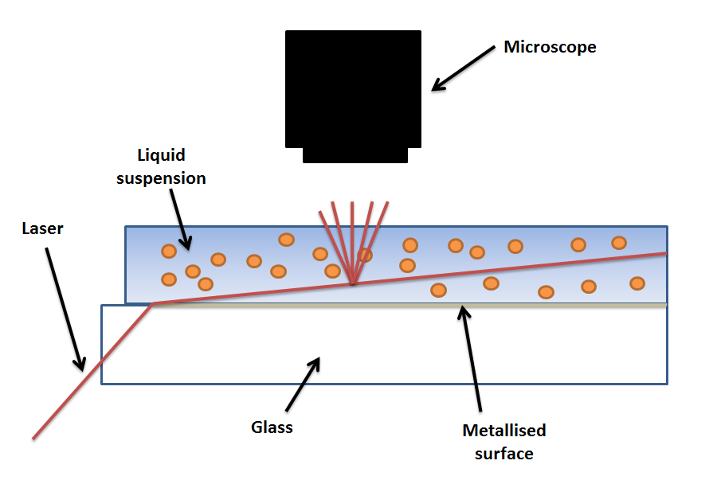
Figure 2.4: NTA schematic adapted from Shang et al. ¹⁶¹

Sizing of the Nanoparticles

The particles that are moving are recorded for analysis. The particles are then individually tracked. In this work, the particles are recorded for at least 60 seconds. The image analysis software (Nanosight NTA 2.2 Analytical Software) then determines the average distance moved by each particle. This can be used to determine the particle diffusion coefficient (Dt). If the sample temperature (T) and solvent viscosity (η) are identified, the hydrodynamic radius (d) of the particles can be calculated using the Stokes-Einstein equation:
$$Dt= \frac{Tk_{B}}{3πηd}$$ | (2.21)
To obtain optimum sizing of particles the concentration regime lies within 10⁷ to 10¹⁰ particles per mL. Samples containing fewer than 10⁷ particles per mL require larger analysis times due to a very small number of particles being present in the field of view at any one time. Particle concentrations greater than 10¹⁰ particles per mL will lead to particle trajectories crossing over meaning a reliable estimate of particle concentration cannot be done through tracking.¹⁶⁰

Method

NTA measurements were done with a NanoSight LM10 (NanoSight, Amesbury, United Kingdom), equipped with a sample chamber with a 488-nm laser. The samples were slowly injected in the sample chamber with sterile syringes until the liquid reached the tip of the output port.

Chapter 3: Modes of Binding for Tannic Acid and Proanthocyanidins to Biopolymers

Summary

Tannin-protein interactions are of vital importance to the food, wine and agricultural industries. Tannin binding to bovine serum albumin (BSA) showed two stages of interaction at 25 °C using Isothermal Titration Calorimetry (ITC). BSA is a heterogeneous protein meaning that the regions tannins bind to would have different enthalpies (∆H). Polyproline on the other hand, is a uniform peptide composed purely of proline meaning that the binding regions cannot have drastically different ∆H. Since tannin binding occurs at multiple sites on a protein, the favourable increase in ∆H at low molar ratios is interpreted as tannin that is already bound to a BSA molecule binding to regions with different amino acid composition of other BSA molecules and therefore different ∆H. Two stages of interaction were not seen for the polyproline-tannic acid interaction. Nanoparticle Tracking Analysis allows visualisation of proteinaceous particles larger than 30 nm. The images showed tannic acid-polyproline particles indicating that bound tannin could be binding to other polyproline molecules in solution. Taken together, this may mean that the two stages of interaction are only seen when bound tannins bind to other molecules in solution with different ∆H.
Decreasing the temperature to 10 °C showed a monophasic binding isotherm. Circular dichroism (CD) results suggested little variation in the secondary structure from 25 to 10 °C meaning temperature induced structural changes are not likely to be the cause behind the different thermodynamics but rather water reorganisation is responsible.
Proanthocyanidin binding to BSA showed two temperature dependent enthalpies. At lower molar ratios, the interaction becomes more endothermic with increasing temperature whereas at higher molar ratios, the interaction becomes more exothermic with increasing temperature. This was interpreted as tannins binding to polar groups on the protein, with the possibility of already bound tannins binding to free polar groups on other proteins in solution. At higher molar ratios, the increasing exothermicity with increasing temperature was suggested to be due to hydrophobic interaction between free proanthocyanidins and proanthocyanidin coated BSA. This was suggested on the basis of previous work on calorimetry. That polar ∆C_{p} is due to water being removed from polar groups whilst a negative ∆C_{p} is water being removed from apolar groups.
Addition of ammonium sulphate and thiocyanate separately increased the exothermicity of the binding interactions, which was assumed to be due to enhancing tannin-protein precipitation.

Introduction

Tannic acid is mixture of gallotannins containing either a central glucose or quinic acid (Figure 3.1). ¹⁶²⁻¹⁶⁴Gall nuts, tumours formed by fungi, bacteria and insects on oak trees are also a rich source of tannic acid in addition to other sources such as oak wood and nettle.
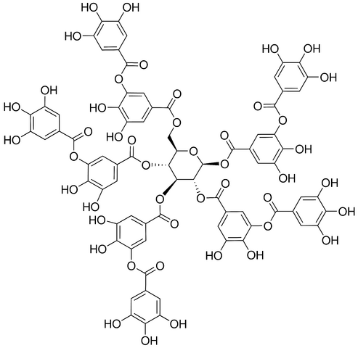
Figure 3.1: Tannic acid adapted from Kim et al. ¹⁶⁵
Tannic acid has been used for centuries for tanning of leather.¹⁶⁶ In addition to this, tannic acid has been shown to have medicinal properties being used to help reduce the swelling of haemorrhoids and treat diarrhoea.^{167,168} Possible molecular mechanisms for the treatment of the latter are the inhibition of calcium activated chloride channels which perform important functions such as smooth muscle contraction and epithelial secretion.¹⁶⁹ Additionally, reducing oxidative cell stress,¹⁷⁰ improving the intestinal epithelial barrier and assisting in mucosal resistance to pathogens have been other suggested possible mechanisms. ^{168,171}
Apart from increasing innate immune responses, tannic acid has also been shown to have antimicrobial properties by reducing the growth of pathogens. ^{172,173} The mechanism behind this is metal chelation; tannic acid binds to iron making it unobtainable to bacteria. As iron is an essential nutrient for bacteria, limiting the extraneous supply will limit growth.¹⁷⁴ It was also suggested that tannic acid could interfere with the cell membrane of pathogens, effectively preventing biofilm formation. ¹⁷⁴
Tannic acid like other tannins binds to mucosal proteins in the mouth resulting in the unpleasant feeling of extreme dryness known as astringency which is thought to be responsible for deterring animals from eating tannin producing plants. ¹⁷⁵ This phenomena has led to investigations into how tannic acid interacts with proteins. The structure activity relationship (SAR) has shown that tannic acid is capable of hydrogen bonding and hydrophobic interaction with proteins.¹⁷⁶
Bovine serum albumin (BSA), being representative of the albumins, is a multifunctional well-characterised globular protein that serves as a transporter in the blood for a range of drugs, metabolites and nutrients (Figure 3.2).^{177,178} In terms of structure, the protein has a high helical content of about 67% with very little β-secondary structure, the remainder being composed of disordered regions which is similar to HSA. The protein also has a high melting point (above 50°C),¹⁷⁹ highly soluble below 700 µM in a range of buffers,¹⁸⁰ remains a monomer below 100 µM ¹⁸¹ and is sold as highly pure fractions.
Size exclusion chromatography studies have suggested that BSA could bind to tannins indicating a potential in vivo carrier. ¹⁸²
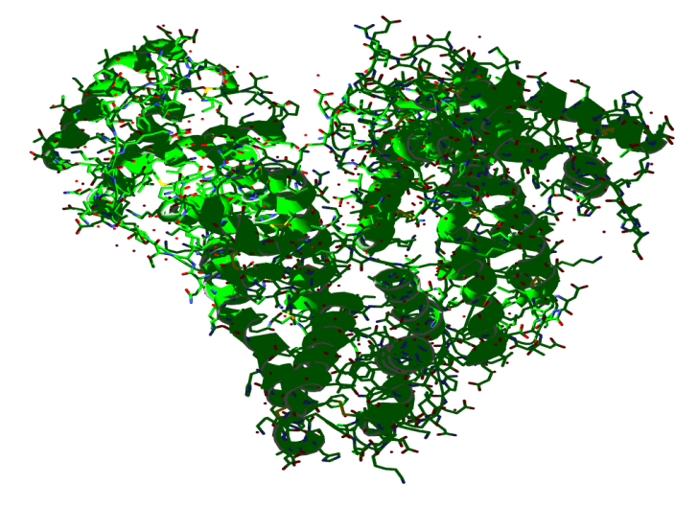
Figure 3.2: Crystal structure of BSA adapted from Bujacz¹⁸³
Precipitation studies have shown that the optimum pH for tannic acid binding to BSA is between 2-5 with pH changes above or below yielding less soluble complexes.¹⁶² Serafini et al. found that ethanol in the range 0-22 % correspondingly reduced insoluble tannin-BSA complexes from red wine. ¹⁸⁴ It was suggested that increasing the ethanol concentration would increase the antioxidant capability of the tannins as there would be more free in solution.
Proanthocyanidins, another type of tannin used in this study, are naturally occurring phenolics that are found in fruits, vegetables, nuts, seeds, flowers, and bark. Being condensed tannins, they are much more hydrophilic than tannic acid but are thought to still be capable of hydrophobic interaction in addition to hydrogen bonding.¹⁸⁵ Structurally they can be either oligomeric or polymeric units of polyhydroxy flavan-3-ol units, such as (-)-epicatechin or more commonly (+)-catechin (Figure 3.3). ¹⁸⁶ These proanthocyanidins can be purified from their natural sources meaning they have a distinct advantage over tannic acid preparations which cannot be purified.
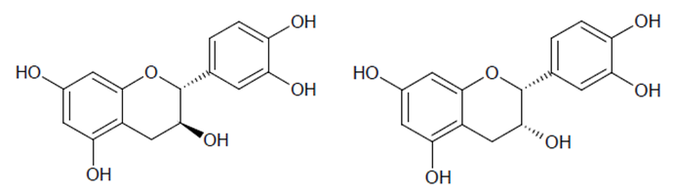
Figure 3.3: Left: (+)-catechin. Right: (-)-epicatechin adapted from Abrahamse et al. ¹⁸⁷
Proanthocyanidins are thought to be responsible for the nutritional benefit of some food stuffs and beverages. ¹⁸⁶ Red wine is high in proanthocyanidins and they are thought to be responsible for the reduced risk of lung cancer associated with low intake of red wine.¹⁸⁸ This chemopreventative action is also seen in rats fed epigallocatechin gallate, a common proanthocyanidin found in both tea and wine.¹⁸⁹ Proanthocyanidins from grape seeds have been found to decrease the levels of oxidants and increase the levels of antioxidants suggesting that a diet rich in proanthocyanidins could help minimise the chances of atherosclerosis.¹⁹⁰
Tea is perhaps on the most popular drinks in the world due to the taste and contains a high concentration of polyphenols. There is a general consensus that green tea assists in digestion and results show that this may due to polyphenols enhancing the catalytic activity of pepsin, an enzyme that degrades food proteins into peptides. ¹⁹¹
Proanthocyanidins are thought to be responsible for the astringent sensation of wine.¹⁹² This dry puckering sensation after drinking wine is thought to be due to the proanthocyanidins precipitating glycoproteins which leads to reduced lubricating properties of the salvia.^{193,194} Higher molecular weight proanthocyanidins (Figure 3.4) have increased protein precipitating ability leading to an increased astringent sensation.¹⁹⁵
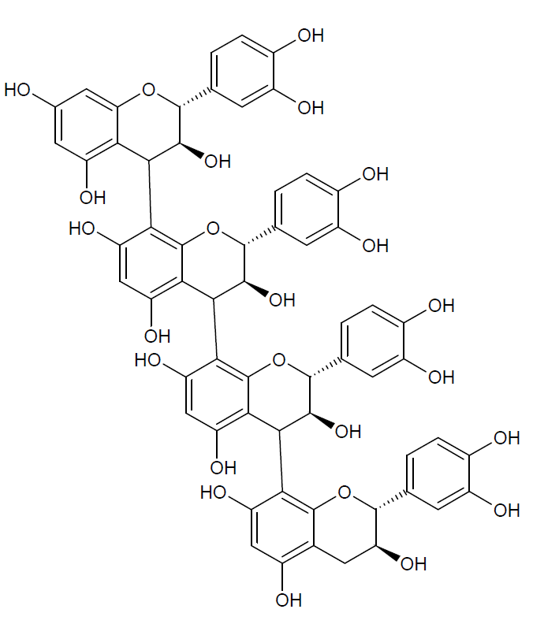
Figure 3.4: Proanthocyanidin tetramer
Examination of proanthocyanidins-protein interactions using Isothermal Titration Calorimetry (ITC), Dynamic Light Scattering (DLS), Molecular Dynamic Simulations (MDS) and Nuclear Magnetic Resonance (NMR) spectroscopy has shown a complex protein-tannin structure activity relationship.^{147,148,196} Flexible proline rich proteins have high affinity for tannins. Procyanidin dimers, which are polymers of catechin, were shown to bind to the hydrophilic and not hydrophobic side of a proline rich peptide IB7₁₄ using a combined NMR and MDS, suggesting that the association was driven by hydrogen bonding. ¹⁹⁷
Polyproline has been utilised in many tannin binding studies because of its simple secondary helical structure consisting of proline residues (Figure 3.5). This structure is distinct from the two major structures found in folded globular proteins, the α-helix and the β-pleated sheet and although less common, it is found in a number of folded and unfolded proteins.¹⁹⁸ Unlike the α-helix, the type II polyproline helix is left handed.
Among the 20 common amino acids, the proline residue is generally held to be a good binding site as it provides a flat, rigid, hydrophobic surface that is favourable to interactions with hydrophobic polyphenol rings.^{148,199,200} Oh et al. suggested hydrogen bonding and hydrophobic interaction to the principal driving forces for binding between polyproline and a mixture of proanthocyanidins.¹⁸⁵ Tannin-peptide formation increased with increasing temperature and ionic strength which is indicative of hydrophobic interactions.
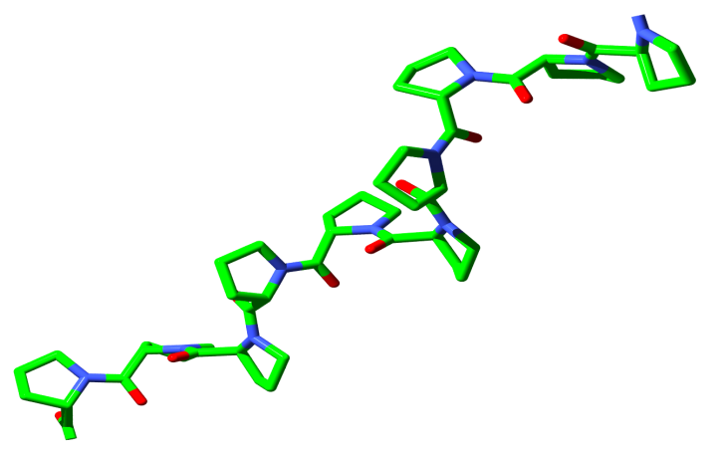
Figure 3.5: Left handed polyproline II helix adapted from Dvir et al. ²⁰¹
No enthalpy change was measured when epicatechin and catechin were titrated into polyproline using ITC. ¹⁴⁴ Upon galloylation of these monomers, ITC measured a strongly enthalpy driven interaction. Although the entropy change was rather minor, this did confirm the importance of the hydrophobic interaction in binding. ¹⁴⁴

Binding modes

ITC has been used to determine a number of binding modes such as independent single site binding, multisite binding, competitive binding and cooperative binding.²⁰²⁻²⁰⁵ Allosteric cooperativity, a form of cooperativity exhibited by proteins, describes how ligand binding at one site can indirectly affect the binding of a ligand to another site. It has remained a focal point of biochemistry for the past fifty years due to the role it plays in regulating metabolism. Two models were produced to describe allosteric behaviour: the KNF (Koshland, Nemethy and Filmer)¹³⁰ which involves a progressive change of protein structure as it binds ligand excluding any conformational change in its absence and the MWC (Monod, Wyman and Changeux)¹²⁸ that suggests the ligand stabilises certain preformed conformations of the protein at equilibrium. Certain aspects of the models are purely phenomenological; however, the definitions here or a hybridisation of the two are thought to be able to explain allostery.
Traditionally, the definition of cooperative binding could only be applied to oligomeric proteins as it was thought subunit interactions within the protein were responsible. In the last 20 years, it has been identified that monomeric proteins are capable of allostery which has greatly improved our understanding of metabolism, particularly how drugs are broken down and distributed round the body.²⁰⁶ (S)-Lorezepam which is used to treat anxiety was found to increase the affinity of human serum albumin for (S)-warfarin an anticoagulant.²⁰⁷ In the presence of myristate, human serum albumin binds thyroxine cooperatively.²⁰⁸ Crystallographic analysis showed that myristate induced conformational changes within human serum albumin allowing thyroxine to bind to a now open high affinity site. Consequently, identifying proteins that are allosterically regulated is a vital topic within pharmacology.
ITC has been used to identify both homotropic (the ligand binds to the binding site and changes the affinity of another binding site for the same ligand) and heterotrophic (a ligand affects the affinity of another binding site for a different ligand) modulation of protein allostery.^{209,210} However, there has been some difficulty in differentiating between binding isotherms that display positive cooperativity of binding to two sites and those that demonstrate that a ligand binds to different sites on a protein independently. This has led to the development of simulations to model binding isotherms that attempt to make this differentiation between independent and cooperative binding.^{211,212} The issue arises due to the fact that a protein exhibiting two or more different binding sites with similar affinities for the same ligand but different enthalpies produces binding isotherms that are comparable to those identified as homotropic positive protein cooperativity. Additionally, precipitation, a process where complexes assemble and become insoluble, seem to produce ITC binding isotherms indicative of supposed positive cooperativity.²¹³
The enthalpy increase at the start of a titration of a tannin fraction into polyproline was suggested to be due to positive cooperativity, that the differing molecular weight procyanidins already bound to polyproline have a favourable effect on the next binding interaction. The authors suggested that a bound ligand would be exposed allowing another protein to bind to it, so called crosslinking. ¹⁴⁴ Frazier et al. also suggested the enthalpy increase observed in the early stages of the titration of myrobolan and tara tannins into gelatin to be evidence of positive cooperativity, that the tannins already bound to gelatin were crosslinking other gelatin molecules. ¹⁴⁶ Charlton et al. originally stated this term in a three stage mechanism to describe polyphenol binding and precipitation (Figure 3.6). The first stage was simple binding of the polyphenol to peptide. The second stage is where bound polyphenol binds to free peptide in solution forming polyphenol-peptide dimers. The last stage, refers to an aggregation event, namely where polyphenol-peptide crosslinked complexes self associate due to favourable interactions and a lack of charge repulsion. It is difficult to discriminate between aggregation and crosslinking using ITC. It would require another technique, such as DLS to determine where crosslinking finishes and aggregation begins. This study tries not to discriminate between the stages.

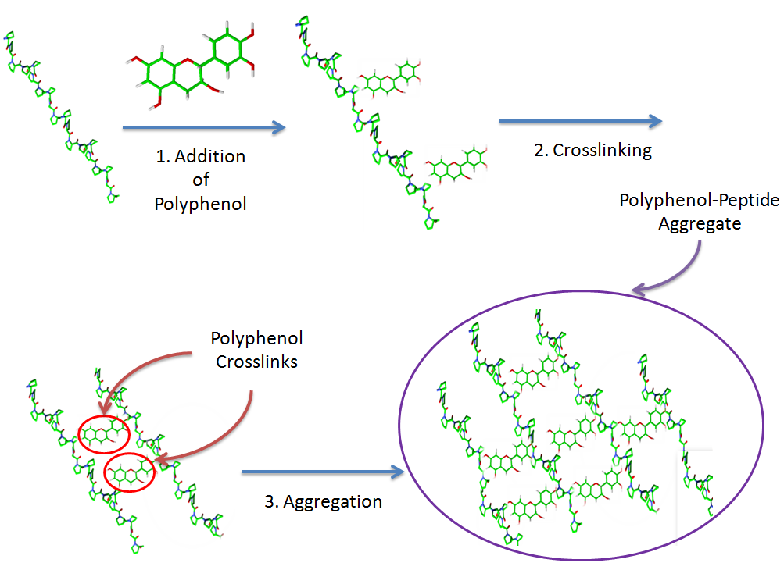
Figure 3.6: Schematic representation of the stages occurring in binding and aggregation of polyphenols by peptides according to Charlton et al. Stage 1: addition of polyphenol and subsequent binding to the peptide. Stage 2: addition of more polyphenol leads to crosslinking of peptides by the polyphenol. These complexes are not soluble. Stage 3: Association of the polyphenol-peptide complexes leads to aggregation. This is suggested to be due to the lack of charge repulsion between the complexes.
Generally, tannin-protein binding is not site specific and these interactions occur at multiple protein areas. BSA was chosen as it is composed of polar and apolar regions meaning polyphenolic binding will have differing thermodynamics. Polyproline on the other hand is a uniform helix consisting of proline. This will allow investigation of:
- If crosslinking induces positive cooperativity as tannins should be able to crosslink both polyproline and BSA producing an enthalpy increase at low molar ratios.
- If the exothermic increase at the start of the titration is due to other tannins present in the fraction binding to the macromolecule. For this to be occurring there should be initial increases in enthalpy at the start of the titration if a more pure fraction of tannins is used.
Performing the titrations at different temperatures allows calculation of the heat capacity of binding ΔC_{p}. ΔC_{p} provides thermodynamic values regarding the change in hydration of apolar and polar residues of the protein in addition to the ligand itself upon binding^{88,214}. In most ITC studies, a negative ΔC_{p} is measured which is an indication that water is being displaced from apolar groups.⁴⁵ It may not be possible to calculate ΔC_{p} for tannin-protein interactions due to the non-specificity in the interactions but some gross estimate can be derived i.e. if the interaction becomes increasingly endo or exothermic. This chapter shows binding at low protein-polyphenol molar ratio exhibits strong temperature dependent enthalpy in comparison to the rest of the binding isotherm with a positive ΔC_{p}.

Materials and Methods

Chemicals and Materials
Ninety-nine percent fatty acid free bovine serum albumin was purchased from Sigma Aldrich and was used without further purification. Sodium acetate (99 % purity), ammonium acetate (99.5% purity), ethanol (99.8% purity), acetic acid (99.8% purity) and tannic acid were also purchased from Sigma Aldrich. All buffers were made using deionised water from a Merk-MILLIPORE Milli-Q system (Darmstadt, Germany). The assumed molecular weight of tannic acid was 1701.2 g/mol as stated on the Sigma Aldrich website.

Isothermal Titration Calorimetry (Fatty Acid Free BSA-Tannic Acid Interactions)
A Nano-ITC instrument (TA instruments, Texas, USA) was used to measure the binding thermodynamics between tannic acid and BSA at 10 and 25 °C. BSA and tannic acid were dissolved in 10 mM sodium acetate 10% ethanol buffer at pH 4. All solutions were degassed prior to the titrations. One mM tannic acid was loaded into the syringe and titrated into the sample cell, which contained BSA at either 5 or 15 µM. The different concentrations of BSA allow identification of BSA-tannic acid crosslinks. Due to dilution effects associated with the first titration a 0.07 µL throwaway injection was made at the start of every titration and discarded from further analysis. In one set of titrations, 30$×$1.5 µL 1 mM tannic acid injections into 15 µM BSA were made over the course of the titration. In the next set of experiments, 25 $×$1.5 µL 1 mM tannic acid injections into 5 µM BSA were made over the course of the titration. In each titration, the reference cell contained the buffer instead of water. The reason being that the ethanol present in the buffer means it has a significantly different heat capacity than water. The time delay between each injection was 300 seconds and the (Rotations Per Minute) RPM was set to 280 to ensure thorough mixing of the cell. Data analysis was performed using the NanoAnalyse software (TA instruments, Texas, USA). The enthalpy of dilution of tannic acid was subtracted from the raw data. By using NanoAnalyse, raw heat data was integrated peak by peak and normalised per mole of injectant to get a plot of observed enthalpy change per mole of tannic acid against tannic acid/protein molar ratio. The first two injections were erroneous due to diffusion effects and were subsequently discarded from analysis. Both the standard mean error and the confidence intervals are provided. Nano ITC users tend to use confidence intervals as the NanoAnalyse software readily provides this. A confidence interval provides a range that contains the population parameter of interest.

Isothermal Titration Calorimetry (Polyproline-Tannic Acid Interactions)
A Nano-ITC instrument was used to measure the binding thermodynamics between polyproline and tannic acid at 10, 25 and 40 °C. Polyproline and tannic acid were dissolved in 10 mM sodium acetate 10% ethanol buffer at pH 4. All solutions were degassed prior to the titrations. The syringe contained 3.474 mM tannic acid and was titrated into the sample cell, which contained 50 µM polyproline. For the 10 °C experiment 25$×$1.49 µL 3.374 mM tannic acid injections into 50 µM polyproline were made over the course of the titration. While for the 25 and 40 °C, 26 $×$ injections were made using the same volumes and concentrations. In each titration, the reference cell contained the buffer. The time delay between each injection was 300 seconds and the RPM was set to 280 to ensure thorough mixing of the cell. Data analysis was carried out as previously stated in section 3.3.2.

Isothermal Titration Calorimetry (Polyproline-Proanthocyanidin Interactions)
A Nano-ITC instrument was used to measure the binding thermodynamics between polyproline and the tetrameric proanthocyanidin at 10, 25 and 40 °C. Previous work has investigated the binding interaction between BSA and tetrameric proanthocyanidin, but not with polyproline.²¹⁵ Polyproline and tetrameric proanthocyanidin were dissolved in 10 mM sodium acetate 10 % ethanol buffer at pH 4. All solutions were degassed prior to the titrations. Two mM tetrameric proanthocyanidin was loaded into the syringe and titrated into the sample cell, which contained 25 µM polyproline using 27$×$1.67 µL injections. In each titration, the reference cell contained the buffer. The time delay between each injection was 300 seconds and the RPM was set to 280 to ensure thorough mixing of the cell. Data analysis was carried out as previously stated in section 3.3.2.

Isothermal Titration Calorimetry (BSA-Proanthocyanidin Interactions)
A Nano-ITC instrument was used to measure the binding thermodynamics between BSA and the octameric proanthocyanidin at 10, 25 and 35 °C. The BSA fraction was not fatty acid free. This increased the stability of the protein meaning ITC studies could be performed at 35 °C. BSA and octameric proanthocyanidin were dissolved in 10 mM ammonium acetate buffer at pH 4. All solutions were degassed prior to the titrations. Four mM octameric proanthocyanidin was loaded into the syringe and titrated into the sample cell, which contained 15 µM fatty acid free BSA using 30$×$1.49 µL injections. In each titration, the reference cell contained water. The time delay between each injection was 300 seconds and the RPM was set to 200.
The pentameric proanthocyanidin was made up to 4.3 mM and the titration performed at 25 °C with 15 µM BSA using 25 $×$1.49 µL injections. To determine the role of water in the binding interaction the binding partners were both dissolved in 10 mM acetate with either 50 mM ammonium sulphate or ammonium thiocyanate. The RPM was set to 200. Data analysis was carried out as previously stated in section 3.3.2.

Isothermal Titration Calorimetry (BSA–Fatty Acid Interactions)

A Nano-ITC instrument was used to measure the binding thermodynamics between BSA and sodium octanoate at 25 °C. Three hundred µM BSA and 6 mM sodium octanoate were dissolved in 20 mM sodium phosphate buffer at pH 7.2 using 32 $×$1.07 µL injections. The binding interaction the binding partners were both dissolved in 10 mM acetate with either 50 mM ammonium sulphate or ammonium thiocyanate. Binding of octanoate to BSA is a simple 1:1 binding interaction unlike the polyphenol-BSA interactions, which are multi-site and lead to crosslinking and or aggregation. This may allow us to discuss how tannin induced aggregation or crosslinking could be affecting the binding isotherms. The RPM was set to 200. Data analysis was carried out as previously stated in section 3.3.2.

Circular Dichroism Spectroscopy
Circular Dichroism (CD) measurements were made on a Jasco-810 automatic recording spectropolarimeter (Jasco,Tokyo, Japan). BSA and polyproline concentration was 3.75 µM and 10 µM respectively. For the BSA experiments a 2 mm cell was used at room temperature and ≈ 25 °C. The spectra were recorded in the range of 190−260 nm and the scan rate was set at 50 nm/min with a response time of 8 s. For the polyproline experiments, a 2 mm cell was used at 10, 25 and 40 °C. The spectra was recorded in the range of 185-260 nm and the scan rate was set at 50 nm/min with a response time of 8 s. The results are expressed as molar ellipticity ([θ]) in deg cm² dmol⁻¹

Nanoparticle Tracking Analysis
Nanoparticle Tracking Analysis (NTA) (NanoSight Ltd., Wiltshire, UK) can visualise nanoparticles in a liquid suspension. NTA has 3 basic stages (1) video capture, (2) setting of analysis parameters, (3) tracking analysis. The Nanosight (LM14) was used in this experiment. The particles scatter light, which is visualised using an optical microscope. A video is then made recording the tracks of the particles.
Two controls were used in the aggregation studies. A solution of 0.5 µM polyproline and 3.75 mM tannic acid in 10 mM sodium acetate in 10% ethanol pH 4 were analysed separately using NTA to determine the amount of particles.
To determine the amount of crosslinking between polyproline and tannic acid, the solutions were thoroughly mixed and 1 ml of the solution was injected into the cell. Temperature was held constant at 25 °C during the experiment, using the temperature control on the LM14. The images are not to scale and are purely representative of the videos capturing the light scattering videos.

Results and Discussion

Tannic Acid Interactions with Bovine Serum Albumin
Titration of buffer into BSA and tannic acid into buffer showed a minor ΔH. The titration at 25 °C shows evidence of two stages of interaction, the first stage shows increasing exothermic enthalpies with each injection producing an upward curvature below 10 protein-tannin molar ratios (Figure 3.7). The second stage shows a less favourable endothermic ΔH with each injection. The second part of the titration curve is not sigmoidal indicating non-specific interaction between tannic acid and BSA. ^{146,216,217} In previous ITC studies, non-specific interactions are thought to occur between the polypeptide chain and the tannin whilst the upward curvature at the start of the titration is believed to be indicative of positive cooperativity. ¹⁴⁵⁻¹⁴⁷
Time (s)
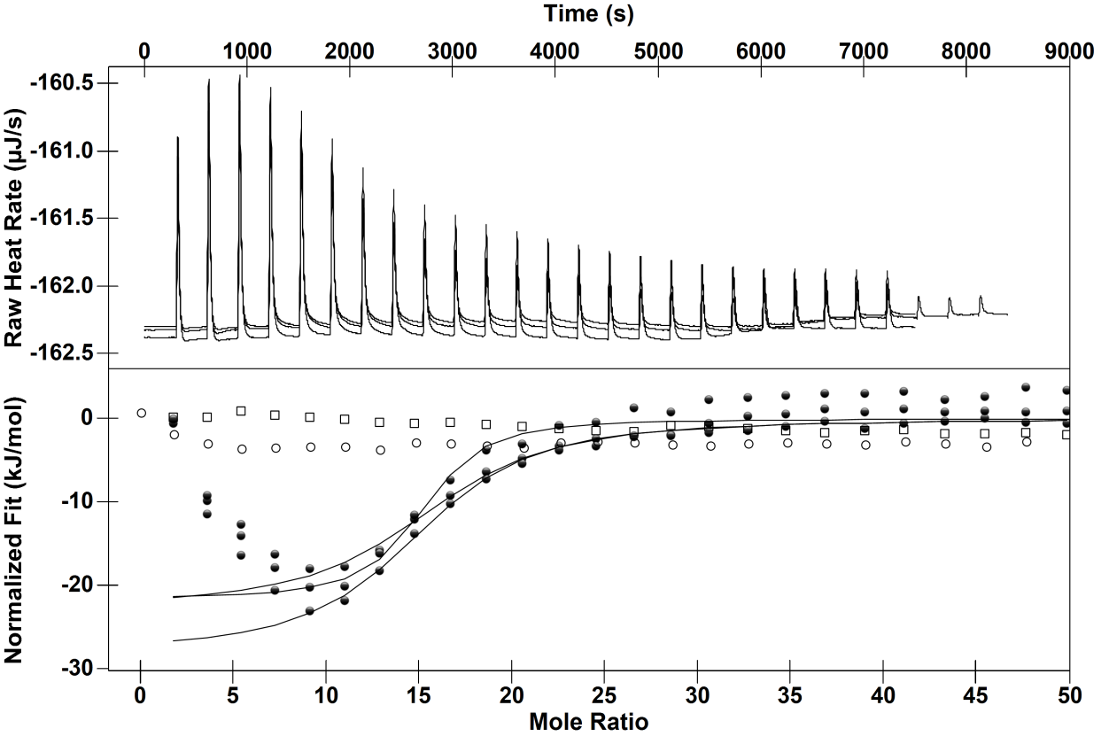
Mole Ratio
Normalised Fit (kJ/mol) Raw Heat Rate (µJ/s)

Figure 3.7: Upper: Thermogram for the interaction of 5 µM BSA with 1 mM tannic acid at 25°C. Lower: ITC binding isotherm for the same interaction (closed squares). Sodium acetate into a solution of BSA (open circles) and tannic acid dilution into sodium acetate (open squares). Solid line represents single site independent binding model fit.
The curve-fitting software generated large confidence intervals for the ΔH value meaning this value should not be taken definitively. Consequently, there is a large error in the TΔS as this value is calculated from the ΔH and ΔG values. The ΔH and TΔS values for the interaction at 10°C should therefore be treated with caution. The stoichiometry values are also erroneous due to the reciprocal mathematical relationship the software uses to calculate both the ΔH and stoichiometry. It was thought that increasing the BSA concentration to 15 µM would allow for better resolution of the binding curves (Figure 3.8), allowing for more accurate thermodynamic values. Table 3.1 shows there is an increase in ΔH with increasing protein concentration from 5 to 15 µM. Increases in ΔH have been previously suggested to be due to aggregation.²¹³ This also provides an explanation as to why the stoichiometry for the end of the first stage changes with protein concentration.
Table 3.1: The temperature, enthalpy ΔH, entropy TΔS, Gibbs free energy ΔG and stoichiometry for the BSA and tannic acid interaction at 10 and 25°C. The standard error (bold) and the confidence intervals (italics) are in brackets. *BSA concentration at 15 µM.
Temperature  (°C) | -ΔH  (kJ/mol) | -TΔS  (kJ/mol) | -ΔG  (kJ/mol) | Stoichiometry  n
10 | 100  (±0)  (±34) | 77  (±0.3) | 23.1  (±0.1)  (±2) | 13  (±3)  (±4)
25 | 24  (±3)  (±4) | 7.7  (±3) | 31.8  (±2)  (±0..1) | 14.8  (±0.2)  (±0.4)
25* | 46.3  (±3)  (±5) | 18.9  (±3) | 27.8  (±0.2)  (±2) | 13.8  (±0.4)  (±0.9)

The other values do contain some error, but they are not as large. The interaction is exothermic. Most likely, the source of the favourable ΔH is hydrogen bonding interactions between the alcohols on the tannic acid and the amide groups of the polypeptide chain and amino acids capable of hydrogen bonding. Given the large surface area between the interacting protein and the tannic acid London dispersion forces would also be making a favourable contribution to the observed ΔH. Increasing the temperature increases the ΔG. Hydrophobic interaction is affected by temperature. Increasing the temperature favours hydrophobic interaction and this would explain the favourable change in ΔG.
Time (s)
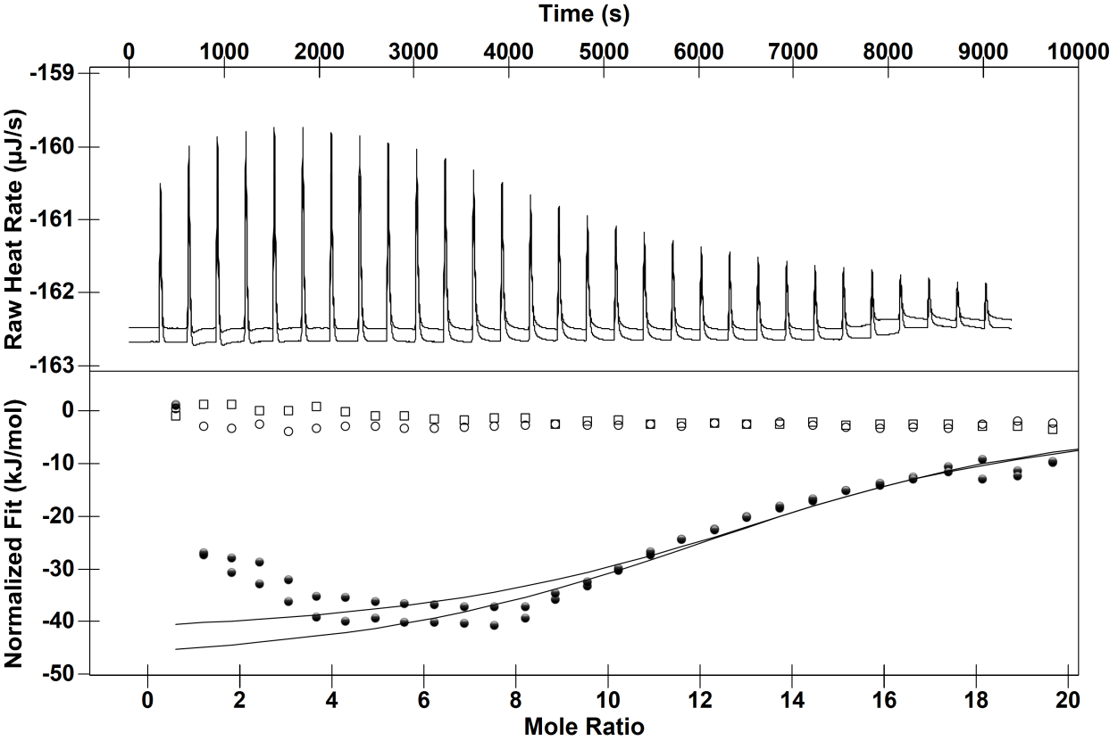
Mole Ratio

Figure 3.8: Upper: Thermogram for the interaction of 15 µM BSA with 1 mM tannic acid at 25 °C pH 4. Lower: ITC binding isotherm for the same interaction (closed circles). Sodium acetate into a solution of BSA (open circles) and tannic acid dilution into sodium acetate (open squares). Solid line represents single site independent binding model fit.
The interaction at 10 °C does not show two stages of interaction (Figure 3.9). Figure 3.10 shows that there is an increase in exothermicity over the entire binding isotherm with the decrease in temperature. The cause is most likely due to solute-solute hydrophilic interactions becoming more favourable at lower temperatures.²¹⁸ Another source of the endothermicity could be ethanol displacement from the both the tannic acid and BSA upon their interaction.
It is possible that given the range of binding interactions there would be endothermic and exothermic contributions to binding. This is presumably why the binding isotherm becomes biphasic at 25C from 10C as the strength of interactions changes with temperature. Given the multitude of the binding interactions, it seems that the ΔH in this case is the summation of two opposing ΔH; an endothermic component from water reorganisation around polar moieties and an exothermic component from both hydrophobic and hydrophilic interaction. It is possible that the calculated TΔS for multiple binding interactions could have an error due to competing ΔH rather providing a value for how ordered the system is.

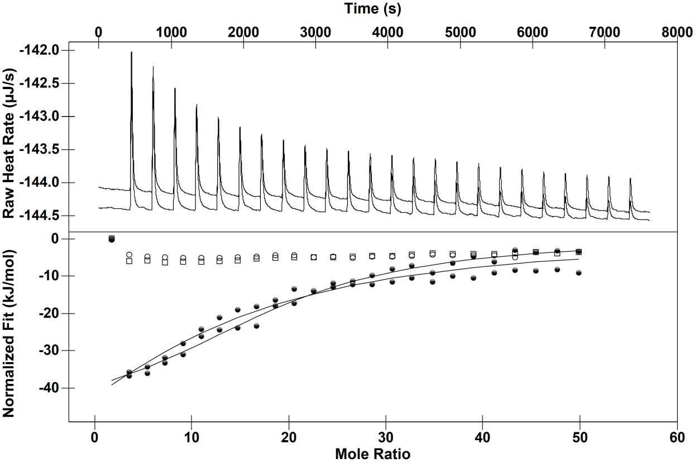
Time (s)
Mole Ratio
Normalised Fit (kJ/mol) Raw Heat Rate (µJ/s)

Figure 3.9: Upper: Thermogram for the interaction of 5 µM BSA with 1 mM tannic acid at 10 °C pH 4. Lower: ITC binding isotherm for the same interaction (closed circles). Sodium acetate into a solution of BSA (open circles) and tannic acid dilution into sodium acetate (open squares). Solid line represents single site independent binding model fit.
The upward curvature at low molar ratios has in the past been interpreted as indication of cooperativity. The loss of the upward curvature could therefore be interpreted as a loss of positive cooperativity at 10 °C. There are caveats to this argument for the interactions presented here which will be pointed out later in this chapter.
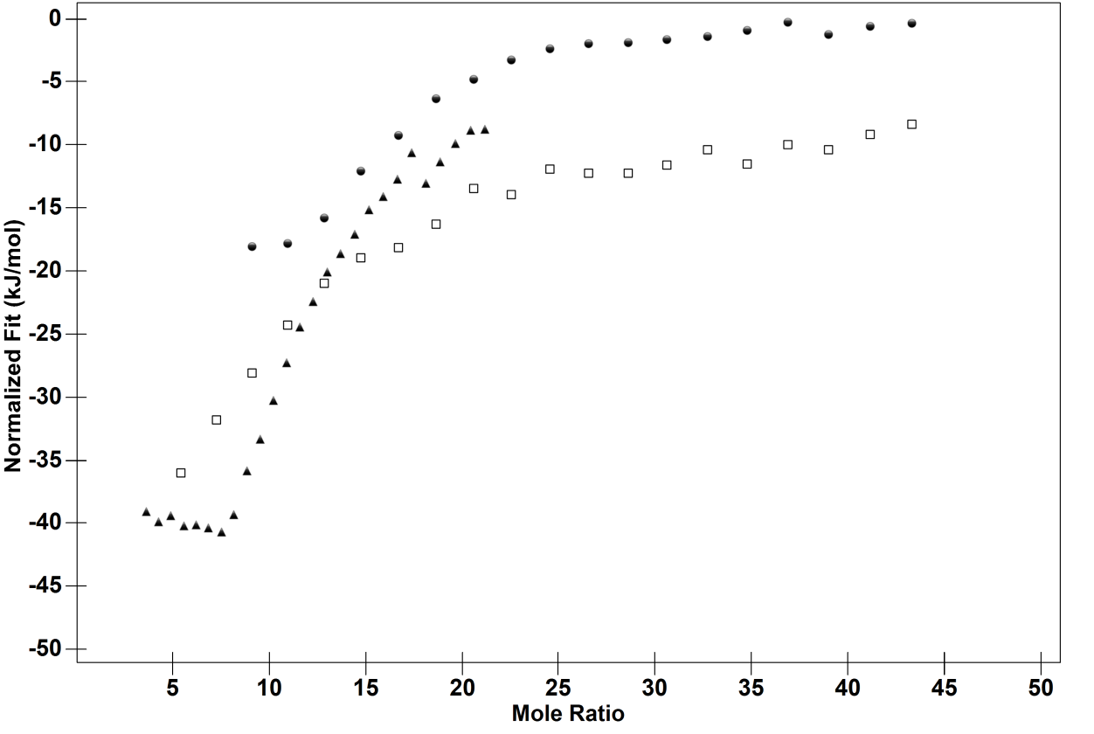
Mole Ratio
Normalised Fit (kJ/mol)
Figure 3.10: Binding isotherms for the interaction between 1 mM tannic acid and 5 µM BSA at 10 (open squares) and 25 °C (closed circles) alongside the binding isotherm for the interaction between 1 mM tannic acid and 15 µM at 25 °C (closed triangles).

Tannic Acid Interactions with Polyproline
Polyproline has been used as a model binding partner for many polyphenolics due to its simple secondary structure.²¹⁹ ITC has been used to measure the thermodynamics between mixed condensed tannin systems found in wine and polyproline to gain a better understanding of astringency and how it changes over time.²²⁰ Similar to the BSA and tannic acid dilution, titration of buffer into polyproline and tannic acid into buffer showed a minor ΔH. The binding isotherms obtained from the titration of tannic acid into polyproline are sigmoidial and do not show two stages within the 10 to 40 °C temperature range (Figure 3.11 to Figure 3.14). Sigmoidal binding isotherms are usually fitted to single site binding model, as it clearly does not show two site binding, dimerisation or cooperativity. However, the chi-squared values for goodness of fit is poor, with χ² ((15) = 51, p <0.5.) and χ² ((21) = 27, p <0.5.) for the models applied for the interactions at 25 and 40 °C respectively. However, the model used to fit the data at 10°C was good, with χ² ((21) = 7.3, p <0.5.) Similar to the binding isotherms presented earlier, the interaction does not reach 0 µJ at 25 or 40 °C, possibly due to continual tannin binding to the polyproline (Figure 3.12 and Figure 3.13). The model cannot fit these data points and explains the poor χ² values. The interaction presented here is favoured enthalpically with a favourable entropic contribution. Both favourable TΔS and ΔH of binding were also reported for mixed condensed tannins-polyproline interactions using ITC.^{219,220}
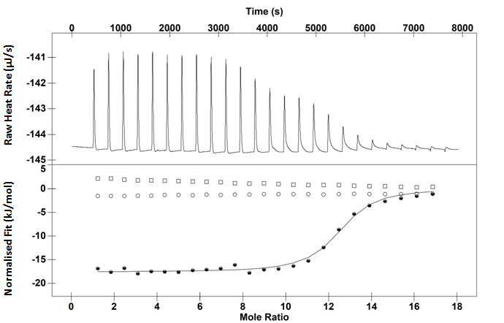
Time (s)
Mole Ratio
Normalised Fit (kJ/mol) Raw Heat Rate (µJ/s)
Figure 3.11 Upper: Thermogram for the interaction of 0.05 mM polyproline with 3.37 µM tannic acid at 10°C. Lower: ITC binding isotherm for the same interaction (closed circles). Sodium acetate into a solution of polyproline (open circles) and tannic acid dilution into sodium acetate (open squares). Solid line represents single site independent binding model fit.

Time (s)
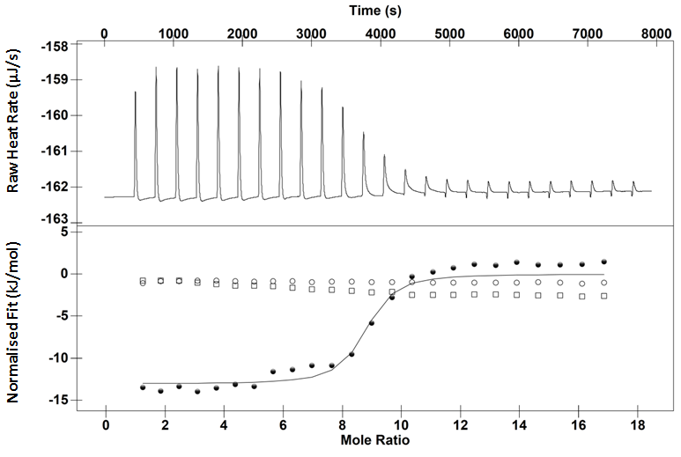
Mole Ratio
Normalised Fit (kJ/mol) Raw Heat Rate (µJ/s)
Figure 3.12: Upper: Thermogram for the interaction of 0.05 mM polyproline with 3.37 µM tannic acid at 25°C. Lower: ITC binding isotherm for the same interaction (closed circles). Sodium acetate into a solution of polyproline (open circles) and tannic acid dilution into sodium acetate (open squares). Solid line represents single site independent binding model fit.

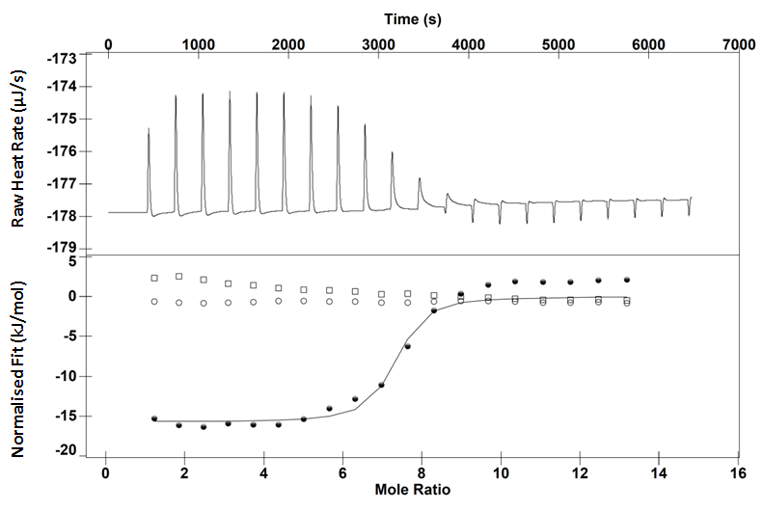
Time (s)
Mole Ratio
Normalised Fit (kJ/mol) Raw Heat Rate (µJ/s)
Figure 3.13: Upper: Thermogram for the interaction of 0.05 mM polyproline with 3.37 µM tannic acid at 40°C. Lower: ITC binding isotherm for the same interaction (closed circles). Sodium acetate into a solution of polyproline (open circles) and tannic acid dilution into sodium acetate (open squares). Solid line represents single site independent binding model fit.
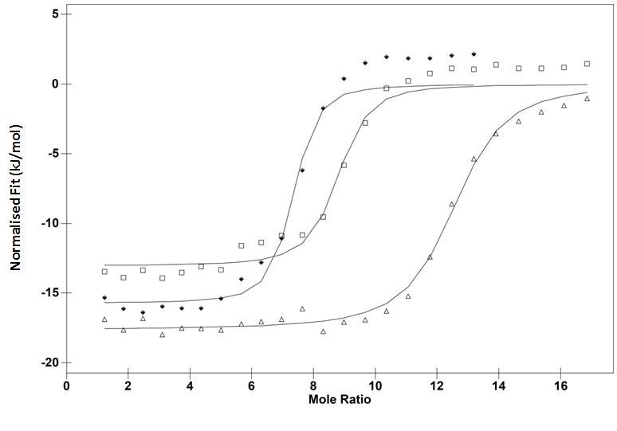
Mole Ratio
Figure 3.14: ITC binding isotherm of the interaction between 50 µM polyproline and 3.374 mM tannic acid in 10 mM acetate 10% ethanol pH 4 at 10 (triangles), 25 (open squares) and 40 °C (black diamonds). Solid line represents model fit.
The source of the favourable ΔH is most likely hydrogen bonding between the phenolic alcohols and those present on the polyproline (Table 3.2). The source of the favourable TΔS is much harder to discern. Tannic acid has 31 rotatable bonds. Presumably, some of these bonds would become conformationally restricted upon binding meaning a decrease in favourable entropy. Polyproline is also fairly rigid meaning it is unlikely that the source of the favourable TΔS is the macromolecule adopting a more flexible state after binding.¹⁹⁸
Much like the tannic acid-BSA system, there was an increase in endothermicity from 10 to 25 °C with an increase in the favourable ΔG. Most likely hydrophobic interaction has become stronger at 25 °C, but the ethanol has reduced the observed exothermicity. Instead, when the tannic acid interacts with the polyproline, the endothermicity of water reorganisation around hydrophilic groups prior to bond formation dominates the observed ΔH. Increasing the temperature to 40 °C increases the exothermicity between tannic acid and polyproline which is expected for hydrophobic interaction.²²¹
Table 3.2: The temperature, enthalpy ΔH, entropy TΔS, Gibbs free energy ΔG and stoichiometry for the tannic acid-polyproline interaction at 10, 25 and 40°C. The confidence intervals (italics) are in brackets.
Temperature  (°C) | -ΔH  (kJ/mol) | -TΔS  (kJ/mol) | -ΔG  (kJ/mol) | Stoichiometry  n
10 | 17.6  (±0.3) | -12.7 | 30.4  (±1) | 12  (±0.1)
25 | 13.1  (±0.8) | -20.5 | 33.6  (±1) | 9  (±0.3)
40 | 15.7  (±1) | -20.5 | 36.2  (±0.7) | 7  (±0.3)

There is a decrease in binding stoichiometry from 10 to 40 °C. This implies a temperature induced change in the tannic-acid polyproline aggregate conformation leading to conformation where tannin binding becomes less accessible possibly due to steric hindrance. It is also possible that the tannin is changing conformation due to the change in temperature. NMR studies have shown that solutions of catechin change conformation from 6 to 40 °C.²²² Tannin binding to proline rich peptides becomes more multidentate at lower temperatures (i.e. multiple binding of one polyphenol to one peptide). Conversely, at higher temperatures, different polyphenols bind to the same peptide at the expense of multidentate binding.¹⁴⁸ Since it is known that polyphenol-peptide conformation changes with temperature, as does the conformation of the tannin, it is possible that the drop in binding stoichiometry could be due to an increase in tannic acid flexibility due to the increase in temperature. This also agrees with the increased TΔS values.
Kresheck showed that hydrophobic interaction was the major driving force in micelle formation. The fall in critical micelle formation was steepest between 15 to 25 °C and levelled above this temperature. ²²³ This may explain why the exothermicity does not increase over the entire temperature range. ΔG of hydrophobic interaction is minimal at 10 °C but 40 °C it is at its maxima. The ΔH for micelle formation also shifts from being endothermic to exothermic over a similar temperature range. For the interaction presented here, the exothermicity of hydrophobic interaction dominates the observed enthalpy between 25 and 40 °C.
Another possibility other than a change in the aggregation state of tannic acid-polyproline complex is a conformational change in the polyproline. CD spectroscopy is an excellent tool for determination of the secondary structure of proteins and peptides.²²⁴ The spectra is indicative of a polyproline II helix rather than the less common polyproline I helix (Figure 3.15). This structure is distinct from the two major structures found in folded globular proteins, the α-helix and the β-pleated sheet and although less common, it is found in a number of folded and unfolded proteins. ¹⁹⁸
The spectral change seen in the CD spectra from 10 to 40 °C is not very large, but the bands are more intense at a lower temperature which is keeping with the work done by Tifany and Krim.²²⁵ In keeping with their hypothesis, it is suggested that the reduction of absorption with increasing temperature is due to “structural loosening” of the macromolecule meaning the buffer does not induce any structural anomalies within the polyproline at the temperature range studied.

Figure 3.15: CD spectra of polyproline in 10 mM acetate 10% ethanol pH 4 at 10 (blue), 25 (red) and 40 °C (green).
Nanoparticle Tracking Analysis (NTA) employs the properties of both light scattering and Brownian motion in order to attain the particle size distribution of samples in solution. The video stills of the polyproline-tannic acid solution showed that tannic acid, in line with the literature, precipitated polyproline out of solution at the molar ratios utilised in the ITC study (Figure 3.16).
Performing NTA studies at 25 and 40 °C visualised how the concentration of particles changes with temperature (Table 3.3). The concentration of particles within the 0.375 µM tannic acid solution was 0, whilst the concentration of particles within the 0.05 µM is negligible. There is a clear dependence between the concentration of particles and the temperature. It seems that increasing the temperature decreases the aggregate concentration. This is not surprising given that previous DLS studies have shown that epigallocatechin gallate-proline rich peptide particles decrease with increasing temperature.¹⁴⁸ The temperature control on the NTA cannot go down to 10 °C meaning particle concentrations at this temperature could not be gathered. The images are not to scale and are purely representative of the videos capturing the light scattering. As such scale bars cannot be used.
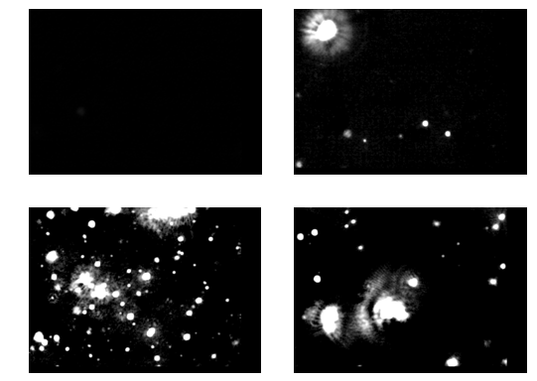
Figure 3.16: Video stills from the NTA analysis. Top left: 0.375 µM tannic acid in 10 mM sodium acetate buffer with 10% ethanol pH 4 at 25 °C. Top right: 0.5 µM polyproline dissolved in the same buffer at 25°C.Bottom left: 0.05 µM polyproline in the presence of 0.675 µM tannic acid in the same buffer at a molar ratio of 13.5 at 25°C. Bottom right: The same 13.5 ratio at 40°C.
Table 3.3: Temperature, molar ratio, concentration of particles given as both per frame and per ml for the tannic acid-polyproline interaction in 10 mM sodium acetate buffer in 10% ethanol pH 4 using the NTA at 25 and 40 °C.
Temperature  (°C) | Molar ratio | Concentration of particles  (Particles/frame) | Concentration of particles  (particles 10⁸ /ml)
25 | 6.75 | 24.45 | 2.86
40 | 6.75 | 16.91 | 2.02
25 | 12 | 58 | 7.04
40 | 12 | 27.2 | 3.22

Arguments against Positive Cooperativity
Many tannin-macromolecule ITC studies have suggested that the enthalpy increase at low molar ratios is due to positive cooperativity, that the bound tannin is having a favourable effect on the next binding event. Mechanistically, this is thought to be achieved by the bound tannin binding to other macromolecules in solution, forming multiple tannin-macromolecule crosslinks. ¹⁴⁵⁻¹⁴⁷ This is referred to as a crosslinking induced cooperativity model.
In terms of the crosslinking induced cooperativity model, tannic acid is a large polyphenol in comparison to the polyphenols used by other studies measuring protein-tannin crosslinks.¹⁴⁸ Consequently, tannic acid would still crosslink proteins at 10 °C, but the biphasic binding isotherm is not present. It is possible that crosslinking becomes more favourable at higher temperatures producing the biphasic binding isotherm. The caveat being precipitation studies have shown the size of polyphenol-peptide aggregates decrease with increasing temperature.¹⁴⁸ It must also be stated that a change in the ΔG would be indicative of a change in cooperativity, not the change in ΔH as there could be a counteracting change in the TΔS.
There is another form of polyphenol-protein forms of cooperativity. Charlton et al. suggested that peptides exhibiting no secondary structure would be able to “wrap around” tannins. Longer peptides are more able to “wrap around” tannins than shorter peptides, meaning binding constants become larger with increasing length of the peptide.^{148,200} However, this form of protein-tannin positive cooperativity can only be applied to peptides exhibiting very little secondary structure, as a peptide with a secondary structure would not be able to “wrap around” a tannin.²⁰⁰ Proteins such as BSA exhibit fairly rigid tertiary structure meaning it is unlikely that BSA would be able to “wrap around” tannins.
It is important to remember that tannins are thought to cause conformational changes in unfolded proteins, inducing a more folded state upon binding. ^{147,226} If protein conformational restriction occurs upon tannin binding then presumably this would induce negative cooperativity as binding would become increasingly less favourable.
As previously suggested, the change in binding stoichiometry may be due to the temperature change increasing the flexibility of the tannin. This would lead to a different binding configuration with changed binding thermodynamics. This could be responsible for the biphasic binding isotherm.

Possible Mechanisms for the Change in the Thermodynamic Parameters at 10 and 25 °C
It is difficult to attribute a definitive mechanism as to why decreasing the temperature increases the exothermicity at low protein-tannin molar ratios. CD spectroscopy was used to measure any temperature dependent secondary structural changes between 10 and 25°C (Figure 3.17). There was a minor shift in absorbance but no drastic change in the overall shape of the spectra indicating a small change in the α-helical portion of BSA. In keeping with the findings presented here, Takeda et al. reported very little structural change in the α-helical proportion between 10 and 25 °C and no change in the β-sheet proportion.²²⁷ The slight change in secondary structure is most likely just correlation and not the cause of the change in binding thermodynamics at the two different temperatures. As stated previously, tannins have higher affinity for more flexible macromolecules. Both β-pleated sheets and α-helices are rigid and so minor conversion between the two would unlikely be a cause of the change in binding thermodynamics at the two different temperatures. Lastly, ΔC_{p} has to be done at multiple temperatures by its very definition. Conformational changes of binding partners are never normally invoked to explain the ΔC_{p}. It is the general consensus ΔC_{p} is due to the water network around the binding partners changing.²²⁸

Figure 3.17: CD spectra of BSA in 10 mM acetate 10% ethanol pH 4 at 10 (blue) and 25 °C (red).
To determine if the positive ΔC_{p} was due to protein unfolding at higher tannic acid concentrations a titration of tannic acid into BSA was done at 40 °C since this is where fatty acid free BSA begins to unfold (Figure 3.18).¹⁷⁹ The baseline of the titration sloped upwards which could be indicative of protein unfolding. A similar sloping is not seen in the thermogram at 25 °C. Instead, there is a slight increase and then a plateau after a protein-tannin molar ratio of 14 (Figure 3.7). Taken together, this could mean that protein unfolding is minimal at 25 °C producing what seems to be baseline noise or it has little effect on the binding thermodynamics. It is possible had BSA unfolding not been an issue, titration of tannic acid into the BSA solution would have also become more exothermic from 25 to 40 °C.
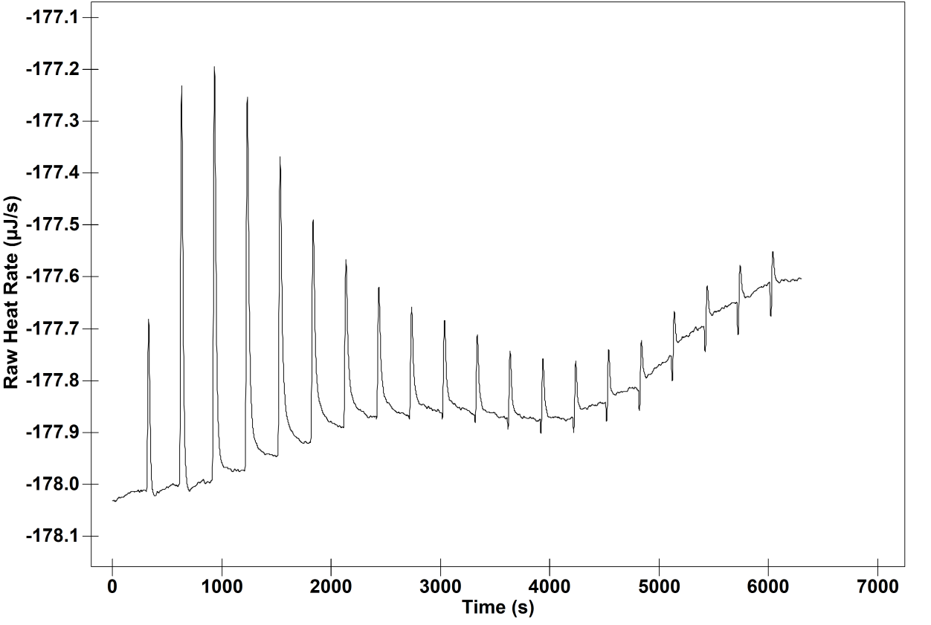
Raw Heat Rate (µJ/s)
Time (s)
Figure 3.18: Thermogram for the interaction of 5 µM BSA with 1 mM tannic acid at 40 °C.
BSA has approximately a total surface accessible area of 63227.54 Å² which can be decomposed into a hydrophilic surface area of 28962.80 Å² and a hydrophobic surface area of 34264.74 Å² .^{183,229} Inspection of the crystal structure reveals that these hydrophobic and hydrophilic regions are dotted around the protein surface.¹⁸³ Tannin binding to BSA is not site specific as it does not involve a particular recognition motif. Tannins are capable of hydrophobic interaction and hydrogen bonding. The positive ΔC_{p} suggests tannins initially interact with hydrophilic areas of the protein, but given the large apolar surface area of the protein binding most likely occurs there too. A ΔC_{p} is a net contribution and therefore could be interpreted as much larger contribution from polar interactions in comparison to apolar. At higher molar ratios, the enthalpic temperature dependence diminishes. This could mean that at higher tannic acid concentrations, interactions occur at less hydrophilic areas of the protein. This would be less temperature dependent because the increase in endothermicity with increasing temperature would change less.
Polyproline has a uniform distribution of binding sites unlike BSA. This means in the case of polyproline-tannic acid interactions that tannin binding only occurs at proline residues. Over the temperature range studied there is no change in the shape of the binding isotherm, but there is a change in the stoichiometry suggesting a possible crosslinking event (Figure 3.14). This supports the idea that, in the case with tannic acid binding to BSA, the upward curvature only becomes apparent when the binding sites are heterogeneous. The polyproline-tannic acid interaction would not give a biphasic binding isotherm as binding only occurs at proline residues. Whereas with BSA, tannin binding would occur at different amino acids each with a different ΔH. It is possible that tannin binding to polyproline does not yield a biphasic binding isotherm as tannic acid crosslinks identical polyproline monomers. BSA does not have a uniform surface. It is possible that tannic acid binds separate BSA monomers at different amino acids yielding biphasicity in the binding isotherm.
However, Poncet-Legrand et al. observed an increase in ΔH at the early stages of titration of a tannin fraction into polyproline. ¹⁴⁴ This opens up other possible reasons as to the biphasicity. Interactions between EGCG and IB-5 were studied by DLS, ITC and CD. ITC along with DLS showed a three stage mechanism. The first stage seemed to correspond to simple binding as this gave a simple binding isotherm with no detectable aggregates. The ITC isotherm was followed by a stable but negative change in enthalpy, which corresponded, to tannins binding to tannin coated peptides. This was then followed by extensive aggregation and gave a “bell shaped” binding isotherm comparable to the tannic acid-BSA interactions.¹⁴⁷ However, NTA showed particles upon the addition of tannic acid to polyproline, yet the binding isotherm did not show the upward curvature. Consequently, this would mean extensive aggregation does not occur at 10 °C for the BSA-tannic acid binding isotherm.
Ethanol was not present in the study conducted by Poncet-Legrand et al., but it was present in this study. Another possibility is that ethanol reduces the crosslinking or aggregation meaning there is no biphasicity in the binding isotherm. Ethanol is known to reduce tannin-induced aggregation. Pascal et al. showed that in the presence of 12% ethanol, the aggregates formed between epigallocatechin gallate and a glycosylated proline rich peptide were reduced.²³⁰ In addition to this, no stable dispersions of large insoluble aggregates were reported, even at high tannin/macromolecule molar ratios. It is therefore entirely possible, that in the study presented here, the ethanol has reduced tannic acid-polyproline aggregation leading to no biphasicity in the binding isotherm.

Tetrameric Proanthocyanidin Interactions with Polyproline
Proanthocyanidins being condensed tannins are much more polar than the hydrolysable tannins. The proanthocyanidins utilised in this study are more than 95% pure unlike the tannic acid which is a mixed system. This allows for a better estimation of the thermodynamic values as the concentration of the ligand is accurately known. Titration of tetrameric proanthocyanidin into polyproline at revealed binding that was exothermic at all temperatures (Figure 3.19 to Figure 3.20). The source of the favourable exothermicity is again most likely due to hydrogen bonding between the two binding partners and London dispersion forces.
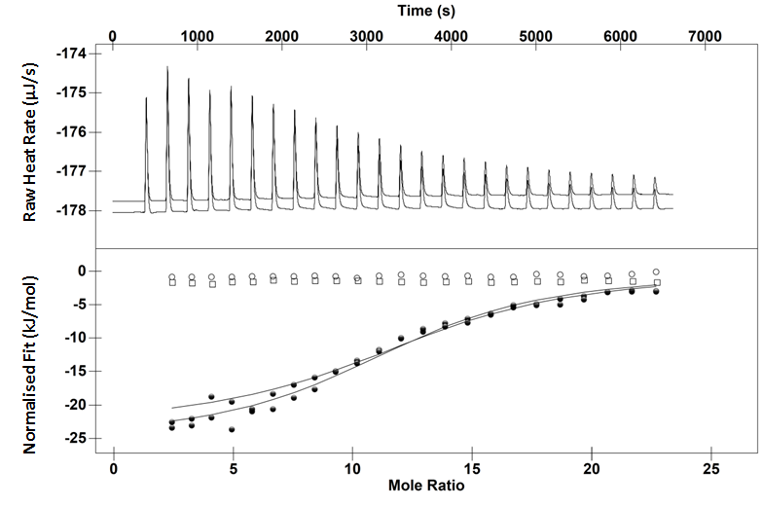
Normalised Fit (kJ/mol) Raw Heat Rate (µJ/s)
Mole Ratio
Time (s)
Figure 3.19: Upper: Thermogram for the interaction of 0.025 mM polyproline with 2 mM tetrameric proanthocyanidin at 25 °C. Lower: ITC binding isotherm for the same interaction (closed circles). Sodium acetate into a solution of polyproline (open circles) and tetrameric proanthocyanidin dilution into sodium acetate (open squares). Solid line represents single site independent binding model fit.

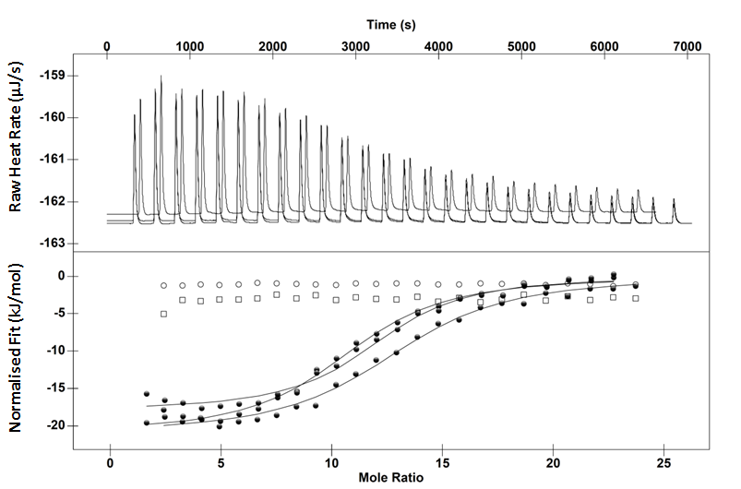
Time (s)
Normalised Fit (kJ/mol) Raw Heat Rate (µJ/s)
Mole Ratio
Figure 3.20: Upper: Thermogram for the interaction of 0.025 mM polyproline with 2 mM tetrameric proanthocyanidin at 40 °C. Lower: ITC binding isotherm for the same interaction (closed circles). 10 mM sodium acetate into a solution of polyproline (open circles) and tetrameric proanthocyanidin dilution into sodium acetate (open squares). Solid line represents single site independent binding model fit.
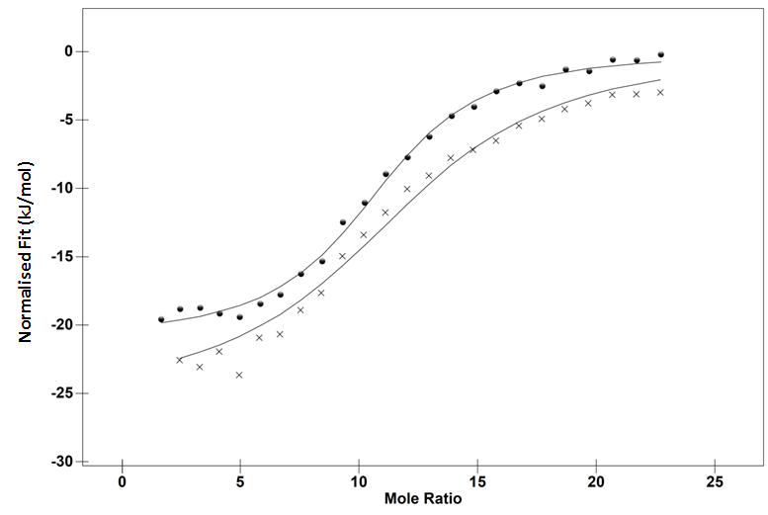
Mole Ratio
Figure 3.21 : ITC binding isotherm of the interaction between tetrameric proanthocyanidin into 25 µM polyproline in 10 mM acetate buffer with 10% ethanol pH 4 at 25 (closed circles) and 40 °C (crosses).
Performing the titrations at different temperatures suggested that the interaction was becoming increasingly exothermic as the temperature was increased from 25 to 40 °C. The TΔS becomes less favourable with increasing temperature leading to a less favourable ΔG. The stoichiometry remains invariant to temperature. The favourable change in ΔH is in accordance to with the exothermicity of hydrophobic interaction increasing with increasing temperature. The partition constant, P, is a measure of the tendency of a neutral molecule to differentially dissolve in two immiscible phases, water and octanol, giving a measure of how hydrophobic a molecule is. The logarithm of the ratio of the concentrations of the solute in the solvents is called logP. Substances with a logP lower than 0 are hydrophilic whilst those with a positive number are hydrophobic, heptane for example has a logP of 4.6 whilst arabinose has a log p of -3. Normally, it is not practical to calculate the LogP of every compound. Subsequently, chemists use software tools to estimate LogP. This is called ClogP – the calculated LogP. Using the ClogP function on ACD/ChemSketch estimated a value of 13.51 for tannic acid. Whilst tetrameric proanthocyanidin has a logP of -1.5.²³¹ The smaller ΔC_{p} in comparison to the tannic acid polyproline system may be due to the differences in LogP (the ratio of a compound in an apolar and polar phases) between the two compounds. Previous work has shown there are two stages of interaction between tetrameric proanthocyanidin and BSA, subsequently it was not repeated here.²¹⁵
Table 3.4: The temperature, enthalpy ΔH, entropy TΔS, Gibbs free energy ΔG and stoichiometry for the proanthocyanidin tetramer-polyproline interaction at 25 and 40 °C. The standard error (bold) and the confidence intervals (italics) are in brackets.
Temperature  (°C) | -ΔH  (kJ/mol) | -TΔS  (kJ/mol) | -ΔG  (kJ/mol) | Stoichiometry  n
25 | 20  (±2)  (±0.7) | -8.33  (± 2) | 28.32  (± 0.4)  (± 2) | 11.9  (±0.8)  (±0.2)
40 | 24.2  (± 1)  (±2) | -3.06  (± 0.9) | 27.3  (± 0.1)  (± 2) | 12.3  (± 0.4)  (± 0.9)

Octomeric Proanthocyanidin Interactions with Bovine Serum Albumin
The binding isotherm between octameric proanthocyanidin and BSA showed a more complex binding isotherm than the one for tetrameric proanthocyanidin and polyproline. The interaction is monophasic at 10 °C (Figure 3.22), but becomes biphasic at 25 °C (Figure 3.23), which is similar to the tannic acid-BSA binding isotherms.
Time (s)
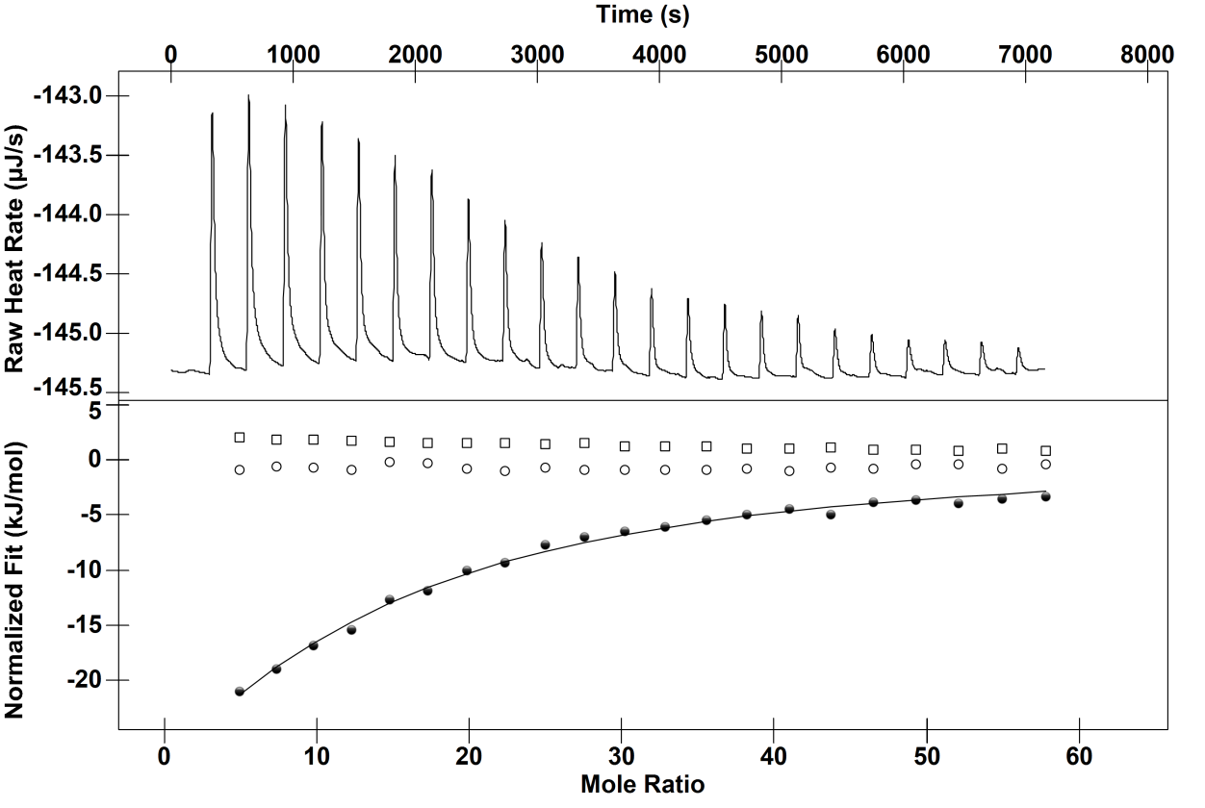
Mole Ratio
Normalised Fit (kJ/mol) Raw Heat Rate (µJ/s)
Figure 3.22 : Upper: Thermogram for the interaction of 15 µM BSA with 4 mM proanthocyanidin octamer in 10 mM ammonium acetate at 10 °C pH 4. Lower: ITC binding isotherm for the same interaction (closed circles). 10 mM ammonium acetate into a solution of BSA (open circles) and proanthocyanidin octamer dilution into ammonium acetate (open squares). Solid line represents single site independent binding model. fit.
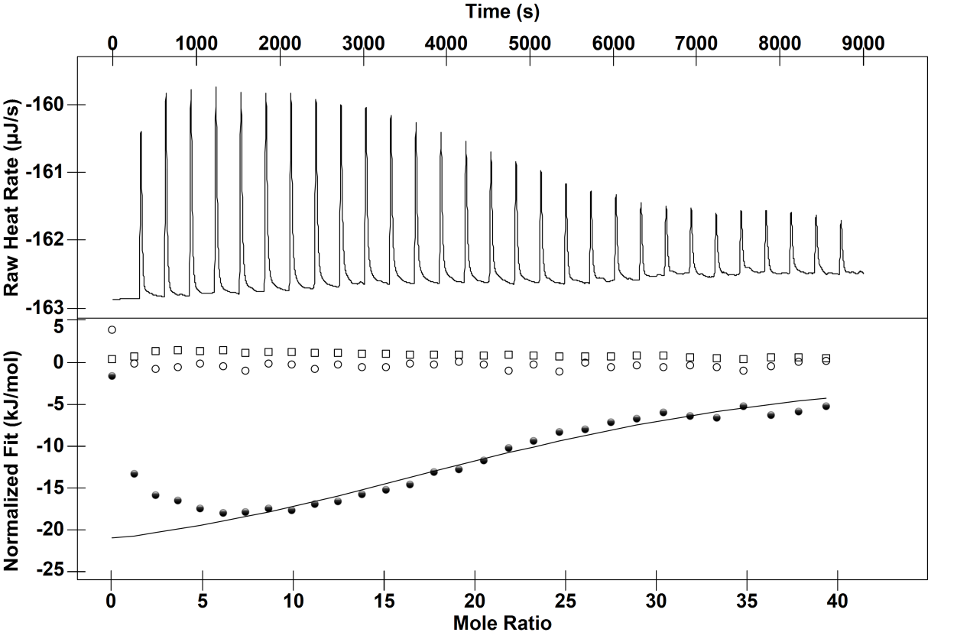
Mole Ratio
Time (s)
Normalised Fit (kJ/mol) Raw Heat Rate (µJ/s)

Figure 3.23: Upper: Thermogram for the interaction of 30 µM BSA with 4 mM proanthocyanidin octamer in 10 mM ammonium acetate at 25 °C pH 4. Lower: ITC binding isotherm for the same interaction (closed circles). 10 mM ammonium acetate into a solution of BSA (open circles) and proanthocyanidin octamer dilution into ammonium acetate (open squares). Solid line represents single site independent binding model fit.
The BSA titrated against octomeric proanthocyanidin contains fatty acids. This means it is much more stable than the BSA used in the BSA-tannic acid study. Consequently, the effect of higher temperatures on binding can now be studied. This allowed an investigation into proanthocyanidin-BSA binding thermodynamics at 35 °C (Figure 3.24). Before the main binding event, at molar ratios below six, there is an increase in endothermicity with increasing temperature which is similar to the tannic acid – BSA interactions. This provides evidence for a mechanism where tannins crosslink proteins via primarily hydrogen bonding at low molar ratios as suggested by McRae et al.²²⁰ At higher molar ratios, above 10 in the case of the octomeric proanthocyanidin-BSA interaction at 25 °C, the empty regions on BSA become fully saturated and networked by the octamer. This is then followed by a steady yet negative change in ΔH.
Performing the titration at 35 °C increases the exothermicity of the interactions found after for the second curve in comparison to the titration performed at 25 °C (Figure 3.23). This suggests this saturation event is driven by hydrophobic interaction. Following the second curve is a steady yet negative change in ΔH most likely caused by proanthocyanidins interacting with the proanthocyanidin coated BSA.²³² The negative ΔC_{p} suggests hydrophobic interaction is the driving force. This is not to say that hydrogen bonding does not play a role. It just means that hydrophobic interaction forms a much larger contribution to the binding thermodynamics.
Time (s)
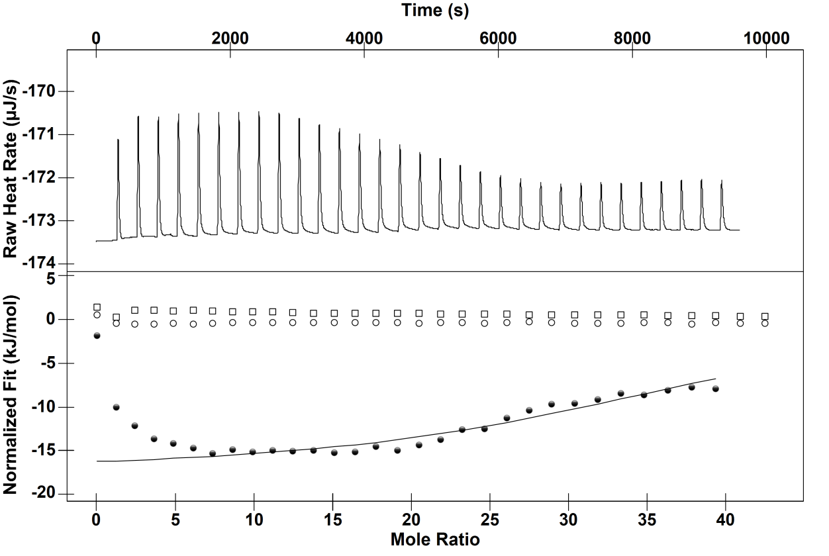
Mole Ratio
Normalised Fit (kJ/mol) Raw Heat Rate (µJ/s)

Figure 3.24: Upper: Thermogram for the interaction of 30 µM BSA with 4 mM proanthocyanidin octamer in 10 mM ammonium acetate at 35 °C pH 4. Lower: ITC binding isotherm for the same interaction (closed circles). 10 mM ammonium acetate into a solution of BSA (open circles) and proanthocyanidin octamer dilution into ammonium acetate (open squares). Solid line represents single site independent binding model fit.
Thermodynamic values have been calculated using the NanoAnalyse software. All of the values calculated for the interaction at 10°C are erroneous and should not be used definitively. The ΔH values for the interactions at higher temperatures should also be used with caution, as temperature clearly effects the two stages of the reaction in different ways and as such a summation of two opposing ΔH, it is advised to instead look at Figure 3.25 to see how temperature affects the binding interactions.
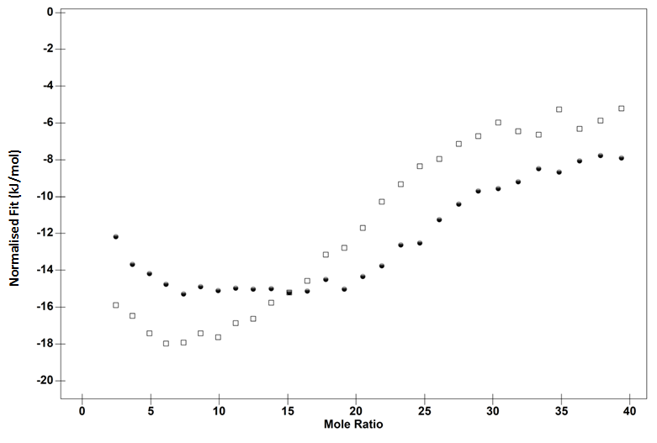
Mole Ratio
Normalised Fit (kJ/mol
Figure 3.25: ITC binding isotherms for the interaction of 30 µM BSA with 4 mM proanthocyanidin octamer in 10 mM ammonium acetate at pH 4 (open squares) 25°C and (closed circles) 35°C.

Table 3.5: The temperature, enthalpy ΔH, entropy TΔS, Gibbs free energy ΔG and stoichiometry for the proanthocyanidin octamer-BSA interaction at 10,25 and 40 °C. The standard error (bold) and the confidence intervals (italics) are in brackets.
Temperature  (°C) | -ΔH  (kJ/mol) | -TΔS  (kJ/mol) | -ΔG  (kJ/mol) | Stoichiometry  n
10 | 100  (±25) | 81.2 | 18.8  (± 6.1) | 8  (± 3)
25 | 25.65  (±5) | 4.08 | 21.6  (± 1.417) | 24.7  (±2)
35 | 17.39  (±3) | -6.7 | 24.1  (± 0.8) | 38.02  (± 2)

The stoichiometry of binding increases from 25 to 35°C. This is similar to the tannic acid-BSA interaction. As previously suggested this could be due to a change in aggregation state or a conformational change of the tannin. The ΔG also increases with increasing temperature, which is expected from hydrophobic interaction.
Enthalpy-entropy compensation is a topic much discussed but poorly understood. The existence of compensation is usually taken to mean that the parameter being varied is affecting a complex interplay of interactions. Grunwald and Steel suggested solvent reorganisation was responsible for enthalpy-entropy compensation based on rate constant temperature dependence.¹⁴ Leffler found empirically that changes in ΔH corresponded to changes in ΔS. Leffler discerned the equation ΔH = β·ΔS where β has dimensions of temperature often known as the compensation temperature.^{90,91} If the data is not erroneous then at a single temperature the ΔH of water reorganisation is equal to the ΔS of water reorganisation. If the reaction is performed at a temperature beyond the compensation temperature then the relationship is invalidated by changes in ΔH with temperature.^{90,91} When the titrations are performed at 10 °C there is a favourable increase in ΔH in comparison to the titration performed at 25 °C. Increasing the temperature from 25 to 35 °C does not seem to change the shape of the binding isotherm, in the sense that another curve is produced, indicating that at these temperatures the ΔH corresponds to the ΔS.
Exposure of polar groups found in the interior of proteins is favoured enthalpically with increasing temperature.²³³ Mechanistically, this is due polar groups making stronger interactions with water than with each other. Therefore, hydrogen bonding between tannins and proteins would become stronger with decreasing temperature. It seems that at 25 °C the enthalpic penalty paid to break the hydration layers around the polar groups required to form solute-solute hydrogen bonds overrides the exothermicity of the interactions producing the upward curvature on the binding isotherm. It seems that water cannot compensate all the numerous binding interactions leading to two distinct curvatures on the binding isotherm. Consequently, entropy-enthalpy compensation does not exist in the system presented here.

Probing Hydrophobic Interaction with Salts

Hydrophobic interaction can be altered using salts. Salts that increase hydrophobic interaction are known as kosmotropes whilst those that decrease the hydrophobic interaction are known as chaotropes. ^{77,109,234,235} Fox et al. investigated how strongly Hofmeister anions associate with the binding pocket of zinc carbonic anhydrase using a competitive binding assay. The larger chaotropic anions bound endothermically with a favourable contribution from ΔS. Hydrogen carbonate, a kosmotrope, bound exothermically.²³⁶ This is also supported by the work by Boncina et al. who identified chaotropes bound to lysozyme exothermically.²³⁷ Based on this it was expected that the chaotropes would make the interaction less exothermic, whilst kosmotropes would make the interaction more exothermic. To test this, 6 mM octonate was titrated into 300 µM BSA in 20 mM phosphate buffer at pH 7.2 with either 50 mM sodium thiocyanate or sodium sulphate. The interaction was exothermic, but due to the weak nature of the association gave a shallow binding isotherm (Figure 3.26). The exothermicty was reduced in both salts (Figure 3.27 and Figure 3.28). Given that octonate is suggested to make both electrostatic and hydrophobic interactions with BSA, it is likely that sulphate screened the electrostatic interaction between the carboxylate group on the fatty acid and the positively charged residues on BSA yielding an increase in endothermicity. The thiocyanate reduced the exothermicity substantially (Figure 3.28). This is most likely due to the screening and diminishing exothermic hydrophobic component to binding. In the study presented here, thiocyanate was chosen to decrease hydrophobic interaction between the proanthocyanidin pentamer and BSA. To increase hydrophobic interaction in this system sulphate was chosen. Octanoate is not soluble at pH 4 forming micelles. This means the binding isotherm would be a composite of a demicellisation reaction in addition to binding. Tannins oxidise and hydrolyse faster at pH 7 losing stability after 3 hours.²³⁸ Subsequently, it was decided that the pH of the two different systems should not be the same.
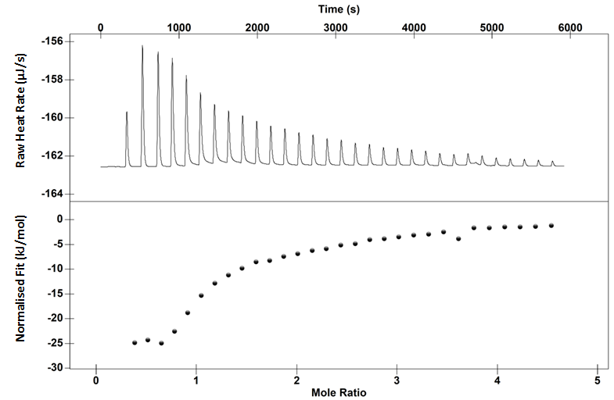
Mole Ratio
Time (s)
Normalised Fit (kJ/mol) Raw Heat Rate (µJ/s)
Figure 3.26 Upper: Thermogram for the interaction between 300 µM BSA and 6 mM octanoate in 20 mM phosphate buffer pH 7.21 at 25 °C. Lower: ITC binding isotherm for the same interaction (closed circles).
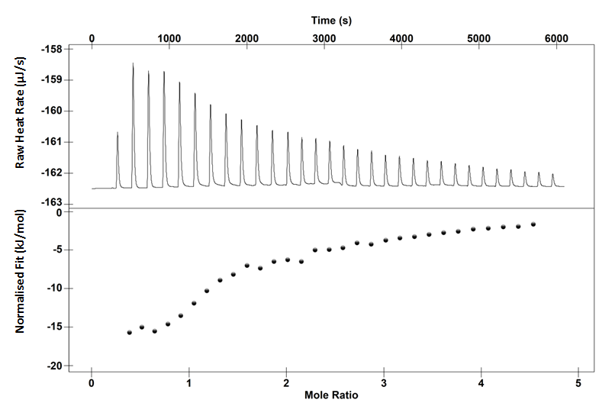
Time (s)
Mole Ratio
Normalised Fit (kJ/mol) Raw Heat Rate (µJ/s)
Figure 3.27 Upper: Thermogram for the interaction between 300 µM BSA and 6 mM octanoate in 20 mM phosphate, 50 mM ammonium sulphate buffer pH 7.21 at 25 °C Lower: ITC binding isotherm for the same interaction (closed circles).

Time (s)
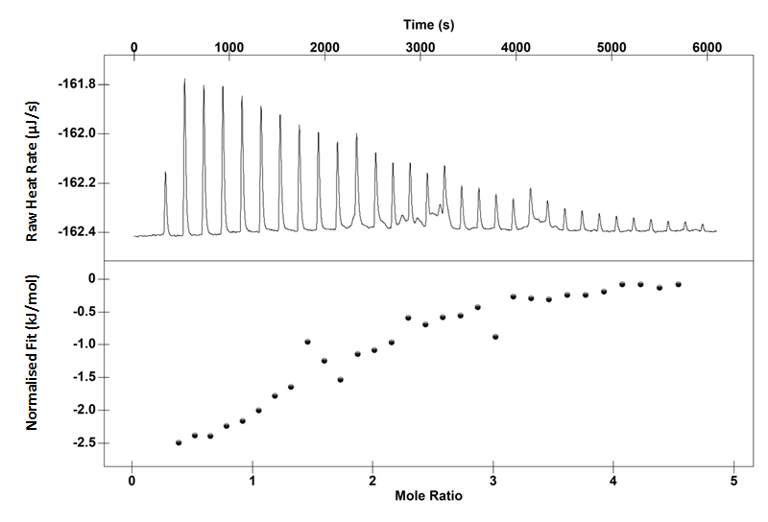
Normalised Fit (kJ/mol) Raw Heat Rate (µJ/s)
Mole Ratio
Figure 3.28 : Upper: Thermogram for the interaction between 300 µM BSA and 6 mM octanoate in 20 mM phosphate, 50 mM ammonium thiocyanate buffer pH 7.21 at 25 °C Lower: ITC binding isotherm for the same interaction (closed circles).

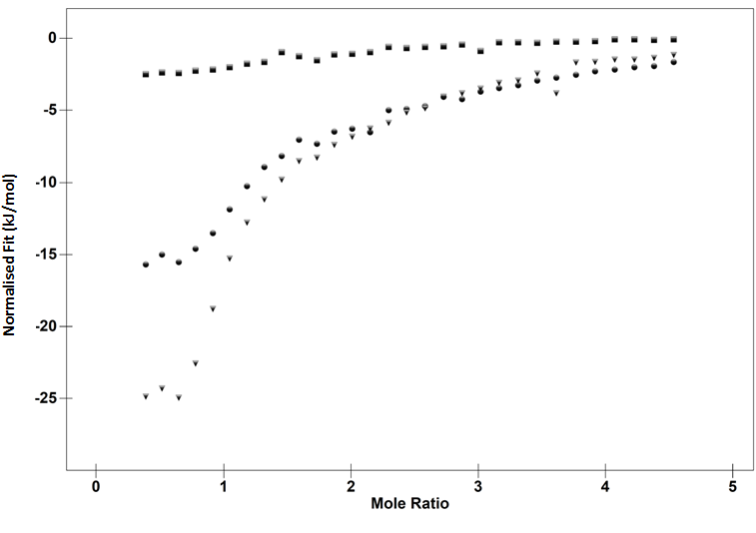
Mole Ratio
Normalised Fit (kJ/mol)
Figure 3.29: ITC binding isotherm of the interaction between 300 µM BSA and 6 mM octanoate in 20 mM phosphate buffer pH 7.21 at 25 °C (triangles) with 50 mM ammonium thiocyanate (closed squares) or ammonium sulphate (circles) respectively.
The binding isotherm for the proanthocyanidin-BSA interaction reveals the interaction to be exothermic with the most likely source being hydrogen bonding and favourable dispersion forces (Figure 3.30). It would be expected that if hydrophobic interaction was prevalent in the system addition of thiocyanate would either decrease the exothermicity of the binding interaction or decrease the association constant. Neither of these situations occurs. Instead, the addition of thiocyanate induces an increase in exothermicity.
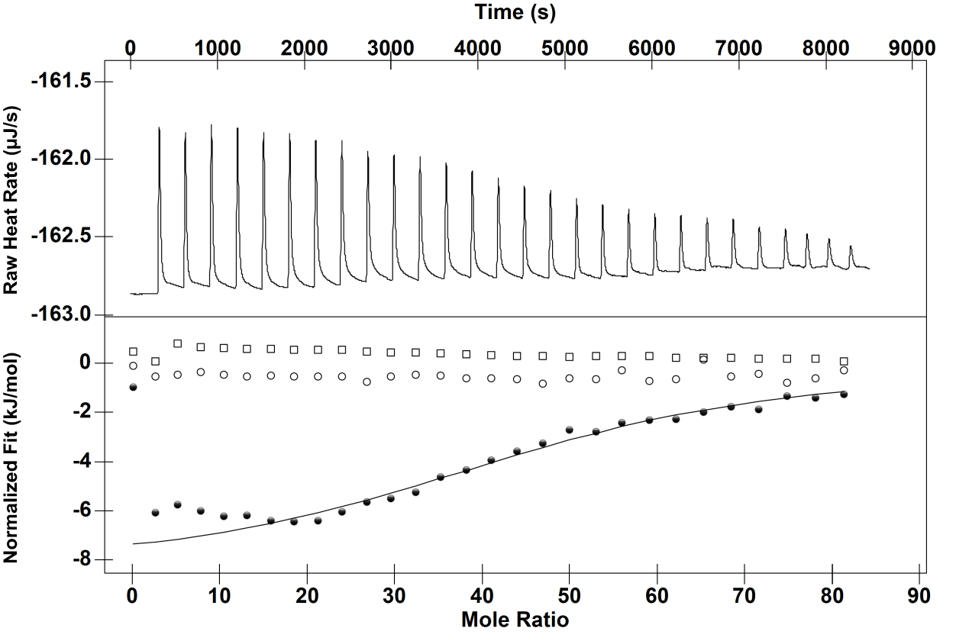
Time (s)
Mole Ratio
Normalised Fit (kJ/mol) Raw Heat Rate (µJ/s)

Figure 3.30 : ITC binding isotherm of the interaction between 15 µM BSA and 4.3 mM pentameric proanthocyanidin in 10 mM acetate pH 4 at 25 °C (closed circles). Sodium acetate into a solution of 15 µM BSA (open circles) and pentameric proanthocyanidin dilution into sodium acetate (open squares). Solid line represents single site independent binding model fit.
Addition of thiocyanate increases the binding exothermicity (Figure 3.31), whilst the addition of sulphate further increased the exothermicity (Figure 3.32 and Figure 3.33). This is not what is expected based on previous work²³⁶ or the BSA-octanoate studies with different salts.
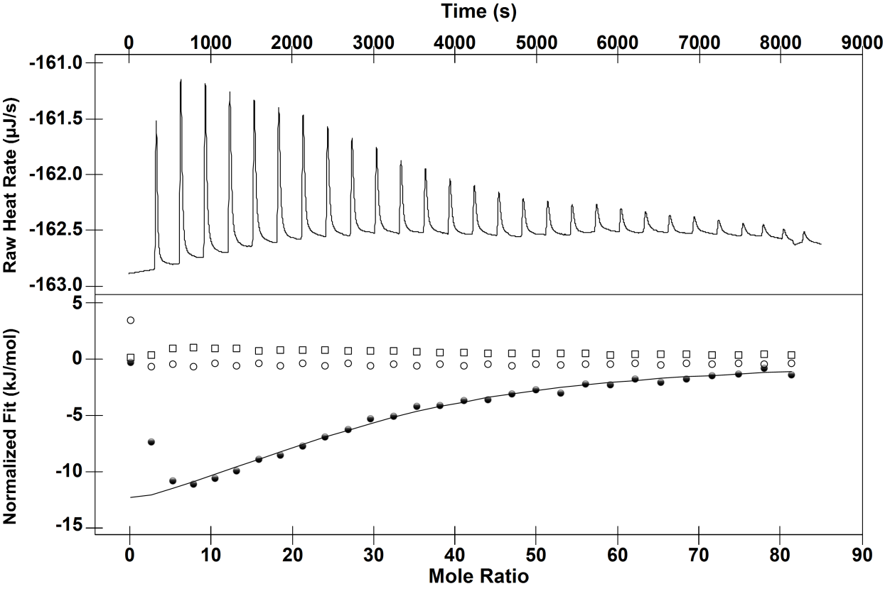
Time (s)
Mole Ratio
Normalised Fit (kJ/mol) Raw Heat Rate (µJ/s)

Figure 3.31: ITC binding isotherm of the interaction between 15 µM BSA and 4.3 mM pentameric proanthocyanidin in 10 mM ammonium acetate 50 mM ammonium thiocyanate pH 4 at 25 °C (closed circles). Ammonium acetate into a solution of 15 µM BSA (open circles) and pentameric proanthocyanidin dilution into sodium acetate with ammonium thiocyanate (open squares). Solid line represents single site independent binding model fit.
Both salts seem to increase the amount of visible precipitation. Increasing the amount of precipitated BSA bound tannin would explain the dramatic increase in exothermicity and why both salts do not have opposing effects on the binding thermodynamics. However, this does not explain how thiocyanate is increasing the amount of precipitation.
Surface tension arises due to hydrogen bonding between water molecules. In the bulk, water can orientate freely and form the optimal number of hydrogen bonds. At the surface, water is less able to adopt an optimal hydrogen bond configuration leading to a less favourable free energy state. Because the hydrophobic effect primarily arises from the strong self attraction of water it means surface tension measurements can be used to measure it.¹¹⁴ All salts with a metal counterion increase the surface tension of water meaning that all salts increase the hydrophobic effect. ⁹⁷ However, it is thought that chaotropes diminish the hydrophobic effect by binding to hydrophobic groups thereby changing the population of water around the macromolecule or increasing charge repulsion. ^{63,118,239,240} It is possible that there is less association in this particular case, between thiocyanate and hydrophobic groups on the protein. Consequently, thiocyanate would remain in the bulk and act to increase the hydrophobic effect.
Another effect that needs to be taken into account is screening partial and full charges. Increasing the ionic strength of the solution will reduce electrostatic repulsion and allow proteins to come together. In this particular example, it may be that thiocyanate reduces like charges on the proteins, facilitating protein crosslinking via the tannin and thereby favourably altering the ΔH.

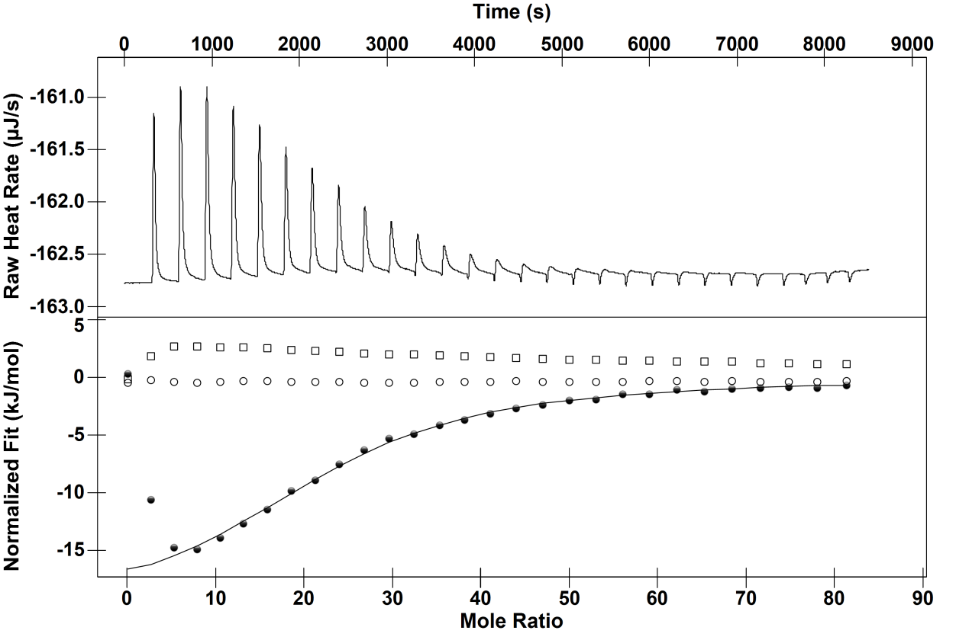
Time (s)
Mole Ratio
Normalised Fit (kJ/mol) Raw Heat Rate (µJ/s)

Figure 3.32: ITC binding isotherm of the interaction between 15 µM BSA and 4.3 mM pentameric proanthocyanidin in 10 mM ammonium acetate 50 mM ammonium sulphate pH 4 at 25 °C (closed circles). Ammonium acetate into a solution of 15 µM BSA (open circles) and pentameric proanthocyanidin dilution into sodium acetate with sulphate (open squares). Solid line represents single site independent binding model fit.
Sulphate on the other hand, is suggested to increase hydrophobic interaction by destabilising the waters around polar moieties and at higher concentrations remove water from apolar moieties favouring hydrophobic collapse, which is supported by NMR and light scattering techniques.^{114,119} Given that the isoelectric point of the protein is just below the pH, BSA would be expected to have a slight positive charge which would act to repel other BSA molecules in solution. Therefore, sulphate may increase tannin-induced precipitation by removing water from hydrophobic and polar moieties in addition to reducing electrostatic repulsion.
The thermodynamic values have been calculated for the interaction between pentameric proanthocyanidin and BSA in the presence of the specified salt (Table 3.6). As previously stated, there is a ΔH increase due to the presence of salt.
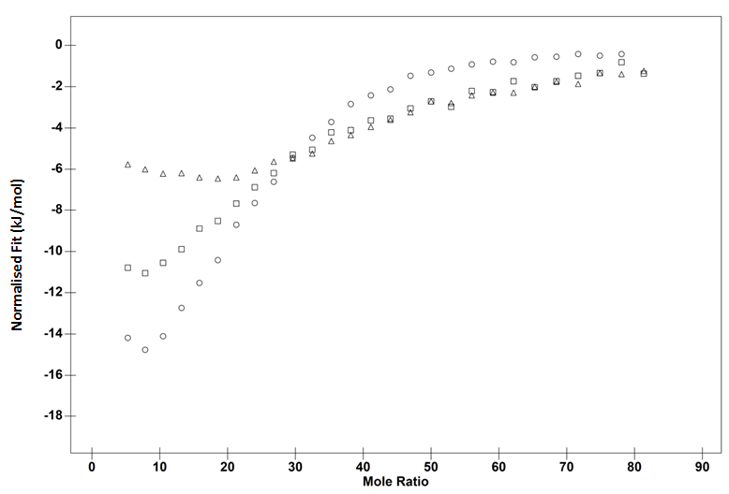
Mole Ratio
Normalised Fit (kJ/mol)
Figure 3.33: ITC binding isotherm of the interaction between 15 µM BSA and 4.3 mM pentameric proanthocyanidin in 10 mM acetate pH 4 at 25 °C (open triangles) with 50 mM ammonium thiocyanate (open squares) or ammonium sulphate (open circles) respectively.

Table 3.6: The temperature, enthalpy ΔH, entropy TΔS, Gibbs free energy ΔG and stoichiometry for the proanthocyanidin pentamer-BSA interaction in different salts. The standard error (bold) and the confidence intervals (italics) are in brackets.
Salt | -ΔH  (kJ/mol) | -TΔS  (kJ/mol) | -ΔG  (kJ/mol) | Stoichiometry  n
10 mM ammonium acetate | 8.5  (±0.08) | 14.00 | 22.2  (± 6) | 47.6  (± 3)
10 mM ammonium acetate with  50 mM thiocyanate | 17.3  (±2) | -4.12 | 21.5  (± 4) | 28.5  (±2)
10 mM ammonium acetate with  50 mM sulphate | 20.7  (±1) | -2.5 | 23.2  (± 3) | 24  (± 1)

Conclusion

Several tannin-macromolecule ITC studies have suggested that the enthalpy increase at low molar ratios is due to positive cooperativity, that the bound tannin is having a favourable effect on the next binding event. Mechanistically, this is thought to be accomplished by the bound tannin binding to other macromolecules in solution, forming multiple tannin-macromolecule crosslinks. ¹⁴⁵⁻¹⁴⁷ The data presented here allows an extension of the model, specifically the cause of the enthalpy increase at low molar ratios. Titration of tannins into proteins solutions produced an enthalpy increase at low molar ratios whilst titration of tannins into polyproline did not. The key point being that BSA is more heterogeneous in terms of amino acid composition or structure than polyproline. The enthalpy increase at low molar ratios could be a property of crosslinking molecules with different structures, shapes or amino acid compositions. Alternatively, it may be the case that crosslinking or aggregation is responsible for the biphasicity. It is possible that the reason why there were not two stages in the binding isotherm for the polyproline-tannin binding isotherms was due to the ethanol either diminishing the aggregation or making the crosslinking less favourable.
Furthermore, it seems that water plays a key role in tannin-protein interactions. At low molar ratios, the enthalpy change for the first curve is positive if the temperature is increased. At higher molar ratios, the enthalpy change for the second curve and the subsequent plateau are negative if the temperature is increased. This suggests three stages of interaction all with different binding energetics. The temperature dependence of the first curve suggests polar desolvation; water being removed from polar amino acids on the protein and polar alcohols on the tannin prior to binding. The binding interactions would most likely therefore encompass hydrogen bonding and van der Waals’ forces. The second curve suggests apolar water desolvation; water being removed from apolar amino acids on the protein and the apolar carbon skeleton of the tannin phenolic rings prior to binding. The subsequent binding interactions most likely encompass a range of mechanisms including hydrogen bonding, van der Waals’ forces and hydrophobic interaction. The enthalpy plateau is significant of tannins binding to the tannin-coated protein. Most likely, hydrophobic interaction is the main driving force here, but hydrogen bonding and van der Waals’ would also be playing a role.
Based on previous work it was suggested that chaotropic anions would increase the endothermicity of the tannin-protein interaction whilst kosmotropes would increase the exothermicity. Instead, both anions favourably increased the enthalpies of binding. It is suggested that thiocyanate reduced charge repulsion between the proteins facilitating crosslinking in addition to possibly increasing the surface tension of water thereby increasing the hydrophobic effect. A dual mechanism is proposed for sulphate whereby screening reduced electrostatic repulsion between the BSA molecules and water was removed from both polar and apolar moieties.

Chapter 4: An Isothermal Titration Calorimetry Study of a Multisite – Electrostatic Binding Interaction between Lysozyme and Phytate

Summary
Phytate negatively affects the bioavailability of nutrients. To further the understanding of the molecular mechanisms behind this, Isothermal Titration Calorimetry (ITC) was used to determine the binding thermodynamics between phytate and the positively charged protein lysozyme in ammonium acetate buffer pH 4 at 10, 25 and 40 °C. The binding isotherm is biphasic which is normally interpreted as favourable (positive) cooperative binding of a ligand to a macromolecule. However, Nanoparticle Tracking Analysis (NTA) identified small aggregates at low molar ratios used in the ITC study. This suggests that the biphasicity observed in ITC binding isotherms could be due to an aggregation event rather than positive cooperative binding.
ITC revealed the interaction to be in the micromolar range with a favourable contribution from the enthalpy (ΔH) and from entropy (TΔS) of binding. Increasing the temperature increases the affinity lysozyme has for phytate and increases the binding stoichiometry (n). This suggests crosslinking between lysozyme molecules via a bridging phytate that sterically hinders the binding to other sites on lysozyme, and that crosslinking becomes less favourable with increasing temperature. Additionally, the heat capacity of binding (ΔC_{p}) was shown to be positive. This suggests removal of water around polar residues and a lack of hydrophobic interaction between lysozyme and phytate. The interaction between phytate and lysozyme was weakened in 100 mM ammonium acetate and completely diminished in 300 mM ammonium acetate. This shows that electrostatic interaction is crucial for this particular binding interaction.
ITC could provide a useful technique to identify the strength and specificity of the interactions between phytate and biological macromolecules both exogenous and endogenous meaning that a better understanding of the antinutritional effects of phytate could be achieved. In addition to this, the effect of temperature on protein-phytate interactions remains unexplored. Furthermore, NTA could assist in providing a mechanistic rationale to ITC binding isotherms that are not purely sigmoidal.

Introduction
Food science and technology are concerned with a wide variety of issues. Routinely, food chemists want to understand how molecules within food affect the bioavailability of nutrients and techniques regularly used in physical chemistry can help with this.¹⁶⁴ Physical chemistry is the study of chemicals using laws and concepts in physics. Typically, such systems studied by physical chemists are homogenous and pure meaning the conclusions derived are quantitative. Foods are not homogenous or pure. However, using techniques employed in physical chemistry can help in understanding basic principles which can assist in a greater awareness of how foods interact with biological systems. For this reason, sodium phytate from rice was used to provide a basic understanding of how phytate may interact with a biological macromolecule. In the subsequent studies potassium phytate was used as the purity is 95% meaning that more quantitative observations can be sought.

Phytate
Phytic acid is a myo-inositol with six orthophosphate groups linked to it by phosphoester bonds (Figure 4.1). The dissociated form of the acid, which exists above a pH of 2, named phytate, is thought to bind to a number of trace metals, colloidal clays and proteins.²⁴¹⁻²⁴⁵ These studies suggest that the phytate ion can bind to positively charged proteins and minerals since it occurs as a set of negatively charged species whose charge composition becomes more negative with increasing pH.^{241,246,247} However, it has also been suggested that phytate interacts as kosmotropic anion, removing water from proteins inducing protein-protein interactions rather than direct interaction.²⁴⁸
Seeds, cereals, legumes and nuts all contain phytate. As such this presents a nutritional problem, as phytate could chelate ions with biological functions.²⁴² It has also been suggested that phytate could form non-digestible complexes with exogenous protein sources and endogenous proteins involved in digestion causing malnutrition.²⁴⁹⁻²⁵¹ Although originally discovered as a form of phosphate storage in plant seeds, it is now known to be present in all eukaryotic cells where it is believed to have a signalling function.²⁵²⁻²⁵⁴ However, its biological functions and how it interacts with cellular components is still not understood.
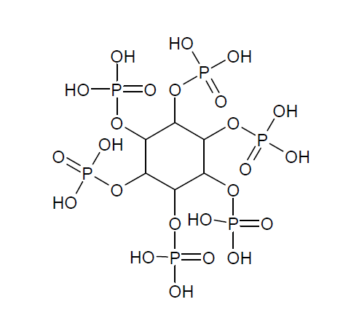
Figure 4.1: Structure of phytic acid
The antinutritional effects of phytate are not just limited to the human population. Malnutrition has major ramifications in the farming industry. Pigs and poultry are negatively affected in terms of growth performance due to phytate present in farmyard feed. ^{255,256} This has led to supplementation of phytase, an enzyme that hydrolyses phosphate esters present on phytate. The global phytase market was evaluated to be worth £244 milion annually and account for more than 60% of the total feed enzyme market in 2010.²⁵⁷ However, there is conjecture regarding the mechanism of how the antinutritional effect of phytate is diminished by phytase.²⁵⁸ Morales et al. showed that trypsin and chymotrypsin in vivo activities in pigs were mostly unaffected or negatively affected by the presence of phytase. ²⁵⁹ Onyango et al. remains speculative about the extent of such inhibition occurring in vivo as it has not yet been verified.²⁶⁰
Although a number of molecular mechanisms have been put forward to explain the antinutritional effects of phytate, there has been little thermodynamic characterisation of any of them with the possible exception of the association constants between phytate and biologically relevant ions and the thermal stability of proteins in the presence of phytate. ^{241,242} Herein lies the problem. Without proper thermodynamic characterisation the strength and specificity of phytate-protein interactions can only be estimated and this is perhaps one of the reasons why there is such conflicting evidence as to the effect of phytase supplemented feed on farmyard nutrition and the interaction of phytate with digestive enzymes. Adeola and Sands suggested that the antinutritional effects of phytate on pig and poultry nutrition is a multifaceted subject and required an understanding of how phytate interacts with minerals, proteins and enzymes in vivo and in vitro. ²⁵⁸ Bruce and Sandstøl showed the apparent ileal digestibility of crude protein was the same with or without 478 unit/kg of phytase. They suggested discrepancies between studies could be due to the diverse binding affinity of inositol phosphates for proteins and minerals.²⁶¹
Isothermal Titration Calorimetry (ITC) is a technique that provides enthalpy (ΔH), entropy (TΔS) and Gibbs free energy values (ΔG) of binding by measuring the heat between two interacting partners in solution. It has been used successfully to characterise a range of binding interactions, including how the β-Propeller phytase hydrolyses insoluble calcium phytate-salts and prevents phytate from binding to metal ions. ²⁶² More recently, ITC has been used to determine how phytate could interact with the cellular medium to gain a greater understanding its function within cells.²⁶³
However, it has not been used to measure the binding energetics between positively charged proteins and phytate at different temperatures. Therefore, ITC could help in furthering the understanding of the antinutritional effects of phytate in addition to determining the role of eukaryotic phytate.

Binding Modes
Most previous studies claiming to have discovered positive cooperativity in various binding systems using ITC have used the presence of a biphasic isotherm with increasingly favourable ΔH at low molar ratios as proof.¹⁷⁻¹⁹ Although the suggested molecular mechanisms behind the positive cooperativity producing these similar isotherms were different i.e. aggregation, crosslinking and subunit interactions^{144,264,265} have been used as suggested mechanisms. A further study by Muscroft-Taylor et al. attempted to fit thermodynamic values to a binding isotherm between lysine and an antibiotic target to prove positive cooperativity was occurring due to differing ΔH and TΔS values.²⁶⁶ That binding of the first lysine molecule to the allosteric site results in expulsion of water molecules and movement of residues to accomplish coordination with adjacent lysine binding site, resulting in an enthalpically stronger interaction but due to protein rigidification an entropically weaker one. The authors made clear that the binding mode did not invoke the KNF or the MWC models referencing a model of cooperativity that does not require a large difference in ∆G between two sites but rather changes in ΔH and TΔS. ²⁶⁷
Recently, a biphasic isotherm similar to those reported to be indicative of positive cooperativity was suggested to be due to negative cooperativity.²⁶⁸ It was suggested that the inhibitor induced negative cooperativity in choline kinase α1 by breaking the dimer symmetry determined by protein crystallography and molecular dynamic simulations.
The previous chapter suggested that the cause behind the increasingly favourable ΔH values at low molar ratios was due to a crosslinking event. Previous studies have suggested phytate crosslinks lysozyme in solution.²⁴¹ This makes it an excellent study to determine if the cause behind the increasingly more favourable ΔH values at low molar ratios is a crosslinking event. Furthermore, lysozyme is a structurally well-characterised protein with hundreds of high-resolution crystal structures in the protein data bank.
The isoelectric point (pI) of the protein is 11.35.²⁶⁹ This is defined as the pH at which the molecule has a net neutral charge. If the pH is below the pI, the protein will carry a net positive charge, as the basic amino acids will bind hydrogen ions. At a pH of 4, which is the pH used in this study, lysozyme will have a net positive charge of 11. Previous studies have indicated the importance of pI in phytate-protein interactions. Co-elution of glycinin and phytate during gel filtration chromatography did not occur at pH 10, 8 and 6. ²⁷⁰ This was above the pI of the molecule and so the authors suggested that pI was important in the structure activity relationship.

Materials and Methods

Chemicals and Materials
Hen egg white lysozyme, sodium phytate (≈80% purity), potassium phytate (≥95% purity), acetic acid (99.8%) ammonium acetate were all sourced from Sigma-Aldrich, Gillingham, U.K. Milli-Q water from a Merk-MILLIPORE (Darmstadt, Germany) fountain was used to prepare the reagents and a Millex – GS 0.22 µm filter (Merk-MILLIPORE Darmstadt, Germany) and a Puradisk™ 0.45 µm filter (GE Healthcare, Buckinghamshire, UK) was used in the aggregation studies to filter larger particles from both the lysozyme and the phytate prior to mixing. A FiveEasy pH meter (Mettler-Toledo International, Ohio, US) was used to measure the pH of the solutions. A Jenway spectrophotometer (Bibby Scientific Limited, Staffordshire, UK) was used to measure the absorbance of the solutions.

Isothermal Titration Calorimetry
A Nano-ITC instrument (TA instruments, Utah, US) was used to measure the binding thermodynamics between phytate and lysozyme at 10, 25 and 40 °C. Phytate and lysozyme were dissolved in 10 mM ammonium acetate buffer at pH 4, unless otherwise stated. Lysozyme was dialysed overnight in 10 mM ammonium acetate buffer pH 4, unless otherwise stated. All solutions were degassed for 20 minutes prior to the titrations at either 10, 25 or 40 °C depending on what temperature the ITC study was carried out at. Six mM phytate was loaded into the syringe and titrated into the sample cell, which contained 400 µM lysozyme. Over the course of the titrations, at least 24$×$1.5 µL 6 mM phytate injections into 400 µM lysozyme were made over the course of the titration. In each titration, the reference cell contained water. The time delay between each injection was variable to ensure equilibration and the RPM was set to 200 to ensure thorough mixing of the cell. Data analysis was performed using the NanoAnalyse software (TA instruments, Utah, US). The enthalpy of dilution of phytate was subtracted from the raw data. By using NanoAnalyse, raw heat data was integrated peak by peak and normalised per mole of injectant to get a plot of observed enthalpy change per mole of phytate against phytate/protein molar ratio. The first injection was erroneous due to diffusion effects and was subsequently discarded from analysis for the two site model. For analysis for the one site binding model, a number of data points below a molar ratio of 1 were discarded to assist with the fitting procedure to the second curve. Both the standard mean error and the confidence intervals are provided. Nano ITC users tend to use confidence intervals as the NanoAnalyse software readily provides this. A confidence interval provides a range that contains the population parameter of interest.

Nanoparticle Tracking Analysis
Nanoparticle Tracking Analysis (NTA) (NanoSight Ltd., Wiltshire, UK) can visualise nanoparticles in a liquid suspension. NTA has 3 basic stages (1) video capture, (2) setting of analysis parameters, (3) tracking analysis. The Nanosight (LM14) was used in this experiment. The particles scatter light which is visualised using an optical microscope. A video is then made recording the tracks of the particles.
Two controls were used in the aggregation studies. A solution of 6 mM phytate and 400 µM lysozyme were analysed separately using NTA to determine the amount of particles. Before injecting the protein solution into the port, the solution was filtered to remove particles. In the case of the aggregation study where lysozyme and phytate were dissolved in 10 mM ammonium acetate, particles larger than 0.45 µM were filtered using a Puradisc filter. Whilst the aggregation study carried out in 100 mM ammonium acetate, particles larger than 0.22 µM were filtered using Millex-GS filter.
To determine the amount of crosslinking between phytate and lysozyme, the solutions were thoroughly mixed and 1 ml of the solution was injected into the cell. Temperature was held constant at 25 °C during the experiment, using the temperature control on the LM14.

Results and Discussion
The thermodynamic parameters of potassium phytate-lysozyme interaction were measured using ITC at 10, 25 and 40 °C (Figure 4.2, Figure 4.3 and Figure 4.4). The thermodynamic parameters of sodium phytate-lysozyme interaction were also measured using ITC at 25 and 40 °C.
Time (s)
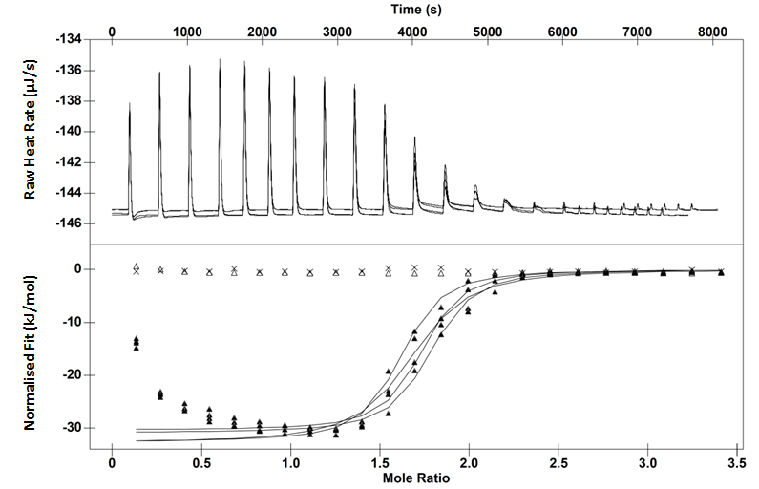
Normalised Fit (kJ/mol) Raw Heat Rate (µJ/s)
Mole Ratio

Figure 4.2: Upper: Thermogram for the interaction between 6 mM potassium phytate and 0.4 mM lysozyme in 10 mM ammonium acetate pH 4 at 10C Lower: ITC binding isotherm for the same interaction (closed triangles). Acetate titrated into lysozyme (Crosses). Phytate titrated into acetate (Open triangles). The solid line represents single site binding model fit.

Time (s)
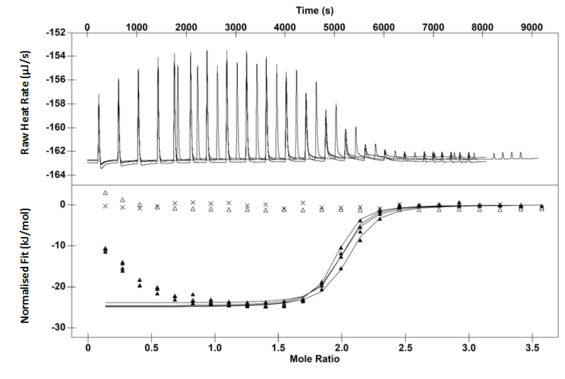
Mole Ratio
Normalised Fit (kJ/mol) Raw Heat Rate (µJ/s)

Figure 4.3: Upper: Thermogram for the interaction of 6 mM potassium phytate and 0.4 mM lysozyme in 10 mM ammonium acetate pH 4 at 25C. Lower: ITC binding isotherm for the same interaction (closed triangles). Acetate titrated into lysozyme (Crosses). Phytate titrated acetate (Open triangles). The solid line represents single site binding model fit.
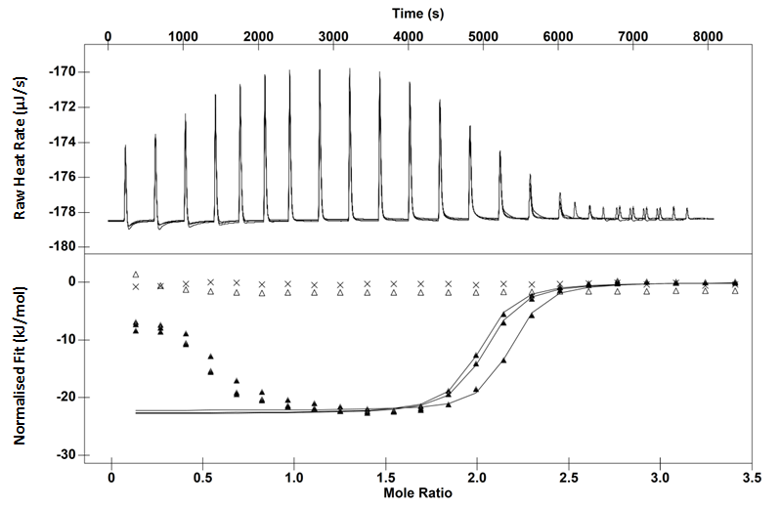
Time (s)
Normalised Fit (kJ/mol) Raw Heat Rate (µJ/s)
Mole Ratio

Figure 4.4 Upper: Thermogram: interaction of 6 mM potassium phytate and 0.4 mM lysozyme in 10 mM ammonium acetate pH 4 at 40C. Lower: ITC binding isotherm for the same interaction (closed triangles). Acetate titrated into 0.4 mM lysozyme (Crosses). Phytate titrated into acetate (Open triangles). The solid line represents single site binding model fit.
Titration of ammonium acetate buffer into lysozyme and potassium phytate into buffer showed a negligible ΔH. All 3 titrations showed evidence of two stages of interaction, the first stage shows increasingly exothermic ΔH with each injection producing an upward curvature below 1 phytate-lysozyme molar ratios. There is then a plateau in the exothermicity which finishes at ≈ 1.2 molar ratios at 10C but 25 and 40C ≈1.8 molar ratios. The second stage shows a less favourable exothermic ΔH with each injection. Increasing the temperature from 10 to 40 °C increased the size of the curve in the 1st stage and increased the endothermicity (Figure 4.5). Titration of sodium phytate into ammonium acetate buffer also showed a negligible ΔH. The binding isotherm shown here for the interaction between sodium phytate and lysozyme is similar to that obtained for the potassium phytate-lysozyme interaction at 25 °C (Figure 4.6). Performing the titration at 40 °C decreased the exothermicity of the binding interaction (Figure 4.7).

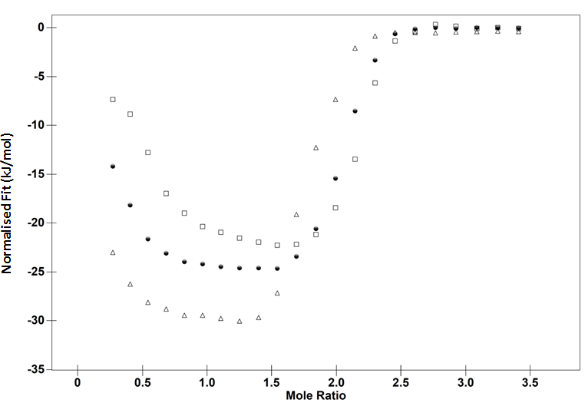
Figure 4.5: ITC binding isotherm for the interaction of 6 mM potassium phytate and 0.4 mM lysozyme in 10 mM ammonium acetate pH 4. 10C (open triangles), 25C (closed circles) 40C (open squares).

Time (s)
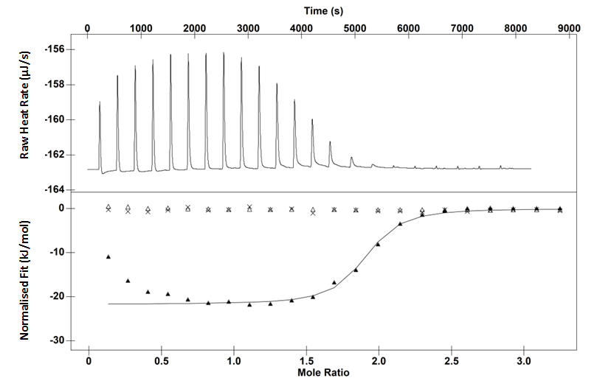
Normalised Fit (kJ/mol) Raw Heat Rate (µJ/s)
Mole Ratio

Figure 4.6: Upper: Thermogram for the interaction of 6 mM impure sodium phytate and 0.4 mM lysozyme in 10 mM ammonium acetate pH 4 at 25C. Lower: ITC binding isotherm for the same interaction (closed triangles). Acetate titrated into lysozyme (Crosses). Phytate titrated into acetate (Open triangles). The solid line represents single site binding model fit.

Time (s)
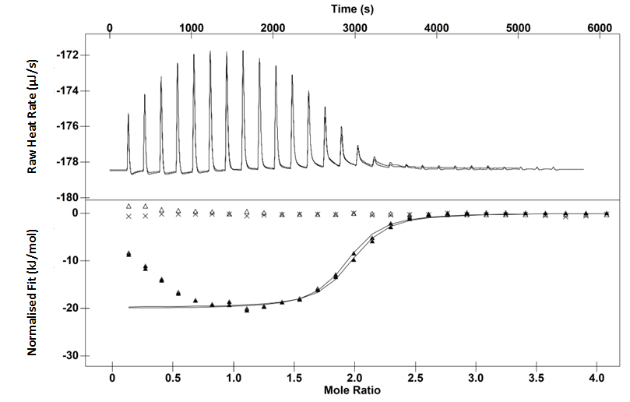
Mole Ratio
Normalised Fit (kJ/mol) Raw Heat Rate (µJ/s)

Figure 4.7: Upper: Thermogram 6 mM impure sodium phytate and 0.4 mM lysozyme in 10 mM ammonium acetate pH 4 at 40C Lower: ITC binding isotherm for the interaction (closed triangles). Acetate titrated into lysozyme (Crosses). Phytate titrated into acetate (Open triangles). The solid line represents single site binding model fit.

Table 4.1: Thermodynamic values derived from ITC binding isotherms for phytate-lysozyme interaction using the one site model at 10, 25 and 40 C. * Undialysed lysozyme and impure sodium phytate. The other values are derived from ITC binding isotherms belonging to the interaction between potassium phytate and dialysed lysozyme. The standard error (bold) and the confidence intervals (italics) are in brackets.
Temperature  (°C) | -ΔH  (kJ/mol) | -TΔS  (kJ/mol) | -ΔG  (kJ/mol) | Stoichiometry  n
10 | 31.7  (±0.6)  (±0.9) | 2.18  (±0.9) | 29.6  (±0.5)  (±2) | 1.65  (±0.03)  (±0.03)
25 | 25.4  (±0.5)  (±0.5) | -7.38  (±0.7) | 32.8  (±0.3)  (±2.8) | 1.9  (±0.03)  (±0.01)
25* | 22.5  (±0.8) | -9 | 31.4  (±3) | 1.9  (±0.02)
40 | 22.6  (±0.2)  (±0.5) | -12.3  (±0.4) | 34.8  (±0.1)  (±2) | 2  (±0.05)  (±0.02)
40* | -19.9  (±0.03)  (±0.5) | -12.3  (±0.06) | 32.4  (±0.2)  (±3) | 1.85  (±0.05)  (±0.02)

Table 4.1 shows that there is some difference in the thermodynamic parameters for the lysozyme interaction between the potassium phytate and the less pure sodium phytate. At 25 and 40 C, the interaction between sodium phytate and lysozyme and is weaker than the potassium phytate-lysozyme interaction for the second stage. The shape of the binding isotherm obtained at 40 °C for the sodium phytate-lysozyme interaction is shallower than the potassium phytate indicating that the free energy of binding is less favourable. This may be due to the difference in purity and the different counter ion in the preparations. The sodium phytate preparation has an excess amount of ions, in particular sodium. This is in comparison to potassium phytate preparation which is a 95% pure dipotassium phytate salt. In addition to this, the lysozyme was not dialysed when using the impure phytate preparation. Consequently, a lower level of purity seems to reduce the affinity lysozyme has for phytate. In the following work potassium phytate was used (unless otherwise stated) as the observations witnessed can be better attributed to phytate.
Inspection of the NMR structures of lysozyme show on average 13 solvent exposed positively charged amino acids (Figure 4.8).
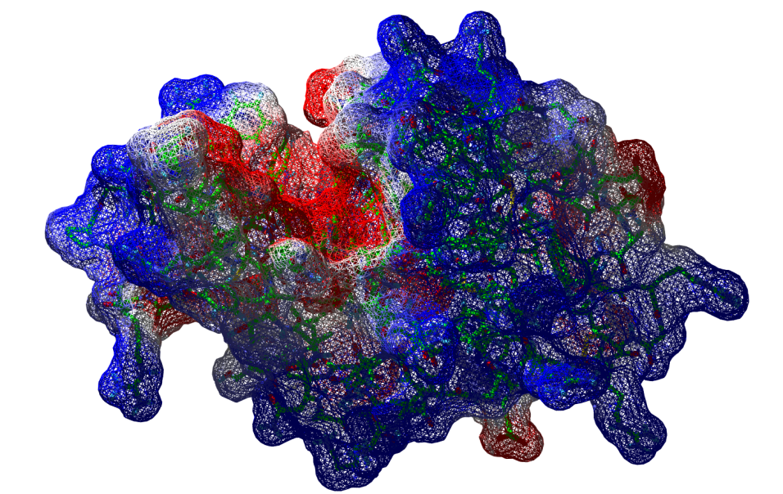
Figure 4.8: Mapped surface of the electrostatic potential of lysozyme adapted from Schwalbe et al. ²⁷¹
From the stoichiometry values, it seems that phytate does not bind to all of these residues. ²⁷¹ This indicates the possibility that phytate interacts with lysozyme specifically. Non-specific interactions generally give non-sigmodial such as the binding isotherm between polymers and surfactants.²¹⁷ Furthermore, the affinity is in the micromolar range which is surprising given that the general consensus that phytate binding to proteins is non-specific. Bound phytate could electrostatically repel other phytates from binding which could provide a degree of specificity. This is interesting given that current models of how proteins bind to substrates do not detail electrostatic repulsion. The lock and key theory assumes that both the protein and substrates have fixed conformations that provide specificity. The induced fit theory describes how specificity is due to substrate induced protein conformational changes. In this particular binding interaction, phytate binds to positively charged amino acids but the negatively charged phosphate groups prevent further phytate binding (Figure 4.9).

Figure 4.9: Lysozyme (red circle) with 13 positively charged residues (open triangles) that could all act as binding sites. Phytate (blue triangle) binds and produces a region of negative charge (blue dashes) making further phytate binding at that region less favourable. Increasing the concentration of bound phytate on lysozyme produces more localised areas of negative charge.
Previous studies have indicated that phytate-lysozyme binding is electrostatic in nature. Bye et al. increased the concentration of NaCl in the presence of lysozyme and phytate and measured the change in protein denaturation temperature (ΔT_{m}) calculated by Differential Scanning Calorimetry (DSC) between the two experiments. They reported that increased NaCl prevented the interaction between phytate and lysozyme restoring the protein denaturation temperature (T_{m}) of this protein until it matched the level without phytate.²⁴¹ The thermodynamic measurements presented here suggest that the interaction between potassium phytate and lysozyme is favoured enthalpically with a minor contribution from TΔS. Presumably, the source of the favourable ΔH is electrostatic interaction between phytate phosphate groups and positively charged amino acids. To test this theory the concentration of ammonium acetate was increased from 10 mM to 300 mM (Figure 4.10). The amount of heat detected was reduced significantly indicating that the interaction is purely electrostatic as high salt concentrations screen columbic interactions. Furthermore, this indicates that hydrogen bonding between the phosphate groups on the phytate and amino acids on the protein is unlikely.
Pig and poultry nutrition is negatively affected by phytate present in the feed.²⁴⁸ This has major economic ramifications for the farming industry and has led to the supplementation of phytase in the feed. However, results on the efficacy of phytase supplementation remain conflicting.²⁵⁸ For example, supplemental microbial phytase did not improve the utilisation of amino acids provided by a soybean meal for pigs.²⁷² Three hundred mM ammonium acetate was found to significantly reduce the interaction between phytate and lysozyme (Figure 4.10). When microbial phytase produces little or no change in amino acid absorption, an alternative could be increasing the ionic strength of the feed. However, if such a strategy was adopted the animals would have to have access to more fresh water.
Although the conditions in this ITC study are not physiological it is interesting to note that the interaction between phytate and lysozyme still occurs in 100 mM acetate at pH 4. The ionic strength of the buffer is 0.1 M which is approximately the same as the human stomach.²⁷³ In addition to this, the pH of stomach is approximately 4 after consumption of food. ²⁷⁴ The thermodynamic parameters for this interaction at different salt concentrations are in Table 4.2.
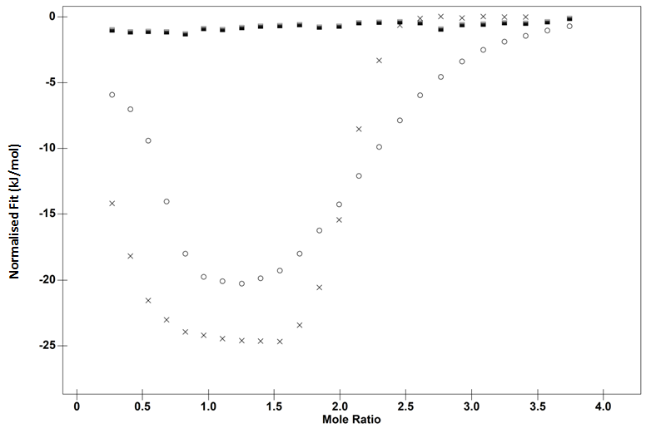
Mole Ratio
Normalised Fit (kJ/mol)
Figure 4.10: ITC binding isotherm for the interaction of 6 mM potassium phytate and 0.4 mM lysozyme in 10 (crosses), 100 (open circles) and 300 (closed squares) mM ammonium acetate pH 4.
The contribution from TΔS is much harder to discern. Kilmister et al. suggested that in ITC studies TΔS had a systematic error due to any endothermic interaction subtracting from exothermic heat changes detected by the ITC. ²¹⁵ Whilst Lambert has suggested that TΔS as a value for how ordered the system is wrong and it should be taken as a measure of energy dispersal.³ In aqueous systems it is particularly difficult to interpret TΔS. When phytate binds to lysozyme, there will presumably be some change in the degrees of freedom in comparison to the non-bound state where the binding partners exist separately. Additionally, upon binding, both water and buffer ions will be displaced. All of these will contribute either favorably or unfavorably to the TΔS value.

Table 4.2: Thermodynamic parameters for the interaction between lysozyme and phytate in 10 mM or 100 mM ammonium acetate buffer. The standard error (bold) and the confidence intervals (italics) are in brackets.
Materials | - ΔH  (kJ/mol) | - TΔS  (kJ/mol) | - ΔG  (kJ/mol) | Stoichiometry  n
10 mM ammonium acetate | 25.4  (±0.5)  (±0.5) | -7.38  (±0.7) | 32.8  (±0.3)  (±2.8) | 1.9  (±0.03)  (±0.01)
100 mM ammonium acetate | 22.4  (± 0.5)  (±0.8) | -4.67  (± 0.4) | 27.1  (± 0.1)  (±3) | 2.2  (± 0.007)  (±0.01)

Performing the titrations at different temperatures allows calculation of the heat capacity of binding (ΔC_{p}). ΔC_{p} provides thermodynamic information regarding the change in hydration of apolar and polar residues of the protein in addition to the ligand itself upon binding.^{88,214} In most ITC studies, a negative ΔC_{p} is measured which is an indication that water is being displaced from apolar groups.⁴⁵ Although rare, a positive ΔC_{p} has been measured for binding of mRNA 5’ cap analogue to the eukaryotic initiation factor eIF4E.²⁷⁵ Unfolding of helical peptides is found to have a negative ΔC_{p} which is in contrast to the positive value for protein unfolding.²⁷⁶ The authors suggested the negative ΔC_{p} was due to the exposure of the polar polypeptide backbone to the solvent. Consequently, a positive ΔC_{p} indicates desolvation from polar groups and solvation of hydrophobic groups. Given that phytate does not reduce the melting temperature of the protein to below 60C it is unlikely that hydrophobic groups are being solvated.²⁴¹ More likely, this is due to water being removed from polar amino acids and the phosphate groups on phytate upon binding. Gallagher and Sharp suggested that ion-ion interactions would have a positive ΔC_{p}.²⁷⁷ However, this is opposed by ions once interacting with the protein becoming more mobile meaning the ΔC_{p} for many electrostatic interactions is negative.²⁷⁷ It seems in this specific example, with the increasing temperature, the increasingly endothermic removal of water from polar groups overrides the exothermic heat change from the increased mobility of ions.
Although entropy is often readily interpreted, thermograms are typically ignored even though they provide a rich source of information regarding the binding process. Therefore, an interpretation of the salient features of the thermograms has been offered.
The first injection has been ignored and the preceding changes in the baseline as both are affected by diffusion which complicates analysis. The second injection is exothermic which is attributable to phytate binding to lysozyme; this is then followed by an endothermic concavity with a steady return to baseline. The endothermic concavity disappears by the 3rd injection at 10 °C, the 4th injection at 25 °C and the 5th injection at 40 °C. This was most pronounced at 40 °C (Figure 4.11). In accordance with the NTA data, the most likely cause of the slow endothermic change in the baseline is due to phytate-lysozyme crosslinking. The presence of overlapping exothermic and endothermic reactions would explain why the first stage of the binding isotherm has lower calculated exothermic values for the initial injections.
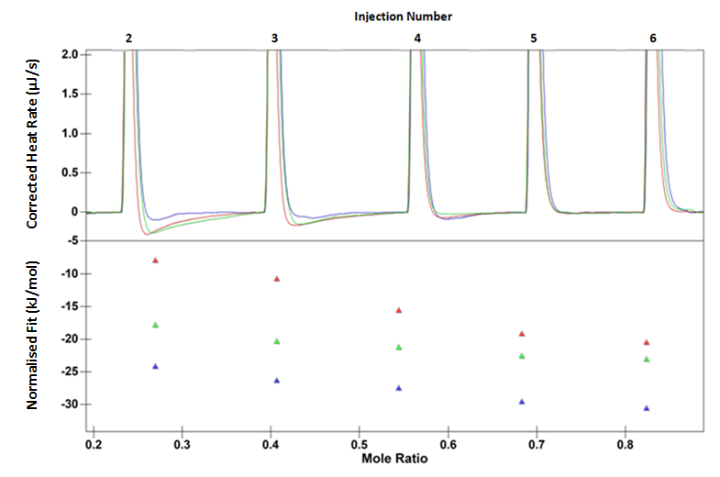
Injection Number
Normalised Fit (kJ/mol) Corrected Heat Rate (µJ/s)
Mole Ratio
Figure 4.11: Upper: Thermogram for the interaction of 6 mM phytate and 0.4 mM lysozyme in 10 mM ammonium acetate at 10 (blue), 25 (green) and 40°C (red). Lower: the binding isotherm for the respective thermogram.
At 10 °C, there is a slow exothermic return to baseline after a molar ratio of 1.4 (Figure 4.12). At the higher temperatures, this phenomenon is seen at 1.7 molar ratios. Normally this slow exothermic return to baseline is indicative of a slow dissociation process. Most likely, it is due to an extensive rearrangement of the phytate-lysozyme aggregate that becomes slower with decreasing temperature and it may be the reason why the stoichiometry of binding at 10 C does not correlate to a whole value. Subsequently, increasing the temperature seems to disrupt formation of these crosslinks as the stoichiometry increases. This is probably due the increased thermal motion within the larger phytate-lysozyme crosslinks breaking them apart. This could mean that phytate is less able to crosslink proteins to form larger networks within the stomach.
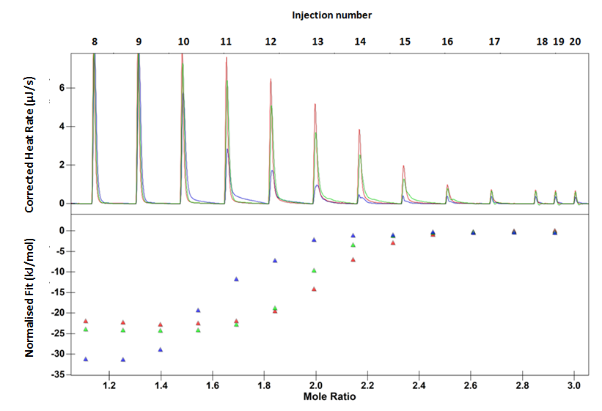
Normalised Fit (kJ/mol) Corrected Heat Rate (µJ/s)
Injection Number
Mole Ratio
Mole Ratio
Injection Number
Figure 4.12: Upper: Thermogram for the interaction of 6 mM phytate and 0.4 mM lysozyme in 10 mM ammonium acetate at 10 (blue), 25 (green) and 40 °C (red). Lower: the binding isotherm for the respective thermogram.
To determine if phytate-lysozyme crosslinks was the cause behind the upward curvature observed at low molar ratios and the slow dissociation kinetics Nanoparticle Tracking Analysis (NTA) was employed. NTA uses a laser beam to scatter light that can then be visualised by a mounted camera. Due to the low refractive index, only protein aggregates of 30 nm more can be detected. This means monomeric lysozyme cannot be visualised.
Figure 4.13 shows the images from the NTA analysis. NTA analysis using the Nanosight software (version 2.3) identified 2.35 particles per frame for the lysozyme solution. This is most likely dust or other particles in the solution that could not be successfully filtered using a 0.45 µM filter. No particles were visualised for the phytate solution. Increasing the phytate-lysozyme molar ratio to 0.132 greatly increases the number of particles, suggesting phytate-lysozyme crosslinking that could also be occurring in the ITC cell. Increasing the molar ratio to 0.297 also visibly increases the amount of particles. Increasing the molar ratio further would again give poor particle counting, as the larger particles have already began to hide smaller particles. Although there were some particles seen in the lysozyme solution in 10 mM ammonium acetate this does not hamper the analysis given the large amount of particles seen when phytate is added to solution. At a molar ratio of 0.132, there are more than 72.43 particles per frame, a substantially larger number than the lysozyme solution which acted as a control.
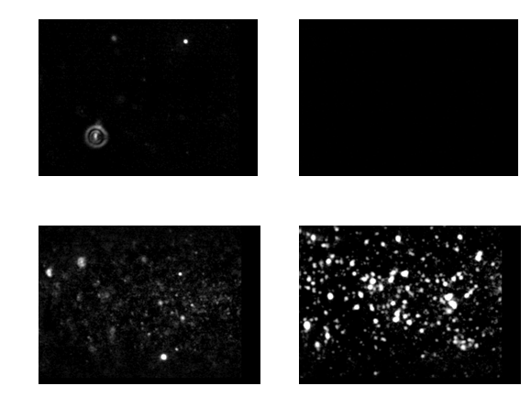
Figure 4.13: Video stills from the NTA analysis. Top left: 400 µM lysozyme in 10 mM ammonium acetate buffer pH 4. Top right: 6 mM phytate in 10 mM ammonium acetate buffer pH 4. Bottom left: 6 mM phytate with 400 µM at a molar ratio of 0.132 in 10 mM ammonium acetate. Bottom right: 6 mM phytate with 400 µM at a molar ratio of 0.297 in 10 mM ammonium acetate.
A similar binding isotherm was observed for the interaction of potassium phytate with lysozyme in 100 mM ammonium acetate in comparison to 10 mM acetate (Figure 4.10). To determine if extensive crosslinking was the cause behind the downward curvature at low molar ratios for this particular binding isotherm, NTA was utilised again. Two solutions of 6 mM phytate and 400 µM lysozyme were looked under the microscope separately. It seems that there were no visible particles. To determine if phytate-lysozyme crosslinking was the cause behind the downward curvature witnessed in this study, the same first two molar ratios used in the ITC study were used the NTA experiment. It seems that at a molar ratio of 0.132, lysozyme-phytate crosslinking occurs. Increasing the molar ratio to 0.297 visibly increases the amount of particles (Figure 4.14).
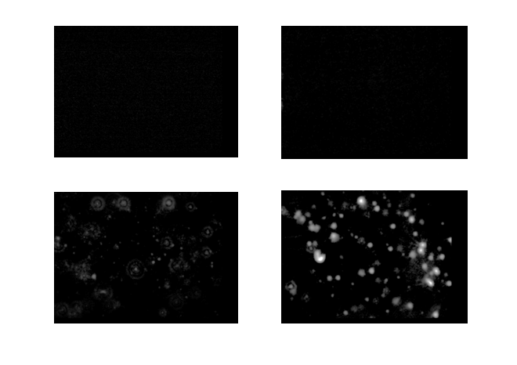
Figure 4.14: Video stills from the NTA analysis. Top left: 400 µM lysozyme in 100 mM ammonium acetate buffer pH 4. Top right: 6 mM phytate in 100 mM ammonium acetate buffer pH 4. Bottom left: 6 mM phytate with 400 µM at a molar ratio of 0.132 in 100 mM ammonium acetate. Bottom right: 6 mM phytate with 400 µM at a molar ratio of 0.297 in 100 mM ammonium acetate.
UV spectrophotometry was employed as a method to look at further crosslinking at higher lysozyme-phytate molar ratios. UV measurements conducted with 6 mM phyate and 0.4 mM lysozyme in 100 mM ammonium acetate at 600 nm showed increasing levels of light scattering which is indicative of particle formation above a molar ratio of 0.6832 (Figure 4.15). Before this molar ratio was reached the absorbance did not alter much from the control (a phytate solution made to the corresponding molar ratio in 100 mM ammonium acetate).

Figure 4.15: UV measurements at 600 nm of 6 mM phytate into 0.4 mM lysozyme in 100 mM ammonium acetate pH 4 (blue diamonds). (Open red squares) 100 mM ammonium acetate with phytate.
The favourable change in ΔG with temperature could due to the change in crosslink formation. Phytate has a negative charge of -6 at pH 4. ²⁴⁵ The phytate networks would not just sterically hinder access of other phytates to lysozyme they would also produce a shield of negative charge around the protein reducing affinity. Increasing the temperature breaks down the negatively charged networks, into smaller aggregates, which could act to increase affinity. Another possible explanation could be conformational changes that would expose more positively charged regions on lysozyme. This could explain both the increase in affinity and the change in stoichiometry.
To understand the stoichiometry, the sequence of binding events and the charge of molecules needs to be considered. Lysozyme has a positive charge at pH 4 of +12 ¹⁸ and phytate has a negative charge of -6.⁵ Binding of the first phytate would result in a decrease in the net positive charge on the lysozyme from +11 to +6. In the next binding event, the net positive charge on the protein diminishes from +5 to 0. It is possible that the lack of positive charge on the lysozyme then allows lysozyme to aggregate as there is no longer sufficient charge repulsion to keep them apart.
The stoichiometry value at 10C suggests that lysozyme binds one and half phytate molecules. The half a binding stoichiometry is probably due to phytate-lysozyme crosslinking, rather than a single lysozyme binding half a phytate. Consequently, this could mean that a single phytate binds to two lysozyme molecules. Interpreting the stoichiometry values in this manner means that at 10C, saturation occurs when 3 lysozyme molecules are bound by a 2 bridging phytates. Increasing the temperature to 25 and 40C increases the stoichiometry value to 2. This indicates that 4 lysozyme molecules are crosslinked by 2 phytates.
The binding isotherm is biphasic and can be separated into two curves. The first curve does not correspond to whole binding stoichiometry. Decreasing the amount of sodium phytate to 3 and 1 mM did allow for better resolution of the binding curve (Figure 4.16). Additionally, there were no initial binding enthalpies of similar strength that is normally seen in binding isotherms. Simulating the binding interaction with two distinct binding sites did not produce the curves witnessed in the ITC study if whole binding stoichiometries were used. This suggests the initial curve is due to a crosslinking event rather than cooperativity.
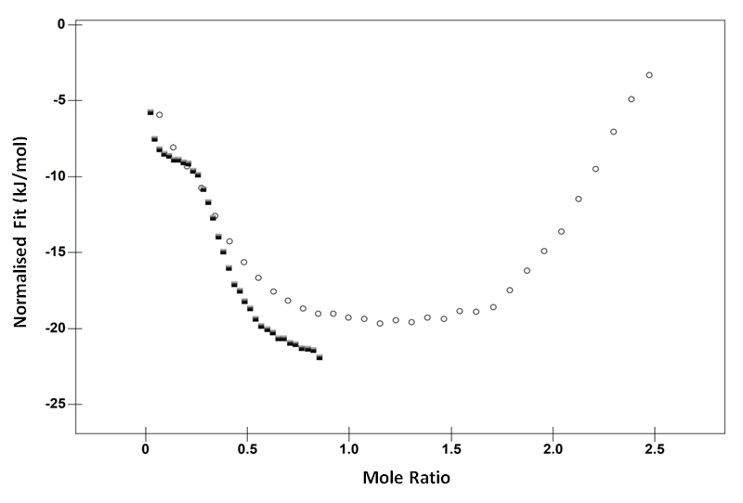
Figure 4.16: ITC binding isotherm for the interaction of 3 (open circles) and 1 (closed squares) mM sodium phytate and 0.4 mM lysozyme in 10 mM ammonium acetate pH 4.
There are papers that suggest the favourable increase in ΔH with the first couple of injections is indicative of positive cooperativity, that already bound ligand has a favourable effect on the next binding interaction.¹⁴⁴⁻¹⁴⁶ However, the binding isotherm presented here is in a sense misleading. Simulating the curve using the one site binding model (Figure 4.3) shows that a lack of positive cooperativity would actually be a more favourable (more exothermic) interaction than the positive cooperativity occurring (upward curvature at low molar ratios) if ΔH itself is taken as an indication. A better way of describing this behaviour would be that the first initial injections become less endothermic in comparison to the rest of the binding isotherm as the language utilised in previous papers lends itself to a notion of positive cooperativity without any other evidence. It should be noted that a favourable increase in ΔH does not necessarily mean a favourable increase in ΔG as there could be an opposing TΔS. It has been suggested that with biphasic isotherms displaying positive cooperativity, the first curve should have lower affinity than the second curve due to affinity increasing with increasing concentration of ligand. ^{149,150}
Calculating ΔG for the 1st curve for all three sets of titrations produces erroneous values. This is due to the lack of similar heats at low molar ratios meaning the model has to effectively predict the lower (more favourable) limit of the enthalpy value. Comparison of the ΔG calculated by both the independent two site and one site model for the 2nd curve suggest that the interaction becomes stronger with increasing temperature (Table 4.3). Trying to model the binding isotherm as cooperative binding produced ΔH of -823 kJ/mol for the first site and 2000 kJ/mol for the second. These values are far too high for the binding interactions and are similar in magnitude but not in sign to protein denaturation ΔH.
Table 4.3: Thermodynamic values derived from ITC binding isotherms for phytate-lysozyme interaction at 25C using the two-site model. The standard error (bold) and the confidence intervals (italics) are in brackets.
-ΔH₁  (kJ/mol) | -TΔS₁  (kJ/mol) | -ΔG₁  (kJ/mol) | Stoichiometry  n₁ | -ΔH₂  (kJ/mol) | -TΔS₂  (kJ/mol) | -ΔG₂  (kJ/mol) | Stoichiometry  n₂
30  (±12)  (±31) | 49.2  (±17) | 27.7  (±3)  (±8) | 0.2  (±0.06)  (±0.1) | -26.6  (±0.5)  (±1) | -5.2  (±0.8) | 31.7  (±0.4)  (±1) | 1.8  (±0.04)  (±0.1)

Another argument against biphasic isotherms of this type always being indicative of allosteric cooperativity is one from the original authors of the MWC model. ¹²⁹ They suggested that allostery was used to regulate metabolism. Those proteins that are allosteric are to be considered a specialised product of selective engineering. ¹²⁹ To our knowledge lysozyme has not undergone any selective pressure to bind phytate allosterically. Phytate is used as a phosphate storage in plants in addition to acting as a signalling molecule to close guard cells surrounding the stoma.²⁷⁸ Although it can bind to proteases involved in digestion and exogenous protein sources causing malnutrition, there is no evidence that phytate evolved as a method as a plant defence mechanism to deter herbivores. Allosteric cooperativity should therefore be treated as a rare and specialised binding event, and not a mechanism that can be regularly used to explain unusual binding isotherms in ITC data.
Based on the above arguments it is suggested that phytate binding is multisite and occurs independently or at least not positively cooperative. It is also unlikely that this is a form of cooperativity that does not result in a change in ΔG but a change in ΔH – so called isoenergetic cooperativity.¹³⁹ As this form of cooperativity has no discernible reason to exist.
Some papers have suggested that networking (otherwise known as crosslinking or a similarly labelled phenomena) assists in further binding interactions.²⁷⁹ This has been labelled cooperative binding. This is sometimes conflated with allosteric cooperativity but they are not the same.¹³⁸ In many cases, networking or crosslinking describes an interaction that involves the ligand binding to multiple macromolecules. ²⁸⁰ Presumably, crosslinking lysozyme molecules via a bridiging phytate would induce less favourable binding due to the decrease of net positive charge on the two lysozyme molecules. Therefore, although crosslinking or aggregation may be responsible for the biphasic binding isotherm it does not necessarily mean it induces or is a signature of positive cooperativity.
The Derjaguin–Landau–Verwey–Overbeek (DLVO) theory of the stability of lyophobic colloids was put forward to describe the behaviour of colloidal suspensions in aqueous electrolyte solutions.²⁸¹ The theory suggests that the stability of colloidal suspensions is due to a balance of electrostatic repulsion and van der Waals attraction. For particles to aggregate, the repulsive electrostatic repulsion must be overcome and for this to occur, in some cases, the opposing charges must be neutralised. Van der Waals attraction is the consequence of forces between particles. The attractive force drives the formation of larger aggregates. Due to the intricacy of protein structure and the complex interplay of interactions governing protein-ligand formation, DVLO theory perhaps cannot describe the phytate-lysozyme interaction quantitatively. However, it does explain it to some extent qualitatively. Lysozyme has an overall positive charge that acts to repel other lysozyme molecules in solution. Phytate neutralises the positive charge on lysozyme upon binding. This allows aggregation of phytate-lysozyme complexes due to a lack of charge repulsion and favourable van der Waals forces between the complexes.
Although this study suggests that, the biphasic nature of these binding isotherms is due to an aggregation or crosslinking event, in some ITC binding isotherms the biphasicity does not appear. Dam et al. studied carbohydrates binding to lectins that are known to form soluble networks, but the titrations were not biphasic. ^{280,282} Tannins are known protein precipitating agents and their action is thought to be due to crosslinking macromolecules in solution. However, titration of tannins into macromolecule solutions does not always induce the upward curvature at low molar ratios even though some level of crosslinking would be occurring in the cell. ²²⁰ It could be suggested that the biphasic nature is due to crosslinking differing protein sites via a ligand or perhaps to an extensive crosslinking process. It is important to point out that crosslinking is not synonymous with positive cooperativity. If crosslinking were a mechanism for positive cooperativity it makes little sense as presumably less soluble lysozyme would be less able to bind phytate.
Cooper suggested that changing the concentration of the macromolecule would alter the enthalpy significantly if aggregation was present.²¹³ Changing the protein concentration from 0.4 mM lysozyme to 0.184 mM lysozyme in 10 mM ammonium acetate did not significantly alter the enthalpy (Figure 4.17). The change in ΔH between the two titrations was calculated to be 0.3 kJ/mol. However, at the end of both titrations precipitation was clearly visible. Presumably, this is a crosslinking induced precipitation reaction rather than a normal binding interaction.
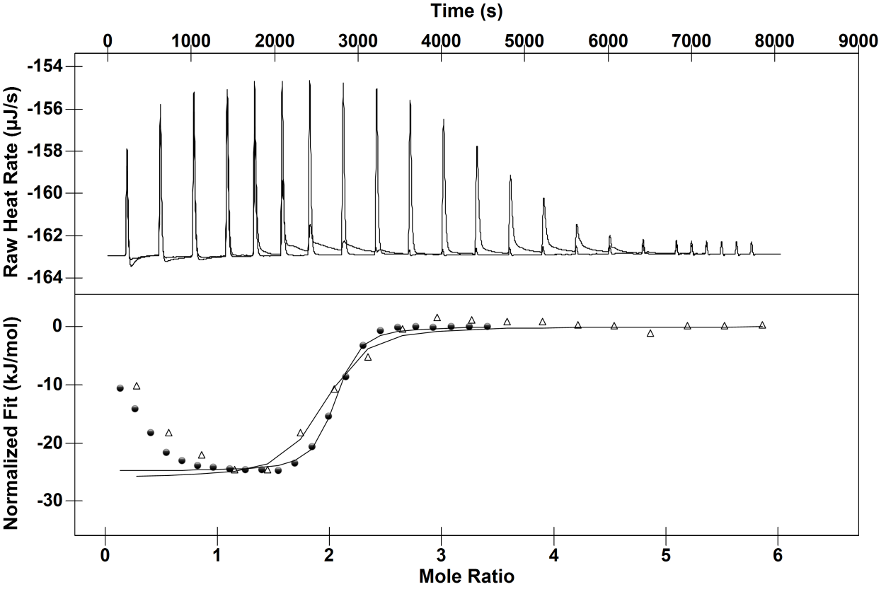
Normalised Fit (kJ/mol) Raw Heat Rate (µJ/s)
Figure 4.17: Upper: Thermograms for the interactions of 6 mM phytate and 0.4 and 0.184 mM lysozyme in 10 mM ammonium acetate pH 4 at 25 °C. ITC binding isotherm for the interaction of 6 mM phytate and 0.4 (open triangles) and 0.184 (closed diamonds) mM lysozyme in 10 mM ammonium acetate pH 4 at 25 °C. Solid line represents single site independent binding model fit.

Conclusion
In conclusion, the ITC study reveals that the phytate-lysozyme interaction is enthalpically driven and the source of this favourable ΔH is most likely electrostatic interaction. The change in stoichiometry suggests a crosslinking process that becomes less favourable with increasing temperature. Additionally, increasing the temperature increases the affinity phytate has for lysozyme. Finally, it is suggested that the apparent initial increase in ΔH for the first few injections should not be taken as allosteric positive cooperativity without thorough inspection, as has been done previously with ITC data, as the biphasic isotherm can be explained by a crosslinking phenomena. In cases where allostery is suspected there should be structural (protein conformational changes), thermodynamic (changing protein affinity for the ligand with increasing concentration of the ligand) and biological (arguments based in terms of evolution) evidence.

Chapter 5: A Continuous Isothermal Titration Calorimetry (cITC) Study of the Interaction between Phytate and Lysozyme

Summary
Continuous Isothermal Titration Calorimetry (cITC) is a method where the ligand solution is continuously titrated over one time interval. This offers the opportunity of thousands of data points meaning the thermodynamics of complex binding modes could be calculated. Continuously titrating a solution of 6 mM phytate into 0.4 mM lysozyme in the presence of 10 mM ammonium acetate produced binding isotherms that had similar shapes in comparison to the ITC studies using incremental injections (iITC). This suggested that the binding stoichiometry at two molar ratios does involve binding to multiple sites. There was a discrepancy at 10 °C between the iITC and cITC binding isotherms. It was suggested that this was due to the crosslinking phenomena becoming more extensive with decreasing temperature.

Introduction
Isothermal Titration Calorimetry is a technique that provides enthalpy (ΔH), entropy (TΔS) and Gibbs free energy values (ΔG), stoichiometry (n) by measuring the heat between two interacting partners in solution. This technique has been successfully used to measure the binding thermodynamics between many different types of interactions, including proteins and small molecules, salts and supramolecular macromolecules, micelle formation and DNA-small molecule interactions.^{7,223,283-285}
Traditionally, ITC experiments are performed using the method of incremental titration. This is where an exact volume of titrant is titrated into the solution in the sample cell at regular time periods. There are caveats to this approach. For 1:1 binding interactions with normal ligand-macromolecule dissociative steps, an ITC experiment can take at least an hour. More complex interactions require more time and material to discern the binding mode and validate thermodynamic values. Even if more data points are produced for analysis, it may still be difficult to differentiate between different binding modes such as ligands binding cooperatively and independent multisite interactions.
Continuous titration (cITC) is a method where the ligand solution is continuously titrated over one time interval. This provides many more data points and therefore should ideal to identify correct binding modes and thermodynamic values for complex multisite interactions. The iITC studies using the TA instruments NanoITC can only effectively utilise a maximum of 83 injections meaning there is poor or no resolution of differing binding sites on an isotherm. Consequently, producing thermodynamic parameters from complex binding isotherms is often inaccurate. However, despite ciTC theoretically being able to yield clear binding isotherms for multiple interactions, the technique remains underused despite a vast number of papers investigating these types of binding.^{146,265,266,286,287}
Another advantage of cITC is that the time taken for an experiment is half the time required to carry out an iITC experiment.²⁸⁸ Presumably, the system is better able to obtain equilibrium if the ligand is injected continuously rather than incrementally. The caveat to this is that an iITC experiment has to be carried out first to make sure that the experiment is baseline resolved, that after each injection the baseline returns to normal (Figure 5.1). Failure to do so may yield inaccurate results from cITC data as the reaction does not reach equilibrium. Furthermore, this can mean the contents of the cell are not being properly mixed during the course of the titration. This also leads to inaccurate resolution of thermodynamic parameters.
One of the drawbacks of ITC is that it can only be used to measure binding constants within millimolar to nanomolar affinity.²⁸⁹ In practise, the range is approximately three orders of magnitude from a given concentration of the host within the sample cell.²⁸⁸ One of the reasons is the relationship between the macromolecule concentration alongside the stoichiometry (n) and the dissociation constant (K_{D}) which is described by the unitless parameter C known as the c-value (Equation 5.1). ¹⁵⁸
$$C= \left(\left[\frac{M_{TOT}}{K_{D}}\right]×n\right)$$ | (5.1)
C-values are useful in determining the accuracy of thermodynamic parameters generated by ITC (Figure 5.2). Normally c-values within 10 to 100 are highly accurate whilst 100 to 500 are satisfactory.²⁹⁰ Anything above 500 is not useful for more analytical ITC work (such as ranking interactions with enthalpy values that change less than 1 to 2 kJ/mol). Consequently, the macromolecule concentration effectively limits the accuracy. Curves that are too steep are the result of high c-values meaning that K_{D} cannot be accurately determined but the enthalpy and stoichiometry can. Conversely, lower c-values produce curves that are too shallow meaning again that K_{D} cannot be determined nor the enthalpy or the stoichiometry.

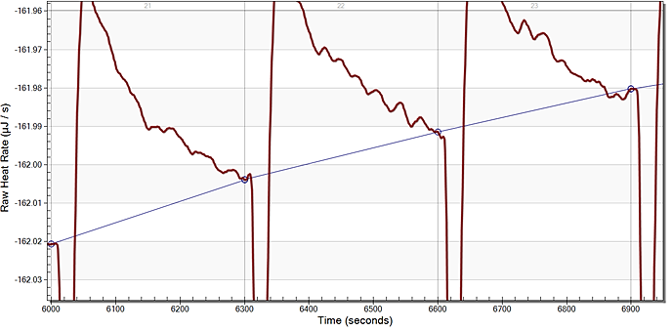
Raw Heat Rate (µJ/s)

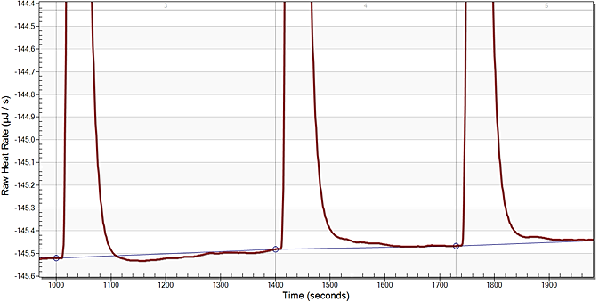
Raw Heat Rate (µJ/s)

Figure 5.1: Upper section: Thermogram baseline not returning to normal. Lower section: Thermogram baseline returning to normal.

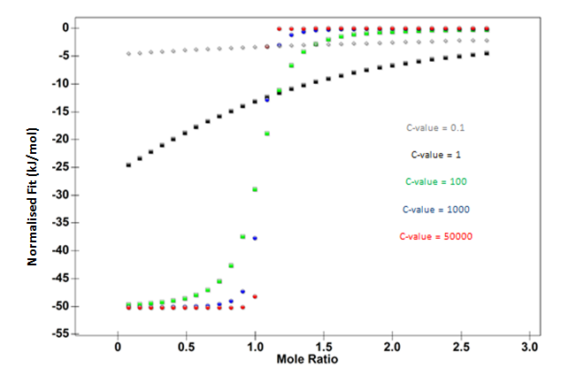
Figure 5.2: Binding isotherms at varying c-values.
Markova and Hallén suggest that cITC in theory should be able to measure much larger association constants at the picomolar range.²⁸⁸ They advocate that the shape of the binding isotherm and the number of data points should be able to determine binding constants with good statistical precision.
Phytic acid is a myo-inositol with six orthophosphate groups linked to it by phosphoester bonds. The conjugate base form the phytic acid is phytate, a molecule known to bind to a number of proteins.^{241,291,292} The molecule is known to present a nutritional problem for humans. In China, it has been implicated in the malnutrition of rural Chinese by chelating mineral ions.²⁵¹ Potentiometric titrations have revealed cations bind to phytate providing a possible mechanistic rationale regarding impaired bioavailability of mineral ions in the presence of phytate.²⁴²
This problem is not just limited to human population but presents a problem for the agricultural industry, specifically pig and poultry nutrition. Phytase is an enzyme that can break down phytate into an inositol ring and free phosphates. Phytase addition to a maize-soybean meal based diet increased the apparent ileal digestibility for pigs.²⁹³ In vitro studies have suggested that phytate inhibition of digestive enzymes in protein metabolism could be responsible for protein malnutrition.²⁹² However, the evidence for this seems weak. In vitro activity of the proteolytic enzyme trypsin using casein as the substrate was increased by low levels of phytic acid if molar ratios of less than 26 were used.²⁹⁴ In addition, chymotrypsin activity was also increased in the presence of phytate at molar ratios below 11. In light of this evidence, it has been suggested that phytate could increase mucin digestion by irritating the lining of the gut.²⁴⁸ An increase in mucin secretion will directly cause an increase in amino acid flow because mucin is composed of amino acids.²⁶⁰
In this study, we have used lysozyme to mimic the interaction of phytate with positively charged proteins such as trypsin, an enzyme found in the ileum that break downs protein.²⁹⁵ Previous ITC work has demonstrated that lysozyme has two sites that phytate can bind to. However, the binding isotherm did not show that the sites where thermodynamically distinguishable. This makes it an excellent candidate for cITC.

Materials and Methods

Chemicals and Materials
Hen egg white lysozyme, sodium phytate (≈80% purity), potassium phytate (≥95% purity), acetic acid (99.8%) ammonium acetate were all sourced from Sigma-Aldrich, Gillingham, U.K. Milli-Q water from a Merk-MILLIPORE (Darmstadt, Germany) fountain was used to prepare the reagents. A FiveEasy pH meter (Mettler-Toledo International, Ohio, US) was used to measure the pH of the solutions.

Isothermal Titration Microcalorimetry
A Nano-ITC instrument (TA instruments, Texas, USA) was used to measure the binding thermodynamics between phytate and lysozyme at 10, 25 and 40 °C. Phytate and lysozyme were dissolved in 10 mM ammonium acetate buffer at pH 4, unless otherwise stated. Lysozyme was dialysed overnight in 10 mM ammonium acetate buffer pH 4, unless otherwise stated. All solutions were degassed prior to the titrations. Six mM phytate was loaded into the syringe and titrated into the sample cell, which contained 400 µM lysozyme. For the iITC, at least 24$×$1.5 µL 6 mM phytate injections into 400 µM lysozyme were made over the course of the titration. In each titration, the reference cell contained water. The time delay between each injection was variable to ensure equilibration and the RPM was set to 200 to ensure thorough mixing of the cell.
For the cITC experiments at 25 and 40C using sodium phytate and undialysed lysozyme, 39.94 µL was injected over a period of 2560 seconds. This time was chosen as it was half the time required for the incremental titration to reach completion. To determine how the presence of salt affects the cITC binding isotherm, 100 mM ammonium acetate was used in the buffer at 25 °C. For the cITC experiments at 10, 25 and 40C using potassium phytate and dialysed lysozyme, 39.94 µL was injected over a period of 4474 seconds. This time is longer than half the time of the incremental titrations, but was chosen to make sure the reaction reached equilibrium. The data was analysed using the NanoAnalyse software. Both the standard mean error and the confidence intervals are provided. Nano ITC users tend to use confidence intervals as the NanoAnalyse software readily provides this. A confidence interval provides a range that contains the population parameter of interest.

Results and Discussion
Previous iITC work has suggested that phytate binds to lysozyme at a minimum of two different binding sites. However, the technique is unable to determine the differing thermodynamics. This could possibly be due to the small number of injections used in iITC studies. CITC uses thousands of small injections and so is thought to be more able to determine the thermodynamics of complex multisite binding interactions. However, this has yet to be verified as currently cITC has only been used to determine the thermodynamics of 1:1 binding interactions. CITC could provide a valuable technique to determine the thermodynamic parameters of multiple binding interactions with similar binding thermodynamics that are unable to be identified using incremental injections. To this end, cITC was employed to determine the binding thermodynamics between phytate and lysozyme.
Firstly, ammonium acetate was titrated into a solution of ammonium acetate to determine if there were any issues regarding the syringe mechanism. The amount of heat produced was negligible and corresponds to heats of injections (Figure 5.3).
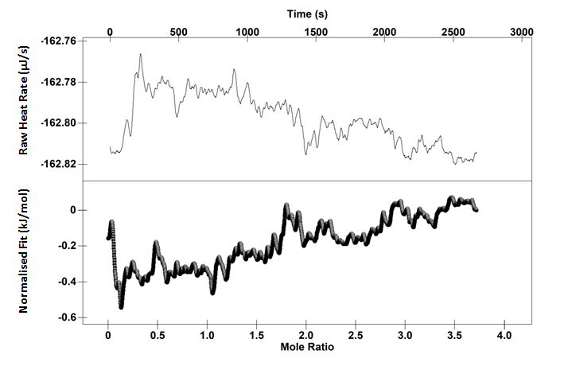
Time (s)
Mole Ratio
Normalised Fit (kJ/mol) Raw Heat Rate (µJ/s)
Figure 5.3: Upper: Thermogram for injection continuous injection of ammonium acetate into a cell of ammonium acetate. Lower: Heat normalised per mole of injectant
Figure 5.4 shows the binding isotherm of phytate and lysozyme using cITC injecting 39.94 µl over a period of 2560 seconds at 40C. The heats of phytate and lysozyme dilution also shown are negligible in comparison to the heats of the binding between phytate and lysozyme. At ≈ 2 molar ratios, there is a small rise in exothermicity estimated to be about 2 kJ/mol, which is still negligible in comparison to the heats of the binding isotherm. Since it occurs for both controls, it is possibly due to small bubbles. Continuously titrating phytate into lysozyme exhibited an exothermic profile similar to the incremental injection (Figure 5.5). The increasing enthalpy from the baseline to 10 kJ/mol at around 0.1 molar ratios for the binding interaction possibly represents something similar to the “diffusion effect” seen at the start of incremental injections.²⁸⁸ This is where the titrate and the titrant are not properly mixed and so the heat represents an aggregate of both diffusion and binding. The first injection seen in the iITC study is due to diffusion effects.
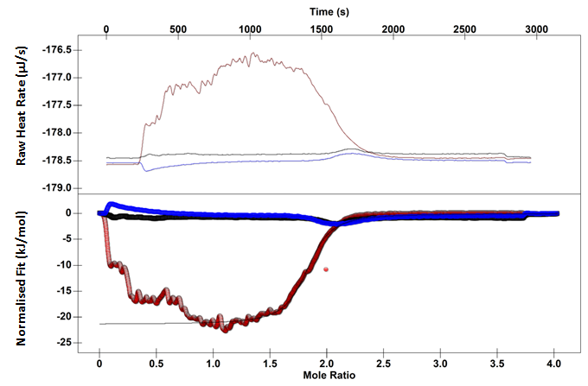
Mole Ratio
Time (s)
Normalised Fit (kJ/mol) Raw Heat Rate (µJ/s)

Figure 5.4: Upper: Thermogram of 6 mM sodium phytate injected into 0.4 mM lysozyme in 10 mM ammonium acetate at 40 °C (red), phytate dilution into ammonium acetate (blue) and ammonium acetate dilution into lysozyme (black).Lower: Binding isotherm for the corresponding interaction, lysozyme interaction (red), phytate dilution into ammonium acetate (blue) and ammonium acetate dilution into lysozyme (black). Solid line represents single site independent binding model fit.
Time (s)
Normalised Fit (kJ/mol) Raw Heat Rate (µJ/s)
Mole Ratio
Figure 5.5: Upper: Thermogram of 6 mM sodium phytate injected into 0.4 mM lysozyme in 10 mM ammonium acetate Lower: Binding isotherm for the corresponding interaction (closed triangles), phytate dilution into ammonium acetate (open triangles) and ammonium acetate dilution into lysozyme (crosses). Solid line represents single site independent binding model fit.
The cITC binding isotherm shows some noise which is probably due to the crosslinking reaction occurring throughout the titration. At 1.5 molar ratios, there is a decline in exothermicity, which is due to extensive crosslinking. Figure 5.5 is the corresponding iITC study.
Table 5.1: Thermodynamic parameters calculated using the one site binding model for the interaction with 6 mM sodium phytate and 0.4 mM lysozyme at pH 4 in 10 mM ammonium acetate at 40 °C using either cITC or iITC. The standard error (bold) and the confidence intervals (italics) are in brackets.
ITC technique | - ΔH  (kJ/mol) | - TΔS  (kJ/mol) | - ΔG  (kJ/mol) | Stoichiometry  n
cITC | 21.5  (±0.05)  (±0.06) | -11  (±1) | 32.5  (±0.05)  (±9) | 1.89  (±0.05)  (±0.002)
iITC | -19.9  (±0.03)  (±0.5) | -12.3  (±0.06) | 32.4  (±0.2)  (±3) | 1.85  (±0.05)  (±0.02)

Table 5.1 shows the thermodynamic parameters calculated using the one site binding model using both cITC and iITC. Both techniques produced thermodynamic data that showed the interaction was exothermic with a favourable contribution of TΔS yielding a strong ΔG. The stoichiometry suggested the binding was 2 for both techniques used. However, the values do deviate. This could possibly be due to the technical limitations of using cITC to measure the thermodynamics of a multisite binding interaction accompanied by a precipitation reaction. Markova and Hallèn state that accurate thermodynamic analysis of cITC data is only correct when the titration is performed at quasi-equilibrium. For this to occur certain prerequisites have to be met. Firstly, the temperature has to be homogenous over the entire sample. It could be argued, however unlikely, that this is not possible due to the formation of particles. Secondly, it has been argued that this method is not suitable for investigating interactions with slow binding kinetics.²⁸⁸ Figure 5.5 shows the thermogram for the interaction between phytate and lysozyme at 40C. The upward drift in the baseline after approximately 2000 seconds is most likely due to slow dissociation kinetics, that the phytate-lysozyme interaction has a slow k_{off} rate. This could account for the discrepancy in the thermodynamic data for the two techniques. Another issue could be due to the purity of both the lysozyme and sodium phytate preparation. The lysozyme was not dialysed in this study and perhaps more importantly, the sodium phytate has a purity of around 80%. Food chemists routinely use ITC to investigate the binding thermodynamics of mixed preparations and proteins. For example, binding thermodynamics between tannins of differing molecular weights and proteins have been resolved using ITC.²²⁰ This approach yields thermodynamic data that can be better interpreted in actuality. Sodium phytate better resembles the form found in rice. Therefore using this preparation is the first step in producing assays that could be utilised for determining the antinutritional effects of this molecule.
Although both techniques gave somewhat comparable thermodynamic data, the initial aim was to discern the thermodynamics between the differing sites. However, the binding isotherm does not show two different sites at 2 molar ratios. This could be due to two different reasons. CITC, despite using hundreds of injections, is unable to discriminate between binding sites. Alternatively, the binding sites for phytate are so similar in terms of their energetics there is not a comparable difference. The second scenario is likely given the chemistry of suggested binding sites on lysozyme for phytate. Both binding sites would likely be composed of positively charged regions on lysozyme. Previously it has been shown that increasing the ionic strength of the buffer to 0.3 M stopped the interaction between phytate and lysozyme suggesting the binding is purely electrostatic at both binding sites. Given that most likely the interaction is between positively charged regions on lysozyme and negatively charged phosphates on phytate it is also likely that the binding energetics are similar.
To determine how salt could affect the shape of the binding isotherm, a cITC study was performed in the presence of 100 mM ammonium acetate (Figure 5.6). The shapes of the two repeats look remarkably similar. However, there seems to be a change in the noise between the two cITC repeats. It is also different from the shape of the cITC binding isotherm performed at 25 °C (Figure 5.7). The enthalpy of binding has also been dramatically reduced due to the increased ionic strength of the solution reducing the strength of the binding interaction. To determine the thermodynamic parameters both the one site model and the two site model were utilised for both titrations in 10 and 100 mM ammonium acetate at 25 °C. For the titration in 100 mM acetate, the two site model was fitted first but produced unrealistic thermodynamic values, such as a ΔH value for the second site of 74 kJ/mol, which is clearly inaccurate from the shape of the binding isotherm. This was despite the standard deviation around the fit being low at 0.996. Moreover, χ² ((2756) = 0.009, p <0.5.) meaning the fit was good. Fitting a one site model by removing the data points below 1.3 molar ratios provided the thermodynamic values in Table 5.2.

Table 5.2: Thermodynamic parameters calculated using the one site binding model for the interaction with 6 mM sodium phytate and 0.4 mM lysozyme at pH 4 in 100 mM ammonium acetate at 25 °C using cITC. The standard error (bold) and the confidence intervals (italics) are in brackets.
- ΔH  (kJ/mol) | - TΔS  (kJ/mol) | - ΔG  (kJ/mol) | Stoichiometry  n₂
18.6  (±1)  (±0.4) | -6.8  (±1) | 25.1  (±0.3)  (±5) | 2.4  (±0)  (±0.03)
Time (s)
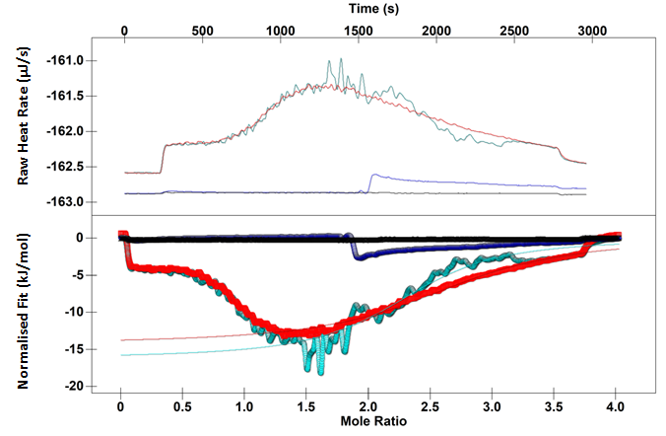
Mole Ratio
Normalised Fit (kJ/mol) Raw Heat Rate (µJ/s)
Figure 5.6: Upper: Thermogram of 6 mM sodium phytate injected into 0.4 mM lysozyme in 100 mM ammonium acetate. Sodium phytate-lysozyme interaction (teal and red), phytate dilution (blue) and lysozyme dilution (black). cITC study of 6 mM sodium phytate injected into 0.4 mM lysozyme in 100 mM ammonium acetate. Sodium phytate-lysozyme interaction (teal and red), phytate dilution into ammonium acetate (blue) and ammonium acetate into lysozyme (black). Solid line represents single site independent binding model fit.
The two site model fitted well to the binding isotherm obtained by titrating 6 mM sodium phytate into lysozyme at 25 °C. The enthalpy of the first site was -8.47 kJ/mol, significantly less favourable than the second site at -18.63 kJ/mol. The ΔG of the first site was -41.8 kJ/mol which is much more favourable than the second site at -28.2 kJ/mol. This means that either the two events are energetically independent or that negative binding cooperativity is occurring. Positive binding cooperativity cannot be occurring due to the less favourable binding energetics at higher molar ratios. The thermodynamic values for the sodium-phytate lysozyme interactions are presented in Table 5.2. The binding isotherm (Figure 5.7) was highly reproducible but for clarity, some of the repeats had to be omitted.
Time (s)
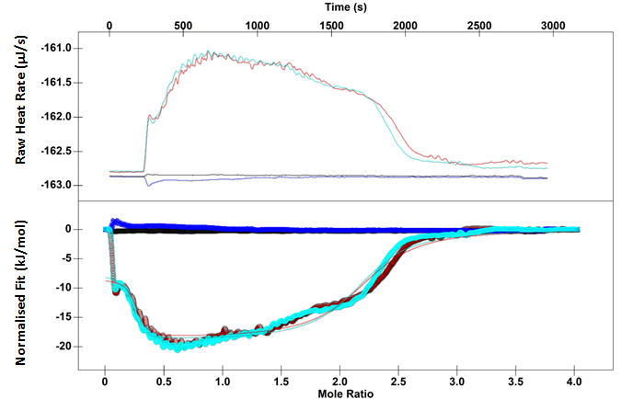
Normalised Fit (kJ/mol) Raw Heat Rate (µJ/s)
Mole Ratio
Figure 5.7: Upper: Thermogram of 6 mM sodium phytate injected into 0.4 mM lysozyme in 10 mM ammonium acetate. Sodium phytate-lysozyme interaction (teal and red), phytate dilution (blue) and lysozyme dilution (black). cITC study of 6 mM sodium phytate injected into 0.4 mM lysozyme in 10 mM ammonium acetate. Sodium phytate-lysozyme interaction (teal and red), phytate dilution into ammonium acetate (blue) and ammonium acetate into lysozyme (black). Solid line represents two site independent binding model fit.

Table 5.3: Thermodynamic parameters calculated using the one site and two site binding model for the interaction with 6 mM sodium phytate and 0.4 mM lysozyme at pH 4 in 10 mM ammonium acetate at 25 °C using either cITC or iITC. The standard error (bold) and the confidence intervals (italics) are in brackets.
ITC technique | - ΔH₁  (kJ/mol) | - TΔS₁  (kJ/mol) | - ΔG₁  (kJ/mol) | Stoichiometry  n₁ | - ΔH₂  (kJ/mol) | - TΔS₂  (kJ/mol) | - ΔG₂  (kJ/mol) | Stoichiometry  n₂
cITC | 8.47  (±2)  (±4) | 33.4  (±8) | 41.8  (±3)  (±10) | 0.27  (±0.07)  (±0.01) | 18.6  (±0.5)  (±0.2) | -10.4  (±0.4) | 28.2  (±0.5)  (±4) | 1.97  (±0.1)  (±0.01)
iITC | - | - | - | - | 22.5  (±0.5)  (±0.5) | -9  (±0.7) | 31.4  (±0.3)  (±3) | 1.9  (±0.003)  (±0.001)

Isothermal Titration Calorimetry Binding Studies between Lysozyme and Potassium Phytate
To determine if purity of the chemicals was an issue, the lysozyme was dialysed overnight and potassium phytate which has a purity of 95% was employed in further ITC studies. Furthermore, the injection interval for the cITC study was increased as the potassium phytate-lysozyme interaction takes longer to achieve equilibrium.
Figure 5.8, Figure 5.9 and Figure 5.10 show the interaction between potassium phytate and lysozyme using cITC at 10, 25 and 40 °C. This allowed an investigation of how temperature affects binding. The binding isotherms generated using cITC show oscillating endo-exothermic heats below 1 molar ratio. This is probably due to phytate-lysozyme crosslinks forming in solution. The exothermic profiles produced by cITC are similar in shape to those produced by iITC at 25 and 40C.
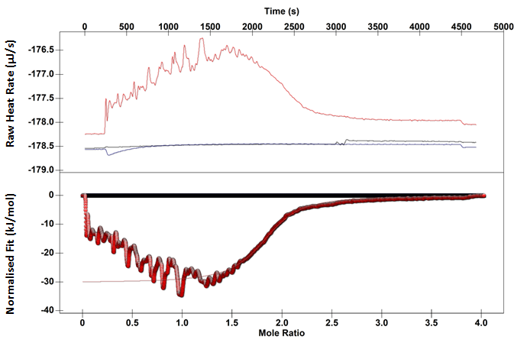
Time (s)
Mole Ratio
Normalised Fit (kJ/mol) Raw Heat Rate (µJ/s)
Figure 5.8: Upper: Thermogram of 6 mM sodium phytate injected into 0.4 mM lysozyme in 10 mM ammonium acetate at 40 °C (red), phytate dilution into ammonium acetate (blue) and ammonium acetate into lysozyme (black) Lower: Binding isotherm for the corresponding interaction (red) phytate dilution into ammonium acetate (blue) and ammonium acetate dilution into lysozyme (black). Solid line represents single site independent binding model fit.
However, the titrations at 10 C show a discrepancy in the binding isotherm generated by cITC or iITC (Figure 5.10 and Figure 5.11). Visual inspection of the binding isotherms produced over the temperature range suggests that the binding energetics begin to differentiate at 10C. Figure 5.12 is the thermogram for the interaction of potassium phytate with lysozyme at 40 and 10C.
Above 4000 seconds, there is a change in the kinetics leading to a slow return to baseline in comparison to the thermogram at 40 °C. This slow return to baseline is usually indicative of aggregation.²⁹⁶ Taken here, it most likely represents formation of larger lysozyme-phytate aggregates. The increase in the time it takes to return to baseline with decreasing temperature suggests the time it takes for the aggregates to dissociate increases with decreasing temperature. Most likely, this lag in exothermicity around 1.5 molar ratios is due to an aggregation event not a change in the binding energetics (Figure 5.10).
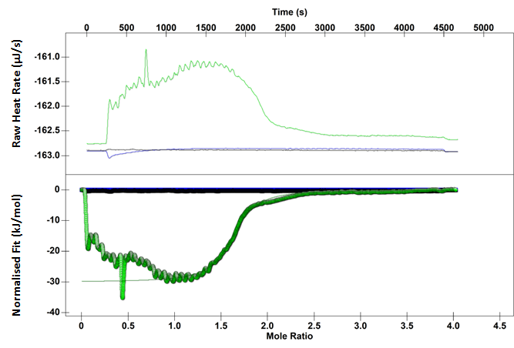
Mole Ratio
Time (s)
Normalised Fit (kJ/mol) Raw Heat Rate (µJ/s)
Figure 5.9: Upper: Thermogram of 6 mM sodium phytate injected into 0.4 mM lysozyme in 10 mM ammonium acetate at 25°C (green), phytate dilution into ammonium acetate (blue) and ammonium acetate into lysozyme (black) Lower: Binding isotherm for the corresponding interaction (green) phytate dilution into ammonium acetate (blue) and ammonium acetate dilution into lysozyme (black). Solid line represents single site independent binding model fit.

Time (s)
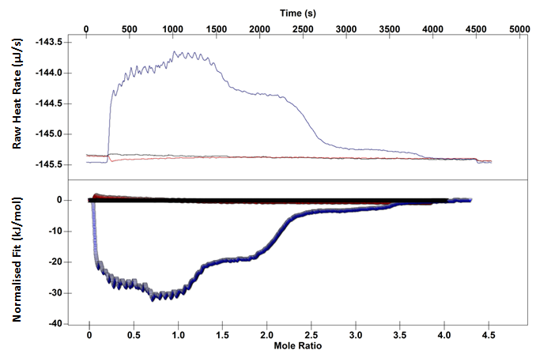
Mole Ratio
Normalised Fit (kJ/mol) Raw Heat Rate (µJ/s)
Figure 5.10 Upper: Thermogram of 6 mM sodium phytate injected into 0.4 mM lysozyme in 10 mM ammonium acetate at 25 °C (blue), phytate dilution into ammonium acetate (red) and ammonium acetate into lysozyme (black) Lower: Binding isotherm for the corresponding interaction (blue) phytate dilution into ammonium acetate (red) and ammonium acetate dilution into lysozyme (black). Solid line represents single site independent binding model fit.
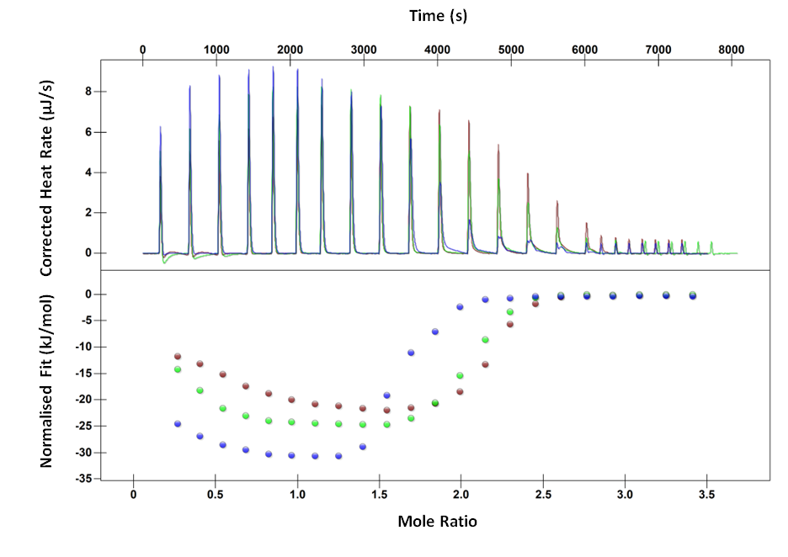
Figure 5.11: (Upper:) Thermogram for the interaction of 6 mM potassium phytate and 0.4 mM lysozyme in the presence of 10 mM ammonium acetate buffer at 10 (blue), 25 (green), 40 °C (red) and the corresponding binding isotherm (lower)
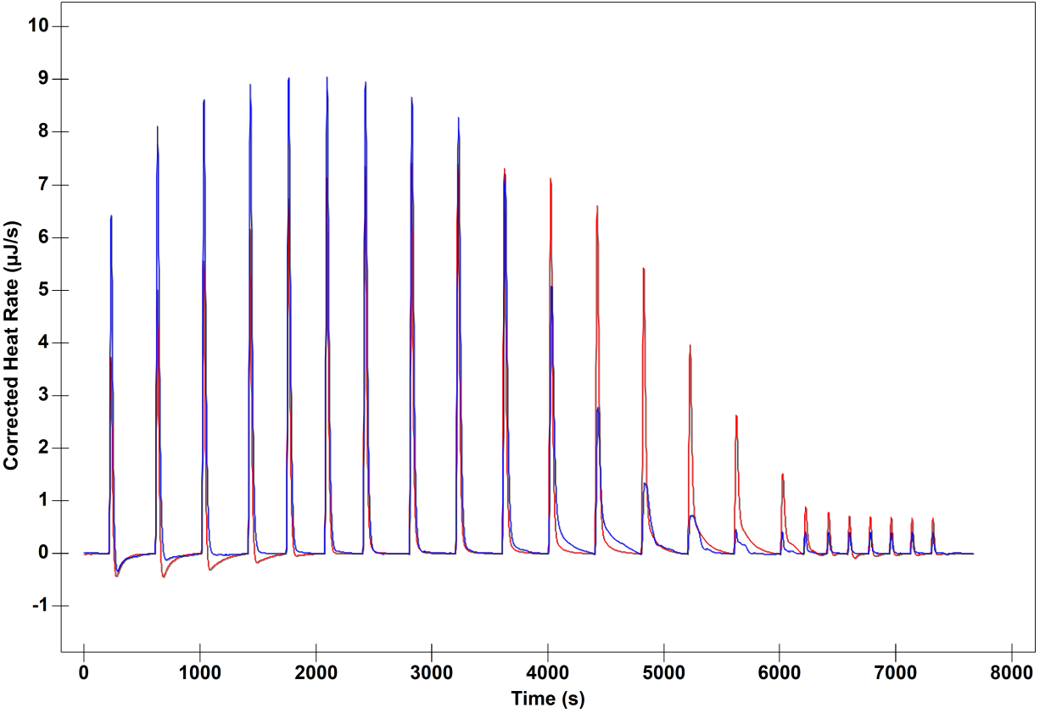
Corrected Heat Rate (µJ/s)
Time (s)
Figure 5.12: Thermogram for the interaction between 6 mM potassium phytate and 0.4 mM lysozyme in 10 mM ammonium acetate at 10 (blue) and 40C (red)
Fitting the binding isotherms to the one site model for binding isotherm obtained at 25 °C provided thermodynamic values that were in the range of the previous iITC study (Table 5.3). Fitting a two site model produced a large error for the enthalpy of the second stage of the interaction and so was not utilised.
Table 5.4: Thermodynamic parameters calculated using the one site binding model for the interaction with 6 mM potassium phytate and 0.4 mM lysozyme at pH 4 in 10 mM ammonium using either cITC or iITC at 25 and 40 °C. The standard error (bold) and the confidence intervals (italics) are in brackets.
Temperature  (°C) | ITC technique | - ΔH  (kJ/mol) | - TΔS  (kJ/mol) | - ΔG  (kJ/mol) | Stoichiometry  n
25 | cITC | 29.8  (± 0.8) | -0.84 | 30.6  (± 10) | 1.65  (± 0.002)
25 | iITC | 25.4  (± 0.5) | -7.38  (± 0.7) | 32.8  (± 0.3) | 1.9  (± 0.03)
40 | cITC | 31.1  (± 0.1) | -1.2 | 30  (± 10) | 2  (±0.02)
40 | iITC | 22.6  (±0.2)  (±0.5) | -12.3  (±0.4) | 34.8  (±0.1)  (±2) | 2  (±0.05)  (±0.02)

The one site model for the binding isotherm obtained for the interaction at 40 °C was not comparable to the previous cITC study. This may have been due to the increase noise in the binding isotherm in comparison to the one at 25 °C meaning a poor fit to the data.
The noise within the potassium phytate binding isotherms is much larger than the sodium phytate. The structure, solubility of phytate changes in respect to the counter ion and this has effect on nutrition.²⁹⁷ ²⁹⁸ Sodium and other ions present in the sodium phytate preparation may have affected the solubility of the protein and the apparent crosslinking phenomena providing binding isotherms that better fitted the two site model.

Conclusion
Continuous Isothermal Titration Calorimetry (cITC) is a method where the ligand solution is continuously titrated over one time interval. This offers the opportunity of thousands of data points meaning the thermodynamics of complex binding modes could be calculated.
The binding isotherms obtained by titrating sodium phytate into lysozyme provided better quality thermodynamic data than the potassium phytate interaction. Fitting a two site model to the binding isotherm obtained for the interaction between sodium phytate and lysozyme at 25 °C showed that positive cooperativity is unlikely to be occurring, given that the ΔG of second site is less favourable than the first site.
For most of the binding isotherms obtained by the potassium phytate–lysozyme interaction, using either the one site or two site models to estimate the binding thermodynamics produced results that were less accurate than those obtained by incremental injections. The crosslinking phenomenon, which is especially evident below a molar ratio of 1, prevented a proper fit to the thermodynamic data and is most likely due to the aggregation event.

Chapter 6: Determining the Specificity of Phytate-Protein Interactions

Summary
Albumins are major transporters of organic compounds and mineral ions in the blood. Human serum albumin (HSA) is the variant found in human blood, whilst bovine serum albumin (BSA) is the variant found in cattle. Inositol hexakisphosphate, otherwise known as phytate, is a cell signalling molecule found in all mammalian cells. It also exists in crops, seeds and legumes meaning it presents a nutritional problem due to its capability of precipitating both exogenenous proteins and those involved in digestion. Isothermal Titration Calorimetry (ITC) was utilised to measure the Gibbs free energy (ΔG), the enthalpy (ΔH), the entropy (TΔS) and stoichiometry (n) of binding between phytate and these two serum albumins. The ΔG was relatively similar, with 28.0 and 28.8 kJ/mol for BSA and HSA respectively. The binding isotherms were sigmoidal, suggesting a lack of extensive precipitation, but showed two stages of interaction. The first stage was indicative of saturation of binding sites with saturation occurring at approximately two molar ratios for both HSA and BSA. The second stage exhibited endothermic peaks on the thermogram which was taken as a possible dissocation event of phytate from the albumins. Visual inspection of the binding isotherms shows that the first stage of phytate binding to HSA is more exothermic than binding to BSA. This suggests that the initial binding event occurs at a different set of positively charged amino acids in respect to both the albumins.
To determine the specificity of the binding interaction the titration was performed in phosphate buffered saline (PBS) buffer at pH 7.4. The pH is well above the isoelectric point (pI) of the protein meaning it has an overall negative charge. Secondly, the high ionic strength of the buffer further prevents non-specific electrostatic interactions between phytate and the albumin. The interaction was completely abolished in PBS buffer at pH 7.4, suggesting the interaction is not specific. This also suggests albumins do not function as extracellular transporters of phytate.

Introduction
Human serum albumin (HSA) is a negatively charged plasma protein which transports numerous substances around the blood such as fatty acids, bilirubin and pharmacologically active molecules. It is one of the most abundant plasma proteins in mammals comprising 60-65% of the total plasma protein in humans.²⁹⁹ HSA has a very high intravascular concentration and so is vital for keeping the oncotic pressure required for the separation of body fluids around the body.³⁰⁰ The protein exhibits a high buffering capacity due to the high number of charged amino acids that are readily titratable.³⁰⁰ HSA has a negative net charge of -19 at physiological pH due to the high number of acidic amino acids in comparison to basic residues.³⁰⁰
The transport role of HSA has been thoroughly researched. The protein binds a number of organic compounds, proteins and inorganic ions either reversibly or irreversibly.³⁰¹ This feature has an acute effect on the pharmacokinetics and pharmacodynamics of a drug and so this protein has been of interest to the pharmaceutical industry. HSA lowers the rate of clearance, increases the plasma half-life of the drug and modifies the volume and pattern of distribution.³⁰¹
Sequence identity is the exact match between amino acids. Typically, a match of 25% or higher indicates similarity in function. Bovine serum albumin (BSA) shares 76% sequence identity with HSA which is visualised in Figure 6.1 as dark blue amino acids. The remaining 23% amino acids are coloured from light blue to orange. Light blue and green represent those amino acids that are less stable but can still be accommodated within the structure. Orange and yellow amino acids are those that are not stable within the structure and are unfavourably positioned. ³⁰²
BSA performs the same function as HSA in cows, carrying a range of endogenous and exogenous ligands. The similar structure and function mean that BSA is often used to study ligand-albumin interactions most probably because it is cheaper to obtain than HSA.
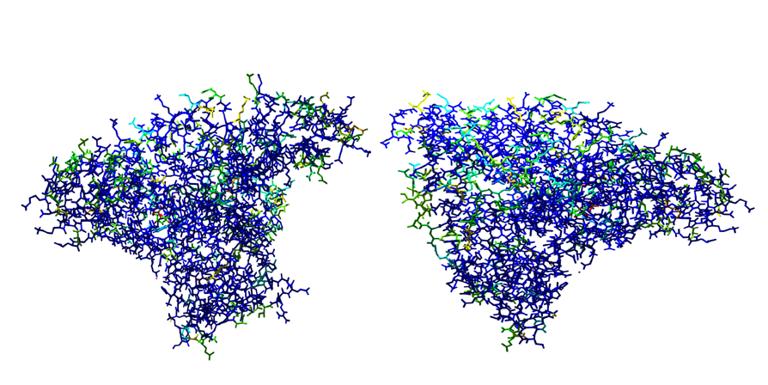
Figure 6.1: Crystal structure of HSA showing the level of sequence identity between HSA and BSA using the structures provided by Wang et al. ³⁰³ and Bujacz. ¹⁸³

Structure of Human Serum Albumin and Drug Binding Interactions
The structure of both HSA and BSA is heart shaped with three homologous domains. Both proteins have a high-helical structure of about 67%, but contain no β-sheet secondary structure.^{227,304} A number of crystal structures have been produced of HSA with and without ligands. Despite the high level of sequence identity, crystallising BSA has proved a much more difficult task, with only two crystal structures produced to date.
There is a widely accepted notation among those whom investigate drug-HSA interactions that there are two main ligand binding sites, named Sudlow site I (warfarin binding site) and Sudlow site II (indole-benzodiazepine binding site).³⁰⁵
Sudlow site I binds large heterocyclic and negatively charged compounds. ³⁰⁶ Kragh-Hansen et al. suggested that the binding site is large and flexible, as it can bind to a diverse set of molecules in terms of size and structure.³⁰⁷ Additionally, both enantiomers of warfarin bind to Sudlow site I with equal preference, which is also symptomatic of binding sites with high flexibility.^{307,308} Drugs that bind to site I show similar association constants for both HSA and BSA. For example, luteolin, a flavonoid, binds to all rat serum albumin, HSA and BSA with the same affinity.³⁰⁹ However, there are some exceptions, ochratoxin A, a mycotoxin, binds to BSA with an association constant of 3.02 × 10⁶ whilst HSA binds with an association constant of 44 × 10⁶.³⁰⁹
Trp214 is found in Sudlow Site II, a partly hydrated residue which is important for fluorescence studies.³¹⁰ It binds to smaller negatively charged ligands such as indoles and diazepam. There is more variation for drug binding constants at these sites compared to site 1 for BSA and HSA. For example, equilibrium dialysis experiments showed that BSA binds diazepam with an association constant of 0.16 × 10⁴, whilst HSA bound diazepam at two different sites within site 1 with association constants of 17 × 10⁵ and 1.78 × 10⁴.³¹¹

Phytate
Inositol hexakisphosphate (InsP₆) was originally discovered as phosphate storage molecule in plants, providing its other name, phytic acid. Phytic acid is one of the most abundant intracellular inositol phosphate species in mammalian cells, ranging from 10 to 60 µM, with evidence suggesting that phytate may exist in the cytolsolic department as well as being compartmentalised within the cell, potentially bound to protein.²⁵⁴
Liquid Chromatography–Mass Spectrometry identified that phytate plasma levels in the human plasma are in the range of 8 nM to 8 µM.³¹² The finding that phytate is present in human fluids is relevant as health food companies are selling it as health supplement. Previous work has suggested that phytate could have an anticancer activity.³¹³ UV radiation in the form of sunlight has been shown to induce skin cancer. One group of mice received UVB exposure and were fed 2% phytate in drinking water whilst the other group were exposed to solely UVB. The phytate fed mice had a lower tumour amount than those that were just exposed to UV indicating a potential antiphotocarcinogenic effect of phytate in drinking water. ³¹⁴
However, High Performance Liquid Chromatography (HPLC) studies performed by Wilson et al. identified that the concentration of phytate in human fluids was much lower (below nanomolar concentrations) suggesting there was no extracellular phytate.³¹⁵ Furthermore, it raises the validity of phytate as a health food supplement as increasing the dietary levels of InsP₆ did not increase the levels found in the blood or urine.²⁵² Grases et al. performed a study where seven healthy volunteers were put on a phytate poor diet and then at a later stage on a diet containing phytate. In contrast to the studies performed by Letcher et al. there were increased levels of phytate found in the plasma of those fed a phytate rich diet of 0.393 µmol, a level significantly higher than those on phytate deficient diet of 0.106 µmol. In addition to this, there were increased levels of phytate found in the urine. However, a separate study performed by Letcher et al. could not find detectable levels of phytate in the urine despite the assay having sensitivity reportedly in the nanomolar range. Even though diet could affect these results and this was not controlled for in the latter study, the reported sensitivity of the assay was (<5 nM) so some detectable level would have been expected given the basal level reported by Grases et al. It was suggested that the discrepancy was due to the techniques utilised rather than the diet of the volunteers. Grases et al. uses ion chromatography and dephosphorylates the phytate into inositol which is then measured using mass spectrophotometry. This method relies on the ion chromatography to be able to purify phytate from other phosphorylated inositols. If it does not, then the amount of phytate will seem higher in the sample being studied. Letcher et al. used a polyacrylamide gel electrophoresis based method that allows the visual detection of phytate. The latter method is a direct measure of phytate so it may be more accurate. They suggest the reason that why extracellular phytate is so low is that an extracellular phosphatase breaks down phytate into Ins(1,2,4,5,6)P₅ suggesting that no extracellular phytate can exist. However, the original authors that discovered the enzyme suggested that it was a protective measure by cancer cells to protect against phytate.³¹⁶ In addition to this, cancerous cells may release phytate upon necrosis meaning the enzyme may also have a role in recycling inositol and phosphate allowing for further mitosis.³¹⁶ BSA is known to bind anionic ligands and so it could be suggested that the discrepancy between the studies may be possibly be due to albumins binding phytate either irreversibly or strongly. In addition to this if phytate does have an anticancer role, it is vital to determine how it could be transported around the blood and how strongly it binds to BSA.
Phytate is believed to have a signalling function, notably a role in activating protein kinase c which then acts to increase insulin secretion.³¹⁷ has also been shown to be integral in mRNA transport by increasing the catalytic efficiency of enzymes involved.³¹⁸ Additionally, crystallography revealed ADAR2, an RNA editing enzyme, could be stabilised by phytate. Expressing the enzyme in an phytate deficient mutant abolished RNA editing activity.³¹⁹
Although there are numerous roles for endogenous, cellular phytate required for homeostasis, exogenous phytate found in animal feeds presents a nutritional problem.²⁹¹ Phytate has been shown to reduce the solubility of both mineral ions and proteins in seeds impairing nutrient bioavailability, as monogastic animals such as pigs and chickens do not have the enzymes required to break down phytate.²⁴⁸ Furthermore, evidence suggests that phytate-protein complexes are less susceptible to proteolysis than protein alone.^{248,292}
Phytate is a negatively charged molecule which meaning it could have a high binding propensity to positively charged proteins. Shears has suggested that while electrostatic interactions can contribute to specificity, in other situations, they may assist in non-specificity.²⁵³ This degree of non-specificity has not been accounted for in a number of assays and this has led to binding constants with a measure of error. Subsequently, Shears has suggested that assays that use ideal conditions (low ionic strength) may be unsuitable to gauge the interaction between phytate and macromolecules in the cellular environment.
Another way to prevent non-specific electrostatic interactions is to use a pH that is above the isoelectric point (pI) of the protein. The pI of the protein is the pH at which a molecule carries no net charge. At a pH above the pI the protein will carry a net negative charge. Conversely, at a pH below the pI the protein will carry a net positive charge. Therefore electrostatic interactions are strengthened if the pH is below the pI. Consequently, using a buffer at the same pH as in vivo conditions is necessary to a gain a better estimation of the binding interaction.
Previous work has suggested that both pI and the number of charges are important in the binding interaction between macromolecules and phytate. The binding of phytic acid to glycin, a protein found in soybean, was investigated using gel filtration chromatography and turbidity measurements with subsequent analysis using phosphorous detection and UV-vis spectrophotometry to determine the amount of protein.²⁷⁰ At pH 4.9, no binding could be identified. Below this pH, binding that resulted in insoluble complexes occurred. This was below the pI of the protein of 5, suggesting an important factor in the phytate-macromolecule structure activity relationship.³²⁰ The extent of phytate-protein interaction in corn germ, soybean flakes, and sesame meal was measured using gel filtration chromatography and electrophoresis.³²¹ The composition of basic amino acids did not correlate with phytate binding which is surprising given the electrostatic nature of the phytate-protein interaction.
It should be noted that precipitation is not synonymous with binding. It has been suggested that highly charged anions such as phosphate and sulphate can remove water from proteins facilitating protein-protein interaction and subsequent precipitation. This does not require binding to the protein surface. More to the point, the gel filtration study was only capable of showing that binding occurred rather than providing an accurate measure of the binding interaction.
The aim of this ITC study is to determine the specificity of the phytate-protein interaction by using both HSA and BSA. Similar binding thermodynamics would suggest similar binding sites on the homologous proteins. In addition to this, a titration was performed using 10 mM phosphate, 2.7 mM potassium chloride and 137 mM sodium chloride at pH 7.4 with BSA and phytate. The pI of BSA is 4.7 meaning at pH 7, the protein has large negative charge. A binding site should have a structure that makes specific interactions with the ligand and provides a degree of shape complementary. There are several pockets of positive charge on BSA at pH 7 meaning binding should still occur to some extent if there is a specific recognition motif. This could not be done using lysozyme as the pI of this protein is 11 meaning the experiment would have to be done at pH 12. Such high pH may negatively affect the stability of lysozyme during the long periods required for the titration. The ITC results suggest that the interaction is not specific, with binding only occurring below the pI of BSA. Furthermore binding appears to be isoenergetic (similar ΔG) between both BSA and HSA, suggesting binding occurs at positive amino acids, but perhaps a different set. For both HSA and BSA, phytate binding was enthalpically favoured and entropically disfavoured for both proteins.

Materials and Methods

Chemicals and Materials
Bovine serum albumin and human serum albumin (essentially fatty acid free and essentially globulin free, ≥99%), (potassium phytate (≥95% purity), acetic acid (99.8%) ammonium acetate, phosphate buffered saline (PBS) were all sourced from Sigma-Aldrich, Gillingham, U.K. Milli-Q water from a Merk-MILLIPORE (Darmstadt, Germany) fountain was used to prepare the reagents. A FiveEasy pH meter (Mettler-Toledo International, Ohio, US) was used to measure the pH of the solutions.

Isothermal Titration Calorimetry
A Nano-ITC instrument (TA instruments, Utah, US) was used to measure the binding thermodynamics between phytate and BSA or HSA at 25 °C. Phytate and the protein were dissolved in 10 mM ammonium acetate buffer at pH 4 or PBS buffer at pH 7.4. The proteins were then dialysed in that buffer overnight. All solutions were degassed for 20 minutes prior to the titration. BSA was made up to either 0.346 mM or 0.149 mM and loaded into the sample cell, whilst the syringe contained either 2.6 mM or 2 mM phytate respectively. For the HSA experiments, 2 mM phytate was loaded into the syringe and the sample cell contained 0.149 mM HSA. For the HSA experiments at least 34$×$0.89 µL 2 mM phytate injections into 0.149 µM HSA were made over the course of the titration. For the BSA experiments at lower concentrations, 45$×$0.89 µL 2 mM phytate injections into 0.149 µM BSA were made over the course of the titration. For the BSA experiments at higher concentrations, at least 35$×$0.89 µL 2.6 mM phytate injections into 0.346 mM BSA were made over the course of the titration. In each titration, the reference cell contained water. The time delay between each injection was variable to ensure equilibration and the RPM was set to 285 to ensure thorough mixing of the cell. Data analysis was performed using the NanoAnalyse software (TA instruments, Utah, US). The enthalpy of dilution of phytate was subtracted from the raw data. By using NanoAnalyse, raw heat data was integrated peak by peak and normalised per mole of injectant to get a plot of observed enthalpy change per mole of phytate against phytate/protein molar ratio. The first injection was erroneous due to diffusion effects and was subsequently discarded from analysis for the one site binding model. To help with the fitting procedure a constant was applied to the data that subtracts the area data above 0 µJ. Both the standard mean error and the confidence intervals are provided. Nano ITC users tend to use confidence intervals as the NanoAnalyse software readily provides this. A confidence interval provides a range that contains the population parameter of interest.

Results and Discussion
In this investigation, the interaction of phytate with both BSA and HSA was investigated by ITC in both PBS and 10 mM ammonium acetate buffer. Titration of phytate into both 10 mM ammonium acetate buffer and PBS buffer showed a negligible ΔH as did titration of these buffers into the proteins. For each protein-phytate interaction studied in 10 mM ammonium acetate pH 4, an exothermic interaction was observed. Figure 6.2 and Figure 6.3 show ITC binding isotherms for both phytate binding to HSA and BSA respectively. The plots are sigmoidal but show evidence of a main primary event and a weak secondary event after two molar ratios.
Time (s)
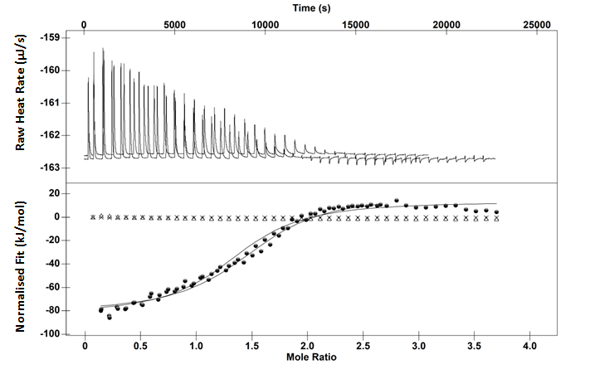
Normalised Fit (kJ/mol) Raw Heat Rate (µJ/s)
Mole Ratio
Figure 6.2: ITC binding isotherm for the interaction of 2 mM potassium phytate and 0.149 mM HSA in 10 mM ammonium acetate at 25 °C pH 4 (closed circles). Acetate titrated into HSA (Crosses). Phytate titrated into acetate (Open triangles). Solid line represents single site independent binding model fit.

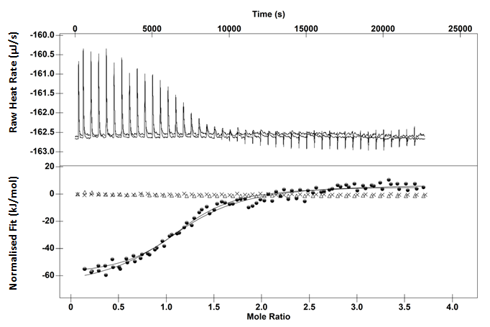
Normalised Fit (kJ/mol) Raw Heat Rate (µJ/s)
Time (s)
Mole Ratio
Figure 6.3: ITC binding isotherm for the interaction of 2 mM potassium phytate and 0.149 mM BSA in 10 mM ammonium acetate at 25 °C pH 4 (closed circles). Acetate titrated into BSA (Crosses). Phytate titrated into 10 mM acetate (Open triangles). Solid line represents single site independent binding model fit.
At low molar ratios, the binding interaction led to an exothermic response, which decreased in size with successive injections indicative of saturation of binding sites on the protein and favouring equilibrium formation of protein-phytate complexes. The return to baseline was slow, approximately 300 seconds between 0.07 and 0.9 molar ratios, indicating a slow dissociation step of phytate from the albumins. Increasing the molar ratio of phytate increased the time taken to reach equilibrium. At approximately, 1.5 molar ratios, the time taken for phytate to dissociate from the albumins was approximately 500 seconds. At higher phytate-protein molar ratio of 2 and above, small but notable exothermic peaks were observed beyond binding saturation even though heat effects from phytate dilution were corrected for.
This is a familiar feature of many tannin-macromolecule interactions. Titration of tara-gallotannins into gelatin produced small exothermic peaks at tannin-macromolecule molar ratios beyond 200:1 which was attributed to non-specific interactions with gelatin.²²⁶ Titration of pentagalloyl glucose into ribulose-1,5-bisphosphate carboxylase/oxygenase (Rubisco) also produced small exothermic peaks at molar ratios beyond 800 tannin-macromolecule molar ratios which is much more than the protein could accommodate on the surface given a simple surface absorption model. The authors suggested two possible reasons. The first could be due to pentagalloyl glucose binding to pentagalloyl glucose already bound forming a tannin-multilayer. The second could be due a change in oligomerisation state for Rubisco allowing further tannin binding to the exposed regions of the subunits.²⁸⁷ For the interaction presented here, for both HSA and BSA, it is unlikely that a multilayer of phytate bound to already bound phytate on the protein is occurring. Phytate is negatively charged and so given the nature of electrostatics, it would be expected that phytate would repel bound phytate. It is possible that phytate is interacting with other smaller positively charged regions on the protein. However, it would be expected that the interaction would be exothermic rather than endothermic given that phytate binding to the albumins is exothermic. Ionic strength is known to be crucial in electrostatic interactions. It is possible when the cell concentration of phytate reaches 0.264 mM it begins to screen, thus promoting dissociation of phytate from the protein.
The favourable change in enthalpy is most likely due to an electrostatic interaction between the negatively charged phosphate groups on the phytate and the positively charged amino acids on the albumin surface. However, care must be taken when interpreting enthalpy values for both proteins, as this represents global heat changes such as precipitation in addition to binding. Another issue is trying to calculate accurate enthalpy values from the binding isotherms. The second stage of the interaction does not allow a good fit to the data as heat production never reaches 0 µJ. A similar problem has been encountered with those who study tannin-macromolecule interactions. A number of biochemists using ITC to investigate tannin-macromolecule interactions present both the one and two site models.^{163,204}. Using the two site model to calculate energetics of the binding isotherm provided worse confidence intervals and unrealistic values. To determine the thermodynamics using the independent site model, two approaches could be utilised. The data points for the second stage could be removed prior to analysis to help the fit. Fitting the data in this manner produced a large error in the enthalpy value as the model effectively estimates the upper (less favourable) limit of the enthalpy value. An alternative approach is to use a constant that reduces the heat for the second stage to zero. This provides a more accurate value for the ΔG of binding for the initial event. However, the ΔH value must be treated with caution as it is the summation of two opposing ΔH.
Although the enthalpy values must be treated with caution, a simple inspection of Figure 6.4 demonstrates that the interaction between HSA and phytate is far more exothermic than that of BSA and phytate. BSA and HSA exhibit 75% sequence identity, this means 25% are not identical. BSA has 99 acidic amino acids, whilst HSA has 98, both proteins have the same number of basic amino acids. However, the amino acid composition is different meaning although the pI of the protein is the same, the number of particular amino acids is different. This variation in composition could be responsible for the differing enthalpies of binding between HSA and BSA. The thermogram for the binding isotherm between BSA and phytate is slightly noisy. Increasing the amount of phytate increases the amount of heat effectively increasing the signal to noise ratio. This means the amount of protein also has to be increased to achieve a molar ratio that allows a good fit to the data. To improve the quality of the thermodynamic data, the BSA concentration was increased to 0.346 mM from 0.149 and the concentration of phytate was increased to 2.6 mM (Figure 6.6).
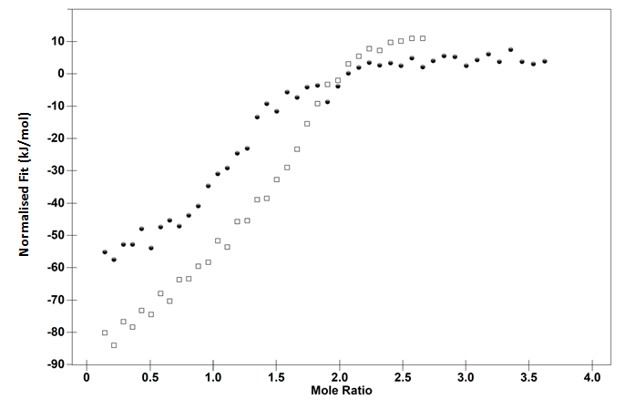
Mole Ratio
Figure 6.4: Binding isotherms for 2 mM potassium phytate titrated into HSA (open squares) and BSA (closed circles) both at 149 µM in 10 mM ammonium acetate pH 4 25 °C.
Time (s)
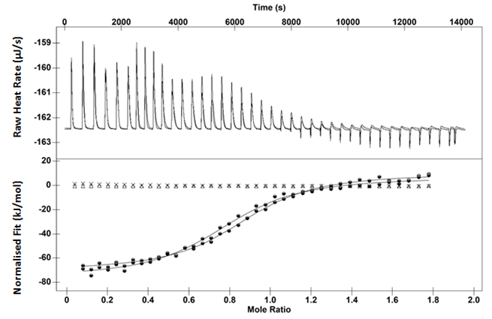
Normalised Fit (kJ/mol) Raw Heat Rate (µJ/s)
Mole Ratio
Figure 6.5: ITC binding isotherm for the interaction of 2.6 mM potassium phytate and 0.346 mM BSA in 10 mM ammonium acetate at 25 °C pH 4 (closed circles). Acetate titrated into BSA (Crosses). Phytate titrated into acetate (Open triangles). Solid line represents single site independent binding model fit.

Table 6.1: Thermodynamic data for the interaction of phytate with BSA and HSA at 25°C. The standard error (bold) and the confidence intervals (italics) are in brackets.*The concentration of BSA was increased from 0.149 to 0.346 mM.
Protein | -ΔH  (kJ/mol) | -TΔS  (kJ/mol) | -ΔG  (kJ/mol) | Stoichiometry
BSA | 71.4  (±5)  (±4) | 44.1  (±6) | 27.5  (±0.6)  (±2) | 1.17  (±0.02)  (±0.04)
HSA | 105  (±13)  (±7) | 77.4  (±13) | 27.7  (±1)  (±1) | 1.5  (±0.1)  (±0.06)
BSA* | 79.6  (± 2)  (±5) | 51  (± 2) | 28.  (± 0.3)  (±2) | 0.85  (± 0.04)  (±1)

The ΔG of binding between both HSA and BSA appears to be the same even when the concentration of BSA is increased. Inspection of the binding isotherms shows that the interaction with phytate and 149 µM HSA is still more exothermic than the interaction of phytate with 346 µM BSA (Figure 6.6).

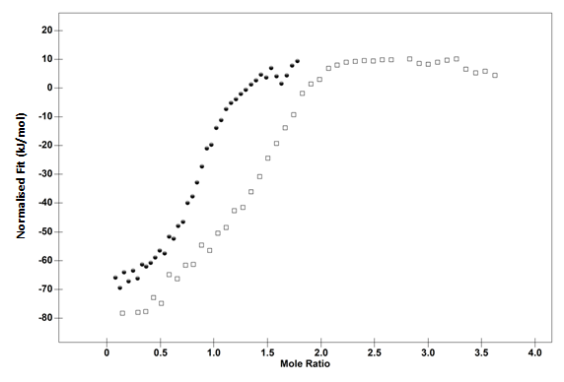
Normalised Fit (kJ/mol
Mole Ratio
Figure 6.6: Binding isotherms for 2.6 mM phytate into HSA at 149 µM (open squares) and BSA at 346 µM (closed circles) in 10 mM ammonium acetate pH 4 at 25 °C.
Entropy-enthalpy compensation is described as process where any changes in enthalpy are counterbalanced by changes in entropy and vice versa meaning no change in the association constant. A very simple example would be where a ligand has been optimised to make more bonds with the binding site (yielding a favourable increase in enthalpy) but both the ligand and the binding site are less flexible (yielding an unfavourable decrease in entropy). To prevent this, some medicinal chemists have began engineering drugs to hydrogen bond to structured regions of the protein as they carry less entropic penalty. Another approach considers making bonds to functional groups already bonded, meaning less entropic penalty has to be paid.⁷ Others have suggested that entropy-enthalpy compensation is an artefact due ligand concentration errors.⁹⁰ Despite the source being an artefact or real, it is still a frustration for those involved in drug optimisation. Since the ΔG of binding are the same for both HSA and BSA it seems entropy-enthalpy compensation exists between the two binding sites. This illustrates the problem of entropy-enthalpy compensation for medicinal chemists. That even presumably the binding sites are dissimilar (as evidenced from the differing ΔH), the ΔG remains relatively similar.
Lumry and Ranjander suggested entropy-enthalpy compensation was a general property of any interaction carried out in water.¹³ Both the protein and the ligand are solvated and upon binding there is a degree of desolvation and change in conformation of both the ligand and the protein effecting a change in the free volume of adjacent water. Later on Chervenak and Toone performed a number of protein-carbohydrate ITC studies in both heavy and normal water.³²² Deuterium bonding is 10% stronger than hydrogen bonding meaning it provides a measure of solvent reorganisation enthalpy. For those systems studied the solvent reorganisation enthalpy provided 25-100% of the overall global enthalpy change but there was no real change in the ΔG of binding.³²² This reinforces the conclusions made by Lumry and Ranjander. It may also provide a reason why the ΔG of binding between HSA and BSA for phytate remains the same but the TΔS are different.
Leffler’s work on entropy-enthalpy compensation for a series of chemical reactions specified a temperature range where the activation energies and equilibrium constants did not change.⁹¹ Performing the experiments at temperatures beyond the compensation temperature in some situations changed the enthalpy without a corresponding change in entropy. Since the binding of phytate to BSA and HSA is isoenergetic it would have been interesting to see if altering the temperature would cause more variation in the binding constant for the two proteins.
The ITC binding isotherm for both interactions was sigmoidal meaning there is less evidence for cooperative binding or an extensive precipitation phenomena. Both BSA and HSA have pI of 4.67-5.3 meaning that at pH 4, both proteins have a slightly partial to neutral charge. Gel filtration studies have shown that incrementally lowering the pH below the pI increases precipitation.²⁷⁰ Performing these experiments at pH 4 means there is minimal levels of precipitation as the negative charges on the proteins repel each other keeping a level of solubility. The stoichiometry of binding suggests that one phytate binds to one molecule of either BSA or HSA.
Entropy is often interpreted as a level of disorder in the system. This has been suggested to be an incorrect description due to Equation 6.1. ^{3,323}
$$S= k_{B}InW$$ | (6.1)
The entropy (S) of an ideal gas is equal to W, which is the number of microstates corresponding to a given macrostate and k_{B} is the Boltzmann constant. Pitzer, quoted by Kozliak and Lambert indicated that for one mole of a substance at 0 K cannot be described as ordered having 10^{26,000,000,000,000,000,000} possible microstates, a microstate being the arrangement of energy of each molecule at a specific time. Kozliak and Lambert suggest that the only correct description of entropy change involves the change in the dispersion of energy as a function of temperature across a number of accessible microstates.³²³ Interpreting the entropy change in this way means the number of accessible microstates has increased upon binding.
The serum albumins are known to carry both exogenous and endogenous ligands around the body. This has been exploited by medicinal chemists to as it can change the half-life of a drug and distribution.³²⁴ For the titrations carried out in PBS buffer, pH 7.4 at 37 °C, no binding isotherm for the interaction between BSA and phytate was observed (Figure 6.7). This means that BSA binding to phytate present in extracellular fluids is unlikely. Blood is composed proteins, dissolved gasses and mineral ions such as potassium, magnesium, calcium and sodium. It is possible that phytate is not protein bound in the blood but is bound by cations, since in the blood albumins are typically the carriers of negatively charged ligands. It is also means that the albumins do not prevent phosphatase action on phytate. If they did, it may provide some reason as to why there are large discrepancies between studies on how much phytate exists in the extracellular space as albumin binding to phytate would affect clearance from the blood.
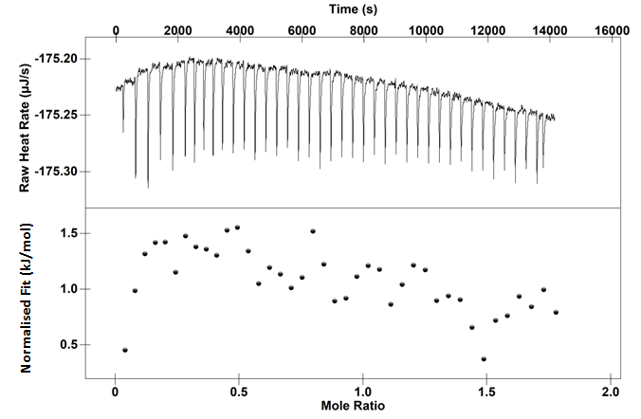
Normalised Fit (kJ/mol) Raw Heat Rate (µJ/s)
Time (s)
Mole Ratio
Figure 6.7: Upper: Thermogram of the interaction of 2.6 mM potassium phytate and 0.346 mM BSA at 37 °C. Lower: Binding isotherm for the same interaction.
Increasing the pH well above the pI means that BSA has an overall net negative charge. This could mean that even though there are positively charged regions on the surface of BSA, the overall net negative charge acted to the repel phytate from these areas. This suggests that pI is crucial in determining the specificity of the phytate-protein interaction which is supported by previous studies.

Conclusion
The binding interaction between phytate and the albumins has been explored. The interaction is favoured enthalpically, but entropically disfavoured yielding a favourable Gibbs free energy of binding. The binding isotherm is sigmoidal, but shows two stages of interaction. The first stage is exothermic, but becomes decreasingly so as the number of binding sites become saturated with phytate. The second stage which occurs at higher molar ratios is endothermic, which was suggested to be due to excess phytate in the system screening electrostatic interactions and thus shifting the equilibrium towards the unbound state. The phytate interaction with HSA was more exothermic than BSA but the Gibbs free energy of binding for the two proteins was similar meaning that entropy-enthalpy compensation existed between the two binding regions.
To determine the specificity between phytate and the albumins, the interaction was performed in PBS buffer at pH 7.4 with BSA. No detectable interaction could be measured which suggests that interaction does not involve a specific recognition motif. Furthermore, this suggests that phytate is not transported in the extracellular space by the albumins.

Chapter 7: Conclusions and Future Work

Main Conclusion
Biphasic binding isotherms produced by Isothermal Titration Calorimetry (ITC) experiments are found in number of areas including materials science, food chemistry, inorganic chemistry and cellular biochemistry. They are routinely suggested as being evidence of cooperative binding, that the initial binding events have a favourable effect on subsequent binding events. However, in some instances, the reasoning behind classifying these binding isotherms as examples of cooperative binding seems lacking. Data is presented that shows these binding isotherms may be indicative of crosslinking, rather than discrete binding events.

Modes of Binding for Tannic Acid and Proanthocyanidins to Biopolymers
Tannin-protein interactions occur in both the natural and commercial world.^{186,325,326} Tannins play an important role in a number of agricultural, nutraceutical and food industries.³²⁷⁻³²⁹ Tannin-protein interactions are responsible for the astringent quality of wines, the distribution of phenolics throughout the body and a whole range of antinutritional effects by binding to both endogenous proteins (dietary enzymes) and exogenous proteins.^{186,192,330} Therefore discerning the strength and specificity of how tannins binds to proteins is of vital importance to a number of industries. Previous work has suggested that in the case of some tannins, the initial binding event increases the binding affinity of subsequent binding events.^{144,145} This was supported by ITC binding isotherms that showed an increase in the favourable enthalpy at low molar ratios and then a decrease in the favourable enthalpy at higher molar ratios. These have been described as biphasic or two stage. It was suggested that the increase in binding affinity was due to tannins crosslinking other free binding partners allowing for better binding as the number of crosslinking occurs. Originally, the mechanism behind protein-tannin positive cooperativity could only be applied to peptides exhibiting very little secondary structure. Longer peptides are better able to “wrap around” polyphenols consequently increasing affinity by a number of interactions.²⁰⁰
ITC binding isotherms between tannic acid and BSA showed evidence of binding isotherms that were previously been identified as being evidence for positive cooperative binding. Firstly, proteins such as BSA exhibit fairly rigid tertiary structure meaning it is unlikely that BSA would be able to “wrap around” tannins. In addition to this, performing the titration at 10 °C produced a monophasic binding isotherm. Secondary structural changes monitored by Circular Dichroism showed no variation over the temperature range suggesting that conformational change was not responsible. This raised questions regarding the nature of the crosslinking induced positive cooperativity model. Crosslinking was occurring throughout the titration and therefore positive cooperativity should therefore be occurring independent of the 10-25 °C temperature range utilised in this study. Since there was no evidence of positive cooperativity at 10 °C other alternatives were explored. In view of the fact that the titration of tannic or tetrameric proanthrocynadin into polyproline was monophasic, it was suggested that the biphasicity was due to crosslinking macromolecules at regions of vastly different amino acid composition, and this becomes apparent between 25 and 10 °C due to water displacement becoming more or less favourable. However, it is possible that the reason why tannin-protein binding isotherms are not two stage at 10 °C could be due to decreased aggregation or crosslinking. Indeed, the reason why biphasicity is not present in the tannin-polyproline binding isotherms maybe due to decreased crosslinking or aggregation in comparison to the tannin-protein interactions.
Performing the ITC experiments at different temperatures allowed a better understanding of the thermodynamics of tannin-protein interactions. Titration of octomeric proanthocyanidin at 10, 25 and 35 °C showed that the initial binding interactions at low molar ratios could be due to the tannin binding primarily at the hydrophilic backbone due to the increase in endothermicity with increasing temperature. At higher molar ratios, there was an increase in exothermicity with increasing temperature meaning the hydrophobic effect was operating. The molecular origins of this could be due to tannin binding to tannins already bound to the protein.

An Isothermal Titration Calorimetry Study of a Multisite – Electrostatic Binding Interaction between Lysozyme and Phytate
Isothermal Titration Calorimetry (ITC) was used to measure phytate binding to lysozyme. Phytate is known to affect the bioavailability of nutrients by binding to both exogenous and endogenous proteins and so providing a mechanistic rationale and thermodynamic values is of the upmost importance.²⁵⁰ The binding isotherm showed two stages which is normally interpreted as favourable (positive) cooperative binding of a ligand to a macromolecule.^{150,266,286} However, Nanoparticle Tracking Analysis (NTA) identified small aggregates (a large assembly of molecular species) at low molar ratios used in the ITC study suggesting a crosslinking event rather than positive cooperative binding. ITC revealed the interaction to be favourable with an association constant in the micromolar range and favourable contributions from both entropy and enthalpy. The source of the favourable enthalpy was suggested to be due to electrostatic interaction between the phosphate groups on the phytate and positively charged amino acids on the protein. This was supported by performing the titrations at 100 and 300 mM ammonium acetate. At 100 mM the exothermicity and the Gibbs free energy became less favourable. Whilst at 300 mM ammonium acetate the interaction was no longer present.
The stoichiometry of binding provided evidence of temperature dependent lysozyme-phyate complex formation, being more prevalent at lower temperatures. This has implications for pig and poultry nutrition as the temperature of food and drinking water could affect bioavalibility of proteinaceous nutrients.

Future work
Characterising the phytate-lysozyme complexes using the Nanoparticle Tracking Analysis (NTA) software over a wider concentration and temperature range would benefit the mechanistic rationale behind the biphasic phytate-lysozyme binding isotherms. A much lower concentration of phytate and lysozyme would have to be used as larger particles may obscure smaller particles leading to poor particle counting. Therefore, this data will have to be supported by other techniques such as turbidity and zeta potential measurements.
Phytase is an enzyme used to break down phytate into free phosphates and inositol. There has been conflicting evidence regarding the efficacy of this enzyme in the presence of different poultry and pig foodstuffs. This is possibly due to tannins present in the feed interacting with the enzyme and preventing its action. To determine this, ITC experiments could be performed. Tannins could be titrated into the cell containing a solution of phytase. If the tannins bind to the phytase, this could show that phytase-tannin inhibition is responsible. Performing an ITC based enzyme assay could confirm this. In this experiment, a suitable tannin concentration would be present in the buffer of both the ligand and the enzyme. Any change in the enzyme parameters, V_{max} or K_{m} can be calculated.

A Continuous Isothermal Titration Calorimetry (cITC) Study of the Interaction between Phytate and Lysozyme
Previous ITC studies have shown that the interaction between phytate and lysozyme is biphasic. The early molar ratios (below 1) show evidence of a crosslinking interaction with an increase in exothermicity with each injection, whilst at higher molar ratios (above 2), the interaction becomes decreasingly less exothermic which was attributed extensive crosslinking of large lysozyme-phytate complexes. The binding thermodynamics estimated from the first stage are erroneous due to the non-sigmoidal nature of the curve. In addition to this, the binding thermodynamics from the second stage may be an average of a series of binding events rather an interaction with the same energetics. Continuous isothermal titration calorimetry (cITC) is a technique based on a continuous slow injection of titrant into the cell providing data points in the order of a 1000. The large number of data points means this technique is more suitable for accurately determining the binding thermodynamics of multisite interactions. The binding isotherms for sodium phytate and lysozyme at 40 °C were similar in shape to the incremental ITC (iITC), but the cITC binding isotherms were noisy most likely due to the crosslinking event occurring throughout the titration. The cITC binding isotherms for sodium phytate and lysozyme at 25 °C showed that positive cooperativity was not occurring.
The potassium phytate-lysozyme interaction for both ciTC and iITC at 10 °C provided different binding isotherms. The cITC binding isotherm showed evidence of another molecular event at 2 molar ratios which was not apparent form iITC binding isotherm. It was concluded this was a change in the crosslinking phenomena.

Future Work
The main issue with the cITC studies was trying to obtain thermodynamic information from binding isotherms that were noisy. It is possible that altering the experimental conditions such as RPM, reducing the protein concentration or longer titration times may assist in producing binding isotherms with less noise.

Determining the Specificity of Phytate-Protein Interactions
Phytate is ubiquitous in nature.²⁵⁴ It is known as a phosphate storage in plants as well as a functioning antioxidant.³³¹ In mammalian cells, phytate is known to have a cell signalling role and involved in transcription.²⁵⁴ In the case of RNA maturation, the enzymes responsible are tethered by phytate allowing them to catalyse the removal of proteins from mRNA.^{318,332} Phytate binding to these enzymes is normally specific and involves a recognition motif on the enzymes.^{318,332} In the case of phytate binding to exogenous proteins such as lysozyme, the interaction is termed non-specific. Non-specific binding normally depends on the charge or hydrophobicity of the ligand – it does not depend on the structures of the two binding partners. Albumins are major transporters of negatively charged organic compounds and mineral ions in the blood.^{177,183} Human serum albumin (HSA) is the variant found in human blood, whilst bovine serum albumin (BSA) is the variant found in cattle. When phytate becomes present in the blood, the albumins may bind it. Understanding this process is crucial since phytate has a role in cancer prevention and metal ion chelation.²⁵⁰ To determine the specificity of the binding interaction between phytate and the albumins, ITC studies were carried out at two different conditions. The interaction carried out in 10 mM ammonium acetate at pH 4 at 25 °C consisted of two stages. The first stage was exothermic and indicative of saturation of binding sites with saturation occurring at approximately two molar ratios for both HSA and BSA. The second stage exhibited endothermic peaks on the thermogram which was taken as a possible dissociation event of phytate from the albumins. To determine the specificity of the binding interaction the titration was performed in phosphate buffered saline (PBS) buffer at pH 7.4 at 37 °C. Firstly, the high ionic strength of the buffer prevents non-specific interactions. Secondly, the proteins have an overall negative charge due to the isoelectric point (pI) of the protein being well below the pH of the buffer. This will also prevent non-specific interaction due to charge-charge repulsion. The interaction was completely eliminated in PBS buffer meaning that the albumins do not carry phytate around the blood stream.

References
(1) Nilsson, T.; Niedderer, H.: Undergraduate students' conceptions of enthalpy, enthalpy change and related concepts. Chemistry Education Research and Practice, 2014, 15, 336-353.
(2) Langbeheim, E.; Safran, S. A.; Yerushalmi, E.: Visualizing the Entropy Change of a Thermal Reservoir. Journal of Chemical Education, 2014, 91, 380-385.
(3) Lambert, F. L.: Disorder - A Cracked Crutch for Supporting Entropy Discussions. Journal of Chemical Education, 2002, 79, 187.
(4) Isaacs, N. S.: Physical organic chemistry. Second ed.; Longman Scientific & Technical; Wiley & Sons, 1995; pp 98.
(5) Alonso, H.; Bliznyuk, A. A.; Gready, J. E.: Combining docking and molecular dynamic simulations in drug design. Medicinal Research Reviews, 2006, 26, 531-568.
(6) Holdgate, G. A.; Gill, A. L.: Kinetic efficiency: the missing metric for enhancing compound quality? Drug discovery today, 2011, 16, 910-933.
(7) Chaires, J. B.: Calorimetry and thermodynamics in drug design. Annual review of biophysics, 2008, 37, 135-51.
(8) Freire, E.: Isothermal titration calorimetry: controlling binding forces in lead optimization. Drug Discovery Today: Technologies, 2004, 1, 295-299.
(9) Duan, J. J. W.; Chen, L. H.; Wasserman, Z. R.; Lu, Z. H.; Liu, R. Q.; Covington, M. B.; Qian, M. X.; Hardman, K. D.; Magolda, R. L.; Newton, R. C.; Christ, D. D.; Wexler, R. R.; Decicco, C. P.: Discovery of gamma-lactam hydroxamic acids as selective inhibitors of tumor necrosis factor alpha converting enzyme: Design, synthesis, and structure-activity relationships. Journal of medicinal chemistry, 2002, 45, 4954-4957.
(10) Freire, E.: Do enthalpy and entropy distinguish first in class from best in class? Drug discovery today, 2008, 13, 869-74.
(11) Freire, E.: A Thermodynamic Guide to Affinity Optimization of Drug Candidates. In Proteomics and Protein-Protein Interactions; Waksman, G., Ed.; Springer US, 2005; Vol. 3; pp 291-307.
(12) Lam, P.; Jadhav, P.; Eyermann, C.; Hodge, C.; Ru, Y.; Bacheler, L.; Meek, J.; Otto, M.; Rayner, M.; Wong, Y.; et, a.: Rational design of potent, bioavailable, nonpeptide cyclic ureas as HIV protease inhibitors. Science, 1994, 263, 380-384.
(13) Lumry, R.; Rajender, S.: Enthalpy–entropy compensation phenomena in water solutions of proteins and small molecules: A ubiquitous properly of water. Biopolymers, 1970, 9, 1125-1227.
(14) Grunwald, E.; Steel, C.: Solvent reorganization and thermodynamic enthalpy-entropy compensation. Journal of the American Chemical Society, 1995, 117, 5687-5692.
(15) Whitesides, G. M.; Krishnamurthy, V. M.: Designing ligands to bind proteins. Quarterly Reviews of Biophysics, 2005, 38, 385-395.
(16) Frank, H. S.; Evans, M. W.: Free Volume and Entropy in Condensed Systems .3. Entropy in Binary Liquid Mixtures - Partial Molal Entropy in Dilute Solutions - Structure and Thermodynamics in Aqueous Electrolytes. Journal of Chemical Physics, 1945, 13, 507-532.
(17) Chaplin, M.: Water Structure and Science. In Hydrogen bonding in water, 2000;. Available at: http://www1.lsbu.ac.uk/water/water_hydrogen_bonding.html (Accessed: 28/07/2016)
(18) Baldwin, R. L.: Temperature dependence of the hydrophobic interaction in protein folding. Proceedings of the National Academy of Sciences, 1986, 83, 8069-8072.
(19) Franks, F.; Gent, M.; Johnson, H. H.: 505. The solubility of benzene in water. Journal of the Chemical Society (Resumed), 1963, 2716-2723.
(20) Davis, J. G.; Gierszal, K. P.; Wang, P.; Ben-Amotz, D.: Water structural transformation at molecular hydrophobic interfaces. Nature, 2012, 491, 582-585.
(21) Kauzmann, W.: The Three Dimensional Structures of Proteins. Biophysical Journal, 1964, 4, 43-54.
(22) Mirejovsky, D.; Arnett, E. M.: Heat capacities of solution for alcohols in polar solvents and the new view of hydrophobic effects. Journal of the American Chemical Society, 1983, 105, 1112-1117.
(23) Biela, A.; Nasief, N. N.; Betz, M.; Heine, A.; Hangauer, D.; Klebe, G.: Dissecting the Hydrophobic Effect on the Molecular Level: The Role of Water, Enthalpy, and Entropy in Ligand Binding to Thermolysin. Angewandte Chemie International Edition, 2013, 52, 1822-1828.
(24) Böcskei, Z.; Findlay, J. B. C.; North, A. C. T.; Phillips, S. E. V.; Somers, W. S.; Wright, C. E.; Lionetti, C.; Tirindelli, R.; Cavaggioni, A.: Crystallization of and preliminary X-ray data for the mouse major urinary protein and rat α-2u globulin. Journal of Molecular Biology, 1991, 218, 699-701.
(25) Bingham, R. J.; Findlay, J. B. C.; Hsieh, S.-Y.; Kalverda, A. P.; Kjellberg, A.; Perazzolo, C.; Phillips, S. E. V.; Seshadri, K.; Trinh, C. H.; Turnbull, W. B.; Bodenhausen, G.; Homans, S. W.: Thermodynamics of Binding of 2-Methoxy-3-isopropylpyrazine and 2-Methoxy-3-isobutylpyrazine to the Major Urinary Protein. Journal of the American Chemical Society, 2004, 126, 1675-1681.
(26) Barratt, E.; Bingham, R. J.; Warner, D. J.; Laughton, C. A.; Phillips, S. E. V.; Homans, S. W.: Van der Waals Interactions Dominate Ligand−Protein Association in a Protein Binding Site Occluded from Solvent Water. Journal of the American Chemical Society, 2005, 127, 11827-11834.
(27) Syme, N. R.; Dennis, C.; Bronowska, A.; Paesen, G. C.; Homans, S. W.: Comparison of Entropic Contributions to Binding in a “Hydrophilic” versus “Hydrophobic” Ligand−Protein Interaction. Journal of the American Chemical Society, 2010, 132, 8682-8689.
(28) Lafont, V.; Armstrong, A. A.; Ohtaka, H.; Kiso, Y.; Mario Amzel, L.; Freire, E.: Compensating Enthalpic and Entropic Changes Hinder Binding Affinity Optimization. Chemical biology & drug design, 2007, 69, 413-422.
(29) Krishnamurthy, V. M.; Kaufman, G. K.; Urbach, A. R.; Gitlin, I.; Gudiksen, K. L.; Weibel, D. B.; Whitesides, G. M.: Carbonic Anhydrase as a Model for Biophysical and Physical-Organic Studies of Proteins and Protein−Ligand Binding. Chemical Reviews, 2008, 108, 946-1051.
(30) Mecinović, J.; Snyder, P. W.; Mirica, K. A.; Bai, S.; Mack, E. T.; Kwant, R. L.; Moustakas, D. T.; Héroux, A.; Whitesides, G. M.: Fluoroalkyl and Alkyl Chains Have Similar Hydrophobicities in Binding to the “Hydrophobic Wall” of Carbonic Anhydrase. Journal of the American Chemical Society, 2011, 133, 14017-14026.
(31) Guex, N.; Peitsch, M. C.: SWISS-MODEL and the Swiss-PdbViewer: an environment for comparative protein modeling. Electrophoresis, 1997, 18, 2714-23.
(32) Lockett, M. R.; Lange, H.; Breiten, B.; Heroux, A.; Sherman, W.; Rappoport, D.; Yau, P. O.; Snyder, P. W.; Whitesides, G. M.: The Binding of Benzoarylsulfonamide Ligands to Human Carbonic Anhydrase is Insensitive to Formal Fluorination of the Ligand. Angewandte Chemie International Edition, 2013, 52, 7714-7717.
(33) Biffinger, J. C.; Kim, H. W.; DiMagno, S. G.: The polar hydrophobicity of fluorinated compounds. Chembiochem : a European journal of chemical biology, 2004, 5, 622-7.
(34) Gao, J.; Qiao, S.; Whitesides, G. M.: Increasing Binding Constants of Ligands to Carbonic Anhydrase by Using "Greasy Tails". J Med Chem, 1995, 38, 2292-2301.
(35) Huang, Y.; Rizzo, R. C.: A water-based mechanism of specificity and resistance for lapatinib with ErbB family kinases. Biochemistry, 2012, 51, 2390-406.
(36) Vega, S.; Kang, L. W.; Velazquez-Campoy, A.; Kiso, Y.; Amzel, L. M.; Freire, E.: A structural and thermodynamic escape mechanism from a drug resistant mutation of the HIV-1 protease. Proteins, 2004, 55, 594-602.
(37) King, N. M.; Prabu-Jeyabalan, M.; Bandaranayake, R. M.; Nalam, M. N.; Nalivaika, E. A.; Ozen, A.; Haliloglu, T.; Yilmaz, N. K.; Schiffer, C. A.: Extreme entropy-enthalpy compensation in a drug-resistant variant of HIV-1 protease. ACS chemical biology, 2012, 7, 1536-46.
(38) Muzammil, S.; Armstrong, A. A.; Kang, L. W.; Jakalian, A.; Bonneau, P. R.; Schmelmer, V.; Amzel, L. M.; Freire, E.: Unique thermodynamic response of tipranavir to human immunodeficiency virus type 1 protease drug resistance mutations. Journal of virology, 2007, 81, 5144-54.
(39) Taylor, J. D.; Ababou, A.; Fawaz, R. R.; Hobbs, C. J.; Williams, M. A.; Ladbury, J. E.: Structure, dynamics, and binding thermodynamics of the v-Src SH2 domain: Implications for drug design. Proteins: Structure, Function, and Bioinformatics, 2008, 73, 929-940.
(40) Perrakis, A.; Morris, R.; Lamzin, V. S.: Automated protein model building combined with iterative structure refinement. Nature Structural & Molecular Biology, 1999, 6, 458-463.
(41) Nakasako, M.: Large-scale networks of hydration water molecules around bovine beta-trypsin revealed by cryogenic X-ray crystal structure analysis. Journal of Molecular Biology, 1999, 289, 547-564.
(42) Ladbury, J. E.: Just add water! The effect of water on the specificity of protein-ligand binding sites and its potential application to drug design. Chemistry & Biology, 1996, 3, 973-980.
(43) Xiang, Q.: Isoequilibrium Relationship, and Enthalpy-Entropy Compensation. Chemical Reviews, 2001, 101, 673-695.
(44) Niehues, G.; Heyden, M.; Schmidt, D. A.; Havenith, M.: Exploring hydrophobicity by THz absorption spectroscopy of solvated amino acids. Faraday Discussions, 2011, 150, 193-207.
(45) Makhatadze, G. I.; Privalov, P. L.: Heat capacity of proteins: I. Partial molar heat capacity of individual amino acid residues in aqueous solution: Hydration effect. Journal of Molecular Biology, 1990, 213, 375-384.
(46) Breiten, B.; Lockett, M. R.; Sherman, W.; Fujita, S.; Al-Sayah, M.; Lange, H.; Bowers, C. M.; Heroux, A.; Krilov, G.; Whitesides, G. M.: Water Networks Contribute to Enthalpy/Entropy Compensation in Protein–Ligand Binding. Journal of the American Chemical Society, 2013, 135, 15579-15584.
(47) Cornish-Bowden, A.: Enthalpy-entropy compensation: a phantom phenomenon. Journal of Biosciences, 2002, 27, 121-126.
(48) Chodera, J. D.; Mobley, D. L.: Entropy-enthalpy compensation: role and ramifications in biomolecular ligand recognition and design. Annual review of biophysics, 2013, 42, 121-42.
(49) Tellinghuisen, J.; Chodera, J. D.: Systematic errors in isothermal titration calorimetry: Concentrations and baselines. Analytical biochemistry, 2011, 414, 297-299.
(50) Myszka, D. G.; Abdiche, Y. N.; Arisaka, F.; Byron, O.; Eisenstein, E.; Hensley, P.; Thomson, J. A.; Lombardo, C. R.; Schwarz, F.; Stafford, W.; Doyle, M. L.: The ABRF-MIRG’02 Study: Assembly State, Thermodynamic, and Kinetic Analysis of an Enzyme/Inhibitor Interaction. Journal of Biomolecular Techniques : JBT, 2003, 14, 247-269.
(51) Higo, J.; Nakasako, M.: Hydration structure of human lysozyme investigated by molecular dynamics simulation and cryogenic X-ray crystal structure analyses: On the correlation between crystal water sites, solvent density, and solvent dipole. Journal of Computational Chemistry, 2002, 23, 1323-1336.
(52) Oleinikova, A.; Sasisanker, P.; Weingartner, H.: What can really be learned from dielectric spectroscopy of protein solutions? A case study of ribonuclease A. Journal of Physical Chemistry B, 2004, 108, 8467-8474.
(53) Yokomizo, T.; Higo, J.; Nakasako, M.: Patterns and networks of hydrogen-bonds in the hydration structure of human lysozyme. Chemical Physics Letters, 2005, 410, 31-35.
(54) Heyden, M.; Havenith, M.: Combining THz spectroscopy and MD simulations to study protein-hydration coupling. Methods, 2010, 52, 74-83.
(55) He, Y.; Ku, P. I.; Knab, J. R.; Chen, J. Y.; Markelz, A. G.: Protein Dynamical Transition Does Not Require Protein Structure. Physical Review Letters, 2008, 101, 178103.
(56) Falconer, R. J.; Markelz, A. G.: Terahertz Spectroscopic Analysis of Peptides and Proteins. Journal of Infrared Millimeter and Terahertz Waves, 2012, 33, 973-988.
(57) Xu, J.; Plaxco, K. W.; Allen, S. J.: Collective Dynamics of Lysozyme in Water: Terahertz Absorption Spectroscopy and Comparison with Theory. The Journal of Physical Chemistry B, 2006, 110, 24255-24259.
(58) Heyden, M.; Sun, J.; Funkner, S.; Mathias, G.; Forbert, H.; Havenith, M.; Marx, D.: Dissecting the THz spectrum of liquid water from first principles via correlations in time and space. Proceedings of the National Academy of Sciences, 2010, 107, 12068-12073.
(59) Miura, N.; Yamada, H.; Moon, A.: Intermolecular vibrational study in liquid water and ice by using far infrared spectroscopy with synchrotron radiation of MIRRORCLE 20. Spectrochimica Acta Part A: Molecular and Biomolecular Spectroscopy, 2010, 77, 1048-1053.
(60) Woods, K. N.; Wiedemann, H.: The relationship between dynamics and structure in the far infrared absorption spectrum of liquid water. Chemical Physics Letters, 2004, 393, 159-165.
(61) Wolf, M.; Gulich, R.; Lunkenheimer, P.; Loidl, A.: Relaxation dynamics of a protein solution investigated by dielectric spectroscopy. Biochimica et Biophysica Acta (BBA) - Proteins and Proteomics, 2012, 1824, 723-730.
(62) Vinh, N. Q.; Allen, S. J.; Plaxco, K. W.: Dielectric Spectroscopy of Proteins as a Quantitative Experimental Test of Computational Models of Their Low-Frequency Harmonic Motions. Journal of the American Chemical Society, 2011, 133, 8942-8947.
(63) Bye, J. W.; Falconer, R. J.: Thermal stability of lysozyme as a function of ion concentration: A reappraisal of the relationship between the Hofmeister series and protein stability. Protein Science, 2013, 22, 1563-1570.
(64) Halle, B.; Denisov, V.; Venu, K.: Multinuclear Relaxation Dispersion Studies of Protein Hydration. In Biological Magnetic Resonance; Krishna, N. R., Berliner, L., Eds.; Springer US, 2002; Vol. 17; pp 419-484.
(65) Qvist, J.; Ortega, G.; Tadeo, X.; Millet, O.; Halle, B.: Hydration Dynamics of a Halophilic Protein in Folded and Unfolded States. Journal of Physical Chemistry B, 2012, 116, 3436-3444.
(66) Kwon, O. H.; Yoo, T. H.; Othon, C. M.; Van Deventer, J. A.; Tirrell, D. A.; Zewail, A. H.: Hydration dynamics at fluorinated protein surfaces. Proceedings of the National Academy of Sciences of the United States of America, 2010, 107, 17101-6.
(67) Qvist, J.; Davidovic, M.; Hamelberg, D.; Halle, B.: A dry ligand-binding cavity in a solvated protein. Proceedings of the National Academy of Sciences, 2008, 105, 6296-6301.
(68) Comez, L.; Lupi, L.; Morresi, A.; Paolantoni, M.; Sassi, P.; Fioretto, D.: More Is Different: Experimental Results on the Effect of Biomolecules on the Dynamics of Hydration Water. The Journal of Physical Chemistry Letters, 2013, 4, 1188-1192.
(69) Perticaroli, S.; Comez, L.; Paolantoni, M.; Sassi, P.; Morresi, A.; Fioretto, D.: Extended Frequency Range Depolarized Light Scattering Study of N-Acetyl-leucine-methylamide–Water Solutions. Journal of the American Chemical Society, 2011, 133, 12063-12068.
(70) Ebbinghaus, S.; Kim, S. J.; Heyden, M.; Yu, X.; Heugen, U.; Gruebele, M.; Leitner, D. M.; Havenith, M.: An extended dynamical hydration shell around proteins. Proceedings of the National Academy of Sciences of the United States of America, 2007, 104, 20749-20752.
(71) Bakker, H. J.: Physical chemistry: Water's response to the fear of water. Nature, 2012, 491, 533-535.
(72) Haslam, E.: Natural polyphenols (vegetable tannins) as drugs: possible modes of action. Journal of natural products, 1996, 59, 205-215.
(73) Qvist, J.; Halle, B.: Thermal signature of hydrophobic hydration dynamics. Journal of the American Chemical Society, 2008, 130, 10345-10353.
(74) Mazur, K.; Heisler, I. A.; Meech, S. R.: Aqueous solvation of amphiphilic solutes: concentration and temperature dependent study of the ultrafast polarisability relaxation dynamics. Physical Chemistry Chemical Physics, 2012, 14, 6343-6351.
(75) Bakulin, A. A.; Pshenichnikov, M. S.; Bakker, H. J.; Petersen, C.: Hydrophobic Molecules Slow Down the Hydrogen-Bond Dynamics of Water. The Journal of Physical Chemistry A, 2011, 115, 1821-1829.
(76) Biela, A.; Betz, M.; Heine, A.; Klebe, G.: Water Makes the Difference: Rearrangement of Water Solvation Layer Triggers Non-additivity of Functional Group Contributions in Protein–Ligand Binding. ChemMedChem, 2012, 7, 1423-1434.
(77) Breslow, R.; Groves, K.; Mayer, M. U.: The hydrophobic effect as a mechanistic tool. Pure and applied chemistry, 1998, 70, 1933-1938.
(78) Breslow, R.; Connors, R. V.: Quantitative Antihydrophobic Effects as Probes for Transition State Structures. 1. Benzoin Condensation and Displacement Reactions. Journal of the American Chemical Society, 1995, 117, 6601-6602.
(79) Breslow, R.; Connors, R.: Antihydrophobic Cosolvent Effects Detect Two Different Geometries for an SN2 Displacement and the Change to a Single-Electron-Transfer Mechanism in Related Cases. Journal of the American Chemical Society, 1996, 118, 6323-6324.
(80) Maurel, P.: Relevance of dielectric constant and solvent hydrophobicity to the organic solvent effect in enzymology. Journal of Biological Chemistry, 1978, 253, 1677-1683.
(81) Xavier, K. A.; Shick, K. A.; Smith-Gil, S.; Willson, R. C.: Involvement of water molecules in the association of monoclonal antibody HyHEL-5 with bobwhite quail lysozyme. Biophysical Journal, 1997, 73, 2116-2125.
(82) Kornblatt, J. A.; Kornblatt, M. J.; Hoa, G. H.; Mauk, A. G.: Responses of two protein-protein complexes to solvent stress: does water play a role at the interface? Biophysical Journal, 1993, 65, 1059-1065.
(83) Robinson, C. R.; Sligar, S. G.: Molecular Recognition Mediated by Bound Water: A Mechanism for Star Activity of the Restriction Endonuclease EcoRI. Journal of Molecular Biology, 1993, 234, 302-306.
(84) Sidorova, N. Y.; Rau, D. C.: The dissociation rate of the EcoRI–DNA-specific complex is linked to water activity. Biopolymers, 2000, 53, 363-368.
(85) Sidorova, N. Y.; Muradymov, S.; Rau, D. C.: Differences in Hydration Coupled to Specific and Nonspecific Competitive Binding and to Specific DNA Binding of the Restriction Endonuclease BamHI. Journal of Biological Chemistry, 2006, 281, 35656-35666.
(86) Kessler, A.; Zeeb, B.; Kranz, B.; Menendez-Aguirre, O.; Fischer, L.; Hinrichs, J.; Weiss, J.: Isothermal titration calorimetry as a tool to determine the thermodynamics of demicellization processes. The Review of scientific instruments, 2012, 83, 105104.
(87) Marsh, D.: Thermodynamics of Phospholipid Self-Assembly. Biophysical Journal, 2012, 102, 1079-1087.
(88) Sturtevant, J. M.: Heat capacity and entropy changes in processes involving proteins. Proceedings of the National Academy of Sciences, 1977, 74, 2236-2240.
(89) Connelly, P. R.; Thomson, J. A.: Heat capacity changes and hydrophobic interactions in the binding of FK506 and rapamycin to the FK506 binding protein. Proceedings of the National Academy of Sciences, 1992, 89, 4781-4785.
(90) Sharp, K.: Entropy—enthalpy compensation: Fact or artifact? Protein Science, 2001, 10, 661-667.
(91) Leffler, J. E.: The Enthalpy-Entropy Relationship and Its Implications for Organic Chemistry. Journal of Organic Chemistry, 1955, 20, 1202-1231.
(92) Kim, H.; Lee, H.; Lee, G.; Kim, H.; Cho, M.: Hofmeister anionic effects on hydration electric fields around water and peptide. The Journal of Chemical Physics, 2012, 136, -.
(93) Petersen, P. B.; Saykally, R. J.: On the nature of ions at the liquid water surface. In Annual Review of Physical Chemistry, 2006; Vol. 57; pp 333-364.
(94) Weissenborn, P. K.; Pugh, R. J.: Surface Tension of Aqueous Solutions of Electrolytes: Relationship with Ion Hydration, Oxygen Solubility, and Bubble Coalescence. Journal of Colloid and Interface Science, 1996, 184, 550-563.
(95) Onsager, L.; Samaras, N. N. T.: The Surface Tension of Debye‐Hückel Electrolytes. The Journal of Chemical Physics, 1934, 2, 528-536.
(96) dos Santos, A. P.; Levin, Y.: Ions at the Water–oil Interface: Interfacial Tension of Electrolyte Solutions. Langmuir, 2011, 28, 1304-1308.
(97) Pegram, L. M.; Record, M. T.: Hofmeister Salt Effects on Surface Tension Arise from Partitioning of Anions and Cations between Bulk Water and the Air−Water Interface. The Journal of Physical Chemistry B, 2007, 111, 5411-5417.
(98) Slavchov, R. I.; Novev, J. K.: Surface tension of concentrated electrolyte solutions. Journal of Colloid and Interface Science, 2012, 387, 234-243.
(99) Marcus, Y.: Individual Ionic Surface Tension Increments in Aqueous Solutions. Langmuir, 2013, 29, 2881-2888.
(100) Petersen, P. B.; Johnson, J. C.; Knutsen, K. P.; Saykally, R. J.: Direct experimental validation of the Jones–Ray effect. Chemical Physics Letters, 2004, 397, 46-50.
(101) Shah, A. U. A.; Ali, K.; Bilal, S.: Surface tension, surface excess concentration, enthalpy and entropy of surface formation of aqueous salt solutions. Colloid Surface A, 2013, 417, 183-190.
(102) Jungwirth, P.; Tobias, D. J.: Molecular Structure of Salt Solutions: A New View of the Interface with Implications for Heterogeneous Atmospheric Chemistry. The Journal of Physical Chemistry B, 2001, 105, 10468-10472.
(103) Allen, H. C.; Casillas-Ituarte, N. N.; Sierra-Hernandez, M. R.; Chen, X.; Tang, C. Y.: Shedding light on water structure at air-aqueous interfaces: ions, lipids, and hydration. Physical Chemistry Chemical Physics, 2009, 11, 5538-5549.
(104) Jubb, A. M.; Hua, W.; Allen, H. C.: Organization of Water and Atmospherically Relevant Ions and Solutes: Vibrational Sum Frequency Spectroscopy at the Vapor/Liquid and Liquid/Solid Interfaces. Accounts of Chemical Research, 2011, 45, 110-119.
(105) Mucha, M.; Frigato, T.; Levering, L. M.; Allen, H. C.; Tobias, D. J.; Dang, L. X.; Jungwirth, P.: Unified Molecular Picture of the Surfaces of Aqueous Acid, Base, and Salt Solutions. The Journal of Physical Chemistry B, 2005, 109, 7617-7623.
(106) Viswanath, P.; Motschmann, H.: Effect of Interfacial Presence of Oriented Thiocyanate on Water Structure. The Journal of Physical Chemistry C, 2008, 112, 2099-2103.
(107) Tarbuck, T. L.; Richmond, G. L.: Adsorption and Reaction of CO2 and SO2 at a Water Surface. Journal of the American Chemical Society, 2006, 128, 3256-3267.
(108) Kiriukhin, M. Y.; Collins, K. D.: Dynamic hydration numbers for biologically important ions. Biophysical chemistry, 2002, 99, 155-168.
(109) Collins, K. D.: Sticky ions in biological systems. Proceedings of the National Academy of Sciences, 1995, 92, 5553-5557.
(110) Washabaugh, M. W.; Collins, K. D.: The systematic characterization by aqueous column chromatography of solutes which affect protein stability. Journal of Biological Chemistry, 1986, 261, 12477-12485.
(111) Collins, K. D.; Neilson, G. W.; Enderby, J. E.: Ions in water: Characterizing the forces that control chemical processes and biological structure. Biophysical chemistry, 2007, 128, 95-104.
(112) Zhang, Y.; Cremer, P. S.: Chemistry of Hofmeister anions and osmolytes. Annual Review of Physical Chemistry, 2010, 61, 63-83.
(113) Bischofberger, I.; Calzolari, D. C. E.; De Los Rios, P.; Jelezarov, I.; Trappe, V.: Hydrophobic hydration of poly-N-isopropyl acrylamide: a matter of the mean energetic state of water. Sci. Rep., 2014, 4.
(114) Zhang, Y.; Furyk, S.; Bergbreiter, D. E.; Cremer, P. S.: Specific Ion Effects on the Water Solubility of Macromolecules: PNIPAM and the Hofmeister Series. Journal of the American Chemical Society, 2005, 127, 14505-14510.
(115) Chen, X.; Yang, T.; Kataoka, S.; Cremer, P. S.: Specific Ion Effects on Interfacial Water Structure near Macromolecules. Journal of the American Chemical Society, 2007, 129, 12272-12279.
(116) Cho, Y.; Zhang, Y.; Christensen, T.; Sagle, L. B.; Chilkoti, A.; Cremer, P. S.: Effects of Hofmeister Anions on the Phase Transition Temperature of Elastin-like Polypeptides. The Journal of Physical Chemistry B, 2008, 112, 13765-13771.
(117) Xie, W.; Liu, C.; Yang, L.; Gao, Y.: On the molecular mechanism of ion specific Hofmeister series. Science China Chemistry, 2014, 57, 36-47.
(118) Rembert, K. B.; Paterová, J.; Heyda, J.; Hilty, C.; Jungwirth, P.; Cremer, P. S.: Molecular Mechanisms of Ion-Specific Effects on Proteins. Journal of the American Chemical Society, 2012, 134, 10039-10046.
(119) Paterová, J.; Rembert, K. B.; Heyda, J.; Kurra, Y.; Okur, H. I.; Liu, W. R.; Hilty, C.; Cremer, P. S.; Jungwirth, P.: Reversal of the Hofmeister Series: Specific Ion Effects on Peptides. The Journal of Physical Chemistry B, 2013, 117, 8150-8158.
(120) Zhang, Y.; Cremer, P. S.: The inverse and direct Hofmeister series for lysozyme. Proceedings of the National Academy of Sciences, 2009.
(121) Flores, S. C.; Kherb, J.; Cremer, P. S.: Direct and Reverse Hofmeister Effects on Interfacial Water Structure. The Journal of Physical Chemistry C, 2012, 116, 14408-14413.
(122) Gibb, C. L. D.; Gibb, B. C.: Anion Binding to Hydrophobic Concavity Is Central to the Salting-in Effects of Hofmeister Chaotropes. Journal of the American Chemical Society, 2011, 133, 7344-7347.
(123) Gokarn, Y. R.; Fesinmeyer, R. M.; Saluja, A.; Razinkov, V.; Chase, S. F.; Laue, T. M.; Brems, D. N.: Effective charge measurements reveal selective and preferential accumulation of anions, but not cations, at the protein surface in dilute salt solutions. Protein Science, 2011, 20, 580-587.
(124) Rankin, B. M.; Ben-Amotz, D.: Expulsion of Ions from Hydrophobic Hydration Shells. Journal of the American Chemical Society, 2013, 135, 8818-8821.
(125) Sinn, C. G.; Dimova, R.; Huin, C.; Sel, Ö.; Antonietti, M.: Correction to “Binding of Ion Pairs onto Polymer Gels via Dehydration Entropy: A New Mechanism for Ion Exchange”. Volume 39, Number 18, pp 6310−6312. Macromolecules, 2006, 39, 9668-9668.
(126) Sinn, C. G.; Dimova, R.; Antonietti, M.: Isothermal Titration Calorimetry of the Polyelectrolyte/Water Interaction and Binding of Ca2+: Effects Determining the Quality of Polymeric Scale Inhibitors. Macromolecules, 2004, 37, 3444-3450.
(127) Francisco, V.; Piñeiro, A.; Nau, W. M.; García-Río, L.: The “True” Affinities of Metal Cations to p-Sulfonatocalix[4]arene: A Thermodynamic Study at Neutral pH Reveals a Pitfall Due to Salt Effects in Microcalorimetry. Chemistry – A European Journal, 2013, 19, 17809-17820.
(128) Monod, J.; Wyman, J.; Changeux, J.-P.: On the nature of allosteric transitions: A plausible model. Journal of Molecular Biology, 1965, 12, 88-118.
(129) Monod, J.; Changeux, J.-P.; Jacob, F.: Allosteric proteins and cellular control systems. Journal of Molecular Biology, 1963, 6, 306-329.
(130) Koshland Jr, D.; Nemethy, G.; Filmer, D.: Comparison of experimental binding data and theoretical models in proteins containing subunits. Biochemistry, 1966, 5, 365-385.
(131) Kister, J.; Poyart, C.; Edelstein, S.: Oxygen-organophosphate linkage in hemoglobin A. The double hump effect. Biophysical Journal, 1987, 52, 527.
(132) Berg, J. M.; Tymoczko, J. L.; Stryer, L.: Hemoglobin transports oxygen efficiently by binding oxygen cooperatively. In Biochemistry; 5th ed.; Freeman, 2002.
(133) Berg, J. M.; Tymoczko, J. L.; Stryer, L.: Aspartate Transcarbamoylase Is Allosterically Inhibited by the End Product of Its Pathway. In Biochemistry; 5th ed.; Freeman, 2002.
(134) Jencks, W. P.: On the attribution and additivity of binding energies. Proceedings of the National Academy of Sciences, 1981, 78, 4046-4050.
(135) Hughes, A. D.; Anslyn, E. V.: A cationic host displaying positive cooperativity in water. Proceedings of the National Academy of Sciences, 2007, 104, 6538-6543.
(136) Zhang, B.; Breslow, R.: Enthalpic domination of the chelate effect in cyclodextrin dimers. Journal of the American Chemical Society, 1993, 115, 9353-9354.
(137) Tobey, S. L.; Anslyn, E. V.: Studies into the Thermodynamic Origin of Negative Cooperativity in Ion-Pairing Molecular Recognition. Journal of the American Chemical Society, 2003, 125, 10963-10970.
(138) Krishnamurthy, V. M.; Estroff, L. A.; Whitesides, G. M.: Multivalency in Ligand Design. In Fragment-based Approaches in Drug Discovery; Wiley-VCH Verlag GmbH & Co. KGaA, 2006; pp 11-53.
(139) Fisher, H. F.; Tally, J.: Isoergonic Cooperativity in Glutamate Dehydrogenase Complexes: A New Form of Allostery. Biochemistry, 1997, 36, 10807-10810.
(140) Goins, B.; Freire, E.: Thermal stability and intersubunit interactions of cholera toxin in solution and in association with its cell-surface receptor ganglioside GM1. Biochemistry, 1988, 27, 2046-2052.
(141) Schoen, A.; Freire, E.: Thermodynamics of intersubunit interactions in cholera toxin upon binding to the oligosaccharide portion of its cell surface receptor, ganglioside GM1. Biochemistry, 1989, 28, 5019-5024.
(142) Hu, H.-Y.; Li, Q.; Cheng, H.-C.; Du, H.-N.: β-Sheet structure formation of proteins in solid state as revealed by circular dichroism spectroscopy. Biopolymers, 2001, 62, 15-21.
(143) Taschner, N.; Muller, S. A.; Alumella, V. R.; Goldie, K. N.; Drake, A. F.; Aebi, U.; Arvinte, T.: Modulation of antigenicity related to changes in antibody flexibility upon lyophilization. Journal of molecular biology, 2001, 310, 169-79.
(144) Poncet-Legrand, C.; Gautier, C.; Cheynier, V.; Imberty, A.: Interactions between flavan-3-ols and poly (L-proline) studied by isothermal titration calorimetry: effect of the tannin structure. Journal of Agricultural and Food Chemistry, 2007, 55, 9235-9240.
(145) Prigent, S. V. E.; Voragen, A. G. J.; van Koningsveld, G. A.; Baron, A.; Renard, C. M. G. C.; Gruppen, H.: Interactions between globular proteins and procyanidins of different degrees of polymerization. Journal of Dairy Science, 2009, 92, 5843-5853.
(146) Frazier, R. A.; Papadopoulou, A.; Mueller-Harvey, I.; Kissoon, D.; Green, R. J.: Probing Protein−Tannin Interactions by Isothermal Titration Microcalorimetry. Journal of Agricultural and Food Chemistry, 2003, 51, 5189-5195.
(147) Pascal, C.; Poncet-Legrand, C.; Imberty, A.; Gautier, C.; Sarni-Manchado, P.; Cheynier, V.; Vernhet, A.: Interactions between a Non Glycosylated Human Proline-Rich Protein and Flavan-3-ols Are Affected by Protein Concentration and Polyphenol/Protein Ratio. Journal of Agricultural and Food Chemistry, 2007, 55, 4895-4901.
(148) Charlton, A. J.; Baxter, N. J.; Khan, M. L.; Moir, A. J.; Haslam, E.; Davies, A. P.; Williamson, M. P.: Polyphenol/peptide binding and precipitation. Journal of Agricultural and Food Chemistry, 2002, 50, 1593-1601.
(149) Téllez‐Sanz, R.; Cesareo, E.; Nuccetelli, M.; Aguilera, A. M.; Barón, C.; Parker, L. J.; Adams, J. J.; Morton, C. J.; Lo Bello, M.; Parker, M. W.: Calorimetric and structural studies of the nitric oxide carrier S‐nitrosoglutathione bound to human glutathione transferase P1‐1. Protein Science, 2006, 15, 1093-1105.
(150) García-Fuentes, L.; Barón, C.; Quesada-Soriano, I.; Ramiro; Téllez-Sanz: Thermodynamics of Molecular Recognition by Calorimetry. In Thermodynamics - Physical Chemistry of Aqueous Systems; Juan, P., Ed.; INTECH Open Access Publisher, 2011; pp 1-26.
(151) Pelton, J. T.; McLean, L. R.: Spectroscopic methods for analysis of protein secondary structure. Analytical biochemistry, 2000, 277, 167-176.
(152) Hui, Y. H.: Handbook of food science, technology, and engineering. CRC press, 2006; Vol. 149; pp 19.
(153) Kelly, S. M.; Jess, T. J.; Price, N. C.: How to study proteins by circular dichroism. Biochimica et Biophysica Acta (BBA)-Proteins and Proteomics, 2005, 1751, 119-139.
(154) Ranjbar, B.; Gill, P.: Circular Dichroism Techniques: Biomolecular and Nanostructural Analyses- A Review. Chemical biology & drug design, 2009, 74, 101-120.
(155) Gokce, I.; Woody, R. W.; Anderluh, G.; Lakey, J. H.: Single peptide bonds exhibit poly (pro) II (“random coil”) circular dichroism spectra. Journal of the American Chemical Society, 2005, 127, 9700-9701.
(156) Corrêa, D. H.; Ramos, C. H.: The use of circular dichroism spectroscopy to study protein folding, form and function. African Journal of Biochemistry Research, 2009, 3, 164-173.
(157) Pierce, M. M.; Raman, C.; Nall, B. T.: Isothermal titration calorimetry of protein–protein interactions. Methods, 1999, 19, 213-221.
(158) Wiseman, T.; Williston, S.; Brandts, J. F.; Lin, L. N.: Rapid Measurement of Binding Constants and Heats of Binding Using a New Titration Calorimeter. Analytical biochemistry, 1989, 179, 131-137.
(159) Freire, E.; Mayorga, O. L.; Straume, M.: Isothermal titration calorimetry. Analytical chemistry, 1990, 62, 950A-959A.
(160) Filipe, V.; Hawe, A.; Jiskoot, W.: Critical evaluation of Nanoparticle Tracking Analysis (NTA) by NanoSight for the measurement of nanoparticles and protein aggregates. Pharmaceutical research, 2010, 27, 796-810.
(161) Shang, J.; Gao, X.: Nanoparticle counting: towards accurate determination of the molar concentration. Chemical Society Reviews, 2014, 43, 7267-7278.
(162) Osawa, R.; Walsh, T. P.: Effects of acidic and alkaline treatments on tannic acid and its binding property to protein. Journal of Agricultural and Food Chemistry, 1993, 41, 704-707.
(163) Dobreva, M. A.; Green, R. J.; Mueller-Harvey, I.; Salminen, J.-P.; Howlin, B. J.; Frazier, R. A.: Size and Molecular Flexibility Affect the Binding of Ellagitannins to Bovine Serum Albumin. Journal of Agricultural and Food Chemistry, 2014, 62, 9186-9194.
(164) Li, M.; Jia, X.; Yang, J.; Deng, J.; Zhao, G.: Effect of tannic acid on properties of soybean (Glycine max) seed ferritin: A model for interaction between naturally-occurring components in foodstuffs. Food Chemistry, 2012, 133, 410-415.
(165) Kim, T.; Silva, J.; Kim, M.; Jung, Y.: Enhanced antioxidant capacity and antimicrobial activity of tannic acid by thermal processing. Food Chemistry, 2010, 118, 740-746.
(166) Fathima, N. N.; Saravanabhavan, S.; Rao, J. R.; Nair, B. U.: An eco-benign tanning system using aluminiuum, tannic acid, and silica combination. Journal of the American Leather Chemists Association, 2004, 99, 73-81.
(167) Hachiro, Y.; Kunimoto, M.; Abe, T.; Kitada, M.; Ebisawa, Y.: Aluminum potassium sulfate and tannic acid (ALTA) injection as the mainstay of treatment for internal hemorrhoids. Surgery today, 2011, 41, 806-809.
(168) Ren, A. X.; Zhang, W. Q.; Thomas, H. G.; Barish, A.; Berry, S.; Kiel, J. S.; Naren, A. P.: A Tannic Acid-Based Medical Food, Cesinex(A (R)), Exhibits Broad-Spectrum Antidiarrheal Properties: A Mechanistic and Clinical Study. Digestive diseases and sciences, 2012, 57, 99-108.
(169) Namkung, W.; Thiagarajah, J. R.; Phuan, P.-W.; Verkman, A.: Inhibition of Ca²⁺-activated Cl⁻ channels by gallotannins as a possible molecular basis for health benefits of red wine and green tea. The FASEB Journal, 2010, 24, 4178-4186.
(170) Chen, C. H.; Liu, T. Z.; Chen, C. H.; Wong, C. H.; Chen, C. H.; Lu, F. J.; Chen, S. C.: The efficacy of protective effects of tannic acid, gallic acid, ellagic acid, and propyl gallate against hydrogen peroxide‐induced oxidative stress and DNA damages in IMR‐90 cells. Molecular Nutrition & Food Research, 2007, 51, 962-968.
(171) van Ampting, M. T.; Schonewille, A. J.; Vink, C.; Brummer, R. J. M.; van der Meer, R.; Bovee‐Oudenhoven, I. M.: Damage to the intestinal epithelial barrier by antibiotic pretreatment of salmonella-infected rats is lessened by dietary calcium or tannic acid. The Journal of Nutrition, 2010, 140, 2167-2172.
(172) Chung, K. T.; SE Jr, S.; Lin, W. F.; Wei, C.: Growth inhibition of selected food‐borne bacteria by tannic acid, propyl gallate and related compounds. Letters in Applied Microbiology, 1993, 17, 29-32.
(173) Ferreira, D.: Antioxidant, antimalarial and antimicrobial activities of tannin-rich fractions, ellagitannins and phenolic acids from Punica granatum L. 2007.
(174) Akiyama, H.; Fujii, K.; Yamasaki, O.; Oono, T.; Iwatsuki, K.: Antibacterial action of several tannins against Staphylococcus aureus. Journal of Antimicrobial Chemotherapy, 2001, 48, 487-491.
(175) Glick, Z.; Joslyn, M.: Food intake depression and other metabolic effects of tannic acid in the rat. Journal of Nutrition, 1970, 100, 509-515.
(176) Hagerman, A. E.; Butler, L. G.: The specificity of proanthocyanidin-protein interactions. Journal of Biological Chemistry, 1981, 256, 4494-4497.
(177) Sulkowska, A.: Interaction of drugs with bovine and human serum albumin. Journal of Molecular Structure, 2002, 614, 227-232.
(178) Majorek, K. A.; Porebski, P. J.; Dayal, A.; Zimmerman, M. D.; Jablonska, K.; Stewart, A. J.; Chruszcz, M.; Minor, W.: Structural and immunologic characterization of bovine, horse, and rabbit serum albumins. Molecular Immunology, 2012, 52, 174-182.
(179) Michnik, A.: Thermal stability of bovine serum albumin DSC study. Journal of Thermal Analysis and Calorimetry, 2003, 71, 509-519.
(180) Arakawa, T.; Timasheff, S.: The mechanism of action of Na glutamate, lysine HCl, and piperazine-N, N'-bis (2-ethanesulfonic acid) in the stabilization of tubulin and microtubule formation. Journal of Biological Chemistry, 1984, 259, 4979-4986.
(181) Barbosa, L. R. S.; Ortore, M. G.; Spinozzi, F.; Mariani, P.; Bernstorff, S.; Itri, R.: The Importance of Protein-Protein Interactions on the pH-Induced Conformational Changes of Bovine Serum Albumin: A Small-Angle X-Ray Scattering Study. Biophysical Journal, 2010, 98, 147-157.
(182) Hatano, T.; Hori, M.; Hemingway, R. W.; Yoshida, T.: Size exclusion chromatographic analysis of polyphenol–serum albumin complexes. Phytochemistry, 2003, 63, 817-823.
(183) Bujacz, A.: Structures of bovine, equine and leporine serum albumin. Acta Crystallographica Section D: Biological Crystallography, 2012, 68, 1278-1289.
(184) Serafini, M.; Maiani, G.; Ferro-Luzzi, A.: Effect of Ethanol on Red Wine Tannin−Protein (BSA) Interactions. Journal of Agricultural and Food Chemistry, 1997, 45, 3148-3151.
(185) Oh, H. I.; Hoff, J. E.; Armstrong, G. S.; Haff, L. A.: Hydrophobic interaction in tannin-protein complexes. Journal of Agricultural and Food Chemistry, 1980, 28, 394-398.
(186) Santos-Buelga, C.; Scalbert, A.: Proanthocyanidins and tannin-like compounds – nature, occurrence, dietary intake and effects on nutrition and health. Journal of the Science of Food and Agriculture, 2000, 80, 1094-1117.
(187) Abrahamse, S. L.; Kloots, W. J.; van Amelsvoort, J. M. M.: Absorption, distribution, and secretion of epicatechin and quercetin in the rat. Nutrition Research, 2005, 25, 305-317.
(188) Prescott, E.; Grønbæk, M.; Becker, U.; Sørensen, T. I. A.: Alcohol Intake and the Risk of Lung Cancer: Influence of Type of Alcoholic Beverage. American Journal of Epidemiology, 1999, 149, 463-470.
(189) Cao, J.; Xu, Y.; Chen, J.; Klaunig, J. E.: Chemopreventive Effects of Green and Black Tea on Pulmonary and Hepatic Carcinogenesis. Fundamental and Applied Toxicology, 1996, 29, 244-250.
(190) Natella, F.; Belelli, F.; Gentili, V.; Ursini, F.; Scaccini, C.: Grape Seed Proanthocyanidins Prevent Plasma Postprandial Oxidative Stress in Humans. Journal of Agricultural and Food Chemistry, 2002, 50, 7720-7725.
(191) Tagliazucchi, D.; Verzelloni, E.; Conte, A.: Effect of Some Phenolic Compounds and Beverages on Pepsin Activity during Simulated Gastric Digestion. Journal of Agricultural and Food Chemistry, 2005, 53, 8706-8713.
(192) McRae, J. M.; Kennedy, J. A.: Wine and grape tannin interactions with salivary proteins and their impact on astringency: a review of current research. Molecules, 2011, 16, 2348-2364.
(193) Prinz, J. F.; Lucas, P. W.: Saliva tannin interactions. Journal of Oral Rehabilitation, 2000, 27, 991-994.
(194) Payne, C.; Bowyer, P. K.; Herderich, M.; Bastian, S. E. P.: Interaction of astringent grape seed procyanidins with oral epithelial cells. Food Chemistry, 2009, 115, 551-557.
(195) Vidal, S.; Francis, L.; Guyot, S.; Marnet, N.; Kwiatkowski, M.; Gawel, R.; Cheynier, V.; Waters, E. J.: The mouth-feel properties of grape and apple proanthocyanidins in a wine-like medium. Journal of the Science of Food and Agriculture, 2003, 83, 564-573.
(196) Cala, O.; Dufourc, E. J.; Fouquet, E.; Manigand, C.; Laguerre, M.; Pianet, I.: The Colloidal State of Tannins Impacts the Nature of Their Interaction with Proteins: The Case of Salivary Proline-Rich Protein/Procyanidins Binding. Langmuir, 2012, 28, 17410-17418.
(197) Simon, C.; Barathieu, K.; Laguerre, M.; Schmitter, J.-M.; Fouquet, E.; Pianet, I.; Dufourc, E. J.: Three-Dimensional Structure and Dynamics of Wine Tannin−Saliva Protein Complexes. A Multitechnique Approach†. Biochemistry, 2003, 42, 10385-10395.
(198) Adzhubei, A. A.; Sternberg, M. J. E.; Makarov, A. A.: Polyproline-II Helix in Proteins: Structure and Function. Journal of Molecular Biology, 2013, 425, 2100-2132.
(199) Baxter, N. J.; Lilley, T. H.; Haslam, E.; Williamson, M. P.: Multiple Interactions between Polyphenols and a Salivary Proline-Rich Protein Repeat Result in Complexation and Precipitation†. Biochemistry, 1997, 36, 5566-5577.
(200) Charlton, A. J.; Baxter, N. J.; Lilley, T. H.; Haslam, E.; McDonald, C. J.; Williamson, M. P.: Tannin interactions with a full-length human salivary proline-rich protein display a stronger affinity than with single proline-rich repeats. FEBS Letters, 1996, 382, 289-292.
(201) Dvir, H.; Harel, M.; Bon, S.; Liu, W. Q.; Vidal, M.; Garbay, C.; Sussman, J. L.; Massoulié, J.; Silman, I.: The synaptic acetylcholinesterase tetramer assembles around a polyproline II helix. The EMBO Journal, 2004, 23, 4394-4405.
(202) Miller, J. P.; Melicher, M. S.; Schepartz, A.: Positive Allostery in Metal Ion Binding by a Cooperatively Folded β-Peptide Bundle. Journal of the American Chemical Society, 2014, 136, 14726-14729.
(203) Velazquez-Campoy, A.; Freire, E.: Isothermal titration calorimetry to determine association constants for high-affinity ligands. Nature Protocols, 2006, 1, 186-191.
(204) Karonen, M.; Oraviita, M.; Mueller-Harvey, I.; Salminen, J. P.; Green, R. J.: Binding of an Oligomeric Ellagitannin Series to Bovine Serum Albumin (BSA): Analysis by Isothermal Titration Calorimetry (ITC). Journal of Agricultural and Food Chemistry, 2015, 63, 10647-54.
(205) Tame, J. R. H.; Sleigh, S. H.; Wilkinson, A. J.; Ladbury, J. E.: The role of water in sequence-independent ligand binding by an oligopeptide transporter protein. Nature Structural Biology, 1996, 3, 998-1001.
(206) Varshney, A.; Sen, P.; Ahmad, E.; Rehan, M.; Subbarao, N.; Khan, R. H.: Ligand Binding Strategies of Human Serum Albumin: How Can the Cargo be Utilized? Chirality, 2010, 22, 77-87.
(207) Fitos, I.; Visy, J.; Kardos, J.: Stereoselective kinetics of warfarin binding to human serum albumin: effect of an allosteric interaction. Chirality, 2002, 14, 442-448.
(208) Petitpas, I.; Petersen, C. E.; Ha, C.-E.; Bhattacharya, A. A.; Zunszain, P. A.; Ghuman, J.; Bhagavan, N. V.; Curry, S.: Structural basis of albumin–thyroxine interactions and familial dysalbuminemic hyperthyroxinemia. Proceedings of the National Academy of Sciences, 2003, 100, 6440-6445.
(209) Velazquez-Campoy, A.; Goñi, G.; Peregrina, J. R.; Medina, M.: Exact Analysis of Heterotropic Interactions in Proteins: Characterization of Cooperative Ligand Binding by Isothermal Titration Calorimetry. Biophysical Journal, 2006, 91, 1887-1904.
(210) Freiburger, L.; Miletti, T.; Zhu, S.; Baettig, O.; Berghuis, A.; Auclair, K.; Mittermaier, A.: Substrate-dependent switching of the allosteric binding mechanism of a dimeric enzyme. Nature Chemical Biology 2014, 10, 937-942.
(211) Poon, G. M. K.: Explicit formulation of titration models for isothermal titration calorimetry. Analytical biochemistry, 2010, 400, 229-236.
(212) Freiburger, L.; Auclair, K.; Mittermaier, A.: Global ITC fitting methods in studies of protein allostery. Methods, 2015, 76, 149-161.
(213) Cooper, A.; McAuley-Hecht, K. E.: Microcalorimetry and the Molecular Recognition of Peptides and Proteins. Philosophical Transactions of the Royal Society of London. Series A: Physical and Engineering Sciences, 1993, 345, 23-35.
(214) Privalov, P.; Gill, S. J.: The hydrophobic effect: a reappraisal. Pure and applied chemistry, 1989, 61, 1097-1104.
(215) Kilmister, R. L.; Faulkner, P.; Downey, M. O.; Darby, S. J.; Falconer, R. J.: The complexity of condensed tannin binding to bovine serum albumin – An isothermal titration calorimetry study. Food Chemistry, 2016, 190, 173-178.
(216) Nielsen, A. D.; Borch, K.; Westh, P.: Thermochemistry of the specific binding of C12 surfactants to bovine serum albumin. Biochimica et Biophysica Acta (BBA)-Protein Structure and Molecular Enzymology, 2000, 1479, 321-331.
(217) Kevelam, J.; van Breemen, J. F. L.; Blokzijl, W.; Engberts, J. B. F. N.: Polymer−Surfactant Interactions Studied by Titration Microcalorimetry: Influence of Polymer Hydrophobicity, Electrostatic Forces, and Surfactant Aggregational State. Langmuir, 1996, 12, 4709-4717.
(218) Makhatadze, G. I.; Privalov, P. L.: Contribution of Hydration to Protein Folding Thermodynamics: I. The Enthalpy of Hydration. Journal of Molecular Biology, 1993, 232, 639-659.
(219) McRae, J. M.; Ziora, Z. M.; Kassara, S.; Cooper, M. A.; Smith, P. A.: Ethanol Concentration Influences the Mechanisms of Wine Tannin Interactions with Poly(l-proline) in Model Wine. Journal of Agricultural and Food Chemistry, 2015, 63, 4345-4352.
(220) McRae, J. M.; Falconer, R. J.; Kennedy, J. A.: Thermodynamics of Grape and Wine Tannin Interaction with Polyproline: Implications for Red Wine Astringency. Journal of Agricultural and Food Chemistry, 2010, 58, 12510-12518.
(221) Haidacher, D.; Vailaya, A.; Horváth, C.: Temperature Effects in Hydrophobic Interaction Chromatography. Proceedings of the National Academy of Sciences of the United States of America, 1996, 93, 2290-2295.
(222) Tobiason, F. L.; Kelley, S. S.; Midland, M. M.; Hemingway, R. W.: Temperature dependence of (+)-catechin pyran ring proton coupling constants as measured by NMR and modeled using GMMX search methodology. Tetrahedron Letters, 1997, 38, 985-988.
(223) Kresheck, G. C.: Comparison of the Calorimetric and van't Hoff Enthalpy of Micelle Formation for a Nonionic Surfactant in H₂O and D₂O Solutions from 15 to 40 °C. The Journal of Physical Chemistry B, 1998, 102, 6596-6600.
(224) Greenfield, N. J.: Using circular dichroism spectra to estimate protein secondary structure. Nature protocols, 2006, 1, 2876-2890.
(225) Tifany, M. L.; Krimm, S.: Effect of temperature on the circular dichroism spectra of polypeptides in the extended state. Biopolymers, 1972, 11, 2309-2316.
(226) Deaville, E. R.; Green, R. J.; Mueller-Harvey, I.; Willoughby, I.; Frazier, R. A.: Hydrolyzable Tannin Structures Influence Relative Globular and Random Coil Protein Binding Strengths. Journal of Agricultural and Food Chemistry, 2007, 55, 4554-4561.
(227) Takeda, K.; Wada, A.; Yamamoto, K.; Moriyama, Y.; Aoki, K.: Conformational change of bovine serum albumin by heat treatment. Journal of Protein Chemistry, 1989, 8, 653-659.
(228) Prabhu, N. V.; Sharp, K. A.: Heat Capacity In Proteins. Annual Review of Physical Chemistry, 2005, 56, 521-548.
(229) Cavallo, L.; Kleinjung, J.; Fraternali, F.: POPS: a fast algorithm for solvent accessible surface areas at atomic and residue level. Nucleic Acids Research, 2003, 31, 3364-3366.
(230) Pascal, C.; Poncet-Legrand, C.; Cabane, B.; Vernhet, A.: Aggregation of a Proline-Rich Protein Induced by Epigallocatechin Gallate and Condensed Tannins: Effect of Protein Glycosylation. Journal of Agricultural and Food Chemistry, 2008, 56, 6724-6732.
(231) Yanagida, A.; Murao, H.; Ohnishi-Kameyama, M.; Yamakawa, Y.; Shoji, A.; Tagashira, M.; Kanda, T.; Shindo, H.; Shibusawa, Y.: Retention behavior of oligomeric proanthocyanidins in hydrophilic interaction chromatography. Journal of Chromatography A, 2007, 1143, 153-161.
(232) Jöbstl, E.; O'Connell, J.; Fairclough, J. P. A.; Williamson, M. P.: Molecular Model for Astringency Produced by Polyphenol/Protein Interactions. Biomacromolecules, 2004, 5, 942-949.
(233) Privalov, P. L.; Makhatadze, G. I.: Contribution of Hydration to Protein Folding Thermodynamics: II. The Entropy and Gibbs Energy of Hydration. Journal of Molecular Biology, 1993, 232, 660-679.
(234) Melander, W.; Horváth, C.: Salt effects on hydrophobic interactions in precipitation and chromatography of proteins: An interpretation of the lyotropic series. Archives of Biochemistry and Biophysics, 1977, 183, 200-215.
(235) Queiroz, J. A.; Tomaz, C. T.; Cabral, J. M. S.: Hydrophobic interaction chromatography of proteins. Journal of Biotechnology, 2001, 87, 143-159.
(236) Fox, J. M.; Kang, K.; Sherman, W.; Héroux, A.; Sastry, G. M.; Baghbanzadeh, M.; Lockett, M. R.; Whitesides, G. M.: Interactions between Hofmeister Anions and the Binding Pocket of a Protein. Journal of the American Chemical Society, 2015, 137, 3859-3866.
(237) Bončina, M.; Lah, J.; Reščič, J.; Vlachy, V.: Thermodynamics of the Lysozyme−Salt Interaction from Calorimetric Titrations. The Journal of Physical Chemistry B, 2010, 114, 4313-4319.
(238) Makkar, H. P. S.; Dawra, R. K.; Singh, B.: Protein precipitation assay for quantitation of tannins: Determination of protein in tannin-protein complex. Analytical biochemistry, 1987, 166, 435-439.
(239) Bye, J. W.; Falconer, R. J.: Three Stages of Lysozyme Thermal Stabilization by High and Medium Charge Density Anions. The Journal of Physical Chemistry B, 2014, 118, 4282-4286.
(240) Lund, M.; Jungwirth, P.: Patchy proteins, anions and the Hofmeister series. Journal of Physics: Condensed Matter, 2008, 20, 494218.
(241) Bye, J. W.; Cowieson, N. P.; Cowieson, A. J.; Selle, P. H.; Falconer, R. J.: Dual Effects of Sodium Phytate on the Structural Stability and Solubility of Proteins. Journal of Agricultural and Food Chemistry, 2013, 61, 290-295.
(242) Bebot-Brigaud, A.; Dange, C.; Fauconnier, N.; Gérard, C.: 31 P NMR, potentiometric and spectrophotometric studies of phytic acid ionization and complexation properties toward Co²⁺, Ni²⁺, Cu²⁺, Zn²⁺ and Cd²⁺. Journal of Inorganic Biochemistry, 1999, 75, 71-78.
(243) Cheryan, M.; Rackis, J. J.: Phytic acid interactions in food systems. Critical Reviews in Food Science & Nutrition, 1980, 13, 297-335.
(244) Celi, L.; Lamacchia, S.; Marsan, F. A.; Barberis, E.: Interaction of inositol hexaphosphate on clays: Adsorption and charging phenomena. Soil Science, 1999, 164, 574-585.
(245) Evans, W. J.; McCourtney, E. J.; Shrager, R. I.: Titration studies of phytic acid. Journal of the American Oil Chemists’ Society, 1982, 59, 189-191.
(246) Isbrandt, L. R.; Oertel, R. P.: Conformational states of myo-inositol hexakis(phosphate) in aqueous solution. A carbon-13 NMR, phosphorus-31 NMR, and Raman spectroscopic investigation. Journal of the American Chemical Society, 1980, 102, 3144-3148.
(247) Heighton, L.; Schmidt, W. F.; Rice, C. P.; Siefert, R. L.: Electrospray ionization mass spectroscopy shows speciation of phytate to be pH dependent. Journal of Food Agriculture and Environment, 2008, 6, 402.
(248) Selle, P. H.; Cowieson, A. J.; Cowieson, N. P.; Ravindran, V.: Protein–phytate interactions in pig and poultry nutrition: a reappraisal. Nutrition Research Reviews, 2012, 25, 1-17.
(249) Vaintraub, I. A.; Bulmaga, V. P.: Effect of phytate on the in vitro activity of digestive proteinases. Journal of Agricultural and Food Chemistry, 1991, 39, 859-861.
(250) Kumar, V.; Sinha, A. K.; Makkar, H. P. S.; Becker, K.: Dietary roles of phytate and phytase in human nutrition: A review. Food Chemistry, 2010, 120, 945-959.
(251) Ma, G.; Li, Y.; Jin, Y.; Zhai, F.; Kok, F. J.; Yang, X.: Phytate intake and molar ratios of phytate to zinc, iron and calcium in the diets of people in China. European Journal of Clinical Nutrition, 2006, 61, 368-374.
(252) Letcher, Andrew J.; Schell, Michael J.; Irvine, Robin F.: Do mammals make all their own inositol hexakisphosphate? Biochemical Journal, 2008, 416, 263-270.
(253) Shears, S. B.: Assessing the omnipotence of inositol hexakisphosphate. Cellular Signalling, 2001, 13, 151-158.
(254) Irvine, R. F.; Schell, M. J.: Back in the water: the return of the inositol phosphates. Nature Reviews Molecular Cell Biology, 2001, 2, 327-338.
(255) Woyengo, T.; Nyachoti, C.: Review: Anti-nutritional effects of phytic acid in diets for pigs and poultry–current knowledge and directions for future research. Canadian Journal of Animal Science, 2013, 93, 9-21.
(256) Woyengo, T.; Beltranena, E.; Zijlstra, R.: Nonruminant Nutrition Symposium: Controlling feed cost by including alternative ingredients into pig diets: A review. Journal of animal science, 2014, 92, 1293-1305.
(257) Lei, X. G.; Weaver, J. D.; Mullaney, E.; Ullah, A. H.; Azain, M. J.: Phytase, a New Life for an “Old” Enzyme. Annual Review of Animal Biosciences, 2013, 1, 283-309.
(258) Adeola, O.; Sands, J.: Does supplemental dietary microbial phytase improve amino acid utilization? A perspective that it does not. Journal of animal science, 2003, 81, E78-E85.
(259) Morales, A.; García, H.; Sánchez, J. E.; Araiza, B. A.; Zijlstra, R. T.; Cervantes, M.: Apparent ileal amino acid digestibility and activities of trypsin and chymotrypsin in pigs fed sorghum–soybean meal diets supplemented with a microbial phytase. Animal Feed Science and Technology, 2012, 172, 247-251.
(260) Onyango, E. M.; Asem, E. K.; Adeola, O.: Phytic acid increases mucin and endogenous amino acid losses from the gastrointestinal tract of chickens. British Journal of Nutrition, 2009, 101, 836-842.
(261) Bruce, J. A. M.; Sundstøl, F.: The effect of microbial phytase in diets for pigs on apparent ileal and faecal digestibility, pH and flow of digesta measurements in growing pigs fed a high-fibre diet. Canadian Journal of Animal Science, 1995, 75, 121-127.
(262) Kim, O.-H.; Kim, Y.-O.; Shim, J.-H.; Jung, Y.-S.; Jung, W.-J.; Choi, W.-C.; Lee, H.; Lee, S.-J.; Kim, K.-K.; Auh, J.-H.; Kim, H.; Kim, J.-W.; Oh, T.-K.; Oh, B.-C.: β-Propeller Phytase Hydrolyzes Insoluble Ca2+-Phytate Salts and Completely Abrogates the Ability of Phytate To Chelate Metal Ions. Biochemistry, 2010, 49, 10216-10227.
(263) Torres, J.; Giorgi, C.; Veiga, N.; Kremer, C.; Bianchi, A.: Interaction of myo-inositol hexakisphosphate with biogenic and synthetic polyamines. Organic & Biomolecular Chemistry, 2015, 13, 7500-7512.
(264) Thao, S.; Escalante-Semerena, J. C.: Biochemical and thermodynamic analyses of Salmonella enterica Pat, a multidomain, multimeric Nε-lysine acetyltransferase involved in carbon and energy metabolism. MBio, 2011, 2, e00216-11.
(265) Frazier, R. A.; Deaville, E. R.; Green, R. J.; Stringano, E.; Willoughby, I.; Plant, J.; Mueller-Harvey, I.: Interactions of tea tannins and condensed tannins with proteins. Journal of Pharmaceutical and Biomedical Analysis, 2010, 51, 490-495.
(266) Muscroft-Taylor, A. C.; Soares da Costa, T. P.; Gerrard, J. A.: New insights into the mechanism of dihydrodipicolinate synthase using isothermal titration calorimetry. Biochimie, 2010, 92, 254-262.
(267) Hunter, C. A.; Tomas, S.: Cooperativity, Partially Bound States, and Enthalpy-Entropy Compensation. Chemistry & Biology, 2003, 10, 1023-1032.
(268) Sahún‐Roncero, M.; Rubio‐Ruiz, B.; Saladino, G.; Conejo‐García, A.; Espinosa, A.; Velázquez‐Campoy, A.; Gervasio, F. L.; Entrena, A.; Hurtado‐Guerrero, R.: The mechanism of allosteric coupling in choline kinase α1 revealed by the action of a rationally designed inhibitor. Angewandte Chemie International Edition, 2013, 52, 4582-4586.
(269) Wetter, L.; Deutsch, H.: Immunological studies on egg white proteins IV. Immunochemical and physical studies of lysozyme. Journal of Biological Chemistry, 1951, 192, 237-242.
(270) Okubo, K.; Myers, D.; Iacobucci, G.: Binding of phytic acid to glycinin [Soybeans]. Cereal Chemistry, 1976.
(271) Schwalbe, H.; Grimshaw, S. B.; Spencer, A.; Buck, M.; Boyd, J.; Dobson, C. M.; Redfield, C.; Smith, L. J.: A refined solution structure of hen lysozyme determined using residual dipolar coupling data. Protein Science, 2001, 10, 677-688.
(272) Traylor, S.; Cromwell, G.; Lindemann, M.; Knabe, D.: Effects of level of supplemental phytase on ileal digestibility of amino acids, calcium, and phosphorus in dehulled soybean meal for growing pigs. Journal of Animal Science, 2001, 79, 2634-2642.
(273) Lindahl, A.; Ungell, A.-L.; Knutson, L.; Lennernäs, H.: Characterization of fluids from the stomach and proximal jejunum in men and women. Pharmaceutical research, 1997, 14, 497-502.
(274) Simonian, H. P.; Vo, L.; Doma, S.; Fisher, R. S.; Parkman, H. P.: Regional postprandial differences in pH within the stomach and gastroesophageal junction. Digestive diseases and sciences, 2005, 50, 2276-2285.
(275) Niedzwiecka, A.; Stepinski, J.; Darzynkiewicz, E.; Sonenberg, N.; Stolarski, R.: Positive Heat Capacity Change upon Specific Binding of Translation Initiation Factor eIF4E to mRNA 5‘ Cap†. Biochemistry, 2002, 41, 12140-12148.
(276) Richardson, J. M.; Makhatadze, G. I.: Temperature Dependence of the Thermodynamics of Helix–Coil Transition. Journal of Molecular Biology, 2004, 335, 1029-1037.
(277) Gallagher, K.; Sharp, K.: Electrostatic Contributions to Heat Capacity Changes of DNA-Ligand Binding. Biophysical Journal, 1998, 75, 769-776.
(278) Lemtiri-Chlieh, F.; MacRobbie, E. A.; Webb, A. A.; Manison, N. F.; Brownlee, C.; Skepper, J. N.; Chen, J.; Prestwich, G. D.; Brearley, C. A.: Inositol hexakisphosphate mobilizes an endomembrane store of calcium in guard cells. Proceedings of the National Academy of Sciences, 2003, 100, 10091-10095.
(279) Huang, Y.; Lapitsky, Y.: Monovalent Salt Enhances Colloidal Stability during the Formation of Chitosan/Tripolyphosphate Microgels. Langmuir, 2011, 27, 10392-10399.
(280) Dam, T. K.: Binding of Multivalent Carbohydrates to Concanavalin A and Dioclea grandiflora Lectin. Thermodynamic Analysis Of The "Multivalency Effect". Journal of Biological Chemistry, 2000, 275, 14223-14230.
(281) Leckband, D.; Sivasankar, S.: Forces controlling protein interactions: theory and experiment. Colloids and Surfaces B: Biointerfaces, 1999, 14, 83-97.
(282) Dam, T. K.; Roy, R.; Pagé, D.; Brewer, C. F.: Negative Cooperativity Associated with Binding of Multivalent Carbohydrates to Lectins. Thermodynamic Analysis of the “Multivalency Effect”†. Biochemistry, 2002, 41, 1351-1358.
(283) Guo, D.-S.; Zhang, H.-Q.; Ding, F.; Liu, Y.: Thermodynamic origins of selective binding affinity between p-sulfonatocalix[4,5]arenes with biguanidiniums. Organic & Biomolecular Chemistry, 2012, 10, 1527-1536.
(284) Galo, A. L.; Rugiero Neto, J.; Brognaro, D. P.; Caetano, R. C.; Souza, F. P.; Colombo, M. F.: The influence of solutes on the enthalpy/entropy change of the actinomycin D binding to DNA: hydration, energy compensation and long-range deformation on DNA. The journal of physical chemistry. B, 2011, 115, 8883-90.
(285) Lachenmann, M. J.; Ladbury, J. E.; Qian, X.; Huang, K.; Singh, R.; Weiss, M. A.: Solvation and the hidden thermodynamics of a zinc finger probed by nonstandard repair of a protein crevice. Protein Science, 2004, 13, 3115-3126.
(286) Téllez-Sanz, R.; Cesareo, E.; Nuccetelli, M.; Aguilera, A. M.; Barón, C.; Parker, L. J.; Adams, J. J.; Morton, C. J.; Lo Bello, M.; Parker, M. W.; García-Fuentes, L.: Calorimetric and structural studies of the nitric oxide carrier S-nitrosoglutathione bound to human glutathione transferase P1-1. Protein science : a publication of the Protein Society, 2006, 15, 1093-1105.
(287) Dobreva, M. A.; Frazier, R. A.; Mueller-Harvey, I.; Clifton, L. A.; Gea, A.; Green, R. J.: Binding of Pentagalloyl Glucose to Two Globular Proteins Occurs via Multiple Surface Sites. Biomacromolecules, 2011, 12, 710-715.
(288) Markova, N.; Hallén, D.: The development of a continuous isothermal titration calorimetric method for equilibrium studies. Analytical biochemistry, 2004, 331, 77-88.
(289) Freyer, M. W.; Lewis, E. A.: Isothermal Titration Calorimetry: Experimental Design, Data Analysis, and Probing Macromolecule/Ligand Binding and Kinetic Interactions. In Methods in Cell Biology; John, J. C., H. William Detrich, III, Eds.; Academic Press, 2008; Vol. Volume 84; pp 79-113.
(290) Broecker, J.; Vargas, C.; Keller, S.: Revisiting the optimal c value for isothermal titration calorimetry. Analytical biochemistry, 2011, 418, 307-309.
(291) Selle, P. H.; Ravindran, V.; Caldwell, A.; Bryden, W. L.: Phytate and phytase: consequences for protein utilisation. Nutrition Research Reviews, 2000, 13, 255-278.
(292) Singh, M.; Krikorian, A. D.: Inhibition of trypsin activity in vitro by phytate. Journal of Agricultural and Food Chemistry, 1982, 30, 799-800.
(293) Kemme, P. A.; Jongbloed, A. W.; Mroz, Z.; Kogut, J.; Beynen, A. C.: Digestibility of nutrients in growing–finishing pigs is affected by Aspergillus niger phytase, phytate and lactic acid levels: 1. Apparent ileal digestibility of amino acids. Livestock Production Science, 1999, 58, 107-117.
(294) Deshpande, S. S.; Damodaran, S.: Effect of Phytate on Solubility, Activity and Conformation of Trypsin and Chymotrypsin. Journal of Food Science, 1989, 54, 695-699.
(295) Whitcomb, D. C.; Lowe, M. E.: Human pancreatic digestive enzymes. Digestive diseases and sciences, 2007, 52, 1-17.
(296) Kasimova, M.(2011) Troubleshooting guide for Isothermal Titration Calorimetry: University of Iowa, p.4. Available at: http:// http://www.cif.iastate.edu/sites/default/files/uploads/Other_Inst/ITC/TroubleshootingITC.pdf (Accessed: 28/07/2016)
(297) Veiga, N.; Torres, J.; Godage, H. Y.; Riley, A. M.; Domínguez, S.; Potter, B. V.; Díaz, A.; Kremer, C.: The behaviour of inositol 1, 3, 4, 5, 6-pentakisphosphate in the presence of the major biological metal cations. JBIC Journal of Biological Inorganic Chemistry, 2009, 14, 1001-1013.
(298) Dersjant-Li, Y.; Awati, A.; Schulze, H.; Partridge, G.: Phytase in non-ruminant animal nutrition: a critical review on phytase activities in the gastrointestinal tract and influencing factors. Journal of the Science of Food and Agriculture, 2015, 95, 878-896.
(299) Ha, C. E.; Bhagavan, N. V.: Novel insights into the pleiotropic effects of human serum albumin in health and disease. Biochimica et Biophysica Acta (BBA) - General Subjects, 2013, 1830, 5486-93.
(300) Kragh-Hansen, U.; Minchiotti, L.; Galliano, M.; Peters, T., Jr.: Human serum albumin isoforms: genetic and molecular aspects and functional consequences. Biochimica et Biophysica Acta (BBA) - General Subjects, 2013, 1830, 5405-17.
(301) Simard, J. R.; Zunszain, P. A.; Hamilton, J. A.; Curry, S.: Location of high and low affinity fatty acid binding sites on human serum albumin revealed by NMR drug-competition analysis. Journal of molecular biology, 2006, 361, 336-51.
(302) Sippl, M. J.: Calculation of conformational ensembles from potentials of mena force: an approach to the knowledge-based prediction of local structures in globular proteins. Journal of Molecular Biology, 1990, 213, 859-883.
(303) Wang, Y.; Yu, H.; Shi, X.; Luo, Z.; Lin, D.; Huang, M.: Structural Mechanism of Ring-opening Reaction of Glucose by Human Serum Albumin. Journal of Biological Chemistry, 2013, 288, 15980-15987.
(304) Kragh-Hansen, U.: Molecular and practical aspects of the enzymatic properties of human serum albumin and of albumin-ligand complexes. Biochimica et biophysica acta, 2013, 1830, 5535-44.
(305) Zhu, L.; Yang, F.; Chen, L.; Meehan, E. J.; Huang, M.: A new drug binding subsite on human serum albumin and drug-drug interaction studied by X-ray crystallography. Journal of Structural Biology, 2008, 162, 40-49.
(306) Sudlow, G.; Birkett, D. J.; Wade, D. N.: Further Characterization of Specific Drug Binding-Sites on Human-Serum Albumin. Molecular Pharmacology, 1976, 12, 1052-1061.
(307) Kragh-Hansen, U.; Chuang, V. T. G.; Otagiri, M.: Practical aspects of the ligand-binding and enzymatic properties of human serum albumin. Biol. Pharmacol. Bull., 2002, 25, 695-704.
(308) Petitpas, I.; Bhattacharya, A. A.; Twine, S.; East, M.; Curry, S.: Crystal structure analysis of warfarin binding to human serum albumin - Anatomy of drug site I. Journal of Biological Chemistry, 2001, 276, 22804-22809.
(309) Poór, M.; Li, Y.; Matisz, G.; Kiss, L.; Kunsági-Máté, S.; Kőszegi, T.: Quantitation of species differences in albumin–ligand interactions for bovine, human and rat serum albumins using fluorescence spectroscopy: A test case with some Sudlow's site I ligands. Journal of Luminescence, 2014, 145, 767-773.
(310) Abou-Zied, O. K.; Al-Lawatia, N.; Elstner, M.; Steinbrecher, T. B.: Binding of Hydroxyquinoline Probes to Human Serum Albumin: Combining Molecular Modeling and Forster's Resonance Energy Transfer Spectroscopy to Understand Flexible Ligand Binding. Journal of Physical Chemistry B, 2013, 117, 1062-1074.
(311) Kosa, T.; Maruyama, T.; Otagiri, M.: Species differences of serum albumins: I. Drug binding sites. Pharmaceutical research, 1997, 14, 1607-1612.
(312) Tur, F.; Tur, E.; Lentheric, I.; Mendoza, P.; Encabo, M.; Isern, B.; Grases, F.; Maraschiello, C.; Perelló, J.: Validation of an LC–MS bioanalytical method for quantification of phytate levels in rat, dog and human plasma. Journal of Chromatography B, 2013, 928, 146-154.
(313) Vucenik, I.; Sakamoto, K.; Bansal, M.; Shamsuddin, A. M.: Inhibition of rat mammary carcinogenesis by inositol hexaphosphate (phytic acid). A pilot study. Cancer Letters, 1993, 75, 95-102.
(314) Kolappaswamy, K.; Williams, K. A.; Benazzi, C.; Sarli, G.; McLeod, C. G.; Vucenik, I.; DeTolla, L. J.: Effect of Inositol Hexaphosphate on the Development of UVB-Induced Skin Tumors in SKH1 Hairless Mice. Comparative Medicine, 2009, 59, 147-152.
(315) Wilson, M. S.; Bulley, S. J.; Pisani, F.; Irvine, R. F.; Saiardi, A.: A novel method for the purification of inositol phosphates from biological samples reveals that no phytate is present in human plasma or urine. Open biology, 2015, 5, 150014.
(316) Windhorst, S.; Lin, H.; Blechner, C.; Fanick, W.; Brandt, L.; Brehm, Maria A.; Mayr, Georg W.: Tumour cells can employ extracellular Ins(1,2,3,4,5,6)P6 and multiple inositol-polyphosphate phosphatase 1 (MINPP1) dephosphorylation to improve their proliferation. Biochemical Journal, 2013, 450, 115-125.
(317) Efanov, A. M.; Zaitsev, S. V.; Berggren, P. O.: Inositol hexakisphosphate stimulates non-Ca²⁺-mediated and primes Ca²⁺-mediated exocytosis of insulin by activation of protein kinase C. Proceedings of the National Academy of Sciences of the United States of America, 1997, 94, 4435-9.
(318) Alcazar-Roman, A. R.; Tran, E. J.; Guo, S.; Wente, S. R.: Inositol hexakisphosphate and Gle1 activate the DEAD-box protein Dbp5 for nuclear mRNA export. Nature Cell Biology, 2006, 8, 711-716.
(319) Macbeth, M. R.; Schubert, H. L.; VanDemark, A. P.; Lingam, A. T.; Hill, C. P.; Bass, B. L.: Inositol Hexakisphosphate Is Bound in the ADAR2 Core and Required for RNA Editing. Science, 2005, 309, 1534-1539.
(320) Hartman, R. J.; Cheng, L. T.: Isoelectric Point of Glycinin. The Journal of Physical Chemistry, 1935, 40, 453-459.
(321) O'Dell, B. L.; De Boland, A.: Complexation of phytate with proteins and cations in corn germ and oil seed meals. Journal of Agricultural and Food Chemistry, 1976, 24, 804-808.
(322) Chervenak, M. C.; Toone, E. J.: A direct measure of the contribution of solvent reorganization to the enthalpy of binding. Journal of the American Chemical Society, 1994, 116, 10533-10539.
(323) Kozliak, E. I.; Lambert, F. L.: "Order-to-disorder” for entropy change? Consider the numbers. The Chemical Educator, 2005, 10, 24-25.
(324) Banker, M. J.; Clark, T. H.: Plasma/serum protein binding determinations. Current drug metabolism, 2008, 9, 854-859.
(325) Barbehenn, R. V.; Peter Constabel, C.: Tannins in plant–herbivore interactions. Phytochemistry, 2011, 72, 1551-1565.
(326) Bate-Smith, E. C.: Haemanalysis of tannins: The concept of relative astringency. Phytochemistry, 1973, 12, 907-912.
(327) Larrosa, M.; García-Conesa, M. T.; Espín, J. C.; Tomás-Barberán, F. A.: Ellagitannins, ellagic acid and vascular health. Molecular Aspects of Medicine, 2010, 31, 513-539.
(328) Cala, O.; Pinaud, N.; Simon, C.; Fouquet, E.; Laguerre, M.; Dufourc, E. J.; Pianet, I.: NMR and molecular modeling of wine tannins binding to saliva proteins: revisiting astringency from molecular and colloidal prospects. The FASEB Journal, 2010, 24, 4281-4290.
(329) Serrano, J.; Puupponen-Pimiä, R.; Dauer, A.; Aura, A.-M.; Saura-Calixto, F.: Tannins: Current knowledge of food sources, intake, bioavailability and biological effects. Molecular Nutrition & Food Research, 2009, 53, S310-S329.
(330) Larry, G. B.; John, C. R.: Biochemical Mechanisms of the Antinutritional Effects of Tannins. In Phenolic Compounds in Food and Their Effects on Health I; American Chemical Society, 1992; Vol. 506; pp 298-304.
(331) Graf, E.; Empson, K. L.; Eaton, J. W.: Phytic acid. A natural antioxidant. Journal of Biological Chemistry, 1987, 262, 11647-11650.
(332) Weirich, C. S.; Erzberger, J. P.; Flick, J. S.; Berger, J. M.; Thorner, J.; Weis, K.: Activation of the DExD/H-box protein Dbp5 by the nuclear-pore protein Gle1 and its coactivator InsP6 is required for mRNA export. Nature Cell Biology, 2006, 8, 668-676.

