


The identification of novel urine biomarkers of chronic kidney disease that offer better prediction of progression than conventional clinical methods.

By
Dr. Zainal Abedin
MBBS (Bangladesh), MMedSci (UK)

Academic Department of Nephrology, Sheffield Kidney Institute

This thesis is submitted in partial fulfilment of the requirements for the degree of Doctor of Philosophy

January 2016

Dedication

To my Parents.

Acknowledgements
First and foremost I thank Allah Almighty for guiding, helping and giving me all the strength and health to take every step in life, and without Allah's blessing no dream comes true.
I would like to express my gratitude to my ex-supervisors Professor Tim Johnson for his support during his period.
I would like to express my gratitude to Dr. Caroline Evans for her kind help to finish my proteomics (iTRAQ) work.
I would also like to express my deep gratitude to Professor A M El Nahas for his tremendous support, guidance and encouragement not only in my whole PhD but also when I was a MMedSci (Nephrology) student.
I would also like to express my deep gratitude to Dr. Francois A Guesdon for his continuous support, useful suggestions, guidance and help to complete all the research work.
All of my supervisors' inspirational instruction and continuous supervision enabled me to complete my work successfully.
I would also like to thanks Ms. Jean Russell (Corporate Information and Computing Services, University of Sheffield) for her kind and expert help for the statistical analyses.
I would like to extend my thanks to my sponsor and the University of Sheffield to allow me to study for this degree.
Special thanks to Ms Fiona Wright (Department of Infection Imunity and Cardiovascular Disease) and Dr Mabrouka Maamra (Department of Oncology and Human Metabolism) for their help in the laboratory. I am also gratefull to all my colleagues, the administrative staff of the Sheffield Kidney Institute, the Academic Unit of Nephrology and the entire study participants for their help, support and valuable contribution to this work.
Finally, I would like to express my deep thanks to my parents, sisters, brother, and daughter for their endless moral support and encouragement. I would like to express my very special thanks to my wife for her endless support through out the years. I could not have completed this effort without their assistance, patience, tolerance, and enthusiasm.

Abstract
Chronic Kidney Disease (CKD) is a major public health problem. A major limitation of therapeutic interventions is failure of identification at early and intermediate stages. The current markers of CKD like albuminuria, proteinuria and estimated glomerular filtration rate (eGFR) are typically altered when the kidney has already experienced moderate to severe damage. Therefore, there is a requirement to search for new biomarkers for the better identification of CKD. The overall aim of this project was to look for new protein markers that could be assayed in patients’ urine.
Potential new candidate markers of CKD progression were identified by reviewing recent literature and by exploring the cytokine contents of patient urine samples through array-based multiplex immunological assays. These literature searches identified KIM-1, MCP-1 and NGAL, which are already used as markers of acute kidney injury, as possible new markers of CKD. Additionally the results of array-based immunological assays (Proteome Profiler Arrays) identified CXCL-16, DPP-IV, leptin and IL-8 as potential biomarkers.
Our hypothesis was that the urine levels of these proteins might reflect the extent of fibrosis and thus the rate of CKD progression. This was tested by performing ELISA assays of our candidates on urine samples from a cohort of 262 patients with various types of CKD and rate of progression and, for controls, from 47 healthy individuals. Patients were categorised as non-progressors or progressors based on loss of eGFR per year (≤ 2 and > 2ml/min/yr, respectively). The predictive potential of the candidate markers were then assessed through statistical analyses of the ELISA results.
The results suggest that KIM-1 predicts the progression of CKD, though less accurately than the current clinical marker albumin: creatinine ratio (ACR). DPP-IV and CXCL-16 also appear to predict progression for diabetic patients and CXCL-16 also seem to be predictive for hypertensive patients.
Finally, at the end of the project, a pilot quantitative analysis of urine proteomes by mass spectrometry was undertaken to identify new candidate markers using the iTRAQ methodology. While the power of this pilot study was limited, it identified 4 possible candidate markers (Apolipoprotein-A1, Cathepsin-D, Fibrinogen and haemoglobin β) and identified the technical requirements for planning more successful new attempts in the future. The predictive value of the candidates identified by iTRAQ remains to be assayed in future studies.

Table of Contents
Dedication II
Acknowledgements III
Abstract IV
Table of Contents V
List of Abbreviations VIII
List of Tables XI
List of Figures XIII
Published posters XV
Chapter 1 : General Introduction 1
1.1 Introduction 2
1.2 Chronic Kidney Disease 2
1.3 Risk Factors of CKD 4
1.4 Markers of Kidney Function 5
1.5 Markers of Kidney Damage 9
1.6 Justification and objectives for the project 34
Chapter 2 : General Methodology 36
2.1 Study design, Research Governance and Ethics 37
2.2 Patient recruitment, clinical assessment and control group 37
2.3 Protein concentration assays 46
2.4 Concentration of individual or pooled urine samples 50
2.5 Proteome Profiler immunological assays (Antibody arrays) 50
2.6 Assays of candidate markers by ELISA 55
2.7 Overview of iTRAQ proteomics methodology 59
2.8 Equalisation of sample proteomes using the ProteoMiner system 64
2.9 Gel electrophoresis of denatured proteins (SDS-PAGE) 65
2.10 Pooling of ProteoMiner eluates and biochemical treatments of pools 67
2.11 Isobaric labelling, HILIC chromatography and iTRAQ MS 71
2.12 iTRAQ data analysis procedure 73
Chapter 3 : Investigating suitability of KIM-1, MCP-1 and NGAL as CKD markers 76
3.1 Hypothesis and aims 77
3.2 Overview of methodology 77
3.3 One-way ANOVA analyses of ACR values 78
3.4 One-way ANOVA analyses of KIM-1/Cr values 87
3.5 One-way ANOVA analyses of MCP-1/Cr values 95
3.6 One-way ANOVA analyses of NGAL/Cr values 98
3.7 Odds ratios for progression 101
3.8 Receiver Operating Characteristic (ROC) curve analyses 102
3.9 Correlation of biomarkers with ACR excretion 107
3.10 Summary 108
Chapter 4 : Identification of candidate markers using immunological arrays and study of their suitability 110
4.1 Hypothesis and Aims 111
4.2 Immunological multiplex assays 111
4.3 Background on the candidate biomarkers identified 130
4.4 Overview of the methodology for investigating the predictive value of the new candidate biomarkers 132
4.5 One-way ANOVA analyses of DPP-IV/Cr values 133
4.6 One-way ANOVA analyses of CXCL-16/Cr values 139
4.7 One-way ANOVA analyses of Leptin/Cr values 144
4.8 One-way ANOVA analyses of IL-8/Cr values 146
4.9 Odds ratios for progression 147
4.10 Receiver Operating Characteristic (ROC) curve analyses 148
4.11 Correlation of biomarkers with ACR excretion 153
4.12 Summary 155
Chapter 5 : Search for candidate biomarkers by iTRAQ mass spectrometry 157
5.1 Introduction 158
5.2 Hypothesis and Aims 159
5.3 Overview of methodology 160
5.4 Results 161
5.5 Analysis of iTRAQ mass spectrometry results 171
5.6 Identification of possible candidate biomarkers 183
5.7 Limitations of this study and proposed improvements 185
5.8 Summary 189
Chapter 6 : General Discussion 190
6.1 Introduction 191
6.2 Review of statistical analysis of candidate markers in large cohort 192
6.3 Possible candidates identified in the pilot iTRAQ proteomics study 197
6.4 Conclusion 199
References 202
Appendices 220
Appendix I – Ethical approval 221
Appendix II – Participant information sheets and consent form 226
Appendix III – Letter to participant’s GP 231
Appendix IV – Antigens detected by immunological arrays 232
Appendix V – Protein recoveries after ProteoMiner equalisation 236
Appendix VI – Intermediate results in the analysis of iTRAQ data 237
Appendix VII – Re-assessment of the progression status of patients whose samples were used in iTRAQ study 242

List of Abbreviations

2D | Two Dimensional
⁵¹Cr-EDTA | Chromium-51-ethylenediaminetetra acetic acid
8-OH-dG | 8-hydroxy-2-deoxyguanosine
ACEI | Angiotensin Converting Enzyme Inhibitor
ACR | Albumin-to-Creatinine Ratio
ADPKD | Autosomal dominant polycystic kidney disease
AER | Albumin Excretion Rate
AGE | Advanced glycation end products
AKI | Acute Kidney Injury
ANOVA | Analysis of variance
ARB | Angiotensin Receptor Blocker
AUC | Area Under Curve
BMI | Body Mass Index
BSA | Bovine serum albumin
BTP | β-trace protein
BUN | Blood Urea Nitrogen
CCD | Charge-coupled device
CCr | Creatinine Clearance
CE-MS | Capillary Electrophoresis coupled to Mass Spectrometry
CGN | Chronic Glomerulonephritis
CI | Confidence intervals
CKD | Chronic Kidney Disease
CKD-EPI | Chronic Kidney Disease Epidemiology Collaboration
Cr | Creatinine
CU | Complete urine
CV | Coefficient variance
CXCL-16 | Chemokine ligand 16
CXCL-8 | Chemokine ligand 8
DKD | Diabetic Kidney Disease
DM | Diabetes Mellitus
DN | Diabetic Nephropathy
DNPH | Dinitrophenylhydrazine
DPP-IV | Dipeptidyl peptidase IV
eGFR | estimated Glomerular Filtration Rate
ELISA | Enzyme Linked Immunosorbent Assay
ESKD | End Stage Kidney Disease
ESRD | End Stage Renal Disease
EU | European Union
FDR | False discovery rate
FE | Fractional excretion
FGF-23 | Fibroblast Growth Factor-23
GFR | Glomerular Filtration Rate
GGT | γ-Glutamyltransferase
GM | Geometric mean
HAVCR-1 | Hepatitis-A virus cellular receptor-1
HILIC | Hydrophilic interaction liquid chromatography
HNE | 4-hydroxy-2-nonenal
HR | Hazard ratio
HRP | Horseradish peroxidase
HTN | Hypertension
ICH-GCP | International conference on harmonisation and the good clinical practice
IL-8 | Interleukin-8
iTRAQ | isobaric tagging for relative and absolute quantification
kDa | Kilo Dalton
KDIGO | Kidney Disease Improving Global Out comes
KDOQI | Kidney Disease Outcome Quality Initiative
KIM-1 | Kidney Injury Molecule-1
LC | Liquid chromatography
L-FABP | Liver-type fatty acid binding protein
MCP-1 | Monocyte Chemoattractant Protein-1
MDRD | Modification in Diet in Renal Disease
MMTS | Methyl methanethiosulfonate
MS | Mass Spectrometry
MSU | Mid stream urine
MudPIT | Multidimensional Protein Identification Technology
NAG | N-acetyl-β-O-glucosaminidase
NGAL | Neutrophil gelatinase-associated lipocalin
NGH | Northern General Hospital
NKF | National Kidney Foundation
NP | Non-progressors
OR | Odds ratio
P | Progressors
PAGE | Polyacrylamide Gel Electrophoresis
PCr | Plasma Creatinine
PCR | Protein to Creatinine ratio
PIR-PSD | Protein information resource- Protein sequence database
RCC | Renal Cell Carcinoma
ROC | Receiver operative characteristic
RPM | Rotation per minute
RRT | Renal Replacement Therapy
SCr | Serum Creatinine
SD | Standard deviation
SDS | Sodium Dodecyl Sulphate
SE | Standard error
SELDI | Surface-Enhanced Laser Desorption Ionization
SEM  SKI | Standard error of mean  Sheffield Kidney Institute
TCEP | Tris(2-carboxyethyl)phosphine
TEAB | Triethyl Ammonium Bicarbonate
TEMED | Tetramethylethylenediamine
TIM-1 | T cell immunoglobulin mucin domains-1
TIN | Tubulointerstitial nephritis
TrEMBL | Translations of European Molecular Biology Laboratory
TRIS | Tris(hydroxymethyl)aminomethane
UACR | Urinary Albumin Creatinine Ratio
UAE | Urinary albumin excretion
Ucr | Urine Creatinine
Uniprot | Universal Protein Resource
UV | Ultra violet
V | volume
WHO | World Health Organization
β2m | β2-microglobulin

List of Tables
Table 1: Classification of CKD (from NKF-KDOQI) (National Kidney, 2002) 3
Table 2: GFR categories in CKD (KDIGO, 2013) 3
Table 3: Albuminuria categories in CKD (KDIGO, 2013) 4
Table 4: Candidate kidney disease biomarkers 32
Table 5: Distribution of the number of samples by cause of CKD. 45
Table 6: Distribution of the number of samples by stage reached at the end of the study period. 45
Table 7: Distribution of the samples by progression. 45
Table 8: Distribution of the number of samples by disease outcome (3 years). 45
Table 9: Distribution of the samples in the three main subgroups. 46
Table 10: Initial volumes and protein contents of the four pools 67
Table 11: Characteristics of samples subjected to disulphide bond reduction and deglycosylation 70
Table 12: Samples subjected to trypsin digestion and isobaric labelling 71
Table 13: Odds ratio of ACR and candidate biomarkers 102
Table 14: Comparison of area of variables on ROC analysis to predict progression of CKD 105
Table 15: Comparison of area of variables on ROC analysis to predict progression of CKD in subgroup 106
Table 16: Pearson correlation tests of biomarkers and ACR excretion 108
Table 17: List of DM patients 112
Table 18: List of CGN patients 113
Table 19: List of HTN patients 113
Table 20: Array-assayed proteins showing statistically significant differences between patient groups 129
Table 21: Odds ratio of ACR and candidate biomarkers 148
Table 22: Comparison of areas under ROC curves for the whole cohort 150
Table 23: Comparison of areas under ROC curves in subgroups 152
Table 24: Pearson test of correlation between biomarkers and ACR excretion 153
Table 25: Microalbuminuric group 162
Table 26: Macroalbuminuric group 162
Table 27: Protein contents and isobaric tags of the four pools subjected to iTRAQ 168
Table 28: Proteins altered in levels in both pair-wise comparisons of macro- and micro-albuminuric pools 175
Table 29: Proteins altered in levels between micro-and macro-albuminuric Non-progressors only 176
Table 30: Proteins altered in levels between micro-and macro-albuminuric Progressors only. 176
Table 31: Proteins significantly altered in levels in all microalbuminuric relative to all macroalbuminuric urine samples 179
Table 32: Candidate progression markers detected in both macro and microalbuminuric groups 181
Table 33: Candidate progression markers detected only in macroalbuminuric pools. 182
Table 34: Candidate markers detected only in microalbuminuric group 182
Table 35: Proteins significantly increased or decreased in all progressors relative to all non-progressors urine samples. 183
Table 36: Antigens detected by the Human cytokine array panel A (Cat. No. ARY005). 232
Table 37: Antigens detected by Human Angiogenesis Array(Cat. No. ARY007). 233
Table 38: Equalisation recoveries for Microalbuminuric Non-progressors 236
Table 39: Equalisation recoveries for Microalbuminuric Progressors 236
Table 40: Equalisation recoveries for Macroalbuminuric Non-progressor 236
Table 41: Equalisation recoveries for Macroalbuminuric Progressor 237
Table 42: Proteins present in different amounts in the macro- and micro-albuminuric progressor pools. 237
Table 43: Proteins present in different amounts between the macroalbuminuric and microalbuminuric non- progressor pools. 239
Table 44: Proteins significantly increased or decreased in progressors relative to non-progressors in macroalbuminuric urine samples 240
Table 45: Proteins significantly increased or decreased in progressors relative to non-progressors in microalbuminuric urine samples (117/116). 241
Table 46: Re-assessment of progression status of patients in the Microalbuminuric pools 242
Table 47: Re-assessment of progression status of patients in the Macroalbuminuric pools 243

List of Figures
Figure 1: Histological images of glomerulus and tubules in healthy individuals and CKD patients 23
Figure 2: Bio-repository database: Patient history 41
Figure 3: Bio-repository database: results of various clinical parameters 42
Figure 4: Typical standard curve for the Pierce protein assay 47
Figure 5: Failure of the Pierce assay in the TEAB buffer 48
Figure 6: Measurement of protein from a sample using NanoDrop software 49
Figure 7: Structure of iTRAQ labelling reagents and principle of iTRAQ 61
Figure 8: Mass spectrometry flow chart 63
Figure 9: HILIC chromatogram 72
Figure 10: ACR values differences between patient groups 80
Figure 11: ACR value variations in DM patient subgroup 82
Figure 12: ACR values variation in CGN patient group 84
Figure 13: ACR values variation within the HTN patient subgroup 86
Figure 14: KIM/Cr value variations between patient groups 88
Figure 15: KIM-1/Cr values variation in DM patient group 90
Figure 16: KIM-1/Cr values variation in CGN patient group 92
Figure 17: KIM-1 /Cr values variation within the HTN patient subgroup 94
Figure 18: MCP-1/Cr values variation between patient groups 96
Figure 19: MCP-1 /Cr values variation in HTN patient group 97
Figure 20: NGAL/Cr values variation between patient groups 99
Figure 21: NGAL/Cr values variation in DM patient group 100
Figure 22: NGAL/Cr values variation in CGN patient group 101
Figure 23: Prediction of CKD progression 104
Figure 24: Plots of the KIM-1/Cr, MCP-1/Cr and NGAL/Cr versus ACR 107
Figure 25: Cytokine and angiogenesis arrays in DM patient pool 114
Figure 26: Results of cytokine assays in urine of DM patients 117
Figure 27: Results of angiogenesis marker assays in urine of DM patients (part A) 118
Figure 28: Results of significance tests for the candidate markers assayed with the immunological arrays 120
Figure 29: Results of cytokine assays in urine of CGN patients 122
Figure 30: Results of angiogenesis marker assays in urine of CGN patients 123
Figure 31: Results of significance tests for the candidate markers assayed with immunological arrays 124
Figure 32: Results of cytokine assays in urine of HTN patients 126
Figure 33: Results of angiogenesis marker assays in urine of HTN patients 127
Figure 34: Results of significance tests for the candidate markers assayed with the Cytokine array and the Angiogenesis markers array 128
Figure 35: DPP-IV/Cr values variation in all patients groups 134
Figure 36: DPP-IV/Cr values variation in the DM patients group 135
Figure 37: DPP-IV/Cr values variation in CGN patients 136
Figure 38: DPP-IV/Cr values variation in the HTN patients 138
Figure 39: CXCL-16/Cr values variations in all patients groups 140
Figure 40: CXCL-16/Cr values variation in DM patients group 141
Figure 41: CXCL-16 /Cr values variation in HTN patients group. 143
Figure 42: Leptin/Cr value variations in the whole cohort 145
Figure 43: IL-8/Cr value variations in the whole cohort 146
Figure 44:Prediction of CKD progression 149
Figure 45: Prediction of CKD progression by the candidate biomarkers in combination 150
Figure 46: Plots of the Leptin/Cr, CXCL-16/Cr, DPP-IV/ Cr and IL-8/Cr values versus ACR. 154
Figure 47: Effects of the concentration and ProteoMiner processing steps on the protein contents of urine samples. 164
Figure 48: Protein quality and pattern in individual microalbuminuric samples 166
Figure 49: Protein quality and pattern in individual macroalbuminuric samples 167
Figure 50: Effects of biochemical processing on protein patterns of sample pools 169
Figure 51: Hierarchical Analysis: Dendrogram and Principal Component Analysis. 172
Figure 52: Overlap between the lists of proteins detected by the two pair-wise comparisons between progressors and non-progressors pools 174
Figure 53: Overlap between the lists of proteins detected by the two pair-wise comparisons between the macro-albuminuric and micro-albuminuric pools 180

Published posters

KIM-1 and MCP-1 do not predict CKD Progression- Poster- Abedin, Z, De Silva Lodge, El Nahas, M, Johnson, T. BSA/RA Conference- Bournemouth UK, March 2013.

Leptin, CXCL-16, DPP-IV and IL-8 as a biomarker of CKD progression. Poster- Abedin Z, , Guesdon F, EL Nahas M. World Congress of Nephrology (WCN), Cape Town, South Africa 2015.

General Introduction

Introduction
Chronic Kidney Disease (CKD) is a major public health problem. The number of patients suffering from CKD is rising worldwide (Couser et al., 2011). Around 10% of the world’s adult population suffer from some sort of kidney disease (Altemtam et al., 2011b, Mangione and Dal Canton, 2011). The annual incidence of End Stage Kidney Disease (ESKD) has doubled over the past decade to 100 new patients per million of population in the UK (El Nahas and Bello, 2005). In the USA the prevalence of CKD stages 1-4 increased from 10.0% in 1988 -1994 to 13.1% in 1999-2004 with a prevalence ratio of 1.3 (Coresh et al., 2007). The USRDS (United States Renal Data System), Annual report 2014, shows that the overall prevalence of CKD in USA is 14% (USRDS, 2014). Such a worldwide epidemic represents not only a serious medical problem, but also an enormous social and economic burden in terms of providing renal replacement therapy. No country in the world has the resources to combat this situation, and thus it is imperative to develop tools to allow earlier detection and characterisation of CKD to prevent the need for dialysis.

Chronic Kidney Disease

Definition of CKD
According to the National Kidney Foundation- Kidney Disease Outcome Quality Initiative (NKF- KDOQI) (National Kidney, 2002), CKD is defined as -
- Kidney damage for ≥3 months, as defined by structural or functional abnormalities of the kidney, with or without decreased Glomerular Filtration Rate (GFR), manifest by either pathological abnormalities or markers of kidney damage, including abnormalities in the composition of blood or urine, or abnormalities in imaging tests.
- GFR <60mL/min/1.73m² for ≥3 months with or without kidney damage.

Stages of CKD
The classification of CKD is done on the basis of estimated GFR (eGFR). The eGFR is calculated from serum creatinine (Cr) using the Modification in Diet in Renal Disease (MDRD) formula (2002). Abnormal urinary results and/ or imaging results form part of the classification. Although high blood pressure is a major risk factor of CKD, it is not considered (Andrew S. Levey, 2002) for the classification.

Table 1: Classification of CKD (from NKF-KDOQI) (National Kidney, 2002)
Stage | Description | GFR (ml/min/1.73m²)
1 | Kidney damage with normal or increased GFR | ≥90
2 | Kidney damage with mild decrease GFR | 60-89
3 | Moderate decrease GFR | 30-59
4 | Severe decrease GFR | 15-29
5 | Kidney failure | <15 (or dialysis)
For stages 1 and 2 kidney damage is classified as abnormal urine findings like albuminuria, proteinuria and or haematuria; and abnormal ultra sonogram findings.

In 2012 KDIGO (Kidney Disease Improving Global Out comes) made some modification in CKD classification. They recommend CKD classification on the basis of cause, GFR category and albuminuria category (CGA) (KDIGO, 2013). The cause of CKD defined using the presence or absence of systemic disease and anatomical abnormalities in the kidney. The GRF categories are as follows

Table 2: GFR categories in CKD (KDIGO, 2013)
GFR category | GFR (ml/min/1.73m²) | Terms
G1 | ≥90 | Normal or high
G2 | 60-89 | Mildly decreased
G3a | 45-59 | Mildly to moderately decreased
G3b | 30-44 | Moderately to severely decreased
G4 | 15-29 | Severely decreased
G5 | <15 | Kidney failure
If the evidence of kidney damage is absent, G1 and G2 do not fulfil the criteria of CKD.

Table 3: Albuminuria categories in CKD (KDIGO, 2013)
Category | AER  (mg/24 hours) | ACR (mg/mmol) | ACR (mg/g) | Terms
A1 | <30 | <3 | <30 | Normal to mildly increased
A2 | 30-300 | 3-30 | 30-300 | Moderately increased
A3 | >300 | >30 | >300 | Severely increased
AER: Albumin Excretion rate; ACR: Albumin-to-creatinine ratio.

Risk Factors of CKD
There are several risk factors for CKD that have been identified. The risk factors are broadly divided into non-modifiable and modifiable groups. The non-modifiable risk factors are age, sex, familial clustering and ethnicity. A review by EL Nahas and Bello (2005) concluded that CKD occurs more commonly in elderly rather than young people and the rate of progression of CKD is faster in old, male and African-American individuals (El Nahas and Bello, 2005). Recently, in a study of 3173 older Icelandic adults, found that CKD and CKD related complications are higher in elderly populations (Okparavero et al., 2015). CKD also clusters in the same family, which implies a genetic or familial predisposition (El Nahas and Bello, 2005).
The modifiable risk factors are systemic hypertension, proteinuria, hyperglycemia, obesity, dyslipidemia and smoking. Systemic hypertension is an independent risk factor of CKD (Yano et al., 2011). It is now well established that hypertension is one of the major causes of glomerular sclerosis. Hypertension aggravates CKD and accelerates its progression. CKD is both a cause and a consequence of hypertension (Couser et al., 2011). Proteinuria is an independent risk factor as well as marker of CKD. Hyperglycaemia is a risk factor for CKD. Diabetes Mellitus (DM) is now the leading cause of CKD in developed countries and is also becoming the leading cause in the developing world (Altemtam et al., 2011b, Couser et al., 2011). Several studies have shown that better glycaemic control improves CKD and even halts the progression of CKD (Breyer, 1992). According to World Health Organization (WHO), worldwide, currently around 171 million people have DM, a number that will double in next 20 years. The increase will be most notable in the developing world.
Obesity is also considered as a risk factor for CKD (Griffin et al., 2008) as it is associated with hypertension, albuminuria, dyslipidemia and also diabetes type 2; all of which are the risk factor for CKD (El Nahas and Bello, 2005). Obesity (body mass index, or BMI, > 30) causes renal adaptation to increased body mass, resulting in increased excretory load, sodium retention, insulin resistance and renal lipotoxicity (Gobal et al., 2011). In one study they found massive proteinuria and glomerulomegaly were associated with obesity (Gobal et al., 2011). In another study it was found that with increasing body mass index the prevalence of microalbuminuria also increased (Kawar et al., 2009). Recently, it was found that there was increased risk of CKD in obese people compared to normal weight participants (MacLaughlin et al., 2015).
Dyslipidemia is now also considered an additional risk factor for the development of CKD (Griffin et al., 2008). Lipotoxicity in proximal tubular cells with associated local inflammation is now a well established consequence of proteinuria (Gobal et al., 2011). Smoking is also associated with initiation and progression of CKD (El Nahas and Bello, 2005). It has also been reported that, in type 2 DM patients smoking increased the risk of CKD (Jiang et al., 2014).

Markers of Kidney Function

Serum Creatinine (SCr)
Creatinine is a muscle protein. It is freely filtered in the glomerulus and minimally reabsorbed in tubules. Serum creatinine (SCr) has long been used as a marker of kidney function, although its use need to take in account other factors due to limitations. These mainly revolve around the fact that the level of SCr mostly depends on muscle mass, body size, nutritional status (high protein intake and creatinine supplements), hydration, ingestion of cooked meat, muscle wasting diseases, inhibition by certain drugs like cimethidine and fenofibrate and chemical interferences (ketones, glucose, billirubin) (KDIGO, 2013). Changes in these, affect the level of SCr. SCr is therefore used more frequently today to estimate creatinine clearance (eGFR) using various formulas that take into account its limitations and factors such as age, sex, weight and ethnicity, as described in the following sections.

Creatinine Clearance (CCr)
GFR can be determined from CCr. To determine GFR from CCr, urine is to be collected over a given period (usually 24 hrs) of time to determine the amount of creatinine removed from blood. CCr is calculated from creatinine concentration in collected urine sample (UCr), urine flow rate (V) and the plasma concentration (PCr). Commonly, urine is collected for 24 hours, from empty bladder of one morning to the contents of the bladder of next morning, with a blood measurement then taken. The formula (Edwards and Whyte, 1959) is as follows-
CCr = UCr × 24hr-Volume / PCrx 24x 60 mins.
Extremely obese (BMI > 35) and slim (BMI < 18.5) patients should have their CCr corrected to their actual body surface area (BSA) and the formula is as follows:
CCr _{– corrected}= CCr × 173/ BSA
However, the need for 24 hour collection makes CCr unattractive to use and it may causes over estimation of GFR particularly in extra cellular fluid expansion, and thus this is also replaced in most circumstances by estimation of GFR from a single blood sample.

Estimating creatinine clearance using Cockcroft-Gault formula
This equation is named after the scientists who first published the equation (Cockcroft and Gault, 1976). It uses patients’ serum creatinine in mg/dl, weight in Kilogram and age. The equation is as follows-
CCr= (140 – Age) × Mass (in kilograms) × [0.85 if female] / 72 × Serum creatinine (in mg/dl)
If SCr is measured in µmol, then the equation is as follows-
CCr= (140 – Age) × Mass (in kilograms) × Constant / Serum creatinine (in µmol/l)
Where the constant is 1.23 for men and 1.04 for women
This equation overestimates the GFR and secretion of creatinine varies among and within individuals. Therefore, it has been gradually replaced with the Modification of Diet in Renal Disease (MDRD) formula.

Estimated GFR (eGFR) using the MDRD formula
The MDRD formula (Levey et al., 1999) is now used as a marker of kidney function. This equation takes consideration of a patient’s serum creatinine, weight, age and ethnicity. However this formula does not accurately measure the eGFR above 60mL/min/1.73m2 and the simplified four variable version (Levey et al., 2003) of the equation sometimes causes misclassification of CKD patients. So, there is much debate about its use and /or replacement (Cirillo et al., 2011, Matsushita et al., 2010). The equation (Levey et al., 2003) is as follows-
For creatinine in mg/dl:
eGFR=186 × Serum creatinine^{-1.154} × Age^{-0.203} × [1.212 if Black] × [0.742 if female]
For creatinine in µmol/l:
eGFR=32788 × serum Creatinine^{-1.154} ×Age^{-0.203} × [1.212 if Black] × [0.742 if female]

Estimating GFR using CKD-EPI formula
The CKD-EPI (Chronic Kidney Disease Epidemiology Collaboration) was first published in May 2009 (Levey et al., 2009). This was developed to create a formula for better measurement of GFR when the GFR is above 60ml/min, than that of using the MDRD formula. In one study, CKD-EPI equation had better accuracy in measuring the eGFR than with MDRD equation. But, in that study most of the study population were middle aged Caucasian and Black. They had relatively few participants with the eGFR of 30-59mL/min/1.73m² and also did not measure the baseline albuminuria (Matsushita et al., 2010). The CKD-EPI formula is as follows-
eGFR= 141 × min (SCr/k,1)ª × max(SCr/k,1)^{-1.209} × 0.993^{Age} × [1.018 if female] × [1.159 if Black]
where Scr is serum creatinine (mg/dl), k is 0.7 for females and 0.9 for males and a is -0.329 for females and 0.411 for males, min indicates the minimum of SCr/k or 1 and max indicates maximum of SCr/k or 1.

2012 CKD-EPI Cystatin C equation and 2012 CKD-EPI creatinine- cystatin C equation (Inker et al., 2012)
Two new equations were developed in 2012 based on cystatin C and SCr, as the SCr based equations are imprecise and over-diagnose the CKD (Inker et al., 2012). The cystatin-C based equation is less affected by age, race and gender. Also cystatin-C based equation can measure GFR less than 60 ml/min more accurately, which is the cut off for the diagnosis of CKD. The combined cystatin C and creatinine equation works better than the cystatin- C alone equation. The equations are as follows-

2012 CKD-EPI cystatin C equation-
133 x min (ScysC/ 0.8,1)^{-0.499}x max (ScysC/0.8, 1) ^{-1.328}x 0.996 ^{Age}[x0.932 if female]
where Scys C is serum cystatin C (in mg/l), min indicates the minimum of ScysC/ 0.8 or 1, and max indicates the maximum of ScysC / 0.8 or 1.

2012 CKD-EPI creatinine- cystatin C equation-
135 x min (SCr/ κ, 1) ^{α}x max (Scr/ κ, 1) ^{-0.601}x min (Scys C /0.8, 1) ^{-0.375}x max (ScysC/ 0.8,1) ^{-0.711} x 0.995 ^{Age}[x 0.969 if female] [ x 1.08 if Black].
where Scr is serum creatinine (in mg/dl), ScysC is serum cystatin C (in mg/l), κ is 0.7 for female and 0.9 for males, α is -0.248 for females and -0.207 for males, min (SCr/ κ, 1) indicates the minimum of SCr/ κ or 1, and max (Scr/ κ, 1) indicates the maximum of Scr/ κ or 1; min (Scys C /0.8, 1) indicates the minimum of Scys C /0.8 or 1 and max (ScysC/ 0.8,1) indicates the maximum of ScysC/ 0.8 or 1.

Measurement of GFR using Inulin
The GFR can be best measured by injecting inulin intravenously in patient’s serum. Inulin is neither secreted nor reabsorbed after glomerular filtration. Its rate of excretion is directly proportional to the rate of filtration of water and solutes across the glomerulus. In early stages of CKD it may show normal GFR due to hyper filtration by the functional nephrons. Incomplete urine collection is a major drawback of GFR measurement using inulin.

Measurement of GFR using radio-isotopes
GFR can be measured using the radioisotopes like Chromium-51-ethylenediaminetetra acetic acid (⁵¹Cr-EDTA). The ⁵¹Cr-EDTA is injected intra venous and then blood and urine collected at set intervals of time. The GRF is measured using the clearance of ⁵¹Cr-EDTA. It slightly over estimates the true GFR due to extra renal clearance of the ⁵¹Cr-EDTA.

Markers of Kidney Damage

Proteinuria
Proteinuria is one of the main symptoms of kidney damage. Proteinuria is defined as when there is more than 150mg/day of protein present in urine when collected over a 24-hour period. In current clinical practice due to the logistics in collection of a 24 hr. urine sample, the protein to creatinine ratio (PCR) in a morning sample of urine is preferred. PCR>15mg/mmol is considered abnormal (Rysava, 2011) ( >300 mg/mmol is considered as nephrotic range proteinuria). After proteinuria occurs, the subsequent 10-year risk of progressive chronic kidney disease is 11% (McClellan and Flanders, 2003). El Nahas and Bello reviewed that patients with persistent high proteinuria (3-5 gm/24hr) have faster progression of CKD than mild or moderate proteinuria (El Nahas and Bello, 2005).

Albuminuria

Definitions
Albumin is a negatively charged, water-soluble protein, produced in the liver. It has a molecular weight of 68 kilo Daltons (kDa). It is the most abundant plasma protein and involved in supporting oncotic pressure and blood volume. In healthy individuals, small amounts of albumin (<30mg/24hr) are excreted into the urine.
Albuminuria is simply defined as abnormal amounts of albumin in the urine. Clinically, microalbuminuria is defined as the presence of persistent urinary albumin excretion (UAE) in the range of 30mg/24 hr. to 299mg/24hr, demonstrated on ≥2 occasions in a first morning urine sample in the absence of certain confounding factor like urinary tract infection, fever, long standing periods or after strenuous exercise. To determine the degree of albuminuria from a spot urine rather than a 24-hour collection, it is often corrected to a urinary albumin:creatinine ratio (UACR) with microalbuminuria indicated by 30µg/mg to 299µg/mg urine creatinine. Macroalbuminuria is defined as UAE ≥ 300mg/24hr or UACR ≥300µg/mg.

Pathophysiological causes
It is well recognised that microalbuminuria may reflect incipient glomerular damage in patients with diabetes. In non-diabetic patients microalbuminuria may also reflect more widespread vascular and endothelial dysfunction, which are risk factors for progression of CKD (Shastri et al., 2011). Microalbuminuria is 9 times more common than macroalbuminuria in stages 1 and 2 of CKD and macroalbuminuria is more common in stage-4 CKD (Kuritzky et al., 2011).
Microalbuminuria is also considered as an independent risk factor of cardiovascular disease (van der Velde et al., 2011) and all causes of mortality in patients with and without diabetes (Astor et al., 2011). The relationship between microalbuminuria and coronary heart disease is independent of sex, age and race (Gobal et al., 2011). Microalbuminuria is also a common accompaniment of metabolic syndrome. High albuminuria and low eGFR is also an independent risk factor for ESKD in CKD patients (Gansevoort et al., 2011). It is also seen that the reduction of albuminuria by anti-albuminuria treatment in early stage CKD patients lowers the risk of ESKD development (Lambers Heerspink and Gansevoort, 2015). In a study it was found that DM, increasing age, obesity and family history of HTN were the main determinant of microalbuminuria (Bello et al., 2010). However, a high prevalence of microalbuminuria is also found in the relatives of CKD patients (Bello et al., 2008).

Predictive value and limitations
Microalbuminuria is currently the best predictor of the rate of decline of kidney function but is only 64% accurate (Altemtam et al., 2011a). However, albuminuria has many shortcomings. Albuminuria or microalbuminuria is not specific to CKD and albumin excretion is affected by certain extra renal factors like obesity (Bello et al., 2007), sex, increasing age, inflammation in other parts of the body and some drugs (Vlassara et al., 2009, Glassock, 2010). In type2 diabetes patients, it has been seen that only 30 to 40% of microalbuminuric patients develop nephrotic range proteinuria over a 10 years period and also a big number (around 30%) become normoalbuminuric during follow-up (Ritz and Tarng, 2001). Moreover, El Nahas (2010) concluded that there is a link between the CVD and microalbuminuria which indicates inflammation and endothelial damage (El Nahas, 2010).

Cystatin C
Serum cystatin C is a biomarker of kidney function. It is a cysteine protease inhibitor that is constantly produced by nucleated cells and released into the blood. It is freely filtered by glomerulus and is normally reabsorbed and catabolised by kidney tubules without re-entering the blood stream. The molecular weight of Cystatin-C is 13 kDa. Measurement of cystatin C is by immunonephelometry or Enzyme Linked Immunosorbent Assay (ELISA). It may be more sensitive than serum creatinine in detecting early decreases in kidney function (Borges et al., 2010), particularly in the setting of acute kidney injury due to its shorter half life (Peralta et al., 2011a). In a study of 26643 participants, adding cystatin C to the combination of creatinine and ACR measures improved the predictive accuracy for all cause mortality and ESRD (Peralta et al., 2011b). In one study 227 patients with non-diabetic various degree of renal impairment were enrolled and 177 patients were followed for 7 years to assess the progression of CKD. At baseline SCr, cystatin C and β-trace protein (BTP) were strongly correlated with GFR as measured with iohexol clearance. Concentration of all three markers increased progressively with declining GFR (Spanaus et al., 2010). In the prospective follow-up period 65 patients experienced progression of CKD and this progression was defined as either those who had doubling of baseline SCr or reached end stage kidney disease (ESKD). All the parameters were higher in this group, compared to the group that did not reach a predefined renal end point. Cox proportional hazard regression analysis showed that, these three clearance markers could equally predict the progression of CKD, after the correction of sex, age, GFR and proteinuria. The study concluded that Cystatin C may be a better estimate of measured GFR in those with eGFR > 60mL/min/1.73m2, the range where the MDRD study and CKD EPI equations are less accurate (Jeon et al., 2011, Shastri et al., 2011). Suzuki et al conducted a study, where they enrolled 325 Japanese type 2 diabetic patients and88 healthy volunteers; they found cystatin-C had better sensitivity and specificity in early detection of diabetic nephropathy than SCr, especially in stage 2 Diabetic Nephropathy (DN) (Suzuki et al., 2012). In another study, 9489 adults were followed up for a mean of 11.2 years. They found that eGFR measured with cystatin-C showed better risk association for coronary heart disease, heart failure, AKI and ESKD than eGFR measured with SCr, where the eGFR > 60ml/min and ACR was 30mg/g (Waheed et al., 2013). Various studies recommend the combined use of Cystatin-C, serum creatinine and microalbuminuria for early identification of kidney disease and better prediction of CKD (Peralta et al., 2011a, Tesch, 2010, Togashi et al., 2011). Recently, the assay of cystatin C has been validated and it is used in the equation to estimate GFR. The results showed cystatin C based equation (see section1.4.6, p. 8) can estimate GFR better than the creatinine-based equation (Inker et al., 2012).

Limitation of current Biomarkers
Despite the clinical use of markers of kidney function / damage described above, they all have significant limitations. eGFR is one of the most commonly used markers of renal function, but it lacks sensitivity when renal impairment is mild and can be affected by tubular secretion of creatinine when the GFR is declining (Cirillo et al., 2011, Tesch, 2010). More importantly several measurements are needed to establish whether a patient has stable or very progressive disease in which time much residual function can be lost. Further, the effect of therapy can take several months or years to alter GFR decline and thus establishing effective therapy for an individual or accessing the development of new therapies in a short trial can be difficult. The serum creatinine levels used to calculate eGFR are also affected by muscle mass, age and gender.
Albuminuria and /or proteinuria are good markers of kidney damage but because of the limitations described above (Section 1.5.2, p. 9), only in 64 % cases can it predict whether a patient has relatively stable or progressive disease (Altemtam et al., 2011a). Cystatin-C has limitations in thyroid disorder, inflammation, diabetes and obesity (Curhan, 2005, Tesch, 2010). Clearly there is a desperate need for better biomarkers of kidney disease, rate of progression of CKD and degree of damage. Markers that are more accurate in determining the rate of disease progression from a single sample if the patient has chronic disease are of particular value as they would allow targeted and more aggressive therapy in patients more at risk of ESRD while opening the door to clinical trials with drugs aimed at CKD where trials are just too long currently to warrant investment.

Overview of experimental Biomarkers
Due to the limitation of current biomarkers, nephrologists and scientists are trying to identify new tests that can give a better understanding of the disease process at an early stage and give a better handle on long-term prognosis. The proposed new biomarkers currently under experimental consideration are very diverse. Based on the different pathophysiological processes with which they are associated, they can be classified as follows:
- Markers of Kidney Function (GFR)
- Markers of Tubulointerstitial injury
- Markers of Glomerular injury
- Markers of Oxidative stress
- Markers of Inflammation
- Markers of fibrosis
- Markers of Metabolic disorders

The following sections will provide an overview of the individual proteins associated with each of the above groups.

Experimental Biomarkers of kidney function (GFR)

β-Trace Protein (BTP)
BTP is a lipocalin glycoprotein. It may be a more sensitive marker of glomerular filtration than serum creatinine, as it can detect an initial small deterioration in renal function. It has been proposed as an indicator of reduced GFR (Hoffmann et al., 1997). To evaluate the characteristics of creatinine, cystatin C and BTP as a prognostic factor in patients with CKD Spanaus et al performed a ROC analysis for the 3 markers in comparison with GFR. Compared with GFR measured by iohexol, area under curve (AUC), the greatest area under curve was obtained using cystatin C as a prognostic marker, followed by BTP and creatinine (Spanaus et al., 2010).

Experimental markers of Tubulointerstitial injury

Neutrophil gelatinase-associated lipocalin (NGAL)
NGAL is a ubiquitous lipocalin iron-carrying protein. It is also known as lipocalin-2, siderocalin, uterocalin and 24p3 (Wasilewska et al., 2011). It belongs to the lipocalin family. It is a 25-kDa protein secreted by various types of human tissues, including the gastrointestinal tract, respiratory tract, the kidneys and vascular cells in the atherosclerotic plaques. It was originally isolated from neutrophils (Fassett et al., 2011). In kidneys the thick ascending limb of the loop of Henle and collecting ducts secrete NGAL into urine by, with synthesis occurring in the distal nephron (Wasilewska et al., 2011). Due to its small molecular size, NGAL is freely filtered and can be easily detected in urine (Wasilewska et al., 2011). It has multiple molecular forms in urine. The dimeric form, originates in neutrophils and the monomeric form, originates in kidney tubular epithelial cells (Fassett et al., 2011). This difference has the potential to improve the specificity of NGAL as a renal biomarker. In one study, it has been shown that the NGAL level is very high in proximal tubules in IgA nephropathy patients (Bolignano et al., 2009). NGAL may have a role in repairing the damaged tubules, as it has been seen to regulate the morphogenesis of tubular epithelial cells in cultured kidney (Abassi et al., 2011). Its role as a marker of tubular damage is also confirmed in kidney transplant recipients in terms of delayed graft function (Hollmen et al., 2011), acute rejection (Makris et al., 2009) and early detection of tubulointerstitial damage in cyclosporine-A nephrotoxicity (Wu et al., 2010). Urinary NGAL levels are markedly increased in acute kidney injury, diabetic nephropathy, nephritic syndrome and tubulointeristitial nephritis (Malyszko et al., 2008). A study showed that increased urinary NGAL levels are associated with obstructive uropathy (Wasilewska et al., 2011). Another study showed that plasma NGAL could be a good marker of DKD as plasma NGAL level is elevated in CKD patients and strongly correlate with the SCr and eGFR, compared to healthy control (Wu et al., 2013). Similar result was seen in another study, where serum NGAL can predict the progression of CKD in 92 CKD patients (stage 2-4) caused by primary chronic glomerulonephritis (Shen et al., 2014). In another study (Smith et al., 2013), baseline urinary NGAL was found to be associated with the initiation of renal replacement therapy (RRT) or death and after correcting the NGAL value with creatinine, associated with the rapid progression of renal disease requiring renal replacement therapy (RRT); in this study most of the population were elderly (mean age 69±12 years). However, in another study, Liu et al found urinary NGAL as an independent risk factor for CKD progression in established CKD patients (total study population was 3386 and mean age was 58.2 ±11 and out of them, 689 developed ESRD but it did not improve the prediction of outcome in terms of halving of the eGFR or patients reaching to the ESRD) (Liu et al., 2013).
In conclusion, the role of NGAL as a marker of CKD progression is not clear, more studies are required to evaluate the role of NGAL as a marker of CKD progression.

Kidney injury molecule-1 (KIM-1)
KIM-1 is a transmembrane glycoprotein. The extra-cytoplasmic domain has three parts, including these are a domain containing six-cysteine immunoglobulin; two sites for N-glycosylation; & a domain high in threonine/ serine and proline, which is the primary feature of mucin like O-glycosylated proteins (Waanders et al., 2010). The endocytoplasmic domain of KIM-1 is relatively short. KIM-1 posses features of signaling molecules, as it has a tyrosine kinase phosphorylated motif at position 350. KIM-1 is expressed on the cell surface as a 104kDa peptide. In kidney injury, KIM-1 can be shed and becomes a soluble protein in urine of approximately 90 KDa. KIM-1 has two homologues in human, KIM-1a and KIM-1b. They are identical except the KIM-1a is lacking of the endocytoplasmic tyrosine kinase phosphorylation site at the C-terminal. KIM1a is mainly expressed in liver and KIM-1b is predominantly expressed in kidney (Waanders et al., 2010). KIM-1 is undetectable in healthy kidney, but abundantly generated in experimental and post-ischemic kidneys (Bonventre, 2008). KIM-1 is mostly expressed in the apical membrane of proximal tubules. It is upregulated in various human primary and secondary kidney diseases (like focal glomerulosclerosis, IgA nephropathy, or membranoproliferative glomerulonephritis) and in allograft nephropathy. KIM-1 up-regulation is caused by cisplatin, cyclosporine, iodinated contrast agent, S-(1,1,2,2-tetrafluoroethyl)1-cysteine and other nephrotoxins (van Timmeren et al., 2007).
KIM-1 is thought to be a good marker of acute kidney damage. It is thought to be also associated with interstitial fibrosis, as KIM-1 positive atrophic tubules are surrounded by fibrosis and inflammation in many cases. It is also highly expressed in renal cell carcinoma (RCC), even when the RCC tumour cells are negative (Morrissey et al., 2011). KIM-1 can be useful in diagnosing AKI. In ischemic acute tubular necrosis, there is 12 fold higher KIM-1 value than the normal (Han et al., 2002). It can also predict adverse clinical outcome. Based on a study of 201 hospitalised patients with AKI, there was 3.2 times more risk of dialysis or hospital death in patients with urine levels of KIM-1 in highest quartile of KIM-1 relative to the lowest quartile (Liangos et al., 2007).
There are studies suggesting that KIM-1 can also be used as a marker of CKD progression. In a matched case control study of 135 patients and 186 controls found that KIM-1 might be associated with the higher risk of incident ESRD (Foster et al., 2015). In a study of 149 patients with CKD and chronic heart failure showed that urinary KIM-1 was strongly associated with the progression of CKD in a 5 year follow-up period (Jungbauer et al., 2015). A positive correlation was seen between the urinary KIM-1 and hypertensive CKD patients in a study of 80 participants, where 40 participants were controls and 40 were hypertensive CKD patients (suffering from CKD for at least 5 years) (Kadioglu et al., 2015). However, in another study, Bhavsar et al. studied 286 (control=143, case CKD-3=143) participants to find out the association between the level of KIM-1 and CKD-3, but they did not find any significant association between the KIM-1 and CKD-3 (Bhavsar et al., 2012). Other studies also suggest that KIM-1 is a poor marker of CKD (van Timmeren et al., 2007, Waanders et al., 2010)
KIM-1 is also called hepatitis-A virus cellular receptor-1 (HAVCR-1) and generated by hepatocytes, aiding the entry of the virus into the cells. It is also known as TIM-1 (T cell immunoglobulin mucin domains-1), as it is produced at low levels by a subpopulation of activated T cells (Waanders et al., 2010). The specific function of soluble KIM-1 in the kidney is not known. It has been suggested that a protective layer may be formed by the soluble shed KIM-1 on the proximal tubular cells, thereby protecting the luminal cells from the protein cast that is formed within the lumen (Vaidya et al., 2011). However this is somewhat controversial and it remains unclear whether KIM-1 is actively involved in the regulation of inflammatory processes or it is expressed just as a response to damage (Waring and Moonie, 2011).

N-acetyl-β-0-glucosaminidase (NAG)
NAG is a lysosomal enzyme of proximal tubules. It appears in urine when the proximal tubular cells are damaged (Fassett et al., 2011, Lapointe et al., 2008). It may become positive in response to injury to other parts of the nephron. NAG can be detected by ELISA, when its level is high in injured kidney due to tubulointerstitial damage (Chaudhary et al., 2010). In a study, regression of microalbuminuria was associated with low level of NAG. In the study, the patients were divided into three groups. One group consisted of 363 patients of type 1 diabetes with normoalbuminuria (DM-NA group), second group consisted of 296 patients of type1 diabetes and microalbuminuria (DM-MA group) and in third group, there was 38 non-diabetic healthy individual, considered as control. NAG concentration was significantly lower in MA regression group than MA stable group (Vaidya et al., 2011). In another study, baseline urine was measured in 260 type 2 diabetic Pima Indians and followed up for 14 years, where they found that the concentration of NAG was highest in macroalbuminuric patients but after multivariable adjustment NAG/Cr was not associated with the progression of ESRD (Fufaa et al., 2015). In another study of 135 patients and 186 controls, no significant association was found between the NAG/Cr and ESRD (Foster et al., 2015).

Liver-type fatty acid-binding protein (L-FABP)
L-FABP is a marker of proximal tubular cells, which is shed in response to hypoxia from decreased peritubular capillary flow. It is a sensitive indicator of acute and chronic tubulointerstitial injury. Increasing level of L-FABP correlate with the declining renal function in CKD (Kamijo et al., 2006). In a study of 50 CKD patients urinary L-FABP was correlated with both urinary protein and severity of tubulointerstitial injury (Kamijo et al., 2004). In one prospective study urinary L-FABP was found to be more sensitive than proteinuria in predicting the progression of CKD. In the multicenter trial, clinical markers were measured in patients with non-diabetic CKD patients (n=48) every 1 to 2 months for a year. According to the rate of the progression of the disease, the patients were divided retrospectively into progression (n=32) and non-progression (n=16) group. The study showed that urinary L-FABP was a better marker than protein in the prediction of the progression of CKD. The changes of L-FABP correlate with the progression of CKD but not with the proteinuria (Kamijo et al., 2005). However two recent studies have suggested that L-FABP may not be a good indicator of progression: a case-control study found that L-FABP/ Cr was not associated with the ESRD (Foster et al., 2015) and in another study, L-FABP/Cr was found to be inversely associated with the ESRD (Fufaa et al., 2015).

γ –glutamyltransferase (GGT)
GGT is a 90 kDa membrane-bound enzyme. It is present in the proximal tubule, liver, pancreas (ductules and acinar cells) and intestine. GGT is mainly used as marker of liver disease and alcohol intake. However this enzyme can be used as a marker of kidney injury (Waring and Moonie, 2011). As GGT has high molecular weight, it is not filtered by the glomerulus, but can be synthesised in renal tubular cells and excreted in urine. One study has showed that urinary GGT levels were three fold higher in type 2 diabetic patients with nephropathy in comparison to those diabetics without nephropathy (De Carvalho et al., 2011). In addition significant correlations were found between urinary albumin and GGT. GGT can differentiate between patients suffering from type 2 diabetes with nephropathy and without nephropathy (De Carvalho et al., 2011). Changes related to AKI can be identified by measuring this enzymes in the urine, long before, than using the conventional measurements such as SCr and GFR (Waring and Moonie, 2011). A study of 332,296 Japanese found that individuals with high levels of serum GGT had a higher probability of proteinuria irrespective of alcohol intake, suggesting that GGT has higher effect on CKD than alcohol consumption (Ishigami et al., 2014).

Experimental markers of glomerular injury
Severely damaged podocytes can detach from glomerular basement membrane and can appear in urine. These can be detected by urine cytology using podocyte specific molecules, like nephrin, podocin and podocalyxin as cell markers. ELISA can also detect urinary levels of nephrin, podocin and podocalyxin as they are often shed from the damaged podocyte.
Urinary podocin and nephrin is elevated in diabetic nephropathy (Wang et al., 2007). In a non-randomised study, 71 patients were studied, who had diabetic nephropathy and were on fixed dose of angiotensin converting enzyme inhibitor (ACEI). Angiotensin receptor blocker (ARB) was also used in 37 patients (combination group). In the control group, 34 patients had the ACEI alone. At 0 and 12 weeks, the mRNA expression of nephrin, podocin and synaptopodin were measured in urine. The nephrin, podocin and synaptodin expression were correlated to the baseline GFR. The percentage of GFR decline rate over 1 year period had a modest correlation with the podocin expression of 12 weeks treatment (Wang et al., 2008). In another study that looked at three groups of DN patients (normoalbuminuric, microalbuminuric and macroalbuminuric, according to their UAE), the urinary mRNA was higher in all DN patients compared to healthy individuals (Zheng et al., 2011). Podocalyxin level is increased in patient with IgA nephropathy, post-streptococcal glomerulonephritis and lupus nephritis (Kanno et al., 2003). In a study of diabetic patients found that podocalyxin was superior to albuminuria for predicting the progression of DKD (PhD thesis 2012, unpublished Nagi Altemtam). Although promising, these biomarkers required more detailed assessment before reaching clinical utility.

Experimental markers of inflammation
Immunoglobulin, chemokines, complement components, leukocyte adhesion molecules, pro-inflammatory cytokines and their soluble receptors are known to have an important role in the initiation of inflammatory process in kidney. Some of these molecules can be the sensitive markers of inflamed kidney and can be measured by ELISA in serum or in urine (Fassett et al., 2011, Oberg et al., 2004). We will summarise here the evidence on molecules that have attracted the interest of researchers: immunoglobulins, complement factors, two chemokines (MCP-1 and IL-8) and two cytokines (leptin and adiponectin).

Immunoglobulins
Due to the high molecular weight of the immunoglobulins, they are not usually filtered by the healthy glomerulus. As such the presence of immunoglobulins in the urine provides a marker of renal inflammation. Urinary levels of IgA can be a marker of severity of IgA nephropathy and the fractional excretion of IgG has been shown to predict the progression of primary FSGS (Bazzi et al., 2003, Boor and Kunter, 2009) and its response to treatment (Tan et al., 2009).

Complement factors
Complement dysregulation is known to be a cause of some chronic kidney diseases (Heeringa and Cohen, 2012). The levels of complement proteins C3d, C4d and complement factor H provide potential markers of complement induced renal injury. Increased level of C3d in urine are associated with tubulointerstitial nephritis, membranous nephropathy and non-membranous glomerular disease (Branten et al., 2003). Urinary excretion of C3d is elevated in patients with tubulointerstitial nephritis (TIN), most likely as a mere consequence of decreased tubular reabsorption. In patients with glomerular disease urinary excretion C3d is increased and related to proteinuria, independent of the underlying glomerular disease. It has been shown that C3d is not measurable in healthy individuals, but detectable in 7 out of 8 TIN patients. In these patients the urinary excretion of β2-microglobulin (β2m) was clearly elevated. The fractional excretion (FE) of C3d correlated with the FE of β2m (Branten et al., 2003).
The complement membrane attack complex (MAC) is also one of the important mediators for proteinuria and membranous nephropathy (Ronco and Debiec, 2015). The MAC comprises complement factors such as C5b, C6, C7, C8 and sometimes C9 (Muller-Eberhard, 1988). Thus these proteins could be markers of kidney disease. However, in a study it was reported that lack of MAC caused glomerulonephritis (Miura et al., 2011).

MCP-1
In response to inflammation, chemokines recruit leukocytes into the kidneys. The urine levels of some chemokines are increased during inflammation and correlate with the number of leukocytes. For example, Monocyte Chemoattractant Protein-1 (MCP-1), also known as CC-chemokine ligand 2, is considered the most potent chemokine for recruiting monocyte /macrophages. It is expressed by many cells in the diseased kidney but is mostly produced by glomerular and tubular epithelial cells. In a mouse model study, it was found that MCP-1 was involved in the development of DN in MCP-1 intact mouse compared to MCP deficient mouse (Chow et al., 2006). Tam et al try to evaluate the role of MCP-1 as a non-invasive marker in renal vasculitis. They found MCP-1 levels were significantly higher in active or persistent renal vasculitis group compared to control patients, patients with inactive disease (Tam et al., 2004). In another study of 56 type 2 diabetic patients, MCP-1 was related to CKD progression and independently predicts the outcome of doubling of SCr: dialysis or death (Titan et al., 2012). By contrast, a long-term follow-up study of 165 idiopathic glomerulonephritis patients over 10 years showed that baseline MCP-1 was not associated with the development of ESRD (Tofik et al., 2014).

Interleukin 8
Interleukin-8 (IL-8/ CXCL-8) is a chemokine, which plays role in kidney disease by attracting neutrophils or lymphocytes to inflammatory site. IL-8 was found to be elevated in several kidney diseases like IgA nephropathy, glomerulonephritis, membranous, lupus nephritis, acute glomerulonephritis and cryoglobulinemia (Wada et al., 1994). IL-8 also produced locally in diseased kidney (Wada et al., 1994). In another study of 37 healthy pediatrics controls and 42 pediatrics CKD patients found that, IL-8 was undetectable in healthy controls and there was a negative correlation between IL-8 and eGFR and positive correlation between IL-8 and body mass index in congenital anomalies of the kidney and urinary tract patients (Vianna et al., 2013). IL-8 and other chemokines have been proposed as good markers to follow-up the kidney transplanted patients. This is because the urinary levels of IL-8, MCP-1, MIP-1 α/CCL2, MIP-1 α/CCL3, RANTES/CCL5, IP-10 and interleukin-1 receptor antagonist were measured at 30, 90 and 300 days after transplantation and the levels of these chemokines were assessed with the GFR of the transplanted patients (Pereira et al., 2012).

Leptin
Leptin is an anorexigenic hormone and one of the key immunomodulatory cytokine. It is involved in the regulation of energy hemeostasis. Leptin increases energy expenditure by inhibiting food intake (Farooqi and O'Rahilly, 2009). After the glomerular filtration, leptin is metabolized by the renal tubules (Cumin et al., 1997b, Cumin et al., 1997a). High plasma leptin level was found to be significantly associated with CKD in the representative sample of US adults of The Third National Health and Nutritional Examination Survey (NHANES) (Shankar et al., 2012). Recently, a case control study of 450 CKD patients and 920 controls showed that high serum leptin levels were positively associated with CKD (Lim et al., 2015). To our knowledge no study of urinary leptin as a potential CKD marker has been published.

Adiponectin
Adiponectin is a 30 kDa hormone secreted by adipocytes that is elevated in kidney disease (Stenvinkel et al., 2004). It improves insulin sensitivity (Yamauchi et al., 2001) and decreases the adverse effects of inflammatory mediators in vascular cells (Kadowaki et al., 2006). There is a direct correlation between adiponectin levels and microalbuminuria, but an inverse correlation between adiponectin and normoalbuminuria in type 2 diabetes patients. The adiponectin levels are high in CKD, which may be due to reduction in clearance, a state of adiponectin resistance and a counter regulatory response to the complex metabolic derangements in CKD (Ix and Sharma, 2010). In a study of 438 subjects with nephropathy with type 1diabetes followed up for about 8 years, 198 patients had serum adiponectin levels measured. In the sub-group those who progressed to ESKD (n=40), patients showed significant higher adiponectin level at baseline. The unadjusted hazard ratio for ESKD patients with adiponectin concentration was above the median (Jorsal et al., 2008). In another study in a sub-group of 296 patients with type 1 diabetic nephropathy and microalbuminuria, adiponectin levels were significantly elevated among those who progressed to ESKD (n=83) (Saraheimo et al., 2008). Another study found that in patients with normoalbuminuria and microalbuminuria, adiponectin levels did not predict progression to ESKD (Kollerits et al., 2007). Recently, a case control study of 450 CKD patients and 920 controls in Asian population showed that high serum adiponectin levels were positively associated with CKD (Lim et al., 2015). An inverse relationship between the serum adiponectin and GFR was found in a study of 1,243 type 2 DM Italian populations (Ortega Moreno et al., 2015).
In conclusion, various studies are indicating that inflammation-related cytokines or chemokines could be good markers of CKD, but to establish if it is the case, various prospective and long-term follow-up studies are still required.

Experimental markers of kidney fibrosis and scarring

Overview of fibrosis and scarring in CKD
Just about every case of CKD progresses to ESKD through a common pathway of renal scarring and fibrosis. Renal fibrosis is characterized by glomerulosclerosis and tubulointerstitial fibrosis (Figure 1). Irrespective of the initial causes, progressive CKD often results in widespread tissue scarring that leads to the complete destruction of kidney parenchyma and end stage kidney disease (reviewed by Liu, 2006).
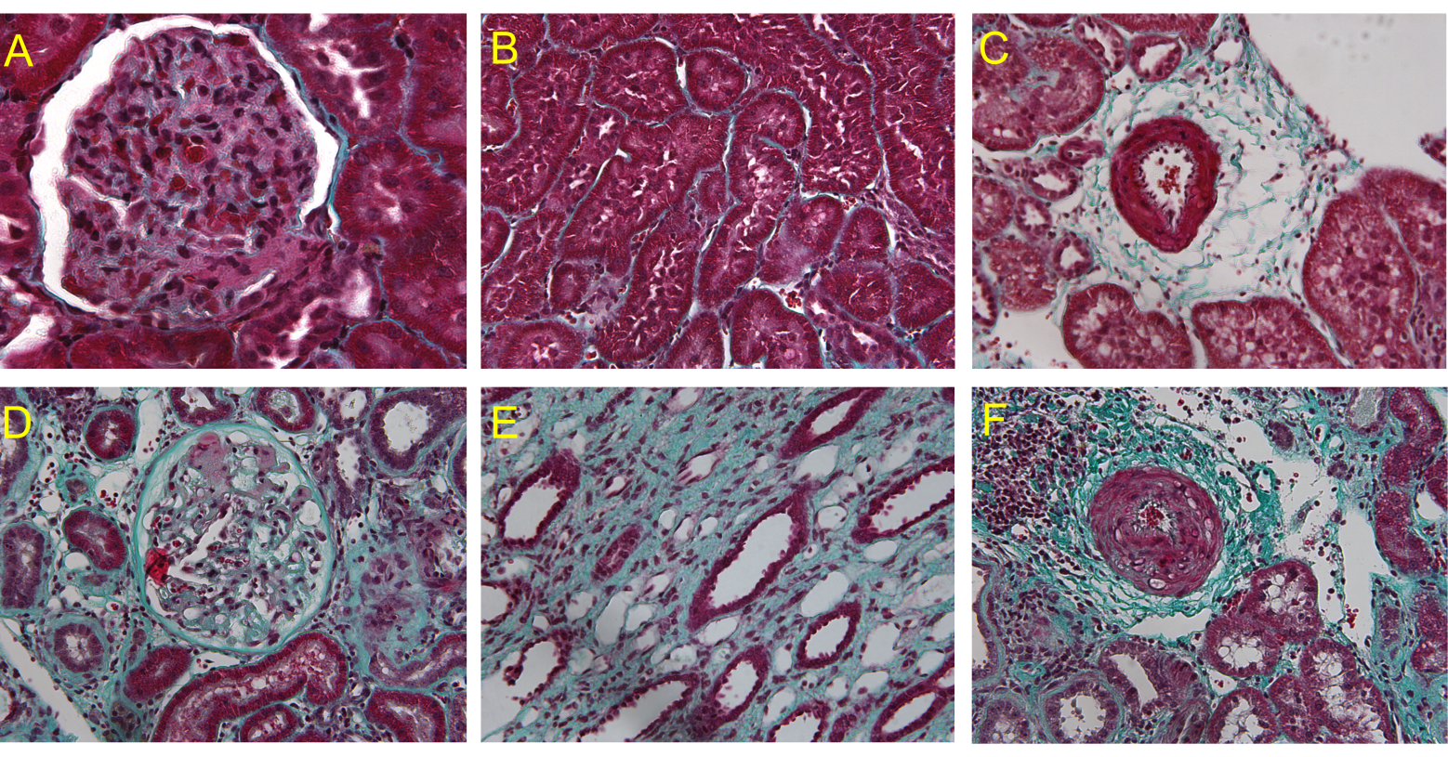
Figure 1: Histological images of glomerulus and tubules in healthy individuals and CKD patients
The figure shows tissue sections stained with Masson’s Trichrome stain. Panels A and B show healthy glomerulus (A) and healthy tubules (B). Several effects of renal fibrosis are shown in panels (C-F): they are capillary loss (C), glomerulosclerosis (D), tubulo-interstitial fibrosis (E) and inflammatory infiltration and loss of renal parenchyma (F) characterized by tubular atrophy. Figure kindly provided by Dr. Armando C Sanchez Lara (former PhD student of Academic unit of Nephrology) and reproduced by permission.

Various mechanisms are involved in the initiation of the pathological process of fibrosis in CKD (Norman, 2011):
- There is an imbalance amongst numerous growth factors, cytokines and anti-fibrotic mediators that control tissue modelling. As a result there is increased production of profibrotic factors such as Transforming growth factor- β1 (TGF-β1), Connective tissue growth factor (CTGF), Platelet-derived growth factor (PDGF), Fibroblast growth factor (FGF), osteopontin and endothelin; and a decrease in the production of anti-fibrotic factors including Hepatocyte growth factor (HGF) and Bone morphogenic protein (BMP)-7.
- There is an increased secretion of vasoconstrictors like Angiotensin II and decreased production of vasodilator such as Nitric oxide.
- The tubulointerstitum suffers from hypoxia as a result of obliteration of microvasculature and micro vascular injury.
- There is loss of epithelial cells and atrophy of tubules.
- There is an infiltration of various inflammatory cells, an increase in the number of interstitial cells (myofibroblasts), alteration in the peritubular capillaries and excessive deposition of ECM (Liu, 2004, Liu, 2010).
Glomerulosclerosis and tubulointerstitial fibrosis in CKD progress through a common pathway, regardless of the initiating factors. This pathological process in CKD has some common findings, which include; Interstitial expansion occurs as a result of infiltration of cells into interstitium and an imbalance between the increased proliferation and decreased apoptosis of native interstitial cells. Interstitial fibroblast or myofibroblast plays an important role in fibrosis, as they have the potential to cause large increases ECM levels by nature of the high levels of synthesis of ECM components such as collagens and production of inhibitors of ECM proteases such as Tissue Inhibitors of Matrix metalloproteinases (TIMPs). The myofibroblasts have multiple sources of origin. They may arise by differentiation of the native fibroblast due to growth factor of cytokine stimulation or from the infiltrating cells like bone marrow derived progenitor cells (fibrocytes), inflammatory cells (fibrocytes) and epithelial mesenchymal transdifferentiation (EMT) of tubular cells. EMT is one of the major causes of loss of tubular structure. It is also suggested that some of the interstitial cells also arise from the pericytes and endothelial cells of capillaries by endothelial-to-mesenchymal transition (Zeisberg et al., 2008).

Markers of extracellular matrix metabolism

Collagen and fibronectin
During fibrosis there is rapid expansion of the matrix that makes up the glomerular basement and tubular basement membranes. These membranes normally consist of various types of macromolecules including collagens I, III and IV, elastin, fibronectin, laminin, proteoglycans and non-collagenous glycoproteins, however the composition as well as quantity of these proteins can also change in CKD (Norman, 2011). For example excess deposition of interstitial collagens and fibronectin are mainly responsible for the expansion of renal ECM. Interstitial collagens such as types I and III are normally only present in low amounts, but are produced in excess during fibrosis replacing the normal collagen type IV. Also during fibrosis, the EDA splice variant of fibronectin appears which is normally absent in the kidney.
In a study, collagen III, IV and fibronectin were studied retrospectively in forty biopsy proven glomerulonephritis patients. The blood and urine were collected at the time of biopsy. Fifteen age matched healthy volunteers were also included in the study. They found that serum and urinary levels of collage type III and type IV were significantly different, compared to healthy volunteers but no significant differences of fibronectin between the controls and nephropathy patients. They also found that, urinary and circulating procollagen III was also strongly correlated with the degree of severity of renal interstitial fibrosis (Soylemezoglu et al., 1997). Recently, another study of a rat model found that degradation products of collagen I and III increased 9- to 100- fold relative to healthy rats and also urinary degradation markers correlate with the renal interstitial deposition of collagen type I and type III (Papasotiriou et al., 2015). Urinary collagen type IV can also be used as a marker of renal fibrosis particularly in diabetic patients (Katavetin et al., 2010, Okonogi et al., 2001, Araki et al., 2010).

Proteinases and protease inhibitors
The normal turnover of the ECM is balanced between production and degradation of ECM proteins. Two major proteolytic processes are responsible for the degradation of the matrix. These are the Matrix metalloproteinases (MMPs) and their endogenous inhibitors, the tissue inhibitors of metalloproteinases (TIMPs), and the serine proteases, especially plasmin, which is controlled via plasminogen activators (uPA and tPA) and the plasminogen activator inhibitors (PAIs) (Eddy, 2005). The roles of MMPs in fibrosis are complex, with both up and down regulation, as these are time, location and cell type dependent. MMPs also play a role in increased expression of profibrotic growth factors by cleaving and activating a variety of biological molecules, which includes cytokines and chemokines.
However, due to the complexity of the functions of MMPs, they might not be suitable biomarkers of kidney fibrosis (Genovese et al., 2014). By contrast, some protease inhibitors and activators may have value as biomarkers. TIMP-1 may have a role in increased ECM accumulation as it causes decrease MMP activity in vivo (Brew and Nagase, 2010). TIMPs affect cell proliferation, survival and differentiation and play a significant role in the process of fibrosis, which is independent of MMP inhibition. The palasminogen activators, uPA and tPA, are also seen to be increased in some models of fibrosis (Eddy, 2009). Their inhibitor, PAI-1 plays its role in fibrosis by recruiting macrophage and myofibroblast into tubulointerstitium (Eddy, 2009).

Growth factors in renal fibrosis
Several growth factors are involved in the process of fibrogenesis and could be considered as potential markers.

Transforming Growth Factor-β (TGF-β)
TGF-β is thought to be the central mediator of fibrosis. There are three isoforms of TGF-β: β1, β2 and β3. TGF-β2 and β3 have similar profibrotic effects on renal cells (Yu et al., 2003). TGF-β forms homodimers, which interact with latency-associated peptide (LAP), and to latent TGF-β-binding protein (LTBP), forming the large latent complex (LLC). Active TGF-β is released after cleavage of LLC by plasmin or matrix metalloproteinases or by binding to and activation by integrin αV (Boor and Floege, 2011). Urinary TGF-β (1) excretion was found to be significantly higher in patients with nephrotic range proteinuria compared to IgA nephropathy and healthy individuals (Goumenos et al., 2002). In another study a significant correlation was found between the glomerular TGF-β expression and severity of glomerulosclerosis (Goumenos et al., 2001). Urinary TGF-β activity can be used as a prognostic marker of crescentic nephritis (Goumenos et al., 2005).
Interestingly, the pro-fibrosis action of TGF-β in the kidney might be countered by another member of the TGF-β family, the Bone Morphogenetic Protein 7 (BMP-7). It is a morphogen essential for renal development with potent antifibrotic actions in renal fibrosis (Zeisberg et al., 2005). Boor and Floege reviewed reports that BMP-7 could reduce or even reverse renal interstitial fibrosis in various experimental models and also ameliorated renal osteodystrophy and decreased uremic vascular calcification (Boor and Floege, 2011).

Connective Tissue Growth Factor (CTGF)
CTGF is a matricellular protein of the CTGF, Cyr61 and NOV protein family. CTGF modulates and regulates signalling of other growth factors and mediates ECM-cell communication. The profibrotic actions of CTGF have been implicated in renal fibrosis (Abdel Wahab and Mason, 2004). In humans with renal fibrosis, CTGF is up regulated (Phanish et al., 2010) while CTGF inhibition significantly reduced renal fibrosis in unilateral ureteral obstruction model of CKD. CTGF potentiates TGF-β signaling (Phanish et al., 2010). CTGF binds to ECM and integrins, thereby controlling various cell functions including adhesion, migration or proliferation. The profibrotic actions of CTGF in renal fibrosis are supported by the following findings:
- In humans with renal fibrosis, CTGF is up regulated (Boor and Floege, 2011);
- CTGF inhibition significantly reduced renal fibrosis in unilateral ureter obstruction (UUO), in an animal model (remnant kidney model) (Boor and Floege, 2011) and experimental diabetic nephropathy (Riser et al., 2010);
- CTGF has also been shown to mediate the profibrotic effect of advanced glycation end products (Burns et al., 2006, Cheng et al., 2006). The effects of CTGF in renal fibrosis are similar to that of TGF-β.

Platelet derived Growth Factor (PDGF)
PDGF is believed to be the major mitogenic and activating factor for cells of mesenchymal origin and is implicated in fibrosis of different organs. PDGF-β ligands are up regulated in the fibrotic renal interstitium and it might have role in renal fibrosis (Bonner, 2004). The PDGF system comprises four chains forming five dimmers. These are PDGF-AA, -BB, -AB, -CC and –DD. One study showed that daily administration of PDGF-BB for 1 week resulted in activation and proliferation, but also apoptosis, of interstitial fibroblasts and finally in the development of fibrosis in rats (Tang et al., 1996). In another study, in progressive mesangioproliferative glomerulonephritis in rats, an early inhibition of PDGF-BB using a specific aptamer reduced the long-term sequelae including tubulointerstitial fibrosis (Ostendorf et al., 2001).

Angiotensin II
Angiotensin II has a major role in fibrosis of the kidney. It is produced locally by activated macrophages and fibroblasts and is considered to produce some of its effects by inducing NADPH (Nicotinamide adenine dinucleotide phosphate) activity, which stimulates TGFβ1 production. As a result there is increased proliferation of fibroblast, which in turn differentiate into collagen secreting myofibroblasts (Wynn, 2008). Angiotensin II also has a massive effect on the haemodynamics of the kidney by causing glomerular hypertension by constriction of the efferent arteriole of glomerulus especially in DN (Mizuiri et al., 2011). ACEI or ARB is now established treatment of HTN and also to reduce the proteinuria in DN (Brenner et al., 2001). ARB also improves cardiovascular outcome and have renoprotective effect in diabetic or hypertensive kidney disease (Deferrari et al., 2002, Schmieder et al., 2011).

Experimental markers of Oxidative stress
Oxidative stress refers to the in vivo oxidation of lipids, proteins, carbohydrates and DNA. It involves many biochemical pathways (Fassett et al., 2011), leading to many compounds being labeled as ‘biomarkers of oxidative stress’. These compounds include advanced oxidation protein products, thiobarbituric acid reactive substances, protein carbonyls, isoprostanes, protein reduced thiols, 4-hydroxy-nonenal, urinary 8-hydroxydeoxy guanosine, advanced glycation end products and oxidized low density. Oxidative stress can also be monitored by determining total antioxidant status (TAS) or assaying antioxidant enzyme activities (e.g. superoxide dismutase, glutathione peroxidase, catalase). CKD patients show evidence of oxidative stress (Oberg et al., 2004). Oxidative stress is also increased in patient on renal replacement therapy (Haemodialysis and Peritoneal dialysis) and decreased after kidney transplantation (reviewed by Tesch, 2010). The following markers of oxidative stress have been studied in urine of CKD patients:

8-hydroxy-2-deoxyguanosine
DNA repair enzymes splice oxidised guanine from cellular DNA as a result of oxidative stress. This results in the release of a metabolically stable product called 8-hydroxy-2-deoxyguanosine (8-OH-dG) into the urine. Increased level of 8-OH-dG can be detected in the urine by ELISA in CKD patients (Locatelli et al., 2003). In a study of fifty three non-dialysed hypertensive CKD patients, it was shown that serum and urinary level of 8-OH-dG were higher in patients with proteinuria greater than 3g/day than those of patients with proteinuria less than 3 g/day (Dincer et al., 2008).

Lipid peroxidation products
8(F2a)-isoprostane and 4-hydroxy-2-nonenal are formed as a result of peroxidation of lipids during oxidative stress. The level of 8-isoprostane and 4-hydroxy-2-nonenal can be measured in serum or urine by ELISA. The level of these products is increased in CKD patients (Locatelli et al., 2003, Paravicini and Touyz, 2008).

Advanced glycation end products
Advanced glycation end products (AGE) are proteins modified by oxidative stress and are associated with the development of diabetic nephropathy (Cvetkovic et al., 2009). Patients affected by type 2 diabetes complicated with nephropathy are under the condition of systemic oxidative stress. A study was conducted to evaluate this. The study enrolled three types of subjects. 21 patients (17 males, 4 females; mean age 59 years) had renal insufficiency due to suffering from type 2 diabetes without dialysis and transplantation, 10 patients (6 males, 4 females; mean age 61 years) were only suffering from type 2 diabetes and 16 healthy subjects were enrolled as controls (13 males, 3 females; mean age 59 years). AGE (Pentosidine), lipid oxidation (4-hydroxy-2-nonenal [HNE] and F2-isoprostanes) and protein oxidation (protein carbonyls [DNPH] were measured in lymphocytes, plasma and in urine as markers of systemic oxidative stress. The levels of all these markers were higher in patients suffering from diabetic nephropathy than the healthy group. A significant correlation between DNPH and the degree of renal failure in diabetic nephropathy patients were found (Calabrese et al., 2007).

Experimental markers of metabolic disorders

Fibroblast Growth Factor-23 (FGF-23)
FGF-23 is an endocrine hormone and is a primary regulator of renal phosphate excretion (Isakova et al., 2011). It is regulated by 1, 25-dihydroxyvitamin D3 and it suppresses 1α-hydroxylase activity in the proximal renal tubule. The circulating level of FGF-23 increases, as the kidney function decline (Isakova et al., 2011). Elevated FGF-23 is an independent risk factor for mortality in patients with ESKD. To evaluate this, a prospective study was performed. 3879 participants with chronic kidney disease stage 2 to 4 were enrolled in the study in between June 2003 to September 2008. During a median follow-up period of 3.5 years, 266 patients died and 410 patients reached end stage renal disease. In adjusted analysis, high level of FGF-23 was found to be an independent risk factor of death (Isakova et al., 2011). FGF-23 is associated with vascular dysfunction in the CKD patient. An elevated level of FGF-23 is an independent risk factor for mortality in patients with CKD stage 2 to 4 (Yilmaz et al., 2010). The exact cause of FGF-23 elevation in CKD is not known, but FGF-23 may rise well before the rise of serum phosphate (Tesch, 2010). Another study showed that FGF-23 levels elevated in AKI, suggesting that FGF-23 dysregulation occurs in AKI as well as CKD (Zhang et al., 2011). It has also been shown that elevated levels of FGF-23 are an independent risk factor for death and allograft loss in kidney transplant recipients (Wolf et al., 2011). Recently, in a study of paediatric population showed that plasma FGF-23 was significantly increased in CKD population compared to controls (Sawires et al., 2015).FGF-23 was found to be significantly increased in a study of 150patients with CKD stages 3 to 5 comparing to healthy controls (Zhang et al., 2015).Higher baseline FGF-23 is also associated with the development of incident ESRD irrespective of the baseline level of kidney function (Rebholz et al., 2015). All these recent findings suggest that FGF-23 is becoming a powerful biomarker of CKD.

Apolipoprotein A-IV
Apolipoprotein A-IV is a glycoprotein involved in cholesterol transport and is increased in the early stages of CKD as well as ESKD (Kronenberg et al., 2002). Apolipoprotein A-IV concentration is a novel independent predictor of progression of CKD. To evaluate this, Boes et al conducted a prospective study in 177 patients, who had mostly mild to moderate renal insufficiency and were followed up prospectively for up to 7 years and found that baseline GFR and serum apolioprotein A-IV concentration could significantly predict the progression of the disease. The study also showed that patients who had apolipoprotein above the median had a significant faster progression than who had below the median, compared to a mean follow up period of 53.7 months (Boes et al., 2006).

Can New Biomarkers Fill the Void?
Table 4 lists all the experimental (or candidate) biomarkers described above. Some of these experimental biomarkers appear promising, but most of them have limiting factors or the data is on very limited populations. For example KIM-1 is certainly a good marker of AKI but its role as a marker of CKD is less well established. MCP-1 is a good marker of acute inflammation, but its role in CKD needs to be far more fully evaluated in different types of CKD in prospective studies. Some markers are good predictors of diabetic kidney disease (Apolipoprotein A-IV and adiponectin), but their role in non-diabetic CKD again needs to be validated. Some biomarkers have shown good prediction for CKD outcome, but as has been described in previous sections, their uses are limited by other disease conditions (e.g. cystatin-C in thyroid disorder, inflammation, diabetes and obesity). Some biomarkers are produced by multiple organs (NGAL, GGT), so, are not specific to kidney disease.
Quite clearly therefore, much work is underway to try and improve the tools available to detect CKD early, predict outcomes better, provide additional diagnostic information and are more robust. However all the current and experimental markers listed above have limitations and do not give 100% certainty in predicting outcome. There is, therefore, an on-going need to identify additional urine biomarkers that can be subsequently evaluated in patient cohorts.

Table 4: Candidate kidney disease biomarkers
Pathophysiological Process | Biomarkers
Kidney Function (GFR) | β-Trace protein
Tubulointerstitial injury | Neutrophil Gelatinase-associated lipocalin (NGAL)  Kidney Injury Molecule-1 (KIM-1)  N-acetyl-β-0-glucosaminidase(NAG)  Liver-type fatty acid-binding protein (L-FABP)  γ –glutamyltransferase (GGT)
Glomerular injury | Podocin  Nephrin  Podocalyxin
Inflammation | Immunoglobulins,  Complement factors,  Chemokines (MCP-1 and IL-8)  Cytokines (leptin and adiponectin  C-reactive protein (CRP) and high-sensitivity-CRP (hs-CRP)  Pentraxin 3 (PTX3)  Soluble Tumor Necrosis Factor Receptor (sTNFrii)  Interleukin-18 (IL-18),  Tenascin  Tissue Inhibitor of Metalloproteinases-1 (TIMP-1)
Fibrosis and scarring | Collagen and derived peptides  Fibronectin  Protease activators and inhibitors  CTGF, PDGF and Angiotensin
Oxidative stress | Total antioxidant status (TAS)  Antioxidant enzyme activities  8-hydroxy-2-deoxyguanosine (DNA oxidation product)  Lipid peroxidation products  Advanced glycation end products (AGE)  Lpid oxidation products  Protein oxidation products
Metabolic disorders | Fibroblast Growth Factor-23 (FGF-23)  Apolipoprotein A-IV (ApoA-IV)

All the serum and urinary biomarkers of CKD discussed in this section of the thesis are listed. They are grouped according to the different pathophysiological processes of the disease. See main text for details. A different version of this table that uses different groupings and mentions additional possible markers can be found in the review of Tesch (2010).

Use of proteomics approaches for identifying new biomarkers

General background
Mass spectrometry proteomics approaches provide powerful tools in this search with the ability to compare whole proteome profiles between individual samples or pools of samples. This approach has developed dramatically in recent years, resulting in the publication of a huge number of reports (Lv et al., 2015, Gu et al., 2014, Mischak, 2015, Bantscheff et al., 2007, Bantscheff et al., 2012).
Proteomics is a term which describes the ‘protein complement of a cell or tissue type’, which refers to all the proteins (including isoforms) expressed by a genome. Proteomics involves the identification of proteins in body compartment and the determination of their role in physiological and pathophysiological functions.
The term proteomics was coined by Marc Wilkins, who defined it as “the study of proteins, how they are modified, when and where they are expressed, how they are involved in metabolic pathways and how they interact with one another.” (Wilkins et al., 1996).
In the search for biomarkers, to identify potential candidates in the first instance, the best approach is to try and compare the protein profile in readily available material such as urine or blood, between those patients developing the condition a marker is required for, against a suitable control (that what it needs to be distinguished from) and highlight differences. Once candidates are identified classical evaluation of these can be undertaken using methodologies suitable for clinical laboratories, like nephelometry (used to measure albumin in urine) or assay of specific proteins by ELISA.
Urine is considered as a good option for proteomics analysis because urine can be collected easily without medically trained person, urine is stored in the bladder for considerable amount of time, sufficient to be allowed to proteolyse by the endogenous protease, urinary proteomes do not change significantly for 3 days at 4°C or 6 hours at room temperature, urine can be stored at -20°C without significant change in its proteome for several days and urine may provide information about the organ that comes in direct contact with it like kidney, bladder and other vascular system (Mischak et al., 2009).
Urine proteomics analysis in most cases can replace the invasive diagnostic test (biopsy) and in recent future it will be able to completely replace the biopsy (Mischak, 2015). In contrast to immunology-based assays, which only detect well known proteins for which antibodies are commercially available, proteomics approaches can detect any protein provided it is present in amounts commensurate with detection sensitivity.
Urine proteomics has been used in several studies for the diagnosis of CKD and these studies identified a large number of urinary proteins ranging from 250 to 2,500 (Muntel et al., 2015). Urine proteomics has been successfully employed for the diagnosis of glomerulonephritis (Good et al., 2010), diabetic nephropathy (Zurbig et al., 2012) hypertensive CKD (Ovrehus et al., 2015), renal cell carcinoma (Urquidi et al., 2012) and allograft rejection (Clarke et al., 2003). A urinary proteomics based classifier has been developed based on the analysis of samples from 3,600 individuals of the naturally occurring human urinary peptides or proteins, known as CKD273. Currently, the database contains 5,010 relevant unique peptides, which can be used as pool for the potential diagnosis and monitoring of various diseases (Good et al., 2010). The CKD273 classifier had been successfully investigated for the prognosis of CKD progression in an independent cohort of 76 CKD patients (Argiles et al., 2013).
A recent study of CKD stages 4 and 5 patients (8 glomerulonephritis/ diabetic nephropathy, 6 HTN patients and 4 miscellaneous patients) and 17 healthy controls, diagnosed using the urinary CKD 273 classification score, found that urinary proteomics improved the diagnostic accuracy over albuminuria (Ovrehus et al., 2015).
So, urinary proteomics is becoming a powerful tool for the identification biomarkers of CKD progression.

Justification and objectives for the project

Knowledge gap
In conclusion there are a dearth of suitable biomarkers used clinically to predict outcome and rate of progression in chronic kidney disease. There are numerous experimental markers of kidney damage, oxidative stress and inflammation that show some promise in improving this situation, but they are far from proven and while data shows some may be superior to what we already use clinically, none fully satisfy the needs of a biomarker of CKD progression and outcome. It is highly likely that there are other proteins in urine which can be used to differentiate the patients with progressive and stable CKD. These new markers could include in particular proteins that are active participants in the disease mechanisms or directly produced as a result of disease processes, such as cytokines or enzymes.

We believe that analysis of urine samples using commercially available multiplex cytokine immuno-assays can easily be used to tease out these proteins in the first instance. A second possible approach, more technically challenging, would be analysing the proteomes of patients’ urine by mass spectrometry-based techniques.

Aims
We therefore propose the hypothesis that “there are unidentified proteins in urine that can predict the better progression of CKD than conventional clinical method.”

The overall aims of this PhD study are to test the above hypothesis by:
- Collecting urine samples from a large cohort of patients with different CKD stages, rates of progression and aetiology and track patient outcomes over a three-year follow-up period.
- Grouping these samples by aetiology and then sub-grouping by rate of progression and albuminuria.
- Carrying out exploratory searches for possible new candidate markers on a small subset of samples. These searches will use two different approaches to analyse urine proteomes:
- Array-based immunological assays (Proteome Profiler Arrays)
- Quantitative mass-spectrometry (iTRAQ)
- Performing ELISA assays on all urine samples for candidate markers identified through reviews of the existing literature (KIM-1, MCP-1 and NGAL) or through the proteome explorations mentioned above.
- Determining the predictive potential of the selected candidate markers through statistical analyses of the ELISA results.

General Methodology

Study design, Research Governance and Ethics
This study was designed by Professor Tim Johnson (then at the University of Sheffield). This was a prospective follow-up study of a population of adult patients with CKD due to various causes. These patients were referred to Sheffield Kidney Institute (SKI) at the Northern General Hospital, NHS Foundation Trust (Sheffield, UK). It is the only tertiary referral centre that provides comprehensive renal service to the North Trent region of England with a population base of approximately 1.6 million. The patients were followed up for three years.
The study was conducted in line with the Declaration of Helsinki for health care research in humans, the international conference on harmonisation and the good clinical practice guidelines (ICH-GCP) of the European Union (EU). The ethical application to the National Research Ethics Committee (reference No 12/YH/0297) was written by Professor Tim Johnson and Dr. Nagi Altemtam (Department of Academic Nephrology Unit). It was first approved with authorisation No STH15020, then renewed in 2013 (authorisation No STH16448) by the North Sheffield ethics committee and hosting organisations (Sheffield teaching hospital NHS Trust). The study provided each participant with patient information sheet, and informed written consent before inclusion, and before any research, related procedures were carried out. Each participant was given enough time to go through the patient information sheet (see Appendix III) before deciding about their participation in the study. The research was also subjected to the research office monitoring and scrutiny during the 3 years of the study periods. The confidentiality and privacy of the study data were maintained.
The letter confirming renewal of ethical authorisation, patient information sheets, consent form and letter informing the participant’s GP are attached in the Appendix.

Patient recruitment, clinical assessment and control group

Chronic kidney disease patients
A total of 277 adult patients of various stages of CKD (according to KDOQI classifications) were recruited from patients attending the renal outpatient clinic at SKI for routine check-up visits by two previous PhD students (Dr. Nagi Altemtam and Dr. Michelle Da Silva Lodge) as part of an ongoing research study. Samples collected at CKD stage 5 were excluded in order to better test predictive ability. This leaves us with 262 disease samples.

Clinical assessment
A detailed medical history of all participants was obtained from the treating physicians according to the standard protocol. The medical history included recording of demographic data (full name, age, race and history of smoking and all concomitant medications). The history of any angina chest pain or any previous history of ischemic heart disease or any cardiac procedures were obtained, besides checking the medical notes. For diabetic retinopathy, the patients were asked about any previous sight problem or any laser treatment as well as by checking medical notes and the unit’s electronic database. Vital signs were measured and recorded & blood samples were taken for routine laboratory investigations. Finally, a fresh mid stream urine sample was collected from each participant. A urine sample was analysed by dipstick analysis for blood, protein, leukocyte esterase, nitrate and glucose. The sample was also sent to the NGH clinical chemistry laboratory for albumin, protein and creatinine measurements.

Control group
Forty-seven apparently healthy subjects with no history of DM, hypertension, CKD or any other chronic illnesses recruited from the SKI research laboratory staff constituted the control group in this study. Each participant was provided with a patient information sheet and a mid stream urine sample collected after taking a written informed consent. Mid-stream urine samples were collected from normal volunteers.

Sample collection, clinical markers determination and database

Urine collection and processing
This was mostly carried out by Drs Nagi Altemtam and Michelle Da Silva Lodge (Academic Nephrology Unit, University of Sheffield), but I also collected some of the control samples. Mid-stream urine (MSU) samples ~ 200 ml were collected from all study participants in sterile containers without adding any protease inhibitors and placed immediately on ice. The samples were processed as soon as possible after the collection at the renal research laboratory, Northern General Hospital. Each 200 ml urine sample was split in to two aliquots; the first 100 ml was placed into a 175 ml conical tip centrifuge tube and centrifuged for 10 minutes at 2000 g to pellet and thus remove cells and cellular debris. The resulting supernatant from was removed and aliquot into 4 x 20ml samples in universal tubes and 2 x 10ml microfuge tubes to avoid protein degradation by freeze/thawing. These constitute the cell free urine (CFU) collection. All tubes were labelled and stored at –80ºC. The remaining urine was also aliquoted into 4 x 20 ml samples and 2 x 10 ml in microfuge tubes. These constitute the complete urine (CU) collection. Again, all the tubes were labelled and stored at -80ºC freezer without further processing.

Determination of proteinuria and albuminuria
One problem with measuring the albumin concentration alone or estimating it with sensitive dipsticks is that the false positive and false negative results can occur since the albumin concentration is also determined by the urine volume. This can be avoided by calculation of the ACR in an untimed urine specimen. Using the ACR is recommended as the preferred screening strategy for all diabetic patients.
The clinical laboratory of the Northern General Hospital measured urine albumin and creatinine levels. Albumin was assayed using nephelometry (Dade-Behring instrument) and urine creatinine was measured using a standardised kinetic Jaffe method. Spot urine ACRs and protein creatinine ratios (PCRs) were calculated for all subjects. The ACR cut-off, according to recommended standard guideline values was used to define the level of albuminuria (Levey et al., 2007). Accordingly, patients were divided in to 3 subgroups; normoalbuminuria (ACR < 2.5 mg/mmol for males and < 3.5 mg/mmol for females), microalbuminiuria (ACR > 2.5 mg/mmol for males; > 3.5 for females and up to 30 mg/mmol) and macroalbuminuria (> 30 mg/mmol).

Sample Bio-repository and database
All urine samples were stored in a dedicated racked at -80ºC freezer. The freezer had an inbuilt temperature display with 24 hour temperature monitoring and alarm facilities to make sure that an average temperature of -80ºC was maintained.
All demographic, clinical and biochemical parameters were collected from the unit’s electronic database and stored into an anonymised bio-repository database established at the SKI to provide catalogued storage of biological material for this and future biomarker studies. This Microsoft Access database generates unique sample codes and storage location coordinates using the patient number to link subsequent samples from the same patient and be capable of storing demographic, biochemical and epidemiological information. The database is stored on a designated University secure server with access by the investigators only from onsite PCs.
The details of each participant were entered into the database as illustrated in the Figure 2 (p. 41) and Figure 3 (p. 42). Finally, up to 10 measurements of eGFR and serum creatinine taken during the follow-up were also recorded in to this database. This allowed the assessment of the progression status of the study populations. When needed, patients’ NHS medical notes were also accessed to obtain data missing from the SKI database for some patients.

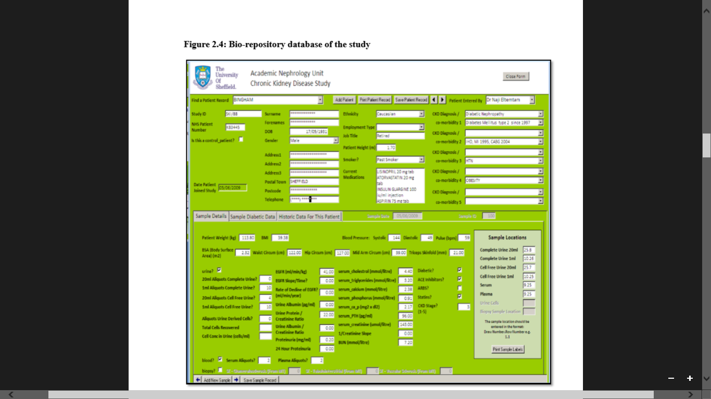

Figure 2: Bio-repository database: Patient history
The patients’ demographic details, clinical parameters, past medical history were stored into an anonymised CKD bio-repository database. Urine and serum samples locations into the -80ºC freezers were also indicated

.
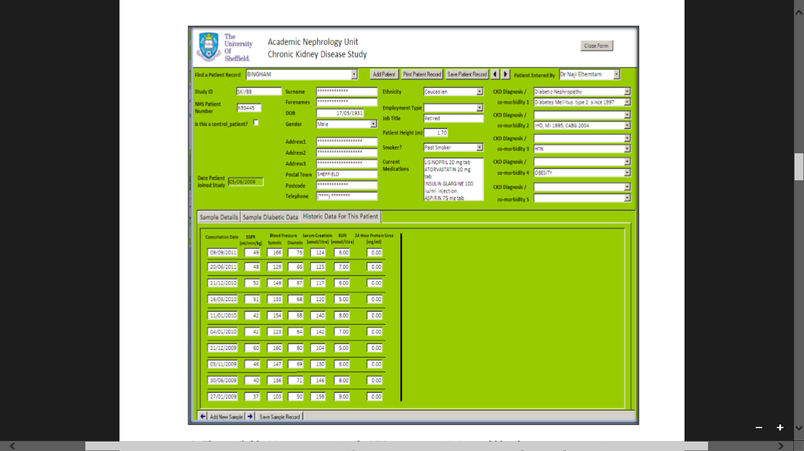

Figure 3: Bio-repository database: results of various clinical parameters
The available 10 measurements of eGFR, serum creatinine and blood pressure parameters during follow-up period were recorded into an anonymised CKD bio-repository database.

Data management and protection
Participant information was kept strictly confidential. All researchers involved in the study respected the participants’ rights to information, confidentiality and privacy. The administration documents were marked with unique identifiers, and no names of participants were recorded on them. Information linking identifiers to names was kept separate from the rest of the data. Access to these data was protected by the Data Protection Act 1998 and was only accessible to the investigators. Moreover, all data items were coded and entered into a database using the SPSS statistical package version 20. Finally, all data entered were verified to ensure accuracy, using range and consistency checks before analysis.

Determination of causes, stages of disease, progression status and outcomes
These 4 types of data were crucial for analysis of results and planning of the proteomics work.

Assessment of cause, stage of disease and outcome
The causes of CKD of every patient were obtained from the Bio-repository database.
The staging (or classification) of the patients was first done based on the eGFR at the beginning of the study from the bio-repository and was revised at the end of the follow-up period (up to 3 years) from the NHS patient records database.
The criteria used for staging are described in section 1.2.2, p.2 (KDIGO, 2013).
The outcomes of the patients were obtained from the NHS patient records database at the end of the follow-up period.

Assessment of CKD progression status
The progression of CKD was evaluated by rate of eGFR decline, as calculated by using the MDRD study equation version 4 (Levey et al., 1999). The rate of eGFR decline per year was used to assess the progression of CKD and calculated by the difference in eGFR (ml/min/1.73m²) at presentation and the last available reading:
(Last eGFR – Baseline eGFR) / Follow-up period in year.
The eGFR fall per year (ml/min/1.73 m²/year) for all patients was used to identify their CKD progression status as follow:
- Progressors: patients with eGFR decline> 2 ml/min/1.73m²/year.
- Non-progressors, stable patients or regressors: patients whose eGFR declined ≤ 2ml/min/1.73 m²/year.
The progressors group included patients with a rate of eGFR decline > 2ml/min/year, this criterion was selected based on a considered average age-related decline of ~-1ml/min/year (Rosansky and Glassock, 2014)and considering variation in serum creatinine measurement. In clinical practice, definitions of progressors and non-progressors depend on the clinical situation. Disease progression was also evaluated based on the slope pattern of eGFR change (ml/min/1.73m²/year) for each patient throughout the entire follow-up period (at least three measurements) by regression coefficient analysis using all calculated eGFR values (Jones et al., 2006). Accordingly, patients were categorised into two groups:
- Progressors (slope significantly negative and decline > 2ml/min/year).
- Stable or non-progressors or regressors (If the slope is neutral i.e. with a decline rate between +2 and -2 or improvement in eGFR).
In theory, the problem of huge eGFR swings or fluctuations during the observational period could be overcome by the slope method and regression coefficient, compared to eGFR average over duration. These measure were taken in order to minimise contribution of some age-related borderline progressors to the non-progressors group. The GFR slope over time would be more indicative of the pattern of progression and possibility of non-linear progression needs to be considered. The annualised rate of eGFR loss was selected, as it is easier for practicing nephrologists to use. The concordance between the two methods also gave credence and validity to our cut-off choice of >-2ml/min/year as a definition for progressors.

Composition of patient cohort used for ELISA assays of candidate markers

Composition of whole cohort
Samples collected from patients that were already at CKD stage 5 at the time of collection were excluded from analyses in order to better test predictive ability. This left us with samples from 262 patients and 47 controls.
The distributions of the different causes, final stages, outcomes and progression status in this cohort of 262 patients were as shown in the following tables:

Table 5: Distribution of the number of samples by cause of CKD.
DM (Diabetic) | CGN  (Chronic glomerular nephritis) | HTN  (Hypertension) | ADPKD  (Autosomal dominant polycystic kidney disease) | Others
103 | 54 | 45 | 11 | 49

Table 6: Distribution of the number of samples by stage reached at the end of the study period.
CKD-1 | CKD-2 | CKD-3a | CKD-3b | CKD-4 | CKD-5
12 | 22 | 39 | 58 | 81 | 50

Table 7: Distribution of the samples by progression.
Non-progressors  (eGFR decline ≤ 2ml/min/1.73m²/year) | Progressors  (eGFR decline >2 ml/min/1.73m²/year)
170 | 92

Table 8: Distribution of the number of samples by disease outcome (3 years).
Discharged | Outpatient | Dialysis | Dead
84 | 124 | 33 | 21

Composition of subgroups
In addition to the analysis of the ELISA data at the level of the whole cohort, some statistical analyses were also done on three separate subgroups corresponding to the three causes of CKD most represented in our sample collection (DM, CGN and HTN).
No sub-group analysis was done on ADPKD samples because there were not enough of them to have enough statistical power. No subgroup analysis was done on “others” because they correspond to a mix of various causes.
The distribution of the final stages, progression status and outcomes within the DM, CGN and HTN sub-groups are shown in the following table.

Table 9: Distribution of the samples in the three main subgroups.
 | DM | CGN | HTN
CKD-1 | 0 | 9 | 0
CKD-2 | 7 | 5 | 0
CKD-3a | 14 | 14 | 8
CKD-3b | 24 | 11 | 12
CKD-4 | 34 | 9 | 13
CKD-5 | 24 | 6 | 12
Non-progressors | 74 | 28 | 29
Progressors | 29 | 26 | 16
Discharged | 38 | 10 | 19
Outpatients | 34 | 39 | 15
Dialysis | 17 | 3 | 8
Dead | 14 | 2 | 3

Protein concentration assays
Two different protein assay procedures were used in this project: the pierce protein assay (which uses a protein binding dye) and NanoDrop spectrophotometry.

Pierce Protein Assay
The Pierce protein assay (purchased from Thermo Scientific, Cat. No 22660) was used to assay protein concentration in raw urine sample. It can detect protein concentration ranging from ~ 0.4 to 5 mg/ml and is detergent and reducing agent-compatible. The assay measures the binding of a proprietary dye-metal complex to proteins in acidic conditions. The free dye-metal complex is reddish-brown but upon protein binding changes to green (absorption maximum at 660nm). The colour change is produced by deprotonation of the dye at low pH facilitated by interactions with positively charged amino acid groups in proteins. Therefore, the dye interacts mainly with basic residues in proteins, such as histidine, arginine and lysine and to a lesser extent tyrosine, tryptophan and phenylalanine.

Procedure
A 50 µg /ml standard was prepared by mixing 10 µl of a 1mg/ ml BSA standard with 190 µl of 0.9% saline and 0.05% of sodium azide. 10 µl of each replicate of standard or sample and the appropriate blank sample was pipette into a micro plate well. 150µl of the Pierce Protein Assay Reagent was added to each well, the plate covered and mixed on a plate shaker (Stuart, Geneflow, microtitre plate shaker, SSM5) at 300RPM speed for 1 minute before incubating at room temperature for 5 minutes. Blank wells were used zero to the plate reader and absorbance was then measured at 660 nm on Lab systems Multiskan Ascent V1.24 micro plate reader with curve analysis and concentration determined using the Ascent software (Thermo lab system, version 2.6). An example of standard curve is shown in Figure 4.

Figure 4: Typical standard curve for the Pierce protein assay
A typical standard curve obtained by assaying BSA standard solutions in water is shown. The graph was generated automatically by the computer software (Lab system Multiskan Ascent V I.24). Concentrations are in mg/ml (x axis). The y axis shows optical density at 660 nm.

The Pierce Protein assay is compatible with most of the commonly used detergents and reducing agents. It is also stable in room temperature. However, the Pierce 660 nm Protein Assay can only quantify peptides that are at least 2,500 Da if their compositions include the amino acid residues that react with the dye-metal.

As Figure 5 illustrates some buffers, such as the TEAB buffer in which the isobaric labelling of samples for iTRAQ takes place, interfere with the Pierce protein assay. So we used a second method, spectrophotometry, to measure the protein concentrations in processed samples containing TEAB buffer.

Figure 5: Failure of the Pierce assay in the TEAB buffer
The results obtained when assaying BSA in TEAB buffer is shown. The concentrations of BSA used for these assays are the same as on Figure 4. The graph generated automatically by the computer software (Lab system Multiskan Ascent V I.24). Concentrations are in mg/ml (x axis). The y axis shows optical density of 660 nm. Note the different scales for the y axes on this Figure and Figure 4.

NanoDrop spectrophotometry
The NanoDrop is a spectrophotometer that can measure protein concentrations from a sample of 0.5 µl to 2 µl. It can measure very concentrated sample without dilution. To have an accurate measurement the sample should be free from interfering UV absorbing components.
The NanoDrop was used to determine protein concentrations at the later stages of the processing of samples for iTRAQ, that is, after the pooled ProteoMiner eluates had been buffer exchanged with TEAB. At that point, the samples could be measured with NanoDrop because they were free from interfering elements present in unprocessed urine like nucleic acids, glycogen, phenols, acetate and salts.
The sample is placed in between two optical fibres and a pulsed xenon flash lamp acts as a light source. The spectrometer utilizes a linear CCD (charge-coupled device) array that analyses the light passing through the sample. The instrument is controlled by the computer software ND-1000 (Thermo Scientific).

Procedure
The sampling arm was raised and the sample was pipette onto the lower measurement pedestal. Then the sampling arm was lowered and brought into contact with the liquid. Thus a bridge was formed in between the two optic fibres. Then the protein was measured using the computer software at 230 and 280 nm (Figure 6) and average of the two results was taken. After completion of the measurement, the sampling arm was raised and wiped the sample from both upper and lower pedestal.

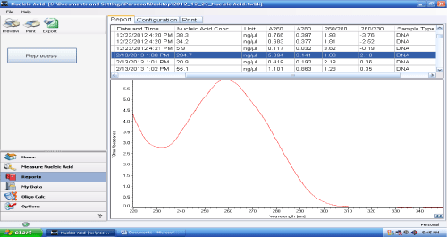
Figure 6: Measurement of protein from a sample using NanoDrop software
Screen capture from the computer controlling the NanoDrop showing the information obtained in a singe assay. The graph shows the absorbance spectrum of the sample for wavelengths ranging from 220 to 340 nm (X axis). Absorbance is on the Y axis. The table above the graph shows absorbance values recorded for several samples (rows) at several specific wavelengths (columns).

Concentration of individual or pooled urine samples
A volume of sample containing 20 mg of protein was loaded on to a Millipore centrifugal concentrator (Millipore Amicon Ultra centrifugal filters, 15 ml, regenerated cellulose 3,000 MWCO filter (Cat. No UFC 900 324) and spun at 4,000 x g for at least 1 hour, or until the sample concentrated down to < 500 µL. If the initial volume to be loaded exceeds capacity (maximum 15 ml), the first 15 ml of sample was run for 1 hour, then the next 15 ml was added and spun for another hour until the whole volume was processed using sequential loading.
After concentration was completed, the volume of the concentrated sample was determined and the protein concentration measured. In concentrated urine, the concentration of the protein was usually higher than the 5 mg/ml upper limit of the assay detection range. So, a small sample of the concentrated urine was diluted (10 fold) for the Pierce protein assay. The measurements showed that there was no significant loss of protein during the concentration. On average the total amount of protein in concentrated urine preparations was 1.01 ± 0.43 times the amount that had been loaded on the concentrator (n=39); the reason for the relatively large SD is because the protein concentration of unprocessed urine was often near or less than the lower limit of the assay detection range (0.4 mg/ml), which limited the precision of measurement in unprocessed urine.

Proteome Profiler immunological assays (Antibody arrays)
The Proteome Profiler array from R & D System was used to assess levels of various cytokines, chemokines and angiogenesis markers in small pools of urine samples to identify potential candidate markers. It is an immunological assay for detecting differences between concentrations of sets of specific proteins between samples. We used the Human Cytokine Array Panel A (Cat. No. ARY005) and the Human Angiogenesis Array (Cat. No. ARY007), which determine the relative levels of 36 human cytokines and 55 angiogenesis-related protein markers, respectively.
The lists of the proteins detected by the two arrays and their coordinates on the array membranes are in Tables 36 and 37, pp. 228 - 229.

Principle of the assay
The arrays are nitrocellulose membranes onto which capture antibodies have been spotted in duplicate at known positions (features). Samples are mixed with a cocktail of biotinylated detection antibodies and incubated for 1 hour. Then the sample-detection antibodies mix was added to the membrane and incubated for overnight at 4°C. After that, the membrane was washed to remove unbound material. To detect the spots Streptavidin-HRP and chemiluminescent detection reagents were added subsequently. The amount of light produced at each spot was proportionate to the amount of analyte bound at each spot.

Preparation of sample pools
For each disease, two pools of samples corresponding to progressors and non-progressors were compared. The patients in each pool were best matched according to sex, ethnicity and age. The amount of each sample corresponded to 1 mg of protein and the sizes of the progressor and non-progressor pools were the same. The pool sizes were 4 patients in each group for hypertension, 6 for CGN and 10 for diabetic. Each pool was then concentrated down to 5ml by centrifugation. The concentrations of the pools were then determined by the Pierce Protein assay (the protein concentration of the samples was 7mg/ml for the DM progressor pool, 6.5mg/ml for DM non-progressor, 7mg/ml for CGN progressor, 5mg/ml for CGN non-progressor, 4mg/ml for HTN progressor and 4 mg/ml for HTN non-progressor).

Reagent preparation
All reagents were freshly prepared according to the manufacturer’s instructions and brought to room temperature before use. When crystals had formed in the concentrate, bottles were mixed gently until the crystals have thoroughly dissolved. Membranes were handled only with gloved hands and flat-tipped tweezers.
The detection antibody cocktail containing biotinylated antibodies were reconstituted with 100 µl of deionized water before use.
Chemi Reagent 1 and 2 were then mixed in equal volumes within 15 minutes of use. 1 ml of the resultant mixture was required per membrane.

Array procedure

Blocking of array membranes
2 ml of Array buffer 4 for cytokine array and Array buffer 7 for angiogenesis was pipetted into each well of the 4 Well Multi-dish. Array buffers 4 and 7 served as a block buffer for cytokine array and angiogenesis array respectively. Each membrane was removed from the protective sheets and placed in a well of the 4-well multi dish with the labelled side facing upwards and incubated for one hour in a rocking platform shaker.

Incubation of samples with antibody cocktails
While the membranes were blocking, the samples were prepared by adding up to 1 ml of each pool to 0.5ml of Array buffer 4. The volume of each sample was then adjusted to a final volume of 1.5 ml with Array buffer 5 as necessary. 15 µl of reconstituted detection antibody cocktail was added to each prepared sample. The reaction mixes were incubated for 1 hour.

Capture of antigen-antibody complexes on the membranes
The sample-antibody mixes were then added to the blocked membranes and the 4 well multi-dish was incubated at 4° C on a rocking platform overnight. After incubation, each membrane was removed from the well carefully and placed in a individual plastic container and washed with 20 ml of wash buffer for 10 minutes and then rinsed with distilled water and dry thoroughly; this was repeated for two more times.

Detection
A solution of Streptavidin-coupled horseradish peroxidase (HRP) was diluted in array buffer 5 as recommended by the manufacturer and 2 ml of this dilution was added to each well of the 4-well multi-dish. The membrane was returned to the 4-well multi dish containing the Streptavidin-HRP and incubated for 30 minutes at room temperature on a rocking platform shaker. Then the membranes were washed again as described above. After the wash, excess buffer was allowed to drain from the membrane by blotting the lower edge on to paper towels. Each membrane was then placed on the bottom sheet of the plastic sheet protector with identification number facing up. 1 ml of prepared Chemi Reagent mix was pipette onto each membrane and mixed evenly and then carefully covered with a plastic sheet protector. Care was taken to spread evenly the Chemi Reagent Mix and smooth out any air bubbles. After a 1-minute incubation, the cover sheets were removed and luminescence was imaged digitally in the ChemiDOC imaging system (Bio-Rad). Membranes were exposed for 10 minutes or until optimal exposure is obtained, as indicated by the ChemiDoc display.

Array imaging and quantification of data
The luminescent spots visible on the ChemiDoc images were identified by placing the transparency overlay template on the array image and aligning it with the pairs of reference spots in three corners of each array. To ensure that the orientation of the membrane matched that of the template, the stamped identification number on the array was placed on the left hand side. Pixel densities of the developed image were analysed using the Image lab software (Bio-Rad). Signal values were exported to a Microsoft Excel spreadsheet file for analysis. The average of the pixel density of the pair of duplicate spots was determined and subtracted from the average of four background measurements for each membrane (signals from clear areas of the array were used as to obtain these background values). The average value of each spot was corrected / normalised according to the percentage of the average reference spots of each membrane. Then the relative changes in the cytokine/angiogenesis levels between the samples were compared by the corresponding signals on different arrays.

Array data analysis by Sequentially Rejective Multiple Test Procedure

Background
From a statistical point of view, the comparisons of the levels of many candidate markers between non-progressor and progressor sample pools using the R&D arrays corresponds to a multiple test problem. The array data tests as many hypotheses as there are candidate markers on the array membrane. For each marker, the null hypothesis is that the value measured in the progressors sample pool is not significantly different from the non-progressors.
This creates a problem when assessing the significance value of each “discovery”, or rejection of the null, which Holm (Holm, 1979) expressed as follows:
“If we want to make our 'discoveries' in form of rejected null hypotheses to be safely claimed, we must keep the probability of rejecting any true null hypotheses small, how many and which the true hypotheses may be.” (Holm, 1979).
We thus used the sequentially rejective multiple test procedure described by Homs to solve this problem. It is a variation on the Bonferroni technique but uses different level of significance for each hypothesis (marker), depending on the importance of the hypothesis. The procedure thus involves ranking the markers in order of importance, which is determined by the method described below.

Test procedure
First, two parameters called t-value and P-value are calculatedfor each hypothesis (marker).
The t-value assesses whether the difference observed between progressors and non-progressor is greater than the observation error. It is determined by the formula
$$t=|\frac{P-NP}{SE}|$$
where P and NP are the mean values measured in the progressors and non-progressors and SE is the standard error of these values, determined by the formula
$$SE= \sqrt{a^{2}+b^{2}}$$
in which a and b are the standard deviations of P and NP.
The P-value, which is used to rank the hypotheses or markers, is calculated using t2 distribution. We determined it using the Microsoft Excel function TDIST(t,2,2), where t is the t-value for the same marker and 2 and 2 are values set for degrees of freedom and number of tails.
Next, the markers are ranked by increasing P-values, that is, in order of decreasing importance (the smallest P-values corresponding to the most important hypotheses). We then determine the corresponding Holm-corrected test value by the formula
$$h=\frac{0.05}{rank+1}$$
Thus, for example, h = 0.025 for the most important hypothesis (smallest P-value), 0.0166… for the second most important and so on.
Finally, the P-value is compared to h. If the P-value is greater than h, the null hypothesis for this marker is considered rejected.

Assays of candidate markers by ELISA
The Enzyme Linked Immunosorbent Assay (ELISA) is one of the most convenient and accurate methods to determine the level of a specific protein/ antigen in a liquid sample. Its main limitation is that it is dependent on the availability of antibodies able to specifically recognise the target with minimal cross-reactivity, which could be a source of false positives.
The human urine samples were assayed for seven different proteins using the commercial 'sandwich' enzyme immunoassay, the ELISA DuoSet from R & D System.

Principle of the assay
The biomarkers were measured in urine using the ELISA DuoSet assays from R & D System. The catalogue numbers of the assays used were DY1750 (for KIM-1), DY279 (MCP-1), DY1757 (NGAL), DY398 (leptin), DY1164 (CXCL-16), DY1180 (DPP-IV) and DY208 (IL-8). These assays are based on a quantitative sandwich enzyme immunoassay technique.
They are carried out in 96-well microplates coated with the capture antibody against the protein to be measured. Standard or samples are then added to the wells. After incubation, the samples are removed, the plate is washed and the secondary antibody is added to the plate. An antibody-antigen-biotinylated antibody sandwich complex was formed. For detection streptavidin peroxidase conjugate was added to the well. Finally, colour substrate (1:1 mixture of Colour Reagent A (H₂O₂) and Colour Reagent B (Tetramethylbenzidine) was added to generate colour, which could be used for quantification. Stop solution (2 N sulfuric acid) was added to stop the colour development and was measured by a microplate reader at the wavelength of 450 nm (Multiskan Ascent V1.24).

Assay Procedure

Reagent preparation
• All the reagents were freshly diluted and brought to room temperature before use. Working dilutions were prepared and used immediately.
• The Capture antibody was reconstituted with PBS according to manufacturer's instruction and stored at 4°C for up to 60 days.
• The Biotinylated Detection antibody was reconstituted with reagent diluent according to manufacturer's instruction.
• After reconstitution, the Standards were allowed to sit for minimum 15 minutes with gentle agitation prior to make dilutions, then were aliquoted and stored at -70°c.
• Streptavidin- HRP- 1 ml of streptavidin conjugated to horseradish peroxidase, diluted to the working condition specified on the vial label using reagent diluent.

Coating of plates with primary antibody
The capture antibody from the DuoSet was diluted to the working concentration in PBS without carrier protein. A 96-well microplate (Costar 3590- 96 well EIA/ RIA flat bottom plate, high binding) was coated with 100 µl per well of the diluted capture antibody. The plate was sealed and incubated overnight at room temperature on a plate shaker (Stuart, Geneflow, microtitre plate shaker, SSM5) at 20 RPM. Each well was aspirated and washed three times with wash buffer (0.05% Tween 20 in PBS, pH 7.2- 7.4), using a microplate washer (Lab tech, Model- ELX 50). After the last wash, inverting the plate and blotting it against clean paper towels removed any remaining wash buffer.

Blocking
Non-specific binding sites were blocked by addition of 300 µl of Reagent diluent (1% Bovine Serum Albumin in PBS, pH 7.2- 7.4) to each well followed by incubation at room temperature for a minimum of 1 hour on a shaker. After washing as above, the plates were then ready for sample addition.

Preparation of standards
A seven-point standard curve using 2-fold serial dilutions in reagent diluent was prepared using the purified antigen provided by the manufacturer with each DuoSet assay. The highest concentration of the standard curve was different for each assay. 100 µl of standard solution was added to each well in reagent diluent (1% BSA in PBS, pH 7.2-7.4).

Assay protocol
100 µl of urine samples (either neat or diluted with reagent diluent) or standard protein were added to each well. The plate was covered with an adhesive strip and incubated for 2 hours at room temperature with shaking. After washing as above, 100 µl of appropriately diluted detection antibody was added to each well. The plate was re-covered with a new adhesive strip and incubated for 2 hours at room temperature again with shaking. The washing procedure was repeated after which 100 µl of the working dilution of Streptavidin-HRP conjugate was added to each well. The re-covered plates were incubated for 20 minutes at room temperature. After washing, 100 µL of colour substrate Solution {a 1:1 mixture of Colour Reagent A (H₂O₂) and Colour Reagent B (Tetramethylbenzidine)} was added to each well and the plate incubated for 20 minutes at room temperature in the dark. 50 µl of Stop Solution (2N H₂SO₄) was added to each well and then the plate gently tapped to ensure thorough mixing.
The optical density of each well was measured using a Lab Systems Multiskan Ascent V1.24 microplate reader set to 450 nm, with curve analysis and concentration determined using the Ascent software (Thermo labsystem, version 2.6).

Determination of appropriate sample dilution and inter- and intra-assay variations
For each assay, it was necessary to find out the dilution of the urine samples most appropriate the dynamic range of the assay. To achieve this, five random different urine samples were used. For each urine sample five different dilutions were used to see, which dilution best fit in the middle of the standard calibration curve.
Inter-assay variation was determined by assaying a single urine sample chosen as reference in every plate run. The inter-assay coefficient variance (CV) was <15%.
Intra-assay variation was evaluated by assaying three samples four times on each plate. The CV % is expressed as a percentage of variance to the mean and therefore, indicates any inconsistencies and inaccuracies in the result. The overall intra-assay coefficient of variation was calculated by working out the CV differences between the mean absorbencies for the same samples on each plate. The results were within the normal limits of the assays specified by the manufacturer (<10%).

Statistical analyses of ELISA results

Normalisation of assay results
All the candidate biomarker values were corrected to creatinine, so the data were ratiometrically analysed as marker/ creatinine, similar to the way albumin is assessed relative to creatinine by ACR value.

Log transformation, ANOVA and ROC analyses
All analyses and calculations were performed using the Statistical Package for Social Sciences (SPSS, Inc., Chicago, IL; version 20). Data for continuous variables are described as mean and SEM.
Analysis of variance (ANOVA) and Receiver Operator Characteristic (ROC) curve analyses were used to determine the discriminatory and predictive values of each biomarker.
Data were not normally distributed and in the data a few outlier were present. So, to minimise the effect of the outliers, One-way ANOVA was carried out on log-transformed data; the results of the ANOVA tests were then de-logged and expressed as geometric mean (GM) ± SEM (Bland and Altman, 1996). The ROC curves were also carried out on log-transformed data.

Odds ratios and correlation coefficients
To complement the ANOVA tests, Odds Ratios (OR) for progression to one of the two late stages (stage 4 or 5) were also determined for all candidates. These OR calculations provide an estimation, for a patient at stage 1, 2 or 3 of whether an increase of 1 unit for a particular candidate marker (arbitrary units) increases the probability that they will eventually reached stage 4 or 5, and to compare the magnitude of various risk factors for that outcome (Szumilas, 2010).
A Pearson correlation coefficient was used to determine the linear correlation of ACR excretion and the measured biomarkers. It shows how strongly two variables are correlated but it does not mean that they are responsible for each other.

Overview of iTRAQ proteomics methodology

Different types of Proteomics Technology
There is a range of proteomics techniques available that can be used to compare proteomes between patients and identify these candidates initially. Five types of proteomics technologies were widely used by the proteomics community at the beginning of this project, all of which had advantages and disadvantages (Bantscheff et al., 2007, Bantscheff et al., 2012). These are:
- Two Dimensional Sodium Dodecyl Sulfate Polyacrylamide Gel Electrophoresis followed by Mass Spectrometry (2D SDS PAGE with MS). In this approach, proteins are first separated by two-dimensional gel electrophoresis according to their isolelectric points in the first dimension (using isoelectric focusing) and their molecular masses in the second dimension (using SDS-PAGE) (Shaw and Riederer, 2003).At the start of this project, this was still the most commonly used method for separation and identification of proteins >20kDa and it has been attempted in the Department by a colleague and I. We found it technically demanding due to the difficulty in obtaining reproducible 2D gel patterns. It is also time-consuming and the results it yields may be variable.
- Multidimensional Protein Identification Technology (MudPIT)-LC-MS/MS. Mud PIT combines both a cation exchange prefractionation and high performance liquid chromatography (HPLC) separation of tryptic peptides to separate them before identification by MS/MS. This approach can analyse an entire proteome of a cell or tissue type protein extract. Its main practical advantages compared to 2D gels are its suitability for automation and its higher sensitivity. However, the number of variables is increased in comparison to 2DE, rendering statistical information challenging (Grant and Wu, 2007).
- Surface-Enhanced Laser Desorption Ionization (SELDI). In this technique the sample is deposited on the surface of a chip that is then subjected to several washing steps, after which only a few proteins stay bound to the chip. These proteins are then analysed by mass spectrometry. The SELDI technology is easy to use and has high throughput but it has low-resolution and lacks reproducibility (Mischak et al., 2009). For these reason, it was not appropriate for this project.
- Capillary Electrophoresis Coupled to Mass-Spectrometry (CE-MS). In this procedure, electrophoresis is performed within a capillary tube to fractionate a sample before analysis by mass spectrometry (Mischak et al., 2009). This approach has high reproducibility, robustness and resolution. Because of its advantages it is the method of choice for analysis of the low molecular proteome and peptidome. Generally, it is not suitable for large molecule (> 20 KDa).
- Isobaric tagging for relative and absolute quantification (iTRAQ), reviewed in (Bantscheff et al., 2007, Bantscheff et al., 2012). It is the most popular quantitative approach for LC MS based biomarker analysis and was the approach chosen in this project for the reasons explained in the next section (Westbrook et al., 2015).

Suitability of the iTRAQ methodology for this project
The iTRAQ approach relies on the use of isobaric tags to label individual samples prior to carrying out mass spectrometry; that is, peptides from different samples are chemically labelled in vitro with tags of different masses (Figure 7). The labelling is performed after the tryptic digestion. The labelled samples are then mixed, fractionated by liquid chromatography (LC) and the fractions are subjected to mass spectrometry (Ross et al., 2004).
A
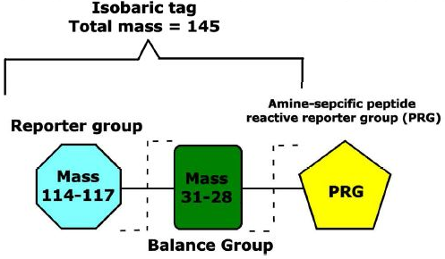
B
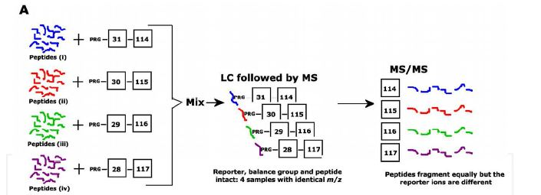
Figure 7: Structure of iTRAQ labelling reagents and principle of iTRAQ
The figure was reproduced from Integrative Proteomics Edited by Dr. Hon-Chiu Leu (page 349 & 350) (H.R.Fuller and Morris, 2012). A. Structure of iTRAQ labelling reagents. Each isobaric tag contains a unique charged reporter group, a peptide reactive group, and a neutral balance group to maintain an overall mass of 145Daand ensure that all tags have the same overall m/z. B. Based on a figure by (Zieske, 2006), this figure shows the general steps of 4-plex iTRAQ experiment. The individual tryptic digests labelled with their specific iTRAQ reagents are mixed together and then separated by LC. The identical peptides from each set appear as a single precursor in MS analysis after fragmentation. During fragmentation in MS/MS, the four peptides fragment in the same way and give rise to b- and y ions and the relative intensities of the reporter ions with different m/z ratios are used for the quantification.

During MS/MS each type of tag generates specific reporter ion of distinct mass (Figure 7), detected as mass/charge (m/z) ratio in a low m/z region. It is the differences in ratio of these reporter fragments that are used for quantification (Figure 7) (Ross et al., 2004). The iTRAQ method allows either absolute or relative protein quantifications.
Absolute quantification requires the use of a labelled standard of peptides, for which the total, absolute amount used in the experiment is known. However, in most studies where the primary need is to obtain information on altered protein levels between samples, relative quantification is sufficient. As a result, iTRAQ is mainly used for relative quantifications and labelled peptides standards are rarely needed. Eight different types of samples can be compared in one experiment, as there are up to eight different types of tags are available.

Overview of iTRAQ process
The iTRAQ proteomics study involved several key steps as shown in Figure 8. The procedures of all the key steps are described in the following sections.

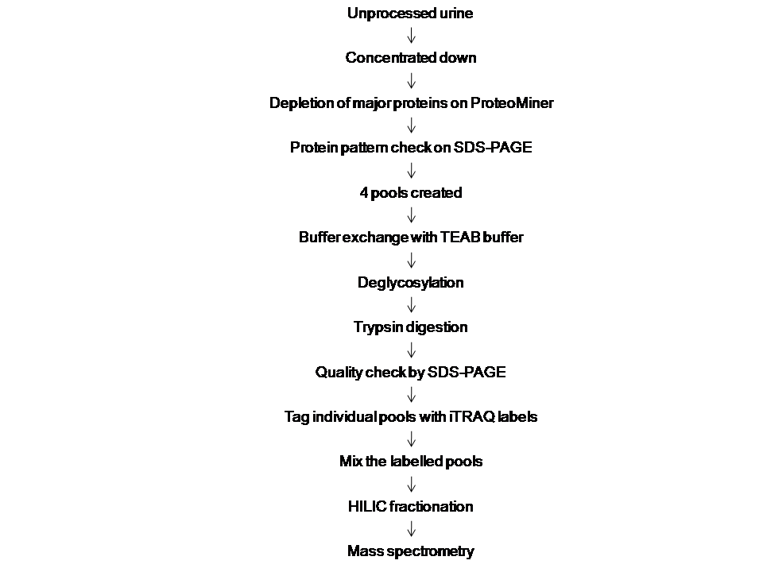
Figure 8: Mass spectrometry flow chart
Overview of the key experimental steps of the iTRAQ analysis of urine samples, from individual unprocessed urine samples to final mass spectrometry. The procedures used at these steps and the data analysis methods are described in the next sections.

Equalisation of sample proteomes using the ProteoMiner system
Medium and low-abundance proteins are difficult to detect in complex biological sample like urine due to the presence of high-abundance proteins. The ProteoMiner technology is a procedure of sample preparation, used for reducing the concentrations of high abundance proteins and enriching the low abundance proteins whilst at the same time maintaining the representatives of all the protein within the original complex biological sample. This is accomplished through the use of a large, highly diverse bead-based library of combinatorial peptide ligands. When complex biological samples are applied to the beads, the high-abundance proteins saturate their high affinity ligands and excess protein is washed away. In contrast, the medium- and low-abundance proteins are concentrated on their specific affinity ligands. This reduces the dynamic range of protein concentration while maintaining representatives of all proteins within the original sample (Righetti and Boschetti, 2013). This technology is available commercially and termed ProteoMiner (Bio-Rad)

ProteoMiner processing of concentrated urine
This procedure was carried out on urine samples that had been concentrated as described in section 2.4 (p. 50).
The ProteoMinerTM columns (Bio-Rad, Large-Capacity Kit catalogue no-163-3006) were prepared as per manufacturer’s instructions. Firstly the top cap was removed and the bottom cap snapped off from each spin column. The columns were placed in a cap-less collection tube and centrifuged at 1,000 g for 30-60 seconds to remove the storage solution. The bottom cap was replaced and 200 µl of wash buffer {50 ml PBS buffer (150 mM NaCl, 10 mM NaH₂PO₄, pH 7.4)} added and the top cap replaced. The column was rotated end-to-end using a cyclic end over end rotator (Stuart- Green flow rotator SB3) at 10 RPM over a 5 minutes period. The bottom cap was then removed, the column placed in a cap-less collection tube and centrifuged at 1,000 x g for 30-60 seconds to remove buffer. This was repeated 3 times. The column then contained 20 µl of settled beads and was ready for sample binding.
A concentrated urine volume equating to 10 mg of protein in a volume between 200 and 500ul µl of urine (protein concentration ≥ 50 mg/ml) was added to the column. The upper cap was replaced and the column rotated using a rotational shaker (Stuart, Geneflow, SB3) (10 RPM) for overnight in cold room (4° C). After this the bottom cap was removed, the column placed in a cap-less collection tube and centrifuged at 1,000 x g for 30-60 sec. The flow through was discarded, the bottom cap replaced and 200 µl of wash buffer added to column. The top cap was replaced and the column rotated as before over a 5 min period and wash removed by centrifugation. This step was repeated twice.
After wash buffer had been removed, the bottom cap was replaced and 200µl of deionised water added and the column rotated end-to-end for 1 min at 15 RPM after which the water was removed as before and discarded 20 µl of elution reagent {lyophilized urea CHAPS (8M urea, 2% CHAPS)} was added to the column, caps replaced and lightly vortex for 5 sec and incubated at room temperature for 15 minutes with light vortex every 2 minutes. The column was then placed in a clean collection tube and the elutant, which should contain the recovered proteins, was collected by centrifugation at 1,000 g for 30-60 sec. Two further elution steps were performed in the same manner, the eluents combined and stored at -20˚C prior to downstream analysis.

Gel electrophoresis of denatured proteins (SDS-PAGE)
To visualise the pattern of protein bands, gel electophoresis were carried out by SDS-PAGE.

Gel preparation and electrophoresis
A 12% resolving gel was prepared by mixing 6.3 ml ultrapure water, 4ml 1.5M TRIS, 5.4 ml 30% Acrylamide stock, 160 µl 10% SDS and 160ul 10% Ammonium persulphate in a small Buchner flask and degassed. The BioRad Mini protean gel casting stand was assembled and 16 µl of TEMED was added to the degassed gel solution and immediately pipette between the plates until 3 cm short of the plate top. The gel was overlaid with a small volume of water saturated Butan-2-ol. Once the resolving gel had set, the stacking gel was prepared by mixing 3.4 ml pure water, 0.835 ml 0.75M TRIS pH 6.8, 0.67 ml 30% Acrylamide stock, 50 µl 10% Ammonium persulphate, 50 µl 10% SDS & 12µl TEMED in a Buchner flask. The butanol layer was then removed from the resolving gel, the gel surface washed with water and an appropriate comb placed in between the glass plates and using a 1 ml pipette the stacking gel placed onto the resolving gel. The comb was allowed to set and then was removed from the stacking gel and the wells filled with running buffer (Glycine 28.8 g/l, Tris 6g/l, 10% SDS 5ml/l). Required volumes of samples were taken and an equal volume of reducing sample buffer (10mM Tris pH 6.8, 2.5% SDS, 10% glycerol, 5% 2-mercaptoethanol, 0.02% bromophenol blue) was added. The sample was heated in the heat block for at least 2 minutes and quickly spun prior to loading to bring the sample to the bottom of the tube. Samples were loaded at room temperature on the gels placed in the gel tank and with the tank filled with running buffer until it covered the bottom of the gel. The anode space was then filled with running buffer ensuring it covered the top of the glass plates. The lid was placed on the gel apparatus, connected to the power pack and run at 100V (constant voltage) for 2 hours or until the dye front was about 1 cm away from the bottom of the glass plates.

Gel staining
After the gel was run, it was stained to visualise the protein using the SYPRO Ruby Red stain (Invitrogen, Ltd). SYPRO Ruby protein stain uses fluorescent detection method. It shows an extremely bright and photostable red-orange luminescence when excited with either UV or blue light. Stained protein can be visualised using a UV transilluminator, a blue-light transilluminator or laser based scanning instrument. After electrophoresis, the gel was removed from the plates and placed in a clean container with 100 ml of fix solution (50% methanol, 7% acetic acid) and agitated on an orbital shaker for 30 minutes after which fix solution was replaced and shaken for another 30 min after which the fixing solution was poured off. 60 ml of SYPRO Ruby gel stain was the added and agitated on an orbital shaker overnight. The gel was transferred to a clean container and washed in 100 ml of wash solution (10% methanol, 7% acetic acid) for 30 minutes. Before imaging the gel was rinsed in ultrapure water a minimum of two times for 5 minutes to prevent possible corrosive damage to the imager. The gel was visualized using the ChemiDoc system from Bio-Rad. The image was analysed using the image lab software (version 2).

Pooling of ProteoMiner eluates and biochemical treatments of pools

Pooling
The ProteoMiner eluates were mixed to create four pools (Table 10). Within each pool, near equal amounts of protein from each eluate were used to ensure equal representation of all samples. To provide as much spare capacity as possible, the sizes of each pool was as large as possible given the amount of protein in the least abundant eluate. The sizes of the resulting pools are shown in Table 10

Table 10: Initial volumes and protein contents of the four pools
 |  | Concentration (µg/µl) | Volume (µl) | Total protein (mg)
Microalbuminuric | Non-progressors | 2.8 | 401 | 1.1
Microalbuminuric | Progressors | 1.5 | 331 | 0.50
Macroalbuminuric | Non-progressors | 2.8 | 165 | 0.46
Macroalbuminuric | Progressors | 4.0 | 98 | 0.39
The volumes and protein contents of the four pools prior to the biochemical treatments are shown. Protein concentrations were measured by the Pierce assay.

TEAB Buffer Exchange
For iTRAQ, the samples needed to be in TEAB buffer and to contain at least 50 µg of protein at a concentration of 1 µg / µl (i.e. 50 µl). To achieve this, a buffer exchange approach was used.
A sample volume contacting at least 70 µg of protein in elution buffer was made up to 500 µl with TEAB buffer. This was pipetted into a concentrator with molecular weight cut-off of 3 kDa (Micron-Amicon ultra-0.5 mL) and spun at 14,000 g to reduce volume to less than 100 µl, while avoiding reduction to dryness. A second 500ul of TEAB was used to refill concentrator and the centrifugation repeated. This was repeated 3 more times so in total there were 5 rounds of buffer exchange with an approximate 1 in 6 dilution at each stage.

Disulfide bonds reduction
Some urine proteins are likely to include disulphide bonds or to be glycosylated (Brownlee et al., 1980). These proteins would not be detected efficiently by the iTRAQ method because the alterations to peptide masses caused by the disulfide bonds or glycosylations will prevent their recognition by the software.
So, to improve the quality of the proteins the samples were treated with the reducing agent Tris(2-carboxyethyl)phosphine (TCEP) at 2.5 mM in the presence of sodium dodecyl sulphate (SDS) at 0.1% for 1 hour at 60˚C (Table 11). After allowing to cool to room temperature they were then supplemented with 1 mM of the alkylating agent methyl methanethiosulfonate (MMTS) and incubated at room temperature for 10 minutes to block the sulfhydryl groups.

Protein deglycosylation

Background
One of the common post-translational modifications of proteins occurs through glycosylation and this is especially true of secreted proteins. The glycosylation change the mass of the peptides, as a, result peptides will not be recognised by the mass spectrometry. So, to identify more peptides, deglycosylation of the proteins was done. Chemical and enzymatic method exist for removing of the oligosaccharides from glycoprotein, but enzymatic method is better as it causes complete removal of the sugar without degradation of the protein.
The Protein Deglycosylation Mix supplied by New England Biolabs (catalog no-P6039S) is an effective enzymatic method of removing N-linked oligosaccharides from glycoproteins. The mix is composed of the following enzymes:
- N-glycisidase F (PNGase F) is purified from Flavobacterium meningosepticum. It is an amidase which cleaves between the innermost GIcNAc and asparagine residues of high mannose, hybrid and complex oligosaccharides from N- linked glycoproteins unless α(1-3) core fucosylated
- O-Glycosidase (Endo-α-N-Acetylgalactosaminidase) is a recombinant enzyme cloned from Enterococcus faecalis. It catalyzes the removal of core 1 and core 3 O-linked disaccharides from glycoproteins.
- Neuraminidase Sialidase (recombinant, cloned from Clostridium perfringens) catalyses the hydrolysis of terminal, non-reducing α2,3, α2,6, and α2,8 linked N-acetylneuraminic acid residues from glycoproteins and oligosaccharides).
- β1-4 Galactosidase (recombinant, cloned from Bacteroides fragilis) catalyzes the hydrolysis of terminal, non-reducing β1-4 linked D-galactopyranosyl residues from oligosaccharides and glycoproteins.
- β-N-acetylglucosaminidase (cloned from Xanthomonas manihotis) catalyzes the hydrolysis of terminal, non-reducing β-N-Acetylglucosamine residues from oligosaccharides and glycoproteins.

Components of the Deglycosylation kit
- 10X G7 Reaction Buffer (50 mM sodium phosphate, pH 7.5 at 25°C)
- Deglycosylation Enzyme Mix (Containing the 5 enzymes at proprietary concentrations in 50mM NaCl, 20 mM Tris-HCl (pH 7.5 and 0.1 mM EDTA).
- 10X Glycoprotein Denaturing Buffer (5% SDS, 400 mM DTT – not used)
- 10% v/v NP-40 (not used)

Procedure
This was carried as recommended by the manufacturer’s instructions except that the solutions designed to denature and reduce the proteins were omitted. The reaction mixes from the previous step, already containing 0.1% SDS (see section 2.10.3), were incubated at 100°C for 10 minutes to denature proteins and was then chilled on ice and centrifuged for 10 second. The mixes were then supplemented with 0.1 volumes of the 10-fold concentrated G7 Reaction Buffer and 0.1 volumes of the Deglycosylation Enzyme Mix (Table 11). The reactions were incubated for 24 hours at 37°C.

Table 11: Characteristics of samples subjected to disulphide bond reduction and deglycosylation
Sample pools |  | Initial volume (µl) | Total urine protein (µg) | Added SDS, TCEP, and MMTS solutions (µl) | Deglyco-sylation cocktail mix  (µl) | Final  Volume (µl)
Micro-albuminuric | Non-progressor | 120 | 240 | 13.2 | 12 | 145.2
Micro-albuminuric | Progressor | 120 | 312 | 13.2 | 15 | 148.2
Macro-albuminuric | Non-progressor | 135 | 189 | 15.3 | 9.5 | 159.8
Macro-albuminuric | Progressor | 130 | 143 | 15.3 | 7 | 152.3
The table shows the initial volumes and total protein contents of the buffer exchanged samples, the volumes of reagents added for reduction and deglycosylation and the final volumes. The amounts of proteins that were treated were less that the total amounts in the initial pools as they were determined by experimental convenience whilst providing sufficient amounts of treated proteins for the subsequent trypsin treatments and iTRAQ labelling.

Trypsin digestion

Background
After deglycosylation the pools were digested with trypsin. Trypsin is the mostly used protease for mass spectrometry because it has high proteolytic activity, very good cleavage specificity and the resulting tryptic peptides have mass and charges optimally suited to detection by mass spectrometry. However, it should be noted that trypsin has a few shortcomings like digestion not being 100% complete with tightly folded proteins in particular being resistant to trypsin (Hustoft et al., 2011).

Procedure
A stock solution of Trypsin (Porcine; Promega; sequencing grade modified) at 0.5 µg/ µl was added at final ratio of 5 µg / 100 µg protein substrate (Table 12) and digested overnight at 37˚C.

Table 12: Samples subjected to trypsin digestion and isobaric labelling
Sample pools |  | Amount of urine protein (µg) | Amount of added trypsin  (µg) | Total volume  (Sample +trypsin) (µl) | iTRAQ  label
Micro-albuminuric | Non-progressor | 136 | 6.8 | 94 | 117
Micro-albuminuric | Progressor | 168 | 8.4 | 97 | 116
Macro-albuminuric | Non-progressor | 96 | 5 | 90 | 115
Macro-albuminuric | Progressor | 100 | 5 | 121 | 114
The total amount of protein, amount of trypsin added, final volume and iTRAQ labels used for the corresponding pools are shown.

Isobaric labelling, HILIC chromatography and iTRAQ MS

Labelling the protein digests with the 4-plex iTRAQ reagents
All the vials of iTRAQ reagent (114, 115, 116, 117) were brought to room temperature. Then 70 µl of ethanol was added to each iTRAQ reagent vial. Each vial was vortexed for 1 minute to dissolve the iTRAQ reagent and then spun to collect the reagent in the bottom of the vial. One iTRAQ reagent was transferred per sample as shown in Table 12.
Each tube was vortexed to mix and then spun to collect the contents. Samples were incubated at room temperature for 1 hour, at which time the contents of each iTRAQ reagent-labelled sample tube were combined into a fresh tube.
Each sample was assigned one of these labels as shown in Table 12 above.

Hydrophilic interaction liquid chromatography (HILIC)
The mixed labelled samples were then fractionated by HILIC. Fractionation is necessary prior to mass spectrometry in order to maximise sensitivity of detection. In recent years, HILIC chromatography has replaced, strong cationic exchange chromatography since HILIC provides better peptide resolution (Ow et al., 2011).
The 4-plex iTRAQ labelled sample was resuspended in HILIC buffer A (10 mM NH₄HCO₂, 80% ACN, pH 3.0) and fractionated by HILIC using a PolyHydroxyethyl™ A column (PolyLC, Columbia, MD, USA) with 5 μm particle size, 20 cm length × 2.1 mm diameter and 200 Å pore size on a Ultimate 3000 HPLC (Thermo Scientific, formerly Dionex, Amsterdam, The Netherlands) controlled by Chromeleon Software, version 6.5 (Thermo Scientific). A set of binary gradient buffers was used for liquid chromatography: buffer A and buffer B (10 mM NH₄HCO₂, 5% ACN, pH 4.0). The binary gradient began with 0% B for 10 min, followed by a linear ramp from 0 to 60% B for 30 min, an extended ramp from 60 to 100% B for 5 min, a further isocratic wash 100% B for 10 min, and column re-equilibration at 0% B for 1 min, in a total of 66 min.

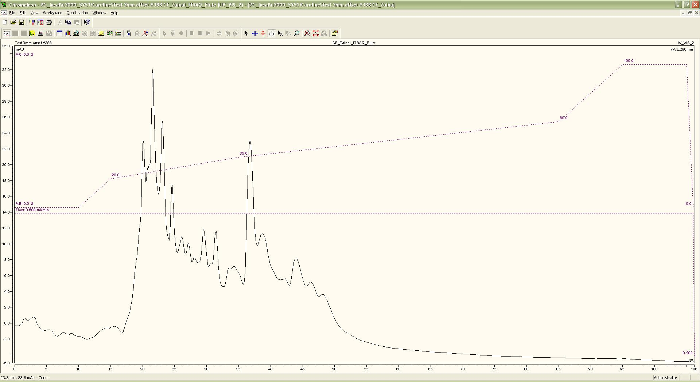
Figure 9: HILIC chromatogram
An example of chromatogram generated by computer software during the HILIC. The flow rate of the sample was 0.5ml/min and the UV length was at 280nm. There was a peak at 23.8 minute and 28.8mAU. Fractions were collected every 45 seconds starting 10 minutes after the elution began.

Mass spectrometry of HILIC fractions and data acquisition
Mass spectrometry of the HILIC fractions was done by Dr. Caroline Evans (Biological Systems Engineering Group, Department of Chemical and Biological Engineering, University of Sheffield). It was done using a Q-STAR XL Hybrid ESI Quadrupole time-of-flight tandem mass spectrometer, ESI-qQ-TOF-MS/MS (ABSciex) coupled to an online capillary liquid chromatography system (U3000 HPLC).
Each peptide-containing HILIC fraction was re-dissolved in 100µl of 0.1% formic acid and 3% acetonitrile. 20µl of sample was then injected into a nano-LC-ESI-MS/MS system for analysis. The peptide mixture was separated on a PepMap C-18 RP capillary column (Thermo), with a constant flow rate of 0.3 µl/min. The LC gradient started with 3% Buffer B (0.1% formic acid in 97% acetonitrile) and 97% Buffer A (0.1% formic acid in 3% acetonitrile) for3 min, followed by 3–30% Buffer B for 90 min, then 90% Buffer B for 7 min, and finally 3% Buffer B for 8 min.
The mass spectrometer was set to perform data acquisition in the positive ion mode, with a selected mass range of 400–1200m/z. Peptides with +2 to +4 charge states were selected for tandem mass spectrometry, and the time of summation of MS/MS events was set to 3sec. The two most abundantly charged peptides above a five-count threshold were selected for MS/MS, and dynamically excluded for 60 sec with a ±50 mmu mass tolerance. Parameters for peptide identification against the database were set up as follows: MS/ MS tolerance were set at the following peptide tolerance 1.2 Da, parent charge 2+, 3+, minimum peptide length, z-score 6.5, maximum p-value 0.000001 and AC score was 6.5 and enzymes used for searching were trypsin digested, with two missed cleavages permitted. Modifications were performed as follows: MMTS (fixed), iTRAQ_8plex_K (variable), Oxidation_M (variable), iTRAQ_8plex_Nterm (variable). These data were then searched within SwissProt (20100511), SwissProt_decoy (20100511), Trembl (20100511), Trembl_decoy (20100511).

iTRAQ data analysis procedure
The proteomic dataset was processed using an in house software pipeline hosted at www.proteome.shef.ac.uk. All the MS/MS raw data derived from the Q STAR instrument were converted to MGF (Mascot generic format) using the mascot server (www.matrixscience.com). MGF represent the MS data as a peak list: m/z value and intensity values in a format compatible with Phenyx.
The data were then submitted to Phenyx. Phenyx is a special search engine. It is a software platform for the identification and characterization of proteins and peptides from mass spectrometry data specifically designed to meet the concurrent demands of high-throughput MS data analysis and dynamic results assessment. It interprets the peptide sequence data for a particular organism and the raw peptide-level quantification information is then exported to Excel for further processing.
The Phenyx-generated excel file was then submitted to FDR (False discovery rate) slice tool (Cox and Mann, 2008). It allows specifying the Z-score threshold for the length of the peptide because short peptide may give false positive result. A FDR of 1% was set and the data exported to excel (Cox and Mann, 2008) for uploaded to uTRAQ processing tool to get protein-level identification and relative quantification. Correction factors were applied to account for protein loading differences and reporter ion impurities median and isotope correction.
The resulting data was then processed in two different ways. First, we used the a Mathematic 10 script (provided by Josselin Noirel) application to carry out a principal component analysis whose aim was to classify samples according to their degree of similarity. Second, we then processed the uTraq output files with the SignifiQuant module, which carries out pair-wise comparisons between any two of the 4 differently labelled samples in the mixture (for example between microalbuminuric progressors and microalbuminuric non-progressors), or between two groups of labelled samples (for example the two progressors versus the two non-progressors). The output of each such comparison is a table (in Microsoft excel format) containing the Genbank ID codes of the proteins for which there are statistically significant differences between their abundances in the two samples compared. The output file also contains and estimate of the fold-difference in concentration between the proteins and the number of identified peptides on which this quantitative comparison is based
To obtain the biologically meaningful information of the proteins the gene bank accession numbers provided by SignifiQuant were submitted to Uniprot (Universal Protein Resource, a central repository of protein data created by combining the Swiss-port, TrEMBL and PIR-PSD database. It is a comprehensive, high quality and freely accessible data base of protein sequence and functional information.), which converts the protein accession numbers into proteins names and provides other information such as length or molecular weight.

Investigating suitability of KIM-1, MCP-1 and NGAL as CKD markers

Hypothesis and aims
Based on the literature review, KIM-1, MCP-1 and NGAL are three most commonly studied biomarkers of AKI. The aim of this study is to explore the merit of these three biomarkers as a marker of CKD in comparison to the current clinical marker, albumin/ creatinine ratio (ACR). Therefore, we hypothesised that KIM-1, MCP-1 and NGAL will predict the progression of CKD and will act as better biomarkers of CKD progression.
The aim is to test statistically the merit of the candidate markers using large number of samples. To meet this aim, the approach of this chapter is:
- To collect urine samples from CKD patients with varying stage (excluding CKD-5 at the time of presentation) and aetiology and follow them up to know the rate of progression of patients with CKD.
- To carry out statistical analyses of the levels of candidate markers between the different groups, after normalisation to creatinine.
- To relate these statistics to CKD progression and determine the value by ROC analysis in predicting the progression of CKD compared to ACR. ROC curve is useful for comparing two or more diagnostic test. It is an efficient way of showing the relationship between the sensitivity and specificity for tests that have continuous outcome (Hajian-Tilaki, 2013).

Overview of methodology

Samples studied
All assays were carried out on urine samples from 262 CKD patients of various causes and stages (excluding stage 5 at the time of presentation) and 47 healthy individuals (for details see, section 2.2, in the “General Methodology” chapter, p. 37).

Assay procedures
Albumin was measured by nephelometry and urine creatinine was measured using the standardised kinetic Jaffe method as described in section 2.2.4.2 (p. 39).
KIM-1, MCP-1 and NGAL were assayed by commercially available ELISA kits from R & D as detailed in section 2.6 (p. 55).

Statistical analyses
All ELISA assay results were normalised to creatinine, so the data were ratiometrically analysed as protein/Cr, similar to the way albumin is assessed relative to creatinine as ACR.
The data were then analysed statistically by one-way ANOVA, ROC calculations, Odds Ratio (OR) calculations and determination of correlation coefficients between each candidate biomarker and ACR (see section 2.6.3, p. 58, for details). Because the data were not normally distributed, the one-way ANOVA and ROC analyses were carried out on log-transformed data to minimize the effect of the outliers (Bland and Altman, 1996).
For each marker, these analyses were carried out on the whole cohort and on each of the three largest subgroups of CKD causes in our patient’s cohort: the diabetic (DM), chronic glomerulonephritis (CGN) and hypertensive (HTN) subgroups. These subgroup analyses were carried out to see whether any assayed protein could be used as a biomarker for a specific disease group.

One-way ANOVA analyses of ACR values

Whole cohort analyses
The results of one-way ANOVA of the ACR data are shown in (Figure 10).
When the data was analysed according to the causes of disease (Figure 10 panel A), the results showed that ACR was significantly higher in DM (P< 0.0001), CGN (P< 0.0001), HTN (P< 0.0001), and Others (P< 0.0001) groups, compared to control group. But there was no significant difference between the control and ADPKD and also between the disease groups.
Analysis of the distribution of ACR values between the different final stages reached by the patients at the end of the study is on Figure 10 panel B. It shows that patient ACR values were significantly higher than those of controls at all stages of CKD except stage 1: the P values between controls and each stage were: for CKD-2, P< 0.0001; CKD-3a, P < 0.0001; CKD-3b, P < 0.0001; CKD-4, P < 0.0001 and for CKD-5, P < 0.0001. There were also statistically significant differences of ACR values between the CKD-1 and CKD-5 (P=0.0027); CKD-3a and CKD-5 (P=0.0472); CKD-3b and CKD-5 (P=0.0051) and CKD-4 and CKD-5 (P = 0.017).
When the ACR values were grouped according to the progression of CKD there was a very significant difference between the control and the non-progressors group (P< 0.0001) and between control and the progressors group (P< 0.0001). The ACR values of progressors were also very significantly higher than those of the non-progressors (P< 0.0001) (Figure 10, panel-C).
When ACR values were grouped according to outcome of the disease at the end of the follow-up period (Figure 10 panel D), there was very significant difference between the control and discharged group (P< 0.0001), outpatient group (P< 0.0001), dialysis group ( P< 0.0001) and dead group (P< 0.0001). There were also significant differences between the discharged and outpatients (P< 0.0001) and discharged and dialysis group (P< 0.0001).
Overall, these results are as could be expected given the clinical value of ACR as a marker.

A B
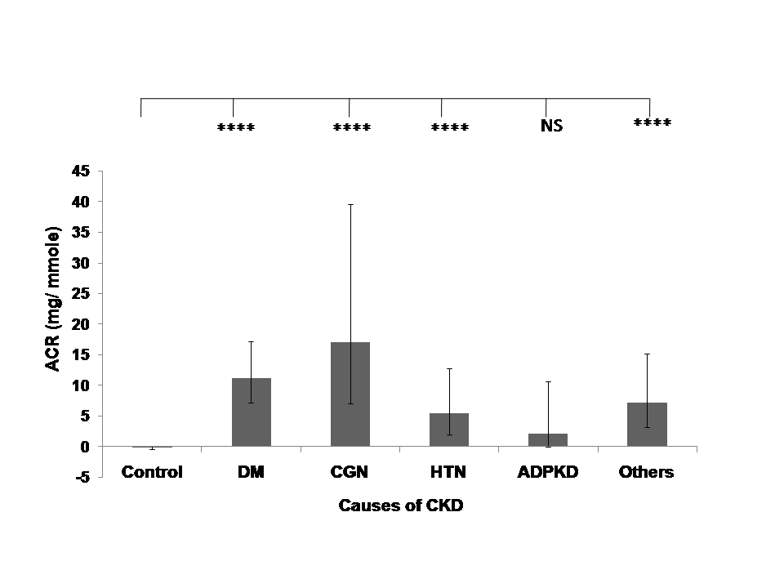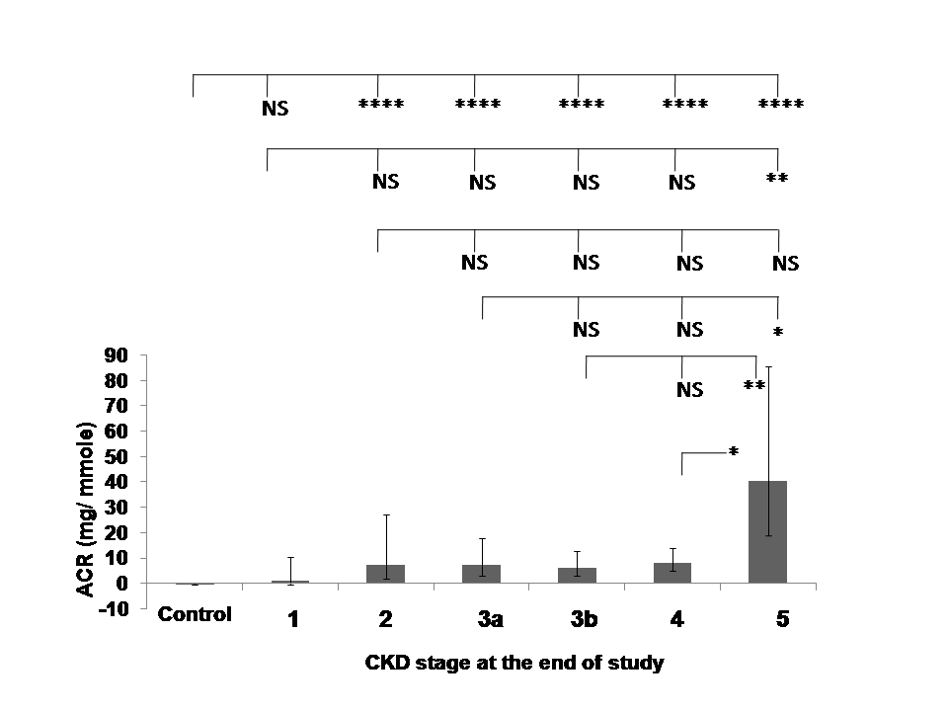

C D
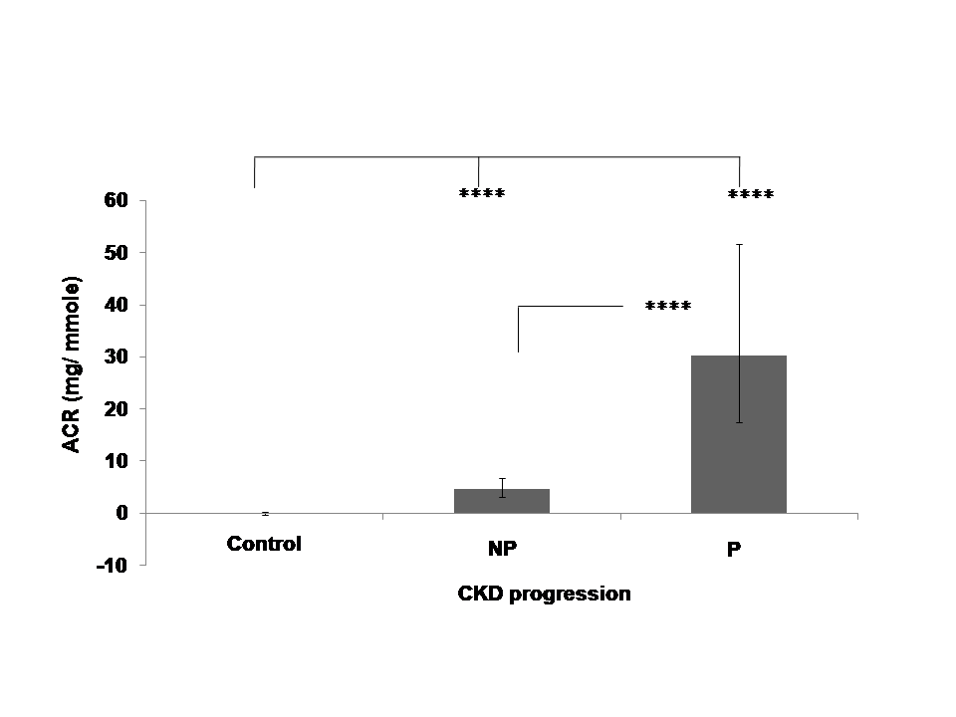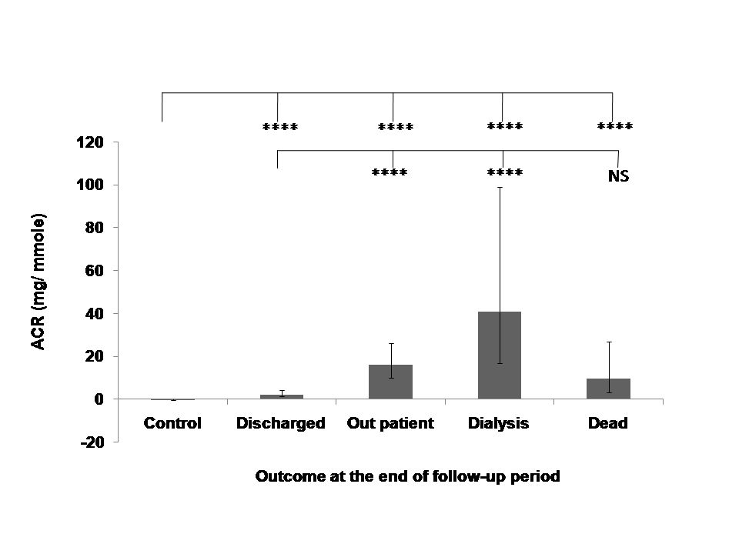
Figure 10: ACR values differences between patient groups
Distribution of ACR concentration ratio in urine according to causes of disease (A), stages (B), progression (C) and outcome of the disease at the end of the follow-up period (D). Geometric means ± SEMs are shown. Statistical significance of differences between populations was tested using 1 way ANOVA on log-transformed data as described in “Methods”. Asterisks indicate statistically significant differences (*, P = 0.02 to 0.01; **, P = 0.01 to 0.001; ***, P = 0.001 to 0.0001 and ****, P < 0.0001see text for exact P values). The population sizes are: (A) control, n= 47; DM, n= 103; CGN, n= 54; HTN, n= 45; APKD, n= 11 and Others, n=49. (B) control, n= 47; 1(CKD-1),n=12; 2(CKD-2),n= 22; 3a(CKD-3a),n= 39; 3b(CKD-3b), n= 58; 4(CKD-4), n=81; 5 (CKD-5), n=50. (C) Control, n= 47; Non-progressors (NP)=170; Progressors (P) =92. (D) Control, n= 47; Discharged, n=84; Outpatient, n= 124; Dialysis, n=33; Dead, n= 21.

Sub-group analyses of ACR values

Analysis of ACR values in the DM patients sub-group
When the ACR values of DM patients were analysed according to the final stage of disease, there were statistically significant differences between the control and CKD-2 (P= 0.0129), CKD-3a (P=0.0028), CKD-3b (P< 0.0001), CKD-4 (P<0.0001) and CKD-5 (P< 0.0001). There was also a significant difference between the CKD-3a and CKD-5 (P= 0.0024), CKD-3b and CKD-5 (P= 0.0034) (Figure 11 panel A). These results were similar to those of the whole-cohort analysis except that in the latter, was also a statistically significant difference between the CKD-4 and CKD-5. In the DM subgroup, the difference can still be seen on the graph (Figure 11 panel A) but it does not reach statistical significance, presumably because of the smaller population sizes in the subgroup analysis.
Analysis of DM patients’ ACR values by progression status showed that there was a significant difference between the control and non-progressors (P< 0.0001), control and progressors (P< 0.0001) and also between the non-progressors and progressors (P< 0.0001) (Figure 11 panel B). These results are similar to those seen in the whole cohort.
When analysing ACR values by disease outcomes, there was a significant difference between the control and the discharged (P< 0.0001), outpatient (P< 0.0001), dialysis (P< 0.0001) and dead groups (P< 0.0001). There was also a significant difference between the discharged and dialysis groups (P= 0.0005) (Figure 11 panel C). This results where similar to those found in the whole cohort, except that the latter also showed a significant difference between the discharged and out- patient groups.

A B
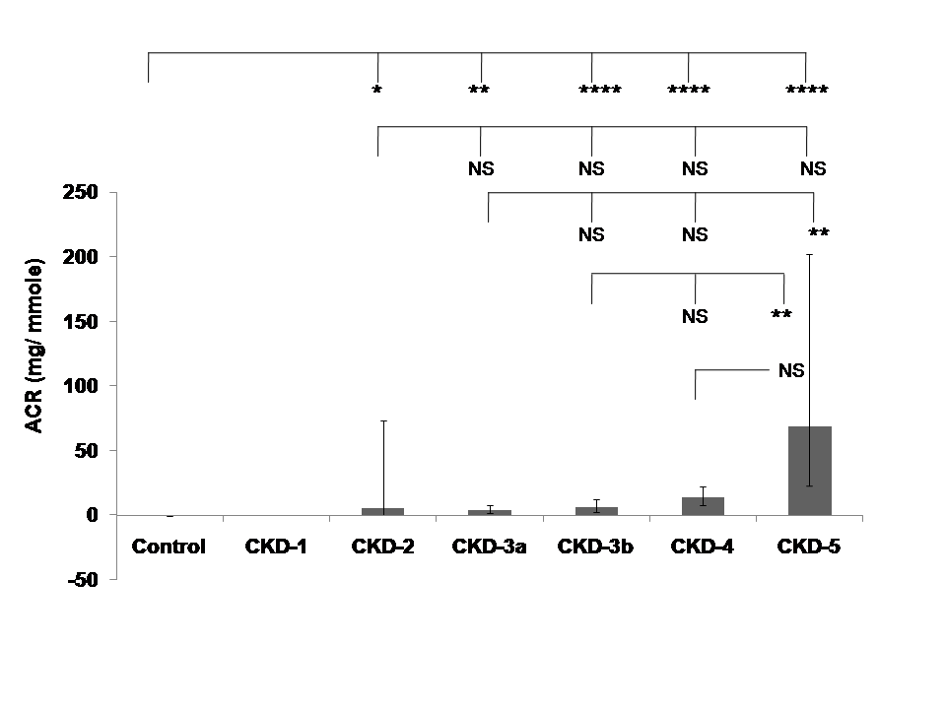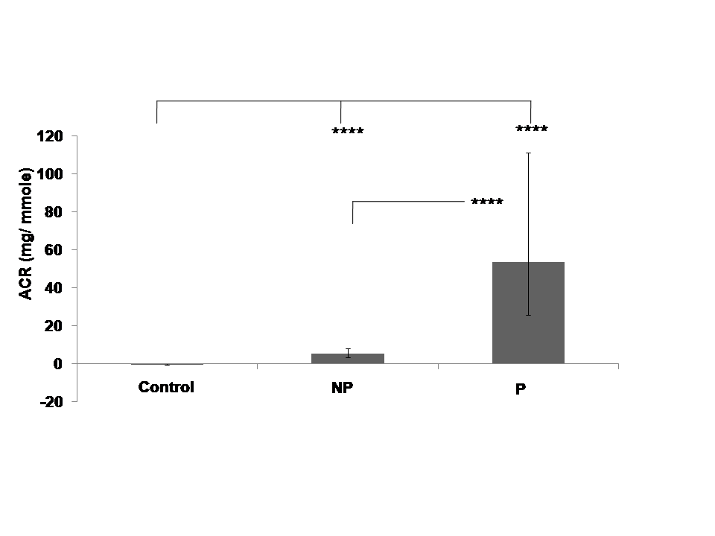

C
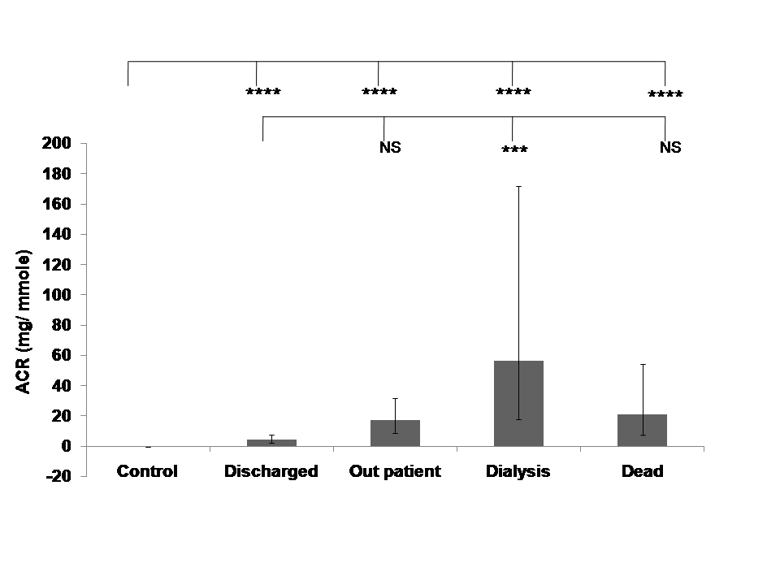

Figure 11: ACR value variations in DM patient subgroup
Distribution of ACR in urine in DM patients subgroup according to stage of disease (A), progression of disease (B) and outcome of the disease at the end of the follow-up period (C). Geometric means ± SEMs are shown. Statistical significance of differences between populations was tested using 1 way ANOVA on log-transformed data as described in “Methods”. Asterisks indicate statistically significant differences (*, P = 0.02 to 0.01; **, P = 0.01 to 0.001; ***, P = 0.001 to 0.0001 and ****, P < 0.0001 see text for exact P values). The population sizes are: control, n= 47; 1(CKD-1), n=0; 2(CKD-2), n= 7; 3a(CKD-3a), n= 14; 3b(CKD-3b), n= 24; 4(CKD-4), n=34; 5 (CKD-5), n=24; Non-progressors (NP), n=74; Progressors (P), n= 29; Discharged, n= 38; Outpatients, n= 34; Dialysis, n= 17 and Dead = 14.

Analyses of ACR values in the CGN patients sub-group
Similar to the DM patients, the ACR values of CGN patients showed statistically significant differences between the controls and CKD-2 (P= 0.0218), CKD-3a (P=0.0003), CKD-3b (P< 0.0001), CKD-4 (P=0.0124) and CKD-5 (P = 0.0052). However, unlike the DM patients, no statistically significant difference was found between the stages in CGN patients (Figure 12 panel A).
Analysis of CGN patients’ ACR by progression status showed that there were statistically significant differences between the control and non-progressors (P< 0.0001) and between control and progressors (P< 0.0001) but not between the non-progressors and progressors (Figure 12 panel B).
When analysing CGN patients’ ACR values by disease outcomes, there was a significant difference between the control and the outpatients (P< 0.0001), but not between controls and other groups. There was also a significant difference between the discharged and outpatient groups (P= 0.0067) but not between other outcome groups (Figure 12 panel C).

A B
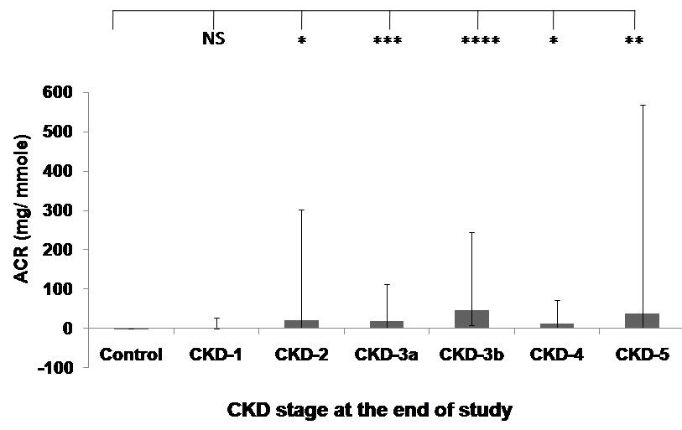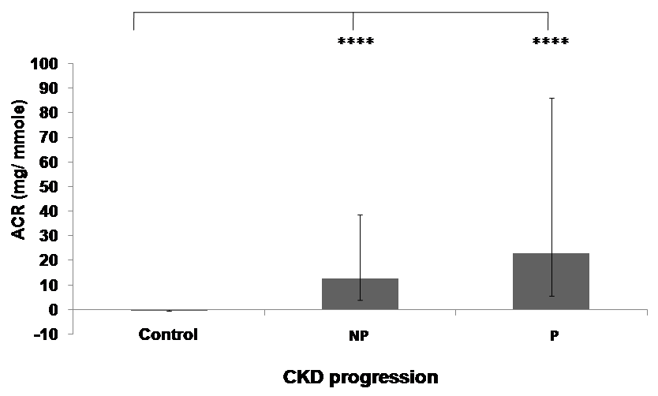
C
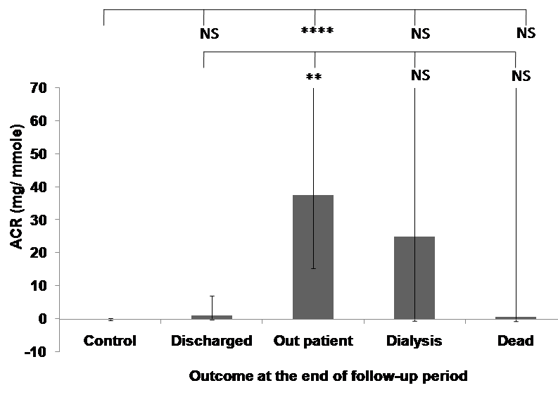

Figure 12: ACR values variation in CGN patient group
Distribution of KIM-1/Cr concentration ratio in urine in CGN patients subgroup according to stage of disease (A), progression of disease (B) and outcome of the disease at the end of the follow-up period (C). Geometric means ± SEMs are shown. Statistical significance of differences between populations was tested using 1 way ANOVA on log-transformed data as described in “Methods”. Asterisks indicate statistically significant differences (*, P = 0.02 to 0.01; **, P = 0.01 to 0.001; ***, P = 0.001 to 0.0001 and ****, P < 0.0001 see text for exact P values). The population sizes are: control, n= 47; 1(CKD-1), n=9; 2(CKD-2), n= 5; 3a(CKD-3a), n= 14; 3b(CKD-3b), n= 11; 4(CKD-4), n=9; 5 (CKD-5), n= 6; Non-progressors (NP), n=28; Progressors (P), n= 26; Discharged, n= 10; Outpatients, n= 39; Dialysis, n= 3 and Dead = 2.

Analyses of ACR values in the HTN patient sub-group
The ACR values of HTN patients showed statistically significant differences between the controls and CKD-3a (P=0.0114), CKD-4 (P=0.0385) and CKD-5 (P < 0.0001) (Figure 13 panel A). The geometric mean value for ACR in the CKD-4 group were higher than in controls (Figure 13 panel A), but the difference was not statistically significant, presumably because of the small number of HTN patients that were at final stage 4 (n=13). There was no patient at stages 1 and 2 in this sub-group. There was also a statistically significant difference between stages 3b and 5 in this subgroup (P=0.0075).
Analysis of HTN patients’ ACR by progression status showed that there were statistically significant differences between the control and non-progressors (P = 0.0026) and between control and progressors (P< 0.0001) but not between the non-progressors and progressors (Figure 13 panel B).
When ACR values of this subgroup were analysed by disease outcomes, there was a significant difference between the controls and the outpatients (P = 0.0008) and between controls and Dialysis group (P< 0.0001) but not between controls and other groups. There was also a significant difference between the discharged and dialysis groups (P= 0.0079) but not between other outcome groups (Figure 13 panel C).

A B
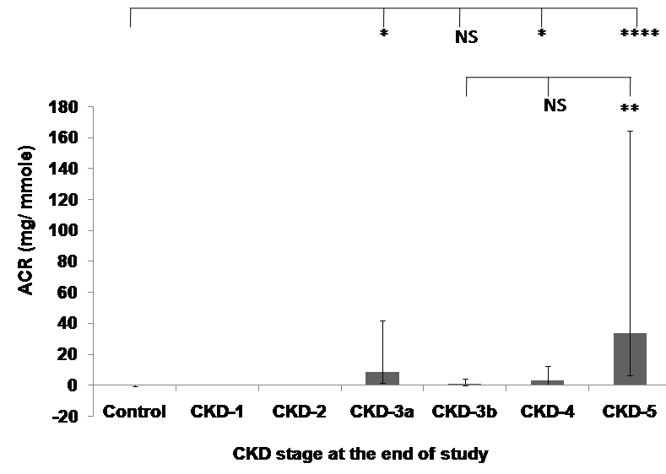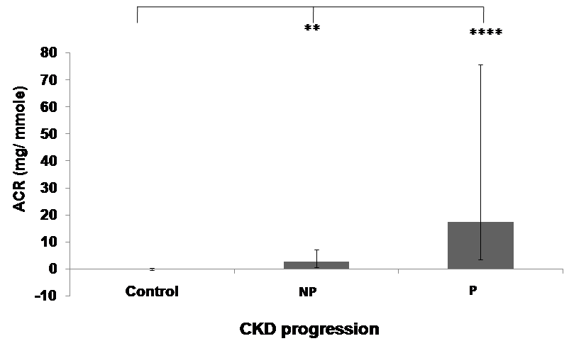
C
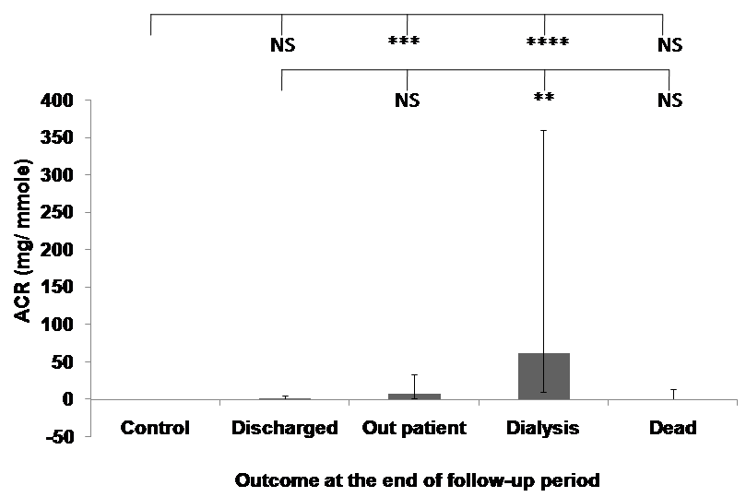

Figure 13: ACR values variation within the HTN patient subgroup
Distributions of KIM-1 /Cr concentration ratios in the HTN patients subgroup according to stage of disease (A), progression of disease (B) and outcome of the disease at the end of the follow-up period (C). Geometric means ± SEMs are shown. Statistical significance of differences between populations was tested using 1 way ANOVA on log-transformed data as described in “Methods”. Asterisks indicate statistically significant differences (*, P = 0.02 to 0.01; **, P = 0.01 to 0.001; ***, P = 0.001 to 0.0001 and ****, P < 0.0001 see text for exact P values). The population sizes are: (A) control, n= 47; 1(CKD-1), n=0; 2(CKD-2), n= 0; 3a(CKD-3a), n= 8; 3b(CKD-3b), n= 12; 4(CKD-4), n=13; 5 (CKD-5), n=12 (B) control, n= 47; Non-progressors (NP)=29; Progressors (P) =16 (C) control, n= 47; Discharged, n=19; Outpatient, n= 15; Dialysis, n=8; Dead, n= 3.
Overall the subgroup analyses thus showed that in each of the three subgroups analysed, the ACR values distributed in the same manner as in the whole cohort and as could be expected given the clinical values of ACR as a marker.

One-way ANOVA analyses of KIM-1/Cr values

Whole cohort analysis
Analysis of Kim-1/Cr values according to causes of CKD (Figure 14 panel A) showed that compared to the control group KIM-1/Cr is significantly higher in the DM (P< 0.0001), CGN (P< 0.0001), HTN (P< 0.0001), ADPKD (P=0.0087) and Others (P< 0.0001) groups. However there was no statistically significant difference between the different causes.
Figure 14 panel B shows that KIM-1/Cr values were significantly higher in all stages of CKD compared to controls: the P values between controls and each stage were: for CKD-1, 0.0395; CKD-2, 0.0098; CKD-3a, P< 0.0001; CKD-3b, P < 0.0001; CKD-4, P < 0.0001 and CKD-5, P < 0.0001. But there was no significant difference between the stages.
When the KIM-1/Cr values were grouped according to the progression of CKD, KIM-1/Cr values were very significantly higher than the controls in both non-progressors (P< 0.0001) and progressors (P < 0.0001) groups (Figure 14 panel C). There was also a statistically significant difference between the non-progressors and progressors groups (P= 0.0244).
When KIM-1/Cr values were grouped according to outcomes of the disease at the end of the follow-up period, there was very significant difference between the control and the discharged (P< 0.0001), outpatient (P< 0.0001), dialysis (P< 0.0001) and dead (P= 0.0001) groups (Figure 14 panel-D). But there was no significant difference between the disease outcome groups.

A B
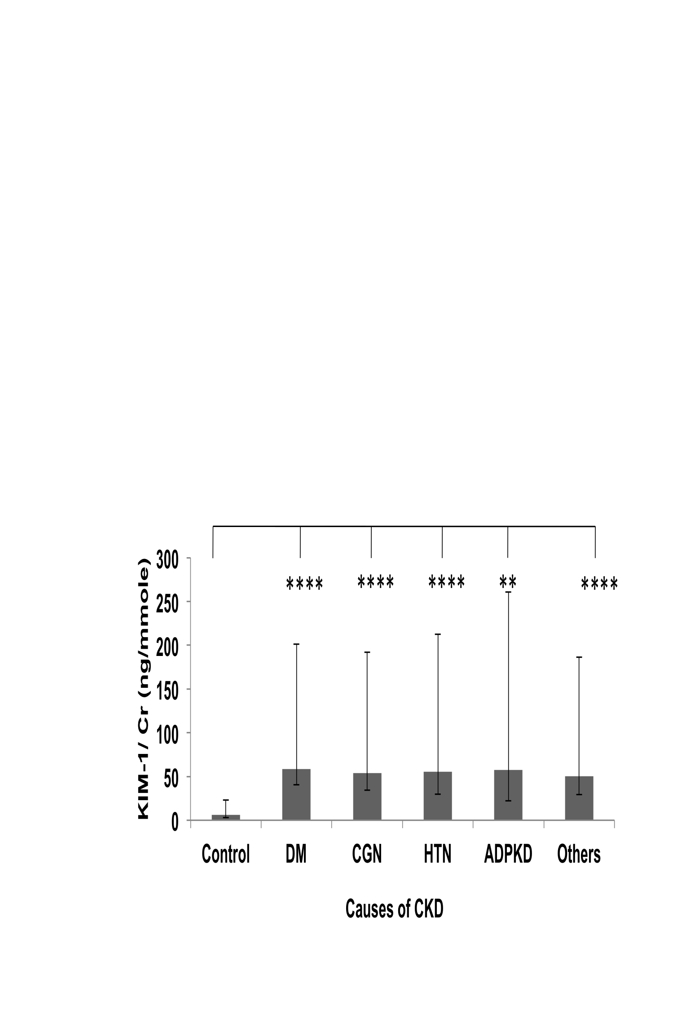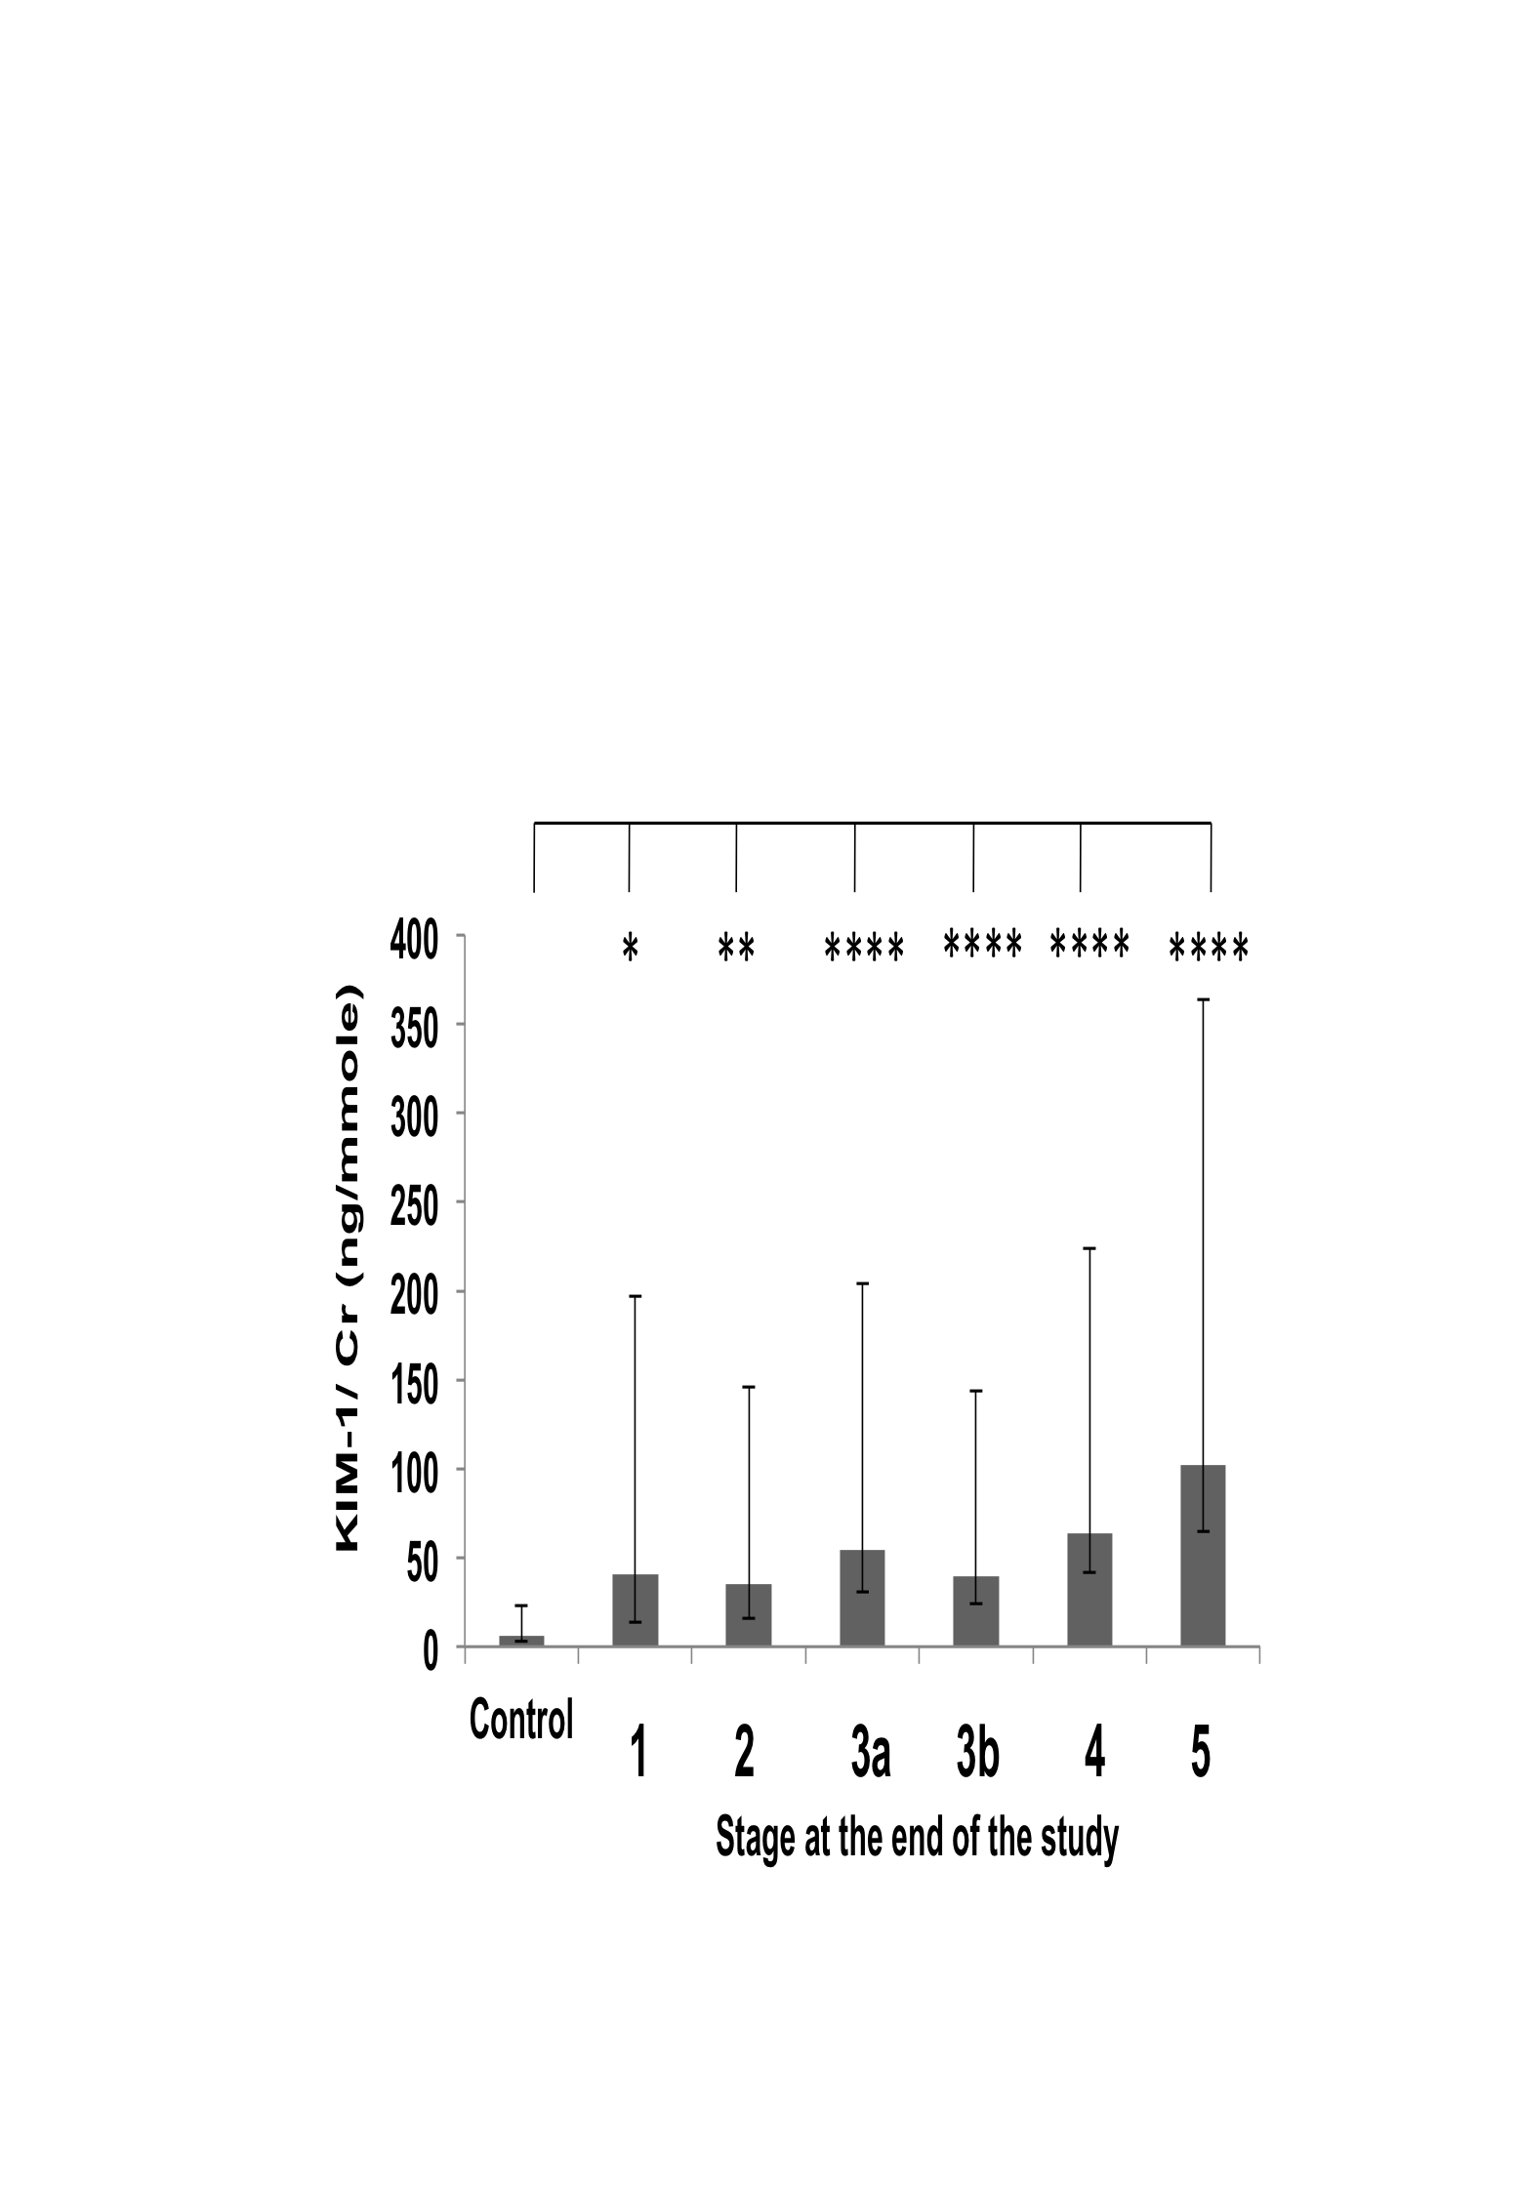

C D
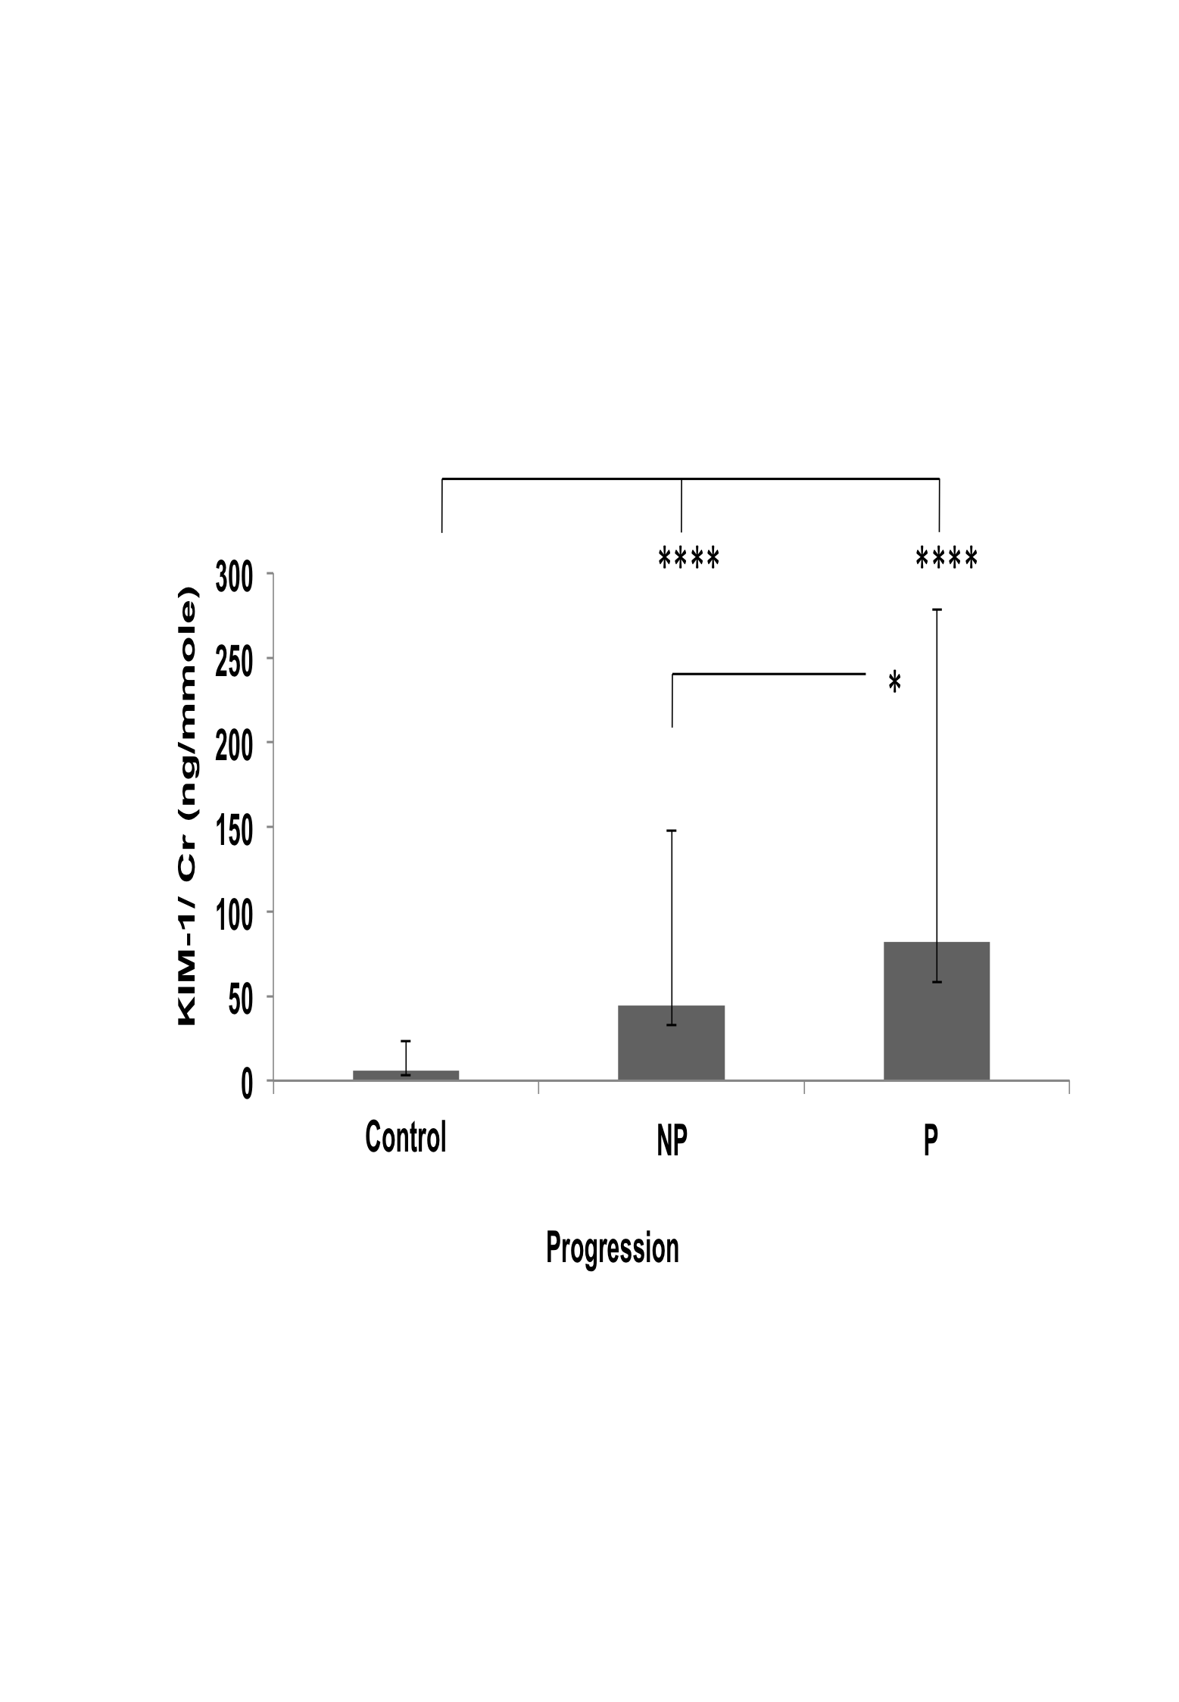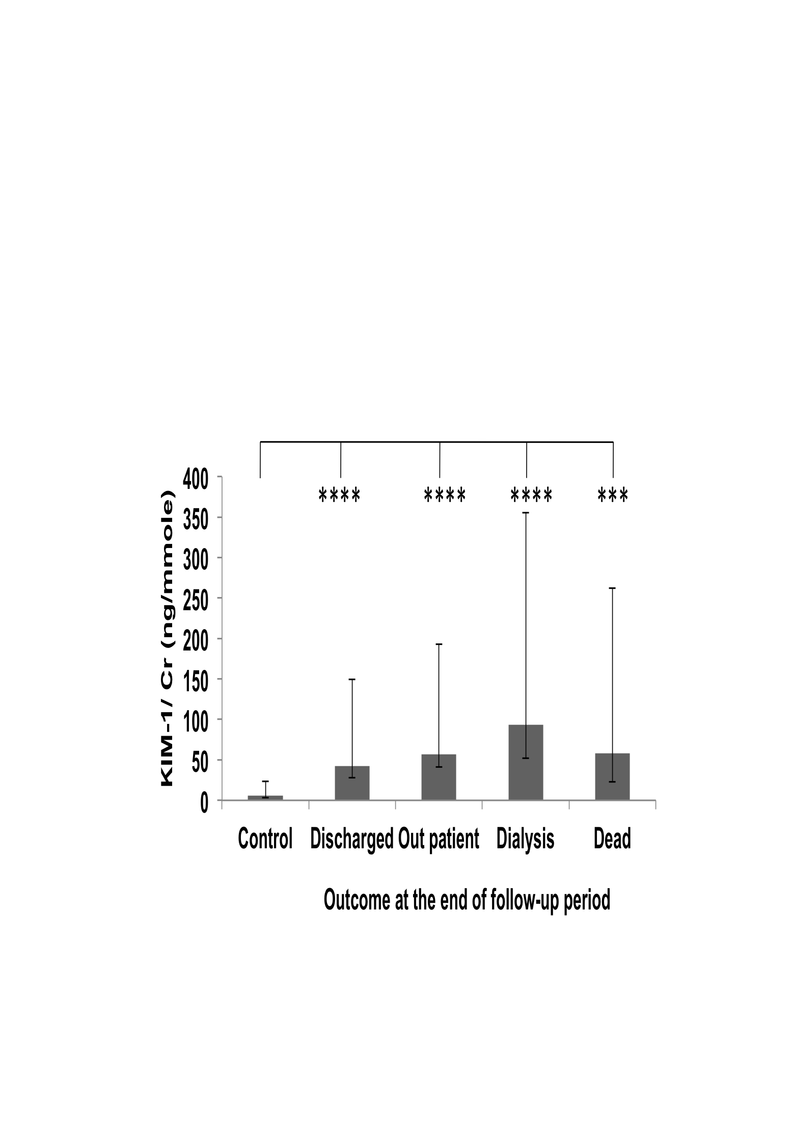
Figure 14: KIM/Cr value variations between patient groups
Distribution of KIM-1/Cr concentration ratio in urine according to causes of disease (A), stages (B), progression (C) and outcome of the disease at the end of the follow-up period (D). Geometric means ± SEMs are shown. Statistical significance of differences between populations was tested using 1 way ANOVA on log-transformed data as described in “Methods”. Asterisks indicate statistically significant differences (*, P = 0.02 to 0.01; **, P = 0.01 to 0.001; ***, P = 0.001 to 0.0001 and ****, P < 0.0001 see text for exact P values). The population sizes are: (A) control, n= 47; DM, n= 103; CGN, n= 54; HTN, n= 45; APKD, n= 11 and Others, n=49. (B) Control, n= 47; 1(CKD-1),n=12; 2(CKD-2),n= 22; 3a(CKD-3a),n= 39; 3b(CKD-3b), n= 58; 4(CKD-4), n=81; 5 (CKD-5), n=50. (C) Control, n= 47; Non-progressors (NP)=170; Progressors (P) =92. (D) Control, n= 47; Discharged, n=84; Outpatient, n= 124; Dialysis, n=33; Dead, n= 21.

Sub-group analyses of KIM-1/Cr values

DM subgroup analysis
When the KIM-1/Cr values of the DM patients were grouped by final stage of disease. There was a significant difference between the control group and each of the CKD-3a (P= 0.0028), CKD-3b (P= 0.0106), CKD-4 (P< 0.0001) and CKD-5 (P< 0.0001) stages (Figure 15 Panel A). However there was no significant difference between the stages. Unlike what was seen in the whole data set (Figure 14, panel B), there was no significant difference between control and stage 2 in this subgroup (Figure 15 Panel A). However, this is probably is an effect of the smaller sample size. There was no patient at stage 1 in this subgroup.
When the KIM-1/Cr values of the DM patients were grouped by progression status, there was a significant difference between the control and non-progressors (P< 0.0001) and progressors group (P< 0.0001). There was also a significant difference in between the non-progressors and progressors (P= 0.0479) (Figure 15 Panel B). Similar results were seen in the whole data set.
When the same data was analysed by outcomes, the KIM-1/Cr values of the discharged, out-patient, dialysis and dead groups were all very significantly higher than the controls (Figure 15 Panel C, P< 0.0001 for all) but there was no significant difference between the disease groups. These results were similar to the whole data set.
In conclusion, except for small differences that are probably due to the smaller sample size in this subgroup, the results of the one-way ANOVA tests for the DM patients were similar to those obtained with the whole data set.

A B
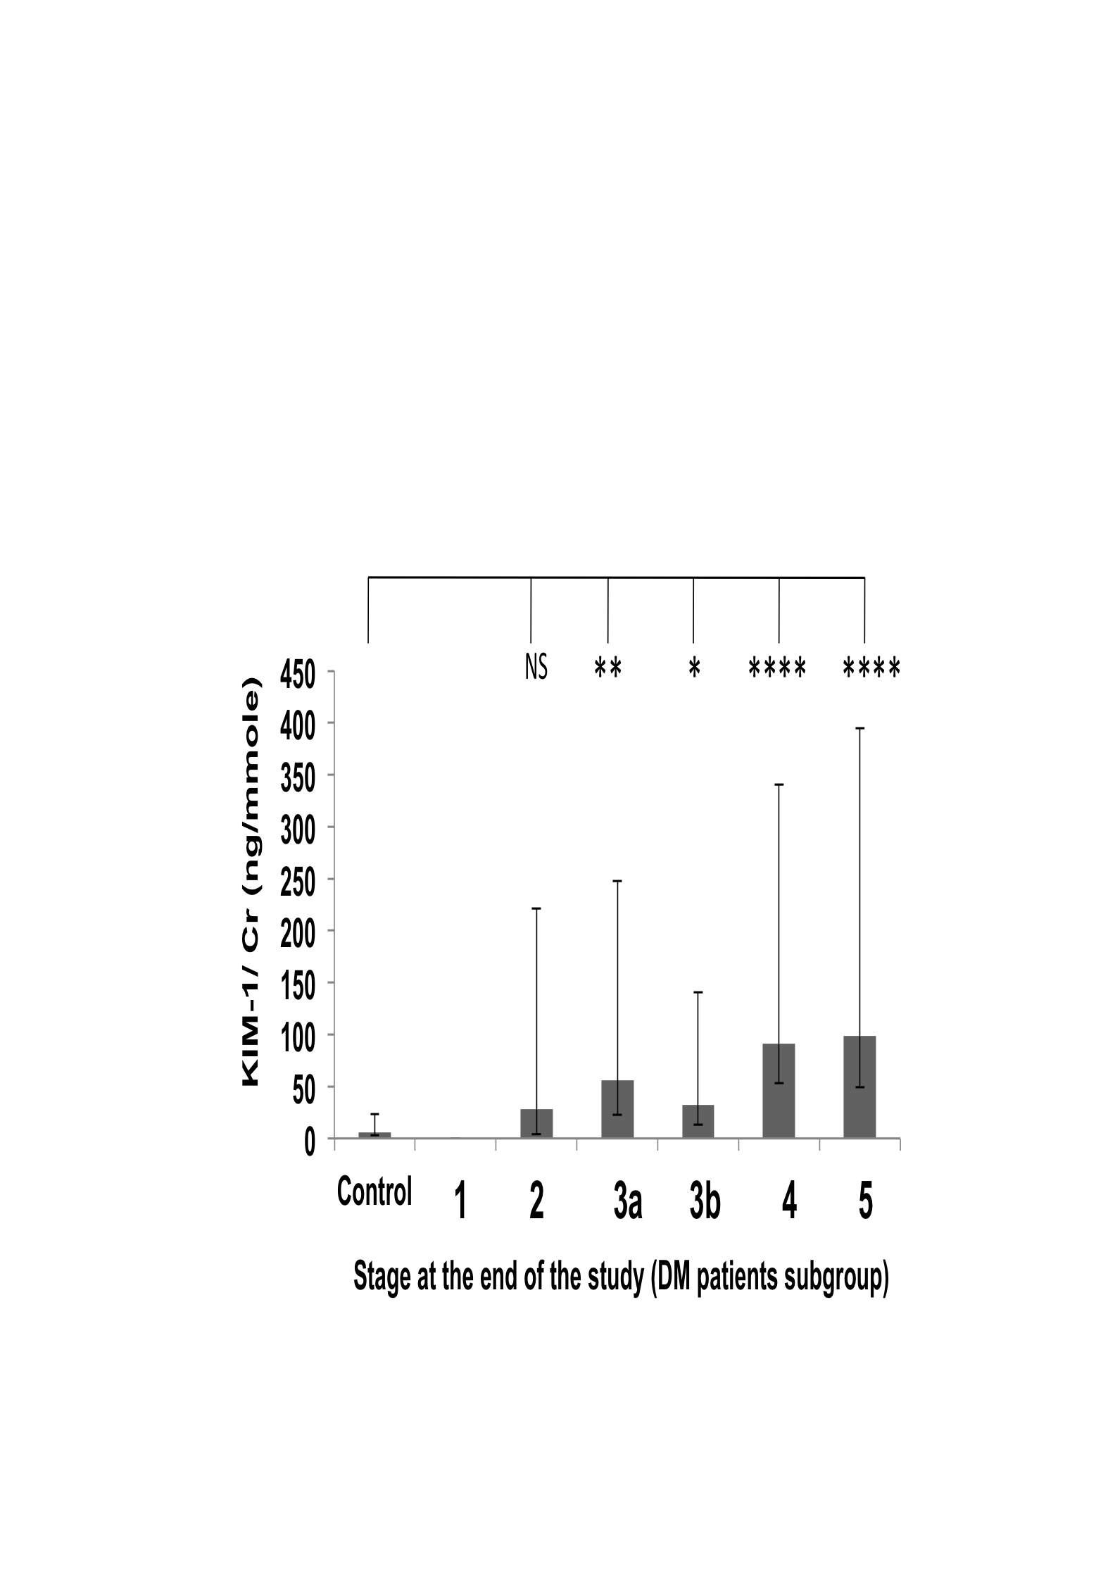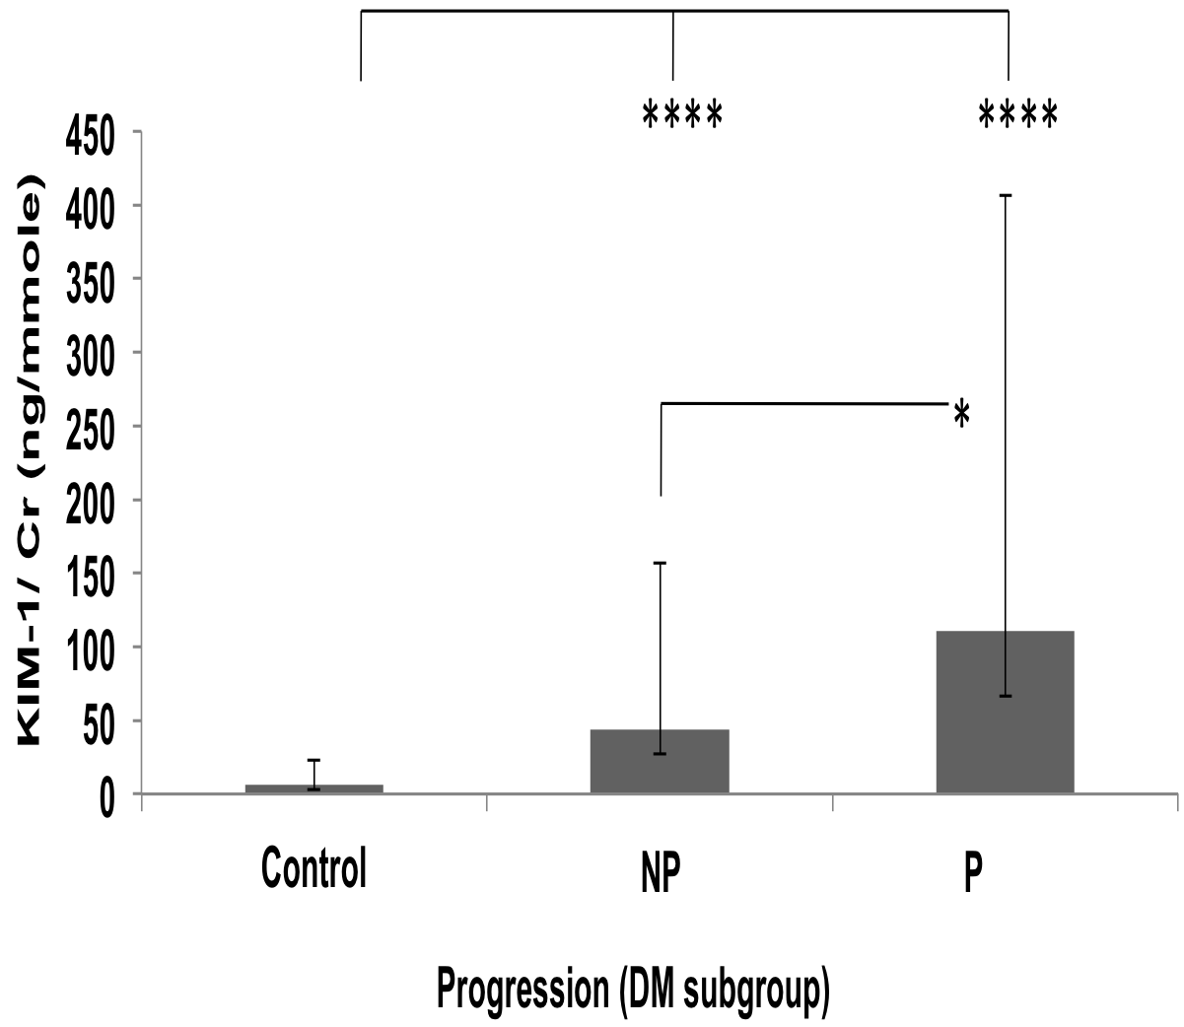

C
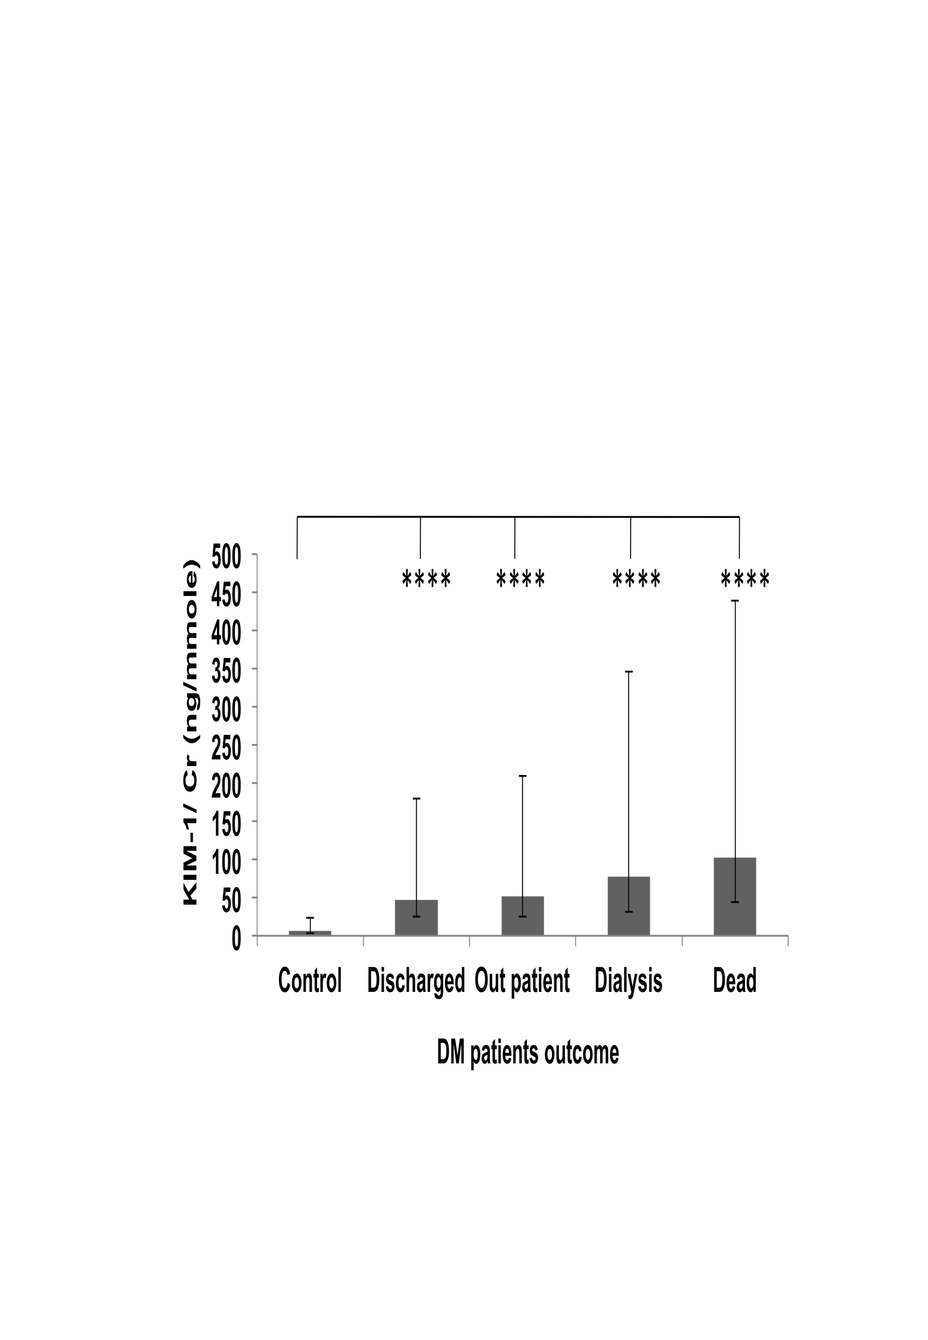
Figure 15: KIM-1/Cr values variation in DM patient group
Distribution of KIM-1/Cr concentration ratio in urine in DM patients subgroup according to stage of disease (A), progression of disease (B) and outcome of the disease at the end of the follow-up period (C). Geometric means ± SEMs are shown. Statistical significance of differences between populations was tested using 1 way ANOVA on log-transformed data as described in “Methods”. Asterisks indicate statistically significant differences (*, P = 0.02 to 0.01; **, P = 0.01 to 0.001; ***, P = 0.001 to 0.0001 and ****, P < 0.0001 see text for exact P values). The population sizes are: control, n= 47; 1(CKD-1), n=0; 2(CKD-2), n= 7; 3a(CKD-3a), n= 14; 3b(CKD-3b), n= 24; 4(CKD-4), n=34; 5 (CKD-5), n=24; Non-progressors (NP), n=74; Progressors (P), n= 29; Discharged, n= 38; Outpatients, n= 34; Dialysis, n= 17 and Dead = 14.

CGN subgroup
There was a significant difference in between the control and CKD-3a (P= 0.0241); CKD-3b (P= 0.0074); CKD-4 (P= 0.0234) and CKD-5 (P= 0.043) (Figure 16 Panel A). But there was no significant difference in between these groups. Unlike for the whole data set, there was no significant difference between the controls and patients at stage1 or 2, as explained earlier for the DM group; this may be due to the smaller sample size.
There was highly significant difference in between the control and non-progressors group (P< 0.0001) and progressors group (P< 0.0001) (Figure 16 Panel B). There was no significant difference between the non-progressor and progressor groups, whereas in the whole data set there was a significant difference between the non-progressor and progressors group (Figure 14 Panel C).
There was a significant difference in between the control and outpatient group (P< 0.0001) (Figure 16 Panel C) but not between control and other groups; and also not between in the out-come groups. This is likely because of the small group size as the outpatient (n=39) is by far the most abundant group.

A B
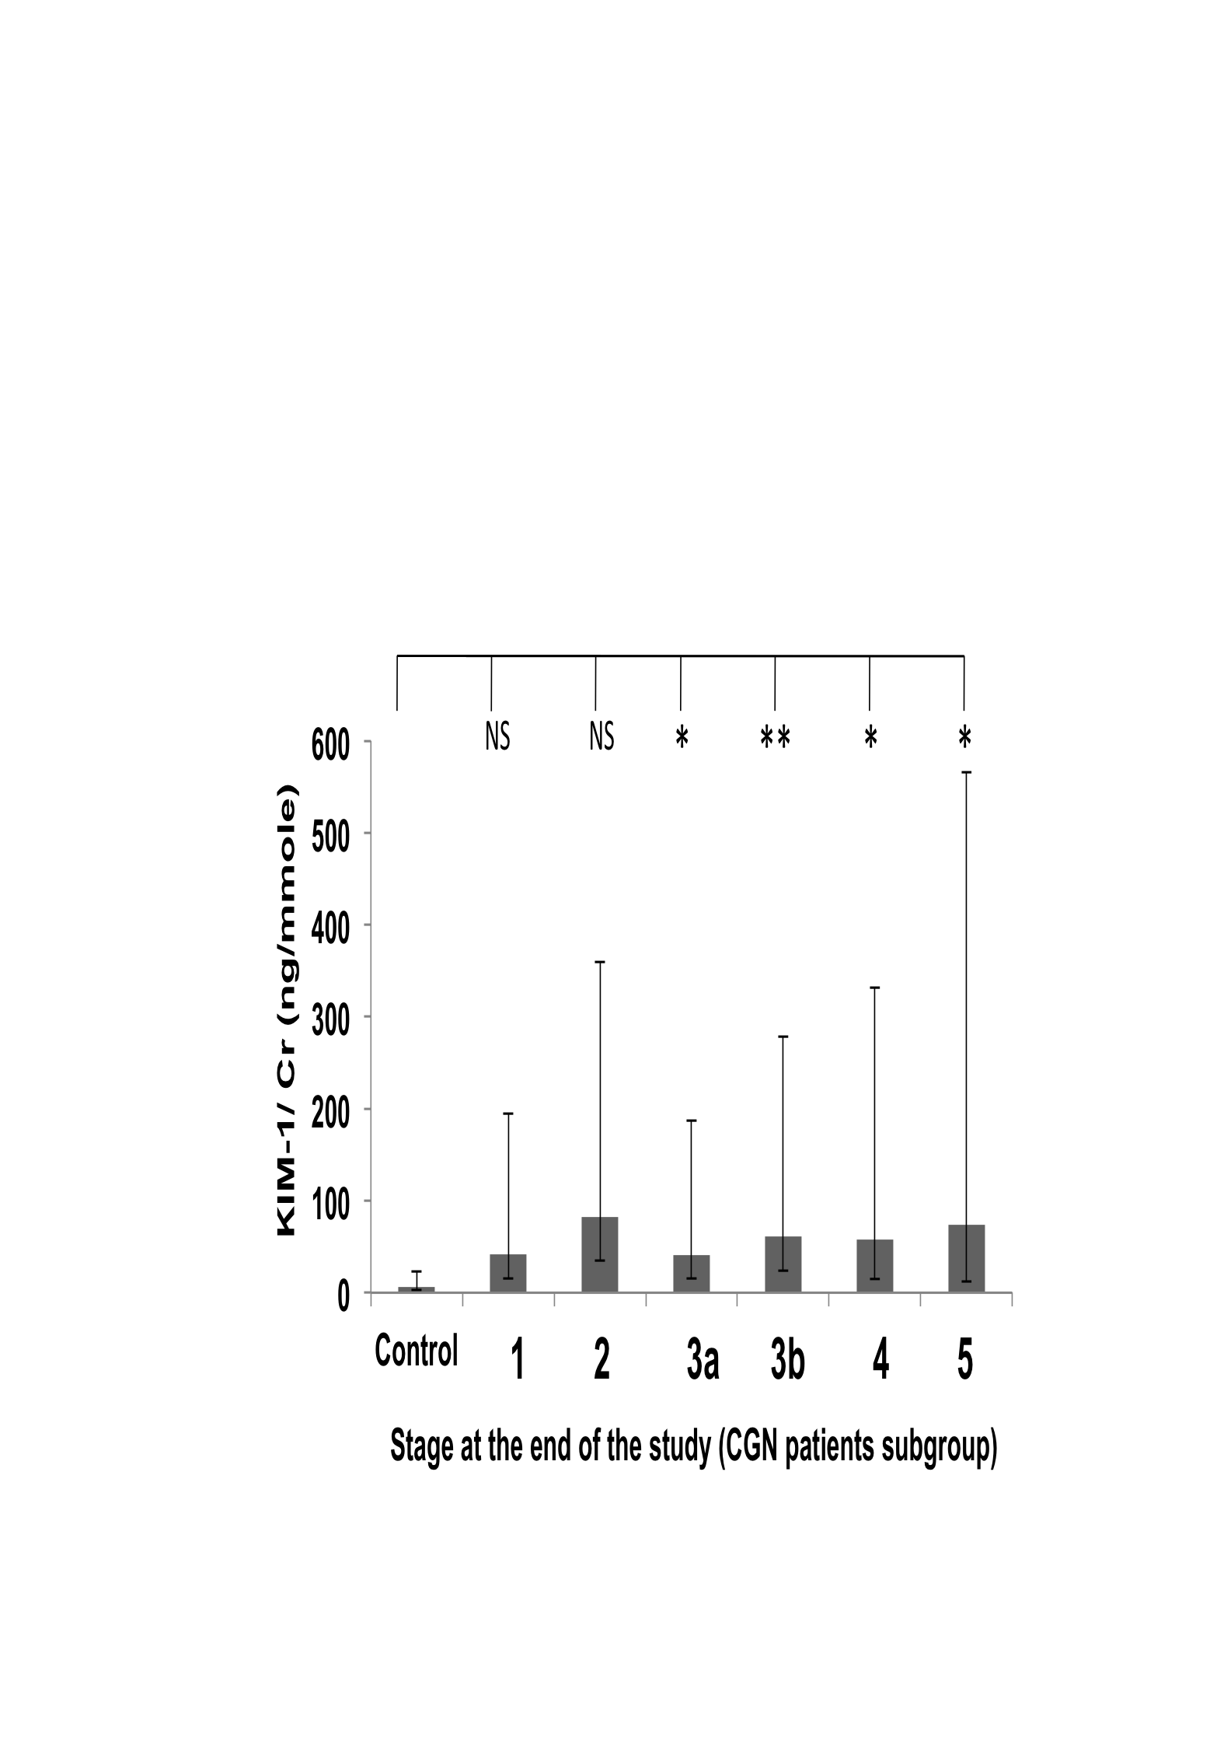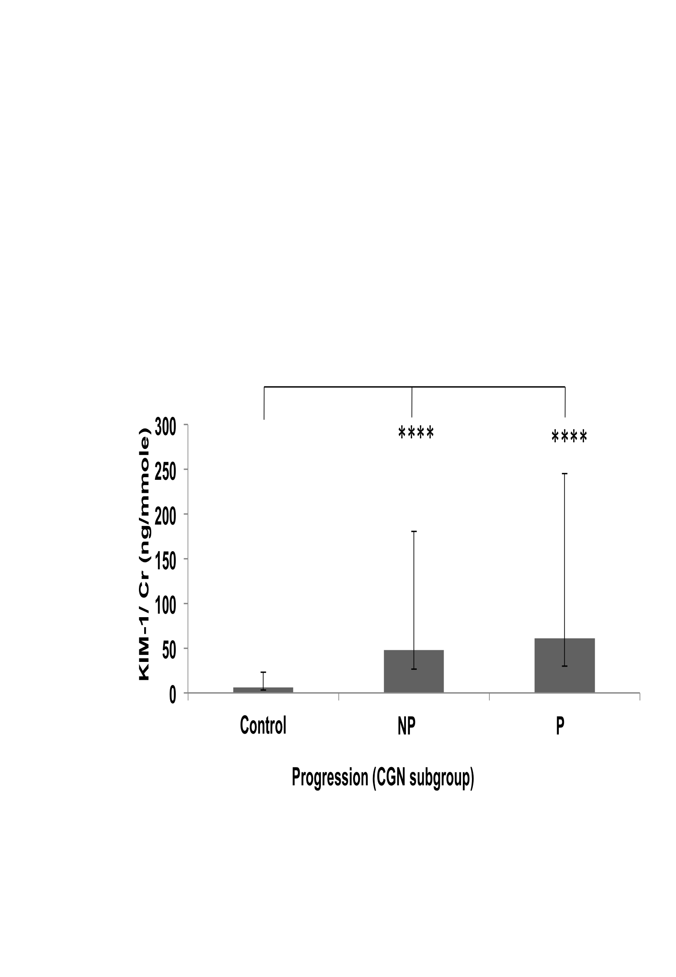

C
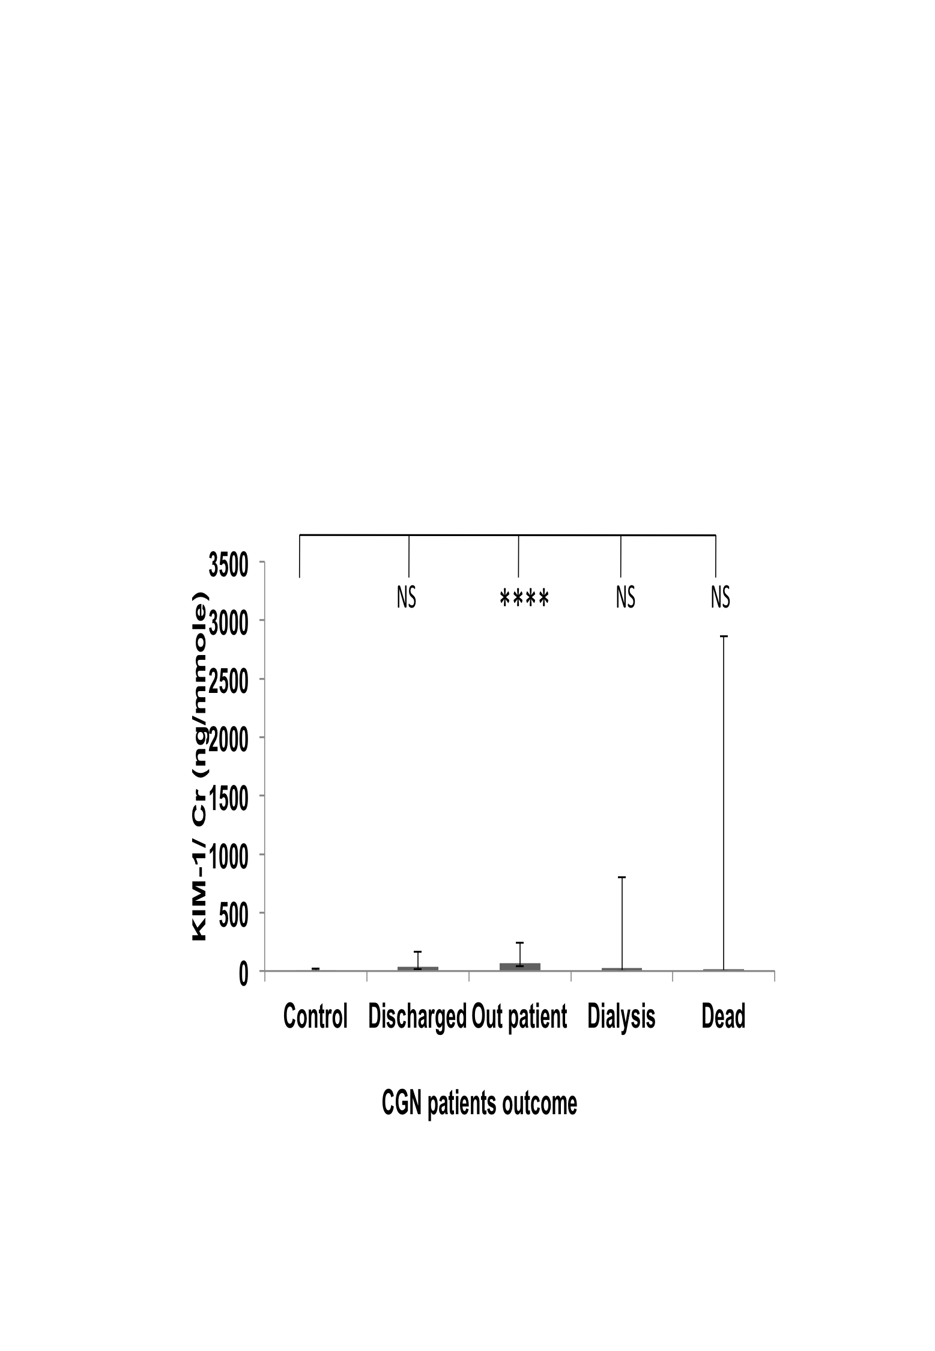
Figure 16: KIM-1/Cr values variation in CGN patient group
Distribution of KIM-1/Cr concentration ratio in urine in CGN patients subgroup according to stage of disease (A), progression of disease (B) and outcome of the disease at the end of the follow-up period (C). Geometric means ± SEMs are shown. Statistical significance of differences between populations was tested using 1 way ANOVA on log-transformed data as described in “Methods”. Asterisks indicate statistically significant differences (*, P = 0.02 to 0.01; **, P = 0.01 to 0.001; ***, P = 0.001 to 0.0001 and ****, P < 0.0001 see text for exact P values). The population sizes are: control, n= 47; 1(CKD-1), n=9; 2(CKD-2), n= 5; 3a(CKD-3a), n= 14; 3b(CKD-3b), n= 11; 4(CKD-4), n=9; 5 (CKD-5), n= 6; Non-progressors (NP), n=28; Progressors (P), n= 26; Discharged, n= 10; Outpatients, n= 39; Dialysis, n= 3 and Dead = 2.

HTN subgroup
There was a significant difference in between the control and CKD-3a (P= 0.0028); CKD-3b (P= 0.0106); CKD-4 (P< 0.0001) and CKD-5 (P< 0.0001) (Figure 17 Panel A). There were no patients at stage 1 or 2 in HTN subgroup, so these could not be studied here. There was also no significant difference between these groups.
There was highly significant difference between the control and non-progressors (P< 0.0001) and progressors (P< 0.0001) groups (Figure 17 Panel B). There was no statistically significant difference between the non-progressor and progressor groups. This contrasts with the results for the whole cohort, where there was a significant difference between the non-progressor and progressor groups (Figure 14 Panel C).
There were highly significant differences between the controls and the discharged group (P= 0.0085), the outpatient group (P= 0.0106) and the dialysis group (P= 0.0002) (Figure 17 Panel C). But there was no significant difference between the outcome groups. There was no significant difference from the controls and dead group. Due to its smaller sample size (n=3), it is not sufficient to draw a firm conclusion from this.

A B
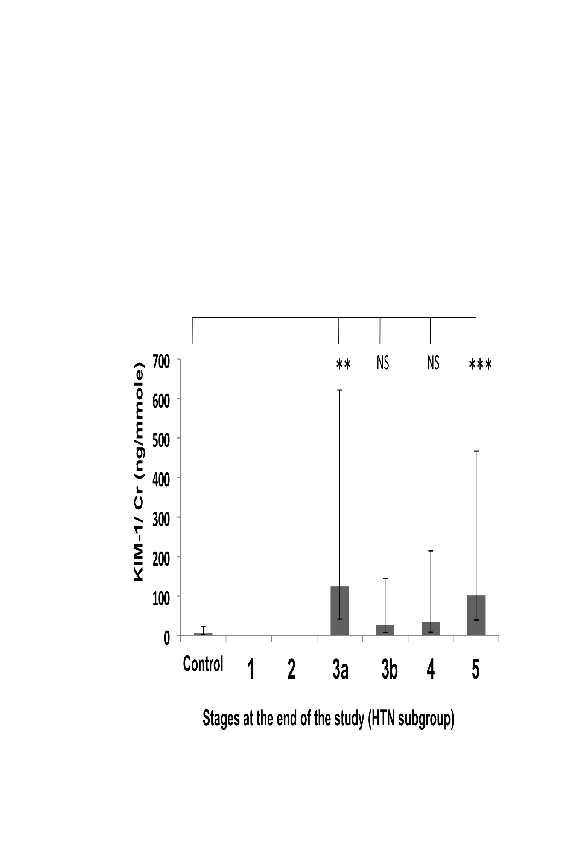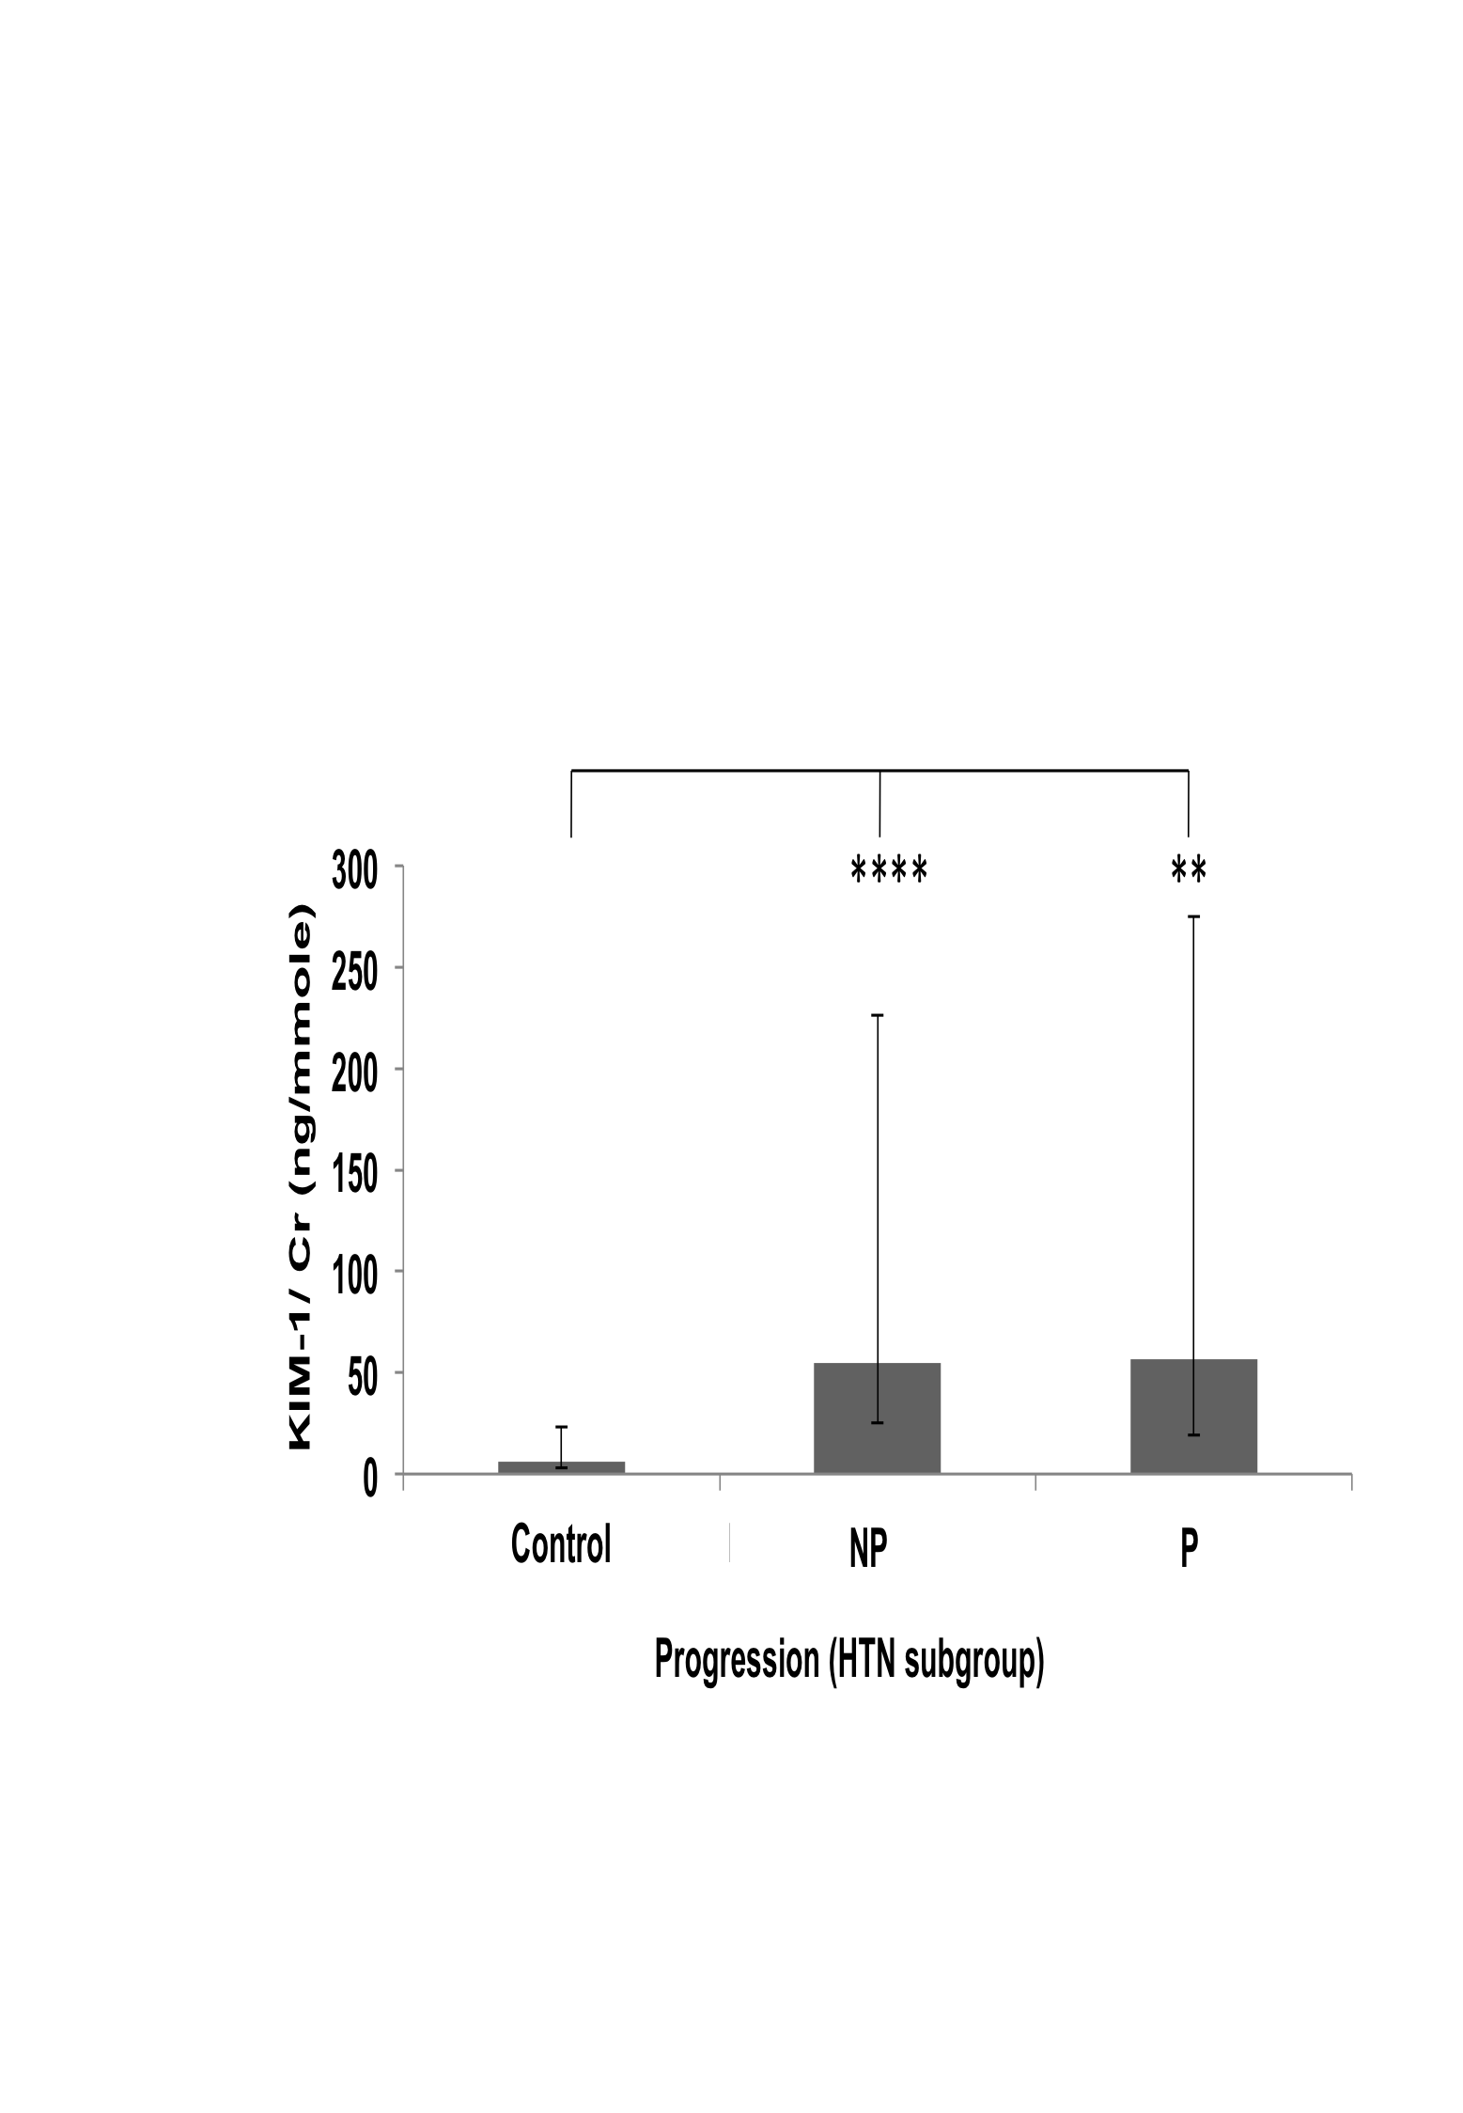

C
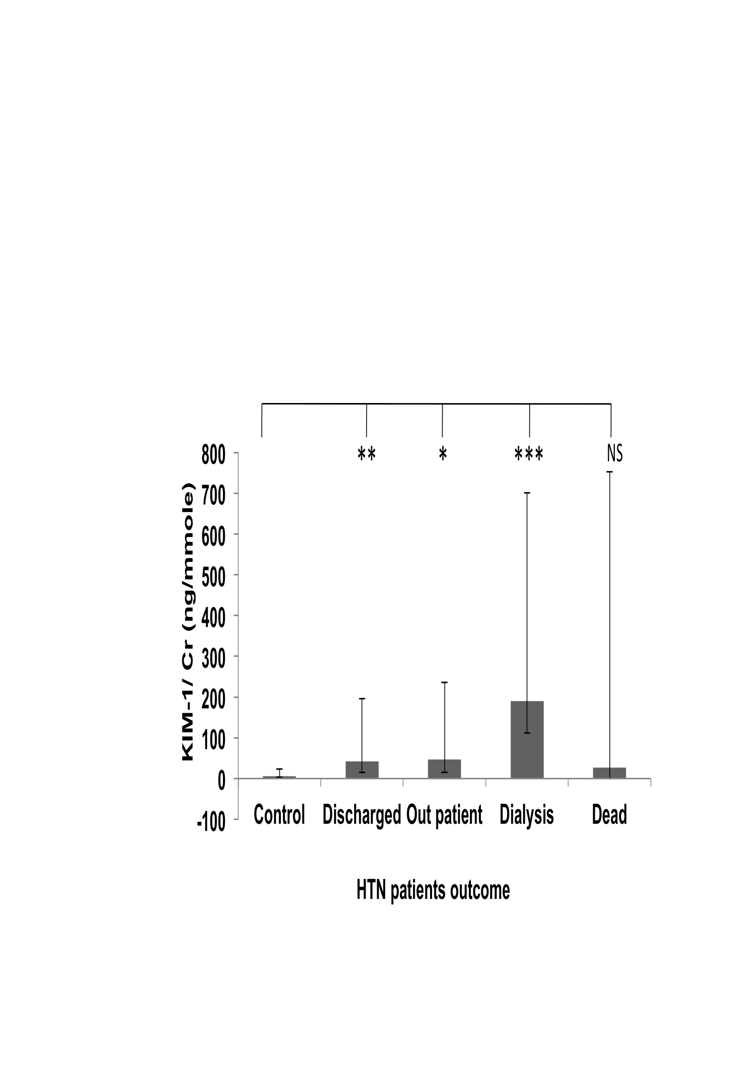

Figure 17: KIM-1 /Cr values variation within the HTN patient subgroup
Distributions of KIM-1 /Cr concentration ratios in the HTN patients subgroup according to stage of disease (A), progression of disease (B) and outcome of the disease at the end of the follow-up period (C). Geometric means ± SEMs are shown. Statistical significance of differences between populations was tested using 1 way ANOVA on log-transformed data as described in “Methods”. Asterisks indicate statistically significant differences (*, P = 0.02 to 0.01; **, P = 0.01 to 0.001; ***, P = 0.001 to 0.0001 and ****, P < 0.0001 see text for exact P values). The population sizes are: (A) control, n= 47; 1(CKD-1), n=0; 2(CKD-2), n= 0; 3a (CKD-3a), n= 8; 3b(CKD-3b), n= 12; 4(CKD-4), n=13; 5 (CKD-5), n=12 (B) control, n= 47; Non-progressors (NP)=29; Progressors (P) =16 (C) control, n= 47; Discharged, n=19; Outpatient, n= 15; Dialysis, n=8; Dead, n= 3.

One-way ANOVA analyses of MCP-1/Cr values

Whole cohort analyses
MCP-1 was measured in urine from 262 CKD patients of various causes and stages (excluding stage 5 at the time of presentation) and 47 healthy individuals using the R and D Duoset ELISA system. To normalise the MCP-1 value, it was expressed as MCP-1/Cr (ng/mmol) ratio. The data were not normally distributed and few outlier were present, so the data were log transformed, so that, the One way ANOVA significance test could be and expressed as geometric mean (GM) ± SEM.
There was no significant difference between the control and causes of CKD when the MCP-1/Cr values were grouped according to the causes of CKD (Figure 18 Panel A).
There was no significant difference between the control and stages of CKD when the MCP-1/Cr values were grouped by the stages of CKD (Figure 18 Panel B).
MCP-1/Cr values were significantly higher in progressors group (P = 0.0065) compared to controls but there was no significant difference between the control and non-progressors group and also between the non-progressors and progressors groups (Figure 18 Panel C).
There was a significant difference in between the control and dialysis group (P= 0.0352), but there was no significant difference between the control and other outcome groups and also in between the outcome groups (Figure 18 Panel D)

A B
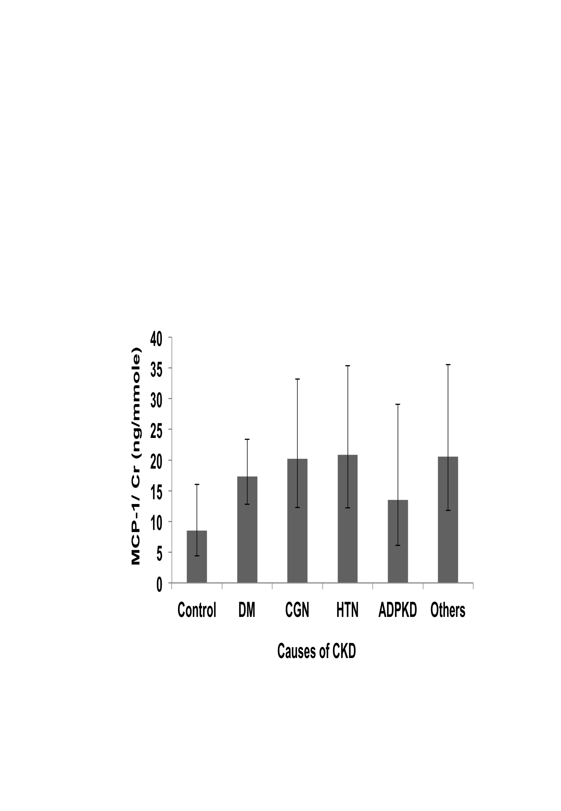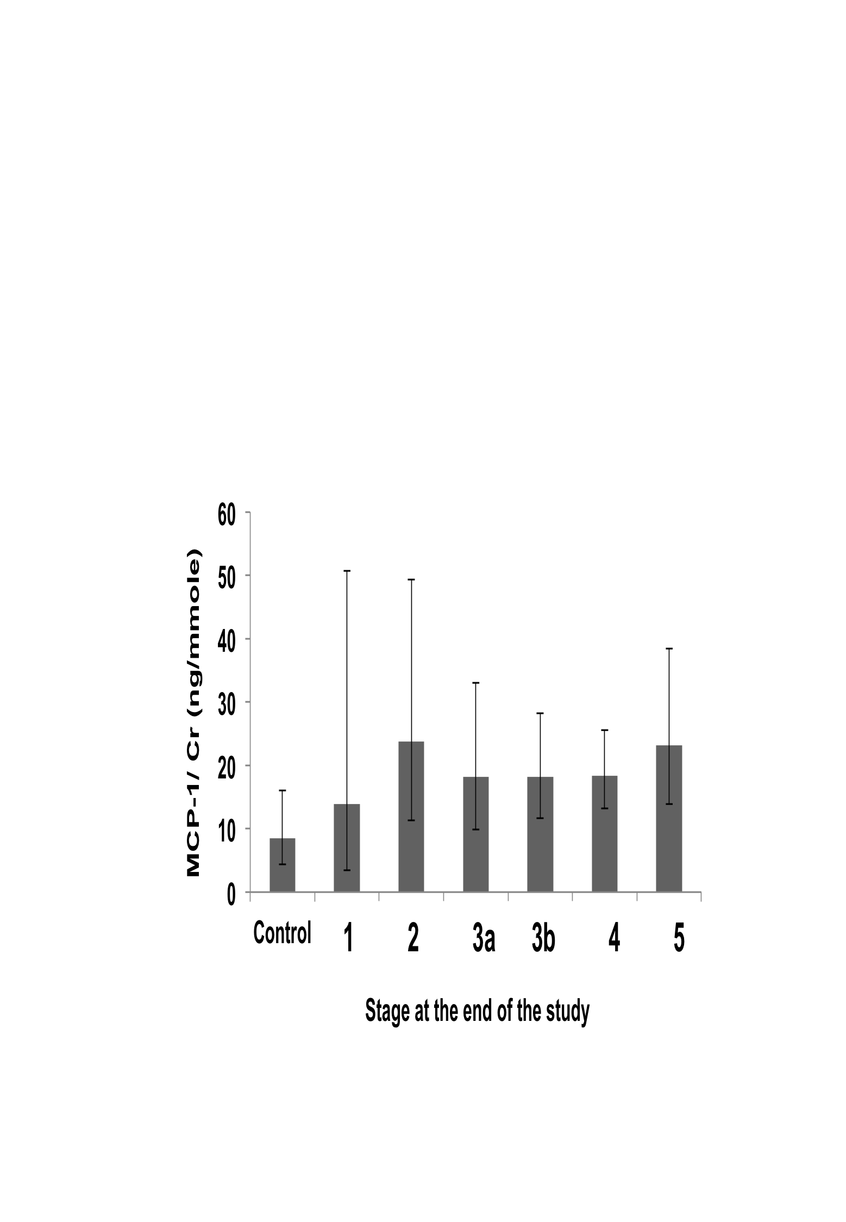

C D
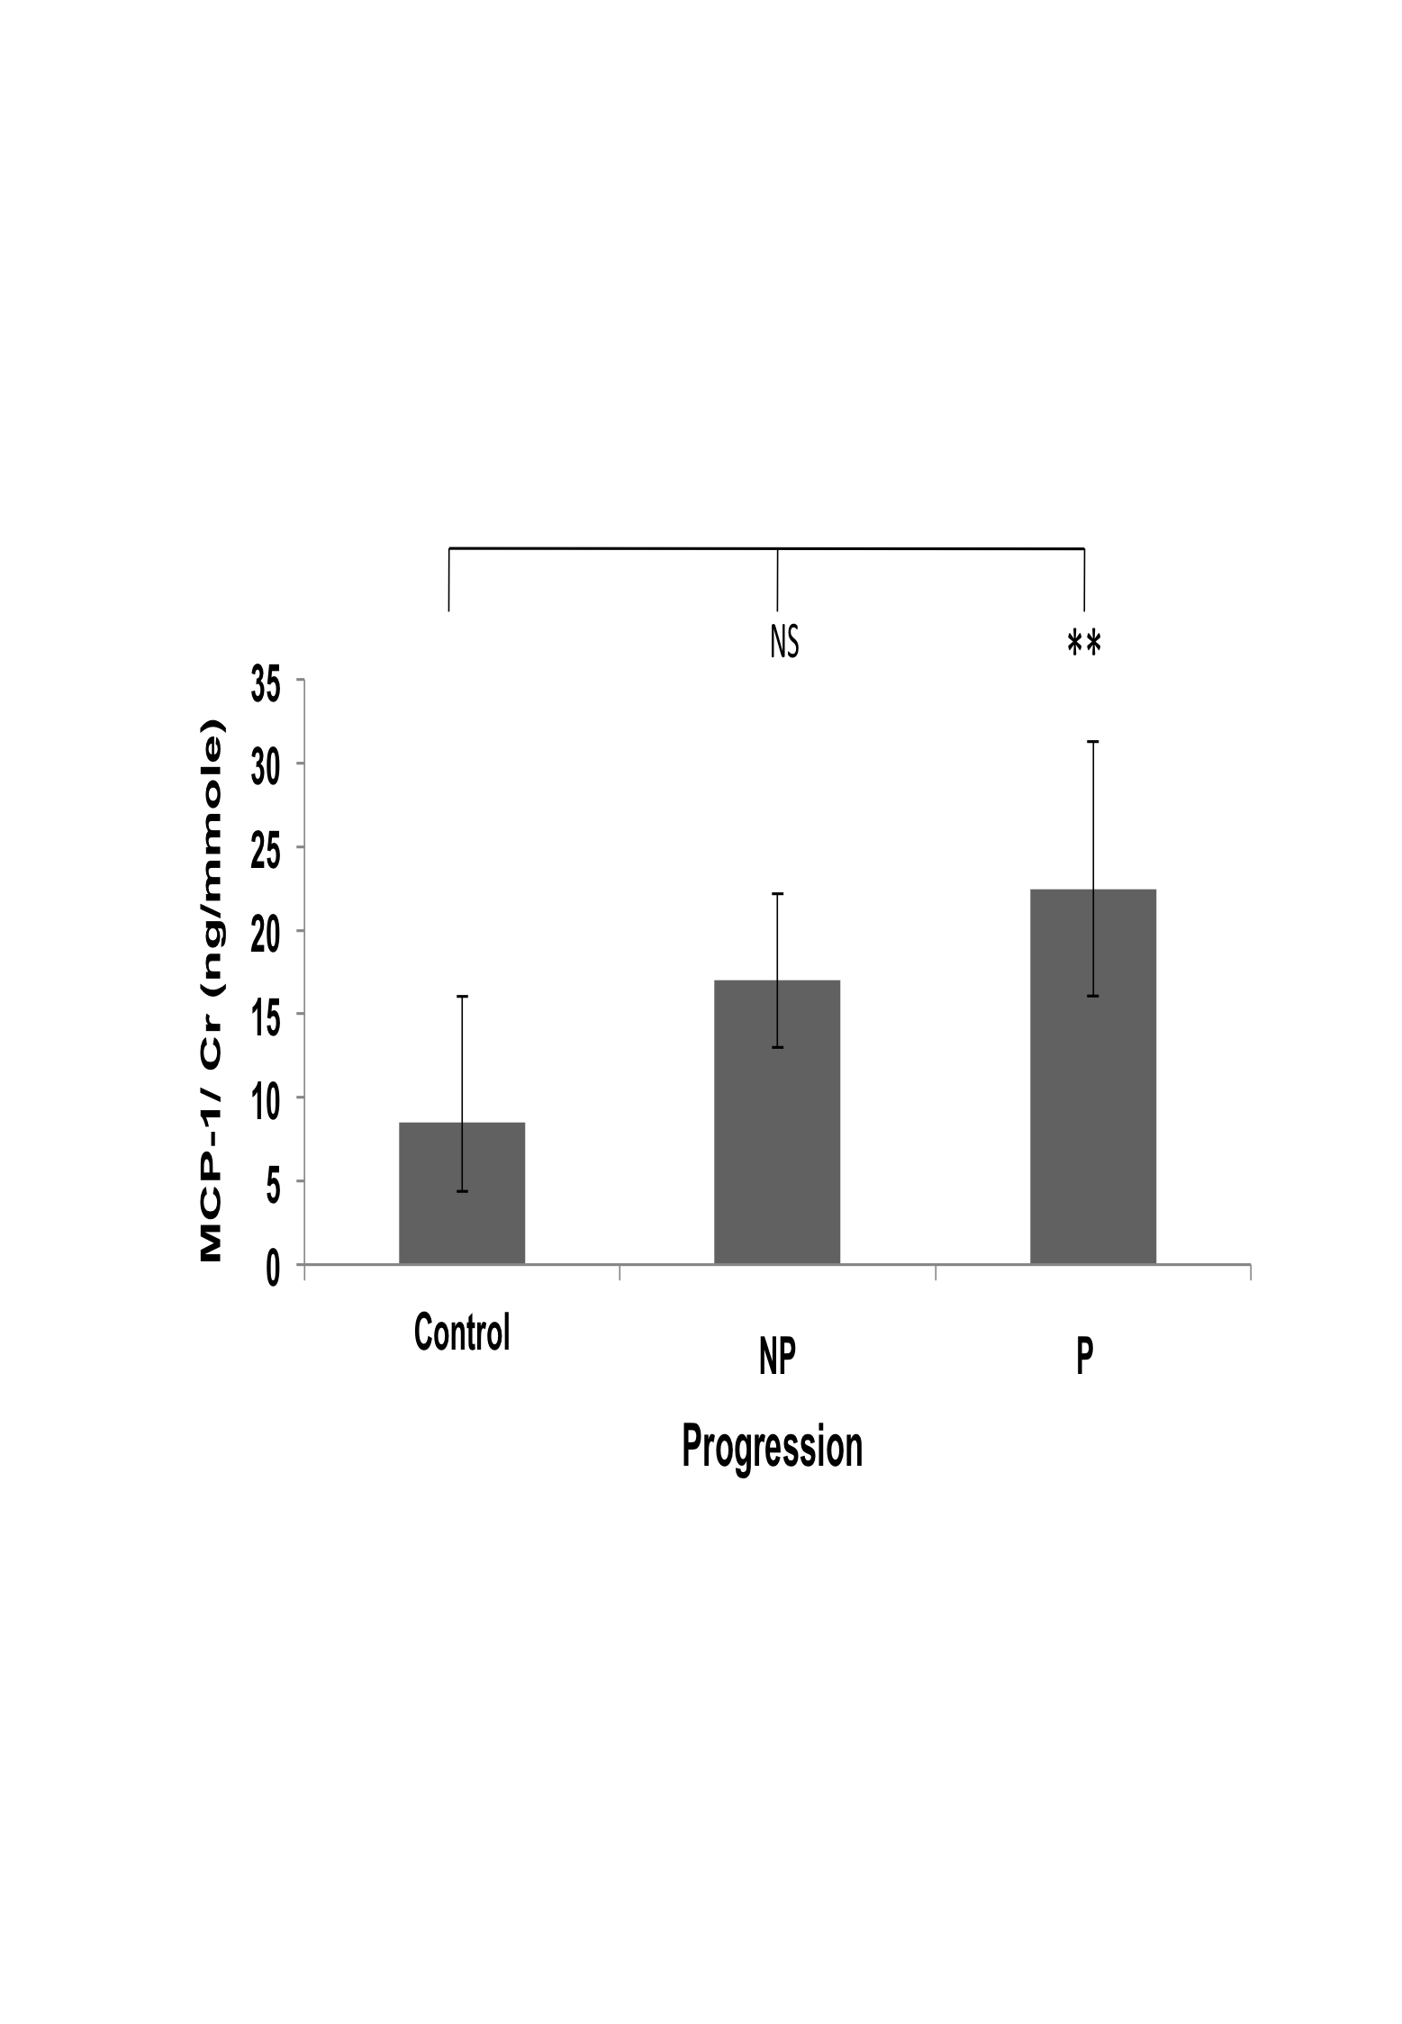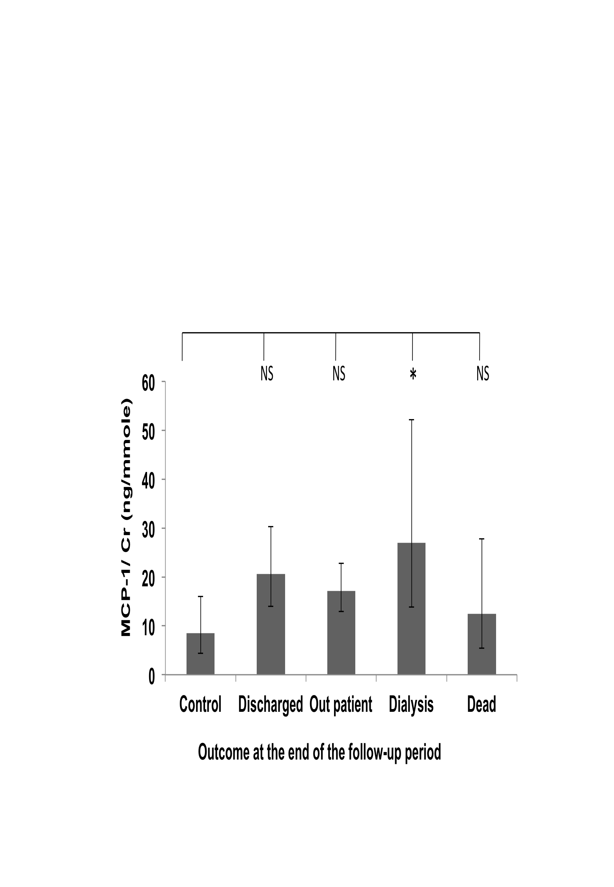

Figure 18: MCP-1/Cr values variation between patient groups
Distribution of MCP-1 /Cr concentration ratio in urine according to causes of disease (A), stages (B), progression (C) and outcome of the disease at the end of the follow-up period (D). Geometric means ± SEMs are shown. Statistical significance of differences between populations was tested using 1 way ANOVA on log-transformed data as described in “Methods”. Asterisks indicate statistically significant differences (*, P = 0.02 to 0.01; **, P = 0.01 to 0.001; ***, P = 0.001 to 0.0001 and ****, P < 0.0001 see text for exact P values). The population sizes are: (A) control, n= 47; DM, n= 103; CGN, n= 54; HTN, n= 45; APKD, n= 11 and Others, n=49. (B) Control, n= 47; 1(CKD-1),n=12; 2(CKD-2),n= 22; 3a(CKD-3a),n= 39; 3b(CKD-3b), n= 58; 4(CKD-4), n=81; 5 (CKD-5), n=50. (C) Control, n= 47; Non-progressors (NP)=170; Progressors (P) =92. (D) Control, n= 47; Discharged, n=84; Outpatient, n= 124; Dialysis, n=33; Dead, n= 21.

Sub-group analyses
The one-way ANOVA analyses carried out on the MCP-1/Cr values of the DN and CGN sub-groups identified no statistically significant differences between the control group and any of the final stages, outcomes or progression status groups (data not shown). Thus, the two statistically significant differences that had been detected in the MCP-1/Cr data set in the whole cohort (between the controls and progressor groups and between the controls and dialysis groups) could not be found in the data from diabetic and chronic glomerulonephritis patients.
When the MCP-1/Cr values of the HTN patient sub-group was analysed by one-way ANOVA, no statistically significant effect could be detected when the data was analysed by final stage of disease or progression status (data not shown), However, there was a statistically significant difference between the control and dialysis groups (Figure 19), with P= 0.0347. This result was similar to the statistical difference between the control and dialysis groups in the analysis of the whole cohort.

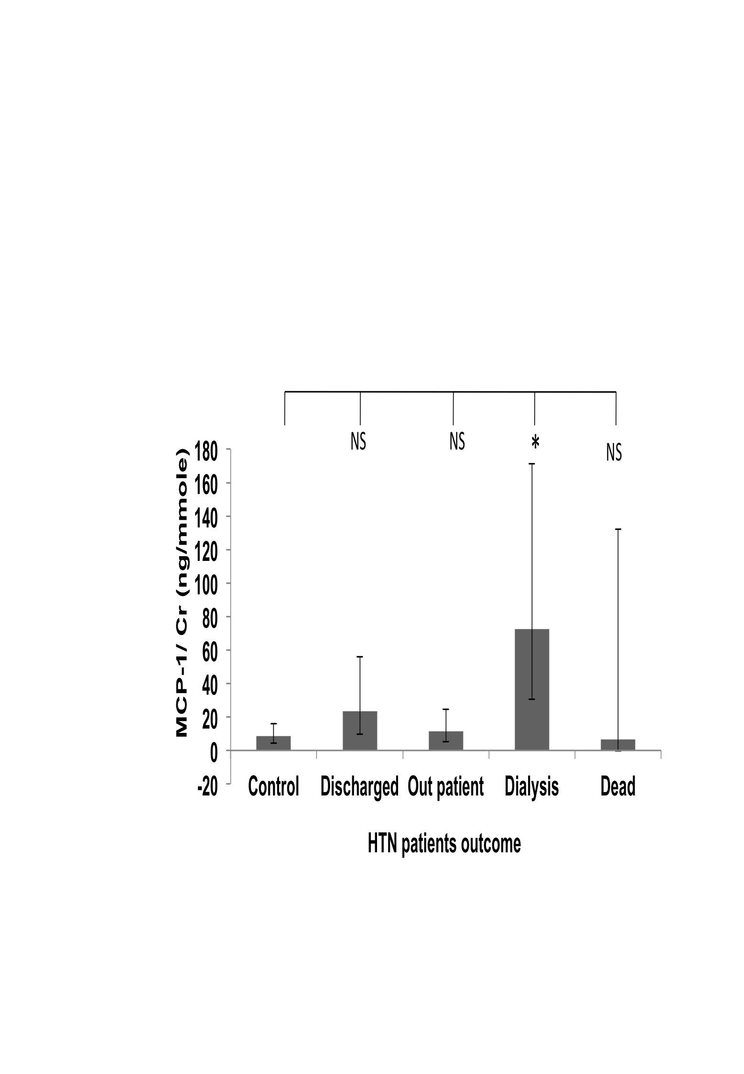
Figure 19: MCP-1 /Cr values variation in HTN patient group
Distribution of MCP-1/Cr concentration ratio in urine according to stage of disease (A), progression of disease (B) and outcome of the disease at the end of the follow-up period (C) in HTN patients subgroup. Geometric means ± SEMs are shown. Statistical significance of differences between populations was tested using 1 way ANOVA on log-transformed data as described in “Methods”. Asterisks indicate statistically significant differences (*, P = 0.02 to 0.01; **, P = 0.01 to 0.001; ***, P = 0.001 to 0.0001 and ****, P < 0.0001 see text for exact P values). The population sizes are: control, n= 47; Discharged, n=19; Outpatient, n= 15; Dialysis, n=8; Dead, n= 3.

One-way ANOVA analyses of NGAL/Cr values

Whole cohort-analyses
There was no significant difference between the control and CKD causes group other than the “Others” group (P= 0.0197) (Figure 20 Panel A). Others group consist of small number of various causes of CKD patients.
There was a significant difference between the control and CKD-4 (P= 0.0412) and there was no significant difference between the CKD stages (Figure 20 Panel B).
There was a significant difference between the control and non-progressors (P= 0.0381) and progressors (P= 0.0012). But there was no significant difference between the non-progressors and progressors group (Figure 20 panel C).
There was a significant difference between the control and discharge group (P = 0.0095) but there was no significant difference in any other disease outcome group (Figure 20 Panel D).

A B
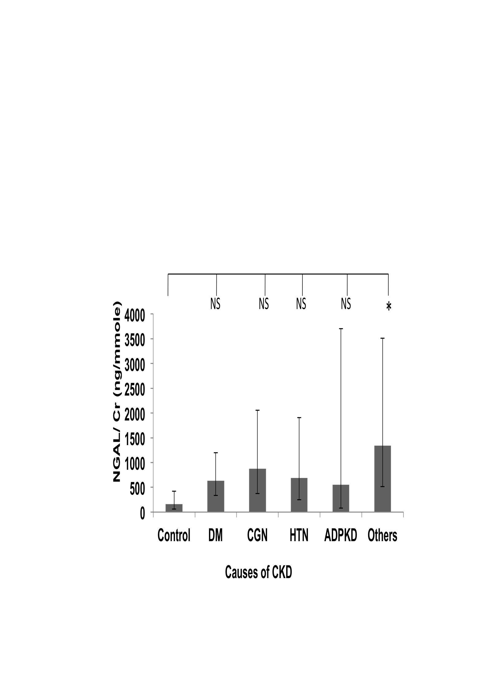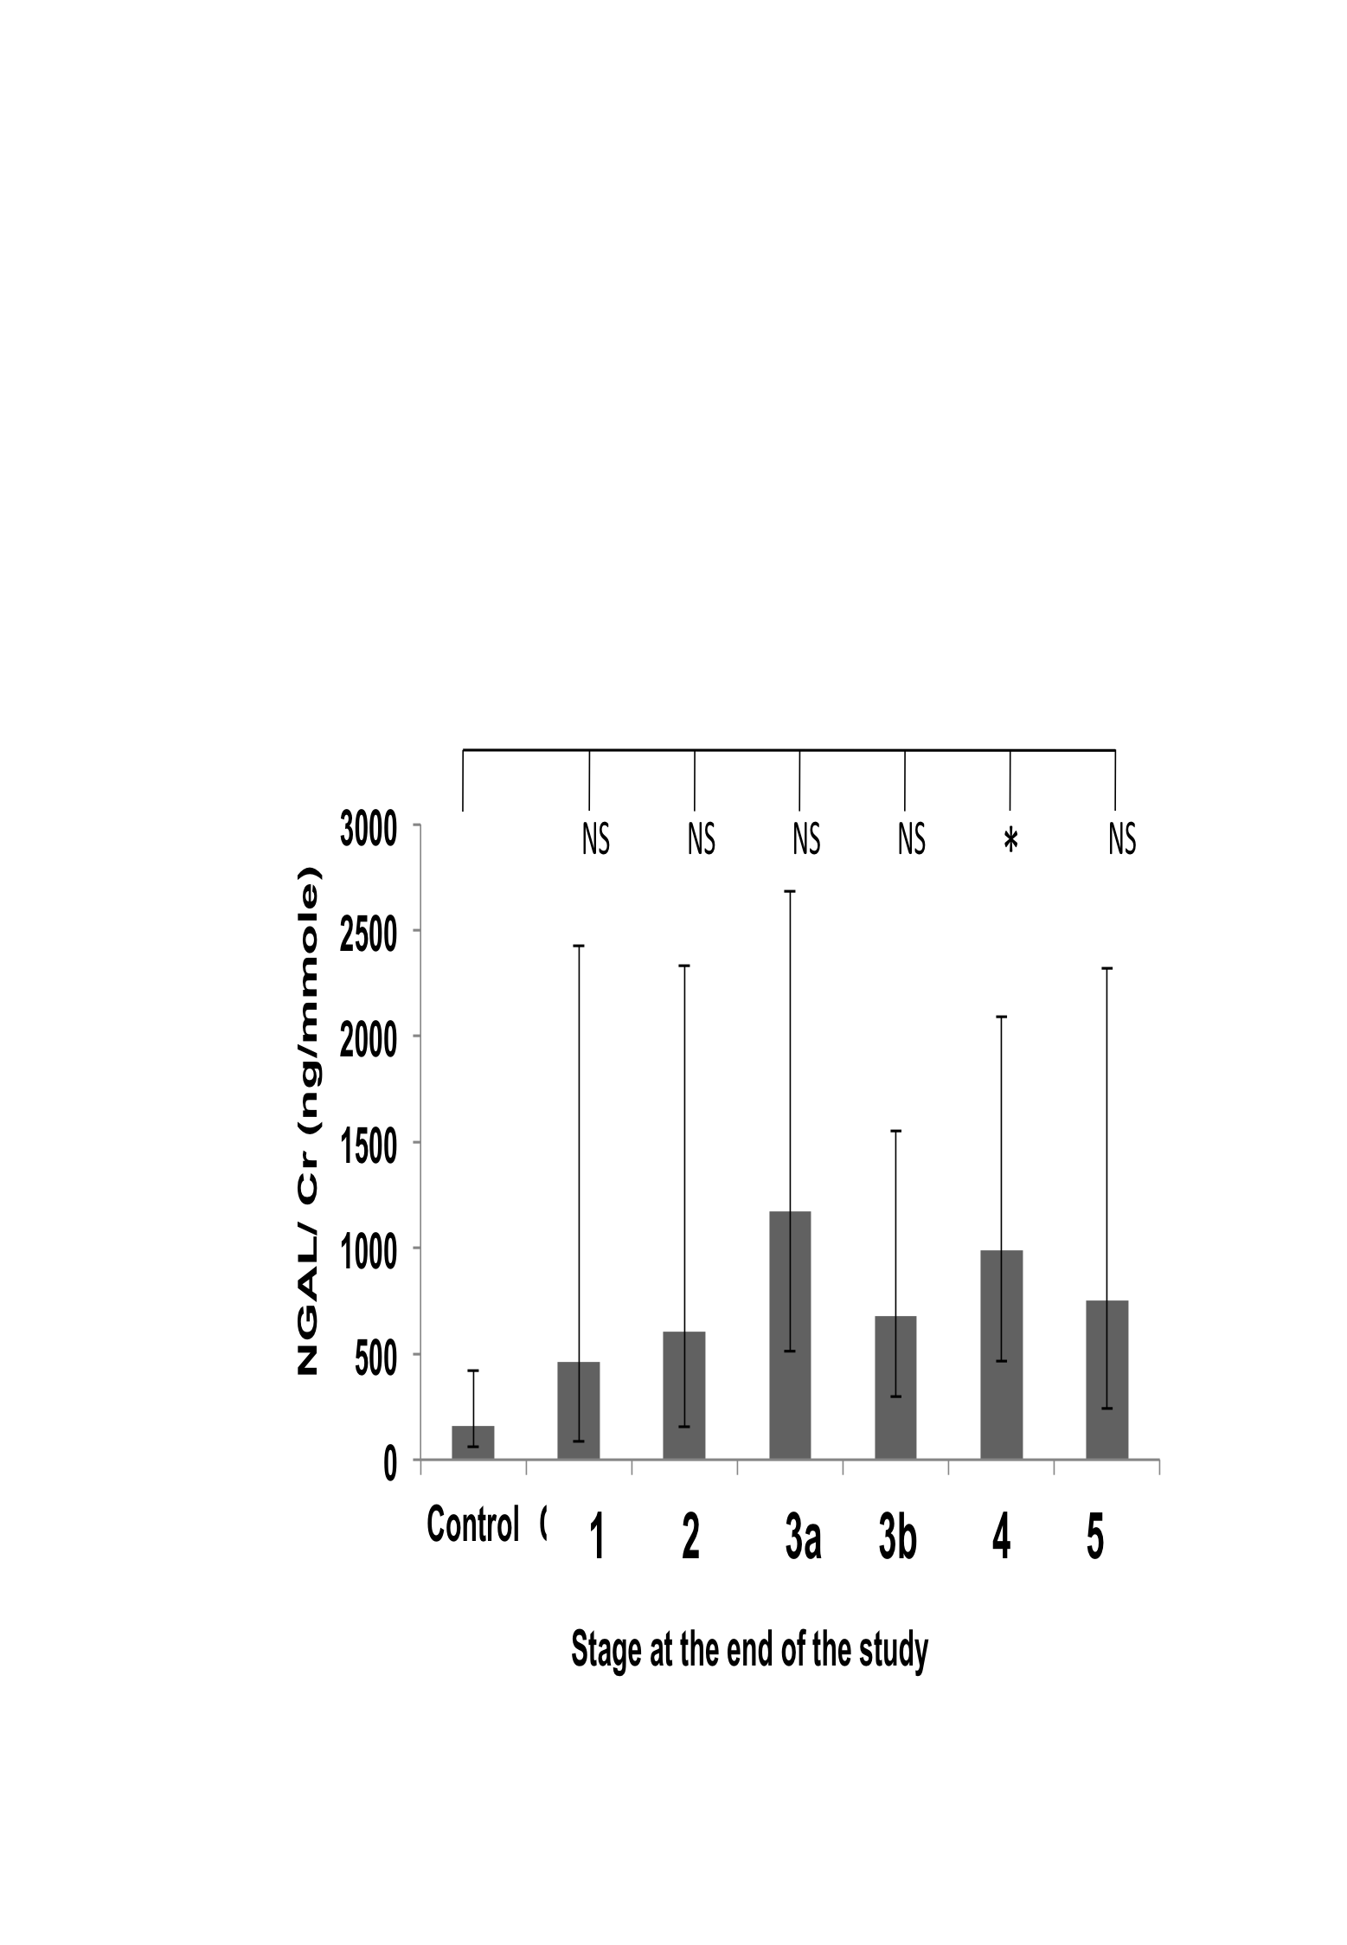

C D
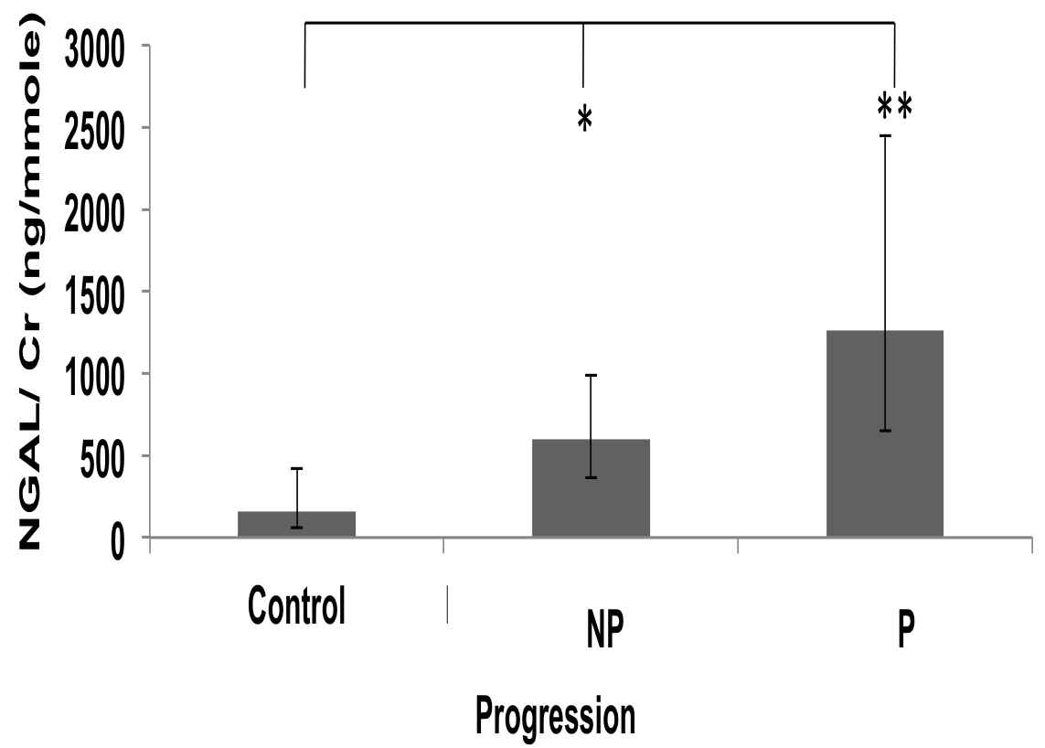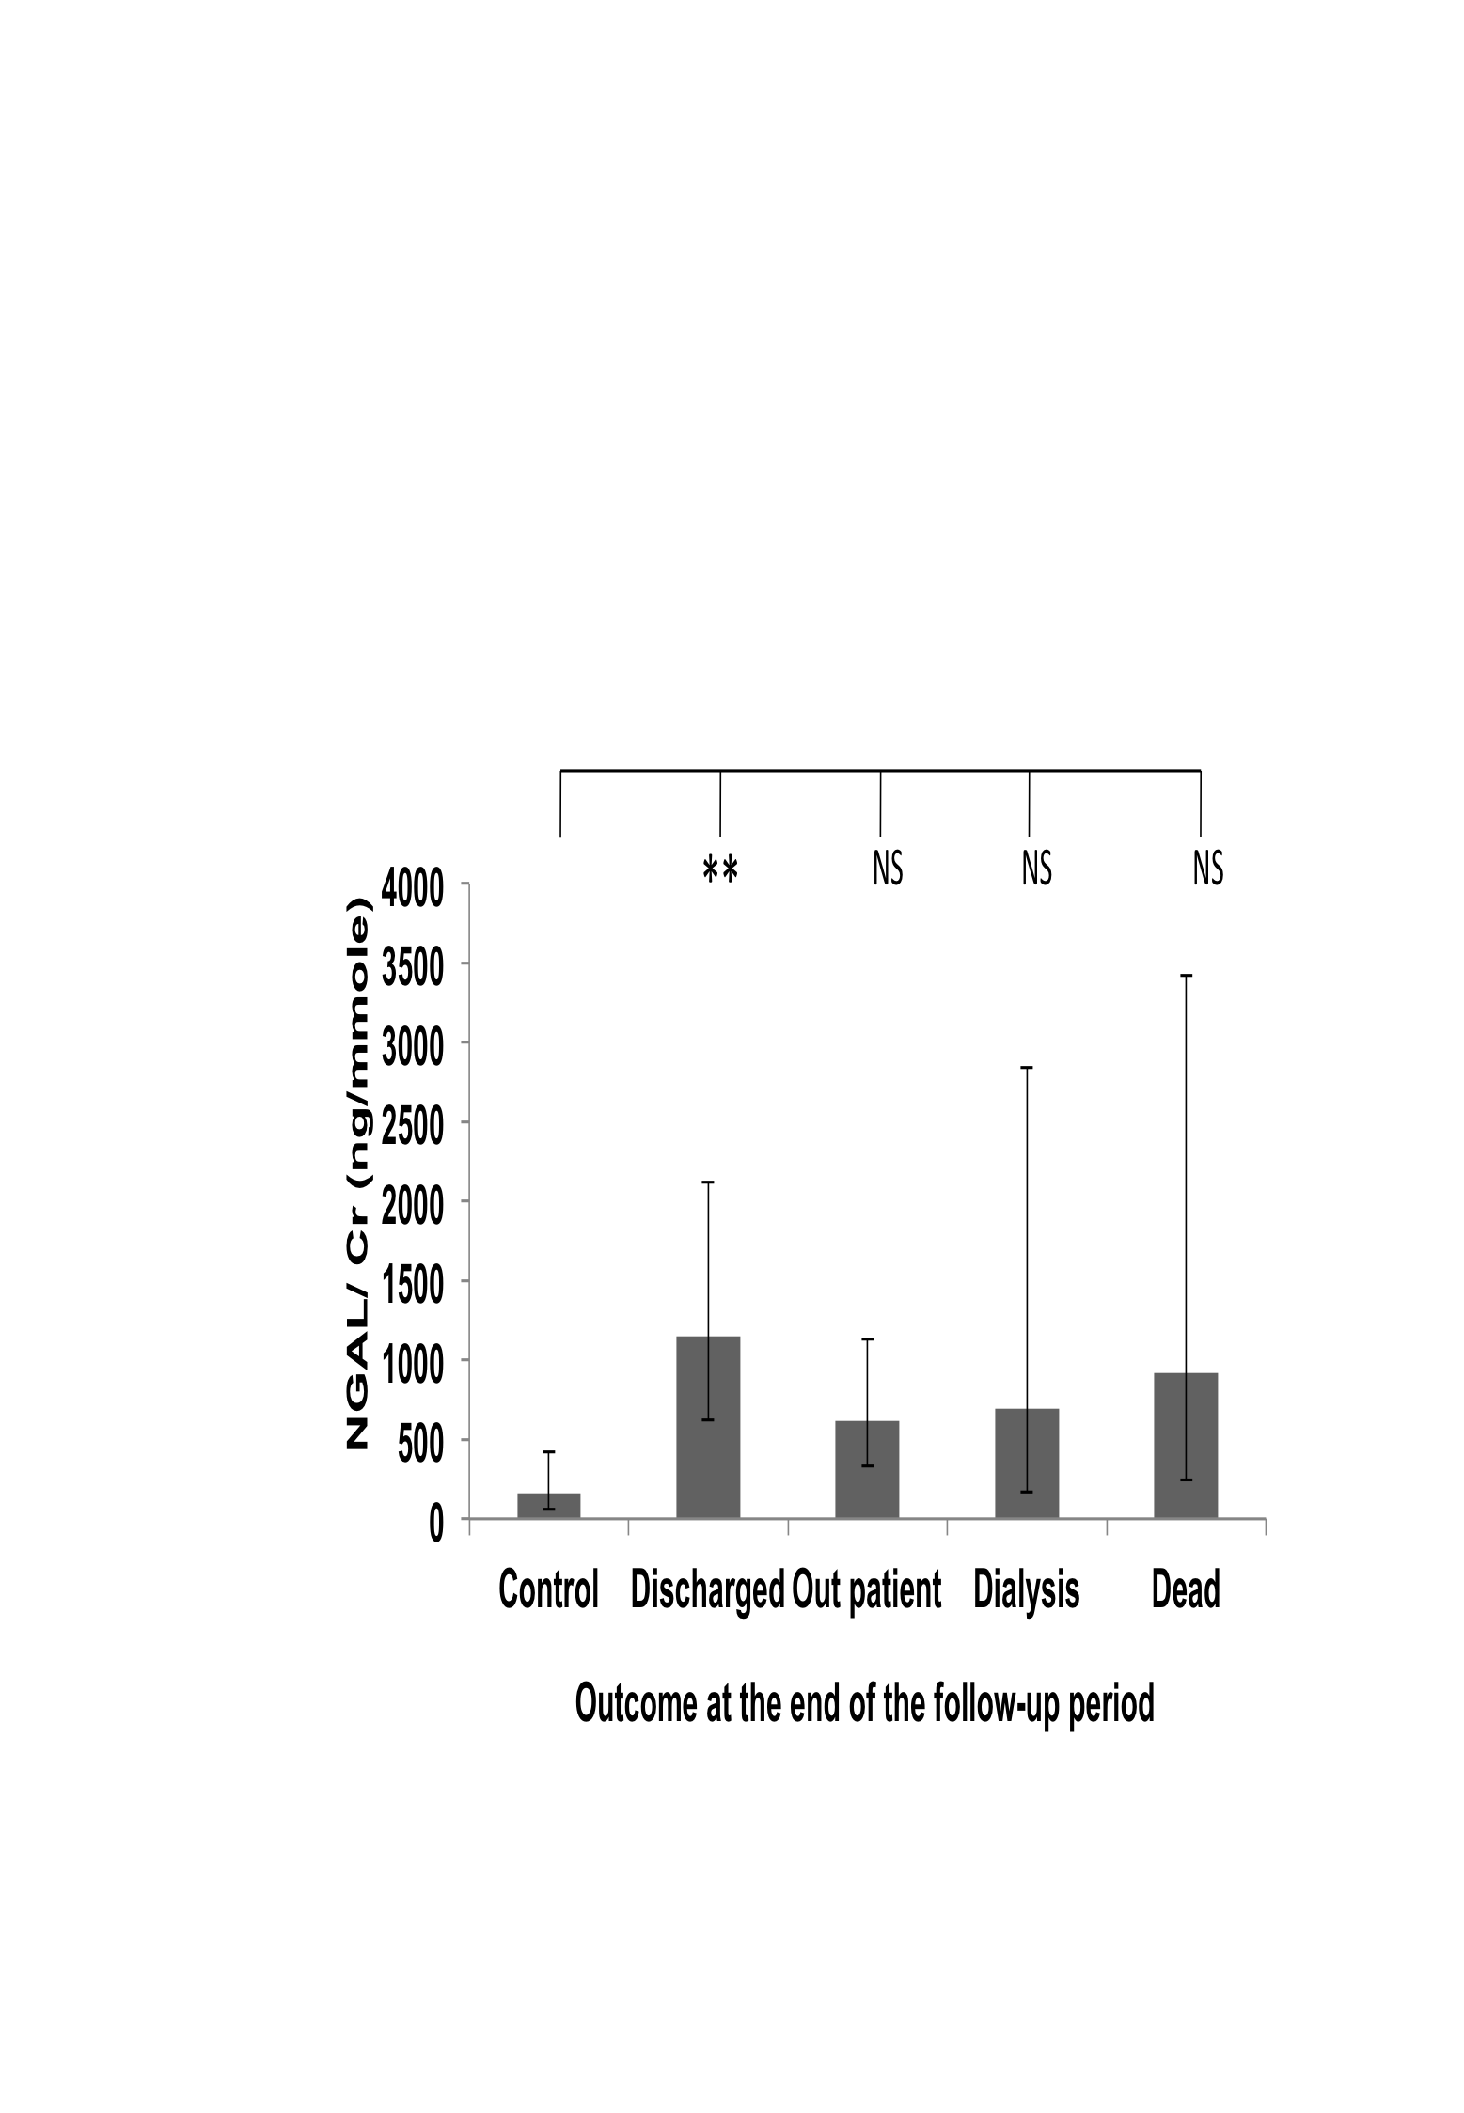

Figure 20: NGAL/Cr values variation between patient groups
Distribution of NGAL /Cr concentration ratios in urine according to causes of disease (A), stages (B), progression (C) and outcome of the disease at the end of the follow-up period (D). Geometric means ± SEMs are shown. Statistical significance of differences between populations was tested using 1 way ANOVA on log-transformed data as described in “Methods”. Asterisks indicate statistically significant differences (*, P = 0.02 to 0.01; **, P = 0.01 to 0.001; ***, P = 0.001 to 0.0001 and ****, P < 0.0001 see text for exact P values). The population sizes are: (A) control, n= 47; DM, n= 103; CGN, n= 54; HTN, n= 45; APKD, n= 11 and Others, n=49. (B) Control, n= 47; 1(CKD-1),n=12; 2(CKD-2),n= 22; 3a(CKD-3a),n= 39; 3b(CKD-3b), n= 58; 4(CKD-4), n=81; 5 (CKD-5), n=50. (C) Control, n= 47; Non-progressors (NP)=170; Progressors (P) =92. (D) Control, n= 47; Discharged, n=84; Outpatient, n= 124; Dialysis, n=33; Dead, n= 21.

Sub-group analyses
When the one-way ANOVA analyses were carried out on the NGAL/Cr data for the DM, CGN and HTN patient sub-groups, no statistically significant differences was found in any subgroup with regards to either final stages of disease or progression status (data not shown). The statistically significant differences that had been found in the whole cohort between the control and non-progressors or progressors groups and between the control and the “Others” groups could therefore not be detected in any of the causes sub-groups. This was presumably because the smaller populations of the sub-groups decreased statistical power of the analyses, compared to the whole cohort.
However, the sub-group analyses when done according to final outcomes, two statistically significant differences were found:
In the DM patients, there was a significant difference between the control and discharge group (P = 0.037) but no other significant difference in between the control and disease outcome groups and also in between the groups (Figure 21). These results were similar to those that had been seen in whole data set (Figure 20, panel D), although the level of significance was decreased in this sub group, maybe due to the smaller number of patients.

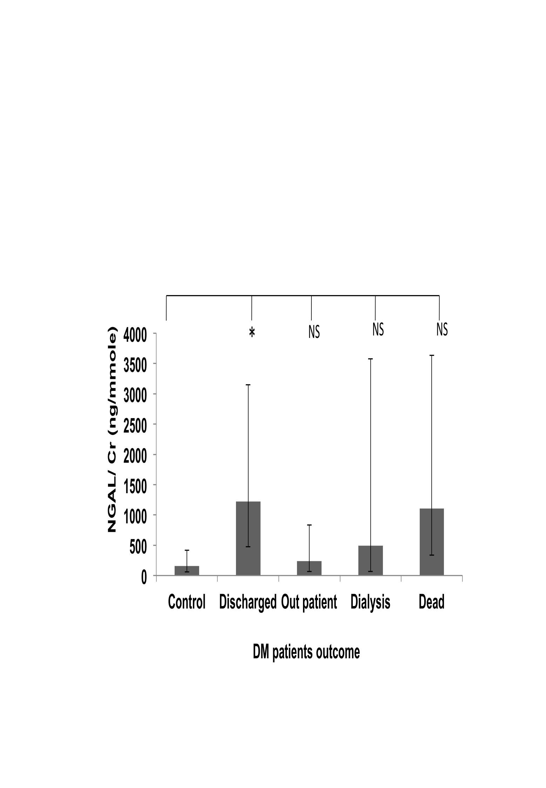
Figure 21: NGAL/Cr values variation in DM patient group
Distribution of NGAL /Cr concentration ratios in the DM patients subgroup according to stage of disease (A), progression of disease (B) and outcome of the disease a end of the follow-up period (C). Geometric means ± SEMs are shown. Statistical significance of differences between populations was tested using 1 way ANOVA on log-transformed data as described in “Methods”. Asterisks indicate statistically significant differences (*, P = 0.02 to 0.01; **, P = 0.01 to 0.001; ***, P = 0.001 to 0.0001 and ****, P < 0.0001 see text for exact P values). The population sizes are: control, n= 47; Discharged, n= 38; Outpatients, n= 34; Dialysis, n= 17 and Dead = 14.

In the CGN subgroup, there was a significant difference in between the controls and outpatients (P = 0.014) but no other significant difference between the outcomes groups. Unlike what had been found in the whole cohort and the DM sub-group, there was no significant difference between the controls and discharged group (Figure 22).

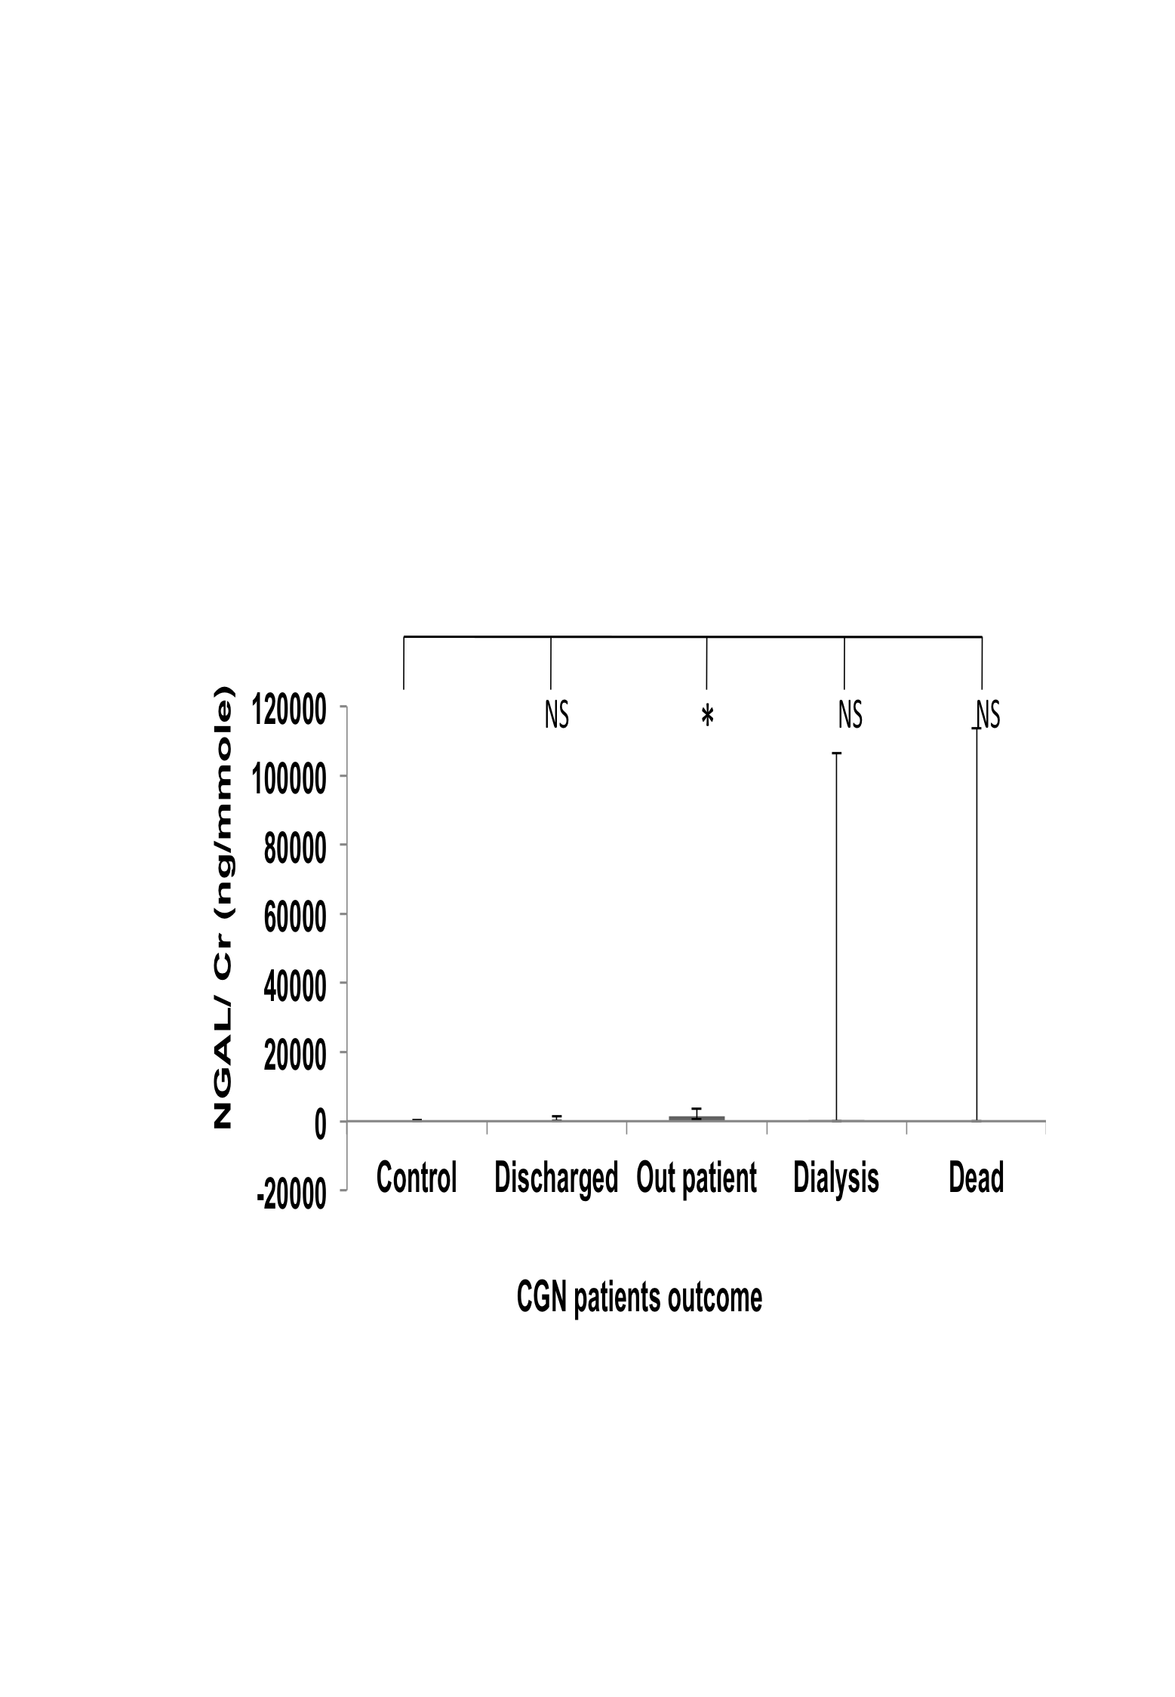
Figure 22: NGAL/Cr values variation in CGN patient group
Distribution of NGAL/Cr concentration ratios in the CGN patients subgroup according to outcome of the disease at the end of the follow-up period. Geometric means ± SEMs are shown. Statistical significance of differences between populations was tested using 1 way ANOVA on log-transformed data as described in “Methods”. Asterisks indicate statistically significant differences (*, P = 0.02 to 0.01; **, P = 0.01 to 0.001; ***, P = 0.001 to 0.0001 and ****, P < 0.0001 see text for exact P values). The population sizes are: control, n= 47; n= 26; Discharged, n= 10; Outpatients, n= 39; Dialysis, n= 3 and Dead = 2.

Odds ratios for progression
To complement the ANOVA tests, Odds Ratios (OR) for progression to one of the two late stages (stage 4 or 5) were also determined for ACR and all candidate markers. These OR calculations provide an estimation, for a patient at stage 1, 2 or 3 of whether an increase of 1 unit for a particular candidate marker (arbitrary units) increases the probability that they will eventually reached stage 4 or 5, and to compare the magnitude of various risk factors for that outcome (Szumilas, 2010).
The summary of the Odds ratios for ACR and all the candidate markers are shown in Table 13. Based on our data, there is a likelihood ratio of 1.003 (with P=0.040) for a single unit increase of ACR value to progress from early stage of CKD to late stage of CKD. The MCP-1/Cr and N-GAL/Cr values did not provide higher odds ratio than that of ACR, indicating that these two markers were not as good for predicting progression in our cohort (Table 13). The KIM-1/Cr, however, did produce a likelihood ratio larger than that of ACR, which suggests that Kim-1/Cr could better predictive value than ACR (Table 13).

Table 13: Odds ratio of ACR and candidate biomarkers
Biomarkers | Odds ratio | P value
ACR | 1.003 | .040
KIM-1/Cr | 1.707 | .027
MCP-1/Cr | 0.772 | .353
NGAL/Cr | 1.00 | .999
To test the predictive value of markers, we compared values between pooled early stages (grouping values from stages 1, 2, 3a and 3b) and pooled late stages (stages 4 and 5) and calculated the likelihood ratio using by binary Logistics regression analysis as described in section 2.6.3.3 (p.58).

Receiver Operating Characteristic (ROC) curve analyses

Whole cohort ROC analyses
Receiver Operating Characteristic (ROC) curve analyses were undertaken to assess the sensitivity / reliability of the measured proteins compared the standard parameter (albuminuria) to predict the disease progression (annual decline of eGFR). The ROC curves analysis for the KIM-1/Cr, MCP-1/Cr and NGAL/Cr ratio showed no advantage in predicting progression over albumin /Cr ratio (Figure 23 Panel A, B and C). Finally, a ROC curve analysis for the combined levels of the urine proteins (KIM-1/Cr + NGAL/Cr) showed no improvement in predicting patients with progressive disease over ACR (Figure 23 Panel D).
The ROC curve results for MCP-1/Cr and NGAL/Cr are thus in agreement with the odds ratios calculations which indicated that these two candidates were not better than ACR at predicting CKD progression. In the case of KIM-1/Cr, the ROC result is in apparent conflict with the odds ratio calculation, as the former does not suggest KIM-1/Cr has better predictive value than ACR whereas the latter does. The reason for this difference probably has to do with the different assumptions underlying the two tests: The ROC predicts progression from one stage to the next irrespective of how early or late the initial and final stages were. By contrast, our odds ratio calculations were specifically testing for progression from an early stage (up to 3b) to a late stage (at least 4).
Overall, our results thus suggest that whilst KIM-1/Cr might not be a better predictor of progression than ACR at all stages of disease, it could be better than ACR at predicting progression from an early to a late stage as defined in our analysis.

In summary, ROC analysis demonstrated that KIM-1 /Cr, MCP-1 / Cr and NGAL /Cr had sensitivities of 62%, 54% and 60.1% respectively and Albumin/Cr 72.3% in predicting CKD progression. However, the combined score of all measured proteins was 63.4 % (Table 14). The “combined urine proteins score” referred to the presence of the two (KIM-1/ Cr and NGAL/Cr) measured proteins in this chapter.

A B
C D

Figure 23: Prediction of CKD progression
ROC analysis using the fraction of true positive results (sensitivity) and false positive results (1-spectificity) for urine (A) KIM-1/Cr, (B) MCP-1/ Cr, (C) NGAL/ Cr and (D) combined KIM-1/ Cr and NGAL /Cr were generated as predictors of CKD progression. A value of 0.5 is no better than expected by chance (null hypothesis), and a value of 1.0 reflects a prefect indicator. The blue curve indicates ACR in all figures and green curve KIM/Cr in panel A, MCP-1/ Cr in panel B, NGAL / Cr in panel C and combined KIM-1/Cr and NGAL /Cr in panel D.

Table 14: Comparison of area of variables on ROC analysis to predict progression of CKD
Variables | AUC | SE | 95% CI | P value
ACR | 0.723 | 0.035 | 0.654 - 0.791 | 0.000
KIM-1/ Cr | 0.620 | 0.036 | 0.549 - 0.691 | 0.001
MCP-1/ Cr | 0.540 | 0.038 | 0.465 - 0.614 | 0.284
NGAL / Cr | 0.601 | 0.037 | 0.529 -0 672 | 0.006
Combined urine protein score (KIM-1/ Cr + NGAL/ Cr) | 0.634 | 0.036 | 0.563 - 0.705 | 0.000
A ROC analysis was performed comparing the selectivity and sensitivity of selected proteins vs. albuminuria in predicting the annual decline of kidney functions. The area under the curve represents the accuracy in prediction. Abbreviations: AUC, area under the curve; SE, standard error and 95% CI, 95% confidence intervals.

Subgroup ROC analyses
ROC analyses were also undertaken in DM, CGN and HTN subgroup for all the measured proteins. The results (Table 15) show that ACR predicted CKD progression better in DM than in the whole cohort and nearly as well in HTN subgroup but in the CGN subgroup ACR was not as good as in the whole cohort. KIM-1/Cr also predicted CKD progression better in DM subgroup but poorly in CGN and HTN subgroup compared to the whole data set. With MCP-1/Cr, prediction of CKD progression was slightly lower in the DM subgroup than in the whole cohort and worse in CGN subgroup but it was better than the whole cohort for the HTN subgroup. NGAL/Cr predicted CKD progression poorly in the DM and HTN subgroups and better in CGN subgroup, relative to the whole data set.
In summary, in all the subgroup ACR was still the better predictor of CKD progression than all the candidate markers (Table 15).

Table 15: Comparison of area of variables on ROC analysis to predict progression of CKD in subgroup
Protein | Variables | DM | CGN | HTN
ACR | AUC | 0.813 | 0.540 | 0.713
ACR | SE | 0.051 | 0.082 | 0.089
ACR | 95%CI | 0.713 - 0.912 | 0.380 - 0.701 | 0.539 - 0.887
ACR | P value | .000 | .611 | 0.017
KIM-1 /Cr | AUC | 0.653 | 0.589 | 0.506
KIM-1 /Cr | SE | 0.057 | 0.081 | 0.094
KIM-1 /Cr | 95%CI | 0.541 - 0.765 | 0.431 - 0.748 | 0.321 - 0.691
KIM-1 /Cr | P value | 0.013 | 0.259 | 0.946
MCP-1 /Cr | AUC | 0.537 | 0.488 | 0.589
MCP-1 /Cr | SE | 0.063 | 0.080 | 0.088
MCP-1 /Cr | 95%CI | 0.414 - 0.660 | 0.332 - 0.644 | 0.417 - 0.762
MCP-1 /Cr | P value | 0.549 | 0.879 | 0.317
NGAL /Cr | AUC | 0.563 | 0.638 | 0.483
NGAL /Cr | SE | 0.063 | 0.078 | 0.091
NGAL /Cr | 95%CI | 0.439 - 0.687 | 0.485 - .791 | 0.304 - 0.661
NGAL /Cr | P value | 0.308 | 0.082 | 0.847
A ROC analysis was performed comparing the selectivity and sensitivity of selected proteins vs. albuminuria in predicting the annual decline of kidney functions. The area under the curve represents the accuracy in prediction. Abbreviations: AUC, area under the curve; SE, standard error and 95% CI, 95% confidence intervals.

Correlation of biomarkers with ACR excretion
The Pearson correlation test was used to see whether the biomarkers correlate with the excretion of ACR. Plots of the data are shown in Figure 24. All the biomarkers positively correlate with the excretion of ACR. The results of the correlation tests are shown in Table 16. They show that KIM-1/Cr has the highest r value (Table 16).

A B
C
Figure 24: Plots of the KIM-1/Cr, MCP-1/Cr and NGAL/Cr versus ACR
The correlation coefficient (r test) was calculated among ACR excretion and KIM-1/Cr excretion (panel A); MCP-1/Cr excretion (panel B) and NGAL/Cr excretion (panel C).
Table 16: Pearson correlation tests of biomarkers and ACR excretion
Biomarkers | Pearson r | 95% CI | R square | P value
KIM-1/Cr | 0.4281 | 0.3237 to 0.5222 | 0.1832 | < 0.0001
MCP-1/Cr | 0.3009 | 0.1852 to 0.4085 | 0.09057 | < 0.0001
NGAL/Cr | 0.3256 | 0.2125 to 0.4300 | 0.1060 | < 0.0001

Summary
This chapter presents analyses of urinary levels of the proteins KIM-1, MCP-1 and NGAL, which were identified as possible biomarkers of kidney disease by a review of the recent research literature.
Methodology:
The candidates were assayed by ELISA in urine samples from large cohort of 262 adult patients and a control group of 47 healthy individuals. At the time of urine collection, the patients presented various causes and stages of CKD except that patients at stage 5 were excluded in order to better test predictive ability. The patients were then monitored for at least 3 years after urine collection to follow progression of disease. All biomarkers assay results were corrected to creatinine, as is normally done on the standard clinical marker, albumin, to determine the albumin/creatinin ratio (ACR). Because the data was not normally distributed, all statistical analyses were carried on log-transform data to minimise the impact of outliers. The analyses were ANOVA and ROC curve to determine the discriminatory and predictive values of each biomarker; odds ratio calculations to find out whether single unit increase of the candidate marker increases the likelihood ratio to fall from early stage to late stage; and a Pearson correlation coefficient to determine the linear correlation between ACR and our candidate biomarkers.
Results:
ACR values are significantly higher in CKD causes, stages, progression and disease
outcomes groups compared to controls. Similar findings were also seen in patients
subgroup analyses.
KIM-1/Cr values are significantly higher in CKD causes, stages, progression and disease outcomes groups compared to controls. Interestingly, KIM-1/Cr has a odd ratio of 1.7, which was higher than ACR in the same cohort. The ROC curve analysis showed that across all stages, KIM-1/Cr values predict progression less reliably than ACR (62% and 72.3% respectively). In the disease subgroups analyse KIM-1/Cr values were significantly higher in the patients at late stages compared to controls. At the subgroup level, the differences between KIM/Cr levels of progressors and non-progressors were still statistically significant in all three subgroups of patients.
MCP-1/Cr values were not significantly increased in any aetiology, stages, progression and disease outcome group relative to controls. Similar results were also found in subgroup analysis, except for MCP-1/Cr in the HTN subgroup, which shows a significant increase between the control and dialysis group.
NGAL/Cr values did not show significant increase when stratified by aetiologies. NGAL/Cr might not be a useful marker of CKD progression as NGAL/Cr values were only significantly higher in non-progressors and progressors compared to controls but not between the progressors and non-progressors. Similar findings were also seen in subgroup analyses.

Identification of candidate markers using immunological arrays and study of their suitability

Hypothesis and Aims
Cytokine and angiogenesis related proteins might be associated with the progression of CKD. Detection of these proteins in the urine is troublesome. Cytokine and angiogenesis arrays could serve as a fast, high-throughput and sensitive tools for detecting the excretion of urinary cytokines and angiogenesis related proteins (Liu et al., 2006).
We hypothesise that the cytokine and angiogenesis array membrane can detect some candidate proteins / biomarkers that will be significantly different between the urine of non-progressors and progressors. After identification by the array the candidate proteins / biomarkers will be assayed in a large cohort by ELISA to test statistically if they can be validated as clinically useful markers of disease progression.
To test the above hypothesis the aims of this chapter are:
1. To search for candidate markers of CKD progression using multiplex immunological assays;
2. To test the predictive values of the candidate using large number of samples. To meet this aim, the approach of the latter part of this chapter is to:
- Collect urine samples from CKD patients with varying stage (excluding CKD-5 at the time of presentation) and aetiology and follow them up to know the rate of progression of patients with CKD.
- Screen the urine samples for selected biomarkers by ELISA
- Relate these urinary proteins with CKD progression and determine the value by ROC analysis in predicting the progression of CKD compared to ACR.

Immunological multiplex assays

Method
We used arrays of immunological assays to assess the levels of various cytokines, chemokines and angiogenesis markers in small pools of urine samples to identify potential candidate markers. The assays are carried out on membranes carrying out arrays of immobilised immunological detection reagents. The advantage of this approach is that it enables cheap and rapid assays of a large number of targets whilst minimising the amount of sample required compared to, for example, the cost and amount of samples that would be required to assay the same number of targets by ELISA. The pitfall of this approach, however, is that only a small number of samples can be processed.
Assays were performed on two commercially available arrays kit from R&D, a Cytokine Array kit designed to assay 36 cytokines and an Angiogenesis Array kit to assay 55 protein markers associated with angiogenesis (see details in “General Methodology” chapter section 2.5, p. 50). Due to the high cost of the kits, the assays were performed on six pools of urine samples, each pool representing a different group of patients. The six pools corresponded to progressors and non-progressors from three diseases (DM, CGN and HTN patients). All patients were microalbuminuric and were selected for best matches according to the sex, ethnicity and age. The distinction between progressors and non-progressors was determined by their rate of eGFR decline, the progressors being the patients with a decline greater than 2.0 ml per min per 1.72m² of body surface area per year (> 2ml/min/1.72m²/year); the assay procedure was carried out on these pools to compare the relative change of the expression of the cytokine and angiogenesis markers between progressors and non-progressors in each disease.
The list of the patients (Table 17, Table 18 and Table 19) whose urine was used for these assays, were as follows-

Table 17: List of DM patients
Non-progressors |  |  |  | Progressors
ID | Sex | Race | Age | ID | Sex | Race | Age
2 | Male | Caucasian | 85 | 5 | Male | Caucasian | 75
13 | Male | Caucasian | 70 | 10 | Male | Caucasian | 41
17 | Male | Caucasian | 81 | 16 | Male | Caucasian | 68
45 | Male | Caucasian | 72 | 22 | Male | Caucasian | 71
67 | Male | Caucasian | 61 | 41 | Male | Caucasian | 78
80 | Male | Caucasian | 65 | 59 | Male | Caucasian | 81
88 | Male | Caucasian | 78 | 60 | Male | Caucasian | 73
99 | Male | Caucasian | 76 | 68 | Male | Caucasian | 66
129 | Male | Caucasian | 82 | 122 | Male | Caucasian | 53
155 | Male | Caucasian | 63 | 149 | Male | Caucasian | 67

Table 18: List of CGN patients
Non-progressors |  |  |  | Progressors
ID | Sex | Race | Age | ID | Sex | Race | Age
26 | Male | Caucasian | 44 | 135 | Male | Caucasian | 71
145 | Female | Caucasian | 80 | 191 | Male | Caucasian | 57
193 | Male | Caucasian | 64 | 231 | Female | Caucasian | 49
271 | Male | Caucasian | 61 | 256 | Male | Caucasian | 47
305 | Male | Caucasian | 63 | 286 | Male | Caucasian | 49
316 | Male | Caucasian | 71 | 317 | Male | Caucasian | 48

Table 19: List of HTN patients
Non-progressors |  |  |  | Progressors
ID | Sex | Race | Age | ID | Sex | Race | Age
214 | Male | Caucasian | 74 | 282 | Male | Caucasian | 84
240 | Female | Caucasian | 74 | 287 | Female | Caucasian | 82
292 | Female | Black | 41 | 301 | Male | Caucasian | 60
354 | Female | Caucasian | 87 | 350 | Male | Caucasian | 80

After performing the assays on the cytokine and angiogenesis arrays, the results were collected by digital imaging of the luminescence detected on the membranes. Examples of the imaging data are show in Figure 25. To quantify the results, the pixel density of the each spot was measured and analysed as detailed in chapter 2 (2.5.4.5, p. 53)

A
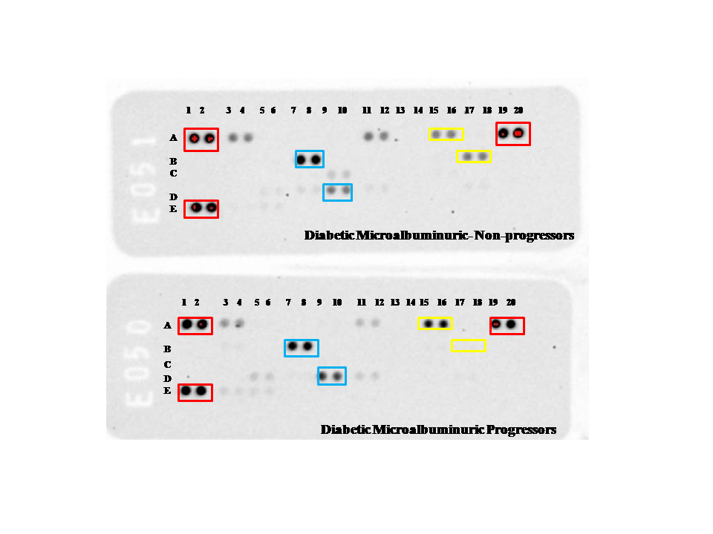
B
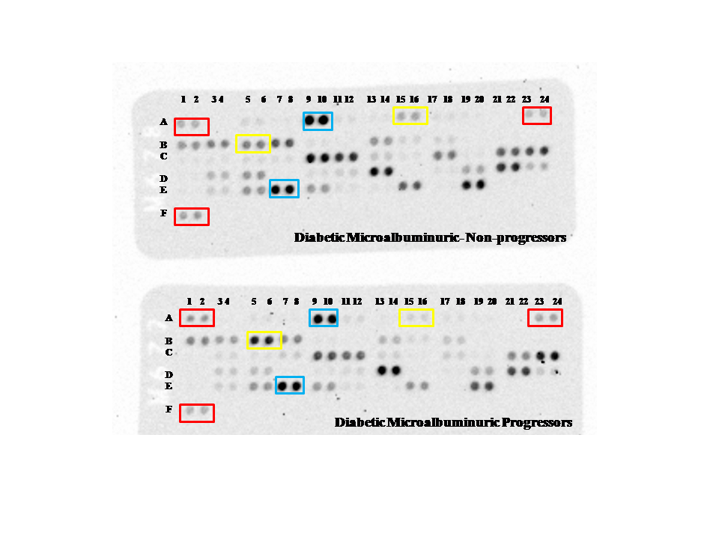
Figure 25: Cytokine and angiogenesis arrays in DM patient pool
Assays of DM patient urine pools with the Cytokine array (A) and Angiogenesis array (B) membranes. Each panel shows two membranes used to assay pools of urine from 10 non-progressors (top) and 10 progressors (bottom) in identical experimental conditions. The pools were concentrated before the assay to increase detection sensitivity. The red boxes show the positions of the reference spots used for calibration; the blue and yellow boxes show examples of proteins that appear to be at the similar and different levels of expression between the non-progressors and progressors, respectively. The membranes contain two assay spots for each antigen, thus providing duplicate measurements. The letters present on the left-hand side (A-E and A-F in cytokine and angiogenesis arrays, respectively) and numbers on top of the membranes (1-20 in cytokine membranes and 1-24 in angiogenesis membrane) are used to indicate the position of individual proteins assayed on the membrane, by reference to the standard template supplied with the kit. For example, the spots at positions A15 and A16 on the cytokine array (panel A) and those at B5 and B6 on the angiogenesis array (B) correspond to sICAM and DPP-IV, respectively.

Results
In this section, we will first present in detail the results obtained with the cytokine array on the urine of DM patients to illustrate the data analysis method that we used. The results of the other assays will be presented more briefly to avoid repetitions.

Cytokine array results
Fourteen of the 36 cytokines assayed by Cytokine Array kit were detected in the urine of DM patients (the list of all 36 tested cytokines on the array is in the Appendix). To assess technical reproducibility, the pooled samples were assayed twice on duplicate sets of membranes, of which one set is shown on Figure 25, panel A. Comparisons of the images shown on Figure 25, panel A, with those of the second set of membranes (not shown) suggested very good reproducibility and this was confirmed by the quantitative data obtained by densitometry of the images. In view of the good technical reproducibility of the technique and the high cost of these assays, and taking in account the fact that these assays were exploratory, it was thus decided that the other assays did not need to be done on duplicate sets of membrane.
Statistical analysis of the cytokine array data (Figure 26) showed that while some cytokines were present in similar levels in both the Progressors and Non-progressors pools (C5/C5a and IL-1ra/IL-1F3), the others appeared to be at different concentrations in the two pools. In particular, 10 cytokines showed more than a two-fold difference between the two pools, which suggest they could be most likely to be significantly different, subject to validation by further statistical tests. They were IP-10, MCP-1, sICAM-1, MIF, RANTES/ CCL5, IL-1α/ IL-1F1 IL-8, IL-16, SerpinE1/ PAI-1 and GROα/ CXCL1 (Figure 26).

Angiogenesis array results
Of the 55 protein markers assayed by the Angiogenesis array, 44 were detected in the same pools (Figure 27). Similar to the Cytokine Array results, some of the detected proteins appeared to be at different concentrations in the Progressors and Non-progressors pools. The differences were greater than two-fold changes for IL-8 (in agreement with the cytokine array result), Angiopoietin-2, Angiostatin/Plasminogen, GDNF, HIGF, IL-1β, MMP-9 and Persephin (Figure 27)

Statistical significance tests
To test which changes were statistically significant, the Holm Bonferroni significance test was applied to the two data sets obtained with the Cytokine and Angiogenesis arrays (Holm, 1979). The results showed that none of the concentration differences detected by the cytokine array between the progressor and non-progressor DM pools were statistically significant (Figure 28 Panel A).
The lack of statistically significant results in this data set may seem surprising, as the very strong differences observed for example in the case of IL-8 and GROα (which were 35-fold and 3– fold more abundant in the non-progressor than in the progressor pool, respectively) suggested they were likely to be significant. However, the Holm modification of the Bonferroni test which we used here to minimise the risk of detecting false positives is even stricter than the standard Bonferroni test (Holm, 1979) and this probably explain why none of the potential candidate markers gave a positive result in this test.
Applying the same significance test to the angiogenesis array data suggested that the differences found in the cases of DDP-IV and MMP-9 were significant (Figure 28 Panel B). However, in the cases of GROα/CXCL1, IL-1α/ IL-1F1, IL-16, IP-10, I-TAC, MIF, SDF-1/ CXCL12, Angiopoietin-2, Angiostatin/ Plasminogen, GDNF, HIGF, IL-1β, and Persephin, the differences noted earlier failed the significance test.

Figure 26: Results of cytokine assays in urine of DM patients
The assays were carried out on the same concentrated pools of progressors (red bars) and non-progressors (blue bars) as on Figure 25 Panel A. The assays were carried out on two sets of membranes, thus providing a total of four data points for each cytokine. The data shown are the means and SD of the 4 background-subtracted densitometry measurements. Only the fourteen cytokines that were detected after background subtraction are shown. They are shown in order of decreasing P / NP ratio (that is, the cytokines that appear to be more abundant in the progressor pool are on top whilst those that seem more abundant in the non-progressor pool are at the bottom, with those showing the smallest differences between the two pools in the middle. The results are expressed relative to the intensities of the reference spots, whose value was set arbitrarily at 100.

A

Figure 27: Results of angiogenesis marker assays in urine of DM patients (part A)
The assays were carried out on the same concentrated pools of progressors (red bars) and non-progressors (blue bars) as for those done on the Angiogenesis array membrane (Figure 25 Panel B). The data shown are averages and SD of duplicate measurements. Due to the large amount of data the graph has been split into two parts (A and B) for better visibility. Part B is on the next page.

B

Figure 27: Results of angiogenesis marker assays in urine of DM patients (part B)
See Part A of the figure on previous page for the legend.

A
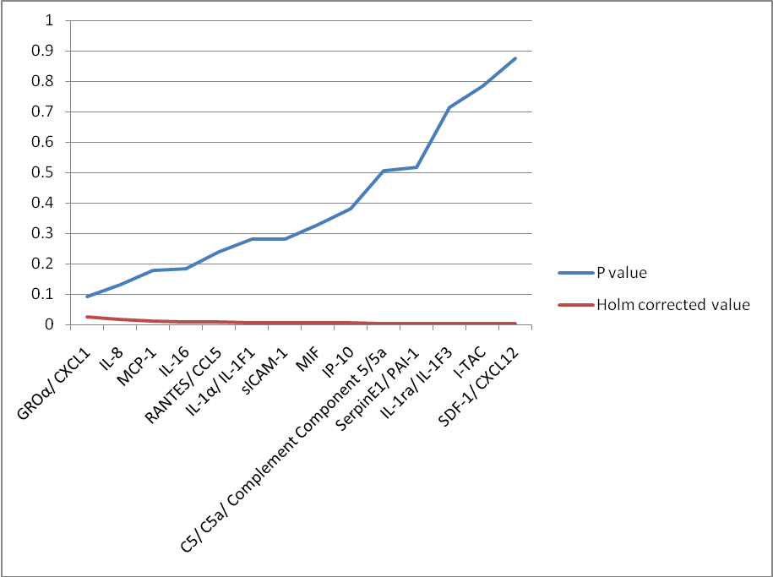
B
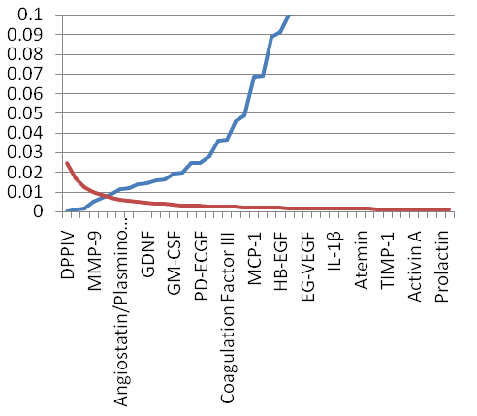
Figure 28: Results of significance tests for the candidate markers assayed with the immunological arrays
Results of significance tests for the candidate markers assayed with the Cytokine array (panel A) and the Angiogenesis markers array (panel B). The mean and SD values shown on Figures 26 and 27 were subjected to the Sequentially Rejective Multiple Test procedure described by Holm (Holm, 1979) as explained in the “Methods” chapter. The graphs show the results of the P values (blue lines) and the Holm-corrected Bonferroni test value (red lines) for the antigens, shown in order of increasing P values. The values for which the Holm test value is greater than the P value are those that should be considered significant.

CGN patients
Thirteen of the 36 cytokines assayed by Cytokine Array kit were detected in the urine of CGN patients (the list of all 36 tested cytokines on the array is in the Appendix). The assay results for the detected cytokines (Figure 29) showed that while some of them were present in similar levels in both the P and NP pools (SDF-1, I-TAC), the others appeared to be at different concentrations in the two pools. In particular, 8 cytokines showed more than a two-fold difference between the two pools, which suggest they could be most likely to be significantly different, subject to validation by further statistical tests. They were in C5/ C5a/ Complement Component 5/ 5a, IL-1α/ IL-1F1, IL-1β/ IL-1f2, IL-8, IL-16, MCP-1, MIF, Serpin E1/ PAI-1 (Figure 29).
Of the 55 protein markers assayed by the Angiogenesis array, 34 were detected in the same pools (Figure 30). Similar to the Cytokine Array results, some of the detected proteins appeared to be at different concentrations in the Progressors and Non-progressors pools. The differences were greater than two-fold changes for Amphiregulin, Coagulation factor III, CXCL-16, Endoglin, FGF acidic/ FGF-1, IGFBP-1, IL-1β, IL-8, LAP (TGF-β1), Leptin, MCP-1, MMP-8, MMP-9, PD-ECGF, PDGF-AA, Platelet factor-4 / CXCL-4, PIGF, Prolactin, Serpin E1, Serpin F1, TIMP-4 and VEGF (Figure 30).
The Holm Bonferroni significance test was applied to the two data sets obtained with the Cytokine and Angiogenesis arrays (Holm, 1979). The results showed that the concentration differences between the progressor and non-progressor CGN pools were significant in the cases of MIF, IL-16, MCP-1 and C5/ C5a/ Complement Component 5/ 5a (Figure 31, Panel A) and MCP-1, IGFBP-1, PD-ECGF, Leptin, CXCL-16 and TIMP-4 (Figure 31, Panel B). However, in the cases of IL-1α/ IL-1F1, IL-1β/ IL-1f2, IL-8, Serpin E1/ PAI-1, Amphiregulin, Coagulation factor III, Endoglin, FGF acidic/ FGF-1, IL-1β, IL-8, LAP (TGF-β1), MMP-8, MMP-9, PDGF-AA, Platelet factor-4 / CXCL-4, PIGF, Prolactin, Serpin E1, Serpin F1 and VEGF the differences noted earlier were not statically significant.

Figure 29: Results of cytokine assays in urine of CGN patients
The assays were carried out on two pools of urine samples from 6 progressors (red bars) and 6 non-progressors (blue bars) on a pair of Cytokine array membranes. All the cytokines that were reliably detected after background subtraction are shown. The data shown are the means and SD of duplicate background-subtracted densitometry measurements. The results are expressed relative to the intensities of the reference spots, whose value was set arbitrarily at 100.

Figure 30: Results of angiogenesis marker assays in urine of CGN patients
The assays were carried out on the same concentrated pools of progressors (red bars) and non-progressors (blue bars) as Figure a pair of the Angiogenesis array membrane. The data shown are the means and SD of duplicate background-subtracted densitometry measurements. The results are expressed relative to the intensities of the reference spots, whose value was set arbitrarily at 100.

A
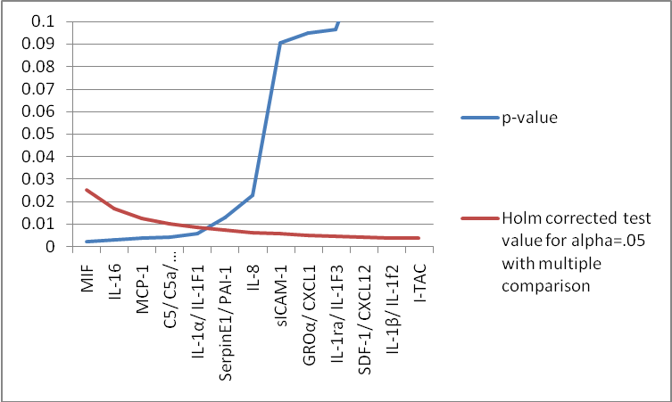
B
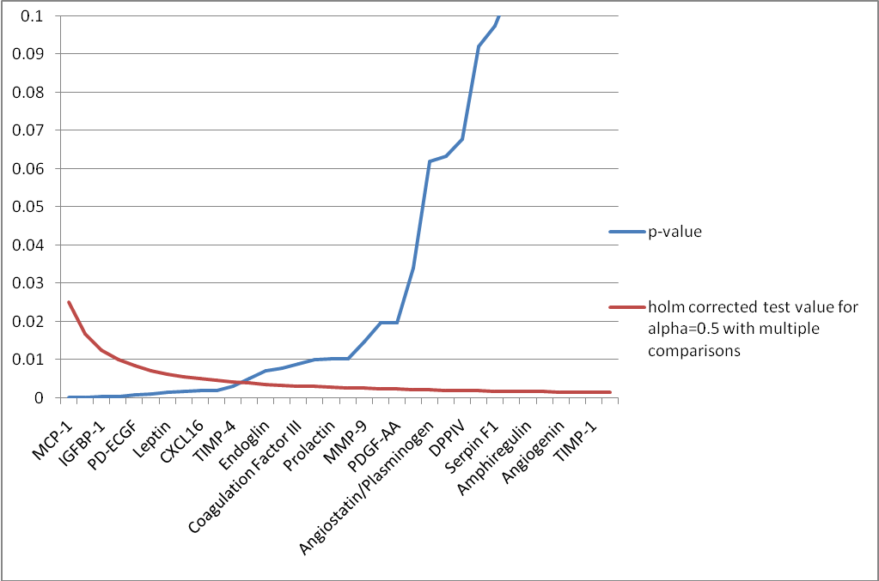
Figure 31: Results of significance tests for the candidate markers assayed with immunological arrays
Results of significance tests for the candidate markers assayed with the Cytokine array (panel A) and the Angiogenesis markers array (panel B). The mean and SD values shown on Figure 29 and Figure 30were subjected to the Sequentially Rejective Multiple Test procedure described by Holm (Holm, 1979) as explained in the “Methods” chapter. The graphs show the results of the P values (blue lines) and the Holm-corrected Bonferroni test value (red lines) for the markers, shown in order of increasing P values. The values for which the Holm test value is greater than the P value are those that should be considered significant.

HTN patients
Fifteen of the 36 cytokines assayed by Cytokine Array kit were detected in the urine of HTN patients (the list of all 36 tested cytokines on the array is in the Appendix). The assay results for the detected cytokines (Figure 32) showed that while some of them were present in similar levels in both the Progressors and Non-progressors pools (Serpin E1, MIF, MCP-1, I-TAC, C5/ C5a/ Complement component 5/ 5a), the others appeared to be at different concentrations in the two pools. In particular, 5 cytokines showed more than a two-fold difference between the two pools, which suggest they could be most likely to be significantly different, subject to validation by further statistical tests. They were in CD40 Ligand, GROα/ CXCL-1, IL-1α/ IL-1F1, IL-16 and IP-10 (Figure 32).
Of the 55 protein markers assayed by the Angiogenesis array, 28 were detected in the same pools (Figure 33). Similar to the Cytokine Array results, some of the detected proteins appeared to be at different concentrations in the Progressors and Non-progressors pools. The differences were greater than two-fold changes for Coagulation factor III, CXCL-16, DPP-IV, Endostatin/ Collagen XVIII, IGFBP-3, Leptin, MMP-8, MMP-9, PDGF-AA, PIGF, Prolactin, TIMP-4 and VEGF (Figure 33).
The Holm Bonferroni significance test was applied to the two data sets obtained with the Cytokine and Angiogenesis arrays (Holm, 1979). The results showed that the concentration differences between the progressor and non-progressor HTN pools were significant in the cases of GROα/CXCL-1, IL-16, IL-1ra/ IL-1F3 (Figure 34, Panel A) andMMP-8, CXCL-16, IGFBP-3 and Leptin (Figure 34, Panel B). However, in the cases of CD40 Ligand, IL-1α/ IL-1F1, Coagulation factor III, DPP-IV, Endostatin/ Collagen XVIII, MMP-9, PDGF-AA, PIGF, Prolactin, TIMP-4 and VEGF the differences noted earlier were not statically significant.

Figure 32: Results of cytokine assays in urine of HTN patients
The assays were carried out on two pools of urine samples from 4 progressors (red bars) and 4 non-progressors (blue bars) on a pair of Cytokine array membrane. The pools were concentrated before the assay to increase detection sensitivity. All the cytokines that were reliably detected after background subtraction are shown. The data shown are the means and SD of duplicate background-subtracted densitometry measurements. The results are expressed relative to the intensities of the reference spots, whose value was set arbitrarily at 100.

Figure 33: Results of angiogenesis marker assays in urine of HTN patients
The assays were carried out on the same concentrated pools of progressors (red bars) and non-progressors (blue bars) as Figure using the Angiogenesis array membrane. Experimental and data analysis methods were as in Figure 32.

A
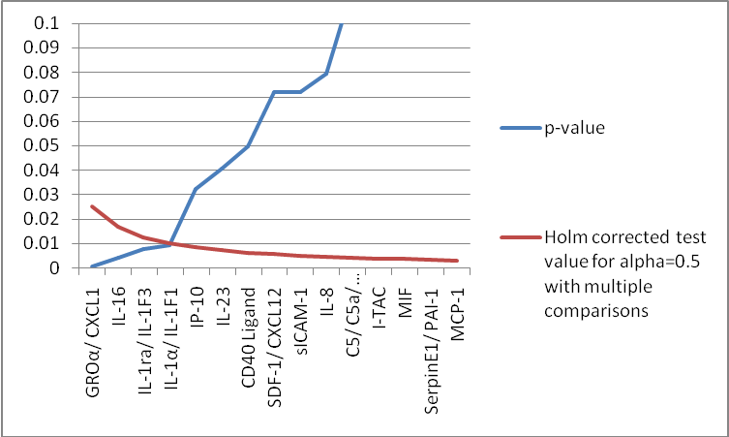
B
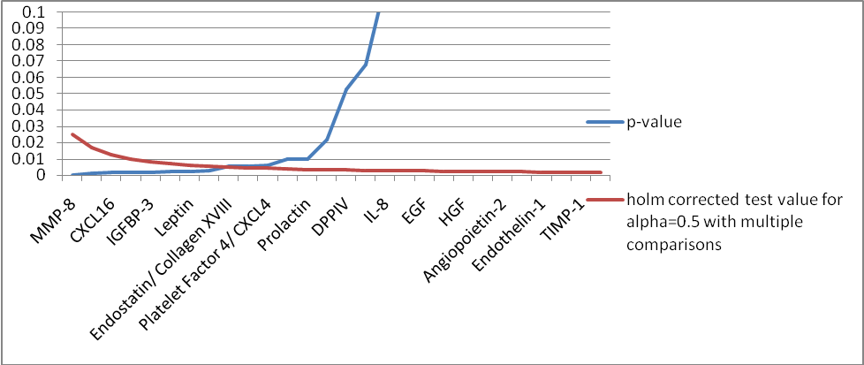
Figure 34: Results of significance tests for the candidate markers assayed with the Cytokine array and the Angiogenesis markers array
Results of significance tests for the candidate markers assayed with the Cytokine array (panel A) and the Angiogenesis markers array (panel B). The mean and SD values shown on Figure 32 and Figure 33 were subjected to the Sequentially Rejective Multiple Test procedure described by Holm (Holm, 1979) as explained in the “Methods” chapter. The graphs show the results of the P values (blue lines) and the Holm-corrected Bonferroni test value (red lines) for the markers, shown in order of increasing P values. The values for which the Holm test value is greater than the P value are those that should be considered significant.

Table 20: Array-assayed proteins showing statistically significant differences between patient groups
DM |  | CGN |  | HTN
Cytokine array | Angio-genesis array | Cytokine array | Angio-genesis array | Cytokine array | Angio-genesis array
No statistically significant difference | DPP-IV MMP-9** | MIF IL-16 MCP-1* C5/C5a | MCP-1 IGFBP-1 PD-ECGF Leptin  CXCL-16  TIMP-4 | GROα/ CXCL-1  IL-16 IL-1ra/  IL-1F3 | MMP-8  CXCL-16 IGFBP-3  Leptin
The table lists all the proteins found to exhibit statistically significant concentration differences between the non-progressors and progressors. Statistical significance was assessed by the Holm Bonferroni test (Holm, 1979) for three different causes of CKD (DM, CGN and HTN). The proteins showing significant differences for more than one disease cause are highlighted in bold typeface. The underlined proteins were selected for ELISA assays in the large cohort. The * indicates a biomarker had been assessed earlier by ELISA based on literature review and ** indicates a biomarker that had been assayed in the large by another member of the group.

Selection criteria
Table 20 showed that there was no single biomarker that was significant for all the diseases. We decided to validate two candidate biomarkers from DM group and two candidate biomarkers from CGN and HTN group. This is because, DM group is the largest group of our cohort, consisting 103 patients and CGN and HTN groups in total 99 (54+45) patients, which will provide statistical power to the analysis of the ELISA result.
In the DM group, DPP-IV and MMP-9 were statically significant in Holm Bonferroni test (Table 20), but MMP-9 was already assessed in the same cohort by another researcher. So, we were left with only one significant candidate biomarker. To find a second candidate progression in the DM patients, we then considered the two proteins that were almost significant according to the Holms test, GROα / CXCL-1 and IL-8 (Figure 28 Panel A). GROα / CXCL-1 was first in the ranked list of Holm Bonferroni test results but it only showed a small fold change (3.5-fold) between progressors and non-progressors (Figure 26). In contrast IL-8, which was the second in the list of Holm Bonferroni test, showed a much higher difference (around 35-fold in cytokine array data) and it also showed a high fold-difference between the progressors and non-progressors in CGN patients (Figure 29). We therefore selected IL-8 for validation on the large cohort.
In CGN and HTN patients group three candidate proteins Leptin, CXCL-16 and IL-16 were statistically significant in Holm Bonferroni test (Table 20). Due to limitation of time and resources, we were only able to assay two biomarkers from these two groups. The fold change between the progressor and non-progressor for leptin was very high both in CGN (46 fold) (Figure 30) and HTN (39 fold) (Figure 33); the -fold change for CXCL-16 was more than 3.5 times in CGN group and more than 4.5 times in HTN group and the fold change for IL-16 was 10 times in CGN group (Figure 29) and 2.7 times in HTN group (Figure 33). So we selected Leptin on the basis of fold change and randomly CXCL-16 to validate by ELISA.

Selected candidate biomarkers for ELISA
So, our final selected candidate biomarkers for ELISA were:
1. DPP-IV
2. CXCL-16
3. Leptin
4. IL-8

Background on the candidate biomarkers identified
The aim of this part of the chapter is to explore the merit of the candidate markers, that were selected from cytokine and angiogenesis study over the current clinical markers in predicting the progression of CKD.

Leptin
Leptin is an anorexigenic hormone and one of the key immunomodulatory cytokine. It is involved in the regulation of energy homeostasis. Leptin increases energy expenditure by inhibiting food intake (Farooqi and O'Rahilly, 2009). After the glomerular filtration, leptin is metabolized by the renal tubules (Cumin et al., 1997b, Cumin et al., 1997a). High plasma leptin level was found to be significantly associated in patients with CKD in The Third National Health and Nutritional Examination Survey (NHANES) (Shankar et al., 2012). Some studies showed conflicting results in the relationship between the level of leptin and CKD. Bian et al (2014) conducted a prospective study to find out the relationship between the leptin level and maintenance haemodialysis patients and they found that there was a converse relationship between the serum leptin and mortality in stable haemodialysis patients and low serum concentration of leptin is an independent risk factor for all causes of mortality in stable haemodialysis patients (Bian et al., 2014). However the value of urinary leptin as possible biomarker of CKD progression has not been evaluated yet.

CXCL-16
Chemokine ligand-16 (CXCL-16) is a membrane-bound chemokine. CXCL-16 is composed of four domains: the chemokine domain, mucin-like domain, transmembrane domain and cytoplasmic tail (Matlubian M et al., 2012). It also has a soluble form, which act as a chemoattractant for NKT cells, activated CD8 T cell. CXCL-16 mediates the adhesion of bacteria to dendritic cells and macrophage (Shimaoka et al., 2003). CXCL-16 expression is induced by inflammatory cytokines and its production by non-immune cells is unclear. To our knowledge, no previous study has implicated CXCL-16 in the pathogenesis of CKD and the relationship between the level of CXCL-16 and CKD have not evaluated so far.

Dipeptidyl-peptidase IV (DPP-IV)
DPP-IV is a cell surface protease and it belongs to the prolyl oligopeptidase family. It is expressed on the cell membrane of most cell types, including the glomerular epithelium cells and also endothelium. It has an important role in extra cellular matrix interaction. DPP-IV plays an important role in the pathogenesis of diabetic nephropathy and CKD induced left heart failure. Sun et al. found that the increase level of DPP-IV was associated with the severity of DKD (Sun et al., 2012). Inhibition of DPP-IV showed renoprotective effect (Vallon and Docherty, 2014) in DKD and also improvement in left ventricular function in CKD patients (Connelly et al., 2014).

Interleukin-8
Interleukin-8 (IL-8/ CXCL-8) is a chemokine, plays role in kidney disease by attracting neutrophils or lymphocytes to inflammatory site. IL-8 was found to be elevated in several kidney diseases like IgA nephropathy, glomerulonephritis, membranous, lupus nephritis, acute glomerulonephritis and cryoglobulinemia (Wada et al., 1994). IL-8 also produced locally in diseased kidney (Wada et al., 1994). The potential use of IL-8 as marker has mostly been studied in paediatric cases, not adult. A study of 37 healthy paediatrics controls and 42 paediatrics CKD patients found that IL-8 was undetectable in healthy controls, whereas in patients there was a negative correlation between IL-8 and eGFR and a positive correlation between IL-8 and body mass index in congenital anomalies of the kidney and urinary tract patients (Vianna et al., 2013). IL-8 and other chemokines can also be good marker to follow-up the kidney transplanted patients (Pereira et al., 2012).

Overview of the methodology for investigating the predictive value of the new candidate biomarkers
The methodology used to investigate the usability of the new candidate biomarkers for assessing CKD was identical to that already used to assess other candidates (KIM-1, NGAL and MCP-1) in the previous chapter.

Samples and assay procedures
All candidates were assayed in individual urine samples from 262 CKD patients of various causes and stages (excluding stage 5 at the time of presentation) and 47 healthy individuals (for details see, section 2.2, in the “General Methodology” chapter, p. 37). The assays were done using commercially available ELISA kits from R & D as detailed in section 2.6 (p. 55)

Statistical analyses
These were done as in the previous chapter. Briefly, all ELISA assay results were normalised to creatinine. The data were then analysed statistically by one-way ANOVA, ROC calculations, Odds Ratio (OR) calculations and determination of correlation coefficients between each candidate biomarker and ACR (see section 2.6.3, p. 58, for details). The one-way ANOVA and ROC analyses were carried out on log-transformed data to minimize the effect of the outliers (Bland and Altman, 1996).
For each marker, these analyses were carried out on the whole cohort and on each of the three largest subgroups of CKD causes in our patient cohort: the diabetic (DM), chronic glomerulonephritis (CGN) and hypertensive (HTN) subgroups. These subgroup analyses were carried out to see whether any assayed protein could be used as a biomarker for a specific disease group.

One-way ANOVA analyses of DPP-IV/Cr values

Whole cohort analyses
When the DPP-IV/Cr values were analysed by causes of CKD, there was a statistically significant difference between the controls and the DM patients (P=0.0226), but not between any other sub-groups but no other significant difference was seen between the controls and other causes of CKD or between the different causes of CKD (Figure 35 Panel A).
When the DPP-IV/Cr levels were grouped according to the CKD stages, they were significantly higher in CKD-5 (P< 0.0001) compared to the controls. There were also statistically significant differences between the CKD-1 and CKD-5 stages (P=0.0479), between CKD-3b and CKD-5 (P=0.0358), and between CKD-4 and CKD-5 (P=0.0437) (Figure 35 Panel B).
Analysis of the data by progression status showed that there was a significant difference between the controls and the non-progressors (P=0.0252) and between controls and progressors (P=0.0006) (Figure 35 Panel C). But there was no significant difference between the non-progressors and progressors.
When the DPP-IV/Cr values were analysed according to the outcome of the disease at the end of the follow-up period, there was a significant difference between the control and outpatient groups (P=0.0123) and between the control and dialysis groups (P=0.0016) (Figure 35 Panel D). But no significant difference was seen between the disease outcome groups.

A B
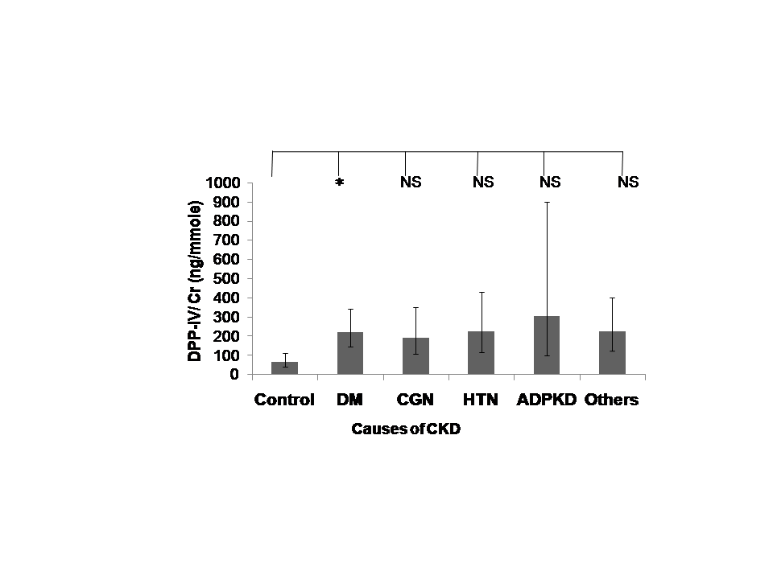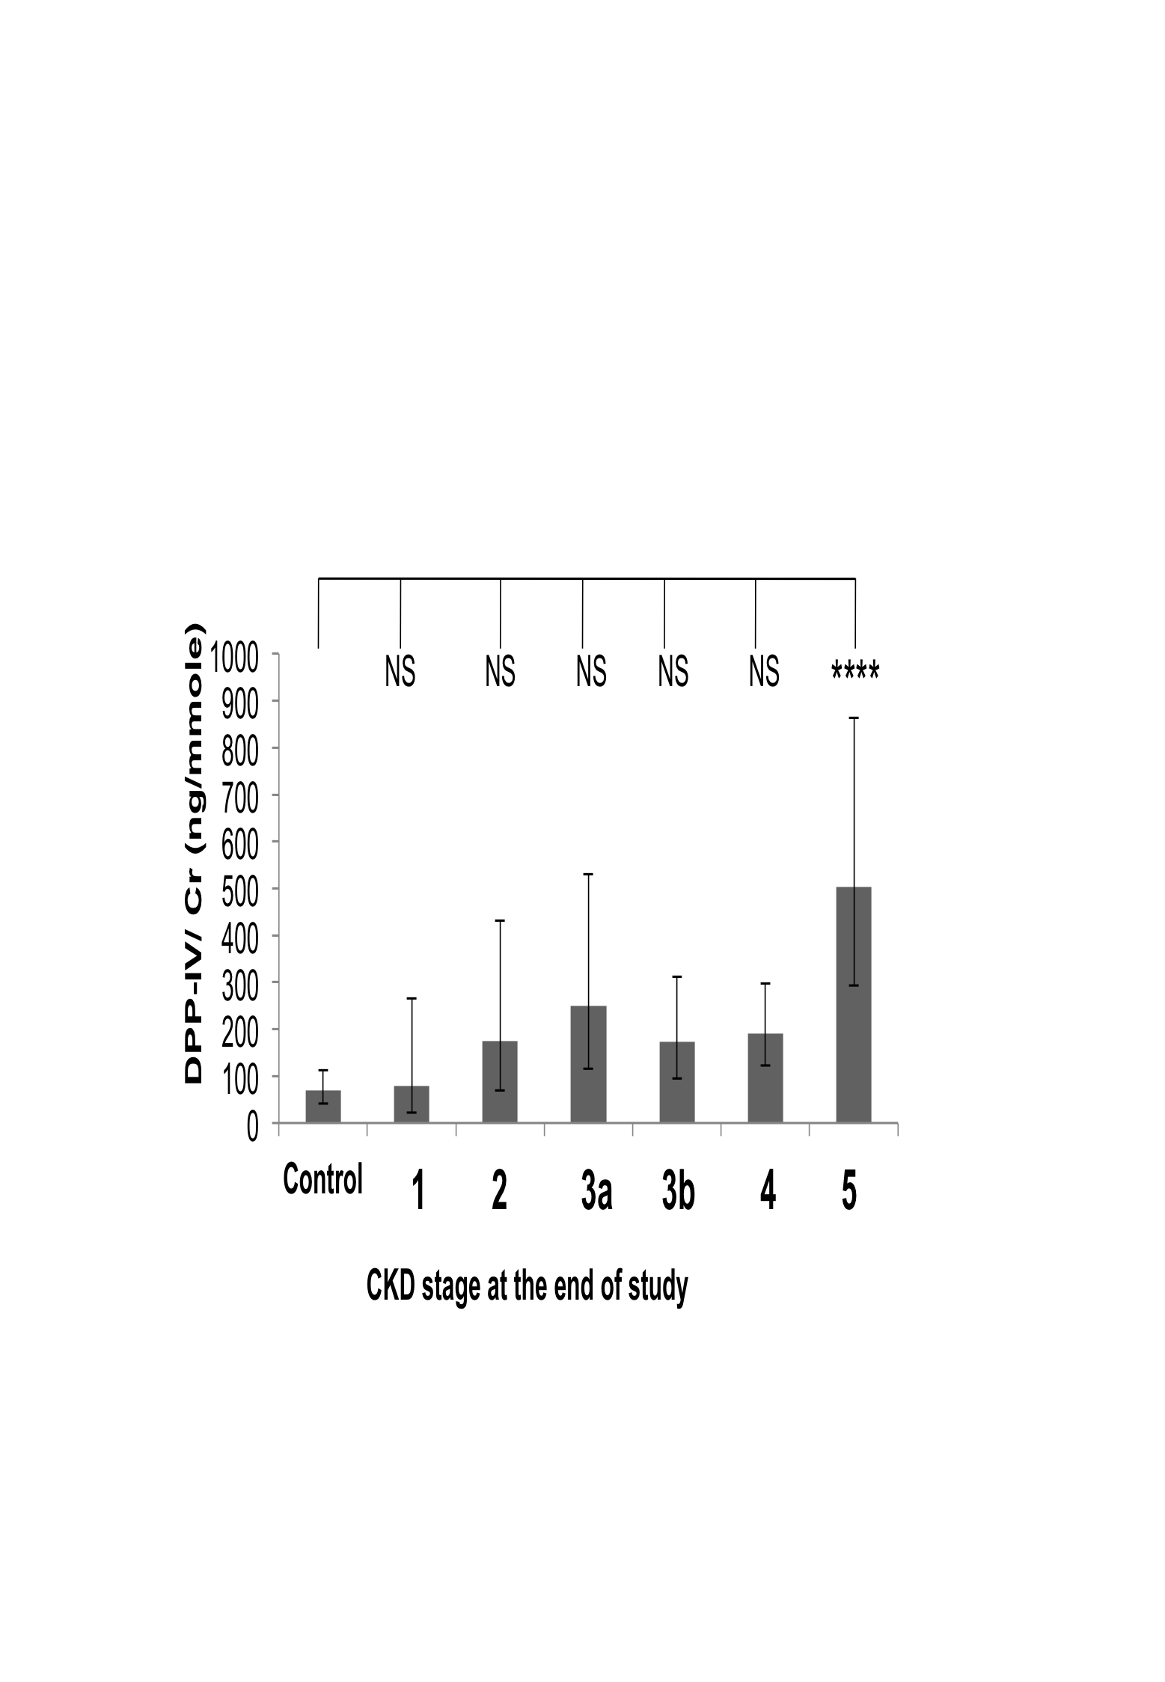

C D
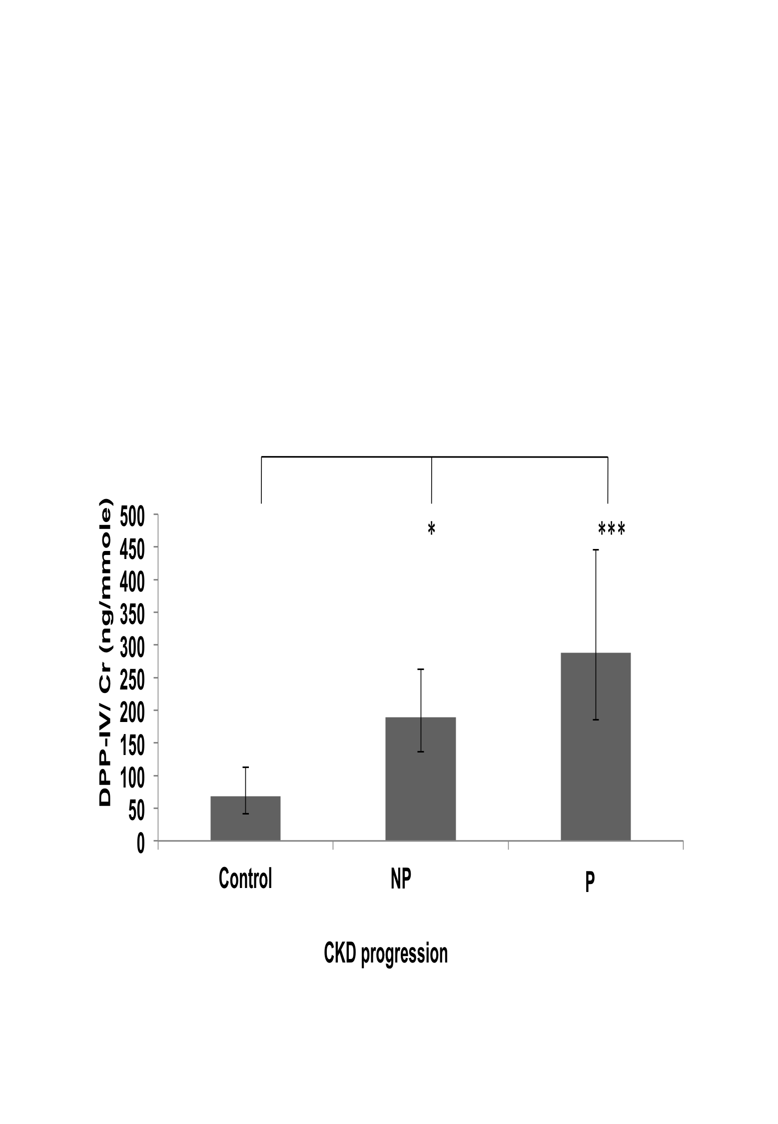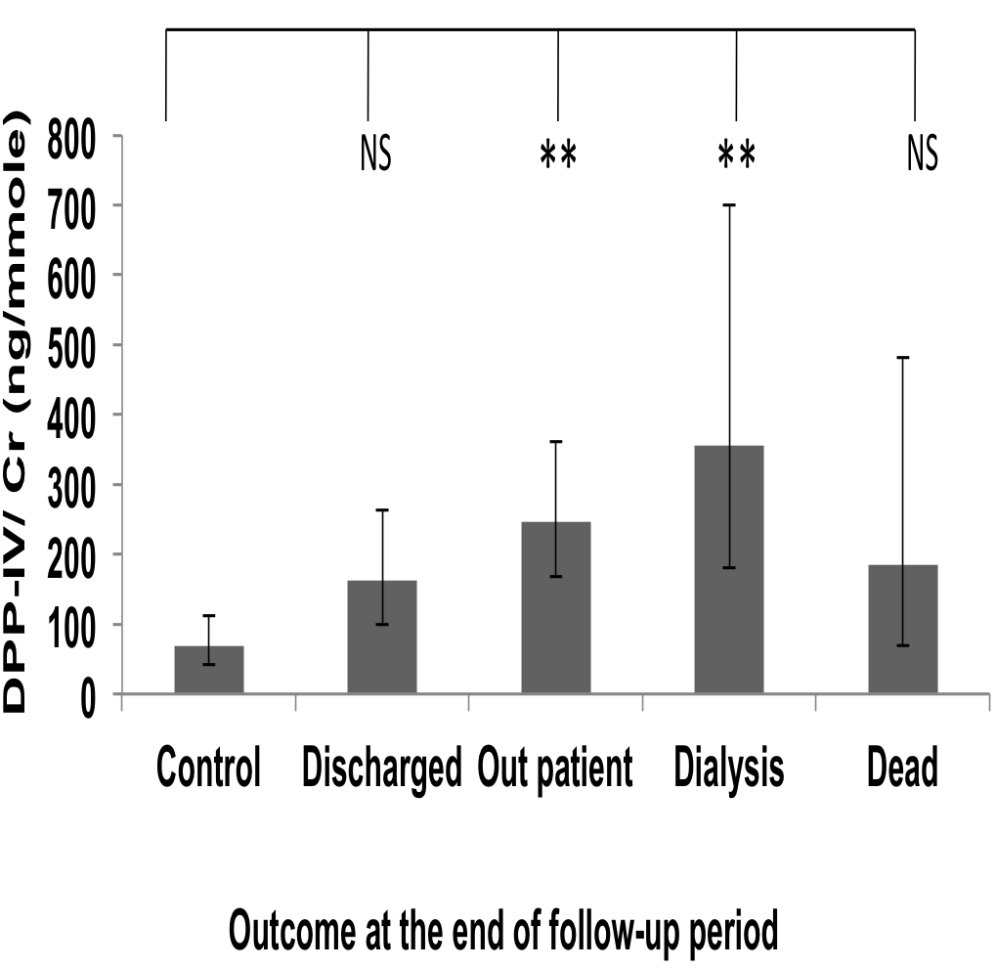
Figure 35: DPP-IV/Cr values variation in all patients groups
Distribution of DPP-IV/Cr concentration ratio in urine according to causes of disease (A), stages (B), progression (C) and outcome of the disease at the end of the follow-up period (D). Geometric means ± SEMs are shown. Statistical significance of differences between populations was tested using 1 way ANOVA on log-transformed data as described in “Methods”. Asterisks indicate statistically significant differences (*, P = 0.02 to 0.01; **, P = 0.01 to 0.001; ***, P = 0.001 to 0.0001 and ****, P < 0.0001 see text for exact P values). The population sizes are: (A) control, n= 47; DM, n= 103; CGN, n= 54; HTN, n= 45; APKD, n= 11 and Others, n=49. (B) Control, n= 47; 1(CKD-1),n=12; 2(CKD-2),n= 22; 3a(CKD-3a),n= 39; 3b(CKD-3b), n= 58; 4(CKD-4), n=81; 5 (CKD-5), n=50. (C) Control, n= 47; Non-progressors (NP)=170; Progressors (P) =92. (D) Control, n= 47; Discharged, n=84; Outpatient, n= 124; Dialysis, n=33; Dead, n= 21.

Subgroup analyses

DM subgroup
When the DPP-IV data for DM patients were grouped according to CKD stages, there was a statistically significant difference between the control and CKD-5 (P=0.0017) (Figure 36 Panel A), but there was no statistically significant difference between the controls and other CKD stages and also between the stages These results were thus very similar to those found when analysing the whole data set (Figure 35 Panel B).
A B
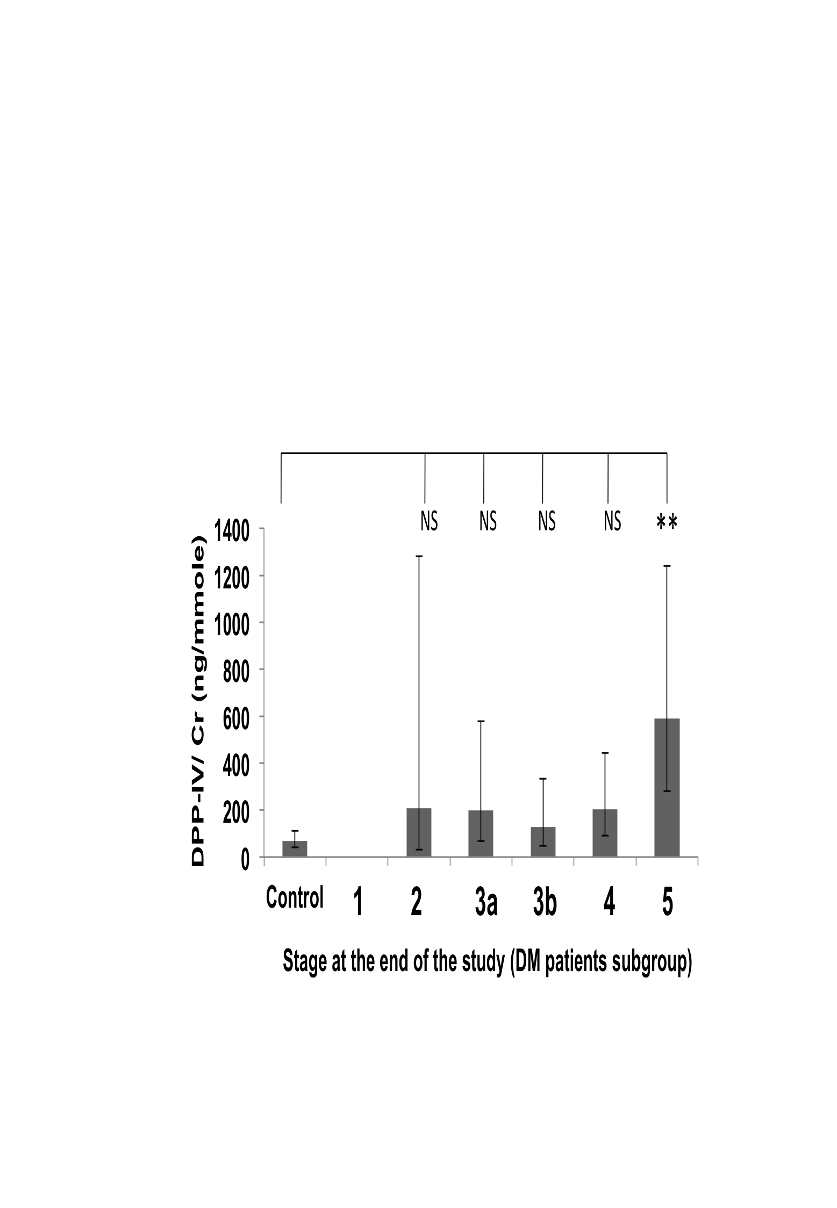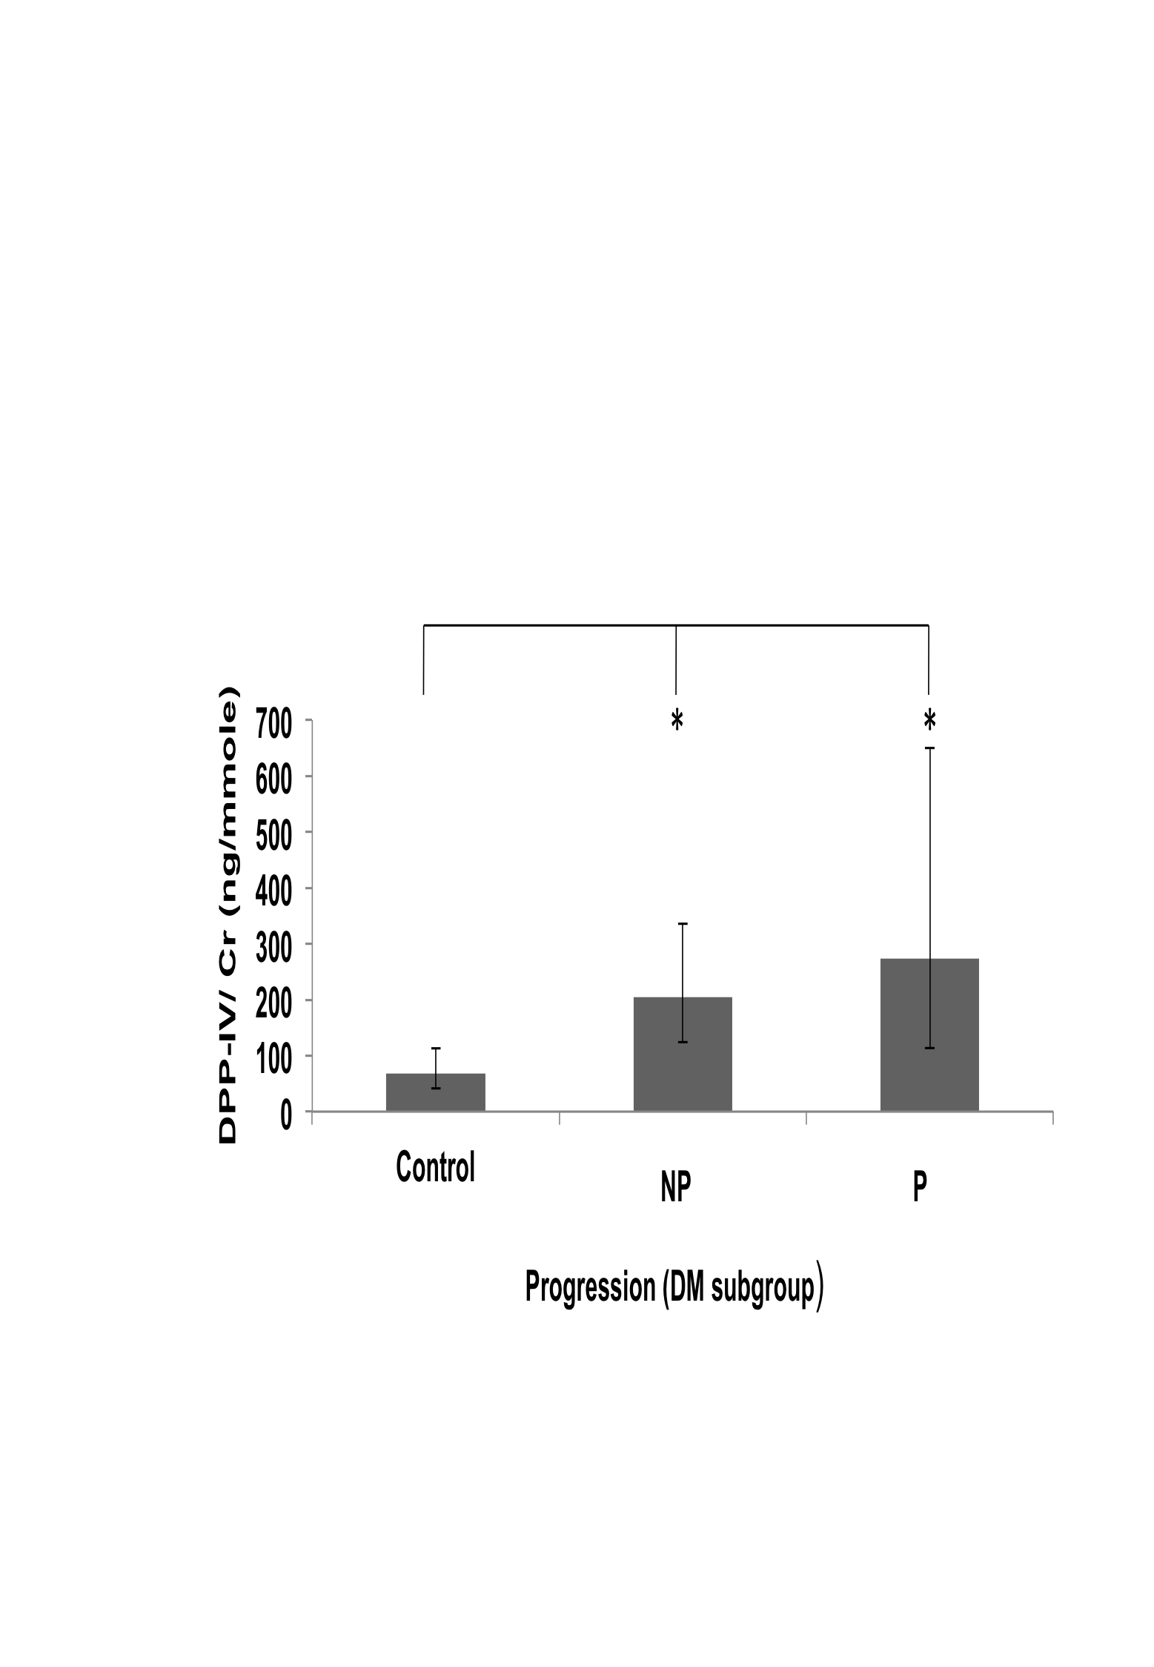

Figure 36: DPP-IV/Cr values variation in the DM patients group
Distribution of DPP-IV/Cr concentration ratio in urine according to stage of disease (A) and progression of disease (B) in the DM patient subgroup. Geometric means ± SEMs are shown. Statistical significance of differences between populations was tested using 1 way ANOVA on log-transformed data as described in “Methods”. Asterisks indicate statistically significant differences (*, P = 0.02 to 0.01; **, P = 0.01 to 0.001; ***, P = 0.001 to 0.0001 and ****, P < 0.0001 see text for exact P values). The population sizes are: control, n= 47; 1 (CKD-1), n=0; 2 (CKD-2), n= 7; 3a (CKD-3a), n= 14; 3b (CKD-3b), n= 24; 4 (CKD-4), n=34; 5 (CKD-5), n=24; Non-progressors (NP), n=74 and Progressors (P), n= 29.

When the data for DM patients was analysed according to progression status, there was a statistically significant difference between the control and non-progressors (P = 0.0148) and between the controls and the progressors (P=0.0141) (Figure 36 Panel B). But there was no significant difference in between the non-progressors and progressors. These results are very similar to what was found when analysing the whole data set.
When the data for DM patients was analysed according to final outcomes, no statistically significant difference was found between the control and any outcome group or between outcome groups. In the whole data set, there were significant difference but they were not seen in DM subgroup.

CGN subgroup
The sub-group analyses carried out on the DPP-IV/Cr values of the CGN patients found no statistically significant differences when the data was analysed by progression status and by final stages (data not shown). In the whole data set some statistically significant differences had been found between controls and stage 5 (Figure 35, Panel B) and between controls and progressors and between controls and non-progressors (Figure 35, Panel C). But they were not seen in the CGN subgroup.
When the DPP-IV/Cr values of the CGN patients were analysed for final outcomes, there was a significant difference between the controls and the outpatient group (P=0.039) (Figure 37), but none of the other disease outcome groups showed any statistically significant difference. This result was similar to that seen in the whole data set (Figure 35, Panel D) for the outpatient group but not for the dialysis group.

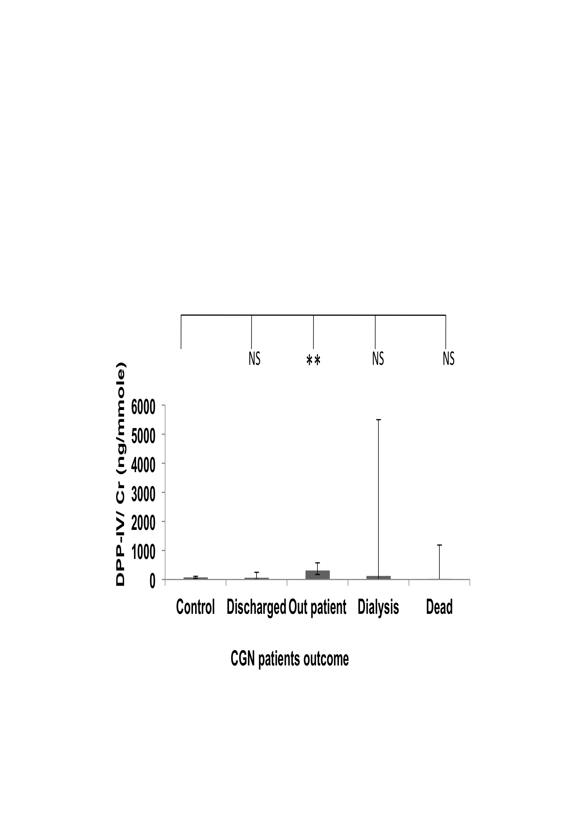
Figure 37: DPP-IV/Cr values variation in CGN patients
Distribution of DPP-IV/Cr concentration ratio in urine according to outcome of the disease at the end of the follow-up period in the CGN patient subgroup. Geometric means ± SEMs are shown. Statistical significance of differences between populations was tested using 1 way ANOVA on log-transformed data as described in “Methods”. Asterisks indicate statistically significant differences (*, P = 0.02 to 0.01; **, P = 0.01 to 0.001; ***, P = 0.001 to 0.0001 and ****, P < 0.0001 see text for exact P values). The population sizes are: control, n= 47; Discharged, n=10; Outpatient, n= 39; Dialysis, n=3; Dead, n= 2.

HTN subgroup
When the data was analysed by final stages there was a statistically significant difference between the control and CKD-3a (P=0.0298) and between controls and CKD-5 (P=0.0184) (Figure 38 Panel A) but there was no significant difference between the stages. In whole data set there was significant difference only between the control and CKD-5. The difference between control and stage 3 for this candidate biomarker was unexpected because it had not been seen in the whole group analysis or in other subgroup analyses. This could be an artefact caused by small numbers of samples in this subgroup (n=8). It is also important to note that this analysis could only be carried out partially because there were not enough samples for all stages (no patients were at stage 1 or 2).
When the data was analysed according to progression status, there was a significant difference between the control and progressors (P=0.0217) but there was no statistically significant differences between the control and non-progressors or between the non-progressors and progressors (Figure 38 Panel B).
The analysis by outcomes showed that there was a significant difference between the control and dialysis group (P=0.0321) (Figure 38 Panel C) but there was no significant difference between the disease outcome groups. The statistically significant difference between control and Dialysis is similar to that seen in whole data set but the significant difference between the control and outpatient group also seen in the whole cohort was not statistically significant in the HTN subgroup.

Overall, the results of these subgroup analyses on the DPP-IV/Cr data suggest that in the DM and HTN subgroups similar significant differences are seen as in the whole cohort but they most of these differences could not be seen in the CGN subgroup.

A B
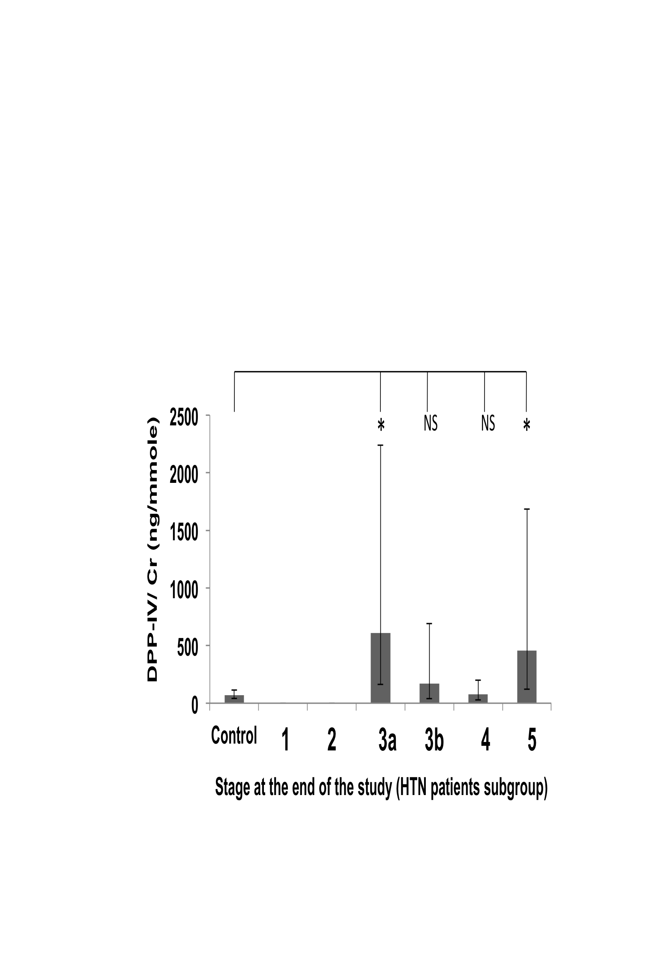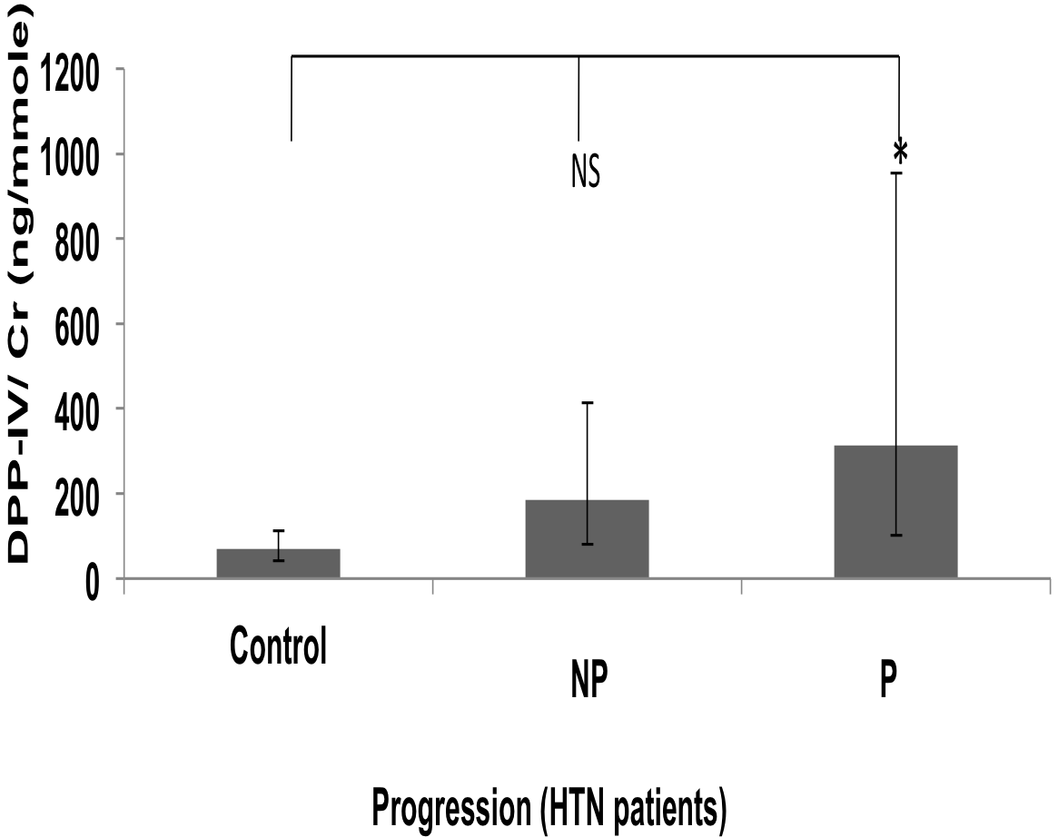

C
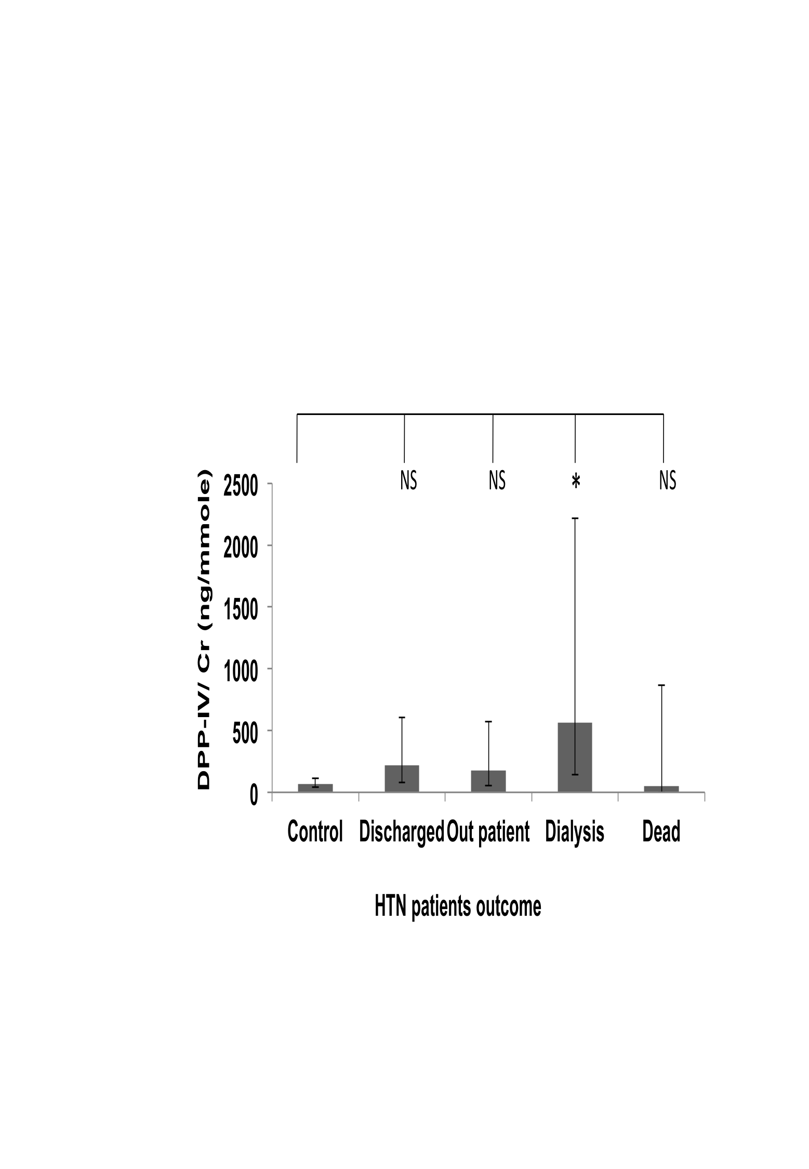

Figure 38: DPP-IV/Cr values variation in the HTN patients
Distribution of DPP-IV/Cr concentration ratio in urine according to stage of disease (A), progression of disease (B) and outcome of the disease at the end of the follow-up period (C) in HTN patients subgroup. Geometric means ± SEMs are shown. Statistical significance of differences between populations was tested using 1 way ANOVA on log-transformed data as described in “Methods”. Asterisks indicate statistically significant differences (*, P = 0.02 to 0.01; **, P = 0.01 to 0.001; ***, P = 0.001 to 0.0001 and ****, P < 0.0001 see text for exact P values). The population sizes are: (A) control, n= 47; 1(CKD-1), n=0; 2(CKD-2), n= 0; 3a(CKD-3a), n= 8; 3b(CKD-3b), n= 12; 4(CKD-4), n=13; 5 (CKD-5), n=12 (B) control, n= 47; Non-progressors (NP)=29; Progressors (P) =16 (C) control, n= 47; Discharged, n=19; Outpatient, n= 15; Dialysis, n=8; Dead, n= 3.

One-way ANOVA analyses of CXCL-16/Cr values

Analysis of all samples
There was no significant difference in between the control and CKD causes and also in between the CKD causes (Figure 39 Panel A).
When the values of CXCL-16/Cr were grouped according to the stages of CKD at the end of the study, CXCL-16/Cr values were significantly higher in CKD-5 compared to controls (P< 0.0001). There were statistically significant differences between CKD-1 and CKD-5 (P = 0.001), CKD-2 and CKD-5 (P = 0.0168), CKD-3a and CKD-5 (P = 0.0004) CKD-3b and CKD-5 (P = 0.0035) and between CKD-4 and CKD-5 (P = 0.0047) (Figure 39 Panel B).
There was no significant difference between the control and non-progressors, but CXCL-16/Cr values were higher in progressors compared to controls (P = 0.0023) (Figure 39 Panel C). But there was no significant difference in between the non-progressors and progressors.
There was a significant difference in between the control and outpatient group (P = 0.0376), and dialysis group (P< 0.0001). There was a significant difference in between the discharged and dialysis group (P = 0.0011) (Figure 39 Panel D).

A B
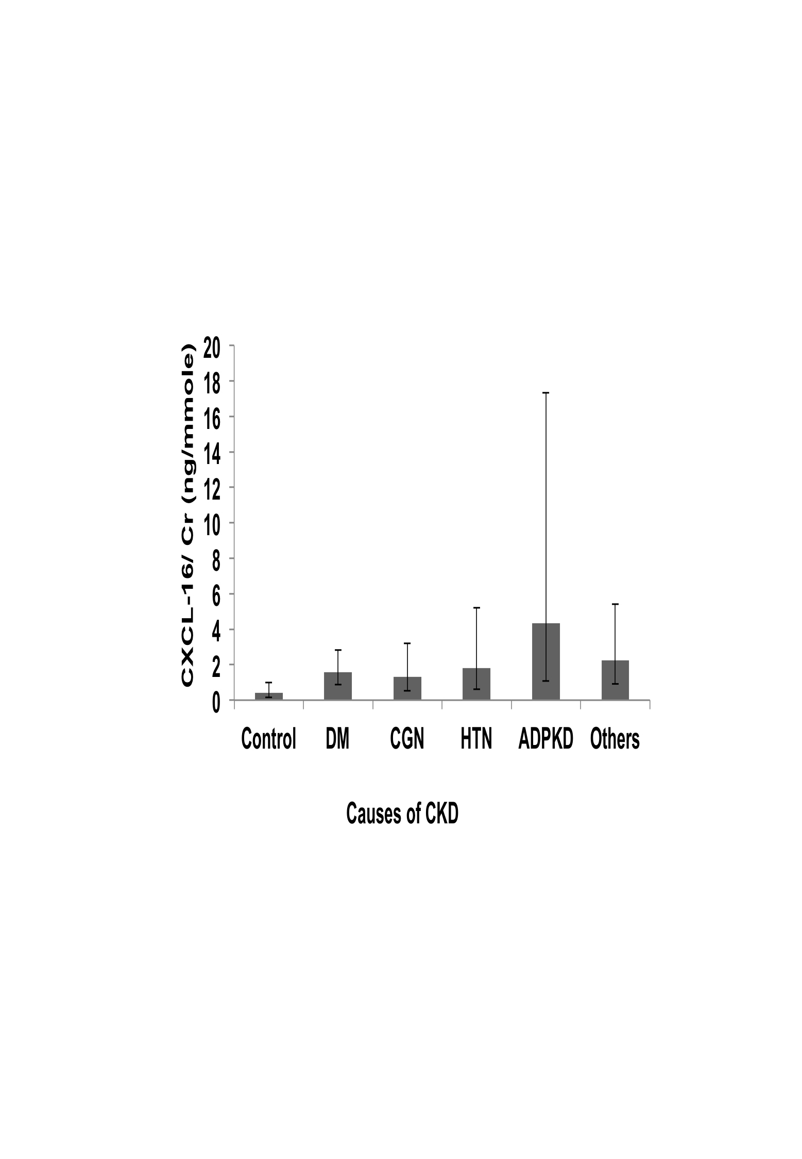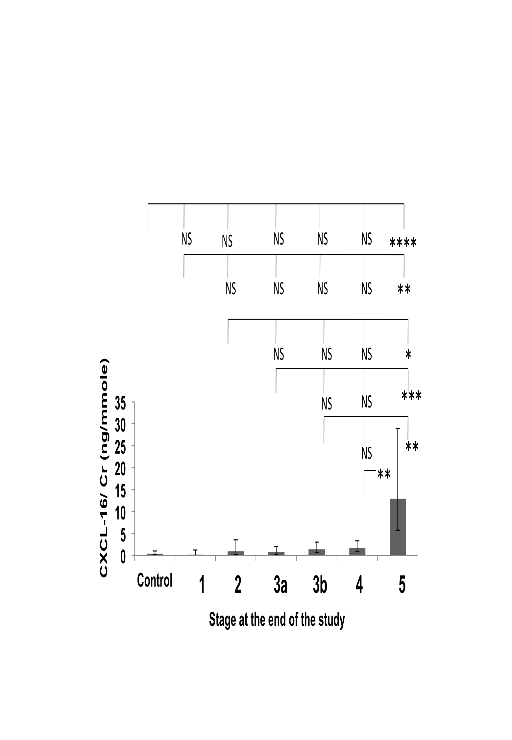

C D
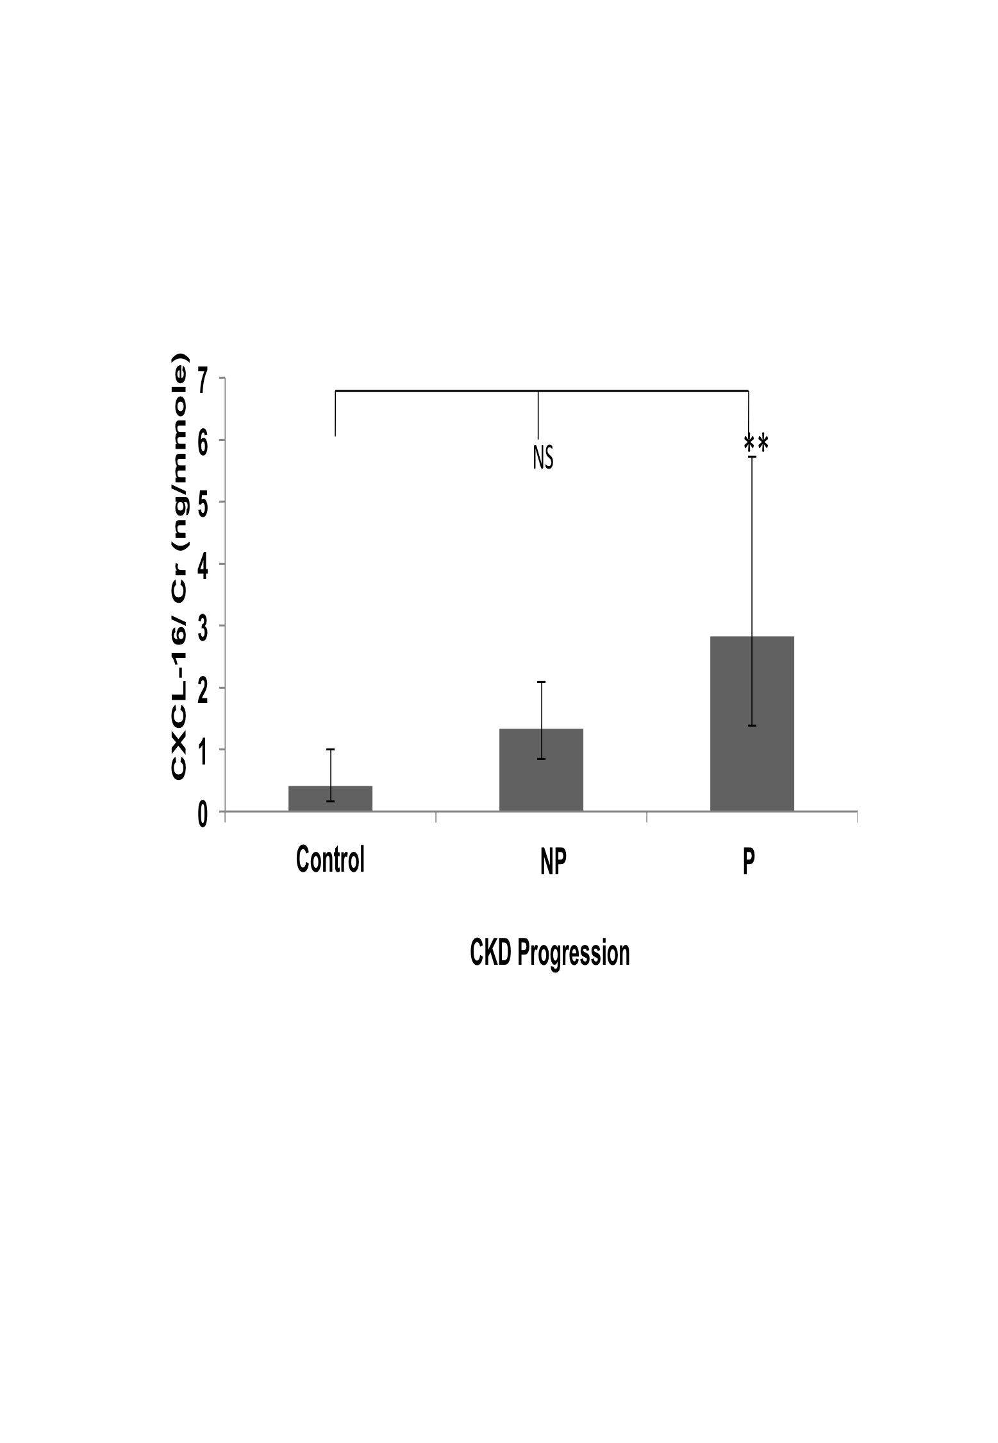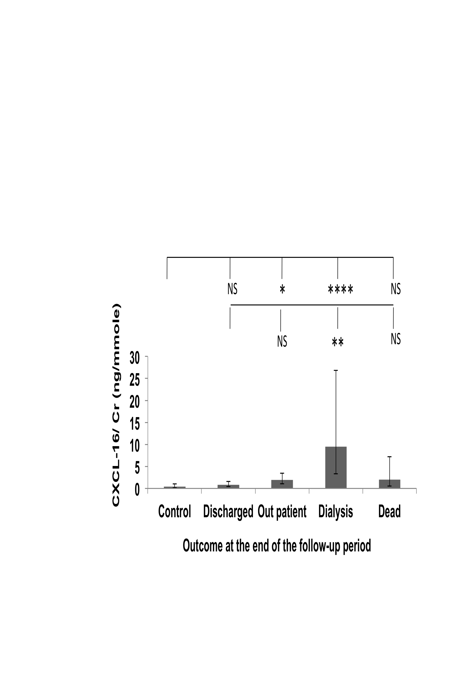

Figure 39: CXCL-16/Cr values variations in all patients groups
Distribution of CXCL-16/Cr concentration ratio in urine according to causes of disease (A), stages (B), progression (C) and outcome of the disease at the end of the follow-up period (D). Geometric means ± SEMs are shown. Statistical significance of differences between populations was tested using 1 way ANOVA on log-transformed data as described in “Methods”. Asterisks indicate statistically significant differences (*, P = 0.02 to 0.01; **, P = 0.01 to 0.001; ***, P = 0.001 to 0.0001 and ****, P < 0.0001 see text for exact P values). The population sizes are: (A) control, n= 47; DM, n= 103; CGN, n= 54; HTN, n= 45; APKD, n= 11 and Others, n=49. (B) Control, n= 47; 1(CKD-1),n=12; 2(CKD-2),n= 22; 3a(CKD-3a),n= 39; 3b(CKD-3b), n= 58; 4(CKD-4), n=81; 5 (CKD-5), n=50. (C) Control, n= 47; Non-progressors (NP)=170; Progressors (P) =92. (D) Control, n= 47; Discharged, n=84; Outpatient, n= 124; Dialysis, n=33; Dead, n= 21.

Subgroup analyses

DM subgroup
There was a significant difference between the control and CKD-5 (P= 0.001), CKD-3a and CKD-5 (P = 0.0052) (Figure 40 panel A). Unlike the results for the whole data set, in this subgroup no statistically significant differences was found between CKD-5 and CKD-1, CKD-2, CKD-3b and CKD-4.
Analysis of the CXCL-16/Cr data by progression status found no statistically significant difference between the controls, progressors and non-progressors (data no shown). This result was different from the whole data set, where there was a significant difference between the control and progressors group.
When the data was analysed by outcomes, there was a statistically significant difference between the control and dialysis group (P = 0.0224) (Figure 40 panel B) but no significant difference between the disease outcome groups. In the whole data set, there was significant difference between the control and outpatient and dialysis groups and also between the discharged and dialysis groups.

A B
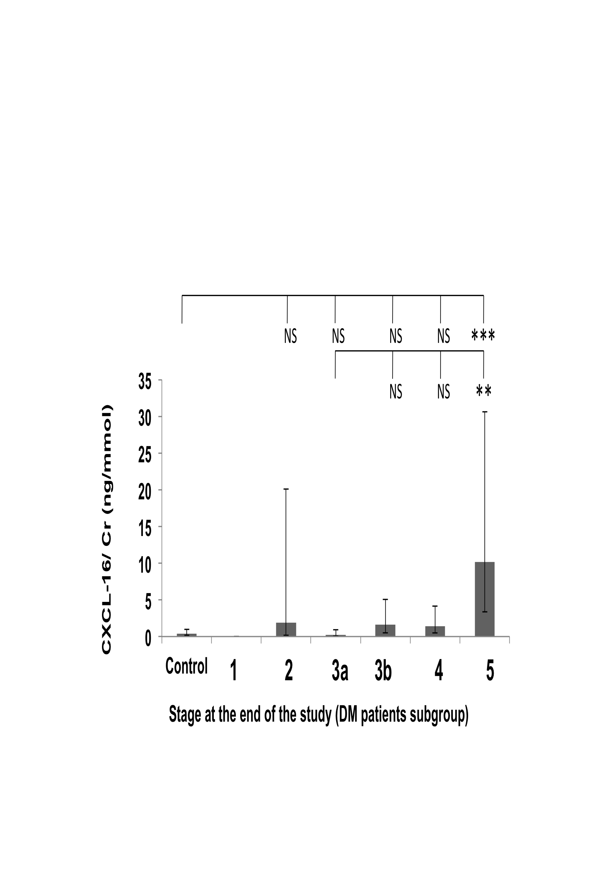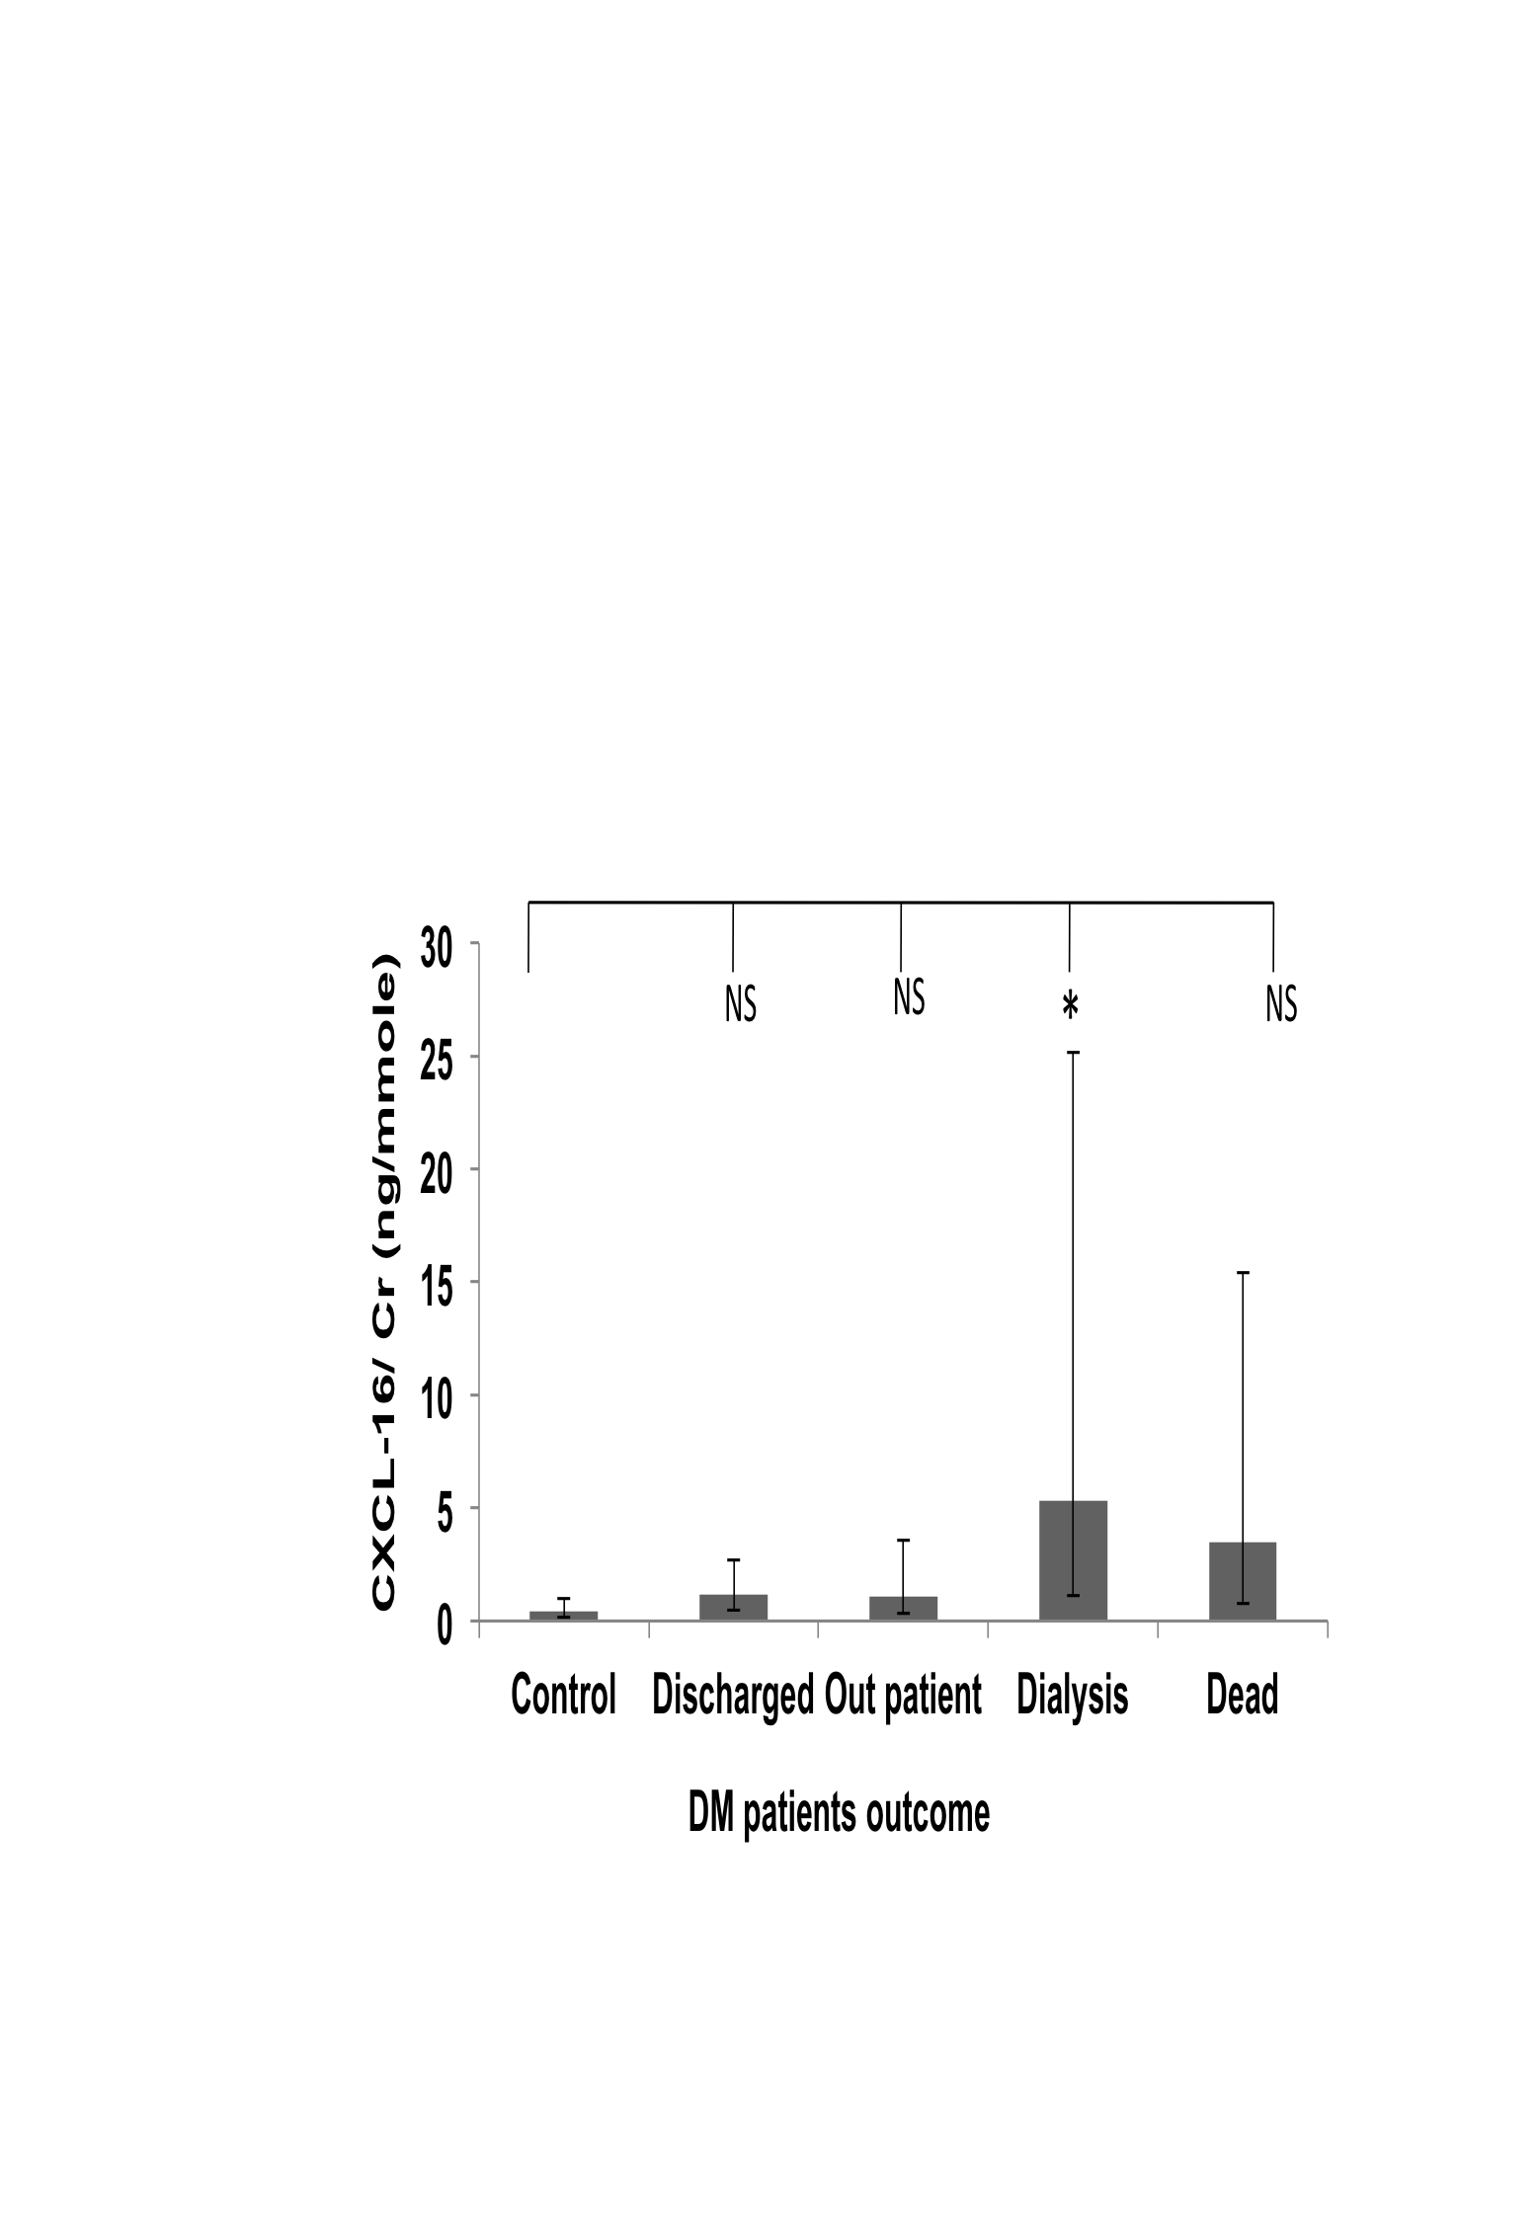
Figure 40: CXCL-16/Cr values variation in DM patients group
Distribution of CXCL-16 /Cr concentration ratio in urine according to stage of disease (A) and outcome of the disease at the end of the follow-up period (B) in DM patients subgroup. Geometric means ± SEMs are shown. Statistical significance of differences between populations was tested using 1 way ANOVA on log-transformed data as described in “Methods”. Asterisks indicate statistically significant differences (*, P = 0.02 to 0.01; **, P = 0.01 to 0.001; ***, P = 0.001 to 0.0001 and ****, P < 0.0001 see text for exact P values). The population sizes are: (A) control, n= 47; 1(CKD-1), n=0; 2(CKD-2), n= 7; 3a(CKD-3a), n= 14; 3b(CKD-3b), n= 24; 4(CKD-4), n=34; 5 (CKD-5), n=24; (B) control, n=47; Discharged, n= 38; Outpatient, n= 34; Dialysis, n= 17; Dead, n= 14.

CGN subgroup
In this subgroup, there was no statistically significant difference between the controls and CKD stages and also between the stages (data not shown). There were also no significant differences between the control and non-progressors and progressors groups and between the control and disease outcome group (data not shown). By contrast in the whole data set there were statistically significant differences between the control and CKD stages (Figure 39, panel B), between the controls and the progressors group (Figure 39, panel C) and between the control and outpatient or dialysis outcome groups (Figure 39, panel D).

HTN subgroup
There was a significant difference in between the control and CKD-5 (P = 0.002) and also in between the CKD-4 and CKD-5 (P = 0.0147) (Figure 41 Panel A). This was similar to the result seen in whole data set, except for CKD-1, CKD-2, CKD-3a, and CKD-3b.
Analysing the data by progression status found no statistically significant difference between the control and non-progressors groups and between the non-progressors and progressors group there was a significant difference between the control and progressors group (P = 0.0214) (Figure 41 Panel B). This was similar to the result seen in whole cohort.
When the data was analysed by outcomes, there was a significant difference in between the control and dialysis group (n=8) (0.008) (Figure 41 panel C) but there was no significant difference in between the groups. This result is different from that seen in the whole data set, which showed significant differences between the control and outpatient and dialysis groups.

Overall, the DM and HTN subgroup showed more or less the similar pattern of whole data set, but the CGN subgroup showed a different pattern from the whole data set.

A B
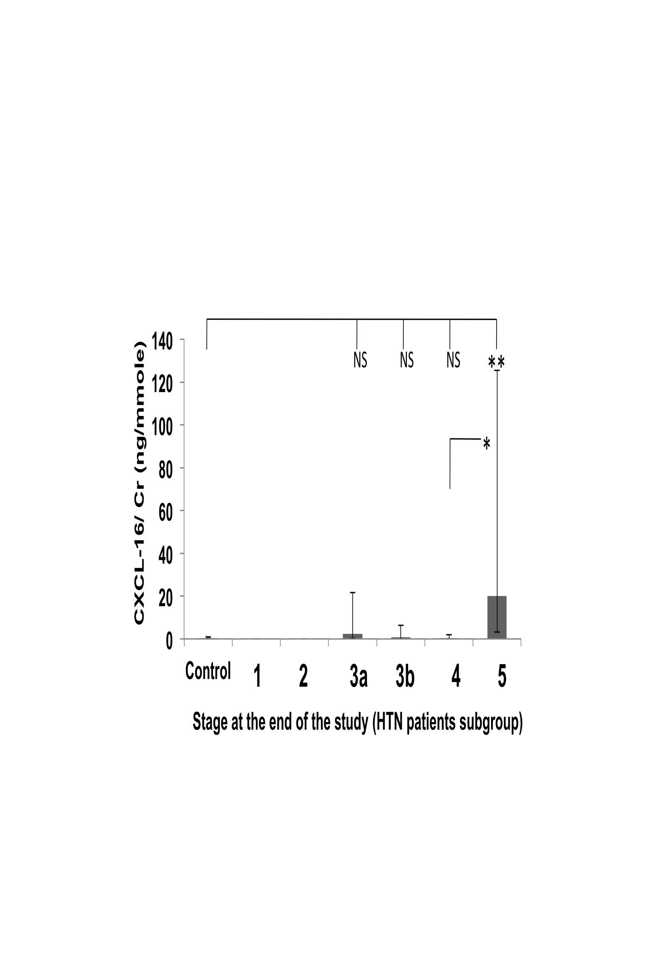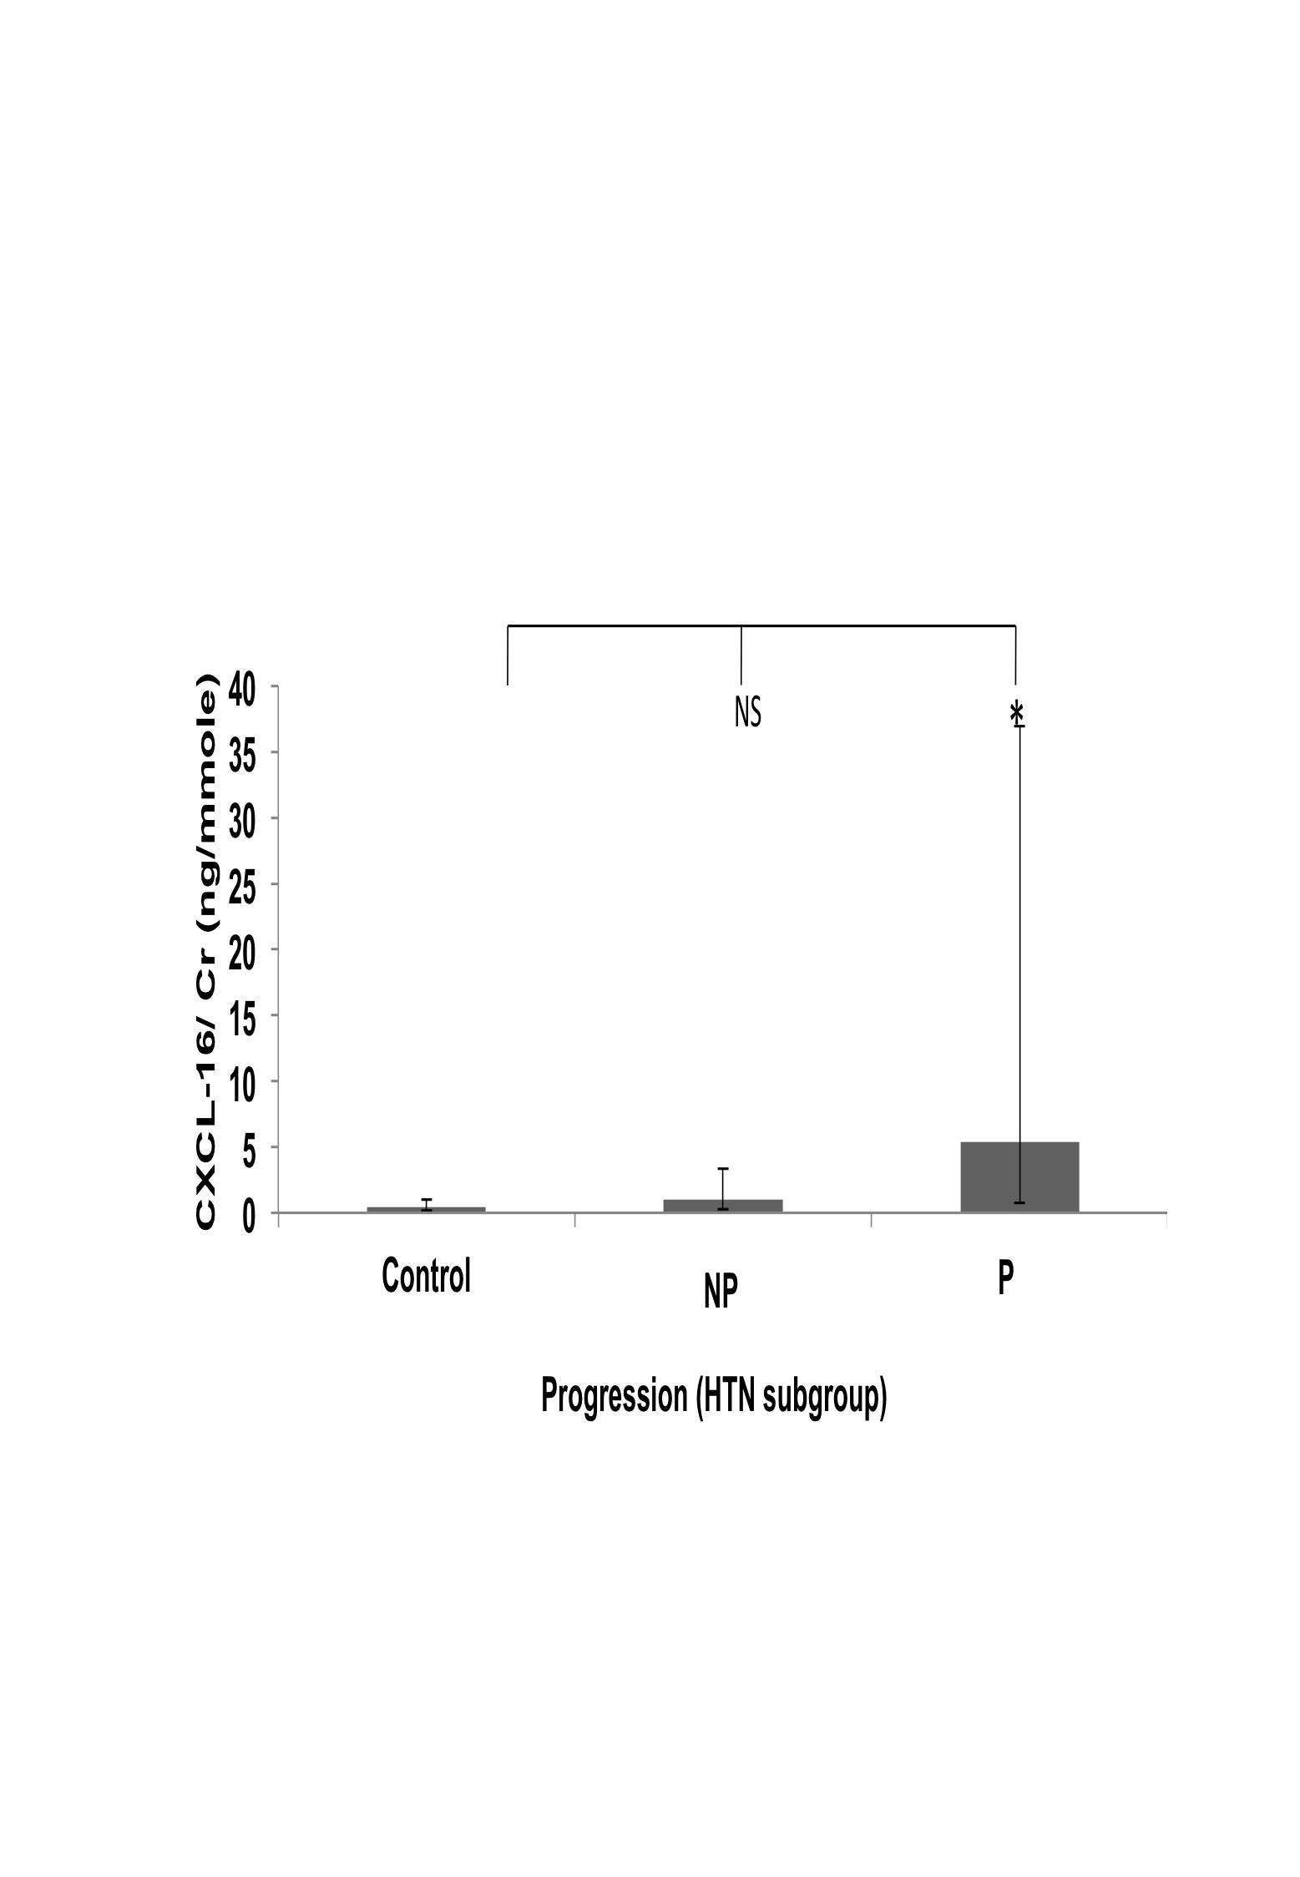

C
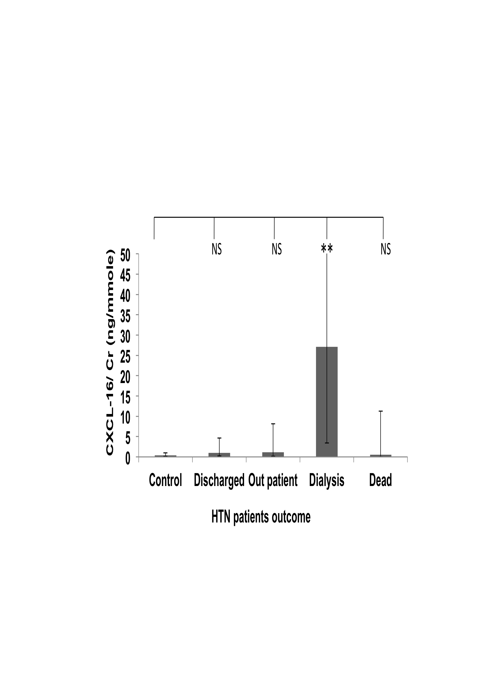

Figure 41: CXCL-16 /Cr values variation in HTN patients group.
Distribution of DPP-IV/Cr concentration ratio in urine according to stage of disease (A), progression of disease (B) and outcome of the disease at the end of the follow-up period (C) in HTN patients subgroup. Geometric means ± SEMs are shown. Statistical significance of differences between populations was tested using 1 way ANOVA on log-transformed data as described in “Methods”. Asterisks indicate statistically significant differences (*, P = 0.02 to 0.01; **, P = 0.01 to 0.001; ***, P = 0.001 to 0.0001 and ****, P < 0.0001 see text for exact P values). The population sizes are: (A) control, n= 47; 1(CKD-1), n=0; 2(CKD-2), n= 0; 3a(CKD-3a), n= 8; 3b(CKD-3b), n= 12; 4(CKD-4), n=13; 5 (CKD-5), n=12 (B) control, n= 47; Non-progressors (NP)=29; Progressors (P) =16 (C) control, n= 47; Discharged, n=19; Outpatient, n= 15; Dialysis, n=8; Dead, n= 3.

One-way ANOVA analyses of Leptin/Cr values

Analysis of all samples
When the leptin /Cr values for the whole cohort were grouped according to the causes of CKD, there was no significant difference between the controls and CKD causes, (Figure 42 Panel A). There was also no significant difference in between the control and CKD stages and also in between the stages, when the patients’ data was grouped according to the stages of CKD (Figure 42 Panel B). There was no significant difference in between the control and non-progressors and progressors group, when grouped according to the progression of the disease (Figure 42 Panel C). Finally, when the data was grouped according to the outcome of the disease at the end of the follow-up period there was no significant difference between the control and disease outcome group (Figure 42 Panel D).

Subgroup analyses
As for the other candidates, subgroup analyses were carried out for the three major subgroup of CKD causes DM, CGN and HTN, to see whether the Leptin/Cr values could be used as marker for any of the disease groups.
These analyses found no statistically significant differences between leptin/Cr values in any of one-way ANOVA analyses carried out in the three sub-groups (data not shown).
Overall, these results of all the subgroup analyses were thus similar to those that had been found for the whole cohort. They suggest that leptin has no predictive value as CKD biomarker.

A B
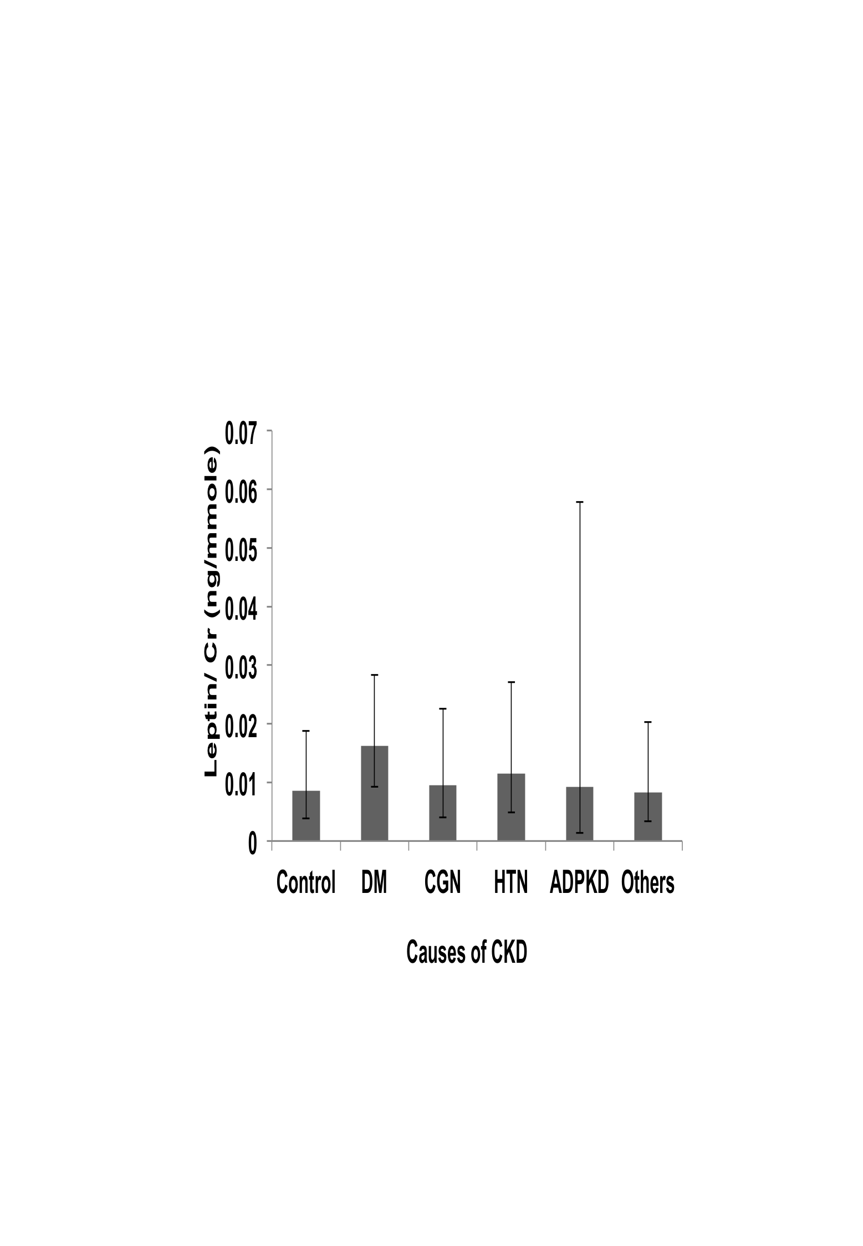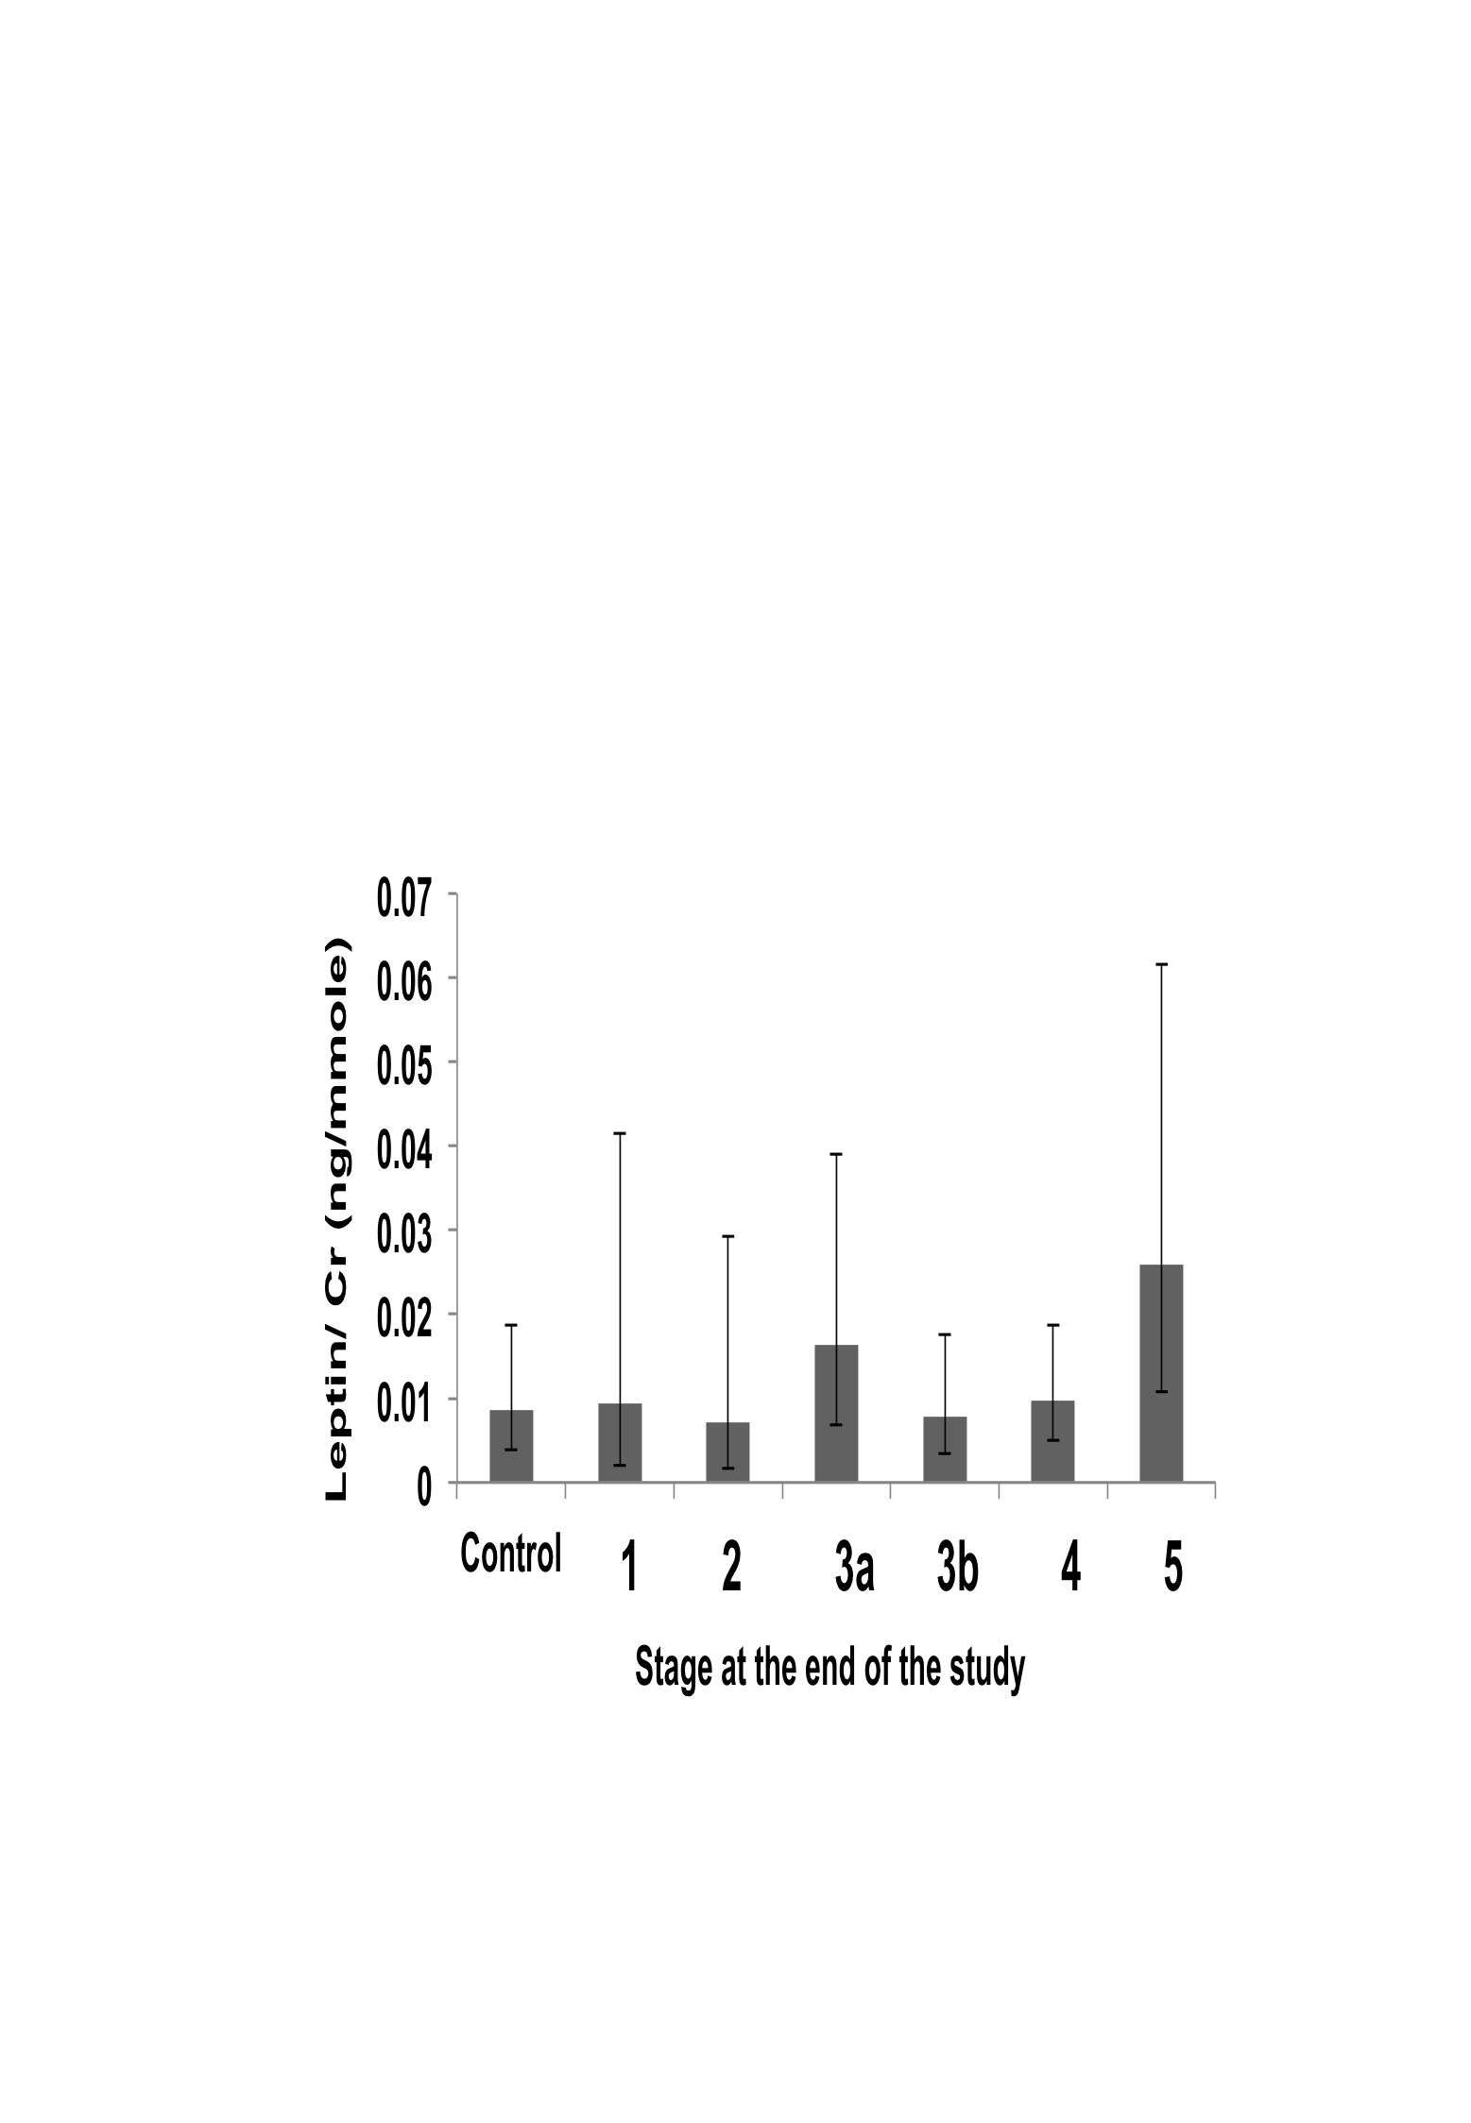

C D

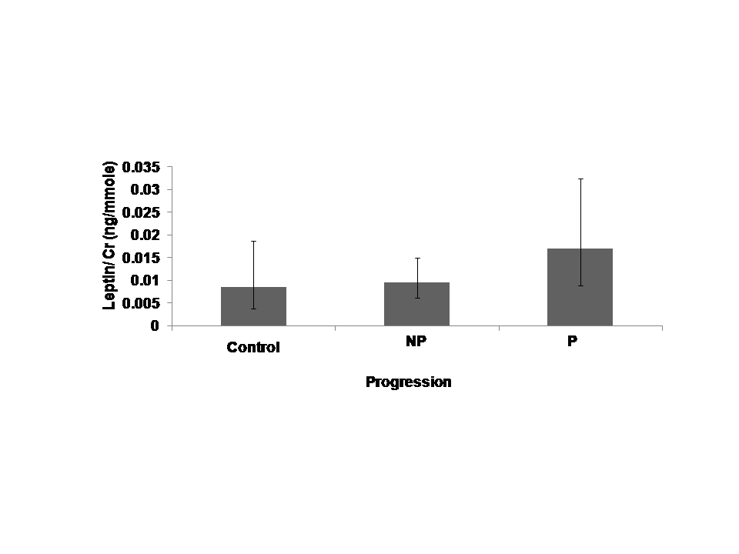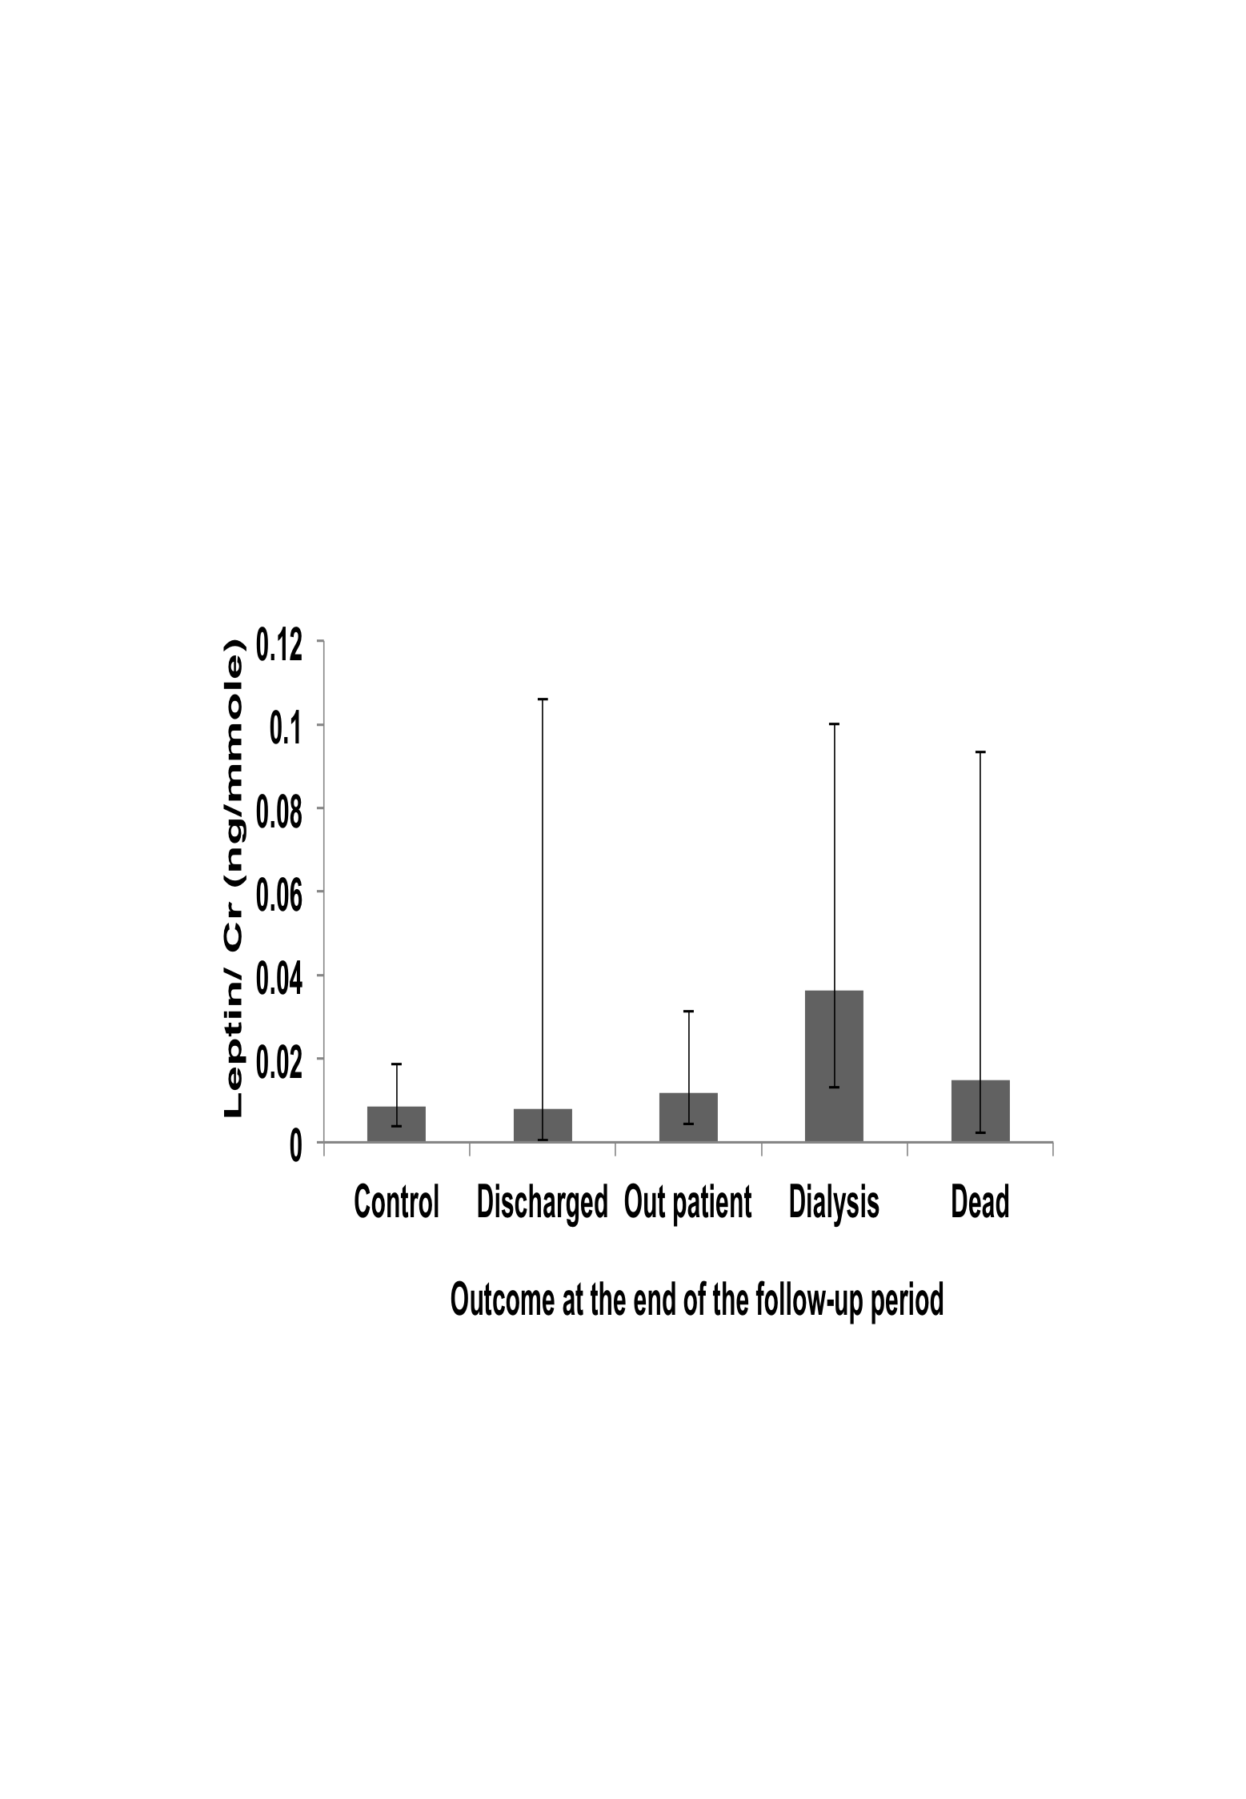
Figure 42: Leptin/Cr value variations in the whole cohort
Distribution of Leptin /Cr concentration ratio in urine according to causes of disease (A), stages (B), progression (C) and outcome of the disease at the end of the follow-up period (D). Geometric means ± SEMs are shown. Statistical significance of differences between populations was tested using 1 way ANOVA on log-transformed data as described in “Methods”. Asterisks indicate statistically significant differences (*, P = 0.02 to 0.01; **, P = 0.01 to 0.001; ***, P = 0.001 to 0.0001 and ****, P < 0.0001 see text for exact P values). The population sizes are: (A) control, n= 47; DM, n= 103; CGN, n= 54; HTN, n= 45; APKD, n= 11 and Others, n=49. (B) Control, n= 47; 1(CKD-1),n=12; 2(CKD-2),n= 22; 3a(CKD-3a),n= 39; 3b(CKD-3b), n= 58; 4(CKD-4), n=81; 5 (CKD-5), n=50. (C) Control, n= 47; Non-progressors (NP)=170; Progressors (P) =92. (D) Control, n= 47; Discharged, n=84; Outpatient, n= 124; Dialysis, n=33; Dead, n= 21.

One-way ANOVA analyses of IL-8/Cr values

Analysis of all samples
Analyses of the IL-8/Cr values did not find any statistically significant differences when the data was divided according to either causes of CKD stages, progression status or final outcome (Figure 43).
A B
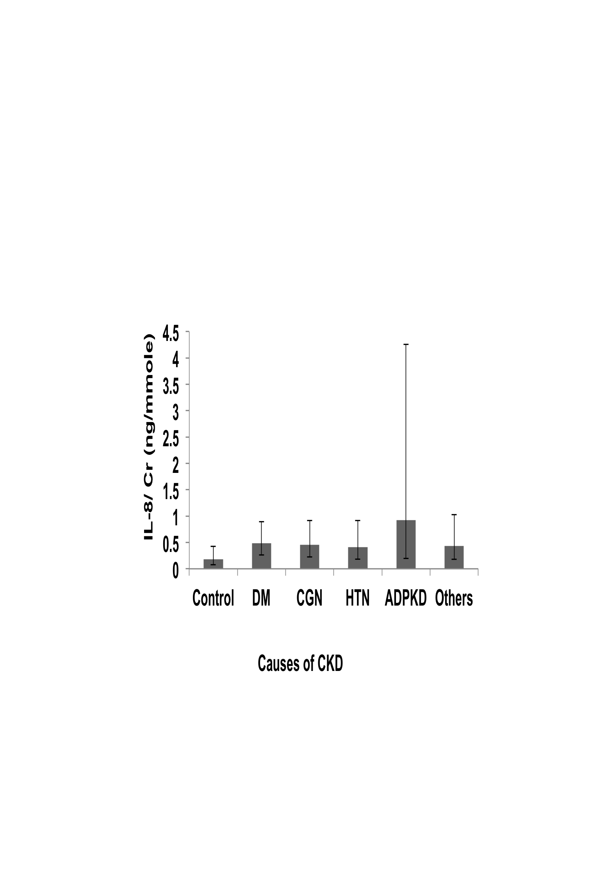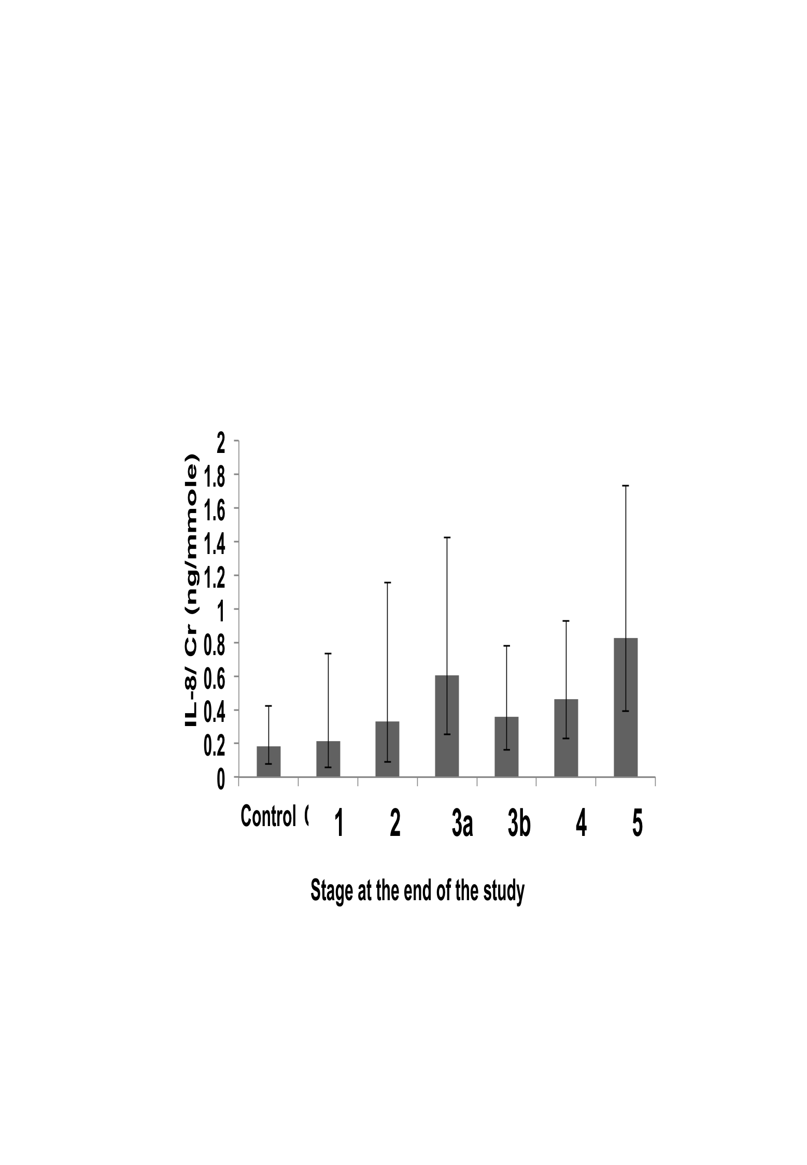
C D

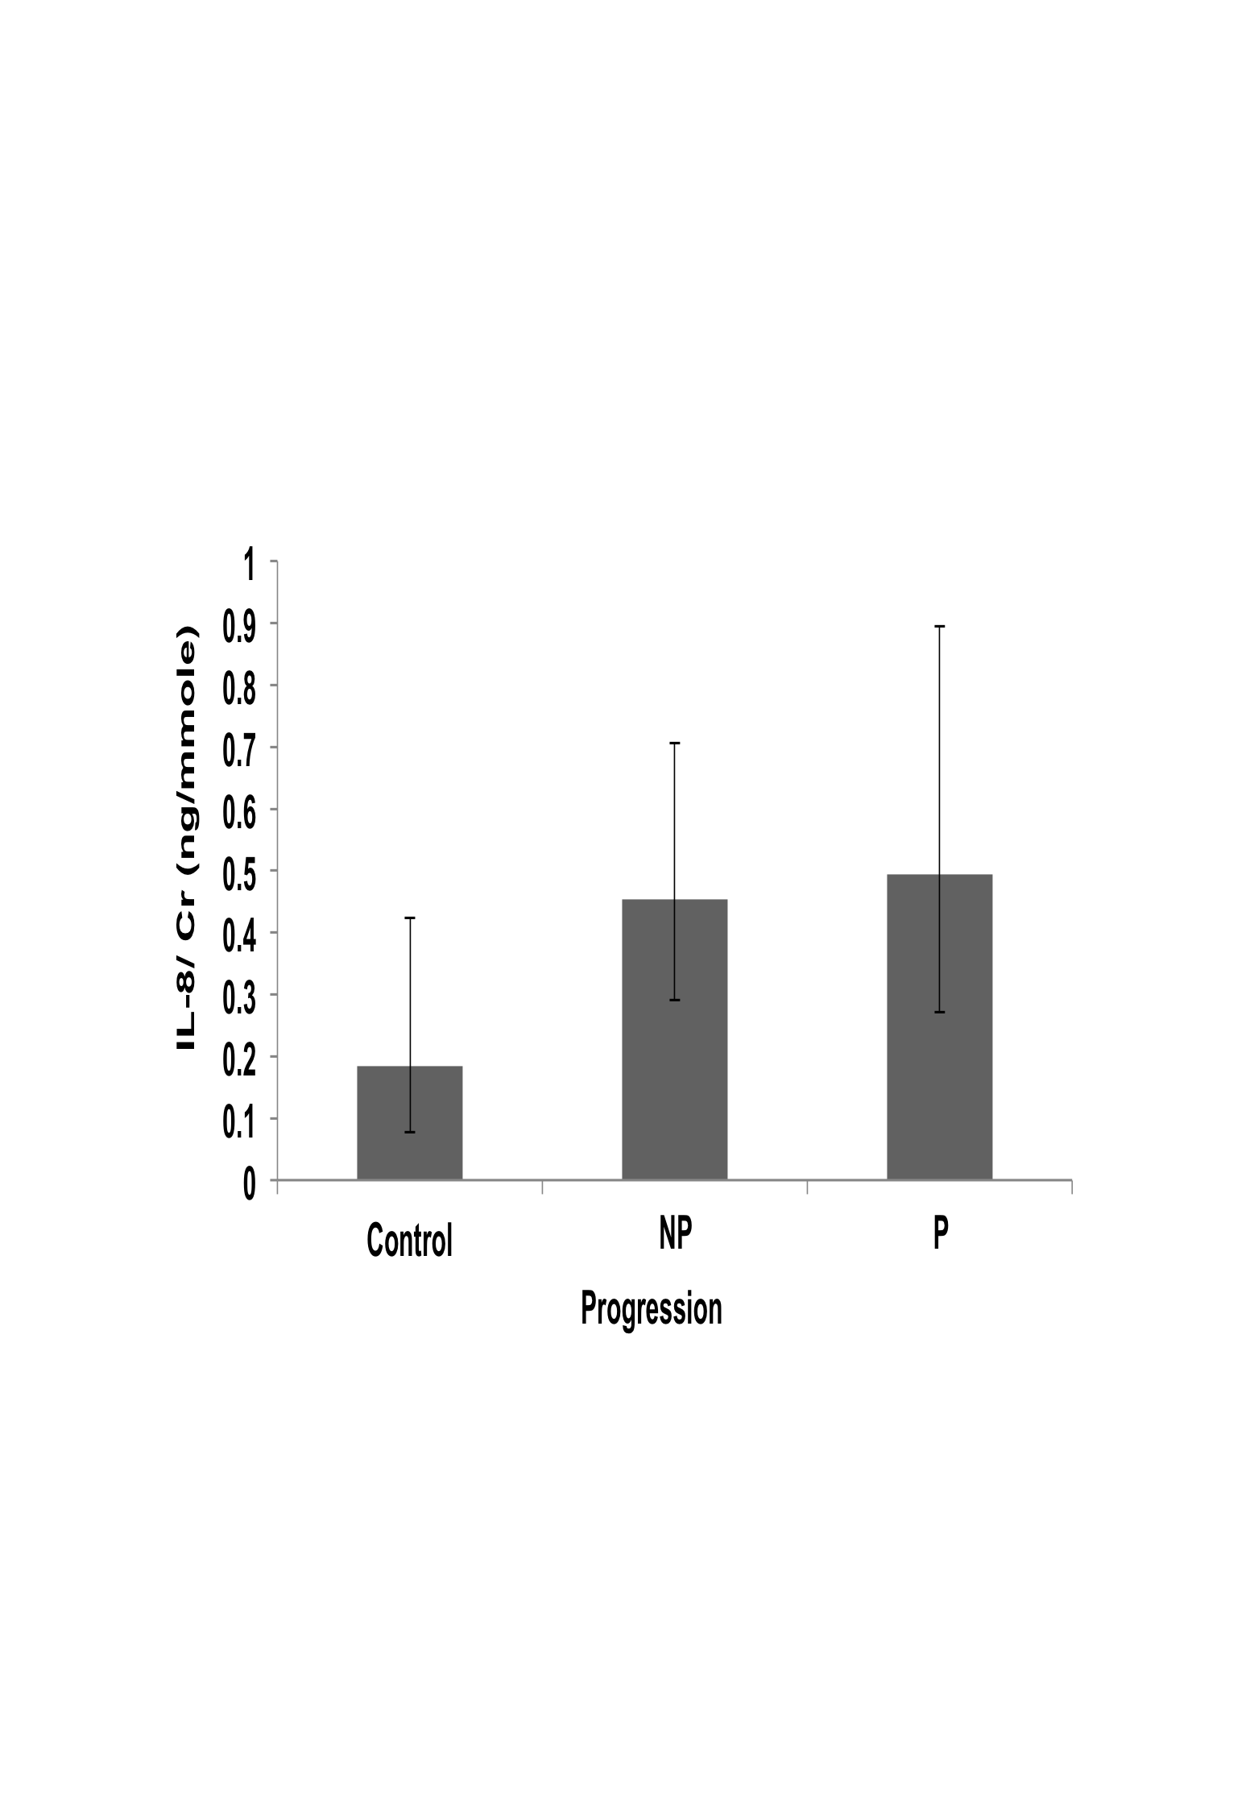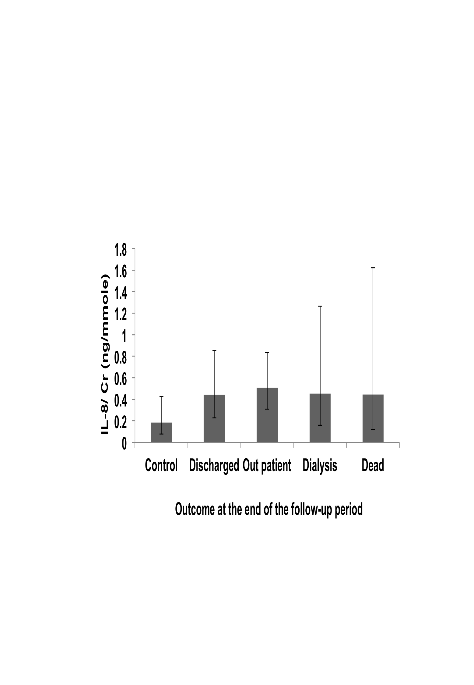
Figure 43: IL-8/Cr value variations in the whole cohort
Distribution of IL-8 /Cr concentration ratio in urine according to causes of disease (A), stages (B), progression (C) and outcome of the disease at the end of the follow-up period (D). Geometric means ± SEMs are shown. Statistical significance of differences between populations was tested using 1 way ANOVA on log-transformed data as described in “Methods”. Asterisks indicate statistically significant differences (*, P = 0.02 to 0.01; **, P = 0.01 to 0.001; ***, P = 0.001 to 0.0001 and ****, P < 0.0001 see text for exact P values). The population sizes are: (A) control, n= 47; DM, n= 103; CGN, n= 54; HTN, n= 45; APKD, n= 11 and Others, n=49. (B) Control, n= 47; 1(CKD-1),n=12; 2(CKD-2),n= 22; 3a(CKD-3a),n= 39; 3b(CKD-3b), n= 58; 4(CKD-4), n=81; 5 (CKD-5), n=50. (C) Control, n= 47; Non-progressors (NP)=170; Progressors (P) =92. (D) Control, n= 47; Discharged, n=84; Outpatient, n= 124; Dialysis, n=33; Dead, n= 21.

Subgroup analyses
Then subgroup analysis was taken in the three major subgroup of CKD causes likely DM, CGN and HTN to see whether, the IL-8 /Cr could be used as a marker of any of the disease group. These analyses did not find any statistically significant difference between IL-8 /Cr values (data not shown). These negative results were similar to those that had been found for the whole cohort. They suggest that IL-8 has no predictive value as CKD biomarker.

Odds ratios for progression
To complement the ANOVA tests, Odds Ratios (OR) for progression to one of the two late stages (stage 4 or 5) were also determined for ACR and all candidate markers. These OR calculations provide an estimation, for a patient at stage 1, 2 or 3 of whether an increase of 1 unit for a particular candidate marker (arbitrary units) increases the probability that they will eventually reached stage 4 or 5, and to compare the magnitude of various risk factors for that outcome (Szumilas, 2010).
The summary of the Odds ratios for ACR and all the candidate markers are shown in Table 21. Based on our data, there is a likelihood ratio of 1.003 (with p=0.040) for a single unit increase of ACR value to progress from early stage of CKD to late stage of CKD. Though the CXCL-16/Cr and IL-8/Cr had higher likelihood ratio than ACR but the P values were poorer than ACR and DPP-IV/Cr and Leptin/Cr did not provide higher odds ratio than that of ACR, indicating that these markers were not as good for predicting progression in our cohort (Table 21).

Table 21: Odds ratio of ACR and candidate biomarkers
Biomarkers | Odds ratio | P value
ACR | 1.003 | 0.040
DPP-IV/Cr | 0.813 | 0.346
CXCL-16/Cr | 1.165 | 0.317
Leptin/Cr | 0.872 | 0.334
IL-8/Cr | 1.182 | 0.232
To test the predictive value of markers, we compared values between pooled early stages (grouping values from stages 1, 2, 3a and 3b) and pooled late stages (stages 4 and 5) and calculated the likelihood ratio using by binary Logistics regression analysis as described in section 2.6.3.3 (p.58).

Receiver Operating Characteristic (ROC) curve analyses

Analysis of all samples
Receiver Operating Characteristic (ROC) curve analyses were undertaken to assess the sensitivity/reliability of the measured proteins compared the standard parameter (albuminuria) to predict the disease progression (annual decline of eGFR).
The ROC curves analyses for Leptin/Cr, CXCL-16/Cr, DPP-IV/ Cr and IL-8/Cr ratio showed no advantage in predicting progression over ACR (Figure 44, Panel A, B, C and D).
Finally, a ROC curve analysis for the combined levels of CXCL-16/CR and DPP-IV/Cr showed no improvement in predicting patients with progressive disease over ACR (Figure 45).

A B
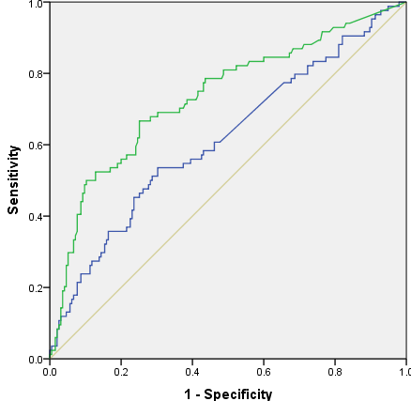

C D
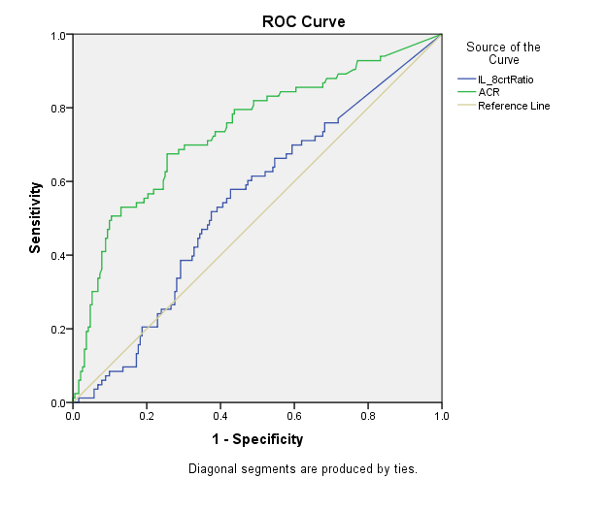
Figure 44:Prediction of CKD progression
ROC analyses using the fraction of true positive results (sensitivity) and false positive results (1-spectificity) for urine Leptin/Cr (A), CXCL-16/Cr (B), DPP-IV/Cr (C) and IL-8/Cr (D) compared to albumin/Cr were generated to evaluate the utility of the candidate biomarkers as predictors of CKD progression. A value of 0.5 is no better than expected by chance (null hypothesis) and a value of 1.0 reflects a prefect indicator. The blue curves represent the candidate biomarkers and the green curves indicate ACR.

Figure 45: Prediction of CKD progression by the candidate biomarkers in combination
ROC analysis using the fraction of true positive results (sensitivity) and false positive results (1-spectificity) for the combined CXCL16/Cr and DPP-IV/Cr data (blue curve) was compared to the ROC analysis of albumin/Cr (green curve). A value of 0.5 is no better than expected by chance and a value of 1.0 reflects a prefect indicator.

Table 22: Comparison of areas under ROC curves for the whole cohort
Variables | AUC | SE | 95% CI | P value
ACR | 0.723 | 0.035 | 0.654 - 0.791 | 0.000
Leptin/Cr | 0.547 | 0.038 | 0.473 -0.621 | 0.206
CXCL-16/Cr | 0.592 | 0.039 | 0.516 - 0.667 | 0.013
DPP-IV/Cr | 0.578 | 0.037 | 0.505 - 0.650 | 0.036
IL-8/Cr | 0.526 | 0.037 | 0.455 - 0.598 | 0.474
Combined urine protein score (CXCL-16 + DPP-IV) | 0.595 | 0.038 | 0.521 - 0.669 | 0.010
To quantify the accuracies in predicting the annual decline of kidney function of ACR and the candidate biomarkers, the areas under the curves (AUC) generated by the ROC analyses were determined. Abbreviations: SE, standard error; CI, confidence interval.

In summary, ROC analysis demonstrated that Leptin/Cr, CXCL-16/Cr, DPP-IV/Cr and IL-8/Cr had sensitivity of 54.7%, 59.2%, 57.8% and 52.6% respectively and albumin/Cr 72.3% in predicting CKD progression. However, the combined score of all measured proteins was 59.5 % (Table 22). The “combined urine proteins score” referred to the presence of the two proteins assayed in this chapter (DPP-IV and CXCL-16).

Subgroup analysis
ROC analyses were also undertaken in DM, CGN and HTN subgroup for all the measured proteins and the areas under the ROC curves were calculated to determine the accuracies of each candidate biomarker in predicting CKD progression in for each of the three major causes of CKD represented in our patient cohort. The results are shown in Table 23.

Table 23: Comparison of areas under ROC curves in subgroups
Protein | Variables | DM | CGN | HTN
ACR | AUC | 0.813 | 0.540 | 0.713
ACR | SE | 0.051 | 0.082 | 0.089
ACR | 95%CI | 0.713 - 0.912 | 0.380 - 0.701 | 0.539 - 0.887
ACR | P value | 0.000 | 0.611 | 0.017
Leptin/Cr | AUC | 0.636 | 0.348 | 0.675
Leptin/Cr | SE | 0.064 | 0.076 | 0.093
Leptin/Cr | 95%CI | 0.512 - 0.760 | 0.200 - 0.496 | 0.493 - 0.858
Leptin/Cr | P value | 0.028 | 0.055 | 0.049
CXCL-16/Cr | AUC | 0.589 | 0.503 | 0.643
CXCL-16/Cr | SE | 0.068 | 0.080 | 0.091
CXCL-16/Cr | 95%CI | 0.457 -0.722 | 0.345 - 0.660 | 0.465 - 0.821
CXCL-16/Cr | P value | 0.148 | 0.973 | 0.109
DPP-IV/Cr | AUC | 0.586 | 0.522 | 0.596
DPP-IV/Cr | SE | 0.063 | 0.081 | 0.092
DPP-IV/Cr | 95%CI | 0.463 - 0.0709 | 0.364 - 0.681 | 0.416 - 0.0777
DPP-IV/Cr | P value | 0.165 | 0.779 | 0.280
IL-8/Cr | AUC | 0.492 | 0.468 | 0.544
IL-8/Cr | SE | 0.062 | 0.080 | 0.088
IL-8/Cr | 95%CI | 0.371 - 0.613 | 0.312 - 0.624 | 0.370 - 0.717
IL-8/Cr | P value | 0.898 | 0.684 | 0.625
The quantitative results of ROC curve analyses carried out on the data from the DM, CGN and HTN subgroups of patents are shown. The abbreviations are: AUC, area under curve; SE, standard error; CI, confidence interval.

ACR predicted better CKD progression in DM and nearly same in HTN subgroup but not good in CGN subgroup, compared to whole data set. Leptin also predicted better CKD progression in DM and HTN subgroup but poorly in CGN subgroup compared to the whole data set. In CXCL-16, DM subgroup predicted CKD progression slightly lower than the whole subgroup and poorly in CGN subgroup but better in HTN subgroup compared to the whole data set. DPP-IV predicted CKD progression better in DM and HTN subgroup and poorly in CGN subgroup compared to the whole data set. IL-8 predicted CKD progression worse in DM and CGN subgroup but better in HTN subgroup compared to whole data set.
In summary, in all the subgroup ACR was still the better predictor of CKD progression than all the candidate markers. Prediction of CKD progression was best in the HTN subgroup for all the candidate biomarkers as well as for ACR, although the highest prediction was for the ACR in DM subgroup.

Correlation of biomarkers with ACR excretion
Pearson correlation test was done to see whether the biomarkers correlate with the excretion of ACR. All the biomarkers positively correlate with the excretion of ACR (Table 24). The results of the correlation test shown in the following table.

Table 24: Pearson test of correlation between biomarkers and ACR excretion
Biomarkers | Pearson r | 95% CI | R square | P value
Leptin/Cr | 0.3544 | 0.2443 to 0.4554 | 0.1256 | < 0.0001
CXCL-16/Cr | 0.4295 | 0.3252 to 0.5234 | 0.1845 | < 0.0001
DPP-IV/Cr | 0.4210 | 0.3164 to 0.5156 | 0.1773 | < 0.0001
IL-8/Cr | 0.2769 | 0.1618 to 0.3846 | 0.07669 | < 0.0001

CXCl-16 (Figure 46 Panel A) and DPP-IV (Figure 46 Panel B) are the two most strong biomarkers to correlate with ACR excretion.

A B

C D

Figure 46: Plots of the Leptin/Cr, CXCL-16/Cr, DPP-IV/ Cr and IL-8/Cr values versus ACR.
The figure shows the graphs generated by GraphPad Prism when calculating the correlation (r test) between ACR excretion and Leptin/Cr (A); CXCL-16/Cr (B); DPP-IV/Cr n (C) or IL-8/Cr (D). The correlation coefficient (r) and P values calculated form these data are shown on each graph and in Table 24.

Summary
This chapter presents the results of a screen carried out to identify new candidate biomarkers candidate biomarkers in a small number of urine samples and a systematic study of the candidates thus identified in the large cohorts of 262 patients and 47 controls.
Methodology:
The Proteome Profiler array is an immunological assay for detecting differences between concentrations of sets of specific proteins between samples. We used cytokine and angiogenesis array membranes, which are nitrocellulose membranes onto which capture antibodies have been spotted in duplicate at known positions. This technique is suitable to quickly assay a large number of proteins 36 human cytokines and 55 angiogenesis-related protein markers were probed on cytokine and angiogenesis array membranes respectively. But it is not suited for assaying a large number of samples. Two pools of samples corresponding to progressors and non-progressors were compared for each disease. The patients in each pool were best matched according to sex, ethnicity and age. The pool sizes were 10 patients in each group for diabetes, 6 for CGN and 4 patients for HTN.
All possible new biomarkers identified from the data were then assayed by ELISA in the same large cohort of patients and controls as in Chapter 3 to check their suitability as clinical markers. Analyses of the ELISA data were done as in Chapter 3.
Results:
Analysis of the immunological array data identified four proteins (DPP-IV, CXCL-16, Leptin and IL-8) whose variations between urine samples of different patient groups suggested they could be biomarkers of CKD. The four proteins were thus assayed by ELISA.
DPP-IV/Cr may be a predictor of DM patients as DPP-IV/Cr values were significantly higher in diabetic group compared to controls. DPP-IV/Cr may have some role in predicting the late stage of the disease DPP-IV/Cr values were significantly higher in CKD-5 compared to controls. Subgroup analyses, showed that in diabetic subgroup, there is a significant difference in between the control and CKD-5, indicating that DPP-IV/Cr could be a marker of late stage of diabetic patients.
CXCl-16/Cr could be a marker of the late stage of CKD as CXCL-16/Cr values were significantly higher in CKD-5 compared to controls and all other stages of CKD. Subgroups analyses showed that in both the diabetic and HTN subgroups, CXCL-16/Cr significantly varies between controls and CKD stage 5 and between controls and the dialysis outcome group, which also indicates that CXCL-16 could be a marker of the late stage of the disease.
Leptin/Cr values were not significantly different any aetiologies, stages, progression and disease outcome groups. Similar findings were also found in subgroup analyses.
IL-8/Cr values were also not significantly higher in any aetiologies, stages, progression and disease outcome group. Similar finding was seen in subgroup analyses.

Search for candidate biomarkers by iTRAQ mass spectrometry

Introduction
To find out potential new candidate biomarkers of CKD another approach using MS-based quantitative proteomics was taken. Several such methods were available (Bantscheff et al., 2007, Bantscheff et al., 2012). We decided to use iTRAQ (isobaric tagging for relative & absolute quantification), which is currently the most popular quantification approach for LC MS based biomarker discoveries. iTRAQ has been employed for simultaneous protein identification and for relative quantification of proteins between groups (Bantscheff et al., 2007, Bantscheff et al., 2012). While this work was in progress several groups reported successful application of iTRAQ to the study of the proteomes of normal urine (Guo et al., 2015, Sigdel et al., 2014a) and of urine from patients suffering from various diseases (Mischak, 2015). In particular, iTRAQ has been applied in the last few years to searches for urinary biomarkers of diseases such as renal cell carcinoma (White et al., 2014), bladder cancer (Chen et al., 2012, Chen et al., 2013), polycystic kidney disease (Choi, 2015), Renal Allograft Rejection (Akkina et al., 2009, Sigdel et al., 2014b), diabetes (Jin et al., 2012) and childhood idiopathic nephrotic syndrome (Andersen et al., 2012).
Briefly, the advantages of iTRAQ to our project are as follows:
- iTRAQ relies on a chemical labelling method to quantify the amount of peptide in each sample. It does not require metabolic labelling, so it can be used in for the quantification of proteins in urine.
- Up to eight different samples can be analysed in one mass spectrometry run, allowing comparisons between samples from different groups patients in a single run.
- The use of isobaric reagents mean that the same peptides, although carrying different labels, will co-elute due to the isobaric (same mass) nature of the chemical tags. This greatly reduces complexity at the level of the survey scan, which simplifies analysis.

Although MS-based analyses of urine had been published before the work described in this chapter (Rao et al., 2007, Andersen et al., 2012, Adachi et al., 2006, Jin et al., 2012), there was only very limited experience of using this approach in our Department. The Sheffield Kidney Institute (SKI) had carried out some preliminary and basic 2D-gels based proteomic studies in whole urine but this did not use the iTRAQ methodology and only identified four potential protein markers (Retinol Binding protein-1, Endorepellin, Transferrin, Hamopexin) that might give both earlier indications of CKD and better prediction of progression (Ali Elfaitori MD thesis, University of Sheffield, 2011, unpublished). The small number of proteins identified from whole urine illustrates why it is necessary to equalise the urinary proteome in order to maximise the efficiency of searches for new biomarkers. The term “equalisation” designates a variety of procedures designed to increase the concentration of the less abundant proteins that could be of interest with respect to disease whilst reducing the concentrations of the most abundant proteins which would otherwise strongly interfere with detection of less abundant proteins (Candiano et al., 2010).
Therefore, the work presented in this chapter was attempted as a pilot work whose purpose was not only to provide the biological information mentioned above, but also to document the potential and the limitations of the equalisation and iTRAQ methodologies. Thus, to inform future research projects, this chapter will include data on workflow development, including the use of technical controls and troubleshooting.

Hypothesis and Aims
We hypothesise that the iTRAQ proteomics methodology can identify the relative changes in amounts of individual proteins in urine samples from different groups of patients and that these differences between groups may identify new candidate biomarkers.
To test these hypotheses we designed a study to meet the following aims:
- Obtain suitable amounts of urine proteins from four groups of patients (microalbuminuric and macroalbuminuric groups, each then further divided into non-progressors and progressors).
- Evaluate the ProteoMinerTM Protein Enrichment Kit for applicability to this study.
- Modify the protocol for ProteoMinerTM for compatibility with iTRAQ analysis.
- Process urine samples as required by standard practice for iTRAQ proteomics analyses whist carrying out technical checks and controls to monitor protein yields and identify possible process-induced technical artefacts at all stages.
- Perform the iTRAQ analysis of the processed sample and look for the presence of already known candidate biomarkers as well as possible new candidates within the resulting dataset.

Overview of methodology
The individual urine samples were concentrated and subjected to proteome equalisation (selective depletion in high abundance proteins and enrichment in low abundance proteins) by the ProteoMiner system, as described in more details in the “Methodology” chapter (section 2.8, p 64). Briefly, the ProteoMiner system uses saturable affinity binding to combinatorial synthetic peptide ligands. The most abundant proteins saturate their binding sites whilst the least abundant proteins bind quantitatively. This allows the selective depletion of major proteins to levels where they are less likely to hinder the detection of the minor components (Candiano et al., 2010, Righetti and Boschetti, 2013).
After equalisation the individual samples were mixed to create four pools (microalbuminuric non-progressors and progressors; macroalbuminuric non-progressors and progressors) in order to be able to perform comparative analysis. Each pool was subjected to buffer exchange by microfiltration, deglycosylation, reduction and blocking of disulphide bonds, digested with trypsin and finally labelled with four iTRAQ isobaric tags distinguishable by their unique low mass reporter groups. The four differently labelled pools were then mixed and the mixture was subjected to fractionation by interaction liquid chromatography (HILIC). The peptide- containing fractions were then subjected to HPLC followed by mass spectrometry as described in the ''Methodology'' chapter (section 2.11.3, p-73).
Quality controls and technical checks consisted of protein assays and assessment of protein recoveries at all stages of the process combined with analysis of protein compositions by SDS-PAGE at key stages.

Results

Sample selection
To prepare the samples for iTRAQ, the urine needs to pass through several steps of biochemical preparation (eliminating non-protein compounds, deglycosylation and trypsin digestion) that involved huge handling losses. So, to have the minimum amount of protein needed at the end, it is essential to start with large amounts of urine. This requirement limited the amount of suitable samples to a total of only 40 of the 262 samples.
All of the samples were from diabetic patients. The majority of them were male Caucasians except for three Caucasian females (SKI ID Nos 53, 55 and 90), four Asian males (SKI numbers 129, 24, 14 and 103) and one Black male (SKI ID No 141).
Based on the albuminuria and the rate of eGFR decline at the beginning of the study, the samples were assigned to 4 groups corresponding to: micro-albuminuric non-progressors, micro-abuminuric progressors, macro-albuminuric non-progressors and macro-albuminuric progressors. The categorisation as progressors or non-progressors was based on the rate of change in eGFR, with progressors having eGFR decline values of -2/year or smaller and non-progressors having eGFR decline values of less than -2/year (slow eGFR decrease), 0 (stable) or positive (increasing eGFR). The sample characteristics of SKI ID numbers, age, and disease state and eGFR decline at the beginning of the study for the microalbuminuric and macroalbuminuric group are shown in Tables 25 and 26. The values presented are data available at the start of the study.

Table 25: Microalbuminuric group
a. Non-progressor (11 patients) b. Progressor (8 patients)
SKI  ID | Age | Stage | eGFR decline / year |  |  | SKI  ID | Age | Stage | eGFR decline / year
13 | 70 | 3b | -1 |  |  | 122 | 53 | 3a | -5
45 | 72 | 3a | -1 |  |  | 60 | 73 | 3b | -4.5
67 | 61 | 4 | 0 |  |  | 05 | 75 | 3b | -3
17 | 81 | 4 | 0 |  |  | 10 | 41 | 4 | -2.5
99 | 76 | 4 | 1 |  |  | 68 | 66 | 3b | -2.5
155 | 63 | 4 | 1.5 |  |  | 149 | 67 | 3b | -2.1
129 | 82 | 3b | 2.5 |  |  | 22 | 71 | 3b | -2.2
02 | 85 | 4 | 2.5 |  |  | 55 | 78 | 3b | -3
53 | 74 | 4 | 1
79 | 83 | 4 | 1
80 | 65 | 3a | 5
Mean Age  73.82 ±8.3 |  | Mean eGFR decline 1.14±1.75 |  |  |  | Mean Age  65.5 ± 12.5 |  | Mean eGFR decline  -3.1 ±1.07
Ages and clinical status of microalbuminuric patients whose urine samples were used for the non-progressors pool (A) and progressors pool (B).

Table 26: Macroalbuminuric group
a. Non-progressor (11 patients) b. Progressor (10 patients)
SKI  ID | Age | Stage | eGFR decline / year |  | SKI  ID | Age | Stage | eGFR decline / year
90 | 79 | 5 | 0.5 |  | 18 | 65 | 3a | -5
58 | 64 | 3b | -0.5 |  | 24 | 63 | 3b | -4.5
21 | 74 | 4 | 0 |  | 14 | 69 | 4 | -4
20 | 59 | 4 | -1.5 |  | 54 | 60 | 3b | -2.5
01 | 73 | 4 | -1 |  | 61 | 45 | 3b | -2.5
154 | 75 | 3b | 0.5 |  | 87 | 70 | 2 | -2
141 | 63 | 4 | -1 |  | 102 | 69 | 3b | -6.5
111 | 32 | 3a | -0.5 |  | 103 | 42 | 4 | -6
19 | 73 | 4 | -0.5 |  | 113 | 61 | 3b | -2
91 | 69 | 3b | 0 |  | 128 | 41 | 3a | -3.5
131 | 71 | 4 | 0.5 |  | Mean Age  58.5 ± 11.48 |  | Mean eGFR decline  -3.85 ± 1.64
Mean Age  66.55 ± 12.8 |  | Mean eGFR decline -0.32 ± 0.69
Ages and clinical status of macroalbuminuric patients whose urine samples were used for the non-progressors pool (A) and progressors pool (B).

Detection of inter-individual differences in electrophoretic protein patterns of minor proteins

Equalisation of urine sample proteomes
All of the 40 individual samples were subjected to the ProteoMiner procedure to reduce the concentration of high abundance proteins like albumin whilst quantitatively retaining the low abundance proteins. This maintains the full diversity of the protein composition of the samples whilst reducing the dynamic range of protein concentration overalls. This equalisation procedure was carried out on concentrated urine samples as described in the “Methodology” chapter (2.8, p.64), using the BioRad ProteoMiner kit (catalogue no-163-3006).
Protein assays carried out on unprocessed urine, concentrates and ProteoMiner eluates showed that no statistically significant losses occurred during concentration (data not shown). In contrast, the ProteoMiner step removed the majority of the proteins from the samples, as was expected given that one of its aims is to deplete the most abundant proteins.
The amounts of proteins recovered in the ProteoMiner eluates varied between individual samples. The recoveries for each individual sample can be found in the Appendix (Table 38, Table 39, Table 40 and Table 41, pp. 232-233). Overall, the recovery was less than 10% of the amount loaded for all macro-albuminuric samples and the majority of the micro-albuminuric samples. The average recoveries were 4.72 ± 3.51% for the macro-albuminuric samples and 9.21 ± 11.57%for the micro-albuminuric samples.
To check how the processing of the samples affected the representation of individual protein components, the protein profiles of samples taken at the three stages of the process to gel electrophoresis (Figure 47).

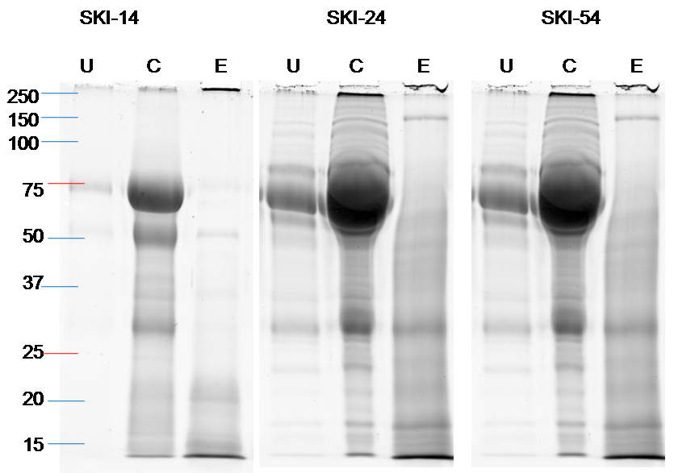
Figure 47: Effects of the concentration and ProteoMiner processing steps on the protein contents of urine samples.
Representative results obtained with three different urine samples from the macro-albuminuric patients SKI numbers14, 24 and 54 are shown. Equal volumes (10 µl) of unprocessed (U) urine, concentrated urine (C) and ProteoMiner eluate (E) samples were subjected to SDS-PAGE electrophoresis on 12% polyacrylamide gels. The gels were stained with the SYPRO Ruby red and the stained proteins were detected by fluorescence imaging. Pixel densities were inverted to facilitate visualisation of faint fluorescent bands on the printed images.

The stained protein patterns (Figure 47) show that as would be predicted in albuminuric patients, the most abundant protein species in unprocessed urine is found at the expected position for albumin (slightly below the 75 kDa marker positions). The second most abundant protein species in urine, immunoglobulins (Rao et al., 2007), can be detected as two bands corresponding to the heavy and light chains in the region of 55 and 30 kDa. Fainter bands corresponding to quantitatively minor protein components can also be seen in unprocessed samples SKI 24 and 54. After concentrating down the urine, the albumin, immunoglobulins and minor proteins become much more abundant and many additional bands that were not detected in unprocessed urine become visible; however, the concentration does not appear to cause obvious major changes in the relative abundance of the different species. By contrast, after ProteoMiner step, the staining patterns show very dramatic reduction in the amounts of albumin and immunoglobulins, whereas the lowest abundant species represented by the faintest bands remain at concentrations similar to those seen in the concentrated samples.
These results thus confirm that, as expected, the protein losses caused by ProteoMiner processing correspond to the preferential loss of the most abundant components.
It should be noted that a consequence of this process, the concentration of the clinical marker albumin in the samples no longer reflect the initial values in unprocessed urine.

Detection of inter-individual differences in protein patterns of ProteoMiner-treated samples.
We then ran on SDS-PAGE gels all individual ProteoMiner eluates to compare the patterns of protein between individual samples after depletion of the major proteins (Figures 48 and 49). This is an essential check, which provides critical information on inter sample variability within the group prior to pooling.
The results show that there were major differences in protein composition between individual samples. Two major types of protein patterns appear to be present on these gels. For example, in the micro-albuminuric non-progressors (Figure 48), some samples (e.g. Patient SKI number 13, 45, or 17) contain predominantly a smear of low-molecular weight proteins, whose staining is most intense in the range below 25 KDa (type 1 pattern) but other samples such as SKI 67, 99 or 129 show strong staining of discrete bands in the mass range between 75 and 20 KDa (type 2). Similar pattern variations between samples were observed of the other pools (Figures 48 and 49).
Qualitatively, most of the individual protein patterns observed in all four groups appeared to belong the two major types described above for the micro-albuminuric non-progressors.
This inter-individual variability in composition of minor proteins was not expected as a published example of similar one-dimensional electrophoretic protein patterns of urine proteins did not show such variability (Fig. 2 in Adachi et al., 2006). It is worth noting however than the samples shown in this article are all from healthy individuals. Thus it is possible that the variations we detected in our samples may reflect either different stages in the damage of the kidneys or other modifiable and non-modifiable risk factors of CKD. It is also possible that variations in the relative amounts minor proteins are not associated with either the progression status or the albuminuric status of the patients. Unfortunately, it was not possible to carry out a more rigorous or quantitative analysis of these variations in the time frame of this project.

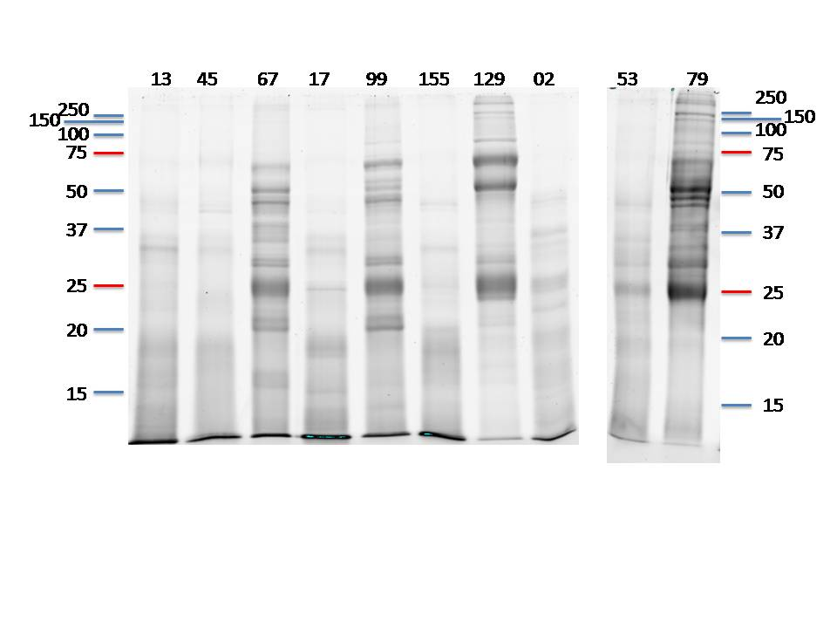
a. Non-progressor
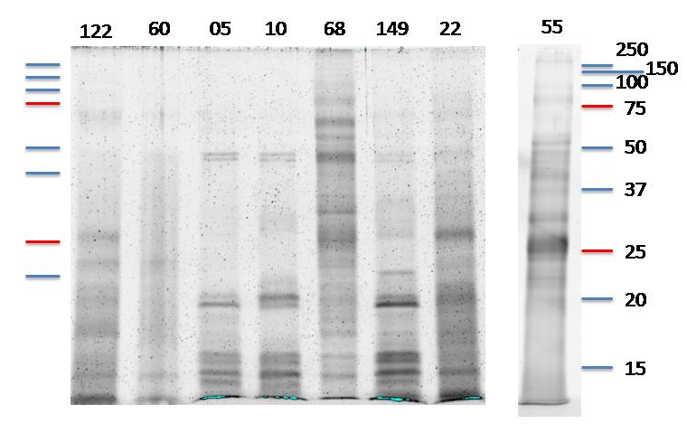
b. Progressor

Figure 48: Protein quality and pattern in individual microalbuminuric samples
12%SDS-PAGE showing protein quality and pattern of microalbuminuric ProteoMiner treated urine samples of non-progressor (a) and progressor (b) group. 5 µg of protein was loaded in each lane. The gels were stained with Sypro Ruby protein gel stain (The image was modified using the GIMP image software version 2.2 for better visibility of the protein band).

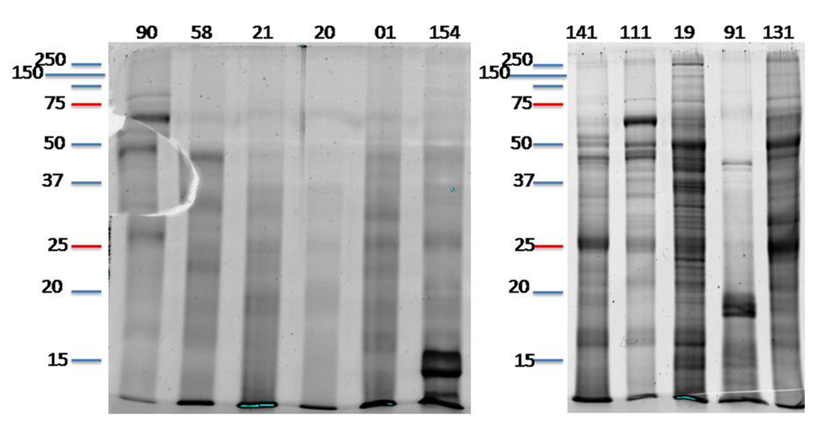
a. Non-progressor

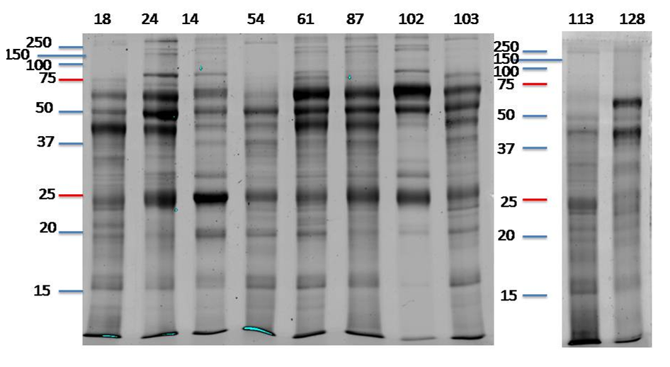
b. Progressor.

Figure 49: Protein quality and pattern in individual macroalbuminuric samples
12%SDS-PAGE showing protein quality and pattern of macroalbuminuric ProteoMiner treated urine samples of non-progressor (a) and progressor(b) group. Five µg of protein was loaded in each lane. The gels were stained with Sypro Ruby protein gel stain (The image was modified using the GIMP image software version 2.2 for better visibility of the protein band).

Pooling of individual samples, processing of pools and quality control checks
The ProteoMiner eluates were mixed to create four pools (microalbuminuric non-progressor, microalbuminuric progressor, macroalbuminuric non-progressor and macroalbuminuric progressor). The pools were then subjected to reduction of disulfide bonds, deglycosylation and digestion by trypsin as described in detail in the “Methodology” chapter (2.10, p-67).
The deglycosylation step was not part of the standard procedure used in our laboratory, but was added in an attempt to increase sensitivity by allowing the recognition of the deglycosylated peptides by the analysis software.
The amounts of trypsin used for samples digestion was as described in Table 27.

Table 27: Protein contents and isobaric tags of the four pools subjected to iTRAQ
Sample pools |  | Amount of urine protein in digested pool (µg) | Total volume of digest (µl) | Isobaric tag
Micro-albuminuric | Non-progressor | 136 | 94 | 117
Micro-albuminuric | Progressor | 168 | 97 | 116
Macro-albuminuric | Non-progressor | 96 | 90 | 115
Macro-albuminuric | Progressor | 100 | 121 | 114
The table shows the total amount of urine protein in each sample, their volumes and the different isobaric tags used to identify the resulting peptides in the iTRAQ mass spectrometry data analysis.

After trypsin digestion SDS-PAGE gels were run to check the effects of deglycosylation and trypsin digestion. The results (Figure 50) show that deglycosylation altered the patterns of the protein bands in all four pools and that some protein bands in the middle section of the gels became slightly sharper after deglycosylation. These changes are consistent with the removal of the sugar molecules from some proteins. In the trypsin-digested samples mostly the proteins are in the bottom part of the gel, indicating effective digestion of the protein by trypsin. The samples were therefore considered suitable for labelling and mass spectrometry.
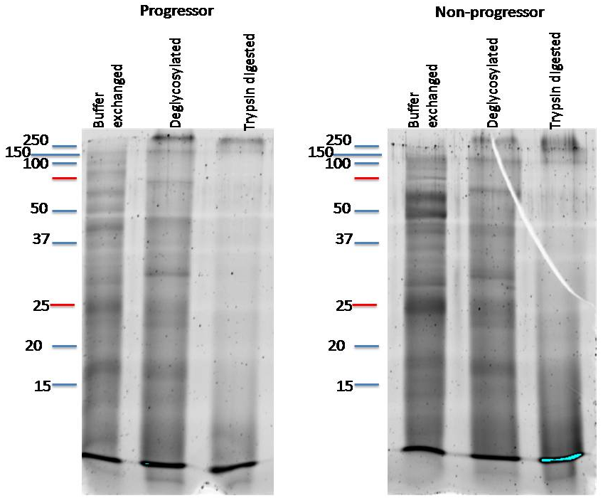
A: Microalbuminuric samples
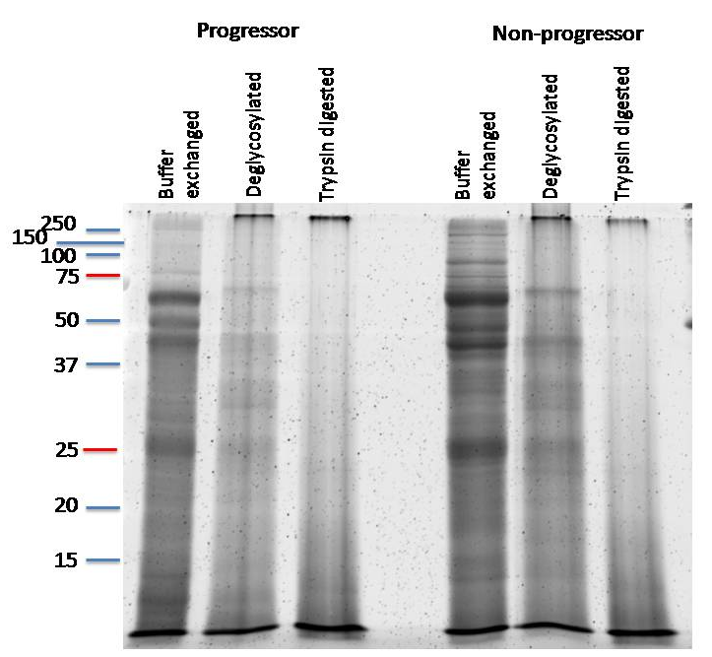
B. Macroalbuminuric samples
Figure 50: Effects of biochemical processing on protein patterns of sample pools
12% SDS-PAGE showing buffer exchanged, deglycosylated and trypsin digested samples.10 µg of protein was loaded in each lane. The gels were stained with Sypro Ruby protein gel stain.

iTRAQ labelling, chromatography and mass spectrometry

iTRAQ labelling
After trypsin digestion the digests were labelled with the 4-plex iTRAQ reagents (see methodology chapter for details). The labelling of the samples were as follows:
- 114.1 - Macroalbuminuric progressor
- 115.1 - Macroalbuminuric non-progressor
- 116.1- Microalbuminuric progressor
- 117.1 - Microalbuminuric non-progressor

All four labelled samples were then mixed by transfer into a new tube and the mixture was vacuum-dried. Ideally, the four samples comprising the mix should have contained identical amounts of proteins to enable direct determination of relative amounts in the iTRAQ data. In practice the amounts of protein in our four labelled samples were not exactly equal (Table 12, Chapter-2, and p.71). However they were sufficiently close to each other for the purpose of this work as two of the data analysis applications, Phenyx and uTRAQ, are designed to detect any inequalities between samples and take them in account when determining relative quantities of specific peptides. Protein ratios were normalized using the overall median ratio for all the peptides in the sample. The ratio for each protein was calculated by taking the average of all the peptide ratios that identified the protein; the data for this provided by the Phenyx output and integrated using the uTRAQ software. This is a standard procedure for processing of iTRAQ data to account for differences in total protein/ iTRAQ label (Noirel et al., 2011, Pham et al., 2010).

Hydrophilic interaction liquid chromatography (HILIC) and mass spectrometry
Peptide fractionation was performed to reduce sample complexity prior to analysis by mass spectrometry. The dried labelled sample was resuspended and fractionated by HILIC on a Polyhydroxyethyl A column as described in the “Methodology” chapter. Each selected fraction from HILIC was then run on Q STAR XL mass spectrometer instrument. The data set resulting from all fractions was then analysed using the software pipeline hosted at www.proteome.shef.ac.uk as described in the methodology chapter (section 2.12, p. 73).

Analysis of iTRAQ mass spectrometry results

Determination of imbalances between pools and correction process
In one of the first steps of the analysis, the software calculates the sum of the iTRAQ reporter ion intensities for each label and uses these sums to assess the relative proportions of each individually labelled pool in the mix. In this experiment reported, the relative protein loads for labels 114:115:116:117 were 1:1.6:1:1.2.
The differences between sample amounts found here were automatically compensated by the analysis software, which applies a median correction (Pham et al., 2010) as described above. Therefore they introduced no bias in the data analysis. The results described in the following sections can thus be interpreted as if the four pools had been perfectly balanced.

Principal component analysis
We first carried out a Hierarchical analysis to assess statistically how similar in comparison the four sample pools were and to generate a dendrogram illustrating the similarities and difference between them (Figure 51).

A B
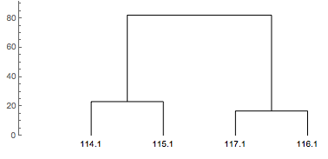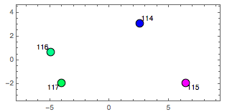
Figure 51: Hierarchical Analysis: Dendrogram and Principal Component Analysis.
Dendrogram (A) and Principal Component Analysis results (B) generated with the Mathematica software using an in-house script written by Josselin Noirel. The four pools are identified by their isobaric tag masses (114, macroalbuminuric progressors; 115, macroalbuminuric non-progressors; 116, microalbuminuric progressors; and 117, microalbuminuric non-progressors).

The graphs indicate that the protein composition data cluster into two major categories, Macro (labels 114.1 and 115.1) and Micro (labels (11.7.1 and 116.1). They both show that within each category, the NP and P samples clustered together. This means that the major differences in composition are between the macro-albuminuric and the micro-albuminuric samples, with relatively smaller differences in composition between progressors and non-progressors in each case.
This analysis suggests that the differences between progressors and non-progressors will be less prominent than those between macro-and micro-albuminuric samples and need to be analysed in the context of the latter. For example, it is possible that different candidate markers of progression might be present in macro- and micro-albuminuric samples. For this reason, accurate analysis of our results requires untangling the differences associated with albuminuric status from those associated with progression status.
Therefore, before attempting to identify progression markers from the data set, we first characterised the differences between the two pairs of micro- and macro-albuminuric pools.

Identification of proteins found in different amounts between micro-albuminuric and macro-albuminuric pools
We then carried more detailed comparisons using SignifiQuant, which performs ANOVA based comparisons between samples. Two types of analyses were carried out: The first consists of pair-wise comparisons between any two of the 4 differently labelled samples, like for example between microalbuminuric progressors and microalbuminuric non-progressors; the second type consists of comparisons between two groups of labelled samples (for example the two progressors versus the two non-progressors).

Pair-wise comparisons between micro-albuminuric and macro-albuminuric pools
We first compared the microalbuminuric progressors to the macroalbuminuric progressors. Twenty-six proteins were identified by the analysis software pipeline as being significantly different between these two pools. They are listed in the appendix (Table 42, p-234). We then compared the macroalbuminuric non-progressors and microalbuminuric non-progressors. Twenty-nine proteins were detected in this comparison (Table 43, p-235). Finally, we used the GeneVenn online tool (http://www.bioinformatics.org/gvenn/) to compare the two lists and find out which proteins were common to both or were only present in one list. The application generated a Venn diagram of the overlap between the two lists (Figure 52). The proteins in each area of the diagram are listed in Table 28, Table 29 and Table 30).

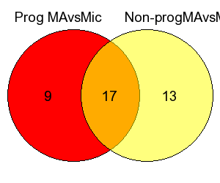
Figure 52: Overlap between the lists of proteins detected by the two pair-wise comparisons between progressors and non-progressors pools
Venn diagram showing the overlap between the lists of proteins detected by the two pair-wise comparisons of the macro-albuminuric and micro-albuminuric pools (Table 42, Appendix, p. 234 and Table 43, Appendix, p.235. The comparison and the diagram were done using the GeneVennonline application available at http://www.bioinformatics.org/gvenn/. The red set correspond to the proteins present in different amounts between the two progressor pools (whilst the yellow set represents the proteins found in different amounts between the two non-progresor pools. The intersecting part showed the proteins detected in both comparisons. The number written in the three areas of the diagram show the number of proteins present in each of them.

The diagram (Figure 52) shows that in total, 39 proteins (9+17+13) were identified in at least one pair-wise comparison and seventeen of these were detected in both. The proteins identified in both comparisons (orange area) are shown in Table 28, those detected only in comparisons between the non-progressors (yellow area) in Table 29 and those detected only in comparisons between the progressors (red area) in Table 30.
Table 28: Proteins altered in levels in both pair-wise comparisons of macro- and micro-albuminuric pools

Uniprot accession No | Protein names | Relative amount ratios |  | Mean amount ratio
Uniprot accession No | Protein names | Progressors | Non-progressors | Mean amount ratio
P02647 | Apolipoprotein A-I | 2.74 | 21.63 | 12.2
P01024 | Complement C3 | 4.58 | 7.83 | 6.2
P01009 | α-1-antitrypsin | 4.03 | 7.45 | 5.7
P06727 | Apolipoprotein A-IV | 4.94 | 6.41 | 5.7
P02774 | Vitamin D-binding protein | 3.06 | 6.18 | 4.6
P02766 | Transthyretin | 3.35 | 5.68 | 4.5
P0C0L4 | Complement C4-A | 4.45 | 4.45 | 4.5
P36955 | Pigment epithelium-derived factor | 3.78 | 3.01 | 3.4
P01860 | γ-3 chain C region | 1.99 | 4.38 | 3.2
P01857 | Ig γ-1 chain C region | 2.27 | 2.65 | 2.5
P00738 | Haptoglobin | 2.56 | 2.31 | 2.4
P00450 | Ceruloplasmin | 1.61 | 3.12 | 2.4
P02768 | Albumin | 1.89 | 2.76 | 2.3
P01861 | Ig γ-4 chain C region | 1.52 | 3.05 | 2.3
P02787 | Serotransferrin (Transferrin) | 2.12 | 2.29 | 2.2
P01859 | Ig γ-2 chain C region | 2.44 | 1.81 | 2.1
P01876 | Ig α-1 chain C region | 1.79 | 1.53 | 1.7
The 17 proteins detected as being altered in levels in the two pair-wise comparisons between the macro and micro-albuminuric pools are shown (the statistical significance P value cut-off for these was 0.0001). The list was generated by GeneVenn and it represents the Orange intersecting parts of the red and yellow sets in Figure 52. The relative amount ratios measured in both comparisons are shown; in each case, the ratio shown is the amount of protein detected in the macro-albuminuric pool, relative to the matching micro-albuminuric pool. The average of these ratios were calculated manually to order the list from increasing to decreasing values. The cells highlighted in grey show the nine proteins known to be the most abundant proteins in urine (Narita et al., 2004, Rao et al., 2007). The mean and SD of the relative amount ratios for these major proteins is 2.34 ± 0.70.

Table 29: Proteins altered in levels between micro-and macro-albuminuric Non-progressors only
Uniprot accession No | Protein names | Amount ratio
P02679 | Fibrinogen γ chain | 8.24
P01008 | Antithrombin-III | 7.65
P01011 | α-1-antichymotrypsin | 7.45
P00751 | Complement factor B | 5.54
P02790 | Hemopexin | 4.87
P04004 | Vitronectin | 4.16
P02765 | α-2-HS-glycoprotein | 3.73
P10909 | Clusterin | 3.08
P04217 | α-1B-glycoprotein | 1.96
P02760 | Protein α-1-microglobulin/bikunin precursor (AMBP) | 0.69
P06396 | Gelsolin | 0.41
P15586 | N-acetylglucosamine-6-sulfatase | 0.33
The list of proteins differently detected in micro and macroalbuminuric non-progressors pools and their amount ratios. The list was generated by Venn diagram and it represents the yellow part of the diagram. It is ordered by decreasing amount ratios.

Table 30: Proteins altered in levels between micro-and macro-albuminuric Progressors only.
Uniprot accession No | Protein names | Amount ratio
P02788 | Lactotransferrin | 9.63
P02750 | Leucine-rich α-2-glycoprotein | 0.56
P11684 | Uteroglobin | 0.44
P05090 | Apolipoprotein D | 0.43
P01042 | Kininogen-1 | 0.39
P08571 | Monocyte differentiation antigen | 0.39
P68871 | Hemoglobin subunit β (β-globin) | 0.23
P17900 | Ganglioside GM2 activator | 0.19
P07911 | Uromodulin (Tamm-Horsfall urinary glycoprotein) | 0.17
The proteins differently present between micro and macroalbuminuric progressors pools and their amount ratios. The list was generated by Venn diagram and it represents red part of the diagram. It is ordered by decreasing amount ratios.

Interpretation of the pair-wise comparisons results
The purpose of these comparisons was to identify proteins that were proportionally more or less abundant in the macro-albuminuric urine samples than in the micro-abuminuric ones. By definition, macro-albuminuric urine will contain much more proteins than micro-albuminuric urine in absolute values (µg/ml) since the levels of albumin are clinically different. However, because the iTRAQ data processing performs a median correction that ensures comparison on a 1:1:1:1 basis (Pham et al., 2010), the data is actually normalised to equivalent amounts proteins. Thus, the proteins that are identified are those that are either more (ratios >1) or less (ratios <1) abundant in macroalbuminuric samples independently of the overall increase in total protein contents that differentiates them from the micro-albuminuric samples.
The inter-individual variability in protein gel electrophoresis patterns (Figure 48, p. 163 and Figure 49, p.164) and the small sizes of our pools suggest that some of the differences detected in the iTRAQ data may result from sampling bias. It is possible however that because they were detected in two independent comparisons involving two different pairs of pools, the proteins listed in Table 28 may be less affected by sampling bias than those of Table 29 and Table 30, which were identified only once in a comparison involving only two of the four pools.
The presence at the bottom of Table 28 of nine of the most abundant proteins in urine (Narita et al., 2004, Rao et al., 2007), including albumin and several immunoglobulins, is interesting from a technical point of view because these proteins were strongly depleted from our samples by the ProteoMiner equalisation step. We have checked this was actually the case for the two most abundant species, albumin and IgG (see Figure 47, p.161). Therefore, variations in the amounts of these proteins in the iTRAQ data do not reflect their actual amounts in the original urine samples but result instead from variations in the amounts retained after the ProteoMiner depletion. These process-induced variations are reflected in the iTRAQ data by amount ratios that ranged from 4.38 (for Ig γ-3 between macro-and micro-albuminuric non-progressor pools, Table 28) to 1.53 (Ig-α-1 in non-progressor pools). Overall, the mean and SD of the relative amount ratios for these nine major urine proteins is 2.34 ± 0.70 ( Table 28). As the amount ratios for these nine major proteins reflect artefactual random variations, we used them to establish criteria for separating possible false positives from potential genuine variations in the iTRAQ data.
Because of the high risk of sampling bias explained above we decided to set the threshold for significance at 5-fold as this value is different by more than 3 SDs from the mean amount ratio for variations known to have occurred by chance (2.34 ± 0.81, Table 28) and is greater than the higher of these artefactual amount ratios (4.38).
Only four proteins in Table 28 show amount ratios greater than the 5-fold significance threshold: Apolipoprotein A-I, Complement C3, α-1-Antitrypin and Apolipoprotein A-IV. This suggests that their normalised concentrations in urine may correlate with albuminuric status. It is interesting to note that for Apolipoprotein A-I, the amount ratios determined in the two independent comparisons are 2.74 for the progressors and 21.6 for the non-progressors ( Table 28). This suggests that normalised Apolipoprotein A-I levels may correlate not only with albuminuric status but also with progression status. By contrast, the two amount ratios measured in progressors and non-progressors for Complement C3, α-1- antitrypsin, Apolipoprotein A-IV and all other proteins in Table 28 differ from each other by less than 2-fold therefore do not suggest their levels correlate with progression status.
For the reasons explained above, the contents of Table 29 and Table 30 are more likely to be affected by sampling bias than that of Table 28 and should be interpreted more cautiously. The two tables include proteins that show very high or low amount ratios, suggesting that their normalised levels in urine can vary strongly between macro- and micro-albuminuric samples. However, this interpretation is complicated by the fact that variations were detected either only in the non-progressor samples (Table 29) or only in the progressor samples ( Table 30). This suggests that, similar to Apolipoprotein A-I, their concentration in urine may correlate with both albuminuric and progression status.
Almost all the proteins listed in Table 28, Table 29 and Table 30 are found in blood and their presence in urine can be explained by leakage. The only exception is Uromodulin, also known as Tamm-Horsfall urinary glycoprotein ( Table 30), which is secreted by the kidney. Its very low amount ratio (0.17) indicates that it is 1/0.17 = 5.9 times more abundant in the micro-albuminuric progressors than in the macro-albuminuric progressors.

Grouped comparisons between all microalbuminuric and macroalbuminuric pools
We then compared all the microalbuminuric patients to macroalbuminuric patients irrespective of progression status. In contrast to the pair-wise comparisons described above, this more direct approach detected only three proteins as being significantly changed between the two groups (Table 31). In this comparison, the two macroalbuminuric pools were used as the reference samples. Therefore, unlike the previous tables (Tables 30, 31 and 32), here amount ratios higher than 1 indicate increased amount are found in microalbuminuric samples.

Table 31: Proteins significantly altered in levels in all microalbuminuric relative to all macroalbuminuric urine samples
Uniprot accession No | n | Amount ratio | Protein names | Molecular weight (Da)
P01842 | 2 | 1.15 | Ig λ-1 chain C regions | 11,348
P07339 | 4 | 0.60 | Cathepsin D | 44,552
P15144 | 4 | 0.63 | Aminopeptidase N | 109,540
The proteins detected by SignifiQuant as being in significantly different amounts in the combined two microalbuminuric pools (labels 116.1 and 117.1) relative to the combined two macroalbuminuric pools (labels 114.1 and 115.1) are shown. The relative amounts were rounded to two decimal places. The full names of the proteins and their molecular weights were obtained from the Uniprot database. The numbers of unique peptides (n) used by SignifiQuant to determine the protein ratios are also shown.

The amounts ratios detected in Table 31 are comprised between 1.15 and 0.6. This indicates that the relative amounts of each protein varied by less than 2-fold between the two groups. Given the heterogeneity and small sizes of the four pools used in this comparison, it seems likely that these quantitatively small differences may not have biological significance.
Surprisingly, none of the proteins detected in the two pair-wise comparisons between macro and microalbuminuric pools in Table 28, Table 29 and Table 30 were identified in the direct comparison of the grouped pools.

Identification of proteins displaying quantitative changes between progressor and non-progressor pools
To identify possible new candidate markers of CKD progression, we then used the two types of analyses described in the previous section to look for proteins that could be present in different amounts between progressors and non-progressors sample pools.

Pair-wise comparisons
The first pair-wise comparison identified proteins that were in significantly different amounts between macroalbuminuric progressors and macroalbuminuric non-progressors (Table 44, in Appendix, p. 236). Then we compared between the microalbuminuric progressors and non-progressors and the proteins those were significantly changed between them were shown in Table 45 (Appendix, p.237). The two lists were then compared by GeneVen to generate a Venn diagram (Figure 53) and 3 tables representing the contents of the three sections in the diagram.

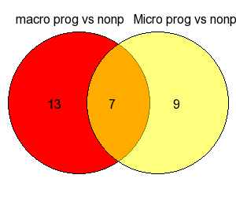
Figure 53: Overlap between the lists of proteins detected by the two pair-wise comparisons between the macro-albuminuric and micro-albuminuric pools
Venn diagram of the sets of proteins detected by the two pair-wise comparisons. The diagram was generated by the GeneVenn application at http://www.bioinformatics.org/gvenn/. The red set contains the proteins present in different amounts between the two macroalbuminuric pools (Table 44, in Appendix, p. 236) whilst the yellow set represents the proteins found in different amounts between the two microalbuminuric pools (Table 45, Appendix, p.237). The intersecting part contains the proteins detected in both comparisons (Table 32, below). The number written in the three areas of the diagram show the number of proteins present in each of them.

Table 32: Candidate progression markers detected in both macro and microalbuminuric groups
Uniprot accession No | Protein names | Amount ratio |  | Average ratio
Uniprot accession No | Protein names | Macro-albuminuric | Micro-albuminuric
P01861 | Ig γ-4 chain C region | 0.65 | 0.97 | 0.81
P02647 | Apolipoprotein A-I | 0.21 | 1.41 | 0.81
P02768 | Albumin | 0.66 | 0.72 | 0.69
P02787 | Serotransferrin (Transferrin) | 0.63 | 0.54 | 0.585
P01859 | Ig γ-2 chain C region | 0.74 | 0.41 | 0.575
P01857 | Ig γ-1 chain C region | 0.55 | 0.46 | 0.505
P01860 | Ig γ-3 chain C region | 0.35 | 0.59 | 0.47
The 7 proteins detected in the two pair-wise comparisons between the progressor and non-progressor pools are shown. The list was generated by GeneVenn and it represents the Orange intersecting parts of the red and yellow sets in Figure 53. The relative amount ratios measured in both comparisons are shown; in each case, the ratio shown is the amount of protein detected in the progressor pool, relative to the matching non-progressor pool. The average of these ratios were calculated manually to order the list from increasing to decreasing values. The cells highlighted in grey show 6 major urine proteins that were depleted by the ProteoMiner equalisation step and for which the amount ratios therefore represent process-induced variations between samples rather than biological variations.

Table 33: Candidate progression markers detected only in macroalbuminuric pools.

Uniprot accession No | Protein names | Amount ratio
P02671 | Fibrinogen α chain | 4.44
P07339 | Cathepsin D | 2.63
P01024 | Complement C3 | 0.69
P06727 | Apolipoprotein A-IV | 0.65
P02750 | Leucine-rich α-2-glycoprotein | 0.54
P01009 | α-1-antitrypsin | 0.51
P10909 | Clusterin | 0.45
P02774 | Vitamin D-binding protein | 0.32
Q14624 | Inter-α-trypsin inhibitor heavy chain | 0.32
P01008 | Antithrombin-III | 0.3
P01011 | α-1-antichymotrypsin | 0.26
P02790 | Hemopexin | 0.24
P02679 | Fibrinogen γ chain | 0.1
The list was generated by GeneVenn and corresponds to the red area in Figure 53. It is ordered by decreasing amount ratios.

Table 34: Candidate markers detected only in microalbuminuric group
Uniprot accession No | Protein names | Amount ratio
P68871 | Hemoglobin subunit β (β-globin) | 6.67
P01042 | Kininogen-1 | 2.03
P17900 | Ganglioside GM2 activator | 1.89
P02765 | α-2-HS-glycoprotein | 1.52
P00738 | Haptoglobin | 0.64
P25311 | Zinc-α-2-glycoprotein | 0.63
P01842 | Ig λ-1 chain C regions | 0.59
P01876 | Ig α-1 chain C region | 0.53
P61769 | β-2-microglobulin | 0.52
The list was generated by GeneVenn and corresponds to the yellow area in Figure 53. It is ordered by decreasing amount ratios.

Grouped comparisons between all non-progressor and progressor pools
In marked contrast to the pair-wise comparisons described in the previous section, the direct comparison of all progressor patients to non-progressors irrespective of albuminuric status detected only one protein, Cathepsin D, which was in increased amounts in the progressors group (Table 35).

Table 35: Proteins significantly increased or decreased in all progressors relative to all non-progressors urine samples.
Uniprot accession No | n | Amount ratio | Protein names | Molecular weight (Da)
P07339 | 4 | 2.64 | Cathepsin D | 44,552
The only protein detected by SignifiQuant as being in different amounts in the combined two progressor pools (labels 114.1 and 116.1) relative to the combined two non-progressor pools (labels 115.1 and 117.1) is shown. The relative amount was rounded to two decimal places. The full name of the protein and their molecular weights were obtained from the Uniprot database. The number of unique peptides (n) used by SignifiQuant to determine the protein ratios are also shown.

Identification of possible candidate biomarkers

Interpretation of searches for progression markers in iTRAQ data
The Venn diagram (Figure 53) shows that 29 proteins (13+7+9) were identified in at least one pair-wise comparison. The proteins identified in both comparisons (orange area) are shown in Table 32, those detected only in comparisons between the macro-albuminuric pools (red area) in Table 33 and those detected only in comparisons between the micro-albuminuric pools (yellow area) in Table 34.
Of the 7 proteins in Table 32, 6 are major proteins that were strongly depleted from individual samples by the ProteoMiner step, including albumin (Figure 47). As explained in a previous section, their variations in the ProteoMiner data therefore are not related to their original concentrations in unprocessed urine. In particular, the amount ratio for albumin in Table 32 which indicates it less abundant in the processed progressor samples than the non-progressor (contrary to the expected situation in unprocessed urine) does not indicate that the data is biologically unreliable.
The only protein in Table 32 that may not have been affected by the ProteoMiner depletion is Apolipoprotein A-I, which had also been detected in the pair-wise comparisons between macro-and micro-albuminuric pools ( Table 28). However the data suggests Apolipoprotein A-I has a complex behaviour, as it varies in opposite directions between micro-and macro-albuminuric samples. It is about 1/0.21 = 4.76 times more abundant in the macro-albuminuric non-progressors than in the macro-albuminuric progressors and therefore almost reaches the threshold we set for significance. In contrast, in the micro-albuminuric samples, it appears slightly more abundant in the progressors than the non-progressors (amount ratio = 1.41, Table 32).
The potential progression markers that were detected only in the pair-wise comparison between the two macro-albuminuric pools are listed in Table 33. It contains only two proteins that are present in higher amounts in progressors, Fibrinogen α chain and Cathepsin D. The amounts ratios measured are in both cases lower than 5. However, that of Fibrinogen α chain (4.4) is close to this value, suggesting it could perhaps be considered as a potential marker of progression in progressors.
The potential markers detected only in the micro-albuminuric samples (Table 34) include only one protein with a relative amount ratio higher than 5, suggesting it could be a candidate marker of progression in this group of patients (Hemoglobin subunit β). The other proteins in Table 34 have amount ratios comprised between 2 and 0.5 and are therefore too small to suggest meaningful biological differences.

Candidate progression markers
In summary, our analysis of the iTRAQ data obtained in this pilot study has identified five proteins that could be worthy of further investigations as potential candidate markers of CKD progression. However, none of these possible candidates showed strong variations between progressors and non-progressors in both micro-and macro-albuminuric pools. They are:
- Apolipoprotein A-I was detected as a possible progression marker, but the fold-ratio suggested strong effects only in the case of the macro-albuminuric samples for which it was 4.8 times less abundant in the progressors than in the non-progressors (Table 32). It thus appears to correlate negatively with progression status.
- Cathepsin D was significantly different between progressors and non-progressors in our macro-albuminuric samples (Table 31, Table 33 and Table 35).
- Fibrinogen α chain (Table 33) and Fibrinogen γ chain (Table 29, Table 33) were significantly different between progressors and non-progressors in our macro-albuminuric samples only.
- Hemoglobin subunit β was in different amounts between progressors and non-progressors only in the micro-albuminuric pools and was 6.7 times more abundant in the progressors ( Table 30, Table 34).

The biological implications of these findings will be discussed in the General Discussion chapter. In the present chapter we will review the technical aspects of this pilot study and the implications for designing future attempts.

Limitations of this study and proposed improvements
The technical controls described in this chapter show that the biochemical processing of urine samples, the labelling of the pools and the mass spectrometry were carried out correctly. However, the validity of the results are uncertain because of the following five weaknesses:

Small pool sizes
In this study, the number of samples in each pool was limited because sufficient amounts of urine had been collected only from a minority of patients. The available literature suggested that pool sizes of 10 individuals would be appropriate for the study of urine proteomes (Liu et al., 2012). Therefore initially we did not expect our study to be significantly underpowered. However, we established that after proteome equalisation by the ProteoMiner, the patterns of the remaining proteins on SDS PAGE gels showed important inter-individual variations within each group. It is therefore important that any follow-up study uses as many samples as possible to minimize the confounding effects of this variability.
We did a preliminary power calculation to estimate the minimum number of samples that will be needed to generate more statistically meaningful results. This estimate was based on the variability of inter-individual ACR values across our entire cohort of patients. The analysis was done using the online calculator at http://powerandsamplesize.com/Calculators/Test-1-Mean/1-Sample-Equivalence. We needed to use ACR as proxy for the variations in minor protein content because the latter were only known for too small a number of samples, those that had been subjected to ProteoMiner. The software tested for the sample size needed for rejection of the null hypothesis given mean ACR values and standard deviations of 184.53 ± 490.27 for the non-progressors and 602.53 ± 726 for the progressors. We set non-inferior or superior margin as 200 arbitrarily on the basis that adding this value to the control mean gives a total of 384.53, which is about half-way between the two mean values. Power was set at 0.8, type I error rate at 5%. The result was a sample size of 44. By comparisons, we were only able to have between 8 and 11 samples in each of our pools. The power calculation thus suggests that pools sizes at least 4-times larger than the ones we used would be needed when planning a repeat of our study.

Variability of ProteoMiner recoveries
One problem encountered in this study was the variability of protein recoveries after ProteoMiner equalisation (section 5.4.2.1, p. 160). The ProteoMiner system relies on affinity binding to combinatorial peptide ligands. In this system, the most abundant proteins saturate their binding sites and their level of depletion is thus likely to vary if the amount of sample loaded on the ProteoMiner columns changes. By contrast the least abundant proteins bind quantitatively and are likely to be fully retained regardless of small variations in loading, but another source of variation is the presence in urine of substances that interfere with binding and elution of proteins such as bile acids (Candiano et al., 2012).
For these reasons, a systematic study recommended the use of constant amounts of proteins and elution by a sequence of multiple steps using different buffers as best suited for reproducible ProteoMiner equalisation of urine proteomes (Candiano et al., 2012). Unfortunately we were unaware of these recommendations when carrying out the present study: the amounts of protein loaded were not controlled strictly enough and we used the single elution step protocol recommended by the manufacturer instead of the sequential elution.

Imperfect assessment of Progressor and non-progressor status
One factor that probably decreased the sensitivity of this study is that some of the samples had been taken from patients whose rate of decline of eGFR then changed during the subsequent follow-up period of 3 years, so that their initial status as progressor or non-progressors was eventually revised. This did not affect the statistical analysis of the ELISA data presented in Chapters 3 and 4 as this took in account the final categorisation of all individual patients as progressors or non-progressors. Unfortunately, this re-allocation was done after the iTRAQ samples had already been pooled. Therefore the actual composition of the pools included some samples whose progression status was incorrect, particularly in the case of the micro-albuminuric samples (see full details of the re-allocation of iTRAQ samples in the Appendix, Table 46 and Table 47). This may be a reason why the candidate progression markers identified in the previous section were not securely identified in both macro- and micro-albuminuric pools. As it was not possible to re-do the iTRAQ work, we can only assess retrospectively in this discussion the possible impact of the inaccurate allocation of some samples on our data analysis. We therefore recommend that in future attempts, the pooling of the individual samples should only be done after a final revision at the end of a long follow-up period.
The eventual re-allocation of all patients whose samples were included in the iTRAQ proteomics work is detailed in the Appendix in Table 46 (p. 238) and Table 47 (p. 239).
The tables show both initial and final eGFR / year values and therefore indicate cases were the categorisation as either progressor or non-progressor was revised at the end of the follow-up period, after the iTRAQ study had already been done.

Lack of replicates and assessment of reliability
Although we initially had enough protein in our pools to carry out the iTRAQ analysis in duplicate, we were only able to do a single successful analysis as our first attempt failed due to an accidental chemical contamination. The source of contamination was identified and successfully avoided in the second attempt. However, futures attempts need to be planned so as to allow replicate analyses of the same pools or analyses of multiple pools.

Lack of sensitivity
We detected proteins that are present in relatively high amounts in blood (typically found in µg/ml concentration range) and one kidney protein, but no cytokines (typically active in ng/ml concentrations and probably more dilute in urine). The mass spectrometer (Q-TOF instrument, type QSTAR XL, supplied byABSciex) has a sensitivity of detection of 10 fmol of peptide, and thus it can be inferred that cytokines were present below this limit. It should also be noted that detection by mass spectrometry requires peptides to be of a m/z within the range of 400-1200 range and to be ionised in the gas phase so not all peptides present in the sample will be detected.

Recommendations for future attempts
To our knowledge, there have been no published reports of any prior attempt to combine ProteoMiner equalisation and iTRAQ to the search for biomarkers in urine samples. Therefore, the approach we have attempted was ground-breaking. From this point of view, an important outcome of this first attempt is the identification of key recommendations for future repeat attempts. They are:
- To minimise the risk of sampling bias, a follow-up study should attempt to uses as many samples as possible. Our power calculation suggests that pools sizes of 44 would be needed when planning a repeat of our study.
- Another important requirement will be to obtain at least 50 ml of urine from each individual. This will ensure that the amounts of proteins obtained from each individual will allow replicate analyses of the same pools.
- The equalisation step by ProteoMiner must use of constant amounts of proteins and elution should be done by a sequence of multiple steps using different buffers as have been shown by others to be best suited for reproducible equalisation of urine proteomes (Candiano et al., 2012).
- To ensure accurate categorisation of patients as Progressors or non-Progressors the pooling of the individual and therefore the iTRAQ procedure should only be done after a final revision of clinical data at the end of a long follow-up period after sample collection.

Summary
This chapter was carried out as a pilot study. The iTRAQ proteomics methodology can identify the relative changes in amounts of individual proteins in urine samples from different groups of patients and that these differences between groups may identify new candidate biomarkers. The iTRAQ methodology can detect new/ candidate proteins, which are not commercially available.
Methodology:
The individual urine samples were concentrated and subjected to proteome equalisation by ProteoMiner system. After equalisation the individual samples were mixed to create four pools (microalbuminuric non-progressors and progressors; macroalbuminuric non-progressors and progressors) to perform comparative analysis. The pools are best matched according to sex, ethnicity and age; and the size of the pools varies between 8 and 11 patients. Each pool was subjected to buffer exchange by microfiltration, deglycosylation, reduction and blocking of disulphide bonds, digested with trypsin and finally labelled with four iTRAQ tags. The four differently labelled pools were then mixed and the mixture was subjected to fractionation by HILIC followed by mass spectrometry. Quality controls at all the key stages were performed by SDS-PAGE.
Results:
In this pilot study, we identified some limitations of the study, which could be implicated in the planning of the future study. Though having some limitations, we identified five possible candidate biomarkers, which could be validated in large cohort by ELISA. The candidate biomarkers selected were Apolipoprotein A-1, Cathepsin-D, Fibrinogen α and γ and Haemoglobin subunit- β.

General Discussion

Introduction
The overall aim of this study was to find out new or candidate biomarkers, those could predict the progression of CKD better than the currently used markers which include albuminuria / proteinuria, creatinine and eGFR.
We used three approaches to find out new candidate biomarkers. First of all, we looked at the literature and selected three mostly studied biomarkers, which were KIM-1, MCP-1 and NGAL to evaluate their role as a marker of CKD progression. Secondly, we took an immunological based approach, where we compared the pooled urine of two groups of patients, progressors and non-progressors, in three different diseases (DM, CGN and HTN), which are the three main causes of CKD in our cohort. From this approach we selected four candidate biomarkers of CKD progression (leptin, CXCL-16, DPP-IV and IL-8). Finally, we carried out a pilot study to test the effectiveness of a quantitative proteomics based approach that relied on equalisation of sample proteomes using the ProteoMiner system and quantitative mass spectrometry using the iTRAQ technology. Although many analyses of urine proteomes have been using iTRAQ since 2009 (see for example Akkina et al., 2009, Andersen et al., 2012, Guo et al., 2015, Nielsen et al., 2015), to our knowledge none of these studies aimed to identify CKD biomarkers and none has attempted to increase detection sensitivity by combining iTRAQ with ProteoMiner equalisation.
The candidate biomarkers that we selected by the first two approaches were then assayed by ELISA in urine samples from a cohort of patients that was large enough to allow comprehensive statistical analyses. The technical reliability of these results has been already discussed in detail in Chapters 3 and 4.
The pilot study using the iTRAQ proteomics approach identified some potential biomarkers (Apolipoprotein A-I, Cathepsin D, Fibrinogen α and γ chain and Hemoglobin subunit β) but the clinical significance of these potential markers was remain undetermined. However, the value of this pilot study is that it allowed us to identify the technical limitations of this new approach and determine the improved conditions that will be required in future studies (see Chapter 5).
In this Discussion chapter, we will first confront the statistical results that we obtained from ELISA assays of our urine sample collection with the results of other studies. In the second part, we will discuss the technical insights gained from the pilot proteomics study and its implications for the design of future studies.

Review of statistical analysis of candidate markers in large cohort

General methodological aspects
We have described in detail the composition of our sample collection and the clinical data associated with it in Chapter 2 (section 2.2, p. 37) and will only provide here a brief reminder of the main characteristics. Our study used 262 patients and 47 controls. This number of patients is larger than most published studies, however, a statistical limitation of our sample collection was the relatively small size of the control population.
ACR is the standard marker used in clinic and for this reason was used here as yardstick against which we can assess the predictive value of the candidate markers. ACR values were thus subjected to the same statistical tests as the candidate markers. As expected, ACR values showed statistically significant differences between the control and CKD causes, stages, progression and disease outcome groups (see section 3.3.1, p. 78). Similar findings were also seen in analyses of the DM, CGN and HTN patient sub-groups (section 3.3.2, p.81).

KIM 1
KIM-1 is thought to be a good marker of acute kidney injury or AKI (Han et al., 2002, Liangos et al., 2007, Morrissey et al., 2011) but its potential value in predicting progression of chronic disease is unclear. We here evaluate the role of KIM-1 as a marker of CKD progression. Analyses of the whole KIM-1/Cr data set showed that compared to healthy controls, KIM-1/Cr values are significantly higher in all aetiologies of CKD, all CKD stages and all disease outcome groups (section 3.4.1, p. 87). This indicates Kim-1/Cr could potentially be a diagnostic marker for all chronic kidney diseases even at early stages. In addition, Kim-1/Cr ratios in progressor patients are significantly different than in non-progressors, which suggest KIM-1/Cr values could be predicting progression in chronic disease patients. Consistent with this suggestion, when we estimated the odds ratio, we found that an increase in 1 unit of KIM-1/Cr increases the likelihood of disease to progress from early to late stage by a factor of 1.7 (see Table 13, p. 102). This was a higher OR than that which was measured for ACR in the same cohort. However, ROC curve analysis showed that across all stages, KIM-1/Cr values predict progression less reliably than ACR (62% v. 72.3 %, respectively).
When the ANOVA analyses were repeated in disease subgroups (section 3.4.2, p. 89), the KIM-1/Cr values remained significantly different from the controls only for patients at late stages (3a, 3b, 4 and 5); this was observed in each of the three subgroups used for the analysis (diabetic, CGN and HTN). Thus the differences between controls and early stage disease (stages 1 or 2) were no longer significant when smaller groups of patients were used. At the subgroup level, the differences between KIM-1/Cr levels of progressors and non-progressors were still statistically significant in all three subgroups of patients.
Our data thus suggest that urinary KIM-1 is strongly associated with many aspects of CKD and could be better than ACR at predicting the progression to late stage (4 or 5) of CKD patients when still at stage 1, 2 3a or 3b.However, our study also suggests that KIM-1 is unlikely to be of general value as a clinical marker given that across all stages, it is not as good a predictor of progression as ACR. Consistent with our findings, a recent matched case-control study of 135 patients and 186 controls (on a total study population larger than our study) showed that KIM-1/Cr ratio might be associated with increased risk of ESKD, but after correction of the confounding factor KIM-1/Cr did not predict the progression of CKD (Foster et al., 2015).
It is worth noting, however, that two forms of KIM-1 exist: a non-phosphorylated form that is mainly produced by the liver (KIM-1a) and a tyrosine-phosphorylated form, KIM-1b, that is predominantly produced by the kidney (Waanders et al., 2010).The assays of urinary KIM-1 used in our studies and others were not capable of discriminating between these two forms, but if the tyrosine phosphorylation of kidney-produced KIM-1b is stable in urine, it might be possible to develop more specific assays using antibodies specific to the phosphorylated form. Such assays could measure more specifically than existing assays the kidney-produced KIM-1, which may be a clinical indicator of kidney disease process. By removing the potentially confounding effect of the liver-produced KIM-1, an assay for phosphorylated KIM-1 might be better suited than the ones used up to now to test if kidney-produced KIM-1 levels are predictive of disease progression.

MCP-1
MCP-1 is a product of monocytes and macrophages and a marker of acute inflammation (Yokoyama et al., 1998), which is considered to be one of the important pathogenic causes of fibrosis (Mori et al., 2005). Given the extensive inflammatory component of CKD, it is logical to think that the presence of MCP-1 in the urine may also reflect the extent of kidney damage. In our cohort, MCP-1/Cr values were not significantly increased in any aetiology, stages, progression and disease outcome group, relative to the controls (section 3.5.1, p.95). Similar findings were also found in subgroup analysis, except for MCP-1/Cr in the HTN subgroup, which shows a significant increase between the control and dialysis group (section 3.5.2, p97). Overall, our results do not suggest that MCP-1/Cr can be used as a predictive marker. Our finding is consistent with that of a long term follow-up study of 165 idiopathic glomerulonephritis patients over 10 years (a much longer period than our study), which showed that baseline MCP-1 was not associated with the development of ESRD (Tofik et al., 2014).

NGAL
NGAL/Cr did not significantly vary between controls and disease samples when stratified by aetiology. When the data is separated by disease stage, NGAL / Cr values significantly differ from the control in only one of the late stages (CKD-4), and this only with borderline significance (P= 0.04). NGAL/Cr values were also significantly different between the control and non-progressors and progressors but not in between the non-progressors and progressors. With regards to outcomes, there is a significant increase between the control and discharged group only (section 3.6.1, p.98).
Subgroup analyses (section 3.6.2, p.100) showed that in the diabetic subgroup there were no statistically significant differences between the stages or progression of CKD. However NGAL/Cr values were significantly higher than the controls in one of the outcomes (the discharged group). In the CGN subgroup NGAL/Cr values were significantly higher than the controls in the outpatient group. In the HTN subgroup there was no statistically significant differences between any of the groups.
Overall, our results do not suggest that NGAL/Cr could be a useful predictor of outcome or progression. A similar conclusion was found in a two other recent studies. The first, carried out on population larger than ours, found no significant association between the urinary NGAL/Cr and ESRD development (Foster et al., 2015). The second study, on 260 diabetic Pima Indians found that NGAL levels did not predict risk of ESRD (Fufaa et al., 2015).

DPP-IV
Whole-cohort ANOVA tests (section 4.5.1, p.132) showed that when the DPPIV/Cr values were grouped by the cause of CKD, there was a statistically significant difference between the control and diabetic (DM) groups (P = 0.0226). When the same data was grouped according to final stage of disease, there was a significant difference between the control and CKD-5 (P < 0.0001). There were statistically significant differences between the control and non-progressors (P = 0.0104) or progressors (P = 0.0005), but no difference between non-progressors and progressors. When grouped according to the outcome of the disease, there was a significant difference between the control and the outpatient (P = 0.0042) and dialysis (P = 0.0048) groups, but no significant difference between the groups.
Subgroup analyses (section 4.5.2, p 134) showed that in diabetic subgroup, there is a significant difference in between the control and CKD-5 (P= 0.0017), control and non-progressors (P = 0.0148), control and progressors (P= 0.0141). But there was no significant difference in between the control and disease outcome group.
In CGN subgroup there is only a significant difference in between the control and outpatient group (P= 0.0039). In the HTN subgroup, there is a statistically significant difference between the control and progressors (P= 0.0217) and between the control and dialysis group (P= 0.0321), but the P values were very close to the traditional significance threshold value of 0.05.
Altogether these results suggest DPP-IV may be of interest as a possible clinical marker for diabetic patients more than for the other types of disease, or as a target for research into disease mechanisms; these findings and suggestions are consistent with prior studies, where it had been showed that high level of DPP-IV was associated with the severity of DKD (127 diabetic patients. The study participants were less than our cohort) (Sun et al., 2012) and inhibition of DPP-IV had a renoprotective effect (Vallon and Docherty, 2014).

CXCL-16
We found that CXCL-16/Cr does not vary between CKD causes but it significantly varies between control and the patients that eventually reached stage 5 of CKD (P < 0.0001) and also in between these patients and those that did not reach stage 5 within the period of the study (section 4.6.1, p.138). CXCL-16/Cr values also differed significantly between the control and progressors groups (P = 0.0023) but not between controls and non-progressors, nor between progressors and non-progressors. CXCL-16/Cr values also differed between the control and the dialysis disease outcome group (P < 0.0001).
Consistent with the whole data set analysis, subgroups analyses (section 4.6.2, p. 140) showed that in both the diabetic and HTN subgroups, CXCL-16/Cr significantly varies between controls and CKD stage 5 and between controls and the dialysis outcome group. By contrast, however, in CGN subgroup there is no significant difference between the groups.
Together these result suggest that high CXCL-16 / Cr values could predict progression to stage 5 or dialysis outcome, at least for the diabetic and HTN patients. In some studies it has been shown that increased urinary CXCL-16 had been associated with lupus nephritis (81 CKD patients and 17 healthy volunteer; total study population was smaller than our cohort) (Wu et al., 2007), DKD (6 healthy kidney tissue and 4 diabetic kidney tissue were used) (Gutwein et al., 2009a) and increased serum CXCL-16 was associated with membranous nephropathy (6 normal kidney tissue and 9 membranous nephropathy kidney biopsy tissue were used) (Gutwein et al., 2009b).

Leptin
Leptin is an anorexigenic hormone and it is also considered as uremic toxin in CKD patients (Teta, 2012) due to its adverse effect on energy balance, immunity and inflammation (Stenvinkel, 1999, Stenvinkel, 1998). Studies have shown that increased levels of serum leptin were found in CKD patients (Sharma et al., 1997, Cumin et al., 1996). However, in our cohort urinary leptin was not significantly increased in any aetiology, stages, progression and disease outcome group (section 4.7.1, p.143). Similar findings are also found in subgroup analysis (section 4.8.2, p.146).
Overall, our results do not suggest that urinary leptin can be used as marker of CKD progression.

IL-8
IL-8 was not significantly different from the control group in any aetiology, stages, progression and disease outcome group (section 4.8.1, p.145). Similar findings are also found in subgroup analysis (section 4.8.2, p.146).
Overall, our results suggest that IL-8 cannot be used as marker of CKD progression in our cohort.

Overall conclusion on candidates assessed in the large cohort.
In summary, of the seven candidates that were assessed in this project, three have been identified as correlating with CKD progression: KIM-1, CXCL-16 and DPP-IV. But taken individually, none of these candidate markers predict the progression of CKD as well as ACR in this cohort, except, in the case of KIM-1, for predicting specifically progression from early to late stage of disease (section 3.7, p. 101). We also assessed if these three candidates could provide better predictions in combined ROC analyse but found that the combined KIM-1/Cr, CXCL-16/Cr and DPP-IV/Cr values predict only 63.4% of progression whereas ACR predicts 72.3%. However. KIM-1, CXCL-16 and DPP-IV may be worth further studies in larger cohort before their utility as clinical markers can be definitely ruled out.

Possible candidates identified in the pilot iTRAQ proteomics study
The technical aspects of this pilot study and the implications for the planning of future attempts have been assessed in Chapter 5 (section 5.7, p. 182). Here, we discuss the biological implications of the results. We analysed the iTRAQ data by looking for relative quantitative differences between the amounts of peptides detected in each pool of sample. The criteria used for detection were: statistical significance, assessed by the SignifiQuant application during online data processing (section 2.12, p. 73) and fold-differences higher than 5-fold (section 5.5.3.2, p. 174). Five possible candidate markers of CKD progression were thus identified in our iTRAQ data:

Apolipoprotein A-I
Apolipoprotein A-I was detected as a possible progression marker, but the fold-ratio suggested strong effects only in the case of the macro-albuminuric samples, for which it was 4.8 times less abundant in the progressors than in the non-progressors (Table 32). It thus appears to correlate negatively with progression status.
Apolipoprotein A-1 was also identified as a possible marker of CKD in an earlier study, which found that in serum, increased levels of the protein were inversely related to progression (Goek et al., 2012). It is possible that serum levels would correlate with urine levels of the protein but to our knowledge there has not been a large-scale study of Apolipoprotein A-I levels in urine if CKD patients. ELISA assays of Apolipoprotein A1 on our entire urine sample collection would be needed to assess its value as a possible marker.

Cathepsin D
Cathepsin D is an inflammatory and atherosclerotic mediator. It was significantly different between progressors and non-progressors in our macro-albuminuric samples.
Recently, in a study of 65 patients, its role was evaluated as marker of endothelial dysfunction in CKD patients. They found serum Cathepsin D was associated with the endothelial dysfunction of CKD patients (Ozkayar et al., 2015). As in the case of Apolipoprotein A-I, there is no published study of its levels in patients urine and ELISA assays of this protein by on our urine sample collection would be the easiest way to assess its value as a possible marker.

Fibrinogen
Fibrinogen is a glycoprotein present in blood and it plays role in blood coagulation. It is a hexameric protein comprised of three different chains linked by disulphide bonds. Our iTRAQ results suggest that two chains, Fibrinogen α and Fibrinogen γ, were in significantly different amounts between progressors and non-progressors in our macro-albuminuric pools only. However, the third component chain of the protein Fibrinogen β, was not detected by our iTRAQ study.
In a recent study, 120 CKD patients at stages 1 to 4 were followed-up for 24 months and they found with progression of CKD there was a significant increase of fibrinogen in plasma (Muslimovic et al., 2015). In another study of 105 diabetic chronic kidney disease patients, the patients were divided into different group according to the GFR and they found there was a significant difference of fibrinogen/ elongation index between the normal and microalbuminuric patients in plasma (Lee et al., 2015). To our knowledge, there has not been a large-scale statistical study of fibrinogen levels in urine of CKD patients.

Haemoglobin subunit β
Haemoglobin subunit β was in different amounts between progressors and non-progressors only in the micro-albuminuric pools and was 6.7 times more abundant in the progressors (Table 34). The relationship between the CKD and haemoglobin is well established and is covered in standard nephrology textbooks. With the progression of CKD, the level of haemoglobin falls mostly due to lack of erythropoietin hormone. However, this concerns haemoglobin A, which is the most common form of the protein in adults. Genetic abnormalities of the β subunit are associated with some diseases like β-thalassemia and sickle cell disease. But there is no known relationaship between the levels of haemoglobin subunit β and CKD.

Conclusion

Summary of results
In conclusion, this study achieved the following results:
- We assayed seven candidate protein biomarkers of CKD progression (KIM-1, MCP-1, NGAL, Leptin, CXCL-16, DPP-IV and IL-8) in a large collection of urine samples (262 patients and 47 healthy controls). Statistical analysis of our data suggests that three of our candidates, KIM-1, DPP-IV and CXCL-16, could have predictive value. KIM-1 could be a better marker of CKD progression from early to late stage than the current clinical marker ACR, though across all stages it does not predict progression as well as ACR. DPP-IV could be a marker of diabetic kidney disease. CXCL-16 also could be a marker of diabetic and hypertensive kidney disease.
- The pilot mass-spectrometry-based exploration of urine proteomes identified possible new candidates (Apolipoprotein-A1, Cathepsin-D, Fibrinogen α chain, Fibrinogen γ chain and Haemoglobin subunit β) that remain to be assayed systematically in a large collection of samples. In addition, this pilot study allowed us, as expected, to identify the limitations of our approach and the improvements that would be required to carry out a more effective follow-up study.
- This pilot study also generated an unexpected result: Controls carried out during the preparation of the samples identified inter-individual variations in the electrophoretic patters of minor proteins. These variations are not well explained. They were not apparent when unprocessed urine was analysed on one-dimensional SDS-PAGE gels and this might be the reason they had not been noticed before. We found that they are easy to detect by SDS-PAGE after ProteoMiner-processing of the samples, which had been carried out to equalise protein concentrations within samples and increase iTRAQ detection sensitivity. However, it is possible that the inter-individual variations might have been caused artefactually by the ProteoMiner processing. A systematic study of these variations must therefore be included as part of any future repeat study to asses if they correspond to genuine biological variations or technical artefacts.

Possible future work:
Our results suggest three possible directions for follow-up research projects.
The first is to assay four candidate markers identified by iTRAQ for which commercial ELISA kits are available. They are Cathepsin-D, fibrinogen, Apolipoprotein-A1 and haemoglobin β. We still have 215 urine samples in amounts sufficient to assay at least 3 candidate biomarkers by ELISA.
The second direction for future research would be to repeat the iTRAQ pilot study using improved methodology to improve on the limitations identified in our technical review of this pilot work. In particular, any future study must use bigger pool sizes as we determined on the basis of our power calculation, collect enough urine from each participant to allow technical replicates, use an improved protocol for ProteoMiner equalisation to reduce the variations in rate of depletion of major proteins and follow the patients for long enough after collection to ensure error-free categorisation between progressor and non-progressor groups.
The third direction of research would be to study the inter-individual variations in SDS-PAGE protein patterns. This would require obtaining new urine samples from many individuals in quantities appropriate for ProteoMiner processing, one-dimensional SDS-PAGE analysis of samples, accurate characterisation of electrophoretic patterns and identification of individual protein bands showing the most interesting variability by mass-spectrometry. It could be carried out in complement to the repeat iTRAQ study proposed in the previous paragraph, with which it would share samples and many methodologies.
Unfortunately, we do not have enough samples left to carry out either the second or the third study suggested above. Therefore pursuing these directions of research would require starting a new collection of urine samples and a long clinical follow-up period after collection before the proteomics work could be undertaken.

References

ABASSI, Z., SAGI, O., ARMALY, Z. & BISHARA, B. 2011. [Neutrophil gelatinase-associated lipocalin (NAGL): a novel biomarker for acute kidney injury]. Harefuah, 150, 111-6, 207, 206.
ABDEL WAHAB, N. & MASON, R. M. 2004. Connective tissue growth factor and renal diseases: some answers, more questions. Curr Opin Nephrol Hypertens, 13, 53-8.
ADACHI, J., KUMAR, C., ZHANG, Y., OLSEN, J. V. & MANN, M. 2006. The human urinary proteome contains more than 1500 proteins, including a large proportion of membrane proteins. Genome Biol, 7, R80.
AKKINA, S. K., ZHANG, Y., NELSESTUEN, G. L., OETTING, W. S. & IBRAHLM, H. N. 2009. Temporal stability of the urinary proteome after kidney transplant: more sensitive than protein composition? J Proteome Res, 8, 94-103.
ALTEMTAM, N., JOHNSON, T. & EL NAHAS, A. M. 2011a. Urinary Matrix Metalloproteinases (MMPS) Activity In Diabetic Kidney Disease: A Marker of Progression? The Renal Association, UK.
ALTEMTAM, N., RUSSELL, J. & EL NAHAS, M. 2011b. A study of the natural history of diabetic kidney disease (DKD). Nephrol Dial Transplant.
ANDERSEN, R. F., PALMFELDT, J., JESPERSEN, B., GREGERSEN, N. & RITTIG, S. 2012. Plasma and urine proteomic profiles in childhood idiopathic nephrotic syndrome. Proteomics Clin Appl, 6, 382-93.
ANDREW S. LEVEY, J. C. 2002. Definition and classification of stages of chronic kidney disease. American Journal of Kidney Diseases, 39, S46-S75.
ARAKI, S., HANEDA, M., KOYA, D., ISSHIKI, K., KUME, S., SUGIMOTO, T., KAWAI, H., NISHIO, Y., KASHIWAGI, A., UZU, T. & MAEGAWA, H. 2010. Association between urinary type IV collagen level and deterioration of renal function in type 2 diabetic patients without overt proteinuria. Diabetes Care, 33, 1805-10.
ARGILES, A., SIWY, J., DURANTON, F., GAYRARD, N., DAKNA, M., LUNDIN, U., OSABA, L., DELLES, C., MOURAD, G., WEINBERGER, K. M. & MISCHAK, H. 2013. CKD273, a new proteomics classifier assessing CKD and its prognosis. PLoS One, 8, e62837.
ASTOR, B. C., MATSUSHITA, K., GANSEVOORT, R. T., VAN DER VELDE, M., WOODWARD, M., LEVEY, A. S., JONG, P. E., CORESH, J., ASTOR, B. C., MATSUSHITA, K., GANSEVOORT, R. T., VAN DER VELDE, M., WOODWARD, M., LEVEY, A. S., DE JONG, P. E., CORESH, J., EL-NAHAS, M., ECKARDT, K. U., KASISKE, B. L., WRIGHT, J., APPEL, L., GREENE, T., LEVIN, A., DJURDJEV, O., WHEELER, D. C., LANDRAY, M. J., TOWNEND, J. N., EMBERSON, J., CLARK, L. E., MACLEOD, A., MARKS, A., ALI, T., FLUCK, N., PRESCOTT, G., SMITH, D. H., WEINSTEIN, J. R., JOHNSON, E. S., THORP, M. L., WETZELS, J. F., BLANKESTIJN, P. J., VAN ZUILEN, A. D., MENON, V., SARNAK, M., BECK, G., KRONENBERG, F., KOLLERITS, B., FROISSART, M., STENGEL, B., METZGER, M., REMUZZI, G., RUGGENENTI, P., PERNA, A., HEERSPINK, H. J., BRENNER, B., DE ZEEUW, D., ROSSING, P., PARVING, H. H., AUGUSTE, P., VELDHUIS, K., WANG, Y., CAMARATA, L., THOMAS, B. & MANLEY, T. 2011. Lower estimated glomerular filtration rate and higher albuminuria are associated with mortality and end-stage renal disease. A collaborative meta-analysis of kidney disease population cohorts. Kidney Int, 79, 1331-40.
BANTSCHEFF, M., LEMEER, S., SAVITSKI, M. M. & KUSTER, B. 2012. Quantitative mass spectrometry in proteomics: critical review update from 2007 to the present. Anal Bioanal Chem, 404, 939-65.
BANTSCHEFF, M., SCHIRLE, M., SWEETMAN, G., RICK, J. & KUSTER, B. 2007. Quantitative mass spectrometry in proteomics: a critical review. Anal Bioanal Chem, 389, 1017-31.
BAZZI, C., PETRINI, C., RIZZA, V., NAPODANO, P., PAPARELLA, M., ARRIGO, G., PISANO, L. & D'AMICO, G. 2003. Fractional excretion of IgG predicts renal outcome and response to therapy in primary focal segmental glomerulosclerosis: a pilot study. Am J Kidney Dis, 41, 328-35.
BELLO, A. K., DE ZEEUW, D., EL NAHAS, M., BRANTSMA, A. H., BAKKER, S. J., DE JONG, P. E. & GANSEVOORT, R. T. 2007. Impact of weight change on albuminuria in the general population. Nephrol Dial Transplant, 22, 1619-27.
BELLO, A. K., PETERS, J., WIGHT, J., DE ZEEUW, D., EL NAHAS, M. & EUROPEAN KIDNEY, I. 2008. A population-based screening for microalbuminuria among relatives of CKD patients: the Kidney Evaluation and Awareness Program in Sheffield (KEAPS). Am J Kidney Dis, 52, 434-43.
BELLO, A. K., PETERS, J., WIGHT, J. & EL NAHAS, M. 2010. The Kidney Evaluation and Awareness Program in Sheffield (KEAPS): a community-based screening for microalbuminuria in a British population. Nephron Clin Pract, 116, c95-103.
BHAVSAR, N. A., KOTTGEN, A., CORESH, J. & ASTOR, B. C. 2012. Neutrophil gelatinase-associated lipocalin (NGAL) and kidney injury molecule 1 (KIM-1) as predictors of incident CKD stage 3: the Atherosclerosis Risk in Communities (ARIC) Study. Am J Kidney Dis, 60, 233-40.
BIAN, X., LIU, N., BAI, Y., ZHENG, L., HE, P., SU, X., DU, F., YANG, X. & LI, D. 2014. Association of leptin with mortality in patients on maintenance hemodialysis: a prospective study. Iran J Kidney Dis, 8, 314-20.
BLAND, J. M. & ALTMAN, D. G. 1996. Transforming data. BMJ, 312, 770.
BOES, E., FLISER, D., RITZ, E., KONIG, P., LHOTTA, K., MANN, J. F., MULLER, G. A., NEYER, U., RIEGEL, W., RIEGLER, P. & KRONENBERG, F. 2006. Apolipoprotein A-IV predicts progression of chronic kidney disease: the mild to moderate kidney disease study. J Am Soc Nephrol, 17, 528-36.
BOLIGNANO, D., LACQUANITI, A., COPPOLINO, G., DONATO, V., CAMPO, S., FAZIO, M. R., NICOCIA, G. & BUEMI, M. 2009. Neutrophil gelatinase-associated lipocalin (NGAL) and progression of chronic kidney disease. Clin J Am Soc Nephrol, 4, 337-44.
BONNER, J. C. 2004. Regulation of PDGF and its receptors in fibrotic diseases. Cytokine Growth Factor Rev, 15, 255-73.
BONVENTRE, J. V. 2008. Kidney Injury Molecule-1 (KIM-1): a specific and sensitive biomarker of kidney injury. Scand J Clin Lab Invest Suppl, 241, 78-83.
BOOR, P. & FLOEGE, J. 2011. Chronic kidney disease growth factors in renal fibrosis. Clin Exp Pharmacol Physiol, 38, 391-400.
BOOR, P. & KUNTER, U. 2009. Polyclonal immunoglobulin G ameliorates the course of progressive mesangioproliferative glomerulonephritis in rats. Kidney Blood Press Res, 32, 169-74.
BORGES, R. L., HIROTA, A. H., QUINTO, B. M., RIBEIRO, A. B., ZANELLA, M. T. & BATISTA, M. C. 2010. Is cystatin C a useful marker in the detection of diabetic kidney disease? Nephron Clin Pract, 114, c127-34.
BRANTEN, A. J., KOCK-JANSEN, M., KLASEN, I. S. & WETZELS, J. F. 2003. Urinary excretion of complement C3d in patients with renal diseases. Eur J Clin Invest, 33, 449-56.
BRENNER, B. M., COOPER, M. E., DE ZEEUW, D., KEANE, W. F., MITCH, W. E., PARVING, H. H., REMUZZI, G., SNAPINN, S. M., ZHANG, Z., SHAHINFAR, S. & INVESTIGATORS, R. S. 2001. Effects of losartan on renal and cardiovascular outcomes in patients with type 2 diabetes and nephropathy. N Engl J Med, 345, 861-9.
BREW, K. & NAGASE, H. 2010. The tissue inhibitors of metalloproteinases (TIMPs): an ancient family with structural and functional diversity. Biochim Biophys Acta, 1803, 55-71.
BREYER, J. A. 1992. Diabetic nephropathy in insulin-dependent patients. Am J Kidney Dis, 20, 533-47.
BROWNLEE, M., VLASSARA, H. & CERAMI, A. 1980. Measurement of glycosylated amino acids and peptides from urine of diabetic patients using affinity chromatography. Diabetes, 29, 1044-7.
BURNS, W. C., TWIGG, S. M., FORBES, J. M., PETE, J., TIKELLIS, C., THALLAS-BONKE, V., THOMAS, M. C., COOPER, M. E. & KANTHARIDIS, P. 2006. Connective tissue growth factor plays an important role in advanced glycation end product-induced tubular epithelial-to-mesenchymal transition: implications for diabetic renal disease. J Am Soc Nephrol, 17, 2484-94.
CALABRESE, V., MANCUSO, C., SAPIENZA, M., PULEO, E., CALAFATO, S., CORNELIUS, C., FINOCCHIARO, M., MANGIAMELI, A., DI MAURO, M., STELLA, A. M. & CASTELLINO, P. 2007. Oxidative stress and cellular stress response in diabetic nephropathy. Cell Stress Chaperones, 12, 299-306.
CANDIANO, G., SANTUCCI, L., BRUSCHI, M., PETRETTO, A., D'AMBROSIO, C., SCALONI, A., RIGHETTI, P. G. & GHIGGERI, G. M. 2012. "Cheek-to-cheek" urinary proteome profiling via combinatorial peptide ligand libraries: A novel, unexpected elution system. J Proteomics, 75, 796-805.
CANDIANO, G., SANTUCCI, L., PETRETTO, A., BRUSCHI, M., DIMUCCIO, V., URBANI, A., BAGNASCO, S. & GHIGGERI, G. M. 2010. 2D-electrophoresis and the urine proteome map: where do we stand? J Proteomics, 73, 829-44.
CHAUDHARY, K., PHADKE, G., NISTALA, R., WEIDMEYER, C. E., MCFARLANE, S. I. & WHALEY-CONNELL, A. 2010. The emerging role of biomarkers in diabetic and hypertensive chronic kidney disease. Curr Diab Rep, 10, 37-42.
CHEN, C. L., LIN, T. S., TSAI, C. H., WU, C. C., CHUNG, T., CHIEN, K. Y., WU, M., CHANG, Y. S., YU, J. S. & CHEN, Y. T. 2013. Identification of potential bladder cancer markers in urine by abundant-protein depletion coupled with quantitative proteomics. J Proteomics, 85, 28-43.
CHEN, Y. T., CHEN, H. W., DOMANSKI, D., SMITH, D. S., LIANG, K. H., WU, C. C., CHEN, C. L., CHUNG, T., CHEN, M. C., CHANG, Y. S., PARKER, C. E., BORCHERS, C. H. & YU, J. S. 2012. Multiplexed quantification of 63 proteins in human urine by multiple reaction monitoring-based mass spectrometry for discovery of potential bladder cancer biomarkers. J Proteomics, 75, 3529-45.
CHENG, O., THUILLIER, R., SAMPSON, E., SCHULTZ, G., RUIZ, P., ZHANG, X., YUEN, P. S. & MANNON, R. B. 2006. Connective tissue growth factor is a biomarker and mediator of kidney allograft fibrosis. Am J Transplant, 6, 2292-306.
CHOI, D. S. 2015. Urinary extracellular vesicles for biomarker source to monitor polycystic kidney disease. Proteomics Clin Appl, 9, 447-8.
CHOW, F. Y., NIKOLIC-PATERSON, D. J., OZOLS, E., ATKINS, R. C., ROLLIN, B. J. & TESCH, G. H. 2006. Monocyte chemoattractant protein-1 promotes the development of diabetic renal injury in streptozotocin-treated mice. Kidney Int, 69, 73-80.
CIRILLO, M., LOMBARDI, C., MELE, A. A., MARCARELLI, F. & BILANCIO, G. 2011. A population-based approach for the definition of chronic kidney disease: the CKD Prognosis Consortium. J Nephrol, 0.
CLARKE, W., SILVERMAN, B. C., ZHANG, Z., CHAN, D. W., KLEIN, A. S. & MOLMENTI, E. P. 2003. Characterization of renal allograft rejection by urinary proteomic analysis. Ann Surg, 237, 660-4; discussion 664-5.
COCKCROFT, D. W. & GAULT, M. H. 1976. Prediction of creatinine clearance from serum creatinine. Nephron, 16, 31-41.
CONNELLY, K. A., BOWSKILL, B. B., ADVANI, S. L., THAI, K., CHEN, L. H., KABIR, M. G., GILBERT, R. E. & ADVANI, A. 2014. Dipeptidyl peptidase-4 inhibition improves left ventricular function in chronic kidney disease. Clin Invest Med, 37, E172.
CORESH, J., SELVIN, E., STEVENS, L. A., MANZI, J., KUSEK, J. W., EGGERS, P., VAN LENTE, F. & LEVEY, A. S. 2007. Prevalence of chronic kidney disease in the United States. Jama, 298, 2038-47.
COUSER, W. G., REMUZZI, G., MENDIS, S. & TONELLI, M. 2011. The contribution of chronic kidney disease to the global burden of major noncommunicable diseases. Kidney Int, 80, 1258-70.
COX, J. & MANN, M. 2008. MaxQuant enables high peptide identification rates, individualized p.p.b.-range mass accuracies and proteome-wide protein quantification. Nat Biotechnol, 26, 1367-72.
CUMIN, F., BAUM, H. P., DE GASPARO, M. & LEVENS, N. 1997a. Removal of endogenous leptin from the circulation by the kidney. Int J Obes Relat Metab Disord, 21, 495-504.
CUMIN, F., BAUM, H. P. & LEVENS, N. 1996. Leptin is cleared from the circulation primarily by the kidney. Int J Obes Relat Metab Disord, 20, 1120-6.
CUMIN, F., BAUM, H. P. & LEVENS, N. 1997b. Mechanism of leptin removal from the circulation by the kidney. J Endocrinol, 155, 577-85.
CURHAN, G. 2005. Cystatin C: a marker of renal function or something more? Clin Chem, 51, 293-4.
CVETKOVIC, T., MITIC, B., LAZAREVIC, G., VLAHOVIC, P., ANTIC, S. & STEFANOVIC, V. 2009. Oxidative stress parameters as possible urine markers in patients with diabetic nephropathy. J Diabetes Complications, 23, 337-42.
DE CARVALHO, J. A., PIVA, S. J., HAUSEN, B. S., BOCHI, G. V., KAEFER, M., COELHO, A. C., DUARTE, M. M. & MORESCO, R. N. 2011. Assessment of urinary gamma-glutamyltransferase and alkaline phosphatase for diagnosis of diabetic nephropathy. Clin Chim Acta, 412, 1407-11.
DEFERRARI, G., RAVERA, M., DEFERRARI, L., VETTORETTI, S., RATTO, E. & PARODI, D. 2002. Renal and cardiovascular protection in type 2 diabetes mellitus: angiotensin II receptor blockers. J Am Soc Nephrol, 13 Suppl 3, S224-9.
DINCER, Y., SEKERCIOGLU, N., PEKPAK, M., GUNES, K. N. & AKCAY, T. 2008. Assessment of DNA oxidation and antioxidant activity in hypertensive patients with chronic kidney disease. Ren Fail, 30, 1006-11.
EDDY, A. A. 2005. Progression in chronic kidney disease. Adv Chronic Kidney Dis, 12, 353-65.
EDDY, A. A. 2009. Serine proteases, inhibitors and receptors in renal fibrosis. Thromb Haemost, 101, 656-64.
EDWARDS, K. D. & WHYTE, H. M. 1959. Plasma creatinine level and creatinine clearance as tests of renal function. Australas Ann Med, 8, 218-24.
EL NAHAS, A. M. & BELLO, A. K. 2005. Chronic kidney disease: the global challenge. Lancet, 365, 331-40.
EL NAHAS, M. 2010. Cardio-Kidney-Damage: a unifying concept. Kidney Int, 78, 14-8.
FAROOQI, I. S. & O'RAHILLY, S. 2009. Leptin: a pivotal regulator of human energy homeostasis. Am J Clin Nutr, 89, 980S-984S.
FASSETT, R. G., VENUTHURUPALLI, S. K., GOBE, G. C., COOMBES, J. S., COOPER, M. A. & HOY, W. E. 2011. Biomarkers in chronic kidney disease: a review. Kidney Int, 80, 806-21.
FOSTER, M. C., CORESH, J., BONVENTRE, J. V., SABBISETTI, V. S., WAIKAR, S. S., MIFFLIN, T. E., NELSON, R. G., GRAMS, M., FELDMAN, H. I., VASAN, R. S., KIMMEL, P. L., HSU, C. Y., LIU, K. D. & CONSORTIUM, C. K. D. B. 2015. Urinary Biomarkers and Risk of ESRD in the Atherosclerosis Risk in Communities Study. Clin J Am Soc Nephrol.
FUFAA, G. D., WEIL, E. J., NELSON, R. G., HANSON, R. L., BONVENTRE, J. V., SABBISETTI, V., WAIKAR, S. S., MIFFLIN, T. E., ZHANG, X., XIE, D., HSU, C. Y., FELDMAN, H. I., CORESH, J., VASAN, R. S., KIMMEL, P. L., LIU, K. D. & CHRONIC KIDNEY DISEASE BIOMARKERS CONSORTIUM, I. 2015. Association of urinary KIM-1, L-FABP, NAG and NGAL with incident end-stage renal disease and mortality in American Indians with type 2 diabetes mellitus. Diabetologia, 58, 188-98.
GANSEVOORT, R. T., MATSUSHITA, K., VAN DER VELDE, M., ASTOR, B. C., WOODWARD, M., LEVEY, A. S., DE JONG, P. E., CORESH, J. & CHRONIC KIDNEY DISEASE PROGNOSIS, C. 2011. Lower estimated GFR and higher albuminuria are associated with adverse kidney outcomes. A collaborative meta-analysis of general and high-risk population cohorts. Kidney Int, 80, 93-104.
GENOVESE, F., MANRESA, A. A., LEEMING, D. J., KARSDAL, M. A. & BOOR, P. 2014. The extracellular matrix in the kidney: a source of novel non-invasive biomarkers of kidney fibrosis? Fibrogenesis Tissue Repair, 7, 4.
GLASSOCK, R. J. 2010. Debate: CON position. Should microalbuminuria ever be considered as a renal endpoint in any clinical trial? Am J Nephrol, 31, 462-5; discussion 466-7.
GOBAL, F., DESHMUKH, A., SHAH, S. & MEHTA, J. L. 2011. Triad of metabolic syndrome, chronic kidney disease, and coronary heart disease with a focus on microalbuminuria death by overeating. J Am Coll Cardiol, 57, 2303-8.
GOEK, O. N., KOTTGEN, A., HOOGEVEEN, R. C., BALLANTYNE, C. M., CORESH, J. & ASTOR, B. C. 2012. Association of apolipoprotein A1 and B with kidney function and chronic kidney disease in two multiethnic population samples. Nephrol Dial Transplant, 27, 2839-47.
GOOD, D. M., ZURBIG, P., ARGILES, A., BAUER, H. W., BEHRENS, G., COON, J. J., DAKNA, M., DECRAMER, S., DELLES, C., DOMINICZAK, A. F., EHRICH, J. H., EITNER, F., FLISER, D., FROMMBERGER, M., GANSER, A., GIROLAMI, M. A., GOLOVKO, I., GWINNER, W., HAUBITZ, M., HERGET-ROSENTHAL, S., JANKOWSKI, J., JAHN, H., JERUMS, G., JULIAN, B. A., KELLMANN, M., KLIEM, V., KOLCH, W., KROLEWSKI, A. S., LUPPI, M., MASSY, Z., MELTER, M., NEUSUSS, C., NOVAK, J., PETER, K., ROSSING, K., RUPPRECHT, H., SCHANSTRA, J. P., SCHIFFER, E., STOLZENBURG, J. U., TARNOW, L., THEODORESCU, D., THONGBOONKERD, V., VANHOLDER, R., WEISSINGER, E. M., MISCHAK, H. & SCHMITT-KOPPLIN, P. 2010. Naturally occurring human urinary peptides for use in diagnosis of chronic kidney disease. Mol Cell Proteomics, 9, 2424-37.
GOUMENOS, D. S., KALLIAKMANI, P., TSAKAS, S., SOTSIOU, F. & VLACHOJANNIS, J. G. 2005. Urinary Transforming Growth Factor-beta 1 as a marker of response to immunosuppressive treatment, in patients with crescentic nephritis. BMC Nephrol, 6, 16.
GOUMENOS, D. S., TSAKAS, S., EL NAHAS, A. M., ALEXANDRI, S., OLDROYD, S., KALLIAKMANI, P. & VLACHOJANNIS, J. G. 2002. Transforming growth factor-beta(1) in the kidney and urine of patients with glomerular disease and proteinuria. Nephrol Dial Transplant, 17, 2145-52.
GOUMENOS, D. S., TSAMANDAS, A. C., OLDROYD, S., SOTSIOU, F., TSAKAS, S., PETROPOULOU, C., BONIKOS, D., EL NAHAS, A. M. & VLACHOJANNIS, J. G. 2001. Transforming growth factor-beta(1) and myofibroblasts: a potential pathway towards renal scarring in human glomerular disease. Nephron, 87, 240-8.
GRANT, K. J. & WU, C. C. 2007. Advances in neuromembrane proteomics: efforts towards a comprehensive analysis of membrane proteins in the brain. Brief Funct Genomic Proteomic, 6, 59-69.
GRIFFIN, K. A., KRAMER, H. & BIDANI, A. K. 2008. Adverse renal consequences of obesity. Am J Physiol Renal Physiol, 294, F685-96.
GU, Y. M., THIJS, L., LIU, Y. P., ZHANG, Z., JACOBS, L., KOECK, T., ZURBIG, P., LICHTINGHAGEN, R., BRAND, K., KUZNETSOVA, T., OLIVI, L., VERHAMME, P., DELLES, C., MISCHAK, H. & STAESSEN, J. A. 2014. The urinary proteome as correlate and predictor of renal function in a population study. Nephrol Dial Transplant, 29, 2260-8.
GUO, Z., ZHANG, Y., ZOU, L., WANG, D., SHAO, C., WANG, Y., SUN, W. & ZHANG, L. 2015. A Proteomic Analysis of Individual and Gender Variations in Normal Human Urine and Cerebrospinal Fluid Using iTRAQ Quantification. PLoS One, 10, e0133270.
GUTWEIN, P., ABDEL-BAKKY, M. S., DOBERSTEIN, K., SCHRAMME, A., BECKMANN, J., SCHAEFER, L., AMANN, K., DOLLER, A., KAMPFER-KOLB, N., ABDEL-AZIZ, A. A., EL SAYED EL, S. M. & PFEILSCHIFTER, J. 2009a. CXCL16 and oxLDL are induced in the onset of diabetic nephropathy. J Cell Mol Med, 13, 3809-25.
GUTWEIN, P., ABDEL-BAKKY, M. S., SCHRAMME, A., DOBERSTEIN, K., KAMPFER-KOLB, N., AMANN, K., HAUSER, I. A., OBERMULLER, N., BARTEL, C., ABDEL-AZIZ, A. A., EL SAYED EL, S. M. & PFEILSCHIFTER, J. 2009b. CXCL16 is expressed in podocytes and acts as a scavenger receptor for oxidized low-density lipoprotein. Am J Pathol, 174, 2061-72.
H.R.FULLER & MORRIS, G. E. 2012. Quantitative Proteomics Using iTRAQ Labeling and Mass Spectrometry,Integrative Proteomics, Dr. Hon-Chiu Leung (Ed.). 347-362.
HAJIAN-TILAKI, K. 2013. Receiver Operating Characteristic (ROC) Curve Analysis for Medical Diagnostic Test Evaluation. Caspian J Intern Med, 4, 627-35.
HAN, W. K., BAILLY, V., ABICHANDANI, R., THADHANI, R. & BONVENTRE, J. V. 2002. Kidney Injury Molecule-1 (KIM-1): a novel biomarker for human renal proximal tubule injury. Kidney Int, 62, 237-44.
HEERINGA, S. F. & COHEN, C. D. 2012. Kidney diseases caused by complement dysregulation: acquired, inherited, and still more to come. Clin Dev Immunol, 2012, 695131.
HOFFMANN, A., NIMTZ, M. & CONRADT, H. S. 1997. Molecular characterization of beta-trace protein in human serum and urine: a potential diagnostic marker for renal diseases. Glycobiology, 7, 499-506.
HOLLMEN, M. E., KYLLONEN, L. E., INKINEN, K. A., LALLA, M. L. & SALMELA, K. T. 2011. Urine neutrophil gelatinase-associated lipocalin is a marker of graft recovery after kidney transplantation. Kidney Int, 79, 89-98.
HOLM, S. 1979. A Simple Sequentially Rejective Multiple Test Procedure Scandinavian Journal of Statistics, 6, 65-70.
HUSTOFT, H. K., REUBSAET, L., GREIBROKK, T., LUNDANES, E. & MALEROD, H. 2011. Critical assessment of accelerating trypsination methods. J Pharm Biomed Anal, 56, 1069-78.
INKER, L. A., SCHMID, C. H., TIGHIOUART, H., ECKFELDT, J. H., FELDMAN, H. I., GREENE, T., KUSEK, J. W., MANZI, J., VAN LENTE, F., ZHANG, Y. L., CORESH, J., LEVEY, A. S. & INVESTIGATORS, C.-E. 2012. Estimating glomerular filtration rate from serum creatinine and cystatin C. N Engl J Med, 367, 20-9.
ISAKOVA, T., XIE, H., YANG, W., XIE, D., ANDERSON, A. H., SCIALLA, J., WAHL, P., GUTIERREZ, O. M., STEIGERWALT, S., HE, J., SCHWARTZ, S., LO, J., OJO, A., SONDHEIMER, J., HSU, C. Y., LASH, J., LEONARD, M., KUSEK, J. W., FELDMAN, H. I. & WOLF, M. 2011. Fibroblast growth factor 23 and risks of mortality and end-stage renal disease in patients with chronic kidney disease. Jama, 305, 2432-9.
ISHIGAMI, T., YAMAMOTO, R., NAGASAWA, Y., ISAKA, Y., RAKUGI, H., ISEKI, K., YAMAGATA, K., TSURUYA, K., YOSHIDA, H., FUJIMOTO, S., ASAHI, K., KURAHASHI, I., OHASHI, Y., MORIYAMA, T. & WATANABE, T. 2014. An association between serum gamma-glutamyltransferase and proteinuria in drinkers and non-drinkers: a Japanese nationwide cross-sectional survey. Clin Exp Nephrol, 18, 899-910.
IX, J. H. & SHARMA, K. 2010. Mechanisms linking obesity, chronic kidney disease, and fatty liver disease: the roles of fetuin-A, adiponectin, and AMPK. J Am Soc Nephrol, 21, 406-12.
JEON, Y. K., KIM, M. R., HUH, J. E., MOK, J. Y., SONG, S. H., KIM, S. S., KIM, B. H., LEE, S. H., KIM, Y. K. & KIM, I. J. 2011. Cystatin C as an early biomarker of nephropathy in patients with type 2 diabetes. J Korean Med Sci, 26, 258-63.
JIANG, F., CHEN, M., HU, C., BAO, Y. & JIA, W. 2014. [Effects of active and passive smoking on chronic kidney disease in patients with type 2 diabetes mellitus]. Zhonghua Nei Ke Za Zhi, 53, 858-64.
JIN, J., KU, Y. H., KIM, Y., KIM, Y., KIM, K., LEE, J. Y., CHO, Y. M., LEE, H. K., PARK, K. S. & KIM, Y. 2012. Differential proteome profiling using iTRAQ in microalbuminuric and normoalbuminuric type 2 diabetic patients. Exp Diabetes Res, 2012, 168602.
JONES, C., RODERICK, P., HARRIS, S. & ROGERSON, M. 2006. Decline in kidney function before and after nephrology referral and the effect on survival in moderate to advanced chronic kidney disease. Nephrol Dial Transplant, 21, 2133-43.
JORSAL, A., TARNOW, L., FRYSTYK, J., LAJER, M., FLYVBJERG, A., PARVING, H. H., VIONNET, N. & ROSSING, P. 2008. Serum adiponectin predicts all-cause mortality and end stage renal disease in patients with type I diabetes and diabetic nephropathy. Kidney Int, 74, 649-54.
JUNGBAUER, C., STADLER, S., MAIER, L. S. & LUCHNER, A. 2015. KIM-1 and NAG: new predictors for long-term progression of chronic kidney disease in patients with heart failure. European Heart Journal, 36, 1182-1182.
KADIOGLU, T., UZUNLULU, M., YIGIT KAYA, S., OGUZ, A., GONENLI, G., ISBILEN, B. & ISMAN, F. K. 2015. Urinary kidney injury molecule-1 levels as a marker of early kidney injury in hypertensive patients. Minerva Urol Nefrol.
KADOWAKI, T., YAMAUCHI, T., KUBOTA, N., HARA, K., UEKI, K. & TOBE, K. 2006. Adiponectin and adiponectin receptors in insulin resistance, diabetes, and the metabolic syndrome. J Clin Invest, 116, 1784-92.
KAMIJO, A., SUGAYA, T., HIKAWA, A., OKADA, M., OKUMURA, F., YAMANOUCHI, M., HONDA, A., OKABE, M., FUJINO, T., HIRATA, Y., OMATA, M., KANEKO, R., FUJII, H., FUKAMIZU, A. & KIMURA, K. 2004. Urinary excretion of fatty acid-binding protein reflects stress overload on the proximal tubules. Am J Pathol, 165, 1243-55.
KAMIJO, A., SUGAYA, T., HIKAWA, A., YAMANOUCHI, M., HIRATA, Y., ISHIMITSU, T., NUMABE, A., TAKAGI, M., HAYAKAWA, H., TABEI, F., SUGIMOTO, T., MISE, N. & KIMURA, K. 2005. Clinical evaluation of urinary excretion of liver-type fatty acid-binding protein as a marker for the monitoring of chronic kidney disease: a multicenter trial. J Lab Clin Med, 145, 125-33.
KAMIJO, A., SUGAYA, T., HIKAWA, A., YAMANOUCHI, M., HIRATA, Y., ISHIMITSU, T., NUMABE, A., TAKAGI, M., HAYAKAWA, H., TABEI, F., SUGIMOTO, T., MISE, N., OMATA, M. & KIMURA, K. 2006. Urinary liver-type fatty acid binding protein as a useful biomarker in chronic kidney disease. Mol Cell Biochem, 284, 175-82.
KANNO, K., KAWACHI, H., UCHIDA, Y., HARA, M., SHIMIZU, F. & UCHIYAMA, M. 2003. Urinary sediment podocalyxin in children with glomerular diseases. Nephron Clin Pract, 95, c91-9.
KATAVETIN, P., KATAVETIN, P., SUSANTITAPHONG, P., TOWNAMCHAI, N., TIRANATHANAGUL, K., TUNGSANGA, K. & EIAM-ONG, S. 2010. Urinary type IV collagen excretion predicts subsequent declining renal function in type 2 diabetic patients with proteinuria. Diabetes Res Clin Pract, 89, e33-5.
KAWAR, B., BELLO, A. K. & EL NAHAS, A. M. 2009. High prevalence of microalbuminuria in the overweight and obese population: data from a UK population screening programme. Nephron Clin Pract, 112, c205-12.
KDIGO 2013. KDIGO 2012 Clinical Practice Guideline for the Evaluation and Management of Chronic Kidney Disease. Kidney Int, 3.
KOLLERITS, B., FLISER, D., HEID, I. M., RITZ, E., KRONENBERG, F. & GROUP, M. S. 2007. Gender-specific association of adiponectin as a predictor of progression of chronic kidney disease: the Mild to Moderate Kidney Disease Study. Kidney Int, 71, 1279-86.
KRONENBERG, F., KUEN, E., RITZ, E., KONIG, P., KRAATZ, G., LHOTTA, K., MANN, J. F., MULLER, G. A., NEYER, U., RIEGEL, W., RIEGLER, P., SCHWENGER, V. & VON ECKARDSTEIN, A. 2002. Apolipoprotein A-IV serum concentrations are elevated in patients with mild and moderate renal failure. J Am Soc Nephrol, 13, 461-9.
KURITZKY, L., TOTO, R. & VAN BUREN, P. 2011. Identification and management of albuminuria in the primary care setting. J Clin Hypertens (Greenwich), 13, 438-49.
LAMBERS HEERSPINK, H. J. & GANSEVOORT, R. T. 2015. Albuminuria Is an Appropriate Therapeutic Target in Patients with CKD: The Pro View. Clin J Am Soc Nephrol, 10, 1079-88.
LAPOINTE, C., BELANGER, M. C., DUNN, M., MOREAU, M. & BEDARD, C. 2008. N-acetyl-beta-D-glucosaminidase index as an early biomarker for chronic kidney disease in cats with hyperthyroidism. J Vet Intern Med, 22, 1103-10.
LEE, S., LEE, M. Y., NAM, J. S., KANG, S., PARK, J. S., SHIN, S., AHN, C. W. & KIM, K. R. 2015. Hemorheological Approach for Early Detection of Chronic Kidney Disease and Diabetic Nephropathy in Type 2 Diabetes. Diabetes Technol Ther, 17, 808-15.
LEVEY, A. S., ATKINS, R., CORESH, J., COHEN, E. P., COLLINS, A. J., ECKARDT, K. U., NAHAS, M. E., JABER, B. L., JADOUL, M., LEVIN, A., POWE, N. R., ROSSERT, J., WHEELER, D. C., LAMEIRE, N. & EKNOYAN, G. 2007. Chronic kidney disease as a global public health problem: approaches and initiatives - a position statement from Kidney Disease Improving Global Outcomes. Kidney Int, 72, 247-59.
LEVEY, A. S., BOSCH, J. P., LEWIS, J. B., GREENE, T., ROGERS, N. & ROTH, D. 1999. A more accurate method to estimate glomerular filtration rate from serum creatinine: a new prediction equation. Modification of Diet in Renal Disease Study Group. Ann Intern Med, 130, 461-70.
LEVEY, A. S., CORESH, J., BALK, E., KAUSZ, A. T., LEVIN, A., STEFFES, M. W., HOGG, R. J., PERRONE, R. D., LAU, J., EKNOYAN, G. & NATIONAL KIDNEY, F. 2003. National Kidney Foundation practice guidelines for chronic kidney disease: evaluation, classification, and stratification. Ann Intern Med, 139, 137-47.
LEVEY, A. S., STEVENS, L. A., SCHMID, C. H., ZHANG, Y. P., CASTRO, A. F., FELDMAN, H. I., KUSEK, J. W., EGGERS, P., VAN LENTE, F., GREENE, T., CORESH, J. & CO, C. K. D. E. 2009. A New Equation to Estimate Glomerular Filtration Rate. Annals of Internal Medicine, 150, 604-612.
LIANGOS, O., PERIANAYAGAM, M. C., VAIDYA, V. S., HAN, W. K., WALD, R., TIGHIOUART, H., MACKINNON, R. W., LI, L., BALAKRISHNAN, V. S., PEREIRA, B. J., BONVENTRE, J. V. & JABER, B. L. 2007. Urinary N-acetyl-beta-(D)-glucosaminidase activity and kidney injury molecule-1 level are associated with adverse outcomes in acute renal failure. J Am Soc Nephrol, 18, 904-12.
LIM, C. C., TEO, B. W., TAI, E. S., LIM, S. C., CHAN, C. M., SETHI, S., WONG, T. Y. & SABANAYAGAM, C. 2015. Elevated serum leptin, adiponectin and leptin to adiponectin ratio is associated with chronic kidney disease in asian adults. PLoS One, 10, e0122009.
LIU, B. C., ZHANG, L., LV, L. L., WANG, Y. L., LIU, D. G. & ZHANG, X. L. 2006. Application of antibody array technology in the analysis of urinary cytokine profiles in patients with chronic kidney disease. Am J Nephrol, 26, 483-90.
LIU, K. D., YANG, W., ANDERSON, A. H., FELDMAN, H. I., DEMIRJIAN, S., HAMANO, T., HE, J., LASH, J., LUSTIGOVA, E., ROSAS, S. E., SIMONSON, M. S., TAO, K., HSU, C. Y. & CHRONIC RENAL INSUFFICIENCY COHORT STUDY, I. 2013. Urine neutrophil gelatinase-associated lipocalin levels do not improve risk prediction of progressive chronic kidney disease. Kidney Int, 83, 909-14.
LIU, X., SHAO, C., WEI, L., DUAN, J., WU, S., LI, X., LI, M. & SUN, W. 2012. An individual urinary proteome analysis in normal human beings to define the minimal sample number to represent the normal urinary proteome. Proteome Sci, 10, 70.
LIU, Y. 2004. Epithelial to mesenchymal transition in renal fibrogenesis: pathologic significance, molecular mechanism, and therapeutic intervention. J Am Soc Nephrol, 15, 1-12.
LIU, Y. 2006. Renal fibrosis: new insights into the pathogenesis and therapeutics. Kidney Int, 69, 213-7.
LIU, Y. 2010. New insights into epithelial-mesenchymal transition in kidney fibrosis. J Am Soc Nephrol, 21, 212-22.
LOCATELLI, F., CANAUD, B., ECKARDT, K. U., STENVINKEL, P., WANNER, C. & ZOCCALI, C. 2003. Oxidative stress in end-stage renal disease: an emerging threat to patient outcome. Nephrol Dial Transplant, 18, 1272-80.
LV, Y., CAI, G. & CHEN, X. 2015. Applications of urinary proteomics in renal disease research using animal models. Adv Exp Med Biol, 845, 145-50.
MACLAUGHLIN, H. L., HALL, W. L., SANDERS, T. A. & MACDOUGALL, I. C. 2015. Risk for chronic kidney disease increases with obesity: Health Survey for England 2010. Public Health Nutr, 18, 3349-54.
MAKRIS, K., MARKOU, N., EVODIA, E., DIMOPOULOU, E., DRAKOPOULOS, I., NTETSIKA, K., RIZOS, D., BALTOPOULOS, G. & HALIASSOS, A. 2009. Urinary neutrophil gelatinase-associated lipocalin (NGAL) as an early marker of acute kidney injury in critically ill multiple trauma patients. Clin Chem Lab Med, 47, 79-82.
MALYSZKO, J., BACHORZEWSKA-GAJEWSKA, H., SITNIEWSKA, E., MALYSZKO, J. S., PONIATOWSKI, B. & DOBRZYCKI, S. 2008. Serum neutrophil gelatinase-associated lipocalin as a marker of renal function in non-diabetic patients with stage 2-4 chronic kidney disease. Ren Fail, 30, 625-8.
MANGIONE, F. & DAL CANTON, A. 2011. Chronic kidney disease epidemic: myth and reality. Intern Emerg Med, 6 Suppl 1, 69-76.
MATLUBIAN M, DAVID A, ENGEL S, RYAN JE & JG, C. 2012. A transmembrane CXC chemokine is a ligand for HIV-coreceptor Bonzo. . Nat. Immunol, 1, 298 - 304.
MATSUSHITA, K., SELVIN, E., BASH, L. D., ASTOR, B. C. & CORESH, J. 2010. Risk implications of the new CKD Epidemiology Collaboration (CKD-EPI) equation compared with the MDRD Study equation for estimated GFR: the Atherosclerosis Risk in Communities (ARIC) Study. Am J Kidney Dis, 55, 648-59.
MCCLELLAN, W. M. & FLANDERS, W. D. 2003. Risk factors for progressive chronic kidney disease. J Am Soc Nephrol, 14, S65-70.
MISCHAK, H. 2015. Pro: Urine proteomics as a liquid kidney biopsy: no more kidney punctures! Nephrol Dial Transplant, 30, 532-7.
MISCHAK, H., MASSY, Z. A. & JANKOWSKI, J. 2009. Proteomics in uremia and renal disease. Semin Dial, 22, 409-16.
MIURA, T., GOTO, S., IGUCHI, S., SHIMADA, H., UENO, M., NISHI, S. & NARITA, I. 2011. Membranoproliferative pattern of glomerular injury associated with complement component 9 deficiency due to Arg95Stop mutation. Clin Exp Nephrol, 15, 86-91.
MIZUIRI, S., AOKI, T., HEMMI, H., ARITA, M., SAKAI, K. & AIKAWA, A. 2011. Urinary angiotensin-converting enzyme 2 in patients with CKD. Nephrology (Carlton), 16, 567-72.
MORI, H., KANEKO, Y., NARITA, I., GOTO, S., SAITO, N., KONDO, D., SATO, F., AJIRO, J., SAGA, D., OGAWA, A., SAKATSUME, M., UENO, M., TABEI, K. & GEJYO, F. 2005. Monocyte chemoattractant protein-1 A-2518G gene polymorphism and renal survival of Japanese patients with immunoglobulin A nephropathy. Clin Exp Nephrol, 9, 297-303.
MORRISSEY, J. J., LONDON, A. N., LAMBERT, M. C. & KHARASCH, E. D. 2011. Sensitivity and specificity of urinary neutrophil gelatinase-associated lipocalin and kidney injury molecule-1 for the diagnosis of renal cell carcinoma. Am J Nephrol, 34, 391-8.
MULLER-EBERHARD, H. J. 1988. Molecular organization and function of the complement system. Annu Rev Biochem, 57, 321-47.
MUNTEL, J., XUAN, Y., BERGER, S. T., REITER, L., BACHUR, R., KENTSIS, A. & STEEN, H. 2015. Advancing Urinary Protein Biomarker Discovery by Data-Independent Acquisition on a Quadrupole-Orbitrap Mass Spectrometer. J Proteome Res, 14, 4752-62.
MUSLIMOVIC, A., RASIC, S., TULUMOVIC, D., HASANSPAHIC, S. & REBIC, D. 2015. Inflammatory Markers and Procoagulants in Chronic Renal Disease Stages 1-4. Med Arch, 69, 307-10.
NARITA, T., SASAKI, H., HOSOBA, M., MIURA, T., YOSHIOKA, N., MORII, T., SHIMOTOMAI, T., KOSHIMURA, J., FUJITA, H., KAKEI, M. & ITO, S. 2004. Parallel increase in urinary excretion rates of immunoglobulin G, ceruloplasmin, transferrin, and orosomucoid in normoalbuminuric type 2 diabetic patients. Diabetes Care, 27, 1176-81.
NATIONAL KIDNEY, F. 2002. K/DOQI clinical practice guidelines for chronic kidney disease: evaluation, classification, and stratification. Am J Kidney Dis, 39, S1-266.
NIELSEN, H. H., BECK, H. C., KRISTENSEN, L. P., BURTON, M., CSEPANY, T., SIMO, M., DIOSZEGHY, P., SEJBAEK, T., GREBING, M., HEEGAARD, N. H. & ILLES, Z. 2015. The Urine Proteome Profile Is Different in Neuromyelitis Optica Compared to Multiple Sclerosis: A Clinical Proteome Study. PLoS One, 10, e0139659.
NOIREL, J., OW, S. Y., SALIM, M., EVANS, C., WRIGHT, P. C., BIGGS, C. A., MUKHERJEE, J. & PANDHAL, J. 2011. Methods in quantitative proteomics: Setting iTRAQ on the right track. Current Proteomics, 8, 17-30.
NORMAN, J. 2011. Fibrosis and progression of autosomal dominant polycystic kidney disease (ADPKD). Biochim Biophys Acta, 1812, 1327-36.
OBERG, B. P., MCMENAMIN, E., LUCAS, F. L., MCMONAGLE, E., MORROW, J., IKIZLER, T. A. & HIMMELFARB, J. 2004. Increased prevalence of oxidant stress and inflammation in patients with moderate to severe chronic kidney disease. Kidney Int, 65, 1009-16.
OKONOGI, H., NISHIMURA, M., UTSUNOMIYA, Y., HAMAGUCHI, K., TSUCHIDA, H., MIURA, Y., SUZUKI, S., KAWAMURA, T., HOSOYA, T. & YAMADA, K. 2001. Urinary type IV collagen excretion reflects renal morphological alterations and type IV collagen expression in patients with type 2 diabetes mellitus. Clin Nephrol, 55, 357-64.
OKPARAVERO, A., FOSTER, M. C., TIGHIOUART, H., GUDNASON, V., INDRIDASON, O., GUDMUNDSDOTTIR, H., EIRIKSDOTTIR, G., GUDMUNDSSON, E. F., INKER, L. A. & LEVEY, A. S. 2015. Prevalence and complications of chronic kidney disease in a representative elderly population in Iceland. Nephrol Dial Transplant.
ORTEGA MORENO, L., LAMACCHIA, O., COPETTI, M., SALVEMINI, L., DE BONIS, C., DE COSMO, S., CIGNARELLI, M., TRISCHITTA, V. & MENZAGHI, C. 2015. Serum Adiponectin and Glomerular Filtration Rate in Patients with Type 2 Diabetes. PLoS One, 10, e0140631.
OSTENDORF, T., KUNTER, U., GRONE, H. J., BAHLMANN, F., KAWACHI, H., SHIMIZU, F., KOCH, K. M., JANJIC, N. & FLOEGE, J. 2001. Specific antagonism of PDGF prevents renal scarring in experimental glomerulonephritis. J Am Soc Nephrol, 12, 909-18.
OVREHUS, M. A., ZURBIG, P., VIKSE, B. E. & HALLAN, S. I. 2015. Urinary proteomics in chronic kidney disease: diagnosis and risk of progression beyond albuminuria. Clin Proteomics, 12, 21.
OW, S. Y., SALIM, M., NOIREL, J., EVANS, C. & WRIGHT, P. C. 2011. Minimising iTRAQ ratio compression through understanding LC-MS elution dependence and high-resolution HILIC fractionation. Proteomics, 11, 2341-6.
OZKAYAR, N., PISKINPASA, S., AKYEL, F., TURGUT, D., BULUT, M., TURHAN, T. & DEDE, F. 2015. Relation between serum cathepsin D levels and endothelial dysfunction in patients with chronic kidney disease. Nefrologia, 35, 72-9.
PAPASOTIRIOU, M., GENOVESE, F., KLINKHAMMER, B. M., KUNTER, U., NIELSEN, S. H., KARSDAL, M. A., FLOEGE, J. & BOOR, P. 2015. Serum and urine markers of collagen degradation reflect renal fibrosis in experimental kidney diseases. Nephrol Dial Transplant, 30, 1112-21.
PARAVICINI, T. M. & TOUYZ, R. M. 2008. NADPH oxidases, reactive oxygen species, and hypertension: clinical implications and therapeutic possibilities. Diabetes Care, 31 Suppl 2, S170-80.
PERALTA, C. A., KATZ, R., SARNAK, M. J., IX, J., FRIED, L. F., DE BOER, I., PALMAS, W., SISCOVICK, D., LEVEY, A. S. & SHLIPAK, M. G. 2011a. Cystatin C identifies chronic kidney disease patients at higher risk for complications. J Am Soc Nephrol, 22, 147-55.
PERALTA, C. A., SHLIPAK, M. G., JUDD, S., CUSHMAN, M., MCCLELLAN, W., ZAKAI, N. A., SAFFORD, M. M., ZHANG, X., MUNTNER, P. & WARNOCK, D. 2011b. Detection of chronic kidney disease with creatinine, cystatin C, and urine albumin-to-creatinine ratio and association with progression to end-stage renal disease and mortality. Jama, 305, 1545-52.
PEREIRA, A. B., TEIXEIRA, A. L., REZENDE, N. A., PEREIRA, R. M., MIRANDA, D. M., OLIVEIRA, E. A., TEIXEIRA, M. M. & SIMOES, E. S. A. C. 2012. Urinary chemokines and anti-inflammatory molecules in renal transplanted patients as potential biomarkers of graft function: a prospective study. Int Urol Nephrol, 44, 1539-48.
PHAM, T. K., ROY, S., NOIREL, J., DOUGLAS, I., WRIGHT, P. C. & STAFFORD, G. P. 2010. A quantitative proteomic analysis of biofilm adaptation by the periodontal pathogen Tannerella forsythia. Proteomics, 10, 3130-41.
PHANISH, M. K., WINN, S. K. & DOCKRELL, M. E. 2010. Connective tissue growth factor-(CTGF, CCN2)--a marker, mediator and therapeutic target for renal fibrosis. Nephron Exp Nephrol, 114, e83-92.
RAO, P. V., LU, X., STANDLEY, M., PATTEE, P., NEELIMA, G., GIRISESH, G., DAKSHINAMURTHY, K. V., ROBERTS, C. T., JR. & NAGALLA, S. R. 2007. Proteomic identification of urinary biomarkers of diabetic nephropathy. Diabetes Care, 30, 629-37.
REBHOLZ, C. M., GRAMS, M. E., CORESH, J., SELVIN, E., INKER, L. A., LEVEY, A. S., KIMMEL, P. L., VASAN, R. S., ECKFELDT, J. H., FELDMAN, H. I., HSU, C. Y., LUTSEY, P. L. & CHRONIC KIDNEY DISEASE BIOMARKERS, C. 2015. Serum fibroblast growth factor-23 is associated with incident kidney disease. J Am Soc Nephrol, 26, 192-200.
RIGHETTI, P. G. & BOSCHETTI, E. 2013. Combinatorial peptide libraries to overcome the classical affinity-enrichment methods in proteomics. Amino Acids, 45, 219-29.
RISER, B. L., NAJMABADI, F., PERBAL, B., RAMBOW, J. A., RISER, M. L., SUKOWSKI, E., YEGER, H., RISER, S. C. & PETERSON, D. R. 2010. CCN3/CCN2 regulation and the fibrosis of diabetic renal disease. J Cell Commun Signal, 4, 39-50.
RITZ, E. & TARNG, D. C. 2001. Renal disease in type 2 diabetes. Nephrol Dial Transplant, 16 Suppl 5, 11-8.
RONCO, P. & DEBIEC, H. 2015. Pathophysiological advances in membranous nephropathy: time for a shift in patient's care. Lancet, 385, 1983-92.
ROSANSKY, S. J. & GLASSOCK, R. J. 2014. Is a decline in estimated GFR an appropriate surrogate end point for renoprotection drug trials? Kidney Int, 85, 723-7.
ROSS, P. L., HUANG, Y. N., MARCHESE, J. N., WILLIAMSON, B., PARKER, K., HATTAN, S., KHAINOVSKI, N., PILLAI, S., DEY, S., DANIELS, S., PURKAYASTHA, S., JUHASZ, P., MARTIN, S., BARTLET-JONES, M., HE, F., JACOBSON, A. & PAPPIN, D. J. 2004. Multiplexed protein quantitation in Saccharomyces cerevisiae using amine-reactive isobaric tagging reagents. Mol Cell Proteomics, 3, 1154-69.
RYSAVA, R. 2011. [Proteinuria in primary care]. Vnitr Lek, 57, 745-50.
SARAHEIMO, M., FORSBLOM, C., THORN, L., WADEN, J., ROSENGARD-BARLUND, M., HEIKKILA, O., HIETALA, K., GORDIN, D., FRYSTYK, J., FLYVBJERG, A. & GROOP, P. H. 2008. Serum adiponectin and progression of diabetic nephropathy in patients with type 1 diabetes. Diabetes Care, 31, 1165-9.
SAWIRES, H. K., ESSAM, R. M., MORGAN, M. F. & MAHMOUD, R. A. 2015. Serum klotho: relation to fibroblast growth factor-23 and other regulators of phosphate metabolism in children with chronic kidney disease. Nephron, 129, 293-9.
SCHMIEDER, R. E., RUILOPE, L. M. & BARNETT, A. H. 2011. Renal protection with angiotensin receptor blockers: where do we stand. J Nephrol, 24, 569-80.
SHANKAR, A., SYAMALA, S., XIAO, J. & MUNTNER, P. 2012. Relationship between Plasma Leptin Level and Chronic Kidney Disease. Int J Nephrol, 2012, 269532.
SHARMA, K., CONSIDINE, R. V., MICHAEL, B., DUNN, S. R., WEISBERG, L. S., KURNIK, B. R., KURNIK, P. B., O'CONNOR, J., SINHA, M. & CARO, J. F. 1997. Plasma leptin is partly cleared by the kidney and is elevated in hemodialysis patients. Kidney Int, 51, 1980-5.
SHASTRI, S., KATZ, R., SHLIPAK, M. G., KESTENBAUM, B., PERALTA, C. A., KRAMER, H., JACOBS, D. R., JR., DE BOER, I. H., CUSHMAN, M., SISCOVICK, D. & SARNAK, M. J. 2011. Cystatin C and albuminuria as risk factors for development of CKD stage 3: the Multi-Ethnic Study of Atherosclerosis (MESA). Am J Kidney Dis, 57, 832-40.
SHAW, M. M. & RIEDERER, B. M. 2003. Sample preparation for two-dimensional gel electrophoresis. Proteomics, 3, 1408-17.
SHEN, S. J., HU, Z. X., LI, Q. H., WANG, S. M., SONG, C. J., WU, D. D., HE, J. L., GUAN, J. C. & SHAN, J. P. 2014. Implications of the changes in serum neutrophil gelatinase-associated lipocalin and cystatin C in patients with chronic kidney disease. Nephrology, 19, 129-135.
SHIMAOKA, T., NAKAYAMA, T., KUME, N., TAKAHASHI, S., YAMAGUCHI, J., MINAMI, M., HAYASHIDA, K., KITA, T., OHSUMI, J., YOSHIE, O. & YONEHARA, S. 2003. Cutting edge: SR-PSOX/CXC chemokine ligand 16 mediates bacterial phagocytosis by APCs through its chemokine domain. J Immunol, 171, 1647-51.
SIGDEL, T. K., NICORA, C. D., HSIEH, S. C., DAI, H., QIAN, W. J., CAMP, D. G., 2ND & SARWAL, M. M. 2014a. Optimization for peptide sample preparation for urine peptidomics. Clin Proteomics, 11, 7.
SIGDEL, T. K., SALOMONIS, N., NICORA, C. D., RYU, S., HE, J., DINH, V., ORTON, D. J., MOORE, R. J., HSIEH, S. C., DAI, H., THIEN-VU, M., XIAO, W., SMITH, R. D., QIAN, W. J., CAMP, D. G., 2ND & SARWAL, M. M. 2014b. The identification of novel potential injury mechanisms and candidate biomarkers in renal allograft rejection by quantitative proteomics. Mol Cell Proteomics, 13, 621-31.
SMITH, E. R., LEE, D., CAI, M. M., TOMLINSON, L. A., FORD, M. L., MCMAHON, L. P. & HOLT, S. G. 2013. Urinary neutrophil gelatinase-associated lipocalin may aid prediction of renal decline in patients with non-proteinuric Stages 3 and 4 chronic kidney disease (CKD). Nephrol Dial Transplant, 28, 1569-79.
SOYLEMEZOGLU, O., WILD, G., DALLEY, A. J., MACNEIL, S., MILFORD-WARD, A., BROWN, C. B. & EL NAHAS, A. M. 1997. Urinary and serum type III collagen: markers of renal fibrosis. Nephrol Dial Transplant, 12, 1883-9.
SPANAUS, K. S., KOLLERITS, B., RITZ, E., HERSBERGER, M., KRONENBERG, F. & VON ECKARDSTEIN, A. 2010. Serum creatinine, cystatin C, and beta-trace protein in diagnostic staging and predicting progression of primary nondiabetic chronic kidney disease. Clin Chem, 56, 740-9.
STENVINKEL, P. 1998. Leptin--a new hormone of definite interest for the nephrologist. Nephrol Dial Transplant, 13, 1099-101.
STENVINKEL, P. 1999. Leptin and its clinical implications in chronic renal failure. Miner Electrolyte Metab, 25, 298-302.
STENVINKEL, P., MARCHLEWSKA, A., PECOITS-FILHO, R., HEIMBURGER, O., ZHANG, Z., HOFF, C., HOLMES, C., AXELSSON, J., ARVIDSSON, S., SCHALLING, M., BARANY, P., LINDHOLM, B. & NORDFORS, L. 2004. Adiponectin in renal disease: relationship to phenotype and genetic variation in the gene encoding adiponectin. Kidney Int, 65, 274-81.
SUN, A. L., DENG, J. T., GUAN, G. J., CHEN, S. H., LIU, Y. T., CHENG, J., LI, Z. W., ZHUANG, X. H., SUN, F. D. & DENG, H. P. 2012. Dipeptidyl peptidase-IV is a potential molecular biomarker in diabetic kidney disease. Diab Vasc Dis Res, 9, 301-8.
SUZUKI, Y., MATSUSHITA, K., SEIMIYA, M., YOSHIDA, T., SAWABE, Y., OGAWA, M. & NOMURA, F. 2012. Serum cystatin C as a marker for early detection of chronic kidney disease and grade 2 nephropathy in Japanese patients with type 2 diabetes. Clin Chem Lab Med, 50, 1833-9.
SZUMILAS, M. 2010. Explaining odds ratios. J Can Acad Child Adolesc Psychiatry, 19, 227-9.
TAM, F. W., SANDERS, J. S., GEORGE, A., HAMMAD, T., MILLER, C., DOUGAN, T., COOK, H. T., KALLENBERG, C. G., GASKIN, G., LEVY, J. B. & PUSEY, C. D. 2004. Urinary monocyte chemoattractant protein-1 (MCP-1) is a marker of active renal vasculitis. Nephrol Dial Transplant, 19, 2761-8.
TAN, Y., ZHANG, J. J., LIU, G., ZHANG, H. & ZHAO, M. H. 2009. The level of urinary secretory immunoglobulin A (sIgA) of patients with IgA nephropathy is elevated and associated with pathological phenotypes. Clin Exp Immunol, 156, 111-6.
TANG, W. W., ULICH, T. R., LACEY, D. L., HILL, D. C., QI, M., KAUFMAN, S. A., VAN, G. Y., TARPLEY, J. E. & YEE, J. S. 1996. Platelet-derived growth factor-BB induces renal tubulointerstitial myofibroblast formation and tubulointerstitial fibrosis. Am J Pathol, 148, 1169-80.
TESCH, G. H. 2010. Review: Serum and urine biomarkers of kidney disease: A pathophysiological perspective. Nephrology (Carlton), 15, 609-16.
TETA, D. 2012. Adipokines as uremic toxins. J Ren Nutr, 22, 81-5.
TITAN, S. M., VIEIRA, J. M., JR., DOMINGUEZ, W. V., MOREIRA, S. R., PEREIRA, A. B., BARROS, R. T. & ZATZ, R. 2012. Urinary MCP-1 and RBP: independent predictors of renal outcome in macroalbuminuric diabetic nephropathy. J Diabetes Complications, 26, 546-53.
TOFIK, R., OHLSSON, S. & BAKOUSH, O. 2014. Urinary concentration of monocyte chemoattractant protein-1 in idiopathic glomerulonephritis: a long-term follow-up study. PLoS One, 9, e87857.
TOGASHI, Y., SAKAGUCHI, Y., MIYAMOTO, M. & MIYAMOTO, Y. 2011. Urinary cystatin C as a biomarker for acute kidney injury and its immunohistochemical localization in kidney in the CDDP-treated rats. Exp Toxicol Pathol.
URQUIDI, V., ROSSER, C. J. & GOODISON, S. 2012. Molecular diagnostic trends in urological cancer: biomarkers for non-invasive diagnosis. Curr Med Chem, 19, 3653-63.
USRDS 2014. USRDS. United State Renal Data System.
VAIDYA, V. S., NIEWCZAS, M. A., FICOCIELLO, L. H., JOHNSON, A. C., COLLINGS, F. B., WARRAM, J. H., KROLEWSKI, A. S. & BONVENTRE, J. V. 2011. Regression of microalbuminuria in type 1 diabetes is associated with lower levels of urinary tubular injury biomarkers, kidney injury molecule-1, and N-acetyl-beta-D-glucosaminidase. Kidney Int, 79, 464-70.
VALLON, V. & DOCHERTY, N. G. 2014. Intestinal regulation of urinary sodium excretion and the pathophysiology of diabetic kidney disease: a focus on glucagon-like peptide 1 and dipeptidyl peptidase 4. Exp Physiol, 99, 1140-5.
VAN DER VELDE, M., MATSUSHITA, K., CORESH, J., ASTOR, B. C., WOODWARD, M., LEVEY, A., DE JONG, P., GANSEVOORT, R. T., VAN DER VELDE, M., MATSUSHITA, K., CORESH, J., ASTOR, B. C., WOODWARD, M., LEVEY, A. S., DE JONG, P. E., GANSEVOORT, R. T., LEVEY, A., EL-NAHAS, M., ECKARDT, K. U., KASISKE, B. L., NINOMIYA, T., CHALMERS, J., MACMAHON, S., TONELLI, M., HEMMELGARN, B., SACKS, F., CURHAN, G., COLLINS, A. J., LI, S., CHEN, S. C., HAWAII COHORT, K. P., LEE, B. J., ISHANI, A., NEATON, J., SVENDSEN, K., MANN, J. F., YUSUF, S., TEO, K. K., GAO, P., NELSON, R. G., KNOWLER, W. C., BILO, H. J., JOOSTEN, H., KLEEFSTRA, N., GROENIER, K. H., AUGUSTE, P., VELDHUIS, K., WANG, Y., CAMARATA, L., THOMAS, B. & MANLEY, T. 2011. Lower estimated glomerular filtration rate and higher albuminuria are associated with all-cause and cardiovascular mortality. A collaborative meta-analysis of high-risk population cohorts. Kidney Int, 79, 1341-52.
VAN TIMMEREN, M. M., VAN DEN HEUVEL, M. C., BAILLY, V., BAKKER, S. J., VAN GOOR, H. & STEGEMAN, C. A. 2007. Tubular kidney injury molecule-1 (KIM-1) in human renal disease. J Pathol, 212, 209-17.
VIANNA, H. R., SOARES, C. M., SILVEIRA, K. D., ELMIRO, G. S., MENDES, P. M., DE SOUSA TAVARES, M., TEIXEIRA, M. M., MIRANDA, D. M. & SIMOES, E. S. A. C. 2013. Cytokines in chronic kidney disease: potential link of MCP-1 and dyslipidemia in glomerular diseases. Pediatr Nephrol, 28, 463-9.
VLASSARA, H., TORREGGIANI, M., POST, J. B., ZHENG, F., URIBARRI, J. & STRIKER, G. E. 2009. Role of oxidants/inflammation in declining renal function in chronic kidney disease and normal aging. Kidney Int Suppl, S3-11.
WAANDERS, F., VAN TIMMEREN, M. M., STEGEMAN, C. A., BAKKER, S. J. & VAN GOOR, H. 2010. Kidney injury molecule-1 in renal disease. J Pathol, 220, 7-16.
WADA, T., YOKOYAMA, H., TOMOSUGI, N., HISADA, Y., OHTA, S., NAITO, T., KOBAYASHI, K., MUKAIDA, N. & MATSUSHIMA, K. 1994. Detection of urinary interleukin-8 in glomerular diseases. Kidney Int, 46, 455-60.
WAHEED, S., MATSUSHITA, K., ASTOR, B. C., HOOGEVEEN, R. C., BALLANTYNE, C. & CORESH, J. 2013. Combined association of creatinine, albuminuria, and cystatin C with all-cause mortality and cardiovascular and kidney outcomes. Clin J Am Soc Nephrol, 8, 434-42.
WANG, G., LAI, F. M., LAI, K. B., CHOW, K. M., KWAN, B. C., LI, P. K. & SZETO, C. C. 2008. Urinary messenger RNA expression of podocyte-associated molecules in patients with diabetic nephropathy treated by angiotensin-converting enzyme inhibitor and angiotensin receptor blocker. Eur J Endocrinol, 158, 317-22.
WANG, G., LAI, F. M., LAI, K. B., CHOW, K. M., LI, K. T. & SZETO, C. C. 2007. Messenger RNA expression of podocyte-associated molecules in the urinary sediment of patients with diabetic nephropathy. Nephron Clin Pract, 106, c169-79.
WARING, W. S. & MOONIE, A. 2011. Earlier recognition of nephrotoxicity using novel biomarkers of acute kidney injury. Clin Toxicol (Phila), 49, 720-8.
WASILEWSKA, A., TARANTA-JANUSZ, K., DEBEK, W., ZOCH-ZWIERZ, W. & KUROCZYCKA-SANIUTYCZ, E. 2011. KIM-1 and NGAL: new markers of obstructive nephropathy. Pediatr Nephrol, 26, 579-86.
WESTBROOK, J. A., NOIREL, J., BROWN, J. E., WRIGHT, P. C. & EVANS, C. A. 2015. Quantitation with chemical tagging reagents in biomarker studies. Proteomics Clin Appl, 9, 295-300.
WHITE, N. M., MASUI, O., DESOUZA, L. V., KRAKOVSKA, O., METIAS, S., ROMASCHIN, A. D., HONEY, R. J., STEWART, R., PACE, K., LEE, J., JEWETT, M. A., BJARNASON, G. A., SIU, K. W. & YOUSEF, G. M. 2014. Quantitative proteomic analysis reveals potential diagnostic markers and pathways involved in pathogenesis of renal cell carcinoma. Oncotarget, 5, 506-18.
WILKINS, M. R., PASQUALI, C., APPEL, R. D., OU, K., GOLAZ, O., SANCHEZ, J. C., YAN, J. X., GOOLEY, A. A., HUGHES, G., HUMPHERY-SMITH, I., WILLIAMS, K. L. & HOCHSTRASSER, D. F. 1996. From proteins to proteomes: large scale protein identification by two-dimensional electrophoresis and amino acid analysis. Biotechnology (N Y), 14, 61-5.
WOLF, M., MOLNAR, M. Z., AMARAL, A. P., CZIRA, M. E., RUDAS, A., UJSZASZI, A., KISS, I., ROSIVALL, L., KOSA, J., LAKATOS, P., KOVESDY, C. P. & MUCSI, I. 2011. Elevated fibroblast growth factor 23 is a risk factor for kidney transplant loss and mortality. J Am Soc Nephrol, 22, 956-66.
WU, K. D., HSING, L. L. & HUANG, Y. F. 2013. Concentration of plasma neutrophil gelatinase-associated lipocalin in patients with chronic kidney disease. Clin Lab, 59, 909-13.
WU, T., XIE, C., WANG, H. W., ZHOU, X. J., SCHWARTZ, N., CALIXTO, S., MACKAY, M., ARANOW, C., PUTTERMAN, C. & MOHAN, C. 2007. Elevated urinary VCAM-1, P-selectin, soluble TNF receptor-1, and CXC chemokine ligand 16 in multiple murine lupus strains and human lupus nephritis. J Immunol, 179, 7166-75.
WU, Y., SU, T., YANG, L., ZHU, S. N. & LI, X. M. 2010. Urinary neutrophil gelatinase-associated lipocalin: A potential biomarker for predicting rapid progression of drug-induced chronic tubulointerstitial nephritis. Am J Med Sci, 339, 537-42.
WYNN, T. A. 2008. Cellular and molecular mechanisms of fibrosis. J Pathol, 214, 199-210.
YAMAUCHI, T., KAMON, J., WAKI, H., TERAUCHI, Y., KUBOTA, N., HARA, K., MORI, Y., IDE, T., MURAKAMI, K., TSUBOYAMA-KASAOKA, N., EZAKI, O., AKANUMA, Y., GAVRILOVA, O., VINSON, C., REITMAN, M. L., KAGECHIKA, H., SHUDO, K., YODA, M., NAKANO, Y., TOBE, K., NAGAI, R., KIMURA, S., TOMITA, M., FROGUEL, P. & KADOWAKI, T. 2001. The fat-derived hormone adiponectin reverses insulin resistance associated with both lipoatrophy and obesity. Nat Med, 7, 941-6.
YANO, Y., FUJIMOTO, S., SATO, Y., KONTA, T., ISEKI, K., MORIYAMA, T., YAMAGATA, K., TSURUYA, K., YOSHIDA, H., ASAHI, K., KURAHASHI, I., OHASHI, Y. & WATANABE, T. 2011. Association between prehypertension and chronic kidney disease in the Japanese general population. Kidney Int.
YILMAZ, M. I., SONMEZ, A., SAGLAM, M., YAMAN, H., KILIC, S., DEMIRKAYA, E., EYILETEN, T., CAGLAR, K., OGUZ, Y., VURAL, A., YENICESU, M. & ZOCCALI, C. 2010. FGF-23 and vascular dysfunction in patients with stage 3 and 4 chronic kidney disease. Kidney Int, 78, 679-85.
YOKOYAMA, H., WADA, T., FURUICHI, K., SEGAWA, C., SHIMIZU, M., KOBAYASHI, K., SU, S., MUKAIDA, N. & MATSUSHIMA, K. 1998. Urinary levels of chemokines (MCAF/MCP-1, IL-8) reflect distinct disease activities and phases of human IgA nephropathy. J Leukoc Biol, 63, 493-9.
YU, L., BORDER, W. A., HUANG, Y. & NOBLE, N. A. 2003. TGF-beta isoforms in renal fibrogenesis. Kidney Int, 64, 844-56.
ZEISBERG, E. M., POTENTA, S. E., SUGIMOTO, H., ZEISBERG, M. & KALLURI, R. 2008. Fibroblasts in kidney fibrosis emerge via endothelial-to-mesenchymal transition. J Am Soc Nephrol, 19, 2282-7.
ZEISBERG, M., SHAH, A. A. & KALLURI, R. 2005. Bone morphogenic protein-7 induces mesenchymal to epithelial transition in adult renal fibroblasts and facilitates regeneration of injured kidney. J Biol Chem, 280, 8094-100.
ZHANG, M., HSU, R., HSU, C. Y., KORDESCH, K., NICASIO, E., CORTEZ, A., MCALPINE, I., BRADY, S., ZHUO, H., KANGELARIS, K. N., STEIN, J., CALFEE, C. S. & LIU, K. D. 2011. FGF-23 and PTH levels in patients with acute kidney injury: A cross-sectional case series study. Ann Intensive Care, 1, 21.
ZHANG, M., YAN, J., ZHU, M. & NI, Z. 2015. Fibroblast growth factor 23 predicts coronary calcification and poor prognosis in patients with chronic kidney disease stages 3-5D. Ann Clin Lab Sci, 45, 17-22.
ZHENG, M., LV, L. L., NI, J., NI, H. F., LI, Q., MA, K. L. & LIU, B. C. 2011. Urinary podocyte-associated mRNA profile in various stages of diabetic nephropathy. PLoS One, 6, e20431.
ZIESKE, L. R. 2006. A perspective on the use of iTRAQ reagent technology for protein complex and profiling studies. J Exp Bot, 57, 1501-8.
ZURBIG, P., JERUMS, G., HOVIND, P., MACISAAC, R. J., MISCHAK, H., NIELSEN, S. E., PANAGIOTOPOULOS, S., PERSSON, F. & ROSSING, P. 2012. Urinary proteomics for early diagnosis in diabetic nephropathy. Diabetes, 61, 3304-13.

Appendices

Appendix I – Ethical approval

5 pages in total

Appendix II – Participant information sheets and consent form

4 pages

Appendix III – Letter to participant’s GP

1 page

Appendix IV – Antigens detected by immunological arrays
Table 36: Antigens detected by the Human cytokine array panel A (Cat. No. ARY005).
Target/ Control | Alternative nomenclature | Coordinate
Reference Spot | - | A1, A2
C5/ C5a | Complement Component 5/5a | A3, A4
CD40 Ligand | CD154 | A5, A6
G-CSF | CSFβ, CSF-3 | A7, A8
GM-CSF | CSFα, CSF-2 | A9, A10
GROα | CXCL1 | A11, A12
I-309 | CCL 1 | A13, A14
sICAM | CD54 | A15, A16
IFN-γ | Type II IFN | A17, A18
Reference Spot | - | A19, A20
IL-1α | IL-1F1 | B3,B4
IL-1β | IL-1F2 | B5, B6
IL-1ra | IL-1F3 | B7, B8
IL-2 | - | B9,B10
IL-4 | - | B11, B12
IL-5 | - | B13,B14
IL-6 | - | B15,B16
IL-8 | CXCL8 | B17,B18
IL-10 | - | C3, C4
IL-12p70 | - | C5, C6
IL-13 | - | C7, C8
IL-16 | LCF | C9, C10
IL-17 | - | C11, C12
IL-17E | - | C13, C14
IL-23 | - | C15, C16
IL-27 | - | C17,C18
IL-32α | - | D3,D4
IP-10 | CXCL10 | D5, D6
I-TAC | CXCL11 | D7, D8
MCP-1 | CCL2 | D9,D10
MIF | GIF, DER6 | D11, D12
MIP-1α | CCL3 | D13, D14
MIP-1β | CCL4 | D15, D16
Serpin E1 | PAI-1 | D17, D18
Reference Spot | - | E1, E2
RANTES | CCL5 | E3, E4
SDF-1 | CXCL12 | E5, E6
TNF-α | TNFSF1A | E7, E8
sTREM-1 | - | E9, E10
Negative control | - | E19, E20

Table 37: Antigens detected by Human Angiogenesis Array(Cat. No. ARY007).
Target | Alternate Nomenclature | Coordinate
Reference spot | - | A1, A2
Activin A | - | A5, A6
ADAMTS-1 | - | A7, A8
Angiogenin | ANG | A9, A10
Angiopoietin-1 | Ang-1 | A11, A12
Angiopoietin-2 | Ang-2 | A13, A14
Angiostatin/Plasminogen | - | A15, A16
Amphiregulin | AR | A17, A18
Artemin | - | A19, A20
Reference spot | - | A23, A24
Coagulation FactorIII | TF | B1, B2
CXCL16 | - | B3, B4
DPPIV | CD26 | B5, B6
EGF | - | B7, B8
EG-VEGF | PK1 | B9, B10
Endoglin | CD105 | B11, B12
Endostatin/ Collagen XVIII | - | B13, B14
Endothelin-1 | ET-1 | B15, B16
FGF acidic | FGF-1 | B17, B18
FGF basic | FGF-2 | B19, B20
FGF-4 | - | B21, B22
FGF-7 | KGF | B23, B24
GDNF | - | C1, C2
GM-CSF | - | C3, C4
HB-EGF | - | C5, C6
HGF | - | C7, C8
IGFBP-1 | - | C9, C10
IGFBP-2 | - | C11, C12
IGFBP-3 | - | C13, C14
IL-1β | IL-1F2 | C15, C16
IL-8 | CXCL8 | C17, C18
LAP (TGF-β1) | - | C19, C20
Leptin | - | C21, C22
MCP-1 | CCL2 | C23, C24
MIP-1α | CCL3 | D1, D2
MMP-8 | - | D3, D4
MMP-9 | - | D5, D6
NRG1-β1 | HRG1-β1 | D7, D8
Pentraxin 3(PTX 3) | TSG-14 | D9, D10
PD-ECGF | - | D11, D12
PDGF-AA | - | D13, D14
PDGF-AB/ PDGF-BB | - | D15, D16
Persephin | - | D17, D18
Platelet Factor 4(PF4) | CXCL4 | D19, D20
PIGF | - | D21, D22
Prolactin | - | D23, D24
Serpin B5 | Maspin | E1, E2
Serpin E1 | PAI-1 | E3, E4
Serpin F1 | PEDF | E5, E6
TIMP-1 | - | E7, E8
TIMP-4 | - | E9, E10
Thrombospondin-1 | TSP-1 | E11, E12
Thrombospondin-2 | TSP-2 | E13, E14
uPA | - | E15, E16
Vasohibin | - | E17, E18
VEGF | - | E19, W20
VEGF-C | - | E21, E22
Reference spots | - | F1, F2
Negative control | Control(-) | F23, F24

Appendix V – Protein recoveries after ProteoMiner equalisation
Table 38: Equalisation recoveries for Microalbuminuric Non-progressors
SKI ID | Amount of proteins loaded (mg) | Amount of proteins eluted (mg) | Protein recovery (%)
13 | 7.548 | 0.236 | 3.13
45 | 0.703 | 0.072 | 10.2
67 | 10.169 | 0.397 | 3.91
17 | 2.722 | 0.147 | 5.40
99 | 1.805 | 0.09 | 4.99
155 | 1.357 | 0.166 | 12.23
129 | 8.463 | 0.363 | 4.29
02 | 3.123 | 0.05 | 1.60
53 | 0.495 | 0.109 | 22.02
79 | 6.675 | 0.277 | 4.15
80 | 2.684 | 0.102 | 3.80
Protein concentrations were determined by the Pierce protein assay

Table 39: Equalisation recoveries for Microalbuminuric Progressors
SKI ID | Amount of proteins loaded (mg) | Amount of proteins eluted (mg) | Protein recovery (%)
122 | 1.303 | 0.063 | 4.84
60 | 0.209 | 0.045 | 21.54
05 | 2.03 | N.D | N.D
10 | 1.1 | 0.535 | 48.64
68 | 2.887 | 0.216 | 7.49
149 | 2.199 | 0.077 | 3.50
22 | 4.19 | 0.072 | 1.71
55 | 2.025 | 0.045 | 2.23
Protein concentrations were determined by the Pierce protein assay. N.D: not determined (due to mishandling of ProteoMiner eluate sample for SKI 05).
Table 40: Equalisation recoveries for Macroalbuminuric Non-progressor
SKI ID | Amount of proteins loaded (mg) | Amount of proteins eluted (mg) | Protein recovery (%)
90 | 6.834 | 0.113 | 1.65
58 | 5.548 | 0.548 | 9.88
21 | 4.035 | 0.259 | 6.42
20 | 6.142 | 0.151 | 2.46
01 | 3.1 | 0.052 | 1.68
154 | 12.63 | 0.198 | 1.57
141 | 3.44 | 0.211 | 6.14
111 | 31.68 | 0.612 | 1.94
19 | 57.678 | 0.930 | 1.62
91 | 0.72 | 0.103 | 14.31
131 | 6.89 | 0.239 | 3.47
Protein concentrations were determined by the Pierce protein assay

Table 41: Equalisation recoveries for Macroalbuminuric Progressor
SKI ID | Amount of proteins loaded (mg) | Amount of proteins eluted (mg) | Protein recovery (%)
18 | 49.46 | 1.16 | 2.35
24 | 15.24 | 0.553 | 3.63
14 | 4.312 | 0.2099 | 4.87
54 | 37.57 | 0.774 | 2.06
61 | 39.65 | 1.23 | 3.10
87 | 19.88 | 0.357 | 1.80
102 | 6.36 | 0.438 | 6.89
103 | 11.4 | 1.049 | 9.21
113 | 4.89 | 0.239 | 4.89
128 | 1.47 | 0.134 | 9.12
Protein concentrations were determined by the Pierce protein assay.

Appendix VI – Intermediate results in the analysis of iTRAQ data
Table 42: Proteins present in different amounts in the macro- and micro-albuminuric progressor pools.
Uniprot accession No | n | Amount ratio  (114/116) | Protein names | Molecular weight (Da)
P02788 | 4 | 9.63 | Lactotransferrin (Lactoferrin) | 78,182
P06727 | 19 | 4.94 | Apolipoprotein A-IV | 45,399
P01024 | 22 | 4.58 | Complement C3 | 187,148
P01009 | 13 | 4.03 | α-1-antitrypsin | 46,737
P36955 | 8 | 3.78 | Pigment epithelium-derived factor | 46,312
P02766 | 3 | 3.35 | Transthyretin | 15,887
P0C0L4 | 7 | 3.09 | Complement C4-A | 192,785
P02774 | 10 | 3.06 | Vitamin D-binding protein | 52,964
P02647 | 14 | 2.74 | Apolipoprotein A-I | 30,778
P00738 | 8 | 2.56 | Haptoglobin | 45,205
P01859 | 2 | 2.44 | Ig γ-2 chain C region | 35,901
P01857 | 2 | 2.27 | Ig γ-1 chain C region | 36,106
P02787 | 23 | 2.12 | Serotransferrin (Transferrin) | 77,064
P01860 | 2 | 1.99 | Ig γ-3 chain C region | 41,287
P02768 | 32 | 1.89 | Albumin | 69,367
P01876 | 2 | 1.79 | Ig α-1 chain C region | 37,655
P00450 | 9 | 1.61 | Ceruloplasmin | 122,205
P01861 | 3 | 1.52 | Ig γ-4 chain C region | 35,941
P02750 | 6 | 0.56 | Leucine-rich α-2-glycoprotein | 38,178
P11684 | 3 | 0.44 | Uteroglobin | 9,994
P05090 | 4 | 0.43 | Apolipoprotein D | 21,276
P01042 | 8 | 0.39 | Kininogen-1 | 71,957
P08571 | 3 | 0.39 | Monocyte differentiation antigen | 40,076
P68871 | 6 | 0.23 | Hemoglobin subunit β (β-globin) | 15,998
P17900 | 5 | 0.19 | Ganglioside GM2 activator | 20,838
P07911 | 8 | 0.17 | Uromodulin (Tamm-Horsfall urinary glycoprotein) | 69,761
The proteins identified by SignifiQuant as being in significantly different concentrations between the two pools and the amount of each protein in the macroalbuminuric progressor pool (label 114.1) relative to the micro-albuminuric progressor pool (label 116.1) are shown. The list is ordered by decreasing amount ratio. The full names of the proteins and their molecular weights were obtained from Uniprot. The relative amounts were rounded to two decimal places. The numbers of peptides detected (n) are also shown.

Table 43: Proteins present in different amounts between the macroalbuminuric and microalbuminuric non- progressor pools.

Uniprot accession No | n | Amount ratio  (115/117) | Protein names | Molecular weight (Da)
P02647 | 14 | 21.63 | Apolipoprotein A-I | 30,778
P02679 | 5 | 8.24 | Fibrinogen γ chain | 51,512
P01024 | 22 | 7.83 | Complement C3 | 187,148
P01008 | 7 | 7.65 | Antithrombin-III | 52,602
P01009 | 13 | 7.45 | α-1-antitrypsin | 46,737
P06727 | 19 | 6.41 | Apolipoprotein A-IV | 45,399
P02774 | 10 | 6.18 | Vitamin D-binding | 52,964
P02766 | 3 | 5.68 | Transthyretin | 15,887
P00751 | 6 | 5.54 | Complement factor B | 85,533
P02790 | 9 | 4.87 | Hemopexin | 51,676
P0C0L4 | 7 | 4.45 | Complement C4-A | 192,785
P01860 | 2 | 4.38 | Ig γ-3 chain C region | 41,287
P04004 | 5 | 4.16 | Vitronectin | 54,306
P02765 | 1 | 3.73 | α-2-HS-glycoprotein | 39,325
P01011 | 4 | 3.66 | α-1-antichymotrypsin | 47,651
P00450 | 9 | 3.12 | Ceruloplasmin | 122,205
P10909 | 5 | 3.08 | Clusterin | 52,495
P01861 | 3 | 3.05 | Ig γ-4 chain C region | 35,941
P36955 | 8 | 3.01 | Pigment epithelium-derived factor | 46,312
P02768 | 32 | 2.76 | Albumin | 69,367
P01857 | 2 | 2.65 | Ig γ-1 chain C region | 36,106
P00738 | 8 | 2.31 | Haptoglobin | 45,205
P02787 | 23 | 2.29 | Serotransferrin (Transferrin) | 77,064
P04217 | 8 | 1.96 | α-1B-glycoprotein | 54,254
P01859 | 2 | 1.81 | Ig γ-2 chain C region | 35,901
P01876 | 2 | 1.53 | Ig α-1 chain C region | 37,655
P02760 | 7 | 0.69 | Protein α-1-microglobulin/bikunin precursor (AMBP) | 38,999
P06396 | 5 | 0.41 | Gelsolin | 85,698
P15586 | 5 | 0.33 | N-acetylglucosamine-6-sulfatase | 62,082
As for Table 42 except that the pair-wise comparison was between the macroalbuminuric non-progressor pool (label 115.1) and the micro-albuminuric non-progressor pool (label 117.1).

Table 44: Proteins significantly increased or decreased in progressors relative to non-progressors in macroalbuminuric urine samples
Uniprot accession No | n | Amount ratio  (114/115) | Protein names | Molecular weight (Da)
P02671 | 4 | 4.44 | Fibrinogen α chain | 94,973
P07339 | 4 | 2.63 | Cathepsin D | 44,552
P01859 | 2 | 0.74 | Ig γ-2 chain C region | 35,901
P01024 | 22 | 0.69 | Complement C3 | 187,148
P02768 | 32 | 0.66 | Albumin | 69,367
P01861 | 3 | 0.65 | Ig γ-4 chain C region | 35,941
P06727 | 19 | 0.65 | Apolipoprotein A-IV | 45,399
P02787 | 23 | 0.63 | Serotransferrin (Transferrin) | 77,064
P01857 | 2 | 0.55 | Ig γ-1 chain C region | 36,106
P02750 | 6 | 0.54 | Leucine-rich α-2-glycoprotein | 38,178
P01009 | 13 | 0.51 | α-1-antitrypsin | 46,737
P10909 | 5 | 0.45 | Clusterin | 52,495
P01860 | 2 | 0.35 | Ig γ-3 chain C region | 41,287
P02774 | 10 | 0.32 | Vitamin D-binding protein | 52,964
Q14624 | 8 | 0.32 | Inter-α-trypsin inhibitor heavy chain | 103,357
P01008 | 7 | 0.3 | Antithrombin-III | 52,602
P01011 | 4 | 0.26 | α-1-antichymotrypsin | 47,651
P02790 | 9 | 0.24 | Hemopexin | 51,676
P02647 | 14 | 0.21 | Apolipoprotein A-I | 30,778
P02679 | 5 | 0.1 | Fibrinogen γ chain | 51,512
Estimates of the amounts of each protein identified in the macroalbuminuric progressor pool (label 114.1) relative to the macro-albuminuric non-progressor pool (label 115.1) were determined by SignifiQuant. The proteins for which the amounts were significantly different between the two pools are shown. n: number of peptides detected. The Relative amounts were rounded to two decimal places. The full names of the proteins and their molecular weights were obtained from Uniprot.

Table 45: Proteins significantly increased or decreased in progressors relative to non-progressors in microalbuminuric urine samples (117/116).
Uniprot accession No | n | Amount ratio  (116/117) | Protein names | Molecular weight (Da)
P68871 | 6 | 6.67 | Hemoglobin subunit β (β-globin) | 15,998
P01042 | 8 | 2.03 | Kininogen-1 | 71,957
P17900 | 5 | 1.89 | Ganglioside GM2 activator | 20,838
P02765 | 1 | 1.52 | α-2-HS-glycoprotein | 39,325
P02647 | 14 | 1.41 | Apolipoprotein A-I | 30,778
P01861 | 3 | 0.97 | Ig γ-4 chain C region | 35,941
P02768 | 32 | 0.72 | Albumin | 69,367
P00738 | 8 | 0.64 | Haptoglobin | 45,205
P25311 | 15 | 0.63 | Zinc-α-2-glycoprotein | 34,259
P01860 | 2 | 0.59 | Ig γ-3 chain C region | 41,287
P02787 | 23 | 0.54 | Serotransferrin (Transferrin) | 77,064
P01876 | 2 | 0.53 | Ig α-1 chain C region | 37,655
P61769 | 2 | 0.52 | β-2-microglobulin | 13,715
P01857 | 2 | 0.46 | Ig γ-1 chain C region | 36,106
P01859 | 2 | 0.41 | Ig γ-2 chain C region | 35,901
Estimates of the amounts of each protein identified in the microalbuminuric progressor pool (label 116.1) relative to the micro-albuminuric non-progressor pool (label 117.1) were determined by SignifiQuant. The proteins for which the amounts were significantly different between the two pools are shown. n: number of peptides detected. The Relative amounts were rounded to two decimal places. The full names of the proteins and their molecular weights were obtained from Uniprot.

Appendix VII – Re-assessment of the progression status of patients whose samples were used in iTRAQ study
Table 46: Re-assessment of progression status of patients in the Microalbuminuric pools
a. Non-progressor (11 patients)
ID | Age | Stage at beginning of the study | eGFR decline / year at beginning of the study | Stage at end of study | eGFR decline / year at end of follow-up | Final P / NP category
13 | 70 | 3b | -1 | 4 | -4 | P
45 | 72 | 3a | -1 | 3a | -1.6 | NP
67 | 61 | 4 | 0 | 4 | 0.3 | NP
17 | 81 | 4 | 0 | 5 | -5 | P
99 | 76 | 4 | 1 | 4 | -1.6 | NP
155 | 63 | 4 | 1.5 | 3b | 2 | NP
129 | 82 | 3b | 2.5 | 4 | -3 | P
02 | 85 | 4 | 2.5 | 3b | 3.6 | NP
53 | 74 | 4 | 1 | 4 | 0 | P
79 | 83 | 4 | 1 | 4 | 0.3 | NP
80 | 65 | 3a | 5 | 3a | 0.3 | NP

b. Progressor (8 patients)
ID | Age | Stage at beginning of the study | eGFR decline / year at beginning of the study | Stage at the end of the study | eGFR decline / year at end of follow-up | Final P/NP category
122 | 53 | 3a | -5 | 3a | 1.6 | NP
60 | 73 | 3b | -4.5 | 3b | 1 | NP
05 | 75 | 3b | -3 | 3b | 1 | NP
10 | 41 | 4 | -2.5 | 4 | 1.3 | NP
68 | 66 | 3b | -2.5 | 4 | -3 | P
149 | 67 | 3b | -2.1 | 4 | -3 | P
22 | 71 | 3b | -2.2 | 4 | -3 | P
55 | 78 | 3b | -3 | 3b | -1.6 | NP

Table 47: Re-assessment of progression status of patients in the Macroalbuminuric pools
a. Non-progressor (11 patients)
ID | Age | Stage at the beginning of the study | eGFR decline / year at beginning of the study | Stage at the end of the study | eGFR decline/ year at end of follow-up | Final P/NP category
90 | 79 | 5 | 0.5 | 5 | -1.6 | NP
58 | 64 | 3b | -0.5 | 3b | -1.6 | NP
21 | 74 | 4 | 0 | 4 | 2 | NP
20 | 59 | 4 | -1.5 | 4 | -1.3 | NP
01 | 73 | 4 | -1 | 4 | -0.6 | NP
154 | 75 | 3b | 0.5 | 5 | -10.6 | P
141 | 63 | 4 | -1 | 5 | -3.6 | P
111 | 32 | 3a | -0.5 | 2 | 12.6 | NP
19 | 73 | 4 | -0.5 | 3b | 2 | NP
91 | 69 | 3b | 0 | 5 | -12 | P
131 | 71 | 4 | 0.5 | 4 | -2 | NP

b. Progressor (10 patients)
ID | Age | Stage at the beginning of the study | eGFR decline / year at beginning of the study | Stage at the end of the study | eGFR decline / year at end of follow-up | Final P/NP category
18 | 65 | 3a | -5 | 5 | -15 | P
24 | 63 | 3b | -4.5 | 5 | -6.6 | P
14 | 69 | 4 | -4 | 5 | -4 | P
54 | 60 | 3b | -2.5 | 5 | -9.3 | P
61 | 45 | 3b | -2.5 | 5 | -7.3 | P
87 | 70 | 2 | -2 | 3a | -3.3 | P
102 | 69 | 3b | -6.5 | 3b | -1 | NP
103 | 42 | 4 | -6 | 5 | -6.3 | P
113 | 61 | 3b | -2 | 5 | -6 | P
128 | 41 | 3a | -3.5 | 3b | -3 | P

