WHY DO SOME PLANTS
GROW FASTER THAN OTHERS?

A SOURCE-SINK PERSPECTIVE

Angela Claire White

Thesis submitted for the degree of Doctor of Philosophy

University of Sheffield,
Faculty of Science,
Department of Animal and Plant Sciences

April 2016 – revised July 2016

Table of Contents

Acknowledgements iii

Thesis summary v

Chapter 1: General introduction 1

Chapter 2: How can we make plants grow faster? A source-sink perspective on growth rate. 5
ABSTRACT 5
INTRODUCTION 6
SOURCE AND SINK DEFINITIONS 8
SOURCE AND SINK TISSUES 10
C0-LIMITATION AND OPTIMIZATION 13
SOURCES AND SINKS AFFECT GROWTH AND YIELD 16
REGULATION OF SINKS AND SOURCES 21
ALTERNATIVE PERSPECTIVES ON GROWTH 26
CONCLUSIONS AND RECOMMENDATIONS 35
ACKNOWLEDGEMENTS 36

Chapter 3: Carbon sink limitation declines during vegetative development in annual barley 37
ABSTRACT 37
INTRODUCTION 38
MATERIALS AND METHODS 40
RESULTS 46
DISCUSSION 56
Chapter 4: Carbon source-sink limitations differ between two species with contrasting growth strategies 63
ABSTRACT 63
INTRODUCTION 64
MATERIALS AND METHODS 67
RESULTS 71
DISCUSSION 82
SUPPLEMENTARY MATERIAL 91

Chapter 5: Nitrogen sink limitation of growth differs between two species with contrasting growth strategies 107
ABSTRACT 107
INTRODUCTION 108
MATERIALS AND METHODS 112
RESULTS 115
DISCUSSION 124

Chapter 6: General discussion 133

References 149

Appendix I: Relative Growth Rate 167

Appendix II: Papers published and arising 173

Appendix III: “How can we make plants grow faster? A source-sink perspective on growth rate” in published format 175

Acknowledgements

I am deeply indebted to many people for the help, support and guidance that have contributed greatly to the completion of this PhD thesis.

First and foremost, I give my heartfelt thanks to my supervisors Colin Osborne, Mark Rees and Alistair Rogers, whose complementary skills and supervisory styles have brought a tremendous depth and breadth of expertise to my academic journey and whose advice has been instrumental at every stage of my PhD studies. My thanks are also due to their lab groups – at the University of Sheffield and at Brookhaven National Laboratory – who have supported me both scientifically and socially, and have made my research in the UK and the USA so enjoyable. Especial thanks are due to Catherine Preece, Millie Mockford, Georg Frenck, Stefanie Lasota, Kim Ely and Shawn Serbin.

For practical assistance, beyond the lab groups mentioned above, I am grateful to Greg Nicholson and his team, and to Stuart Pearce, Irene Johnson, Maggi Killion, John Beresford and Hazel Basford who have provided a fantastic level of support for my work at the University of Sheffield. I am also grateful to the Police Department at Brookhaven National Laboratory for the vital practical assistance they provided. Joel Rowlands, Lizzy Parker, Peter White and Matthew Burnett generously gave their time to help me with a harvest schedule that was well outside of normal working hours. Emily Beardon, Debbie Coldwell, Becky Wilson and Kayleigh Kerrins kindly kept my experimental plants alive and well when I was away from Sheffield. Bethan Hindle and Jason Griffiths were unfailingly generous with their time when assistance with the programme R was required. James Brown of the John Innes Centre and Neil Havis of SRUC provided pathological expertise when Ramularia struck an experiment.

For academic advice and helpful conversations relating to the content of this thesis I wish to thank Lee Sweetlove of the University of Oxford, Howard Griffiths of the University of Cambridge, and Mike Burrell and Duncan Cameron of the University of Sheffield.

Tiffany Bowman of Brookhaven National Laboratory provided ready and excellent assistance with graphic design.

I am very grateful to the Society for Experimental Biology for generously funding my PhD and for providing me with a wonderful range of opportunities to get involved in science communication and policy, as well as giving me the chance to present my research at their brilliant and friendly conferences.

Finally, I don’t know if I could have brought this thesis to fruition without the love and support of my friends, housemates, family and church both in Sheffield and further afield. But I’m so glad that I didn’t have to attempt it without this wonderful group of people. I am blessed by each one of you and my especial thanks go to my amazing fiancé Matt, who has shared in all the triumphs and trials of the past few years with me, to my wonderful Dad who has always provided a listening ear and a calm and encouraging point of view, and to my incredible Mum, whose enthusiastic and rigorous support of my academic endeavours has never ceased since teaching me to read, write and touch type all those years ago!

I dedicate this thesis to the memory of my grandfather, Brian “Toadie” White, who sadly died before its completion, and who had an inspirational and insatiable thirst for knowledge right to the end of his life.

Thesis summary

Increasing crop yield is a critical research target for future food security, and advancing our understanding of the factors contributing to plant growth is vital if yields are to be improved effectively. This thesis sets out the requirement for a unified perspective on plant growth and investigates the relative limitations imposed by carbon and nitrogen sources and sinks on growth. I firstly demonstrate that source-sink interactions underpin plant growth when viewed through three perspectives: physiology, allocation and development. I then report data from experimental manipulations of the carbon and nitrogen source:sink ratios in domesticated annual and wild perennial barley. I measured resource uptake, metabolites, partitioning and growth, to gain an integrated perspective of the contribution of sources and sinks to growth in my system. The key findings of this experimental work are:

- Annual barley shifts from being more carbon sink limited to more carbon source limited during vegetative development.
- Growth in annual barley is carbon sink limited and growth in perennial barley is carbon source limited during vegetative development.
- Growth in both species is nitrogen sink limited during vegetative development

This implies that annual barley may not respond favourably to future elevated carbon dioxide; an increase in carbon and nitrogen sink capacity during vegetative growth will be required to improve source capacity and yield effectively. The supply of carbon and nitrogen to crops is a pertinent issue in the current global context of rising CO₂ levels and increasing environmental pollution via nitrogen fertiliser use. To implement the findings of this research effectively for crop improvement, it will be important to carry out field experiments over the whole lifetime of the crop, and to gain a deeper understanding of how carbon and nitrogen interact in the context of plant growth.

Chapter 1: General introduction

Growth is a fundamental and fascinating area of biology. The sessile nature of plants means that their growth patterns are essential for resource capture – plants must grow towards the resources they require, using leaves to capture light and carbon dioxide, and roots to obtain water and soil nutrients. Whilst plants employ a dazzling array of resource acquisition strategies, from symbiotic interactions with soil microbes to maximise uptake of limiting nutrients (Read, 1991), to the enterprising photosynthetic activity of the glumes and awns of cereal grains (Sanchez-Bragado et al., 2014), they are also balancing growth and survival, a key trade-off that comprises a significant axis of variation in global plant traits (Wright et al., 2004; Díaz et al., 2016).

Not only is plant growth an interesting field of study in its own right, it is also of vital importance for humanity, since we are heavily dependent on plants for food, fuel, shelter, clothing, medicines and oxygen. Growth contributes strongly to crop yield, and in a world of food insecurity and climate change (Ackerman and Stanton, 2013; FAO et al., 2014; Ort et al., 2015), deepening our understanding of the factors limiting crop growth will be essential if future yields are to be maintained and increased in the face of environmental change. The supply and demand for resources is, just as in our global economy, a critical system underpinning growth and survival in the micro-economy that exists within each plant. Source tissues provide net intake of resources from the environment and have a net export of these resources to the rest of the plant; sink tissues have a net uptake of resources from the source. During vegetative growth, leaves are net sources for carbon and roots are net sinks, whilst the opposite is true for nitrogen, and the finely-tuned balance between source and sink activity is a vital influence on plant growth (White et al., 2016; Chapter 2).

Myriad research efforts, including a number of global consortia, have been concentrated on the improvement of crops, investigating how yields may be increased and crops may be safeguarded against future climate change (e.g. von Caemmerer et al., 2012; Reynolds et al., 2012; Ort et al., 2015) and although many of these focus primarily on improving carbon source capacity via photosynthesis, there has also been significant research into the need for sink improvement in concert with source development (e.g. Foulkes et al., 2011). However, different disciplines define growth in very different ways and a framework for using source-sink interactions to underpin and therefore unite different perspectives on growth has not previously been established.

Furthermore, whilst a range of experimental manipulations has been used to probe the relative contribution of source and sink to growth – including alterations of substrate availability, removal or inactivation of source or sink tissues, and genetic modification (reviewed by White et al., 2016) – such experiments have generally focused on carbon. However, both carbon and nitrogen are important resources for plant growth, being the two mineral nutrients required in largest quantities (Sakakibara et al., 2006), and there is significant crosstalk between signalling pathways for these two elements (Stitt and Krapp, 1999). A view encompassing sources and sinks for carbon and nitrogen is therefore important if we are to improve the growth and yield of crops effectively for future harvests.

This thesis outlines a holistic view of growth, uniting perspectives from different disciplines, and then employs this integrated outlook to elucidate the relative contributions of carbon and nitrogen sources and sinks to growth in two barley species.

Chapter 2 emphasises the need for an integrated view of growth, encompassing physiology, allocation and development. This chapter extensively reviews the relevant literature and develops a novel synthesis of three perspectives on growth into a model that demonstrates how source and sink underpin growth. This chapter considers the importance of studying plant growth, sets out definitions of sources and sinks with examples, discusses the varying control of growth during ontogeny, reviews source-sink manipulations in the literature, discusses regulatory factors such as molecular feedbacks and finally unifies three perspectives on growth – physiology, allocation and development – into one equation.

Subsequent chapters of this thesis (Chapters 3-5) move towards the integrated viewpoint outlined in Chapter 2, using simultaneous measurements at the whole plant scale of photosynthesis, intermediate metabolites, storage metabolites, allocation and growth, at different times during vegetative development. This experimental work is carried out in barley, which is the second most widely grown cereal crop in the UK and is also important globally.

Chapter 3 investigates how carbon sources and sinks interact during the vegetative development of annual barley, testing an innovative approach for investigating carbon source limitation (transient elevated CO₂ treatment) coupled with a better-established method for looking at carbon sink limitation (defoliation). This chapter includes measurements of carbon uptake, metabolites, allocation and growth to build a holistic picture of source-sink limitations and it tests the feasibility of using non-destructive growth measurements to estimate relative growth rate at the time of harvest. The key finding of Chapter 3 is that sink limitation diminishes as plants get larger and growth slows during the vegetative development of annual barley. The growth methodology worked well but the effect of transient CO₂ was too subtle to be a useful experimental manipulation and the defoliation treatment did not induce expected effects, necessitating a change of approach in the following chapters.

Chapter 4 builds upon Chapter 3 and employs a longer-term, non-invasive manipulation of carbon source activity: a gradient of CO₂ is used to diminish or enhance the carbon supply through photosynthesis, to investigate the role of carbon source limitation in controlling differences in growth rate between species. In this chapter and in Chapter 5, two species of barley are used: a fast growing domesticated elite annual barley and a slow growing wild perennial barley. This enables deeper analysis of source and sink limitation on growth, through investigation of congenerics with different growth habits. This chapter further expands on Chapter 3 by measuring metabolite concentrations in each major compartment of the whole plant, both pre-dawn and pre-dusk. As well as carrying out measurements of the parameters explored in Chapter 3, this chapter includes the use of additional diagnostics such as amino acid:sucrose ratio to look at source limitation, and tillering to look at plasticity of allocation, and focuses on one time point during development in order to build up an in-depth characterisation of the two species. This chapter found that growth in annual barley is more limited by carbon sink development, revealed by carbohydrate accumulation under elevated CO₂, while growth in perennial barley is more limited by carbon sources during vegetative development, shown by its ability to increase photosynthetic rate and sink allocation under elevated CO₂. This developmental plasticity in the perennial reflects an opportunistic capacity to respond to changes in CO₂.

Chapter 5 moves towards a fuller characterisation of the barley species studied in Chapter 4, by using a nitrogen gradient analogous to the CO₂ approach in Chapter 4 to investigate the contribution of nitrogen source and sink to vegetative growth in annual and perennial barley. In this chapter, measurements were performed three times during vegetative growth to look for developmental effects, focusing on the time at which maximum relative growth rate occurs using data obtained from earlier chapters. As for the experiments presented in the earlier chapters, Chapter 5 looks at uptake, metabolites, allocation and growth, and introduces a new method to measure nitrogen uptake rather than carbon uptake. Chapter 5 found that growth in annual barley is more limited by nitrogen sink development than growth in perennial barley during vegetative development, but both species showed evidence of nitrogen sink limitation.

Finally, Chapter 6 draws together the findings of this thesis to provide the holistic insight into source and sink limitation of growth that I advocate here.

Chapter 2: How can we make plants grow faster? A source-sink perspective on growth rate.

Published in Journal of Experimental Botany Vol. 67, No. 1 pp. 31-45, 2016
Authors: Angela C. White, Alistair Rogers, Mark Rees and Colin P. Osborne
This chapter is cited as ‘White et al., 2016’ in this thesis.

ABSTRACT

Growth is a major component of fitness in all organisms, an important mediator of competitive interactions in plant communities, and a central determinant of yield in crops. Understanding what limits plant growth is therefore of fundamental importance to plant evolution, ecology, and crop science, but each discipline views the process from a different perspective. This review highlights the importance of source-sink interactions as determinants of growth. The evidence for source- and sink-limitation of growth, and the ways in which regulatory molecular feedback systems act to maintain an appropriate source:sink balance, are first discussed. Evidence clearly shows that future increases in crop productivity depend crucially on a quantitative understanding of the extent to which sources or sinks limit growth, and how this changes during development. To identify bottlenecks limiting growth and yield, a holistic view of growth is required at the whole plant scale, incorporating mechanistic interactions between physiology, resource allocation, and plant development. Such a perspective on source-sink interactions will allow the development of a more integrated, whole-system level understanding of growth, with benefits across multiple disciplines.

INTRODUCTION

Growth rates of plants vary widely: even in constant environmental conditions, relative growth rate can vary six-fold among species (Grime and Hunt, 1975). This is not surprising given the astonishing variety of ecological niches occupied by plants in all the major biomes, where adaptation comes in part from matching growth rate to available resources (Díaz et al., 2004). Growth is controlled by proximate physiological and developmental mechanisms, but ultimately depends upon ecological adaptations and evolutionary history: plants with different growth strategies succeed in different ecosystems, and in different niches within those ecosystems. For example, in the dynamic, diverse rainforest environment, rapidly-growing seedlings and lianas will quickly colonise gaps, whilst slow-growing epiphytes often stay poised and wait for a gap in the canopy before upregulating their rates of photosynthesis and growth (Hubbell and Foster, 1992). Ecological life history theory points towards a growth-survival trade-off (e.g. Baraloto et al., 2010), which helps to explain species differences in growth rate (Metcalf et al., 2006), and leads to niche partitioning (Wright et al., 2010). Growth rate therefore represents a major axis of ecological variation among species, which correlates with changes in resource availability and risk of mortality, but trades off against defence and storage (Grime, 1977; Herms and Mattson, 1992; Rose et al., 2009; Turnbull et al., 2012).

Proximate causes of growth rate variation include both external and internal factors (Körner, 1991). Externally, plants are affected by a plethora of abiotic and biotic factors including nutrient and light levels, temperature, competition and herbivory, all of which influence the supply and demand for essential resources, and plants must ensure that growth rates are attuned accordingly (Bloom et al., 1985; Coley et al., 1985). Internally, plant growth is constrained by molecular, physiological and developmental processes: metabolic rates determine the capacity to take up and store resources, whilst allocation during development, rates of cell division and expansion, and developmental transitions from vegetative to reproductive growth all have important effects on resource use and partitioning. These internal processes can all be understood within the framework of source-sink interactions: source activity refers to the rate at which essential external resources are acquired by the plant and made available internally, whilst sink activity refers to the internal drawdown of these resources. This drawdown encompasses resource sequestration in growth and storage, plus resource losses through respiration or exudation. By necessity, the relationships between sinks and sources are both finely tuned and tightly regulated by feedback and feedforward mechanisms, many of which are now well characterised within tissues at the molecular level (e.g. Smith and Stitt, 2007; Lawlor and Paul, 2014). Since plants are sessile and can only influence external factors to a limited degree, the internal factors are well controlled. As a consequence, it is these internal interactions of source and sink activity that must be responsible for the large intrinsic variation in relative growth rate among species under common environmental conditions.

The general principles governing the diversity in intrinsic growth rate among wild species also underpin the variation in yield potential among crop genotypes. The current need to increase crop productivity for food and fuel, due to a rapidly-increasing global population, is urgent and well-documented (FAO et al., 2014). Yield increases in rice and wheat due to breeding and genetic techniques are currently around 1% per year, a trajectory too low to meet future requirements, and this has motivated the development of global consortia for crop improvement (von Caemmerer et al., 2012; Reynolds et al., 2012; Ort et al., 2015). The primary focus for many of these is boosting photosynthetic carbon acquisition (source activity), yet sink activity is also believed to limit grain development in many major crops (Acreche and Slafer, 2009; Peterhansel and Offermann, 2012; Slewinski, 2012). Global efforts to elucidate the responses of crop photosynthesis and yield to future elevated atmospheric CO₂ conditions show that the translation of a large and sustained stimulation of photosynthesis into growth and yield differs markedly between species and often falls short of the expected response (Long et al., 2006a). Achieving future yield targets requires that this translation of improved photosynthesis into yield is made effectively through enhanced sink development. To achieve the 70% increase in crop productivity required by 2050, a greater understanding of the relationships between photosynthesis and growth, and the factors underpinning growth rates, is therefore essential.

This review discusses current understanding of plant growth rates, considering a range of factors from molecular to ecological, with a particular focus on source-sink interactions. It emphasises the importance of sources and sinks as determinants of growth and as targets for crop improvement. For the first time, this review argues the case for a fully integrated network analysis of physiology, allocation and development when considering growth across the diversity of wild and crop plants. It highlights source and sink limitation as key areas where understanding could be improved, and suggests that quantitative estimates are required of how sources and sinks limit growth, the extent to which these limitations change at different stages of development within the same species, and their differences in species which vary in allocation and life history strategies.

SOURCE AND SINK DEFINITIONS

Source tissues are net exporters of an elemental resource required for plant growth, such as carbon or nitrogen, while sink tissues are net importers and are responsible for resource assimilation. Mature leaves are net sources of carbon but sinks for nitrogen, whilst root tissues are net sources of nitrogen but sinks for carbon. Cells require carbon and nitrogen for growth and development; nitrogen to maintain protein turnover; and carbon for respiration to fuel metabolic processes. Other elements are also vital for growth, such as oxygen obtained from the air, hydrogen from water, and minerals found in soil including the macronutrients potassium and phosphorus, and numerous micronutrients. This review focuses on carbon and nitrogen only, because these elements are commonly limiting for growth, and effectively illustrate the balance between source and sink tissues. Carbon is usually exchanged between sources and sinks as simple sugars, typically sucrose. The equivalent currency of exchange for nitrogen includes both inorganic ions (NO₃⁻) and organic forms (typically amino acids).

Source tissues are generally responsible for the acquisition of resources from the external environment, although the remobilization of stored resources (e.g. to subsidise reproduction or regrowth after disturbance) may also turn a sink into an internal source. A general definition of source strength should therefore consider the export rate of a particular resource from the source tissue. However, C- or N-uptake from the external environment is more commonly and easily measured than internal fluxes of sucrose or inorganic and organic nitrogen. Consequently, the term “source strength” usually refers to the net rate of uptake (mol s⁻¹) for a particular resource from the external environment:

$Source strength=source size x source activity$ (Equation 1),

where source size refers to the total biomass of source tissue (g), and source activity is the specific uptake rate of the resource (mol g⁻¹ s⁻¹; based on Geiger and Shieh, 1993).

Sink tissues are net receivers of resources from source tissues (Doehlert, 1993). Whilst all tissues have some sink activity, leaves are net sinks for nitrogen transported from the root system, and roots are net sinks for sucrose exported from leaves. Sink strength refers to the net rate of uptake (mol s⁻¹) for a particular resource by a defined tissue within the plant:

$Sink strength=sink size x sink activity$ (Equation 2),

where sink size is the total biomass of sink tissue (g), and sink activity refers to the specific uptake rate of the resource (mol g⁻¹ s⁻¹). Sink activity involves the utilisation of resources for the synthesis of new tissues, including the synthesis of structural components such as cell walls, or the maintenance and modification of existing tissues, including the synthesis of non-structural components including enzymes, storage and defence compounds. Sink activity also encompasses the expenditure of resources in respiration or root exudation. In practice, therefore, it is usually quantified via the net accumulation rate of a particular resource in a tissue over time, after accounting for the losses from respiration and exudation.

Source tissues thus take up resources from the environment and export them to sinks, which draw down resources within the plant. The parallels with financial transactions are clear in this conceptualisation of plant function, and the next section considers the molecular currencies traded between sources and sinks.

SOURCE AND SINK TISSUES

Carbon

Mature leaves are net sources of carbon. Carbon dioxide is fixed to generate triose phosphate in photosynthesis, which is then converted to starch for diurnal storage in the chloroplast (Smith and Stitt, 2007; Gibon et al., 2009; Stitt and Zeeman, 2012; Pilkington et al., 2015), or to sucrose for export from the leaf or storage in the vacuole.

Net carbon sink tissues include roots, tubers, reproductive structures and young leaves. Sucrose may itself be stored directly, or it may first be converted to storage polymers. These polymers are typically starch or fructans, depending on the species; some plants store additional compounds such as raffinoses (Atkinson et al., 2012). Starch is stored in the amyloplasts and chloroplasts of many higher plants (Müller-Röber et al., 1992); amyloplasts are found in seeds, shoot storage tissues and roots, whilst chloroplasts are found in leaves and stems (and are the only repository for starch within leaves). Starch is also the primary carbohydrate in the grains of many crops, including wheat, rice and maize, and in the tubers and storage roots of vegetables (Pollock and Cairns, 1991; Zeeman et al., 2010). Carbon storage in the stems of many temperate grasses consists primarily of fructans (Pollock and Cairns, 1991; Scofield et al., 2009), water-soluble fructose polymers which confer some resistance to low temperatures (Sandve et al., 2011). Typically, fructans and sucrose are stored together in the stem, as in wheat, barley and oat (Slewinski, 2012). Significant stem storage of starch is rare in cereals – rice being a notable exception, storing sucrose in leaves and starch in stems (Murchie et al. 2009), and being unable to synthesise fructans naturally (Kawakami et al., 2008). Stem storage of carbohydrates is an important buffering system for recovery after grazing and for supplying photosynthate to cereal ears during grain filling, especially during drought (Schnyder, 1993; Ruuska et al., 2006; Slewinski, 2012), and is thus a relatively labile sink. For growth, a major use of photosynthate is the synthesis of cell wall polysaccharides such as cellulose and hemicellulose, in all parts of the plant. Indeed, almost half of plant cell wall biomass is comprised of carbon (Körner, 2012).

In addition to the assimilation of resources in sink tissues, the utilisation of resources in respiration and exudation constitute a further sink, since these processes also contribute to resource drawdown. Maintenance respiration can represent a significant carbon cost to the plant (Penning de Vries, 1975); for example, respiration constitutes 70% of the carbon sink in Pinus halepensis (Klein and Hoch, 2015). Carbon and nitrogen are released through root exudation of a variety of compounds including organic acids, sugars, polysaccharides, ectoenzymes such as acid phosphatase, and sloughed-off cells and tissues (Marschner, 1995). Exuded metabolites have many functions (Badri and Vivanco, 2009) such as modifying the rhizosphere to provide a desirable environment for beneficial microorganisms and providing signals to aid recruitment of arbuscular mycorrhizal fungi, contributing to immunity (Cameron et al., 2013). These processes may be substantial – one meta-analysis of annuals found that 30-60% of net photosynthetic carbon is allocated to roots, of which 40-90% is lost in respiration and exudation (Lynch and Whipps, 1990).

Nitrogen

In contrast to carbon, roots are net sources for nitrogen, while shoot tissues are net nitrogen sinks until senescence when their nitrogen is remobilised (Aerts and Chapin, 2000). Annuals remobilise nitrogen for reproduction whilst perennials may remobilise nitrogen for reproduction or for growth and storage in subsequent years. Inorganic nitrogen is taken up by roots as nitrate (NO₃–) or ammonium (NH₄⁺), and may be utilized in growth or exported from the root. Assimilation of nitrogen into amino acids takes place in both roots and shoots, although the relative proportions depend on the species and are still debated (Nunes-Nesi et al., 2010). Approximately 80% of wild plant species benefit from mycorrhizal associations in which specialised fungi aid the uptake of phosphorus and sometimes organic nitrogen (Read, 1991). Organic nitrogen may also be taken up from the soil in the form of free amino acids. Nitrogen is exported from roots as nitrate (transported in the xylem), amino acids or amides (both transported in the phloem).

Root and leaf nitrogen concentrations are positively correlated, but a global survey of wild grassland species found that leaf nitrogen concentration is more than double that of roots in the same species (Craine et al., 2005). The main use of nitrogen for growth is in proteins and there is a particularly high demand in leaves, where the complex, enzyme-rich photosynthetic machinery is assembled and maintained. Photosynthetic proteins encompass the majority of leaf nitrogen – for example Rubisco (EC 4.1.1.39) typically accounts for between 10 and 30% of leaf nitrogen content but can account for up to 50% of leaf nitrogen content (Ellis, 1979; Sage et al., 1987; Evans, 1989). Through Rubisco, carbon source activity is directly connected with leaf nitrogen sink activity, providing one way in which source and sink activity are intrinsically coordinated. Nitrogen partitioning into photosynthetic proteins is a flexible trait, varying between species and as resource availability changes (Evans, 1989).

Nitrogen may be stored as nitrate in the vacuole, or as proteins (Millard, 1988). Vegetative storage proteins (VSPs) may comprise up to 50% of soluble protein in vegetative tissues (Liu et al., 2005). Protein storage occurs primarily in seeds, although some legumes, tuber-formers and deciduous trees species have additional storage proteins (Shewry, 1995). VSPs have been well-studied in soybean, and the nitrogen sink-to-source transition occurring in leaves during ontogeny is correlated with a decrease in VSP gene expression in this species (reviewed by Staswick, 1990). In both potato and soybean, removal of nitrogen sink tissues upregulates nitrogen storage in other parts of the plant, indicating a buffering role for VSPs in maintaining source:sink balance (Staswick, 1990). In contrast, grasses such as wheat (annual) and rice (usually grown as an annual) are less reliant on protein stores beyond those in the seed, yet can still accumulate nitrogen when conditions are favourable. For example, excess nitrogen in wheat accumulates in the lamina of upper leaves or the true stem of the peduncle, and just as stem carbohydrate reserves are important for grain-filling in grasses, this stored nitrogen is thought to provide a nitrogen buffer for use during grain-filling (Pask et al., 2012). Non-leaf nitrogen stores, such as the culm in grasses, may also play a role in plant recovery after grazing.

C0-LIMITATION AND OPTIMIZATION

A plant that has optimised its source:sink ratio can grow using balanced allocation of source and sink sizes and activities (Equations 1-2), facilitated by molecular feedbacks. However, at any point in time, most plants are not fully optimised, meaning that the creation of either more source or sink tissue could increase growth: in these cases, the potential source or sink strength (Equations 1-2) has not been realised (Patrick, 1993). The extent to which these potentials are met may be investigated using environmental or genetic manipulations, and are discussed later in this review.

Resource uptake changes over time due to fluctuations in the external environment, such that the total supply of a particular resource over the lifetime of the plant cannot be predicted in advance. The plant reacts to these fluctuations in resource availability by modifying its investment in resource acquisition and consumption (Freschet et al., 2015). At the most general level, a suitable balance between leaf and root tissues is critical for balancing the acquisition of carbon and mineral nutrients. Allocation to shoot and root is adjusted depending on available resources so that, for example, the allocation of resources to root growth is increased in low nitrogen soil conditions. Co-limitation by carbon and nitrogen has been demonstrated experimentally and optimisation of these resources has been considered in models (Woodrow, 1994; Iwasa, 2000; Guilbaud et al., 2015) yet due to environmental and developmental constraints plants do not always achieve perfect co-limitation in vivo.

Greater insights into this balancing of sources and sinks at the whole plant scale can be gained by analogy with metabolic systems within cells or tissues. In plant metabolic networks, control of the overall flux is typically shared between several enzyme steps, although many elements in the system exert only a limited effect (Fell and Thomas, 1995; e.g. Raines, 2003; Araújo et al., 2012). If the dynamic internal system of resource fluxes among source and sink tissues is analogous to such a metabolic system, then overall control of the flux of materials into growth is also likely to be shared among multiple elements. This flux control analogy generates two predictions.

The first prediction is that multiple elements in the system share control of the growth rate, and growth will increase if their sizes or activities are raised together. In contrast, most elements exert limited control, and are present in excess. The most resource-efficient solution for the developing plant is therefore to tune down investment in those components with little influence, and increase allocation to the elements exerting a high degree of control. Such regulation must be a dynamic process that balances fluctuations in external resource availability with ontogenic changes in the demand for resources. Analogous examples from metabolism show how such reallocation among elements in the system can optimize enzyme activities to increase fluxes (Woodrow, 1994; Zhu et al., 2007). However, in a whole plant system, this optimisation process must operate within the context of life history strategies of investment in growth verses defence or storage (the growth-survival trade-off).

The second prediction generated by the flux control analogy is that development of new source and sink organs during ontogeny shifts the overall control of growth to different elements in the system. This effect is expected because changes in the number, size and activity of plant organs during development alters the internal capacity of a plant to acquire and consume resources, and is well supported by experimental evidence. For example, some plants transition from sink to source limitation during the shift from vegetative to reproductive growth (examples within Arp, 1991; Marschner, 1995; Rogers and Ainsworth, 2006). Equivalent effects arise when plants are exposed to external environmental conditions which change resource acquisition rates, or if the numbers or activities of source or sink organs are manipulated experimentally. The evidence for such effects is considered in the next section of this review.

In combination, these external and internal factors mean that the acquisition and consumption of resources must be balanced over time by a combination of coarse and fine internal regulatory controls. This control, in turn, operates within a general life history strategy of investment in growth verses storage or defence, which means that the growth rate is not necessarily maximised under particular internal and external constraints.

The situation for crop plants is simpler, since breeders aim to maximise lifetime growth and reproductive allocation within monospecific communities (Denison, 2012). Current views on source-sink relations in crop plants point towards a co-limitation of growth by sources and sinks during grain-filling (Álvaro et al., 2008; Acreche and Slafer, 2009; Peterhansel and Offermann, 2012; Slewinski, 2012) yet growth could be further optimised. One line of evidence for the lack of optimisation of source and sink to maximise growth comes from experiments where plants are grown at elevated CO₂ (discussed later, in Table 1). Such experiments aim to predict the responses of plants to future climatic conditions, and increase the carbon source activity of plants in a non-invasive manner. The increase in photosynthesis under elevated CO₂ demonstrates that source activity typically limits growth under ambient CO₂ levels. However, the increases in photosynthesis and yield seen when plants are grown under elevated CO₂ do not match the magnitude of those predicted from theoretical modelling and extrapolation of chamber experiments (Long et al., 2006a; Ainsworth et al., 2008a; Leakey et al., 2009). These results suggest a degree of sink limitation of growth, which could be due to nitrogen limitation. Responses to CO₂ do vary between species (Poorter, 1993) and some plants are able to upregulate source and sink in concert. For example, high CO₂ can stimulate nitrate uptake to balance source and sink capacity (Stitt and Krapp, 1999). When external nitrate levels are low, elevated CO₂ levels cause an increase in both the rate of nitrate uptake and the activity of a high affinity nitrate transport system in wheat roots (Lekshmy et al., 2009), representing an upregulation of nitrogen source strength through increased activity (Equation 1).

In order to improve crop yields, a greater, more integrated understanding of how plant growth rates are limited by sinks and sources for carbon and nitrogen, and the shifts in limitation that occur during the lifetime of a plant, is required. Only by grounding modelling and experimental work in mechanistic knowledge of source:sink relationships will plant growth be effectively understood – and potentially manipulated – at every stage of development in order to maximise yield.

SOURCES AND SINKS AFFECT GROWTH AND YIELD

Evidence that growth may be controlled by both source and sink strengths comes from manipulation experiments and studies of natural variation among species.

Manipulation experiments

Manipulating the source:sink balance shows that source and sink strengths often operate below their full potential, due to the limitations imposed by environmental and developmental changes discussed above. Historically, such manipulations involved physically manipulating the plant or its environment: for example, source activity may be altered by elevated CO₂, defoliation, or shading, while sink activity may be altered by sink removal or sink chilling. However, modern genetic approaches may now be used to alter source and sink activity with greater elegance. Table 1 outlines a range of source:sink manipulations and summarises their results. Broadly speaking, increasing either source or sink may increase growth, suggesting that both can limit growth to a certain extent. Sources and sinks regulate each other by molecular feedback mechanisms (discussed later), and evidence for these is seen at the whole-plant scale when manipulation of the source affects sink activity, and vice versa.

Table 1. Experimental manipulations of the carbon source:sink balance, illustrating that: (a) both sources and sinks affect plant growth; (b) sources and sinks regulate each other by feedback mechanisms; (c) source and sink strength can be altered by the plant, to alleviate perturbations of the source:sink balance. ‘+’ denotes treatments applied in combination; ‘/’ denotes alternative treatments.

Species | Manipulation | Effect | Key result | Reference
SOURCE MANIPULATIONS
Eucalyptus globulus | Defoliation  +  Debudding | Reduces source  Reduces sink | Defoliation increases photosynthesis in other leaves; source:sink biomass ratio is main driver of this change | Eyles et al., 2013
Three chalk grassland species | Defoliation  +  Elevated CO₂ | Reduces source  Increases source | In two species, photosynthetic acclimation to elevated CO₂ was alleviated by defoliation, which restores the source:sink balance | Bryant et al., 1998
Lolium perenne | Canopy-cutting  +  Elevated CO₂ | Reduces source  Increases source | Photosynthetic acclimation to elevated CO₂ was alleviated by cutting the canopy which restores the source:sink balance | Rogers et al., 1998
Phaseolus vulgaris | Defoliation /  Reduced light  +  Elevated CO₂ | Reduces source  Increases source | At ambient and elevated CO₂: defoliation increases photosynthetic rate in other leaves, reduced light decreases photosynthetic rate | von Caemmerer & Farquhar, 1984
Lolium perenne | Elevated CO₂  +  Canopy-cutting  +  Low nitrogen | Increases source  Reduces source  Reduces sink | Photosynthetic rate decreased in low nitrogen, but this effect was reduced when the source:sink balance was restored by canopy-cutting | Ainsworth et al., 2003
Dactylis glomerata | Elevated CO₂ | Increases source | Shortening of cell cycle in shoot and root meristems | Kinsman et al., 1997
Species | Manipulation | Effect | Key result | Reference
Triticum aestivum | Elevated CO₂ | Increases source | Cell division and expansion affected | Masle, 2000
SINK MANIPULATIONS
Various species | Elevated CO₂  +  Removal of sinks / Low nitrogen  / Low temperature | Increases source  All reduce sink | Reducing sink capacity increases acclimation of source activity | Arp, 1991
Arabidopsis thaliana | Low temperature  +  Genetic manipulation of T6P/ SnRK1 signalling pathway | Reduces sink  Affects integration of sucrose levels and growth | Altered signalling pathway reduced plant capacity to recover from sink limitation | Nunes et al., 2013
Various species | Inhibition of sucrose export from source leaves | Reduces apparent sink demand | Inhibition of photosynthesis | Ainsworth and Bush, 2011
Glycine max | Elevated CO₂  +  Genetic modification to make a determinate line of a cultivar normally showing indeterminate growth | Increases source  Reduces sink | Reduced sink capacity and decreased photosynthesis, due to increase in source:sink balance | Ainsworth et al., 2004
Solanum tuberosum | Transgenic reduction of ADP-glucose pyrophos-phorylase | Reduces sink capacity by reducing starch synthesis | Tuber sinks adapted by increasing sucrose content | Müller-Röber et al., 1992
Solanum tuberosum | Transgenic reduction of ADP-glucose pyrophos-phorylase  +  Transgenic expression of fructan biosynthesis enzymes | Reduces sink capacity by reducing starch synthesis  Increases sink | Plants avoided yield reductions by synthesising fructan instead | Zuther et al., 2011
Tricitum aestivum | Transgenic modification to increase sucrose uptake in developing grains | Increases sink | Storage protein synthesis increased | Weichert et al., 2010
Species | Manipulation | Effect | Key result | Reference
Triticum aestivum | Elevated CO₂  +  Addition of nitrogen in proportion to growth | Increases source  Increases sink | Acclimation of photosynthesis did not occur when nitrogen was added in this way | Farage et al., 1998
Abutilon theophrasti and  Setaria faberii | Elevated CO₂  +  Large size /  High nutrients | Increases source  Both increase sink | Increase in growth and yield in response to elevated CO₂ was higher when sink capacity was also increased | McConnaughay et al., 1993
Triticum aestivum | Elevated CO₂  +  Cultivars with high and low harvest index | Increases source  Different sink sizes | Increase in photosynthesis and growth was dependent on high sink strength: only seen in cultivar with high harvest index | Aranjuelo et al., 2013
Brassica spp. | Elevated CO₂  +  Species had different sink sizes | Increases source  Different sink sizes | Long-term growth increases were dependent (to an extent) on species-specific sink size | Reekie et al., 1998

Elevated CO₂ increases the potential carbon source activity of the plant by stimulating photosynthesis, and this typically translates into faster growth (Table 1; e.g. McConnaughay et al., 1993; Christ and Körner, 1995; Masle, 2000; see also Taylor et al., 1994; Ranasinghe and Taylor, 1996; Long et al., 2006b; Ainsworth and Rogers, 2007; Leakey et al., 2009), also affecting cell patterning, cell expansion, and plant architecture (Kinsman et al., 1997; Pritchard et al., 1999; Masle, 2000). Growing plants in large pots increases the potential carbon sink activity, due in part to increased nitrogen availability, generally leading to increased growth (Table 1; McConnaughay et al., 1993; Poorter et al., 2012), and experiments comparing species or cultivars with different sink sizes reveal that growth is faster when sinks are larger (Table 1; Reekie et al., 1998; Aranjuelo et al., 2013).

Reduction of source leaf area by defoliation usually leads to an increase in photosynthesis in the remaining leaves, to maintain source activity within the plant and support the sinks (Table 1; von Caemmerer and Farquhar, 1984; Eyles et al., 2013). This could indicate sink limitation of growth because leaves are not carrying out their maximal potential rates of photosynthesis under normal conditions. In contrast, decreasing sink capacity – for example, by inhibiting sucrose export from leaves to reduce the apparent sink demand – leads to an inhibition of photosynthesis (Table 1; Ainsworth and Bush, 2011) mediated by an increase in leaf carbohydrates (Sheen, 1990).

Combining experimental treatments that affect both source and sink provides evidence that sources and sinks work together and feed back on each other. Photosynthetic acclimation at elevated CO₂ concentration is a decrease in photosynthetic capacity that reduces the magnitude of the CO₂-induced stimulation in photosynthetic rate at elevated CO₂. Acclimation acts to reduce the ratio of source:sink activity and thus adjust source:sink balance toward equilibrium. Combining defoliation and elevated CO₂ treatments (which decrease and increase the source, respectively) shows that photosynthetic acclimation under elevated CO₂ is alleviated by defoliation, supporting the hypothesis that it is sink-mediated (Table 1; e.g. Bryant et al., 1998; Rogers et al., 1998; Ainsworth et al., 2003). The alleviation of acclimation occurs because defoliation opposes the effect of elevated CO₂ by decreasing the source:sink ratio, and higher levels of photosynthesis can thus be maintained in the remaining leaves. The opposite effect is seen when the source is increased but the sink is reduced. For example, when physical removal / restriction of sinks or genetic manipulation to reduce sink size is combined with elevated CO₂, leading to an increase in the source:sink balance, source activity is decreased in order to return toward equilibrium (Table 1; Arp, 1991; Ainsworth et al., 2004). Combining low nitrogen or low temperature – which restrict sink development – with elevated CO₂ has a similar effect (Table 1; Arp, 1991). In contrast, increasing carbon sink capacity under elevated CO₂, by using high-yielding cultivars or adding nitrogen, facilitates increased photosynthesis (Table 1; Farage et al., 1998; Aranjuelo et al., 2013).

Differences among species

In some species, developmental plasticity allows for greater flexibility when the source:sink balance is perturbed. Potato and citrus may easily increase their sink size, so tend to suffer less from feedback inhibition of photosynthesis (Paul and Foyer, 2001), and nitrogen-fixing legumes are easily able to increase their sink size in response to elevated CO₂ (Rogers et al., 2009).

The physical mechanism of carbon export is important for the coordination of source and sink. Growth determinacy in soybean prevents an increase in photosynthesis at high CO₂, whilst poplar trees have high photosynthate export and maintain elevated photosynthesis at high CO₂ (Table 1; Ainsworth et al., 2004; Ainsworth and Bush, 2011). Species which are symplastic loaders (many trees and shrubs) transport sucrose from source tissues into the phloem through developmentally-fixed plasmodesmata, whereas apoplastic loaders (many herbaceous species) use developmentally-plastic membrane transporters (Ainsworth and Bush, 2011). Therefore, at high CO₂, symplastic loaders cannot upregulate photosynthate export to the same extent as apoplastic loaders. As a result they tend to accumulate more non-structural carbohydrates in their leaves (Körner et al., 1995) and can show a smaller increase in photosynthesis under elevated CO₂. However, despite their symplastic loading strategy, trees are generally well able to maintain photosynthetic stimulation under elevated CO₂ (Ainsworth and Rogers, 2007) although some species are capable of both symplastic and apoplastic loading and many species have not yet been characterised.

Taken together, this evidence clearly demonstrates that source and sink can both limit growth, and that feedbacks enable a degree of compensation. Species with greater plasticity can be more flexible in their response to manipulations of source and sink.

REGULATION OF SINKS AND SOURCES

Regulation of source:sink balance is essential for enabling plants to maintain a growth rate appropriate for a given availability of resources. Storage allows the assimilation of more resources than are needed in growth, to create a reserve for future development in a fluctuating environment or recovery from disturbances such as grazing. However, carbon assimilation must be appropriate for the available sink strength, in order to create a sufficiently large store which is still within the limits imposed by sink potential – thus sinks must feed back on sources to regulate their activity. Similarly, source activity must influence sink strength so that appropriate sinks may develop and plants can fully realise their growth potential for a given resource availability. Furthermore, the high metabolic costs of carbon and nitrogen assimilation mean that regulation of source and sink is vital to avoid wasting energy.

A complex molecular network including carbon- and nitrogen-derived signals and phytohormones has evolved to integrate the uptake, assimilation and allocation of resources (Nunes-Nesi et al., 2010). Many mechanisms of these molecular interactions are now well established although the puzzle remains incomplete at the whole plant scale. Figure 1 illustrates key feedforward and feedback mechanisms regulating the source:sink relationship. Carbon- and nitrogen-derived feedforward and feedback signals act on sources and sinks of both carbon and nitrogen. This allows sources and sinks to modify their own activity, and also to regulate that of other tissues, creating molecular signalling links between source and sink.

Carbon feedbacks

Leaf carbohydrates feed into a complex network, affecting transcription, translation and post-translational processes in order to balance carbon supply and demand (reviewed in Fig. 1). For example, a high carbon status upregulates nitrogen source and sink activity (Fig. 1; arrows 7 & 9) and carbon sink activity (arrows 5a & 5c), whilst downregulating photosynthesis (arrows 2 & 3). In contrast, a low carbohydrate content in the leaf leads to the repression of carbon sink activity (arrow 5b). The presence of such a regulatory feedback loop in the leaf has long been investigated: in 1868, Boussingault first proposed that assimilate accumulation could decrease photosynthesis by feedback (Neales and Incoll, 1968), yet the precise mechanism for sucrose signalling remains unknown (Reda, 2015).
Figure 1. A range of feedback mechanisms fine-tunes the source:sink balance and therefore plant growth. Signals derived from both carbon (green) and nitrogen (blue) regulate source-sink relationships. Feedbacks operate at the tissue level (arrows 1-4 and 6-9) and at the whole-plant level (arrows 5 and 10). Narrow grey arrows represent net movement of carbon and nitrogen from source (lighter) to sink (darker) tissues within the plant.

The partitioning of carbon into starch and sucrose is an important point of carbon source-sink regulation (directly affecting arrows 2 & 5 in Fig. 1) and is controlled by several factors. For example, trehalose-6-phospate is believed to influence starch synthesis by redox-regulation of AGPase, a key enzyme in starch synthesis, whilst the degradation of starch is regulated by a variety of enzymes, by the circadian clock, and possibly by starch-derived signals or even the level of starch itself (Smith and Stitt, 2007). It is important to note that most research into sugar and starch regulation has been carried out in Arabidopsis and it is therefore necessary to expand current knowledge of regulatory mechanisms in crop plants, which may not share the same mechanisms. For example, the starch degradation pathway in the endosperm of cereal grains differs from that in Arabidopsis leaves (Smith, 2012), whilst mutation of PGM, an enzyme important in starch synthesis and essential for normal growth in Arabidopsis, does not affect all species equally, suggesting the use of different metabolic pathways or storage compounds (Stitt and Zeeman, 2012).

Nitrogen feedbacks

Just as carbon availability impacts both on carbon and nitrogen source and sink activities, nitrogen availability regulates the uptake and storage of carbon (reviewed in Fig. 1). A high nitrogen status increases the rate of carbon acquisition in photosynthesis and also upregulates carbon sinks (Fig. 1; arrows 1 & 4). Nitrogen also increases the assimilation of nitrate by the enzyme nitrate reductase, to upregulate nitrogen source and sink activity (Fig. 1; arrows 6 & 8), and increases shoot:root allocation, enabling the plant to acquire more carbon and make use of the available nitrogen (arrow 10). Furthermore, nitrate increases root cytokinin production and export (Fig. 1, arrow 10), important for meristem generation and function in shoot and root (Su et al., 2011).

Crosstalk

Tight control of the source-sink relationship is facilitated by points of crosstalk between carbon- and nitrogen-signalling pathways. This enables plants to maintain a degree of co-limitation for sources and sinks, and carbon and nitrogen. Starch synthesis is regulated by nitrate as well as by sugar: nitrate downregulates transcription of the gene encoding the regulatory subunit of AGPase, an enzyme involved in starch synthesis. This negative regulation by nitrate lowers starch accumulation and allows more leaf sugar to be exported for growth when nitrate levels are high (discussed by Stitt and Krapp, 1999). Leaf sugars are involved in the transcription and post-translational regulation of nitrate reductase (Fig. 1, arrow 9), enabling plants to coordinate carbon and nitrogen supply (Stitt and Krapp, 1999; Kaiser et al., 2002): sugars increase the level of nitrate reductase (Reda, 2015) whilst low sugar levels repress its transcription (Klein et al., 2000).

Coordination is enhanced still further by crosstalk between sugars and phytohormones (for recent review, see Lastdrager et al. (2014)). This contributes to developmental processes such as meristem activity (which is generally upregulated by cytokinins, e.g. Fig. 1, arrow 4) and lends an added layer of complexity to growth regulation (Eveland and Jackson, 2012). For example, sugars interact with abscisic acid (Teng et al., 2008) and with auxin (Stokes et al., 2013). Sugars can also act directly on development, independently of phytohormones, and are believed to be important for regulating meristem activities (Eveland and Jackson, 2012). Furthermore, sugar levels influence the transcription of thousands of genes; sugars and the circadian clock regulate each other; and sugars induce phytochrome-interacting factors, which regulate growth (Lastdrager et al., 2014).

In summary, molecular feedbacks including carbon- and nitrogen-derived signals regulate sources and sinks for carbon and nitrogen. Crosstalk exists both between these signals and with growth regulators. With such elaborate molecular mechanisms in place – and given sufficient resources – increasing the sink activity of a plant might be expected to increase its source activity, and vice versa. However, as discussed above, experimental manipulations of sink strength and of source strength reveal that growth cannot always be altered as expected (e.g. Long et al., 2006a). It has thus become important to increase knowledge of the potential strengths of source and sink, the limits to their physiological interactions, and to better incorporate known molecular mechanisms of the source-sink relationship into models of whole-plant growth. Moreover, in order to effectively increase crop yield, it may be necessary to manipulate the molecular feedback mechanisms between source and sink, in addition to manipulating the strengths of source and sink themselves. A source-sink-based perspective on growth is therefore an essential cross-disciplinary tool for understanding and increasing the growth and yield of crops.

ALTERNATIVE PERSPECTIVES ON GROWTH

Different disciplines have alternative perspectives of plant growth. Advancing the mechanistic understanding of growth that is necessary to realise improvements in crop growth will require a unification of these disciplines and their perspectives. Here, a parsimonious model of plant growth which unites these different perspectives is presented. An extremely simplified system is used for illustration. Reality is certainly not as simple as the system presented here, where various factors have been omitted for simplicity, clarity and ease of unification: both intrinsic (additional resources and tissue types within the plant, and feedbacks between internal processes) and extrinsic (environmental limitations on physiological and developmental processes), since plant growth and development are the product of genetic and environmental processes (e.g. Prusinkiewicz et al., 2009; Pantin et al., 2012). Rather than provide comprehensive models of growth, this section highlights key processes of interest for each of the three perspectives on growth, and uses equations to demonstrate the focus of each. In each perspective, the processes of interest depend on source and sink activities and tissues, and the equations are finally united to form a basic holistic model of plant growth which is underpinned at every level by source:sink interactions.

Growth may be conceptualised in a number of different ways, and may be viewed through different lenses depending on the perspective adopted. Three classic perspectives on growth are based on: the physiology of resource acquisition and loss; the internal allocation of resources to source and sink organs; and the morphogenetic development of source and sink tissues. Crucially, these three alternative perspectives, adopted by communities of scientists from different disciplines are all readily conceptualised within the context of source-sink interactions.

Here, equations have been used to illustrate each definition of growth, by considering a highly simplified system in which a single resource (carbon) is acquired by a source tissue (leaves) and used by sinks (in both leaves and roots). This system enables the limitations on growth to be formally defined in a readily interpreted form, yet still allows growth to be viewed through the three alternative lenses presented. Each of the three perspectives presented is, by mathematical definition, true. However, each is based implicitly upon an alternative hypothesis about the critical intrinsic controls on growth.

At its most fundamental level, growth may be defined as an increase in plant mass over time. For simplicity, growth is considered equivalent to net organic carbon gain, and the acquisition of other resources is ignored. The dry weight of organic carbon in the plant is W_{P}, and absolute growth rate (AGR) is thus net carbon gain over time, in g day⁻¹:

$\frac{dW_{P}}{dt}=Absolute growth rate$$\frac{dW_{P}}{dt}=Absolute growth rate$ (Equation 3).

Growth may now be defined in various ways according to the perspective adopted, but the central definition (Equation 3) is retained. The different approaches to explaining growth focus attention on different primary limitations.

Physiology

The first approach is physiological: a flux balance of organic carbon for the plant based on the loss and acquisition of this essential resource to and from the atmosphere via the processes of photosynthesis and respiration (Lambers et al., 1989; Poorter and van der Werf, 1998).

This carbon-based balance viewpoint on growth is adopted widely in crop production models and in Ecosystem and Earth System Models (EESMs) which simulate the physical properties and carbon exchange of the vegetated land surface (e.g. Knorr, 2000; Sitch et al., 2003; Lu and Ji, 2006; Zaehle and Friend, 2010) and are ultimately used to project future global change (Friedlingstein et al., 2014; IPCC, 2014). This flux balance approach expresses the AGR as the difference between photosynthesis and respiration:

$\frac{dW_{P}}{dt}=A . W_{L}-R. W_{P}$ (Equation 4a),

where A is gross photosynthetic carbon uptake in g C day⁻¹ g⁻¹ leaf mass, W_{L} is total leaf mass (g), and R is respiratory carbon loss in g C day⁻¹ g⁻¹ plant mass. Note that not all of the inorganic carbon captured by photosynthesis is converted to biomass, and so R includes the metabolic costs of biosynthesis, translocation, exudation, and the uptake and assimilation of nitrogen needed for growth (“growth respiration”), as well as those associated with maintaining existing tissues (“maintenance respiration”) (reviewed by Amthor, 2000).

Respiration may be partitioned between photosynthetic and non-photosynthetic tissues:

$\frac{dW_{P}}{dt}=A . W_{L}-R_{L}.W_{L}-R_{R}{. W}_{R}$ (Equation 4b),

where the subscripts L and R denote leaf and root tissues respectively. A simple case is considered here, but this approach may be easily extended to include other sink tissues such as storage organs, stems and reproductive tissues.

This basic model views growth as the net accumulation of organic carbon. However, the approach is limited because, while respiration is one component of sink activity, the sink activities of growth and storage are not explicitly considered, and accounting for sink limitation requires modifications to the model (Fatichi et al., 2013). Furthermore, recent authors have argued that A and R do not control plant growth rate. Instead, it is argued that growth is controlled by the supply of mineral nutrients and water, and the plant regulates A and R to meet its growth requirements (Körner, 2012; Fatichi et al., 2013; Körner, 2013). Without accounting for sink activities and their feedbacks on photosynthesis, the approach illustrated by Equations 4 cannot provide a complete description of the processes controlling growth.

Allocation

A second approach considers the internal allocation of resources to either photosynthetic or non-photosynthetic tissues. These tissues represent net carbon sources and sinks respectively.

The philosophy underlying this approach is that allocation of resources to leaves (especially to leaf area) accelerates growth, whereas allocation to non-photosynthetic tissues (in this case, roots) has an opposing effect. Allocation is an important determinant of growth rate, and this viewpoint is classically adopted by ecologists when considering the ecological strategies of plants (Grime and Hunt, 1975), resource limitations on growth (McConnaughay and Coleman, 1999; Yang and Midmore, 2005), and the growth-allocation trade-off as a constraint on life history decisions (Bazzaz et al., 1987). It is also considered dynamically in relation to resource limitation in global vegetation models (e.g. Higgins and Scheiter, 2012) and in crop simulation models (e.g. Weir et al., 1984; Brisson et al., 1998; Jamieson et al., 1998).

The change in plant mass over time is the product of leaf area ratio, net assimilation rate and plant mass:
$\frac{dW_{P}}{dt}=LAR . NAR . W_{P}$
(Equation 5a),

where LAR is leaf area ratio (m² leaf area g⁻¹ plant mass) and NAR is net assimilation rate (g plant mass m⁻² leaf area day⁻¹).

Viewed through the lens of carbon allocation, growth depends critically on the availability of photosynthetic tissue, expressed as the LAR. The LAR is in turn a product of SLA, the ratio of leaf area to leaf mass (efficiency of leaf area deployment, m² g⁻¹ leaf mass), and LMR, the ratio of W_{L} to W_{P} (dimensionless):

$LAR=SLA . LMR$ (Equation 5b).

Both SLA and LMR vary with W_{P}. At any point in time, by definition, leaf area (L, in m²) is therefore given by the following equation:

$L=SLA \left(W_{P}\right). LMR \left(W_{P}\right) . W_{P}$ (Equation 5c),

where SLA(W_{P}) and LMR(W_{P}) denote W_{P}-dependent values of SLA and LMR. The LAR changes over time in accordance with changes in allocation during growth, and the components of LAR therefore vary with plant mass, W_{P}:

$$\frac{dL}{dt}=\frac{∂SLA}{∂W_{P}}\frac{∂W_{P}}{∂t}LMR.W_{P}+\frac{∂LMR}{∂W_{P}}\frac{∂W_{P}}{∂t}SLA.W_{P}+\frac{∂W_{P}}{∂t}SLA.LMR$$
(Equation 5d),

where $∂SLA/∂W_{P}$ and $∂LMR/∂W_{P}$ describe the effects of allocation changing over time.

The allocation perspective on growth, like the physiological perspective, can be interpreted in terms of source-sink interactions. For carbon, leaves constitute a net source whilst roots constitute a net sink. Thus Equation 5d describes the change in the carbon source over time, and equivalent equations for roots would describe the change in the carbon sink.

These first two perspectives, which look at growth through the lenses of physiology and allocation, are ultimately resource-driven. The physiological perspective defines growth as being driven by carbon acquisition from, and losses to, the external environment, although in reality sink feedbacks are also important here. The allocation perspective is driven by the allocation of carbon to structures that are responsible for its net acquisition or consumption.

Development

The third perspective encompasses the developmental processes of organ initiation, growth and termination. These processes represent carbon sinks.

In contrast to the first two approaches, which are resource-driven, the third perspective considers the developmental process explicitly, and this is the approach applied by developmental biologists working on growth in Arabidopsis and crop plants. This perspective also impinges on large-scale macroevolutionary comparisons among species, since the evolution of development must inevitably drive changes in potential growth rate, for example in transitions between woody and herbaceous life forms (Dodd et al., 1999) or in transitions between determinate and indeterminate growth (Shishkova et al., 2008).

Cells divide and expand at a rate that is ultimately limited not by the speed of resource acquisition from the external environment (although this does influence meristem activity, e.g. Pritchard et al., 1999; Granier et al., 2007) but by intrinsic constraints set by the internal resource balance, the cell cycle and developmental programme. Again, internal source-sink interactions underpin these processes. Because cell division and expansion, and the creation of new meristems through branching constitute sinks for carbon, modelling growth from a developmental perspective places greater emphasis on the limitation of growth by sink rather than source activity. Ultimately, cell division rate is limited by molecular constraints: for example, plant genome size is negatively correlated with cell cycle time (Francis et al., 2008) and with root meristem growth rate (Gruner et al., 2010).

Complex formulations for organ initiation, expansion and termination have been developed, but a simple case is considered, for illustrative purposes. If growth is considered in terms of morphogenetic constraints and development, without taking into account environmental parameters, it can be expressed as a function of the number and mass of cells:
$$\frac{dW_{P}}{dt}=\frac{dC}{dt} .m$$
(Equation 6a),

where C is the number of cells in the plant, dependent on the division rate dC/dt in cells day⁻¹, and m is the mass of organic carbon in each cell, g cell⁻¹.

As in Equation 4b, this can be partitioned into developmental processes occurring in leaves and in roots, where W_{L} and W_{R} refer to the dry mass of organic carbon in the leaf and root respectively:

$$\frac{dW_{P}}{dt}=\frac{dW_{L}}{dt} + \frac{dW_{R}}{dt}=\frac{dC_{L}}{dt} . m_{L}+ \frac{dC_{R}}{dt}. m_{R}$$
(Equation 6b).

Unification

The three perspectives on growth can be unified to show their interrelated nature, and to illustrate the overarching dependence of growth on source-sink relationships. Whilst the physiological perspective focuses on metabolic processes which exchange carbon with the external environment, the allocation perspective focuses on the tissues which carry out net acquisition and drawdown of carbon, and the developmental perspective focuses on the rate of cell division in these tissues, all three perspectives are underpinned by source:sink interactions.

The mass of leaf and root tissues, seen in Equations 4b and 6b (relating to physiology and development respectively), are dependent on allocation and can be expressed as follows:

$W_{L}= LMR . W_{P}$ (Equation 7a),

$W_{R}=(1-LMR) . W_{P}$ (Equation 7b).

Substituting for dW_{P}/dt in Equation 6b using Equation 4b unifies the physiological and developmental perspectives:

$$A . W_{L}-R_{L}.W_{L}-R_{R}{. W}_{R}=\frac{dC_{L}}{dt} . m_{L}+ \frac{dC_{R}}{dt}. m_{R}$$
(Equation 8a),

and substituting in the definitions of W_{L} and W_{R} seen in Equations 7 incorporates the allocation perspective, to give:

$$A . LMR . W_{P}-R_{L}.{LMR . W}_{P}-R_{R}{. \left(1-LMR\right) . W}_{P}=\frac{dC_{L}}{dt} . m_{L}+ \frac{dC_{R}}{dt}. m_{R}$$

(Equation 8b)

where the dependence of SLA and LMR on W_{P} has been suppressed for ease of presentation.

This unifies the three lenses for looking at growth, and can be rearranged as:

$A . LMR . W_{P}=\left[\frac{dC_{L}}{dt}.m_{L}+R_{L}.LMR . W_{P}\right]$
$+ [\frac{dC_{R}}{dt}.m_{R}+ R_{R}. (1-LMR) . W_{P}$]
(Equation 9a),

which is an expression of, for carbon:

$Source=leaf sinks+root sinks$$Source=leafsinks+rootsinks$ (Equation 9b).

Equation 9 illustrates an important point: it is relatively easy in a single mathematical formulation to encapsulate the intrinsic limitations on growth imposed by the physiology of resource capture, internal resource partitioning, and morphogenetic constraints on organ development. Equation 9 is not intended to be a realistic and detailed representation of growth – as discussed, it makes manifold simplifying assumptions and ignores several important components. Rather, it is intended to illustrate the potential value of taking such a unifying approach, as in the more realistic, detailed representations of the plant system developed by Chew et al. (2014) and Evers et al. (Evers et al., 2010; Vos et al., 2010). This unification is conceptually useful for understanding how the critical processes of source and sink development and activity interact to limit growth in different species. A key step forwards will be model representation of the mechanisms that govern the crosstalk and interactions between different components.

Crucially, Equation 9 shows that source-sink interactions underpin all the aspects of growth described in the preceding equations. A balance between source and sink is essential for plants to grow and develop efficiently. Increased organ initiation, faster cell growth and larger organ size will strengthen sinks; changes in the root:shoot ratio or leaf area ratio can alter the balance between carbon and nitrogen source and sink tissues; while uptake rates of carbon and mineral nutrients are primary determinants of source strength. A holistic understanding of growth rate should therefore draw on the concepts of source and sink strength, recognising that each depends on the size and activity of the relevant tissue (Equations 1 and 2). Integrating molecular interactions at the tissue level (Fig. 1) with the behaviours of whole plants in terms of physiological regulation, allocation to different tissues and developmental processes will be critical for building a picture of the interactions between the three components discussed above. In order to increase crop yield effectively, it will be essential to build comprehensive growth models in which the source:sink balance is the cornerstone underpinning physiological, allocation-based and developmental mechanisms for growth limitation. This will create an integrated perspective that allows the effects of this vital determinant of growth to be realised.

CONCLUSIONS AND RECOMMENDATIONS

An integrated understanding of source-sink relationships, growth and yield is a vital next step in ongoing efforts to increase crop productivity, and requires a number of key “unknowns” to be addressed: (1) Which components in the plant system of sources and sinks exert the strongest control over growth in major crops? (2) How do these source and sink limitations change during the crops’ lifetimes? (3) Through what developmental or physiological mechanisms do these limitations arise? (4) Via genetic modification or selective breeding, to what extent is it possible to manipulate these processes to upregulate source and sink together, at the appropriate stage of development, to improve crop production?

We advocate the development of an integrated perspective, unifying physiological limitations on fluxes, controls on growth allocation, and the development of sink tissues, to successfully improve crop growth. A holistic view of the mechanistic interactions between sinks and sources is needed at the whole plant scale during the trajectory of growth and development, in order to identify bottlenecks limiting growth rate. To address this knowledge gap, it will be vital to develop a greater understanding of the physiological processes operating at intermediate scales between molecular mechanisms and whole-plant traits. Ideotypes for future crops have been proposed (Sreenivasulu and Schnurbusch, 2012; Bennett et al., 2012; von Caemmerer et al., 2012; Reynolds et al., 2012; Ort et al., 2015), but reaping the maximum possible gains from these approaches requires a parallel effort in understanding how and when source and sink capacity limit growth and yield.

ACKNOWLEDGEMENTS

We thank Professor Andrew Fleming (Department of Animal and Plant Sciences, University of Sheffield) for helpful discussions relating to the manuscript. We are grateful to the three anonymous reviewers who provided constructive and insightful comments that significantly improved the manuscript. We thank Tiffany Bowman (Brookhaven National Laboratory) for assistance with graphic deisgn. AW was supported by a PhD studentship from the Society for Experimental Biology (SEB). AR was supported by the United States Department of Energy contract No. DE-SC00112704 to Brookhaven National Laboratory and by the Next-Generation Ecosystem Experiments (NGEE Tropics) project that is supported by the Office of Biological and Environmental Research in the Department of Energy, Office of Science.

Chapter 3: Carbon sink limitation declines during vegetative development in annual barley

ABSTRACT

The source:sink balance underpins plant growth. Here, short-term elevated carbon dioxide (CO₂) and partial defoliation treatments were used to increase and decrease the carbon source:sink ratio respectively at three timepoints during vegetative growth in annual barley (Hordeum vulgare) plants grown at 280 μmol mol⁻¹ CO₂. It was hypothesised that plants undergo a transition from being more sink limited to more source limited during development, such that the impact of a transient elevated CO₂ treatment at 1500 μmol mol⁻¹ CO₂ (which alleviates source limitation) on growth would be greater later in development, and the impact of partial defoliation (which alleviates sink limitation) on photosynthesis in the remaining leaves would be greater earlier in development. Overall, no significant increase in net photosynthesis or relative growth rate was revealed under the elevated CO₂ treatment, but the leaf carbohydrate concentration was greatly increased, indicating that sink limitation was exacerbated by this treatment. The difference between plants exposed to elevated CO₂ and control plants is greater for growth and smaller for leaf carbohydrate concentration later in development, suggesting a decrease in sink limitation over time, since additional carbon was invested in growth rather than storage, although these trends are not statistically significant. Defoliation had no impact on photosynthetic rate or capacity, or on leaf carbohydrate content. However, there were developmental effects in both treatments: net photosynthetic rate, relative growth rate, leaf mass per area and leaf carbohydrate and protein concentrations decreased significantly during development, whilst hexose:sucrose ratio increased during development. Overall, these data tentatively support the hypothesis of a transition from greater sink limitation towards greater source limitation during vegetative development but there are fundamental limitations to the approach taken here.

INTRODUCTION

Source-sink relations are critical determinants of plant growth. Sources acquire resources whilst sinks use or sequester resources, and an appropriate balance between source and sink is vital for successful growth in a fluctuating environment. In order to take a holistic view of the source-sink balance and the contribution of sources and sinks to growth, it is essential to consider source strength, allocation and sink development simultaneously through measurements of photosynthesis, metabolites, partitioning and growth (White et al., 2016; Chapter 2). Manipulating the source:sink ratio enables the relative extents to which source and sink limit growth to be assessed (White et al., 2016), which will be an important component of achieving crop yield increases (Murchie et al., 2009). A variety of techniques – with varying degrees of invasiveness – may be employed to manipulate the source:sink ratio, such as defoliation (von Caemmerer and Farquhar, 1984; Bryant et al., 1998; Eyles et al., 2013), genetic modification (Müller-Röber et al., 1992; Ainsworth et al., 2004; Weichert et al., 2010; Zuther et al., 2011; Nunes et al., 2013), and increased substrate availability (McConnaughay et al., 1993; Kinsman et al., 1997; Reekie et al., 1998; Farage et al., 1998; Masle, 2000; Aranjuelo et al., 2013).

Applying source and sink manipulations at different times during development will be important for understanding ontogenetic patterns in the factors that limit growth (White et al., 2016). Many plants undergo a shift from being primarily sink limited to primarily source limited during the course of development (Arp, 1991; Marschner, 1995). This is because earlier in growth, plants do not have a strong sink capacity to store resources, while later in growth, plants have developed storage organs and will be primarily limited by the capacity of the source to acquire resources. The transition from sink to source limitation often occurs at the onset of reproductive growth (Arp, 1991), since reproductive organs such as cereal grains are major sinks for resources. Here we hypothesised that this transition is not abrupt, but that plants show a trend of decreasing sink limitation and increasing source limitation during vegetative growth, as plants move through ontogeny towards reproduction and non-reproductive sink organs develop during vegetative growth. We therefore expected that manipulating the source:sink ratio to increase the source relative to the sink would have greater effects later in development when the source is limiting, and that manipulating the source:sink ratio to decrease the source relative to the sink (and thus increasing the ratio of sink to source) would have greater effects earlier in development when the sink is limiting.

Treatments were imposed to manipulate the carbon source:sink ratio in annual barley (Hordeum vulgare cv. Optic). Barley is the second most widely grown cereal crop in the UK and amongst the most widely grown crops globally: in the 2013-14 growing season, 144 million metric tons of barley were produced worldwide, of which 60 million were produced in the European Union and the majority of the rest produced in the former Soviet Union, the Middle East, Canada and Australia (USDA-FAS, 2016). In Europe, barley was amongst the top 20 agricultural commodities produced in 2012 (FAO, 2014) and the UK was the fourth largest European Union cereal producer in 2014 (Eurostat, 2015). Therefore, barley is not only a useful experimental model species that is easy to cultivate and harvest in controlled environment growth chambers, but also a crop with important global relevance for cereal improvement.

To increase the carbon source:sink ratio, an elevated carbon dioxide (CO₂) treatment of 1500 μmol mol⁻¹ was imposed for 14 days on plants grown at 280 μmol mol⁻¹ CO₂. This transiently increased the availability of carbon and therefore increased carbon source activity relative to the sink. To decrease the carbon source:sink ratio, a partial defoliation treatment was imposed on plants grown at 280 μmol mol⁻¹ CO₂. This involved the removal of carbon source tissue at a single point in time, thereby reducing the carbon source activity relative to the sink. The short-term elevated CO₂ treatment was expected to increase photosynthetic rate (Long et al., 2004) and increase the growth rate (McConnaughay et al., 1993), but because the control of growth shifts from source towards sink in this treatment, non-structural carbohydrates were expected to build up in the leaf (Rogers and Ainsworth, 2006). The opposite was expected in the short-term defoliation treatment, where removal of photosynthetic leaves shifts the control of growth from sink to source, leading to a decrease in the concentration of non-structural carbohydrates in remaining leaves (as observed after defoliation, Rogers et al., 1998, and when a subset of leaves was rendered photosynthetically inactive, Jaikumar et al., 2014), and an increase in the photosynthetic capacity of the remaining leaves (von Caemmerer and Farquhar, 1984; Eyles et al., 2013). Each manipulation was compared to a common control.

Based on the hypothesis that plants transition from sink towards source limitation during vegetative growth, we predicted that the increase in growth under short-term elevated CO₂ would be greatest later in development when the source is more limiting to growth (because increased CO₂ alleviates source limitation), and that the increase in leaf carbohydrate concentration under short-term elevated CO₂ would be greatest earlier in development when sink is more limiting to growth. Conversely, we expected that the increase in photosynthetic capacity after partial defoliation would be greatest earlier in development when the sink is more limiting to growth (because defoliation increases the relative size of the sink compared to the source), and that the decrease in carbohydrate concentration in the leaves that remain after defoliation would be greatest later in development when the source is more limiting to growth.

MATERIALS AND METHODS

Plant material and growth conditions

Seeds of Hordeum vulgare cv. Optic, an elite UK spring barley variety (HGCA, 2013), were obtained from the John Innes Centre (Norwich, UK). Seeds were germinated on wet filter paper, transplanted to 10-litre pots filled with a 1:10 sand:vermiculite mix and topped with an additional layer of sand to aid root development of the seedlings. Plants were grown in one control controlled environment growth chamber (BDR 16, Conviron, Isleham, UK) at the University of Sheffield, adapted to scrub CO₂ using soda lime. Plants were grown under a 16-hour photoperiod with day/night temperatures of 20/18 °C, 50% humidity, and daytime light levels of 600 μmol photons m⁻² s⁻¹ at plant height resulting in a daily light integral of 34.56 mol photons m⁻² day⁻¹. The CO₂ concentration in the control chamber was 280 μmol mol⁻¹ CO₂. This is the pre-industrial atmospheric CO₂ level and was chosen because it is recent enough that plants are able to grow well – photosynthesis in modern plants is adapted to pre-industrial CO₂ concentrations (Zhu et al., 2007) – yet it is sufficiently low that a large difference in CO₂ level can be achieved using the elevated CO₂ treatment. A second controlled environment growth chamber (BDR 16, Conviron, Isleham, UK) was used to impose the elevated CO₂ treatment; this chamber provided 1500 μmol mol⁻¹ CO₂, but all other conditions were identical to those in the control growth chamber. During seedling establishment and initial water-saturation of the growth medium, plants were watered with 200ml Reverse Osmosis water twice daily. Long Ashton’s nutrient solution was introduced 8 days after germination, and the frequency of watering was gradually reduced over the following week until plants were watered three times per week with 400ml 20% Long Ashton’s nutrient solution.

Elevated CO₂ transient and partial defoliation treatments

For the transient elevated CO₂ treatment, plants were transferred from the control chamber to the elevated CO₂ chamber 14 days before harvest. 10 extraneous plants were kept in the elevated CO₂ chamber throughout the experiment to provide a canopy, so that the experimental plants being transferred to the elevated CO₂ chamber would experience similar shading from neighbouring plants as they had done in the control chamber, rather than experiencing an increase in light level that would confound the effect of elevated CO₂.

For the partial defoliation treatment, 50% of the leaf material was removed using scissors 8 days before harvest (5 days before for harvest 1). This treatment involved removing alternate leaves from every tiller, removing a representative sample of older and younger leaves. Defoliated and control plants were kept in the control growth chamber throughout the experiment.

Treatments were carried out at three timepoints during the vegetative growth stage such that measurements were repeated three times: 4, 6 and 10 weeks after germination. Six sets of measurements had been scheduled, but the experiment was truncated due to a Ramularia infection which led to severe leaf damage developing in plants before the fourth harvest. For the third harvest, only undamaged leaves were measured. For each set of measurements, three plants were transferred to elevated CO₂, three plants were defoliated, and three plants were used as controls; thus a total of 27 plants were measured in the study.

Gas exchange measurements

Leaf gas exchange measurements were performed in the growth chambers, using a portable open gas exchange system (LI-6400XT with Leaf Chamber Fluorometer attachment, LI-COR Biosciences, Lincoln, Nebraska, USA). These measurements were made at regular intervals from the time each treatment was applied until each harvest. For the elevated CO₂ treatment, measurements of net photosynthetic rate were made under chamber conditions on elevated CO₂ plants and control plants to confirm that the treatment had increased source activity, following a 2-minute acclimation period in the leaf cuvette. For the defoliation treatment, which was expected to upregulate photosynthetic capacity in the remaining leaves, A/C_{i} curves, dose-response functions of net photosynthetic rate (A) to leaf internal CO₂ concentration (C_{i}), were measured for defoliated plants and control plants by running an autoprogramme measuring A at a range of values of C_{i}. These curves were also measured for defoliated plants before the defoliation treatment was imposed so that pre-existing differences in photosynthetic parameters could be accounted for during analysis. The youngest fully expanded leaf was selected for gas exchange and the same leaf on each individual was always used. The reference CO₂ values used were 320, 200, 100, 50, 320, 320, 600, 800, 1000, 1200, 1400, 320 μmol mol⁻¹, with wait times of 60-150 seconds between points to enable photosynthesis to reach steady state. Curves were performed at a photon flux density of 1500 μmol photons m⁻² s⁻¹ in order to light-saturate photosynthesis, relative humidity of approximately 60% (controlled by keeping a constant H₂O mol fraction), leaf temperature of 20°C, and a flow rate in the leaf cuvette of 300 μmol s⁻¹. These curves were subsequently modelled using the approach of Sharkey et al. (2007). Due to technical problems, only stabilised ambient measurements of net photosynthesis and stomatal conductance were measured for plants at 10 weeks old (the third harvest).

Determination of non-structural carbohydrates and protein
Leaves were harvested at the end of the photoperiod. A subsample of leaf midsections representing all leaf ages were flash frozen in liquid nitrogen, stored at -80°C, and cryoshipped to Brookhaven National Laboratory for analysis. Metabolites were extracted from the frozen tissue using sequential ethanol extractions. All biochemical analysis was conducted in standard 96-well microplates (Microtest Plate 96-Well Flat Bottom, Sarstedt, Nümbrecht, Germany), using a robotic liquid handling system (Evolution P³ Precision Pipetting Platform, Perkin Elmer, Waltham, MA, USA).

Ethanol soluble carbohydrates (glucose, fructose, sucrose, low degree of polymerisation (LDP) fructan) were analysed using a continuous enzymatic substrate assay as described previously (Ainsworth et al., 2007) adapted for measuring sucrose in the presence of LDP fructans (Harrison et al., 1997). After testing the assay of Harrison et al. (1997) it was decided to omit the coupling enzyme phosphoglucomutase (EC 2.7.5.1) and the substrate glucose-1-phosphate and simply multiply the signal associated with fructose liberated from sucrose by two rather than independently measure the liberated glucose. As described previously, a glucose assay mix of HEPES buffer containing 3.6U well⁻¹ glucose-6-phosphate dehydrogenase and sufficient ATP, NADP and inorganic phosphate to complete the subsequent enzymic reactions was added to an aliquot of the ethanol extract obtained from the frozen tissue samples. Enzymes were added sequentially; when the amount of NADPH released due to the presence of a given carbohydrate stabilised, the next enzyme was added. In this manner, 1U well⁻¹ of the enzymes hexokinase (EC 2.7.1.1), phosphoglucose-isomerase (EC 5.3.1.9), sucrose phosphorylase (EC 2.4.1.7) and a combined solution of exo-inulinase (EC 3.2.1.80) and endo-inulinase (EC 3.2.1.7) was added in HEPES buffer. The NADPH signal associated with each carbohydrate in the sample was measured at A₃₄₀ (ELx808, BioTek, Winooski, VT, USA) and converted to nmol hexose equivalents using a standard curve loaded on each plate.

The pellets from the ethanol extraction were heated to 95°C in 0.1M NaOH, to solubilise protein. A commercially available protein assay kit (Pierce BCA protein assay kit, Thermoscientific, Rockford, IL, USA) based on the Lowry method was used to measure protein content (Lowry et al., 1951) using BSA as a standard. Following the protein assay, samples were neutralised with HCl.

For the starch and high degree of polymerisation (HDP) fructan assay, starch and HDP fructans from 40 µl aliquots of the suspended pellet material were digested using enzymes in 60 µl 0.05M acetate buffer as follows. Starch: 0.17U well⁻¹ amyloglucosidase (EC 3.2.1.3) and 0.1U well⁻¹ α-amylase (EC 3.2.1.1); starch and HDP fructan: 0.1U well⁻¹ exo-inulinase (EC 3.2.1.80), 0.1U well⁻¹ endo-inulinase (EC 3.2.1.7), 0.17U well⁻¹ amyloglucosidase and 0.1U well⁻¹ α-amylase. Plates were incubated overnight at 37°C. 40 µl of the supernatant from the overnight digest was transferred to each well of a 96-well microplate. 262µg ATP well⁻¹, 349µg NADP well⁻¹ and 3.6U well⁻¹ glucose-6-phosphate dehydrogenase (EC 1.1.1.49, grade II) were added in a buffer of 0.1M HEPES/KOH, 3mM MgCl₂, ph7.0 to initiate the reaction. Microplates were centrifuged for 1 minute to remove bubbles, then inserted into a plate reader, and the NADPH associated with the carbohydrates in the sample was measured at A₃₄₀ (ELx808, BioTek, Winooski, VT, USA).

Starch and HDP fructans were assayed by sequentially adding 1U enzyme in HEPES buffer to each well as follows, using the rationale for the soluble carbohydrates assay (Ainsworth et al., 2007). Starch: hexokinase (EC 2.7.1.1); starch and HDP fructan: hexokinase, phosphoglucose-isomerase (EC 5.3.1.9). HDP fructan values were obtained by subtracting the starch assay values for starch from the starch and fructan values for combined starch and fructan. This approach was necessary because preliminary recovery experiments had shown that digesting fructan using exoinulinase and endoinulinase also degraded a small amount of starch, leading to an artificially high value for fructan content which was corrected using the approach described here. Starch and HDP fructan content was measured as nmol hexose equivalents, using a standard glucose curve loaded on each plate.

Growth at elevated CO₂ can lead to carbohydrate accumulation in leaves (Rogers and Ainsworth, 2006) thus metabolite data are expressed here per g carbohydrate-corrected dry weight (CCDW) in order to avoid a dilution effect when assessing the concentrations of other metabolites (Rogers et al., 2006). CCDW is obtained by subtracting the mass of total non-structural carbohydrate from the dry mass of each sample.

Growth and allocation

Relative growth rate (RGR) was calculated using a non-destructive method based on projected area in plants subjected to the elevated CO₂ and control treatments. Plants were photographed at regular intervals starting 3 weeks after germination (PowerShot G9, Canon, Tokyo, Japan). Each time, plants were photographed six times from the side against a white background and rotated 60 degrees between successive photographs. Leaf area in pixels was derived from each image using Image J (U. S. National Institutes of Health, Bethesda, Maryland, USA, http://imagej.nih.gov/ij/) and converted to mm² using a scale bar included in the photographs. This enabled area-based RGR, expressed as m² m⁻² day⁻¹, to be obtained using the area data during the CO₂ treatment period.

For all plants in the study, total dry mass was measured when the destructive metabolite harvest was carried out, and used to calculate root:shoot ratio. The dry mass of the leaf samples that were flash frozen was obtained by measuring fresh mass before freezing and later converting it to dry mass based on the relationship between fresh and dry mass recorded for other leaves. Leaf area was also obtained for these samples, enabling leaf mass per unit area to be calculated for all plants in the study. The dry mass of the rest of the plant was obtained by oven-drying plant material. The total dry mass of each individual was then correlated with area for plants of different ages and sizes. Dry mass was strongly correlated with photographed leaf area (r² = 0.98). No image data was collected prior to the third harvest due to Ramularia infection. Both root:shoot ratio and leaf mass per unit area were obtained based on total tissue dry weight rather than carbohydrate-corrected dry weight.

Statistical methods

All data were analysed in R (R Core Team, 2015) using Type II ANOVA, simultaneously testing for effects of harvest time and treatment. Each treatment was analysed separately: data from elevated CO₂ and defoliation treatments were each compared with common control plants. Logarithmic transformations were performed on metabolite data prior to analysis to improve the fit of the models.

RESULTS

Elevated CO₂ transient

Contrary to predictions, the transient elevated CO₂ treatment has only a weak effect on leaf photosynthesis, measured under growth chamber conditions (Fig. 1). Although the rate of photosynthesis is 61% higher in plants under elevated CO₂ at the harvest 6 weeks after germination, it is not significantly higher at the harvests at 4 and 10 weeks after germination (Fig. 1), leading to a weak treatment effect overall (F_{(1,14)} = 5.14, p<0.05). Photosynthesis decreases significantly over time (F_{(1,14)} = 9.09, p<0.01), in the successive sets of measurements that preceded each of the three harvests (Fig. 1), although no effect of time was seen within each set of measurements.

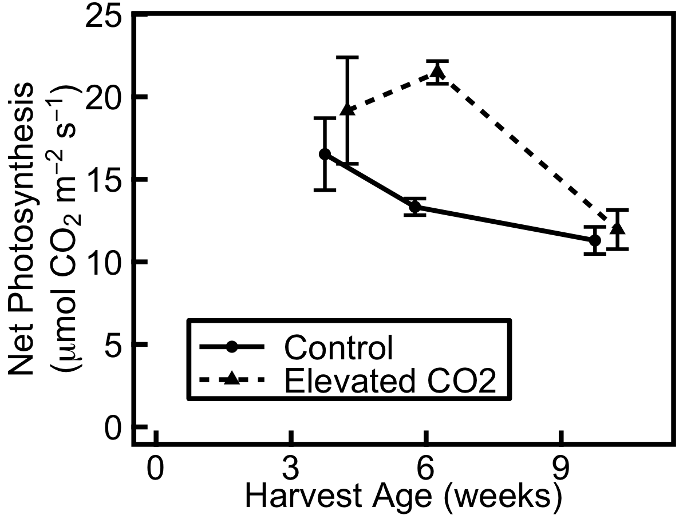

Figure 1. Net photosynthesis is not increased during a two-week elevated CO₂ treatment (filled triangles, dashed line) compared to controls (filled circles, solid line) in annual barley harvested 4 and 10 weeks after germination, but is increased in plants harvested 6 weeks after germination. Overall, net photosynthesis decreases across the three harvests. For each plant, photosynthesis was measured under growth chamber conditions (either elevated CO₂ or control) multiple times during a two-week elevated CO₂ exposure period and the results averaged. Data show mean ± SE (n=3). Means from the two treatments are slightly offset to enable them to be seen properly.

Relative growth rate (RGR; Fig. 2) during the period of elevated CO₂ decreases over time (F_{(1,7)} = 25.42, p<0.01), similar to the trend in photosynthesis (Fig. 1). Contrary to expectations, there is no effect of CO₂ on RGR (Fig. 2), yet CO₂ does affect biomass allocation. Plants exposed to elevated CO₂ allocate more biomass to shoot than root (Table 1). They have a lower root:shoot ratio and higher LMA (leaf dry mass per unit area, g m⁻²) than controls (treatment effect on root:shoot ratio: F_{(1,14)} = 5.9, p<0.05; for LMA: F_{(1,14)} = 5.2, p<0.05). LMA decreases significantly over time in elevated CO₂ and control plants (F_{(1,14)} = 42.9, p<0.001). However there are no treatment x harvest interactions (for root:shoot ratio, p>0.1; for LMA, p>0.3).
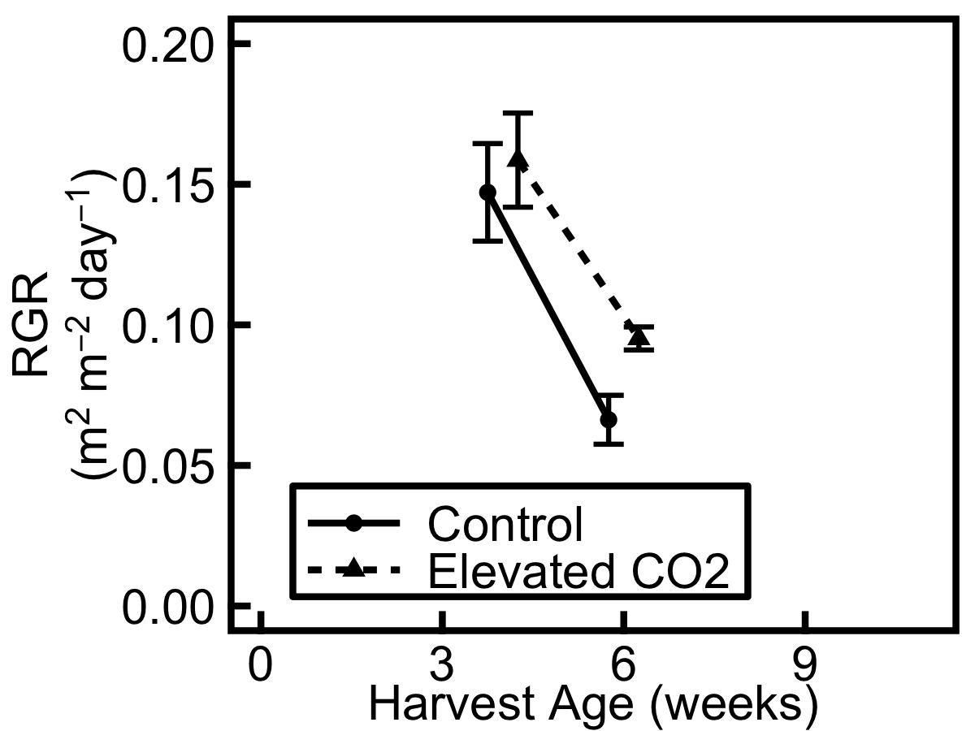

Figure 2. Relative growth rate (RGR; daily gain in aboveground area relative to total aboveground area, m² mm⁻² day⁻¹) during two-week treatment period is not increased under elevated CO₂ (filled triangles, dashed line) compared to control (filled circles, solid line) in annual barley harvested 4 and 6 weeks after germination. No image data could be collected for the harvest at week 10. RGR decreases across the two harvests, yet is decreased to a greater extent in the control plants. Data show mean ± SE (n=3).

Table 1. Plants exposed to elevated CO₂ allocate more biomass to shoot than root, in annual barley harvested 4, 6 and 10 weeks after germination. Leaf mass per unit area (LMA, g m⁻²) is higher and root:shoot ratio is lower, compared to controls. LMA decreases significantly over time in plants exposed to elevated CO₂ and in control plants but there is no interaction. Data show mean ± SE (n=3).

 | Treatment | 4 weeks | 6 weeks | 10 weeks
LMA | Elevated CO₂ | 76.3 ± 2.1 | 74.1 ± 2.6 | 51.4 ± 2.2
LMA | Control | 69.0 ± 3.7 | 63.8 ± 2.5 | 50.2 ± 0.72
Root:Shoot | Elevated CO₂ | 0.50 ± 0.07 | 0.48 ± 0.03 | 0.51 ± 0.01
Root:Shoot | Control | 0.54 ± 0.02 | 0.58 ± 0.01 | 0.81 ± 0.17

Consistent with hypotheses, elevated CO₂ has a significant effect on leaf carbohydrate levels, an indication of sink limitation (Rogers and Ainsworth, 2006). Total non-structural carbohydrate (TNC) concentration (the sum of glucose, fructose, sucrose, short- and long-chain fructans, and starch) is significantly higher under elevated CO₂ (F_{(1,12)} = 46.88, p<0.001). This effect is notable at all ages but diminishes over time: 4 weeks after germination, TNC is 116% higher under elevated CO₂; by 10 weeks after germination it is 73% higher, as expected if plants undergo a transition from sink towards source limitation during ontogeny (Fig. 3). However, analysis revealed no treatment x harvest interaction (p>0.2).

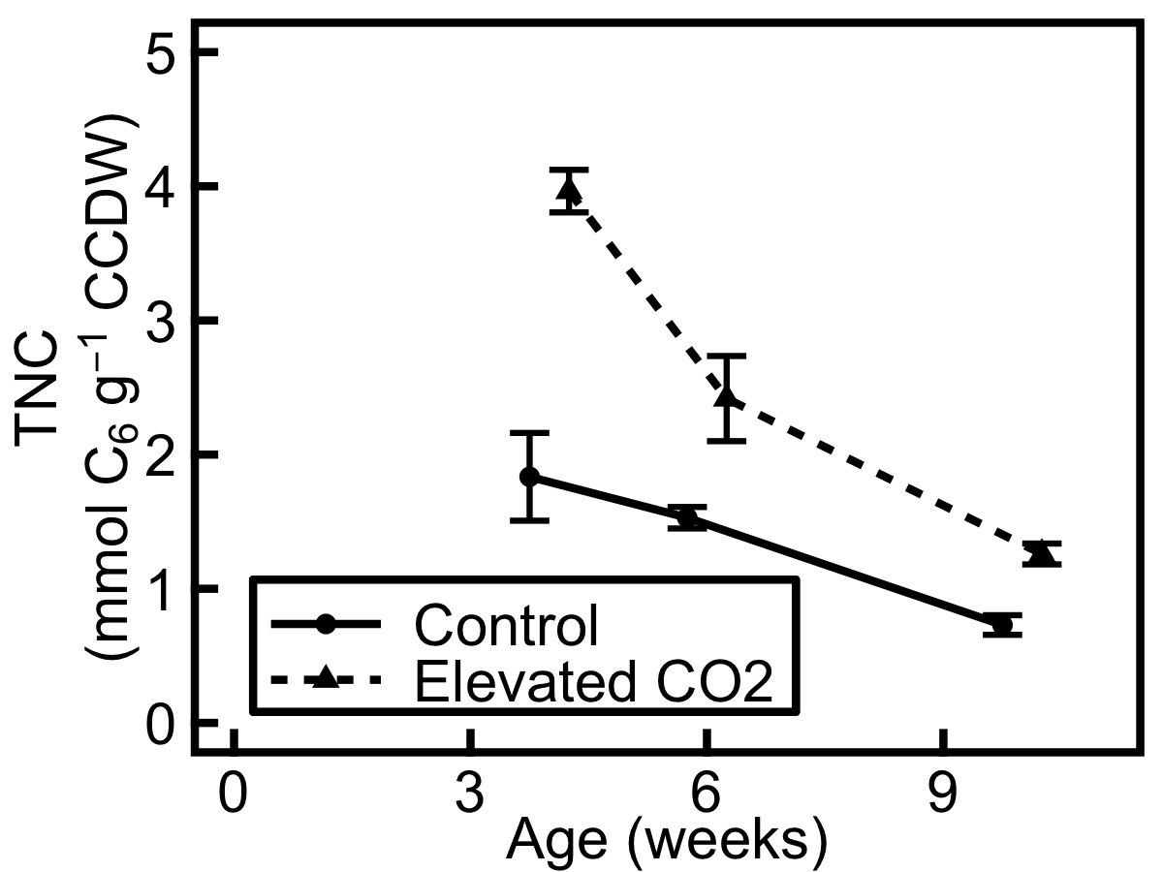

Figure 3. Total non-structural carbohydrate (TNC) concentrations in leaf tissue are significantly higher in plants exposed to a two-week elevated CO₂ treatment (filled triangles, dashed line) than in control plants (filled circles, solid line). TNC concentration decreases across the three harvests and decreases more in elevated CO₂ than in control plants. TNC concentration is the sum of glucose, fructose, sucrose, short- and long-chain fructans, and starch concentrations. Data are expressed in mmol glucose equivalents per g carbohydrate-corrected dry weight (CCDW). Data show mean ± SE (n=3).

A large fraction of the increase in TNC under transient elevated CO₂ (Fig. 3) is due to significant increases in starch and long-chain fructan concentrations (for starch, F_{(1,12)} = 86.50, p<0.001; for long-chain fructans, F_{(1,12)} = 28.76, p<0.001). There is no treatment x harvest interaction for either starch (p>0.6) or long-chain fructan (p>0.3). The treatment differences are consistently high in all harvests, with concentrations of starch and long-chain fructan always more than 100% higher in plants exposed to elevated CO₂ compared to control (Fig. 4). In these plants, starch concentration is 153% higher at 4 weeks, 193% higher at 6 weeks and 127% higher at 10 weeks. The relative effect of elevated CO₂ on long-chain fructan is even greater overall: long-chain fructan concentration is 210% higher at 4 weeks, 295% higher at 6 weeks and 105% higher at 10 weeks, compared to controls.

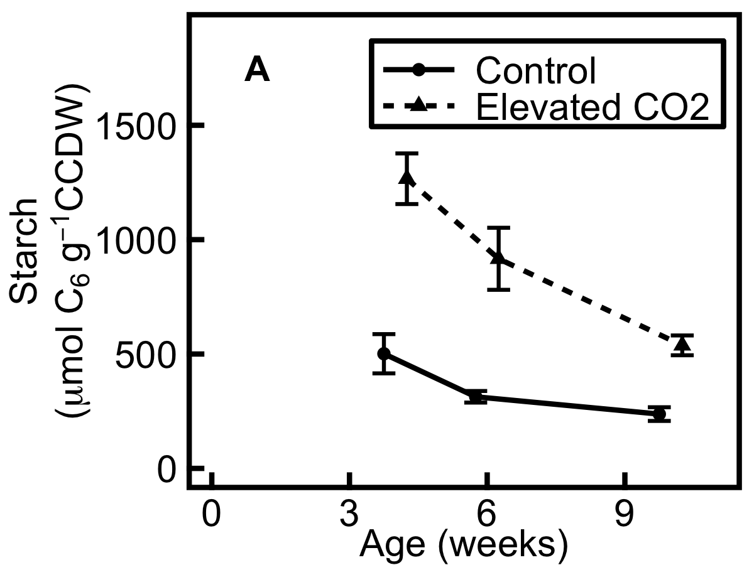

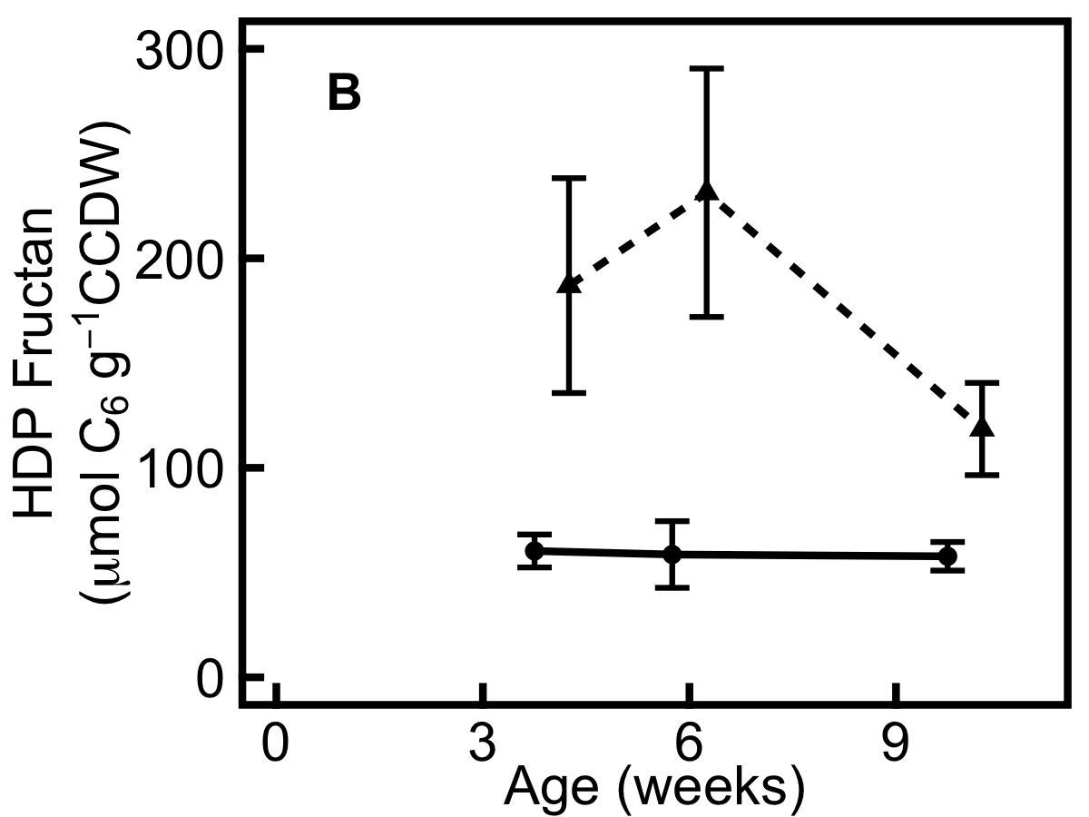

Figure 4. Storage carbohydrate concentrations in leaf tissue are significantly higher in plants exposed to a two-week elevated CO₂ treatment (filled triangles, dashed line) than in control plants (filled circles, solid line). A, starch; B, long-chain fructan. Data are expressed in μmol glucose equivalents per g carbohydrate-corrected dry weight (CCDW). Data show mean ± SE (n=3).

Hexose:sucrose ratio is an indicator of sink limitation (Moore et al., 1999), since hexoses repress photosynthesis when the sink is limiting, mediated by the sugar sensor hexokinase (Jang and Sheen, 1994; Rogers and Ainsworth, 2006). The hexose:sucrose ratio (Fig. 5) increases over time in both elevated CO₂ and control plants (F_{(2,12)} = 40.60, p<0.001) and is slightly higher in plants exposed to elevated CO₂ (F_{(1,12)} = 8.60, p<0.05), but there is no treatment x harvest interaction (p>0.7). In contrast, the concentrations of TNC (Fig. 3) and protein (Fig. 6) decrease over time in the leaf with significant effects of harvest age (for TNC, F_{(2,12)} = 47.92, p<0.001; for protein, F_{(2,12)} = 33.36, p<0.001).
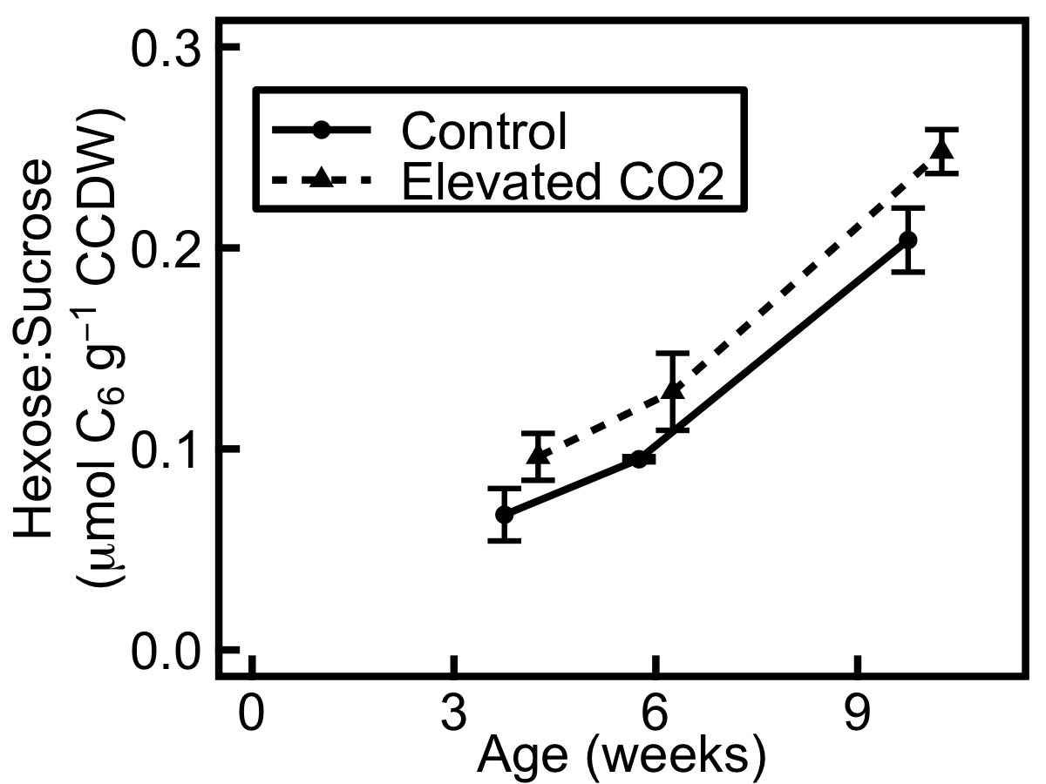

Figure 5. Hexose:sucrose ratio in leaf tissue increases across harvests in plants exposed to a two-week elevated CO₂ treatment (filled triangles, dashed line) and in control plants (filled circles, solid line). Data are expressed in μmol glucose equivalents per g carbohydrate-corrected dry weight (CCDW). Data show mean ± SE (n=3).

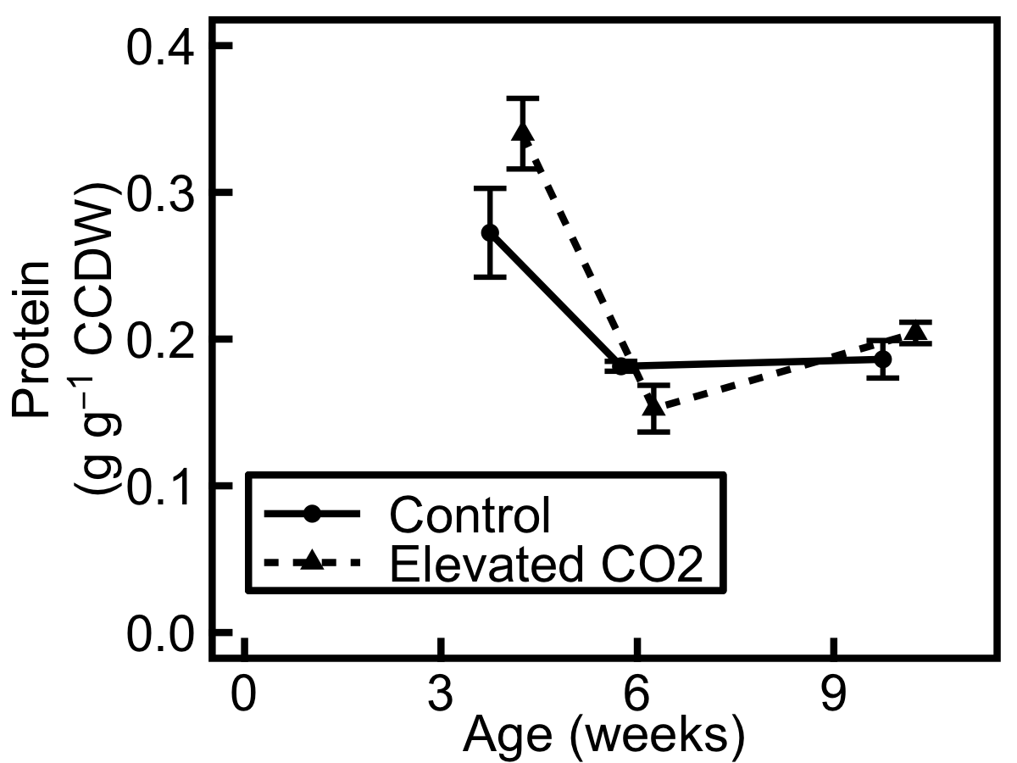

Figure 6. Protein concentration in leaf tissue decreases over time and is not higher in plants exposed to a two-week elevated CO₂ treatment (filled triangles, dashed line) than in control plants (filled circles, solid line). Data are expressed in g protein per g carbohydrate-corrected dry weight (CCDW). Data show mean ± SE (n=3).

Partial defoliation

Contrary to the hypothesis that defoliation would increase photosynthesis, especially earlier in development, defoliation does not affect photosynthetic activity or capacity in the remaining leaves (Fig. 7). Differentials of four parameters were obtained by subtracting the value after defoliation from the value before defoliation for each individual. These parameters are: steady state light-saturated net photosynthesis under ambient conditions, at the start of the A/C_{i} curve (Fig. 7A); steady state stomatal conductance at the start of the A/C_{i} curve (Fig. 7B); maximum carboxylation capacity of Rubisco (V_{c,max}) modelled from the curve (Fig. 7C) and electron transport capacity (J_{max}) modelled from the curve (Fig. 7D).

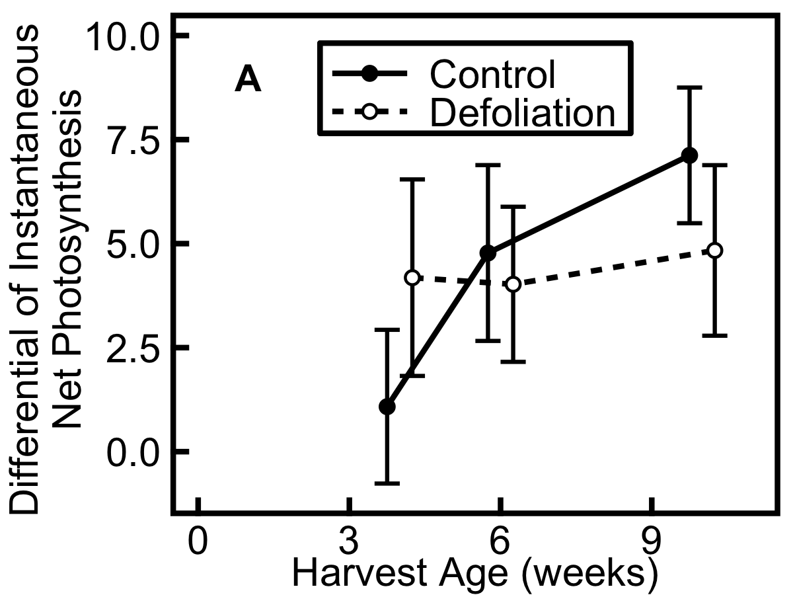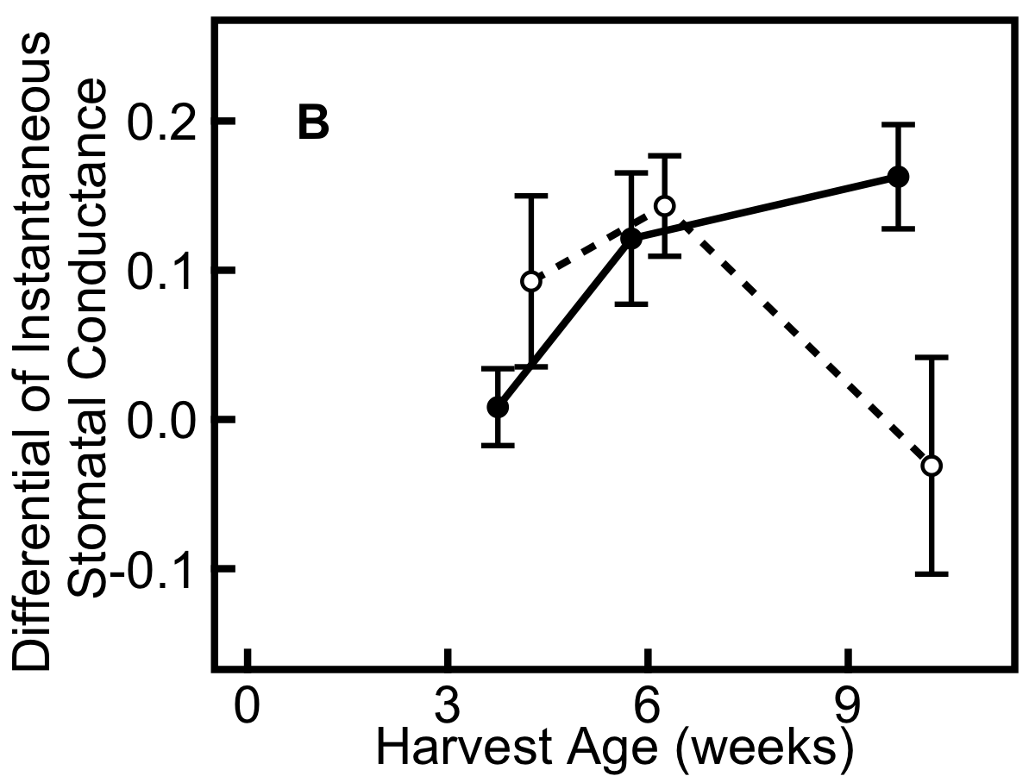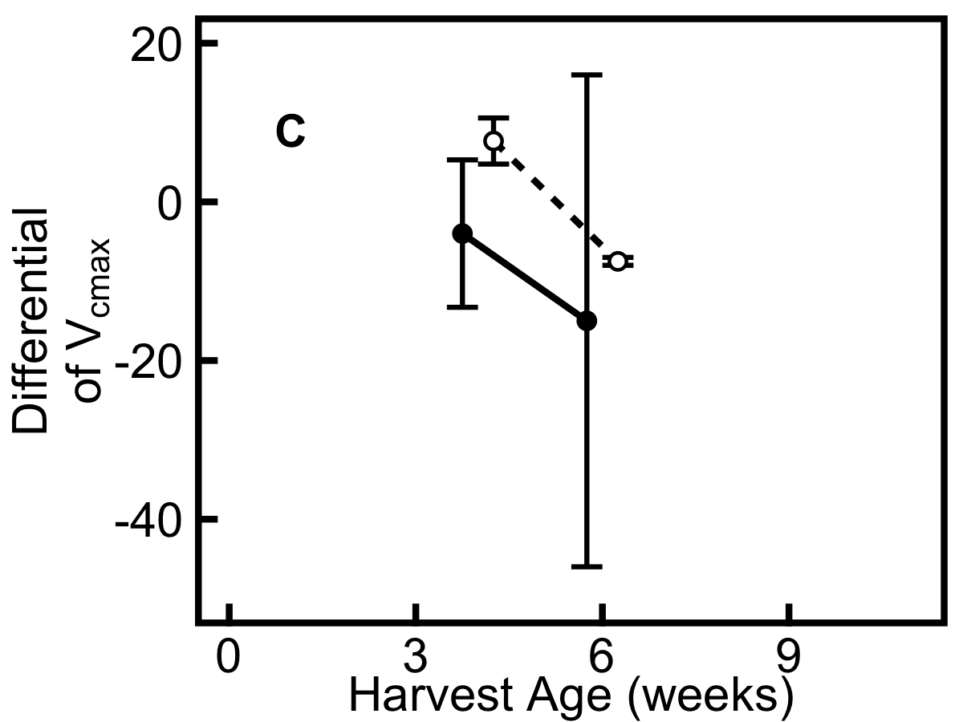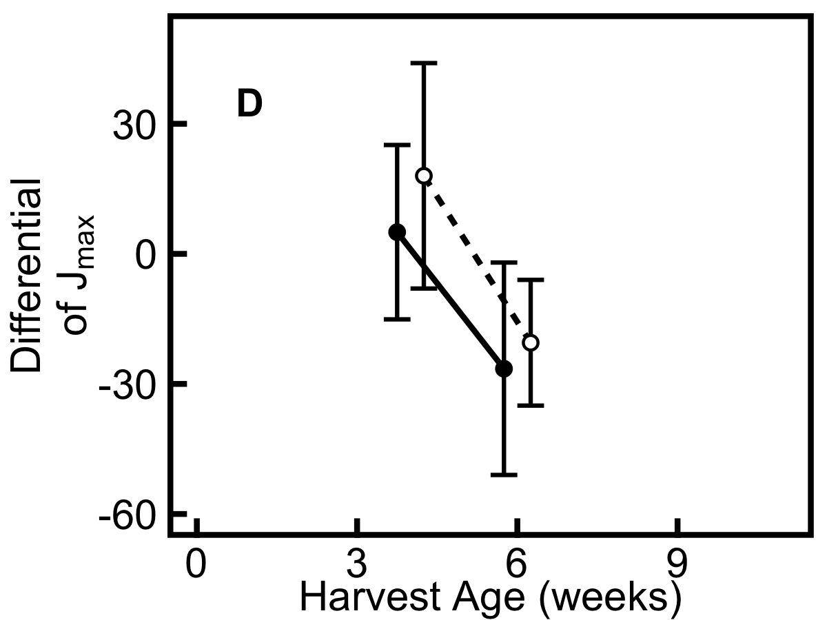
Figure 7. Defoliation has no effect on photosynthetic parameters obtained from A/C_{i} curves, in plants exposed to a 1-week defoliation treatment (hollow circles, dashed line) in comparison with control plants (filled circles, solid line). A, net photosynthesis recorded at the start of the curve; B, stomatal conductance recorded at the start of the curve; C, maximum carboxylation efficiency of Rubisco, V_{c,max}, modelled from the curve; D, electron transport capacity, J_{max}, modelled from the curve. For each parameter the differential is shown: value after defoliation was subtracted from value before defoliation for each individual. A/C_{i} curves were performed during the day before defoliation was imposed and again the day before harvest. For plants at 10 weeks old, only steady state light saturated ambient measurements of net photosynthesis and stomatal conductance were measured, since no curves could be performed. Data show mean ± SE (n=3).
Defoliation and harvest time have no main effects on these parameters, and whilst there is a treatment x harvest interaction for stomatal conductance (F_{(1,14)} = 7.46, p<0.05), with lower stomatal conductance in defoliated plants compared to controls 10 weeks after germination, there are no treatment x harvest interactions for net photosynthesis (p>0.1), V_{c,max} (p>0.8) or J_{max} (p>0.8).

Net photosynthesis measured in control plants the day before harvest (Fig. 8) does decrease during development (F_{(1,7)} = 53.23, p<0.001), but plant age does not affect stomatal conductance, V_{c,max} or J_{max} for these plants.

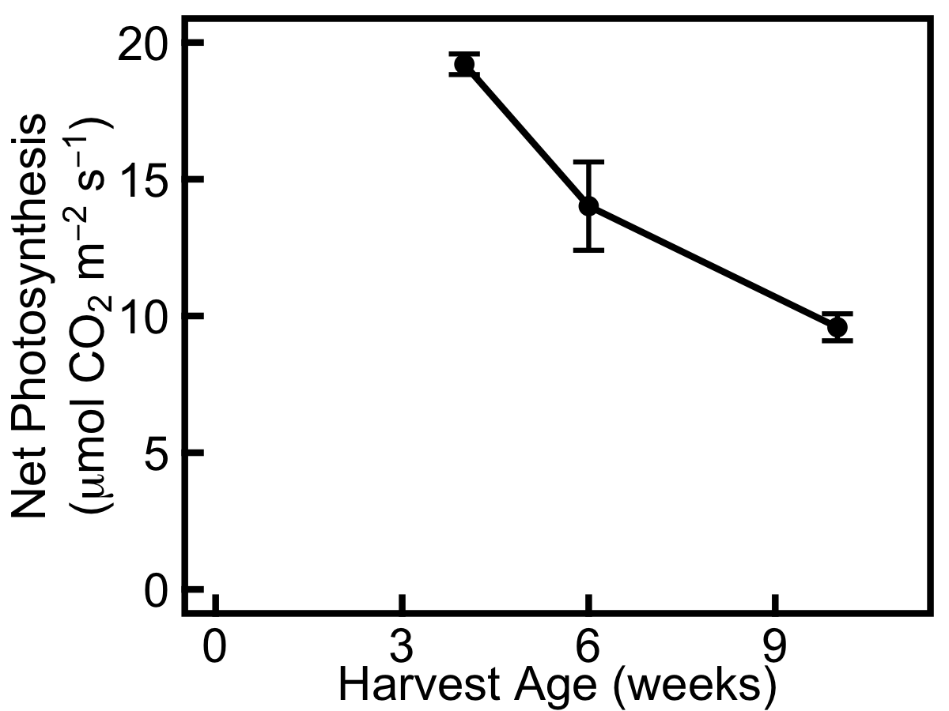

Figure 8. Light-saturated net photosynthesis under ambient CO₂ in control plants decreases across the three harvests. Data shown are from A/C_{i} curves carried out the day before harvest. Data show mean ± SE (n=3).

Contrary to predictions, defoliation does not affect TNC in the remaining leaves (Fig. 9). As with the elevated CO₂ plants, leaf TNC (Fig. 9) and protein (Fig. 10) decreases significantly in defoliated plants over time (for TNC, F_{(2,12)} = 59.87, p<0.001; for protein, F_{(2,12)} = 26.37, p<0.001). Hexose:sucrose ratio increases over time (Fig. 11), but whilst the harvest time effect is significant (F_{(2,12)} = 35.26, p<0.001) there is no treatment effect.

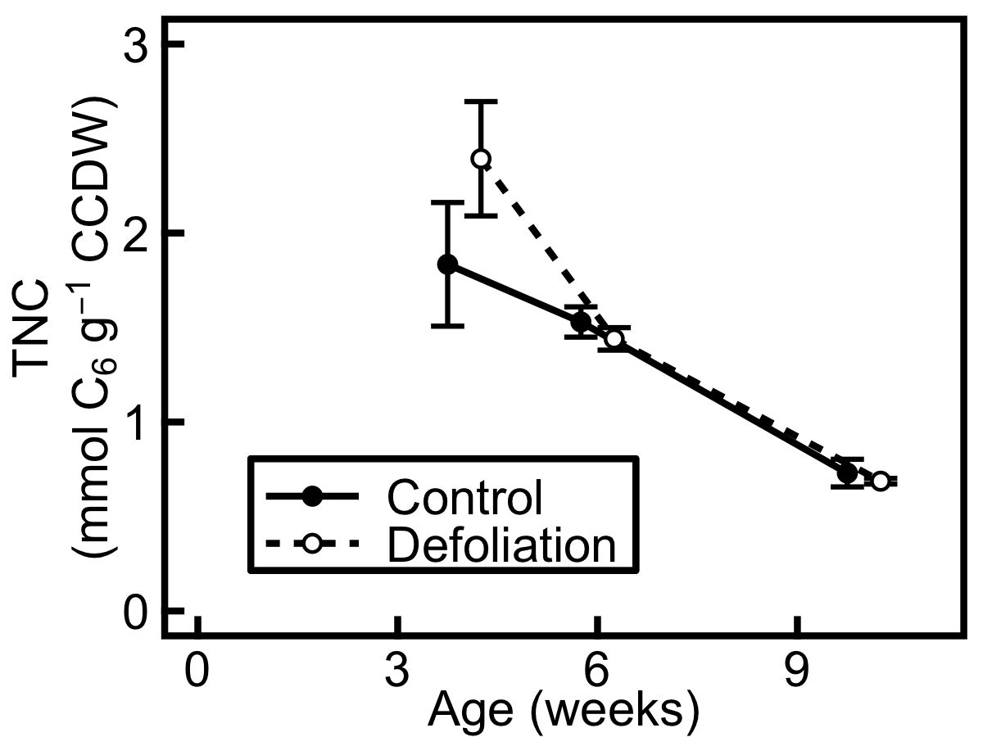

Figure 9. Total non-structural carbohydrate (TNC) concentration in leaf tissue is no higher in plants exposed to defoliation (hollow circles, dashed line) than in control plants (filled circles, solid line). TNC concentration decreases across the three harvests. Data are expressed in mmol glucose equivalents per g carbohydrate-corrected dry weight (CCDW). Data show mean ± SE (n=3).

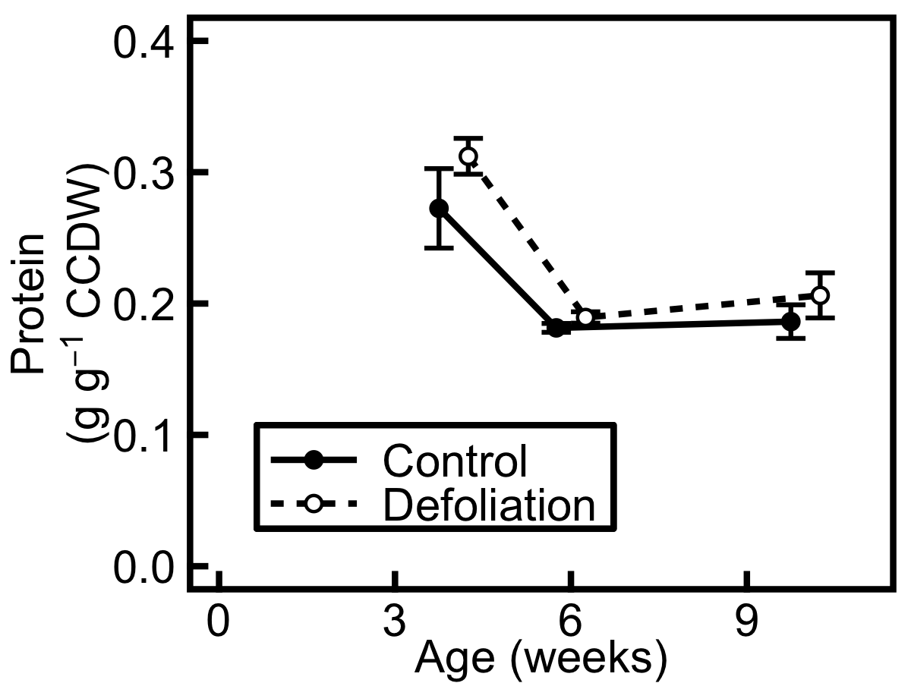

Figure 10. Protein concentration in leaf tissue decreases over time and is not higher in plants exposed to defoliation (hollow circles, dashed line) than in control plants (filled circles, solid line). Data are expressed in g protein per g carbohydrate-corrected dry weight (CCDW). Data show mean ± SE (n=3).

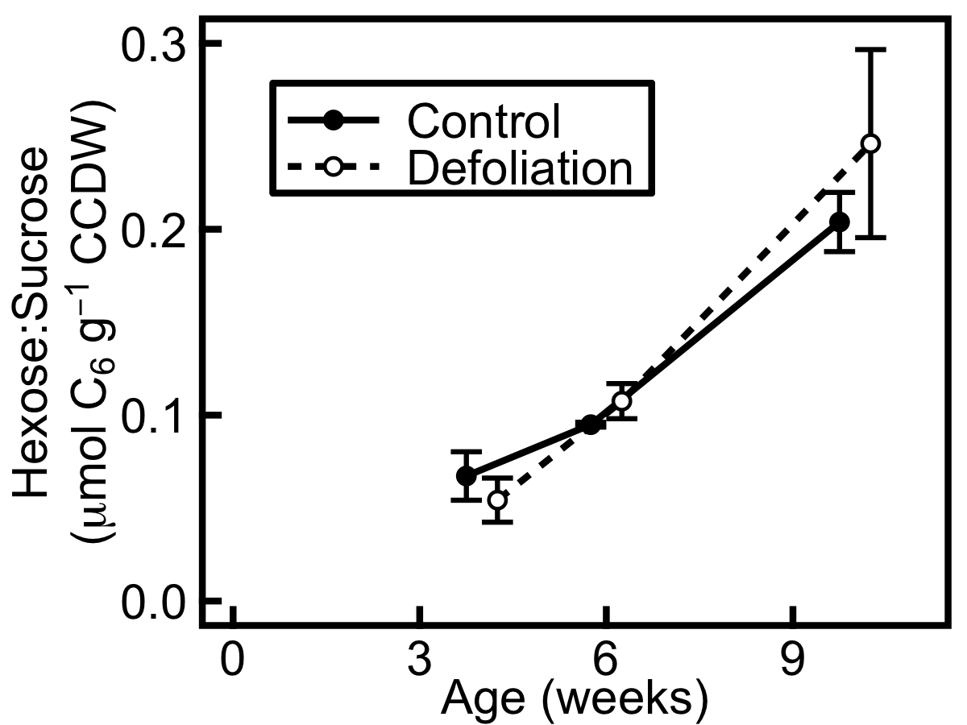

Figure 11. Hexose:sucrose ratio in leaf tissue increases across harvests in plants exposed to defoliation (hollow circles, dashed line) and in control plants (filled circles, solid line). Data are expressed in μmol glucose equivalents per g carbohydrate-corrected dry weight (CCDW). Data show mean ± SE (n=3).

Because plants were partially defoliated 5 or 8 days before harvest, RGR and root:shoot ratio could not be measured. However, LMA in the remaining leaves was measured at harvest for these plants. LMA (Table 2) decreases significantly over time in defoliated and control plants (F_{(1,12)} = 27.2, p<0.001), as seen for elevated CO₂ and control plants (Table 1), but there is no effect of defoliation treatment on LMA.

Table 2. Leaf mass per unit area (LMA, g m⁻²) decreases significantly over time in defoliated and control barley plants harvested 4, 6 and 10 weeks after germination. Data show mean ± SE (n=3, except for LMA after defoliation treatment at 4 weeks where n=1).

 | Treatment | 4 weeks | 6 weeks | 10 weeks
LMA | Defoliation | 71.1 | 71.8 ± 2.6 | 54.5 ± 3.6
LMA | Control | 69.0 ± 3.7 | 63.8 ± 2.5 | 50.2 ± 0.72

DISCUSSION

In order to investigate the extent to which source and sink limit growth in annual barley, a short-term elevated CO₂ treatment was applied to plants that had developed in control conditions to increase the carbon source:sink ratio, whilst a 5- or 8-day partial defoliation treatment was applied to separate plants to decrease the carbon source:sink ratio. Leaf total non-structural carbohydrate (TNC) concentration is increased under elevated CO₂, suggesting sink limitation, an effect which appears to diminish over time indicating a shift from sink limitation towards greater source limitation during vegetative growth. However the defoliation treatment has no effect on the parameters measured here and is deemed ineffective. The results from this study have subsequently enabled the development of effective methods for source:sink manipulation in barley, discussed in the following chapters of this thesis.

Elevated CO₂ transient does not increase photosynthesis

Contrary to predictions, elevated CO₂ does not increase net photosynthetic rate except at the second harvest, after 6 weeks of growth (Fig. 1). The imposition of sink limitation by elevated CO₂ – reflected in the increased TNC levels – could cause feedback inhibition of photosynthesis by acclimation resulting in an apparent lack of photosynthetic response (Rogers et al., 1998; Long et al., 2004). This could be caused proximately by a decrease in V_{c,max} brought about by changes in the amount or activity of Rubisco, by RuBP-regeneration limitation, or by a direct sink feedback due to triose phosphate limitation (Sharkey et al., 2007); A/C_{i} curves would be required to investigate the limitation. Elevated CO₂ treatments are often applied for months or years, and photosynthetic acclimation occurs over these longer timescales (McConnaughay et al., 1993; Bryant et al., 1998; Farage et al., 1998; Rogers et al., 1998; Ainsworth et al., 2003, 2004; Aranjuelo et al., 2013). In all these cases, photosynthetic acclimation is alleviated when the carbon sink is increased. Shorter-term studies reveal that whilst photosynthesis is increased under elevated CO₂ over a time period of seconds or hours (Makino and Mae, 1999), over a period of days or weeks acclimation occurs due to carbohydrate feedback or nitrogen limitation (Stitt, 1991; Makino and Mae, 1999) which may be linked to a decrease in Rubisco content (Cheng et al., 1998). Here, the elevated CO₂ treatment is imposed for only two weeks so that equivalent data could be collected at all three time points, yet even on this relatively short time scale it appears that the sink is insufficient – supported by the metabolite data discussed later in this section – and that photosynthetic acclimation occurs at 4 and 10 weeks after germination under transient elevated CO₂.

Elevated CO₂ transient affects biomass allocation but not growth rate

RGR decreases over time in elevated CO₂ and control plants, revealing developmental effects on growth rate, yet does not differ significantly between treatment and control (Fig. 2), particularly at the first harvest where photosynthesis also does not differ (Fig. 1). This lack of the expected growth response to the high CO₂ transient could be because the treatment was imposed for an insufficient length of time to observe long-term effects on photosynthesis and growth, since the effect of elevated CO₂ on plant growth is well-documented (Leakey et al., 2009). Elevated CO₂ plants have a slightly higher rate of growth than control plants at harvest 2, which matches the results for photosynthesis (Fig. 1). Although not statistically significant, it is worth noting this developmental trend. This tentatively supports the hypothesis that the source capacity becomes more limiting later in development, since the elevated CO₂ plants at harvest 2 appear better able to take up the additional CO₂ in photosynthesis and utilise the acquired carbon for growth. This indicates a decrease in sink limitation between harvests 1 and 2. Earlier in development, at harvest 1, if plants are more sink limited due their small size and lack of sufficient storage organs, they will be less able to utilise any additional carbon fixed under elevated CO₂ conditions. The increase in source capacity due to elevated CO₂ thus leads to a much smaller relative increase in RGR at harvest 1 compared to harvest 2.

The increased leaf mass per unit area (LMA) and decreased root:shoot ratio in plants exposed to elevated CO₂ (Table 1) indicate greater allocation of biomass to shoot tissues in these plants. This is contrary to expectations, since plants generally invest in acquiring the resource that is limiting – which in the case of elevated CO₂ is usually nitrogen, requiring greater allocation to roots. However the significant build up of leaf carbohydrates can explain the greater LMA and lower root:shoot ratio under elevated CO₂: the average increase in TNC is 0.09g g⁻¹ CCDW under elevated CO₂, an increase of 9%, and the average increase in LMA is 9.7% under elevated CO₂.

Leaf carbohydrates accumulate under elevated CO₂ transient

In accordance with hypotheses, the elevated CO₂ treatment does result in an increase in leaf TNC (Fig. 3). This suggests sink limitation of growth under elevated CO₂, since plants are unable to utilise the additional carbon and instead store it in their leaves (Rogers and Ainsworth, 2006). This CO₂-mediated increase diminishes over time, suggesting a weakening of sink relative to source limitation through development, although analysis did not reveal a significant interaction between treatment and harvest time.

The composition of leaf TNC is also informative: an increase in starch and fructan, which is observed for the elevated CO₂ plants (Fig. 4), is indicative of sink limitation (Rogers and Ainsworth, 2006), and fructan is a key repository for excess photosynthate in barley (Schnyder, 1993). An increase in the end-of-day hexose:sucrose ratio (Fig. 5) is a further indication of sink limitation, since this suggests a high futile cycle rate of excess leaf sugars, which cycle between hexoses and sucrose (Moore et al., 1999; Rogers and Ainsworth, 2006). This cycle is mediated by invertase activity, which hydrolyses sucrose into hexoses and thus increases the hexose:sucrose ratio, leading to feedback inhibition of photosynthesis (Goldschmidt and Huber, 1992; Jang and Sheen, 1994). High hexose levels decrease Rubisco expression and photosynthesis (Moore et al., 1999; Long et al., 2004) and hexokinases play important roles in the sugar-mediated repression of photosynthesis (Jang and Sheen, 1994; Granot et al., 2013; Kelly et al., 2013). As would be expected, the hexose:sucrose ratio is higher in elevated CO₂ plants than control plants yet, contrary to expectations, it increases over time, suggesting an increase in sink limitation. This apparently contradicts the decrease in sink limitation suggested by the responses of RGR and non-structural carbohydrates over time discussed above.

Partial defoliation does not increase photosynthesis in remaining leaves

Contrary to expectations, steady state photosynthetic rate and photosynthetic capacity measured using A/C_{i} curves are not higher in defoliated plants than in control plants (Fig. 7). This suggests that defoliation does not lead to an upregulation of photosynthetic capacity in order to alleviate source limitation. Rather, photosynthetic capacity is unaffected by this treatment. Notably, barley is well-adapted to grazing and new leaves grew in the place of those which had been removed – and the new leaves were not measured. It is also possible that the treatment was imposed for insufficient time for upregulation of photosynthesis to occur (for example, the defoliation treatment used by von Caemmerer and Farquhar, 1984 was imposed for 18 days), although the elevated CO₂ data of Cheng et al (1998) suggest that changes in Rubisco content may occur on relatively short timescales.

Partial defoliation does not affect leaf carbohydrates

The TNC concentration of leaves is also unaffected by defoliation (Fig. 9), which also goes against expectations and further indicates that source limitation has not been effectively imposed by this treatment, since plants are able to maintain normal concentrations of leaf carbohydrates rather than needing to increase export to sink organs. As with the CO₂ treatment, the decrease in TNC observed over time in defoliated and control plants suggests a weakening of sink relative to source limitation during development: an increase in sink strength over time could lead to this pattern, with additional storage pools for carbohydrates developing over time and reducing carbohydrate build-up in the leaves. However, as for the elevated CO₂ plants, an increase in hexose:sucrose ratio is observed over time for the defoliated plants (Fig. 11).

Overall ontogenetic effects

Across both treatments and in control plants, steady state net photosynthesis, measured at ambient conditions for elevated CO₂ plants and under saturating light for defoliated plants, decreases during development in all plants (Figs. 1, 8). Leaf protein concentration follows the same trend and is unaffected by either treatment (Figs. 6, 10). LMA also decreases during development in plants exposed to both treatments and in controls (Tables 1 and 2), suggesting a developmental trend towards thinner leaves with less protein per unit area and consequently lower rates of photosynthesis, since photosynthetic proteins constitute a major part of leaf nitrogen (Ellis, 1979; Evans, 1989; Spreitzer and Salvucci, 2002). This makes an important contribution to the decline in TNC during development (Figs. 3, 9), showing lower source activity relative to sink activity, which could arise from larger plants with better developed sinks, alongside reduced rates of leaf photosynthesis. The change in protein concentration may also be due to leaf expansion: as leaves get larger, vacuoles can take up a greater proportion of each cell, leading to a lower observed cytosolic protein concentration which may account for the decrease in protein concentration seen here.

Limitations

The defoliation treatment used here did not manipulate the source:sink ratio, and would need to be maintained (by removal of new leaves that grow during the treatment period) and/or extended (to give a longer time period for acclimation) in order to be effective. However, the invasive nature of defoliation compared to elevated CO₂ is likely to introduce confounding factors such as wounding responses and is therefore not an ideal manipulation for future work; instead the use of sub-ambient CO₂ could provide a non-invasive method for reducing the source:sink ratio. Similarly, the timescale of elevated CO₂ treatment could be improved – either extended to understand the longer-term effects when plants are grown permanently in elevated CO₂, and/or the measurement schedule altered to capture plant responses hours after transfer to elevated CO₂ in addition to the responses measured after several days of CO₂ treatment.

Conclusions and future directions

Annual barley appears to transition from being more sink limited to more source limited during vegetative development. At 4 weeks after germination, a short-term elevated CO₂ treatment reveals that plants are sink limited: TNC concentration increases, leading to photosynthetic acclimation and a lack of growth response. At 6 weeks after germination, plants are better able to use the increased TNC, meaning that an elevation of photosynthesis can occur and additional carbon can be invested in faster growth under elevated CO₂. The decrease in TNC seen in all plants in the study over time further suggests a decline in sink limitation towards greater source limitation.

The results from this study were greatly informative in designing the experiments outlined in the rest of this thesis. The successful use of elevated CO₂ in imposing sink limitation, seen in the increase in non-structural carbohydrates, meant that this manipulation could be used with confidence for future work to impose carbon sink limitation. However, the lack of growth and photosynthetic responses under elevated CO₂ highlighted a need to impose source:sink manipulations for longer, and manipulations were applied for the entire duration of the experiment in subsequent work. The lack of any response to defoliation treatment, coupled with the regrowth of leaves during this treatment, pointed to the need for more elegant, non-invasive manipulations to be used in future studies: firstly the use of sub-ambient CO₂ and elevated CO₂, and secondly the use of a nitrogen gradient.

TNC and fructan concentrations provided good diagnostics for sink limitation in this study, and the relationship between sink limitation and foliar carbohydrates is well established. However, the hexose:sucrose ratios reported here do not agree with the trend seen in other carbohydrate levels. For diagnosing sink limitation this measurement is both less robust, as it is an indicator of invertase activity which is a more robust measurement (Moore et al., 1999), and less well-established: most studies focus on TNC, and much of the early work on hexose signalling was carried out in protoplasts making it perhaps less physiologically relevant for whole plant studies (e.g. Jang and Sheen, 1994). Thus for subsequent work, measurement of hexose:sucrose ratios was not used as a diagnostic for sink limitation. The amino acid:sucrose ratio is a better indicator of carbon source limitation (Paul and Driscoll, 1997; Stitt and Krapp, 1999; Isopp et al., 2000) and links carbon and nitrogen metabolism, and this was utilised in subsequent experiments, in which amino acid data were available.

To build on the findings of this work, in addition to the methodological improvements noted above, subsequent experiments were expanded to include another species (a congeneric wild perennial barley) and whole plant metabolite analysis (by harvesting leaf sheaths and roots, in addition to leaves). In order to deepen understanding of carbohydrate accumulation, in one experiment plants were harvested pre-dawn in addition to pre-dusk in order to assess diurnal patterns and to obtain the start-of-day baseline carbohydrate levels. Measurement of free nitrate and free amino acids, in addition to protein, enabled a more complete profile of nitrogen metabolite pools in different organs to be obtained in subsequent experiments. A different cultivar of annual barley was used in subsequent experiments so that seed pre-treated with fungicide could be used, in order to guard against Ramularia infection, but an elite UK annual spring malting barley was chosen again in order to facilitate comparison of results.

Chapter 4: Carbon source-sink limitations differ between two species with contrasting growth strategies

A modified version of this chapter is in press and is cited as ‘Burnett et al., 2016’ in this thesis.

ABSTRACT

Understanding the limitation of plant growth rate by carbon source and sink strengths is a critical knowledge gap that hinders efforts to maximise yield in future germplasm. We sought to explain how differences in growth rate between species arise from source-sink limitations, using a model system comparing a fast-growing domesticated annual barley (Hordeum vulgare cv. NFC Tipple) with a slow-growing wild perennial relative (Hordeum bulbosum). Source strength was manipulated by growing these plants at sub-ambient and elevated CO₂ concentrations ([CO₂]), diagnosing the limitations on vegetative growth imposed by source and sink by measuring relative growth rate (RGR), developmental plasticity, photosynthesis and major pools of carbon and nitrogen metabolites. We found that growth was sink limited in the annual but source limited in the perennial. RGR and carbon acquisition were higher in the annual, but photosynthesis responded weakly to elevated [CO₂] indicating that source strength was near maximal at current [CO₂]. In contrast, photosynthetic rate and sink development responded strongly to elevated [CO₂] in the perennial, indicating significant source limitation. Sink limitation was avoided in the perennial by a high degree of sink plasticity, manifested as a marked increase in tillering and root:shoot ratio at elevated [CO₂]. The annual lacked this plasticity and accumulated more non-structural carbohydrates. In contrast, free amino acid concentration was higher in the perennial supporting the hypothesis of carbon source limitation. This work suggests that alleviating sink limitation during vegetative development could be important for maximising the growth potential of elite cereal crops under future elevated [CO₂].

INTRODUCTION

Global population growth, economic development and climate change are exerting increasing pressure on our global food supply, raising demand that must be met, in part, by improving crop yields (Ainsworth et al., 2008b; Godfray et al., 2010; Foley et al., 2011; von Caemmerer et al., 2012; Reynolds et al., 2012; FAO et al., 2014; Ort et al., 2015). Increasing yield depends critically on a firm understanding of plant growth, which is in turn underpinned by the interactions between carbon and nitrogen sources and sinks (White et al., 2016). Sources provide net uptake of resources from the external environment whilst sinks cause a net internal drawdown of these resources. For carbon, mature leaves are sources and roots are sinks, and the balance between them is achieved by well-characterised molecular crosstalk mechanisms (Smith and Stitt, 2007; Lawlor and Paul, 2014; White et al., 2016). Decades of research into the effects of elevated CO₂ have demonstrated that increasing source activity through a stimulation of photosynthesis often does not translate into corresponding yield increases (Long et al., 2006a; Ainsworth et al., 2008a; Leakey et al., 2009), although this depends on the species (Yamori et al., 2016). Similarly, increasing sink capacity does not always translate into greater yield under field conditions (Weichert et al., 2010). A holistic approach to growth and yield considering both source and sink capacities is therefore essential for developing higher yielding crop varieties (White et al., 2016).

One strategy for understanding the fundamental limitations on growth is to investigate the natural diversity of growth rates in wild plants. In wild species, one of the major causes of growth rate variation is life-history (Grime and Hunt, 1975; Garnier, 1992). Annual and perennial growth strategies enable plants to allocate resources in a way that is appropriate for their environment: annuals grow quickly and invest everything in reproduction in the first year before they die, whilst perennials grow more slowly and conserve resources for the following season (Garnier, 1992; Iwasa, 2000; Bennett et al., 2012). Annuals are typically seen as having flexible growth strategies for exploiting fluctuating environments, whereas perennials have more conservative growth strategies – i.e. lower allocation to reproduction and slower growth (Atkinson et al., 2012, 2014). Although perennials with large storage organs may never be sink limited, annuals generally transition from sink to source limitation during development when they switch from vegetative to reproductive growth (Arp, 1991), and perennials lacking large storage organs are likely to undergo this transition as well. Because perennials grow more slowly than annuals and transition to the reproductive growth stage later, they are therefore likely to be sink limited for a longer period of time.

Despite this well developed ecological theory, we do not currently know the extent to which slower growth in perennials than annuals arises from greater source or sink limitation. Experimental manipulations of the source:sink balance provide insights into the relative contributions of source and sink processes to growth rate, and may be achieved through a variety of techniques including: sink removal (Arp, 1991); genetic modification (Ainsworth et al., 2004; Weichert et al., 2010; Zuther et al., 2011); source removal (von Caemmerer and Farquhar, 1984; Bryant et al., 1998; Rogers et al., 1998; Eyles et al., 2013); inhibiting resource export from the source (Ainsworth and Bush, 2011); and increasing source activity using elevated CO₂ (Kinsman et al., 1997; Masle, 2000). Here, we alter the atmospheric CO₂ concentration ([CO₂]) to non-invasively manipulate the source:sink ratio in barley – elevated [CO₂] to increase the source strength and sub-ambient [CO₂] to decrease it – with current [CO₂] as a reference against which to compare the source manipulations. This approach enables analysis of source and sink limitation under current [CO₂], and strong CO₂ treatments are applied in order to produce large perturbations of the system. In C₃ plants, [CO₂] affects carbon source strength directly through one well-understood process i.e. carbon assimilation by Rubisco, and therefore avoids wounding responses and other confounding effects, which may arise from alternative approaches for source:sink manipulation. We took a holistic approach to investigating source-sink interactions, measuring the responses of growth, photosynthesis and key carbon and nitrogen metabolite pools on the same plants. Together, these simultaneous measurements of growth, carbon uptake and carbon utilization allowed us to diagnose source and sink limitation in our model system. For example, a high concentration of free amino acids indicates carbon source limitation (Paul and Driscoll, 1997; Stitt and Krapp, 1999; Isopp et al., 2000; Rogers et al., 2006), whilst a build-up of non-structural carbohydrates in leaves indicates carbon sink limitation (Rogers and Ainsworth, 2006; Ainsworth and Bush, 2011).

In order to elucidate physiological mechanisms underpinning differences in growth rate, this study compared domesticated annual barley (Hordeum vulgare cv. NFC Tipple) and a wild perennial relative (Hordeum bulbosum). Annual barley is sink limited during grain filling (Schnyder, 1993; Bingham et al., 2007; Serrago et al., 2013), yet to our knowledge no study of source- and sink limitation during the vegetative growth stage has been made in this species. The annual barley used here is an elite agricultural spring barley from the HGCA recommended list (HGCA, 2014) and has a fast-growing life-history strategy. The perennial is a wild species from Turkey, which is able to grow in diverse habitats but generally occupies nutrient-rich environments (von Bothmer, 1996). Plants were grown at different CO₂ conditions from germination to harvest, which occurred during the vegetative growth phase of the life cycle. We predicted that annual barley, which grows faster than perennial barley, would be sink limited during vegetative growth, and the perennial would be more strongly sink limited (Jaikumar et al., 2014). Based on this hypothesis we would expect the fast-growing annual to show a greater increase in growth and photosynthesis in response to elevated [CO₂] than the perennial (Poorter, 1993; Roumet and Roy, 1996). This is because the elevated [CO₂] alleviates source limitation and will therefore have a greater effect in the plants which are less sink limited (Bryant et al., 1998; Rogers et al., 1998; Ainsworth et al., 2003). In contrast, we expected that the more strongly sink limited, slower-growing perennial would show a greater increase in storage of carbon rich metabolites under elevated [CO₂].

MATERIALS AND METHODS

Plant material and growth conditions

Seeds of Hordeum vulgare cv. NFC Tipple and Hordeum bulbosum (Accessions GRA1031 and GRA947) were obtained from Syngenta and IPK Gatersleben respectively. Seeds were germinated on wet filter paper and transplanted to 4-litre pots filled with 1:10 sand:vermiculite and topped with an additional layer of sand to aid root development of the seedlings. Plants were grown in controlled environment growth chambers (BDR 16, Conviron, Isleham, UK) at the University of Sheffield, two of which had been modified to scrub CO₂ using soda lime. Plants were grown in three chambers with fixed CO₂ levels of 180 µmol mol⁻¹, 400 µmol mol⁻¹ and 1500 µmol mol⁻¹ for 61 days. 180 and 1500 µmol mol⁻¹ were chosen in order to impose strong carbon source and sink limitations. All chambers had a 12-hour photoperiod with day/night temperatures of 20/18°C, 65% humidity, and daytime light levels of 600 µmol photons m⁻² s⁻¹ at plant height resulting in a daily light integral of 25.92 mol photons m⁻² day⁻¹. Plants were kept adequately watered with 20% Long Ashton’s nutrient solution. During seedling establishment, plants were watered daily – with 150ml Reverse Osmosis water for 8 days and with 150ml Long Ashton’s solution thereafter. After 17 days, plants were watered three times per week with 150ml Long Ashton’s solution until 29 days old, 225ml until 45 days old, and 450ml thereafter.

Photosynthesis measurements and metabolite harvests were carried out three times in consecutive weeks, between 46 and 61 days after germination (DAG). In each of these harvest weeks, six annuals from each CO₂ level were harvested (three at dawn and three at dusk), giving a total of 54 individuals across three weeks. In the first and third of these harvest weeks, six perennials from each CO₂ level were harvested (three at dawn and three at dusk), giving a total of 36 individuals.

Relative growth rate, root:shoot ratio and tillering

RGR was calculated based on the plant mass that had been derived from weekly imaging of above ground biomass, beginning when plants were two weeks old. Plants were photographed (PowerShot G9, Canon, Tokyo, Japan) six times, from the side against a white background, with the plant rotated 60 degrees between successive photographs. A scale bar of known length was included for calibration. Leaf area in pixels was obtained for each photograph using Image J (U. S. National Institutes of Health, Bethesda, Maryland, USA, http://imagej.nih.gov/ij/), and converted to mm² using the area of the scale bar. A batch of 29 additional plants, not used in the main study, was also photographed weekly. At nine time points between 33 and 60 DAG, individuals from this batch were separated into leaf, leaf sheath and root, and oven-dried to provide a calibration curve for leaf area and dry mass for each species. These curves were then used to predict dry mass for each plant for each set of six photographs (Fig. S1; r² = 0.97 for species-based calibration). Individual growth curves showing predicted dry mass over time were obtained for each plant using a nonlinear mixed-effects model obtained by stepwise selection and used to estimate RGR at multiple timepoints by differentiation, where more than three timepoints had been measured.

The calibration was also used to predict root:shoot ratio for the plants in the main study. For each of the oven-dried individuals, the relative contribution of shoot and root to whole plant mass was recorded and the mean fraction of root and shoot was calculated. This was then applied to the plant mass predicted for the plants in the main study using calibration of image data, to give an estimate of root:shoot ratio for each individual.

Tillers were counted the day before metabolite harvests were carried out.

Photosynthesis

Diurnal measurements of photosynthesis were made the day before plants were harvested for metabolite assays. 51 annual and 26 perennial individuals were measured (the remaining plants were too small for gas exchange measurements to be performed). Instantaneous net photosynthetic rate was measured every 3.5 hours between 30 minutes after dawn and 30 minutes before dusk, using the LI-6400XT Portable Photosynthesis System (LI-COR Biosciences, Lincoln, NE, USA). Net photosynthetic rate was measured in situ within growth chambers, under the ambient environmental conditions of each chamber described above. These measurements were used to obtain a curve of photosynthesis during the photoperiod for each plant, and the area underneath was integrated to give a daily rate of net carbon fixation per unit area.

A/C_{i} curves were measured for 15 individuals (9 annuals and 6 perennials) when plants were 54 days old, using the LI-6400XT Portable Photosynthesis System with the following settings: PAR 2000 µmol m⁻² s⁻¹; leaf temperature 20°C; air flow 300 µmol s⁻¹. Each plant was acclimated under growth [CO₂] for approximately 20 minutes, then [CO₂] was reduced stepwise to 50 µmol mol⁻¹, and then increased stepwise to 1400 µmol mol⁻¹.

Metabolites

Plants were harvested from 47 to 61 DAG, within one hour before dawn and one hour before dusk. Samples were flash frozen in liquid nitrogen, stored at -80°C, and freeze-dried prior to analysis. For small plants, the entire plant was harvested; for larger plants, representative samples of leaf, leaf sheath and root from both young and old tissue were harvested. In the first week, plants were harvested at 47, 48 and 49 DAG. In the second week, plants were harvested at 52, 53 and 54 DAG. In the third week, plants were harvested at 59, 60 and 61 DAG. Three replicates from each species from one chamber were harvested on each date, with the exception of the second week when only annuals were harvested. The order of chambers was randomised in each of the three harvest weeks.

Metabolite analysis was carried out at Brookhaven National Laboratory. Metabolites were extracted from the freeze-dried ground tissue using sequential ethanol extractions.
Ethanol soluble carbohydrates (glucose, fructose, sucrose, low degree of polymerisation (LDP) fructan), starch, high degree of polymerisation (HDP) fructan and protein were analysed as described in Chapter 3 of this thesis.
Total free amino acids were quantified using fluorescamine. 15µl 0.1M sodium borate buffer, 90µl fluorescamine and 100µl water were combined with 2µl of ethanol extract in a black 96-well microplate (Nunc MicroWell, Thermo Fisher Scientific, Waltham, MA, USA). Following a 5 minute dark incubation, fluorescence (360nm excitation, 460nm emission, 40 nm bandwidth) was measured (Synergy HT, BioTex, Winooski, VT, USA) and converted into nmol amino groups using a standard glutamate curve loaded on each plate.
The Griess reaction was used to quantify free nitrate. First, 0.005U well⁻¹ nitrate reductase (EC 1.7.1.3) and 50 nmol NADPH in 0.11M potassium phosphate buffer were added to a 10µl aliquot of the ethanol extract. Each microplate was shaken. Following a 30 minute incubation (dark, room temperature), 20µl 0.25mM phenazine methosulfate was added to each well. Plates were shaken again and incubated for a further 20 minutes. 45µl 1% w/v sulfanilamide in 5% phosphoric acid followed by 45µl 0.02% N(1-Napthyl)ethylendiamine dihydrochloride was added to each well. Following another shake and a 5 minute incubation, A₅₄₀ was measured (ELx808, BioTex, Winooski, VT, USA) and converted into nmol nitrate using a standard nitrate curve loaded on each plate.

Metabolite data were expressed per g carbohydrate-corrected dry weight, obtained by subtracting the mass of total non-structural carbohydrate from the dry mass of each sample. Technical and analytical replicates were run for all assays (Fernie et al., 2011).
Statistical Methods

Analysis was performed using R (R Core Team, 2015). Analysis of variance models incorporating error terms reflecting the split-split plot design of the experiment were carried out for each variable measured. Logarithmic transformations were performed on all data prior to analysis to improve the fit of the models. For photosynthesis, TNC, amino acids and amino acid:sucrose (Figs. 2, 4, 6, 7), small error bars are present but are obscured by symbols.

RESULTS

Perennial barley shows greater developmental plasticity in response to elevated [CO₂] than the annual species

Repeated imaging measurements of projected shoot area enabled multiple, non-invasive and non-destructive measurements to be made for each plant in the main study. Additional plants, grown purely for calibration of the image data, were harvested destructively throughout the duration of the study to calibrate shoot area against plant mass and root:shoot ratio for each species (Fig. S1). This calibration was applied to the plants in the main study, to generate a growth curve of mass against time for each individual (Fig. S2), enabling growth rate to be estimated for each individual at the time when it was destructively sampled for metabolite analysis.

Relative growth rate (RGR; the efficiency of whole plant dry mass increase obtained from calibration of shoot area, and measured in g g⁻¹ day⁻¹) was obtained from individual growth curves by differentiation. RGR was higher in the annual than perennial plants, and greater at higher CO₂ levels (Fig. 1). Stepwise model selection was used to choose fixed effects, and the effects of species and [CO₂] on the maximum plant size and the time to reach half size were each highly significant (p<0.001) – although these are additive effects with no significant interaction between [CO₂] and species.

Figure 1. Relative growth rate (RGR; daily gain in dry mass relative to whole plant dry mass, g g⁻¹ day⁻¹) is higher in annual (solid line) than perennial (dashed line) barley, and is greater at higher [CO₂]. A, elevated [CO₂]: 1500 µmol mol⁻¹; B, current [CO₂]: 400 µmol mol⁻¹; C, sub-ambient [CO₂]: 180 µmol mol⁻¹.

In both species, the increase in RGR was greater between 180 and 400 µmol mol⁻¹ CO₂ than between 400 and 1500 µmol mol⁻¹ CO₂. Peak RGR in the annual increased by 17% between 180 and 400 µmol mol⁻¹ CO₂, but only 5% between 400 and 1500 µmol mol⁻¹ CO₂. Peak RGR in the perennial increased by 21% between 180 and 400 µmol mol⁻¹ CO₂, but only 6% between 400 and 1500 µmol mol⁻¹ CO₂. However the difference between annual and perennial remained relatively consistent: peak RGR in the annual was 21%, 18% and 17% higher than in the perennial, at 180, 400 and 1500 µmol mol⁻¹ CO₂ respectively.

The modular nature of plant body plans means that, in order for RGR to increase, plants must either increase the biomass of existing organs, or initiate new structures through branching (tillering, in the case of grasses). Tillering in the perennial increased by 163% between 180 and 1500 µmol mol⁻¹ CO₂, whereas the number of tillers in the annual increased by just 15% across the same CO₂ range (Table 1). This highly significant species x [CO₂] interaction (F_{(1,80)} = 56 p<0.001) indicates greater developmental plasticity in the perennial.

Table 1. Responses of tillering and root:shoot ratio to increasing [CO₂]. Annual barley shows very limited tillering and root:shoot ratio responses to increasing CO₂ concentration, whilst the perennial shows a dramatic increase in tillering and a significant increase in root:shoot ratio. Data shown are obtained from 54 annual and 36 perennial individuals across the three treatments. Tillers were counted directly, whilst root:shoot ratio was estimated non-destructively using imaging. Data show mean ± SE, reported to three significant figures (annual n=18, perennial n=12).

 | Annual, 180 µmol mol⁻¹ CO₂ | Annual, 400 µmol mol⁻¹ CO₂ | Annual, 1500 µmol mol⁻¹ CO₂ | Perennial, 180 µmol mol⁻¹ CO₂ | Perennial, 400 µmol mol⁻¹ CO₂ | Perennial, 1500 µmol mol⁻¹ CO₂
Tillers | 13.3  ± 0.753 | 13.4  ± 0.506 | 15.3  ± 0.676 | 12.4  ± 1.275 | 17.4  ± 1.341 | 32.6  ± 2.464
Root:Shoot Ratio | 0.529  ± 0.00321 | 0.544  ± 0.00190 | 0.547  ± 0.00187 | 0.466  ± 0.0174 | 0.520  ± 0.00768 | 0.542  ± 0.00309

Root:shoot ratio also showed a larger response to increasing [CO₂] in perennial than annual barley. In the annual, the root:shoot ratio increased by only 2.8% between 180 and 400 µmol mol⁻¹ CO₂, whilst in the perennial it increased 11.6% between 180 and 400 µmol mol⁻¹, and 4.2% between 400 and 1500 µmol mol⁻¹ (Table 1). This highly significant species x [CO₂] interaction (F_{(1,77)} = 24, p<0.001) provides further evidence of greater developmental plasticity in the perennial.

Perennial barley also shows a greater photosynthetic response to elevated [CO₂] than the annual species

Net leaf photosynthetic CO₂ assimilation, measured under growth conditions, was recorded at four timepoints throughout the day before each harvest to obtain a daily timecourse of leaf photosynthesis for each individual. For illustration, means of these timecourses at 400 µmol mol⁻¹ CO₂ are shown in Fig. 2A. The area under each curve was integrated to give the daily rate of net leaf photosynthesis per unit leaf area (Fig. 2B). This value was multiplied by the projected shoot area to estimate the total daily photosynthesis in the whole shoot – i.e. the carbon source strength (Fig. 2C). Annual barley generally has a higher photosynthetic rate than the perennial, but the photosynthetic rate in the perennial shows a much stronger response to [CO₂] (Fig. 2B). In the annual plants, the daily photosynthetic rate increased by 87% between 180 and 400 µmol mol⁻¹ CO₂, but only by 13% between 400 and 1500 µmol mol⁻¹. In contrast, in the perennial it increased 58% between 180 and 400 µmol mol⁻¹, but 75% between 400 and 1500 µmol mol⁻¹. This led to a significant species x [CO₂] interaction: F_{(1,67)} = 4.9, p<0.05; Fig. 2B. Because the annual is a larger plant than the perennial, the difference in whole shoot photosynthetic rate (Fig. 2C) is greater than the difference in the rate per unit area (Fig. 2B). In the annual, the whole shoot daily photosynthetic rate increased by 177% between 180 and 400 µmol mol⁻¹ CO₂, but only 25% between 400 and 1500 µmol mol⁻¹. In contrast, in the perennial it increased 528% between 180 and 400 µmol mol⁻¹, and 123% between 400 and 1500 µmol mol⁻¹. There was a highly significant species x [CO₂] interaction: F_{(1,66)} = 18, p<0.001; Fig. 2C. A/C_{i} curves performed 54 days after germination (Fig. S3) revealed a decrease in V_{c,max}, the carboxylation efficiency of Rubisco, at 1500 compared to 400 µmol mol⁻¹ CO₂ in the annual, while V_{c,max} remained constant in the perennial at 400 and 1500 µmol mol⁻¹ CO₂.
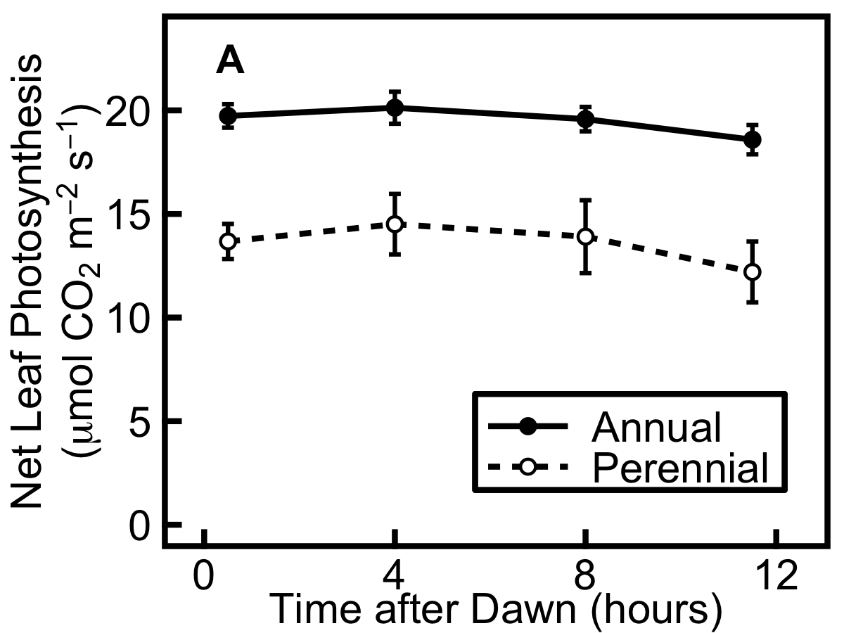
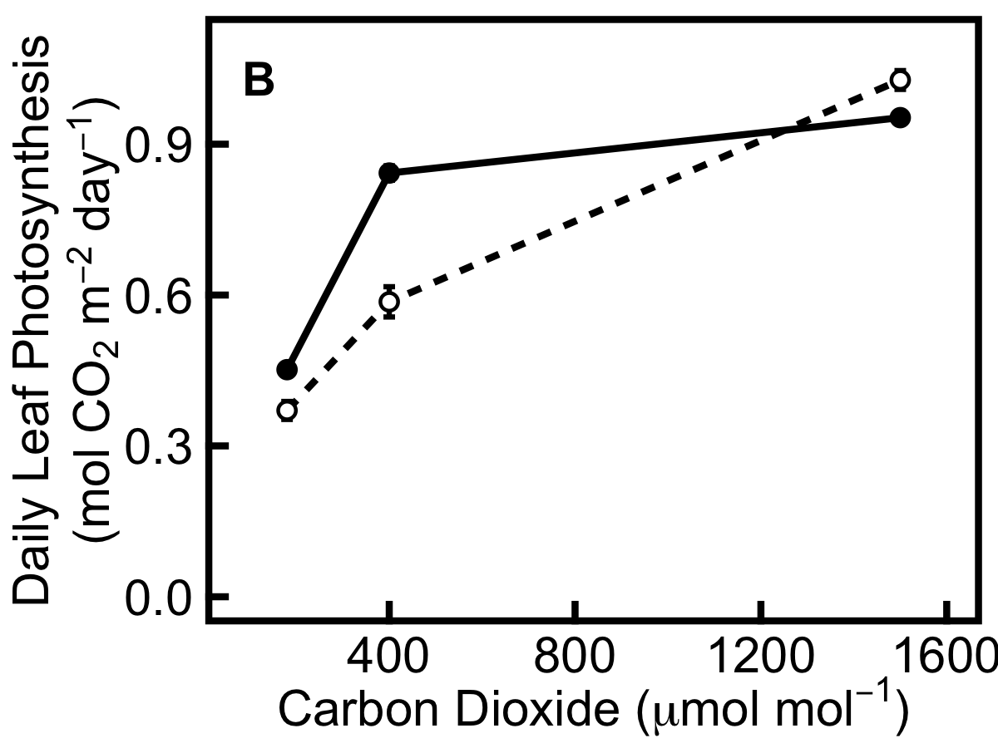
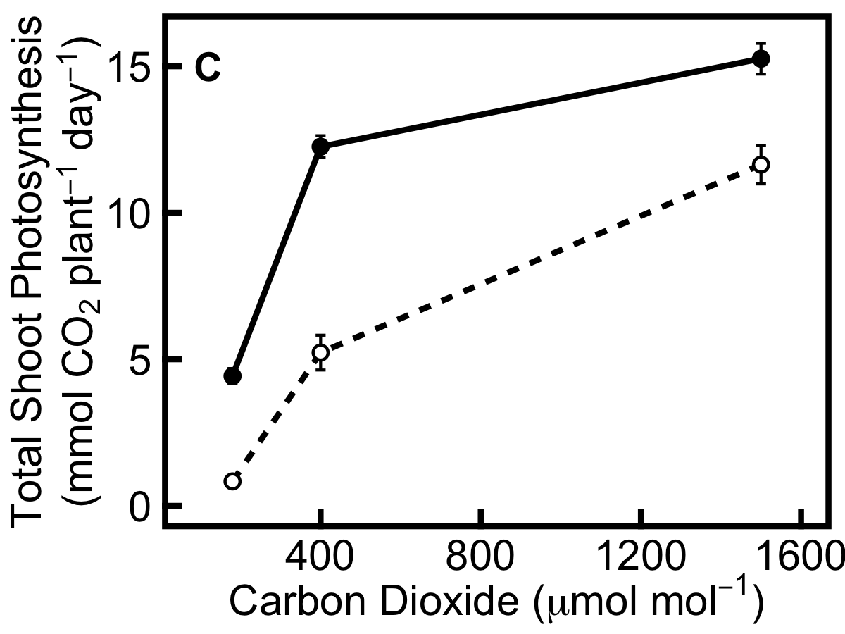
Figure 2. Perennial barley (dashed line) has a more pronounced photosynthetic response to elevated [CO₂] than annual barley (solid line). A, diurnal timecourse of net leaf photosynthesis in annuals and perennials grown at 400 µmol mol⁻¹ CO₂. B, daily rate of net leaf photosynthesis per unit area; C, total daily photosynthesis in the whole shoot, obtained by multiplying the daily rate (B) by projected shoot area. Data show mean ± SE (A: annual n=18, perennial n=9; B: at 180, 400, 1500 µmol mol⁻¹ CO₂, annual n=15, 18, 18, perennial n=5, 9, 12; C: at 180, 400, 1500 µmol mol⁻¹ CO₂, annual n=15, 18, 18, perennial n=4, 9, 12).
The ratio of photosynthesis to growth is higher in the annual than the perennial (Fig. 3), seen in the plots of individuals (Fig. 3A,B) and means (Fig. 3C,D) with a highly significant effect of species: F_{(1,61)} = 25, p<0.001. When expressed in g C g⁻¹ day⁻¹ (Fig. 3A), growth shows three clusters corresponding to the decreasing values of RGR as time progresses over the three harvests. When expressed in g C plant⁻¹ day⁻¹ (Fig. 3B), these clusters are no longer present, and a positive correlation between photosynthesis and growth is seen. The ratio increases with [CO₂] (Fig. 3C) and with plant age at harvest (Fig. 3D). There was a highly significant interaction of the harvest week x [CO₂] (F_{(4,61)} = 16, p<0.001), such that the photosynthesis:growth ratio is greater at higher [CO₂], but this trend becomes less pronounced at later harvests.

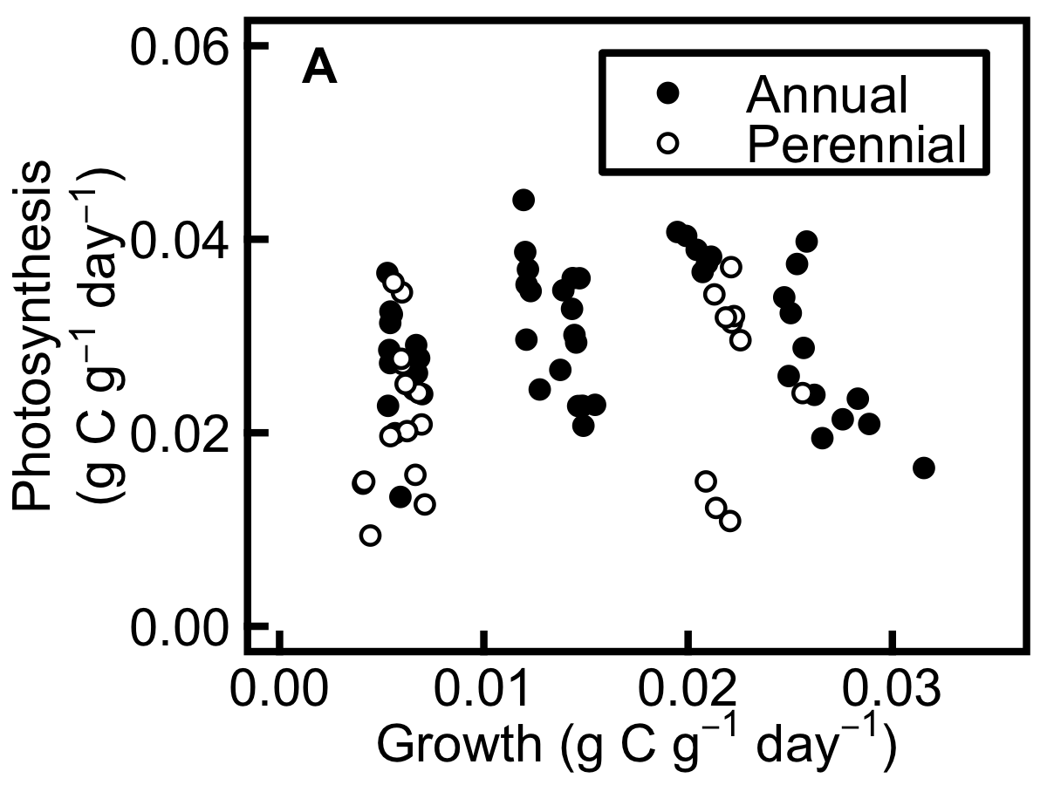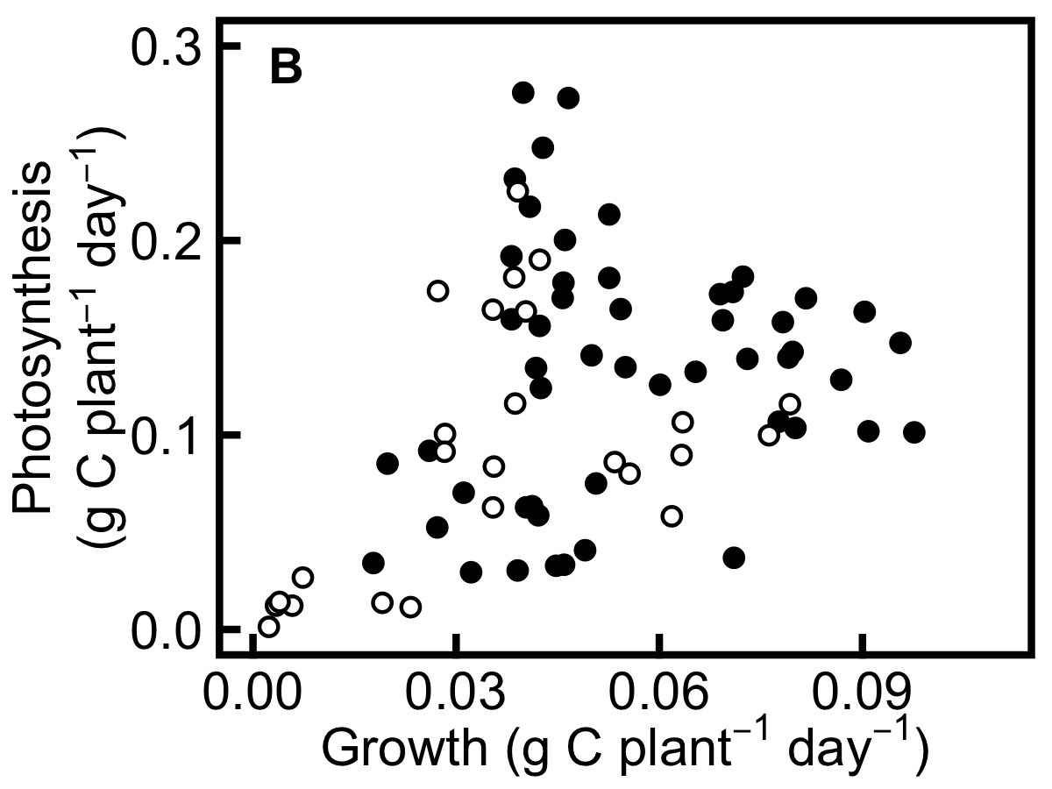

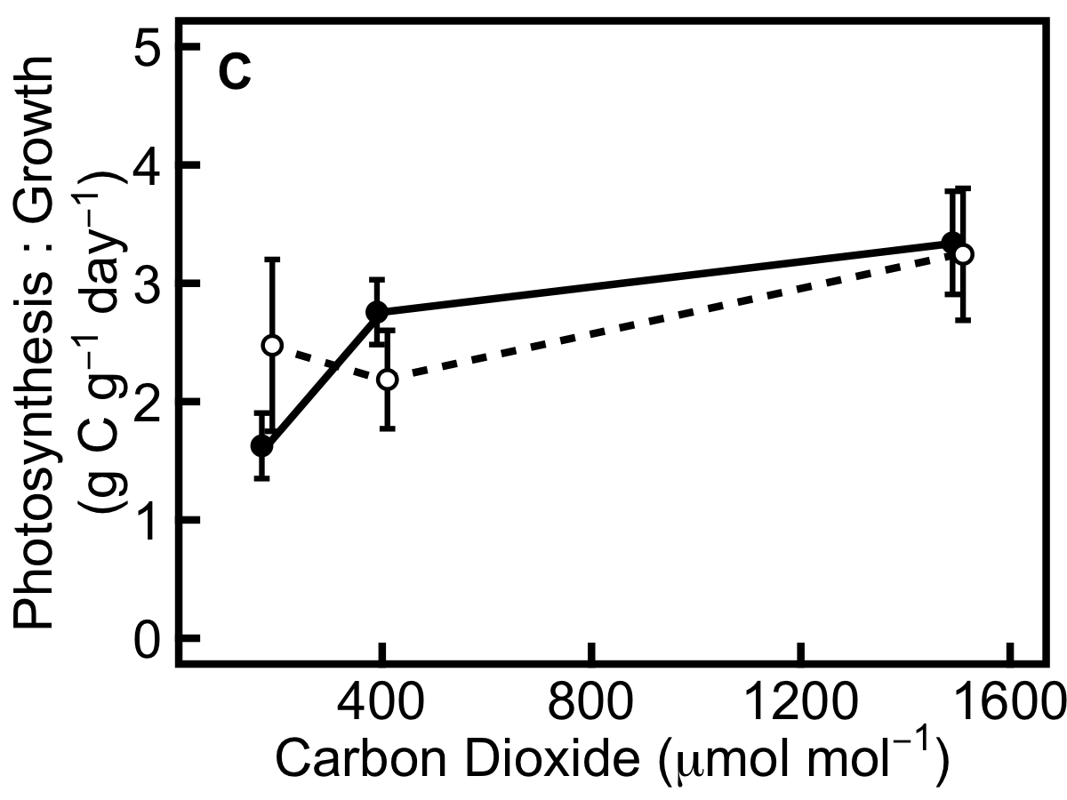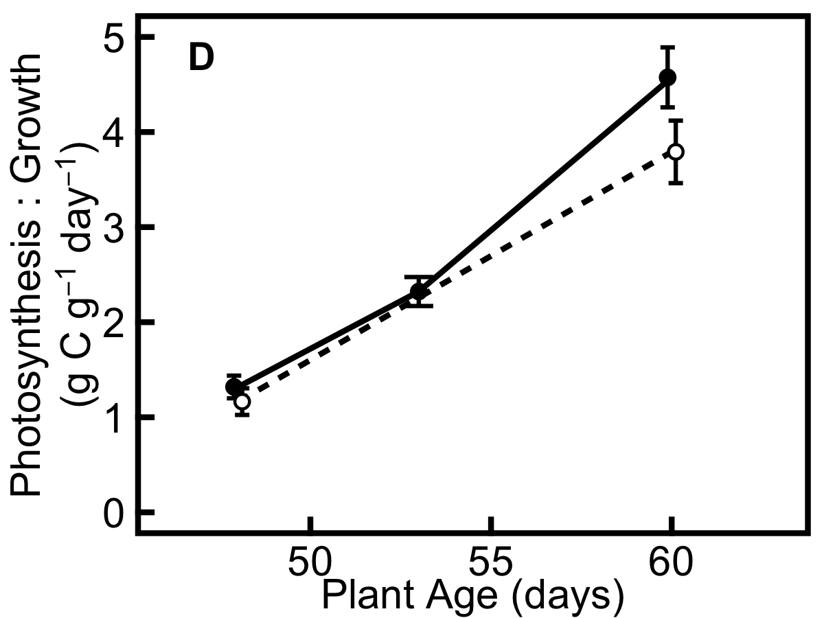
Figure 3. The ratio of photosynthesis to growth is higher in annual than perennial barley and greater at higher [CO₂] and in older plants. A, photosynthesis and growth for individual plants at all times and CO₂ levels, expressed in g C g⁻¹ day⁻¹, showing three clusters along the x-axis corresponding to the three harvest times with RGR decreasing as time progresses; B, photosynthesis and growth for individual plants at all times and CO₂ levels expressed in g C plant⁻¹ day⁻¹; C, photosynthesis:growth ratio in the three [CO₂] treatments; D, changes in the photosynthesis:growth ratio with respect to the mean plant age at harvest. Data show mean ± SE (C and D: at 180, 400, 1500 µmol mol⁻¹ CO₂, annual n=15, 18, 18, perennial n=4, 9, 12).
Annual barley accumulates more non-structural carbohydrates than the perennial species

Plants were harvested for metabolite analysis following the non-invasive measurements of growth and photosynthesis. These harvests were carried out between 47 and 61 days after germination, during the vegetative growth stage. Harvests were carried out immediately before dawn and dusk, enabling the diurnal accumulation of metabolites to be analysed. Plants were separated into leaf, leaf sheath and root, since these represent distinct storage compartments in grasses. Total non-structural carbohydrates (glucose, fructose, sucrose, starch and fructan), protein, free amino acids and free nitrate were measured using a range of enzyme-linked biochemical assays.

Pre-dawn measurements indicate the basal level of carbohydrates in plant organs, when metabolites accumulated during the previous photoperiod have been utilised for respiration, exported or consumed by growth at night. Before dawn, annual barley had a higher concentration of total non-structural carbohydrates (TNC) than the perennial, and showed a greater accumulation of TNC in leaf sheaths and roots when [CO₂] was increased from 180 to 1500 µmol mol⁻¹ (Fig. 4). However, in the leaves, perennial barley showed a stronger TNC response than the annual when [CO₂] was increased from 180 to 1500 µmol mol⁻¹ (Fig. 4). Across all TNC data, there was a significant organ type x time of day x species interaction (F_{(2,120)} = 9.2, p<0.001); a significant organ type x time of day x [CO₂] interaction (F_{(4,120)} = 18, p<0.001); a significant organ x species x [CO₂] interaction (F_{(4,120)} = 22, p<0.001); and a significant organ x harvest week x [CO₂] interaction (F_{(8,120)} = 4.5, p<0.001). In the leaf, TNC was 114% greater in the annual than the perennial at 180 µmol mol⁻¹ CO₂, 57% greater in the annual at 400 µmol mol⁻¹ CO₂, but approximately equal (0.4% greater in the perennial) at 1500 µmol mol⁻¹ CO₂ (Fig. 4A). In the leaf sheath, TNC was 29% greater in the annual than the perennial at 180 µmol mol⁻¹ CO₂, 57% greater in the annual at 400 µmol mol⁻¹ CO₂, and 25% greater in the annual at 1500 µmol mol⁻¹ CO₂ (Fig. 4B). In the root, TNC was 35% greater in the annual than the perennial at 180 µmol mol⁻¹ CO₂, 56% greater in the annual at 400 µmol mol⁻¹ CO₂, and 97% greater in the annual at 1500 µmol mol⁻¹ CO₂ (Fig. 4C). In both species, TNC concentration is highest at 1500 µmol mol⁻¹ CO₂ suggesting that sinks are replete under these conditions.

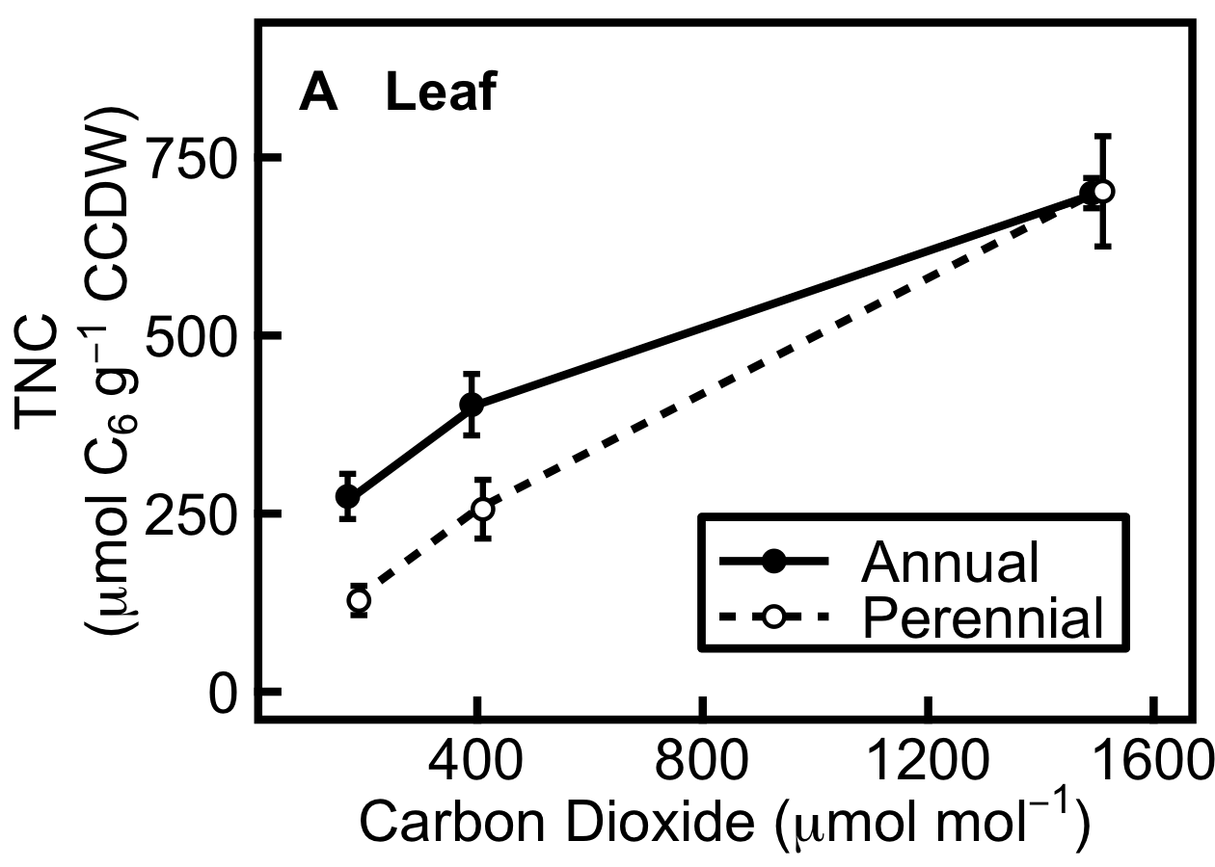
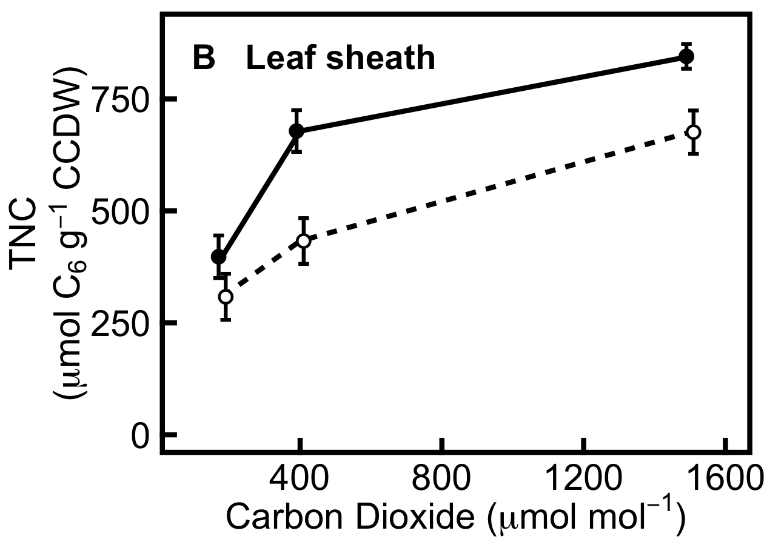
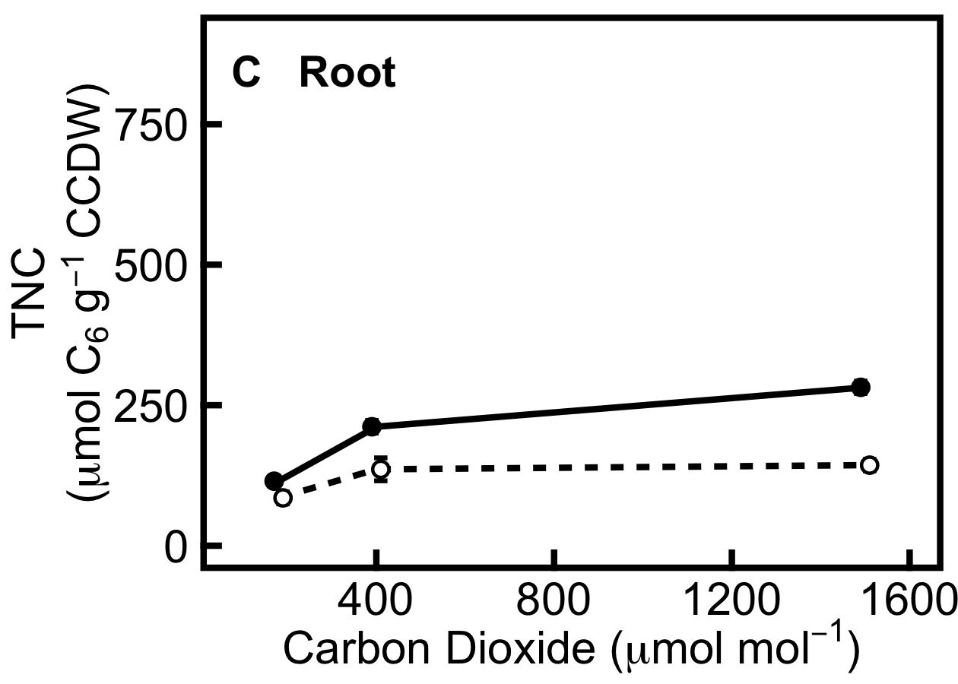

Figure 4. Pre-dawn concentrations of total non-structural carbohydrates (TNC) are higher in the annual (solid line) than perennial (dashed line) barley. A, leaf; B, leaf sheath; C, root. The overall CO₂ response is greater for perennials in the leaf, but greater for annuals in the leaf sheath and root. Data are expressed in µmol glucose equivalents per g carbohydrate-corrected dry weight (CCDW). Data show mean ± SE (annual n=9, perennial n=6).

Subtracting the mean pre-dawn values from the mean pre-dusk values provides a differential of TNC (Fig. 5), which represents the amount of carbon accumulated during the photoperiod, and is equivalent to the amount of carbon available for respiration, export or growth at night. These differentials are much greater in the leaf than in leaf sheath or root (Fig. 5), since diurnal fluctuations of TNC in leaves are more tightly coupled to the diurnal activity of photosynthesis than the distal sinks of leaf sheath and root. The perennial shows a greater TNC differential than the annual in leaves at 400 and 1500 µmol mol⁻¹ CO₂, yet there is little difference in TNC differentials in leaf sheath and root, across the CO₂ concentrations (Fig. 5). Therefore, whilst the basal pre-dawn level of TNC is higher in annuals (Fig. 4), the diurnal accumulation of TNC is greater in perennials for leaves at 400 and 1500 µmol mol⁻¹ CO₂ (Fig. 5).

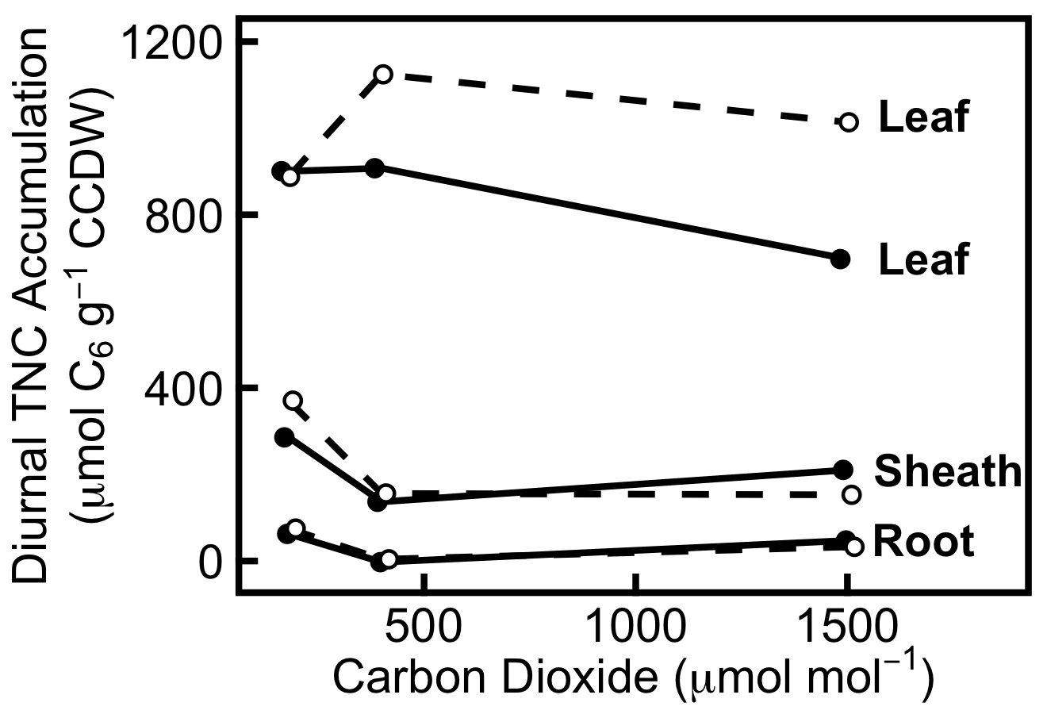

Figure 5. The diurnal accumulation of total non-structural carbohydrates (TNC), equivalent to the carbon pool available for nocturnal use or export in the leaf, leaf sheath and root, in annual barley (solid line) and perennial barley (dashed line). Data show the mean pre-dawn concentrations subtracted from mean pre-dusk concentrations, expressed in µmol glucose equivalents per g carbohydrate-corrected dry weight (CCDW). Different plants were harvested at dawn and dusk, so standard errors cannot be calculated for these data (raw data presented in Table S1).

Perennial barley accumulates more free amino acids than the annual species

Free amino acids are an indicator of source limitation (Paul and Driscoll, 1997; Stitt and Krapp, 1999; Isopp et al., 2000). A high free amino acid concentration or high amino acid:sucrose ratio reflects a surplus of available nitrogen for biosynthesis, since source limited plants lack sufficient carbon to use along with this nitrogen for growth and development. The perennial has a higher leaf concentration of free amino acids than the annual (Fig. 6). In both annual and perennial, free amino acid concentration is highest at 180 µmol mol⁻¹ CO₂, which implies a carbon source limitation, and decreases as [CO₂] increases (Fig. 6). Before dawn, amino acid concentration is 41% greater in the perennial than the annual at 180 µmol mol⁻¹ CO₂, 127% greater in the perennial at 400 µmol mol⁻¹ CO₂, and 12% greater in the perennial at 1500 µmol mol⁻¹ CO₂ (Fig. 6A). Before dusk, amino acid concentration is 67% greater in the perennial than the annual at 180 µmol mol⁻¹ CO₂, 47% greater in the perennial at 400 µmol mol⁻¹ CO₂, and 64% greater in the perennial at 1500 µmol mol⁻¹ CO₂ (Fig. 6B).

There was a highly significant organ x species x [CO₂] interaction for free amino acid concentration: F_{(4,117)} = 9.3, p<0.001. A similar trend for the two species and three CO₂ levels is seen for free nitrate (data shown in summary form in Fig. 8) and there was also a significant organ x species x [CO₂] interaction for these data: F_{(4,116)} = 6.9, p<0.001.

The perennial also has a higher free amino acid:sucrose ratio than the annual (Fig. 7), indicative of carbon source limitation. This ratio is higher pre-dawn since sucrose accumulates during the day. For leaves, there is a significant species x [CO₂] x time of day interaction: F_{(1,70)} = 13, p<0.001.

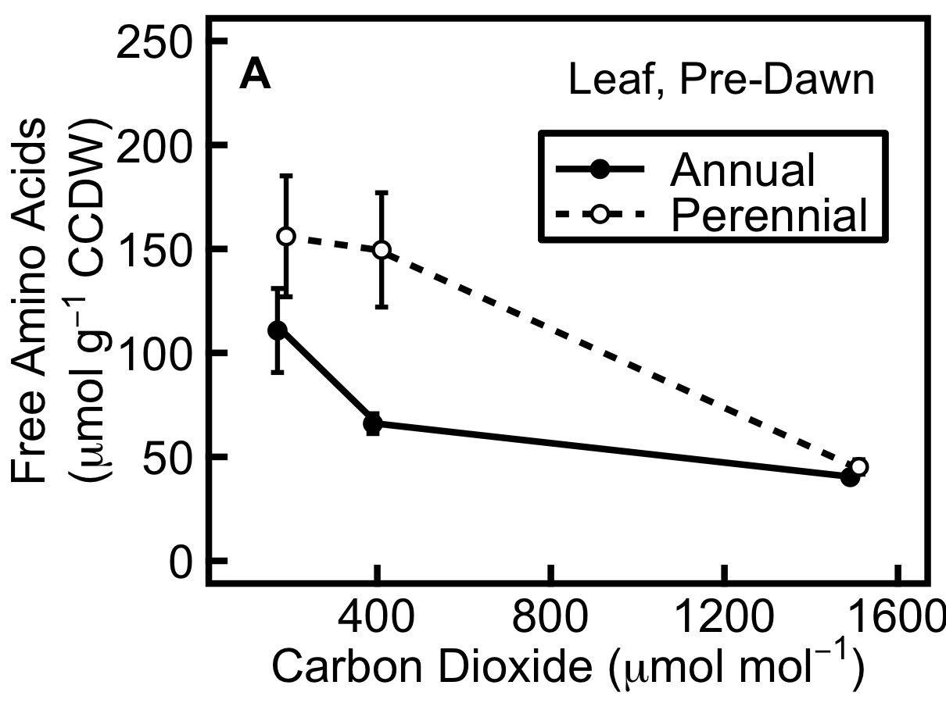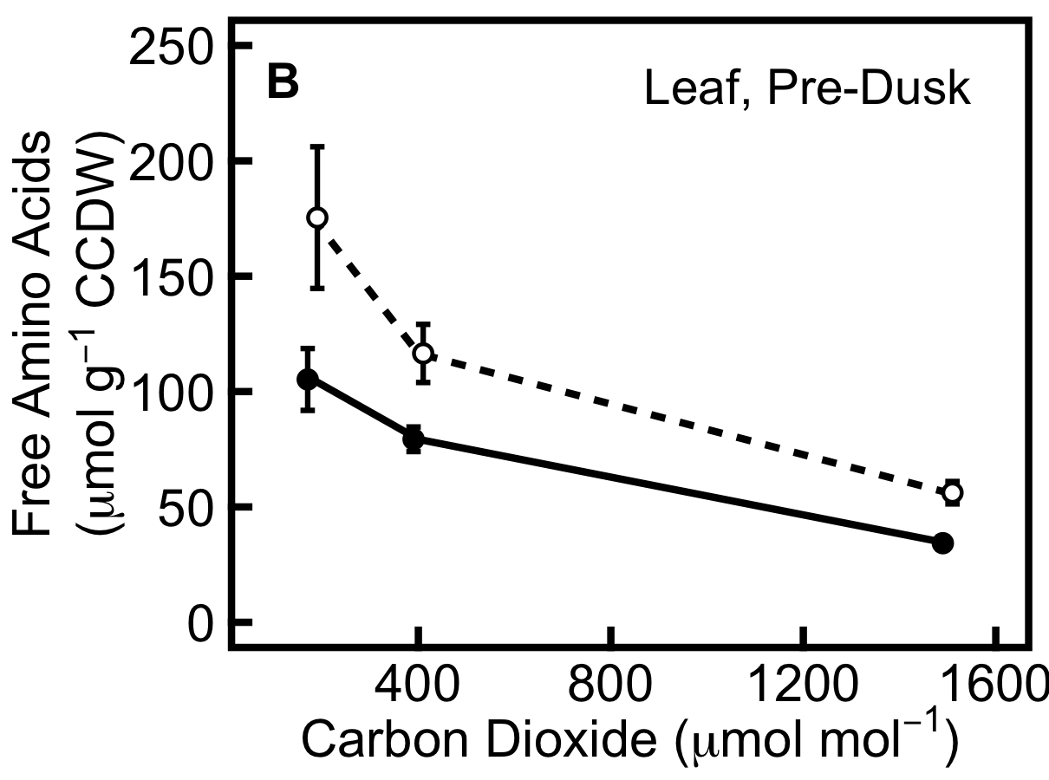

Figure 6. Free amino acid concentration is higher in perennial barley (dashed line) than annual barley (solid line). A, pre-dawn; B, pre-dusk. Data are expressed in µmol amino groups per g carbohydrate-corrected dry weight (CCDW). Data show mean ± SE (annual n=9, perennial n=6).

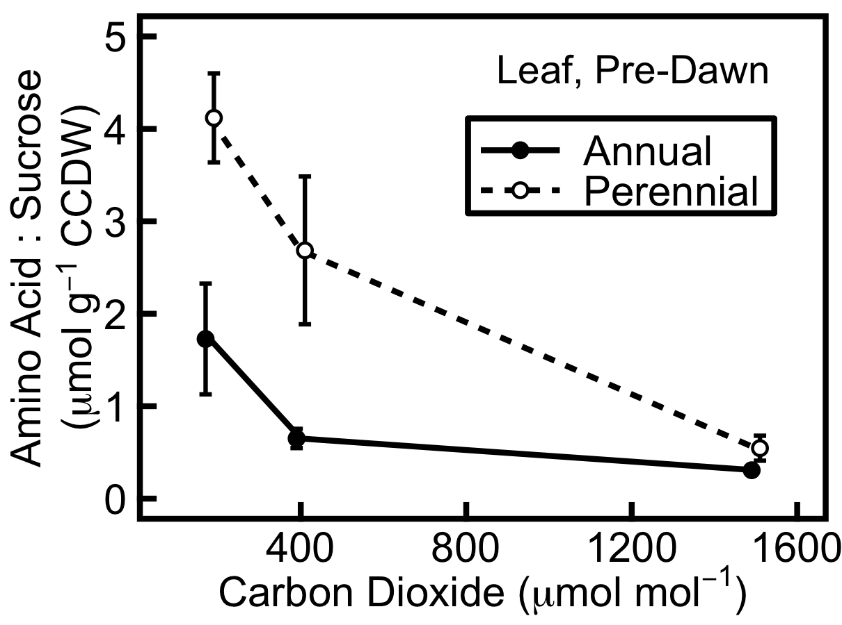

Figure 7. Ratio of free amino acids to free sucrose, an indicator of carbon source limitation, is higher in perennial barley (dashed line) than annual barley (solid line) at 180 and 400 µmol mol⁻¹ CO₂ in leaves pre-dawn. Metabolites are expressed in µmol amino groups and µmol sucrose per g carbohydrate-corrected dry weight (CCDW), respectively. The ratio is lower at higher [CO₂]. Data show mean ± SE (annual n=9, perennial n=6).

DISCUSSION

Developmental plasticity in the perennial enables extra CO₂ to be utilised in growth, suggesting source limitation

Increasing [CO₂] increases the availability of photosynthetic substrate and suppresses photorespiration (Farquhar et al., 1980). This increases the potential rate of carbon uptake into the plant, increasing source strength, alleviating source limitation, and increasing the source:sink ratio. Conversely, decreasing [CO₂] has the opposite effects. The stronger photosynthetic, tillering and root partitioning responses of perennial than annual barley to increasing [CO₂] (Table 1; Fig. 2) suggest that the source is more limiting for growth than the sink in this species during the vegetative stage. This response is not seen to such a great extent in the annual, which shows much smaller increases in photosynthesis, tillering and root partitioning as CO₂ levels increase. This suggests that growth in the annual is primarily sink limited, constrained by developmental potential, and that it is operating at near-maximum source activity under current ambient conditions (400 µmol mol⁻¹ CO₂). The ratio of photosynthesis to growth is higher in annual than perennial barley (Fig. 3), a further indication of sink limitation. Photosynthesis:growth is greater at higher [CO₂] in both species (Fig. 3C), indicating sink limitation at elevated [CO₂], and as plants become older and leave the exponential phase of growth (Fig. 3D).

The developmental plasticity seen in the perennial, via its ability to increase tillering and root partitioning in response to a greater carbon source strength, suggests that it is better able than the domesticated annual crop to adapt to fluctuating environmental conditions. In general, selective breeding of crops has resulted in plants with fewer tillers because, although additional non-flowering tillers provide a selective advantage through competition in wild plants, they reduce the yield of crop stands by diverting resources away from flowering tillers. To an extent, domesticated barley has retained its tillering capacity (Doust, 2007; Sang, 2009). However, under experimental conditions, the perennial barley increased tillering in response to increased [CO₂] far more readily than the annual crop.

Altering the root:shoot ratio enables plants to increase access to the most limiting resources by adjusting allocation to nitrogen- or carbon-acquiring tissues (Stitt and Krapp, 1999; Freschet et al., 2015). Under elevated [CO₂], nitrogen becomes more limiting for growth, making an increase in root:shoot ratio advantageous. The perennial was better able to make this plastic adjustment to growth (Table 1). However, its greater relative increase in allocation to roots (Table 1) would have also tended to offset its growth response, since roots are heterotrophic and root respiration represents a significant carbon sink. Despite this, the perennial still showed a similar increase in RGR to the annual (Fig. 1). In combination, these results suggest that the combined response of sink strength (growth and respiration) to [CO₂] was stronger in the perennial than annual. Increasing root allocation enabled the perennial to take up more nitrogen, further increasing its ability to match carbon skeletons with amino acids for growth.

Our findings suggest a more opportunistic growth strategy in the perennial than annual, whereby the use of additional resources is maximised via partitioning into more branches above ground and roots below ground. In contrast, the annual appears to be highly constrained in its ability to develop larger sinks at 400 µmol mol⁻¹ CO₂ (Table 1; Fig. 2), and unable to increase these to the same extent as the perennial. Although the annual has a higher rate of photosynthesis at 400 µmol mol⁻¹ compared to 180 µmol mol⁻¹ (Fig 2B), it does not show an increase at 1500 µmol mol⁻¹ compared to 180 µmol mol⁻¹, suggesting a downregulation of Rubisco amount or activity due to sink limitation. A/C_{i} curves (Fig. S3) show that whilst the perennial has a constant V_{c,max} at 400 and 1500 µmol mol⁻¹ CO₂, the annual shows a decrease in V_{c,max} as CO₂ increases from 180 through to 1500 µmol mol⁻¹ CO₂, meeting the lower V_{c,max} of the perennial at 1500 µmol mol⁻¹ CO₂ (Fig. S3A). This indicates acclimation of photosynthetic capacity in the annual at elevated [CO₂], due to an exacerbation of existing sink limitation by the CO₂ treatment. It thus seems that the strategy of the annual is for maximal growth under current [CO₂] – and as a result it is sink limited. The annual has been subjected to intense selective breeding that has maximised growth under current ambient CO₂ conditions, but suppressed its developmental plasticity, and growth during the vegetative phase is largely unresponsive to increased [CO₂].

The annual accumulates carbohydrates whilst having low amino acids, suggesting carbon sink limitation

Figure 8 illustrates the metabolite data, expressed as ratios: at 180 µmol mol⁻¹ CO₂ relative to 400 µmol mol⁻¹ (“Low Carbon Dioxide” Fig. 8) and at 1500 µmol mol⁻¹ CO₂ relative to 400 µmol mol⁻¹ (“High Carbon Dioxide” Fig. 8), in each compartment (leaf, sheath and root), for each species and time of day (raw data may be found in Table S1). In general, the amount of each non-structural carbohydrate (glucose, fructose, sucrose, starch and fructan) was lower at 180 µmol mol⁻¹ and higher at 1500 µmol mol⁻¹, compared to 400 µmol mol⁻¹ CO₂ (Fig. 8). Short- and long-chain fructans represent the major stores for carbon at 1500 µmol mol⁻¹ CO₂ in both species (Fig. 8). In contrast, free nitrate, free amino acid and protein levels tended to show the opposite trend (especially for the annual, Fig. 8A,B).

Figure 8 further illustrates the pattern of source limitation in the perennial and sink limitation in the annual seen in the growth and photosynthesis data. At 400 µmol mol⁻¹, growth in the annual shows strong evidence of sink limitation, shown by a high rate of photosynthesis (Fig. 2), high TNC accumulation (Fig. 4) and low amino acid concentration and amino acid:sucrose ratio – indicating that there are sufficient carbon skeletons available for utilisation of the available amino acid supply (Figs. 6, 7). At 180 µmol mol⁻¹ CO₂, growth becomes more source limited, with lower carbohydrate and higher nitrate and amino acid concentrations compared to 400 µmol mol⁻¹ (Figs. 4, 6, 8A,B). At 1500 µmol mol⁻¹ CO₂, growth becomes more sink limited, with higher carbohydrate and lower nitrate and lower amino acid concentrations (Figs. 4, 6, 8A,B). This trend
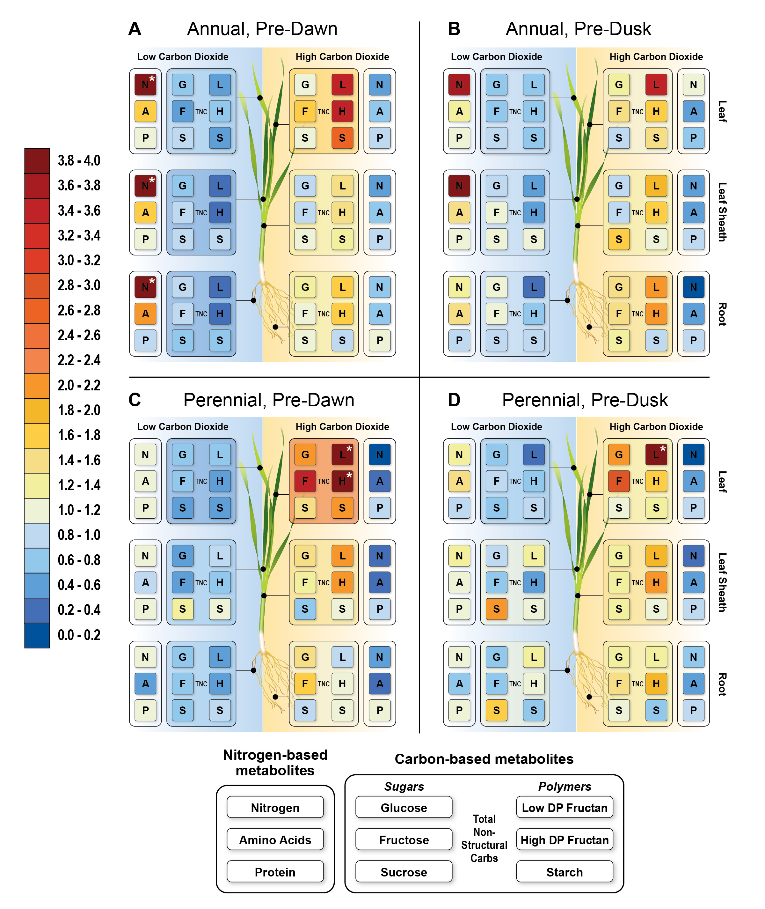
Figure 8. Carbon- and nitrogen-based metabolites in annual and perennial barley at pre-dawn and pre-dusk harvests. Data are ratios of metabolite concentrations in leaf, leaf sheath and root of annual and perennial barley at 180 relative to 400 µmol mol⁻¹ CO₂, and 1500 relative to 400 µmol mol⁻¹ CO₂. Blue denotes a decrease and orange/red an increase compared to 400 µmol mol⁻¹, according to the colour scale on the left; a ratio of 1 signifies no change. Low and high DP refer to the degree of polymerisation in short- and long-chain fructans respectively. A, Annual pre-dawn; B, Annual pre-dusk; C, Perennial pre-dawn; D, Perennial pre-dusk. Exceptionally high ratios, indicated by asterisks, are as follows: annual pre-dawn (A) at 180 µmol mol⁻¹ CO₂, nitrate in leaf is 6.5x concentration at 400 µmol mol⁻¹, nitrate in leaf sheath is 7.7x concentration at 400 µmol mol⁻¹ and nitrate in root is 5.5x concentration at 400 µmol mol⁻¹; perennial pre-dawn (C), in leaf at 1500 µmol mol⁻¹ CO₂, low DP fructan is 23.4x concentration at 400 µmol mol⁻¹ and high DP fructan is 6.3x concentration at 400 µmol mol⁻¹; perennial pre-dusk (D), in leaf at 1500 µmol mol⁻¹ CO₂, low DP fructan is 4.8x concentration at 400 µmol mol⁻¹.

is seen at both times of day, but is most pronounced before dawn (Figs. 8A,B), since carbon skeletons and reductants from photosynthesis are required to incorporate free nitrate into amino acids and to assimilate amino acids into proteins. As a result, the levels of these metabolites decrease during the day as carbohydrates build up. Although this trend is seen in all organ types, it is most pronounced in leaves, where photosynthesis is strongly coupled to changes in carbon and nitrogen metabolism.

At 400 µmol mol⁻¹, the perennial shows strong evidence of source limitation, having a lower rate of photosynthesis than the annual (Fig. 2), low TNC accumulation (Fig. 4) and high amino acid concentrations and amino acid:sucrose ratio (Figs. 6, 7). At 180 µmol mol⁻¹ CO₂, the perennial remains source limited, so levels of free nitrate and amino acids generally do not increase relative to 400 µmol mol⁻¹ (Fig. 8C,D). Just as the perennial shows a greater response of tillering and root allocation (Table 1) and photosynthesis (Fig. 2B) than the annual between 400 and 1500 µmol mol⁻¹ CO₂, as this alleviates source limitation, it also shows a more dramatic decrease in free amino acids and amino acid:sucrose (Figs. 6, 7) as it is better able than the annual to pair additional sugars from photosynthesis with existing free amino acids to bring about a growth response. However at 1500 µmol mol⁻¹, growth in the perennial transitions to become sink limited, and the plants have a high carbohydrate content, and low nitrate and low amino acid concentrations (Figs. 4, 6, 8A,B). Thus the treatments imposed are sufficiently strong that even the annual becomes more source limited at low [CO₂], and even the perennial becomes more sink limited at elevated [CO₂].

Total non-structural carbohydrate concentrations are higher in the annual than in the perennial in all organs and at all CO₂ levels except in leaves at 1500 µmol mol⁻¹ CO₂ (Fig. 4). This provides further evidence that growth in the annual is more limited by the sink than by the source, since it is accumulating carbohydrates rather than using them for growth. At 1500 µmol mol⁻¹ CO₂, both annual and perennial are sink limited, leading to a high basal level of TNC in the photosynthetic organs (leaf and leaf sheath). Accumulation of fructan, a key store for surplus photosynthate during the vegetative growth stage in barley (Schnyder, 1993), is particularly high compared to other metabolites under elevated [CO₂] in both species (Fig. 8). Leaf sucrose is a key driver of phloem loading for photosynthate export (Ainsworth and Bush, 2011). However, the increase in TNC at elevated [CO₂] seen here is primarily driven by increases in storage carbohydrates (fructans and starch, Fig. 8) and not transport carbohydrates (sucrose). This provides evidence that the carbohydrate accumulation at elevated [CO₂] is indicative of sink limitation rather than a reflection of increased phloem loading of recent photosynthate. Indeed, the increased accumulation of carbohydrates will feed back on phloem transport throughout the plant and phloem loading in the leaf (Ainsworth and Bush, 2011), and high foliar TNC concentration is thus an indicator of sink limitation in both species, whilst the fact that TNC does not accumulate in roots under elevated CO₂ in the perennial suggests that carbon transport may be more limiting in this species.

The pre-dawn leaf TNC concentrations are consistent with the pattern seen in photosynthesis. At 1500 µmol mol⁻¹ CO₂, photosynthetic rate per unit leaf area and leaf TNC concentration are the same in annual and perennial barley. Although the perennial displays a greater response to [CO₂] for these parameters, the total rate of photosynthesis and the total concentration of TNC never exceed those of the annual. This implies physiological or developmental limits that are common to both species – the annual is unable to utilise more photosynthate than it acquires at 400 µmol mol⁻¹ CO₂, by increasing partitioning to tillers and roots. In contrast, the perennial is able to utilise the additional photosynthate acquired at the highest CO₂ concentration, but never exceeds the maximum rates of growth and photosynthesis seen in the annual (Figs. 1, 2, S3). This suggests that, whilst the perennial has greater developmental flexibility, its intrinsic capacities for photosynthesis and growth are no greater than those of the annual.

The daily accumulation of TNC in leaf organs is greater in the perennial than in the annual at 400 and 1500 µmol mol⁻¹ CO₂ (Fig. 5), although the perennial has a lower basal level of TNC (Fig. 4). This low basal level suggests that the perennial is highly efficient at utilising the carbon acquired each day – by developing new sinks or enlarging existing ones, seen in the strong tillering response to elevated [CO₂] (Table 1), or by increasing TNC storage in the leaf sheath (Fig. 4). Developing new sinks such as tillers increases sink size, whilst increasing storage in existing sink organs increases sink activity; both enable the plant to upregulate its sink capacity (Geiger and Shieh, 1993; White et al., 2016). The high rate of tillering translates to a higher sink capacity and high demand for photosynthate which could explain the high accumulation of carbohydrates in these organs.

Ecological strategies

The typical growth strategy of wild annual plants can be caricatured as ‘live fast, die young’, leading to the expectation of a growth strategy that is primarily source limited during the lifetime of the plant, and that enables the annual to maximise the use of available CO₂ for growth. We therefore expected the annual to be less sink limited than the perennial during vegetative growth, especially since it is adapted for fertilised soils. In contrast, we expected the perennial to have a more conservative growth habit, ‘live slow, live long’, which limits photosynthesis and growth but is opportunistic, being better adapted for the possibility of low nutrients in a variable environment yet able to capitalise on rising [CO₂] by increasing storage when substrates are available.

Although plants are typically sink limited during the vegetative stage and transition to source limitation at reproduction (Arp, 1991), many crops are co-limited by sinks and sources during grain-filling (Álvaro et al., 2008; Acreche and Slafer, 2009; Peterhansel and Offermann, 2012; Slewinski, 2012). We anticipated that during the vegetative stage, the ‘live slow’ perennial would be more sink limited than the ‘live fast’ annual (Jaikumar et al., 2014). The results confounded these expectations.

The perennial adopts more of a ‘live fast’ strategy than anticipated; perennials generally store carbon for future use (Atkinson et al., 2012), yet here the perennial showed a dramatic increase in growth under elevated [CO₂] rather than an increase in storage, indicating source limitation. Coming from a fluctuating natural environment, and being able to grow in a variety of habitats including roadsides, ditches and rich grassy meadows and at varying altitudes (von Bothmer, 1996), the wild perennial has the plasticity to maximise growth when CO₂ is abundant. However, a perennial confined to unproductive habitats might be expected to display slower growth and greater sink limitation.

In contrast, the developmental plasticity of the annual appears to have been altered through selective breeding such that it cannot adapt to live faster when conditions allow and the results of this study show that it is sink limited during vegetative growth, in addition to being sink limited during reproduction (Schnyder, 1993; Bingham et al., 2007; Serrago et al., 2013). This suggests that the annual would remain sink limited in the reproductive stage even under elevated [CO₂], and its limited developmental plasticity seen in the low [CO₂] responses of tillering and root allocation would be mirrored in a poor ability to create sufficient grain sinks to efficiently utilise additional carbon resources under elevated [CO₂]. If this were the case, it would be important in the current global context of rising atmospheric [CO₂], since the sink strength of barley would limit yield of this important crop, and a concerted effort to increase sink strength would be a vital part of breeding programmes in order to increase yield.

CONCLUSIONS

Contrary to expectations that the fast-growing annual would be less sink limited and show a greater increase in growth and photosynthesis in response to elevated [CO₂], and that the slow-growing perennial would be more sink limited, the results of this study suggest that annual barley is more sink limited and perennial barley is more source limited during the vegetative growth stage. Our findings thus suggest that annual barley germplasm is optimised for growth at current [CO₂] and that future elevated [CO₂] is unlikely to facilitate yield increases in this species. The lack of developmental plasticity in the annual means that new sinks are not readily initiated, which could result in a critical lack of flexibility for developing additional grain sinks and thus increasing yield under elevated [CO₂]. The holistic approach taken here enables a broad view of the carbon source-sink balance to be taken, encompassing measurements of resource acquisition, storage, and allocation to growth, in a model system of congeneric species. In order to draw firm conclusions of agricultural relevance, it will be vital to extend such research: including nitrogen as well as carbon source-sink manipulations, following source-sink processes throughout crop development to their impact on yield; investigating these processes in a wider range of cereal varieties and wild species; and carrying out agronomically relevant experiments in the field.

SUPPLEMENTARY MATERIAL

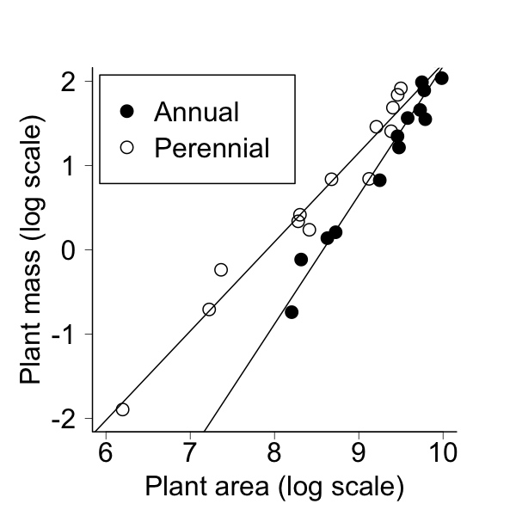

Figure S1. Log mass against log area, for the additional subset of annual and perennial barley plants harvested throughout the duration of the study in order to establish a calibration between mass and area for the plants in the main study. r² = 0.97, meaning that differences in species and plant area account for 97% of variation in plant mass. Lines show linear regression of area and mass. Log mass = 1.53 log area – 13.11 (annual); log mass = 1.06 log area – 8.37 (perennial).

Figure S2. Growth curves for all individuals in the main study used to obtain relative growth rate. Log predicted mass, obtained using mass-area calibration from additional plants (shown in Fig. S1), is plotted against plant age. Blue lines show the overall mean using fixed effects from model; pink lines show growth curves for individual plants. Each plant has a unique ID: A denotes annual individuals and PM and PE denote the two accessions of perennial individuals; numbers were assigned to individuals at random.

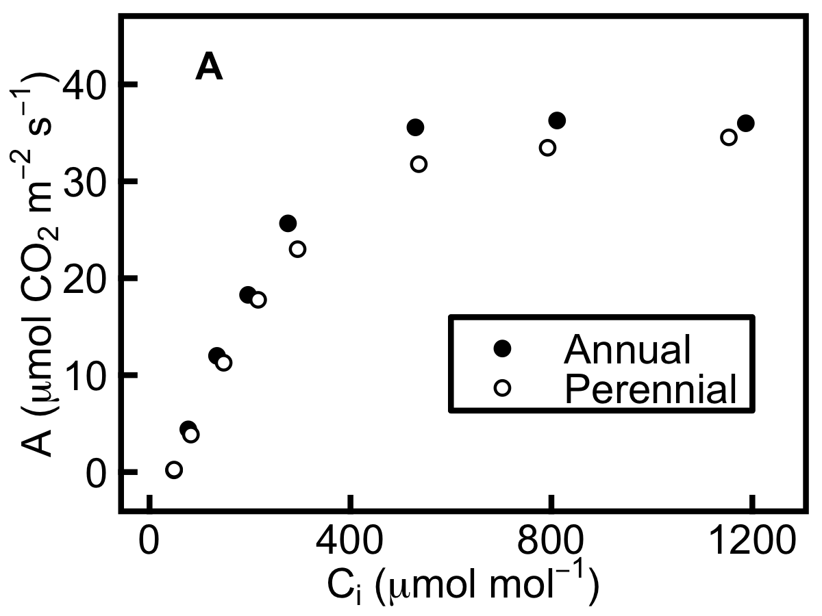
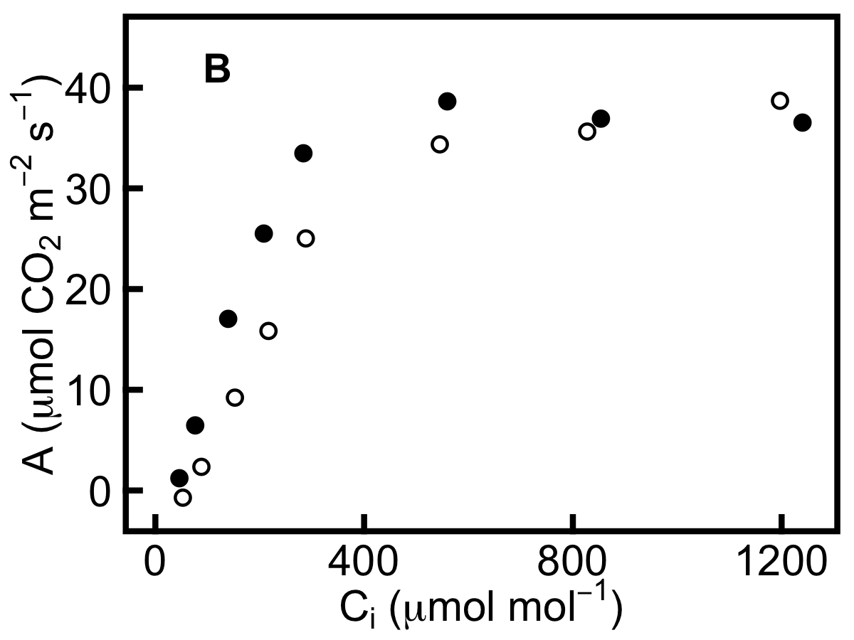

Figure S3. A/C_{i} curves for four individual plants, performed 54 days after germination. The carboxylation efficiency of Rubisco (V_{c,max}, proportional to the initial slope of the curve) is downregulated in the annual at 1500 µmol mol⁻¹ compared to 400 µmol mol⁻¹, whilst remaining constant in the perennial. Curves are representative of a larger dataset. Growth conditions are as follows. A, elevated CO₂: 1500 µmol mol⁻¹; B, current CO₂: 400 µmol mol⁻¹. A/C_{i} curves were performed on 15 individuals, but here representative curves are shown.

Table S1. Raw metabolite data used to produce Figs. 4, 5, 6, 7, 8.
Plant Number | Accession Code | Species | Harvest Week | Time of Harvest | CO₂ | Organ | Harvest Age | Starch | HDP Fructan | Glucose | Fructose | Sucrose | LDP Fructan | Amino Acids | Nitrate | Protein
 |  |  |  |  | μmol mol⁻¹ |  | days | nmol Glucose equivalents mg⁻¹ carbohydrate-corrected dry weight (CCDW) |  |  |  |  |  | nmol mg⁻¹ CCDW |  | μg mg⁻¹ CCDW
3 | a | annual | 3 | Pre-Dawn | 400 | leaf | 59 | 83.0 | 12.7 | 28.3 | 42.2 | 253.2 | 55.1 | 58.8 | 7.4 | 201.6
3 | a | annual | 3 | Pre-Dawn | 400 | root | 59 | 10.7 | 45.2 | 10.8 | 33.9 | 110.2 | 65.4 | 25.6 | 37.5 | 134.5
3 | a | annual | 3 | Pre-Dawn | 400 | leaf sheath | 59 | 48.4 | 145.2 | 177.1 | 123.2 | 83.5 | 300.8 | 125.2 | 16.6 | 115.7
4 | a | annual | 2 | Pre-Dawn | 400 | leaf | 54 | 35.9 | 4.8 | 25.5 | 31.1 | 191.0 | 23.5 | 46.1 | 15.8 | 200.8
4 | a | annual | 2 | Pre-Dawn | 400 | root | 54 | 4.2 | 35.1 | 4.9 | 16.5 | 93.2 | 43.1 | 20.9 | 247.1 | 134.1
4 | a | annual | 2 | Pre-Dawn | 400 | leaf sheath | 54 | 21.5 | 129.6 | 194.7 | 114.7 | 57.9 | 178.4 | 115.3 | 53.5 | 118.1
5 | a | annual | 2 | Pre-Dusk | 400 | leaf | 54 | 183.8 | 29.2 | 44.2 | 38.1 | 1056.3 | 24.6 | 102.7 | 39.0 | 216.7
5 | a | annual | 2 | Pre-Dusk | 400 | root | 54 | 6.2 | 22.1 | 9.1 | 23.2 | 121.2 | 25.6 | 32.4 | 673.4 | 147.6
5 | a | annual | 2 | Pre-Dusk | 400 | leaf sheath | 54 | 67.2 | 91.1 | 243.1 | 146.0 | 114.1 | 88.5 | 181.9 | 486.4 | 121.0
6 | a | annual | 1 | Pre-Dawn | 400 | leaf | 48 | 91.9 | 19.0 | 46.3 | 53.3 | 366.4 | 90.3 | 57.0 | 143.2 | 192.7
6 | a | annual | 1 | Pre-Dawn | 400 | root | 48 | 3.3 | 37.9 | 7.8 | 25.1 | 95.3 | 58.5 | 18.7 | 30.8 | 142.8
6 | a | annual | 1 | Pre-Dawn | 400 | leaf sheath | 48 | 43.0 | 122.6 | 220.6 | 175.9 | 2.7 | 185.3 | 157.2 | 162.8 | 107.3
7 | a | annual | 1 | Pre-Dusk | 400 | leaf | 48 | 172.2 | 45.3 | 46.8 | 47.3 | 1004.3 | 41.5 | 69.3 | 2.0 | 193.2
7 | a | annual | 1 | Pre-Dusk | 400 | root | 48 | 2.2 | 32.8 | 7.7 | 24.4 | 125.1 | 43.6 | 19.0 | 58.0 | 132.2
7 | a | annual | 1 | Pre-Dusk | 400 | leaf sheath | 48 | 73.0 | 100.4 | 225.4 | 131.1 | 133.2 | 203.6 | 141.1 | 50.5 | 113.6
8 | a | annual | 3 | Pre-Dawn | 400 | leaf | 59 | 60.4 | 15.0 | 39.1 | 39.2 | 254.1 | 25.8 | 59.4 | 1.1 | 205.8
8 | a | annual | 3 | Pre-Dawn | 400 | root | 59 | 9.8 | 23.0 | 7.3 | 19.7 | 86.5 | 50.6 | 19.7 | 32.3 | 149.1
8 | a | annual | 3 | Pre-Dawn | 400 | leaf sheath | 59 | 34.1 | 126.8 | 184.2 | 131.8 | 39.8 | 229.7 | 133.8 | 14.1 | 123.4
9 | a | annual | 1 | Pre-Dusk | 400 | leaf | 48 | 197.2 | 35.5 | 53.8 | 42.3 | 1079.0 | 52.4 | 78.3 | 5.6 | 201.2
9 | a | annual | 1 | Pre-Dusk | 400 | root | 48 | 5.6 | 28.8 | 10.8 | 33.1 | 75.2 | 51.3 | 23.9 | 66.8 | 130.3
9 | a | annual | 1 | Pre-Dusk | 400 | leaf sheath | 48 | 78.1 | 84.3 | 272.8 | 167.8 | 135.7 | 198.8 | 182.1 | 491.5 | 118.8
14 | a | annual | 2 | Pre-Dawn | 400 | leaf | 54 | 24.9 | 9.7 | 23.6 | 18.4 | 146.2 | 18.0 | 88.8 | 26.1 | 203.5
14 | a | annual | 2 | Pre-Dawn | 400 | root | 54 | 5.9 | 27.9 | 5.5 | 11.6 | 104.1 | 18.5 | 54.3 | 57.7 | 147.5
14 | a | annual | 2 | Pre-Dawn | 400 | leaf sheath | 54 | 37.8 | 66.5 | 153.0 | 140.3 |  | 51.9 | 226.4 | 330.1 | 124.4
15 | a | annual | 2 | Pre-Dawn | 400 | leaf | 54 | 32.6 | 7.4 | 41.5 | 21.4 | 160.3 | 12.6 | 87.8 | 58.5 | 207.3
15 | a | annual | 2 | Pre-Dawn | 400 | root | 54 | 9.0 | 27.3 | 6.0 | 15.5 | 88.2 | 26.1 | 40.9 | 114.9 | 119.1
15 | a | annual | 2 | Pre-Dawn | 400 | leaf sheath | 54 | 35.7 | 110.5 | 162.0 | 125.8 |  | 108.7 | 167.7 | 108.3 | 119.6
23 | a | annual | 3 | Pre-Dusk | 400 | leaf | 59 | 177.9 | 26.8 | 57.1 | 52.4 | 1012.1 | 28.2 | 62.6 | 11.7 | 204.1
23 | a | annual | 3 | Pre-Dusk | 400 | root | 59 | 7.2 | 32.6 | 7.7 | 26.1 | 111.6 | 41.8 | 19.7 | 29.3 | 137.8
23 | a | annual | 3 | Pre-Dusk | 400 | leaf sheath | 59 | 60.3 | 93.5 | 245.4 | 128.6 | 148.5 | 232.5 | 148.8 | 82.8 | 120.3
25 | a | annual | 2 | Pre-Dusk | 400 | leaf | 54 | 179.9 | 28.7 | 56.9 | 13.7 | 946.0 | 17.0 | 99.6 | 62.2 | 218.2
25 | a | annual | 2 | Pre-Dusk | 400 | root | 54 | 4.0 | 16.8 | 9.4 | 19.6 | 136.9 | 27.9 | 51.1 | 98.6 | 159.6
25 | a | annual | 2 | Pre-Dusk | 400 | leaf sheath | 54 | 55.7 | 99.4 | 203.7 | 125.4 | 19.1 | 105.5 | 173.0 | 67.7 | 119.4
26 | a | annual | 3 | Pre-Dusk | 400 | leaf | 59 | 175.5 | 38.0 | 51.8 | 49.3 | 899.6 | 31.6 | 66.5 |  | 209.4
26 | a | annual | 3 | Pre-Dusk | 400 | root | 59 | 4.1 | 33.1 | 8.6 | 23.2 | 106.0 | 41.4 | 21.1 | 196.6 | 132.9
26 | a | annual | 3 | Pre-Dusk | 400 | leaf sheath | 59 | 59.1 | 114.4 | 217.4 | 118.2 | 185.5 | 255.6 | 124.6 | 18.3 | 123.3
28 | a | annual | 1 | Pre-Dawn | 400 | leaf | 48 | 53.9 | 11.1 | 33.3 | 23.0 | 247.0 | 31.9 | 70.5 | 8.7 | 206.7
28 | a | annual | 1 | Pre-Dawn | 400 | root | 48 | 5.7 | 26.5 | 5.2 | 16.3 | 93.2 | 47.1 | 22.8 | 57.7 | 147.6
28 | a | annual | 1 | Pre-Dawn | 400 | leaf sheath | 48 | 48.0 | 93.4 | 189.3 | 143.6 | 118.8 | 200.7 | 167.5 | 62.0 | 114.9
29 | a | annual | 1 | Pre-Dawn | 400 | leaf | 48 | 66.3 | 12.3 | 35.2 | 42.5 | 249.5 | 57.5 | 59.5 | 15.8 | 188.5
29 | a | annual | 1 | Pre-Dawn | 400 | root | 48 | 11.9 | 36.8 | 18.9 | 52.5 | 65.9 | 53.3 | 27.9 | 29.7 | 137.8
29 | a | annual | 1 | Pre-Dawn | 400 | leaf sheath | 48 | 43.0 | 110.7 | 218.8 | 144.4 | 1.4 | 154.1 | 151.2 | 29.0 | 113.4
33 | a | annual | 3 | Pre-Dawn | 400 | leaf | 59 | 57.4 | 15.0 | 36.4 | 44.1 | 170.8 | 44.7 | 66.0 | 8.9 | 203.6
33 | a | annual | 3 | Pre-Dawn | 400 | root | 59 | 9.5 | 31.1 | 7.1 | 21.2 | 102.4 | 56.6 | 23.0 | 37.0 | 143.8
33 | a | annual | 3 | Pre-Dawn | 400 | leaf sheath | 59 | 33.3 | 129.1 | 181.7 | 102.6 | 145.5 | 274.2 | 118.6 | 21.8 | 112.9
37 | a | annual | 3 | Pre-Dusk | 400 | leaf | 59 | 164.5 | 36.2 | 59.9 | 50.9 | 919.5 | 16.0 | 72.8 | 14.9 | 221.0
37 | a | annual | 3 | Pre-Dusk | 400 | root | 59 | 3.3 | 26.2 | 6.6 | 18.7 | 85.1 | 31.0 | 24.5 | 134.1 | 147.0
37 | a | annual | 3 | Pre-Dusk | 400 | leaf sheath | 59 | 52.3 | 89.0 | 214.1 | 125.4 | 108.1 | 134.1 | 139.0 | 40.1 | 128.6
38 | a | annual | 2 | Pre-Dusk | 400 | leaf | 54 | 170.0 | 44.7 | 54.2 | 36.9 | 949.1 | 47.9 | 96.7 | 12.9 | 212.5
38 | a | annual | 2 | Pre-Dusk | 400 | root | 54 | 8.7 | 27.2 | 7.3 | 18.4 | 115.8 | 29.6 | 29.2 | 609.3 | 141.3
38 | a | annual | 2 | Pre-Dusk | 400 | leaf sheath | 54 | 72.8 | 82.2 | 242.9 | 164.9 | 72.4 | 99.1 | 172.8 | 90.3 | 111.7
41 | a | annual | 1 | Pre-Dusk | 400 | leaf | 48 | 176.7 | 34.5 | 55.6 | 43.0 | 845.3 | 52.9 | 65.5 | 4.8 | 192.1
41 | a | annual | 1 | Pre-Dusk | 400 | root | 48 | 22.1 | 21.1 | 8.6 | 26.1 | 66.1 | 52.5 | 23.5 | 301.2 | 139.0
41 | a | annual | 1 | Pre-Dusk | 400 | leaf sheath | 48 | 80.9 | 105.4 | 241.4 | 179.1 | 84.3 | 182.1 | 196.4 | 52.1 | 114.2
44 | a | annual | 3 | Pre-Dusk | 1500 | leaf | 60 | 224.3 | 58.8 | 60.8 | 53.2 | 805.9 | 109.7 | 39.2 | 33.4 | 173.5
44 | a | annual | 3 | Pre-Dusk | 1500 | root | 60 | 6.4 | 56.0 | 8.1 | 25.5 | 119.7 | 76.0 | 12.3 | 12.5 | 129.2
44 | a | annual | 3 | Pre-Dusk | 1500 | leaf sheath | 60 | 52.2 | 163.7 | 132.9 | 101.4 | 28.6 | 271.4 | 86.1 | 59.0 | 103.6
46 | a | annual | 2 | Pre-Dusk | 1500 | leaf | 52 | 268.8 | 69.8 | 60.8 | 81.3 | 750.6 | 189.9 | 32.3 | 31.0 | 153.2
46 | a | annual | 2 | Pre-Dusk | 1500 | root | 52 | 3.7 | 69.1 | 13.2 | 37.3 | 177.9 | 91.5 | 14.2 | 28.1 | 130.9
46 | a | annual | 2 | Pre-Dusk | 1500 | leaf sheath | 52 | 73.0 | 184.6 | 172.1 | 127.1 | 130.1 | 389.5 | 68.6 | 12.1 | 97.6
47 | a | annual | 3 | Pre-Dusk | 1500 | leaf | 60 | 230.9 | 52.4 | 58.0 | 51.3 | 848.1 | 76.5 | 39.1 | 24.4 | 160.5
47 | a | annual | 3 | Pre-Dusk | 1500 | root | 60 | 6.5 | 47.0 | 9.4 | 25.4 | 133.0 | 69.3 | 14.6 | 95.3 | 145.4
47 | a | annual | 3 | Pre-Dusk | 1500 | leaf sheath | 60 | 60.1 | 185.8 | 213.6 | 142.3 | 155.9 | 340.4 | 99.3 | 234.2 | 109.8
52 | a | annual | 1 | Pre-Dawn | 1500 | leaf | 49 | 168.1 | 44.6 | 36.6 | 61.1 | 267.2 | 161.9 | 37.5 | 10.4 | 173.6
52 | a | annual | 1 | Pre-Dawn | 1500 | root | 49 | 7.7 | 62.4 | 11.5 | 35.3 | 105.9 | 85.2 | 17.3 | 18.5 | 138.4
52 | a | annual | 1 | Pre-Dawn | 1500 | leaf sheath | 49 | 56.7 | 166.0 | 164.5 | 103.5 | 33.4 | 303.4 | 87.0 | 35.9 | 110.4
57 | a | annual | 1 | Pre-Dawn | 1500 | leaf | 49 | 136.7 | 52.1 | 28.5 | 57.0 | 253.7 | 156.9 | 40.2 |  | 171.6
57 | a | annual | 1 | Pre-Dawn | 1500 | root | 49 | 5.3 | 44.0 | 11.8 | 35.5 | 88.6 | 85.3 | 18.3 | 81.6 | 149.5
57 | a | annual | 1 | Pre-Dawn | 1500 | leaf sheath | 49 | 54.5 | 156.3 | 190.8 | 113.5 | 198.9 | 269.5 | 93.0 | 18.6 | 113.4
59 | a | annual | 1 | Pre-Dusk | 1500 | leaf | 49 | 291.1 | 67.7 | 98.0 | 83.8 | 977.2 | 126.9 | 35.9 | 27.1 | 171.3
59 | a | annual | 1 | Pre-Dusk | 1500 | root | 49 | 16.6 | 49.5 | 19.1 | 51.1 | 117.2 | 73.1 | 16.3 | 39.8 | 139.3
59 | a | annual | 1 | Pre-Dusk | 1500 | leaf sheath | 49 | 82.3 | 166.4 | 251.0 | 182.5 | 285.5 | 301.6 | 100.1 | 84.3 | 110.4
60 | a | annual | 2 | Pre-Dawn | 1500 | leaf | 52 | 169.1 | 33.4 | 46.3 | 71.6 | 256.3 | 185.1 | 38.6 | 2.8 | 179.5
60 | a | annual | 2 | Pre-Dawn | 1500 | root | 52 | 5.7 | 49.3 | 11.2 | 28.0 | 119.4 | 71.7 | 18.8 | 207.2 | 139.4
60 | a | annual | 2 | Pre-Dawn | 1500 | leaf sheath | 52 | 53.8 | 137.7 | 162.4 | 104.6 | 113.5 | 255.8 | 90.8 | 27.2 | 111.4
61 | a | annual | 3 | Pre-Dawn | 1500 | leaf | 60 | 149.1 | 36.5 | 37.9 | 53.0 | 243.6 | 118.4 | 38.8 | 6.5 | 187.1
61 | a | annual | 3 | Pre-Dawn | 1500 | root | 60 | 10.4 | 45.7 | 5.7 | 14.0 | 111.3 | 86.9 | 17.3 | 30.9 | 142.5
61 | a | annual | 3 | Pre-Dawn | 1500 | leaf sheath | 60 | 48.8 | 180.2 | 149.0 | 112.1 | 105.8 | 346.0 | 79.5 | 27.1 | 112.4
62 | a | annual | 1 | Pre-Dusk | 1500 | leaf | 49 | 254.6 | 57.4 | 70.1 | 62.1 | 850.0 | 103.9 | 40.0 | 9.7 | 164.3
62 | a | annual | 1 | Pre-Dusk | 1500 | root | 49 | 4.4 | 56.3 | 18.6 | 50.1 | 118.3 | 76.5 | 17.1 | 21.4 | 135.4
62 | a | annual | 1 | Pre-Dusk | 1500 | leaf sheath | 49 | 80.7 | 159.0 | 213.4 | 147.2 | 217.3 | 296.1 | 84.3 | 125.6 | 109.6
64 | a | annual | 2 | Pre-Dawn | 1500 | leaf | 52 | 139.9 | 35.1 | 31.5 | 47.9 | 268.5 | 67.8 | 44.1 | 7.7 | 185.5
64 | a | annual | 2 | Pre-Dawn | 1500 | root | 52 | 4.8 | 61.0 | 11.4 | 31.1 | 115.8 | 76.8 | 15.7 | 29.6 | 144.9
64 | a | annual | 2 | Pre-Dawn | 1500 | leaf sheath | 52 | 56.9 | 168.1 | 183.2 | 124.8 | 46.1 | 269.6 | 92.0 | 14.2 | 111.5
65 | a | annual | 2 | Pre-Dusk | 1500 | leaf | 52 | 247.6 | 60.4 | 40.9 | 34.1 | 483.4 | 98.2 | 16.5 | 0.1 | 145.0
65 | a | annual | 2 | Pre-Dusk | 1500 | root | 52 | 3.3 | 54.9 | 15.0 | 39.9 | 162.6 | 76.2 | 19.1 | 7.5 | 150.3
65 | a | annual | 2 | Pre-Dusk | 1500 | leaf sheath | 52 | 66.2 | 168.4 | 195.4 | 112.4 | 77.2 | 305.4 | 67.9 | 7.1 | 97.7
67 | a | annual | 3 | Pre-Dawn | 1500 | leaf | 60 | 129.4 | 48.2 | 44.4 | 65.8 | 255.5 | 122.6 | 39.5 |  | 181.6
67 | a | annual | 3 | Pre-Dawn | 1500 | root | 60 | 4.2 | 43.2 | 6.5 | 18.3 | 100.7 | 74.0 | 14.2 | 12.1 | 148.3
67 | a | annual | 3 | Pre-Dawn | 1500 | leaf sheath | 60 | 37.9 | 164.2 | 154.8 | 127.3 | 37.0 | 292.4 | 81.7 | 41.3 | 111.8
68 | a | annual | 2 | Pre-Dawn | 1500 | leaf | 52 | 170.6 | 43.8 | 39.1 | 59.5 | 312.8 | 145.3 | 32.0 | 7.5 | 179.2
68 | a | annual | 2 | Pre-Dawn | 1500 | root | 52 | 10.4 | 57.1 | 10.8 | 26.6 | 145.0 | 88.6 | 20.3 | 24.4 | 141.0
68 | a | annual | 2 | Pre-Dawn | 1500 | leaf sheath | 52 | 54.6 | 165.3 | 156.6 | 140.1 | 28.2 | 325.5 | 97.7 | 48.4 | 107.8
70 | a | annual | 1 | Pre-Dawn | 1500 | leaf | 49 | 151.4 | 27.5 | 50.0 | 66.5 | 293.3 | 177.8 | 46.1 | 70.7 | 226.7
70 | a | annual | 1 | Pre-Dawn | 1500 | root | 49 | 8.7 | 45.8 | 11.9 | 32.7 | 72.1 | 55.8 | 16.9 | 39.5 | 140.9
70 | a | annual | 1 | Pre-Dawn | 1500 | leaf sheath | 49 | 54.5 | 138.0 | 211.7 | 120.3 | 15.6 | 185.8 | 122.1 | 100.0 | 113.1
71 | a | annual | 1 | Pre-Dusk | 1500 | leaf | 49 | 272.8 | 85.4 | 74.6 | 72.6 | 962.8 | 144.4 | 40.9 | 29.2 | 164.9
71 | a | annual | 1 | Pre-Dusk | 1500 | root | 49 | 5.9 | 57.1 | 15.2 | 40.0 | 129.7 | 62.4 | 16.0 | 113.1 | 144.1
71 | a | annual | 1 | Pre-Dusk | 1500 | leaf sheath | 49 | 78.8 | 143.6 | 242.1 | 152.7 | 137.7 | 232.6 | 106.6 | 31.8 | 113.3
75 | a | annual | 2 | Pre-Dusk | 1500 | leaf | 52 | 280.6 | 61.0 | 65.1 | 57.8 | 866.5 | 133.7 | 28.2 | 22.7 | 162.7
75 | a | annual | 2 | Pre-Dusk | 1500 | root | 52 | 3.8 | 67.7 | 10.8 | 30.1 | 149.8 | 91.6 | 16.8 | 39.3 | 147.2
75 | a | annual | 2 | Pre-Dusk | 1500 | leaf sheath | 52 | 69.0 | 160.2 | 154.6 | 94.8 | 248.6 | 262.2 | 72.9 | 9.3 | 100.2
78 | a | annual | 3 | Pre-Dusk | 1500 | leaf | 60 | 277.3 | 56.0 | 63.1 | 39.7 | 878.0 | 126.5 | 36.4 | 2.4 | 183.6
78 | a | annual | 3 | Pre-Dusk | 1500 | root | 60 | 9.0 | 59.3 | 9.8 | 28.7 | 128.9 | 84.7 | 14.7 | 44.3 | 124.7
78 | a | annual | 3 | Pre-Dusk | 1500 | leaf sheath | 60 | 66.5 | 182.0 | 174.9 | 111.1 | 324.5 | 430.9 | 76.1 | 3.9 | 106.3
79 | a | annual | 3 | Pre-Dawn | 1500 | leaf | 60 | 149.6 | 51.0 | 34.9 | 54.4 | 232.5 | 157.5 | 45.7 | 21.3 | 175.6
79 | a | annual | 3 | Pre-Dawn | 1500 | root | 60 | 8.6 | 56.5 | 10.2 | 27.3 | 99.4 | 83.0 | 15.6 | 62.1 | 138.5
79 | a | annual | 3 | Pre-Dawn | 1500 | leaf sheath | 60 | 48.5 | 186.9 | 120.9 | 85.5 | 37.1 | 316.1 | 82.9 | 18.9 | 97.5
86 | a | annual | 1 | Pre-Dusk | 180 | leaf | 47 | 210.2 | 27.2 | 33.5 | 23.4 | 1100.3 | 44.7 | 191.8 | 280.4 | 210.2
86 | a | annual | 1 | Pre-Dusk | 180 | root | 47 | 11.8 | 8.9 | 10.7 | 27.3 | 66.6 | 14.4 | 51.8 | 507.3 | 134.9
86 | a | annual | 1 | Pre-Dusk | 180 | leaf sheath | 47 | 99.8 | 29.6 | 244.9 | 179.7 | 220.4 | 114.5 | 374.8 | 994.3 | 127.3
90 | a | annual | 3 | Pre-Dawn | 180 | leaf | 61 | 23.3 | 4.9 | 22.7 | 16.6 | 206.1 | 15.9 | 78.6 | 38.2 | 209.8
90 | a | annual | 3 | Pre-Dawn | 180 | root | 61 | 7.9 | 18.2 | 6.4 | 18.7 | 86.5 | 13.5 | 33.9 | 168.6 | 127.7
90 | a | annual | 3 | Pre-Dawn | 180 | leaf sheath | 61 | 35.7 | 57.7 | 178.4 | 136.0 | 204.4 | 72.5 | 206.9 | 207.4 | 125.1
91 | a | annual | 1 | Pre-Dawn | 180 | leaf | 47 | 47.3 | 11.6 | 27.4 | 23.9 | 247.5 | 37.3 | 90.8 | 92.5 | 206.7
91 | a | annual | 1 | Pre-Dawn | 180 | root | 47 | 6.6 | 14.8 | 11.9 | 32.7 | 58.4 | 20.7 | 37.3 | 697.8 | 140.7
91 | a | annual | 1 | Pre-Dawn | 180 | leaf sheath | 47 | 50.6 | 50.4 | 179.0 | 154.7 |  | 82.3 | 208.7 | 465.7 | 131.8
92 | a | annual | 3 | Pre-Dawn | 180 | leaf | 61 | 26.1 | 5.0 | 20.9 | 13.1 | 166.0 | 12.9 | 86.9 | 31.0 | 220.6
92 | a | annual | 3 | Pre-Dawn | 180 | root | 61 | 4.2 | 12.5 | 7.5 | 18.3 | 62.7 | 7.9 | 52.1 | 257.5 | 136.1
92 | a | annual | 3 | Pre-Dawn | 180 | leaf sheath | 61 | 32.7 | 30.7 | 153.1 | 105.5 | 21.8 | 41.5 | 234.7 | 584.4 | 130.1
93 | a | annual | 3 | Pre-Dusk | 180 | leaf | 61 | 102.5 | 18.2 | 41.4 | 28.4 | 893.4 | 34.5 | 86.7 | 90.4 | 227.6
93 | a | annual | 3 | Pre-Dusk | 180 | root | 61 | 3.6 | 31.8 | 9.6 | 23.9 | 120.2 | 12.9 | 52.4 | 244.7 | 139.4
93 | a | annual | 3 | Pre-Dusk | 180 | leaf sheath | 61 | 64.6 | 42.5 | 221.9 | 129.7 | 76.6 | 78.4 | 211.7 | 663.1 | 121.4
94 | a | annual | 1 | Pre-Dawn | 180 | leaf | 47 | 48.9 | 8.8 | 19.8 | 21.2 | 259.5 | 23.8 | 85.8 | 161.7 | 210.0
94 | a | annual | 1 | Pre-Dawn | 180 | root | 47 | 7.0 | 11.1 | 11.2 | 30.5 | 65.2 | 11.6 | 35.3 | 294.5 | 135.0
94 | a | annual | 1 | Pre-Dawn | 180 | leaf sheath | 47 | 46.4 | 41.6 | 174.3 | 149.7 |  | 76.8 | 225.6 | 509.0 | 127.1
97 | a | annual | 1 | Pre-Dawn | 180 | leaf | 47 | 43.7 | 9.1 | 17.8 | 13.7 | 167.4 | 31.5 | 91.1 | 379.0 | 205.7
97 | a | annual | 1 | Pre-Dawn | 180 | root | 47 | 9.3 | 8.4 | 8.0 | 21.1 | 51.4 | 10.2 | 45.4 | 358.8 | 136.8
97 | a | annual | 1 | Pre-Dawn | 180 | leaf sheath | 47 | 42.1 | 18.7 | 132.7 | 109.1 | 33.3 | 23.0 | 264.8 | 1091.6 | 125.4
98 | a | annual | 2 | Pre-Dusk | 180 | leaf | 53 | 77.1 | 10.0 | 29.1 | 21.2 | 799.4 | 11.4 | 97.3 | 58.8 | 234.7
98 | a | annual | 2 | Pre-Dusk | 180 | root | 53 | 6.0 | 16.3 | 6.8 | 13.7 | 131.5 | 3.0 | 39.3 | 245.6 | 111.8
98 | a | annual | 2 | Pre-Dusk | 180 | leaf sheath | 53 | 51.5 | 24.9 | 227.7 | 125.5 | 116.1 | 28.4 | 226.7 | 664.9 | 134.4
99 | a | annual | 2 | Pre-Dawn | 180 | leaf | 53 | 28.3 | 3.6 | 20.2 | 14.5 | 93.7 | 9.5 | 269.5 | 609.9 | 194.6
99 | a | annual | 2 | Pre-Dawn | 180 | root | 53 | 5.7 | 7.8 | 8.4 | 13.2 | 41.9 |  | 170.7 | 551.9 | 142.1
99 | a | annual | 2 | Pre-Dawn | 180 | leaf sheath | 53 | 34.2 | 27.4 | 83.7 | 64.9 | 24.8 | 16.9 |  | 1221.7 | 131.3
102 | a | annual | 3 | Pre-Dusk | 180 | leaf | 61 | 100.0 | 20.9 | 30.5 | 25.0 | 879.9 | 1.4 | 87.3 | 7.9 | 229.5
102 | a | annual | 3 | Pre-Dusk | 180 | root | 61 | 7.4 | 13.2 | 7.3 | 18.5 | 132.0 | 11.0 | 44.9 | 296.1 | 134.3
102 | a | annual | 3 | Pre-Dusk | 180 | leaf sheath | 61 | 69.3 | 41.6 | 252.6 | 171.7 | 73.6 | 123.7 | 256.6 | 266.7 | 134.2
105 | a | annual | 2 | Pre-Dawn | 180 | leaf | 53 | 20.7 | 9.4 | 39.0 | 18.3 | 169.3 | 16.1 | 93.3 | 86.0 | 205.8
105 | a | annual | 2 | Pre-Dawn | 180 | root | 53 | 2.8 | 15.6 | 6.4 | 13.6 | 65.8 | 0.6 | 41.1 | 278.2 | 137.1
105 | a | annual | 2 | Pre-Dawn | 180 | leaf sheath | 53 | 33.3 | 41.8 | 123.8 | 129.1 | 59.6 | 15.6 | 292.9 | 783.8 | 128.7
107 | a | annual | 3 | Pre-Dusk | 180 | leaf | 61 | 114.9 | 22.9 | 40.7 | 31.6 | 927.8 | 29.6 | 93.0 | 28.6 | 226.1
107 | a | annual | 3 | Pre-Dusk | 180 | root | 61 | 5.9 | 21.3 | 4.3 | 10.5 | 59.1 | 11.1 | 35.7 | 343.3 | 138.4
107 | a | annual | 3 | Pre-Dusk | 180 | leaf sheath | 61 | 80.0 | 45.9 | 200.4 | 168.3 | 175.4 | 90.7 | 346.0 | 1262.4 | 125.8
108 | a | annual | 2 | Pre-Dawn | 180 | leaf | 53 | 7.7 | 4.3 | 16.3 | 11.5 | 63.0 | 3.1 | 118.5 | 426.0 | 201.5
108 | a | annual | 2 | Pre-Dawn | 180 | root | 53 | 7.0 | 10.9 | 3.6 | 9.0 | 54.2 |  | 85.7 | 812.9 | 138.1
108 | a | annual | 2 | Pre-Dawn | 180 | leaf sheath | 53 | 28.9 | 28.3 | 71.6 | 61.6 | 38.1 | 37.1 | 373.2 | 978.7 | 126.7
109 | a | annual | 2 | Pre-Dusk | 180 | leaf | 53 | 66.4 | 15.4 | 27.3 | 21.5 | 809.4 | 18.9 | 74.5 | 3.7 | 202.0
109 | a | annual | 2 | Pre-Dusk | 180 | root | 53 | 4.0 | 18.1 | 18.2 | 49.3 | 113.9 | 11.4 | 36.1 | 524.9 | 129.7
109 | a | annual | 2 | Pre-Dusk | 180 | leaf sheath | 53 | 53.4 | 51.8 | 214.6 | 150.3 | 87.7 | 26.3 | 182.1 | 122.4 | 125.0
111 | a | annual | 2 | Pre-Dusk | 180 | leaf | 53 | 89.2 | 18.1 | 30.4 | 26.0 | 764.9 | 13.6 | 90.9 | 38.8 | 228.6
111 | a | annual | 2 | Pre-Dusk | 180 | root | 53 | 6.7 | 19.7 | 9.8 | 23.8 | 107.2 | 6.5 | 45.5 | 271.9 | 137.7
111 | a | annual | 2 | Pre-Dusk | 180 | leaf sheath | 53 | 60.9 | 38.9 | 223.3 | 161.7 | 104.5 | 26.6 | 271.1 | 557.9 | 136.0
112 | a | annual | 3 | Pre-Dawn | 180 | leaf | 61 | 27.0 | 13.4 | 21.1 | 15.8 | 259.7 | 9.9 | 82.3 | 38.6 | 220.6
112 | a | annual | 3 | Pre-Dawn | 180 | root | 61 | 4.4 | 16.8 | 6.4 | 12.9 | 84.3 | 3.5 | 31.1 | 109.4 | 133.2
112 | a | annual | 3 | Pre-Dawn | 180 | leaf sheath | 61 | 27.2 | 41.6 | 153.4 | 123.2 | 59.0 | 79.8 | 220.0 | 286.7 | 129.4
114 | a | annual | 1 | Pre-Dusk | 180 | leaf | 47 | 180.0 | 41.3 | 43.0 | 30.1 | 1166.7 | 20.5 | 153.6 | 114.9 | 231.2
114 | a | annual | 1 | Pre-Dusk | 180 | root | 47 | 12.6 | 3.4 | 10.3 | 29.0 | 99.3 | 18.3 | 44.5 | 295.1 | 144.8
114 | a | annual | 1 | Pre-Dusk | 180 | leaf sheath | 47 | 78.6 | 34.4 | 166.3 | 117.3 | 32.3 | 72.2 | 288.2 | 793.1 | 122.5
117 | a | annual | 1 | Pre-Dusk | 180 | leaf | 47 | 182.2 | 29.2 | 49.9 | 42.9 | 1089.3 | 72.5 | 72.2 | 4.5 | 204.4
117 | a | annual | 1 | Pre-Dusk | 180 | root | 47 | 4.6 | 37.1 | 11.7 | 36.5 | 74.5 | 49.0 | 27.6 | 234.8 | 133.0
117 | a | annual | 1 | Pre-Dusk | 180 | leaf sheath | 47 | 77.0 | 113.3 | 214.3 | 152.0 | 136.3 | 185.7 | 164.2 | 24.8 | 123.1
2 | pe | perennial | 3 | Pre-Dusk | 400 | leaf | 59 | 259.2 | 30.7 | 46.0 | 12.0 | 1158.8 | 16.4 | 97.0 | 697.0 | 184.9
2 | pe | perennial | 3 | Pre-Dusk | 400 | root | 59 | 6.6 | 19.7 | 40.5 | 32.8 | 32.7 | 15.4 | 130.4 | 399.0 | 145.6
2 | pe | perennial | 3 | Pre-Dusk | 400 | leaf sheath | 59 | 63.3 | 40.7 | 279.6 | 46.1 | 104.2 | 21.4 | 193.3 | 745.4 | 129.0
3 | pe | perennial | 3 | Pre-Dusk | 400 | leaf | 59 | 246.8 | 23.7 | 32.0 | 10.8 | 1107.6 | 33.6 | 87.6 | 58.3 | 202.8
3 | pe | perennial | 3 | Pre-Dusk | 400 | root | 59 | 11.5 | 19.1 | 37.0 | 33.9 | 50.5 | 11.3 | 83.7 | 358.0 | 148.2
3 | pe | perennial | 3 | Pre-Dusk | 400 | leaf sheath | 59 | 50.2 | 62.4 | 233.2 | 60.1 | 55.0 | 60.9 | 286.4 | 474.4 | 131.9
6 | pe | perennial | 3 | Pre-Dusk | 400 | leaf | 59 | 180.9 | 19.4 | 19.2 | 11.2 | 973.1 | 43.4 | 87.4 | 213.8 | 201.9
6 | pe | perennial | 3 | Pre-Dusk | 400 | root | 59 | 6.0 | 18.4 | 14.4 | 23.1 | 39.7 | 27.2 | 65.7 | 996.4 | 152.0
6 | pe | perennial | 3 | Pre-Dusk | 400 | leaf sheath | 59 | 77.9 | 90.6 | 224.7 | 94.7 | 44.2 | 117.9 | 263.6 | 672.0 | 128.8
8 | pe | perennial | 3 | Pre-Dawn | 400 | leaf | 59 | 142.7 | 19.2 | 33.5 | 12.7 | 232.1 | 20.2 | 103.8 | 627.1 | 168.4
8 | pe | perennial | 3 | Pre-Dawn | 400 | root | 59 | 12.9 | 32.0 | 14.8 | 21.2 | 70.1 | 34.9 | 85.1 | 234.5 | 136.7
8 | pe | perennial | 3 | Pre-Dawn | 400 | leaf sheath | 59 | 80.0 | 80.5 | 327.3 | 75.9 | 23.6 | 96.2 | 314.2 | 380.4 | 118.7
9 | pe | perennial | 3 | Pre-Dawn | 400 | leaf | 59 | 43.3 | 8.0 | 13.6 | 8.8 | 215.8 |  | 76.5 | 1123.0 | 186.4
9 | pe | perennial | 3 | Pre-Dawn | 400 | root | 59 | 7.2 | 19.6 | 40.7 | 28.9 | 54.6 | 15.6 | 93.8 | 405.6 | 141.8
9 | pe | perennial | 3 | Pre-Dawn | 400 | leaf sheath | 59 | 33.5 | 42.6 | 235.3 | 64.5 |  | 35.7 | 255.2 | 951.5 | 134.3
10 | pe | perennial | 3 | Pre-Dawn | 400 | leaf | 59 | 51.3 | 5.8 | 23.7 | 15.6 | 130.0 | 2.0 | 154.4 | 720.8 | 179.0
10 | pe | perennial | 3 | Pre-Dawn | 400 | root | 59 | 5.6 | 42.2 | 6.3 | 12.9 | 79.4 | 44.1 | 178.3 | 764.2 | 141.4
10 | pe | perennial | 3 | Pre-Dawn | 400 | leaf sheath | 59 | 35.9 | 44.8 | 94.7 | 42.1 | 222.1 | 47.7 |  | 1126.4 | 144.6
12 | pe | perennial | 3 | Pre-Dusk | 1500 | leaf | 60 | 318.0 | 50.7 | 56.6 | 21.0 | 1457.8 | 93.5 | 40.0 |  | 150.5
12 | pe | perennial | 3 | Pre-Dusk | 1500 | root | 60 | 5.8 | 41.1 | 44.7 | 39.2 | 49.5 | 25.7 | 25.9 | 65.1 | 137.9
12 | pe | perennial | 3 | Pre-Dusk | 1500 | leaf sheath | 60 | 67.9 | 92.2 | 341.5 | 82.1 | 93.8 | 79.1 | 130.8 | 47.2 | 132.9
14 | pe | perennial | 3 | Pre-Dawn | 1500 | leaf | 60 | 246.6 | 50.0 | 30.3 | 28.0 | 293.7 | 220.9 | 34.2 | 25.6 | 155.5
14 | pe | perennial | 3 | Pre-Dawn | 1500 | root | 60 | 9.2 | 23.1 | 19.6 | 28.2 | 45.1 | 15.4 | 14.0 | 53.9 | 150.7
14 | pe | perennial | 3 | Pre-Dawn | 1500 | leaf sheath | 60 | 54.6 | 123.3 | 257.2 | 81.1 | 73.3 | 84.9 | 48.5 | 43.4 | 112.7
17 | pe | perennial | 3 | Pre-Dawn | 1500 | leaf | 60 | 201.1 | 60.3 | 27.4 | 21.1 | 277.3 | 166.1 | 38.0 | 5.4 | 161.8
17 | pe | perennial | 3 | Pre-Dawn | 1500 | root | 60 | 7.9 | 29.9 | 23.0 | 25.2 | 53.1 | 34.7 | 14.8 | 32.4 | 139.8
17 | pe | perennial | 3 | Pre-Dawn | 1500 | leaf sheath | 60 | 58.0 | 138.5 | 197.0 | 86.8 | 72.6 | 143.6 | 81.0 | 158.9 | 116.7
20 | pe | perennial | 3 | Pre-Dusk | 1500 | leaf | 60 | 330.9 | 34.7 | 36.9 | 18.5 | 1004.6 | 211.4 | 47.4 | 14.4 | 143.8
20 | pe | perennial | 3 | Pre-Dusk | 1500 | root | 60 | 4.9 | 39.5 | 23.3 | 32.0 | 62.3 | 24.2 | 19.1 | 17.7 | 148.6
20 | pe | perennial | 3 | Pre-Dusk | 1500 | leaf sheath | 60 | 77.4 | 146.4 | 249.5 | 100.3 | 120.0 | 167.3 | 64.8 | 228.9 | 110.4
21 | pe | perennial | 3 | Pre-Dawn | 1500 | leaf | 60 | 158.7 | 50.1 | 53.7 | 63.0 | 346.9 | 267.8 | 41.1 | 2.7 | 181.8
21 | pe | perennial | 3 | Pre-Dawn | 1500 | root | 60 | 7.9 | 28.1 | 28.8 | 35.6 | 54.9 | 16.1 | 21.5 | 50.7 | 151.4
21 | pe | perennial | 3 | Pre-Dawn | 1500 | leaf sheath | 60 | 53.3 | 123.1 | 318.6 | 65.6 | 39.9 | 267.9 | 74.5 | 308.3 | 127.5
23 | pe | perennial | 3 | Pre-Dusk | 1500 | leaf | 60 | 266.0 | 42.3 | 46.0 | 14.3 | 1288.9 | 69.4 | 54.3 | 26.4 | 171.7
23 | pe | perennial | 3 | Pre-Dusk | 1500 | root | 60 | 5.9 | 25.5 | 18.4 | 29.1 | 44.9 | 23.1 | 26.9 | 286.0 | 140.5
23 | pe | perennial | 3 | Pre-Dusk | 1500 | leaf sheath | 60 | 72.8 | 87.9 | 275.8 | 59.9 | 154.0 | 146.6 | 127.8 | 169.6 | 137.6
24 | pe | perennial | 3 | Pre-Dawn | 180 | leaf | 61 | 20.2 | 3.0 | 8.3 | 7.4 | 49.2 | 4.7 | 80.4 | 1032.4 | 173.4
24 | pe | perennial | 3 | Pre-Dawn | 180 | root | 61 | 3.0 | 9.9 | 12.9 | 17.9 | 41.5 |  | 45.3 | 468.9 | 151.7
24 | pe | perennial | 3 | Pre-Dawn | 180 | leaf sheath | 61 | 38.3 | 21.9 | 128.5 | 16.8 | 134.0 | 43.0 | 246.4 | 1153.8 | 141.3
29 | pe | perennial | 3 | Pre-Dawn | 180 | leaf | 61 | 26.1 | 2.3 | 14.2 | 8.6 | 61.6 | 13.0 | 132.5 | 733.8 | 194.4
29 | pe | perennial | 3 | Pre-Dawn | 180 | root | 61 | 4.3 | 10.6 | 9.2 | 11.1 | 25.2 | 2.6 | 50.1 | 557.6 | 154.0
29 | pe | perennial | 3 | Pre-Dawn | 180 | leaf sheath | 61 | 39.0 | 19.6 | 33.2 | 12.4 | 94.2 | 18.0 | 289.8 | 1138.1 | 146.6
30 | pe | perennial | 3 | Pre-Dusk | 180 | leaf | 61 | 111.0 | 14.5 | 17.3 | 13.0 | 618.6 | 4.8 | 99.9 | 774.2 | 178.0
30 | pe | perennial | 3 | Pre-Dusk | 180 | root | 61 | 5.2 | 16.0 | 20.4 | 18.2 | 96.4 | 16.1 | 69.5 | 655.8 | 143.0
30 | pe | perennial | 3 | Pre-Dusk | 180 | leaf sheath | 61 | 72.5 | 31.5 | 162.1 | 49.5 | 243.9 | 65.6 | 273.0 | 999.2 | 130.7
31 | pe | perennial | 3 | Pre-Dusk | 180 | leaf | 61 | 130.2 | 16.7 | 25.0 | 9.9 | 666.5 | 2.9 | 88.5 | 1023.1 | 187.6
31 | pe | perennial | 3 | Pre-Dusk | 180 | root | 61 | 6.3 | 15.1 | 13.8 | 13.6 | 115.0 | 13.8 | 32.9 | 685.2 | 144.4
31 | pe | perennial | 3 | Pre-Dusk | 180 | leaf sheath | 61 | 73.2 | 19.5 | 326.5 | 62.7 | 350.9 | 46.2 | 236.8 | 1171.9 | 151.0
32 | pe | perennial | 3 | Pre-Dusk | 180 | leaf | 61 | 191.0 | 27.0 | 13.0 | 7.5 | 453.8 | 9.2 | 157.2 | 1358.4 | 165.1
32 | pe | perennial | 3 | Pre-Dusk | 180 | root | 61 | 3.4 | 15.5 | 18.2 | 16.7 | 102.8 | 23.7 | 66.0 | 479.9 | 145.5
32 | pe | perennial | 3 | Pre-Dusk | 180 | leaf sheath | 61 | 99.8 | 20.0 | 166.8 | 52.6 | 212.9 | 51.6 | 333.1 | 1114.3 | 132.2
33 | pe | perennial | 3 | Pre-Dawn | 180 | leaf | 61 | 17.3 | 2.1 | 10.7 | 5.0 | 76.5 | 2.4 | 84.4 | 783.6 | 182.8
33 | pe | perennial | 3 | Pre-Dawn | 180 | root | 61 | 7.7 | 8.2 | 9.3 | 14.4 | 25.1 | 6.9 | 34.9 | 596.5 | 141.9
33 | pe | perennial | 3 | Pre-Dawn | 180 | leaf sheath | 61 | 42.3 | 43.9 | 92.9 | 37.5 | 88.2 | 28.2 | 214.6 | 1110.4 | 144.1
1 | pm | perennial | 1 | Pre-Dusk | 400 | leaf | 48 | 197.6 | 37.7 | 18.9 | 10.8 | 896.5 | 5.5 | 152.0 | 1236.8 | 199.6
1 | pm | perennial | 1 | Pre-Dusk | 400 | root | 48 | 9.4 | 7.1 | 10.8 | 9.8 | 55.3 | 8.4 | 136.6 | 677.7 | 156.6
1 | pm | perennial | 1 | Pre-Dusk | 400 | leaf sheath | 48 | 66.9 | 32.6 | 179.0 | 50.4 | 87.0 | 41.8 | 366.0 | 874.7 | 124.5
2 | pm | perennial | 1 | Pre-Dawn | 400 | leaf | 48 | 76.0 | 6.2 | 8.4 | 6.9 | 93.4 | 4.9 | 272.6 | 748.3 | 171.2
2 | pm | perennial | 1 | Pre-Dawn | 400 | root | 48 | 5.7 | 11.7 | 8.4 | 11.0 | 39.7 | 13.1 | 167.6 | 737.4 | 138.1
2 | pm | perennial | 1 | Pre-Dawn | 400 | leaf sheath | 48 | 56.3 | 42.9 | 125.3 | 44.8 | 36.9 | 97.4 | 232.7 | 821.3 | 125.7
3 | pm | perennial | 1 | Pre-Dusk | 400 | leaf | 48 | 234.9 | 10.3 | 21.6 | 13.5 | 938.0 |  | 154.2 | 669.6 | 206.1
3 | pm | perennial | 1 | Pre-Dusk | 400 | root | 48 | 8.6 | 13.9 | 12.2 | 14.3 | 88.1 | 27.4 | 45.7 | 785.2 | 147.7
3 | pm | perennial | 1 | Pre-Dusk | 400 | leaf sheath | 48 | 73.4 | 26.9 | 240.1 | 77.7 |  | 67.7 | 235.2 | 908.6 | 134.0
6 | pm | perennial | 1 | Pre-Dawn | 400 | leaf | 48 | 62.3 | 14.3 | 9.9 | 9.2 | 130.4 | 6.1 | 146.8 | 419.2 | 189.1
6 | pm | perennial | 1 | Pre-Dawn | 400 | root | 48 | 4.7 | 11.5 | 9.5 | 10.2 | 35.2 | 17.4 | 85.9 | 637.4 | 144.5
6 | pm | perennial | 1 | Pre-Dawn | 400 | leaf sheath | 48 | 50.2 | 46.5 | 106.1 | 34.2 | 49.9 | 71.4 | 408.2 | 771.6 | 138.0
7 | pm | perennial | 1 | Pre-Dawn | 400 | leaf | 48 | 51.1 | 4.7 | 13.6 | 10.8 | 70.8 | 8.5 | 143.1 | 792.3 | 195.3
7 | pm | perennial | 1 | Pre-Dawn | 400 | root | 48 | 2.9 | 8.7 | 9.2 | 11.7 | 45.3 | 16.5 | 117.7 | 632.8 | 148.7
7 | pm | perennial | 1 | Pre-Dawn | 400 | leaf sheath | 48 | 43.5 | 37.0 | 171.9 | 67.9 |  | 33.3 | 369.2 | 1153.3 | 121.8
8 | pm | perennial | 1 | Pre-Dusk | 400 | leaf | 48 | 280.2 | 40.0 | 33.8 | 11.4 | 1273.8 | 47.0 | 121.0 | 701.6 | 211.7
8 | pm | perennial | 1 | Pre-Dusk | 400 | root | 48 | 2.9 | 18.6 | 19.5 | 17.5 | 45.3 | 29.7 | 83.5 | 450.0 | 150.2
8 | pm | perennial | 1 | Pre-Dusk | 400 | leaf sheath | 48 | 114.0 | 43.5 | 281.5 | 83.0 | 243.5 | 96.3 | 233.1 | 897.2 | 137.8
10 | pm | perennial | 1 | Pre-Dawn | 1500 | leaf | 49 | 139.8 | 97.5 | 48.8 | 36.0 | 115.5 | 216.9 | 52.0 | 178.1 | 177.8
10 | pm | perennial | 1 | Pre-Dawn | 1500 | root | 49 | 10.0 | 14.2 | 22.2 | 24.8 | 43.7 | 21.1 | 58.0 | 694.2 | 161.0
10 | pm | perennial | 1 | Pre-Dawn | 1500 | leaf sheath | 49 | 65.2 | 91.3 | 265.6 | 64.7 | 118.5 | 108.9 | 138.2 | 695.9 | 150.5
12 | pm | perennial | 1 | Pre-Dawn | 1500 | leaf | 49 | 75.8 | 68.5 | 37.0 | 46.7 | 115.0 | 96.2 | 50.9 | 92.6 | 176.7
12 | pm | perennial | 1 | Pre-Dawn | 1500 | root | 49 | 2.2 | 23.7 | 25.1 | 20.6 | 42.6 | 13.5 | 42.3 | 365.2 | 153.5
12 | pm | perennial | 1 | Pre-Dawn | 1500 | leaf sheath | 49 | 49.4 | 83.9 | 226.0 | 41.0 | 41.9 | 102.5 | 101.5 | 67.6 | 122.5
13 | pm | perennial | 1 | Pre-Dusk | 1500 | leaf | 49 | 309.4 | 59.0 | 51.6 | 17.6 | 1096.5 | 252.1 | 61.0 | 25.3 | 158.4
13 | pm | perennial | 1 | Pre-Dusk | 1500 | root | 49 | 5.0 | 19.7 | 22.9 | 27.0 | 58.9 | 27.2 | 43.2 | 943.1 | 143.3
13 | pm | perennial | 1 | Pre-Dusk | 1500 | leaf sheath | 49 | 109.6 | 113.6 | 319.0 | 92.8 | 243.0 | 187.2 | 121.2 | 82.8 | 108.9
14 | pm | perennial | 1 | Pre-Dusk | 1500 | leaf | 49 | 233.5 | 63.2 | 91.2 | 66.5 | 894.8 | 127.4 | 60.1 | 65.6 | 184.7
14 | pm | perennial | 1 | Pre-Dusk | 1500 | root | 49 | 3.2 | 18.2 | 31.8 | 31.9 | 39.1 | 17.4 | 38.8 | 427.3 | 155.8
14 | pm | perennial | 1 | Pre-Dusk | 1500 | leaf sheath | 49 | 83.0 | 86.2 | 274.5 | 61.3 | 164.8 | 101.7 | 102.4 | 727.4 | 129.7
18 | pm | perennial | 1 | Pre-Dawn | 1500 | leaf | 49 | 116.0 | 42.6 | 24.5 | 26.2 | 147.2 | 201.1 | 54.7 | 38.9 | 181.3
18 | pm | perennial | 1 | Pre-Dawn | 1500 | root | 49 | 9.5 | 9.2 | 20.7 | 20.1 | 30.3 | 20.7 | 28.6 | 519.8 | 142.5
18 | pm | perennial | 1 | Pre-Dawn | 1500 | leaf sheath | 49 | 58.6 | 84.2 | 250.7 | 64.6 | 29.8 | 68.5 | 120.4 | 725.2 | 134.4
20 | pm | perennial | 1 | Pre-Dusk | 1500 | leaf | 49 | 259.0 | 40.1 | 83.7 | 67.9 | 1135.4 | 85.9 | 74.3 | 366.6 | 183.2
20 | pm | perennial | 1 | Pre-Dusk | 1500 | root | 49 | 3.9 | 36.7 | 29.8 | 28.3 | 79.7 | 35.7 | 83.7 | 629.0 | 132.5
20 | pm | perennial | 1 | Pre-Dusk | 1500 | leaf sheath | 49 | 76.8 | 83.0 | 291.9 | 120.7 | 54.8 | 93.8 | 181.1 | 246.5 | 125.9
23 | pm | perennial | 1 | Pre-Dusk | 180 | leaf | 47 | 204.5 | 19.1 | 15.7 | 10.3 | 925.8 | 14.3 | 189.5 | 369.7 | 206.0
23 | pm | perennial | 1 | Pre-Dusk | 180 | root | 47 | 4.9 | 10.0 | 8.4 | 10.6 | 65.5 | 15.5 | 60.1 | 620.6 | 155.0
23 | pm | perennial | 1 | Pre-Dusk | 180 | leaf sheath | 47 | 90.3 | 21.4 | 168.5 | 49.3 | 228.7 | 139.9 | 236.4 | 837.7 | 145.6
25 | pm | perennial | 1 | Pre-Dawn | 180 | leaf | 47 | 49.2 | 11.7 | 13.7 | 8.0 | 96.0 |  | 221.2 | 771.0 | 187.8
25 | pm | perennial | 1 | Pre-Dawn | 180 | root | 47 | 9.5 | 5.3 | 6.3 | 7.6 | 44.8 | 2.3 | 73.5 | 789.0 | 151.1
25 | pm | perennial | 1 | Pre-Dawn | 180 | leaf sheath | 47 | 46.4 | 22.5 | 92.0 | 18.6 |  | 80.6 | 348.4 | 961.8 | 138.5
26 | pm | perennial | 1 | Pre-Dawn | 180 | leaf | 47 | 75.9 |  | 10.4 | 5.1 | 66.2 | 13.4 | 163.6 | 667.1 | 189.4
26 | pm | perennial | 1 | Pre-Dawn | 180 | root | 47 | 4.0 | 7.6 | 6.2 | 6.7 | 44.4 | 16.1 | 87.5 | 704.4 | 150.3
26 | pm | perennial | 1 | Pre-Dawn | 180 | leaf sheath | 47 | 64.8 | 15.9 | 73.5 | 12.1 |  | 72.5 | 360.8 | 901.6 | 130.2
27 | pm | perennial | 1 | Pre-Dawn | 180 | leaf | 47 | 56.5 | 7.7 | 11.2 | 6.8 | 94.3 | 6.8 | 254.2 | 623.4 | 189.4
27 | pm | perennial | 1 | Pre-Dawn | 180 | root | 47 | 3.0 | 18.8 | 12.4 | 13.2 | 51.3 | 37.5 | 115.3 | 633.1 | 159.5
27 | pm | perennial | 1 | Pre-Dawn | 180 | leaf sheath | 47 | 81.9 | 53.8 | 149.0 | 47.6 | 87.3 | 127.3 |  | 674.5 | 128.4
28 | pm | perennial | 1 | Pre-Dusk | 180 | leaf | 47 | 252.4 | 28.7 | 22.1 | 15.2 | 968.9 | 24.3 | 240.5 | 638.7 | 176.5
28 | pm | perennial | 1 | Pre-Dusk | 180 | root | 47 | 6.1 | 28.3 | 7.6 | 9.1 | 84.2 | 49.4 | 107.4 | 545.0 | 153.6
28 | pm | perennial | 1 | Pre-Dusk | 180 | leaf sheath | 47 | 90.3 | 53.3 | 149.4 | 39.6 | 207.7 | 166.3 | 338.3 | 712.0 | 122.8
30 | pm | perennial | 1 | Pre-Dusk | 180 | leaf | 47 | 262.4 | 9.8 | 20.9 | 12.8 | 992.7 |  | 276.8 | 301.6 | 201.4
30 | pm | perennial | 1 | Pre-Dusk | 180 | root | 47 | 6.0 | 12.6 | 13.3 | 15.0 | 57.0 | 26.4 | 73.7 | 866.0 | 166.9
30 | pm | perennial | 1 | Pre-Dusk | 180 | leaf sheath | 47 | 77.9 | 22.5 | 233.0 | 62.7 | 121.1 | 41.4 | 413.2 | 978.3 | 117.0

Chapter 5: Nitrogen sink limitation of growth differs between two species with contrasting growth strategies

ABSTRACT

Nitrogen is vital for plant growth and is therefore an important agricultural and ecological resource. The effects of nitrogen on plant growth are underpinned by interactions between nitrogen sources and sinks, which take up and utilise this resource, but the extent to which each limits growth in different species remains unclear. We tested the hypothesis that slower growing wild perennial barley (Hordeum bulbosum) would be more nitrogen sink limited and that faster growing domesticated annual barley (Hordeum vulgare) would be more nitrogen source limited during vegetative growth. We applied a nitrogen treatment and measured nitrogen uptake, growth and allocation, and the partitioning of nitrogen and carbon metabolites. Consistent with hypotheses, the perennial stored more nitrogen suggesting stronger nitrogen sink limitation, and the annual invested more nitrogen in growth suggesting more pronounced nitrogen source limitation. However, the perennial showed a much greater growth response than the annual to increasing nitrogen treatment. In both species, nitrogen uptake, growth, tillering, allocation to shoot tissues and nitrogen storage increased with increasing nitrogen treatment, whilst carbon storage showed the opposite trend. A higher amino acid:sucrose ratio revealed carbon source limitation in the perennial, consistent with previous work on this species. Overall, growth in both species was predominantly limited by the development of nitrogen sinks, which has important implications for breeding future high-yielding crops.

INTRODUCTION

The use of nitrogen fertiliser in agriculture is an increasing cause of concern from both economic and environmental perspectives (Masclaux-Daubresse et al., 2010). Nitrogen is the mineral nutrient required in second-largest quantities for plants (Sakakibara et al., 2006), and is a vital resource, affecting growth, allocation and phenology (Stitt and Krapp, 1999); nitrate is the most common source of nitrogen for crop plants (Lillo, 2008). Fertiliser use has led to great increases in crop production, but excess application of nitrogen fertiliser has simultaneously decreased agricultural nitrogen use efficiency and increased environmental damage (Erisman et al., 2008). For instance, the manufacture and distribution of nitrogen fertiliser via the Haber-Bosch process is a considerable source of anthropogenic carbon dioxide, and agricultural run-off has led to devastating eutrophication in areas such as the Gulf of Mexico (Rabalais et al., 2002). Appropriate fertiliser application will enable the financial and ecological costs of intensive farming to be reduced, yet the crop requirement for nitrogen must be met in order to maintain and increase yields. Together, these requirements make nitrogen use efficiency a major target for crop improvement. Extensive research into the best timings for fertiliser application has been carried out, and much is known about nitrate transport and signalling mechanisms (Sakakibara et al., 2006; Miller et al., 2007; Kiba et al., 2011). However, the whole-plant physiological behaviour linking molecular physiology on one hand, and crop ecology on the other, remains poorly characterised.

The relationships between nitrogen sources and sinks constitute a vital determinant of whole-plant growth behaviour. The source describes the capacity of the plant to take up a resource – in this case, nitrogen – whilst the sink is the capacity of the plant to utilise that resource. The nitrogen source:sink ratio is finely tuned by interacting molecular mechanisms, yet our understanding of the extent to which nitrogen source and sink limit growth at different times during plant ontogeny remains limited (White et al., 2016). Broadly speaking, plants are thought to transition from carbon sink to source limitation during growth (Arp, 1991; Marschner, 1995), but the picture is far from complete, with differences in source and sink limitation observed for a variety of crops, particularly at grain filling (Álvaro et al., 2008; Acreche and Slafer, 2009; Peterhansel and Offermann, 2012; Slewinski, 2012; Jaikumar et al., 2014). To our knowledge, patterns of nitrogen source and sink limitation have not been extensively researched, yet nitrogen is a vital resource for plant growth, and understanding the limitations to growth imposed by nitrogen sources and sinks as well as carbon sources and sinks will be important for improving crops in a holistic manner (Burnett et al., 2016; White et al., 2016).

The natural diversity of plant growth rates can be used to investigate the factors that limit growth, and ecological research has advanced our understanding of how growth and nitrogen use by plants is adapted to different soil conditions. Growth rate is considered an important adaptation to variation in soil fertility, which in turn is hypothesised as an important explanation of global trait variation (Wright et al., 2004; Díaz et al., 2016). Nutrient-poor environments are dominated by slower growing plants, and vice versa (Aerts and Chapin, 2000). Life history strategy is also an important axis of growth rate variation among wild species (Grime and Hunt, 1975; Garnier, 1992), and the growth rate differences between annuals and perennials are well documented (Houghton et al., 2013). Annuals grow quickly in order to make a high investment in reproduction during their single year of life; perennials grow more slowly in order to conserve resources for future years (Garnier, 1992; Iwasa, 2000; Bennett et al., 2012). Therefore, annuals generally have a higher relative growth rate (RGR) than perennials, which is especially clear when congeneric species are compared (Garnier, 1992). The higher RGR of annual plants arises from their greater investment in leaf area and photosynthetic capacity: specific leaf area (SLA, mm² leaf g⁻¹ leaf) and nitrogen concentration are both higher in annuals, enabling greater carbon acquisition due to a greater light-harvesting area and a greater investment of nitrogen into the enzyme-rich photosynthetic machinery, thus facilitating faster growth (Garnier and Laurent, 1994; Grime et al., 1997; Poorter and van der Werf, 1998; Pierce et al., 2013); SLA correlates with nitrogen concentration (Reich et al., 2003; Wright et al., 2004; Díaz et al., 2016). Fast growers also have a higher photosynthetic nitrogen use efficiency than slow growers, which leads to a higher rate of growth per unit nitrogen, i.e. nitrogen productivity (Poorter et al., 1990). In contrast, perennials tend to have lower SLA and nitrogen concentration, and invest more in leaf longevity for longer-term survival. Plants with lower SLA may also invest proportionately less leaf nitrogen into photosynthetic components (Hikosaka et al., 1998).

Despite the dominance of slow growers in nutrient-poor environments (Aerts and Chapin, 2000), fast growing species still grow faster than slow growing ones in infertile soil, and species differences in nitrogen productivity also persist at low nitrogen (Campbell and Grime, 1992; Poorter et al., 1995). As well as having a high nutrient uptake capacity, fast growers have a better ability to alter their uptake capacity in response to nutrient availability, i.e. a greater physiological plasticity (Garnier et al., 1989; Aerts and Chapin, 2000). Based on this evidence, we therefore hypothesise that growth in fast growing species is more nitrogen source limited, and growth in slow growing species more nitrogen sink limited, such that, even at low nitrogen levels, fast growers will have a higher RGR and lower storage of nitrogen than slow growers.

Here, we test this hypothesis by comparing the responses of two species of barley to a nitrogen gradient. We use an elite domesticated annual spring malting barley (Hordeum vulgare cv. NFC Tipple) from the HGCA recommended list (HGCA, 2014) and a wild perennial relative (Hordeum bulbosum) from Turkey, able to grow in diverse habitats (von Bothmer, 1996). We measured nitrogen uptake (source activity), storage (sink activity) and relative growth rate (sink activity). We hypothesise that the perennial is inherently limited in its development of nitrogen sinks, since it develops more slowly (Burnett et al., 2016) and lives for longer, and adopts an ecological strategy requiring the conservation of nitrogen rather than extensive nitrogen use. Based on this hypothesis, we predict that the nitrogen requirement of the perennial is lower than that of the annual. In contrast, because crops have been bred to exploit high nitrogen availability in soils (Xu et al., 2012), the capacity of the annual to take up nitrogen will be greater and we hypothesise that it will be better able to utilise additional nitrogen in growth in the short-term (long-term analysis of competitive interactions is beyond the scope of this study). We thus predict that perennial barley will be more nitrogen sink limited, and annual barley more nitrogen source limited, during vegetative growth.

Our previous work on these species has uncovered significant carbon sink limitation of growth in the annual, shown by a lack of plasticity of photosynthesis and allocation and increased carbohydrate concentrations under elevated carbon dioxide. In contrast, the perennial exhibits carbon source limitation, and is able to increase photosynthesis and sink development in response to elevated carbon dioxide, with a high amino acid:sucrose ratio (Burnett et al., 2016). Since leaves are sources for carbon and sinks for nitrogen, and roots are sinks for carbon and sources for nitrogen (White et al., 2016), it is logical that the carbon sink limited annual will be more nitrogen source limited as hypothesised above, if carbon sink development is being restricted by the availability of nitrogen for growth and root development. Similarly, it follows that the carbon source limited perennial will be more nitrogen sink limited, if carbon source strength is restricted by the conservative allocation of nitrogen to leaves. Both species are expected to show an increase in nitrogen uptake, nitrogen storage and growth as nitrogen treatment is increased. However, nitrogen sink limited plants are expected to display a greater nitrogen storage response as nitrogen treatment is increased, due to exacerbation of existing sink limitation, whilst nitrogen source limited plants will show a greater growth response due to alleviation of existing source limitation. We also hypothesise that both species will show a transition from nitrogen sink limitation towards source limitation during vegetative development, as observed for carbon (Arp, 1991; Marschner, 1995). This is because younger plants lack a strong sink capacity for resource storage, while older plants have developed storage organs which are resource sinks, and will thus be more limited by source-driven resource acquisition than by sink capacity.

MATERIALS AND METHODS

Plant material, growth conditions and nitrogen treatment

Seeds of Hordeum vulgare cv. NFC Tipple from the UK and Hordeum bulbosum (Accessions GRA1031 and GRA947) from Turkey were obtained from Syngenta and IPK Gatersleben respectively. Seeds were first germinated on wet filter paper, then transplanted to 4-litre pots filled with a 1:10 sand:vermiculite mix topped with an additional layer of sand to aid seedling root development. Plants were grown at the University of Sheffield in controlled environment plant growth chambers (BDR 16, Conviron, Isleham, UK), modified to scrub CO₂ using soda lime to achieve 400 μmol mol⁻¹ CO₂. Plants were randomised between three chambers, with the following growth conditions: 12-hour photoperiod with day/night temperatures of 20/18°, 65% relative humidity, 400 μmol mol⁻¹ CO₂, and daytime light levels of 600 μmol photons m⁻² s⁻¹ to provide a daily light integral of 25.9 mol m⁻² day⁻¹. For the first week, plants were watered daily with Reverse Osmosis water. Thereafter, plants were watered three times per week with 250ml Long Ashton’s nutrient solution, applied at different concentrations (nitrogen treatments): 1%, 20% (control) and 100%. Plants were harvested at three times during vegetative growth: 14, 28 and 42 days after germination, because previous work on these species had found that RGR peaks 28 days after germination (Burnett et al., 2016). Plants were always watered 24 hours before harvest.

¹⁵N uptake

¹⁵NO₃ was fed 24 hours before harvest, for the harvest 42 days after germination. This measurement had been planned for all three harvests but chemical supply and time constraints meant that this measurement could only be performed for the final harvest. ¹⁵N-labelled potassium nitrate and calcium nitrate (10% labelled atom) were substituted for the same mass of unlabelled potassium nitrate and calcium nitrate in the Long Ashton’s nutrient solution, such that the plants received their usual dose of all nutrients.

A subsample of the ground, freeze-dried material obtained for metabolite harvests (see below) was analysed for ¹⁵N enrichment using an ANCA GSL 20-20 Mass Spectrometer (Sercon PDZ Europa, Crewe, UK). Values from control samples were subtracted from these data in order to give ¹⁵N enrichment relative to the baseline level for each organ type and nitrogen treatment (there was no inherent difference in baseline ¹⁵N between the two species).

Growth and allocation

Shoot area was obtained by photographing plants twice per week starting eight days after germination (method described in Burnett et al., 2016). For very young plants, only one photograph was required at each time point. Shoot area was calibrated with dry mass using a batch of 29 additional plants, not used in the main study, which were also photographed twice weekly. At five time points, once per week starting 12 days after germination, individuals from this batch were harvested and oven-dried in order to calibrate shoot area to leaf area and dry mass (r² = 0.88), and to analyse partitioning to different organs. Mass-based relative growth rate (RGR) was obtained for each individual by converting non-destructive projected area measurements to dry mass using the calibration from destructively harvested plants.

The dry mass fractions of leaf, leaf sheath and root were calculated for each oven-dried individual and the means for each species and nitrogen concentration were obtained. The leaf fractions for each species and nitrogen concentration were multiplied by the predicted dry mass from photographs for the plants in the main study to give leaf mass ratio (LMR). Leaf area ratio (LAR) for each individual was obtained by multiplying specific leaf area (SLA, measured on all metabolite harvest plants) by leaf mass ratio (measured for biomass harvests and means for each species and nitrogen level taken).

Tillers were counted immediately before metabolite harvests were carried out.

Metabolites

At 14, 28 and 42 days after germination, metabolite harvests were carried out on plants from the main study, since previous work had found that maximum RGR occurs approximately 28 days after germination in these species (Burnett et al., 2016). For each of the nitrogen levels and species, one replicate from each of the three growth chambers was taken, giving a total of 18 plants at each time point. For the harvests 14 days after germination, two individuals of the same species and treatment were pooled to make each replicate due to the small size of each individual. Plants were harvested within one hour before dawn. Plants were separated into leaf, leaf sheath and root, flash-frozen in liquid nitrogen and stored at -80°C; samples were subsequently freeze-dried prior to analysis. For small plants, the entire plant was harvested; for larger plants, representative samples of each organ from both young and old tissue were harvested. Metabolite assays were performed at Brookhaven National Laboratory using the protocols described by Burnett et al. (2016). Elemental CHN was analysed using a 2400 Series II CHN analyser (PerkinElmer, Waltham, MA, USA). More samples were available for CHN analysis than for metabolite assays, due to the small size of some plants. Growth at elevated CO₂ commonly results in an accumulation of carbohydrate in leaves, particularly when sink development is restricted (Rogers and Ainsworth, 2006), and the low nitrogen treatment here resulted in accumulation of carbohydrates. Therefore, to avoid the diluting effect which this mass of carbohydrate can have on assessment of other metabolite contents, data were expressed per g carbohydrate-corrected dry weight, obtained by subtracting the mass of total non-structural carbohydrate from the dry mass of each sample as has been done previously (Rogers et al., 2006).

Statistical methods

All data were analysed in R (R Core Team, 2015) using Type II ANOVA. Logarithmic transformations were performed prior to analysis to satisfy the assumptions of ANOVA.

RESULTS

Nitrogen uptake

Net nitrogen uptake (Fig. 1) increases significantly with increasing nitrogen treatment (F_{(2,10)} = 54.6, p<0.001), in accordance with the hypothesis that both species will increase nitrogen uptake as nitrogen treatment increases. Uptake was measured by feeding ¹⁵N-labelled nitrate and measuring the ¹⁵N:¹⁴N ratio in harvested plant material. There is no significant species effect (either main effect or interaction, p>0.5 in each case) on net nitrogen uptake (Fig. 1).

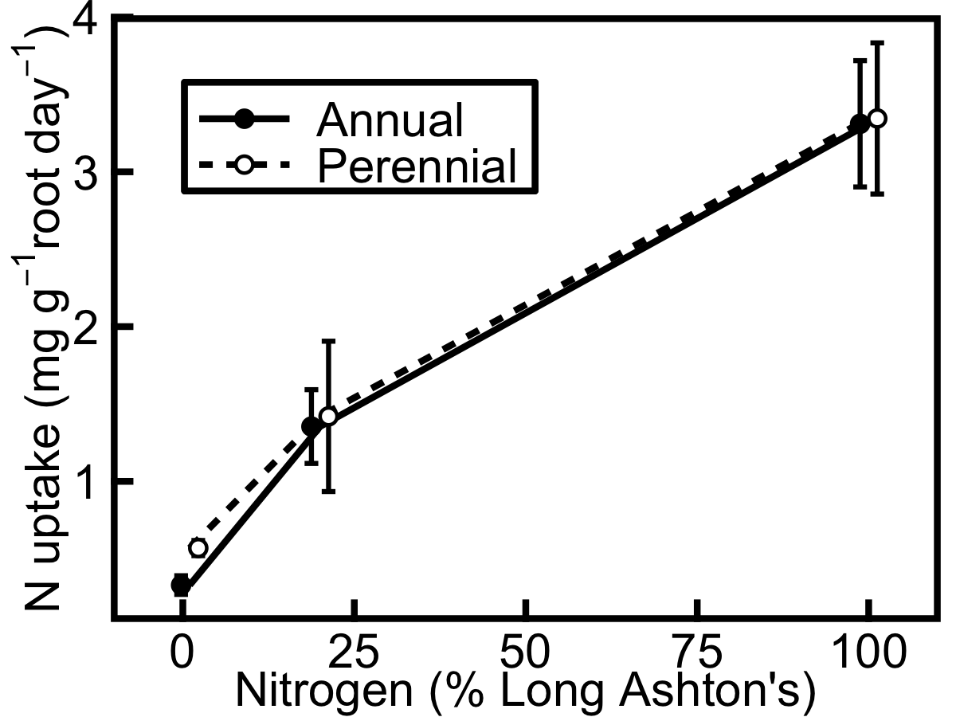

Figure 1. Net nitrogen uptake rate of annual (filled circles, solid line) and perennial barley (hollow circles, dashed line) increases with nitrogen treatment level. Uptake was measured over 24 hours before harvesting plants at 6 weeks old. Data show mean ± SE (n=3).

Growth and allocation

Relative growth rate (RGR) is consistently higher in annual than in perennial barley, supporting the hypothesis that the annual invests more resources in growth than the perennial, even at low nitrogen (significant effect of species: F_{(1,11)} = 0.0097, p<0.01). However, this effect decreases as nitrogen treatment increases. Peak RGR is 375% higher in the annual than in the perennial at 1% nitrogen, 132% higher at 20% nitrogen, and 51% higher at 100% nitrogen. In accordance with the hypothesis that both species will show an increase in growth rate with increasing nitrogen treatment, RGR increases significantly in annual and perennial barley when nitrogen treatment is increased (F_{(1,12)} = 0.0072, p<0.01). However, RGR shows a much greater relative increase in the perennial than the annual when nitrogen treatment is increased (Fig. 3): peak RGR in the perennial increases by 287% between 1% and 20% nitrogen, and 77% between 20% and 100% nitrogen, whereas peak RGR in the annual increases by 89% between 1% and 20% nitrogen, and 15% between 20% and 100% nitrogen.

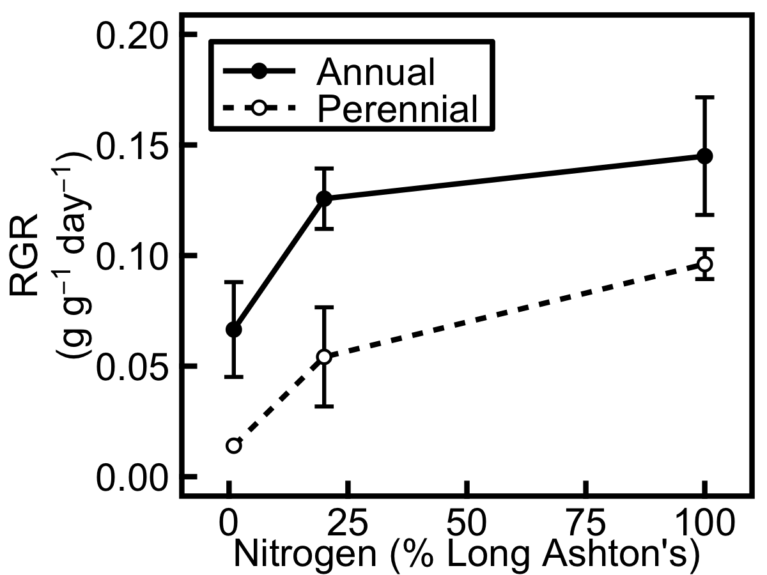

Figure 2. Relative growth rate (RGR, g g⁻¹ day⁻¹) is greater in annual (solid line) than perennial (dashed line) barley and increases with nitrogen treatment. Data are from plants harvested 28 and 42 days after germination. Data show mean ± SE (for annuals, n = 5, 6, 4, and for perennials, n = 1, 3 3 at 1, 20 and 100% nitrogen respectively).

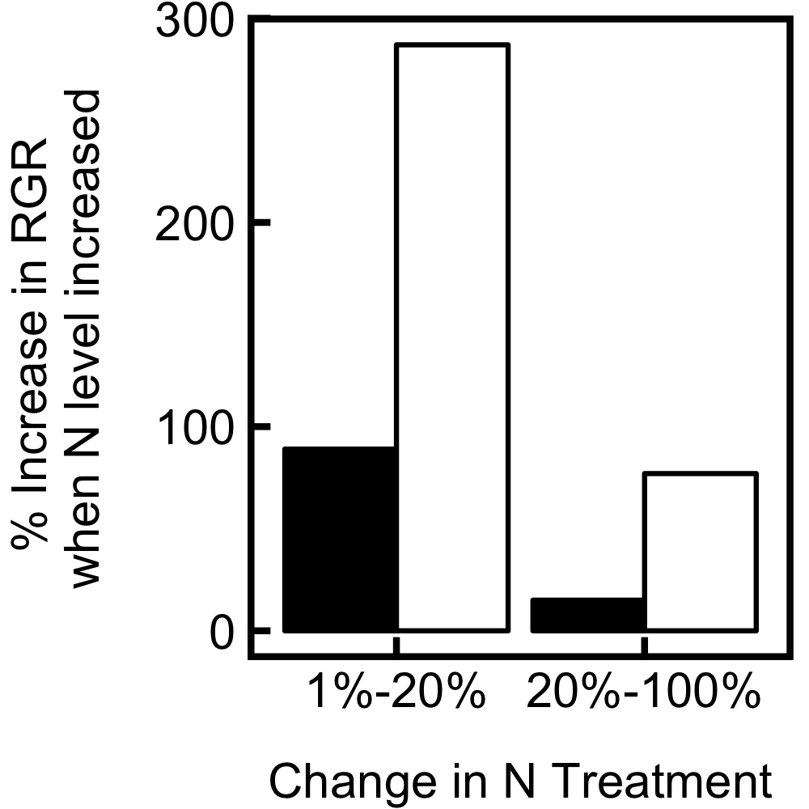

Figure 3. Relative growth rate (RGR, g g⁻¹ day⁻¹) shows a much greater increase when nitrogen treatment is increased from 1% to 20%, than when nitrogen treatment is increased from 20% to 100%. This increase is significantly higher for perennial (hollow bars) than annual (filled bars) barley. Percentages are obtained from the mean RGR values shown in Fig. 2.

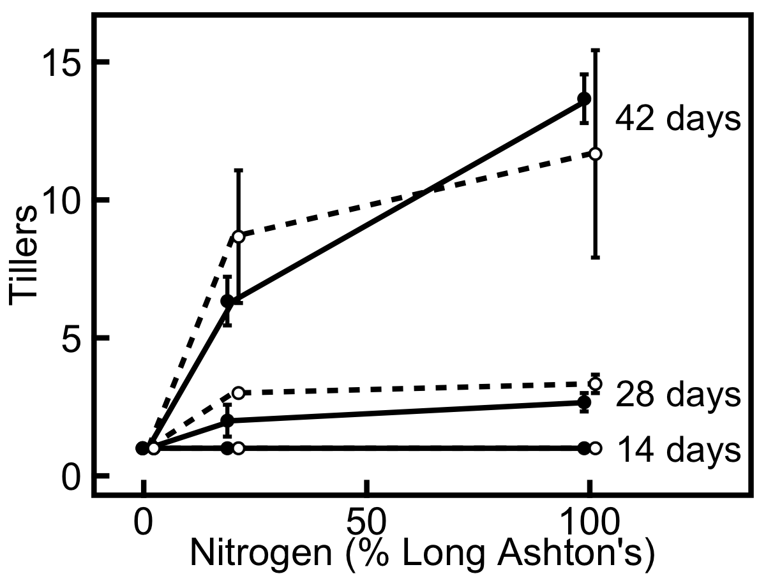

Figure 4. Tillering increases with nitrogen treatment and this effect increases with age in both annual (filled circles, solid line) and perennial (hollow circles, dashed line) barley. Data show mean ± SE (n=3), for plants harvested 14, 28 and 42 days after germination; at all three ages, plants at 1% nitrogen treatment have only one tiller.

Partitioning of biomass is also affected by nitrogen treatment. In accordance with the change in RGR, tillering increases dramatically with nitrogen treatment (Fig. 4), and this effect is greater as plants get older (significant nitrogen x age interaction for tillering: F_{(2,40)} = 10.9, p<0.001). However, there is no difference between species nor a nitrogen x species interaction (p>0.6 in each case). Allocation to roots (Table 1) decreases at higher nitrogen supplies (for root:shoot ratio, F_{(1,19)} = 40.6, p<0.001; for root mass ratio, F_{(1,19)} = 38.9, p<0.001), but does not differ between species. In both species, sheath mass ratio and leaf mass ratio (Table 1) increase with nitrogen treatment (for sheaths, F_{(1,19)} = 25.9, p<0.001; for leaves, F_{(1,19)} = 30.1, p<0.001). The annual allocates more biomass to roots earlier in development and more to sheaths later in development whilst the opposite trend is seen in the perennial (significant species x age interactions: for shoot mass ratio, F_{(1,19)} = 16.8, p<0.001; for root:shoot ratio, F_{(1,19)} = 10.6, p<0.01).

Table 1. Root:shoot and root mass ratios decrease and leaf and sheath mass ratios increase with increasing nitrogen treatment level in annual and perennial barley. These data are obtained from the subset of additional plants harvested for biomass calibration. For root:shoot ratio, root mass is divided by the sum of leaf and sheath mass for each individual and the results averaged. For leaf, sheath and root mass ratios, the ratio is the dry mass of that organ divided by the dry mass of the whole plant. 18 annuals and 11 perennials were harvested at five timepoints. Data show mean ± SE (at 1, 20, 100% nitrogen, annual n = 6, 6, 5; perennial n = 4, 2, 5). For brevity, age effects have not been included in this summary, but they are discussed elsewhere in the manuscript.

 | Species | 1% nitrogen | 20% nitrogen | 100% nitrogen
Root:shoot ratio | Annual  Perennial | 1.60 ± 0.213  1.54 ± 0.301 | 0.80 ± 0.219  0.83 ± 0.176 | 0.54 ± 0.113  0.59 ± 0.065
Leaf Mass Ratio | Annual  Perennial | 0.33 ± 0.027  0.27 ± 0.014 | 0.42 ± 0.030  0.35 ± 0.014 | 0.46 ± 0.012  0.44 ± 0.039
Sheath Mass Ratio | Annual  Perennial | 0.07 ± 0.004  0.14 ± 0.054 | 0.17 ± 0.029  0.20 ± 0.067 | 0.24 ± 0.020  0.19 ± 0.018
Root Mass Ratio | Annual  Perennial | 0.60 ± 0.031  0.59 ± 0.054 | 0.41 ± 0.055  0.45 ± 0.053 | 0.30 ± 0.014  0.37 ± 0.028

Leaf area ratio (LAR, m² leaf kg⁻¹ plant) is the product of specific leaf area (SLA, m² leaf kg⁻¹ leaf) and leaf mass ratio (LMR, kg leaf kg⁻¹ plant). Although LMR is slightly higher in the annual, SLA is slightly higher in the perennial (F_{(1,45)} = 5.97, p<0.05), meaning that LAR is the same in both species (Table 2). LAR and SLA decrease with age in both species (LAR: F_{(1,45)} = 34.6, p<0.001; SLA: F_{(1,45)} = 42.2, p<0.001), whereas LAR increases with nitrogen treatment (F_{(1,45)} = 56.6, p<0.001), in addition to the increase in LMR documented above (Table 1). Thus at higher nitrogen treatment levels, proportionately more biomass is allocated to leaves and there is also more leaf area per unit biomass.

Table 2. Leaf area ratio (LAR, expressed here as m² leaf kg⁻¹ plant) and specific leaf area (SLA, expressed here as m² leaf kg⁻¹ leaf) decrease with age, and LAR increases with nitrogen treatment, in annual and perennial barley harvested 14, 28 and 42 days after germination. SLA is higher in perennial than annual barley overall, whilst LAR does not differ between species. LAR is the product of SLA (measured on all plants in the main study at the time of metabolite harvest) and LMR (from the subset of plants harvested for biomass calibration; see Table 1). Data show mean ± SE (n=3).

 | Species | 1% nitrogen | 20% nitrogen | 100% nitrogen
LAR, 14 days | Annual  Perennial | 11.3 ± 0.476  9.5 ± 0.773 | 14.7 ± 1.138  16.1 ± 0.678 | 20.0 ± 2.237  19.9 ± 1.676
LAR, 28 days | Annual  Perennial | 12.0 ± 0.227  12.3 ± 3.202 | 13.7 ± 0.543  13.6 ± 1.079 | 17.3 ± 1.137  16.1 ± 1.842
LAR, 42 days | Annual  Perennial | 9.8 ± 0.105  7.7 ± 0.396 | 10.3 ± 0.575  10.6 ± 1.210 | 12.3 ± 0.163  13.2 ± 0.288
SLA, 14 days | Annual  Perennial | 34.3 ± 1.44  35.1 ± 2.86 | 35.0 ± 2.71  46.1 ± 1.94 | 43.4 ± 4.86  45.3 ± 3.81
SLA, 28 days | Annual  Perennial | 36.5 ± 0.69  45.7 ± 11.86 | 32.6 ± 1.29  38.9 ± 3.08 | 37.6 ± 2.47  36.6 ± 4.19
SLA, 42 days | Annual  Perennial | 29.6 ± 0.32  28.6 ± 1.47 | 24.6 ± 1.37  30.3 ± 3.46 | 26.8 ± 0.35  30.1 ± 0.65

Nitrogen and carbon metabolites

Overall, an increase in nitrogen treatment leads to an increase in plant nitrogen concentration and a decrease in plant carbon concentration (Figs. 5-8). The concentration of nitrogen metabolites in leaves, leaf sheaths and roots of annual and perennial barley increases when nitrogen treatment is increased from 1% to 20%, consistent with the hypothesis that both species will show an increase in nitrogen storage as nitrogen treatment increases, yet shows a comparatively smaller change when nitrogen treatment is increased further to 100% (Fig. 5), similar to the response of RGR to nitrogen treatment (Figs. 2, 3). Nitrate shows a particularly strong response to nitrogen treatment, especially in young leaves and roots (Fig. 5A,F). The nitrogen treatment has a significant effect on nitrate concentration in leaf (F_{(1,28)} = 21.7, p<0.001), leaf sheath (F_{(1,11)} = 17.9, p<0.01) and root (F_{(1,29)} = 36.1, p<0.001). Nitrate in the sheath tissue is also significantly higher in the annual (F_{(1,11)} = 45.9, p<0.001). Amino acid concentration increases with age (Fig. 5), and this age effect is significant in the sheath (Fig. 5D,E; F_{(1,11)} = 20.8, p<0.001). In leaf and root, amino acids increase with nitrogen treatment (leaf: F_{(1,28)} = 8.4, p<0.001; root: F_{(1,29)} = 13.5, p<0.001). However, the protein concentration remains fairly constant at all nitrogen treatment levels (Fig. 5), increasing with nitrogen treatment level in the leaf (F_{(1,28)} = 25.4, p<0.001), but otherwise showing no significant change.
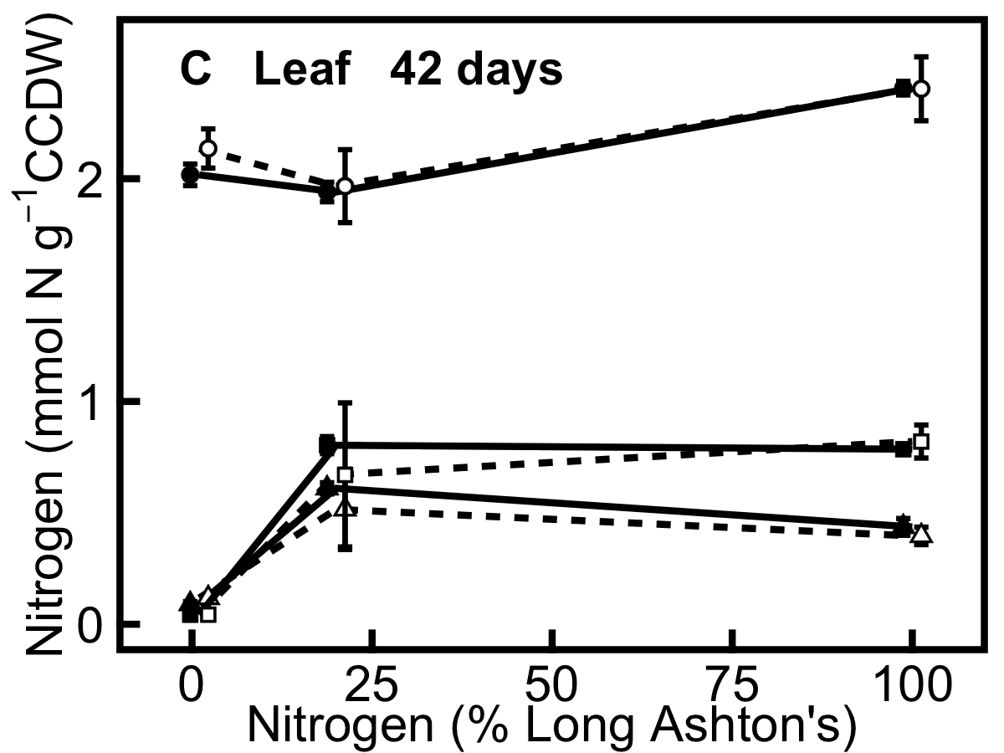
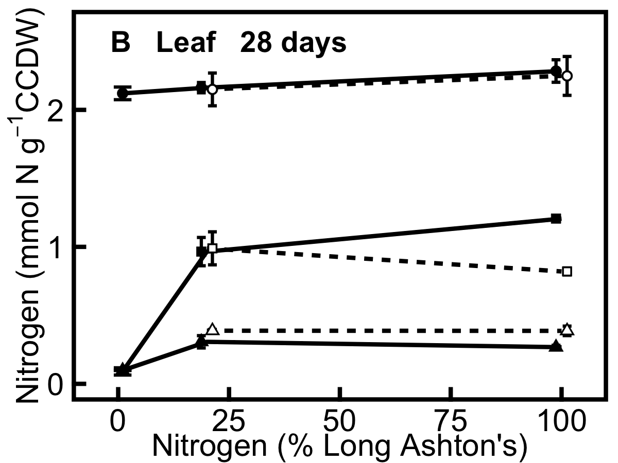
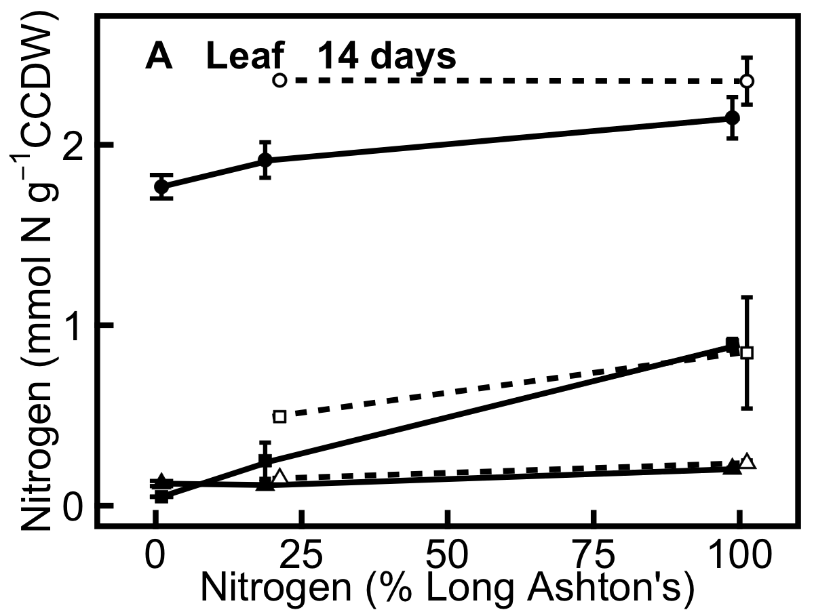
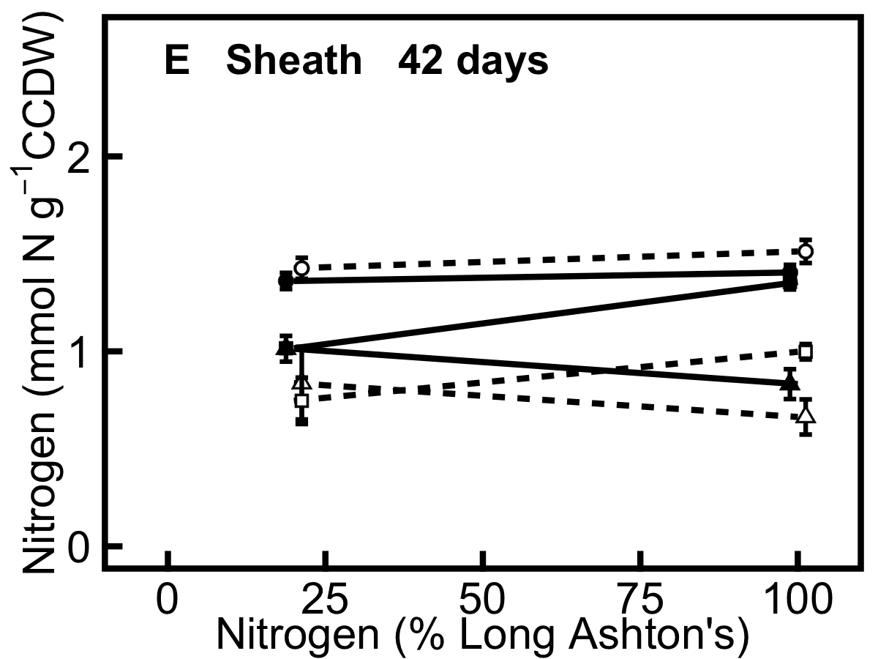

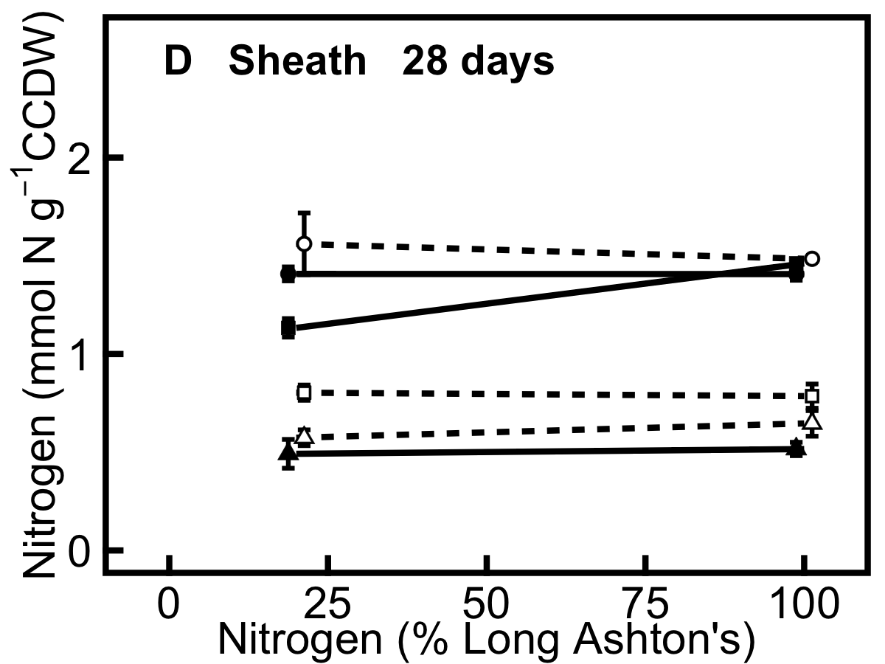

 | Protein
 | Nitrate
 | Amino acids
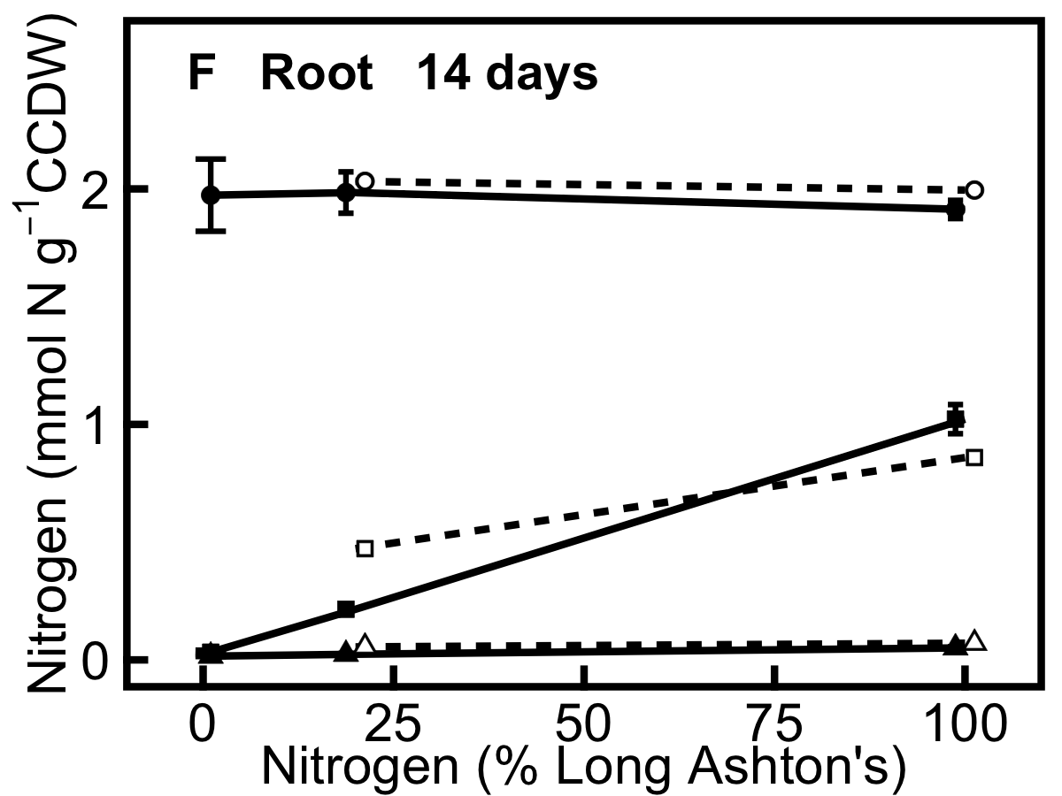
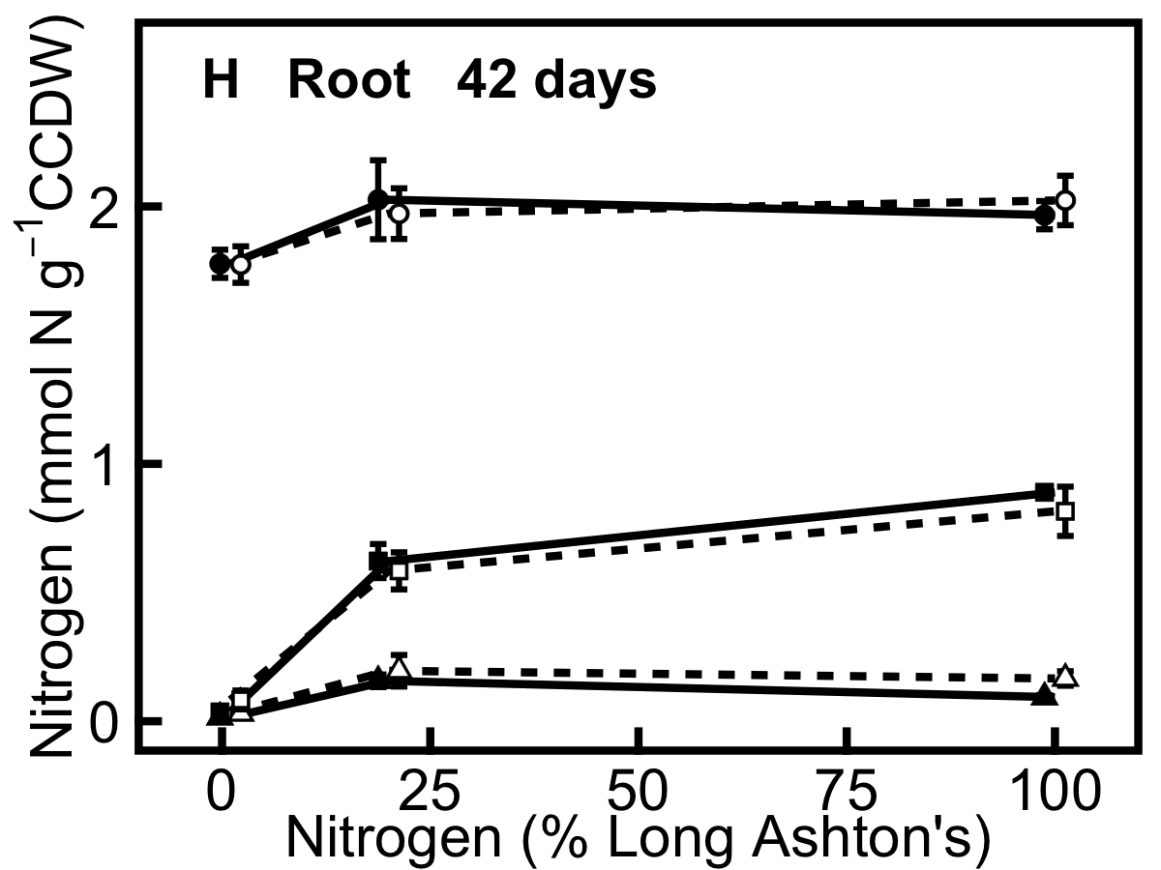
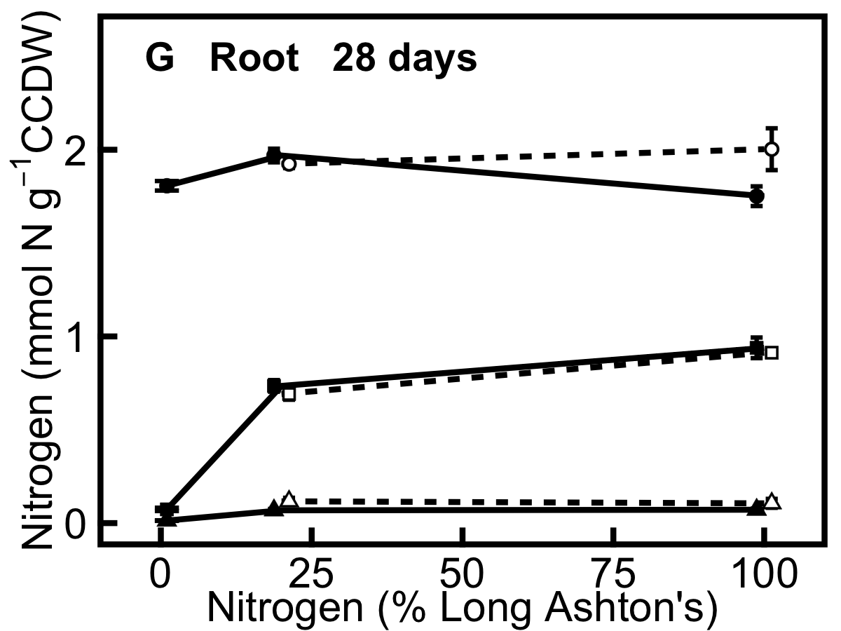

Figure 5. Partitioning of nitrogen resources in annual (filled symbols, solid line) and perennial (hollow symbols, dashed line) barley. Panel shows allocation of nitrogen to protein (filled and hollow circles), free nitrate (filled and hollow squares), and free amino acids (filled and hollow triangles). All data are expressed in mmol N g⁻¹ carbohydrate-corrected dry weight (CCDW). A, leaf 14 days after germination; B, leaf 28 days; C, leaf 42 days; D, leaf sheath 28 days; E, leaf sheath 42 days; F, root 14 days; G, root 28 days; H, root 42 days. Leaf and leaf sheath tissues were pooled for the harvests at 14 days. Data show mean ± SE (n=3).
In contrast to nitrogen metabolites, the storage of carbon metabolites decreases when nitrogen treatment is increased from 1% to 20% but, as for RGR and nitrogen metabolites, this storage shows relatively little change when nitrogen treatment is increased to 100% (Fig. 6).

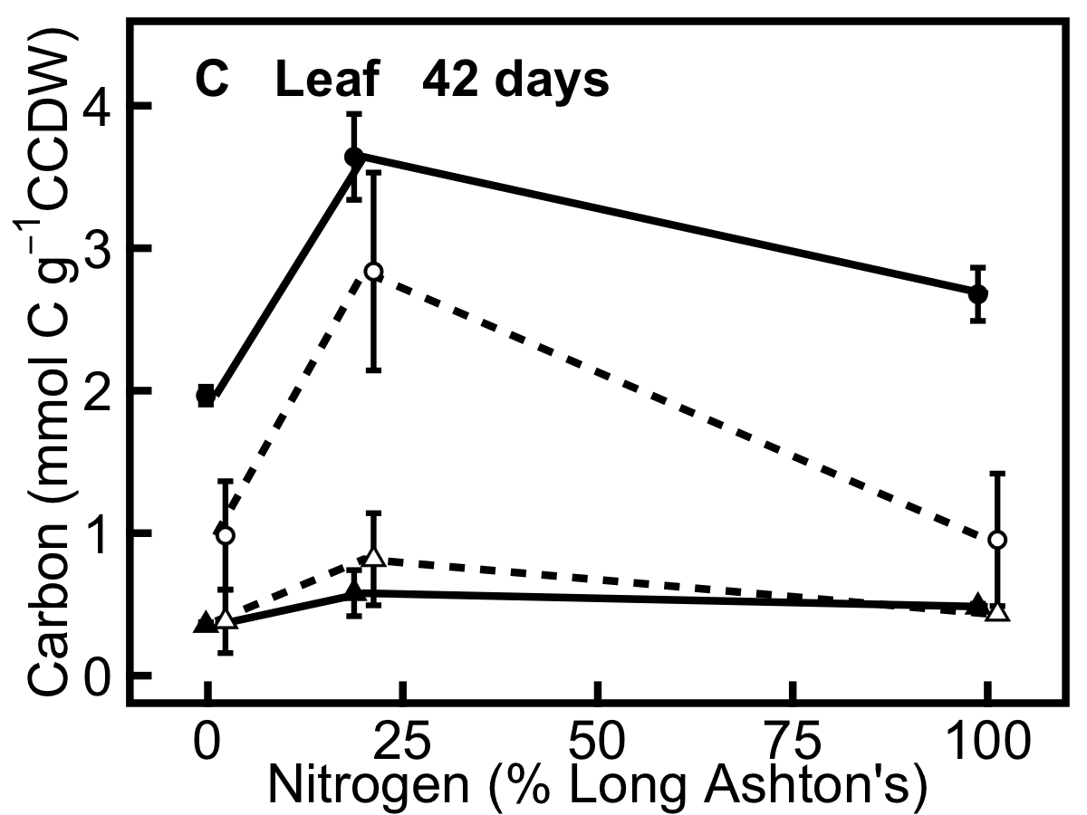
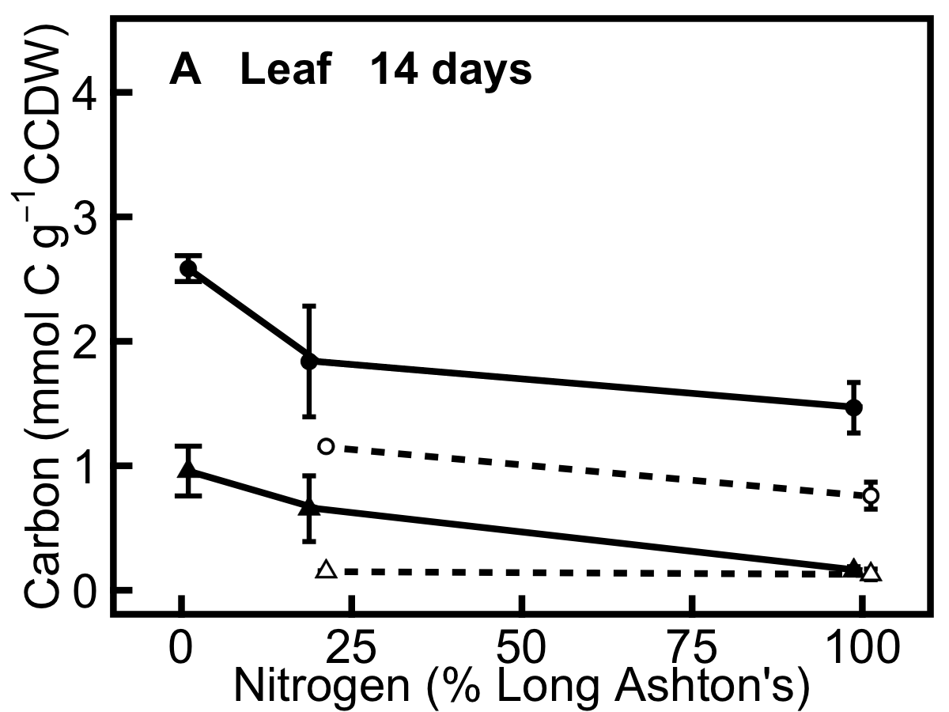
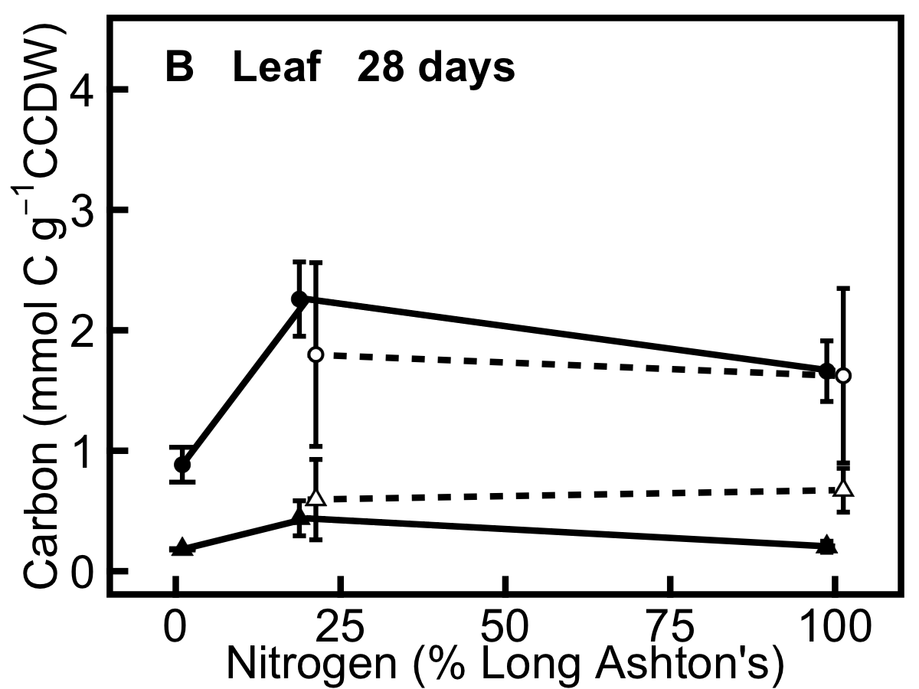
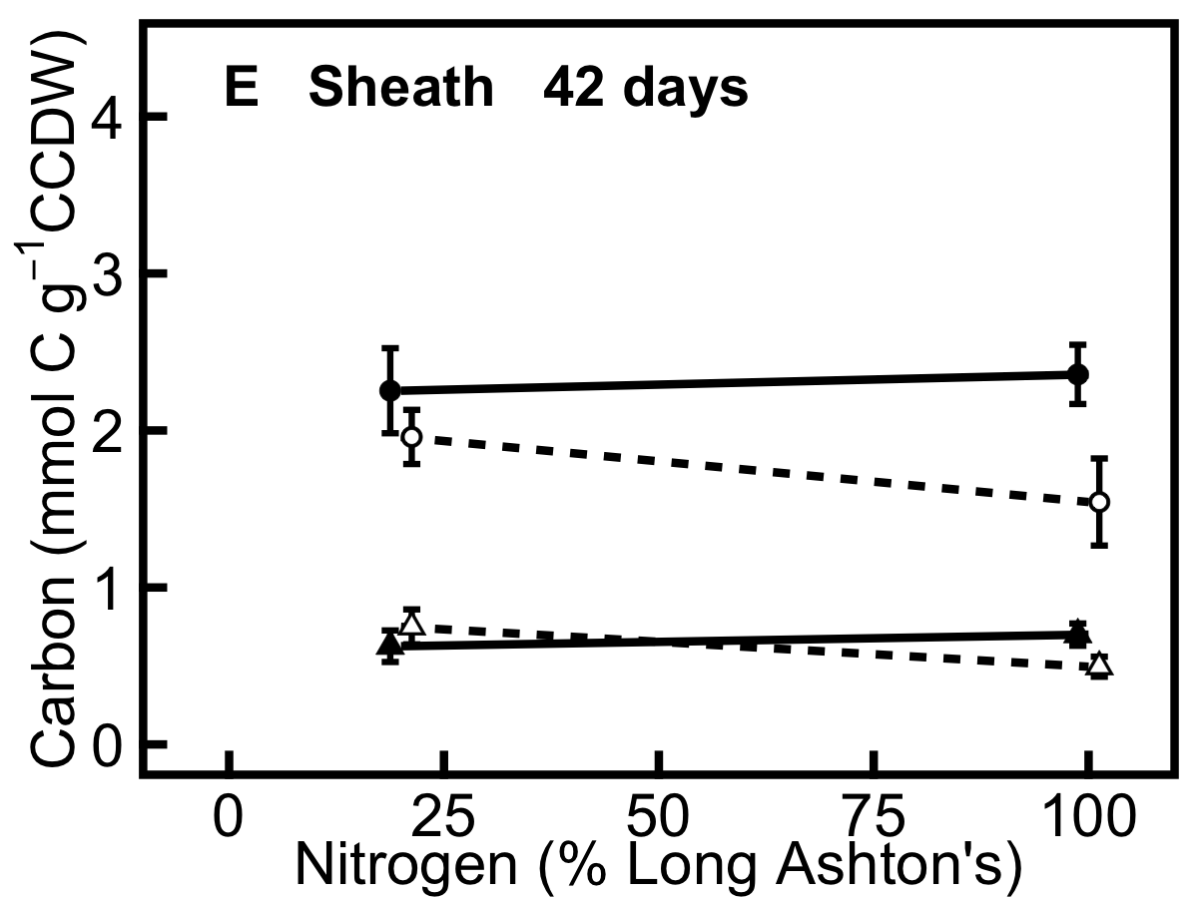
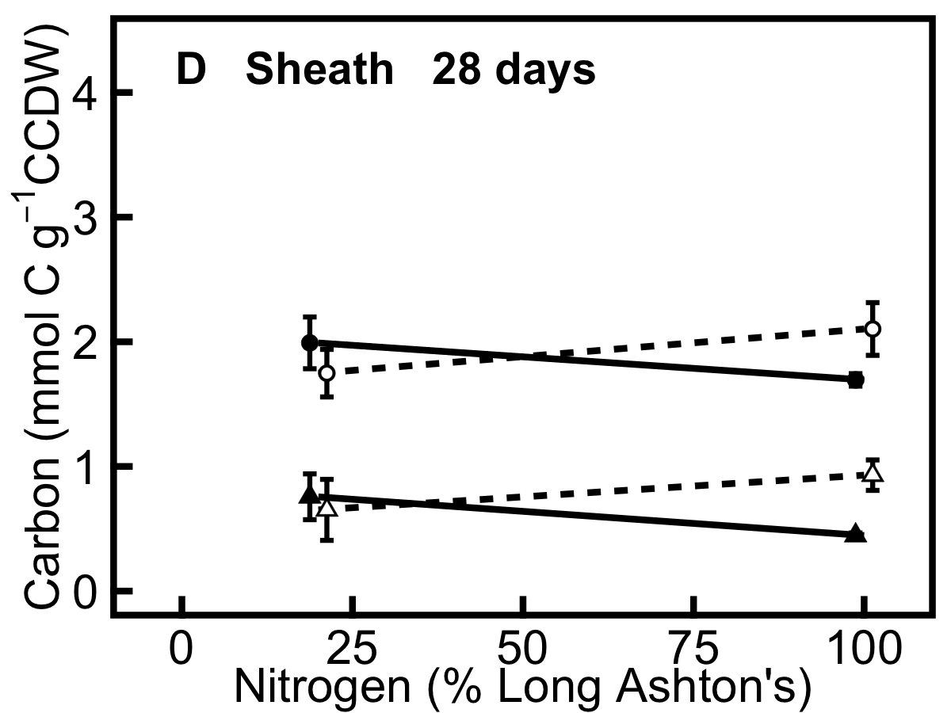

TNC
Fructans

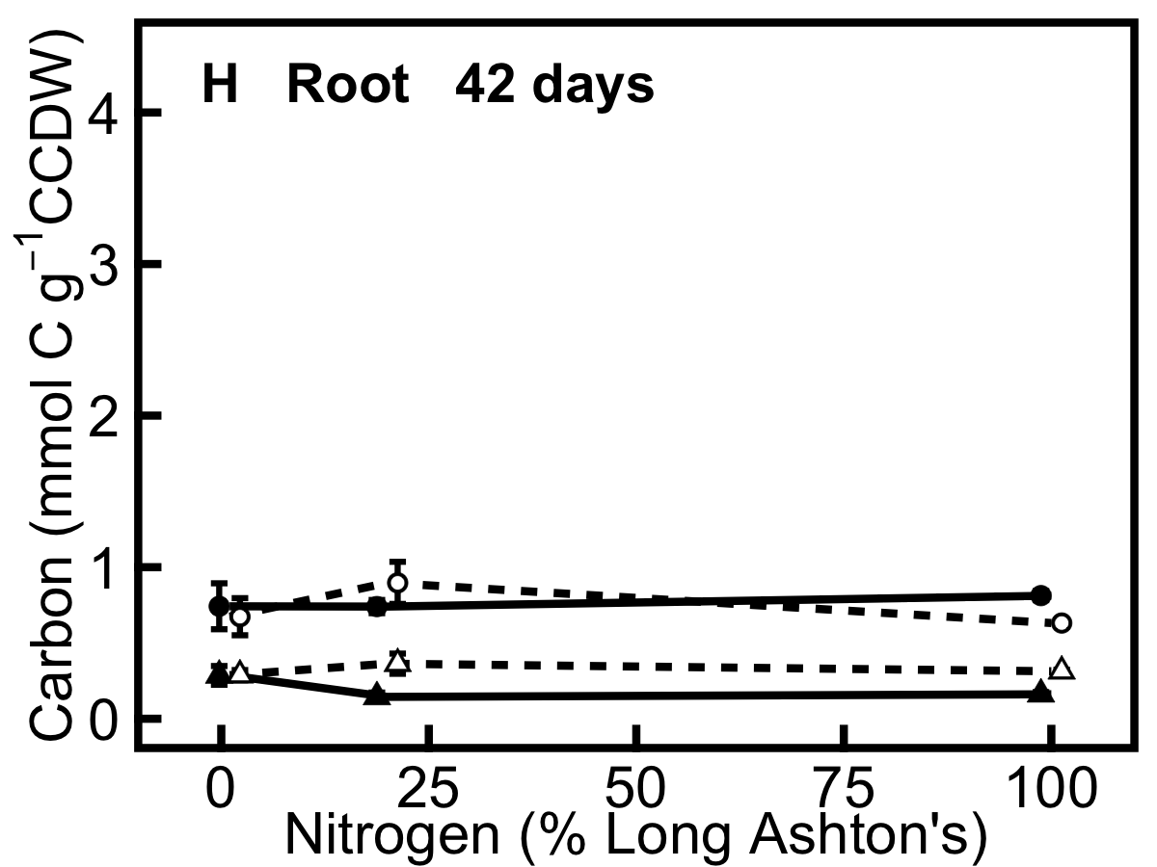
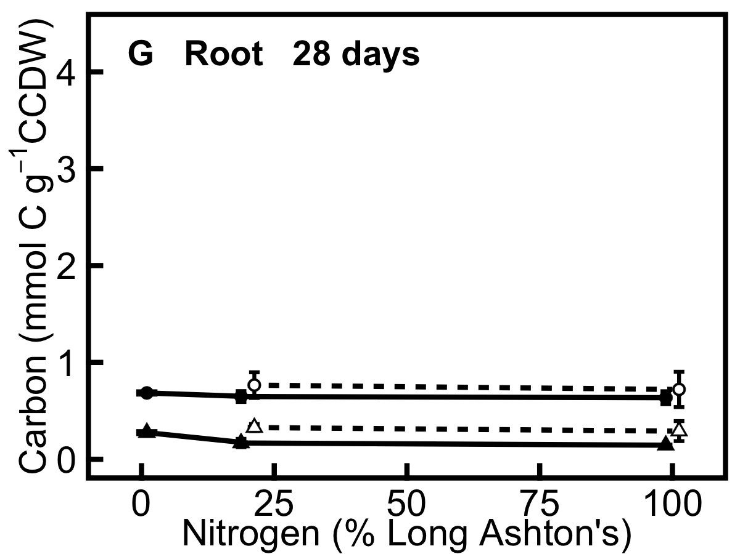
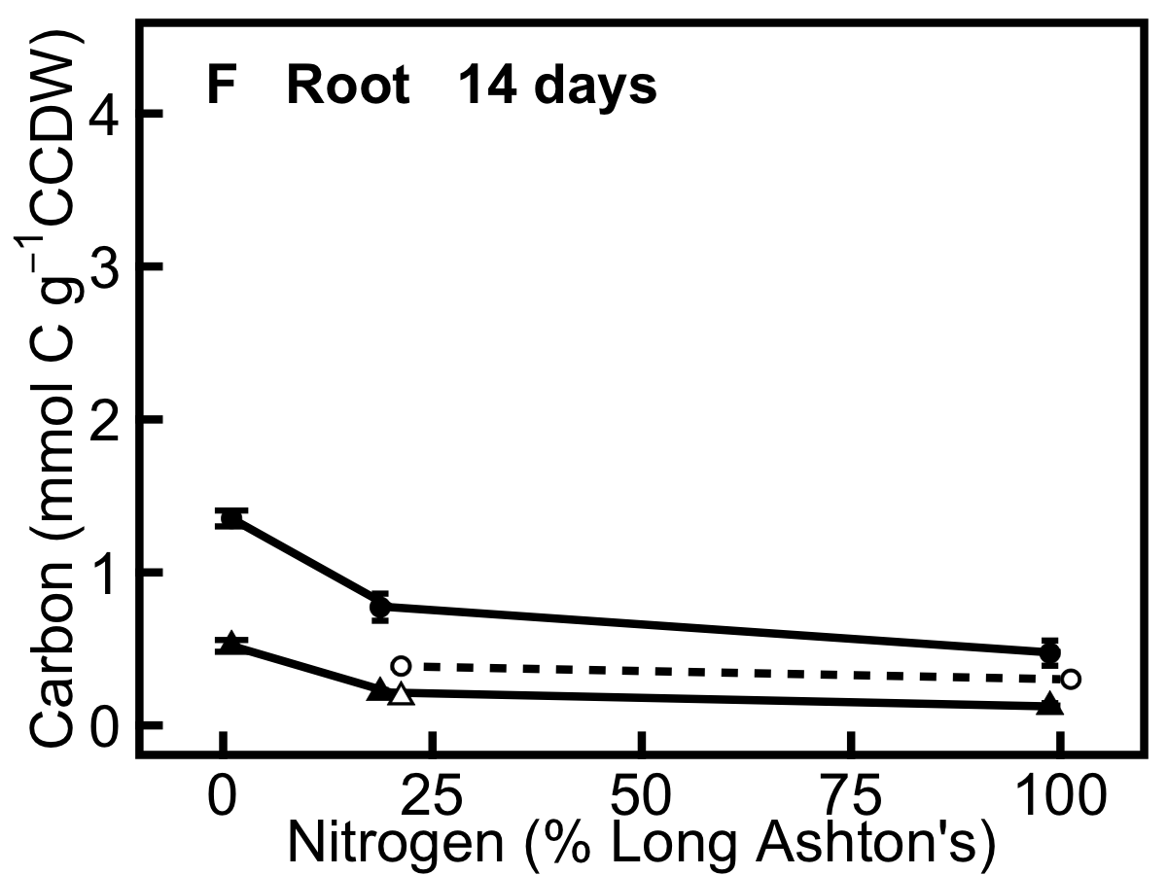

Figure 6. Non-structural carbohydrates in annual (filled symbols, solid line) and perennial (hollow symbols, dashed line) barley. Panel shows allocation of carbon to total non-structural carbohydrates (TNC; filled and hollow circles) and to total fructans (filled and hollow triangles) which represent a large proportion of TNC. TNC is the sum of glucose, fructose, sucrose, starch, short-chain and long-chain fructans. All data are expressed in mmol C g⁻¹ carbohydrate-corrected dry weight (CCDW). A, leaf 14 days after germination; B, leaf 28 days; C, leaf 42 days; D, leaf sheath 28 days; E, leaf sheath 42 days; F, root 14 days; G, root 28 days; H, root 42 days. Leaf and leaf sheath tissues were pooled for the harvests at 14 days. Data show mean ± SE (n=3).

Fructans are a major store for carbon (Fig. 6), and the roots of both species contain more carbon and less nitrogen than the shoot tissues (Fig. 7). In general, the tissues of annual barley contain a higher concentration of total non-structural carbohydrate (TNC) than the perennial (Fig. 6). TNC is significantly higher in the annual in leaf (F_{(1,28)} = 7.7, p<0.01), sheath (F_{(1,11)} 5.3, p<0.05) and shows a species x age interaction in the root: TNC is higher in the annual 14 days after germination but is similar in both species thereafter (F_{(2,29)} = 6.8, p<0.01). Root TNC also shows a significant nitrogen treatment x age interaction (F_{(2,29)} = 12.7, p<0.001), with the decrease in TNC with increasing nitrogen treatment being most pronounced 14 days after germination (Fig. 6F). Fructan concentration shows a significant nitrogen x species x age interaction in the sheath (F_{(1,11)} = 10.5, p<0.01), with fructan decreasing more at 28 days in the annual and more at 42 days in the perennial in response to the increase in nitrogen treatment (Fig. 6D,E). In the root there are significant effects of nitrogen (F_{(1,28)} = 15.1, p<0.001) and species (F_{(1,28)} = 18.6, p<0.001) on fructan concentration: fructan decreases with increasing nitrogen treatment and is generally higher in the perennial (Fig. 6, F,G,H).

Overall, perennial barley has a higher concentration of nitrogen in its tissues than annual barley (Fig. 7), consistent with the hypothesis that nitrogen sink limitation in the perennial would lead to a greater storage response in this species. Elemental N content (Fig. 7A,B,C) increases with the nitrogen treatment level in leaf (F_{(1,33)} = 47.6, p<0.001), sheath (F_{(1,13)} = 4.8, p<0.05) and root (F_{(1,34)} = 42.4). It is also higher in the perennial in leaf tissue (F_{(1,33)} = 6.6, p<0.05), but there is no species x nitrogen treatment interaction. Carbon:nitrogen (C:N) ratio (Fig. 7D,E,F) decreases with nitrogen treatment in leaf (F_{(1,33)} = 46.3, p<0.001), sheath (F_{(1,13)} = 5.5, p<0.05) and root (F_{(1,34)} = 46.8). It is also higher in annual barley leaf tissue compared to perennial barley (F_{(1,33)} = 5.9, p<0.05). The trend shown by Figures 5 and 6, that carbon and nitrogen storage is more affected by an increase in nitrogen treatment from 1% to 20% than by an increase from 20% to 100%, is also seen in Figure 7.

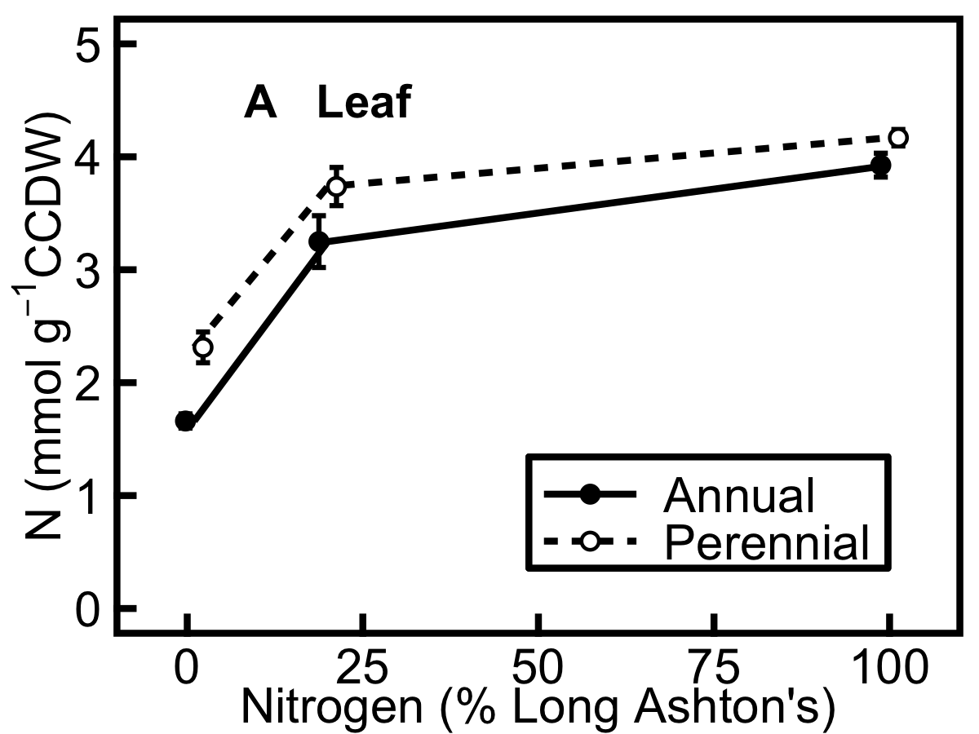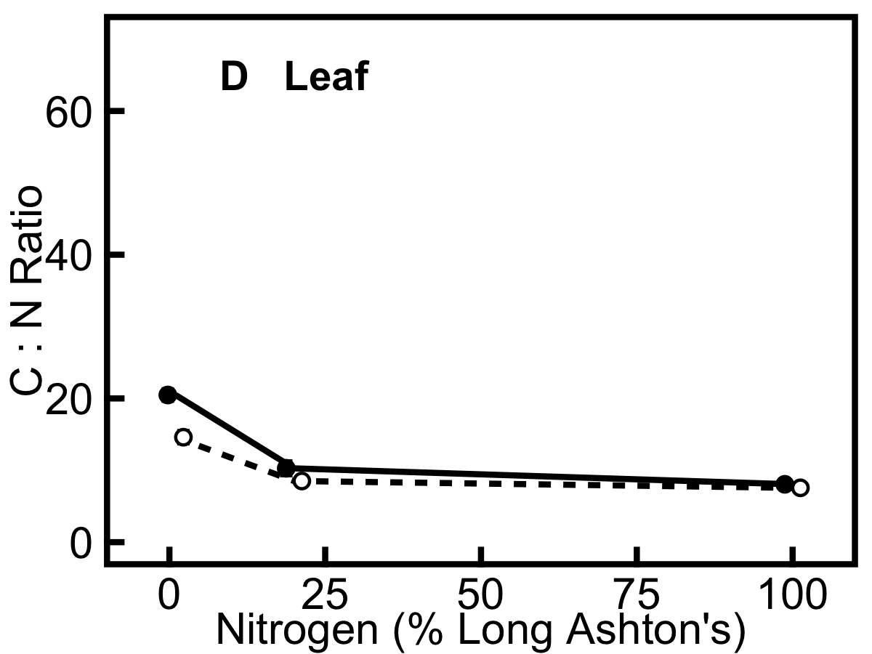

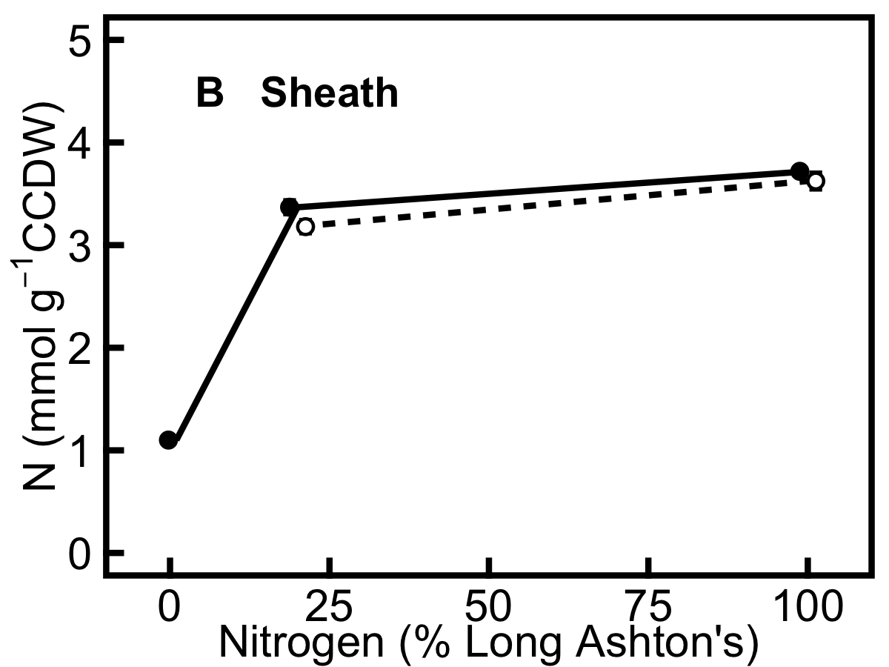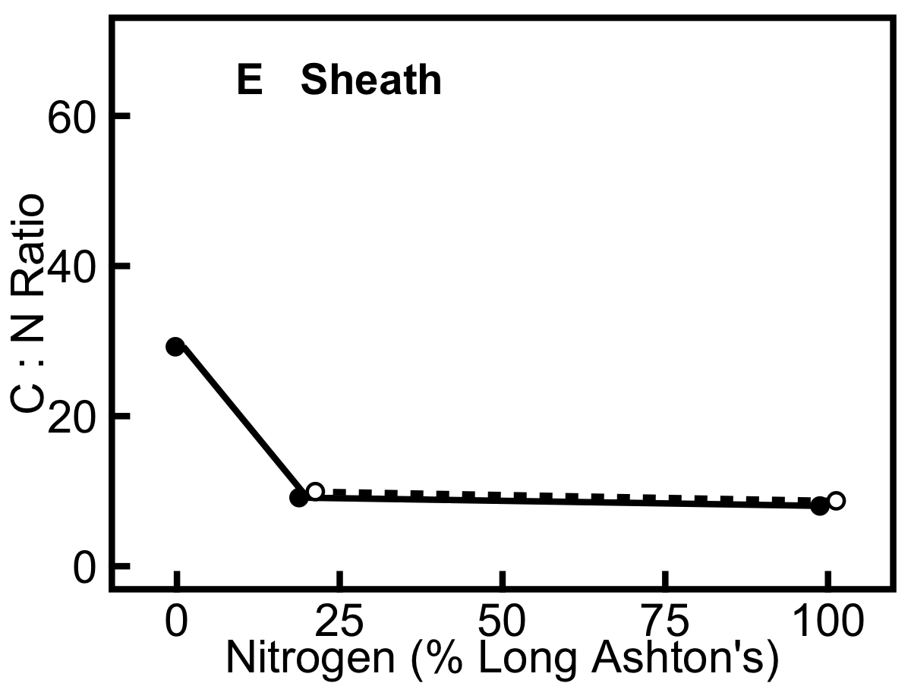

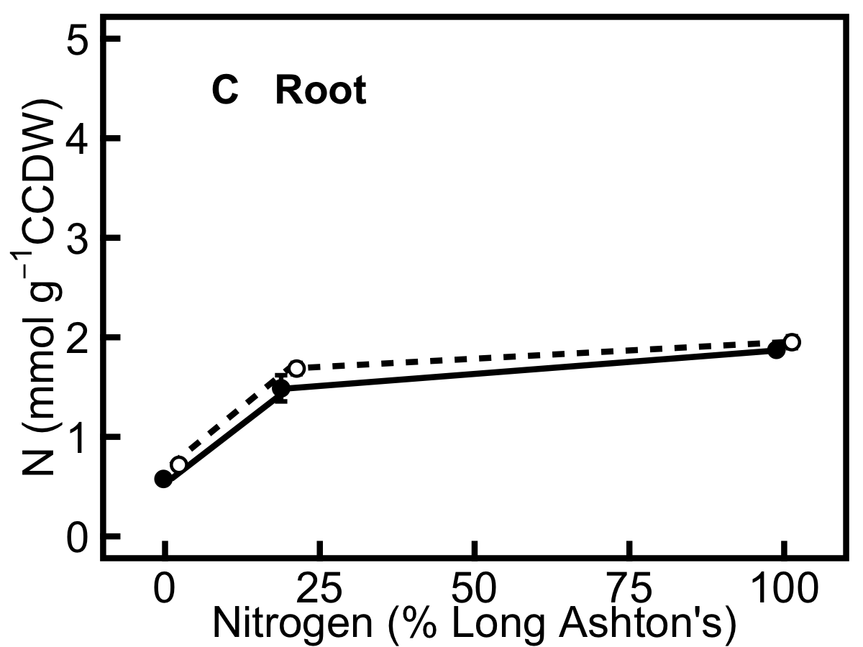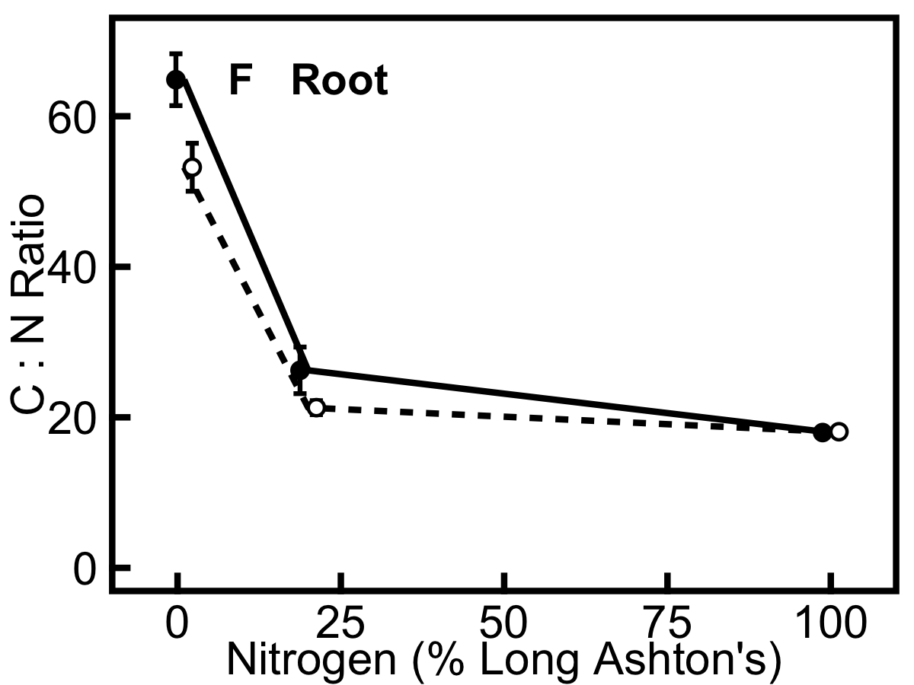

Figure 7. Total nitrogen concentration increases with nitrogen treatment and carbon:nitrogen (C:N) ratio decreases with nitrogen treatment in annual (filled circles, solid line) and perennial (hollow circles, dashed line) barley. Carbohydrate-corrected dry weight (CCDW) was used for these elemental N and C concentrations. A, leaf nitrogen; B, sheath nitrogen; C, root nitrogen; D, leaf C:N ratio; E, sheath C:N ratio; F, root C:N ratio. Data show mean across all ages due to lack of significant age effects ± SE (at 1, 20, 100% nitrogen, annual n = 9, 9, 9 in leaf and root and 1, 6, 6 for sheath; perennial n = 4, 7, 9 for leaf, 0, 5, 5 for sheath, and 5, 7, 9 for root). There are more samples for CHN analysis than for metabolite analysis due to the small size of some samples.

Perennial barley has a higher amino acid:sucrose ratio (Fig. 8) in the leaves compared to the annual (F_{(1,28)} = 21.8, p<0.001), an indicator of carbon source limitation in this species.
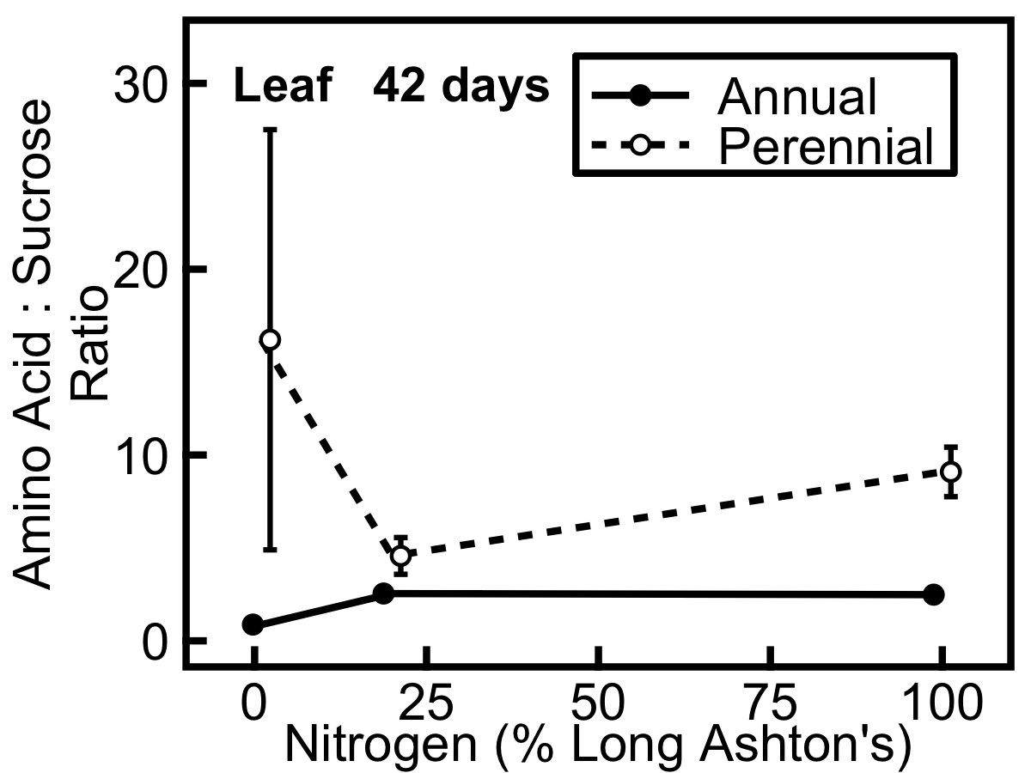

Figure 8. Amino acid:sucrose ratio is higher in perennial (hollow circles, dashed line) than annual (filled circles, solid line) barley. Metabolites are expressed in μmol amino groups and μmol sucrose per g carbohydrate-corrected dry weight (CCDW), respectively. Data show mean ± SE (n=3).

DISCUSSION

In this study, annual and perennial barley were grown along a nitrogen gradient to elucidate the relative contributions of nitrogen source and sink strengths to growth. Annual and perennial barley show a range of responses to the nitrogen treatments. As the nitrogen treatment level increases, both species show an increase in nitrogen uptake (Fig. 1), an increase in tillering and allocation to leaves, and a decrease in allocation to roots (Fig. 4; Table 1). The investment of nitrogen into growth and storage shows large increases when nitrogen treatment is increased from 1% to 20%, but this response is smaller when nitrogen treatment is increased further from 20% to 100%, especially in annual barley, indicating significant nitrogen sink limitation in this species (Figs. 3, 5-7). Whilst the annual invests more resources in growth overall (Fig. 2), the perennial is better able to invest in growth under high nitrogen levels (Fig. 3), suggesting that growth in the perennial is less nitrogen sink limited than growth in the annual.

Annual and perennial barley do not differ in nitrogen uptake capacity

Annual and perennial barley have the same net nitrogen uptake rate (Fig. 1) indicating that both species are well adapted to extract this vital resource from the environment. Nitrate efflux can be substantial (Devienne et al., 1994a); here the net influx was measured, and the uptake rates measured here correspond with those of other authors (e.g. Taulemesse et al., 2015). Both species show a substantial increase in nitrogen uptake with increasing nitrogen treatment level (Fig. 1), consistent with the hypotheses for this study.

Perennial barley shows a greater growth response to increased nitrogen

As the nitrogen treatment increases from 1% to 20%, plants show a dramatic response, with both the amount of plant material (Figs. 2, 3) and the concentration of nitrogen in that material (Fig. 5) increasing significantly, consistent with hypotheses.

Annual barley grows faster overall (Fig. 2), yet the perennial shows a greater relative growth response when nitrogen treatment is increased (Fig. 3) and has a higher leaf nitrogen concentration (Fig. 7A). This suggests that under nitrogen-limited conditions (1% nitrogen treatment) the perennial preferentially allocates nitrogen to storage rather than growth, consistent with the hypothesis that the perennial will conserve nitrogen (Campbell and Grime, 1992). This enables the perennial to be opportunistic in its use of carbon resources, as observed in previous work with these species, which found that the perennial is better able to respond to increasing carbon dioxide compared to the annual (Burnett et al., 2016). In contrast to the hypothesis that growth in the perennial would be more nitrogen sink limited and growth in the annual more nitrogen source limited, the perennial shows a greater response to increased nitrogen treatment. This indicates that growth in the perennial is in fact less nitrogen sink limited than growth in the annual.

Perennial barley allocates both nitrogen and biomass to storage organs

Consistent with the hypothesis that perennial barley would show a greater storage response to nitrogen treatment than the annual, the perennial displays a lower allocation of mass to leaves compared to the annual (Table 1), allocating more biomass to the storage organs of leaf sheath and root, with a higher sheath mass ratio earlier in development and a higher allocation to roots later in development. Since perennial barley has a higher nitrogen concentration and lower C:N ratio in the root compared to the annual (Fig. 7C,F), its greater allocation to roots in terms of biomass fraction enables proportionately greater nitrogen storage at the whole plant level, and its greater allocation to leaf sheaths offsets its lower sheath nitrogen concentration compared to the annual (Fig. 7B). This is consistent with a conservative growth strategy: the perennial grows more slowly than the annual (Fig. 2) and conserves resources when nutrients are limiting, allocating biomass and nitrogen to storage (Table 1; Figs. 5, 7). However, our previous work revealed significant developmental plasticity in the perennial, which is carbon source limited and therefore shows a stronger response to increasing carbon dioxide compared to the annual (Burnett et al., 2016). A conservative, nitrogen-storing strategy thus facilitates opportunistic and flexible responses to changes in the availability of other resources such as carbon.

Contrary to expectations, the perennial has a higher specific leaf area (SLA) (Table 2) and higher nitrogen concentration (Fig. 7) compared to the annual, traits that are generally associated with fast growing species in the ecological literature (Reich et al., 2003; Wright et al., 2004). This is consistent with previous work on this species (Burnett et al., 2016), which revealed carbon source limitation in the perennial, since it is investing in carbon acquisition by the leaves in order to match carbon and nitrogen supply. Indeed, the higher SLA and leaf nitrogen concentration observed here for the perennial indicate that it may have the potential to be a rather fast growing species despite its perennial life history strategy. Potential RGR has previously been correlated with nutrient uptake capacity (Garnier et al., 1989) and here the net nitrogen uptake rates are very similar for annual and perennial barley, although the perennial never matches the RGR of the annual. LMR (Table 1) and RGR (Fig. 2) are both higher in the annual, such that LAR (the product of SLA and LMR) does not differ between species (Table 2). Whilst SLA tends to be the major contributor to LAR and thus RGR in herbaceous species (Poorter and van der Werf, 1998), some studies have found that RGR correlates with LMR rather than SLA (references within Garnier, 1992), which is consistent with the higher LMR and higher RGR seen here for annual barley. Two further points of contention, which go beyond the scope of this study but are of interest here, are whether RGR regulates resource uptake or vice versa (e.g. Rodgers and Barneix, 1988; Garnier et al., 1989), and the extent to which uptake is regulated by demand (Taulemesse et al., 2015). Indeed, nitrate itself is an important regulator of nitrogen uptake (Masclaux-Daubresse et al., 2010). In addition to elucidating the relative contribution of nitrogen source and sink to growth, a deeper understanding of the molecular drivers that underpin regulation of nutrient uptake will be an important component of improving nitrogen use efficiency.

It is important to note the assumption that only the labelled nitrogen fed 24 hours before harvest would be taken up during that time. Plants were grown in large pots and it was assumed that nitrogen would be evenly distributed and depleted around the roots. Since the substrate was not flushed out with nitrogen-free liquid before ¹⁵N-labelled Long Ashton’s was fed, it is possible that some nitrogen from earlier feeds would have been taken up too and the measurement of uptake rate would thus not encompass all nitrogen that was taken up during the 24 hours before harvest. It is also possible that this creates further bias, if for example there was more nitrogen remaining in pots exposed to the 100% nitrogen treatment than in those exposed to 1% nitrogen, such that the uptake rate at 100% nitrogen would be underestimated compared to at 1% nitrogen due to this dilution effect.

Nitrate is a key store for excess nitrogen

Nitrate shows a particularly strong response to nitrogen treatment (Fig. 5) because it is a labile store. Nitrate also shows a strong response to nitrogen treatment in wheat (Devienne et al., 1994b) and Arabidopsis (Tschoep et al., 2009) and, along with protein, constitutes a key store for nitrogen in herbaceous plants (Millard, 1988). Here, the raw material for nitrogen uptake is nitrate, and this is readily accumulated in plant tissues with relatively low cost since there is no assimilation cost (as would be required for converting nitrate into amino acids). Accumulating nitrate therefore means that nitrogen can readily be acquired under high nitrogen treatment levels, even if carbon is limiting. Such carbon limitation could quickly arise in young plants because greater leaf area is required in order to create the carbon skeletons needed for amino acid synthesis; in the leaf, nitrate accumulates with increasing nitrogen treatment 14 days after germination (Fig. 5A), but 42 days after germination amino acids accumulate instead (Fig. 5C) and also build up in the leaf sheath (Fig. 5E). Compared to nitrate and amino acids, protein concentration remains relatively constant at all nitrogen treatment levels (Fig. 5). Excess nitrogen is thus stored as nitrate or amino acids, or invested in growth, but is not used to elevate protein concentration. The lack of an ontogenetic effect on leaf protein during vegetative growth is also notable (Fig. 5): rather than increase leaf protein concentration as leaves get older, plants create more leaf tissue and maintain the same protein concentrations.

High nitrogen increases carbon source limitation

Total non-structural carbohydrate (TNC) concentration decreases when nitrogen treatment is increased from 20 to 100% in both species (Fig. 6) due to increasing carbon source limitation. Both species show an increase in N concentration and a decrease in C:N ratio as the nitrogen treatment is increased (Fig. 7). This corresponds with a shift from excess carbon to excess nitrogen in the plants, imposed by the nitrogen treatment: nitrogen limitation increases TNC concentration, and nitrogen excess reduces it (Stitt and Krapp, 1999). However, this effect is observed when nitrogen treatment is increased from 1% to 20%, but not to 100% (Fig. 7) despite a high nitrate availability and uptake rate, suggesting that plants are reaching their maximum capacity for nitrogen storage.

The increase in leaf and sheath mass ratios in both species at higher nitrogen treatment levels (Table 1) enables greater acquisition of carbon, which becomes an increasingly limiting resource at higher nitrogen treatment levels; conversely, more biomass is allocated to roots in low nutrient environments (Aerts and Chapin, 2000). Not only does leaf mass ratio increase with nitrogen treatment in both species, but leaf area ratio also increases, as observed by Garnier et al. (1989), enabling greater photosynthetic carbon acquisition since there is a greater, thinner leaf area for light harvesting. Both species show an increase in tillering as nitrogen treatment is increased (Fig. 4), as observed in wheat by Taulemesse et al. (2015), and especially when plants are older, facilitating a rapid increase in allocation to shoots and thus to carbon acquisition.

Perennial barley has a higher amino acid:sucrose ratio than the annual (Fig. 8) which indicates that it is more carbon source limited than the annual, since the available amino acids that could be used for growth outstrip the corresponding supply of available carbon (Paul and Driscoll, 1997; Stitt and Krapp, 1999; Isopp et al., 2000). This corroborates the evidence from our previous work (Burnett et al., 2016).

Annual is more nitrogen sink limited than perennial barley at 20% nitrogen

In addition to the species differences in their nitrogen responses, there are broad similarities revealed by the nitrogen treatment. The treatment conditions are sufficiently strong that, at 1% nitrogen treatment, growth in both annual and perennial barley is nitrogen source limited, shown by their high C:N ratios (Fig. 7D-F), low nitrogen uptake rates (Fig. 1) and low growth rates compared to 20% nitrogen (Fig. 2A,B). At 100% nitrogen, growth in the annual is more nitrogen sink limited, shown by its lower ability to increase growth compared to the perennial (Fig. 2B,C; Fig. 3). Growth under control conditions appears to be more nitrogen sink limited in annual barley, since increasing the nitrogen level dramatically above 20% has a much greater effect in the perennial species.

Contrary to the hypothesis that annual and perennial barley would move from nitrogen sink to source limitation during vegetative growth, there are very few effects of time on the nitrogen source:sink ratio revealed by this study, suggesting either that such a transition does not occur, or that the duration of this study is insufficient to detect it.

Conclusions

Growth in annual barley is more nitrogen sink limited than growth in perennial barley during the vegetative stage. At 20% nitrogen, annual barley invests more nitrogen in growth, whilst perennial barley invests more nitrogen in storage, consistent with the hypothesis that growth in the annual is relatively more nitrogen source limited and growth in the perennial is relatively more nitrogen sink limited. However, increasing the nitrogen treatment reveals a more flexible growth response in the perennial species, indicating that it is actually less nitrogen sink limited than the annual. Annual barley is more carbon sink limited and perennial barley is more carbon source limited, revealed here by the higher amino acid:sucrose ratio in the perennial, in agreement with previous work on these species (Burnett et al., 2016). Crosstalk between nitrogen and carbon metabolic pathways (Krapp and Stitt, 1995; Masclaux-Daubresse et al., 2010; White et al., 2016) means that plants must not only regulate nitrogen sources and sinks but also balance these with carbon sources and sinks. The efficiency of nutrient utilisation – not just acquisition – is important for breeders (Santa-Maria et al., 2015), and nitrogen use efficiency is an important target for crop improvement (Murchie et al., 2009; Masclaux-Daubresse et al., 2010), not least because it is an important contributor to photosynthetic efficiency. The sink limitation uncovered here for annual barley under control conditions implies that barley crops are unable to invest excess nitrogen into growth and storage during the vegetative stage. Additional nitrogen storage, in order to build up nitrogen reserves for subsequent grain filling, would require greater nitrogen sinks during vegetative growth. This could reduce the dosage level of fertiliser application later in development and increase yield (rather than grain nitrogen), which is of interest for breeders and farmers working with malting barley (Syngenta Crop Protection, 2011). Improving source and sink will enable crop ideotypes to be realised (Foulkes et al., 2011) and in addition to an understanding of the contribution of source and sink to growth, it will be important to investigate mechanisms linking supply and demand to effectively improve the nitrogen source:sink balance.

Chapter 6: General discussion

This thesis has examined the fundamental role played by sources and sinks in determining plant growth, by outlining an innovative holistic approach to plant growth and applying this framework to an important crop, comparing domesticated annual and wild perennial barley species to investigate the impact of carbon and nitrogen sources and sinks on growth.

Firstly, Chapter 2 laid out the basis for source and sink limitation of growth, synthesised the literature in this area, and created a novel perspective which showed that growth is underpinned by source-sink interactions whether viewed through the lens of physiology, allocation or development. Chapter 3 put the holistic viewpoint advocated in Chapter 2 into practice by investigating carbon source and sink limitation in annual barley through measurements of photosynthesis, metabolites, allocation and growth in response to defoliation and transient elevated CO₂ treatments, and found that annual barley transitions from being more carbon sink limited to more carbon source limited during vegetative growth. Chapter 4 expanded on the work of Chapter 3, using a longer-term CO₂ gradient to manipulate the carbon source, carrying out many more metabolite measurements, and including a second species in order to investigate the difference in source-sink interactions between species with different growth rates. This work showed that growth in annual barley is more carbon sink limited whilst growth in perennial barley is more carbon source limited during vegetative development. Finally, Chapter 5 shifted the focus from carbon to nitrogen sources and sinks in order to test their limiting effects on growth, and measured nitrogen uptake, metabolites, allocation and growth in annual and perennial barley grown along a nitrogen gradient and harvested at three time points during vegetative growth. This work found that both species are nitrogen sink limited during vegetative growth, but that this nitrogen sink limitation is particularly strong in the annual.
Elasticities

Plotting elasticities of the parameters measured in chapters 4 and 5 provides a unification of responses to carbon and nitrogen gradients in annual and perennial barley, which is especially pertinent given the crossover between carbon and nitrogen sinks and sources. Elasticities, or proportional sensitivities, estimate the fractional change in one parameter as a result of a fractional change in another, and may be obtained directly from the slope of log-log plots. A high elasticity value therefore denotes a strong response of the y-axis parameter to the x-axis parameter: for example, an elasticity of +0.1 denotes a 10% increase in y for a 100% increase in x. Although elasticities alone are informative, they may also be used to obtain flux control coefficients, which describe relationships between the activity of each process measured (resource uptake, storage and use in growth) and the system as a whole. This gives even better information about the degree of control exerted by each process over growth, and will be considered in future work. Here, elasticities are presented to show the responses of resource uptake, storage and use in growth: firstly to CO₂ and nitrogen gradients; and secondly to the intermediate pool of transport sugars. Manipulating CO₂ affects the carbon source and the nitrogen sink; conversely, manipulating nitrogen affects the nitrogen source and the carbon sink; transport sugars provide an intermediate pool that is linked to resource uptake, storage and growth. To enable unification, data shown here are from plants measured 6-7 weeks after germination (47-49 days after germination for the CO₂ gradient; 42 days after germination for the nitrogen gradient) and are from plants harvested pre-dawn.

In annual barley, RGR (Fig. 1A and B) responds more strongly to nitrogen gradient than to CO₂ gradient, with an elasticity of -0.175 for CO₂ and 0.263 for nitrogen; in the perennial, RGR is more responsive to nitrogen gradient (0.263) than CO₂ gradient (-0.003). The overall r² value is 0.97 for RGR across the CO₂ gradient and 0.71 for RGR across the nitrogen gradient. However, all these responses are relatively low, suggesting relatively low control of growth rate by resource availability. Because RGR peaks earlier when plants are grown under elevated CO₂ (Chapter 4), growth in plants measured 6-7 weeks after germination is faster at low CO₂ than at elevated CO₂ giving a negative elasticity, but this is an ontogenetic artefact and the relationship between RGR and CO₂ is usually positive (Chapter 4). For these elasticity plots, RGR values for CO₂ show RGR at time of harvest, whilst RGR values for nitrogen show overall RGR (Chapter 5).

In both species, resource uptake (Fig. 1C and D) responds to resource availability, with higher elasticity than that seen for RGR. This response is especially strong across the CO₂ gradient in the perennial, which has an elasticity of 0.531, whilst the annual has an elasticity of 0.284, and both species have an elasticity of 0.333 for nitrogen uptake across the nitrogen gradient. The overall r² value is 0.91 for carbon uptake across the CO₂ gradient and 0.75 for nitrogen uptake across the nitrogen gradient. Thus increasing carbon and nitrogen sources respectively has a strong influence on uptake of carbon and nitrogen resources.

Carbon concentration (Fig. 1E and F) increases with CO₂ gradient in the perennial, having an elasticity of 0.196, but is unresponsive to CO₂ gradient in the annual (0.014) or to nitrogen gradient in either the annual (-0.005) or the perennial (0.015). The overall r² value is 0.70 for carbon storage across the CO₂ gradient and 0.46 for carbon storage across the nitrogen gradient. This highlights the carbon source limitation of the perennial in contrast to the carbon sink limitation of the annual, which is unable to utilise additional carbon; neither species alters carbon concentration in response to nitrogen gradient. In contrast, nitrogen concentration (Fig. 1G and H) responds to the CO₂ gradient and the nitrogen gradient in both species. There are no species differences, and the elasticity of nitrogen concentration is -0.181 across the CO₂ gradient and 0.279 across the nitrogen gradient (r² = 0.48 and 0.94 respectively). Thus nitrogen storage decreases as the nitrogen sink is increased via elevated CO₂, since nitrogen becomes increasingly limiting to growth, and nitrogen storage increases as the nitrogen source is increased, since nitrogen sink limitation is exacerbated under high nitrogen.
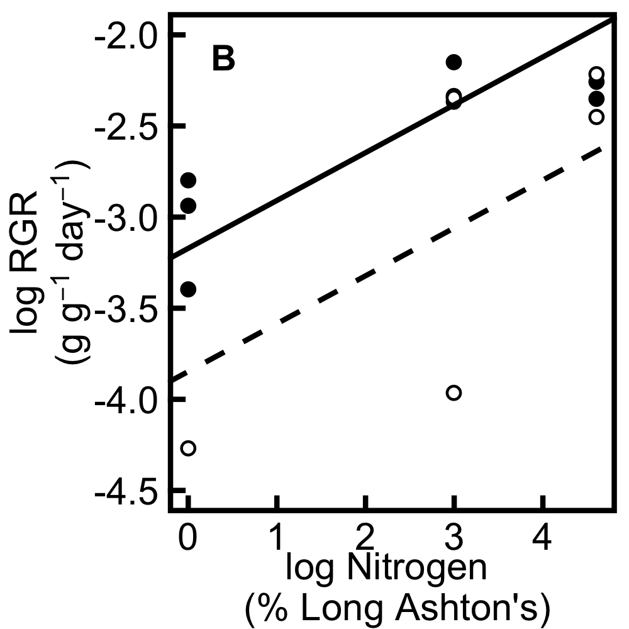
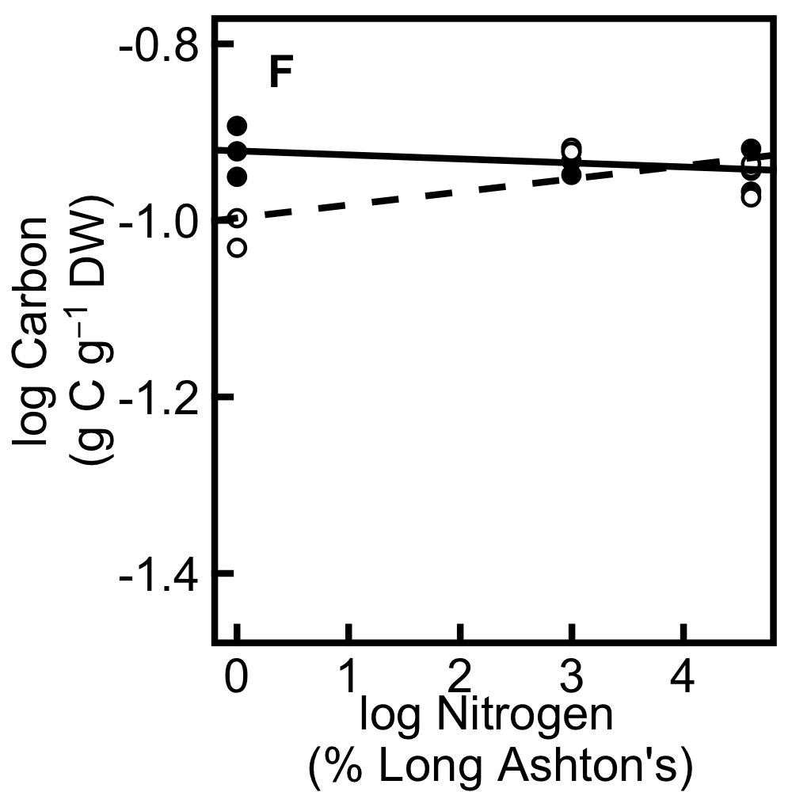
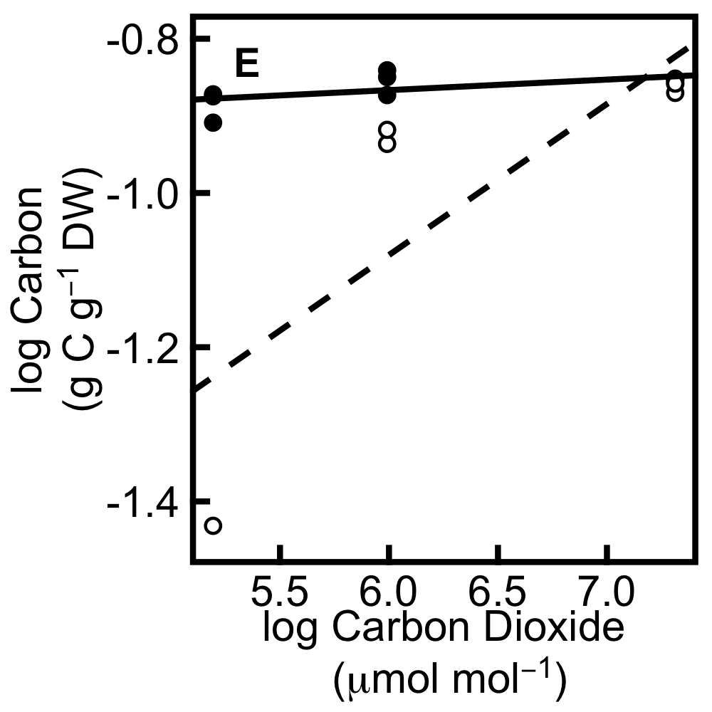
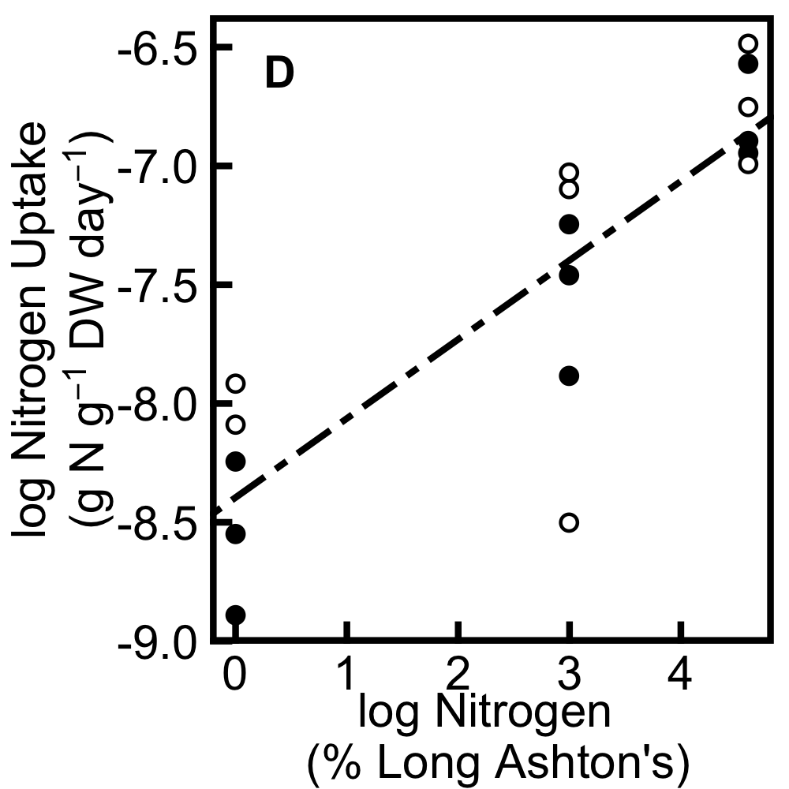
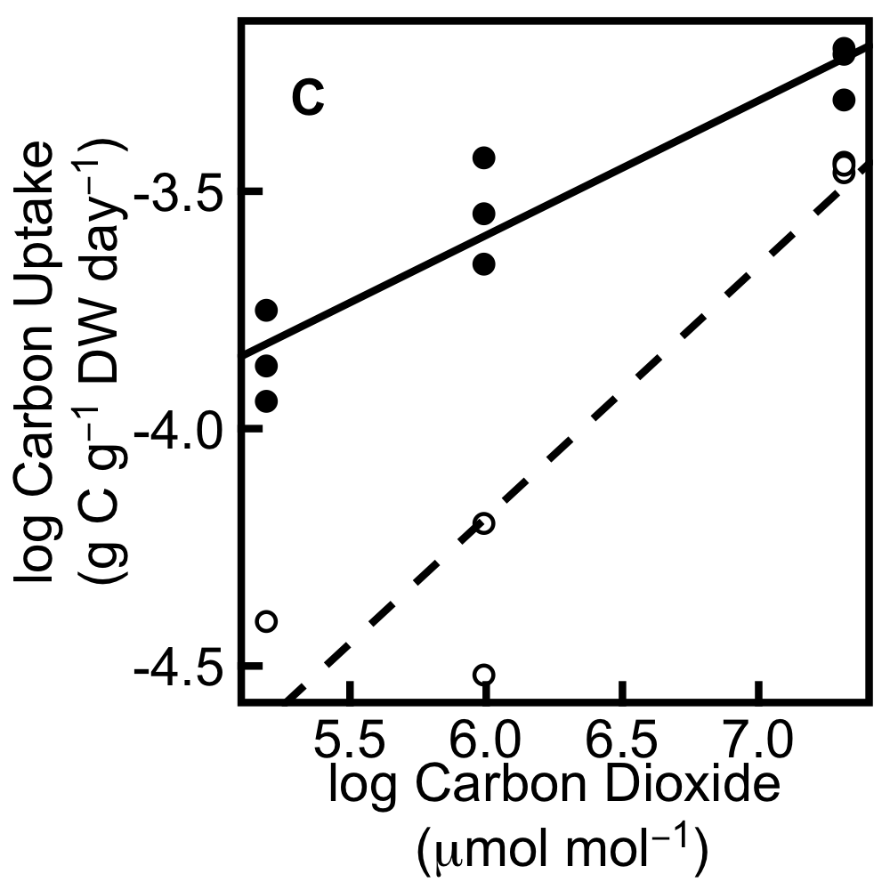
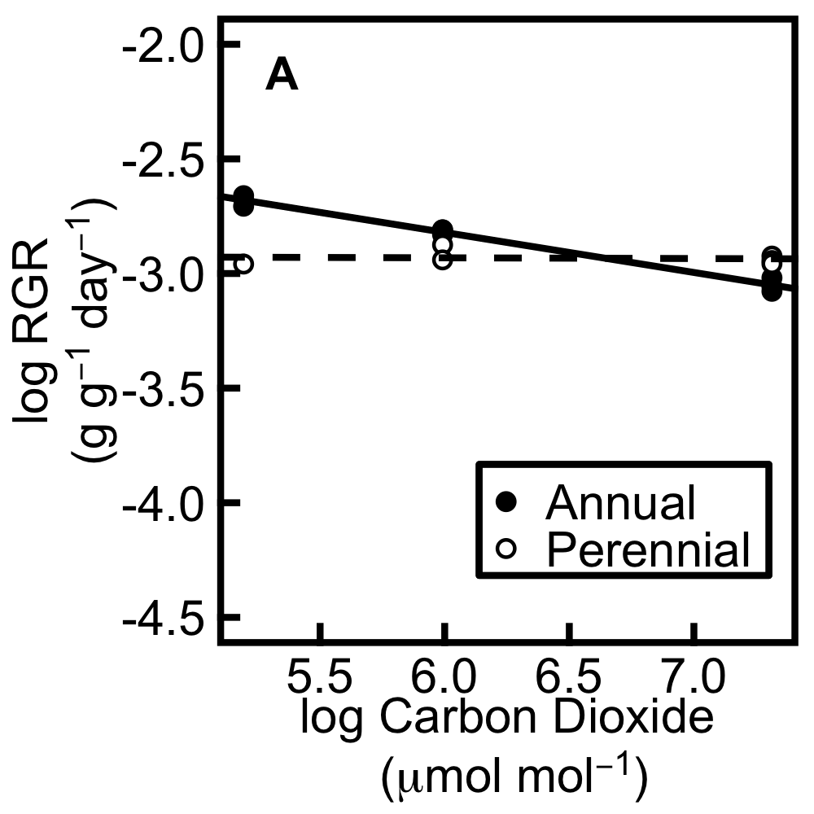
CO₂ gradient Nitrogen gradient

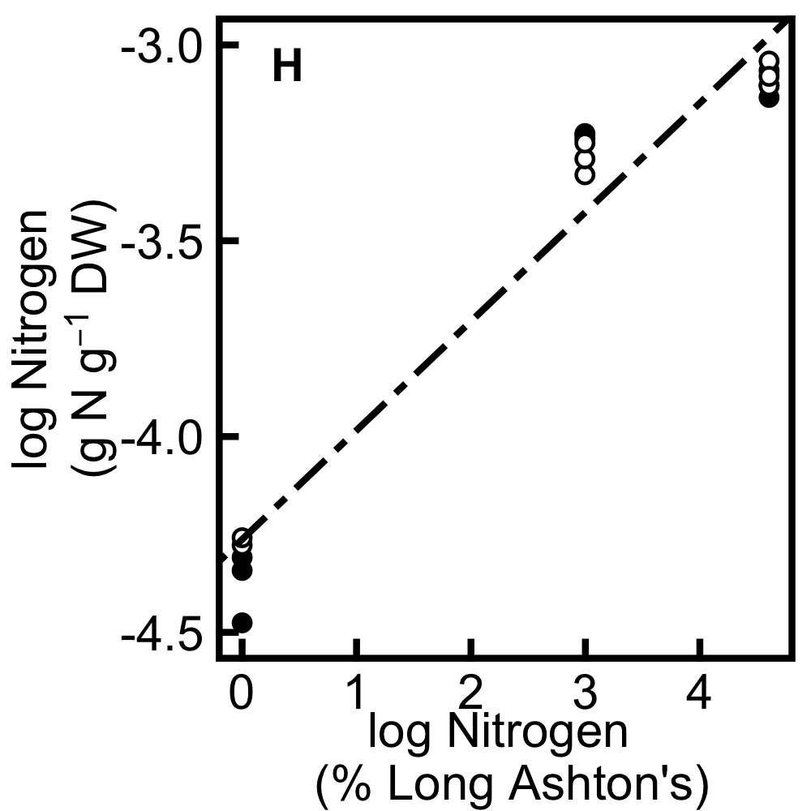
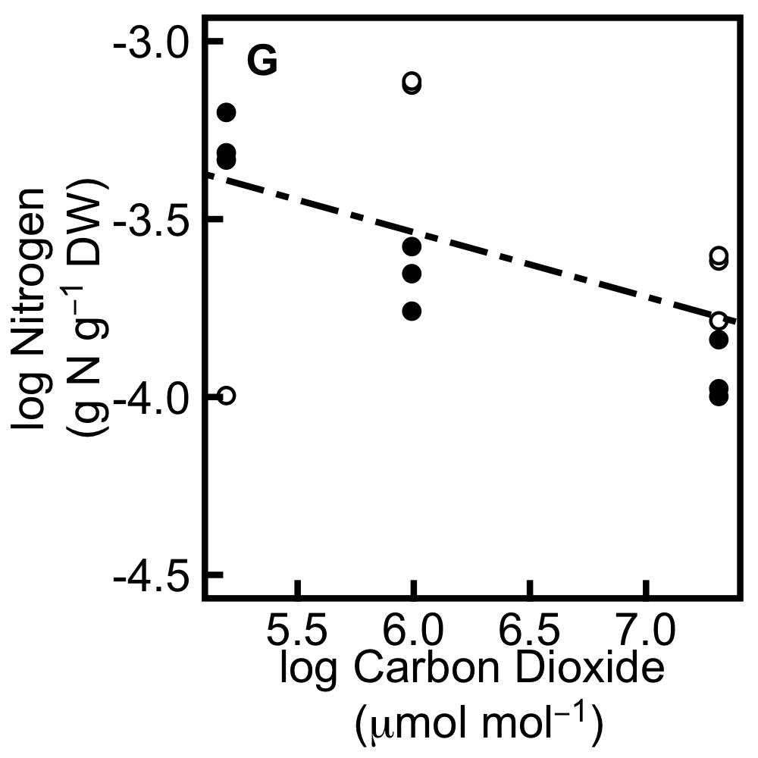

Figure 1. Response of relative growth rate (RGR), resource uptake and resource storage to carbon dioxide and nitrogen gradients in annual (filled circles) and perennial (hollow circles) barley measured pre-dawn 6-7 weeks after germination. Linear regression is shown using solid lines for annual barley and evenly dashed lines for perennial barley. Where there is no species difference in slope or intercept, a dotdash line is used to denote the overall relationship. A & B, RGR across CO₂ gradient and nitrogen gradient respectively; C, carbon uptake across CO₂ gradient; D, nitrogen uptake across nitrogen gradient; E & F, mean plant carbon concentration across CO₂ and nitrogen gradient respectively; G & H, mean plant nitrogen concentration across CO₂ and nitrogen gradient respectively. Data shown are individual plant values.
The carbon and nitrogen concentrations used here show mean values per gram plant, obtained by weighting carbon and nitrogen concentrations from CHN analysis according to the fraction of plant material allocated to each organ type (leaf, leaf sheath and root).

Overall, Figure 1 shows that growth is not highly responsive to increasing CO₂ or nitrogen in either annual or perennial barley. Carbon uptake responds strongly to increasing CO₂, especially in the perennial, which is more carbon source limited, and nitrogen uptake responds strongly to nitrogen gradient in both species, in spite of the nitrogen sink limitation exhibited by both species and reflected in the increased nitrogen concentration. Carbon concentration increases with CO₂ in the perennial, but not in the annual, and does not respond to increasing nitrogen in either species. In contrast, nitrogen concentration decreases in response to CO₂ gradient and increases strongly in response to nitrogen gradient. These elasticities generally corroborate the findings of this thesis, that increasing the supply of carbon or nitrogen leads to increased uptake and storage of that resource and increases limitation by the other resource. In annual barley, growth is more limited by carbon and nitrogen sink capacity, whilst in perennial barley, growth is more limited by carbon source and nitrogen sink capacity, and these findings are reflected here by the particularly strong response of carbon uptake and concentration in response to the CO₂ gradient in the perennial compared to the annual. Since the accumulation of non-structural carbohydrates is greater in the annual under elevated CO₂ (Chapter 4), the greater increase in whole plant carbon concentration in response to CO₂ seen in the perennial suggests investment of additional carbon into structural components in this species facilitating its flexible response of growth and development to increased CO₂.

These parameters may also be plotted against transport sugars, since the key processes of resource uptake, storage and growth are all interlinked by this labile pool of intermediates, which mediates the transfer of carbon and nitrogen resources between sources and sinks. Here, carbohydrates have been separated into two pools, transport carbohydrates and storage carbohydrates, and protein is used as a proxy for nitrogen storage since it is a strong nitrogen sink. Transport carbohydrates, labelled here as transport sugars for ease of presentation, are the sum of glucose, fructose, sucrose and short-chain fructans, all of which may be transported within the plant and constitute a relatively temporary and labile pool of carbohydrates. Storage carbohydrates are expressed here as the sum of starch and long-chain fructans. These carbohydrate and protein data are expressed as mean values per gram plant, obtained by firstly weighting metabolite concentrations according to the fraction of plant material allocated to each organ type (leaf, leaf sheath and root) and then converting these metabolite data to concentrations of carbon and nitrogen stored in each metabolite pool.

In annual barley, RGR (Fig. 2A) shows a much stronger negative response to transport sugars across the CO₂ gradient than the perennial, with an elasticity of -0.457 for the annual and -0.028 for the perennial, whilst both species show a strong increase in RGR in response to transport sugars across the nitrogen gradient (Fig 2B) with an elasticity of 0.580. The overall r² value is 0.68 for carbon and 0.46 for nitrogen. The negative relationship between RGR and transport sugars across the CO₂ gradient indicates that increases in RGR when carbon source activity is decreased (since higher RGRs are correlated here with decreased CO₂ due to the ontogenetic artefact discussed for Figure 1) depend on drawdown of transport sugars. Meanwhile, the positive relationship between RGR and transport sugars across the nitrogen gradient suggests that increases in RGR when the nitrogen source is increased depend more on nitrogen than on transport sugar drawdown, since CO₂ is not limiting in this case.

Annual and perennial barley show a strong increase in resource uptake in response to transport sugars, both for carbon uptake across the CO₂ gradient and for nitrogen uptake across the nitrogen gradient (Fig. 2C and D), with elasticities of 0.876 and 0.253 respectively. The r² values are 0.83 for carbon uptake and 0.43 for nitrogen uptake. For nitrogen, this indicates a capacity to pair carbon and nitrogen for investing in growth; for carbon, the direct causal relationship between carbon uptake and transport sugars means that the change in sugars is probably due to carbon uptake rather than vice versa.

The concentration of storage carbohydrates responds very strongly to transport sugars in both species (Fig. 2E and F), with elasticities of 1.42 across the CO₂ gradient and 0.706 across the nitrogen gradient, and higher values in the perennial, indicating efficient use of sugars and highlighting the lower carbon sink limitation in the perennial compared to the annual which allows the perennial to convert sugars to storage carbohydrates more readily. The r² values are 0.83 and 0.73 respectively. The concentration of protein (Fig, 2G and H), used here as a proxy for storage nitrogen, does not respond to transport sugars across the CO₂ gradient in either species, pr esumably since these sugars are not accompanied by increased free nitrogen with which they may be combined to make protein (elasticity for both species is -0.009, r² = 0.13). In contrast, protein concentration does respond to transport sugars across the nitrogen gradient in both species, since these sugars can be used alongside the additional nitrogen made available by this treatment in order to build protein (elasticity for both species is 0.209, with higher values in the perennial; r² = 0.67).

Overall when the carbon source is manipulated via the CO₂ gradient, growth in the annual and photosynthesis and carbon storage in both species show strong relationships with transport sugars, whilst growth in the perennial and protein accumulation in both species do not. When the carbon sink is manipulated via the nitrogen gradient, growth, nitrogen uptake, carbon storage and protein accumulation in both species respond strongly to transport sugars, with the response for carbon storage being particularly strong. Thus increasing the carbon source or the carbon sink reveals a strong response of growth in the annual and of carbon storage in both species with respect to transport sugars, whilst increasing the carbon source reveals a strong link between photosynthesis and transport sugars; photosynthesis provides an increase in transport sugars to which growth and storage respond.

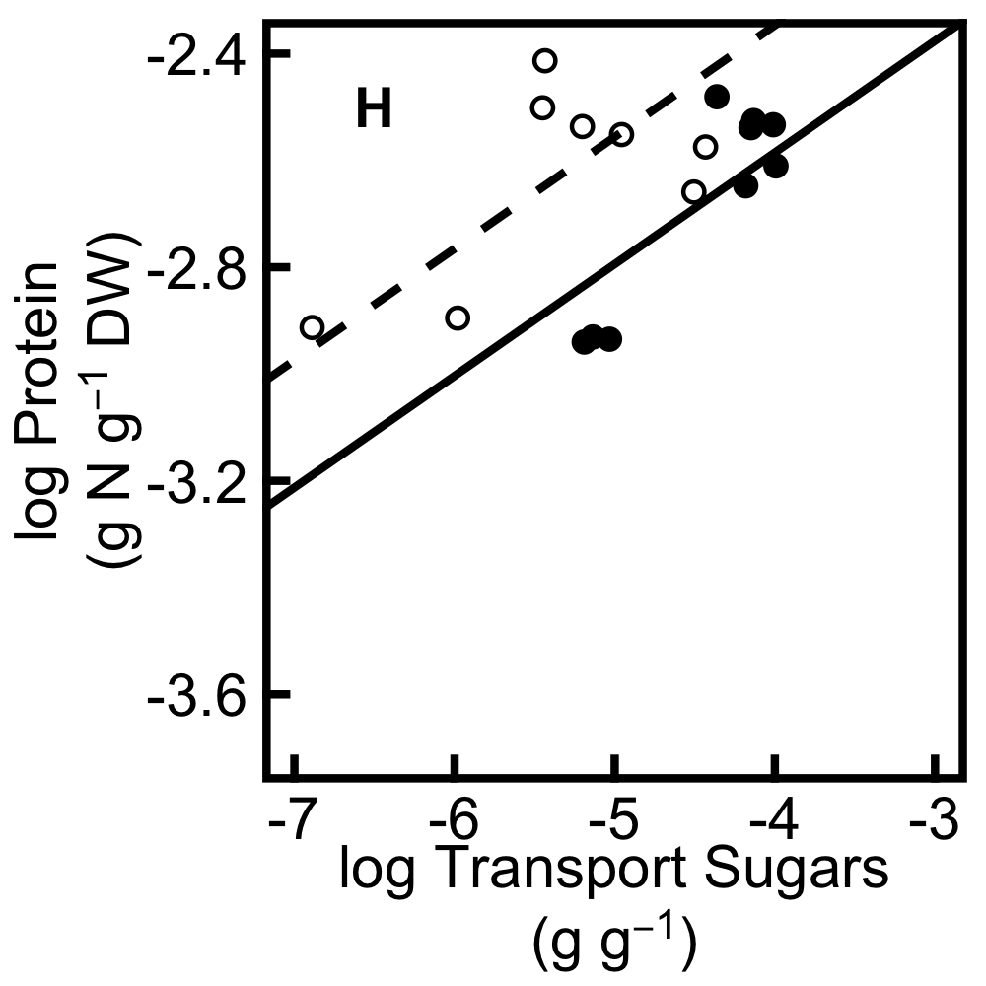
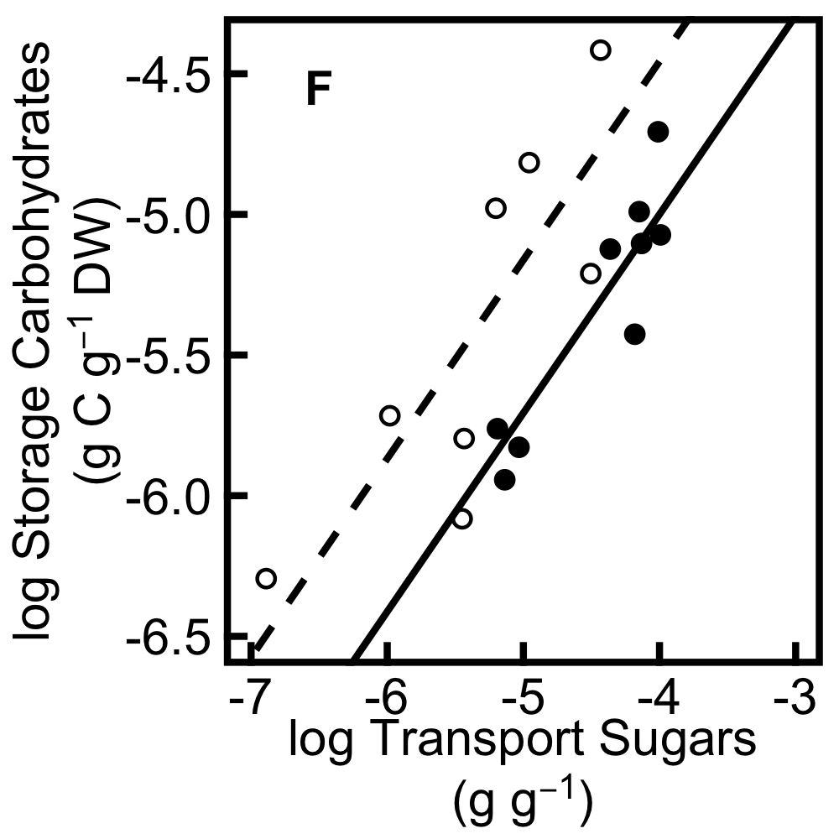
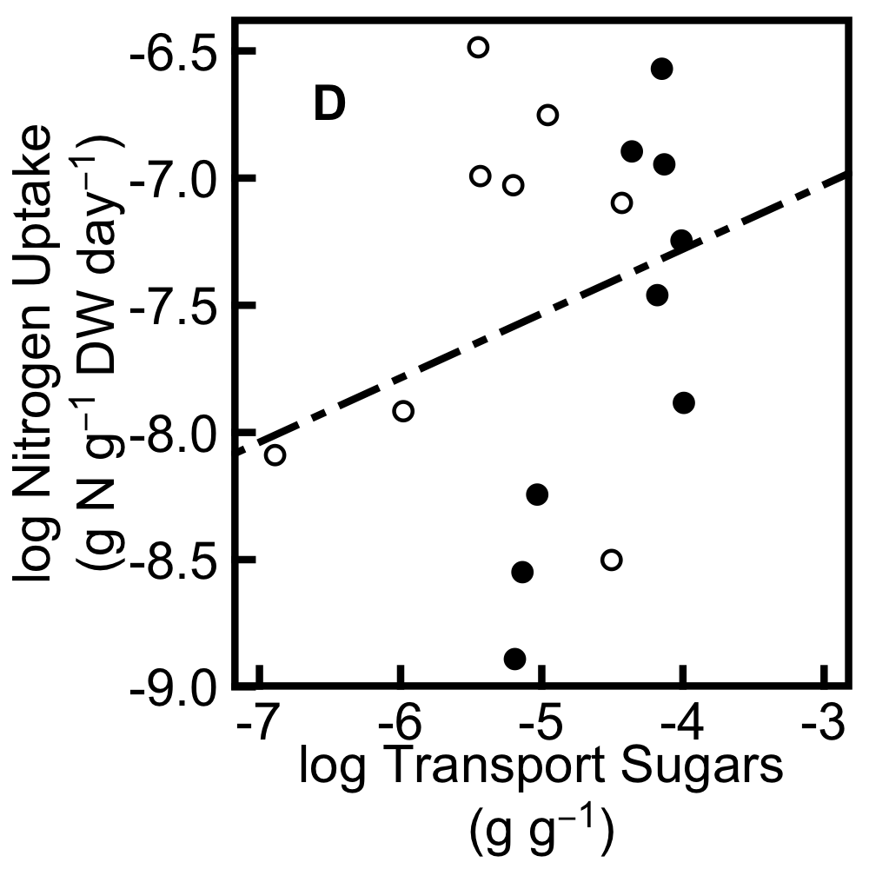
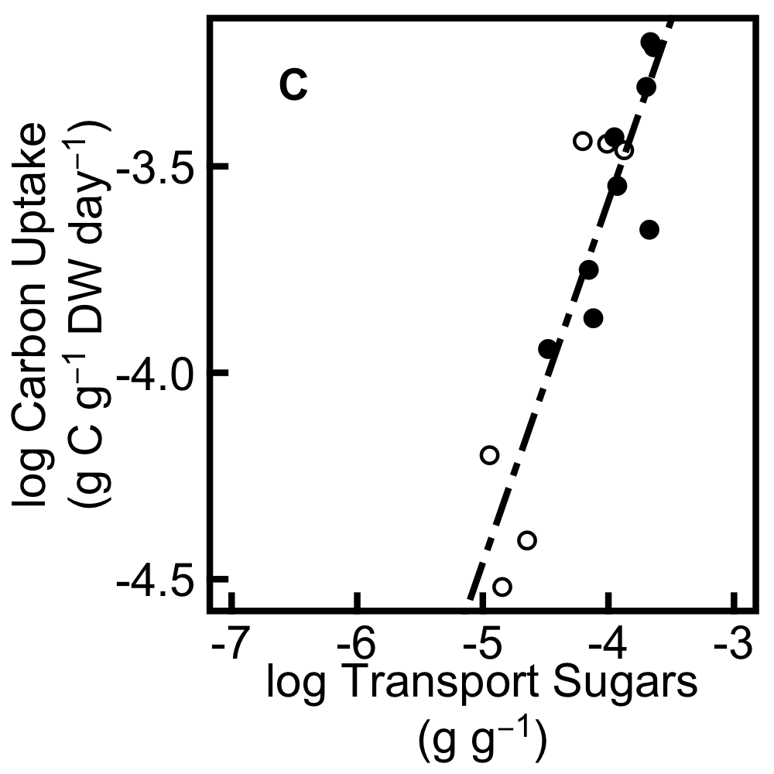
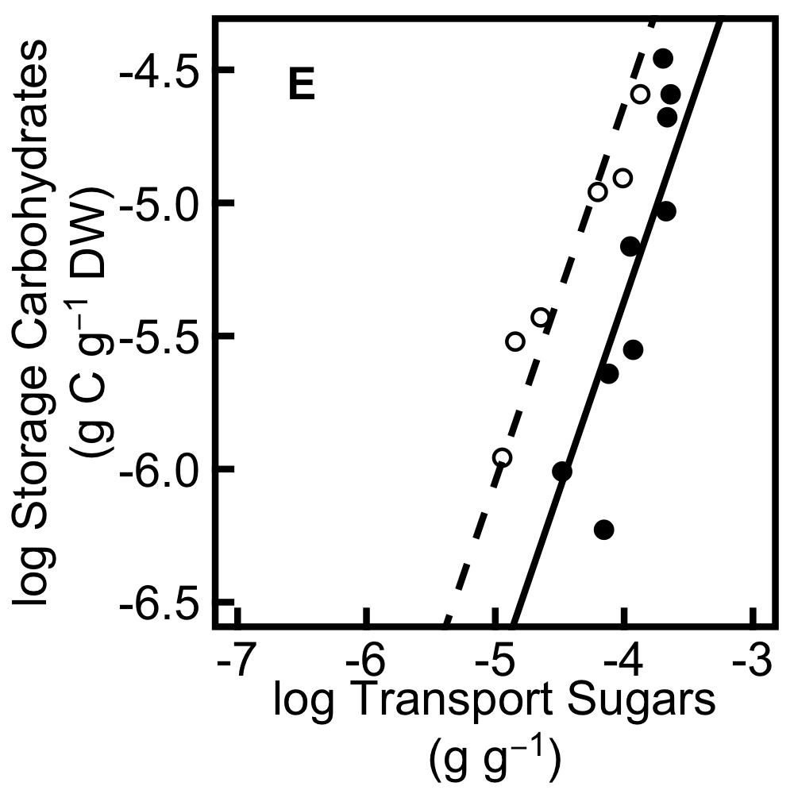
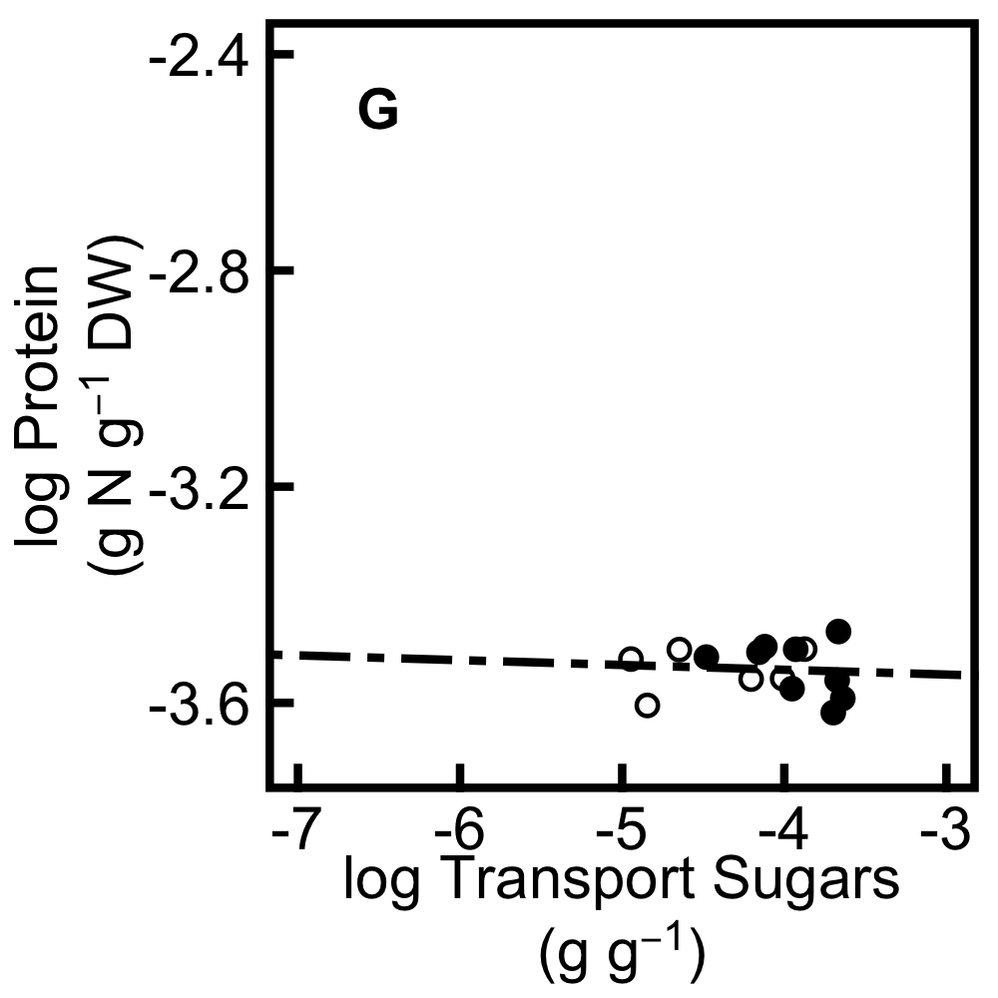
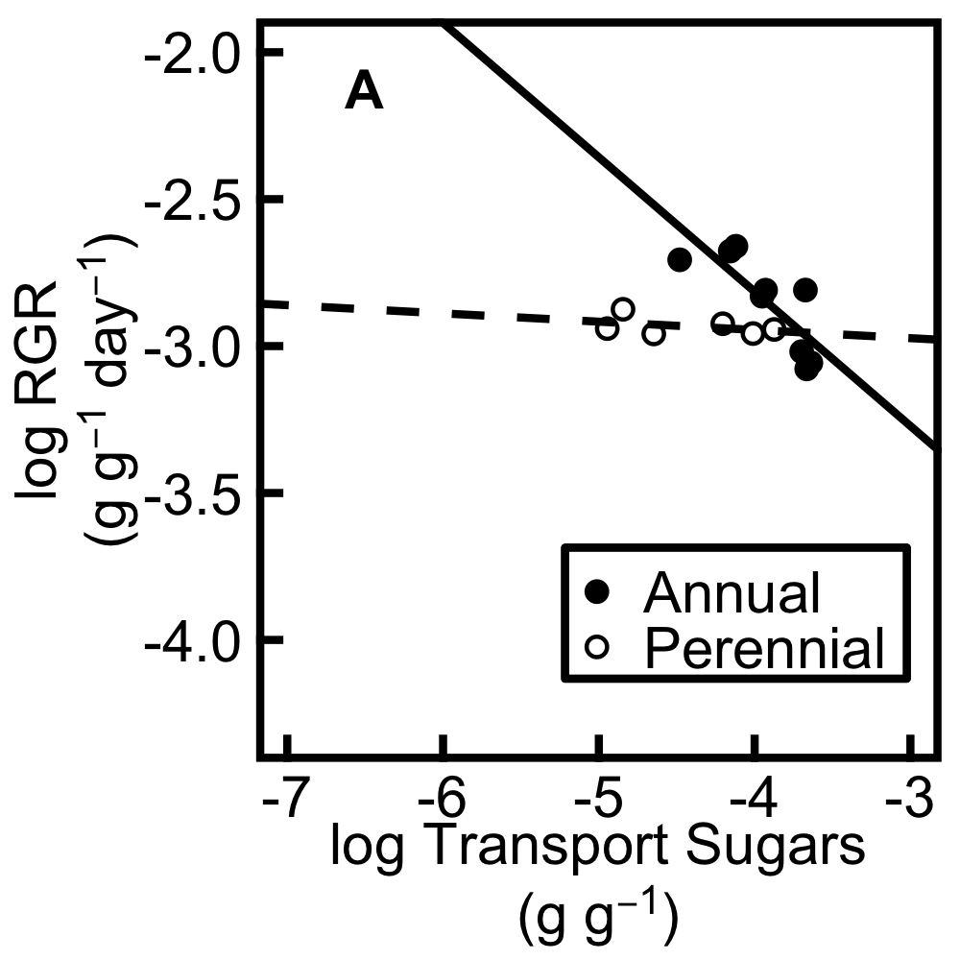
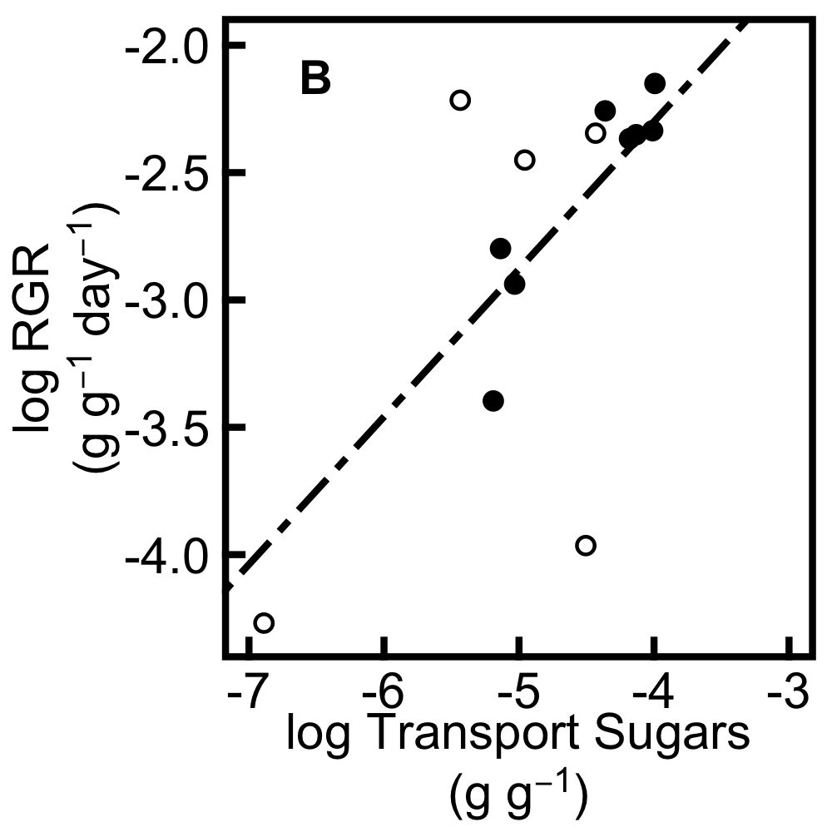
CO₂ gradient Nitrogen gradient

Figure 2. Response of RGR, resource uptake and resource storage to transport sugars in annual (filled circles) and perennial (hollow circles) barley measured pre-dawn 6-7 weeks after germination. Linear regression is shown using solid lines for annual barley and evenly dashed lines for perennial barley; a dotdash line is used where there is no species difference in slope or intercept. A & B, RGR across CO₂ and N gradients respectively; C, carbon uptake across CO₂ gradient; D, N uptake across N gradient; E & F, mean plant storage carbohydrate (starch and long-chain fructan) concentration across CO₂ and N gradients respectively; G & H, mean plant protein concentration across CO₂ and N gradients respectively. Data show individual plants.
Increasing the carbon sink by increasing the nitrogen source reveals a strong response of growth and nitrogen storage in both species to transport sugars, whereby additional nitrogen can be paired with sugars to allow protein synthesis, especially in the perennial which has a growth strategy reliant on resource conservation. These elasticities highlight the interdependent nature of carbon and nitrogen sources and sinks, which enables plants to balance the processes of resource uptake, storage and growth in accordance with the availability of both carbon and nitrogen resources.

Conclusions and future directions

Overall, this thesis found that growth in annual barley is limited by the development of both carbon and nitrogen sinks during vegetative growth (Figure 3). These findings suggest significant issues for the improvement of this fast growing crop. In contrast, the perennial barley species is carbon source and nitrogen sink limited during vegetative growth, which is consistent with a conservative growth strategy (Figure 3). The different ecological strategies of the fast growing annual and the slow growing perennial studied here result in different allocation patterns which contribute to the different limitations imposed on growth by sources and sinks in each species. Compared to the perennial, the annual is significantly more carbon sink limited and also more nitrogen sink limited, suggesting limitation of growth by root development, since roots are the site of nitrogen uptake and allow significant carbon storage. In contrast, the perennial is more carbon source limited than the annual, as well as being nitrogen sink limited, suggesting limitation of growth by shoot development, because shoot tissues are the site of photosynthesis which enables carbon uptake and provide a major sink for nitrogen in the plant due to the high investment of nitrogen resources into photosynthetic enzymes. This is supported by the findings of both chapters 4 and 5, which show that the annual grows faster than the perennial (Chapters 4 and 5) and allocates more mass to leaves than the perennial (Chapter 5).
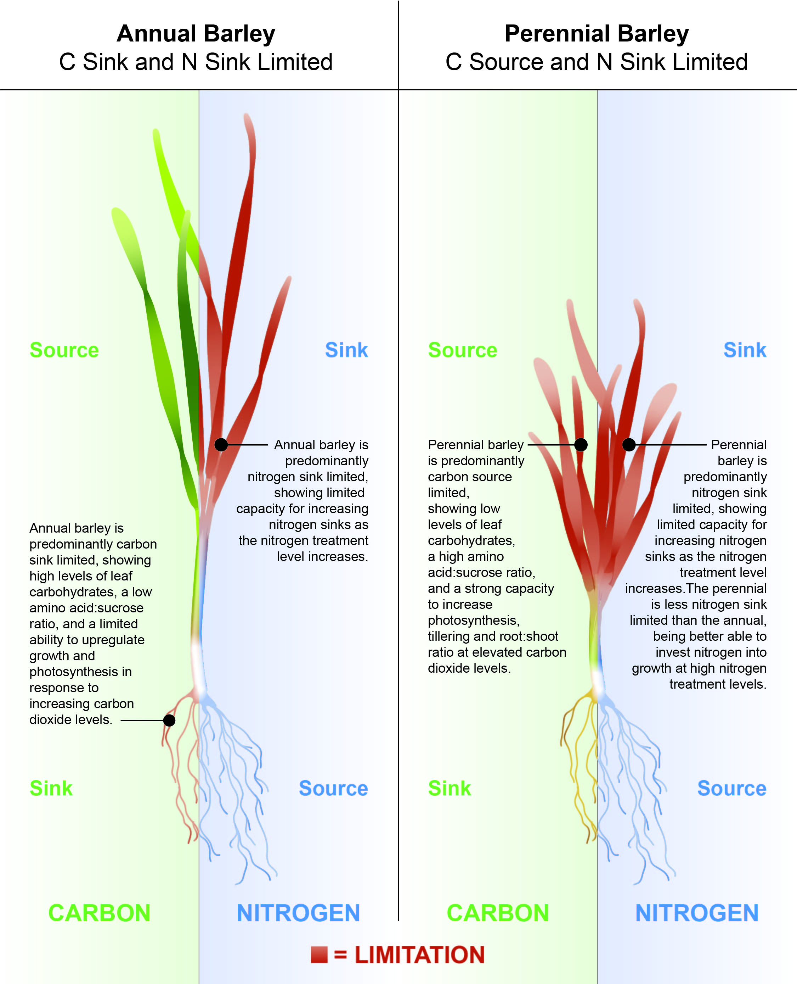

Figure 3. Conceptual diagram highlighting the major findings of this thesis: annual barley is predominantly carbon sink and nitrogen sink limited, whilst perennial barley is predominantly carbon source and nitrogen sink limited.

The fast growing annual exhibits greater accumulation of photosynthate which is used to power growth, and has a higher rate of photosynthesis to facilitate this (Chapter 4). In contrast, the perennial is more conservative with resources and has a higher concentration of nitrogen (Chapter 5). Growth in both species is predominantly nitrogen sink limited, suggesting that annual barley would not be able to invest more nitrogen into photosynthesis as it cannot store and use more nitrogen during vegetative growth (Chapter 5), although measurements of photosynthetic capacity in plants grown along a nitrogen gradient would be required to confirm this. The conservative growth strategy exhibited by the perennial in terms of nitrogen conservation (Chapter 5) contrasts with the fast growing strategy of the annual and enables opportunistic responses to increases in carbon availability (Chapter 4). This could be due to an inherently lower photosynthetic capacity in the perennial, caused by its conservative use of nitrogen. This facilitates greater increases in photosynthesis in the perennial under elevated CO₂ since this treatment allows photosynthetic rates to increase without any additional nitrogen cost. Figure 3 summarises these findings.

Our world faces food insecurity and climate change (Ackerman and Stanton, 2013; FAO et al., 2014; Ort et al., 2015), and improving crop yield with consideration of future climatic conditions will be vital for safeguarding future food security (Ainsworth et al., 2008b; Godfray et al., 2010; Foley et al., 2011; von Caemmerer et al., 2012; Reynolds et al., 2012). Whilst beyond the scope of this thesis, it is worth noting that in addition to the predicted increased CO₂ levels, changes in temperature and levels of O₃ will affect crop physiology, and many environmental variables interact with one another producing complex effects which must be considered when breeding crops for future environments (Ainsworth et al., 2008b; Ackerman and Stanton, 2013). Atmospheric CO₂ levels are rising quickly, making CO₂ experiments not only a useful non-invasive manipulation of the carbon source as shown in this thesis where strong CO₂ perturbations were used, but also an environmentally and agronomically relevant way to test the possible responses of crops to future conditions, when appropriate CO₂ levels are used. Crop ideotypes must thrive in future atmospheres, but here the elite annual barley species currently highly favoured by growers in the UK (HGCA, 2014) was unable to utilise additional CO₂ for photosynthesis and growth under elevated CO₂ (Chapter 4). Increasing sink capacity alongside source capacity will be an important facet of ensuring effective yield gains (Foulkes et al., 2011), especially since sink activity can be a major factor limiting grain filling in cereals (Acreche and Slafer, 2009; Peterhansel and Offermann, 2012; Slewinski, 2012).

Increasing carbon source activity is a major target for many breeding efforts (Kromdijk and Long, 2016), and transgenic work reveals increased biomass and yield when source capacity is increased, for example by regulating the amount or activity of the Calvin cycle enzyme SBPase (Rosenthal et al., 2011). Since future climates will have elevated levels of CO₂ compared to those currently experienced by plants, enhancing the carbon source capacity will be an important facet of increasing the yield of crops, and barley is no exception. However, the fact that yield responses to elevated CO₂ often fall short of those predicted (Long et al., 2006a; Ainsworth et al., 2008a; Leakey et al., 2009), coupled with the evidence for carbon sink limitation in annual barley seen here (Chapter 4), suggests that increasing sink capacity alongside source capacity will be vital for increasing yield in this species.

Increasing source or sink capacity in isolation does not always stimulate the expected increases in yield under field conditions (Long et al., 2006a; Ainsworth et al., 2008a; Leakey et al., 2009; Weichert et al., 2010). Although elevated CO₂ suppresses photorespiration (Farquhar et al., 1980), if sink capacity is insufficient the increased rates of photosynthesis under elevated CO₂ can decrease through acclimation (Rogers et al., 1998; Long et al., 2004), leading to changes in biomass and yield which are below the expected responses. Sink capacity may be increased by increasing the size or activity of the sink (Geiger and Shieh, 1993; White et al., 2016). Thus manipulating the rate at which sinks can sequester carbon, and/or breeding for increased sink size during vegetative and reproductive growth, can increase the capacity of the sink and facilitate increases in growth and yield.

Although plants generally transition from carbon sink to source limitation during growth (Arp, 1991; Marschner, 1995), annual barley is sink limited during grain filling (Schnyder, 1993; Bingham et al., 2007; Serrago et al., 2013). Even if sink limitation were to be reduced at later times during ontogeny – currently not the case for annual barley – maximising resource use efficiency early in development could still be useful for improving crop yields. A key starting point for building on the work of this thesis will be to carry out investigations into the relative limitations imposed by carbon and nitrogen sources and sinks during the whole of crop development, from early vegetative growth right through to grain maturity. Uniting work on carbon and nitrogen, for instance by measuring photosynthetic capacity along a nitrogen gradient or measuring nitrogen uptake along a CO₂ gradient, will enable greater integration of the results seen here. This will enable potential crossover between, for example, carbon source limitation and nitrogen sink limitation to be established, as well as facilitating the development of a holistic perspective of carbon-nitrogen interactions during ontogeny. New approaches could also be taken to deepen understanding of the ways in which sources and sinks underpin development, by looking not just at tillering and relative growth rate but also at cell division rate and meristem branching. Furthermore, experiments similar to those conducted here in growth chambers should be carried out in the field under agronomically relevant conditions and on a wider range of species, in order to confirm and expand the generality of the findings, so that genetic modification or selective breeding may be used to upregulate source and sink together in order to improve productivity.

Manipulation of the molecular mechanisms controlling communication between sources and sinks for carbon and nitrogen (Stitt and Krapp, 1999; Smith and Stitt, 2007; Masclaux-Daubresse et al., 2010; Lawlor and Paul, 2014; White et al., 2016) could be another target for alleviating sink limitation and enabling increased crop yields. The signalling pathways facilitating communication between sources and sinks of carbon and nitrogen form another target for crop improvement. Manipulating the signalling pathway that integrates photosynthesis and starch synthesis, for example, has been shown to increase yield in maize (Nuccio et al., 2015). Alongside work to increase sink capacity directly, signalling mechanisms in barley could also be investigated as a potential means of increasing growth and yield. Furthermore, modelling will be an important part of developing future crops through collaborative research. Zhu et al. (2016) make a strong case for the need for coherent collaboration in order to utilise modelling work effectively. This will be an important aspect of breeding for increased yield, since modelling can bring about increased understanding of the impacts of, for example, external environmental factors on sources and sinks. The approach advocated by Zhu et al. is a multi-layer modelling community, enabling insights from the genetic to the ecological level to be integrated into a holistic picture of growth, of great interest for developing breeding goals dependent on environmental factors, and linking with the concept of physiological breeding which unites genetic strategies with phenomic screening (Reynolds and Langridge, 2016).

However, the need to base models on species-specific parameters must not be under-estimated. The physiology and metabolism of Arabidopsis do not always map onto those of crop plants (White et al., 2016). For example, the fact that species differ in their metabolite storage strategies must be treated carefully. Indeed, the negative correlation between starch and biomass observed in a range of accessions of Arabidopsis (Sulpice et al., 2009) is not borne out by the data presented in this thesis – rather, the fast-growing annual species has a higher rate of carbohydrate accumulation despite having greater biomass. Growth in plants with different life forms and life histories may be subject to different constraints; in slow growing Arabidopsis accessions, growth is slow because it is sink limited, whereas in perennial barley, growth is slower than the annual because it is source limited and therefore uncorrelated with carbohydrate content. Whilst the use of Arabidopsis as a model plant is certainly highly valuable, care must be taken to ensure that species-specific characterisations are carried out. For example, pathways involved in starch synthesis and degradation differ between Arabidopsis and other species (Smith, 2012; Stitt and Zeeman, 2012).

The results presented in this thesis suggest that improving sink strength in annual barley during the vegetative growth stage will be critical for maximising yields of this important crop. Annual barley is sink limited during grain filling (Schnyder, 1993; Bingham et al., 2007; Serrago et al., 2013) and the findings presented here show that annual barley is also sink limited during the vegetative stage, for both carbon and nitrogen. It seems that the perennial is better able to utilise additional CO₂ than the annual, which has important implications for the role of wild crop relatives in breeding crops suited to future elevated atmospheric CO₂. In terms of nitrogen, reducing fertiliser use will be important for economically viable and environmentally sustainable agriculture in the future (Rabalais et al., 2002; Erisman et al., 2008; Masclaux-Daubresse et al., 2010). Nitrogen is of vital importance for crop production, and providing a great excess of nitrogen had a relatively small effect on growth in the annual barley studied here (Chapter 5). Crops have been bred to be able to exploit high levels of soil nitrogen (Xu et al., 2012), yet beyond acquisition the efficient utilisation of this resource is important if we are to develop efficient crops with high yields (Murchie et al., 2009; Masclaux-Daubresse et al., 2010; Santa-Maria et al., 2015) and will potentially enable us to reduce fertiliser application whilst maintaining yield (Syngenta Crop Protection, 2011). Future crop design for utilising low nitrogen, such as through improving uptake rates at low soil nitrogen concentrations, will be important for crops in areas of poor soil quality in order to reduce the economic and environmental costs of nitrogen fertiliser, and will be especially critical for improving yields in less economically developed countries. Finally, the translocation of carbon and nitrogen resources accumulated during the vegetative growth stage makes a significant contribution to grain filling (Schnyder, 1993).

To conclude, if the overall sink strength of annual barley can be improved – both during vegetative growth, in order to accumulate greater reserves for grain filling, and during the reproductive stage, in order to increase the sink capacity of grains – then source manipulations, whether via increased atmospheric CO₂ levels due to anthropogenic climate change, or via breeding for increased photosynthetic capacity, will be able to have a greater effect.

References

Ackerman F, Stanton EA. 2013. Climate Impacts on Agriculture: A Challenge to Complacency?
Acreche MM, Slafer GA. 2009. Grain weight, radiation interception and use efficiency as affected by sink-strength in Mediterranean wheats released from 1940 to 2005. Field Crops Research 110, 98–105.
Aerts R, Chapin FS. 2000. The mineral nutrition of wild plants revisited: a re-evaluation of processes and patterns. Advances in Ecological Research 30, 1–67.
Ainsworth EA, Bush DR. 2011. Carbohydrate export from the leaf: a highly regulated process and target to enhance photosynthesis and productivity. Plant Physiology 155, 64–9.
Ainsworth EA, Davey PA, Hymus GJ, Osborne CP, Rogers A, Blum H, Nösberger J. 2003. Is stimulation of leaf photosynthesis by elevated carbon dioxide concentration maintained in the long term? A test with Lolium perenne grown for 10 years at two nitrogen fertilization levels under Free Air CO₂ Enrichment (FACE). Plant, Cell & Environment 26, 705–714.
Ainsworth EA, Leakey ADB, Ort DR, Long SP. 2008a. FACE-ing the facts: inconsistencies and interdependence among field, chamber and modeling studies of elevated [CO₂] impacts on crop yield and food supply. New Phytologist 179, 5–9.
Ainsworth EA, Rogers A. 2007. The response of photosynthesis and stomatal conductance to rising [CO₂]: mechanisms and environmental interactions. Plant, Cell & Environment 30, 258–70.
Ainsworth EA, Rogers A, Leakey ADB. 2008b. Targets for crop biotechnology in a future high-CO₂ and high-O₃ world. Plant Physiology 147, 13–9.
Ainsworth EA, Rogers A, Leakey ADB, Heady LE, Gibon Y, Stitt M, Schurr U. 2007. Does elevated atmospheric [CO₂] alter diurnal C uptake and the balance of C and N metabolites in growing and fully expanded soybean leaves? Journal of Experimental Botany 58, 579–91.
Ainsworth EA, Rogers A, Nelson R, Long SP. 2004. Testing the ‘source–sink’ hypothesis of down-regulation of photosynthesis in elevated [CO₂] in the field with single gene substitutions in Glycine max. Agricultural and Forest Meteorology 122, 85–94.
Álvaro F, Royo C, García del Moral LF, Villegas D. 2008. Grain filling and dry matter translocation responses to source–sink modifications in a historical series of durum wheat. Crop Science 48, 1523.
Amthor JS. 2000. The McCree-de Wit-Penning de Vries-Thornley respiration paradigms: 30 years later. Annals of Botany 86, 1–20.
Aranjuelo I, Sanz-Sáez A, Jauregui I, Irigoyen JJ, Araus JL, Sánchez-Díaz M, Erice G. 2013. Harvest index, a parameter conditioning responsiveness of wheat plants to elevated CO₂. Journal of Experimental Botany 64, 1879–1892.
Araújo WL, Nunes-Nesi A, Nikoloski Z, Sweetlove LJ, Fernie AR. 2012. Metabolic control and regulation of the tricarboxylic acid cycle in photosynthetic and heterotrophic plant tissues. Plant, Cell & Environment 35, 1–21.
Arp WJ. 1991. Effects of source-sink relations on photosynthetic acclimation to elevated CO₂. Plant, Cell & Environment 14, 869–875.
Atkinson RRL, Burrell MM, Osborne CP, Rose KE, Rees M. 2012. A non-targeted metabolomics approach to quantifying differences in root storage between fast- and slow-growing plants. New Phytologist 196, 200–11.
Atkinson RRL, Burrell MM, Rose KE, Osborne CP, Rees M. 2014. The dynamics of recovery and growth: how defoliation affects stored resources. Proceedings of the Royal Society B 281, 20133355.
Badri D V., Vivanco JM. 2009. Regulation and function of root exudates. Plant, Cell & Environment 32, 666–681.
Baraloto C, Timothy Paine CE, Poorter L, Beauchene J, Bonal D, Domenach A-M, Hérault B, Patiño S, Roggy J-C, Chave J. 2010. Decoupled leaf and stem economics in rain forest trees. Ecology Letters 13, 1338–47.
Bazzaz FA, Chiariello NR, Coley PD, Pitelka LF. 1987. Allocating Resources to Reproduction and Defense. BioScience 37, 58–67.
Bennett E, Roberts JA, Wagstaff C. 2012. Manipulating resource allocation in plants. Journal of Experimental Botany 63, 3391–400.
Bingham IJ, Blake J, Foulkes MJ, Spink J. 2007. Is barley yield in the UK sink limited? Field Crops Research 101, 198–211.
Bloom AJ, Chapin FS, Mooney HA. 1985. Resource limitation in plants - an Economic analogy. Annual Review of Ecology and Systematics 16, 363–392.
von Bothmer R. 1996. Distribution and habitat preferences in the genus Hordeum in Iran and Turkey. Annalen des Naturhistorischen Museums in Wien, Serie B 98-Suppl., 107–116.
Brisson N, Mary B, Ripoche D, et al. 1998. STICS : a generic model for the simulation of crops and their water and nitrogen balances. 1. Theory and parameterization applied to wheat and corn. Agronomie 18, 311–346.
Bryant J, Taylor G, Frehner M. 1998. Photosynthetic acclimation to elevated CO₂ is modified by source:sink balance in three component species of chalk grassland swards grown in a free air carbon dioxide enrichment (FACE) experiment. Plant, Cell & Environment 21, 159–168.
Burnett AC, Rogers A, Rees M, Osborne CP. 2016. Source-sink limitations differ between two species with contrasting growth strategies. In press. Plant Cell and Environment.
von Caemmerer S, Farquhar GD. 1984. Effects of partial defoliation, changes of irradiance during growth, short-term water stress and growth at enhanced p(CO₂) on the photosynthetic capacity of leaves of Phaseolus vulgaris L. Planta 160, 320–329.
von Caemmerer S, Quick WP, Furbank RT. 2012. The development of C₄ rice: current progress and future challenges. Science 336, 1671–2.
Cameron DD, Neal AL, van Wees SCM, Ton J. 2013. Mycorrhiza-induced resistance: more than the sum of its parts? Trends in Plant Science 18, 539–545.
Campbell BD, Grime JP. 1992. An Experimental Test of Plant Strategy Theory. Ecology 73, 15–29.
Cheng SH, Moore B, Seemann JR. 1998. Effects of short- and long-term elevated CO₂ on the expression of ribulose-1,5-bisphosphate carboxylase/oxygenase genes and carbohydrate accumulation in leaves of Arabidopsis thaliana (L.) Heynh. Plant physiology 116, 715–723.
Chew YH, Wenden B, Flis A, et al. 2014. Multiscale digital Arabidopsis predicts individual organ and whole-organism growth. PNAS 111, E4127–E4136.
Christ RA, Körner C. 1995. Responses of shoot and root gas exchange, leaf blade expansion and biomass production to pulses of elevated CO₂ in hydroponic wheat. Journal of Experimental Botany 46, 1661–1667.
Coley PD, Bryant JP, Chapin FS. 1985. Resource availability and plant antiherbivore defence. Science 230, 895–899.
Craine JM, Lee WG, Bond WJ, Williams RJ, Johnson LC. 2005. Environmental constraints on a global relationship among leaf and root traits of grasses. Ecology 86, 12–19.
Denison RF. 2012. Darwinian Agriculture: How Understanding Evolution Can Improve Agriculture. Princeton, New Jersey: Princeton University Press.
Devienne F, Mary B, Lamaze T. 1994a. Nitrate Transport in Intact Wheat Roots: I. Estimation of Cellular Fluxes and NO₃⁻ Distribution Using Compartmental Analysis from Data of (¹⁵)NO₃⁻ Efflux. Journal of Experimental Botany 45, 667–676.
Devienne F, Mary B, Lamaze T. 1994b. Nitrate Transport in Intact Wheat Roots: II. Long-term Effects of NO₃⁻ Concentration in the Nutrient Solution on NO₃⁻ Unidirectional Fluxes and Distribution Within the Tissues. Journal of Experimental Botany 45, 677–684.
Díaz S, Hodgson J., Thompson K, et al. 2004. The plant traits that drive ecosystems : Evidence from three continents. Journal of Vegetation Science 15, 295–304.
Díaz S, Kattge J, Cornelissen JHC, et al. 2016. The global spectrum of plant form and function. Nature 529, 167–183.
Dodd ME, Silvertown J, Chase MW. 1999. Phylogenetic analysis of trait evolution and species diversity variation among angiosperm families. Evolution 53, 732–744.
Doehlert DC. 1993. Sink strength: dynamic with source strength. Plant, Cell & Environment 16, 1027–1028.
Doust A. 2007. Architectural evolution and its implications for domestication in grasses. Annals of Botany 100, 941–950.
Ellis RJ. 1979. The most abundant protein in the world. Trends in Biochemical Science 4, 241–244.
Erisman JW, Sutton MA, Galloway J, Klimont Z, Winiwarter W. 2008. How a century of ammonia synthesis changed the world. Nature Geoscience 1, 636–639.
Eurostat. 2015. Agricultural production - crops.
Evans JR. 1989. Photosynthesis and nitrogen relationships in leaves of C₃ plants. Oecologia 78, 9–19.
Eveland AL, Jackson DP. 2012. Sugars, signalling, and plant development. Journal of Experimental Botany 63, 3367–77.
Evers JB, Vos J, Yin X, Romero P, Van Der Putten PEL, Struik PC. 2010. Simulation of wheat growth and development based on organ-level photosynthesis and assimilate allocation. Journal of Experimental Botany 61, 2203–2216.
Eyles A, Pinkard EA, Davies NW, Corkrey R, Churchill K, O’Grady AP, Sands P, Mohammed C. 2013. Whole-plant- versus leaf-level regulation of photosynthetic responses after partial defoliation in Eucalyptus globulus saplings. Journal of Experimental Botany 64, 1625–1636.
FAO. 2014. FAOSTAT.
FAO, IFAD, WFP. 2014. The State of Food Insecurity in the World. Strengthening the enabling environment for food security and nutrition. Rome, FAO.
Farage P, McKee I, Long S. 1998. Does a low nitrogen supply necessarily lead to acclimation of photosynthesis to elevated CO₂? Plant Physiology 118, 573–80.
Farquhar GD, Caemmerer S, Berry JA. 1980. A biochemical model of photosynthetic CO₂ assimilation in leaves of C₃ species. Planta 149, 78–90.
Fatichi S, Leuzinger S, Korner C. 2013. Moving beyond photosynthesis: from carbon source to sink-driven vegetation modeling. New Phytologist 201, 1068–95.
Fell DA, Thomas S. 1995. Physiological control of metabolic flux: the requirement for multisite modulation. The Biochemical Journal 311, 35–39.
Fernie AR, Aharoni A, Willmitzer L, Stitt M, Tohge T, Kopka J, Carroll AJ, Saito K, Fraser PD, DeLuca V. 2011. Recommendations for reporting metabolite data. The Plant Cell 23, 2477–82.
Foley JA, Ramankutty N, Brauman KA, et al. 2011. Solutions for a cultivated planet. Nature 478, 337–342.
Foulkes MJ, Slafer GA, Davies WJ, Berry PM, Sylvester-Bradley R, Martre P, Calderini DF, Griffiths S, Reynolds MP. 2011. Raising yield potential of wheat. III. Optimizing partitioning to grain while maintaining lodging resistance. Journal of Experimental Botany 62, 469–86.
Francis D, Davies MS, Barlow PW. 2008. A strong nucleotypic effect on the cell cycle regardless of ploidy level. Annals of Botany 101, 747–57.
Freschet GT, Sward EM, Cornelissen JHC. 2015. Integrated plant phenotypic responses to contrasting above- and below-ground resources: key roles of specific leaf area and root mass fraction. New Phytologist 206, 1247–1260.
Friedlingstein P, Meinshausen M, Arora V, Jones C, Anav A, Liddicoat S, Knutti R. 2014. Uncertainties in CMIP5 climate projections due to carbon cycle feedbacks. Journal of Climate 27, 511–526.
Garnier E. 1992. Growth analysis of congeneric annual and perennial grass species. Journal of Ecology 80, 665–675.
Garnier E, Koch GW, Roy J, Mooney HA. 1989. Responses of wild plants to nitrate availability. Oecologia 79, 542–550.
Garnier E, Laurent G. 1994. Leaf Anatomy, Specific Mass and Water-Content in Congeneric Annual and Perennial Grass Species. New Phytologist 128, 725–736.
Geiger DR, Shieh W. 1993. Sink strength: learning to measure, measuring to learn. Plant, Cell & Environment 16, 1017–1018.
Ghanem ME, Albacete A, Smigocki AC, et al. 2011. Root-synthesized cytokinins improve shoot growth and fruit yield in salinized tomato (Solanum lycopersicum L.) plants. Journal of Experimental Botany 62, 125–40.

Godfray H, Beddington J, Crute I, Haddad L, Lawrence D, Muir J, Pretty J, Robinson S, Thomas S, Toulmin C. 2010. The Challenge of Food Security. Science 327, 812–818.
Goldschmidt E, Huber S. 1992. Regulation of photosynthesis by end-product accumulation in leaves of plants storing starch, sucrose, and hexose sugars. Plant Physiology 99.
Granier C, Cookson SJ, Tardieu F, Muller B. 2007. Cell cycle and environmental stresses. In: Inze D, ed. Annual Plant Reviews Volume 32: Cell Cycle Control and Plant Development. Blackwell, 335–355.
Granot D, David-Schwartz R, Kelly G. 2013. Hexose kinases and their role in sugar-sensing and plant development. Frontiers in Plant Science 4, 44.
Grime J. 1977. Evidence for the existence of three primary strategies in plants and its relevance to ecological and evolutionary theory. American Naturalist 111, 1169–1194.
Grime JP, Hunt R. 1975. Relative Growth-Rate: Its range and adaptive significance in a local flora. Journal of Ecology 63, 393–422.
Grime JP, Thompson K, Hunt R, et al. 1997. Integrated screening validates primary axes of specialisation in plants. Oikos 79, 259–281.
Gruner A, Hoverter N, Smith T, Knight C a. 2010. Genome size is a strong predictor of root meristem growth rate. Journal of Botany, Article ID 390414.
Guilbaud CSE, Dalchau N, Purves DW, Turnbull LA. 2015. Is ‘peak N’ key to understanding the timing of flowering in annual plants ? New Phytologist 205, 918–927.
Harrison J, Gallagher JA, Pollock CJ. 1997. A simple and rapid method for the analysis of water-soluble carbohydrates from small segments of cereal leaf tissue. Journal of Plant Physiology 151, 654–659.
Herms D, Mattson W. 1992. The dilemma of plants: to grow or defend. Quarterly Review of Biology 67, 283–335.
HGCA. 2013. HGCA Recommended List Spring barley 2013.
HGCA. 2014. HGCA Recommended List Spring barley 2014.
Higgins SI, Scheiter S. 2012. Atmospheric CO₂ forces abrupt vegetation shifts locally, but not globally. Nature 488, 209–12.
Hikosaka K, Hanba YT, Hirose T, Terashima I. 1998. Photosynthetic nitrogen-use efficiency in leaves of woody and herbaceous species. Functional Ecology 12, 896–905.
Houghton J, Thompson K, Rees M. 2013. Does seed mass drive the differences in relative growth rate between growth forms? Proceedings of the Royal Society B.
Hubbell SP, Foster RB. 1992. Short-term dynamics of a neotropical forest: why ecological research matters to tropical conservation and management. Oikos 63, 48–61.
IPCC. 2014. Climate Change 2014: Synthesis Report. Contribution of Working Groups I, II and III to the Fifth Assessment Report of the Intergovernmental Panel on Climate Change [Core Writing Team, R.K. Pachauri and L.A. Meyer (eds.)]. IPCC, Geneva, Switzerland, 151 pp.
Isopp H, Frehner M, Long SP, Nösberger J. 2000. Sucrose-phosphate synthase responds differently to source-sink relations and to photosynthetic rates: Lolium perenne L. growing at elevated p(CO₂) in the field. Plant, Cell and Environment 23, 597–607.
Iwasa Y. 2000. Dynamic optimization of plant growth. Evolutionary Ecology Research 2, 437–455.
Jaikumar NS, Snapp SS, Flore JA, Loescher W. 2014. Photosynthetic Responses in Annual Rye, Perennial Wheat, and Perennial Rye Subjected to Modest Source: Sink Ratio Changes. Crop Science 54, 274–283.
Jamieson P, Semenov M, Brooking I, Francis G. 1998. Sirius: a mechanistic model of wheat response to environmental variation. European Journal of Agronomy 8, 161–179.
Jang J-C, Sheen J. 1994. Sugar sensing in higher plants. The Plant Cell 6, 1665–1679.
Kaiser WM, Weiner H, Kandlbinder A, Tsai C-B, Rockel P, Sonoda M, Planchet E. 2002. Modulation of nitrate reductase: some new insights, an unusual case and a potentially important side reaction. Journal of Experimental Botany 53, 875–882.
Kawakami A, Sato Y, Yoshida M. 2008. Genetic engineering of rice capable of synthesizing fructans and enhancing chilling tolerance. Journal of Experimental Botany 59, 793–802.
Kelly G, Moshelion M, David-Schwartz R, Halperin O, Wallach R, Attia Z, Belausov E, Granot D. 2013. Hexokinase mediates stomatal closure. The Plant Journal 75, 977–88.
Kiba T, Kudo T, Kojima M, Sakakibara H. 2011. Hormonal control of nitrogen acquisition: Roles of auxin, abscisic acid, and cytokinin. Journal of Experimental Botany 62, 1399–1409.
Kinsman EA, Lewis C, Davies MS, Young JE, Francis D, Vilhar B, Ougham HJ. 1997. Elevated CO₂ stimulates cells to divide in grass meristems: a differential effect in two natural populations of Dactylis glomerata. Plant, Cell & Environment 20, 1309–1316.
Klein T, Hoch G. 2015. Tree carbon allocation dynamics determined using a carbon mass balance approach. The New Phytologist 205, 147–59.
Klein D, Morcuende R, Stitt M, Krapp A. 2000. Regulation of nitrate reductase expression in leaves by nitrate and nitrogen metabolism is completely overridden when sugars fall below a critical level. Plant, Cell & Environment 23, 863–871.
Knorr W. 2000. Annual and interannual CO₂ exchanges of the terrestrial biosphere: process-based simulations and uncertainties. Global Ecology and Biogeography 9, 225–252.
Körner C. 1991. Some often overlooked plant characteristics as determinants of plant growth : a reconsideration. Functional Ecology 5, 162–173.
Körner C. 2012. When growth controls photosynthesis. Paper presented to IEEE 4th International Symposium on Plant Growth Modeling, Simulation, Visualization and Applications.
Körner C. 2013. Growth Controls Photosynthesis – Mostly. Nova Acta Leopoldina 391, 273–283.
Körner C, Pelaez-Riedl S, van Bel AJE. 1995. CO₂ responsiveness of plants: a possible link to phloem loading. Plant, Cell & Environment 18, 595–600.
Krapp A, Stitt M. 1995. An evaluation of direct and indirect mechanisms for the ‘sink-regulation’ of photosynthesis in spinach: Changes in gas exchange, carbohydrates, metabolites, enzyme activities and steady-state transcript levels after cold-girdling source leaves. Planta 195, 313–323.
Kromdijk J, Long SP. 2016. One crop breeding cycle from starvation? How engineering crop photosynthesis for rising CO₂ and temperature could be one important route to alleviation. Proceedings of The Royal Society B 283, 20152578–.
Kuiper D. 1993. Sink strength: Established and regulated by plant growth regulators. Plant, Cell & Environment 16, 1025–1026.

Lambers H, Freijsen N, Poorter H, Hirose T, Van der Werf A. 1989. Analyses of growth based on net assimilation rate and nitrogen productivity. Their physiological background. In: Lambers H, Cambridge M, Konings H, Pons T, eds. Causes and Consequences of Variation in Growth Rate and Productivity of Higher Plants. The Hague: SPB Academic Publishing.
Lastdrager J, Hanson J, Smeekens S. 2014. Sugar signals and the control of plant growth and development. Journal of Experimental Botany 65, 799–807.
Lawlor DW, Paul MJ. 2014. Source/sink interactions underpin crop yield: the case for trehalose 6-phosphate/SnRK1 in improvement of wheat. Frontiers in Plant Science 5, 418.
Leakey ADB, Ainsworth EA, Bernacchi CJ, Rogers A, Long SP, Ort DR. 2009. Elevated CO₂ effects on plant carbon, nitrogen, and water relations: six important lessons from FACE. Journal of Experimental Botany 60, 2859–76.
Lekshmy S, Jain V, Khetarpal S, Pandey R, Singh R. 2009. Effect of elevated carbon dioxide on kinetics of nitrate uptake in wheat roots. Indian Journal of Plant Physiology 14, 16–22.
Lillo C. 2008. Signalling cascades integrating light-enhanced nitrate metabolism. The Biochemical journal 415, 11–9.
Liu Y, Ahn J-E, Datta S, Salzman RA, Moon J, Huyghues-Despointes B, Pittendrigh B, Murdock LL, Koiwa H, Zhu-Salzman K. 2005. Arabidopsis vegetative storage protein is an anti-insect acid phosphatase. Plant Physiology 139, 1545–1556.
Long SP, Ainsworth EA, Leakey ADB, Nösberger J, Ort DR. 2006a. Food for thought: lower-than-expected crop yield stimulation with rising CO₂ concentrations. Science 312, 1918–21.
Long SP, Ainsworth EA, Rogers A, Ort DR. 2004. Rising atmospheric carbon dioxide: plants FACE the future. Annual Review of Plant Biology 55, 591–628.
Long SP, Zhu X-G, Naidu SL, Ort DR. 2006b. Can improvement in photosynthesis increase crop yields? Plant, Cell & Environment 29, 315–330.
Lowry O, Rosebrough N, Farr A, Randall R. 1951. Protein measurement with the folin phenol reagent. The Journal of Biological Chemistry 193, 265–275.
Lu J, Ji J. 2006. A simulation and mechanism analysis of long-term variations at land surface over arid/semi-arid area in north China. Journal of Geophysical Research 111.
Lunn JE, Delorge I, Figueroa CM, Van Dijck P, Stitt M. 2014. Trehalose metabolism in plants. The Plant Journal, 544–567.

Lynch JM, Whipps JM. 1990. Substrate flow in the rhizosphere. Plant and Soil 129, 1–10.
Makino A, Mae T. 1999. Photosynthesis and Plant Growth at Elevated Levels of CO₂. Plant and Cell Physiology 40, 999–1006.
Marschner H. 1995. Mineral Nutrition of Higher Plants (P Marschner, Ed.). London: Academic Press.
Masclaux-Daubresse C, Daniel-Vedele F, Dechorgnat J, Chardon F, Gaufichon L, Suzuki A. 2010. Nitrogen uptake, assimilation and remobilization in plants: Challenges for sustainable and productive agriculture. Annals of Botany 105, 1141–1157.
Masle J. 2000. The effects of elevated CO₂ concentrations on cell division rates, growth patterns, and blade anatomy in young wheat plants are modulated by factors related to leaf position, vernalization, and genotype. Plant Physiology 122, 1399–415.
McConnaughay KDM, Berntson GM, Bazzaz FA. 1993. Limitations to CO₂-induced growth enhancement in pot studies. Oecologia 94, 550–557.
McConnaughay KDM, Coleman JS. 1999. Biomass allocation in plants: ontogeny or optimality? A test along three resource gradients. Ecology 80, 2581–2593.
Metcalf CJE, Rees M, Alexander JM, Rose K. 2006. Growth-survival trade-offs and allometries in rosette-forming perennials. Functional Ecology 20, 217–225.
Millard P. 1988. The accumulation and storage of nitrogen by herbaceous plants. Plant, Cell & Environment 11, 1–8.
Miller AJ, Fan X, Orsel M, Smith SJ, Wells DM. 2007. Nitrate transport and signalling. Journal of Experimental Botany 58, 2297–2306.
Moore BD, Cheng SH, Sims D, Seemann JR. 1999. The biochemical and molecular basis for photosynthetic acclimation to elevated atmospheric CO₂. Plant Cell and Environment 22, 567–582.
Müller-Röber B, Sonnewald U, Willmitzer L. 1992. Inhibition of the ADP-glucose pyrophosphorylase in transgenic potatoes leads to sugar-storing tubers and influences tuber formation and expression of tuber storage protein genes. The EMBO Journal 11, 1229–38.
Murchie EH, Pinto M, Horton P. 2009. Agriculture and the new challenges for photosynthesis research. New Phytologist 181, 532–52.
Neales TF, Incoll LD. 1968. The control of leaf photosynthesis rate by the level of assimilate concentration in the leaf: a review of the hypothesis. The Botanical Review 34, 107–125.
Nuccio ML, Wu J, Mowers R, et al. 2015. Expression of trehalose-6-phosphate phosphatase in maize ears improves yield in well-watered and drought conditions. Nature Biotechnology 33, 1–13.
Nunes CM, O’Hara L, Primavesi L, Delatte T, Schluepmann H, Somsen G, Silva A, Fevereiro P, Wingler A, Paul MJ. 2013. The trehalose 6-phosphate/ SnRK1 signalling pathway primes growth recovery following relief of sink limitation. Plant Physiology 162, 1720–1732.
Nunes-Nesi A, Fernie AR, Stitt M. 2010. Metabolic and signaling aspects underpinning the regulation of plant carbon nitrogen interactions. Molecular Plant 3, 973–96.
Ort DR, Merchant SS, Alric J, et al. 2015. Redesigning photosynthesis to sustainably meet global food and bioenergy demand. Proceedings of the National Academy of Sciences 112, 8529–8536.
Pantin F, Simonneau T, Muller B. 2012. Coming of leaf age: control of growth by hydraulics and metabolics during leaf ontogeny. New Phytologist 196, 349–66.
Pask AJD, Sylvester-Bradley R, Jamieson PD, Foulkes MJ. 2012. Quantifying how winter wheat crops accumulate and use nitrogen reserves during growth. Field Crops Research 126, 104–118.
Patrick JW. 1993. Sink strength: whole plant considerations. Plant, Cell & Environment 16, 1019–1020.
Paul MJ, Driscoll SP. 1997. Sugar repression of photosynthesis: the role of carbohydrates in signalling nitrogen deficiency through source:sink imbalance. Plant, Cell & Environment 20, 110–116.
Paul MJ, Foyer CH. 2001. Sink regulation of photosynthesis. Journal of Experimental Botany 52, 1383–1400.
Penning de Vries FWT. 1975. The Cost of Maintenance Processes in Plant Cells. Annals of Botany 39, 77–92.
Peterhansel C, Offermann S. 2012. Re-engineering of carbon fixation in plants - challenges for plant biotechnology to improve yields in a high-CO₂ world. Current Opinion in Biotechnology 23, 204–8.
Pierce S, Brusa G, Vagge I, Cerabolini BEL. 2013. Allocating CSR plant functional types: The use of leaf economics and size traits to classify woody and herbaceous vascular plants. Functional Ecology 27, 1002–1010.
Pollock CJ, Cairns AJ. 1991. Fructan metabolism in grasses and cereals. Annual Review of Plant Physiology and Plant Molecular Biology 42, 77–101.
Poorter H. 1993. Interspecific variation in the growth response of plants to an elevated ambient CO₂ concentration. Vegetatio 104, 77–97.
Poorter H, Bühler J, van Dusschoten D, Climent J, Postma JA. 2012. Pot size matters: a meta-analysis of the effects of rooting volume on plant growth. Functional Plant Biology 39, 839.
Poorter H, Remkes C, Lambers H. 1990. Carbon and Nitrogen Economy of 24 Wild Species Differing in Relative Growth Rate. Plant Physiology 94, 621–627.
Poorter H, van de Vijver CADM, Boot RGA, Lambers H. 1995. Growth and carbon economy of a fast-growing and a slow-growing grass species as dependent on nitrate supply. Plant and Soil 171, 217–227.
Poorter H, van der Werf A. 1998. Is inherent variation in RGR determined by LAR at low irradiance and by NAR at high irradiance? A review of herbaceous species. In: Lambers H, Poorter H, van Vuuren M, eds. Inherent variation in plant growth. Physiological mechanisms and ecological consequences. Leiden: Backhuys Publishers, 309–336.
Pritchard SG, Rogers HH, Prior SA, Peterson CM. 1999. Elevated CO₂ and plant structure: a review. Global Change Biology 5, 807–837.
Prusinkiewicz P, Crawford S, Smith RS, Ljung K, Bennett T, Ongaro V, Leyser O. 2009. Control of bud activation by an auxin transport switch. Proceedings of the National Academy of Sciences of the United States of America 106, 17431–17436.
R Core Team. 2015. R: A language and environment for statistical computing. R Foundation for Statistical Computing, Vienna, Austria.
Rabalais NN, Turner RE, Wiseman WJ. 2002. Gulf of Mexico Hypoxia, A.K.A. ‘The Dead Zone’. Annual Review of Ecology and Systematics 33, 235–263.
Raines CA. 2003. The Calvin cycle revisited. Photosynthesis Research 75, 1–10.
Ranasinghe S, Taylor G. 1996. Mechanism for increased leaf growth in elevated CO₂. Journal of Experimental Botany 47, 349–358.
Read DJ. 1991. Mycorrhizas in ecosystems. Experientia 47, 376–391.
Reda M. 2015. Response of nitrate reductase activity and NIA genes expression in roots of Arabidopsis hxk1 mutant treated with selected carbon and nitrogen metabolites. Plant Science 230, 51–8.
Reekie EG, MacDougall G, Wong I, Hicklenton PR. 1998. Effect of sink size on growth response to elevated atmospheric CO₂ within the genus Brassica. Canadian Journal of Botany 76, 829–835.
Rees M, Osborne CP, Woodward FI, Hulme SP, Turnbull LA, Taylor SH. 2010. Partitioning the components of relative growth rate: how important is plant size variation? The American Naturalist 176, E152–61.
Reich PB, Wright IJ, Cavender‐Bares J, Craine JM, Oleksyn J, Westoby M, Walters MB. 2003. The Evolution of Plant Functional Variation: Traits, Spectra, and Strategies. International Journal of Plant Sciences 164, S143–S164.
Reynolds M, Foulkes J, Furbank R, Griffiths S, King J, Murchie E, Parry M, Slafer G. 2012. Achieving yield gains in wheat. Plant, Cell & Environment 35, 1799–1823.
Reynolds M, Langridge P. 2016. Physiological breeding. Current Opinion in Plant Biology 31, 162–171.
Rodgers CO, Barneix AJ. 1988. Cultivar differences in the rate of nitrate uptake by intact wheat plants as related to growth rate. Physiologia Plantarum 72, 121–126.
Rogers A, Ainsworth EA. 2006. The response of foliar carbohydrates to elevated [CO₂]. In: Nosberger J, Long S, Blum H, Norby R, Hendrey G, Stitt M, eds. Managed ecosystems and CO₂ case studies processes and perspectives. Heidelberg, Berlin: Springer-Verlag, 293–308.
Rogers A, Ainsworth EA, Leakey ADB. 2009. Will elevated carbon dioxide concentration amplify the benefits of nitrogen fixation in legumes? Plant Physiology 151, 1009–16.
Rogers A, Fischer B, Bryant J, Frehner M, Blum H, Raines C, Long S. 1998. Acclimation of photosynthesis to elevated CO₂ under low-nitrogen nutrition is affected by the capacity for assimilate utilization. Perennial ryegrass under free-air CO₂ enrichment. Plant Physiology 118, 683–9.
Rogers A, Gibon Y, Stitt M, Morgan PB, Bernacchi CJ, Ort DR, Long SP. 2006. Increased C availability at elevated carbon dioxide concentration improves N assimilation in a legume. Plant, Cell and Environment 29, 1651–1658.
Rose KE, Atkinson RL, Turnbull LA, Rees M. 2009. The costs and benefits of fast living. Ecology Letters 12, 1379–84.
Rosenthal DM, Locke AM, Khozaei M, Raines CA, Long SP, Ort DR. 2011. Over-expressing the C₃ photosynthesis cycle enzyme Sedoheptulose-1-7 Bisphosphatase improves photosynthetic carbon gain and yield under fully open air CO₂ fumigation (FACE). BMC plant biology 11, 123.
Roumet C, Roy J. 1996. Prediction of the growth response to elevated CO₂: A search for physiological criteria in closely related grass species. New Phytologist 134, 615–621.
Ruuska SA, Rebetzke GJ, van Herwaarden AF, Richards RA, Fettell NA, Tabe L, Jenkins CLD. 2006. Genotypic variation in water-soluble carbohydrate accumulation in wheat. Functional Plant Biology 33, 799.
Sage RF, Pearcy RW, Seemann JR. 1987. The Nitrogen Use Efficiency of C₃ and C4 Plants: III. Leaf Nitrogen Effects on the Activity of Carboxylating Enzymes in Chenopodium album (L.) and Amaranthus retroflexus (L.). Plant Physiology 85, 355–359.
Sakakibara H, Takei K, Hirose N. 2006. Interactions between nitrogen and cytokinin in the regulation of metabolism and development. Trends in Plant Science 11, 440–448.
Sanchez-Bragado R, Molero G, Reynolds MP, Araus JL. 2014. Relative contribution of shoot and ear photosynthesis to grain filling in wheat under good agronomical conditions assessed by differential organ δ¹³C. 65, 5401–5413.
Sandve SR, Kosmala A, Rudi H, Fjellheim S, Rapacz M, Yamada T, Rognli OA. 2011. Molecular mechanisms underlying frost tolerance in perennial grasses adapted to cold climates. Plant Science 180, 69–77.
Sang T. 2009. Genes and mutations underlying domestication transitions in grasses. Plant Physiology 149, 63–70.
Santa-Maria GE, Moriconi JI, Oliferuk S. 2015. Internal efficiency of nutrient utilization: what is it and how to measure it during vegetative plant growth? Journal of Experimental Botany 66, 3011–3018.
Schnyder H. 1993. The role of carbohydrate storage and redistribution in the source-sink relations of wheat and barley during grain filling - a review. New Phytologist 123, 233–245.
Scofield GN, Ruuska SA, Aoki N, Lewis DC, Tabe LM, Jenkins CLD. 2009. Starch storage in the stems of wheat plants: localization and temporal changes. Annals of Botany 103, 859–68.
Serrago RA, Alzueta I, Savin R, Slafer GA. 2013. Understanding grain yield responses to source–sink ratios during grain filling in wheat and barley under contrasting environments. Field Crops Research 150, 42–51.
Sharkey TD, Bernacchi CJ, Farquhar GD, Singsaas EL. 2007. Fitting photosynthetic carbon dioxide response curves for C₃ leaves. Plant, Cell & Environment 30, 1035–40.
Sheen J. 1990. Metabolic Repression of Transcription in Higher Plants. The Plant Cell 2, 1027–1038.
Shewry PR. 1995. Plant storage proteins. Biological Reviews of the Cambridge Philosophical Society 70, 375–426.
Shishkova S, Rost TL, Dubrovsky JG. 2008. Determinate root growth and meristem maintenance in angiosperms. Annals of Botany 101, 319–40.
Sitch S, Smith B, Prentice IC, et al. 2003. Evaluation of ecosystem dynamics, plant geography and terrestrial carbon cycling in the LPJ dynamic global vegetation model. Global Change Biology 9, 161–185.
Slewinski TL. 2012. Non-structural carbohydrate partitioning in grass stems: a target to increase yield stability, stress tolerance, and biofuel production. Journal of Experimental Botany 63, 4647–70.
Smeekens S, Ma J, Hanson J, Rolland F. 2010. Sugar signals and molecular networks controlling plant growth. Current Opinion in Plant Biology 13, 274–9.

Smith AM. 2012. Starch in the Arabidopsis plant. Starch/Stärke 64, 421–434.
Smith AM, Stitt M. 2007. Coordination of carbon supply and plant growth. Plant, Cell & Environment 30, 1126–49.
Spreitzer RJ, Salvucci ME. 2002. Rubisco: structure, regulatory interactions, and possibilities for a better enzyme. Annual Review of Plant Biology 53, 449–75.
Sreenivasulu N, Schnurbusch T. 2012. A genetic playground for enhancing grain number in cereals. Trends in Plant Science 17, 91–101.
Staswick PE. 1990. Novel Regulation of Vegetative Storage Protein Genes. The Plant Cell 2, 1–6.
Stitt M. 1991. Rising CO₂ levels and their potential significance for carbon flow in photosynthetic cells. Plant, Cell and Environment, 741–762.
Stitt M, Krapp A. 1999. The interaction between elevated carbon dioxide and nitrogen nutrition: the physiological and molecular background. Plant, Cell & Environment 22, 583–621.
Stitt M, Zeeman SC. 2012. Starch turnover: pathways, regulation and role in growth. Current Opinion in Plant Biology 15, 282–92.
Stokes ME, Chattopadhyay A, Wilkins O, Nambara E, Campbell MM. 2013. Interplay between sucrose and folate modulates auxin signalling in Arabidopsis. Plant Physiology 162, 1552–1565.
Su Y-H, Liu Y-B, Zhang X-S. 2011. Auxin-cytokinin interaction regulates meristem development. Molecular Plant 4, 616–25.
Sulpice R, Pyl E, Ishihara H, Trenkamp S, Steinfath M, Witucka-wall H, Korff M Von, Caroline M, Gibon Y, Stitt M. 2009. Starch as a major integrator in the regulation of plant growth. Proceedings of the National Academy of Sciences of the United States of America 106, 10348–10353.
Syngenta Crop Protection. 2011. NFC Tipple.
Taulemesse F, Le Gouis J, Gouache D, Gibon Y, Allard V. 2015. Post-flowering nitrate uptake in wheat is controlled by N Status at Flowering, with a putative major role of root nitrate transporter NRT2.1. PLoS ONE 10, 1–23.
Taylor G, Ranasinghe S, Bosac C, Gardner SDL, Ferris R. 1994. Elevated CO₂ and plant growth : cellular mechanisms and responses of whole plants. Journal of Experimental Botany 45, 1761–1774.
Teng S, Rognoni S, Bentsink L, Smeekens S. 2008. The Arabidopsis GSQ5/DOG1 Cvi allele is induced by the ABA-mediated sugar signalling pathway, and enhances sugar sensitivity by stimulating ABI4 expression. The Plant Journal 55, 372–81.
Thomas H. 2013. Senescence, ageing and death of the whole plant. New Phytologist 197, 696–711.

Tschoep H, Gibon Y, Carillo P, Armengaud P, Szecowka M, Nunes-Nesi A, Fernie AR, Koehl K, Stitt M. 2009. Adjustment of growth and central metabolism to a mild but sustained nitrogen-limitation in Arabidopsis. Plant, Cell and Environment 32, 300–318.
Turnbull LA, Philipson CD, Purves DW, et al. 2012. Plant growth rates and seed size: a re-evaluation. Ecology 93, 1283–1289.
USDA-FAS. 2016. World Agricultural Production.
Vaughn MW, Harrington GN, Bush DR. 2002. Sucrose-mediated transcriptional regulation of sucrose symporter activity in the phloem. Proceedings of the National Academy of Sciences of the United States of America 99, 10876–80.

Vos J, Evers JB, Buck-Sorlin GH, Andrieu B, Chelle M, De Visser PHB. 2010. Functional-structural plant modelling: A new versatile tool in crop science. Journal of Experimental Botany 61, 2101–2115.
Weichert N, Saalbach I, Weichert H, et al. 2010. Increasing sucrose uptake capacity of wheat grains stimulates storage protein synthesis. Plant Physiology 152, 698–710.
Weir AH, Bragg PL, Porter JR, Rayner JH. 1984. A winter wheat crop simulation model without water or nutrient limitations. Journal of Agricultural Science 102, 371–382.
White AC, Rogers A, Rees M, Osborne CP. 2016. How can we make plants grow faster? A source–sink perspective on growth rate. Journal of Experimental Botany 67, 31–45.
Woodrow IE. 1994. Optimal acclimation of the C₃ photosynthetic system under enhanced CO₂. Photosynthesis Research 39, 401–412.
Wright SJ, Kitajima K, Kraft NJB, et al. 2010. Functional traits and the growth-mortality trade-off in tropical trees. Ecology 91, 3664–74.
Wright IJ, Reich PB, Westoby M, et al. 2004. The worldwide leaf economics spectrum. Nature 428, 821–827.
Vaughn MW, Harrington GN, Bush DR. 2002. Sucrose-mediated transcriptional regulation of sucrose symporter activity in the phloem. Proceedings of the National Academy of Sciences of the United States of America 99, 10876–80.

Xiong Y, McCormack M, Li L, Hall Q, Xiang C, Sheen J. 2013. Glucose-TOR signalling reprograms the transcriptome and activates meristems. Nature 496, 181–6.

Xu G, Fan X, Miller AJ. 2012. Plant nitrogen assimilation and use efficiency. Annual Review of Plant Biology 63, 153–82.
Yamori W, Kondo E, Sugiura D, Terashima I, Suzuki Y, Makino A. 2016. Enhanced leaf photosynthesis as a target to increase grain yield: Insights from transgenic rice lines with variable Rieske FeS protein content in the Cytochrome b6/f complex. Plant, Cell & Environment 39, 80–87.
Yang Z, Midmore DJ. 2005. Modelling plant resource allocation and growth partitioning in response to environmental heterogeneity. Ecological Modelling 181, 59–77.
Zaehle S, Friend AD. 2010. Carbon and nitrogen cycle dynamics in the O-CN land surface model: 1. Model description, site-scale evaluation, and sensitivity to parameter estimates. Global Biogeochemical Cycles 24, DOI: 10.1029/2009GB003522.
Zeeman SC, Kossmann J, Smith AM. 2010. Starch: its metabolism, evolution, and biotechnological modification in plants. Annual Review of Plant Biology 61, 209–34.
Zhu X-G, Lynch JP, LeBauer DS, Millar AJ, Stitt M, Long SP. 2016. Plants in silico: why, why now and what? - an integrative platform for plant systems biology research. Plant, Cell and Environment 39, 1049–1057.
Zhu X-G, de Sturler E, Long SP. 2007. Optimizing the distribution of resources between enzymes of carbon metabolism can dramatically increase photosynthetic rate: a numerical simulation using an evolutionary algorithm. Plant Physiology 145, 513–526.
Zuther E, Hoermiller II, Heyer AG. 2011. Evidence against sink limitation by the sucrose-to-starch route in potato plants expressing fructosyltransferases. Physiologia Plantarum 143, 115–25.

Appendix I: Relative Growth Rate

For relative growth rate (RGR) at different levels of CO₂ (presented in Figures 1 and S2 of Chapter 4), a four-parameter logistic model with self-starting routines was fitted to the plant mass data, in accordance with the model discussed by Rees et al. (2010). The parameters used are the minimum mass, the asymptotic mass, the time when plant mass is halfway between the minimum and asymptotic mass, and the rate of growth; after plotting these parameters the asymptotic mass and the time at half-size were set to vary with species and CO₂.

For six plants (PM27, PE29, PE30, PE31, PE32 and PE33), the curves did not fit the data well. To ensure the analysis was robust, these plants were removed from the analysis and the analysis was repeated. The qualitative findings of the analysis remained the same:
- RGR peaks earlier at higher levels of CO₂
- The increase in RGR is greater between 180 and 400 μmol mol⁻¹ CO₂ than between 400 and 1500 μmol mol⁻¹ CO₂
- RGR is higher in the annual than the perennial
and so it was decided to retain these individuals in the analysis.

RGR was then obtained using the equation of Rees et al. (2010), which enabled RGR at different times during development to be estimated.

For RGR at different levels of external nitrogen (presented in Figures 2 and 3 of Chapter 5), there was insufficient data to fit the four-parameter logistic model used for RGR at different levels of CO₂. For data from the nitrogen manipulation experiment, overall RGR was obtained from initial and final mass using the following equation:

$$\frac{\log\left(final mass\right)-log⁡(initial mass)}{time}$$

This gave an overall value of RGR for each individual, rather than RGR at different times. Differences between species and nitrogen treatments were then revealed using Type II ANOVA. This approach was also taken in Chapter 3, where area-based RGR was used.

R code used to obtain RGR at different levels of CO₂:

rm(list = ls (all = TRUE))
require(ggplot2)
require(lattice)
require(gridExtra)
require(doBy)
require(nlme)

# First use the data from destructively-harvested plants to obtain the relationship between mass and area
mydata <- read.csv("Biomass Harvest Data.csv")
mydata$plant <- factor(mydata$plant)
mydata$carbondioxide <- factor(mydata$carbondioxide, levels=c("180ppm", "400ppm", "1500ppm"))
mydata$chamber <- factor(mydata$chamber)
str(mydata)

### Dry masses in grams
### Shoot areas in mm2

#######################################################
#Predicting mass from leaf area for plants harvested destructively
#######################################################

mydata <- transform(mydata, total.mass = root + leaf + stem)
mydata <- transform(mydata, log.mass = log(total.mass))
mydata <- transform(mydata, log.area = log(shootA))

###### Mass and area were correlated using regression analysis. There was a highly significant area*species interaction (p=0.000169) so separate lines were fitted for each species.
###### The overall model had an R2 value 0.9668 (p < 0.00001)
# we tried out a few; just need species not co2 or accession
# thus we get a separate intercept and slope for each species
# use logged data - makes curves fit well
fit.0 <- lm(log.mass ~ species * log.area, data=mydata)
anova(fit.0)
summary(fit.0)

#######################################################
#Predicting mass from leaf area for the main dataset
#######################################################

area.data <- read.csv("Mean Shoot Areas from Summer 2014 Photos.csv")
# need to have same names in both files, for parameters of interest

area.data <- transform(area.data, log.area = log(Mean.area.mm2))
area.data <- transform(area.data, log.mass.pred = predict(fit.0,newdata=area.data))

# Plot mass against area for destructively harvested plants
par(mfrow=c(1,1),bty="l",pty="s",pch=19, lwd=2, cex.lab=2, cex.axis=2, las=1, tck=-0.02)
plot(log.mass~log.area,data=mydata,subset=species=="a", cex=2, xlab="Plant area (log scale)",ylab="Plant mass (log scale)", ylim=c(-2,2), xlim=c(6,10))
points(log.mass~log.area,data=mydata,subset=species=="p",cex=2, pch=21)
legend("topleft", inset=.02, c("Annual", "Perennial"), pch=c(19,21), cex=2)
n.fit <- lm(log.mass ~ species / log.area -1 , data=mydata)
abline(coef(n.fit)[1],coef(n.fit)[3])
abline(coef(n.fit)[2],coef(n.fit)[4])
summary(n.fit)
# use summary Coefficient Estimates to give intercepts and slopes

# Plot predicted mass against area for main dataset
with(area.data,plot(log.mass.pred~log.area))

# save predicted masses as a csv file
write.csv(area.data, file = "Predicted DW.csv")

#################################
# Short data for analysis
#################################

short.data <- area.data[,c("log.mass.pred","log.area","age","plant","species","carbondioxide","harvest.age")]

short.data <- short.data[complete.cases(short.data),]

# select only plants with more than 3 datapoints in order to ease curve-fitting
good.plant <- names(table(short.data$plant))[table(short.data$plant)>3 ]
short.data <- short.data[is.element(short.data$plant, good.plant),]

#################################
# MODELS
#################################

#### Modelling based on predicted mass, for all plants in the main dataset

model.data=groupedData(log.mass.pred~age|plant, outer=~carbondioxide + species,data=short.data)
plot(model.data)

test.fit.nlslist.mass <- nlsList(log.mass.pred ~ SSfpl (age, A, B, xmid, scal) , data=model.data,na.action=na.omit)
test.fit.nlslist.mass
summary(test.fit.nlslist.mass)

fit.nlme.mass=nlme(test.fit.nlslist.mass, random=pdDiag(A + B + xmid ~ 1))
summary(fit.nlme.mass)
# in these plots, blue line = whole dataset, pink line = plant
plot(augPred(fit.nlme.mass,level=0:1))

# because lines do not fit all points, improve model
# if needed, increase max iterations and tolerance (in 'control') in order to run this more complex model
fit.nlme.mass.1=update(fit.nlme.mass, random=pdDiag(A + B + xmid + scal ~ 1))
summary(fit.nlme.mass.1)
plot(augPred(fit.nlme.mass.1,level=0:1))

# plot random effects to see which parameters should be set to vary with species and treatment
ranef.fit.nlme <- ranef(fit.nlme.mass.1, augFrame=T)
# A = smallest size in model - no difference between species or treatments (observe y-axis scale!)
plot(ranef.fit.nlme,form=A~species + carbondioxide)
# B = biggest size in model - differs between species and treatments
plot(ranef.fit.nlme,form=B~species + carbondioxide)
# xmid = time at half-size in model - differs between species and treatments
plot(ranef.fit.nlme,form=xmid~species + carbondioxide)
# scal = rate of growth - no difference between species and treatments
plot(ranef.fit.nlme,form=scal~species + carbondioxide)
### just B and xmid need to vary with species and treatment

fit.nlme.mass.2=update(fit.nlme.mass.1, random=pdDiag( B + xmid ~ 1))

# continue improving the model to improve the fits of the curves, using numbers from the model summary
fit.nlme.mass.3=update(fit.nlme.mass.2,fixed=list(A ~1, B~species+carbondioxide,xmid+scal~1),start=c(-5,1.4,0,0,0,27,9))

fit.nlme.mass.4=update(fit.nlme.mass.3,fixed=list(A ~1, B ~ species + carbondioxide, xmid ~ carbondioxide, scal ~ 1), start=c(-6,3,-1.5,-1.8,-0.55,27,0,0,10))

fit.nlme.mass.5=update(fit.nlme.mass.4,fixed=list(A ~1, B ~ species + carbondioxide, xmid ~ species + carbondioxide, scal ~ 1), start=c(-6,3,-1.5,-1.8,-0.55,27,0,0,0,10))

# most complex model is the best fit:
plot(augPred(fit.nlme.mass.5,level=0:1),xlab="Plant age (days)",ylab="Predicted plant mass (log scale)")

# use the model output to obtain RGR
# in the model summary, things are compared to the alphabetically-first item in each category
# for species, species p is compared against a
# for co2, 180 and 400 are compared against 1500
# in the summary, in Fixed effects, look at xmid(Intercept): 26.29...days until half-size reached, in annual at 1500ppm
# xmid for perennial at 1500ppm is 26.29... + 8.65... days (add the values)
# xmid at 180ppm = 8.87... days longer; xmid at 400ppm = 2.34... days longer
# B (full size) is greatest in Annual at 1500ppm, and is smaller in Perennial (1.84... + (-0.39...))
# B is also smaller at 180ppm (1.84 -.63...) and at 400ppm (1.84 -.22...)
summary(fit.nlme.mass.5)

# using equation of Rees et al. 2010, with values from model as outlined above
RGR.f <- function (A,B,xmid,scal,t)
((B-A) * exp((xmid-t)/scal) ) / ( (1+exp((xmid-t)/scal)) * (1+exp((xmid-t)/scal)) * scal )

RGR.a.1500 <- RGR.f(-4.988284,2.324436,26.901748,7.584238,1:60)
RGR.p.1500 <- RGR.f(-4.988284,2.324436-1.039740,26.901748+1.505567,7.584238,1:60)

RGR.a.400 <- RGR.f(-4.988284,2.324436-0.351220,26.901748+1.054286,7.584238,1:60)
RGR.p.400 <- RGR.f(-4.988284,2.324436-1.039740-0.351220,26.901748+1.505567+1.054286,7.584238,1:60)

RGR.a.180 <- RGR.f(-4.988284,2.324436-1.362902,26.901748+2.578045,7.584238,1:60)
RGR.p.180 <- RGR.f(-4.988284,2.324436-1.039740-1.362902,26.901748+1.505567+2.578045,7.584238,1:60)

# plot RGR on three plots, one for each CO2 level

par(mfrow=c(1,1), cex.lab=1.8, cex.axis=1.8, font.lab=2, font.axis=2, family="sans")

plot(1:60,RGR.a.1500,type="l",xlab="Plant Age (days)",ylab="Relative Growth Rate\n", ylim=c(0,0.3), lwd.ticks=6, tck= 0.02)
points(1:60,RGR.p.1500,type="l", lty=2)
text(x=5, y=0.28, cex = 1.8, font = 2, labels = "A")
text(x=25, y=0.28, cex = 1.8, font = 2, labels = (expression(paste("\n1500 ", mu, "mol ", mol^-1, CO[2], "", sep=""))))

plot(1:60,RGR.a.400,type="l",xlab="Plant Age (days)",ylab="Relative Growth Rate\n", ylim=c(0,0.3), lwd.ticks=6, tck= 0.02)
points(1:60,RGR.p.400,type="l", lty=2)
text(x=5, y=0.28, cex = 1.8, font = 2, labels = "B")
text(x=25, y=0.28, cex = 1.8, font = 2, labels = (expression(paste("\n400 ", mu, "mol ", mol^-1, CO[2], "", sep=""))))

plot(1:60,RGR.a.180,type="l",xlab="Plant Age (days)",ylab="Relative Growth Rate\n", ylim=c(0,0.3), lwd.ticks=6, tck= 0.02)
points(1:60,RGR.p.180,type="l", lty=2)
text(x=5, y=0.28, cex = 1.8, font = 2, labels = "C")
text(x=25, y=0.28, cex = 1.8, font = 2, labels = (expression(paste("\n180 ", mu, "mol ", mol^-1, CO[2], "", sep=""))))

Appendix II: Papers published and arising

NB Chapters 4 and 5 will be published under my married name.

Chapter 2

How can we make plants grow faster? A source-sink perspective on growth rate
Angela C. White, Alistair Rogers, Mark Rees and Colin P. Osborne
Published in Journal of Experimental Botany Vol. 67, No. 1 pp. 31-45, 2016

Chapter 4 (edited version)

Carbon source-sink limitations differ between two species with contrasting growth strategies
Angela C. Burnett, Alistair Rogers, Mark Rees and Colin P. Osborne
Plant, Cell and Environment – In press.

Chapter 5 (edited version)

Nitrogen sink limitation of growth differs between two species with contrasting growth strategies
Angela C. Burnett, Alistair Rogers, Mark Rees and Colin P. Osborne
Journal of Experimental Botany – In review.

Appendix III: “How can we make plants grow faster? A source-sink perspective on growth rate” in published format

