

Lymphatic mapping and occult nodal metastasis in melanoma

By:

Martin Wiener

A thesis submitted in partial fulfilment of the requirements for the degree of
Doctor of Medicine

The University of Sheffield
Faculty of Medicine
Department of Oncology and Metabolism

March 2016
Acknowledgements and declarations

I am grateful for the guidance and supervision provided by my supervisors: Professor John Thompson, Miss Lynda Wyld and Mr Michael Brotherston. They, along with Professor Roger Uren and the late Dr Helen Shaw have provided inspiration and encouragement throughout. The research within this thesis has involved collaboration across three continents and I would like to thank those collaborators, including Katharine Acland, Seng-Jaw Soong, Hui-Yi Lin, Dung-Tsa Chen, Richard Scolyer, Julie Winstanley and Christina Bordea for their valuable contributions. Some of the studies contained within this thesis were conducted by collecting data for, or extracting data from, existing databases to which patients had given their prior consent for research use. I am grateful to all the patients who provided their consent and to the people who work to maintain the accuracy of such databases so that valuable information can be retrieved and improvements made to patient care.
Finally, as I have undertaken this research whilst working, I owe a great debt of gratitude to my wife and family for their patience and understanding, and for allowing me the time to complete it.

Financial disclosures: No funding sources to declare.
Conflicts of interest: No conflicts of interest to declare.

Summary
Around 20% of patients, diagnosed with a clinically localized primary cutaneous melanoma, have occult lymph node metastases. Lymphatic mapping and sentinel node biopsy, using pre-operative lymphoscintigraphy, intra-operative blue dye injection and gamma probe localization, in most cases identifies the node or nodes most likely to contain occult metastases, if present. The presence or absence of such metastases is the most powerful prognostic indicator in this group of patients. However, a number of other factors related to the patient and the primary melanoma can be used to determine prognosis. It is therefore important that the quality of lymphatic mapping is maximized and information gained from sentinel node biopsy is used to best effect, so that advice and treatment can be tailored to the individual patient.
The studies contained within this thesis represent an attempt to improve the quality and individualization of care. The technique of lymphatic mapping using lymphoscintigraphy has been critically analysed to identify sources of inaccuracy. The frequency and causes of failure to identify sentinel nodes using lymphoscintigraphy have been determined in a large series of patients. The lymphatic drainage patterns from the head and neck have been investigated, using the forehead and its subdivisions, in order to produce new recommendations for selective neck dissection. The relative importance of clinical and pathological factors in sentinel node positive patients and the significance of nodal metastasis beyond sentinel nodes have been determined. A new prognostic classification or survival tree has been developed for patients with occult nodal metastases and then validated in a separate population. This allows four distinct prognostic groups with 5-year survival ranging from over 90% to around 20% to be identified. The prognostic groups differentiate patients who are at high and low risk of having occult distant metastases and so could be used to select patients for entry into clinical trials of adjuvant therapies as well as to determine who should receive existing adjuvant therapies. The survival tree has been compared with currently available prognostic tools with favourable results.

Publications arising from the thesis

Wiener M, Uren RF, and Thompson JF. (2014) Lymphatic drainage patterns from primary cutaneous tumour sites on the forehead: Refining the recommendations for selective neck dissection. J Plast Reconstr & Aexth Surg. 67(8): 1038-44.

Wiener M, Acland KM, Shaw HM, Soong S-J, Lin H-Y, Chen D-T, Scolyer RA, Winstanley J, and Thompson JF. (2010) Sentinel node positive melanoma patients: prediction and prognostic significance of non-sentinel node metastases and development of a survival tree model. Ann Surg Oncol. 17(8): 1995-2005.

Contents

Acknowledgements | i
Summary of thesis | ii-iii
Publications arising from the thesis | iv
Contents | v
List of figures | vi-vii
List of tables | viii-ix
List of abbreviations | x
Section 0 – Aims and objectives of the thesis | 1-4
Section 1 – Review of the literature | 5-76
1.1: Melanoma: A Clinical Overview. | 7-35
1.2: Lymphatic mapping and occult nodal metastasis in melanoma: a review of the literature. | 36-47
1.3: Lymphoscintigraphy – technical considerations and potential pitfalls in practice. | 48-76
Section 2 – Lymphatic mapping studies | 77-111
2.1: Failure to identify sentinel nodes (non-localization) using lymphoscintigraphy for cutaneous tumours: Its frequency and causes. | 79-93
2.2: Lymphatic drainage patterns from cutaneous tumours of the forehead: Refining the recommendations for selective neck dissection. | 94-111
Section 3 – Occult nodal metastasis studies | 112-181
3.1: What is the significance of non-sentinel node metastasis in melanoma: A systematic review | 114-133
3.2: Sentinel node positive melanoma patients: Prediction and prognostic significance of non-sentinel node metastases and development of a survival tree model. | 134-158
3.3: Sentinel node positive melanoma patients: Validation and comparison of a survival tree model. | 159-182
Section 4 – General summary and conclusions | 183-188
Section 5 – References | 189-206
Appendix | 207-208

List of figures
Figure 0.1. The standard sentinel node biopsy-based management pathway for melanoma. | 2
Figure 0.2. The potential outcomes of lymphoscintigraphy. | 3
Figure 1.1.1. Cumulative risk of 0–74 years in 2000–2002. | 9
Figure 1.1.2. American Joint Committee on Cancer (AJCC) staging system for melanoma (7th Edition) | 14
Figure 1.1.3. Examples of in transit metastases | 25-26
Figure 1.3.1. Lymphoscintigram showing injection of radiocolloid at a primary tumour site lateral to the right eye with uptake in the pre-auricular region, the tissues of the mouth and the contralateral lower neck. | 52
Figure 1.3.2. The importance of accurately documenting the primary tumour site. | 55
Figure 1.3.3. Contamination of clothing with radiocolloid mimicking internal mammary node uptake on a lymphoscintigram for a primary tumour located on the nose. | 58
Figure 1.3.4. A lymphoscintigram result following 4 injections of radiocolloid around a skin graft on the left medial forehead. | 61
Figure 1.3.5. The effect previous nodal surgery. | 65
Figure 1.3.6. Systemic uptake of radiocolloid. | 68
Figure 2.1.1. Primary tumour site locations from which non-localization was observed (n=18). | 86
Figure 2.1.2. Proposed algorithm for the management of non-localization. | 93
Figure 2.2.1. The zones and boundaries of the forehead, including their relationship to the vascular anatomy. | 99
Figure 2.2.2. The pattern of lymphoscintigraphically demonstrated lymphatic drainage from the forehead. | 102
Figure 2.2.3. The pattern of drainage from the 22 tumours with bilateral lymphatic drainage. | 104
Figure 2.2.4. The pattern of lymphoscintigraphically demonstrated lymphatic drainage from each forehead zone. | 106
Figure 2.2.5. Lymphatic drainage pathway observed from the central forehead and glabella. | 109
Figure 3.1.1. Flow diagram for the systematic review | 118
Figure 3.2.1. Kaplan-Meier survival curves for patients with total number of positive nodes (PN) 1, 2, 3, and >3. | 145
Figure 3.2.2. Kaplan-Meier survival curves for patients with 1 and >1 positive sentinel node (SN). | 146
Figure 3.2.3. Kaplan-Meier survival curves for patients with 0, 1, and >1 positive non-sentinel node (NSN). | 147
Figure 3.2.4. Kaplan-Meier survival curves comparing non-sentinel node (NSN) status for patients with a total of 2 or 3 positive nodes. | 148
Figure 3.2.5. Survival tree model for sentinel node (SN) positive patients (non-sentinel node = NSN; sentinel node biopsy = SNB). | 150
Figure 3.2.6. Kaplan-Meier survival curves resulting from regrouping by survival tree analysis. | 151
Figure 3.3.1. Kaplan-Meier survival analysis comparing overall survival for patients grouped according to the survival tree model and results of log rank test. | 171
Figure 3.3.2. Kaplan-Meier survival analysis comparing overall survival for patients grouped into quartiles from the predicted 5-year survival by the AJCC endorsed prognostic tool. | 172
Figure 3.3.3. Kaplan-Meier survival analysis comparing overall survival for patients grouped into quartiles from the predicted 5-year survival by the Lifemath.net prognostic tool. | 173
Figure 3.3.4. Kaplan-Meier survival analysis comparing overall survival for patients grouped into quartiles from the predicted 5-year survival by the Melanomacalculator.com prognostic tool. | 174
Figure 3.3.5. Receiver operator characteristic (ROC) curves comparing the survival tree model with the AJCC endorsed, lifemath.net and melanomacalculator.com prediction tools as predictors of status (alive or dead) at 5 years. | 176

List of tables
Table 1.1.1. The ABCD(E) warning signs for melanoma versus benign mole. | 10
Table 1.1.2. Completed randomized trials comparing excision margins for melanoma. | 20
Table 1.1.3. Current recommendations for wide excision for melanoma in the UK, Europe, United States and Australasia. | 23
Table 1.3.1. Summary of studies examining the validity of lymphoscintigraphy and sentinel node biopsy for patients who have undergone previous wide local excision. | 63
Table 2.1.1. Potential causes for non-localization. | 84
Table 2.1.2. Observed and expected frequencies of non-localization and localization from the study population (n=5600). | 87
Table 2.1.3. Details of cases where failure to identify sentinel nodes (non-localization) by lymphoscintigraphy occurred. | 88-89
Table 3.1.1. Excluded studies that did investigate non-sentinel node status as a predictor of survival (n=4). | 120
Table 3.1.2. Studies that met the inclusion criteria and were included in the critical review (n=11). | 121
Table 3.1.3. Studies that performed multivariate Cox regression analyses for factors predictive of overall, or disease-specific, survival on sentinel node positive melanoma patients that did not account for an effect due to total number of positive nodes (n=4). | 129
Table 3.1.4. Studies that performed multivariate Cox regression analyses for factors predictive of overall, or disease-specific, survival in sentinel node positive melanoma patients and accounted for an effect due to total number of positive nodes (n=3). | 130
Table 3.1.5. Quantitative quality assessment of included studies (n=11) against checklist scoring system developed from the STROBE statement checklist. | 131
Table 3.2.1. Exclusion criteria and numbers excluded. | 141
Table 3.2.2. Characteristics of study patients (n=323). | 142
Table 3.2.3. Distribution of positive nodes within the study population. | 143
Table 3.2.4. Cox regression models for melanoma patients with positive sentinel nodes (n=301). | 144
Table 3.2.5. Distributions of characteristics and logistic model results regarding presence of positive non-sentinel nodes (NSNs) | 149
Table 3.3.1. Prognostic tools that are available to estimate prognosis for sentinel node positive melanoma patients. | 162
Table 3.3.2. Characteristics of the study patients (n=44) compared to the original Australian population (n=323) on which survival tree was based. | 166
Table 3.3.3. The distribution of positive nodes within the study population. | 167
Table 3.3.4. Survival and recurrence by survival tree group. | 167
Table 3.3.5. Actual survival compared with predicted survival according to the survival tree model. | 169
Table 3.3.6. Estimated 5-year survival and distribution of subjects for the test population grouped by the survival tree model and the 3 online prognostic calculators (AJCC endorsed, Lifemath.net and melanomacalculator.com). | 175
Table 3.3.7. Potential patterns of occult metastasis following wide excision and sentinel node biopsy with completion lymph node dissection for sentinel node positive nodal basins. | 178

List of abbreviations
AJCC – American Joint Committee against Cancer
CI – Confidence Interval
CLND – Completion lymph node dissection
CT – Computed Tomography
FNA – Fine Needle Aspiration
H & E – Haematoxylin & Eosin
HR – Hazard Ratio
LDH – Lactate dehydrogenase
MIA- Melanoma Institute of Australia
MRI – Magnetic Resonance Imaging
MSLT I – The First Multi-centre Lymphadenectomy Trial
MSLT II – The Second Multi-centre Lymphadenectomy Trial
NSN – Non-sentinel node
PET – Positron Emission Tomography
SMU – Sydney Melanoma Unit
SN – Sentinel node
SNB – Sentinel node biopsy
SPECT – Single-Photon Emission Computed Tomography
TLND – Therapeutic lymph node dissection
TNM – Tumour Node Metastasis

Aims and objectives of the thesis.

The aim of this thesis was to enhance the quality and individualization of care for melanoma patients by improving the consistency and accuracy of information that is obtained from, or can be applied to, individual melanoma patients treated using the sentinel node biopsy-based management pathway (Figure 0.1). Specific objectives were:
1) To identify potential sources of inaccuracy or failure related to lymphoscintigraphy, the critical first step in the pathway.
2) To determine the prognostic significance of non-sentinel node metastasis by testing the following null hypothesis: There is no significant difference in prognosis when patients have metastasis to sentinel versus sentinel and non-sentinel nodes.
3) To develop and validate a prognostic tool that could be easily applied to all patients completing this pathway. This tool could then be used to provide accurate prognostic information and to determine groups who are at high risk of having occult distant metastases and may benefit from adjuvant therapy and/or inclusion in clinical trials.

Specific questions addressed within the thesis
The first step in the management pathway is lymphoscintigraphy. The successful negotiation of the entire pathway is thus dependent on the quality of this first step, as is the quality of data obtained at each subsequent step in the pathway. Lymphoscintigraphy could identify sentinel nodes accurately, inaccurately or not at all (see Figure 0.2).

Figure 0.1. The standard sentinel node biopsy-based management pathway for melanoma.

A proportion will have occult metastastic disease. Technique used to identify the sentinel nodes (nodes with direct lymphatic drainage from the primary melanoma site).
Surgical procedure to remove the sentinel node(s), the accuracy of which relies on accurate lymphoscintigraphy.
Detected using standard histopathological and immunohistochemical staining of sections of each sentinel node.

Non-sentinel node metastases are metastases in lymph nodes downstream from sentinel nodes. Many factors have been shown to provide prognostic information that could be used to select patients for adjuvant therapy and clinical trials.

Figure 0.2. The potential outcomes of lymphoscintigraphy.

Inaccurate lymphoscintigraphy and non-localization are undesirable results that could jeopardise the whole pathway. Studies were therefore conducted to examine these situations and also to improve utilization of data that was available from lymphoscintigraphy.

Questions included:
- What factors could affect the accuracy of lymphoscintigraphy? – Sections 1.3 + 2.1
- How frequently does non-localization occur? – Section 2.1
- What are the types and causes of non-localization? – Sections 1.3 + 2.1
- What is the likely effect of non-localization on the outcome of sentinel node biopsy? – Section 2.1
- Can the unpredictability of lymphatic drainage patterns from the head and neck be reduced by examining drainage patterns from smaller subdivisions of the head and neck? – Section 2.2
- Can refinements be made to recommendations for selective neck dissections based on information on the patterns of lymphatic drainage from specific sites on the forehead? – Section 2.2

Non-sentinel node metastasis and prognosis

With regards to non-sentinel node metastasis, its significance was unclear and so the studies aimed to determine this and then to develop a prognostic tool for patients who complete the standard sentinel node biopsy-based management pathway for melanoma.

Questions included:
- Can the likelihood of metastasis to non-sentinel nodes be determined prior to completion lymph node dissection, so that it could be avoided for patients who are at low risk of having non-sentinel node metastases? – Section 3.2
- What factors determine prognosis for patients who complete the standard sentinel node biopsy-based management pathway? – Sections 3.1, 3.2 + 3.3
- Prognosis is determined by the total number of metastatic nodes but does it make a difference whether these nodes are sentinel only or a mixture of sentinel and non-sentinel? – Sections 3.1 + 3.2
- Can patients be grouped according to prognosis in an easily applicable manner that would allow decisions to be made regarding their need for adjuvant therapy? – Sections 3.2 + 3.3.

Section 1

Section 1 – Review of the literature

This section includes a broad clinical overview of melanoma (Section 1.1) followed by a focused review of lymphatic mapping and occult nodal metastasis in melanoma (Section 1.2).
Section 1.3 comprises a theoretical analysis of lymphoscintigraphy in combination with literature review and clinical examples to address the following questions:
- What factors could affect the accuracy of lymphoscintigraphy? – Section 1.3
- What are the types and causes of non-localization? – Section 1.3

1.1: Melanoma: A Clinical Overview
Epidemiology
Melanoma (melas=black, in ancient Greek) is a highly malignant tumour of melanocytes that can affect all ages. The incidence of melanoma has been increasing over the past few decades and it is currently the 5th commonest cancer in the UK.¹ The current incidence of melanoma in the UK is over five times higher than it was in the mid-1970s. It is predicted that this incidence will continue to increase over the next few decades to become the 4th most common cancer by 2030.² Worldwide, it is estimated that 55 500 people died from melanoma in 2012 and in the UK this figure was around 2100. In the UK, in 2011, there were around 13 300 cases of melanoma diagnosed. Melanoma disproportionately affects young adults and is currently the second most common cancer in those aged 15 to 34 years.¹

Pathophysiology
Melanocytes are specialized cells derived from embryonic neural crest cells that have migrated to their location in the developed human. Melanocytes can be found in the skin, the mucosal membranes of the respiratory and gastrointestinal tracts, the eye and the central nervous system. Consequently, melanoma can arise in all of these locations. The commonest site for melanoma is the skin. Melanomas in other locations display different patterns of behaviour and require different methods of treatment. All subsequent reference to “melanoma” within this thesis will be specifically to melanoma of the skin, unless otherwise stated.
Within the skin, melanocytes are normally located at the dermoepidermal junction. Melanocytes synthesise, process, package and distribute the pigment melanin, in the form of melanosomes, to surrounding cells. The melanin acts to protect the cell nucleus by absorbing ultra-violet radiation that may damage the deoxyribonucleic acid (DNA) within the nucleus. The actual number of melanocytes remains relatively constant between individuals of different races and skin types. However, the amount of melanin that the melanocytes produce varies. Within an individual, the ratio of melanocytes to keratinocytes varies depending on the location of the skin within the body, with the highest densities of melanocytes occurring in the skin of the face and genitalia.

Aetiology
There is good evidence to suggest a link between exposure to ultra-violet radiation and the incidence of melanoma.^{3,4} The risk of developing melanoma is increased in individuals with skin that is less pigmented.⁵ Epidemiological data demonstrating the incidence of melanoma in countries throughout the world highlight these points well. Countries such as Australia and New Zealand, where there has been significant immigration of white Caucasians and there are high levels of sunlight-related ultra-violet radiation have the highest incidences of melanoma. In Australia the lifetime risk of melanoma is around 1 in 14 for males and 1 in 23 for females, whereas in the UK it is 1 in 55 for males and 1 in 56 for females.^{6,7} Figure 1.1.1 shows cumulative risk of melanoma by country for those aged less than 75 years.⁸ The increasing incidence of melanoma observed in the UK since the mid-1970s has also been observed worldwide and over a wide age range.⁸

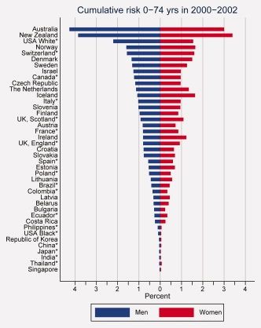
Figure 1.1.1. Cumulative risk of 0–74 years in 2000–2002. Bar chart of cumulative risk of the incidence of melanoma by country by sex, sorted in descending order of cumulative risk in men. Time period is 2000–2002, except for Spain (1998–2000). Cumulative risks based on data from regional registries and groups of regional registries are marked with *. ⁸ Copyright © 2012 UICC (reproduced with permission from John Wiley and Sons).

Presentation and Diagnosis
Melanoma lies within a spectrum of disorders of melanocytes, which includes benign, pre-malignant and malignant lesions, along with lesions of uncertain malignant potential. There are a number of non-melanocytic skin tumours and conditions that result in pigmented lesions that may be confused with melanoma. There are also a number of melanocytic tumours that are non-pigmented, including amelanotic melanoma. This combination of factors poses diagnostic challenges both clinically and histologically. The best chance of cure for a patient with a melanoma is early diagnosis and early complete surgical excision. Therefore the assessment of patients who present with a pigmented skin lesion is aimed at identifying or excluding melanoma. There are a number of features on history and clinical examination that raise suspicion that a pigmented lesion could be a melanoma. These include an increase in size, a change in colour (usually darkening), becoming irregular, itching and/or bleeding. The ABCD(E) warning signs for melanoma (Table 1.1.1) described by Friedman, Rigel and Kopf in 1985, and subsequently modified, provides a useful aide memoire when examining a pigmented lesion.^{9,10} There are, however, many exceptions that do not follow these categories.

Table 1.1.1. The ABCD(E) warning signs for melanoma versus benign mole.
Feature | Benign mole | Melanoma
A –Asymmetry | Symmetrical | Asymmetrical
B – Border | Smooth | Uneven, scalloped, notched
C – Colour | One colour and often one shade | Multiple shades or colours
D - Diameter | Small (<6mm) | Larger
E - Evolving | Stable over time | Changing size, shape, colour, becoming itchy or bleeding
Some patients will present with a single pigmented lesion of concern, whereas others, such as patients with dysplastic naevus or atypical mole syndrome, may present with hundreds of pigmented lesions, many of which exhibit some features of melanoma. In patients with a large number of moles the “ugly duckling” sign can be useful.¹¹ Often a patient’s moles all tend to have a similar appearance and if one stands out as different from the rest then it may be a melanoma. A number of strategies and medical devices have been developed to aid clinical diagnosis. These include serial photography and clinical examination, dermoscopy and confocal microscopy. Confocal microscopy requires a confocal microscope, which is used to produce in vivo images of the melanocytes within the skin.¹² It is not suited to widespread use by a variety of health professionals because it is expensive to set up, the microscope takes up a significant amount of space and it requires specialized training and time to perform. Dermoscopy however, is quick to perform and requires only a hand-held dermatoscope, which is relatively inexpensive and portable. Basic training can provide the clinician with useful skills that can result in a reduction in the number of excisions of benign pigmented lesions and also improve the rate of detection of melanoma.^{13,14}
Once the decision has been made that a pigmented lesion is suspicious for melanoma an excision biopsy is recommended with a 2mm margin, taking a cuff of underlying fat.¹⁵ In rare circumstances an incisional biopsy or biopsies, taking only a representative portion of the lesion for histological analysis, may be appropriate. This is due to the size and/or location of the lesion in a cosmetically or functionally important site, such as the face or acral skin sites.¹⁵ Incisional biopsies are not routinely recommended because an incisional biopsy often misrepresents the features of the lesion and could lead to inadequate treatment.¹⁶ When an appropriate biopsy has been performed the biopsy specimen is then fixed in formalin, sectioned and stained for histological analysis using standard haematoxylin and eosin along with immunostains such as S100, HMB45 and Melan A. If a diagnosis of melanoma is made then a minimum dataset which contains information on the primary tumour location, along with a number of histopathological features, should be reported.¹⁷

Classification and Staging
Classically, melanomas have been described by their clinical and histological appearance into a number of subtypes. These include four common subtypes: superficial spreading melanoma, nodular melanoma, lentigo maligna melanoma and acral lentiginous melanoma, and then rarer subtypes such as desmoplastic, spindle cell, epithelioid, balloon cell, malignant blue naevus and naevoid. The absence of pigmentation within a melanoma does not denote a distinct histological subtype but a melanoma with this feature is described as amelanotic, in addition to its histological subtype e.g. amelanotic nodular melanoma. Classification by clinicopathological subtype does not however provide independent prognostic information and has no implications for the choice of treatment.
It had been recognized that the vertical extent of invasion of the primary melanoma was related to prognosis, and in 1969 Clark and co-workers published their group’s method for microstaging melanoma by depth of invasion in relation to the anatomical layers of the skin.¹⁸ The following year, Breslow published an analysis of prognosis for 98 melanomas, according to primary tumour thickness, diameter and Clark’s microstaging classification.¹⁹ Melanoma thickness was measured using an ocular micrometer “from the skin surface to the deepest point of invasion”. The study findings confirmed the prognostic value of both tumour thickness and Clark’s stage. Subsequent study identified that Breslow’s measurement of thickness provided the more important predictor of prognosis and this has been confirmed in large population group analyses.²⁰ These have shown that it is the most important prognostic indicator for a patient with clinically localised primary melanoma.^{20–22} Melanoma thickness (Breslow thickness) is now more specifically-defined as the distance from the top of the granular layer of the overlying epidermis to the deepest invasive cell across the broad base of the tumour, with strategies to deal with situations such as ulceration or growth of tumour along adnexal structures.¹⁷ A number of other variables relating to the patient or the primary melanoma histopathology have also been identified as independent predictors of prognosis. These include age, sex, primary tumour site, ulceration, mitotic rate and lymphovascular invasion.^{21,22} The relative importance of these variables in terms of prognosis forms the basis for the widely accepted staging system for melanoma published by the American Joint Committee on Cancer (AJCC), currently in its 7th edition (see Figure 1.1.2).
Figure 1.1.2. American Joint Committee on Cancer (AJCC) staging system for melanoma (7th Edition)

The AJCC staging system for melanoma has undergone refinement since its inception in 1977 and is based on literature review and prognostic information from a large combined database of patients held at the University of Alabama. The data originated from melanoma patients treated at several centres within the US and at the Sydney Melanoma Unit in Australia.²³ The main purpose of the staging system is to provide a method for conveying clinical information to others without ambiguity. There are also a number of additional important uses. These include selection of patients for treatment, estimating prognosis, allowing evaluation of treatment results in comparable groups within a single institution and between different institutions and allowing other data to be compared between institutions throughout the world. As new research findings become available, staging criteria must be re-evaluated and revised. Thus far, the staging system has followed the “Tumour, Node, Metastasis (TNM)” model that is used for a large variety of cancer staging systems. The complexity of the system has increased with each revision and includes patient characteristics, primary melanoma histopathological characteristics and characteristics related to metastatic spread of the tumour (Figure 1.1.2). In the future additional information may be incorporated from advances in molecular genetics. This field of medicine is already leading to increased understanding and a new method for classification of melanoma based on mutations detected within the tumour cells, but of even greater significance, it has led to the development of new and effective drug therapies for metastatic melanoma.^{24,25}
In the UK and many other countries, melanoma patients are managed in a multi-disciplinary setting with recommendations regarding investigation and treatment made by a multi-disciplinary team, typically comprising clinical nurse specialists, clinical psychologist, dermatopathologists, dermatologists, oncologists, plastic surgeons, radiologists and clerical support staff. The recommendations provided by the multi-disciplinary team are used as a basis for discussion between the responsible clinician and the patient to allow the patient to choose a care pathway that suits their individual circumstances. National guidelines for the management of cutaneous melanoma provide an evidence-based framework for decision-making and the AJCC staging system is used to stage patients and provide a basis for selection of patients for trials, for follow-up regime and for further staging investigations.¹⁵
Once the patient diagnosed with a primary cutaneous melanoma has had the tumour completely excised, the management focuses on reducing the risk of developing local recurrence. In some institutions management also aims to detect and remove occult metastases that would become clinically evident in the future, by targeting locations where melanoma cells may be present. Metastasis generally occurs via lymphatics, the bloodstream or both. Two hypotheses for models of metastasis in melanoma have been described: the incubator hypothesis and the marker hypothesis.²⁶ According to the incubator hypothesis metastasis occurs first via lymphatics to the regional lymph nodes, where cells remain and grow before spreading via the blood-stream to distant sites. In the marker hypothesis metastasis occurs via the lymphatic and blood systems simultaneously. For the ideal of obtaining cure for all patients with a primary melanoma to be achieved, staging investigations and/or further treatment must aim to detect and treat all potential sites of metastasis. However, investigations and treatments all have the potential to cause morbidity to some degree, as well as making demands on resources, and so it is important that patients are selected appropriately for further investigation or treatment. Staging investigations can include blood tests, radiological tests and more invasive interventions. Investigations are also limited to varying degrees in terms of their sensitivity and specificity. The only blood test that is incorporated into the AJCC staging system is the serum lactate dehydrogenase (LDH) level for patients with stage IV disease. LDH is an enzyme that is present in body tissues within the cytoplasm of cells, where it converts lactate to pyruvate. Tumour cells can increase their content of LDH as a part of the process of becoming less dependent on oxygen, thus allowing them to survive and grow more rapidly.²⁷ However, tumours that are growing very rapidly and have larger volumes are more likely to outgrow their blood and oxygen supply, resulting in areas of necrosis. This leads to release of LDH, which can be detected as raised serum levels in patients. The finding of raised serum LDH in patients with distant metastatic melanoma (stage IV disease) is associated with a worse prognosis.^{28–31}
A number of different imaging modalities have been used to detect melanoma metastases or as an adjunct in more invasive methods of staging. These include plain x-ray, ultrasound, lymphangiography, lymphoscintigraphy, computed tomography (CT), single-photon emission computed tomography (SPECT) CT, magnetic resonance imaging (MRI), positron emission tomography (PET) with or without CT and isotope bone scans. The need for and choice of investigation are guided by symptoms and signs exhibited by the patient and routine imaging is not currently recommended for patients without evidence of metastatic disease (AJCC stage <III).¹⁵ Invasive investigations that have been used for staging include fine needle aspiration (FNA), core biopsy, incisional biopsy, excisional biopsy, elective lymphadenectomy and sentinel node biopsy.

Treatment
The treatment strategy for melanoma is also based on the AJCC staging system, which incorporates available prognostic information and stratifies patients into prognostic groups. However, in essence there are four main areas that can be addressed, as follows:
- Management of the primary melanoma site.
- Management of local recurrence and in-transit disease.
- Management of regional nodal basins.
- Management of distant metastatic disease.
The strategies employed to manage each of these areas have evolved and continue to evolve over time. They are influenced by the presence or absence of either clinically-detectable or microscopically-detectable (occult) metastases.
i) Management of the primary melanoma site.
Once a diagnosis of primary melanoma has been confirmed by narrow margin excisional biopsy or, in some cases an incisional biopsy, treatment of the primary melanoma site aims to excise any residual primary tumour and to excise a wider margin of normal skin and subcutaneous fat to reduce the risk of local recurrence due to small groups of tumour cells that have moved away from the primary tumour site (microsatellites). The exact amount of normal-appearing skin and subcutaneous fat that should be excised has been and remains the subject of investigation and debate. In 1907, William Handley, delivered 2 Hunterian lectures that were published in The Lancet, and based largely on an autopsy of a patient with disseminated melanoma.^{32,33} He recognised the mode of spread of melanoma via lymphatics and advised that a “circular incision should be made through the skin around the tumour at what is judged by present standards to be a safe and practicable distance. The incision, situated as a rule about an inch from the tumour, should be just deep enough to expose the subcutaneous fat. The skin with a thin attached layer of subcutaneous fat is now separated from the deeper structures for about two inches in all directions around the skin incision. At the extreme base of the elevated skin flaps, a ring incision down to the muscles surrounds and isolates the area of deep fascia and overlying deeper subcutaneous fat to be removed. This fascial area is next to be dissected up centripetally from the muscles beneath up to a line, which corresponds with that of the circular skin incision. Finally, the whole mass with the growth at its centre is removed by scooping out with the knife a circular area of the muscle immediately subjacent to the growth.” This work is likely to have formed the basis for the common practice of taking wide excisions with 4-5cm margins of skin and subcutaneous fat that was in existence well into the 1970s. By the late 1970s there was recognition of the need to try to adopt a surgical approach that would result in less morbidity and disfigurement. The prognostic importance of primary tumour thickness became recognised and this allowed a number of retrospective studies to be carried out documenting local recurrence in patients who had undergone narrower margin excision for tumours of varying Breslow thickness.^{34–40} These studies suggested that margins narrower than 4-5cm could be taken without increasing the risk of local recurrence. However, they also demonstrated an increased rate of local recurrence when very narrow (<0.5cm) margins were taken. Prospective randomised studies were therefore required and to date there have been six published trials.^{41–46} The details of the published randomised trials are documented in Table 1.1.2.
Table 1.1.2. Completed randomized trials comparing excision margins for melanoma.
Study | Period of accrual | Excision margins compared |  | Number of patients randomised | Primary melanoma thickness inclusion criteria | Primary melanoma sites and/or subtypes excluded | Overall survival comparison
Study | Period of accrual | Skin | Fat
World Health Organization (WHO)^{41,47,48} | 1980-1985 | 1cm vs 3cm | 1-2cm wider than skin excision | 703 | ≤2mm |  | At 8yrs 89.6% (1cm) vs 90.3% (3cm), p =0.64
French Co-operative Group⁴⁴ | 1981-1986 | 2cm vs 5cm | Extended down to muscle fascia | 337 | <2mm, age <70 | Toe, nail, finger lesions, melanomas arising form melanosis, lentigo and acral lesions. | At 10yrs 87% (2cm) vs 85% (5cm), p=0.56
Intergroup Melanoma Trial^{42,49} | Not stated | 2cm vs 4 cm | Same as skin down to or including fascia | 486*  470*  468* | 1 to 4 mm | Lentigo maligna melanoma, melanomas distal to knee or elbow or on head and neck | At 10 yrs 70% (2cm) vs 77% (4cm), p=0.07
Swedish Melanoma Study Group^{43,50} | 1982-1991 | 2cm vs 5 cm | Incisions extended to or included fascia | 989 | >0.8 to 2mm | Head and neck, hands, feet. | At 10 yrs 79% (2cm) vs 76% (5cm), p=non-significant
UK Melanoma Study Group⁴⁵ | 1993-2001 | 1cm vs 3cm | Not stated but to extend to or include deep fascia | 900 | ≥2mm | Head and neck, palms and soles or if 3cm margin not technically possible. | No significant difference
Swedish Study II⁴⁶ | 1992-2004 | 2cm vs 4cm | Down to the fascia | 936 | Age≤75  Breslow thickness >2mm | Hand, foot, head, neck, ano-genital | At 5 years 65% (2cm) vs 65% (4cm), p=0.69
*published value varied in separate reports of the trial.

The first trials were conducted in the late 1970s and 1980s by the French Cooperative Group and the World Health Organisation (WHO).^{41,44} The French Cooperative Group trial compared 2cm versus 5cm wide excision in patients with primary melanoma Breslow thickness of 2mm or less.⁴⁴ There was no increase in risk of local or distant recurrence with a 2cm margin and no difference in overall survival rate. It was therefore concluded that a 2cm margin was sufficient for melanoma with a Breslow thickness of 2mm or less. The WHO trial similarly involved patients with primary melanoma <2mm thick but compared an excision margin of 3cm versus 1cm.⁴¹ The study showed no difference in survival between the two groups and the rate of local recurrence was not statistically significantly different, leading to the recommendation that a 1cm margin be adopted for patients with primary tumour thickness <2mm. However, although it appeared safe to perform a 1cm wide excision for melanoma with primary tumour thickness <1mm, there were concerns that the risk of local recurrence may be increased in the subgroup of patients with primary tumour thickness between 1 and 2mm. Five out of six local recurrences detected during the trial were in the group that had a 1cm excision margin and a primary tumour thickness of 1-2mm. It should also be noted that in this trial the wide excision technique involved excision of a wider area (additional 1-2cm) of subcutaneous fat than skin. Thus a significant volume of subcutaneous tissue would have been excised beyond the 1cm skin margin. Modern practice tends to involve wide excision with the same margin of skin and subcutaneous tissue, an important difference in technique. Despite this, a 1cm margin has become established as the excision margin for melanoma with Breslow thickness <1mm, based on the result of the WHO trial.⁴¹

In order to guide best practice in management of intermediate thickness melanoma, a third trial was conducted. The Intergroup Melanoma Trial included patients with primary tumour thickness 1-4mm and compared 2cm and 4cm margins of excision. There was no statistically significant difference between the two groups in terms of overall survival, local recurrence or rates of metastases, thus suggesting that a 2cm margin was sufficient for this subgroup.^{42,49} At a similar time the Swedish Melanoma Study Group conducted a multicentre study comparing 2cm versus 5cm margins for patients with melanoma of 0.81mm to 2mm thickness.⁴³ There was no difference in overall survival between the two groups and so it became established that margins over 2cm were not necessary for melanoma with Breslow thickness up to 2mm, and possibly up to 4mm. The UK Melanoma Study Group trial was conducted to compare 1cm versus 3cm margins in patients with thicker melanoma (2mm or greater).⁴⁵ This trial, along with the aforementioned Swedish Melanoma Study Group trial, differed from previous trials in the method of analysing recurrence. They analysed local, in-transit and regional nodal recurrences grouped into one category (locoregional recurrence), rather than as separate categories for nodal recurrence and for local or in-transit recurrence. There was no difference in overall survival or in local recurrence rate when analysed on its own. The difference in rates of locoregional recurrence within the first 3 years did however reach statistical significance (p=0.02) and led to a recommendation to perform 3cm wide excision margins for melanoma with Breslow thickness >4mm and to consider 2-3cm margins for melanoma with Breslow thickness 2-4mm. This recommendation was endorsed by the UK guidelines for the management of melanoma, but was not incorporated into other international melanoma guidelines.¹⁵ Longer-term follow-up from this trial has resulted in a difference in melanoma-specific survival with reduced survival in the 1cm wide excision group.⁵¹ The most recent trial to report, conducted in Scandinavia and Estonia and published in 2011, compared 2cm versus 4cm margins for patients with primary melanoma thickness >2mm.⁴⁶ No statistically significant differences were found in overall survival, melanoma specific survival, local recurrence or locoregional recurrence rates. In 2009 Sladden et al. conducted a systematic review of trials comparing surgical excision margins for primary cutaneous melanoma.⁵² This study analysed results from all the above trials except for the latest Scandinavian trial. The summary estimate for overall survival from this study favoured wide excision by a small degree (hazard ratio 1.04; 95% confidence interval 0.95 to 1.15; p=0.40) but was not statistically significant. The authors concluded “a small, but potentially important, difference in overall survival between wide and narrow excision margins could not be confidently ruled out”. Further trials will be required, and are currently underway, to fully establish the optimal margins for excision of primary cutaneous melanoma. It should be noted, in particular, that all studies except the WHO trial and French Cooperative Group trial have excluded head and neck melanoma, and so there may be important differences with regards to this subpopulation that ought to be elucidated before trial results for excision margins are applied without question to patients with head and neck melanoma.^{41,44}
The current recommendations for wide excision margins for melanoma in the UK can be compared with current recommendations in Europe, the United States and Australasia (Table 1.1.3).

Breslow thickness (mm) | UK  (2010) | UK  (NICE)  (2015) | US  (2014) | Australia and New Zealand  (2008) | Dutch  (2012) | ESMO*  (2015)
In situ | 0.5cm | 0.5cm | 0.5-1cm | 0.5cm | 0.5cm | 0.5cm
≤ 1.0mm | 1cm | At least 1cm | 1cm | 1cm | 1cm | 1cm
1.01 to 2.00 mm | 1-2cm | At least 1cm | 1-2cm | 1-2cm | 1cm | 1cm
2.01 to 4.00 mm | 2-3cm | At least 2cm | 2cm | 1-2cm | 2cm | 2cm
> 4.0 mm | 3cm | At least 2cm | 2cm | 2cm | 2cm | 2cm
Table 1.1.3. Current recommendations for wide excision for melanoma in the UK, Europe, United States and Australasia.
* European Society for Medical Oncology

ii) Management of local recurrence and in-transit metastases.
The clinical appearance of local recurrence and in-transit metastases can be very different from that of the primary melanoma and can present as an isolated lesion or as a group of lesions. The size of the metastases varies from small dermal deposits to large subcutaneous metastases and these may be darkly pigmented or amelanotic. Examples of in-transit metastases are shown in Figure 1.1.3.

Figure 1.1.3. Examples of in-transit metastases
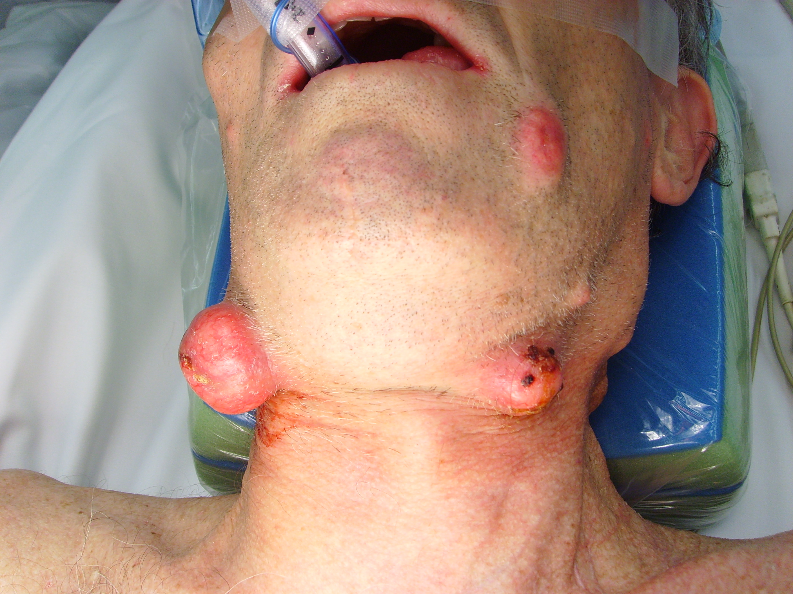
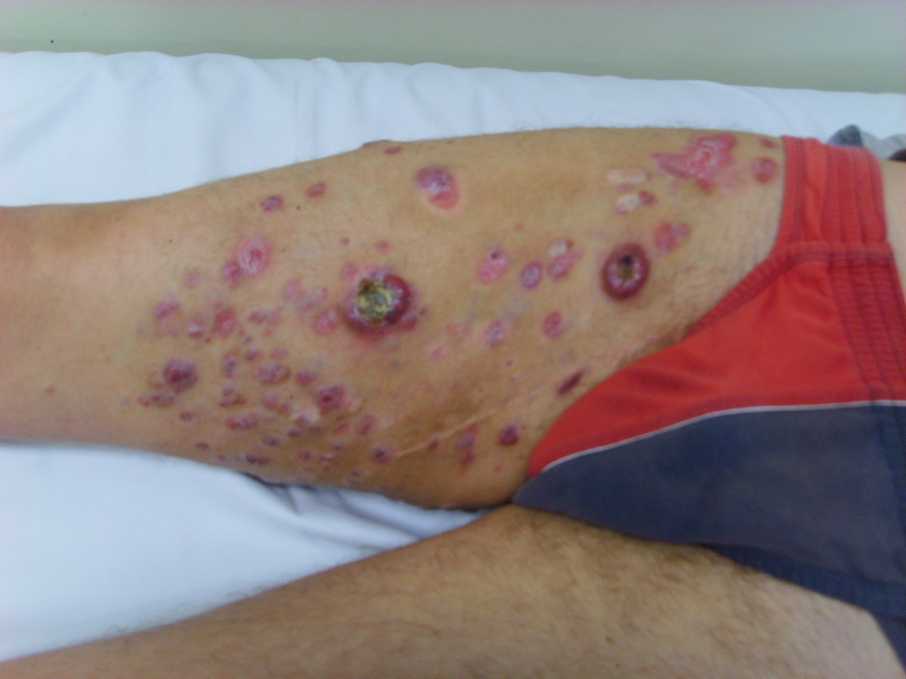
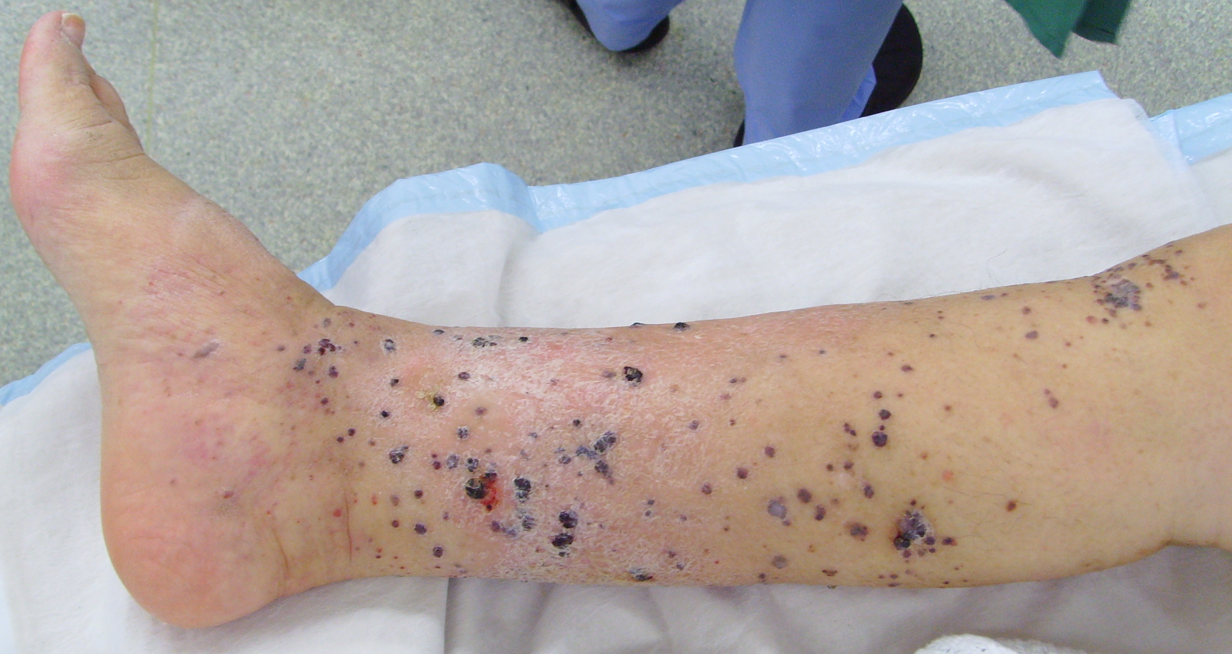
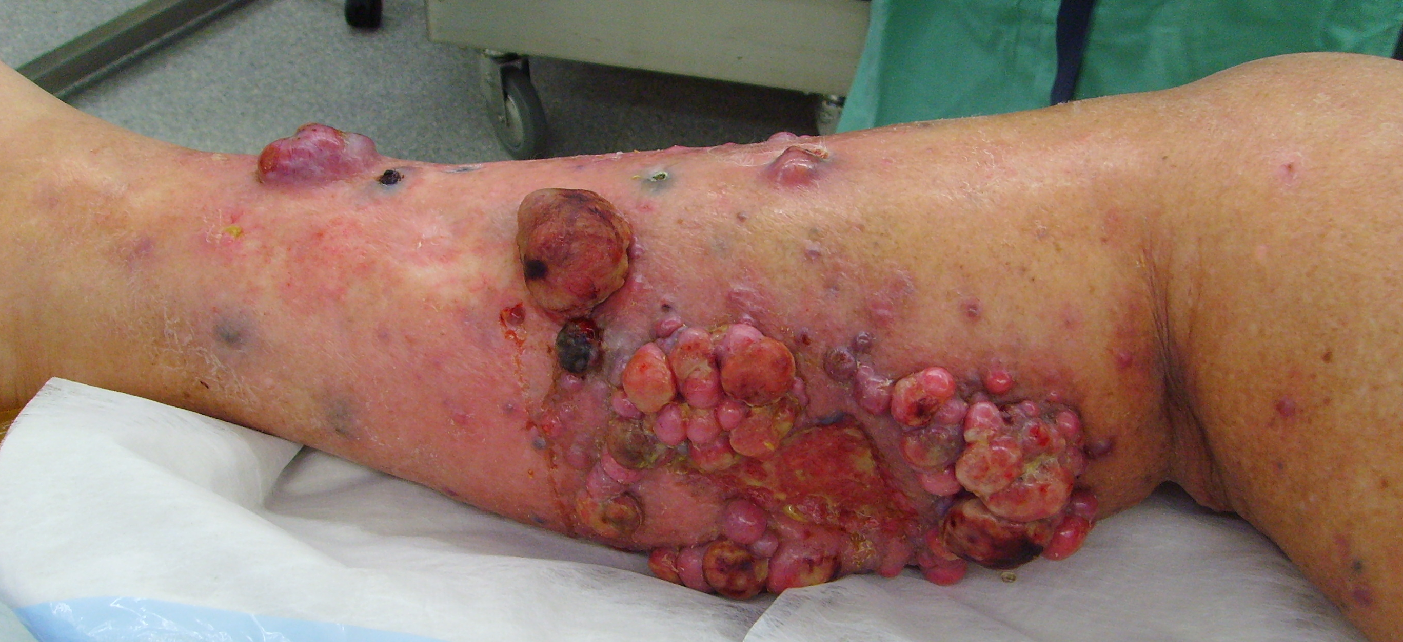

Local recurrence of melanoma is defined as recurrence of melanoma within 2cm of the primary melanoma surgical scar. It can be subdivided into two categories. The first is true local recurrence, which is growth of primary tumour that was inadequately excised. The second is metastatic melanoma located within 2cm of the primary tumour site. These can be called satellite lesions and their prognosis tends to be worse, reflecting the fact that they are a form of metastatic disease.⁵³ In-transit metastases are defined as any skin or subcutaneous metastases that are more than 2cm away from the primary melanoma but are not arising beyond the nodal basin(s) that drains the primary melanoma site.²³ These definitions are not particularly satisfactory as local recurrence encompasses two distinct subsets with differing pathogenesis and prognostic implications, whereas the only distinction between local recurrence due to metastatic deposits and in-transit metastases is the completely arbitrary figure of a 2cm distance from the primary melanoma excision scar. Both represent the same biological process and confer a similar prognosis. Ideally it would be possible to distinguish true local recurrence from metastatic local recurrence so that metastatic local recurrence could be grouped with in-transit metastases. The incidence of in-transit metastases following wide excision and sentinel node biopsy for melanoma has been recorded at 6.6% in a group of 1395 patients with a median follow up of 3.9 years.⁵⁴ The local recurrence rate and in-transit metastasis rate as first site of recurrence in 4704 patients with Stage I or II melanoma treated between 1960 and 2002 were 2.0 % and 1.8% respectively.⁵⁵ The current AJCC staging classification assigns patients with in-transit or satellite metastases, and no other distant metastases, to the N category (N2c or N3 depending on whether nodal metastases are also present), to reflect the fact that they are usually intralymphatic metastases (see Figure 1.1.2). At present, treatment strategies are similar for both local recurrence and in-transit metastases and the following modalities are currently in use: simple excision, fulguration, carbon dioxide laser ablation, electrochemotherapy using either intralesional or systemic bleomycin, isolated limb infusion using melphalan and actinomycin D and isolated limb perfusion using melphalan and tumour necrosis factor, or systemic therapies. The prognostic implications of local and in-transit recurrence have been documented in a number of studies.^{54–56} Dong et al. retrospectively analysed the outcomes for 648 patients who developed local recurrence as a first event.⁵⁶ The 5-year survival rate for this group was 51.5%. In the Sydney Melanoma Unit study the 5-year survival rates for patients following local or in-transit recurrence were 74% and 44% respectively.⁵⁵ Patients who develop local recurrence or in-transit metastases within a shorter period of their treatment for the primary melanoma tend to have a worse prognosis.^{54,56}

iii) Management of regional lymph nodes
As with other cancers, such as breast and head and neck, the trend for management of regional nodal metastases has evolved from a radical destructive approach to more conservative surgery, aiming to preserve function without compromising oncological clearance. Melanoma frequently metastasises via the lymphatic system to regional lymph nodes and patients with melanoma can present with clinical evidence of regional lymph node involvement at the time of diagnosis. If such patients have no evidence of distant metastases it is generally accepted that therapeutic lymphadenectomy should be offered in order to obtain local control of the disease. For patients with distant metastases the multi-disciplinary recommendation whether or not to offer therapeutic lymphadenectomy will be based on the extent and location of metastases, along with co-morbidities.
For the majority of patients diagnosed with a primary melanoma, there is no clinical evidence of regional lymph node metastasis. The optimal management strategy for this group has been the focus of many trials and debate over several decades, and remains controversial today. In 1892 Snow recommended elective lymph node dissection for melanoma.⁵⁷ Two approaches became common practice. Some surgeons elected to perform wide excision of the primary melanoma site only and observe for clinical evidence of regional node metastases before offering to perform a therapeutic lymphadenectomy. Others followed Snow’s recommendation and took the view that given the high risk of regional node metastasis developing in patients with a primary melanoma, the chance of cure may be greater if the lymph nodes were removed before the volume of tumour within them became clinically detectable. They therefore performed elective lymphadenectomy at the time of wide excision of the primary melanoma site. A number of retrospective studies reported a survival advantage from this approach and randomised trials were conducted in order to confirm this.^{58–60} The first trial, conducted by the World Health Organization Melanoma Program did not show any survival advantage from elective lymphadenectomy.^{58,61} A randomised trial was performed at the Mayo Clinic and the finding similarly was of no survival advantage from elective lymphadenectomy.⁵⁹ These trials did not examine separate subgroups of patients with different prognoses based on their primary tumour or other patient factors. However some non-randomised studies had suggested that survival was improved for patients with intermediate thickness melanoma (Breslow thickness 1-4mm) and so the Intergroup Melanoma Surgical Trial was initiated with one of its aims to determine whether survival differences due to elective lymphadenectomy could be detected in patients with intermediate thickness melanoma (Breslow thickness 1-4mm) grouped according to prognostic factors.^{60,62,63} The trial involved 740 patients with stage I and II melanoma. Overall survival did not differ significantly between the elective lymphadenectomy arm and the observation arm. However, for patients aged 60 years or younger (552 patients) the 5-year survival rate was significantly better for those who underwent elective lymphadenectomy.⁶⁰
One of the difficulties with elective lymphadenectomy was selection of the correct nodal basin(s) to dissect. This was particularly problematic for head, neck and trunk primary melanoma sites from which lymphatic drainage was variable.⁶⁴ As a result, lymphoscintigraphy began to be used to determine the nodal basin(s) to which primary tumour lymphatic drainage occurred, in order to improve the accuracy of the procedure.^{65,66} However, there was significant morbidity created by lymphadenectomy and, for patients who were subsequently found to have no evidence of nodal metastases, this morbidity was considered excessive. This led to the development of intra-operative lymphatic mapping and sentinel node biopsy as a procedure with lesser morbidity that could identify and stage the regional lymph nodes draining the primary melanoma site.⁶⁷ The development of lymphatic mapping and sentinel node biopsy are described in Section 1.2.

iv) Management of distant metastases
Only around 1.3% of patients will be diagnosed with distant metastases at the time of initial presentation with melanoma.⁶⁸ The most common sites of distant metastasis are skin and subcutaneous, distant nodal basins, lung, liver and brain. Other sites such as small bowel, adrenal gland, spleen and other gastrointestinal locations occasionally harbour metastases. Patients who present with distant metastases are classified as having AJCC stage IV disease and have a poorer prognosis in comparison to patients with stage I, II or III disease, with median survival of 6 months.⁶⁸ The management of distant metastases is dependent upon their number and location whilst taking account of the general health of the patient. Surgical excision is commonly advocated when it is feasible e.g. for isolated metastasis or metastases that can be resected without causing significant morbidity. Therapies such as isolated limb infusion or perfusion and electrochemotherapy can be used in some circumstances. Radiotherapy is used for palliation in patients with metastatic melanoma. Melanoma has traditionally had a reputation as a tumour that is relatively radio-resistant, although this may be undeserved.⁶⁹ It has a role in treating brain metastases either via stereotactic radiosurgery or as whole brain radiotherapy. It can also be effective for treating dermal metastases and for relieving pain in patients with bone metastases.⁷⁰ Chemotherapeutic options have been limited for many years with dacarbazine, a cytotoxic alkylating agent, being the standard drug. Dacarbazine was granted FDA approval in 1975 and is given as a series of intravenous infusions typically in 3- or 4-week cycles. It has significant side effects including nausea, vomiting, headache, skin rashes, bone marrow suppression and sterility. It is a relatively ineffective drug with complete response rates and partial response rates of around 10% and 10% respectively.⁷¹ As a result, 5-year survival rates for patients with stage IV disease in the UK have ranged from 8% for men to 25% for women.⁶⁸ Patients with isolated lung metastases tend to have a better prognosis than those with other forms of visceral metastasis, but overall the median survival time is 6 months.⁵⁵
One of the most exciting developments in melanoma treatment over recent years has been the emergence of targeted therapies and immunotherapy as effective treatments for stage IV disease. Advances in genomic medicine have identified novel targets for drug development and elucidated some of the steps in oncogenesis relating to melanoma. In 2002 Davies et al. discovered a mutation in the BRAF gene, which occurred in 40-60% of cutaneous melanomas.⁷² This was a single mutation at codon 600 and most commonly (90% of cases) involved substitution of valine for glutamic acid (V600E mutation). BRAF is a serine-threonine kinase and the result of the mutation in the gene that encodes BRAF is that it becomes active. BRAF forms part of a pathway between the cell membrane and the nucleus, known as the mitogen-activated protein (MAP) kinase pathway. This pathway normally transmits signals from extra-cellular growth factors, such as fibroblast growth factor, stem-cell factor and hepatocyte growth factor, to the cell nucleus.⁷³ The extra-cellular growth factor binds with a cell membrane tyrosine kinase receptor, which passes a signal through the cell wall and activates an intra-cellular GTPase called RAS. A signal is then transmitted via the cytosolic protein kinases, BRAF, MEK and ERK, to the cell nucleus to undergo growth and proliferation. The presence of the V600E mutation has the effect of turning on this pathway from within the cell itself, and doing so permanently, thus leading to unrestrained cell growth and proliferation. The BRAF gene becomes an oncogene. A number of additional mutations such as valine to lysine substitution (V600K) have since been discovered at the V600 codon of BRAF. These are generally far less common than the V600E mutation, although there is evidence to suggest that the V600K mutation may account for up to 30% of BRAF mutations in cutaneous melanoma.⁷⁴ The discovery of this single point mutation on a gene that codes for a specific serine-threonine kinase in a known cellular pathway lent itself to the development of drugs specifically targeted to inhibit BRAF V600 and thus stop or slow down the flow of messages telling the cell nucleus to grow and proliferate. The first such molecular targeted therapy for melanoma was vemurafenib (a BRAF V600 inhibitor) and the results of a phase I trial were published in 2010.⁷⁵ This trial demonstrated complete or partial response to vemurafenib in 81% of patients who had V600E mutated BRAF. The subsequent phase III trial (BRAF inhibitor in melanoma 3 (BRIM-3)) compared vemurafenib with dacarbazine in 675 patients with V600E mutated BRAF and metastatic melanoma. Overall survival at 6 months was 84% (95% confidence interval (CI) 78-89) for the vemurafenib group versus 64% (95% CI 56-73) for the dacarbazine group.⁷⁶ Another BRAF inhibitor, dabrafenib, has subsequently been developed and shown to improve survival for patients with metastatic melanoma.⁷⁷ The challenge at present is to determine the optimal use for such agents alone and in combination. One of the main advantages of these drugs is that they are administered orally and so the morbidity and number of hospital admissions or day-visits are reduced in comparison with conventional intravenous chemotherapy using dacarbazine. The news is not all good, however. One of the main side effects with vemurafenib is that there is an increase in the incidence of squamous cell carcinomas (~12%).⁷⁶ In addition, resistance appears to develop to treatment with BRAF inhibitors so that disease progression eventually occurs.⁷⁸ Drugs that target other steps in the MAP kinase pathway are therefore being developed in order to combat the problem of resistance.
The aforementioned advances in genomic medicine and increased understanding of the cellular mechanisms underpinning melanoma pathogenesis have paved the way for a new approach to classification of melanoma. What is emerging is a clinicopathological and genetic correlation.⁷⁹ For example, nodular melanoma occurring on chronically sun damaged skin and lentigo maligna melanoma are associated with mutations in KIT but not BRAF whereas nodular and superficial spreading melanomas arising on non-chronically sun damaged skin are associated with BRAF but not KIT mutations. They typically occur at different ages and exhibit different patterns of metastasis.⁷⁹ Knowledge of such differences will allow treatment strategies to become more individualized.
In addition to the ground-breaking developments in targeted therapy, there have been significant breakthroughs in the use of immunotherapy for treatment of metastatic melanoma. Immunotherapy has been a focus of attention in relation to melanoma for the last half century. Early trials using Bacillus Calmette-Guerin (BCG) showed some promise but this was not borne out in a randomized trial.^{80,81} However, high dose interferon α2b was shown to improve survival in a trial in which it was administered as an adjuvant therapy to patients with resected melanoma and high-risk of recurrence (either T4 or N1 disease).⁸² The treatment period lasted for 12 months which is significant not least because high-dose interferon is associated with significant side-effects.⁸³ An improvement in recurrence free survival and in overall survival were found in the high dose interferon group compared to the observation group and this has remained with prolonged follow-up, and has also been demonstrated in later randomized trials.⁸⁴ A trial with another agent, interleukin-2, was also conducted during the 1980s and 1990s.⁸⁵ Although the response rate was fairly low (6% complete response and 10% partial response) it was durable in a significant proportion of patients. The median duration of complete responses was at least 59 months.⁸⁶ Such durable responses are rarely seen with traditional cytotoxic therapy or newer targeted therapies and so this was a very promising finding. However, there were significant side-effects with treatment including arrhythmias, hypotension, pulmonary oedema and sepsis. Deaths occurred in 2% of trial participants, associated with sepsis.⁸⁵ Treatment involved two initial courses of 14 intravenous infusions given every 8 hours and then repeat courses every 6 to 12 weeks for patients who were responding. These factors combined with the lack of benefit for 84% of patients undergoing treatment meant that its use did not become commonplace. A new drug, ipilimumab, was subsequently developed and trialed in a vaccine-controlled phase III study.⁸⁷ Ipilimumab is a monoclonal antibody against cytotoxic T-lymphocyte antigen (CTLA-4). CTLA- 4 works as a “braking system” or “check-point” for the immune response by negatively regulating T-cells and dampening the T-cell response to a stimulator, such as a melanoma cell. When a T-cell is activated by binding of the major histocompatibility complex on an antigen-presenting cell to the T-cell receptor, it expresses CTLA-4 which then binds to sites on the T-cell which would otherwise be occupied by another molecule on the antigen-presenting cell to provide a second stimulatory signal.²⁵ By blocking this system (check-point blockade) using ipilimumab, the bindings sites for the second stimulatory signal become available and the immune response is effectively boosted. This is, however, non-specific and so immune-related side effects such as colitis, dermatitis or vitiligo, hypophysitis, hepatitis and uveitis can occur. In the initial trial 2.1% of patients died due to treatment-related side-effects.⁸⁷ Understanding of these side-effects has improved and management with dose reduction or cessation and corticosteroids has led to a reduction in treatment-related deaths.⁷¹ The response rate with ipilimumab, as with interleukin-2, is low (10.9%) but durable in those who respond.⁸⁷ However, there are newer and even more effective drugs undergoing trials. These drugs have a different target known as programmed cell death 1 (PD-1) molecule. PD-1 is also involved in negative regulation of T-cells and inhibition of the immune response, but it is a cell receptor protein that is found not only on antigen-presenting cells but also on cancer cells themselves.²⁴ Monoclonal antibodies against PD-1 include nivolumab and lambrolizumab and early phase clinical trials have demonstrated objective response rates of 31% and 52% respectively, making this field of medicine currently one of the most exciting, and providing real hope for patients with metastatic disease.²⁴

Summary
The management of melanoma has evolved over the past century or so from an often late-diagnosed, invariably fatal condition, for which mutilating surgery was commonplace and no treatment could help those with widespread metastatic disease, to a condition where earlier diagnosis and cure are possible, where surgery is more conservative and aims to maximise potential benefit whilst minimising morbidity, and where effective treatment is now available for those with metastatic disease. The relative abundance of novel agents and their potential for efficacy in the adjuvant setting mean that an accurate method for identifying patients likely to benefit from such drugs is needed now more than ever before. Sentinel node biopsy involving lymphatic mapping by lymphoscintigraphy assists in the identification of patients at high risk of relapse. It is therefore vital that its quality is of the highest standard and that information obtained as a result of the procedure is utilized to best effect. These are the themes that underpin all the studies contained within this thesis. In the future melanoma patients should receive highly individualized information regarding their prognosis, and be offered therapies that are specifically tailored to their particular tumour and their actual disease burden.

1.2: Lymphatic mapping and occult nodal metastasis in melanoma: a review of the literature.

BACKGROUND
The detection of occult nodal metastasis in melanoma has important implications for prognosis, staging and subsequent therapeutic interventions. The ability to accurately group patients according to prognosis is desirable to allow appropriate selection of patients for entry into clinical trials. For an individual, an accurate prognosis could be helpful in allowing that individual to plan their life accordingly. It is therefore vital that the methods used to detect occult nodal metastasis are reliable and reproducible and that the subsequent prognostic stratification of patients occurs such that within each group, prognostic variability is minimal. Lymphatic mapping techniques have evolved over many years and have facilitated the development of the sentinel node concept into the technique of sentinel node biopsy that has become widely adopted as a minimally-invasive surgical procedure for detecting occult nodal metastasis in melanoma. However, the ability to identify such patients presents a series of dilemmas, which require evidence in order to determine the most appropriate way forward. This section aims to provide a brief overview of the development of lymphatic mapping and sentinel node biopsy for melanoma, to summarize current understanding with regards to occult nodal metastasis and to highlight areas where further research is required.

HISTORY OF LYMPHATIC MAPPING
The lymphatic system has been the subject of study for over 2000 years.⁸⁸ However, it was in the 19th century that major advances began to pave the way for the development of modern methods of lymphatic mapping. Cruikshank, a pupil of William Hunter, and Mascagni, a professor of anatomy in Sienna, Italy, had independently produced detailed illustrations of lymphatic vessels in man in the late 1780s.^{89,90} These investigators used a mercury injection technique and this technique was refined by Sappey, a professor of anatomy in Paris. The resulting illustrations, produced following mercury injections in a series of cadavers, detailed the cutaneous lymphatic drainage pathways of the entire human body, and were published in an atlas in 1874.⁹¹ Sappey described zones on the trunk, in the midline and horizontally through the umbilicus around to L2 vertebra, from where drainage could occur to more than one nodal field. Outside these zones, Sappey believed that drainage could only occur to the ipsilateral axilla or groin depending whether it was above or below the horizontal zone respectively. Mercury injection could not be performed in living humans, and so other substances were tested. Gerota discovered that dyes such as Prussian blue could be used to identify lymphatics in vivo.⁹² X-ray was discovered in 1895 and this provided a novel medium in which to image lymphatic anatomy. Thorotrast, a colloidal preparation of thorium dioxide was developed and used in vivo to demonstrate lymphatic anatomy.⁹³ However its use was discontinued when it was found to cause malignancies.⁹⁴
From the early 1930s vital dyes began to be used to study lymphatic drainage in patients, with the discovery that interstitial injections result in uptake into lymphatic capillaries and then to lymph nodes.⁹⁵ The application of this technique for the identification of lymph nodes draining cancer is attributed to Weinberg in 1950.⁹⁶ Shortly following this Kinmonth developed the technique of x-ray contrast lymphangiography for in vivo imaging of lymphatic vessels and their draining lymph nodes.⁹⁷ The procedure involved subcutaneous injection of Patent Blue dye on the dorsum of the hand or foot. This allowed identification of a blue-stained lymphatic channel, which was then cannulated for the injection of radio-opaque dye. At a similar time, the technique of lymphoscintigraphy using radioactive colloidal gold was introduced.⁹⁸ Although lymphangiography initially became the standard method for imaging the lymphatic system in vivo, it was lymphoscintigraphy that produced clear evidence against the existence of the strict boundaries described by Sappey, and demonstrated that lymphatic drainage patterns from the same area of skin could vary greatly from patient to patient.⁹⁹ This latter finding was perhaps most notable in the head and neck, thus leading to its reputation as an area with unpredictable drainage.^{100–106} In the literature, cited rates of discordance between predicted and lymphoscintigraphically-determined sentinel node sites in the head and neck vary from 7% to 37%.^{100,101,103–105}

DEVELOPMENT OF THE SENTINEL NODE CONCEPT AND SENTINEL NODE BIOPSY
The sentinel node concept is now well established and sentinel node biopsy has been validated and widely accepted as a staging procedure in melanoma. This situation has arisen from almost a century of observation, investigation and conceptual evolution. Braithwaite is credited with introducing the concept of the sentinel node following an incidental observation of black pigment within a chain of nodes from the ileocaecal region to the duodenum and superior mesenteric artery in a patient with acute appendicitis.¹⁰⁷ The study of testicular cancer, using lymphangiography, the technique developed by Kinmonth, also led to the development of a concept approaching that of the sentinel node.⁹⁷ It was recognized that primary nodes existed, to which lymph drained directly, and secondary nodes, to which lymph from primary nodes drained.¹⁰⁸ The term “sentinel node” was used by Cabanas in 1977 to describe a specific node that he believed reliably drained the penis.¹⁰⁹ He performed lymphangiography in 100 male subjects, 10 of whom were volunteers, 10 of whom had benign inflammatory lesions and the remaining 80 had penile carcinoma. Lymphangiography was performed by cannulating and injecting one or two dorsal lymphatics of the penis in 33 cases, but the remainder had injections via the dorsum of both feet. The sentinel lymph node was described as a specific lymph node, frequently located at the anterior or medial aspect of the superficial epigastric vein. Cabanas also described a technique of sentinel node biopsy, involving an incision parallel to the inguinal ligament with insertion of a finger under the upper flap to retrieve the sentinel node. It was acknowledged that there may be up to 3 nodes at this site and that all should be removed, but that the sentinel node was always the largest and most medial. Cabanas found that in all patients with metastases from penile carcinoma, this sentinel node contained metastases. He recommended that sentinel node biopsy should be performed bilaterally for patients with penile carcinoma and that, if the results were negative, formal inguinal dissection could be avoided. Although this treatment principle remains sound and underpins the current management strategy for melanoma and several other cancers, there are important differences in the method of identification of the sentinel node(s), its definition and the operative technique used for sentinel node biopsy. The limitations of Cabanas’ work are that the technique did not image lymphatic drainage from the actual tumour site, the sentinel node was defined anatomically rather than as the node(s) identified by the imaging, and the operative technique did not involve any method of intraoperative mapping to confirm the identity of the sentinel node. In addition, the technique is only applicable to tumours located on the penis.
It was Morton’s group, in 1991, who developed a scientifically robust method for sentinel node biopsy that could be applied to cutaneous tumours in any location. Preliminary studies were carried out using a feline model because of the presence of 3 inguinal lymph nodes rather than a single node, as is found in the majority of rodents and mammals.¹¹⁰ Several dyes were used but isosulfan blue was found to be the most suitable. In each animal 0.25-0.5ml of dye was injected intradermally at a site on the lower trunk, groin or lower limb and 5 minutes later a superficial groin dissection was performed, recording the presence or absence of dye in each lymph node. A predictable pattern of lymphatic drainage emerged with no cases of unexpected drainage occurring. Further studies were performed in which the progress of the dye through the lymphatics to the sentinel node and beyond was observed. The following year Morton et al. published the technical details of this procedure applied to melanoma patients.⁶⁷ In a series of 223 patients, intraoperative lymphatic mapping and sentinel node biopsy were performed for 237 nodal basins followed immediately by en bloc lymphadenectomy. Patent blue-V was found to identify channels and stain sentinel nodes more brightly than isosulfan blue. It was acknowledged that the technique required a significant learning curve and that the sentinel node(s) could not be identified in all patients. Sentinel nodes were identified in 82% of nodal basins. Metastases were found in 47 of 259 sentinel nodes compared to 2 of 3079 non-sentinel nodes and so it was proposed that radical lymphadenectomy should be reserved for only those patients with sentinel node metastases. The main limitation of the technique described by Morton et al. was that it required meticulous dissection to identify and preserve the blue-stained lymphatic channel(s) at the periphery of the lymph node field so that each could be followed into the first draining lymph node(s). The development of hand-held gamma probes and small particle colloids labelled with ^{99m}Tc (Technetium) permitted the use of such radioisotopes for intra-operative localization of sentinel nodes. The first publications of this technique were by Alex et al. in 1993.^{111,112} They carried out preliminary studies in the feline model and then in 10 melanoma patients using intradermal injections of ^{99m}Tc-labelled colloid in addition to blue dye. They discovered that it was not necessary to trace the lymphatics over as large a distance because the gamma probe could be placed on the skin and the sentinel node localized prior to making an incision. Removal of the sentinel node could then be achieved via a small incision overlying it. The other advantage of this technique was that it made the procedure less technically demanding and so facilitated its adoption by others. Several groups began to gain experience using this technique and validation of the accuracy of the technique was confirmed by a multicentre trial.¹¹³ It was shown that intra-operative injection of radiocolloid was not necessary and that radiocolloid injected at the time of lymphoscintigraphy would produce sufficient emissions to allow the procedure to be performed 24 hours later.¹¹⁴ It was also shown that the surgical procedure could be further simplified if, during lymphoscintigraphy, information was provided on the depth of the sentinel node(s).⁹⁹ The triple technique, comprising pre-operative lymphoscintigraphy, intra-operative gamma probe localization and intra-operative injection of blue dye was found to achieve a success rate of 99.1% when compared to a 95.2% success rate using blue dye alone.¹¹³ This triple technique has become the gold standard method when performing sentinel node biopsy for melanoma. In England, it is currently recommended that sentinel node biopsy is considered as a staging procedure for patients with stage IB-IIC melanoma with Breslow thickness >1mm (NICE (National Institute for Health and Care Excellence) guideline NG14).¹¹⁵
The triple technique does have some disadvantages. The patient undergoes lymphoscintigraphy several hours or the day before surgery and this requires a small intradermal injection, which can be painful. The procedure involves small doses of radiation to which the patient and healthcare workers will be exposed and radioactivity at the injection site can obscure sentinel nodes in some cases. Alternative methods of lymphatic mapping have therefore been developed and continue to be investigated. These include indocyanine green lymphangiography, contrast enhanced ultrasound and magnetic nano particles.^{116,117} The recently published MELAMAG trial compared a non-radioactive magnetic tracer with standard blue dye and radioisotope technique, with the ultimate aim of introducing a technique that does not require radioisotope.¹¹⁷ Although sentinel node identification rates were similar (97.7% for standard technique versus 95.3% for magnetic technique) the pre-defined predicted non-inferiority margin for the trial was not reached. In addition, the magnetic tracer injection produced black staining at the primary melanoma site, which was present at 1 year in 16.2% of cases and could cause confusion with possible recurrent disease. For melanoma, the location of potential sentinel nodes can be very varied (unlike sentinel node biopsy for breast cancer, for example) and so, irrespective of the intra-operative tracer choice, the pre-operative lymphoscintigram remains important to ensure that all lymphatic basins that contain sentinel nodes are identified. Valsecchi et al. conducted a meta-analysis of studies of sentinel node biopsy for staging in melanoma and found that the average sentinel node identification rate was 98.1% (95% CI: 97.3-98.6%), based on data from 71 studies containing 25240 patients.¹¹⁸ The average false negative rate was 12.5% (95% CI: 11-14.2%).

IMPLICATIONS OF OCCULT NODAL METASTASIS
For the patient with a primary melanoma and no clinical evidence of metastasis, there are a number of characteristics that have been proven to provide prognostic information.^{18,19,21,22,119} These include patient factors, such as age and sex, and features of the primary melanoma, such as primary tumour thickness, ulceration and mitotic rate. Some of these characteristics can be used to predict the risk of occult nodal metastasis.^{120–122} However, their sensitivity to detect occult nodal metastasis is not comparable to that of sentinel node biopsy and, once sentinel node biopsy has been performed, it is the result of this: positive or negative, that provides the most powerful prognostic information.^{22,123–125} The rate of sentinel node positivity has varied from 9% to 33.8% and is influenced by the technique used to localise the sentinel nodes and by the methods used to examine the nodes for metastatic melanoma cells.^{126,127} However, a rate of sentinel node positivity between 16% and 22% is typical.^{67,118,120,125,128–135} The five-year survival rate for sentinel node positive patients is 72% versus 90% for their sentinel node negative counterparts.¹²⁴ Both sentinel node negative and sentinel node positive patients will have had their sentinel nodes, and hence the metastasis-containing tissue, removed and so the difference in prognosis must relate to a higher likelihood, in sentinel node positive patients, of further occult metastasis having occurred in non-sentinel nodes or at other sites. The question of how to manage such patients then arises. Completion lymph node dissection involves excision of the remaining lymph nodes (non-sentinel nodes) within the nodal basin that was sentinel node positive, and this would seem logical as a next step. Using sentinel node biopsy to identify sentinel node negative patients allows this group to be spared a completion lymph node dissection as they are unlikely to have metastases in non-sentinel nodes. This approach to management was the focus of the First MultiCentre Selective Lymphadenectomy Trial, which began in 1994.¹²⁵ This randomised trial aimed to determine melanoma-specific survival in a group of patients treated by wide excision and sentinel node biopsy and, for those who were found to be sentinel node positive, completion lymph node dissection, versus wide excision and nodal observation with therapeutic lymph node dissection for those patients who developed subsequent nodal recurrence during observation. Patients with a primary melanoma with Breslow thickness of 1.00mm or more or of Clark level IV or V with any Breslow thickness were eligible for inclusion, but patients with intermediate thickness melanoma (1.20 to 3.50mm) were the primary study group. Two thousand and one patients were registered and enrollment closed in 2002. The randomisation process assigned 60% of patients to the wide excision and sentinel node biopsy group and 40% of patients to the wide excision and nodal observation group. In the intermediate thickness group there were 1347 patients with 814 in the sentinel node biopsy group and 533 in the nodal observation group. There was just over 4% cross over from each arm with 35 patients in the sentinel node biopsy group actually undergoing observation and 22 patients in the nodal observation group actually having sentinel node biopsy. Sentinel node biopsy was shown to accurately detect occult nodal disease in 96% of cases and sentinel node status was confirmed as the most powerful predictor of survival in the study population. The 10-year melanoma-specific survival rate (mean +/- standard error) for the biopsy group was 81.4+/-1.5% versus 78.3+/-2.0% for the observation group. This difference was not statistically significant. One of the problems with this trial was that the ideal comparison groups (sentinel node positive patients versus patients who develop nodal recurrence in the observation group) could not be identified prior to the point of randomisation and so statistical comparison of melanoma-specific survival for these two groups could be affected by bias. In order to compare these two groups and to account for potential bias the authors employed a statistical method called latent subgroup analysis and found that the melanoma-specific survival time for sentinel node positive patients in the sentinel node biopsy group was double that of patients who developed nodal recurrence in the nodal observation group. This finding was the case only in the intermediate thickness melanoma group. In the thick melanoma group (>3.50mm) there was no significant difference in survival and in the thin melanoma group (<1.20mm) there were relatively few cases with nodal disease and so statistical analysis was not reported.

THE SIGNIFICANCE OF NODAL METASTASIS BEYOND SENTINEL NODES
A non-sentinel node can be defined as any node that does not receive direct lymphatic drainage from the primary tumour site. Non-sentinel nodes would not normally be removed at the time of sentinel node biopsy unless there was a clinical suspicion of metastatic disease within such a node or nodes. Patients who are sentinel node positive i.e. found to have occult metastases within a sentinel node(s) removed at sentinel node biopsy, will have additional metastases in non-sentinel nodes, removed at completion lymph node dissection, in only 7-33% of cases.^{123,136–155} It would seem logical to assume that completion lymph node dissection could only benefit those patients who have non-sentinel node metastases, as only normal lymph nodes would be removed in the remainder. This would mean that the procedure would be unnecessary for 67-93% of sentinel node positive patients. Making the assumption that only non-sentinel node positive patients would benefit from completion lymph node dissection is not necessarily valid because there may be patients who have undetected metastases that are removed by the procedure, and hence may receive a survival benefit. Completion lymph node dissection is a major surgical procedure with significant risks of both short and longer-term morbidity when compared with sentinel node biopsy alone.^{156–158} If patients who have non-sentinel node metastases, or are at highest risk for having them, could be identified prior to performing completion lymph node dissection then unnecessary morbidity could be avoided for those at low risk of non-sentinel node metastasis. However, there is also a need to determine whether or not completion lymph node dissection provides any survival advantage over therapeutic lymph node dissection if metastases become apparent in sentinel node positive patients. A further multicentre trial has been set up in order to address this question.¹⁵⁹ The Second Multicentre Selective Lymphadenectomy Trial (MSLT II) began in 2005, has completed enrollment with approximately 1925 patients and is due to be completed in 2022.¹⁶⁰ In general, patients aged between 18 and 75 years of age were eligible for inclusion in the trial if they had a primary cutaneous melanoma with clear margins following wide local excision, were found to be sentinel node positive and did not meet any of the exclusion criteria (see https://clinicaltrials.gov/ct2/show/NCT00297895). The primary outcome measure is melanoma-specific survival and patients have been randomised to receive either completion lymph node dissection or monitoring with serial ultrasound scans and completion lymph node dissection if recurrence is detected. If no survival advantage or improvement in quality of life is demonstrated from completion lymph node dissection, then the procedure is likely to be abandoned in favour of follow-up and therapeutic lymph node dissection as required. However, if the results from MSLT II do demonstrate a survival advantage for completion lymph node dissection then the ability to identify patients with a high likelihood of non-sentinel node metastases, prior to them undergoing completion lymph node dissection, would be highly desirable. A number of studies have examined various characteristics related to the patient, the primary tumour pathology and the sentinel node.^{123,136–155,161} The findings from these studies demonstrate a lack of any consistent predictors of non-sentinel node metastasis relating to patient or primary melanoma characteristics. Tumour load and location within the SN have also been investigated and, despite some reports to the contrary, most studies have suggested that various measurements of tumour load and/or location are predictors of non-sentinel node positivity.^{123,136–155,162} However, the accurate and reproducible identification of all non-sentinel node negative or positive patients by any method remains an elusive goal. This has been confirmed in a recent meta-analysis which concluded that further studies are required to confirm the standard criteria for not performing completion lymph node dissection.¹⁶³
The question remains: What is the actual significance of non-sentinel node metastasis? It is well-established that prognosis is related to the total number of metastatic nodes detected, and this is accounted for in the current American Joint Committee on Cancer (AJCC) staging system.²³ However, the nature of such metastasis; within sentinel nodes only or within a combination of sentinel and non-sentinel nodes, may be important. For example, does a patient with 3 positive sentinel nodes and no positive non-sentinel nodes have a better prognosis than a patient with 1 positive sentinel node and 2 positive non-sentinel nodes and so forth? At the start of this thesis only one study had attempted to address this question.¹⁴⁹ Cascinelli et al. reported that non-sentinel node metastasis was a prognostic indicator in a group of 176 sentinel node positive patients, 18.7% of whom had non-sentinel node metastasis.¹⁴⁹ However, information on the numbers of positive non-sentinel nodes was not provided and so this difference in prognosis may simply have been related to patients with non-sentinel node metastasis having a higher total number of positive nodes. As work progressed with the current thesis, Jakub et al. reported findings that prognosis was not affected by increasing number of positive sentinel nodes but was affected by the presence of positive non-sentinel nodes.¹⁶⁴ However, again it appeared that the effect of increasing total number of positive nodes was not fully accounted for within their analyses. Ariyan et al. similarly reported results suggesting that survival for patients with two positive nodes was worse when one node was non-sentinel (p=0.05) although it can be seen that the significance level in their initial report of this study was borderline.¹⁶⁵

SUMMARY
Understanding of the lymphatic system has gradually advanced over the last two millennia, with accelerating speed in the last century. Its anatomy is well documented and knowledge regarding its function in health and disease is steadily increasing. Techniques have been developed to image lymphatic drainage in vivo, allowing reliable identification and surgical removal of the lymph nodes that directly drain a specific tumour site on the skin. This has facilitated a transition from radical cancer surgery to more selective approaches that aim to minimise morbidity without compromising prognosis. In melanoma there has been a distinct absence of effective systemic therapy and the management of metastatic disease has remained largely surgical. For nodal metastases there has been a transition from elective lymph node dissection, to sentinel node biopsy with or without completion lymph node dissection, or simply observation and therapeutic lymph node dissection when required. However, there remain many areas of controversy that require further study. The technique of sentinel node biopsy, although well established, is not without limitations and efforts should be made to further refine the procedure and increase awareness of potential pitfalls. In particular, in the head and neck, further study is required to elucidate whether lymphatic drainage is truly as unpredictable as it appears. The presence of more predicable drainage patterns may allow more selective surgical approaches to be taken. The significance of metastasis in sentinel nodes is well established but there is scope to further define patients with sentinel node metastasis in terms of prognosis. The ability to do this may benefit individual patients as well as improve selection for clinical trials. Finally, the ability to detect patients with nodal metastases beyond sentinel nodes, prior to excising these nodes, and to determine the significance of such metastases in terms of prognosis would clearly be highly desirable.

Section 1.3: Lymphoscintigraphy – technical considerations and potential pitfalls in practice.

Introduction
The sentinel node or nodes are the first and frequently the only lymph nodes affected by occult metastatic spread from primary cutaneous melanomas.⁶⁷ The presence or absence of metastatic disease in a sentinel node provides the most powerful indication of prognosis for patients with clinical AJCC stage I or II disease.¹²⁵ Therefore, for an individual patient it is of paramount importance that sentinel node biopsy is performed accurately. False-negative sentinel node biopsy will result in down-staging of the disease and potentially deny the patient access to adjuvant therapies which may prolong survival. The possibility that sentinel node biopsy may provide therapeutic benefit by removing all residual disease in those patients whose metastases are contained entirely within the sentinel nodes exists but as yet remains unproven.
Since its introduction by Morton et al. in 1992, the technique of sentinel node biopsy has undergone a period of evolution and refinement.⁶⁷ Current standard technique involves pre-operative lymphoscintigraphy, intra-operative mapping using blue dye and intra-operative gamma probe localization.¹⁸² Cutaneous lymphoscintigraphy plays an important role, the sole aim being to demonstrate the location of all sentinel nodes that are receiving drainage directly from the primary tumour site.¹⁸³ The value of accurate pre-operative lymphoscintigraphy to the surgeon should not be under-estimated, and the provision of this service requires close co-operation with a dedicated nuclear medicine physician. A large number of studies have documented the success rate for sentinel node biopsy in a variety of settings.^{67,118,120,125–135,184} Published false-negative rates for sentinel node biopsy range from 0% to 34% and false-negative sentinel node biopsy procedures can often be accounted for by some deficiency in technique rather than biological spread of tumour that bypasses sentinel nodes to become established in non-sentinel nodes.¹¹⁸
There is undoubtedly a learning curve for the surgeon, associated with achieving lower false negative rates.¹⁵⁷ This has been recognised in the UK, in breast surgery, with the introduction of a sentinel lymph node biopsy training program for breast surgeons, endorsed by the Royal College of Surgeons of England.¹⁸⁵ However, the potential contribution of lymphoscintigraphy itself to false-negative rates, and other limitations of the technique, have rarely been discussed.
In reality, there are several ways in which lymphoscintigraphy may fail to achieve its aim, each with a variety of potential causes. In this section, putative factors that could adversely affect the accuracy of lymphoscintigraphy have been identified. Data from the Melanoma Institute of Australia that support or reject these factors are provided where available, and a review and critical analysis of the existing literature have been performed.

Tracer choice and quality
The ideal tracer for lymphoscintigraphy would be rapidly, completely and selectively taken up into lymphatic vessels, and transported to the sentinel nodes where it would all be retained and remain detectable for 24-48 hours. In reality this tracer does not exist. Initial descriptions of lymph node concentration of radioactive colloid involved Au¹⁹⁸ particles (particle size 50-250μm) suspended in a weak gelatin solution, with the aim of delivering localised therapeutic radiation doses to the lymphatic system.⁹⁸ As the technique developed into an imaging modality radioactive colloidal gold was abandoned for substances that delivered lower doses of radiation. A variety of different tracers have been evaluated including ^{99m}Tc antimony sulphide colloid (particle size 5-15nm), filtered ^{99m}Tc sulphur colloid (particle size 5-100nm), ^{99m}Tc labeled nanocolloid of albumin (particle size 3-80nm), ^{99m}Tc labeled human serum albumin and ^{99m}Tc rhenium sulphide colloid (particle size approx. 50nm).^{186,187}
Colloids can reach lymph nodes by two known transport mechanisms: extracellular transport of free particles and an intracellular pathway involving phagocytosis of particles by macrophages that subsequently migrate into the lymphatics. Ikomi et al. studied these pathways following subcutaneous injection of both large (0.34μm) and small (0.06μm) particle colloids in rabbits.¹⁸⁸ By measuring intra- and extracellular colloid within the lymph fluid they showed that for both colloids the volume passing via the extracellular pathway was greatest in the first 2 hours and then steadily declined. The volume passing via the intracellular pathway increased to a peak at around 24 hours but remained lower than that via the extracellular pathway. Assuming that these results translate to colloidal uptake in humans, the extracellular pathway would be the main uptake pathway occurring during lymphoscintigraphy. It was also shown that the smaller particle colloid was able to enter the lymphatics more readily than the larger particle colloid and its extra-cellular concentration was 17.7 times greater 2 hours following injection (p < 0.01). Glass et al compared lymphoscintigraphic findings using filtered ^{99m}Tc sulphur colloid, ^{99m}Tc labeled nanocolloid of albumin, and ^{99m}Tc labeled human serum albumin.¹⁸⁶ They found that lymphatic channels were better defined using the human serum albumin whereas the particulate agents were retained within lymph nodes for longer. All three agents did however provide reliable identification of sentinel nodes. For lymphoscintigrams that detect uptake in more than one lymph node per field the identification of lymph nodes as either sentinel or non-sentinel depends on the visualisation of channels, and in their absence, is reliant upon the judgment of the nuclear medicine physician. Improved visualisation of channels with smaller particle colloids suggests that there is theoretically a higher risk of incorrect identification of sentinel nodes with larger particle radiocolloids. Unfortunately licensing variations between different countries rather than evidence-based choices have determined the existing geographical variability in tracer use for lymphoscintigraphy.
For any radiocolloid, the radioactivity must be attached to the colloid in order for uptake to occur mainly via the lymphatics. Free radioactive particles will be taken up by non-lymphatic tissues and produce confusing lymphoscintigrams. Figure 1.3.1 shows a lymphoscintigram produced by injection at an excision biopsy site lateral to the right eye. Uptake of tracer can be seen in the pre-auricular region but also in the tissues of the mouth and in the lower neck on the contralateral side of the midline. The uptake in the lower neck was not in lymph nodes but in the left lobe of the thyroid gland. There was no uptake in the right lobe of the thyroid because the patient had previously had a right hemithyroidectomy. Quality testing of the radiocolloid used in this case revealed considerable free technetium pertechnetate.
A radiopharmaceutical that has been specifically engineered for lymphoscintigraphy and sentinel node biopsy has been developed and tested in randomized trials.¹⁸⁹ ^{99m}Technetium-labeled Tilmanocept is composed of a dextran backbone and has diethylene-triamine-pentaacetic acid groups that tightly bind the ^{99m}Technetium. It also has mannose groups, which bind to mannose receptors on the surface of reticuloendothelial cells that are present in lymph nodes. It has a small diameter (7.1nm) and can therefore enter lymphatics readily. Its affinity for reticuloendothelial cells may mean that it is held within the sentinel node with limited uptake in second tier nodes. It has been shown to be retained in sentinel nodes for up to 30 hours. Further trials with this radiopharmaceutical will be required to confirm its comparability to established tracers.

Figure 1.3.1. Lymphoscintigram showing injection of radiocolloid at a primary tumour site lateral to the right eye with uptake in the pre-auricular region, the tissues of the mouth and the contralateral lower neck. The lower neck uptake was in the left lobe of the thyroid gland (the patient had had the right lobe resected previously). Quality testing of the radiocolloid revealed considerable free technetium pertechnetate as the cause of this anomalous uptake.
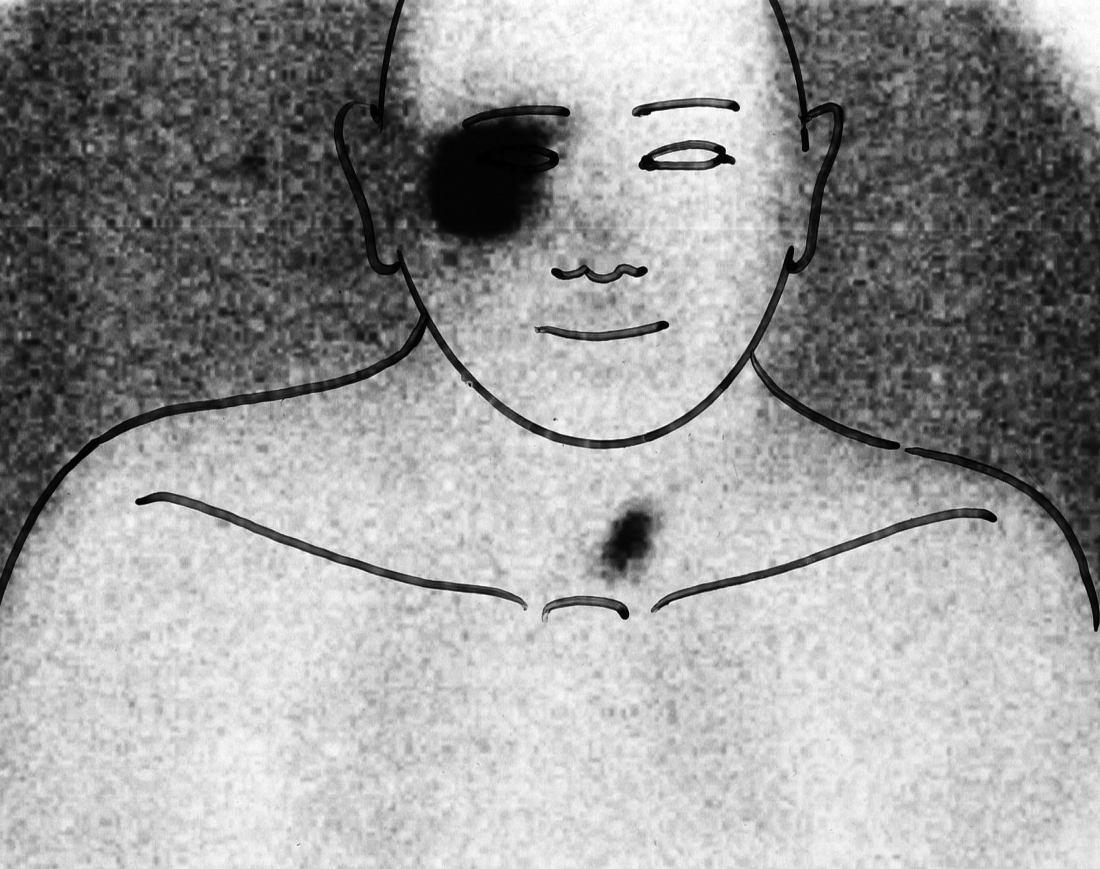
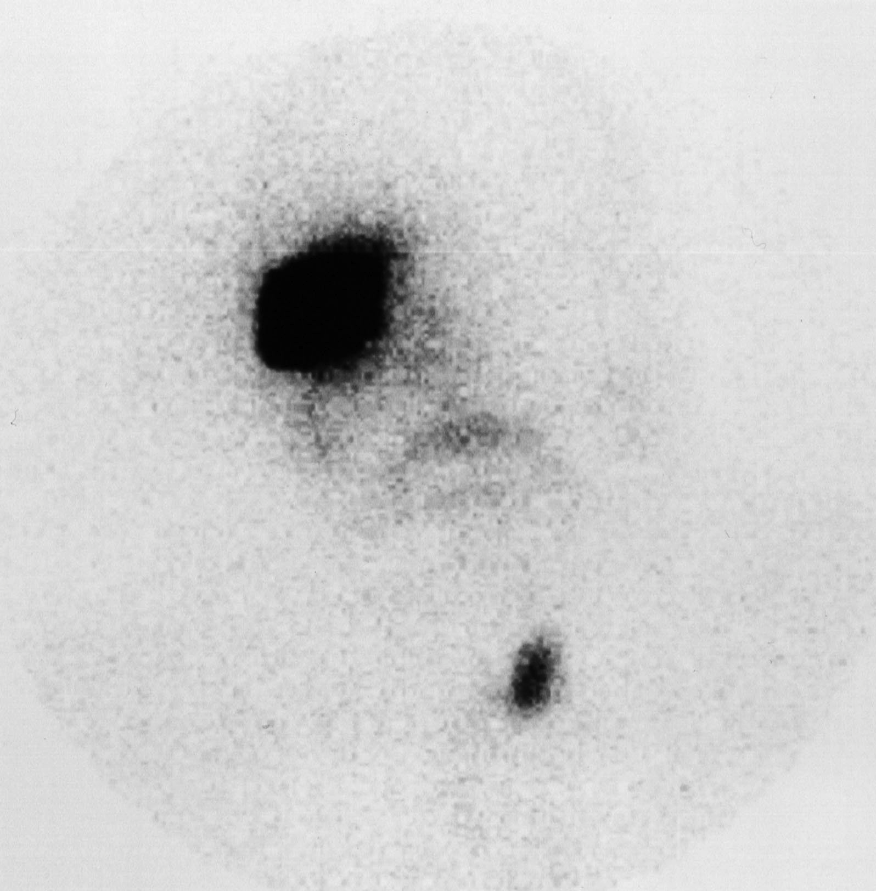

Injection technique
The lymph nodes that are identified by lymphoscintigraphy correspond to the lymph nodes that drain the area of skin throughout which the injected radioactive colloid has been dissipated, taken up and transported in sufficient concentration to produce a detectable image. This area of skin cannot be assumed to correspond exactly to the skin affected by tumour. However, the technique of up to four injections around the tumour site is designed to ensure that it at least includes the tumour-containing skin. The implications of this are that there may be drainage from areas of skin around the tumour site to lymph nodes that do not also drain the tumour-containing skin. The lymph nodes receiving drainage from such skin will be identified as sentinel nodes by lymphoscintigraphy when in fact they are not true sentinel nodes. This limitation of lymphoscintigraphy applies equally to the technique of intra-operative mapping with blue dye. In practical terms this is not a problem when only one or two sentinel nodes are identified, but could have a significant impact when high numbers of sentinel nodes are identified.
Factors such as the speed and volume of injection will to some extent determine the area over which the tracer dissipates and could therefore affect the accuracy of the lymphoscintigram. The typical volume that is injected varies from 0.05 to 0.1ml. The typical volume of blue dye injected is much higher and typically ranges from 0.5 to 1.0ml. The Italian multicentre SOLISM-IMI study investigated the effects of lymphoscintigraphy technique on the outcome of sentinel node biopsy in 1313 melanoma patients.¹²⁸ The number and volume of injections and the dose of radiation were recorded. In this study patients who received <3 peritumoral injections of radiocolloid had a higher number of sentinel nodes excised than those who received >3 injections. However, when sentinel node positivity was examined in relation to the number of peritumoral injections a univariate analysis found that those patients receiving <3 injections had a lower rate of sentinel node positivity. The significance of this factor disappeared following inclusion of Breslow thickness in a multivariate analysis. Other factors such as hyperthermia and massage are also known to affect the speed of uptake of the radiocolloid and may have an effect on the area of dissipation at the injection site.¹⁸⁸
Comparisons between the area of dissipation of radiocolloid and the area of dissipation of blue dye are lacking. It is generally accepted, although evidence appears to be limited, that the injections for cutaneous tumour lymphoscintigraphy should be intradermal as the density of lymphatics is greater than in the subcutaneous region and also to limit dissipation of the injected radiocolloid. Some investigators have suggested that smaller volume or lower radioactive dose injections are necessary in the head and neck to avoid radioactivity from sentinel nodes being obscured by the radioactivity at the primary tumour injection site, as it often lies over or only a short distance from the sentinel nodes.¹⁹⁰ If the tumour has already been excised the injection is generally administered on both sides of the scar at its mid-point or at up to four points, particularly when a skin graft has been used. The excision biopsy site is usually obvious but on very rare occasions simply locating it can present a challenge that could lead to great inaccuracy (Figure 1.3.2).

Figure 1.3.2. The importance of accurately documenting the primary tumour site. This patient attended for pre-operative lymphoscintigraphy 2 weeks following excision biopsy of a melanoma on the shoulder. He had had multiple previous excisions of lesions and was unsure of the location of the most recent excision biopsy site. This situation can be avoided if pre-operative photography of the melanoma is carried out and the images are available to the surgeon performing sentinel node biopsy.

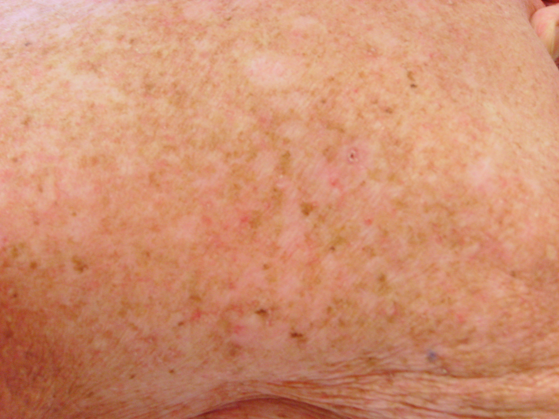

Once the site to be injected has been identified, in order to avoid inadvertent subcutaneous injection or contamination, it is essential that the patient remains still. All air should be expelled from the syringe prior to injection, the injection site should be shielded with gauze during injection, and negative pressure should be applied to the syringe prior to removing the needle tip.^{99,186,191} Figure 1.3.3 shows the results following injection of tracer around a skin graft on the nose. Initial scans demonstrated apparent uptake in the neck and in several areas over the upper anterior chest in the region of the left internal mammary nodes. The unusual location and arrangement of this apparent internal mammary chain uptake alerted the nuclear medicine physician to the possibility of external contamination with radioactive tracer. This concern was confirmed when the patient’s shirt was removed for the delayed scans and the true pattern of lymphatic drainage was revealed (Figure 1.3.3b). Any apparent uptake that appears uncharacteristic in location or distribution should raise the suspicion of contamination and this can be easily confirmed by removing the relevant item of clothing or washing the area of the body before performing repeat imaging.

Image acquisition technique
Once the injection of radiocolloid has been performed it is important to obtain dynamic imaging to follow the radiocolloid as it travels within lymphatic collecting vessels to the sentinel nodes.^{99,186,191} By observing direct drainage from the lymphatic vessel to the lymph nodes, sentinel nodes can be differentiated from second tier non-sentinel nodes. If only delayed imaging of nodal fields is performed then this distinction will not be possible to make. It is vital that all possible nodal drainage sites are included in the imaging, as the surgeon will be reliant on the information provided by the nuclear medicine physician. Failure to detect drainage to a nodal basin will result in no attempt at sentinel node biopsy in that nodal basin and may result in a false-negative sentinel node biopsy.
A further source of error is the presence of radiocolloid at the site of injection. Using ^{99m}Technetium antimony sulphide colloid, 92-95% of the colloid remains at the injection site. With other radiocolloids an even higher percentage remains at the injection site. This can directly overlie or lie near to the sentinel nodes and the level of radioactivity emitted will be much higher than that from the sentinel nodes. One method to overcome this problem is to use lead sheets to shield the injection site. This will not however, allow detection of sentinel nodes directly deep to the injection site. The image produced by the gamma camera can be digitally-enhanced so that faint lymphatic channels or sentinel nodes can be identified. However using digital enhancement with high-resolution collimators can result in star artifact, which can obscure sentinel nodes. The use of a super high-resolution collimator, which is constructed by a different method, avoids problems with star artifact.¹⁹¹

Marking, tattooing and further imaging
Once the sentinel nodes have been identified, their position should be marked as accurately as possible on the skin, in the position that the patient will be placed in for the surgical procedure. This necessitates a degree of understanding of surgical positioning on the part of the nuclear medicine physician or the technician, and requires a close working relationship to maximize the quality and mutual understanding of the information being transmitted. The skin markings provide a guide for the surgical incision to access the sentinel nodes but the location of the sentinel nodes should be confirmed prior to surgery using the hand-held gamma probe by the surgeon in the operating theatre. If sentinel node biopsy is not going to be performed then it is useful to tattoo the skin overlying the sentinel nodes so that they can be monitored more closely during follow-up.¹⁹¹ Ultrasound assessment of the sentinel nodes can be performed at the time of lymphoscintigraphy to assess for evidence of metastatic disease and also to provide more information on the size, depth and anatomical location of the nodes.¹⁹² More recently SPECT CT has become increasingly employed to provide precise anatomical detail of the location of sentinel nodes, particularly in the head and neck.¹⁹³

Figure 1.3.3. Contamination of clothing with radiocolloid mimicking internal mammary node uptake on a lymphoscintigram for a primary tumour located on the nose.
Figure 1.3.3a) Lymphoscintigram result with patient wearing shirt.
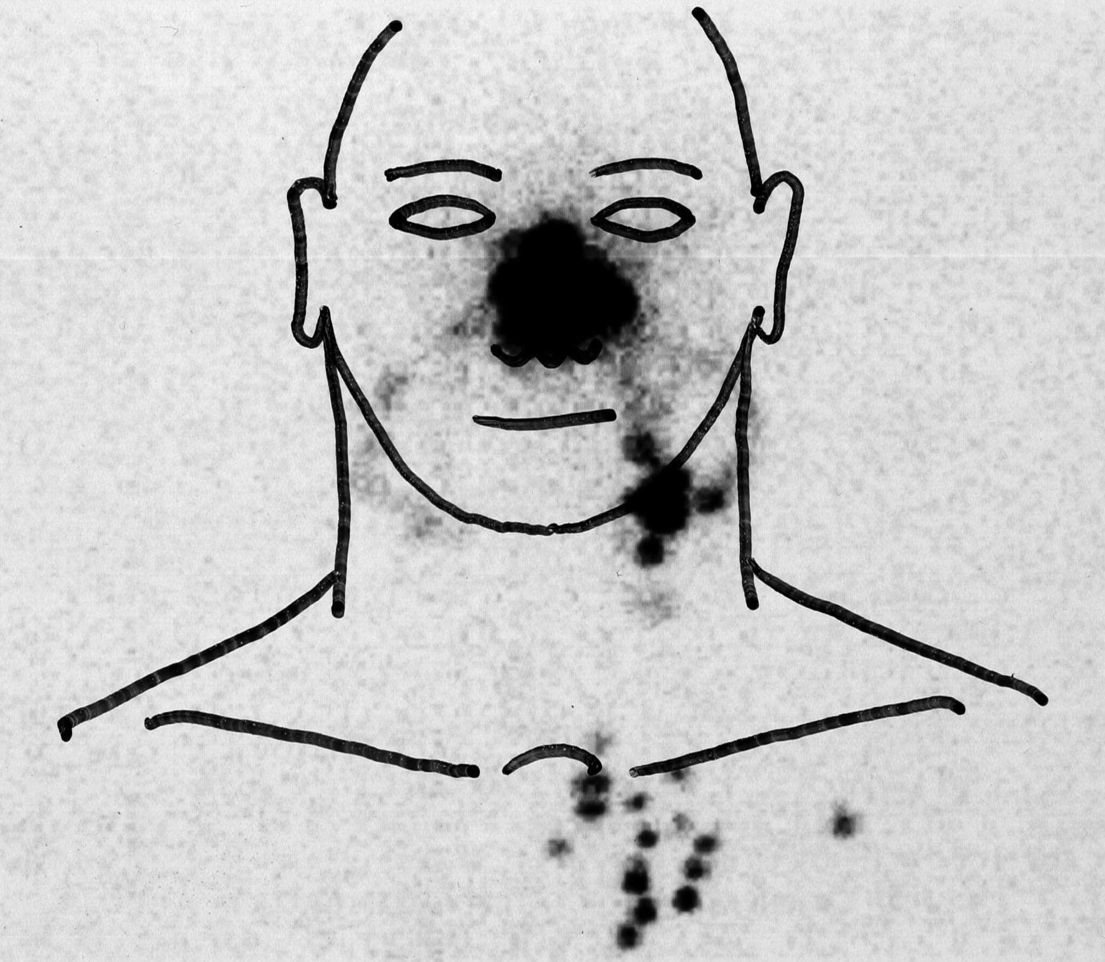
Figure 1.3.3b) Lymphoscintigram result when patient removed shirt.
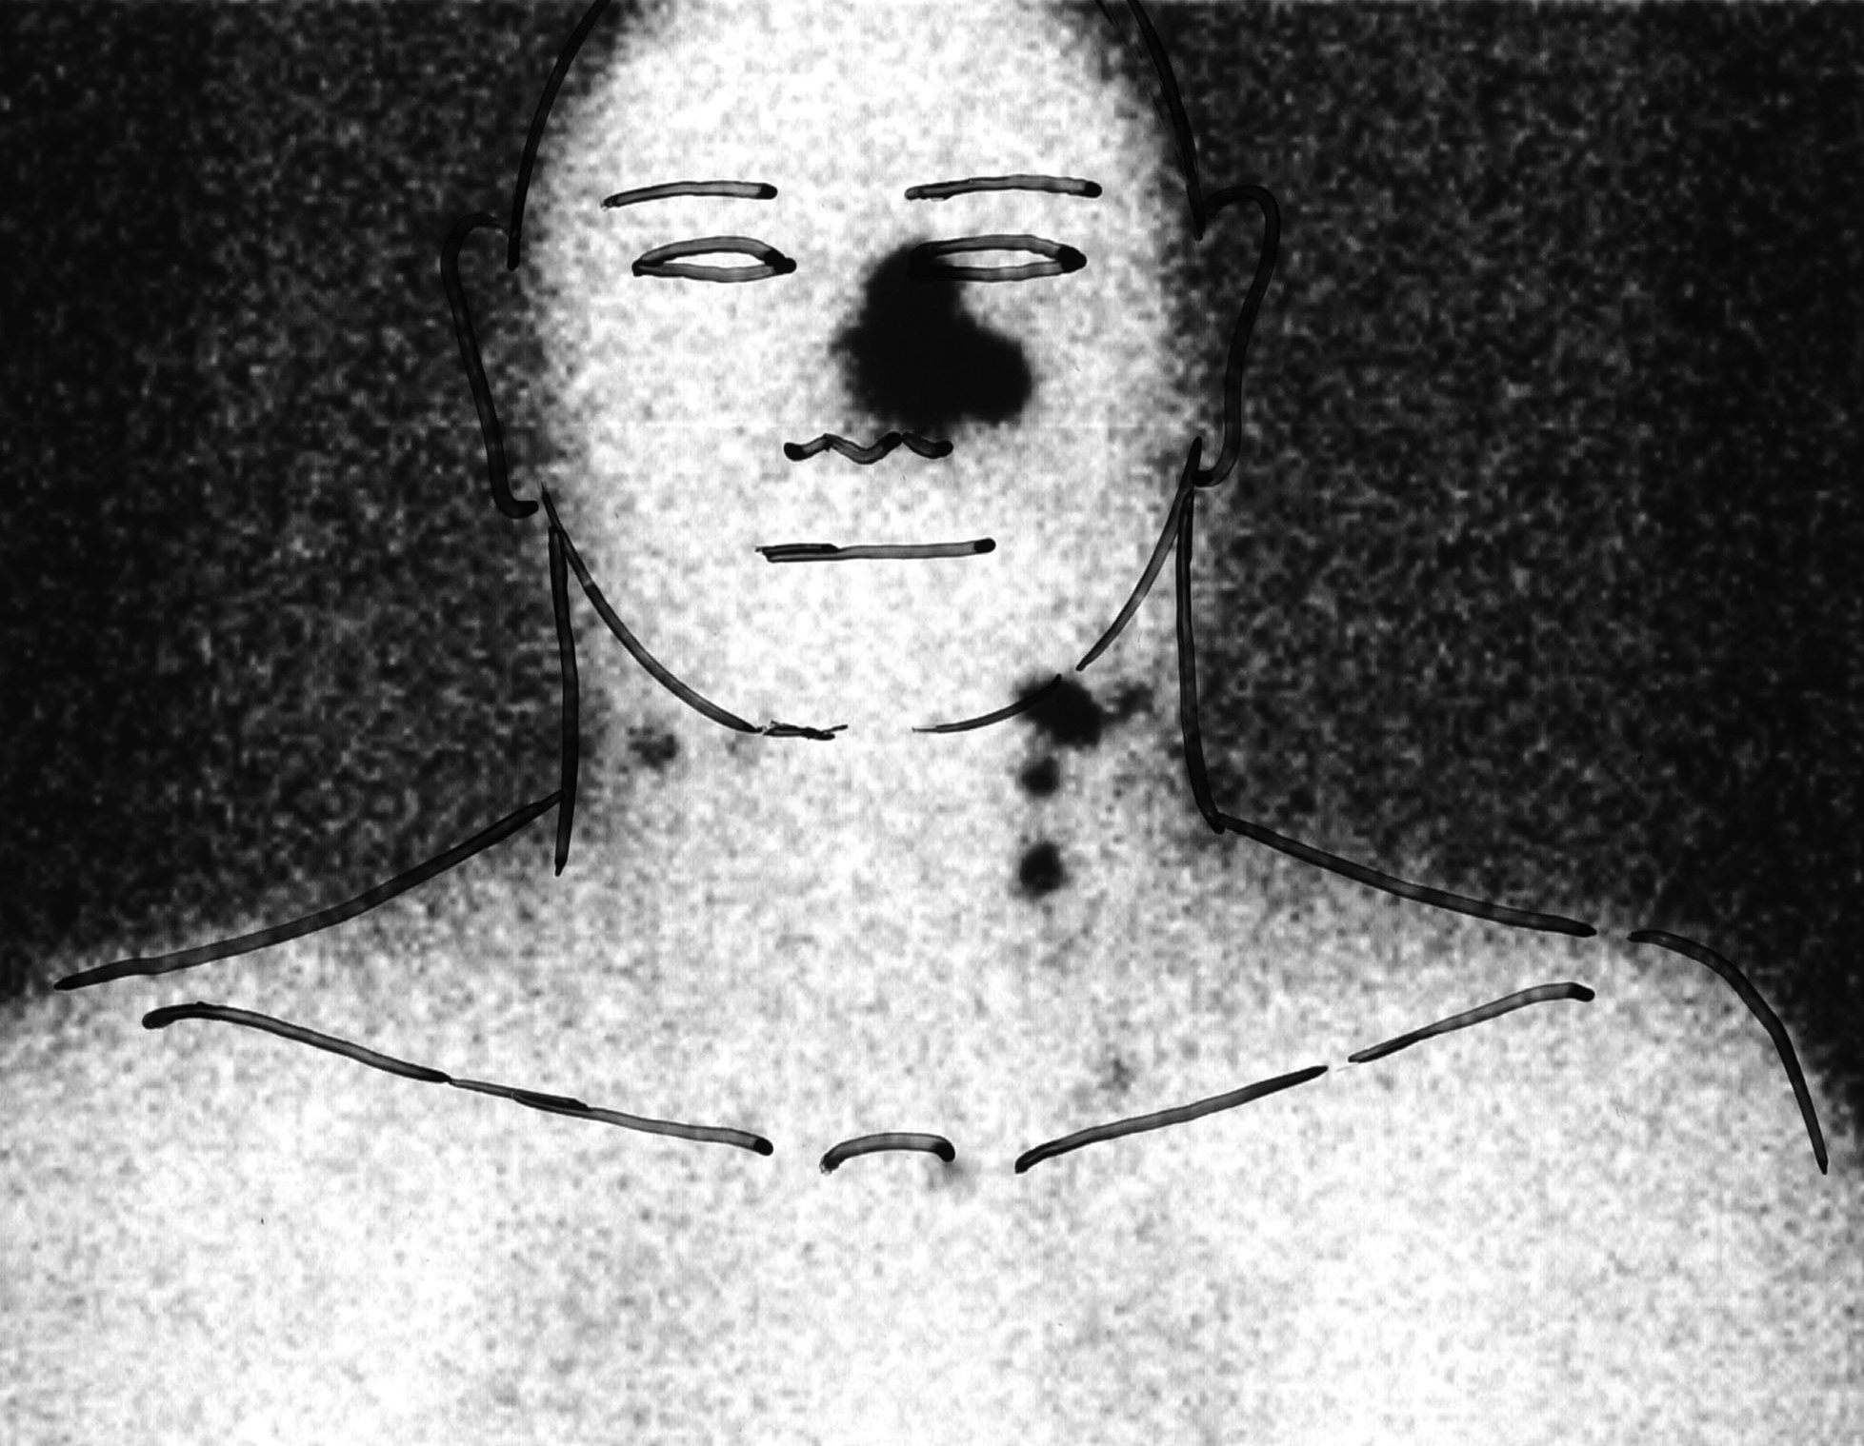

Effects of previous surgery
- Excision biopsy
The effect of excision biopsy prior to lymphoscintigraphy on the accuracy of identification of the true sentinel nodes has not been studied because excision rather than incision biopsy is recommended to obtain the initial diagnosis of melanoma and to determine whether lymphoscintigraphy and sentinel node biopsy are appropriate. Rettenbacher et al. performed lymphoscintigraphy twice in 100 patients with cutaneous melanoma to compare injection around the tumour or scar at a distance of 2 - 5mm with injection 10mm from the initial site.¹⁹⁴ They found that in 84 of 100 patients the lymphoscintigrams showed the same number and location of sentinel nodes. In the remaining 16 patients the more distant injection detected an additional sentinel node but none of these additional nodes contained metastases. This number of patients with additional sentinel nodes detected by distant injection is too small for definitive conclusions to be made regarding whether these additional sentinel nodes were “true” or “false”. Performing lymphoscintigraphy after excision biopsy in effect increases the distance of injection from the skin containing the primary melanoma and could in theory result in the identification of a higher percentage of false sentinel nodes. The theoretical possibility that the skin removed at excision biopsy could drain to sentinel nodes not also draining the surrounding skin could account for some cases of false negative sentinel node biopsy. This risk should be reduced by excision of only the minimum amount of tissue for diagnosis and complete removal of the lesion and avoiding the practice of undermining wound edges, to minimise destruction of subdermal lymphatic channels. For very extensive lesions diagnostic incision biopsies may be most appropriate.

- Skin graft
Skin grafts are commonly used to close defects following excision biopsy on the head and neck. The head and neck has a rich lymphatic drainage system and it is likely that the effect of injecting around a skin graft (usually 4 injections) will result in a larger area of local distribution of colloid than would be the case with an injection on each side of an excision biopsy scar (see Figure 1.3.4). The resultant effect may be similar to that observed by Rettenbacher et al. in that a larger number of sentinel nodes will be identified.¹⁹⁴

Figure 1.3.4. A lymphoscintigram result following 4 injections of radiocolloid around a skin graft on the left medial forehead. It can be seen that radiocolloid has become distributed, either by diffusion or uptake into lymphatics, over a wide area involving the left upper eyelid, left anterior scalp, and right medial forehead, in addition to the majority of the left forehead where the primary tumour was located. At least 4 different sentinel nodes have been identified in both pre-auricular regions and in level I, thus making sentinel node biopsy challenging.


- Wide local excision
Lymphoscintigraphy is especially important for patients who have previously had wide local excision because blue dye injection is sometimes not performed in order to avoid potentially permanent tattooing of the skin at the injection site (this skin would normally be excised as part of the wide local excision). A number of studies have addressed the accuracy of sentinel node biopsy for patients who have already undergone wide local excision.^{195–201} The details of these studies are summarized in Table 1.3.1. Pooling the data from these studies provides information on 442 patients, the majority of whom had trunk and extremity melanomas. The SN positivity rate is 24% and the false negative rate, including false negatives that were explained by other factors is 3%. These rates compare favourably with sentinel node biopsy in patients who have not already undergone wide local excision.¹¹⁸ More detailed analysis of the 13 cases of false-negative sentinel node biopsy within these studies, conducted by the investigators, identified potential causes for the false-negative result, in 7 cases, that were unrelated to the fact that previous wide local excision had been performed. These included incorrect histological analysis of the sentinel node in 2 cases, failure to identify an interval node in 1 case, initial in-transit metastasis prior to nodal recurrence in 1 case and systemic recurrence with nodal disease in 3 cases. The importance of the method of wound closure or reconstruction following wide local excision was identified as a likely cause in 4 cases, in which a rotation flap, a flap which would have involved fairly extensive incisions and significant tissue undermining, was used. In summary, the evidence suggests that for patients with primary melanoma on the trunk or extremities who have already undergone wide local excision, lymphoscintigraphy and sentinel node biopsy remain reliable, provided that a rotational flap has not been used in reconstruction. For patients with head and neck melanoma there is inadequate data to support this view and, given the high concentration of lymphatic drainage pathways in this region, there may be a higher likelihood of altered lymphatic drainage as a result of wide local excision.

Table 1.3.1. Summary of studies examining the validity of lymphoscintigraphy and sentinel node biopsy for patients who have undergone previous wide local excision.
Publication | Number of patients | Tumour locations | Number of patients with positive SNs | Number of false negative SN biopsies | Likely cause for false negative SN biopsies
Karakousis and Grigoropoulos, 1999 ¹⁹⁶ | 26 | All sites | 9 | 1 | Rotation flap
Kelemen et al., 1999 ¹⁹⁵ | 47 | All sites | 11 | 3 | Histology error in 2 cases + in-transit metastasis in other case
McCready et al., 2001 ¹⁹⁹ | 100 | Head + neck excluded | 31 | 3 | Rotation flap in 2 cases
Leong et al., 2003 ²⁰¹ | 24 | Limbs only | 2 | 1 | Interval node missed
Leong, Ghazarian and McCready, 2003 ²⁰⁰ | 65 | Head + neck excluded | 21 | 1 | Rotation flap
Evans et al., 2003 ¹⁹⁷ | 76 | Head + neck excluded | 11 | 4 | 3 had systemic disease plus nodal recurrence
Gannon et al., 2006 ¹⁹⁸ | 104 | All sites, but excluded rotation flaps | 19 | 0 | Not applicable
Pooled data from above studies | 442 | Mainly trunk and limb | 104 (24%) | 13 (3%)
SN = sentinel node

D. Regional node surgery
The effects of regional node surgery on lymphatic drainage patterns have been described by Rees et al in a series of 10 patients with primary melanoma of the trunk.²⁰² Following lymphoscintigraphy, eight patients underwent wide local excision and sentinel node biopsy. The remaining two patients had already undergone wide local excision and so received sentinel node biopsy only. All patients had regional node dissections and repeat lymphoscintigrams 12 to 23 months post-operatively. In 8 patients, including the two patients who had their lymphoscintigrams after wide local excision had been previously performed, the lymphatic drainage pattern had changed. Unusual patterns of lymphatic drainage undoubtedly occur in patients who have previously undergone regional node surgery. Figure 1.3.5 shows the lymphoscintigram of a patient who had previously undergone a left neck dissection. In certain cases these unusually located sentinel nodes have contained metastases, thus demonstrating that new functional lymphatic drainage pathways can form following surgery and suggesting that any regional node surgery taking place between the time of development of primary tumour and lymphoscintigraphy is likely to cause considerable inaccuracy.

Figure 1.3.5. The effect previous nodal surgery. A lymphoscintigram from a patient with a primary tumour site on the left forehead. Uptake of radiocolloid can be clearly seen passing via a lymphatic channel on the left side of the face, down to the neck and then crossing the midline of the neck to a sentinel node on the contra-lateral neck. This patient had previously undergone a left neck dissection.

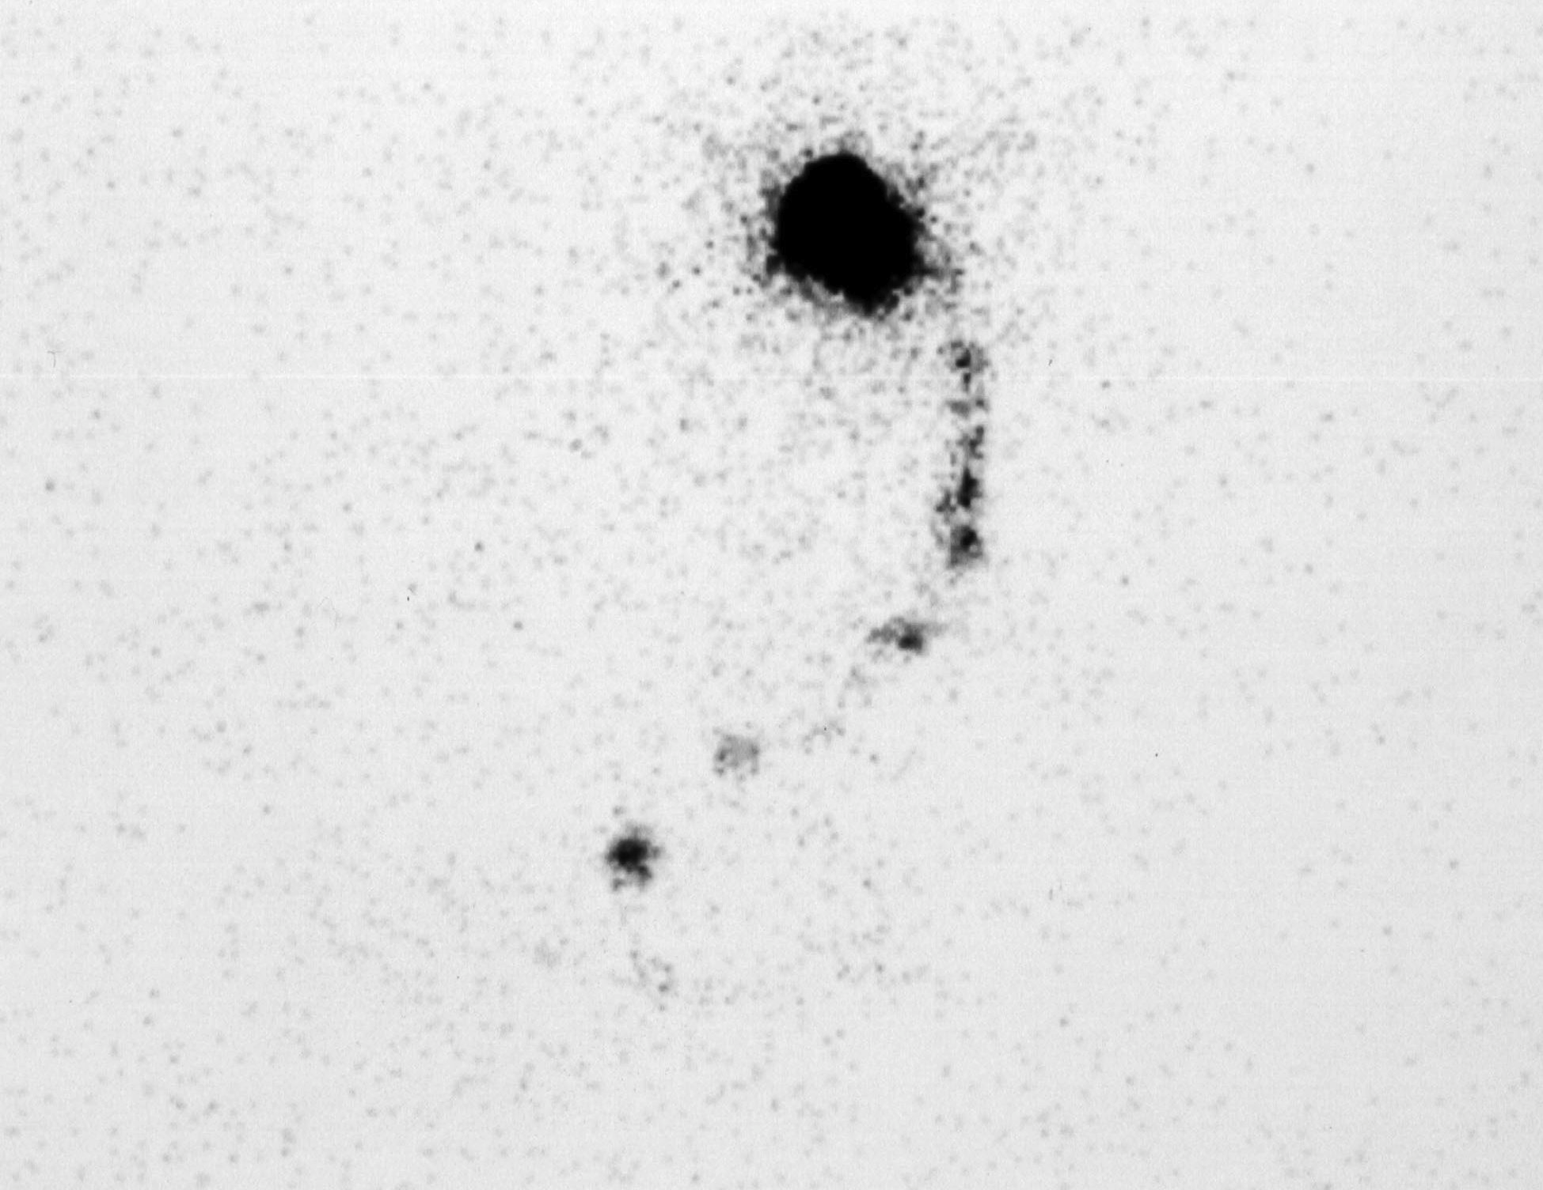



Effects of previous radiotherapy
Patients who have received radiotherapy treatment to the area of skin occupied by the tumour or to the regional lymph node field have often also had surgery to one or both areas and so it is difficult to determine whether observed effects are the result of surgery, radiotherapy or a combination. There are isolated cases where patients have received only radiotherapy prior to surgery and a sentinel node could not be found. The destruction of lymphatics by radiotherapy has been proposed as a cause for failure to identify sentinel nodes in a patient undergoing sentinel node biopsy for vulval cancer.²⁰³ No case reports were identified involving lymphoscintigraphy pre-and post-radiotherapy to provide more substantial evidence for changes in lymphatic drainage patterns resulting from radiotherapy.

Problematic lymphoscintigraphy results and their practical implications

In the absence of exclusive identification of all sentinel nodes there are four potential situations that could exist. These are as follows:
- Identification of non-lymphatic tissue as sentinel nodes.
- Identification of non-sentinel nodes as sentinel nodes.
- Identification of some but not all sentinel nodes.
- No sentinel nodes identified (non-localization).

From a practical point of view for the surgeon performing sentinel node biopsy, non-localization and the identification of very large numbers of “sentinel” nodes in different node fields are the only two situations that will have immediately apparent implications regarding possible inaccuracy or failure of the procedure.

1. Identification of non-lymphatic tissue as sentinel nodes.

There are three situations where non-lymphatic uptake may occur, but in only two situations is this likely to be mistakenly interpreted as uptake in sentinel nodes. The first is contamination of skin or clothing with radiocolloid which may give obvious anomalous results or may produce patterns consistent with sentinel node uptake, the second is uptake of free isotope (not bound to colloid) into non-lymphatic structures, such as the thyroid gland, which could again be mistaken for sentinel node uptake (see previous discussion and Figures 1.3.3 and 1.3.1). The third situation where non-lymphatic uptake occurs is systemic uptake and is shown in Figure 1.3.6. The pattern of uptake in this situation follows the vasculature and is clearly not within lymph nodes. This should therefore be easily recognized as anomalous.

Figure 1.3.6. Systemic uptake of radiocolloid. A lymphoscintigram following injection of radiocolloid around a primary tumour site on the scalp. No lymphatic uptake is seen but uptake is apparent in a pattern corresponding to the vasculature of the upper body.

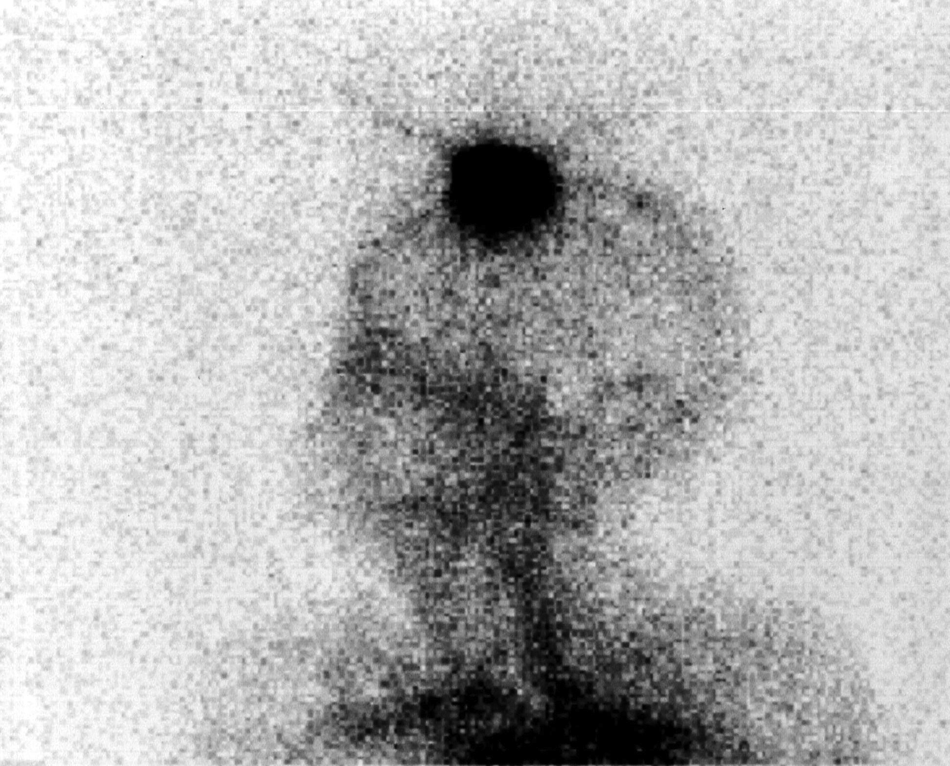

2. Non-sentinel nodes identified as sentinel nodes
The clinical relevance of sentinel nodes in certain sites, as identified by lymphoscintigraphy, has been called into question by some surgeons. The observation that a high percentage of metastases are found at clinically predicted sites and the concern that sentinel nodes identified by lymphoscintigraphy may not all be clinically relevant can be addressed by considering the limitations of the technique of lymphoscintigraphy. It is widely recognised that the number of sentinel nodes identified by lymphoscintigraphy is to some extent dependent on the particle size of the radiocolloid and the interpretations of the nuclear medicine physician, especially when lymphatic channels are not visualised entering the sentinel node(s). These factors could lead to second-tier nodes being confused for sentinel nodes and in the literature such nodes are often referred to as “false” versus “true” sentinel nodes. However, failure to identify lymphatic channels could not account for identification of clinically irrelevant lymphatic drainage to two or more anatomically-distinct nodal basins. In this situation it would be theoretically possible to see lymphatic channels draining into nodes in each basin but for some of those nodes not to be draining the primary tumour site. All the nodes with lymphatic channels draining directly to them would typically be defined as “true” sentinel nodes but strictly some would be “false” sentinel nodes. The existence of two distinct groups within the “true” sentinel nodes: the “true-true” sentinel nodes with the higher probability of harbouring metastases, and the “apparent- or false-true” sentinel nodes with a low probability of harbouring metastases is an inherent limitation of lymphoscintigraphy, which may not be simply of theoretical interest. The head and neck, an area with a reputation for unpredictable lymphatic drainage and drainage to high numbers of sentinel nodes at different nodal sites, is an area where this situation could be a problem. If injected radiocolloid disperses over an area of skin that is greater than the area occupied by the tumour, and includes drainage to lymph nodes not draining the tumour site, this would result in a reduced ratio of positive to negative nodes in the sentinel nodes removed, as the true sentinel nodes are the nodes most likely to contain metastatic disease. There would however be no alteration in the overall result of sentinel node biopsy i.e. positive or negative, provided that all nodes identified as “sentinel” were removed.
The potential clinical importance of this theoretical situation for tumours on the head and neck can be highlighted by taking the example of a tumour that is close to the midline but not on the midline. The injected radiocolloid may dissipate across the midline into skin with a different lymphatic drainage from the primary tumour skin and be taken up by lymphatics to contralateral lymph nodes. These will be identified as sentinel nodes and will need to be removed as part of the sentinel node biopsy procedure but will have a low probability of harbouring metastases as they did not drain the area of skin occupied by the tumour. The result for the patient would be an extra scar, an increased risk of complications and a longer operation, all for no benefit; or worse still, a decision by the surgeon not to go ahead with sentinel node biopsy because of the likely morbidity, and a resultant failure to obtain any prognostic information.
The question of the relative clinical significance of sentinel nodes at certain nodal sites and the suggestion that sentinel nodes at certain sites should be dismissed as clinically-irrelevant, and therefore not biopsied, requires further consideration. If the number of lymph nodes found at each site is accounted for, the low rate of positivity observed at certain sites can be explained. Comparing the pre-auricular region with the post-auricular region, the average number of lymph nodes at each site will differ, with a higher number of nodes being located in the pre-auricular region. If it is assumed that each lymph node draining skin within the head and neck region drains a similar sized area of skin and has an equal chance of harbouring metastasis when a tumour is located within the skin that it drains, then the likelihood of observing positive sentinel nodes at a particular nodal site in a patient population would be related to the mean total number of skin-draining nodes at that site. Sites with more nodes would more frequently be sites where sentinel nodes would be found and hence more frequently sites of positive sentinel nodes. In order to compare the sentinel node positivity rates for different anatomical regions, the observed rate of sentinel node positivity would need to be divided by the average number of skin-draining lymph nodes found in that region. Sites with fewer nodes, such as the post-auricular region, would be less frequent sites of positive sentinel nodes even though the individual nodes within those sites may have the same chance of being positive as nodes at other sites. It is certainly true that positive sentinel nodes are much more commonly found in the pre-auricular region than the post-auricular region. However, this observation should not lead to an erroneous conclusion that post-auricular sentinel nodes are clinically-irrelevant. The fact that positive sentinel nodes can occasionally be found in the post-auricular region provides support for the principle and technique of sentinel node biopsy.

3. Identification of some but not all sentinel nodes
The number of cases in which some but not all sentinel nodes are identified is impossible to determine because there is no method for indisputably identifying all sentinel nodes in vivo and so neither the nuclear medicine physician nor the surgeon will be aware of such cases when they occur. These cases could account for a proportion of recurrences in the same or separate nodal basins following both positive and negative sentinel node biopsy procedures. The majority of the unidentified sentinel nodes that remained in situ would not contain metastatic disease. False negative sentinel node biopsies resulting from previously unidentified sentinel nodes in the same nodal basin would be difficult to conclusively differentiate from false negatives occurring as a result of surgical failure to remove the correctly-identified sentinel nodes.
There are several possible situations where failure to identify all sentinel nodes by lymphoscintigraphy may occur. Firstly, unexpected concomitant drainage to more distant or unusual nodal sites should be detected by the nuclear medicine physician, in all cases, by ensuring that every possible drainage site is imaged. Secondly, sentinel nodes obscured by primary site activity should be carefully sought by the surgeon whenever the primary overlies a nodal basin. This is particularly the case in the head and neck where the distance between primary site and regional nodes is often small. The sentinel nodes are not always the hottest nodes or the closest nodes to the primary site.¹¹³ In the absence of visualisation of lymphatic channels draining directly to each node or passing via another node, the decision regarding their identification as a sentinel or non-sentinel node rests on the experience of the nuclear medicine physician and is therefore subjective. The development of single-photon emission computed tomography (SPECT-CT) as an adjunct in lymphoscintigraphy has been shown to improve detection of sentinel nodes.^{193,204}
Finally, between the time of development of the primary tumour and lymphoscintigraphy, any process that results in physical disruption or blockage of the draining lymphatics could potentially affect the accuracy of lymphoscintigraphy. Examples include radiotherapy, surgery, infection, inflammation and neoplastic processes at the primary tumour site, the region where the lymphatics travel between primary tumour site and sentinel nodes or at the regional nodes.^{196,199,200,205–207} The likely effect of previous nodal surgery to the neck can be seen in the patient who underwent lymphoscintigraphy for a primary tumour located on the left forehead and had previously had a neck dissection (Figure 1.3.5).

4. No sentinel nodes identified (non-localization)
A pre-operative lymphoscintigram that does not demonstrate drainage to any lymph nodes places the surgeon in a compromised position with an increased risk of failure or false negative sentinel node biopsy. The options are to proceed with the planned wide local excision with or without an attempt to identify sentinel nodes intra-operatively, or to postpone surgery and repeat lymphoscintigraphy in the hope that the result will be more informative. By proceeding with wide local excision, there is a theoretical chance that lymphatic drainage pathways may be disrupted and make subsequent lymphoscintigraphy inaccurate. However, studies to date investigating the effect of prior wide local excision on sentinel node biopsy (see Table 1.3.1) suggest that this is not necessarily the case unless reconstruction with a rotation flap is performed.^{195–201} Postponing surgery to repeat lymphoscintigraphy results in wasted operating theatre time, but more importantly causes disruption and anxiety for the patient, especially if the primary tumour has not been completely excised. The repeat lymphoscintigram may also fail to demonstrate drainage to lymph nodes. In order to determine the most appropriate course of action for the individual patient several factors should be considered. These include whether or not the primary lesion has been completely excised, the likelihood of the primary tumour lying directly over the nodal basin that contains the sentinel nodes, and the possibility of technical factors related to lymphoscintigraphy that could have produced an inaccurate result. When the primary tumour has not been completely excised then it would seem sensible that this should take priority and wide local excision should go ahead with or without blue dye injection and an attempt at sentinel node biopsy. For primary tumours located directly over nodal basins, SPECT CT can be considered and blue dye can be injected as usual and wide excision performed. Once the primary site radioactivity is removed, the gamma probe can be used to examine the underlying nodal basin and any blue lymphatic channels can be followed to sentinel nodes whose uptake of tracer had previously been obscured by primary site activity. These cases can be described as “apparent non-localization” in contrast to “true non-localization” where no evidence can be found for movement of tracer via the lymphatics. True non-localization should be suspected when the primary site was not overlying a known lymphatic basin and early scanning failed to demonstrate any lymphatic channels. The risk of non-localization appears to be higher for primary tumour sites on the scalp and cheek. Both sites have a rich lymphatic and vascular network. A case of true non-localization is demonstrated in Figure 1.3.6. The excision biopsy site on the anterior scalp was injected with tracer and uptake was seen only in a distribution corresponding to the vasculature of the upper body. Stadelmann et al. performed repeat lymphoscintigrams in 2 of 5 patients whose initial lymphoscintigrams had failed to demonstrate lymphatic uptake of tracer.²⁰⁸ They found that the repeat lymphoscintigrams produced the same result.
For all cases, the possibility of inadvertent intravascular injection, systemic uptake, or a problem with the tracer should be considered. Using the technique of four intradermal injections around the primary site, the likelihood of four consecutive inadvertent intravascular injections and no lymphatic uptake is minimal. The mechanism for apparent systemic uptake into the venous system that is occasionally seen is as yet unknown. Rapid lymphatic uptake and passage through the regional nodal basin(s) has been suggested by some as an explanation, but is not scientifically plausible because once tracer is taken up by lymph nodes it typically remains detectable within them for at least 24 hours.¹¹⁴ The possibility that the sentinel nodes lie in an unpredicted nodal basin that has not been imaged should always be considered, but routine imaging of all possible draining nodal basins at the time of lymphoscintigraphy should virtually eliminate this error. The observation of systemic uptake in the absence of lymphatic uptake could be explained on the basis of findings from anatomical studies on lymphatics that have demonstrated connections between lymphatics and veins. The existence of such connections between afferent lymphatics from the primary tumour site and veins in the region could allow tracer, and lymph containing malignant cells, to enter the systemic circulation without ever passing through a lymph node. This could thus explain not only cases of true non-localization but also why some patients develop distant metastases in the absence of regional nodal metastases. There could therefore be two groups of patients: those in whom there is no direct pathway from the afferent lymphatics to the vascular system and so all lymph is filtered by lymph nodes and those in whom a lymphaticovenous connection allows passage of lymph directly from a tumour site to the bloodstream. The former group could demonstrate patterns of metastasis that conform to either the “incubator” or the “marker” theory of metastasis, whereas those with a direct route to the vascular system could only be expected to conform to the “marker” theory, as nodal metastases could only occur due to tumour cells circulating within the bloodstream becoming trapped within lymph nodes. These lymph nodes would not be sentinel nodes and this mechanism could therefore explain some cases of false-negative sentinel node biopsy.
It has been suggested that a sentinel node that is grossly involved by metastatic disease or another unrelated disease process may be non-functioning and therefore fail to demonstrate any uptake of tracer. For this reason, the surgeon should have no hesitation in excising an apparently non-sentinel node that appears abnormal at operation. However, Kamath et al performed lymphoscintigraphy in 8 patients with a grossly involved nodal basin and found that 14 of 16 sentinel nodes contained tumour with the sentinel node being the grossly palpable node in each case.²⁰⁹ It therefore seems that if grossly involved nodes remained capable of uptake of radioactive colloid then impalpable, grossly normal nodes are most unlikely to be non-functioning.

Conclusions
In this section potential factors that could affect the accuracy of lymphoscintigraphy have been identified by systematic analysis of the process. The available literature that supports or rejects each factor as a possible source of inaccuracy has been reviewed and clinical examples have been provided to support the factors identified and highlight some of the potential pitfalls for those involved in either performing or interpreting lymphoscintigrams. The aim of sentinel node biopsy is to accurately identify, remove and histologically analyse all lymph nodes that receive direct lymphatic drainage from the primary tumour site so that all cases in which occult metastasis has occurred are identified. This review highlights that the success of the procedure is dependent on the accuracy and quality of each individual step in the process. Lymphoscintigraphy is the first component in the sentinel node biopsy procedure and so inaccuracy at this stage will jeopardise the whole procedure. An awareness of the potential situations in which individual steps can result in inaccuracy should allow their identification and in some cases action can be taken to avoid inaccuracy, thus preventing it from translating to inaccuracy of the sentinel node procedure itself. The European Association of Nuclear Medicine have recently produced guidelines for lymphoscintigraphy and sentinel lymph node biopsy in melanoma which should lead to increased standardization of the procedure and avoidance of some of the common pitfalls.²¹⁰

Section 2

Section 2 – Lymphatic mapping studies

This section addresses the following questions:
- How frequently does non-localization occur? – Section 2.1
- What are the types and causes of non-localization? – Section 2.1
- What is the likely effect of non-localization on the outcome of sentinel node biopsy? – Section 2.1
- Can the unpredictability of lymphatic drainage patterns from the head and neck be reduced by examining drainage patterns from smaller subdivisions of the head and neck? – Section 2.2
- Can refinements be made to recommendations for selective neck dissections based on information on the patterns of lymphatic drainage from specific sites on the forehead? – Section 2.2

Section 2.2 is included (with permission) as it was when published in Journal of Plastic and Reconstructive Surgery in 2014.

Section 2.1: Failure to identify sentinel nodes (non-localization) using lymphoscintigraphy for cutaneous tumours: Its frequency and causes.

Abstract
Aims: For patients with a primary melanoma and no evidence of metastatic disease, the presence or absence of micrometastases within the sentinel node(s) provides the most powerful prognostic information. Failure to identify any sentinel nodes using lymphoscintigraphy prior to sentinel node biopsy (non-localization) appears to be relatively uncommon. However, when it does occur it creates a dilemma for the surgeon and their patient. This study aimed to document the frequency of non-localization and to identify specific reasons why it might occur in order to guide management for future cases of non-localization.

Methods: Data were extracted from a prospectively-maintained database containing details of lymphoscintigrams performed on patients with cutaneous melanomas and merkel cell tumours between 1989 and 2007. All patients in whom non-localization occurred using lymphoscintigraphy were identified. The prospectively-maintained database of the Melanoma Institute of Australia (formerly Sydney Melanoma Unit) was then searched to obtain further information that might assist in identifying causes of non-localization in this group of patients.

Results: Non-localization occurred in 0.3% of patients (18/5600 patients). There were plausible patient-related or technical factors to account for non-localization in 14 out of 18 cases. Of the 4 cases in which no patient-related or technical factors could be identified, 3 primary tumour sites were located near the midline at the scalp vertex and 1 was located on the cheek in the malar region.

Conclusion: Failure to identify any sentinel nodes for patients undergoing lymphoscintigraphy for cutaneous tumours is rare (0.3% of cases) and technical or patient-related factors can be identified in the majority of cases. The midline scalp vertex and malar cheek regions appear to be locations where physiological non-localization can occur, possibly due to the presence of direct lymphaticovenous connections.

Introduction
The aim of sentinel node biopsy in any patient with melanoma or other cutaneous tumour is to detect and remove all lymph nodes that receive direct lymphatic drainage from the site of the primary tumour. Lymphoscintigraphy plays a key role in this process by providing information on the location of the sentinel nodes, and is especially valuable when drainage occurs to distant nodal basins or to unexpected locations.^{99,112} It has been established that the accuracy and success of sentinel node biopsy increase when pre-operative lymphoscintigraphy is performed.¹¹³ On rare occasions lymphoscintigraphy fails to identify any sentinel nodes and this is termed non-localization. This situation creates a dilemma for the surgeon who must decide whether to proceed with sentinel node biopsy in the hope that blue dye injection and use of the intra-operative gamma probe will successfully identify sentinel node(s), or to postpone the procedure and repeat the lymphoscintigram at a later date. Delaying surgery has obvious implications for the patient and the medical resource, and there is no evidence to indicate an increased likelihood of success with repeat lymphoscintigraphy.²⁰⁸
The actual incidence of non-localization on lymphoscintigraphy is not widely documented, but appears to be higher for tumours located on the head and neck. It has been recorded in relatively small studies for the head and neck as between 5% and 7%.^{208,211} The mid-line scalp area and the malar cheek region have been identified as sites where non-localization occurred. However, the causes of such non-localization were not elucidated.²⁰⁸ A variety of potential causes exist for failure to identify a sentinel node using lymphoscintigraphy (non-localization). These include problems with radiolabelling of the colloid, failure to image all potential nodal drainage fields, sentinel nodes directly underlying the primary tumour site and thus being obscured on imaging by radioactivity at the injection site, and failure of uptake of radiocolloid by the lymphatic system.
This study aimed to determine and compare the frequency of failure to identify sentinel node(s) (non-localization) for the head and neck versus trunk and extremity in patients undergoing lymphoscintigraphy for cutaneous melanoma or merkel cell tumour, to identify likely causes of non-localization and to determine the impact of non-localization on the success of sentinel node biopsy. Knowledge of such factors could help guide decision-making for patients with non-localization on a pre-operative lymphoscintigram.

Methods
The technique of lymphoscintigraphy at our institution has been described previously.¹⁸³ The radiocolloid used was ^{99m}technetium antimony sulphide: Particle size 10-12nm (measured by the Radiopharmacist, Peter MacCallum Centre, Victoria 8006, Australia). Typically, two or four intra-dermal injections of ^{99m}technetium antimony sulphide colloid were administered around the primary tumour or on each side of the centre of the excision biopsy site.¹⁸³ The volume of each injection was 0.05 to 0.1ml and contained 5 to 20 MBq of tracer depending on when surgery was planned. A super-high resolution collimator (Siemens eCam dual head, low-energy, high-resolution collimator with 1.5mm hexholes, 0.23mm septae and 35mm hole length) was used, with dynamic imaging performed immediately following injection of tracer in order to identify and follow the lymphatic collecting vessels, thus allowing accurate identification of the sentinel nodes. Delayed scans were performed at 1 to 2 hours, with imaging of all regions that could possibly contain sentinel nodes.
A sentinel lymph node was defined as “any lymph node that received drainage directly from the primary tumour site”.^{183,212} Data were extracted from a prospectively-maintained database containing details of lymphoscintigrams performed on patients with cutaneous melanomas and merkel cell tumours between 1989 and 2007. All patients in whom non-localization occurred using lymphoscintigraphy were identified. The prospectively-maintained database of the Melanoma Institute of Australia (formerly Sydney Melanoma Unit) was then searched to obtain further information that might assist in identifying causes of non-localization in this group of patients. The locations of primary tumour sites were mapped using a co-ordinate-based system and the frequency of non-localization was determined for the head and neck and for the trunk and extremities. The case records and details of lymphoscintigraphy for each patient were studied in order to identify technical and/or patient-related factors that could explain non-localization. It was proposed that non-localization by lymphoscintigraphy could fall into 2 categories: “apparent” or “true” (Table 2.1.1). Apparent non-localization would occur as a result of technical failure, such as inadequate tracer radiolabelling, operator neglecting to include relevant node fields on imaging, or sentinel nodes being obscured by primary tumour site radioactivity. In this situation uptake of radiocolloid into lymphatics and transport to sentinel nodes would be occurring, or be able to occur, and hence sentinel node biopsy could be successfully performed. True non-localization would occur when patient factors were present that resulted in either disruption of lymphatic drainage, such that the tracer remained entirely at the primary tumour site, or diversion of lymphatic drainage via an alternative pathway, avoiding passage through any lymph nodes (most likely via a lymphaticovenous connection). In such a situation radiocolloid would not reach sentinel nodes and so sentinel node biopsy would not be possible.
The observed frequency of non-localization was recorded for the head and neck, and for the trunk and extremity. The expected frequencies of non-localization and localization were calculated for the head and neck versus the trunk and extremity and the chi-squared distribution was calculated to test for a difference between the observed and expected frequencies. A p value of <0.05 was regarded as significant.

Table 2.1.1. Potential causes for non-localization.

Potential cause for non-localization | Category of cause | Type of non-localization (true or apparent) | Implications for sentinel node biopsy (SNB) success
Lymphaticovenous connection (Lymphovenous shunt, lymphovascular connection) | Anatomical, pathological or iatrogenic lymph node bypass | True | SNB Not possible
Radiocolloid quality issue or collimator issue | Technical | Apparent | Can be rectified prior to SNB. SNB possible
Failure to scan correct nodal fields | Technical | Apparent | Can be rectified prior to SNB. SNB possible
Primary site overlying sentinel nodes | Technical | Apparent | SNB may be possible using blue dye and gamma probe localization
Disruption of lymphatic drainage pathways | Pathological or iatrogenic mechanical obstruction or destruction | True | SNB not possible
SNB = sentinel node biopsy

Results
Lymphoscintigraphy was performed for 5600 patients at the Melanoma Institute of Australia during the time period from 1989 and 2007. In the vast majority of patients (99.7%) lymphoscintigraphy identified at least one sentinel node. Non-localization occurred in 18 cases (0.3%) and the locations of the primary tumour sites in these patients are shown in Figure 2.1.1. The mean age (+standard deviation) of the population was 67.6 (+17.7) years (range 25 to 89 years) and there were 13 females and 5 males. The primary tumour sites were most commonly located on the head and neck (11 patients), followed by the trunk (4 patients) and the limbs (3 patients). Table 2.1.2 shows the observed and expected frequencies of non-localization and localization for the head and neck versus trunk and extremity. There was a significant difference between the observed and expected frequency of non-localization for head and neck versus trunk and extremity sites, with a higher frequency than expected for the head and neck (chi-square test, p=0.000026, 1 degree of freedom). All except one case of non-localization occurred on the head and neck or upper torso.
In Table 2.1.3, factors identified as possible causes of non-localization for individual patients are detailed, along with the results of sentinel node biopsy, if performed, and any recurrent disease. The assigned category of non-localization (apparent or true) is also shown. Non-localization was most likely ‘apparent’ in 5 cases, ‘true’ in 7 cases and in 6 cases there were factors identified that could have caused apparent non-localization and factors that could have caused true non-localization. In 4 of the cases of true non-localization there were no technical, pathological or iatrogenic factors identified that could have caused non-localization to occur.

Figure 2.1.1. Primary tumour site locations from which non-localization was observed (n=18).

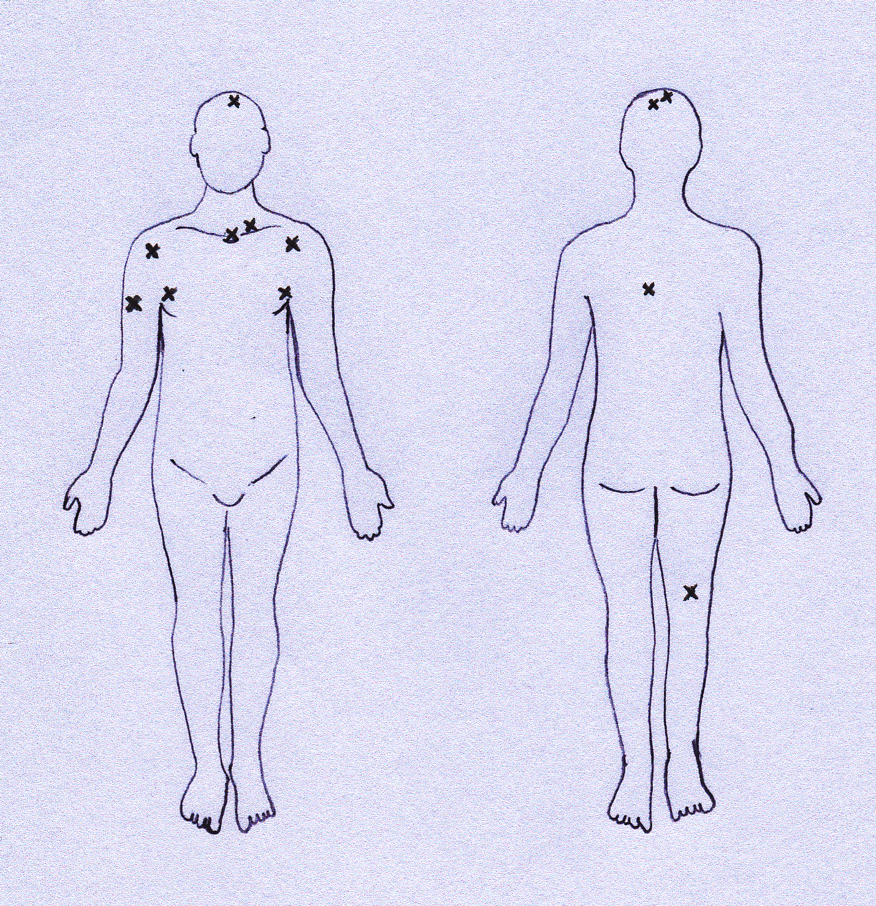
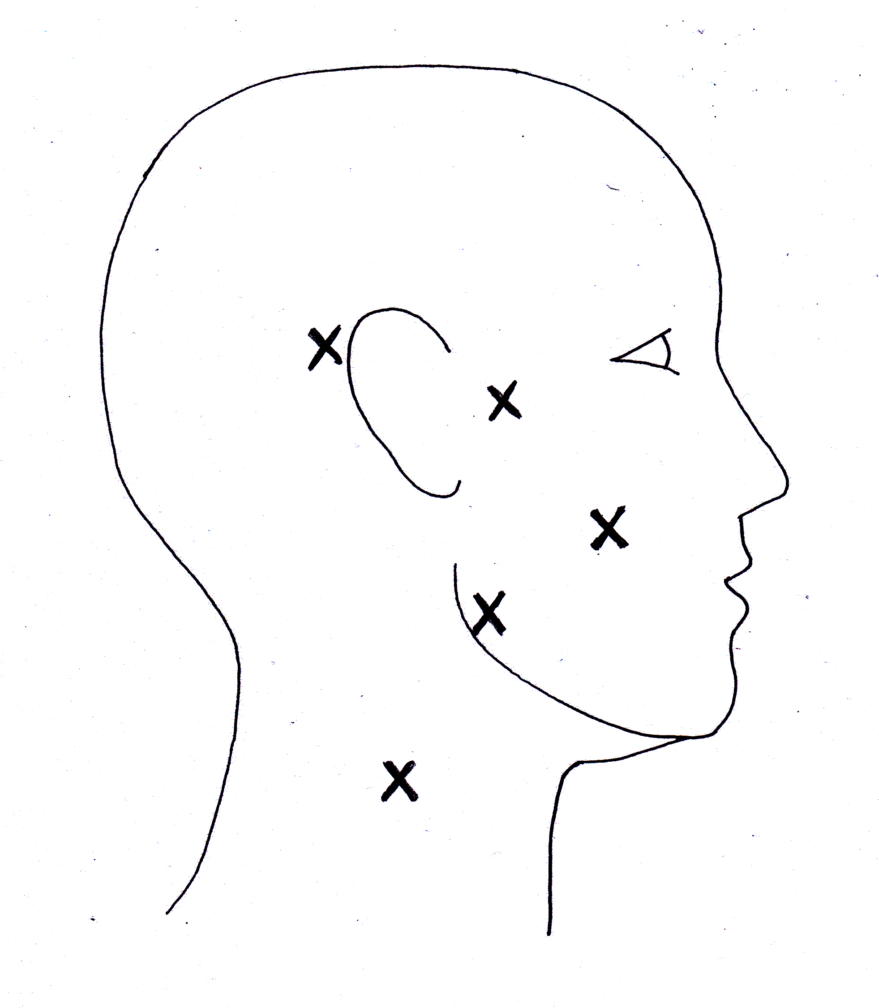
Table 2.1.2. Observed and expected frequencies of non-localization and localization from the study population (n=5600).
 | Head + neck (observed) | Trunk + extremity (observed)
Non-localization | 11 | 7
Localization | 1161 | 4421
 | Head + neck (expected) | Trunk + extremity (expected)
Non-localization | 3.76 | 14.23
Localization | 1168.23 | 4413.77

Age | Sex | Year of LSG | Location of primary tumour | Likely cause for failure to identify SNs | Category of non-localization | SN biopsy performed? | Site of any recurrence
65 | F | 1992 | Right pre-auricular region | Primary site over regional nodes | Apparent | No | None at 10 years
45 | F | 1994 | Right neck | Primary site over regional nodes | Apparent | Yes (negative) | None at 11 years
66 | M | 1999 | Right axilla | Primary site over regional nodes | Apparent | No | Right axilla
77 | F | 2001 | Right cheek | No cause identified | True | Unknown | Unknown
57 | F | 2001 | Right posterior shoulder | Previous right axillary dissection | True or apparent | No | None at 5 years
77 | F | 2001 | Right neck | a) Excision biopsy site infection  b) Primary site over regional nodes  c) Previous sternotomy. | a) True  b) Apparent  c) True | No. No focal hot spot found with gamma probe | None at 3 years
75 | M | 2001 | Left thorax posterior | Excision biopsy site inflamed + dehisced | True | No | Died 9 months later, cause unknown
25 | F | 2002 | Left supra-clavicular | Primary site over regional nodes | Apparent or true (close to thoracic duct) | No | None recorded
52 | F | 2002 | Left axilla | Primary site over regional nodes | Apparent | No | Left axilla
Table 2.1.3. Details of cases where failure to identify sentinel nodes (non-localization) by lymphoscintigraphy occurred.

Table 2.1.3 (continued)

Age | Sex | Date of LSG | Location of primary tumour | Likely cause for failure to identify SNs | Category of non-localization | SN biopsy performed? | Site of any recurrence
76 | F | 2003 | Right lower posterior thigh | Hodgkin’s disease | True | No  Channel seen on LSG but did not reach lymph node | Died of cerebral metastases
89 | M | 2004 | Left midline scalp | No cause identified | True | Unknown | Unknown
39 | F | 2004 | Lateral left upper arm | Previous left axillary dissection | True | No | None at 1 year
89 | M | 2005 | Right midline scalp near vertex | Previous wide excision right temporal region, right parotidectomy + radiotherapy | Difficult to determine as previous primary melanoma on temple | Yes- 2 nodes positive | In-transit then lung.  NB previous primary
85 | F | 2005 | Right upper arm | Rheumatoid arthritis | Apparent or true | No | None recorded
68 | F | 2005 | Right neck | Primary site over regional nodes | Apparent | Yes – 1 node positive* | Liver and spleen
75 | M | 2006 | Left midline scalp | No cause identified | True | Unknown | Unknown
74 | F | 2006 | Left midline scalp | No cause identified | True | No | Unknown
82 | F | 2007 | Suprasternal notch | Previous sternotomy | True or apparent | Unknown | Unknown

SN = sentinel node, LSG = lymphoscintigram
* SN seen on ultrasound due to air in lymphatic channel

Discussion
At the Melanoma Institute of Australia, in a consecutive series of patients, the incidence of non-localization to sentinel nodes on lymphoscintigraphy using two or four intra-dermal injections of ^{99m}technetium antimony sulphide colloid around the primary tumour or on each side of the centre of the excision biopsy site was 0.3% (18/5600 cases). For head and neck sites the incidence was 0.9% (11/1172 cases) and for trunk and limb sites it was 0.2% (7/4428 cases). The overall incidence appears to be several-fold lower than that observed previously in studies that have reported non-localization using lymphoscintigraphy.^{103,104,106,208,211} This difference may be explained by use of different radiocolloid or other differences in technique of lymphoscintigraphy. The rate of uptake into lymphatic channels and the length of time that radioactivity remains detectable within sentinel nodes varies between radiocolloids, as does the amount of radioactivity that remains at the injection site. These factors could all influence accuracy in detection of sentinel nodes during lymphoscintigraphy. In reality, technical problems resulting from inadequate radiolabelling of the tracer and excessive free radioactivity are likely to be picked up by the nuclear medicine physician as there will be uptake in non-lymphatic tissues and this will occur on repeated lymphoscintigraphy in other patients. Therefore, the only technical problem that the nuclear medicine physician cannot overcome is sentinel nodes obscured by primary tumour site radioactivity. This factor can be overcome using blue dye injection and with use of the intra-operative gamma probe once the primary tumour site has been excised, although the success of sentinel node biopsy is likely to be reduced. The addition of SPECT CT imaging has also been shown to be of value in identifying sentinel nodes that are missed using standard planar images for lymphoscintigraphy, and so may be of value in cases where the primary tumour site overlies the regional lymph nodes.¹⁹³ Similarly, ultrasound examination at the time of lymphoscintigraphy was useful in one case where the primary site was on the right neck. The sentinel node was identified due to air within the lymphatic channel leading to it.
In the present study, there were plausible technical, pathological or iatrogenic factors to account for non-localization in 14 out of 18 cases. Of the 4 cases in which no such factors could be found, 3 primary tumour sites were located near the midline at the scalp vertex and 1 was located on the cheek in the malar region. These are the same locations at which unexplained non-localization has previously been observed.²⁰⁸ A possible explanation for non-localization in these cases is that the tumours were located in areas where lymphatics drain directly into the venous system. Injected radiocolloid would therefore dissipate rapidly into the bloodstream without passing through lymph nodes. Evidence for the existence of such connections has been provided in the anatomical study of superficial head and neck tissues conducted by Pan, Suami and Taylor.²¹³ A lymphaticovenous connection was observed in the occipital region in 1 out of 9 human cadavers. The existence of lymphaticovenous connections has been demonstrated in a number of circumstances, namely: following radical mastectomy, in the presence of primary and secondary malignancy in lymph nodes, in primary lymphoedema and following surgery involving skin excisional surgery with excision of a segment of underlying saphenous vein. ^{214,215} These lymphaticovenous connections most likely result from pathological processes or iatrogenic causes rather than comprising normal anatomical variation. However, in the head and neck the existence of normal anatomical lymphaticovenous connections may be one reason why there is a low incidence of lymphoedema even following bilateral neck dissections. The presence of direct lymphaticovenous connections could also confer a higher risk of haematogenous metastasis without nodal metastasis from tumours located in this region. This would fit with the findings from the Sunbelt Melanoma Trial, in which patients with head and neck melanoma had a poorer prognosis than those with trunk or extremity melanoma but conversely had a lower rate of sentinel node metastasis (15% for head and neck, 23% for trunk and 20% for extremity sites).²¹⁶ The actual prevalence of lymphaticovenous connections within the normal population is unknown and further anatomical or physiological studies would be of interest, as would a study to determine whether or not there is a higher likelihood of distant metastasis without nodal metastasis from tumours on the scalp vertex and malar cheek regions.
A proposed algorithm for the management of cases in which non-localization occurs is shown in Figure 2.1.2. This combines the evidence from the present study with existing literature to provide a practical guide that can be followed in such cases. By following the algorithm it should be possible to avoid unnecessary delays in treatment that would result from repeating lymphoscintigraphy when it is unlikely to provide more information, to guide attempts at sentinel node biopsy when the chances of success are reasonable and to caution against attempts when the chances of success are low.

Figure 2.1.2. Proposed algorithm for the management of non-localization.

Section 2.2: Lymphatic drainage patterns from cutaneous tumours of the forehead: Refining the recommendations for selective neck dissection.

Authors
Martin Wiener, MBChB^{1*}, Roger F Uren, MD^{1,2,3}, John F Thompson, MD^{1,2}

Reprinted from Journal of Plastic, Reconstructive & Aesthetic Surgery, 67(8), Martin Wiener, Roger F. Uren, John F. Thompson, Lymphatic drainage patterns from primary cutaneous tumours of the forehead: Refining the recommendations for selective neck dissection, Pages 1038-1044, Copyright (2014), with permission from Elsevier.

¹Melanoma Institute Australia (formerly the Sydney Melanoma Unit), Sydney, New South Wales, Australia.
²Sydney Medical School, The University of Sydney, Sydney, New South Wales, Australia.
³Royal Prince Alfred Hospital Medical Centre, Sydney, New South Wales, Australia.
* Martin Wiener is currently based at The University of Sheffield, Sheffield, UK.

Key words: Lymphoscintigraphy, forehead, melanoma, lymphatic, selective.

Acknowledgements
The late Dr Helen Shaw, whose lifelong devotion and contributions to melanoma research would be difficult to over-estimate, provided valuable guidance and words of advice. The assistance of the late Robert Haynes in producing the line drawings included in the manuscript was also greatly appreciated.

Abstract
BACKGROUND: This study examined lymphatic drainage patterns from forehead primary cutaneous tumour sites to create evidence-based recommendations for selective neck dissections.

METHODS: The forehead was divided into glabellar, supra-orbital and anterior temple zones. Prospectively-collected data from all patients undergoing lymphoscintigraphy for forehead primary cutaneous tumours were analyzed to determine the patterns of lymphatic drainage.

RESULTS: Between 1994 and 2006, 152 patients underwent lymphoscintigraphy for primary cutaneous tumours on the forehead. Between zones there were significant differences in drainage patterns and frequency of bilateral drainage. Glabellar zone drainage was more frequently to a higher number of sentinel lymph nodes and to level I nodes.

CONCLUSIONS: Lymphatic drainage patterns from primary cutaneous tumour sites on the forehead vary significantly with tumour location. Drainage to level 1 nodes from the anterior temple is rare, suggesting that level 1 may be safely excluded when performing selective neck dissection for tumours in this zone.

Introduction
In 1991, the patterns of regional lymph node metastasis in 111 patients with cutaneous melanomas of the head and neck were reported by Shah et al.²¹⁷ These authors used the information to make recommendations for the extent of elective and therapeutic neck dissections. The subsequent introduction of lymphoscintigraphy and intraoperative lymphatic mapping for sentinel lymph node (SLN) biopsy provided an opportunity for more precise study of lymphatic drainage patterns from primary cutaneous tumours.^{67,218} Evaluation of these techniques for cutaneous tumours of the head and neck resulted in the region acquiring a perhaps undeserved reputation for unpredictable lymphatic drainage.^{100–106} Lymphatic drainage from head and neck sites is particularly rich and complex, often to multiple SLNs, and it may be that predictable drainage patterns do exist but have been overlooked for a variety of reasons. For example, techniques used to demonstrate lymphatic drainage from the head and neck may not have sufficient “resolution”, resulting in the identification of SLNs draining areas of skin larger than the area of interest.
Previous studies assessing the predictability of lymphatic drainage from cutaneous head and neck tumour sites have subdivided the region into areas that remain large and diverse, such as the entire face. The locations of SLNs from tumours within such areas have been compared with “clinically predicted” nodal drainage sites for those areas.^{101,219} As a single subdivision of the head and neck, the face has typically been taken to comprise the forehead, anterior temples, eyelids, nose, mouth, cheeks and chin, and the recommended selective neck dissection for this entire area has been parotidectomy combined with clearance of Levels I-III or I-IV cervical lymph nodes.²²⁰ The multi-disciplinary team, faced with a patient who has a positive SLN (or SLNs) or clinically detected nodal metastasis from a primary cutaneous tumour on the face, must decide on the type and extent of neck dissection to be performed and/or the lymph nodes to be targeted during radiotherapy. Any therapeutic intervention may fail if it does not include all potential sites of metastasis, but the routine inclusion of all possible sites, e.g. total head and neck irradiation or bilateral parotidectomies + level I-V neck dissections, would produce unacceptable morbidity and would clearly be inappropriate. It would be logical to subdivide an area as large and anatomically diverse as the face into smaller zones, with the expectation of demonstrating more predictable lymphatic drainage from these zones to fewer nodal sites. Evidence-based refinements could then be made to the existing recommendations for selective neck dissection and radiotherapy. To investigate this hypothesis, the forehead (including the anterior temple) was selected as an anatomically unremarkable subdivision of the face in which to determine the variability (and thus unpredictability) of lymphatic drainage. No previously published reports focusing on patterns of lymphatic drainage from the forehead could be found on literature review, and so the first aim of the present study was to describe the lymphatic drainage patterns from the forehead. Additional aims were to document the frequency of drainage to contralateral SLNs, and to subdivide the forehead itself into zones and assess variability of drainage between zones in the hope that refinements could then be made to existing recommendations for selective neck dissections for tumours located on the forehead.

Methods
Between March 1994 and July 2006 data were collected prospectively on all patients undergoing lymphoscintigraphy at the Sydney Melanoma Unit (SMU) for primary cutaneous tumours (melanomas and Merkel cell carcinomas). The location of each primary tumour was mapped using a coordinate-based system. For the present study the boundaries of the forehead were defined as shown in Figure 2.2.1. The forehead was further subdivided into a central glabellar zone, with supra-orbital and anterior temple zones laterally. These subdivisions were based on the vascular anatomy of the area (see Figure 2.2.1), based on the assumption that the lymphatic drainage would be likely to follow a similar pattern. The central glabellar zone was based around the supra-trochlear vessels, the supra-orbital zone around the supra-orbital vessels and the anterior temple zone around the anterior branches of the superficial temporal vessels.

Figure 2.2.1. The zones and boundaries of the forehead, including their relationship to the vascular anatomy (“a” denotes anterior temple zone containing anterior branches of the superficial temporal vessels, “b” denotes supraorbital zone containing the supraorbital vessels and “c” denotes glabellar zone containing the supratrochlear vessels).

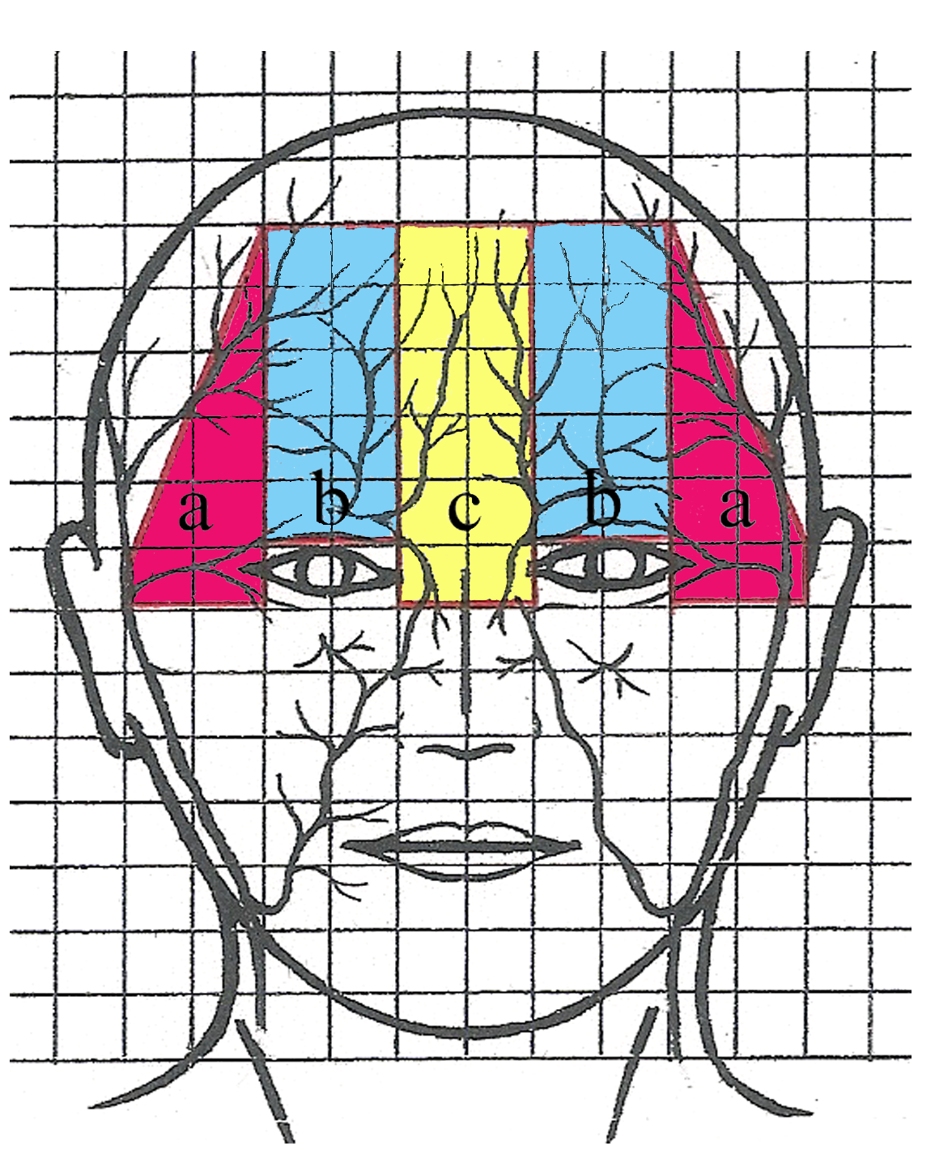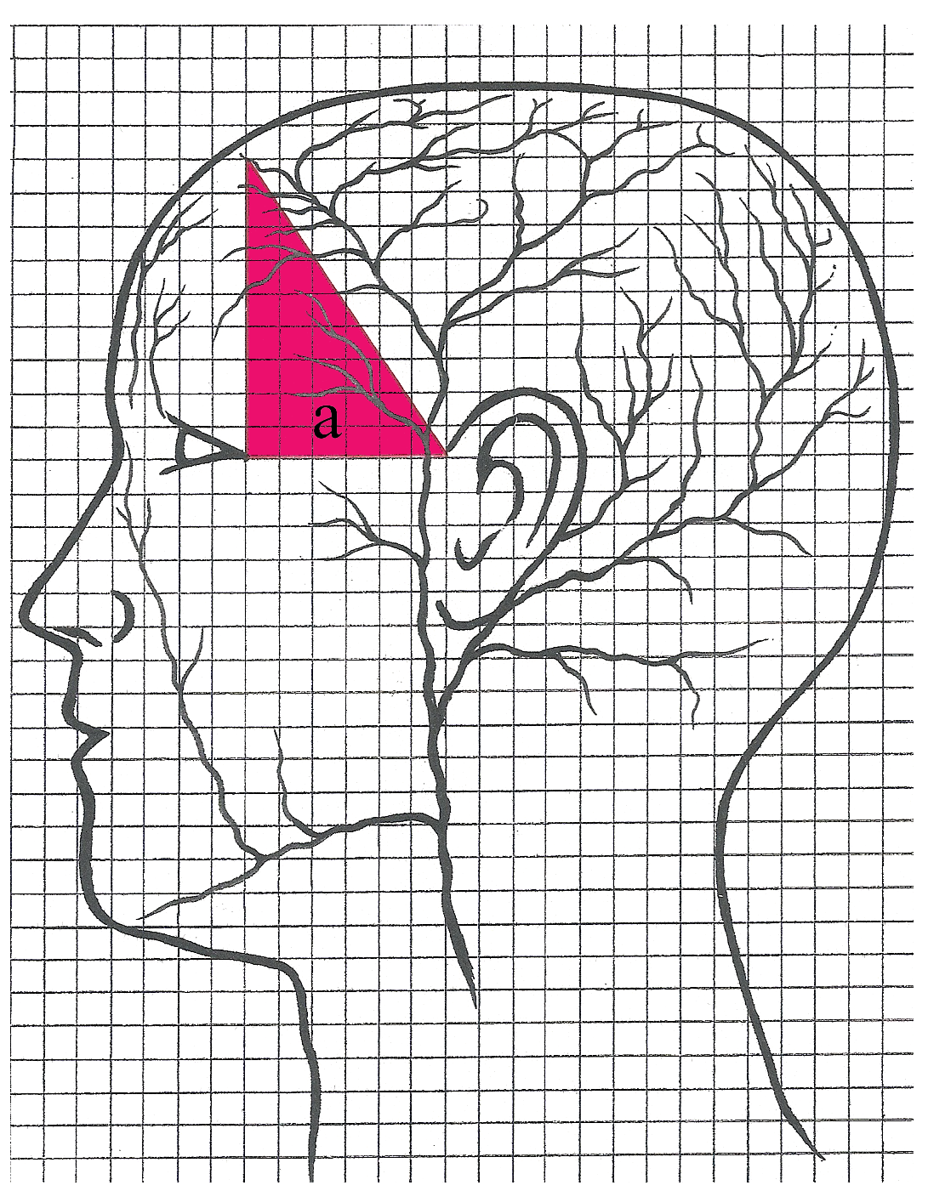

The technique of lymphoscintigraphy at our institution has been described in detail previously (see Section 2.1). Briefly, two or four intra-dermal injections of ^{99m}technetium antimony sulphide colloid are placed immediately adjacent to the primary tumour or on each side of the centre of the excision-biopsy site.¹⁸³ The volume of each injection is 0.05 to 0.1ml and contains 5 to 20 MBq of tracer depending on when surgery is planned. A super-high resolution collimator is used, with dynamic imaging performed immediately following injection of tracer in order to identify and follow the lymphatic collecting vessels, thus allowing accurate identification of SLNs. Delayed scans are performed at 1 to 2 hours, with imaging of all regions that could possibly contain SLNs.
A SLN was defined as “any lymph node that received drainage directly from the primary tumour site”.^{183,212} The location of each SLN detected by lymphoscintigraphy was recorded and classified as levels I-V, pre-auricular (equivalent to parotid) and other sites (occipital, post-auricular and interval) that are not included as part of standard neck dissections.
Patients were eligible for inclusion in the study if they had undergone lymphoscintigraphy at the SMU for a primary cutaneous tumour located within the area defined as the forehead between March 1994 and July 2006. The variability of drainage from each zone of the forehead was assessed by comparing the number of SLNs, number of SLN sites, frequency of drainage to each site, frequency of contralateral drainage, and number of different drainage patterns identified for each zone. For continuous variables, mean and standard deviations were calculated. For categorical variables, frequencies and percentages were determined. Statistical comparisons, using SPSS for Windows version 16.0, were made by one-way analysis of variance (ANOVA) with the Levene test for homogeneity of variance and the Bonferroni test to determine whether the means of the groups differed significantly. In all cases a p value <0.05 was regarded as statistically significant.

Results
In the selected study period, 152 patients underwent lymphoscintigraphy for primary cutaneous tumours located on the forehead. There were 122 males and 30 females with a median age of 67 (range 15 - 91) years. Full details regarding the nature of the primary cutaneous tumour were available for 144 cases, of which 134 (93%) were melanomas, and 10 (7%) were Merkel cell carcinomas. The distribution of primary tumour sites and the pattern of lymphatic drainage from the entire forehead are shown in Figure 2.2.2. Sixty-two tumours were situated on the anterior temple, 68 supra-orbitally and 22 in the central glabellar zone. Lymphoscintigraphy identified 441 SLNs in these 152 patients. SLNs were found at up to five different sites in some patients, with most patients having SLNs at 2 sites (mean +/- standard deviation (SD): 2.1+/-0.96, median: 2). The number of SLNs per patient varied from 1 to 8 (mean +/-SD: 2.90+/-1.30, median: 3).

Figure 2.2.2. The pattern of lymphoscintigraphically demonstrated lymphatic drainage from the forehead.
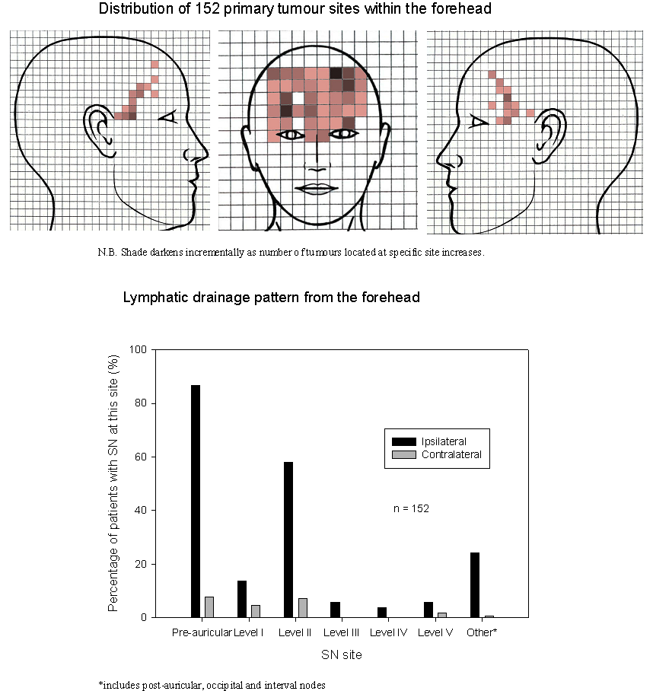

The majority of primary tumour sites (84.9%) drained only to SLNs on the same side of the body. Bilateral drainage was seen in 14.5% of cases and in a single patient lymphatic drainage occurred solely to a SLN on the opposite side of the body (Figure 1.3.5). In this case the lymphatic channel was clearly seen passing down the ipsilateral neck before crossing the midline at the level of the hyoid bone and entering a SLN in the contralateral neck. This anomalous drainage pattern was explained by a previous neck dissection on the side of the tumour.
The locations of the 22 tumour sites that exhibited bilateral lymphatic drainage are shown in Figure 2.2.3. Eighteen were located in the glabellar zone, 4 supra-orbitally and none in the anterior temple zones. From Figure 2.2.2 it is clear that the majority of SLNs (70.7%) were found at two sites: in the ipsilateral pre-auricular region (44.4%) and in ipsilateral level II cervical nodes (26.4%): 96.1% of patients had at least one SLN at one of these sites. It should also be noted that 25% of patients had drainage to SLNs outside the standard fields included in neck dissections, and such SLNs accounted for 10.4% of all SLNs. The commonest non-standard sites were post-auricular (24 patients) and interval (21 patients), with only one patient having drainage to an occipital node.

Figure 2.2.3. The pattern of drainage from the 22 tumours with bilateral lymphatic drainage.


Shade darkens incrementally as number of tumours at particular site increases.

The pattern of drainage from each zone is shown in Figure 2.2.4. From the anterior temple zone no contralateral drainage occurred, the mean number of SLNs was 2.68 (SD +/- 0.97) and the mean number of SLN sites was 1.84 (SD +/- 0.75). Thirteen different drainage patterns were observed amongst 62 patients, with the most frequent being to ipsilateral pre-auricular and level II nodes. Lymphoscintigraphy rarely demonstrated drainage to level I nodes from this zone (2.7% of cases). Drainage from the supra-orbital zones occurred to a mean of 2.81 (SD +/- 1.36) SLNs and a mean of 2.05 (SD +/- 0.94) SLN sites. The drainage patterns from the supra-orbital zones were more variable, with 22 different patterns for 68 patients. Central glabellar zone drainage was to a mean of 3.64 (SD +/- 1.43) SLNs and 3.09 (SD +/- 0.95) SLN sites. The drainage patterns from this zone showed by far the highest variability, with 19 different patterns amongst 22 patients. The number of SLNs located in level I was also greatest in this group, with 40.9% of cases exhibiting drainage to this level. Tumours located in the glabellar zone tended to drain to a greater number of SLNs (p=0.009), to a greater number of SLN sites (p=<0.0001), and were more likely to exhibit bilateral drainage (p=<0.0001) than tumours located more peripherally (one-way ANOVA).

Figure 2.2.4. The pattern of lymphoscintigraphically demonstrated lymphatic drainage from each forehead zone.

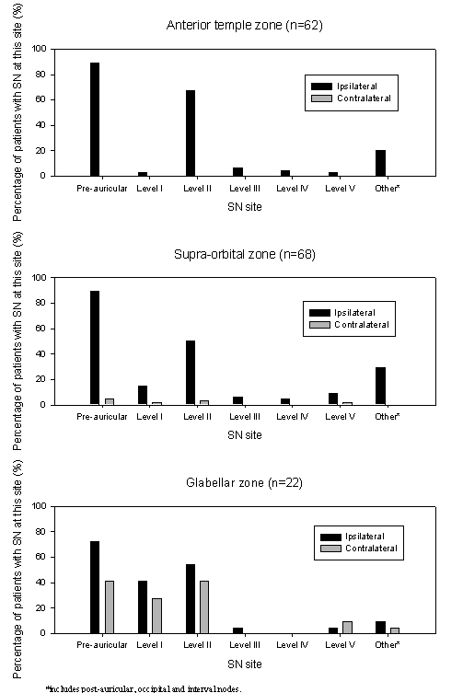
Discussion
Early studies of lymphatic anatomy and lymphatic mapping are well documented.^{221,222} In 1952 Kinmonth developed the technique of x-ray contrast lymphangiography for in vivo imaging of lymphatic vessels and the lymph nodes to which they drained.⁹⁷ The procedure involved subcutaneous injection of Patent Blue dye on the dorsum of the hand or foot. This allowed identification of a blue-stained lymphatic channel, which was then cannulated so that a radio-opaque dye could be injected. Around the same time the technique of lymphoscintigraphy using radioactive colloidal gold was introduced.⁹⁸ However, x-ray lymphangiography initially became the standard method for imaging the lymphatic system in vivo. A notable limitation of lymphangiography as a method of lymphatic mapping is that it involves cannulation of lymphatic vessels. It is now well documented that several lymphatic vessels may drain from a tumour site, each terminating in a different SLN. Failure to cannulate all the relevant lymphatic vessels could therefore result in failure to identify all SLNs draining that site. The cadaveric studies undertaken by early investigators such as Sappey used similar techniques of cannulation and injection of opaque substances to demonstrate lymphatics. They produced models showing areas with apparently predictable lymphatic drainage and distinct boundaries between these.⁹¹ Lymphoscintigraphy subsequently produced clear evidence that strict boundaries did not exist, and demonstrated that lymphatic drainage patterns from the same area of skin could vary greatly from patient to patient.⁹⁹ This latter finding was perhaps most apparent in the head and neck, leading to its reputation as an area with unpredictable lymphatic drainage.^{100–106} In the literature, cited rates of discordance between predicted and lymphoscintigraphically-determined SLN sites in the head and neck vary from 7% to 37%.^{100,101,103–105}
Two recent studies have provided valuable insights into the lymphatic anatomy of the head and neck, and have contributed greatly to current understanding in this area.^{213,223} The first of these was undertaken by Pan, Suami and Taylor.²¹³ Using a mixture of hydrogen peroxide with and without India ink they were able to detect lymphatic vessels and inject them with a radio-opaque lead oxide mixture. This technique was carried out to map lymphatics of the superficial head and neck tissues from 9 fresh-frozen human cadavers. The specimen from each cadaver was divided in half at the midline and so the presence or absence of lymphatic vessels crossing the midline could not be investigated. However, in one cadaver shown in their paper a lymphatic vessel can be seen passing vertically down the forehead, through the glabellar region, medial to the eye and then obliquely over the face to a buccinator node. This pathway was not recorded in the drawings by Sappey, in which all lymphatic vessels were shown running transversely across the forehead from the midline.⁹¹ The present study based on lymphoscintigraphy corroborates the findings in cadavers of Pan et al. and demonstrates, in vivo, that drainage can occur from the central forehead and glabella via lymphatics that pass vertically down the forehead between the eyes, beside the nose and across the cheek to level 1 or preauricular nodes (Figure 2.2.5).²¹³ This pattern of drainage was clearly observed on lymphoscintigraphy in 5 patients and suggests that the lymphatics of the forehead follow a similar pattern to that of the blood vessels.

Figure 2.2.5. Lymphatic drainage pathway observed from the central forehead and glabella.

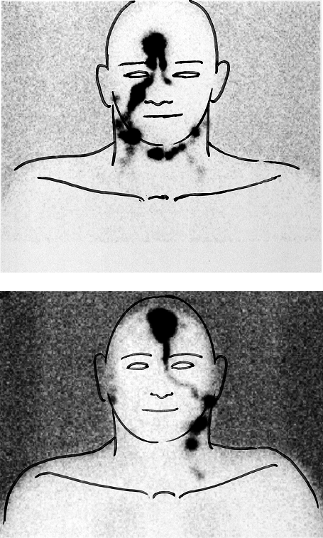

The second important recent study was by Reynolds et al, who mapped lymphoscintigraphy data collected at the SMU onto a 3-dimensional computer model.²²³ Their findings confirmed that lymphatic drainage from the head and neck is unpredictable, but also highlighted regions where lymphatic drainage appears to change from anterior to posterior lymph node fields. The 3-dimensional model that was produced can be used to show likely locations of sentinel nodes for a given primary tumour site on the head and neck; it is available to view online at http://www.bioeng.aukland.ac.nz/head.
In the present study, variability of lymphoscintigraphically-determined lymphatic drainage from the forehead has been clearly demonstrated. Subdivision of the forehead into anterior temple, supra-orbital and glabellar zones indicated that the lymphatic drainage pattern becomes more predictable as one moves laterally from the glabella to the anterior temple. The findings provide information of clinical relevance for SLN biopsy as well as for selective neck dissection. For the patient with a centrally-located tumour, the higher likelihood of bilateral drainage to a greater number of SLNs in a greater number of SLN sites means SLN biopsy is likely to entail a longer, more challenging procedure, involving several skin incisions. In some cases the sheer number of widely distributed SLNs identified by lymphoscintigraphy may lead the surgeon to decide that it is inappropriate to attempt SLN biopsy, thus potentially impacting the ability to determine prognosis. In contrast, for patients with a tumour located on the anterior temple, the high likelihood that SLNs will be located ipsilaterally in a lower number of different sites means that SLN biopsy is more likely to be achievable via a single incision, with more limited surgical exploration. The likelihood that SLN biopsy will involve surgical exploration in the pre-auricular (parotid) region is high irrespective of which zone of the forehead a patient’s tumour falls within. 89% of lymphoscintigrams demonstrated lymphatic drainage from the forehead to at least one SLN at this site.
Level I cervical nodes have traditionally been included within all elective and therapeutic neck dissections for tumours located on the face. The present findings provide evidence to suggest that, whilst this may be appropriate for tumours in the central glabellar zone (40.9% of which exhibited drainage to level I), a more selective approach should be considered for laterally located tumours, particularly those on the anterior temple, since only 2.7% of patients were shown to have drainage from the anterior temple to level I nodes. Limiting a selective neck dissection to the preauricular region and levels II-IV in such patients may reduce morbidity without compromising the efficacy of the procedure.

Section 3

Section 3 – Occult nodal metastasis studies

This section addresses the following questions:
- What factors determine prognosis for patients who complete the standard sentinel node-based management pathway? – Sections 3.1 + 3.2 + 3.3.
- Prognosis is determined by the total number of metastatic nodes but does it make a difference whether these nodes are sentinel only or a mixture of sentinel and non-sentinel? – Sections 3.1 + 3.2.
- Can the likelihood of metastasis to non-sentinel nodes be determined prior to completion lymph node dissection so that it could be avoided for patients who are at low risk of having non-sentinel node metastases? – Section 3.2.
- Can patients be grouped according to prognosis in an easily applicable manner that would allow decisions to be made regarding their need for adjuvant therapy? – Sections 3.2 + 3.3.

Section 3.2 is included (with permission) as it was when published in Annals of Surgical Oncology in 2010, in order to reflect the literature at the time that the research was carried out. The systematic review (Section 3.1) and the more general reviews in Sections 1.1 and 1.2 cover relevant literature that was published prior and subsequent to it.

3.1: What is the prognostic significance of non-sentinel node metastasis in melanoma: A systematic review.

ABSTRACT
BACKGROUND: It is well established that prognosis for patients with melanoma is related to the total number of metastatic nodes. When patients with clinically localised melanoma are staged by sentinel node biopsy, and then by completion lymph node dissection if sentinel node positive, it is possible to differentiate the metastatic nodes into sentinel and non-sentinel nodes. This differentiation may have prognostic significance. The objective of this systematic review was to identify all studies that have investigated the prognostic significance of non-sentinel node metastasis in melanoma, and in particular, to identify studies that have performed analyses to account for the confounding effect of total number of positive nodes.
METHODS: Studies were eligible for inclusion if analyses were performed for an effect on survival due to the presence of metastases in non-sentinel nodes. Studies which included only univariate analyses or survival curve analyses that did not account for total number of positive nodes were excluded. Electronic database searches (PubMed, OVID, EMBASE and Cochrane library) were performed and supplemented by hand searching reference lists. Data were collected using a standardised form and studies meeting the inclusion criteria were critically analysed to identify the studies that had performed analyses that accounted for total number of positive nodes.
RESULTS: Eleven studies met the inclusion criteria. All were retrospective cohort studies. Four studies compared survival based on non-sentinel node status and accounted for total number of positive nodes. Three studies performed multivariate analyses that accounted for an effect due to total number of positive nodes. In all cases, survival was worse for patients who were non-sentinel node negative.
CONCLUSIONS: In retrospective cohort studies investigating non-sentinel node status in relation to overall or disease-specific survival, presence of non-sentinel node metastasis has consistently been associated with reduced survival.

INTRODUCTION
The current AJCC staging system for melanoma (see Figure 1.1.3) recognises the importance of the total number of metastatic nodes as a prognostic indicator and separates patients into N1, N2 or N3 categories with 1 metastatic node, 2-3 metastatic nodes and 4 or more metastatic nodes respectively. For patients who are staged by sentinel node biopsy, it is possible to differentiate between metastatic sentinel nodes and metastatic non-sentinel nodes. The question whether such a distinction provides useful prognostic information forms the main focus of this thesis and was unclear from the literature when the study in Section 3.2 was begun. However, the subject has also been addressed by a number of other investigators, before, during and following publication of the study presented in Section 3.2. This section therefore aims to provide a systematic review of the literature, updated until January 2016. The key to unraveling the significance of non-sentinel node metastasis being to determine the relative prognostic significance of the variables: total number of positive nodes, number of positive sentinel nodes (or sentinel node status) and number of positive non-sentinel nodes (or non-sentinel node status) when they are applied to a population of sentinel node positive melanoma patients.

METHODS
In order to address the free-form question “What is the significance of non-sentinel node metastasis in melanoma”, a structured question was developed according to the PICOS (Populations, Interventions or exposures, Comparisons, Outcomes, Study designs) acronym.¹⁶⁶ This was as follows.

Populations: Populations of melanoma patients with clinically localised disease who, following positive sentinel node biopsy for cutaneous melanoma, have undergone completion lymph node dissection.

Interventions or exposures: Completion lymph node dissection following positive sentinel node biopsy, which would divide the population into two groups: non-sentinel node positive and non-sentinel node negative, based on the presence or absence of micrometastatic disease within the lymph nodes removed.

Comparisons: Patient-related, primary tumour related and/or lymph node-related variables assessed as predictors of survival.

Outcomes: Overall survival or melanoma (disease)-specific survival.

Study designs: Observational studies documenting survival and examining non-sentinel node status as a putative independent predictor of survival in sentinel node positive melanoma patients.

The systematic review was conducted with reference to the PRISMA (Preferred Reporting Items for Systematic reviews and Meta-analysis) guidelines.¹⁶⁶ The criteria for inclusion in the critical literature review were:
1. Studies reporting survival (overall, disease-specific or recurrence-free) for sentinel node positive melanoma patients who had undergone completion lymph node dissection.
2. Multivariate analysis performed for factors predictive of survival.

To fully address the study question, and be included in the final tables, studies must also have met one or more of the following criteria:
1. Performed multivariate analysis for overall or disease-specific survival that accounted for the difference in total number of positive nodes between non-sentinel node positive and non-sentinel node negative patients.
2. Performed alternative analyses to determine the effect of non-sentinel node status on survival using a method that excluded total number of positive nodes as a potential confounding factor.

Electronic searches were carried out using PubMed, EMBASE, OVID and the Cochrane library, including in-process and other non-indexed citations with the maximum years included in each database and no language limitations. The search terms “melanoma”, “sentinel node”, “non-sentinel node” and possible variations were used. Articles including the term “breast” in the title were excluded. The retrieved records were screened by title and excluded if not relevant. Abstracts were reviewed for the remaining records and further exclusions made or full text articles obtained for review. For each full text article the reference lists were examined and any potentially relevant studies screened to determine eligibility. The flow diagram in Figure 3.1.1 shows the number of exclusions at each stage. Included studies were assessed for methodological quality and descriptive statistical data were collected. Methodological quality was assessed qualitatively and also by a quantitative method, developed from the STROBE (Strengthening of Reporting of Observational Studies in Epidemiology) Statement checklist.¹⁶⁷ This was produced by allocating a score for each item on the 21-point checklist, so that each study could be scored out of 70 points (see Appendix). Data were then extracted regarding survival characteristics for each study population based on non-sentinel node status. The results of univariate and multivariate analyses for factors predictive of survival in each study were also retrieved.
Figure 3.1.1. Flow diagram for the systematic review

Records identified via electronic database searches (PubMed, OVID, Cochrane library, EMBASE)
(n = 252)
Records identified via manual searching
(n = 3)

Duplicates removed
(n = 67)

Records excluded by title
(n = 88)
Records excluded by abstract
(n = 80)
Records screened
(n = 188)

Records excluded after full text review,
with reasons
(n = 9)
Records for full text review
(n = 20)

Studies included
(n = 11)

RESULTS
Twenty full text articles were assessed and 9 were excluded. Five of these exclusions were because they did not contain data regarding non-sentinel node status and survival.^{152,163,168–170} In the remaining 4 excluded studies the effect of non-sentinel node status was investigated but not by multivariate analysis or by an alternative method that accounted for the effect of an increasing total number of positive nodes in the non-sentinel node positive population.^{155,171–173} These excluded studies that did investigate non-sentinel node status as a predictor of survival have been summarized in Table 3.1.1.
Eleven studies met the inclusion criteria and are summarized in Table 1.3.2.^{149,161,164,174–181} All were observational (retrospective cohort) studies, most commonly carried out by review of prospectively-maintained databases or as a post-hoc analysis of patients included in a trial. Data were from patients treated at institutions in the United States (5 studies), North America (3 studies), Australia (1 study) and Italy (2 studies). Three of the studies included patients from the same prospective trial (SUNBELT melanoma trial).^{176–178} The 11 included studies provided data regarding 4543 sentinel node positive melanoma patients with median follow-up ranging from 33 to 68 months. However, the actual number of individual patients would be lower than this due to inclusion of patients from the SUNBELT melanoma trial in several studies. Seven studies carried out multivariate analyses investigating the prognostic significance of non-sentinel node status in the sentinel node positive population but 4 of these did not include total number of positive nodes as a variable (Table 3.1.3).^{164,175,178,181} The 2 studies that did include total number of positive nodes and 1 study that adjusted for total number of positive nodes by including total number of sentinel nodes and non-sentinel node status are shown in Table 3.1.4.^{161,174,180} Quantitative quality assessment scores of the 11 included studies are shown in Table 3.1.5.

Table 3.1.1. Excluded studies that did investigate non-sentinel node status as a predictor of survival (n=4).

1st Author (year of publication) | Setting | Study type | Period of study | Median follow-up (months) | Number of SN positive patients | Outcome worse if NSN positive? | Reasons for exclusion
Roka (2008)¹⁵⁵ | Vienna, Austria | Retrospective, observational | 1998-2005 | 31 | 103 | Yes | Univariate analysis only
Wright (2010)¹⁷¹ | Hull, UK | Retrospective, observational | Not stated | Not stated (range 2-8 years) | 49 | Yes | Does not state type of analysis
Baehner (2012)¹⁷² | San Francisco, USA | Review of prospective database | 1994-2003 | 81.6 | 63 | Yes | Did not investigate NSN status in multivariate analysis and did not account for total number of positive nodes in survival curve comparison
Patuzzo (2015)¹⁷³ | Milan, Italy | Retrospective, observational | 2000-2014 | Not stated | 1096 | Yes | No details of statistical analysis (conference abstract)
SN = sentinel node, NSN = non-sentinel node.

Table 3.1.2. Studies that met the inclusion criteria and were included in the critical review (n=11).

1st Author (year of publication) | Setting | Study type | Period of study | Median follow-up (months) | Number of SN positive patients | Number of NSN positive patients (%) | Outcome worse if NSN positive?
Cascinelli (2006)¹⁴⁹ | Milan, Italy | Review of prospective database | 1994-2005 | 61.1 | 176 | 33 (18.7) | Yes
Ariyan (2008)¹⁷⁴ | New York, USA | Review of prospective database | 1991-2006 | 33 | 222 | 37 (16.7) | Yes
Ghaferi (2009)¹⁷⁵ | Michigan, USA | Review of prospective database | 1997- not stated | 36.8 | 419 | 71 (16.9) | Yes
Jakub (2009)¹⁶⁴ | Florida, USA | Review of prospective database | 1998-2006 | Not stated (mean 38.9) | 229 | 46 (20.1) | Yes
Wiener (2010)¹⁶¹ | Sydney, Australia | Review of prospective database | 1992-2005 | 40 | 323 | 60 (18.6) | Yes
Brown (2010)¹⁷⁶ | SUNBELT trial (USA and Canada) | Post-hoc analysis of trial database | 1997-2003 with analysis of follow-up data until 2009 | 68 | 347 | 51 (14.7) | Yes
Eggerª (2013) (Ann Surg Oncol)¹⁷⁸ | SUNBELT trial (USA and Canada) | Post-hoc analysis of trial database | Not stated (1997-2003 = trial enrollment period) | 58 | 509 | 51 (10.0) | Yes
Reintgen (2013)¹⁷⁹ | Florida, USA | Review of prospective database | 1990-2011 | Not stated (mean 42) | 331 | 61 (18.4) | Yes
Leung (2013)¹⁸⁰ | California, USA | Review of prospective database | 1986-2012 | Not stated | 329 | 79 (24%) | Yes
Egger^{b} (2013) (Am J Surg)¹⁷⁷ | SUNBELT trial (USA and Canada) + Louisville, USA | Post-hoc analysis of trial database and review of local prospective database | Not stated | 62 | 220 | Not stated | Yes
Pasquali (2014)¹⁸¹ | 9 centres in Italy | Retrospective data collection | 1993-2011 | 45 | 1538 | 353 (23%) | Yes
SN = sentinel node, NSN = non-sentinel node.

DISCUSSION

Cascinelli et al. evaluated prognosis for 1108 melanoma patients who underwent sentinel node biopsy.¹⁴⁹ Sentinel node biopsy was positive for 176 (15.9%) patients of whom 33 (18.7%) were non-sentinel node positive. Non-sentinel node negative patients had an 82% 5-year survival rate whereas non-sentinel node negative patients had a 47.1% 5-year survival rate. A multivariate analysis was performed, but this was for the entire population (n=1108) rather than just the sentinel node positive population, and can therefore not be assumed to apply in the same way to the sentinel node positive population. The multivariate model included age, sex, Breslow thickness and groupings by sentinel and non-sentinel node status, including a category for false negative sentinel node biopsy. However, total number of positive nodes was not included and so it is not possible to determine whether reduced survival for non-sentinel node positive patients was due to their higher total number of positive nodes or the fact that they were non-sentinel nodes. This study is therefore excluded from the final table of studies that included multivariate analyses investigating the prognostic impact of non-sentinel node status and accounted for differences in total number of positive nodes (Table 3.1.4).
Ariyan et al. provided data from 222 sentinel node positive patients, 37 (16.7%) of whom were non-sentinel node positive.¹⁷⁴ Survival by non-sentinel node status was compared for patients with a total of 2 positive nodes (58 patients), thus excluding an effect due to increasing number of positive nodes in non-sentinel node positive patients. Median survival for the 41 non-sentinel node negative patients was 66 months compared to 34 months for the 17 non-sentinel node positive patients (p=0.04). Univariate analysis included increasing age, Breslow thickness, presence of ulceration number of positive nodes and positive non-sentinel node status and found that all factors were associated with reduced disease-specific survival. The authors refer to a table within their manuscript that they state contains the results of these univariate analyses. However, the table does not contain the result of the univariate analysis for ulceration and this appears to have been omitted from the multivariate analysis despite the authors stating that it was significant on univariate analysis. A multivariate analysis of factors predictive of disease-specific survival (excluding ulceration) was performed with 4 variables (age, Breslow thickness, number of positive nodes and positive non-sentinel node) included. Age, Breslow thickness and number of positive nodes were analysed as continuous variables. Number of positive nodes, which had been a significant predictor on univariate analysis was no longer significant (Hazard Ratio (HR)(95% CI): 1.1 (0.97-1.30), p=0.100). The factors that remained significant were age (HR(95% CI): 1.0 (1.01.-1.04), p=0.003), Breslow thickness (HR(95% CI): 1.1 (1.06-1.16), p<0.001) and positive non-sentinel lymph node(s) (HR(95% CI): 2.5 (1.51-4.26), p<0.001).

Ghaferi et al. reported their analysis of 419 sentinel node positive patients, 71 (16.9%) of whom were non-sentinel node positive.¹⁷⁵ In order to account for an effect due to total number of positive nodes they compared survival for patients with a total of 2-3 positive nodes (n=131) and found that median overall survival was 90.5 months for non-sentinel node negative patients (n=90) compared to 59.4 months for non-sentinel node positive patients (n=41) (p<0.001). Data showing the distribution of patients with 2 positive nodes and 3 positive nodes within the non-sentinel node negative and non-sentinel node positive groups were not presented and so it is not possible to determine whether the distribution was even and thus unlikely to be an influencing factor.
On univariate analysis of the entire study population, age (variable type not stated), Breslow depth >2mm, mitotic rate (as continuous variable), ulceration, angiolymphatic invasion, satellitosis, volume of disease within the sentinel node of >1% surface area, extracapsular extension in the sentinel node, total number of positive nodes>3 and positive non-sentinel node were all significant predictors of overall survival. On multivariate analysis volume of disease within the sentinel node of >1% surface area and total number of positive nodes >3 were no longer significant. Age (HR(95%CI): 1.03 (1.02-1.04), Breslow thickness >2mm (HR(95%CI): 1.76 (1.14-2.73), extracapsular extension in the sentinel node (HR(95%CI): 2.39 (1.45-3.95) and positive non-sentinel node (HR(95%CI): 1.92 (1.27-2.89) all remained significant with extracapsular extension being the most powerful determinant of survival. P values were not provided. The authors did not provide hazard ratios for mitotic rate, ulceration, angiolymphatic invasion and satellitosis from the multivariate analysis. The inclusion of total number of positive nodes >3 (a categorical variable) could be problematic as most patients with >3 positive nodes have at least 1 positive non-sentinel node and so this is really just another way of distinguishing patients by non-sentinel node status. If total number of positive nodes was included as a continuous variable it would have allowed differentiation between survival effects due to non-sentinel node status or total number of positive nodes in patients with a total of 2 or 3 positive nodes.
Jakub et al. presented data relating to 229 sentinel node positive patients, 46 (20.1%) of whom were non-sentinel node positive.¹⁶⁴ Kaplan-Meier survival curves were plotted for patients grouped by number of positive sentinel nodes (1 positive sentinel node, 2 positive sentinel nodes and 3 or more positive sentinel nodes). There was no significant difference (p = 0.59) in overall survival. However, when survival curves were plotted grouping patients by number of positive non-sentinel nodes (0 positive non-sentinel nodes, 1 positive non-sentinel node and 2 or more positive non-sentinel nodes) there was a significant difference (p<0.001). The finding was confirmed on univariate analysis which showed reduced overall survival (p<0.001) with increasing number of positive non-sentinel nodes (HR(95% CI): 1.8 (1.1-2.9) for 1 positive non-sentinel node versus non-sentinel node negative and HR(95% CI): 3.4 (2.0-5.6) for 2 or more positive non-sentinel nodes versus non-sentinel node negative). The multivariate analysis in this study included age (variable type not stated), sex, Breslow thickness (variable type not stated) and number of positive non-sentinel nodes, with the latter variable retaining its prognostic significance. However, total number of positive nodes was not included within the multivariate model.
The publication by Wiener et al. comprises Section 3.2 of this thesis.¹⁶¹
The papers by Brown et al. and Eggerª et al. both relate to patients enrolled in the SUNBELT melanoma trial and so will be discussed together.^{176,178} Brown et al. (published in 2010) analysed a total of 2335 patients with median follow-up of 68 months and found 347 sentinel node positive patients, of whom 51(14.7%) were non-sentinel node positive.¹⁷⁶ Egger et al. (published in 2013) analysed data regarding 509 sentinel node positive patients, of whom 51 (10%) were non-sentinel node positive.¹⁷⁸ The median follow-up in this report was 58 months. Although the number of non-sentinel node positive patients is the same in each report, there is clearly a large discrepancy in the number of sentinel node positive patients (347 versus 509) between the two reports of the same clinical trial population. The reason for this is unclear but is obviously of concern.
Brown et al. conducted univariate and multivariate analyses for overall survival that included sentinel node negative patients (n=1988) as well as sentinel node positive patients (n=347). Sentinel node negative patients are all also non-sentinel node negative and so their inclusion in an analysis to determine the prognostic significance of non-sentinel node metastasis in melanoma is unnecessary. The results of such analyses may not be directly applicable to the sentinel node positive population. This, and the fact that they relate to the same group of patients presented by Eggerª et al. are the reasons why they have been excluded from Table 3.1.4.
The analysis reported by Eggerª et al. did include only sentinel node positive patients. Data on primary melanoma mitotic rate were not available for patients enrolled in the SUNBELT melanoma trial and so this variable was not included within the analyses. Univariate analysis included Breslow thickness ≥ 2.1mm, age ≥ 59 years, sex, Clark level ≥ IV, regression, ulceration, primary tumour location, histological subtype, lymphovascular invasion and non-sentinel node status. Regression, primary tumour location, histological subtype and lymphovascular invasion were not significant predictors of overall survival and so were excluded from the multivariate analysis. The multivariate analysis demonstrated reduced overall survival with Breslow thickness ≥ 2.1mm (HR(95%CI): 1.73 (1.24-2.45), p=0.0011), age ≥ 59 years (HR(95%CI): 1.78 (1.32-2.37), p=0.0002), male sex (HR(95%CI): 1.53 (1.13-2.1), p=0.0054), presence of ulceration (HR(95%CI): 1.78 (1.33-2.39), p=0.0001), and positive non-sentinel node status (HR(95%CI): 1.51 (1.01-2.2), p=0.0467, but not with Clark level ≥ IV. A notable exclusion from the multivariate analysis was total number of positive nodes. Interestingly, the authors reported a worse prognosis as the number of positive sentinel nodes increased. This finding is in concordance with Leung et al. but in contrast to other studies in which increasing number of positive sentinel nodes did not adversely affect prognosis.^{161,164,180}
Reintgen et al. provided data relating to 331 sentinel node positive patients of whom 61 (18.4%) had positive non-sentinel nodes.¹⁷⁹ The mean follow-up was 42 months. The analyses related to disease-free survival rather than overall or disease-specific survival and the authors stated that “Multivariate regression analysis limited to patients with disease beyond the SLNs (sentinel lymph nodes) (N2 and N3 disease) confirmed that the decreased disease-free survival shown in the non-sentinel node positive group was not merely due to the increased incidence of ulceration or thicker tumors, or to the increased number of positive nodes”. This statement cannot be correct because patients with N2 and N3 disease do not necessarily have disease beyond the sentinel nodes. For example, a patient who has 2 or 3 positive sentinel nodes and no positive non-sentinel nodes has N2 disease and a patient with 4 or more positive sentinel nodes and no positive non-sentinel nodes has N3 disease, but neither have disease beyond the sentinel lymph nodes. It is possible that all the patients with >1 positive sentinel node and no positive non-sentinel nodes were excluded from this analysis but this has not been specified. However, the multivariate analysis itself clearly accounted for patients with a mixture of positive sentinel and non-sentinel nodes as it included number of positive nodes (HR: 1.0761, p=0.0200), and positive non-sentinel node(s) (HR: 2.6970, p=0.0019), as separate variables, in addition to Breslow thickness (HR: 1.0032, p=0.9601), and ulceration (HR: 0.9846, p=0.9408). As the multivariate analysis related to disease free survival rather than overall, or disease specific survival, it has not been included in Table 3.1.4.
The paper by Leung et al. determined survival for 329 sentinel node positive patients, of whom 79 (24%) were non-sentinel node positive.¹⁸⁰ The median overall survival for non-sentinel node negative patients was 178 months and for non-sentinel node positive patients it was 42.2 months. A multivariate analysis for overall survival was performed and found that older age (HR(95%CI): 1.03 (1.02-1.04), p<0.001), male sex (HR(95%CI): 1.53 (1.03-2.26), p=0.03), greater Breslow thickness (HR(95%CI): 1.03 (1.00-1.06), p=0.04), increasing number of positive sentinel nodes (HR(95%CI): 1.63 (1.30-2.06), p<0.001), and non-sentinel node positivity (HR(95%CI): 1.82 (1.24-2.69), p<0.001), were predictors of reduced overall survival. Kaplan-Meier curves were also compared for patients with a total of 2 or 3 positive nodes and showed reduced disease-specific survival in those who were non-sentinel node positive (p=0.04).
The second paper by Egger^{b} et al. specifically investigated superficial spreading melanoma only.¹⁷⁷ Data were extracted from the SUNBELT melanoma trial and from a local prospectively-maintained database. Median follow-up was 62 months and 1643 patients were identified with superficial spreading melanoma. Two hundred and twenty patients were sentinel node positive, but it is not stated how many were non-sentinel node positive. A multivariate analysis was performed for overall survival, but similar to Cascinelli et al. and Brown et al., this included sentinel node negative patients as well.^{149,176} Also, total number of positive nodes was not included within the multivariate model and so the findings cannot be assumed to hold true for the sentinel node positive population. This multivariate analysis is therefore not included in Table 3.1.4.
The most recent paper, by Pasquali et al. provided data regarding 1538 sentinel node positive patients, of whom 353 (23%) were non-sentinel node positive.¹⁸¹ The median follow-up was 45 months. On univariate analysis size of the enrolling centre (≤ 150 patients versus >150 patients) and year of diagnosis (1993-2001 versus 2001-2010) were not significant predictors of disease-specific survival. Age (variable type not stated), sex, Breslow thickness, ulceration, Clark level (II-III versus IV-V), number of lymph nodes excised, non-sentinel node status (negative or positive) and AJCC N Stage (N1, N2 or N3) were all significant predictors. The multivariate analysis reported hazard ratios for age (HR(95%CI): 1.02 (1.01-1.03), p<0.01), male sex (HR(95%CI): 1.55 (1.22-1.99), p<0.01), Breslow thickness (HR(95%CI): 1.04 (1.03-1.06), p<0.001), ulceration (HR(95%CI): 1.84 (1.45-2.35), p<0.001) and non-sentinel node status (HR(95%CI): 1.34 (1.18-1.52), p<0.001) and can be compared in Table 3.1.3. As a separate analysis to investigate the significance of non-sentinel node status independent of the total number of positive nodes, disease-specific survival was analysed for patients with a total of 2 positive nodes. There were 124 patients with 2 positive sentinel nodes and 170 patients with 1 positive sentinel node and 1 positive non-sentinel node. Patients with a positive non-sentinel node had reduced survival (log rank test p = 0.048). The authors also conducted a systematic review and meta-analysis of studies that investigated the prognostic value of non-sentinel node status in patients with 2-3 positive nodes. They included the studies by Ghaferi et al. and Wiener et al. and combined the data with their own data to provide a summary hazard ratio (summary HR: 1.59, p<0.001) based on 620 patients (284 non-sentinel node negative patients and 336 non-sentinel node positive patients).^{161,175} In the paper by Pasquali et al. there seems to be a typographical error in Table 3 such that the numbers of positive and negative non-sentinel node patients from their own data do not add up to the total of 387.
As well as examining non-sentinel node status, several of the studies have assessed the potential prognostic effect of an increase in the number of positive sentinel nodes. Jakub et al. found no significant difference in survival on Kaplan-Meier analysis by number of positive sentinel nodes but did not confirm the independence of this finding by including it as a variable in a multivariate model along with total number of positive nodes or number of positive non-sentinel nodes.¹⁶⁴ Eggerª et al. and Leung et al. found, in contrast, that prognosis was worse as number of positive sentinel nodes increased.^{178,180} In the paper by Eggerª et al. this finding was from Kaplan-Meier analysis only and in the paper by Leung et al. this was included as a variable within the multivariate analysis, as described above. The analyses performed by Wiener et al. (see section 3.2) found no significant difference in survival by number of positive sentinel nodes on Kaplan-Meier analysis or when included within two multivariate models (with number of positive non-sentinel nodes in Model 2 and with total number of positive nodes in Model 3).¹⁶¹
Table 3.1.3. Studies that performed multivariate Cox regression analyses for factors predictive of overall, or disease-specific, survival on sentinel node positive melanoma patients that did not account for an effect due to total number of positive nodes (n=4).

Variable | Study first author (year of publication)
Variable | Ghaferi (2009)$ | Jakub (2009) | Eggerª (2013) | Pasquali (2014)
Variable | Hazard ratio (95% CI), p value
Age (as continuous variable unless stated) | 1.03 (1.02-1.04) | Not reported | ≥59 yrs: 1.788 (1.32-2.37), p=0.0002 | 1.02 (1.01-1.03), p<0.001
Sex | Not included | Not reported | Male: 1.53 (1.13-2.1), p=0.0054 | Male: 1.55 (1.22-1.99), p<0.001
Primary tumour location (compared to trunk location unless stated) | Not included | Not included | Not significant on univariate | Not included
Breslow thickness (as continuous variable unless stated) | 1.76 (1.14-2.73) | Not reported | ≥2.1mm: 1.73 (1.24-2.45), p=0.0011 | 1.04 (1.03-1.06), p<0.001
Ulceration | Not reported | Not included | 1.78 (1.33-2.39), p=0.0001 | 1.84 (1.45-2.35), p<0.001
Mitotic rate (mitoses/mm²)  (≤5, 6-10, >10) | Not reported | Not included | Not included | Not included
Lympho-vascular invasion | Not reported | Not included | Not significant on univariate | Not included
Satellitosis | Not reported | Not included | Not included | Not included
Number of SNs removed | Not included | Not included | Not included | Not included
Number of positive SNs | Not included | Not included | Not included | Not included
Extra-capsular extension | 2.39 (1.45-3.95) | Not included | Not included | Not included
SN tumour volume | Not reported | Not included | Not included | Not included
Number of positive NSNs | Not included | 1.7 (1.0-2.9) for 1 NSN, 2.7 (1.6-4.6) for >1 NSN | Not included | Not included
NSN status | 1.92 (1.27-2.89) | Not included | 1.51 (1.01-2.2), p=0.0467 | 1.34 (1.18-1.52), p<0.001
Total number of positive nodes | Not reported | Not included | Not included | Not included
$p values not reported for the multivariate or univariate analyses.
SN = sentinel node, NSN= non-sentinel node.

Table 3.1.4. Studies that performed multivariate Cox regression analyses for factors predictive of overall, or disease-specific, survival in sentinel node positive melanoma patients and accounted for an effect due to total number of positive nodes (n=3).

Variable | Study first author (year of publication)
Variable | Ariyan (2008) | Wiener (2010)& | Leung (2013)
Variable | Hazard ratio (95% CI), p value
Age (as continuous variable unless stated) | 1.0 (1.01-1.04), p =0.003 | Age in 10yr increments: 1.19 (1.04-1.37), p=0.012 | 1.03 (1.02-1.04), p<0.001
Sex | Not significant on univariate | Female: 0.64 (0.41-1.00), p=0.052) | Male: 1.53 (1.03-2.26), p=0.03
Primary tumour location (compared to trunk location unless stated) | Not included | Extremity: 0.96 (0.62-1.51), p=0.87. Head and neck: 1.11 (0.58-2.12), p=0.761 | Not included
Breslow thickness (as continuous variable unless stated) | 1.1 (1.06-1.16), p<0.001 | ≤2mm: 1.0  2.1-4.0mm: 1.70 (0.91-3.18), p=0.096  >4.0mm: 2.38 (1.25-4.55), p=0.008 | 1.032 (1.00-1.06), p=0.04
Ulceration | *Not included | 1.49 (0.95-2.34), p=0.085 | 1.28 (0.84-1.96), p=0.28
Mitotic rate (mitoses/mm²)  (≤5, 6-10, >10) | Not included | ≤5/mm²: 1.0  6-10/mm²: 1.30 (0.80-2.13), p=0.295  >10/mm²: 1.77 (1.05-2.96), p=0.031 | Not included
Lympho-vascular invasion | Not included | Not included | Not included
Satellitosis | Not included | Not included | Not included
Number of SNs removed | Not included | 1.02 (0.85-1.24), p=0.818 | Not included
Number of positive SNs | Not included | Included in separate multivariate analyses and found not to be significant | 1.64 (1.30-2.06), p<0.001
Extra-capsular extension | Not included | Not included | Not included
SN tumour volume | Not included | Not included | Not included
Number of positive NSNs | Not included | 1.76 (1.05-2.95), p=0.032 | Not included
NSN status | 2.5 (1.51-4.26), p<0.001 | Not included | 1.82 (1.24-2.69), p=0.002
Total number of positive nodes | 1.1 (0.97-1.30), p=0.1 | 0.82 (0.51-1.32), p=0.409 | Not included
* authors stated that ulceration was included and was significant on univariate analysis but it did not appear in their results table or included in the multivariate analysis.
&3 multivariate analyses performed. Model 1 presented in current table.
SN = sentinel node, NSN = non-sentinel node.

Table 3.1.5. Quantitative quality assessment of included studies (n=11) against checklist scoring system developed from the STROBE statement checklist.

Checklist Item | Study first author (year)
Checklist Item | Cascinelli  (2006) | Ariyan  (2008) | Jakub  (2009) | Ghaferi  (2009) | Wiener  (2010) | Brown  (2010) | Reintgen  (2013) | Eggerª  (2013) | Leung  (2013) | Egger^{b}  (2013) | Pasquali  (2014)
1 | 3 | 4 | 2 | 4 | 4 | 4 | 2 | 5 | 4 | 4 | 4
2 | 1 | 2 | 2 | 2 | 2 | 2 | 2 | 2 | 2 | 2 | 2
3 | 0 | 1 | 1 | 1 | 1 | 1 | 1 | 1 | 1 | 0 | 0
4 | 2 | 3 | 3 | 3 | 3 | 3 | 2 | 3 | 3 | 3 | 3
5 | 5 | 5 | 6 | 5 | 5 | 6 | 6 | 5 | 6 | 4 | 6
6 | 3 | 3 | 3 | 3 | 3 | 3 | 3 | 3 | 2 | 3 | 3
7 | 4 | 4 | 4 | 5 | 4 | 4 | 2 | 4 | 4 | 5 | 4
8 | 3 | 3 | 4 | 4 | 4 | 3 | 3 | 4 | 3 | 3 | 3
9 | 0 | 0 | 2 | 0 | 2 | 1 | 0 | 2 | 2 | 0 | 1
10 | 1 | 1 | 1 | 1 | 1 | 1 | 1 | 1 | 1 | 1 | 1
11 | 2 | 3 | 3 | 3 | 3 | 3 | 0 | 1 | 3 | 2 | 2
12 | 3 | 2 | 4 | 3 | 4 | 3 | 3 | 4 | 2 | 3 | 4
13 | 2 | 1 | 3 | 3 | 3 | 2 | 2 | 3 | 1 | 2 | 1
14 | 4 | 4 | 4 | 4 | 4 | 3 | 4 | 4 | 2 | 2 | 4
15 | 1 | 1 | 1 | 1 | 1 | 1 | 1 | 1 | 1 | 1 | 1
16 | 4 | 5 | 4 | 5 | 5 | 5 | 5 | 5 | 4 | 4 | 5
17 | 2 | 2 | 2 | 1 | 2 | 2 | 2 | 2 | 2 | 2 | 2
18 | 1 | 1 | 1 | 1 | 1 | 1 | 1 | 1 | 1 | 1 | 1
19 | 0 | 1 | 2 | 1 | 3 | 2 | 1 | 2 | 2 | 2 | 1
20 | 4 | 4 | 4 | 4 | 5 | 5 | 4 | 5 | 3 | 4 | 5
21 | 1 | 1 | 1 | 1 | 1 | 1 | 1 | 1 | 1 | 1 | 1
22 | 0 | 0 | 0 | 1 | 0 | 2 | 0 | 2 | 2 | 1 | 1
TOTAL | 46 | 51 | 57 | 56 | 60 | 58 | 46 | 61 | 52 | 50 | 55

Limitations
There are a number of limitations relating to clinical practice and sentinel node biopsy and also to the identified studies evaluating non-sentinel node status that have implications for this review. The classification of lymph nodes as sentinel or non-sentinel is reliant upon correct identification and removal by the surgeon who performs sentinel node biopsy. Non-sentinel nodes removed at the time of sentinel node biopsy should be clearly documented as such and only removed if there is a clinical suspicion that they contain metastases. It is rare for studies to report on the number of non-sentinel nodes that were removed at the time of sentinel node biopsy rather than at the time of completion lymph node dissection. Similarly, sentinel nodes that were not identified and removed at sentinel node biopsy are likely to be removed and mislabeled as non-sentinel nodes at completion lymph node dissection, thus resulting in inaccuracy of data for studies aiming to determine the effect of non-sentinel node status.
All studies examining non-sentinel node status have been retrospective studies, commonly using data from prospectively-maintained databases. Some sizeable studies and studies with an overlapping patient population were excluded. However, all included and excluded studies reached the same conclusion regarding the significance of non-sentinel node status and so their inclusion would not have altered the outcome of the review. A meta-analysis of the effect size of non-sentinel node status was not performed as part of this review as the 3 studies suitable for inclusion in such a meta-analysis had accounted for non-sentinel node status using different combinations of variables and so were unsuitable for meta-analysis.

CONCLUSIONS
The prognostic significance of non-sentinel node status has been investigated in Kaplan-Meier analyses that accounted for an effect due to differing total number of positive nodes in four studies (Ariyan et al., Ghaferi et al., Wiener et al. and Pasquali et al.).^{161,174,175,181} The analyses have all shown reduced survival for patients who are non-sentinel node positive. Three studies have performed multivariate analyses that included variables that would differentiate between a survival effect due to increasing total number of positive nodes in non-sentinel node positive patients and an effect due to non-sentinel node status itself (Ariyan et al., Wiener et al. and Leung et al.).^{161,174,180} These studies have all also shown that non-sentinel node status is an independent predictor of survival. Consideration should therefore be given to including non-sentinel node status as a discriminator for patients with micrometastases in 2-3 lymph nodes in the next revision of the AJCC staging system for melanoma.

3.2: Sentinel node positive melanoma patients: Prediction and prognostic significance of non-sentinel node metastases and development of a survival tree model.

Martin Wiener^{1*}, Katharine M. Acland^{1*}, Helen M. Shaw^{1,2}, Seng-Jaw Soong³, Hui-Yi Lin⁴, Dung-Tsa Chen⁴, Richard A. Scolyer^{1, 5,6}, Julie Winstanley¹, John F. Thompson^{1,2}

1. Sydney Melanoma Unit and Melanoma Institute of Australia, Sydney, Australia.
2. Discipline of Surgery, University of Sydney, Sydney, Australia.
3. Biostatistics and Bioinformatic Unit, Comprehensive Cancer Center, University of Alabama, Birmingham, Alabama, USA.
4. Department of Biostatistics, H. Lee Moffitt Cancer Center & Research Institute, Tampa, Florida, USA.
5.Department of Anatomical Pathology, Royal Prince Alfred Hospital, Sydney, Australia.
6. Discipline of Pathology, University of Sydney, Sydney, Australia.
* Drs Wiener and Acland contributed equally to this work.

Originally published by Springer and Annals of Surgical Oncology (2010) Volume 17(8) 1995-2005. © Springer International Publishing AG, Part of Springer Science + Business Media. Reproduced with kind permission from Springer Science and Business Media.

Abstract

BACKGROUND

Completion lymph node dissection (CLND) following positive sentinel node biopsy (SNB) for melanoma detects additional non-sentinel node (NSN) metastases in approximately 20% of cases. This study aimed to establish whether NSN status can be predicted, to determine its effect on survival, and to develop survival tree models for the sentinel node (SN) positive population.

METHODS

Sydney Melanoma Unit patients with at least one positive SN, meeting inclusion criteria and treated between October, 1992 and June, 2005, were identified from the Unit database. Survival characteristics, potential predictors of survival and NSN status were assessed using the Kaplan-Meier method, Cox and logistic regression analyses respectively. Classification tree analysis was performed to identify groups with distinctly different survival characteristics.

RESULTS

323 SN positive melanoma patients met the inclusion criteria. On multivariate analysis, age, gender, primary tumor thickness, mitotic rate, number of positive NSNs or total number of positive nodes were statistically significant predictors of survival. NSN metastasis, found at CLND in 19% of patients, was only predicted to a statistically significant degree by ulceration. Multivariate analyses demonstrated that survival was more closely related to number of positive NSNs than total number of positive nodes. Classification tree analysis revealed 4 prognostically distinct survival groups.

CONCLUSIONS

Patients with NSN metastases could not be reliably identified prior to CLND. Prognosis following CLND was more closely related to number of positive NSNs than total number of positive nodes. Classification tree analysis defined distinctly different survival groups more accurately than use of single factor analysis.

KEYWORDS: Melanoma, non-sentinel, prognosis, survival.

Synopsis

Primary melanoma ulceration predicted non-sentinel node (non-SN) metastasis in 323 SN positive patients, and number of positive non-SNs was the most powerful predictor of survival. Classification tree analysis, using 5 variables, stratified this population into four distinct prognostic groups.

BACKGROUND
When melanoma metastasis is not clinically apparent, certain patient and primary melanoma characteristics provide valuable prognostic information.^{18,19,21,22,119} Some of these characteristics also predict the likelihood of metastasis being present in a sentinel node (SN).^{120–122} However, once sentinel node biopsy (SNB) has been performed, SN status becomes the most powerful predictor of survival.^{22,123,124} The five-year survival rate for SN positive patients is 72% versus 90% for their SN negative counterparts.¹²⁴ It is clear, therefore, that the availability of effective treatment for SN positive patients could lead to substantially improved survival.
The First Multicenter Selective Lymphadenectomy Trial (MSLT I) is being conducted for patients with intermediate thickness melanoma.¹²⁴ Results from the third of five interim analyses demonstrated that, for patients with clinically-occult nodal metastasis, disease-free survival was improved by performing SNB and immediate completion lymph node dissection (CLND), rather than clinical observation and therapeutic lymph node dissection (TLND) when metastases became clinically detectable.¹²⁴ However, heterogeneity exists amongst SN positive patients, with additional metastases in NSNs found at CLND in 7-33% of cases.^{123,136–155} In addition, CLND is a major surgical procedure that carries a significant risk of subsequent morbidity when compared with SNB alone.^{156–158} It is usually assumed, although not proven, that the patients found to have additional nodal metastases at CLND are the only ones who could benefit from the procedure. Following from this assumption, there have been considerable efforts to identify predictors of NSN status with a view to avoiding CLND in those predicted to be NSN negative.^{123,136–155} The actual significance of NSN status has not been fully determined. The Second Multicenter Selective Lymphadenectomy Trial (MSLT II) is currently under way to determine whether, for SN positive patients, immediate CLND confers any survival advantage over high-resolution ultrasound monitoring and delayed TLND as required.¹⁵⁹ However, it is possible that a survival advantage from immediate CLND in a subset of this heterogeneous group may go undetected. For example, at the time of CLND, patients who have metastases confined to nodes that would all be excised at CLND, and have no distant metastases, could be cured by the procedure. Using ultrasound monitoring these nodal metastases would remain within the patient and retain the potential to metastasize to distant sites.
Thus, the present study was undertaken to further define and characterize the SN positive population. Specific aims were first to determine the prognostic significance of NSN status. Second, to examine patient and primary tumor characteristics for factors predictive of NSN metastasis. Third, to develop a classification system for SN positive patients that delineates groups with distinctly different survival, and could be useful for selecting patients for clinical trials.

METHODS

Data acquisition
Data were retrieved from the prospectively collected Sydney Melanoma Unit (SMU) database for all SNB positive patients treated between October 1992 and June 2005. The exclusion criteria shown in Table 3.2.1 were then applied. In order to obtain information regarding NSNs, only patients who proceeded to have a CLND were included. Patients with SNs in more than one lymph node basin were excluded because it was not known whether the finding of 2 positive SNs in the same lymph node basin carries the same prognostic implications as 1 positive SN in two different lymph node basins. Similarly, patients with positive interval nodes were excluded as their prognostic significance compared to standard nodes is unknown.
For each patient, the number of actual SNs removed at operation was confirmed by correlating the number and location of SNs detected by lymphoscintigraphy with the number and location of nodes detected by blue dye and/or a hand-held gamma probe, and excised at SNB. The histopathology reports were reviewed to ensure that all specimens labeled as lymph nodes actually contained nodal tissue. Nodes removed at CLND and those removed at SNB but identified as non-sentinel were classified as NSNs. For each patient the numbers of positive SNs and NSNs were recorded, and survival rates were determined.

Technical details of procedures
The techniques of lymphatic mapping and SNB at the SMU have been described previously.^{182,224} Lymph nodes from CLND specimens and those labeled “non-sentinel” at the time of SNB were stained with H&E only.²²⁵ For the primary tumors, Breslow thickness (mm), mitotic rate (mitoses/mm²) and presence or absence of ulceration were assessed and recorded, the latter two according to criteria previously described.²¹

Statistical analysis
Patients’ demographics and cancer clinical characteristics were summarized using descriptive statistics. For continuous variables, mean and standard deviations (SD) were calculated. For categorical variables, frequency and percentages were listed. Analysis of disease-specific survival was performed according to the Kaplan-Meier method and the log-rank test was applied to test group differences.²²⁶ The potential predictors of survival in SN positive patients were assessed by the Cox regression model.²²⁷ A logistic regression model was used to assess potential predictors of positive NSNs. In order to evaluate which factors could be used to obtain groups with distinct survival functions the survival tree analysis proposed by LeBlanc and Clowley (1992) was performed.²²⁸ This method, an extension of recursive partitioning for censored survival data, uses a full likelihood estimation procedure to successively split the covariate space into regions and the dataset into increasingly homogeneous groups, until it is infeasible to continue according to a stopping rule. At each stage, all covariates are examined and the split points of the covariates that give the best separation are chosen. In this study, the stopping rule was based on a split failing to improve the homogeneity by at least 0.3%. The survival tree model has been applied to an AJCC localized melanoma dataset and has shown improvement over the current AJCC melanoma staging system.²²⁹ The candidate variables for the survival tree analysis included variables that were significantly associated with survival and three variables of interest: age at SNB (≤65/>65), tumor thickness (≤2/>2 mm), mitotic rate (≤10/>10 mitoses/mm²), total number of positive nodes (1, 2-3, >3), number of positive sentinel nodes (1/≥2) and NSN status (negative/positive). Logistic regression models and Cox proportional hazard models were performed using SAS 9.1 and the survival tree model was conducted using the rpart package in R statistical computing environment. In all cases a p value < 0.05 was regarded as statistically significant.

RESULTS
Between October 1992 and June 2005, 501 SMU patients undergoing lymphatic mapping and SNB for melanoma had at least one positive SN. After the exclusion criteria listed in Table 3.2.1 were applied, 323 patients were available for analysis. The commonest reason for exclusion was that CLND was not performed, mainly due to recruitment of patients into MSLT II. The characteristics of the 323 patients included in the study are shown in Table 3.2.2. Data regarding tumor thickness, presence/absence of ulceration and mitotic rate were unavailable in 4, 18 and 9 cases respectively, with 301 patients having complete data. The distribution of positive SNs and NSNs within the population is shown in Table 3.2.3. The median follow-up was 40 months (range 4.4 to 160 months) with the last date of follow-up in January 2007. Analysis of the study population showed that patients with >3 positive nodes were unlikely to be NSN negative (p=0.005).

Table 3.2.1. Exclusion criteria and numbers excluded

Exclusion criteria | Excluded from 501 eligible patients (n)
>1 invasive primary melanoma (previous or subsequent melanoma-in-situ not excluded) | 40
SNB¹ performed for recurrence | 20
Positive interval SN (eg popliteal, epitrochlear, triangular intermuscular space) | 26
Positive SN in >1 nodal field | 13
CLND² not performed | 43
Time from SNB to CLND > 12 weeks | 6
False negative SNB (late recurrence in SN field) | 8
Primary tumor histology unable to be reviewed by SMU³ histopathologist | 8
SNB or CLND performed by non-SMU surgeon | 14
TOTAL EXCLUDED | 178
¹SNB=sentinel node biopsy
²CLND=completion lymph node dissection
³SMU=Sydney Melanoma Unit

Table 3.2.2. Characteristics of study patients (n=323)

Characteristic | Mean ± SD or n (%)
Age at SNB¹ | 52.3 ± 16.9
Gender  Male  Female | 198 (61.3)  125 (38.7)
Tumor thickness (mm)  ≤2.0  2.1-4.0  >4.0 | 96 (30.0)  133 (41.7)  90 (28.2)
Ulceration  No  Yes | 173 (56.7)  132 (43.3)
Mitotic rate (mitoses/mm²)  ≤5  6-10  >10 | 191 (60.8)  70 (22.3)  53 (16.9)
Location of primary melanoma  Trunk  Extremity  Head and neck  Others | 115 (35.6)  168 (52.0)  39 (12.1)  1 ( 0.3)
¹SNB=sentinel node biopsy

Table 3.2.3. Distribution of positive nodes within the study population

SN+NSN | SN | NSN | n | (%)
1 | 1 | 0 | 210 | (64.8)
2 | 1 | 1 | 27 | (8.3)
 | 2 | 0 | 44 | (13.6)
3 | 1 | 2 | 12 | (3.7)
 | 2 | 1 | 11 | (3.4)
 | 3 | 0 | 8 | (2.5)
4 | 1 | 3 | 4 | (0.9)
 | 2 | 2 | 1 | (0.3)
 | 3 | 1 | 1 | (0.3)
 | 4 | 0 | 1 | (0.3)
5 | 1 | 4 | 1 | (0.3)
 | 2 | 3 | 1 | (0.3)
7 | 1 | 6 | 1 | (0.3)
8 | 4 | 4 | 1 | (0.3)
SN = sentinel node
NSN = non-sentinel node
n = number of patients

Three separate multivariate analyses (Models 1,2 and 3 in Table 3.2.4) were performed to establish the relative influence of the variables: total number of positive nodes, number of positive SNs and number of positive NSNs on survival. Number of positive SNs did not significantly influence survival. Inclusion of total number of positive nodes and number of positive NSNs within the same multivariate analysis produced p values of 0.409 and 0.032 respectively, indicating that number of positive NSNs had the greater influence on survival. Factors associated with reduced survival were increasing age, male gender, primary melanoma thickness >4.0mm, mitotic rate >10 mitoses/mm² and increasing number of positive NSNs or increasing total number of positive nodes. The survival curves for patients grouped by total number of positive nodes (1, 2, 3 or >3 positive nodes) demonstrated poor survival for patients with >3 positive nodes (Figure 3.2.1).

Table 3.2.4. Cox regression models for melanoma patients with positive sentinel nodes (n=301)

Variables | Model 1# |  | Model 2# |  | Model 3#
Variables | Hazard ratio (95% CI) | p-value | Hazard ratio (95% CI) | p-value | Hazard Ratio (95% CI) | p-value
Age at SNB¹ (10-year increments) | 1.19 (1.04-1.37) | 0.012 | 1.20 (1.05-1.38) | 0.009 | 1.21 (1.05-1.39) | 0.008
Gender  Male  Female | 1.0  0.64 (0.41-1.00) | 0.052 | 1.0  0.638 (0.41-1.00) | 0.049 | 1.0  0.65 (0.41-1.01) | 0.056
Tumor thickness (mm)  ≤2.0  2.1-4.0  >4.0 | 1.0  1.70 (0.91-3.18)  2.38 (1.25-4.55) | 0.096  0.008 | 1.0  1.67 (0.90-3.13)  2.35 (1.23-4.48) | 0.106  0.010 | 1.0  1.67 (0.90-3.12)  2.34 (1.23-4.47) | 0.106  0.010
Ulceration  No  Yes | 1.0  1.49 (0.95-2.34) | 0.085 | 1.0  1.49 (0.95-2.34) | 0.083 | 1.0  1.50 (0.96-2.35) | 0.079
Mitotic rate (mitoses/mm²)  ≤5  6-10  >10 | 1.0  1.30 (0.80-2.13)  1.77 (1.05-2.96) | 0.295  0.031 | 1.0  1.32 (0.81-2.16)  1.77 (1.05-2.96) | 0.270  0.031 | 1.0  1.32 (0.80-2.12)  1.79 (1.07-2.99) | 0.275  0.027
Total number of positive nodes | 0.82 (0.51-1.32) | 0.409 | Not included |  | 1.40 (1.14-1.71) | 0.001
Number of positive sentinel nodes | Not included |  | 0.96 (0.61-1.51) | 0.852 | 0.69 (0.42-1.13) | 0.140
Number of positive non-sentinel nodes | 1.76 (1.05-2.95) | 0.032 | 1.44 (1.18-1.75) | <0.001 | Not included
Number of sentinel nodes removed | 1.02 (0.85-1.24) | 0.818 | 1.00 (0.82-1.21) | 0.989 | 0.99 (0.82-1.21) | 0.943
Location of primary melanoma  Trunk  Extremity  Head and neck | 1.0  0.96 (0.62-1.51)  1.11 (0.58-2.12) | 0.870  0.761 | 1.0  0.97 (0.62-1.51)  1.13 (0.59-2.17) | 0.878  0.709 | 1.0  0.96 (0.61-1.50)  1.13 (0.59-2.17) | 0.849  0.708
¹SNB=sentinel node biopsy
#In order to overcome the problem of multicollinearity 3 separate multivariate analyses (Models 1-3) were performed with each model excluding one variable (total number of positive nodes, number of positive sentinel nodes or number of positive non-sentinel nodes).

Figure 3.2.1. Kaplan-Meier survival curves for patients with total number of positive nodes (PN) 1, 2, 3, and >3.
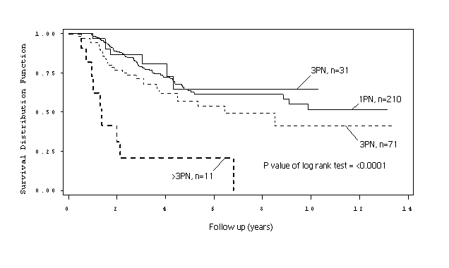

Considering SNs exclusively, the number of positive SNs per patient varied from 1 to 4 (mean 1.25, median 1). Only 11 patients (3.4%) were found to have >2 positive SNs. The Kaplan-Meier survival curves comparing patients with 1 positive SN to those with >1 positive SN did not show any significant difference in survival between these two groups of patients (p=0.5880) (Figure 3.2.2). Sixty patients (18.6%) were found to be NSN positive, with the number of metastasis-containing NSNs per patient ranging from 1 to 6 (mean 1.57, median 1). However, only 8 patients had >2 positive NSNs. The Kaplan-Meier survival curves for patients with 0,1 and >1 positive NSN demonstrate a statistically significant difference in survival between these groups, with prolonged survival for NSN negative patients (p=0.0001) (Figure 3.2.3).

Figure 3.2.2. Kaplan-Meier survival curves for patients with 1 and >1 positive sentinel node (SN).

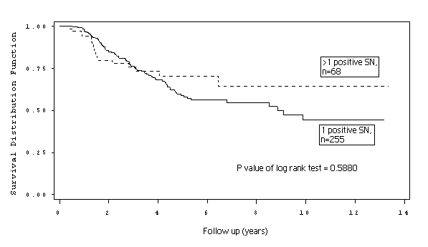

Figure 3.2.3. Kaplan-Meier survival curves for patients with 0, 1, and >1 positive non-sentinel node (NSN).

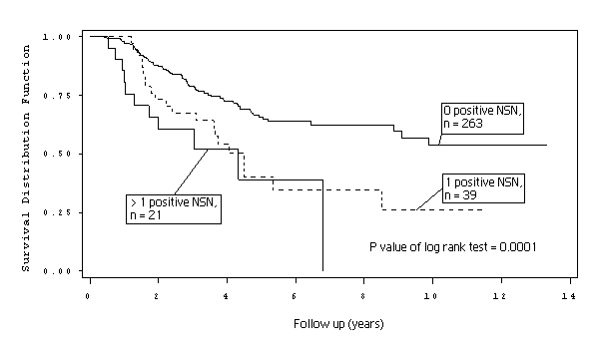
The impact of NSN status on survival for patients with a similar total number of positive nodes was of particular interest. There was no statistically significant difference in survival between patients with a total of 2 versus 3 positive nodes (log rank test p value = 0.2247). For patients with a total of 2-3 positive nodes, survival was significantly better for NSN negative patients than NSN positive patients (Figure 3.2.4, p=0.0266). This finding was tested further in a subgroup analysis containing all patients with a total of 2-3 positive nodes. Age, gender, primary tumor location, thickness, ulceration and mitotic rate, NSN status and total number of positive nodes were tested. Only age and NSN status were found to be statistically significant predictors of survival on univariate analysis. Age, NSN status and total number of positive nodes were then included in a multivariate model, resulting in p values of 0.07, 0.04 and 0.16 respectively.
Figure 3.2.4. Kaplan-Meier survival curves comparing non-sentinel node (NSN) status for patients with a total of 2 or 3 positive nodes.

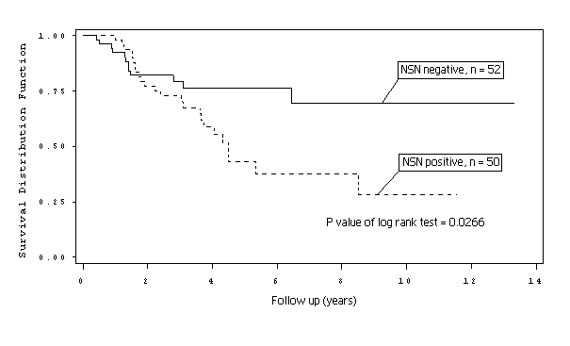
The distribution of the 6 potential predictors of NSN status and the results of the logistic regression analysis are shown in Table 3.2.5. Ulceration was the only statistically significant predictor of NSN status (p=0.042). The outcome of the classification-tree based survival analysis for SN positive patients is shown in Figure 3.2.5. Since survival curves from 4 groups were similar, they were merged into one: “Group 3”. The resultant classification tree used 5 variables (total number of positive nodes, tumor thickness, age, mitotic rate and NSN status) to divide SN-positive patients into 4 distinctly different prognostic groups (Figure 3.2.6).

Table 3.2.5. Distributions of characteristics and logistic model results regarding presence of positive non-sentinel nodes (NSNs)

 | Metastasis found in NSN(s)? |  | Univariate |  | Multivariate
Characteristic | No (N=263)  N (%) | Yes (N=60)  N (%) | Crude OR (95%CI) | p-value | Adjusted OR (95%CI) | p-value
Age at SNB#*$ | 51.7 ± 16.9 | 54.7 ± 17.2 | 1.11 (0.94-1.32) | 0.224 | 1.08 (0.90-1.30) | 0.406
Gender  Male  Female | 157 (79.3)  106 (84.8) | 41(20.7)  19(15.2) | 1  0.69 (0.38-1.25) | 0.217 | 1  0.73 (0.39-1.36) | 0.319
Tumor thickness (mm)  ≤2.0  2.1-4.0  >4.0 | 79 (82.3)  110 (82.7)  70 (77.8) | 17 (17.7)  23 (17.3)  20 (22.2) | 1  0.97 (0.49-1.94)  1.33 (0.65-2.73) | 0.935  0.442 | 1  0.45 (0.20-1.04)  0.68 (0.28-1.61) | 0.061  0.376
Ulceration  No  Yes | 149 (86.1)  97 (73.5) | 24(13.9)  35(26.5) | 1  2.24 (1.26-4.00) | 0.006 | 1  2.06 (1.03-4.14) | 0.042
Mitotic rate (mitoses/mm²)  ≤5  6-10  >10 | 163 (85.3)  54 (76.1)  38 (71.7) | 28 (14.7)  16 (22.9)  15 (28.3) | 1  1.73 (0.87-3.43)  2.30 (1.12-4.72) | 0.120  0.024 | 1  1.75 (0.84-3.67)  2.02 (0.89-4.57) | 0.137  0.092
Number of sentinel nodes removed | 2.1 ± 1.1 | 1.8 ± 1.0 | 0.80 (0.60-1.06) | 0.119 | 0.79 (0.59-1.07) | 0.124
# SNB=sentinel node biopsy
*Mean ± SD
$ Adjusted odds ratio for age in 10 year increments

Figure 3.2.5. Survival tree model for sentinel node (SN) positive patients (non-sentinel node = NSN; sentinel node biopsy = SNB).

Group | 5yr survival (95% CI)
1 | 92% (85-99)
2 | 70% (58-81)
3 | 39% (29-49)
4 | 21% (0-46)

Figure 3.2.6. Kaplan-Meier survival curves resulting from regrouping by survival tree analysis.

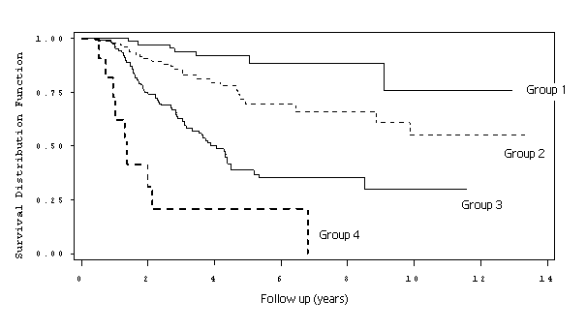

DISCUSSION
It remains unclear how to most appropriately manage patients who are SN positive. Crucial steps to allow determination of best practice in this scenario include establishing the significance of NSN metastases, and determining the efficacy of CLND. The variability in NSN positivity rates reported in the literature may be due to variations in the type of radiocolloid used for lymphoscintigraphy, interpretation of lymphoscintigrams, the proportion of lymph nodes designated as “sentinel”, or to variations in histologic protocols used for the examination of both SNs and CLND specimens. The rate of NSN positivity in this study was 18.6%. The disease-free survival advantage reported from MSLT I was detected in a group of patients undergoing both SNB and CLND, of which 16% had additional positive NSNs identified in CLND specimens.¹²⁴ A logical progression leads one to question whether CLND prolonged survival in any of these patients and if so, which ones? Assumptions that patients with additional metastases detected at CLND are the only ones benefiting from CLND and that the procedure should be avoided in the remainder are not necessarily valid. Some NSN positive patients have high tumor load and are likely to die from distant metastases irrespective of their nodal management. In addition, a proportion of “NSN negative” cases are likely to be false-negatives due to less intensive analysis of the large number of nodes removed at CLND. These patients may be gaining a survival advantage from CLND but could be denied this if it became possible to select and perform CLND only for patients with currently detectable NSN metastases. However, at present, there is no accepted method of reliably identifying a patient’s NSN status prior to CLND.
Findings from the present study indicate that the vast majority (96.6%) of SN positive patients have metastases in <4 nodes (sentinel +/- non-sentinel) and prognosis worsens as the number of positive NSNs increases. For the small minority of patients who have ≥4 metastatic nodes the prognosis appears dismal, with a 3-year survival of 21% (95%CI 0 - 46), and this may be irrespective of whether the metastatic nodes are NSNs or SNs. The number of patients with ≥4 metastatic nodes, and in particular those with ≥4 positive SNs who are NSN negative, is too small to allow conclusions to be drawn on this issue. However, these patients will also represent a very small minority in clinical practice.
The statistical phenomenon of multicollinearity was encountered during the survival analyses in this study (Table 3.2.4). This problem occurs when explanatory variables related by a linear function are included in the same regression analysis, resulting in inaccurate estimation of regression coefficients. Total number of positive nodes is the sum of number of positive SNs and number of positive NSNs. Consequently, multicollinearity occurred when total number of positive nodes was included in the same multivariate analysis as the latter two variables. To overcome this, 3 separate multivariate analyses were performed to establish the relative prognostic importance of each variable (Table 3.2.4). The result, indicating that total number of positive NSNs is a more powerful predictor of survival than total number of positive nodes, is consistent with the theory that prognosis deteriorates as metastases progress through the lymph node field.
The results of the sub-group analysis of patients with a total of 2 or 3 positive nodes also support this conclusion, with NSN status and age being the only statistically significant predictors of survival on univariate analysis, and only NSN status remaining statistically significant in a multivariate model that accounted for total number of positive nodes. It should be noted that the sample size for this subgroup analysis was relatively small (102 patients) and that multicollinearity may again be an issue, resulting from NSN status and total number of positive nodes being highly correlated variables.
Cascinelli et al. reported that NSN metastasis was a prognostic indicator in a group of 176 SN positive patients, 18.7% of whom had NSN metastasis, a proportion very similar to that in the present study (18.6%).¹⁴⁹ However, information on the numbers of positive NSNs was not provided. More recently, Jakub et al. have reported findings that prognosis is not affected by increasing number of positive SNs but is affected by the presence of positive NSNs.¹⁶⁴ NSN positive patients are likely to have a higher average total number of positive nodes than those with only positive SNs. In the present study, survival varied significantly (p<0.0001) according to the total number of nodes involved (Figure 3.2.1) and the median total number of involved nodes in the NSN negative group was 1 compared to 3 in the NSN positive group. It was therefore necessary to account for this difference when analyzing the effect of NSN metastasis. Ariyan et al. have similarly reported results suggesting that survival for patients with two positive nodes was worse when one node was non-sentinel (p=0.05).¹⁷⁴
The poorer prognosis detected for patients with positive NSNs occurred despite the fact that these metastatic nodes were excised at CLND. A possible explanation for this finding is that NSN metastasis identifies patients with a higher prevalence of occult distant hematogenous spread at the time of CLND. In this scenario, CLND could provide a cure only for the proportion of NSN positive patients without occult distant hematogenous metastasis. The observation that prognosis worsens in a step-wise fashion from SN negative to SN positive and then to NSN positive patients would fit a theory that associates these biologically-distinct stages with corresponding increases in the prevalence of occult distant hematogenous metastasis. This “Increasing Relative Risks” model could incorporate not only the increasing relative risk associated with SN and NSN metastasis but also relative risks associated with features of the primary melanoma, if it was assumed that hematogenous metastasis could occur in the absence of lymphatic metastasis. If melanoma behaves according to this model, the only group of patients who could be completely cured as a direct result of SNB would be those who, following adequate treatment of the primary site, are SN positive but NSN negative and are without occult hematogenous disease. This is likely to be a relatively small proportion of all patients who undergo SNB. The potential implication for trials aiming to assess the therapeutic efficacy of SNB or CLND is that small proportions of patients being cured by these procedures may go undetected because it is not yet possible to identify them prior to treatment.
Taking CLND as an example, it has not been possible to assess the contribution that the procedure makes to survival in NSN negative versus NSN positive patients. Wong et al. attempted to determine the contribution that CLND makes to survival using a patient group in which NSN status was unknown.²³⁰ This retrospective study combined data from 16 centers worldwide documenting recurrence and survival in 134 SN-positive patients who did not undergo CLND. The median follow-up time was 20 months and nodal recurrence occurred in 15% of patients, a figure similar to observed rates of NSN metastasis in CLND specimens. The investigators also selected a comparison group of 164 Memorial Sloan-Kettering Cancer Center patients who had undergone CLND and found that their nodal recurrence rate was 10% with a median follow-up of 36 months. This difference in recurrence-free survival was not statistically significant. However, this may have been due to inadequate follow-up time for patients with relatively low tumor burdens. The present study, with a median follow-up of 40 months (range 4.4 to 160 months) highlights this issue. The survival difference for patients with a total of 2-3 positive nodes grouped by NSN status (Figure 3.2.4) became apparent only after approximately 36 months of follow-up. The median 3-year survival was similar for both groups (79% (95%CI 68 - 91) in the NSN negative group and 73% (95%CI 60 - 86) in the NSN positive group) but, whilst it remained at approximately the same level at 5 years for the NSN negative group (77% (95%CI 64 - 89), in the NSN positive group it had fallen to 43% (95%CI 26 - 60).
The contribution that CLND makes to survival, also using a patient group in which NSN status is unknown, is currently being determined prospectively by MSLT II.¹⁵⁹ If no survival advantage or improvement in quality of life is demonstrated from CLND, then the procedure is likely to be abandoned in favor of high-resolution ultrasound follow-up and TLND as required. However, if CLND is shown to provide a survival advantage then, in order to avoid unnecessary morbidity, it would become necessary to determine whether some or all patients benefit from the procedure. Achievement of this aim is likely to require a method for reliably identifying patients with NSN metastases, prior to CLND. The present study examined 6 potential predictors of NSN metastasis (age, gender, tumor thickness, ulceration, mitotic rate and number of SNs removed), and found that ulceration was the only statistically significant predictor of NSN status. A number of previous studies have examined various characteristics related to the patient, the primary tumor pathology and the SN.^{123,136–155} Table 3.2.6 summarizes studies reporting multivariate analyses of potential predictors of NSN positivity and demonstrates the lack of any consistent predictors relating to patient or primary melanoma characteristics. The present study contains the second largest sample size reported to date (323 patients) and found an association only with primary tumor ulceration. The largest published report found no association with ulceration but an association with primary tumor thickness >2mm on multivariate analysis of 343 patients.¹²³ Tumor load and location within the SN have also been investigated and, despite some reports to the contrary, most studies have suggested that various measurements of tumor load and/or location are predictors of NSN positivity.^{123,136–155,162} However, the accurate and reproducible identification of all NSN negative patients by any method remains an elusive goal.
The final aim of the present study was to perform a classification tree analysis for SN positive patients that produced groups with distinctly different survival outcomes. Classification of melanoma patients by exponential survival tree analysis has become increasingly popular due to its superior ability over regression analyses to define distinct prognostic groups.^{121,136,229,231} Analysis of the current data resulted in the classification tree (Figure 3.2.5) and four prognostic groups with distinctly different survival curves (Figure 3.2.6). Group 4 (patients with a total of >3 positive nodes) had a 5-year survival rate of 21% (95%CI 0 - 46). Group 1 patients, who were NSN negative with a total of <4 positive nodes and primary tumor thickness of 2mm or less, had a 5-year survival rate of 92% (95%CI 85 - 99), which is similar to that of SN-negative patients. Five-year survival rates for Group 2 and Group 3 were 70% (95%CI 58 - 81) and 39% (95%CI 29 - 49) respectively.
Thus it can be seen that SN positive patients constitute a truly heterogeneous group in terms of survival, from a level similar to that for SN negative patients to only marginally better than that for patients with some forms of distant metastases. Such diversity in the prognosis of SN positive patients leads to the suggestion that equally diverse therapeutic strategies may be required to provide the most effective treatment for this group of patients. The information that this classification provides should enhance decision-making. All SN positive patients who have had CLND can be grouped and the risks versus benefits for particular therapies weighed against their likely prognosis. Each group is simply defined using variables that are routinely collected by most centers, and could therefore be used to form inclusion criteria for entry into multicenter trials.
One of the limitations of this study is that the data reflect the activities of a single center. Variation in factors such as the type of radiocolloid used for lymphoscintigraphy and local interpretations of the definition of SNs could affect the proportion of lymph nodes designated “sentinel”, and thus the reproducibility of these findings. The fact that this study suggests a survival difference between NSN positive and NSN negative patients, independent of the total number of nodes involved, lends support to the technique of SNB and the definition of SNs used at the SMU. It could however, be argued that the difference in survival between NSN negative and NSN positive patients may have resulted from metastatic nodes being present in NSN positive patients for an additional time period between SNB and CLND, during which hematogenous spread could have occurred. In order to minimize any such effect, the study was designed to exclude patients in whom CLND was performed >12 weeks following SNB. Further large-scale studies are needed to confirm the influence of NSN status on the survival of melanoma patients and in particular to determine whether incorporating a differentiation between metastatic disease in SNs and NSNs would improve the prognostic power of the AJCC staging system.

3.3: Sentinel node positive melanoma patients: Validation and comparison of a survival tree model.

Abstract
BACKGROUND
A survival tree model for melanoma has been developed from an Australian population who underwent sentinel node biopsy and completion lymph node dissection. This identified four groups (1-4) with estimated 5-year survival rates of 92%, 70%, 39% and 21% respectively, but has not yet been validated. The aims of this study were to validate the survival tree model using a UK melanoma patient population, to compare the prognostic accuracy with other widely available prognostic calculators and to investigate patterns of recurrence.

METHOD
All melanoma patients who had undergone sentinel node biopsy and completion lymph node dissection at this institution, between January 2000 and December 2005, were eligible for inclusion. Patients were included if their primary melanoma pathology had been reviewed at this institution and included all variables required to obtain a group allocation in the survival tree model. Survival tree model grouping was calculated for all patients and predicted 5-year survival rate was also calculated using 3 different prognostic calculators. Survival time, survival status at 5 years of follow-up and details of any recurrences were determined. Survival curves and the ability to predict outcome at 5 years were compared for the different prognostic calculators.

RESULTS
Forty-four patients were included in the analysis. Group 1 (n=12) patients (median follow-up 64 months) were all alive without evidence of metastasis, with 2 patients having had recurrence, Group 2 (n=15) patients (median follow-up 73 months) had 6 cases of recurrence and 3 deaths from melanoma, Group 3 (n=14) patients (median follow-up 70 months) had 7 cases of recurrence and 6 deaths from melanoma and Group 4 (n=3) patients had all died from melanoma. The type of initial recurrence appeared to differ between Group 2, with mainly local or in-transit recurrences, compared with mainly distant recurrence in Groups 3 and 4.

CONCLUSIONS
Using a survival tree model developed from an Australian melanoma patient population, sentinel node positive melanoma patients in a UK institution who underwent completion lymph node dissection could be grouped into one of four prognostic groups with distinctly different survival characteristics and patterns of recurrence, based on the total number of positive nodes, Breslow thickness, patient age, non-sentinel node status and primary melanoma mitotic rate.

INTRODUCTION
It is important that prognostic information for patients with melanoma is as accurate as possible. Inaccurate prognostic information can result in unnecessary patient anxiety and may lead the patient to take actions or make life decisions that they will later regret. A number of tools are widely available for health professionals to use in order to determine their patient’s prognosis. These tools are applicable to patients with primary cutaneous melanoma who undergo wide local excision and sentinel node biopsy. The most widely available are an AJCC-endorsed prognostic calculator (available at www.melanomaprognosis.orgwww.melanomaprognosis.org), a web calculator devised by the Laboratory for Quantitative Medicine at Massachusetts General Hospital (available at www.lifemath.netwww.lifemath.net) and a calculator developed by the University of Louisville School of Medicine in conjunction with Advertek Inc. Healthcare Data (available at www.melanomacalculator.comwww.melanomacalculator.com). These calculators require the input of a variable number of patient and pathology characteristics and produce predictions on prognosis for an individual patient. The variables required for each model to calculate prognosis for a patient with clinically localised melanoma who has undergone sentinel node biopsy and completion lymph node dissection are shown in Table 3.3.1.

Table 3.3.1. Prognostic tools that are available to estimate prognosis for sentinel node positive melanoma patients.

Prognostic calculator | AJCC endorsed | Lifemath.net | Melanomacalculator.com | Survival tree model
Variables required* | - Age  - Site  - Number of metastatic nodes  - Ulceration  -Breslow thickness | - Age  - Site  - Number of metastatic nodes  - Ulceration  -Breslow thickness  -Sex  -Histological subtype  -Clark level | -Age  -Site  -Number of positive sentinel nodes  -Non-sentinel node status  -Ulceration  -Breslow thickness  -Sex | -Age  -Number of metastatic nodes  -Non-sentinel node status  -Breslow thickness  -Tumour mitotic rate
Total number of variables required | 5 | 8 | 7 | 5
*To calculate prognosis for a patient with clinically localized melanoma who has undergone sentinel node biopsy and completion lymph node dissection.

Sentinel node status is the single most important prognostic indicator for patients with clinically localized melanoma and 5-year survival for patients who are sentinel node positive is 72% versus 90% for the sentinel node negative population.¹²⁴ However, sentinel node positive melanoma patients can have widely varying survival times and so it would be useful to be able to separate them into subgroups based on their prognosis so that decisions on adjuvant therapy and eligibility for clinical trials can be made more appropriately. In section 3.2 of this thesis a survival tree model has been developed for the sentinel node positive population who undergo completion lymph node dissection (see Figure 3.2.5). ¹⁶¹ This was based on an Australian patient population in the era prior to the introduction of targeted therapies for patients with metastatic disease. The survival tree that was produced included five variables (age, Breslow thickness, tumour mitotic rate, total number of positive nodes and non-sentinel node status) and separated patients into 4 prognostic categories with estimated 5-year survival of 21%, 39%, 70% and 92% respectively (see Figures 3.2.5 and 3.2.6). The present study aimed to determine the validity of this survival tree in predicting overall survival when applied to a UK population. Secondary aims were to compare outcomes at 5 years and survival curves for patients using the survival tree and the 3 prognostic tools, and to investigate the patterns of recurrence of the study population grouped according to the survival tree.

METHODS
The study was carried out using anonymised data from a UK population attending a tertiary referral centre for melanoma. All melanoma patients who had undergone lymphoscintigraphy and sentinel node biopsy at this institution between January 2000 and December 2005, with at least 1 positive sentinel node, were eligible for inclusion. Patients on the database had had their primary melanoma pathology reports reviewed and were included if they had undergone both dermatopathological review of their primary melanoma histology and completion lymph node dissection at the institution. Patients with missing prognostic variables that were required for the survival tree prognostic grouping were excluded, as were patients with no follow-up details. Patients were then categorised into the four prognostic groups based on the total number of positive nodes, Breslow thickness, patient age, non-sentinel node status and primary melanoma mitotic rate. For each prognostic group; survival, follow-up status and details of any recurrences were then recorded. Survival time was calculated from the time of wide local excision and sentinel node biopsy. For each of the study patients the relevant data were entered into three online prognostic calculators (www.melanomaprognosis.org, www.lifemath.net and www.melanomacalculator.com) in order to obtain and record the predicted 5-year survival rates.

Statistical methods
Statistical comparisons were made using SPSS version 22. Kaplan-Meier survival curves were calculated for the four survival tree groups and the log rank test was used to test for differences between the groups. The values for predicted 5-year survival determined by each online prognostic calculator were used to divide the study population into quartiles (Group 1: predicted survival 76-100%, Group 2: predicted survival 51-75%, Group 3: predicted survival 26-50% and Group 4: predicted survival 0-25%). Separate Kaplan-Meier survival curves were then calculated for the study patients according to their predicted 5-year survival as determined by each online prognostic calculator and then grouped into quartiles.
Comparison between the online prognostic calculators and the survival tree classification was performed by plotting the receiver operator characteristic (ROC) curves for each classifier as a determinant of status at 5 years (alive or dead) and determining the area beneath the curve in each case. ROC curves are a plot of the false positive rate (1-specificity) on the x axis against the true positive rate (sensitivity) on the y axis. A test that is non-discriminatory i.e. gives the same outcome as flipping a coin, would produce a straight diagonal line from the point (0,0) to (1,1) with an area under the line of 0.5. The more sensitive and specific the test the closer it forms a curve that rises steeply following the y axis. Thus, the greater will be the area under the curve in such cases, with the maximum possible being 1.0. For each ROC curve the standard error of the area under the curve was calculated and the asymptotic p value was calculated against the null hypothesis that the area under the curve = 0.5. In all cases a p value <0.05 was considered significant.

RESULTS
There were 63 eligible patients. Fifteen patients were excluded as they did not undergo completion lymph node dissection and 4 patients were excluded as they had undergone follow-up at a different institution. After exclusions there were 44 patients suitable for analysis. The characteristics of the study patients are shown in Table 3.3.2. The distribution of occult metastases within sentinel and non-sentinel nodes is shown in Table 3.3.3. The details regarding recurrences and deaths by survival tree group are contained in Table 3.3.4.

Table 3.3.2. Characteristics of the study patients (n=44) compared to the original Australian population (n=323) on which survival tree was based.
Variable | Mean (±standard deviation) or Number (%)
Variable | Current study (n=44) | Original study (n=323)
Age at sentinel node biopsy | 51.4 (±16.8) | 52.3 (± 16.9)
Gender
Male | 25 (56.8) | 198 (61.3)
Female | 19 (43.2) | 125 (38.7)
Tumour thickness (mm)
≤2.0 | 12 (27.3) | 96 (30.0)
2.1 – 4.0 | 23 (52.3) | 133 (41.7)
>4.0 | 9 (20.5) | 90 (28.2)
Ulceration*
No | 24 (63.2) | 173 (56.7)
Yes | 14 (36.8) | 132 (43.3)
Mitotic rate (mitoses/mm²)$
≤5 | 25 (69.4) | 191 (60.8)
6-10 | 7 (19.4) | 70 (22.3)
>10 | 4 (11.1) | 53 (16.9)
Location of primary melanoma
Trunk | 20 (45.5) | 115 (35.6)
Extremity | 21 (47.7) | 168 (52.0)
Head + neck | 3 (6.8) | 39(12.1)
Others | 0 (0.0) | 1 (0.3)
*Data missing or not possible to measure in 6 cases in current study
$Data missing in 8 cases in current study

Table 3.3.3. The distribution of positive nodes within the study population.
SN + NSN | SN | NSN | n
1 | 1 | 0 | 30
2 | 2 | 0 | 6
2 | 1 | 1 | 4
3 | 1 | 2 | 1
4 | 4 | 0 | 1
4 | 3 | 1 | 1
24 | 1 | 24 | 1
SN = sentinel node, NSN = non-sentinel node, n = number of patients

Table 3.3.4. Survival and recurrence by survival tree group.
Group | n | Developed recurrence | Died from melanoma | Alive without melanoma | Survived ≥5 years | Free of disease but <5 years follow-up
1 | 12 | 2 | 0 | 12 | 8 | 4
2 | 15 | 6 | 3 | 11 | 11 | 2
3 | 14 | 7 | 6 | 8 | 7 | 3
4 | 3 | 3 | 3 | 0 | 0 | 0

Eight of 44 patients had metastases in non-sentinel nodes in addition to sentinel nodes. The classification tree assigned 12 patients to Group One, 15 patients to Group Two, 14 patients to Group Three, and 3 patients to Group Four. The median follow-up time for the study population was 61 months (range 5 to 113 months) and 11 of 44 patients died from melanoma. All patients in Group Four developed metastatic disease and died, with a maximum survival time of 3 years. In contrast, all patients in Group One were alive and without evidence of metastatic disease with a median follow-up time of 64 months (range 5 to 104 months). There were two patients within this group who were lost to follow up at 5 months and 18 months. Two patients had developed recurrence: one had had local and in-transit recurrences treated and had been recurrence-free for 60 months, the other had developed further nodal disease within the previously dissected nodal basin and then in more proximal nodes. This patient underwent further resections and had been clinically free of disease for 31 months.
Of the Group Two patients 6 of 15 had developed recurrence and 3 had died of melanoma with survival times ranging from 7 to 79 months. The nature of the initial recurrence was local or in-transit metastases in 4 cases, distant skin metastasis in 1 case and lung metastasis in 1 case. Only 2 patients survived for less than 45 months and for those who remained alive the median follow-up time was 73 (range 45 to 102) months. In Group Three 7 of 14 patients had developed recurrence and 6 had died of melanoma. The nature of the initial recurrence was multiple distant sites in all but one case where local recurrence occurred. All patients who had developed initial recurrence at distant sites had died, with survival times ranging from 15 to 78 months (median 39 months). The median follow-up time for those who remained alive was 70 (44 to 113) months and all patients were clinically free of disease.
There were 35 patients who had a follow-up time of at least 5 years or had died within 5 years. The predicted survival rates according to the survival tree model are compared with the actual survival rates for this group in Table 3.3.5.
Table 3.3.5. Actual survival compared with predicted survival according to the survival tree model.

Survival tree group | Survival tree predicted 5-year survival rate (%(95% CI)) (based on Australian population) | Actual 5-year survival rate (%(n/n)) observed for study population (n=35)
1 | 92 (85-99) | 100 (7/7)
2 | 70 (58-81) | 85 (11/13)
3 | 39 (29-49) | 58 (7/12)
4 | 21 (0-46) | 0 (3/3)
CI = confidence interval, SD = standard deviation

The survival curves for all patients (n=44), grouped according to the survival tree model, differed significantly (p value of log rank test <0.0005) (Figure 3.3.1). Estimated 5-year survival for Group 1 was 100%, for Group 2 it was 87%, for Group 3 it was 61% and for Group 4 it was 0%. The survival curves for the patients grouped into quartiles on the basis of predicted 5-year survival according to the AJCC-endorsed (n=38), lifemath.net (n=44) and melanomacalculator.com (n=29) prognostic tools are shown in Figures 3.3.2, 3.3.3 and 3.3.4 respectively. The calculation could only be completed in 38 of 44 cases using the AJCC-endorsed tool as this required ulceration status to be entered in order to calculate prognosis, and this was not available for 6 cases. The melanomacalculator.com tool has limits on data entry (age maximum of 70 years and a maximum Breslow thickness of 6.9mm) in addition to requiring ulceration status to be entered in order to produce a prognosis, and thus was unable to calculate prognosis in 15 cases.
The estimated 5-year survival rates and distribution of patients across the 4 groups based on predicted survival are shown in Table 3.3.6. The ability of the 4 different prognostic tools to determine status (alive or dead) at 5 years is demonstrated in the receiver operator characteristic (ROC) curves shown in Figure 3.3.5. For the survival tree the patients were grouped 1-4 and for the other prognostic tools the predicted 5-year survival rate (%) for each individual was used. The larger the area beneath the curve the better the prognostic tool is at determining actual outcome at 5 years. The survival tree grouping produced the largest area under the curve (0.934) and this differed significantly (p=0.007) from the null hypothesis that the area under the curve = 0.5.

Figure 3.3.1. Kaplan-Meier survival analysis comparing overall survival for patients grouped according to the survival tree model and results of log rank test.

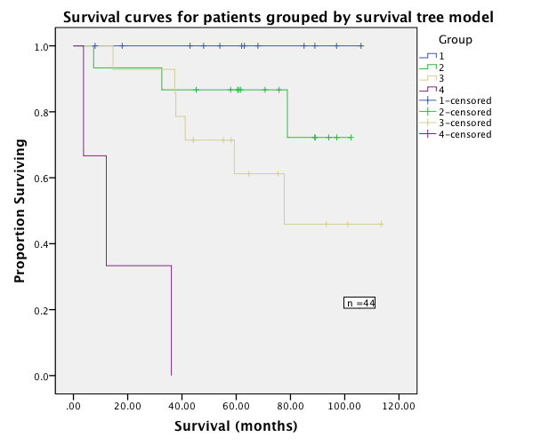

Overall Comparisons
 | Chi-Square | df | Sig.
Log Rank (Mantel-Cox) | 37.564 | 3 | .000
Figure 3.3.2. Kaplan-Meier survival analysis comparing overall survival for patients grouped into quartiles from the predicted 5-year survival by the AJCC endorsed prognostic tool.

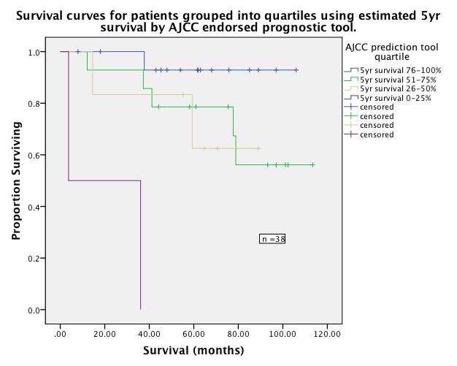

Overall Comparisons
 | Chi-Square | df | Sig.
Log Rank (Mantel-Cox) | 28.101 | 3 | .000

Figure 3.3.3. Kaplan-Meier survival analysis comparing overall survival for patients grouped into quartiles from the predicted 5-year survival by the Lifemath.net prognostic tool.

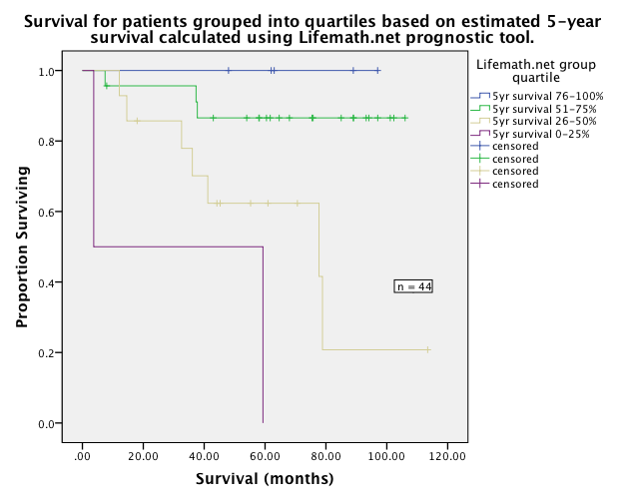

Overall Comparisons
 | Chi-Square | df | Sig.
Log Rank (Mantel-Cox) | 18.330 | 3 | .000

Figure 3.3.4. Kaplan-Meier survival analysis comparing overall survival for patients grouped into quartiles from the predicted 5-year survival by the Melanomacalculator.com prognostic tool.

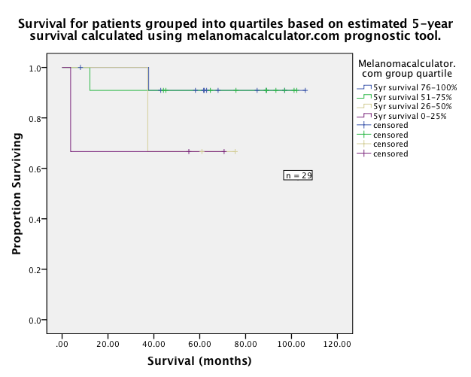

Overall Comparisons
 | Chi-Square | df | Sig.
Log Rank (Mantel-Cox) | 2.664 | 3 | .446

Table 3.3.6. Estimated 5-year survival and distribution of subjects for the test population grouped by the survival tree model and the 3 online prognostic calculators (AJCC endorsed, Lifemath.net and melanomacalculator.com)
Group* | Survival tree |  | AJCC endorsed |  | Lifemath.net |  | Melanomacalculator.com
Group* | 5-year survival | n | 5-year survival | n | 5-year survival | n | 5-year survival | n
1 | 100% | 12 | 93% | 16 | 100% | 5 | 91% | 12
2 | 87% | 15 | 79% | 14 | 87% | 23 | 91% | 11
3 | 61% | 14 | 63% | 6 | 62% | 14 | 67% | 3
4 | 0% | 3 | 0% | 2 | 0% | 2 | 67% | 3
Total number for whom prognosis could be calculated |  | 44 |  | 38 |  | 44 |  | 29
*5-year survival grouped into quartiles for each online prognostic calculator (Group 1: 76-100%, Group 2: 51-75%, Group 3: 26-50%, Group 4: 0-25%). For survival tree: groups 1-4 are as designated by the tree.

Figure 3.3.5. Receiver operator characteristic (ROC) curves comparing the survival tree model with the AJCC endorsed, lifemath.net and melanomacalculator.com prediction tools as predictors of status (alive or dead) at 5 years.
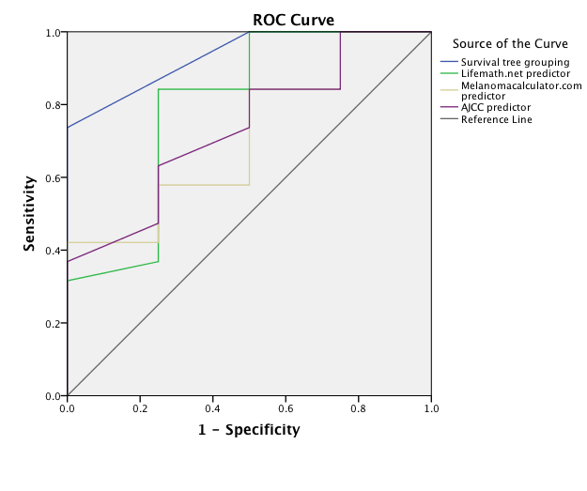

Area Under the Curve
Test Result Variable(s) | Area | Std. Errorª | Asymptotic Sig.^{b} | Asymptotic 95% Confidence Interval
 |  |  |  | Lower Bound | Upper Bound
Survival tree grouping | .934 | .057 | .007 | .823 | 1.000
Lifemath.net predictor | .796 | .143 | .068 | .515 | 1.000
Melanomacalculator.com predictor | .711 | .134 | .194 | .449 | .972
AJCC predictor | .737 | .128 | .144 | .486 | .988
a. Under the nonparametric assumption
b. Null hypothesis: true area = 0.5
DISCUSSION
Management of clinically localised primary cutaneous melanoma by wide excision and sentinel node biopsy with completion lymph node dissection for those with micrometastases addresses the primary tumour site and the regional lymph nodes but does not address possible micrometastatic disease within the intervening lymphatics or sites of possible occult distant metastases. Patients who undergo such management will therefore fall into a number of categories and will be more likely to develop certain types of initial recurrence accordingly (see Table 3.3.7).

Table 3.3.7. Potential patterns of occult metastasis following wide excision and sentinel node biopsy with completion lymph node dissection for sentinel node positive nodal basins (black shading = melanoma still present, white = no melanoma present).
Category | Presence or absence of residual melanoma at site following treatment |  |  |  |  | Likely type of initial recurrence
Category | Primary melanoma site | Intervening lymphatics | Sentinel nodes | Non-sentinel nodes | Distant sites | Likely type of initial recurrence
1 |  |  |  |  |  | None (cured)
2 |  |  |  |  |  | Local
3 |  |  |  |  |  | In-transit
4 |  |  |  |  |  | Nodal
5 |  |  |  |  |  | Nodal
6 |  |  |  |  |  | Distant
7 |  |  |  |  |  | Local + in-transit
8 |  |  |  |  |  | In-transit + nodal
9 |  |  |  |  |  | Nodal
10 |  |  |  |  |  | Nodal + distant
11 |  |  |  |  |  | Local + nodal
12 |  |  |  |  |  | Local + nodal
13 |  |  |  |  |  | Local + distant
14 |  |  |  |  |  | Local + in-transit + nodal
15 |  |  |  |  |  | In-transit + nodal
16 |  |  |  |  |  | Nodal + distant
17 |  |  |  |  |  | Local + in-transit + nodal
18 |  |  |  |  |  | Local + in-transit + distant
19 |  |  |  |  |  | Local + nodal
20 |  |  |  |  |  | Local + nodal + distant
21 |  |  |  |  |  | Local + in-transit + nodal + distant
22 |  |  |  |  |  | Local + nodal + distant
23 |  |  |  |  |  | In-transit + nodal + distant
24 |  |  |  |  |  | In-transit + nodal + distant
25 |  |  |  |  |  | In-transit + nodal + distant
26 |  |  |  |  |  | Local + nodal + distant
27 |  |  |  |  |  | Nodal + distant
28 |  |  |  |  |  | Local + in-transit + nodal + distant
29 |  |  |  |  |  | Local + in-transit + nodal + distant

A typical patient will undergo sentinel node biopsy with or without subsequent completion lymph node dissection and then enter follow-up in order to identify metastatic disease when it has reached sufficient volume to become clinically-detectable. This treatment process is far from ideal because it does not attempt to address occult in-transit metastases, which become clinically apparent in around 6-7% of patients who undergo sentinel node biopsy. ^{54,232} Similarly, it does not attempt to address occult distant metastases. Instead, watchful waiting gives the melanoma metastases opportunity to grow and to spread from in-transit sites to nodal and distant sites and for distant metastases to grow and disseminate further. To improve management requires two components. Firstly there should be a method for accurately identifying the patients who are most likely to have occult in-transit and/or distant metastases. Secondly there would need to be effective treatments to eradicate such metastases.
The prognostic classification or survival tree developed previously from an Australian population has been validated in the present study. It identifies a group (Group 4) where all members appear likely to have occult distant metastatic disease and a poor prognosis.¹⁶¹ An argument could therefore be made for treating this group in the same way as patients with stage IV disease. Similarly, patients in Group 3 appear to have a high risk of distant visceral metastatic disease and a relatively poor prognosis. In contrast, patients in Group 2 have a similar rate of recurrence but their risk is mainly for initial local or in-transit recurrence rather than distant metastases. Patients in Group 1 appear to be unlikely to have distant metastases and are mainly at risk from in-transit metastases or failures of nodal management due to inaccurate sentinel node biopsy or inadequate nodal clearance. Comparison of the survival tree-based prognostic grouping with the AJCC prognostic tool (Figures 3.3.1 and 3.3.2) shows that the survival tree may be of particular value in differentiating the patients that are contained within Groups 2 and 3. The mean and median predicted 5-year survival for Groups 2 and 3 were similar using the AJCC prognostic tool (Group 2 mean 63.6 (median 62.3) months, Group 3 mean 57.1 (median 62.5) months). However, the survival tree predicted 5-year survival was 39% (95% CI 29-49) for Group 3 and 70% (95% CI 58-81) for Group 2. Actual 5-year survival (based on survival tree grouping) for the present study was 58% for Group 3 and 85% for Group 2. The actual 5-year survival rates for patients in Groups 2 and 3 were better than predicted. This could be the result of the emergence of effective therapies for patients with distant metastatic disease, small sample size or differences in the study populations. The UK population had a slightly higher proportion of female patients and a slightly lower proportion of melanomas with high mitotic rate, ulceration and/or Breslow thickness >4.0mm, all factors which would confer a better prognosis (see Table 3.3.2). Comparison of the survival curves for the survival tree model and the 3 online prognostic calculators demonstrated that the survival tree model and the lifemath.net calculator provided the most separated survival curves with very similar estimated 5-year survival for each group (Figures 3.3.1 to 3.3.4). However, the patient population was more evenly distributed using the survival tree model. In particular for the Group 1 patients, with estimated 5-year survival of 100%, the survival tree model assigned 12 patients to Group 1 whereas the equivalent lifemath.net-derived group (patients with estimated 5-year survival 76-100%) contained only 5 patients.
Further assessment of the effectiveness of each prognostic tool to predict status (alive or dead) at 5 years was performed by plotting the receiver operator characteristic curve for each prognostic tool. Figure 3.3.5 demonstrates that the survival tree classification produced the greatest area under the curve (area 0.934, p = 0.005) suggesting that it was the most accurate as a test for predicting status at 5 years.
The patterns of recurrence observed in the present study suggest that the survival tree creates groups that are distinguished by their high or low risk of occult distant metastases. Overall, the findings suggest that systemic therapies should be considered for those in Group 4 and Group 3 whereas for Group 2 therapies that address occult in-transit metastases could be considered. For Group 1 observation only may be required unless a low morbidity therapy to address occult in-transit metastases becomes available.
It would be beneficial to confirm or refute this finding by examining the patterns of recurrence within different sentinel node positive melanoma populations and also to further confirm the validity of the survival tree in a larger sample size. If it is confirmed then it could provide a useful tool for identifying 2 groups of patients: those who may benefit from clinical trials aimed at addressing occult in-transit metastases and those who may benefit from clinical trials aimed at eradicating occult distant metastases. This would allow trials to be conducted on the specific groups of patients most likely to benefit from treatment, before their disease burden has increased to levels where palliation is the only possibility. The exclusion of low risk patients, whose outcomes are likely to be good, with or without treatment, and patients whose risk is of a different type of metastasis should mean that fewer participants would be needed in order to demonstrate a treatment effect. This is likely to become increasingly important as more and more new drugs become available for trials. The number of eligible patients will be a limiting factor to the speed with which such trials can be completed. If it is possible to identify two subsets of patients within the sentinel node positive patient population that would be eligible for 2 separate types of trial and more likely to benefit from the trial in each case, then that would be highly desirable. It would allow the effectiveness of each trial therapy to be determined more quickly so that effective therapies can be made available to the wider population sooner.

CONCLUSIONS
Sentinel node positive melanoma patients who underwent completion lymph node dissection were categorized into 4 prognostic groups using a previously developed survival tree model, based on 5 routinely collected variables (age, Breslow thickness, primary tumour mitotic rate, total number of metastatic nodes and non-sentinel node status). These groups (1-4) determined actual overall survival at 5 years (100%, 85%, 58% and 0% respectively). The prognostic accuracy of the survival tree model compared favourably when evaluated against widely available prognostic calculators. This simple tool could be used to select patients for adjuvant therapy.

Section 4

Section 4 – General summary and conclusions
The aim of this thesis was to enhance the quality and individualization of care for melanoma patients by improving the consistency and accuracy of information that is obtained from, or can be applied to, individual melanoma patients treated using the sentinel node biopsy-based management pathway (Figure 0.1). Specific objectives were:
1) To identify potential sources of inaccuracy or failure related to lymphoscintigraphy, the critical first step in the pathway.
2) To determine the prognostic significance of non-sentinel node metastasis by testing the following null hypothesis: There is no significant difference in prognosis when patients have metastasis to sentinel versus sentinel and non-sentinel nodes.
3) To develop and validate a prognostic tool that could be easily applied to all patients completing this pathway. This tool could then be used to provide accurate prognostic information and to determine groups who are at high risk of having occult distant metastases and may benefit from adjuvant therapy and/or inclusion in clinical trials.
By addressing lymphoscintigraphy, the critical first step in the pathway, and identifying factors that could affect the accuracy of the procedure, including factors that could account for cases of failure to identify any sentinel nodes (non-localization), it has been possible to provide strategies to deal with these situations. Dissemination of this information should lead to increased awareness and avoidance of potential pitfalls, and thus to greater consistency in obtaining sentinel nodes at surgery. In turn this will mean, for the individual patient, that better quality prognostic information will be provided. Similarly, by focusing on a small area of the head and neck: the forehead, and documenting lymphatic drainage patterns from different sites within this small area, it has been possible to demonstrate that distinct patterns of lymphatic drainage do exist on a population basis and that these patterns differ dependent on location even within this small area. This information has allowed new recommendations to be made regarding the extent of neck dissection dependent on the primary tumour site, thus signifying an increase in the quality and the utility of information for the individual patient who presents with a melanoma on the forehead. In future research, the approach taken for the forehead could be replicated for other regions of the head and neck to similarly refine understanding of the likely patterns of metastasis.
The null hypothesis that there is no significant difference in prognosis when patients have metastasis to sentinel versus sentinel and non-sentinel nodes has been disproven. Non-sentinel node status has been established as an independent prognostic factor for patients who undergo sentinel node biopsy-based management. Consideration should be given to including non-sentinel node status as a discriminator in future versions of the AJCC staging system for melanoma. The prognostic significance of non-sentinel node status has been incorporated into a survival tree model and this has been validated on an independent population. As a result, when a patient undergoes completion lymph node dissection, following a positive sentinel node biopsy, it is now possible to provide that individual with more accurate prognostic information. Future research that aims to further validate the survival tree model in separate melanoma populations would be beneficial.
On a more general note, the finding that prognosis is worse when non-sentinel node metastasis occurs in comparison to sentinel node metastasis alone, independent of the total number of metastatic nodes, is important because it indicates that there is a difference between metastases in sentinel nodes and metastases in non-sentinel nodes. This has implications for the validity of theories on cancer metastasis. Breast cancer has inspired the formulation of several theories pertaining to the significance or implications of nodal metastasis and its relationship to distant metastasis. Halsted’s notion that cancer metastasizes in an orderly, contiguous fashion from the primary site, via lymphatics and lymph nodes, and remains contiguous even as it reaches distant sites, has been comprehensively disproven, but only after it influenced the management of a variety of cancers for nearly a century.^{233,234} This model views the lymph nodes as an incubator where cancer cells could grow before moving on to the next point in their journey. Halsted developed his theory as a result of experience performing mastectomies for patients with generally fairly advanced breast cancers, often with nodal and extranodal involvement. He reported a low rate of local (or locoregional) recurrence when en bloc resection was performed.²³³ This included removal of the axillary contents, the pectoralis major muscle and a large area of skin as well as the breast. When Fisher began to provide evidence that such radical surgery did not improve survival, the Halstedian theory began to lose credibility and the systemic theory, developed by Fisher, became established.²³⁴ This embodies the notion that cancer is a systemic disease from the outset and that lymph node metastases are simply a marker of a cancer that is already systemic. As a result, treatment that simply addresses the locoregional disease will not affect prognosis. Hellman questioned the validity of Fisher’s model based on findings in patients with small breast cancers and considered ‘breast cancer to be a heterogeneous disease that can be thought of as a spectrum of proclivities extending from a disease that remains local throughout it course to one that is systemic when first detectable.” ²³⁵ The evidence relating to prognostic factors in melanoma does not seem to fit any of the aforementioned theories entirely. The “seed and soil” theory introduced by Stephen Paget in 1889 to explain his observations of differing frequencies of distant metastases in different organs, and with different primary cancers, has been strengthened by experimental evidence over the last half-century.^{236,237} It is now thought that metastases occur when single cells possess the qualities that allow them to travel and survive the journey from the primary tumour to a distant site where they are able to enter the tissue, evade host defences and become established.²³⁷ The likelihood that cells with distant metastastic potential exist within a particular cancer could be indicated by a number of features related to various aspects of the individual as well as specific features of the tumour itself. These are likely to be the same features that determine prognosis when locoregional treatment has been completed and there is no clinical evidence of distant metastases, because prognosis is usually related to the risk of occult distant metastasis having already occurred. If this is the case then features relating to the patient (e.g. age, sex), the primary tumour (e.g. mitotic rate, thickness), the lymph nodes (e.g. size of metastasis, number of metastases) and so on, could be regarded as indicators of the relative risk of cells with distant metastatic potential existing and/or favourable conditions being present to permit the establishment of metastases by such cells. In this “Increasing Relative Risks” model, each feature in itself would not denote the presence or absence of distant metastasis, but would contribute a proportion to the total value for the relative risk of distant metastasis. An increasing number of poor prognostic features would result in an increased relative risk of metastasis having already occurred. This model would fit with the finding that there is a difference in survival between patients who have 2 positive sentinel nodes and patients who have 1 positive sentinel node and 1 positive non-sentinel node. It would also be consistent with the finding that some patients with nodal metastasis have survival rates that are as good as those for patients with no evidence of nodal metastasis. Similarly, it would account for the situation where distant metastases occur in the absence of nodal metastases. In contrast to the Spectrum theory and the Halstedian theory, the Increasing Relative Risks theory permits metastasis to occur from a small or relatively good prognosis primary tumour because features are present that indicate the possibility, albeit small, of that tumour containing cells that have the capacity to form distant metastases. In contrast to the Systemic theory, the Increasing Relative Risks theory permits distant metastasis to be absent even in the presence of nodal metastasis, because although the relative risk of cells being present with the capability of forming distant metastases is high, it is not 100% and even if they are present they may fail to become established at distant sites due to other factors such as the patient’s immune system. Finally, the Increasing Relative Risks theory also allows a stepwise progression of the metastatic process from the primary tumour to sentinel nodes, then on to non-sentinel nodes, with an increasing relative risk of distant metastasis occurring at each stage. The Seed and Soil theory can work in harmony with the Increasing Relative Risks theory because the factors that determine the relative risk of distant metastasis may relate to the seed i.e. the cancer cell and its likelihood of possessing all the features that are required to achieve distant metastasis, or they may relate to factors determining the state of the soil i.e. specific organs, within the individual, being good hosts for metastatic cells. The seed and soil concept could even be expanded to include the “climate” if factors such as age, sex and the ability of the immune system in general to defend against metastasis are taken into account. This ‘seed, soil and climate’ model would then explain how occult distant metastases can occur, before locoregional treatment is provided, and then lie dormant for many years, before changes in the climate, such as increased age or a period of immunosuppression occur, allowing them to grow and become clinically detectable. Amalgamation of both models would produce a unifying model. This could be termed the ‘seed, soil and climate increasing relative risks model for cancer metastasis’.

In fertile soil, when the climate is right, a single seed will thrive,
With climate hostile, a thousand seeds sown, not a single one alive,
…that is until the climate changes.

Section 5

Section 5 - References
1. UK, C. R. Cancer Incidence for Common Cancers. Cancer Research UK 1 (2013). at <http://www.cancerresearchuk.org/cancer-info/cancerstats/incidence/commoncancers/uk-cancer-incidence-statistics-for-common-cancers>
2. Mistry, M., Parkin, D. M., Ahmad, A. S. & Sasieni, P. Cancer incidence in the United Kingdom: projections to the year 2030. Br. J. Cancer 105, 1795–803 (2011).
3. Parkin, D. M., Mesher, D. & Sasieni, P. 13. Cancers attributable to solar (ultraviolet) radiation exposure in the UK in 2010. Br. J. Cancer 105 Suppl , S66–9 (2011).
4. Garbe, C. & Leiter, U. Epidemiology of melanoma and nonmelanoma skin cancer-the role of sunlight. Advances in Experimental Medicine and Biology 624, 89–103 (2008).
5. Olsen, C. M., Carroll, H. J. & Whiteman, D. C. Estimating the attributable fraction for melanoma: A meta-analysis of pigmentary characteristics and freckling. Int. J. Cancer 127, 2430–2445 (2010).
6. Australian Cancer Network Melanoma Guidelines Revision Working Party. Clinical Practice Guidelines for the Management of Melanoma in Australia and New Zealand. Cancer Council Australia and Australian Cancer Network, Sydney and New Zealand Guidelines Group. (2008).
7. UK, C. R. Skin Cancer. Cancer Statistics Report. (2013). at <http://publications.cancerresearchuk.org/downloads/product/CS_CS_SKIN.pdf>
8. Erdmann, F. et al. International trends in the incidence of malignant melanoma 1953-2008-are recent generations at higher or lower risk? Int. J. Cancer 132, 385–400 (2013).
9. Friedman, R. J., Rigel, D. S. & Kopf, A. W. Early Detection of Malignant Melanoma: The Role of Physician Examination and Self-Examination of the Skin. CA. Cancer J. Clin. 35, 130–151 (1985).
10. Abbasi, N. R. et al. Early Diagnosis of Cutaneous Melanoma. JAMA 292, 2771–2776 (2004).
11. Grob, J. J. & Bonerandi, J. J. The ‘Ugly Duckling’ Sign: Identification of the Common Characteristics of Nevi in an Individual as a Basis for Melanoma Screening. Arch. Dermatol. 134, 103–104 (1998).
12. Rajadhyaksha, M., Grossman, M., Esterowitz, D., Webb, R. H. & Anderson, R. R. In vivo confocal scanning laser microscopy of human skin: melanin provides strong contrast. J. Invest. Dermatol. 104, 946–52 (1995).
13. Carli, P. et al. Addition of dermoscopy to conventional naked-eye examination in melanoma screening: a randomized study. J. Am. Acad. Dermatol. 50, 683–9 (2004).
14. Vestergaard, M. E., Macaskill, P., Holt, P. E. & Menzies, S. W. Dermoscopy compared with naked eye examination for the diagnosis of primary melanoma: a meta-analysis of studies performed in a clinical setting. Br. J. Dermatol. 159, 669–76 (2008).
15. Marsden, J. R. et al. Revised UK guidelines for the management of cutaneous melanoma 2010. J. Plast. Reconstr. Aesthet. Surg. 63, 1401–19 (2010).
16. Sharma, K. S., Lim, P. & Brotherston, M. T. Excision versus incision biopsy in the management of malignant melanoma. J. Dermatolog. Treat. 17, 1–3 (2015).
17. Scolyer, R. A. et al. Data set for pathology reporting of cutaneous invasive melanoma: recommendations from the international collaboration on cancer reporting (ICCR). Am. J. Surg. Pathol. 37, 1797–814 (2013).
18. Clark, W., From, l, Bernandino, E. & Mihm, M. The histogenesis and biologic behaviour of primary human malignant melanoma of the skin. Cancer Res 29, 705–727 (1969).
19. Breslow, A. Thickness, cross-sectional areas and depth of invasion in the prognosis of cutaneous melanoma. Ann. Surg. 172, 902–8 (1970).
20. Balch, C. M. et al. A multifactorial analysis of melanoma: prognostic histopathological features comparing Clark’s and Breslow's staging methods. Ann. Surg. 188, 732–42 (1978).
21. Azzola, M. F. et al. Tumor mitotic rate is a more powerful prognostic indicator than ulceration in patients with primary cutaneous melanoma: An analysis of 3661 patients from a single center. Cancer 97, 1488–1498 (2003).
22. Balch, C. M. et al. Prognostic factors analysis of 17,600 melanoma patients: Validation of the American Joint Committee on Cancer melanoma staging system. J. Clin. Oncol. 19, 3622–3634 (2001).
23. Balch, C. M. et al. Final version of 2009 AJCC melanoma staging and classification. J. Clin. Oncol. 27, 6199–6206 (2009).
24. Lindsay, C. R., Spiliopoulou, P. & Waterston, A. Blinded by the light: why the treatment of metastatic melanoma has created a new paradigm for the management of cancer. Ther. Adv. Med. Oncol. 7, 107–21 (2015).
25. Gyorki, D. E., Spillane, J., Speakman, D., Shackleton, M. & Henderson, M. A. Current management of advanced melanoma: a transformed landscape. ANZ J. Surg. 84, 612–617 (2014).
26. Morton, D. L. et al. Lymphatic mapping and sentinel lymphadenectomy for early-stage melanoma: therapeutic utility and implications of nodal microanatomy and molecular staging for improving the accuracy of detection of nodal micrometastases. Ann. Surg. 238, 538–549; discussion 549–550 (2003).
27. Agarwala, S. S. et al. LDH correlation with survival in advanced melanoma from two large, randomised trials (Oblimersen GM301 and EORTC 18951). Eur. J. Cancer 45, 1807–14 (2009).
28. Sirott, M. N. et al. Prognostic factors in patients with metastatic malignant melanoma. A multivariate analysis. Cancer 72, 3091–8 (1993).
29. Eton, O. et al. Prognostic factors for survival of patients treated systemically for disseminated melanoma. J. Clin. Oncol. 16, 1103–11 (1998).
30. Manola, J., Atkins, M., Ibrahim, J. & Kirkwood, J. Prognostic factors in metastatic melanoma: a pooled analysis of Eastern Cooperative Oncology Group trials. J. Clin. Oncol. 18, 3782–93 (2000).
31. Weide, B. et al. Serum markers lactate dehydrogenase and S100B predict independently disease outcome in melanoma patients with distant metastasis. Br. J. Cancer 107, 422–8 (2012).
32. Handley, W. The Hunterian Lectures on the pathology of melanotic growths in relation to their operative treatment. Lancet 169, 927–933 (1907).
33. Handley, W. The Hunterian Lectures on the pathology of melanotic growths in relation to their operative treatment. Lancet 169, 996–1003 (1907).
34. Balch, C. M. et al. Tumor thickness as a guide to surgical management of clinical stage I melanoma patients. Cancer 43, 883–8 (1979).
35. Breslow, A. & Macht, S. D. Optimal size of resection margin for thin cutaneous melanoma. Surg. Gynecol. Obstet. 145, 691–2 (1977).
36. Cosimi, A. B., Sober, A. J., Mihm, M. C. & Fitzpatrick, T. B. Conservative surgical management of superficially invasive cutaneous melanoma. Cancer 53, 1256–9 (1984).
37. Day, C. L., Mihm, M. C., Sober, A. J., Fitzpatrick, T. B. & Malt, R. A. Narrower margins for clinical stage I malignant melanoma. N. Engl. J. Med. 306, 479–82 (1982).
38. Elder, D. E. et al. Optimal resection margin for cutaneous malignant melanoma. Plast. Reconstr. Surg. 71, 66–72 (1983).
39. Goldman, L. I. & Byrd, R. Narrowing resection margins for patients with low-risk melanoma. Am. J. Surg. 155, 242–4 (1988).
40. Stage I melanoma of the skin: the problem of resection margins. W.H.O. Collaborating Centres for Evaluation of Methods of Diagnosis and Treatment of Melanoma. Eur. J. Cancer 16, 1079–85 (1980).
41. Veronesi, U. et al. Thin stage I primary cutaneous malignant melanoma. Comparison of excision with margins of 1 or 3 cm. N. Engl. J. Med. 318, 1159–62 (1988).
42. Balch, C. M. et al. Efficacy of 2-cm surgical margins for intermediate-thickness melanomas (1 to 4 mm). Results of a multi-institutional randomized surgical trial. Ann. Surg. 218, 262–7; discussion 267–9 (1993).
43. Ringborg, U. et al. Resection margins of 2 versus 5 cm for cutaneous malignant melanoma with a tumor thickness of 0.8 to 2.0 mm: randomized study by the Swedish Melanoma Study Group. Cancer 77, 1809–14 (1996).
44. Khayat, D. et al. Surgical margins in cutaneous melanoma (2 cm versus 5 cm for lesions measuring less than 2.1-mm thick). Cancer 97, 1941–6 (2003).
45. Thomas, J. M. et al. Excision margins in high-risk malignant melanoma. N. Engl. J. Med. 350, 757–66 (2004).
46. Gillgren, P. et al. 2-cm versus 4-cm surgical excision margins for primary cutaneous melanoma thicker than 2 mm: a randomised, multicentre trial. Lancet 378, 1635–42 (2011).
47. Veronesi, U. & Cascinelli, N. Narrow excision (1-cm margin). A safe procedure for thin cutaneous melanoma. Arch. Surg. 126, 438–41 (1991).
48. Cascinelli, N. Margin of resection in the management of primary melanoma. Semin. Surg. Oncol. 14, 272–5 (1998).
49. Balch, C. M. et al. Long-term results of a prospective surgical trial comparing 2 cm vs. 4 cm excision margins for 740 patients with 1-4 mm melanomas. Ann. Surg. Oncol. 8, 101–8 (2001).
50. Cohn-Cedermark, G. et al. Long term results of a randomized study by the Swedish Melanoma Study Group on 2-cm versus 5-cm resection margins for patients with cutaneous melanoma with a tumor thickness of 0.8-2.0 mm. Cancer 89, 1495–501 (2000).
51. Hayes, A. J. et al. Long term follow up of survival in a randomised trial of wide or narrow excision margins in high risk primary melanoma. ASCO Meet. Abstr. 33, 9001 (2015).
52. Sladden, M. J. et al. Surgical excision margins for primary cutaneous melanoma. The Cochrane Libary (2009). doi:10.1002/14651858.CD004835.pub2
53. Heenan, P. J. Local recurrence of melanoma. Pathology 36, 491–5 (2004).
54. Pawlik, T. M. et al. Predictors and natural history of in-transit melanoma after sentinel lymphadenectomy. Ann. Surg. Oncol. 12, 587–96 (2005).
55. Francken, A. B. et al. Prognosis and determinants of outcome following locoregional or distant recurrence in patients with cutaneous melanoma. Ann. Surg. Oncol. 15, 1476–84 (2008).
56. Dong, X. D., Tyler, D., Johnson, J. L., DeMatos, P. & Seigler, H. F. Analysis of prognosis and disease progression after local recurrence of melanoma. Cancer 88, 1063–71 (2000).
57. Snow, H. Melanotic cancerous disease. Lancet 2, 872–874 (1892).
58. Veronesi, U. et al. Inefficacy of immediate node dissection in stage 1 melanoma of the limbs. N. Engl. J. Med. 297, 627–30 (1977).
59. Sim, F. H., Taylor, W. F., Ivins, J. C., Pritchard, D. J. & Soule, E. H. A prospective randomized study of the efficacy of routine elective lymphadenectomy in management of malignant melanoma. Preliminary results. Cancer 41, 948–56 (1978).
60. Balch, C. M. et al. Efficacy of an elective regional lymph node dissection of 1 to 4 mm thick melanomas for patients 60 years of age and younger. Ann. Surg. 224, 255–63; discussion 263–6 (1996).
61. Veronesi, U. et al. Delayed regional lymph node dissection in stage I melanoma of the skin of the lower extremities. Cancer 49, 2420–30 (1982).
62. Milton, G. W. et al. Prophylactic lymph node dissection in clinical stage I cutaneous malignant melanoma: results of surgical treatment in 1319 patients. Br. J. Surg. 69, 108–11 (1982).
63. Balch, C. M. et al. A comparison of prognostic factors and surgical results in 1,786 patients with localized (stage I) melanoma treated in Alabama, USA, and New South Wales, Australia. Ann. Surg. 196, 677–84 (1982).
64. Uren, R. F., Howman-Giles, R. & Thompson, J. F. Patterns of lymphatic drainage from the skin in patients with melanoma. J. Nucl. Med. 44, 570–82 (2003).
65. Norman, J. et al. The expanding role of lymphoscintigraphy in the management of cutaneous melanoma. First Place Winner: Conrad Jobst award. Am. Surg. 55, 689–94 (1989).
66. Jones, R. F., Moe, R. E. & Nelp, W. Use of radionuclide lymphograms to determine lymphatic drainage of truncal melanomas. Am. J. Surg. 149, 613–4 (1985).
67. Morton, D. L. et al. Technical details of intraoperative lymphatic mapping for early stage melanoma. Arch. Surg. 127, 392–9 (1992).
68. Cancer Research UK. CancerStats: Cancer Statistics for the UK. Online Source. www.cancerresearchuk.org/cancer-info/cancerstats/ (2012). at <http://www.cancerresearchuk.org/cancer-info/cancerstats/>
69. Stevens, G. & McKay, M. J. Dispelling the myths surrounding radiotherapy for treatment of cutaneous melanoma. Lancet. Oncol. 7, 575–83 (2006).
70. Barker, C. A. & Lee, N. Y. Radiation therapy for cutaneous melanoma. Dermatol. Clin. 30, 525–33 (2012).
71. Robert, C. et al. Ipilimumab plus dacarbazine for previously untreated metastatic melanoma. N. Engl. J. Med. 364, 2517–2526 (2011).
72. Davies, H. et al. Mutations of the BRAF gene in human cancer. Nature 417, 949–54 (2002).
73. Gray-Schopfer, V., Wellbrock, C. & Marais, R. Melanoma biology and new targeted therapy. Nature 445, 851–857 (2007).
74. Rubinstein, J. C. et al. Incidence of the V600K mutation among melanoma patients with BRAF mutations, and potential therapeutic response to the specific BRAF inhibitor PLX4032. J. Transl. Med. 8, 67 (2010).
75. Flaherty, K. T. et al. Inhibition of mutated, activated BRAF in metastatic melanoma. N. Engl. J. Med. 363, 809–19 (2010).
76. Chapman, P. B. et al. Improved survival with vemurafenib in melanoma with BRAF V600E mutation. N. Engl. J. Med. 364, 2507–16 (2011).
77. Hauschild, A. et al. Dabrafenib in BRAF-mutated metastatic melanoma: A multicentre, open-label, phase 3 randomised controlled trial. Lancet 380, 358–365 (2012).
78. Nazarian, R. et al. Melanomas acquire resistance to B-RAF(V600E) inhibition by RTK or N-RAS upregulation. Nature 468, 973–977 (2010).
79. Bastian, B. C. The molecular pathology of melanoma: an integrated taxonomy of melanocytic neoplasia. Annu Rev Pathol 9, 239–271 (2014).
80. Morton, D. L. et al. BCG immunotherapy of malignant melanoma: summary of a seven-year experience. Ann. Surg. 180, 635–43 (1974).
81. Veronesi, U. et al. A randomized trial of adjuvant chemotherapy and immunotherapy in cutaneous melanoma. N.Engl.J Med. 307, 913–916 (1982).
82. Kirkwood, J. et al. Interferon alfa-2b adjuvant therapy of high-risk resected cutaneous melanoma: the Eastern Cooperative Oncology Group Trial EST 1684. J. Clin. Oncol. 14, 7–17 (1996).
83. Hauschild, A. et al. Practical guidelines for the management of interferon-alpha-2b side effects in patients receiving adjuvant treatment for melanoma: expert opinion. Cancer 112, 982–94 (2008).
84. Kirkwood, J. M. A Pooled Analysis of Eastern Cooperative Oncology Group and Intergroup Trials of Adjuvant High-Dose Interferon for Melanoma. Clin. Cancer Res. 10, 1670–1677 (2004).
85. Atkins, M. B. et al. High-dose recombinant interleukin 2 therapy for patients with metastatic melanoma: Analysis of 270 patients treated between 1985 and 1993. J. Clin. Oncol. 17, 2105–2116 (1999).
86. Atkins, M. B., Kunkel, L., Sznol, M. & Rosenberg, S. A. High-dose recombinant interleukin-2 therapy in patients with metastatic melanoma: long-term survival update. Cancer J. Sci. Am. 6 Suppl 1, S11–S14 (2000).
87. Hodi, F. S. et al. Improved survival with ipilimumab in patients with metastatic melanoma. N. Engl. J. Med. 363, 711–723 (2010).
88. Thompson, J. F., Morton, D. L. & Kroon, B. B. R. Textbook of Melanoma. (Martin-Dunitz, 2004).
89. Cruikshank, W. The anatomy of the absorbing vessels of the human body. (1786).
90. Mascagni, P. Vasorum lymphaticum corporis humani historia et ichnographia. (1787).
91. Sappey, P. C. Anatomie, physiologie, pathologie des vaisseaux lymphatiques considâerâes chez l’homme et les vertâebrâes. (Delahaye, 1874).
92. Gerota. Zur Technik der Lymphgefassinjection. Eine neue Injections-masse fur Lymphgefasse. Polychrom Inject. Anat Anzeiger 12, 216 (1896).
93. Gray, J. H. The relation of lymphatic vessels to the spread of cancer. Br. J. Surg. 26, 462–495 (1939).
94. Horta, J. Malignancy and other late effects following administration of Thorootrast. Lancet 286, 201–205 (1965).
95. Hudack, S. S. & McMaster, P. D. The lymphatic participation in human cutaneous phenomena: A study of the minute lymphatics of the living skin. J. Exp. Med. 57, 751–74 (1933).
96. Weinberg, J. & Greaney, E. M. Identification of regional lymph nodes by means of a vital staining dye during surgery of gastric cancer. Surg. Gynecol. Obstet. 90, 561–7 (1950).
97. Kinmonth, J. B. Lymphangiography in man; a method of outlining lymphatic trunks at operation. Clin. Sci. (Lond). 11, 13–20 (1952).
98. Sherman, A. I. & Ter-Pogossian, M. Lymph-node concentration of radioactive colloidal gold following interstitial injection. Cancer 6, 1238–40 (1953).
99. Uren, R. F., Howman-Giles, R. B., Shaw, H. M., Thompson, J. F. & McCarthy, W. H. Lymphoscintigraphy in high-risk melanoma of the trunk: predicting draining node groups, defining lymphatic channels and locating the sentinel node. J. Nucl. Med. 34, 1435–40 (1993).
100. Wells, K. E. et al. The use of lymphoscintigraphy in melanoma of the head and neck. Plast. Reconstr. Surg. 93, 757–61 (1994).
101. O’Brien, C. J. et al. Prediction of potential metastatic sites in cutaneous head and neck melanoma using lymphoscintigraphy. Am. J. Surg. 170, 461–6 (1995).
102. Wagner, J. D., Park, H. M., Coleman, J. J., Love, C. & Hayes, J. T. Cervical sentinel lymph node biopsy for melanomas of the head and neck and upper thorax. Arch. Otolaryngol. Head. Neck Surg. 126, 313–21 (2000).
103. Jansen, L. et al. Sentinel node biopsy for melanoma in the head and neck region. Head Neck 22, 27–33 (2000).
104. Shpitzer, T. et al. Sentinel node guided surgery for melanoma in the head and neck region. Melanoma Res. 14, 283–7 (2004).
105. Fincher, T. R. et al. Patterns of Drainage and Recurrence Following Sentinel Lymph Node Biopsy for Cutaneous Melanoma of the Head and Neck. Arch. Otolaryngol. Neck Surg. 130, 844–848 (2004).
106. Carlson, G. W., Murray, D. R., Lyles, R. H., Hestley, A. & Cohen, C. Sentinel lymph node biopsy in the management of cutaneous head and neck melanoma. Plast. Reconstr. Surg. 115, 721–8 (2005).
107. Braithwaite, L. R. The flow of lymph from the ileocaecal angle, and its possible bearing on the cause of duodenal and gastric ulcer. Br. J. Surg. 11, 7–26 (1914).
108. Busch, F. M., Sayegh, E. S. & Chenault, O. W. Some uses of lymphangiography in the management of testicular tumors. J. Urol. 93, 490–5 (1965).
109. Cabanas, R. M. An approach for the treatment of penile carcinoma. Cancer 39, 456–66 (1977).
110. Wong, J. H., Cagle, L. A. & Morton, D. L. Lymphatic drainage of skin to a sentinel lymph node in a feline model. Ann. Surg. 214, 637–41 (1991).
111. Alex, J. C. & Krag, D. N. Gamma-probe guided localization of lymph nodes. Surg. Oncol. 2, 137–43 (1993).
112. Alex, J. C., Weaver, D. L., Fairbank, J. T., Rankin, B. S. & Krag, D. N. Gamma-probe-guided lymph node localization in malignant melanoma. Surg. Oncol. 2, 303–8 (1993).
113. Morton, D. L. et al. Validation of the accuracy of intraoperative lymphatic mapping and sentinel lymphadenectomy for early-stage melanoma: a multicenter trial. Multicenter Selective Lymphadenectomy Trial Group. Ann. Surg. 230, 453–63; discussion 463–5 (1999).
114. Thompson, J. F. et al. Single-dose isotope injection for both preoperative lymphoscintigraphy and intraoperative sentinel lymph node identification in melanoma patients. Melanoma Res. 7, 500–6 (1997).
115. National Institute for Health and Care Excellence. Melanoma: assessment and management. NICE guideline 14 (2015).
116. Zhang, F., Niu, G., Lu, G. & Chen, X. Preclinical lymphatic imaging. Mol. Imaging Biol. 13, 599–612 (2011).
117. Anninga, B. et al. Magnetic Technique for Sentinel Lymph Node Biopsy in Melanoma: The MELAMAG Trial. Ann. Surg. Oncol. (2016). doi:10.1245/s10434-016-5113-7
118. Valsecchi, M. E., Silbermins, D., de Rosa, N., Wong, S. L. & Lyman, G. H. Lymphatic mapping and sentinel lymph node biopsy in patients with melanoma: a meta-analysis. J. Clin. Oncol. 29, 1479–87 (2011).
119. Scoggins, C. R. et al. Gender-related differences in outcome for melanoma patients. Ann. Surg. 243, 693–8; discussion 698–700 (2006).
120. McMasters, K. M. et al. Factors that predict the presence of sentinel lymph node metastasis in patients with melanoma. Surgery 130, 151–6 (2001).
121. Kruper, L. L. et al. Predicting sentinel node status in AJCC stage I/II primary cutaneous melanoma. Cancer 107, 2436–45 (2006).
122. Paek, S. C. et al. The impact of factors beyond Breslow depth on predicting sentinel lymph node positivity in melanoma. Cancer 109, 100–8 (2007).
123. Gershenwald, J. E. et al. Microscopic tumor burden in sentinel lymph nodes predicts synchronous nonsentinel lymph node involvement in patients with melanoma. J. Clin. Oncol. 26, 4296–303 (2008).
124. Morton, D. L. et al. Sentinel-node biopsy or nodal observation in melanoma. N. Engl. J. Med. 355, 1307–17 (2006).
125. Morton, D. L. et al. Final trial report of sentinel-node biopsy versus nodal observation in melanoma. N. Engl. J. Med. 370, 599–609 (2014).
126. Cook, M. G. et al. The development of optimal pathological assessment of sentinel lymph nodes for melanoma. J. Pathol. 200, 314–9 (2003).
127. Gogel, B. M. et al. Sentinel lymph node biopsy for melanoma. Am. J. Surg. 176, 544–7 (1998).
128. Rossi, C. R. et al. The impact of lymphoscintigraphy technique on the outcome of sentinel node biopsy in 1,313 patients with cutaneous melanoma: an Italian Multicentric Study (SOLISM-IMI). J. Nucl. Med. 47, 234–41 (2006).
129. Estourgie, S. H., Nieweg, O. E., Valdés Olmos, R. A., Hoefnagel, C. A. & Kroon, B. B. R. Review and evaluation of sentinel node procedures in 250 melanoma patients with a median follow-up of 6 years. Ann. Surg. Oncol. 10, 681–8 (2003).
130. Cascinelli, N. et al. Sentinel lymph node biopsy in cutaneous melanoma: the WHO Melanoma Program experience. Ann. Surg. Oncol. 7, 469–74 (2000).
131. Nowecki, Z. I., Rutkowski, P., Nasierowska-Guttmejer, A. & Ruka, W. Sentinel lymph node biopsy in melanoma patients with clinically negative regional lymph nodes--one institution’s experience. Melanoma Res. 13, 35–43 (2003).
132. Landi, G. et al. Sentinel lymph node biopsy in patients with primary cutaneous melanoma: study of 455 cases. J. Eur. Acad. Dermatol. Venereol. 14, 35–45 (2000).
133. Biver-Dalle, C. et al. Sentinel lymph node biopsy in melanoma: our 8-year clinical experience in a single French institute (2002-2009). BMC Dermatol. 12, 21 (2012).
134. Gershenwald, J. E. et al. Multi-institutional melanoma lymphatic mapping experience: the prognostic value of sentinel lymph node status in 612 stage I or II melanoma patients. J. Clin. Oncol. 17, 976–83 (1999).
135. Vuylsteke, R. J. C. L. M. et al. Clinical outcome of stage I/II melanoma patients after selective sentinel lymph node dissection: long-term follow-up results. J. Clin. Oncol. 21, 1057–65 (2003).
136. Wagner, J. D. et al. Predicting sentinel and residual lymph node basin disease after sentinel lymph node biopsy for melanoma. Cancer 89, 453–62 (2000).
137. McMasters, K. M. et al. Frequency of nonsentinel lymph node metastasis in melanoma. Ann. Surg. Oncol. 9, 137–41 (2002).
138. Salti, G. I. & Das Gupta, T. K. Predicting residual lymph node basin disease in melanoma patients with sentinel lymph node metastases. Am. J. Surg. 186, 98–101 (2003).
139. Reeves, M. E., Delgado, R., Busam, K. J., Brady, M. S. & Coit, D. G. Prediction of nonsentinel lymph node status in melanoma. Ann. Surg. Oncol. 10, 27–31 (2003).
140. Cochran, A. J. et al. Prediction of metastatic melanoma in nonsentinel nodes and clinical outcome based on the primary melanoma and the sentinel node. Mod. Pathol. 17, 747–55 (2004).
141. Lee, J. H. Factors Predictive of Tumor-Positive Nonsentinel Lymph Nodes After Tumor-Positive Sentinel Lymph Node Dissection for Melanoma. J. Clin. Oncol. 22, 3677–3684 (2004).
142. Scolyer, R. A. et al. Micromorphometric Features of Positive Sentinel Lymph Nodes Predict Involvement of Nonsentinel Nodes in Patients With Melanoma. Am. J. Clin. Pathol. 122, 532–539 (2004).
143. Starz, H., Siedlecki, K. & Balda, B.-R. Sentinel lymphonodectomy and s-classification: a successful strategy for better prediction and improvement of outcome of melanoma. Ann. Surg. Oncol. 11, 162S–8S (2004).
144. Dewar, D. J. et al. The microanatomic location of metastatic melanoma in sentinel lymph nodes predicts nonsentinel lymph node involvement. J. Clin. Oncol. 22, 3345–9 (2004).
145. Fink, A. M. et al. S-classification of sentinel lymph node biopsy predicts the results of complete regional lymph node dissection. Melanoma Res. 15, 267–71 (2005).
146. Sabel, M. S. et al. Predictors of nonsentinel lymph node positivity in patients with a positive sentinel node for melanoma. J. Am. Coll. Surg. 201, 37–47 (2005).
147. Vuylsteke, R. J. C. L. M. et al. Sentinel lymph node tumor load: an independent predictor of additional lymph node involvement and survival in melanoma. Ann. Surg. Oncol. 12, 440–8 (2005).
148. Pearlman, N. W. et al. Size of sentinel node metastases predicts other nodal disease and survival in malignant melanoma. Am. J. Surg. 192, 878–81 (2006).
149. Cascinelli, N. et al. Sentinel and nonsentinel node status in stage IB and II melanoma patients: two-step prognostic indicators of survival. J. Clin. Oncol. 24, 4464–71 (2006).
150. Debarbieux, S. et al. Sentinel lymph node biopsy in melanoma: a micromorphometric study relating to prognosis and completion lymph node dissection. Br. J. Dermatol. 157, 58–67 (2007).
151. Page, A. J. et al. Prediction of nonsentinel lymph node involvement in patients with a positive sentinel lymph node in malignant melanoma. Am. Surg. 73, 674–8; discussion 678–9 (2007).
152. Rossi, C. R. et al. Factors predictive of nonsentinel lymph node involvement and clinical outcome in melanoma patients with metastatic sentinel lymph node. Ann. Surg. Oncol. 15, 1202–10 (2008).
153. Satzger, I., Völker, B., Meier, A., Kapp, A. & Gutzmer, R. Criteria in sentinel lymph nodes of melanoma patients that predict involvement of nonsentinel lymph nodes. Ann. Surg. Oncol. 15, 1723–32 (2008).
154. Van Akkooi, A. C. J. et al. Clinical relevance of melanoma micrometastases (<0.1 mm) in sentinel nodes: are these nodes to be considered negative? Ann. Oncol. 17, 1578–85 (2006).
155. Roka, F. et al. Prediction of non-sentinel node status and outcome in sentinel node-positive melanoma patients. Eur. J. Surg. Oncol. 34, 82–88 (2008).
156. Wrightson, W. R. et al. Complications associated with sentinel lymph node biopsy for melanoma. Ann. Surg. Oncol. 10, 676–80 (2003).
157. Morton, D. L. et al. Sentinel node biopsy for early-stage melanoma: accuracy and morbidity in MSLT-I, an international multicenter trial. Ann. Surg. 242, 302–11; discussion 311–3 (2005).
158. De Vries, M., Vonkeman, W. G., van Ginkel, R. J. & Hoekstra, H. J. Morbidity after inguinal sentinel lymph node biopsy and completion lymph node dissection in patients with cutaneous melanoma. Eur. J. Surg. Oncol. 32, 785–9 (2006).
159. Morton, D. L. Sentinel node mapping and an International Sentinel Node Society: current issues and future directions. Ann. Surg. Oncol. 11, 137S–43S (2004).
160. Morton, D. L. Overview and update of the phase III Multicenter Selective Lymphadenectomy Trials (MSLT-I and MSLT-II) in melanoma. Clin. Exp. Metastasis 29, 699–706 (2012).
161. Wiener, M. et al. Sentinel node positive melanoma patients: prediction and prognostic significance of nonsentinel node metastases and development of a survival tree model. Ann. Surg. Oncol. 17, 1995–2005 (2010).
162. Govindarajan, A., Ghazarian, D. M., McCready, D. R. & Leong, W. L. Histological features of melanoma sentinel lymph node metastases associated with status of the completion lymphadenectomy and rate of subsequent relapse. Ann. Surg. Oncol. 14, 906–12 (2007).
163. Nagaraja, V. & Eslick, G. D. Is complete lymph node dissection after a positive sentinel lymph node biopsy for cutaneous melanoma always necessary? A meta-analysis. Eur. J. Surg. Oncol. 39, 669–80 (2013).
164. Jakub, J. W. et al. The number of lymph nodes involved with metastatic disease does not affect outcome in melanoma patients as long as all disease is confined to the sentinel lymph node. Ann. Surg. Oncol. 16, 2245–51 (2009).
165. Ariyan, C., Brady, M., Busam, K. & Coit, D. Positive non-sentinel lymph node predicts mortality in cutaneous melanoma patients. Ann. Surg. Oncol. 15, 10–11 (2008).
166. Moher, D., Liberati, A., Tetzlaff, J. & Altman, D. G. Preferred reporting items for systematic reviews and meta-analyses: the PRISMA statement. PLoS Med. 6, e1000097 (2009).
167. Von Elm, E. et al. The Strengthening the Reporting of Observational Studies in Epidemiology (STROBE)statement: guidelines for reporting observational studies. J Clin Epidemiol 61, 344–349 (2008).
168. Sondak, V. K. Nonsentinel node metastases in melanoma: do they reflect the biology of the tumor, the lymph node or the surgeon? : Editorial to Accompany Ghaferi et al., ASO-2009-03-0312.R1. Ann. Surg. Oncol. 16, 2965–7 (2009).
169. Elsaesser, O. et al. Prognosis of sentinel node staged patients with primary cutaneous melanoma. PLoS One 7, e29791 (2012).
170. Kjerkegaard, U. & Eldon, M. A single-center retrospective study on 659 re-excisions of melanoma and 769 sentinel node biopsies in 2008–2012. Eur. J. Plast. … (2015). at <http://link.springer.com/article/10.1007/s00238-015-1145-7>
171. Wright, E. H., Stanley, P. R. W. & Roy, A. Evaluation of sentinel lymph nodes positive for melanoma for features predictive of non-sentinel nodal disease and patient prognosis: a 49 patient series. J. Plast. Reconstr. Aesthet. Surg. 63, e500–2 (2010).
172. Baehner, F. L. et al. The impact of primary melanoma thickness and microscopic tumor burden in sentinel lymph nodes on melanoma patient survival. Ann. Surg. Oncol. 19, 1034–42 (2012).
173. Patuzzo, R. et al. The prognostic role of further positive non sentinel nodes in melanoma patients. ASCO Meet. Abstr. 33, e20058 (2015).
174. Ariyan, C., Brady, M. S., Gönen, M., Busam, K. & Coit, D. Positive nonsentinel node status predicts mortality in patients with cutaneous melanoma. Ann. Surg. Oncol. 16, 186–90 (2009).
175. Ghaferi, A. A. et al. Prognostic significance of a positive nonsentinel lymph node in cutaneous melanoma. Ann. Surg. Oncol. 16, 2978–84 (2009).
176. Brown, R. E. et al. The prognostic significance of nonsentinel lymph node metastasis in melanoma. Ann. Surg. Oncol. 17, 3330–5 (2010).
177. Egger, M. E. et al. Outcomes and prognostic factors in superficial spreading melanoma. Am. J. Surg. 206, 861–7; discussion 867–8 (2013).
178. Egger, M. E. et al. Diversity of stage III melanoma in the era of sentinel lymph node biopsy. Ann. Surg. Oncol. 20, 956–63 (2013).
179. Reintgen, M. et al. Evidence for a better nodal staging system for melanoma: the clinical relevance of metastatic disease confined to the sentinel lymph nodes. Ann. Surg. Oncol. 20, 668–74 (2013).
180. Leung, A. M. et al. Staging of regional lymph nodes in melanoma: a case for including nonsentinel lymph node positivity in the American Joint Committee on Cancer staging system. JAMA Surg. 148, 879–84 (2013).
181. Pasquali, S. et al. Nonsentinel lymph node status in patients with cutaneous melanoma: results from a multi-institution prognostic study. J. Clin. Oncol. 32, 935–41 (2014).
182. Thompson, J. F. & Uren, R. F. Teaching points on lymphatic mapping for melanoma from the Sydney Melanoma Unit. Semin. Oncol. 31, 349–56 (2004).
183. Uren, R. F. et al. Lymphoscintigraphy to identify sentinel lymph nodes in patients with melanoma. Melanoma Res. 4, 395–9 (1994).
184. Topping, A. et al. Five years of sentinel node biopsy for melanoma: the St George’s Melanoma Unit experience. Br. J. Plast. Surg. 57, 97–104 (2004).
185. Mansel, R. E. et al. Results of a national training programme in sentinel lymph node biopsy for breast cancer. Br. J. Surg. 100, 654–61 (2013).
186. Glass, E. C., Essner, R. & Morton, D. L. Kinetics of three lymphoscintigraphic agents in patients with cutaneous melanoma. J. Nucl. Med. 39, 1185–90 (1998).
187. Wong, J. H., Terada, K., Ko, P. & Coel, M. N. Lack of effect of particle size on the identification of the sentinel node in cutaneous malignancies. Ann. Surg. Oncol. 5, 77–80 (1998).
188. Ikomi, F., Hanna, G. K. & Schmid-Schönbein, G. W. Mechanism of colloidal particle uptake into the lymphatic system: basic study with percutaneous lymphography. Radiology 196, 107–13 (1995).
189. Sondak, V. K. et al. Combined analysis of phase III trials evaluating [⁹⁹mTc]tilmanocept and vital blue dye for identification of sentinel lymph nodes in clinically node-negative cutaneous melanoma. Ann. Surg. Oncol. 20, 680–8 (2013).
190. Balkissoon, J., Rasgon, B. M. & Schweitzer, L. Lymphatic mapping for staging of head and neck cancer. Semin. Oncol. 31, 382–93 (2004).
191. Uren, R. F., Howman-Giles, R., Chung, D. & Thompson, J. F. Nuclear medicine aspects of melanoma and breast lymphatic mapping. Semin. Oncol. 31, 338–48 (2004).
192. Sanki, A. et al. Targeted High-Resolution Ultrasound Is Not an Effective Substitute for Sentinel Lymph Node Biopsy in Patients With Primary Cutaneous Melanoma. J. Clin. Oncol. 27, 5614–5619 (2009).
193. Even-Sapir, E. et al. Lymphoscintigraphy for sentinel node mapping using a hybrid SPECT/CT system. J. Nucl. Med. 44, 1413–20 (2003).
194. Rettenbacher, L. et al. Reproducibility of lymphoscintigraphy in cutaneous melanoma: can we accurately detect the sentinel lymph node by expanding the tracer injection distance from the tumor site? J. Nucl. Med. 42, 424–9 (2001).
195. Kelemen, P. R., Essner, R., Foshag, L. J. & Morton, D. L. Lymphatic mapping and sentinel lymphadenectomy after wide local excision of primary melanoma. J. Am. Coll. Surg. 189, 247–52 (1999).
196. Karakousis, C. P. & Grigoropoulos, P. Sentinel node biopsy before and after wide excision of the primary melanoma. Ann. Surg. Oncol. 6, 785–9 (1999).
197. Evans, H. L. et al. Lymphoscintigraphy and sentinel node biopsy accurately stage melanoma in patients presenting after wide local excision. Ann. Surg. Oncol. 10, 416–25 (2003).
198. Gannon, C. J. et al. Accuracy of lymphatic mapping and sentinel lymph node biopsy after previous wide local excision in patients with primary melanoma. Cancer 107, 2647–2652 (2006).
199. McCready, D. R. et al. Sentinel lymph-node biopsy after previous wide local excision for melanoma. Can. J. Surg. 44, 432–4 (2001).
200. Leong, W. L., Ghazarian, D. M. & McCready, D. R. Previous wide local excision of primary melanoma is not a contraindication for sentinel lymph node biopsy of the trunk and extremity. J. Surg. Oncol. 82, 143–6 (2003).
201. Leong, S. P. L. et al. Delayed harvesting of sentinel lymph nodes after previous wide local excision of extremity melanoma. Ann. Surg. Oncol. 10, 196–200 (2003).
202. Rees, W. V, Robinson, D. S., Holmes, E. C. & Morton, D. L. Altered lymphatic drainage following lymphadenectomy. Cancer 45, 3045–9 (1980).
203. Levavi, H., Sabah, G., Hardoff, R., Koren, C. & Gutman, H. Failure of sentinel node identification following neo-adjuvant chemo-radiotherapy for locally advanced squamous cell carcinoma of the vulva. Eur. J. Gynaecol. Oncol. 24, 433–4 (2003).
204. Bennie, G., Vorster, M., Buscombe, J. & Sathekge, M. The Added Value of a Single-photon Emission Computed Tomography-Computed Tomography in Sentinel Lymph Node Mapping in Patients with Breast Cancer and Malignant Melanoma. World J. Nucl. Med. 14, 41–6 (2015).
205. Lam, T. K. et al. False-negative sentinel node biopsy because of obstruction of lymphatics by metastatic melanoma: the value of ultrasound in conjunction with preoperative lymphoscintigraphy. Melanoma Res. 19, 94–9 (2009).
206. Sood, A. et al. Alternative lymphatic pathway after previous axillary node dissection in recurrent/primary breast cancer. Clin. Nucl. Med. 29, 698–702 (2004).
207. Silverio, A., McRae, M., Ariyan, S. & Narayan, D. Management of the difficult sentinel lymph node in patients with primary cutaneous melanoma. Ann. Plast. Surg. 65, 418–24 (2010).
208. Stadelmann, W. K., Cobbins, L. & Lentsch, E. J. Incidence of nonlocalization of sentinel lymph nodes using preoperative lymphoscintigraphy in 74 consecutive head and neck melanoma and Merkel cell carcinoma patients. Ann. Plast. Surg. 52, 546–9; discussion 550 (2004).
209. Kamath, D. et al. Cutaneous lymphatic drainage in patients with grossly involved nodal basins. Ann. Surg. Oncol. 6, 345–9 (1999).
210. Bluemel, C. et al. EANM practice guidelines for lymphoscintigraphy and sentinel lymph node biopsy in melanoma. Eur. J. Nucl. Med. Mol. Imaging 42, 1750–66 (2015).
211. Medina-Franco, H., Beenken, S. W., Heslin, M. J. & Urist, M. M. Sentinel Node Biopsy for Cutaneous Melanoma in the Head and Neck. Ann. Surg. Oncol. 8, 716–719 (2001).
212. Thompson, J. F. & Uren, R. F. What is a ‘sentinel’ lymph node? Eur. J. Surg. Oncol. 26, 103–4 (2000).
213. Pan, W.-R., Suami, H. & Taylor, G. I. Lymphatic drainage of the superficial tissues of the head and neck: anatomical study and clinical implications. Plast. Reconstr. Surg. 121, 1614–24; discussion 1625–6 (2008).
214. Edwards, J. M. & Kinmonth, J. B. Lymphovenous shunts in man. Br. Med. J. 4, 579–81 (1969).
215. Aboul-Enein, A., Eshmawy, I., Arafa, S. & Abboud, A. The role of lymphovenous communication in the development of postmastectomy lymphedema. Surgery 95, 562–6 (1984).
216. Chao, C. et al. Sentinel lymph node biopsy for head and neck melanomas. Ann. Surg. Oncol. 10, 21–6 (2003).
217. Shah, J. P., Kraus, D. H., Dubner, S. & Sarkar, S. Patterns of regional lymph node metastases from cutaneous melanomas of the head and neck. Am. J. Surg. 162, 320–3 (1991).
218. Thompson, J. F. et al. Location of sentinel lymph nodes in patients with cutaneous melanoma: new insights into lymphatic anatomy. J. Am. Coll. Surg. 189, 195–204 (1999).
219. Wells, K. E. et al. Sentinel lymph node biopsy in melanoma of the head and neck. Plast. Reconstr. Surg. 100, 591–4 (1997).
220. O’Brien, C. J. et al. Radical, modified, and selective neck dissection for cutaneous malignant melanoma. Head Neck 17, 232–41 (1995).
221. Uren, R. F., Thompson, J. F. & Howman-Giles, R. B. Lymphatic drainage of the skin and breast: locating the sentinel nodes. (Harwood Academic Publishers, 1999).
222. Uren, R. F., Thompson, J. F., Coventry, B. J. & Chatterton, B. E. in Cutaneous Melanoma (eds. Balch, C. M. et al.) (CRC Press, 2009).
223. Reynolds, H. M., Smith, N. P., Uren, R. F., Thompson, J. F. & Dunbar, P. R. Three-dimensional visualization of skin lymphatic drainage patterns of the head and neck. Head Neck 31, 1316–1325 (2009).
224. Li, L.-X. L. et al. Pathologic review of negative sentinel lymph nodes in melanoma patients with regional recurrence: a clinicopathologic study of 1152 patients undergoing sentinel lymph node biopsy. Am. J. Surg. Pathol. 27, 1197–202 (2003).
225. Scolyer, R. A. et al. Immunohistochemical stains fail to increase the detection rate of micrometastatic melanoma in completion regional lymph node dissection specimens. Melanoma Res. 14, 263–8 (2004).
226. Kaplan, E. L. & Meier, P. Nonparametric Estimation from Incomplete Observations. J. Am. Stat. Assoc. 53, 457–481 (1958).
227. Cox, D. Regression models and life-tables. J. R. Stat. Soc. Ser. B 34, 187–220 (1972).
228. LeBlanc, M. & Crowley, J. Relative risk trees for censored survival data. Biometrics 48, 411–25 (1992).
229. Tsai, C.-A. et al. An integrated tree-based classification approach to prognostic grouping with application to localized melanoma patients. J. Biopharm. Stat. 17, 445–60 (2007).
230. Wong, S. L. et al. Melanoma patients with positive sentinel nodes who did not undergo completion lymphadenectomy: a multi-institutional study. Ann. Surg. Oncol. 13, 809–16 (2006).
231. Huang, X., Soong, S., McCarthy, W. H., Urist, M. M. & Balch, C. M. Classification of localized melanoma by the exponential survival trees method. Cancer 79, 1122–8 (1997).
232. Read, R. L. et al. In-transit melanoma metastases: incidence, prognosis, and the role of lymphadenectomy. Ann. Surg. Oncol. 22, 475–81 (2015).
233. Halsted, W. S. I. The Results of Operations for the Cure of Cancer of the Breast Performed at the Johns Hopkins Hospital from June, 1889, to January, 1894. Ann. Surg. 20, 497–555 (1894).
234. Fisher, B. Biological research in the evolution of cancer surgery: a personal perspective. Cancer Res. 68, 10007–20 (2008).
235. Hellman, S. Karnofsky Memorial Lecture. Natural history of small breast cancers. J. Clin. Oncol. 12, 2229–34 (1994).
236. Paget, S. The distribution of secondary growths in cancer of the breast. 1889. Lancet 133, 571–573 (1889).
237. Fidler, I. J. The pathogenesis of cancer metastasis: the ‘seed and soil’ hypothesis revisited. Nat. Rev. Cancer 3, 453–8 (2003).

Appendix

Quantitative Quality Assessment Scoring System (developed from the STROBE Statement Checklist¹⁶⁷)

STROBE Statement—Checklist of items that should be included in reports of cohort studies
 | Item No | Recommendation | Score
Title and abstract | 1 | (a) Indicate the study’s design with a commonly used term in the title or the abstract | /1
Title and abstract | 1 | (b) Provide in the abstract an informative and balanced summary of what was done and what was found | /4
Introduction
Background/rationale | 2 | Explain the scientific background and rationale for the investigation being reported | /2
Objectives | 3 | State specific objectives, including any prespecified hypotheses | /1
Methods
Study design | 4 | Present key elements of study design early in the paper | /3
Setting | 5 | Describe the setting, locations, and relevant dates, including periods of recruitment, exposure, follow-up, and data collection | /6
Participants | 6 | (a) Give the eligibility criteria, and the sources and methods of selection of participants. Describe methods of follow-up | /3
Participants | 6 | (b) For matched studies, give matching criteria and number of exposed and unexposed | /1
Variables | 7 | Clearly define all outcomes, exposures, predictors, potential confounders, and effect modifiers. Give diagnostic criteria, if applicable | /5
Data sources/ measurement | 8* | For each variable of interest, give sources of data and details of methods of assessment (measurement). Describe comparability of assessment methods if there is more than one group | /4
Bias | 9 | Describe any efforts to address potential sources of bias | /3
Study size | 10 | Explain how the study size was arrived at | /1
Quantitative variables | 11 | Explain how quantitative variables were handled in the analyses. If applicable, describe which groupings were chosen and why | /3
Statistical methods | 12 | (a) Describe all statistical methods, including those used to control for confounding | /1
Statistical methods | 12 | (b) Describe any methods used to examine subgroups and interactions | /1
Statistical methods | 12 | (c) Explain how missing data were addressed | /1
Statistical methods | 12 | (d) If applicable, explain how loss to follow-up was addressed | /1
Statistical methods | 12 | (e) Describe any sensitivity analyses | /1
Results
Participants | 13* | (a) Report numbers of individuals at each stage of study—eg numbers potentially eligible, examined for eligibility, confirmed eligible, included in the study, completing follow-up, and analysed | /1
Participants | 13* | (b) Give reasons for non-participation at each stage | /1
Participants | 13* | (c) Consider use of a flow diagram | /1
Descriptive data | 14* | (a) Give characteristics of study participants (eg demographic, clinical, social) and information on exposures and potential confounders | /2
Descriptive data | 14* | (b) Indicate number of participants with missing data for each variable of interest | /1
Descriptive data | 14* | (c) Summarise follow-up time (eg, average and total amount) | /1
Outcome data | 15* | Report numbers of outcome events or summary measures over time | /1
Main results | 16 | (a) Give unadjusted estimates and, if applicable, confounder-adjusted estimates and their precision (eg, 95% confidence interval). Make clear which confounders were adjusted for and why they were included | /3
Main results | 16 | (b) Report category boundaries when continuous variables were categorized | /1
Main results | 16 | (c) If relevant, consider translating estimates of relative risk into absolute risk for a meaningful time period | /1
Other analyses | 17 | Report other analyses done—eg analyses of subgroups and interactions, and sensitivity analyses | /2
Discussion
Key results | 18 | Summarise key results with reference to study objectives | /1
Limitations | 19 | Discuss limitations of the study, taking into account sources of potential bias or imprecision. Discuss both direction and magnitude of any potential bias | /3
Interpretation | 20 | Give a cautious overall interpretation of results considering objectives, limitations, multiplicity of analyses, results from similar studies, and other relevant evidence | /5
Generalisability | 21 | Discuss the generalisability (external validity) of the study results | /1
Other information
Funding | 22 | Give the source of funding and the role of the funders for the present study and, if applicable, for the original study on which the present article is based | /2
TOTAL |  |  | /70

*Give information separately for exposed and unexposed groups.

Note: An Explanation and Elaboration article discusses each checklist item and gives methodological background and published examples of transparent reporting. The STROBE checklist is best used in conjunction with this article (freely available on the Web sites of PLoS Medicine at http://www.plosmedicine.org/, Annals of Internal Medicine at http://www.annals.org/, and Epidemiology at http://www.epidem.com/). Information on the STROBE Initiative is available at http://www.strobe-statement.org.

