Studying the effects of severe sepsis on histone post translational modifications using mass spectrometry
By:

Thomas C Minshull

A thesis submitted in partial fulfilment of the requirements for the degree of
Doctor of Philosophy

The University of Sheffield
Faculty of Medicine & Engineering
School (or Department) of Infection and Immunity & Chemical and Biological Engineering

Submission September 2015

Acknowledgements
I have found this PhD to be both incredibly challenging and rewarding and there are many people that I wish to thank for their help and support.
I would like to thank my two supervisors Mark Dickman and Robert Read for all of their guidance and support during this PhD I would also like to thank everyone in the lab group and everyone in both the Infection & Immunity and Chemical & biological engineering offices for making the PhD such an enjoyable experience. In particular, Ben, David, Sam, Loz, Jenny, Dan, Sarah, Hannah, Liz, Vi, Danielle, Andrew, Beata and An-wen
A big Thank you to Joby for his countless useful discussions and assistance as well as contributing to my dependency on caffeine with the weekly and sometime daily visits to tamper coffee and always telling me to work harder.
Also to both Joseph and Joanna, for putting up with me in my final year, in which I promised to stay for only six months and ended up being over a year.
Special thanks to Lorena, David and Dion for all their contributions to the work presented in this thesis
Next, I would especially like to thank my Mum, Dad, Jack and Grandparents, for their continued support and belief in me.
I would also like to thank the Windles who have been so kind and supportive to me throughout my PhD.
Finally, I would like to thank Becky, it is an understatement to say I could not have done this without you. I cannot thank you enough for all your love and support.

List of publications
Publications arising during the PhD.
Thomas C. Minshull, Joby Cole, David H. Dockrell, Robert C. Read, Mark J. Dickman Analysis of histone post translational modifications in primary monocyte derived macrophages using reverse phase x reverse phase chromatography in conjunction with porous graphitic carbon stationary phase. Journal of Chromatography A · May 2016 (accepted manuscript)
Snijders, A. P., Hautbergue, G. M., Bloom, A., Williamson, J. C., Minshull, T. C., Phillips, H. L., Mihaylov, S. R., Gjerde, D. T., Hornby, D. P., Wilson, S. A., Hurd, P. J. & Dickman, M. J. Arginine methylation and citrullination of splicing factor proline- and glutamine-rich (SFPQ/PSF) regulates its association with mRNA. RNA (2015), 3:347-59..

Minshull, T.C & Dickman, M. J. Mass spectrometry analysis of histone post translational modifications. Drug Discovery Today: Disease Models (2014), 12: 41-48.
Gervais D, King D, Kanda P, Foote N, Elliott L, Brown P, Lee NO, Thalassinos K, Pizzey C, Rambo R, Minshull TC, Dickman MJ & Smith S (2015) Structural Characterisation of Non-Deamidated Acidic Variants of Erwinia chrysanthemi L-asparaginase Using Small-Angle X-ray Scattering and Ion-Mobility Mass Spectrometry. Pharmaceutical Research. (2015) Jun 4 [Epub ahead of print]

Manuscript in preparation
Quantitative mass spectrometry analysis of the effect of LPS on global histone post translational modifications in human primary macrophages,. Minshull TC, M Dickman

Table of Contents

Chapter 1: Introduction 1
1.1. Epigenetics 1
1.2. Histone proteins and their modifications 1
1.3. The histone code 3
1.4. Chromatin associated proteins 3
1.5. Techniques for studying PTMs on histones 6
1.5.1. Identification of histone PTMs using antibody based techniques 6
1.5.2. Chromatin immunoprecipitation (ChIP) 6
1.5.3. Mass spectrometry 7
1.5.3.1. The Quadrupole mass analyser. 8
1.5.3.2. Time of Flight 10
1.5.3.3. Tandem Mass spectrometry. 11
1.5.4. MS workflows for the analysis of histone PTMs 14
1.5.4.1. Bottom up 14
1.5.4.2. Quantification of histone modifications using mass spectrometry 15
1.5.5. Combining antibody and MS approaches 17
1.6. Sepsis 17
1.6.1. Biochemical nature of sepsis 19
1.6.2. The role of Histone PTMs in sepsis 21
1.6.2.1. Macrophages 21
1.6.2.2. T-cells 22
1.6.3. Treatment for acute sepsis 24
1.6.4. The role of predisposing factor in the severity of sepsis. 24
1.6.5. New treatments 25
1.6.6. Biomarkers 26
1.7. Final remarks 27
1.8. Aims 27
1.9. Outline 28
Chapter 2: Materials and Methods 30
2.1. Isolation of PBMCs 30
2.2. Monocyte derived macrophage culture and LPS stimulation 30
2.3. T- cell purification and activation 31
2.4. Cell Staining (flow cytometry) 31
2.5. Acid extraction 32
2.6. SDS-PAGE 33
2.7. In solution trypsin digest & propionylation 33
2.8. Quantification of proteins 34
2.8.1. Sample preparation pre mass spectrometric analysis 34
2.8.2. HPLC fractionation 34
2.9. Hypercarb tip clean up. 35
2.10. Mass spectrometry 35
2.11. Data analysis 37
Chapter 3: Offline 2D HPLC fractionation using porous graphite carbon in conjunction with a downstream data analysis pipeline for the analysis of histone PTMs 39
3.1. Abstract 39
3.2. Introduction 40
3.2.1. Current Strategies for the bottom up analysis of Histone proteins 41
3.3. Results and Discussion 44
3.3.1. Orthogonality 47
3.3.2. Fractionation efficiency 49
3.3.3. Elution profiles of modified peptides 52
3.4. A comparative study between offline 2D-LC and two one pot methodologies in the identification of histone PTMs. 53
3.4.1. Considerations in quantification 56
3.4.2. Downstream analysis of data generated from 2D-LC-MS. 58
3.4.3. Assumptions and quality control 61
3.5. Conclusions 63
Chapter 4: An investigation of global histone post translational modifications associated with severe sepsis: An in-vitro study in human primary macrophages. 64
4.1. Abstract 64
4.2. Introduction 65
4.3. Results and discussion 68
4.3.1. Mass spectrometry analysis 72
4.3.2. Quantification 76
4.3.2.1. Assessment of Quantification 76
4.3.2.2. Amidation 78
4.3.2.3. Effect of over and aspecific propionylation 78
4.3.3. H3.1 quantification 81
4.3.3.1. Quantification of H3K3-8 81
4.3.3.2. Quantification of histone H3 K9-17 81
4.4. Quantification of H3 K18-26 84
4.5. Quantification of H3.1/2 K27-40 84
4.5.1. Function of methylation events on lys27 and lys36 87
4.5.1.1. Lysine 27 87
4.5.1.2. Lysine 36 88
4.5.2. Crosstalk between K27 and K36 methylation. 88
4.5.3. Quantification of histone3.3 peptide 89
4.5.4. Effects of LPS exposure on H3.3 90
4.5.5. Quantification of H3 K73-84 and H4 K5-18. 93
4.5.6. Quantification of H2A, H2B and H1 peptides. 93
4.6. Conclusions 94
Chapter 5: An in-vivo study into the impacts of sepsis on the global histone landscape in human primary T-cells 96
5.1. Abstract 96
5.2. Introduction 97
5.2.1. The role of T-cells in Sepsis 98
5.3. Results and Discussion 100
5.3.1. Cellular activation, proliferation and cytokine studies 100
5.3.2. Isolation of the T-cell population histones 101
5.3.3. Mass spectrometry analysis of T-cell histone proteins 101
5.3.4. Quantification of histone PTMs 103
5.3.5. The quantification of H3.1/2 peptides 104
5.3.5.1. Quantification of H3 K4-8 104
5.3.5.2. Quantification of H3 K9-17 105
5.3.5.3. Quantification of H3 K18-26 111
5.3.5.4. Quantification of H3.1/2 K27-40 115
5.3.5.5. H3.3 K27-40 116
5.3.6. Histone H4 117
5.3.7. Quantification of histone proteins H2A, H2B and H1 118
5.3.8. Studying the differences in global histone PTMs of CD3+ T-cells and macrophages derived in-vitro from monocytes 118
5.4. Conclusions 121
Chapter 6: Final Discussion and future work. 122
6.1. Inhibition studies 127
6.2. Cell based model for severe sepsis in T-cells. 128
6.3. Final remarks. 129
Bibliography 130
Appendices……………………………………………………………………………………………………………Attached CD
List of figures
Figure 1.1 The Nucleosome, Chromatin and histone post translational modifications…………………………………………………………………………………………………………4
Figure 1.2 A schematic diagram of a typical QToF mass spectrometer and online HPLC set-up………………………………………………………………………………………………………………………….8
Figure 1.3 A schematic representation of the quadrupoles within a mass spectrometer……………………………………………………………………………………………………….9
Figure 1.4 A Schematic overview of MS and MS/MS workflows………………………………………………………..………………………………………………….12
Figure 1.5 Schematic diagram of peptide fragmentation that occurs in tandem MS (MS/MS)...................................................................................................................13
Figure 1.6 Fragmentation patterns of peptides induced by collisions induced dissociation with an inert gas………………………………………………………………………………………………………….13
Figure 1.7 The clinical diagnostic criteria for sepsis……………………………………………………………….18
Figure 1.8 A graphical representation of the progression of sepsis……………………………………….20
Figure 1.9 An overview of the TLR-4 signalling pathway………………………………………………………..20
Figure 2.1 An example of the sequential gating used in processing Flow cytometery data…...32
Figure 3.1 Flow diagram of sample preparation for bottom-up mass spectrometry analysis…44
Figure 3.2 HPLC chromatogram of digested histone proteins on a PGC column…………………… 45
Figure 3.3 Manual verification of histone post translational modifications……………………………46
Figure 3.4 The assessment of orthogonality between the PGC column and the C18 column…48
Figure 3.5 Fractionation of histone peptides on the 1st dimension PGC stationary phase…….50
Figure 3.6 Elution pattern of histone PTMs from the PGC column…………………………………..…….51
Figure 3.7 Fractionation efficiency of histone peptides on the PGC column………………………….52
Figure 3.8 A comparison of the elution profiles of differently modified versions of the K9-17 peptide………………………………………………………………………………………………………………..53
Figure 3.9 The impact of 2D fractionation on peptide quantification…………………………………..57
Figure 3.10 Summary of the number of differently modified histone peptide identified in each approach…………………………………………………………………………………………………………….58
Figure 3.11 Workflow summarising the data analysis pipeline for the identification and quantification of histone peptides………………………………………………………………………60
Figure 3.12 Histomatic automated quantification of histone modifications………………………….62
Figure 4.1 Analysis of monocyte derived macrophages (MDMs)…………………………………………..69
Figure 4.2 LPS stimulation and tolerisation of macrophages………………………………………………...71
Figure 4.3 Identification of histone modifications and their combinatorial patterns on histones H3 and H4. ………………………………………………………………………………………………………74
Figure 4.4 MS analysis and Identification of modified isobaric peptides………………………………75
Figure 4.5 Quantitative MS analysis of the propionylation of histone peptides……………………77
Figure 4.6 Assessment of the impact of over propionylation and amidation on peptide quantification…………………………………………………………………………………………………….80
Figure 4.7 Quantification of H3 peptides: K3-8, K9-17, K18-26 and K73-83 using mass spectrometry……………………………………………………………………………………………………83
Figure 4. 8 Quantification of H3 peptide K27-40 and H4 peptide 5-17 using mass spectrometry…………………………………………………………………………………………………….86
Figure 4.9 Identification and quantification of H3.3 peptide……………………………………………….91
Figure 4.10 The quantification of H3.3 peptide: K27-40, H1.4 K26-33 and H2A G4-11………..92
Figure 5.1 Flow cytometry analysis of enriched T-cells from PBMCs………………………………..…102
Figure 5.2 12% SDS-PAGE gel of extracted histone proteins……………………………………………....103
Figure 5.3 Identification of histone PTMs and their combinatorial patterns on histones H3 and H4…………………………………………………………………………………………………………………...…104
Figure 5.4 Global histone PTM quantification of peptides H3K3-8 and H3K9-17………….........106
Figure 5.5 the determination of the contribution of K18acK23un vs K18unK23ac……………..113
Figure 5.6 The relative abundance of histone PTMs on the peptides K18-26 and K27-40…..114
Figure 5.7 The relative abundance of histone PTMs on the peptides H3.3 (K27-30) and H4 (K4-17)………………………………………………………………………………………….…...117
Figure 5.8 A comparison between the global histone PTM profiles of human primary T-cells and macrophages………………………………………………………………………………………….….120

List of Tables
Table 1.1 Summary of MS approaches used to identify histone PTMs…………………………..14
Table 2.1 List of antibody with attached flourochrome used in flow cytometry staining experiments……………………………………………………………………………………………………31
Table 2.2 A table displaying the gradient used for separation of peptides on the PGC column in the first dimension…………………………………………………………………………………………35
Table 2.3 A table displaying the gradient used for separation of peptides on the C18 column online with the mass spectrometer……………………………………………………………….36

List of abbreviations

(V(J)D)- V (variable) D (diversity) and J (joining)
1D-LC – one dimensional liquid chromatography
ABC – Ammonium bicarbonate
Ac- acetylation
ACCP - American College of Chest Physicians
ACN – Acetonitrile
APC- Antigen presenting cell
ATS - American Thoracic Society
BPC- base peak chromatogram
BSA – Bovine serum albumin
CARS- Compensatory anti-inflammatory response syndrome
ChAP-MS - chromatin affinity purification with mass spectrometry
ChIP - chromatin immunoprecipitation
ChIP-seq - chromatin immunoprecipitation - sequencing
CID - collision induced dissociation
CitH3 - citrullination of histone H3
CLP – cecal ligature and puncture
DA – Data analysis
DC - direct current
DIC - disseminated intravascular coagulopathy
ECD - electron capture dissociation
ELISA - Enzyme linked immunosorbant assay
ESI - electrospray ionization
ESICM - European Society of Intensive Care Medicine
ETD - electron transfer dissociation
FCS- Fetal calf serum
FT-ICR - fourier transform ion cyclotron resonance
G-CSF- granulocyte colony stimulating factor
HAT - histone acetyl transferase
HAT- Histone acetylase
HDAC- Histone deactylase
HILIC - Hydrophilic interaction chromatography
HKMT- histone lysine methyltransferase
HMT - histone methyl transferase enzyme
HPLC - high performance liquid chromatography system
HRP – Horseradish peroxidase
ICU – intensive care unit
IL-1 Interlukin-1
K- lysine
KMT - lysine methyltransferases
LC – Liquid chromatography
LC-MS/MS - liquid chromatography – tandem mass spectrometry
LPS – lipopolysaccharide
LPS – Lipopolysaccharide
MALDI - matrix assisted laser desorption ionization
MAP- Mean Arterial Pressure
MDMs – Monocyte derived macrophages
Me1- monomethylation
Me2- dimethylation
Me3- trimethylation
MHC – Major histocompatibility complex
MILP - mixed integer linear optimization
MS - mass spectrometry
MS/MS – tandem mass spectrometry
N – Asparagine
NETs - neutrophil extracellular traps
NT- non tolerisable genes
OP- over propionylation
PADI - peptidyl arginine deiminase
PAMP - pathogen associated molecular pattern
PBMCs – Peripheral blood mononuclear cells
PBS – Phosphate buffered saline
PGC – Porous graphitic carbon
Ph- phosphorylation
PIC - pre-initiation complex
PRC2 Polycomb repressive complex 2
PTMs - post translational modifications
Q- Glutamine
Q-ToF – Quadrupole Time-of-flight
RA- Relative abundance
RF – radiofrequency
RP HPLC – Reversed phase high performance liquid chromatography
RP-LC-MS/MS- Reverse phase liquid chromatography tandem MS
SAHA - suberoylanilide hydroxamic acid
SB - sodium butyrate
SCCM - Society of Critical Care Medicine
SCID - severe combined immunodeficiency
SCX - Strong cation exchange
SDS-PAGE - Sodium dodecyl sulphate – polyacrylamide gel electrophoresis
SILAC - stable isotope labelling with amino acids in cell culture
SIRS - systemic inflammatory response syndrome
SIS - Surgical Infection Society
SMYD- SET and MYND domain
T- Tolerisable genes
TAU-PAGE – Acid-urea-triton – polyacrylamide gel electrophoresis
TCA - Trichloroacetic acid
TCR – T-cell receptor
TEMED - Tetramethylethylenediamine
TFA – Trifluoroacetic acid
TIC- Total ion chromatogram
TNFα – Tumour Necrosis Factor alpha
ToF - time-of-flight
TSA – trichostatin
TSS- transcriptional start site
UV- ultra violet light
VB – visual basic
XIC/EIC - Extracted ion chromatograms

Thesis Abstract
Sepsis is a very serious clinical syndrome. It results from the host’s systemic response to an infectious agent. In order to treat sepsis an effective therapeutic target and robust biomarkers are required, so that the appropriate drug can be given at the right time. However, 30 clinical trials of therapies attempting to treat sepsis by blocking the action of TNFα or IL-1 have proven ineffective and a meta-analysis of 3370 studies examining 178 biomarkers found that none displayed the necessary specificity to be routinely and robustly used in clinical practice (Hotchkiss et al. 2013b; Pierrakos & Vincent 2010). Therefore, an effective and robust therapeutic target and biomarker are highly sort after for the management of sepsis.
Recent research has highlighted a possible role for histone post translational modifications (PTMs) in the disease process of sepsis. This thesis sought to utilise a mass spectrometry approach to identify and quantify global levels of histone PTMs in sepsis. In order to investigate this, a novel 2D-LC-MS/MS workflow was developed using a porous graphitic column in the first dimension. This increased the number of histone peptides identified by 62.7% compared to a 1D-LC approach. Using this methodology research focused on two human primary cell types: macrophages and T-cells to examine the effects of sepsis on global levels of histone PTMs.
This study for the first time identified a number of histone PTMs that were perturbed during sepsis in both primary human cell types. The results showed that significant changes in a number of histone modifications were observed, including; H3.3K27me2K36me2, H2AK5ac, H3K9me2 and H3K23ac. These results provide further insight into the role of epigenetics associated with severe sepsis and provide potential biomarkers that can be used to stage the progression of sepsis, or be targeted therapeutically in the treatment of sepsis.

Introduction

Epigenetics
The term epigenetics was coined in the 1940s by C.H. Waddington (Waddington 2012). He proposed the term ‘epigenotype’ to describe the complex development processes between the genotype and phenotype (Waddington 2012). Since the first use of the term epigenetics back in the 1940s the definition has evolved. The term epigenetics now describes the changes in gene expression without alterations to the underlying DNA sequence. Three different mechanisms are known to influence the epigenetic state of the cell. These are DNA methylation, histone modifications and non-coding RNA. It is important to note that these separate mechanisms do not act in isolation, but rather work in concert; enforcing and repressing other epigenetic marks (El Gazzar et al. 2008; Lippman & Martienssen 2004; Djupedal & Ekwall 2009; Tufarelli et al. 2003). The nature of histone marks and their importance in the epigenetic regulation of cellular function has made them prime candidates for study in both disease and drug discovery. Research presented within this thesis focuses on one of these mechanisms: histone post translational modifications (PTMs).

Histone proteins and their modifications
Within most human cells approximately 2 m of DNA is coiled tightly around proteins to form a complex known as chromatin (Li 1975; Luger et al. 1997). Association with this global scaffolding complex allows the 2 m of DNA to be compacted into a cell nucleus (Shahbazian & Grunstein 2007). The nucleosome, which is fundamental structural unit of chromatin, consists of 147 bp of DNA wrapped around an octamer of core histone proteins (see Figure 1.1A). The histone octamer is made up of two copies of each of the histone protein families H2A, H2B, H3 and H4, arranged as a H3-H4 tetramer and two H2A-H2B dimers (Luger et al. 1997).
Nucleosomes are separated along the genome by varying lengths of linker DNA, forming the traditional “beads on a string” appearance (Thoma et al. 1979). This is the lowest structural (i.e. least compacted) level of chromatin known as euchromatin (Kornberg 2007). Transcriptionally inactive areas of chromatin are known as heterochromatin (see Figure 1.1C). Structurally chromatin can form highly condensed fibres of ~30 nm in diameter, with the aid of linker histone H1 (H5 in chickens) (Shahbazian & Grunstein 2007).
The core histone protein sequences are amongst one of the most highly conserved protein families in eukaryota, much like ribosomal proteins, highlighting their importance to correct cellular functioning (Malik & Henikoff 2003). Core histone proteins (H2A, H2B, H3 and H4) all contain the structural motif known as “histone fold” which consist of 3 alpha helices connected by two loops. These loops are thought to allow heterodimeric interactions between protein families. There is high conservation within histone protein families. Although the different histone families vary in terms of sequence even in the histone fold, the structure remains conserved (Arents & Moudrianakis 1995).
Histone proteins have high amounts (22% in H3.1) of positively charged amino acids (lysine and arginine) allowing electrostatic interactions between these residues and the negatively charged phosphate groups present on the backbone of DNA to occur. These interactions along with others e.g. hydrogen bonding between the DNA backbone and the amides on the main chain of the polypeptide, allow histones to non-specifically bind DNA regardless of sequence (Cosgrove et al. 2004).
Importantly, histone proteins can be modified post translationally most of which are found at the N-terminal tail. Although some modifications are present in the globular and C-terminal region these are far sparser than the dense collection of modifications at the N-terminal tail (Tropberger & Schneider 2010). Chemical modifications affect not only the structure of chromatin, but also the recruitment of effector proteins, and therefore influence gene expression: this is in effect is the basis of the ‘histone code’ (Strahl & Allis 2000). A vast array of histone PTMs have been identified, including, but not limited to mono, di and trimethylation, acetylation, phosphorylation, SUMOylation, crotonylation and ubiquitination (Strahl & Allis 2000; Iñiguez-Lluhí 2006; Tan & Zhao 2011; Beck et al. 2006). The combinatorial complexity and amount of information that can be contained within histones is vast. For example lysine 9 on histone H3 which has been identified with a range of modifications including; mono, di, tri-methylation, acetylation, ubiquitination, SUMOylation, crotonylation and recently 2-hydroxyisobutyrylation (Kouzarides 2007; Iñiguez-Lluhí 2006; Tan & Zhao 2011; Dai et al. 2014). This lysine is just one of numerous sites that can be modified on histone H3, the majority of which can also be modified in more ways than one. Combined with the presence of asynchronous histone modifications (modifications present on only one of two H3 histone proteins in the same nucleosome) the full extent of the combinatorial complexity becomes apparent (Voigt et al. 2012).

The histone code
The vast combinations of histone PTMs that have been described not only control the condensation of chromatin and the availability of DNA to other proteins. Histone PTMs also act as a binding platform for chromatin associated proteins, dubbed “readers” (Jenuwein & Allis 2001; Yun et al. 2011). In this way the combinations of histone modifications act on their own or in concert with other epigenetic mechanisms as well as each other to control the gene expression profile of a cell (Shinkai & Tachibana 2011a; El Gazzar et al. 2008; Djupedal & Ekwall 2009; Schramke et al. 2005).

Chromatin associated proteins
There are multiple mechanisms by which combinations of histones PTMs are read. Targets for readers can be in close proximity to each other, i.e. on the same histone, or further apart: on the same nucleosome. There is even evidence to suggest that complexes can target marks on separate nucleosomes (Zippo et al. 2009; Gardner et al. 2011). Readers can be divided into four categories based on their functions and are described below.
- Architectural – Architectural proteins that contain reader domains can polymerise, and propagate between many nucleosomes, inducing compaction of chromatin and sequester DNA. This type of reader is instrumental in the formation and spreading of heterochromatic regions and hence gene silencing. The histone mark trimethylation of lysine 9 on histone H3 (H3K9me3) is recognised by a protein containing a chromodomain, in this case heterochromatin protein 1 (HP1) (Figure 1.1) (Bannister et al. 2001; Nielsen et al. 2002; Lachner et al. 2001). HP1 is a reader found in higher eukaryotes, it also contains a domain known as the chromoshadow domain, so called as it is often found in complexes with chromodomains (Aasland & Stewart 1995; Bannister et al. 2001). Chromoshadow domains can not only bind to themselves, causing the recruitment and polymerisation of HP1 proteins, but can also bind to a histone methyl transferase enzyme (HMT) (Yamamoto & Sonoda 2003). This enzyme subsequently methylates the adjacent nucleosomes, generating a new binding site for HP1. In this way, the heterochromatin structure can spread along chromatin; this process of propagation is believed to continue until a boundary element (an area of DNA bound by non-histone proteins) is reached (Bannister et al. 2001).
2) Chromatin modifiers- There are several readers that contain domains which direct the modification of other histone sites. The demethylase KDM4a complex, which has been shown to demethylate di- and trimethyl forms of H3K36 and H3K9 contains two chromodomains that bind to H3K4me3 and H4K20me3 (Cloos et al. 2006; Klose et al. 2006; Whetstine et al. 2006; Y. Huang et al. 2006). These findings point toward a relationship between these distant methylation marks.
3) Chromatin remodelers –Proteins from this class of reader form complexes that utilise ATP to either displace or ‘slide’ the nucleosome along the DNA freeing up or blocking access to certain DNA sequences such as the TATA box. Normally the transcription of the IFN-β gene is blocked by a nucleosome, stopping the formation of the pre-initiation complex and hence transcription and expression of the gene (Lomvardas & Thanos 2001). Lomvardos & Thanos 2001 found that upon viral infection two histone acetyl transferase (HAT) enzymes recruited by the enhanceosome (CBP and GCN5) acetylated a small subset of the possible lysine residues present on the H3 and H4 histones in vivo (which is actually less than the amount in vitro) (Lomvardas & Thanos 2001).
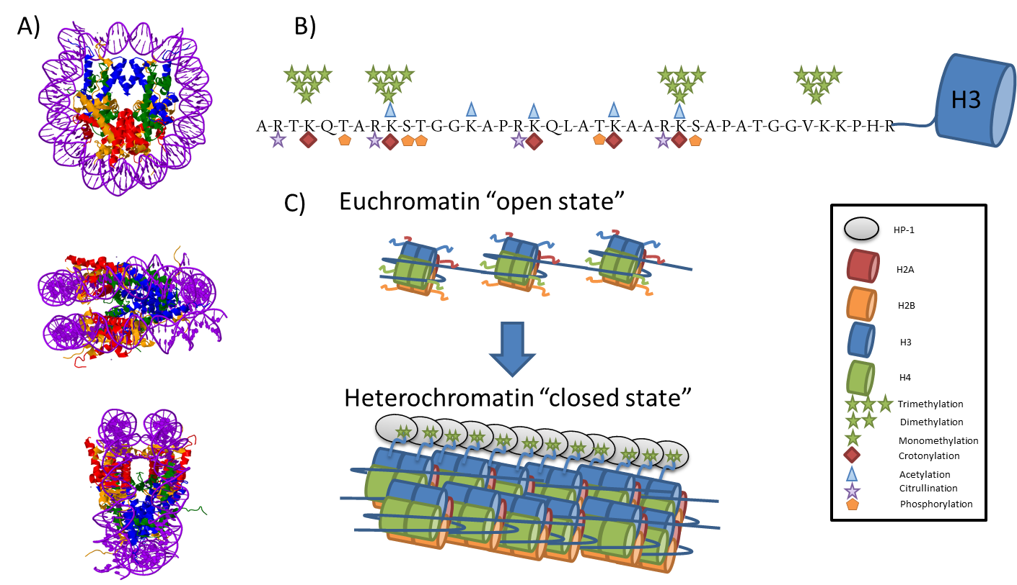
Figure 1.1 The nucleosome, chromatin and histone post translational modifications
A) The crystal structure of a nucleosome containing 146 bp of DNA wrapped around a core histone octamer consisting of 2 copies of the proteins H2A (red cylinder), H2B (yellow cylinder), H3 (blue cylinder) and H4 (green cylinder). Protruding from each histone protein is an unstructured N-terminal tail, which can be modified by the addition of a number of chemical groups. Image from the RCSB PDB (www.rcsb.org) of PDB ID 1ID3 (White 2001).
B) The N-terminus of histone H3 is heavily modifiable. Modifications to the histone tail include methylation, phosphorylation, acetylation and crotonylation and contribute to a complex combinatorial code. C) The addition of a dimethyl group at lysine 9 on histone H3 is strongly associated with gene repression in promoter and enhancer regions. The interaction between H3K9me2 and the protein HP-1 causes heterochromatin formation and leads to the inaccessibility of the underlying DNA preventing transcription.

Along with weakening the interactions between the histone proteins and DNA, these modifications are essential for the recruitment of SWI/SNF complex and an ATPase. The presence of which causes the nucleosome to slide 36 bp along the DNA freeing up a TATA box which allows transcription factors to bind and hence initiates gene expression (Lomvardas & Thanos 2001). This notion was backed by the observation that acetylation of H4K8 is needed for the recruitment of the ATPase to the SWI-SNF complex and by mutational studies on H3K9 and H3K14, which when mutated stops the recruitment of TFIID (Agalioti et al. 2002).
4) Adaptors- Readers can also act as adaptors for a plethora of different proteins that interact with the DNA anchoring them to chromatin, in a highly selective manner dependent upon the histone modifications present (Zippo et al. 2009). Recombination of V(D)J genes is vital for the generation of the huge repertoire of immunoglobulins expressed by B cells and T cells (Tonegawa 1983). The proteins RAG1 and 2 are essential in the initial steps of this recombination process (Ji et al. 2010). RAG2 contains a PHD domain, which has been shown to be specific (by mutagenic studies) to histone H3K4me3 (Matthews et al. 2007). Association with the H3K4me3 mark was found to be the major factor contributing to the association between RAG2 and chromatin. Another example of a histone modification, this time at the C terminus, is the phosphorylation of Ser139 on a special histone variant known as H2AX. H2AX binds to MDC1, causing a cascade of phosphorylation, eventually ending up in the recruitment of DNA repair proteins (Jungmichel & Stucki 2010). The recruitment of adaptor proteins is also the mechanism by which histone modifications play a role in the recruitment and activity of transcription. The activational control of the HO gene in yeast has been well studied, including the recruitment of coactivators, alongside the role of and modifications of histone PTMs. The SWI/SNF complex with the action of the ATPase effectively slides nucleosomes around 36 bp of linker DNA, causing new areas of DNA to be exposed leading to the recruitment of the transcription factor: TFIID from the pre-initiation complex (PIC) (Mitra et al. 2006). The recruitment of TFIID is dependent upon the state of histone modifications around the TATA box to which the TBP domain of TFIID binds on the DNA. The subunit TAF_{II}250 (AKA TAF1) contains two bromodomains that bind to H4K5ac, K8ac, K12ac, K16ac with micromolar affinity. This binding is both sequence and modifications specific (Jacobson 2000). The binding of TAF3 to histone H3K4me3 acts along with other histone modifications to selectively anchor TFIID (Vermeulen et al. 2007). The binding of which allows the assembly of the PIC and therefore the start of transcription. These examples show a mechanistic link between histone acetylation, H3K4me3 and gene transcription, exemplifying how important the histone code is for controlling the gene expression of a cell.

Techniques for studying PTMs on histones

Identification of histone PTMs using antibody based techniques
Antibody based techniques are widely used for studying histone PTMs, These antibodies are not only specific to a particular chemical modification, but are also sequence specific. Antibody based techniques such as western blots and dot blot analysis have been used not only to provide identification of histone modifications but also semi-quantitative data. These techniques have been used to probe the role of histone modifications in a multitude of systems and have forwarded the field of epigenetics enormously (Wei et al. 2009; Roh et al. 2006; Jacobson 2000). Antibodies provide a very sensitive, high throughput method for the detection of histone PTMs and have been used to associate histone PTMs with cancer (Elsheikh et al. 2009), immunity (Wei et al. 2009) and in a wide range of other fields.
However, as with all techniques, there are a number of limitations with respect to antibody based techniques for probing histone modifications, including problems associated with selectivity, epitope occlusion and cross reactivity (Fuchs et al. 2011; Egelhofer et al. 2011; Barski et al. 2007). Moreover, antibody based approaches usually can only detect one modification at a time and are not directly able to identify new or novel histone PTMs.

Chromatin immunoprecipitation (ChIP)
Chromatin immunoprecipitation (ChIP) allows specifically modified histones to be immunoprecipitated along with its corresponding DNA sequence, thus allowing the mapping of certain histone modifications to their genomic location. This technique is often used in conjunction with next generation sequencing tools to perform ChIP-seq or with microarray technology in ChIP-chip to provide a high throughput method of linking histone PTMs to genomic location (Collas 2010). These techniques enable researchers to probe the epigenome and have enabled significant advances in the field of chromatin and epigenetics research. The current technologies have been reviewed by Collas (Collas 2010).

Mass spectrometry
Mass spectrometry (MS) represents an orthologous pathway by which histone modifications can be identified and is often considered as the gold standard for protein identification and quantification (Aebersold et al. 2013). Mass spectrometers measure the mass to charge ratio (m/z) of ions, in the gas phase. In the case of proteins and peptides, their ionization and delivery into the gas phase is achieved by alternative MS ion sources: matrix assisted laser desorption ionization (MALDI) or electrospray ionization (ESI) via an online high performance liquid chromatography system (HPLC).
The basic function of these sources is to convert the sample in the liquid phase to gaseous phase, and channel the resulting gaseous ions into the mass spectrometer. In MALDI, this is done by placing the sample to be analysed and drying it on a highly absorptive matrix compound. This is then bombarded by a laser, causing both the sample and matrix to be released as singularly charged ions, these are then fed into the MS (Karas & Hillenkamp 1988; Hillenkamp et al. 1991). In ESI, the ionisation process, which produces an aerosol of highly charged ions, occurs by passing the acidic sample solution through a capillary tipped needle in the presence of a high electric charge (Mirgorodskaya 1994; Mann & Wilm 1995). The peptides, due to the acidic nature of the sample solution have a positive charge causes them to repel each other resulting in the formation of smaller and smaller droplets. Eventually, this reaches a point where the surface tension of the droplets is exceeded by the repulsive forces between the positively charged ions causing them to be expelled. The positively charged ions are then channelled into the mass spectrometer where they are guided to the first quadrupole by electrostatic lenses (Figure 1.2). Unlike MALDI, ESI can produce multiply charged ions, these are denoted as such (M+nH) ^{n+} where M = the mass of the ion, H = mass of a proton and n= charge state of the ion. One of the major benefits of ESI is its compatibility with high performance liquid chromatography (HPLC) allowing the peptides to be separated and continually fed into the mass spectrometer (Figure 1.2).

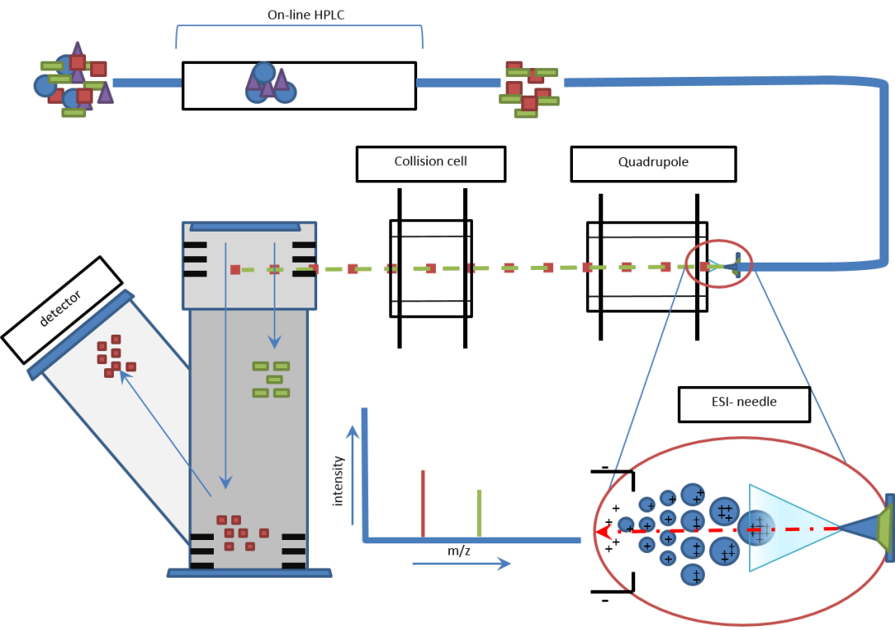
MS aperture
ESI-needle

Eluted subset of peptide mixture
Mixture of peptides

Figure 1.2 A schematic diagram of a typical QToF mass spectrometer and online HPLC set-up
Digested peptides are separated on a C18 column which is online with the mass spectrometer and allows the separation of the peptides based in an orthogonal manner to mass spectrometers. The peptides in the liquid phase are converted to charged ions in the gas phase and introduced to the MS by the electrospray ionisation needle. The ions then travel along a series of quadrupoles, and their mass to charge ratio (m/z) is determined from the flight time in the time of flight tube.

The Quadrupole mass analyser.
Once the ions have entered the mass spectrometer they are funnelled into the quadrupole mass analyser. The quadrupole mass analyser is often referred to as a mass filter; this is due to the way in which the quadrupoles influence the ions within the analyser. The quadrupole mass analysers consist primarily of 2 pairs of rod shaped electrodes organised as shown in Figure 1.3. The principle by which the quadrupoles operate is that within a radiofrequency (RF) field, the force that an ion experiences is proportional to its distances from the centre of the field. Using this premise it is possible, by altering the RF and direct current (DC) voltages in the correct combination to effectively trap the ions on the x and y axis, thus allowing it to move along the z axis (Miller & Denton 1986). There is a defined range of ion m/z values that are stable within certain parameters of RF and DC voltages. Therefore, the quadruple analyser can effectively be implemented as a mass filter. Ions with an m/z value outside of the range of stability will follow an unstable trajectory and will not be transmitted along the quadrupole (Figure 1.3). Quadrupoles can also act as ion transmitters allowing all ions within a range of m/z to be transmitted along the quadrupole. These two functions are utilised to enable the mass spectrometer to both scan the m/z of different peptides, or pick and isolate one of these for tandem M/S (MS/MS) (discussed later). The layout of multiple quadrupole units within a mass spectrometer allows this. Within Quadrupole- Time-of-flight (Q-ToF) mass spectrometers there are usually two Quadrupoles: Q1 and Q2, as shown in Figure 1.2. Depending on the function that the mass spectrometer is running, Q1 can act as an ion transmitter or a mass filter. During an MS run Q1 allows a broad range of m/z ions to be transmitted into Q2, also known as the collision cell. In the case of MS analysis, Q2 acts as an ion transmitter and feeds the ions into the ion modulator section of the ToF instrument. During an MS/MS run Q1 acts as a mass filter and only allows a small range of m/z to be transmitted to Q2. These selected ions (known as parent ions) are subjected to collision induced dissociation (CID) to form fragment ions and are fed into the detector (discussed in section 1.5.3.3) (James 2001).

Quadrupole – side on view
Quadrupole – front on view
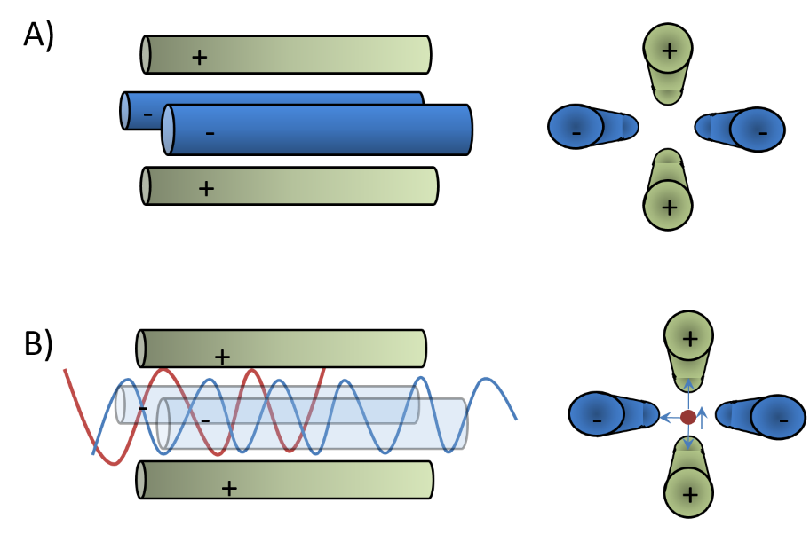
Stable trajectory
Unstable trajectory
Figure 1.3 A schematic representation of the quadrupoles within a mass spectrometer.
The quadrupole within a mass spectrometer consists of 4 electrodes arranged as shown in A. By manipulating the current passing through the electrodes, the radio frequency field generated by can be used to trap the ions along the X and Y axis, allowing them to pass through the quadrupole along the Z axis (B- blue path). The quadrupole therefore can also act as mass filter by manipulating the ions in such a way that only ions with a select m/z can pass along the quadrupole on a stable trajectory, Those ions that are no selected have an unstable trajectory and do not pass along the length of the quadrupole (B - red path)

Time of Flight
There are many types of mass analysers used in proteomic research, such as Ion Tap, Fourier transform ion cyclotron resonance (FT-ICR) and Time-of-flight (ToF) mass analysers. My research utilises the ToF mass analyser. Ions are introduced into the ion modulator from the collision cell (Figure 1.2), and packets of these ions are exposed or pulsed with an accelerating voltage, causing these ions to “fly” down a tube of set length under vacuum. The ions travel along the length of tube in a straight line and at constant speed to the detector which plots the abundance of the ion and the time in which it took to travel from the pulse event to the detector. The speed at which the ions travel down to the detector is dependent upon two factors: the mass of the ion (m), and the charge of the ion (z). Typically, for ions with a single charge (z=1) the larger the mass the longer it will take for the ion to travel to the detector. Therefore accurately measuring the time taken for ions to reach the detectors enables the determination of the m/z of the ions (Guilhaus 1995). The resolution of the instrument is limited by two factors that mainly occur when measuring ions with high mass. The first of these relates to the way in which the two ions of different mass are distinguished. The expression of the difference in flight times between two ions with one unit of mass difference can be expressed as follows:

$$t_{m-}t_{m+1}=∆t=\left[\sqrt{\frac{m}{z}}-\sqrt{\frac{m+1}{z}}\right]×x$$
Where X is a constant based on tube length, electron charge and accelerating electric field. (Increase in tube length, will increase X).
And t= time taken for the ion to reach detector.
M = mass of ion and z = charge of ion
The other limitation in terms of resolution using this type of mass analyser results from the fact that ions of the same mass will not all arrive at exactly the same time to the detector. This is due to the fact that the different positions at which the ions receive the accelerating force. Similarly they will not receive exactly the same amount of kinetic energy. Therefore, the ions will arrive with a Gaussian distribution, this combined with the small time difference between higher mass ions arriving can cause overlap in arrivals and hence reduce resolution.
It is possible however, to improve the resolution by extending the length of the flight tube, although this can be somewhat impractical, so a device known as a reflectron is often used. The reflectron is effectively and ion mirror and causes the ions to reverse the direction of travel and return along the flight tube to a detector. The reflectron consists of a series of equally spaced electrodes that have the same polarity as the oncoming ions. This not only effectively doubles the length of the flight tube and therefore increases the resolution; it also addresses one of the major limitations to resolution discussed above. The reflectron does this by correcting the distribution in kinetic energies within isobaric ions species: ions with higher kinetic energy penetrate further into the reflectron, and so spend longer in the reflectron than isobaric ions with lower kinetic energy, causing the packet of ions to group together more tightly and arrive at the detector in a much smaller time range. In this way, the reflectron vastly increases the resolution of ToF instruments.

Tandem Mass spectrometry.
The output of m/z values from the MS can be used to determine very accurately the mass of a protein or peptide (precursor mass). This information is then combined with tandem MS (MS/MS) to enable unambiguous identification of the peptide sequence and more importantly the precise location of any PTMs that might be present. Tandem MS is performed by isolating a specific precursor ion and inducing its fragmentation into a series of product ions (Figure 1.4). The m/z values for these ions are measured and mapped to protein sequences in a database to provide identification. Moreover, the position of the amino acid that has been modified can be elucidated (Figure 1.5). Fragmentation for tandem MS is commonly performed using collision induced dissociation (CID). In CID, the isolated precursor ions are, depending on the type of MS either directed into a collision cell or confined in an ion trap both containing an inert gas, normally nitrogen, argon or helium. Collisions of the precursor ion with the gas molecules causes fragmentation (James 2001; Khatun et al. 2007). CID causes the peptide to fragment predominantly at the peptide bond (C-N) causing the formation of b- and y-ions (see Figure 1.6). This method is best for analysis on smaller peptides <15 residues, and lower charger states. Electron capture dissociation (ECD) and electron transfer dissociation (ETD) are additional fragmentation approaches which are more commonly used for proteins and large peptides with charge states >3. ECD and ETD both use the transfer of electrons to drive fragmentation reactions (Zubarev et al. 1998; Zubarev 2004; Syka et al. 2004). The ability to accurately map the position and type of multiple modifications in an unbiased way makes MS ideal for the identification and characterisation of histone PTMs. However, there are several challenges to overcome, such as resolution of isobaric modifications, and discrimination between chemical modifications with the same nominal mass, such as acetylation and tri-methylation (which differ by 0.036 Da).
ESI Needle

ESI Needle

Figure 1.4 A Schematic overview of MS and MS/MS workflows
Ions are introduced into the mass spectrometer by the ESI needle, in MS mode the quadrupole acts as an ion tunnel and allows all ions to pass through, the collision cell is empty and ions pass through to the time of flight analyser (ToF) where packets of ions are pulsed with an accelerating voltage. The time taken to traverse the flight tube to the detector is dependent on the m/z of the ion. This results in MS spectrum. From this specific parent ions are chosen for tandem MS/MS. In order to accomplish this the first quadrupole acts as a mass filter only letting the selected ion through into the collision cell where it is fragmented by collisions with an inert gas such as argon. The m/z value for each of these fragment ions is then determined allowing the amino acid sequence to be deduced.

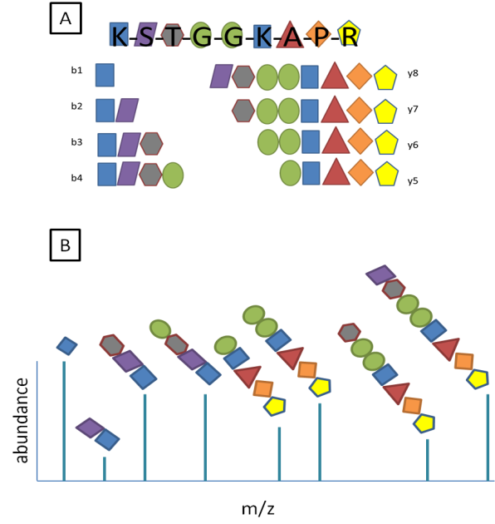
Figure 1.5 Schematic diagram of peptide fragmentation that occurs in tandem MS (MS/MS).
(A) Tandem MS is used to determine the primary sequence of the digested peptides. Internal fragmentation of the digested peptide along the peptide backbone generates a series of charged ions. The Figure highlights the typical fragments that are generated using collision induced dissociation resulting in the formation of y and b ions depending on which peptide bond along the backbone is cleaved (single letter amino acid code shown). (B) The m/z values for these ions are measured and compared to a theoretical database, allowing the peptide sequence to be determined. In addition this enables the precise identification of the site of any PTM present.

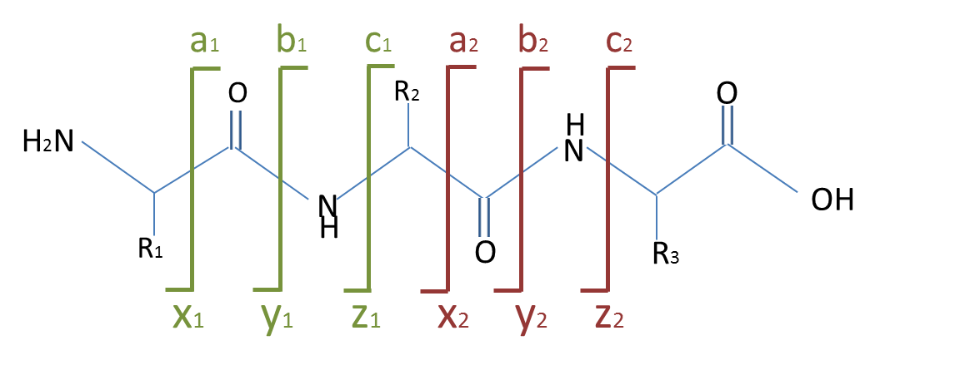
Figure 1.6 Fragmentation patterns of peptides induced by collision induced dissociation with an inert gas
A schematic of a peptide backbone, showing the ions that are formed depending upon the position of the cleavage: In order to generate MS/MS spectra, isolated populations of ions are fragmented. There are several ways in which this can occur, such as via collision induced dissociation (CID) or electron capture dissociation (ECD). The type of dissociation influences where the fragmentation occurs, and hence the structural nature of each of the fragments. In CID the fragmentation occurs at the peptide bond generating b and y ions, whereas ECD causes the cleavage of N-Cα bonds generating mainly c and y ions. The fragmented ions are then passed into the detector. The resulting spectra allow the sequence of the peptide to be determined.

MS workflows for the analysis of histone PTMs
The mass spectrometry workflows adopted for the analysis of histone PTMs can broadly be differentiated into 3 different strategies; top down, middle down and bottom up. The main difference between these approaches lies in the use of enzymatic digestion, which has a knock on effect on the type and depth of information that can be achieved and is summarised in Table 1.1. As all of the work presented in this thesis utilises the bottom up approach, the following section will discuss in detail this MS strategy for studying histone PTMs.

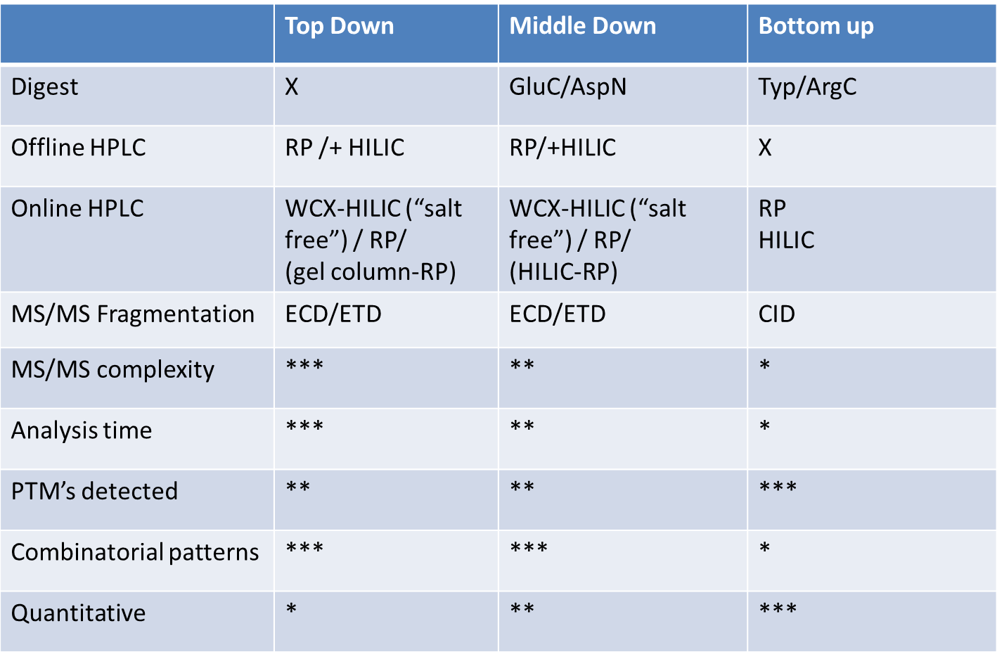
Table 1.1 Summary of MS approaches used to identify histone PTMs.
MS analysis of histone proteins can be divided into three different strategies; top down, middle down and bottom up. Due to the comparatively small size of the peptides generated in the bottom up approach, the MS/MS complexity is relatively low as is the analysis time. Middle down and top down approaches allow the analysis of larger peptides/intact proteins respectively. The larger size also impacts on the upstream separations that are required to achieve the necessary resolution to allow accurate quantification. However, these approaches enable long range combinatorial PTMs to be probed. Arbitrary scale used *: low, ***: high.

Bottom up
Bottom up is the most widely used approach for MS based proteomics. Peptide generation is normally performed using enzymatic digestion, commonly by trypsin, because of its high reproducibility and affordability. The analysis of small peptides (typically 8-15 amino acid residues) rather than using intact proteins is advantageous due to the reduction of spectral complexity allowing easier data analysis, greater sensitivity and higher mass accuracy. A chemical derivatisation step is often included before the use of trypsin owing to the high abundance of both lysine and arginine residues at the N-terminal tails of histone proteins generating very small hydrophilic peptides, which are unsuitable for analysis via liquid chromatography tandem mass spectrometry (LC-MS/MS). Propionylation is one of the most common chemical derivations used; adding a propionyl group to lysines, mono-methyl lysines and the peptide N-terminus (Garcia, Mollah, et al. 2007). Thus, propionylation effectively changes the specificity of trypsin to that of Arg-C, but with the efficiency and reproducibility of trypsin (Garcia, Mollah, et al. 2007). It also makes the peptide fragments more hydrophobic, leading to increased retention on reverse phase high performance liquid chromatography RP-HPLC columns prior to MS analysis and reduces the charge state making the peptides more amenable to fragmentation using CID (Garcia, Mollah, et al. 2007; Bonaldi et al. 2004). The major downside in using bottom up peptide centric approaches is that long range combinatorial information is lost. However, some combinatorial information can be elucidated from these studies as well as accurate and detailed PTM analysis of the histone tail. This has been successfully done in many biological systems including Homo sapiens (Zhang et al. 2013), Apis melifera (Dickman et al. 2013), Saccharomyces cerevisiae (Ngubo et al. 2011) and Suz12 KO mouse embryonic stem cells (Jung et al. 2010). It is important to note that the different approaches to mass spectrometry are not mutually exclusive and sometimes a combined approach is best. Bonet-Costa et al used a combination of bottom up and top down to identify and map 25 PTMs across the entire histone H1 protein (Bonet-Costa et al. 2012).

Quantification of histone modifications using mass spectrometry
In addition to the identification and characterisation of histone PTMs, MS approaches can quantify their relative or absolute abundance. Techniques for quantification of histone PTMs can be divided into two groups: stable isotope labelling and label free.
The use of stable isotope labelling is a common method used in proteomic quantification and can be divided into two categories: (a) chemical and (b) metabolic labelling. These labelling approaches generate light and heavy versions of the same peptide from two experiments, making them distinguishable by MS and thus enabling their analysis as a mixture in a single acquisition. Therefore, the change in relative ion intensities given by the heavy and light forms of the peptide directly correlate to the changes in relative abundances of the peptide under two experimental conditions.
Chemical labelling methods such as deuteroacetylation has been used as a quantification method (Smith et al. 2003). Deuterated propionic anhydride (d10) has also been used in conjunction with chemical derivatisation in bottom up strategies for quantification (Plazas-Mayorca et al. 2009). However, the use of this type of chemical derivatisation for labelling only produces a small difference in m/z between the heavy and light versions, which can lead to issues with correct identification of heavy and light pairs. Another disadvantage is that deuterated peptides typically elute earlier compared to their unlabelled counterparts during reverse phase chromatography (Boutilier et al. 2012), presenting a further challenge for data processing.
Stable isotope labelling with amino acids in cell culture (SILAC) is an example of metabolic labelling (Ong et al. 2002; Chang et al. 2013). Heavy isotopes are introduced via “heavy” amino acids contained within growth medium or food. Heavy forms of the lysine and arginine are widely used in combination with trypsin, ensuring that every peptide generated contains at least one heavy amino acid. In the MS scan, the heavy and light versions differ in mass by exactly the mass difference between the light and heavy amino acids. This technique is most amenable to cell lines, but has also been used to label Drosophila melanogaster by the feeding of “heavy” yeast. SILAC has successfully been used to map the breast cancer-specific epigenetic signature of 4 different human cancer cell lines (Cuomo et al. 2011) and quantify histone PTMs from HeLa cells arrested at different cell cycle time points (Bonenfant et al. 2007).
It is also possible to quantify proteins, via their (tryptic) peptide fragments without using a label. For relative quantification, the different samples are not isotopically labelled and consequently require separate LC-MS/MS analyses. Extracted ion chromatograms corresponding to the target modified peptides in the separate analyses are integrated to determine the relative abundances of specific modifications in the different samples. Label free analysis has been used to identify and quantify 59 differentially modified H3 and H4 in different stages of Xenopus laevis embryo development (Schneider et al. 2011) and compare PTM profiles of H3 in various model organisms (Garcia, Hake, et al. 2007)
The effective separation of positional isomers represents one of the biggest challenges in quantifying histone PTMs. This is true of all approaches, be it top down or bottom up. These species are isobaric and often co-elute and hence result in multiplexed tandem mass spectra, making it difficult to elucidate the relative abundances of the different positional isomers. A novel mixed integer linear optimization (MILP) computational framework has been developed allowing the relative abundances of multiplexed species to be accurately determined (DiMaggio et al. 2009).
MS based quantification not only allows the global relative abundances of histone post translational modifications to be elucidated, but also the vast combinatorial patterns of PTMs. Global patterns of histone PTMs have been described in several disease phenotypes including breast cancer and Crohn’s disease (Tsaprouni et al. 2011). However, the location of the histone proteins in relation to the genome is unknown, something that is possible with ChIP experiments.

Combining antibody and MS approaches
Current technologies feature MS and ChIP as separate entities; with MS allowing an unbiased global view of histone modifications and ChIP providing information regarding the genomic location of selected histone modifications. New technologies attempt to bridge the gap between these two seemingly polar techniques. Modifications of native ChIP techniques have been combined with quantitative MS (ChIP-qMS) using FLAG tagged bromo/chromodomains to isolate chromatin. The histone proteins are then subjected to MS analysis (Leroy et al. 2012). An alternative technique termed chromatin affinity purification with mass spectrometry (ChAP-MS), utilizes a specifically enriched ~1000 bp section of chromatin. The chromatin proteins are then separated for MS analysis, giving an unbiased view of genomic location specific histone modifications (Byrum et al. 2012). Similarly, Dejardin & Kingston used hybridisation of a labelled oligonucleotide to isolate telomeric DNA and associated chromatin proteins (Déjardin & Kingston 2009). The combination of ChIP and MS has also been used to assess histone modifications by cross-linking a bromodomain protein (MSL-3) to chromatin and other interacting proteins, which were identified by LC-MS/MS analysis. MSL-3 was found co-localise with both H3K36me3 and CG4747, a putative K36me3 binding protein (Wang et al. 2013). This technique is unique in that it allows low-affinity interacting proteins to be captured and identified by MS on the intact chromatin template, whist at the same time allowing an unbiased characterisation of the PTMs on the captured histone proteins.

Sepsis
Sepsis, is a severe clinical syndrome that results from the damaging host response to infection (Levy et al. 2003; Bone et al. 1992). Clinical definitions of sepsis and its related conditions, such as septic shock and severe sepsis is a much debated topic. In 1991, the Society Critical Care Medicine along with American College of Chest Physicians, came together at a consensus conference to define a set of clinical definitions for sepsis and related terms, these are summarised below:
- Systemic inflammatory response syndrome (SIRS): the systemic response to a severe clinical insult, (such as burn injuries). Clinically it must satisfy 2 or more of the four criteria listed in Figure 1.7.
- Sepsis: the systemic response to infection. I.e. SIRS with presence of an infectious agent.
- Severe sepsis: Sepsis associated with organ dysfunction, hypoperfusion or hypotension.
- Septic shock: sepsis induced with hypotension despite adequate fluid resuscitation along with perfusion abnormalities.
Figure 1.7 The clinical diagnostic criteria for sepsis
In 2001 a meeting between SCCM/ESICM/ACCP/ATS/SIS societies, was conducted to revisit the clinical criteria for the diagnosis of sepsis and its sequelae originally defined by (bone et al., 1992). From this they updated and expanded the clinical criteria to better reflect the response to a systemic infection Taken from (Levy et al. 2003).
In light of criticisms of these definitions being over sensitive and unspecific the Society of Critical Care Medicine (SCCM), The European Society of Intensive Care Medicine (ESICM), the American College of Chest Physicians (ACCP), the American Thoracic Society (ATS), and the Surgical Infection Society (SIS) sponsored a definitions conference. The outcome was an extended list of criteria that better defined the clinical aspects of sepsis (Figure 1.7). Along with the PIRO acronym system for the staging sepsis in order to better characterise the syndrome. P stands for predisposing factors i.e. any premorbidities that may reduce short term life expectancy. I stands for infection as the site, extent and type of infecting agent will affect prognosis. R relates to the host response to the infection, such as SIRS. Finally O stands for organ dysfunction and includes the failure of the coagulation system among others (Levy et al. 2003).
It is estimated that there are 18 million cases of sepsis worldwide with 1.8 million confirmed every year (Slade et al. 2003). With mortality rates of 30-50%, sepsis causes an estimated 32,000 -64,000 deaths every year in the UK alone. This causes a large burden on the NHS, with 46% of intensive care unit bed days being occupied by patients with severe sepsis each year and costing £2-3bn (Harrison et al. 2006).

Biochemical nature of sepsis
The host’s reaction to the infection (usually bacterial) is what causes the detrimental effects seen in sepsis. While, there is simultaneously a pro-inflammatory and an anti-inflammatory/ immunosuppressive response by the host to sepsis (Figure 1.8). It is thought that the pro inflammatory response usually dominates in the initial stages, driven via the innate immune system by cytokines such as TNFα (Rigato et al. 1996). Lipopolysaccharide (LPS) has been shown at least for gram negative infections, to be one of the major drivers of this initial cytokine storm. Injections of LPS alone induce a shock like state in humans (Suffredini et al. 1989; Parrillo 1993). It is also seen at elevated levels in patients with severe sepsis (Munoz et al. 1991). LPS is a potent pathogen associated molecular pattern (PAMP) recognised by TLR4 mainly on macrophages which results in the activation of NFκB or AP-1 , via MyD88 independent or dependant pathway respectively (Figure 1.9) (Lu et al. 2008). Activation of macrophages by LPS leads to adaptation of the cells to an M1-inflammatory phenotype and the release of a plethora of pro-inflammatory cytokines such as TNFα IL-6 and IL-1β (Foster & Medzhitov 2009). The macrophage is one of the most vital cells to the innate immune system. The importance of macrophages to the immune system, is best exemplified by the observation that tissue macrophages are present in most of the body’s organs, sometimes making up to 15% of the total cell numbers in these organs (Sakurai et al. 2002).

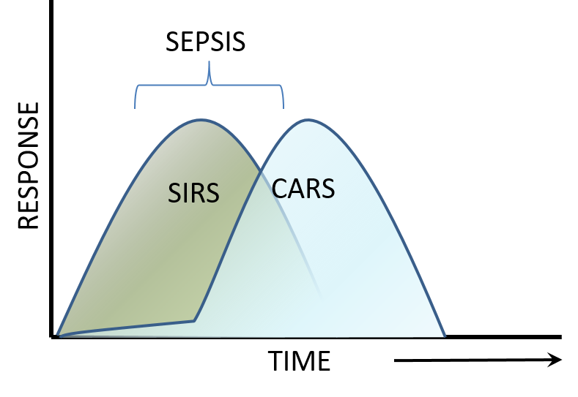
Figure 1.8 A graphical representation of the progression of sepsis
Sepsis is a complex clinical condition that comprises of differing and overlapping responses by the immune system. A) Firstly, a mass inflammatory response known as systemic inflammatory response syndrome (SIRS), which in the presence of an infectious agent equates to sepsis, this is the hallmark of acute sepsis, and septic shock. Following this acute mass inflammatory stage, i.e. in a protracted state of severe sepsis, the pathology is earmarked by a mass immunosuppressive response known as Compensatory anti-inflammatory response syndrome (CARS) in which cells of the immune no longer mount a pro-inflammatory response. B) Excess pro-inflammatory is the main cause of death in early stages of sepsis whereas, the response and pathology shifts to one dominated by an anti-inflammatory response, leading to death via failure to clear infections. Image taken from (Hotchkiss et al., 2013)

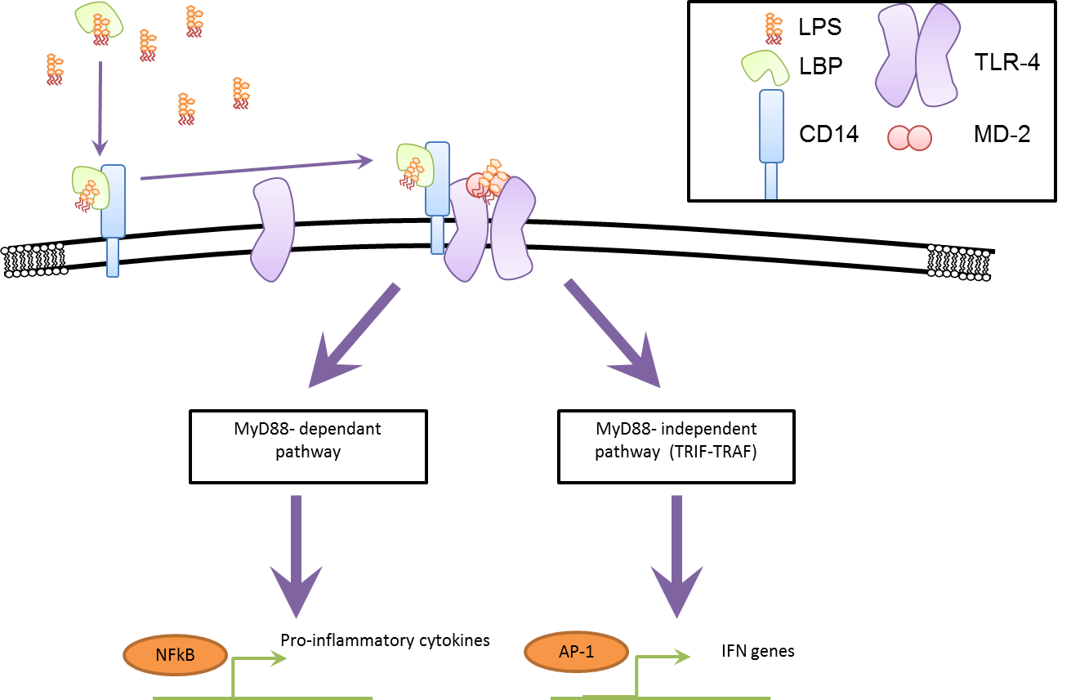
Figure 1.9 An overview of the TLR-4 signalling pathway
The recognition of Lipopolysaccharide (LPS) is highly regulated and involves many different proteins. LPS is bound extracellularly by the shuttle protein: LPS binding protein (LBP), which facilitates the binding between LPS and CD14. Once bound with LPS, CD14 assists the binding of LPS to the TLR-4/MD-2 complex. Upon binding this complex undergoes oligomerisation and the signal is transmitted into the cell and proceeds either via the MyD88 or TRIF-TRAF dependant pathway, resulting in the activation either NFκB or AP-1 which causes the expression of a plethora of genes.
When the inflammatory response is too large, it can cause multi organ damage in part due to tissue ischemia as a result of hypotension and haemodynamic instability. The inflammatory markers such as TNFα and Il-1 stimulate the release of tissue factor, in monocytes, macrophages and also within epithelial cells (Esmon 2005; Moldow et al. 1993). The release of tissue factor results in the stimulation of the extrinsic clotting cascade causing systemic clotting and depletion of the bloods clotting factors, this can result in disseminated intravascular coagulopathy (DIC) and eventually lead to death (T. Zhao, Li, Liu, et al. 2014; Esmon 2005). This pathway to destruction is avoided by a mechanism known as LPS tolerance. Acquired tolerance to the potent pyrogen LPS was first discovered in the 1940s, since then much research has focused on the basis this protective response. The tolerisation event is focused predominantly but not exclusively on monocytes and macrophages. Pre-treatment with LPS, causes a highly attenuated pro inflammatory cytokine response to a delayed secondary dose (Mages et al. 2007). TNFα and IL-6 show a vastly reduced induction; this reduction in response was seen as the hallmark of tolerance (Erroi et al. 1993). However, TLR4 signalling is not restricted to the production of pro-inflammatory cytokines; there are rafts of other important molecules that are up regulated upon primary stimulation, these include anti-microbial peptides, anti-inflammatory mediators and cytokines. Interestingly, not all of these are down regulated upon a secondary LPS stimulation, suggesting that retrograde control, via negative feedback loops, of the TLR4 signalling cascade is not sufficient to account for the gene level control exhibited by a tolerised cell (Foster & Medzhitov 2009; Lu et al. 2008).

The role of Histone PTMs in sepsis
This next section will describe the role of epigenetics in sepsis. Firstly the role of histone PTMs is examined in the innate immune system during sepsis, focusing specifically on macrophages and secondly the adaptive immune system, focusing on T-cells.

Macrophages
Foster et al, split TLR4 inducible genes into two classes depending on whether the genes induced by the first 24 hr LPS stimulation were either not induced or induced to a much lesser extent (toleriseable (T)) or still inducible (non-toleriseable (NT)) by a second LPS stimulation. He concluded that the control of expression was at the single gene level mediated at the chromatin level driven by histone protein modifications(Foster et al. 2007). ChIP analysis on bone marrow macrophages from mice identified an increased level of acetylation in Histone H4, upon LPS stimulation at the promoter regions of both NT and T genes. However, this acetylation was not maintained in T class genes such as Il-6 upon stimulation of tolerised macrophages (Foster et al. 2007). Acetylation is associated with active areas of gene expression and open chromatin conformation, the acetylation events observed in naïve and tolerised macrophages correlates well with expected changes in gene expression. Another modification associated with gene activation H3K4me3 was analysed by ChIP. Despite, being increased in both sets of genes, H3K4me3 is selectively lost at NT genes in tolerised macrophages stimulated with LPS (Foster et al. 2007). These findings agree with previous research focusing on the TNFα gene (a tolerisable gene) in which the dimethylation of K9 by G9a was found to be causative in the silencing of TNFα gene expression along with DNA methylation enzymes (El Gazzar et al. 2007).
Due to sequestration of DNA binding regions by H3 methylation mediated HP-1 binding, TNFα is not expressed in resting naïve macrophages (El Gazzar et al. 2007). Following LPS stimulation via TLR4, NFΚB proteins are activated and accumulate in the nucleus, this coincides with the loss of H3K9me and increase in phosphorylation of H3S10 allows the recruitment of p65 (an NFΚB protein) and transcription of TNFα (El Gazzar et al. 2007). LPS stimulation of macrophages also directly increases levels of the demethylase JMJD3, via activation of NFΚB. JMJD3 influences the expression of around 70% LPS inducible genes in mouse bone marrow macrophages (BMM’s) (De Santa et al. 2007). However, in tolerant macrophages, along with the sequestration of p65 in the cytoplasm, H3K9 is remethylated and H3S10 is dephosphorylated, allowing HP1 binding, preventing the production of TNFα. Similarly, with the IL-1β gene, methylation of histone H3K9 is inversely proportional to p65 binding and gene expression (Chan et al. 2005). The methylation events allow a platform for G9a protein to bind and methylate the underlying DNA; along with HP1 further strengthening the silencing event (El Gazzar et al. 2008). Histone acetylation has also linked to macrophage response to LPS (Foster et al. 2007).

T-cells
The adaptive immune system, consisting of T and B cells elicits a specific and versatile response to invading pathogens and protection against reinfection of the same pathogens. T-cells can be divided into several subsets, defined by the expression of surface cell markers e.g. CD4+ and CD8+ cells. CD4+ cells also known as T helper cells (Th cells) are vital for a fully functioning immune system: Th cells aid in the maturation and activation of B-cells, cytotoxic T-cells (CD8+) as well as macrophages. Although at first the idea of sepsis deaths being due to immunosuppression was viewed as controversial, there is now a mounting body of evidence that supports this theory, including patients that died from septic shock having unresolved septic foci, and a propensity to develop and die from nosocomial infections such as Candida spp. (Torgersen et al. 2009; Otto et al. 2011). One of the most striking pieces of evidence is the marked reduction in immune cells, including T and B cells, via apoptotic pathways, resulting in a reduction of the very cells that should be undergoing clonal expansion in order to fight the mass infectious event (Boomer et al. 2011). In addition, the phagocytosis of apoptotic cells by innate immune cells can induce immune tolerance. This mass apoptotic event is seemingly resisted by the immunosuppressive T-regs (a subset of CD4+ cells), which leads to a relative increase in T-reg numbers in septic patients. Although this eventually returns to normal levels (Venet et al. 2004). Post septic T-regs show increased immunosuppressive activity compared to normal controls (Cavassani et al. 2010). The expression of FoxP3 is required for the differentiation of the T-regs. This expression has been shown to be linked with an increase in H3K4me3, H3K9ac and DNA demethylation (Sauer et al. 2008; Cavassani et al. 2010; Kim & Leonard 2007). Interestingly, in post sepsis classically non T-reg T-cells (CD4+ CD25-) the foxp3 gene is increased, suggesting that these cells are being primed towards an immunosuppressive phenotype, These T-regs show an significant increase in the expression linked H3K9ac around the foxp3 gene, alongside increases in the HAT kat2a mRNA (Cavassani et al. 2010).
Human CD4+ T-cells recovered from spleen and lung tissues 30-180 minutes post mortality also suffer long term deficiencies in proliferation and in the production of cytokines both pro and anti-inflammatory and are deemed as being skewed towards a more anti-inflammatory Th2 phenotype (Roth et al. 2003). This state of anergy, also described as an exhaustive phenotype is coupled with the increase of the inhibitory cell surface molecule PD-1 and decrease in cell survival molecules IL-7Rα in the spleen, both of which correlate with mortality (Boomer et al. 2011). Further to this, sepsis causes a reduction in the diversity of T-cell receptors. Like, the formation of antibodies, the TCR repertoire is dependent upon recombination of V (variable) D (diversity) and J (joining) (V(J)D) genes. This recombination is vital to the correct recognition of antigens by the adaptive immune system, evident by the severe immunocompromised state of severe combined immunodeficiency (SCID) mice (Chang et al. 1995). This process has been documented to be under the regulation of histone PTMs: H3k4me3 binds to the protein RAG2 which is necessary for recombination to occur (Liu et al. 2009; Matthews et al. 2007).
Recent studies focusing on post septic naïve T-cells have shown they seem to experience difficulties in fully committing to either a Th1 or Th2 lineage. Demonstrated in a mouse model of severe sepsis CD4+ cells instructed to be Th2 produce Th1 like cytokines such as IFNγ and IL-4, compared to sham surgery mice. This correlated with the increase of the repressive histone PTM H3K27me2 at promoters for IFNγ and GATA3 genes (Th1 and Th2 specific genes respectively) (Carson et al. 2010). There is not a full understanding of the effects of sepsis on T-cells; one contradiction with in the literature is that, repressive marks are upregulated at the GATA3 promoter, but population wise post septic T-cells seem to be skewed towards a Th2 phenotype. However, the aforementioned study only focused on two of the vast amount of histone marks that exist, and excludes to compound effect of crosstalk between multiple histone marks, with no studies relating to DNA methylation and RNAi.
Despite this, there is strong evidence to suggest that severe sepsis induces a change in the histone PTM landscape in naive CD4+ cells which not only limits the end point lineage determination, but also primes certain genomic locations for transcription prior to stimulation events. This epigenetic conditioning of T-cells may be passed down to daughter cells perpetuating the much extended immunosuppressive phenotype.

Treatment for acute sepsis
Because of the belief that it is the pro inflammatory response that drives mortality in sepsis, the majority of new treatments for sepsis involve the dampening down the immune response. However, over 30 clinical trials of therapies attempting to block the action of TNFα or il-1 have proven ineffective (Remick 2007; Hotchkiss et al. 2013a). It is thought that these treatments have failed due to the lack of a proper staging system based on which immune response is dominating.

The role of predisposing factor in the severity of sepsis.
Predisposing factors such as age, premorbid health status and genetic factors impact heavily upon the survival of patients with sepsis. Each of these predispositions poses different risks at different stages of sepsis. For example an 80 year old patient with immunosenescence, will have decreased risk related to hyper inflammation, but an increased risk of infection. Whereas a healthy 25 year old with the TNF2 allele, which results in a larger pro-inflammatory response, will reduce infective load, but increase the risk of having the damaging TNFα driven septic shock response (Mira et al. 1999). In both of these examples, the patient is deemed to have sepsis, but the pathologies are very different. This is because sepsis is a very complex clinical state or syndrome and involves a delicate interplay between both arms of the immune system. A large part played by patients’ premorbid factors and as such sepsis should be regarded as a clinically significant perturbation of immunological homeostasis.
Despite these failings there have been vast improvements in the survival of patients in this initial phase due to improved treatment protocols such as the “surviving sepsis campaign” international guidelines rather than immunomodulary treatments (Dellinger et al. 2013). The primary goal of which is to restore haemodynamic stability, by providing adequate fluid resuscitation (along with antibiotics). Only when this is not possible are anti-inflammatories such as corticosteroids given (Dellinger et al. 2013). The increased survival of the patients with severe sepsis and the TNFα driven septic shock, has led to a more prolonged disease with an immunosuppressive phenotype with poor prognosis (Iwashyna et al. 2010). This immunosuppressive phenotype has been coined as immunoparalysis or compensatory anti-inflammatory response syndrome (CARS) in the literature (Bone 1996). 70% of deaths occur after the first 3 days of sepsis (Hotchkiss et al. 2013a). This prolonged immunosuppressive phenotype described in macrophages above, is also seen in dendritic cells and cells of the adaptive immune system.

New treatments
As the modification of histone proteins is controlled by enzymatic reactions this makes them potential drug candidates. The enzymes responsible for the deacetylation of histones (HDACs) have been widely targeted for inhibition. HDAC inhibitors (HDACi) are already in clinical trials for other conditions such as cancer (Dinarello et al. 2011), Graft vs host diseases (Choi & Reddy 2011) and juvenile arthritis (Vojinovic et al. 2011). Due to the anti-inflammatory nature of inhibitors of HDACs they have been widely trialled as a treatment for LPS induced shock and severe sepsis. Pre-treatment with either Trichostatin (TSA) or sodium butyrate (SB) 30 minutes prior to Cecal ligation and puncture (CLP), reduced morphological lesions, oedema and leukocyte infiltration into lung tissue (one of the most likely organs to fail in severe sepsis) (Zhang et al. 2010). There was also a significant decrease in plasma IL-6 levels, all of which delayed death compared to Sham controls (Zhang et al. 2010). In another study TSA, a potent HDAC-6 inhibitor, also attenuated stress hormone abnormalities, decreased cortex and bone marrow atrophy and decreased splenic follicle apoptosis (T. Zhao, Li, Bronson, et al. 2014). Suberoylanilide hydroxamic acid (SAHA) is another widely used HDACi has been widely shown to increase survival in CLP mouse models of endotoxin shock and severe sepsis (Li et al. 2012; Li & Alam 2011; T. Zhao, Li, Liu, et al. 2014) with the benefits of decreasing acute liver damage (Y. Zhao, Peter Zhou, Liu, Bambakidis, et al. 2014) and attenuating coagulation abnormalities (T. Zhao, Li, Liu, et al. 2014). Although these studies are encouraging they are only proof of concept as HDACi are given either before or very soon after septic/LPS injury reducing its clinical relevance. These studies have proven that HDACis anti-inflammatory effects are due to interaction with a wide range of mediators in the pro-inflammatory response. HDACis decrease cytokine response and MyD88 expression in macrophages(Leoni et al. 2002). HDACs do not only target histones, they have multiple targets and their inhibition promotes the acetylation of NFΚB, HSP-90 and induces anti-inflammatory genes (Kovacs et al. 2005; Kiernan et al. 2003). The multifaceted action of HDACi may result in better suppression the immune system compared to strategies that target single biomarkers or inflammatory mediators such as anti-TNFα therapy which has failed clinically to improve survival in sepsis. However, one of the most clinically important caveats of HDACi use is the increase in susceptibility to bacterial and fungal infections and decrease the phagocytic ability of macrophages (Roger et al. 2015; Mombelli et al. 2011). This may have severe effects on survival during the immunosuppressive phase of sepsis.
It is clear that for any anti-inflammatory or immunomodulatory drug to work there is a need for accurate staging of sepsis, be it the acute TNFα driven hyper-inflammatory stage or the later immunosuppressive stage, on a cellular level. Identifying an effective biomarker promises to transform sepsis from being a physiological state to a group of distinct biochemical disorders.

Biomarkers
Pierrakos & Vincent reviewed 3370 studies on septic biomarkers; these studies found and assessed 178 biomarkers for their effectiveness in both the diagnosis and prognosis of sepsis (Pierrakos & Vincent 2010). None displayed the necessary specificity needed to be a definitive biomarker that is routinely and robustly used in clinical practice (Pierrakos & Vincent 2010). The difficulty in the identification of a useful biomarker is the same with that of an effective treatment target. This is compounded by the failure to define strict parameters for sepsis at both a systemic and cellular level. This is due to the complexity of the highly variable and nonspecific nature of the host response. The delamination of the complex interplay of abnormal process in sepsis, and the severity will allow the implementation of correct therapies and most importantly at the correct time. Recently, LPS stimulation in HL-60 cells has been shown to stimulate the citrullination of histone H3 (citH3), this correlated with the secretion of histone proteins, which are antimicrobial, as part of the neutrophil extracellular traps (NETs) (Li et al. 2014). Importantly levels of citH3 correlate with the severity of severe sepsis and are detectable in the plasma at 3 hours post initiation of sepsis in mice. Thus, CitH3 presents itself as a possible biomarker for the severity of sepsis (Li et al. 2011). This potential biomarker is also a potential therapeutic target as induction of citH3 by LPS is inhibited by SAHA, and associates with a reduced release of NETs (Li et al. 2014). This indicates that acetylation inhibits the citrullination of histones, although the mechanism by which this occurs is unknown. It may be due to steric inhibition of peptidyl arginine deiminase (PADI) binding as citrullination and acetylation site are mostly adjacent to each other on H3 terminal tail. Further evidence shows increased survival comparable to that of SAHA in CLP mice administered with either a PADI4 inhibitor or anti-citH3 antibodies (Li et al. 2014).
Despite this, it is unlikely that any one biomarker will be sufficient in describing the complex nature of sepsis affecting so many diverse physiological processes. Therefore, the interplay of multiple biomarkers may be a more effective strategy in the diagnosis and prognosis of septic patients.

Final remarks
The current research supports a role of epigenetics in the pathology of sepsis. The current definitions of sepsis are not clearly defined, and much work is needed to attain concrete criteria to diagnose a patient with sepsis. Sepsis is a huge burden not only health services in this country but on medical centres globally. Histone modifications may provide potential biomarkers, therapeutic targets and a deeper understanding of the biochemical mechanisms at play in both the initial inflammatory and protracted immunoparalysis stages of sepsis. However, further research is needed to identify key epigenetic changes at both a genomic loci specific and global level. Antibody based methods are commonly employed to analyse histone PTMs. However, there are a number of caveats associated with these approaches including; cross-reactivity, epitope occlusion and quantitative accuracy. Mass spectrometry is now widely employed in the global, unbiased, quantitative analysis of histone PTMs. The application of MS based approaches has been used to study histone PTMs in wide range of different biological systems, demonstrating that mass spectrometry is a powerful research tool. Moreover, the ability of top down and middle down approaches to generate detailed information regarding complex combinatorial patterns of histone PTMs has revolutionised our ability to decipher the histone code.

Aims
The overall aim of this thesis is to identify and quantify the global post translational modifications of histone proteins that are associated with severe sepsis. This aim will be addressed from two perspectives; firstly an in-vitro study to analyse the effects of LPS stimulation and subsequent tolerisation. Secondly, research focused on the adaptive immune system, specifically on T-cells examining in-vivo severe sepsis in humans. It is hypothesised that global histone PTMs would be perturbed during severe sepsis. By quantifying changes in histone PTMs this would provide further insight the epigenetic mechanisms associated with sepsis and also present a possible target for therapeutic intervention or a biomarker to better stage the progression of the disease.

Outline
A summary of each chapter is given one the next page.
Chapter 2- Materials and Methods.
This chapter presents all the materials and methods used within this thesis. This includes flow cytometry, culturing of human primary cells, acid extraction of histones and label free relative quantitative analysis, including detailed MS analysis.
Chapter 3- Offline 2D HPLC fractionation using porous graphite carbon in conjunction with a downstream data analysis pipeline for the analysis of histone PTMs.
The aim of this chapter was to develop a novel 2D-LC approach with the view to increase the number of histone PTMs identified and quantified using mass spectrometry. The developed 2D LC approach was compared to other shotgun based approaches that involve no prior fractionation. In addition to this a downstream bioinformatics pipeline including a script was developed in order to increase throughput for the quantification of histone PTMs from 2D LC-MS data.
Chapter 4-An investigation of global histone post translational modifications associated with severe sepsis: An in-vitro study in human primary macrophages.
The techniques established in chapter 3 were employed with the aim of identifying and characterising global levels of histone PTMs in human primary macrophages. In addition changes in the relative abundance of histone PTMs were analysed upon exposure to LPS to first stimulate and then tolerise macrophages to model sepsis.
Chapter 5- The impacts of severe sepsis on histone PTMs in T-cells isolated from patients with endoperitoneal severe sepsis.
The aim of this chapter was to explore the changes in histone PTMs that occur as a result of severe sepsis in human primary T-cells isolated from patients diagnosed with severe sepsis in the ICU following surgery. The histone PTMs of these patients was compared to both healthy and surgical controls, to generate global histone PTM profiles of patients with severe sepsis.
Chapter 6- Conclusion and future work
This chapter brings together the work presented in this thesis, focusing on the role of epigenetics in sepsis. Future work is also discussed.

Materials and Methods

Isolation of PBMCs
Hepsinised blood (1 IU of heparin / ml of blood) was collected from volunteers at the Royal Hallamshire Hospital (procedure approved by the central office for research ethics). The blood was diluted in a 1:1 ratio with sterile phosphate buffered saline (PBS) and then carefully layered on to lymphocyte separation buffer (1 part separation buffer: 2 parts blood) (BioWhittaker, Lonza, UK) and separated by centrifugation (400 rcf, 35 mins, 20˚C). A proportion of plasma was saved for use in media later. Peripheral blood mononuclear cells (PBMCs) (formed at the interface between the separation buffer and the plasma) were transferred to a separate tube. Cells were then pelleted (600 rcf, 15 mins, 4˚C) and washed in ice cold PBS twice (600 rcf, 5 mins, 4˚C). Cells were then placed in RPMI 1640 media (BioWhittaker, Lonza) with 20% plasma and 2 mM L-Glutamine (Lonza), and counted using an improved NeuBauer chamber.

Monocyte derived macrophage culture and LPS stimulation
Isolated PBMCs were seeded in a 6 well plate at a concentration of 2x10^6 cells / well in a total of 3 ml of media. Cells were then incubated for 24 hrs at 37˚C 5 % CO₂ at which point the cells were washed to remove non adherent cells with RPMI 1640 with 10 % HI FCS media. Media was replenished every 3-4 days until day 14 when monocytes had differentiated into monocytes derived macrophages (MDMs). Each well was then washed with PBS to remove, any dead cells or contaminating lymphocytes before any further experimentation. On day 14, cells were either placed in fresh media (control), incubated in 100 ng/ml LPS for 6 hours (stimulated) or 24 hours (tolerised). Cells were then scraped in cold PBS, centrifuged at 600 rcf, for 10 mins at 4˚C, the supernatant was then removed and the cell pellet frozen. A section of tolerised macrophages were after 24 hour exposure to LPS, washed twice with PBS, and re-stimulated with 10 ng/ml of lipopolysaccharide (LPS) for 6 hours. Supernatants were collected at every time point in order to check the tolerisation was successful, this was done by TNFα enzyme linked immunosorbent assay (ELISA) (ready-set-GO ELISA kit) (ebioscience)

T- cell purification and activation
T-cells were activated using plate bound anti-CD3, which was plated at a concentration of 0.2 mg/ml (0.5 ml/well) 24 hrs prior to T-cell seeding. Wells were then washed to remove any unbound CD3 with 1x PBS. Isolated PBMC cells were seeded in 250 µl at a concentration of 2x10^6 cells/ well in a 48 well plate with or without LPS and present in the media at a concentration of 100 ng/ml for 24, 48 and 72 hours. At which point they were extracted from the wells, and the T-cells isolated.
T-cells were negatively selected for using the RoboSep® CD4+ (STEMCELL technologies) according to protocol. Once T-cells had been isolated using this method, cells were stained as detailed in the flow cytometry section to check purity, and activation.

Cell Staining (flow cytometry)
All cell samples were treated the same. Cells were placed at a concentration of 1x10^6 into a FACS tube. The cells were then pelleted and washed three times in chilled FACS buffer (PBS with 0.1 % BSA) were stained with 1 µl of each of the required antibodies (2 µl of Alexa 700) and UV live/dead stain (Table 2.1) in 80 µl of FACS buffer. This was then incubated at 4˚C in the dark for 1 hour. The sample was then pelleted and washed three times in chilled FACS buffer and finally fixed in 1 % paraformaldehyde before flow cytometry was run. To generate the unstained control and UV control, no antibodies were added to unstained and only UV live/dead stain was added to UV control.
Target Molecule | Flourochrome | Channel | Supplier
CD3 | Alexa 700 | Red 730/45 | eBioscience
CD4 | APC | Red 780/60 | eBioscience
CD14 | PB | Violet 450/50 | eBioscience
CD25 | PE | Blue 575/26 | eBioscience
CD19 | PE-CY7 | Blue 780/60 | eBioscience
CD68 | PE | Blue 575/26 | eBioscience
Table 2.1 List of antibody with attached flourochrome used in flow cytometry staining experiments

Cell purity was determined using the LSRII flow cytometer (BDbiosciences). Compensation was done using anti-mouse single colour compensation beads and the compensation function in the FlowJo 7.6 software. FlowJo 7.6 was also used to process the data. The data was processed using sequential gating to first exclude the debris, then only include singlet cells, next only live cells were included using UV live dead staining. The cell population which satisfied all of these gates, were then processed on the basis of the presence of the presence of fluorescently labelled antibodies raised to specific cell surface markers (Figure 2.1)
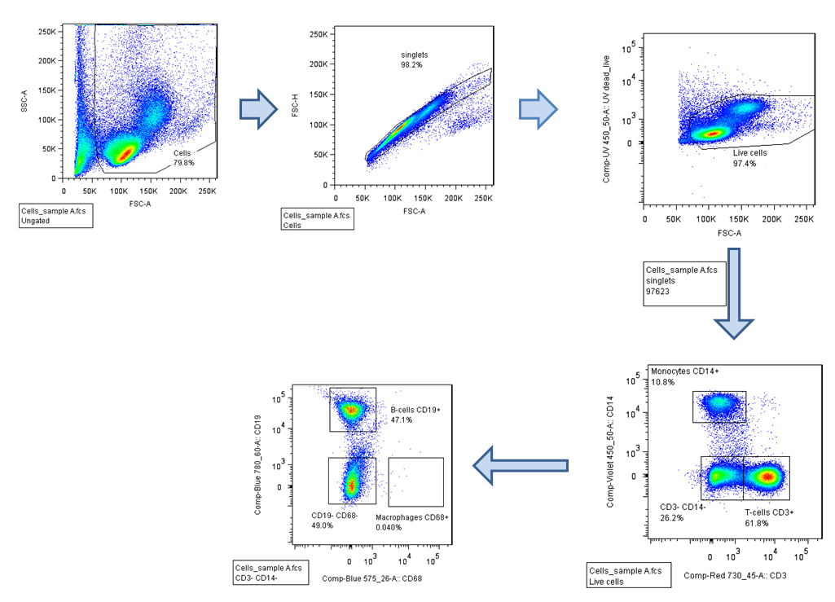

Figure 2.1 An example of the sequential gating used in processing Flow cytometry data.

Acid extraction
950 µl of isotonic lysis buffer (10 mM Tris-Cl pH 8, 1.5 mM MgCl₂, 1 mM KCL and 1 mM DTT) was premixed with 50 µl of protease inhibitor (5 x final concentrations) (Thermo Fisher) and used to resuspend and thaw the frozen cell pellet. This was incubated on ice for 30 minutes with constant agitation. The sample was then centrifuged at 10,000 x g for 10 minutes at 4˚C. The supernatant was removed and the pellet was resuspended in 400 µl of 0.2 M H₂SO₄ and placed on ice for 4 hours. The sample was then centrifuged at 16,000 x g for 10 minutes at 4˚C and the supernatant was transferred to a fresh lo-bind Eppendorf tube to which 132 µl of 6.6 N trichloroacetic acid (TCA) was added drop wise, inverted several times to ensure mixing and left on ice overnight. The sample was then centrifuged at 16,000 x g for 10 minutes at 4˚C the supernatant was then removed and the pellet was carefully washed by adding 200 µl of -20˚C HPLC grade acetone and centrifuging at 4˚C for 5 minutes and 16,000 x g, this wash was done twice. The acetone was then removed and the pellet was allowed to air dry at room temperature for 20 minutes. 100 µl of HPLC water was pipetted up and down the Eppendorf tube to resuspend the histone proteins; this was then transferred to a fresh lo-bind Eppendorf tube and stored at -20˚c (Shechter et al. 2007).

SDS-PAGE
A sodium dodecyl sulphate – polyacrylamide gel electrophoresis (SDS-PAGE) gel was made to test the purity of the histone proteins and to get a working measurement of the concentration. A 12 % SDS PAGE gel was found to give good resolution of histone proteins and was made in the following way: Resolving gel was mixed and poured into the Bio-Rad mini-protein gel apparatus, isopropanol was layered on top (3 ml of acrylamide, 4.38 ml of water, 2.5 ml of lower buffer, 100 µl of freshly made 10 % Ammonium persulfate (APS) (w/v) and 20 µl of tetramethylethylenediamine (TEMED). Following polymerisation of the resolving gel, the isopropanol was removed and stacking gel (750 µl of 40 % acrylamide, 3.6 ml of water, 1.5 ml of upper buffer, 75 µl freshly made 10 % APS (w/v), 15 µl of TEMED) was mixed and poured with a comb inserted to create sample wells. Gels were loaded into Bio-Rad mini-protein II cassettes and placed in 1x SDS running buffer (National Diagnostics). Samples were added to 4x loading buffer (50 mM Tris-HCL, 10 % glycerol, 2 % SDS, 0.1 % bromophenol blue, 100 mM β-mercaptoethanol). Final pH was adjusted to 6.8 and heated to 95˚C for 10 minutes. SDS-PAGE was performed at 80 V for 15 mins and then 170 V for 45 mins. All gels were run with 5 µl of protein ladder (NEB). Gels were then stained overnight with Colloidal Coomassie stain (0.08 % Colloidal coomassie brilliant blue dye, 1.6 % orthophosphoric acid, 8 % ammonium sulphate 20 % ethanol), and then destained in distilled water.

In solution trypsin digest & propionylation
Extracted histone samples were propionylated and digested with trypsin as described in (Garcia, Mollah, et al. 2007). Briefly, 10 µl of 100 mM ammonium bicarbonate (ABC) and 5 µl of ammonium hydroxide was added to 10 µg of extracted histone proteins. 10 µl of freshly prepared propionyl reagent was then added (7.5 µl of propionyl anhydride + 2.5 µl of acetonitrile (ACN)). The sample was then vortexed and pH was tested and adjusted to pH 8 if necessary and incubated at 51˚C. After 20 minutes the sample was centrifuged to remove condensation and vacuum centrifuged to dryness. 5 µl of 100 mM ABC and 3 µl of Ammonium hydroxide was then added and the procedure was repeated to ensure full propionylation. Upon completion, 50 µl of 60 ng/µl of trypsin in 100 mM ABC was added and left to incubate overnight. The reaction was then quenched by the addition of 4 µl of glacial acetic acid, and placing the samples at -20˚C for 20 minutes. The samples were then dried and the propionylation reaction was carried out two more times, to propionylated the newly cleaved N-terminals. Finally, samples were stored at -20˚C for up to 1 week.

Quantification of proteins
Protein concentration was determined by Bradford using a 96-well plate and TECAN plate reader at an absorbance of 595 nm. Briefly, a standard curve was made up using bovine serum albumin (BSA) (Sigma) with concentrations ranging from 2 µg/µl to 62.5 ng/µl. 5 µl of sample was added to 250 µl of Bradford reagent (Sigma) and incubated for 15 minutes at room temperature before measurements taken. Net absorbance was determined (by subtracting average of blanks n= 10) and concentration determined by comparison to the standard curve.

Sample preparation pre mass spectrometric analysis
The propionylated, digested histones extracts were either resuspended in 0.1 % TFA and run on the mass spectrometer (one-pot), fractionated by HPLC (HPLC-fractionation) or cleaned with HyperSep hypercarb tips (hypercarb clean up).

HPLC fractionation
Digested, propionylated histone samples were resuspended in 10 µl of 0.1 % TFA and were fractionated on the U3000 HPLC (ThermoFisher) with a Hypercarb Column ((50 x 2.1 mm, I.D. 5 µm particle size) (ThermoFisher) running chromleon software. The gradient, buffers and parameters are listed below. Fractions were collected every 60 seconds, into a lo-bind 284 deep well plate (Eppendorf). They were then transferred to lo-bind Eppendorf tubes, vacuum centrifuged to dryness and stored at -80˚C.
Buffers: Buffer A: 3 % ACN 0.1 % TFA, Buffer B: 97 % ACN 0.1 % TFA
Parameters: column temperature: 30˚C, UV: 214 nm (50Hz), flow rate: 0.2 ml/min
Gradient:
%B | Time (min) | Flow rate (µl/min)
0 | 0 | 0.3
0 | 1 | 0.3
70 | 25 | 0.3
90 | 26 | 0.3
90 | 30 | 0.3
5 | 31 | 0.3
0 | 35 | 0.3
Table 2.2. A table displaying the gradient used for separation of peptides on the PGC column in the first dimension

Hypercarb tip clean up.
Digested and propionylated histone samples were resuspended in 20 µl of 0.1 % trifluoroacetic acid (TFA). HyperCarb tips were conditioned using 5 washes with elution buffer (90 % ACN 0.1 % TFA) followed by 3 washes with binding buffer (0.1 % TFA).The sample was then bound by aspirating and expelling the sample 50 times. 20 µl volumes of binding solution (10 times) was then used to wash the tip. Bound peptides were then eluted in elution buffer by aspirating and expelling 10 times into lo-bind tubes. This was repeated 15 times to ensure high recovery from the tips. Recovered peptides were then dried completely in the vacuum centrifuge and stored at -80˚C

Mass spectrometry
All samples were re-suspended in 10 µl of 0.1 % TFA (LC-MS grade), and a proportion of this was loaded into mass spectrometer. The MaXis Ultra high resolution quadrupole time-of-flight (Q-ToF) system (Bruker Daltonics) with an online UltiMate 3000 RSLCnano (Dionex) HPLC was used to acquire spectra. CID was used to generate MS/MS spectra. Data was acquired over 61 minutes with the following gradient. Buffer A –0.1 % FA 3 % ACN (LC-MS grade) Buffer B – 0.1 % FA 97 % ACN.
%B | Time (min) | Flow rate (µl/min)
3 | 0 | 0.3
3 | 2 | 0.3
25 | 30 | 0.3
50 | 40.1 | 0.3
90 | 41 | 0.3
90 | 47 | 0.3
3 | 48 | 0.3
3 | 55 | 0.3

Table 2.3. . A table displaying the gradient used for separation of peptides on the C18 column online with the mass spectrometer

Typically, 10 µg of acid extracted histones from MDMs were propionylated and digested with trypsin and re-propionylated, as described by Garcia (Garcia, Mollah, et al. 2007). Following this the digested histone proteins were resuspended in 10ul of 0.1% TFA and injected onto a HyperCarb column. The peptides were separated by a linear gradient of elution. (Buffer A: 0.1% TFA 3% acetonitrile (ACN). Buffer B: 0.1 % TFA 97% ACN. 3-70 % buffer B over 25 minutes.) Chromatograms were recorded at 214 nm. A compromise had to be made between the length of gradient and hence theoretically better separation and downstream analysis time and throughput. Because of this, it was decided a short 25minute gradient would be used, with fractions collected every 1 minute at a flow rate of 0.2ml/min. 18 fractions were collected in a 384 lo-bind deepwell plate, starting at 8 minutes. Following collection samples were concentrated to dryness using a vacuum concentrator, resuspended in 10µl of 0.1% TFA and a 5µl aliquot was injected onto a 150mmx75 µm I.D. PepMap C18 column online with a MaXis mass spectrometer (LC-MS). (Buffer A: 0.1% formic acid (FA) 3% ACN. Buffer B: 0.1% FA 97% ACN. 3-25% buffer B over 22 minutes. 25-50% buffer B over 10 minutes.)
This method was compared against the one-pot shotgun approach (Plazas-Mayorca et al. 2009). Briefly, in solution acid extracted histones were prepared in the same way as the 2D-LC method. However, following concentration to dryness samples were either resuspended in 20 µl of 0.1 % TFA and desalted using a HyperCarb tip, at the end of which 5 µl of sample was injected on the LC-MS, or resuspended in 10 µl online by injecting 5 µl with a method with an elongated 8 minute wash. A longer LC gradient was used (Buffer A: 0.1 % formic acid (FA) 3 % ACN. Buffer B: 0.1 % FA 97 % ACN. 3-25 % buffer B over 32 minutes. 25-50 % buffer B over 10 minutes) in order to allow better separation of peptides.
In both cases the online HPLC was connected to a maXis mass spectrometer (Bruker Daltonics, Bremen, Germany) in conjunction with CaptiveSpray ion source (Bruker Daltonics, Bremen, Germany). CaptiveSpray capillary 1400 V, dry gas 3.0 L/min, dry heater 150 ˚C. MS and MS/MS scans (m/z 100-2000) were acquired in positive ion mode, no active exclusion, peptide charge state selected +2+3+4, collision energy 10.0 eV, collision cell RF 1200, ion cooler pre storage pulse 5.0 µs, summation factors for MS/MS 1.6, 0.3 s, isolation widths 3- 6 m/z, resolution MS and MS/MS 40,000 (m/z 1222). Lock mass calibration was performed using HP 1221.990364.

Data analysis

Data was first internally calibrated and .mgf file was generated using DataAnalysis 4.1 software with a signal to noise threshold of 100 and an absolute intensity threshold of 5000 and a maximum compound number of 50,000. Data was searched using MASCOT v2.5.1 using Swiss-Prot database under the taxonomy Homo sapiens. Fixed modifications were set as Propionyl (N-term and K) Variable modifications were set as Acetyl (K), Methyl, Dimethyl, and Trimethyl (K) Phosphoryl (ST).
All modifications identified by MASCOT were manually verified to ensure correct assignment. The relative abundance of histone peptides was determined by the integration of smoothed (gauss algorithm, 1 cycle) extracted ion chromatograms (XIC). Quantification was done using Hist-o-matic VBscript which interacted with Data Analysis to generate a specified list of extracted ion chromatograms, these were smoothed and integrated. In order to establish any significant changes in histone PTM relative abundances that occurred between the observed groups. A two-way ANOVA was chosen as the statistical test. This test was chosen as it allows the comparison of more than two-groups, and negates the impact of a type-I error that conducting multiple t-tests would introduce. A type-I error is one where the null hypothesis is correct but is rejected, in other words a false positive. When conducting a t-test the probability or the rate of this error or the chance of a false positive is normally set to 5% which is also normally the set significance level. When multiple t-tests are conducted as would be the case with the data presented within this thesis, the chance or the rate of a type-I error is increased and increased for every additional t-test conducted known as a familywise error. Therefore, the ANOVA test is used with Tukeys multiple comparison post hoc analysis. This test allows the comparison of multiple groups without introducing this error and reports the results as adjusted p values. ANOVAs measure the variance both within a group and between groups to determine significance. One of the assumptions made in order to use this test is that the data is normally distributed or parametric. Not enough data was generated to determine whether the case for the experiments used, however, parametric tests were chosen as the are more powerful than their non-parametric counterparts, secondly this assumption is also made within the literature using the same techniques (Kulej et al. 2015; Soldi et al. 2014).
Within the paper asterisks are used to denote level of significance. * = adjusted p value of <0.05, ** = adjusted p value of <0.01, *** = adjusted p value of <0.001, **** = adjusted p value of <0.0001.

Offline 2D HPLC fractionation using porous graphite carbon in conjunction with a downstream data analysis pipeline for the analysis of histone PTMs

Abstract
The aim of this chapter was to develop a novel 2D-LC based shotgun approach for the mass spectrometry analysis of histone post translational modifications (PTMs). Using a bottom-up based approach, a porous graphite carbon (PGC column) in the first dimension was used in conjunction with Reverse phase liquid chromatography tandem MS (RP-LC-MS/MS) to analyse global histone PTMs in primary monocyte derived macrophages (MDMs). A comparison of the developed 2D-LC methodology to 1D-LC approaches with and without offline desalting was performed. The use of the PGC column in the first dimension resulted in efficient separation of histone peptides across the gradient, with good resolution and a degree of orthogonality to the online C18 chromatography. Overall, more histone peptides were identified using 2D-LC compared to conventional approaches. In total, 86 histone PTMs including combinatorial marks were identified. This represents an increase in the identification of histone peptides by 66% and 53% of marks found compared to two 1D-LC approaches used on the same MS instrument. In addition, a bioinformatics pipeline utilising VB script known as the Histomatic was developed to enable the high throughput and accurate quantification of fractionated histone peptides. The automation of the downstream analysis pipeline increased the throughput of the 2D-LC-MS/MS approach.
This protocol introduces an alternative shotgun based approach to studying histone PTMs that increases the amount of detectable histone PTMs without the need for large amounts of sample desalting. Moreover, the use of the Histomatic script greatly streamlines the downstream data analysis making this method amenable to a high throughput approach.

Introduction
Epigenetics, more specifically histone PTMs have recently come to the forefront of biochemical research, due to the key role it plays in regulating eukaryotic gene expression. In eukaryotes, DNA exists in a complex with the core histone octamer (a heteromeric tetramer consisting of H3 and H4 proteins and two H2A/H2B dimers) called the nucleosome (Luger et al. 1997). Along with H1 and regions of linker DNA this forms chromatin. Protruding from each of the core histone proteins is a highly modifiable unstructured N-terminal tail. Post translational modifications are being discovered regularly and include (but not exclusively) acetylation, methylation, propionylation, ubiquitination, crotonylation and phosphorylation. The “histone code”, describes the complex combinatorial PTM patterns that exist on histone tails and less commonly on their globular domain (Jenuwein & Allis 2001). These histone marks not only dictate chromatin structure but they also control access to the underlying DNA and hence are involved in all DNA based processes including gene expression (Kouzarides 2007).
The use of mass spectrometry (MS) has become the tool of choice for the analysis of protein PTMs. With the rise of epigenetics in recent years, MS is an obvious tool to identify and characterise the wide range of PTMs on histones. MS allows the unbiased identification and quantification of multiple global histone PTMs including combinations thereof, in one experiment (Britton et al. 2011). Thus MS is one of the most powerful tools for probing the histone code, and the discovery of new histone PTMs. The bottom up approach is the most widely used due to its superior sensitivity, reproducibility and liquid chromatography (LC) separation of isobaric peptides. The enzyme of choice for bottom up approaches is usually trypsin, due to its low cost, high specificity and efficiency. However, due to histone tails having a large number of lysine and arginine residues, use of trypsin generates small hydrophilic peptides that are poorly retained on reverse phase columns. Therefore, a chemical derivation step, most commonly by propionic anhydride, is now widely employed and results in peptides of suitable length, with greater hydrophobicity, leading to better retention and separation of isobaric peptides on reverse phase columns (Garcia, Mollah, et al. 2007). Propionylation also reduces the number of isobaric peptides, simplifying the downstream data analysis. However, propionylation is a naturally occurring modification and hence cannot be studied using this technique (Chen et al. 2007). In addition, propionylation also does not address the issue of the effect that modifications have on the ionisation efficiency of peptides. For example, phosphorylated peptides are known to be ionised much less efficiently than its unmodified version although this is dependent on the position of phosphorylation (Gao & Wang 2007). This is an issue which affects both the reliability of absolute quantification, as well as relative quantification (as the data is normalised to the sum of the extracted ion chromatogram (XIC) areas for all isoforms). Recently, this issue has been addressed by generating correction factors by normalising the detection efficiencies of 93 synthetic histone peptides (Lin et al. 2014).

Current Strategies for the bottom up analysis of Histone proteins
Digested histone proteins are usually introduced into the mass spectrometer by the electrospray ionisation (ESI) needle; this converts the peptides in the liquid phase into charged ions in the gas phase, which can then be channelled into the mass spectrometer where the m/z values for each of the peptides is determined. ESI is the method of choice for the introduction of histone peptides into a mass spectrometer due to the ease of linking to an online HPLC. Nano flow HPLC utilising reverse phase chromatography in conjunction with C18 stationary phases are commonly used for high resolution peptide separations in combination with MS compatible buffers. The use of offline HPLC to fractionate histone proteins is commonly utilised as a way of further simplifying the complex mixture of peptides introduced to the mass spectrometer. This involves the separation of both histone proteins such as H3 and H4 and histone protein variants H3.1, H3.2. A wide variety of approaches have been utilised including SDS PAGE, TAU-PAGE (Shechter et al. 2007), RP HPLC (Jung et al. 2010; Schneider et al. 2011) and HILIC (Young et al. 2009). These techniques allow PTM information for each histone variant to be determined and have been widely used to unambiguously identify a broad range of histone modifications.
Alternatively, a one-pot or shotgun approach to identify and quantify histone PTMs can be used. Unfractionated histones are propionylated pre and post digestion with trypsin followed by the use of a C18 tip desalt prior to MS analysis (Plazas-Mayorca et al. 2009). This technique, although it loses histone variant information (for the most part) showed comparable identification of a wide range of acetylation and methylation marks on both histone H3 and H4 and histone 2A/B variants (Plazas-Mayorca et al. 2009).
2D LC approaches have been widely employed within the proteomics field to separate peptides using online/offline fractionation prior to RP-LC-MS/MS as a way of increasing the number of peptide identifications. This approach is often needed due to the data acquisition rate limitations in the presence of co-eluting peptides that are inherent within mass spectrometers (Michalski et al. 2011; Washburn et al. 2001). Several pre-fractionation methods have been developed including strong cation exchange chromatography (SCX). SCX represents an orthologous chromatographic technique to reverse phase that separates peptides in terms of solution phase charge. The column is operated at a low pH resulting in positively charged peptides that bind the negatively charged stationary phase. An increasing salt gradient is used to elute the peptides. However, these high salt concentrations have to be removed from each of the fractions to avoid the negative effects they have on ESI, ( making ion formation less reproducible, causing severe adduction or ion suppression) this both increases sample loss and reduces its amenability to high-throughput approaches (Constantopoulos et al. 1999). This approach has previously been used in the middle down approach to studying histone PTMs, where the separation of isobaric and co-eluting peptides is essential for the both the correct identification and assignment of positional isomers of histone PTMs (Young et al. 2009).
Recently, the use of porous graphitic carbon (PGC) as a stationary phase in a reverse- phase buffer system has also been used as a first dimension separation prior to LC-MS/MS (Griffiths et al. 2012). Although PGC columns use the same buffers as conventional reverse phase chromatography it has been shown to have good orthogonality traditional RP materials (Griffiths et al. 2012). This is due to the induced dipole interactions that occur on the surface of the graphite and so the PGC columns separation mode is based on both hydrophobicity and charge-induced interactions. From whole cell lysates PGC column perform better than SCX in the first dimension before RP-MS/MS in terms of separation and identification of unique peptides columns and in terms of even separation. Furthermore, it has been shown to retain small hydrophobic peptides longer than conventional RP and increase identification of these peptides when used as a first dimension separation (Y. Zhao, Samuel S W Szeto, Kong, Law, et al. 2014).
The separation of the post tryptic and propionylated histone peptides prior to LC-MS/MS using an in-solution isoelectric focusing fractionation has been used along with the traditional approaches above to identify 130 unique histone PTM sites, 67 of which were novel (Tan & Zhao 2011). They also discovered two new modifications: lysine crotonylation and threonine hydroxylation (Tan & Zhao 2011). Because of this success a variety of 2-dimensional separation techniques have been used in order to reduce the complexity of proteolytic samples and ion suppression whilst improving the dynamic range.
The application of multidimensional LC-MS/MS has been used previously for the analysis of histone PTMs via a bottom up approach using an SCX column as the first dimension (Zhang et al. 2013). However, there are a number of caveats associated with SCX in the first dimension as described previously. Therefore it was proposed that a 2D-LC approach using a PGC column may increase the dynamic range, and decrease suppression, effectively increasing the number of modified peptides identified and making quantification more reliable. Whilst still being amenable to a high throughput approach.
The aim of this chapter is to develop a novel 2D-LC-MS/MS platform including a downstream data analysis pipeline for the high throughput analysis of histone PTMs. This platform uses offline fractionation using a PGC column followed by RP-LC/MS-MS and will be assessed in terms orthogonality to a standard C18 RP column and fractionation efficiency. Finally the performance of this new platform will be compared with “one-pot” shotgun approaches in terms of the identification of histone peptides and their modifications.

Results and Discussion
Histone proteins were purified from 14 day old human primary macrophages, using acid extraction protocol (Shechter et al. 2007). The purity was checked using a 12% SDS-PAGE gel and yield was determined by Bradford absorbance at 595 nm. 10 µg of histone protein was then subjected to chemical derivitisation by propionic anhydride prior to and post tryptic digestion (see Chapter 2.7). A flow chart summarising the workflow is shown in Figure 3.1.
Figure 3.1 Flow diagram of sample preparation for bottom-up mass spectrometry analysis. Following acid extraction of histone proteins, there are two routes by which histones can be processed. 1) Offline fractionation of intact histone proteins (variants) via HPLC /SDS-PAGE before digestion followed by 1D-LC-MS analysis. 2) Shotgun based approaches to digests the complete mixture of histone proteins/variants, prior to 1D-LC-MS analysis. The blue line represents current 1D methodologies whereas the red line highlights the route taken using the 2D-LC methodology. The Box represents the methods that are explored within this chapter.

Extracted histone sample
HPLC separation of histone proteins and isoforms
Digestion
de-salt
offline fractionation
propionylation
propionylation
Mass Spectrometry
digestion
propionylation
propionylation

The digested histone peptides were then separated and fractionated in the first dimension on the PGC column (see Figure 3.2). Fractions were then concentrated to dryness, and analysed via LC-MS on a short 32 minute gradient. The MS spectra generated were then analysed using DataAnalysis (Bruker Daltonics), .mgf files were also created using this software. The .mgf files were then searched using MASCOT against the swissprot database, constrained to the Homo sapiens taxonomy. Propionylation (N-term, K) was set as a fixed modification. A broad selection of post translational modifications was probed by selecting them as variable modifications (see chapter 2.10). All modifications were manually verified to confirm correct identification.
Retention time (minutes)
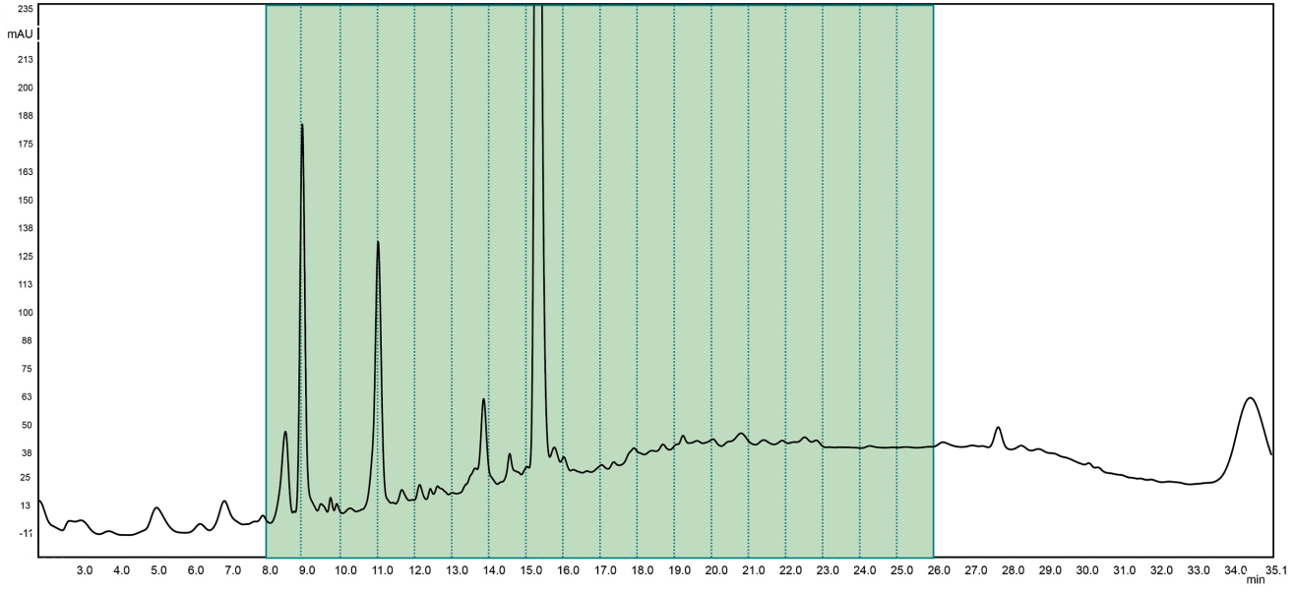
Absorbance (mAU)

Figure 3.2 HPLC chromatogram of digested histone proteins on a PGC column
10 µg of propionylated histone peptides were analysed on a PGC hypercarb column. A 25 minute linear gradient, of 0-70% Buffer B (97 % ACN 0.1 % TFA) was used at a flow rate 0.2ml/min. Absorbance at 214 nm. One minute fractions were collected from 8 min - 26 min (green area).

Following the manual verification of all peptides, the PGC column was assessed as a candidate for separation in the 1st dimension. This was assessed by two main parameters: orthogonality and fraction efficiency. Furthermore the elution profile of modified peptides was also examined.
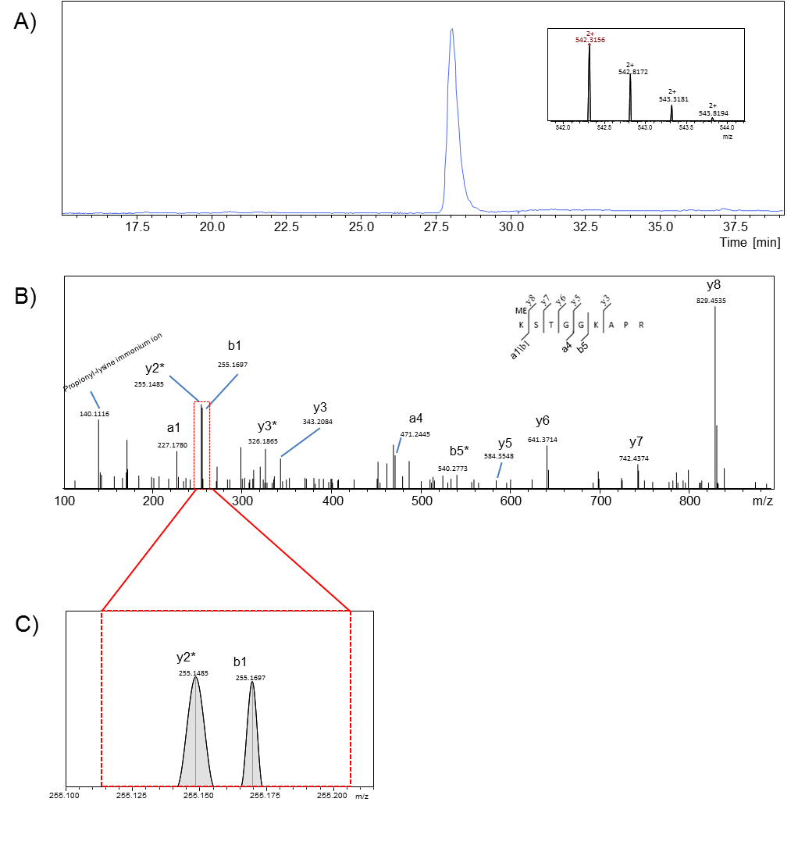
Figure 3.3 Manual verification of histone post translational modifications
Following LC-MS analysis, the MASCOT database is used to identify possible histone PTMs. Each of these possible peptides is manually verified by inspecting the fragment ions generated in the MS spectra. A) An EIC is generated for the singly methylated peptide KmeSTGGKAPR which has an m/z of 542.3157 (the insert shows the single MS of this peptide.) B) Manual verification of the MS/MS spectra was conducted to identify the position and type of modification. C) The b1 and y2* ions vary by 0.0212 m/z and therefore are near isobaric. Due to the high resolution of the MaXis mass spectrometer at both the MS and MS/MS level it is possible to distinguish between the two ions. Thus allowing the correct identification of the diagnostic b1 ion and hence the modified peptide.

Orthogonality
When considering fractionation in the first dimension using a 2D-LC approach, a balance must be struck between the length of gradient, number of fractions and downstream MS analysis time. Therefore a short linear 25 minute gradient of increasing acetonitrile was chosen to separate the histone peptides prior to LC-MS analysis. Figure 3.2 shows a typical HPLC chromatogram of the analysis of trypsin digested/chemically derivatised peptides from 10 µg of acid extracted histones. Subsequently 1 minute fractions were collected, dried and analysed using LC-MS to identify histone PTMs (see section 3.3.4).
Previous research has highlighted the orthogonality of the PGC based hypercarb column compared to the C18 column for shotgun proteomics (Griffiths et al. 2012). This is thought to be due to the additional charge induced dipole interactions that exist on the polarisable surface of the graphite (Griffiths et al. 2012). Orthogonality between the two dimensions of HPLC separation is important as it allows greater separation of peptides and therefore greater MS identification. Histone peptides represent a good test of the orthogonality between the PGC column and the traditional online C18 column as the Arg-C like tryptic peptides contain a wide range of hydrophobicities, including small hydrophilic peptides that are not well retained on C18 column such as H3K4 peptides. In order to assess orthogonality, the base peak chromatogram (BPC) of each 1 min fraction was analysed. The analysis of fraction 8 is shown in Figure 3.4A and demonstrates a number of components present in this fraction are separated in the 2nd dimension. These results demonstrate that there is a degree orthogonality between the two systems. A 2D LC plot of the BPC for each of the fractions from the 1st dimension is shown in the Figure 3.4B. The results show that although a higher degree of orthogonality is observed, it is not truly orthogonal as the early eluting fractions from the 1st dimension are biased towards earlier retention times in the second dimension. Further shown in Figure 3.4C where the retention time of all observed histone peptides in the first and second dimension are shown. Using linear regression the relationship between the two stationary phases for retention of histone peptides is shown to be only moderate with an R²= 0.592. As previously observed, the results demonstrate a high degree of orthogonality between the two dimensions for the analysis of histone peptides, consistent with previous analysis (Griffiths et al. 2012).

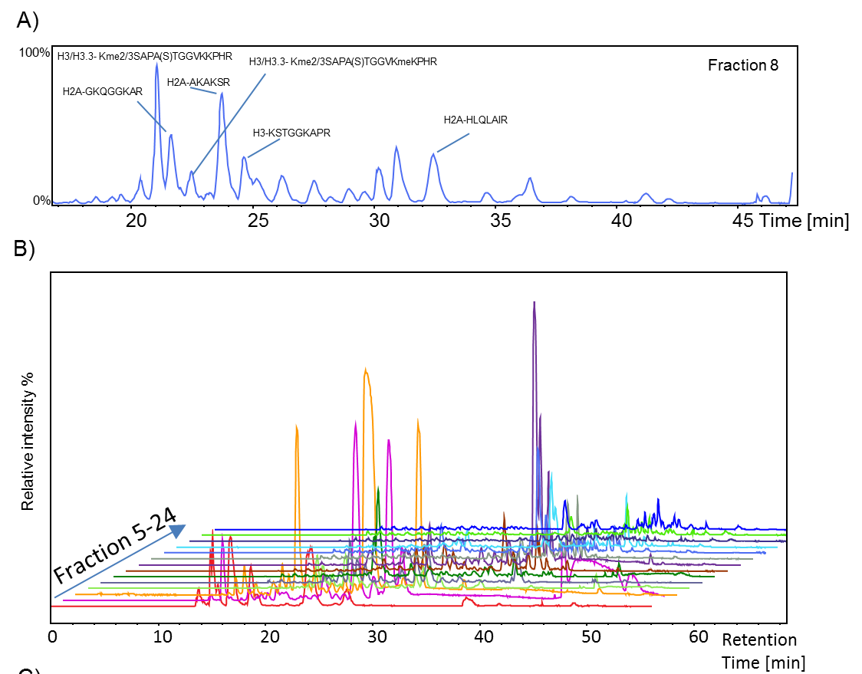
C)
Figure 3.4. The assessment of orthogonality between the PGC column and the C18 column.
The orthogonality between the PGC column and the C18 column was assessed. A) Orthogonality is exemplified by the BPC trace of a single fraction (8). A number of identified histone peptides are highlighted. B) 2D plot for the BPCs obtained for each 1st dimension fraction. C) 2D plot comparing the retention time of histone H3 peptides in both the 1st and 2nd dimension. Each dot represents a single peptide, with only the fraction where the species is most abundant is shown.

Fractionation efficiency
The fractionation efficiency of the PGC column in the first dimension was evaluated. To do this the number of fractions in which unique histone peptides eluted was examined. The different proteoforms of peptides are recorded as unique the first time that they are identified; subsequent identifications in later fractions (i.e. duplicates) are included within the total number of peptides identified.
The resolution of the first dimension was also measured by observing the number of fractions the histone proteins eluted in across the entire gradient. Ideally all of a single proteoform will elute out in one fraction, as this reduces sample complexity. As can be seen in Figure 3.5A the majority of peptides (75 %) elute within 3 fractions or less, with a small amount of peptides eluting out over longer ranges. However, the fractionation point is timed arbitrary every minute meaning some peaks might be intersected between fractions despite eluting off the column over a small range. Further analysis of the elution reveals that in most cases, >90 % of the total peptide elutes out in one or two fractions (see Figure 3.5B). The majority of the peptides that elute over a longer range are retained more strongly by the PGC column. This is represented in a more detailed way in figure 3.6. Analysis of the elution patterns highlights areas that could be used for future development of this technique such as the development of an effective pooling strategy such as the pooling of the later fractions which are less dense in terms of histone peptides, than the earlier fractions. The result shown in Figure 3.7 demonstrates that most H3 peptides elute in the first 7 fractions. Fraction 12 contains both the most number of histone peptides and unique peptides (Figure 3.7). The peptide H3K9me3K14ac is the first histone peptide to elute with only a couple of non-histone peptides eluting prior to this. All histone peptides elute within a 14 minute window, and it is this window that is used for fractionation in further experiments. This analysis has only focused on the fractionation efficiency and resolution of differentially modified histone peptides, which are not the only peptides within the sample. The results show that the PGC column provides a first dimension with good resolution and separation of the histone peptides.

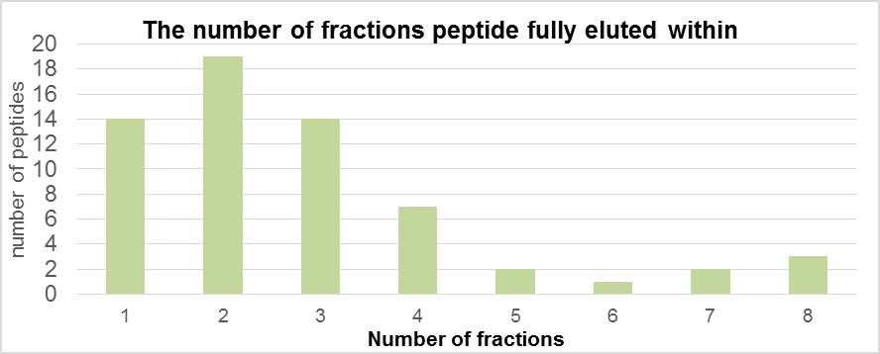
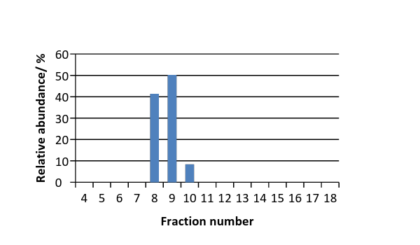
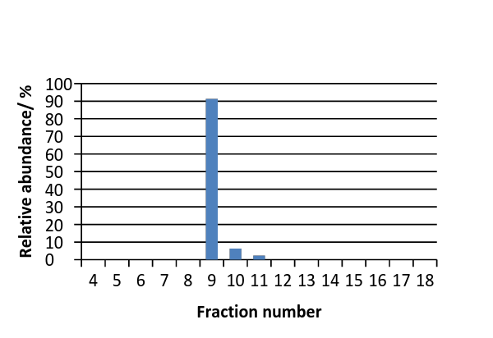
Kme1SAPATGGVKme3KPHR
Kme1STGGKAPR

Figure 3.5 Fractionation of histone peptides on the 1st dimension PGC stationary phase
A) Graph plotting the number of fractions that histone peptides elute out in on the PGC column in the first dimension. The majority of histone peptides elute in three fractions. B) Bar chart showing the relative abundance of two histone peptides across multiple fractions. Quantitative analysis of the Kme1STGGKAPR peptide shows 91% elutes in one fraction. Similarly, 92% of the Kme1SAPATGGVKme3KPHR elutes over 2 fractions, with the entire species eluting over three.

 | Fraction Number
Histone peptides | 5 | 6 | 7 | 8 | 9 | 10 | 11 | 12 | 13 | 14 | 15 | 16 | 17 | 18
TKQTAR
TKme1QTAR
KSTGGKAPR
Kme1STGGKAPR
Kme2STGGKAPR
Kme3STGGKAPR
KSTGGKacAPR/KacSTGGKAPR
Kme1STGGKacAPR
Kme2STGGKacAPR
Kme2STGGKacAPR
Kme3STGGKacAPR
KacSTGGKacAPR
KSphTGGKAPR
Kme1SphTGGKAPR
Kme2SphTGGKAPR
Kme3SphTGGKAPR
KQLATKAAR
KELATKAAR
KQLATphKAAR
Kme1QLATKAAR
KQLATKacAAR/KacQLATKAAR
KacQLATKacAAR
KSAPATGGVKKPHR
Kme1SAPATGGVKKPHR
Kme2SAPATGGVKKPHR
Kme3SAPATGGVKKPHR
Kme1SAPATGGVKme1KPHR
Kme1SAPATGGVKme2KPHR
Kme1SAPATGGVKme3KPHR
Kme2SAPATGGVKme1KPHR
Kme2SAPATGGVKme2KPHR
Kme2SAPATGGVKme3KPHR
Kme3SAPATGGVKme1KPHR
Kme2SphAPATGGVKKPHR
YRPGTVALR
YRPGTphVALR
YQKSTELLIR
KLFPQR
KacLFPQR
EIAQDFKTDLR
EIAQDFKme1TDLR
EIAQDFKme2TDLR
K5-18 (0 acetyl)
K5-18 (1 acetyl)
K5-18 (2 acetyl)
K5-18 (3 acetyl)
Kme2VLRDNIQGITKPAIR
Kme3VLRDNIQGITKPAIR
DNIQGITKPAIR
DNIQGITphKPAIR
ISGLIYEETR
DAVTYTEHAKR
KTVTAMDVVYALKR
AKAKSR
AKAKTR
HLQLAIR
DNKKTR
GKTGGKAR
KGHYAER
GKmeQGGKAR
GKacQGGKAR
AGLQFPVGR
NDEELNKLLGR
AGGKAGKDSGKAKTKAVSR
AGGKAGKDSGKAKAKAVSR
GKQGGKAR
HLQLAVR
GGKKKSTKTSR
KmeSAGAAKR
SETAPAAPAAPAPAEKTPVKKKAR
SETAPAETATPAPVEKSPAKKKATKKAAGAGAAKR
GAPAAATAPAPTAHKAKKAAPGAAGSR
EIQTAVR
LAHYNKR
>0% 100%
Figure 3.6 Elution pattern of histone PTMs from the PGC column
A graphical representation of the elution patterns of histone protein H1, H2A, H2B, H3.1/2 and H4. Histone H3.3 peptides are not shown as they mirror that of H3.1/2. The colours are representative of the relative elution of each species in that fraction. Dark green represents when 100% of the peptide elutes out in that fraction. Whereas red represents where a peptide has been identified but makes up a very small percentage of the total peptide amount from all fractions.

Figure 3.7 Fractionation efficiency of histone peptides on the PGC column.
Fractionation efficiency of the PGC column was assessed by plotting both the number unique and total of histone peptides (H2A, H2B, H3, H4 and H1) that were identified in each fraction. H3 peptides elute first from fraction 5 (12 minutes) and elute out across the entire gradient. Histone H4 peptides eluted from fraction 10 onwards. H1 peptides eluted over a short range (fraction 8-12). Peptides from both H2A and H2B eluted across the majority of the gradient, importantly unique peptides elute out across the gradient with the majority eluting in the first half of the gradient.

Elution profiles of modified peptides
Both the LC-MS retention time and elution profile of peptides offer useful additional information for the identification/verification of post translational modifications. A defined elution profile on a C18 column has been well characterised for a number of peptides and their modified forms (Plazas-Mayorca et al. 2009; Schneider et al. 2011). In order to assess the elution profiles on the PGC column, the elution profile of the KSTGGKAPR peptide was further analysed. Figure 3.7A shows the elution profile of the modified peptides on the C18 column compared to the fraction of elution plotted against the intensity in the first dimension (Figure 3.7B). A similar elution profile can clearly be seen. The K9me species is the latest eluting peptide, with the K9me2 and K9me3 and dual modification versions K9me2/3K14ac eluting first (Figure 3.7B). There is greater overlap in elution times compared to the C18 column, this is likely due to the reduced resolution when viewing the first dimension compared to the second. As has been reported previously, the H3k9me3 and H3k9/14ac which vary in mass by only 0.036 Da have distinctly different retention times (Plazas-Mayorca et al. 2009). This results in the two peptides eluting in separate fractions on the PGC 1st dimension separation. This therefore represents an additional level of confirmation, without requiring high mass resolution to discriminate between the two species.

A comparative study between offline 2D-LC and two one pot methodologies in the identification of histone PTMs.
Following the assessment of the properties of PGC column as a means of 1st dimensional separation in a 2D-LC-MS methodology, the next step was to examine the impact of this 2D approach on the number of identifiable and importantly quantifiable histone PTMs. Therefore a comparative study between the offline 2D-LC, offline desalting via PGC tips and online desalting via C18 was conducted. All the studies were combined with a nano-flow C18 column interfaced with the MaXis. It was hypothesised that due to the orthogonality and fractionation efficiency afforded by the PGC column that more peptides will be identified by the 2D-LC methodology. All peptides identified, were subject to manual verification to confirm type and position of the modification.
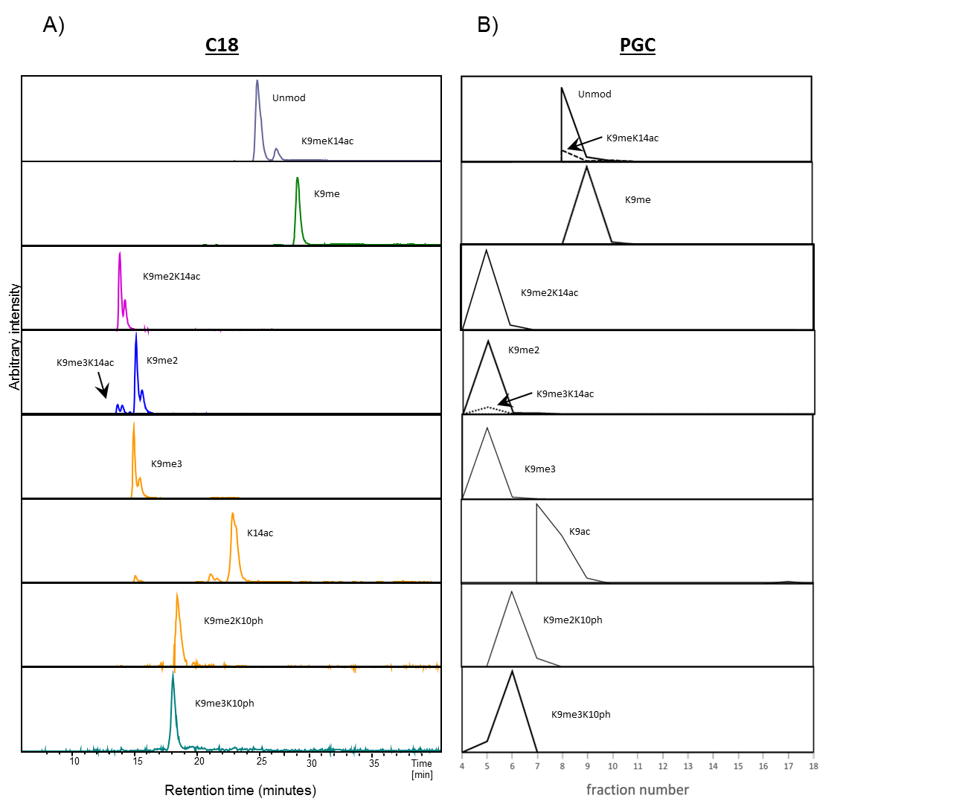
Figure 3.8 A comparison of the elution profiles of differently modified versions of the K9-17 peptide
To compare the elution profiles of the K9-17 peptide on the C18 and PGC stationary phases A) EICs were generated for all proteoforms of peptide K9-17 [M+2H] ²⁺ from the second dimension analysis. B) Total area of these peaks was plotted against fraction number in the first dimension.

A total of 14 fractions from the 2D-LC were analysed and compared to 1D-LC methods. If a modified peptide was identified by one approach then it was manually searched for in the other approaches, even if it was not identified by MASCOT. The results are summarised in Figure 3.8 and Appendix Table 1. This table details all the histone peptides routinely quantifiable within this thesis and is not limited to the macrophages studied within this chapter. The difference between the two cell types in terms of histone peptides identified highlights the impact of cell type on this type of experiment, and demonstrates the difficultly in comparing between studies. Furthermore the data would suggest that the state of the cell, i.e. stimulated vs unstimulated may have an impact on the number of histone peptides identified. Focusing on histone H3, the best characterised histone protein, 2D-LC analysis enabled the identification of 53 histone peptides in MDMs. In contrast, the 1D-LC online or offline desalting identified 20 and 25 histone peptides respectively methodologies (Figure 3.8). Similarly the number of modifiable sites identified was increased in the 2D-LC method with 11 modifiable sites identified, compared to 9 for the 1D-LC online or offline desalting. The same trend can be seen with histone H2A, H2B, H4 and H1. The number of peptides detected with the 1D-LC methods using a tip to desalt the sample identified is similar to the number found previously using the same technique used in previous studies (Plazas-Mayorca et al. 2009). Overall, fewer peptides were detected using online de-salting compared to the PGC tip method. No peptides were detected by the one pot approaches that weren’t detected by the 2D-LC approach (Figure 3.8B). The peptides that were not detected in the online desalt method are those that are the most hydrophilic (K4me2/me3 and K9me2/me3K14ac) peptides. These small, hydrophilic peptides do not bind well to the C18 columns and it is likely that they desorb from the C18 surface during the 8 minute wash step. Similarly, fewer low abundant peptides are seen in the one pot analyses. This may be in part due to the increase in dynamic range that is afforded by using an offline separation with a PGC column prior to LC-MS (Y. Zhao, Samuel S W Szeto, Kong, Law, et al. 2014). However, A limitation of the high resolution of the MS2 (40,000) that was acquired was the time taken to acquire the data, this is an issue due to a data dependant methodology (DDA) being employed. The DDA approach meant that the top 3 peaks on the MS1 scan were chosen for MS2 hence this limits the cycle between MS peaks that can be selected for fragmentation and MS2 analysis. Because of this, it is possible lower abundant peaks were missed. This may be a factor that contributed to a reduced number of identification of PTMs using the 1D-LC approaches. It is possible to overcome this limitation, by exploring a number of alternative methodologies such as using a data independent approach (DIA): whereby peaks within the MS scan when present are automatically selected for MS2 analysis by a predetermined list set by the experimenter. Thus ensuring known histone PTMs are selected for MS2 analysis, increasing the chance of a positive identification. This technique has become increasingly popular within the histone field recently and is a methodology likely to become the predominant approach for analysis of histone PTMs (Tang et al. 2014). Similarly an exclusion list can be employed to “ignore” known and often highly abundant contaminant peaks such as from trypsin or human keratin and prevent them from being sequenced by MS2 at the expense of sample peptides (Hodge et al. 2013). Finally by conducting MS2 scans at a lower resolution it would be possible to select more peaks for MS2 analysis possibly increasing the amount of peptides identified. The majority of the undetected peptides were the lower abundant peptides including the unmodified K23-40, K9acK14ac and K18me. As mentioned previously, Lin et al used 93 differentially modified histone peptides, to calculate the impact of modifications on the detection efficiency of the peptides (Lin et al. 2014). A vast difference in detection efficiency was found between different peptides and between different modifications on the same peptide that was dependent upon position and type of modification. With this knowledge they developed correction factors to compensate, meaning that PTMs that appear to have low abundance following correction can make up a much larger percentage of the total relative abundance. These results demonstrate the importance of detecting as many PTMs as possible, within a given peptide to generate an accurate reflection of the relative abundances of the different proteoforms The number of H3 histone PTMs detected using the 2D-LC approach is an improvement on that compared to another 2D-LC based approach that used an SCX based approach (Zhang et al. 2013). However, experiments using a shotgun approach have identified more peptides including the fully acetylated H4 peptide which was not identified in any of the techniques employed. Furthermore all the modifications identified by the 2D-LC approach are routinely seen in other analyses, that use a 1D approach (Kulej et al. 2015; Wen et al. 2009; Garcia, Hake, et al. 2007; Leroy et al. 2013). However, comparative analysis across these different studies is difficult as each analysed a different biological system which has different PTM profiles (Garcia et al., 2007). Furthermore each study will have utilised a different MS instrument, different LC conditions and different algorithm to analyse the MS data and will have significant impact on the number of histone PTMs identified (Yuan et al., 2014). As different cell types or often different organisms are used, which have different histone PTM profiles and so caution should be applied when comparing two different methods. Moreover, the mass spectrometer used will have significant impact on histone PTM detection. Mass spectrometers have different capabilities in terms of sensitivity, dynamic range and resolution, all of which affect the accurate identification and quantification of histone PTMs. For example, H3K36me2 was not detected on its own in MDM primary cells, but previous research within this lab group has detected this modification in Apis melifera (Dickman et al. 2013).

Considerations in quantification
In order to quantify the relative abundance of histone PTMs, an EIC is generated for the correct mass that corresponds to the histone PTM of choice, once the correct peak that corresponds to the histone peptide is identified the area underneath is calculated by integration. For 1D-LC approaches the entirety of the relative abundance is determined by the integration of one peak. However this is not the case for the 2D-LC approach where a histone peptide may elute out over several fractions and hence to total abundance of that peptide is determined by the summation of several peak areas that are in different LC-MS runs. This has the potential to introduce a multitude of errors. These include the potential additive errors of combining multiple measurements vs one measurement, issues with the stability of spray between MS runs and other environmental factors such as temperature and humidity. In order to negate these MS based error factors as much as possible MS runs were run in sequence with no time gaps. As it is likely that the changes in spray stability, temperature etc, will not change suddenly but will likely drift over time. With regard to the spray stability an internal standard was used for both calibration and to monitor the performance of the mass spectrometer between runs. Furthermore routine BSA standards were run again to monitor the performance of the MS overtime, to ensure there were no major shifts away from starting conditions that may impact on the quality of the quantitation between runs.
Another issue which could affect the accuracy of quantitation is additive errors, i.e. each measurement has a certain error, therefore repeated measurements to give a final result, are likely to increase this error compared to a single measurement giving the final result. The effect of this is likely reduced because as stated the majority of peptides elute out within three fractions. Thus, limiting the extent of the propagative error. In order to address these concerns, we have compared the histone PTM quantification from the 1DLC analysis with the 2D-LC analysis using both MDMs and in addition an alternative sample (CHO cells) using the same method is shown in figure 3.9. However, it should be noted that for accurate relative comparison of the quantification of histone PTMs (1D 2DLC) we can only use limited peptides in which the same number of peptide proteoforms were identified. As figure 3.9 shows the use of fractionation does not impact the accuracy of quantification.

MDM H3K9-17
Figure 3.9 . The impact of 2D fractionation on peptide quantification.
A comparison of the effect of the summation of EIC over multiple limited fractions on the relative abundance compared to a 1D “one-pot” approach. A) histone H4 peptide K5-18 B) Histone H3 K9-17 both from Chinese hamster ovary (CHO) cells. C) histone H3 peptide K9-17 from monocyte derived macrophages. H4 peptide CHO both conditions n=4, H3 peptide CHO both conditions n=3 and H3 peptide MDM 2D-LC n=4, 1D-LC (tip) n=3. All data is shown as mean with SEM. All data plotted and statistics calculated using GraphPad Prism. No significant differences in relative abundance can be seen between the two methodologies. This is consistent in different cell types and peptide

Figure 3.10 Summary of the number of differently modified histone peptide identified in each approach. Three different bottom-up methodologies were compared based on the number of histone peptides identified. The methods compared are offline 2D-LC using a PGC column in the 1st dimension, 1D-LC method using an offline PGC tip clean-up and a 1D-LC approach using an online clean-up (C18). In all cases a total of 5 µg of digested histone protein was used for LC-MS/MS analysis.

Downstream analysis of data generated from 2D-LC-MS.
The major benefit using the 2D-LC set up is that it allows the increased identification and quantification of histone PTMs compared to “one-pot” methodologies. However, one of the major caveats is the increase in both MS and downstream analysis time. Typically, 14 fractions were run on the mass spectrometer per biological sample, each of which requires further manual verification of the tandem MS and the integration of the area under the XIC in order to calculate the relative abundance of the peptide. This becomes a laborious task when you consider that in H3, 54 differently modified peptides were identified, all of which can and do exist in multiple charge states and elute over multiple fractions. In order to overcome this, a script was developed in visual basic language (VB). This script language was chosen as it could directly interface with the DataAnalysis (DA) software and could be imbedded in Microsoft Excel, as the compound spectra list generated in DA could be exported as a .csv file. Figure 3.9 summarises the workflow of the downstream processing pipeline that was developed, including the section which has been automated using the VB script termed the “Histomatic” (see Appendix 7.1).
Following the creation of the .mgf file by DA and database search in MASCOT all identified peptides were manually verified by first generating the extracted ion chromatogram (XIC/EIC) for the specified peptide, and correlating with the identified peptide in MASCOT. Subsequently the parent ion is first checked to be in the correct charge state and if this is correct, then the MS/MS spectra is verified against the theoretical MS/MS spectra generated by MASCOT. The time at the apex of the EIC peak for which the peptide has been identified, is then recorded. This process is repeated until all peptides have been manually verified. This information is then placed into the Histomatic (If multiple elution times are observed for example when double peaks are present in the EIC both of which contain the identified peptide, then both RT are added).
- The Histomatic will then generate the specified EICs in DA with a range of +/- 0.025 m/z for every entered peptide that has a RT of >0. Unless, the EIC has been added previously i.e. for isobaric PTMs such as H3K27meK36me2 & H3K27me2K36me by using an array function.
- The Histomatic then smooths all the generated EICs and integrates them, generating a compound list.
- Following integration, the DA file is saved in its current state and the compound list is exported into a .csv file and saved into a folder on the C-drive known as ZZHistomatic (which must be made by user).
- The Histomatic, then uses this file to search for the EIC that corresponds with the RT entered (within an error range of +/- 0.2 min) to allow for retention time variation between fraction runs.
- Once these two variables are paired up, the line from the exported compound list, including Area, S/N, range etc. is pulled out and inputted into the Histomatic table
  - In the case of there being two RT, separated by a slash, the sum of the area, S/N and intensity values are displayed.
  - The range values are listed as two separate values separated by a comma

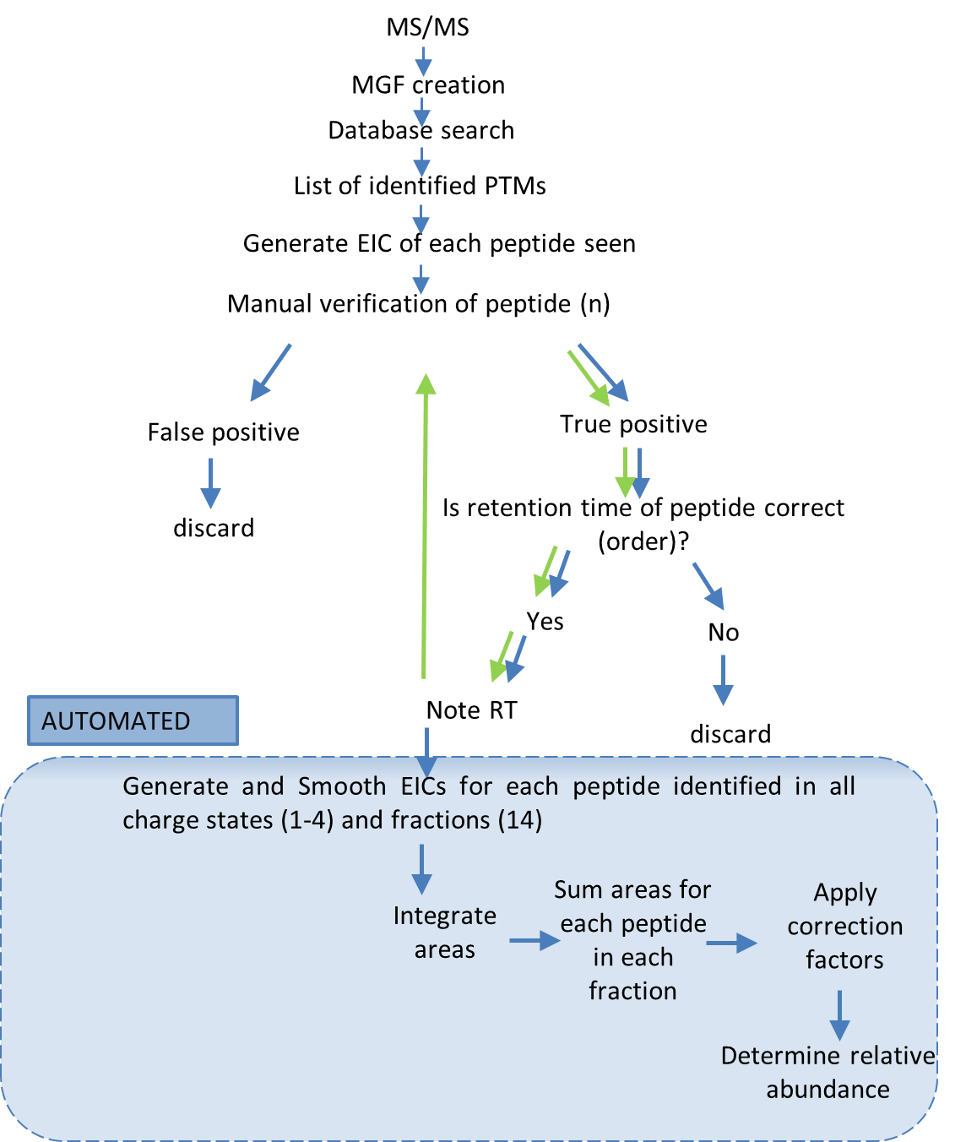
Figure 3.11 Workflow summarising the data analysis pipeline for the identification and quantification of histone peptides.
Following the acquisition of mass spectrometry data, an MGF is created using Data Analysis software (Bruker), this file is then uploaded into the MASCOT database, and used alongside raw data, to manually verify the peptide identification. During this process, the retention time (RT) of the peaks containing the peptide hits that have passed manual verification is recorded and assessed as additional evidence. The RTs are then entered into the Histomatic which allows the automation of the integration and recording of peak areas used in quantification for all fractions.

Assumptions and quality control
A number of assumptions are made when using the Histomatic script; 1) if the peptide has been manually verified in any one fraction, then if any of its corresponding EIC peaks are identified in another fraction with the same retention time (+/- 0.2min) then it is assumed to be the same peptide. 2) If the peptide is manually verified in one charge state then it is assumed that it also exists in other charge states (1-4) even if it is not identified in MASCOT. Due to these assumptions a quality control step was put in place, to exclude any outliers. This is done by plotting the sum of the area for each peptide in all charge states against fraction number (see Figure 3.3). As each peptide will have a range of organic solvent that it will elute out in (generally 2-3 fractions on the hypercarb column) outliers from this range can readily be identified and excluded if necessary.
It is possible that an isobaric contaminant has the same retention time for a particular peptide. Hence a quality control mechanism was put in place using the data output from the Histomatic; the percentage of each charge state that makes up the total area for a given peptide in a given fraction was plotted. This allows the charge state distribution in for each peptide in each fraction to be determined. Significant contaminants can then be determined by large shifts away from the normal distribution of modifications. For example, (99%) of the peptide Kme2STGGKAPR exists in the 2+ charge state, any significant shift towards a different charge state is likely to be a contaminant and can be excluded. Of course, these charge state distributions for each peptide will be instrument dependant, and so new parameters would have to be set if this quality control was to be considered for use on other instruments. Experimentally, very few of these contaminants were observed, most probably due to significant enrichment of histone proteins during acid extraction vastly reducing the complexity of the sample and hence decreasing the probability of isobaric contaminants that have the same elution profile as the histone peptides.
It is important to note that the Histomatic does not define what qualifies as a peak and therefore what is integrated and hence what information is inputted into the compound list. This is done in the method parameters used to process the raw data, and generate the .mgf files originally. For all experiments used in this chapter the S/N ratio was set at 100 and the minimum absolute intensity was set as 5000. Any peak that did not satisfy these criteria is not defined as a peak, and therefore is ignored by the Histomatic. Following the quality control steps, the processed data is then subjected to correction factors to correct for the effects of type and location of PTMs on detection efficiency (Lin et al. 2014). The relative abundance of each peptide is determined using the formula described (Lin et al. 2014). This is all done automatically within the Histomatic (Figure 3.10).
Therefore, the PGC column allows the quick separation of histone peptides, in MS compatible buffers, and removes salts from the sample, thereby reducing sample loss, the effects of ion suppression and improving dynamic range while not increasing the amount of downstream MS and data analysis meaning that the method is still amenable to high throughput methodologies.
Figure 3.12 Histomatic automated quantification of histone modifications.
Upon completion of the script and quality control checks, the data is automatically entered into the results table calculating the relative amount of each modified peptide against the sum of all modified version of that peptide. Correction factors are then applied to compensate from differences in detection efficiency (Lin et al. 2014).

Conclusions
The offline HPLC fractionation of peptides generated from the bottom up analysis of acid extracted histone proteins was performed using a PGC based hypercarb column in the first dimension, in conjunction with LC-MS analysis using C18 stationary phase in the second dimension. This first dimension separation uses typical reverse phase solvents that are readily compatible with the second dimension following removal of the acetonitrile and shows a high degree of orthogonality to C18 RP separations. Using this approach up to a 62.7% increase in histone PTMs was detected and quantified compared to traditional 1D-LC analysis on the same MS instrument. This method enabled more low abundant peptides to be identified and reliably quantified from an increased dynamic range. This method is an improvement on previous SCX based 2D-LC methodologies in terms of throughput and reduction in sample loss as no desalting or buffer exchange of the sample is required prior to LC-MS analysis. The major downside to using a 2D-LC-MS/MS approach is the increased time for both the MS acquisition and data processing compared to standard shotgun approaches. To combat the latter of these two issues a Histomatic script was developed. The use of the Histomatic allows the rapid, automated, high throughput processing of data generated from 2D-LC-MS/MS experiments.

An investigation of global histone post translational modifications associated with severe sepsis: An in-vitro study in human primary macrophages.

Abstract
Sepsis is a severe clinical syndrome that results from the damaging host response to infection. It is estimated that there are 18 million cases of sepsis worldwide with 1.8 million confirmed every year with mortality rates of 30-50 %, (Slade et al. 2003). Sepsis causes an estimated 32,000 -64,000 deaths every year in the UK alone. The NHS bears the brunt of this large burden, with 46% of intensive care unit bed days being occupied by patients with severe sepsis each year, costing an estimated £2-3bn a year (Harrison et al. 2006). Current research supports the theory that epigenetics plays an important role in the pathophysiology of sepsis. The aim of this Chapter is to study the effects of LPS on global histone post translational modifications in human primary macrophages. Mass spectrometry was utilised to identify and quantify global histone PTMs. The results show that LPS stimulation causes a significant reduction in H3K27me2K36me2, H3K9me2K14ac and H2AK5ac on a global scale. The subsequent tolerisation of macrophages caused a significant reduction in H3.3K27me2K36me2 and significant increase in H3K23ac and H2AK5 compared to healthy controls. Thus demonstrating separate global landscapes for control, stimulated and tolerised macrophages.
It is proposed that the identification these distinct global states of both individual and combinatorial histone PTMs via mass spectrometry may open new avenues for drug therapy or biomarker discovery and provide further insight as an in-vitro model for septic shock and severe sepsis.

Introduction
Sepsis is a complex clinical syndrome that results from the dysregulation of the host immune response following a severe infection.
Sepsis represents one of the leading causes of death in intensive care units (ICUs) (Iwashyna et al. 2010). Unsurprisingly an effective therapeutic is highly sort after. However, the development of therapeutic strategies for sepsis and its sequelae has proven highly challenging: A plethora of clinical trials using anti-inflammatory based treatments such as anti-TNFα and an interleukin-1 receptor antagonist have all failed (Remick 2007; Hotchkiss et al. 2013b). The motives behind the use of such therapeutics are based on research documenting sepsis as a highly inflammatory syndrome. For example, the injection with non-lethal doses of lipopolysaccharide (LPS) directly into animals leads to higher levels of pro-inflammatory cytokines such as TNFα, and a systemic inflammatory response (Copeland et al. 2005) .This theory dominated until fairly recently. However, this is now known not to be the case. Patients in the later stages of sepsis (severe sepsis) have a marked reduction in the production of both pro and anti-inflammatory cytokines (Boomer et al. 2011). This protracted phase of sepsis is associated with significantly higher levels of opportunistic pathogens (bacterial and fungal) positive blood culture results. A hallmark of immunosuppression (Otto et al. 2011).Therefore, if these anti-inflammatory molecules are given at the wrong stage, they are likely to make little difference and may even further subdue the immune system. A further complication arises from the apparent lack of success of using immunostimulatory drugs. The use of granulocyte colony stimulating factor (G-CSF) to treat septic patients failed to improve survival (Root et al. 2003). Furthermore, patients that survive severe sepsis have a much reduced 5-8 year survival rate compared to healthy age matched controls, and in mouse models, survivors are more prone to opportunistic pathogens such as Aspergillus spp. (Perl et al. 1995; Quartin et al. 1997).
To better understand sepsis, and in order to better manage it, the numerous underlying mechanisms that cause the pathology of sepsis, need to be better understood, at both a systemic and cellular level. Macrophages are one of the most important cell types in the innate immune cell and are vital in the proper functioning of the immune system. Derived from monocytes in the circulating blood, macrophages are mainly located within tissues, where their main function is to detect and clear pathogens, along with activating other immune cells so that the host responds appropriately to an infection. In order to detect infectious agents macrophages express a plethora of pathogen recognition receptors. These detect a wide range of pathogen associated molecular patterns. One such molecule: lipopolysaccharide (LPS) is often used to model the effects of sepsis at the cellular level in macrophages. LPS is a potent activator of macrophages and elicits a very strong pro-inflammatory response (Suffredini et al. 1989; Parrillo 1993). This occurs via the TLR4 signalling pathway activating both TRIF and MyD88 dependant pathways releasing vast amounts of pro-inflammatory mediators such as TNFα and IL-6 which can contribute to systemic shock (Lu et al. 2008; Foster & Medzhitov 2009). The expression of these pro-inflammatory genes is tightly controlled and multiple feedback loops exist in the signalling pathway to control them (Lu et al. 2008). However, the activation of the TLR-4 pathway raises a much more complex response than just the expression of inflammatory mediators. Antimicrobial peptides, chemokines, some tissue repair and anti-inflammatory agents are also released by macrophages upon LPS stimulation which have very different functions. Hence, they require differing levels of control. Moreover, the phenomenon of LPS tolerance cannot be fully explained by negative feedback loops alone (Foster & Medzhitov 2009). LPS tolerance represents an adaptive mechanism by which the innate immune system protects the host against the deleterious effects of septic shock (West & Heagy 2002). This is because following the pro-inflammatory state induced by an initial exposure to LPS a subsequent or prolonged exposure to LPS will lead to the down regulation of pro-inflammatory mediators and continued production of anti-inflammatory products, leading to an immunosuppressive phenotype (Boomer et al. 2011). If the same stimuli (activation of TLR-4) in the same cell type results in a significantly different response then regulation of LPS activated products must be at the gene level and not solely the signalling level (Foster & Medzhitov 2009). This phenotype is similar to that seen in patients with prolonged sepsis hence, LPS tolerance in macrophages is widely used as a model for severe sepsis (Cavaillon & Adib-Conquy 2006).
Control at this level must be due to epigenetic mechanisms including the modification of histone proteins. The expression of many genes involved in inflammation has been shown to under the control of the chromatin structure, and histone PTMs (De Santa et al. 2007; El Gazzar et al. 2008; El Gazzar et al. 2007). The genes activated by LPS in macrophages can be split into two classes: primary response genes (PRG) (those genes that are induced that do not require de novo protein synthesis for their expression) and secondary response genes (SRG) (whereby the induced genes require de novo protein expression for their expression) (Fowler et al. 2011). These second SRG and some late primary genes, require the recruitment of the nucleosome remodelling SWI/SNF complex in order for them to be transcribed (Ramirez-Carrozzi et al. 2006). Similarly, upon viral infection the SWI/SNF removes a nucleosome that obstructs the TATA box site in the promoter region of the IFN- from transcription factors allowing transcription (Lomvardas & Thanos 2001). PTMs also play a vital role in the control of gene expression that leads to the tolerised phenotype. Foster et al split the LPS induced genes into two groups: tolerisable i.e. genes that are expressed in LPS stimulated macrophages but are not expressed following tolerisation, and non tolerisable (genes expressed in tolerised macrophages) (Foster et al. 2007). Several NT genes were noted to be primed following tolerisation such as the Fpr1 gene which was induced faster and to a greater extent than in naïve cells (Foster et al. 2007). Focusing on H3K4me3 at promoter sites, following LPS stimulation levels of H3K4me3 are increased at the promoters of T and NT class genes. Upon tolerisation, the levels of H3K4me3 remain high in both classes. Finally, upon stimulation of tolerant macrophages with LPS H3k4me3 is lost only at T promoters. H4 acetylation follows a similar pattern; it is highly enriched at promoters at both T and NT promoters following LPS stimulation. H4ac is reduced in both classes of promoter but to a much greater extent following tolerisation. H4ac was re-induced following a secondary LPS stimulation in the tolerant cell and to a greater extent in some NT class genes (Foster et al. 2007).
Previous research has clearly shown a role for histone PTMs at the promoter regions in the response of macrophages to LPS stimulation and tolerisation (De Santa et al. 2007; El Gazzar et al. 2008; El Gazzar et al. 2007; Foster et al. 2007). However, a global analysis of PTMs in human primary macrophages during LPS tolerisation has not been performed. This chapter aims to use bottom up mass spectrometry to identify and quantify global levels of histone PTMs in primary human macrophages including short range combinatorial marks. Secondly, this chapter aims to quantify the changes in relative abundance in global histone PTMs upon LPS stimulation and tolerisation.

Results and discussion
Blood was collected from healthy donors at the Sheffield Hallamshire hospital. All donors were male aged between 19 and 25 years old. PBMCs were isolated using a ficoll-plaque gradient separation, and plated out into 6-well culture plates, at a density of 2x10⁶ per well. Media (RPMI 1640 supplemented with 1% glycine and 10 & fetal calf serum) was changed after 24 hours, to remove non-adherent cells, repeated every 3-4 days for 14 days. On day 14 mature macrophage cells were washed twice with 1 x PBS to ensure removal of contaminating non-adherent cells. Cells were then scraped and purity tested (Figure 4.1). The purity of macrophage preparation was determined to be between 88-92% with the two major contaminants found to be B and T-cells; these are clearly identified in the flow cytometry (Figure 4.1B). It is important to note that the macrophage cells were not identified as being CD14+, despite the monocytes population of the PBMCs staining CD14+. However, they respond strongly to exogenous LPS (Figure 4.2) which requires CD14 to be present in order for signal transduction. In addition, light microscopy analysis confirmed the cells as having a macrophage phenotype (Figure 4.1). It is hypothesised therefore that the macrophages adopt a naïve M0 like phenotype, and are not primed towards a specific phenotype e.g. pre-treatment with IL-4 prime’s macrophages to an M2 phenotype. This agrees with previous research showing significantly lower levels of CD14 in MDMs matured using plate adherence in LPS free FCS-media compared to monocytes using this culturing method (Daigneault et al. 2010). The purity of MDMs is an important step to qualify as this ensures that the histone PTMs identified and quantified come from as close to a homogeneous population as possible.
In order to model the acute hyper inflammatory stage and also the immuno-senescent phase in protracted severe sepsis, LPS stimulation and tolerisation was used. A schematic diagram summarising the methodology is shown in Figure 4.2. This approach is widely used to model gram negative sepsis, as the phenomenon of immunosuppression observed in macrophages recovered from septic patients, resembles that of endotoxin tolerised macrophages (Cavaillon & Adib-Conquy 2006).

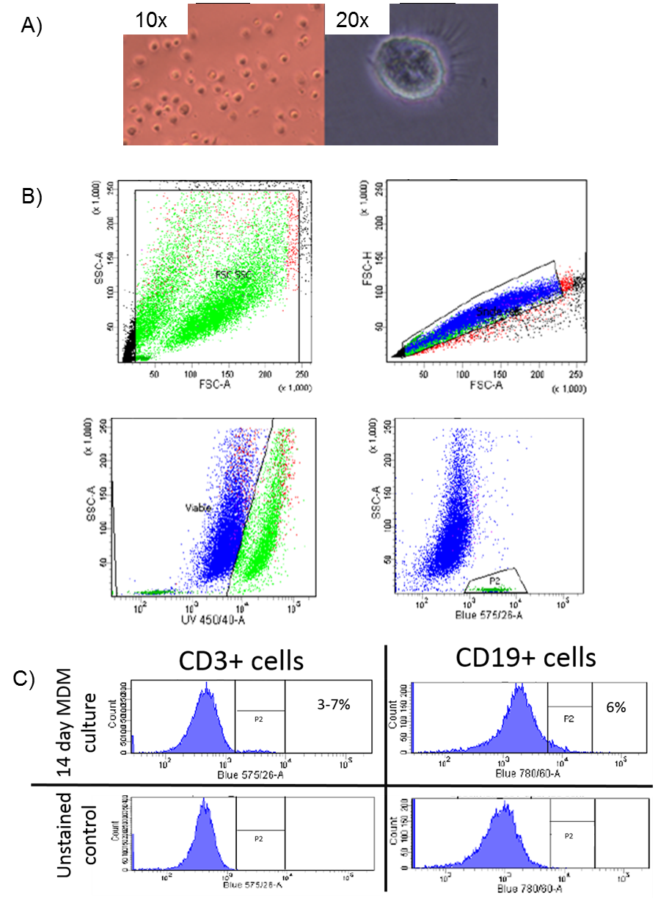
Figure 4.1 Analysis of monocyte derived macrophages (MDMs)
Peripheral blood mononuclear cells were isolated from healthy volunteers and matured over 14 days to produce monocyte derived macrophages (MDM). A) Light microscopy at 10x & 20x magnification, showing a typical MDM. B) Flow cytometry analysis of MDMs. Purity was determined by flow cytometry. Sequential gating was used to first exclude debris (panel 1), remove duplets (panel 2), and finally remove non-viable cells (high UV) (Panel 3). C) Two contaminant cell types were identified as being CD3⁺ and CD19⁺ cells (T and B cells respectively). The contribution of these lymphocytes is shown in P2. By comparing the fluorescently stained sample vs the unstained control, the overall purity of macrophages was deemed to be between 87-91%.
In order to stimulate the macrophages 100 ng/ml of LPS in fresh media was added to 14 day old MDMs and incubated for 6 hours, following which the media was taken for cytokine analysis via ELISA and cells were scraped, pelleted and flash frozen in liquid nitrogen and stored at -80°C. Tolerant MDMs were generated by exposure to 100 ng/ml of LPS in fresh media for 24 hours, and (control) naïve MDMs were given fresh media with no LPS for 24 hours (Figure 4.2). In order to confirm tolerisation, tolerant macrophages were washed in 1 x PBS and further stimulated with 10 ng/ml LPS. The supernatants were then analysed by ELISA. This protocol is very similar to that used by Foster et al, except that only control, stimulated and tolerant macrophages were generated (Foster & Medzhitov 2009). This is due to restrictions on cell numbers attainable from using blood donations and losses that result during the maturation of primary macrophages. Furthermore, a shorter time point for the secondary LPS exposure is used in our experiments, this was done so the expression levels of the cytokines could be directly compared to the primary stimulation.
The establishment of tolerant and stimulated MDMs was confirmed by the ELISA of IL-6 and TNFα (Figure 4.2). Both IL-6 and TNFα are pro-inflammatory cytokines, known to be released after exposure to the LPS via the TLR4-MyD88 pathway (Lu et al. 2008). The average amount of TNFα and IL-6 expressed after 6 hrs of LPS exposure was 1809 pg/ml and 436 pg/ml respectively, this represents a significant increase upon LPS exposure (Figure 4.2). After 24 hours both pro-inflammatory cytokines are still present in the media, at lower levels in TNFα and at higher levels in IL-6. These findings agree with similar work performed in human primary MDMs (Seshadri et al. 2009). In order to check whether that the MDMs are in fact tolerant at 24 hours, they were washed in 1 x PBS and re-stimulated with LPS for 6 hours (see Figure 4.3). The lack of a significant pro-inflammatory response following this second exposure is indicative of a tolerant phenotype is consistent with previous studies (Foster et al. 2007). However, a reduction in IL-6 expression is seen at 24 hours compared to the 6 hr time point. This may be due to the use of human primary cells compared to using bone marrow derived macrophages from mice as it closely matches the expression profile of human LPS stimulated macrophages (Seshadri et al. 2009).

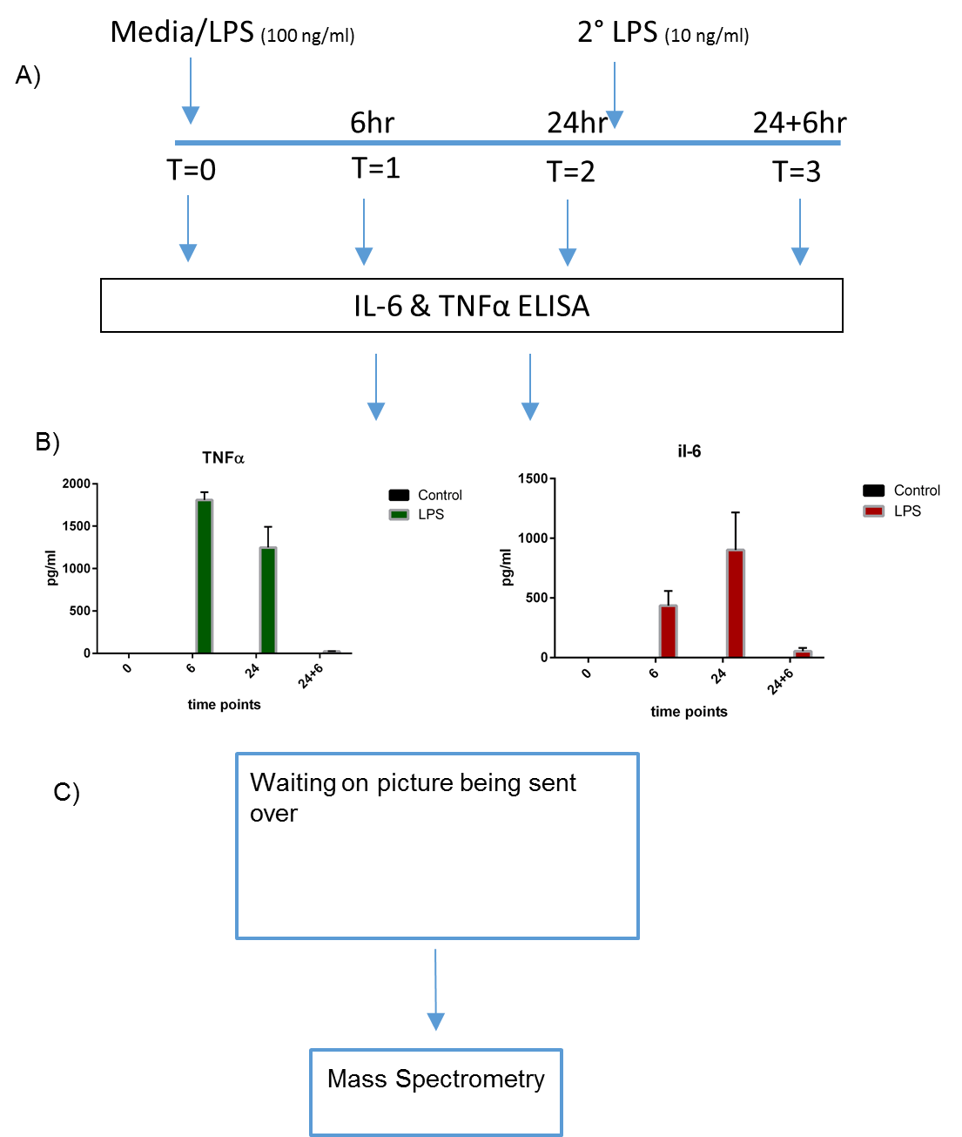
Figure 4.2 LPS stimulation and tolerisation of macrophages
A) Workflow showing the strategy for LPS stimulation and tolerisation of macrophages. 14 day old MDMs were exposed to LPS for differing lengths of time in order to generate LPS stimulated (6 hrs) and tolerised cells (24 hrs). Control cells were incubated in fresh media for 24 hours. Supernatants were taken at each time point including, a further LPS exposure, for 6 hours, following 24 hours (24+6). B) ELISA analysis of two proinflammatory cytokines (IL-6, TNFα). Stimulation of macrophages was confirmed with significant increases in both IL-6 and TNFα. Similarity tolerisation is confirmed by the lack of proinflammatory cytokine response upon secondary stimulation following a prior 24 hour long exposure. C) SDS PAGE analysis of histones extracted from control, stimulated and tolerised macrophages. Following extraction, chemical derivitisation analysis was performed using mass spectrometry.

Cell pellets for control, stimulated and tolerant MDMs were resuspended from frozen in hypotonic lysis buffer with added protease and phosphatase inhibitors (see Chapter 2.5). Following lysis, nuclei were pelleted, and resuspended in 0.2 M sulphuric acid and incubated on ice for 4 hours, to precipitate non- histone nuclear proteins and nucleic acids. The soluble histone proteins were then precipitated in TCA overnight at 4°C, washed in ice cold acetone to remove acid, and resuspended in HPLC grade water. Histone proteins were then quantified using Bradford reagent and absorbance at 595 nm. Purity was checked by 12% SDS PAGE gel (Figure 4.2C). Significant enrichment of the core histone proteins (H2A, H2B, H3 and H4) as well as linker histone H1 can be seen. Typically from 3 x 10⁶ MDMs generated for each condition around 60-80 µg of histone proteins were extracted.
In order to identify and characterise histone PTMs, mass spectrometry was used. A bottom up approach using the developed 2D LC methodology (see Chapter 3.4) was used as it allows the best amino acid specific identification, exhibits the highest sensitivity and is the most quantitative of all the approaches. The bottom up approach utilises trypsin to generate peptides (see Chapter 2.5). Chemical derivitisation by propionyl anhydride was conducted prior and post tryptic digestion. Thereby effectively changing the specificity of trypsin to that of Arg-C so that larger more hydrophobic peptides are generated that are better retained on the C18 column that is online with the MS. Mass spectrometry was utilised to enable a global view of histone PTMs in human primary macrophages. The majority of work conducted in this field focuses on the gene-level changes in histone PTMs; this is usually a promoter-centric approach focusing on the histone mark H3K4me3, which is strongly associated with activation. However, global levels of histone PTMs in human macrophages have not been examined before and it is the aim of this work to explore this area. 10 µg of total histone protein was propionylated and pre and post tryptic digestion as described in chapter 3.1. Histone peptides were then fractionated on the PGC (hypercarb) column in the first dimension. Following fractionation the histone peptides were concentrated to dryness and analysed using mass spectrometry as described in chapter 2.

Mass spectrometry analysis
The strategy employed to identify histone post translational modifications is described in Chapter 2.10. Briefly, N-term and lysine propionylation are set as fixed modifications, the enzyme is Arg-C, (due to the propionylation) and variable modifications were changed depending on search, the main search included lysine acetylation, mono/di/tri methylation and phosphorylation. Then subsequent searches were done, substituting in different combinations of lysine ubiquitination, crotonylation, SUMOylation (+2135.92 and +3549.53 Da although this is a large addition of MW to the peptide, and so may reduce the likely hood of it being detected with the MS scan range) and N and Q deamidation. No ubiquitination, crotonylation or SUMOylation was detected by MASCOT. A wide range of modifications were identified across the histone tail and within the globular domain, the methylation and acetylation of lysine residues were the most abundant modifications seen along with a degree of phosphorylation and small amounts of deamidation of N and Q residues.
MS analysis of the histones extracted from MDMs reveals a highly modifiable N-terminal histone tail. A summary of the modifications identified on Histone H3 and H4 is shown in Figure 4.3. In total 54 different proteoforms of histone H3 were identified, including 10 for histone H3.3. Because a shotgun approach was used experimentally, histone variant information in areas of amino acid sequence overlap is lost. In the histone N-terminal tail, there is very little sequence difference between H3 variants. For example, the peptide fragment sequence KSTGGKAPR is present in all H3 variants detected, and so its origin cannot be determined. Histone H3.3 varies in the N-terminal tail sequence by a single amino acid, compared to H3.1 and H3.2. This allows the K27-R40 peptide from H3.3 to be distinguished, and separately quantified.
All histone PTMs that were identified in MASCOT were manually verified, within Data Analysis (DA). This was done using many levels of information to confirm the presence and precise location of the PTM within the peptide. Firstly, an extracted ion chromatogram (EIC) of the peptide in question is generated in DA, the corresponding peak is then identified and the charge state determined, confirming the species thus confirming the species is that identified, by MASCOT. In addition the MS/MS spectra were examined. Diagnostic peaks that confirm the site of modification are then identified, allowing unambiguous determination of the PTMs position. All MS/MS spectra for the modified peptides identified in this study are shown in Appendix 7.2. Finally, the retention time of the modified form is compared in relation to other modifications on the same peptide. For example, the peptides Kme2SAPATGGVKme1PHR (K27me2K36me1), Kme1SAPATGGVKme2KPHR (K27me1K36me2) and Kme3SAPATGGVKKPHR (K27me3) are all isobaric, they have the same nominal mass). In order to determine the correct modification and its site a combination of the retention time and MS/MS was used (Figure 4.4). In the 3+ charge state all three of the peptides monoisotopic peaks are 548.66 m/z. When an EIC is generated for this m/z it reveals three peaks (Figure 4.4A). In order to assign each peak to its corresponding proteoform, the MS/MS spectra were examined, as can be seen in Figure 4.4B the Kme2SAPATGGVKme1KPHR peptide contains diagnostic shift in b2 ions at 371 which is diagnostic of a dimethylation, and doesn’t not contain either any peaks corresponding to a methylation or trimethylation. Importantly this spectrum also contains a mass shifts at y5 that is indicative of a methylation at this position and not the adjacent lysine confirming that this species is indeed the Kme2SAPATGGVKme1KPHR. This pattern of elution is consistent, even though the exact retention time will shift as it is dependent on the gradient and can be used as additional evidence. The trimethylated species elutes from the C18 column first followed by the K27me2K36me1 and finally K27me1K36me3 (Figure 4.4A).
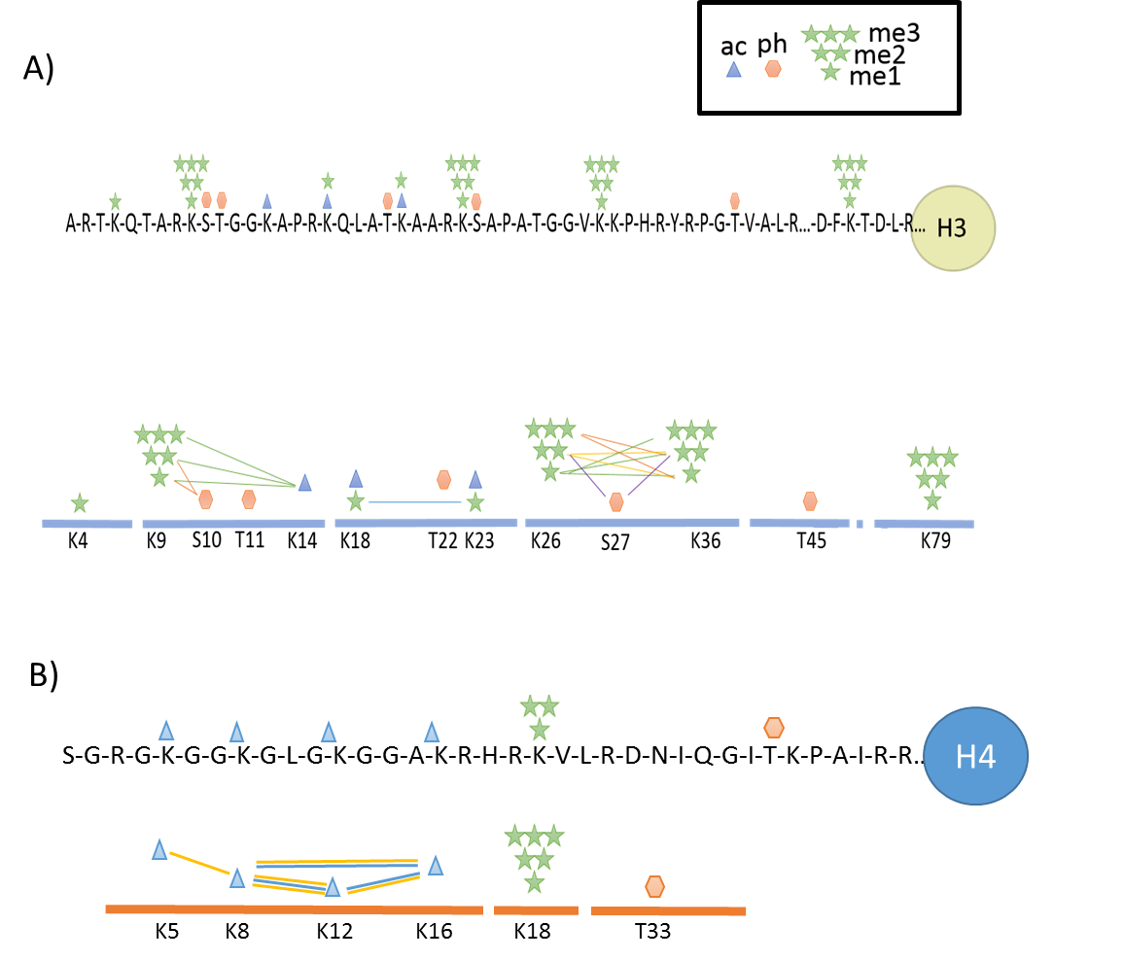
Figure 4.3 Identification of histone modifications and their combinatorial patterns on histones H3 and H4
A Schematic illustration summarising the modifications identified and the combinatorial nature of these modifications on A) histone H3 and B) H4 using mass spectrometry analysis. The modifications identified were focused on the N-terminal tails in both histone proteins. Lysine residues were the main site of modification. Mono, di and trimethylation and acetylation were the major modifications only small levels of phosphorylation were detected. Peptide K27-40 displayed the most combinatorial complexity along with peptide K5-17 on H4 each line shows modifications that were seen on the same peptide. On H4 the yellow line = triacetylation combinations, blue line = diacetylation combinations.

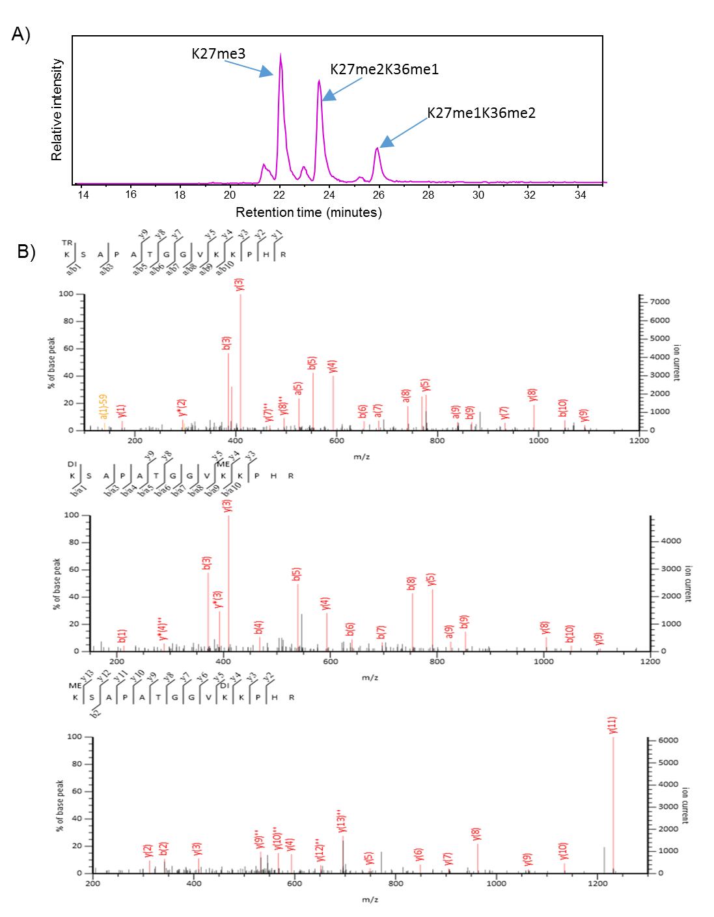
Figure 4.4 MS analysis and Identification of modified isobaric peptides
A) An EIC at 548.66 m/z reveals 3 peaks corresponding to the peptides K27me3, K27me2K36me1 and K27me1K36me2 all have the same m/z of 548.66 in the 3+ charge state. B) MS/MS spectra of the peptides corresponding m/z 548.66 taken from mascot (Me = me1, DI = me2 and TR = me3). To assign the correct modifications to each peak the MS/MS is used. Diagnostic ions especially at y4 and y5 confirm both position and type of modification present. The shift from 385 m/z to 371 m/z for the b3 ion allows K27me2 vs K27me3 to be differentiated.

Mass spectrometry not only allows a vast amount of histone PTMs to be discovered in all histone proteins within a single experiment, but also allows combinations of these modifications to be identified. However, as a bottom up approach was used, only short range modifications were identified, due to the relatively short size of peptides generated. Despite this, of the 54 modified H3 peptides discovered, 25 were the result of the addition of multiple chemical groups. The MS analysis (summarised in Figure 4.3) highlights the combinatorial complexity that exists on the N-terminal tails, something that although is widely known to exist within histone proteins has not before been described in human primary macrophages.

Quantification
Following identification of wide range of histone PTMs in MDMs further analysis was performed aimed at quantifying the relative abundance of the PTMs in an effort to identify changes in global histone PTMs from MDMs stimulated and tolerised with LPS.

Assessment of Quantification
A number of different search strategies were employed to analyse the MS data to quantify modifications. In addition a more detailed analysis was performed to study the effects of under (incomplete) propionylation at lysine and N-terminal amine groups and over propionylation (OP) (also known as aspecific propionylation) i.e. propionylation of Serine and Threonine (Figure 4.5). The extremes of either of these would result in significant loss of signal of the expected peak, and will also change the detection efficiency of the peptide, resulting in loss of reliability in quantification. Propionylation was set as a variable modification at N-terminal and on Lysine, Serine and Threonine residues, with 3 missed cleavages allowed for. Only two peptides showed "under" propionylation of lysine, this is the unmodified KSTGGKAPR peptide (resulting peptide = STGGKAPR peptide) and the unmodified KSAPATGGVKKPHR (resulting peptide = SAPATGGVKKPHR). This peptide represents a small fraction of the entire unmodified peptide (<5%). There was no significant change in the abundance of this peptide between samples, and therefore it was not included in the relative abundance (RA) calculations. Furthermore, the actual contribution of this mis-cleaved peptide to the intact peptide in terms of quantification is hard to determine, based on differences in ionisation efficiency resulting from the peptide sequence difference. In addition, low levels of cleavage by trypsin at dimethylated lysine were identified (Figure 4.5). Again, this contributed only a small proportion of the entire sample that it did not significantly impact upon accurate quantification. The over propionylation of either serine or threonine both contribute a significant amount to total signal intensity (27.42% to the total). The K9-17 peptide is much more susceptible to over propionylation than K27-40 peptide. The level of over propionylation varies both between samples and within peptides. This variation in both cases is significant (Figure 4.6). However, only one of the 9 samples showed significantly different propionylation compared to the others. Within peptides most proteoforms showed approximately the same levels of propionylation with only the very low abundant peptides having no detectable over propionylation. As would be expected the most over propionylated modification is the most abundant peptide (H3K27me2) with two detectable levels of propionylation. The peptides TKQTAR, KQLATKAAR showed no detectable over propionylation.
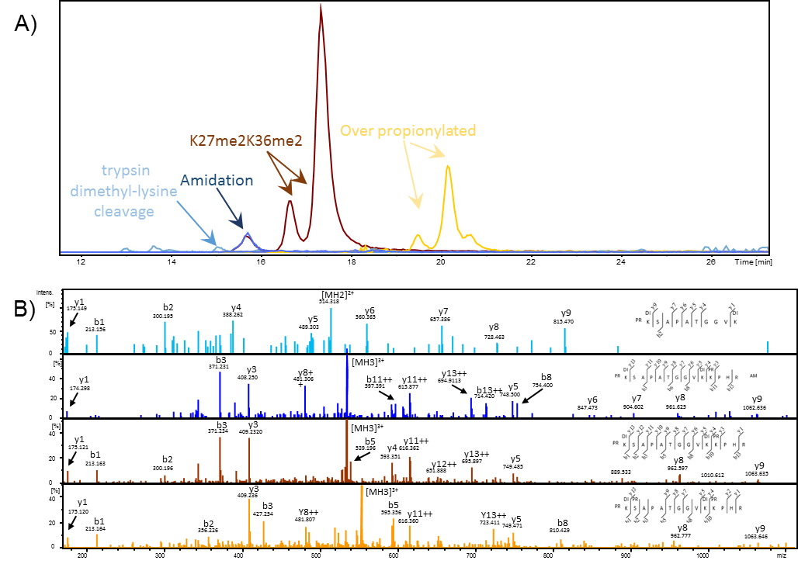
Figure 4.5 Quantitative MS analysis of the propionylation of histone peptides.
A) EICs generated for each species generated by the reaction of propionic anhydride and histone peptide K27me2K36me2. The common side reactions including over propionylation and amidation are highlighted. In addition to this the product of the cleavage of trypsin at a dimethyl lysine is also shown. B) MS/MS spectra of the identified peptides from the above EIC confirming the modifications present. Light blue: peptide formed by cleavage of dimethyl lysine, Dark blue: amidated peptide, red: correctly propionylated peptide and Yellow: over propionylated peptide.

Amidation
Side reactions such as amidation that occur during the reaction of histone peptides with propionyl anhydride can generate species that contribute to the loss of expected signals. Amidation is the replacement of the free hydroxyl group with an amide group (NH₂) occurs at the C-terminus, D and E residues.This results in the net loss of 1 Da, and causes a reduction in the retention time resulting in the amidated form eluting before the non-amidated form of the peptide (Figure 4.5). Several amidated peptides were detected. Although, when quantified the percentage of the amidated form was, typically less than 10% of the non amidated form.

Effect of over and aspecific propionylation
In summary, the propionylation method used produced high levels of correct propionylation (N-term and lysine) with only small levels of detectable under propionylation. On average 27% of the total peptide was found to be over propionylated. When this is combined with the levels of amidation, it results in a large loss of total peptide signal. Furthermore, the addition of these side reactions makes the sample more complex with more precursors selected for MS/MS without providing any extra information, which reduces the peptide annotation rate when using the data dependant acquisition method. Amidation and over propionylation are known side reactions occur during the propionylation reaction when ACN is used as the solvent. It is possible to use other solvents in place of ACN such as isopropanol and methanol (Plazas-Mayorca et al. 2009). The use of methanol is less favourable due to its propensity to react via methyl-esterification forming methylated peptides which due to methylation being a PTM of interest in histone PTM analysis (Paternoster et al. 2016). Isopropanol has also been used as a solvent for the propionylation reaction. Unlike methanol, this alcohol does not react with histone peptides. Although other side reactions such as Amidation and over / under propionylation still occur (Paternoster et al. 2016). Recently within the lab isopropanol has been trailed as an alternative solvent, along with a reduction in both the length and temperature at which the reaction takes place as has been documented in recent literature (Sidoli, Yuan, Lin, et al. 2015). Although not a direct and thorough comparison of ACN vs isopropanol, initial results suggest that these new conditions curtail the levels of over propionylation. Whilst not causing any more under propionylation.
In order to assess the impact that propionylation has upon accurate quantification, the samples were quantified in a label free manner, using relative abundance both with and without the OP and amidation taken into account. The difference between the two samples is plotted on Figure 4.6B for the H3 peptides K9-17 and K27-40. The inclusion on OP and amidation changed the overall relative abundance to a small degree. In the vast majority of cases the inclusion of OP and amidated peptides altered the relative abundance of each proteoform by less than 2% for both peptides. The addition, of OP and amidation also decreased the standard deviation in both cases (Figure 4.6C). Therefore, the inclusion of the OP and amidated proteoforms did not significantly alter the quantitative data, and did not change the outcomes (which are discussed later). Furthermore, as shown by Lin et al, PTMs have a significant effect upon ionisation efficiency (Lin et al. 2014). Therefore it is likely that the addition of extra propionylation groups, along with altering retention times, will also affect the detection efficiency of the peptides. Thus the correction factors used for accurate quantification determined could not be used with confidence. Therefore, the relative abundance of the histone PTMs were quantified without taking into account over propionylation and amidation.
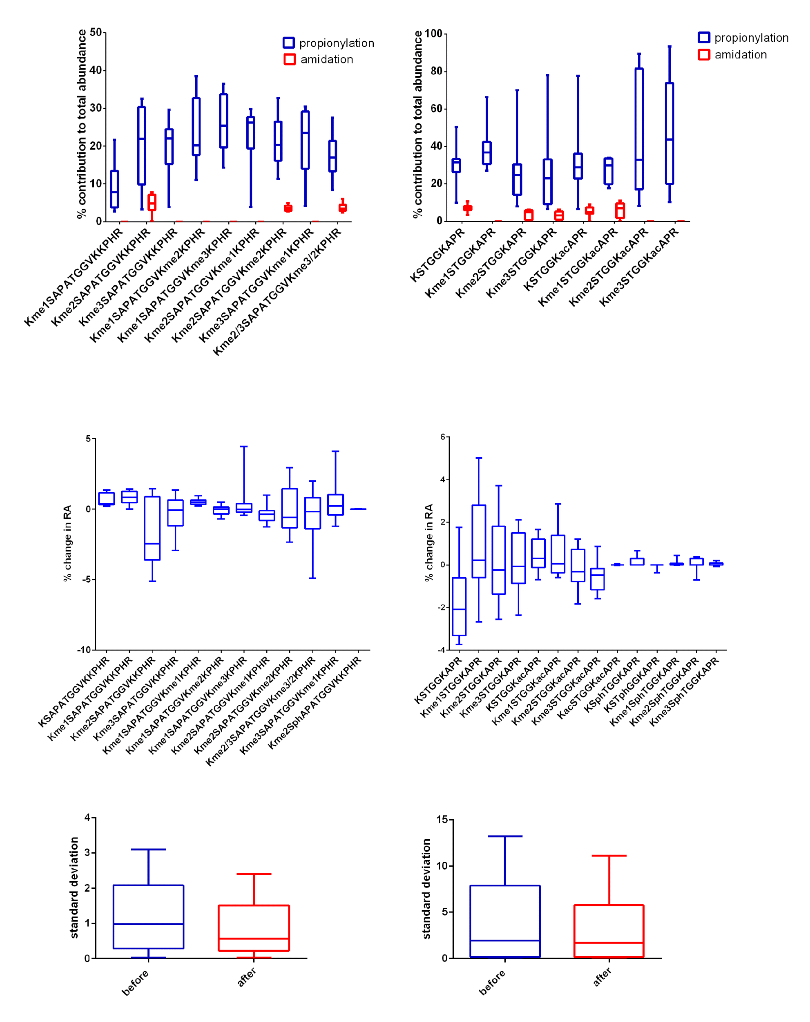
K9-17 peptide
K27-40 peptide
A)
B)
C)
Figure 4.6 Assessment of the impact of over propionylation and amidation on peptide quantification
Box plots showing the relative contribution of over propionylation and amidation and the effect that these side reactions have on the accuracy and final quantification of highly modified histone peptides K27-40 -left panels and K9-17 right panels. A) A min to max box plot of the relative contributions of over propionylation and amidation to total signal of all found proteoforms of two peptides. (n=9) B) A box plot to show the change in the final overall relative intensity with the inclusion of over propionylated and amidated species. (n=9) C) A box plot of the standard deviation was calculated before and after the addition over propionylated and amidated species in the quantification of either K27-40 (left) or K9-17 (right) peptides.

H3.1 quantification
Having assessed the effect of over propionylation on the accuracy of quantification, global levels of histone macrophages were then quantified. Focusing first on histone H3: PTMs were identified in all but three of the peptides in all three conditions. The results are summarised in Figures 4.7 and 4.8A.

Quantification of H3K3-8
While the peptide TKQTAR was identified, in both methylated and unmodified forms it was not reliably identified across all 3 biological repeats (Figure 4.7). This is due to its poor retention on C18 columns especially in the me2 and me3 forms, which were not detected in these analyses (Garcia, Mollah, et al. 2007). However, reliable quantification was possible for the rest of the histone tail, and for several peptides in the globular domain.

Quantification of histone H3 K9-17
14 different combinations of PTMs were discovered at three sites: K9, S10 and K14 on the peptide K9-17 using MS analysis (Figure 4.7). The modifications identified were mono, di and trimethylation along with acetylation and phosphorylation. K9 methylation (me2/me3) was the most abundant modifications seen in macrophages. Due to the co-elution of the singly acetylated peptides K9acK14un and K9unK14ac, it was not possible to directly determine the relative abundance of each species at solely the MS level. Therefore, the relative abundance of diagnostic ions in the MS/MS spectra was used for quantification (Pesavento et al. 2006; Plazas-Mayorca et al. 2010). The results shown in Figure 4.7 demonstrate that following stimulation K9me2K14ac was significantly decreased (adjusted p = 0.0129). These levels return to near control levels following tolerisation. This suggests a dynamic time dependant response in this modification to LPS. K9me2K14ac contains two histone PTMs that have opposing functions: K9me2 is deposited mainly by the G9a/GLP enzyme and this modification is linked to HP-1 binding and hence transcriptional repression. Conversely, K14ac is heavily implicated in transcriptional activation (Karmodiya et al. 2012). Therefore, similar to K4me3K27me3, K9me2K14ac is thought to constitute a bivalent domain, and poises genes for activation or repression. Genes containing these bivalent domains at their promoters tend to be unexpressed (Taverna et al. 2007). No significant change is seen in either K9 methylation or K14 acetylation upon stimulation, this may be due to the counter action of genes becoming expressed and others being repressed associated with an increase and decrease in K9me2 respectively. Alternatively, as this significant reduction in K9me2K14ac is found with a parallel significant increase in the unmodified form of the peptide (K9unK14un) (adjusted p value = 0.0052). This suggests that both K9me2 and K14ac are selectively lost but only when they are found in combination. There is limited research into the effector functions of this unmodified peptide, therefore its function remains unknown.
The significant decrease in this bivalent domain is consistent with the movement away from a poised state into an effector state when the MDM is exposed to LPS. After tolerisation occurs, the MDMs returns to a poised state. It is proposed that this poised state, although similar on the global level to control, is significantly altered in terms of genomic location. Indeed tolerised macrophages re-stimulated with LPS show highly altered responses (De Santa et al. 2007; El Gazzar et al. 2008; El Gazzar et al. 2007; Foster et al. 2007). This alteration in the global deposition of histone PTMs represents a form of innate immune memory via similar to that of innate immune training (Ifrim et al. 2014).
Interestingly, in the control all four donors show similar basal levels of histone modifications, with small levels of variance. Upon LPS exposure for 6 and 24 hours, the response from one donor is highly different to the others. This may represent a basis for the inherent patient variability to the same stimuli. The data presented is an n=4, which is not sufficient to tease out any population based effects such as possible “high” and “low responders” to LPS and further along tolerisation. This may not be reflected in the production of IL-6 and TNFα as, this is just one of the many phenotypic impacts that LPS has upon MDMs. LPS has also been shown to inhibit killing of bacteria by macrophages (De Lima et al. 2014). Furthermore, this data only represents a snapshot of the dynamic response to LPS by macrophages, therefore differences in response time to the stimuli may account for the variability. What this data does show is that LPS elicits a large global response within cells at the histone PTM level and therefore cause alterations in global chromatin structure consistent with previous observed changes in gene expression (Wells et al. 2003)
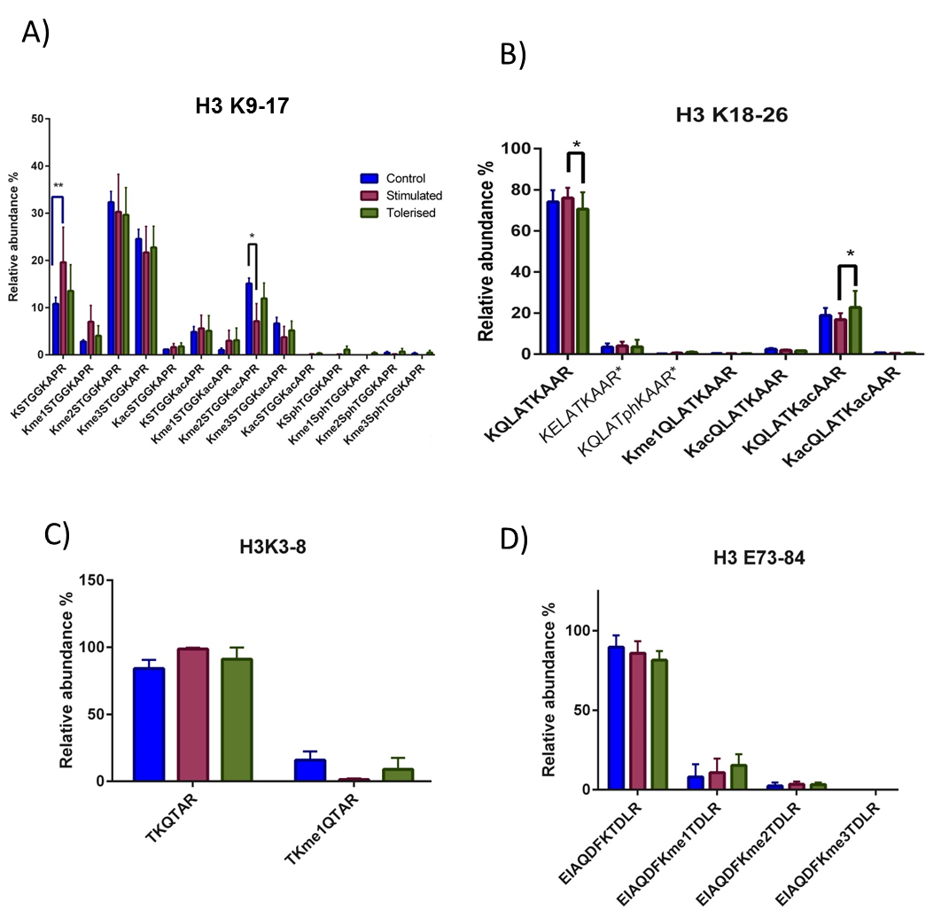
Figure 4.7 Quantification of H3 peptides: K3-8, K9-17, K18-26 and K73-83 using mass spectrometry
A) Bar chart showing the relative abundance of K9-17. There is a significant increase in unmodified KSTGGKAPR peptide (K9-17) in stimulated MDMs compared to the control. This corresponds to significant decreases K9me2K14ac. A wide degree of variance can be seen in the response to LPS exposure. B) Bar chart showing the relative abundances of PTMs on the peptide KQLATKAAR (K18-26) a significant increase in K23ac was identified between stimulated and tolerised cells C) Bar chart showing the relative abundances of PTMs on the peptide TKQTAR (K3-8) D) Bar chart showing the relative abundances of PTMs on the peptide EIAQDFKTDLR (K73-83) peptides between control, stimulated and tolerised groups. All conditions in peptides K9-17 are n=4, K3-8 K18-26 and K73-83 are n=3. Statistics were generated using a repeated measures two-way ANOVA using the Tukey method to determine significance in Graphpad prism 6. All error bars plotted are SEM.

Quantification of H3 K18-26
Analysis of the K18-26 peptide shows that the majority of the peptide was found in the unmodified state (K18unK23un) (see Figure 4.7). Low levels of acetylation were also observed, alongside deamination of Q19, and phosphorylation of T22 (Figure 4.7). As with K9ac and K14ac the single acetyl positional isomer peptides co-elute resulting in mixed MS/MS spectra. Therefore relative quantification was based on abundant specific MS/MS ions and is described in more detail in Chapter 5.3.5.3 (Pesavento et al. 2006; Plazas-Mayorca et al. 2010). Using this approach a significant increase in K23ac was seen upon tolerisation compared to stimulated cells (adjusted p value = 0.0132). These results are in contrast to the more repressive profile observed in tolerised cells at the gene level (El Gazzar et al. 2007). However, the tolerised phenotype is a complex one, and only certain subsets are repressed where as others are more strongly expressed following the re-stimulation of tolerised cells (Foster et al. 2007). Further studies using ChIP- based methods would have to be carried out to determine the genomic location of this modification.

Quantification of H3.1/2 K27-40
Analysis of the K27-40 peptide is shown in Figure 4.8. The results show small but significant changes in methylation were identified similar to the K9-17 peptide (see Figure 4.7). Dimethylation again represented the highest abundance modification on the peptide: representing around 21% of the population at K27 alone and 23% when in combination with K36me2. In resting macrophages 62.5% of the total K27me2 signal is found in combination with another modification. This represents a significant proportion, and it is in a combination that the largest difference is seen between control and stimulated cells. The results show that K27me2K36me2 is significantly reduced upon LPS stimulation (adjusted p value = 0.005). This reduction in K27me2K36me2 was recently been reported, although it was not significant (Soldi et al. 2014). However, a shorter LPS exposure was used in this study, in non-primary cells, which may account for this difference (Soldi et al. 2014). Interestingly this seems to be a transient reduction as it increases back to near control levels upon tolerisation, which matches the transient reduction in K9me2K14ac. The reduction coincides with small but not significant increases in both K27me2 and K27me3. This loss of the dual dimethyl peptide and corresponding increase in the singly dimethylated peptide (K27me2) suggests that LPS selectively causes the global loss of K36me2, specifically when it is in combination with K27me2. The level of reduction observed in K27me2K36me2 was not the same when compared to K36me2 in combination with K27me1 or me3.
The reduction of K36me2 has been shown, at least at the promoter level of tolerisable genes (TNFα and IL-6), to be due to the reduction in the histone lysine methyltransferase (HKMT) SMYD2 upon LPS stimulation at both the protein and mRNA level (Xu et al. 2011). The SMYD (SET and MYND domain) family of proteins are lysine methyltransferases (KMT) that were first identified as HKMTs, but have been found to also methylate other proteins (Yamamoto et al. 2011; J. Huang et al. 2006; Butson 2011). The SMYD2 protein, unlike the other members of the SMYD family, is a specific H3K36 methyltransferase adding a dimethyl group to the lysine. The reduction of this protein correlates well with our data that sees a global reduction in K36me2 levels (Figure 4.8A). The levels of H3K27me2K36me2 increase back to near control levels upon LPS tolerisation. Although the specific K36me2 dimethylase enzyme is known to still be downregulated at 24hrs following LPS treatment (Xu et al. 2015). Research has suggested that the methylation of lysine residues by NSD (coordinated by chronic active G9a) (both HMTase enzymes) offer a possible pathway for the levels of K36me2 levels to return to control levels, upon tolerisation (Liu et al. 2014a).
However, the reduction in K27me2K36me2 observed following LPS stimulation can arise due to a number of factors and not just the reduction of K36me2 such as the methylation or demethylation of K36me2 or K27me2. In order to determine the pathways that lead to the reduction in K27me2K36me2 there are several experiments that could be conducted and these are discussed below.
The sole donor and cofactor of methyltransferase enzymes required for the methylation of histone proteins is s-adenosylmethionine (SAM) (Bannister & Kouzarides 2011). Methonine is an essential amino acid, which means it is not synthesised by the cell itself, instead it is acquired from the environment or by the breaking down of proteins. This lends methionine to the application of SILAC: methylated histones from cells cultured in methionine containing a heavy methyl group, will be labelled with this heavy methyl group which under MS analysis will be distinguishable from its light counterpart. If this is introduced at the same time as the cells are incubated with LPS, then the additions of novel methylation caused by LPS stimulation could be viewed by the presence of heavy methylation. In this way the decrease in K27me2K36me2 following stimulation can be assessed as to whether it is the result of the methylation of this histone PTM or whether it is the loss of methyl groups from this combinatorial PTM that is causing the reduction in relative abundance. Furthermore the inhibition of either histone methyltransferases or demethylases could also provide insight into the dynamics of this reduction of K27me2K36me2 following LPS stimulation. Although, the functional redundancy within these enzymes may reduce the efficacy of this approach as it may not be possible to completely inhibit the de/methylation of a specific histone PTM site. Finally, the use of a SAM analogue, would inhibit the methylation of histone proteins, and therefore if the reduction in K27me2K36me2 is still seen would suggest that the response is due to demethylation pathway.
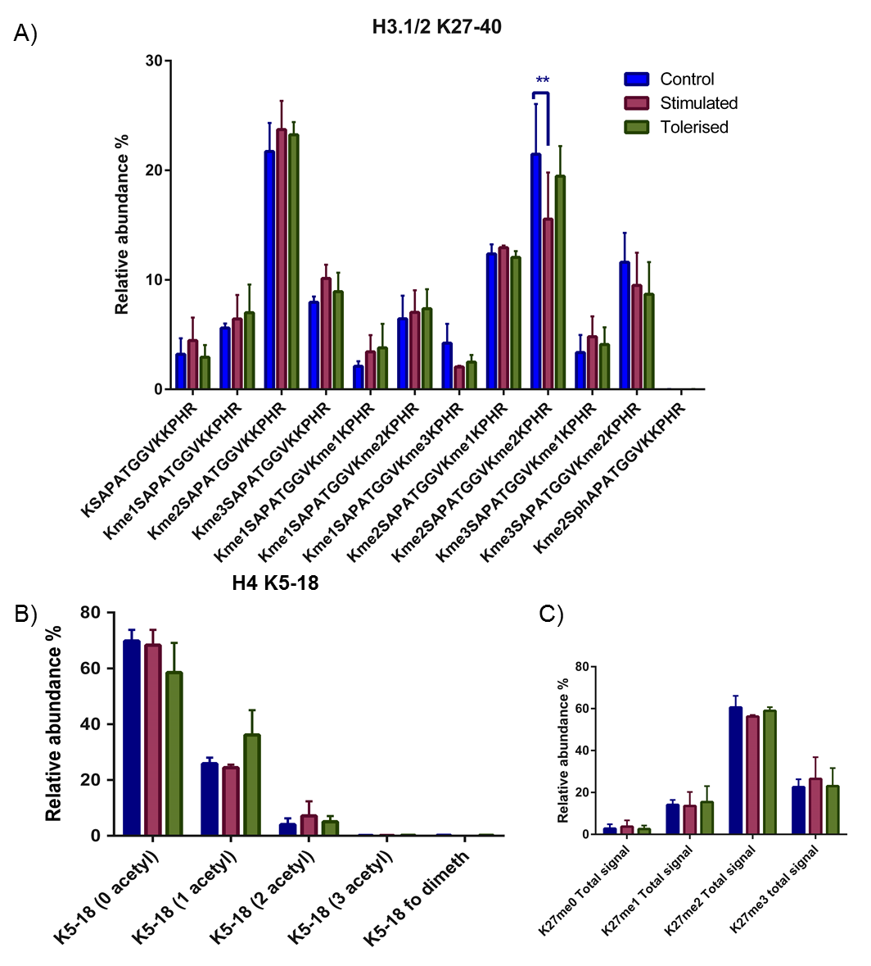
Figure 4. 8 Quantification of H3 peptide K27-40 and H4 peptide 5-17 using mass spectrometry
A Bar Chart showing the relative abundance of A) KSAPATGGVKKPHR (H3.1/2K27-40). This peptide was the most complex modified peptides, with multiple combinations of mono, di and trimethylation seen. Upon LPS stimulation there is a significant reduction in the relative abundance of the dual modified peptide: K27me2K36me2 compared to control cells B) A Bar chart showing the relative abundance of PTMs on the H4 peptide K4-17. There were no significant changes seen in this peptide following LPS exposure C) A bar chart showing the pooled abundance for each of the different K27 methylation states e.g. K27me total signal = K27me1 signal + K27me1K27K36me1/2/3 signal. No significant difference can be seen in levels of K27me3 upon LPS stimulation as reported consistent with previous analysis using Western blots (De Santa et al. 2009)
Statistics were generated using a repeated measures two-way ANOVA using the Tukey method to determine significance in Graphpad prism 6. All error bars plotted are SEM.

Function of methylation events on lys27 and lys36

Lysine 27
Methylation of H3K27 at all three levels is dependent upon the action of the PRC2 complex (although other enzymes have been implicated in me1/2 deposition). Despite this the three levels of methylation are functionally distinct and are deposited in mutually exclusive genomic domains (Ferrari et al. 2014). K27me1 is preferentially enriched in gene bodies of active genes, and is positively correlated with the position of H3K36me3 deposition (another histone PTM linked with gene expression) hence linking it with gene expression (Cui et al. 2009; Steiner et al. 2011). K27me2 is widely seen globally as one of the most abundant modifications of K27 (Jung et al. 2013; Peters et al. 2003). It is associated with areas of gene inactivation, and is thought to have a protective function against K27ac at non-cell type specific enhancers (Ferrari et al. 2014). Similarly, H3K27me3 is also associated with gene silencing, and is stable through cell generations (Lund & Van Lohuizen 2004; Barski et al. 2007). Furthermore it appears to be mutually exclusive to K36me3 both in our data and in others (Yuan et al. 2011; Schmitges et al. 2011; Jung et al. 2010). The K27me3 landscape of entire genomes has been mapped before using ChIP-seq based techniques. In contrast to strong activating marks such as K4me3 which forms peaks of 2.4-2.9 kb at promoter regions, H3K27me3 forms broad localised regions (~43 kb in mice and ~21.2 and 27.8 in macrophages), which are equally distributed over both genes and intergenic regions and not at promoters (Barski et al. 2007; Pauler et al. 2009; De Santa et al. 2009).
In regards to inflammation, the H3K27me3 specific demethylase Jmjd3 has been shown to be significantly upregulated upon LPS stimulation in macrophages which was thought to cause the loss of this repressive mark (De Santa et al. 2007). However, loss of this mark upon LPS treatment when normalised against loss of overall H3 signal, suggests that nucleosome loss rather than demethylation was the cause of K27me3 reduction (De Santa et al. 2009). Therefore, it is thought that JmJd3 acts independently of its demethylase action. Overall they found no significant differences in K27me3 upon LPS stimulation, although in 113 broad regions an enrichment of more than two fold was seen, compared to only 3 that saw a reduction (De Santa et al. 2009). These results are consistent with the MS analysis of all the pooled K27me3 signals which shows a small but not significant increase in the LPS stimulated cells (see Figure 4.8C).

Lysine 36
H3K36me2 and H3K36me3 are thought to be involved in gene activation and are associated with activated genes and RNA pol II (Rao et al. 2005; Bannister et al. 2005; Bell et al. 2008). Bannister et al showed that in chickens both H3K36me2 and me3 were localised at the 3’ end of active transcription, not the 5’ end like H3K4me3, suggesting that although they are involved in activation they have different functions (Bannister et al. 2005). However, the degree of K36me2 was found not to correlate with transcriptional frequency (Rao et al. 2005). Additionally, other evidence has suggested that H3K36 may be involved in gene silencing as it is found to be co-translationally methylated by SET2 that binds elongating RNA Pol II (Gerber & Shilatifard 2003; Strahl et al. 2002). In the higher methylation states me2/3 H3K36 is recognised by the EAF3 chromodomain and recruits the HDAC Rpd3Cs, and deacetylates surrounding histones (Carrozza et al. 2005; Li et al. 2009; Brown et al. 2006). This is thought to restore normal chromatin structure in the wake of RNA pol II progression, to prevent inappropriate initiation of transcription within coding regions (Carrozza et al. 2005). Therefore, the exact function of K36me2 has not been fully elucidated, and is probably dependent upon location within the genome and importantly the local histone PTM environment.

Crosstalk between K27 and K36 methylation.
Histone PTMs don’t exist in isolation and the interaction between different PTMs on the same histone tail, and between different histone proteins has been explored. One of the most heavily studied examples of cross talk between two sites of histone PTMs is K27-K36.
Results presented here demonstrate the complicated interplay and crosstalk between methylation events at these two lysine residues (see Figure 4.3A). K36 methylation was not detected in isolation at any level. Despite this, the most abundant peptide was K27me2K36me2 followed closely by K27me2. This strongly suggests that methylation especially dimethylation at K27 reinforces the presence of K36me2. However, in a multiple myeloma cell line Zheng et al found that dimethylation on either lysine reduced further methylation on the other site by up to 100 fold (Zheng et al. 2012). Furthermore, it has also been shown that K36me3 inhibits the conversion of K27me1 to K27me2 by PRC2 (Ferrari et al. 2014). No K27me2K36me3 or K27me3K36me3 was identified in this study, consistent with this data. In contrast, work done by the Jensen group shows strong connectivity between K27me2 and K36me2 marks in ES cells (Jung et al. 2010; Jung et al. 2013). Suggesting that that methylation of K27 is most likely deposited first, followed by the subsequent methylation of K36. This represents an orthologous pathway by which both K27 and K36 can become dimethylated. Supporting this, it has been shown that the methylation of H3K36 blocks the deposition of H3K27me3 by PRC2 complex, but not vice versa (Yuan et al. 2011; Schmitges et al. 2011).
It is therefore unexpected that alongside the loss of K27me2K36me2 there is a trend, albeit not significant, towards an increase of repressive histone PTMs e.g. K27me3. Or decrease in activating combinations such as K27me1K36me3. One would expect that when presented with a stimulus, the global histone PTM landscape would shift to a more activated one, and then upon tolerisation this would reverse. This trend is similar to that seen in Raw 264.7 (Soldi et al. 2014). Furthermore, it should be stressed that the mass spectrometry data is global, and measures the total global histone PTM profile, not just at areas of the genome that contain genes, promoters or enhancers. This only makes up a small proportion of the entire genome; hence it is difficult to correlate these findings to previous research that focused on modifications at promoter sites.

Quantification of histone3.3 peptide
Histone H3.3 is one of the 7 variants of histone H3 that have been reported in humans: canonical variants H3.1 and H3.2, H3.3, 3t, 3.X and 3.Y and CENP-A (Szenker et al. 2011). Histone proteins H3.1 & H3.2 are found in multi copy clusters in humans such as at the HIST1 loci, which contain 49 core histone genes. H3.1/2 genes contain no introns, and their transcripts are not polyadenylated (Szenker et al. 2011). This is strikingly different to histone H3.3, which has low gene copy numbers, possess introns and are polyadenylated (Szenker et al. 2011). H3.3 varies from H3.1 and 3.2 by 5 and 4 amino acid residues respectively. The differences in residues 87, 89 and 90 are important as they determine its localisation to the genome (Goldberg et al. 2010). In terms of localisation, H3.3 is found to be enriched at transcriptionally active sites, promoters and greatly impacted upon the formation of higher order chromatin structures (Chen et al. 2013; Braunschweig et al. 2009). Conversely, H3.3S31 phosphorylation (which is specific for H3.3) has been localised to pericentric heterochromatin regions in HeLa cells, and is also thought to be involved in the repression of telomeric repeats (Goldberg et al. 2010; Hake et al. 2005). Hence the role of H3.3 has yet to be fully elucidated. Although the histone variants were not separated prior to MS analysis, the K27-40 peptide of H3.3 can be used to discriminate between the different variants (substitution of an alanine to serine). However the quantification of the peptide K27-40 peptide for H3.3 is difficult due to the following issues:
      - There is significant overlap between elution of H3.1 species containing a me3 group and H3.3 species containing a me2 group, e.g. H3.1 K27me3K26me1 and H3.3 K27me2K36me1.These two species differ by only 2 Da. The problem then arises from overlaps in the isotopic distribution of each of these species.
- With a mass difference of 2 Da, the 1st or monoisotopic peak (containing no heavy isotopes) of the H3.3 K27me2K36me1 peptide will overlap with the third peak of the H3.1 K27me3K26me1 peptide regardless of charge state. This means that the total intensity of this overlapping peak is made up of two parts (1st peak of H3.3 and 3rd peak of H3.1 peptides).
The contribution of each of the two species can be determined by deducting the theoretical value for the 3rd isotope peak of H3.1 isotope distribution series (taken from (Lin et al. 2014)) from the total value of corresponding peak, therefore allowing the intensity of the H3.3 monoisotopic peak to be determined. However, as the H3.3 peptides elute out marginally earlier than the H3.1 near isobaric counterpart it was decided that the maximal peak intensity would be used to determine the relative abundance. An example, of how this is determined is shown in Figure 4.9.

Effects of LPS exposure on H3.3
The relative abundances of the H3.3 peak intensities were then plotted (Figure 4.10) Like Histone H3.1/2 the most abundant species was K27me2K36me2 followed by K27me2. In contrast to histone H3.1/2, no significant difference in relative abundance of histone PTMs were seen upon LPS stimulation (Figure 4.10). Interestingly a significant loss was seen at H3.3K27me2K36me2 in the tolerised condition compared to control (adjusted p = 0.0409). In combination with this significant loss a significant increase in H3.3K27me2 was observed compared to control (adjusted p = 0.0252). This suggests that H3.3 and H3.1/2 are differentially regulated and modified upon LPS stimulation and subsequent tolerisation. This would have interesting implications on active transcription as the histone H3.3 variant is known to be enriched at these areas in human somatic cells structures (Chen et al. 2013; Braunschweig et al. 2009). It also brings into question what the function of K27me2K36me2 is at areas of active gene transcription. This has not before been explored, for the reason that it is a dual modification, and hence is less amenable to antibody based studies. Although, it is important to note that the two data sets (H3.1/2 and H3.3) are not directly comparable due to the differences in the way in which they were quantified.
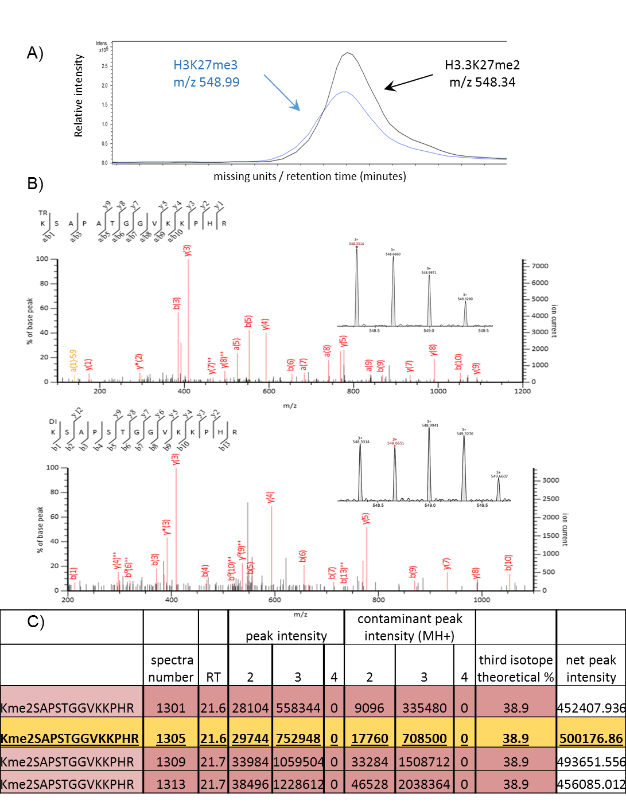
Figure 4.9 Identification and quantification of H3.3 peptide
A) EIC generated for peptides H3.3K27me2 and H3.1K27me3 (3+ charge state) showing the co-elution of these peptides. B) H3.1 K27me3 has the M+3H⁺³ peak at 548.33 m/z overlaps from the third isotopic peak onwards with the first isotopic peak of H3.3 K27me2 MH3+3 peak at 548.99 m/z. This overlap does not allow for quantification in the normal manner, instead the maximal peak intensity is used to quantitate the H3.3 peptide. C) In order to determine the maximal peak intensity of the H3.3 monoisotopic peak, 38.9% of the ‘contaminating peak’ is subtracted from the total intensity of the 549.33 m/z, peak to give the net peak intensity. This is done for 2, 3, 4+ charge states and over multiple time points, allowing the maximal intensity to be determined. This Figure is then used to calculate the relative abundance.

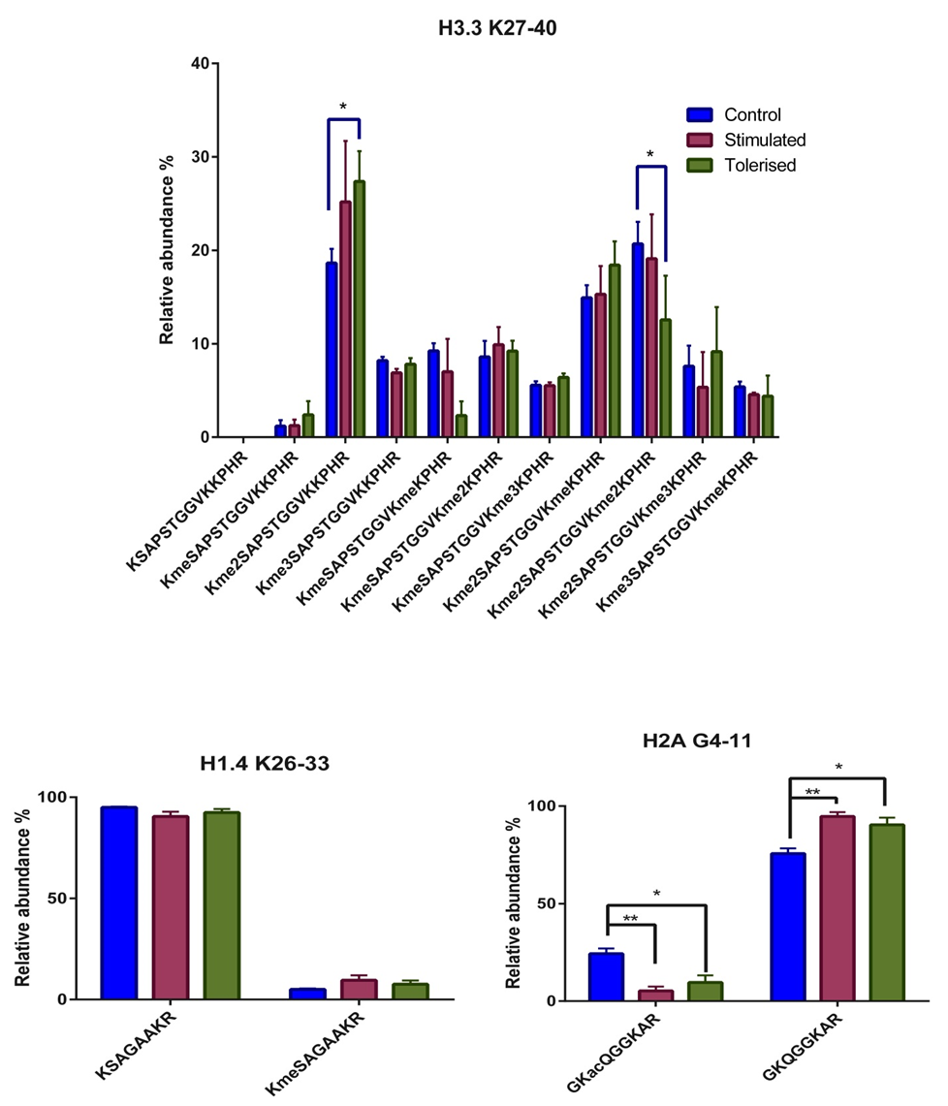
Figure 4.10. The quantification of H3.3 peptide: K27-40, H1.4 K26-33 and H2A G4-11
A) Bar chart visualising the relative abundance of histone PTMs on the human histone variant H3.3. Due to overlapping isotopic peaks with H3.1/2, the relative abundance was calculated from the maximal peak intensity. Similar to the K27-40 peptide from H3.1/2 is highly modifiable. However, there are differences in how H3.3 responds to LPS. This is complemented by the significant increase in K27me2 compared to control. B) Bar chart showing the relative abundances of PTMs on the peptide H1.4 K26-33 C) Bar chart showing the relative abundances of PTMs on the peptide H2A G4-11. A significant decrease in K5ac was seen upon stimulation and tolerisation.
Statistics were generated using repeated measures two-way ANOVA using the Tukey method to determine significance in Graphpad prism 6.All error bars plotted are SEM.

Quantification of H3 K73-84 and H4 K5-18.
The histone peptide H3 K73-84 lies not on the histone tail but within the globular domain. Methylation at K79 was identified (Figure 4.7) but did not alter significantly between control, stimulated and tolerised groups. Acetylation of H4 on the peptide K5-18 was also quantified (Figure 4.8). The majority of the K4-17 peptide was unmodified. There exist 4 possible acetylation sites on K4-17 peptide and acetylation was found to exist on all four possible sites. As expected multiple levels of acetylation were detected, up to 3 acetylations on the same peptide. The precise location of the acetylation can be determined, but cannot be easily quantified. This is because there is a lack of chromatographic separation of the different positional isomers of the same acetylation level. Upon LPS stimulation, no significant change in H4 acetylation was detected, at any level. Similarly, no change was seen upon LPS tolerisation. A significant difference upon LPS stimulation has previously been reported at the gene level, and globally upon LPS stimulation (Foster et al. 2007; Soldi et al. 2014). This global change in LPS was seen in the tetra-acetylated peptide, a species that was not identified in this study.

Quantification of H2A, H2B and H1 peptides.
MS analysis also identified 13 H2A peptides, 3 H2B peptides and 3 H1 peptides. However only two of these peptides were identified with post translational modifications: the H2A peptide G4-11 (GKQGGKAR) and H1.4 peptide K26-33 (KSAGAAKR) contained modifications and therefore could be assessed for perturbations following sepsis (Figure 4.10). The H2A peptide belongs to canonical H2A (H2A type-1 / type-2) these two types are near identical, and differ at position 51 and other C-terminal residues. Although no function specialisation has been found between the two type (Bönisch & Hake 2012). As a bottom up approach was taken it was not possible to determine the origin of this modified peptide, as the distinctive sequence lies on a different tryptic peptide. Upon exposure to LPS both for 6 hours and 24 hours a significant reduction in H2AK5ac is seen compared to control ( adjusted p = 0.0038 and 0.0151 respectively). H2AK5ac marks regions of active gene expression, and is mutually exclusive with K27me3 (Cuddapah et al. 2009a). These two marks are separated by CTCF protein which is thought to define boundaries between areas of activation and repression on the genome (Cuddapah et al. 2009b). This histone PTM has not previously been studied with regards to inflammation or sepsis. Therefore, it is identified as a novel PTM associated with both LPS stimulation and subsequent tolerisation. Further experiments are required to define its genomic location in both stimulated and tolerised macrophages and possibly identify its functional role in response to LPS. Histone H1, also known as the linker histone, is separate from the core histone proteins (H2A, H2B, H3 and H4). H1 allows the formation of higher order chromatic structures, minimises nucleosome sliding as well as modulating the activity of nucleosome remodelling complexes. However, knockouts of this histone protein did not lead to any significant changes in phenotype (Bustin et al. 2005). Therefore, the role of H1 is yet to be fully understood. Histone H1.4 K26me was the only modified form of H1 that was identified in this study. No significant differences in H1.4K26me were seen upon stimulation or subsequent tolerisation (Figure 4.10). Deposition of this mark occurs by G9a/Glp enzymes. Functionally H1.4K26me can recruit the protein HP-1 and is therefore likely to be repressive (Weiss et al. 2010).

Conclusions
The global MS analysis of histone PTMs in human primary macrophages identified 11 differently modifiable sites in H3, 6 sites in H4 and 1 site in both H2A and H1. This equated to 54 peptides on H3 variants and 10 on H4. The relative abundance of each of the 62 quantifiable modifications was determined using peak areas at two time points following exposure to LPS. Significant increases in unmodified H3K9-17 peptide and a significant reduction in H3K9me2K14ac, H3K27me2K36me2 and H2AK5ac were observed upon LPS stimulation. It is likely that the modifications H3K9me2, K14ac and K27me2K36me2 represent bivalent domains allowing the fine, dynamic control of chromatin structure over large ranges of DNA, both intra and intergenically through the action of HKMTs and demethylases. It is proposed that these two bivalent domains result in chromatin being in a poised state, ready to react to different conditions. This mark can become activating, by loss of methylation at K27 or gain of methylation at K36 (K27me1K36me3). These two marks in tandem show very good co-localisation in active gene areas (Ferrari et al. 2014). Or highly repressive, by loss of K36me resulting in the increased kinetic favourability of K27me3 formation (Zheng et al. 2012). As K27me2K36me2 is found on nearly a quarter of global H3.1/2 proteins, it holds enormous power in controlling the transcriptional state of the cell. The significant changes seen although small likely correspond to a large global chromatin reorganisation, due to the high concentration of nucleosomes. Furthermore, because bulk histones were analysed, epigenetic changes relating to the activation of inflammatory genes are probably counterbalanced by the silencing of other gene groups resulting in no net global change, but significant localised changes. Interestingly, modifications on H3 and H3.3 variants differed in the global response to LPS. The results presented in this Chapter highlight that K27me2K36me2, K9me2K14ac and H2AK5ac may play an important role in macrophage response to LPS. Further studies including transcriptome analysis, and a ChIP-seq analysis, could provide further insight on the role of these histone PTMs in macrophage response to LPS. .

An in-vivo study into the impacts of sepsis on the global histone landscape in human primary T-cells

Abstract
T-cells are key players in the role in the pathology of severe sepsis. Indeed T-cells isolated from severe septic patients’ exhibit a large reduction in terms of activation capabilities. Cell number surviving T-cells are either skewed towards a Th2 phenotype or possess an exhaustive phenotype also known as anergy (Carson et al. 2010; Roth et al. 2003; Boomer et al. 2011; Hotchkiss et al. 2013b).
The impact of this is a state of immunosuppression which is documented in both severe septic patients in post mortem studies and also in surviving patients with Compensatory anti-inflammatory response syndrome (CARS). Severe sepsis is a very serious and complex clinical syndrome that has high levels of mortality estimated to be around 30-50% (Slade et al. 2003). Sepsis is defined by a broad range of clinical symptoms, which have been criticised for being over sensitive and non-specific (Levy et al. 2003). Furthermore, a meta-analysis of 178 biomarkers showed that none displayed the specificity required for use in clinical practice (Pierrakos & Vincent 2010). Therefore, a biomarker to appropriately diagnose and stage sepsis, septic shock and severe sepsis is highly sort after. Epigenetics namely histone post translational modifications have been implicated in a wide range of T-cell effector functions, and unsurprisingly they have been implicated in sepsis (Carson et al. 2010). The aim of this chapter is to study the effects of severe sepsis on global histone PTMs in human patients’ in-vivo, an area that has not previously been explored. T-cells isolated from septic patients showed significantly reduced activation and proliferative capacity. Mass spectrometry analysis identified a significant increase in H3K9me2 and a concomitant significant decrease in K23ac in septic patients compared to both healthy and surgical controls. In addition, K9unK14un was significantly lower in septic patients compared to surgical controls. Finally, the K27unK36un peptide was significantly higher in surgical controls compared to healthy controls. The discovery of these alterations of global histone PTMs due to sepsis may open new avenues for biomarker discovery and lead to new therapeutic targets.

Introduction
The adaptive immune system provides specific, dynamic and long lasting defence against specific pathogens. B- and T-tells, both of hematopoietic decent, are produced within the bone marrow. The immature CD3+ T-cells, travel to the thymus where they mature via several selection procedures into either CD4+ or CD8+ T-cells, which are then released into the bloodstream (Germain 2002a). Both types of cells are defined by the expression of cell surface receptors. CD8+ T-cells, also known as cytotoxic T cells, represent the cell mediated side of adaptive immunity (Gulzar & Copeland 2004). Infected cells process foreign antigens and present them via the major histocompatibility complex 1 (MHC1), this antigen in complex with the MHC1 proteins is recognised specifically by the T-cell receptor, along with the CD8 co-receptor (Germain 2002b). This corresponds to the first of two signals, the second signal being the interaction between the antigen presenting cell (APC) and CD28 on the T-cell or cytokines released by CD4+ cells (Talmage & Health 1999). Once this occurs, CD8+ cells become activated and clonally expand (Curtsinger et al. 2003) . The activated T-cells induce apoptosis in the infected cell either by the release of cytotoxins such as perforin and granzymes, or via interactions with the FAS ligand on the activated cell surface (Waring & Müllbacher 1999). CD8+ cells also produce a cytokines similar to Th1 cells such as IFN-gamma in response for an infection (Ngai et al. 2007).
CD4+ cells are activated in a similar manner. However, they are activated by APCs, including macrophages that phagocytose foreign bodies e.g. bacteria (Underhill et al. 1999a). phagocytosed bacterial proteins are then broken down and presented on the cell surface via the MHCII complex which binds to the T cell receptor on the T-helper cell (Davis et al. 1998). The co-receptor in this case is CD4, secondary signal through CD28 is needed for full activation of the T helper cell (Talmage & Health 1999; Underhill et al. 1999b). Once activated the T helper cell undergoes clonal expansion like their CD8+ counterpart (Macatonia et al. 1995) . There are several subtypes of T-helper cell that develop depending on the cytokine environment, at the time of clonal expansion. The two major types are Th1 and Th2, recently, more distinct lineages have also been discovered, including Th-17 and Treg cells (Zhou et al. 2007a; Bluestone & Abbas 2003a). All of the lineages of mature T-cells are defined by the cytokine profile that they produce; this influences their role within the host during infection (Athie-Morales et al. 2004; Rothermel et al. 1991; Zhou et al. 2007b; Donkor et al. 2012).

The expression of transcription factors is clearly required for the differentiation of naive T-cells (Ivanov et al. 2006; Kaplan et al. 1996; Szabo et al. 2000; Bluestone & Abbas 2003b). In addition, there is strong evidence to support the role of histone PTMs in the activation and differentiation of T cells: K4me3 and K27me3 have been marked to specific genes that are regulators of fate determination (Wei et al. 2009). Treating T-cells such as Th1’s as terminally differentiated cells may be a too simplistic model for states in which activated T-cells can act for example in lymphocytic choriomeningitis virus infection Th2 cells can express IFN-γ a Th1 cytokine (Hegazy et al. 2010). This is thought to be due to the existence of bivalent domains, in which, at certain genomic loci, the histone PTMs K4me3 and K27me3 coexist. These histone PTMs have opposing functions: K4me3 at promoter regions is linked with gene activation and conversely K27me3 is related to gene silencing and heterochromatin formation (Wei et al. 2009).

The role of T-cells in Sepsis
Like macrophages, T-cells are also key players in the pathology of sepsis. In patients with severe sepsis, both CD4+ and CD8+ T-cells exhibit a prominent reduction in terms of cell numbers and in terms of activation capabilities (Carson et al. 2010; Roth et al. 2003). CD4+ T-cell response during sepsis is characterised either by a skewing of responses towards an anti-inflammatory Th2 phenotype or an exhaustive phenotype (Boomer et al. 2011; Hotchkiss et al. 2013b). This contributes to the immunosuppressive phenotype documented in post death septic patients (Roth et al. 2003). The exhaustive phenotype, in which T-cells exhibit reduced cytokine expression, correlates well with the increase in repressive histone PTMs such as K27 dimethylation at the promoter of Th1 and Th2 specific genes. This increase in repressive histone marks also correlates with the inability for T-cells to commit to a lineage: naive T-cells, in septic mice show a failure to fully commit to a specific lineage: when instructed to be Th2 cells via cytokine exposure, T-cells produced Th1 specific cytokines such as IL-4 (Carson et al. 2010).
In addition, during severe sepsis Tregs are relatively increased as they are more resistant to apoptosis (Venet et al. 2004). Tregs also display stronger immunomodulatory effector functions compared to mouse model sham surgery Tregs (Carson et al. 2010; Venet et al. 2004). This response has been shown to both reduce the proliferative activity of T-cells but also reduce the cytokine production in Th1 cells in trauma patients and septic patients (MacConmara et al. 2006). These combined effects contribute to the immunosuppressive phenotype that is the hallmark of severe sepsis. FoxP3 expression is required for the formation of Treg cells, the expression of which is linked to increases in the activating histone PTMs H3K4me3 and H3K9ac (Carson et al. 2010).Furthermore a reduction in the T-cell receptor (TCR) diversity is also seen as a product of sepsis., Histone PTMs have been implicated in regulating the observed reduction in TCR diversity. Similar to immunoglobulins, the diverse repertoire of the TCR peptides originates from the recombination of V (variable) D (diversity) and J (joining) (V(J)D) arrays of gene segments (Ji et al. 2010). V(J)D recombination is initiated by the proteins RAG1 and RAG2. The later of these two proteins recognises H3K4me3 on actively transcribed genes, via a PHD domain. RAG1 recognises the recombination signal sequence (Liu et al. 2009; Matthews et al. 2007). When RAG1 and RAG2 are localised together, recombination of the various genes is initiated (Ji et al. 2010).
The aim of this chapter is to study the effects of severe sepsis on human CD3+ T-cells. It is proposed that the inability of septic T-cells to lineage commit the reduction in TCR repertoire and the state of anergy is due to epigenetic changes that can be seen at the level of global histone post translational modifications. Identification of a distinctive histone PTM profile in septic macrophages may point towards a biomarker for the progression of sepsis. Alternatively, it may suggest avenues for drug treatment, to reverse the anergic immunosuppressed state of septic T-cells.

Results and Discussion
In order to investigate the effects of severe sepsis on T-cells, a pilot study of 12 patients with severe sepsis and 12 surgical controls was conducted. A smaller subset of healthy controls (n=3) were also included in the study. It was not possible to age or sex match these controls). Patients recruited were documented as having clinical, radiological or laboratory evidence of severe sepsis, secondary to faecal peritonitis. Faecal peritonitis is defined by the radiological or surgical findings of bowel contents in the usually sterile abdominal peritoneum. Severe sepsis therefore in this study is categorised as patients who have both faecal peritonitis and hypotension (defined as either Mean Arterial Pressure (MAP) <65 mm Hg, or systolic blood pressure of <90 or a drop of > 40 mm Hg.) in association with:
- No other identified cause
- Does not respond (or transiently responds <1hr) to two litres of fluid resuscitation.
Surgical controls were recruited from post-operative inpatient elective abdominal surgical patients, with no evidence of sepsis. The extensive list of inclusion and exclusion criteria is documented in the appendix.
The mean age of septic patients was 59.6 and of surgical controls 66.3. It was not possible to age match the healthy controls in this study. The average MAP for septic patients in the study was 62.3 (S.D. 10.99) and for surgical controls was 81.8 (S.D. 16.5).
On day one, following the diagnosis of severe sepsis/ septic shock 35 ml of blood was taken from both surgical and septic patients on the same day into a tube containing heparin. Where possible blood from septic patients was taken from an existing access site or at the same time as scheduled bloods. Blood was transferred at room temperature where peripheral blood mononuclear cells (PBMCs) were isolated from the blood sample by ficoll gradient centrifugation (see Chapter 2.1). Autologous plasma was frozen at -20°C for use in cytokine assays.

Cellular activation, proliferation and cytokine studies
All work presented in this section was conducted by Dr David Gore and Dr Lorena Preciado- Llanes, at the Medical School, University of Sheffield. Following isolation, the cellular population of PBMCs was determined by flow cytometry (day 0). A significant percentage decrease in CD4+ T-cells and relative increase in CD19+ cells (B-cells) was seen in septic patients but not in surgical or septic controls (p= <0.001). This loss of CD4+ T-cells has widely been reported in severe sepsis patients (Carson et al. 2010; Roth et al. 2003). Subsequently the PBMCs were stimulated with both dynabeads (anti-CD3/CD28) which mimics stimulation by antigen-presenting cells and the polyclonal B-cell activator dextran bound anti-IgD. Proliferation and activation were measured at four days post stimulation along with unstimulated negative controls. Proliferation was measured by CFSE (Caboxy-fluorescein diacetate) staining. Activation was measured as a function of CD25 expression for B-cells and C86 for B-cells. Both CD8+ and CD4+ T-cells from septic patients exhibited reduced proliferative capacity when stimulated with anti-CD3/28 beads compared to surgical and healthy controls. However, there was no significant difference in the anti-CD3 only stimulated group. There was no significant difference between healthy control and surgical control groups. Septic patients CD4+ and CD8+ cells also showed significant reductions in terms of activation compared to healthy and surgical controls when exposed to anti CD3/CD28. Thus, this demonstrates the hypo-responsive state of in the T-cells in patient with severe sepsis consistent with previous studies (Boomer et al. 2011).

Isolation of the T-cell population histones
CD3+ T- cells were further isolated using magnetic negative selection beads. The purity of T-cells gained from this method was assessed using flow cytometry with healthy donor PBMCs, prior to use on surgical and septic patient PBMCs. The purity of CD3+ T-cells using negative selection was found to be >95% (Figure 5.1)

Mass spectrometry analysis of T-cell histone proteins
Following isolation, PBMCs were pelleted and resuspended in hypotonic lysis buffer (with protease and phosphatase inhibitors) and histones acid extracted (See Chapter 2.5) and analysed using 12% SDS PAGE (Figure 5.2). ~10 µg of histone proteins were propionylated prior to trypsin digestion and re-propionylated (see Chapter 2.7). Following chemical derivatisation 2D-LC fractionation was performed as previously described in Chapter 3. The collected fractions were concentrated to dryness, resuspended in TFA prior to mass spectrometry analysis (see Chapter 2.9)
A summary of both the histone modifications identified and the combinatorial complexities identified is shown in Figure 5.3. The results show that similar to the macrophages (see Chapter 4), a large range of histone PTMs were identified using mass spectrometry. Mass spectrometry of T-cells revealed complex patterns lysine acetylation, mono, di, and trimethylation. No phosphorylation, ubiquitination or crotonylation was identified in this study. In total 39 differentially modified peptides were identified including 11 from the Histone H3.3 isoform and 12 H4-peptides. 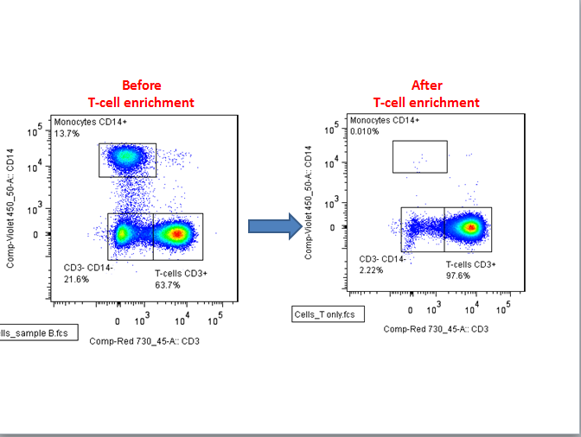
T-cell percentage graph
Figure 5.1 Flow cytometry analysis of enriched T-cells from PBMCs.
Freshly purified peripheral blood mononuclear cells (PBMCs), were subject to negative selection by magnetic beads to isolate CD3+ cells. The flow cytometry data before and after T-cell enrichment shows CD14- CD3+ cells are significantly enriched to over 95% purity using this method.

1 2 3 4 5 6
1) NEB ladder
2) HELA Nuclear Extract
3) T-cell Healthy Control
4) T-cell Surgical Control
5) T-cell Septic Patient
6) Calf histone
Figure 5.2 12% SDS-PAGE gel of extracted histone proteins
Extracted histone peptides were separated on a 12% SDS-PAGE gel to check for purity. As shown the major bands are that of histone proteins.

Quantification of histone PTMs
In order to determine possible changes in the epigenetic landscape in relation to sepsis, the relative abundance of the histone PTMs, in healthy control, surgical control and septic patients were analysed using MS. Extracted ion chromatograms (XIC) for all identified histone PTMs were generated from the 2D-LC analysis in conjunction with the in-house Histomatic program, which automatically smoothed and integrated all of the inputted extracted ion chromatograms across all fractions and in multiple charge states (see Chapter 3). A summary of modifications discovered is shown in Figure 5.3. Histone peptides from H3.1/2, H3.3 and H4 were quantified and results are discussed below.
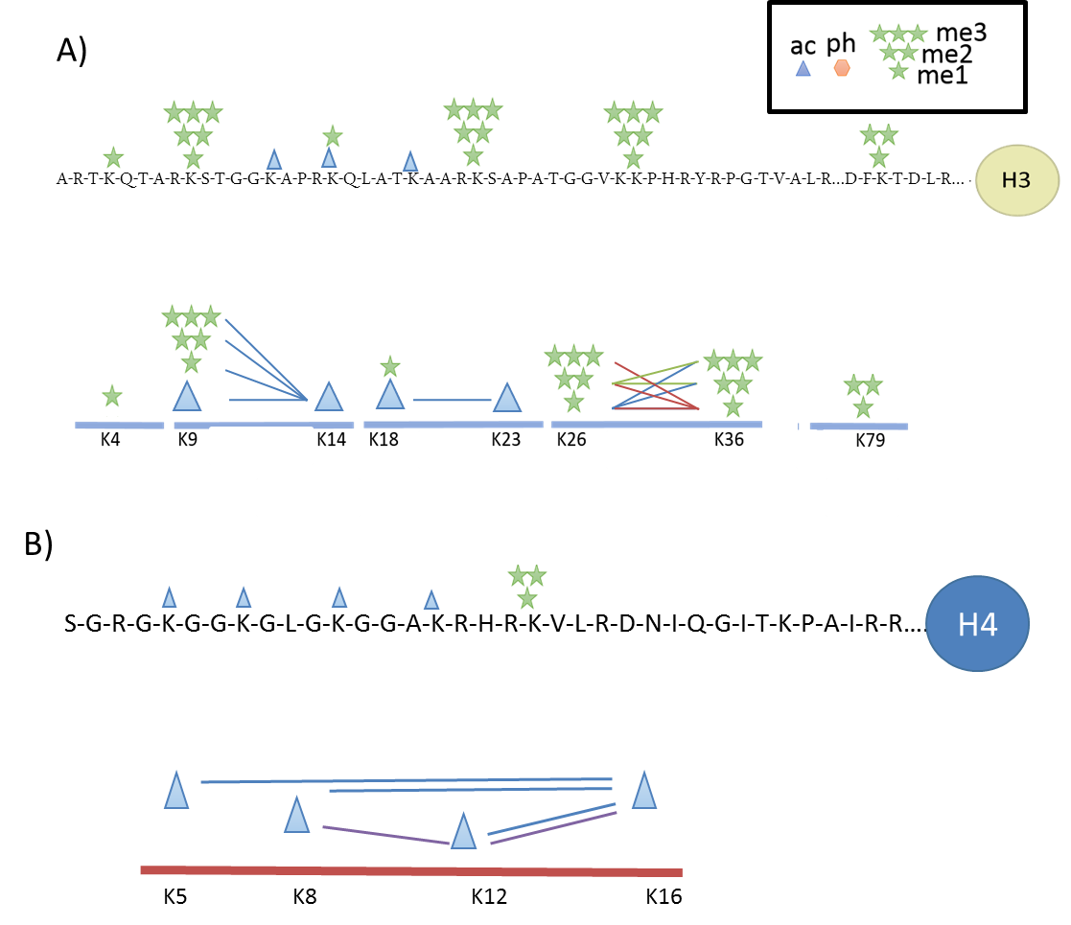
Figure 5.3 Identification of histone PTMs and their combinatorial patterns on histones H3 and H4
Schematic illustration summarising the modifications identified and the combinatorial nature of these modifications. A) Histone H3 and B) H4 using mass spectrometry analysis. The modifications identified were focused on the N-terminal tails in both histone proteins. Lysine residues were the main site of modification. Mono, di and trimethylation and acetylation were the major modifications. Peptide K27-40 displayed the most combinatorial complexity along with peptide K5-17 on H4. Each line shows modifications that were seen on the same peptide. On H4 the purple line = triacetylation combinations, blue line = diacetylation combinations.

The quantification of H3.1/2 peptides

Quantification of H3 K4-8
The TKQTAR peptide was found both unmodified and methylated despite the lack of reliable detection due to the small hydrophilic nature of the peptide, an n=3 was obtained for all conditions (Figure 5.4A). Globally the unmodified form is the most abundant with small amounts of methylation, typically <5%. There is a slight increase in methylation in the surgical control group. However this is not significant.

Quantification of H3 K9-17
Dimethylation was the most abundant modification seen on the KSTGGKAPR peptide both alone and in combination with K14 acetylation (Figure 5.4B). Due to overlapping retention times of K9 acetylation and K14 acetylation, it was not possible to quantify the relative contribution of each monoacetylated species at the MS level. The overlapping retention times of these two peptides resulted in multiplex spectra at the MS/MS level. This also occurs on the peptide K18-26. Therefore, in order to quantify the relative contribution of K9ac vs K14ac to the total KSTGKAPR + ac signal, three fragment ions were selected y7, y8 and b1 for further analysis. All MS/MS spectra were averaged across the MS peak of the parent ion similar to previous studies (Pesavento et al. 2006; Plazas-Mayorca et al. 2010). Within the averaged MS/MS there were two masses for each of the ions y7, y8 and b1 which represent the two positional isomers. The intensity of these ion pairs was compared and the relative contribution of each determined. This is exemplified using the K18-23 peptide (see Figure 5.5). The average abundance of K9ac based on these ions was 6.15 % for the healthy control, 18.6 % for the surgical control and 21.9 % for the septic patients. The percentage contribution of each positional isomer was used to divide the total MS signal (KSTGGKAPR+ac) seen between the two isomers correctly at the individual sample level. Using this value as the raw abundance, correction factors were applied to each and then plotted as a relative abundance against all other proteoforms of this peptide (Figure 5.4). There was no significant difference between seen in acetylation levels between the three conditions. A significant increase in K9me2 was observed in septic patients compared to both health controls and surgical controls adjusted p = 0.0241 and 0.0160 respectively. K9me2 increased by 1.69 and 1.59 fold respectively.
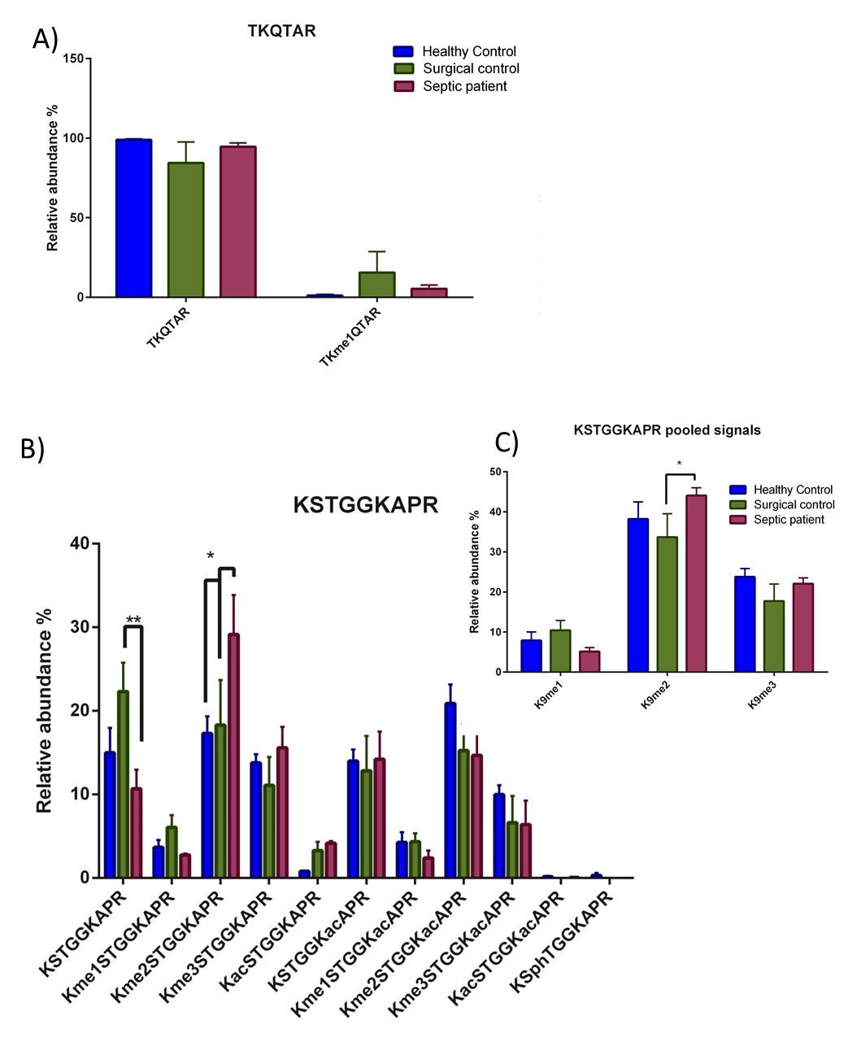Figure 5.4 Global histone PTM quantification of peptides H3K3-8 and H3K9-17
Bar charts showing the global relative abundance of modifications identified on histone H3 peptides from healthy controls, surgical controls and septic patients. A) TKQTAR (H3K3-8). B) KSTGGKAPR (H3K9-17) C) Combined methylation on KSTGGKAPR (H3K9-17). For peptide K3-8 n=3 for all conditions. For peptide K9-17 n=3 for healthy controls and n=5 for both surgical and septic patients Statistics were generated using a two-way ANOVA using the Tukey method to determine significance in Graphpad prism 6. All error bars plotted are SEM.
.

Although this is only a small fold change, it is in the range of histone PTM perturbations found in the macrophage model (Chapter 4). This increase in K9me2 equates to a shift in the global chromatin landscape from 17-18% of total chromatin in healthy and surgical controls is K9me2K14un compared to 30% in septic patients and potentially corresponds to a large change in the structure of chromatin. Functionally, K9me2 is linked to the repression of gene expression. ChIP-seq analysis on all methylation states on K9 (me1/2/3) performed on human T-cells, showed that unlike monomethylation of K9, K9me2 and me3 were found at a higher abundance in the 10 kb surrounding the transcriptional start site (TSS) of silent genes, although there was no peak in abundance around the TSS (Barski et al. 2007). Furthermore, both K9me2 and K9me3 were inversely correlated to the expression of genes, whereas K9me was found to correlate with active gene expression, suggesting a role in gene expression for the mono-methylated form of K9 (Barski et al. 2007).
The significant increase in the repressive histone PTM K9me2, observed in the septic T-cells is consistent with the significant reduction in proliferation and in activation seen in both CD8+ and CD4+ T-cells following stimulation observed in this study. The majority of K9me2 in T-cells has been shown to be deposited by the G9a/GLP complex, exemplified in G9a knockouts in T-cells that exhibit an 80% decrease in K9me2 (Thomas et al. 2008). This heteromeric complex acts via its SET domain, to preferentially dimethylate and to a lesser degree monomethylate lysine residues (Shinkai & Tachibana 2011b). The major site of G9a action is K9 on Histone H3 in euchromatic regions, the K9me2 acts as a binding platform for HP-1 binding, linking it to gene repression (El Gazzar et al. 2008; Tachibana et al. 2005). In addition, upon tolerisation in macrophages, G9a dimethylates the promoter of the TNFɑ gene. In conjunction with G9a, K9me2 interacts with HP-1 and the DNA methyltransferase enzyme DNMT1/3, the recruitment of DNMT1/3, causes the methylation of the underlying DNA, both of these contribute to the effective silencing of the TNFɑ locus (El Gazzar et al. 2008). Similarly, K9me2 is depleted in H3.3 at CD69 and heparanase genes following stimulation, and enriched with acetylation at K9 (Sutcliffe et al. 2009). The role of G9a has previously been studied with regard to inflammation and T-helper cell differentiation. Using G9a knockout mice, Antignano et al suggested that G9a and K9me2 role was to limit activation-induced differentiation of naive T cells into T-regs / Th17 cells lineages (Antignano et al. 2014). Therefore, the global increase in K9me2 seen in this study may contribute to the failure of T-helper cells to fully lineage commit, a phenotype displayed by septic T-cells (Carson et al. 2010).
Interestingly, the G9a dependant K9 methylation in T-cells exhibits a high degree of target specificity (Lehnertz et al. 2010). Therefore, it is hypothesised that G9a is upregulated in severe sepsis and may also serve as a potential biomarker. Furthermore, as K9me2 is significantly increased in CD3+ T-cells in vivo severe sepsis, and G9a is the major enzyme responsible for the deposition of this histone mark, G9a presents itself as a possible therapeutic target in treating sepsis. This target ideally would be a specific methyltransferase inhibitor such as BIX-01294 has previously been reported to be highly specific to G9a with a slight inhibitory effect seen on the functionally related GLP protein, even at relatively high concentrations (Kubicek et al. 2007). Treatment with BIX-01294 in mouse ES cells and human HeLa cells caused a global decrease in K9me2 without affecting levels of K9me1 or K9me3 levels, with a parallel increase in unmodified K9 (Kubicek et al. 2007). K9me2 in the form of large organized chromatin K9-modifications (LOCKs) is important in the differentiation of cells; this represents a possible side effect of treatment with G9a (Wen et al. 2009). However, through the generation of G9a knockouts in mice, K9me2 in thymocytes and pro B-cells, has been shown not to be required for T-cell homeostasis or response to immune function (Lehnertz et al. 2010). G9a knockout mice also demonstrated perturbed global levels of other methylation sites. For example, the reduction in K9me2 as a result of the G9a/Glp1 knockdown was also associated with a decrease in K27me2 and increase in K36me2, and a larger 2 fold increase in K79me2 (Plazas-Mayorca et al. 2010). The decrease in the repressive histone mark K9 is mirrored by the other methylation changes. The decrease in K27me2, a repressive mark and increases in active marks K36me2 and K79me2, suggesting a tandem inverse regulation (Plazas-Mayorca et al. 2010). There was no change in H4 acetylation, but an increase in K14ac was seen in G9a/Glp1 knockouts (Plazas-Mayorca et al. 2010). Hence, any treatment to reduce K9me2 will also impact the abundance of even distant methylations.
Another possible problem is that G9a has been shown to be a critical regulator of Th2 responses in vivo as G9a -/- mice fail to protect against infection with an intestinal helminth, related to their inability to produce Th2 specific IL-4, IL-13 genes. Although this function is independent of the methyltransferase activity, as treatment of CD4+ T-cells with the compound BIX-01294 has been shown not to affect the induction of these genes (Lehnertz et al. 2010). Furthermore, the repression of IFN-γ is also G9a dependant but independent of its KMT activity (Lehnertz et al. 2010).
It is important to stress that the research cited above has been conducted in CD4+ cells only and not the CD3+ cell population as a whole as conducted in the mass spectrometry experiments presented in this chapter. Although both CD8+ and CD4+ cells both exhibit a state of anergy or exhaustion, coupled with reduced proliferative capacity (section 5.1.2) and have both been shown to display a reduced TCR repertoire, albeit transiently (Zhou et al. 2012). Moreover, the relative makeup of the population is shown to be perturbed compared to controls, with a skewing towards a Th2 phenotype and a relative increase in Treg cells (Carson et al. 2010; Cavassani et al. 2010; Huang et al. 2010). This coupled with the lack of genomic localisation information does not allow any mechanistic understanding to be gained from the experiment. In spite of this, the experiments presented here allow the identification of a new target for ChIP based experiments in sepsis, which has mainly focused on the K4me3 and K27me3 histone marks (Carson et al. 2010).
The increase in K9me2 observed in septic patients, also presents itself as a possible candidate for a biomarker for the progression of sepsis. A robust and specific biomarker is highly sought after for use in clinical practice. Recently, a meta-analysis of 3370 studies on biomarkers in sepsis was conducted, assessing 178 different biomarkers in their effectiveness in both the diagnosis and prognosis of sepsis (Pierrakos & Vincent 2010). None of the assessed biomarkers displayed the specificity required for clinical use. In order to assess the robustness of K9me2 as a biomarker the examination of an extended cohort of patients would have to be undertaken, as the significant difference is seen in a single mark, it may be possible to undertake such a study by western blot. With the hypothesis that k9me2 is higher in septic patients. A factor to consider is that western blot takes the whole K9me2 population and ignores combinatorial information. Taking this into account the methylation signals on K9 were pooled, therefore resembling what one would see in a western blot analysis (Figure 5.4). It is proposed that a significant difference would be seen only between the surgical control and septic patient, which may be useful when tracking a post-surgical patient, prior to the development of sepsis. However, the change although significant is very small, and whether this would be visible by western blot analysis which is only semi quantitative remains to be determined. Finally, the study detailed here constitutes a pilot study with a relatively small number of patients, and a much extended cohort would be needed to fully ascertain whether it is robust enough to be used clinically.
Along with the increase in the singly modified K9me2 peptide in septic patients compared to healthy controls and surgical controls there is a decrease, albeit not significantly, in the dual modification K9me2K14ac in both septic patients and surgical controls compared to healthy controls. K9me2K14ac is the most abundant modification in healthy controls; this combinatorial mark is known as a “bivalent domain”. Similar to other bivalent domains, such as H3K4me3K27me3, two modifications with opposing functions exist on the same histone protein (Taverna et al. 2007). K9me2 as presented above is associated with repression, whereas K14ac is associated with active gene expression (Barski et al. 2007; Karmodiya et al. 2012). It is therefore hypothesised that this histone combination poises genes for activation or repression. 54% of the total K9me2 signal is found in combination with K14ac to form the K9me2K14ac peptide in the healthy control most likely depicting a naive unstimulated cell. Whereas in the septic patient the proportion of K9me2 found in combination with K14 decreases to 33% in septic patients. This represents a large shift away from a poised state, as seen in the controls towards a more repressed one, in which K9me2 alone predominates (Figure 5.4).
In septic patients this also correlates with a small decrease in K9unK14un, suggesting that both the loss of K14ac from the bivalent domain and the dimethylation of K9 contributes to the K9me2K14un signal. Interestingly in a G9a/Glp1 knockout, a greater reduction in K9me2K14ac was seen than in K9me2 alone, suggesting that G9a preferentially dimethylates K9 when K14ac is present (Plazas-Mayorca et al. 2010). In surgical controls, the decrease in K9me2K14ac is linked to an increase in the unmodified peptide, although not significantly, suggesting a separate mechanism that occurs only in severe sepsis. The function of the unmodified histone H3 is unknown, it may have its own function or it may just serve as a blank slate, ready to be modified. Histone proteins containing K9unK14un peptides have a slower turnover rate than activating PTMs, but faster than repressive methylation marks, suggesting the later may be true (Zee et al. 2010). Interestingly there are proteins that require an unmodified H3K9 substrate to bind e.g. BAZ2A (Chan et al. 2009). Despite the large increase in K9unK14un in surgical controls, there is no significant difference between surgical and healthy controls. This may be due to the limited number of patients used in this trial, n=5 for surgical and n=3 for healthy controls. An extended cohort may be able to determine whether there is in fact a significant change in global histone PTMs, following surgery. Caution must be taken however when comparing these two groups, and similarly when comparing septic vs healthy controls. In contrast to healthy controls, both surgical and septic patients have documented comorbidities including the reason the surgical controls underwent elective surgery.

Quantification of H3 K18-26
Acetylation was the major histone PTM identified on the peptide K18-26 with both the lysine groups found to be acetylated, both on their own and to a much lesser extent in combination with each other (Figure 5.6). The majority of K18-26 peptide was found to be unmodified in all groups, with single acetylation of either the K18 or the K23 being present on around a quarter of global H3 proteins. As with the K9/K14 peptide, chromatographic separation of the isobaric positional acetylation isomers is not sufficient to determine the relative abundance of the individual isomers at the MS level. Therefore, the average abundance of three diagnostic ions (y8, y7, b1) summed over the entire parent peak at the MS/MS level was used to determine the contribution of each species (Figure 5.5). The average abundance of K18ac based on these ions was 9.58 % for the healthy control, 13.94 % for the surgical control and 22.5 % for the septic patients. This was used to determine the percentage contribution of each isomer to the total signal of the KQLATKAAR+ac MS peak. A method similar to this has been used previously and allows the accurate quantification of the two position isomers (Pesavento et al. 2006; Plazas-Mayorca et al. 2010). However, the caveat of this method is that by taking the sum of all MS/MS over the range of the peak, other peptides will have been selected for MS/MS and could potentially skew results if they contain an isobaric daughter ion. To remove this issue a parallel reaction monitoring PRM method could be undertaken which plots the intensity of the MS/MS ions from only one ion species over time, thus excludes any possible contaminants.
There was a significant decrease in K18unK23ac in septic patients compared to surgical controls, and healthy controls (adjusted p value = 0.0008 and 0.0139 respectively) (Figure 5.5). K23ac as with most acetylations has been linked with regions of gene activation. Therefore, the reduction in acetylation is consistent with the move towards a repressive phenotype in septic patients and agrees functionally with the concomitant increase in K9me2 (see Figure 5.4). It is not known whether these two marks occur on the same histone protein, as long range combinatorial information is lost upon tryptic digest. In order to investigate whether these changes are co-occurring on the same histone protein a middle-down approach would have to be undertaken. The roles of modifications on this peptide have not previously been described in sepsis before. Therefore this significant reduction similar to the K9me2 may be a possible biomarker for sepsis. In terms of a therapeutic outlet for this discovery, as a decrease in acetylation in seen then possibly increasing acetylation levels, may improve prognosis.
Histone deacetylase inhibitors (HDACi) have been used in order to treat sepsis due to their anti-inflammatory nature ((Shakespear et al. 2011).
The use of Trichostatin A (TSA) is a strong inhibitor of HDAC6, prior to CLP induced sepsis in a mouse model improved survival reduced morphological lesions, oedema and leukocyte infiltration into lung tissue (Zhang et al. 2010). Suberoylanilide hydroxamic acid (SAHA) a pan HDACi increases survival in CLP mouse models of endotoxin shock and severe (Liu et al. 2014b; Li et al. 2012; Li & Alam 2011; Li et al. 2014). Although this treatment is not solely on T-cells, acetylation is likely to play a role in their function. HDACs are not sole histone deacetylases and use of HDACi also increases the acetylation levels of a number of different proteins including the master regulator FoxP3 (Tao et al. 2007). Although no significant change was identified in K18ac in septic patients, past
No significant change in H3K18ac were seen however, recent research has identified a reduction in K18ac during infection by Listeria monocytogenes (Eskandarian et al. 2013). This is due to a direct interaction between bacterial factors and the deacetylase enzyme SIRT-2 and so is a global change that is bacteria specific and not a general host reaction to infection. Acetylation at this position has also been shown to be perturbed following adenovirus infection (Kulej et al. 2015).

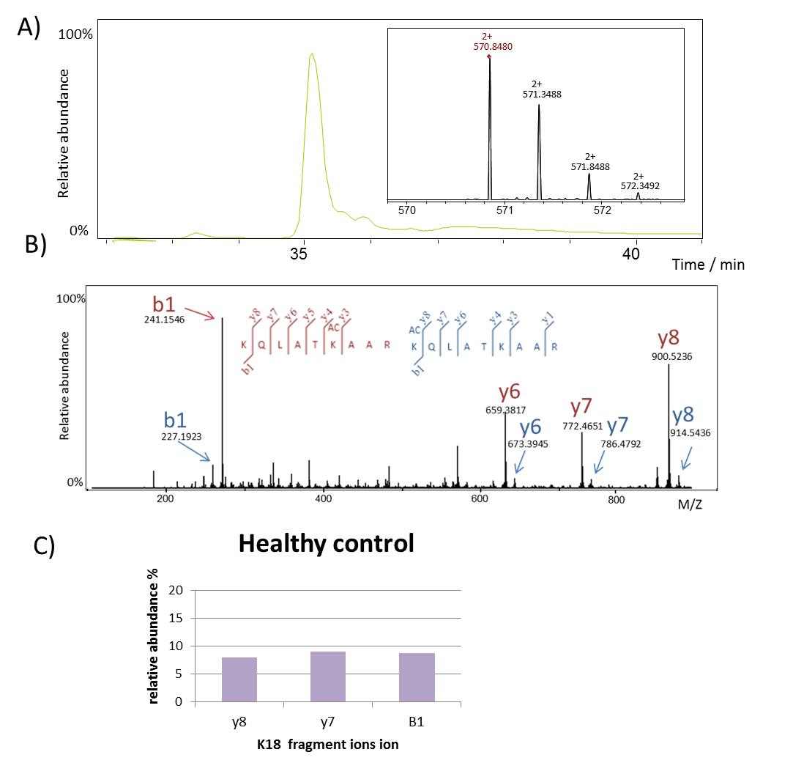

Figure 5.5 MS quantification of K18acK23un vs K18unK23ac
The single acetylation of the peptide K18-26 can occur at two sites: K18 or K23. A) These two positional isomers cannot be separated by chromatography hence both isomers elute in one peak. The insert shows this peak is made up of one species: 570.848 which has a 2+ charge state. B) The MS/MS spectra is averages across the peak and due to two species being present results in a multiplexed spectra. The blue ions correspond to the K18ac and the red K23ac. C) The relative abundance of each of these peaks is determined and from this the area under the peak in A) is divided up to determine the total area of each isomer

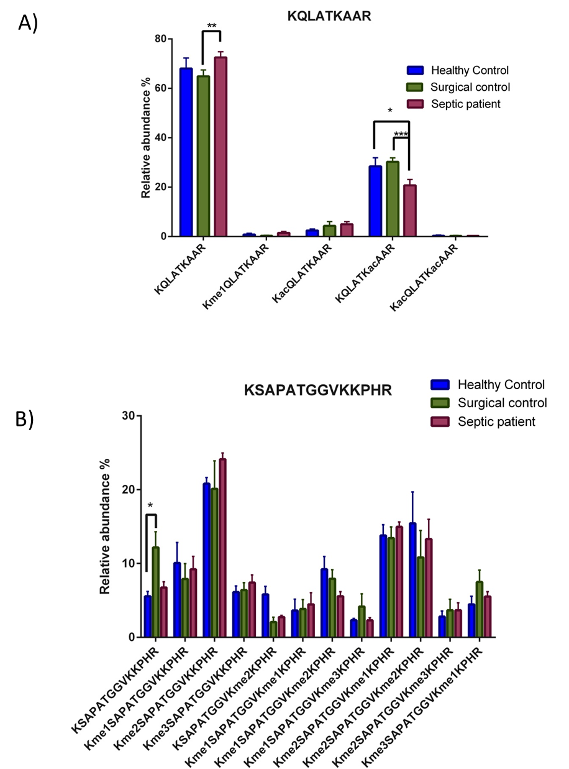
Figure 5.6 The relative abundance of histone PTMs on the peptides K18-26 and K27-40.
Bar charts showing the global relative abundance of identified histone H3 peptides from healthy controls, surgical controls and septic patients. A) KQLATKAAR (K18-26). B) KSAPATGGVKKPHR (H3K27-40). For the K18-26 peptide, healthy control n=3, surgical control n=5 and septic patient n=4. For K27-40 healthy control and septic patients n=3 and surgical control n=5 Statistics were generated using a two-way ANOVA using the Tukey method to determine significance in Graphpad prism 6. All error bars plotted are SEM.
.

Quantification of H3.1/2 K27-40
The K27-40 peptide is the most complex peptide generated by the modified tryptic digest in terms of the methylation pattern observed. Both K27 and K36 can be mono di and trimethylated, with combinations of these different levels of methylation seen on the same peptide. Dimethylation of K27 was the most abundant modification seen, followed by the dual histone modification K27me2K36me2, a bivalent domain. K27me2 is associated with the Polycomb repressive complex in vivo and hence is linked with gene repression (Ferrari et al. 2014; Margueron & Reinberg 2011). In T-cells both K27me2 and K27me3 levels are reduced at active promoters and enhanced in silenced genes (Barski et al. 2007). K36me3 is found to be enriched intergenically at active genes (Barski et al. 2007). K36me2 is also found to be enriched intergenically at actively expressed genes although this has not been examined in T-cells (Bannister et al. 2005; Bell et al. 2008; Rao et al. 2005; Yuan et al. 2011). The presence of this bivalent domain is thought to poise genes for either repression or activation by the removal of one of the two marks (Bernstein et al. 2006). K27me2K36me2 is reduced in both the surgical controls and septic patients. This is linked in septic patients to a slight increase (not significant) in K27me2 and decrease in K36me2 (adjusted p value = 0.3166 and 0.9278). Although not significant, again links histone PTM changes identified in sepsis to the actions of G9a: A knockout of G9a not only perturbed levels of K9me2 and K9me2K14ac as expected, but also decreased K27me2 and increased K36me2 levels (Plazas-Mayorca et al. 2010). It is proposed that If G9a is upregulated in sepsis then one would anticipate that along with an increase in K9me2, K27me2 levels would increase and K36me2 decrease. Consistent with this, the MS analysis of the septic patients shows both increased levels of K27me and decreased K36me2 levels albeit not significantly compared to healthy and surgical controls.
No previous research has focused on global combinatorial histone PTMs in sepsis in T-cells, even in a cellular model. Significant changes in combinatorial modifications are seen in this peptide, in the macrophage model of sepsis (see Chapter 4). ChIP experiments focusing on K27me3 (due to its involvement in bivalent domains with K4me3) in a cecal ligation and puncture (CLP) model of severe sepsis in mice showed that CD4+ T-cells exhibit a decreased capability to commit to Th1 and Th2 lineage, along with effector and activation functions. This was linked to the presence of K27me3 at the promoter regions of GATA-3 (the master regulator of Th2 cells) and IFN-ɣ a Th1 cytokine, which are normally free of K27me3 in normal Th2 and Th1 cells respectively (Hirahara et al. 2011). Globally, no increase in K27me3 was identified in septic T-cells, even when signal was pooled so that it mirrored that of an antibody based approach. These results suggest that the effect of sepsis on K27me3 is likely gene specific, only affecting a small proportion of chromatin, or that increases in K27me3 are counteracted by the loss of K27me3 on other genes. In monocytes extracted from the blood of septic patients, no global increase in K27me3 was observed due to opposing changes in different gene clusters (Weiterer et al. 2015) Although no significant change was seen in the septic group, compared to either control, surgical controls, as with the peptide K9-17 showed significantly higher levels of K27unK36un (0.472). The reason for the increase of these unmodified forms is not known.

H3.3 K27-40
With a shotgun approach being taken, the variant origin of peptides with overlapping sequences is lost. However, the peptide H3.3K27-40 can be differentiated due to the substitution of alanine to serine at residue 31. The overlapping retention times of the near isobaric H3.1/2 me3 and H3.3 me2 containing peptides cause an overlap in the isotopic distribution. Therefore the relative abundance is calculated by the maximal peak intensity and not by the area under the curve (see chapter 4.5.4)
In contrast to the H3.1 peptide, no significant change was seen between the surgical and healthy controls for the unmodified peptide (K27unK36un). Comparative analysis of the changes in the global histone PTM profile between septic patients and controls, no increase in K27me2 in contrast to the H3.1 K27-40 peptide (figure 5.7).

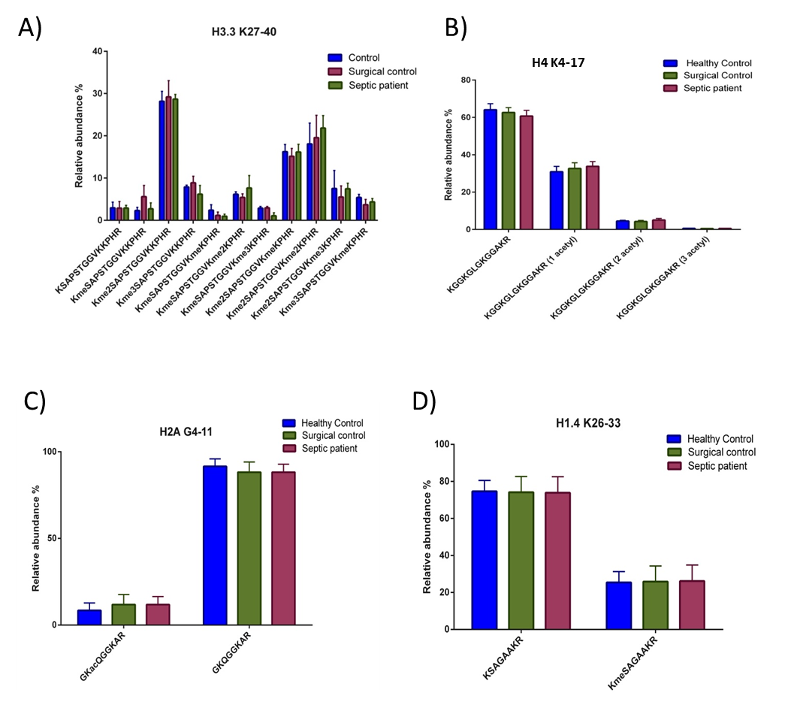
Figure 5.7. The relative abundance of histone PTMs on the peptides H3.3 (K27-30) and H4 (K4-17).
Bar charts showing the global relative abundance of identified histone H3.3 and H4 peptides from healthy controls, surgical controls and septic patients. A) KSAPSTGGVKKPHR (H3.3 K27-30). B) GKGGKGLGKGGAKR (H4 K4-17) C) GKQGGKAR (H2A G4-11) and D) KSAGAAKR (H1.4 26-33) Control, septic patients and surgical control n=3 for both graphs (A and B). Surgical controls and septic patients n=5 healthy control n=3 (C and D) Statistics were generated using a two-way ANOVA using the Tukey method to determine significance in Graphpad prism 6. All error bars plotted are SEM.

Histone H4
The histone protein H4, which forms a tetrameric complex with H3, was also quantified by mass spectrometry. Using the bottom-up approach 12 peptides were identified with an average coverage of the histone protein of 68%. Only one peptide with PTMs was routinely seen this was the peptide GKGGKGLGKGGAKR (residues 5-17). With four lysines present in this peptide (K5, 8, 12, 16) it is highly modifiable, namely with differing levels of acetylation. Methylation has also been previously reported on this peptide (Van Aller et al. 2012). The MS analysis identified the mono, di and tri acetylated forms of this peptide. The most abundant form identified was the unmodified peptide, with the tri-acetylated form being the least abundant (Figure 5.7). No significant changes were identified in H4 acetylation levels between any of the groups. Similarly no changes in acetylation were seen during 48 hours of adenovirus infection (Kulej et al. 2015). The role of Histone H4 acetylation has not been previously explored in T-cell during sepsis.

Quantification of histone proteins H2A, H2B and H1
MS analysis identified several peptides for each of these three histone proteins and their respective variants). However, only the peptides H2A G4-11 (GKQGGKAR) and H1.4 K26-33 (KSAGAAKR) contained modifications and therefore could be assessed for perturbations following sepsis (Figure 5.7). H2AK5 acetylation was present on ~10% of canonical H2A global peptides. No significant differences were seen between septic patients and controls. Similarly, H1.4 K26me was unperturbed in patients with sepsis compared to controls (Figure 5.7).

Studying the differences in global histone PTMs of CD3+ T-cells and macrophages derived in-vitro from monocytes
Previous research has demonstrated large differences in global histone PTMs between species (Garcia, Hake, et al. 2007), between different cancer cells lines derived from a various tissues (Leroy et al. 2013), and between different tissues in a rat (Garcia et al. 2008). Therefore it was hypothesised that there would be quantifiable differences between the profiles of the two cell types used in these studies, CD3+ T-cells and macrophages derived in-vitro from monocytes. Comparative quantitative analysis of the global histone PTMs is shown in Figures 5.8. The peptides K9-17 and H3.1/2 and H3.3K27-40 show significant differences between the two cell types (see Figure 5.8). Macrophages exhibit significantly more repressive histone marks (K9me2/me3) on the K9-17 peptide than T-cells. This was associated with significantly less acetylation, a mark associated with active genes. Interestingly, there is also a large relative proportion of K9me2K14ac and H3.1/2K27me2K36me2 in T-cells. Examination of this peptide reveals multiple complex differences between the two cell types. Alongside a significant increase in K27me2K36me2, T-cells also possess greater levels of K27me2K36me1 and K27me3K36me2 and significantly less K27me3K36me1. These changes were not seen when comparing H3.3K27-40 in fact the only significant differences were seen in K27me2 and K27meK36me. This suggests that H3.3K27-40 is differentially targeted by histone modifying enzymes. Macrophages derive the same progenitor as all blood cells; Hematopoietic stem cells. However, from there they proceed down very different and distinct lineages lymphoid and myeloid respectively, developing into effector cells from different arms of the immune systems (Seita & Weissman 2011). Due to the distant precursor, and vastly different phenotypes, it is unsurprising that there are large differences in the global chromatin state. These results suggest that differences in global PTMs reflect the differential control of gene expression in the two cell types.

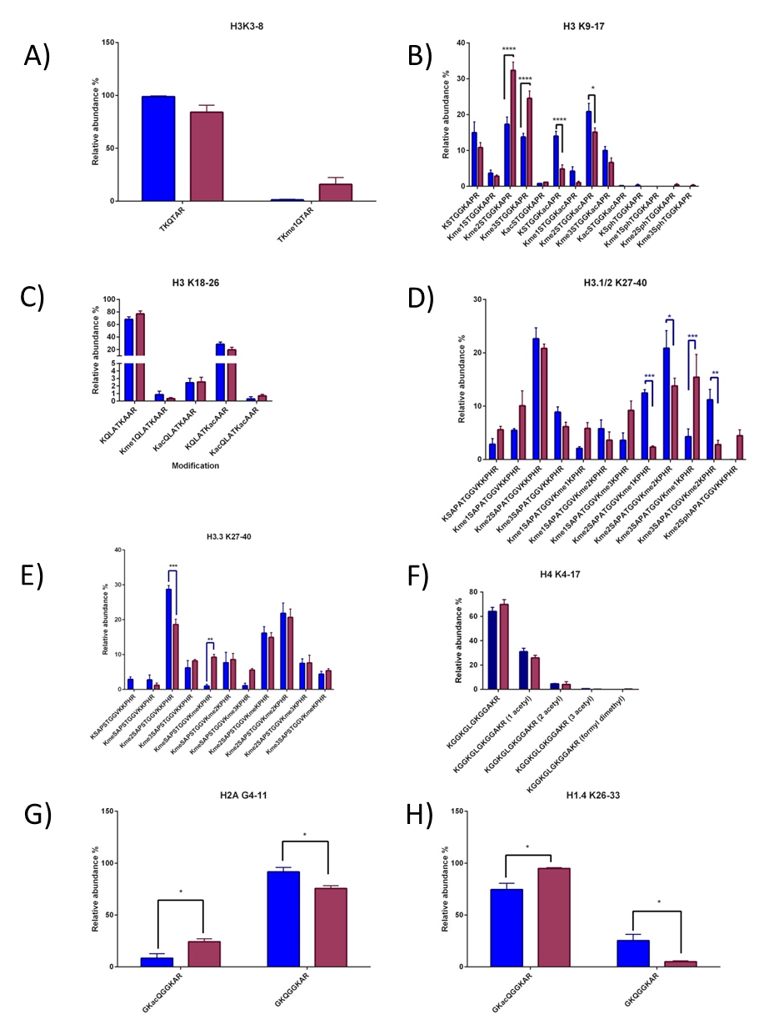
Figure 5.8 A comparison between the global histone PTM profiles of human primary T-cells and macrophages.
Bar graphs comparing the relative global abundance of histone PTMs for histone H3 and H4 between primary purified T-cells and Macrophages. A) H3K2-8. B) H3K9-17. C) H3K18-26. D) H3.1/2K27-40. E) H3.3K27-40. F) H4K5-18 G) H1.4 K26-33. Macrophages exhibit significantly higher levels of K9me2 and K9me3 and lower levels of K9/14ac. A more complex pattern of difference was identified in K27-40 for both H3.1/2 and H3 (D&E). Statistics were generated using an unpaired two-way ANOVA using the Tukey method to determine significance in Graphpad prism 6. All error bars plotted are SEM. n=3 for both macrophages and T-cells for all peptides.

Conclusions
Previous research has focused on ChIP based approaches to study epigenetics (histone PTMs) that are associated with sepsis. This has advanced the understanding of the field enormously, especially focusing on the presence of histone PTMs around important immune genes. In this Chapter T-cells isolated from septic patients were shown to exhibit the phenotype previously described of septic T-cells including reduced proliferation and activation upon stimulation (Carson et al. 2010; Roth et al. 2003; Boomer et al. 2011; Hotchkiss et al. 2013a). Quantitative 2D-LC-MS was used to study the relative abundance of the histone PTMs in T-cells isolated from healthy control, surgical control and septic patients. In total 43 differently modified histone peptides were quantified by 2D-LC-MS analysis. Several histone PTMs were found to be significantly perturbed during sepsis. The major findings from this research are the significant increase in K9me2 and significant decrease in K23ac in septic patients than in both healthy and surgical controls. In addition, K9unK14un was significantly lower in septic patients compared to surgical controls. Finally, the K27unK36un peptide was significantly higher in surgical controls compared to healthy controls.
The significant increase in K9me2 correlates well with the reduction in effector functions of the T-cell population from septic patients. The effect of the unmodified forms of K9unK14un and K27unK36un is unknown. ChIP based methods do not provide information about the combinatorial nature of the histone PTMs on the same histone tails. The results showed that 54% of the total K9me2 signal is found in combination with K14ac to form the K9me2K14ac peptide in the healthy control whereas in the septic patient that number decreases to 33%. In both cases this represents a large proportion of the K9me2 signal, which may not have a repressive function. Therefore, it may be recommended that like the joint use of K4me2 and K27me2 in ChIP experiments, that when K9me2 is probed by antibodies K14ac should also be considered. Severe sepsis has distinct repressive effect on human T-cells which phenotypically results in reduced proliferative and effector functions such as activation.
This study for the first time demonstrates the in-vivo correlation of this phenotype with a significant increase in K9me2 and decrease in K23ac compared to healthy and surgical controls. Moreover data from this study not only identifies H3K9me2 and potentially G9a/Glp1 but also H23ac as a possible biomarkers and therapeutic target for future studies.

Final Discussion and future work.
The overall aim of this thesis was to identify and quantify the global post translational modifications of histone proteins that are associated with severe sepsis. This aim was addressed from two perspectives; firstly an in-vitro study analysing the effects of Lipopolysaccharide (LPS) stimulation and subsequent tolerisation. Secondly, examining the impacts of in-vivo severe sepsis on humans T-cells. It was hypothesised that global histone PTMs would be perturbed during severe sepsis. By quantifying these changes in histone PTMs further insight into the epigenetic mechanisms associated with sepsis may present a possible targets for therapeutic intervention or biomarkers to better stage the progression of the disease.
In order to examine this hypothesis we employed a bottom-up mass spectrometry (MS) approach to accurately identify and quantify global levels of histone PTMs. To improve the discovery and quantification of peptides on a MaXis Quadrupole Time of Flight (Q-ToF) instrument, an offline 2D-LC peptide fractionation method using a porous graphitic carbon (PGC) column in the first dimension was developed. This resulted in a 62.7 % increase in the number of quantifiable histone peptides compared to a one-pot approach on the same instrument. The PGC column showed a good degree of orthogonality compared to the C18 column online with MS. Furthermore, a high degree of fractionation efficiency was observed with 90% of the peptides eluting within 2 fractions. The use of the same MS compatible mobile phase as the C18 column increased throughput compared to other strong cation exchange methodologies that have been employed (Zhang et al. 2013).
Using the methods described in this thesis, it was not possible to determine the co-occurrence of distant combinations. This is because the bottom up approach can only detect short range combinatorial modifications that occur on the same tryptic peptide. As the combinatorial nature of histone PTMs is vital to their function, the future of histone PTM research will most likely move towards the middle down approach. Therefore, it would be interesting to assess the impact of the 2D-LC method developed in a middle-down style experiment. A middle-down experiment would enable the identification and separation of PTM combinations along the entire length of the histone tail to be determined and more recently, reliably quantified (Sidoli, Lin, Karch, et al. 2015). Current methodology used for this type of experiment is strong cation exchange (SCX) or weak cation exchange (WCX) to separate peptides prior to LC-MS analysis, generally with a C18 column online with the MS. The fractions generated from separation by SCX columns have to be desalted prior to LC-MS analysis thus limiting throughput and increasing sample loss. Recently, WCX has been utilised to convert middle down experiments from one that solely requires 2D fractionation into one that is amenable to high-throughput ‘one-pot’ methodologies (Young et al. 2009). As both SCX/WCX and PGC represent orthologous separation to a C18 column, then a PGC column may provide a useful pathway for separation in either the first dimension or as it the buffers used are MS compatible, online with the MS.
Due to the increase in amount of data generated using offline fractionation prior to LC-MS analysis, a script was written using VB in order to enable the quantification of peptides that eluted out over multiple fractions and in multiple charge states. This software increases throughput while still allowing the accurate quantification of peptides. However, the histomatic script still requires large amounts of user input including the manual input of retention times. Recently, Skyline has incorporated internal retention time standards which when spiked into the sample allow adjustment of the time window for which a peptide is expected to elute enabling outliers from this to quickly be excluded without having to probe the MS/MS level. The calculation of an expected retention time trained around iRT standards would improve the throughput of the developed pipeline. Using this method would still require manual inspection and RT entry of these peaks, however using this internal calibration the window of elution for histone peptides could be greatly narrowed following training of the program to recognise this. Further improvements that could be performed include the automatic removal of incorrect isobaric/near isobaric contaminants that are co- eluting with histone peptides. This can usually be determined by the charge state. E.g. the histone peptide K27me3K36me1 has an m/z at 415.23, with a charge of 4+ a common contaminant is a doubly charged species at 414.73. A way to do this would to be incorporating charge state information into the script. Finally, future work could include incorporating the readout of this script into a bioinformatics platform such as R, where statistical analysis can be fully incorporated, producing a single read out of data. In addition, the Histomatic script is currently designed for use with Bruker instruments (integrated to data analysis). Therefore future work could focus on extending this so it compatible with additional MS programmes from different suppliers.
Recently, the use of data-independent methodologies such as parallel reaction monitoring (PRM) or sequential window acquisition of all theoretical fragment ion spectra (SWATH-MS) experiments have become popular for the relative quantitation of histone PTMs (Sidoli, Lin, Xiong, et al. 2015; Tang et al. 2014). These data independent approaches require a triple quadrupole mass spectrometer where the third quadrupole (Q3) is replaced with a high accuracy mass analyser such as the Triple-ToF 6600 (SCIEX), and can quantify in a label free manner, which is useful when isotope labelling is not possible. In a SWATH-MS experiment, all precursors within a fixed isolation widow are fragmented, and the fragment ions detected. This window proceeds in a sequential manner across the desired m/z range generating MS/MS spectra that can be plotted against time. Similar to this parallel reaction monitoring (PRM) uses a more directed selection of precursor ions and detects all target product ions at once. Use of these methods generate more accurate and sensitive quantification and allows quantitation over a wider dynamic range compared to data dependant acquisition (DDA) and selective reaction monitoring (SRM) based methods (Peterson et al. 2012; Sidoli, Lin, Xiong, et al. 2015; Tang et al. 2014). Programs that do similar functions are commercially available, such as Skyline and Epiprofile (not currently released) have been developed to increase the throughput and accuracy of quantification of proteomics based research (Yuan et al. 2015). It is likely that due to the advantages mentioned above, and the development of software that can accommodate this type of data these MS pipelines are likely to be adopted as the principle methods used for high throughput quantification of histone PTMs.

Using the developed 2DLC-MS method a global analysis of histone PTMs in human primary monocyte derived macrophages was conducted for the first time (see Chapter 4). In total 83 peptides with differential modifications were identified in the histone proteins H1, H2A, H2B, H3.1/2, H3.3 and H4. In addition, global changes following LPS stimulation and subsequent tolerisation were quantified. LPS stimulation was accompanied by a significant increase in the unmodified K9-17 peptides in conjunction with the significant reduction in the bivalent domain K9me2K14ac. Furthermore, a significant reduction in the highly abundant dual histone PTM H3.1/2K27me2K36me2 was also seen upon LPS stimulation. This PTM is thought to represent a bivalent domain, as these two marks have reported opposing functions (Bernstein et al. 2006). A significant reduction of the peptide K27me2K36me2 was observed between control and tolerised cells and a parallel increase in the repressive mark K27me2 was identified in the histone variant H3.3. This is of particular interest because the same modification K27me2K36me2 is significantly reduced upon stimulation on the canonical version of the peptide. In addition, a reduction in H3K27me2K36me2 in stimulated cells is not associated with an increase in K27me2 or any other histone PTM combination on the K27-40 peptide. This suggests two separate mechanisms regulate K27me2K36me2 and that these mechanisms are histone variant dependant.
K27me2K36me2 therefore presents itself as a novel candidate for a histone PTM combination that has a role in the pathology of severe sepsis. There are a number of studies that could be conducted to further investigate the role of K27me2K36me2. Owing to the fact that it is a dual histone PTM, it would be difficult to conduct ChIP based experiments. This is further exasperated by the fact that this study was conducted in primary cells of which only low cell numbers (3x10⁶ cells) per condition could be generated. Further studies using sequential ChIP experiments would be informative, but would require large cell numbers despite K27me2K36me2 being one of the most abundant forms of the K27-40 peptide. Therefore, a cell line such as human THP-1 could be used. A further complication is that the significant changes observed in this study appear to be variant dependant, and although H3.3 specific antibodies exist, the combination of selectivity for H3.3 and K27/K36 dimethylation does not. Therefore it would not be possible to discern the variant origin of these marks. These limitations also effectively rule out the use of K27me2K36me2 as a possible biomarker as antibodies can’t be used for peptides with more than modification. However, this approach may provide further insight into genes marked by this bivalent domain. Identified genes could be probed for expression by a transcriptomic approach such as RNA-seq. This would give a fascinating insight into the possible function of K27me2K36me2 with regards to both response to LPS and tolerisation.
Future work could also include the potential identification of readers that are specific of K27me2K36me2. By understanding the proteins that bind to these combinations it may be possible to infer their function. The use of a synthetic K27me2K36me2 peptide could be used to pull down possible binding partners from macrophage cell extracts, using the synthetic modified peptides K27me2K36un and K27unK36me2 as negative controls would allow the differentiation between readers that are specific to K27me2K36me2 or permissive of the adjacent modification. A protein of interest for future study is the K36me2 demethylase SMYD2, which is decreased upon LPS stimulation and linked to a reduction in K36me2 (Xu et al. 2015). This data correlates with the research presented in Chapter 4, and suggests that the loss in K36me2 is specific to peptides that also contain a dimethylation on the adjacent lysine (K27). The impact of methylation on the adjacent lysine has not previously been explored with regards to SMYD2 binding.
Previous research has included a tolerised +LPS group when analysing histone PTMs. This additional state further alters the epigenetic signature at specific genes as analysed by ChIP experiments. The non-tolerisable (NT) class of genes exhibit increased acetylation at promoter regions increasing accessibility and leading expression to a greater magnitude and faster kinetics, following a secondary dose of LPS. It would be interesting to extend the experiment to include this group, to see whether the global architecture of histone PTMs further changed.
Histone proteins isolated from the T-cells of septic patients, were subjected to mass spectrometry analysis. A similar number of peptides and proteoforms were identified compared to the macrophage cells. Comparing the results from both cell types together suggests that tolerisation in macrophages, and anergy in T-cells following sepsis, are associated with a very different perturbation in the histone PTM profile. Globally in T-cells a significant increase in K9me2 and a decrease in K23ac was observed in contrast to macrophages. In addition, the significant loss of H3.3K37me2K36me2 was observed in tolerised macrophages in contrast to T-cells. This data suggests that the impact of severe sepsis upon cells is not a general mechanism. These very different global changes in histone PTMs may owe to the fact that the cells have very different epigenetic landscapes to begin with.
Future work proposed would be targeted to utilise the increase of K9me2 or decrease in K23ac in septic patients as a possible biomarker. Extending the cohort of patients in conjunction with either western blots or high throughput targeted MS analysis to quantify the levels of K9me2 or K23ac would test its applicability to use as a biomarker. It is predicted that even though levels of K9me2K14ac decrease, a significant increase in overall K9me2 will be observed (Figure 5.4). The extended cohort would ideally be collected from numerous hospitals across the UK, as it was only possible to collect a small amount of patients over 6 months. Furthermore, mapping the levels of K9me2/ K23ac in T-cells over time would also be an exciting prospect. If levels of K9me2 or K23ac alter as sepsis progresses or are only present in the immunosuppressive stage, then they may also be a candidate for biomarkers that can track and possibly better stage the progression of sepsis. Such a biomarker is highly sort after in the clinical field, and may be able to better direct the use of other drugs, increasing their efficacy. It is known from previous studies in mammalian stem cells that these combinations of the modifications identified as significantly perturbed in this research do coexist together (Jung et al. 2010; Jung et al. 2013). Using a middle-up MS approach would allow long range PTMs across the whole length of the histone tails to be identified, including additional histone PTMs such as arginine methylation. Although less sensitive than the bottom-up approach, it has recently been shown to have similar levels of accuracy in determining the stoichiometry of histone PTMs as compared to the bottom up approach (Sidoli, Lin, Karch, et al. 2015). Therefore, in conjunction with recent improvements in mass spectrometers, LC- separation techniques and bioinformatics, the analysis of histone PTMs using the middle down or top down approaches will be more commonly used to study histone PTMs and provide further insight into the long range combinatorial patterns of histone PTMs.

Inhibition studies
The histone demethylase protein G9a has previously been associated with the tolerised phenotype seen in macrophages (Liu et al. 2014b). Consistent with the results obtained in Chapter 5, it is proposed that G9a could be involved in the deposition of K9me2 in severe septic T-cells. However, the level of K9me2 in tolerised macrophages is not significantly increased compared to control or even stimulated, which sees a reduction in K9me2. As G9a/GLP is the main mammalian enzyme involved in the deposition of K9me2, it presents itself a possible candidate protein or therapeutic target for intervention in the progression of sepsis (Thomas et al. 2008). Currently, no G9a inhibitors are in use for clinical trials. There are several known inhibitors of G9a and related protein GLP, one of these inhibitors (BIX-01294) acts as a non-competitive inhibitor of the methyl transferase activity (Kubicek et al. 2007). It has been used in T-cells previously, and was shown to only inhibit the methyl transferase activity of the enzyme; the activating functions of G9a are independent of its methyl transferase activity (Lehnertz et al. 2010). The role of G9a has not been explored in T-cells before. In macrophages chronic active G9a causes a phenotype similar to that of endotoxin tolerant macrophages (Liu et al. 2014b). In order to further assess the role in G9a in sepsis, quantitative analysis of protein expression levels could be measured using western blot or targeted quantitative MS approaches. It is proposed that increased expression levels of G9 might be present in septic patients. Ideally collection of this data could be done in tandem with the extended cohort study for of K9me2 previously discussed.
Further work is proposed in order to determine whether G9a is not only associated with T-cell anergy in a severe sepsis, but also plays a functional role. Treatment of T-cell populations from septic patients prior to or in tandem with stimulation via CD3/CD28 beads could be performed in conjunction with cytokine screens to measure the effect on both stimulation and proliferation. It is hypothesised that if G9a/GLP has a causal link with anergy in sepsis, thus the use of the G9a KMT inhibitor should reverse the inability of T-cells in patients with severe sepsis to be stimulated. Alternatively, the function of G9a could be modelled, in either a whole animal model such as in mouse. A protocol for generating severe sepsis is well established (cecal ligature and puncture (CLP) although this is the model that most closely resembles that of sepsis, there are a number of caveats associated with this model (Dejager et al. 2011). Alternatively, a T-cell based model of severe sepsis could be developed to measure this impact in a completely in-vitro model of sepsis.
This thesis has also implicated acetylation as a possible therapeutic target, several changes to acetylations are seen in both T-cells and macrophages. Histone deacetylase inhibitors (HDACi) have previously been used in order to treat sepsis due to their anti-inflammatory nature (Shakespear et al. 2011). As discussed in Chapter 5, HDACi such as TSA and SAHA have been shown to increase survival in a mouse model of severe sepsis (Liu et al. 2014b; Li et al. 2012; Li & Alam 2011; Li et al. 2014). Therefore it would be of interest to examine the effects of HDACi treatment during severe sepsis on the levels of H3K23ac and H2AK5ac. As H3K23ac is significantly increased in the macrophage model of severe sepsis and significantly decreased in the T-cells isolated from septic patients. Therefore, the impacts of HDACi during sepsis may be cell specific. Another compounding factor is that HDACs are not sole histone deacetylases and use of HDACi also increases the acetylation levels of a number of different proteins including the master regulator FoxP3 (Tao et al. 2007). Thus it may be difficult to tease out the precise effect of changing the Histone acetylation levels.

Cell based model for severe sepsis in T-cells.
During severe sepsis, T-cells are known to have reduced proliferative and activator functions, also known as cell exhaustion or anergy (Hotchkiss et al. 2013b; Boomer et al. 2011). In order to generate T-cells that mirror this function in-vitro, it was reasoned that the simple activation of the T-cell population by anti-CD3 (although it mirrors physiological activation) may not be enough to fully represent the complex layers of signals experienced by a cell during severe sepsis. Furthermore, it is widely known that crosstalk exists between cells of the adaptive and innate immune system. Therefore, a model system was developed in which human primary PBMC cells were activated with two stimuli. The first was LPS, a potent activator of the innate immune system. The second was CD3+ one of the stimulatory molecules that T-cells require. A preliminary time course was conducted with freshly isolated PBMCs that were stimulated with anti-CD3+, 1 µg/ml LPS or a combination of the two. This was paired with a control in which fresh media was added. Cells were analysed at 0, 24, 48 and 72 hours. Activation was assessed by measuring levels of CD25+ and CD69+ cells. As this experiment was only preliminary and conducted on two donors no statistical inference can be made. Overall the general trend seen was that LPS alone was not sufficient to activate T-cells. This was expected as TNFα (produced by monocytes following LPS stimulation is only one of the two stimuli needed to activate a T-cell. However, a small subset of B-cells was activated by LPS alone. As expected CD4+ T-cells were activated by anti-CD3 alone from the 24 hour time point onwards, shown by increases in both CD25+ and CD69+ cells. The exposure to LPS/CD3 resulted in a reduced capacity of CD4+ cells to be activated. Further studies are needed to investigate whether this phenotype mirrors that of septic T-cells. Proliferation and cytokine screens should be conducted to assess the clinical similarities of this in-vivo model. If a cell based model could be constructed it would allow the mechanistic role of G9a in severe sepsis to be studied.

Final remarks.
The research presented in this thesis has documented for the first time the global epigenetic changes that occur in sepsis in both T-cells and macrophages. This has identified several specific histone PTMs that are modulated during sepsis including H3K27me2K36me2, H3K23ac and H3K9me2. These histone PTMs may provide a possible biomarker or a therapeutic avenue that is highly sought for the treatment of sepsis. The next challenge lies in determining the clinical relevance of these histone PTM changes, and whether they are robust enough to be used in clinical medicine. In addition the development of faster, high throughput approaches are required to characterise histone PTMs from patients for this to be clinically relevant time scale. Taking the histone field as a whole, at present mass spectrometry and ChIP represent two orthologous techniques. The genome wide profiling of single histone PTMs that ChIP-seq provides is vital to understanding the context of histone PTMs. Conversely, the combinatorial nature of histone PTMs, which likely defines their biological function, can currently only be analysed by mass spectrometry techniques. Currently there is no way to combine these two techniques together, at least not genome wide. In order to understand the function and location of these combinatorial modifications the development of techniques that could combine the output of these two strategies is the holy grail of histone PTM research. This will be vital in the understanding of the role of histone PTMs in the pathology of sepsis. As mass spectrometers continue to evolve, including increased sensitivity, the ability to identify and characterise histone PTMs from ever decreasing sample amounts will facilitate this coupling of MS approaches to genomic approaches and potentially single-cell studies. The prospect that this will ultimately lead to the functional roles of combinatorial modifications on the entire histone protein to be ascertained and possibly crosstalk between histones in the same nucleosome is an exciting one.

Bibliography
Aasland, R. & Stewart, a F., 1995. The chromo shadow domain, a second chromo domain in heterochromatin-binding protein 1, HP1. Nucleic acids research, 23(16), pp.3168–3173.
Aebersold, R., Burlingame, A.L. & Bradshaw, R. a, 2013. Western blots versus selected reaction monitoring assays: time to turn the tables? Molecular & cellular proteomics : MCP, 12(9), pp.2381–2. Available at: http://www.pubmedcentral.nih.gov/articlerender.fcgi?artid=3769317&tool=pmcentrez&rendertype=abstract [Accessed June 4, 2014].
Agalioti, T., Chen, G. & Thanos, D., 2002. Deciphering the transcriptional histone acetylation code for a human gene. Cell, 111(3), pp.381–392. Available at: http://www.ncbi.nlm.nih.gov/pubmed/12419248.
Van Aller, G.S. et al., 2012. Smyd3 regulates cancer cell phenotypes and catalyzes histone H4 lysine 5 methylation. Epigenetics, 7(4), pp.340–3. Available at: http://www.pubmedcentral.nih.gov/articlerender.fcgi?artid=3368817&tool=pmcentrez&rendertype=abstract.
Antignano, F. et al., 2014. Methyltransferase G9A regulates T cell differentiation during murine intestinal inflammation. , 124(5), pp.1945–1955.
Arents, G. & Moudrianakis, E.N., 1995. The histone fold: a ubiquitous architectural motif utilized in DNA compaction and protein dimerization. Proceedings of the National Academy of Sciences of the United States of America, 92(24), pp.11170–4. Available at: http://www.pubmedcentral.nih.gov/articlerender.fcgi?artid=40593&tool=pmcentrez&rendertype=abstract [Accessed January 8, 2015].
Athie-Morales, V. et al., 2004. Sustained IL-12 signaling is required for Th1 development. Journal of immunology (Baltimore, Md. : 1950), 172(1), pp.61–9. Available at: http://www.jimmunol.org/cgi/doi/10.4049/jimmunol.172.1.61 [Accessed September 8, 2015].
Bannister, a J. et al., 2001. Selective recognition of methylated lysine 9 on histone H3 by the HP1 chromo domain. Nature, 410(6824), pp.120–124. Available at: http://www.ncbi.nlm.nih.gov/pubmed/11242054.
Bannister, A.J. et al., 2005. Spatial distribution of di- and tri-methyl lysine 36 of histone H3 at active genes. Journal of Biological Chemistry, 280(18), pp.17732–17736.
Bannister, A.J. & Kouzarides, T., 2011. Regulation of chromatin by histone modifications. Cell Research, 21(3), pp.381–395.
Barski, A. et al., 2007. High-resolution profiling of histone methylations in the human genome. Cell, 129(4), pp.823–37. Available at: http://www.ncbi.nlm.nih.gov/pubmed/17512414 [Accessed November 7, 2013].
Beck, H.C. et al., 2006. Quantitative proteomic analysis of post-translational modifications of human histones. Molecular & cellular proteomics : MCP, 5(7), pp.1314–25. Available at: http://www.ncbi.nlm.nih.gov/pubmed/16627869 [Accessed June 5, 2013].
Bell, O. et al., 2008. Transcription-coupled methylation of histone H3 at lysine 36 regulates dosage compensation by enhancing recruitment of the MSL complex in Drosophila melanogaster. Molecular and cellular biology, 28(10), pp.3401–3409.
Bernstein, B.E. et al., 2006. A bivalent chromatin structure marks key developmental genes in embryonic stem cells. Cell, 125(2), pp.315–26. Available at: http://www.ncbi.nlm.nih.gov/pubmed/16630819 [Accessed January 10, 2014].
Bluestone, J.A. & Abbas, A.K., 2003a. Natural versus adaptive regulatory T cells. Nature reviews. Immunology, 3(3), pp.253–7. Available at: http://www.ncbi.nlm.nih.gov/pubmed/15567926 [Accessed September 8, 2015].
Bluestone, J.A. & Abbas, A.K., 2003b. Natural versus adaptive regulatory T cells. Nature reviews. Immunology, 3(3), pp.253–7.
Bonaldi, T., Imhof, A. & Regula, J.T., 2004. A combination of different mass spectroscopic techniques for the analysis of dynamic changes of histone modifications. Proteomics, 4(5), pp.1382–96. Available at: http://www.ncbi.nlm.nih.gov/pubmed/15188406 [Accessed November 12, 2013].
Bone, R.C. et al., 1992. Definitions for sepsis and organ failure and guidelines for the use of innovative therapies in sepsis. The ACCP/SCCM Consensus Conference Committee. American College of Chest Physicians/Society of Critical Care Medicine. Chest, 101(6), pp.1644–55. Available at: http://www.ncbi.nlm.nih.gov/pubmed/1303622 [Accessed October 25, 2014].
Bone, R.C., 1996. Sir Isaac Newton, sepsis, SIRS, and CARS. Critical care medicine, 24(7), pp.1125–8. Available at: http://www.ncbi.nlm.nih.gov/pubmed/8674323 [Accessed January 5, 2015].
Bonenfant, D. et al., 2007. Analysis of dynamic changes in post-translational modifications of human histones during cell cycle by mass spectrometry. Molecular & cellular proteomics : MCP, 6(11), pp.1917–32. Available at: http://www.ncbi.nlm.nih.gov/pubmed/17644761 [Accessed November 11, 2013].
Bonet-Costa, C. et al., 2012. Combined bottom-up and top-down mass spectrometry analyses of the pattern of post-translational modifications of Drosophila melanogaster linker histone H1. Journal of proteomics, 75(13), pp.4124–38. Available at: http://www.ncbi.nlm.nih.gov/pubmed/22647927 [Accessed June 4, 2014].
Bönisch, C. & Hake, S.B., 2012. Histone H2A variants in nucleosomes and chromatin: more or less stable? Nucleic acids research, 40(21), pp.10719–41. Available at: http://www.pubmedcentral.nih.gov/articlerender.fcgi?artid=3510494&tool=pmcentrez&rendertype=abstract [Accessed September 16, 2015].
Boomer, J.S. et al., 2011. Immunosuppression in Patients Who Die of Sepsis and Multiple Organ Failure. , 63110.
Boutilier, J.M. et al., 2012. Chromatographic behaviour of peptides following dimethylation with H2/D2-formaldehyde: implications for comparative proteomics. Journal of chromatography. B, Analytical technologies in the biomedical and life sciences, 908, pp.59–66. Available at: http://dx.doi.org/10.1016/j.jchromb.2012.09.035 [Accessed June 4, 2014].
Braunschweig, U. et al., 2009. Histone H1 binding is inhibited by histone variant H3.3. The EMBO journal, 28(23), pp.3635–3645. Available at: http://dx.doi.org/10.1038/emboj.2009.301.
Britton, L.-M.P. et al., 2011. Breaking the histone code with quantitative mass spectrometry. Expert review of proteomics, 8(5), pp.631–43. Available at: http://www.pubmedcentral.nih.gov/articlerender.fcgi?artid=3249422&tool=pmcentrez&rendertype=abstract [Accessed January 26, 2014].
Brown, M. a et al., 2006. Identification and characterization of Smyd2: a split SET/MYND domain-containing histone H3 lysine 36-specific methyltransferase that interacts with the Sin3 histone deacetylase complex. Molecular cancer, 5, p.26.
Bustin, M., Catez, F. & Lim, J.-H., 2005. The dynamics of histone H1 function in chromatin. Molecular cell, 17(5), pp.617–20. Available at: http://www.ncbi.nlm.nih.gov/pubmed/15749012 [Accessed September 16, 2015].
Butson, J., 2011. Proteomic analyses of the SMYD family interactomes identify HSP 90 as a novel target for SMYD 2. , pp.301–308.
Byrum, S.D. et al., 2012. ChAP-MS: a method for identification of proteins and histone posttranslational modifications at a single genomic locus. Cell reports, 2(1), pp.198–205. Available at: http://www.pubmedcentral.nih.gov/articlerender.fcgi?artid=3408609&tool=pmcentrez&rendertype=abstract [Accessed January 29, 2014].
Carrozza, M.J. et al., 2005. Histone H3 methylation by Set2 directs deacetylation of coding regions by Rpd3S to suppress spurious intragenic transcription. Cell, 123(4), pp.581–592.
Carson, W.F. et al., 2010. Impaired CD4+ T-cell proliferation and effector function correlates with repressive histone methylation events in a mouse model of severe sepsis. European journal of immunology, 40(4), pp.998–1010. Available at: http://www.pubmedcentral.nih.gov/articlerender.fcgi?artid=3040412&tool=pmcentrez&rendertype=abstract [Accessed June 5, 2014].
Cavaillon, J.-M. & Adib-Conquy, M., 2006. Bench-to-bedside review: endotoxin tolerance as a model of leukocyte reprogramming in sepsis. Critical care (London, England), 10(5), p.233. Available at: http://www.pubmedcentral.nih.gov/articlerender.fcgi?artid=1751079&tool=pmcentrez&rendertype=abstract [Accessed November 19, 2013].
Cavassani, K.A. et al., 2010. The post sepsis-induced expansion and enhanced function of regulatory T cells create an environment to potentiate tumor growth. Blood, 115(22), pp.4403–11. Available at: http://www.pubmedcentral.nih.gov/articlerender.fcgi?artid=2881495&tool=pmcentrez&rendertype=abstract [Accessed January 10, 2015].
Chan, C. et al., 2005. Endotoxin Tolerance Disrupts Chromatin Remodeling and NF- B Transactivation at the IL-1 Promoter. The Journal of Immunology, 175(1), pp.461–468. Available at: http://www.jimmunol.org/cgi/doi/10.4049/jimmunol.175.1.461 [Accessed December 11, 2014].
Chan, D.W. et al., 2009. Unbiased proteomic screen for binding proteins to modified lysines on histone H3. PROTEOMICS, 9(9), pp.2343–2354. Available at: http://doi.wiley.com/10.1002/pmic.200800600.
Chang, Y., Bosma, G.C. & Bosma, M.J., 1995. Development of B cells in scid mice with immunoglobulin transgenes: implications for the control of V(D)J recombination. Immunity, 2(6), pp.607–16. Available at: http://www.ncbi.nlm.nih.gov/pubmed/7796294 [Accessed September 17, 2015].
Chang, Y.-C. et al., 2013. Evaluation of Drosophila metabolic labeling strategies for in vivo quantitative proteomic analyses with applications to early pupa formation and amino acid starvation. Journal of proteome research, 12(5), pp.2138–50. Available at: http://www.ncbi.nlm.nih.gov/pubmed/23517121.
Chen, P. et al., 2013. H3.3 actively marks enhancers and primes gene transcription via opening higher-ordered chromatin. Genes and Development, 27(19), pp.2109–2124.
Chen, Y. et al., 2007. Lysine propionylation and butyrylation are novel post-translational modifications in histones. Molecular & cellular proteomics : MCP, 6(5), pp.812–9. Available at: http://www.mcponline.org/content/6/5/812.full [Accessed April 16, 2015].
Choi, S. & Reddy, P., 2011. HDAC inhibition and graft versus host disease. Molecular medicine (Cambridge, Mass.), 17(5-6), pp.404–16. Available at: http://www.pubmedcentral.nih.gov/articlerender.fcgi?artid=3105142&tool=pmcentrez&rendertype=abstract [Accessed January 6, 2015].
Cloos, P. a C. et al., 2006. The putative oncogene GASC1 demethylates tri- and dimethylated lysine 9 on histone H3. Nature, 442(7100), pp.307–311.
Collas, P., 2010. The current state of chromatin immunoprecipitation. Molecular biotechnology, 45(1), pp.87–100. Available at: http://www.ncbi.nlm.nih.gov/pubmed/20077036 [Accessed August 8, 2013].
Constantopoulos, T.L., Jackson, G.S. & Enke, C.G., 1999. Effects of salt concentration on analyte response using electrospray ionization mass spectrometry. Journal of the American Society for Mass Spectrometry, 10(7), pp.625–34. Available at: http://www.sciencedirect.com/science/article/pii/S1044030599000318 [Accessed April 16, 2015].
Copeland, S. et al., 2005. Acute Inflammatory Response to Endotoxin in Mice and Humans Acute Inflammatory Response to Endotoxin in Mice and Humans. Clinical and Diagnostic Laboratory Immunology, 12(1), pp.60–67.
Cosgrove, M.S., Boeke, J.D. & Wolberger, C., 2004. Regulated nucleosome mobility and the histone code. Nature structural & molecular biology, 11(11), pp.1037–43. Available at: http://www.ncbi.nlm.nih.gov/pubmed/15523479 [Accessed December 26, 2014].
Cuddapah, S. et al., 2009a. Global analysis of the insulator binding protein CTCF in chromatin barrier regions reveals demarcation of active and repressive domains. Genome research, 19(1), pp.24–32. Available at: http://www.pubmedcentral.nih.gov/articlerender.fcgi?artid=2612964&tool=pmcentrez&rendertype=abstract [Accessed August 12, 2015].
Cuddapah, S. et al., 2009b. Global analysis of the insulator binding protein CTCF in chromatin barrier regions reveals demarcation of active and repressive domains. Genome research, 19(1), pp.24–32.
Cui, K. et al., 2009. Chromatin Signatures in Multipotent Human Hematopoietic Stem Cells Indicate the Fate of Bivalent Genes during Differentiation. Cell Stem Cell, 4(1), pp.80–93. Available at: http://dx.doi.org/10.1016/j.stem.2008.11.011.
Cuomo, A. et al., 2011. SILAC-based proteomic analysis to dissect the “histone modification signature” of human breast cancer cells. Amino acids, 41(2), pp.387–99. Available at: http://www.ncbi.nlm.nih.gov/pubmed/20617350 [Accessed November 14, 2013].
Curtsinger, J.M., Johnson, C.M. & Mescher, M.F., 2003. CD8 T Cell Clonal Expansion and Development of Effector Function Require Prolonged Exposure to Antigen, Costimulation, and Signal 3 Cytokine. The Journal of Immunology, 171(10), pp.5165–5171. Available at: http://www.jimmunol.org/cgi/doi/10.4049/jimmunol.171.10.5165 [Accessed September 8, 2015].
Dai, L. et al., 2014. Lysine 2-hydroxyisobutyrylation is a widely distributed active histone mark. Nature chemical biology, 10(5), pp.365–70. Available at: http://www.ncbi.nlm.nih.gov/pubmed/24681537 [Accessed June 4, 2014].
Daigneault, M. et al., 2010. The identification of markers of macrophage differentiation in PMA-stimulated THP-1 cells and monocyte-derived macrophages. PloS one, 5(1), p.e8668. Available at: http://www.pubmedcentral.nih.gov/articlerender.fcgi?artid=2800192&tool=pmcentrez&rendertype=abstract [Accessed July 21, 2014].
Davis, M.M. et al., 1998. LIGAND RECOGNITION BY αβ T CELL RECEPTORS.
Dejager, L. et al., 2011. Cecal ligation and puncture: the gold standard model for polymicrobial sepsis? Trends in Microbiology, 19(4), pp.198–208. Available at: http://linkinghub.elsevier.com/retrieve/pii/S0966842X11000035 [Accessed September 20, 2015].
Déjardin, J. & Kingston, R.E., 2009. Purification of proteins associated with specific genomic Loci. Cell, 136(1), pp.175–86. Available at: http://www.pubmedcentral.nih.gov/articlerender.fcgi?artid=3395431&tool=pmcentrez&rendertype=abstract [Accessed January 20, 2014].
Dellinger, R.P. et al., 2013. Surviving Sepsis Campaign: international guidelines for management of severe sepsis and septic shock, 2012. Intensive care medicine, 39(2), pp.165–228. Available at: http://www.ncbi.nlm.nih.gov/pubmed/23361625 [Accessed July 11, 2014].
Dickman, M.J. et al., 2013. Extensive histone post-translational modification in honey bees. Insect biochemistry and molecular biology, 43(2), pp.125–37. Available at: http://www.sciencedirect.com/science/article/pii/S096517481200166X [Accessed November 12, 2013].
DiMaggio, P. a et al., 2009. A mixed integer linear optimization framework for the identification and quantification of targeted post-translational modifications of highly modified proteins using multiplexed electron transfer dissociation tandem mass spectrometry. Molecular & cellular proteomics : MCP, 8(11), pp.2527–43. Available at: http://www.pubmedcentral.nih.gov/articlerender.fcgi?artid=2773719&tool=pmcentrez&rendertype=abstract [Accessed November 13, 2013].
Dinarello, C. a, Fossati, G. & Mascagni, P., 2011. Histone deacetylase inhibitors for treating a spectrum of diseases not related to cancer. Molecular medicine (Cambridge, Mass.), 17(5-6), pp.333–52. Available at: http://www.pubmedcentral.nih.gov/articlerender.fcgi?artid=3105126&tool=pmcentrez&rendertype=abstract [Accessed January 10, 2015].
Djupedal, I. & Ekwall, K., 2009. Epigenetics: heterochromatin meets RNAi. Cell research, 19(3), pp.282–295. Available at: http://www.ncbi.nlm.nih.gov/pubmed/19188930 [Accessed August 28, 2013].
Donkor, O.N. et al., 2012. Cytokine profile and induction of T helper type 17 and regulatory T cells by human peripheral mononuclear cells after microbial exposure. Clinical and experimental immunology, 167(2), pp.282–95. Available at: http://www.pubmedcentral.nih.gov/articlerender.fcgi?artid=3278695&tool=pmcentrez&rendertype=abstract [Accessed July 9, 2015].
Egelhofer, T.A. et al., 2011. An assessment of histone-modification antibody quality. Nature structural & molecular biology, 18(1), pp.91–3. Available at: http://www.pubmedcentral.nih.gov/articlerender.fcgi?artid=3017233&tool=pmcentrez&rendertype=abstract [Accessed August 8, 2013].
Elsheikh, S.E. et al., 2009. Global histone modifications in breast cancer correlate with tumor phenotypes, prognostic factors, and patient outcome. Cancer research, 69(9), pp.3802–9. Available at: http://www.ncbi.nlm.nih.gov/pubmed/19366799 [Accessed January 20, 2014].
Erroi, A. et al., 1993. Differential regulation of cytokine production in lipopolysaccharide tolerance in mice. Infection and immunity, 61(10), pp.4356–9. Available at: http://www.pubmedcentral.nih.gov/articlerender.fcgi?artid=281166&tool=pmcentrez&rendertype=abstract [Accessed December 19, 2014].
Eskandarian, H.A. et al., 2013. A role for SIRT2-dependent histone H3K18 deacetylation in bacterial infection. Science (New York, N.Y.), 341(6145), p.1238858.
Esmon, C.T., 2005. The interactions between inflammation and coagulation. British journal of haematology, 131(4), pp.417–30. Available at: http://www.ncbi.nlm.nih.gov/pubmed/16281932 [Accessed January 10, 2015].
Ferrari, K.J. et al., 2014. Polycomb-Dependent H3K27me1 and H3K27me2 Regulate Active Transcription and Enhancer Fidelity. Molecular Cell, 53, pp.49–62.
Foster, S.L., Hargreaves, D.C. & Medzhitov, R., 2007. Gene-specific control of inflammation by TLR-induced chromatin modifications. Nature, 447(7147), pp.972–8. Available at: http://www.ncbi.nlm.nih.gov/pubmed/17538624 [Accessed May 23, 2014].
Foster, S.L. & Medzhitov, R., 2009. Gene-specific control of the TLR-induced inflammatory response. Clinical immunology (Orlando, Fla.), 130(1), pp.7–15. Available at: http://www.pubmedcentral.nih.gov/articlerender.fcgi?artid=3252731&tool=pmcentrez&rendertype=abstract [Accessed November 9, 2014].
Fowler, T., Sen, R. & Roy, A.L., 2011. Regulation of primary response genes. Molecular Cell, 44(3), pp.348–360. Available at: http://dx.doi.org/10.1016/j.molcel.2011.09.014.
Fuchs, S.M. et al., 2011. Influence of combinatorial histone modifications on antibody and effector protein recognition. Current biology : CB, 21(1), pp.53–8. Available at: http://www.pubmedcentral.nih.gov/articlerender.fcgi?artid=3019281&tool=pmcentrez&rendertype=abstract [Accessed August 23, 2013].
Gao, Y. & Wang, Y., 2007. A method to determine the ionization efficiency change of peptides caused by phosphorylation. Journal of the American Society for Mass Spectrometry, 18(11), pp.1973–6. Available at: http://www.sciencedirect.com/science/article/pii/S1044030507007192 [Accessed April 16, 2015].
Garcia, B.A., Mollah, S., et al., 2007. Chemical derivatization of histones for facilitated analysis by mass spectrometry. Nature protocols, 2(4), pp.933–938. Available at: http://www.ncbi.nlm.nih.gov/pubmed/17446892 [Accessed November 12, 2013].
Garcia, B.A., Hake, S.B., et al., 2007. Organismal differences in post-translational modifications in histones H3 and H4. The Journal of biological chemistry, 282(10), pp.7641–55. Available at: http://www.ncbi.nlm.nih.gov/pubmed/17194708 [Accessed June 4, 2014].
Garcia, B.A. et al., 2008. Tissue-specific expression and post-translational modification of histone H3 variants. Journal of proteome research, 7(10), pp.4225–36. Available at: http://www.pubmedcentral.nih.gov/articlerender.fcgi?artid=2615678&tool=pmcentrez&rendertype=abstract [Accessed January 21, 2014].
Gardner, K.E., Allis, C.D. & Strahl, B.D., 2011. Operating on chromatin, a colorful language where context matters. Journal of molecular biology, 409(1), pp.36–46. Available at: http://www.pubmedcentral.nih.gov/articlerender.fcgi?artid=3085666&tool=pmcentrez&rendertype=abstract [Accessed August 6, 2013].
El Gazzar, M. et al., 2007. Epigenetic silencing of tumor necrosis factor alpha during endotoxin tolerance. The Journal of biological chemistry, 282(37), pp.26857–64. Available at: http://www.ncbi.nlm.nih.gov/pubmed/17646159 [Accessed September 9, 2013].
El Gazzar, M. et al., 2008. G9a and HP1 couple histone and DNA methylation to TNFalpha transcription silencing during endotoxin tolerance. The Journal of biological chemistry, 283(47), pp.32198–208. Available at: http://www.pubmedcentral.nih.gov/articlerender.fcgi?artid=2583293&tool=pmcentrez&rendertype=abstract [Accessed January 8, 2015].
Gerber, M. & Shilatifard, A., 2003. Transcriptional elongation by RNA polymerase II and histone methylation. Journal of Biological Chemistry, 278(29), pp.26303–26306.
Germain, R.N., 2002a. T-cell development and the CD4-CD8 lineage decision. Nature reviews. Immunology, 2(5), pp.309–22. Available at: http://www.ncbi.nlm.nih.gov/pubmed/12033737 [Accessed July 30, 2015].
Germain, R.N., 2002b. T-cell development and the CD4-CD8 lineage decision. Nature reviews. Immunology, 2(5), pp.309–22.
Goldberg, A.D. et al., 2010. Distinct Factors Control Histone Variant H3.3 Localization at Specific Genomic Regions. Cell, 140(5), pp.678–691. Available at: http://dx.doi.org/10.1016/j.cell.2010.01.003.
Griffiths, J.R. et al., 2012. The utility of porous graphitic carbon as a stationary phase in proteomics workflows: two-dimensional chromatography of complex peptide samples. Journal of chromatography. A, 1232, pp.276–80. Available at: http://www.sciencedirect.com/science/article/pii/S0021967312000799 [Accessed April 16, 2015].
Guilhaus, M., 1995. Principles and instrumentation in time-of-flight mass spectrometry: Physical and instrumental concepts. Journal of Mass Spectrometry, 30(11), pp.1519–1532.
Gulzar, N. & Copeland, K.F.T., 2004. CD8+ T-cells: function and response to HIV infection. Current HIV research, 2(1), pp.23–37. Available at: http://www.ncbi.nlm.nih.gov/pubmed/15053338 [Accessed September 8, 2015].
Hake, S.B. et al., 2005. Serine 31 phosphorylation of histone variant H3.3 is specific to regions bordering centromeres in metaphase chromosomes. Proceedings of the National Academy of Sciences of the United States of America, 102(18), pp.6344–6349.
Harrison, D. a, Welch, C. a & Eddleston, J.M., 2006. The epidemiology of severe sepsis in England, Wales and Northern Ireland, 1996 to 2004: secondary analysis of a high quality clinical database, the ICNARC Case Mix Programme Database. Critical care (London, England), 10(2), p.R42. Available at: http://www.pubmedcentral.nih.gov/articlerender.fcgi?artid=1550902&tool=pmcentrez&rendertype=abstract [Accessed December 26, 2014].
Hegazy, A.N. et al., 2010. Interferons direct Th2 cell reprogramming to generate a stable GATA-3(+)T-bet(+) cell subset with combined Th2 and Th1 cell functions. Immunity, 32(1), pp.116–28. Available at: http://www.ncbi.nlm.nih.gov/pubmed/20079668 [Accessed May 24, 2015].
Hillenkamp, F. et al., 1991. Matrix-assisted laser desorption/ionization mass spectrometry of biopolymers. Analytical Chemistry, 63(24), p.1193A–1203A. Available at: http://pubs.acs.org/doi/abs/10.1021/ac00024a002.
Hirahara, K. et al., 2011. Helper T-cell differentiation and plasticity: insights from epigenetics. Immunology, 134(3), pp.235–45. Available at: http://www.pubmedcentral.nih.gov/articlerender.fcgi?artid=3209564&tool=pmcentrez&rendertype=abstract [Accessed June 5, 2014].
Hodge, K. et al., 2013. Cleaning up the masses: Exclusion lists to reduce contamination with HPLC-MS/MS(). Journal of Proteomics, 88, pp.92–103. Available at: http://www.ncbi.nlm.nih.gov/pmc/articles/PMC3714598/.
Hotchkiss, R.S., Monneret, G. & Payen, D., 2013a. Immunosuppression in sepsis: a novel understanding of the disorder and a new therapeutic approach. The Lancet. Infectious diseases, 13(3), pp.260–8. Available at: http://www.pubmedcentral.nih.gov/articlerender.fcgi?artid=3798159&tool=pmcentrez&rendertype=abstract [Accessed December 1, 2014].
Hotchkiss, R.S., Monneret, G. & Payen, D., 2013b. Sepsis-induced immunosuppression: from cellular dysfunctions to immunotherapy. Nature reviews. Immunology, 13(12), pp.862–74. Available at: http://www.ncbi.nlm.nih.gov/pubmed/24232462 [Accessed January 30, 2014].
Huang, J. et al., 2006. Repression of p53 activity by Smyd2-mediated methylation. Nature, 444(7119), pp.629–32. Available at: http://www.ncbi.nlm.nih.gov/pubmed/17108971 [Accessed August 10, 2015].
Huang, L.-F. et al., 2010. Association between regulatory T cell activity and sepsis and outcome of severely burned patients: a prospective, observational study. Critical care (London, England), 14(1), p.R3. Available at: http://www.pubmedcentral.nih.gov/articlerender.fcgi?artid=2875505&tool=pmcentrez&rendertype=abstract.
Huang, Y. et al., 2006. Recognition of histone H3 lysine-4 methylation by the double tudor domain of JMJD2A. Science (New York, N.Y.), 312(5774), pp.748–51. Available at: http://www.ncbi.nlm.nih.gov/pubmed/16601153 [Accessed January 10, 2015].
Ifrim, D.C. et al., 2014. Trained immunity or tolerance: Opposing functional programs induced in human monocytes after engagement of various pattern recognition receptors. Clinical and Vaccine Immunology, 21(4), pp.534–545.
Iñiguez-Lluhí, J.A., 2006. For a healthy histone code, a little SUMO in the tail keeps the acetyl away. ACS chemical biology, 1(4), pp.204–206. Available at: http://www.ncbi.nlm.nih.gov/pubmed/22112143.
Ivanov, I.I. et al., 2006. The orphan nuclear receptor RORgammat directs the differentiation program of proinflammatory IL-17+ T helper cells. Cell, 126(6), pp.1121–33.
Iwashyna, T.J. et al., 2010. Long-term cognitive impairment and functional disability among survivors of severe sepsis. JAMA, 304(16), pp.1787–94. Available at: http://www.pubmedcentral.nih.gov/articlerender.fcgi?artid=3345288&tool=pmcentrez&rendertype=abstract [Accessed January 10, 2015].
Jacobson, R.H., 2000. Structure and Function of a Human TAFII250 Double Bromodomain Module. Science, 288(5470), pp.1422–1425. Available at: http://www.sciencemag.org/cgi/doi/10.1126/science.288.5470.1422 [Accessed September 9, 2013].
James, P. ed., 2001. Proteome Research: Mass Spectrometry (Principles and Practice). In Proteome Research: Mass Spectrometry (Principles and Practice). pp. 143–166.
Jenuwein, T. & Allis, C.D., 2001. Translating the histone code. Science (New York, N.Y.), 293(5532), pp.1074–1080. Available at: http://www.ncbi.nlm.nih.gov/pubmed/11498575 [Accessed August 6, 2013].
Ji, Y. et al., 2010. The in vivo pattern of binding of RAG1 and RAG2 to antigen receptor loci. Cell, 141(3), pp.419–31. Available at: http://www.pubmedcentral.nih.gov/articlerender.fcgi?artid=2879619&tool=pmcentrez&rendertype=abstract [Accessed October 27, 2014].
Jung, H.R. et al., 2013. Precision mapping of coexisting modifications in histone H3 tails from embryonic stem cells by ETD-MS/MS. Analytical chemistry, 85(17), pp.8232–9. Available at: http://www.ncbi.nlm.nih.gov/pubmed/23889513 [Accessed January 21, 2014].
Jung, H.R. et al., 2010. Quantitative mass spectrometry of histones H3.2 and H3.3 in Suz12-deficient mouse embryonic stem cells reveals distinct, dynamic post-translational modifications at Lys-27 and Lys-36. Molecular & cellular proteomics : MCP, 9(5), pp.838–50. Available at: http://www.pubmedcentral.nih.gov/articlerender.fcgi?artid=2871418&tool=pmcentrez&rendertype=abstract [Accessed January 21, 2014].
Jungmichel, S. & Stucki, M., 2010. MDC1: The art of keeping things in focus. Chromosoma, 119(4), pp.337–49. Available at: http://www.ncbi.nlm.nih.gov/pubmed/20224865 [Accessed October 24, 2014].
Kaplan, M.H. et al., 1996. Stat6 Is Required for Mediating Responses to IL-4 and for the Development of Th2 Cells. , 4, pp.313–319.
Karas, M. & Hillenkamp, F., 1988. Laser desorption ionization of proteins with molecular masses exceeding 10,000 daltons. Analytical chemistry, 2301(29), pp.2299–2301. Available at: http://pubs.acs.org/doi/abs/10.1021/ac00171a028 [Accessed January 9, 2015].
Karmodiya, K. et al., 2012. H3K9 and H3K14 acetylation co-occur at many gene regulatory elements, while H3K14ac marks a subset of inactive inducible promoters in mouse embryonic stem cells. BMC genomics, 13(1), p.424. Available at: http://www.pubmedcentral.nih.gov/articlerender.fcgi?artid=3473242&tool=pmcentrez&rendertype=abstract [Accessed June 20, 2015].
Khatun, J., Ramkissoon, K. & Giddings, M.C., 2007. Fragmentation characteristics of collision-induced dissociation in MALDI TOF/TOF mass spectrometry. Analytical chemistry, 79(8), pp.3032–40. Available at: http://www.pubmedcentral.nih.gov/articlerender.fcgi?artid=2553356&tool=pmcentrez&rendertype=abstract.
Kiernan, R. et al., 2003. Post-activation turn-off of NF-kappa B-dependent transcription is regulated by acetylation of p65. The Journal of biological chemistry, 278(4), pp.2758–66. Available at: http://www.jbc.org/content/278/4/2758.long [Accessed January 10, 2015].
Kim, H.-P. & Leonard, W.J., 2007. CREB/ATF-dependent T cell receptor-induced FoxP3 gene expression: a role for DNA methylation. The Journal of experimental medicine, 204(7), pp.1543–51. Available at: http://www.pubmedcentral.nih.gov/articlerender.fcgi?artid=2118651&tool=pmcentrez&rendertype=abstract [Accessed January 4, 2015].
Klose, R.J. et al., 2006. The transcriptional repressor JHDM3A demethylates trimethyl histone H3 lysine 9 and lysine 36. Nature, 442(7100), pp.312–6. Available at: http://www.ncbi.nlm.nih.gov/pubmed/16732292 [Accessed December 19, 2014].
Kornberg, R.D., 2007. The molecular basis of eukaryotic transcription. Proceedings of the National Academy of Sciences of the United States of America, 104(32), pp.12955–12961. Available at: http://www.pubmedcentral.nih.gov/articlerender.fcgi?artid=1941834&tool=pmcentrez&rendertype=abstract.
Kouzarides, T., 2007. Chromatin modifications and their function. Cell, 128(4), pp.693–705. Available at: http://www.ncbi.nlm.nih.gov/pubmed/17320507 [Accessed November 6, 2013].
Kovacs, J.J. et al., 2005. HDAC6 regulates Hsp90 acetylation and chaperone-dependent activation of glucocorticoid receptor. Molecular cell, 18(5), pp.601–7. Available at: http://www.sciencedirect.com/science/article/pii/S1097276505012840 [Accessed January 10, 2015].
Kubicek, S. et al., 2007. Reversal of H3K9me2 by a Small-Molecule Inhibitor for the G9a Histone Methyltransferase. Molecular Cell, 25(3), pp.473–481.
Kulej, K. et al., 2015. Characterization of histone post-translational modifications during virus infection using mass spectrometry-based proteomics. Methods. Available at: http://linkinghub.elsevier.com/retrieve/pii/S1046202315002492.
Lachner, M. et al., 2001. Methylation of histone H3 lysine 9 creates a binding site for HP1 proteins. Nature, 410(6824), pp.116–20. Available at: http://www.ncbi.nlm.nih.gov/pubmed/11242053.
Lehnertz, B. et al., 2010. Activating and inhibitory functions for the histone lysine methyltransferase G9a in T helper cell differentiation and function. The Journal of experimental medicine, 207(5), pp.915–22. Available at: http://www.pubmedcentral.nih.gov/articlerender.fcgi?artid=2867284&tool=pmcentrez&rendertype=abstract [Accessed August 14, 2015].
Leoni, F. et al., 2002. The antitumor histone deacetylase inhibitor suberoylanilide hydroxamic acid exhibits antiinflammatory properties via suppression of cytokines. Proceedings of the National Academy of Sciences of the United States of America, 99(5), pp.2995–3000.
Leroy, G. et al., 2013. A quantitative atlas of histone modification signatures from human cancer cells. Epigenetics & chromatin, 6(1), p.20. Available at: http://www.pubmedcentral.nih.gov/articlerender.fcgi?artid=3710262&tool=pmcentrez&rendertype=abstract [Accessed August 20, 2015].
Leroy, G. et al., 2012. Proteogenomic characterization and mapping of nucleosomes decoded by Brd and HP1 proteins. Genome biology, 13(8), p.R68. Available at: http://www.pubmedcentral.nih.gov/articlerender.fcgi?artid=3491368&tool=pmcentrez&rendertype=abstract [Accessed January 27, 2014].
Levy, M.M. et al., 2003. 2001 SCCM/ESICM/ACCP/ATS/SIS International Sepsis Definitions Conference. Intensive care medicine, 29(4), pp.530–8. Available at: http://www.ncbi.nlm.nih.gov/pubmed/12664219 [Accessed July 18, 2014].
Li, B. et al., 2009. Histone H3 lysine 36 dimethylation (H3K36me2) is sufficient to recruit the Rpd3s Histone deacetylase complex and to repress spurious transcription. Journal of Biological Chemistry, 284(12), pp.7970–7976.
Li, H.J., 1975. A model for chromatin structure. Nucleic Acids Research, 2(8), pp.1275–1289. Available at: http://www.ncbi.nlm.nih.gov/pmc/articles/PMC344381/.
Li, Y. et al., 2014. Citrullinated histone H3: a novel target for the treatment of sepsis. Surgery, 156(2), pp.229–34. Available at: http://www.ncbi.nlm.nih.gov/pubmed/24957671 [Accessed January 6, 2015].
Li, Y. et al., 2012. Creating a “pro-survival” phenotype through epigenetic modulation. Surgery, 152(3), pp.455–464. Available at: http://www.sciencedirect.com/science/article/pii/S0039606012003297 [Accessed November 9, 2014].
Li, Y. et al., 2011. Identification of citrullinated histone H3 as a potential serum protein biomarker in a lethal model of lipopolysaccharide-induced shock. Surgery, 150(3), pp.442–51. Available at: http://www.pubmedcentral.nih.gov/articlerender.fcgi?artid=3170094&tool=pmcentrez&rendertype=abstract [Accessed January 6, 2015].
Li, Y. & Alam, H.B., 2011. Modulation of acetylation: creating a pro-survival and anti-inflammatory phenotype in lethal hemorrhagic and septic shock. Journal of Biomedicine & Biotechnology, 2011, p.523481.
Lin, S. et al., 2014. Stable Isotope labeled histone peptide library for histone post-translational modification and variant quantification by mass spectrometry. Molecular & cellular proteomics : MCP, pp.2450–2466. Available at: http://www.ncbi.nlm.nih.gov/pubmed/25000943 [Accessed September 4, 2014].
Lippman, Z. & Martienssen, R., 2004. The role of RNA interference in heterochromatic silencing. Nature, 431(7006), pp.364–370. Available at: http://www.ncbi.nlm.nih.gov/pubmed/15372044.
Liu, C. et al., 2014a. A chromatin activity-based chemoproteomic approach reveals a transcriptional repressome for gene-specific silencing. Nature Communications, 5, p.5733.
Liu, C. et al., 2014b. A chromatin activity-based chemoproteomic approach reveals a transcriptional repressome for gene-specific silencing. Nature Communications, 5, p.5733. Available at: http://www.nature.com/doifinder/10.1038/ncomms6733.
Liu, Y., Zhang, L. & Desiderio, S., 2009. Temporal and spatial regulation of V(D)J recombination: interactions of extrinsic factors with the RAG complex. Advances in experimental medicine and biology, 650(7), pp.157–65. Available at: http://www.ncbi.nlm.nih.gov/pubmed/2875152 [Accessed August 19, 2015].
Lomvardas, S. & Thanos, D., 2001. Nucleosome sliding via TBP DNA binding in vivo. Cell, 106(6), pp.685–696. Available at: http://www.ncbi.nlm.nih.gov/pubmed/11572775.
Lu, Y.-C., Yeh, W.-C. & Ohashi, P.S., 2008. LPS/TLR4 signal transduction pathway. Cytokine, 42(2), pp.145–51. Available at: http://www.ncbi.nlm.nih.gov/pubmed/18304834 [Accessed July 11, 2014].
Luger, K. et al., 1997. Crystal structure of the nucleosome core particle at 2.8 A resolution. Nature, 389(6648), pp.251–60. Available at: http://www.ncbi.nlm.nih.gov/pubmed/9305837 [Accessed November 28, 2014].
Lund, A.H. & Van Lohuizen, M., 2004. Polycomb complexes and silencing mechanisms. Current Opinion in Cell Biology, 16(3), pp.239–246.
Macatonia, S.E. et al., 1995. Dendritic cells produce IL-12 and direct the development of Th1 cells from naive CD4+ T cells. Journal of immunology (Baltimore, Md. : 1950), 154(10), pp.5071–9. Available at: http://www.ncbi.nlm.nih.gov/pubmed/7730613 [Accessed September 8, 2015].
MacConmara, M.P. et al., 2006. Increased CD4+ CD25+ T regulatory cell activity in trauma patients depresses protective Th1 immunity. Annals of surgery, 244(4), pp.514–23. Available at: http://www.pubmedcentral.nih.gov/articlerender.fcgi?artid=1856576&tool=pmcentrez&rendertype=abstract [Accessed August 19, 2015].
Mages, J., Dietrich, H. & Lang, R., 2007. A genome-wide analysis of LPS tolerance in macrophages. Immunobiology, 212(9-10), pp.723–37. Available at: http://www.ncbi.nlm.nih.gov/pubmed/18086374 [Accessed June 5, 2014].
Malik, H.S. & Henikoff, S., 2003. Phylogenomics of the nucleosome. Nature structural biology, 10(11), pp.882–91. Available at: http://www.ncbi.nlm.nih.gov/pubmed/14583738 [Accessed June 5, 2014].
Mann, M. & Wilm, M., 1995. Electrospray mass spectrometry for protein characterization. Trends in biochemical sciences, (c). Available at: http://www.sciencedirect.com/science/article/pii/S0968000400890192 [Accessed January 9, 2015].
Margueron, R. & Reinberg, D., 2011. The Polycomb complex PRC2 and its mark in life. Nature, 469(7330), pp.343–349.
Matthews, A.G.W. et al., 2007. RAG2 PHD finger couples histone H3 lysine 4 trimethylation with V(D)J recombination. Nature, 450(7172), pp.1106–10. Available at: http://www.pubmedcentral.nih.gov/articlerender.fcgi?artid=2988437&tool=pmcentrez&rendertype=abstract [Accessed August 19, 2015].
Michalski, A., Cox, J. & Mann, M., 2011. More than 100,000 detectable peptide species elute in single shotgun proteomics runs but the majority is inaccessible to data-dependent LC-MS/MS. Journal of Proteome Research, 10(4), pp.1785–1793.
Miller, P.E. & Denton, M.B., 1986. The quadrupole mass filter: Basic operating concepts. Journal of Chemical Education, 63(7), p.617. Available at: http://pubs.acs.org/doi/abs/10.1021/ed063p617\nhttp://pubs.acs.org/doi/abs/10.1021/ed063p617?journalCode=jceda8&quickLinkVolume=63&quickLinkPage=617&selectedTab=citation&volume=63.
Mira, J.P. et al., 1999. Association of TNF2, a TNF-alpha promoter polymorphism, with septic shock susceptibility and mortality: a multicenter study. JAMA : the journal of the American Medical Association, 282(6), pp.561–568.
Mirgorodskaya, O., 1994. Electrospray-ionization time-of-flight mass spectrometry in protein chemistry. Analytical …, (1), pp.99–107. Available at: http://pubs.acs.org/doi/abs/10.1021/ac00073a018 [Accessed January 9, 2015].
Mitra, D. et al., 2006. SWI/SNF binding to the HO promoter requires histone acetylation and stimulates TATA-binding protein recruitment. Molecular and cellular biology, 26(11), pp.4095–110. Available at: http://www.pubmedcentral.nih.gov/articlerender.fcgi?artid=1489090&tool=pmcentrez&rendertype=abstract [Accessed June 5, 2014].
Moldow, C.F. et al., 1993. Induction of endothelial tissue factor by endotoxin and its precursors. Thrombosis and haemostasis, 70(4), pp.702–6. Available at: http://www.ncbi.nlm.nih.gov/pubmed/8116000 [Accessed January 10, 2015].
Mombelli, M. et al., 2011. Histone Deacetylase Inhibitors Impair Antibacterial Defenses of Macrophages. Journal of Infectious Diseases, 204(9), pp.1367–1374.
Munoz, C. et al., 1991. Dysregulation of In Vitro Cytokine Production by Monocytes during Sepsis. , 88(November), pp.1747–1754.
Ngai, P. et al., 2007. Gamma interferon responses of CD4 and CD8 T-cell subsets are quantitatively different and independent of each other during pulmonary Mycobacterium bovis BCG infection. Infection and immunity, 75(5), pp.2244–52. Available at: http://www.pubmedcentral.nih.gov/articlerender.fcgi?artid=1865770&tool=pmcentrez&rendertype=abstract [Accessed September 8, 2015].
Ngubo, M., Kemp, G. & Patterton, H.G., 2011. Nano-electrospray tandem mass spectrometric analysis of the acetylation state of histones H3 and H4 in stationary phase in Saccharomyces cerevisiae. BMC biochemistry, 12(1), p.34. Available at: http://www.pubmedcentral.nih.gov/articlerender.fcgi?artid=3136420&tool=pmcentrez&rendertype=abstract [Accessed January 27, 2014].
Nielsen, P.R. et al., 2002. Structure of the HP1 chromodomain bound to histone H3 methylated at lysine 9. Nature, 416(6876), pp.103–107. Available at: http://www.ncbi.nlm.nih.gov/pubmed/11882902.
Ong, S.-E. et al., 2002. Stable isotope labeling by amino acids in cell culture, SILAC, as a simple and accurate approach to expression proteomics. Molecular & cellular proteomics : MCP, 1(5), pp.376–86. Available at: http://www.mcponline.org/cgi/doi/10.1074/mcp.M200025-MCP200 [Accessed January 27, 2014].
Otto, G.P. et al., 2011. The late phase of sepsis is characterized by an increased microbiological burden and death rate. Critical care (London, England), 15(4), p.R183. Available at: http://www.pubmedcentral.nih.gov/articlerender.fcgi?artid=3387626&tool=pmcentrez&rendertype=abstract [Accessed January 10, 2015].
Parrillo, J.E., 1993. Pathogenetic mechanisms of septic shock. The New England journal of medicine, 328(20), pp.1471–7. Available at: http://www.ncbi.nlm.nih.gov/pubmed/8479467 [Accessed January 9, 2015].
Paternoster, V. et al., 2016. Quantitative assessment of methyl-esterification and other side reactions in a standard propionylation protocol for detection of histone modifications. Proteomics. Available at: http://www.ncbi.nlm.nih.gov/pubmed/27080621.
Pauler, F.M. et al., 2009. H3K27me3 forms BLOCs over silent genes and intergenic regions and specifies a histone banding pattern on a mouse autosomal chromosome. Genome Research, 19(2), pp.221–233.
Perl, T.M. et al., 1995. Long-term survival and function after suspected gram-negative sepsis.,
Pesavento, J.J., Mizzen, C. a & Kelleher, N.L., 2006. Quantitative analysis of modified proteins and their positional isomers by tandem mass spectrometry: human histone H4. Analytical chemistry, 78(13), pp.4271–80. Available at: http://www.ncbi.nlm.nih.gov/pubmed/16808433.
Peters, A.H.F.M. et al., 2003. Partitioning and Plasticity of Repressive Histone Methylation States in Mammalian Chromatin. Molecular Cell, 12(6), pp.1577–1589.
Peterson, A.C. et al., 2012. Parallel reaction monitoring for high resolution and high mass accuracy quantitative, targeted proteomics. Molecular & cellular proteomics : MCP, 11(11), pp.1475–88.
Pierrakos, C. & Vincent, J.-L., 2010. Sepsis biomarkers: a review. Critical care (London, England), 14(1), p.R15. Available at: http://www.pubmedcentral.nih.gov/articlerender.fcgi?artid=2875530&tool=pmcentrez&rendertype=abstract.
Plazas-Mayorca, M.D. et al., 2009. One-pot shotgun quantitative mass spectrometry characterization of histones. Journal of proteome research, 8(11), pp.5367–74. Available at: http://www.pubmedcentral.nih.gov/articlerender.fcgi?artid=2798817&tool=pmcentrez&rendertype=abstract [Accessed January 21, 2014].
Plazas-Mayorca, M.D. et al., 2010. Quantitative proteomics reveals direct and indirect alterations in the histone code following methyltransferase knockdown. Molecular bioSystems, 6(9), pp.1719–29. Available at: http://www.pubmedcentral.nih.gov/articlerender.fcgi?artid=3321735&tool=pmcentrez&rendertype=abstract [Accessed October 25, 2013].
Quartin, A.A. et al., 1997. Magnitude and duration of the effect of sepsis on survival. Department of Veterans Affairs Systemic Sepsis Cooperative Studies Group. JAMA : the journal of the American Medical Association, 277, pp.1058–1063.
Ramirez-Carrozzi, V.R. et al., 2006. Selective and antagonistic functions of SWI/SNF and Mi-2β nucleosome remodeling complexes during an inflammatory response. Genes and Development, 20(3), pp.282–296.
Rao, B. et al., 2005. Dimethylation of histone H3 at lysine 36 demarcates regulatory and nonregulatory chromatin genome-wide. Molecular and cellular biology, 25(21), pp.9447–9459.
Remick, D.G., 2007. Pathophysiology of sepsis. The American journal of pathology, 170(5), pp.1435–44. Available at: http://www.pubmedcentral.nih.gov/articlerender.fcgi?artid=1854939&tool=pmcentrez&rendertype=abstract [Accessed September 25, 2014].
Rigato, O. et al., 1996. Tumor necrosis factor alpha (TNF-α) and sepsis: Evidence for a role in host defense. Infection, 24(4), pp.314–318. Available at: http://link.springer.com/10.1007/BF01743367.
Roger, T. et al., 2015. Histone deacetylase inhibitors impair innate immune responses to Toll-like receptor agonists and to infection. , 117(4), pp.1205–1218.
Roh, T.-Y. et al., 2006. The genomic landscape of histone modifications in human T cells. Proceedings of the National Academy of Sciences of the United States of America, 103(43), pp.15782–7. Available at: http://www.pubmedcentral.nih.gov/articlerender.fcgi?artid=1613230&tool=pmcentrez&rendertype=abstract.
Root, R.K. et al., 2003. Multicenter, double-blind, placebo-controlled study of the use of filgrastim in patients hospitalized with pneumonia and severe sepsis. Critical care medicine, 31(2), pp.367–373.
Roth, G. et al., 2003. Susceptibility to programmed cell death in T-lymphocytes from septic patients: a mechanism for lymphopenia and Th2 predominance. Biochemical and Biophysical Research Communications, 308(4), pp.840–846. Available at: http://www.sciencedirect.com/science/article/pii/S0006291X03014827 [Accessed January 10, 2015].
Rothermel, A.L., Gilbert, K.M. & Weigle, W.O., 1991. Differential abilities of Th1 and Th2 to induce polyclonal B cell proliferation. Cellular Immunology, 135(1), pp.1–15. Available at: http://linkinghub.elsevier.com/retrieve/pii/000887499190249B [Accessed September 8, 2015].
Sakurai, F. et al., 2002. The role of tissue macrophages in the induction of proinflammatory cytokine production following intravenous injection of lipoplexes. Gene therapy, 9(16), pp.1120–6. Available at: http://www.ncbi.nlm.nih.gov/pubmed/12140741 [Accessed January 10, 2015].
De Santa, F. et al., 2009. Jmjd3 contributes to the control of gene expression in LPS-activated macrophages. The EMBO journal, 28(21), pp.3341–3352. Available at: http://dx.doi.org/10.1038/emboj.2009.271.
De Santa, F. et al., 2007. The histone H3 lysine-27 demethylase Jmjd3 links inflammation to inhibition of polycomb-mediated gene silencing. Cell, 130(6), pp.1083–94. Available at: http://www.ncbi.nlm.nih.gov/pubmed/17825402 [Accessed August 1, 2014].
Sauer, S. et al., 2008. T cell receptor signaling controls Foxp3 expression via PI3K, Akt, and mTOR. Proceedings of the National Academy of Sciences of the United States of America, 105(22), pp.7797–802. Available at: http://www.pubmedcentral.nih.gov/articlerender.fcgi?artid=2409380&tool=pmcentrez&rendertype=abstract [Accessed January 10, 2015].
Schmitges, F.W. et al., 2011. Histone Methylation by PRC2 Is Inhibited by Active Chromatin Marks. Molecular Cell, 42(3), pp.330–341.
Schneider, T.D. et al., 2011. Stage-specific histone modification profiles reveal global transitions in the Xenopus embryonic epigenome. PloS one, 6(7), p.e22548. Available at: http://www.pubmedcentral.nih.gov/articlerender.fcgi?artid=3142184&tool=pmcentrez&rendertype=abstract [Accessed January 13, 2014].
Schramke, V. et al., 2005. RNA-interference-directed chromatin modification coupled to RNA polymerase II transcription. Nature, 435(7046), pp.1275–1279. Available at: http://www.ncbi.nlm.nih.gov/pubmed/21458673.
Seita, J. & Weissman, I.L., 2011. Hematopoietic stem cell: self-renewal versus differentiation. Wiley interdisciplinary reviews. Systems biology and medicine, 2(6), pp.640–53. Available at: http://www.pubmedcentral.nih.gov/articlerender.fcgi?artid=2950323&tool=pmcentrez&rendertype=abstract [Accessed September 8, 2015].
Seshadri, S. et al., 2009. MAIL regulates human monocyte IL-6 production. Journal of immunology (Baltimore, Md. : 1950), 183(8), pp.5358–5368.
Shahbazian, M.D. & Grunstein, M., 2007. Functions of site-specific histone acetylation and deacetylation. Annual review of biochemistry, 76, pp.75–100. Available at: http://www.ncbi.nlm.nih.gov/pubmed/17362198 [Accessed August 7, 2013].
Shakespear, M.R. et al., 2011. Histone deacetylases as regulators of inflammation and immunity. Trends in immunology, 32(7), pp.335–43. Available at: http://www.ncbi.nlm.nih.gov/pubmed/21570914 [Accessed May 26, 2014].
Shechter, D. et al., 2007. Extraction, purification and analysis of histones. Nature protocols, 2(6), pp.1445–57. Available at: http://www.ncbi.nlm.nih.gov/pubmed/17545981 [Accessed August 28, 2013].
Shinkai, Y. & Tachibana, M., 2011a. H3K9 methyltransferase G9a and the related molecule GLP. , pp.781–788.
Shinkai, Y. & Tachibana, M., 2011b. H3K9 methyltransferase G9a and the related molecule GLP. Genes and Development, 25(8), pp.781–788.
Sidoli, S., Lin, S., Karch, K.R., et al., 2015. Bottom-Up and Middle-Down Proteomics Have Comparable Accuracies in Defining Histone Post-Translational Modification Relative Abundance and Stoichiometry. Analytical Chemistry, p.150303095018003. Available at: http://pubs.acs.org/doi/abs/10.1021/acs.analchem.5b00072.
Sidoli, S., Yuan, Z., Lin, S., et al., 2015. Drawbacks in the use of unconventional hydrophobic anhydrides for histone derivatization in bottom-up proteomics PTM analysis. , pp.1–14.
Sidoli, S., Lin, S., Xiong, L., et al., 2015. SWATH TM Analysis for Characterization and Quantification of Histone Post-translational Modifications. Molecular & cellular proteomics : MCP, pp.1–19.
Slade, E., Tamber, P.S. & Vincent, J., 2003. The Surviving Sepsis Campaign : raising awareness to reduce mortality. , pp.1–2.
Smith, C.M. et al., 2003. Mass spectrometric quantification of acetylation at specific lysines within the amino-terminal tail of histone H4. Analytical Biochemistry, 316(1), pp.23–33. Available at: http://linkinghub.elsevier.com/retrieve/pii/S0003269703000320 [Accessed November 14, 2013].
Soldi, M., Cuomo, A. & Bonaldi, T., 2014. Improved bottom-up strategy to efficiently separate hypermodified histone peptides through ultra-HPLC separation on a bench top Orbitrap instrument. Proteomics, 14(19), pp.2212–2225. Available at: http://doi.wiley.com/10.1002/pmic.201400075.
Steiner, L. a. et al., 2011. Patterns of histone H3 lysine 27 monomethylation and erythroid cell type-specific gene expression. Journal of Biological Chemistry, 286(45), pp.39457–39465.
Strahl, B.D. et al., 2002. Set2 is a nucleosomal histone H3-selective methyltransferase that mediates transcriptional repression. Molecular and cellular biology, 22(5), pp.1298–1306.
Strahl, B.D. & Allis, C.D., 2000. The language of covalent histone modifications. Nature, 403(6765), pp.41–5. Available at: http://www.ncbi.nlm.nih.gov/pubmed/10638745 [Accessed January 21, 2014].
Suffredini, A.F. et al., 1989. The cardiovascular response of normal humans to the administration of endotoxin. The New England journal of medicine, 321(5), pp.280–7. Available at: http://www.nejm.org/doi/full/10.1056/NEJM198908033210503 [Accessed January 9, 2015].
Sutcliffe, E.L. et al., 2009. Dynamic histone variant exchange accompanies gene induction in T cells. Molecular and cellular biology, 29(7), pp.1972–86. Available at: http://www.pubmedcentral.nih.gov/articlerender.fcgi?artid=2655607&tool=pmcentrez&rendertype=abstract [Accessed August 14, 2015].
Syka, J.E.P. et al., 2004. Peptide and protein sequence analysis by electron transfer dissociation mass spectrometry. Proceedings of the National Academy of Sciences of the United States of America, 101(26), pp.9528–33. Available at: http://www.pubmedcentral.nih.gov/articlerender.fcgi?artid=470779&tool=pmcentrez&rendertype=abstract [Accessed June 4, 2014].
Szabo, S.J. et al., 2000. A Novel Transcription Factor , T-bet , Directs Th1 Lineage Commitment. , 100, pp.655–669.
Szenker, E., Ray-Gallet, D. & Almouzni, G., 2011. The double face of the histone variant H3.3. Cell research, 21(3), pp.421–434. Available at: http://dx.doi.org/10.1038/cr.2011.14.
Tachibana, M. et al., 2005. Histone methyltransferases G9a and GLP form heteromeric complexes and are both crucial for methylation of euchromatin at H3-K9. Genes and Development, 19(7), pp.815–826.
Talmage, D.W. & Health, C., 1999. A two-step , two-signal model for the primary activation of precursor helper T cells. , 96(January), pp.185–190.
Tan, M. & Zhao, Y., 2011. Identification of 67 histone marks and histone lysine crotonylation as a new type of histone modification. Cell, 146(6), pp.1016–1028. Available at: http://www.sciencedirect.com/science/article/pii/S0092867411008919 [Accessed January 17, 2014].
Tang, H. et al., 2014. Multiplexed parallel reaction monitoring targeting histone modifications on the QExactive mass spectrometer. Analytical chemistry, 86(11), pp.5526–34.
Tao, R. et al., 2007. Deacetylase inhibition promotes the generation and function of regulatory T cells. Nat Med, 13(11), pp.1299–1307. Available at: http://dx.doi.org/10.1038/nm1652.
Taverna, S.D. et al., 2007. Long-distance combinatorial linkage between methylation and acetylation on histone H3 N termini. Proceedings of the National Academy of Sciences of the United States of America, 104(7), pp.2086–91. Available at: http://www.pubmedcentral.nih.gov/articlerender.fcgi?artid=1892956&tool=pmcentrez&rendertype=abstract [Accessed June 4, 2014].
Thoma, F., Koller, T. & Klug, A., 1979. Involvement of histone H1 in the organization of the nucleosome and of the salt-dependent superstructures of chromatin. The Journal of cell biology, 83(2 Pt 1), pp.403–27. Available at: http://www.pubmedcentral.nih.gov/articlerender.fcgi?artid=2111545&tool=pmcentrez&rendertype=abstract [Accessed January 8, 2015].
Thomas, L.R. et al., 2008. Functional Analysis of Histone Methyltransferase G9a in B and T Lymphocytes. The Journal of Immunology, 181(1), pp.485–493. Available at: http://www.jimmunol.org/cgi/doi/10.4049/jimmunol.181.1.485 [Accessed August 14, 2015].
Tonegawa, S., 1983. Somatic generation of antibody diversity. Nature, 302(5909), pp.575–581. Available at: http://dx.doi.org/10.1038/302575a0.
Torgersen, C. et al., 2009. Macroscopic postmortem findings in 235 surgical intensive care patients with sepsis. Anesthesia and analgesia, 108(6), pp.1841–7. Available at: http://www.ncbi.nlm.nih.gov/pubmed/19448210 [Accessed January 10, 2015].
Tropberger, P. & Schneider, R., 2010. Going global: novel histone modifications in the globular domain of H3. Epigenetics : official journal of the DNA Methylation Society, 5(2), pp.112–7. Available at: http://www.ncbi.nlm.nih.gov/pubmed/20160509 [Accessed June 4, 2014].
Tsaprouni, L.G. et al., 2011. Differential patterns of histone acetylation in inflammatory bowel diseases. Journal of inflammation (London, England), 8(1), p.1. Available at: http://www.pubmedcentral.nih.gov/articlerender.fcgi?artid=3040698&tool=pmcentrez&rendertype=abstract [Accessed February 4, 2014].
Tufarelli, C. et al., 2003. Transcription of antisense RNA leading to gene silencing and methylation as a novel cause of human genetic disease. Nature genetics, 34(2), pp.157–165. Available at: http://www.ncbi.nlm.nih.gov/pubmed/12730694.
Underhill, D.M. et al., 1999a. Dynamic Interactions of Macrophages with T Cells during Antigen Presentation. Journal of Experimental Medicine, 190(12), pp.1909–1914. Available at: http://www.jem.org/cgi/doi/10.1084/jem.190.12.1909.
Underhill, D.M. et al., 1999b. Dynamic Interactions of Macrophages with T Cells during Antigen Presentation. Journal of Experimental Medicine, 190(12), pp.1909–1914.
Venet, F. et al., 2004. Increased percentage of CD4+CD25+ regulatory T cells during septic shock is due to the decrease of CD4+CD25- lymphocytes. Critical care medicine, 32(11), pp.2329–31. Available at: http://www.ncbi.nlm.nih.gov/pubmed/15640650 [Accessed January 10, 2015].
Vermeulen, M. et al., 2007. Selective anchoring of TFIID to nucleosomes by trimethylation of histone H3 lysine 4. Cell, 131(1), pp.58–69. Available at: http://www.ncbi.nlm.nih.gov/pubmed/17884155 [Accessed May 2, 2014].
Voigt, P. et al., 2012. Asymmetrically modified nucleosomes. Cell, 151(1), pp.181–93. Available at: http://www.pubmedcentral.nih.gov/articlerender.fcgi?artid=3498816&tool=pmcentrez&rendertype=abstract [Accessed June 4, 2014].
Vojinovic, J. et al., 2011. Safety and efficacy of an oral histone deacetylase inhibitor in systemic-onset juvenile idiopathic arthritis. Arthritis and rheumatism, 63(5), pp.1452–8. Available at: http://www.ncbi.nlm.nih.gov/pubmed/21538322 [Accessed January 6, 2015].
Waddington, C.H., 2012. The epigenotype. 1942. International journal of epidemiology, 41(1), pp.10–3. Available at: http://www.ncbi.nlm.nih.gov/pubmed/22186258 [Accessed January 8, 2015].
Wang, C.I. et al., 2013. Chromatin proteins captured by ChIP-mass spectrometry are linked to dosage compensation in Drosophila. Nature structural & molecular biology, 20(2), pp.202–9. Available at: http://www.ncbi.nlm.nih.gov/pubmed/23295261 [Accessed June 7, 2013].
Waring, P. & Müllbacher, A., 1999. Cell death induced by the Fas/Fas ligand pathway and its role in pathology. Immunology and cell biology, 77(4), pp.312–7. Available at: http://www.ncbi.nlm.nih.gov/pubmed/10457197 [Accessed June 30, 2015].
Washburn, M.P., Wolters, D. & Yates, J.R., 2001. Large-scale analysis of the yeast proteome by multidimensional protein identification technology. Nature biotechnology, 19(3), pp.242–247.
Wei, G. et al., 2009. Global mapping of H3K4me3 and H3K27me3 reveals specificity and plasticity in lineage fate determination of differentiating CD4+ T cells. Immunity, 30(1), pp.155–67. Available at: http://www.pubmedcentral.nih.gov/articlerender.fcgi?artid=2722509&tool=pmcentrez&rendertype=abstract [Accessed January 20, 2014].
Weiss, T. et al., 2010. Histone H1 variant-specific lysine methylation by G9a/KMT1C and Glp1/KMT1D. Epigenetics & chromatin, 3(1), p.7. Available at: http://www.pubmedcentral.nih.gov/articlerender.fcgi?artid=2860349&tool=pmcentrez&rendertype=abstract [Accessed September 16, 2015].
Weiterer, S. et al., 2015. Sepsis induces specific changes in histone modification patterns in human monocytes. PloS one, 10(3), p.e0121748. Available at: http://www.pubmedcentral.nih.gov/articlerender.fcgi?artid=4368631&tool=pmcentrez&rendertype=abstract [Accessed August 17, 2015].
Wells, C. a et al., 2003. Genetic control of the innate immune response. BMC immunology, 4, p.5.
Wen, B., Wu, H. & Shinkai, Y., 2009. Large organized chromatin K9-modifications (LOCKs) distinguish differentiated from embryonic stem cells. Nature genetics, 41(2), pp.246–250. Available at: http://www.ncbi.nlm.nih.gov/pmc/articles/pmc2632725/.
West, M.A. & Heagy, W., 2002. Endotoxin tolerance: a review. Critical care medicine, 30, pp.S64–S73.
Whetstine, J.R. et al., 2006. Reversal of Histone Lysine Trimethylation by the JMJD2 Family of Histone Demethylases. Cell, 125(3), pp.467–481.
White, C.L.. S.R.K.. L.K., 2001. Structure of the yeast nucleosome core particle reveals fundamental changes in internucleosome interactions. EMBO J., 20, pp.5207–5218. Available at: http://www.rcsb.org/pdb/explore.do?structureId=1id3 [Accessed September 2, 2015].
Xu, G. et al., 2015. Histone methyltransferase Smyd2 is a negative regulator of macrophage activation by suppressing IL-6 and TNF-α production. Journal of Biological Chemistry, 290(9), p.jbc.M114.610345. Available at: http://www.jbc.org/lookup/doi/10.1074/jbc.M114.610345.
Xu, S. et al., 2011. Structure of human lysine methyltransferase Smyd2 reveals insights into the substrate divergence in Smyd proteins. Journal of Molecular Cell Biology, 3, pp.293–300.
Yamamoto, K. et al., 2011. SMYD3 interacts with HTLV-1 Tax and regulates subcellular localization of Tax. Cancer science, 102(1), pp.260–6. Available at: http://www.ncbi.nlm.nih.gov/pubmed/21054678 [Accessed August 10, 2015].
Yamamoto, K. & Sonoda, M., 2003. Self-interaction of heterochromatin protein 1 is required for direct binding to histone methyltransferase, SUV39H1. Biochemical and Biophysical Research Communications, 301(2), pp.287–292.
Young, N.L. et al., 2009. High throughput characterization of combinatorial histone codes. Molecular & cellular proteomics : MCP, 8(10), pp.2266–84. Available at: http://www.pubmedcentral.nih.gov/articlerender.fcgi?artid=2758755&tool=pmcentrez&rendertype=abstract [Accessed October 22, 2013].
Yuan, W. et al., 2011. H3K36 methylation antagonizes PRC2-mediated H3K27 methylation. Journal of Biological Chemistry, 286(10), pp.7983–7989.
Yuan, Z.-F. et al., 2015. EpiProfile Quantifies Histone Peptides With Modifications by Extracting Retention Time and Intensity in High-resolution Mass Spectra. Molecular & cellular proteomics : MCP, 14(6), pp.1696–707.
Yun, M. et al., 2011. Readers of histone modifications. Cell research, 21(4), pp.564–78. Available at: http://www.pubmedcentral.nih.gov/articlerender.fcgi?artid=3131977&tool=pmcentrez&rendertype=abstract [Accessed May 27, 2014].
Zee, B.M. et al., 2010. Global turnover of histone post-translational modifications and variants in human cells. Epigenetics & chromatin, 3(1), p.22. Available at: http://www.epigeneticsandchromatin.com/content/3/1/22.
Zhang, L. et al., 2010. Histone deacetylase inhibitors attenuate acute lung injury during cecal ligation and puncture-induced polymicrobial sepsis. World journal of surgery, 34(7), pp.1676–83. Available at: http://www.ncbi.nlm.nih.gov/pubmed/20177680 [Accessed January 6, 2015].
Zhang, Q. et al., 2013. Histone modification mapping in human brain reveals aberrant expression of histone H3 lysine 79 dimethylation in neural tube defects. Neurobiology of disease, 54, pp.404–13. Available at: http://www.ncbi.nlm.nih.gov/pubmed/23376398 [Accessed January 21, 2014].
Zhao, T., Li, Y., Liu, B., et al., 2014. Histone deacetylase inhibitor treatment attenuates coagulation imbalance in a lethal murine model of sepsis. Surgery, 156(2), pp.214–20. Available at: http://www.ncbi.nlm.nih.gov/pubmed/24957668 [Accessed January 6, 2015].
Zhao, T., Li, Y., Bronson, R.T., et al., 2014. Selective histone deacetylase-6 inhibition attenuates stress responses and prevents immune organ atrophy in a lethal septic model. Surgery, 156(2), pp.235–42. Available at: http://www.ncbi.nlm.nih.gov/pubmed/24947640 [Accessed January 6, 2015].
Zhao, Y., Szeto, S.S.W., Kong, R.P.W., Law, C.H., et al., 2014. Online Two-Dimensional Porous Graphitic Carbon/Reversed Phase Liquid Chromatography Platform Applied to Shotgun Proteomics and Glycoproteomics.
Zhao, Y., Zhou, P., Liu, B., Bambakidis, T., et al., 2014. Protective effect of suberoylanilide hydroxamic acid against lipopolysaccharide-induced liver damage in rodents. The Journal of surgical research, pp.1–7. Available at: http://www.ncbi.nlm.nih.gov/pubmed/25479907 [Accessed January 6, 2015].
Zheng, Y. et al., 2012. Total kinetic analysis reveals how combinatorial methylation patterns are established on lysines 27 and 36 of histone H3. Available at: http://sro.sussex.ac.uk/43423/1/Zheng_Sweet_Kelleher_PNAS_2012.docx.
Zhou, L. et al., 2007a. IL-6 programs T(H)-17 cell differentiation by promoting sequential engagement of the IL-21 and IL-23 pathways. Nature immunology, 8(9), pp.967–74. Available at: http://www.ncbi.nlm.nih.gov/pubmed/17581537 [Accessed September 8, 2015].
Zhou, L. et al., 2007b. IL-6 programs T(H)-17 cell differentiation by promoting sequential engagement of the IL-21 and IL-23 pathways. Nature immunology, 8(9), pp.967–74.
Zhou, X.-F. et al., 2012. TRIM28 mediates chromatin modifications at the TCRα enhancer and regulates the development of T and natural killer T cells. Proceedings of the National Academy of Sciences of the United States of America, 109(49), pp.20083–8. Available at: http://www.pubmedcentral.nih.gov/articlerender.fcgi?artid=3523851&tool=pmcentrez&rendertype=abstract.
Zippo, A. et al., 2009. Histone crosstalk between H3S10ph and H4K16ac generates a histone code that mediates transcription elongation. Cell, 138(6), pp.1122–36. Available at: http://www.sciencedirect.com/science/article/pii/S0092867409009118 [Accessed January 11, 2015].
Zubarev, R. a, 2004. Electron-capture dissociation tandem mass spectrometry. Current opinion in biotechnology, 15(1), pp.12–6. Available at: http://www.ncbi.nlm.nih.gov/pubmed/15102460 [Accessed October 29, 2013].
Zubarev, R.A., Kelleher, N.L. & McLafferty, F.W., 1998. Electron Capture Dissociation of Multiply Charged Protein Cations. A Nonergodic Process. Journal of the American Chemical Society, 120(13), pp.3265–3266. Available at: http://pubs.acs.org/doi/pdf/10.1021/ja973478k [Accessed May 27, 2014].

