Thesis abstract

Conventional ¹H MRI relies on protons in bodily tissues which are abundant in most organs of the human body whilst the lungs consist mainly of air spaces with a resulting low density of ¹H that can be imaged. Hyperpolarised gas (³He and ¹²⁹Xe) MRI provides solutions to these challenges by imaging the ventilated airspaces and provides clinical sensitivity to lung disease pathophysiology such as ventilation defects, obstructive lung disease, emphysematous alveolar damage, intrapulmonary oxygen quantification, ventilation-perfusion mismatch and interstitial diseases. In addition, xenon is lipophilic, dissolves into the pulmonary bloodstream and is transported to distal organs (such as heart, brain, kidney and liver). Upon reaching the cerebral vasculature, xenon passively diffuses into the brain tissues. ¹²⁹Xe exhibits a wide chemical shift range, providing contrast for different compartments of the brain (such as grey matter, white matter, cerebrospinal fluid and blood). Using LASER spin exchange optical pumping, the NMR sensitivity of hyperpolarised gases is dramatically increased allowing the detection at very low concentrations.
In this thesis, I have developed original instrumentation for new applications of hyperpolarised gas MRI in lungs and brain and make novel research contributions in order to;
- Improve the signal-to-noise ratio of ¹H signal from the lungs in multi-nuclear same-breath lung imaging, by establishing an accurate analytical method to design a ¹H receiver coil array that functions nested inside a ³He or ¹²⁹Xe transmit-receive coil.
- Demonstrate triple-nuclear (¹²⁹Xe-³He-¹H) same-breath lung imaging (structure-ventilation) and dual-nuclear (¹²⁹Xe-³He) same-breath apparent diffusion coefficient mapping with a new dual tuned RF transceiver coil design.
- Demonstrate the feasibility of using hyperpolarized ¹²⁹Xe for in vivo evaluation of cerebral perfusion and, using tracer kinetic analysis, enable quantitative measurement of the intrinsic properties of the blood-brain barrier.

(Page intentionally left blank)

Radio frequency coil and pulse sequence design for hyperpolarised noble gas MRI of the human lungs and brain

A thesis by
Madhwesha Rama Rao
Academic unit of Radiology
Department of Infection, Immunity & Cardiovascular Disease
University of Sheffield
Sheffield, South Yorkshire, United Kingdom

Thesis submitted in partial fulfilment of the requirements for the doctor of philosophy in Magnetic Resonance Physics and Engineering under the supervision of Professor Jim M Wild.

Spine title: MRI of ³He, ¹²⁹Xe and ¹H of lung and brain
Thesis format: Integrated article

Submission date: 20 November 2015
(Page intentionally left blank)

Dedicated to my mother Prabha Rama Rao and
father late Rama Krishnamurthy Rao

(Page intentionally left blank)

Co-Authorship
Chapter 2 and 3 of this thesis was co-authored by Madhwesha Rao¹, Fraser J Robb^{1,2} and Jim M Wild¹. ¹Academic Unit of Radiology, University of Sheffield, UK. ²GE healthcare, Aurora, Ohio, USA. The research is published in Magnetic Resonance in Medicine, Volume 74, Issue 1, Pages 291-299, July 2015. The article was first published online on 30 July 2014 with DOI: 10.1002/mrm.25384. © 2014 Wiley Periodicals, Inc. My specific contributions to these chapters were; derivation of analytical solutions to design the RF coils for multi-nuclear MRI, development of the RF coils in the laboratory and demonstration of multi-nuclear lung MRI with the RF coils using the pulse sequences routinely used by our research group.
Chapter 4 of this thesis was co-authored by Madhwesha Rao and Jim M Wild. Academic Unit of Radiology, University of Sheffield, UK. The research is published in Magnetic Resonance in Medicine, Early view. The article was published online on 13 May 2015. DOI: 0.1002/mrm.25680. © 2015 Wiley Periodicals, Inc. My specific contributions to this chapter were; design of the dual-nuclear RF coil, development of the RF coil in the laboratory and demonstration of multi-nuclear lung MRI with the RF coil using the pulse sequences routinely used by our research group.
Chapters 5 and 6 of this thesis was co-authored by Madhwesha Rao, Neil J Stewart, Graham Norquay, Paul D Griffiths and Jim M Wild. Academic Unit of Radiology, University of Sheffield, UK. The manuscript with the title ‘High resolution spectroscopy and chemical shift imaging of hyperpolarized ¹²⁹Xe dissolved in the human brain in vivo at 1.5 Tesla’ has been accepted by Magnetic Resonance in Medicine (DOI 10.1002/mrm.26241). The manuscript with the title ‘Imaging the human brain perfusion with inhaled hyperpolarized xenon-129 using magnetic resonance imaging’ is yet to be submitted for peer-reviewed journal. My specific contribution to these chapters were; design of the RF coil and spectroscopic pulse sequence, development of the RF coil in the laboratory, derivation of the tracer kinetic model for dynamic behaviour of hyperpolarised ¹²⁹Xe in human brain in vivo using Fick’s principles (Kety. Pharm re. 1951), established imaging parameters for imaging hyperpolarised ¹²⁹Xe in the brain, demonstration of imaging of human brain in vivo using hyperpolarised ¹²⁹Xe and demonstration of dynamic behaviour of hyperpolarised ¹²⁹Xe in the human brain. Note: software program and compilation of spectroscopic pulse sequence was carried out by the co-author Neil J Stewart, and the strength of polarisation of the polariser was optimised and maintained by the co-author Graham Norquay.

(Page intentionally left blank)

Acknowledgments
I would like to thank my supervisor Professor Jim M Wild for giving me this opportunity to pursue a doctor of philosophy in MR physics and engineering at the University of Sheffield. He not only encouraged me through difficult times but also led me to succeed. Without his expertise and clear thinking it would have been impossible to break going around in circles. I would like to thank him for being patient and guiding me through this research. It is such a privilege to be his student.
I would like to thank Fraser J Robb for his persistent guidance over a decade. He has mentored me through various academic and industrial aspects cutting across MR physics, engineering and technology such as electromagnetic simulation, building prototypes, product engineering and development. I am very grateful to have him guide me.
I would like to thank Neil J Stewart and Graham Norquay who were equally passionate in exploring new clinical applications for xenon, I always enjoyed the academic discussions with them. Neil J Stewart has spent many hours polarising xenon which is unforgettable. I always looked forward to discussions with Guilhem J Collier and Juan Parra-Robles to discuss critical aspects of MR physics. I would like to thank Helen Marshall for her assistance in conducting some of the experiments. I would also like to thank Felix C Horn and General Leung for sharing their best practices. I would like to thank Paul D Griffiths and the entire staff of Academic unit of Radiology for their help and support.
I would like to thank University of Sheffield for giving me this wonderful opportunity and for the PhD student scholarship.
Finally, on a personal note, I would like to thank my wife Nitya (Belgaumkar) Rao and my brother Harish Rama Rao for their support beyond appreciation. I have always considered my mother Prabha Rama Rao as my role model and would like to thank her for all the encouragement she offered.

(Page intentionally left blank)

Preface
According to the World Health Organisation (WHO), over the last 2 decades average global life expectancy has increased by 6 years (1). The major factors contributing to the improvement of average life expectancy is the decrease in infant mortality and cardiovascular diseases (adults). Of the 20 leading causes of premature mortality (mortality at an age lower than average life expectancy), 1 in every 5 premature deaths are due to the diseases of the lungs and the brain (1), which are lower respiratory infections (≈ 7.2 %), Chronic Obstructive Pulmonary Disease (COPD, ≈ 3.1 %), cancer of trachea, bronchus and lung (≈ 1.9 %), tuberculosis (≈ 1.8 %) and stroke (≈ 6.8 %). Radiology plays a vital role in the medical diagnosis of both lung and brain diseases which is not only essential for defining effective treatments but also for early detection (2).
Magnetic resonance imaging (MRI) is a well-established diagnostic imaging modality which provides tomographic information using strong magnetic fields and pulses of non-ionising radio frequency waves. MRI has a unique advantage that the contrast in the tomographic image is based on the magnetic properties of biological material where there is detectable diversity sensitive to physical and biochemical functions of the human body. Whereas in other diagnostic imaging modalities such as ultrasound, X-ray and computed tomography, the image contrast is based on signal attenuation where a wide range of biological material have identical properties leading to ambiguous interpretation such as in a case of soft tissues.
In this thesis, the author (Madhwesha Rao) presents recent advances in methods for multi-nuclear hyperpolarised gas MRI with a view to clinical translation for human lung and brain applications. The author provides necessary background, theoretical details, mathematical treatment, engineering methods, design description, results, interpretation of results, discusses benefits and limitation, and arrives at conclusions from these theoretical and experimental developments.
Chapter 1 serves an introduction and background to the reader. The author expresses the motivation for the research.
Chapters 2, 3 and 4 comprise original research regarding engineering developments for multi-nuclear hyperpolarised gas MRI of the lung. The author provides ready-made formulas to design RF coils for multi-nuclear applications and demonstrates some unique benefits and potential of multi-nuclear lung MRI.
Chapters 5 and 6 comprise original research regarding MR imaging and dynamics of hyperpolarised xenon dissolved in the human brain. The author reports the first images of the human brain using xenon of a quality required for clinical diagnosis. The author then goes on to interpret dynamics of xenon uptake in the brain to extract physiological properties within the frame of the current understanding of brain physiology and function.
(Page intentionally left blank)

Table of Contents
Co-Authorship 1
Acknowledgments 3
Preface 5
Table of Contents 7
1. Introduction and background 11
1.1. Introduction 11
1.1.1. Hyperpolarised noble gases and optical pumping 11
1.1.2. Properties of ¹²⁹Xe 15
1.1.3. MRI of the lungs 17
1.1.4. Hyperpolarised gas MRI of the brain 22
1.1.5. Motivation of the work in this thesis 26
1.2. Literature review and theoretical background 27
1.2.1. MR Engineering essentials 27
MR system overview 27
Principle of reciprocity 30
RF Resonance 31
Complex frequency 32
Basics of signal detection in NMR and MRI 33
Aliasing in MR 36
1.2.2. RF coil – essentials 38
Quality factor of RF coil 38
Polarisation of RF coils 40
Receive-only RF arrays 41
Signal-to-noise ratio (SNR) 45
Under-sampling and signal-to-noise ratio 45
RF coils for dual (multi) nuclear MRI 46
Critical aspects of RF coil arrays 48
Transmit RF coils for hyperpolarised gas imaging 48
Receive RF coil arrays for hyperpolarised gas imaging 50
Accelerated imaging for hyperpolarised MRI 51
1.2.3. Overview of NMR and MRI pulse sequences used in this thesis 52
Chemical shift imaging 52
Spoiled gradient echo imaging sequence 52
1.2.4. Quantitative HP brain MRI – the bare essentials 54
Tracer Kinetics 54
2. Dedicated receiver array coil for ¹H lung imaging for same breath acquisition of hyperpolarised ³He and ¹²⁹Xe gas 56
2.1. Introduction 56
2.2. Theory 57
Determination of the resonant modes and capacitors values 57
Coil with one trap 57
Coil with two traps 58
Coils with $m$traps 60
Dual-tuned RF coils 61
Limiting conditions for capacitor selection 61
2.3. Design of the receiver array coil for ¹H lung imaging 61
¹H array design 61
RF measurements of ¹H array 63
MR signal-to-noise ratio measurement of ¹H array 66
2.4. Dual-nuclear same breath lung imaging with dedicated ¹H receiver array 67
In vivo experiments 67
RF coil configuration and gas dose for dual-nuclear same-breath imaging 68
MRI procedure and protocol 69
Illustration of SNR improvement in vivo 72
2.5. Discussion 73
3. Lung-specific ¹H RF receiver array coil 74
3.1. Introduction 74
3.2. Design of the lung-specific ¹H RF receiver array coil 74
3.3. RF measurements of the ¹H array 75
3.4. In vivo MRI using the Lung specific ¹H coil 76
3.5. Discussion 77
4. Same-breath triple nuclear lung MR imaging of ¹H and hyperpolarised ³He and ¹²⁹Xe. 79
4.1. Introduction 79
4.2. Design of dual-tuned RF coil 79
RF measurements on the dual-tuned RF coil 81
RF signal routing and calibration 82
In vivo experiments 83
$B1+$Sensitivity - Flip angle profile 83
4.3. Same-breath ADC and Triple-nuclear lung imaging 84
Imaging parameters and gas dose 84
Triple nuclear (³He, ¹²⁹Xe and ¹H) structure and ventilation lung imaging 85
Same-breath ADC (³He and ¹²⁹Xe) 86
Stand-alone performance for 3D ³He and 3D ¹²⁹Xe ventilation MRI 88
4.4. Discussion 90
5. Spectroscopy and MR imaging of hyperpolarised ¹²⁹Xe dissolved in human brain 95
5.1. Introduction 95
5.2. Birdcage transmit-receive RF coil for ¹²⁹Xe for brain (head) application 96
Design of birdcage RF coil 96
RF measurements of birdcage RF coil 97
Flip angle measurement of birdcage RF coil 98
Discussion 99
5.3. Spectroscopy and Chemical Shift imaging of HP ¹²⁹Xe dissolved in human brain 99
¹²⁹Xe gas-phase resonance frequency 99
High resolution spectroscopy of HP ¹²⁹Xe dissolved in human brain in vivo 100
Chemical-shift imaging and association to chemical environment 102
Discussion 111
5.4. Imaging hyperpolarised ¹²⁹Xe dissolved in the human brain 113
Discussion 117
6. Dynamics of hyperpolarised ¹²⁹Xe dissolved in the human brain 119
6.1. Introduction 119
6.2. Pulse sequence and characterisation of HP ¹²⁹Xe dynamics 120
BUSAR (HP ¹²⁹Xe Brain Uptake Saturation And Recovery) pulse sequence 120
Time course of signal of HP ¹²⁹Xe 122
Characterisation of the time course of signal of HP ¹²⁹Xe in cerebral blood 124
Repeatability study (Pulse sequence and gas dose) 125
Characterisation of time course of signal of HP ¹²⁹Xe in grey matter 126
6.3. Tracer kinetics model for HP ¹²⁹Xe transported across the blood brain barrier 127
Derivation of tracer kinetics model for HP ¹²⁹Xe dynamics 127
HP ¹²⁹Xe – BBB tracer kinetics model illustration 131
Repeatability study: Results 134
6.4. Discussion 136
7. Epilogue 139
7.1. Summary 139
7.2. Conclusion 142
7.3. Publications, scientific abstracts and conference proceedings related to this thesis 143
Publications 143
Scientific abstracts and conference proceedings 143
8. Appendix 146
8.1. List of Figures 146
8.2. List of Tables 149
9. Bibliography 150

- Introduction and background
  - Introduction
    - Hyperpolarised noble gases and optical pumping
Prior to the application of an external magnetic field${ B}_{0}$, the net magnetisation $M_{0}$ in a sample containing spin $\frac{1}{2}$ nuclei such as protons in water (¹H) or isotopes of noble gases (³He and ¹²⁹Xe) is null. With an applied external magnetic field${ B}_{0}$, a finite polarisation $P_{Thermal}$ is achieved along the direction of applied magnetic field due to distribution of the spins between the two Zeeman energy levels under Boltzmann’s thermal equilibrium. The polarisation $P_{Thermal}$ is given by,
$P_{Thermal}≈ \frac{µB_{0}}{k_{B}T}$ 1.1.1
Where, μ is the dipolar nuclear magnetic moment, which is 1.411X10⁻²⁶ $JT^{-1}$ for proton (¹H), $B_{0}$ is the external static magnetic field strength in tesla, $k_{B}$ is the Boltzmann’s constant 1.38X10⁻²³ $JK^{-1}$ and T is the temperature in kelvin. At 1.5 T and 310 K, the polarisation achieved is 5X10⁻⁶ (3,4). For a low${ B}_{0}$,${ P}_{Thermal}≪1$. Under Zeeman (Boltzmann) polarisation the net magnetisation $M_{Thermal}$ is proportional to the external static magnetic field $B_{0}$ and is given by,
$M_{Thermal}= \frac{Nγ^{2}ħ^{2} I(I+1)}{3k_{B}T}B_{0}= {\left.\frac{Nγ^{2}ħ^{2} }{4k_{B}T}B_{0} \right|}_{I= \frac{1}{2}}$ 1.1.2
Where $N$ is the total number of nuclear spin moments in the sample, $γ$ is the gyromagnetic ratio (see Table 1.1.1) expressed in $rad S^{-1} T^{-1}$, $ħ$ is the reduced Plank’s constant $6.582 {10}^{-16} eVs$, $I$ is the nuclear spin quantum number which is $\frac{1}{2}$ for ¹H, ³He and ¹²⁹Xe nuclei considered here, $k_{B}$ is the Boltzmann constant 1.38X10⁻²³ $JK^{-1}$, $T$ is the temperature in kelvin and $B_{0}$ is the strength of static magnetic field in tesla. The net magnetisation is always proportional to the polarisation achieved in the sample.
Though the polarisation $P_{Thermal}$ achieved is small, due to the abundance of protons in the water molecules within tissue, the net magnetisation is significantly large enough for the NMR signal to be detected for imaging. In contrast to proton imaging, the noble gases ³He and ¹²⁹Xe have nuclear magnetic moments of 1.074X10⁻²⁶ J/T and 0.388X10⁻²⁶ J/T respectively. However, the spin density (2.37X10¹⁹ atoms/cm³) of ³He and ¹²⁹Xe at 1 atmospheric pressure is much smaller than the ¹H (6.69x10²² atoms/cm³ in tissue water) (3). Thus, the NMR signal achieved for the noble gases ³He and ¹²⁹Xe with an external magnetic field $B_{0}$ of 1.5 T or 3.0 T under Boltzmann thermal equilibrium is not generally large enough for high SNR imaging at voxel sizes that are diagnostically useful. These noble gases, can however be hyperpolarised to achieve a detectable (higher) magnetisation, beyond that achieved at Boltzmann thermal equilibrium and the process of achieving this is known as hyperpolarisation. The schematic representation of the population of the nuclear spins in the two energy levels for Zeeman (Boltzmann, or thermal) polarisation and hyperpolarisation are illustrated in Figure 1.1.1.
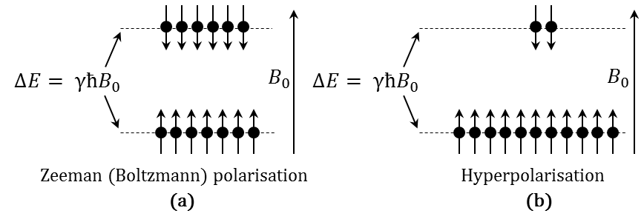
Figure 1.1.1: Illustration of hyperpolarisation. (a) Schematic representation of energy levels ($eV$) of spins at Zeeman (Boltzmann, or thermal) polarisation. (b) Schematic representation of energy levels ($eV$) of hyperpolarised spins. $γ$ is the gyromagnetic ratio expressed in $rad S^{-1} T^{-1}$, $ħ$ is the reduced Plank’s constant $6.582 {10}^{-16} eVs$ and $B_{0}$ is the strength of static magnetic field in tesla (T).
For the total population of the nuclear spins (either at Zeeman polarisation or hyperpolarisation) in the two energy levels $+\frac{1}{2}$ and $-\frac{1}{2}$ represented by $N_{↑}$ and $N_{↓}$ respectively, the polarisation $P_{0}$ of the sample is given by,
$P_{0}= \frac{\left|N_{↑}- N_{↓}\right|}{N_{↑}+ N_{↓}}$ 1.1.3
For an illustration of Equation 1.1.3 and the distinction in polarisations achieved between Zeeman (Boltzmann) polarisation $P_{Thermal}$ and hyperpolarisation${ P}_{Hyper}$, consider the simplified representative schematic in Figure 1.1.1. For Zeeman (Boltzmann) polarisation $P_{Thermal}=\frac{\left|6 -7 \right|}{6 + 7}= \frac{1}{13}$and for hyperpolarisation${ P}_{Hyper}=\frac{\left|2 -11 \right|}{2 + 11}= \frac{9}{13}$. Thus,
${\left.{ P}_{Hyper}≫ P_{Thermal} → { M}_{Hyper}≫ M_{Thermal} \right|}_{{ N}_{Hyper}= { N}_{Thermal}}$ 1.1.4
In hyperpolarised gas NMR the net magnetisation $M_{Hyper}$ is proportional to the polarisation $P_{Hyper}$ achieved in the process of hyperpolarisation.
³He and ¹²⁹Xe have the nuclear spin of $\frac{1}{2}$ (5) and both gases can be hyperpolarised using methods other than the Zeeman effect. The two methods of hyperpolarisation, both involving lasers are: spin-exchange optical pumping (SEOP) (6,7) and metastabilty exchange optical pumping (MEOP) (8,9). Metastabilty exchange is a direct method where by the ³He nucleus is directly excited with a circularly polarised laser light of wavelength 1083 nm via the temporary formation of metastable molecules of ³He₂ under a plasma discharge. The SEOP method is an indirect method; electrons in rubidium vapour are excited first with a circularly polarised laser light of wavelength 795 nm, and polarised rubidium electrons excite ³He or ¹²⁹Xe nuclei by exchanging electron and nuclear spin polarisation during atomic gas phase collisions in the cell. An illustration of the components of a typical SEOP polariser is shown in Figure 1.1.2 (a). The Sheffield polariser with 50 W LDA-VGH (Laser diode arrays – volume holographic grating) is shown in Figure 1.1.2. (b) (Reproduced from Norquay et al. (10)).
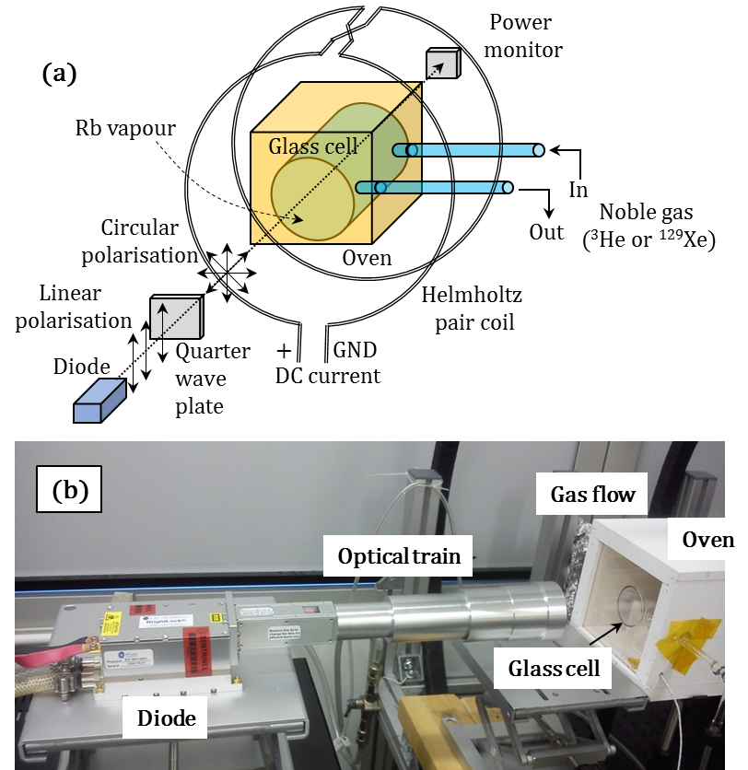
Figure 1.1.2: Spin-exchange optical pumping polariser. (a) Schematic representation of a SEOP polariser (b) 50 W Laser diode arrays, volume holographic grating and optical train. The image is reproduced from Norquay. G., et al (10).

A comparison of the MR properties of the two noble gases explored in this thesis and ¹H is given in Table 1.1.1.
Properties |  | ¹H | ³He | ¹²⁹Xe
Gyromagnetic ratio (γ) MHz/T |  | 42.576 | -32.434 | - 11.777
Larmor frequency in MHz | 1.5 T | 63.86 | 48.64 | 17.65
 | 3.0 T | 127.71 | 97.29 | 35.31
Spin density (10¹⁹ atoms/cm³) |  | 6690 | 2.37 | 2.37
Magnetic moment (10²⁶ J/T) |  | 1.411 | 1.074 | 0.388
Methods of hyperpolarisation |  | - | SEOP, MEOP | SEOP
Table 1.1.1: Comparison of MR properties between ¹H, ³He and ¹²⁹Xe (3).
Although the spin density of gas is much lower when compared to the density of proton spins (¹H) in the human body, the polarisation in an optical pumped hyperpolarised gas can be much more than the polarisation achieved by the Zeeman (Boltzmann) polarisation (11,12). Hyperpolarised noble gases have the following salient MR properties (13,14):
- From the time noble gases are hyperpolarised, the non-equilibrium magnetisation decays ($T_{1}$) continuously as spins relax to thermal equilibrium (11,12). The $T_{1}$ of the hyperpolarised noble gases in the gas phase in the lung is inversely proportional to the partial pressure of oxygen (pO₂) in the lung.
- Every RF pulse destroys magnetisation by the factor of${ cos⁡(α)}^{n}$, where α is the flip angle and n is the number of RF excitation pulse applied in the imaging sequence. Thus magnetisation lost in this way with every RF pulse is non-recoverable. Any unused magnetisation after the procedure/scan is lost permanently (15,16) unless magnetisation recycling pulse sequences such as steady state free precession are used (17).
- The signal strength which depends on the net longitudinal magnetisation is determined by the percentage of polarisation achieved in the polariser and the amount of gas inhaled into the lung. Thus, unlike conventional ¹H, the signal strength is not fully determined by strength of applied external magnetic field (13).
- For a flip angle of $α$, the transverse magnetisation ($M_{n^{th}-xy}$) at $n^{th}$ RF pulse is given by,
$M_{n^{th}-xy}= M_{0}{ cos(α)}^{n}sin(α)$ 1.1.5

    - Properties of ¹²⁹Xe
Some of the properties of xenon relevant to the research is covered in the thesis:
- Xenon is a rare atmospheric gas. The natural occurrence of ¹²⁹Xe in the atmosphere is 0.023 parts per million. The natural abundance of ¹²⁹Xe is 26%. Other naturally occurring isotopes are ¹²⁸Xe, ¹³⁰Xe, ¹³¹Xe and ¹³²Xe with natural occurrence of 0.001, 0.004, 0.018 and 0.023 parts per million respectively. The isotope ¹³³Xe is radioactive and used clinically to diagnose lung diseases and to measure cerebral blood flow (18,19). The ground state nuclear spin of ¹²⁹Xe is $\frac{1}{2}$ with a gyromagnetic ratio of -74.521 ${10}^{6}$ $rad s^{-1}T^{-1}$ (20). The melting temperature of solid phase Xe is 161.4 K and the liquid phase boiling temperature is 165.05 K (21).
- Xenon is lipophilic and a few notable partition coefficients are provided in Table 1.1.2.
 | Value | Reference
Bunsen partition coefficient
Phospholipid - gas | 1.36 | (22)
Water - gas | 0.146
Ostwald’s partition coefficient
Olive oil - water | 22.5 | (23)
Blood - gas | 0.12 | (24)
Blood - grey matter | 0.84 | (25)
Blood – white matter | 1.3
Table 1.1.2: Bunsen and Ostwald’s partition coefficient of xenon. Note: the Bunsen solubility coefficient is the volume of gas at 0°C and 101.3 kPa dissolved per unit volume of a pure solvent at a specified temperature. Ostwald’s solubility coefficient differs from Bunsen solubility coefficient in that the volume of gas is expressed at the temperature of the experiment instead of 0°C. Partition coefficient between two solvents is the ratio of their solubility coefficients.

With variation in red blood cell concentration (haematocrit) the solubility of xenon in the blood and perfused tissue varies. At 37%, 63.5% and 90% haematocrit, the solubility of xenon for grey matter is 0.12, 0.092 and 0.0776 and the solubility of xenon in white matter is 0.204, 0.153 and 0.129 (26).
- Due to the distensibility of its relative weakly bound outer electron shell, ¹²⁹Xe interacts with its electrochemical environment and has a wide range of chemical shifts when dissolved in common solvents; in vivo, the chemical shift ranges from 148 ppm to 335 ppm (27). Some of the relevant chemical shifts are 217 ppm for blood – red blood cells (28-33), 199 ppm for aqueous solution – blood plasma (27,28), 195 ppm for grey matter (34-36), 192 for white matter (34-36) and phospholipids (34,36,37). A detailed chemical shift range of ¹²⁹Xe (38) is shown in Figure 1.1.3.
- The $T_{1}$ relaxation of hyperpolarised (HP) ¹²⁹Xe dissolved in the human blood is sufficiently long for the signal to be detected in distal organs after being transported from the lungs (30,31,33). Typical values for $T_{1}$ relaxation of HP ¹²⁹Xe in the human blood are 7.7 s and 2.8 s for arterial (oxygenated) blood and venous (deoxygenated) blood respectively (31-33).
Figure removed because the copyright permission not suitable for open access

Figure 1.1.3: Chemical shift range of ¹²⁹Xe. Reproduced from (38) with permission, © John Wiley and Sons 2016.

- Xenon has anaesthetic properties when inhaled in large quantities (stable inhalation) (39-41). When administered in a dose of 1 L under a breath hold it can cause temporal dizziness, paraesthesia and hypoesthesia, but these adverse events are mild or moderate and reverse within tens of seconds of breaking apnoea (42).
- Under a stable xenon-anaesthetised state the cerebral blow flow (CBF) does not change in rats (43,44). In humans, as xenon infuses into the brain tissue, cerebral blow flow (CBF) reduces in grey matter and increases in white matter (25,45). However, using xenon CT scanning, measurable/significant change in CBF has only so far been observed under a stable-anaesthetised state which requires 30 minutes of continued steady state breathing of xenon (45). The reduction in CBF is mainly attributed to the decrease in metabolism in the cortex (grey matter) under stable anaesthesia. For the initial few seconds (30~40s) such as the case of a breath hold, CBF or autoregulation is not affected as the partial pressure of CO₂ or metabolism in the cortex is unaltered (25,44,46).

    - MRI of the lungs
Anatomically the human lungs are made up of smooth muscular tissue which forms the bronchial tree and pulmonary blood vessels (47). The bronchial tree divides dichotomously in 25 generations of branches terminating at the alveoli, the small airways responsible for gas exchange. Contemporarily, diagnosis of lung diseases relies on whole lung function tests of air flow and volume such as spirometry (48,49) which do not provide any tomographic regional information on the site of the disease. Magnetic resonance imaging (MRI) is not the radiological modality of choice for structural diagnosis of lung diseases because conventional ¹H MRI relies on water (or lipid) molecules which are abundant in the human body whilst the lungs consist mainly of air spaces with a resulting low density of ¹H that can be imaged (~0.2g/cc) (47). MRI detection is further hindered by the short transverse relaxation times in the lungs (between 1~2 ms at 1.5 T) which arise due to the susceptibility gradients between tissue and air. Hyperpolarised (HP) gas MRI evades some of these challenges and provides clinical sensitivity to lung disease pathophysiology that cannot be assessed by either conventional ¹H MRI or other diagnostic imaging modalities like computer tomography (CT), nuclear medicine (scintigraphy, PET- positron emission tomography), X-ray and ultrasound (50,51). When inhaled these hyperpolarised inert gases (³He and ¹²⁹Xe) provide sufficient signal to illuminate the ventilated air spaces in the lungs, revealing clinical information relevant to lung diseases as shown in Figure 1.1.4.
Lung ventilation defects and alveolar augmentation occur due to lung obstruction and emphysema. Pathologies such as lung tumours can also restrict the airways and limit air from reaching the small airways beyond as illustrated in Figure 1.1.5(a). With hyperpolarised (HP) gas MRI these ventilation abnormalities manifest as absence of NMR signal at that particular location in a spatially resolved image. A typical hyperpolarised gas MRI of the lung with ventilation defects (52) is reproduced here for the purpose of illustration in Figure 1.1.5(b).
When alveolar length scales are enlarged by the process of emphysema, gas atoms within the alveoli are less restricted in terms of motion by Brownian diffusion. With hyperpolarised gas MRI the alveolar augmentation is manifested as a higher apparent diffusion coefficient (ADC)(53) which can be measured with pulsed gradient echo methods, as is illustrated in Figure 1.1.6 (a). A typical measurement of apparent diffusion coefficient of hyperpolarised gas in the lung (54) is reproduced here for the purpose of illustration in Figure 1.1.6 (b).

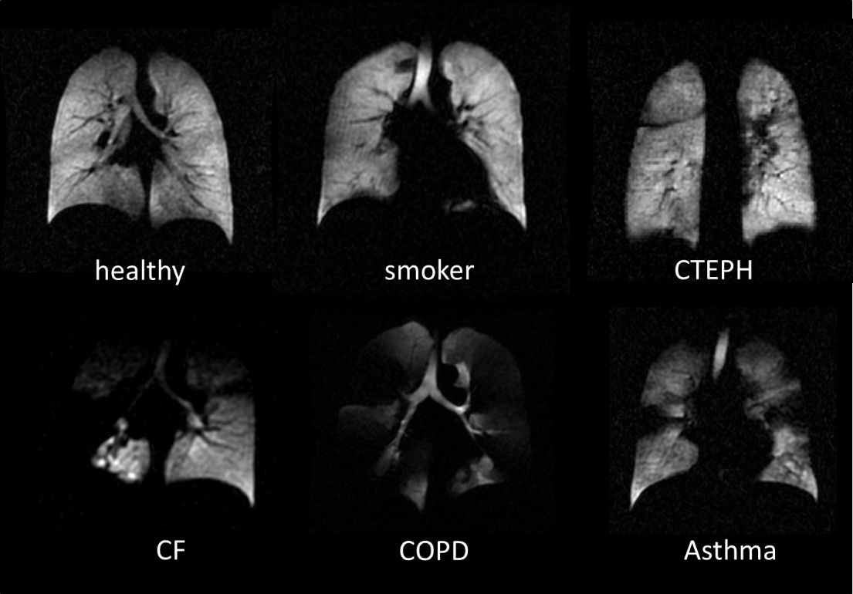
Figure 1.1.4: Ventilation images of the human lungs for various lung diseases acquired with hyperpolarised ³He. These images illustrate the diagnostic capabilities to detect and differentiate various lung diseases such as smoker, Chronic Thromboembolic Pulmonary Hypertension (CTEPH), Cystic Fibrosis (CF), Chronic Obstructive Pulmonary Disease (COPD) and Asthma. These images were acquired within the Academic unit of Radiology (hyperpolarised imaging group in the University of Sheffield) and reproduced here for the purpose of illustration. © University of Sheffield.
Figure removed because the copyright permission not suitable for open access
Figure 1.1.5: Illustration of ventilation defects in the lungs (a) Illustration of normal airway and an abnormality in the airway restricting the hyperpolarised gas from reaching alveoli and (b) Demonstration of ventilation defect in a patient with a tumour in the upper right lobe. The image is reproduced from (52) with permission of the American Thoracic Society. Copyright © 2015 American Thoracic Society.

Figure removed because the copyright permission not suitable for open access
Figure 1.1.6: Illustration of apparent diffusion coefficient measurement. (c) Hyperpolarised gas atoms in an augmented alveolus move randomly over a larger space as compared to the movement of hyperpolarised atoms in a normal alveolus in the same time interval and (d) Demonstration of apparent diffusion coefficient measurement in a patient with sever emphysema. The image is reproduced from (54) with permission, © Radiology 2015. Colour bar indicates apparent diffusion coefficient in cm²s⁻¹.
The first biological images from hyperpolarised gas MRI were acquired in 1994 by Albert et al. (11) using hyperpolarised ¹²⁹Xe in the lung of a deceased guinea pig. The first images from hyperpolarised gas MRI in the human lung in vivo were acquired in 1996 by Ebert et al. (12) using hyperpolarised ³He. Hyperpolarised gas MRI provides clinical sensitivity in diagnosing ventilation defects for chronic obstructive pulmonary diseases, cystic fibrosis, bronchiectasis, asthma, bronchiolitis and pulmonary embolism (5,55). In a preliminary study involving 10 patients with asthma and 10 healthy subjects, HP ³He lung MRI not only indicated ventilation defects in patients with asthma, but also enabled visualisation of response to bronchodilator therapy (56). A similar study with asthma patients showed correlation with forced expiratory volume (${FEV}_{1}$) when patients were subjected to methacholine and exercise challenge (57). Studies have also demonstrated the clinical benefits of early detection of lung obstruction with HP ³He lung imaging involving patients with cystic fibrosis (58-61) and COPD (62,63). In an initial study with 11 patients who were clinically diagnosed with smoking-related chronic obstructive pulmonary disease (COPD) and 16 controls, the measured mean ADC values correlated well with forced expiratory volume $({FEV}_{1}-liters)$ and ${FEV}_{1}$ per forced vital capacity$(\frac{{FEV}_{1}}{FVC})$ (54) (conventional spirometry airflow measurements of whole lung function for the diagnosis of COPD). In another study involving 5 patients with emphysema and 11 healthy volunteers, the diffusivity of HP ³He was 2.5 times higher in patients when compared to lung of healthy volunteers (64). With several other similar studies, diffusion MRI of HP gases (¹²⁹Xe and ³He) in the lung has been established as a quantitative measure of lung structure-function (65-69). Intrapulmonary oxygenation quantified by $T_{1}$ mapping may be abnormal due to ventilation perfusion mismatch or interstitial lung disease (70). To summarise, pulmonary defects can be diagnosed with HP gas MRI as normal healthy lung has a homogeneous signal intensity whereas unhealthy lung can have:
(a) An inhomogeneous (void) signal intensity indicating obstructive lung disease (56,71-73),
(b) Increased gas diffusivity indicating emphysematous alveolar damage (64),
(c) $T_{1}$ map quantifying intrapulmonary oxygenation (70).
In addition, the solubility of ¹²⁹Xe has enabled diagnosis of lung disease related to alveolar-interstitial-capillary gas-exchange (63,74-77). Hyperpolarised ¹²⁹Xe resonances from a dog chest illustrating gas-phase and dissolved-phase resonance is shown in Figure 1.1.7. A comparison of imaging the gas-phase and the dissolved-phase resonances of HP ¹²⁹Xe in the human lung is shown in Figure 1.1.8. The short $T_{2}^{*}$ of the dissolved-phase resonance of HP ¹²⁹Xe makes imaging more challenging.
Figure removed because the copyright permission not suitable for open access
Figure 1.1.7: Hyperpolarised ¹²⁹Xe resonances from a dog chest acquired during breath hold. Reproduced from (78) with permission, © John Wiley and Sons 2016. In this study, the resonances at 197 ppm and 212 ppm are associated to ¹²⁹Xe dissolved in the lung parenchyma and haemoglobin respectively. The chemical shift in ppm scale is measured relative to the resonance of ¹²⁹Xe gas in the lungs (0 ppm).
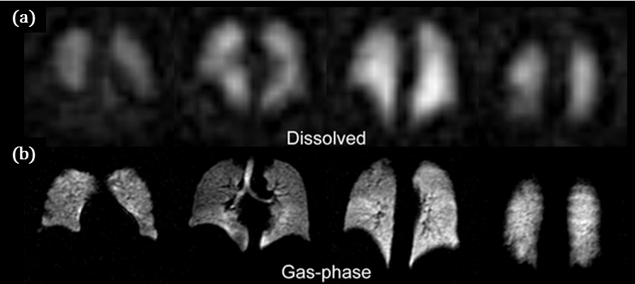
Figure 1.1.8: A comparison of imaging the gas-phase and the dissolved-phase resonances of HP ¹²⁹Xe in the human lung reproduced from (75), open access – no permission required. (a) Imaging gas-phase resonance and (b) Imaging dissolved-phase resonance.
With advances in the physiological and functional sensitivity of hyperpolarised gas imaging of the lungs, the significance with respect to clinical diagnosis is enhanced when the functional information from the hyperpolarised gas is imaged synchronously with the structural ¹H images, so that both tissues in the lungs and the airspace itself are imaged together in the same physiological time frame. Preliminary investigations indicating the clinical benefits of combined imaging of ³He and ¹H was demonstrated in four patients with cystic fibrosis (73). In another study ¹H images and ³He images were used together to estimate functional ventilated volume. It was observed that non-smokers, smokers and COPD patients had mean ventilation volumes of 90%, 75.2% and 67.6% respectively (79). Similarly benefits were indicated in detecting pulmonary emboli from ¹H vascular MRI and ventilation defects from HP ³He MRI (80). These studies used separate breath-holds, wherein the images from HP ³He and ¹H were not spatially registered or temporally synchronised. In a recent study, a synchronous acquisition of HP ³He and ¹H was demonstrated with the images from each of the nuclei being spatially co-registered (81,82). The images show fine details of pulmonary blood vessels, trachea and bronchi as seen in Figure 1.1.9.

Figure removed because the copyright permission not suitable for open access
Figure 1.1.9: Illustration of multi-nuclear synchronous imaging of the lung with HP ³He, ¹²⁹Xe and ¹H. The images from HP ³He and ¹²⁹Xe are spatially co-registered with the ¹H images. A study from our group (82) reproduced here with permission, © Radiology 2015.
    - Hyperpolarised gas MRI of the brain
Anatomically, the intracranial human brain is composed of brain tissue (80 %), blood (10 %) and cerebrospinal fluid (10 %) (83). A typical adult human brain is made up of approximately 100 billion neurons, compartmentalised into grey matter and white matter based on the lipid (myelin and cholesterol) fraction of its dry weight (84,85). White matter has a higher degree of myelination when compared to grey matter (86,87) and this enables differential MRI contrast with $T_{1}$ and $T_{2}$weighted imaging (88-91). The underlying principle of the acquisition is that the regions with higher myelin content (white matter) appear brighter on $T_{1}$ weighted images and darker on $T_{2}$ weighted images. An example of MRI contrast for grey matter and white matter imaging is shown in Figure 1.1.10. Although $T_{1}$ and $T_{2}$weighted imaging techniques are widely used for the diagnosis of brain abnormalities related to structure (for example brain tumours), abnormalities such as stroke, which are related to perfusion abnormalities would require additional functional assessment. Thus, ¹H MR functional brain imaging techniques such as $T_{2}^{*}$-weighted imaging, diffusion-weighted imaging and contrast-enhanced MR angiography are used in the assessment of brain parenchyma, cerebral circulation, perfusion and the anaerobic penumbra region of semi-viable tissue around a brain infarct (92-99). The time between the on-set of a stroke to thrombolysis is very critical (100,101) for treatment, and MRI has been shown to be the most suitable instrument in the diagnosis of acute stroke (haemorrhagic and ischemic) as it provides spatial information of intravascular clot, ischemic core and penumbra (102,103).
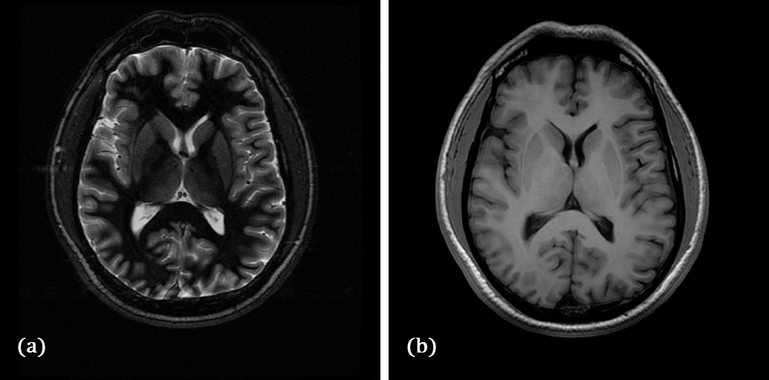
Figure 1.1.10: MR imaging of the grey matter and the white matter using GRE pulse sequence. (a) Grey matter. The imaging parameters were: TR = 7.72 s, TE = 32.6 ms, Echo train = 8, bandwidth = 25 kHz, TI = 300 ms, FOV = 24 cm, slice thickness = 4 mm and matrix size = 352 X 224. (b) White matter. The imaging parameters were: TR = 12.4 ms, TE = 5.2 ms, bandwidth = 15.6 kHz, TI = 450 ms, FOV = 24 cm, slice thickness = 1.6 cm and matrix size = 256 X 256. Acquired at 1.5 T using GE signa® HDx MR System

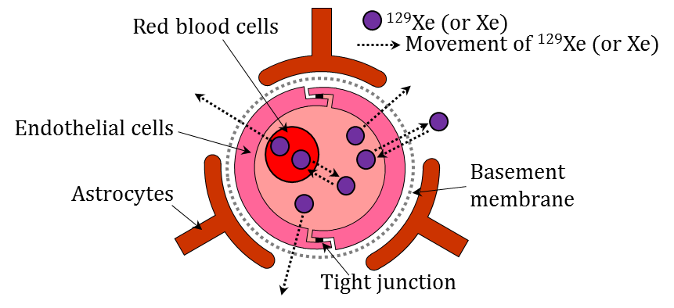
Figure 1.1.11: Schematic representation of the blood brain barrier
The blood-brain barrier (BBB) separates the cerebral blood vessels from the brain tissues (grey matter and white matter) as shown in Figure 1.1.11. Endothelial cells in the BBB are joined by tight junctions (83,104) and these cells regulate the permeability of the BBB (105,106). Astrocytes (protoplasmic and fibrous) are non-neuronal glial cells which regulate the chemical environment, provide biochemical support to the endothelial cells and transport nutrients. The BBB along with astrocytes allow the passage of smaller molecules vital for physiology (example O₂, CO₂, glucose) and restrict passage of larger molecules to the brain. Xenon is highly soluble in lipids (107), the bilayer lipid of endothelial cells enables xenon to cross the BBB through passive diffusion (108). As xenon does not have any electrical change or an affinity to form tightly bound molecules, the transfer of xenon across the BBB is not thought to be regulated by surface activity or active efflux transporters in the endothelial cells (109). Thus, the concentration of xenon in the brain is mainly driven by entropy and the difference in concentration of xenon in the blood to the concentration of xenon in the brain tissue. At equilibrium, the ratio of concentration in these compartments is determined by Ostwald’s partition coefficient as shown in Table 1.1.2.
Figure removed because the copyright permission not suitable for open access
Figure 1.1.12: Imaging the cerebral perfusion with ¹⁷O. (a) ¹⁷O MR image – Sagittal plane, (b) reference ¹H MR image – Sagittal plane, (c) ¹⁷O MR image – Coronal plane and (d) reference ¹H MR image – Coronal plane. Reproduced from (110) with permission, © Springer 2016.
Treating brain diseases (or psychiatric disorders) by delivering the drug to the brain tissue by crossing the blood-brain barrier (BBB) (111,112) is very challenging (113-115). In terms of MR imaging, established Gadolinium chelated contrast agents are molecularly large and do not cross the BBB unless it is damaged in the case of cerebral haemorrhage (116-118). Currently there are no clinical MRI contrast agents which can cross the intact BBB (in the absence a haemorrhage). However, ¹⁷O MRI has been demonstrated for imaging cerebral perfusion and the passage of oxygen across the BBB (110,119) as shown in Figure 1.1.12. The isotope is very expensive and the signal is inherently low. A safe and economical contrast agent and a tracer is the area of interest of this thesis. In this respect, dissolved xenon is potentially attractive as a brain contrast agent as it is soluble in blood and crosses the BBB following the cerebral oxygen uptake pathway. Moreover its chemical shift gives added spectral-spatial sensitivity to different compartments of the brain.
Compared to pulmonary imaging, less has been accomplished with MRI of hyperpolarised agents in the brain than in other organs with some preliminary findings in rats (120-122) and in humans (29,35,37) using ¹²⁹Xe. Kershaw et al and Nakamura et al (34,36) detected 5 peaks in a ¹²⁹Xe head spectrum in a rat, attributing the peaks to grey matter (193 ppm – 197 ppm), jaw muscle (187 ppm – 191 ppm), fat tissue outside brain (197 ppm – 201 ppm), white matter (191 ppm – 194 ppm) and blood – RBC (210 ppm). The peak at 187 ppm – 191 ppm was confirmed to originate from outside the brain by comparing the spectra obtained with and without ligation of the external carotid artery (34,36). Mazzanti et al (120) demonstrated the possibility of detecting the increased brain perfusion and functional activity following sensory stimulation in rats. Zhou et al (121) demonstrated the detection of ischemic stroke in rat, reproduced here for the purpose of illustration in Figure 1.1.13.
Figure removed because the copyright permission not suitable for open access
Figure 1.1.13: Demonstration of stroke detection in rat brain using dissolved HP ¹²⁹Xe. (a) HP ¹²⁹Xe chemical shift image from a rat brain without stroke and (b) HP ¹²⁹Xe chemical shift image from a rat brain with stroke. The spatially resolved peak in the images is HP ¹²⁹Xe dissolved in brain tissue (grey matter). Regions marked 1 and 2 on both hemispheres of the brain (left and right) have similar cerebral perfusion. Comparing region 1 on both hemispheres indicate ischemic core and comparing region 2 on both hemispheres indicate normal tissue. Study conducted by (121) reproduced here with permission, © John Wiley and Sons 2016.
A similar study was conducted for imaging the brain tissue of rats using HP ¹²⁹Xe (123). The only studies in the human brain with HP ¹²⁹Xe to date are from Mugler et al (29) and Kilian et al (35) who demonstrated time resolved uptake spectra of HP ¹²⁹Xe dissolved in human brain in vivo. These studies found two dissolved peaks attributed to grey matter (195 ppm – 198 ppm) and white matter (192 ppm – 194 ppm) respectively. Kilian et al (35,37) also demonstrated preliminary results of chemical shift imaging of HP ¹²⁹Xe dissolved in human brain in vivo with an imaging matrix of 8 x 8 and estimated $T_{1}$ relaxation of HP ¹²⁹Xe dissolved in grey matter and white matter to be 14 s and 8 s respectively.
    - Motivation of the work in this thesis
The motivation for the research in this thesis was to advance the state-of-the-art instrumentation (and methods) for applications of hyperpolarised gas MRI in lungs and brain with a view to clinical translation of the methods. This was realised with three distinct but related topics of technical research:
- Improvising signal-to-noise ratio of ¹H signal from the lungs in dual-nuclear (¹H-³He, ¹H- ¹²⁹Xe) same-breath lung imaging (structure-function) by establishing accurate analytical methods to design a ¹H receiver coil array that functions nested inside a ³He or ¹²⁹Xe transmit-receive coils.
The HP gases ³He and ¹²⁹Xe have distinct physical properties, which provide different but complementary functional information (3,4,55). The ability to image both nuclei in the same breath alongside the ¹H anatomical images adds further structural and functional sensitivity to the acquisition. To date, ¹H images in same-breath multi-nuclear lung imaging have been acquired using the MR system’s body coil (81,82,124,125). The SNR of ¹H lung images acquired from the MR system’s body coil is moderate at best due to the low proton density in the lungs and the lack of proximity of the coil. The presence of coils tuned to hyperpolarised gas frequencies within the magnet bore can further degrade the SNR (¹H lung image) through unwanted coupling and detuning. Although it is well known that a dedicated receiver array positioned at close proximity to the subject provides more SNR than the system body coil (126), to date, the use of dedicated receiver arrays for ¹H lung MRI in conjunction with same-breath acquisition of hyperpolarised gases has not been demonstrated. Thus an RF coil system that allows the imaging of both gases in conjunction with high quality ¹H imaging is also highly attractive from a clinical perspective for fast throughput clinical imaging of the lungs with multinuclear MRI.
- Demonstrating triple-nuclear (¹²⁹Xe-³He-¹H) same-breath lung imaging (structure-ventilation) and dual-nuclear (¹²⁹Xe-³He) same-breath apparent diffusion coefficient mapping.
³He is highly diffusive when compared to ¹²⁹Xe (127-129), and the visualisation and quantification of lung ventilation and diffusion with these two gases at the same time when inhaled in the lungs can help address important physiological questions such as the position of the diffusion – convection front in the lungs. The capability to measure the diffusivity of both ³He and ¹²⁹Xe gases in the same lung inflation level also provides added information for measuring and modelling lung micro-structure based on their measured apparent diffusion coefficients (ADC) (130).
- Investigating the feasibility of hyperpolarised ¹²⁹Xe MRI for imaging perfused brain tissue and quantification of intrinsic characteristic of the blood brain barrier.
Although previous studies have been conducted to image HP ¹²⁹Xe dissolved in the rat brain tissue, all previous studies were conducted on animals in an anaesthetised state (120,121). HP ¹²⁹Xe has never been demonstrated as an imaging agent for imaging the perfused human brain tissue, in a breath-hold, in awake-state (not anaesthetised), which could potentially be used in regular clinical practice. Additionally, xenon is a safe agent that can be delivered to the brain (40,41) and most importantly when compared to established paramagnetic chelated MRI contrast agents (131-133), xenon is lipophilic and crosses the blood brain barrier without perturbing the biological system. HP ¹²⁹Xe MRI has yet to be used to measure characteristic properties of the blood brain barrier in vivo.
  - Literature review and theoretical background
For the sake of repetition of background MRI physics and engineering the author recognises the reader as a peer researcher with a prior knowledge of Magnetic Resonance Imaging (MRI) physics and engineering and its clinical applications. Basic concepts of MR physics and engineering aspects such as magnetic moment of a nucleus in an external magnetic field, RF excitation and precession, longitudinal and transverse relaxation, the Bloch equations, quantum mechanics description, principle of signal detection, free induction decay, slice selection, pulse sequence design, gradient and spin echo, inversion recovery, sampling and image reconstruction, polarisation and optical pumping are deliberately not covered in this section. Some aspects of the background MR physics and engineering that are particularly relevant to the research methodology of this thesis are however covered in this section; namely MR system engineering overview, basics of signal detection, RF coil engineering, chemical shift imaging, basic spoiled gradient echo pulse sequence and tracer kinetics theory.
    - MR Engineering essentials

MR system overview
This section provides a basic overview of MR system engineering and highlights the challenges and constraints posed by the different components in the hardware chain with particular reference to hyperpolarised MRI. A typical architecture of an MR system is shown in Figure 1.2.1.1. It mainly consists of a static magnet that provides the $B_{0}$ field – usually realised by a superconducting magnet (134-137), gradient magnetic field system (138,139), radio frequency coils (140) and real-time operating system to synchronise magnet shimming, pulsed gradients, RF transceiver operation and data acquisition. Inhomogeneity of the static magnetic field may dominate over the MR frequency properties of the sample under examination (141,142). The homogeneity of the static magnetic field is therefore improved by shimming hardware which is composed of several coils generating superposed magnetic fields (specifically spherical harmonics) (143,144). Shimming is performed either passively (145,146), iteratively (manual shimming) or auto non-iteratively (magnetic field map based shimming, projection based shimming, dynamic shim updating) (147-150).
The field encoding gradients are generated by gradient coils, which are Maxwell pairs with currents in opposite directions (151). Unlike static magnetic field coils, gradient coils are not superconducting and they carry pulses of current delivered by high fidelity amplifiers capable of delivering hundreds (even thousands) of Amperes at frequencies in the audio range. Thus the power efficiency, self-inductance, eddy currents and management of heating in these circuits and structures are some of the primary engineering challenges. Typically there are two sets of gradient coils, a primary coil and a secondary coil. These coils are optimised for the delivery of a linear gradient field and any non-linearity in the gradient field will result in image distortion. In addition to any non-linearity in the gradient field, the time-varying magnetic field is self-distorted by the formation and decay of eddy currents (152-157). The effect of eddy currents can be compensated by pre-emphasis (156-158) and active shimming (159,160). The low gyromagnetic ratio of ¹²⁹Xe necessitates much stronger gradients for a given bandwidth and spatial dimension than for ¹H MRI and as such can place demands on the system’s gradient power supply.
The operating mechanism of a MRI system is complex with ample opportunities for uncertainty, noise and artefacts. The fidelity of the image acquired across the field of view (FOV) and slice thickness is primarily limited by the homogeneity of the static magnetic field ($B_{0}$), the linearity of the gradient field, homogeneity of the delivered $B_{1}$ field of the transmitter RF coil and phase noise of the direct digital frequency synthesisers (DDS)(161). For ¹H MRI the system generally has automated routines for pre-determining (calibration or pre-scan) the RF power required for a desired flip angle, but this is counterproductive in hyperpolarised MRI as the RF pulses applied in the calibration procedure will destroy the polarisation. Uncertainty can also be introduced in the flip angle delivered due to non-linearity of the RF amplifier gain (162-164).

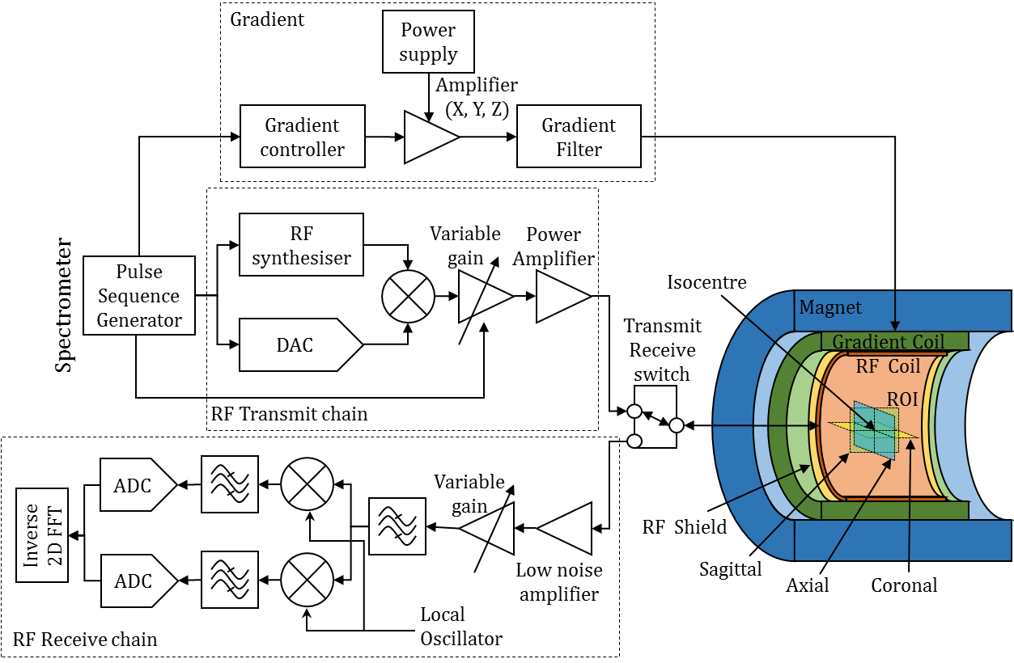
Figure 1.2.1.1: A typical architecture of MR system
The three main sources of noise in the receiver are (i) sample noise (induced eddy current in the subject under test), (ii) Ohmic loss (resistive and parasitic loss from the resonant RF coil) and (iii) the noise figure and gain of the low noise amplifier (LNA). RF coil and the subject dominated noise are covered later in the section. In addition to the detection electronics (RF coil and LNA), signal demodulation and analogue-to-digital conversion (ADC) will also contribute to the noise in the receiver. The demodulation circuit is associated with residual conversion loss and common-mode rejection efficiency (164). The dynamic range and signal-to-noise ratio (SNR) of the ADC will be limited by the effective number of bits (ENOB) and internal noise sources (code-translation error, linearity, offset, gain, quantisation, temperature drift)(165). Gradient amplifiers are high power devices (typically 50 kW). Though the frequency of operation of pulse gradient coils is in the order of kHz, higher order harmonics are generated by the gradient driver (synthesiser and amplifier), which despite attenuation from the gradient filter can contribute to the noise in NMR signal, especially during an examination of a nucleus with lower gyromagnetic ratio (¹³C, ¹⁷O, ²³Na, ¹²⁹Xe) as the clinical MR scanner noise suppression is primarily engineered for the ¹H frequency.
In addition to uncertainty and noise, engineering limitations can create artefacts and non-uniformity in a MR image (166-171). MR images are distorted and modulated by the inhomogeneity of the static magnetic field, gradient field and RF field. Non-linearity of the gradient field in the phase and frequency encoding directions results in anatomical distortion and irregular voxel dimensions (171). Sensitivity drop-off of the RF coil increases as the distance from the RF coil increases, causing a drop-off in the intensity in the image, accordingly (171,172). A local intensity shift in the image is caused when using a receiver RF coil array due to the coil internal electronics acting as parasitic conductors to the resonant loops of the RF coil array (173). A realistic RF pulse with a non-ideal excitation profile will excite nuclei outside the slice. A DC offset in either one or both (real and imaginary) components causes a bright spot in the centre of the image. An unequal gain in the receiver between real and imaginary components can cause ghosting in the image (174). An ineffective RF shield of the MRI system room will allow RF from the external environment to leak into the receiver causing undesired bright spots in the image also known as zero-line, star and zipper artefacts (171,172). Many other artefacts not related to engineering limitations occur due to additional factors more related to the patient such as; motion, localised tissue susceptibility difference, blood flow, chemical shift of fat and water, partial volume, aliasing, magic angle effects, Moire fringes, zero-filling, wraparound, slice-overlap, entry-slice phenomenon, k-space truncation (Gibbs ringing), these are not covered here and the reader is encouraged to read relevant literature on the artefacts of MRI acquisition (167,170-172).

Principle of reciprocity
The spatial sensitivity of RF coils follow the principle of reciprocity (175,176). Consider a point P at a certain distance D from a simple resonant loop as shown in Figure 1.2.1.2. When the loop is fed with an RF source, the resulting alternating current I of frequency $ω$ flows through the resonant loop of radius R which generates a magnetic field ${ B}_{1}$ as shown in Figure 1.2.1.2(a). The finite transverse magnetisation${ M}_{xy}$ at the point P induces current in the loop as shown in Figure 1.2.1.2(b) as per Faraday’s law of induction (177). ${ B}_{1}$ can be expressed as,${ B}_{1}= {µ_{0}R^{2}2π\left[4π {\left(D^{2}+ R^{2}\right)}^{\frac{3}{2}}\right]}^{-1}$, where $µ_{0}$ is the permeability of free space. The strength of the alternating magnetic field generated ${(B}_{1})$ is inversely proportional to the distance D from the loop. Considering the principle of reciprocity, as distance D reduces, the current induced in the loop increases. The generated ${ B}_{1}$ field also depends on the polarisation of the RF coil (178). Conventionally, the transmission rotating component and reception anti-rotating component are denoted as $B_{1}^{+}$ and $B_{1}^{-}$ respectively.
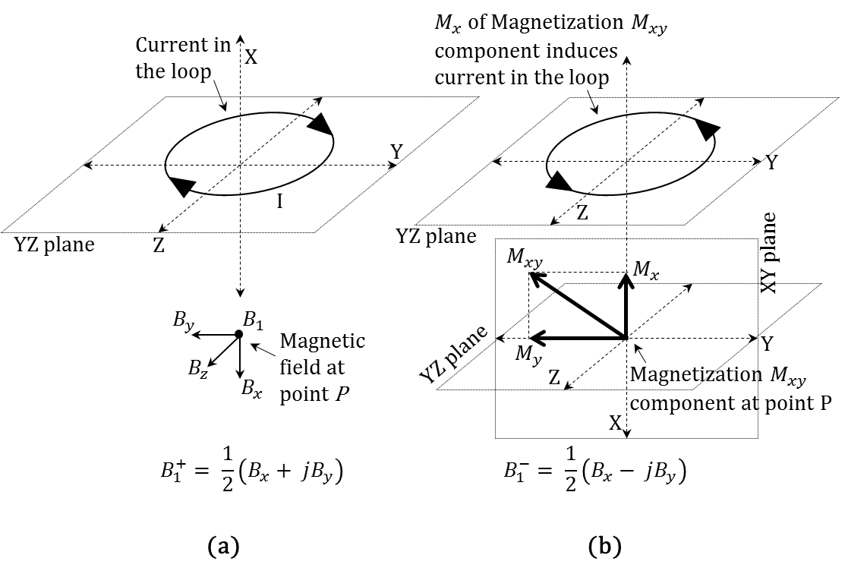
Figure 1.2.1.2: Illustration of principle of reciprocity

RF Resonance
For a series resonance, consider the circuit in Figure 1.2.1.3 (a). The capacitor $C_{S}$ with reactance $\frac{1}{jωC_{S}}$ and the inductor $L_{S}$ with reactance $jωL_{S}$ are in series. $R$ is the ohmic loss of the circuit. The total impedance of the circuit is$\frac{1}{jωC_{S}}+ jωL_{S}+R$. At the resonance frequency, the reactance of the capacitor $C_{S}$ and the inductor $L_{S}$ mutual cancel out, and the total impedance of the circuit is reduced to its ohmic loss$R$. Thus, we have$\frac{1}{jωC_{S}}+ jωL_{S}=0$. By rearranging the terms, $ω^{2}=\frac{1}{L_{S}C_{S}}$ where $ω$ is the frequency of resonance. For a parallel resonance, consider the circuit in Figure 1.2.1.3 (b). The capacitor $C_{P}$ with reactance $\frac{1}{jωC_{P}}$ and the inductor $L_{P}$ with reactance $jωL_{P}$ are in parallel. $R$ is the ohmic loss of the circuit. The total admittance of the circuit is$\frac{1}{R}+\frac{1}{jωL_{P}}+jωC_{P}$. At the resonance frequency, the reactance of the capacitor $C_{P}$ and the inductor $L_{P}$ mutual compliment forming a tank circuit, and the total admittance of the circuit is reduced to the inverse of its ohimc loss$\frac{1}{R}$. Thus, we have$\frac{1}{jωL_{P}}+ jωC_{P}=0$. By rearranging the terms, $ω^{2}=\frac{1}{L_{P}C_{P}}$ and $ω$ is the frequency of resonance.
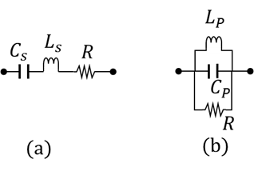
Figure 1.2.1.3: Series (a) and parallel (b) resonance circuit illustration.

Complex frequency
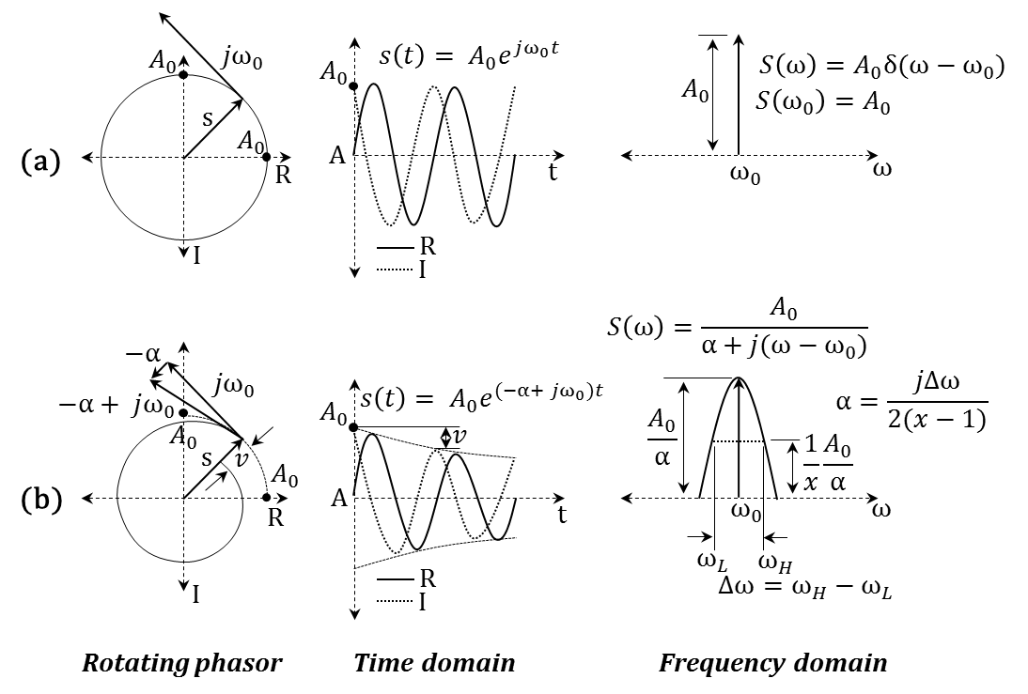
Figure 1.2.1.4: Complex frequencies (a) Ideal oscillating signal and (b) Ideal oscillating signal damping with time. Legends: I – imaginary, R – real, A – amplitude, t – time and $ω$ – frequency.
Consider the oscillating signal $s$ as shown in the phasor diagram in Figure 1.2.1.4 (a). This signal with amplitude $A_{0}$ and tangential angular velocity $jω_{0}$ is given by the expression$s\left(t\right)= A_{0}e^{jω_{0}t}$. The real and imaginary component of the signal in time domain is shown in Figure 1.2.1.4(a). In the frequency domain, the Fourier transform of the signal is$S\left(ω\right)=A_{0}δ(ω-ω_{0})$. Such that, for$ω=ω_{0}$, $S\left(ω_{0}\right)=A_{0}$ and for$ω≠ω_{0}$,$S\left(ω_{≠0}\right)=0$. For a damped oscillating signal as shown in the phasor diagram in Figure 1.2.1.4 (b), the signal $s$ with amplitude $A_{0}$ not only has the tangential angular velocity $jω_{0}$ but also a damping factor $α$ which is anti-parallel to the signal $s$. In the time domain, the signal $s$ is given by the expression,$s\left(t\right)= A_{0}e^{(-α+ jω_{0})t}$. In the frequency domain, the Fourier transform of the signal $s$ is,
$S\left(ω\right)=\frac{A_{0}}{α+j(ω-ω_{0})}$ 1.2.1.1
When$ω=ω_{0}$,
$S\left(ω_{0}\right)=\frac{A_{0}}{α}$ 1.2.1.2
Consider the frequencies${ ω}_{L}$ and $ω_{H}$ such that${ ω}_{L}< { ω}_{0}$, ${ ω}_{H}> { ω}_{0}$, $\left|{ ω}_{L}- { ω}_{0}\right|= \left|{ ω}_{H}- { ω}_{0}\right|= \frac{Δω}{2}$ and $\frac{S\left(ω_{L}\right)}{S\left(ω_{0}\right)}= \frac{S\left(ω_{H}\right)}{S\left(ω_{0}\right)}= \frac{1}{x}$, where $x$ is power-ratio of $S\left(ω=ω_{L} \right)$ or $S\left(ω=ω_{H} \right)$ with respect to $S\left(ω =ω_{0}\right)$. For example, for the half power bandwidth (or full width half maximum),$x=2$.
Substituting $ω= ω_{L}$in Equation 1.2.1.1 we have,
$S\left(ω_{L}\right)= \frac{A_{0}}{α+j(ω_{L}-ω_{0})}= \frac{1}{x} S\left(ω_{0}\right)$ 1.2.1.3
Substituting Equation 1.2.1.2 in 1.2.1.3
$\frac{A_{0}}{α+j(ω_{L}-ω_{0})}= \frac{1}{x}\frac{A_{0}}{α}$ 1.2.1.4
Rearranging the terms in Equation 1.2.1.4, we arrive at the expression for $α$ as,
$α=\frac{jΔω}{2(x-1)}$ 1.2.1.5
Using Equation 1.2.1.5, it can be shown that at half power bandwidth$(x=2$),$α=\frac{Δω}{2}$. This is of particular interest because in a quantitative NMR spectroscopy experiment,$α=\frac{1}{T_{2}^{*}}$. Which means, $\frac{Δω}{2}= \frac{1}{T_{2}^{*}}$ which implies$Δf= \frac{1}{π T_{2}^{*}}$. Similarly it can be shown that, for an arbitrary power-ratio bandwidth with power-ratio$x$, $\frac{Δf_{x}}{x-1}= \frac{1}{π T_{2}^{*}}$.

Basics of signal detection in NMR and MRI
Consider an elementary NMR spectroscopy experimental setup with a static magnetic field, a sample and a basic transmit-receiver RF coil (linear or quadrature). The initial magnetisation $M_{0_{-}}$ of the sample along the direction (Z) of static magnetic field $B_{0}$ ($t<0$) is such that,$M_{x}=0$, $M_{y}=0$ and $M_{z}=M_{0_{-}}$. In a typical MR spectroscopy examination, the initial magnetisation is tipped (flipped) by the RF pulse of flip angle$α$. Let $M_{0}$ be the magnetisation at time$t=0$, immediately after excitation as shown in Figure 1.2.1.5. The magnetisation components of $M_{0}$in the rotating frame ($M_{0}^{rot}$) are given by,
$\left[\begin{matrix}M_{x_{0}}^{rot} \\ M_{y_{0}}^{rot} \\ M_{z_{0}}^{rot}\end{matrix}\right]=\left[\begin{matrix}1 & 0 & 0 \\ 0 & \cos{α} & \sin{α} \\ 0 & -sin{α} & \cos{α}\end{matrix}\right]\left[\begin{matrix}0 \\ 0 \\ M_{z}\end{matrix}\right]= \left[\begin{matrix}0 \\ \sin{α} M_{z} \\ \cos{α} M_{z}\end{matrix}\right]$ 1.2.1.6
Where${ M}_{x_{0}}^{rot}$, $M_{y_{0}}^{rot}$ and $M_{z_{0}}^{rot}$ are the magnetisation components in the rotating frame $M_{0}^{rot}$. Let${ M}_{x_{0}}$, $M_{y_{0}}$ and $M_{z_{0}}$ be components of magnetisation $M_{0}$ in laboratory frame, it is given by,
$\left[\begin{matrix}{ M}_{x_{0}} \\ { M}_{y_{0}} \\ { M}_{z_{0}}\end{matrix}\right]= \left[\begin{matrix}\cos{φ} & -sin{φ} & 0 \\ \sin{φ} & \cos{φ} & 0 \\ 0 & 0 & 1\end{matrix}\right]\left[\begin{matrix}0 \\ \sin{α} M_{z} \\ \cos{α} M_{z}\end{matrix}\right]$ 1.2.1.7
Where $φ$ is the initial arbitrary phase off-set between rotating frame and laboratory frame.
After a certain time interval ($t_{1}-t_{0}$) due to Larmor precession, the magnetisation $M_{0}$ would have evolved to magnetisation${ M}_{1}$. In the rotating frame the components of magnetisation would be,
$\left[\begin{matrix}M_{x_{1}}^{rot} \\ M_{y_{1}}^{rot} \\ M_{z_{1}}^{rot}\end{matrix}\right]= \left[\begin{matrix}0 \\ M_{z} sin{α} e^{-\frac{t_{1}-t_{0}}{T_{1}}} \\ M_{z} \cos{α} ({1-e}^{-\frac{t_{1}-t_{0}}{T_{1}}})\end{matrix}\right]$ 1.2.1.8
And in the laboratory frame, the magnetisation ${ M}_{1}$ is given as,
$\left[\begin{matrix}{ M}_{x_{1}} \\ { M}_{y_{1}} \\ { M}_{z_{1}}\end{matrix}\right]= \left[\begin{matrix}\cos{(φ+ { ω}_{0}\left(t_{1}-t_{0}\right))} & -sin{(φ+ { ω}_{0}\left(t_{1}-t_{0}\right))} & 0 \\ \sin{(φ+ { ω}_{0}\left(t_{1}-t_{0}\right))} & \cos{(φ+ { ω}_{0}\left(t_{1}-t_{0}\right))} & 0 \\ 0 & 0 & 1\end{matrix}\right]\left[\begin{matrix}0 \\ M_{z} sin{α} e^{-\frac{t_{1}-t_{0}}{T_{1}}} \\ M_{z} \cos{α} ({1-e}^{-\frac{t_{1}-t_{0}}{T_{1}}})\end{matrix}\right]$ 1.2.1.9
In a sample with bulk magnetisation, due to spin-spin interactions among nuclei the decay in transverse magnetisation reaches equilibrium much faster with spin-spin relaxation time constant${ T}_{2}$. In reality, due to experimental considerations such as $B_{0}$ inhomogeneity and local magnetic susceptibility, the process of dephasing is accelerated with time constant${ T}_{2}^{*}$. Thus, with quadrature detection (In-phase and quadrature-phase) as shown in Figure 1.2.1.5, the magnetisation detected free induction decay (FID) is,
${ M}_{x}= - M_{z}\sin{(φ+ { ω}_{0}t)} sin{α} e^{-\frac{t}{T_{2}^{*}}}$ 1.2.1.10
${ M}_{y}= M_{z}\cos{(φ+ { ω}_{0}t)} sin{α} e^{-\frac{t}{T_{2}^{*}}}$ 1.2.1.11

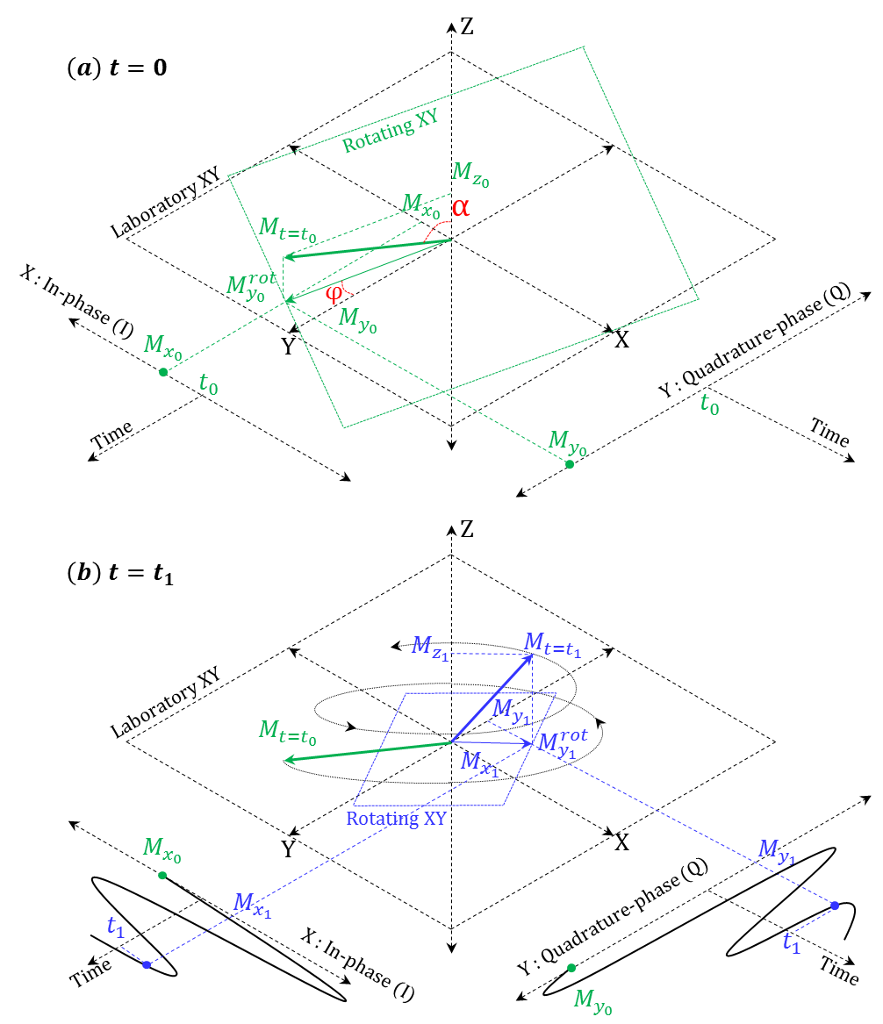
Figure 1.2.1.5: Illustration of Larmor precession and quadrature detection. (a) $t=0$ and (b) $t=t_{1}$.
For a linear coil, one of the components of the transverse magnetisation${ M}_{x}$ or ${ M}_{y}$ is detected. Let us consider ${ M}_{y}$ as the component detected by linear polarisation. The in-phase and quadrature-phase component from a linear polarisation is given by decomposing the linear component into two circular components rotating in opposite directions. The decomposed${ M}_{y}$ component is,
$${ M}_{y}= \frac{1}{2} M_{z} sin{α} e^{-\frac{t}{T_{2}^{*}}} \left[\cos\left(φ+ { ω}_{0}t\right)- i\sin\left(φ+ { ω}_{0}t\right)\right]$$
$+ \frac{1}{2} M_{z} sin{α} e^{-\frac{t}{T_{2}^{*}}} \left[\cos{(φ+ { ω}_{0}t)}+ i\sin{(φ+ { ω}_{0}t)}\right]$ 1.2.1.12
Thus, the quadrature component is given by one of the circular components which is rotating in the direction of Larmor precession. It is important to note that the power (efficiency) in linear detection is half the power (efficiency) in quadrature detection. The initial phase$φ$ of the recorded FID is arbitrary as the oscillator in the spectrometer is not phase locked with the NMR signal. For quantitative measurements like peak maxima and half power bandwidth (full width half maximum), the initial phase of the FID should be corrected with a digital phase shifter as shown in Figure 1.2.1.6. With 1D Fast Fourier Transform (FFT), the spectrum of the NMR signal is then arrived at.
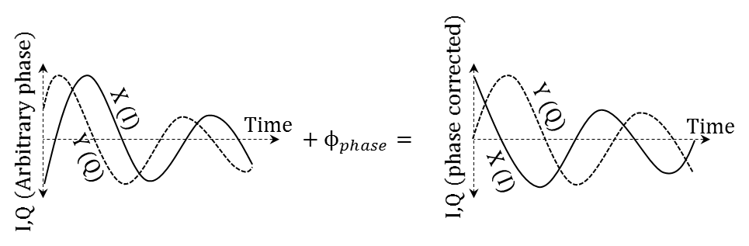
Figure 1.2.1.6: Correcting the initial phase of the recorded free induction decay signal. X (I) and Y (Q) are the real (X plane – In phase) and imaginary (Y plane – Quadrature phase) components of the complex signal.

Aliasing in MR
Figure 1.2.1.7 (a) shows a typical block diagram of the receiver of a spectrometer. It consists of a frequency mixer to down-convert the NMR signal from the Larmor frequency to the baseband (information) frequency. Though a single-stage down-conversion is shown in the Figure 1.2.1.7 (a), a commercially available spectrometer may have multiple stages. There may be a LNA or gain block amplifier prior to the mixer. The output of the mixer is fed to a low-pass filter to eliminate intermodulation products. The output of the low pass filter is then fed to the analogue-to-digital (ADC) converter and the NMR signal is thus recorded. One potential pit-fall in the spectrometer is aliasing of undesired peaks (frequency in NMR spectra) which are close to the desired peak. This is illustrated in Figure 1.2.1.7. Let $f_{D}$ and $f_{U}$be the desired and undesired frequency component in the NMR signal. In a typical MR spectroscopy experiment, the frequency of the local oscillator for the mixer is set to the desired Larmor frequency component in the NMR signal. Let $f_{0}$be the frequency of the local oscillator and${ f}_{0}≈ f_{D}$. The mixer down converts all the frequency components at the input of the mixer, and as a by-product the mixer also up converts as shown in Figure 1.2.1.7 (b).

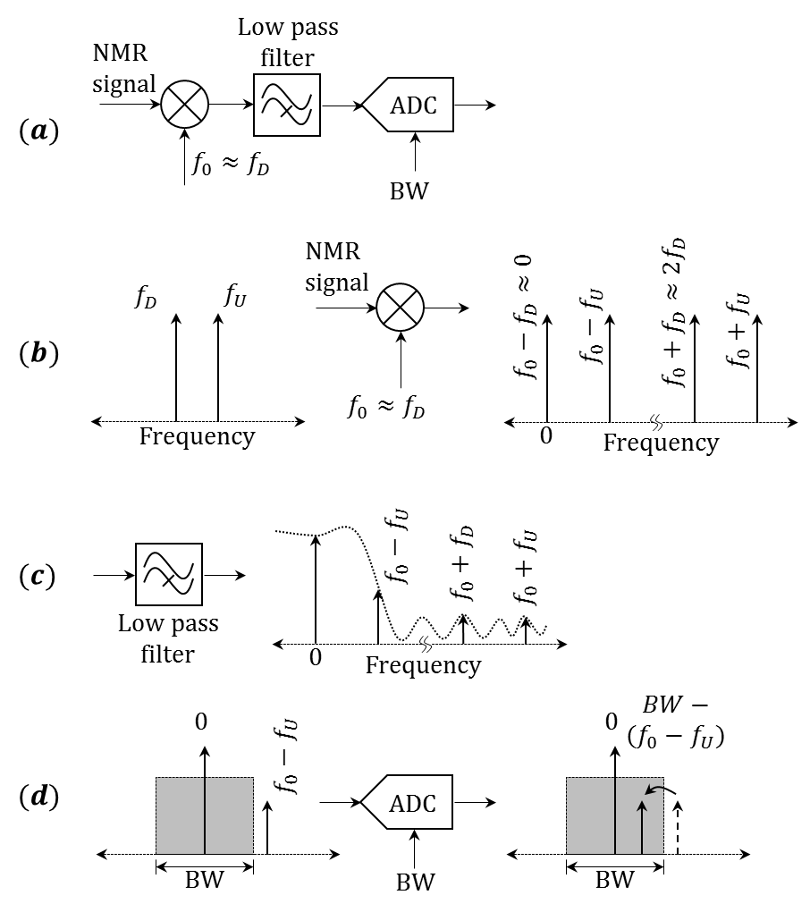

Figure 1.2.1.7: (a) Receiver block diagram of a typical spectrometer, (b) Mixer down converting from the Larmor frequency to the baseband (information) frequency, (c) Low-pass filter eliminating high frequency components and attenuating undesired frequency component and (d) Digitisation of the down converted NMR signal.
The output frequency (ignoring higher order intermodulation products) components are$f_{0}-f_{D} ≈0$,${ f}_{0}-f_{U}$, $f_{0}+f_{D}≈2f_{D}$ and${ f}_{0}+ f_{U}$. The low-pass filter eliminates high frequency components $f_{0}+f_{D}≈2f_{D}$ and${ f}_{0}+ f_{U}$ as they fall in the stop-band of the low-pass filter. The undesired frequency component ${ f}_{0}-f_{U}$ which is close to the desired frequency component may lie in the pass-band or in the roll-off band of the low-pass filter as shown in Figure 1.2.1.7 (c). The undesired frequency component is not eliminated but attenuated to an observable level.
Further, when the signal is digitised by the ADC with a sampling frequency as determined by the prescribed bandwidth (BW) of the spectrum, the undesired frequency component ${ f}_{0}-f_{U}$ is under-sampled and appears within the bandwidth of the spectrum with frequency$BW-(f_{0}-f_{U})$ as shown in Figure 1.2.1.7 (d). To avoid such aliasing of the undesired frequency component, the bandwidth of the spectrum should be set such that the sampling rate meets the Nyquist criterion given by,
$BW=2 (f_{0}-f_{U})$ 1.2.1.13

    - RF coil – essentials

Quality factor of RF coil
The RF coil as well as the means of the signal detection is one of the major contributors to the received noise. The quality (Q) factor of the RF coil is one of the practical assessment of the noise contributed. The Q factor is a measure of losses in the RF coil, and is measured as a ratio of half power bandwidth $f_{BW}$ to the frequency of resonance$f_{0}$, $Q= \frac{f_{0}}{f_{BW}}$ (See Figure 1.2.2.1 for illustration). The $Q$ factor determines the power efficiency and it is expressed as$Q= 2π\frac{Energy stored}{Energy dissipated per cycle}$ .
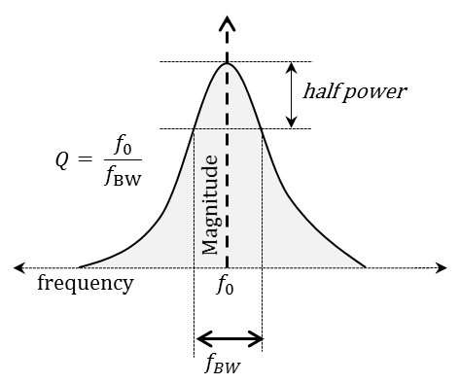
Figure 1.2.2.1: Measurement of the quality (Q) factor for a resonant circuit.
In a resonant circuit, $Q= R^{-1} {\left(L C^{-1}\right) }^{\frac{1}{2}}$ for series resonance and $Q=R{\left(C L^{-1}\right)}^{\frac{1}{2}}$ for parallel resonance, where R, C and L are resistance, capacitance and inductance respectively. The sources of loss that contribute to the overall loss (Q) of a RF coil are $R_{coil}$ - Ohmic loss of the resonant loop (copper and capacitors), $R_{sample}$ - sample loss (biological sample, tissue or equivalent), $R_{E-field}$ - E-field generated by the RF coil (As electric field does not contribute to the NMR signal) and $R_{radiation}$ - radiation loss (including stray parasitic). The overall loss $R_{total}$ is;
$R_{total}= R_{sample}+ R_{coil}+ R_{E-field}+ R_{radiation}$ 1.2.2.1
SNR is inversely proportional to$\sqrt{R_{total}}$. By optimal RF coil design,${ R}_{coil}$, $R_{E-field}$ and $R_{radiation}$ can be minimised, however $R_{sample}$ cannot be reduced or eliminated. The RF coil is said to be sensitive to the sample (biological sample, tissue or equivalent) when the sample loss dominates the total (overall) loss. The ratio of Q of the RF coil without ($Q_{unloaded}$) and with ($Q_{loaded}$) the sample in-situ is a measure of dominance of sample loss, which is the measure of sensitivity of the RF coil to the sample, proportional to the SNR (179-181).
$\frac{Q_{unloaded}}{Q_{loaded}}= \frac{( R_{coil}+ R_{E-field}+ R_{radiation} )}{( R_{sample}+ R_{coil}+ R_{E-field}+ R_{radiation} )} ∝SNR$ 1.2.2.2
When the coil is loaded with a sample of high dielectric constant (added capacitance) the resonant frequency drifts to lower frequency with no decrease in Q and when loaded with a lossy sample the Q decreases with no change in resonant frequency.
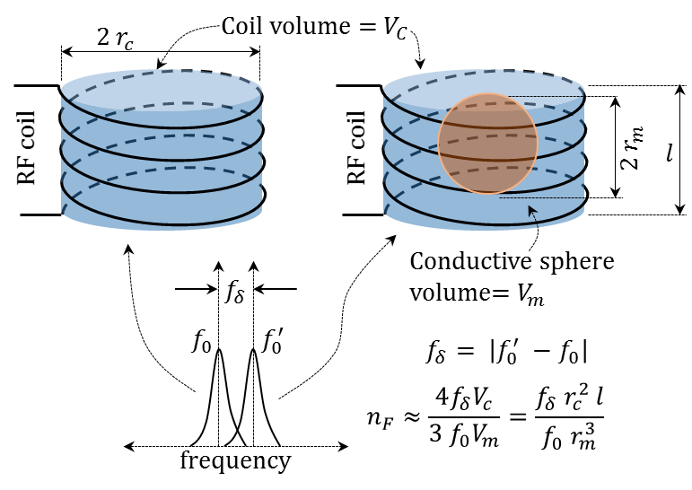
Figure 1.2.2.2: Illustration of filling factor
The filling factor, which is the ratio of volume of magnetisation of the sample contributing to the NMR signal to the sensitive volume of the RF coil, is a useful measure of RF coil performance. The filling factor can only estimate the efficiency of the coil. Alternatively, it is the ratio of transverse magnetisation of the medium within the sample to the total sensitivity of the RF coil volume. A practical method to measure the filling factor $n_{F}$ for a RF coil with volume $V_{c}$ is by observing the frequency drift $f_{δ}$ in the resonance frequency with and without a conductive sphere of volume${ V}_{m}$. Thereby, the filling factor is given by (182), $n_{F}≈ {4f_{δ}V_{c}\left[3 f_{0}V_{m}\right]}^{-1}$ as shown in Figure 1.2.2.2.

Polarisation of RF coils
The polarisation of an RF coil is perpendicular to the direction of static magnetic field${ B}_{0}$. The polarisation can be either linear (178), quadrature (183) or circular (178,179,184). A linear polarisation can be achieved using a single loop RF coil as shown in Figure 1.2.2.3(a), quadrature polarisation can be achieved using a dual Helmholtz RF coil as shown in Figure 1.2.2.3(b) and circular polarisation can be achieved using a birdcage RF resonator as shown in Figure 1.2.2.3(c). A typical linear or quadrature RF coil resonates at a single resonance frequency (unless dual tuned). A typical birdcage RF resonator will have two circular end rings connected by straight segments (legs/rung). For $N$ number of legs/rungs, a birdcage will have $\frac{N}{2}$ resonant modes. Birdcage RF resonators are either low-pass, high-pass or band-pass based on the capacitors distributed on leg/rungs-only, end ring-only and on both leg/rung and end ring, respectively. High-pass and band-pass birdcage RF resonators will have an additional resonant mode due to the capacitors distributed on the end ring.
As an example, an 8 leg/rung birdcage low-pass topology is shown in Figure 1.2.2.3 (c) with 4 resonant modes marked 1-4 in Figure 1.2.2.3 (d). For the low-pass birdcage topology with 8 leg/rung, modes 2-4 are degenerative modes and mode 1 is the desired Nyquist resonant mode. The rotating magnetic field $B_{1}^{+}$ generated by the birdcage resonator has the highest spatial homogeneity in the transverse plane, making it the most preferred choice for the transmitter RF coils.

Figure removed because the copyright permission not suitable for open access
Figure 1.2.2.3: Polarisation of RF coils. (a) Linear polarisation using single loop, (b) Quadrature polarisation using dual Helmholtz, (c) Circular polarisation using low-pass birdcage resonator and (d) Resonant modes for an 8 leg/rung birdcage low-pass topology reproduced from (185) with permission, © Elsevier 2016. Modes 2-4 are degenerative modes ending with Nyquist mode 1.

Receive-only RF arrays
Larger loops coil generally have lower sensitivity due to higher Ohmic resistance and parasitic loss. This becomes a particular problem at higher resonant frequency when the RF wavelength becomes comparable with the conducting length (physical dimension) of the coil, for example in the case of ¹H MR at 128 MHz (λ/4 ≈ 50 cm) at 3.0 T. Smaller single loops (coils) do not offer sufficient anatomical coverage and have less sensitivity at depth in the sample. Without increasing the physical dimension of an individual loop (coil), anatomical coverage can be enlarged (increased) by a collection or an array of individual receiver coils (186,187). Thereby, the dimension of each of the individual loops (coils) is optimised for SNR, and volume coverage is achieved by adding more coils. Roemer et al (126) developed a method to reduce the interaction between the individual loops and to combine the NMR signal from individual loops in a phased array of RF coils. RF interaction (coupling) between individual loops in an array is overcome in two steps. Firstly by a geometric, capacitive or transformer decoupling and secondly, by using a low input impedance low noise amplifier (LNA) fitted to each of the individual loops. This is illustrated in Figure 1.2.2.4. When two loops (coils) tuned to the same resonant frequency$f_{0}$ (as shown in Figure 1.2.2.4 (a)) are positioned at proximity there will be mutual inductive coupling and the resonance will split as shown in Figure 1.2.2.4 (b). Decoupling techniques (geometric, transformer or capacitive) induce current that will be equal and opposite in direction to the current induced by mutual inductive coupling thus cancelling the field at the overlap. The decoupling techniques such as geometric decoupling which rely on critical overlap, transformer decoupling and capacitive decoupling are shown in Figure 1.2.2.4 (c), (d) and (e) respectively. Further, the coupling between the loops is reduced by using a low input impedance LNA (126). This method not only reduces the coupling between adjacent elements but also between the next nearest neighbour and other loops (coils) in the array. Consider an arrangement of two coils with finite mutual coupling as shown in Figure 1.2.2.5 (a). The two loops $E_{1}$ and $E_{2}$ have a low input impedance LNA with optimal noise figure performance at impedance $Z_{ns1}$ and $Z_{ns2}$ respectively. With proper choice of capacitors${ C}_{M1}$, $C_{M2}$ and inductors${ L}_{1}$, $L_{2}$ the resistances of the coils${ R}_{1}$, $R_{2}$ are transformed to$Z_{ns1}$ , $Z_{ns2}$ for optimal noise figure performance of the low noise amplifier. The input impedance of the LNA${ R}_{A1}$,${ R}_{A2}$ is low, and${ C}_{M1}$, ${ C}_{M2}$ with${ L}_{1}$, ${ L}_{2}$ form a parallel resonant circuit. The choice of${ C}_{M1}$, ${ C}_{M2}$ and${ L}_{1}$, ${ L}_{2}$ is such that the resonant frequency of the parallel resonant circuit (${ C}_{M1}||{ L}_{1}$,${ C}_{M2}||{ L}_{2}$) is the same as the resonance frequency of the RF coil. This will marginally split the resonance of the coil as shown in Figure 1.2.2.5 (b), thus reducing the coupling between any two individual coils. As the LNA input circuit is a parallel resonant tank circuit there will be finite current through ${ R}_{A1}$ and${ R}_{A2}$, which is further amplified with a second stage amplifier.
Even with two decoupling measures applied there will be residual coupling between the individual coils and this contributes as an additional source of noise in the receiver. This coupling is characterised by the noise covariance matrix of an RF coil array. The noise covariance (or correlation) matrix is a square matrix R, where the diagonal elements indicate the strength of coupling of the individual coil with the sample and the non-diagonal elements indicate mutual coupling between the individual coils. In the laboratory (RF experimental test setup), the noise covariance matrix is populated with the real part of the impedance matrix of N ports (measured looking into the coil element, $Z_{c1}$, $Z_{c1-c2}$, $Z_{c2-c1}$ and $Z_{c2}$ for an array with two individual coils shown in Figure 1.2.2.5), where N is the total number of individual coils (188). On the MR system, the noise correlation matrix can be measured by acquiring a noise image; an acquisition without the sample or equivalent and without applying any correction (gradient and digital correction filters bias the noise), acquired with full dynamic range of the receiver. The noise correlation matrix is then given by$R= \frac{1}{N}\sum{n_{x}n_{x}^{T}}$. Where $n_{x}$ is the noise vector from all the individual coils at the voxel $x$ and $n_{x}^{T}$ is the transpose conjugate of $n_{x}$ (126,189,190). Ideally, for highly decoupled coils such as in a coil array optimised for parallel imaging where it is preferable for each of the coils to have its own discrete footprint (region of sensitivity) and minimal spatial overlap in sensitivity between the elements, there should be minimal cross-talk (coupling) between the individual loops (coils) and the noise covariance matrix should resemble an identity matrix. An example of noise correlation matrix for a 32 channel receiver array for ³He at 1.5 T is shown in Figure 1.2.2.6.
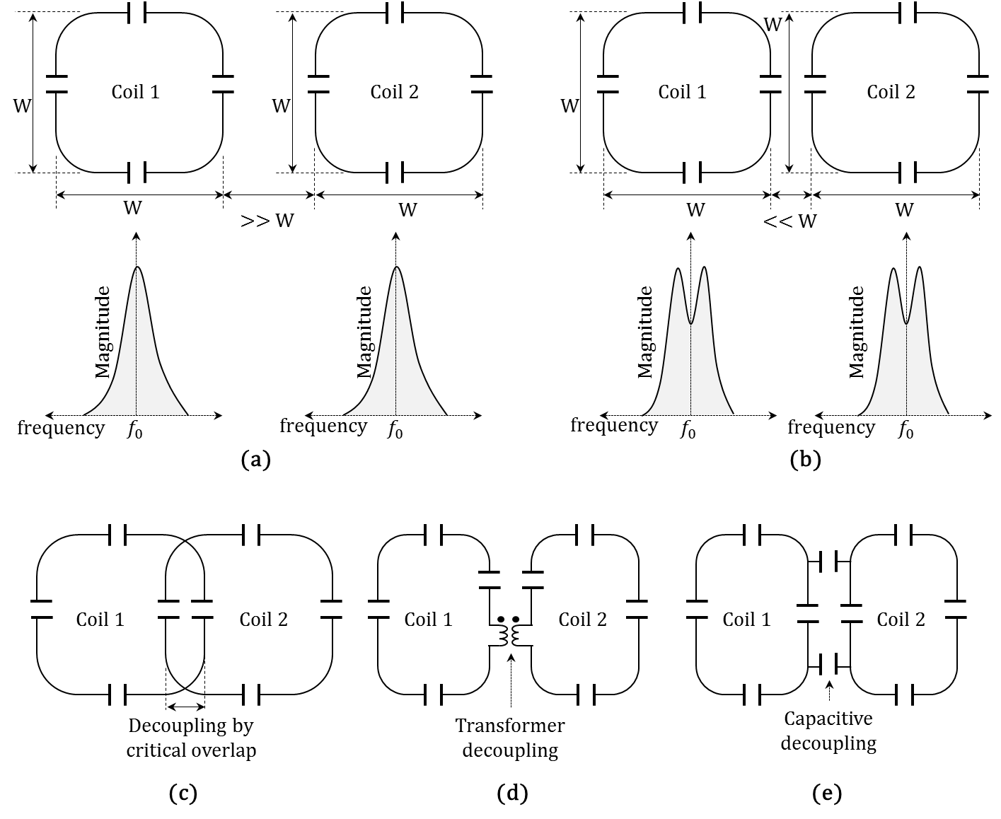
Figure 1.2.2.4: Illustration of decoupling techniques for an RF coil array. (a) Two resonant loops tuned to the same resonance frequency are positioned far apart with negligible inductive coupling. The resonance frequency of these loops are preserved. (b) The resonant loops from (a) are positioned at close proximity and the resonance frequency splits. (c) Geometric decoupling using critical overlap between the loops for effective inductive cancellation in the overlapping region. (d) Transformer decoupling using a transformer between the loops. (e) Capacitive decoupling using capacitors between the loops.
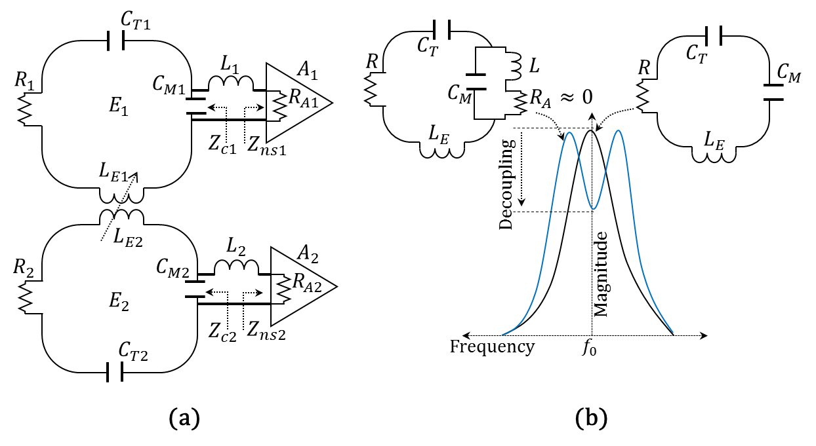
Figure 1.2.2.5: Illustration of decoupling with a low input impedance LNA. (a) An arrangement of two coils with low input impedance LNA. (b) Illustration of resonance split of the coil with a low input impedance LNA.
Figure removed because the copyright permission not suitable for open access
Figure 1.2.2.6: Noise correlation matrix for a 32 channel receiver array for ³He at 1.5 T from (191) is reproduced here with permission, © John Wiley and Sons 2016.

Signal-to-noise ratio (SNR)
Theoretically the signal-to-noise ratio (SNR) in an MR experiment is given by (13,192),
$SNR= \frac{ω_{0}\left[M_{0}nV_{s}\right]\left[KB_{1}^{-}\right]}{\sqrt{\left[4k_{B}Δf\right] \left[T_{C}R_{C}+ T_{S}R_{S}\right] }}$ 1.2.2.3
Where, $ω_{0}$ is the Larmor frequency of the sample volume, $M_{0}$ is the magnetisation, $n$ is the filling factor of the sample, $V_{s}$ is the sample volume, K is the effective field over the sample produced by unit current, $B_{1}^{-}$ is the anti-rotating RF component, $k_{B}$ is Boltzmann constant, $Δf$ is the receiver bandwidth, $T_{C}$ is the temperature of the coil, $R_{C}$ is the resistance of the coil, $T_{S}$ is the temperature of the sample and $R_{S}$ is resistance of the sample. Under Zeeman (Boltzmann) polarisation the magnetisation $M_{0}$ ($M_{Thermal}$) is proportional to the external static magnetic field $B_{0}$ (see Equation 1.1.2). In a hyperpolarised spin sample the magnetisation $M_{0}$ ($M_{Hyper}$) is proportional to the polarisation achieved in the SEOP process. Revisiting Equation 1.1.4, for the same nuclei, spin density and concentration, we have,
${ M}_{Hyper}≫ M_{Thermal} →{ SNR}_{Hyper}≫ {SNR}_{Thermal}$ 1.2.2.4
From an MR image, SNR can be estimated as (193,194),
$SNR= \frac{\overline{A}}{\sqrt{2} σ_{bn}}$ 1.2.2.5
Where the standard deviation of the background noise $σ_{bn}$ has Gaussian distribution with zero-mean and $\overline{A}$ is the mean of the signal. If there is DC bias the standard deviation of background noise can have a Rician distribution (biased, non-zero mean) and an appropriate correction factor can be used (194).
The SNR of the combined image in an RF coil array is given by (126,189,190,195),
$SNR= \sqrt{S^{T}R^{-1}S}$ 1.2.2.6
Where $S$ is the complex sensitivity matrix from individual coils and $S^{T}$ is the transpose conjugate of$S$. R is the noise covariance matrix.

Under-sampling and signal-to-noise ratio
In parallel MR imaging, the number of phase-encoding steps are reduced to shorten the scan time (196). In a typical parallel imaging acquisition, phase-encoding steps are acquired such that the space between any two phase-encoding steps is$\frac{F}{Field of View}$ as compared to $\frac{1}{Field of View}$ for a fully sampled imaging, where $F$ is the under-sampling factor. The SNR of an under-sampled k-space image is given by (196),
${SNR}_{undersampled}= \frac{{SNR}_{Full}}{g\sqrt{F}}$ 1.2.2.7
Where $g$ is the geometry factor, given by (196),
$g= \sqrt{{\left(S^{T}ψ^{-1}S\right)}^{-1} \left(S^{T}ψ^{-1}S\right)}$ 1.2.2.8
Where $ψ$ is the receiver noise matrix given by (196) $ψ_{γ,γ^{T}}= \sum_{τ}{σ_{τ}^{2}}ω_{γ,τ}ω_{γ^{T},τ}^{T}$. Where $ω_{γ,τ}$ is the time-independent complex weighting coefficient for the channel (individual coil) $γ$ and at voxel $τ$, $σ_{τ}^{2}$ is the noise variance at voxel $τ$ and $ω_{γ,τ}^{T}$ is the transpose complex conjugate of$ω_{γ,τ}$.
As the spaces between phase-encodes are increased, the field of view (FOV) is reduced by the factor of$\frac{1}{F}$, resulting in aliased composite signal. The aliased composite signal of an under-sampled k-space image is separated by using an unfolding matrix obtained by the discrete spatial sensitivity profile from individual loops (coils) in the receiver array. The unfolding matrix $U$ is given by (196),
$U= {\left(S^{T}ψ^{-1}S\right)}^{-1}S^{T}ψ^{-1}$ 1.2.2.9
Using the unfolding matrix the signal-separated complex image is given by$I_{seperated}=UI_{aliased}$. Where $I_{aliased}$ is a vector of aliased complex image values.

RF coils for dual (multi) nuclear MRI
RF coils for multinuclear MR imaging need to be able to excite (transmit) and detect (receive) RF signals from different nuclei at different frequencies from the same sample. For a multi-nuclear imaging study which has the flexibility to perform separate scans/exams for each nucleus, individual tuned RF coils for respective Larmor frequencies can be used and the subject will need to be moved from one RF coil to another between the scans/exams (73,79,80).
However, in a multi-nuclear imaging study where there are clinical benefits to be able to image all the nuclei in the same setup or in the same physiological timeframe (81), RF coils will have additional design considerations in contrast to conventional RF coils that are tuned to a single nucleus. The image acquisition can be either interleaved or back-to-back in a single breath hold (81,82). RF coils for dual (multi) nuclear MRI are designed with one of the following approaches:
(a) By inserting a pole (also known as traps) in the resonant circuit, multiple resonant modes are generated (197-203) as shown in Figure 1.2.2.7 (a),
(b) By an arrangement where two (multiple) single-tuned RF coils are nested and electrically isolated (204-210) as shown in Figure 1.2.2.7 (b), or
(c) By other techniques which are not commonly used like switchable coils (switch between the nuclei using RF switches) (211) or modified resonators (212-215) as shown in Figure 1.2.2.7 (c).
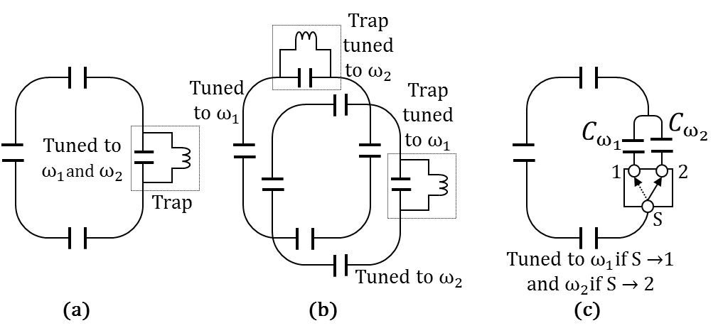
Figure 1.2.2.7: Illustration of different methods for the dual tuned RF coils, tuned to frequencies $ω_{1}$ and${ ω}_{2}$. (a) By inserting a pole (also known as traps) in the resonant circuit, two resonant modes are generated at frequencies $ω_{1}$ and${ ω}_{2}$. (b) By an arrangement where two single-tuned RF coils, tuned to frequencies $ω_{1}$ and${ ω}_{2}$ are nested and electrically isolated by using passive (or active) traps tuned to frequencies $ω_{2}$ and${ ω}_{1}$ respectively. (c) Switchable coils where a switch S is toggled between connections 1 and 2, so that a loop capacitor of the resonant circuit is toggled between capacitors $C_{ω_{1}}$and${ C}_{ω_{2}}$ such that the resonant frequency is toggled between $ω_{1}$ and${ ω}_{2}$.
Multi (dual)-tuned coils use a common-resonant conducting structure that resonates at multiple resonant frequencies (197-202). The common-resonant structures used in these designs intrinsically suffer from moderate isolation between the receivers, which increases noise in the respective receivers. Switchable coils incorporate actively controlled PIN diodes which switch the tuning of the coil between two (or more) Larmor resonant frequencies (211). However these coils have reduced sensitivity due to added losses from the PIN diodes and the carrier life time of the PIN diode should be taken into consideration for applications involving rapid switching within the pulse sequence such as ultra-short echo time (UTE). The individual isolated coil configurations consist of geometrically compatible arrangements of separate coils tuned to different resonance frequencies. The configuration can be achieved either by passive detuning with a parallel resonant notch-filter in series within the resonant loops or by actively detuning with PIN diodes. Passive parallel resonant notch-filter circuits that resonate at the desired blocking frequency are commonly referred to as ‘trap circuits’ (197-200,216). The added parallel inductance in passive traps adds Ohmic loss and can reduce the quality factor (Q) of the coil, especially at low blocking frequencies. Active detuning is suitable when the two Larmor frequencies are either far apart as with ¹H – ²³Na (207) or close-together as with ¹H – ¹⁹F. Considering the combination of two individual RF coils for ¹H and ³He used in lung MRI, when the ³He RF coil is actively detuned, a higher resonant mode thus generated could couple to the ¹H RF coil and vice-versa (³He 48.6 MHz and ¹H 63.6 MHz at 1.5 T). Hence, in such a situation it will be preferable to use passive-traps instead of active detuning.

Critical aspects of RF coil arrays
One of the critical aspects in designing an RF coil array is to decouple the receive-only RF coil array from the MR system transmitter RF coil during transmission. The maximum RF power delivered to the MR system transmitter body RF coil can be as high as 16 kW for 1.5 T and 32 kW for 3.0 T MR System. With ineffective decoupling, high RF power would induce sufficient RF current in the receiver RF coil in-situ to generate heat and can cause burns (217,218) and also damage the receiver RF coil and LNA. The receiver RF coil is decoupled from the MR system transmitter RF coil by using actively or passively controlled switches (PIN diodes) which can enable or disable the receiver RF coil (219-221). Despite these measures there will be residual coupling which (a) can distort the transmit coil sensitivity $B_{1}$ (inhomogeneous flip angle in the region of interest) leading to spatial variation in SNR and saturation of the tissue close to the coil (subcutaneous fat saturation), (b) will reduce the power efficiency of the MR system transmitter RF coil (requires more power for the desired flip angle) and (c) will reduce the engineering reliability of the receiver RF coil due to electrical stress on the components in the receiver RF coil.
In a receiver RF coil array, electronic components, coaxial cables, inter-connects and other conductive surfaces act as parasitics to the resonant coils of the array. These parasitics skew the sensitivity (and cross-talk) of the coils in the array such that at various locations in the region of interest, the sensitivities arbitrarily add constructively or destructively causing local intensity shift artefacts (173). Variation in signal intensity is also caused by (a) variation in the gain of the LNA in each of the RF coils, (b) the dimension of the individual RF coil and (c) variation in the sample loss in the individual RF coil. Another inevitable cause of variation in the signal intensity is that the signal is brighter near the surface and drops-off with distance from the surface of the coil (171).

Transmit RF coils for hyperpolarised gas imaging
Unlike conventional ¹H MRI or other non-hyperpolarised media, in hyperpolarised gas imaging with every RF pulse; (a) the magnetisation lost does not recover (15), (b) the signal from the sample changes and (c) does not reach an equilibrium state (note: a thermal equilibrium state is reached eventually, but not usable). This affects the optimal number of RF pulses used in an imaging experiment (16) (see Equation 1.1.5). The variation in the flip angle of the transmitter is an important factor for the design of a hyperpolarised MR coil. An elementary transmitter for hyperpolarised gas imaging of the lung is a flexible transmit-receiver dual Helmholtz like quadrature coil that can be wrapped around the chest with easy ingress of the subject into the scanner. Flexible coils have inherently high sensitivity but poor uniformity of flip angle across the sample when compared to birdcage RF resonators (179). Though the homogeneity of the Helmholtz pair can be improved with capacitive coupling (222), a more homogenous flip angle can be delivered with a birdcage coil (179). Previously developed birdcage RF resonators for human lung imaging applications are typically elliptical and asymmetric (223). This is primarily to fit a volume resonator within the scanner and yet accommodate the human chest. In an elliptical birdcage designed for ³He with radial asymmetric legs, the location of the legs were determined by conformal mapping (224). The capacitor values were determined by measuring self-inductance of individual meshes, mutual inductance of adjacent meshes and by solving for modal mesh current (223). Unlike a circular birdcage, the capacitor values in an asymmetric birdcage are not equal. These elliptical asymmetric birdcage RF resonators are voluminous, thus facilitating a two part construction (posterior half – anterior half). The subject is positioned on the posterior half and then the anterior half is fixed. Such a birdcage design for ³He lung MRI has been shown to have a variation of flip angle of 7% across the lungs (223) as compared to 16~20% for flexible T-R RF coils, justifying the additional efforts in coil design and coil handling during the clinical work flow.
Figure removed because the copyright permission not suitable for open access
Figure 1.2.2.8: (a) Asymmetric ³He transmit-receive birdcage (the RF coil itself cannot be seen). (b) Flip angle map of twin-saddle quadrature coil. (c) Flip angle map of asymmetric birdcage coil. Reproduced from (223) with permission, © John Wiley and Sons 2016. Colour bar indicates flip angle.
An elliptical asymmetric birdcage is shown in Figure 1.2.2.8. Such a shielded birdcage for ³He at 48.6 MHz (225), positioned within the MR system containing the ¹H system body coil (birdcage) will mutual couple with an observable drop in the Q factor of the coil. Though an asymmetric birdcage delivers uniform flip angle, its low filling factor and increased ohmic resistance from large conducting elements makes it less RF power efficient than a flexible RF coil that can be tightly wrapped to the chest of the subject.

Receive RF coil arrays for hyperpolarised gas imaging
In earlier studies involving RF coil arrays for hyperpolarised gas imaging, 32 channel arrays were developed for ³He and ¹²⁹Xe, wherein the individual RF coils in the array were arranged to form a hexagonal patchwork pattern (225,226). This provides an advantage over a conventional cascaded (ladder-like) pattern because the diagonal elements can be decoupled using geometric critical overlap (225,226). A decoupling of at least -12 dB can be achieved by this method. However, unlike RF coil arrays which have concentric shielding for the individual RF coils (191), the hexagonal-tilt array has a reduced $B_{1}^{-}$ efficiency of 15% (225). Though critical overlap is a widely used technique for decoupling, in a study conducted by Deppe, M et al (191), the decoupling between the individual RF coils was achieved by using an additional conductive counter current loop of larger dimension and concentric to each of the individual RF coils. Decoupling is achieved because, during reception as the RF current (NMR signal) is induced (from the sample) in the resonant loop (RF coil), as per Lenz’s law current is induced in the concentric loop in the opposite direction and limits the influence of magnetic flux of the RF coil outside the concentric loop. This study reported (a) a ratio of Q unloaded to Q loaded as 3.6 (without capacitors on shield), (b) less than 3% of the RF coil-pairs had significant coupling, (c) the decoupling between the RF coils was -11 dB which is similar when compared to the RF coil array with critical overlap (225) and (d) decoupling of -20 dB was achieved between the RF coil array and the elliptical asymmetric transmit birdcage used in the study. Comparing the SNR achieved from the RF coil array to the SNR achieved with the elliptical body coil which is shown above (223) as a receiver, this study (191) reported a 2-fold improvement in SNR in the distal slices (located at anterior or posterior) and 30% improvement in SNR in the slices located at the centre. The lower improvement of SNR in the slices located at the centre is due to reduced depth of sensitivity of the individual RF coil caused by the concentric shield around it. The effective noise correlation matrix with modest 2-fold increase in SNR indicate this array is an effective parallel imaging coil but is less optimised for high SNR. In a 32-channel high density coil design, Meise et al demonstrated limited decoupling by critical overlap, decoupling by low input impedance LNAs can contribute up to 21 dB (226) for ³He at 1.5T (48.5 MHz) and 35 dB (225) for ¹²⁹Xe at 3.0T (34 MHz) in the design of Dregely et al. For a 24 channel array for ³He imaging, critical overlap was along the left-right direction and decoupling in the superior-inferior direction was solely dependent on the 2 Ω input impedance LNA (227). A section of receiver arrays developed for hyperpolarised gas lung imaging from the literature are shown in Figure 1.2.2.9.
Figure removed because the copyright permission not suitable for open access
Figure 1.2.2.9: (a)(b) 32 channel receiver array for ¹²⁹Xe. Reproduced from (225) with permission, © John Wiley and Sons 2016 (c) 32 channel receiver array for helium ³He. Reproduced from (226) with permission, © John Wiley and Sons 2016 (d) 32 channel receiver array combined with asymmetric birdcage transmitter. Reproduced from Deppe M H (191) with permission, © John Wiley and Sons 2016.

Accelerated imaging for hyperpolarised MRI
In conventional ¹H MRI, when the k-space is under-sampled with reduced RF encoding steps as in parallel imaging (196), the SNR obtained is lower when compared to a full Nyquist-sampled k-space (see Equation 1.2.2.7). Hyperpolarised gas imaging can compensate for the loss in SNR by increasing the signal (transverse magnetisation) by increasing the flip angle. It was demonstrated with a 24 channel RF coil array for ³He at 1.5T that the acquisition time (acceleration) could be reduced by 8 times without any loss in signal-to-noise ratio (227). Similarly with a 32 channel RF coil array for ³He at 1.5T, an acceleration of 4 in one dimension and 8 in two dimensions was achieved to reduce the scan time of originally 35 s to 5 s by increasing the flip angle from nominal 7.5⁰ to 9⁰ (226). In a similar study, a nominal scan time of 14 s (flip angle = 7°) was reduced to scan time of 8 s (flip angle = 9.5°) and 4 s (flip angle = 11.8°) without any loss in SNR (191). In a demonstration for ¹²⁹Xe at 3.0 T with a 32 channel RF coil array, the scan time was reduced from 8 s to 2 s. This 32 channel RF coil array had 15 individual coil elements on the anterior side and 17 individual coil on the posterior side, enabling an acceleration factor of 3 with 2D imaging and 6 with 3D imaging (225). The increment in flip angle is relatively moderate to achieve the accelerated MR images with equivalent SNR. In addition, in the lung imaging in vivo, as the polarisation of the hyperpolarised gas rapidly relaxes to thermal equilibrium due to presence of oxygen (228), reducing imaging time can inherently improve SNR.
    - Overview of NMR and MRI pulse sequences used in this thesis

Chemical shift imaging
In chemical shift imaging (CSI), spectra from the sample are spatially resolved by applying phase-encoding gradients. For a one (or two) dimension CSI, phase encoding is applied in one (or two) dimensions. A basic spectroscopic imaging pulse sequence is shown in Figure 1.2.3.1. After every slice-selective RF pulse along with a slice-selective gradient, a phase-encoding gradient is applied in one (or two) directions. With the application of non-zero phase-encoding, the FID (resonances) will acquire a phase shift depending on its spatial location in the gradient field. There is no frequency-encoding involved in the sequence as this would cause spectral dispersion of the different resonances of interest. After the phase-encoding gradient has elapsed, the detected free induction decay is thus phase encoded with spatial information. For a gradient pulse${ G}_{x}$ of duration t, the phase shift in the resonance at location $x$ from the isocentre is$γxG_{x}t$ and the phase shift between the two edges of the FOV is$2π$, where γ is the gyromagnetic ratio. The spectroscopic image is reconstructed by applying FFTs in each of the phase encoding directions to transform the phase encoded FID from the whole volume into a spatial decomposition of individual FIDs, which are then transformed into spatially resolved spectra by 1D FFT.

Spoiled gradient echo imaging sequence
In a spoiled gradient echo pulse sequence, a frequency encoding gradient is used to disperse the FID such that the resonant frequency of spins in the sample along the gradient direction increases with distance from the isocentre, providing a direct relation between spin signal and position in the dispersed spectrum. A spoiler (or crusher gradient) is applied after the read-out gradient has elapsed. A basic spoiled gradient echo pulse sequence is shown in Figure 1.2.3.2. The spoiler gradient is applied in the slice gradient direction and it will dephase all the residual transverse magnetisation.

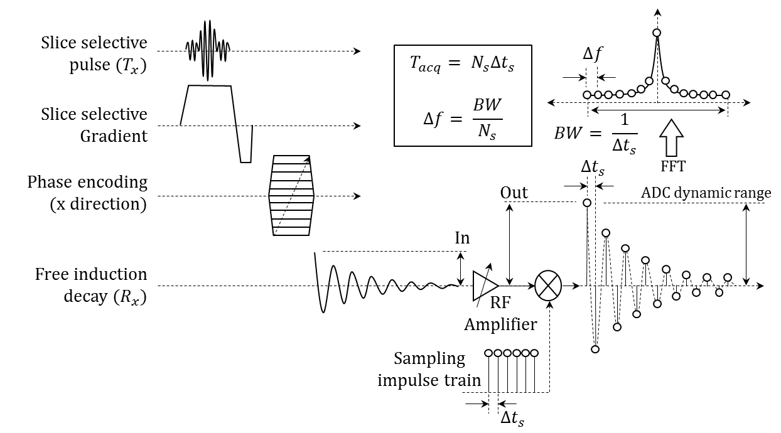
Figure 1.2.3.1: Pulse sequence diagram of a typical one-dimensional chemical shift imaging sequence with free induction decay. Legends: $∆t_{s}$ is the sampling time-interval, $BW$ is the receiver bandwidth, $∆f$ is the spectral resolution, $N_{s}$ is the number of samples and $T_{acq}$is the total acquisition time.

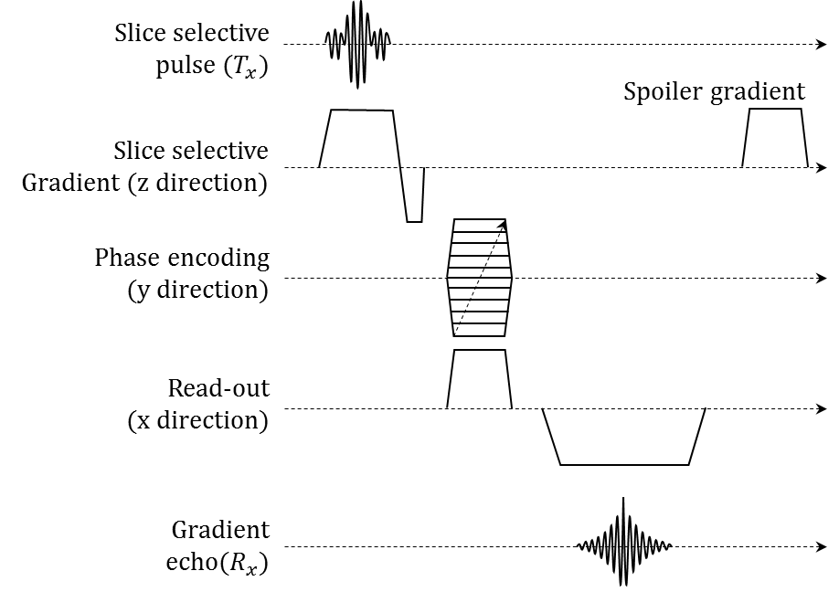
Figure 1.2.3.2: A basic spoiled echo gradient pulse sequence.

    - Quantitative HP brain MRI – the bare essentials

Tracer Kinetics
A biological tracer is an exogenous substance which is introduced externally to the biological system of interest to enable quantification (characterisation) of the system (229). A tracer (or contrast agent) after being introduced will cause time-dependent changes in the signal. The goal of tracer kinetics analysis is to infer kinetic (time-dependent) information of the biological system by mathematical interpretation of the spatial and temporal distribution of the tracer in the system (230). An ideal tracer is detectable by an observer but does not perturb the physiology of the biological system in to which it is being introduced (229). Some literature suggests that an ideal tracer is chemically identical to the substance of interest, for instance magnetic labelling of the endogenous blood with arterial spin labelling (231), nevertheless as along as the tracer does not physiologically perturb the biological system the mathematical treatment for those substances which are chemically identical and endogenous tracers which differ are the same. In MRI, $T_{1}$ weighted dynamic contrast-enhanced (DCE) imaging with Gadolinium chelated (example Gd-DTPA) contrast agents is widely used to estimate the biological dynamics like perfusion, tissue mass (volume) and rate of transfer (contrast agent from capillary bed to tissue, permeability-surface area product) (232,233). For the diagnosis of damage to the blood-brain barrier (BBB), the Gadolinium chelated contrast agents is used to detect leakage (116-118). In contrast to Gadolinium chelated contrast agents, xenon behaves closer to a behaviour of an ideal freely diffusing tracer, as it passively diffuses across the blood brain barrier.
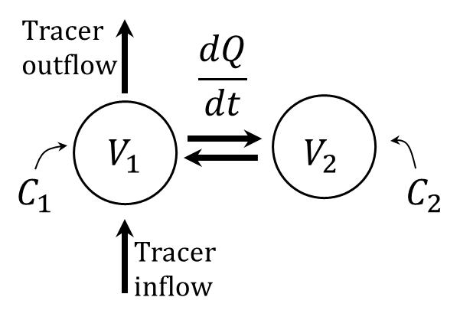
Figure 1.2.4.1: A two compartment tracer-kinetic model.
Sourbron and Buckley (231) have summarised various models used for tracer-kinetic modelling and analysis in a comprehensive review. With relevance to the subsequent work in this thesis, a two-compartment model is introduced here as shown in Figure 1.2.4.1. A two-compartment model is based on the detection of time-dependent variation in the concentration of tracer in the two compartments. The model assumes that within the compartment the tracer is uniformly distributed and any change in the NMR signal is proportional to the changing concentration of the tracer in the particular compartment.
Consider the two compartment model shown in Figure 1.2.4.1. The two compartments $V_{1}$ and $V_{2}$ have tracer concentration of $C_{1}$ and $C_{2}$ respectively. The rate of transfer of tracer (flux, Q) between compartments $V_{1}$ and $V_{2}$ is given by, $\frac{dQ}{dt}= -k \left({λ_{2}C}_{2}-{λ_{1}C}_{1}\right)$, where $k$ is a constant depending on permeability, surface area and diffusivity of the barrier. $λ_{1}$ and $λ_{2}$ are the solubility partition-coefficient in compartment $V_{1}$ and $V_{2}$ respectively.

- Dedicated receiver array coil for ¹H lung imaging for same breath acquisition of hyperpolarised ³He and ¹²⁹Xe gas
  - Introduction
In multi-nuclear same-breath lung MRI, hyperpolarised gas (³He and ¹²⁹Xe) and ¹H images of the lungs are acquired interleaved or back-to-back in a single breath hold (81,82). As the acquisition is performed in the same breath-hold, the images from hyperpolarised gas and ¹H are inherently spatially and temporally co-registered, and provide complementary structural and functional information in the same physiological time frame. To date, ¹H images in same-breath acquisition have been acquired using the MR system’s body coil (81,82,124,125). The ¹H lung image SNR (signal to noise ratio) from the system’s birdcage body coil is moderate at best due to the low proton density in the lungs. The presence of coils tuned to hyperpolarised gas frequencies within the magnet bore can further degrade the ¹H body coil SNR through unwanted coupling and detuning. Although it is well known that a dedicated receiver array positioned at close proximity to the subject provides more SNR than the system body coil (126), to date the use of dedicated receiver arrays for ¹H lung MRI in conjunction with same-breath acquisition of hyperpolarised gases has not been demonstrated. The motivation of this chapter was to demonstrate the application of a dedicated ¹H receiver array coil to improve the ¹H lung SNR in same-breath acquisition with hyperpolarised (HP) gas ³He or ¹²⁹Xe at 1.5 T. Section 2.2 formulates analytical equations to accurately determine the resonant modes and capacitor values required to design an RF coil which uses traps to decouple from another RF coil tuned to a different nucleus in close proximity. In addition, a formalism to design a dual tuned coil is also established. In Section 2.3, this derived analytical formalism is then used to build a custom ¹H receiver RF coil array to acquire high quality ¹H images of the lung (tissue) in the same breath as hyperpolarised ³He or ¹²⁹Xe images of the lung (air space) which were acquired with a proximal transmit-receive coil tuned to the respective frequency. The ¹H receiver RF coil array was built in two configurations. In the first configuration, one trap tuned to ³He was fitted to demonstrate dual nuclear (¹H and ³He) same breath lung imaging. In the second configuration a second trap tuned to ¹²⁹Xe was added (in addition to the trap tuned to ³He) to demonstrate both dual (¹H and ¹²⁹Xe) and triple (¹H, ³He and ¹²⁹Xe) nuclear same breath lung imaging (see chapter 4 for triple nuclear lung imaging). Section 2.4 reports in vivo measurements of dual nuclear (³He-¹H and ¹²⁹Xe-¹H) same breath lung imaging using this custom designed ¹H receiver array. The section illustrates the advantage and clinical significance of using dedicated receiver arrays for ¹H in a multi-nuclear same breath lung imaging examination.
This work has been published in part in the paper Rao M, et al. Magn Reson Med 2014 (234).
  - Theory

Determination of the resonant modes and capacitors values
When trap(s) are added to a coil, multiple resonant modes are generated based on the number of trap(s) added. To arrive at a theoretical formalism for the accurate determination of the resonant modes and capacitor values in a coil with trap(s), consider a resonant circuit as shown in Figure 2.2.1(a), where${ C}_{T1}$,${ C}_{T2}$ and$C_{2}$are the loop capacitors and $L_{H}$is the distributed inductance of the loop. The resonance frequency $\left(ω_{Res}\right)$ of this circuit is given by$, ω_{Res}^{2}={\left[L_{H}C_{0}\right]}^{-1}$ , where${ C}_{0}$ is the total capacitance in the loop, given by${ C}_{0}= {\left( C_{T1}^{-1}+ C_{T2}^{-1}+ C_{2}^{-1}\right)}^{-1}$.
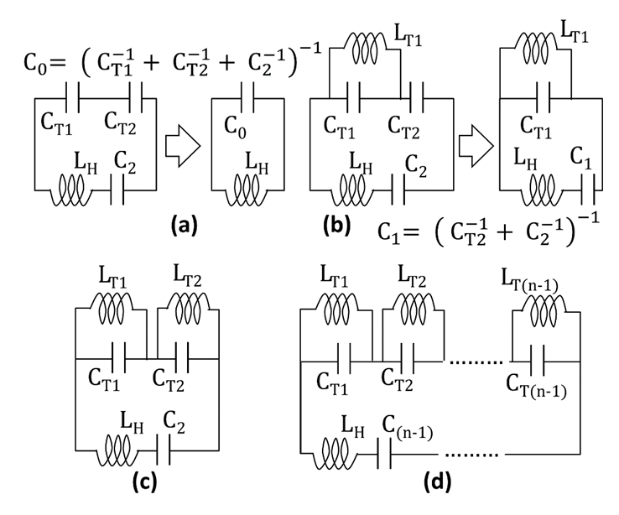
Figure 2.2.1: Illustration of a resonant loop (a) without traps (b) with one trap introduced across loop capacitor $C_{T1}$ (c) with two traps introduced across loop capacitors $C_{T1}$ and $C_{T2}$ and (d) with $(n-1)$ traps (ignoring Ohmic resistive losses). Reproduced from (234) with permission, © John Wiley and Sons 2016.

Coil with one trap
To determine the capacitor values for a resonant loop with one trap, consider a trap introduced across the loop capacitor $C_{T1}$ in Figure 2.2.1(a), we arrive at the circuit as shown in Figure 2.2.1(b). Let the other series capacitors be combined as${ C}_{1}= {\left( C_{T2}^{-1}+ C_{2}^{-1}\right)}^{-1}$ and ${ L}_{T1}$ is a wire-wound inductor as typically used in a trap circuit. Analysing the circuit in Figure 2.2.1(b) at resonance in the frequency domain we have,

$\frac{{jωL}_{T1}.\frac{1}{{jωC}_{T1}}}{{jωL}_{T1}+\frac{1}{{jωC}_{T1}}}+ {jωL}_{H}+ \frac{1}{{jωC}_{1}}=0$ 2.2.1

This simplifies to,

$ω^{4}\left(L_{H}L_{T1}C_{1}C_{T1}\right)- ω^{2}\left(L_{T1}C_{T1}+L_{H}C_{1}+L_{T1}C_{1}\right)+1=0$ 2.2.2

Solving for$ω$, the roots of Equation 2.2.2 yield the two resonant modes $ω_{low}$ and$ω_{high}$. Taking forward the classical RF theory in Equation 2.2.2 with relevance to application in multi-tuned RF coils, we know that, ${ L}_{T1}$ is chosen such that$ω_{T1}^{2}= {\left[C_{T1}L_{T1}\right]}^{-1}$, where $ω_{T1}$ is the target frequency for the trap. With this, Equation 2.2.2 can be re-written as,

$ω^{4}-ω^{2}\left(L_{H}^{-1}C_{0}^{-1}+ω_{T1}^{2}\right)+L_{H}^{-1}C_{1}^{-1}ω_{T1}^{2}=0$ 2.2.3

The roots of Equation 2.2.3 yield the two resonant modes of the circuit $ω_{low}$ and$ω_{high}$. Let $ω_{0}$ be the required Larmor frequency of resonance of the RF coil and ${ ω}_{T1}$ be the blocking (target) frequency for the trap. Then the required capacitance in the loop${ C}_{1}$ for a pre-selected capacitor in the trap circuit${ C}_{T1}$ is given by Equation 2.2.4,

$C_{1}= \frac{C_{T1}\left(ω_{0}^{2}-ω_{T1}^{2}\right)}{ω_{0}^{2}\left[L_{H}C_{T1}\left(ω_{0}^{2}- ω_{T1}^{2}\right)-1\right]}$ 2.2.4
Similarly, the required capacitor in the trap circuit$C_{T1}$ for a pre-selected capacitor of the loop $C_{1}$is then given by Equation 2.2.5,

$C_{T1}= \frac{C_{1}{ ω}_{0}^{2}}{(1- ω_{0}^{2}L_{H}C_{1} )\left(ω_{T1}^{2}-ω_{0}^{2}\right)}$ 2.2.5

Coil with two traps
In a more complex arrangement where same breath acquisition of both hyperpolarised gases ³He and ¹²⁹Xe is desired with ¹H co-functionality, then the ¹H coil should perform well with both ³He and ¹²⁹Xe transmit-receive coils in close proximity to itself and the subject, either with each of them separately or if used together in a triple-nuclear MRI application (82). In such a case multiple traps should be fitted to the ¹H array coil. To determine the capacitor values for such a resonant loop with two traps, consider the resonant loop from Figure 2.2.1(a) with two traps introduced across the loop capacitors$C_{T1}$ and$C_{T2}$ as shown in Figure 2.2.1(c), where${ L}_{T1}$ and ${ L}_{T2}$ are wire-wound inductors typically used in a trap circuit. Analysing the circuit in Figure 2.2.1(c) in the frequency domain, we arrive at Equation 2.2.6,

$\frac{{jωL}_{T1}.\frac{1}{{jωC}_{T1}}}{{jωL}_{T1}+\frac{1}{{jωC}_{T1}}}+\frac{{jωL}_{T2}.\frac{1}{{jωC}_{T2}}}{{jωL}_{2}+\frac{1}{{jωC}_{T2}}}+ {jωL}_{H}+ \frac{1}{{jωC}_{2}}=0$ 2.2.6

This simplifies to,

$x^{3}a_{0}+ x^{2}a_{1}+ x^{1}a_{2}+a_{3}=0$ 2.2.7

Where,$x= ω^{2}$,
$a_{0}= -\left(L_{H}L_{T1}L_{T2}C_{2}C_{T1}C_{T2}\right)$,
$a_{1}= \left(L_{T1}L_{T2}C_{2}C_{T2}+ L_{T1}L_{T2}C_{2}C_{T1}+ L_{T1}L_{T2}C_{T1}C_{T2}+L_{H}L_{T2}C_{2}C_{T2}+ L_{H}L_{T1}C_{2}C_{T1}\right)$,
$a_{2}= -\left(L_{T1}C_{2}+L_{T2}C_{2}+ L_{T2}C_{T2}+ L_{T1}C_{T1}+ L_{H}C_{2} \right)$ and
$a_{3}=1$.
Solving for the roots of the Equation 2.2.7 determines the three resonant modes. Again, applying classical RF theory in Equation 2.2.7 with relevance to application in the MRI RF coils, we know that,${ L}_{T1}$ and ${ L}_{T2}$ are chosen such that$ω_{T1}^{2}= {\left[C_{T1}L_{T1}\right]}^{-1}$ and$ω_{T2}^{2}= {\left[C_{T2}L_{T2}\right]}^{-1}$, where $ω_{T1}$ and $ω_{T2}$ are the chosen blocking frequencies for the two traps. The coefficients of Equation 2.2.7 then become,
${ a}_{0}=1$,
${ a}_{1}= -\left(L_{H}^{-1}C_{0}^{-1}+ω_{T1}^{2}+ω_{T2}^{2}\right)$,
$a_{2}= \left(ω_{T1}^{2}ω_{T2}^{2}+ω_{T2}^{2}L_{H}^{-1}\left(C_{T1}^{-1}+C_{2}^{-1}\right)+ω_{T1}^{2}L_{H}^{-1}\left(C_{T2}^{-1}+C_{2}^{-1}\right)\right)$ and
$a_{3}= -ω_{T1}^{2}ω_{T2}^{2}L_{H}^{-1}C_{2}^{-1}$.
Let $ω_{0}$ be the required frequency (Larmor) of resonance, ${ ω}_{T1}$ and ${ ω}_{T2}$ be the chosen blocking (target) frequencies for the two traps. Then the required loop capacitor$C_{2}$ for the pre-selected trap capacitors $C_{T1}$ and$C_{T2}$ is given by,

$C_{2}= \frac{ C_{T1}C_{T2}\left(ω_{0}^{2}-ω_{T1}^{2}\right)\left(ω_{0}^{2}-ω_{T2}^{2}\right)}{ω_{0}^{2}\left[L_{H}C_{T2}C_{T1}\left(ω_{0}^{2}-ω_{T1}^{2}\right)\left(ω_{0}^{2}-ω_{T2}^{2}\right)+C_{T2}\left(ω_{T2}^{2}-ω_{0}^{2}\right) +C_{T1}\left(ω_{T1}^{2}-ω_{0}^{2}\right)\right]}$ 2.2.8

Similarly, the required trap capacitors $C_{T1}$ and $C_{T2}$ for a pre-selected loop capacitor$C_{2}$ are given by,

$C_{T2}= \frac{ω_{0}^{2}C_{2}C_{T1}\left(ω_{0}^{2}-ω_{T1}^{2}\right)}{\left[C_{T1}\left(1-ω_{0}^{2}L_{H}C_{2}\right)\left(ω_{0}^{2}-ω_{T1}^{2}\right)+ω_{0}^{2}C_{2}\right]\left(ω_{T2}^{2}-ω_{0}^{2}\right)}$ 2.2.9
$C_{T1}= \frac{ω_{0}^{2}C_{2}C_{T2}\left(ω_{0}^{2}-ω_{T2}^{2}\right)}{\left[C_{T2}\left(1-ω_{0}^{2}L_{H}C_{2}\right)\left(ω_{0}^{2}-ω_{T2}^{2}\right)+ω_{0}^{2}C_{2}\right]\left(ω_{T1}^{2}-ω_{0}^{2}\right)}$ 2.2.10

Coils with $m$traps
Now extending the formalism of Equation 2.2.7 to a circuit with $m$ traps, where$m>2$ and$m=n-1$, such that $ω_{T1}^{2}= {\left[C_{T1}L_{T1}\right]}^{-1}$ , $ω_{T2}^{2}= {\left[C_{T2}L_{T2}\right]}^{-1}$ … $ω_{T(n-1)}^{2}= {\left[C_{T(n-1)}L_{T(n-1)}\right]}^{-1}$. Where${ ω}_{T1}$, ${ ω}_{T2}$ … ${ ω}_{T(n-1)}$ are the required frequencies of the traps. $C_{T1}$,$C_{T2}$ … $C_{T(n-1)}$ are the respective loop capacitors. The traps placed parallel to these loop capacitors with wire-wound inductor are given by $L_{T1}$, $L_{T2}$ … $L_{T(n-1)}$ respectively. $L_{H}$ is the distributed inductance of the loop and $C_{(n-1)}$ is a loop capacitor (without a trap) used for tuning as shown in Figure 2.2.1(d). The resonant modes of this circuit can be obtained by solving Equation 2.2.11,
$$\sum_{i=0}^{n}{x^{(n-i)}a_{i}}=0 , ∀ n >3$$
2.2.11
Where,$x= ω^{2},$
$$a_{0}=1$$
$$a_{1}= -{\left[{\left[C_{\left(n-1\right)}^{-1}+\sum_{i=T1}^{T\left(n-1\right)}{C_{i}^{-1}}\right]}^{-1}L_{H}\right]}^{-1}-\sum_{i=T1}^{T(n-1)}{ω_{i}^{2}}$$
$$a_{2}= \sum_{j>i}^{T(n-1)}{ω_{i}^{2}ω_{j}^{2}}+L_{H}^{-1}\sum_{i=T1}^{T(n-1)}{\left[ω_{i}^{2}\left[C_{(n-1)}^{-1}-C_{i}^{-1}+\sum_{j=T1}^{T(n-1)}{C_{j}^{-1}}\right] \right]}$$
$$a_{n}= -{\left[C_{(n-1)}L_{H}\right]}^{-1}\prod_{i=T1}^{T(n-1)}{ω_{i}^{2}}$$

It can be observed in Equation 2.2.11 that${ a}_{0}=1$, $a_{1}≠0$ and $a_{2}≠0$. Knowing that the roots (resonant modes) of Equation 2.2.11 are real, the mean and that the standard deviation of the square of the resonant modes ($ω^{2}$) generated with multiple traps can be estimated with the Laguerre–Samuelson inequality using $a_{1}$and${ a}_{2}$ (235,236). This is applicable for an array in a practical condition which would effectively have between 3~5 traps (or equivalent) on it. For example in a practical scenario with passive traps for both ³He and ¹²⁹Xe – frequency blocking, an active detuning circuit, a passive detuning circuit and a preamplifier decoupling circuit (126).

Dual-tuned RF coils
The equations established can now be used to design a dual tuned coil. Let, $ω_{1}$ and $ω_{2 }$be the two required frequencies of a dual tuned coil. Let $C$be the loop capacitor and $L_{H}$ be the distributed inductance of the loop, then, the required frequency ${(ω}_{T})$of the trap circuit is,
${ ω}_{T}^{2}= Cω_{1}^{2}ω_{2}^{2}L_{H}$ 2.2.12
Subsequently, the required capacitor for the trap circuit is provided by Equation 2.2.5.

Limiting conditions for capacitor selection
Using this theory we can accurately predict the required capacitors needed for a given configuration of coils for a given multi-frequency operation. In the case of a coil with one trap, two resonant modes are generated. When the higher resonant mode is selected to resonate at the Larmor frequency, as is the case for a ¹H array with traps for ³He or ¹²⁹Xe, the capacitor ($C_{T1}$) to be selected to build the trap has a lower-limit, given by,$C_{T1}≥ {\left[L_{H}\left({ω_{0}^{2}-ω}_{T1}^{2}\right)\right]}^{-1}, ∀ ω_{0}> ω_{T1}$. Where,$L_{H}$ is the distributed inductance of the coil, $ω_{0 }$is the Larmor frequency and $ω_{T1}$ is the resonance frequency of the trap. This also implies that the distributed inductance of the coil, which depends on the physical dimension of the RF coil has an upper-limit.
  - Design of the receiver array coil for ¹H lung imaging

¹H array design
For the demonstration of same-breath acquisition of hyperpolarised ³He or ¹²⁹Xe gas with a dedicated receiver array coil for ¹H, a dedicated 4 loop ¹H receiver array was constructed in-house with self-adhesive copper tape (FE-5100-5276-7, 3M, UK) of 66 μm thickness and 6 mm width, which was fixed on a substrate of 0.5 mm thick PTFE (Polytetrafluoroethylene, Direct Plastics, Sheffield, UK) sheet as shown in Figure 2.3.1(a). The capacitors used on the resonant loop were of 10C package (Dalian Dalicap Technology Co.,Ltd, China). The printed circuit boards (PCB) for discrete capacitors, traps and passive-detuning circuits on the resonant loop were custom designed, fabricated on 0.4 mm FR4 (Minnitron Ltd, UK). The feed-board PCB was fitted with an active detuning circuit, coaxial shielded balun and low input impedance LNA (GE Healthcare Coils, Inc. OH, USA). All the PCBs were protected in a plastic box enclosure (Hammond Mfg. Co. Ltd, Canada).
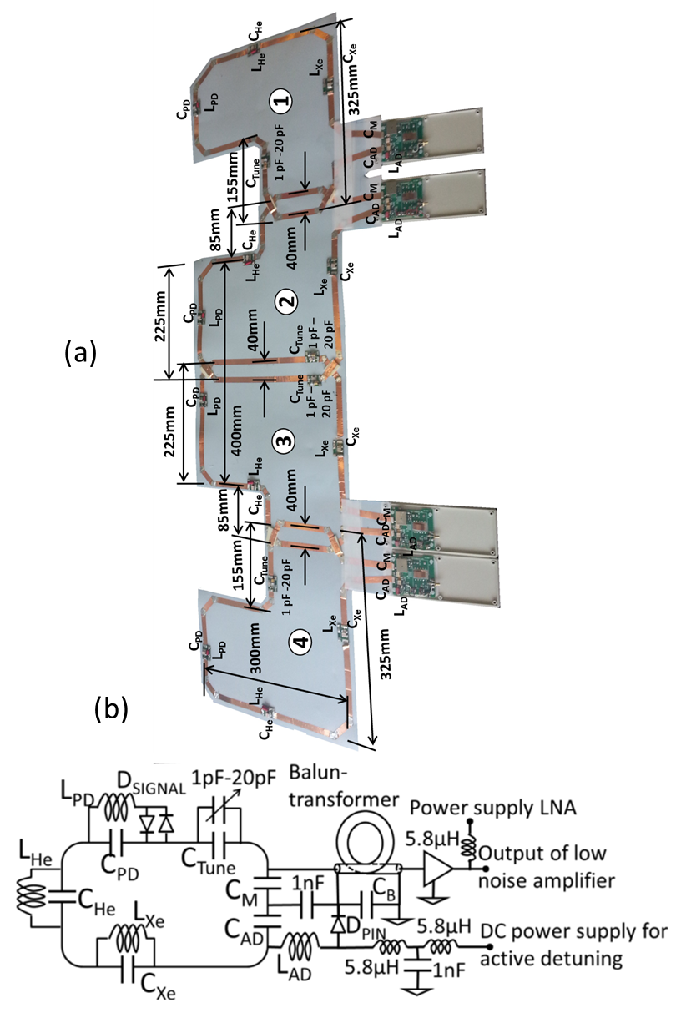
Figure 2.3.1: (a) Photograph of the constructed ¹H array prior to covering with foam,
(b) Schematic of each of the loops in the ¹H array. Note: L_{xe} is not shown in the photograph. Reproduced from (234) with permission, © John Wiley and Sons 2016.

Each of the 4 loops was fitted with an active detuning (AD), passive detuning (PD), traps and low input impedance LNA (GE Healthcare Coils, Inc. OH, USA) as shown in the schematic in Figure 2.3.1(b). The loops were initially tuned to the ¹H frequency (63.8 MHz) without any traps. The inductances of the loops were estimated to be 1150 nH from the initial resonance condition. Capacitor values for all the loops were C_{PD} = 30 pF, C_{He} = 30 pF, C_{Xe} = 75 pF, C_{AD} = 56 pF, C_{M} = 33 pF, C_{B} = 68 pF and C_{Tune} = 68 pF. A variable capacitor, varying from 1 pF to 20 pF was fitted across C_{Tune}. The inductors L_{He}, L_{PD}, L_{AD} and L_{Xe} were home-made wire wound inductors made from 21 AWG. The active detuning inductor L_{AD} was 5 mm in diameter with 6 turns. The passive detuning inductor L_{PD} was 5 mm in diameter with 13.5 turns. For the first configuration of the ¹H array which was designed for same-breath acquisition of ¹H with ³He, an inductor L_{He} was added across the capacitor C_{He} of 30 pF. The capacitor values were chosen based on the Equations 2.2.3, 2.2.4 and 2.2.5. L_{He} was 8 mm in diameter with 9.5 turns. For the second configuration of the ¹H array designed for same-breath acquisition of ¹H with ¹²⁹Xe, the ¹²⁹Xe trap was added across C_{Xe} in addition to the ³He trap already present in the loop. The capacitor values were chosen based on Equations 2.2.8, 2.2.9 and 2.2.10. For the ¹²⁹Xe trap, an inductor L_{Xe} (5 mm diameter with 36 turns) was added across the loop capacitor C_{Xe} of 75 pF. The thickness of the array with the foam covering was 8 mm (4 mm each side). The array was wrapped to the subject as shown in Figure 2.3.2.
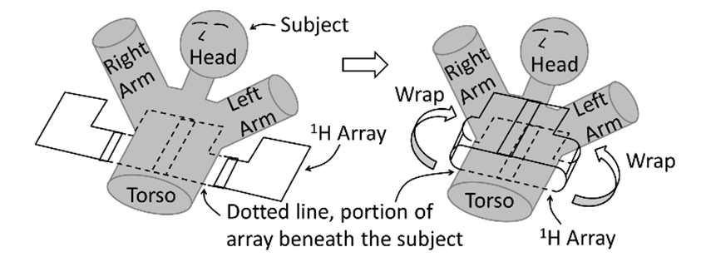
Figure 2.3.2: Illustration of ¹H array applied on the subject
The developed array was designed to function normally when nested within the commercially available dual Helmholtz quadrature T-R coil (CMRS, Brookfield, WI, USA), which has a flexible jacket design and is used routinely for clinical lung imaging studies with hyperpolarised ³He and ¹²⁹Xe at our site and others.

RF measurements of ¹H array
RF measurements were performed with an Agilent 5601A Network Analyser (Keysight Technologies, Santa Rosa, CA) and were expressed as S-parameter measurements in dB. The detuning circuits (both active and passive) were isolated from the array for the measurement (transfer coefficient, S_{ij}, (i≠j)). For reflection coefficient measurement (S_{ii}, return loss, impedance matching) the array was wrapped around the thorax of the subject (male 29y, 88 kg). The subject-dominated loss of the coil was matched to 50 Ω as per the specification of the LNA for the optimal noise figure and gain. The isolation (transfer coefficient, S_{ij}, (i≠j)) between the loops was measured at the input port of the LNA (with the LNA detached from the array). The resonant modes and quality factor (Q) of the coil were determined by transfer coefficient (S_{ij}, (i≠j)) measurement with two isolated DC probes (self-resonating frequency > 1 GHz). With the LNA on the ¹H array biased (turned ON), sensitivity was measured with a DC probe (self-resonating frequency > 1 GHz) which was connected to the transmitter port of the network analyser and the output of the LNA was connected to the receiver port of network analyser over a frequency span of 10 MHz to 80 MHz. With this, the sensitivity measurement indicates the gain of the loop at ¹H frequency and rejection of the ³He and ¹²⁹Xe signal on the ¹H receiver channel. For the ¹H receiver array, both the detuning circuits were tuned to below -30 dB. A minimum match of -20 dB was ensured for all loops. The isolation between the adjacent loops was below -20 dB and between the non-adjacent loops was below -15 dB. The low input impedance LNA provided additional decoupling between the loops. The loops generated the resonant modes as detailed in Table 2.3.1.
 | No traps | Fitted with 1 trap (³He) |  |  |  |  | Fitted with 2 traps (³He and ¹²⁹Xe)
Loops of ¹H array | Q_{UL} | Resonance modes (MHz) |  | Q measured at ¹H frequency |  |  | Resonance modes (MHz) |  |  | Q measured at ¹H frequency
 |  |  |  | Q_{UL} | Q_{L} | Q_{UL}/Q_{L} |  |  |  | Q_{UL} | Q_{L} | Q_{UL}/Q_{L}
Loop 1 | 120 | 32.2 | 63.8 | 110 | 10 | 11 | 15.25 | 35.5 | 63.9 | 105 | 10 | 10.5
Loop 2 | 122 | 33.6 | 63.9 | 115 | 12 | 9.5 | 15.9 | 35.9 | 64.0 | 110 | 12 | 10
Loop 3 | 120 | 35.1 | 63.9 | 115 | 10 | 11.5 | 15.9 | 35.7 | 64.0 | 110 | 12 | 10
Loop 4 | 120 | 32.8 | 63.8 | 115 | 10 | 11.5 | 15.6 | 35.9 | 63.9 | 106 | 11 | 9.5
Table 2.3.1: Resonant modes and Q measurement of array without traps, with 1 trap and 2 traps [Q_{UL} – Q Unloaded, Q_{L} – Q Loaded].
Figure 2.3.3: (a) The isolation between the ¹H array and ¹²⁹Xe T-R coil and (b) ¹H Array gain and rejection of ³He and¹²⁹Xe signals on the ¹H receiver. Note the arrows represent the resonant frequencies of ¹²⁹Xe, ³He and ¹H at 1.5 T. Reproduced from (234) with permission, © John Wiley and Sons 2016.
As shown in Table 2.3.1, the reduction in the Q of the loops in the ¹H array fitted with and without the traps was 8%, with one trap and 12% when fitted with two traps. This indicates that there is no major increase in Ohmic loss of the ¹H array for both the configurations (one-trap and two-trap). For both the configurations the ratio of Q unloaded (Q_{UL}) to Q loaded (Q_{L}) was 10, which is indicative of good SNR.
The RF measurement with two traps was worse than with one trap; Figure 2.3.3 shows isolation and sensitivity measurement of the ¹H array with two traps fitted, nested inside the ¹²⁹Xe T-R coil. The isolation between the ¹H array and the ³He/¹²⁹Xe T-R vest coil was below -40 dB at the Larmor frequencies of ¹H (63.8 MHz), ³He (48.6 MHz) and ¹²⁹Xe (17.7 MHz) as shown in Figure 2.3.3 (a). The array provided very good rejection below -60 dB for both the ³He and ¹²⁹Xe signals on the ¹H receiver as shown in Figure 2.3.3 (b). The difference in sensitivity at the ¹H frequency when the active detuning diode (D_{PIN} in Figure 2.3.1 (b)) is turned On to Off was below -30 dB, which indicates effective detuning.
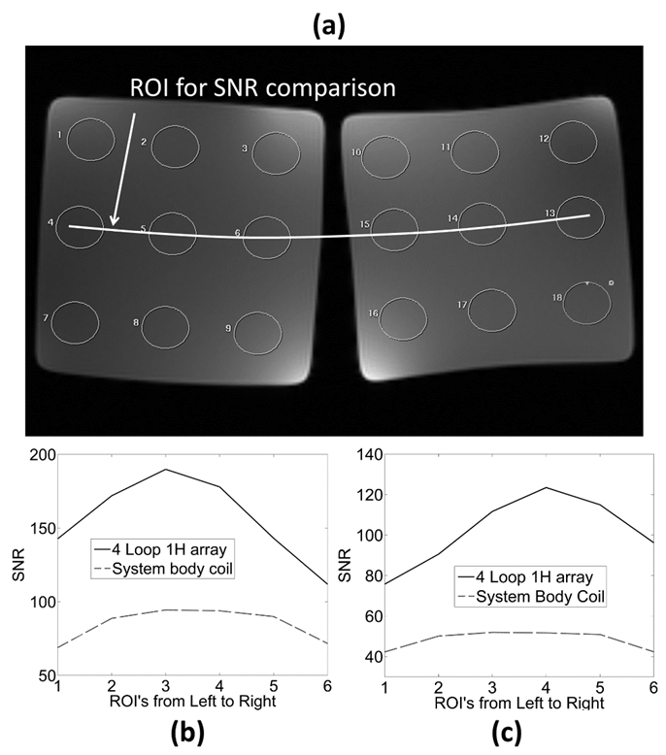
Figure 2.3.4: (a) Illustration of region of interest (ROI) selected for SNR comparison between the ¹H receiver array and the system body coil. Comparison of ¹H SNR between the ¹H receiver array and the system body coil with (b) gradient-echo images and (c) with spin-echo images. Reproduced from (234) with permission, © John Wiley and Sons 2016.

MR signal-to-noise ratio measurement of ¹H array
The ¹H image SNR was measured from the sum of squares images as the ratio of the mean of the signal to $\sqrt{2}$ times the standard deviation of the background noise (126,193,194). A spin-echo and gradient-echo pulse sequence were used for ¹H SNR comparisons between the ¹H array (2 traps) and body coil using a (NiCl₂∙6H₂0:H₂0) doped water imaging phantom with height (anterior-posterior) of 15 cm. Imaging parameters were, TE = 20 ms, TR = 500 ms, BW = 31.25 KHz, Axial slice, FOV = 36 cm, slice thickness = 5 mm and matrix = 256 X 256 for spin-echo and TE = 30 ms, TR = 300 ms, BW = 15.6 KHz, axial slice, FOV = 36 cm, slice thickness = 5 mm and matrix = 256 X 256 for the gradient-echo pulse sequence. Images from the ¹H receiver array were acquired with the ¹²⁹Xe T-R coil in-situ. Images from system body coil were also acquired with the ¹²⁹Xe T-R coil in-situ, without the ¹H receiver array nested inside it. Regions of interest (ROI) were selected at the centre of the phantom and ROI for both the images (¹H array and system body coil) placed in consistent locations as shown in Figure 2.3.4 (a). When compared with the second configuration with two traps, the ¹H SNR from the ¹H receiver array was 2 fold higher than the system body coil with the gradient-echo pulse sequence and 2.4 fold higher than the system body coil with the spin-echo pulse sequence as shown in Figure 2.3.4 (b) and 2.3.4 (c) respectively. The distribution of the background noise was verified to be a Gaussian distribution with zero mean as shown in Figure 2.3.5.
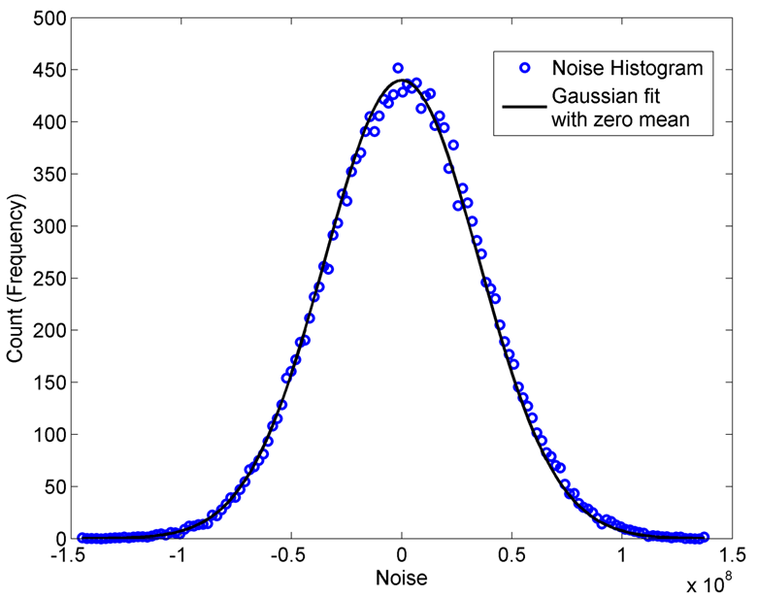
Figure 2.3.5: Histogram of the real part of background noise. The histogram is fit with a Gaussian curve with zero mean.

  - Dual-nuclear same breath lung imaging with dedicated ¹H receiver array

In vivo experiments
All in-vivo imaging with ³He and ¹²⁹Xe was performed with approval from the National Research Ethics Committee. Lung MRI was performed on a GE whole body 1.5 T Signa® HDx system with ³He and ¹²⁹Xe gas polarised with spin exchange optical pumping (237).

RF coil configuration and gas dose for dual-nuclear same-breath imaging
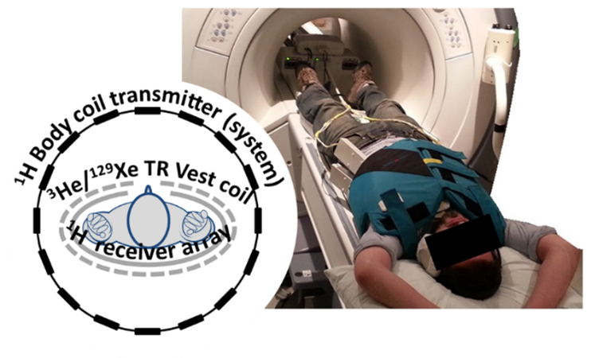
Figure 2.4.1: Coil setup for the same-breath acquisition with ³He/¹²⁹Xe T-R vest coil with the nested ¹H array. Reproduced from (234), with permission, © John Wiley and Sons 2016.
For same-breath acquisition with the ¹H receiver array and ³He or ¹²⁹Xe, the commercially available flexible T-R vest coils (CMRS, WI, USA) were used (for both ³He and ¹²⁹Xe) without modification. Both of the flexible coils, T-R vest coil (³He or ¹²⁹Xe) and the array (¹H) were tightly wrapped around the subject with the ¹H array nested inside as shown in Figure 2.4.1. The gas mixture and dosage of gases are shown in Table 2.4.1.
¹H array Configuration | 1 | 2
HP T-R coil used  for scan | ¹H array (1 trap for ³He) and ³He T-R coil | ¹H array (2 traps for ³He and ¹²⁹Xe) and ¹²⁹Xe T-R coil
Volunteer details | Female 32, 61 kg | Male 30, 88 kg
Imaging details | ¹H and ³He | ¹H and ¹²⁹Xe
Dosage and Percentage of polarisation | 300ml of ³He with 700ml of N₂. 25% polarisation  (≈100% of He is ³He) | 450ml of Xe with 550ml of N₂. 15% polarisation. (87% of Xe is ¹²⁹Xe)
Gas mixture | 30% ³He, 70% N₂ | 45% Xe, 55% N₂
Corresponding Figure | Figure 2.4.2(b,c) | Figure 2.4.2 (e,f)
Table 2.4.1: Details of dosage and gas mixtures.
Figure 2.4.2: Same-breath acquisition of HP ³He with ¹H, (a) ¹H image, (b) ³He image and (c) superposed image of ¹H and ³He. Same-breath acquisition of ¹²⁹Xe with ¹H (d) ¹H image, (e) ¹²⁹Xe image and (f) superposed image of ¹H and ¹²⁹Xe. (a)(b)(c) ¹H array (1 trap for ³He) and ³He T-R coil, Female 32, 61 kg. (d)(e)(f) ¹H array (2 traps for ³He and ¹²⁹Xe) and ¹²⁹Xe T-R coil, Male 30, 88 kg. Reproduced from (234), with permission, © John Wiley and Sons 2016.

MRI procedure and protocol
The RF power required for the desired flip angle for ³He and ¹²⁹Xe imaging was calculated based on a standard calibration procedure, whereby the rate of depletion of polarisation is calculated from the decay of signal resulting from a set of hard RF pulse-acquires of equal amplitude. The consistency of flip angle was maintained between various scan configurations indicating that the performance of both the ³He and ¹²⁹Xe transmit coils was uncompromised by the presence of the in-situ ¹H array. The imaging parameters for same-breath acquisition of ¹H with HP gases were as follows, for ³He imaging, flip angle = 8⁰, TE = 1.1 ms, TR = 3.6 ms, matrix size = 104 (phase) x 80 (frequency), slice thickness = 10 mm, number of slices = 5, FOV = 38.4 cm and for ¹²⁹Xe imaging, flip angle = 8⁰, TE = 3.6 ms, TR = 18.9 ms, matrix size = 78_{phase} x 64_{frequency} slice thickness = 15 mm, number of slices = 5, FOV = 38 cm. The imaging parameters for ¹H were flip angle = 50⁰, TE = 0.9 ms, TR = 2.9 ms, matrix size = 192_{phase} x 256_{frequency} in both cases. The imaging time for ³He imaging was 2s, for ¹²⁹Xe imaging was 8s and ¹H imaging was 1s. The pulse sequence was a 2D, coronal, fast spoiled gradient echo for HP gas imaging and 2D, coronal, balanced steady state free precession for ¹H imaging. Two sets of images were acquired back-to-back in the same breath-hold, HP gas image followed by the ¹H image. The transmit gain (TG) and analogue and digital receiver gains (R1, R2) needed for ¹H MRI on the MR system are normally pre-calibrated from an auto-prescan. This was bypassed for back-to-back same breath acquisition by running a shell script, which provides the sequence with pre-calibrated values for R1, R2 and TG. The time period between the end of HP gas imaging and initiation of ¹H imaging is less than 4s.
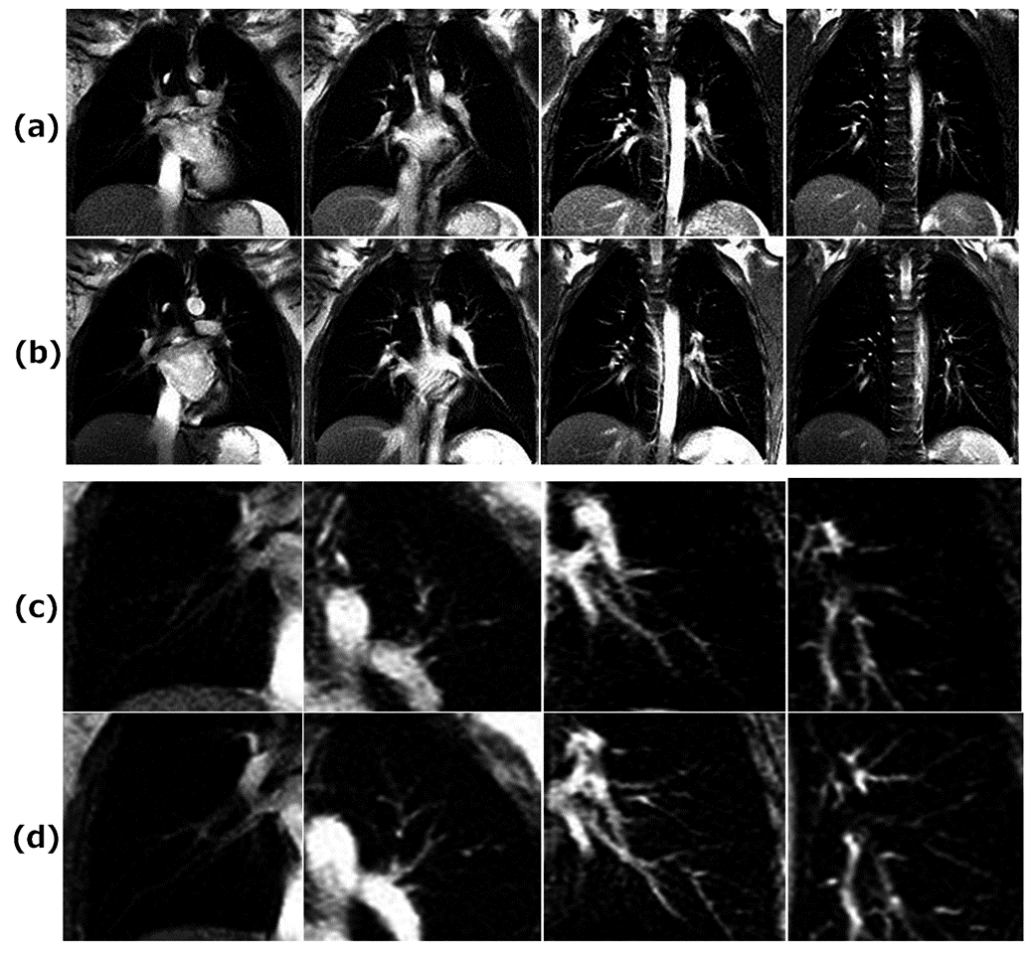
Figure 2.4.3: Four cascaded slices of the lung: (a) ¹H images from system body coil and (b) ¹H images from ¹H array. Enlarged sections illustrating SNR improvement of ¹H array: (c) ¹H images from system body coil and (d) ¹H images from ¹H array. All the four were acquired in a same-breath acquisition of ³He with ¹H, with the ³He TR coil in-situ. Reproduced from (234) with permission, © John Wiley and Sons 2016.
Dual-nuclear same breath image acquisitions performed with ³He (first configuration) and ¹²⁹Xe (second configuration) are shown in Figure 2.4.2. See Table 2.4.1 for details on the configurations. The images from ¹H Figure 2.4.2 (a) and Figure 2.4.2 (d) are co-registered with the images from HP gas ³He Figure 2.4.2 (b) and ¹²⁹Xe Figure 2.4.2 (e). Figure 2.4.2 (c) and Figure 2.4.2 (f) are the superposed images. The images in Figure 2.4.2 (b) and Figure 2.4.2 (e) are images from ³He and ¹²⁹Xe respectively.

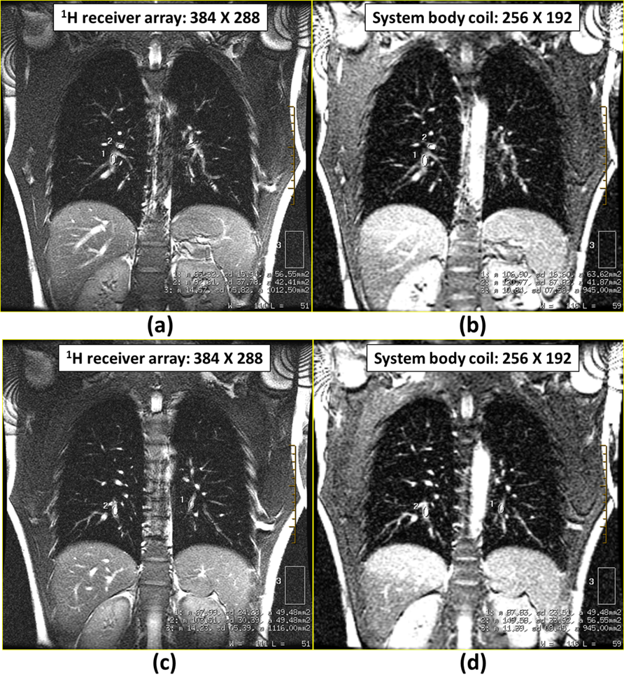
Figure 2.4.4: (a) Image obtained from the 4 element ¹H receiver array with a matrix size of 384X288 and (b) is the image obtained from the system body coil with matrix size of 256X192. Images (a) and (b) are the same coronal slices, same FOV with identical imaging parameters. Similarly, (c) shows an image obtained from the 4 element receiver array with a matrix size of 384X288 and (d) is the image obtained from the system body coil with matrix size of 256X192. Images (c) and (d) are coronal slices, same FOV, with identical imaging parameters. Subject: Male 30, 88 kg.

Illustration of SNR improvement in vivo
The advantages of improved SNR can be also observed in the in vivo images as shown in the four cascaded slices of the lung from the system body coil and the ¹H receiver array in Figure 2.4.3 (a) and (b) respectively. The enlarged images in Figure 2.4.3 (c-d), demonstrate the SNR improvement from the ¹H array with more structural information from the small blood vessels discernible.
An alternative way to emphasise the benefit of SNR is by demonstrating that the array can provide SNR equal (or better) to the body coil with twice the spatial resolution. For the purpose of a quick visual demonstration (without absolute quantification), the SNR in lung parenchyma from the body coil and the ¹H receiver array coil is illustrated with two coronal slices as shown in Figure 2.4.4. For the particular coronal slice of the lungs, images from the receiver array were acquired with higher resolution than the images from the body coil – the rest of the imaging parameters were identical (steady state free-precession, flip angle = 50⁰, TE = 0.9 ms, TR = 2.9 ms). The images from the array were acquired with a matrix size of 384_{frequency} X 288_{phase} and the images from the body coil were acquired with a matrix size of 256_{frequency} X 192_{phase} for the same FOV. As detailed in Table 2.4.2, the image SNR from the array was equal or better to the image SNR from the body coil for a pixel volume of less than half the size.
Figure  2.4.4 | Location | 4 element ¹H array (384 X 288) |  |  | System body coil (256 X 192)
 |  | Signal (Mean) | Noise (standard deviation) | Signal to Noise ratio | Signal (Mean) | Noise (standard deviation) | Signal to Noise ratio
(a)(b) | 1 | 85 | - | 10.15 | 106 | - | 9.18
(a)(b) | 2 | 92 | - | 10.98 | 120 | - | 10.39
(a)(b) | 3 | - | 5.82 | - | - | 7.56 | -
(c)(d) | 1 | 67 | - | 8.63 | 87 | - | 6.67
(c)(d) | 2 | 103 | - | 13.28 | 149 | - | 11.42
(c)(d) | 3 | - | 5.39 | - | - | 8.54 | -
Table 2.4.2: Details of signal mean measured in the lung parenchymal and the background noise for both receiver array and body coil. The SNR for receiver array was calculated as the ratio of mean signal to standard deviation of noise with scaling factor of 0.695, whereas for the body coil the scaling factor was 0.655. The scaling factor is due to Rician distribution of background noise (194).
It should be noted that although in vivo measurements are not the preferred way to measure the SNR, these two examples measured are DICOM images from the scanner and are for quick illustration only, overlooking the error in the measurement contributed from factors such as, (a) the number of pixels used to measure mean and standard deviation is different for the receiver array and body coil and (b) the mean in the background noise is non-zero and different for receiver array and body coil. The rationale to overlook these errors is that the variation (10%~20%) when ignoring them is minor when compared to the reported SNR improvement (100%~130%).
  - Discussion
In the process of this work we have firstly demonstrated a new, more comprehensive theoretical formalism for the trap circuit design for multiple resonant frequency RF coil configurations. In comparison with existing approaches (204), consider the schematic in Figure 2.2.1(b), simplifying the equations for the lower and higher resonant modes as previously shown in (204), $ω_{LOW}^{2}= {\left[\left(L_{H}+L_{T1}\right)C_{1}\right]}^{-1}$ and $ω_{HIGH}^{2}= \left(C_{1}+C_{T1}\right)L_{H}^{-1}C_{1}^{-1}C_{T1}^{-1}$ then this simplification is relevant only if $ω_{HIGH}≫ ω_{TRAP}$ and $ω_{LOW}≪ ω_{TRAP}$, where the trap circuit is simplified to be purely capacitive and inductive respectively, unlike in the studies in this thesis. Also, in a realistic RF coil design, one of the series capacitors of the RF coil is split into to two capacitors (for example see capacitors $C_{M}$ and $C_{T}$ in Figure 1.2.2.5) to create a virtual ground essential to transform the balanced RF network of the RF coil to the unbalanced RF network of the spectrometer. Further, the value of the capacitor across which the RF power is fed (or received) is determined by the sample-dominated loss (which also depends on the physical dimension of the RF coil) as explained earlier in section 1.2.2.
The formulations and calculations presented here do not account for Ohmic losses in the distributed inductance of the loop or the trap circuits. However, the variation in the resonant modes due to this (if any) should be well within the tuning range of the variable capacitor. Also, the use of trap circuits may not be feasible in applications where the resonant frequency and the trap frequencies are very close, for example ¹H and ¹⁹F at 1.5T.
In a same-breath multi-nuclear (HP gas and ¹H) acquisition, the ¹H imaging is usually performed after the HP gas imaging. For a healthy/normal volunteer, the typical breath-hold tolerance for the inhaled gas mixture is less than 20 seconds. In a same-breath acquisition of 20 seconds, the HP gas imaging lasts for 12 seconds and the time taken to load the ¹H imaging sequence and initiate the scan with predetermined pre-scan values on the GE spectrometer is typically 3~4 seconds; the remaining 4~5 seconds is the time allotted for ¹H imaging. This limited time period therefore prevents ¹H image averaging and thus to improve the ¹H image SNR, it is essential to have an RF coil with higher sensitivity.
A higher channel (element) of ¹H array specific to the lung, designed considering the thoracic anatomical structure would further increase ¹H SNR. This is described in the next chapter.

- Lung-specific ¹H RF receiver array coil
  - Introduction
Human lungs consist of mainly air spaces with a low density of ¹H that can be imaged (≈0.2 g/cc) (47), in addition, the transverse relaxation time $T_{2}^{*}$ is lower (1~2 ms at 1.5 T) due to susceptibility gradients between tissue and air. Thus, the SNR of ¹H lung images are inherently lower, especially when acquired using the MR system’s body coil. The previous chapter demonstrated the improvement in SNR of ¹H lung images in a multi-nuclear same-breath acquisition of ¹H and hyperpolarised gas (³He/¹²⁹Xe) using a 4-element dedicated ¹H receiver coil array. In this chapter a novel 8-channel RF coil array topology specific to ¹H lung imaging at 1.5 T is introduced and a further SNR improvement is demonstrated by comparing it with a conventional ladder-like RF coil array (commercially available) with preliminary in vivo measurements.
  - Design of the lung-specific ¹H RF receiver array coil
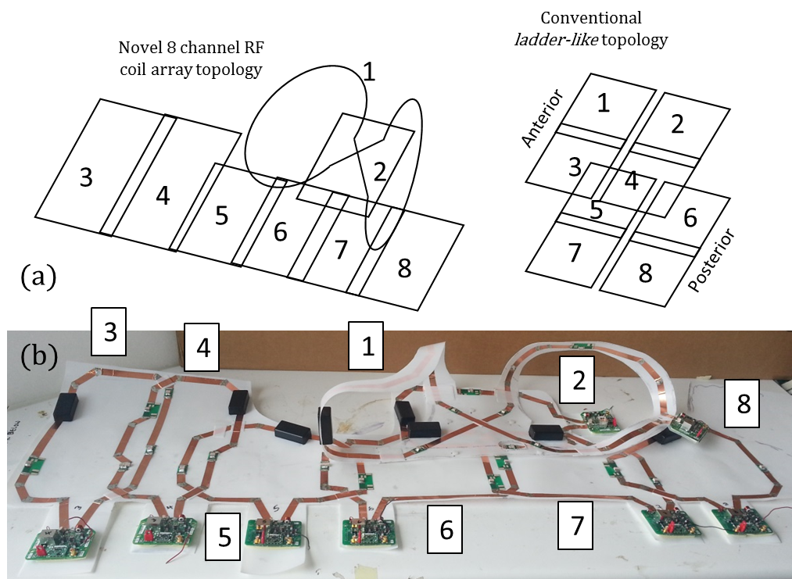
Figure 3.2.1: (a) Illustration of topology of the 8 element ¹H array and (b) Photograph of the prototype before covering with foam.
The ¹H SNR of the lungs could be further improved with an RF coil array topology that conforms well to the lung anatomy. The proposed ¹H receiver RF coil array is an 8-channel design as shown in Figure 3.2.1. Element 1 is a volume figure-of-8 topology and structured in such a way that the arms of the subject can pass through and conforms (couples) well to the upper chest as shown in Figure 3.2.2. Element 1 along with the elements 2-4 combine in quadrature for enhanced sensitivity coverage of the upper/superior left and right lobes of the lungs. This region typically has low SNR when imaged with conventional bi-planar (ladder-like) cardiac and chest RF coil array designs. Elements 3-8 cover the lower/inferior left and right lobes. Element 1 is geometrically decoupled from the elements 2, 3, 4, 6, 7 as the $B_{1}^{-}$ polarisation is mutually orthogonal. Element 1 is decoupled from the elements 5, 8 by critical overlap. Element 2-8 are critically overlapped and a low input impedance LNA fitted to all of the 8 elements(126). Each of the elements are decoupled from the ¹H transmit body coil with one active and one passive detuning circuit.
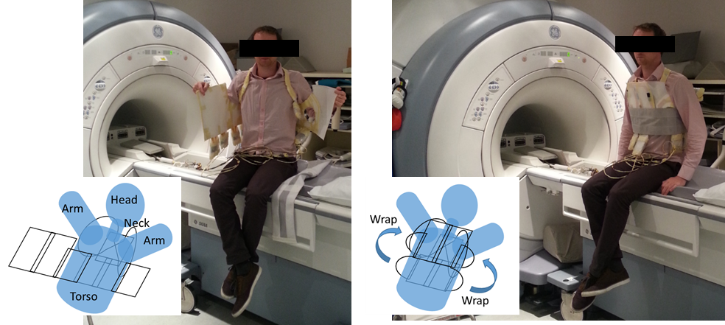
Figure 3.2.2: Illustration of the application of the proposed 8-element ¹H array on the subject.
  - RF measurements of the ¹H array
RF measurements were performed with an Agilent 5601A Network Analyser (Keysight Technologies, Santa Rosa, CA) and were expressed as s-parameter measurements in dB. Test setup for RF coil matching, isolation and Q measurement were similar as mentioned in Section 2.3. All the elements were matched below -20 dB. The isolation between any two elements was less than -18 dB, decoupling from the LNA further improves isolation. The ratio of Q_{unloaded} to Q_{loaded} was more than 8 for all the elements.
  - In vivo MRI using the Lung specific ¹H coil
For in vivo studies, white blood (also known as bright/slow blood) and black blood (also known as dark/fast blood) MR imaging was performed. The imaging parameters for the white blood imaging were; balanced steady-state free precession sequence, 2D coronal slices, flip angle was 50°, TE was 0.9 ms, TR was 2.9 ms, slice thickness was 10 mm, field of view was 38 cm, matrix size was 384_{frequency} X 256_{Phase} and bandwidth = 125 kHz. Two coronal slices from the lung specific coil are shown in Figure 3.4.1 (a). Black blood imaging typically used for diagnosis of pulmonary hypertension in clinical practice was performed with a triple inversion recovery pulse sequence using fast spin echo (FSE) readout (238). The imaging parameters for black blood imaging were: 2D axial slices, flip angle was 90°, TE was 69 ms, TR was cardiac gated, slice thickness was 8 mm, field of view was 35 cm, matrix size was 256_{frequency} X 224_{phase} and bandwidth was 31.25 kHz. Two axial slices from the lung-specific coil are shown in Figure 3.4.1 (b).
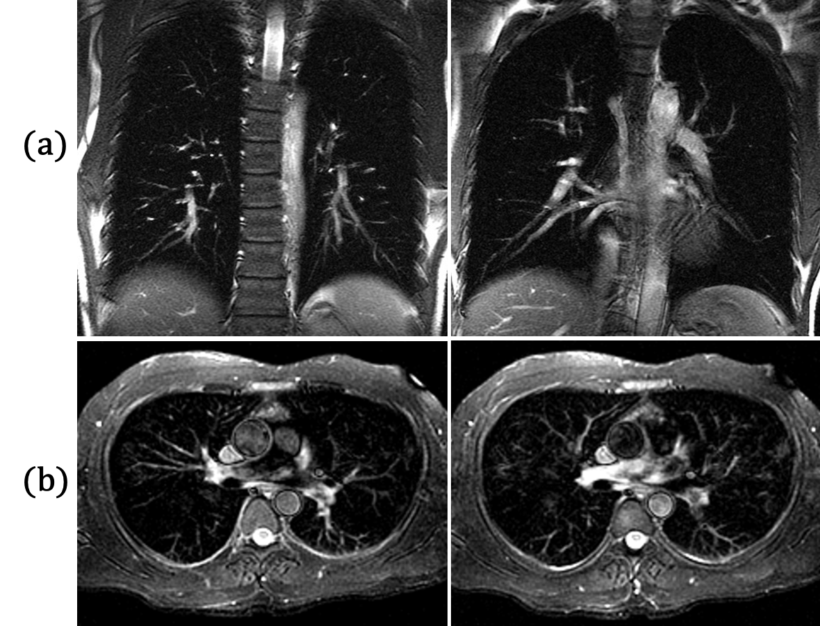
Figure 3.4.1: Lung-cardiac images from the lung specific coil. (a) White blood coronal images and (b) black blood axial images. Subject: Male 32 Y.

Preliminary SNR measurements and comparison with a conventional ladder-like 8-channel cardio-thoracic receiver array were performed using the exact same sequence settings. The SNR was measured from the sum of squares images as the ratio of the mean of signal to $\sqrt{2}$ times the standard deviation of noise, performed with a NiCl phantom with a GRE pulse sequence with identical imaging parameters (same procedure as SNR measurements explained in Section 2.3). The ¹H SNR (average) from the lung-specific topology was >30% higher (preliminary results) than the conventional topology. When in vivo images acquired with the lung-specific topology were compared with images acquired using the conventional ladder-like topology, finer anatomical details are visible as shown in Figure 3.4.2. These images were acquired with imaging parameters for white blood imaging mentioned earlier in the section.

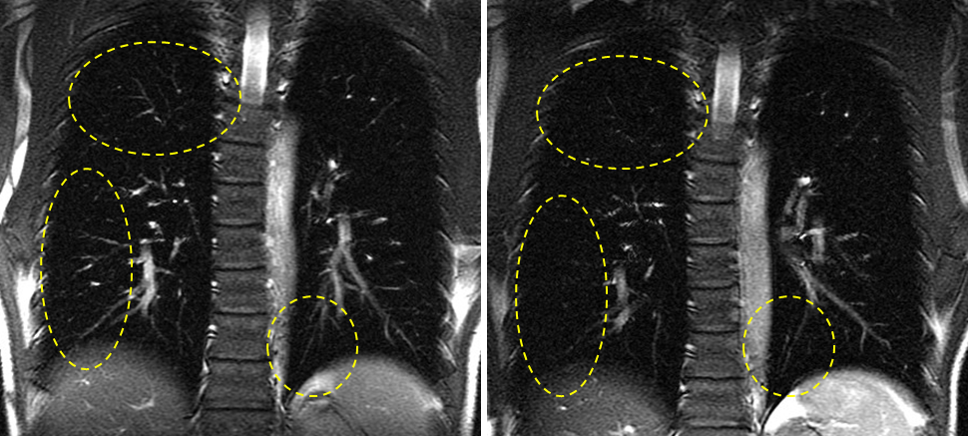
Figure 3.4.2: Comparing in vivo images of lung-specific coil with conventional ladder-like cardiac coil. (a) Lung specific coil and (b) Conventional ladder-like coil. Finer anatomical details are visible from the images acquired from lung specific coil. Subject: Male 32 Y.
  - Discussion
The prototype was built in-house and the cable assembly did not have baluns fitted. With baluns we would expect further improvement in the SNR (219,239,240). The volume figure-of-8 element provides sensitivity across the right-left direction improving ¹H SNR over the conventional ladder-like topology. The novel 8-element receiver array is thus optimised for high sensitivity and volume coverage as shown in Figure 3.5.1, but makes the coil less suited for parallel imaging due to the less discrete spatial sensitivity profiles of the elements.
The array former is thin (6mm) and can be easily inserted within other coils for example for multi-nuclear applications as in the previous chapter. The next step in this design is to fit traps for ³He/¹²⁹Xe for same-breath acquisition of the lungs like the ¹H array described in Section 2.3. In addition, though the topology is demonstrated for ¹H, it can be readily tuned to ³He, ¹²⁹Xe and ¹⁹F imaging of the Lung.

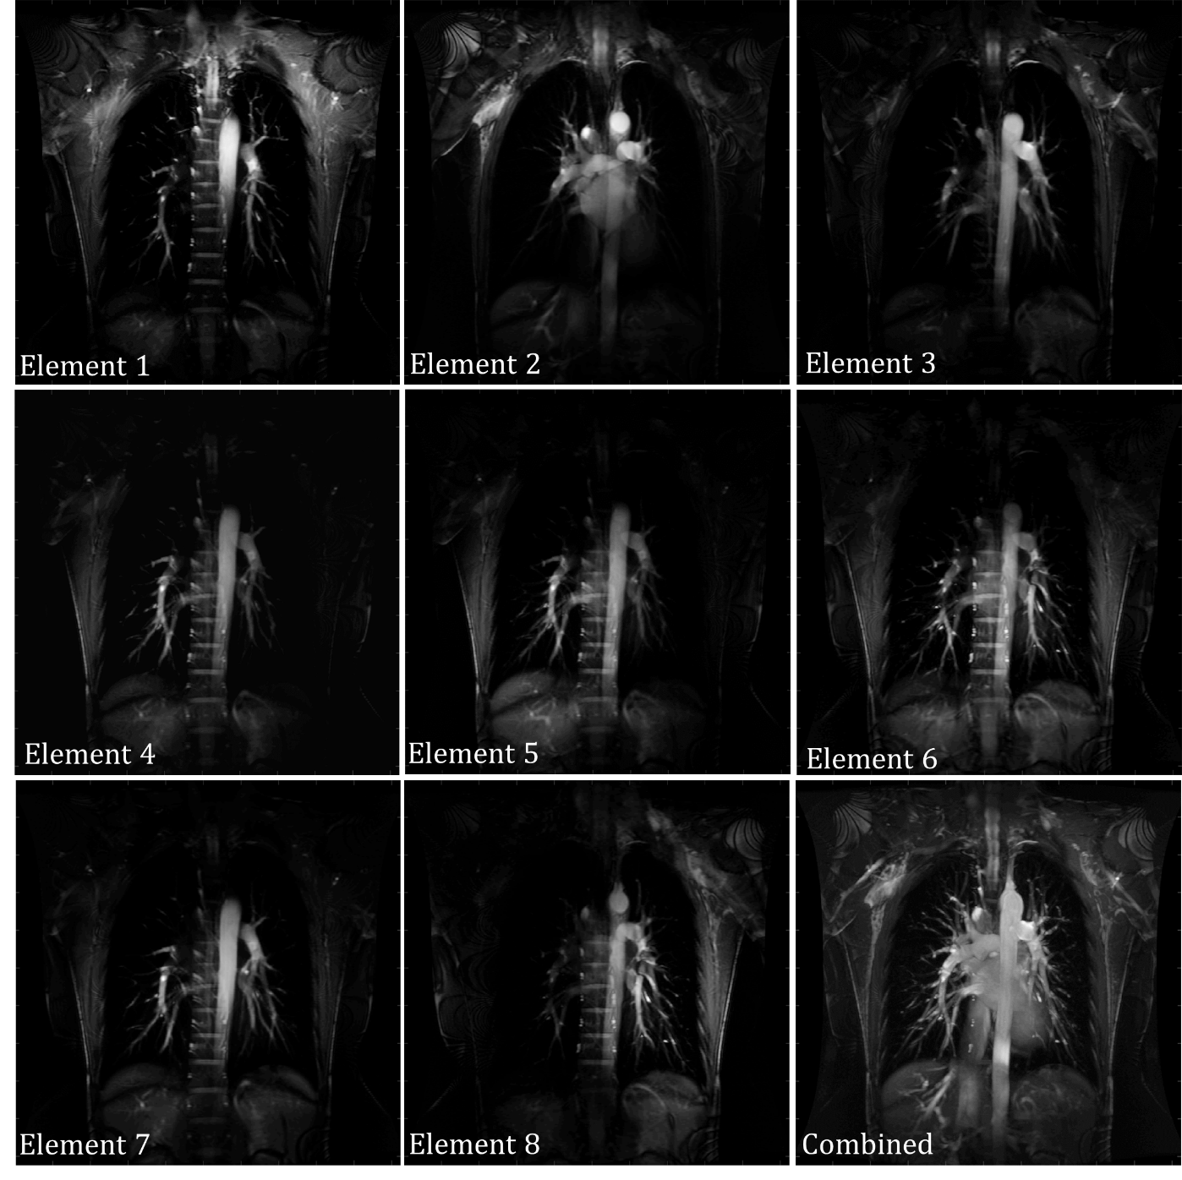
Figure 3.5.1: Sensitivity profile of individual elements of the novel 8 element receiver RF coil array. The RF coil array is optimised for high sensitivity and volume coverage.

- Same-breath triple nuclear lung MR imaging of ¹H and hyperpolarised ³He and ¹²⁹Xe.
  - Introduction
Hyperpolarised gases ³He and ¹²⁹Xe have distinct physical properties, which provide different but complementary functional information (3,4,55), the ability to image both nuclei in the same-breath alongside the ¹H anatomical images adds further structural and functional sensitivity to the acquisition. ³He is highly diffusive when compared to ¹²⁹Xe (127-129), and the visualization and quantification of lung ventilation and diffusion with these two gases at the same time can help address important physiological questions such as the position of the diffusion – convection front in the lungs. The capability to measure the diffusivity of both ³He and ¹²⁹Xe gases in the same lung inflation level also provides added information for measuring and modelling lung micro-structure based on their measured apparent diffusion coefficients (ADC) (130). Preliminary studies have used separate and spatially nested transmit-receive (T-R) coils for each nucleus (82). The reliance on the ¹H MR system’s birdcage body coil for signal reception constrains the signal to noise ratio (SNR) in ¹H images of the lung, which is already limited by the low proton density of lung parenchyma. Recent work (234) showed that the ¹H lung SNR in same-breath imaging can be improved with a nested ¹H receive array, which is compatible with operation with either a ³He or a ¹²⁹Xe T-R coil.
In this chapter a dual-tuned dual-Helmholtz flexible transmit-receive RF coil is developed to operate in quadrature for both ³He and ¹²⁹Xe lung MRI at 1.5 T. Using this dual-tuned T-R RF coil and the dedicated ¹H receiver array (see Section 2.3 for coil design) we go on to demonstrate triple-nuclear same-breath lung imaging of ³He, ¹²⁹Xe and ¹H at 1.5 T is demonstrated for the first time. Dual-nuclear same-breath ADC mapping of ³He and ¹²⁹Xe is also demonstrated for the first time.
  - Design of dual-tuned RF coil
The dual-tuned (³He and ¹²⁹Xe) flexible quadrature T-R coil was designed and constructed in-house. The conducting elements were made from self-adhesive copper tape (FE-5100-5276-7, 3M, UK) of 66 μm thickness and 6 mm width, which was fixed on a substrate of 0.5 mm thick PTFE sheet (Polytetrafluoroethylene, Direct Plastics, Sheffield, UK) as shown in Figure 4.2.1(a).
The capacitors used on the resonant circuit were of 10C package (Dalian Dalicap Technology Co., Ltd, China). The thickness of the array with the foam was 6 mm (3 mm each side). The dual-tuned flexible T-R coil was a dual-Helmholtz-like quadrature design, whereby, the Helmholtz pair for the in-phase resonance of the quadrature spans the anterior right lung to posterior left lung, connected over the left trapezius. Similarly, the Helmholtz pair for the quadrature-phase resonance spans the anterior left lung to posterior right lung, via the right trapezius. The cross-over of the copper strip for each of the Helmholtz pairs (which forms a figure of eight topology) was positioned such that it was within the other resonant element (anterior) and was balanced on either side to minimise coupling as shown in Figure 4.2.1(a) and Figure 4.2.2.
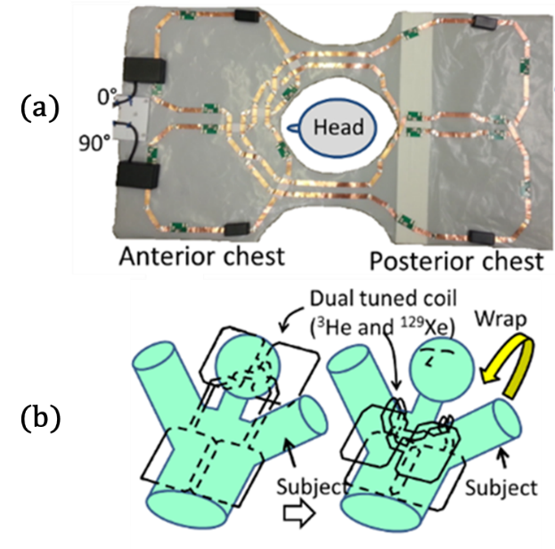
Figure 4.2.1: (a) Picture of the dual-tuned flexible TR coil for ¹²⁹Xe and ³He. The in-phase and quadrature-phase ports are marked with 0° and 90° respectively. The plastic housing at the port (0°, 90°) consists of high pass matching circuits (90 pF, 90 pF and 300 nH) and the two loop capacitors (47 pF and 220 pF) and (b) Illustration of application of the dual-tuned TR coil on the subject for RF measurements. Reproduced from (241) with permission, © John Wiley and Sons 2016.

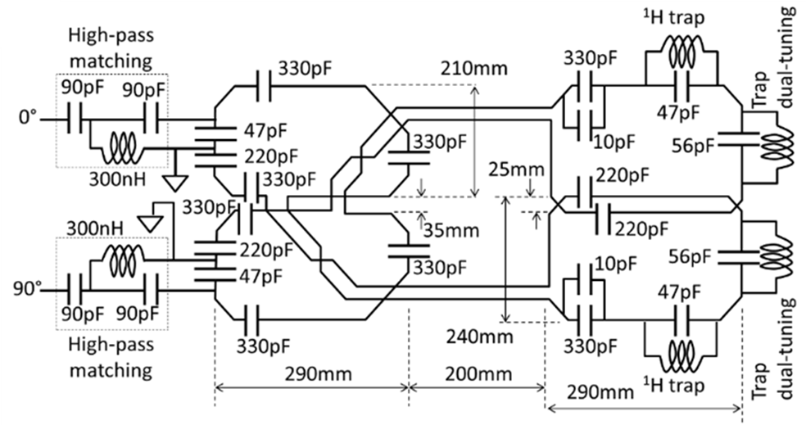
Figure 4.2.2: The design/schematic of the dual tune flexible TR coil for ¹²⁹Xe and ³He. The in-phase and quadrature-phase ports are marked with 0° and 90° respectively. Reproduced from (241) with permission, © John Wiley and Sons 2016.
The schematic of the dual-tuned T-R coil circuit is shown in Figure 4.2.2 and a photograph is shown in Figure 4.2.1(a). The assembled topology of the flexible coil constitutes a bib design wrapped around the subject longitudinally as shown in Figure 4.2.1(b). Both the elements of the dual Helmholtz coil were fitted with two traps; one trap at the ¹H frequency to enable ¹H imaging with this coil in-situ and the other trap to dual-tune the coil to the ¹²⁹Xe and ³He Larmor frequencies. The trap design was based on the theory developed in Chapter 2, Equation 2.2.5 and 2.2.12 (see Section 2.2). The frequency of the trap for dual-tuning was 47.81 MHz. A high-pass matching circuit was used to match the coil at both resonant frequencies of ³He (48.62 MHz) and ¹²⁹Xe (17.65 MHz) at 1.5 T. The ¹H trap was tuned with a 47 pF capacitor and a 7-turn wire-wound inductor of diameter 6 mm. The trap for dual-tuning the coil was tuned with a 56 pF capacitor and a 9-turn wire-wound inductor of diameter 6 mm. Wire-wound inductors were constructed from 21 AWG insulated copper wire.

RF measurements on the dual-tuned RF coil
RF measurements were performed with an Agilent 5061B Network Analyser (Keysight Technologies, Santa Rosa, CA) and were expressed as S-parameter measurements in dB. For RF measurement, the dual-tuned coil was wrapped longitudinally around the thorax of the subject, as shown in Figure 4.2.1 (b). The ¹H trap in the dual-tuned coil was tuned to below -30 dB. The isolation between the two ports of the Helmholtz pair coil was less than -15 dB. The quality (Q) factor of the dual-tuned coil at the ¹²⁹Xe Larmor frequency (17.65 MHz) was 61 in the unloaded condition and 17 in the condition when loaded with the chest of a 90 kg male subject. The Q factor of the dual-tuned coil at the ³He Larmor frequency (48.62 MHz) was 32 in the unloaded condition and 7 in the loaded condition. Thus, the ratio of Q factor unloaded to loaded condition was 3.5 at the ¹²⁹Xe Larmor frequency (17.65 MHz) and 4.5 at the ³He Larmor frequency (48.62 MHz).
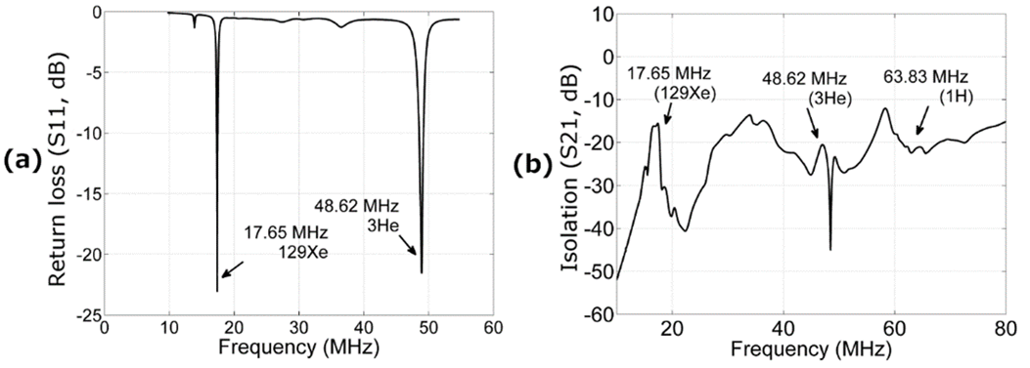
Figure 4.2.3: (a) Matching of the dual-tuned coil at 17.65 MHz and 48.62 MHz, (b) Isolation between the dual-tuned coil and the ¹H receiver array (described in chapter 2) over the frequency span of 10 MHz to 80 MHz. Reproduced from (241) with permission, © John Wiley and Sons 2016.

Under the loaded condition, the dual-tuned coil was matched to less than -20 dB at both the ports at both the Larmor frequencies of ¹²⁹Xe (17.65 MHz) and ³He (48.62 MHz) as shown in Figure 4.2.3 (a). This coil was designed to work with full functionality when the 4-channel ¹H chest receiver array (from Section 2.3) was nested inside for in-situ high SNR ¹H lung imaging. As such, the isolation between the dual-tuned coil and the ¹H array was tested and was less than -15 dB as shown in Figure 4.2.3(b).

RF signal routing and calibration
To route the transmit RF signal (³He-¹²⁹Xe) from the appropriate T-R switch on the scanner to the dual-tuned coil and to route the received RF signal (³He-¹²⁹Xe) from the dual-tuned coil back to the appropriate T-R switch on the scanner, a 2kW rated coaxial antenna RF switch (CX-SW2PL, Watson, Essex, UK)) was used. The time period to prescribe calibration values on the spectrometer between the end of imaging a particular nucleus and initiation of the sequence for imaging the next nucleus was less than 4 s. The time required to operate the RF switch manually between acquisitions was 3 s (planned along with switching the spectrometer).
The $T_{1}$ of hyperpolarised gases when inhaled in the lungs is sensitive to the oxygen partial pressure in the lung during the breath-hold (228). ³He is more sensitive to this effect. This is due to the fact that the gyromagnetic ratio of ³He is approximately 3 times larger than that of ¹²⁹Xe, and as such the dipolar coupling to the electrons in the paramagnetic oxygen molecule is stronger. Thus the order of acquisition was ³He followed by ¹²⁹Xe, followed by ¹H.

In vivo experiments
All in-vivo imaging with ³He and ¹²⁹Xe was performed with approval from the National Research Ethics Committee. Lung MRI was performed on a GE whole body 1.5 T Signa® HDx system with ³He and ¹²⁹Xe gas polarised with spin exchange optical pumping (237).
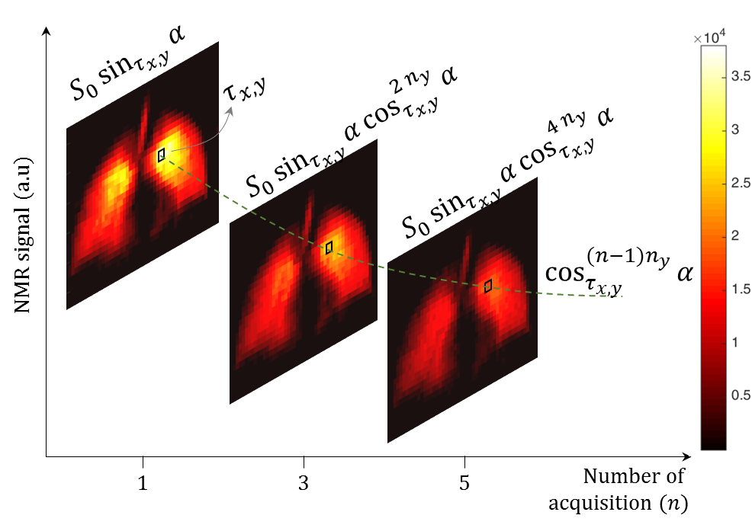
Figure 4.2.4: Illustration of flip angle calculation with repeated imaging. The colour bar indicates NMR signal (a.u).

$B_{1}^{+}$Sensitivity - Flip angle profile
Flip angle maps of the dual-tuned coil at both the ³He and ¹²⁹Xe frequencies were calculated by measuring the depletion of polarisation of the hyperpolarised gas ³He and ¹²⁹Xe at each voxel in the lungs by repeated imaging in a breath hold with a 2D spoiled gradient-echo sequence. The imaging parameters for this measurement were:
- ³He: The gas dose was 50 ml (25% polarisation, ~100% of He is ³He), TE = 1.1 ms, TR = 3.6 ms, matrix = 52 (phase) X 44 (frequency), slice thickness = 200 mm, number of slices = 1 and field of view = 40 cm. The flip angle was measured in the coronal plane (2D) with a fast spoiled gradient echo pulse sequence. 6 repeated acquisitions were performed which lasted for 0.9 s.
- ¹²⁹Xe: The gas dose was 100 ml (25% polarisation, 87% of Xe is ¹²⁹Xe), TE = 3.6 ms, TR = 18.9 ms, matrix = 52 (phase) X 44 (frequency), slice thickness = 200 mm, number of slices = 1 and field of view = 40 cm. The flip angle was measured in the coronal plane (2D) with a fast spoiled gradient echo pulse sequence. 6 repeated acquisitions were performed which lasted for 2.4 s.
As shown in Figure 4.2.4, the flip angle was calculated from${ S}_{n,τ_{x,y}}= S_{0}\sin_{τ_{x,y}}{α}\cos_{τ_{x,y}}^{(n-1)n_{y}}{α}$, where $S_{0}$ is the initial magnetisation, $n$ is the number of repeated RF pulses, $τ_{x,y}$is the voxel location, $n_{y}$ is the number of phase encodes before the voxel location $τ_{x,y}$ and $α$ is the flip angle. $T_{1}$ relaxation was neglected when calculating the flip angle for both gases due to the short acquisition time. Flip angle maps for the dual-tuned coil for the nominal flip angles used (transmit RF power prescribed - 8°~10°) for a triple-nuclear same-breath lung imaging and ADC measurements are shown in Figure 4.2.5(a) for ³He and Figure 4.2.5(b) for ¹²⁹Xe. The standard deviation of flip angle map was calculated to be 0.7° (mean = 8°) for ³He and 0.3° (mean = 9°) for ¹²⁹Xe.
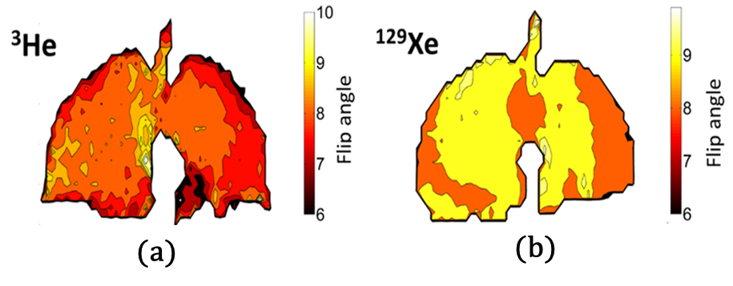
Figure 4.2.5 (a) Flip angle map of the dual-tuned coil for ³He and (b) Flip angle map of the dual-tuned coil for ¹²⁹Xe. The colour bars indicate the flip angle in degrees. Reproduced from (241) with permission, © John Wiley and Sons 2016.

  - Same-breath ADC and Triple-nuclear lung imaging

Imaging parameters and gas dose
Imaging was performed on a healthy volunteer (M, 31 y, 185 cm, 89 kg). The gas dosage, imaging and pulse sequence parameters used for all the three nuclei are shown in Table 4.3.1. The hyperpolarised ³He and ¹²⁹Xe gases were delivered in separate Tedlar bags and were mixed at the mouth-piece at the time of inhalation as illustrated in Figure 4.3.1(b). ³He had a polarisation of 25% (≈100% of He is ³He). ¹²⁹Xe had a polarisation of 40% (87% of Xe is ¹²⁹Xe).
Measurement |  | Lung structure and ventilation |  |  | ADC
Physiological details |  | Triple-nuclear, Same-breath |  |  | Dual-nuclear, Same-breath
RF coil |  | Section 2.3 and 4.2 |  |  | Section 4.2
Nucleus |  | ¹H | ³He | ¹²⁹Xe | ³He | ¹²⁹Xe
Dosage (ml) |  | - | 350 | 500 | 300 | 500
Flip angle |  | 50° | 8° | 9° | 9° | 10°
TE (ms) |  | 0.9 | 1.1 | 3.6 | 4.8 | 12.5
TR (ms) |  | 2.9 | 3.6 | 18.9 | 10 | 27
Matrix | Phase | 192 | 104 | 78 | 48 | 48
 | Frequency | 256 | 80 | 64 | 64 | 64
Slice thickness (mm) |  | 15 |  |  | 15
Number of slices |  | 3 |  |  | 2 | 2
FOV (cm) |  | 40 |  |  | 44
Axis |  | 2D, Coronal |  |  | 2D, Coronal
Pulse sequence |  | Balanced steady state free precession | Fast spoiled gradient echo |  | Fast spoiled gradient echo
Imaging time (s) |  | 1 | 2 | 4 | 6 | 8
b Value (s cm⁻²) |  | - | - | - | 1.6 | 8
Corresponding Figure |  | 4.3.2(a)(d)(e) | 4.3.2 (b)(d) | 4.3.2 (c)(e) | 4.3.3 (a) | 4.3.3 (b)
Table 4.3.1: Details of gas mixture-dosage, imaging parameters and pulse sequence used for all the three nuclei.

Triple nuclear (³He, ¹²⁹Xe and ¹H) structure and ventilation lung imaging
For triple-nuclear lung imaging, the dual-tuned ³He -¹²⁹Xe coil from Section 4.2 and the ¹H array from Section 2.3 were nested as shown in Figure 4.3.1(a). To demonstrate imaging of all three nuclei in the same breath, three sets of images were acquired back-to-back in the following order: ³He imaging, followed by ¹²⁹Xe, followed by ¹H. The imaging parameters are shown in Table 4.3.1.
Same-breath triple-nuclear lung (structure and ventilation) images are shown in Figure 4.3.2. The ¹H images in Figure 4.3.2 (a), ³He images in Figure 4.3.2 (b) and ¹²⁹Xe images in Figure 4.3.2 (c) all acquired in the same-breath, are co-registered as shown in superimposed images in Figure 4.3.2 (d) and Figure 4.3.2 (e).

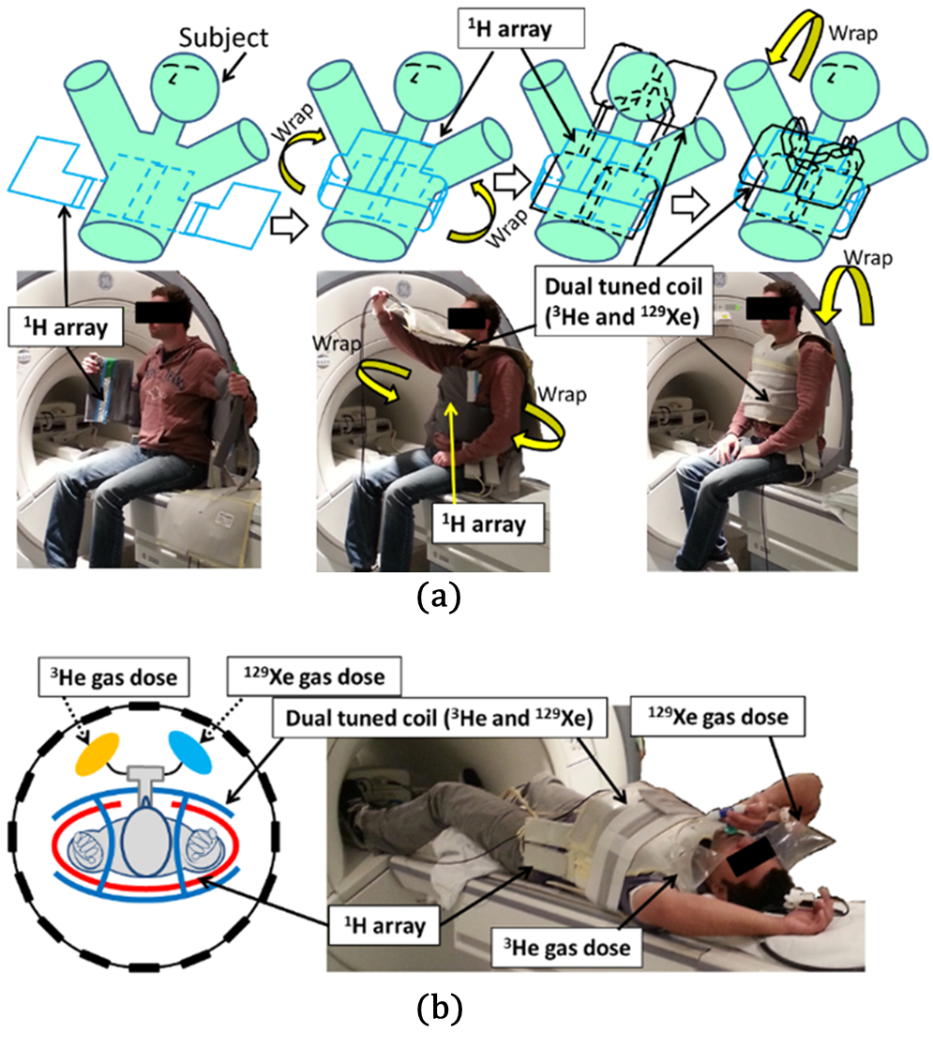
Figure 4.3.1: (a) Illustration of ¹H array and dual-tuned coil nested for triple nuclear imaging and (b) Picture of the setup on the scanner. The picture indicates the mouth piece and the two Tedlar bags affixed to it. Reproduced from (241) with permission, © John Wiley and Sons 2016.

Same-breath ADC (³He and ¹²⁹Xe)
For same-breath ADC measurement, the dual-tuned ³He-¹²⁹Xe coil was wrapped longitudinally as shown in Figure 4.3.1(b), without the ¹H array nested inside. To demonstrate same-breath ADC maps, two sets of ADC measurements were acquired back-to-back in a single breath, starting with the ³He ADC measurement followed by the ¹²⁹Xe ADC measurement. The imaging parameters are shown in Table 4.3.1. The ADC measurement of ³He and ¹²⁹Xe, performed in the same lung-inflation are shown in Figure 4.3.3. The ³He ADC map is shown in Figure 4.3.3 (a) and ¹²⁹Xe ADC map in Figure 4.3.3 (b). Figure 4.3.3 (c) shows the pixel-to-pixel correlation between the ADC map of ³He (from Figure 4.3.3(a)) and ADC map of ¹²⁹Xe (from Figure 4.3.3(b)).
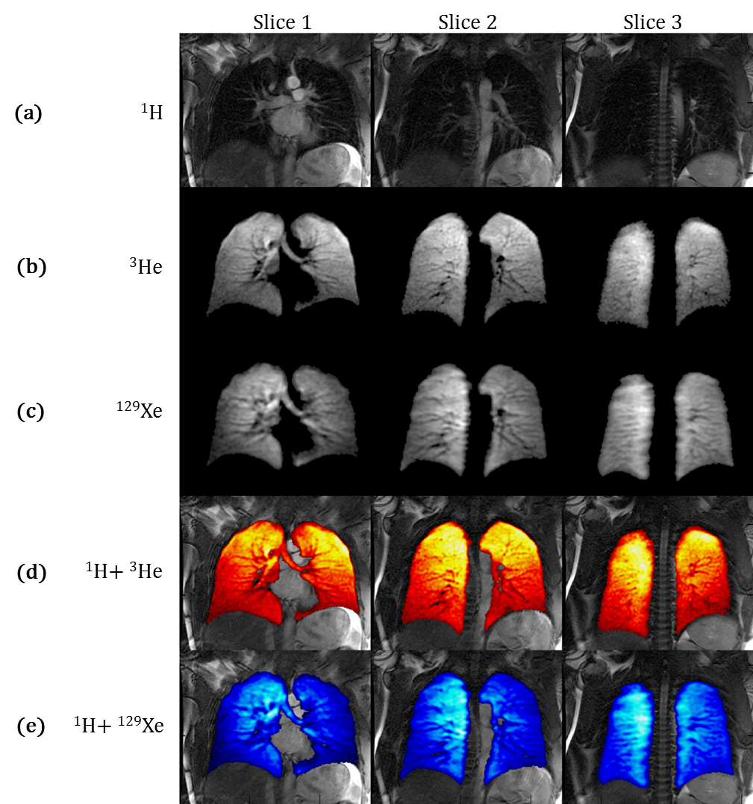
Figure 4.3.2: (a) ¹H images from lungs (b) Same-breath ³He images from lung (c) Same-breath ¹²⁹Xe images from the lungs (d) ³He images superimposed over ¹H images and (e) ¹²⁹Xe images superimposed over ¹H images. Reproduced from (241) with permission, © John Wiley and Sons 2016.

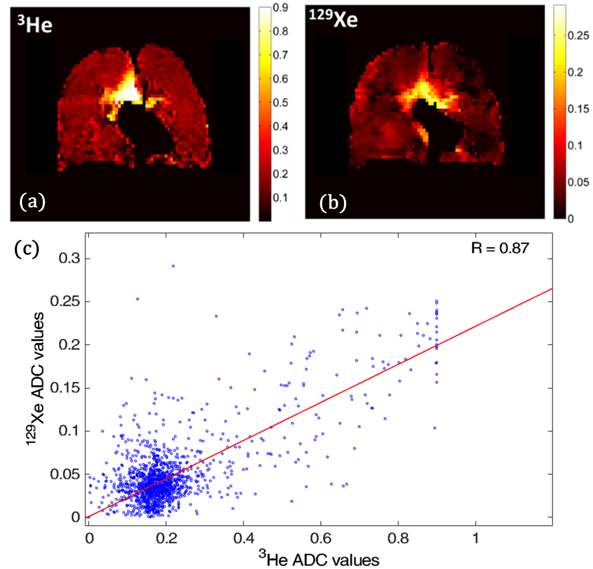
Figure 4.3.3: Apparent diffusion coefficient measurement (ADC) of ³He-¹²⁹Xe in same-breath, (a) ³He ADC and (b) ¹²⁹Xe ADC. The colour bar indicate apparent diffusion coefficient in cm²s⁻¹. (c) Pixel-to-pixel correlation between the ADC map of ³He and ADC map of ¹²⁹Xe. Subject: Male 33 Y. (a)(b) Reproduced from (241) with permission, © John Wiley and Sons 2016.

Stand-alone performance for 3D ³He and 3D ¹²⁹Xe ventilation MRI
To demonstrate the coil’s performance as a stand-alone separate-breath ³He or ¹²⁹Xe T-R coil (without the ¹H array in-situ), high-resolution 3D coronal imaging data sets were acquired with a 3D balanced steady state sequence (242,243). The imaging parameters were;
³He: gas dose was 200 ml (with 800 ml N₂), flip angle = 10°, TE = 0.6 ms, TR = 1.9 ms, matrix = 80 (frequency) X 82 (phase), slice thickness = 4 mm, number of slices = 46, field of view = 40 cm and the imaging time was 7 s;
¹²⁹Xe: gas dose was 500 ml (with 500 ml N₂), flip angle = 10°, TE = 2.1 ms, TR = 6.4 ms, matrix = 80 (frequency) X 82 (phase), slice thickness = 10 mm, number of slices = 24, field of view = 40 cm and the imaging time was 13 s.
Volumetric ventilation images from the 3D bSSFP sequence for the coil in operation as a stand-alone transceiver for ³He are shown in Figure 4.3.4(a) and for ¹²⁹Xe are shown in Figure 4.3.4(b).
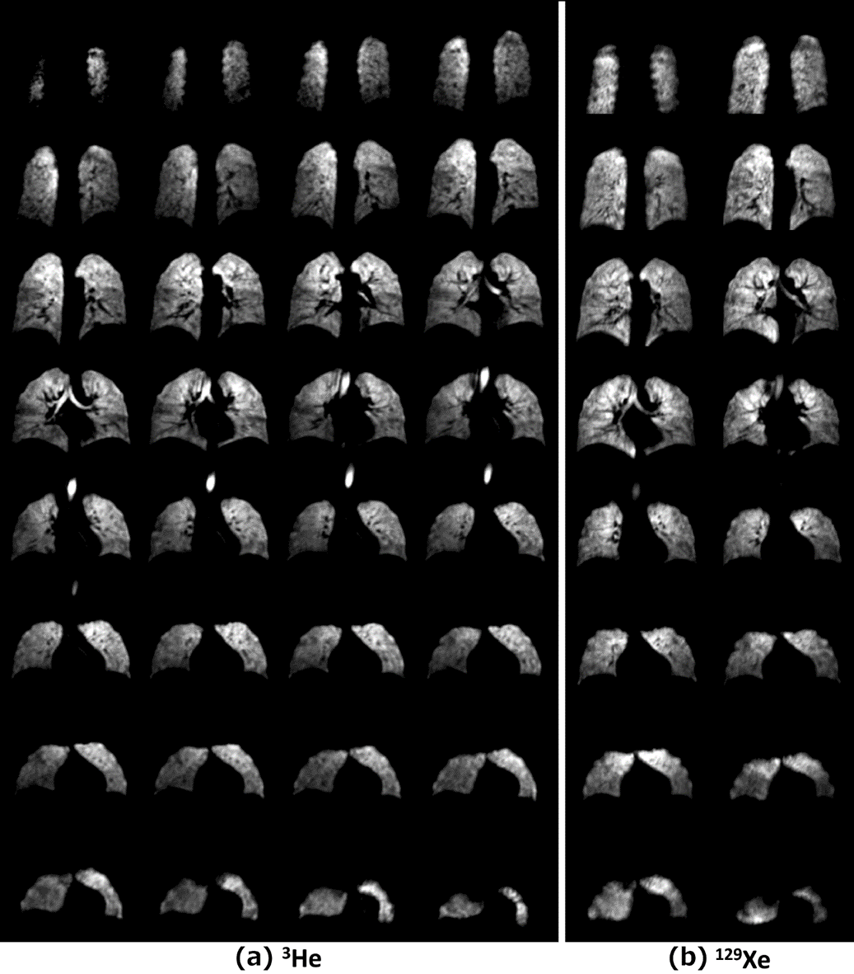
Figure 4.3.4: Hyperpolarised gas images of the lungs from 3D bSSFP sequence with dual-tuned coil in a stand-alone configuration (without ¹H array nested): (a) Hyperpolarised ³He gas and (b) hyperpolarised ¹²⁹Xe gas. Subject: Male 31 Y. Reproduced from (241) with permission, © John Wiley and Sons 2016.
  - Discussion
The construction of the dual-tuned coil is in the form of a bib, which enables a close fit to the subject’s thorax irrespective of body type. The two traps on the coil at 47.81 MHz and 63.86 MHz (¹H trap) generated three resonant modes at 17.65 MHz (¹²⁹Xe Larmor frequency), 48.62 MHz (³He Larmor frequency) and 79.2 MHz. The stray resonance at 79.2 MHz does not affect the performance of the coil at 17.65 MHz and 48.62 MHz for two reasons; firstly the frequency is far-off and secondly, the high-pass matching circuit is optimised to match at 17.65 MHz and 48.62 MHz, but does not have a good match at 79.2 MHz (-1.5 dB). The design was optimised to a typical subject (Male, 31 Years, 89 kg). As the shape/form deviates from the optimal design with other body types, the distributed inductance and the T-R efficiency of the dual-tuned coil changes accordingly. The $B_{1}$field homogeneity of the dual Helmholtz design is inherently less than that of a birdcage design (179). Considering the typical anatomy of a torso, the distance between the RF coil and lung air spaces generally increases from superior (upper) to inferior (lower). This means that sensitivity in the lower lung is reduced for two reasons, firstly due to proximity of the conducting elements to the lungs and secondly as the parallel condition for a Helmholtz pair is disrupted. Despite these factors the observed $B_{1}$ transmit homogeneity (variation in flip angle, 3% for ¹²⁹Xe and 9% for ³He) is comparable to the coil described in (223) and is better than the coil described in (16) studies reported previously using single-tuned flexible T-R coils for ³He and ¹²⁹Xe lung imaging.
As the RF switches are currently manually operated and the spectrometer has an inherent delay time for gain pre-calibration for each nucleus, the method is not currently compatible with repetition time interleaved imaging as demonstrated in an earlier study with same breath ³He-¹H lung imaging (82). It should be noted that this limitation is nothing to do with the RF coil design or configuration, but is from the MR system which currently supports only one spectrometer T-R switch (single-nucleus) to be actively connected at any given point in time (in addition to ¹H). Both the dual-tuned RF coil (Section 4.2) and the nested ¹H array (Section 2.3) are capable of operating simultaneously. If we consider the coil’s operation as part of the system for triple-nuclear imaging, 50~60% of the time (18~20 s of the breath-hold) is consumed by switching the spectrometer between the nuclei. This can be reduced with the appropriate spectrometer software engineering and using electrically driven RF switches like PIN diodes or FETs.
The difference in experimental imaging parameters (such as voxel size) between ³He and ¹²⁹Xe are due to the difference in the SNR of the two gas images. For the same gas polarisation, at the same B₀ (static magnetic field strength), image SNR scales roughly with γ (gyromagnetic ratio) assuming equivalent coil sensitivity. The experimental parameters such as voxel size were optimised accordingly (242).
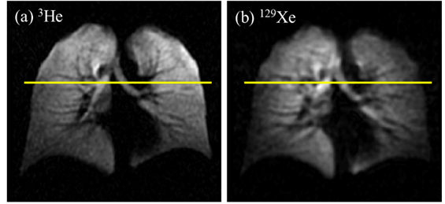
Figure 4.4.1: Illustration of line of interest (LOI) to inspect SNR variation of a particular hyperpolarised gas and its corresponding variation in the flip angle. (a) ³He and (b) ¹²⁹Xe.
The variation in the flip angle measured is 9% for ³He and 3% for ¹²⁹Xe (see section 4.2). Any observed asymmetry beyond what can be attributed to the variation/asymmetry in the flip angle is due to the dynamics of distribution and diffusion of the gas mixture as shown in Table 4.3.1. Though the distribution and diffusion dynamics of ³He and ¹²⁹Xe in a gas mixture needs further investigation, the observed inhomogeneity can be explained as follows considering the ³He and ¹²⁹Xe images from Figure 4.3.2(b) and 4.3.2(c). Consider a line of interest (LOI) across the ³He and ¹²⁹Xe images where the asymmetry is observable as shown in Figure 4.4.1.
Inspecting the variation of signal to noise ratio (SNR) and flip angle along the LOI, we arrive at the profile shown in Figure 4.4.2. As we observe in Figure 4.4.2 (a) (b), the flip angle variation along LOI is 6.8% for ³He and 2.4% for ¹²⁹Xe (for the 8°~9° flip angle for the ventilation pulse sequence as mentioned in Table 4.3.1). Considering the dual tuned coil is a transmit and receive coil, the sensitivity profile of the received images is modulated twice by the${ B}_{1}$ sensitivity, once during transmit and once during receive. The variation in the sensitivity profile of the coil can be approximated as the square of the flip angle ($\sin{α} ≈ α, ∀α ≈0$). Thus, the variation in sensitivity profile of the dual-tuned coil is 13% for ³He and 4.8% for ¹²⁹Xe (for 8°~9° flip angle for ventilation pulse sequence as mentioned in Table 4.3.1).
Interestingly, when we compare the ${ B}_{1}$ normalised SNR profile of ³He and ¹²⁹Xe along the line of interest, we observe that the SNR profile is comparable in the right lung. However in the left lung, the SNR profile of ³He and ¹²⁹Xe are mutually complimenting each other. Where the ¹²⁹Xe SNR reduces as we move towards the left direction (45-55mm, reference in Figure 4.4.2 (c)), the ³He SNR increases. This indicates a variation in the local concentration of the gases.
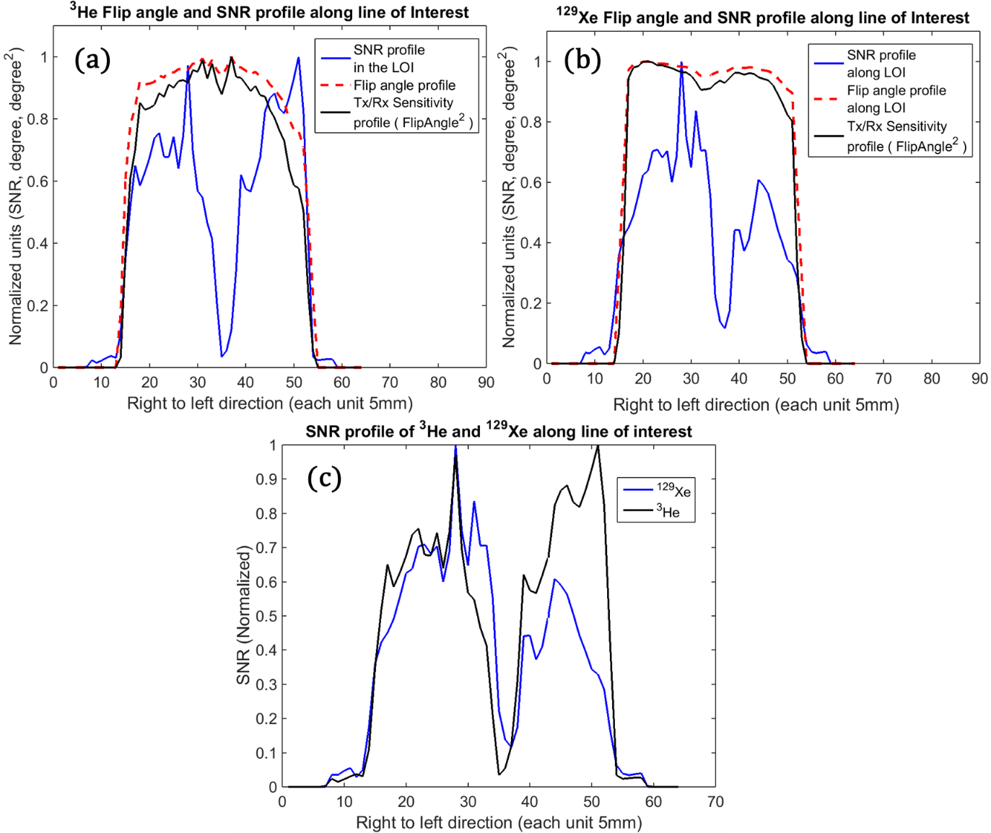
Figure 4.4.2: Signal to noise ratio, flip angle profile and sensitivity profile (considering the dual-tuned coil is a transmit and receive, the sensitivity profile is approximated as square of the flip angle). (a) ³He and (b) ¹²⁹Xe. (c) Comparing SNR profile of ³He and ¹²⁹Xe along the line of interest.
For the purpose of illustration of gas distribution in the lung, the SNR profile of ³He and ¹²⁹Xe was normalised using the maximum signal intensity along the LOI. Further, when the normalised SNR profile of ³He and ¹²⁹Xe was summed along the LOI we observe a homogenous gas distribution from right to left direction as shown in Figure 4.4.3 (a).
The peak in the signal (right lung) is attributed to the right main bronchus and void in the signal (left lung) is due to the presence of the heart. When the SNR profile along the LOI of ¹²⁹Xe in a mixture with ³He (as mentioned in Table 3.4.1) is compared with the SNR profile along the LOI of ¹²⁹Xe imaged when imaged separately as a single inhaled gas (without ³He in the mixture), we observe that the SNR profile is homogenous and the gas is evenly distributed as shown in Figure 4.4.3 (b). Similarly, ³He SNR profile along the LOI is homogenous and the gas is evenly distributed as a single gas (without the ¹²⁹Xe) when compared to the SNR profile along the LOI of the image of the mixture with ¹²⁹Xe as shown in Figure 4.4.3 (c). Thus, we attribute the asymmetry observed in the ¹²⁹Xe image to be primarily due to gas distribution. These findings are highly interesting from the perspective of lung physiology and would never have been elucidated without a custom dual-tuned lung RF coil allowing same-breath imaging of a ³He-¹²⁹Xe gas mixture. These findings are currently being investigated in future work studying the physiology of gas mixing in the lung with the two gases.
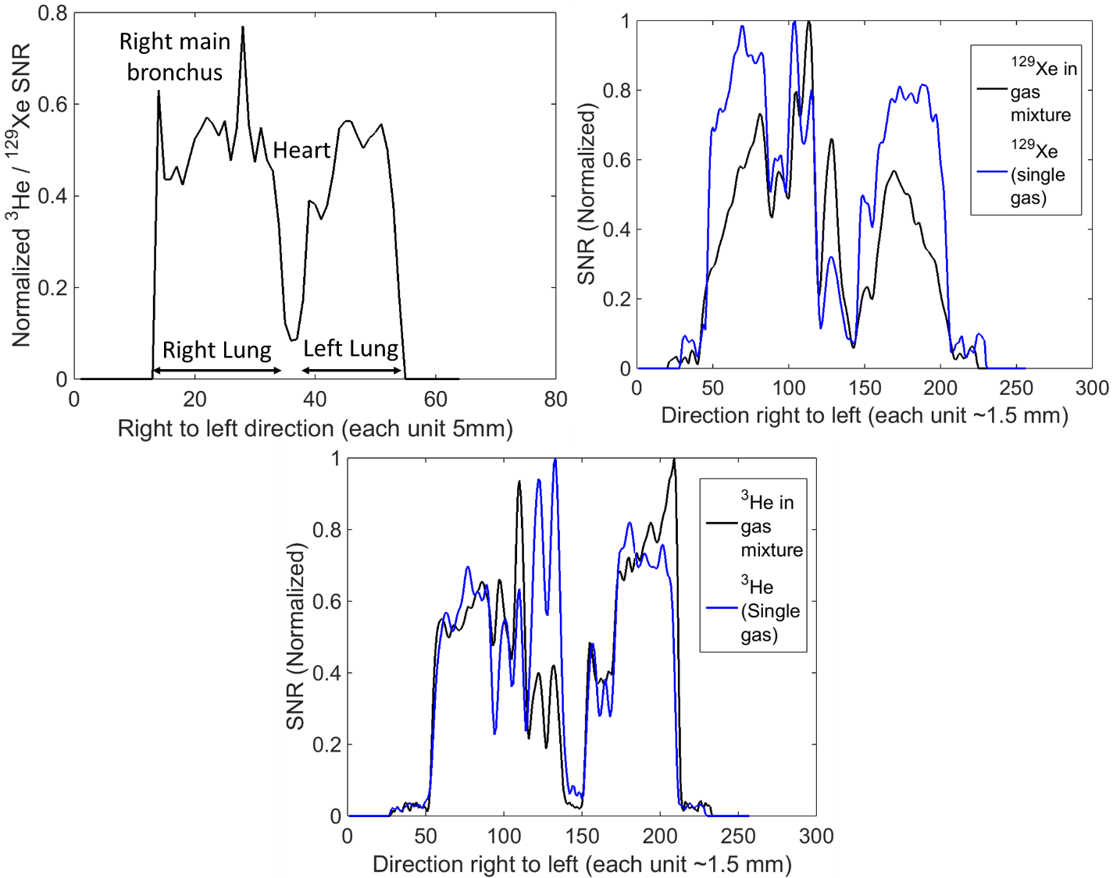
Figure 4.4.3: (a) Summation of normalised ³He and ¹²⁹Xe SNR accounted for the volume fraction indicating homogenous gas distribution, (b) comparison of SNR profile of ¹²⁹Xe in a mixture with ³He and as a single gas and (c) comparison of SNR profile of ³He in a mixture with ¹²⁹Xe and as a single gas.
The free diffusion coefficient of ³He in air is 0.88 cm²s⁻¹ (53,244), in this study of same-breath ADC of the gas mixture we report 0.85 cm²s⁻¹ for ³He in the trachea (approximated for free-diffusion). The free diffusion of ¹²⁹Xe is 0.14 cm²s⁻¹ (53), in this study we report 0.22 cm²s⁻¹ for ¹²⁹Xe in the trachea. It is assumed that the higher measured ADC value for ¹²⁹Xe in the trachea, we presume is due to its mixture with the highly diffusive ³He (245). Future work is to study the diffusion coefficients of ³He and ¹²⁹Xe with the variation in gas mixture and multi-nuclear multi-breath washout.
In contrast to previous triple-nuclear same-breath lung imaging experiments which were demonstrated at 3T on a Philips system using the ¹H body T-R coil, a ³He birdcage T-R coil and a nested ¹²⁹Xe T-R vest coil (82), the design used in this study at 1.5T has several potential benefits. Mainly from the coil perspective, the use of the dual-tuned ³He-¹²⁹Xe coil minimises the number of individually tuned coils and the nested ¹H array improves the ¹H SNR by closer proximity to the lung than the system body coil. Future applications of this triple-nuclear RF system for clinical lung MRI and research on lung physiology are manifold and allow the different physical and physiological properties of the two gases to be explored in the same time course with added provision of high-quality and co-registered ¹H structural images.

- Spectroscopy and MR imaging of hyperpolarised ¹²⁹Xe dissolved in human brain
  - Introduction
Hyperpolarised (HP) ¹²⁹Xe when inhaled in the lungs, promptly dissolves (diffuses) into the blood by diffusive gas exchange across the alveolar-capillary membrane (4,29,55,246,247). The fraction that dissolves in the blood is determined by the blood-gas partition coefficient of xenon (24,248) and the ratio of ventilated (tidal) volume to pulmonary blood volume (47). In addition, the amount of HP ¹²⁹Xe dissolved also depends on the capillary perfusion and the gas exchange surface determined by factors such as alveolar structure and lung inflation state. Dissolved HP ¹²⁹Xe is then transported to distal organs through the systemic circulation. The $T_{1}$ relaxation of HP ¹²⁹Xe in the human blood is sufficiently long to be detected in distal organs (30,31). Typical values for $T_{1}$ relaxation of HP ¹²⁹Xe in the human blood are 7 s and 2.8 s for arterial (oxygenated) blood and venous (deoxygenated) blood, respectively (31). Figure 5.1.1 provides an illustration of xenon delivery to the brain tissues from the lung.
To understand the kinetics of xenon delivery to the brain tissues, it is necessary to understand the cerebral blood circulation. Ibaraki et al (249) have summarised the measurement of mean transit time (${MTT}_{b}$) of blood in the brain through tracer kinetic theory. Though earlier studies (250-256) have reported a wide ranges of values for the cerebrovascular${ MTT}_{b}$ from 2 s to 8 s, recent studies (249,257,258) have measured more consistent values for the cerebrovascular${ MTT}_{b}$ between 3.5 s and 4.5 s. The${MTT}_{b}$ is sufficiently long to allow ¹²⁹Xe to diffuse (dissolve) into different compartments of the brain from the cerebral blood supply. When dissolved in the human brain, ¹²⁹Xe exhibits a wide range of chemical shift providing distinct resonances that have been attributed to brain tissue (grey matter, white matter), fluids (cerebrospinal fluid, body interstitial fluid), lipids, muscle and blood (29,34-36,120-123).
Exploiting the chemical shift property of ¹²⁹Xe, this chapter compiles novel experimental methodology and results that establish HP ¹²⁹Xe as an imaging agent for imaging brain tissue gas uptake (HP ¹²⁹Xe dissolved in grey and white matter). As the ¹²⁹Xe is delivered to the brain by cerebral blood circulation, applications of dissolved xenon brain imaging could be in the evaluation of brain ischemia, vascular abnormality and brain tumour perfusion.
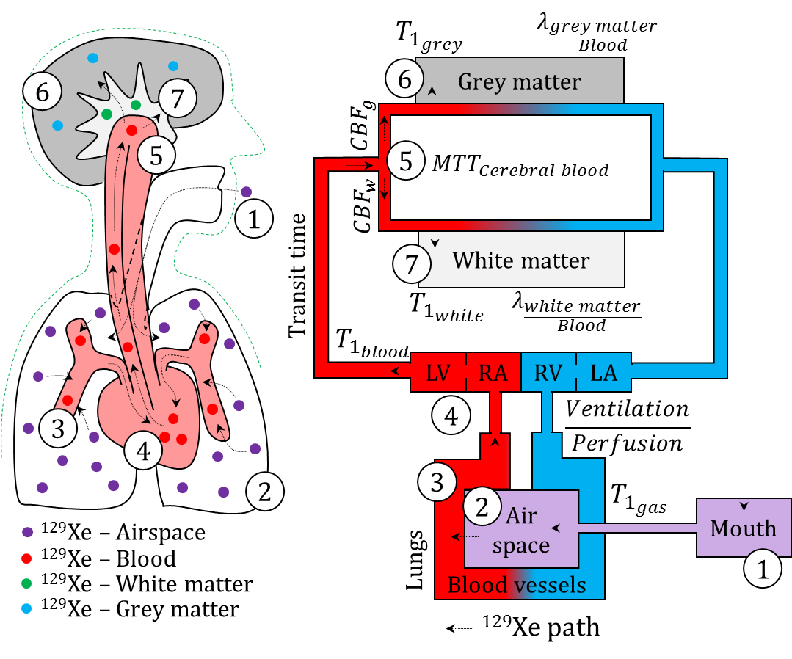
Figure 5.1.1: Schematic representation of xenon (HP ¹²⁹Xe) inhaled in the lungs and transferred to the brain tissue. Legends: (1) HP ¹²⁹Xe inhaled, (2) HP ¹²⁹Xe reservoir in the lungs, (3) HP ¹²⁹Xe dissolved in blood, (4) HP ¹²⁹Xe transferred to the distal organs through systemic circulation, (5) HP ¹²⁹Xe dissolved in cerebral blood, (6) HP ¹²⁹Xe dissolved in grey matter and (7) HP ¹²⁹Xe dissolved in white matter. $T_{1_{gas}}$ is the $T_{1}$ relaxation time of HP ¹²⁹Xe (gas-phase) in the lung reservoir. $T_{1_{blood}}$ is the $T_{1}$ relaxation time of HP ¹²⁹Xe dissolved in arterial blood. $T_{1_{grey}}$and $T_{1_{white}}$ are the $T_{1}$ relaxation times of HP ¹²⁹Xe dissolved in grey matter and white matter respectively. ${CBF}_{g}$ is the cerebral blood flow for grey matter. ${CBF}_{w}$ is the cerebral blood flow of white matter. ${MTT}_{Cerebral blood}$ is the mean transit time for cerebral blood in the brain. $λ_{\frac{Blood}{Gas}}$ is the Oswald’s solubility blood-gas partition coefficient of xenon. $λ_{\frac{Grey matter}{Blood}}$ and $λ_{\frac{White matter}{Blood}}$ are the Oswald’s solubility grey matter - blood and white matter – blood partition coefficient of xenon.

  - Birdcage transmit-receive RF coil for ¹²⁹Xe for brain (head) application

Design of birdcage RF coil
For the construction of the RF coil, a rigid mechanical former was recycled from an obsolete ¹H birdcage head coil. An 8-leg birdcage coil of band pass topology was constructed with 289.5 pF (270 pF + 18 pF + 1.5 pF) on the legs and 1000 pF on the end ring as shown in Figure 5.2.1 (a). The birdcage coil was driven in quadrature mode. The end ring diameter was 305 mm and length of the legs were 300 mm as shown in Figure 5.2.1 (b). The capacitors used on the birdcage RF coil were of 10C package (Dalian Dalicap Technology Co., Ltd, Dalian, China). For the application a plastic foam was used to position the head in the centre of birdcage as shown in Figure 5.2.1 (c).
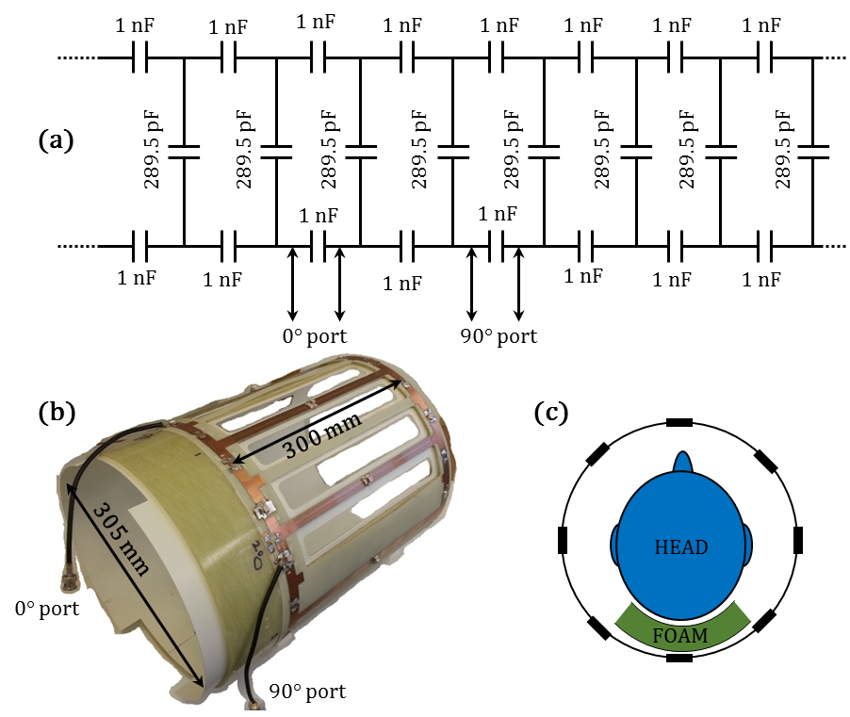
Figure 5.2.1: (a) Schematic of the ¹²⁹Xe head birdcage RF coil, (b) Photograph of the ¹²⁹Xe head birdcage RF coil and (c) Application of the ¹²⁹Xe head birdcage RF coil whereby, the subject’s head is positioned with help of a plastic foam. Manuscript accepted, DOI:10.1002/mrm.26241.

RF measurements of birdcage RF coil
RF measurements were performed with an Agilent 5061B Network Analyser (Keysight Technologies, Santa Rosa, CA). The Q factor of the birdcage RF coil in the unloaded condition was 270 and in the loaded condition was 86. Thus, the ratio of Q factor in the unloaded condition to loaded condition was 3.1. The isolation (transfer coefficient, S_{ij}, (i≠j)) between the in-phase and the quadrature-phase ports of the birdcage RF coil was -15 dB.

Flip angle measurement of birdcage RF coil
The RF power required for the desired flip angle was calculated based on a standard calibration procedure, whereby the rate of depletion of polarisation is calculated from the decay of signal resulting from a set of hard RF pulse-acquires of equal amplitude. To calculate the variation in flip angle, a tube with 6 mm inner diameter was filled with HP ¹²⁹Xe and positioned laterally to the RF coil as shown in photograph in Figure 5.2.2 (a).
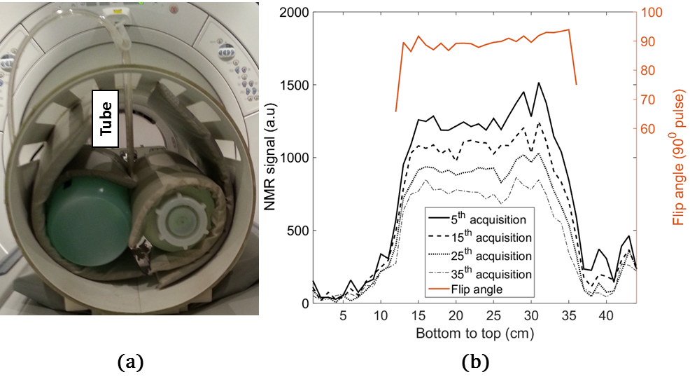
Figure 5.2.2: Flip angle measurement of the RF birdcage coil. (a) A tube with 6 mm inner diameter filled with HP ¹²⁹Xe and positioned laterally to the RF birdcage coil and (b) Depletion of polarisation at 5th, 15th, 25th and 35th RF pulse, and flip angle profile for a 90° RF pulse. Manuscript accepted, DOI:10.1002/mrm.26241.
The length of the tube was 36 cm and covered the whole width (diameter) of the RF coil. With spatial encoding applied only in the frequency encoding direction (anterior to posterior) using a fast spoiled gradient echo sequence, a flip angle profile along the diameter of the RF coil was calculated by measuring the depletion of polarisation of the HP ¹²⁹Xe at each voxel (along the tube) as shown in Figure 5.2.2(b). Acquisition parameters were, ¹²⁹Xe at 25% polarisation (87% of Xe is ¹²⁹Xe), TE = 3.6 ms, TR = 18.9 ms, matrix = 1 (phase) X 44 (frequency), slice thickness = 200 mm, number of slice = 1 and field of view = 44. Flip angle was measured in the axial plane (2D) with a fast spoiled gradient echo pulse sequence that lasted 2.4 s. 39 repeated acquisitions were performed.$T_{1}$ relaxation and gas diffusion-related signal modulation was neglected when calculating the flip angle. Figure 5.2.2(b) shows the depletion of polarisation at the 5th, 15th, 25th and 35th RF pulse. For a 90° RF pulse, the standard deviation of the flip angle was 5.9° or 6.56 %. The flip angle profile for a 90° RF pulse is shown in Figure 5.2.2 (b).

Discussion
This prototype birdcage RF coil did not have ¹H traps fitted (or equivalent), which restricted the use of high power with the ¹H body coil with this coil in situ. Future work is to add detuning circuits in order to make the coil compatible with a ¹²⁹Xe receiver array RF coil.
  - Spectroscopy and Chemical Shift imaging of HP ¹²⁹Xe dissolved in human brain
All of the in-vivo imaging with ¹²⁹Xe was performed with approval from the National Research Ethics Committee under a protocol for the evaluation of novel MRI methods to image xenon in the lungs, brain and heart of volunteers. MRI experiments were performed on a GE whole body 1.5 T Signa® HDx system using a home-built quadrature birdcage coil described in the previous section. Experiments were conducted following inhalation of xenon from 1L Tedlar bags. The ¹²⁹Xe gas was polarised with spin exchange optical pumping (237). In vivo experiments were conducted on 3 healthy make volunteers with the mean age of 29 years and standard deviation of 3 years.

¹²⁹Xe gas-phase resonance frequency
To measure the chemical shift characteristics of the different compartments of hyperpolarised ¹²⁹Xe dissolved in the brain (tissue, blood, interstitial fluid), it was first essential to establish the Larmor (resonant) frequency of ¹²⁹Xe in the gas-phase (in vitro) under typical experimental conditions. With a FID pulse-acquire sequence, hard RF pulse, flip angle ≈ 90° and 2.4 kHz bandwidth centred at 17657300 Hz, a ¹²⁹Xe gas-phase spectrum was acquired. The Larmor frequency of ¹²⁹Xe gas-phase under typical experimental condition was measured to be 17657302.4 Hz as shown in Figure 5.3.1. The chemical shift reported in this research are systematically expressed relative to the Larmor frequency of ¹²⁹Xe measured in the gas-phase at 17657302 Hz (= 0 ppm). Under these typical experimental settings, it should be noted that the position of the gas-phase ¹²⁹Xe Larmor frequency can change with the actual position of the sample within the MR system due to $B_{0}$ inhomogeneity including magnet-object shim and the bulk susceptibility of human subjects.
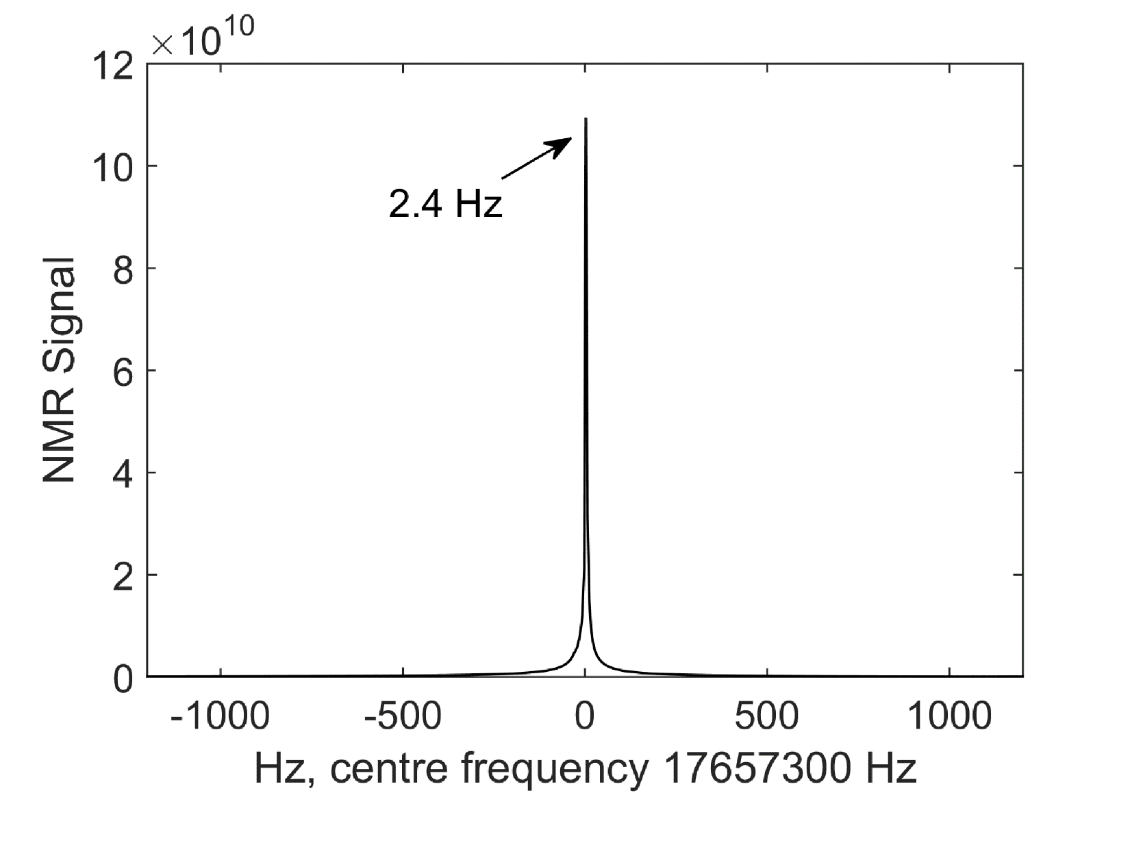
Figure 5.3.1: Larmor frequency of ¹²⁹Xe in the gas-phase measured from the HP ¹²⁹Xe gas in the Tedlar® bag. A single-shot magnitude spectrum acquired with a centre frequency of 17657300 Hz, and the frequency offset of the Larmor (resonant) frequency of ¹²⁹Xe gas-phase is indicated.

High resolution spectroscopy of HP ¹²⁹Xe dissolved in human brain in vivo
Two high-resolution spectra of HP ¹²⁹Xe dissolved in the human (whole) brain were acquired with a FID hard pulse-acquire sequence without slice-selection on the RF pulse. For the first spectrum, the xenon gas dose of 1 L (87% of Xe is ¹²⁹Xe with 25~30% polarisation) was administered to the subject by inhalation via a Tedlar® bag. The acquisition was performed under breath-hold commencing immediately after the inhalation of the gas and lasted for 20 s thereafter. After the inhalation of the gas from the bag, the bag with residual gas was placed on the neck (also near the end-ring of the RF birdcage coil) of the subject in order to obtain a reference HP ¹²⁹Xe gas-phase spectrum. 20 discrete FIDs were acquired with a flip angle of 20° and TR of 1 s between any two consecutive acquisitions. The transmit RF pulse duration was 500 µs with the excitation bandwidth of 2 kHz. The centre frequency of the spectrum was set to 197.93 ppm downfield (17660800 Hz) from the ¹²⁹Xe gas-phase resonance and the receiver bandwidth was 674.16 ppm (11.9 kHz). The spectral resolution was 0.16 ppm (2.9 Hz) with 4096 points in the spectrum. All the 20 spectra thus acquired were corrected for initial phase and averaged (complex spectra) to improve the signal-to-noise ratio (SNR). No spectral line broadening filters were applied. The resulting averaged whole brain spectrum of HP ¹²⁹Xe dissolved in the human brain acquired with 675 ppm receiver bandwidth is shown in Figure 5.3.2 (a).
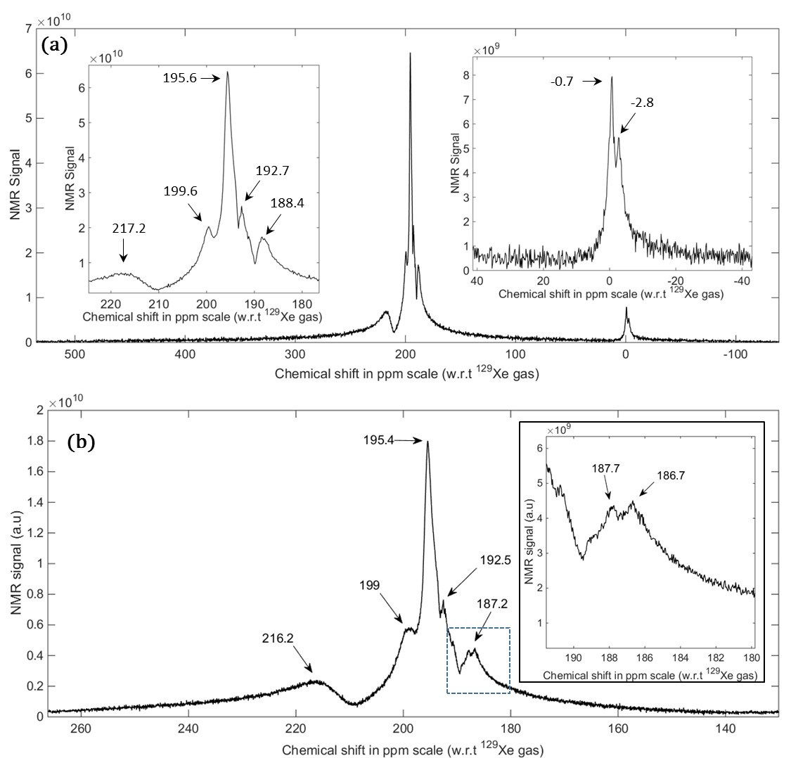
Figure 5.3.2: Magnitude spectra of HP ¹²⁹Xe dissolved in human brain, acquired in vivo.
(a) Averaged spectrum with wide bandwidth (674.16 ppm) and a spectral resolution of 0.16 ppm.
(b) Averaged spectrum with higher resolution (0.033 ppm) and a bandwidth of 136.09 ppm.
Note: (a) and (b) are two separate acquisitions in the same subject. Subject: Male, 31 years. Manuscript accepted, DOI:10.1002/mrm.26241.
The spectrum has two distinct peaks near 0 ppm. The peak at -0.7 ppm is from the Tedlar® bag containing the residual gas. The ¹²⁹Xe gas-phase resonance differs by -0.7 ppm (instead of 0 ppm) due to $B_{0}$ inhomogeneity as the Tedlar® bag is not positioned at the isocentre and due to bulk susceptibility shifts related to the subject’s head. The peak at -2.8 ppm is from ¹²⁹Xe gas in the lungs is due to a combination of effects, including; bulk magnetic susceptibility shift effects (246), the chemical shift associated with mixing with oxygen (259), and the fact that while an average adult head is positioned at the isocentre of the static magnetic field${ B}_{0}$, the lung will eventually lie far away from the isocentre at a lower static magnetic field strength than the isocentre and would experience a lower Larmor frequency. Near the centre frequency of the spectrum, there are 5 distinct dissolved ¹²⁹Xe peaks (188.4 ppm, 192.7 ppm, 195.6 ppm, 199.6 ppm and 217.2 ppm).
For the second spectrum, the xenon gas dose for the acquisition was 1 L (87% of Xe is ¹²⁹Xe with 25~30% polarisation). The acquisition was performed under breath-hold, commencing 4 s after the inhalation of the gas and lasted for 20 s thereafter. 10 discrete FIDs were acquired with TR of 2 s between any two consecutive acquisitions. The flip angle was 45°. The transmit RF pulse duration was 500 µs with the excitation bandwidth of 2 kHz. The centre frequency of the spectrum was at 197.93 ppm downfield (17660800 Hz) from ¹²⁹Xe gas-phase resonance and the receiver bandwidth was 136.09 ppm (2403 Hz). The spectral resolution was 0.033 ppm (0.58 Hz) with 4096 points in the spectrum. The 10 spectra were corrected for initial phase and the complex spectra were averaged. No spectral line broadening filters were applied. The averaged whole brain spectrum HP ¹²⁹Xe dissolved in the human brain with 0.033 ppm resolution is shown in Figure 5.3.2 (b). The spectrum has several peaks at 216.2 ppm, 199 ppm, 195.4 ppm, 192. 5 ppm and 187.2 ppm. On closer inspection, it can be seen that the peak at 187.2 ppm is actually made up of two closely spaced peaks at 186.7 ppm and 187.7 ppm.

Chemical-shift imaging and association to chemical environment
In order to associate the observed chemical shifts to the particular dissolved-phase compartment in the human brain, the spectrum was spatially resolved with a 2D axial, sagittal and coronal chemical shift imaging (CSI) experiments. Phase-encoding was applied in the anterior-posterior and right-left direction for the axial plane, anterior-posterior and superior-inferior direction for the sagittal plane and right-left and superior-inferior direction for the coronal plane. FIDs were acquired for each of the phase-encode steps with a pulse-acquire sequence without slice selection. The transmit RF pulse duration was 500 µs with the transmitter bandwidth of 2 kHz. The delay time incurred by the phase encode gradient was 1592 µs (including 296 µs of ramp up and ramp down time each). The centre frequency of the spectrum was 197.93 ppm downfield (17660800 Hz) and the receiver bandwidth was 136.05 ppm (2403 Hz). The spectral resolution was 2.1 ppm with 64 sample points per spectrum. The flip angle was 10° and TR was 45 ms. The matrix size of 12 x 12 and FOV of 24 cm resulted in 144 phase-encoded spectra at an in-plane voxel resolution of 2 cm x 2 cm over the FOV.
The xenon gas dose for this acquisition was 1 L (87% of Xe is ¹²⁹Xe with 25~30% polarisation). The acquisition was performed under breath-hold, commencing at 16 s after the inhalation of the gas and lasted for 6.4 s thereafter. For the purpose of illustrating that the SNR of the individual spatially resolved spectra is sufficient for quantitative and qualitative regional spectroscopy, one spatially resolved spectrum (at arbitrary locations) for each of the planes are shown in Figure 5.3.3. As can be observed in Figure 5.3.3, the SNR of individual spatially-resolved spectra is sufficient that the peaks observed at 188 ppm, 192 ppm, 196 ppm, 200 ppm and 217 ppm can be adequately distinguished from each other and are clearly prominent above the noise floor. A rough estimate for SNR, measured as the ratio of the signal of the prominent peak to the standard deviation of the noise floor was 45. The chemical shift values observed here (Figure 5.3.3) are marginally different from the chemical shift values reported in Figure 5.3.2. This is due to the considerable difference in the spectral resolution between the two acquisitions. In addition, it can be observed that some of the known five peaks seen in the whole brain spectrum (from Figure 5.3.2) are absent in each of the spectra in Figure 5.3.3. This is indicative that the particular solvent (compartment, chemical environment) that would provide that particular chemical shift value (peak) is not present at that particular voxel location. Spatially resolved spectra from 2D chemical shift imaging (axial, sagittal and coronal plane) of HP ¹²⁹Xe dissolved in the human brain superimposed on reference ¹H images are shown in Figure 5.3.4 (a), (b) and (c).
For the purpose of association of a particular chemical shift value to a particular brain compartment (solvent), the peaks (at chemical shift value of 188 ppm, 192 ppm, 196 ppm, 200 ppm and 217 ppm) from the spatially resolved spectra were used to produce a chemical shift image superimposed (using colour) on a reference ¹H image. Each pixel of the HP ¹²⁹Xe chemical shift image represents the maximum value of a particular chemical shift peak at that spatial location. A threshold (higher than noise floor) was applied on the 2D CSI images of dissolved HP ¹²⁹Xe to eliminate background noise. The threshold for each of the 2D CSI images were determined and applied individually.
¹H brain images were also acquired (in each of the three planes) with an inversion recovery gradient echo pulse sequence in a separate scan with the same (24 cm) FOV as the 2D chemical shift images of dissolved HP ¹²⁹Xe. The imaging parameters were, TE = 5.2 ms, TI = 450 ms, TR = 12.4 ms, bandwidth = 15.6 kHz, slice thickness = 1.6 mm and matrix size = 512 X 512.
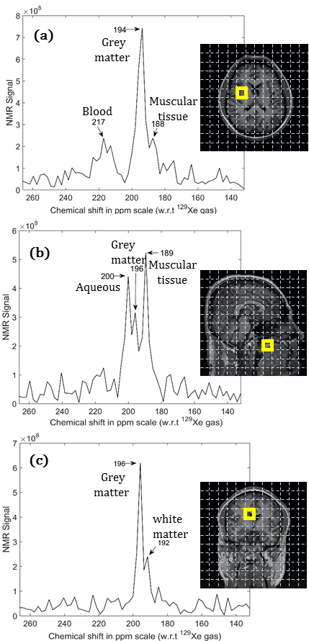
Figure 5.3.3: Individual spectra from the 2D chemical shift imaging experiment at different (arbitrary) locations in the head. (a) Axial plane spectrum, where peaks at 188 ppm, 194 ppm and 217 ppm were present, (b) sagittal plane spectrum, where peaks at 189 ppm, 196 ppm and 200 ppm were present and (c) Coronal plane spectrum, where peaks at 192 ppm and 196 were present. Subject: Male, 31 years. Manuscript accepted, DOI:10.1002/mrm.26241.
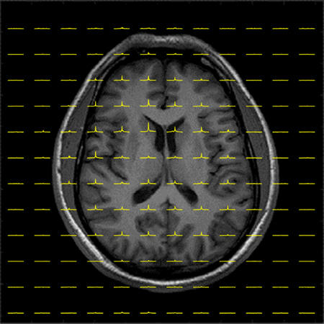
Figure 5.3.4 (a): Spatially resolved spectra from axial 2D chemical shift imaging of HP ¹²⁹Xe dissolved in the human brain superimposed on ¹H reference image. Subject: Male, 31 years. Manuscript accepted, DOI:10.1002/mrm.26241.
Figure 5.3.4 (b): Spatially resolved spectra from sagittal 2D chemical shift imaging of HP ¹²⁹Xe dissolved in the human brain superimposed on ¹H reference image. Subject: Male, 31 years. Manuscript accepted, DOI:10.1002/mrm.26241.
Figure 5.3.4 (c): Spatially resolved spectra from coronal 2D chemical shift imaging of HP ¹²⁹Xe dissolved in the human brain superimposed on reference ¹H image. Subject: Male, 31 years. Manuscript accepted, DOI:10.1002/mrm.26241.
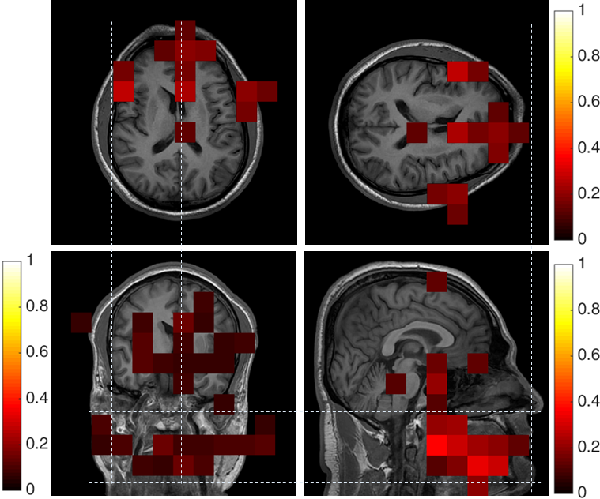
Figure 5.3.5: Peak at 188 ppm (muscular tissue) spatially resolved and superimposed (colour) on ¹H reference image (grey scale) in all the three planes. Colour bars represent arbitrary units normalized to the maximum NMR signal intensity of hyperpolarized ¹²⁹Xe dissolved in the grey matter. Subject: Male, 31 years. Manuscript accepted, DOI:10.1002/mrm.26241.
Based on the anatomical distribution of the signals, we propose the association of each individual peak to a chemical environment (compartment of the brain) as follows:
188 ppm: From Figure 5.3.5, the peak at 188 ppm appears to be most intense in the anterior region in the axial plane. The sagittal plane image indicates that most of the signal from this peak arises from regions below the eyes, above the jaw and between the nose and ears. In the coronal plane image, it is clear that the intensity is approximately symmetric on both sides of the head (right and left). In addition, this image shows that some fraction is located at the midbrain/brain stem. From Figure 5.3.5, the peak at 188 ppm is made up of two closely spaced peaks. Thus, we allocate the peak at 188 ppm to HP ¹²⁹Xe dissolved in the tissue in cheek muscle and the tissue in the midbrain/brain stem, consistent with earlier studies (34,36,37).
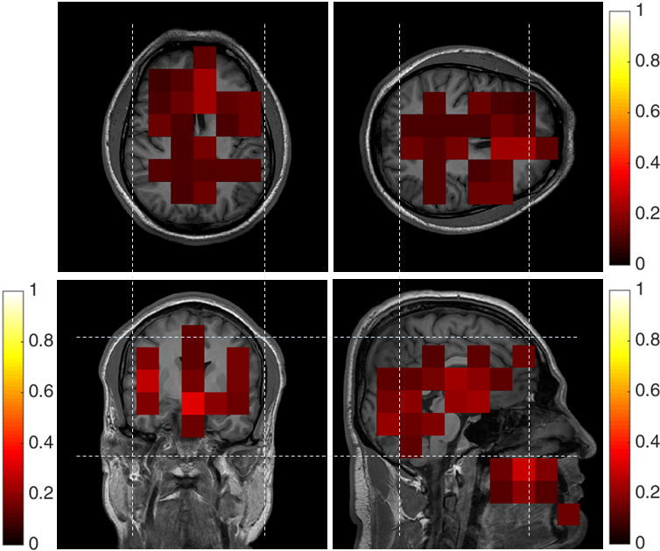
Figure 5.3.6: Peak at 192 ppm (white matter) spatially resolved and superimposed (colour) on ¹H reference image (grey scale) in all the three planes. Colour bars represent arbitrary units normalized to the maximum NMR signal intensity of hyperpolarized ¹²⁹Xe dissolved in the grey matter. Subject: Male, 31 years. Manuscript accepted, DOI:10.1002/mrm.26241.
192 ppm: From Figure 5.3.6, it can be observed that the peak at 192 ppm appears to be predominantly arising from ¹²⁹Xe dissolved in the brain, both supra and infra-tentorial. In the axial plane, the peak at 192 ppm is most intense in the cerebral hemisphere with visible tracts. Similarly, in the coronal plane image, the peak at 192 ppm appears to be most intense in the central brain, again with visible tracts. In the sagittal plane image, in addition to cerebrum, the peak at 192 ppm arises from ¹²⁹Xe dissolved in the nasal cavity and lip. Thus, it can be postulated that the peak at 192 ppm is contributed to by HP ¹²⁹Xe dissolved in white matter (Commissural and Projection tracts) and cartilaginous soft-tissue, consistent with earlier studies (34-36).
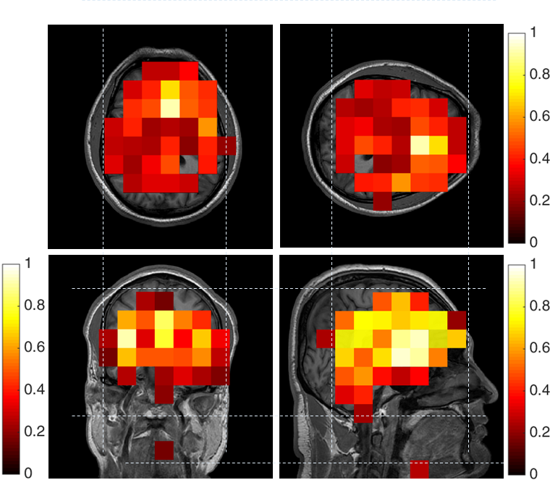
Figure 5.3.7: Peak at 196 ppm (grey matter) spatially resolved and superimposed (colour) on ¹H reference image (grey scale) in all the three planes. Colour bars represent arbitrary units normalized to the maximum NMR signal intensity. Subject: Male, 31 years. Manuscript accepted, DOI:10.1002/mrm.26241.
196 ppm: Figure 5.3.7 shows that the peak at 196 ppm appears to be predominantly composed of ¹²⁹Xe in the brain. It can be clearly seen in all the three planes that the peak not only emanates from the brain but also does not appear anywhere else in the head. Thus it can be concluded that the peak at 196 ppm pertains to HP ¹²⁹Xe dissolved in the grey matter, consistent with earlier studies (34-36).
Figure 5.3.8 shows the spectrum from Figure 5.3.2(b) split into its constituent real and imaginary parts. The spectrum has been corrected for the initial phase of the real part of the spectrum using 195.4 ppm (grey matter) as reference. Unlike the case of an isolated bag of gas, in the human brain in vivo it is necessary to consider that ¹²⁹Xe will continuously exchange with other compartments of the brain with which it shares a gas exchange pathway (cerebral blood, white matter, body interstitial fluid and cerebrospinal fluid). Existence of any such chemical exchange will broaden the line width of the peaks pertaining to the regions under exchange (20,260). Nevertheless, under these conditions the FWHM of the spectrum will provide a lower limit estimate of${ T}_{2}^{*}$ for the whole head. The FWHM of the peak (grey matter) was 36 Hz, which would mean${ T}_{2}^{*}≥8.8 ms$.
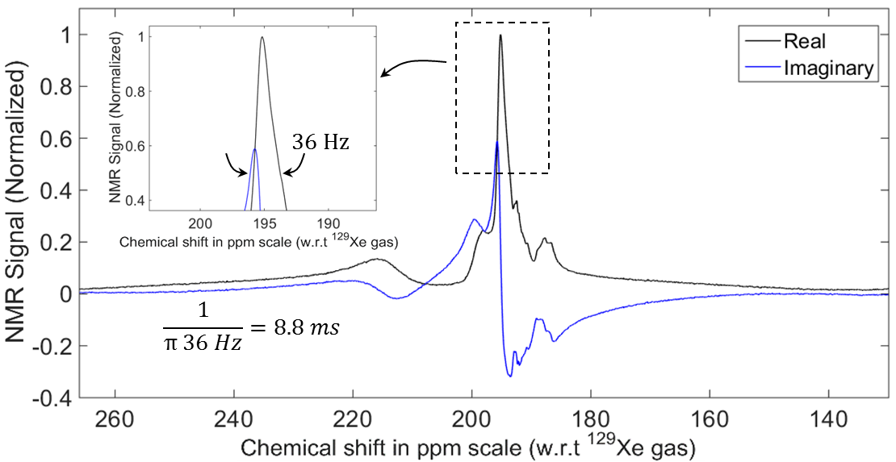
Figure 5.3.8: Phase-corrected real and imaginary parts of the spectrum of HP ¹²⁹Xe dissolved in human brain in vivo with a spectral resolution of 0.033 ppm and bandwidth of 136.09 ppm. Manuscript accepted, DOI:10.1002/mrm.26241.
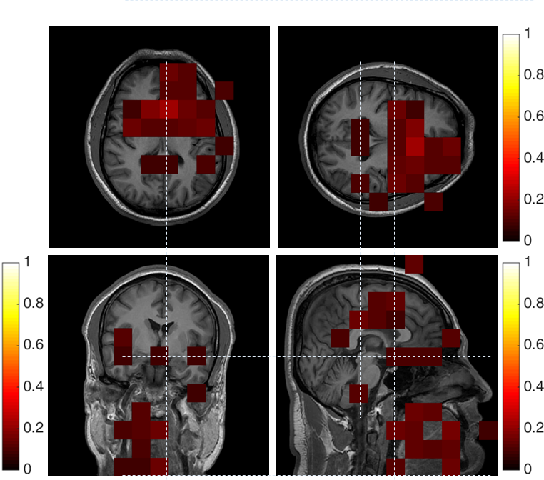
Figure 5.3.9: Peak at 200 ppm (fluids, fat outside the brain) spatially resolved and superimposed (colour) on ¹H reference image (grey scale) in all the three planes. Colour bars represent arbitrary units normalized to the maximum NMR signal intensity of hyperpolarized ¹²⁹Xe dissolved in the grey matter. Subject: Male, 31 years. Manuscript accepted, DOI:10.1002/mrm.26241.
200 ppm: From Figure 5.3.9, the peak at 200 ppm appears to be predominantly due to ¹²⁹Xe located in the anterior region of the head, as seen from the axial plane image. In the sagittal plane image, the peak at 200 ppm appears to originate from between the eyes and ears, and extends below towards the jaw. In the coronal plane image, the signal appears to arise from the centre of the head. In all of the three planes the signal associated with peak appears to be arise from the ventricles. The peak at 200 ppm represents HP ¹²⁹Xe dissolved in interstitial fluid, cerebrospinal fluid and fat outside the brain, consistent with earlier studies (27,28,34,36).
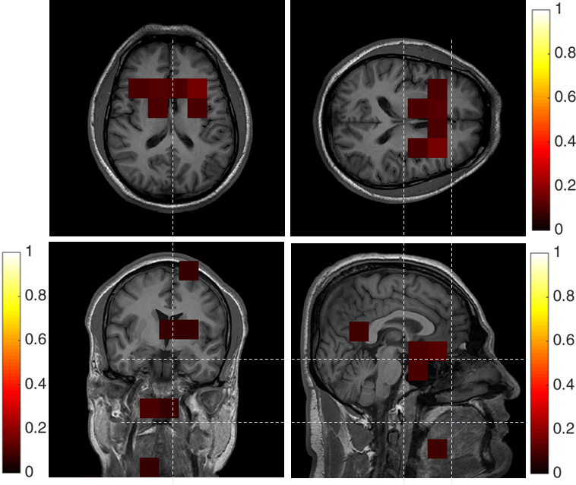
Figure 5.3.10: Peak at 217 ppm (red blood cells) spatially resolved and superimposed (colour) on ¹H reference image (grey scale) in all the three planes. Colour bars represent arbitrary units normalized to the maximum NMR signal intensity of hyperpolarized ¹²⁹Xe dissolved in the grey matter. Subject: Male, 31 years. Manuscript accepted, DOI:10.1002/mrm.26241.
217 ppm: From Figure 5.3.10, in all the three planes, the only location where the peak at 217 ppm shows considerable signal intensity is at the location of the Circle of Willis and its main branches. The peak at 217 ppm is therefore allocated to HP ¹²⁹Xe dissolved in the RBC in blood, consistent with earlier studies (28-32). Note the broader line width of the peak from RBC is due to exchange with plasma due to the constant contact of the two compartments in the blood. A summary of the peaks observed along with their association is shown in Figure 5.3.11.
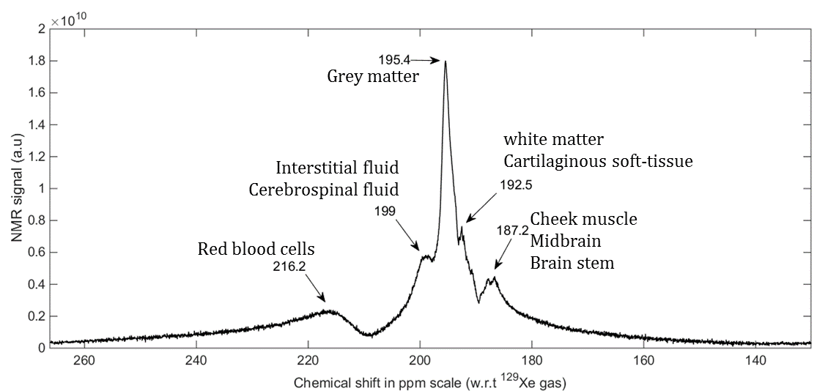
Figure 5.3.11: Spectrum annotated with the peaks of ¹²⁹Xe in the brain.

Discussion
Chemical shift (ppm) | Association in this study | Earlier studies
187.2 | Cheek muscle and brain stem | (34,36,37)
192.7 | White matter and mucus or soft-tissue | (34-36)
195.6 | Grey matter | (34-36)
199 | Aqueous solution (cerebrospinal fluid, body interstitial fluid) | (27,28)
217.2 | Red blood cells | (28-32)
Table 5.3.1: Assignment of different peaks of ¹²⁹Xe dissolved in the human head to particular chemical environments, supported by references to previous works.
This is the first time 5 distinct ¹²⁹Xe peaks have been observed in human brain spectroscopy, earlier studies have observed 5 distinct peaks in rats (34,36), however only one or two peaks have been previously detected from ¹²⁹Xe in the human head at 3.0 T, using spectra of significantly lower SNR than in this study (29,35). In addition, in this study we have observed that one of the five peaks (187.2 ppm) is made up of two closely spaced peaks, a finding that has not been reported before. The association of the chemical shift values to the particular chemical environments in this study is consistent with earlier studies, including in vivo measurements of ¹²⁹Xe in the human and rat brain and in vitro studies of ¹²⁹Xe dissolved in the human blood. Earlier studies have suggested the following peak assignments: peak at 217.2 ppm to red blood cells (28-32), peak at 199.6 ppm to aqueous solution (cerebrospinal fluid, interstitial fluid in this study) (27,28), peak at 195.6 to grey matter (34-36), peak at 192.7 ppm to white matter (and mucus or soft-tissue in this study) (34-36) and peak at 187.2 ppm to muscle (34,36,37). A summary of our proposed peak assignments and relevant references is shown in Table 5.3.1.
The peaks seen in whole brain spectroscopy and their spatial distribution from CSI, were found to be consistent between the subjects as shown in Figure 5.3.12. The SNR of the obtained spectra was found to be somewhat variable between the subjects. Since SNR is limited by the quantity and polarization of ¹²⁹Xe delivered to the brain by the systemic blood circulation, any variability in the polarization of the SEOP process, gas dose inhaled or${ T}_{1}$ losses related to different lung-to-brain transit times will affect the observed SNR. Assessment of these factors, their variability and their effect on measured spectroscopic SNR of dissolved ¹²⁹Xe in the brain is the subject of future work.
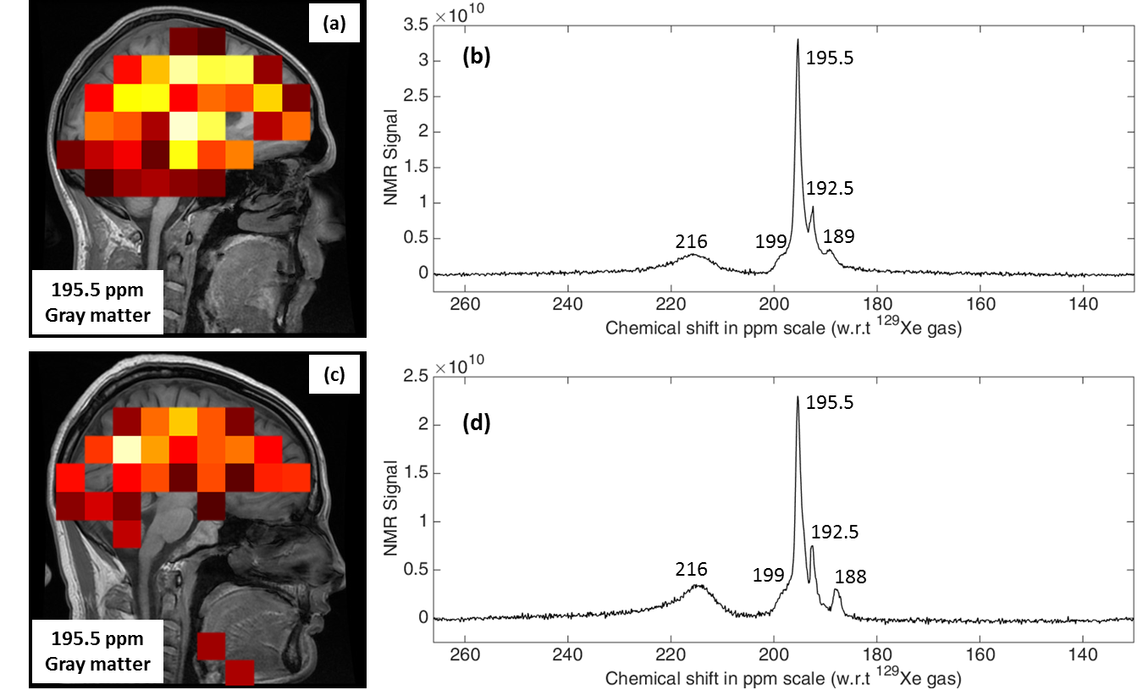
Figure 5.3.12: Chemical shift images of the spectral peak at 195.5 ppm assigned to ¹²⁹Xe dissolved in gray matter, subject: (a) male 25 years and (c) male 30 years. Spectra (real part) of HP ¹²⁹Xe dissolved in the human brain in vivo acquired with same acquisition parameter as high resolution spectrum. Subjects: (b) male 25 years and (d) male 30 years. Manuscript accepted, DOI:10.1002/mrm.26241.

  - Imaging hyperpolarised ¹²⁹Xe dissolved in the human brain
The uptake of HP ¹²⁹Xe into the brain tissue (grey matter) was investigated by acquiring several discrete spectra with low flip angle and low TR (fixed), and then by plotting the peak signal at 195.4 ppm for grey matter as a function of time. This acquisition was performed with an inhaled xenon gas dose of 500 mL (87% of Xe is ¹²⁹Xe with 40~50% polarisation, note the improved polarisation levels to previous experiments due to a new high-power laser). The acquisition was performed under breath-hold, which commenced immediately after the inhalation of the gas and lasted for 50 s thereafter. Without any obligation to hold the breath throughout the acquisition the subject resumed normal breathing after 25 s, half-way through the acquisition. In total, 100 discrete FIDs were acquired with a TR of 0.5 s between any two consecutive acquisitions. The flip angle was 8°. The transmit hard RF pulse duration was 500 µs with an excitation bandwidth of 2 kHz. The centre frequency of the spectrum was at 197.93 ppm downfield (17660800 Hz) from ¹²⁹Xe gas-phase resonance and the receiver bandwidth was 67.89 ppm (1199 Hz). The spectral resolution was 0.26 ppm (4.68 Hz) with 256 points in the spectrum.
The obtained signal from the grey matter peak as a function of time is shown in Figure 5.4.1 (a). During the first 25~30 s (until the subject resumed normal breathing), the signal time course has a cumulative decay which we believed to be determined by the combined mechanisms of $T_{1}$ relaxation of HP ¹²⁹Xe gas in the lung, $T_{1}$ relaxation of HP ¹²⁹Xe dissolved in the blood and grey matter along with polarisation destroyed by every RF pulse. (See next chapter for further details).
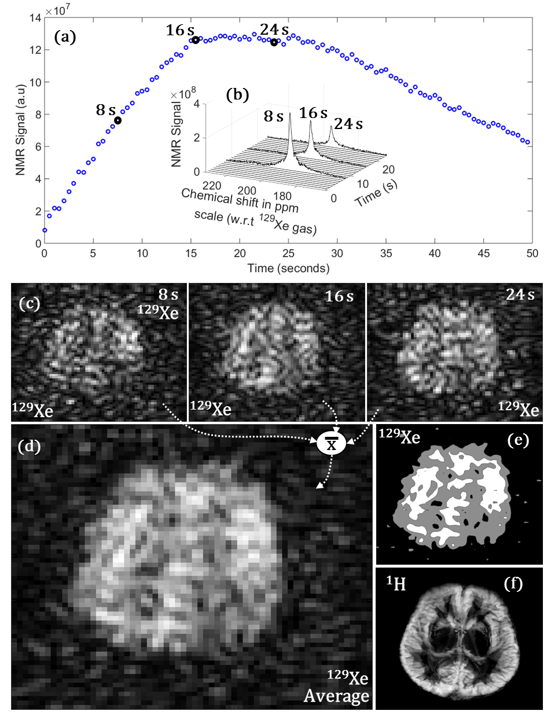
Figure 5.4.1: Imaging HP ¹²⁹Xe dissolved in the human brain in vivo. (a) Time course of signal from HP ¹²⁹Xe dissolved in the grey matter (integrated over ±0.5 ppm), (b) Spectra of HP ¹²⁹Xe dissolved in the brain acquired at 8 s, 16 s and 24 s after inhalation of the gas dose, (c) Spoiled gradient echo images of HP ¹²⁹Xe dissolved in the brain acquired at 8 s, 16 s and 24 s after the inhalation of the gas dose, (d) Average of the three images shown in (c), (e) Image shown in (d) after application of certain thresholds (contours at noise, lower NMR signal intensity and higher NMR signal intensity) and (f) ¹H brain image with contrast for the grey matter (and segmented) for anatomical reference acquired at approximately the same anatomical location as the image in (d). (a) and (b) are separate acquisitions.

Table reference-column | (a) | (b) | (c) | (d)
Subject | M, 31 Y |  |  | M, 24 Y
Gas dosage (ml) | 800 | 1000
Polarisation | 87% of Xe was ¹²⁹Xe with 40~50% polarisation
Number of samples | 3 | 4 | 3 | 4
Time interval between samples (s) | 8 | 6 | 8 | 6
Plane (2D) | Axial |  | Sagittal | Axial
Pulse sequence | SPGRE. Cartesian k-space, centric ordered. Slice selective sinc RF pulse.
Centre frequency (Hz) | 17660800
TE (ms) | 1.7 |  |  | 1.5
TR (ms) | 34 | 8.5 | 34 | 8.5
Flip angle | 12.5° | 14° | 12° | 12.5°
BW (kHz) | 4 |  |  | 8
FOV (cm) | 22
Slice thickness (mm) | 50
Matrix (frequency X phase) | 32 X 32 |  |  | 48 X 48
Number of slices | 1
Corresponding Figure (average) | 5.4.1 (c), (d) | 5.4.3 (b) | 5.4.3 (c) | 5.4.3 (a)
Table 5.4.1: Imaging parameters for the gradient echo sequence used for imaging HP ¹²⁹Xe dissolved in the human brain.
To image the HP ¹²⁹Xe dissolved in the human brain tissue (grey matter), a trade-off between allowing a sufficient time-interval for ¹²⁹Xe to infuse into the brain tissue and the depolarisation of HP ¹²⁹Xe through $T_{1}$ relaxation (in the gas, blood and brain tissue compartment) is needed. Figure 5.4.1 (b) shows 3 discrete spectra acquired with a time-gap of 8 s between pulsing with a 90° flip angle. Other parameters are the same as in the spectroscopy experiments described earlier (Figure 5.4.1 (a)). It is noteworthy that Figure 5.4.1 (b) clearly demonstrates that the power in the spectrum is dominated by the peak of ¹²⁹Xe in grey matter, hence we expect a frequency encoded image to be dominated by this signal. The experiment was then repeated with spatial encoding with the aim of imaging HP ¹²⁹Xe dissolved in the grey matter. Three images of HP ¹²⁹Xe dissolved in the grey matter were acquired with a gradient echo pulse sequence and time-gap of 8 s between the acquisition. The imaging parameters for the acquisition are detailed in Table 5.4.1 column (a). The three images acquired at 8 s, 16 s and 24 s after the inhalation of HP ¹²⁹Xe gas dose under the breath-hold are shown in Figure 5.4.1 (c). To improve the SNR the three time-resolved images were averaged as shown in Figure 5.4.1 (d).
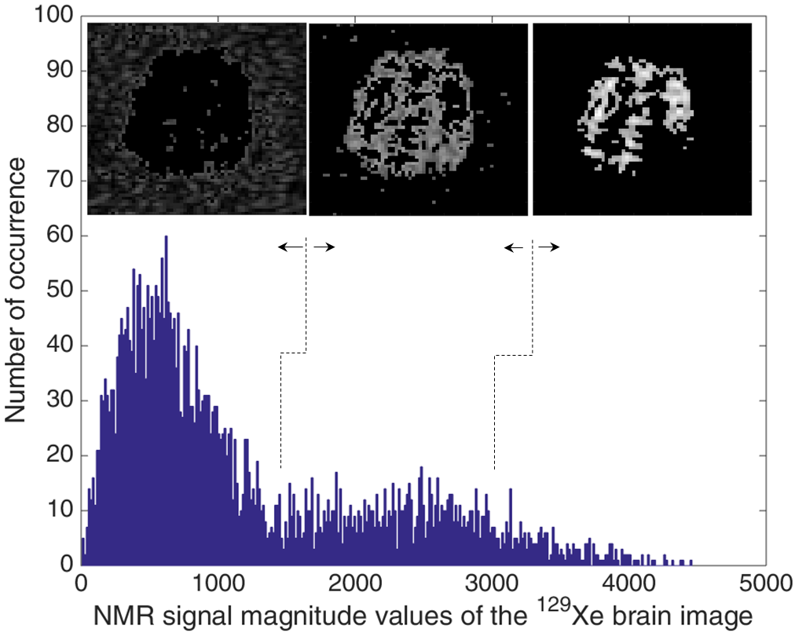
Figure 5.4.2: Illustration of application of thresholds to the image of HP ¹²⁹Xe dissolved in the grey matter. The plot is a histogram of signal intensities in the image. Distribution at lower signal intensities corresponds to noise and thresholding was applied to filter this.
For anatomical reference, ¹H MR images with enhanced contrast for grey matter were obtained with an inversion recovery gradient echo pulse sequence. The imaging parameters were, axial plane, TE = 3.6 ms, TI = 300 ms, TR = 7.72 s (8 echoes), bandwidth = 25 kHz, FOV= 22 cm, slice thickness = 4 mm (38 slices) and matrix size = 352 (frequency) X 224 (phase). The images were further segmented by applying threshold. Of all the slices thus acquired, those slices that corresponded to the anatomical region of the slice acquired for the HP ¹²⁹Xe brain imaging were maximum-intensity projected together to form a single thick slice, for ease of comparison with the HP ¹²⁹Xe brain image as shown in Figure 5.4.1 (f). The axial image of HP ¹²⁹Xe dissolved in grey matter in Figure 5.4.1 (d) and the anatomical reference ¹H image in Figure 5.4.1 (f) are from the same subject, at the same (approximate) anatomical location. When particular thresholds were applied to the image of HP ¹²⁹Xe dissolved in the grey matter (Figure 5.4.1 (d)) as illustrated in Figure 5.4.2, we arrive at the image shown in Figure 5.4.1 (e). By visual inspection, the thresholded image in Figure 5.4.1 (e) matches well with the segmented ¹H anatomical image with contrast to grey matter in Figure 5.4.1 (f).
The repeatability of the experiment was assessed with some variation in the imaging parameters (time-gap between the acquisitions) and additional ¹²⁹Xe brain images were acquired in the axial and sagittal plane. The imaging parameters for additional HP ¹²⁹Xe brain images are detailed in Table 5.4.1(b)-(d). In each of the HP ¹²⁹Xe brain imaging exams, multiple ¹²⁹Xe brain images acquired within the exams were averaged. The images are shown in Figure 5.4.3.
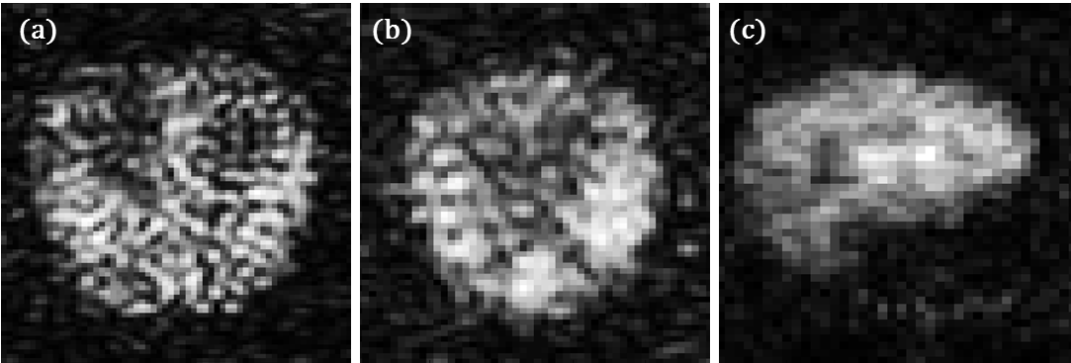
Figure 5.4.3: Images of HP ¹²⁹Xe dissolved in the human brain in vivo acquired in various planes. (a) Axial (subject: male, 24 years), (b) axial (subject: male, 31 years) and (c) sagittal (subject: male, 31 years).

Discussion
Although previous studies have been conducted to image HP ¹²⁹Xe dissolved in rat brain tissue, all the studies were conducted in the anaesthetised state (120-123) with the animals on a steady state constant inhalation of hyperpolarised xenon. It has been observed earlier that the cerebral blood flow (CBF) does not change in rats under stable-anaesthetised state (43,44), unlike in humans. In humans, as xenon infuses into the brain tissue, the cerebral blood flow reduces in grey matter and increases in white matter (25,45). However, a measurable/significant change in human CBF is only observed when the subject is in a stable anaesthetised state, which requires 30 minutes of continuous breathing of xenon (45). The reduction in CBF is mainly attributed to the decrease in metabolism in the cortex (grey matter) under stable anaesthesia. For the initial few seconds (30~40s) as in the case of the breath hold experiments here, CBF or autoregulation are not affected as the partial pressure of CO₂ and the metabolism in the cortex is unaltered (25,44,46). Thus, it is neither possible to translate the results of earlier studies (120-123) conducted in rats for human clinical studies presented here, nor is it practical to conduct human studies using the same protocol as in the rat studies. The imaging in this study is therefore limited by the quantity of ¹²⁹Xe that is transported and diffused into the brain tissue before the polarisation decays and the spectroscopic experiments performed here served as an empirical basis for the subsequent optimisation of these brain imaging experiments. Furthermore, the lung-to-brain transit time in rodents is much shorter than that in humans, meaning that $T_{1}$ decay due to transit in the blood ($T_{1_{Blood}}$ ≈ 7 s) is less (31). For these reasons imaging xenon in human brain is more challenging from a sensitivity perspective.
The described imaging experiments were weighted towards the detection of grey matter, firstly by weighting the imaging time to the time at which the signal from ¹²⁹Xe in the grey matter peaked in the spectroscopic experiments and secondly by the fact that the signal from grey matter is the dominant peak in the spectrum that is dispersed by frequency encoding. Grey matter is more perfused than any other compartments in the brain (83). As can be observed in Figure 5.4.1(b), though the signal from grey matter (at 196 ppm) dominates the power in the spectrum, a prominent adjacent peak from white matter (at 193 ppm) is evident and these two peaks become spectrally dispersed by the applied imaging gradient. However, considering the imaging parameters shown in Table 5.4.1, bandwidth per pixel is 125 Hz and 166.5 Hz for column (a)-(c) and (d) respectively, and the frequency separation between grey matter and white matter is 53 Hz at 1.5 T, which implies that the spatial shift between the images of these two resonances (grey matter and white matter) is less than a pixel. Previous ¹²⁹Xe studies in rodents were also only able to visualise ¹²⁹Xe in grey matter (120-123). The study here is advantageous as it does not require either the subject to be anaesthetised or to be on respiratory apparatus.
This is the first hyperpolarised medium to be imaged in the human brain which is of a quality required for clinical diagnosis.
Future work is to develop a receiver RF coil array and to repeat the experiments with higher SNR and evaluate xenon brain imaging at 3.0 T. Future applications could have clinical relevance in the diagnosis of brain diseases such as stroke and cerebral ischemia.

- Dynamics of hyperpolarised ¹²⁹Xe dissolved in the human brain
  - Introduction
Xenon is highly soluble in cerebral tissues and fluids such as grey matter, white matter, blood and lipids (22,23,107) with the signal from the dissolved compartments having a discrete chemical shift signature. The movement of xenon between the cerebral blood and brain tissues is by passive diffusion (106,108), and the concentration of xenon in the brain is mainly driven by entropy and the difference in concentration of xenon in the blood and in the brain tissue. Exploiting the diffusivity and solubility properties of xenon, this chapter compiles novel experimental methodology and results that establish HP ¹²⁹Xe as an inhaled hyperpolarised tracer to potentially quantify some of the intrinsic properties of the BBB such as permeability and total surface area. Measuring BBB permeability could shed insight into brain pathophysiology and may help customise drug delivery to the brain (115,261,262).
In Chapter 5, the chemical shifts of xenon dissolved in the different chemical compartments of the human brain were assigned with high-resolution spectroscopy (Figure 5.3.2 (b)) and 3-plane CSI (Figure 5.3.5-10). These experiments were not temporally resolved and thus represent an ensemble average of dissolved xenon distribution in the human brain over a given acquisition time. The dynamics of HP ¹²⁹Xe uptake into the human brain tissue have been studied previously by Kilian et al (35), where the time course of HP ¹²⁹Xe signal in the grey matter and white matter were examined at 3 T with whole-brain spectroscopy, and estimates of the $T_{1}$relaxation of HP ¹²⁹Xe dissolved in these compartments were made. In this chapter, we examine in detail the dynamics of HP ¹²⁹Xe signal uptake in the grey matter and cerebral blood pool and attempt to quantitatively model the transfer of HP ¹²⁹Xe between the two compartments as a means to measure BBB properties.
All of the in-vivo imaging with ¹²⁹Xe was performed with approval from the National Research Ethics Committee under a protocol for the evaluation of novel MRI methods to image xenon in the lungs, brain and heart of volunteers. MRI experiments were performed on a GE whole body 1.5 T Signa® HDx system using the home built quadrature birdcage described in Section 5.2. Experiments were conducted following inhalation of xenon from 1L Tedlar bags. The ¹²⁹Xe gas was polarised to around 30% with spin exchange optical pumping (237).

  - Pulse sequence and characterisation of HP ¹²⁹Xe dynamics

BUSAR (HP ¹²⁹Xe Brain Uptake Saturation And Recovery) pulse sequence
In this study the HP ¹²⁹Xe uptake kinetics is examined using the pulse sequence shown in Figure 6.2.1 (a) and (f). The acquisitions were performed whilst the subject maintained breath hold, which commenced immediately after the inhalation of a HP ¹²⁹Xe gas dose. The acquisition was initialised by the application of two 90° hard RF saturation pulses followed by a spoiler gradient as shown in Figure 6.2.1(a). The purpose of this preparation saturation cycle of the sequence is to completely depolarise the initial amount of HP ¹²⁹Xe dissolved in the brain and other parts of the head, including; mouth, nasal cavity and sinus as shown in Figure 6.2.1(b) and (c). Thereafter, as HP ¹²⁹Xe accumulates in the cerebral blood due to systemic blood circulation from the gas exchange reservoir of the lungs, as shown in Figure 6.2.1(d), the concentration of hyperpolarised ¹²⁹Xe increases in the cerebral blood and reaches its maximum level within the time interval equal to the mean transit time of cerebral blood (${MTT}_{b} ≈4 s$ (249)).
Thus, the time-delay after the preparation sequence and prior to the FID acquisition was chosen to be${ MTT}_{b}$ as shown in Figure 6.2.1(f). After the time-delay (${ MTT}_{b}$) the two compartment model of xenon in cerebral blood and xenon in grey matter separated by the BBB can be represented as shown in Figure 6.2.1(e). Cerebral blood is shown on the left of the BBB and grey matter is shown on right of the BBB in Figure 6.2.1(e). Although exchange of ¹²⁹Xe between the cerebral blood and grey matter occurs during the ${ MTT}_{b}$ waiting period, for simplicity Figure 6.2.1 (e) depicts the ¹²⁹Xe in cerebral blood as freshly infused hyperpolarised ¹²⁹Xe and ¹²⁹Xe in grey matter as depolarised ¹²⁹Xe. The movement of Xe across the BBB is represented by the annotation C and D in the Figure 6.2.1 (b-e), the equation will be discussed in detail later. After the time delay (TR = ${MTT}_{b}$), six successive acquisitions were performed with a hard pulse-acquire sequence as shown in Figure 6.2.1 (f). The transmit RF pulse duration was 500 µs with an excitation bandwidth of 2 kHz. The flip angle for FID acquisition was 90° followed by two additional 90° saturation RF pulses with spoiler gradients as shown in Figure 6.2.1 (f). The purpose of these saturation pulses and spoiler gradients is to depolarise any unknown residual polarisation dissolved in brain tissue. There was no FID acquisition following the 90° destructive RF pulses. Thus, this sequence is referred to as a brain uptake saturation and recovery (BUSAR) pulse sequence.
It is noteworthy that for the purpose of illustration of the efficiency of the depolarisation of residual polarisation following the 90° saturation RF pulse, a separate experiment was conducted in which FIDs were acquired after each 90° saturation RF pulses as shown in Figure 6.2.2. As seen in Figure 6.2.2, after the second saturation RF pulse, all the polarisation of HP ¹²⁹Xe dissolved in all the compartments of the brain/head is destroyed.
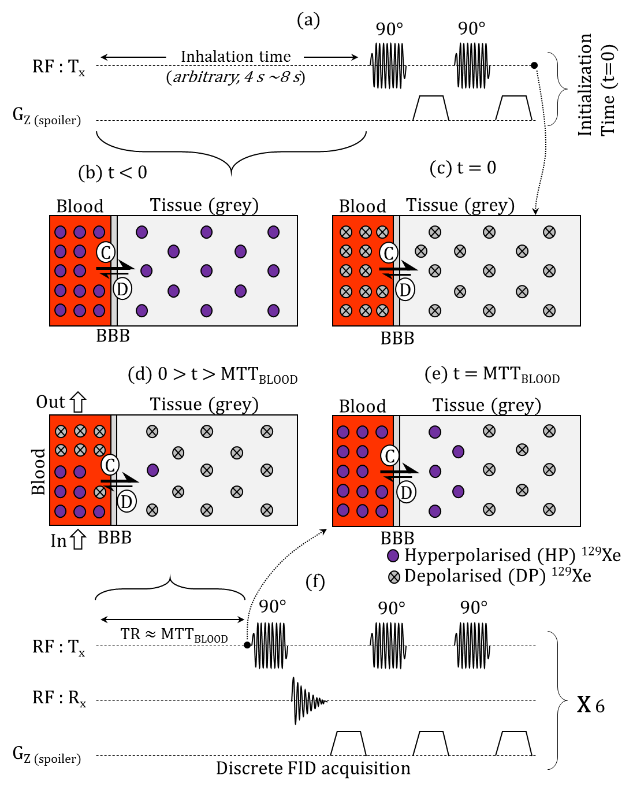
Figure 6.2.1: Schematic of HP ¹²⁹Xe infusing into human brain and illustration of the design of the BUSAR (HP ¹²⁹Xe Brain Uptake Saturation And Recovery) pulse sequence.
(a) Initialisation of BUSAR pulse sequence with two 90° RF destructive pulses.
(b) Schematic representation of an initial (arbitrary) amount of HP ¹²⁹Xe dissolved in the cerebral blood and grey matter before the beginning of the acquisition.
(c) Schematic representation of the depolarisation of the initial (arbitrary) amount of HP ¹²⁹Xe by the saturation pulses of the BUSAR pulse sequence. The dotted arrow indicates the end of the initialisation of the BUSAR pulse sequence, when the initial (arbitrary) amount of HP ¹²⁹Xe is completely depolarised.
(d) Schematic representation of HP ¹²⁹Xe accumulating in the cerebral blood due to the systemic blood circulation and begins to transfer into the grey matter.
(e) Diffusion of HP ¹²⁹Xe from cerebral blood into grey matter across the blood brain barrier and vice-versa.
In (b)-(e), The Solid circle represents HP ¹²⁹Xe and a crossed circle represents depolarised (by 90° RF saturation pulse) ¹²⁹Xe. The annotation ‘C’ and ‘D’ refer to the characteristics of movement of ¹²⁹Xe across the blood brain barrier, representing the two contributions to a change in hyperpolarised ¹²⁹Xe signal (net magnetisation density) in the grey matter. C refers to the movement of HP ¹²⁹Xe from the cerebral blood to the grey matter driven by difference in concentration of xenon in the cerebral blood to the grey matter. This movement results in the increase of concentration of xenon in the grey matter. Although the net movement of xenon is down the concentration gradient, there are also some atoms that move against this gradient due to Brownian diffusion under dynamic equilibrium. D refers to the movement of depolarised xenon across the blood brain barrier against the concentration gradient (from the grey matter to the cerebral blood). In this movement, depolarised ¹²⁹Xe in the grey matter is replaced (exchanged) with the same amount of hyperpolarised ¹²⁹Xe in the cerebral blood. Under this movement, the concentration of xenon in both the grey matter and the cerebral blood is unaffected, however will result in an increase of the net magnetisation density in the grey matter.
(f) Typical BUSAR acquisition. There is an initial time-delay after preparation ($≈{MTT}_{b}$) followed by a FID acquisition using a 90° hard RF pulse and then a spoiler gradient. This sequence of initialisation, delay and acquisition are then repeated 6 times (typical) over the course of the breath-hold.

Time course of signal of HP ¹²⁹Xe
The time course of the signal of HP ¹²⁹Xe dissolved in each compartment (grey matter, white matter, cerebral blood, muscle, CSF, interstitial fluid, as assigned in Chapter 5) was obtained by plotting the spectral peak at the chemical shift relating to the certain brain-compartment along the time axis. The principal compartments of interest in our model outlined in Figure 6.2.1 are HP ¹²⁹Xe gas in; the lung, dissolved in the cerebral blood and dissolved in grey matter. It should be noted that the signal time course obtained in this way presents the dynamics of hyperpolarised ¹²⁹Xe with a sampling interval (TR). This is because once the HP ¹²⁹Xe is depolarised with a 90° RF pulse, the RF coil and receiver system are not sufficiently sensitive to detect the signal from thermally polarised ¹²⁹Xe at these concentrations in the brain.

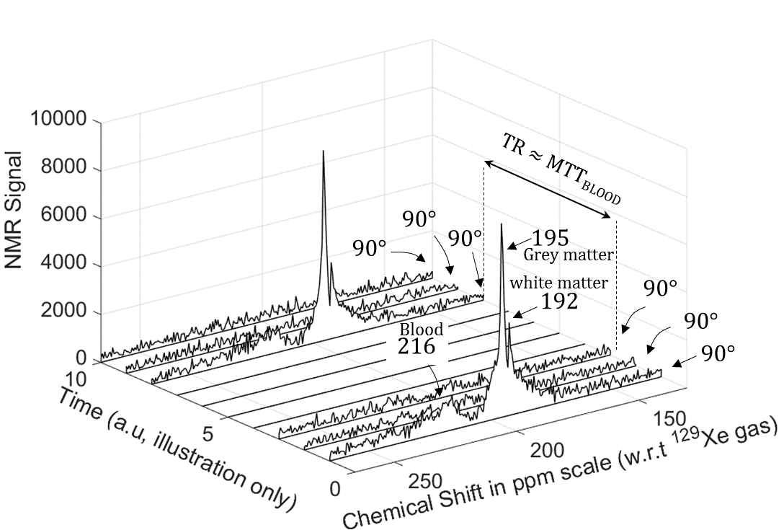
Figure 6.2.2: The result of an atypical acquisition using the BUSAR pulse sequence, whereby FIDs were acquired after each successive 90° saturation RF pulses, in order to demonstrate the depolarisation efficiency of the sequence.
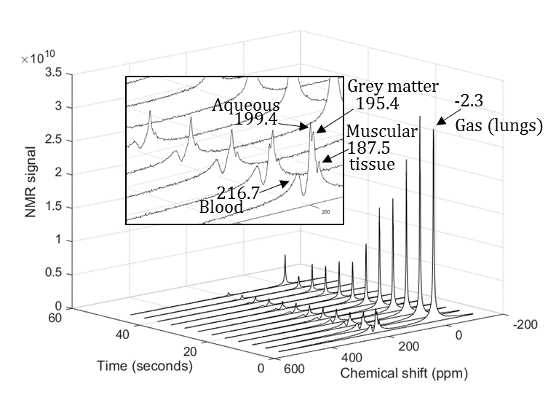
Figure 6.2.3: Time series of magnitude spectra of HP ¹²⁹Xe acquired with the BUSAR pulse sequence, using a wide receiver bandwidth (674.16 ppm, 11.9 kHz) and centred at 197.93 ppm downfield (17660800 Hz) from the ¹²⁹Xe gas-phase resonance

Characterisation of the time course of signal of HP ¹²⁹Xe in cerebral blood
The sensitivity of the RF coil employed in this work is such that with the excitation bandwidth of 2 kHz (transmit RF pulse duration of 500 µs) and a 90° flip angle, the RF coil has a stray $B_{1}$ field that produces around a 4° flip angle in the upper lung and airways of the neck. A wider spectral bandwidth would therefore allow us to detect dissolved-phase HP ¹²⁹Xe in the brain and some gas-phase ¹²⁹Xe signal originating in the upper airways. Using the BUSAR pulse sequence a time series of spectra was acquired at TR = 4 s with a centre frequency of 197.93 ppm downfield (17660800 Hz) from the ¹²⁹Xe gas-phase resonance. The receiver bandwidth was 674.16 ppm (11.9 kHz), which is sufficiently wide to detect the ¹²⁹Xe gas-phase resonance. The spectral resolution was 0.6 ppm (11.62 Hz) with 1024 sample points in the spectrum. The xenon gas dose used for this acquisition was 800 mL (87% of Xe is ¹²⁹Xe with 25% polarisation).
The acquired spectra are shown in Figure 6.2.3, exhibiting 5 distinct peaks which we attribute to blood-RBC (216.7 ppm), CSF/interstitial fluid (199.4 ppm), grey matter (195.4 ppm), muscular tissue (187.5 ppm) and gas-phase in lung (-2.3 ppm). The waterfall plot thus shows the dynamics of the time course signal of HP ¹²⁹Xe in each of the compartments.
As mentioned in Chapter 5, the observed dissolved HP ¹²⁹Xe signal experiences a cumulative polarisation decay which has a contribution from the $T_{1}$ relaxation of the gas-phase reservoir of HP ¹²⁹Xe in the lung, and the ensuing $T_{1}$ relaxation when the xenon is dissolved in the blood enroute to the brain and into the grey matter. Thus we can express the total decay in polarisation due to these cumulative $T_{1}$relaxations pathways as${ e}^{-\frac{t}{T_{1_{gas}}}}$ , ${ e}^{-\frac{t}{T_{1_{gas}}}}{ e}^{-\frac{τ}{T_{1_{blood}}}}$ and ${ e}^{-\frac{t}{T_{1_{gas}}}}{ e}^{-\frac{τ}{T_{1_{blood}}}} \int_{t=0}^{TR}{{ e}^{-\frac{t}{T_{1_{grey}}}}}$
for HP ¹²⁹Xe gas-phase in the lung, HP ¹²⁹Xe dissolved in the blood and the grey matter respectively, where $T_{1_{gas}}$ is the $T_{1}$ of HP ¹²⁹Xe gas-phase in the lung, $T_{1_{blood}}$ is the $T_{1}$ of HP ¹²⁹Xe dissolved in the blood (note that $T_{1_{blood}}$ is an effective $T_{1}$, considering that the blood is a mixture of RBC and plasma), $T_{1_{grey}}$ is the $T_{1}$ of HP ¹²⁹Xe dissolved in the grey matter, $τ$ is the circulation transit time of blood from the lungs to the brain through the left side of the heart, and $TR$ is the repetition time and $i$ is the time interval between HP ¹²⁹Xe diffusing into the grey matter from cerebral blood and the occurrence of the FID acquisition. From these expressions, we observe that ${ e}^{-\frac{τ}{T_{1_{blood}}}}$ and $\int_{i=0}^{TR}{{ e}^{-\frac{i}{T_{1_{grey}}}}}$ are constants if we assume that the blood oxygenation stays constant during these short periods of apnoea and any effect of slight change in blood oxygenation upon $T_{1}$ is negligible. Thus, the signal decay with time experienced by all of the compartments has a term that is proportional to${ e}^{-\frac{t}{T_{1_{gas}}}}$. Figure 6.2.4 (a) shows the time course of the signal of HP ¹²⁹Xe in the gas phase in the upper airways of the lungs and dissolved in the RBC normalised to their respective initial values. We observe that the signal time course from both the compartments follow each other, from which we can deduce that the observed$T_{1}$ of ¹²⁹Xe in the cerebral blood is equivalent to $T_{1_{gas}}$ and the concentration of HP ¹²⁹Xe in the cerebral blood is identical (over the measured time duration).

Repeatability study (Pulse sequence and gas dose)
The dynamics of HP ¹²⁹Xe uptake in the brain was studied by repeated examinations on three healthy subjects with various gas doses as detailed in Table 6.2.1. For all of the acquisitions the centre frequency of the spectrum was observed at 197.93 ppm downfield (17660800 Hz) from the ¹²⁹Xe gas-phase resonance and the bandwidth was 67.89 ppm (1199 Hz). The spectral resolution was 1.06 ppm (18.7 Hz) with 128 number of points in the spectrum. The BUSAR pulse sequence was again acquired with TR of 4 s.
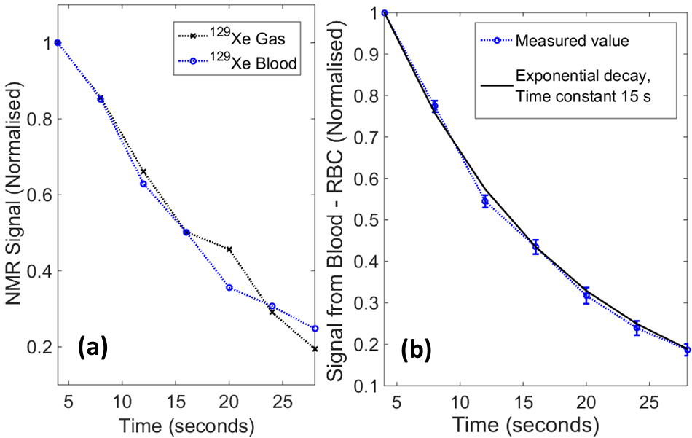
Figure 6.2.4: (a) The time course of signal of HP ¹²⁹Xe in the gas-phase in the lungs and ¹²⁹Xe dissolved in blood normalised to their respective initial values (b) The mean of the time course of signal of HP ¹²⁹Xe dissolved in blood, normalised to the initial value of all the individual examination performed on subject 2 (see Table 6.2.1) along with its standard error. The mean time course of the signal is fitted with by an exponential decay with decay time constant of 15 s.

Subject | Detail | Gas dose | Number of repeated examination
1 | Male, 32 Years | 250ml Xe + 750ml N₂ | 3
 |  | 500ml Xe + 500ml N₂ | 3
2 | Male, 31 Years | 250ml Xe + 750ml N₂ | 3
 |  | 500ml Xe + 500ml N₂ | 4
 |  | 800ml Xe | 1*
3 | Male, 24 years | 500ml Xe + 500ml N₂ | 2
 |  | 700ml Xe | 1*
Table 6.2.1: Details of the subjects, their inhaled gas dose and the number of repeated examinations. (87% of Xe is HP ¹²⁹Xe with 25~30% polarisation). *Bandwidth of the spectrum was 674.16 ppm (11.9 kHz) with the spectral resolution of 0.6 ppm (11.62 Hz) and 1024 points.

Characterisation of time course of signal of HP ¹²⁹Xe in grey matter
The time course of signal of HP ¹²⁹Xe dissolved in the blood and the grey matter was obtained by plotting the area under the peaks in the phased spectrum integrated over a range of ± 0.5 ppm from both HP ¹²⁹Xe dissolved in cerebral blood (¹²⁹Xe_{B}) and grey matter (¹²⁹Xe_{G}) along the time axis. The mean of the spectral signal course of ¹²⁹Xe_{B} from all of the examinations performed on subject 2 (normalised to the initial value) along with the standard error is shown in Figure 6.2.4 (b). The${ T}_{1_{gas}}$ was estimated to be 15 s, as illustrated in Figure 6.2.4 (b). ¹²⁹Xe_{B} is modulated by two factors, firstly, the${ T}_{1_{gas}}$ and secondly, any variation in the blood flow (concentration of ¹²⁹Xe_{B}) would manifest as a deviation from a mono-exponential decay. Thus when ¹²⁹Xe_{G} is de-convolved with the blood signal time course, ¹²⁹Xe_{B}, we arrive at the de-convolved signal ¹²⁹Xe_{G}*, which is compensated for ${ T}_{1_{gas}}$ and any variation in the blood flow (concentration of ¹²⁹Xe_{B}). Thus this time course signal (¹²⁹Xe_{G}*,) is the quantity (amount) of hyperpolarised ¹²⁹Xe which has diffused from cerebral blood into the brain tissue in the BUSAR sequence repetition time (TR), ¹²⁹Xe_{G}* = ¹²⁹Xe_{G}/¹²⁹Xe_{B}. It should be noted that the ratio of the detected spectroscopic signals ¹²⁹Xe_{G}/¹²⁹Xe_{B} does not indicate the volume fraction by itself, but is proportional to it. The mean of ¹²⁹Xe_{B}, ¹²⁹Xe_{G} and ¹²⁹Xe_{G}* (¹²⁹Xe_{G}* normalised to their initial value), of all the examinations performed on subject 2 along with their standard error is shown in Figure 6.2.5. The mean and standard error of ¹²⁹Xe_{G}* is calculated with ¹²⁹Xe_{G}* obtained by de-convolving ¹²⁹Xe_{G} with ¹²⁹Xe_{B} independently for each of the examination.
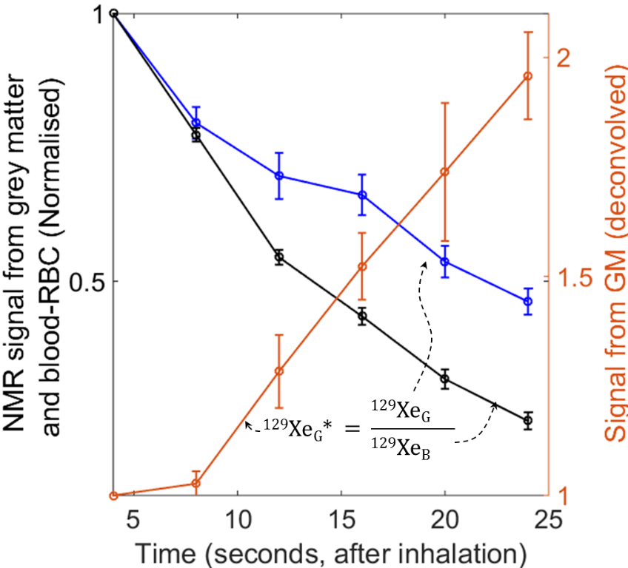
Figure 6.2.5: The mean of ¹²⁹Xe_{B}, ¹²⁹Xe_{G} and ¹²⁹Xe_{G}* (normalised to their respective initial values), of all examinations performed on subject 2 (see Table 6.2.1), along with the corresponding standard error values.
  - Tracer kinetics model for HP ¹²⁹Xe transported across the blood brain barrier

Derivation of tracer kinetics model for HP ¹²⁹Xe dynamics
The ¹²⁹Xe_{G}* signal time course (Figure 6.2.5) can be modelled with tracer kinetics theory developed by Kety et al (248), where in HP ¹²⁹Xe is the tracer and grey matter is the target distal organ. It should be noted that only hyperpolarised ¹²⁹Xe is viewed as the active tracer as depolarised ¹²⁹Xe cannot be detected within the sensitivity limits of the experimental setup.
Within the BUSAR pulse sequence, during the repetition time (TR), fresh (arterial) blood carrying HP ¹²⁹Xe fills the cerebral volume as shown in Figure 6.2.1 (d). Although hyperpolarised ¹²⁹Xe can transfer from the cerebral blood to grey matter at any time, we consider the time instant prior to a new FID acquisition from the perspective of a two compartment model as shown in Figure 6.2.1 (e), where the left compartment is the cerebral blood containing hyperpolarised ¹²⁹Xe and the right compartment is grey matter containing depolarised (DP) ¹²⁹Xe. There will be a diffusive movement of ¹²⁹Xe across the blood brain barrier driven by the xenon concentration gradient from cerebral blood to grey matter. However, since we are measuring the hyperpolarised ¹²⁹Xe signal only, rather than the overall concentration, we must consider two separate contributions to increasing ¹²⁹Xe signal represented by annotations C and D in Figure 6.2.1 (e).
The term C represents the net increase in HP ¹²⁹Xe signal in grey matter due to xenon diffusing down the concentration gradient from the cerebral blood to the grey matter, which results in an increased concentration of xenon in grey matter.
However, whilst the net motion is in the direction from higher concentration to lower concentration, there will be a fraction of xenon atoms that move against this gradient due to entropic Brownian diffusion under dynamic equilibrium. The term D represents the contribution of depolarised ¹²⁹Xe atoms moving against the concentration gradient, which, when replaced by hyperpolarised ¹²⁹Xe does not lead to an overall change in the concentration of xenon in the grey matter, but does lead to an additional increase in net magnetisation of HP ¹²⁹Xe in the grey matter. It is important to note that the signal detected from the grey matter is always the hyperpolarised ¹²⁹Xe magnetisation density, rather than the overall xenon concentration. Hence, the movement represented by term D is depolarised ¹²⁹Xe in the grey matter that would exchange with hyperpolarised ¹²⁹Xe in the cerebral blood leading to increases in HP ¹²⁹Xe magnetisation density in the grey matter without altering concentration of xenon in either of the compartments.
For an alternative way to explain the movements represented by the term C and D, consider the two compartment model in Figure 6.2.1 (b)-(e) where in-flux is the quantity of xenon transferred from the cerebral blood to grey matter and out-flux is the quantity of xenon transferred from grey matter to the cerebral blood in a unit time. The in-flux of hyperpolarised ¹²⁹Xe is the summation of term C and D. The out-flux of depolarised ¹²⁹Xe which is not detectable as explained earlier is equal to the term D. The dynamics represented by terms C and D are thus summarised:
- At the time$t=0$, we have $C≠0$ and$D= 0$ such that in-flux $≠0$and out-flux$=0$.
- Between the time$t=0$ and$t=∞$, we have $C≠0$ and$D≠ 0$ such that in-flux$≠0$, out-flux $≠0$ and in-flux > out-flux.
- At time$t=∞$, we have we have $C=0$ and$D≠ 0$ such that in-flux$≠0$, out-flux $≠0$ and in-flux = out-flux.

We can now derive a mathematical model for the dynamics of hyperpolarised ¹²⁹Xe in the human brain. The movement of hyperpolarised ¹²⁹Xe into grey matter over time $\frac{d g_{b}(t)}{dt}$ can be broken in to two parts, $\frac{d g_{b}^{C}(t)}{dt}$ and$\frac{dg_{b}^{D}(t)}{dt}$, such that,
$\frac{d g_{b}(t)}{dt}=\frac{d g_{b}^{C}(t)}{dt}+ \frac{dg_{b}^{D}(t)}{dt}$ 6.3.1
Where $\frac{d g_{b}^{C}(t)}{dt}$ and $\frac{dg_{b}^{D}(t)}{dt}$ denotes the two contributions causing a change in hyperpolarised ¹²⁹Xe signal in the grey matter (Figure 6.2.1 (e)). The first part$\frac{d g_{b}^{C}(t)}{dt}$ represents the diffusion of HP ¹²⁹Xe from cerebral blood into grey matter driven by the difference in concentration of ¹²⁹Xe (total ¹²⁹Xe, both HP and depolarised) between cerebral blood and grey matter represented by term ‘C’ in Figure 6.2.1 (e). This is the amount of HP ¹²⁹Xe transferred per time interval TR, i.e. the flux of xenon across the BBB. The second part$\frac{d g_{b}^{D}(t)}{dt}$ represents the random exchange of ¹²⁹Xe (both hyperpolarised and depolarised) between the two compartments by Brownian diffusion. By this mechanism, a certain amount of depolarised ¹²⁹Xe in the grey matter is exchanged with an equivalent amount of HP ¹²⁹Xe in the cerebral blood, without changing the net concentration of Xe (both hyperpolarised and depolarised) in the grey matter represented by term ‘D’ in Figure 6.2.1 (e). The amount of ¹²⁹Xe exchanged is proportional to the total amount (concentration) of ¹²⁹Xe in the grey matter. The total amount of ¹²⁹Xe in the grey matter can then be derived from the time integral of the flux of HP ¹²⁹Xe crossing the BBB. Thus we have,
$\frac{dg_{b}^{D}(t)}{dt}= F_{E} ρ\int{\frac{d g_{b}^{C}(t)}{dt}}dt$ 6.3.2
Where $ρ$ is the probability of the ¹²⁹Xe transferred by random exchange from the grey matter back to the cerebral blood (against the concentration gradient) being a depolarised ¹²⁹Xe atom.
$ρ= \left(1-\frac{d g_{b}^{C}(t)}{\int{\frac{d g_{b}^{C}(t)}{dt}}dt}\right)$ 6.3.3
To reiterate as explained earlier, only hyperpolarised ¹²⁹Xe is the detected tracer, thus net magnetisation will increase when depolarised ¹²⁹Xe in the compartment exchanges with hyperpolarised ¹²⁹Xe. The exchange fractions where hyperpolarised ¹²⁹Xe exchanges with hyperpolarised ¹²⁹Xe and depolarised ¹²⁹Xe exchange with depolarised ¹²⁹Xe do not contribute to the change in magnetisation represented by annotation D. The term $F_{E}$ has been introduced in Equation 6.3.2 to represent the fraction of the total amount of ¹²⁹Xe that is transferred from grey matter to cerebral blood under diffusive exchange movement, the exchange fraction. $F_{E}$ is dependent upon several factors which are intrinsic properties of BBB, such as its permeability to xenon and its total surface area. Substituting equation 6.3.2 in 6.3.1, we have,
$\frac{d g_{b}(t)}{dt}= \frac{d g_{b}^{C}(t)}{dt}+ F_{E} ρ\int{\frac{d g_{b}^{C}(t)}{dt}}dt$ 6.3.4
Solving for $\frac{d g_{b}^{C}(t)}{dt}$, from Fick’s law we have (248),
$\frac{dg_{b}^{C}(t)}{dt}=- \frac{{CBF}_{G}}{λ_{\frac{g}{b}} V_{G}}\left(g_{b}^{C}(t)-λ_{\frac{g}{b}}\right)$ 6.3.5
Where, ${CBF}_{G}$ is the cerebral blood flow to grey matter, $V_{G}$ is the volume of grey matter and $λ_{\frac{g}{b}}$ is Ostwald’s solubility partition coefficient between grey matter and blood. It should be noted that in Equation 6.3.5 the concentration of xenon in the cerebral blood is set to unity and the${ g}_{b}^{C}(t)$ is the ratio of concentration of xenon in the grey matter to the concentration of xenon in the cerebral blood. Solving the first order differential equation in Equation 6.3.5, we obtain,
$\frac{dg_{b}^{C}(t)}{dt}= \frac{{CBF}_{G}}{ V_{G}}e^{-\frac{{CBF}_{G} t}{Vλ_{\frac{g}{b}}}}$ 6.3.6
In the BUSAR pulse sequence, after every acquisition the residual polarisation in the cerebral blood is depolarised. Fresh HP ¹²⁹Xe then accumulates in the cerebral blood due to the circulation carrying hyperpolarised ¹²⁹Xe from the lungs. The concentration of ¹²⁹Xe in the cerebral blood reaches a maximum level at the cerebral blood mean transit time (${MTT}_{b}$), thereafter the concentration is approximately constant. This is the justification for choosing${ TR ≈MTT}_{b}$. Thus, the flow of the tracer (HP ¹²⁹Xe) for every acquisition can be defined as$\int_{0}^{TR}{{CBF}_{G}}dt≈ \int_{0}^{{MTT}_{b}}{{CBF}_{G}}dt= {CBF}_{G} {MTT}_{b}$. Thus, Equation 6.3.6 now becomes
$\frac{dg_{b}^{C}(t)}{dt}= \frac{\int_{0}^{{MTT}_{b}}{{CBF}_{G}}dt}{ V_{G}}e^{-\frac{\int_{0}^{{MTT}_{b}}{{CBF}_{G} dt} t}{Vλ_{\frac{g}{b}}}}= \frac{{CBF}_{G} {MTT}_{b}}{ V_{G}}e^{-K t}$ 6.3.7
Where the constant terms have been collated with;$K= \frac{{CBF}_{G} {MTT}_{b}}{ V_{G}λ_{\frac{g}{b}}}$.
To arrive at an expression for$\frac{dg_{b}^{D}(t)}{dt}$, we can now evaluate the time integral of $\frac{dg_{b}^{C}(t)}{dt}$ as,
$\int{\frac{dg_{b}^{C}(t)}{dt} dt} =\int{\left[\frac{{CBF}_{G} {MTT}_{b}}{ V_{G}}e^{-K t}\right] dt}=-{ λ}_{\frac{g}{b}}{ e}^{-K t}+Constant$ 6.3.8
$\int{\frac{dg_{b}^{C}(0)}{dt} dt}=0 → Constant={ λ}_{\frac{g}{b}}$ 6.3.9
Substituting Equation 6.3.9 in Equation 6.3.8 and rearranging we have,
$\int{\frac{dg_{b}^{C}(t)}{dt} dt} ={ λ}_{\frac{g}{b}}{ ( 1 - e}^{-K t})$ 6.3.10
Substituting Equation 6.3.10 and 6.3.7 in Equation 6.3.4, we arrive at the expression for the time signal ¹²⁹Xe_{G}*, for the detected grey matter signal ¹²⁹Xe_{G} following de-convolution with the blood input function ¹²⁹Xe_{B} as shown in Equation 6.3.11.
$\frac{d g_{b}(t)}{dt}=\frac{{CBF}_{G} {MTT}_{b}}{ V_{G}}e^{-K t}+ F_{E} ρ{ λ}_{\frac{g}{b}}{ ( 1 - e}^{-K t})$ 6.3.11
Equation 6.3.11 is the derived tracer kinetics model we use to describe hyperpolarised ¹²⁹Xe transport across the blood brain barrier. In the following section, this equation is employed to fit the in vivo ¹²⁹Xe BUSAR data acquired from the human brain in order to determine the constant${ F}_{E}$, which could be used to quantify fundamental properties of the BBB such as the permeability and total surface area. It should be noted that the $F_{E}$ may not be directly proportional to permeability-surface area product but depends on it.

HP ¹²⁹Xe – BBB tracer kinetics model illustration
A typical overview of the steps involved to estimate the exchange fraction $F_{E}$ through tracer kinetics modelling is now provided. For this particular example the subject was 31 year old male.
- Preparing the xenon gas mixture. 500 ml of hyperpolarised xenon with the polarisation of 30% was prepared using SEOP as explained earlier. 87% of xenon polarised was ¹²⁹Xe. Xenon was mixed with 500 ml of $N_{2}$ in a 1 L Tedlar® bag. This was delivered to the subject for inhalation during the experiment.
- A typical BUSAR pulse sequence as shown in Figure 6.2.1 was used. Acquisition parameters were; TR = 4 s, centre frequency = 197.93 ppm downfield (17660800 Hz) from the ¹²⁹Xe gas-phase resonance and bandwidth = 67.89 ppm (1199 Hz).
- The acquired spectra obtained using the BUSAR sequence are shown in Figure 6.3.1.
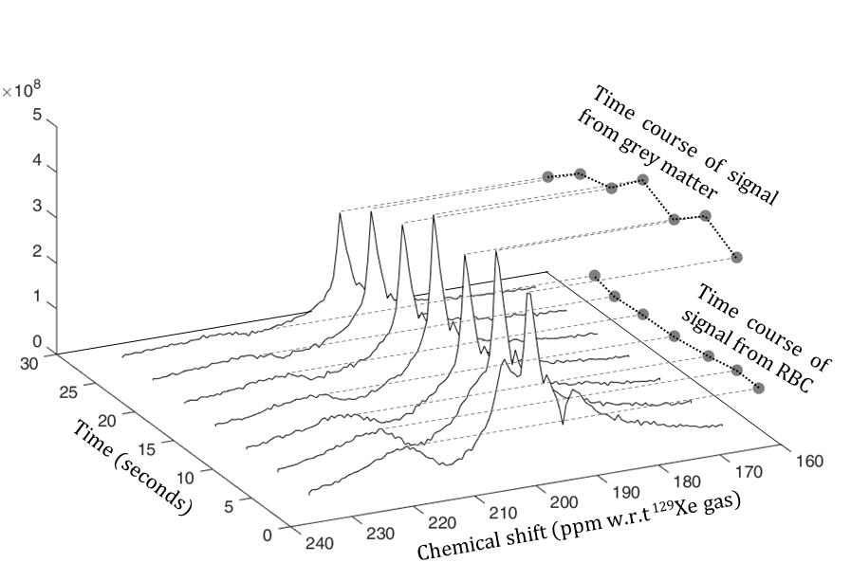
Figure 6.3.1: Acquired spectra for a typical the BUSAS sequence.
- The signal from grey matter ¹²⁹Xe_{G} and blood ¹²⁹Xe_{B} – RBC plotted as a function of time is shown in Figure 6.3.2.
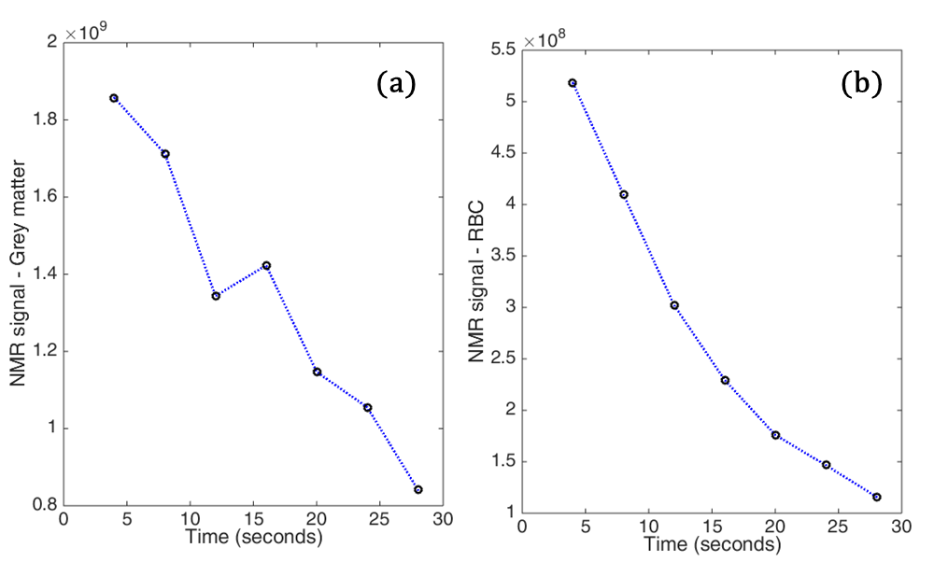
Figure 6.3.2: Time course of signal from (a) grey matter and (b) blood - RBC
- The time course of signal from the grey matter ¹²⁹Xe_{G} is de-convolved with the time course of signal from blood-RBC ¹²⁹Xe_{B} as shown in Figure 6.3.3 (a). The de-convolved grey matter signal ¹²⁹Xe_{G}* is fit with the tracer kinetic model in Equation 6.3.11. Typical values for the constants in the expression 6.3.11 are,${ λ}_{\frac{g}{b}}=0.88$ (25), $MTT=4 s$ (249), ${CBF}_{G}=1.25 ml/s/100g$ (83) and density of grey matter ≈ $1 g/ml$ (83,263). $100 g=100 ml (V_{G})$. Using these typical values, the model was fit between the time period of 8 s and 24 s. This is because, before 8 s the value of $ρ$ was much less ($≪1$) as shown in Figure 6.3.3 (b), estimated using Equation 6.3.3. The model was fitted only in regions of the curve where the probability ρ was higher because at lower probabilities the exchange of DP ¹²⁹Xe with HP ¹²⁹Xe is not well defined (ambiguous) and the differential equation is no longer homogenous.
¹²⁹Xe_{G}* = $\frac{d g_{b}(t)}{dt}$_{MODEL}, $∀ ρ ≈1$ 6.3.12
The subject resumed normal breathing after 24 s of breath-hold, thus the grey matter de-convolved signal after 24 s was ignored.
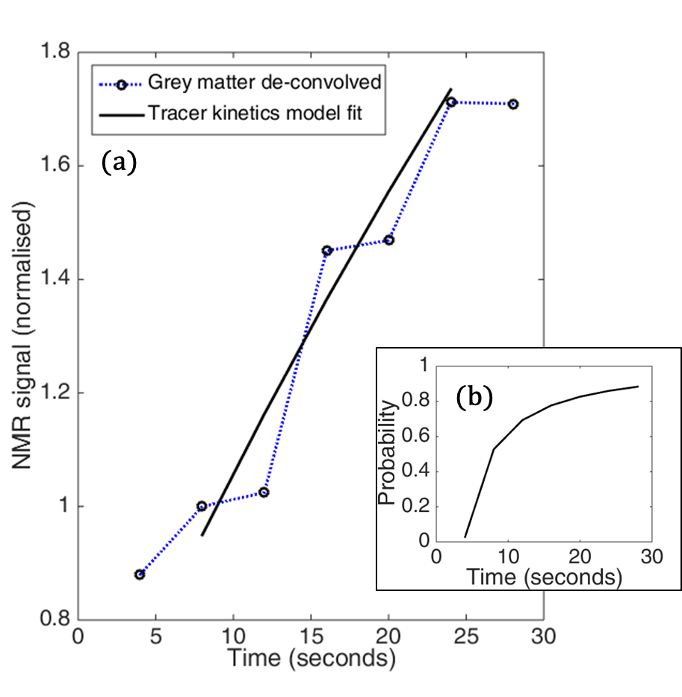
Figure 6.3.3: (a) The tracer kinetic model fit to time course of signal from grey matter de-convolved with blood-RBC and (b) Estimation of probability $ρ$ using Equation 6.3.3.
- For the example explained here, the tracer kinetic model was fit (as shown in Figure 6.3.3 (a)) using 0.38 as exchange fraction$F_{E}$. This implies that 38 % of xenon dissolved in the brain tissue would exchange with equal amount of xenon dissolved in the cerebral blood every 4 s. Alternatively, the out-flux of xenon every 4 s from the brain tissue is 38 % of the total quantity dissolved in it. Thus, the exchange fraction$F_{E}$ provides physiological insight of the permeability and surface area of the blood brain barrier.

Repeatability study: Results
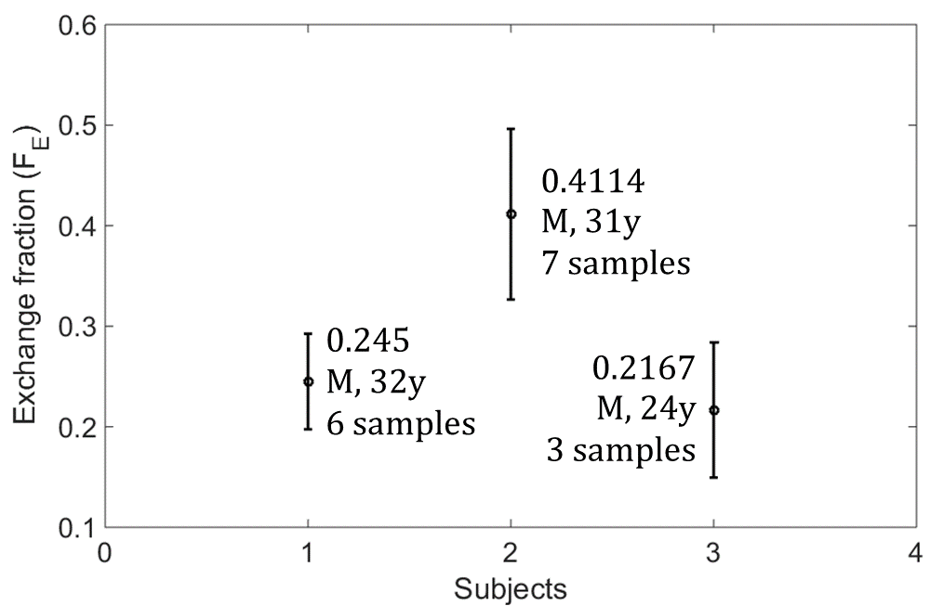
Figure 6.3.4: Compilation of the derived exchange fraction, $F_{E}$, for all repeatability studies performed on three subjects.
In order to assess the repeatability of measurements (Table 6.2.1) the tracer kinetics model was individually fitted to ¹²⁹Xe_{G}* BUSAR data obtained from a number of repeat experiments in three volunteers. The mean of the obtained $F_{E}$ values for each of the experiments for the three subjects (see Table 6.2.1) is shown in Figure 6.3.4 along with its standard error. In all of the three cases, $F_{E}$ was calculated using typical values for${ λ}_{\frac{g}{b}}$,$MTT$, ${CBF}_{G}$ and $V_{G}$ mentioned earlier. The $F_{E}$ reported for each subject describes the BBB characteristics for that particular subject. Hence we propose $F_{E}$ as a quantitative physiological indicator of the permeability of the BBB to xenon diffusion. As shown in Figure 6.3.4, subjects 1, 2 and 3 have a mean $F_{E}$ (exchange fraction) value of 0.245, 0.4114 and 0.2167 respectively, meaning that 24.5 %, 41.14 % and 21.67 % of xenon in the grey matter exchanges with the cerebral blood for every mean transit time (${MTT}_{b}$,$TR$) respectively. These results are preliminary and a means of translating the estimated $F_{E}$ to physiological information such as permeability, surface area or cerebral perfusion is yet to be investigated with more studies involving subjects of diverse age group, size, healthy-diseased and gender.
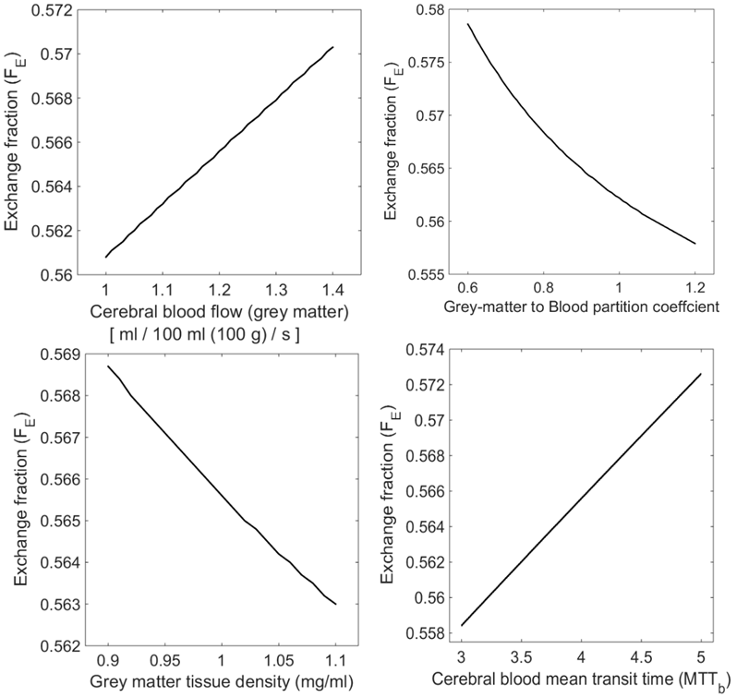
Figure 6.3.5: Sensitivity simulation of exchange the fraction $F_{E}$ as a function of the characteristic parameters:${ λ}_{\frac{g}{b}}$,${MTT}_{b}$, ${CBF}_{G}$ and $V_{G}$ (represented as density).
The estimated value for $F_{E}$ is sensitive to the parameters of the tracer kinetic model:${ λ}_{\frac{g}{b}}$,${MTT}_{b}$, ${CBF}_{G}$ and $V_{G}$. Thus, for a known values of${ λ}_{\frac{g}{b}}$,${MTT}_{b}$, ${CBF}_{G}$ and $V_{G}$ for a particular subject, $F_{E}$ provides an estimate of some of the intrinsic properties of the BBB and additionally, for a known (or pre-estimated) value of${ F}_{E}$, variations in ${ λ}_{\frac{g}{b}}$,${MTT}_{b}$, ${CBF}_{G}$ and $V_{G}$ (due to temperature, auto-regulation, tissue density, diseases patho-physiology) could potentially be measured. Figure 6.3.5 summarises the sensitivity simulation of estimated value in $F_{E}$ (exchange fraction) to changes in${ λ}_{\frac{g}{b}}$,${MTT}_{b}$,${CBF}_{G}$ and${ V}_{G}$. Sensitivity simulation in Figure 6.3.5 indicates the interdependency of variables${ λ}_{\frac{g}{b}}$,${MTT}_{b}$,${CBF}_{G}$,${ V}_{G}$ and $F_{E}$.

  - Discussion
In this work we have examined the uptake kinetics of hyperpolarised ¹²⁹Xe spectroscopic signals in the compartments of cerebral blood and grey matter in the human brain. By de-convolving the grey matter signal with the input signal from cerebral blood we are able to normalise the hyperpolarised signal for decay in polarisation in the gas exchange reservoir of the lungs allowing a quantitative tracer kinetic analysis of xenon uptake by diffusion across the BBB. We propose a parameter, the exchange fraction $F_{E}$ for xenon exchange, which could reflect some of the intrinsic physiological characteristics of the BBB, such as the permeability to xenon and its total surface area.
We note that if it was possible to perform a free-breathing experiment, in which HP xenon was inhaled repetitively over the course of many minutes, the xenon concentration in both the cerebral blood and grey matter compartments (see Figure 6.2.1 (e)) would reach saturation level, and there would be no net movement of xenon down the concentration gradient (see C in Figure 6.2.1 (e)). However, under these circumstances, the term D, which describes the Brownian diffusion of depolarised and hyperpolarised ¹²⁹Xe can still lead to a net influx of HP ¹²⁹Xe (and hence a signal increase) in the grey matter. Thus the BUSAR measurement process and the derived exchange fraction (${ F}_{E}$) parameter described here could be used to determine parameters of BBB function in both short, breath-hold experiments and long free-breathing experiments. Indeed measurement of the exchange fraction parameter may allow better optimisation of experimental sequence acquisition parameters for MRI protocols for free breathing experiments of ¹²⁹Xe dissolved in the brain. Moreover ${ F}_{E}$ could provide unique non-invasive insight into the BBB permeability and surface area in vivo, which could provide new physiological information on BBB function and aid in customising drug delivery to the brain tissues. As mentioned earlier, the measured $F_{E}$ (exchange fraction), is not a direct measure of BBB permeability-surface area product by itself, but it does depend on these parameters. By accounting for the cerebral blood volume and grey matter (tissue) volume, it may be possible to estimate the BBB permeability-surface area product.
The uncertainties of the HP ¹²⁹Xe BBB tracer kinetics model in the Equation 6.3.11 are summarised as below:
- The BUSAR sequence relies on the complete performance of 90° saturation RF pulses to eliminate any unknown/residual polarisation in the head (brain, mouth, nasal cavity and sinus) and the tracer kinetics model assumes that the HP ¹²⁹Xe is delivered to the brain tissue by cerebral blood flow only, thus ignoring any diffusive transport by gas diffusion from the air spaces direct to tissues in the nasal cavity or sinus.
- Over time, the concentration of depolarised ¹²⁹Xe increases in arterial blood due to depolarised ¹²⁹Xe leaving the brain and being recycled after re-oxygenation of the blood in the lungs. The model assumes that all Xe in arterial blood is hyperpolarised ¹²⁹Xe. Taking typical literature values for mean transit time of cerebral blood ${(MTT}_{b})$ as 4 s (47,264), pulmonary transit time ${(MTT}_{p})$ as 9 s (264), transit time for blood to circulate from lung to brain ${(τ}_{LB})$ as 4 s, the fraction of the cardiac output (arterial blood) delivered to brain ${(F}_{CB})$ as 15% (84) and ignoring the gas-exchange in the lung, after 17 s ${(MTT}_{b}+ {MTT}_{p}+ τ_{LB})$ then only 2.25% $(F_{CB}^{2})$ of the arterial blood would contain depolarised ¹²⁹Xe. Since the acquisition time of the experiment is only slightly longer than this (24 s), we feel it is justifiable to ignore this fraction. Although the model could be corrected for the contribution of this fraction from the signal ¹²⁹Xe_{G}*, in this study no correction has been applied for simplicity.
- ¹²⁹Xe atoms (either DP or HP) in close proximity to the BBB have a higher tendency to exchange (diffuse across the BBB) than the ¹²⁹Xe atoms that are relatively further away from the BBB. It follows that the ¹²⁹Xe atoms near the BBB are the ones that have diffused most recently. In the model described by Equation 6.3.11, gas transfer and exchange are approximated by a homogenous 1D differential equation so spatial distribution of xenon within the blood vessel itself is considered uniform. Furthermore we ignore hyperpolarised ¹²⁹Xe that returns to the cerebral blood from the grey matter against the concentration gradient (due to exchange$\frac{d g_{b}^{D}(t)}{dt}$), which was already delivered to the grey matter from cerebral blood ($\frac{d g_{b}^{C}(t)}{dt}$) within the same TR (≈MTT). The potential uncertainty due to this approximation was mitigated by discarding the initial part of the time course of signal where the probability $ρ$ of a ¹²⁹Xe atom in grey matter being depolarised was $≪1$ as shown in Figure 6.3.3(b).
Contemporarily, cerebral blood flow and perfusion is measured using ¹⁵O positron emission tomography (PET), dynamic susceptibility contrast enhanced MR imaging following a bolus injection of Gadolinium chelated agents or γ-camera based ¹³³Xe single photon emission computed tomography (SPECT) (118,233,258,265-274). Both ¹⁵O and ¹³³Xe are not naturally occurring isotopes and they are both radioactive. Gadolinium-chelated contrast agents cannot be used in some patients due to the risk of nephrogenic systemic fibrosis (132,133), moreover the size of the chelate prevents the passage of these agents across the blood-brain barrier. In PET there are numerous other radiotracers which are targeted to bind with specific receptors or proteins (275-278). However, these tracers face challenges; such as delivery to the brain by crossing the blood-brain barrier (lipophilicity), surviving metabolism, nonspecific binding/interaction and clearance after use (275-278). In contrast, in the proposed method with HP ¹²⁹Xe NMR, the isotope ¹²⁹Xe is stable, naturally occurring and safe. ¹²⁹Xe has unique signatures (chemical shift) for the chemical environments it reside in, making it possible to differentiate between specific and nonspecific binding/interactions. This is particularly advantageous because, the concentration of ¹²⁹Xe in a particular brain compartment (for example grey matter) at a particular location can be determined by chemical shift, rather than estimated partial volume (predicted) of that particular brain compartment in that anatomical location. This eliminates potential uncertainty in the concentration of the tracer that arises from nonspecific binding in that particular location. Another crucial aspect of the proposed method is that the signal from tracer (HP ¹²⁹Xe) once detected (by RF excitation) can be made invisible (depolarises to thermal equilibrium), enabling the study of dynamic behaviour of xenon uptake which are not readily observed by peak concentration measurements such as ¹⁷O NMR, ¹⁵O PET, ¹³³Xe SPECT and Gadolinium chelated tracers. Table 6.4.1 provides a comparison of key factors related to xenon tracers: HP ¹²⁹Xe NMR proposed in this study and γ-Camera based ¹³³Xe SPECT.
 | HP ¹²⁹Xe NMR | γ-Camera based ¹³³Xe SPECT
Measured parameter | Global measurements: BBB diffusivity, cerebral blood flow, mean transit time and tissue density | Reginal measurements: cerebral blood flow, mean transit time and cerebral blood volume.
Modality | Magnetic Resonance Imaging | Computed Tomography
Ionising radiation | No | Yes
Clearance | Rapid | Rapid
Temporal resolution | 4 s | 2 minutes
Spatial resolution | Global, 20 mm (CS Imaging) | 7 ~ 10 mm
Scan duration | 20 s | 20 minutes
Administration | Inhalation | Inhalation/Bolus injection
Respiration | Breath-hold | Continues breathing
Subject condition | Awake | Anaesthetised
Determination of solvent | NMR chemical shift | Partial estimated volume (Predicted fraction)
Disadvantages | $T_{1}$ relaxation in vivo | Uncertainty due to Compton scattering
References | This study | (18,25,267,268,271-274,279)
Table 6.4.1: Comparison between HP ¹²⁹Xe NMR with γ-Camera based ¹³³Xe SPECT.

- Epilogue
  - Summary
Summarising the novel scientific contributions of this thesis:
In chapter 2, an accurate set of analytical equations to design RF coils for multi-nuclear MRI has been provided. These equations are applicable for the design of RF coils with one trap, two traps and for the design of dual-tuned RF coils.
For the purpose of obtaining co-registered lung images of ¹H and hyperpolarised gases ³He and ¹²⁹Xe, the imaging of these nuclei were performed back-to-back in a breath-hold. The limited time period available in a breath-hold constrains multiple ¹H image averaging and the lower signal-to-noise ratio from the ¹H system body coil inhibits reaching higher image spatial resolution. Thus, it was essential to develop a dedicated ¹H RF coil receiver array compatible with being nested inside a ³He or ¹²⁹Xe transmit-receive lung coil.
The design of such a ¹H RF coil receiver array using passive-traps tuned to ³He and ¹²⁹Xe has been described using the trap theory that we developed. The improvement in signal-to-noise ratio by a factor of 2 achieved using a dedicated ¹H RF coil receiver array when compared to the system’s body coil for a same-breath multi-nuclear lung imaging exam is demonstrated. In vivo results show that ¹H images acquired with the dedicated ¹H receiver array can provide higher SNR from lung parenchyma and can help resolve finer structure in the lungs such as the small pulmonary blood vessels. This newly developed method for the design of ¹H RF coil receiver arrays has clinical benefits, for example it will provide more structural information when estimating functional ventilated volume, detecting pulmonary emboli from ¹H vascular MRI or when registering structural images from computed tomography to MRI. The ¹H RF coil receiver array described in chapter 2 can be further improved with a lung-specific topology as illustrated in chapter 3, where one element (coil) of the array of RF coil is a volume figure-of-8 such that the arms of the subject can pass through and couples well to the chest.
In chapter 4, design and construction of a dual-tuned dual-Helmholtz quadrature transmit-receive coil is described. The dual-tuned coil is tuned to 35.3 MHz and 48.6 MHz for ¹²⁹Xe and ³He Larmor frequencies at 1.5 T respectively. The dual-tuned coil with passive traps tuned to ¹H Larmor frequency enables ¹H imaging with the dual-tuned coil in situ. Triple-nuclear (³He-¹²⁹Xe-¹H) lung function-structure imaging and dual-nuclear (³He-¹²⁹Xe) apparent diffusion measurement has been demonstrated. The visualisation and quantification of lung ventilation and diffusion with these two gases at the same time in the lungs will help address important physiological questions such as the position of the diffusion – convection front in the lungs. Measuring the diffusivity of both ³He and ¹²⁹Xe gases in the same lung inflation level provides information for measuring and modelling lung micro-structure.
In Chapter 5, we depart from the lungs to the brain where the properties of ¹²⁹Xe such as solubility (blood, lipid and tissue) and chemical shift have been explored in this thesis. High resolution ¹²⁹Xe human brain spectra has been demonstrated which shows 5 distinct peaks for red blood cells, aqueous medium (cerebrospinal fluid and body interstitial fluid), grey matter, white matter and soft tissue. This is the first report of ¹²⁹Xe brain chemical shift imaging in the human at 1.5 T and some of the resonances observed have been identified in human brain for the first time.
We then go on to image the perfusion of human brain in vivo with hyperpolarised ¹²⁹Xe for the first time. These images demonstrate the feasibility of using hyperpolarised ¹²⁹Xe as a safe and non-invasive inhaled contrast agent, thus providing a novel MRI contrast agent for functional imaging of the brain.
In Chapter 6, we exploit the chemical shift of the hyperpolarised ¹²⁹Xe resonances, to study the transfer of xenon between the cerebral blood and the grey matter compartment. Using tracer kinetic analysis a quantitative measurement of the intrinsic physiological characteristic of the blood brain barrier such as permeability and total surface area was derived, which may help improve understanding of cerebral hemodynamic and physiological control mechanisms. The method has many potential future clinical applications for all age groups, for instance monitoring the concentration of xenon while treating neonatal hypoxic ischemic encephalopathy, using xenon gas to enhance hypothermic neuroprotection.

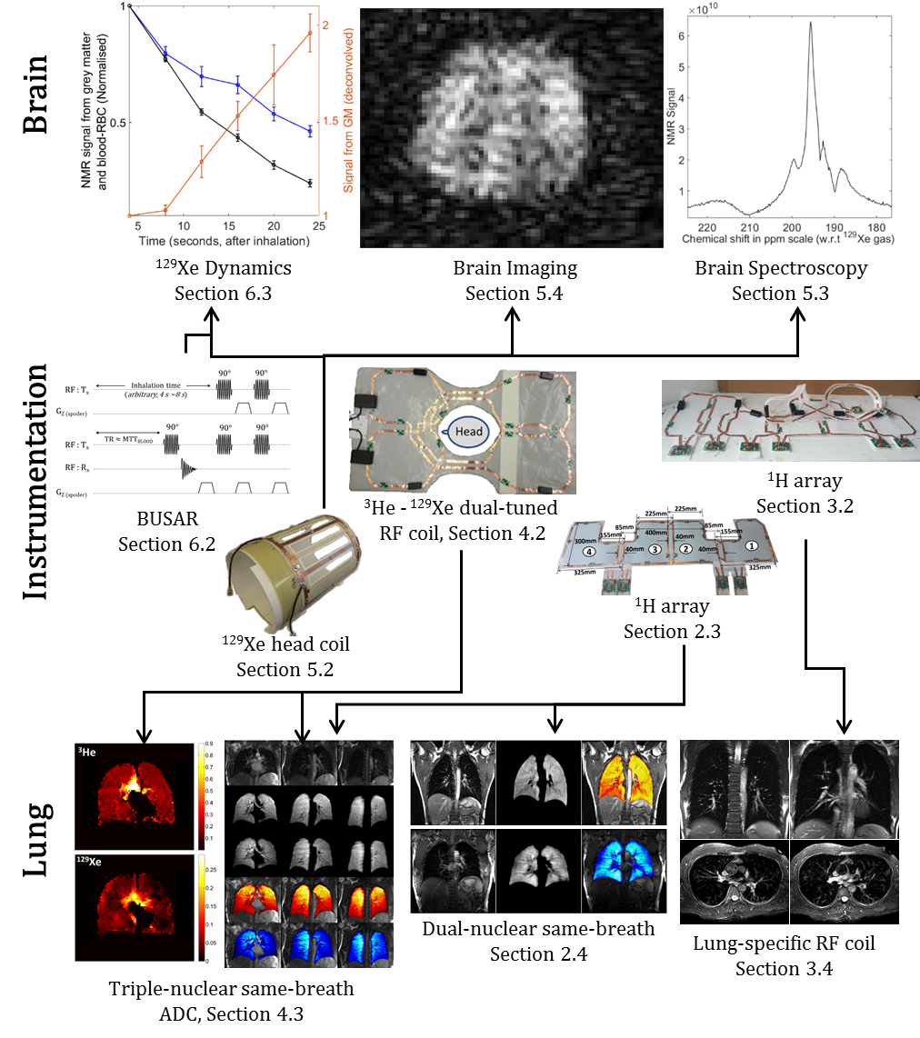
Figure 7.1.1: A graphical summary of the thesis

  - Conclusion
- This is the first time a dedicated ¹H receiver array has been used in a multi-nuclear same breath lung imaging of ¹H with hyperpolarised noble gases.
- Dual-nuclear apparent diffusion coefficient mapping with hyperpolarised ³He and ¹²⁹Xe in the same breath and same lung-inflation state has been demonstrated for the first time.
- This is the first time 5 distinct peaks have been observed (with 1 peak made up of 2 closely spaced peaks) in ¹²⁹Xe human brain spectra at 1.5 T. These (Figure 5.3.2-10) are the first chemical shift images of HP ¹²⁹Xe dissolved in the human brain at 1.5 T.
- This is the first time that the human brain has been imaged using HP ¹²⁹Xe with a quality required for clinical diagnosis, thus establishing HP ¹²⁹Xe as a possible contrast agent to image perfused brain tissue. The imaging of the human brain is performed under breath-hold, in awake-state, which bodes well for future application in a clinical setting.
- Hyperpolarised ¹²⁹Xe has been shown to have potential as a physiological indicator of blood-brain barrier integrity. Speculatively, the in vivo information of blood-brain barrier permeability and total surface area obtained from the HP ¹²⁹Xe MR spectroscopy may aid in the customisation of drug delivery to the brain and quantifying sleep apnoea.

  - Publications, scientific abstracts and conference proceedings related to this thesis

Publications
- Title: Dedicated receiver array coil for ¹H lung imaging with same-breath acquisition of hyperpolarised ³He and ¹²⁹Xe gas.
Authors: Madhwesha Rao (University of Sheffield), Fraser Robb (University of Sheffield, GE healthcare Aurora OH USA) and Jim M Wild (University of Sheffield).
Publisher: Magnetic Resonance in Medicine, Volume 74, Issue 1, Pages 291-299, July 2015.
Article first published online: 30 July 2014.
DOI: 10.1002/mrm.25384. © 2014 Wiley Periodicals, Inc.
- Title: RF instrumentation for same-breath triple nuclear lung MR imaging of ¹H and hyperpolarised ³He and ¹²⁹Xe at 1.5T.
Authors: Madhwesha Rao (University of Sheffield) and Jim M Wild (University of Sheffield).
Publisher: Magnetic Resonance in Medicine, Early view.
Article first published online: 13 May 2015.
DOI: 10.1002/mrm.25680. © 2015 Wiley Periodicals, Inc.
- Title: High resolution spectroscopy and chemical shift imaging of hyperpolarized ¹²⁹Xe dissolved in the human brain in vivo at 1.5 Tesla.
Authors: Madhwesha Rao, Neil J Stewart, Graham Norquay, Paul D Griffiths and Jim M Wild. Academic Unit of Radiology, University of Sheffield, UK.
Publisher: Magnetic Resonance in Medicine.
Article first published online: In-Press, Accepted on 21 March 2016.
DOI: 10.1002/mrm.26241. © 2016 Wiley Periodicals, Inc.

Scientific abstracts and conference proceedings

- Title: Dedicated receiver array coil for ¹H lung imaging with same-breath acquisition of hyperpolarised ³He and ¹²⁹Xe gas.

Authors: Madhwesha Rao (University of Sheffield), Fraser Robb (University of Sheffield, GE healthcare Aurora OH USA) and Jim M Wild (University of Sheffield).

Conferences:
- International Workshop for Pulmonary Functional Imaging (IWPFI), Madison, WI, July 18-20, 2013.
- Proceeding of International Society for Magnetic Resonance in Medicine (ISMRM) 2014. Program number 0625
- COST annual meeting ‘Spin hyperpolarisation in NMR and MRI’ ETH Zurich June 27-29 2014
- ISMRM – British Chapter 2013. P 12

- Title: Spectroscopy and imaging of hyperpolarised ¹²⁹Xe dissolved in human brain at 1.5 T.
Authors: Madhwesha Rao, Neil Stewart Graham Norquay and Jim M Wild. University of Sheffield.
Conferences:
- ISMRM – British Chapter 2014
- COST annual meeting ‘Spin hyperpolarisation in NMR and MRI’ ETH Zurich June 27-29 2014
- Proceeding of International Society for Magnetic Resonance in Medicine (ISMRM) 2014. Program number 3532
- PiNG14, Les Houches, Chamonix, 19 Sep to 3 Oct 2014
- Proceeding of International Society for Magnetic Resonance in Medicine (ISMRM) 2015. Program number 1254, 1445.
- XeMAT – 2015. September 13-17 2015, Dresden. Germany.
- European Society for Magnetic Resonance in Medicine and Biology (ESMRMB). October 1-3, 2015, Edinburgh, UK. Presentation number: 82.

- Title: RF instrumentation for same-breath triple nuclear lung MR imaging of ¹H and hyperpolarised ³He and ¹²⁹Xe at 1.5T.
Authors: Madhwesha Rao and Jim M Wild. University of Sheffield
Conferences:
- Proceeding of International Society for Magnetic Resonance in Medicine (ISMRM) 2015. Program number 1812.
- ISMRM – British Chapter 2014

- Title: Lung-specific RF array coil topology for ¹H lung imaging at 1.5T.
Authors: Madhwesha Rao (University of Sheffield), Fraser Robb (University of Sheffield, GE healthcare Aurora OH USA) and Jim M Wild (University of Sheffield).
Conferences: Proceeding of International Society for Magnetic Resonance in Medicine (ISMRM) 2015. Program number 3128.

- Appendix
  - List of Figures
Figure | Description | Page
Figure 1.1.1 | Illustration of hyperpolarisation | 12
Figure 1.1.2 | Spin-exchange optical pumping polariser | 13
Figure 1.1.3 | Chemical shift range of ¹²⁹Xe | 16
Figure 1.1.4 | Ventilation images of the human lungs | 18
Figure 1.1.5 | Illustration of ventilation defects in the lungs | 18
Figure 1.1.6 | Illustration of apparent diffusion coefficient measurements | 19
Figure 1.1.7 | Hyperpolarised ¹²⁹Xe resonances from a dog chest | 20
Figure 1.1.8 | A comparison of imaging the gas-phase and the dissolved-phase resonances of HP ¹²⁹Xe in the human lung | 21
Figure 1.1.9 | Illustration of multi-nuclear synchronous imaging of the lung with HP ³He, ¹²⁹Xe and ¹H | 22
Figure 1.1.10 | ¹H MR imaging of the grey matter and the white matter | 23
Figure 1.1.11 | Schematic representation of blood brain barrier | 23
Figure 1.1.12 | Imaging the cerebral perfusion with ¹⁷O | 24
Figure 1.1.13 | Demonstration of stroke detection in rat brain using HP ¹²⁹Xe | 25
Figure 1.2.1.1 | A typical architecture of MR system | 29
Figure 1.2.1.2 | Illustration of principle of reciprocity | 31
Figure 1.2.1.3 | Series and parallel resonance | 32
Figure 1.2.1.4 | Complex frequencies | 32
Figure 1.2.1.5 | Illustration of Larmor precession and quadrature detection | 35
Figure 1.2.1.6 | Correcting the initial phase of the recorded free induction decay signal | 36
Figure 1.2.1.7 | Receiver block diagram of a typical spectrometer | 37
Figure 1.2.2.1 | Measurement of the quality factor for a resonant circuit | 38
Figure 1.2.2.2 | Illustration of filling factor | 39
Figure 1.2.2.3 | Polarisation of RF coils | 41
Figure 1.2.2.4 | Illustration of decoupling techniques for an RF coil array | 43
Figure 1.2.2.5 | Illustration of decoupling with a low input impedance LNA | 44
Figure 1.2.2.6 | Noise correlation matrix for a 32 channel receiver array | 44
Figure 1.2.2.7 | Illustration of different methods for the dual-tuned RF coils | 47
Figure 1.2.2.8 | Transmit RF coils for hyperpolarised gas imaging | 49
Figure 1.2.2.9 | Receive RF coil arrays for hyperpolarised gas imaging | 51
Figure 1.2.3.1 | Pulse sequence diagram of a 1D chemical shift imaging | 53
Figure 1.2.3.2 | A basic spoiled echo gradient pulse sequence | 53
Figure 1.2.4.1 | A two compartment tracer-kinetic model | 54
Figure 2.2.1 | Illustration of a resonant loop with traps | 57
Figure 2.3.1 | Photograph and schematic of each of the loops in the ¹H array | 62
Figure 2.3.2 | Illustration of ¹H array applied on the subject | 63
Figure 2.3.3 | Isolation between the ¹H array and ¹²⁹Xe T-R coil | 65
Figure 2.3.4 | SNR comparison between the ¹H receiver array and the system body coil | 66
Figure 2.3.5 | Histogram of the background noise | 67
Figure 2.4.1 | Coil setup for the same-breath acquisition ³He & ¹²⁹Xe - ¹H array | 68
Figure 2.4.2 | Same-breath acquisition of HP ³He with ¹H and ¹²⁹Xe with ¹H | 69
Figure 2.4.3 | SNR comparison, ¹H four cascaded slices of the lung | 70
Figure 2.4.4 | SNR comparison with higher resolution ¹H images of lung | 71
Figure 3.2.1 | Topology and photograph of the 8 element ¹H array | 74
Figure 3.2.2 | Application of proposed 8 element ¹H array on the subject | 75
Figure 3.4.1 | Lung-cardiac images from the lung specific coil | 76
Figure 3.4.2 | Comparing in vivo images of lung-specific coil with conventional coil | 77
Figure 3.5.1 | Sensitivity profile of individual elements of the RF coil array | 78
Figure 4.2.1 | Picture of the dual-tuned flexible TR coil for ¹²⁹Xe and ³He | 80
Figure 4.2.2 | The schematic of the dual tune flexible TR coil for ¹²⁹Xe and ³He | 81
Figure 4.2.3 | Matching and isolation of the dual-tuned coil | 82
Figure 4.2.4 | : Illustration of flip angle calculation with repeated imaging | 83
Figure 4.2.5 | Flip angle map of the dual-tuned coil | 84
Figure 4.3.1 | Illustration and picture of ¹H array and dual-tuned coil for triple nuclear imaging | 86
Figure 4.3.2 | Triple nuclear same breath lung imaging (3He-129Xe-1H) | 87
Figure 4.3.3 | ADC of ³He-¹²⁹Xe in same-breath | 88
Figure 4.3.4 | HP images of the lungs from 3D bSSFP with dual-tuned coil | 89
Figure 4.4.1 | Illustration of line of interest (LOI) to inspect SNR | 91
Figure 4.4.2 | Signal to noise ratio, flip angle profile and sensitivity profile | 92
Figure 4.4.3 | Comparing SNR profiles of ³He and ¹²⁹Xe | 93
Figure 4.1.1 | Schematic representation of xenon transferred to the brain tissue | 96
Figure 5.2.1 | Schematic and photograph of the ¹²⁹Xe head birdcage RF coil | 97
Figure 5.2.2 | Flip angle measurement of the RF birdcage coil | 98
Figure 5.3.1 | Larmor frequency of ¹²⁹Xe in the gas-phase | 100
Figure 5.3.2 | Magnitude spectra of HP 129Xe dissolved in human brain | 101
Figure 5.3.3 | Individual spectra from the 2D chemical shift imaging experiment | 104
Figure 5.3.4(a) | Spatially resolved spectra – axial | 105
Figure 5.3.4(b) | Spatially resolved spectra – sagittal | 105
Figure 5.3.4(c) | Spatially resolved spectra – coronal | 106
Figure 5.3.5 | Peak at 188 ppm spatially resolved | 106
Figure 5.3.6 | Peak at 192 ppm spatially resolved | 107
Figure 5.3.7 | Peak at 196 ppm spatially resolved | 108
Figure 5.3.8 | Phase-corrected real and imaginary parts of the 129Xe brain spectrum | 109
Figure 5.3.9 | Peak at 200 ppm spatially resolved | 109
Figure 5.3.10 | Peak at 217 ppm spatially resolved | 110
Figure 5.3.11 | Peaks of ¹²⁹Xe brain spectrum | 111
Figure 5.3.12 | HP ¹²⁹Xe - CSI of grey matter and spectra (2 volunteers) | 112
Figure 5.4.1 | Imaging HP ¹²⁹Xe dissolved in the human brain in vivo | 114
Figure 5.4.2 | Illustration of application of thresholds to the image of HP ¹²⁹Xe | 116
Figure 5.4.3 | Images of HP ¹²⁹Xe dissolved in the human brain in vivo acquired in various planes | 117
Figure 6.2.1 | Schematic and illustration of the design of the BUSAR pulse sequence | 121
Figure 6.2.2 | The result of an atypical acquisition using the BUSAR pulse sequence | 123
Figure 6.2.3 | Time series of HP ¹²⁹Xe acquired with the BUSAR pulse sequence | 123
Figure 6.2.4 | The time course of HP 129Xe in the lungs and blood | 125
Figure 6.2.5 | The mean of ¹²⁹Xe_{B}, ¹²⁹Xe_{G} and ¹²⁹Xe_{G}* | 127
Figure 6.3.1 | Acquired spectra for a typical the BUSAS sequence | 132
Figure 6.3.2 | Time course of signal from grey matter and blood - RBC | 132
Figure 6.3.3 | Tracer kinetic model illustration | 133
Figure 6.3.4 | Compilation of the derived exchange fraction FE | 134
Figure 6.3.5 | Sensitivity analysis of exchange the fraction FE | 135
Figure 7.1.1 | A graphical summary of the thesis | 141

  - List of Tables
Table | Description | Page
Table 1.1.1 | Comparison of MR properties between ¹H, ³He and ¹²⁹Xe | 14
Table 1.1.2 | Bunsen and Ostwald’s partition coefficient of xenon | 15
Table 2.3.1 | Resonant modes and Q measurement of array | 64
Table 2.4.1 | Details of dosage and gas mixtures. | 68
Table 2.4.2 | Details of SNR measured in the lung parenchymal | 72
Table 4.3.1 | Details of gas mixture-dosage, imaging parameters and pulse sequence used for all the three nuclei | 85
Table 5.3.1 | Assignment of different peaks of ¹²⁹Xe dissolved in the human head | 111
Table 5.4.1 | Imaging parameters for HP ¹²⁹Xe dissolved in human brain | 115
Table 6.2.1 | Details of the subjects, gas dosage and the number of repeated examinations | 126
Table 6.4.1 | Comparison between HP ¹²⁹Xe NMR with γ-Camera based ¹³³Xe SPECT | 138

- Bibliography

1. Organization WH. World Health Statistics 2014. Global Health Observatory:(GHO). 20 Avenue Appia, 1211 Geneva 27, Switzerland: World Health Organization; 2014.
2. Herring W. Learning radiology: Recognizing the basics: Elsevier Health Sciences; 2015.
3. Kauczor HU, Surkau R, Roberts T. MRI using hyperpolarized noble gases. European Radiology 1998;8(5):820-827.
4. Möller HE, Chen XJ, Saam B, Hagspiel KD, Johnson GA, Altes TA, De Lange EE, Kauczor HU. MRI of the lungs using hyperpolarized noble gases. Magnetic Resonance in Medicine 2002;47(6):1029-1051.
5. Van Beek EJR, Wild JM, Kauczor HU, Schreiber W, Mugler Iii JP, De Lange EE. Functional MRI of the lung using hyperpolarized 3-helium gas. Journal of Magnetic Resonance Imaging 2004;20(4):540-554.
6. Happer W, Miron E, Schaefer S, Schreiber D, Van Wijngaarden WA, Zeng X. Polarization of the nuclear spins of noble-gas atoms by spin exchange with optically pumped alkali-metal atoms. Physical Review A 1984;29(6):3092-3110.
7. Walker TG, Happer W. Spin-exchange optical pumping of noble-gas nuclei. Reviews of Modern Physics 1997;69(2):629-642.
8. Colegrove FD, Schearer LD, Walters GK. Polarization of He3 gas by optical pumping. Physical Review 1963;132(6):2561-2572.
9. Gentile TR, Jones GL, Thompson AK, Rizi RR, Roberts DA, Dimitrov IE, Reddy R, Lipson DA, Gefter W, Schnall MD, Leigh JS. Demonstration of a compact compressor for application of metastability- exchange optical pumping of 3He to human lung imaging. Magnetic Resonance in Medicine 2000;43(2):290-294.
10. Norquay G, Stewart NJ, Wild JM. Approaching the theoretical limit for 129Xe hyperpolarisation with continuous-flow spin-exchange optical pumping. Proc Intl Soc Mag Reson Med 23 (2015) 1505 2015.
11. Albert MS, Cates GD, Driehuys B, Happer W, Saam B, Springer Jr CS, Wishnia A. Biological magnetic resonance imaging using laser-polarized 129Xe. Nature 1994;370(6486):199-201.
12. Ebert M, Grossmann T, Heil W, Otten WE, Surkau R, Leduc M, Bachert P, Knopp MV, Schad LR, Thelen M. Nuclear magnetic resonance imaging with hyperpolarised helium-3. Lancet 1996;347(9011):1297-1299.
13. Parra-Robles J, Cross AR, Santyr GE. Theoretical signal-to-noise ratio and spatial resolution dependence on the magnetic field strength for hyperpolarized noble gas magnetic resonance imaging of human lungs. Medical Physics 2005;32(1):221-229.
14. Deppe MH, Parra-Robles J, Ajraoui S, Parnell SR, Clemence M, Schulte RF, Wild JM. Susceptibility effects in hyperpolarized 3He lung MRI at 1.5T and 3T. Journal of Magnetic Resonance Imaging 2009;30(2):418-423.
15. Zhao L, Mulkern R, Tseng CH, Williamson D, Patz S, Kraft R, Walsworth RL, Jolesz FA, Albert MS. Gradient-echo imaging considerations for hyperpolarized 129Xe MR. Journal of Magnetic Resonance - Series B 1996;113(2):179-183.
16. Miller GW, Altes TA, Brookeman JR, de Lange EE, Mugler JP. Hyperpolarized He-3 lung ventilation imaging with B-1-inhomogeneity correction in a single breath-hold scan. Magn Reson Mat Phys Biol Med 2004;16(5):218-226.
17. Wild JM, Teh K, Woodhouse N, Paley MN, Fichele S, de Zanche N, Kasuboski L. Steady-state free precession with hyperpolarized 3He: experiments and theory. J Magn Reson 2006;183(1):13-24.
18. Obrist WD, Thompson HK, Wang HS, Wilkinson WE. Regional cerebral blood-flow estimated by xenon-133 inhalation. Stroke 1975;6(3):245-256.
19. Lauritzen M, Olesen J. Regional cerebral blood-flow during migraine attacks by xenon-133 inhalation and emission tomography. Brain 1984;107(JUN):447-461.
20. Levitt MH. Spin Dynamics: Basics of Nuclear Magnetic Resonance: Wiley; 2013.
21. Haynes WM. CRC Handbook of Chemistry and Physics, 96th Edition: CRC Press; 2015.
22. Smith RA, Porter EG, Miller KW. The solubility of anesthetic gases in lipid bilayers. Biochimica et Biophysica Acta (BBA) - Biomembranes 1981;645(2):327-338.
23. Chen R, Fan F-C, Kim S, Jan K, Usami S, Chien S. Tissue-blood partition coefficient for xenon: temperature and hematocrit dependence. J Appl Physiol 1980;49(2):178-183.
24. Goto T, Suwa K, Uezono S, Ichinose F, Uchiyama M, Morita S. The blood-gas partition coefficient of xenon may be lower than generally accepted. British journal of anaesthesia 1998;80(2):255-256.
25. Meyer JS, Hayman LA, Amano T, Nakajima S, Shaw T, Lauzon P, Derman S, Karacan I, Harati Y. Mapping local blod-flow of human-brain by CT scanning during stable xenon inhalation. Stroke 1981;12(4):426-436.
26. Isbister W, Schofield P, Torrance H. Measurement of the solubility of xenon-133 in blood and human brain. Physics in medicine and biology 1965;10(2):243.
27. Miller KW, Reo NV, Schoot Uiterkamp AJ, Stengle DP, Stengle TR, Williamson KL. Xenon NMR: chemical shifts of a general anesthetic in common solvents, proteins, and membranes. Proc Natl Acad Sci U S A 1981;78(8):4946-4949.
28. Bifone A, Song Y-Q, Seydoux R, Taylor RE, Goodson BM, Pietrass T, Budinger TF, Navon G, Pines A. NMR of laser-polarized xenon in human blood. Proceedings of the National Academy of Sciences 1996;93(23):12932-12936.
29. Mugler III JP, Driehuys B, Brookeman JR, Cates GD, Berr SS, Bryant RG, Daniel TM, De Lange EE, Downs Iii JH, Erickson CJ, Happer W, Hinton DP, Kassel NF, Maier T, Phillips CD, Saam BT, Sauer KL, Wagshul ME. MR imaging and spectroscopy using hyperpolarized 129Xe gas: Preliminary human results. Magnetic Resonance in Medicine 1997;37(6):809-815.
30. Albert MS, Schepkin VD, Budinger TF. Measurement of 129Xe T1 in Blood to Explore the Feasibility of Hyperpolarized 129Xe MRI. Journal of Computer Assisted Tomography 1995;19(6):975-978.
31. Norquay G, Leung G, Stewart NJ, Tozer GM, Wolber J, Wild JM. Relaxation and exchange dynamics of hyperpolarized (129) Xe in human blood. Magn Reson Med 2015;74(2):303-311.
32. Wolber J, Cherubini A, Leach MO, Bifone A. Hyperpolarized 129Xe NMR as a probe for blood oxygenation. Magnetic Resonance in Medicine 2000;43(4):491-496.
33. Wolber J, Cherubini A, Dzik-Jurasz AS, Leach MO, Bifone A. Spin-lattice relaxation of laser-polarized xenon in human blood. Proc Natl Acad Sci U S A 1999;96(7):3664-3669.
34. Kershaw J, Nakamura K, Kondoh Y, Wakai A, Suzuki N, Kanno I. Confirming the existence of five peaks in 129Xe rat head spectra. Magnetic Resonance in Medicine 2007;57(4):791-797.
35. Kilian W, Seifert F, Rinneberg H. Dynamic NMR Spectroscopy of Hyperpolarized 129Xe in Human Brain Analyzed by an Uptake Model. Magnetic Resonance in Medicine 2004;51(4):843-847.
36. Nakamura K, Kondoh Y, Wakai A, Kershaw J, Wright D, Kanno I. 129Xe spectra from the heads of rats with and without ligation of the external carotid and pterygopalatine arteries. Magnetic Resonance in Medicine 2005;53(3):528-534.
37. Kilian W, Seifert F. 2D Chemical Shift Imaging of hyperpolarized isotopically enriched 129Xe within human brain. Proc Intl Soc Mag Reson Med 13 P 1163 2005.
38. Pietraiß T, Gaede HC. Optically Polarized 129Xe in NMR Spectroscopy*. Advanced Materials 1995;7(10):826-838.
39. Kennedy RR, Stokes JW, Downing P. Anaesthesia and the 'inert' gases with special reference to xenon. Anaesth Intensive Care 1992;20(1):66-70.
40. Lachmann B, Armbruster S, Schairer W, Landstra M, Trouwborst A, Vandaal GJ, Kusuma A, Erdmann W. Safety and efficacy of xenon in routine use as an inhalational anesthetic. Lancet 1990;335(8703):1413-1415.
41. Latchaw RE, Yonas H, Pentheny SL, Gur D. Adverse reactions to xenon-enhanced CT cerebral blood flow determination. Radiology 1987;163(1):251-254.
42. Driehuys B, Martinez-Jimenez S, Cleveland ZI, Metz GM, Beaver DM, Nouls JC, Kaushik SS, Firszt R, Willis C, Kelly KT, Wolber J, Kraft M, McAdams HP. Chronic obstructive pulmonary disease: safety and tolerability of hyperpolarized 129Xe MR imaging in healthy volunteers and patients. Radiology 2012;262(1):279-289.
43. Frietsch T, Bogdanski R, Blobner M, Werner C, Kuschinsky W, Waschke KF. Effects of xenon on cerebral flood flow and cerebral glucose utilization in rats. Anesthesiology 2001;94(2):290-297.
44. Fink H, Blobner M, Bogdanski R, Hanel F, Werner C, Kochs E. Effects of xenon on cerebral blood flow and autoregulation: an experimental study in pigs. British journal of anaesthesia 2000;84(2):221-225.
45. Laitio RM, Kaisti KK, Langsjo JW, Aalto S, Salmi E, Maksimow A, Aantaa R, Oikonen V, Sipila H, Parkkola R, Scheinin H. Effects of xenon anesthesia on cerebral blood flow in humans - A positron emission tomograpby study. Anesthesiology 2007;106(6):1128-1133.
46. Hartmann A, Dettmers C, Schuier FJ, Wassmann HD, Schumacher HW. Effect od stable xenon on regional cerbral blood-flow and the electroencephalogram in normal volunteers. Stroke 1991;22(2):182-189.
47. West JB. Respiratory physiology: the essentials: Lippincott Williams & Wilkins; 2012.
48. Vestbo J, Hurd SS, Agustí AG, Jones PW, Vogelmeier C, Anzueto A, Barnes PJ, Fabbri LM, Martinez FJ, Nishimura M, Stockley RA, Sin DD, Rodriguez-Roisin R. Global Strategy for the Diagnosis, Management, and Prevention of Chronic Obstructive Pulmonary Disease. American Journal of Respiratory and Critical Care Medicine 2013;187(4):347-365.
49. Celli BR, MacNee W, Agusti A, Anzueto A, Berg B, Buist AS, Calverley PMA, Chavannes N, Dillard T, Fahy B, Fein A, Heffner J, Lareau S, Meek P, Martinez F, McNicholas W, Muris J, Austegard E, Pauwels R, Rennard S, Rossi A, Siafakas N, Tiep B, Vestbo J, Wouters E, ZuWallack R. Standards for the diagnosis and treatment of patients with COPD: a summary of the ATS/ERS position paper. European Respiratory Journal 2004;23(6):932-946.
50. Rockall AG, Hatrick A, Armstrong P, Wastie M. Diagnostic Imaging: Wiley; 2013.
51. Hendee WR, Ritenour ER. Medical Imaging Physics: Wiley; 2003.
52. Van Beek EJR, Wild JM. Hyperpolarized 3-Helium Magnetic Resonance Imaging to Probe Lung Function. Proceedings of the American Thoracic Society 2005;2(6):528-532.
53. Chen XJ, Möller HE, Chawla MS, Cofer GP, Driehuys B, Hedlund LW, Johnson GA, Fitzsimons EG. Spatially resolved measurements of hyperpolarized gas properties in the lung in vivo. Part I: Diffusion coefficient. Magnetic Resonance in Medicine 1999;42(4):721-728.
54. Salerno M, Lange EEd, Altes TA, Truwit JD, Brookeman JR, John P. Mugler I. Emphysema: Hyperpolarized Helium 3 Diffusion MR Imaging of the Lungs Compared with Spirometric Indexes—Initial Experience. Radiology 2002;222(1):252-260.
55. Fain SB, Korosec FR, Holmes JH, O'Halloran R, Sorkness RL, Grist TM. Functional lung imaging using hyperpolarized gas MRI. Journal of Magnetic Resonance Imaging 2007;25(5):910-923.
56. Altes TA, Powers PL, Knight-Scott J, Rakes G, Platts-Mills TAE, de Lange EE, Alford BA, Mugler JP, Brookeman JR. Hyperpolarized 3He MR lung ventilation imaging in asthmatics: Preliminary findings. Journal of Magnetic Resonance Imaging 2001;13(3):378-384.
57. Samee S, Altes T, Powers P, de Lange EE, Knight-Scott J, Rakes G, Mugler Iii JP, Ciambotti JM, Alford BA, Brookeman JR, Platts-Mills TAE. Imaging the lungs in asthmatic patients by using hyperpolarized helium-3 magnetic resonance: Assessment of response to methacholine and exercise challenge. Journal of Allergy and Clinical Immunology 2003;111(6):1205-1211.
58. McMahon C, Dodd J, Hill C, Woodhouse N, Wild J, Fichele S, Gallagher C, Skehan S, van Beek ER, Masterson J. Hyperpolarized 3helium magnetic resonance ventilation imaging of the lung in cystic fibrosis: comparison with high resolution CT and spirometry. European Radiology 2006;16(11):2483-2490.
59. Koumellis P, van Beek EJR, Woodhouse N, Fichele S, Swift AJ, Paley MNJ, Hill C, Taylor CJ, Wild JM. Quantitative analysis of regional airways obstruction using dynamic hyperpolarized 3He MRI—Preliminary results in children with cystic fibrosis. Journal of Magnetic Resonance Imaging 2005;22(3):420-426.
60. Woodhouse N, Wild JM, van Beek EJR, Hoggard N, Barker N, Taylor CJ. Assessment of hyperpolarized 3He lung MRI for regional evaluation of interventional therapy: A pilot study in pediatric cystic fibrosis. Journal of Magnetic Resonance Imaging 2009;30(5):981-988.
61. Van Beek ER, Hill C, Woodhouse N, Fichele S, Fleming S, Howe B, Bott S, Wild J, Taylor C. Assessment of lung disease in children with cystic fibrosis using hyperpolarized 3-Helium MRI: comparison with Shwachman score, Chrispin-Norman score and spirometry. European Radiology 2007;17(4):1018-1024.
62. Marshall H, Deppe MH, Parra-Robles J, Hillis S, Billings CG, Rajaram S, Swift A, Miller SR, Watson JH, Wolber J, Lipson DA, Lawson R, Wild JM. Direct visualisation of collateral ventilation in COPD with hyperpolarised gas MRI. Thorax 2012.
63. Swift AJ, Wild JM, Fichele S, Woodhouse N, Fleming S, Waterhouse J, Lawson RA, Paley MNJ, Van Beek EJR. Emphysematous changes and normal variation in smokers and COPD patients using diffusion 3He MRI. Eur J Radiol 2005;54(3):352-358.
64. Saam BT, Yablonskiy DA, Kodibagkar VD, Leawoods JC, Gierada DS, Cooper JD, Lefrak SS, Conradi MS. MR imaging of diffusion of 3He gas in healthy and diseased lungs. Magnetic Resonance in Medicine 2000;44(2):174-179.
65. Morbach AE, Gast KK, Schmiedeskamp J, Dahmen A, Herweling A, Heussel CP, Kauczor H-U, Schreiber WG. Diffusion-weighted MRI of the lung with hyperpolarized helium-3: A study of reproducibility. Journal of Magnetic Resonance Imaging 2005;21(6):765-774.
66. Parraga G, Ouriadov A, Evans A, McKay S, Lam WW, Fenster A, Etemad-Rezai R, McCormack D, Santyr G. Hyperpolarized 3He Ventilation Defects and Apparent Diffusion Coefficients in Chronic Obstructive Pulmonary Disease: Preliminary Results at 3.0 Tesla. Invest Radiol 2007;42(6):384-391.
67. Fain SB, Altes TA, Panth SR, Evans MD, Waters B, Mugler Iii JP, Korosec FR, Grist TM, Silverman M, Salerno M, Owers-Bradley J. Detection of Age-Dependent Changes in Healthy Adult Lungs With Diffusion-Weighted 3He MRI. Academic Radiology 2005;12(11):1385-1393.
68. Kaushik SS, Cleveland ZI, Cofer GP, Metz G, Beaver D, Nouls J, Kraft M, Auffermann W, Wolber J, McAdams HP, Driehuys B. Diffusion-weighted hyperpolarized 129Xe MRI in healthy volunteers and subjects with chronic obstructive pulmonary disease. Magnetic Resonance in Medicine 2011;65(4):1154-1165.
69. Wang C, Altes TA, Mugler JP, Miller GW, Ruppert K, Mata JF, Cates GD, Borish L, de Lange EE. Assessment of the lung microstructure in patients with asthma using hyperpolarized 3He diffusion MRI at two time scales: Comparison with healthy subjects and patients with COPD. Journal of Magnetic Resonance Imaging 2008;28(1):80-88.
70. Deninger AJ, Eberle B, Ebert M, Großmann T, Heil W, Kauczor HU, Lauer L, Markstaller K, Otten E, Schmiedeskamp J, Schreiber W, Surkau R, Thelen M, Weiler N. Quantification of Regional Intrapulmonary Oxygen Partial Pressure Evolution during Apnea by 3He MRI. Journal of Magnetic Resonance 1999;141(2):207-216.
71. Kauczor HU, Hofmann D, Kreitner KF, Nilgens H, Surkau R, Heil W, Potthast A, Knopp MV, Otten EW, Thelen M. Normal and abnormal pulmonary ventilation: Visualization at hyperpolarized He-3 MR imaging. Radiology 1996;201(2):564-568.
72. Kauczor HU, Ebert M, Kreitner KF, Nilgens H, Surkau R, Heil W, Hofmann D, Otten EW, Thelen M. Imaging of the lungs using 3He MRI: Preliminary clinical experience in 18 patients with and without lung disease. Journal of Magnetic Resonance Imaging 1997;7(3):538-543.
73. Donnelly LF, MacFall JR, McAdams HP, Majure JM, Smith J, Frush DP, Bogonad P, Charles HC, Ravin CE. Cystic fibrosis: Combined hyperpolarized 3He-enhanced and conventional proton MR imaging in the lung - Preliminary observations. Radiology 1999;212(3):885-889.
74. Patz S, Muradyan I, Hrovat MI, Dabaghyan M, Washko GR, Hatabu H, Butler JP. Diffusion of hyperpolarized 129Xe in the lung: a simplified model of 129Xe septal uptake and experimental results. New Journal of Physics 2011;13(1):015009.
75. Cleveland ZI, Cofer GP, Metz G, Beaver D, Nouls J, Kaushik SS, Kraft M, Wolber J, Kelly KT, McAdams HP, Driehuys B. Hyperpolarized 129-Xe MR Imaging of Alveolar Gas Uptake in Humans. PloS one 2010;5(8):e12192.
76. Driehuys B, Cofer GP, Pollaro J, Mackel JB, Hedlund LW, Johnson GA. Imaging alveolar–capillary gas transfer using hyperpolarized 129Xe MRI. Proceedings of the National Academy of Sciences 2006;103(48):18278-18283.
77. Stewart NJ, Leung G, Norquay G, Marshall H, Parra-Robles J, Murphy PS, Schulte RF, Elliot C, Condliffe R, Griffiths PD, Kiely DG, Whyte MK, Wolber J, Wild JM. Experimental validation of the hyperpolarized 129Xe chemical shift saturation recovery technique in healthy volunteers and subjects with interstitial lung disease. Magnetic Resonance in Medicine 2015;74(1):196-207.
78. Ruppert K, Brookeman JR, Hagspiel KD, Driehuys B, Mugler JP. NMR of hyperpolarized 129Xe in the canine chest: spectral dynamics during a breath-hold. NMR in Biomedicine 2000;13(4):220-228.
79. Woodhouse N, Wild JM, Paley MNJ, Fichele S, Said Z, Swift AJ, Van Beek EJR. Combined helium-3/proton magnetic resonance imaging measurement of ventilated lung volumes in smokers compared to never-smokers. Journal of Magnetic Resonance Imaging 2005;21(4):365-369.
80. Zheng J, Leawoods JC, Nolte M, Yablonskiy DA, Woodard PK, Laub G, Gropler RJ, Conradi MS. Combined MR proton lung perfusion/angiography and helium ventilation: Potential for detecting pulmonary emboli and ventilation defects. Magnetic Resonance in Medicine 2002;47(3):433-438.
81. Wild JM, Ajraoui S, Deppe MH, Parnell SR, Marshall H, Parra-Robles J, Ireland RH. Synchronous acquisition of hyperpolarised 3He and 1H MR images of the lungs - maximising mutual anatomical and functional information. NMR in Biomedicine 2011;24(2):130-134.
82. Wild JM, Marshall H, Xu X, Norquay G, Parnell SR, Clemence M, Griffiths PD, Parra-Robles J. Simultaneous imaging of lung structure and function with triple-nuclear hybrid MR imaging. Radiology 2013;267(1):251-255.
83. Rengachary SS, Ellenbogen RG. Principles of Neurosurgery: Elsevier Mosby; 2005.
84. Kandel E, Schwartz JH, Jessell T. Principles of Neural Science: McGraw-Hill Medical; 2000.
85. Williams RW, Herrup K. The control of neuron number. Annual review of neuroscience 1988;11(1):423-453.
86. Olsson NU, Harding AJ, Harper C, Salem Jr N. High-performance liquid chromatography method with light-scattering detection for measurements of lipid class composition: analysis of brains from alcoholics. Journal of Chromatography B: Biomedical Sciences and Applications 1996;681(2):213-218.
87. Staudt M, Schropp C, Staudt F, Obletter N, Bise K, Breit A, Weinmann HM. MRI assessment of myelination: an age standardization. Pediatr Radiol 1994;24(2):122-127.
88. Christophe C, Muller MF, Balériaux D, Kahn A, Pardou A, Perlmutter N, Szliwowski H, Segebarth C. Mapping of normal brain maturation in infants on phase-sensitive inversion-recovery MR images. Neuroradiology 1990;32(3):173-178.
89. McArdle CB, Richardson CJ, Nicholas DA, Mirfakhraee M, Hayden CK, Amparo EG. Developmental features of the neonatal brain: MR imaging. Part I. Gray-white matter differentiation and myelination. Radiology 1987;162(1):223-229.
90. Crooks LE, Hylton NM, Ortendahl DA, Posin JP, Kaufman L. The Value of Relaxation Times and Density Measurements in Clinical MRI. Invest Radiol 1987;22(2):158-169.
91. Tofts PS, du Boulay EPGH. Towards quantitative measurements of relaxation times and other parameters in the brain. Neuroradiology 1990;32(5):407-415.
92. Rowley HA. The four Ps of acute stroke imaging: parenchyma, pipes, perfusion, and penumbra. AJNR Am J Neuroradiol 2001;22(4):599-601.
93. Kidwell CS, Saver JL, Villablanca JP, Duckwiler G, Fredieu A, Gough K, Leary MC, Starkman S, Gobin YP, Jahan R, Vespa P, Liebeskind DS, Alger JR, Vinuela F. Magnetic resonance imaging detection of microbleeds before thrombolysis: an emerging application. Stroke 2002;33(1):95-98.
94. Lutsep H, Albers G, DeCrespigny A, Kamat G, Marks M, Moseley M. Clinical utility of diffusion‐weighted magnetic resonance imaging in the assessment of ischemic stroke. Annals of neurology 1997;41(5):574-580.
95. Yang JJ, Hill MD, Morrish WF, Hudon ME, Barber PA, Demchuk AM, Sevick RJ, Frayne R. Comparison of pre- and postcontrast 3D time-of-flight MR angiography for the evaluation of distal intracranial branch occlusions in acute ischemic stroke. AJNR Am J Neuroradiol 2002;23(4):557-567.
96. Willig DS, Turski PA, Frayne R, Graves VB, Korosec FR, Swan JS, Mistretta CA, Grist TM. Contrast-enhanced 3D MR DSA of the carotid artery bifurcation: preliminary study of comparison with unenhanced 2D and 3D time-of-flight MR angiography. Radiology 1998;208(2):447-451.
97. Yuan C, Mitsumori LM, Beach KW, Maravilla KR. Carotid atherosclerotic plaque: noninvasive MR characterization and identification of vulnerable lesions. Radiology 2001;221(2):285-299.
98. Warach S, Dashe JF, Edelman RR. Clinical Outcome in Ischemic Stroke Predicted by Early Diffusion-Weighted and Perfusion Magnetic Resonance Imaging: A Preliminary Analysis. Journal of cerebral blood flow and metabolism : official journal of the International Society of Cerebral Blood Flow and Metabolism 1996;16(1):53-59.
99. Butcher K, Parsons M, Baird T, Barber A, Donnan G, Desmond P, Tress B, Davis S. Perfusion thresholds in acute stroke thrombolysis. Stroke 2003;34(9):2159-2164.
100. del Zoppo GJ, Saver JL, Jauch EC, Adams HP, Council obotAHAS. Expansion of the Time Window for Treatment of Acute Ischemic Stroke With Intravenous Tissue Plasminogen Activator: A Science Advisory From the American Heart Association/American Stroke Association. Stroke 2009;40(8):2945-2948.
101. Nael K, Khan R, Choudhary G, Meshksar A, Villablanca P, Tay J, Drake K, Coull BM, Kidwell CS. Six-Minute Magnetic Resonance Imaging Protocol for Evaluation of Acute Ischemic Stroke: Pushing the Boundaries. Stroke 2014;45(7):1985-1991.
102. Kidwell CS, Chalela JA, Saver JL, et al. Comparison of mri and ct for detection of acute intracerebral hemorrhage. JAMA 2004;292(15):1823-1830.
103. Donnan GA, Davis SM. Neuroimaging, the ischaemic penumbra, and selection of patients for acute stroke therapy. The Lancet Neurology 2002;1(7):417-425.
104. Pardridge WM, ed. Introduction to the Blood-Brain Barrier: Cambridge University Press; 1998.
105. Pardridge WM. Blood-brain barrier biology and methodology. Journal of neurovirology 1999;5(6):556-569.
106. Abbott NJ. Astrocyte-endothelial interactions and blood-brain barrier permeability. Journal of anatomy 2002;200(6):629-638.
107. Weathersby PK, Homer LD. Solubility of inert gases in biological fluids and tissues: a review. Undersea biomedical research 1980;7(4):277-296.
108. Abbott NJ, Ronnback L, Hansson E. Astrocyte-endothelial interactions at the blood-brain barrier. Nature reviews Neuroscience 2006;7(1):41-53.
109. Seelig A, Gottschlich R, Devant RM. A method to determine the ability of drugs to diffuse through the blood-brain barrier. Proceedings of the National Academy of Sciences 1994;91(1):68-72.
110. Borowiak R, Groebner J, Haas M, Hennig J, Bock M. Direct cerebral and cardiac 17O-MRI at 3 Tesla: initial results at natural abundance. Magn Reson Mater Phy 2014;27(1):95-99.
111. Brightman MW. Morphology of blood-brain interfaces. Experimental Eye Research 1977;25, Supplement 1(0):1-25.
112. Janzer RC, Raff MC. Astrocytes induce blood-brain barrier properties in endothelial cells. Nature 1987;325(6101):253-257.
113. Jolliet-Riant P, Tillement JP. Drug transfer across the blood-brain barrier and improvement of brain delivery. Fundam Clin Pharmacol 1999;13(1):16-26.
114. Pardridge WM, Triguero D, Buciak JL. β-endorphin chimeric peptides: Transport through the blood-brain barrier in vivo and cleavage of disulfide linkage by brain. Endocrinology 1990;126(2):977-984.
115. Pardridge WM. Drug delivery to the brain. J Cereb Blood Flow Metab 1997;17(7):713-731.
116. Tofts PS, Kermode AG. Measurement of the blood-brain barrier permeability and leakage space using dynamic MR imaging. 1. Fundamental concepts. Magn Reson Med 1991;17(2):357-367.
117. Larsson HB, Stubgaard M, Frederiksen JL, Jensen M, Henriksen O, Paulson OB. Quantitation of blood-brain barrier defect by magnetic resonance imaging and gadolinium-DTPA in patients with multiple sclerosis and brain tumors. Magn Reson Med 1990;16(1):117-131.
118. Brix G, Semmler W, Port R, Schad LR, Layer G, Lorenz WJ. Pharmacokinetic parameters in CNS Gd-DTPA enhanced MR imaging. J Comput Assist Tomogr 1991;15(4):621-628.
119. Fiat D, Hankiewicz J, Liu S, Trbovic S, Brint S. 17O magnetic resonance imaging of the human brain. Neurological Research 2004;26(8):803-808.
120. Mazzanti ML, Walvick RP, Zhou X, Sun Y, Shah N, Mansour J, Gereige J, Albert MS. Distribution of hyperpolarized xenon in the brain following sensory stimulation: preliminary MRI findings. PloS one 2011;6(7):e21607.
121. Zhou X, Sun Y, Mazzanti M, Henninger N, Mansour J, Fisher M, Albert M. MRI of stroke using hyperpolarized 129Xe. NMR Biomed 2011;24(2):170-175.
122. Swanson SD, Rosen MS, Coulter KP, Welsh RC, Chupp TE. Distribution and dynamics of laser-polarized Xe-129 magnetization in vivo. Magnetic Resonance in Medicine 1999;42(6):1137-1145.
123. Swanson SD, Rosen MS, Agranoff BW, Coulter KP, Welsh RC, Chupp TE. Brain MRI with laser-polarized Xe-129. Magnetic Resonance in Medicine 1997;38(5):695-698.
124. Virgincar RS, Cleveland ZI, Sivaram Kaushik S, Freeman MS, Nouls J, Cofer GP, Martinez-Jimenez S, He M, Kraft M, Wolber J, Page Mcadams H, Driehuys B. Quantitative analysis of hyperpolarized 129Xe ventilation imaging in healthy volunteers and subjects with chronic obstructive pulmonary disease. NMR in Biomedicine 2013;26(4):424-435.
125. Ajraoui S, Parra-Robles J, Wild JM. Incorporation of prior knowledge in compressed sensing for faster acquisition of hyperpolarized gas images. Magnetic Resonance in Medicine 2013;69(2):360-369.
126. Roemer PB, Edelstein WA, Hayes CE, Souza SP, Mueller OM. The NMR phased array. Magnetic Resonance in Medicine 1990;16(2):192-225.
127. Kirby M, Svenningsen S, Owrangi A, Wheatley A, Farag A, Ouriadov A, Santyr GE, Etemad-Rezai R, Coxson HO, McCormack DG, Parraga G. Hyperpolarized He-3 and Xe-129 MR Imaging in Healthy Volunteers and Patients with Chronic Obstructive Pulmonary Disease. Radiology 2012;265(2):600-610.
128. Kirby M, Svenningsen S, Kanhere N, Owrangi A, Wheatley A, Coxson HO, Santyr GE, Paterson NAM, McCormack DG, Parraga G. Pulmonary ventilation visualized using hyperpolarized helium-3 and xenon-129 magnetic resonance imaging: differences in COPD and relationship to emphysema. J Appl Physiol 2013;114(6):707-715.
129. Ouriadov A, Farag A, Kirby M, McCormack DG, Parraga G, Santyr GE. Lung Morphometry Using Hyperpolarized Xe-129 Apparent Diffusion Coefficient Anisotropy in Chronic Obstructive Pulmonary Disease. Magnetic Resonance in Medicine 2013;70(6):1699-1706.
130. Parra-Robles J, Wild JM. The influence of lung airways branching structure and diffusion time on measurements and models of short-range 3He gas MR diffusion. Journal of Magnetic Resonance 2012;225(0):102-113.
131. Caravan P, Ellison JJ, McMurry TJ, Lauffer RB. Gadolinium(III) chelates as MRI contrast agents: Structure, dynamics, and applications. Chem Rev 1999;99(9):2293-2352.
132. Idee JM, Port M, Medina C, Lancelot E, Fayoux E, Ballet S, Corot C. Possible involvement of gadolinium chelates in the pathophysiology of nephrogenic systemic fibrosis: A critical review. Toxicology 2008;248(2-3):77-88.
133. Penfield JG. Nephrogenic systemic fibrosis and the use of gadolinium-based contrast agents. Pediatr Nephrol 2008;23(12):2121-2129.
134. Hoult DI, Richards RE. Critical Factors in the Design of Sensitive High Resolution Nuclear Magnetic Resonance Spectrometers. Proceedings of the Royal Society of London Series A, Mathematical and Physical Sciences 1975;344(1638):311-340.
135. Hanley P. Magnets for Medical Applications of Nmr. Brit Med Bull 1984;40(2):125-131.
136. Gordon RE, Timms WE. Magnet Systems Used in Medical Nmr. Comput Radiol 1984;8(5):245-261.
137. Laukien DD, Tschopp WH. Superconducting NMR magnet design. Concepts in Magnetic Resonance 1994;6(4):255-273.
138. Bernstein MA, King KF, Zhou XJ. Handbook of MRI Pulse Sequences: Elsevier Academic Press; 2004.
139. Haacke EM, Brown RW, Thompson MR, Venkatesan R. Magnetic Resonance Imaging: Physical Principles and Sequence Design: Wiley; 1999.
140. Vaughan JT, Griffiths JR. RF Coils for MRI: Wiley; 2012.
141. Dickinson WC. The Time Average Magnetic Field at the Nucleus in Nuclear Magnetic Resonance Experiments. Physical Review 1951;81(5):717-731.
142. Chu SC, Xu Y, Balschi JA, Springer CS, Jr. Bulk magnetic susceptibility shifts in NMR studies of compartmentalized samples: use of paramagnetic reagents. Magn Reson Med 1990;13(2):239-262.
143. Brideson MA, Forbes LK, Crozier S. Determining complicated winding patterns for shim coils using stream functions and the target-field method. Concepts in Magnetic Resonance Part A: Bridging Education and Research 2002;14(1):9-18.
144. Hoult DI, Deslauriers R. Accurate Shim-Coil Design and Magnet-Field Profiling by a Power-Minimization-Matrix Method. Journal of Magnetic Resonance, Series A 1994;108(1):9-20.
145. Juchem C, Muller-Bierl B, Schick F, Logothetis NK, Pfeuffer J. Combined passive and active shimming for in vivo MR spectroscopy at high magnetic fields. J Magn Reson 2006;183(2):278-289.
146. Wilson JL, Jenkinson M, Jezzard P. Optimization of static field homogeneity in human brain using diamagnetic passive shims. Magn Reson Med 2002;48(5):906-914.
147. Shen J. Effect of degenerate spherical harmonics and a method for automatic shimming of oblique slices. NMR Biomed 2001;14(3):177-183.
148. Koch KM, McIntyre S, Nixon TW, Rothman DL, de Graaf RA. Dynamic shim updating on the human brain. J Magn Reson 2006;180(2):286-296.
149. Gruetter R. Automatic, localized in vivo adjustment of all first- and second-order shim coils. Magn Reson Med 1993;29(6):804-811.
150. de Graaf RA, Brown PB, McIntyre S, Rothman DL, Nixon TW. Dynamic shim updating (DSU) for multislice signal acquisition. Magn Reson Med 2003;49(3):409-416.
151. Golay MJE. Field Homogenizing Coils for Nuclear Spin Resonance Instrumentation. Review of Scientific Instruments 1958;29(4):313-315.
152. Carlson JW, Derby KA, Hawryszko KC, Weideman M. Design and evaluation of shielded gradient coils. Magnetic Resonance in Medicine 1992;26(2):191-206.
153. Bowtell R, Robyr P. Multilayer Gradient Coil Design. Journal of Magnetic Resonance 1998;131(2):286-294.
154. Turner R. Gradient coil design: A review of methods. Magnetic Resonance Imaging 1993;11(7):903-920.
155. Eccles CD, Crozier S, Roffman W, Doddrell DM, Back P, Callaghan PT. Practical aspects of shielded gradient-coil design for localised in vivo NMR spectroscopy and small-scale imaging. Magnetic Resonance Imaging 1994;12(4):621-630.
156. Van Vaals JJ, Bergman AH. Optimization of eddy-current compensation. Journal of Magnetic Resonance (1969) 1990;90(1):52-70.
157. Jehenson P, Westphal M, Schuff N. Analytical method for the compensation of eddy-current effects induced by pulsed magnetic field gradients in NMR systems. Journal of Magnetic Resonance (1969) 1990;90(2):264-278.
158. Jensen DJ, Brey WW, Delayre JL, Narayana PA. Reduction of pulsed gradient settling time in the superconducting magnet of a magnetic resonance instrument. Med Phys 1987;14(5):859-862.
159. Terpstra M, Andersen PM, Gruetter R. Localized eddy current compensation using quantitative field mapping. J Magn Reson 1998;131(1):139-143.
160. Mansfield P, Chapman B. Active magnetic screening of gradient coils in NMR imaging. Journal of Magnetic Resonance (1969) 1986;66(3):573-576.
161. Kroupa VF, Electrical Io, Engineers E. Direct digital frequency synthesizers: IEEE; 1999.
162. Raab FH, Asbeck P, Cripps S, Kenington PB, Popovic ZB, Pothecary N, Sevic JF, Sokal NO. RF and microwave power amplifier and transmitter technologies-Part 1. High Frequency Electronics 2003;2(3):22-36.
163. Grebennikov A. RF and microwave transmitter design: John Wiley & Sons; 2011.
164. Pozar DM. Microwave and RF design of wireless systems: John Wiley & Sons, Inc.; 2000.
165. Pelgrom MJ. Analog-to-digital Conversion: Springer; 2010.
166. Yamanashi WS, Wheatley KK, Lester PD, Anderson DW. Technical artifacts in magnetic resonance imaging. Physiol Chem Phys Med NMR 1984;16(3):237-250.
167. Krupa K, Bekiesińska-Figatowska M. Artifacts in Magnetic Resonance Imaging. Polish Journal of Radiology 2015;80:93-106.
168. Graves MJ, Mitchell DG. Body MRI artifacts in clinical practice: A physicist's and radiologist's perspective. Journal of Magnetic Resonance Imaging 2013;38(2):269-287.
169. Bellon EM, Haacke EM, Coleman PE, Sacco DC, Steiger DA, Gangarosa RE. MR artifacts: a review. American Journal of Roentgenology 1986;147(6):1271-1281.
170. Erasmus LJ, Hurter D, Naude M, Kritzinger HG, Acho S. A short overview of MRI artefacts : review article. Volume 82004. p p.13-17.
171. Pusey E, Lufkin RB, Brown RK, Solomon MA, Stark DD, Tarr RW, Hanafee WN. Magnetic resonance imaging artifacts: mechanism and clinical significance. Radiographics 1986;6(5):891-911.
172. Bushberg JT. The Essential Physics of Medical Imaging: Lippincott Williams & Wilkins; 2002.
173. Jones RW, Witte RJ. Signal intensity artifacts in clinical MR imaging. Radiographics 2000;20(3):893-901.
174. Holden M, Breeuwer MM, McLeish K, Hawkes DJ, Keevil SF, Hill DL. Sources and correction of higher-order geometrical distortion for serial MR brain imaging. 2001. p 69-78.
175. Hoult DI. The principle of reciprocity. Journal of Magnetic Resonance 2011;213(2):344-346.
176. Hoult DI. The principle of reciprocity in signal strength calculations - A mathematical guide. Concepts in Magnetic Resonance 2000;12(4):173-187.
177. Hoult DI, Ginsberg NS. The quantum origins of the free induction decay signal and spin noise. Journal of Magnetic Resonance 2001;148(1):182-199.
178. Glover GH, Hayes CE, Pelc NJ, Edelstein WA, Mueller OM, Hart HR, Hardy CJ, O'Donnell M, Barber WD. Comparison of linear and circular polarization for magnetic resonance imaging. Journal of Magnetic Resonance (1969) 1985;64(2):255-270.
179. Hayes CE, Edelstein WA, Schenck JF, Mueller OM, Eash M. An efficient, highly homogeneous radiofrequency coil for whole-body NMR imaging at 1.5 T. Journal of Magnetic Resonance (1969) 1985;63(3):622-628.
180. Edelstein WA, Bottomley PA, Hart HR, Smith LS. Signal, Noise, and Contrast in Nuclear Magnetic Resonance (NMR) Imaging. Journal of Computer Assisted Tomography 1983;7(3):391-401.
181. Edelstein WA, Bottomley PA, Pfeifer LM. A signal‐to‐noise calibration procedure for NMR imaging systems. Medical Physics 1984;11(2):180-185.
182. Doty FD, Entzminger Jr G, Hauck CD, Staab JP. Practical Aspects of Birdcage Coils. Journal of Magnetic Resonance 1999;138(1):144-154.
183. Zailaa A, Vegh V, Maillet D, Strudwick MW. Quadrature radio frequency coil for magnetic resonance imaging of the wrist at 4T. Concepts in Magnetic Resonance Part B: Magnetic Resonance Engineering 2009;35(4):191-197.
184. Tropp J. The theory of the bird-cage resonator. Journal of Magnetic Resonance (1969) 1989;82(1):51-62.
185. Pascone RJ, Garcia BJ, Fitzgerald TM, Vullo T, Zipagan R, Cahill PT. Generalized electrical analysis of low-pass and high-pass birdcage resonators. Magnetic Resonance Imaging 1991;9(3):395-408.
186. Hayes CE, Mathis CM, Yuan C. Surface coil phased arrays for high-resolution imaging of the carotid arteries. Journal of Magnetic Resonance Imaging 1996;6(1):109-112.
187. Hayes CE, Dietz MJ, King BF, Ehman RL. Pelvic imaging with phased-array coils: quantitative assessment of signal-to-noise ratio improvement. Journal of magnetic resonance imaging : JMRI 1992;2(3):321-326.
188. Redpath TW. Noise correlation in multicoil receiver systems. Magnetic Resonance in Medicine 1992;24(1):85-89.
189. Kellman P. Image reconstruction in SNR units: a general method for SNR measurement (vol 54, pg 1439, 2005). Magnetic Resonance in Medicine 2007;58(1):211-212.
190. Kellman P, McVeigh ER. Image reconstruction in SNR units: A general method for SNR measurement. Magnetic Resonance in Medicine 2005;54(6):1439-1447.
191. Deppe MH, Parra-Robles J, Marshall H, Lanz T, Wild JM. A flexible 32-channel receive array combined with a homogeneous transmit coil for human lung imaging with hyperpolarized 3He at 1.5 T. Magnetic Resonance in Medicine 2011;66(6):1788-1797.
192. Hoult DI, Richards RE. The signal-to-noise ratio of the nuclear magnetic resonance experiment. Journal of Magnetic Resonance (1969) 1976;24(1):71-85.
193. Constantinides CD, Atalar E, McVeigh ER. Signal to noise measurements in magnitude images from NMR phased arrays - (vol 38, pg 852, 1997). Magnetic Resonance in Medicine 2004;52(1):219-219.
194. Henkelman RM. Measurement of Signal Intensities in the Presence of Noise in Mr Images. Medical Physics 1985;12(2):232-233.
195. Carlson JW. An algorithm for NMR imaging reconstruction based on multiple RF receiver coils. Journal of Magnetic Resonance (1969) 1987;74(2):376-380.
196. Pruessmann KP, Weiger M, Scheidegger MB, Boesiger P. SENSE: Sensitivity encoding for fast MRI. Magnetic Resonance in Medicine 1999;42(5):952-962.
197. Shen GX, Boada FE, Thulborn KR. Dual-frequency, dual-quadrature, birdcage RF coil design with identical B1 pattern for sodium and proton imaging of the human brain at 1.5 T. Magnetic Resonance in Medicine 1997;38(5):717-725.
198. Matson GB, Vermathen P, Hill TC. A practical double-tuned 1H/31P quadrature birdcage headcoil optimized for 31P operation. Magnetic Resonance in Medicine 1999;42(1):173-182.
199. Rath AR. Design and performance of a double-tuned bird-cage coil. Journal of Magnetic Resonance (1969) 1990;86(3):488-495.
200. Isaac G, Schnall MD, Lenkinski RE, Vogele K. A design for a double-tuned birdcage coil for use in an integrated MRI/MRS examination. Journal of Magnetic Resonance (1969) 1990;89(1):41-50.
201. Wetterling F, Högler M, Molkenthin U, Junge S, Gallagher L, Mhairi MacRae I, Fagan AJ. The design of a double-tuned two-port surface resonator and its application to in vivo Hydrogen- and Sodium-MRI. Journal of Magnetic Resonance 2012;217:10-18.
202. Schnall MD, Harihara Subramanian V, Leigh Jr JS, Chance B. A new double-tuned probed for concurrent 1H and 31P NMR. Journal of Magnetic Resonance (1969) 1985;65(1):122-129.
203. Shen GX, Wu JF, Boada FE, Thulborn KR. Experimentally verified, theoretical design of dual-tuned, low-pass birdcage radiofrequency resonators for magnetic resonance imaging and magnetic resonance spectroscopy of human brain at 3.0 Tesla. Magn Reson Med 1999;41(2):268-275.
204. Alecci M, Romanzetti S, Kaffanke J, Celik A, Wegener HP, Shah NJ. Practical design of a 4 Tesla double-tuned RF surface coil for interleaved 1H and 23Na MRI of rat brain. Journal of Magnetic Resonance 2006;181(2):203-211.
205. Dabirzadeh A, McDougall MP. Trap design for insertable second-nuclei radiofrequency coils for magnetic resonance imaging and spectroscopy. Concepts in Magnetic Resonance Part B: Magnetic Resonance Engineering 2009;35(3):121-132.
206. Fitzsimmons JR, Brooker HR, Beck B. A transformer-coupled double-resonant probe for NMR imaging and spectroscopy. Magn Reson Med 1987;5(5):471-477.
207. Brown R, Madelin G, Lattanzi R, Chang G, Regatte RR, Sodickson DK, Wiggins GC. Design of a nested eight-channel sodium and four-channel proton coil for 7T knee imaging. Magnetic Resonance in Medicine 2013;70(1):259-268.
208. Fleysher L, Oesingmann N, Brown R, Sodickson DK, Wiggins GC, Inglese M. Noninvasive quantification of intracellular sodium in human brain using ultrahigh-field MRI. NMR Biomed 2013;26(1):9-19.
209. Fitzsimmons JR, Beck BL, Ralph Brooker H. Double resonant quadrature birdcage. Magnetic Resonance in Medicine 1993;30(1):107-114.
210. Avdievich NI, Hetherington HP. 4 T Actively detuneable double-tuned 1H/31P head volume coil and four-channel 31P phased array for human brain spectroscopy. J Magn Reson 2007;186(2):341-346.
211. Ha S, Hamamura MJ, Nalcioglu O, Muftuler LT. A PIN diode controlled dual-tuned MRI RF coil and phased array for multi nuclear imaging. Physics in Medicine and Biology 2010;55(9):2589-2600.
212. Vaughan JT, Hetherington HP, Otu JO, Pan JW, Pohost GM. High frequency volume coils for clinical NMR imaging and spectroscopy. Magn Reson Med 1994;32(2):206-218.
213. Amari S, Ulug AM, Bornemann J, van Zijl PC, Barker PB. Multiple tuning of birdcage resonators. Magn Reson Med 1997;37(2):243-251.
214. Murphy-Boesch J, Srinivasan R, Carvajal L, Brown TR. Two configurations of the four-ring birdcage coil for 1H imaging and 1H-decoupled 31P spectroscopy of the human head. J Magn Reson B 1994;103(2):103-114.
215. Lanz T, von Kienlin M, Behr W, Haase A. Double-tuned four-ring birdcage resonators for in vivo 31P-nuclear magnetic resonance spectroscopy at 11.75 T. MAGMA 1997;5(3):243-246.
216. Magill AW, Gruetter R. Nested Surface Coils for Multinuclear NMR. eMagRes: John Wiley & Sons, Ltd; 2007.
217. Nyenhuis J. RF Device Safety and Compatibility. eMagRes: John Wiley & Sons, Ltd; 2007.
218. Fitzsimmons JR. The design of RF systems for patient safety. Annals of the New York Academy of Sciences 1992;649:313-321.
219. Barberi EA, Gati JS, Rutt BK, Menon RS. A transmit-only/receive-only (TORO) RF system for high-field MRI/MRS applications. Magnetic Resonance in Medicine 2000;43(2):284-289.
220. Arakawa M, Crooks LE. MRI transmit coil disable switching via RF in/out cable. US patent: US4763076A.; 1988.
221. Hayes CE. Apparatus and method for enhanced multiple coil nuclear magnetic resonance (NMR) imaging. US patent: US4947121A.; 1990.
222. Tropp J, Lupo JM, Chen A, Calderon P, McCune D, Grafendorfer T, Ozturk-Isik E, Larson PEZ, Hu S, Yen YF, Robb F, Bok R, Schulte R, Xu D, Hurd R, Vigneron D, Nelson S. Multi-channel metabolic imaging, with SENSE reconstruction, of hyperpolarized [1- 13C] pyruvate in a live rat at 3.0 tesla on a clinical MR scanner. Journal of Magnetic Resonance 2011;208(1):171-177.
223. De Zanche N, Chhina N, Teh K, Randell C, Pruessmann KP, Wild JM. Asymmetric quadrature split birdcage coil for hyperpolarized 3He lung MRI at 1.5T. Magnetic Resonance in Medicine 2008;60(2):431-438.
224. De Zanche N, Yahya A, Vermeulen FE, Allen PS. Analytical approach to noncircular section birdcage coil design: Verification with a cassinian oval coil. Magnetic Resonance in Medicine 2005;53(1):201-211.
225. Dregely I, Ruset IC, Wiggins G, Mareyam A, Mugler JP, Altes TA, Meyer C, Ruppert K, Wald LL, Hersman FW. 32-channel phased-array receive with asymmetric birdcage transmit coil for hyperpolarized xenon-129 lung imaging. Magnetic Resonance in Medicine 2012.
226. Meise FM, Rivoire J, Terekhov M, Wiggins GC, Keil B, Karpuk S, Salhi Z, Wald LL, Schreiber LM. Design and evaluation of a 32-channel phased-array coil for lung imaging with hyperpolarized 3-helium. Magnetic Resonance in Medicine 2010;63(2):456-464.
227. Lee RF, Johnson G, Stoeckel B, Stefanescu C, Trampel R, McGuinness G. A 24-ch phased-array system for hyperpolarized helium gas parallel MRI to evaluate lung functions. 2005. p 4278-4281.
228. Saam B, Happer W, Middleton H. Nuclear relaxation of He3 in the presence of O2. Physical Review A 1995;52(1):862-865.
229. Cobelli C, Foster D, Toffolo G. Tracer Kinetics in Biomedical Research: From Data to Model: Springer US; 2007.
230. Ingrisch M, Sourbron S. Tracer-kinetic modeling of dynamic contrast-enhanced MRI and CT: a primer. J Pharmacokinet Pharmacodyn 2013;40(3):281-300.
231. Sourbron SP, Buckley DL. Tracer kinetic modelling in MRI: estimating perfusion and capillary permeability. Phys Med Biol 2012;57(2):R1-33.
232. Tofts PS, Brix G, Buckley DL, Evelhoch JL, Henderson E, Knopp MV, Larsson HB, Lee TY, Mayr NA, Parker GJ, Port RE, Taylor J, Weisskoff RM. Estimating kinetic parameters from dynamic contrast-enhanced T(1)-weighted MRI of a diffusable tracer: standardized quantities and symbols. J Magn Reson Imaging 1999;10(3):223-232.
233. Tofts PS. Modeling tracer kinetics in dynamic Gd-DTPA MR imaging. J Magn Reson Imaging 1997;7(1):91-101.
234. Rao M, Robb F, Wild JM. Dedicated receiver array coil for H lung imaging with same-breath acquisition of hyperpolarized He and Xe gas. Magn Reson Med. Vol 74, Issue 1, Pages 291-299. July 2015.
235. Niezgoda M. Laguerre-Samuelson type inequalities. Linear Algebra and Its Applications 2007;422(2-3):574-581.
236. Trenkler G, Puntanen S. A multivariate version of Samuelson's inequality. Linear Algebra and Its Applications 2005;410(1-3):143-149.
237. Norquay G, Parnell SR, Xu X, Parra-Robles J, Wild JM. Optimized production of hyperpolarized 129Xe at 2 bars for in vivo lung magnetic resonance imaging. Journal of Applied Physics 2013;113(4).
238. Swift AJ, Rajaram S, Marshall H, Condliffe R, Capener D, Hill C, Davies C, Hurdman J, Elliot CA, Wild JM, Kiely DG. Black blood MRI has diagnostic and prognostic value in the assessment of patients with pulmonary hypertension. Eur Radiol 2012;22(3):695-702.
239. Harrison WH, Arakawa M, McCarten BM. RF coil coupling for MRI with tuned RF rejection circuit using coax shield choke. US patent: US4682125A.; 1987.
240. Keren H. Balun circuit for radio frequency coils in magnetic resonance systems. US patent: US4859950A.; 1989.
241. Rao M, Wild JM. RF instrumentation for same-breath triple nuclear lung MR imaging of H and hyperpolarized He and Xe at 1.5T. Magn Reson Med 2015. DOI: 10.1002/mrm.25680.
242. Atoji Y, Wild JM. Anatomy of the avian hippocampal formation. Reviews in the neurosciences 2006;17(1-2):3-15.
243. Stewart NJ, Norquay G, Griffiths PD, Wild JM. Feasibility of human lung ventilation imaging using highly polarized naturally abundant xenon and optimized three-dimensional steady-state free precession. Magnetic Resonance in Medicine 2015;74(2):346-352.
244. Yablonskiy DA, Sukstanskii AL, Leawoods JC, Gierada DS, Bretthorst GL, Lefrak SS, Cooper JD, Conradi MS. Quantitative in vivo assessment of lung microstructure at the alveolar level with hyperpolarized 3He diffusion MRI. Proceedings of the National Academy of Sciences 2002;99(5):3111-3116.
245. Acosta RH, Blumler P, Agulles-Pedros L, Morbach AE, Schmiedeskamp J, Herweling A, Wolf U, Scholz A, Schreiber WG, Heil W, Thelen M, Spiess HW. Controlling diffusion of 3He by buffer gases: a structural contrast agent in lung MRI. J Magn Reson Imaging 2006;24(6):1291-1297.
246. Wagshul ME, Button TM, Li HFF, Liang ZR, Springer CS, Zhong K, Wishnia A. In vivo MR imaging and spectroscopy using hyperpolarized Xe-129. Magnetic Resonance in Medicine 1996;36(2):183-191.
247. Ruppert K, Mata JF, Brookeman JR, Hagspiel KD, Mugler JP. Exploring lung function with hyperpolarized Xe-129 nuclear magnetic resonance. Magnetic Resonance in Medicine 2004;51(4):676-687.
248. Kety SS. The theory and applications of the exchange of inert gas at the lungs and tissues. Pharmacol Rev 1951;3(1):1-41.
249. Ibaraki M, Ito H, Shimosegawa E, Toyoshima H, Ishigame K, Takahashi K, Kanno I, Miura S. Cerebral vascular mean transit time in healthy humans: a comparative study with PET and dynamic susceptibility contrast-enhanced MRI. J Cereb Blood Flow Metab 2007;27(2):404-413.
250. Ostergaard L, Smith DF, Vestergaard-Poulsen P, Hansen SB, Gee AD, Gjedde A, Gyldensted C. Absolute cerebral blood flow and blood volume measured by magnetic resonance imaging bolus tracking: Comparison with positron emission tomography values. J Cereb Blood Flow Metab 1998;18(4):425-432.
251. Ostergaard L, Sorensen AG, Kwong KK, Weisskoff RM, Gyldensted C, Rosen BR. High resolution measurement of cerebral blood flow using intravascular tracer bolus passages .2. Experimental comparison and preliminary results. Magnetic Resonance in Medicine 1996;36(5):726-736.
252. Schreiber WG, Guckel F, Stritzke P, Schmiedek P, Schwartz A, Brix G. Cerebral blood flow and cerebrovascular reserve capacity: Estimation by dynamic magnetic resonance imaging. J Cereb Blood Flow Metab 1998;18(10):1143-1156.
253. Marstrand JR, Rostrup E, Rosenbaum S, Garde E, Larsson HBW. Cerebral hemodynamic changes measured by gradient-echo or spin-echo bolus tracking and its correlation to changes in ICA blood flow measured by phase-mapping MRI. Journal of Magnetic Resonance Imaging 2001;14(4):391-400.
254. Koshimoto Y, Yamada H, Kimura H, Maeda M, Tsuchida C, Kawamura Y, Ishii Y. Quantitative analysis of cerebral microvascular hemodynamics with T2-weighted dynamic MR imaging. JMRI-J Magn Reson Imaging 1999;9(3):462-467.
255. Rempp KA, Brix G, Wenz F, Becker CR, Guckel F, Lorenz WJ. Quantification of Regional Cerebral Blood-FLow and Volume with dynamic susceptibility contrast-enhanced MR-imaging. Radiology 1994;193(3):637-641.
256. Vonken E, van Osch MJP, Bakker CJG, Viergever MA. Measurement of cerebral perfusion with dual-echo multi-slice quantitative dynamic susceptibility contrast MRI. JMRI-J Magn Reson Imaging 1999;10(2):109-117.
257. Sakaie KE, Shin W, Curtin KR, McCarthy RM, Cashen TA, Carroll TJ. Method for improving the accuracy of quantitative cerebral perfusion imaging. Journal of Magnetic Resonance Imaging 2005;21(5):512-519.
258. Watabe T, Shimosegawa E, Kato H, Isohashi K, Ishibashi M, Hatazawa J. CBF/CBV maps in normal volunteers studied with O-15 PET: a possible index of cerebral perfusion pressure. Neurosci Bull 2014;30(5):857-862.
259. Jameson CJ, Keith Jameson A. Density dependence of 129Xe N.M.R. chemical shifts in O2 and NO. Molecular Physics 1971;20(5):957-959.
260. Slichter CP. Principles of Magnetic Resonance: Springer Berlin Heidelberg; 1996.
261. Neuwelt EA. Implications of the blood-brain barrier and its manipulation: Plenum Pub Corp; 1989.
262. Pardridge WM. Log(BB), PS products and in silico models of drug brain penetration. Drug Discov Today 2004;9(9):392-393.
263. Blinkov SM. The Human Brain in Figures and Tables: A Quantitative Handbook: Basic Books; 1968.
264. Hopkins SR, Belzberg AS, Wiggs BR, McKenzie DC. Pulmonary transit time and diffusion limitation during heavy exercise in athletes. Respir Physiol 1996;103(1):67-73.
265. Warmuth C, Günther M, Zimmer C. Quantification of Blood Flow in Brain Tumors: Comparison of Arterial Spin Labeling and Dynamic Susceptibility-weighted Contrast-enhanced MR Imaging. Radiology 2003;228(2):523-532.
266. Gibbs JM, Wise RJ, Leenders KL, Jones T. Evaluation of cerebral perfusion reserve in patients with carotid-artery occlusion. Lancet 1984;1(8372):310-314.
267. Shirahata N, Henriksen L, Vorstrup S, Holm S, Lauritzen M, Paulson OB, Lassen NA. Regional Cerebral Blood Flow Assessed by 133Xe Inhalation and Emission Tomography: Normal Values. Journal of Computer Assisted Tomography 1985;9(5):861-866.
268. Meneghetti G, Vorstrup S, Mickey B, Lindewald H, Lassen N. Crossed cerebellar diaschisis in ischemic stroke: a study of regional cerebral blood flow by 133Xe inhalation and single photon emission computerized tomography. Journal of Cerebral Blood Flow & Metabolism 1984;4(2):235-240.
269. Powers WJ, Raichle ME. Positron emission tomography and its application to the study of cerebrovascular disease in man. Stroke 1985;16(3):361-376.
270. Kaneko K, Kuwabara Y, Mihara F, Yoshiura T, Nakagawa M, Tanaka A, Sasaki M, Koga H, Hayashi K, Honda H. Validation of the CBF, CBV, and MTT values by perfusion MRI in chronic occlusive cerebrovascular disease: A comparison with O-15-PET. Academic Radiology 2004;11(5):489-497.
271. Lassen NA. Cerebral blood flow tomography with xenon-133. Seminars in Nuclear Medicine 1985;15(4):347-356.
272. Knutsson L, Börjesson S, Larsson E-M, Risberg J, Gustafson L, Passant U, Ståhlberg F, Wirestam R. Absolute quantification of cerebral blood flow in normal volunteers: Correlation between Xe-133 SPECT and dynamic susceptibility contrast MRI. Journal of Magnetic Resonance Imaging 2007;26(4):913-920.
273. DEVOUS M, GONG W, PAYNE J. DYNAMIC QUANTITATIVE XE-133 RCBF SPECT ON THE PRISM 3-HEADED TOMOGRAPH-SIMULATION AND PHANTOM STUDIES. 1993. SOC NUCLEAR MEDICINE INC 1850 SAMUEL MORSE DR, RESTON, VA 20190-5316. p P91-P91.
274. Devous MD. Single-Photon Emission Computed Tomography in Neurotherapeutics. NeuroRx 2005;2(2):237-249.
275. Pike VW. Positron-emitting radioligands for studies in vivo-probes for human psychopharmacology. Journal of psychopharmacology (Oxford, England) 1993;7(2):139-158.
276. Laruelle M, Slifstein M, Huang Y. Relationships between radiotracer properties and image quality in molecular imaging of the brain with positron emission tomography. Molecular imaging and biology : MIB : the official publication of the Academy of Molecular Imaging 2003;5(6):363-375.
277. Jacobs AH, Li H, Winkeler A, Hilker R, Knoess C, Ruger A, Galldiks N, Schaller B, Sobesky J, Kracht L, Monfared P, Klein M, Vollmar S, Bauer B, Wagner R, Graf R, Wienhard K, Herholz K, Heiss WD. PET-based molecular imaging in neuroscience. European journal of nuclear medicine and molecular imaging 2003;30(7):1051-1065.
278. Pike VW. PET Radiotracers: crossing the blood-brain barrier and surviving metabolism. Trends in pharmacological sciences 2009;30(8):431-440.
279. Meyer JS, Hayman LA, Yamamoto M, Sakai F, Nakajima S. LOCAL CEREBRAL BLOOD-FLOW MEASURED BY CT AFTER STABLE XENON INHALATION. American Journal of Roentgenology 1980;135(2):239-251.

