Developing a layer-by-layer coating
to make materials angiogenic
for urological applications


Thesis submitted to the University of Sheffield for the degree of Doctor of Philosophy

Department of Materials Science and Engineering

Giulia Gigliobianco
October 2015

‘New discoveries in science will continue to create a thousand new frontiers for these who still would adventure’.

Herbert Hoover

Acknowledgements
My PhD and the completion of my dissertation have been a great journey. It is true that “Life is what happens to you while you're busy making other plans” (A. Saunders). Life doesn’t stand still but my PhD gave me the opportunity to grow both as person and as scientist, to meet friends and mentors and to understand what I want from life.
First and foremost, I thank my academic advisor, Professor Sheila Macneil, for accepting me into her group. She contributed to a rewarding experience by giving me intellectual freedom in my work, supporting my attendance at various conferences, engaging me in new ideas, and demanding a high quality in all my work. She was an inspiration as a person and as a scientist, and I thank her for that.
Additionally, I would like to thank all the academic members of the tissue engineering group at the Kroto Research Institute (University of Sheffield) for their feedback and interest in my work: Prof. Haycock, Dr. Claeyssens, Dr. Rehman, Dr. Reilly, Dr. Chong, Dr. Matcher, Dr. Green and Dr. Hearnden.
Every result described in this thesis was accomplished with the help and support of fellow labmates. I thank Lindsey Dew, Leyla Zilic, Sabiniano Roman, Thomas Paterson, Anthony Bullock, Naside Mangir, Nadir Osman and James Dugan. Also I would like to thank Mark Wagner for entertaining lunch breaks and for being an exceptional lab manager.
I would have not being able to enjoy my PhD experience if I would not have met so many wonderful friends on the way: a special thank you to Davood, Hanifeh, Atra, Munira, Mai, Andy, Chris R., Chris T., Joe, Colin and Dominika.
This research was supported by the EPSRC and I would like to thank the NEXUS facility, Naoko in particular, for the XPS analysis, at the University of Newcastle.

Last but not least, I would like to thank my husband Rominus that would follow me on top of the world and that keeps my life on track. This thesis would not be able to exist without him.

Table of Contents
Acknowledgements 5
Publications 12
Abbreviations 14
Table of Figures 15
ABSTRACT 21
1. Chapter 1 – Introduction 23
1.1. Anatomy of the Female Pelvic Floor 23
1.1. Function of the Female Pelvic Floor 26
1.2. Causes of Pelvic Floor Dysfunctions 26
1.3. Pelvic Floor dysfunctions that might require reconstruction 27
1.4. Non-surgical approaches to pelvic floor dysfunction 28
1.5. Surgical approaches to pelvic floor dysfunction 29
1.6. Materials used for pelvic floor reconstruction 30
1.6.1. Autografts 31
1.6.2. Allografts 31
1.6.3. Xenografts 32
1.6.4. Synthetic materials 34
1.7. Limitations of current materials 41
1.8. The material of the future 44
1.9. Manufacturing techniques 46
1.9.1. Current approaches: Knitting and Weaving 46
1.9.2. Future approaches: Electrospinning 47
1.10. Synthetic polymers currently electrospun for soft tissue engineering 48
1.10.1. Polycaprolactone 49
1.10.2. Poly Glycolic Acid 49
1.10.3. PolyLactic Acid 50
1.10.4. Polyurethanes 50
1.11. The biggest hurdle after implantation: Angiogenesis 51
1.12. Strategies to make electrospun materials more angiogenic 53
1.12.1. Electrospinning to induce angiogenesis 54
1.12.2. Cell seeding to induce angiogenesis 56
1.12.3. Incorporation of active molecules to induce angiogenesis 58
1.12.4. Surface modification using bioactive molecules 59
1.13. Bioactive molecules used to induce angiogenesis 62
1.13.1. Extracellular Matrix Components 63
1.13.2. Growth Factors 64
1.13.3. Drugs and other components 65
1.13.4. PolySaccharides 65
1.14. Project Aim 67
2. Chapter 2 - Materials and Methods 69
2.1. Scaffolds 69
2.1.1. Electrospinning of PLLA 69
2.1.2. Electrospinning of Polyurethane 70
2.1.3. Gynemesh PS 71
2.2. Coating 72
2.2.1. Plasma Polymerization 72
2.2.2. Layer-by-Layer Coating 73
2.2.3. Heparin and Toluidine Blue quantification 75
2.2.4. VEGF coating 75
2.2.5. Human blood plasma coating 75
2.3. Quantification 76
2.3.1. Scanning Electron Microscopy (SEM) 76
2.3.2. Ellipsometry 77
2.3.3. X-Ray Photoelectron Spectroscopy (XPS) 77
2.3.4. Ability of scaffolds to bind VEGF 78
2.3.5. Angiogenic properties of coated scaffolds using the CAM Assay 78
2.3.6. Histology 79
2.3.6 Immunohistochemistry 80
2.3.7 Imaging 80
2.3.8 Statistical Analysis 81
3. Chapter 3 – Characterization of materials used 82
3.1. Poly (L) Lactic Acid (PLLA) 82
3.1.1 Chemistry and Manufacturing 83
3.2 Polyurethanes 84
3.2.1 Chemistry and Manufacturing 85
3.3 Polypropylene 86
3.3.1 Chemistry and Manufacturing 86
3.4 Results 87
3.5 Discussion 92
4. Chapter 4 – Characterisation of the Layer-by-Layer coating 97
4.1. Introduction 97
4.2 Coating Characterization on PLLA 101
4.2.1 Scanning Electron Microscopy 101
4.2.2 Presence of the base layer of acrylic acid on the PLLA surface 104
4.2.3 Presence of Sulphur on the coated PLLA surface 107
4.2.4 Ellipsometric analysis: building the layer by layer 109
4.2.5 Quantification of heparin on PLLA scaffold 111
4.2.6 Immunostaining to visualise VEGF on the surface of the scaffold 112
4.2.7 ELISA to verify if heparin on PLLA binds VEGF 115
4.3 Applying the coating to PolyUrethane 116
4.3.1 Morphology of the surface before and after functionalization 116
4.3.2 XPS to verify the presence of the acrylic acid base Layer 118
4.3.3 Presence of sulphur on functionalised PU 119
4.4 Applying the coating to PolyPropylene 120
4.4.1 Morphology of the surface before and after functionalization 120
4.4.2 XPS to verify the presence of the acrylic acid base layer 123
4.4.3 Presence of sulphur on functionalised PP 123
4.5 Toluidine Blue 124
4.6 Discussion 125
4.6.1 PLLA 125
4.6.2 PU 128
4.6.3 PP 129
4.7 Conclusion 130
5. Chapter 5 – Testing the angiogenicity of the coating 132
5.1. Introduction 132
5.2. Results 145
5.2.1. Angiogenic activity Assay 145
5.3. Discussion 163
5.3.1. PLLA 164
5.3.2. PU 167
5.3.3. PP 168
5.4. Conclusion 170
6. Summary and Future Works 171
6.1. It adds to knowledge 172
6.2. It is useful 173
6.3. It is inexpensive 173
6.4. Future Work 174
APPENDICES 178
Appendix I 178
Appendix II 179
Appendix III 179
Giulia Gigliobianco,¹ Sabiniano Roman Regueros,¹ Nadir I. Osman,^{1,2} Julio Bissoli,³ Anthony J. Bullock,¹ Chris R. Chapple,² and Sheila MacNeil¹ 1 183
1. Introduction 184
2. Methods 185
3. Results 185
4. Relating Postimplantation Changes toClinical Outcomes 196
5. Perspective on the Ideal Material 204
6. Conclusion and Future Perspective 204
Disclosure 205
Conflict of Interests 205
Acknowledgment 205
References 205
Giulia Gigliobianco, Chuh K Chong and Sheila MacNeil 210
Introduction 211
Materials and methods Scaffold synthesis 211
Surface modification 212
Surface characterisation 213
Results Morphology of the scaffolds 216
Plasma polymerisation of electrospun PLLA with acrylic acid 216
Coating with heparin 218
ELISA confirmed that the heparin functionalised scaffolds bind VEGF 219
CAM assay confirmed angiogenic activity of the functionalised scaffolds 219
Discussion 220
Conclusion 224
Bibliography 225
Publications 256

Publications

Peer-reviewed articles
- GIGLIOBIANCO G, CHONG C.K., MACNEIL S. Simple surface coating of electrospun poly-L-lactic acid scaffolds to induce angiogenesis. Journal of Biomaterials Applications 02/2015; DOI: 10.1177/0885328215569891

- GIGLIOBIANCO G, OSMAN N, ROMAN S, BULLOCK AJ, BISSOLI J, CHAPPLE C, MACNEIL S. Biomaterials for the pelvic floor reconstructive surgery – how can we do better?. Biomed Research International. BioMed Research International. 08/2014; DOI: 10.1155/2015/968087

- EASTON, C. D., BULLOCK, A. J., GIGLIOBIANCO, G., MCARTHUR, S. L. & MACNEIL, S. 2014. Application of layer-by-layer coatings to tissue scaffolds - development of an angiogenic biomaterial. Journal of Materials Chemistry B, 2, 5558-5568.

- OSMAN, I., ROMAN, S., GIGLIOBIANCO, G., BULLOCK, A. J., CHAPPLE, C. & MACNEIL, S. 2013a. Biomechanical optimisation of a tissue engineered prosthesis for pelvic floor repair. British Journal of Surgery, 100, 66-66.

- OSMAN, N. I., ROMAN, S., GIGLIOBIANCO, G., MANGERA, A., BULLOCK, A. J., CHAPPLE, C. R. & MACNEIL, S. 2013b. Tissue engineering as a potential alternative or adjunct to surgical reconstruction in treating pelvic organ prolapse: comment on Boennelycke et al. International Urogynecology Journal, 24, 881-881.

Conference Proceedings
YOUNG UROLOGY MEETING 2013 (Bristol, UK)
- GIGLIOBIANCO, G.; ROMAN, S.; OSMAN, N.; BULLOCK, A.; CHONG, C.; MACNEIL, S. Surface functionalization of electro-spun Poly(L) Lactic Acid scaffolds with heparin to induce angiogenesis
TERMIS 2013 (Istanbul, Turkey)
- GIGLIOBIANCO, G.; ROMAN, S.; OSMAN, N.; BULLOCK, A.; CHONG, C.; MACNEIL, S. Surface functionalization of electro-spun Poly(L) Lactic Acid scaffolds with heparin to induce angiogenesis
YOUNG UROLOGY MEETING 2014 (Bristol, UK)
- GIGLIOBIANCO, G.; ROMAN, S.; OSMAN, N.; BULLOCK, A.; CHONG, C.; MACNEIL, S. Surface functionalization of electro-spun Poly(L) Lactic Acid scaffolds with heparin to induce angiogenesis

TERMIS 2014 (Genova, Italy)
- GIGLIOBIANCO, G.; ROMAN, S.; OSMAN, N.; BULLOCK, A.; CHONG, C.; MACNEIL, S. Surface functionalization of electro-spun Poly(L) Lactic Acid scaffolds with heparin to induce angiogenesis JOURNAL OF TISSUE ENGINEERING AND REGENERATIVE MEDICINE Volume: 8 Special Issue: SI Supplement: 1 Pages: 169-169 Meeting Abstract: OP237 Published: JUN 2014

Tissue and Cells Engineering Society 2015 (Southampton, UK)
- GIGLIOBIANCO G.; DEW L.; MACNEL S. Developing a Layer-by-Layer biomaterials coating approach with heparin and patients’ blood to induce angiogenesis.

Conference Posters
Tissue and Cells Engineering Society 2013 (Cardiff, UK)

- GIGLIOBIANCO, G., ROMAN, S., OSMAN, N.I.. BULLOCK, A.J., CHONG, C.K., & MACNEIL, S. 2013. Surface functionalization of electro-spun poly(L)lactic acid scaffolds to improve angiogenesis for surgical treatment of pelvic organ prolapse. [Abstract.] Tissue and Cell Engineering Society Annual Meeting, July 2013, Cardiff, United Kingdom. Eur Cell Mater. 2013;26 Suppl 7:56.

Tissue and Cells Engineering Society 2014 (Newcastle, UK)
- GIGLIOBIANCO, G., CHONG, C.K., & MACNEIL, S. 2013. Surface functionalization of electro-spun poly(L)lactic acid scaffolds to improve angiogenesis for surgical treatment of pelvic organ prolapse.

European Society of Biomaterials 2014 (Liverpool, UK)
- GIGLIOBIANCO, G., CHONG, C.K., & MACNEIL, S. 2013. Angiogenic materials for urological applications.

Abbreviations

- 3D: Three Dimensional
- ADSC: adipose-Derived Stem Cells
- AMS: American Medical system
- ATP: Adenosine TriPhosphate
- BAEC: Bovine Aortic Endothelial Cell
- CAM: Chorionic Allantoic Membrane
- CD: Cluster of Differentiation
- CE: Conformite Europeanne
- DAPI: 4',6-diamidino-2-phenylindole
- DMF: Dimethylformamide
- DPX: distyrene and xylene resin
- EC: Endothelial Cell
- ECM: Extra Cellular Matrix
- ELISA: Enzyme-Linked Immuno Sorbent Assay
- EPC: Endothelial Progenitor Cell
- EPSRC: Engineering and Physical Sciences Research Council
- FDA: Food and Drug Administration
- FGF: Fibroblast Growth Factor
- H&E: Haematoxylin and Eosin
- HDMEC: human Dermal Microvascular Endothelial Cells
- HEP: Heparin
- HUVEC: Human Umbilical Vascular Endothelial Cells
- ISO: International Organisation of Standardisation
- J&J: Johnson & Johnson
- LBL: Layer-By-Layer
- PAC: Poly Acrylic Acid
- PBS: Phosphate Buffered Saline
- PCL: PolyCaproLactone
- PDGF: Platelet Derived Growth Factor
- PECAM: Platelet Endothelial Cell Adhesion Molecule
- PEG: PolyEthylene Glycol
- PEI: PolyEthylene Imine
- PEO: PolyEthylene Oxide
- PGA: PolyGlycolic Acid
- PLA: PolyLactic Acid
- PLGA: PolyLactic-co-Glycolic Acid
- PLLA: Poly- L-Lactic Acid
- PP: PolyPropylene
- PRP: Platelet Rich Plasma
- PU: PolyUrethane
- RF: Radio Frequency
- SEM: Scanning Electron Microscopy
- SIS: Sub Intestinal Submucousa
- TGF-β: Tumour Growth Factor Beta
- THF: TetroHydroFuran
- VEGF: Vascular Endothelial Growth Factor
- XPS: X-Ray Photo Electron Spectroscopy

Table of Figures
Figure 1. Cartoon of the female lower abdomen, picturing the role of the pelvic floor (Picture taken from http://www.continence.org.au/pages/about-your-bladder.html. 19
Figure 2. Detailed cartoon of the pelvic floor, picturing the various components present (cartoon taken from http://www.beyondbasicsphysicaltherapy.com/pelvic-floor-anatomy ) 20
Figure 3. Diagram of the Pelvic Floor (Ashton-Miller and Delancey, 2007). 21
Figure 4. Porcine Small Intestine Submucosa after processing and decellularization (Badylak 2002) 30
Figure 5. Example of a commonly used monofilament macroporous knitted polypropylene mesh (Gynemesh, Ethicon, J&J, USA). 34
Figure 6. Cartoon of mechanisms of failure of urological materials: a) mechanical failure, b) material recognized as non-self and destroyed by body tissues with encapsulation, c) exposure (erosion), d) optimal result for implanted material (Gigliobianco, Regueros, et al. 2015). 37
Figure 7. Different types of weaves for urological meshes (Chen et al. 2007) 39
Figure 8. Different types of knit for urological meshes (Chen et al. 2007) 40
Figure 9. SEM picture of electrospun PLLA 3D structure 41
Figure 10. Cartoon of regular electrospinning versus coaxial electrospining. 53
Figure 11. Diagram of the electrospinning rig used to manufacture the scaffods 63
Figure 12. Photo of the electrospinning rig used. 64
Figure 13. Diagram of the plasma rig used to plasma polymerize acrylic acid on top of the scaffolds surface. 66
Figure 14. Molecules used in this study. 66
Figure 15. Diagram of the coating protocol. 67
Figure 16. Timeline of the CAM assay, from fertilization to egg scarification. 71
Figure 17. Chemical structure of the monomer (L) Lactic Acid 75
Figure 18. Chemical structure of the polyurethane Z3A1 used in this study. 77
Figure 19. Propylene monomer 78
Figure 20. Light microscope picture of the scaffolds prior to implantation. 79
Figure 21. SEM of PLLA electrospun mat 80
Figure 22. Frequency of pore size in the PLLA mesh. 80
Figure 23. SEM of electrospun polyurethane fibres. 81
Figure 24. Quantification of pore sizes and distribution for the PU mesh. 82
Figure 25. SEM of commercially available polypropylene mesh. 82
Figure 26. Pores size and frequency of a commercially available PP mesh. 83
Figure 27. Difference in scaffold thickness among the materials used. 84
Figure 28. Schematic of the LBL process. Schematic of the film deposition process using slides and beakers. Steps 1 and 3 represent the adsorption of a polyanion and polycation, respectively, and steps 2 and 4 are washing steps. The four steps are the basic build. 90
Figure 29. SEM of the functionalised side of PLLA. 94
Figure 30. Fibre diameter for every step of the functionalization. 95
Figure 31. Pore size of plain electrospun PLLA scaffold compared to functionalised one. There was no significant difference between the two variables. 95
Figure 32. Assessment of surface chemistry of plain PLLA scaffold (a), plasma polymerised acrylic acid on electrospun PLLA (b), narrow scan of the carbon peak of the plain PLLA(c), and the carbon peak of the PLLA after plasma polymerization of acrylic acid (d). 97
Figure 33. Presence of heparin on PLLA coated with PEI and HEP versus PLLA coated with PEI and PAC based on the atomic sulphur on the surface (**=p < 0.001, ***=p<0.0001). 99
Figure 34. Surface thickness of a silica wafer coated with a layer by layer of PEI and heparin. 100
Figure 35. Ellipsometry of a silica wafer coated with a layer by layer PEI/PAC. 101
Figure 36. Various steps of PLLA coating in contact with 0.005% Toluidine Blue solution. 101
Figure 37. Amount of heparin left in solution after PLLA functionalization with heparin. 102
Figure 38. Immunostaining for VEGF of plain scaffolds compared to scaffolds with the coating. Side A is the plain side and side B is the coated side. 103
Figure 39. Immunostaining of scaffolds coated with VEGF and human plasma. 104
Figure 40. Amount of VEGF on the surface of PLLA after functionalization of a LBL of PEI/PAC. 105
Figure 41. SEM of electrospun PU, plain compared to coated. 106
Figure 42. Fibre diameter of electrospun PU. 107
Figure 43. Average pore size of plain PU compared to functionalised PU. There was no significant difference in this variable. 107
Figure 44. XPS spectra of the carbon peak on electrospun polyurethane. 108
Figure 45. Ratio of the atomic percentage of carbon to sulphur (C:S), on plain PU compared to coated PU. 109
Figure 46. SEM of plain PP fibres compared to coated PP fibres. 110
Figure 47. Fibre diameter of plain and coated PP. 111
Figure 48. Pore size of plain PP compared to functionalised PP. There was no significant difference in this variable. 111
Figure 49. XPS spectra of the carbon peak of plain PP compared to coated PP. The carboxylic group is visible after plasma polymerization with acrylic acid. 112
Figure 50. Ratio of atomic percentage of carbon to sulphur (C:S) on the surface of plain PP compared to coated PP. 112
Figure 51. Amount of heparin on the surface of each scaffold type. 113
Figure 52. Simplified steps involved in angiogenesis. 121
Figure 53. Angiogenesis in-vitro assays. 124
Figure 54. Explanted aorta assay. 125
Figure 55. Cornea Pocket angiogenesis assay. 126
Figure 56. Cartoon of Matrigel Plug Assay in-vivo. 126
Figure 57. Cartoon of dorsal skin fold assay. 127
Figure 58. Cartoon of the fluorescent zebra fish assay. 127
Figure 59. Basic concept of the CAM assay, that requires a scaffold to be inserted into a fertilised eggs. 128
Figure 60. Chronological representation of CAM assays. 129
Figure 61. Heparin molecular structure (Rabenstein 2002). 131
Figure 62. Proteins found in cellular environment that bind to HS/Heparin. Adapted from (Bernfield et al. 1992; Carey 1997; Conrad 1998) 132
Figure 63. H&E of coated PLLA conditioned with VEGF and implanted in the CAM 134
Figure 64. Stain for CD31 as endothelial markers for scaffolds implanted in the CAM. Scaffolds coated with heparin only were compared to scaffolds coated with heparin and VEGF. The Chorionic Allantoic Membrane was used as positive control. 135
Figure 65. Quantification of the CAM assay for scaffolds coated with heparin only and scaffolds coated with heparin and conditioned with VEGF. Cell infiltration was quantified using arbitrary units, where 0, indicates little cell infiltration, to 3, with extensive cell infiltration and more collagen production (* = p < 0.05). 135
Figure 66. Plain PU and PU coated with heparin and VEGF implanted on the CAM. 136
Figure 67. Retrieved plain PU and PU coated with heparin and VEGF from the CAM. 137
Figure 68. Differences in colour elements in the PU scaffolds retrieved from the CAM. 137
Figure 69. SEM of electrospun PU explanted from the CAM (plain versus coated). 138
Figure 70. CAM images of the plain PP and coated PP with heparin and VEGF. 139
Figure 71. Extracted scaffolds from the CAM: plain PP versus functionalised PP. 140
Figure 72. Quantification of the differences in the colour present in the explanted PP meshes. 141
Figure 73. Quantification of angiogenic activity of plain PU scaffolds compared to PU scaffolds coated with heparin and VEGF based on the light pictures of the explanted scaffolds (Fig.12)(arbitrary units, from 0, transparent/white to 4, bright red/numerous vessels visible). 142
Figure 74. SEM of Gynemesh after explantation from the CAM. A piece of CAM was used as control (first two pictures). The plain and coated PP were implanted on the CAM for a period of 7 days and they were explanted in the same way. 142
Figure 75. CAM pictures of PLLA scaffolds. 143
Figure 76. Quantification of number of blood vessels around scaffold coated with VEGF versus scaffolds coated with human plasma 144
Figure 77. Histology sections of PLLA once explanted from the CAM. Plain PLLA was compared to PLLA coated with heparin and human platelet rich plasma. 145
Figure 78. CD31 stain in PLLA scaffolds extracted from the CAM. PLLA scaffolds coated with VEGF were compared to PLLA scaffolds coated with human plasma. Control used was a plain piece of CAM that has been extracted from a 14 days old egg. 145
Figure 79. explanted PLLA from the CAM. Plain PLLA compared to PLLA coated with heparin and 3 different human plasmas. Pictures are representative of 3 different experiments. 146
Figure 80. Pictures of the CAM and retrieved PU scaffolds (plain versus coated). 147
Figure 82. Pictures of the CAM and retrieved PP scaffolds (plain versus functionalised). Pictures are representative of three different experiments. 147
Figure 83. Semi-quantification by the four assessors based on the light pictures of the retrieved scaffolds. Arbitrary units used were 0, transparent/white to 4, bright red/numerous vessels visible. 148
Figure 84. Diagram defining each step for the commercialization of this product. 164

ABSTRACT
Developing a Layer-by-Layer coating to make materials angiogenic for urological applications

Abstract
Tissue engineered constructs often fail due to poor integration with the patient’s tissues. Specifically, they fail to be vascularised, leading to the death and loss of the implanted tissues. Thus, there is a need to produce angiogenic materials to improve tissue integration. We describe the development of a layer-by-layer (LBL) approach to coat electrospun scaffolds to help promote angiogenesis into these biomaterials once implanted. Initially, Electrospun poly-L-lactic acid (PLLA) was coated comparing two different techniques – one using alternative layers of PolyEthyleneImine (PEI) and PolyAcrylic Acid (PAC) and one with alternative layers of PEI and heparin (HEP) for a total of seven layers in both cases. Both scaffolds were then coated with heparin as the final layer. The scaffold coated with alternate PEI and PAC showed a clear ability to bind the most heparin. This scaffold was then studied further for its ability to bind VEGF which was confirmed using an ELISA. The scaffold coated with 7 alternate layers of PEI and PAC and heparin was then implanted in a chick chorionic allantoic membrane (CAM) assay. After a period of 7 days in the CAM, the coated scaffold showed strong angiogenic activity. In contrast, the uncoated scaffolds did not promote angiogenesis. Sub sequentially, this approach was used to coat two other different materials, electrospun polyurethane and a commercially available polypropylene mesh. They were also implanted into the chick CAM. We conclude that this approach to functionalising scaffolds is effective within a clinically relevant time period (7 days in an in vivo angiogenic model) and suggest this will be useful for improving integration of scaffolds once implanted.

Key words: PLLA – electrospinning - plasma polymerization – Layer-by-Layer – Heparin – VEGF – ELISA – chick CAM

- Chapter 1 – Introduction
The clinical experience in reconstruction of the pelvic floor suggests that both synthetic and biological materials can provide successful outcomes when used in the surgical management of pelvic floor disorders. However, it has become clear that the complication rate with polypropylene meshes is significant and is now deemed unacceptable. Both the host response and the mechanical properties of the materials need to be taken into consideration to predict success of the implants, in addition their response to dynamic loading. There has clearly been a lack of adequate pre-clinical evaluation with polypropylene mesh and we suggest several steps which may make the development for new materials an altogether safer endeavour. Ultimately to develop new effective and safe materials there is need for a multidisciplinary approach that combines the efforts of those working in regenerative medicine, biomaterials and surgery. This study is a first step toward new materials deveopments.

  - Anatomy of the Female Pelvic Floor
In simple terms, the pelvic floor is composed of muscles and connective tissues that keep the female visceral organs in place (Figure 1).
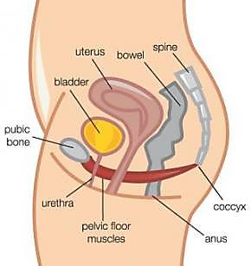
Figure 1. Cartoon of the female lower abdomen, picturing the role of the pelvic floor (Picture taken from http://www.continence.org.au/pages/about-your-bladder.html.
However, the pelvic floor is a complex structure formed of various layers of muscles and connective tissue, attached to the pelvic bones in various directions to support the internal organs in the most appropriate way (Herschorn 2004) (Figure 2).
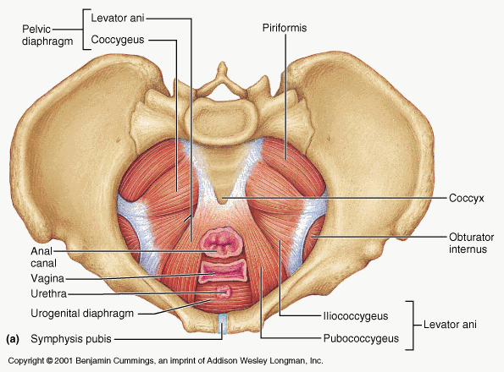
Figure 2. Detailed cartoon of the pelvic floor, picturing the various components present (cartoon taken from http://jessicarealept.com/2015/07/09/pelvic-floor-pain-athletes/ )

The pelvic floor is formed of three muscle layers: superficial perineal layer, deep urogenital diaphragm layer and pelvic diaphragm. The superficial perineal layer mainly supports the uterus and the vagina, the deep urogenital diaphragm supports the urethra and the anus and the pelvic is the muscle that divides the pelvic cavity and the peritoneal area (Ashton-Miller & Delancey 2007) (Figure 3) .

Figure 3. Diagram of the Pelvic Floor (Ashton-Miller and Delancey, 2007).

As previously mentioned, the pelvic floor is mainly made of connective tissue and layers of smooth muscle that give fibromuscular support. Therefore, the composition of these tissues is crucial for their function. The balance between fibroblasts, fibrillary elements, such as collagen and elastin, and non-fibrillar components such as proteins and proteoglycans, within the extracellular matrix is crucial for the pelvic floor function. Thus, pelvic floor function is mainly based on the remodelling of the connective tissue which has a primarily a supportive role (Goh 2003).
  - Function of the Female Pelvic Floor

The female pelvic floor supports pelvic and abdominal organs during any increases in abdominal pressure. These muscles keep the abdominal organs in place and they control the fluctuations of the abdominal pressure due to various factors such as exercise, excretory functions and childbirth.
The support of the Pelvic floor depends on its attachment to the pelvis thanks to the supportive tendons . When the pelvic floor is healthy, muscles elongate so they can deal with the abdominal pressure, keeping the tendons under minimal stress. However, when muscles relax or they are damaged, the tendons have to hold the abdominal pressure, and they can do so only for a short period of time. If they are under constant strain, due to the constant lack of muscle support, they will get damaged in the long run. Therefore, problems in either the muscle tone or the tendons might result in pelvic floor dysfunction (Ashton-Miller and Delancey, 2007).
  - Causes of Pelvic Floor Dysfunctions
Pelvic floor dysfunctions can be caused by damage to the muscles or supporting ligaments due to many causes. Below there is a list of few common causes for pelvic floor weakening or damage, leading to dysfunction.
Childbirth has been recognized as the major factor to cause pelvic floor dysfunction. Vaginal birth can often be hurtful on the pelvic floor, resulting in tears of the pelvic floor muscles and fascia, due to excessive stretching (Samuelsson et al. 1999).
Also age at birth of the first child (Samuelsson et al. 1999; Glazener et al. 2013), BMI and baby’s weight are factors that might cause pelvis strain and damage (Gyhagen et al. 2013a; Gyhagen et al. 2013b; Gyhagen et al. 2013c).
Moreover family history and genetic predisposition have been shown to be factors predicting pelvic floor dysfunctions (Milsom et al., 2013). Aging can also affect the pelvic floor muscle strength, which is also an indicator of future dysfunctions (Samuelsson et al. 1999; Milsom et al. 2013).
Other causes include pelvic girdle pain. During pregnancy, the pelvis might lose stability and alignment, causing pain. To compensate, the pelvic floor will become overexcited to try and restore stability, causing pelvic floor dysfunction. Life style can also put strain on the pelvic floor, such as poor posture or heavy work might lead to build up in tension, as result of the pelvis not aligned correctly with the rest of the body (Slieker-ten Hove et al. 2009). Chronic constipation can also weaken the pelvic floor and strain the organs due to the prolonged bearing of faeces. Overactive pelvic floor conditions can also strain the pelvic floor causing weakening. These are disorders where the pelvic floor muscles are held chronically tight and voluntary movement is difficult. Examples include excessive tension of vaginal or anal muscles and tension of the muscles involved in defecation (Gyhagen et al. 2013c; Milsom et al. 2013).

  - Pelvic Floor dysfunctions that might require reconstruction
Pelvic floor reconstruction might be needed when the pelvic floor loses its mechanical properties severely and therefore its function. Major scenarios when pelvic floor reconstruction is needed are Pelvic Organ Prolapse (POP) and Stress Urinary Incontinence (SUI).
POP occurs when the female pelvic organs including vagina (vaginal vault prolapse), bladder (cystocele), uterus (uterine prolapse), rectum (rectocele) and bowel (enterocele), fall away from their position, dropping into the tissues underneath. This displacement might cause morbidities such as SUI and discomfort (Cannon et al., 2005, Hunskaar, 2005).
  - Non-surgical approaches to pelvic floor dysfunction
Methods to treat POP and SUI can be surgical and non-surgical. Non-surgical approaches include pelvic floor exercises, the use of pessaries and hormone therapy.
Pelvic floor exercises are useful means to increase pelvic floor tonicity only in the low percentage of cases where the pelvic muscles are still functioning. Although it requires specialist physiotherapy training and it might vary according to lifestyles, it is still recommended for many patients as it results in improved pelvic floor function (Hagen et al. 2006; Hagen et al. 2009; Moen et al. 2009).
Pessaries can also be used when excretory functions have been compromised due to weakening of the pelvic floor. They are placed intra-vaginally and they provide structural support to the vagina. Their shape is often circular, and they can be bent with increasing in abdominal pressure and the position of the woman (Pott-Grinstein & Newcomer 2001; Handa & Jones 2002).
Hormones such as oestrogen are also prescribed to women affected by pelvic floor dysfunctions. It has been shown that oestrogen receptors are expressed in the vagina, levator ani muscle, ligaments and fascia. Increasing concentration of oestrogen should stimulate the pelvic floor to remodel by increasing collagen I and III production. Initially, Falconel hypothesized that connective tissue in the pelvic floor underwent aging and weakened as for any other tissues in the body. They therefore tested oestrogen replacement therapy in patients in menopause. They found that after oestrogen replacement therapy, patients developed pre-menopausal connective tissue composition, with more proteoglycans and less cross-linking.
These findings have been confirmed in animal models in more recent studies (Falconel et al. 1996; Clark et al. 2005; Vardy et al. 2005; Rizk et al. 2008).
  - Surgical approaches to pelvic floor dysfunction
However, following failure of conservative management including physiotherapy, pessaries and hormone replacement therapy, corrective surgery is considered to be the most effective and durable treatment for both SUI and POP. Studies show that surgery involving prostheses resulted in longer lasting solutions than any other methods, although additional data is needed to quantify improvement in quality of life (Maher et al. 2010). It is reported that an estimated almost 226000 women a year had surgery for POP in the USA (Brown et al. 2002). Currently, the probability of necessitating POP surgery above the age of 80 is around 11%, and 29% to 40% of women who have surgery undergo further surgeries within 3 years after the first operation (Olsen et al. 1997; Clark et al. 2003; Bogusiewicz et al. 2006).
Recent studies have also shown that women of various ethnic backgrounds are also equally affected by POP (Walker & Gunasekera 2011). Moreover, as a result of an ageing population, the global demand for pelvic floor treatments will significantly increase in the next three decades (Luber et al. 2001).
Most of older surgical techniques relied upon suturing the local tissues to the back of the pubic bone (colposuspension) or using an autologous fascial sling. More recently, there has been a growing trend to reinforce repairs using both synthetic and biological materials. The use of synthetic mesh made from polypropylene was adapted from hernia surgery where there is established evidence that repairs reinforced with synthetic mesh provide superior outcomes (Gigliobianco, Regueros, et al. 2015).
The most common surgical procedures to repair the pelvic floor are:
- Anterior vaginal wall repair: materials are used to re-inforce the connective tissue/ fascia - around the vagina.
- Upper vaginal repair: usually in case of uterine prolapse, materials are used to restore the function of the uterosacral ligaments. This often happens in women in menopause, and the surgical treatment consists of a hysterectomy (i.e. removal of the uterus), and lifting of the remaining vagina to the sacral bone.
- Posterior vaginal wall repair: materials are used to support the posterior part of the pelvic floor, usually lifting the colon that has prolapsed.
  - Materials used for pelvic floor reconstruction
Materials for pelvic floor reconstruction are various, such as autografts, allografts, xenografts and synthetic meshes (Birch, 2005, Deprest et al., 2005, Amrute and Badlani, 2006, Huebner et al., 2006, Herschorn, 2007, Wu, 2008, Lousquy et al., 2009). The choice of the material will depend on the type of procedure but mostly on the surgeon’s choice.
    - Autografts
The most commonly used material, autologous fascia, has been used for over 100 years in the treatment of SUI with good efficacy. Autologous grafts are pieces of connective tissue harvested from the patient herself. Autologous grafts are harvested from the rectus fascia or the fascia lata around the thighs. Fascia is the connective tissue that wraps the muscles and it is mainly made of aligned collagen fibres that give strength to the tissue.
Fascia has long been used in pelvic floor reconstruction as it has a high percentage of success. A major advantage of autografts over synthetic materials is that erosion is almost unheard of (Golomb et al., 2001). In this thesis the term ‘Erosion’ is meant as the gradual destruction of soft tissue around the material. The main drawback however is the need to harvest the graft from a donor site (fascia lata from the thigh, or rectus fascia from the abdominal wall) and potential morbidity (e.g. wound infection, scar, nerve injury, hernia) (Birch & Fynes 2002). There is a limitation on how much graft can be harvested which precludes its use in POP which is associated with relatively large fascial defects. Another possible disadvantage to using autografts is that the connective tissues of patients with SUI and POP may be inherently weak pre-disposing to failure. Nevertheless, the overall long term outcomes with autografts are largely excellent with reported rates of cure generally over 90% (Morgan et al., 2000, Latini et al., 2004).
    - Allografts
Allografts are grafts donated from another human being. Allografts used in pelvic floor reconstruction usually consist of fascia. The donors are screened for infectious diseases before the grafts undergo cleaning, freeze drying and gamma irradiation to eradicate any infective or immunogenic material. A concern with these grafts is that they are often donated by the elderly who have an age related weakening of connective tissues (Moalli, 2006). Additionally, processing techniques such as freeze drying and solvent dehydration may also reduce their tensile strength (Lemer et al., 1999). Cadaveric grafts are advantageous in that they avoid donor site complications. In terms of efficacy, results are mixed. Some have shown cadaveric fascia to demonstrate similar subjective cure rates to autologous fascia at around 90% at 2 years (McBride et al., 2005).
However, others have shown that on urodynamic testing 42% of cadaveric graft patients had SUI whereas no patients with autologous grafts had SUI (Howden et al., 2006).
    - Xenografts
Lack of autograft or allograft availability can be avoided by using grafts derived from animal derived collagenous tissues (e.g. porcine dermis, porcine small intestine and bovine dermis), called xenografts. However, these materials require extensive processing: decellularisation, sterilization, and cross-linking processes to resist degradation (Freytes et al. 2005). While this renders materials non-immunogenic, it can impact upon their biomechanical properties (Vangsness et al. 2003). There is also the risk of viral or, with bovine tissues, prion transmission (Birch & Fynes 2002).
Clinical studies are limited, however clinical experience is that all of the materials appear to be associated with graft failure in the medium term due to the body’s response to the material, leading to its encapsulation and subsequent degradation with limited remodeling.
A number of grafts from animals, mainly porcine and bovine, have been used in pelvic floor surgery. Commercially available products include porcine dermis (Stryker, Airmed Biologics and CorMarix, USA- emcm, Europe) and small intestine submucosa (Cook biotech and RT Biologics, USA). These materials undergo extensive processing to be decellularised and to render them non-immunogenic. Additionally, there are FDA regulations on animal source and vaccination status which must be complied with (Amrute and Badlani, 2009). An advantage is that additional steps might be added to improve graft’s quality.
For example, porcine dermis may be artificially cross-linked using hexamethylene-di-isocyanate to make it more resistant to enzymatic digestion (Winters, 2006). Clinical studies showed lower continence rates for porcine dermis (approx. 80%) and increased re-operation than for synthetic tape or autologous fascia (Lucas M, 2004). Porcine small intestine submucosa (SIS) has shown cure rates from 79 to 93% at 2 and 4 year follow up respectively (Jones et al., 2005, Rutner et al., 2003) (Figure 4). However, one study has raised concerns that SIS may not be strictly acellular and may contain porcine DNA (Zheng et al., 2005).
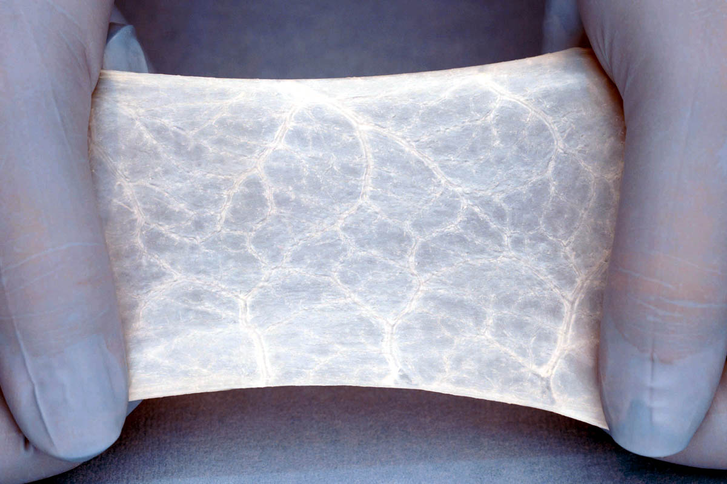
Figure 4. Porcine Small Intestine Submucosa after processing and decellularization (Badylak 2002)
    - Synthetic materials
Meshes for urological applications were adapted from meshes used in hernia repair where they were firstly introduced in 1960 (Usher et al. 1960). After many years of synthetic meshes being used for hernia repair, they started being used for uro-gynocological applications.
Synthetic meshes were popularized in pelvic floor surgery for SUI following the work of Ulmsten and Petros (Ulmsten & Petros 1995). The mid-urethral tape (MUT) involved a minimally invasive approach to implant a thin synthetic mesh underneath the mid-urethral point. Early reports of cure rates in the range of 80-90% further propelled the uptake of this technology. Following the early success of MUT and a randomized control trial against colposuspension, synthetic mesh for SUI was soon introduced (Ward 2002). Ward et al (2002) study, demonstrated a 4% of the implanted meshes were exposed. This meant that they were visible after implantation, due to damaged tissue around the material. Subsequently, mesh was introduced for the treatment of pelvic organ prolapse (POP) and this has resulted in a significant problem with mesh exposure which has led to enormous medico-legal problems, particularly in the United States of America(Division of Small Manufacturers 2011) .
However, synthetic meshes are still the surgeons’ preferred choice, and the most common material used is still polypropylene, as there is a wide range of synthetic polypropylene meshes to choose from. The most common meshes are summarized in Table 1 where they are classified as Types 1, 2, 3 or 4 according to their porosity, where 1 is macroporous (>75 µm), 2 is less than 10µm, 3 is microporous with microporous compartments and 4 is nanoporous (<1µm) (Birch 2005; Deprest et al. 2005). These materials offer several advantages including no risk of infectious diseases, readily availability, as well as the sustainable tensile strength due to their non-degradable nature (Gomelsky and Dmochowski, 2007). The initial clinical experience with a mid-type II (microporous/multifilament fibers e.g. expanded PTFE), and III (macroporous and microporous/multifilament fibers e.g. Mersilene) meshes was poor with excision rates of up to 30% for expanded PTFE (Weinberger and Ostergard, 1996) and erosion rates of 17% for Mersilene (polyester) (Young et al., 2001).
Table 1. Classification of synthetic materials used in pelvic floor reconstruction
Mesh Type |  | Polymer | Trade name | Company
Type 1 = Macroporous 75< x >500µm | Monofilament | Polypropylene | Uretex® | CR Bard
Type 1 = Macroporous 75< x >500µm | Monofilament | Polypropylene | GynecareTVT | Ethicon,Johnson&Johnson
Type 1 = Macroporous 75< x >500µm | Monofilament | Polypropylene | Bard®Mesh | Bard/Davol
Type 1 = Macroporous 75< x >500µm | Monofilament | Polypropylene | SPARCTM | American Medical Systems
Type 1 = Macroporous 75< x >500µm | Monofilament | Polypropylene | In-FastTM | American Medical Systems
Type 1 = Macroporous 75< x >500µm | Monofilament | Polypropylene | MonarcTM | American Medical Systems
Type 1 = Macroporous 75< x >500µm | Monofilament | Polypropylene | Lynx® | Boston Scientific
Type 1 = Macroporous 75< x >500µm | Monofilament | Polypropylene | Advantage® | Boston Scientific
Type 1 = Macroporous 75< x >500µm | Monofilament | Polypropylene | obtryx® | Boston Scientific
Type 1 = Macroporous 75< x >500µm | Monofilament | Polypropylene | Optilene® | B. Braun
Type 1 = Macroporous 75< x >500µm | Monofilament | Polypropylene | ArisTM | Mentor Corp
Type 1 = Macroporous 75< x >500µm | Monofilament | Polypropylene | PerigeeTM | American Medical Systems
Type 1 = Macroporous 75< x >500µm | Monofilament | Polypropylene | Parietene | Covidien
Type 1 = Macroporous 75< x >500µm | Monofilament | Polypropylene | Intepro® | American Medical Systems
Type 1 = Macroporous 75< x >500µm | Monofilament | Polypropylene | Gynecare Prolift® | Ethicon,Johnson&Johnson
Type 1 = Macroporous 75< x >500µm | Monofilament | Polypropylene | SurgiproTM | Covidien
Type 1 = Macroporous 75< x >500µm | Monofilament | Polypropylene | Prolene® | Ethicon,Johnson&Johnson
Type 1 = Macroporous 75< x >500µm | Monofilament | Polypropylene | Prolene® Soft | Ethicon,Johnson&Johnson
Type 1 = Macroporous 75< x >500µm | Monofilament | Polypropylene | GynemeshPS | Ethicon,Johnson&Johnson
Type 1 = Macroporous 75< x >500µm | Monofilament | Polypropylene | Atrium | Atrium Medical
Type 1 = Macroporous 75< x >500µm | Monofilament | Polypropylene | Marlex® | CR Bard
Type 1 = Macroporous 75< x >500µm | Multifilament | Copolymer ofglycolide(90%) andlactide(10%) | Vicryl® | Ethicon,Johnson&Johnson
Type 1 = Macroporous 75< x >500µm | Multifilament | Copolymer ofglycolide(90%) andlactide(10%) | Vypro® | Ethicon,Johnson&Johnson
Type 1 = Macroporous 75< x >500µm | Multifilament | Polypropylene and Polyglecaprone | UltraPro® | Ethicon,Johnson&Johnson
Type 1 = Macroporous 75< x >500µm | Multifilament | Poly Glycolic Acid | Dexon® | Davis andGeck
Macroporous = 1µm< x>10 µm | Multifilament | Expanded PTFF | GoreTex® | W.L Gore
Macroporous = 1µm< x>10 µm | Multifilament | Poly EthyleneTerephtalate | Mersuture | Ethicon,Johnson&Johnson
Macroporouswith microporous components = 0.1 µm< x>< 10 µm | Multifilament | PTFE | Teflon® | C.R. Bard
Macroporouswith microporous components = 0.1 µm< x>< 10 µm | Multifilament | Poly EthyleneTerephtalate | Mersilene® | Ethicon,Johnson&Johnson
Macroporouswith microporous components = 0.1 µm< x>< 10 µm | Multifilament | Polypropylene | IVSTunnellerTM | Tyco Healthcare
Macroporouswith microporous components = 0.1 µm< x>< 10 µm | Multifilament | Woven polyester | Protegen | Boston Scientific
Nanoporous = < 1 µm | Multifilament | Silicon-Coated Polyester | Intemesh® | American Medical Systems
Nanoporous = < 1 µm | Multifilament | Dura Mater substitute | PRECLUDE® MVP® Dura substitute | W.L. Gore
Nanoporous = < 1 µm | Multifilament | Expanded PTFE, pericardialmembrane substitute | PRECLUDE® Pericardial Membrane | W.L. Gore

Since then, a range of designs have been introduced to improve the host response to polypropylene meshes.
A greater pore size is thought to be advantageous as it allows the admittance of immune cells and greater collagen ingrowth into the construct (Birch and Fynes, 2002). This is thought to reduce the risk of mesh infection and accelerate and enhance host tissue integration. In addition to pores size, the nature of the mesh influences cell responses. Monofilament meshes are thought to reduce risk of infection in comparison with multifilament meshes. The theoretical concern with the latter is that bacteria may colonize the sub 10μm spaces between fibres which are inaccessible for the larger host immune cells (9-20μm) (Winters et al., 2006). Today a mid-type I polypropylene mesh that is macroporous and monofilament is most commonly used (Slack et al., 2006) with cure rates for SUI of > 90% at 5 years (Figure 5).
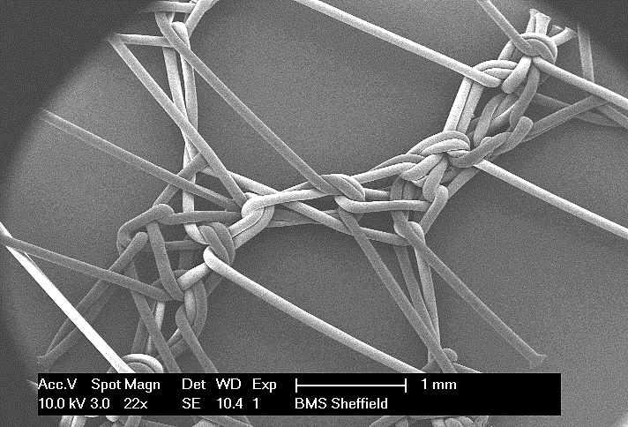
Figure 5. Example of a commonly used monofilament macroporous knitted polypropylene mesh (Gynemesh, Ethicon, J&J, USA).

  - Limitations of current materials
Generally, synthetic meshes last a lifetime with no complications. However, a small percentage (about 10%) of cases do not succeed and they will eventually fail, generating erosion and mesh contraction (Falagas et al., 2007, Gomelsky et al., 2011).
The past two decades have seen a rapid rise in reports of mesh for POP related complications. Thus reports of debilitating complications of vaginal mesh implantation have emerged including vaginal wall erosion (0-25.6%) chronic pain (0-5.5%) and sexual problems (1.9-17%). Although it can be debated whether these rates are high, the complications are often difficult to treat, requiring further hospital visits, tests and further reconstructive surgery.
The situation has not escaped the attention of medical regulatory bodies such as the FDA who have issued statements warning patients and surgeons of the potential dangers of mesh use for pelvic floor reconstruction (Schultz 2008b) . More recently there has been a wave of class action litigation law suits raised against device manufacturers by patients who have suffered mesh complications, such that several major manufacturers have withdrawn products from the market (Colaco et al. 2014; Schultz 2008a). Since this time, a new focus has been given to develop novel materials for pelvic floor reconstruction.
However, little attention was given to the causes of failure of the implants. There are not many studies investigating reasons for failure but with colleagues in the Macneil and Chapple groups, I undertook a recent review of this area (Gigliobianco, Regueros, et al. 2015). Materials for pelvic floor reconstruction were reviewed for their mechanical and biocompatibility properties.
We concluded that failure of the implants might be caused by one of several mechanisms, according to the nature of the implant materials such as mechanical failure straight after implantation, enzymatic degradation of the material causing mechanical degradation or a chronic inflammatory response causing erosion of the grafts (Gigliobianco, Regueros, et al. 2015).
It is likely that biomaterials are subject to multifactorial problems because of (1) their physical properties (e.g. porosity and degradability) (2) their mechanical properties (e.g. stiffness, strength) or (3) the nature of the patient’s immune response to the implanted biomaterials. In addition, surgical and patient specific factors (e.g. individual anatomy, comorbidities) are likely to play a role, though these are not modifiable by material design.
To provide a simple context, Figure 6 depicts the current hypotheses of how failures of implants might occur through several routes in cartoon form, where the implanted material is shown conceptually as a hammock attached to two trees (the supporting structures of the pelvic floor).
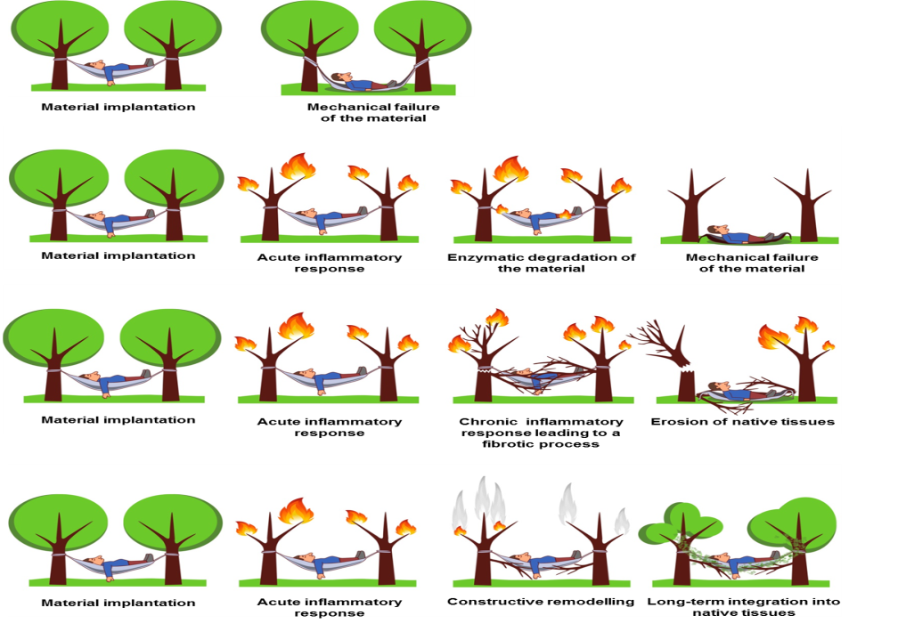
A
B
C
D
Figure 6. Cartoon of mechanisms of failure of urological materials: a) mechanical failure, b) material recognized as non-self and destroyed by body tissues with encapsulation, c) exposure (erosion), d) optimal result for implanted material (Gigliobianco, Regueros, et al. 2015).
In the case of a successful implantation, it is currently thought that the material induces an acute inflammatory response, which leads to constructive remodeling and material integration (Fig.6d). That is the final goal of materials for pelvic floor reconstruction. This is the aim of the material of the future.

  - The material of the future
Latest developments in materials for soft tissue regeneration, like the pelvic floor, include composites materials where the core is non-degradable and the outside is degradable and cell friendly (Faulk et al. 2014; Wolf et al. 2014) or it might be a mixture of non-degradable and degradable polymers such as Vicryl®, Vypro® and UltraPro®.
Recently, experimental studies suggest the use of coated commercially available materials with cell friendly polymers (Faulk et al. 2014; Wolf et al. 2014) or tissue engineered prostheses to reconstruct the pelvic floor (De Filippo et al., 2003, Cannon et al., 2005, Hung et al., 2010). Tissue engineered prostheses are particularly appealing as they are versatile and they incorporate an active component within the material. Tissue engineered prostheses used experimentally consist of biodegradable polymer scaffolds that are able to support autologous cell growth. These devices (i.e. the scaffolds/mesh) along with an active component (i.e. autologous cells/active molecule) are implanted into the host. Recent results have found a progressive reduction of inflammation response proportional to new tissue formation after implantation of the tissue-engineered prosthesis (Hung et al., 2010). Also, incorporation of cells into the device is very important, as it might affect the functionality of the device. It has been shown that autologous muscle cells can be largely increased in number and seeded on SIS or on PolyGlycolic Acid scaffolds. They are able to maintain contractile activity and polar orientation, creating self-organized structures after implantation (De Filippo et al., 2003, Cannon et al., 2005). Several studies have confirmed that ECM production and the cellular behaviour are influenced by the materials. Composition, structure, mechanical and physical properties of the surrounding environment were shown to influence cell phenotype, genotype and behaviour (Petreaca and Martins-Green, 2011). Thus, recent focus was given to approaches to influence cell behaviour once implanted, from manufacturing techniques to incorporation of active molecules.
  - Manufacturing techniques
As previously mentioned, the most common meshes for pelvic floor reconstruction are the synthetic ones as polymers are extremely versatile materials and they can be manufactured according to the wanted properties and features. However, there has been little exploration of manufacturing procedures for urological meshes because they have been used for long time for hernia repair. Meshes are usually packed into kits, to make them more easily used by surgeons, reducing operation time and overall costs.
    - Current approaches: Knitting and Weaving
Meshes for urological application are mainly made via knitting or weaving filaments of the polymer into a mesh (Chen et al. 2007). Filaments can vary in diameter and the knit can create small or large pores ( from macroporous: > 75 µm to nanoporous: < 1µm) (Chen et al. 2007) (Figure 7 & Figure 8).
Figure 7. Different types of weaves for urological meshes (Chen et al. 2007)

Figure 8. Different types of knit for urological meshes (Chen et al. 2007)

However, knitting or weaving limits the possibility of producing a matrix similar to the extracellular matrix of the body. Therefore, it is worth having a look at other manufacturing techniques that are more versatile to work with. Electrospun materials have been proven to be versatile and they can be manufactured in a variety of polymers and arrangements.
    - Future approaches: Electrospinning
Electrospinning can be used to produce non-woven materials for many applications.
Recently, electrospinning has been used for medical applications since a variety of polymers can be used (Blackwood et al. 2008). Electrospinning is used to manufacture scaffolds using electrostatic forces to assemble fibres and/or particles from an electrically charged solution. This technique is highly adaptable because materials and processing conditions can be finely tuned to control the direction and sizes of the electrospun fibres and the overall porosity (). Moreover, it is possible to incorporate other materials, such as active molecules or other polymers into the mat for use in drug delivery or to improve the mechanical properties of the final material (Shah et al. 2011).
Electrospinning has been investigated for medical applications in a variety of fields such as cardiovascular (Bergmeister et al. 2012; H. Liu et al. 2011; Ju et al. 2010; Nseir et al. 2013; Tillman et al. 2009; Mrówczyński et al. 2014), cartilage (McCullen et al. 2012; Fisher et al. 2013), bone (Nie et al. 2008; Jose et al. 2010; Park et al. 2012; Su et al. 2012; H. Liu et al. 2013; Chae et al. 2013; Lu et al. 2013) and peripheral nerve repair (Chew et al. 2007; Xie, Macewan, et al. 2009; Xie, Willerth, et al. 2009; Gupta et al. 2009; Prabhakaran et al. 2009; J.-J. Liu et al. 2011; Leach et al. 2011; Masaeli et al. 2013).
Fibres
Pore

Figure 9. SEM picture of an electrospun PLLA 3D structure.
  - Synthetic polymers currently electrospun for soft tissue engineering
The majority of the polymers currently investigated for soft tissue engineering are biodegradable: they would induce tissue regeneration but then they would degrade over time.
Biodegradable polymers are absorbed by the body and they encourage fibroblast activity leading to long lasting fibrosis. Macrophages slowly degrade the polymer, and the material is replaced with new fibrotic tissue (Cosson et al. 2003). Many of these polymers are FDA approved and already used clinically for other applications, such as degradable sutures, so the route to the clinic can be more straightforward. The most investigated electrospun polymers for soft tissue engineering are PolyCaproLactone (PCL), PolyGlycolic Acid (PGA) and PolyLactic Acid (PLA) due to their mechanical properties, degradability profile and versatility in manufacturing.
    - Polycaprolactone
PCL is a hydrophobic and semi-crystalline polymer, the higher the molecular weight, the lower the crystallinity. It can be easily dissolved in a wide range of solvents, it has a low melting point (59–64 ◦C) and it can easily be blended with other polymers or molecules (Chandra & Rustgi 1998; Coulembier et al. 2006). PCL degradation is considered slow as it usually degrades in 3-4 years, although its degradation kinetics can be tuned by mixing it with other polymers or changing the surface chemistry. PCL fibres can also be tuned by changing the electrospinning setting. In addition to these preferable properties, PCL is also FDA approved and CE mark registered, that would result in a faster route to market. For these reasons, PCL is still very popular in research for its potential biomedical applications (Woodruff & Hutmacher 2010).
    - Poly Glycolic Acid
Polyglycolic acid (PGA) is a biodegradable polyester that is also FDA approved as it is already in use for resorbable sutures and meshes. PGA is considered a fast degrading polymer and it undergoes plastic deformation and failure when exposed to long-term cyclic strain. Therefore, it is often mixed with other polymers to alter the properties to be suited for a range of applications. PGA is often added to polymers such as PCL and PLLA to increase their degradation rate. Additionally, PGA, as it undergoes plastic deformation, might be mixed with more elastic materials (Valentine Kanyanta, Alojz Ivankovic 2013). Recent examples of studies where PGA was mixed or grafted with other polymers can be found in appendix I (C. D. Easton et al. 2014; Farokhi et al. 2014; Farokhi et al. 2013; Xie et al. 2013; Xu et al. 2013; DeVolder et al. 2011).

    - PolyLactic Acid
PLLA is also a biodegradable polyester approved by the FDA (Coulembier et al. 2006). PLLA degrades by hydrolysis and its degradation rate is considered medium as it almost totally degrades about 12 months after implantation (Leerslag et al. 1987). It has been extensively investigated for its versatility for soft tissue engineering. Particularly, it has been used for electrospinning because by tuning the electrospinning parameters, a wide range of materials can be produced (. Blackwood et al. 2008) ). Various studies have investigated electrospun PLLA for its suitability to be an angiogenic material. It has been also mixed with PGA to produce better materials. Due to its porosity and surface chemistry, it has been shown that PLLA successfully supports angiogenesis (Eghtesad & Nurminskaya 2013; Huang et al. 2013).
    - Polyurethanes
Polyurethanes are also used for biomedical applications. They were firstly introduced as non-degradable materials in 1960 for cardiovascular applications (Lelah & Cooper 1986).
Polyurethanes can be divided into polyesters and polyethers, depending on the functional groups of the chain extender used to make the polymer. Polyesters are more susceptible to hydrolysis, more hydrophilic with low crystallinity and low melting point compared to polyether polyurethanes. Their chemical structure can be finely tuned by changing the raw materials used for their polymerization (Stokes & McVenes 1995). Polyurethanes are now being investigated for a range of medical applications due to their tuneable physical and mechanical properties. Recent studies have focussed on the use of polyurethanes for cardiovascular, musco-skeletal and nerve regeneration (Guelcher 2008).
  - The biggest hurdle after implantation: Angiogenesis
The choice of materials based on physical and mechanical properties has been discussed extensively. However, when the material is implanted into a human being, it has to face host’s fluids, cells and immune system. The material will need to be able to overcome the immune system reaction and induce tissue remodelling.
In case of tissue engineered prostheses (i.e. prostheses that include a material and cells) or degradable materials, the most important factor for the survival of the prosthesis is the formation of blood vessels into and around the prosthesis to ensure survival of the new regenerated tissue.
The slow development of new blood vessels after clinical implantation of tissue engineered constructs is a limiting factor for the initial integration of any 3D tissue constructs (Lovett et al. 2009; Naderi et al. 2011). This is because the thickness of the graft limits gas diffusion; if the scaffold thickness is more than 2 mm, the graft will require blood vessels for its survival (Zandonella 2003).
In pelvic floor reconstruction, angiogenesis is particularly relevant as the presence of blood vessels in the weakened area would bring cells and nutrients needed for the regeneration of the weakened tissue.
Angiogenesis is described as the formation of new blood vessels from existing ones (Hertig 1935). The angiogenesis cascade is usually triggered by an angiogenic stimulus, such as growth factors or change in oxygen concentration. Initially, the basement membrane is disrupted, then endothelial cells migrate towards the angiogenic stimulus and they organise themselves in that direction. Ultimately, endothelial cells proliferate enough to have enough cells to form the new vessel. These new vessels formed will bring nutrients and oxygen to the new part of the body that was previously without vasculature (Revised by Dew et al. 2015).
Angiogenesis was firstly studied in depth in the context of cancer biology because studies found that cancer, in order to survive within the host, would emanate angiogenic stimuli and induce formation of new blood vessels around it. This would result in a fresh supply of nutrients and oxygen to the tumour, ensuring its survival within the host (Norrby 2006).
This very same mechanism can be exploited by bioengineers to ensure the survival of the implanted material. Recently, the number of publications focussing on angiogenesis has increased, showing increasing efforts to develop materials that can induce blood vessel ingrowth. Approaches to introduce blood vessels in tissue engineered prosthesis include in-vitro and in-vivo pre-vascularisation. In-vitro pre-vascularization often uses existing vasculature connected to a perfusion bioreactor in addition to culture endothelial cells.
The flow of the bioreactor and the presence of a natural vasculature and endothelial cells create conditions for new blood vessels to sprout. In-vivo pre-vascularisation exploits the natural vasculature already present in animals. The construct is implanted in an area full of blood vessels, such as under the skin or around the omentum, for a period long enough for blood vessels to grow into the construct. This approach has been already tested to vascularise bladder, liver, myocardium and skin (Revised by Dew et al. 2015).
However, pre-vascularization strategies require additional manipulation steps of the construct, complicating the route to the clinic and increasing costs. Other vascularization strategies often include the use of molecular mechanisms such as chemokines, extracellular matrix components and mechanical stimuli. Angiogenic biomaterials are often designed to regulate the release of growth factors and other bioactive molecules. Although many growth factors are responsible for blood vessel formation, it is believed that vascular endothelial growth factor (VEGF) alone is sufficient to promote angiogenesis (Lovett et al. 2009). However, there are many ways to functionalise an electrospun scaffold to make it more angiogenic. Approaches include adding growth factors or bioactive molecules, either in the electrospinning solution or included in particles, tuning the porosity and the fibres size, adding angiogenic cells or binding active molecules on the surface of the electrospun scaffold (Sengupta et al. 2014).
  - Strategies to make electrospun materials more angiogenic
MEDLINE was screened for recent articles that studied methods to modify electrospun biomaterials to induce angiogenesis. All these studies seem to agree on the need for an improved material that integrates better with the surrounding tissue, inducing angiogenesis.
Three main approaches developed in the last five years to make electrospun scaffolds more angiogenic are microfabrication, cell seeding and incorporation of active molecules within the electrospun scaffolds. Microfabrication includes strategies to tune fibers diameter and scaffold porosity by changing the electrospinning settings to make various 3D structures. Cell seeding with various cell types, from endothelial cells to mesenchymal stem cells, is thought to induce angiogenesis by seeding progenitor cells, stem cells or inflammatory cells onto the scaffold prior implantation. These cells, once implanted, can secrete chemokines and angiogenic factors to induce a response. Lastly, integration of bioactive molecules is the most popular approach so far, where studies have investigated integration of sulphate and non-sulphated sugars, growth factors and other bioactive molecules within the scaffold to induce angiogenesis.
All these studies are summarised in a table in Appendix I.
    - Electrospinning to induce angiogenesis
Microfabrication is generally defined as the process of fabrication of miniature structures of micrometre scales and smaller. It is based on the principle of creating structures that mimic the in-vivo environment.
In case of tissue engineering electrospun scaffolds, it refers to mimicking the in-vivo Extra Cellular Matrix (ECM) structure via electrospinning of synthetic or natural occurring polymers in nano- or micro- structure that are suited for specific applications. As ECM, synthetic electrospun scaffold should be able to:
- Guide cell growth
- Guide cell infiltration
- Guide cell differentiation
- Guide inflammatory response
- Recruit cells to the site on injury
- Promote healing and guide remodelling
(Sengupta et al. 2014)
Due to the complexity of the human body and healing process, studies have started by looking at how the structure of electrospun scaffolds can affect the healing and angiogenesis. By tuning the electrospinning settings, it is possible to produce mats with different fibres diameters (from nanometres to micrometres) with small pores (5 µm) or big pores (300 µm). Also, laser ablation and fibre alignment can be used to increase scaffold porosity and thus enhance cell infiltration (Kurpinski et al. 2010; B. L.-P. Lee et al. 2012; Phipps et al. 2012).
Papers that have investigate microfabrication as tool to induce angiogenesis are summarised in Appendix I. A study found that a scaffold, to be angiogenic have to be at least 25% porous and the pores have to be interconnected (Walthers et al. 2014). Also (Joshi et al. 2013) showed that laser-cutting pores in electrospun scaffolds of 300 µm induced more angiogenesis than 80 µm or 160 µm pores. Another study showed how an increase in porosity (fibre diameter of 3µm and pore diameter of 30 µm) induce a better macrophage response, where there was an increase in production of VEGF, TGF-β1 and bFGF (Garg et al. 2013). Another study showed how wet electrospinning can be used to produce highly porous mats that were infiltrated by blood vessels after 8 weeks implantation in rats (Yang et al. 2013). Also a study of Rnjak-Kovacina showed that electrospun elastin scaffolds with high porosity had better in-vitro cell infiltration and in-vivo angiogenesis in a mouse after 6 weeks compared to low porosity scaffolds (Rnjak-Kovacina et al. 2011).
In conclusion, a few recent studies have investigated how microfabrication can be used to induce angiogenesis. They all agree that a scaffold has to be highly porous to allow angiogenesis to occur, and that pore size have to be at least 30 µm, but greater values are preferable, according to applications. These studies also agreed that a reasonable size for electrospun fibers is 2-5 µm in diameter. This size allows cell attachment and infiltration reasonably well.

    - Cell seeding to induce angiogenesis
Tissue engineering approach incorporates cells into a material in order to improve the outcome of the material once implanted (Vacanti & Langer 1999). Endothelial cells are usually preferred over other cell types for materials that need to be vascularised fast. This is because of their known phenotype and their role in forming blood vessels in-vivo, where they line the inside of blood vessels.
Primary sources of endothelial cells are human dermal microvascular ECs (HDMECs), human umbilical vein ECs (HUVECs) and bovine aortic ECs (BAECs). However, they are quite difficult to isolate, they have a low proliferation rate and high maintenance costs (Yamamoto et al. 2014). Other groups have also tried to use endothelial progenitor cells as they can be easily isolated from a wide range of tissues: umbilical cord, peripheral blood, bone marrow-derived mononuclear cells and adipose tissue. Their differentiation can be confirmed by markers such as VonWillebrand factor, PECAM-1/CD31 and vascular endothelial cadherin (Fadini et al. 2012). It has been shown that progenitor cells promote migration into the damaged tissue, inducing an increase in capillaries in animals as they secrete chemotactic factors and cell-cell communication (Cottler-fox et al. 2003; Rafii & Lyden 2003; Yan et al. 2009). More recently, co-cultures of EPCs and other cell types such as smooth muscle cell, fibroblasts, adipocytes and osteocytes have been successfully tested to promote angiogenesis in-vivo (Chung et al. 2009; Hurley et al. 2010; Unger et al. 2010). However, these studies did not use electrospun scaffolds.
A few studies have been found that focus on cell seeding on electrospun scaffolds to help angiogenesis. One study tried a mixture of polymers to improve endothelial cells growth and sprouting. They electrospun a mixture of ethylene-co-acrylic acid, PCL, PEO, PEG, powdered milk and methyl cellulose. They then seeded endothelial cell spheroids and tested them for angiogenesis in-vitro. They found that the addition of powdered milk and methyl cellulose increased endothelial cells sprouting and the expression of angiogenic markers (Fu et al. 2014).
These studies are summarised in Appendix I. A study investigated how urine-derived stem cells seeded on electrospun PCL and gelatine improved wound healing in a full-thickness skin rabbit model and endothelial cells proliferation and tube formation in-vitro (Fu et al. 2014). In another study, they focused on electrospun tropoelastin seeded with ADSC. The scaffolds were then implanted in a full thickness model of immune-deficient rats for 6 days. H&E staining showed improved angiogenesis in scaffolds seeded with cells before implantation (Machula et al. 2014). The limited number of studies investigating cell seeding to induce angiogenesis in humans is probably due to the high regulatory hurdles for device approval if cells are included, although it has been shown the real improvement in angiogenesis and cell infiltration if cells were incorporated within the scaffold.
    - Incorporation of active molecules to induce angiogenesis
Incorporation of active molecules is still the preferred approach, as more studies have been found mixing or bonding active molecules to scaffold to make them more angiogenic compared to cell seeding or manufacturing. It is an adaptable technique as it is possible to use various active molecules, from growth factors to sulphated polysaccharides, and they can be bound on the electrospun scaffolds either by mixing the molecule, either alone or in a carrier, with the solution to electrospin, or by binding molecules on the surface of the electrospun material, either covalently or electrostatically. Recent studies on active molecules incorporated into or onto electrospun scaffolds to induce angiogenesis are found in Appendix I.
      - Molecules are blended into the polymer emulsion
The majority of the studies found were mixing active molecules, either alone or in a carrier, with the polymer mixture to electrospin (Augustine et al. 2014; Rujitanaroj et al. 2014; Wu et al. 2014; Xie et al. 2013; Farokhi et al. 2013; H. Wang et al. 2013; Xu et al. 2013; He et al. 2012; Montero et al. 2012). Coaxial electrospinning is also a preferred way to incorporate molecules within the electrospun mat, where the main polymer solution is spun on one side, and the solution containing the active molecule either alone or in a carrier is spun at the same time, but on the other side with another syringe and pump (Huang et al. 2013; Zhang et al. 2013; Guo et al. 2012; Seyednejad et al. 2012; DeVolder et al. 2011; Liao & Leong 2011). Figure 10 shows the difference between regular electrospinning and co-axial electrospinning. This approach is appealing as it is adaptable to various substrates and not technically difficult.
Electrospinning | 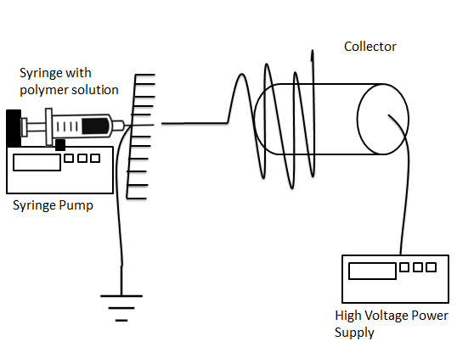
Co-axial electrospinning | 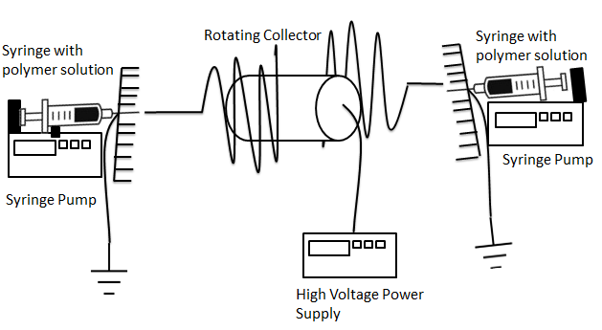

Figure 10. Cartoon of regular electrospinning versus coaxial electrospining.

    - Surface modification using bioactive molecules
Although the idea of blending polymers and active molecules together for electrospinning is attractive due to its simplicity, the molecules might be entrapped within the fibres and they play a little role in the initial material-cells contact as soon as the prosthesis is implanted. Therefore, surface modification techniques are more attractive as they allow modifying the surface of the polymer, which is the primary interface of contact for body fluid and cells (Chen et al. 2008; Rashidi et al. 2014).
As soon as the scaffold is implanted, it will encounter a protein-rich environment. Depending on the surface chemistry of the material, certain proteins will prefer to stick first on the surface rather than others. Therefore, surface modification techniques would give flexibility to improve cell-material interaction, without redesign the bulk properties of the materials.
Surface modification techniques are many, and they either introduce new functional groups onto the surface or they aim to coat the surface with a thin layer of another polymer or molecule. It is possible to introduce new functional groups by surface hydrolysis, plasma etching or grafting. Techniques that allow the formation of a thin layer of polymer are plasma polymerization, layer-by-layer assembly or physical adsorption (Rashidi et al. 2014). They are summarised in Table 2.
Table 2. Summary of surface modification techniques (adapted from (Rashidi et al. 2014)).
Covalent Grafting of peptides | Covalently bind peptides on the surface of the material. | (France et al. 1998; Melkoumian et al. 2010)
Plasma polymerization of a thin polymer layer | A polymer is plasma polymerised on the surface of the material to keep their functional groups. | (Daw et al. 1998; France et al. 1998; Barry et al. 2006)
Physical adsorption | Scaffolds are immersed in a solution with the compound of interest that become adsorbed on the surface. | (Yang et al. 2001; Quirk et al. 2001)
Layer-by-Layer assembly | The surface is firstly modified with a charged polymer. A polymer with the opposite charge is absorbed on top of it to create a multi-electrolyte structure on top of each other. | (Decher 1997; Zhu et al. 2003; Gong et al. 2007)
      - Molecules are covalently bound onto the scaffold
Few studies have investigated the efficacy of electrospun scaffolds if active molecules were covalently bound onto the surface of the fibres. These studies experimented with the surface chemistry of the electrospun mat in order to bind growth factors or polysaccharides that would bind growth factors (Zhang et al. 2014; J. Lee et al. 2012; Ekaputra et al. 2011; Kim et al. 2011).
The choice to covalently bind an active molecule on the surface might depends on the release profile wanted for that specific molecule. As covalent bonding is strong, the molecule might release slowly and not be available straightaway at the time of implantation. It might also be that the molecule, because is covalently bound onto the substrate, it is not active in its bounded form (Hinrichs et al. 1997).
As angiogenesis is crucial from the very first days of implantation, it is important that whatever molecule is on the scaffold to induce angiogenesis, would be readily available at the moment of implantation. This is why various other groups have investigated methods to electrostatically bind these molecules on the surface of electrospun scaffolds.

      - Molecule are electrostatically adsorbed onto the scaffold
Molecules are electrostatically absorbed on a surface (i.e. they are attracted to each other by their opposite charge) and it might be an interesting alternative to blending molecules in the polymer mixture when a fast release is wanted, just straight after implantation. Studies investigating how to electrostatically absorb active molecules on scaffolds were many and they are summarised in Appendix I (Castan et al. 2014; Diaz-gomez et al. 2014; Farokhi et al. 2014; Wu et al. 2014; Zhang et al. 2014; Del Gaudio et al. 2013; C D Easton et al. 2014; Eghtesad & Nurminskaya 2013; Z. Wang et al. 2012). Thus, molecules can be bound electrostatically on substrates when a fast release is beneficial an appropriate body response according to the application of that material.

  - Bioactive molecules used to induce angiogenesis
As previous studies suggest, the step forward from microfabrication is to make the materials smarter by incorporating active molecules to induce angiogenesis. They can either be mixed in the polymer solution, or bound to the substrate. In addition to strategies used to make the material smarter, the choice of the active molecule to make the material angiogenic is also very important because it will determine the host’s response towards the material.
The number of molecules used in-vitro to induce angiogenesis is vast, aiming to mimic the in-vivo reality. Scientists have tried to incorporate within the scaffold extracellular matrix components, such as collagen and elastin, both for their role in structural support and signalling; they also incorporate growth factors such as FGF, VEGF, PDGF and TGF-β for their crucial role in the angiogenesis cascade (Dew et al. 2015). Latest developments include the use of polysaccharides such as heparin or heparin-like saccharides that include motif to bind growth factors. These polysaccharides also have the ability to bind growth factors already present in solution, with a longer angiogenic effects than growth factors alone, as they denature quickly (Raman et al. 2005).
    - Extracellular Matrix Components
Recent studies have investigated how extracellular matrix (ECM) components can also help angiogenesis. The rationale behind this, as mentioned before, it is to recreate an environment similar to the in-vivo surroundings. ECM proteins, in addition to their structural function, also have a function in signalling and organizing cells around them.
This is because their protein sequences include adhesion sequences that would induce different reaction in different cell types (Badylak 2002). These ECM adhesion sequences can interact with integrins on the cell surface that act as mechanoreceptors between the matrix and the cells, creating adhesion points. This is how capillary endothelial cells might control their growth in response to chemotactic factors, by detecting ECM and mechanical signals around them (Ingber 2002). These adhesion points would be responsible for the activation of internal pathways, activating various cell types from endothelial cells to fibroblasts (Lutolf & Hubbell 2005).
More recently, energies have been focused on analysing various components of the ECM, to understand what are the peptide sequences relevant for angiogenesis and why. There is a general agreement that the ECM is mainly composed of stromal matrices and basement membranes. Stromal matrices are mainly composed of fibrillary collagen, elastins and fibrin, while basement membranes are mainly made of laminins, collagen IV and heparin sulphate proteoglycans. Compositions of these components change according to the tissue type and function, but stromal matrices have been shown that allow vessels sprouting and cell alignment (Francis et al. 2008). On these bases, elastin, collagen and hyaluronic acid have all been electrospun, creating scaffolds that supports angiogenesis (Ekaputra et al. 2011; Rnjak-Kovacina et al. 2011). Moreover, sulphate proteoglycans have also been investigated for their role to bind growth factors. However, growth factors are still the most attractive bioactive molecules, due to their ability to direct cell behaviour directly, compared to ECM components.

    - Growth Factors
Growth factors, as said before, are proteins that are involved in cell’s communication and movement (chemotaxis). They are the proteins that regulate the development, maintenance and death of all cells in living beings (Folkman 1995).
Thus they are appealing molecules for bioengineering due to their crucial role they play in regeneration and angiogenesis. Growth factors involved in angiogenesis have been extensively reviewed and they all agree that the major contributors to angiogenesis are VEGF, FGF and PDGF (Moon & West 2014; Pérez et al. 2013; Roy et al. 2011; Laschke et al. 2006). They have been shown to play an role in the angiogenic cascade (Dew et al. 2015).
In the specific case of electrospun scaffolds, many studies have incorporated growth factors within the electrospun matrix. The most common growth factors recently used to functionalise elecrospun scaffolds are Fibroblast Growth Factor (FGF) (Kim et al. 2011; Liao & Leong 2011; Guo et al. 2012; He et al. 2012; Montero et al. 2012), Vascular Endothelial Growth Factor (VEGF) (DeVolder et al. 2011; Liao & Leong 2011; He et al. 2012; Seyednejad et al. 2012; Del Gaudio et al. 2013; Farokhi et al. 2013; Xie et al. 2013; Farokhi et al. 2014) and Platelet-Derived Growth Factor (PDGF) (J. Lee et al. 2012; Farokhi et al. 2013; Xie et al. 2013; Zhang et al. 2013), or a combination of these. Although less common chemokines, such as sphingosines, have also been used (Zhang & Song 2014).
However, growth factors are expensive molecules and very unstable; they often need to be mixed with a carrier, such as heparin, gelatine or polymers, in order to be bioactive once in-vivo. Therefore, the option to use a cheaper and more stable alternative is appealing from a translational point of view.
    - Drugs and other components
For this reason, other mixtures have been investigated, where a cheaper and more stable alternative was used. Other extracellular components were used to functionalise electrospun scaffolds such as serum (Eghtesad & Nurminskaya 2013), serum albumin (Xu et al. 2013), herbal components (H. Wang et al. 2013), platelet-enriched plasma (Diaz-gomez et al. 2014) and zinc oxide (Augustine et al. 2014) as they all have been proven to help with cell infiltration and angiogenesis. The advantage to use these components, other than the cost, is that they can be used to condition the scaffold once in the operating theatre.
    - PolySaccharides
Recently, studies have been focusing on the use of saccharides to functionalise scaffolds, instead of using growth factors or synthetic drugs. Saccharides become appealing in the past few years as they have been found to also bind and stabilise growth factors and they might be a cheaper alternative (van Wijk & van Kuppevelt 2014).
PolySaccharides are a major component of cell membranes and extracellular matrices. More specifically, glycosaminoglycans have been shown to play many physiological roles due to their flexible chemical structure (Raman et al. 2005). In angiogenesis, the glycosaminoglycan of major interest is heparin, a highly sulphated glycosaminoglycan, because of its ability to sequester growth factors in solution.
Heparin is already used clinically as anti-coagulant for its action against anti-thrombin III. In addition to its anticoagulant properties, heparin was also shown to have high affinity with important angiogenic factors such as FGF and VEGF.
This is because growth factors have heparin-binding sequences. It also protects growth factors from proteolysis and thermal damage (van Wijk & van Kuppevelt 2014).
Many studies have shown that functionalization of electrospun scaffolds with heparin was useful to bind growth factors present in solution, rendering the scaffold angiogenic (Kim et al. 2011; Z. Wang et al. 2012; Huang et al. 2013; C. D. Easton et al. 2014; Wu et al. 2014).
These recent studies confirm that heparin and heparin salts are attractive molecules to modify materials to make them more angiogenic. For this reason, heparin was used to functionalise various substrates in this study.

  - Project Aim
The aim of this study is to develop an angiogenic coating for materials for pelvic floor reconstruction.
We hypothesise that the surface modification of existing scaffolds with heparin offers the potential to make these materials angiogenic in-vivo by binding VEGF or ideally by binding growth factors already present in naturally occurring body fluids. This will enhance the surface property of the polymer decreasing the possibility of a chronic inflammatory response. This would lead to a better host integration and vascularization (Rashidi et al. 2014).

OBJECTIVES
To investigate this, the project was divided into the following main experimental objectives:
- To manufacture electrospun polylactic acid and polyurethane scaffolds that would support cell infiltration and collagen production, to be compared with a commercially available polypropylene mesh.
- To plasma polymerise a layer of acrylic acid onto these scaffolds and a PP mesh used as control, as base for a layer-by-layer assembly.
- To bind heparin to the scaffolds using a layer by layer approach on these scaffolds.
- To verify the ability of the coated scaffolds to bind VEGF, as a representative growth factor for angiogenesis.
- To verify the angiogenic potential of coated scaffolds in an in-vivo CAM model.
- To verify the feasibility of conditioning the coated scaffolds with human plasma to make them angiogenic prior implantation in the CAM model.

- Chapter 2 - Materials and Methods
  - Scaffolds
    - Electrospinning of PLLA
PLLA (Goodfellow, UK) was dissolved in Dichloromethane (DCM) (Sigma-Aldrich, UK) in 10% weight/volume proportion. The solution was left on a rocking platform overnight to dissolve at room temperature. The following day, 40 ml of the solution was electrospun with a 50 ml syringes fitted with a manifold with 12 stainless steel blunt needles. It was placed horizontally on a programmable syringe pump (Kent Scientific, USA) and discharged at a rate of 480 µl per second. The syringe was supplied with 17 kV by a high voltage power supply (Genvolt, UK). The fibrous scaffold was collected on a rotating drum 16 cm x 6 cm in diameter at a distance of 17 cm from the needles tips (Figure 11). This drum rotated at 300 revolutions per minute, resulting in an 18 x 16 cm mat of approximately 150 µm thick. Scaffolds were produced at a room temperature of about 20°C. If scaffolds were produced under sterile conditions, the collector was enveloped in a sterile sheet of aluminium and the needles were wiped in 70% ethanol in deionised water. After electrospinning, the scaffold was removed with sterile scissors and forceps and placed in a sterile square petri dish.
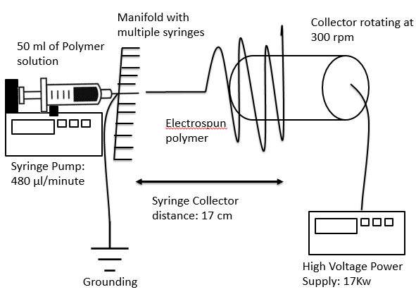
Figure 11. Diagram of the electrospinning rig used to manufacture the scaffolds. It includes a syringe with the polymer that is pumped ansd the polymer is sprayed from a manifold with many needles. The polymer is charged and, while it is pumped, it is attracted and collected to a rotating collector. These settings have been established optimal by previous work (K. A. Blackwood et al. 2008).

    - Electrospinning of Polyurethane
Polyurethane Z3A1 was purchased from Biomer (Rancorn, UK) and it was electrospun following these settings: Z3A1 was dissolved in a solution of 70:30 of DMF:THF (Sigma-Aldrich, UK) in 10% weight/volume proportion. The solution was left on a rocking platform overnight to dissolve at room temperature. The following day, the mixture was stirred energetically and it was left on the rocking platform for one more night.
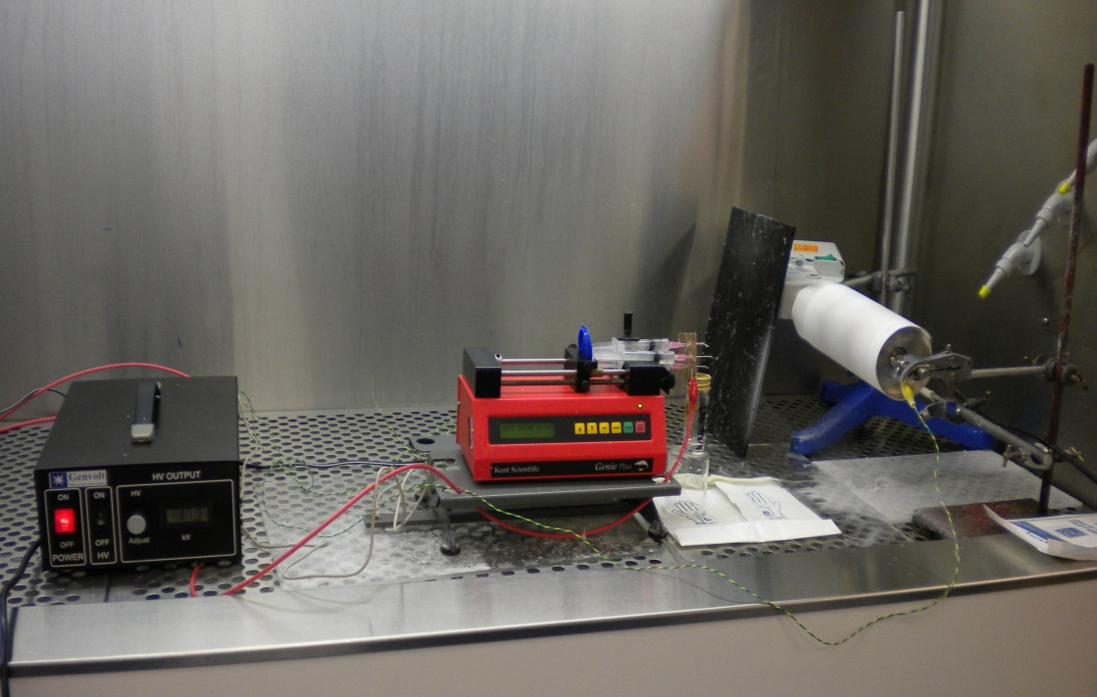
On the third day, 40 ml of the solution was electrospun with a 50 ml syringes fitted with a manifold with 12 stainless steel blunt needles. It was placed horizontally on a programmable syringe pump (Kent Scientific, USA) and discharged at a rate of 480 µl per second. The syringe was supplied with 20 kV by a high voltage power supply (Genvolt, UK). The fibrous scaffold was collected on a rotating drum 16 cm x 6 cm in diameter at a distance of 17 cm from the needles tips (Figure 12).
Figure 12. Photo of the electrospinning rig used.

This drum rotated at 300 revolutions per minute, resulting in an 18 x 16 cm mat. Scaffolds were produced at a room temperature of about 20°C. If scaffolds were produced under sterile conditions, the collector was enveloped in a sterile sheet of aluminium and the needles were wiped in 70% ethanol in deionised water. After electrospinning, the scaffold was removed with sterile scissors and forceps and placed in a sterile square petri dish. This manufacturing protocol and these scaffolds were chosen because they have been proven suitable for soft tissue regeneration as previously investigated (Blackwood et al. 2008).
    - Gynemesh PS
Commercially available polypropylene mesh, Gynemesh (Ethicon, Johnson&Johnson, USA) was used as supplied.
  - Coating
    - Plasma Polymerization
Scaffolds were plasma polymerized with 98% PAC (Sigma-Aldrich, USA) in deionised water. Plasma polymerization is carried out as following: scaffolds were inserted into the glass chamber of the plasma rig and the flask with 98% PAC was attached to the rig. The initial pressure was adjusted at 3.0 x 10⁻² mbar by opening the needle valve. The vacuum valve was then closed for 30 second and the final pressure was 4.2 x 10⁻¹ mbar. This process was repeated three times to ensure that the flow rate was stable. The power was then switched on for 20 minutes by an RF-plasma at 13.56 MHz and delivering at 15 W. After 20 minutes, the RF-plasma was switched off and the pump was kept on for 5 minutes to remove the acrylic acid left in air from the chamber. Afterwards, the needle valve was closed for one minute to allow the residual air to leave the glass chamber. Finally, air was let into the chamber and scaffolds were retrieved (Figure 13).
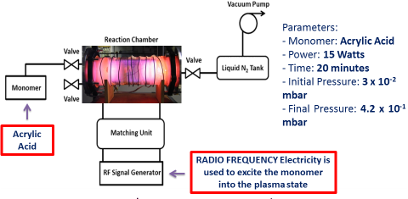
Figure 13. Diagram of the plasma rig used to plasma polymerize acrylic acid on top of the scaffolds surfaces. The monomer used was Acrylic acid, which was excited with radio frequency.
    - Layer-by-Layer Coating
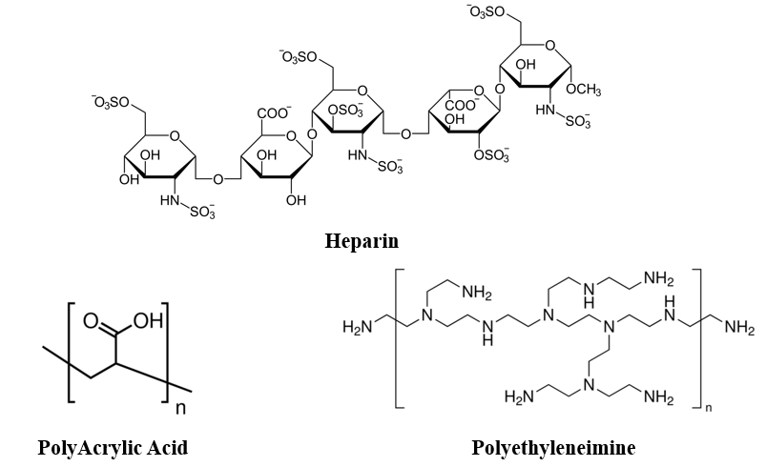
Initially, two coatings were tested on the PLLA scaffolds to understand which one was most suitable for binding heparin (HEP). The first coating was made by PEI and HEP. The second multilayer coating was made of PEI and PAC. These two types of coatings were tested for the best coating to bind heparin. PEI was chosen because it was demonstrated to build a good and stable multilayer coating (Dong et al. 2008; Mahlicli & Altinkaya 2013; Scheuerlein et al. 2015). PAC was chosen because it was shown to create a stable and cell-friendly negatively charged surface (Müller et al. 2001; Lehle et al. 2004; C. D. Easton et al. 2014). PAC solution was made of 0.5% volume/volume PAC (Sigma-Aldrich, UK) in deionised water. The pH was adjusted to 4 by adding drops of 50% PEI until the pH was reached. PEI solution was made of 0.5% weight/volume PEI (Sigma-Aldrich, UK) in deionised water. The pH was adjusted to 9 by adding drops of 98% polyacrylic acid until the pH was reached. Chemistry of the monomers are found in Figure 14.
Figure 14. Molecules used in this study: Heparin, PolyAcrylic Aid and PolyEthyleneImine
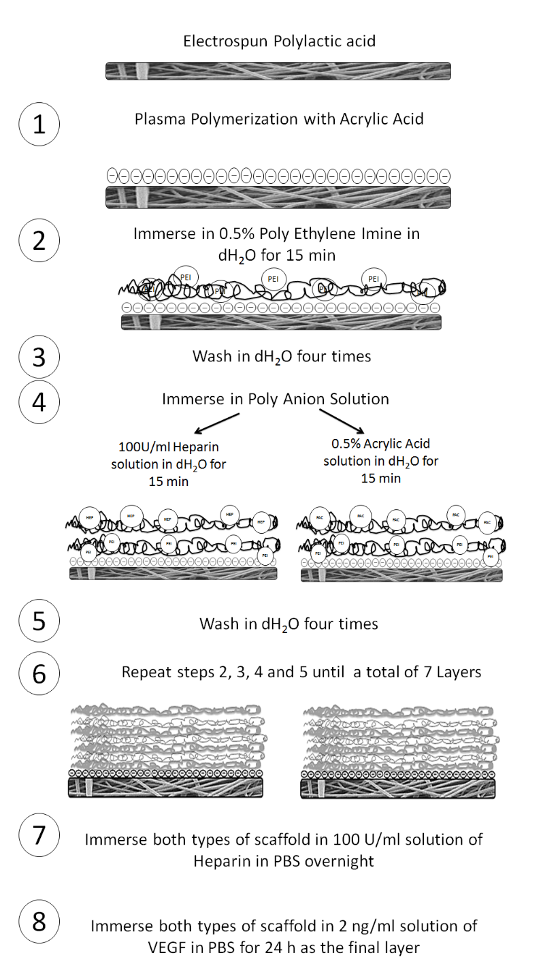
After plasma polymerization, scaffolds were coated with these two different type of coatings (Figure 15).
Figure 15. Diagram of the coating protocol where two types of coatings were used.
Plasma polymerised PLLA scaffolds were transferred into the PEI aqueous solution for 30 minutes at room temperature. Scaffolds were then washed four times with deionised water and they were immersed in a 100 U/ml aqueous solution of HEP (Sigma-Aldrich, USA) for 30 minutes at room temperature. The other set of scaffolds they were immersed in a 0.5% aqueous solution of PolyAcryilic Acid (PAC) (Sigma-Aldrich, USA) for 30 minutes at room temperature, after plasma polymerization,. Both types of scaffold were washed again four times with deionised water and placed into the PEI aqueous solution for 30 minutes at room temperature. These steps were repeated each time throughout the production of the seven layers, with the last layer always being PEI. Figure 15 describes the coating protocol. After it was established that the best polyelectrolyte combination was PEI/PAC, the other to scaffold types, electrospun PU and PP mesh, were coated with PEI/PAC as Figure 15 shows.
    - Heparin and Toluidine Blue quantification
After the LBL coating, scaffolds were dipped in 2 ml of 100 U/ml heparin aqueous solution overnight at room temperature (Figure 15 - step 7). Heparin was quantified by the toluidine blue assay initially described by Hinrics et al. 1997 (Hinrichs et al. 1997).
Briefly, one part of heparin solution used to coat the scaffolds was mixed with two part of toluidine blue solution (0.005% toluidine blue in PBS). The resulting solution was left on a rocking platform for 4 hours, to allow heparin-toluidine blue complexes to be formed. After 4 hours, the solutions were centrifuged at 10000 rpm for 5 minutes to allow the precipitate to sink at the bottom of the Eppendorf tubes. After centrifugation, the exec liquid was removed and the pellet was dissolved in 1 ml of 4:1 of pure ethanol and 0.1 M of NaOH. Once the pellet were dissolved, 100 µm of the resulting solution was read at 562 nm. A standard curve was created with known concentration of heparin.
    - VEGF coating
Afterwards, scaffolds were washed with deionised water and left overnight in 1 ml of 2000 pg/ml VEGF solution in PBS (Figure 15 - step 8). VEGF was used (Sigma-Aldrich).The following day, the VEGF solution was removed and scaffolds were washed with PBS.
    - Human blood plasma coating
Human blood was harvested with the consent of donors. Trisodium citrate (Sigma-Aldrich) at 0.1009 M in 1:10 dilution was used to avoid coagulation of the samples.
Whole blood was centrifuged at 300 rpg for 20 minutes to divide the red blood cells from the plasma. Once erythrocytes precipitated, blood plasma was aspirated from the tubes and aliquoted in fresh tubes for freezing and afterwards use. Scaffolds were than conditioned with 1 ml of human plasma overnight.
  - Quantification
    - Scanning Electron Microscopy (SEM)
SEM was used to characterise the surface of the scaffolds. After functionalization with heparin, samples were dried at room temperature. They were then coated in gold with a sputter coater (Edwards sputter coater S150B, Crawley, England). Samples were imaged with a Phillips XL-20 scanning electron microscope (Cambridge, UK). SEM pictures were taken before and after functionalization.
SEM was also used to characterise the surface of the scaffolds retrieved from the CAM. Scaffolds, after being retrieved from the CAM, were fixed in paraformaldehyde for 1 hour. After, scaffolds have been dehydrated with serial dilutions of ethanol (30%, 60%, 80%, 90% and 100%), for 15 minutes for each dilution of ethanol. Samples were then dried at room temperature for up to a week. They were then coated in gold with a sputter coater (Edwards sputter coater S150B, Crawley, England). Samples were imaged with a Phillips XL-20 scanning electron microscope (Cambridge, UK). SEM pictures were taken before and after functionalization.
    - Ellipsometry
Ellipsometry is a non-invasive and non-destructive measurement method of layer thickness and absorption coefficient from the refractive index of the surface. The relative change of polarization of light hitting a sample surface can give information about the sample properties. The resolution of ellipsometry regarding thickness is very precise and enables measuring thickness < 1 nm and refractive index error from 0.001 to 0.01 [1]. In this lab experiment we measure the thickness of two different coatings on a silicium wafer sample. In the protocol, the refractive index was calculated based on the incident angle and the angles of polarizer/analyzer and compare it with the determined value via the ellipsometer software.

    - X-Ray Photoelectron Spectroscopy (XPS)
Surface chemistry was verified by X-Ray Photon Electron Spectroscopy (XPS). After functionalization with heparin, the samples were left to dry completely at room temperature before surface analysis. X-ray photoelectron spectra were obtained at the National EPSRC XPS User's Service (NEXUS) at Newcastle University. The instrument used was the K-Alpha instrument equipped with a monochromated AlKα source (Thermo Scientific, East Grinstead, UK). Pass energy of 200 eV and a step size of 1.0 eV were employed for survey spectra, while a pass energy of 40 eV and a step size of 0.1 eV was used for high resolution spectra of the elements of interest (Carbon, Oxygen, Nitrogen and Sulphur).
Two spots were taken for each sample, and two samples of each scaffold type were analysed. Curve fitting was carried out with casaXPS programme (USA). After curve fitting, atomic percentages for each element were measured. Plain scaffolds were compared to coated scaffolds.

    - Ability of scaffolds to bind VEGF
As previously mentioned, the coated scaffolds were immersed into either a 2 ng/ml Vascular Endothelial Growth Factor (VEGF) solution in PBS at room temperature overnight. The scaffolds were then washed once in 1 ml PBS. A human VEGF Enzyme-Linked Immuno-Sorbent Assay (ELISA) (Peprotech Inc., USA) was carried out on the wash solutions to quantify how much VEGF was present in the solutions and how much was therefore still bound to the surface of the scaffolds. The assay was carried out according to the manufacturer’s instructions.
    - Angiogenic properties of coated scaffolds using the CAM Assay
Fertilized chicken (Gallus domesticus) eggs were purchased from Medeggs (UK) and incubated from day 2 of fertilization until day 8 at 37°C in a humidified rocking egg incubator (R-COM Suro20). At day 8, a square window (1 cm²) was cut into the shell and lifted, and a 2 cm² fully coated scaffold was placed onto the CAM. Half of the samples were fully functionalised and soaked in VEGF or human plasma prior to implantation, and then washed. The other half was plain scaffolds soaked in VEGF solution and washed. Each egg was implanted with one scaffold only. The shell window was replaced with parafilm (Bemis Flexible Packaging, USA) and sealed with adhesive tape. After implantation, eggs were placed again at 37°C in a 40% humidified incubator until day 14. At day 14, scaffolds were retrieved and the eggs were sacrificed. Figure 16 shows a cartoon of the timeline of this assay.
Angiogenesis was quantified by taking light microscope pictures just before scaffold retrieval and blindly scored by four assessors using histological images of the retrieved scaffolds. Images were scored for cell infiltration and number of blood vessels.
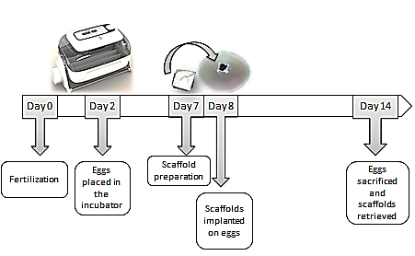
Figure 16. Timeline of the CAM assay, from fertilization to egg scarification. Chicken eggs get fertilised at day 0, and they were incubated in the lab at day 2. Scaffolds were implanted on the embryo on day 8 and explantation of the scaffold was carried out at day 14.

    - Histology
Histology was performed on the retrieved scaffolds. Scaffolds from the CAM were fixed in 3.7% paraformaldehyde (Sigma Aldrich, USA) in deionised water for at least 1 hour. They were placed into moulds for cryo-sectioning filled with OCT solution (Leica, Germany). They were left to freeze at -80°C and 20 µm sections were cut with the cryostat Leica CM1860UV (Leica Germany). Slides were then stained with Haematoxylin & Eosin solutions (H&E) and Gouldner’s Trichrome, according to the standard protocol for frozen slides.
Slides were then covered with DPX (Sigma-Aldrich, USA) and a glass coverslip to be imaged with a light microscope (Motic, China). Quantification of cell infiltration and angiogenesis of each scaffold after CAM assay was based on the H&E histology. Four scorers evaluate blindly cell infiltration and angiogenesis. The histology images were blindly scored from 0 (no cell infiltration) to 3 (massive cell infiltration) by 4 assessors. Angiogenesis was also blindly assessed by 4 scorers, by counting the number of blood vessels.

2.3.6 Immunohistochemistry

Frozen slides were then stained for the CD31 antigen. Slides were firstly washed twice in PBS and then blocked with 10% bovine serum albumin in PBS for 1 hour. They were then incubated overnight at 4°C with the primary antibody (Dako) (monoclonal CD31, 1:50). Samples were washed 4 times for 5 minutes. Slides were then incubated for at least 1 hour with the secondary antibody goat anti-mouse Alexa488 (Life technologies) (1:200). Samples were then washed 4 times for 5 minutes. Finally, they were incubated at room temperature for 20 minutes with DAPI solution to stain the nuclei.

2.3.7 Imaging
Pictures of the CAM were taken with a USB microscope (Maplin, UK) using natural light. Histology and Immunohistochemistry images were taken with a light microscope (Motic, China) and fluorescent immunohistochemistry pictures were taken with a confocal microscope (Leica, Germany).
    - Statistical Analysis
Statistical analysis was performed to verify statistical difference between groups or among variables. Two tailed T-test was performed two compare two groups. One-way ANOVA was used to find statistical difference among several groups of variables.

- Chapter 3 – Characterization of materials used
  - Poly (L) Lactic Acid (PLLA)
One of the major challenges in regenerative medicine is to develop biomaterials that are biodegradable and bioabsorbable with the right biological and mechanical properties. Polylactones are usually preferred for biomedical applications because they are very biocompatible (Cheng et al. 2009). Among polylactones, Poly(L)Lactic Acid (PLLA) has been approved by the FDA as a material for medical applications and its route to the clinic should therefore be faster than a material without approval (Coulembier et al. 2006). It was firstly used in a form of degradable stitches in 1960 (Kulkarni et al. 1966). It is currently investigated for several medical applications (Jamshidian et al. 2010).
Advantages of using PLLA for medical applications are many. Firstly, as it is a polylactone that degrade with hydrolysis, it does not erode human tissues as it will degrade slowly. A slow degradation will also allow a gradual restoration of tissue function as while the material degrades, the new tissue is formed.
Synthetic polymers such as PLLA are also attractive because they can be prepared as an off-the-shelf product, readily available for when the surgeon needs it. This also means that, unlike autologous grafts, the patient would not require a second surgery, either to remove the implant or to harvest autologous tissue, reducing medical costs. That is why lactic acid was used in this study in a form of an electrospun mat. Electrospun materials have been shown to form good scaffolds for soft tissue engineering as they are very versatile in how they can be manufactured (Szentivanyi et al., 2011, Jin et al., 2012, Supaphol et al., 2012, Zhong et al., 2012, Goh et al., 2013, Hasan et al., 2014, Sundaramurthi et al., 2014).
    - Chemistry and Manufacturing
The chemical formula of PLLA is (C₃H₄O₂)_{n}. It is usually produced by ring opening polymerization of lactic acid. Lactic acid is also called 2-hydrohypropionic acid with two chiral conformations: -L and –D enantiomers. For this project, the –L enantiomer was used. It contains both a carboxylic group and a hydroxyl group (Figure 17) (Lasprilla et al. 2012). They degrade by hydrolysis of the ester bonds (C-O), resulting in lactic acid that it is transformed into pyruvic acid to feed the Krebs’ cycle in the body to produce ATP (Tsuji & Ikarashi 2004). This is very favourable as the degradation does not produce molecules that would induce a chronic inflammation.

Figure 17. Chemical structure of the monomer (L) Lactic Acid

PLLA can be manufactured in various ways, as it is a polymer that can be dissolved in solvents or melted. Most commonly used methods are particulate-leaching, fibre extrusion, phase separation, gas foaming and emulsion freeze-drying (Jamshidian et al. 2010). More recently, other techniques become popular such as 3D printing and electrospinning for their ability to produce a wide range of 3D structures (K. A. Blackwood et al. 2008; Serra et al. 2014).
In this study, we opted for electrospun PLLA, as a fibre mat would be preferable for urological applications where the tissue is generally soft and surgeons need sheets of relatively strong yet flexible materials to replace damaged tissues. Electrospun PLLA has been largely used for many applications as previously mentioned. However, PLLA is fairly new for urological application, as just lately companies have started manufacturing degradable (Vicryl®, by Ethicon and Dexon® by Davis&Geck) or partially degradable meshes (Vypro® and UltraPro® by Ethicon) for urological applications where meshes incorporate degradable polymers such as PLA and PGA.
Electrospinning exploits an electric charge to drive the polymer, that it is usually dissolved in a solvent, onto a collector by creating fine fibres (Chapter 2.1.1). This technique creates mats of different thickness, fibre diameter and alignment, depending on the amount of polymer spun, the voltage used and the nature of the collector. It is usually a fast process and with care the mat produced can be very reproducible ( Blackwood et al. 2008).
  - Polyurethanes
Polyurethanes have been used for medical applications for more than 50 years in many fields such as cardiovascular and plastic surgery. They were initially introduced as non-degradable materials, but it was found that due to their stable nature, they induced a foreign body reaction once implanted. Thus, in recent years, the focus was to develop biodegradable polyurethanes. This was possible due to their segmented polymeric nature that allows a wide range of properties to be incorporated into the polymer (Zdrahala & Zdrahala 1999).
Recent studies confirmed that polyurethanes can be used for various medical applications, from cardiovascular (Fujimoto et al. 2007; Siepe et al. 2007; Stankus et al. 2007), to muscoskeletal (Klompmaker et al. 1992; De Groot et al. 1997; Gisselfält & Flodin 1998; Chang et al. 2007) to nerve regeneration (Borkenhagen et al. 1998).
Advantages of using these polyurethane are that they can be easily electrospun into mats to create 3D scaffolds, they are cell-friendly and promote new tissue ingrowth and their elastic properties are ideal for reconstructing the pelvic floor (Zdrahala & Zdrahala 1999) (Hillary et al. accepted).
    - Chemistry and Manufacturing
Polyurethane are formed of 3 basic components: P-(D(CD)-P) where P is called polyol or soft segment, D is diisocyanate and C is the chain extender, and together are called hard segment. The soft segment is usually a chain with low glass transition temperature (<25°C) and terminated by hydroxyl groups (-OH) (Santerre et al. 2005). For this study, we used Z3A1 polyurethane, supplied by Biomer where the soft segment is a polyether (Rancorn, UK) (Figure 18).
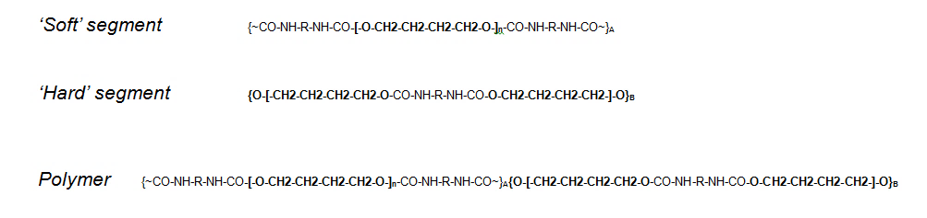
Figure 18. Chemical structure of the polyurethane Z3A1 used in this study.

Polyurethanes are degraded by hydrolysis or enzymatic degradation of the ester bond (soft segment). The rate of degradation affect the host response: slowly degrading polyurethane induce a higher macrophage response than faster degrading ones (Siepe et al. 2006; Kazuro et al. 2007).
Similar to PLLA, polyurethane can be manufactured in various ways. Examples are thermally induced phase separation, salt leaching, wet spinning, electrospinning and carbon dioxide foaming (Guelcher 2008).
In this study, polyurethane was electrospun to create a reproducible and elastic mat, suitable for pelvic floor reconstruction.
  - Polypropylene
Polypropylene is the most commonly used material for pelvic floor reconstruction, as it has a long history of success for hernia repair and it has been simply adapted for urological applications. However, FDA recently issued a public health notification stating the danger of using PP meshes for urological applications (Schultz 2008a). Despite the FDA notification, polypropylene is still commonly used since major companies such as AMS and J&J have invested in developing kits for use in Stress Urinary Incontinence (SUI) by adapted hernia meshes for use in the pelvic floor (Chapter 1, Table 1) and surgeons have been trained to use these meshes for many years.
    - Chemistry and Manufacturing
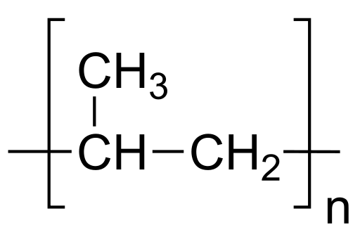
Polypropylene is made by refining petroleum and polymerizing the monomer propylene (Figure 19).

Figure 19. Propylene monomer

Fibres are produced by heating and stretching the polypropylene, and they can either be a single fibre (monofilament) or a bundle of fibres (multifilaments). Afterwards, they are knitted or woven according to the mesh to be produced (Chapter 1, Figure 7 & Figure 8). The resulting mesh is hydrophobic and non-hydrolysable (Sternschuss et al. 2012). However, it has been found that is not inert, probably due to the presence of the stabilizers used on the surface which can induce acute inflammation and it is thought that the oxidants produced by neutrophils damage the surface chemistry of the fibres (King & Lyman 1975; Sternschuss et al. 2012).
As polypropylene meshes are commercially available and widely used by surgeons, it was used as a control material for this study; specifically, Gynemesh (Ethicon, USA) was used.

  - Results
Morphological and physical properties of the scaffolds were investigated initially.
PLLA and PU were electrospun as previously mentioned (Chapter 2), resulting in a white mat. Commercially available polypropylene mesh was used that look like a transparent woven net (Figure 20).
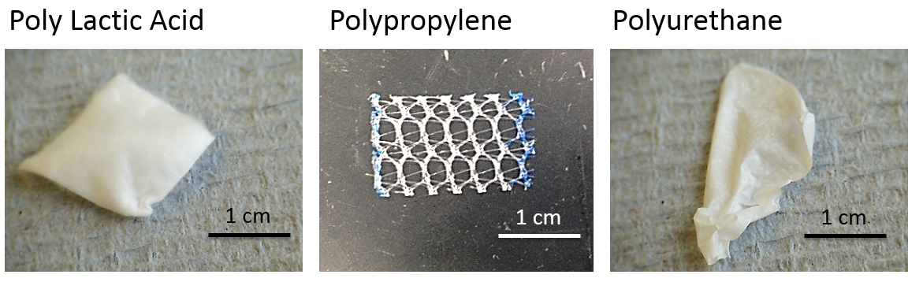
Figure 20. Light microscope picture of the scaffolds prior to implantation.
SEM picture of PLLA shows the micro scale nature of the scaffolds: fibres are randomly aligned.
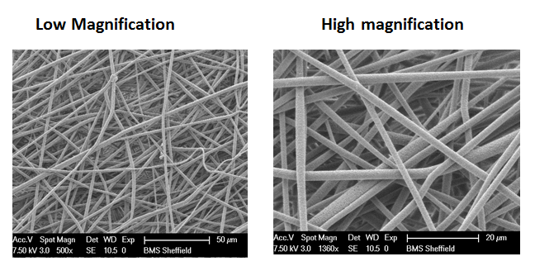
Figure 21. SEM of representative PLLA electrospun mats

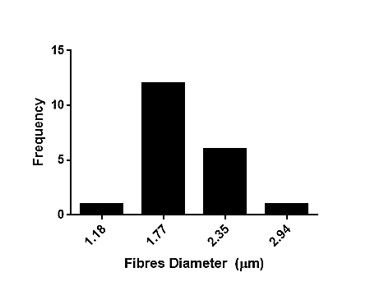
From Figure 21, it is possible to observe that the mat is highly porous on the surface. Although pore sizes varied, the spread was between 7 µm and 17 µm (Figure 22). It is also possible to observe that the fibres are randomly aligned and non-woven, creating an appropriate 3D environment for cells to infiltrate. Fibres diameter was also measured. PLLA dispersion of fibre diameter is narrow, ranging from 1.77 to 2.35 µm (Figure 22).
Figure 22. Representative frequency of pore size in the PLLA mesh. Measures were taken for SEM pictures of 9 scaffolds. Three pictures were taken from 3 different area per scaffolds. Three measurements were taken for both pore diameter and fiber diameter per picture.

Electrospun PU was also morphologically characterised. SEM pictures of the electrospun PU scaffolds also show that the mat is made of randomly aligned fibres (Figure 23).
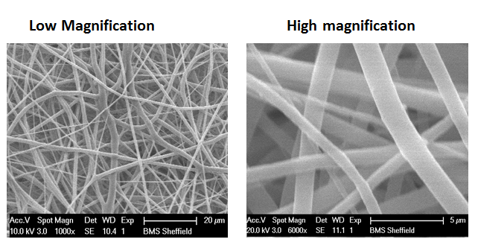
Figure 23. Representitive SEM of electrospun polyurethane fibres.

As with the PLLA mat, the PU mat was also very porous on the surface. Pores size was smaller and more homogenous than both PLLA and PP, with a closer distribution (Fig.8). However, it is still a very suitable environment for cells to grow into, as literature suggest (Roman et al. accepted). Fibre diameters of the PU mat vary between 0.8 and 1.76 µm. They are smaller than PLLA but the size is still relevant for cell attachment and infiltration (Figure 24).
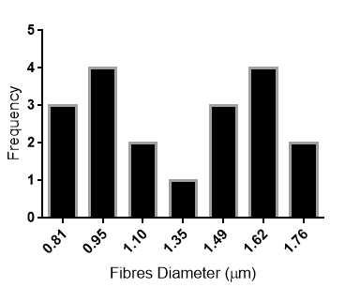
Figure 24. Representative quantification of pore sizes and distribution for the PU mesh. Measures were taken for SEM pictures of 9 scaffolds. Three pictures were taken from 3 different areas per scaffold. Three measurements were taken for both pore diameter and fibre diameter per picture.

PP mesh used is commercially available (Gynemesh, Ethico, USA) and it is knitted (i.e. fibres are used to create knots that then form a mesh) (Fig. 9). SEM pictures of the mesh show the nature of the knots and the fibres. Knots create areas of small pores while there the other areas have less material and much bigger pores. The pictures also show fibres of different colours, white and dark grey, probably suggesting different coating or processing of the fibres (Figure 25).
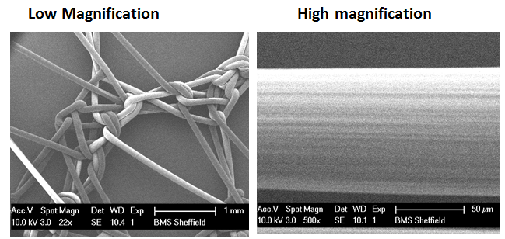
Figure 25. Representative SEM images of a commercially available polypropylene mesh.

Pore size has a wide distribution due to the nature of the scaffold, ranging from 200 µm to 1.5 mm. Fibre diameters are much larger than the previous two materials, ranging from 97 to 128 µm (Figure 26).
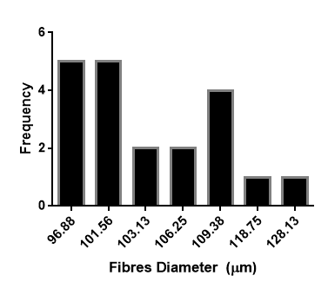
Figure 26. Representative pores size and frequency of a commercially available PP mesh. Measures were taken for SEM pictures of 9 scaffolds. Three pictures were taken from 3 different area per scaffolds. Three measurements were taken for both pore diameter and fibres diameter per picture.

This structure does not create an ideal environment for cell infiltration, as the large pores are too big for cells to attach and create a matrix. This structure together with the material that is inert and it is not degradable, might increase the possibility of a chronic inflammatory response and prosthesis rejection (Figure 27).

Scaffolds thickness was also measured, as it plays a crucial role in gas and nutrients exchange for the cells that populate these scaffolds.

Figure 27. Difference in scaffold thickness among the materials used. Thickness was measured with a feeler. 3 different scaffolds were prepared for each type of scaffolds. 3 measurements were taken for each scaffold. Statistical analysis was not performed as the aim was not to compare differences in thickness (± SEM).

From these measurements, it is possible to conclude that PP is the thickest scaffold and that PU is the thinnest. Although PP is thick, the big pores allow passage of gases and nutrients. However, even if PP and PU are thinner compared to PP, their interconnected non-woven mesh might create a barrier for gas and liquid exchange. This graph represents the heterogeneity of scaffolds included in this study, to make sure that the coating, if successful, could be applied to as many types of scaffolds as possible.
  - Discussion
Electrospinning allows production of a porous mat in about 2 hours. However, this technique is affected by temperature and humidity. Care must be taken to ensure that any scaffolds not conforming to the required specifications are rejected –in practice this means routinely examining fibre structure and diameters and scaffold pore sizes. Although these scaffolds were reproducibly produced in house, there are now small spin-out companies producing electrospun scaffolds under Good Manufacturing Practices and ISO standards (http://www.electrospinning.co.uk/company/quality-assurance/). This company currently works with academic groups to develop reproducible protocols for scale up and clinical use.
PLLA was chosen as it has been already approved by the FDA and cells interact well with it. PU was chosen because it has distensibility without deforming plastically in contrast to PP mesh (Roman et al. accepted). PP was investigated as it is the material most commonly used in repair of the pelvic floor (Gigliobianco, Regueros, et al. 2015) and in the context of these studies it was used as a control material.
PLLA and PU can be easily electrospun into mats with controlled fibre diameter and interconnected porosity. Pore sizes for these two materials proved the right size for cell infiltration (PLLA pore range: 7-17 µm and PU pore range: 2-10 µm) as previous studies shown (Joshi et al. 2013; Walthers et al. 2014).
Moreover, as previously mentioned, fibre diameter also plays a role in tissue formation and cell infiltration. PLLA and PU scaffolds, due to their non-woven nature that mimics natural tissues, should have better cells infiltration into their 3D structure, compared to the PP open knitted structure (Takahashi & Tabata 2004; Fioretta et al. 2014). Thus, they are a good starting point for further in-vitro investigations. .
Pore size can have a great impact on tissue integration as previous studies show. Small pores, like PLLA and PU, are preferred than very large pores like in PP as cells need a scaffold that allows them to ‘climb’ into it (Klinge et al. 2002). Moreover, pores smaller than 5µm might not allow macrophages to get into the tissue, favouring the development of infections (Birch & Fynes 2002).
Fibre diameter is also important as fibres constitute the 3D network that supports cell ingrowth. It has been shown that cells sense the porosity and the fibre diameter.
Studies have reported how cell behaviour (infiltration, proliferation and differentiation) are affected by these factors (Takahashi & Tabata 2004; Sanders et al. 2005; Hadjizadeh & Doillon 2010; Hodgkinson et al. 2014; Abrigo et al. 2015). All these studies agree that a pore size > 10 µm and a fibre diameter not thicker of 10µm are better for cell infiltration, attachment and proliferation. Therefore, smaller fibres are preferable, as in PLLA and PU electrospun meshes, to thick fibres as in PP meshes, because they offer more support to cells infiltrating the scaffolds. This is extremely important because if the 3D structure allows cells to attach and infiltrate, this would induce production of extracellular matrix that would replace the scaffold and the damaged tissue. It would ultimately affect the success of the implant.
Moreover, thickness of the scaffold is also extremely important; if the material is very thick, cells would not be able to infiltrate it and that would cause inflammation and a giant body reaction with the likely development of a fibrotic shell around the implant. Ultimately, there would be no integration between the material and the host (Elbert et al. 1999; Joshi et al. 2013).
Studies have found that porosity and fibres’ diameter affect the degree of inflammation caused by the material. Large and non-degradable fibres like PP meshes tend to cause chronic inflammation and granulated tissue around the material. Granulation and chronic inflammation is the body attempt to isolate the material from the body, suggesting poor integration of the prosthesis within the host. These studies on PP mesh agree that polypropylene meshes provoke a fairly pronounced inflammation, leading to a massive cell infiltration into the scaffold and ultimately to collagen production (Kuznetsov et al. 2004a; Rabah et al. 2004a; Bogusiewicz et al. 2006; Bazi et al. 2007; De Almeida et al. 2007; Huffaker et al. 2008; Woodruff et al. 2008; Elmer et al. 2009; Pierce et al. 2009).
On the other hand, studies on immunological responses against electrospun PLLA and PU scaffolds, suggest that these scaffolds induce an M2 macrophage response, leading to tissue remodelling and material integration (Sabi’s paper (K. a. Blackwood et al. 2008)).
Currently, PP meshes are the golden standard for urological applications and electrospun PLLA and PU are cutting edge technologies that have not reach the clinic yet. Long time will pass before these latest technologies will reach the clinic but we need strategies to improve existing material straightaway. Therefore, it is important to investigate strategies to improve integration within the host despite the substrate, because ultimately this will improve regeneration. This approach will give the opportunity to modify and improve a wide range of materials that are currently in use. This study focusses on a novel coating of scaffolds to induce angiogenesis. The above mentioned scaffolds were chosen as implanted substrates for the coating, as they are representative of the current status in pelvic floor reconstruction: electrospun PLLA and PU represent emerging technologies and the PP mesh represent a well-established material for pelvic floor reconstruction.

- Chapter 4 – Characterisation of the Layer-by-Layer coating
  - Introduction
The time required for new blood vessel formation after implantation of a tissue-engineered construct within the host is a great limiting factor for the survival of the construct (Lovett et al., 2009, Naderi et al., 2011). The size of the graft is also a limiting factor as the tissue diffusion limit is <2 mm. Any tissue thicker than that requires blood vessels for its survival (Zandonella, 2003). For this reason, great focus has been given to materials that can induce blood vessel growth. As previously mentioned, various approaches are currently taken into consideration such as slow release of growth factors, seeding scaffolds with endothelial cells and angiogenic growth factors or creating a vascular net within the material, prior to implantation (Griffith et al., 2005). Microfabrication, cell seeding and addition of active molecules to the polymer mix have all been used to stimulate angiogenesis. In recent years the potential of surface coatings has been explored (C D Easton et al. 2014; Eghtesad & Nurminskaya 2013; Zhang et al. 2014; Del Gaudio et al. 2013; Diaz-gomez et al. 2014; Z. Wang et al. 2012; Castan et al. 2014; Farokhi et al. 2014; Wu et al. 2014).
It has been shown that incorporating active molecules within biomaterials can result in a slow release of the active component. However, active molecules are more readily available for the surrounding tissue if they are on the surface of the scaffolds rather than within the matrix. That is the focus of this study, to develop a surface coating to bind growth factors at the site of implantation.
For this purpose, a layer-by-layer (LBL) approach was used to build a surface charge to ultimately electrostatically bind heparin. LBL was originally pioneered by Iler ( 1966) and successively by Decher (1992; 1997). They successfully demonstrated that it was possible to build a film by absorption of alternate polycations (positively charged macromolecules) and polyanions (negatively charged macromolecules) (Figure 28).
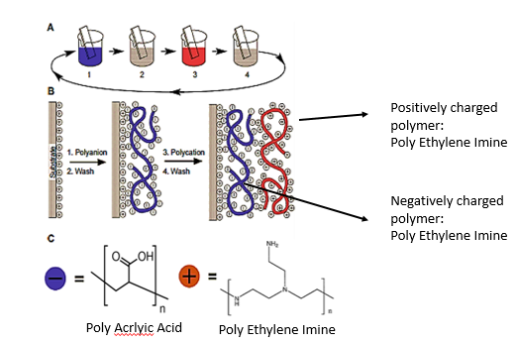
Figure 28. Schematic of the LBL process. Schematic of the film deposition process using slides and beakers. Steps 1 and 3 represent the adsorption of a polyanion and polycation, respectively, and steps 2 and 4 are washing steps. The four steps are the basic build.
PolyAcrylic Acid

A specific picture of the protocol used can be found in Figure 15. It is created by dissolving polymers in aqueous solutions at a specific pH, and then building alternative layers of positively charged polymers and negatively charged ones (Decher et al., 1992). The resulting film show alternate positive and negative charges that allows to adsorb a great variety of compounds. These films can potentially grow on any substrates and they are highly versatile (Hammond 2004).
Since the initial reports this LBL approach has been extensively used to modify surfaces for biomedical applications such as immobilising proteins onto the surface, for drug delivery or as a method to improve cell attachment and biocompatibility (Tang et al., 2006, Detzel et al., 2011, Hammond, 2012). For this reason, LBL coatings have been widely investigated for medical applications as it is possible to develop biomimetic films. Previous studies include LBL composed of alginate/polylysine (Elbert et al. 1999), chitosan/dextran sulphate (Serizawa et al. 2002), hyaluronic acid/polylysine (Picart et al. 2001), polylysine/polyglutamic acid (Richert et al. 2005) and collagen (Grant et al. 2001).
The approach described in this study is based on a LBL to ultimately bind heparin. Heparin is a highly sulphated glycosaminoglycan and it is commonly used in medicine as an anticoagulant agent. Specifically, heparin has been used to coat cardiovascular grafts due to its anti-thrombogenic effect (Olsson et al., 2000). It is also found in many places in natural tissue , from cell membrane to ECM as heparan sulphate. However heparin has been recently rediscovered to be used in tissue engineering for its ability to bind growth factors and therefore induce angiogenesis. Moreover, the use of macromolecules such as heparin that bind and stabilise growth factors is more efficient and a cheaper option than using growth factors alone.
Recently several studies are engaged in binding heparin onto and/or into the scaffold with the aim of binding growth factors already present in the body, creating an angiogenic gradient towards the implanted scaffold (Cabric et al., 2010, Singh et al., 2011, Leijon et al., 2013).

In this study, the LBL was performed on a stable negatively charged surface of polyacrylic acid that was plasma polymerised on top of the scaffolds of choice. From that surface, a LBL was created using two combinations of electrolytes to compare their efficacy in binding heparin: polyacrylic acid (negatively charged) and polyetheleneimine (positively charged) versus heparin (negatively charged) and polyetheleimine. shows a cartoon of the coating process.

As previously mentioned, plasma polymerization was used as the technique to provide a base layer to build a polyelectrolyte layer-by layer-coating. Plasma polymerization has been already used to change surface properties in biomedical applications (Poncin-Epaillard & Legeay 2003). In this study, plasma polymerised acrylic acid was used as a negatively charged base layer for the LBL formation for every substrate of choice. Plasma polymerised acrylic acid was already investigated for coating medical devices prior implantation. This study reported a successful plasma polymerization of acrylic acid on commercially available PP meshes. The advantages of plasma polymerised acrylic acid as base layer for the LBL are the creation of a homogeneous and stable polymer layer on top of any substrate, where the changes on the surface would not affect the bulk properties. This is also essential for building the LBL film. Moreover, acrylic acid stimulates cell adhesion and makes the surface of the substrate more hydrophilic (Nisticò et al. 2015).
The aim of this study is to successfully coat various substrates, electrospun poly-lactic acid, electrospun polyurethane and commercially available polypropylene by plasma polymerization and layer-by-layer approach, to bind heparin and induce angiogenesis once implanted for future soft tissue applications.
Firstly, two electrolyte multilayers were compared: heparin/polyethyleneimine and polyacrylic acid/polyethyleneimine to verify their efficiency in binding heparin on PLLA substrate. Subsequentially, the chosen multi-electrolyte combination was recreated on two other substrates, electrospun PU and a commercially available PP mesh. SEM was performed to visualise the morphological changes of the surfaces after functionalization, XPS was used to verify the presence of acrylic acid and sulphur on the surfaces and toluidine blue was performed to quantify the amount of heparin adsorbed onto the surfaces of the substrates.
These materials were used as case studies as they represent three major groups of materials for pelvic floor reconstruction; PLLA represent the newest development in biodegradable materials that are cell-friendly; PU also represents a novel material that can be stretch and it also supports cell growth; finally, PP mesh was used as it is a material commercially in use, and it was used as control.
  - Coating Characterization on PLLA
    - Scanning Electron Microscopy
SEM was performed on the functionalised side of the electrospun PLLA scaffolds, before and during functionalization with the two electrolytes combinations in order to visualise effects of the functionalization on the fibres surface (Figure 29).

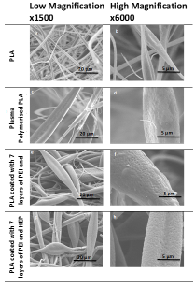
Figure 29. Representative SEM pictures of the functionalised side of PLLA.

PLLA fibres that were on the functionalised side appear enlarged after the coating steps, for both combinations of electrolytes. The surface of the fibres appeared etched compared to the plain fibres (Figure 29 a-d) and were also enlarged compared to the plain fibres. After coating with 7 layers of either PEI/PAC or PEI/HEP (Figure 29 e-h) there was no further change in appearance or fibre size. Fibres diameter was quantified at every step of the functionalization. After every step of the functionalization, the fibres enlarged a bit, until the 7th layer (Figure 30).
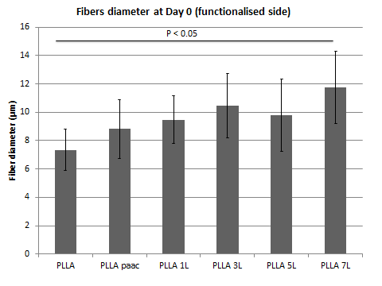

Figure 30. Mean of Fibre diameters for every step of the functionalization. Three measurements were taken from each picture from the top two layers of fibres. Three pictures were taken per scaffolds. Three scaffolds were produced per layer. A one way ANOVA was performed to establish significant difference among the different types of coating. Significant difference was found between plain PLLA scaffolds and fully coated scaffolds (± SD).
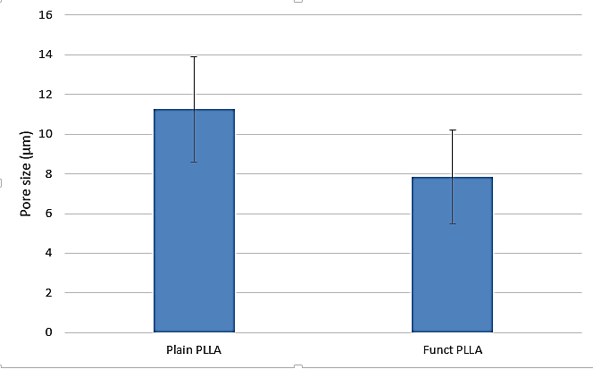
Porosity was also quantified after the functionalization (Figure 31). Porosity decreased after functionalization, while fibres diameters increased. However, pores are still big enough for cells to infiltrate in, as the literature suggests (Birch & Fynes 2002; Winters 2006).
Figure 31. Pore size of plain electrospun PLLA scaffold compared to functionalised one. Three measurements were taken from each picture from the top two layers of fibres. Three pictures were taken per scaffolds. Three scaffolds were produced per layer. At-test was performed to establish significant difference among the different types of coating. There was not significant difference between plain PLLA scaffolds and fully coated scaffolds (± SD).

    - Presence of the base layer of acrylic acid on the PLLA surface

XPS was performed on the PLLA scaffolds after plasma polymerization with acrylic acid to verify the presence of the carboxylic group (from the acrylic acid) on the surface (Figure 32). The presence of acrylic acid on the surface of PLLA is extremely important as it is the negatively charged base layer for the layer-by-layer coating. Thus functionalization with carboxylic groups will allow the first layer of polyethyleneimine to electrostatically bind onto the scaffold.

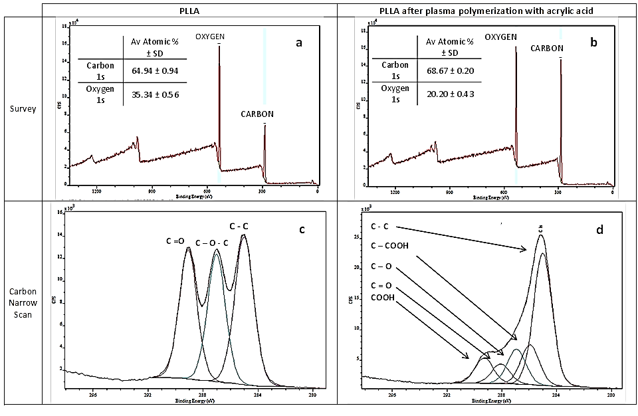
Figure 32. Assessment of surface chemistry of plain PLLA scaffold (a), plasma polymerised acrylic acid on electrospun PLLA (b), narrow scan of the carbon peak of the plain PLLA(c), and the carbon peak of the PLLA after plasma polymerization of acrylic acid (d). XPS was perfrmed on two spots on all scaffolds types. 2 scaffold were analysed per type of scaffolds. Curve fitting was done using XPScasa software.
Plain PLLA was compared with plasma polymerised PLLA. The presence of acrylic acid on the surface of the scaffolds was quantified by the atomic percentage (% At) of the elements on the surface (i.e. carbon, oxygen and nitrogen) and by the presence of the carboxylic acid peak (i.e. –COOH). Changes in height of the carbon and nitrogen peak heights of the two samples suggest the presence of acrylic acid on top of the surface. Surface composition of plain PLLA was 65% carbon and 36% oxygen. For the plasma polymerised PLLA, the average atomic composition was 75% carbon and 25% oxygen, suggesting that the surface chemistry had changed (Figure 32 a & b). Moreover, a narrow scan of the carbon for the plasma polymerised sample suggests the presence of the carboxylic group which is not present on plain PLLA surface (Figure 32 c & d). Also, the carbon peak shape changed after plasma polymerization (Figure 32 c & d). Narrow carbon scans of the plain PLLA showed the three typical peaks of the carbon bonds present (C-C, C-O-C and C=O) (Figure 32 c), while narrow carbon scans of the scaffolds after plasma polymerization showed a distinctive carboxylic peak at about 289 eV bonding energy, as a result of the plasma polymerization with acrylic acid (Fig. Figure 32 d). This was possible to calculate curve fitting was performed; an equation was fitted to the data obtained from the narrow scan of the element. Each equation was fitted so that the line of the real data is the same as the line of the calculated data, so to understand the type of bonds present in the narrow scan.
    - Presence of Sulphur on the coated PLLA surface
The two scaffolds, either functionalised with PEI and HEP or functionalised with PEI and PAC, were analysed for the presence of sulphur on the surface, indicating the presence of heparin by XPS. This is because the only compound with sulphur on the scaffold surface is the heparin salt. Thus, it would be possible to determine which scaffold binds the most heparin by quantifying the atomic percentage of the sulphur on these scaffolds (Figure 33).
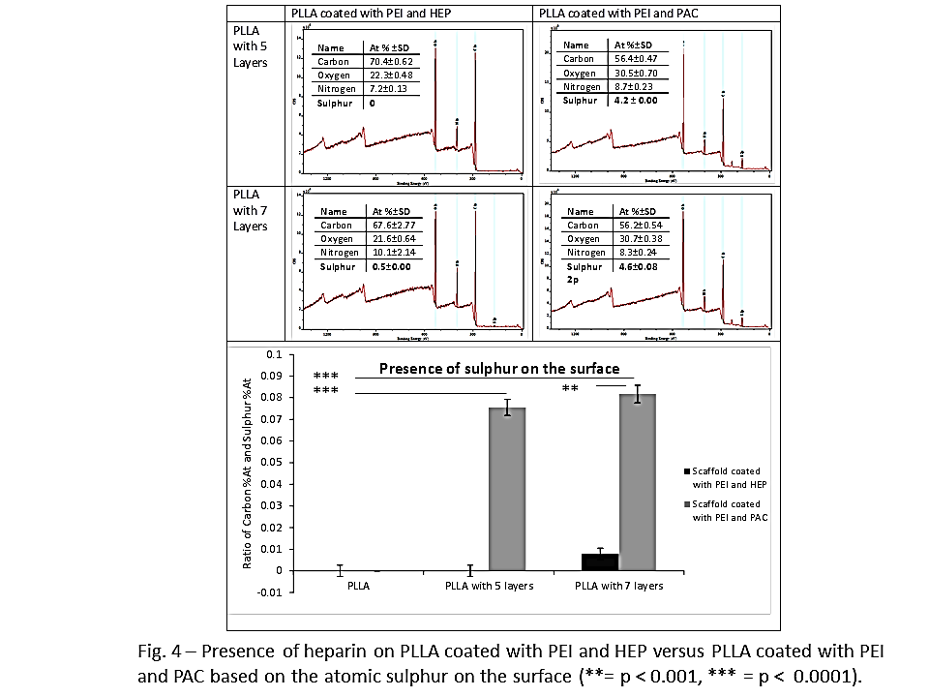
Figure 33. Presence of heparin on PLLA coated with PEI and HEP versus PLLA coated with PEI and PAC based on the atomic sulphur on the surface (**=p < 0.001, ***=p<0.0001). Two scaffolds per types were analysed with XPS. Two spots per scaffold were analysed via XPS. Three measurements were taken from each picture from the top two layers of fibres. A one way ANOVA was performed to establish significant difference among the different types of coating. Significant difference was found between plain PLLA scaffolds and fully coated scaffolds.

From this analysis there was a significant difference between the two types of coating: PEI/PAC bound significantly more heparin then PEI/HEP. Accordingly, PEI/PAC scaffolds were then used for all future investigations. For PEI and PAC, 7 layers of functionalization gave slightly but not significantly more heparin bound than 5 layers (Figure 33). After this, we established that the combination of polyethelenimine and polyacrylic acid performed better at binding heparin than a LBL of polyetheleneimine and heparin. Therefore, PEI/PAC multilayer was then used for further analysis on the other two substrates.
    - Ellipsometric analysis: building the layer by layer
Ellipsometry was used to quantify the thickness of each layer and to verify that a layer by layer was formed. A silica wafer was coated according to the protocol previously mentioned with both combinations of electrolytes. Measurement with the ellipsometer was taken for every layer formed. Figure 34 shows that, when a silica wafer is coated with a layer by layer of PEI and heparin, surface thickness increases.
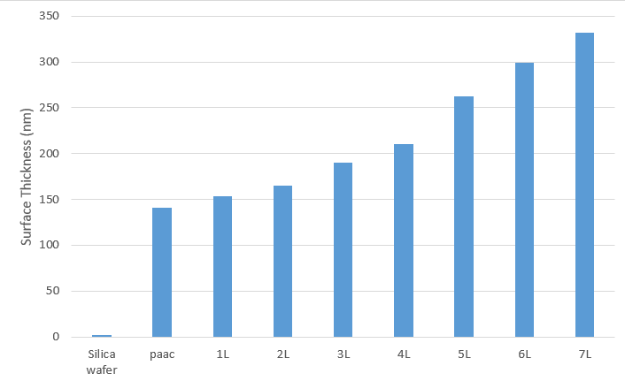
Figure 34. Surface thickness of a silica wafer coated with a layer by layer of PEI and heparin. Samples for each type of scaffolds were prepared to be analysed with an ellipsometric device. Ellipsometry gives you a single measurement to build your mathematical model represented in this graph.

The same experiment was carried out also for the PEI/PAC coating, and similar results were found (Figure 35).
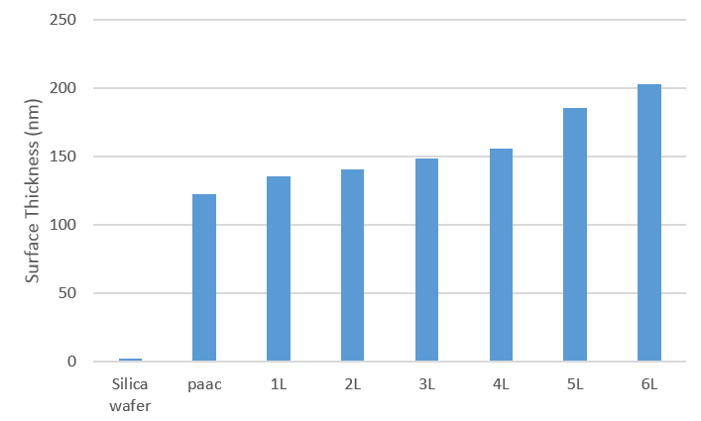
Figure 35. Ellipsometry of a silica wafer coated with a layer by layer PEI/PAC. Samples for each type of scaffolds were prepared to be analysed with an ellipsometric device. Ellipsometry gives you a single measurement to build your mathematical model represented in this graph.

    - Quantification of heparin on PLLA scaffold
Toluidine Blue was used to quantify the amount of heparin bound onto the coated PLLA scaffold. Toluidine Blue is a dye, dark blue in nature that, in contact with negative polyelectrolytes like heparin, turns purple. This colour change can be quantified because the absorbance spectrum of the dye shifts to a shorter wavelength once it is in contact with heparin. Figure 36 is a visualization of the colour change of toluidine Blue when it is in contact with PLLA coated with heparin.
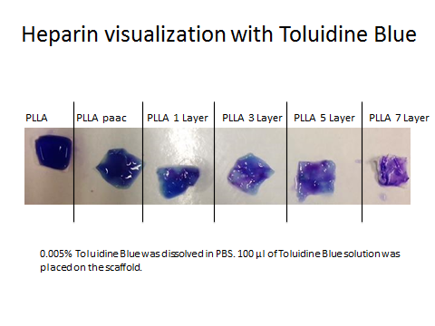
Figure 36. Various steps of PLLA coating in contact with 0.005% Toluidine Blue solution. The scaffolds have been immersed for 10 minutes in 0.005% Toluidine Blue solution, they have been removed and a picture was taken of the scaffolds.
The toluidine blue change of colour was quantified with a modified protocol of Hinrichs et al. 1997. Five ml of 100U/ml heparin was used to soak the scaffolds for 2 hours. The solution was then recovered and mixed with toluidine blue. It was then left at room temperature for 4 hours to allow heparin/toluidine blue complexes to form. The pellet was retrieved and dissolved in 1 ml of 4:1 of pure ethanol and 0.1 M of NaOH. Once the pellets were dissolved, 100 µm of the resulting solution was read at 562 nm. A standard curve was created with a known concentration of heparin (500 U/ml, 250 U/ml, 125 U/ml, 61.5 U/ml, 30.5 U/ml, 0 U/ml).
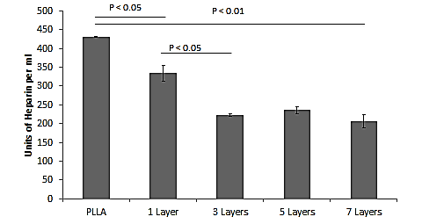
Figure 37. Amount of heparin left in solution after PLLA functionalization with heparin. Scaffolds were immersed in a known concentration solution of 0.005% Toluidine Blue solution, Scaffolds were removed from the solution and the remaining toluidine blue solution was quantified for the amount of heaparin left (± SD).

These experiments showed that coated scaffolds bind more heparin than the uncoated ones. From this it appears that only 3 layers are needed to bind significantly more heparin than plain scaffolds (Figure 37).
    - Immunostaining to visualise VEGF on the surface of the scaffold
Coated scaffolds with heparin and VEGF were stained with an anti-VEGF antibody and a fluorescent secondary antibody, to simply visualise the presence of VEGF on the surface of the functionalised scaffolds (Figure 38 Side B).
 | Side A | Side B | Negative Control
Plain PLLA |   1 mm |   1 mm
PLLA functionalised with 7 Layers + Heparin + VEGF |   1 mm | 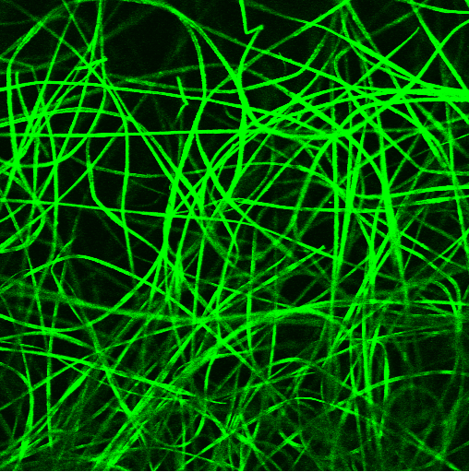  1 mm
Figure 38. Immunostaining for VEGF of plain scaffolds compared to scaffolds with the coating. Side A is the plain side and side B is the coated side. Negative control is without primary antibody and only stained with secondary antibody.

Plain PLLA did not fluoresce once stained for VEGF, suggesting that there was not VEGF bound onto the surface of the scaffold. However, the functionalised side of the scaffold coated with heparin and VEGF was positively stained for VEGF, suggesting that VEGF was bound onto the surface of the scaffold. This same assay was performed on scaffold conditioned with human serum, to verify the presence of bound serum VEGF on the surface of the coated scaffolds.
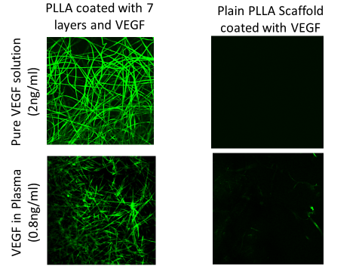
1 mm
1 mm
Figure 39. Immunostaining of fully functionalised scaffolds coated with VEGF and human plasma. Fully functionalised scaffolds were stained with VEGF primary antibody and fluorescent secondary antibody (Chapter 2, Paragraph 2.3).
Scaffolds coated with heparin and VEGF or human plasma were also positively stained for human VEGF, suggesting that VEGF was bound on the surface of the scaffolds. VEGF concentration was quantified by a standard ELISA kit from Peprotech. The intensity of VEGF from the human plasma is dimmer, as a result of less human VEGF present in solution (0.8 ng/ml) compared to the pure VEGF solution (2 ng/ml) (Figure 39).
    - ELISA to verify if heparin on PLLA binds VEGF
An ELISA was then used to quantify the amount of VEGF that could be bound to the scaffolds functionalised with PEI and PAC and loaded with heparin. The amount of VEGF bound to the surface increased with the number of layers up to 3 layers but no further VEGF was bound with further layers (Figure 40). The coated scaffolds were immersed into a 2 ng/ml Vascular Endothelial Growth Factor (VEGF) solution in PBS at room temperature overnight. The scaffolds were then washed once in 1 ml PBS. A human VEGF Enzyme-Linked Immuno-Sorbent Assay (ELISA) (Peprotech Inc., USA) was carried out on the wash solutions to quantify how much VEGF was present in the solutions and therefore by subtraction how much was therefore still bound to the surface of the scaffolds. The assay was carried out according to the manufacturer’s instructions.

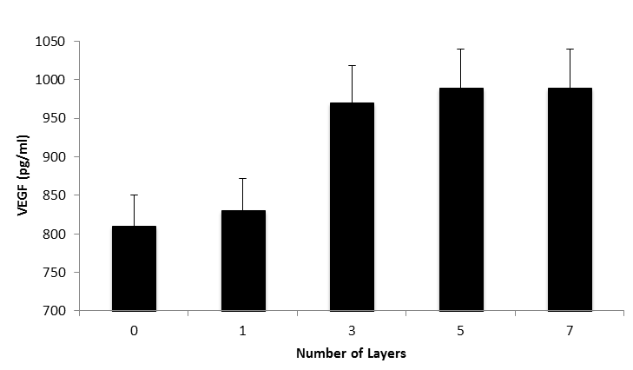
Figure 40. Amount of VEGF on the surface of PLLA after functionalization of a LBL of PEI/PAC. Plain and Functionalised Scaffolds were immersed on a solution of pure VEGF. After a period of incubation, they have been removed from the solution and VEGF amount left in the solution was quantified. The difference of VEGF amount from the starting solution to the final solution was quantified in this graph, as VEGF remaining on the surface of the scaffold (± SD).
  - Applying the coating to PolyUrethane
After optimising the coating on PLLA, the LBL approach was tested on other two substrates, electrospun PU and PP mesh.
    - Morphology of the surface before and after functionalization
The appearance of the uncoated and coated electrospun PU was investigated using SEM. Although the surface of the PU fibres did not look etched, the diameter of the fibres increased after functionalization (Figure 41). Also the porosity at the surface interface looked different, probably due to the change in size of the fibres’ diameter.

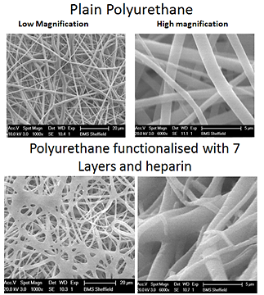
Figure 41. SEM of electrospun PU. Plain PU was compared to fully functionalised PU, according to the previous reported protocol in Chapter 2.2.

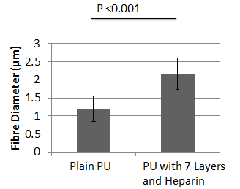
From the SEM pictures, it appears that the functionalised scaffold are more prone to fibre and porosity change. Fibres are enlarged after functionalization, similar to PLLA (Figure 42).
Figure 42. Fibre diameter of electrospun PU. Fibre diameter was quantified from the high magnification SEM pictures. 3 measurements per picture were taken from the top 2 layers of fibres. 3 pictures of per batch were taken. 3 independent batches were produced (± SD).
Moreover, porosity before and after functionalization was quantified. However, there was no significant difference between pore sizes plain and functionalised PU (Figure 43). Literature suggests that this pore size is still suitable for cell growth and infiltration (Birch & Fynes 2002; Winters 2006).
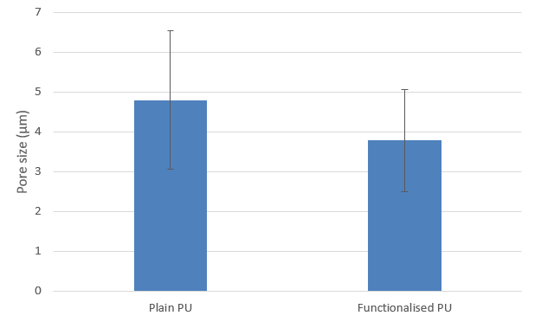
Figure 43. Average pore size of plain PU compared to functionalised PU. There was no significant difference in this variable. Pore size was quantified from the high magnification SEM pictures. 3 measurements per picture were taken from the top 2 layers of fibres. 3 pictures of per batch were taken. 3 independent batches were produced (± SD).

    - XPS to verify the presence of the acrylic acid base Layer
Plain polyurethane was compared with plasma polymerised polyurethane to quantify the presence of acrylic acid on the surface of the scaffold by the atomic percentage (% At) of the elements on the surface and by the presence of the carboxylic acid peak. Polyurethane already contains a carboxylic group, but after plasma polymerization, the magnitude of the carboxylic peak increased and there are changes in the carbon and oxygen atomic percentage, suggesting the presence of acrylic acid on the surface. Surface composition of plain PU was 81.23% carbon and 15.96 % oxygen. For the plasma polymerised PU, the average atomic composition was 76.20% carbon and 23.65% oxygen, suggesting that the surface chemistry had changed (Figure 44).
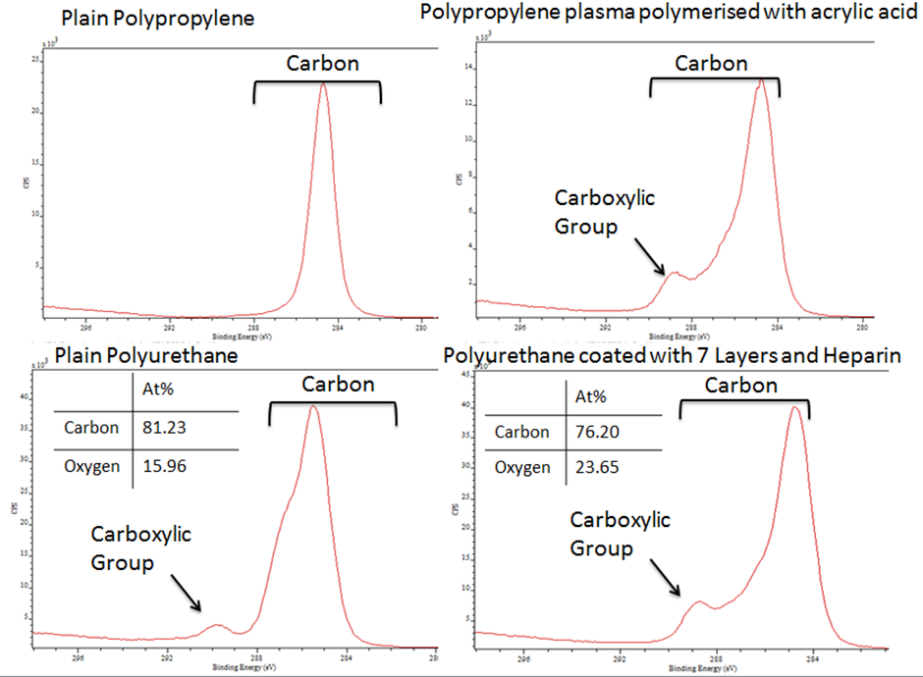
Figure 44. XPS spectra of the carbon peak on electrospun polyurethane. XPS data were obtained from two different spots on the same material. Plain PU was compared to fully functionalised PU

    - Presence of sulphur on functionalised PU
Plain PU and functionalised PU were analysed for the presence of sulphur on the surface by XPS, indicating the presence of heparin (Figure 45). This is because the only compound with sulphur on the scaffold surface is the heparin salt.
Thus, it would be possible to determine which scaffold binds the most heparin by quantifying the atomic percentage of the sulphur on these scaffolds.

Figure 45. Ratio of the atomic percentage of carbon to sulphur (C:S), on plain PU compared to coated PU. XPS data were obtained from two different spots on the same sample of material. A range of materials were analysed, from plan PU to fully functionalised PU, and every coating step in between. The atomic percentage of Carbon was divided by the atomic percentage of the S. This graph shows the averages of these ratios (± SD).

From this analysis there was a significant difference between the plain scaffolds and the functionalised scaffolds. Plain scaffolds, plain PU and plain PP, did not retain heparin, hence no sulphur was present on the surface. However, functionalised scaffolds, retained heparin as sulphur could be detected, although there no significant difference observed between the layers (Figure 45).

  - Applying the coating to PolyPropylene
Ultimately, the challenge would be to coat existing scaffolds and verify that the coating is going to improve cell infiltration and angiogenesis of a fairly inert PP mesh.
    - Morphology of the surface before and after functionalization
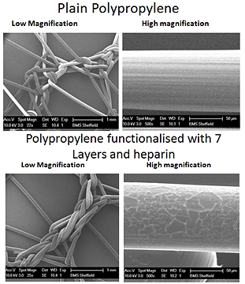
The appearance of the uncoated and coated commercially available polypropylene was investigated using SEM. This showed that after plasma treatment, the surface of the fibres appeared etched compared to the plain fibres (Figure 46).

Figure 46. SEM of plain PP fibres compared to coated PP fibres. Plain PP was compared to fully functionalised PP, according to the previous reported protocol in Chapter 2.2.

The fibre diameter was not affected by the functionalization (Figure 47).
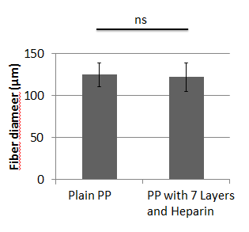
Figure 47. Fibre diameter of plain and coated PP. Fibre diameter was quantified from the high magnification SEM pictures. 3 measurements per picture were taken from the top 2 layers of fibres. 3 pictures of per batch were taken. 3 independent batches were produced (± SD).

Porosity before and after functionalization was quantified. However, there was no significant difference between pore sizes of plain and functionalised PU (Figure 48). The literature suggests that this pore size is still suitable for cell growth and infiltration (Birch & Fynes 2002; Winters 2006).
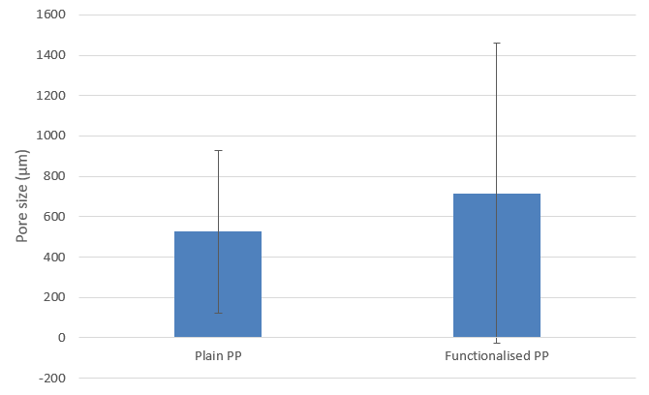
Figure 48. Pore size of plain PP compared to functionalised PP. There was no significant difference in this variable. Pore size was quantified from the high magnification SEM pictures. 3 measurements per picture were taken from the top 2 layers of fibres. 3 pictures of per batch were taken. 3 independent batches were produced (± SD).

    - XPS to verify the presence of the acrylic acid base layer
XPS confirmed the presence of the carboxylic group on the PP plasma polymerised with acrylic acid. There is no carboxylic acid peak on the plain scaffold, but it is visible on the coated scaffold instead at about 289 eV passing energy, confirming that it is the carboxylic group peak (Figure 49).
Figure 49. XPS spectra of the carbon peak of plain PP compared to coated PP. The carboxylic group is visible after plasma polymerization with acrylic acid. XPS data were obtained from two different spots on the same material. Plain PP was compared to fully functionalised PP.

    - Presence of sulphur on functionalised PP
XPS was performed to quantify the atomic percentage of sulphur on the surface of plain PP compared to coated PP.

Figure 50. Ratio of atomic percentage of carbon to sulphur (C:S) on the surface of plain PP compared to coated PP. XPS data were obtained from two different spots on the same sample of material. A range of materials were analysed, from plan PP to fully functionalised PP, and every coating step in between. The atomic percentage of Carbon was divided by the atomic percentage of the S. This graph shows the averages of these ratios (± SD).

Data suggests as previously, that only a few layers are needed to bind a significant amount of heparin, compared to plain PP (Figure 50).
  - Toluidine Blue
The toluidine blue assay was performed to verify the XPS data (Figure 51). Functionalised scaffolds were soaked with 200 U/ml aqueous heparin solution for 2 hours. The remaining solution was used to quantify the amount of heparin left. The protocol to quantify the amount of toluidine blue was adapted from (Hinrichs et al. 1997).
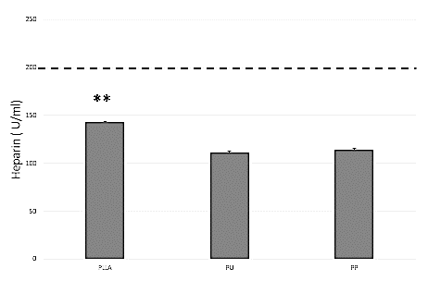
Figure 51. Amount of heparin on the surface of each scaffold type quantified by a modified Hinrichs protocol. Heparin coated Scaffolds were immersed in a solution of pure heparin of 200 U/ml (dotted line). Heparin left in solution was quantified, and the difference is represented in this graph, that is the heparin left on the surface of the scaffold (± SEM).

Briefly, one part of heparin solution used to coat the scaffolds was mixed with two part of toluidine blue solution (0.005% toluidine blue in PBS). The resulting solution was left on a rocking platform for 4 hours, to allow heparin-toluidine blue complexes to be formed. After 4 hours, the solutions were centrifuged at 10000 rpm for 5 minutes to allow the precipitate to sink to the bottom of the Eppendorf tubes. After centrifugation, the supernatant liquid was removed and the pellet was dissolved in 1 ml of 4:1 of pure ethanol and 0.1 M of NaOH.
Once the pellets were dissolved, 100 µm of the resulting solution was read at 562 nm. A standard curve was created with known concentrations of heparin.
Toluidine blue data confirmed the XPS results: All 3 scaffolds bound heparin with PLLA binding slightly more than PU and PP which performed similarly (Figure 51).

  - Discussion
    - PLLA
Fibres of PLLA after plasma polymerization and after coating look enlarged. This is probably due to the initial plasma polymerization that appeared to etch the surface of the fibres. This would allow water entry during the many steps of the LBL functionalization, to slowly penetrate into the fibres causing their enlargement. As a result, porosity of the surface decreased; but it is still porous enough for cells to infiltrate. Enlargement of electrospun fibre diameter due to plasma polymerization was previously observed by Zhao et al. (Zhao et al. 2013). This also means that the surface of the scaffold is made more hydrophilic which is a favourable characteristic at the interface for cell interaction.
Plasma polymerization of acrylic acid was successful as the carboxylic acid group was detected by the XPS and the proportions of carbon and oxygen changes between the plain and the functionalised PLLA. Functionalised PLLA shows an increased amount of oxygen, compared to plain PLLA, suggesting that extra oxygen was introduced into the system from the carboxylic group (-COOH). Moreover, also curve fitting within the carbon narrow scan suggests that the surface of the plain PLLA has three carbon conformations, typical of PLLA: C=O, C-C and C-O-C.
However, when acrylic acid is plasma polymerised onto the surface, the peak shape changes, as two more carbon conformations are introduced into the system (-COOH, C-COOH). Other studies also show that the shape of the narrow carbon scan also reflects the presence of acrylic acid where the carboxylic group is present at about 290 eV passing energy, like in this study (Morent et al. 2010; David E. Robinson et al. 2014).
Afterwards, the presence of sulphur at the end of the coating steps was quantified for both combinations of polyelectrolytes. The presence of sulphur on the surface is directly related to the amount of heparin present, as heparin is the only compound containing sulphur on the surface. Other studies have also measured sulphur as measure of heparin presence via XPS (B. Liu et al. 2013; C D Easton et al. 2014). It was observed that the combination of layers that bound the highest amount of heparin was PEI and PAC, compared to PEI and HEP. That is probably because heparin binding might not be stable in all the washes needed to build the LBL. Thus, it would not be sufficient to build the electrostatic charge needed to ultimately bind more heparin than the PEI/PAC combination. Very few studies have investigated the combination of PEI/HEP for biological applications, but the amount of heparin bound was not quantified nor its ability to bind growth factors (Dong et al. 2008; Mahlicli & Altinkaya 2013). However, other studies confirmed the suitability of the PEI/PAC combination to bind electrostatically heparin and ultimately growth factors needed for angiogenesis (Muller et al. 2001; Muller et al. 2006; C D Easton et al. 2014).
Because the combination of PEI/PAC could bind more heparin, it was continued for further analysis and to coat other scaffolds.
Toluidine Blue was used to further visualise and quantify heparin on the PLLA. The amount of heparin remaining in the solution used to coat the scaffolds was used for quantification. There was a high amount of heparin remaining in the solution used to coat plain scaffolds; whereas there was little heparin left in the solution used to coat the functionalised scaffolds. This suggests that the coating helped retain more heparin on the surface of the functionalised scaffolds, compared to the uncoated scaffolds. This is consistent with other studies where LBL was used to bind heparin or heparin sulphates salts to ultimately bind and stabilise growth factors (Mao et al. 2005).
The next step in the investigation was to determine if the coating with heparin bound growth factors. VEGF was chosen as it is a very important factor in angiogenesis: it stimulates survival, proliferation, migration and differentiation of endothelial cells. ELISA data showed that the coating with heparin successful bound VEGF. These results agree with many studies where heparin was showed to bind and stabilise VEGF (G Neufeld et al. 1999; Belair & Murphy 2013; Delcombel et al. 2013; Vempati et al. 2014).
    - PU
Polyurethane fibres also looked enlarged after functionalization with polyacrylic acid and LBL coating with PEI and PAC. This is probably a very similar effect to the previously mentioned PLLA. The surface of the fibres re etched by the plasma polymerization and this would allow water to infiltrate the fibres during the LBL process. That might cause the enlargement of the fibres.
The presence of acrylic acid on the surface of the fibres of polyurethane was verified by XPS. Although PU also contains a carboxylic acid group, as it is visible on the narrow scan of the carbon, after the plasma polymerization the carboxylic peak increased in height. Also the amount of oxygen increased, resulting from the increase of carboxylic groups (-COOH) in the system. Other studies have also confirmed that plasma polymerisation of polyacrylic acid on polyurethane surfaces increase the amount of atomic oxygen on the surface and that the carboxylic group in the narrow scan increase in height (Vilani et al. 2007; Weibel et al. 2007; Najafabadi et al. 2014). After verifying that the plasma polymerization with polyacrylic acid was successful, the electrospun PU scaffolds were then coated with alternate layers of PEI and PAC in a LBL approach.
Afterwards, the presence of sulphur at the end of the coating steps was quantified. As before, the presence of sulphur on the surface was related to the amount of heparin present. It was observed that the highest amount of heparin was bound for 3, 5 and 7 layers. That is probably because enough surface charge is created after the 3 layer. These results are consistent with previous results for PLLA where there was no difference in heparin and VEGF bound onto the surface after the 3rd layer. These results also show that enough heparin was bound onto the surface by using the PEI/PAC electrolyte combination. Toluidine Blue was also used to quantify the amount of heparin bound onto the scaffold. Both XPS and Toluidine blue data suggest that heparin was immobilised onto the surface. Previous studies also used Toluidine Blue and XPS to verify the presence of heparin onto silk fibres or PU films, where sulphur was used as measure of heparin (Y. Wang et al. 2012; Elahi et al. 2014).
    - PP
PP fibres diameter was not affected by the coating. However, the surface of the fibres looks cracked after the coat was completed. That might be the result of the plasma polymerization. PP, not being elastic, had to crack to cope with the glow discharge: the energetic ions and radicals present in the plasma caused an oxidative chemical effect of the polymer surface that might results in surface etching. After the many washes of the LBL protocol, the cracks were enlarged due to water penetration.
The presence of acrylic acid on the surface of the PP mesh was verified by XPS. It is possible to observe a carboxylic group peak in the carbon narrow scan of the coated PP that is not present in the plain PP scan. The carboxylixc group derived from the polyacrylic acid, as numerous previous studies reported (Morent et al. 2010; Nisticò et al. 2015).
After verifying that the plasma polymerization with polyacrylic acid was successful, PP meshes were then coated with alternate layers of PEI and PAC in a LBL approach. Presence of sulphur at the end of the coating steps was quantified. As before, presence of sulphur on the surface was related to the amount of heparin present. It was observed that the highest amount of heparin was bound for 3, 5 and 7 layers. That is probably because enough surface charge is created after the 3 layer. However, PP meshes are the scaffolds with the least amount of heparin bound onto them. This is probably due to their nature; they have very large fibres a very big pores, so the surface area that can be functionalised is very small, compared to electrospun scaffolds such as PLLA and PU, that they are very dense with fibres.

4.7 Conclusion
In conclusion, the multi-electrolyte combination that binds the most heparin was PEI/PAC and it was used for further analysis. All three types of scaffolds can be functionalised with plasma polymerised acrylic acid. Afterwards, they can be coated with a LBL approach using PEI as cation and PC as anion, due to their ability to bind electrostatically heparin. Heparin was successfully bound on top of the LBL coating.
The next step in the investigation was to verify the angiogenic potential of functionalised scaffolds in an in-vivo assay.

- Chapter 5 – Testing the angiogenicity of the coating
  - Introduction
Angiogenesis, the formation of new blood vessels sprouted from small venules, was firstly identified in 1935 when formation of new blood vessels was observed in the placenta (Hertig 1935). Following that observation, considerable energy was put into understanding angiogenesis in the context of tumour biology. It was understood that tumours induced growth of new capillaries and that ‘anti-angiogenesis’ could be a potential therapy (Folkman et al. 1971). By the late 1970’s, the sequence of events involved in angiogenesis was quite well understood: it begins with local degradation of the basement membrane of the parental vessel; sequentially, endothelial cells migrate towards the angiogenic stimulus; the sprouted endothelial cells align and organise themselves to form a lumen (i.e. the internal space of a tubular structure); lastly, the newly formed vessels elongate due to endothelial cell proliferation (Ausprunk & Folkman 1977) (Figure 52).
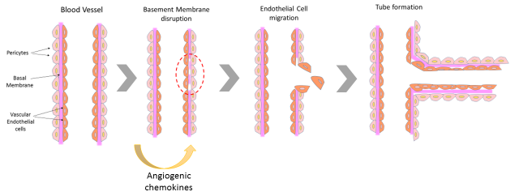
Figure 52. Simplified steps involved in angiogenesis.
However, they lacked the tools to study angiogenesis in more detail. Each of these steps could be tested in 2D in-vitro. However the goal was to aim to achieve an approach that would consider contemporarily all the steps involved. Thus, there was the need to develop bioassays to study the biochemistry of angiogenesis in more detail and in a controlled way. Four new methods were developed in the mid-1970s for this purpose: corneal micro pockets in the rabbit (Gimbrone et al. 1974), mouse and rat (Muthukkaruppan & Auerbach 1979) for the measurements of individual capillaries as they grow; biocompatible polymers were developed for the sustained release of angiogenic factors in-vivo (Folkman & Klagsbrun 1987); chick embryo chorioallantoic membrane, initially used to detect angiogenic activity of parts of tumour (Ausprunk et al. 1974; Klagsbrun et al. 1976); vascular endothelial cells were cultured from explanted umbilical vein (Jaffe et al. 1972), aorta and capillaries to guide the purification of endothelial cells growth factors (Gospodarowicz et al. 1976; Birdwell et al. 1977).
In recent years, a few more models have been developed to study angiogenesis. They all aim to study the efficiency of angiogenic and anti-angiogenic factors, in a more comprehensive way. Angiogenic bioassays are divided into in-vitro and in-vivo assays; in-vitro assays are usually faster and cheaper than animal work; however, there is a consensus that they are preliminary and multiple tests have to be used to arrive to a definite conclusion. Alternatively, in-vivo tests, although difficult, expensive and time-consuming, are considered well rounded and conclusive to establish angiogenicity of the material (Auerbach et al. 2003). In-vitro angiogenic assays entail culturing endothelial cells and measuring cell proliferation, cell migration and tube formation. The cell proliferation assay is based on the rationale that substances might speed up or slow down the proliferation of cultured cells.
It would be possible to then correlate their rate of proliferation with the variety of media/substances used to evaluate which one had an effect on the culture. Cell migration assays are also based on a similar concept, that some substances might have a chemotactic effect on cells. It is possible to track cell movements within the plate and the length and speed of movement can be correlated with the various media used (Obeso & Auerbach 1984; Schor et al. 2001). Another commonly used in-vitro assay is the tube formation assay where endothelial cells are plated out on Matrigel and allowed to form tubular structures over a period of time. All these tests are complimentary to the in-vivo tests, and they differ in clinical context, types of cells used and experimental conditions; small changes to the experimental protocol might greatly affect the outcome of the experiment (Auerbach et al. 2003). They are graphically represented in Figure 53.
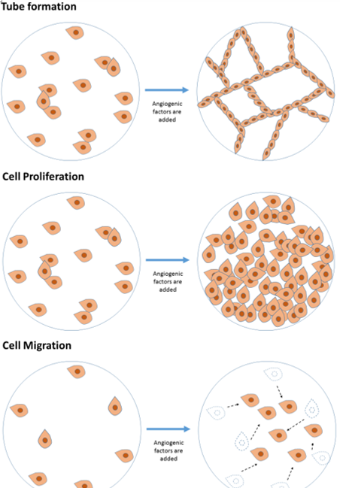

Figure 53. Angiogenesis in-vitro assays, order of events: Cell migration, Cell Proliferation and Tube formation.

The aortic ring assay is the only assay based on an explanted organ, sitting at the interface of in-vitro and in-vivo models. Organ culture assays are all based on the concept of explanting a segment of aorta, usually from rats or chick embryos, and culture it in-vitro on a collagenous matrix such as Matrigel (Figure 54). Matrigel is the commercial name for a gelatinous protein mixture secreted by a mouse sarcoma.
This heterogeneous mixture of proteins has been proven to allow endothelial cells growth and organization (Arnaoutova et al. 2009). Once the aorta is explanted, a very thin segment is laid on a Matrigel bed in the presence of endothelial cell growth media. Endothelial cells from the thin aorta slice can proliferate and organise themselves on the Matrigel coated plate. Outgrow of endothelial cells from the explant is monitored and the length and quantity of sprouted vessels are quantified (Auerbach et al. 2003).
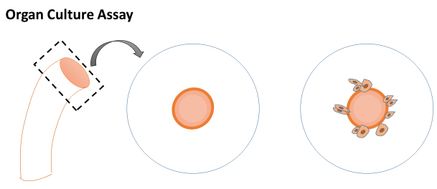
Figure 54. Explanted aorta assay. Aorta from an animal, usually a porcine aorta, is sliced in thin slices and plated on a petri dish with culture media and/or gelatin. Over time, endothelial cells migrate from the ring of the aorta to the rest of the plate.
All the already mentioned techniques are really useful because they allow one to monitor single steps in the angiogenesis cascade of events in a very controlled way. However, the ultimate evaluation of angiogenesis should ideally be carried out in-vivo where all the angiogenic steps are involved. There are several assays to test angiogenesis in-vivo: corneal angiogenesis assay, Matrigel plug assay, the dorsal skin fold assay, zebrafish model and the chick Chorionic Allantoic Membrane (CAM) assay.
The corneal angiogenesis assay is based on the fact that the cornea is avascular and that the presence of blood vessels would be caused by an angiogenic stimulus (Figure 55).
Common animal models for this assay are rabbits (Gimbrone et al. 1974) and mice (Muthukkaruppan & Auerbach 1979). A pocket is created in the cornea and the tissue or molecule of interest is inserted in it. The vasculature formed is then injected with a fluorophore/chromophore to allow the visualisation of the newly formed vessels. Quantification of this assay include the area of vessel penetration, progress over time and measurement of the fluorescence intensity (Kenyon et al. 1996).
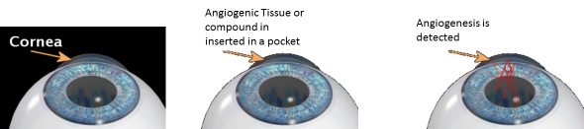
Figure 55. Cornea Pocket angiogenesis assay. A pocket is created in the avascular cornea and angiogenesis is observed.

Another assay to establish angiogenesis in-vivo is the Matrigel plug assay, where Matrigel is mixed with substances of interest and injected subcutaneously in either rats, mice or rabbits, to form a plug (Figure 56). After a period of incubation, this plug is retrieved. Quantification is based on the histology sections of the plug or by quantifying the amount of haemoglobin in the plug itself (Auerbach et al. 2003).
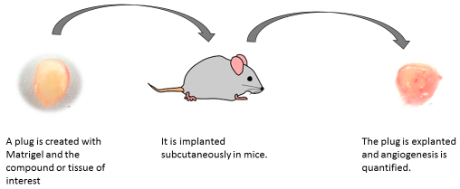
Figure 56. Cartoon of Matrigel Plug Assay in-vivo. A plug of matrigel is implanted subcutaneously on mice. The plug is extracted and sectioned for histological analysis.

A commonly used assay is also the dorsal skin fold assay, where two symmetrical metal frames are inserted into the dorsal skin of a mouse or rat. These two frames sandwich the material of interest under the skin of the animal, and angiogenesis is monitored over time (Figure 57). Analysis includes the use of an upright microscope and fluorophores/chromophores to visualise the microcirculation of the animal around the implant over a window on the frame (Laschke et al. 2011).
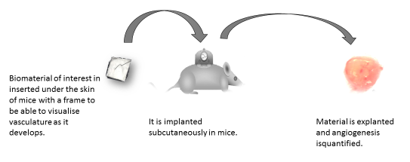
Figure 57. Cartoon of dorsal skin fold assay. A plug of matrigel is implanted subcutaneously on mice with a help of a frame. The plug is extracted and sectioned for histological analysis.

Recently, also the biology of zebrafishes was exploited to study angiogenesis (Figure 58). Substances of interest are added to the water where zebrafishes are growing and, because they are totally transparent in the first few days of development, it is possible to visualise changes in blood vessel development and organogenesis (Norrby 2006).
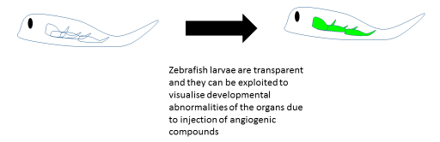
Figure 58. Cartoon of the fluorescent zebra fish assay. Fluorescence is exploited to monitor the development of the embryo and angiogenic system of a zebra fish.

Lastly, the CAM assay is the most commonly used assay to evaluate angiogenesis. It exploit the vasculature of the chorionic allantoic membrane of a fertilise chick to study a scaffold (Figure 59).
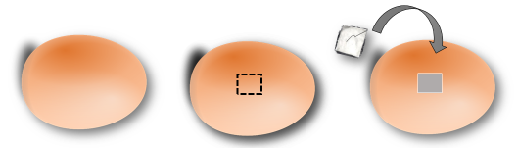
Figure 59. Basic concept of the CAM assay, that requires a scaffold to be inserted into a fertilised eggs.

Timescale of this assay might vary according to protocols. However, the general idea is that a tissue or biomaterial is placed on the CAM after opening the shell during the first period of development. After a period of incubation, the tissue/organ on the CAM are taken with a light camera and retrieved for histology. However, the majority of the groups prefer to work within two weeks form fertilization, as for this period a home office animal licence is not required and the vasculature is not very dense yet. Figure 60 shows how representative groups work on similar timelines over the years (Joerg Borges et al. 2003; Mancini et al. 2007; Stumpf et al. 2011; Gigliobianco, Chong, et al. 2015).
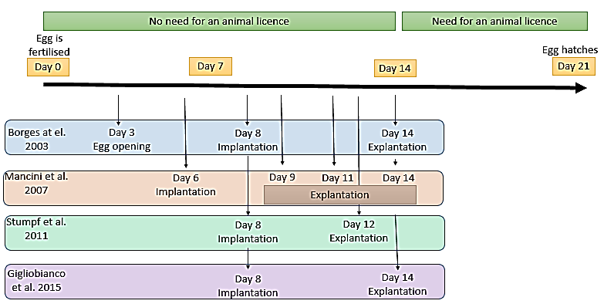
Figure 60. Chronological representation of CAM assays for the most representative studies.

Quantification of this assay is usually based on the light pictures of the CAM and on the histology slides. Scorers that have been kept blinded from the experiment will need to score the pictures from 0 to 4, depending on the degree of angiogenesis. A summary of the advantages and disadvantages of these assays are given in Table 3.
Table 3. Advantages and Disadvantages of in-vivo models to assess angiogenesis. Adapted from (Norrby 2006; Ribatti et al. 2014).
Type of Assay | Advantages | Disadvantages
Corneal Pocket | Easy to visualise blood vessels  Various animal models: rabbits, rats & mice  Non-invasive observations over a long period of time  Quantitative  Mammalian | Not-naturally occurring angiogenesis  Highly technical  Traumatic use of animals  Expensive due to use of animals
Matrigel Plug | Not difficult to perform  Observations over a long period of time  Suitable for screening large numbers of samples | Analysis is time consuming  Formation of granular tissue  Unknown Matrigel composition  Expensive due to use of animals
Dorsal skin fold | Mammalian  Observations over a long period of time  Suitable for a variety of substrates | Difficult to perform  Expensive due to use of animals  Almost any material would vascularise
Zebrafish | Whole animal  Genotype analysis of endothelial cells  Suitable for large screenings  Fast | Non-mammalian model  Embryonic  Expensive to establish and if maintained for long periods
CAM | Technically simple  Low cost  Fast  Natural immunodeficiency  Variety of substrates can be examined | High variability  Sensitive to oxygen or foreign materials  Difficult to quantify

Overall, they all agree that the most difficult technical problem is the accurate interpretation of the highly diverse results from these assays. Moreover, it is also difficult to compare results among groups that use different protocols for the same assay.
There has been an increase in the number of papers dealing with angiogenesis, as it is now established that is a key factor in regenerative medicine and tumour biology. However, there is a huge variation among studies in what they measure and how they measure it, as they usually show qualitative data rather than quantitative (Jain et al. 1997; Folkman et al. 2001; Auerbach et al. 2003).
For this study, we establish the CAM model as, previously mentioned, for its simplicity and relatively low cost compared to in-vivo studies. Quantification was carried out by blind scoring of the histological slides and the light microscope pictures.
Although these assays were originally developed for evaluation of anti-angiogenic compounds for cancer treatment, in recent years, these assays have also been used to assess angiogenesis on materials for regenerative medicine.
The focus of this study is to use the CAM model to study the effect of heparin bound onto the surface of our scaffolds.
Heparan Sulphates (HS), and the more sulphated pharmaceutical product heparin, are strongly anionic linear polysaccharides that are mostly found as part of membrane-bound proteoglycans (Figure 61) (Lindahl et al. 1998; Rabenstein 2002).
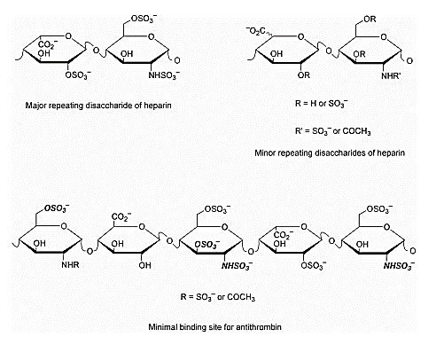

Figure 61. Heparin molecular structure (Rabenstein 2002).
They bind an extensive variety of soluble and insoluble extracellular molecules with high affinity via a specific protein domain (Kd of 1-100 nM). This mechanism is highly functional, as HS are involved in wound healing, morphogenesis, host defence and energy metabolism (Bernfield et al. 1999). Figure 62 shows the variety of ligands that heparin has, resulting in many functions that heparan sulphate play in the human body.

Figure 62. Proteins found in cellular environment that bind to HS/Heparin. Adapted from (Bernfield et al. 1992; Carey 1997; Conrad 1998)

Heparin is famous medically because it is used as a powerful anticoagulant since it modulates the action of anti-thrombin III. However, heparan sulphate proteoglycans are ubiquitous in the human body, and they are found in the majority of tissues. They interact with stromal proteins such as fibronectin, laminin and collagen, playing an important role in organization of the basement membrane, extracellular matrix and cell adhesion. They also play a critical role in the host defence, morphogenesis and tissue repair by modulating interactions with ECM molecules (Varki 1993; Venter et al. 2001).
Last but not least, heparan sulphate proteoglycans bind growth factors and cytokines that are molecules that regulates cell behaviour within the body. The family of growth factors that contain a heparin-binding domain include BMP-2, EGF, FGFs, IGF, PDGF and TGF-β. A large number of these molecules are growth factors involved in angiogenesis, such as VEGF, FGF and EGF (Dew et al. 2015).
Already in the early ‘80s, heparin was shown to play an important role in angiogenesis for the following reasons: masts cells and mast cells-derived heparin stimulate movement of endothelial cells in-vitro (Azizkhan et al. 1980);
Heparin increase angiogenesis induced by a tumour in the CAM assay (Taylor & Folkman 1982); heparin increases the action of acidic FGF on endothelial cells in-vitro (Thornton et al. 1983); heparin-affinity chromatography is a powerful method to purify angiogenic endothelial growth factors (Shing et al. 1984).
Specifically for angiogenesis purposes, heparin’s high affinity with the Vascular Endothelial Growth Factor (VEGF) could be exploited to induce angiogenesis. VEGF is a powerful growth factor that induce proliferation in vascular endothelial cells. VEGF has five isoforms that results from different splicing of the same VEGF gene. They vary for their molecular weight and their biological activity. VEGF₁₂₁ lacks the amino acids encoded by exons 6 and 7, lacking the ability to bind to heparin and heparan sulphates. However, the other four isoforms, VEGF₁₄₅, VEGF₁₆₅, VEGF₁₈₉ and VEGF₂₀₆ have one or both sequences form the exons 6 and 7, giving them the ability to bind heparin and heparan sulphate (Gera Neufeld et al. 1999). Specifically, VEGF₁₆₅ used in this study, has both the sequences from exons 6 and 7 and it has heparin binding ability and it is commonly secreted in the medium (Park et al. 1993; Choen et al. 1995).
The aim of this chapter is to evaluate the angiogenic activity of scaffolds with modified surfaces previously explained in chapter 4. We initially evaluated if heparin alone could induce angiogenesis, compared to heparin loaded with VEGF. Successively, we conditioned the functionalised scaffolds with human serum, to see if it was possible for the heparin to sequester growth factors from a heterogeneous solution. All these angiogenic chemokines are already present in human blood in physiological conditions (Weatherby & Ferguson 2002). Thus heparin should be able to sequester these growth factors already present in solution.
  - Results
    - Angiogenic activity Assay
As previously stated, the Chorionic Allantoic Membrane (CAM) assay is commonly used to assess the angiogenicity of biomaterials (Valdes et al. 2002). Initially, the CAM assay was used to verify the functionality of the heparin alone, compared to heparin loaded with VEGF. Scaffolds coated with heparin only and scaffolds coated with heparin and VEGF were implanted in the CAM model. CAM images did not look conclusive so histology was used to quantify the differences in cell infiltration and angiogenesis between scaffolds coated with heparin and heparin conditioned with VEGF. Figure 63 shows a sample of the histological sections of the two types of scaffolds stained with H&E.
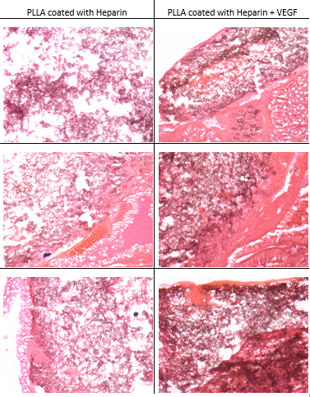
Scaffold
Scaffold
Scaffold
Scaffold
CAM
Scaffold
CAM
Scaffold
Sample 3
Sample 2
Sample 1
Sample 3
Sample 2
Sample 1
100 µm
Figure 63. H&E of plain PLLA and coated PLLA that has been conditioned with VEGF. They both have been implanted in the CAM and retrieved at Day 7 from fertilization. After explantation, scaffolds were fixed with paraformaldehyde and processed for H&E.

Histology did not enable the visualisation of blood vessels, therefore, immunohistochemistry was carried out to be able to visualise better endothelial cells.
Cell infiltration was observed on PLLA scaffolds coated with heparin only. However, more cell infiltration and extracellular matrix production was observed on coated scaffolds that have been conditioned with VEGF, compared to scaffolds coated with heparin only. Quantification of the images was carried out by 4 assessors unaware of the variables of the experiment. Slides were also stained for endothelial marker CD31 to visualise infiltration of endothelial cells.
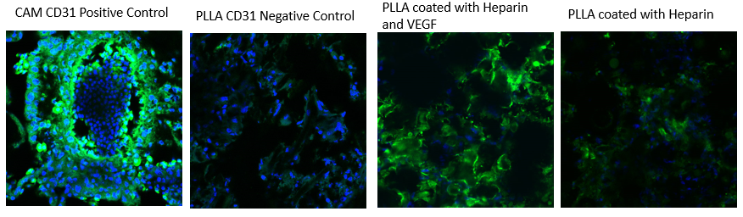
Figure 64. Stain for CD31 as endothelial markers for scaffolds implanted in the CAM. Scaffolds coated with heparin only were compared to scaffolds coated with heparin and VEGF. The Chorionic Allantoic Membrane was used as positive control.
Figure 64 shows the presence of endothelial cells in the scaffolds coated with heparin and VEGF, but there were no positive CD31 stained cells seen in the uncoated PLLA and heparin coated PLLA scaffolds.
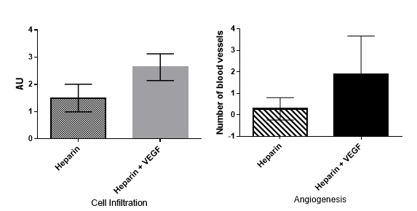
Quantification of the CAM assay shows that there is a significant difference between scaffolds coated with heparin only and scaffolds coated with heparin and VEGF.
*
*
Figure 65. Quantification of the CAM assay for scaffolds coated with heparin only and scaffolds coated with heparin and conditioned with VEGF (Chapter 2.3.4). Cell infiltration was quantified by the visual amount of collagen and cell nuclei inside the scaffold. Angiogenesis was quantified by the number of blood-vessel like structures within the scaffold. They were both quantified based on histology images. Cell infiltration was quantified using arbitrary units, where 0, indicates little cell infiltration, to 3, with extensive cell infiltration and more collagen production. A two tailed T test was performed to see if there was any statistical difference (* = p < 0.05) (± SD).
The latter shows increased cell infiltration, ECM production and the number of blood vessels infiltrated into the scaffold (Figure 65).
This experiment shows that the presence of an angiogenic chemokine (VEGF in this instance) is important to induce angiogenesis. Moreover, heparin alone in a not-inflamed scenario like the CAM does not induce angiogenesis, although it does not interfere with cell infiltration. The presence of heparin is important because it binds growth factors, as previously shown in Chapter 4.
Following these results, the coating with heparin and VEGF was applied to different substrates to demonstrate the versatility of this approach.
Plain PU and PU coated with heparin and VEGF were implanted on the CAM (Figure 66).
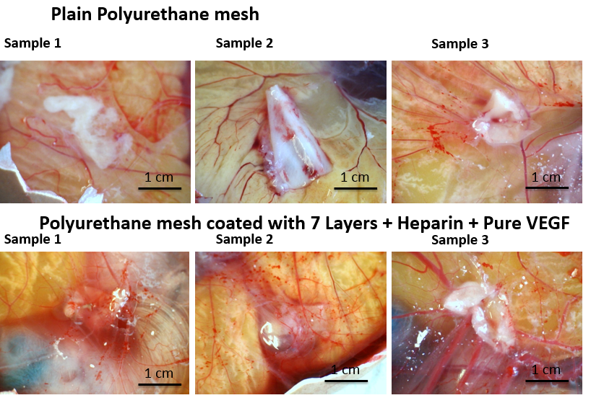
Figure 66. Plain PU and PU coated with heparin and VEGF were implanted on the CAM. Eggs were fertilised at day 0 and incubated at 37 degrees Celsius. Scaffolds were implanted at Day 8 of fertilization on top of the CAM membrane.

The scaffolds were then retrieved from the eggs to be able to better examine the vascularization around the material (Figure 67).
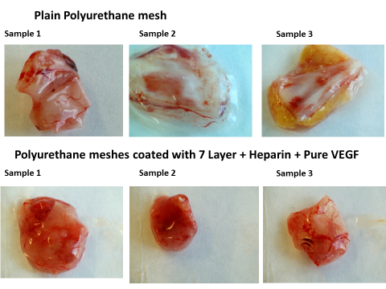
1 cm
1 cm
1 cm
1 cm
1 cm
1 cm
Figure 67. Retrieved plain PU and PU coated with heparin and VEGF from the CAM at Day 14. Scissors were used to cut the CAM around the scaffolds and scaffolds were imaged straight after explantation.
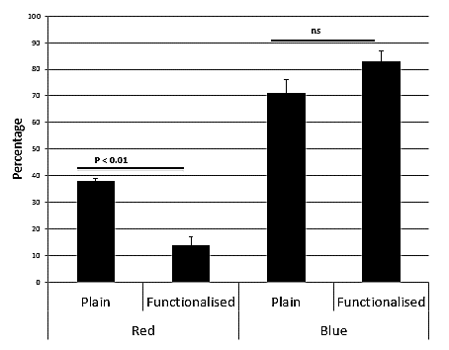
Although the CAM images were not very clear, images of the PU retrieved scaffolds show a visible difference between plain and coated scaffolds. The difference was blindly quantified by 4 assessor and also by an image analysis software (Figure 68).
Figure 68. Differences in colour elements in the PU scaffolds retrieved from the CAM. Colour was quantified by ImageJ software; 3 areas of the scaffolds were quantified for the percentage of each primary colour in the picture; an average was calculated, to represent the whole picture. As the colour quantified was a brown-like colour, the amount of red is inversely proportional to the amount of brown. A two tailed T test was performed to see if there was any statistical difference between the two colours of the scaffolds (± SD).
PU scaffolds coated with heparin and VEGF looked redder compared to plain PU after being retrieved from the CAM model (Figure 67). Pictures were brown the image software divided the brown colour into the primary colours, based on the rationale that different brown shades have various amount of primary colours in them. Quantification with the image software also shows a significant difference in amount of red in the pixels among the light pictures taken (Figure 68). Four assessors that were kept blinded to the nature of the images they were reviewing scored the scaffolds with arbitrary units, from 0, transparent/white through to 4, bright red/numerous vessels visible. They confirmed that there was a significant difference between the plain and the coated scaffolds (Figure 68). PU scaffolds were also analysed with SEM, to visualise the growth of extracellular matrix around the scaffolds (Figure 69).
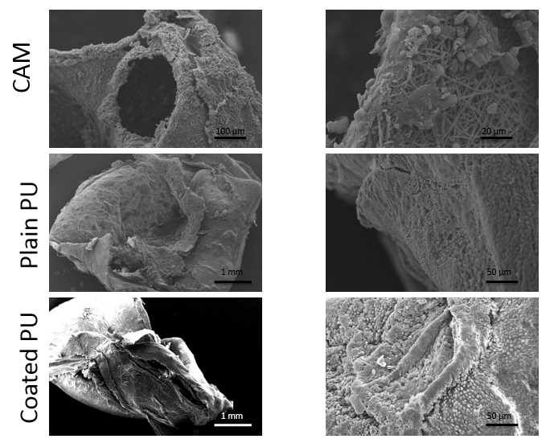
Figure 69. SEM of electrospun PU explanted from the CAM (plain versus coated). Plain and coated scaffolds were explanted at day 14 from the CAM, fixed with parafolmahyde and processed for SEM imaging.

Both PU scaffolds, plain and coated, have the CAM extracellular matrix growing around them uniformly. At high magnification, it was not possible to find blood vessels on the plain scaffolds while it was possible to find some on the functionalised ones.
The same experiment was performed with PP scaffolds. Plain PP scaffolds and coated PP scaffolds with heparin and VEGF were implanted in the CAM model and angiogenic activity was assessed (Figure 70).
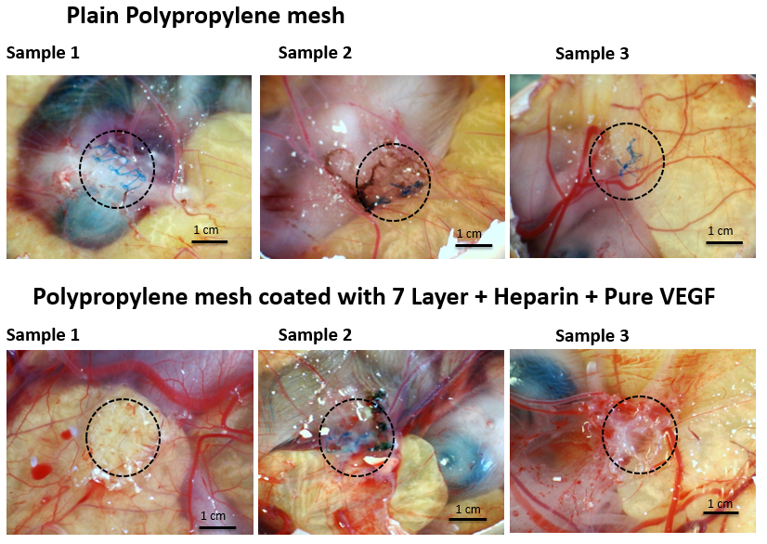
Figure 70. CAM images of the plain PP and coated PP with heparin and VEGF. Plain PP and PP coated with heparin and VEGF were implanted on the CAM. Eggs were fertilised at day 0 and incubated at 37 degrees Celsius. Scaffolds were implanted at Day 8 of fertilization on top of the CAM membrane.

Light camera pictures of the CAM assay did not show a difference between plain and functionalised PP. This is probably due to the messy background of the CAM, where the yolk and the chick embryo stand in the way of a clear visualization. Thus, scaffolds were retrieved from the egg and they were imaged on a neutral background.
It was then possible to see differences between implanted plain PP and implanted functionalised PP (Figure 71). Images of the extracted scaffolds were evaluated by four blind assessors and by ImageJ. Blind evaluation confirmed that there is an increase in the presence of blood vessels around and within the functionalised scaffolds.
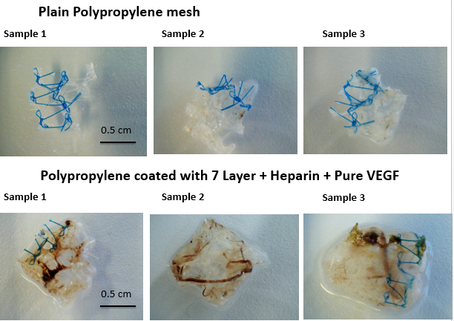
Figure 71. Extracted scaffolds from the CAM: plain PP versus functionalised PP. Retrieved plain PP and PP coated with heparin and VEGF from the CAM at Day 14. Scissors were used to cut the CAM around the scaffolds and scaffolds were imaged after being fixed in paraformaldehyde.

Moreover, quantification of the images of the extracted scaffolds with ImageJ confirmed differences in colour (Figure 72).
Colour differences were quantified using ImageJ and show that there is a quantifiable and significant difference between the plain scaffolds (more white) and the coated ones (more red).
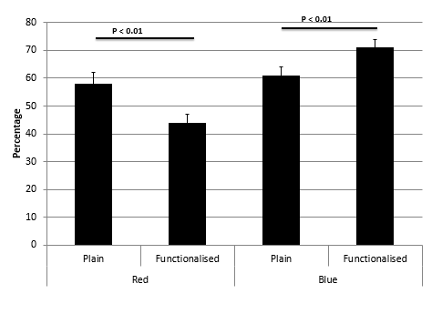
Figure 72. Quantification of the differences in the colour present in the explanted PP meshes. Colour was quantified by ImageJ software; 3 areas of the scaffolds were quantified for the percentage of each primary colour in the picture; an average was calculated, to represent the whole picture. As the colour quantified was a brown-like colour, the amount of red is inversely proportional to the amount of brown. A two tailed T test was performed to see if there was any statistical difference between the two colours of the scaffolds (± SD).

Table 4 shows the proportions of blue and red contained in the pictures of the retrieved scaffolds. Coated PU has the bigger proportions, resulting from a high amount of red in the pictures from the blood vessels.
Table 4. Colour proportion among retrieved scaffolds.
Blue/Red proportions
 | Control | plus VEGF
PU | 1.87 | 5.93
PP | 1.05 | 1.61

Explanted scaffolds also showed a visible difference between plain scaffolds and coated scaffolds, also confirmed by a semi-quantitative scoring system (Figure 73).
Figure 73. Quantification of angiogenic activity of plain PU scaffolds compared to PU scaffolds coated with heparin and VEGF based on the light pictures of the explanted scaffolds. Assessor scored light pictures of the explanted scaffolds from 0, transparent/white to 4 to bright red/numerous vessels visible. Two tailed T-test was performed to check for statistical significance (± SD).
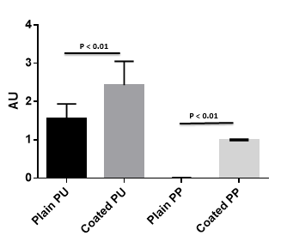

PP was also imaged with SEM to visualise how the CAM wraps the PP scaffolds (Figure 74).
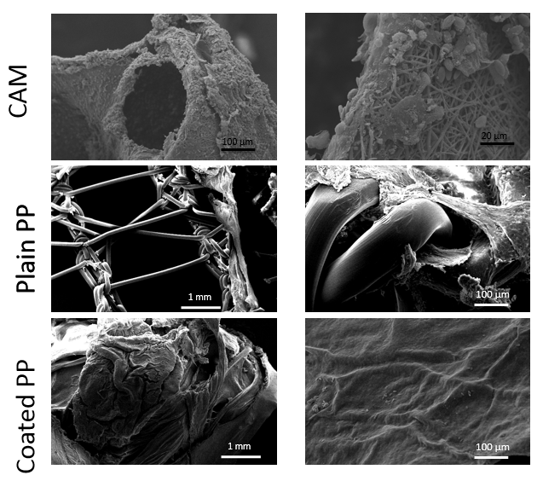
Figure 74. SEM of Gynemesh after explantation from the CAM. A piece of CAM was used as control (first two pictures). The plain and coated PP were implanted on the CAM for a period of 7 days and they were explanted in the same way.
PP scaffolds
Blood Vessels
ECM

The same magnification was used, and it is possible to see that the CAM is patchy on the plain PP fibres but it is uniform on the coated PP scaffold. This suggests that the coating improve cell-compatibility and matrix production. At high magnification, it was also possible to visualise small blood vessels on the surface of the coated PP (Figure 74).
We initially used a pure solution of VEGF that however, does not reflect reality. Once the material is implanted, it is in contact with the human blood and plasma in the first instance. So, after verifying that the coated scaffolds could bind VEGF and they become more angiogenic, we aimed to perform an experiment that would resemble the conditions in-vivo. Thus, we aimed to coat the scaffolds with heparin and platelet rich plasma (PRP).
Blood was harvested from volunteers and plasma and platelets were separated from the red blood cells. The plasma obtained was used to condition the coated scaffolds. After conditioning, the scaffolds were implanted in the CAM to assess any signs of angiogenesis induced by the plasma. PLLA was tested first with 3 different human plasmas and it was compared to the positive control (Figure 75).
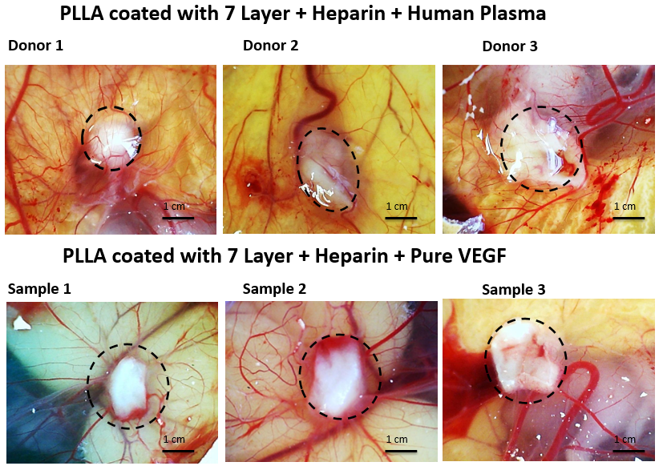
Figure 75. CAM images of fully coated PLLAs conditioned with VEGF, compared to fully coated PLLA conditioned with human plasma that have been implanted on CAM after 7 days of fertilization. Eggs were fertilised at day 0 and incubated at 37 degrees Celsius. Scaffolds were implanted at Day 8 of fertilization on top of the CAM membrane.

Scaffolds coated with heparin and human plasma gave the same positive response than scaffolds coated with heparin and VEGF. These images were blindly scored by four assessors (Figure 76).
ns
ns
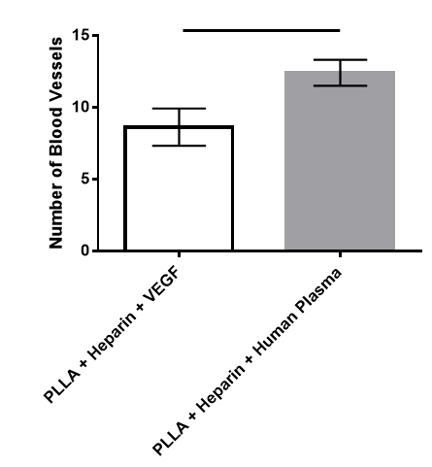
Figure 76. Quantification of number of blood vessels around scaffold coated with VEGF versus scaffolds coated with human plasma. Assessors counted the number of blood vessels based on light micrograph pictures of the explanted scaffolds. 3 pictures per scaffolds were taken. 3 scaffolds per type were produced for 3 different experiments. Two tailed T-test was performed to verify statistical difference (± SD).

There was no significant difference between the number of blood vessels in and around the PLLA coated with VEGF, compared to the one conditioned in human plasma (Figure 76). Scaffolds were then retrieved for histological analysis. Figure 77 shows H&E and Gouldner’s trichrome sections of the coated PLLA.
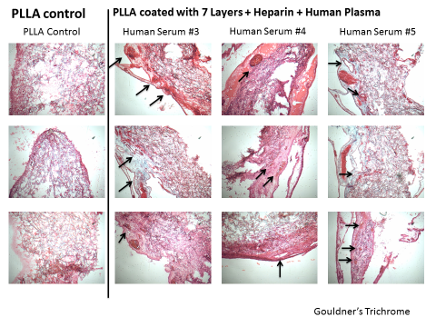
100 µm
Figure 77. Histology sections of PLLA once explanted from the CAM. Plain PLLA was compared to PLLA coated with heparin and human platelet rich plasma. (They all have the same scale). After explantation, scaffolds have been fixed and sectioned for H&E stain.

Slides were also stained for CD31 to confirm the presence of endothelial cells in our scaffolds (Figure 78).
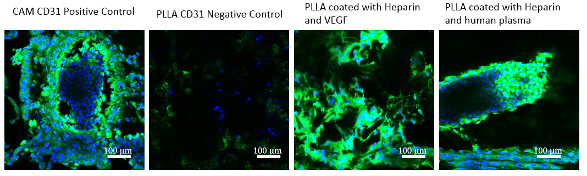
Figure 78. CD31 stain in PLLA scaffolds extracted from the CAM. PLLA scaffolds coated with VEGF were compared to PLLA scaffolds coated with human plasma. Control used was a plain piece of CAM that has been extracted from a 14 days old egg.

Blood vessels are visible around and within the scaffolds, and the collagen produced appeared increased in the scaffolds coated with human plasma compared to the plain PLLA scaffolds. This shows that growth factors have indeed bound onto the surface of the scaffolds and were inducing an angiogenic response in the CAM. Similar results were obtained when human plasma from three different individuals were tested. Taking into consideration biological variability, all of the three different sera showed an increase in blood vessels on the scaffolds (Figure 77). Moreover, the presence of positively stained cells with CD31 suggests that endothelial cells have moved towards the scaffold.
Plain PLLA, once retrieved, was white, compared to the scaffolds that have been coated with human plasma, where blood vessels were visible on and around them (Figure 79).
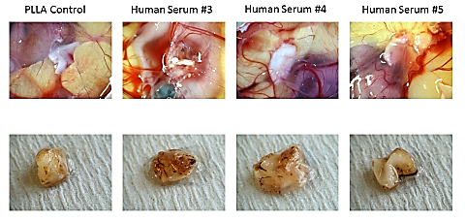
1 cm
1 cm
Figure 79. Explanted PLLA from the CAM. Plain PLLA and PLLA coated with heparin and 3 different human plasmas were implanted on a CAM. Pictures are representative of 3 different experiments with 3 different human plasma.

The experiment was repeated with the other two substrates, PP and PU. Both PU and PP were coated with heparin and conditioned with human platelet rich plasma. They were then placed on the CAM to check for angiogenic activity (Figure 80).
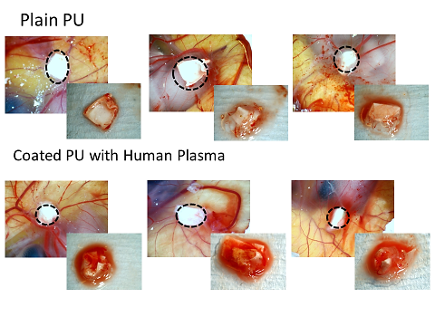
1 cm
1 cm
Figure 80. Pictures of the CAM of retrieved Plain PU and coated PU scaffolds. Scaffolds were implanted on the CAM at Day 7 from fertilization. Scaffolds were retrieved at Day 14 from fertilization. Scissors were used to cut around the scaffold, keeping the CAM intact. Pictures are representative of 3 different experiments.

Plain PU scaffolds retrieved from the CAM looked whiter compared to the coated PU scaffolds that looked red and more vascularised. Similar results were obtained when plain PP was compared to coated PP with human plasma (Figure 81).
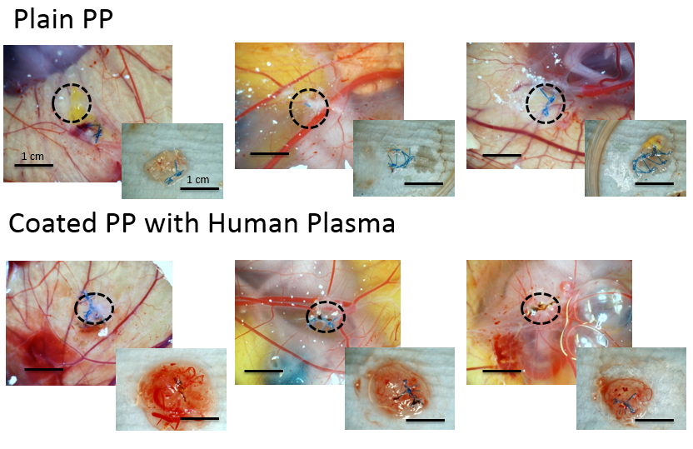
Figure 81. Pictures of the CAM of retrieved Plain PP and coated PP scaffolds. Scaffolds were implanted on the CAM at Day 7 from fertilization. Scaffolds were retrieved at Day 14 from fertilization. Scissors were used to cut around the scaffold, keeping the CAM intact. Pictures are representative of three different experiments.

It is possible to observe that PP scaffolds are not as red as PU scaffolds that is probably due to the nature of the scaffolds (i.e. big pores and big fibres). However, a difference between plain PP and coated P is visible where coated PP are surrounded by tissue and blood vessels, while plain PP are not. Due to the nature of these scaffolds, it was very difficult to do histology, so quantification was carried out by four assessors on the basis of examining the light pictures of the CAM and the retrieved scaffolds (Figure 82).
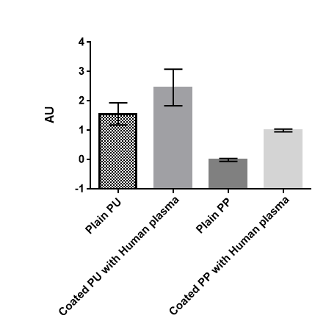
Figure 82. Semi-quantification by the four assessors based on the light pictures of the retrieved scaffolds. Assessors used arbitrary units to score the light pictures, were 0, transparent/white to 4, bright red/numerous vessels visible. 3 pictures per scaffolds were taken. 3 scaffolds per type were produced for 3 different experiments. Two tailed T-test was performed to verify statistical difference (± SD).
P < 0.05
P < 0.05

After quantification, there was a significant difference between plain and coated scaffolds. The coated scaffolds showed an increased number of blood vessels around them compared to the control (Figure 84).
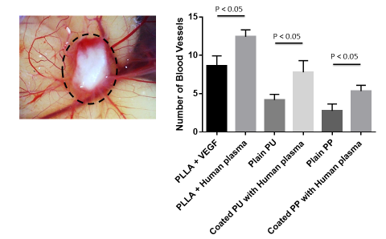
Figure 83. Quantification of number of blood vessels around scaffold coated with VEGF versus scaffolds coated with human plasma. Assessors counted the number of blood vessels based on light pictures of the explanted scaffolds. 3 pictures per scaffolds were taken.
  - Discussion
The first step of this study aimed to show if heparin alone could induce angiogenesis, or if heparin has to be loaded with growth factors. PLLA scaffolds coated with heparin were compared to scaffolds coated with heparin and VEGF using the CAM assay. This first analysis was performed on PLLA only to check its feasibility. Results show that heparin alone, in a non-inflammatory situation like the CAM, does not induce angiogenesis. However, if heparin is left in a solution containing growth factors, like a pure solution of VEGF, it would sequester them from a solution, making the scaffold angiogenic. Similar results were obtained when PU and PP were coated with the same protocol where more angiogenesis was visible in the coated scaffolds.
Secondly, coated scaffolds were conditioned with platelet rich plasma, instead of pure VEGF solution, to recreate similar in-vivo conditions. Again, plasma conditioned scaffolds appeared to induce more matrix production and more blood vessels. However, differences in performance among scaffolds were visible, and it is worth discussing these differences that are probably caused by the different natures of the scaffolds used.
    - PLLA
PLLA was the best performing scaffold and it was used to initially prove the functionality of our coating. PLLA scaffolds coated with heparin alone were compared with PLLA coated with heparin and VEGF. Results show that heparin alone is not angiogenic. However, it has the ability to bind growth factors that are chemoattractant for endothelial cells. This study is consistent with recent studies where heparin was used to stabilise and bind VEGF to make materials more angiogenic. Initial studies included heparin to stabilise VEGF for slow release in particles aimed at pharmacological therapies (Cleland et al. 2001; Perets et al. 2003; Chung et al. 2006). More recently, the same rationale was applied to materials for medical applications. Heparin is used, either within the material or as a coating, to make the material able to bind growth factors. These studies are all based on the same principle that heparin is able to bind and stabilise growth factors with heparin-binding sites such as VEGF, EGFs and FGFs (Ekaputra et al. 2011; Kim et al. 2011; Guo et al. 2012; Z. Wang et al. 2012; B. L.-P. Lee et al. 2012; Huang et al. 2013; Wu et al. 2014; Pitarresi et al. 2014; C. D. Easton et al. 2014; Steffens et al. 2004; Bezuidenhout et al. 2010; Hou et al. 2010; Singh et al. 2011; Schmidt et al. 2011).
However, heparin is usually covalently bound onto the substrate, making its availability limited. This study instead focuses on a method to electrostatically bind heparin on the surface. The first part of this study validated the functionality of the coating. It has been shown for the first time on electrospun mats, compared to commercially available polypropylene meshes, that coating with heparin and VEGF induced endothelial cells proliferation (C D Easton et al. 2014). Following that, we carried the project forward to show that this coating is angiogenic in the CAM assay. We used the CAM assay because it is currently used and universally accepted as a screening method for angiogenesis (Valdes et al. 2002; J Borges et al. 2003; Baiguera et al. 2012). The CAM assay allowed us to verify that scaffolds coated with heparin and VEGF induce an angiogenic response (Gigliobianco, Chong, et al. 2015).
After verifying that the heparin coated PLLA could sequester VEGF from a solution, we mimic the in-vivo scenario by conditioning the heparin coated PLLA with human platelet rich plasma. This was based on the basis that the first liquid to be in contact with the scaffold as soon as it is implanted is human plasma and erythrocytes. All of the scaffolds coated with platelet rich plasma appeared angiogenic, despite the biological variability among them. The use of human plasma has been long known and recently used to induce a positive body reaction: clotting, wound healing, endothelial cells proliferation, angiogenesis and tissue integration (Marx 2004; Schade & Roukis 2008; Nikolidakis & Jansen 2008; Intini 2009; Horimizu et al. 2013; Sánchez-Ilárduya et al. 2013; Diaz-Gomez et al. 2014; La & Yang 2014; Anitua et al. 2015). This is due to the growth factors present within the plasma that have been sequestered by the heparin on the surface of the scaffolds.
Moreover, these growth factors have been shown to be responsible for angiogenesis. Numerous studies have confirmed that heparin sequesters growth factors in a heterogeneous solution. Already in the early 80’s it was shown that endothelial growth factors have a high affinity for heparin. Endothelial growth factors were shown to be angiogenic in the CAM and the rat cornea assay (Shing et al. 1983; Shing et al. 1984). Soon after, many other endothelial growth factors were found to have a high affinity with heparin (D’Amore & Klagsbrun 1984; Lobb & Fett 1984; Gospodarowicz et al. 1984; Maciag et al. 1984; Courty et al. 1985; Esch et al. 1985; Gimenez-Gallego et al. 1985; Sullivan & Klagsbrun 1985; Abraham et al. 1986).
We have shown this by conditioning the heparin coated scaffolds with VEGF. We took this forward by conditioning the scaffolds with platelet rich human plasma (PRP),to verify that heparin was able to bind growth factors present in a heterogeneous solution such as human plasma. The advantages of using human plasma are that it is autologous so move straightforward to take to the clinic than recombinant growth factors, conditioning can be performed in the operating theatre and it is cheaper than commercially available growth factors. Recent studies have also used PRP as part of the scaffold to improve the material’s biological properties. In a recent study of Kim et al., PRP was incorporated into gelatin particles. Addition of PRP to the gelatin particles resulted in recruitment of macrophages to the site and bone remodelling (Kim et al. 2014). Moreover, another study mixed PRP in a gel with Schwann cells to fill nerve conduits made of PLGA. After implantation in rabbits, a conduit with PRP had a positive effect on nerve regeneration (Ye et al. 2012). Also a study of He et al. confirmed that the presence of PRP was also beneficial for tissue regeneration. PLGA and calcium phosphate cement were mixed with PRP for bone repair in rabbits.
The presence of PRP boosted bone formation and scaffold degradation. They also showed that angiogenesis increased when PRP was present (He et al. 2014). Two studies have been found where PRP was used to modify scaffolds made of poly-lactic fibres. Lee et al. incorporated PRP into a PLGA woven mesh (Vycryl) by various strategies. They confirmed that the presence of platelet related plasma improved cell adhesion and spreading (Lee et al. 2015). In a similar study, PLLA was mixed with various concentrations of PRP and then electrospun into aligned and random fibres. Scaffolds with PRP showed enhanced cell proliferation and adhesion to the scaffolds (Diaz-Gomez et al. 2014). However, for both of these studies, angiogenesis was not tested.
Compared to all the studies previously mentioned, the study depicted in this thesis shows a novel approach to electrostatically binding heparin onto the surface of electrospun PLLA and then loading it with human plasma. We also showed that this method of coating PLLA is also angiogenic in an in-vivo model.
The coating, although it was possible to have 3 layers, the study carried on with 7 layers for comparison purposes. We advanced this project by testing the coating on two other different substrates, an electrospun PU mat that represent the future generation of urological materials, and a knitted PP mesh, that represents the gold standard for reconstructive urology.
    - PU
PU is often used for cardiovascular applications, such synthetic vessels. Due its adaptable properties, it is often considered an ideal biomaterial for soft tissue engineering (Zdrahala & Zdrahala 1999). They are biocompatible, indifferent to hydrolysis and flexible, that are often the wanted properties for materials for soft tissues regeneration (Eloy et al. 1988).
We also confirmed the biocompatibility of PU as SEM pictures show that extracellular matrix enveloped the explanted PU scaffold both plain and coated, suggesting that PU is cell-friendly. Other studies also have shown that PU is cell friendly but, according to the applications, it might not be desirable, especially for cardiovascular materials (Zhang et al. 2015). These materials will need to be anti-thrombogenic to avoid blood clotting when in contact with the material. Therefore, coating PU materials with heparin is desirable for heparin’s anti-thrombogenic effect (Gott et al. 1963; Chung & Ellerton 1976; Ito 1987). Various methods have been used to bind heparin to PU surfaces, from ionic exchange, surface blending, covalent bonding and surface coating (Brynda et al. 2000; Weber et al. 2000).
However, not many studies have investigated the potential to bind heparin to PU for angiogenic purposes. One study was found to consider PU for its angiogenic potential. A PU sponge was polymerised with PRP using thrombin and HUVECs and osteoblasts were culture on it. However, the study did not report whether PRP supported cell growth and vascularization (Hofmann et al. 2008).
Therefore, we explored the possibility to make PU angiogenic for other purposes rather than cardiovascular. PU is such a flexible material that would be very suitable for urological applications. Our investigation confirmed the possibility of using heparin to bind growth factors and make otherwise inert PU meshes into angiogenic materials.
However, knitted or woven PP meshes are still the gold standard for urological reconstruction. We wanted to verify the feasibility of this coating on existing materials such as PP meshes.
    - PP
Overall, PP was the worst performing scaffold among the three. Although cell infiltration and angiogenesis was improved due to the coating, the extracellular matrix produced and number of blood vessels was less compared to the previous two scaffolds. This is probably due to its very big pores and to the nature of the CAM that is a very loose collagen matrix and the PP does not offer a good scaffold for CAM support. Cells have difficulties in bridging big pores. Moreover, quantification of inflammation caused by the material is limited in the CAM due to the lack of inflammatory cells within the first 11 days of embryo development. Previous studies have reported that PP mesh provokes a fairly pronounced inflammation, leading to a massive cell infiltration into the scaffold and ultimately to collagen production (Kuznetsov et al. 2004b; Rabah et al. 2004b; Bazi et al. 2007; De Almeida et al. 2007; Huffaker et al. 2008; Woodruff et al. 2008; Elmer et al. 2009; Pierce et al. 2009).
However, in a simple system like the CAM, inflammation and ECM production are difficult to assess. Yet, it was possible to observe from the SEM that cell attachment and ECM production were improved after the coating. It is possible to observe that single cells struggle to form a network on plain PP, but a uniform sheet of collagen and cells is visible on coated PP.
Recently, many studies have focused on coating PP with mainly ECM components to improve its biocompatibility. Examples include collagen and heterogeneous hydrogels from ECM substrates. Only one study was found to coat PP with titanium carboxonitride but they did not find that the coating improved the PP biocompatibility (Lehle et al. 2004).

A couple of studies compared PP with PP coated with collagen but they did not find that the collagen improved prosthesis integration, inflammation or cellular response (Pierce et al. 2011; Lukasiewicz et al. 2013). However, recent studies have shown that it is possible to induce an M2 macrophage response, leading to tissue remodelling. Schug-Pass et al. compared Dyanamesh IPOM (PP + PVD), Proceed (PP + cellulose, Ethicon) and Parietene Composite (PP + collagen, Covidien) in a porcine model. They showed that collagen coated meshes had better tissue integration (Schug-Pass et al. 2009). Also, a couple of other studies compared plain PP to a purified collagen-coated PP where the presence of collagen improved remodelling, decreasing inflammation. Moreover, the PP mesh with the collagen coating had more blood vessels present and increased expression of metalloproteases 2 and 3 (Siniscalchi et al. 2013; Dias et al. 2014). Similarly, the Badylak group also reported similar findings; they compared plain PP mesh to a PP mesh coated with a heterogeneous hydrogel of ECM components from bladder and dermis. The coating modulated the macrophage response towards the material, from a M1 to an M2 response, suggesting that the ECM present in the hydrogel played a role in changing the macrophages polarization inducing tissue remodelling, over a period of 3 months (Faulk et al. 2014; Wolf et al. 2014).
Therefore, it is clear that the surface of the material is extremely important to modulate inflammation and ultimately tissue remodelling. Our study is novel in the extent that no studies were found that used heparin to coat polypropylene with the aim to make it more angiogenic. The majority of the studies use heparin to coat PP for its anti-clotting ability and to improve blood compatibility (Tyan et al. 2002; Degoutin et al. 2012; Guo et al. 2013).

  - Conclusion
In conclusion, this chapter evaluated in-vivo the angiogenicity of the coating on different substrates. Initially, we tested if heparin alone could be angiogenic but we found that it wasn’t. However, we confirmed that heparin on the surface is useful as it binds growth factors in solution. Initially, the scaffolds coated with heparin were immersed in a solution of pure VEGF and implanted in the CAM to verify their angiogenicity. The CAM showed that there was an increase number of blood vessels in the coated scaffolds compared to the plain ones.
We carried that further when coated scaffolds were conditioned with human plasma to test if heparin sequestered plasma’s growth factors and made the scaffolds angiogenic. All three scaffolds appeared angiogenic after conditioning with human plasma. This type of scaffold conditioning may be a great option for surgeons as it can be carried out in the theatre.
A limiting factor of this study is the variety of substrates involved. Due to the different natures of the scaffolds (materials, properties …), it was difficult to compare their biological properties and to design experiments to take all these factors into consideration.
Additional limitations of this study include the huge difference in CAM response that made the quantification of the CAM model semi-quantitative. Moreover, the short term CAM experiment, although it was convenient to be short, the full development of the chick could not exploited.
- Summary and Future Works
This study aimed to electrostatically bind heparin onto the surface of electrospun (PLLA and PU) and knitted scaffolds (PP). The coating is relatively low technology, inexpensive and reliable (C D Easton et al. 2014). We also showed that the coating is able to bind pro-angiogenic growth factors from human plasma.
Overall, it is possible to say that PLLA was the best performing scaffold, closely followed by PU. Biologically speaking, the worst performing scaffold was PP, due to its highly porous structure and big fibres. Electrospun PLLA and PU proved very suitable for cell culture and cell infiltration, making them good choices for future studies.
It is possible then to consider the usefulness of each type of scaffold related to the coating. It is also applicable to many materials, from non-woven biodegradable (PLLA) to knitted non-degradable (PP) materials. PLLA, being degradable and more prone to surface etching, is probably the best performing scaffold because of the high surface porosity that allows more heparin to be bound onto the surface compared to PU and PP.
Table 5. Overall performance of the substrates used for the coating.
 | PLLA | PU | PP
Physical properties | Biodegradable  Non-woven | Non-degradable  Non-woven | Non-degradable  Knitted
Heparin binding | +++ | ++ | +
VEGF binding | +++ | ++ | +
Angiogenesis in the CAM assay with plasma coating | +++ | +++ | ++

  - It adds to knowledge
This is the first ever study that shows that PEI and PAC can be used for a layer-by-layer coating on an electrospun mat. Moreover, the study also demonstrated the functionality of the coating in an in-vivo model. It was also shown the feasibility to use heparin to sequester growth factors from a heterogeneous solutions such as human plasma to make a scaffold angiogenic.
  - It is useful
This coating was shown to be useful as it could be applied to three different substrates. Other studies have shown that it is possible to make scaffolds ore angiogenic. However, they often coat flat surfaces or they mix active compounds with the polymer. In this study, we aimed to develop a surface coating for non-woven and knitted flat scaffolds that would cover the upper fibres of the scaffold.
The rational for developing a surface coating is to make the molecules readily available straight after implantation. This approach is clinically relevant in scenarios where vascularization is difficult and urgently required such as pelvic floor reconstruction in women with weakened collagenous tissues..
A surface coating has the advantage of releasing the molecules of interests faster because it is on the surface, compared to other approaches where the molecule is mixed within the polymers of the scaffold. If a molecule is mixed with the scaffold, the scaffold will need to degrade before releasing the molecule. However, if the molecule is adsorbed on the surface, it is released without waiting for the scaffold to degrade.

  - It is inexpensive
Moreover, this approach, although research intensive while in development, could be made to be very inexpensive. Although the first step seems technically difficult, it is not very expensive and plasma polymerization can be carried out in large batches.
The subsequent steps of dip coating could be automated. The use of heparin is also a strategic choice as it is already in use clinically, and it is also affordable in the NHS.

  - Future Work
As this study is the first of its kind to test the angiogenic potential of this type of coating, additional investigations are needed if this technology is to be taken into the clinic. This study gathered evidences of the chemistry of the coating and that this coating is angiogenic.
This study is coherent with recent studies that have taken into considerations modifying the surface of materials with heparin to improve biocompatibility and induce an angiogenic response by directing endothelial cells behaviour. These studies indicates new trends in developing smarter materials that activally interact with the human body (Leijon et al. 2013; H. G. Wang et al. 2013; David E Robinson et al. 2014; Zhou et al. 2016). This study gathered further evidences of the feasibility of a coating approach of existing materials to induce a tissue response. However, no clinical product is currently available that combines heparin on a surface to induce angiogenicity. This is because the development of such a product includes various challenges and further studies are required.
Firstly, studies that investigate interactions between heparin and the human plasma in more detail will need to be carried out to understand what factors bind to heparin, in addition to the kinetics and stability of the interaction. Although the focus of this study was the biological function of the coating, it would also be important to fully characterise the properties of the material after the coating as mechanical properties might get affected by the coating processing. This might influence the performance of the material once implanted. These tests would include tensiometric tests to verify stress and strain that the material can withstand once functionalised. Stitch retention test and burst test would also be useful as the material will need to be stitched in place and resist to abdominal pressure.
Therefore, the overall evaluation of the material will have to take into consideration both biological and mechanical properties of the final product. This will need to happen in appropriate animal models, where the material is under mechanical and biological strain within the animal. Straightforward animal models include mice and rabbits; however, more complex and relevant models include sheep and procine models.
We used the CAM assay to test the functionality of our coating. However, efforts can be spent in making the CAM more quantitative and increase the experimental yield.
Once the properties of the materials are fully known, both mechanical and biological, it would be useful to think towards a commercialization of this approach. Figure 84 depicts the basic steps to take into consideration for commercialization of this technology.
6
5
4
3
2
1
Figure 84. Diagram defining each step for the commercialization of this product.

Although this study showed the feasibility and utility of an electrostatic coating to induce angiogenesis, it did not fully investigate the coating as a clinical product.
For regulatory purposes, further studies on the stability of the coating, sterility and biocompatibility would be needed. Hypothetically, this product can be marketed as a material coated with 7 layers only, leaving the heparin and human plasma step to be done last in the operating theatre. Preferably, it could also be marketed as a material coated with 7 layers and heparin, leaving only one step to be done in the theatre, the coating with human plasma. Both types of product will need to be compared and evaluated. Although results show that 3 layers of coating would still bind enough VEGF, the studied carried with 7 layers to be able to compare different substrates, as initially 7 layers were used on the PLLA substrate, and to follow recent literature (C D Easton et al. 2014).
After establishing what the best combination is it is important to establish a sterility assay appropriate for the coating, as sterilisation may affect the chemistry and the functionality of the scaffold; therefore, after testing various sterility strategies, the coating will have to be tested again for its chemistry and functionality.
After that, biocompatbility tests will have to be performed to demonstrate that the coating is safe in middle size animals, such as mice or rabbits, for a period clinically relevant like 28 days.
The most appropriate in-vivo animal would probably be diabetic mouse, as diabetic mice wounds heal slowly. Therefore, the scaffold could show its ability to induce angiogenesis, heal the wounds faster with hopefully no-side effects.
It is also important to consider how this product can be made convenient and economical to use.
Further studies will involve studies on the best packaging to ensure a long and stable shelf-life for the coated material. It would be useful to investigate the optimum storage and packaging conditions to preserve the coating and the material itself, in order to maximise the material’s shelf life and functionality of the coating when ready for conditioning with human plasma. Ideally, the product will be kept dried under vacuum with a desiccator, in a fridge to lengthen the shelf life. Moreover, further studies will need to test additional controls, for each step of the coating protocol, to verify how the scaffold is affected after each step.
All these investigations will form the technical file for this new material to be brought to the market and comply to the EU Regulations.

This study was a stepping stone to demonstrate the feasibility of surface coatings to improve existing materials for urological applications, in addition to give more options for developing materials for the future. It is possible to functionalise the surface of new and existing materials for urological applications. The use of heparin and human plasma show how the surface of a scaffold can be made angiogenic using existing technologies, opening new frontiers for biomaterials modification.

APPENDICES

Appendix I

Studies involved in making electrospun scaffolds angiogenic by MICROFABRICATION
Authors | Paper Title | Summary
(Fioretta et al. 2014) | Differential Response of Endothelial and Endothelial Colony Forming Cells on Electrospun Scaffolds with Distinct Microfiber Diameters | PCL was electrospun at various settings to produce a range of fibers diameter. Angiogenesis was assessed by seeding the scaffolds with functional endothelial cells and HUVECs.
(Walthers et al. 2014) | The effect of scaffold macroporosity on angiogenesis and cell survival in tissue-engineered smooth muscle. | PCL was electrospun and holes were cut using a laser cutter. Scaffolds were implanted in animals.
(Joshi et al. 2013) | Macroporosity enhances vascularization of electrospun scaffolds. | Electrospun polycaprolactone was perforated using a laser cutter (300, 160 and 80 µm). They were implanted in rats peritoneal cavity.
(Garg et al. 2013) | Macrophage functional polarization ( M1 / M2 ) in response to varying fiber and pore dimensions of electrospun scaffolds | Polydiaxanone was electrospun at the same settings but varyin the concentration of the polymer in solution creating range of pores and fibers diameters.
(Yang et al. 2013) | In vivo bone generation via the endochondral pathway on three-dimensional electrospun fibers. | Blend of PLGA and PCL electrospun. Scaffolds were implanted subcutaneously in nude rats. Blood vessels formation after 8 weeks.
(Sekiya et al. 2013) | Efficacy of a poly glycolic acid (PGA)/collagen composite nanofibre scaffold on cell migration and neovascularisation in vivo skin defect model. | Nanofibres of PGA and collagen were elctrospun. Scaffolds were implanted in a mouse wound model. Histology after 5 and 7 days after implantation showed high cell density and increased capillaries number.
(Rnjak-Kovacina et al. 2011) | Tailoring the porosity and pore size of electrospun synthetic human elastin scaffolds for dermal tissue engineering. | Elastin was electrospun in mats of various porosities by changing the flow rate. Scaffolds were implanted subcutaneously in mice.

Appendix II

Studies involved in making electrospun scaffolds angiogenic by CELL SEEDING
Authors | Paper Title | Summary
(Fu et al. 2014) | Human urine-derived stem cells in combination with polycaprolactone/gelatin nanofibrous membranes enhance wound healing by promoting angiogenesis. | Urine-derived stem cells were seeded on electrospun polycaprolactone and gelatine. They were implanted in a skin full thickness rabbit model.
(Machula et al. 2014) | Electrospun Tropoelastin for Delivery of Therapeutic Adipose-Derived Stem Cells to Full-Thickness Dermal Wounds. | Electrospun tropoelastin seeded with ADSC was implanted in a full-thickness model of immunodeficient mice for 6 days. Angiogenesis was evaluated by histology amd H&E staining.
(Nosoudi et al. 2013) | Local delivery of endothelial cell spheroids to promote angiogenesis through novel extracellular matrix mimicking electrospun scaffolds | A mixture of polymers containing ethylene-co-acrylic acid, PCL, PEO, PEG, powdered milk and methyl cellulose was electrospun. Scaffolds were then seeded with endothelial cells spheroids. Angiogenesis was tested in-vitro for sprouting and angiogenic markers like connexion-43, cavedin-1 and VEGFR-1.

Appendix III

Studies involved in making electrospun scaffolds angiogenic by ADDITION of ACTIVE MOLECULES.
 | Authors | Paper Title | Summary
Covalently bound | (J. Lee et al. 2012) | Biomaterials The effect of controlled release of PDGF-BB from heparin-conjugated electrospun PCL / gelatin scaffolds on cellular bioactivity and in filtration | A mixture of PCL and gelatine were electrospun. After, heparin was covalently bound onto the fibers. The scaffolds were then immerged in PDGF solution to electrostatically bind the growth factor to the heparin. Angiogenic activity was measure in-vitro with smooth muscle cells.
Covalently bound | (Kim et al. 2011) | Release kinetics and in vitro bioactivity of basic fibroblast growth factor: effect of the thickness of fibrous matrices. | A mixture of PCL and heparin was electrospun. Heparin was covalently bound onto the fibers. Scaffolds were immerged in bFGF solution. Angiogenesis was assessed in-vitro by culturing mesenchymal stem cells and HUVECs.
Covalently bound | (Ekaputra et al. 2011) | The three-dimensional vascularization of growth factor-releasing hybrid scaffold of poly (epsilon-caprolactone)/collagen fibers and hyaluronic acid hydrogel. | A blend of PCL, collagen and hyaluronic acid was electrospun. Subsequentially, heparin was covalently bound onto the fibers. Angiogenesis was assessed in-vitro by co-culturing HUVEC and fibroblasts.
Covalently bound | (Zhang & Song 2014) | Amphiphilic degradable polymers for immobilization and sustained delivery of sphingosine 1-phosphate. | S1P is covalently bound and grafted into the polymer prior electrospinning.
Adsorbed or electrostatically bound | (C. D. Easton et al. 2014) | Application of layer-by-layer coatings to tissue scaffolds - development of an angiogenic biomaterial | Electrospun PLGA was coated electrostatically to bind heparin. Angiogenesis was assessed in-vitro with HDMECs.
Adsorbed or electrostatically bound | (Eghtesad & Nurminskaya 2013) | Binding of pro-migratory serum factors to electrospun PLLA nano-fibers. | PLLA was electrospun in nanofibers. It was then immerged in serum. Angiogenesis was evaluated by culturing human mesenchymal stem cells and human vascular smooth muscle cells.
Adsorbed or electrostatically bound | (Zhang et al. 2014) | Monocyte chemoattractant protein-1 released from polycaprolactone/chitosan hybrid membrane to promote angiogenesis in vivo | Hybrid electrospun membrane of polycaprolactone and chitosan were incubated in a heparin solution and then immerged in a MCP-1 solution. They have been implanted subcutaneously in rats.
Adsorbed or electrostatically bound | (Del Gaudio et al. 2013) | Induction of angiogenesis using VEGF releasing genipin-crosslinked electrospun gelatin mats. | Gelatine was electrospun, freeze-dried and immersed in VEGF solution. The scaffolds were tested in a CAM.
Adsorbed or electrostatically bound | (Diaz-gomez et al. 2014) | Biodegradable electrospun nano fibers coated with platelet-rich plasma for cell adhesion and proliferation | Electrospun polycaprolactone was immersed in activated platelet-enriched plasma.
Adsorbed or electrostatically bound | (Z. Wang et al. 2012) | Functionalization of electrospun poly( -caprolactone) scaffold with heparin and vascular endothelial growth factors for potential application as vascular grafts | Heparin is electrostatically bound onto an aminated electrospun PCL mat. The scaffolds were then immerged in VEGF solution. Scaffolds were implanted subcutaneously in rats.
Adsorbed or electrostatically bound | (Castan et al. 2014) | Angiogenesis in Bone Regeneration : Tailored Calcium Release in Hybrid Fibrous Scaffolds | Mixture of ormoglass and PCL was electrospun. Scaffolds were implanted on the back of rats.
Adsorbed or electrostatically bound | (Farokhi et al. 2014) | Bio-hybrid silk fibroin / calcium phosphate / PLGA nanocomposite scaffold to control the delivery of vascular endothelial growth factor | VEGF was dissolved in a PLGA/silk solution and the mixture was electrospun. The scaffold was implanted in periostal defects in rabbits.
Adsorbed or electrostatically bound | (Wu et al. 2014) | A novel heparin loaded poly ( L -lactide-co-caprolactone ) covered stent for aneurysm therapy | Heparin was blended with polycaprolactone and electrospun in nanofibers. The scaffold was implanted in a rabbit aneurysm model.
Blends and Emulsions | (Augustine et al. 2014) | Investigation of angiogenesis and its mechanism using zinc oxide nanoparticle-loaded electrospun tissue engineering scaffolds | Blend of polycaprolactone and zinc oxide particles were electrospun. The scaffold was tested in the CAM and in a guinea pig full thickness skin model.
Blends and Emulsions | (Rujitanaroj et al. 2014) | Polysaccharide electrospun fibers with sulfated poly(fucose) promote endothelial cell migration and VEGF-mediated angiogenesis | Pullulan and Fucoidan (a sulphated polysaccharide) was mixed and electrospun. The scaffold was then immerged in a VEGF solution and implanted subcutaneously in mice.
Blends and Emulsions | (Xie et al. 2013) | Dual growth factor releasing multi-functional nanofibers for wound healing | Chitosan was electrospun with PLGA particles containing VEGF and PDGF. The scaffolds were implanted in a full thickness wound rats model.
Blends and Emulsions | (Farokhi et al. 2013) | Sustained release of platelet-derived growth factor and vascular endothelial growth factor from silk/calcium phosphate/PLGA based nanocomposite scaffold. | PLGA, silk and calcium phosphate were electrospun together with VEGF and PDGF. Scaffolds were implanted in periosteum rabbit’s defects.
Blends and Emulsions | (H. Wang et al. 2013) | Synergistic promotion of blood vessel regeneration by astragaloside IV and ferulic acid from electrospun fibrous mats. | Mixture of Poly(ethylene glycol)-poly(DL-lactide) with herbal components and electrospun. They were implanted subcutaneously in rats.
Blends and Emulsions | (Huang et al. 2013) | Heparin loading and pre-endothelialization in enhancing the patency rate of electrospun small-diameter vascular grafts in a canine model. | Coaxial electrospinning of PLLA and heparin. The scaffold was endotheliazed in-vitro and implanted in a dog model.
Blends and Emulsions | (Zhang et al. 2013) | Dual-delivery of VEGF and PDGF by double-layered electrospun membranes for blood vessel regeneration. | Mixture of caprolactone, VEGF and PDGF electrospun. Scaffolds were implanted in a rabbit model.
Blends and Emulsions | (Xu et al. 2013) | Controllable dual protein delivery through electrospun fibrous scaffolds with different hydrophilicities. | PolyLactide-co-glycolide was electrospun with Bovine Serum Albumin or myglobin dissolved in solution. Angiogenesis was not proven though.
Blends and Emulsions | (Seyednejad et al. 2012) | Coaxially Electrospun Sca ff olds Based on Hydroxyl-Functionalized Poly( ε -caprolactone) and Loaded with VEGF for Tissue Engineering Applications | Coaxial electrospinning of a solution of PCL, Bovine Serum Albumin and VEGF. Angiogenesis was assessed by HUVEC growth in-vitro.
Blends and Emulsions | (Guo et al. 2012) | Creating 3D angiogenic growth factor gradients in fibrous constructs to guide fast angiogenesis. | A blend of bFGF entrapped in PLGA and heparin particles was coaxially electrospun with PCL. Scaffolds were implanted subcutaneously in mice.
Blends and Emulsions | (He et al. 2012) | Multiple releases of polyplexes of plasmids VEGF and bFGF from electrospun fibrous scaffolds towards regeneration of mature blood vessels. | Polyplexes of VEGF and bFGF were electrospun with poly(DL)lactide-polyethylene glycol (PELA). The scaffolds were implanted subcutaneously in rats.
Blends and Emulsions | (Montero et al. 2012) | bFGF-containing electrospun gelatin scaffolds with controlled nano-architectural features for directed angiogenesis. | Gelatin was electrospun with bFGF and crosslinked. Angiogenesis was assessed by HUVEC in-vitro.
Blends and Emulsions | (DeVolder et al. 2011) | Directed blood vessel growth using an angiogenic microfiber/microparticle composite patch. | Coaxial electrospinning of PLLA and PLGA particles containing VEGF. Angiogenesis was assessed in the CAM.
Blends and Emulsions | (Liao & Leong 2011) | Efficacy of engineered FVIII-producing skeletal muscle enhanced by growth factor-releasing co-axial electrospun fibers. | Coaxial electrospinning of polyurethane and a solution containing VEGF and bFGF. Scaffolds were seeded with muscle cells and implanted subcutaneously in mice.





Hindawi Publishing Corporation
BioMed Research International
Article ID 968087
Review Article
Biomaterials for Pelvic Floor Reconstructive Surgery: How Can We Do Better?

Giulia Gigliobianco,¹ Sabiniano Roman Regueros,¹ Nadir I. Osman,^{1,2} Julio Bissoli,³ Anthony J. Bullock,¹ Chris R. Chapple,² and Sheila MacNeil¹ 1
Material Science Engineering, University of Sheffield, Sheffield S1 3JD, UK 2
Royal Hallamshire Hospital, Sheffield S10 2JF, UK 3
Hospital das Cl´ınicas da Faculdade de Medicina, Universidade de Sao Paulo, 05410-020 Sao Paulo, Brazil˜
Correspondence should be addressed to Sheila MacNeil; s.macneil@sheffield.ac.uk
Received 25 June 2014; Accepted 19 August 2014
Academic Editor: Uwe Klinge
Copyright © Giulia Gigliobianco et al. This is an open access article distributed under the Creative Commons Attribution License, which permits unrestricted use, distribution, and reproduction in any medium, provided the original work is properly cited.
Stress urinary incontinence (SUI) and pelvic organ prolapse (POP) are major health issues that detrimentally impact the quality of life of millions of women worldwide. Surgical repair is an effective and durable treatment for both conditions. Over the past two decades there has been a trend to enforce or reinforce repairs with synthetic and biological materials. The determinants of surgical outcome are many, encompassing the physical and mechanical properties of the material used, and individual immune responses, as well surgical and constitutional factors. Of the current biomaterials in use none represents an ideal. Biomaterials that induce limited inflammatory response followed by constructive remodelling appear to have more long term success than biomaterials that induce chronic inflammation, fibrosis and encapsulation. In this review we draw upon published animal and human studies to characterize the changes biomaterials undergo after implantation and the typical host responses, placing these in the context of

clinical outcomes.

Introduction
Stress urinary incontinence (SUI) and pelvic organ prolapse (POP) are important health problems that cause a sizable personal, societal, and economic burden [1]. SUI is defined as the “involuntary leakage of urine on exertion, sneezing or coughing” [2, 3]. POP is the “the descent of one or more of the anterior vaginal wall, posterior vaginal wall, the uterus (cervix), or the apex of the vagina (vaginal vault or cuff scar after hysterectomy)” [4]. SUI and POP are thought to share a common pathogenesis, weakening of the muscular and connective tissues of the pelvic floor. Multiple etiological factors have been implicated including ageing, obesity, pregnancy, and childbirth, as well as genetic factors and menopause
[1, 5–7].
Following failure of conservative management including physiotherapy, corrective surgery is considered to be the most effective and durable treatment for both SUI and POP. Most of the older surgical techniques relied upon suturing the local tissues to the back of the pubic bone (colposuspension) or using an autologous fascial sling. More recently there has been a growing trend to reinforce repairs using both synthetic and biological materials. This practice has been adapted from hernia surgery where there is established evidence that repairs reinforced with synthetic mesh provide superior outcomes.
Synthetic meshes were popularized in pelvic floor surgery for SUI following the work of Ulmsten and Petros [8]. The mid-urethral tape (MUT) involved a minimally invasive approach to implant a thin synthetic mesh underneath the mid-urethral point. Early reports of cure rates in the range of 80–90% further propelled the uptake of this technology. Following the early success of MUT and a randomized control trial against colposuspension, synthetic mesh for SUI was soon introduced [9]. This was not based on long term supportive data but rather a grandfather clause which permitted introduction of a new material based on its similarity to an index product, which was used for hernia repair, namely, polypropylene mesh. A long term follow-up, the Ward and Hilton [9] study, demonstrated a 4% exposure of mesh rate.
Subsequently mesh was introduced for the treatment of pelvic organ prolapse (POP) and this has resulted in a significant problem with mesh exposure which has led to enormous medico-legal problems, particularly in the United States of America.
The following decade has seen a rapid rise in reports of mesh for POP related complications, but it is clearly important to differentiate mesh exposure (erosion) used for SUI from that used for POP. Thus reports of debilitating complications of vaginal mesh implantation have emerged including vaginal wall erosion (0–25.6%), chronic pain (0– 5.5%), and sexual problems (1.9–17%) [10]. Although it can be debated whether these rates are high, the complications are oftendifficulttotreat,requiringfurtherhospitalvisits,further tests,andfurtherreconstructivesurgery.Thesituationhasnot escaped the attention of medical regulatory bodies such as the FDA who have issued statements warning patients and surgeons of the potential dangers of mesh use for POP [11, 12]. More recently there has been a wave of class action litigation law suits raised against device manufacturers by patients who have suffered mesh complications, such that several major manufacturers have withdrawn products from the market.
Biological grafts are alternatives to synthetic mesh. The most commonly used material, autologous fascia, has been used for over 100 years in the treatment of SUI with good efficacy. The main drawback however is the need to harvest the graft from a donor site (fascia lata from the thigh or rectus fascia from the abdominal wall) and potential morbidity (e.g., wound infection, scar, nerve injury, and hernia) [13]. There is a limitation on how much graft can be harvested which precludes its use in POP which is associated with relatively large fascial defects. This can be avoided by using grafts derived from cadavers or alternatively animal derived collagen matrices (e.g., porcine dermis, porcine small intestine, and bovine dermis). However, these materials require extensive processing decellularization, sterilization, and cross-linking processes to resist degradation [14]. While this renders materials nonimmunogenic, it can impact their biomechanical properties [15]. There is also the risk of viral or prion transmission [13]. Clinical studies are limited; however clinical experience is that all of the materials appear to be associated with graft failure in the medium term due to the body’s response to the material, leading its encapsulation and subsequent degradation with limited remodeling.
It is likely that biomaterials are subject to multifactorial problems because of (1) their physical properties (e.g., porosity and degradability), (2) their mechanical properties (e.g., stiffness and strength), or (3) the nature of the patient’s immune response to the implanted biomaterials. In addition, surgical and patient specific factors (e.g., individual anatomy and comorbidities) are likely to play a role, though these are not modifiable by material design.
To provide a simple context for this review we depict the current hypotheses of how failures of implant might occur through several routes in cartoon form in Figure 1 where the implanted material is shown conceptually as a hammock attached to two trees (the supporting structures of the pelvic floor).
In the case of successful implantation, it is currently thought that the material induces an acute inflammatory response, which leads to constructive remodeling and material integration (Figure 1(d)).
The aim of this review is to characterize these changes and responses, from the available human and animal studies, and relate them to clinical outcomes, thereby guiding the design of novel materials for this challenging clinical application.

Methods
The MEDLINE database was searched for articles describing studies investigating the in vivo response to biomaterials used routinely in pelvic floor surgery or that have been studied in the context of clinical trials. The search was limited to the years 1990 to 2013. The following search terms were used: “pelvis,” “pelvic floor,” “vagina,” “in vivo,” “in vitro,” “biocompatibility,” “prolapse,” “incontinence,” “biomaterial,” “sling,” “mesh,” “polypropylene,” “autografts,” “allografts,” and “xenografts.” Abstracts were screened for relevance by 2 reviewers before full articles were retrieved. Articles were included if they described the changes in physical or biomechanical properties of materials after implantation in animals or humans or the histological features of the host response to the implanted material. Implantation sites were restricted to subcutaneous, intravaginal, or abdominal muscles.

Results
In total 10 studies assessing autologous materials, 11 assessing allograft materials, 24 assessing xenografts, and 24 assessing polypropylene meshes compared with other synthetic meshes were included. These studies are summarized in Tables 2, 3, 4, and 5.
3.1. Biological Materials
3.1.1.AutologousMaterials. Autologousgraftsharvestedfrom the rectus fascia and fascia lata have long been used in SUI surgery. A major advantage of autografts over synthetic materials is that erosion is almost unheard of [16]. A possible disadvantage to using autografts is that the connective tissues of patients with SUI may be inherently weak predisposing to failure. Nevertheless the overall long term outcomes with autografts are largely excellent with reported rates of cure generally over 90% [17, 18].
Material implantation
Mechanical failure
of the material
(a)
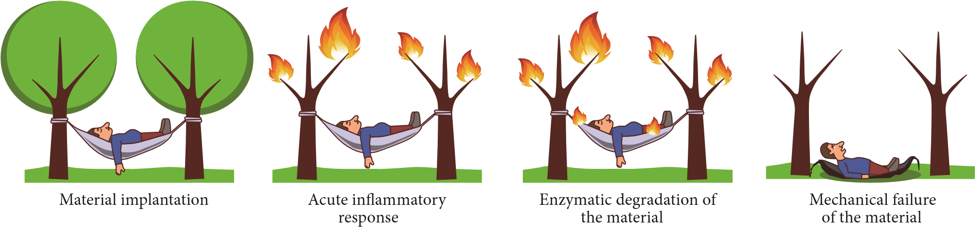
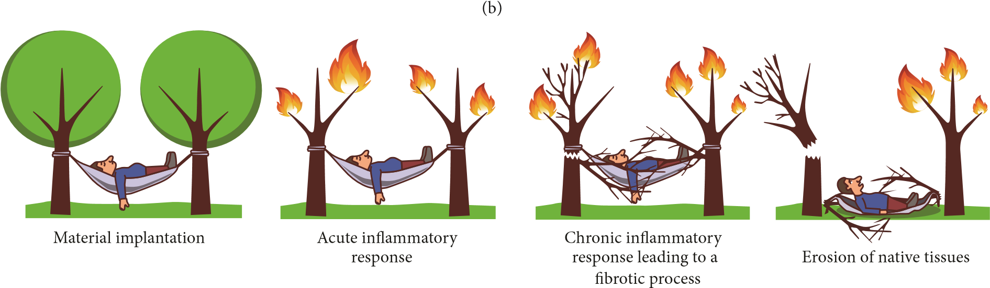
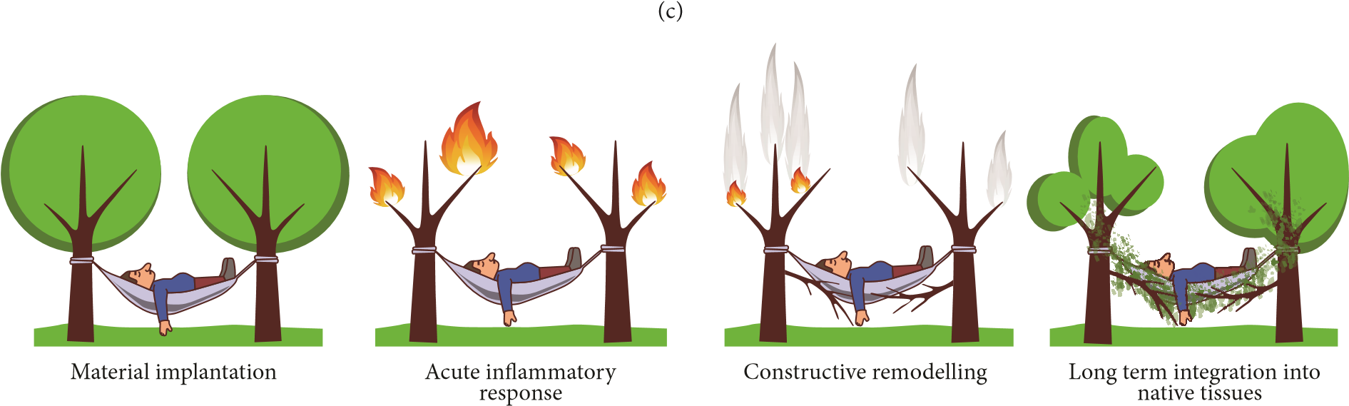
(d)
Figure 1: Cartoon of how patients can respond to materials implanted in the pelvic floor: (a) mechanical failure, (b) material recognized as non-self and isolated from body tissues with encapsulation, (c) exposure (erosion), and (d) optimal result for implanted material.
Biomechanical Properties of Autologous Materials. Four studies describing changes in mechanical properties of autologous materials over a 12–16-week period were found. Uniaxial stress strain testing of autologous rectus fascia before and after implantation in rabbit vagina and anterior abdominal wall showed no significant decrease of ultimate tensile strength (UTS) (the maximum stress a material can take before failing) and Young’s modulus (YM) (material stiffness), at twelve weeks after implantation [19, 20]. However, there was a reduction in surface area of the grafts by 50% suggesting that significant degradation had occurred [19, 20]. A comparison of mechanical strength of autologous materials used for sling was carried out by Choe et al. [21]. They harvested dermis, rectus fascia, and vaginal mucosa from 20 women undergoing vagina prolapse surgery and they tested displacement and maximum load with the Instron tensiometer. This study showed that fascia lata had the highest mean maximum load to failure (217 N), followed by human dermis (122 N), rectus fascia, and vaginal mucosa (both 42 N) in women undergoing surgeries for various reasons [21]. Autologous rectus fascia showed no significant decrease in tear resistance using the trouser tear test after 4 months of subcutaneous implantation in rodents [22]. In summary in all four studies there was agreement that the mechanical properties did not change significantly over a 12- to 16-week duration [19–22].
Host Response to Implanted Autologous Materials. Eight studies analysed the host response to autologous materials over a time period up to 90 days [19, 20, 23–29]. In the majority of studies, unless stated otherwise, biomaterials were assessed after implantation by conventional blindly scored histology (staining of fixed samples by haematoxylin and eosin (H&E)), trichromes, and/or the presence of proangiogenic cells.
Hilger and colleagues assessed human cadaveric skin and autologous fascia after implantation in the abdominal and vaginal walls of New Zealand white rabbits. Materials were harvested at 6 and 12 weeks. Histological analysis demonstrated that autologous fascia promoted a relatively minimal inflammatory response and neovascularization but moderate collagen infiltration when compared to fenestrated porcine dermis and porcine collagen-coated polypropylene mesh [20]. Jeong and coworkers described similar results noting minimal inflammatory response and neovascularization in rabbits when autologous fascia was implanted under the eye lid for up to 8 weeks [24].
Two studies assessed histological changes in paravaginal tissue after the implantation of autologous fascial slings for SUI in women. In the study by FitzGerald et al. biopsies of the sling were taken from 5 patients requiring revision surgery due to persistent incontinence. The time since the initial surgery ranged from 3 weeks to 4 years. The grafts explanted after up to 8 weeks showed moderate uniform fibroblast infiltration and neovascularization. Collagen remodelling was evident in parts of the graft biopsied at 4 years, with no evidence of chronic inflammation [23]. Woodruff and colleagues performed a similar study in 24 patients undergoing sling revision for poor efficacy (2 patients), urinary retention (9), and sling obstruction (13), 2–34 months after implantation [27]. All grafts showed moderate uniform fibroblast infiltration and moderate collagen fibers. All grafts showed moderate degradation. There was no evidence of encapsulation.
In summary these eight studies suggest that when autologous fascia is implanted there is a minimal to moderate inflammatory response, a moderate degree of collagen production, and a suggestion that grafts undergo a degree of remodelling over the long term.
3.1.2. Allografts. Allografts used in pelvic floor reconstruction usually consist of fascia. The donors are screened for infectious diseases before the grafts undergo cleaning, freeze drying, and gamma irradiation to eradicate any infective or immunogenic material. A concern with these grafts is that they are often donated by the elderly who have an age related weakening in connective tissues [30]; additionally processing techniques such as freeze drying and solvent dehydration may reduce the tensile strength [31]. Cadaveric grafts are advantageous in that they avoid donor site complications. In terms of efficacy, results are mixed. Some have shown cadaveric fascia to demonstrate similar subjective cure rates to autologous fascia at around 90% at 2 years [32]. However others have shown that on urodynamic testing 42% of cadaveric graft patients had SUI whereas no patients with autologous grafts had SUI [33].
Biomechanical Properties of Allografts. Five studies investigated the change in mechanical properties after implantation of allografts in animals. All these studies utilized uniaxial stress strain testing. The time after which samples were explanted ranged from 60 days to 12 weeks [20, 22, 34–36].
After implanting human cadaveric dermis in rabbit vagina, Hilger et al. reported a decrease in ultimate strength of
86.6% at 12 weeks; in comparison autologous fascia lost only 28.6%[20].Conversely,Riceandcolleaguesfoundanincrease in tensile strength of cadaveric dermis (AlloDerm) from 0.142 to 0.226 MPa, increasing by about 80% of its initial strength, 60 days following subcutaneous implantation [36]. Walter et al. reported that, after 12 weeks, following implantation of cadaveric fascia lata in rabbit vagina, the tensile strength decreased by approximately 90% [34]. Spiess et al. implanted human cadaveric fascia lata subcutaneously on the abdominal wall of 20 rats randomized into 2 survival groups at 6 and 12 weeks. They found no significant decrease in tensile strength from 0.167 kg at week 6 and 0.185 kg at week 12 [35]. Kim et al., similarly, implanted human cadaveric fascia in 20
rats, randomized into 2 survival groups of 2 and 4 months. They found no significant difference in fracture toughness before implantation and after implantation in human cadaveric fascia (from 2120 to 1145 J/m², 𝑃 = 0.09) [22].
In summary, the available studies show disparate results with respect to the changes in mechanical properties of allografts following implantation. This may be attributable to the heterogeneity in the type of allografts used, the animals studied, the sites of implantation, and the assessment at different time points.
Host Response to Implanted Allografts. In total eight studies assessed the host response to allografts in both animals and humans. The time since implantation ranged from 2 days up to 65 weeks [20, 26, 27, 36–40].
Human cadaveric dermis and cadaveric fascia have been found to be well integrated onto the abdominal wall [37, 40, 41] and rectus muscle [36, 38] in different animals, including rats, rabbits, and pigs, as noted by moderate fibroblast infiltration, new collagen production, and neovascularization where materials were implanted from 2 days up to 62 weeks. Human cadaveric dermis, after 12 weeks of implantation, was similarly well integrated into vaginal tissues of rabbits. However, it appeared highly fragmented suggesting significant degradation [20]. Krambeck et al. also describe a faster degradation of cadaveric fascia implanted subcutaneously on the abdominal wall of rabbits with a fascial defect for 6 and 12 weeks compared to polypropylene or autologous fascia [26]. VandeVord and colleagues also found moderate cell infiltration and angiogenesis at 12 weeks following the insertion of human cadaveric dermis and cadaveric fascia slings under the bladder neck of rats; however there was a moderate encapsulation after implantation [39]. Finally, in the study by Woodruff et al. in 5 women who received human cadaveric dermis grafts, biopsies 2–65 months after implantation showed significant graft degradation with residual areas of graft appearing acellular and encapsulated [27].
In summary, some studies suggest that allografts demonstrate infiltration by host cells, new collagen production, and neovascularization whilst other studies suggest that a variable degree of graft degradation occurs along with encapsulation in the long term. There is a degree of agreement that allograft induces an acute inflammatory response as inflammatory infiltrates have been found populating the grafts.
3.1.3. Xenografts. A number of grafts from animals, mainly porcine and bovine, have been used in pelvic floor surgery. These materials undergo extensive processing after harvesting to decellularize them and render them non-immunogenic. Additionally there are FDA regulations on animal source and vaccination status which must comply with [42]. Porcine dermis may be artificially cross-linked using hexamethylene diisocyanate to make it more resistant to enzymatic digestion [43]. Clinical studies showed lower continence rates for porcine dermis (approx. 80%) and increased reoperation than that for synthetic tape or autologous fascia [44]. Porcine small intestine submucosa (SIS) has shown cure rates from 79 to 93% at 2- and 4-year follow-up, respectively [45, 46]. However one study has raised concerns that SIS may not be strictly acellular and may contain porcine DNA [47].
Biomechanical Properties of Xenografts. Nine studies investigated the mechanical properties of xenografts before and after implantation. All these studies assessed either porcine dermal collagen matrix, both cross-linked and non-cross-linked, or porcine small intestine submucosa.
Hilger et al. assessed non-cross-linked porcine dermis xenografts implanted on the abdominal wall and vaginal wall of rabbits. After 12 weeks, half of the grafts implanted in the vaginal wall were absent. The other half as well as grafts implanted into the abdominal wall showed an average reduction of 84.1% in ultimate strength [20]. Another study assessed the long term mechanical integrity of cross-linked porcine dermis. After 9 months following implantation in the abdominal and vagina walls, grafts had degraded by 36% and 46%, respectively. When subjected to mechanical testing non-degraded graft fragments showed similar strength compared to baseline values whilst degraded fragments decreased by more than 50% [48].
Liu and colleagues implanted SIS and porcine dermal collagen matrix in rats with surgically created abdominal wall defects. The maximum load (at failure) at baseline for SIS and dermal collagen matrix was 22.81 N and 43.16 N, respectively. Following 12 weeks of implantation, there was no significant change in the maximum load of cross-linked porcine dermal collagen matrix and SIS [49]. Similarly other workers observed an increase in the ultimate tensile strength of SIS after 90 days of implantation from a baseline value of 7.5 and 9.8 N/cm² at baseline, respectively, to 19.56 and 13.3 N/cm. These results were averages of 48 implants in rats [50]. Rice et al. also found an increase in tensile strength of SIS after 60 days of implantation in a rat abdominal wall defect from 0.142 MPa at day 0 up to 0.226 MPa after 60 days of implantation [36]. Similarly, Zhang et al. implanted SIS in abdominal wall of rats and they found increased strength for SIS from 0.35 MPa to 0.41 after 4 weeks [51]. Badylak et al. repaired surgically created abdominal wall defects in dogs with SIS (8 × 12 cm); they performed serial ball burst strength tests after 1, 4, 7, and 10 days and then at 1, 3, 6, and 24 months) [52]. There was an initial decrease in ball burst strength from 73.37 pounds to 39.97 pounds by day 10. After day 10, the strength began to increase and after 2 years there was an increase to 157.20 pounds in burst strength. Jenkins et al. showed an increase in strength in crosslinked porcine matrices after 6 months of implantation in the preperitoneal area from 0.07 ± 0.01 N up to 22.36 ± 3.3 N [53]. In contrast, Ko and colleagues found no significant difference in ultimate tensile strength of SIS after 4 months of implantation in a porcine wall defect, with values ranging from 41.3 to 74.8 N/cm² [54].
In summary it appears that non-cross-linked porcine dermal collagen matrices are degraded rapidly (within 3 months) and lose most of their mechanical integrity within this period. By contrast cross-linked porcine dermal collagen matrix is more resistant to degradation and maintains its mechanical properties for at least 3 months, whereas SIS appears to increase in strength after as long as 2 years after implantation.
Host Response to Implanted Xenografts. Twenty-four studies assessing the host response to allografts were found. Noncross-linked porcine dermal collagen was assessed in fourteen studies [20, 26, 27, 36, 39, 50–52, 54–61]. These studies were performed on rats [36, 50, 51, 55, 58, 59], dogs [52, 55], pigs [54, 57], and rabbits [26] in addition to few clinical studies [20, 27, 39, 56]. Cross-linked porcine matrices were assessed in seven studies [40, 49, 53, 62–66]. Animal models mainly used were abdominal defects of rats [49, 62, 66], rabbits [65], minipigs [53], pigs [40, 63], and primates [64]. Some of these studies looked at the acute response [39, 49, 53, 55, 59, 66]; some other studies looked at a more intermediate response (1–3 months) [20, 26, 36, 39, 40, 49–51, 54, 55, 57, 58, 60, 62–64, 66]; another looked at longer term response (more than 3-months) [27, 40, 53, 62, 64, 65].
Hilger et al. and Pierce et al. found minimal neovascularization and collagen ingrowth in porcine dermal xenografts [20, 65]. Both studies agreed that the degradation of porcine dermis is higher when the inflammatory response is high, and it may accelerate this degradation process. They also reported fragments encapsulated, which has been also found in many studies with different species including rats [39, 62], rabbits [65], pigs [40], primates [64], and humans [27].
In contrast, non-cross-linked SIS leads to high collagen ingrowth with a moderate degree of remodeling and orientation and high neovascularization [29, 36, 39, 49– 51, 54, 55, 57, 63]. On the other hand, many studies agree with a very rapid degradation of the SIS which is replaced by the host tissue [49, 51, 52, 55, 58, 66, 67]. Only two studies reported an absence of host fibroblast infiltration and fibrotic tissue penetration without neovascularization for SIS implanted in rats [62] and rabbits [26]. In humans, Cole et al. performed revision surgery on a patient who had developed a bladder outlet obstruction after SIS implantation and found that the implant had been encapsulated [60]. Nevertheless, other investigators, at 12 and 48 months, respectively, found that the SIS was replaced by native tissue in humans
[56, 61].
In summary, the available studies agree that the degree of cross-linkage affects the rate of degradation and the degree of the inflammatory response of the host. Studies on cross-linked xenografts agree that cross-linked collagenous matrices induce little cell infiltration; hence there is limited collagen remodeling and graft degradation. In non-crosslinked xenografts, cell infiltration was greater with faster degradation rate and collagen production.
3.2. Polypropylene Mesh. There is a range of synthetic polypropylene meshes that have been used. These are summarized in Table 1 where they are classified as type 1, 2, 3, or 4 according to their mesh size, where 1 is macroporous (>75 𝜇m), 2 is less than 10 𝜇m, 3 is microporous with microporous compartments, and 4 is nanoporous (<1 𝜇m). Thus a wide range of synthetic materials have been investigated for use in the treatment of SUI. These materials offer several advantages including lack of transmission of infectious diseases and ease of availability, as well as the sustainable tensile strength due to their nondegradable nature [68]. Mesh materials have been classified in to 4 groups based on the basis of porosity (microporous or macroporous) and filamentous structure (monofilament of multifilament) [69]. The initial clinical experience with mid-type II (microporous/multifilament fibers, e.g., expanded PTFE) and III (macroporous and microporous/multifilament fibers, e.g., Mersilene) meshes was largely negative with excision rates of up to 30% for expanded PTFE [70] and erosion rates of 17% for Mersilene (polyester)
[71].
A greater pore size is thought to be advantageous as it allows the admittance of immune cells and greater collagen ingrowth into the construct [13]. This is thought to reduce the risk of mesh infection and accelerate and enhance host tissue integration. Monofilament meshes are thought to reduce the risk of infection in comparison to multifilament meshes. The theoretical concern with the latter is that bacteria may colonize the 10 𝜇m subspaces between fibers which are inaccessible for the larger host immune cells (9–20 𝜇m) [72]. Today a mid-type I polypropylene mesh that is macroporous and monofilament is most commonly used [73] with cure rates for SUI of >90% at 5 years.
Biomechanical Properties of Polypropylene. Seven studies investigated the mechanical properties of polypropylene meshes with implantation times ranging from two weeks in animal models up to two years. Animal models used were rats abdominal wall [35, 74], pig preperitoneal implantation [75], rats rectus fascia [76], minipigs hernia repair [77], and ewes abdominal and vaginal walls [78].
Melman et al. tested Bard Mesh, a knitted monofilament mesh made of high molecular weight polypropylene (HMWPP) and Ultrapro, a knitted macroporous composite mesh made of low molecular weight polypropylene (LMWPP) and poliglecaprone (Table 1). They have been implanted in minipigs hernia repair model for up to 5 months. HMWPP mesh decreased from maximal load at failure 59.3 N at 1 month to 36.0 N at 5 months, while LWPP mesh decreased from 61.5 to 37.8 N at 5 months [77]. Long term studies were carried out by Zorn et al. where TVT and SPARC were compared to SIS in a rat abdominal wall defect for up to 12 months. Both TVT and SPARC are macroporous meshes made of polypropylene monofilaments. SPARC did not change its mechanical properties after 12 months of implantation (maximum load at baseline 0.453 kg and at 12 months 0.497 kg). By contrast the maximum load for TVT decreased from 0.779 kg to 0.523 kg for TVT and for SIS decreased from 0.402 kg to 0.174 kg [74]. Also Bazi et al. showed how similar are the mechanical properties of Gynecare TVT and Advantage, both macroporous polypropylene monofilament meshes, compared with other meshes such as IVS Tunneller, multifilament polypropylene mesh, and SPARC. The lowest, at 25.2 N, was TVT and the highest, 34.9 N, was Advantage, with no significance between them after 24 weeks of implantation in rats rectus fascia [76]. Also other studies agree on these parameters where TVT was found to be able to comply with the highest break load (0.740 kg), compared to 0.39 kg for fascia lata after implantation in rats abdominal wall for up to 12 weeks [35], and was said to be less stiff than other synthetic materials used for meshes (0.23 N/mm comparedto nylon,6.83 N/mm) [79].
A recent study compared two sizes of meshes implanted in two different places in a sheep model. Gynemesh was cut in two sizes (50 × 50 mm and 35 × 35 mm) and it was implanted in 20 adult ewes, on the abdominal and vaginal walls for a period of 60 and 90 days. Results showed that grafts of both dimensions, implanted on the vaginal wall, were stiffer than the ones implanted on the abdominal wall, after a period of 90 days [78].
However, they all agree that physical characteristics of the mesh, such as monofilament or multifilament, porosity, and polymer molecular weight, hugely affect the mechanical performance of the implants in vivo.
Host Response to the Implanted Polypropylene. Twenty-one papers have looked at the host response to the polypropylene meshes. They have been assessed in various animal models: rats abdominal wall [50, 58, 74, 80–82], rats rectus fascia [38, 76, 83], rabbits bladder neck [84], rabbits abdominal wall [85], rabbits rectus fascia [26], rabbits vaginas [65, 86], minipigs hernia [77], pigs peritoneum [75, 87], ewes vagina [78, 88], and ewes abdominal wall [78] in addition to few clinical studies [27, 89–91]. The studies have looked at acute inflammatory responses to the most commonly used, nondegradable meshes, described in Table 1. Few studies looked at the acute inflammatory response that occurs from the day of implantation up to 30 days [50, 58, 80–82, 85, 88]. Other studies looked at the immediate responses (1–3 months) [26, 75, 78, 83, 84, 86, 87] and longer term responses (>3 months) where fibrosis and chronic inflammation can be seen [27, 65, 74, 76, 77, 89–91].
A very recent study of Manodoro et al. showed how 30% of Gynemesh grafts (50 × 50 mm), implanted in ewes after 90 days, caused vaginal erosion and exposure. The study also showed that 60% of the smaller Gynemesh meshes (35 × 35 mm) had a reduced surface (i.e., contracting) after 90 days of implantation [78].
Falconer et al. reported a study on Prolene and Mersilene meshes. The biopsies were stained with Masson’s trichrome.

Table 1: Classification of synthetic materials used in pelvic floor reconstruction.
Type | Mesh pore size | Structure | Polymer | Trade name | Company
I | Macroporous  >75 𝜇m | Monofilament | Polypropylene | Uretex  Gynecare TVT  Bard Mesh  SPARC  In-Fast  Monarc  Lynx  Advantage  Obtryx  Optilene  Aris  Perigee | C. R. Bard  Ethicon, Johnson &  Johnson  Bard/Davol  American Medical Systems  American Medical Systems  American Medical Systems  Boston Scientific  Boston Scientific  Boston Scientific  B. Braun  Mentor Corp  American Medical Systems
 |  |  |  | Parietene | Covidien
 |  |  |  | Intepro | American Medical Systems
 |  |  |  | Gynecare Prolift | Ethicon, Johnson & Johnson
 |  |  |  | Surgipro | Covidien
 |  |  |  | Prolene | Ethicon, Johnson & Johnson
 |  |  |  | Prolene Soft | Ethicon, Johnson & Johnson
 |  |  |  | Gynemesh PS | Ethicon, Johnson & Johnson
 |  |  |  | Atrium | Atrium Medical
 |  |  |  | Marlex | C. R. Bard
 |  | Multifilament | Copolymer of glycolide (90%) and lactide (10%)  Polypropylene and polyglecaprone | Vicryl  Vypro | Ethicon, Johnson &Johnson  Ethicon, Johnson &  Johnson
 |  |  |  | UltraPro | Ethicon, Johnson & Johnson
 |  |  | Polyglycolic acid | Dexon | Davis and Geck
II | Macroporous  <10 𝜇m | Multifilament | Expanded PTFF  Polyethylene terephthalate | GORE-TEX  Mersuture | W. L. Gore  Ethicon, Johnson &  Johnson
III | Macroporous with microporous components  <10 𝜇m | Multifilament | PTFE  Polyethylene terephthalate Polypropylene  Woven polyester | Teflon  Mersilene  IVS Tunneller  Protegen | C. R. Bard  Ethicon, Johnson & Johnson  Tyco Healthcare  Boston Scientific
IV | Nanoporous  <1 𝜇m | Multifilament | Silicon-coated polyester  Dura mater  substitute | Intermesh  PRECLUDE MVP Dura  substitute | American Medical Systems  W. L. Gore
 |  |  | Expanded PTFE,  pericardial membrane  substitute | PRECLUDE  Pericardial  Membrane | W. L. Gore
Table 2: Autologous fascia.
Author | Sample | Biomechanical properties | Host response
FitzGerald et al., 2000 [23] | Autologous rectus fascia implanted in 5 patients suffering from SUI. Samples obtained, respectively, from transvaginal revision after 3, 5, 8, and 17 weeks and from replacement after 4 years. |  | - Moderate and uniform infiltrationof host fibroblasts and neovascularization after 5 and 8 weeks of implantation.  - After 4 years of implantation, noevidence of inflammatory cell infiltrate or foreign body reaction and collagen remodeling by connective tissue organized longitudinally.
Jeong et al., 2000 [24] | Autologous lata fascia implanted in 16 rabbits randomized into 4 survival groups and examined after 1, 2, 4, and 8 weeks.  Implantation into upper eyelids. |  | (i) Low inflammatory cell infiltration. (ii) Fibroblast infiltration and collagen remodeling.
Choe et al., 2001 [21] | Dermis, rectus fascia, and vaginal mucosa harvested from 20 women undergoing vagina prolapse surgery. | Tensiometric analysis of full strips versus patch suture slings. Displacement and maximum load calculated.
Kim et al., 2001 [22] | Autologous rectus fascia implanted in 20 rats randomized into 2 survival groups (2 and 4 months). | No significant decrease of the fracture toughness calculated by the trouser tear test over 4 months.
Dora et al., 2004 [19] | Autologous rectus fascia implanted in 15 rabbits randomized into 3 survival groups (2, 6, and 12 weeks). Implantation on the anterior rectus fascia. | No significant decrease of biomechanical properties after 12 weeks of implantation. | 50% decrease in surface area.
Hilger et al., 2006 [20] | Autologous rectus fascia implanted in 20 rabbits randomized into 2 survival groups (6 and 12 weeks). Half implanted on the rectus fascia and half on the posterior vagina fascia. | No significant decrease of biomechanical properties after 12 weeks of implantation. | - Collagen remodeling by moderatecollagen infiltration but encapsulation as well.  - Minimal inflammatory response.  - Minimal neovascularization.
Krambeck et al., 2006 [26] | Autologous rectus fascia implanted subcutaneously on the anterior rectus fascia of 10 rabbits randomized into 2 survival groups (6 and 12 weeks). |  | - Moderate fibrosis.  - High degree of scarring.(iii) High degree of inflammatory infiltrate.
de Almeida et al., 2007 [29] | Adult female rats incontinence model. Marlex, autologous sling, SIS, polypropylene mesh, and sham at 30 and 60 days. |  | Reduced inflammatory response and collagen production around autologous grafts, in comparison with synthetic materials and xenografts.
Woodruff et al., 2008 [27] | Autologous fascia grafts  explanted after sling revision from 5 women, due to different complications, between 2 and 65 months after implantation. |  | - Moderate and uniform infiltration  of host fibroblasts and little neovascularization.  - Collagen remodeling by newcollagen fibers organized longitudinally.  - No evidence of encapsulation orgross infection.
de Rezende Pinna et al., 2011 [28] | Autologous fascia lata implanted in 14 rabbits randomized into 2 survival groups (30 and 60 days). Implantation into the right voice muscle. |  | - No significant inflammatoryreaction.  - No significant fibrosis or scarring.
Table 3: Allografts.
Author | Sample | Biomechanical properties | Host response
Sclafani et al., 2000 [37] | Human cadaveric dermis (AlloDerm) disk implanted subdermally behind a patient’s ear. Micronized human cadaveric dermis (AlloDerm) injected intradermally and subdermally in 2 different locations behind a patient’s ear. Both implants were examined 3 months and 1 month after implantation, respectively. |  | - Both materials extensively invaded byhost fibroblasts.  - Both materials present new collageningrowth.
Kim et al., 2001 [22] | Human cadaveric fascia implanted in 20 rats randomized into 2 survival groups (2 and 4 months). | No significant decrease of the fracture toughness calculated by the trouser tear test.
Walter et al., 2003 [34] | Freeze-dried and gamma-irradiated human cadaveric lata fascia implanted in 18 rabbits and excised 12 weeks after implantation. | Significant decrease of biomechanical properties after 12 weeks of implantation.
Spiess et al., 2004 [35] | Human cadaveric fascia lata implanted subcutaneously on the abdominal wall of 20 rats randomized into 2 survival groups (6 and 12 weeks). | No significant decrease of tensile strength with time.
Yildirim et al., 2005 [38] | Human cadaveric lata fascia implanted subcutaneously on the abdominal wall in 20 rabbits randomized into 4 survival groups (2, 7, 15, and 30 days). |  | - Acute inflammation by high cellinfiltration predominantly of polymorphous granulocytes.  - Integration in host tissue by moderatefibrotic process and muscle infiltration on day 30, with persistent inflammatory response.
Krambeck et al., 2006 [26] | Cadaveric fascia lata implanted subcutaneously on the anterior rectus fascia of 10 rabbits randomized into 2 survival groups (6 and 12 weeks). |  | - Moderate to high focal fibrosis.  - Minimal to moderate degree of scar.  - High degree of inflammatoryinfiltrate.
Hilger et al., 2006 [20] | Human cadaveric dermis and lata fascia implanted in 20 rabbits randomized into 2 survival groups (6 and 12 weeks). Half implanted on the rectus fascia and half on the posterior vagina fascia. | Very significant decrease of biomechanical properties after 12 weeks of implantation. | - Two missing or fragmented materialsimplanted on the vagina after 12 weeks.  - Moderate inflammatory response.  - Minimal neovascularization.  - Minimal collagen ingrowth withoutsignificant cell infiltration.
Woodruff et al., 2008 [27] | Human cadaveric dermis slings explanted after revision from 2 women, due to different complications, between 2 and 65 months after implantation. |  | - Moderate levels of encapsulation.  - High levels of degradation.  - Peripheries of the grafts invaded byfibroblasts but central portions remained acellular.
VandeVord et al., 2010 [39] | Human cadaveric dermis and fascia lata implanted in 16 rats, respectively, and both randomized into 4 survival groups (2, 4, 8, and 12 weeks).  Implantation around the bladder neck, anchored to the surrounding tissues. |  | (i) Thin fibrous capsule formation. (ii) Moderate cell infiltration and angiogenesis.
Rice et al., 2010 [36] | Human cadaveric dermis (AlloDerm) implanted in 18 rats randomized into 2 survival groups (30 and 60 days). Subcutaneous implantation on abdominis rectus muscle defect. | Increase of tensile strength after 30 days and, again, increase of tensile strength after 60 days, respectively, to 30 days. | - Moderate amounts of collagendeposition well organized.  - Abundant revascularization.
Table 3: Continued.
Author | Sample | Biomechanical properties | Host response
Kolb et al., 2012 [40] | Human cadaveric dermis (AlloDerm) implanted subcutaneously in 5 pigs randomized into 4 survival groups (7, 21, 90, and 180 days). |  | - Robust inflammatory response after 7 days of implantation, which achieved maximal level at 21 days, with formation of granulomas and areas of necrosis noted within the graft.  - Moderate fibroblast infiltration,  collagen ingrowth, and neovascularisation.  - Moderate levels of encapsulation.

Mersilene was found to induce a higher inflammatory response compared to Prolene, which triggered a minimal inflammatory reaction [89].
Pierce et al. reported a long term study comparing biological and synthetic grafts implanted in rabbits. Polypropylene caused a milder inflammatory reaction with more long term, better host tissue incorporation compared to natural grafts [65]. Also Bazi et al. evaluated biopsies on the basis of inflammatory infiltrate, fibrosis, mast cell presence, muscular infiltration, and collagen filling of the mesh on an arbitrary scale described as low, moderate, or extensive based on H&E, periodic acid-Schiff, and toluidine blue staining of tissue. They agreed that all of the materials (Advantage, IVS, SPARC, and TVT) induced inflammation and collagen production, with SPARC being the one with the mildest response and TVT the one with the highest inflammatory response [76]. Elmer et al. reported an increase in macrophages and mast cell counts and a mild but persistent foreign body response to polypropylene meshes [91]. This study is consistent with other reported investigations where the polypropylene meshes are invaded with both macrophages and leukocytes, signs of inflammation, resulting in collagen production [27, 38, 65, 76, 83, 85].
In summary the studies agree that polypropylene meshes provoke a fairly pronounced inflammation, leading to a massive cell infiltration into the scaffold and ultimately to collagen production [27, 29, 48, 76, 83, 84, 86, 90–92].

Relating Postimplantation Changes toClinical Outcomes
4.1. Biomechanics. In general, when biological materials fail this is due to enzymatic degradation after implantation, leading to a loss of mechanical support and weakening of the repair. This appears to apply particularly to the non-crosslinked xenogenic matrices. Chemically cross-linking appears to prevent this degradation and improve the mechanical outcomes. Unfortunately there is a lack of clinical evidence on how these mechanical outcomes translate into patient outcomes. Autologous grafts are the most successful biological material used in contemporary practice and the studies reviewed appear to support the long term mechanical integrity of these grafts. Nevertheless, they present several important limitations that are related to the need to harvest from a donor site. However use of cadaveric tissues avoids these limitations; however their quality depends on the age and comorbidities of the donor and this is maybe the reason for the mixed results in mechanical properties. This is consistent with the available clinical studies which suggest that allografts have poorer cure rates than autologous grafts.
We have found that polypropylene maintains its morphology and strength after implantation for up to 24 weeks [35, 74, 76]. However there was evidence that stiffness increases [77, 93]. This is consistent with durable cure rates particularly in SUI surgery (there is still some question regarding efficacy of transvaginal POP repair, compared with native tissue repair). The major issue with polypropylene meshes is the associated serious complications, in particular vaginal or urinary tract exposure (up to 10–14%). There is some evidence that meshes with greater stiffness cause the surrounding tissue to weaken, an effect termed stress shielding [94]. This can be compared to the effect of metal implants on the surrounding bone after orthopedic surgery. This effect could lead to thinning of the surrounding vaginal tissues as predisposing to erosion.
4.2. Host Response. Biomaterials implanted into the body will always attract the attention of the immune system. With some materials there is an M1 macrophage response of constructive remodeling; this appears to be the case with some biological matrices, SIS in particular. With materials which the body cannot remodel or integrate such as polypropylene meshes, the macrophage response is much more aggressive, an M2 macrophage response [95, 96].
It appears that a state of constant inflammation can be generated by some patients in response to some of these nondegradable materials. Constant inflammation leads to an upregulation of degradative enzymes; although these enzymes cannot degrade the material, they may damage the surrounding extracellular matrix and contribute to tissue thinning and mesh exposure. Moreover perpetuation of the inflammatory response can also result in activated fibroblasts, which produce excessive collagen laid down in a disorganized fashion around the implant (i.e., fibrosis), encapsulating the material. A small amount of fibrosis is arguably advantageous to the repair in SUI, providing a stable back stop allowing urethral compression. However excessive fibrosis may lead to mesh contraction resulting in increased pull on the adjacent tissues leading to complications such as voiding dysfunction, pain, and painful intercourse. In POP this excessive fibrotic response can lead to mesh exposure which presents a major reconstructive surgical challenge, often necessitating repeat

Table 4: Xenografts.
Author | Sample | Biomechanical properties | Host response
Badylak et al., 2001 [52] | Abdominal wall defect repaired with SIS in 40 dogs randomized into 8 survival groups (1, 4, 7, and 10 days and 1, 3, 6, and 24 months). | Strength was decreased from day 1 to day 10 after implantation, followed by a progressive increase, until reaching double of the original strength 24 months after implantation. | Rapid degradation with associated and subsequent host remodeling.
Badylak et al., 2002 [55] | Abdominal wall defect repaired with SIS in 10 dogs and 30 rats, both randomized into 4 survival groups (1 week, 1 month, 3 months, 6 months, and 2 years). |  | (i) No shrinkage or expansion of the graft site over the 2-year period of the study. (ii) One week after implantation, abundant levels of polymorphonuclear leukocytes diminished to negligible after 1 month.  (iii) Moderate neovascularization. (iv) By 3 months, graft material was not recognizable and was replaced by moderately well-organized host tissues including collagenous connective tissue, adipose tissue, and skeletal muscle.
Cole et al., 2003 [60] | SIS removed from a 42-year-old female patient 4 months after pubovaginal implantation of the sling due to severe obstruction. |  | - Completely intact acellular sling.  - Well defined fibrous capsule.  - Chronic inflammatory response.
Zhang et al., 2003  [51] | SIS implanted in the abdominal wall of rats for up to 2 months. | SIS together with the abdominal wall has increased strength. | Levels of interleukin 2 and interleukin 6 were high straight after the operation but they become normal after 2 months.
Wiedemann and  Otto, 2004 [56] | Biopsies taken from the implantation site of the SIS band under the vaginal mucosa from 3 patients during reoperation, at a mean of 12.7 months, after pubourethral sling procedures due to recurrent urinary stress incontinence. |  | - Focal residues of SIS implant.  - No evidence of a specific tissue reactionthat might point to a foreign body reaction.  - No evidence of any significantimmunological reaction and in particular no evidence of any chronic inflammatory reaction.
Konstantinovic et al., 2005 [50] | Abdominal wall defect repaired with SIS in 24 Wistar rats randomized into 4 survival groups (7, 14, 30, and 90 days). | Significant increase of biomechanical properties after 90 days of implantation. | - Moderate acute inflammatory response atday 7, decreased to minimal after 90 days.  - Moderate neovascularization.(iii) Abundant collagen deposition well organized after 90 days.
Macleod et al., 2005 [62] | SIS and cross-linked porcine dermis (Permacol) implanted subcutaneously on the anterior rectus fascia of 18 rats each randomized into 5 survival groups (1, 2, 4, 10, and 20 weeks). |  | For both grafts:  - absent acute inflammatory response,  - from moderate chronic inflammation after1 week of implantation to minimal after 20 weeks,  - absent eosinophilic infiltration and stromalfibroblastic reaction over the entire implantation,  - from moderate fibrosis and vascularityaround the grafts after 1 week of implantation to minimal after 20 weeks.
Poulose et al., 2005 [57] | 12 female pigs were implanted with SIS intraperitoneally for up to 6 weeks. |  | - Cell infiltration.  - Vascularization.  - Collagen deposition and remodelling.
Thiel et al., 2005 [58] | SIS implanted subcutaneously on the abdominal wall of 30 rats randomized into 3 survival groups (7, 30, and 90 days). |  | - Moderate inflammatory reaction increasedto severe after 90 days.  - 86% of the graft was replaced by newcollagen fibers.
Table 4: Continued.
Author | Sample | Biomechanical properties | Host response
Krambeck et al., 2006 [26] | SIS and porcine dermis implanted subcutaneously on the anterior rectus fascia of 10 rabbits randomized into 2 survival groups (6 and 12 weeks). |  | - Porcine dermis presented moderate fibrosiswhich was minimal for SIS.  - Minimal degree of scar for both grafts andhigh degree of inflammatory infiltrate.
Ko et al., 2006 [54] | Abdominal wall defect repaired with 8-layer SIS in 20 domestic pigs randomized into 2 survival groups (1 and 4 months). | No significant changes of biomechanical properties after 4 months of implantation. | - Dense fibrous connective tissue ingrowth.  - Minimal to mild mononuclearinflammatory cell infiltrate throughout the connective tissue.
Hilger et al., 2006 [20] | Porcine dermis implanted in 20 rabbits randomized into 2 survival groups (6 and 12 weeks). Half implanted on the rectus fascia and half on the posterior vagina fascia. | Very significant decrease of biomechanical properties after 12 weeks of implantation. | (i) Two missing or fragmented materials 12 weeks after being implanted on the vagina. (ii) Moderate to strong inflammatory response. (iii) Minimal collagen ingrowth without significant cell infiltration.  (iv) Minimal neovascularization.
Kim et al., 2007 [59] | SIS implanted in the subcutaneous dorsum of 3 rats sacrificed after 2 weeks. |  | - Prominent infiltration and ingrowth of hostcells.  - Few macrophages infiltrated oraccumulated around the grafts.
Rauth et al., 2007 [63] | SIS implanted on the peritoneal surface of the abdominal wall of 6 pigs sacrificed 8 weeks after implantation. |  | - 80% of contraction from original surfacearea.  - Moderate neovascularization.(iii) Densely populated by host cells with moderate amounts of new disorganized collagen deposition.
Woodruff et al., 2008 [27] | Porcine dermis slings explanted after revision from 4 women, due to different complications, between 2 and 65 months after implantation. |  | - Severe encapsulation.  - No degradation.  - No fibroblasts infiltration andneovascularization.
Sandor et al., 2008 [64] | Abdominal wall defect repaired with SIS and cross-linked porcine dermis (Permacol) in 33 primates randomized into 3 survival groups (1, 3, and 6 months). |  | - Considerable contraction after 1 month forboth materials, but not significant change over the next 5 months.  - Better integration of both materials at latestage by scar formation.  - Inflammatory cells infiltration 3 monthsafter implantation for SIS associated with formation of few blood vessels.  - Acellular porcine dermis over the entirecourse implantation with substantial inflammation surrounding their perimeter. (v) Partial resorption for both materials after 6 months.
Pierce et al., 2009 [65] | Cross-linked porcine dermis implanted on the abdominal wall and posterior vagina of 18 rabbits sacrificed 9 months after implantation. | 11 grafts remained intact without significant changes of biomechanical properties compared to the baseline values. They were just thicker and tolerated with less elongation at failure. Seven grafts were partially degraded but thicker again and with significant decrease of all biomechanical properties. | - Host connective tissue incorporationbetween fibers.  - Intense foreign body reaction in degradedgrafts.
Table 4: Continued.
Author | Sample | Biomechanical properties | Host response
VandeVord et al., 2010 [39] | SIS and porcine dermis implanted in 16 rats, respectively, and both randomized into 4 survival groups (2, 4, 8, and 12 weeks). Implantation around the bladder neck, anchored to the surrounding tissues. |  | - Thin fibrous capsule formation.  - Moderate cell infiltration and angiogenesisfor SIS and minimal for porcine dermis.
Rice et al., 2010 [36] | Abdominal wall defect repair with SIS (Surgisis) in 18 rats randomized into 2 survival groups (30 and 60 days). | Increase of tensile strength after 30 days and, increase of tensile strength after 60 days, respectively, to 30 days. | - Moderate amounts of collagen depositionwell organized.  - Abundant revascularization.
Deprest et al., 2010 [61] | 13 patients underwent secondary sacrocolpopexy because of a graft related complication after the initial sacrocolpopexy with porcine dermal collagen  (Pelvicol) (9) or SIS (Surgisis) (4). |  | (i) Pelvicol presented high degradation rates associated with no foreign body reaction. (ii) Pelvicol remnants were integrated into collagen rich connective tissue with limited neovascularization (scar host tissue). (iii) No significant body foreign reaction to Surgisis grafts.  (iv) Surgisis no longer recognizable replaced by irregularly organized connective tissue and fat tissue.
Liu et al., 2011 [49] | Abdominal wall defect repaired with SIS and acellular porcine dermal matrix in 50 Sprague Dawley rats randomized into 5 survival groups (1, 2, 4, 8, and 12 weeks). | After initial decrease of biomechanical properties at week 2, these were increased over the next 10 weeks reaching similar values to week 1. | - Pronounced inflammatory response 1 to 4 weeks after implantation for SIS compared with porcine dermis, but falling to similar negligible values for both after 12 weeks.  - Large neovascularization and collagendeposition, which was higher for SIS group. (iii) SIS implants degraded more quickly and were almost totally replaced by organized collagenous tissues.  (iv) Contraction at the first weeks leading to significant lower surface area in both materials.
Jenkins et al., 2011 [53] | Abdominal wall defect repaired with porcine dermal matrix in 24 Yucatan minipigs randomized into 2 survival groups (1 and 6 months). | Significantly greater incorporation strengths after 6 months compared with 1 month. | - Moderate cell infiltration.  - Moderate extracellular matrix deposition.  - Moderate neovascularisation.  - Partial degradation and from widely tomild fibrous encapsulation.
Kolb et al., 2012 [40] | Cross-linked porcine dermis (Permacol) implanted subcutaneously in 5 pigs randomized into 4 survival groups (7, 21, 90, and 180 days). |  | - Mild inflammatory response decreased tominimal from day 7 to day 180 after implantation.  - None to minimal neovascularization after180 days.  - Small amount of residual SIS remainedsurrounded by mild to moderate chronic inflammation.  - Moderate levels of encapsulation.
Daly et al., 2012 [66] | Abdominal wall defect repaired with porcine dermis in rats randomized into 3 survival groups (1, 3, and 35 days). |  | (i) Cell infiltrates into all grafts by day 35. (ii) Degradation of the scaffold most pronounced at the periphery with fibrous tissue, angiogenesis, and foreign body giant cells noted.  (iii) Grafts surrounded by a dense and circumferentially organized connective tissue. (iv) Mononuclear cells decreased in number compared with earlier time points.
Table 5: Polypropylene meshes.
Author | Sample | Biomechanical properties | Host response
Falconer et al., 2001 [89] | 16 women were implanted with TVT for up to 2 years: 6 with Mersilene and 10 with Prolene. |  | Mersilene induces higher inflammatory response than Prolene. Mersilene is easier to extract than Prolene.
Klinge et al., 2002 [80] | Heavy weight monofilament with small pore size (HWM) and low weight with large pore size multifilament (LWM) on the posterior abdominal wall of rats for  7, 14, 21, and 90 days. |  | - HWM: intense inflammation,embedded in connective tissue.  - LWM: less pronounced inflammatoryresponse and fibrotic capsule, with collagen distributed within the mesh.
Wang et al., 2004 [90] | 17 women with sling erosion and 7 women with voiding difficulties implanted with TVT and SPARC. |  | Pronounced fibrosis around the fibers—erosion and voiding difficulty as a result.
Rabah et al., 2004 [84] | Implantation of Surgipro and cadaveric fascia lata in rabbit’s bladder neck for 6 and 12 weeks. |  | - Cadaveric fascia lata group: theimplant was incorporated in a plate of fibrous tissue.  - Polypropylene mesh: inflammationlocalized on the graft.
Spiess et al., 2004 [35] | TVT and cadaveric fascia lata implanted in abdominal wall of rats for 6 and 12 weeks. | TVT has the greater break load and the maximum average load compared to cadaveric fascia lata.
Zheng et al., 2004 [81] | Prolene and Pelvicol implanted in full thickness abdominal wall defects in rats for 7, 14, 30, and 90 days. |  | Prolene prosthesis shows the presence of leukocytes in the activated state.
Konstantinovic et al., 2005 [50] | Marlex and non-cross-linked Surgisis implanted on the anterior abdominal wall of rats for 7, 14, 30, and 90 days. |  | - Marlex: more pronouncedinflammatory reaction and  vascularization throughout the graft than  Surgisis  - Surgisis: milder inflammatoryreaction.
Yildirim et al., 2005 [38] | Gynecare TVT, SPARC, polypropylene mesh, and IVS implanted in contact with the rats rectus muscle for up to 30 days. |  | Inflammation and fibrosis are decreased in large pore meshes.
Thiel et al., 2005 [58] | Monofilament polypropylene mesh, silicone mesh, SIS, and PLA were implanted subcutaneously on the abdomen of rats for 7, 30, and 90 days. |  | Polypropylene induces the mildest inflammatory response among the samples.
Bogusiewicz et al., 2006 [83] | Monofilament TVT and multifilament IVS were implanted in rats rectus fascia for 42 days. |  | - They induce production of similaramount of collagen.  - Differences in the arrangement ofcollagen and inflammation intensity.
Boulanger et al., 2006 [87] | Vicryl, Vypro, Prolene, Prolene Soft, and Mersuture were implanted in pigs peritoneum for 10 weeks. |  | - Vicryl: low level of inflammation andcompletely absorbed.  - Vypro: intense inflammation andstrong fibrotic response.  - Prolene and Prolene Soft: wellintegrated, weak inflammatory response.  - Mersuture: no good integration.
Krambeck et al., 2006 [26] | SPARC mesh, human cadaveric fascia, porcine dermis, SIS, and autologous fascia were implanted in rabbits rectus fascia for 12 weeks. |  | - Polypropylene mesh has the greatestscar formation.  - Polypropylene has the mildestinflammatory response.
Boukerrou et al., 2007 [75] | Preperitoneal implantation of Vicryl, Vypro, Prolene, Prolene Soft, and  Mersuture mesh for 2 months in pigs. | Nonabsorbable, monofilamentous, macroporous materials (type I) seem more  resistant, retract less, and have the best tolerance. | .
Table 5: Continued.
Author | Sample | Biomechanical properties | Host response
Spelzini et al., 2007 [82] | Polypropylene type I mesh and macroporous silk construct were implanted in rat fascial defects for 7, 14, 30, and 90 days. |  | Polypropylene meshes induce a moderate inflammatory response and not architectural degradation.
Zorn et al., 2007 [74] | Rat abdominal wall was implanted with SPARC, TVT, and SIS for 6 weeks and 9, 6, 9, and 12 months. | TVT has tensile properties similar to SPARC and they are superior to Stratasis.
Bazi et al., 2007 [76] | Rats rectus fascia was implanted with Advantage, IVS, SPARC, and TVT for up to 24 weeks. | They all show similar mechanical properties after removal. | They induce different host responses due to different porosity.
Tayrac et al., 2007 | Ewes vaginas were implanted with a noncoated LW polypropylene mesh (Soft Prolene) and a coated one (Ugytex) from 1 to 12 weeks. |  | Similar inflammatory response between the two materials.
Huffaker et al., 2008 [86] | Rabbits vaginas were implanted with  Pelvitex (collagen-coated) and Gynemesh (uncoated polypropylene meshes) for up to 12 weeks. |  | Both materials induce a mild foreign body reaction with minimal fibrosis.
Woodruff et al., 2008 [27] | 24 grafts were explanted in women undergoing sling revision after 2–34 months. Grafts were polypropylene meshes, autologous fascia, porcine dermis, and cadaveric dermis. |  | No evidence of degradation or encapsulation, abundant host infiltration.  Neovascularisation was visible.
Elmer et al., 2009 [91] | Prolift was implanted in humans for 1 year. |  | - Increase in macrophages and mastcells count.  - Mild but persistent foreign bodyresponse.
Pierce et al., 2009 [65] | Polypropylene mesh versus cross-linked porcine dermis implanted in rabbits vagina and abdomen for 9 months. |  | Polypropylene caused milder inflammatory reaction, more long term, good host tissue incorporation.
Melman et al., 2011 [77] | Bard mesh (HWPP), Ultrapro (LWPP), and GORE INFINIT Mesh (ePTFE) in minipigs hernia repair for 1, 3, and 5 months. | Their maximum tensile strength decreases for all of them. | - Inflammation decreases with time.  - Cell infiltration increases with time.
Pascual et al., 2012 [85] | Surgipro, Optilene, and GORE INFINIT Mesh (ePTFE) were implanted in rabbits abdominal wall defect for 14 days. | LWPP implants might be improved by the newly formed tissue around it. | - PTFE induces an increasedmacrophage response when compared to polypropylene.  - Increase in collagen deposition inhigh porosity meshes.
Manodoro et al., 2013 [78] | Gynemesh in two sizes (50×50 mm and 35×35 mm) implanted in 20 adult ewes for 60 and 90 days, both on the abdominal and vaginal walls. | Implants were contracting  more when implanted on the vaginal wall, compared to abdominal wall.  Grafts implanted on the vaginal wall are stiffer than the ones implanted on the abdominal wall, after retrieval. | - 30% of the 50×50 meshes caused vaginal erosion and exposure.  - 60% of the 35×35 meshes had  reduced surface (i.e., contracting after 90 days.)
HWPP: heavy weight polypropylene.
LWPP: lightweight polypropylene (also called soft); ePTFE: expanded polytetrafluoroethylene; PLGA: polylactide-co-glycolide acid; PLA: polylactide acid; PGA: polyglycolide acid.

procedures with no guarantee of symptom resolution. Nevertheless with the observation that the vast majority of patients do well with mesh, it can be concluded that some degree of fibrosis is helpful to the surgical management whereas clearly excessive fibrosis is detrimental.
Implantation of autologous fascia in general showed good integration within host tissues, associated with a low inflammatory response, compared to polypropylene meshes and degree of graft remodelling in the available human studies [50, 84]. It must be borne in mind that the human studies were all reoperative cases for clinical failure. It is difficult to speculate on whether all successful outcomes result in fully integratedandremodelledgraft.Non-cross-linkedxenografts are associated with clinical failure due to rapid degradation which is presumably too soon for the regeneration of strong tissues in its place [20, 24, 29]. The cross-linked grafts avoid this but rather similar to the synthetic mesh are associated with a perpetuated inflammatory response as the body is unable to integrate and remodel them. This ultimately leads to encapsulation of the graft. It would therefore seem appropriate that there should be a proper balance of degradation and replacement by new host tissue with xenografts. SIS appears to fulfill this.
This relationship between grafts and host tissues will vary for different materials and with different individuals. Here it is worth noting that as many as 15% of the population are allergic to nickel and more than 80% can become sensitized to nickel on sustained exposure [97] and that there are very successful studies involving muscle regeneration using decellularized ECM [98]. Therefore, it is clear that the immune response to any foreign material is complex, dynamic, and patient specific. The fact that polypropylene meshes provoke little adverse reaction when implanted in the abdominal wall for hernia repair but are associated with complications in the pelvic floor may also suggest a site-specific host response notwithstanding the differences in biomechanical aspects [99]. This contrasting response has been confirmed in ewes [78], therefore the need for relevant animal models for longer studies [100].

Perspective on the Ideal Material
Whilst authors have previously described paradigms of the ideal material, we suggest that these have been unrealistic [101]. Ultimately a permanent material will always cause complications in some patients due to variation in individual immune responses. Conversely degradable materials will fail in some patients. The question is which is least desirable? Whilst recurrent symptoms can always be treated by corrective surgery, the complications of polypropylene mesh such as chronic pain have proven resistant to treatment in many cases. Thus we suggest that materials for this application should be degradable based on the principle of least harm. With this in mind, it is essential that the degradability is tuned so that it allows enough time for the development of a neotissue that is able to mechanically support the pelvic organs. A material that does not cause any inflammation is unrealistic and probably undesirable as an initial inflammatory response is required to promote angiogenesis and collagen ingrowth, integrating the material. This is essentially an M1 macrophage response. For this to happen, the material should be readily permeable to host cells. On a practical level any material for this application needs to be robust to withstand surgical handling and provide support at the point of insertion. We suggest that a more realistic material for this application would be the one that
- is degradable,
- provokes an acute inflammatory response,
- undergoes tissue remodeling,
- is permeable to cells,
- is mechanically robust at point of implantation.

Conclusion and Future Perspective
The clinical experience suggests that both synthetic and biological materials can provide successful outcomes when used in the surgical management of pelvic floor disorders. However, it has become clear that there is an incidence of significant complications of polypropylene meshes and that many surgeons do not consider the complication rate acceptable. Both the host response and the mechanical properties of the materials need to be taken into consideration to predict success of the implants, in addition to their response to dynamic loading. There has clearly been a lack of adequate preclinical evaluation with polypropylene mesh and we suggest several steps which may make the development for new materials an altogether safer endeavor:
- a better understanding of the forces within thepelvic floor, whose materials need to cope with when implanted;
- computational modeling of how materials might perform under load for many years (this can be achieved using in virtuo models once established);
- the investigation of immune responses in patients inwhom materials perform well over many years versus patients in whom they cause severe complications (using biochemical markers, genomic markers, and non-invasive imaging);
- the development of better animal models that developthe complications associated with vaginal mesh use such as exposure;
- establishment of standardized criteria to evaluate theperformance of materials in in vivo and in vitro studies so that they can be accurately compared.
There are several other factors which require urgent attention but are beyond the scope of this review. Surgical expertise based on training and experience in reconstructive surgery is a key factor in outcomes of pelvic floor procedures and there is a need to ensure that surgeons are adequately trained. Patient specific issues, such as individual anatomy and tissue strength, could also impact outcomes and further investigation remains necessary to assess these aspects and their role in determining outcome [102]. Although databases to track complication rates exist, such as MAUDE and Postmarket Surveillance Studies, the medical community needs to participate more fully in these databases in order to more critically audit patient outcomes and move forward.
Ultimately to develop new effective and safe materials there is a need for a multidisciplinary approach that combines the efforts of those working in regenerative medicine, biomaterials, and surgery.

Disclosure
Professor Chris Chapple is a consultant for AMS, Allergan, Astellas, Lilly, ONO, Pfizer, and Recordati. He is also a researcher, speaker, and trial participant for Allergan, Astellas, Pfizer, and Recordati. All the other authors have nothing to disclose.

Conflict of Interests
The authors declare that there is no conflict of interests regarding the publication of this paper.

Acknowledgment
The authors gratefully acknowledge support for this work. Mrs Gigliobianco was supported by an EPSRC Doctoral Training College PhD and Dr. Roman Regueros was supported by the Trust European Marie Curie Network. The authors also would like to thank Emma Gugon for Figure 1.

References
- I. Milsom, D. Altman, R. Cartwright et al., “Epidemiology of urinary incontinence (UI) and other lower urinary tract symptoms (LUTS), pelvic organ prolapse (POP) and anal incontinence,” in Incontinence (5th International Consultation on Incontinence), P. Abrams, L. Cardozo, S. Khoury, and A. Wein, Eds., Paris, France, 2013.
- P. Abrams, L. Cardozo, M. Fall et al., “The standardisation of terminology of lower urinary tract function: report from the standardisation sub-committee of the International Continence Society,” Neurourology and Urodynamics, vol. 21, no. 2, pp. 167– 178, 2002.
- X.Fritel,N.Varnoux,M.Zins,G.Breart,andV.Ringa,“Symptomatic pelvic organ prolapse at midlife, quality of life, and risk factors,” Obstetrics and Gynecology, vol. 113, no. 3, pp. 609–616, 2009.
- B. T. Haylen, D. de Ridder, R. M. Freeman et al., “An International Urogynecological Association (IUGA)/International Continence Society (ICS) joint report on the terminology for female pelvic floor dysfunction,” Neurourology and Urodynamics, vol. 29, no. 1, pp. 4–20, 2010.
- S. Maggi, N. Minicuci, J. Langlois, M. Pavan, G. Enzi, and G. Crepaldi, “Prevalence rate of urinary incontinence in community-dwelling elderly individuals: The Veneto study,” Journals of Gerontology Series A: Biological Sciences and Medical Sciences, vol. 56, no. 1, pp. M14–M18, 2001.
- A. Miedel, G. Tegerstedt, M. Mæhle-Schmidt, O. Nyren, and´ M. Hammarstrom, “Nonobstetric risk factors for symptomatic¨ pelvic organ prolapse,” Obstetrics and Gynecology, vol. 113, no. 5, pp. 1089–1097, 2009.
- I. Nygaard, C. Bradley, and D. Brandt, “Pelvic organ prolapse in older women: prevalence and risk factors,” Obstetrics and Gynecology, vol. 104, no. 3, pp. 489–497, 2004.
- U. Ulmsten and P. Petros, “Intravaginal slingplasty (IVS): an ambulatory surgical procedure for treatment of female urinary incontinence,” Scandinavian Journal of Urology and Nephrology, vol. 29, no. 1, pp. 75–82, 1995.
- K. Ward and P. Hilton, “Prospective multicentre randomised trial of tension-free vaginal tape and colposuspension as primary treatment for stress incontinence,” BritishMedicalJournal, vol. 325, no. 7355, pp. 67–70, 2002.
- J. Mahon, D. Varley, and J. Glanville, “Summaries of the safety/adverse effects of vaginal tapes/slings/meshes for stress urinary incontinence and prolapse,” Medicines and Healthcare products Regulatory Agency, 2012.
- D. G. Schultz, FDAPublicHealthNotification:SeriousComplications Associated with Transvaginal Placement of Surgical Mesh in Repair of Pelvic Organ Prolapse and Stress Urinary Incontinence, 2008.
- US-FDA, Safety Communication: UPDATE on Serious Complications Associated with Transvaginal Placement of Surgical Mesh for Pelvic Organ Prolapse, US Food and Drug Administration (FDA), Silver Spring, Md, USA, 2011.
- C. Birch and M. M. Fynes, “The role of synthetic and biological prostheses in reconstructive pelvic floor surgery,” Current Opinion in Obstetrics & Gynecology, vol. 14, no. 5, pp. 527–535, 2002.
- D. O. Freytes, R. S. Tullius, and S. F. Badylak, “Effect of storage upon material properties of lyophilized porcine extracellular matrix derived from the urinary bladder,” Journal of Biomedical Materials Research Part B: Applied Biomaterials, vol. 78, no. 2, pp. 327–333, 2006.
- C. T. Vangsness Jr., I. A. Garcia, C. R. Mills, M. A. Kainer, M. R. Roberts, and T. M. Moore, “Allograft transplantation in the knee: tissue regulation, procurement, processing, and sterilization,” The American Journal of Sports Medicine, vol. 31, no. 3, pp. 474–481, 2003.
- J. Golomb, A. Groutz, Y. Mor, I. Leibovitch, and J. Ramon, “Management of urethral erosion caused by a pubovaginal fascial sling,” Urology, vol. 57, no. 1, pp. 159–160, 2001.
- T. O. Morgan Jr., O. L. Westney, and E. J. McGuire, “Pubovaginal sling: 4-year outcome analysis and quality of life assessment,” Journal of Urology, vol. 163, no. 6, pp. 1845–1848, 2000.
- J. M. Latini, M. M. Lux, and K. J. Kreder, “Efficacy and morbidity of autologous fascia lata sling cystourethropexy,” Journal of Urology, vol. 171, no. 3, pp. 1180–1184, 2004.
- C. D. Dora, D. S. Dimarco, M. E. Zobitz, and D. S. Elliott, “Time dependent variations in biomechanical properties of cadaveric fascia, porcine dermis, porcine small intestine submucosa, polypropylene mesh and autologous fascia in the rabbit model: implications for sling surgery,” Journal of Urology, vol. 171, no. 5, pp. 1970–1973, 2004.
- W. S. Hilger, A. Walter, M. E. Zobitz, K. O. Leslie, P. Magtibay, and J. Cornella, “Histological and biomechanical evaluation of implanted graft materials in a rabbit vaginal and abdominal model,” American Journal of Obstetrics and Gynecology, vol. 195, no. 6, pp. 1826–1831, 2006.
- J. M. Choe, R. Kothandapani, L. James, and D. Bowling, “Autologous, cadaveric, and synthetic materials used in sling surgery: comparative biomechanical analysis,” Urology, vol. 58, no. 3, pp. 482–486, 2001.
- H. L. Kim, M. C. LaBarbera, R. V. Patel, W. J. Cromie, and G. T. Bales, “Comparison of the durability of cadaveric and autologous fascia using an in vivo model,” Urology, vol. 58, no. 5, pp. 800–804, 2001.
- M. P. FitzGerald, J. Mollenhauer, and L. Brubaker, “The fate of rectus fascia suburethral slings,” The American Journal of Obstetrics and Gynecology, vol. 183, no. 4, pp. 964–966, 2000.
- S. Jeong, Y. R. Ma, and Y. G. Park, “Histopathological study of frontalis suspension materials,” Japanese Journal of Ophthalmology, vol. 44, no. 2, pp. 171–174, 2000.
- C. D. G. Carneiro, L. U. Sennes, P. H. N. Saldiva, D. H. Tsuji, and J. A. Ximenes Filho, “Assessment of collagen deposits after implant of fascia lata and fat in the vocal folds of rabbits: histomorphometric study,” Revista Brasileira de Otorrinolaringologia, vol. 71, no. 6, pp. 798–802, 2005.
- A. E. Krambeck, C. D. Dora, T. J. Sebo, A. L. Rohlinger, D. S. DiMarco, and D. S. Elliott, “Time-dependent variations in inflammation and scar formation of six different pubovaginal sling materials in the rabbit model,” Urology, vol. 67, no. 5, pp. 1105–1110, 2006.
- A. J. Woodruff, E. E. Cole, R. R. Dmochowski, H. M. Scarpero, E. N. Beckman, and J. C. Winters, “Histologic comparison of pubovaginal sling graft materials: a comparative study,” Urology, vol. 72, no. 1, pp. 85–89, 2008.
- B. de Rezende Pinna, J. N. Stavale, P. A. de Lima Pontes, and O. de Oliveira Campones do Brasil, “Histological analysisˆ of autologous fascia graft implantation into the rabbit voice muscle,” Brazilian Journal of Otorhinolaryngology, vol. 77, no. 2, pp. 185–190, 2011.
- S. H. M. de Almeida, M. A. F. Rodrigues, E. Greg´ orio, J.´ Cresp´ıgio, and H. A. Moreira, “Influence of sling material on inflammation and collagen deposit in an animal model,” International Journal of Urology, vol. 14, no. 11, pp. 1040–1043, 2007.
- P. A. Moalli, “Cadaveric fascia lata,” International Urogynecology Journal and Pelvic Floor Dysfunction, vol. 17, supplement 1, no. 7, pp. S48–S50, 2006.
- M. L. Lemer, D. C. Chaikin, and J. G. Blaivas, “Tissue strength analysis of autologous and cadaveric allografts for the pubovaginal sling,” NeurourologyandUrodynamics, vol. 18, no. 5, pp. 497– 503, 1999.
- A. W. McBride, R. M. Ellerkmann, A. E. Bent, and C. F. Melick, “Comparison of long-term outcomes of autologous fascia lata slings with Suspend Tutoplast fascia lata allograft slings for stress incontinence,” American Journal of Obstetrics and Gynecology, vol. 192, no. 5, pp. 1677–1681, 2005.
- N. S. Howden, H. M. Zyczynski, P. A. Moalli, E. R. Sagan, L. A. Meyn, and A. M. Weber, “Comparison of autologous rectus fascia and cadaveric fascia in pubovaginal sling continence outcomes,” The American Journal of Obstetrics and Gynecology, vol. 194, no. 5, pp. 1444–1449, 2006.
- A. J. Walter, A. N. Morse, K. O. Leslie, M. E. Zobitz, J. G. Hentz, and J. L. Cornella, “Changes in tensile strength of cadaveric human fascia lata after implantation in a rabbit vagina model,” The Journal of Urology, vol. 169, no. 5, pp. 1907–1910, 2003.
- P. E. Spiess, D. Rabah, C. Herrera, G. Singh, R. Moore, and J. Corcos, “The tensile properties of tension-free vaginal tape and cadaveric fascia lata in an in vivo rat model,” BJU International, vol. 93, no. 1, pp. 171–173, 2004.
- R. D. Rice, F. S. Ayubi, Z. J. Shaub, D. M. Parker, P. J. Armstrong, and J. W. Tsai, “Comparison of surgisis, AlloDerm, and Vicryl Woven Mesh grafts for abdominal wall defect repair in an animal model,” Aesthetic Plastic Surgery, vol. 34, no. 3, pp. 290– 296, 2010.
- A. P. Sclafani, T. Romo III, A. A. Jacono, S. McCormick, R. Cocker, and A. Parker, “Evaluation of acellular dermal graft in sheet (AlloDerm) and injectable (micronized AlloDerm) forms for soft tissue augmentation. Clinical observations and histological analysis,” Archives of Facial Plastic Surgery, vol. 2, no. 2, pp. 130–136, 2000.
- A. Yildirim, E. K. Basok, T. Gulpinar, C. Gurbuz, E. Zemheri, and R. Tokuc, “Tissue reactions of 5 sling materials and tissue material detachment strength of 4 synthetic mesh materials in a rabbit model,” The Journal of Urology, vol. 174, no. 5, pp. 2037– 2040, 2005.
- P. J. VandeVord, K. M. Broadrick, B. Krishnamurthy, and A. K. Singla, “A comparative study evaluating the in vivo incorporation of biological sling materials,” Urology, vol. 75, no. 5, pp. 1228–1233, 2010.
- C. M. Kolb, L. M. Pierce, and S. B. Roofe, “Biocompatibility comparison of novel soft tissue implants vs commonly used biomaterials in a pig model,” Otolaryngology—Head and Neck Surgery, vol. 147, no. 3, pp. 456–461, 2012.
- C. D. Richters, A. Pirayesh, H. Hoeksema et al., “Development of a dermal matrix from glycerol preserved allogeneic skin,” Cell and Tissue Banking, vol. 9, no. 4, pp. 309–315, 2008.
- K. V. Amrute and G. H. Badlani, “The science behind biomaterials in female stress urinary incontinence surgery,” TheScientificWorldJournal, vol. 9, pp. 23–31, 2009.
- J. C. Winters, “InteXen tissue processing and laboratory study,” International Urogynecology Journal and Pelvic Floor Dysfunction, vol. 17, supplement 1, pp. S34–S38, 2006.
- M. Lucas, S. Emery, W. Alan, and W. Kathy, “Failure of porcine xenograft sling in a randomised controlled trial of three sling materials in surgery for stress incontience,” in Proceedings of the International Continence Society (34th Annual Meeting) and the International UroGynecological Association, Paris, France, 2004.
- J. S. Jones, R. R. Rackley, R. Berglund, J. B. Abdelmalak, G. Deorco, and S. P. Vasavada, “Porcine small intestinal submucosa as a percutaneous mid-urethral sling: 2-year results,” BJU International, vol. 96, no. 1, pp. 103–106, 2005.
- A. B. Rutner, S. R. Levine, and J. F. Schmaelzle, “Processed porcine small intestine submucosa as a graft material for pubovaginal slings: durability and results,” Urology, vol. 62, no. 5, pp. 805–809, 2003.
- M.-H. Zheng, J. Chen, Y. Kirilak, C. Willers, J. Xu, and D. Wood, “Porcine small intestine submucosa (SIS) is not an acellular collagenous matrix and contains porcine DNA: possible implications in human implantation,” Journal of Biomedical Materials Research B: Applied Biomaterials, vol. 73, no. 1, pp. 61–67, 2005.
- L. M. Pierce, M. A. Grunlan, Y. Hou, S. S. Baumann, T. J. Kuehl, and T. W. Muir, “Biomechanical properties of synthetic and biologic graft materials following long-term implantation in the rabbit abdomen and vagina,” American Journal of Obstetrics & Gynecology, vol. 200, no. 5, pp. 549.e1–549.e8, 2009.
- Z. Liu, R. Tang, Z. Zhou, Z. Song, H. Wang, and Y. Gu, “Comparison of two porcine-derived materials for repairing abdominal wall defects in rats,” PLoS ONE, vol. 6, no. 5, Article ID e20520,
2011.
- M. L. Konstantinovic, P. Lagae, F. Zheng, E. K. Verbeken, D. de Ridder, and J. A. Deprest, “Comparison of host response to polypropylene and non-cross-linked porcine small intestine serosal-derived collagen implants in a rat model,” BJOG, vol. 112, no. 11, pp. 1554–1560, 2005.
- F. Zhang, J. Zhang, S. Lin et al., “Small intestinal submucosa in abdominal wall repair after TRAM flap harvesting in a rat model,” Plastic and Reconstructive Surgery, vol. 112, no. 2, pp. 565–570, 2003.
- S. Badylak, K. Kokini, B. Tullius, and B. Whitson, “Strength over time of a resorbable bioscaffold for body wall repair in a dog model,” Journal of Surgical Research, vol. 99, no. 2, pp. 282–287, 2001.
- E. D. Jenkins, L. Melman, C. R. Deeken, S. C. Greco, M. M. Frisella, and B. D. Matthews, “Biomechanical and histologic evaluation of fenestrated and nonfenestrated biologic mesh in a porcine model of ventral hernia repair,” Journal of the American College of Surgeons, vol. 212, no. 3, pp. 327–339, 2011.
- R. Ko, E. A. Kazacos, S. Snyder, D. M. J. Ernst, and G. C. Lantz, “Tensile strength comparison of small intestinal submucosa body wall repair,” Journal of Surgical Research, vol. 135, no. 1, pp. 9–17, 2006.
- S. Badylak, K. Kokini, B. Tullius, A. Simmons-Byrd, and R. Morff, “Morphologic study of small intestinal submucosa as a body wall repair device,” Journal of Surgical Research, vol. 103, no. 2, pp. 190–202, 2002.
- A. Wiedemann and M. Otto, “Small intestinal submucosa for pubourethral sling suspension for the treatment of stress incontinence: first histopathological results in humans,” The Journal of Urology, vol. 172, no. 1, pp. 215–218, 2004.
- B. K. Poulose, S. Scholz, D. E. Moore et al., “Physiologic properties of small intestine submucosa,” Journal of Surgical Research, vol. 123, no. 2, pp. 262–267, 2005.
- M. Thiel, P. C. Rodrigues Palma, C. L. Z. Riccetto, M. Dambros, and N. R. Netto Jr., “A stereological analysis of fibrosis and inflammatory reaction induced by four different synthetic slings,” BJU International, vol. 95, no. 6, pp. 833–837, 2005.
- M. S. Kim, H. H. Ahn, Y. N. Shin, M. H. Cho, G. Khang, and H. B. Lee, “An in vivo study of the host tissue response to subcutaneous implantation of PLGA- and/or porcine small intestinal submucosa-based scaffolds,” Biomaterials, vol. 28, no. 34, pp. 5137–5143, 2007.
- E. Cole, A. Gomelsky, and R. R. Dmochowski, “Encapsulation of a porcine dermis pubovaginal sling,” Journal of Urology, vol. 170, no. 5, p. 1950, 2003.
- J. Deprest, B. Klosterhalfen, A. Schreurs, J. Verguts, D. De Ridder, and F. Claerhout, “Clinicopathological study of patients requiring reintervention after sacrocolpopexy with xenogenic acellular collagen grafts,” The Journal of Urology, vol. 183, no. 6, pp. 2249–2255, 2010.
- T. M. Macleod, G. Williams, R. Sanders, and C. J. Green, “Histological evaluation of Permacol as a subcutaneous implant over a 20-week period in the rat model,” British Journal of Plastic Surgery, vol. 58, no. 4, pp. 518–532, 2005.
- T. P. Rauth, B. K. Poulose, L. B. Nanney, and M. D. Holzman, “A comparative analysis of expanded polytetrafluoroethylene and small intestinal submucosa—implications for patch repair in ventral herniorrhaphy,” Journal of Surgical Research, vol. 143, no. 1, pp. 43–49, 2007.
- M. Sandor, H. Xu, J. Connor et al., “Host response to implanted porcine-derived biologic materials in a primate model of abdominal wall repair,” Tissue Engineering Part A, vol. 14, no. 12, pp. 2021–2031, 2008.
- L. M. Pierce, A. Rao, S. S. Baumann, J. E. Glassberg, T. J. Kuehl, and T. W. Muir, “Long-term histologic response to synthetic and biologic graft materials implanted in the vagina and abdomen of a rabbit model,” The American Journal of Obstetrics and Gynecology, vol. 200, no. 5, pp. 546.el–546.e8, 2009.
- K. A. Daly, S. Liu, V. Agrawal et al., “The host response to endotoxin-contaminated dermal matrix,” Tissue Engineering— Part A, vol. 18, no. 11-12, pp. 1293–1303, 2012.
- M. A. Suckow, W. R. Wolter, C. Fecteau, S. M. LabadieSuckow, and C. Johnson, “Bupivacaine-enhanced small intestinal submucosa biomaterial as a hernia repair device,” Journal of Biomaterials Applications, vol. 27, no. 2, pp. 231–237, 2012.
- A. Gomelsky and R. R. Dmochowski, “Biocompatibility assessment of Synthetic Sling Materials for Female Stress Urinary Incontinence,” Journal of Urology, vol. 178, no. 4, pp. 1171–1181, 2007.
- P. K. Amid, “Classification of biomaterials and their related complications in abdominal wall hernia surgery,” Hernia, vol. 1, no. 1, pp. 15–21, 1997.
- M. W. Weinberger and D. R. Ostergard, “Postoperative catheterization, urinary retention, and permanent voiding dysfunction after polytetrafluoroethylene suburethral sling placement,” Obstetrics and Gynecology, vol. 87, no. 1, pp. 50–54, 1996.
- S. B. Young, A. E. Howard, and S. P. Baker, “Mersilene mesh sling: short- and long-term clinical and urodynamic outcomes,” American Journal of Obstetrics & Gynecology, vol. 185, no. 1, pp. 32–40, 2001.
- J. C. Winters, M. P. Fitzgerald, and M. D. Barber, “The use of synthetic mesh in female pelvic reconstructive surgery,” BJU International, vol. 98, no. 1, pp. 70–77, 2006.
- M. Slack, J. S. Sandhu, D. R. Staskin, and R. C. Grant, “In vivo comparison of suburethral sling materials,” International Urogynecology Journal and Pelvic Floor Dysfunction, vol. 17, no. 2, pp. 106–110, 2006.
- K. C. Zorn, P. E. Spiess, G. Singh, M. A. Orvieto, B. Moore, and J. Corcos, “Long-term tensile properties of tension-free vaginal tape, suprapubic arc sling system and urethral sling in an in vivo rat model,” The Journal of Urology, vol. 177, no. 3, pp. 1195–1198, 2007.
- M. Boukerrou, L. Boulanger, C. Rubod, E. Lambaudie, P. Dubois, and M. Cosson, “Study of the biomechanical properties of synthetic mesh implanted in vivo,” European Journal of Obstetrics Gynecology and Reproductive Biology, vol. 134, no. 2, pp. 262–267, 2007.
- T. M. Bazi, R. F. Hamade, I. A. H. Hussein, K. A. Nader, and A. Jurjus, “Polypropylene midurethral tapes do not have similar biologic and biomechanical performance in the rat,” European Urology, vol. 51, no. 5, pp. 1364–1375, 2007.
- L. Melman, E. D. Jenkins, N. A. Hamilton et al., “Histologic and biomechanical evaluation of a novel macroporous polytetrafluoroethylene knit mesh compared to lightweight and heavyweight polypropylene mesh in a porcine model of ventral incisional hernia repair,” Hernia, vol. 15, no. 4, pp. 423–431, 2011.
- S. Manodoro, M. Endo, P. Uvin et al., “Graft-related complications and biaxial tensiometry following experimental vaginal implantation of flat mesh of variable dimensions,” BJOG, vol. 120, no. 2, pp. 244–250, 2013.
- H. P. Dietz, P. Vancaillie, M. Svehla, W. Walsh, A. B. Steensma, and T. G. Vancaillie, “Mechanical properties of urogynecologic implant materials,” International Urogynecology Journal and Pelvic Floor Dysfunction, vol. 14, no. 4, pp. 239–243, 2003.
- U. Klinge, B. Klosterhalfen, V. Birkenhauer, K. Junge, J. Conze, and V. Schumpelick, “Impact of polymer pore size on the interface scar formation in a rat model,” Journal of Surgical Research, vol. 103, no. 2, pp. 208–214, 2002.
- F. Zheng, Y. Lin, E. Verbeken et al., “Host response after reconstruction of abdominal wall defects with porcine dermal collagen in a rat model,” The American Journal of Obstetrics and Gynecology, vol. 191, no. 6, pp. 1961–1970, 2004.
- F. Spelzini, M. L. Konstantinovic, I. Guelinckx et al., “Tensile strength and host response towards silk and type I polypropylene implants used for augmentation of fascial repair in a rat model,” Gynecologic and Obstetric Investigation, vol. 63, no. 3, pp. 155–162, 2007.
- M. Bogusiewicz, A. Wrobel, K. Jankiewicz et al., “Collagen´ deposition around polypropylene tapes implanted in the rectus fascia of female rats,” European Journal of Obstetrics Gynecology and Reproductive Biology, vol. 124, no. 1, pp. 106–109, 2006.
- D. M. Rabah, L. R. Begin, A. Zahran, and J. Corcos, “Tissue´ reactions of the rabbit urinary bladder to cadaveric human fascia lata and polypropylene surgical mesh,” The Canadian Journal of Urology, vol. 11, no. 4, pp. 2344–2349, 2004.
- G. Pascual, M. Rodr´ıguez, S. Sotomayor, B. Perez-K´ ohler, and J.¨ M. Bellon, “Inflammatory reaction and neotissue maturation in´ theearlyhosttissueincorporationofpolypropyleneprostheses,” Hernia, vol. 16, no. 6, pp. 697–707, 2012.
- R. K. Huffaker, T. W. Muir, A. Rao, S. S. Baumann, T. J. Kuehl, and L. M. Pierce, “Histologic response of porcine collagencoated and uncoated polypropylene grafts in a rabbit vagina model,” The American Journal of Obstetrics and Gynecology, vol. 198, no. 5, pp. 582.e1–582.e7, 2008.
- L. Boulanger, M. Boukerrou, E. Lambaudie, A. Defossez, and M. Cosson, “Tissue integration and tolerance to meshes used in gynecologic surgery: an experimental study,” European Journal of Obstetrics & Gynecology and Reproductive Biology, vol. 125, no. 1, pp. 103–108, 2006.
- R. Tayrac, A. Alves, and M. Therin, “Collagen-coated vs nonco-´ ated low-weight polypropylene meshes in a sheep model for vaginal surgery. A pilot study,” International Urogynecology Journal, vol. 18, no. 5, pp. 513–520, 2007.
- C. Falconer, M. Soderberg, B. Blomgren, and U. Ulmsten,¨ “Influence of different sling materials on connective tissue metabolism in stress urinary incontinent women,” International Urogynecology Journal and Pelvic Floor Dysfunction, vol. 12, no. 2, pp. S19–S23, 2001.
- A. C. Wang, L. Y. Lee, C. T. Lin, and J. R. Chen, “A histologic and immunohistochemical analysis of defective vaginal healing after continence taping procedures: a prospective casecontrolled pilot study,” American Journal of Obstetrics and Gynecology, vol. 191, no. 6, pp. 1868–1874, 2004.
- C. Elmer, B. Blomgren, C. Falconer, A. Zhang, and D. Altman, “Histological inflammatory response to transvaginal polypropylene mesh for pelvic reconstructive surgery,” The Journal of Urology, vol. 181, no. 3, pp. 1189–1195, 2009.
- F. E. Govier, K. C. Kobashi, D. D. Kuznetsov et al., “Multicenter prospective study of the long-term effectiveness of a silicone coated synthetic mesh sling,” JournalofUrology, vol. 171, supplement 4, pp. 92–93, 2005.
- A. Mangera, A. J. Bullock, C. R. Chapple, and S. MacNeil, “Are biomechanical properties predictive of the success of prostheses used in stress urinary incontinence and pelvic organ prolapse? A systematic review,” Neurourology and Urodynamics, vol. 31, no. 1, pp. 13–21, 2012.
- A. Feola, S. Abramowitch, Z. Jallah et al., “Deterioration in biomechanical properties of the vagina following implantation
of a high-stiffness prolapse mesh,” BJOG, vol. 120, no. 2, pp. 224– 232, 2013.
- A. Remes and D. F. Williams, “Immune response in biocompatibility,” Biomaterials, vol. 13, no. 11, pp. 731–743, 1992.
- M. T. Wolf, C. L. Dearth, C. A. Ranallo et al., “Macrophage polarization in response to ECM coated polypropylene mesh,” Biomaterials, vol. 35, no. 25, pp. 6838–6849, 2014.
- A. Kligman and R. Gollhausen, “The “angry back”: a new concept or old confusion?” British Journal of Dermatology, vol. 115, no. 31, pp. 93–100, 1986.
- B. M. Sicari, J. P. Rubin, C. L. Dearth et al., “An acellular biologic scaffold promotes skeletal muscle formation in mice and humans with volumetric muscle loss,” Science Translational Medicine, vol. 6, no. 234, Article ID 234ra58, 2014.
- H. Patel, D. R. Ostergard, and G. Sternschuss, “Polypropylene mesh and the host response,” International Urogynecology Journal and Pelvic Floor Dysfunction, vol. 23, no. 6, pp. 669–679, 2012.
- J. Deprest and A. Feola, “The need for preclinical research on pelvic floor reconstruction,” BJOG: An International Journal of Obstetrics and Gynaecology, vol. 120, no. 2, pp. 141–143, 2013.
- M. E. Karlovsky, L. Kushner, and G. H. Badlani, “Synthetic biomaterials for pelvic floor reconstruction,” Current Urology Reports, vol. 6, no. 5, pp. 376–384, 2005.
- C. R. Chapple, S. Raz, L. Brubaker, and P. E. Zimmern, “Mesh sling in an era of uncertainty: lessons learned and the way forward,” European Urology, vol. 64, no. 4, pp. 525–529, 2013.

Simple surface coating of electrospun poly-L-lactic acid scaffolds to induce angiogenesis

Giulia Gigliobianco, Chuh K Chong and Sheila MacNeil
Abstract
Journal of Biomaterials Applications
0(0) 1–11
Tissue-engineered constructs often fail due to poor integration with the patient’s tissues. Specifically, they fail to be neovascularised, leading to the death and loss of the implanted tissues. Thus, there is a need to produce angiogenic materials to improve tissue integration. We describe the development of a layer-by-layer approach to coat electrospun scaffolds to help promote angiogenesis into these biomaterials once implanted. Electrospun poly-L-lactic acid was coated comparing two different techniques – one using alternative layers of polyethyleneImine (PEI) and polyacrylic Acid (PAC) and one with alternative layers of PEI and heparin for a total of seven layers in both cases. Both scaffolds were then coated with heparin as the final layer. The scaffold coated with alternate PEI and PAC showed a clear ability to bind the most heparin. This scaffold was then studied further for its ability to bind vascular endothelial growth factor, which was confirmed using an ELISA. The scaffold coated with seven alternate layers of PEI and PAC and heparin was then implanted in a chick chorionic allantoic membrane (CAM) assay. After a period of 7 days in the CAM, the coated scaffold showed strong angiogenic activity. In contrast, the uncoated scaffolds did not promote angiogenesis. We conclude that this approach to functionalising scaffolds is effective within a clinically relevant time period (7 days in an in-vivo angiogenic model) and suggest this will be useful for improving integration of scaffolds once implanted.
Keywords
Poly-L-lactic acid, electrospinning, plasma polymerisation, layer-by-layer, heparin, vascular endothelial growth factor,
! The Author(s) 2015 Reprints and permissions: sagepub.co.uk/journalsPermissions.nav DOI: 10.1177/0885328215569891 jba.sagepub.com

ELISA, chick chorionic allantoic membrane

Introduction
The slow development of new blood vessels after clinical implantation of tissue engineered constructs is a limiting factor for the initial integration of any 3D tissue constructs.^{1,2} The thickness of the graft limits gas diffusion; if the scaffold thickness is >2mm, the graft will require blood vessels for its survival.³ For this reason, research focuses every effort to develop materials that can induce blood vessel ingrowth. Angiogenic biomaterials are often designed to regulate the release of growth factors and other bioactive molecules. Although many growth factors are responsible for blood vessel formation, it is believed that vascular endothelial growth factor (VEGF) alone is sufficient to promote angiogenesis.¹
Functional Biomaterials Surfaces
We previously reported an approach to produce hydrogels containing lysine and arginine to electrostatically bind heparin – which then bound VEGF – and was then demonstrated to be mitogenic for human dermal microvascular endothelial cells (HDMEC). Heparin has been included within scaffold architectures as a means to bind and stabilise VEGF, while regulating the release of the growth factor to promote vasculogenesis.⁴ We then more recently described a layer-by-layer (LBL) coating strategy using polyacrylic acid (PAC) as the polyanion and polyetheylenimine (PEI) as the polycation to coat
fibrous scaffolds with heparin.⁵
In our previous paper in which we first described a LBL approach, we focussed on a detailed characterisation of the formation of these heparin binding layers using quartz crystal microbalance with dissipation (QCM-D), X-ray photoelectron spectroscopy (XPS) and atomic force microscopy (AFM). We demonstrated that this methodology could be applied to both a

Materials Science and Engineering, North Campus, University of Sheffield,
Broad Lane, Sheffield, UK
Corresponding author:
Sheila MacNeil, Materials Science and Engineering, North Campus, University of Sheffield, Broad Lane, Sheffield, S3 7HQ, UK. Email: s.macneil@sheffield.ac.uk
commercially available non-degradable polypropylene mesh (currently used in hernia repair and in pelvic organ prolapse) and to a biodegradable electrospun poly(lactic/glycolic acid) (PLGA 75:25).⁵ In this study, we have developed this further by comparing two approaches to achieve heparin binding. We explored the possibility of using heparin itself as an anion for the LBL approach as it was proposed that heparin with alternate layers of PEI might be sufficiently electrostatictoachieveaboundlayerofheparin.Thus,theHEP and PEI coating was compared to the more established PEI/PAC coating. We then assessed the ability of the most effective coating strategy to induce new blood vessel formation in a bioassay called chick chorionic allantoic membrane (CAM) assay.

Materials and methods Scaffold synthesis
Electrospinning. PLLA (Goodfellow, UK) was dissolved in dichloromethane (DCM) (Sigma-Aldrich, UK) in 10% w/v proportion. The solution was left on a rocking platform overnight to dissolve at room temperature. The following day, 40mL of the solution was electrospun with a 50mL syringes fitted with a manifold holding 12 stainless steel blunt needles. It was placed horizontally on a programmable syringe pump (Kent Scientific, USA) and discharged at a rate of 480mL/s. The syringe was supplied with 17kV by a high voltage power supply (Genvolt, UK). The fibrous scaffold was collected on a rotating drum 16cm6cm in diameter at a distance of 17cm from the needles tips. This drum rotated at 300rpm, resulting in a 18cm16cm mat of approximately 150mm thickness. Scaffolds were produced at a room temperature of about 20C.

Surface modification
Plasma polymerisation. Electrospun PLLA scaffolds were plasma polymerised with 98% PAC (Sigma-Aldrich, USA) in deionised water. Electrospun PLLA mat was inserted into the glass chamber of the plasma rig. The initial pressure was adjusted at 3.010^{–2} mbar by opening the needle valve. The vacuum valve was then closed for 30s and the final pressure was 4.210^{–1} mbar. This process was repeated three times to ensure that the flow rate was stable. The power was then switched on for 20min by an RF-plasma at
13.56MHz and delivering at 15W.
Layer-by-layer coating. Two polyelectrolyte coatings were tested to understand which one was the most suitable for binding heparin (HEP). The first LBL coating was made by PEI and HEP. The second multilayer coating was made of PEI and PAC. Plasma polymerised electrospun scaffolds were transferred into an aqueous solution of 0.5% w/v PEI (Sigma-Aldrich, UK) at pH 9 for 30min at room temperature. Scaffolds were then washed four times with deionised water and they were immersed in a 100 U/mL aqueous solution of HEP (Sigma-Aldrich, USA) for 30min at room temperature. The other set of scaffolds, after plasma polymerisation, were also immersed in a 0.5% w/v PEI solution at pH 9. Then, they were immersed in a 0.5% aqueous solution of PAC (Sigma-Aldrich, USA) at pH 4 for 30min at room temperature. Both types of scaffold were washed again four times with deionised water and these steps were repeated each time throughout the production of the seven layers, with the last layer always being PEI. Figure 1 describes the coating protocol.
Electrospun Poly-L-Lactic acid
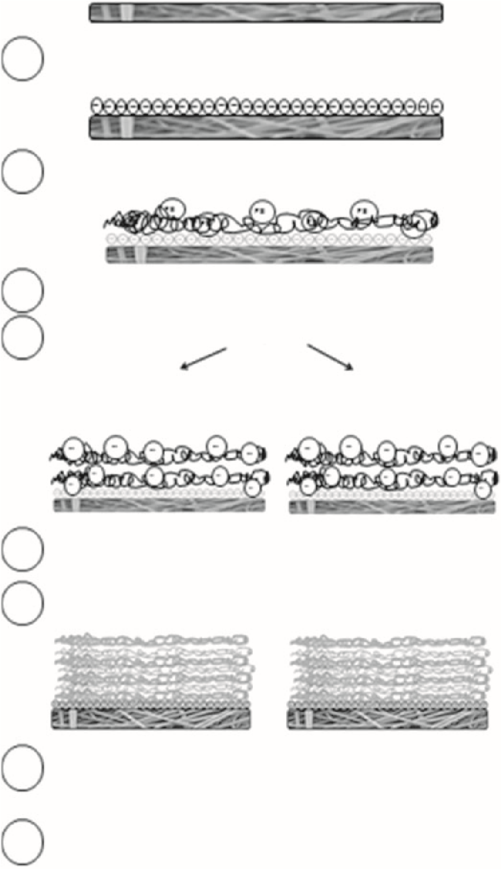
Plasma polymerization with Acrylic Acid
Immerse in 0.5% Poly Ethylene Imine in
dH
2
O for 30 min
Wash in dH
2
O four times
Wash in dH
2
O four times
100
U/ml Heparin
solution in cH
2
O
for 30 min
% Acrylic Acid
0.5
solution in cH
2
O
for 30 min
Immerse in Poly Anion Solution
Repeat steps 2, 3, 4 and 5 until a total of 7 Layers
Immerse both types of scaffold in 100 U/ml solution of
Heparin in PBS overnight
Immerse both types of scaffold in 2 ng/ml solution of
VEGF in PBS for 24 h as the final la
y
er
8
7
6
4
3
2
1
5
Figure 1. Diagram of the coating protocol.
Heparin and VEGF coating. After the LBL coating, scaffolds were dipped in 2mL of 100 U/mL heparin aqueous solution for 4h at room temperature. Afterwards, scaffolds were washed four times in deionised water and left overnight in 1mL of 2ng/mL VEGF solution in PBS. The following day, the VEGF solution was removed and scaffolds were placed in fresh phosphate buffer saline (PBS) solution for 24h.

Surface characterisation
Scanning Electron Microscopy (SEM). After functionalisation with heparin, samples were dried at room temperature. They were then coated in gold with a sputter coater (Edwards sputter coater S150B, Crawley, England). Samples were imaged with a Phillips XL-20 scanning electron microscope (Cambridge, UK).
X-ray Photoelectron Spectroscopy (XPS). After functionalisation with heparin, the samples were left to dry completely at room temperature before surface analysis. Surface chemistry was verified by XPS. X-ray photoelectron spectra were obtained at the National EPSRC XPS User’s Service (NEXUS) at Newcastle University. The instrument used was the K-Alpha instrument equipped with a monochromated AlKa source
(Thermo Scientific, East Grinstead, UK). Pass energy of 200eV and a step size of 1.0eV were employed for survey spectra, while a pass energy of 40eV and a step size of 0.1eV was used for high resolution spectra of the elements of interest (Carbon, Oxygen, Nitrogen and Sulphur). Two spots were taken for each sample, and two samples of each scaffold type were analysed. Atomic percentages for each element were measured. Curve fitting was carried out with casaXPS programme (USA).
Ability of scaffolds to bind VEGF. The coated scaffolds were immersed into a 2ng/mL VEGF solution in PBS at room temperature overnight. The scaffolds were then washed once in 1mL PBS and left in a second wash of 1mL PBS overnight. A human VEGF enzyme-linked immunosorbent assay (ELISA) (Peprotech Inc., USA) was carried out on the wash solutions to quantify how much VEGF was present in the solutions and how much was therefore still bound to the surface of the scaffolds. The assay was carried out according to the manufacturer’s instructions.
Assessment of angiogenic properties of coated scaffolds using the CAM assay. Fertilised chicken (Gallus domesticus) eggs were purchased from Medeggs (UK) and incubated from day 2 of fertilisation until day 8 at 37C in a humidified egg incubator (R-COM Suro20).
At day 8, a square window (1 cm²) was cut into the shell and lifted, and a 2 cm² fully functionalised electrospun scaffold was placed onto the CAM, with a black silk stitch placed in the scaffold to help later identify it on retrieval. Half of the samples were fully functionalised and soaked in VEGF prior to implantation, and then washed. The other half was plain PLLA soaked in VEGF solution and washed. Each egg was implanted with one scaffold only. The shell window was replaced with parafilm (Bemis Flexible Packaging, USA) and sealed with adhesive tape. After implantation, eggs were placed again at 37C in a 40% humidified incubator until day 14. At day 14, scaffolds were retrieved and the eggs were sacrificed. Angiogenesis was quantified by taking light microscope pictures just before scaffold retrieval and blindly scored by four independent assessors using histological images of the retrieved scaffolds. Figure 2 shows a cartoon of the timeline of this assay.
Histology. Histology was performed on the retrieved scaffolds. Scaffolds from the CAM were fixed in 3.7% paraformaldehyde (Sigma Aldrich, USA) in deionised water for at least 1h. They were placed into moulds for cryo-sectioning filled with OCT solution (Leica, Germany). They were left to freeze at 80C and 20mm sections were cut with the cryostat Leica CM1860UV (Leica Germany). Slides were then stained with haematoxylin & eosin solutions (H&E), according to the standard protocol for frozen slides. Slides were then covered with DPX (Sigma-Aldrich, USA) and a glass coverslip to be imaged with a light microscope (Motic, China). Quantification of cell infiltration and angiogenesis of each scaffold after CAM assay was based on the H&E histology. The four independent assessor evaluated blindly 22 images for cell infiltration and 14 images for angiogenesis from three different experiments(Table1).Thehistologyimageswereblindly scored from 1 (no cell infiltration) to 3 (massive cell infiltration) by 4 assessors. Angiogenesis was also blindly scored counting the number of blood vessels per slide.
Immunohistochemistry. Frozen slides were then stained for the CD31 antigen. Slides were firstly washed twice in PBS and then blocked with 10% bovine serum albumin in PBS for 1h. They were then incubated overnight at 4C with the primary antibody (Dako) (monoclonal CD31, 1:50). Samples were washed four times for 5min. Slides were then incubated for at least 1h with the secondary antibody goat anti-mouse Alexa488 (Life technologies) (1:200). Samples were then washed four times for 5min. Finally, they were incubated at room temperature for 20min with DAPI solution to stain the nuclei.
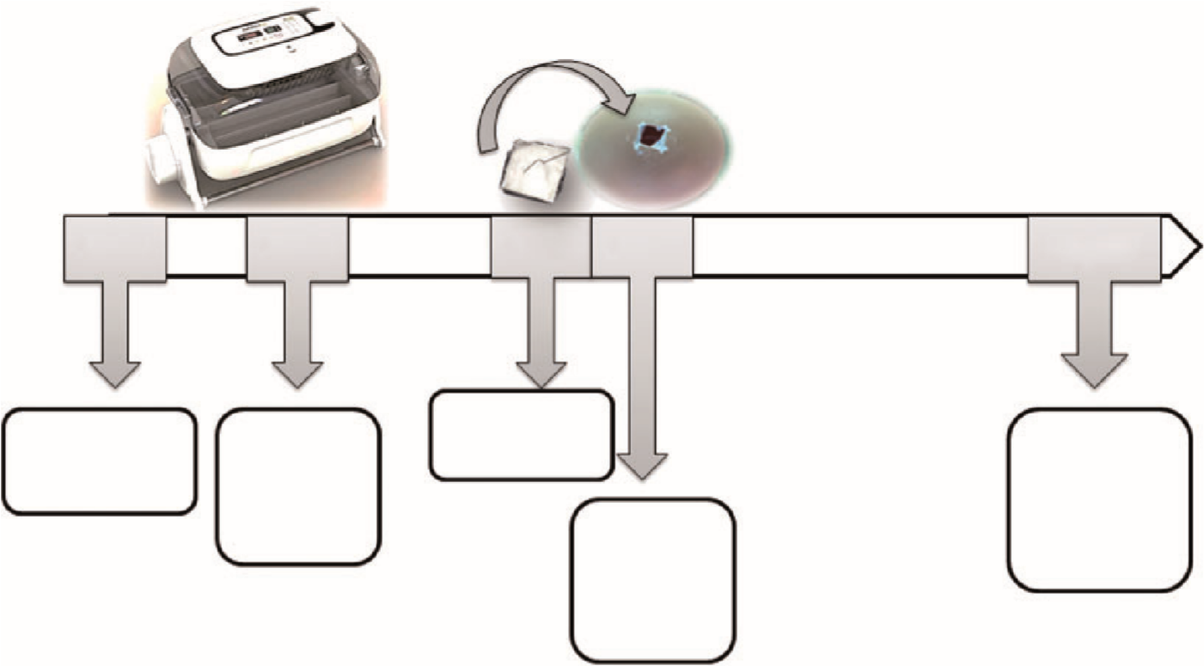
Day 0
Day 2
Day 7
Day 8
Day 14
Fertilization
Scaffold
preparation
Scaffolds
implanted
on eggs
Eggs
placed in
the
incubator
Eggs
sacrified
and
scaffolds
retrieved
Figure 2. Chorionic allantoic membrane (CAM) assay protocol.
Table 1. Blind assessment of extent of cell infiltration and angiogenesis of uncoated versus coated PLLA scaffolds.
Cell infiltration |  |  |  | Angiogenesis
 | Sample | PLLA (SD) | Coated PLLA ( SD) | PLLA ( SD) | Coated PLLA ( SD)
Exp. 1 | 1 | 1 0 | 2.5 0.5 | 0 0 | 1.5 0.56
 | 2 | 1.75 0.96 | 2 0.58 | 0 0 | 4.5 1.29
 | 3 | 1.25 0.5 | 2.25 0.5 | 1 0 | 2.25 0.96
 | 4 | 2 0.82 | 2.5 0.58 | ND | ND
Exp. 2 | 1 | 1 0 | 2.5 0.58 | 0 0 | 5.25 2.63
 | 2 | 1.5 1 | 2.25 0.5 | 0 0 | 4.5 1
 | 3 | 1.5 0.58 | 2.25 0.5 | ND | ND
 | 4 | 1 0 | 3 0 | ND | ND
Exp. 3 | 1 | 1.75 0.5 | 2.75 0.5 | 0 0 | 3 2.71
 | 2 | 1.5 1 | 2.75 0.5 | 0 0 | 2.5 1.29
 | 3 | 1 0 | 2.25 0.5 | ND | ND
Mean ( SD) |  | 1.38 0.65 | 2.45 0.50 | 0.14 0.38 | 3.36 1.40
As seen from the table, PLLA membranes either uncoated or coated (and preloaded with heparin and VEGF as in the methods) were placed for 7 days onto a chick CAM. They were then removed and subjected to conventional H&E staining. The extent of cell infiltration was assessed by four assessors who were blind to the nature of the scaffolds they were examining. Cell infiltration was scored as 1 (no evidence of cell infiltration) to 3 (extensive cell infiltration). For angiogenesis, the assessors were asked to count the number of blood vessels they could see within their field of view (area of 3 mm 10 mm). Results in the table show the scores obtained by the four assessors and then the average values are given at the bottom of the table. Cell infiltration was significantly greater in coated scaffolds (p< 0.001) and the extent of blood vessels found in the coated scaffolds was also significantly greater than in the uncoated scaffolds
(p< 0.0001).

Results Morphology of the scaffolds
The appearance of the uncoated and coated scaffolds was investigated using SEM. This showed that after plasma treatment, the surface of the fibres appeared etched (Figure 3(a) to (d)) and enlarged compared to the plain fibres. After coating with seven layers of either PEI/PAC or PEI/HEP (Figure 3(e) to (h)) there was no further change in appearance or fibre size.

Plasma polymerisation of electrospun PLLA with acrylic acid
Plain PLLA was compared with plasma polymerised PLLA to quantify the presence of acrylic acid on the surface of the scaffolds by the atomic percentage
Low Magnification High Magnification x1500 x6000
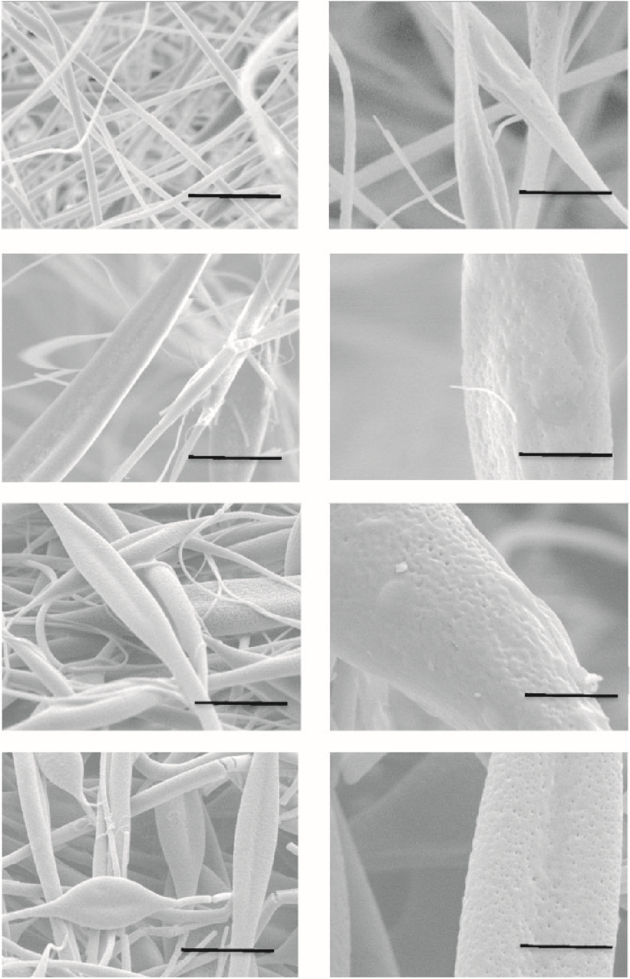
PLLA
Plasma
polymerised PLLA
with acrylic acid
PLLA coated with 7
layers of PEI
and PAC
PLLA coated with 7
layers of PEI
and HEP

20
μ
m
5

μ
m
20

μ

5
m
μ
m

20
μ

m
5
μ
m
20

μ
m
5

μ
m
)
a
(
)
b
(
(
)
c
)
d
(
(
e
)
f
)
(
(
g
)
(
h
)
Figure 3. The fibre surfaces before and after plasma treatment and layer-by-layer coating. Poly-L-Lactic (a and b), Poly-L-Lactic plasma polymerised with acrylic acid (c and d), Poly-L-Lactic plasma polymerised with acrylic acid and coated with seven layers of alternate PEI and PAC þ HEP (e and f), Poly-L-Lactic plasma polymerised with acrylic acid and coated with seven layers of alternate PEI
and HEP þ HEP (g and h).
(At.%) of the elements on the surface and by the presence of the carboxylic acid peak. Changes in height of the carbon and nitrogen peak heights of the two samples suggest the present of acrylic acid on top of the surface. Surface composition of plain PLLA was 65% carbon and 36% oxygen. For the plasma polymerised PLLA, the average atomic composition was 75% carbon and 25% oxygen, suggesting that the surface chemistry had changed (Figure 4(a) and (b)). Moreover, a narrow scan of the carbon for the plasma polymerised sample suggests the presence of the carboxylic group which is not present on plain PLLA surface (Figure 4(c) and (d)). Also, the carbon peak shape changed after plasma polymerisation (Figure 4(c) and (d)). Narrow carbon scans of the plain PLLA showed the three typical peaks of the carbon bonds present (C–C, C–O–C and C¼O)
(Figure 4(c)), while narrow carbon scans of the scaffolds after plasma polymerisation showed a distinctive carboxylic peak at about 289eV bonding energy, as a result of the plasma polymerisation with acrylic acid (Figure 4(d)).
PLLA PLLA after plasma polymerization
(a) _{x10}4 (b) _{x10}4 with acrylic acid
Survey 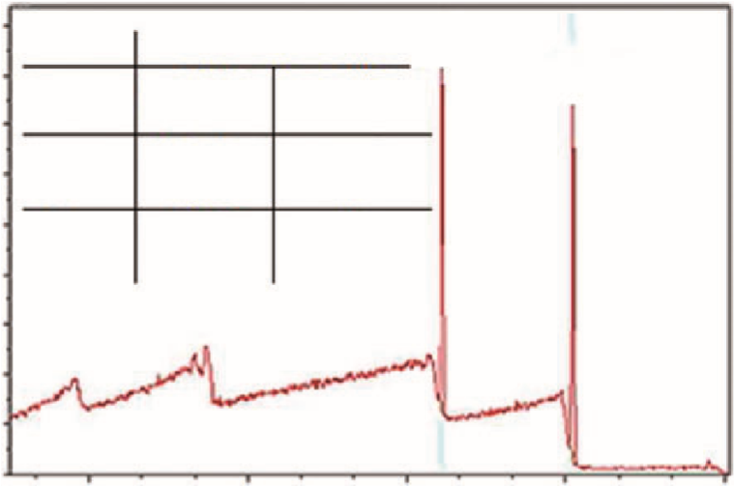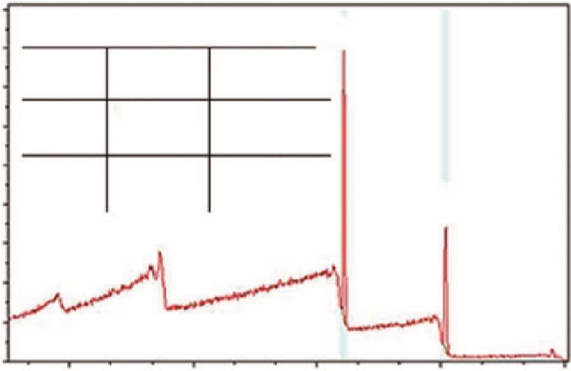
CPS
0
2
4
6
8
60
40
75
35
10
12
14
16
18
CPS
0
2
4
6
8
10
12
14
16
18
Atomic Percentage
Atomic Percentage
OXYGEN
CARBON
OXYGEN
CARBON
Carbon
1
s

64.94
±
0.94
35.34

±
0.56
68.67

±
0.20

20.20
±
0.43
Oxygen
1
s
Carbon
s
1
Oxygen
s
1
Empirical
±
SD
Empirical
%
±
SD
Theoretical
Theoretical
900 600 300 0 1200 900 600 300 0
Binding Energy (eV) Binding Energy (eV)
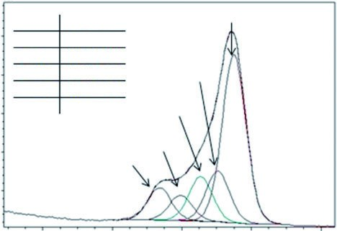
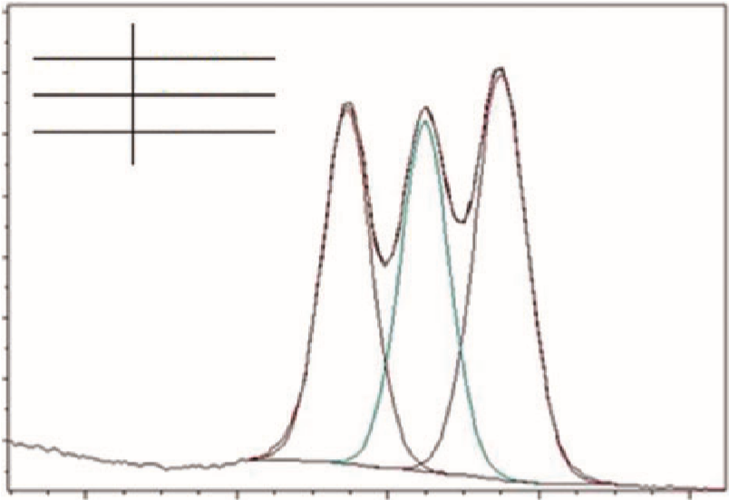
(c) x103 (d) x103
CPS
C-C
C-C
C-C
C-O
COOH
Position
Position
286.79
eV
288.96
eV
288.08
eV
289.28
eV
285.00
eV
285.93
eV
286.92
eV
284.93
eV
C-O-C
C-O-C
C-O-C
O-C=O
C-C
C-O
C-O-C
O-C=O
COOH
O-C=O
O-C=O
2
4
6
8
10
12
14
16
CPS
5
25
20
15
10
Carbon
Narrow
Scan
292 288 284 280 295 292 288 284 280
Binding Energy (eV) Binding Energy (eV)
Figure 4. Assessment of surface chemistry of plain PLLA scaffold (a), plasma polymerised acrylic acid on electrospun PLLA (b), narrow scan of the carbon peak of the plain PLLA (c) and the carbon peak of the functionalised PLLA (d).

Coating with heparin
The two scaffolds, either functionalised with PEI and HEP or functionalised with PEI and PAC, were analysed by XPS for the presence of sulphur on the surface, indicating the presence of heparin. This is because the only compound with sulphur on the scaffold surface is the heparin salt. Thus, it would be possible to determine which scaffoldbinds the most heparin byquantifying the atomic percentage of the sulphur on these scaffolds.
From this analysis there was a significant difference between the two types of coating: PEI/PAC bound significantly more heparin then PEI/HEP. Accordingly, PEI/PAC scaffolds were then used for all future investigations. For PEI and PAC, seven layers of functionalisation gave slightly but not significantly more heparin bound than five layers (Figure 5).

ELISA confirmed that the heparin functionalised scaffolds bind VEGF
An ELISA was used to quantify the amount of VEGF that could be bound to the scaffolds functionalised with PEI and PAC with HEP. The amount of VEGF bound to the surface increased with the number of layers up to three layers but no further VEGF was bound with further layers (Figure 6).

CAM assay confirmed angiogenic activity of the functionalised scaffolds
The CAM assay was used to assess the angiogenic potential of the scaffold functionalised with PEI and PAC. Figure 7 shows light microscope pictures of the scaffold implanted on the CAM, in addition to histology of the scaffold after explantation. The pictures show how the chick blood vessels grow toward the functionalised scaffold in contrast to the non-coated PLLA scaffolds. H&E staining showed the massive cell infiltration of the chick cells into the functionalised scaffold, compared to the plain PLLA. CD31 staining shows that endothelial cells have infiltrated the angiogenic scaffold, while there were no endothelial cells in the plain PLLA.
Assessors then blindly scored the histology images of the implanted scaffolds (Table 1). Results show that there was a significant difference (p<0.0001) in
 | PLLA coated with PEI and HEP | PLLA coated with PEI and PAC
PLLA with 5 Layers | 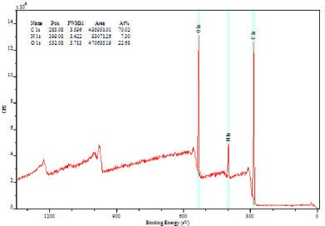 | 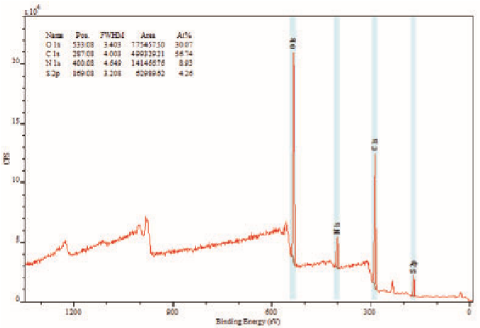
  Name | At % ±SD
  Carbon 1s | 70.46±0.62
  Oxygen 1s | 22.34±0.48
  Nitrogen 1s | 7.21±0.13
  Sulphur 2p | 0
  Name | At %±SD
  Carbon 1s | 56.41 ± 0.47
  Oxygen 1s | 30.57 ± 0.70
  Nitrogen 1s | 8.77 ± 0.23
  Sulphur 2p | 4.26 ± 0.00
PLLA with 7 Layers | 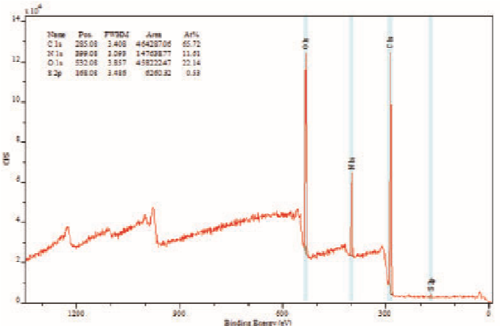 | 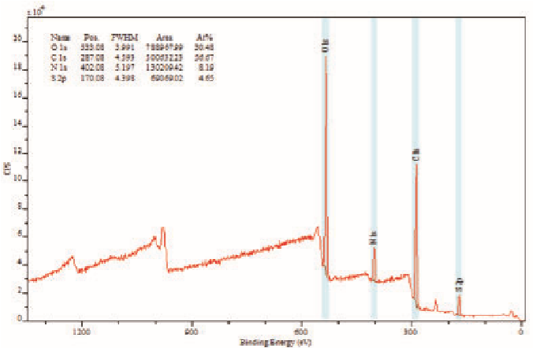
  Name | At %±SD
  Carbon 1s | 67.68±2.77
  Oxygen 1s | 21.69±0.64
  Nitrogen 1s | 10.10±2.14
  Sulphur 2p | 0.53±0.00
  Name | At %±SD
  Carbon 1s | 56.29±0.54
  Oxygen 1s | 30.75±0.38
  Nitrogen 1s | 8.36±0.24
  Sulphur 2p | 4.60±0.08
0.1
-0.01
0
0.01
0.02
0.03
0.04
0.05
0.06
0.07
0.08
0.09
PLLA
PLLA with 5 layers
PLLA with 7 layers
Rao of Carbon %At and Sulphur %At
Scaffold coated
with PEI and HEP
Scaffold coated
with PEI and PAC
Presence of sulphur on the surface
Figure 5. Presence of heparin on PLLA coated with PEI and HEP versus PLLA coated with PEI and PAC based on the presence of
atomic sulphur on the surface (**p< 0.001, ***p< 0.0001).
infiltration and number of blood vessels observed between plain PLLA and PLLA coated with PEI and PAC (Figure 8).

Discussion
This work looked at developing flexible coating strategies to promote angiogenesis in biomaterials for future clinical use. In tissue engineering, it is well accepted that the failure to develop new vasculature quickly enough leads to failure of tissue engineered constructs.⁶ Indeed manygroupsarenowdevelopingapproachestopromote angiogenesis. It is particularly attractive to use natural and synthetic HEP mimetics like HEP-loaded hydrogels as these provide a more readily translatable approach to clinicaltranslationthanaddingrecombinantgrowthfactors. HEP modified tissue scaffolds and HEP modified bone cements, collagen matrices and functionalised micro and nanoparticles have all been developed.
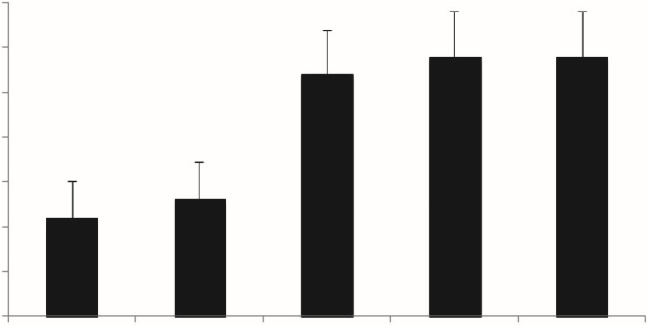∗∗
1050
1000
950
900
850
800
750
700
0
1
3
5
7
Number of la
y
ers
VEGF (pg/ml)
Figure 6. ELISA assay used to assess the optimum numbers of layers of polyethylene imine and polyacrylic acid needed to bind the highest amount of VEGF.
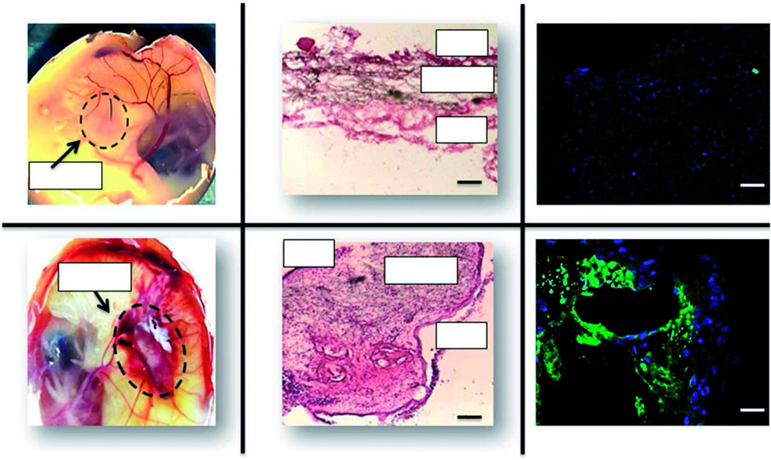
CAM
PLLA
Functionalised PLLA
DAPI and CD31 staining
H&E Staining
Scaffold
Scaffold
Scaffold
Scaffold
CAM
CAM
CAM
1
mm
1
mm
1

μ
m
1

μ
m
CAM
Figure 7. Implantation of plain PLLA and coated PLLA in the CAM.
The aim of this study was to develop a flexible LBL approach which could be used to coat a range of existing scaffolds and to evaluate to what extent this approach can induce angiogenesis in an in-vivo model. We compared two LBL approaches for binding HEP. One approach used alternative layers of PEI and PAC and the other looked at alternative layers of PEI and heparin. PEI/PAC coating was chosen because previously published work shows that it is a viable system to adsorb protein and sugars onto surfaces.^{5,7,8} In this study, we also wanted to explore the possibility of using alternate layers of PEI and HEP as multilayers based on the electrostatic charge between these two as heparin is more biocompatible than acrylic acid.
The first step of PLLA functionalisation for both coatings was plasma polymerisation with Acrylic acid. This step was essential in order to build the polyelectrolyte coating and to etch the surface. SEM images show an increase in surface roughness of the fibres, as a result of the plasma polymerisation (Figure 3(a) to (d)). This is probably a major factor in increasing the hydrophilicity of the scaffold after this treatment, in addition to the acid groups on the surface. This was also confirmed by the increase in fibre diameter after seven layers of coating, suggesting that water was taken up by the fibres after this coating, probably as a result of the acid plasma etching (Figure 3(e) to (h)).
The success of the plasma polymerisation was also confirmed by XPS (Figure 4), which showed the presence of carbon and oxygen on the surface of the scaffolds originating from the PLLA (Figure 4(a)).
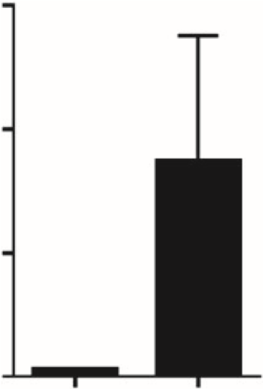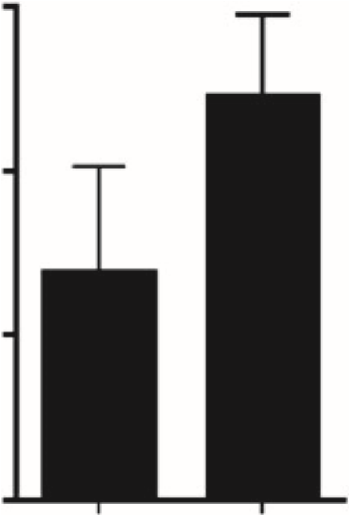
3
2
1
0
6
4
2
0
AU
Number of Blood Vessels
PLLA
Coated PLLA
PLLA
Coated PLLA
**
**
Cell Infiltration ^{Angiogenesis}
Figure 8. The quantification of cell infiltration and angiogenesis of scaffolds assessed using the chick chorionic allantoic membrane (CAM) assay. Scaffolds were placed on the CAM for 7 days and then removed and processed for H&E histology. These images (from three experiments with 3–4 samples in each) were then scored blindly by four assessors. For cell infiltration these were scored as 1 (no evidence of cell infiltration) through 3 (extensive cell infiltration). For angiogenesis the number of blood vessels in the field of view, were counted. Results shown are the average SD and **p< 0.01.
After plasma polymerisation with acrylic acid, the proportion of the oxygen and carbon elements changed and the carboxylic peak was present at a binding energy of 289eV (tables in Figure 4(a) and (b)).
Previous studies have shown how PLLA surfaces can be successfully plasma polymerised with acrylic acid.^{9–11} The carboxylic peak at binding energy of about 289eV is recognisable in many other studies where acrylic acid has been plasma polymerised onto
a surface.12–15
Successful plasma polymerisation is essential to build a multilayer of polyelectrolytes, to ultimately bind HEP. LBL approaches are being used in tissue engineering because they are flexible and versatile. This approach has been used to bind or adsorb materials to surfaces to improve biocompatibility and cell adhesion of materials for biomedical applications.¹⁶ The successful coating in this study used PEI as polycation and PAC as the polyanion. The ability of the scaffolds to bind HEP was assessed by XPS and showed that more heparin was bound on the surface functionalised with PEI and PAC compared to the scaffold functionalised with PEI and HEP, as shown in Figure 5. These results are consistent with our recent study showing that the optimum number of layers to bind heparin was around 5–7 layers.⁵ Although we did not investigate more layers, the underlying message is that you need few layers to build up the surface charge necessary to bind heparin. Once that is reached, the amount of heparin that is bound does not appear to increase significantly.
We then confirmed, using an ELISA, that the heparin coated scaffolds were capable of binding VEGF. The ELISA results confirmed that there was little VEGF bound with a lower number of layers (see Figure 6) but by five and seven layers there was at least 950pg of VEGF bound per cm². As the amount of heparin does not increase significantly with more layers, so it appears to be with the amount of VEGF bound. Other studies have shown that a multilayer of PEI and heparin will assist in protein adsorption.¹⁷ These authors found a PEI/PAC combination successful for binding proteins contained in foetal calf serum and this helped in cell adhesion. Another study found similar results using HEP and a polyanion where the polyelectrolyte multilayer aided cell adhesion and growth.¹⁸ In this study, we explored alternative of layers of PEI and HEP compared to PEI and acrylic acid but the results clearly supported the use of PEI and acrylic acid as the most effective approach to coating.
We then used the chick CAM model to show that the scaffold had a chemotactic effect on the production of new blood vessels. This CAM model is commonly used
in tissue engineering for this purpose.^{19–21}
Several groups have investigated binding heparin to materials. They have shown that HEP binds growth factors such as VEGF to induce angiogenesis.^{22–26} These studies have all shown that heparin was able to bind growth factors and induce massive cell infiltration within the scaffold and eventual blood vessel formation. However, these studies developed methods to covalently bind HEP to their substrates. In contrast to this chemical binding process this study investigates the ability of HEP to be electrostatically adsorbed onto surfaces, specifically fibres. We investigate the applicability of a flexible LBL and HEP coating on a fibrous non-woven surface such as electrospun PLLA. We have shown how HEP was adsorbed onto the surface of electrospun PLLA and was able to bind VEGF and, once implanted in a chick CAM, to induce blood vessel formation towards the scaffold (Figure 7). Standard histology confirmed more extensive infiltration of chick cells into the functionalised scaffold compared to lesser cell infiltration into the uncoated PLLA scaffold (Figure 8). There is a general understanding that biomaterials which result in rapid growth of new blood vessels and tissue infiltration will be better tolerated than those which show delayed angiogenesis and persistent inflammation.²⁷ This is a complex area but certainly for tissue engineered materials the imperative to obtain a blood supply rapidly for the survival of the tissues is clear. These results show that the functionalised scaffold can release VEGF over a clinically relevant time of 7 days.
Thus in conclusion, we report an approach which is not too technically difficult to coat existing fibrous scaffolds to make them more proangiogenic. In this study, we did not look into the stability of the surface coating which now needs to be determined but the key issue we have demonstrated is that these scaffolds can be made reproducibly and they will promote rapid neovascularisation in the CAM in-vivo assay. Once some initial neovascularisation is present, then arguably stability of the scaffold in terms of continued binding of heparin and VEGF becomes less relevant.

Conclusion
Electrospun PLLA fibres can be successfully plasma polymerised with acrylic acid to change their surface chemistry. A polyelectrolyte multilayer was then developed on the plasma polymerised surface, allowing appreciable amounts of heparin to be bound to the surface. This heparin was effective in binding VEGF. The fully functionalised scaffold with heparin and VEGF induced angiogenesis once implanted in a chick CAM model. Control non-coated scaffolds did not induce angiogenesis. We suggest this is a useful approach to treating existing scaffolds to make them angiogenic for better clinical integration.
Acknowledgments
X-ray photoelectron spectra were obtained at the National EPSRC XPS User’s Service (NEXUS) at Newcastle University, an EPSRC Mid-Range Facility. We also thank Professor Richard Oreffo and his group for kindly providing training in the CAM assay.
Declaration of conflicting interests
The authors declared no potential conflicts of interest with respect to the research, authorship, and/or publication of this article.
Funding
This study was supported by an EPSRC White Rose Doctoral Training Centre Grant.
References
- Lovett M, Lee K, Edwards A, et al. Vascularization strategies for tissue engineering. Tissue Eng, Part B-Rev 2009; 15(3): 353–370.
- Naderi H, Matin MM and Bahrami AR. Critical issues intissue engineering: Biomaterials, cell sources, angiogenesis, and drug delivery systems. J Biomater Appl 2011; 26(4): 383–417.
- Zandonella C. Tissue engineering: The beat goes on.Nature 2003; 421(6926): 884–886.
- Gilmore L, Rimmer S, McArthur SL, et al. Argininefunctionalization of hydrogels for heparin bindingua supramolecular approach to developing a pro-angiogenic biomaterial. Biotechnol Bioeng 2013; 110(1): 296–317.
- Easton CD, Bullock AJ, Gigliobianco G, et al. Application of layer-by-layer coatings to tissue scaffolds-development of an angiogenic biomaterial. J Mater Chem B 2014; 2(34): 5558–5568.
- MacNeil S. Progress and opportunities for tissue-engineered skin. Nature 2007; 445(7130): 874–880.
- Muller M, Kessler B, Houbenov N, et al. PH dependenceand protein selectivity of poly(ethyleneimine)/poly(acrylic acid) multilayers studied by in situ ATR-FTIR spectroscopy. Biomacromolecules 2006; 7(4): 1285–1294.
- Muller M, Rieser T, Dubin PL, et al. Selective interactionbetween proteins and the outermost surface of polyelectrolyte multilayers: Influence of the polyanion type, pH and salt. Macromol Rapid Commun 2001; 22(6): 390–395. 9. Chaiwong C, Rachtanapun P, Wongchaiya P, et al. Effect of plasma treatment on hydrophobicity and barrier property of polylactic acid. Surf Coat Technol 2010; 204(18–19): 2933–2939.
- Chen J-P and Su C-H. Surface modification of electrospun PLLA nanofibers by plasma treatment and cationized gelatin immobilization for cartilage tissue engineering. Acta Biomater 2011; 7(1): 234–243.
- Shah A, Shah S, Mani G, et al. Endothelial cell behaviouron gas-plasma-treated PLA surfaces: The roles of surface chemistry and roughness. J Tissue Eng Regen Med 2011; 5(4): 301–312.
- Otoole L, Beck AJ and Short RD. Characterization ofplasma polymers of acrylic acid and propanoic acid. Macromolecules 1996; 29(15): 5172–5177.
- Alexander MR and Duc TM. The chemistry of depositsformed from acrylic acid plasmas. J Mater Chem 1998; 8(4): 937–943.
- Cheng ZY and Teoh SH. Surface modification of ultra thin poly(epsilon-caprolactone) films using acrylic acid and collagen. Biomaterials 2004; 25(11): 1991–2001.
- Donegan M and Dowling DP. Protein adhesion on waterstable atmospheric plasma deposited acrylic acid coatings. Surf Coat Technol 2013; 234: 53–59.
- Gribova V, Auzely-Velty R and Picart C. Polyelectrolytemultilayer assemblies on materials surfaces: From cell adhesion to tissue engineering. Chem Mat 2012; 24(5): 854–869.
- Niepel MS, Peschel D, Sisquella X, et al. pH-dependentmodulation of fibroblast adhesion on multilayers composed of poly(ethylene imine) and heparin. Biomaterials 2009; 30(28): 4939–4947.
- Aggarwal N, Altgarde N, Svedhem S, et al. Tuningcell adhesion and growth on biomimetic polyelectrolyte multilayers by variation of pH during layer-bylayer assembly. Macromol Biosci 2013; 13(10):
1327–1338.
- Valdes TI, Kreutzer D and Moussy F. The chick chorioallantoic membrane as a novel in vivo model for the testing of biomaterials. J Biomed Mater Res 2002; 62(2): 273–282.
- Borges J, Tegtmeier FT, Padron NT, et al.
Chorioallantoic membrane angiogenesis model for tissue engineering: A new twist on a classic model. Tissue Eng 2003; 9(3): 441–450.
- Baiguera S, Macchiarini P and Ribatti D.
Chorioallantoic membrane for in vivo investigation of tissue-engineered construct biocompatibility. J Biomed Mater Res Part B-Appl Biomater 2012; 100B(5):
1425–1434.
- Steffens GCM, Yao C, Prevel P, et al. Modulation ofangiogenic potential of collagen matrices by covalent incorporation of heparin and loading with vascular endothelial growth factor. Tissue Eng 2004; 10(9–10): 1502–1509.
- Bezuidenhout D, Davies N, Black M, et al. Covalent surface heparinization potentiates porous polyurethane scaffold vascularization. J Biomater Appl 2010; 24(5): 401–418.
- Hou Y-T, Ijima H, Matsumoto S, et al. Effect of a hepatocyte growth factor/heparin-immobilized collagen system on albumin synthesis and spheroid formation by hepatocytes. J Biosci Bioeng 2010; 110(2): 208–216.
- Schmidt C, Bezuidenhout D, Higham L, et al. Inducedchronic hypoxia negates the pro-angiogenic effect of surface immobilized heparin in a polyurethane porous scaffold. J Biomed Mater Res Part A 2011; 98A(4): 621–628.
- Singh S, Wu BM and Dunn JCY. The enhancement of
VEGF-mediated angiogenesis by polycaprolactone scaffolds with surface cross-linked heparin. Biomaterials 2011; 32(8): 2059–2069.
- Wolf MT, Dearth CL, Ranallo CA, et al. Macrophagepolarization in response to ECM coated polypropylene mesh. Biomaterials 2014; 35(25): 6838–6849.

Bibliography
Abraham, J.A. et al., 1986. Nucleotide Sequence of a bovine clone encoding the angiogenic protein, basic fibroblast growth factor. Science, 233, pp.s46–s48.
Abrigo, M., Kingshott, P. & McArthur, S.L., 2015. Electrospun Polystyrene Fiber Diameter Influencing Bacterial Attachment, Proliferation, and Growth. ACS Applied Materials & Interfaces, 7(14), pp.7644–7652. Available at: http://pubs.acs.org/doi/abs/10.1021/acsami.5b00453.
De Almeida, S.H.M. et al., 2007. Influence of sling material on inflammation and collagen deposit in an animal model. International Journal of Urology, 14(11), pp.1040–1043.
Anitua, E. et al., 2015. In fi ltration of plasma rich in growth factors enhances in vivo angiogenesis and improves reperfusion and tissue remodeling after severe hind limb ischemia. Journal of Controlled Release, 202, pp.31–39.
Arnaoutova, I. et al., 2009. The endothelial cell tube formation assay on basement membrane turns 20: state of the science and the art. Angiogenesis, 12(3), pp.267–74. Available at: http://apps.webofknowledge.com.eresources.shef.ac.uk/full_record.do?product=UA&search_mode=GeneralSearch&qid=1&SID=Y2l1uK1wuwAqmoqAI54&page=1&doc=1&cacheurlFromRightClick=no [Accessed September 22, 2015].
Ashton-Miller, J.A. & Delancey, J.O.L., 2007. Functional anatomy of the female pelvic floor. In D. Elad & R. C. Young, eds. Reproductive Biomechanics. pp. 266–296. Available at: <Go to ISI>://WOS:000246636900017.
Auerbach, R. et al., 2003. Angiogenesis assays: A critical overview. Clinical Chemistry, 49(1), pp.32–40.
Augustine, R. et al., 2014. Investigation of angiogenesis and its mechanism using zinc oxide nanoparticle-loaded electrospun tissue engineering scaffolds. RSC Adv., 4(93), pp.51528–51536. Available at: http://xlink.rsc.org/?DOI=C4RA07361D [Accessed January 11, 2015].
Ausprunk, D.H. & Folkman, J., 1977. Migration and Proliferation of Endothelial Cells in Preformed and Newly Formed Blood Vessels during Tumor Angiogenesis. Microvascular Research, 14, pp.53–65.
Ausprunk, D.H., Knighton, D.R. & Folkman, J., 1974. Differentiation of vascular endothelium in the chick chorioallantois: a structural and autoradiographic study. Developmental biology, 38(2), pp.237–248.
Azizkhan, R.G. et al., 1980. Capillary Stimulates Migration of Capillary Endothelial Cells in-vitro. Journal of Experimental Medicine, 152(October), pp.931–944.
Badylak, S.F., 2002. The extracellular matrix as a scaffold for tissue reconstruction. seminars in CELL & DEVELOPMENTAL BIOLOGY, 13(02), pp.377–383.
Baiguera, S., Macchiarini, P. & Ribatti, D., 2012. Chorioallantoic membrane for in vivo investigation of tissue-engineered construct biocompatibility. Journal of Biomedical Materials Research Part B-Applied Biomaterials, 100B(5), pp.1425–1434. Available at: <Go to ISI>://WOS:000304864500029.
Barry, J.J. a et al., 2006. Using a core-sheath distribution of surface chemistry through 3D tissue engineering scaffolds to control cell ingress. Advanced Materials, 18(11), pp.1406–1410.
Bazi, T.M. et al., 2007. Polypropylene Midurethral Tapes Do Not Have Similar Biologic and Biomechanical Performance in the Rat. European Urology, 51(5), pp.1364–1375.
Belair, D.G. & Murphy, W.L., 2013. Specific VEGF sequestering to biomaterials: Influence of serum stability. Acta Biomaterialia, 9(11), pp.8823–8831.
Bergmeister, H. et al., 2012. Electrospun small-diameter polyurethane vascular grafts: ingrowth and differentiation of vascular-specific host cells. Artificial organs, 36(1), pp.54–61. Available at: http://www.ncbi.nlm.nih.gov/pubmed/21848935 [Accessed January 9, 2015].
Bernfield, M. et al., 1992. Biology of the syndecans: a family of transmembrane heparan sulfate proteoglycans. Annual review of cell biology, 8, pp.365–393.
Bernfield, M. et al., 1999. Functions of Cell Surface Heparan Sulfate Proteoglycans. Annual review of biochemistry, 68, pp.729–777.
Bezuidenhout, D. et al., 2010. Covalent Surface Heparinization Potentiates Porous Polyurethane Scaffold Vascularization. Journal of Biomaterials Applications, 24(5), pp.401–418. Available at: <Go to ISI>://WOS:000274257300002.
Birch, C., 2005. The use of prosthetics in pelvic reconstructive surgery. Best Practice & Research in Clinical Obstetrics & Gynaecology, 19(6), pp.979–991. Available at: <Go to ISI>://WOS:000236206300011.
Birch, C. & Fynes, M.M., 2002. The role of synthetic and biological prostheses in reconstructive pelvic floor surgery. Curr Opin Obstet Gynecol, 14(5), pp.527–535. Available at: http://www.ncbi.nlm.nih.gov/pubmed/12401983.
Birdwell, C.R., Gospodarowicz, D. & Nicolson, G.L., 1977. Factors from 3T3 cells stimulate proliferation of cultured vascular endothelial cells. Nature, 268(5620), pp.528–531. Available at: http://apps.webofknowledge.com.eresources.shef.ac.uk/full_record.do?product=UA&search_mode=GeneralSearch&qid=30&SID=U2wVgaiTI2wktAi8geT&page=1&doc=1&cacheurlFromRightClick=no [Accessed August 5, 2015].
Blackwood, K. a. et al., 2008. Development of biodegradable electrospun scaffolds for dermal replacement. Biomaterials, 29(21), pp.3091–3104.
Blackwood, K.A. et al., 2008. Development of biodegradable electrospun scaffolds for dermal replacement. Biomaterials, 29(21), pp.3091–104. Available at: http://www.ncbi.nlm.nih.gov/pubmed/18448164 [Accessed November 28, 2014].
Bogusiewicz, M. et al., 2006. Collagen deposition around polypropylene tapes implanted in the rectus fascia of female rats. European Journal of Obstetrics Gynecology and Reproductive Biology, 124(1), pp.106–109. Available at: <Go to ISI>://WOS:000234794100021.
Borges, J. et al., 2003. Chorioallantoic membrane angiogenesis model for tissue engineering: A new twist on a classic model. Tissue Engineering, 9(3), pp.441–450. Available at: <Go to ISI>://WOS:000183681200006.
Borges, J. et al., 2003. Chorioallantoic membrane angiogenesis model for tissue engineering: a new twist on a classic model. Tissue engineering, 9(3), pp.441–450.
Borkenhagen, M. et al., 1998. In vivo performance of a new biodegradable polyester urethane system used as a nerve guidance channel. Biomaterials, 19(23), pp.2155–2165.
Brown, J.S. et al., 2002. Pelvic organ prolapse surgery in the United States, 1997. American Journal of Obstetrics and Gynecology, 186(4), pp.712–716. Available at: http://linkinghub.elsevier.com/retrieve/pii/S0002937802067522 [Accessed January 29, 2015].
Brynda, E. et al., 2000. Albumin and heparin multilayer coatings for blood-contacting medical devices. JOURNAL OF BIOMEDICAL MATERIALS RESEARCH, 51(2), pp.249–257. Available at: http://apps.webofknowledge.com.eresources.shef.ac.uk/full_record.do?product=UA&search_mode=GeneralSearch&qid=84&SID=X2kyaLt7ewWGOaQEGI4&page=1&doc=1 [Accessed August 26, 2015].
Carey, D.J., 1997. Syndecans : multifunctional cell-surface co-receptors. Biochem J, 327 (Pt. 1, pp.1–16.
Castan, O. et al., 2014. Angiogenesis in Bone Regeneration : Tailored Calcium Release in Hybrid Fibrous Sca ff olds. Applied Materials and Interfaces, 6, pp.7512–7522.
Chae, T. et al., 2013. Novel biomimetic hydroxyapatite/alginate nanocomposite fibrous scaffolds for bone tissue regeneration. Journal of materials science. Materials in medicine, 24(8), pp.1885–94. Available at: http://www.ncbi.nlm.nih.gov/pubmed/23695359 [Accessed January 9, 2015].
Chandra, R. & Rustgi, R., 1998. Pergamon BIODEGRADABLE POLYMERS. Prog Polym Sci, 23, pp.1273–1335.
Chang, P.-C. et al., 2007. Bone tissue engineering with novel rhBMP2-PLLA composite scaffolds. Journal of biomedical materials research. Part A, 81(4), pp.771–780.
Chen, C.C.G., Ridgeway, B. & Paraiso, M.F.R., 2007. Biologic grafts and synthetic meshes in pelvic reconstructive surgery. Clinical obstetrics and gynecology, 50(2), pp.383–411. Available at: http://www.ncbi.nlm.nih.gov/pubmed/17513926.
Chen, H. et al., 2008. Biocompatible polymer materials: Role of protein-surface interactions. Progress in Polymer Science (Oxford), 33(11), pp.1059–1087.
Cheng, Y. et al., 2009. Polylactic acid (PLA) synthesis and modifications: a review. Frontiers of Chemistry in China, 4(3), pp.259–264. Available at: http://link.springer.com/10.1007/s11458-009-0092-x [Accessed April 26, 2015].
Chew, S.Y. et al., 2007. Aligned Protein-Polymer Composite Fibers Enhance Nerve Regeneration: A Potential Tissue-Engineering Platform. Advanced functional materials, 17(8), pp.1288–1296. Available at: http://www.pubmedcentral.nih.gov/articlerender.fcgi?artid=2447933&tool=pmcentrez&rendertype=abstract [Accessed December 16, 2014].
Choen, T. et al., 1995. VEGF121, a Vascular Endothelial Growth Factor (VEGF) Isoform lacking Heparin Binding Ability, Requires Cell-surface Heparan Sulfates for Efficient Binding to the VEGF Receptors of Human Melanoma Cells. The Journal of Biological Chemistry, 270(19), pp.11322–11326.
Chung, M.C. & Ellerton, N.F., 1976. Viscosity at low shear and circular dichroism studies of heparin. Biopolymers, 15(7), pp.1409–1423.
Chung, S. et al., 2009. Cell migration into scaffolds under co-culture conditions in a microfluidic platform. Lab on a chip, 9(2), pp.269–75. Available at: http://www.ncbi.nlm.nih.gov/pubmed/19107284 [Accessed December 30, 2014].
Chung, Y.-I., Tae, G. & Hong Yuk, S., 2006. A facile method to prepare heparin-functionalized nanoparticles for controlled release of growth factors. Biomaterials, 27(12), pp.2621–2626.
Clark, A.L. et al., 2003. Epidemiologic evaluation of reoperation for surgically treated pelvic organ prolapse and urinary incontinence. American Journal of Obstetrics and Gynecology, 189(5), pp.1261–1267. Available at: <Go to ISI>://WOS:000186979500009.
Clark, A.L. et al., 2005. Estrogen increases collagen I and III mRNA expression in the pelvic support tissues of the rhesus macaque. American journal of obstetrics and gynecology, 192(5), pp.1523–9. Available at: http://www.ncbi.nlm.nih.gov/pubmed/15902152 [Accessed January 30, 2015].
Cleland, J.L. et al., 2001. Development of poly-(,-lactide-coglycolide) microsphere formulations containing recombinant human vascular endothelial growth factor to promote local angiogenesis. Journal of Controlled Release, 72(1-3), pp.13–24. Available at: http://www.sciencedirect.com.proxy.lib.uwaterloo.ca/science/article/B6T3D-435CR3P-3/2/185c87ba79a18d8a5fd513c2958a4f5b\nhttp://www.sciencedirect.com.proxy.lib.uwaterloo.ca/science?_ob=ArticleURL&_udi=B6T3D-435CR3P-3&_user=1067412&_coverDate=05/14/2001&_rd.
Colaco, M. et al., 2014. THE MEDICOLEGAL AND ECONOMIC IMPLICATIONS OF FDA COMMUNICATIONS REGARDING THE USE OF TRANSVAGINAL MESH. In NEUROUROLOGY AND URODYNAMICS. pp. 240–241.
Conrad, H.E., 1998. Heparan Sulfate Proteoglycans-Present and Future. Trends in Glycoscience and Glycotechnology, 10(52), pp.51–56. Available at: https://www-jstage-jst-go-jp.eresources.shef.ac.uk/article/tigg1989/10/52/10_52_51/_article/-char/ja/ [Accessed August 4, 2015].
Cosson, M. et al., 2003. Mechanical properties of synthetic implants used in the repair of prolapse and urinary incontinence in women: which is the ideal material? International urogynecology journal and pelvic floor dysfunction, 14(3), pp.169–78; discussion 178. Available at: http://www.ncbi.nlm.nih.gov/pubmed/12955338 [Accessed February 1, 2015].
Cottler-fox, M.H. et al., 2003. Stem Cell Mobilization. Hematology, pp.419–437.
Coulembier, O. et al., 2006. From controlled ring-opening polymerization to biodegradable aliphatic polyester: Especially poly(β-malic acid) derivatives. Progress in Polymer Science, 31(8), pp.723–747. Available at: http://linkinghub.elsevier.com/retrieve/pii/S0079670006000712 [Accessed February 1, 2015].
Courty, J. et al., 1985. Bovine retina contains three growth factor activities with different affinity to heparin: eye derived growth factor I, II, III. Biochimie, 67(2), pp.265–269.
D’Amore, P. a & Klagsbrun, M., 1984. Endothelial mitogens derived from retina and hypothalamus: Biological and biochemical similarities. J. Cell Biol., 99, pp.1545–1549.
Daw, R. et al., 1998. Plasma copolymer surfaces of acrylic acid/1,7 octadiene: Surface characterisation and the attachment of ROS 17/2.8 osteoblast-like cells. Biomaterials, 19(19), pp.1717–1725.
Decher, G., 1997. Fuzzy Nanoassemblies: Toward Layered Polymeric Multicomposites. Science, 277(5330), pp.1232–1237.
Decher, G., Hong, J.D. & Schmitt, J., 1992. BUILDUP OF ULTRATHIN MULTILAYER FILMS BY A SELF-ASSEMBLY PROCESS .3. CONSECUTIVELY ALTERNATING ADSORPTION OF ANIONIC AND CATIONIC POLYELECTROLYTES ON CHARGED SURFACES. Thin Solid Films, 210(1-2), pp.831–835. Available at: <Go to ISI>://WOS:A1992HV02500118.
Degoutin, S. et al., 2012. Anticoagulant and antimicrobial finishing of non-woven polypropylene textiles. Biomedical Materials, 7(3), p.035001.
Delcombel, R. et al., 2013. New prospects in the roles of the C-terminal domains of VEGF-A and their cooperation for ligand binding, cellular signaling and vessels formation. Angiogenesis, 16(2), pp.353–371.
Deprest, J. et al., 2005. Synthetic and biodegradable prostheses in pelvic floor surgery. In E. F. B. V. H. B. H. V. H. Slager, ed. Gynaecology, Obstetrics, and Reproductive Medicine in Daily Practice. pp. 387–397. Available at: <Go to ISI>://WOS:000230367900064.
DeVolder, R.J. et al., 2011. Directed blood vessel growth using an angiogenic microfiber/microparticle composite patch. Advanced materials (Deerfield Beach, Fla.), 23(28), pp.3139–43. Available at: http://www.ncbi.nlm.nih.gov/pubmed/21618617 [Accessed December 16, 2014].
Dew, L., Macneil, S. & Chong, C.K., 2015. Vascularization strategies for tissue engineers. Regenerative Medicine, 10(2), pp.211–224.
Dias, F.G.F. et al., 2014. Can highly purified collagen coating modulate polypropylene mesh immune-inflammatory and fibroblastic reactions? Immunohistochemical analysis in a rat model. International Urogynecology Journal, pp.569–576. Available at: http://link.springer.com/10.1007/s00192-014-2529-0.
Diaz-gomez, L. et al., 2014. Biodegradable electrospun nano fi bers coated with platelet-rich plasma for cell adhesion and proliferation. Materials Science and Engineering C, 40, pp.180–188.
Diaz-Gomez, L. et al., 2014. Biodegradable electrospun nanofibers coated with platelet-rich plasma for cell adhesion and proliferation. Materials science & engineering. C, Materials for biological applications, 40, pp.180–8.
Division of Small Manufacturers, I. and C.A., 2011. UPDATE on Serious Complications Associated with Transvaginal Placement of Surgical Mesh for Pelvic Organ Prolapse. FDA Safety Communication. Available at: http://www.fda.gov/MedicalDevices/Safety/AlertsandNotices/ucm262435.htm.
Dong, P. et al., 2008. Fabrication and biocompatibility of polyethyleneimine/heparin self-assembly coating on NiTi alloy. Thin Solid Films, 516(16), pp.5168–5171.
Easton, C.D. et al., 2014. Application of layer-by-layer coatings to tissue scaffolds - development of an angiogenic biomaterial. Journal of Materials Chemistry B, 2(34), pp.5558–5568. Available at: <Go to ISI>://WOS:000340586500007.
Easton, C.D. et al., 2014. Application of layer-by-layer coatings to tissue scaffolds – development of an angiogenic biomaterial. Journal of Materials Chemistry B, 2(34), p.5558. Available at: http://xlink.rsc.org/?DOI=C4TB00448E [Accessed January 10, 2015].
Eghtesad, S. & Nurminskaya, M. V, 2013. Binding of pro-migratory serum factors to electrospun PLLA nano-fibers. Journal of biomaterials science. Polymer edition, 24(17), pp.2006–17. Available at: http://apps.webofknowledge.com.eresources.shef.ac.uk/full_record.do?product=UA&search_mode=GeneralSearch&qid=3&SID=R1HuGKNgQqiD33XIHxf&page=5&doc=47&cacheurlFromRightClick=no [Accessed January 10, 2015].
Ekaputra, A.K. et al., 2011. The three-dimensional vascularization of growth factor-releasing hybrid scaffold of poly (epsilon-caprolactone)/collagen fibers and hyaluronic acid hydrogel. Biomaterials, 32(32), pp.8108–17. Available at: http://www.ncbi.nlm.nih.gov/pubmed/21807407 [Accessed January 2, 2015].
Elahi, M.F. et al., 2014. Influence of layer-by-layer polyelectrolyte deposition and EDC/NHS activated heparin immobilization onto silk fibroin fabric. Materials, 7(4), pp.2956–2977.
Elbert, D.L., Herbert, C.B. & Hubbell, J. a., 1999. Thin polymer layers formed by polyelectrolyte multilayer techniques on biological surfaces. Langmuir, 15(16), pp.5355–5362.
Elmer, C. et al., 2009. Histological Inflammatory Response to Transvaginal Polypropylene Mesh for Pelvic Reconstructive Surgery. Journal of Urology, 181(3), pp.1189–1195.
Eloy, R. et al., 1988. Heparinization of medical grade polyurethanes. Journal of biomaterials applications, 2(4), pp.475–519.
Esch, F. et al., 1985. Primary structure of bovine pituitary basic fibroblast growth factor (FGF) and comparison with the amino-terminal sequence of bovine brain acidic FGF. Proceedings of the National Academy of Sciences of the United States of America, 82(19), pp.6507–6511.
Fadini, G.P., Losordo, D. & Dimmeler, S., 2012. Critical reevaluation of endothelial progenitor cell phenotypes for therapeutic and diagnostic use. Circulation research, 110(4), pp.624–37. Available at: http://www.pubmedcentral.nih.gov/articlerender.fcgi?artid=3382070&tool=pmcentrez&rendertype=abstract [Accessed January 19, 2015].
Falconel, C. et al., 1996. Changes in paraurethral connective tissue at menopause are counteracted by estrogen. Maturitas, 24, pp.197–204.
Farokhi, M. et al., 2014. Bio-hybrid silk fi broin / calcium phosphate / PLGA nanocomposite scaffold to control the delivery of vascular endothelial growth factor. Materials Science and Engineering C, 35, pp.401–410.
Farokhi, M. et al., 2013. Sustained release of platelet-derived growth factor and vascular endothelial growth factor from silk/calcium phosphate/PLGA based nanocomposite scaffold. International journal of pharmaceutics, 454(1), pp.216–25. Available at: http://www.ncbi.nlm.nih.gov/pubmed/23856159.
Faulk, D.M. et al., 2014. ECM hydrogel coating mitigates the chronic inflammatory response to polypropylene mesh. Biomaterials, 35(30), pp.8585–95. Available at: http://apps.webofknowledge.com.eresources.shef.ac.uk/full_record.do?product=UA&search_mode=GeneralSearch&qid=1&SID=R2OQdSejKpgQ5HFfAO4&page=1&doc=5&cacheurlFromRightClick=no [Accessed December 21, 2014].
Fioretta, E.S. et al., 2014. Di fferential Response of Endothelial and Endothelial Colony Forming Cells on Electrospun Scaffolds with Distinct Microfiber Diameters. Biomacromolecules, 15, pp.821–829.
Fisher, M.B. et al., 2013. Organized nanofibrous scaffolds that mimic the macroscopic and microscopic architecture of the knee meniscus. Acta biomaterialia, 9(1), pp.4496–504. Available at: http://www.pubmedcentral.nih.gov/articlerender.fcgi?artid=3508287&tool=pmcentrez&rendertype=abstract.
Folkman, J., 1995. Angiogenesis in cancer, vascular, rheumatoid and other disease. Nature medicine, 1(1), pp.27–31.
Folkman, J. et al., 1971. TUMOR ANGIOGENESIS - THERAPEUTIC IMPLICATIONS. NEW ENGLAND JOURNAL OF MEDICINE, 285(21), p.1182–&. Available at: http://apps.webofknowledge.com.eresources.shef.ac.uk/full_record.do?product=UA&search_mode=GeneralSearch&qid=6&SID=U2wVgaiTI2wktAi8geT&page=1&doc=1&cacheurlFromRightClick=no [Accessed August 5, 2015].
Folkman, J., Browder, T. & Palmblad, J., 2001. Angiogenesis research: Guidelines for translation to clinical application. THROMBOSIS AND HAEMOSTASIS, 86(1), pp.23–33. Available at: http://apps.webofknowledge.com.eresources.shef.ac.uk/full_record.do?product=UA&search_mode=GeneralSearch&qid=69&SID=U2wVgaiTI2wktAi8geT&page=1&doc=1 [Accessed August 5, 2015].
Folkman, J. & Klagsbrun, M., 1987. Angiogenic factors. Science, 235, pp.442–447.
France, R.M. et al., 1998. Plasma Treatment of Polymers: The Effects of Energy Transfer from an Argon Plasma on the Surface Chemistry of Polystyrene, and Polypropylene. A High-Energy Resolution X-ray Photoelectron Spectroscopy Study. Langmuir, 14(17), pp.4827–4835.
Francis, M.E., Uriel, S. & Brey, E.M., 2008. Endothelial cell-matrix interactions in neovascularization. Tissue engineering. Part B, Reviews, 14(1), pp.19–32. Available at: http://www.ncbi.nlm.nih.gov/pubmed/18454632 [Accessed January 23, 2015].
Freytes, D.O., Tullius, R.S. & Badylak, S.F., 2005. Effect of Storage Upon Material Properties of Lyophilized Porcine Extracellular Matrix Derived From the Urinary Bladder. Journal of biomedical materials research: part B, pp.327–333.
Fu, Y. et al., 2014. Human urine-derived stem cells in combination with polycaprolactone/gelatin nanofibrous membranes enhance wound healing by promoting angiogenesis. Journal of translational medicine, 12(1), p.274. Available at: http://www.pubmedcentral.nih.gov/articlerender.fcgi?artid=4189744&tool=pmcentrez&rendertype=abstract.
Fujimoto, K.L. et al., 2007. In Vivo Evaluation of a Porous, Elastic, Biodegradable Patch for Reconstructive Cardiac Procedures. Annals of Thoracic Surgery, 83(2), pp.648–654.
Garg, K. et al., 2013. Biomaterials Macrophage functional polarization ( M1 / M2 ) in response to varying fi ber and pore dimensions of electrospun scaffolds. Biomaterials, 34, pp.4439–4451.
Del Gaudio, C. et al., 2013. Induction of angiogenesis using VEGF releasing genipin-crosslinked electrospun gelatin mats. Biomaterials, 34(31), pp.7754–65. Available at: http://www.ncbi.nlm.nih.gov/pubmed/23863451.
Gigliobianco, G., Regueros, S.R., et al., 2015. Biomaterials for Pelvic Floor Reconstructive Surgery : How Can We Do Better ? BioMed Research International, 2015. Available at: http://www.hindawi.com/journals/bmri/2015/968087/.
Gigliobianco, G., Chong, C.K. & MacNeil, S., 2015. Simple surface coating of electrospun poly-L-lactic acid scaffolds to induce angiogenesis. Journal of biomaterials applications, 0(0), pp.1–11. Available at: http://www.ncbi.nlm.nih.gov/pubmed/25652887 [Accessed February 16, 2015].
Gimbrone, M. a et al., 1974. Tumor growth and neovascularization: an experimental model using the rabbit cornea. Journal of the National Cancer Institute, 52(2), pp.413–427.
Gimenez-Gallego, G. et al., 1985. Brain-derived acidic fibroblast growth factor: complete amino acid sequence and homologies. Science (New York, N.Y.), 230(4732), pp.1385–1388.
Gisselfält, K. & Flodin, P., 1998. A biodegradable material for ACL reconstruction. Macromolecular Symposia, 130(1), pp.103–111. Available at: http://apps.webofknowledge.com.eresources.shef.ac.uk/full_record.do?product=UA&search_mode=GeneralSearch&qid=9&SID=S1ILBpOnh7DVnbdlHmY&page=1&doc=1&cacheurlFromRightClick=no [Accessed May 17, 2015].
Glazener, C. et al., 2013. Childbirth and prolapse: long-term associations with the symptoms and objective measurement of pelvic organ prolapse. BJOG : an international journal of obstetrics and gynaecology, 120(2), pp.161–8. Available at: http://apps.webofknowledge.com.eresources.shef.ac.uk/full_record.do?product=UA&search_mode=MarkedList&qid=17&SID=Q1HL66BneSqfIGVty5i&page=1&doc=1&colName=WOS [Accessed December 17, 2014].
Goh, J.T.W., 2003. Biomechanical and biochemical assessments for pelvic organ prolapse. Current opinion in obstetrics & gynecology, 15(5), pp.391–4. Available at: http://www.ncbi.nlm.nih.gov/pubmed/14501242 [Accessed January 29, 2015].
Gong, Y. et al., 2007. Layer-by-layer assembly of chondroitin sulfate and collagen on aminolyzed poly(l-lactic acid) porous scaffolds to enhance their chondrogenesis. Acta Biomaterialia, 3(5), pp.677–685.
Gospodarowicz, D. et al., 1976. Clonal growth of bovine vascular endothelial cells: fibroblast growth factor as a survival agent. Proceedings of the National Academy of Sciences, 73(11), pp.4120–4124. Available at: http://apps.webofknowledge.com.eresources.shef.ac.uk/full_record.do?product=UA&search_mode=GeneralSearch&qid=38&SID=U2wVgaiTI2wktAi8geT&page=1&doc=1&cacheurlFromRightClick=no [Accessed August 5, 2015].
Gospodarowicz, D. et al., 1984. Isolation of brain fibroblast growth factor by heparin-sepharose affinity chromatography: Identity with pituitary fibrobalsts growth factor. Proc. Natl. Acad. Sci., 81(November), pp.6963–6967.
Gott, V.L., Whiffen, J.D. & Dutton, R.C., 1963. Heparin Bonding on colloidal graphite surfaces. Science, 142(December), p.1297–.
Grant, G.G.S. et al., 2001. Layer-by-layer assembly of collagen thin films: Controlled thickness and biocompatibility. Biomedical Microdevices, 3(4), pp.301–306.
De Groot, J.H., Kuijper, H.W. & Pennings, a. J., 1997. A novel method for fabrication of biodegradable scaffolds with high compression moduli. Journal of Materials Science: Materials in Medicine, 8(11), pp.707–712.
Guelcher, S. a, 2008. Biodegradable polyurethanes: synthesis and applications in regenerative medicine. Tissue engineering. Part B, Reviews, 14(1), pp.3–17.
Guo, C., Zhou, L. & Lv, J., 2013. Effects of expandable graphite and modified ammonium polyphosphate on the flame-retardant and mechanical properties of wood flour-polypropylene composites. Polymers and Polymer Composites, 21(7), pp.449–456.
Guo, X. et al., 2012. Creating 3D angiogenic growth factor gradients in fibrous constructs to guide fast angiogenesis. Biomacromolecules, 13(10), pp.3262–71. Available at: http://www.ncbi.nlm.nih.gov/pubmed/22924876.
Gupta, D. et al., 2009. Aligned and random nanofibrous substrate for the in vitro culture of Schwann cells for neural tissue engineering. Acta biomaterialia, 5(7), pp.2560–9. Available at: http://www.ncbi.nlm.nih.gov/pubmed/19269270 [Accessed January 10, 2015].
Gyhagen, M. et al., 2013a. A comparison of the long-term consequences of vaginal delivery versus caesarean section on the prevalence, severity and bothersomeness of urinary incontinence subtypes: a national cohort study in primiparous women. BJOG : an international journal of obstetrics and gynaecology, 120(12), pp.1548–55. Available at: http://www.ncbi.nlm.nih.gov/pubmed/23786421 [Accessed January 6, 2015].
Gyhagen, M. et al., 2013b. Prevalence and risk factors for pelvic organ prolapse 20 years after childbirth: a national cohort study in singleton primiparae after vaginal or caesarean delivery. BJOG : an international journal of obstetrics and gynaecology, 120(2), pp.152–60. Available at: http://www.ncbi.nlm.nih.gov/pubmed/23121158 [Accessed December 8, 2014].
Gyhagen, M. et al., 2013c. The prevalence of urinary incontinence 20 years after childbirth: a national cohort study in singleton primiparae after vaginal or caesarean delivery. BJOG : an international journal of obstetrics and gynaecology, 120(2), pp.144–51. Available at: http://www.ncbi.nlm.nih.gov/pubmed/22413831 [Accessed December 8, 2014].
Hadjizadeh, A. & Doillon, C.J., 2010. Directional migration of endothelial cells towards angiogenesis using polymer fibres in a 3D co-culture system. Journal of tissue engineering and regenerative medicine, 4(7), pp.524–531.
Hagen, S. et al., 2009. A randomized controlled trial of pelvic floor muscle training for stages I and II pelvic organ prolapse. International urogynecology journal and pelvic floor dysfunction, 20(1), pp.45–51. Available at: http://www.ncbi.nlm.nih.gov/pubmed/18806910 [Accessed January 30, 2015].
Hagen, S. et al., 2006. Conservative management of pelvic organ prolapse in women. The Cochrane database of systematic reviews, (4), p.CD003882. Available at: http://apps.webofknowledge.com.eresources.shef.ac.uk/full_record.do?product=UA&search_mode=GeneralSearch&qid=3&SID=R2eNazjnbarv8ZQxzJT&page=1&doc=1&cacheurlFromRightClick=no [Accessed January 30, 2015].
Hammond, P.T., 2004. Form and function in multilayer assembly: New applications at the nanoscale. Advanced Materials, 16(15 SPEC. ISS.), pp.1271–1293.
Handa, V.L. & Jones, M., 2002. Original Article Do Pessaries Prevent the Progression of Pelvic Organ Prolapse ? International Urogynecology Journal, 13, pp.349–352.
He, F. et al., 2014. Improving bone repair of femoral and radial defects in rabbit by incorporating PRP into PLGA/CPC composite scaffold with unidirectional pore structure. Journal of Biomedical Materials Research - Part A, pp.1312–1324.
He, S. et al., 2012. Multiple release of polyplexes of plasmids VEGF and bFGF from electrospun fibrous scaffolds towards regeneration of mature blood vessels. Acta biomaterialia, 8(7), pp.2659–69. Available at: http://www.ncbi.nlm.nih.gov/pubmed/22484697.
Herschorn, S., 2004. Female Pelvic Floor Anatomy : The Pelvic Floor , Supporting Structures , and Pelvic Organs. Reviews in Urology, 6, pp.2–10.
Hertig, A., 1935. Angiogenesis in the early human chorion and in the primary placenta of the macaque monkey. CONTRIBUTIONS TO EMBRYOLOGY, 25(146), pp.39–U13. Available at: http://apps.webofknowledge.com.eresources.shef.ac.uk/full_record.do?product=UA&search_mode=GeneralSearch&qid=1&SID=U2wVgaiTI2wktAi8geT&page=1&doc=1&cacheurlFromRightClick=no [Accessed August 5, 2015].
Hinrichs, W.L.J. et al., 1997. Controlled Release Heparin. Journal of Controlled Release, 45, pp.163–176.
Hodgkinson, T., Yuan, X.-F. & Bayat, a., 2014. Electrospun silk fibroin fiber diameter influences in vitro dermal fibroblast behavior and promotes healing of ex vivo wound models. Journal of Tissue Engineering, 5(0). Available at: http://tej.sagepub.com/lookup/doi/10.1177/2041731414551661.
Hofmann, A. et al., 2008. The effect of human osteoblasts on proliferation and neo-vessel formation of human umbilical vein endothelial cells in a long-term 3D co-culture on polyurethane scaffolds. Biomaterials, 29(31), pp.4217–4226.
Horimizu, M. et al., 2013. An improved freeze-dried PRP-coated biodegradable material suitable for connective tissue regenerative therapy. Cryobiology, 66(3), pp.223–232.
Hou, Y.-T. et al., 2010. Effect of a hepatocyte growth factor/heparin-immobilized collagen system on albumin synthesis and spheroid formation by hepatocytes. Journal of Bioscience and Bioengineering, 110(2), pp.208–216. Available at: <Go to ISI>://WOS:000282148000013.
Huang, C. et al., 2013. Heparin loading and pre-endothelialization in enhancing the patency rate of electrospun small-diameter vascular grafts in a canine model. ACS applied materials & interfaces, 5(6), pp.2220–6. Available at: http://www.ncbi.nlm.nih.gov/pubmed/23465348.
Huffaker, R.K. et al., 2008. Histologic response of porcine collagen-coated and uncoated polypropylene grafts in a rabbit vagina model. American Journal of Obstetrics and Gynecology, 198(5).
Hurley, J.R., Balaji, S. & Narmoneva, D. a, 2010. Complex temporal regulation of capillary morphogenesis by fibroblasts. American journal of physiology. Cell physiology, 299(2), pp.C444–53. Available at: http://www.pubmedcentral.nih.gov/articlerender.fcgi?artid=3774339&tool=pmcentrez&rendertype=abstract [Accessed January 31, 2015].
Iler, R.K., 1966. Multilayers of colloidal particles. Journal of Colloid and Interface Science, 21(6), pp.569–594.
Ingber, D.E., 2002. Mechanical Signaling and the Cellular Response to Extracellular Matrix in Angiogenesis and Cardiovascular Physiology. Circulation Research, 91(10), pp.877–887. Available at: http://circres.ahajournals.org/cgi/doi/10.1161/01.RES.0000039537.73816.E5 [Accessed December 24, 2014].
Intini, G., 2009. The use of platelet-rich plasma in bone reconstruction therapy. Biomaterials, 30(28), pp.4956–4966.
Ito, Y., 1987. Antithrombogenic Heparin- Bound Polyurethanes. Journal of biomaterials applications, 2, pp.235–265.
Jaffe, E., Nachman, R. & Becker, C., 1972. CULTURE OF HUMAN ENDOTHELIAL CELLS DERIVED FROM UMBILICAL-CORD VEINS. JOURNAL OF CLINICAL INVESTIGATION, 51(6), p.A46–&. Available at: http://apps.webofknowledge.com.eresources.shef.ac.uk/full_record.do?product=UA&search_mode=GeneralSearch&qid=26&SID=U2wVgaiTI2wktAi8geT&page=1&doc=2&cacheurlFromRightClick=no [Accessed August 5, 2015].
Jain, R.K. et al., 1997. Quantitative angiogenesis assays: Progress and problems. Nature Medicine, 3(11), pp.1203–1208.
Jamshidian, M. et al., 2010. Poly-Lactic Acid: Production, applications, nanocomposites, and release studies. Comprehensive Reviews in Food Science and Food Safety, 9(5), pp.552–571.
Jose, M. V et al., 2010. Aligned bioactive multi-component nanofibrous nanocomposite scaffolds for bone tissue engineering. Macromolecular bioscience, 10(4), pp.433–44. Available at: http://www.ncbi.nlm.nih.gov/pubmed/20112236 [Accessed January 9, 2015].
Joshi, V.S. et al., 2013. Macroporosity enhances vascularization of electrospun scaffolds. The Journal of surgical research, 183(1), pp.18–26. Available at: http://www.pubmedcentral.nih.gov/articlerender.fcgi?artid=3694756&tool=pmcentrez&rendertype=abstract.
Ju, Y.M. et al., 2010. Bilayered scaffold for engineering cellularized blood vessels. Biomaterials, 31(15), pp.4313–21. Available at: http://www.ncbi.nlm.nih.gov/pubmed/20188414 [Accessed January 6, 2015].
Kazuro, F.L. et al., 2007. An Elastic, Biodegradable Cardiac Patch Induces Contractile Smooth Muscle and Improves Cardiac Remodeling and Function in Subacute Myocardial Infarction. J Am Coll Cardiol, 49(23), pp.2292–2300.
Kenyon, B.M. et al., 1996. A model of angiogenesis in the mouse cornea. Investigative Ophthalmology and Visual Science, 37(8), pp.1625–1632.
Kim, M.S. et al., 2011. Release kinetics and in vitro bioactivity of basic fibroblast growth factor: effect of the thickness of fibrous matrices. Macromolecular bioscience, 11(1), pp.122–30. Available at: http://www.ncbi.nlm.nih.gov/pubmed/20886548 [Accessed January 11, 2015].
Kim, Y.H., Furuya, H. & Tabata, Y., 2014. Enhancement of bone regeneration by dual release of a macrophage recruitment agent and platelet-rich plasma from gelatin hydrogels. Biomaterials, 35(1), pp.214–224.
King, R.N. & Lyman, D.J., 1975. Polymers in Contact with the Body. Environmental Health Perspectives, 11(June), pp.71–74.
Klagsbrun, M., Knighton, D. & Folkman, J., 1976. Tumor Angiogenesis Activity in Cells Grown in Tissue Culture Tumor Angiogenesis Activity in Cells Grown in Tissue Culture1. Cancer Research, 36, pp.110–114.
Klinge, U. et al., 2002. Impact of polymer pore size on the interface scar formation in a rat model. The Journal of surgical research, 103(2), pp.208–214.
Klompmaker, J. et al., 1992. Porous polymer implants for repair of full-thickness defects of articular cartilage: An experimental study in rabbit and dog. Biomaterials, 13(9), pp.625–634.
Kulkarni, R.K. et al., 1966. Polylactic acid for surgical implants. Archives of surgery, 93(5), pp.839–843.
Kurpinski, K.T. et al., 2010. The effect of fiber alignment and heparin coating on cell infiltration into nanofibrous PLLA scaffolds. Biomaterials, 31(13), pp.3536–42. Available at: http://www.pubmedcentral.nih.gov/articlerender.fcgi?artid=2842911&tool=pmcentrez&rendertype=abstract [Accessed January 9, 2015].
Kuznetsov, D., Kobashi, K. & Govier, F., 2004a. Efficacy of SPARC mid-urethral polypropylene sling. JOURNAL OF UROLOGY, 171(4), pp.92–92. Available at: http://apps.webofknowledge.com.eresources.shef.ac.uk/full_record.do?product=UA&search_mode=GeneralSearch&qid=2&SID=R1ZMwYaVOd9gqacTX6j&page=1&doc=1&cacheurlFromRightClick=no [Accessed August 27, 2015].
Kuznetsov, D., Kobashi, K. & Govier, F., 2004b. Efficacy of SPARC mid-urethral polypropylene sling. JOURNAL OF UROLOGY, 171(4), pp.92–92.
La, W.-G. & Yang, H.S., 2014. Heparin-Conjugated Poly(Lactic-Co-Glycolic Acid) Nanospheres Enhance Large-Wound Healing by Delivering Growth Factors in Platelet-Rich Plasma. Artificial Organs, 39(4), p.n/a–n/a. Available at: http://doi.wiley.com/10.1111/aor.12389.
Laschke, M.W. et al., 2006. Angiogenesis in Tissue Engineering : Breathing Life into Constructed Tissue Substitutes. Tissue Engineering, 12(8).
Laschke, M.W., Vollmar, B. & Menger, M.D., 2011. The dorsal skinfold chamber: Window into the dynamic interaction of biomaterials with their surrounding host tissue. European Cells and Materials, 22, pp.147–167.
Lasprilla, A.J.R. et al., 2012. Poly-lactic acid synthesis for application in biomedical devices - A review. Biotechnology Advances, 30, pp.321–328.
Leach, M.K. et al., 2011. The culture of primary motor and sensory neurons in defined media on electrospun poly-L-lactide nanofiber scaffolds. Journal of visualized experiments : JoVE, (48), pp.1–5. Available at: http://www.pubmedcentral.nih.gov/articlerender.fcgi?artid=3197391&tool=pmcentrez&rendertype=abstract [Accessed December 20, 2014].
Lee, B.L.-P. et al., 2012. Femtosecond laser ablation enhances cell infiltration into three-dimensional electrospun scaffolds. Acta biomaterialia, 8(7), pp.2648–58. Available at: http://www.pubmedcentral.nih.gov/articlerender.fcgi?artid=3425609&tool=pmcentrez&rendertype=abstract.
Lee, J. et al., 2012. Biomaterials The effect of controlled release of PDGF-BB from heparin-conjugated electrospun PCL / gelatin scaffolds on cellular bioactivity and in filtration. Biomaterials, 33, pp.6709–6720.
Lee, J.-H. et al., 2015. Comparison of three different methods for effective introduction of platelet-rich plasma on PLGA woven mesh. Biomedical Materials, 10(2), p.025002. Available at: http://stacks.iop.org/1748-605X/10/i=2/a=025002?key=crossref.722052e36947cdb6067d685d6c7547d1.
Leerslag, J.W., Pans, A.J. & Boeringt, G., 1987. Efficacy of a poly glycolic acid (PGA)/collagen composite nanofibre scaffold on cell migration and neovascularisation in vivo skin defect model. Biomaterials, 8(4), pp.311–314.
Lehle, K. et al., 2004. Cytological evaluation of the tissue-implant reaction associated with subcutaneous implantation of polymers coated with titaniumcarboxonitride in vivo. Biomaterials, 25(24), pp.5457–5466.
Leijon, J. et al., 2013. Attachment of Flexible Heparin Chains to Gelatin Scaffolds Improves Endothelial Cell Infiltration. Tissue engineering. Part A, 19, pp.1336–1348.
Lelah, M.D. & Cooper, S.L., 1986. Polyurethanes in medicine, CRC Press. Available at: https://books.google.com/books?id=yyxrAAAAMAAJ&pgis=1 [Accessed May 17, 2015].
Liao, I.-C. & Leong, K.W., 2011. Efficacy of engineered FVIII-producing skeletal muscle enhanced by growth factor-releasing co-axial electrospun fibers. Biomaterials, 32(6), pp.1669–77. Available at: http://www.pubmedcentral.nih.gov/articlerender.fcgi?artid=3053058&tool=pmcentrez&rendertype=abstract [Accessed December 20, 2014].
Lindahl, U., Kusche-Gullberg, M. & Kjellen, L., 1998. Regulated diversity of heparan sulfate. Journal of Biological Chemistry, 273(39), pp.24979–24982.
Liu, B. et al., 2013. Electrospun PLLA fibers coated with chitosan/heparin for scaffold of vascular tissue engineering. Surface and Coatings Technology, 228(SUPPL.1), pp.568–573.
Liu, H. et al., 2013. Biomaterials The promotion of bone regeneration by nano fi brous hydroxyapatite / chitosan scaffolds by effects on integrin-BMP / Smad signaling pathway in BMSCs. Biomaterials, 34, pp.4404–4417.
Liu, H. et al., 2011. Electrospun sulfated silk fibroin nanofibrous scaffolds for vascular tissue engineering. Biomaterials, 32(15), pp.3784–93. Available at: http://www.ncbi.nlm.nih.gov/pubmed/21376391 [Accessed December 19, 2014].
Liu, J.-J. et al., 2011. Peripheral nerve regeneration using composite poly(lactic acid-caprolactone)/nerve growth factor conduits prepared by coaxial electrospinning. Journal of biomedical materials research. Part A, 96(1), pp.13–20. Available at: http://www.ncbi.nlm.nih.gov/pubmed/20949481 [Accessed December 30, 2014].
Lobb, R.R. & Fett, J.W., 1984. Purification of two dinstict growth factors from bovine neural tissue by heparin affinity chromatography. Biochemistry, 23(26), pp.6296–6299.
Lovett, M. et al., 2009. Vascularization Strategies for Tissue Engineering. Tissue Engineering Part B-Reviews, 15(3), pp.353–370. Available at: <Go to ISI>://WOS:000269621100010.
Lu, L. et al., 2013. E ff ects of Hydroxyapatite-Containing Composite Nano fi bers on Osteogenesis of Mesenchymal Stem Cells In vitro and Bone Regeneration In vivo. Applied Materials and Interfaces, 5, pp.319–330.
Luber, K.M., Boero, S. & Choe, J.Y., 2001. The demographics of pelvic floor disorders: Current observations and future projections. American Journal of Obstetrics and Gynecology, 184(7), pp.1496–1503. Available at: <Go to ISI>://WOS:000169479400028.
Lukasiewicz, A. et al., 2013. Collagen/Polypropylene composite mesh biocompatibility in abdominal wall reconstruction. Plastic and reconstructive surgery, 131(5), p.731e–40e. Available at: http://www.ncbi.nlm.nih.gov/pubmed/23629112.
Lutolf, M.P. & Hubbell, J. a, 2005. Synthetic biomaterials as instructive extracellular microenvironments for morphogenesis in tissue engineering. Nature biotechnology, 23(1), pp.47–55. Available at: http://www.ncbi.nlm.nih.gov/pubmed/15637621 [Accessed July 11, 2014].
Machula, H., Ensley, B. & Kellar, R., 2014. Electrospun Tropoelastin for Delivery of Therapeutic Adipose-Derived Stem Cells to Full-Thickness Dermal Wounds. Advances in wound care, 3(5), pp.367–375. Available at: http://www.pubmedcentral.nih.gov/articlerender.fcgi?artid=4005485&tool=pmcentrez&rendertype=abstract [Accessed January 31, 2015].
Maciag, T., Mehlman, T. & Friesel, R., 1984. Heparin Binds Endothelial Cell Growth Factor, the principal endothelial cell mitogen in bovine brain. Science, 225, pp.932–934.
Maher, C. et al., 2010. Surgical management of pelvic organ prolapse in women. The Cochrane database of systematic reviews, (4), p.CD004014. Available at: http://apps.webofknowledge.com.eresources.shef.ac.uk/full_record.do?product=UA&search_mode=GeneralSearch&qid=22&SID=N2DAUU1nO7keR3c66WW&page=1&doc=1&cacheurlFromRightClick=no [Accessed January 31, 2015].
Mahlicli, F.Y. & Altinkaya, S.A., 2013. Surface modification of polysulfone based hemodialysis membranes with layer by layer self assembly of polyethyleneimine/alginate-heparin: A simple polyelectrolyte blend approach for heparin immobilization. Journal of Materials Science: Materials in Medicine, 24(2), pp.533–546.
Mancini, L. et al., 2007. Osteoblasts cultured on three-dimensional synthetic hydroxyapatite implanted on a chick allantochorial membrane induce ectopic bone marrow differentiation. Annals of the New York Academy of Sciences, 1116, pp.306–315.
Mao, Z. et al., 2005. Bioactive thin film of acidic fibroblast growth factor fabricated by layer-by-layer assembly. Bioconjugate Chemistry, 16(5), pp.1316–1322.
Marx, R.E., 2004. Platelet-Rich Plasma: Evidence to Support Its Use. Journal of Oral and Maxillofacial Surgery, 62(4), pp.489–496.
Masaeli, E. et al., 2013. Fabrication, characterization and cellular compatibility of poly(hydroxy alkanoate) composite nanofibrous scaffolds for nerve tissue engineering. PloS one, 8(2), p.e57157. Available at: http://www.pubmedcentral.nih.gov/articlerender.fcgi?artid=3584130&tool=pmcentrez&rendertype=abstract [Accessed January 10, 2015].
McCullen, S.D. et al., 2012. Anisotropic fibrous scaffolds for articular cartilage regeneration. Tissue engineering. Part A, 18(19-20), pp.2073–83. Available at: http://www.pubmedcentral.nih.gov/articlerender.fcgi?artid=3463280&tool=pmcentrez&rendertype=abstract [Accessed December 26, 2014].
Melkoumian, Z. et al., 2010. Synthetic peptide-acrylate surfaces for long-term self-renewal and cardiomyocyte differentiation of human embryonic stem cells. Nature biotechnology, 28(6), pp.606–610.
Milsom, I. et al., 2013. Epidemiology of Urinary Incontinence (UI) and other Lower Urinary Tract Symptoms (LUTS), Pelvic Organ Prolapse (POP) and Anal (AI) Incontinence. In C. Abrams & K. and Wein, eds. Incontinence. Paris: Health Publications Ltd, pp. 15–107.
Moen, M.D. et al., 2009. Pelvic floor muscle function in women presenting with pelvic floor disorders. International urogynecology journal and pelvic floor dysfunction, 20(7), pp.843–6. Available at: http://www.ncbi.nlm.nih.gov/pubmed/19495547 [Accessed January 30, 2015].
Montero, R.B. et al., 2012. bFGF-containing electrospun gelatin scaffolds with controlled nano-architectural features for directed angiogenesis. Acta biomaterialia, 8(5), pp.1778–91. Available at: http://www.pubmedcentral.nih.gov/articlerender.fcgi?artid=3432918&tool=pmcentrez&rendertype=abstract [Accessed December 21, 2014].
Moon, J.J. & West, J.L., 2014. Vascularization of Engineered Tissues: Approaches to Promote Angio-genesis in Biomaterials. Curr Top Med Chem, 8(4), pp.300–310.
Morent, R. et al., 2010. Stability study of polyacrylic acid films plasma-polymerized on polypropylene substrates at medium pressure. Applied Surface Science, 257(2), pp.372–380.
Mrówczyński, W. et al., 2014. Porcine carotid artery replacement with biodegradable electrospun poly-e-caprolactone vascular prosthesis. Journal of vascular surgery, 59(1), pp.210–9. Available at: http://www.ncbi.nlm.nih.gov/pubmed/23707057.
Muller, M. et al., 2006. PH dependence and protein selectivity of poly(ethyleneimine)/poly(acrylic acid) multilayers studied by in situ ATR-FTIR spectroscopy. Biomacromolecules, 7(4), pp.1285–1294. Available at: <Go to ISI>://WOS:000236868800039.
Muller, M. et al., 2001. Selective interaction between proteins and the outermost surface of polyelectrolyte multilayers: Influence of the polyanion type, pH and salt. Macromolecular Rapid Communications, 22(6), pp.390–395. Available at: <Go to ISI>://WOS:000168097600003.
Müller, M. et al., 2001. Selective interaction between proteins and the outermost surface of polyelectrolyte multilayers: Influence of the polyanion type, pH and salt. Macromolecular Rapid Communications, 22(6), pp.390–395.
Muthukkaruppan, V. & Auerbach, R., 1979. Angiogenesis in a mouse cornea. Science, 205(September), pp.1416–1418.
Naderi, H., Matin, M.M. & Bahrami, A.R., 2011. Review paper: Critical Issues in Tissue Engineering: Biomaterials, Cell Sources, Angiogenesis, and Drug Delivery Systems. Journal of Biomaterials Applications, 26(4), pp.383–417.
Najafabadi, S.A.A. et al., 2014. Surface Modification of Castor Oil-Based Polyurethane by Polyacrylic Acid Graft using a Two-Step Plasma Treatment for Biomedical Applications. Advances in Polymer Technology, 33(3), p.n/a–n/a. Available at: http://doi.wiley.com/10.1002/adv.21411.
Neufeld, G. et al., 1999. Vascular endothelial growth factor ( VEGF ) and its receptors. FASEB JOURNAL, 13, pp.9–22.
Neufeld, G. et al., 1999. Vascular endothelial growth factor (VEGF) and its receptors. FASEB journal : official publication of the Federation of American Societies for Experimental Biology, 13(1), pp.9–22. Available at: http://www.ncbi.nlm.nih.gov/pubmed/9872925.
Nie, H. et al., 2008. Three-dimensional fibrous PLGA/HAp composite scaffold for BMP-2 delivery. Biotechnology and bioengineering, 99(1), pp.223–34. Available at: http://www.ncbi.nlm.nih.gov/pubmed/17570710.
Nikolidakis, D. & Jansen, J. a, 2008. The biology of platelet-rich plasma and its application in oral surgery: literature review. Tissue engineering. Part B, Reviews, 14(3), pp.249–258.
Nisticò, R. et al., 2015. Applied Surface Science Surface functionalisation of polypropylene hernia-repair meshes by RF-activated plasma polymerisation of acrylic acid and silver nanoparticles. Applied Surface Science, 328, pp.287–295.
Norrby, K., 2006. In vivo models of angiogenesis. J Cell Mol Med, 10(3), pp.588–612.
Nosoudi, N., Yin, W. & Rubenstein, D.A., 2013. Local delivery of endothelial cell spheroids to promote angiogenesis through novel extracellular matrix mimicking electrospun scaffolds. FASEB JOURNAL, 27. Available at: http://apps.webofknowledge.com.eresources.shef.ac.uk/full_record.do?product=UA&search_mode=GeneralSearch&qid=1&SID=U1uHilG6CjiR7WDU9HA&page=2&doc=12&cacheurlFromRightClick=no [Accessed February 1, 2015].
Nseir, N. et al., 2013. Biodegradable scaffold fabricated of electrospun albumin fibers: mechanical and biological characterization. Tissue engineering. Part C, Methods, 19(4), pp.257–64. Available at: http://www.ncbi.nlm.nih.gov/pubmed/22881713 [Accessed January 9, 2015].
Obeso, J.L. & Auerbach, R., 1984. A new microtechnique for quantitating cell movement in vitro using polystyrene bead monolayers. Journal of Immunological Methods, 70(2), pp.141–152.
Olsen, A.L. et al., 1997. Epidemiology of surgically managed pelvic organ prolapse and urinary incontinence. Obstetrics and Gynecology, 89(4), pp.501–506. Available at: <Go to ISI>://WOS:A1997WP92300003.
Park, B.-H. et al., 2012. Enhancement of tibial regeneration in a rat model by adipose-derived stromal cells in a PLGA scaffold. Bone, 51(3), pp.313–23. Available at: http://www.ncbi.nlm.nih.gov/pubmed/22684001 [Accessed January 9, 2015].
Park, J.E., Keller, G. a & Ferrara, N., 1993. The vascular endothelial growth factor (VEGF) isoforms: differential deposition into the subepithelial extracellular matrix and bioactivity of extracellular matrix-bound VEGF. Molecular biology of the cell, 4(12), pp.1317–1326.
Perets, A. et al., 2003. Enhancing the vascularization of three-dimensional porous alginate scaffolds by incorporating controlled release basic fibroblast growth factor microspheres. Journal of biomedical materials research. Part A, 65(4), pp.489–497.
Pérez, R. a et al., 2013. Naturally and synthetic smart composite biomaterials for tissue regeneration. Advanced drug delivery reviews, 65(4), pp.471–96. Available at: http://www.ncbi.nlm.nih.gov/pubmed/22465488 [Accessed October 21, 2014].
Phipps, M.C. et al., 2012. Increasing the pore sizes of bone-mimetic electrospun scaffolds comprised of polycaprolactone, collagen I and hydroxyapatite to enhance cell infiltration. Biomaterials, 33(2), pp.524–34. Available at: http://www.pubmedcentral.nih.gov/articlerender.fcgi?artid=3381740&tool=pmcentrez&rendertype=abstract [Accessed January 5, 2015].
Picart, C. et al., 2001. Buildup Mechanism for Poly( l -lysine)/Hyaluronic Acid Films onto a Solid Surface. Langmuir, 17(23), pp.7414–7424. Available at: http://pubs.acs.org/doi/abs/10.1021/la010848g\nhttp://dx.doi.org/10.1021/la010848g.
Pierce, L.M. et al., 2009. Biomechanical properties of synthetic and biologic graft materials following long-term implantation in the rabbit abdomen and vagina. American Journal of Obstetrics and Gynecology, 200(5), pp.1–8.
Pierce, L.M. et al., 2011. Inflammatory cytokine and matrix metalloproteinase expression induced by collagen-coated and uncoated polypropylene meshes in a rat model. American Journal of Obstetrics and Gynecology, 205(1).
Pitarresi, G. et al., 2014. Heparin functionalized polyaspartamide/polyester scaffold for potential blood vessel regeneration. Journal of Biomedical Materials Research - Part A, 102(5), pp.1334–1341.
Poncin-Epaillard, F. & Legeay, G., 2003. Surface engineering of biomaterials with plasma techniques. Journal of biomaterials science. Polymer edition, 14(10), pp.1005–1028.
Pott-Grinstein, E. & Newcomer, J., 2001. Gynecologists’ patterns of prescribing pessaries. JOURNAL OF REPRODUCTIVE MEDICINE, 46(3), pp.205–208. Available at: http://apps.webofknowledge.com.eresources.shef.ac.uk/full_record.do?product=UA&search_mode=GeneralSearch&qid=7&SID=R2eNazjnbarv8ZQxzJT&page=1&doc=1&cacheurlFromRightClick=no [Accessed January 30, 2015].
Prabhakaran, M.P., Venugopal, J.R. & Ramakrishna, S., 2009. Mesenchymal stem cell differentiation to neuronal cells on electrospun nanofibrous substrates for nerve tissue engineering. Biomaterials, 30(28), pp.4996–5003. Available at: http://www.ncbi.nlm.nih.gov/pubmed/19539369 [Accessed January 10, 2015].
Quirk, R. a et al., 2001. Poly ( L -lysine ) GRGDS as a biomimetic surface modi " er for poly ( lactic acid ). Biomaterials, 22(8), pp.865–872. Available at: http://www.sciencedirect.com/science/article/B6TWB-42C07GV-F/2/d50e16c72ae28d23b39c8f639c139ca6.
Rabah, D.M. et al., 2004a. Tissue reactions of the rabbit urinary bladder to cadaveric human fascia lata and polypropylene surgical mesh. The Canadian journal of urology, 11(4), pp.2344–2349. Available at: http://apps.webofknowledge.com.eresources.shef.ac.uk/full_record.do?product=UA&search_mode=GeneralSearch&qid=3&SID=R1ZMwYaVOd9gqacTX6j&page=1&doc=1&cacheurlFromRightClick=no [Accessed August 27, 2015].
Rabah, D.M. et al., 2004b. Tissue reactions of the rabbit urinary bladder to cadaveric human fascia lata and polypropylene surgical mesh. The Canadian journal of urology, 11(4), pp.2344–2349.
Rabenstein, D.L., 2002. Heparin and heparan sulfate: structure and function. Natural product reports, 19(3), pp.312–331.
Rafii, S. & Lyden, D., 2003. Therapeutic stem and progenitor cell transplantation for organ vascularization and regeneration. Nature medicine, 9(6), pp.702–12. Available at: http://www.ncbi.nlm.nih.gov/pubmed/12778169.
Raman, R., Sasisekharan, V. & Sasisekharan, R., 2005. Structural insights into biological roles of protein-glycosaminoglycan interactions. Chemistry & biology, 12(3), pp.267–77. Available at: http://www.ncbi.nlm.nih.gov/pubmed/15797210 [Accessed January 23, 2015].
Rashidi, H., Yang, J. & Shakesheff, K.M., 2014. Surface engineering of synthetic polymer materials for tissue engineering and regenerative medicine applications. Biomaterials Science, 2(10), p.1318. Available at: http://xlink.rsc.org/?DOI=C3BM60330J [Accessed February 1, 2015].
Ribatti, D. et al., 2014. The chick embryo chorioallantoic membrane as a model for in vivo research on anti-angiogenesis. Experimental Cell Research, 328, pp.314–324.
Richert, L. et al., 2005. Endothelial cell--interactions with polyelectrolyte multilayer films. Biomaterials, 26(22), pp.4568–4575.
Rizk, D.E.E. et al., 2008. Combined estrogen and ghrelin administration decreases expression of p27(kip1) and proportion of isomyosin type I in the striated urethral and anal sphincters and levator ani of old ovariectomized rats. International urogynecology journal and pelvic floor dysfunction, 19(10), pp.1363–9. Available at: http://www.ncbi.nlm.nih.gov/pubmed/18496635 [Accessed January 30, 2015].
Rnjak-Kovacina, J. et al., 2011. Tailoring the porosity and pore size of electrospun synthetic human elastin scaffolds for dermal tissue engineering. Biomaterials, 32(28), pp.6729–36. Available at: http://www.ncbi.nlm.nih.gov/pubmed/21683438 [Accessed December 11, 2014].
Robinson, D.E. et al., 2014. Biomaterials Science e ff ectiveness of fi broblast growth factor 2 ( FGF-2 ) †. Biomater. Sci., 2, pp.875–882.
Robinson, D.E. et al., 2014. Development of a surface to enhance the effectiveness of fibroblast growth factor 2 (FGF-2). Biomaterials Science, 2(6), p.875. Available at: http://xlink.rsc.org/?DOI=c4bm00018h.
Roy, R.S., Roy, B. & Sengupta, S., 2011. Emerging technologies for enabling proangiogenic therapy. Nanotechnology, 22(49), p.494004. Available at: http://www.ncbi.nlm.nih.gov/pubmed/22101316 [Accessed January 23, 2015].
Rujitanaroj, P.-O. et al., 2014. Polysaccharide electrospun fibers with sulfated poly(fucose) promote endothelial cell migration and VEGF-mediated angiogenesis. Biomaterials Science, 2(6), p.843. Available at: http://xlink.rsc.org/?DOI=c3bm60245a [Accessed January 8, 2015].
Samuelsson, E.C. et al., 1999. Signs of genital prolapse in a Swedish population of women 20 to 59 years of age and possible related factors. American Journal of Obstetrics and Gynecology, 180(2), pp.299–305. Available at: http://linkinghub.elsevier.com/retrieve/pii/S0002937899702036.
Sánchez-Ilárduya, M.B. et al., 2013. Time-dependent release of growth factors from implant surfaces treated with plasma rich in growth factors. Journal of Biomedical Materials Research - Part A, 101 A(5), pp.1478–1488.
Sanders, J.E. et al., 2005. Small fiber diameter fibro-porous meshes: Tissue response sensitivity to fiber spacing. Journal of Biomedical Materials Research - Part A, 72(3), pp.335–342.
Santerre, J.P. et al., 2005. Understanding the biodegradation of polyurethanes: From classical implants to tissue engineering materials. Biomaterials, 26, pp.7457–7470.
Schade, V.L. & Roukis, T.S., 2008. Use of platelet-rich plasma with split-thickness skin grafts in the high-risk patient. Foot & ankle specialist, 1(3), pp.155–159.
Scheuerlein, H. et al., 2015. [Preparation and in-vitro analysis of a polyethylenimine coating on hernia meshes]. Zentralblatt für Chirurgie, 140(2), pp.170–8. Available at: http://www.ncbi.nlm.nih.gov/pubmed/24347458 [Accessed May 17, 2015].
Schmidt, C. et al., 2011. Induced chronic hypoxia negates the pro-angiogenic effect of surface immobilized heparin in a polyurethane porous scaffold. Journal of Biomedical Materials Research Part A, 98A(4), pp.621–628. Available at: <Go to ISI>://WOS:000293850500016.
Schor, A., Ellis, I. & Schor, S., 2001. Chemotaxis and chemokinesis in 3D macromolecular matrices - Relevance to angiogenesis. ANGIOGENESIS PROTOCOLS, 46, pp.163–183. Available at: http://apps.webofknowledge.com.eresources.shef.ac.uk/full_record.do?product=UA&search_mode=GeneralSearch&qid=73&SID=U2wVgaiTI2wktAi8geT&page=1&doc=2&cacheurlFromRightClick=no [Accessed August 5, 2015].
Schug-Pass, C. et al., 2009. The use of composite meshes in laparoscopic repair of abdominal wall hernias: Are there differences in biocompatibily?: Experimental results obtained in a laparoscopic porcine model. Surgical Endoscopy and Other Interventional Techniques, 23(3), pp.487–495.
Schultz, D., 2008a. FDA Public Health Notification: Serious Complications Associated with Transvaginal Placement of Surgical Mesh in Repair of Pelvic Organ Prolapse and Stress Urinary Incontinence. Public Health Notifications (Medical Devices). Available at: http://www.fda.gov/MedicalDevices/Safety/AlertsandNotices/PublicHealthNotifications/ucm061976.htm [Accessed May 17, 2015].
Schultz, D., 2008b. Public Health Notifications (Medical Devices) - FDA Public Health Notification: Serious Complications Associated with Transvaginal Placement of Surgical Mesh in Repair of Pelvic Organ Prolapse and Stress Urinary Incontinence. Available at: http://www.fda.gov/MedicalDevices/Safety/AlertsandNotices/PublicHealthNotifications/ucm061976.htm#.VMzLABlbDRg.mendeley [Accessed January 31, 2015].
Sekiya, N. et al., 2013. Efficacy of a poly glycolic acid (PGA)/collagen composite nanofibre scaffold on cell migration and neovascularisation in vivo skin defect model. Journal of plastic surgery and hand surgery, 47(6), pp.498–502. Available at: http://apps.webofknowledge.com.eresources.shef.ac.uk/full_record.do?product=UA&search_mode=GeneralSearch&qid=10&SID=Q25PLc6lCVxGuPfCvr1&page=1&doc=4&cacheurlFromRightClick=no [Accessed February 1, 2015].
Sengupta, D., Waldman, S.D. & Li, S., 2014. From in vitro to in situ tissue engineering. Annals of biomedical engineering, 42(7), pp.1537–45. Available at: http://www.ncbi.nlm.nih.gov/pubmed/24809723 [Accessed January 11, 2015].
Serizawa, T., Yamaguchi, M. & Akashi, M., 2002. Enzymatic hydrolysis of a layer-by-layer assembly prepared from chitosan and dextran sulfate. Macromolecules, 35(23), pp.8656–8658.
Serra, T. et al., 2014. 3D printed PLA-based scaffolds. Organogenesis, 9(4), pp.239–244. Available at: http://www.tandfonline.com/doi/abs/10.4161/org.26048.
Seyednejad, H. et al., 2012. Coaxially Electrospun Sca ff olds Based on Hydroxyl-Functionalized Poly( ε -caprolactone) and Loaded with VEGF for Tissue Engineering Applications. Biomacromolecules, 13, pp.3650–3660.
Shah, A. et al., 2011. Endothelial cell behaviour on gas-plasma-treated PLA surfaces: the roles of surface chemistry and roughness. Journal of Tissue Engineering and Regenerative Medicine, 5(4), pp.301–312. Available at: <Go to ISI>://WOS:000288558800012.
Shing, Y. et al., 1984. Heparin affinity: purification of a tumor-derived capillary endothelial cell growth factor. Science (New York, N.Y.), 223(4642), pp.1296–1299.
SHING, Y. et al., 1983. PURIFICATION BY AFFINITY-CHROMATOGRAPHY ON HEPARIN-SEPHAROSE OF A GROWTH-FACTOR THAT STIMULATES CAPILLARY ENDOTHELIAL CELL-PROLIFERATION. JOURNAL OF CELL BIOLOGY, 97(5), pp.A395–A395. Available at: http://apps.webofknowledge.com.eresources.shef.ac.uk/full_record.do?product=UA&search_mode=GeneralSearch&qid=15&SID=X2kyaLt7ewWGOaQEGI4&page=1&doc=1&cacheurlFromRightClick=no [Accessed August 26, 2015].
Siepe, M. et al., 2007. Construction of skeletal myoblast-based polyurethane scaffolds for myocardial repair. Artificial Organs, 31(6), pp.425–433.
Siepe, M. et al., 2006. Myoblast-seeded biodegradable scaffolds to prevent post-myocardial infarction evolution toward heart failure. Journal of Thoracic and Cardiovascular Surgery, 132(1), pp.124–131.
Singh, S., Wu, B.M. & Dunn, J.C.Y., 2011. The enhancement of VEGF-mediated angiogenesis by polycaprolactone scaffolds with surface cross-linked heparin. Biomaterials, 32(8), pp.2059–2069. Available at: <Go to ISI>://WOS:000287061400006.
Siniscalchi, R.T. et al., 2013. Highly purified collagen coating enhances tissue adherence and integration properties of monofilament polypropylene meshes. International Urogynecology Journal and Pelvic Floor Dysfunction, 24(10), pp.1747–1754.
Slieker-ten Hove, M.C.P. et al., 2009. Symptomatic pelvic organ prolapse and possible risk factors in a general population. American journal of obstetrics and gynecology, 200(2), pp.184.e1–7. Available at: http://www.ncbi.nlm.nih.gov/pubmed/19110218 [Accessed January 13, 2015].
Stankus, J.J. et al., 2007. Fabrication of cell microintegrated blood vessel constructs through electrohydrodynamic atomization. Biomaterials, 28(17), pp.2738–2746.
Steffens, G.C.M. et al., 2004. Modulation of angiogenic potential of collagen matrices by covalent incorporation of heparin and loading with vascular endothelial growth factor. Tissue Engineering, 10(9-10), pp.1502–1509. Available at: <Go to ISI>://WOS:000225396300020.
Sternschuss, G., Ostergard, D.R. & Patel, H., 2012. Post-implantation alterations of polypropylene in the human. Journal of Urology, 188(1), pp.27–32.
Stokes, K. & McVenes, R., 1995. Polyurethane Elastomer Biostability. Journal of Composite Materials, 9(April 1995), pp.321–354.
Stumpf, U. et al., 2011. Selection of proangiogenic ascorbate derivatives and their exploitation in a novel drug-releasing system for wound healing. Wound Repair and Regeneration, 19(5), pp.597–607.
Su, Y. et al., 2012. Controlled release of bone morphogenetic protein 2 and dexamethasone loaded in core-shell PLLACL-collagen fibers for use in bone tissue engineering. Acta biomaterialia, 8(2), pp.763–71. Available at: http://www.ncbi.nlm.nih.gov/pubmed/22100346 [Accessed January 9, 2015].
Sullivan, R. & Klagsbrun, M., 1985. Purification of cartilage-derived growth factor by heparin affinity chromatography. Journal of Biological Chemistry, 260(4), pp.2399–2403.
Takahashi, Y. & Tabata, Y., 2004. Effect of the fiber diameter and porosity of non-woven PET fabrics on the osteogenic differentiation of mesenchymal stem cells. Journal of biomaterials science. Polymer edition, 15(1), pp.41–57.
Taylor, S. & Folkman, J., 1982. Protamine is an inhibitor of angiogenesis. Nature, 297(5864), pp.307–312. Available at: http://apps.webofknowledge.com.eresources.shef.ac.uk/full_record.do?product=UA&search_mode=GeneralSearch&qid=55&SID=U2wVgaiTI2wktAi8geT&page=1&doc=1&cacheurlFromRightClick=no [Accessed August 5, 2015].
Thornton, S.C., Mueller, S.N. & Levine, E.M., 1983. Human endothelial cells: use of heparin in cloning and long-term serial cultivation. Science (New York, N.Y.), 222(4624), pp.623–625.
Tillman, B.W. et al., 2009. The in vivo stability of electrospun polycaprolactone-collagen scaffolds in vascular reconstruction. Biomaterials, 30(4), pp.583–8. Available at: http://www.ncbi.nlm.nih.gov/pubmed/18990437 [Accessed December 5, 2014].
Tsuji, H. & Ikarashi, K., 2004. In vitro hydrolysis of poly(?-lactide) crystalline residues as extended-chain crystallites. Part I: long-term hydrolysis in phosphate-buffered solution at 37°C. Biomaterials, 25(24), pp.5449–5455.
Tyan, Y.-C. et al., 2002. Anticoagulant activity of immobilized heparin on the polypropylene nonwoven fabric surface depending upon the pH of processing environment. Journal of biomaterials applications, 17(2), pp.153–178.
Ulmsten, U. & Petros, P., 1995. INTRAVAGINAL SLINGPLASTY (IVS) - AN AMBULATORY SURGICAL-PROCEDURE FOR TREATMENT OF FEMALE URINARY-INCONTINENCE. SCANDINAVIAN JOURNAL OF UROLOGY AND NEPHROLOGY, 29(1), pp.75–82. Available at: http://apps.webofknowledge.com.eresources.shef.ac.uk/full_record.do?product=UA&search_mode=GeneralSearch&qid=1&SID=N2DAUU1nO7keR3c66WW&page=1&doc=2&cacheurlFromRightClick=no [Accessed January 31, 2015].
Unger, R.E. et al., 2010. The rapid anastomosis between prevascularized networks on silk fibroin scaffolds generated in vitro with cocultures of human microvascular endothelial and osteoblast cells and the host vasculature. Biomaterials, 31(27), pp.6959–67. Available at: http://www.ncbi.nlm.nih.gov/pubmed/20619788 [Accessed January 22, 2015].
Usher, F., Cogan, J. & Lowry, T., 1960. A NEW TECHNIQUE FOR THE REPAIR OF INGUINAL AND INCISIONAL HERNIAS. ARCHIVES OF SURGERY, 81(5), pp.847–854. Available at: http://apps.webofknowledge.com.eresources.shef.ac.uk/full_record.do?product=UA&search_mode=GeneralSearch&qid=32&SID=T2HOcHHiGyKH8LUAsEW&page=1&doc=1&cacheurlFromRightClick=no [Accessed May 18, 2015].
Vacanti, J.P. & Langer, R., 1999. Tissue engineering : the design and fabrication of living replacement devices for surgical reconstruction and transplantation. Lancet, 354, p.suppl I: 32–34.
Valdes, T.I., Kreutzer, D. & Moussy, F., 2002. The chick chorioallantoic membrane as a novel in vivo model for the testing of biomaterials. Journal of Biomedical Materials Research, 62(2), pp.273–282. Available at: <Go to ISI>://WOS:000177754800015.
Valentine Kanyanta, Alojz Ivankovic, N.M., 2013. Advances in Elastomers II P. M. Visakh et al., eds., Berlin, Heidelberg: Springer Berlin Heidelberg. Available at: http://link.springer.com/10.1007/978-3-642-20928-4 [Accessed January 6, 2015].
Vangsness, C.T. et al., 2003. Allograft Transplantation in the Knee : Tissue Regulation , Procurement , Processing , and Sterilization. The american journal of sports medicine, 31(3), pp.474–481.
Vardy, M.D. et al., 2005. The effects of hormone replacement on the biomechanical properties of the uterosacral and round ligaments in the monkey model. American journal of obstetrics and gynecology, 192(5), pp.1741–51. Available at: http://www.ncbi.nlm.nih.gov/pubmed/15902188 [Accessed January 30, 2015].
Varki, a, 1993. Biological roles of oligosaccharides: all of the theories are correct. Glycobiology, 3(2), pp.97–130.
Vempati, P., Popel, A.S. & Mac Gabhann, F., 2014. Extracellular regulation of VEGF: Isoforms, proteolysis, and vascular patterning. Cytokine and Growth Factor Reviews, 25(1), pp.1–19.
Venter, J.C. et al., 2001. The Sequence of the Human Genome. Science, 291(5507), pp.1304–1351. Available at: http://www.sciencemag.org/content/291/5507/1304.abstract.
Vilani, C. et al., 2007. Study of the influence of the acrylic acid plasma parameters on silicon and polyurethane substrates using XPS and AFM. Applied Surface Science, 254(1 SPEC. ISS.), pp.131–134.
Walker, G.J.A. & Gunasekera, P., 2011. Pelvic organ prolapse and incontinence in developing countries: review of prevalence and risk factors. International Urogynecology Journal, 22(2), pp.127–135. Available at: <Go to ISI>://WOS:000286467700002.
Walthers, C.M. et al., 2014. The effect of scaffold macroporosity on angiogenesis and cell survival in tissue-engineered smooth muscle. Biomaterials, 35(19), pp.5129–37. Available at: http://www.ncbi.nlm.nih.gov/pubmed/24695092.
Wang, H. et al., 2013. Synergistic promotion of blood vessel regeneration by astragaloside IV and ferulic acid from electrospun fibrous mats. Molecular pharmaceutics, 10(6), pp.2394–403. Available at: http://www.ncbi.nlm.nih.gov/pubmed/23651405.
Wang, H.G. et al., 2013. Biofunctionalization of titanium surface with multilayer films modified by heparin-VEGF-fibronectin complex to improve endothelial cell proliferation and blood compatibility. J Biomed Res Part A, 101A, pp.413–420.
Wang, Y. et al., 2012. Surface properties of polyurethanes modified by bioactive polysaccharide-based polyelectrolyte multilayers. Colloids and Surfaces B: Biointerfaces, 100, pp.77–83.
Wang, Z. et al., 2012. Functionalization of electrospun poly( -caprolactone) scaffold with heparin and vascular endothelial growth factors for potential application as vascular grafts. Journal of Bioactive and Compatible Polymers, 28(2), pp.154–166. Available at: http://jbc.sagepub.com/cgi/doi/10.1177/0883911512469707 [Accessed January 2, 2015].
Ward, K., 2002. Prospective multicentre randomised trial of tension-free vaginal tape and colposuspension as primary treatment for stress incontinence. BMJ, 325(7355), pp.67–67. Available at: http://apps.webofknowledge.com.eresources.shef.ac.uk/full_record.do?product=UA&search_mode=GeneralSearch&qid=5&SID=N2DAUU1nO7keR3c66WW&page=1&doc=1&cacheurlFromRightClick=no [Accessed January 31, 2015].
Weatherby, D. & Ferguson, S., 2002. Blood Chemistry and CBC Analysis, United States of America: Bear Mountain Publishing.
Weber, N., Wendel, H.P. & Ziemer, G., 2000. Quality Assessment of heparin coatings by their binding capacities of coagulation and complement enzymes. Journal of biomaterials applications, 15, pp.8–22.
Weibel, D.E. et al., 2007. Surface modification of polyurethane membranes using acrylic acid vapour plasma and its effects on the pervaporation processes. Journal of Membrane Science, 293(1-2), pp.124–132.
Van Wijk, X.M.R. & van Kuppevelt, T.H., 2014. Heparan sulfate in angiogenesis: a target for therapy. Angiogenesis, 17(3), pp.443–62. Available at: http://www.ncbi.nlm.nih.gov/pubmed/24146040 [Accessed February 1, 2015].
Winters, J.C., 2006. InteXen tissue processing and laboratory study. Int Urogynecol J Pelvic Floor Dysfunct, 17 Suppl 1, pp.S34–8. Available at: http://www.ncbi.nlm.nih.gov/pubmed/16738746.
Wolf, M.T. et al., 2014. Macrophage polarization in response to ECM coated polypropylene mesh. Biomaterials, 35(25), pp.6838–6849. Available at: <Go to ISI>://MEDLINE:24856104.
Woodruff, A.J. et al., 2008. Histologic Comparison of Pubovaginal Sling Graft Materials: A Comparative Study. Urology, 72(1), pp.85–89.
Woodruff, M.A. & Hutmacher, D.W., 2010. The return of a forgotten polymer—Polycaprolactone in the 21st century. Progress in Polymer Science, 35(10), pp.1217–1256. Available at: http://linkinghub.elsevier.com/retrieve/pii/S0079670010000419 [Accessed July 10, 2014].
Wu, C. et al., 2014. A novel heparin loaded poly ( L -lactide-co-caprolactone ) covered stent for aneurysm therapy. Materials Letters, 116, pp.39–42.
Xie, J., Macewan, M.R., et al., 2009. Conductive Core-Sheath Nanofibers and Their Potential Application in Neural Tissue Engineering. Advanced functional materials, 19(14), pp.2312–2318. Available at: http://www.pubmedcentral.nih.gov/articlerender.fcgi?artid=2760838&tool=pmcentrez&rendertype=abstract [Accessed January 10, 2015].
Xie, J., Willerth, S.M., et al., 2009. The differentiation of embryonic stem cells seeded on electrospun nanofibers into neural lineages. Biomaterials, 30(3), pp.354–62. Available at: http://www.pubmedcentral.nih.gov/articlerender.fcgi?artid=2610458&tool=pmcentrez&rendertype=abstract [Accessed December 20, 2014].
Xie, Z. et al., 2013. Dual growth factor releasing multi-functional nanofibers for wound healing. Acta biomaterialia, 9, pp.9351–9359.
Xu, W. et al., 2013. Controllable dual protein delivery through electrospun fibrous scaffolds with different hydrophilicities. Biomedical materials (Bristol, England), 8(1), p.014104. Available at: http://www.ncbi.nlm.nih.gov/pubmed/23353662 [Accessed January 11, 2015].
Yamamoto, M., Ra, S. & Rabbany, S.Y., 2014. Scaffold biomaterials for nano-pathophysiology ☆. Advanced drug delivery reviews, 74, pp.104–114.
Yan, J. et al., 2009. Recovery from hind limb ischemia is less effective in type 2 than in type 1 diabetic mice: roles of endothelial nitric oxide synthase and endothelial progenitor cells. Journal of vascular surgery, 50(6), pp.1412–22. Available at: http://www.pubmedcentral.nih.gov/articlerender.fcgi?artid=2797079&tool=pmcentrez&rendertype=abstract [Accessed January 31, 2015].
Yang, W. et al., 2013. In vivo bone generation via the endochondral pathway on three-dimensional electrospun fibers. Acta biomaterialia, 9(1), pp.4505–12. Available at: http://www.ncbi.nlm.nih.gov/pubmed/23059416.
Yang, X.B. et al., 2001. Human osteoprogenitor growth and differentiation on synthetic biodegradable structures after surface modification. Bone, 29(6), pp.523–531.
Ye, F. et al., 2012. Platelet-rich plasma gel in combination with Schwann cells for repair of sciatic nerve injury. Neural Regeneration Research, 7(29), pp.8–11.
Zandonella, C., 2003. Tissue engineering: The beat goes on. Nature, 421(6926), pp.884–886. Available at: <Go to ISI>://WOS:000181186900012.
Zdrahala, R. & Zdrahala, I., 1999. Biomedical Applications of Polyurethanes: A Review of Past Promises, Present Realities and a Vibrant Future. Journal of biomaterials applications, 14, pp.67–90.
Zhang, H. et al., 2013. Dual-delivery of VEGF and PDGF by double-layered electrospun membranes for blood vessel regeneration. Biomaterials, 34(9), pp.2202–12. Available at: http://www.ncbi.nlm.nih.gov/pubmed/23290468.
Zhang, J. et al., 2014. Monocyte chemoattractant protein-1 released from polycaprolactone/chitosan hybrid membrane to promote angiogenesis in vivo. Journal of Bioactive and Compatible Polymers, 29(6), pp.572–588. Available at: http://jbc.sagepub.com/cgi/doi/10.1177/0883911514554146 [Accessed January 11, 2015].
Zhang, J. & Song, J., 2014. Amphiphilic degradable polymers for immobilization and sustained delivery of sphingosine 1-phosphate. Acta biomaterialia, 10(7), pp.3079–90. Available at: http://www.ncbi.nlm.nih.gov/pubmed/24631657.
Zhang, Q. et al., 2015. Surface biocompatible construction of polyurethane by heparinization. Journal of Polymer Research, 22(5), p.68. Available at: http://link.springer.com/10.1007/s10965-015-0700-z.
Zhao, Z. et al., 2013. Controllable modification of polymer membranes by long-distance and dynamic low-temperature plasma flow : AA grafting penetrated through electrospun PP fi brous membranes. Journal of Membrane Science, 440, pp.9–19. Available at: http://dx.doi.org/10.1016/j.memsci.2013.03.069.
Zhou, G. et al., 2016. Reducing the inflammatory responses of biomaterials by surface modification with glycosaminoglycan multilayers. J Biomed Mater Res part A, 104A, pp.493–502.
Zhu, Y. et al., 2003. Layer-by-Layer Assembly To Modify Poly ( L -lactic acid ) Surface toward Improving Its Cytocompatibility to Human Endothelial Cells. , 4(2), pp.446–452.

Publications

