(i) Abstract 5
(ii) Acknowledgements 6
(v) List of abbreviations 13
1. Introduction 15
2. Literature review 17
2.1. The healthy periodontium 17
2.2. Periodontal diseases 18
2.3. Treatment of periodontitis 20
2.4. Guided bone regeneration membranes 22
2.4.1. Resorbable vs. non-resorbable 25
2.5. Resorbable polymers 27
2.5.1. Synthetic resorbable polymers 27
2.5.2. Natural polymers 37
2.6. Non-resorbable polymers 42
2.6.1. Non-resorbable synthetic polymers 42
2.7. Patents 50
2.8. Use of scaffolds in bone regeneration 51
2.9. Composite materials 57
2.9.1. Composite membranes 58
2.9.2. Composite scaffolds 60
2.10. Hydroxyapatite 61
2.10.1. Hydroxyapatite structure 62
2.10.2. Substituted hydroxyapatite 64
2.10.3. Hydroxyapatite synthesis 66
2.11. Manufacturing methods 72
2.11.1. Electrospinning 72
2.11.2. Rapid Prototyping and 3D Printing 75
3. Aims and objectives 81
4. Methods 83
4.1. Materials 83
4.2. Hydroxyapatite synthesis 83
4.2.1. Sol-gel method (HA 1) 83
4.2.2. Wet precipitation method 1 (HA 2) 84
4.2.3. Wet precipitation method 2 (HA 3) 84
4.2.4. Wet precipitation method 3 (HA 4) 84
4.3. Strontium-substituted hydroxyapatite methods 85
4.3.1. Strontium-substituted HA via HA 3 method 85
4.3.2. Strontium-substituted HA via HA 4 method 85
4.4. Fabrication of electrospun membrane 86
4.4.1. Polymer solution 86
4.4.2. Electrospinning 86
4.4.3. Membrane shrinkage 87
4.5. Fabrication of heterogeneous membrane 87
4.5.1. Entrapment method 87
4.5.2. Coating methods 87
4.6. Biocompatibility testing 90
4.6.1. Rat mesenchymal stem cell isolation 90
4.6.2. Expansion of rat mesenchymal stem cells 91
4.6.3. Cell culture of rat mesenchymal stem cells on materials 92
4.6.4. Cell culture of human mesenchymal stem cells 92
4.7. 3D printing 93
4.7.1. Reference scaffolds 93
4.7.2. Composite scaffolds 93
4.7.3. Cell culture of rat mesenchymal stem cells on scaffolds 95
4.8. Analysis methods 95
4.8.1. X-Ray diffraction 95
4.8.2. Scanning electron microscopy 96
4.8.3. Transmission electron microscopy 96
4.8.4. X-Ray fluorescence (XRF) 96
4.9. Biocompatibility analytical methods 97
4.9.1. pNPP alkaline phosphatase assay 97
4.9.2. PicoGreen assay 98
4.9.3. Von Kossa stain 99
4.9.4. DAPI and actin cytoskeleton stains 99
4.9.5. SEM preparation 100
4.10. Statistical analysis 100
5. Results 101
5.1. X-ray diffraction results 101
5.1.1. XRD results for unsubstituted HA 102
5.1.2. X-ray diffraction spectra for strontium-substituted hydroxyapatite 113
5.2. X-ray fluorescence results 116
5.3. Transmission electron microscopy images 117
5.3.1. Average particle size 117
5.4. X-ray diffraction spectra of heterogeneous membrane coating 118
5.4.1. DM1 118
5.4.2. DM2 119
5.4.3. HA 3 dipping method 120
5.4.4. HA 3 titration method 121
5.4.5. HA 4 titration method 122
5.5. PLGA shrinkage results 123
5.6. Heterogeneous membrane fabrication 125
5.7. Scanning electron microscopy images 127
5.7.1. Shrunk PLGA 127
5.7.2. DM1 128
5.7.3. DM2 131
5.7.4. HA 3 dipping method 132
5.7.5. HA 4 dipping method 135
5.7.6. HA 3 titration method 138
5.7.7. HA 4 titration method 140
5.8. In vitro tests on membranes 142
5.8.1. pNPP and PicoGreen assays 142
5.8.2. Histology 154
5.8.3. Scanning electron microscopy results 157
5.9. 3D printed scaffolds 165
5.9.1. Light microscopy results 167
5.9.2. Scanning electron microscopy results 168
5.9.3. Scaffold dimensions 169
5.10. In vitro tests on 3DP scaffolds 171
5.10.1. DNA and alkaline phosphatase quantitative assays 171
5.10.2. Scanning electron microscopy results 174
6. Discussion 178
6.1. Hydroxyapatite synthesis 178
6.2. Membranes 181
6.2.1. Heterogeneous membrane synthesis 181
6.2.2. In vitro testing of membranes 185
6.3. 3D printed scaffolds 189
6.3.1. 3D printed composite scaffold synthesis 189
6.3.2. In vitro testing of 3D printed scaffolds 191
7. Conclusions 193
8. Future work 195
9. References 196

(i) Abstract
Membranes are used in maxillofacial surgery to provide a barrier against soft tissue in-growth into a bone defect, to retain a bone filler if used, and therefore to facilitate guided bone regeneration. Although there are membranes already available on the commercial market, these do little to actively promote bone regeneration, and instead merely provide a barrier function. Issues surround the two “gold standard” materials; a natural resorbable porcine collagen membrane and a synthetic non-resorbable polytetrafluoroethylene membrane. Additionally, neither of these materials contain a bioactive component to help promote bone regeneration. Scaffolds can be used in conjunction with membranes, and provide a mechanical support for the defect site and a structure for cells to proliferate on.

The aims of this research were therefore to investigate the potentials of resorbable polymer-ceramic membranes and scaffolds with bioactive properties to be viable options for use in guided bone regeneration procedures. Heterogeneous membranes were successfully fabricated via electrospun poly(lactide-co-glycolide) and combined with a hydroxyapatite coating to promote osteoinduction. Several coating methods were tested and the most promising, a titration coating with an average particle size of 30 x 11 nm and an average coating of 7.67 μg/mm² (15 wt%), was taken forward for in vitro testing. The average size of hydroxyapatite found within the body is 20 nm; particles close of a similar size are expected to have better bioactive properties due to their biomimetic nature. Biocompatibility experiments using human and rat mesenchymal stem cells demonstrated that the membranes were able to support cell proliferation for up to 21 days. DNA and alkaline phosphatase levels were quantified to investigate the degree of osteogenic differentiation. The coating supported an increased rate of cell proliferation in comparison to uncoated membranes.

Composite polycaprolactone-hydroxyapatite scaffolds were fabricated via 3D printing at a range of hydroxyapatite concentrations (0-40 %). The addition of a surfactant made printing of higher weight concentrations of hydroxyapatite possible at lower temperatures and pressures than previously reported. 40 wt% HA scaffolds had an average fibre width of 720 x 1320 μm and pore size of 960 x 540 μm, The bioactivity of the scaffolds was investigated using rat mesenchymal stem cells. In vitro results suggest that the pore size is critical for the attachment of cells. Pure PCL scaffolds had the best cell attachment at day 1, quantified by levels of DNA. This work demonstrated that a custom-built low cost 3D printer can be used to produce scaffolds intended for bone tissue regeneration, although they must have a higher resolution in order to print scaffolds with smaller pore sizes.

(ii) Acknowledgements
I would first like to thank my supervisors, Professor Paul Hatton, Dr Cheryl Miller and Dr Piergiorgio Gentile, of the University of Sheffield for giving me the opportunity to undertake this PhD, and to Dr Paul Genever for allowing me to conduct in vitro experiments in his lab at the University of York. I would also like to thank the EPSRC and DTCTERM for providing the funding for this work. Special thanks must go to Dr Antonios Mikos at Rice University, Houston, Texas, for offering me the chance of a lifetime to spend four months in his lab. This placement cannot be mentioned without acknowledging the support and friendship of Jordan Trachtenberg. Jordan, thank you for making 3D printing and my time at Rice so enjoyable (but sorry, your British accent was truly terrible). I hope to see you this side of the pond soon! Drs Martin Santocildes Romero and Jill Callaghan, my gratitude for putting up with my pestering questions, and for graciously sharing your knowledge and expertise with such good humour. Your support has been invaluable. I am grateful to Dr Aileen Crawford for taking the time to explain more complex data from tissue culture and bioassays. To Mr Wayne Austin and Ceramisys Ltd, thank you for the initial support of this project, and for allowing me to experience working with industry. Thank you to Kirsty Franklin for her technical support, and Dr Rob Moorehead for his positive encouragement...

To the “D22 crew”: Caroline, Ellie, Sarah and Saima- thanks for keeping me sane, and for providing excellent entertainment. A special mention for Caroline, with whom initial lab work was conducted, and who proved herself to be an excellent conference buddy (three words: Romeo and Juliet). To all my other friends who have stuck with me throughout this escapade, cheers!

Last but not least, I would like to thank my family for their support throughout. None of this would have been possible without the help of my mum and dad, who have always been there for me. To my big sister Ratty, ta for all the free dinners (I know, I’m the best little sister in the world). Finally, Morris, my canine companion: thanks for the slimy bones!

“OK, let’s go”
General Dwight D. Eisenhower launching the largest amphibious invasion the world has ever seen, 5th June 1944.

(iii) List of figures

Figure 2.1. Tissues of the periodontium involved in tooth support. 18
Figure 2.2. X-rays of (a) healthy teeth and periodontium and (b) diseased periodontium 19
Figure 2.3. Schematic of the placement of a membrane for socket preservation 23
Figure 2.4. Structure of polycaprolactone. 30
Figure 2.5. Structure of polyglycolide. 31
Figure 2.6. Structure of poly(L-lactide). 32
Figure 2.7. Structure of poly(lactide-co-glycolide). 33
Figure 2.8. Structure of silk fibroin. 40
Figure 2.9. Structure of polytetrafluoroethylene. 43
Figure 2.10. Schematic of the placement of a membrane over a bone defect, used in conjunction with a bone graft 51
Figure 2.11. Diagram showing an autologous bone graft being removed from the iliac crest 52
Figure 2.12. Bone graft materials 54
Figure 2.13. Crystal structure of P2₁/b hydroxyapatite 63
Figure 2.14. CrystalMaker structure of a unit cell of hydroxyapatite 63
Figure 2.15. Tetrahedral structure of PO₄ (Ophardt, 2003). 63
Figure 2.16. Schematic representation of the nucleation and growth mechanisms of hydroxyapatite 68
Figure 2.17. Diagram of the electrospinning rig set-up 74
Figure 2.18. The electrospinning rig used to produce the membranes. 74
Figure 2.19. Surfactant micelle formation at the critical micelle concentration. 79
Figure 5.1. X-ray diffraction spectrum of sol-gel pH 9 hydroxyapatite sintered at 500 °C 102
Figure 5.2. X-ray diffraction spectrum of sol-gel pH 9 hydroxyapatite sintered at 550 °C 103
Figure 5.3. X-ray diffraction spectrum of sol-gel pH 9 hydroxyapatite sintered at 600 °C 103
Figure 5.4. X-ray diffraction spectrum of sol-gel pH 10 hydroxyapatite sintered at 500 °C 104
Figure 5.5. X-ray diffraction spectrum of sol-gel pH 10 hydroxyapatite sintered at 550 °C 104
Figure 5.6. X-ray diffraction spectrum of sol-gel pH 10 hydroxyapatite sintered at 600 °C 105
Figure 5.7. X-ray diffraction spectrum of sol-gel pH 10.5 hydroxyapatite sintered at 500 °C 105
Figure 5.8. X-ray diffraction spectrum of sol-gel pH 10.5 hydroxyapatite sintered at 550 °C 106
Figure 5.9. X-ray diffraction spectrum of sol-gel pH 10.5 hydroxyapatite sintered at 600 °C 106
Figure 5.5.10. X-ray diffraction spectrum of unsintered HA 2 method hydroxyapatite 107
Figure 5.11. X-ray diffraction spectrum of 1000 °C sintered HA 2 method hydroxyapatite 108
Figure 5.12. X-ray diffraction spectrum of unsintered HA 3 method hydroxyapatite. 109
Figure 5.13. X-ray diffraction spectrum of 1000 °C sintered HA 3 method hydroxyapatite 110
Figure 5.14. X-ray diffraction spectrum of unsintered HA 4 method hydroxyapatite. 111
Figure 5.15. X-ray diffraction spectrum of 1000 °C sintered HA 4 method hydroxyapatite 111
Figure 5.16. X-ray diffraction spectrum of unsintered HA 3 method 50 % strontium-substituted hydroxyapatite 113
Figure 5.17. X-ray diffraction spectrum of unsintered HA 4 method 10 % strontium-substituted hydroxyapatite 114
Figure 5.18. X-ray diffraction spectrum of unsintered HA 4 method 100% strontium-substituted hydroxyapatite 115
Figure 5.19. Transmission electron microscopy of hydroxyapatite produced by the HA 3 method 117
Figure 5.20. Transmission electron microscopy of hydroxyapatite produced by the HA 4 method 118
Figure 5.21. X-ray diffraction spectrum of precipitate obtained from calcium solution in DM1 119
Figure 5.22. X-ray diffraction spectrum of precipitate obtained from the calcium solution in DM2 120
Figure 5.23. X-ray diffraction spectrum of precipitate obtained from calcium solution in HA 3 dipping method 120
Figure 5.24. X-ray diffraction spectrum of precipitate obtained from calcium solution for HA 4 dipping method 121
Figure 5.25. X-ray diffraction spectrum of precipitate obtained from HA 3 titration method 122
Figure 5.26. X-ray diffraction spectrum of precipitate obtained from HA 4 titration method 122
Figure 5.27. Comparison of change in surface area as percentage of original surface area prior to shrinkage. 123
Figure 5.28. Comparison of change in weight per change in surface area for membranes shrunk with and without hydroxyapatite in PBS and dH₂O 124
Figure 5.29. Comparison of average fibre widths for unshrunk and shrunk PLGA membranes electrospun at 16 kV 124
Figure 5.30. Comparison of average weight change per mm² for the HA 3, 2 x HA 3 and HA 4 coating methods on shrunk electrospun PLGA 126
Figure 5.31. Scanning electron microscopy images of (a) PLGA shrunk in PBS and (b) PLGA shrunk with hydroxyapatite in PBS 127
Figure 5.32. Scanning electron microscopy images of unshrunk PLGA membrane treated with DM1 5 cycles. 128
Figure 5.33. Scanning electron microscopy images of unshrunk PLGA membrane treated with DM1 10 cycles 129
Figure 5.34. Scanning electron microscopy images of unshrunk PLGA membrane treated with DM1 15 cycles 130
Figure 5.35. Scanning electron microscopy images of unshrunk PLGA membranes coated using DM2. 131
Figure 5.36. Scanning electron microscopy images of unshrunk PLGA membrane coated using HA 3 dipping method 5 cycles 132
Figure 5.5.37. Scanning electron microscopy images of unshrunk PLGA membrane coated using HA 3 dipping method 10 cycles 133
Figure 5.38. Scanning electron microscopy images of unshrunk PLGA membrane coated using HA 3 dipping method 15 cycles 134
Figure 5.39. Scanning electron microscopy of unshrunk PLGA membrane coated using HA 4 dipping method 5 cycles 135
Figure 5.40. Scanning electron microscopy of unshrunk PLGA membrane coated using HA 4 dipping method 10 cycles 136
Figure 5.41. Scanning electron microscopy of unshrunk PLGA membrane coated using HA 4 dipping method 15 cycles 137
Figure 5.42. Scanning electron microscopy of unshrunk PLGA coated using HA 4 dipping method 20 cycles 137
Figure 5.43. Scanning electron microscopy of unshrunk PLGA membrane coated using HA 3 titration method 138
Figure 5.44. Scanning electron microscopy of shrunk PLGA coated using HA 3 titration method. 139
Figure 5.45. Scanning electron microscopy of unshrunk PLGA coated using HA 4 titration method. 140
Figure 5.46. Scanning electron microscopy of shrunk PLGA coated using HA 4 titration method 141
Figure 5.47. Scanning electron microscopy image of brushite 141
Figure 5.48. dsDNA quantification by the PicoGreen assay for human mesenchymal stem cells cultured on hydroxyapatite-coated PLGA membranes for 21 days in basal and osteogenic media 142
Figure 5.49. Alkaline phosphatase expression quantified by pNPP assay for human mesenchymal stem cells cultured on electrospun hydroxyapatite-coated membranes for 21 days in basal and osteogenic media 143
Figure 5.50. Alkaline phosphatase relative to dsDNA for human mesenchymal stem cells cultured on hydroxyapatite-coated shrunk electrospun PLGA membranes for 21 days in basal and osteogenic media. 144
Figure 5.51. dsDNA quantified by the PicoGreen assay for human mesenchymal stem cells cultured on uncoated and hydroxyapatite-coated electrospun PLGA membranes for 21 days in basal and osteogenic media 145
Figure 5.52. Alkaline phosphatase expression quantified by pNPP assay for human mesenchymal stem cells cultured on uncoated and hydroxyapatite-coated shrunk electrospun PLGA membranes in basal and osteogenic media for 21 days 146
Figure 5.53. Alkaline phosphatase relative to dsDNA for human mesenchymal stem cells cultured on uncoated and hydroxyapatite-coated electrospun PLGA membranes for 21 days in basal and osteogenic media 147
Figure 5.54. dsDNA quantified by the PicoGreen assay for rat MSCs cultured days on uncoated and hydroxyapatite-coated shrunk electrospun PLGA membranes for 21 in basal and osteogenic media 148
Figure 5.55. Alkaline phosphatase expression quantified by pNPP for rat mesenchymal stem cells cultured on uncoated and hydroxyapatite-coated shrunk electrospun PLGA membranes for 21 days in basal and osteogenic media 149
Figure 5.56. Alkaline phosphatase relative to dsDNA for rat mesenchymal stem cells cultured on uncoated and hydroxyapatite-coated electrospun PLGA membranes for 21 days in basal and osteogenic media 150
Figure 5.57. dsDNA quantified by the PicoGreen assay for rat mesenchymal stem cells cultured on uncoated and hydroxyapatite-coated electrospun PLGA membranes for 21 days in basal and osteogenic media 151
Figure 5.58. Alkaline phosphatase expression quantified by pNPP for rat mesenchymal stem cells cultured on uncoated and hydroxyapatite-coated shrunk electrospun PLGA membranes for 21 days in basal and osteogenic media 152
Figure 5.59. Alkaline phosphatase relative to dsDNA for rat mesenchymal stem cells cultured on uncoated and hydroxyapatite-coated electrospun PLGA membranes for 21 days in basal and osteogenic media 153
Figure 5.60. Von Kossa staining on hydroxyapatite-coated shrunk electrospun PLGA membranes at days 0, 14 and 21 154
Figure 5.61. DAPI staining of membranes cultured with rat mesenchymal stem cells in osteogenic media at day 7 155
Figure 5.62. Combined images of DAPI and TRITC-conjugated Phalloidin staining of membranes cultured with rat mesenchymal stem cells in osteogenic media at day 7 156
Figure 5.63. Scanning electron microscopy images at day 0 of membranes with rat mesenchymal stem cells in basal media 157
Figure 5.64. Scanning electron microscopy images of membranes with rat mesenchymal stem cells at day 7 157
Figure 5.65. Scanning electron microscopy images of membranes with rat mesenchymal stem cells at day 14 158
Figure 5.66. Scanning electron microscopy images of membranes with rat mesenchymal stem cells at day 21. 159
Figure 5.67. Scanning electron microscopy images of membranes at day 1 cultured with rat mesenchymal stem cells 160
Figure 5.68. Scanning electron microscopy images of membranes at day 7 cultured with rat mesenchymal stem cells 161
Figure 5.69. Scanning electron microscopy images of membranes at day 14 cultured with rat mesenchymal stem cells 162
Figure 5.70. Scanning electron microscopy images of membranes at day 21 cultured with rat mesenchymal stem cells 163
Figure 5.71. 3D printing of scaffolds 166
Figure 5.72. 40 wt % HA/PCL scaffold with SDS 166
Figure 5.73. Light microscopy images of 3D printed scaffolds 167
Figure 5.74. Scanning electron microscopy images of 3D printed scaffolds 168
Figure 5.75. Scanning electron microscopy image of 40 wt% HA:PCL + SDS 169
Figure 5.76. Light micrograph of pure PCL scaffold demonstrating how the fibre and pore dimensions were measured 169
Figure 5.77. dsDNA quantification by the PicoGreen assay for rat mesenchymal stem cells cultured on 3D printed scaffolds for 21 days in basal and osteogenic media 171
Figure 5.78. Alkaline phosphatase expression quantified by pNPP for rat mesenchymal stem cells cultured on 3D printed scaffolds for 21 days in basal and osteogenic media 172
Figure 5.79. Alkaline phosphatase relative to dsDNA for rat mesenchymal stem cells cultured on 3D printed scaffolds for 21 days in basal and osteogenic media 173
Figure 5.80. Scanning electron microscopy images of scaffolds cultured with rat mesenchymal stem cells at day 1 174
Figure 5.81. Scanning electron microscopy images of scaffolds cultured with rat mesenchymal stem cells at day 7 175
Figure 5.82. Scanning electron microscopy images of scaffolds cultured with rat mesenchymal stem cells at day 14 176
Figure 5.83. Scanning electron microscopy images of scaffolds cultured with rat mesenchymal stem cells at day 21 177

(iv) List of tables

Table 2.1. Tissues that comprise the periodontium and their function 17
Table 2.2.Summary of synthetic resorbable polymers and their applications in medicine. 28
Table 2.3.Summary of natural resorbable polymers and their applications in medicine. 37
Table 2.4. Summary of synthetic non-resorbable polymers and their applications in medicine. 42
Table 2.5. Summary of commercially available synthetic resorbable polymer guided bone regeneration membranes. 45
Table 2.6. Summary of commercially available resorbable natural polymer guided bone regeneration membranes. 47
Table 2.7. Possible substitutes for components of hydroxyapatite 65
Table 2.8. Common electrospun polymers and their associated solvents for electrospinning. 73
Table 4.1. Summary of surfactants used and their properties. 94
Table 4.2. Summary of sonication and surfactant combinations for weight percentages of HA:PCL printed 94
Table 4.3. Summary of HA:PCL:PLGA and surfactant combinations 95
Table 4.4. Range and concentration of pNPP standards. 97
Table 4.5. Range and concentration of PicoGreen standards. 98
Table 5.1. Summary of the compounds identified by XRD with the International Centre for Diffraction Data (ICCD) card and its quality 101
Table 5.2. Hydroxyapatite synthesis methods and the phases produced as identified by XRD analysis 112
Table 5.3. Strontium-substituted hydroxyapatite and the phases identified by X-ray diffraction analysis. 115
Table 5.4. Calcium: phosphate ratios for sintered hydroxyapatite powders obtained by X-ray fluorescence. 116
Table 5.5. Average length and widths of HA particles measured from transmission electron microscopy images 117
Table 5.6. Comparison of average weight change per unit surface area for dipping and titration coating methods 125
Table 5.7. Summary of printing parameters for all HA:PCL and surfactant combinations printed 165
Table 5.8. Summary of printing parameters for all HA:PCL:PLGA and surfactant combinations printed 165
Table 5.9. Table summarising average fibre and pore diameters in the x and y directions for all compositions successfully printed 170

(v) List of abbreviations
3DP | 3 dimensional printing
α-MEM | Alpha Minimum Essential Modified media
ALP | Alkaline phosphatase
B | Basal media
B_{T} | Bed temperature of 3D printer
BMP | Bone morphogenetic protein
β-TCP | Beta-tricalcium phosphate
BTE | Bone tissue engineering
CaP | Calcium phosphate
Ca:P | Calcium phosphate ratio
CMC | Critical micelle concentration
DCM | Dichloromethane
DM1 | Dipping method one used to coat membranes
DM2 | Dipping method two used to coat membranes
DMEM | Dulbecco’s Modified Eagle Medium
dH₂O | Distilled water
dsDNA | Double stranded DNA
E | Extruder temperature of 3D printer
EDS | Energy dispersive spectroscopy
e-PTFE | Expanded polytetrafluoroethylene
F | Printing speed of 3D printer
FBS | Foetal bovine serum
FCS | Foetal calf serum
FDA | Food and Drug Administration
FGF | Fibroblast growth factor
FGM | Functionally graded membrane
GBR | Guided bone regeneration
GTR | Guided tissue regeneration
HA | Hydroxyapatite
hMSC | Human mesenchymal cell
IMS | Industrial methylated spirit
KOH | Potassium hydroxide
Me-PEG | Methoxy(polyethyleneglycol)
MSC | Mesenchymal stem cell
nHA | Nanoscale hydroxyapatite
O | Osteogenic media
OFD | Open flap debridement
P | Printing pressure of 3D printer
PBS | Phosphate buffered saline
PCL | Polycaprolactone
PDGF | Platelet-derived growth factor
PDL | Periodontal ligament
PEG | Poly(ethylene glycol)
PFA | Paraformaldehyde
PGA | Polyglycolide
PLA | Polylactide
PLCL | Poly(DL-lactide-co-ε- caprolactone)
PLGA | Poly(lactide-co-glycolide)
pNP | para-Nitrophenyl
pNPP | para-Nitrophenyl phosphate
POP | Poly(propylene oxide)
PRP | Platelet-rich plasma
PTFE | Polytetrafluoroethylene
rMSC | Rat mesenchymal stem cell
RT-PCR | Reverse transcriptase polymerase chain reaction
S | Shrunk
SDS | Sodium dodecyl sulphate
SEM | Scanning electron microscope
Sr-HA | Strontium substituted hydroxyapatite
SRP | Scaling and root planning
TCP | Tricalcium phosphate
TEM | Transmission electron microscope
TEP | Triethyl phosphate
T_{g} | Glass transition temperature
U/S | Unshrunk
VEGF | Vascular endothelial growth factor
XRD | X-ray diffraction
XRF | X-ray fluorescence

Introduction
The collection of specialised tissues collectively referred to as the periodontium have the essential role of supporting the teeth in the maxillary and mandibular bones. These tissues include the gingival, periodontal ligament (PDL), cementum and alveolar bone, which are involved in accommodating tooth movement and provide support against functional stresses, such as those exerted during chewing. However, the periodontium is susceptible to diseases that can damage the soft tissue and bone supporting the teeth. In its milder form this disease is known as gingivitis, and is caused by poor dental hygiene that allows for the build-up of plaque on the teeth to occur. If left untreated, this disease can develop into the more serious periodontitis, which can lead to the destruction of the periodontium, including the resorption of the alveolar bone which can result in tooth loss.

The Centers for Disease Control and Prevention have estimated that 47 % of American adults suffer from mild, moderate or severe periodontitis (Eke et al., 2012). Tooth loss affects the patient’s quality of life, not only though functional limitations that can cause problems eating and a resulting poorer diet, but also self-esteem, with sufferers reporting feelings of shame (Davis et al., 2000). Teeth have long held social and cultural significance, and indeed, the rise to the throne of African kings could be halted by a mere broken tooth, as this was symbolic of emasculation (Ziolkowski, 1976).

Treatment of periodontitis initially focuses on control of the infection. However, if the patient desires to have the missing tooth replaced by an implant, or if the affected tooth is still loosely attached, then the issue of the loss of supporting tissues needs to be addressed. Different treatment methods to repair the damaged or lost alveolar bone are discussed in more depth in the following chapter, but the most common technique uses a membrane, often in conjunction with a bone filler or graft material, to act as a barrier between the bone defect site and the soft tissue. This technique is referred to as “guided bone regeneration” (GBR).

Membranes utilised for GBR can be fabricated from synthetic or natural polymers, and be either resorbable or non-resorbable. The advantages and limitations of these different materials are discussed in the next chapter. The current gold standard is a porcine collagen membrane, a natural and resorbable material. However, concerns about this material exist, including ethical and cultural issues surrounding the source of the collagen as well as risks of disease transmission. In addition to these limitations, this membrane provides only a barrier function, and does not promote bone regeneration to enhance the healing process. In addition, barrier membranes are at risk of collapse if used to treat larger defects without additional mechanical support. Surgeons frequently use a graft (either synthetic hydroxyapatite or natural bone) in order to boost repair and provide support to the membrane. These may however limit the migration of regenerative cells within the defect. Current scaffold options include pastes, which fill the defect but no not allow infiltration of cells, whilst particulate fillers have random porosity.

Despite recent advances in the discipline of regenerative medicine, and the opportunities to optimise material properties for bone tissue regeneration, there are no synthetic and resorbable membranes currently available that promote regeneration in addition to providing a barrier function. The basic biology and function of the tissues of the periodontium will be considered overleaf, before continuing to a detailed review of membrane technology. Polymers suitable for guided bone regeneration applications will be reviewed, and the design criteria and materials for scaffolds will be discussed in chapter 2.3. An overview of hydroxyapatite synthesis methods will be reviewed, and manufacturing methods for the production of guided bone regeneration membranes and scaffolds will be discussed in chapter 2.6

Literature review

The healthy periodontium
The periodontium refers to the collection of specialised tissues that surround the teeth and attach them to the jawbone. These tissues include the gingival, periodontal ligament (PDL), cementum and alveolar bone. The function of these tissues is summarised in Table 2.1 below. Figure 2.1 overleaf shows the components of the periodontium surrounding a tooth.

Table 2.1. Tissues that comprise the periodontium and their function. Adapted from (JS Nield-Gehrig, 2008).
Structure | Function
Gingiva | Provides a tissue seal around the neck of the tooth and holds the tissue against the tooth during mastication.
Periodontal ligament | Supports and maintains tooth in its socket by providing attachment for the cementum to the alveolar bone. Contains progenitor cells which aid restoration of lost bone and cementum (Yamamoto et al., 2014).
Cementum | Mineralised tissue that covers the outermost layer of the tooth and anchors the ends of the PDL fibres to the tooth to retain the tooth in the socket (Yamamoto et al., 2010).
Alveolar bone | Surrounds and supports roots of the tooth.

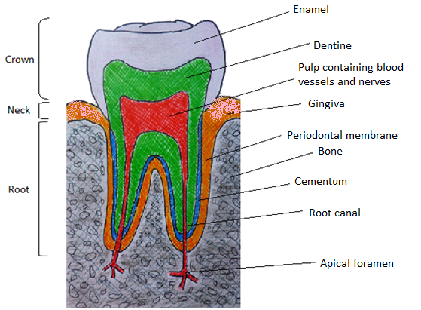

Figure 2.1. Tissues of the periodontium involved in tooth support.

To summarise, the functions of the healthy periodontium are to support and maintain the dentition. Diseases and injuries that involve these tissues and structures are therefore potentially serious, and can eventually result in tooth loss and impaired quality of life.

Periodontal diseases
Periodontitis is an inflammatory disease caused by microbial accumulation around the teeth (i.e. plaque) that calcifies into tartar or calculus. The bacterial plaque can secrete collagenase which results in destruction of the components of the periodontium (Sorsa et al., 2011). As the plaque accumulates, the body releases cells such as neutrophils, which leads to inflammation as the cells attempt to engulf the bacterial pathogens (Hao et al., 2015). To fight the infection, the body also releases chemical mediators such as cytokines. Excessive production of these mediators can become destructive, and cause further breakdown of the alveolar bone and connective tissue attachment (Page, 1991). When this inflammation is localised to gingival tissue but does not result in the destruction of bone or attachment apparatus, the condition is called gingivitis. Gingivitis does not always develop into periodontitis, however, if left untreated, it is likely to do so (Obiechina, 2011). Figure 2.2 shows comparative X-ray radiographs of healthy and diseased periodontium, demonstrating the recession of the alveolar bone that occurs with untreated periodontitis.
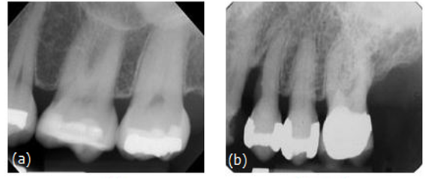
Figure 2.2. X-rays of (a) healthy teeth and periodontium and (b) diseased periodontium, showing recession of the alveolar bone and loss of tooth-bone contact tissue (Layport, 2010).

In addition to the effects on oral health, links have been established between periodontitis and other diseases, including peripheral arterial disease and hypertension (Chen et al., 2008b, Tsioufis et al., 2011). Furthermore, possible links between periodontitis and osteoporosis, rheumatoid arthritis and even preterm low birth weight babies have been identified (Persson et al., 2011, de Smit et al., 2011, Clothier et al., 2007). Additionally, diabetes has been accepted as a risk factor for periodontitis (Chang and Lim, 2012). Some studies have found that patients whose diabetes was well managed still experienced periodontal problems, suggesting that even with glycaemic control, diabetes-induced periodontal modifications may be irreversible (Iacopino, 2001).

Treatment of periodontitis
Whilst the main focus of the literature review is periodontal regenerative therapy involving the use of membranes and bone graft materials, this section will discuss alternative methods available for the treatment of periodontitis, and their limitations. Several alternate methods exist to treat periodontitis, including scaling and root planning (SRP), gingival curettage, open flap debridement, and the use of growth factors, in addition to the prescription of antibiotics (Bottino et al., 2012). These will be reviewed first, and their limitations highlighted, before attention is turned to bone tissue regeneration techniques.

SRP is carried out by the patient’s dentist or hygienist, and involves the removal of calculus and plaque both above and below the gum line, followed by root planing to smooth the surface of the tooth, helping to remove bacteria and promote reattachment of the gum. Gingival curettage completely removes both bacteria and the diseased tissue by removing the soft tissue lining of the periodontal pockets. It can be used in conjunction with SRP, however there is no significant improvement of the periodontal tissues when the two treatments are combined over SRP alone (Echeverria and Caffesse, 1983).

Open flap debridement (OFP) is a procedure in which the gingiva is incised to provide greater access to the alveolar bone and the tooth root surfaces. These areas can then be treated by the SRP procedure for the removal of plaque from areas that could not be reached via conventional SRP. However, occurrences of significant gingival recession have been reported in patients who have undergone this treatment method (Hirsch et al., 2004). Furthermore, treatment of sites with deep periodontal pockets has been reported to lead to significant gingival recession, due to the lack of bone support for the flap, thin gingival tissue and limited blood supply (Becker et al., 1988). An additional drawback is the shrinkage of the gingival flap itself, which may lead to tooth hypersensitivity, root surface caries, and potentially aesthetic connotations.
Growth factors are a group of proteins that are involved in cellular proliferation, differentiation and morphogenesis of tissues and organs from embryogenesis through to adulthood. Some growth factors are able to change the phenotype of their target cells, and are able to enhance the proliferation of certain cell types (Schliephake, 2002). The growth factors investigated include platelet-rich plasma (PRP), platelet-derived growth factor (PDGF), vascular endothelia growth factor (VEGF) and fibroblast growth factor (FGF). PRP has been demonstrated to enhance osteoprogenitor cell proliferation, promote angiogenesis, and enhance fracture healing and bone regeneration (Alsousou et al., 2009).

The most widely studied set of growth factors in bone regeneration are the bone morphogenetic proteins (BMPs), and they have been investigated in the repair of non-union fractures, bone defects and spinal fusion (Nauth et al., 2011). BMP-2 and BMP-7 are licenced for clinical use in open fractures of long bones, non-union fractures and spinal fusion (Gautschi et al., 2007). It has been shown that long-term delivery of BMP-2 is more effective at promoting bone regeneration a burst release of the same dose over a few days. (Jeon et al., 2008).

FDA approval was granted in 2007 for the delivery of BMP-2 via a collagen sponge carrier for clinical use in craniofacial deformities (Razzouk and Sarkis, 2012). Natural materials investigated as carriers include, alginate, hyaluronans, silk, fibrin, with the most popular choice being collagen (Gupta and Maitra, 2002), (Yilgor et al., 2009). Synthetic materials include PLA, PGA, PLGA and PCL (Schliephake et al., 2008), (Shen et al., 2009),(Saito and Takaoka, 2003),(Savarino et al., 2007). Ceramics including β-TCP and HA and ceramic-polymer composites have also been evaluated as potential carriers and delivery systems for BMPs (Sohier et al., 2010),(Notodihardjo et al., 2012),(Fu et al., 2008),(Wang et al., 2003).

The main challenge currently hindering the more routine use of BMPs in the field of regenerative medicine is the delivery mechanism. The level of BMP needed to promote bone regeneration is far in excess of that found in the human body, and the challenge for researchers is how to achieve an optimal delivery system that is able to use a significantly reduced dose of BMP, whilst maintaining a sustained release pattern that is effective for osteoconduction (Meikle, 2007).

Regenerative surgery using guided bone regeneration (GBR) techniques is a treatment scheme formulated at the turn of the 21st century to fill the bony defects caused by peri-implantitis. This is caused by inflammation that occurs around a dental implant site, commonly 10 years post-implantation, that leads to loss of the supporting tissue (Jung et al., 2008, Lang et al., 2000). Numerous case reports, case series, and clinical trials on GBR techniques in peri-implantitis have been reported.

GBR membranes also have applications in other maxillofacial surgical procedures, including the treatment of cleft lip and palate defects and reconstruction of the mandible (Machtei et al., 1999, Sverzut et al., 2008). Other applications of GBR include the treatment of large cystic jaw bone lesions and large bony defects created following the removal of tumours (Apruzzese and Longoni, 1999). With these additional applications in mind, membranes and their modification are the main subject of this review, and are therefore considered in more detail in section 2.4.

Guided bone regeneration membranes
The mid-1980s saw the introduction of the GBR principle. This suggested that when cells which have the ability to regenerate the type of tissue that has been lost are allowed to populate the defect during the healing period, regeneration of that particular type of tissue is possible (Nyman et al., 1990). Guided bone regeneration membranes are used to promote bone formation in osseous deformities, such as extraction sites, or to regenerate lost supporting tissue, such as alveolar bone, periodontal ligament and cementum around the site of a previously diseased tooth root (CM Agrawal, 2000). GBR membranes can be used to either preserve the socket around an in situ tooth, or after the tooth has been extracted or lost, in order to regenerate bone into the socket site. Figure 2.3 demonstrates the placement for a membrane for socket preservation around an existing tooth, and as a tool to regenerate alveolar bone after tooth loss or extraction.

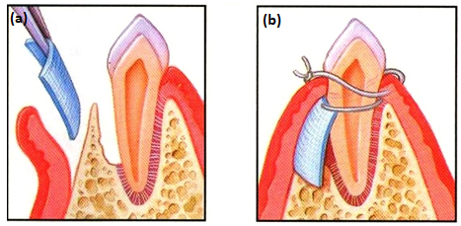
Figure 2.3. Schematic of the placement of a membrane for socket preservation. (a) In order to preserve the socket around an in situ tooth, the area concerned is cleaned and a membrane inserted between the gum and bone. (b) The membrane acts as a carrier to exclude unwanted tissue, allowing the lost bone to regenerate and ligament fibres to grow. Once the regeneration is complete, the membrane is either surgically removed or resorbed by the patient’s own body (Gerrish, 2011).

The GBR protocol involves the surgical placement of a cell-occlusive membrane that faces the bone surface. Thus the site where regeneration is required is physically sealed off, and the membrane creates and maintains an isolated space. This provides a suitable environment for osteoprogenitor cells to be recruited, proliferate and differentiate along the osteoblastic lineage, so that expression of osteogenic activity is possible (Linde et al., 1993, Karring et al., 1993). New bone, PDL and cementum can be formed by the repopulation of the root area by progenitor cells in the remaining periodontal ligament, adjacent alveolar bone or blood, differentiating into new supportive tissues of the periodontium (Bottino et al., 2012).

Laurell et al performed a meta-analysis on 20 years of articles on the surgical treatment of intrabony defect. Outcomes from treatments including (a) open flap debridement (OFD), (b) OFD plus bone grafts (demineralised freeze-dried bone allograft, freeze-dried bone allografts or autogenous bone) and (c) GTR in “intrabony” defects were analysed. The articles studied presented data on probing depths, intrabony defect depths measured during surgery, clinical attachment level gain and/or bone fill. GTR treatment yielded the most significant pocket reduction compared to the other treatments (Laurell et al., 1998).

For a GBR membrane to achieve clinical success, there are certain properties and/or abilities that it should possess:
- Cell exclusion: a GBR membrane is used to exclude gingival fibroblasts and/or epithelial cells from accessing the wound site and then forming fibrous connective tissue (Basile et al., 2015)
- Framework: in non-space maintaining defect, it may be necessary to support the membrane in order to prevent collapse. This support can sometimes be provided by a bone graft (Gottlow et al., 1986)
- Tenting: the membrane should be fitted so that a space is created that will function to isolate the defect from soft tissue. The membrane should also be cut to fit so that it extends 2-3 mm beyond the defect in all directions (Kaneko et al., 2012)
- Scaffolding: a fibrin clot initially occupies the tented space, serving as the scaffold for the in-growth of progenitor cells (Khan et al., 2014)
- Stabilisation: in order to protect the clot from being disturbed by movement of the overlying flap during the healing process, the membrane can be held in place using sutures or mini bone screws (Von Arx and Buser, 2006), (Chiapasco et al., 1999)
- Clinical manageability: the membrane should have good handling properties for ease of use by the surgeon (Kim et al., 2005b)
- Biocompatibility: should be excellent in order to avoid unnecessary adverse reactions to the membrane, such as inflammation.

To summarise, when considered carefully, membranes represent surprisingly complex systems where a large number of variables will determine clinical performance. If the bone defect is too large, the membrane is at risk of collapse into the defect site. Scaffolds can be used to prevent this collapse from occurring by offering additional stability, and will be discussed more in the following section.

Resorbable vs. non-resorbable
Two types of membrane exist: resorbable and non-resorbable. The use of a resorbable membrane removes the need for a secondary surgical procedure to remove the material, thus reducing both the cost of the procedure and the trauma suffered by the patient. Resorbable membranes include those made from polyglycolide (PGA), polylactide (PLA), co-polymers of the two, and collagen barriers (Imbronito et al., 2002a). However, the meta-analysis performed by Laurell et al found that there were no significant differences between the performances of resorbable and non-resorbable membranes.

Imbronito et al., compared the newly formed bone under resorbable (PLA) and non-resorbable expanded polytetrafluoroethylene (e-PTFE) membranes two and four months after the membrane placement. Newly formed bone was observed under both types of membrane, and the amount of regenerated bone was similar between both types of membrane at 2 and 4 months post-surgery (Imbronito et al., 2002a). Results showed that more bone was formed at the sites protected by membranes than at the control site after 2 months, and the area of augmented bone was higher in the sites with the resorbable membrane compared to both the control site and the non-resorbable membrane site. It was concluded that both the resorbable PLA membrane and the non-resorbable e-PTFE membrane tested had limitations for the treatment of large, non space-making defects, and suggested that bone graft materials supporting the physical barrier might help to prevent barrier collapse into osseous defect.

The current “gold standard” guided bone regeneration membrane is a natural and resorbable membrane fabricated from porcine collagen with a bilayered structure (Bio-Gide®, Geistlich, Switzerland). The two former “gold standard” membranes on the market were both based on e-PTFE, e.g. GoreTex® (Gore, Newar, DE, USA) and Cytoplast® TXT-200 (Osteogenics Biomedical, Lubbock, TX, USA). e-PTFE membranes are inert, biocompatible, and aid tissue integration, cell occlusion and mechanical stability (Bottino et al., 2012). However, their use has been limited by the necessity of a second surgical procedure for removal and by the high membrane exposure rate, which could potentially cause the patient discomfort, increased cost, and there is a risk of suboptimal bone regeneration (Gotfredsen et al., 1993).

The second most popular membrane is titanium-reinforced high-density PTFE e.g. Cytoplast® Ti-250 (Osteogenics Biomedical, Lubbock, TX, USA). Studies comparing the performance of traditional PTFE membranes to titanium-reinforced high density PTFE membranes concluded that the latter leads to superior regenerative capacity, mostly due to the additional mechanical support that the titanium frame provides against the compressive forces exerted by the overlying soft tissue (Jovanovic and Nevins, 1995). However, the need for a second surgical procedure to remove the membrane led to the development of bioresorbable membranes, which do not need to be removed.

Current resorbable membranes are commonly made of collagen, polyglycolide, polylactide, or co-polymers of lactic and glycolic acid. However, these membranes can have weak structural integrity, variable degradation rates and can provoke host immune reactivity. The following sections review the synthetic resorbable and non-resorbable, and natural resorbable polymers available to be utilised in membrane technology.

Resorbable polymers

Synthetic resorbable polymers
Biodegradable polymers undergo four states of degradation once they have been placed in a biological system, or any other aqueous environment. These stages are: hydration, loss of strength, loss of mass integrity and solubilisation via phagocytosis. The nature of the polymer, the polymer crystallisation degree, the temperature, pH and the membrane volume all influence the duration of each of the four stages of degradation and consequently the overall degradation rate (Warrer et al., 1992, Hammerle and Jung, 2003). From this, it can be inferred that the duration of the barrier function is not under complete control, and that the resorption process could interfere with the bone regeneration process, as well as the wound healing. It has been suggested that whilst bioresorbable membranes have eliminated the need for a second surgical procedure, e-PTFE membranes should still serve as the gold standard for comparing results obtained from new materials (Hammerle and Karring, 1998).

Table 2.2 overleaf summarises the main synthetic resorbable polymers used in medicine and tissue engineering, with examples of the medical applications they are used in.
Table 2.2. Summary of synthetic resorbable polymers and their applications in medicine.
Polymer | Biodegradability/features | Medical applications
Polyglycolide  (PGA) | High crystallinity (45-55%), high tensile modulus, very low solubility in organic solvents. Bulk degrading polymer, loses strength in 1-2 months when hydrolysed, loses mass in 6-12 months. Broken down into glycine (excreted in urine or converted to CO₂ and water via the citric acid cycle) (Maurus and Kaeding, 2004). | DEXON® (biodegradable synthetic suture).
Poly(lactide)  (PLA) | Slow degradation rate of several years for complete resorption to occur to hydrophobic methyl group in the backbone. | Drug delivery systems, protein encapsulation and delivery, hydrogels (Hu et al., 2003, Chandy et al., 2002, Li, 2003)
Poly(L-lactide), (PLLA) | ~37% crystallinity. Slow degradation rate, high modulus, good tensile strength and low extension. Hydrolytic degradation (Oonishi et al., 1997). | Orthopaedic products: Bioscrew®, Full Thread Bio Interference Screw®.
Poly(lactide-co-glycolide)  (PLGA) | Co-polymer of PGA and PLLA. Demonstrates good cell adhesion. Degradation rate depends upon lactic acid: glycolic acid, molecular weight and matrix shape and structure. | Vicryl Mesh®. Guided tissue regeneration (space preservation): CYTOPLAST Resorb®. (PLGA-collagen matrix).
Polydioxanone | Hydrolytic degradation, broken down into glycoxylate and excreted in urine or similar breakdown to PLLA. Loses strength within 1-2 months, loses mass within 6-12 months. | Drug delivery vehicle for small and medium-sized biologically active molecules (SynBiosys®)
Polycapralactone (PCL) | Low tensile strength (~23MPa) but very high elongation at breakage (>700%) (Bonzani et al., 2007). Degradation rate slow (2-3 years). Excellent biocompatibility. | PCL composites with calcium phosphate-based ceramics investigated as bone tissue engineering scaffolds (Sinha et al., 2004).
Poly(trimethylene carbonate) (PMTC) | Excellent flexibility, poor mechanical strength. Rate of in vivo degradation found to be much higher than in vitro degradation, potentially due to enzymatic degradation process (Zhang et al., 2006). | Used in a 67 % PGA : 33 % TMC blend in Gore® Resolut® Adapt® membrane (discontinued)
Polyurethanes | Non-resorbable without modification, but resorbable polyurethanes can be created by reacting lysine diisocynate (LDI) polyurethane polymer with PDLLA, PCL and other co-polymers, which has demonstrated appropriate bonding strength and mechanical support at physiological temperatures, as well as showing promotion of favourable cell adhesion and proliferation (Bonzani et al., 2007). Excellent biocompatibility and mechanical properties. | PolyNova® (LDI-based polyurethane system- orthopaedic applications- bone cement). Degrapol® (elastic poly(ester urethane) developing highly porous scaffold for tissue engineering applications (Saad et al., 1997).

Polycaprolactone (PCL)
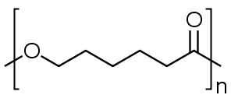
Figure 2.4. Structure of polycaprolactone.

Polycaprolactone (PCL) is a Food and Drug Administration (FDA) approved semicrystalline polyester that is highly processable and is soluble in a wide range of organic solvents. Its crystallinity tends to decrease with increasing molecular weight, and it has good solubility and a low melting point (59-64 °C). Synthesis of PCL, via free radical ring-opening polymerisation, is of relatively low cost (Woodruff and Hutmacher, 2010). It undergoes hydrolytic degradation due to the presence of hydrolytically labile aliphatic ester linkages, but the degradation rate is slow at a reported 2-3 years.

PCL has been used as a suture material as a blend with other bioresorbable polymers, for example Monocryl®, a suture based on segmented block copolymers of PCL and PGA (Bezwada et al., 1995). Its initial popularity in the medical research sector waned in the face of increasing interest in polymers with shorter degradation times for use in devices that would release drugs within days or weeks, and that would be completely resorbed within 6 months post-implantation (Woodruff and Hutmacher, 2010). Its poor mechanical properties made it unsuitable for use in load bearing applications. Uses for PCL include as a release vehicle for chlorohexadine and an ultra-thin film for cutaneous wounds.

The slow degradation time of PCL makes it a suitable polymer for use in bone regeneration scaffolds. However, its limitations for use in tissue engineering applications include its lack of bioactivity and its inherent hydrophobicity (Declercq et al., 2013).

Polyglycolide (PGA)
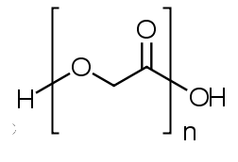
Figure 2.5. Structure of polyglycolide.

Polyglycolide (PGA) has been used as a medical suture since the 1960s and has FDA approval for use in biomedical applications including a vascular closure device (Middleton and Tipton, 2000),(Schmelter et al., 2013). PGA has been studied both in vivo and in vitro (Kellomaki et al., 2000). Several studies have found that seeded cells showed good growth and adhesion on the surface of PGA membranes, suggesting good bone tissue compatibly (Hatton et al., 1994, Breitbart et al., 1998). On its own, membranes only had a small effect on bone regeneration, but bone formation was improved when the membrane was seeded with cultured cells (Breitbart et al., 1998). Self-reinforced PGA membranes were found to guide bone regeneration and also lead to the enhanced healing of metaphyseal bone defects in rabbits, and were biocompatible with osseous tissue (Ashammakhi et al., 1994, Ashammakhi et al., 1995, Ashammakhi, 1996). It has previously been shown that culturing cells on PGA can increase the degradation rate of the polymer, limiting its use in applications where it is desirable for the membrane to retain structural integrity for longer periods of time (Dong et al., 2010).

PGA has a short resorption time, with strength lost in 1-2 months post implantation, which in certain applications can be disadvantageous. An increased resorption rate with total degradation within 3 weeks for electrospun PCL has been reported. These materials were only able to support cell growth for the first few days (Dong et al., 2010). The rapid resorption time of PGA, which is less than that of other polylactides, limits its use as a suitable polymer for GBR.

Poly(L-lactide) (PLLA)
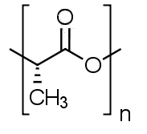
Figure 2.6. Structure of poly(L-lactide).

PLA is a biodegradable aliphatic polyester that is relatively cheap to produce in large scale quantities, and can be manufactured in a wide range of grades (Avérous, 2008). PLA can exist in the forms of poly-L-lactide (PLLA), poly-D-lactide (PDLA) and poly-DL-lactide (PDLLA) (Kim et al., 2003). Due to its amorphous structure, PDLLA has a shorter degradation time than crystalline PLLA: less than and more than 6 months respectively (Merolli et al., 2001, Chen et al., 2008a).

Bhattarai et. al., created a nonwoven fibrous matrix from biodegradable poly(p-dioxanone-co-L-lactide)-block-poly(ethylene glycol) (PDDO/PLLA-b-PEG) copolymer that was electrospun into a scaffold (median pore size 8 µm, porosity greater than 80% and a mechanical strength of 1.4 MPa). NIH 3T3 fibroblasts cells seeded onto the structure were reported to maintain phenotypic shape and showed guided growth according to the orientation of the nanofibres. The structure demonstrated the ability to support cell attachment and proliferation (Bhattarai et al., 2004). The inclusion of the p-dioxanone (PDO) segments in the PLLA segment is responsible for the improved biodegradable release matrix over the PLLA-b-PEG copolymer (Saito et al., 2001).

PLLA-tetracycline films cast onto PGA meshes have been investigated as a method of providing antibiotic release alongside the barrier function. Bony reunion occurred after 2 weeks of implantation in rat calvarial defects, and maintained a barrier function for four weeks post implantation. Tetracycline was included as it has been shown to enhance bone-forming ability by reduced bone resorption and osteoblast cell chemotaxis (Park et al., 2000a).

Poly(lactide-co-glycolide) (PLGA)
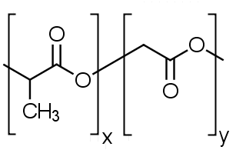
Figure 2.7. Structure of poly(lactide-co-glycolide).

Factors explaining the popularity of PLGA for biomedical applications include its excellent biocompatibility and FDA approval for use in humans. PLGA has a tailorable degradation rate, which depends upon a variety of parameters, including the LA/GA ratio, molecular weight, and the shape and structure of the matrix. 75:25 LA:GA PLGA has a degradation rate of 4-5 months; the degradation rate decreases with increasing LA content (JP Jain, 2011). PLGA co-polymers with a higher LA content are more hydrophobic, absorbing less water. Its slower rate of degradation is due to the presence of methyl side group in PLA, which makes it more hydrophobic than PGA (Gentile et al., 2014).

PLGA undergoes hydrolytic degradation of its ester linkages in aqueous environments, which can be described in four steps. Firstly, in a hydration stage, water penetrates into the amorphous regions, disrupting hydrogen bonds and Van der Waals forces, causing a decrease in the glass transition temperature (T_{g}). Secondly, initial degradation occurs, leading to a decrease in molecular weight due to the cleavage of covalent bonds. Constant degradation occurs in the third phase, during which carboxylic end groups autocatalyse the degradation process, and mass loss is begun by massive cleavage of the backbone covalent bonds, causing loss of polymer integrity. Finally, the fragments are further cleaved to soluble molecules, and degradation is homogenous (Engineer et al., 2011).

Good processability means it can be made into a variety of structures and forms. Current applications of PLGA include meshes (Vicryl Mesh®), suture reinforcements and skin replacement materials. Dermagraft®, a tissue engineered skin graft, uses a Vicryl Mesh® as the scaffolding structure. PLGA is a potential candidate in tissue engineering devices as it shows good cell adhesion and proliferation. CYTOPLAST Resorb® is a composite PLGA-collagen matrix for guided tissue regeneration that is currently on the market. Lupron Depot® is a commercially available drug delivery device which uses PLGA microspheres combined with a cancer drug for the treatment of advanced prostate cancer (Lu et al., 2009). 75:25 PLGA microspheres loaded with an antimycobacterial agent have been investigated as a targeted tuberculosis treatment (Suarez et al., 2001). This polymer has also been shown to have potential as a controlled drug delivery system for the delivery of antibiotics for the treatment of one of the main bacteria responsible for dental implant failure (Gentile et al., 2015).

There have been reports of electrospun PLGA membranes shrinking extensively when incubated in aqueous media at 37 °C (Kim et al., 2003). PLGA exhibits shrinkage by almost 80 % after soaking in aqueous media at 37 °C for 2 hours. Relaxation of the polymer chains in the fibres can be responsible for the significant shrinkage of the electrospun membrane. One explanation of this behaviour is due to the alignment of the polymer chains in the fibres due to electrospinning. If the glass transition temperature (T_{g}) of the polymer is low enough, the aligned polymer will gradually relax to random coils, causing the entire membrane to shrink. The dry electrospun PLGA mesh was able to maintain its dimensional morphology at 37 °C. No shrinkage was observed for the wet PLGA mesh at room temperature (25 °C). The T_{g} of PLGA was measured by differential scanning colorimetry to be 48 °C (literature value 50-55 °C depending upon polymer molecular weight). When subjected to water treatment, T_{g} of PLGA decreased to about 35 °C. In contrast, non-woven meshes composed of PCL or PLLA retained their dimensional morphology (Yoshimoto et al., 2003, Zong et al., 2003). Cell migration from the seeding site into the electrospun mesh could be limited by the shrinkage-induced decrease in the mesh porosity, and serious fibre “fusion” was observed during the PLGA electrospun membrane degradation (Sung et al., 2005).

Although PLGA and PCL are immiscible, the presence of PCL slowed PLGA degradation (Zhu et al., 2008). One study found that no significant shrinking of the PLGA meshes occurred when the PLGA fraction was below 80%, but above 90% PLGA content the shrinkage increased with increased PLGA content. It was found that the T_{g} of PLGA increased with the increase in PCL content in the fibre. XRD patterns suggested that the crystalline region in the composite fibres with a PCL fraction greater than 20% can act as physical cross-linking points, preventing relaxation of the aligned polymer chains in the fibres. Liu et al., observed an increase in fibre diameter from 1.35 µm to 1.95 µm with an increase in the PLGA fraction from 20 % to 100 % (Liu et al.,2008).

Owen et al., fabricated a PLGA membrane with the aim of controlling cell behaviour for promoting periodontal tissue regeneration. The membranes were created by casting a PLGA copolymer (85:15) blend with methoxy(polyethyleneglycol) (MePEG), with smooth, grooved and sandblasted-acid-etched topographies. The membrane was reported to remain intact for at least 3 months in an aqueous environment. The membrane was designed to inhibit epithelial cell migration or proliferation on one side, and guide osteoblast migration to a desired area on the other side. Migration of epithelial cells was inhibited on the sandblasted-acid-etched surface, whilst they spread on the smooth surface. Osteoblasts were reported to spread and increase in number on the grooved and smooth surfaces, with the cells that adhered in the grooves migrating preferentially in the direction of the grooves. The authors suggested that a grooved surface of a membrane could be placed facing the bone defect to guide osteoblasts to the defect, whilst a rough surface could be produced for the surface that faces the epithelium, to inhibit epithelial migration and proliferation, providing the barrier function (Owen et al., 2005). b

Natural polymers
Table 2.3. Summary of natural resorbable polymers and their applications in medicine.
Material | Biocompatibility/features | Medical applications
Collagen | Undergoes enzymatic degradation in body via enzymes e.g. collagenases and metalloproteinases. Use as drug delivery vehicle- extent of drug release controllable by varying physical properties e.g. porosity, density and degradation rate. High concentration of collagen accounts for the high strength of natural bone. | Bio-Gide® (porcine skin, GBR membrane), Alloderm® (human skin), Alloderm® (bovine Achilles tendon) and Biobrane® (acellular collagen matrices), Apligraf® (collagen-based bilayer dressing seeded with live human keratinocytes and fibroblasts). DuraGen® (3D collagen matrix graft for spinal repair and regeneration (Narotam et al., 2004). Septocoll® (prolonged antibiotic collagen delivery system) (Gruessner et al., 2001).
Hyaluronic acid | Glycosaminoglycan. Can undergo degradation within the body by free radicals and MMPs found in the extracellular matrix, followed by endocytosis. Also digestible by lysosomal enzymes to form mono and disaccharides, further converted into NH₃, CO₂ and H₂O via Krebs cycle (Al-Assaf et al., 2003). | HYAFF® (Wound dressing applications). AMVISC® (vitreous humor substitute, eye tissue protection during cataract extraction, corneal transplantation and glaucoma surgery). SYNVISC® (synovial fluid substitute).
Chitosan | Biodegradable, non-antigenic, biocompatible, biologically renewable | Wound dressing, wound healing, drug delivery systems, tissue engineering scaffolds (Ravi Kumar, 2000, Hirano et al., 1990, Aiedeh et al., 1997, Berger et al., 2004, Park et al., 2000b)
Chondroitin sulphate | Major component of aggrecan, the most abundant glycosaminoglycan found in proteoglycans of articular cartilage. Involved in intracellular signalling and cell recognition. Anti-inflammatory properties (S Ayad, 1994). | Wound dressing applications. Possibility of using chondroitin sulphate with other biopolymers e.g. collagen or synthetic biodegradable polymers as cartilage tissue engineering scaffolds (Maurus and Kaeding, 2004).

Collagen
It has been thought that using a collagen membrane might improve guided tissue regeneration by enhancing its native properties, as both alveolar bone and the periodontal ligament contain collagen (Bashutski and Wang, 2009). The current gold standard of GBR membranes is a porcine collagen type I and III membrane (Bio-Gide®, Geistlich, Switzerland). Collagen membranes exist that are made from human skin (AlloDerm®, LifeCell™, NJ, USA) and bovine Achilles tendon (Neomen®, Citagenix, Laval, Canada) (Owens and Yukna, 2001), (Schwartzmann, 2000).

Collagen facilitates wound stability by promoting platelet aggregation and fibroblast migration, which might accelerate wound closure (Steinberg et al., 1986). The high cost and a poor definition of its commercial sources combine to limit the use of type-I collagen as these factors make it difficult to control the degradation and mechanical properties of the membrane. A poor performance in vivo as the membrane starts to degrade, combined with concerns about disease transmission, religious beliefs and ethical concerns combine to limit the use of collagen membranes. The matrix stability and biomechanical properties of collagen can be improved by physical/chemical crosslinking, but the ethical and disease concerns remain.. K

Silk fibroin
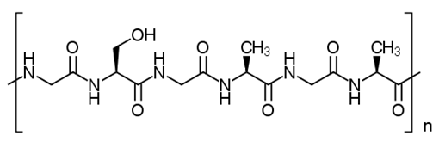
Figure 2.8. Structure of silk fibroin.

Good biocompatibility, oxygen and water permeability and biodegradability make silk fibroin a potential candidate for biomedical applications (Santin et al., 1999). Silk can be obtained from a diverse number of sources, including spiders, silkworms, scorpions, mites and flies. Spider silk has been limited in its commercial use due to the cannibalistic nature of spiders (Kundu et al., 2013). Silkworm silk has been accepted as a high quality textile fibre and suture for a long time. It consists of two types of proteins: fibroin and sericin. Over decades of use, silk fibres have proven to be effective in many clinical applications, yet there are biocompatibility concerns about inflammation and degradation. Recent research however has identified the sericin proteins as the major cause of these problems, which include skin irritation and hypersensitivity (Aramwit et al., 2009),(Meinel et al., 2005). Biological responses to the fibroin fibres are reported to improve if sericin is removed (Foschi et al., 2001). However, the process of removing sericins is detrimental to the mechanical properties of the silk (Pérez-Rigueiro et al., 2002).

Fibroin on its own has been investigated as a membrane material (Altman et al., 2003). Silk fibroin has been considered as a potential electrospun substrate due to its useful properties for tissue engineering, e.g. as cell compatibility, biodegradability, and minimal inflammatory response (Jin et al., 2004). A matrix of silk fibroin fibres can support the attachment, growth and differentiation of human progenitor bone marrow stromal cells (Altman et al., 2003).
Initial cell adhesion and growth of bone marrow stromal cells and osteoblastic cells have been observed on electrospun silk nanofibres (Meechaisue et al., 2007). The ability of silk fibroin to promote the deposition of calcium phosphate minerals that are able to form an apatite-silk nanocomposite is one of its advantages in bone regeneration (Li M, 2005). A patent exists for a nonwoven guided bone tissue regeneration membrane of silk fibroin nanofibres that have been obtained by removing sericin from the silk fibres (Chung et al., 2008).

Although native silk fibres have excellent mechanical properties, including high strength with flexibility, many silk materials developed from silk fibroin solution are weak and brittle (Altman et al., 2003). In addition, the long term safety of silk materials in the human body remains under question. Although silk sutures are successfully used in surgical procedures, they are removed from the body after a certain period of time. Further investigation is needed into the effect of silk biomaterials placed in contact with tissues for a prolonged period of time, with reference to the location of the implant and any associated immune system responses.

Non-resorbable polymers

Non-resorbable synthetic polymers
Table 2.4. Summary of synthetic non-resorbable polymers and their applications in medicine.
Polymer | Biocompatibility/features | Medical applications
Polytetrafluoroe-hylene  (PTFE) | Chemically stable. Biologically inert. Porous structure and flexible form. Resists microbiological and enzymatic degradation. Does not illicit immunologic reactions (Laustriat et al., 1990) | Membranes for periodontal and bone regeneration (Gore-Tex®), used as an implant in rhinoplasty (Godin and Della Torre, 2008). Heart valve implants (Quintessenza et al., 2010)
Polyurethanes | Biostable (Burke and Hasirci, 2004). Excellent biocompatibility and mechanical properties. Synthesised from polymers including poly(ethylene glycol) (PEG) and poly(propylene oxide) (Janik and Marzec, 2015) | Investigated as long term medical implants, e.g. pacemakers and vascular grafts (Ratcliffe, 2000)

Polytetrafluoroethylene

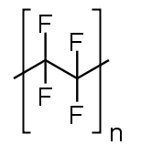
Figure 2.9. Structure of polytetrafluoroethylene.

PTFE is a chemically and biologically inert polymer, and has the ability to resist enzymatic and microbiological attack, making it suitable for use as a medical membrane (Marouf and El-Guindi, 2000). The macroporous structure of expanded PTFE (e-PTFE) is believed to enhance wound healing, however, this material can be affected by early bacterial infections, which can have a detrimental outcome on the regeneration process (Carbonell et al., 2014). e-PTFE membranes require primary closure to prevent the ingrowth of soft tissue, bacterial contamination and infection, graft exposure and membrane movement.

High-density non-expanded polytetrafluoroethylene (n-PTFE) has been proposed as a solution to the issues surrounding the porous nature of e-PTFE membranes. The n-PTFE membranes are non-porous, dense and non-permeable, and do not require primary closure (Bartee and Carr, 1995), (Barber et al., 2007). Commercially available n-PTFE membranes include Cytoplast Regentex TXT-200 and Ti-250, a titanium-reinforced membrane (Osteogenics, Lubbock, TX, USA). n-PTFE lacks tissue adhesion properties, but attempts to overcome this issue have been made by combining the non-resorbable membrane with a collagen membrane (Wang and Carroll, 2001). This combines the benefit of an n-PTFE membrane not requiring primary closure with the biocompatible properties of collagen. This synergistic treatment negates the benefits of the resorbable collagen membrane over the non-resorbable n-PTFE membrane i.e. a second surgical procedure is still required, and improved imperviousness to bacteria over e-PTFE membranes, n-PTFE membranes are still limited still by the necessity for their removal.

The following pages summarises all commercially available synthetic resorbable, natural resorbable and synthetic non-resorbable guided bone regeneration membranes, including those which have been withdrawn from the market (Table 2.5 Table 2.7 respectively).

Commercially available synthetic resorbable polymer guided bone regeneration membranes
Table 2.5. Summary of commercially available synthetic resorbable polymer guided bone regeneration membranes.
Product name | Manufacturer | Material | Properties and comments
MembraGelTM | Straumann® | PEG | Gel application, quicker to place than conventional membranes. Barrier properties last 4-6 months
Epi-Guide® | Curasan AG | PLA | 3-layer design, maintains structural integrity for up to 20 weeks, full degradation occurs 6-12 months
Inion GTRTM | Curasan AG | Co-polymers of L-lactic, D-lactic, glycolic acid & TMC | Provides barrier function for 8-12 weeks. Plasticiser provided temporarily softens membrane to aid handling and shaping
RESOLUT® ADAPT® | Gore® | PGA & PLA | Remains substantially intact for 8-10 weeks. Discontinued
RESOLUT® ADAPT® LT | Gore® | PGA:TMC copolymer | Remains substantially intact for 16-24 weeks. Discontinued
RESOLUT® XT | Gore® | PGA:TMC copolymer | Remains substantially intact for 8-10 weeks. Discontinued
Atrisorb® | Citagenix | Powder-form polylactide in liquid carrier (NMP) (Hou et al., 2004) | Barrier function for at least 20 weeks, applied as a gel. Membrane thickness 600-750 μm. No significant degradation before 5 months (Coonts et al., 1998).
Guidor® | Sunstar Guidor® | PLA & citric acid ester acetyl tributylcitrate | Rectangular perforations (400-500/cm²) of external layer designed to allow integration of overlying gingival flap. Barrier function maintained for min. 6 weeks, total resorption 6-12 months (Aurer and Jorgić-Srdjak, 2005).
AMCA bone membrane | Regenecure | Ammonio methacrylate copolymer type A & a plasticiser | In clinical trial stage.
Vicryl Periodontal Mesh® | Ethicon/Johnson & Johnson | Polyglactin 910 | Membrane loses structure after 2 weeks, complete resorption in 4 or more weeks (Aurer and Jorgić-Srdjak, 2005).

Commercially available natural resorbable polymer guided bone regeneration membranes
Table 2.6. Summary of commercially available resorbable natural polymer guided bone regeneration membranes.
Product name | Manufacturer | Material | Properties and comments
Bio-Gide® | Geistlich | Porcine collagen (types I & III) | Natural bilayer system. Current gold standard. 24 week resorption time (Bunyaratavej and Wang, 2001)
CytoplastTM RTM Collagen | Osteogenics | Bovine collagen type I (Achilles tendon) | High tensile strength, multilayer construction. Resorption 26-38 weeks
MatrixDermTM | Collagen Matrix Dental | Porcine collagen (types I & III) from intact dermis | Thickness 0.3-0.5 mm, high mechanical strength. Resorbable in 6-9 months, slight exposure is acceptable.
Zimmer CurVTM | Zimmer Dental | Bovine collagen type I (Achilles tendon) | Pre-shaped configurations for anterior and posterior placement. Can be trimmed and shaped to most defect sites
CollaGuideTM | Curasan | Bovine collagen type I | As barrier resorbs, fibrils making up the membrane separate, creating a matrix allowing fibroblast infiltration and cellular attachment
PARASORB RESODONT® | Resorba | Equine collagen | Crosslinked without chemical additives, no fixation required. Microstructure permits growth of bone-producing cells
BioSorbTM | 3M EPSE | Bovine collagen type I (Achilles tendon) | Dense orientated fibres provide mechanical strength. Degrades in 26-38 weeks (Rakhmatia et al., 2013)
OsseoGuardTM | Biomet 3i® | Bovine collagen type I (Achilles tendon) | Dense fibrillar matrix structure to provide strength. Pore size occlusive to gingival and epithelial cells while still permeable to essential nutrients
OsseoGuard FlexTM | BIOMET 3i® | Bovine collagen types I & III (dermis) | Engineered to yield flexibility. Pore size occlusive to gingival and epithelial cells while still permeable to essential nutrients.

Commercially available synthetic non-resorbable polymer guided bone regeneration membranes

Table 2.7. Summary of commercially available synthetic non-resorbable polymer guided bone regeneration membranes.
Product name | Manufacturer | Material | Properties and comments
Gore-Tex® | Gore® | e-PTFE | Discontinued
CytoplastTM TXT-200 | Osteogenics | n- PTFE | Pore size < 0.3 µm. Hexagonal dimples to increase surface area
TefGen-FDTM | Keystone Dental | n-PTFE | Bioinert. Can remain in place for up to 9 months before removal, easy to remove (Marouf and El-Guindi, 2000)
CytoplastTM Ti-150 | Osteogenics | Titanium reinforced high density PTFE | 150 µm thick. 8 different membrane configurations available, little trimming necessary
CytoplastTM Ti-250 | Osteogenics | Titanium reinforced high density PTFE | 250 µm thick. Textured RegentexTM surface aids stabilisation of the membrane
Gore® Regenerative membrane titanium reinforced | Gore® | Titanium reinforced e-PTFE | Space-creating and shape-maintaining. Discontinued
CTi-mem | HuberMed | Titanium | Pre-shaped for intended target shape, easily removed

Patents
US patent 6,589,590 B2 covers a method for making a collagen-HA composite membrane. The HA coating is created by the use of a calcium solution and a phosphate solution, separated by the membrane. The calcium ions and phosphate ions then diffuse across the membrane, and form a crystalline deposit upon meeting. By controlling the pH and concentration of each solution, the resulting precipitate is controllable. The authors claim to be able to obtain a HA coating that is in the range of 1-80 % by weight of the weight of the composite membrane (Czernuszka et al., 2003).

A PCL/PLGA/TCP composite membrane has been patented for uses in GBR. The membrane has a dense layer made of resorbable polymer, which acts as the barrier to cells and soft tissues and provides the membrane with rigidity and stiffness to maintain the defect space. A second nanofibrillar layer made of a resorbable polymer, with fibre diameters in the range of collagen fibres, provides support for cell attachment, proliferation and differentiation. This layer contains micro-sized tricalcium phosphate (TCP) particles. In vivo experiments using a rabbit calvaria model showed the formation of a mature new bone layer that bridged the defect (Hoornaert et al., 2013).

A silicon-releasing calcium carbonate-PLA composite bilayer membrane is described in US 2012/0315319 A1. Silicon-releasing calcium carbonate is contained in a non-woven PLA layer, with a second layer of non-woven biodegradable polymer. The PLA layer prevents the invasion of soft tissues, whilst the silicon-releasing calcium carbonate-PLA layer improves cellular affinity and osteogenic ability (Kasuga et al., 2010).

Use of scaffolds in bone regeneration
Scaffolds can be required for a range of reasons, from bone loss due to tumour removal to non-unionised fractures. In dental and maxillofacial surgery, scaffolds can be used in combination with membranes as part of the GBR procedure in order to regenerate alveolar bone if additional mechanical stability is required due to the size of the defect (Figure 2.10).
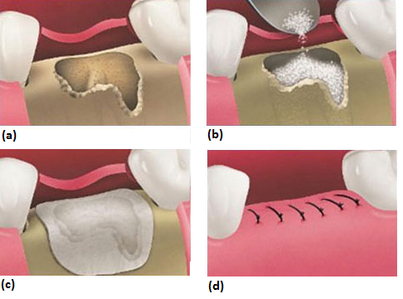
Figure 2.10. Schematic of the placement of a membrane over a bone defect, used in conjunction with a bone graft. (a) If necessary, the tooth is extracted prior to the remaining socket being thoroughly cleaned of infected and inflamed tissue, (b) the defect is filled with a bone graft material, (c) a GBR membrane is placed over the graft material to exclude soft tissue from the defect site, (d) the gum is repositioned using sutures over the membrane to allow regeneration and healing to occur (Amin, 2014).

Techniques to replace, restore or regenerate bone are a major clinical need in orthopaedic, spinal, dental, cranial and maxillofacial surgical procedures (Brydone et al., 2010). Over 500,000 bone grafting procedures are performed annually in the US alone, with other forms of fixation accounting for 1.7 million surgical procedures a year (Greenwald et al., 2001). The total cost of bone grafting is estimated to be approximately $2.5 billion (Desai, 2007).
Scaffolds can be produced from a wide variety of materials: natural bone grafts can be auto-, allo- or xenogenic in origin, whilst synthetic scaffolds can be ceramic or polymeric. The merits and drawbacks of each type will be discussed below.

Natural bone grafts
Three types of bone graft exist: autogenic, allogenic, and xenogenic. Autografts are from the patient themselves. Allografts are tissues or organs taken from another individual of the same species, whilst xenografts are composed of materials from another species e.g. porcine.

The current gold standard for bone grafts is autogenous bone (i.e. from the patient), often taken from the iliac crest of the pelvis, or from the fibula. Figure 2.11 demonstrates the area of the hip that the graft can be harvested from, and is suggestive of the invasiveness of this procedure.

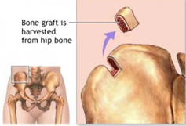
Figure 2.11. Diagram showing an autologous bone graft being removed from the iliac crest (Paudel, 2013).

By using bone from the same individual, there are no concerns about rejection. There are three types of bone growth that characterise bone formation in grafting: osteogenesis, osteoinduction and osteoconduction. Osteogenesis is the formation of new bone by osteoblasts that are derived from the graft material, whilst osteoinduction is the ability of the material to induce the formation of osteoblasts from the tissue that surrounds the graft host site, resulting in growth. Finally, if a material is able to support the growth of bone over a surface, it is osteoconductive. It is also advantageous for the graft material to promote osteointegration, the ability to chemically bind to the surrounding bone, as this promotes the incorporation of the graft at the host site (Precheur, 2007).

Autogenous grafts can be lamellar or cancellous bone, or even a combination of both. Cancellous grafts revascularise sooner due to their spongy structure, with revascularisation commencing around the fifth day after implantation (Futran, 2006). The volume of graft available is limited if it is harvested from the oral or maxillofacial region (Hollinger et al., 1996, Chan et al., 2002). The possibility of problematic bone volume maintenance due to erratic bone resorption is an additional problem. In large defects, the body may resorb the graft before osteogenesis is even complete (Enneking et al., 1980). The disadvantages of autogenous grafts are the small volume of available graft material, and morbidity associated with their harvest. Because of these disadvantages, other graft materials have been developed; these are allografts, xenografts and synthetic grafts.

Allografts come from cadaver donors, and are suitable because of the close match of the architecture and elemental composition to the bone being replaced. Allografts have immunogenicity risks and there is a potential for disease transmission. Procedures for screening and testing the grafts for disease exist, with most processes involving steps that address cleaning, decontamination, antimicrobial treatment, dehydration, graft size and terminal sterilisation (Holtzclaw et al., 2008). However, the estimated risk of HIV transmission has been put at 1 in 1.6 million, hepatitis C at 1 in 60,000, and hepatitis B at 1 in 100,000 (Boyce et al., 1999, Tomford, 1995). The allograft can come as a block, small cubes or crushed into a finer powder, depending upon the intended purpose, as shown in Figure 2.12 overleaf.

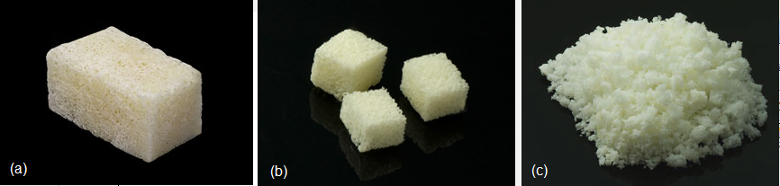
Figure 2.12. Bone graft materials. (a) Cancellous allograft block (30 x 15 x 15mm). (b) Cancellous allograft, 5mm cubes. (c) Crushed cancellous autograft, 4-10mm particle size. Adapted from (SteriGraft, 2010).

Two popular sources of xenografts are bovine bone and natural coral. Inorganic bovine graft has a comparable mineral composition and microporous structure to human bone, and is a naturally derived porous and deproteinated bone mineral (Jensen et al., 2006). Deproteinated bovine bone has been suggested to have an osteoconductive function due to hydroxyapatite (HA) crystals, which may allow osteoblasts to attach and subsequently deposit new bone matrices (Berglundh and Lindhe, 1997, Tapety et al., 2004).

Synthetic bone grafts
Auto-, allo- and xenografts all have their disadvantages, as discussed above. Synthetic materials can be used as bone grafts, and include calcium sulphate, calcium phosphates (HA and TCP) and bioactive glasses. In 1892, the first application of a synthetic bone graft was recorded; a calcium sulphate treatment of large-bone defects by Dreesmann (Capo and Tan, 2013). Calcium sulphate is not ideal for use in the clinical setting however, since it requires a dry environment to set, and if exposed to moisture it can soften and fragment. HA and TCP are osteoconductive, but are brittle. HA bone filler materials are currently available on the market as pastes, granules and cements. Biphasic HA/TCP filler materials are also available (Behnia et al., 2012).

Synthetic scaffolds
Synthetic grafts are biocompatible, inorganic and commonly divided into two classes: ceramics and polymers (scaffolds). Scaffolds have been fabricated from synthetic polymers including PCL, PLA, PLGA, poly(propylene fumerate) (PPF), and PEG (Lewandrowski et al., 2003, Bose et al., 2013). Commercially available ceramic-based synthetic materials include calcium phosphates (e.g. HA and TCP), calcium sulphate and bioactive glasses. These materials are classed as osteointegrative as they promote the formation of bonds between the new mineralised tissue and the graft material. The biological and physical characteristics of the ceramic grafts, including strength, modulus and dissolution rate, are all affected by differences in the crystalline structure (Boccaccini and Blaker, 2005).

By comparing two synthetic HA bone graft materials (OsteoGen and OsteoGraf/LD300) with deproteinised natural bone, Rosen et al. found that the synthetic grafts showed little structure, whilst the natural bone was highly structured. SEM analysis revealed that the natural bone has a periodic spacing of crystallites along the fibrils that is consistent with the banding pattern of collagen and inter-fibrillar-bridging crystallites which had a plate-like habit (Rosen et al., 2002).

Scaffold design
The porosity and pore size of the scaffold have an impact on its efficacy as a bone regeneration tool. A porous structure with interconnected pores is essential for the transportation of nutrients and waste, and cell proliferation and migration which is necessary for vascularisation and the formation of new tissue. Additionally, a porous surface can improve the mechanical stability of the scaffold-natural bone interface by improving the mechanical interlocking between the two materials (Story et al., 1998).

The degradation properties of the scaffold material can play an important role when considering the porosity of the desired scaffold. Scaffolds with high porosities (>90 %) should not be fabricated from biomaterials with a high degradation rate, since the mechanical and structural integrity of the scaffold will be compromised before new bone can be generated. However, highly porous scaffolds can be fabricated from materials with a low degradation rate and good mechanical properties. Because of the higher pore surface area that interacts with the host tissue, degradation can be accelerated by two effects: macrophages via oxidation and/or hydrolysis.

Pore size also has an important role in the use of scaffolds for BTE: too small a pore and the cells cannot penetrate into the scaffold. If the pores are too large, the mechanical properties of the scaffold may be detrimentally affected by increasing the void volume. (El-Ghannam, 2004, Williams et al., 2005). Although scaffolds with a range of pore sizes from 10-1500 µm have been used in bone tissue engineering, a size of greater than 300 µm is recommended due to an enhanced new bone formation (Karageorgiou and Kaplan, 2005). The pore size has been shown to affect the progression of osteogenesis due to expanding on the degree vascularisation. In small pores, osteochondral formation can occur before osteogenesis due to the hypoxic conditions within them, whereas large, well-vascularised pores facilitate direct osteogenesis.

An ideal scaffold for tissue engineering should have:
- Biocompatibility: to support normal cellular activity without any local or systemic toxic effects, the scaffold should be biocompatible (Williams, 2008). Ideally, the scaffold should be osteoconductive, allowing bone cells to adhere, proliferate and form extracellular matrix on and in its surface and pores.
- Bioresorbability: resorption should be controllable, and the scaffold degradation rate should match the regeneration rate of the tissue it is replacing (Bose et al., 2012),
- Porosity: scaffolds should have high porosity with an interconnected pore network to facilitate cell growth and flow transport of nutrients and metabolic waste (Karageorgiou and Kaplan, 2005),
- Mechanical properties: scaffold mechanical properties should be a close match to those of the tissues at the implantation site (Milovac et al., 2014)

From the shortcomings of the auto-, allo- and xenografts, it is apparent that bone tissue engineering will increasingly involve synthetic scaffolds with tailor-made properties such as mechanical strength and pore size.

Composite materials
Ceramics used in BTE can be divided into three categories: bioinert, bioresorbable and bioactive. Bioinert materials do not initiate a response or interact with biological tissue. Bioresorbable materials are dissolved in the body and the by-products usually disposed of via the body’s normal metabolic pathways. Bioactive materials have an effect or interactions with cells in the body. Ceramics incorporated into polymer membranes can help overcome weakness in the polymer that are due to degradation-associated strength reduction. Bioceramics have been shown to have significant roles in the buffering of pH and in improving bone cell responses. The term “heterogeneous” was applied to the polymer:ceramic membranes produced in this work as the coating was applied in a secondary step after membrane fabrication. The 3D printed scaffolds were termed “composite” as the polymer and ceramic components were combined prior to printing.

Scaffolds for BTE have been fabricated from ceramics, glasses and metals, as well as both natural and synthetic polymers. Ceramics used include HA and β-TCP. Existing bone scaffolds on the market include the ceramic calcium sulphate (Plaster of Paris), which is available as powder or pellets under the four main trade names: Osteoset®, MIIG® X3, Bone Plast® and Stimulan® (Hammouche et al., 2012). Their applications can be restricted by poor mechanical properties and random porosity lacking in interconnectivity (Carson and Bostrom, 2007). Another limitation of these scaffolds is the severe allergic reaction that has been reported following the implantation of calcium sulphate pellets (Vigler et al., 2006).

Composite membranes
Many synthetic polymers are hydrophobic, and which causes low surface wettability. Osteogenic cells preferentially attach to hydrophilic surfaces, to which they demonstrate a higher proliferative and a lower apoptotic rate (Anselme, 2000). Pure polymer biomaterials also lack bioactive functions for promoting bone formation. Whilst these membranes have a barrier function, they do little to provoke response from the surrounding tissue (Kim et al., 2007). The results of studies which reported no difference in the quantity of augmented bone between a resorbable (PLA) and a non-resorbable membrane (e-PTFE) suggest that neither of these categories of membrane actively promote bone regeneration. Furthermore, partial collapse into the defect due to soft tissue growth was reported for both types of membrane, suggesting the need for a supporting scaffold (Imbronito et al., 2002b). If the lack of active regeneration by the membrane is to be improved, then it would be desirable to incorporate a bioactive element.

Bioglasses and many calcium phosphate (CaP) ceramics, including HA, are bioactive and can induce and promote bone regeneration. These materials, however, have low mechanical strength and poor elastic properties, limiting their performance after implantation. Combining CaP phases with polymers can create materials with osteoconductive properties, a barrier function and improved mechanical strength (Best et al., 2008).

GBR membranes made from a variety of materials have been researched, including alginate, a nanoscale HA (nHA)/chitosan composite, collagen, and polycaprolactone/calcium carbonate composite membranes (Ueyama et al., 2002, Xianmiao et al., 2009, Taguchi et al., 2005, Piattelli et al., 1996). Two layer PCL membranes with calcium carbonate (CaCO₃) filler were fabricated by electrospinning and analysed by Fujihara et al. The composite nanofibres were electrospun. The composite nanofibres were spun onto PCL nanofibrous membranes which have high tensile strength in order to provide the mechanical stability desirable of GBR membranes. The membrane consists of two layers: a functional layer (PCL/CaCO₃) and a mechanical support layer (PCL). Two PCL/CaCO₃ ratios were tested: GBR membrane (A): PCL:CaCO₃ = 75:25 wt% and GBR membrane (B): PCL:CaCO₃ = 25:75 wt%. SEM analysis revealed that good cell attachment and proliferation was observed on both membranes. Membrane A had good osteoblast attachment at day 1, and SEM analysis showed no significant difference of cell attachment. The absorbance intensity of both membranes increased during the 5-day cell seeding period, which was confirmed by the MTS assay results (Fujihara et al., 2005).

TCP/copolymer composite membranes have high bending properties (about 50 MPa). This value is sufficiently high to avoid deformations of the membrane at the mandible defect due to high mechanical stress as well as collapse of the bone regeneration space. The problems associated with this composite include a softening temperature that is too high (> 100 °C) for surgeons to be able to mould it into the desired shape during the surgical procedure, and a high elastic modulus (>10 GPa). In addition, toxicity of the sebacates (the copolymerised substances that add softness to CPLA) is an issue. This toxicity could be a barrier to the use of CPLA in clinical situations (Kikuchi et al., 2002). In order to overcome the problems associated with TCP fillers in copolymerised poly L-lactide (CPLA), Kikuchi et al synthesised a new flexible and thermoplastic copolymer, poly (L-lactide-co-glycolide-co-ε-caprolactone) (PLGC) (Kikuchi et al., 2004). The composite membrane was fabricated from the PLGA/PCL copolymer and β-TCP. The copolymer maintained its mechanical strength up to 12 weeks in PBS, with decomposition occurring within 24 weeks.

The desire to combat pathogens in the gingival fluid and/or periodontal pocket after the placement of the membrane has led to studies in which antibiotics have been incorporated into the membrane itself. Whilst antibiotics can be administered orally to help treat periodontal diseases, the bacterial strain resistance that can occur after prolonged use of systemic antimicrobials created a need to be able to deliver the drug to a localised area. Bottino et al., fabricated a functionally graded membrane (FGM) containing metronidazole (MET) as an antibiotic. The membrane consisted of three layers: the core layer (CL), composed of poly(DL-lactide-co-ε- caprolactone) (PLCL) and two functional surface layers (SLs), one interfacing with bone and containing nHA and one facing the epithelial tissues, containing metronidazole. Both the SLs were composed of a protein/polymer ternary blend (PLCL:PLA:GEL) (Bottino et al., 2012).

Composite scaffolds
As previously mentioned, HA is a highly bioactive ceramic. However, its use as a scaffold for bone tissue regeneration (BTE) is limited by its inherent brittleness and poor tensile properties. Combining HA with a polymer should produce a composite with good bioactivity, degradability and mechanical strength.

The addition of HA to PCL has previously been shown to promote primary cell attachment when compared to a pure PCL (Rizzi et al., 2001). The wettability, water uptake and compressive modulus of PCL/HA scaffolds were seen to increase with increasing HA content (0- 40 wt% HA). Compressive moduli values of 26.5 MPa and 49.8 MPa were measured for the pure PCL and 40 wt% HA scaffolds respectively (Jiang et al., 2012). In a study comparing the differences in properties between scaffolds fabricated from a nHA/PCL blend and a micro-HA/PCL blend (both blends contained 40 wt% HA), the nHA/PCL composite was found to have a significantly higher compressive modulus. It also had improved hydrophilicity over the micro-HA/PCL scaffold (Heo et al., 2009). However, this work only investigated the effects at one weight concentration. Jiang et al., investigated printing composite scaffolds of PCL and bovine-derived HA with HA contents of 0, 10, 20 and 40 wt%. A failure to print a 60 wt% scaffold was reported (Jiang et al., 2013). Scaffolds fabricated from pure PCL, a PCL/HA composite and a PCL/HA shifted pattern scaffold were investigated. The HA content was set at 40 wt%, and the shifted pattern PCL/HA scaffold was found to have increased cell attachment and adhesion over the two other scaffolds, albeit with a lower compressive modulus (Park et al., 2011). The 40 wt% HA scaffolds were fabricated at 650 kPa (Park, 2014). nHA has been shown to improve mechanical properties in other composite scaffold systems, including HA-collagen composites (Cunniffe et al., 2010a). The addition of HA to 3DP PCL has been shown to increase surface roughness due to the presence of HA particles at the surface (Rodriguez et al., 2013).

Commercially available ceramic-based synthetic materials include calcium phosphates (e.g. HA and TCP), calcium sulphate and bioactive glasses. Because these materials promote the formation of bonds between the new mineralised tissue and the graft material, they are classed as osteointegrative. The biological and physical characteristics of the ceramic, including strength, modulus and dissolution rate, are all affected by differences in the crystalline structure (Boccaccini and Blaker, 2005).

As the chosen calcium phosphate (CaP) for creating both a composite membrane and a composite scaffold, the structure and properties of HA will be discussed in the following section.

Hydroxyapatite
HA [Ca₁₀(PO₄)₆(OH₂)], (HA), belongs to a group of calcium-phosphate (CaP) based minerals, known as apatites. The prefix depends upon the dominance of one of four groups: hydroxyl (HA), fluoride (fluorapatite), chlorine (chlorapatite) or bromine (bromapatite). HA is a highly biocompatible mineral, and is used as a bone filler to replace cancerous bone. It can also be used as a coating on joint replacements to promote osseointegration, and as a scaffold for tissue engineering. nHA is expected to have better bioactivity than coarser crystals, since its morphology and size are closer to that of HA found naturally occurring in the body (approximately 20 nm in the largest dimension) (Palmer et al., 2008),(Clarke, 2008). As such, nHA has attracted research interest as a potential biomaterial (Cunniffe et al., 2010b). HA occurs naturally in bone and teeth. In teeth, HA twists into rods in the cusp of the tooth, providing strength. However, HA on its own has poor mechanical properties causing its use to often be limited to applications involving little load bearing, for example coatings on joint replacements, a use which is successful in clinical practice (Geesink, 1990).

Doping, or substituting HA can enhance its properties. Elements substituted into HA include strontium, magnesium, zinc, manganese and titanium. These dopants are added to improve mechanical strength and cell-material interactions. Another reason to dope HA with minerals and traces of metal elements is that they can promote bone formation and resorption on bone cells or mineral both in vivo and in vitro, which will encourage faster healing time (Kim et al., 2004).

Hydroxyapatite structure
The stoichiometric form of HA is monoclinic, with the space group P2_{1/b} (Morgan et al., 2000). HA has a mixed monoclinic phase: 23 % monoliniv P2_{1/}b and 77 % monoclinic P2₁ (Haverty et al., 2005). The P2₁/b space group has unit cell parameters of a= 0.943 nm, b = 2a and c = 0.688 nm (Figure 2.13 and Figure 2.14 overleaf) (Elliott and Young, 1967). The unit cell has 10 cation sites arranged in two non-equivalent positions. Four of these, which are called Ca(I) sites, are aligned in the column and are each surrounded by nine oxygen atoms. There are six Ca(II) sites which are arranged at the apexes of staggered equilateral triangles and each is surrounded by seven oxygen atoms. The structure is characterised by ordering within the OH- ion columns, where a sequence is formed: -OH-OH-OH-OH-. The (0001) stacking sequence consists of columns of skewed 3 Ca(II)-O trigonal prisms around the 6₃ axes. P and O form PO₄ tetrahedra (Figure 2.15 overleaf).

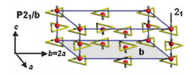
Figure 2.13. Crystal structure of P2₁/b hydroxyapatite. Ca atoms are at the vertices on triangles around each hydroxyl group (Corno et al., 2010).
Figure 2.14. CrystalMaker structure of a unit cell of hydroxyapatite, looking down the c-axis. Red- oxygen, blue- Ca, grey- P, pink- H (Terra et al., 2009).

Figure 2.15. Tetrahedral structure of PO₄ (Ophardt, 2003).

The tetrahedra do not share oxygen atoms between themselves and are held together by the Ca(I) atoms (Elliot, 1994). As a result of this, OH⁻ ions can escape from HA lattices first if they obtain enough heat or elastic energy due to high lattice strains (Senger et al., 1992). As a result, HA becomes unstable at high temperatures due to dehydration. After vacancies are created by the loss of two OH⁻ ions, calcium ions are more weakly bound and can displace. This leads to the further decomposition of the HA phase to a more stable calcium phosphate phase (Chu et al., 2002). The PO₄ groups provide the skeletal framework which is responsible for the stability of apatite structures.

Slightly non-stoichiometric HA has the hexagonal space group P6₃/m, characterised by ordering within the OH⁻ columns to form the sequence OH mentioned previously, with an ordered arrangement of these columns, so that the b-axis is doubled. This gives the lattice parameters a = 9.421 Å, b = 2a, and c = 6.8814 Å (Posner et al., 1958). Usually only hydrothermal preparation yields HA with the monoclinic phase, with other preparations usually producing hexagonal phase HA. It is thought that if there are sufficient OH⁻ ions missing, these are replaced by H₂O or impurity ions, so that the ordering is achieved. This could explain why the particle shapes produced by sol-gel synthesis are so different in appearance to the needle-like particles produced by the hydrothermal route. Hydrothermally synthesised HA grows as needle-shaped particles until a certain temperature, which is around 60°C. Hydrothermal HA grows along the c-axis and consists of two temperature-dependent effects. First, as the temperature rises, HA crystallinity is thermally activated. As the temperature increase, the tendency for monocrystalline HA particles to grow along the c-axis is limited. This is the critical temperature, and above this point, the tendency for directed growth stops and the particles become more regular and circular in shape (Bouyer et al., 2000).

Substituted hydroxyapatite
A large variety of cationic and anionic species can be substituted into the HA structure because the apatite structure is highly flexible. Dopants can affect several properties of HA. Lattice parameters, crystal size and shape, crystallinity, infrared absorption spectral properties and thermal stability can all be altered by substituents (LeGeros, 1983). Because of this, the volume of the apatite lattice can expand and contract. This is demonstrated by the fact that many other apatite compounds exist- fluorapatite and chlorapatite, bromapatite and carbonate apatite. Table 2.7 lists possible substitutes for HA and the ion for which it substitutes.

Table 2.7. Possible substitutes for components of hydroxyapatite (Barbucci, 2002).
Ca²⁺ | PO₄³⁻ | OH⁻
Substitutes | Substitutes | Substitutes
Ti⁴⁺ | CO₃²- | F⁻
Sr²⁺ | HPO₄²⁻ | Cl⁻
Na⁺ | SiO₄²⁻ | CO₃²⁻
Mg²⁺ | HCO₃⁻ | S²⁻
K⁺ | P₂O₇⁴⁻ | O₂₋
Li⁺ | H₂O
Fe²⁺
Eu²⁺
Mn²⁺
Pb²⁺
Zn²⁺
Ba²⁺
Cu²⁺

Strontium-substituted hydroxyapatite
Strontium, a group II metal, is a trace metal found in the human body, and is present in the mineral phase of bone, particularly at regions with high metabolic turnover (Blake et al., 1986). In new compact bone, the strontium content is three- to four times higher than in old compact bone, and in new cancellous bone, it is approximately 2.5 times higher (Marie et al., 2001). The anti-osteoporosis drug strontium ranelate has been shown to decrease the rate of bone resorption (Pors Nielsen, 2004). Strontium reduces osteoclast activity and bone resorption in vitro. Strontium-containing bioactive ceramics have been shown to increase several osteoblastic markers, and in particular, type-I collagen when cultured with human bone-derived cells (Baron and Tsouderos, 2002, Wu et al., 2007).

Strontium substitutes for calcium in the HA structure. The Sr²⁺ ion is larger than the Ca²⁺ ion (0.118 nm and 0.1 nm respectively). The inclusion of the larger strontium ion into the lattice may affect the lattice parameters. The alterations in parameters are thought to affect crystallinity and increase solubility, with solubility reported to increase with increasing strontium content (Christoffersen et al., 1997). The increased solubility of Sr-HA could facilitate a slow release of Sr²⁺ into the implant site and surrounding tissue, which could increase osteoblast activity. Sr-HA has an improved level of bioactivity over HA due to this release of strontium ions, making it a more desirable material in vivo (Curran et al., 2011). Additionally, the increased solubility of Sr-HA can lead to an increase in Ca²⁺ release, which may stimulate cell response by activating calcium channels (Coulombe et al., 2004).

Hydroxyapatite synthesis
Various methods exist for the synthesis of HA. These include sol-gel, wet precipitation and hydrothermal. The characteristics of HA depends on the synthesis method used (Liu et al., 1997, Masuda et al., 1990). In this work, HA was synthesised using sol-gel and wet precipitation methods.

Sol-gel synthesis of hydroxyapatite
The first work on producing HA by sol-gel synthesis was conducted by Masuda et al (Masuda et al., 1990). Sol-gel produced HA powders have molecular-level mixing and thus tend to have better stoichiometric ratios and better chemical homogeneity than those prepared by other routes such as hydrothermal synthesis. These can produce HA powders with calcium:phosphate ratios below that of the ideal stoichiometric value of 1.67, which is achievable by sol-gel synthesis (Yoshimura et al., 1994, Liu et al., 2001). Ca:P ratios greater than 1.67 suggest the presence of calcium oxide (CaO) in the sample. In natural HA, this value is not commonly observed as small amounts of other elements such as carbon, nitrogen and iron are incorporated into the structure (Vazquez, 2005).

Hydrolysis and polymerisation are the two chemical reactions involved in the sol-gel process. In the gel phase, clusters grow by the condensation of polymers or aggregations of particles until clusters collide with one another. The gel, which is a single giant cluster, is formed by links between the different clusters. The gel has been described as being a solid skeleton which encloses a continuous liquid phase (Klein, 1988).

When the rate of hydrolysis is less than the rate of polymerisation, hydroxides form by nucleation and growth. Nucleation occurs relatively infrequently whilst growth occurs more rapidly. In the first stage of growth, HA nanocrystallites are formed by nucleation and growth. Aggregation of elemental nanocrystals occurs by molecular attraction, resulting in the minimisation of the surface free energy (Gomez-Morales et al., 2001). Further crystal growth, at a constant residual supersaturation, acts as a cementing agent inside the aggregates to form an agglomerate. The increase in particle size with temperature takes place due to aggregation of the agglomerated particles to form a secondary particle. These stages are highlighted in the diagram below (Figure 2.16 overleaf). Rodriguez et al. termed this process nucleation-aggregation-agglomeration-growth (Rodríguez-Clemente et al., 1998).

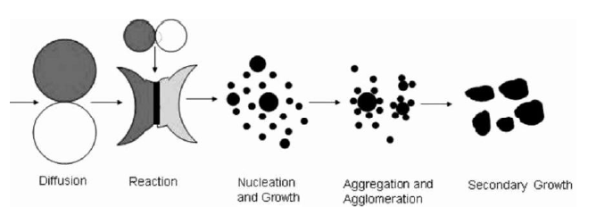
Figure 2.16. Schematic representation of the nucleation and growth mechanisms of hydroxyapatite (A Randolph and Larson, 1988).

It is thought that both the charged surfaces and condition of the super-saturated ionic solution are important factors in the nucleation of HA. Based on the concept of biomineralisation, the functions of organic macromolecules are important in the regulation of HA growth. This concerns molecular recognition between ions on the surface of a crystal nucleus and functional groups on the surface of organic macromolecules.

There are, in general, three aspects of recognition at inorganic-organic interfaces which lead to specificity in the nucleation of biominerals which are considered effective. These are the electrostatic accumulation of cations, structural correspondence and stereochemical requirements. It has been reported that negatively charged surfaces are always favourable for the heterogeneous nucleation of HA, whereas nucleation is inhibited on a positive surface (Calvert, 1997). It is believed that the accumulation of Ca²⁺ ions due to electrostatic attraction increases the supersaturation near the negative surface, preferentially triggering the initial nucleation (Zhu et al., 2004). During the initial stage of homogeneous nucleation, the solute molecules combine to form clusters. When the degree of supersaturation is less than one, Gibbs free energy (GI) is always positive and clusters do not form. When the degree of supersaturation is greater than one, GI has a positive maximum at the critical size r*. The energy barrier for nucleation occurs when maximum Gibbs free energy G_{max} = G(r*). As the clusters continue to grow, the free energy decreases, meaning that “stable” nuclei are formed which can grow to form macroscopic particles. Below the critical size, clusters cannot form and dissolve back into the solution.
Sol-gel method parameters
Several parameters in the sol-gel process can affect the size and composition of the resulting particles. In the sol-gel method used in this work, the phosphorous source is a hygroscopic liquid (triethyl phosphite, TEP). If the initial reaction of the phosphorous and calcium solutions is not covered with a lid, phosphorous can be lost, leading to the formation of a non-stoichiometric HA. The first reaction stage involves the polymerisation of the phosphite, resulting in the formation of charged hydroxyl ligands. A ligand is an ion or molecule that binds to a central metal atom to form a co-ordination complex. When the partial charge of the hydroxyl groups reaches zero or positive charge, polymerisation ceases. The colloidal particles in the solution can be considered to be an aggregation of oligomeric particles.

The hydrolysis reaction of TEP is:
OP(OC₂H₅)₃ + H₂O → OP(OC₂H₅)_{3-x} (OH)_{x} + _{x}C₂H₅OH (Equation 1)
Increasing the aging time accelerates equation 1.

In the sol-gel method, the reaction for the ethanol-based process is:
P(Oet)_{3-x}(OH)_{x} + Ca(NO₃)_{2-y}(Oet)_{y}
→ (Oet)_{y’}(NO₃)_{2-y’}-Ca-O-HPO(Oet)_{3-x’} + H₂O + C₂H₅)H (Equation 2) (Hench, 1991)

A pH drop is noticed in the solution, which can be accounted for by the release of protons in reaction. The aging time of the solution can also affect the stoichiometry of the end HA: fast titration results in a decrease of the pH solution below 9, which can lead to the formation of a calcium-deficient HA (Y Yang, 2008). A slower titration also aids the improvement of chemical homogeneity. The sintering step causes a phase transfer to an apatite structure. The apatitic phase can be obtained at temperatures as low as 400 °C, however, increasing the temperature increases the volume of the HA phase (Liu et al., 2002). This suggests that the removal of organic residuals increases the amount of HA present, as well as improving the crystallinity of the apatite.

The pH of the sol-gel can be altered by adding an alkali to each solution separately before titrating the calcium nitrate solution into the phosphate solution. Increasing the pH can enhance the gelation process to produce HA with less CaO, CaCO₃ and TCP (Kim et al., 2005a). These phases form due to the incomplete gelation process, in which [Ca-O-P-] oligomers are formed (Wang and Shaw, 2009). Impure HA can result in decomposition in body fluid (Li et al., 2007). HA is formed at pH values above 8. An acidic environment causes the partial dissolution of the surface, leading to the enrichment of Ca²⁺, H₂PO₄⁻, PO₄³⁻, H⁺, OH⁻ and also ion pairs such as CaH₂PO₄⁺ and CaOH⁺ in a hydrated layer (RZ LeGeros, 1993). Adding an alkali enhances the gelation rate by providing a larger number of OH- ions to capture H⁺ ions in the solution.

Wet chemical precipitation synthesis of hydroxyapatite
The wet-chemical precipitation method for synthesising HA was first investigated in 1976 (Jarcho and Bolen, 1976). Wet chemical precipitation is an attractive HA synthesis route, due to the low cost of equipment requirements, low working temperature, high percentages of pure products and as in experimental operations (Cao et al., 2005, Kong et al., 2002). Nanoscale HA can be produced via precipitation if the temperature does not exceed 100 °C (Mobasherpour et al., 2007). Factors that affect the properties of HA synthesised by this method include starting materials, pH, stirring speed, temperature and ageing time (Monmaturapoj, 2008). Wet chemical precipitation offer more precise control over the morphology and size of the HA particles over hydrothermal synthesis routes, and have a more simple methodology than sol-gel synthesis (Ramesh et al., 2015).

Wet chemical precipitation parameters
Wet chemical precipitation calcium and phosphate precursors can be dissolved in water, although some methods use a combination of water and ethanol (Brito et al., 2008). However, it has been found that increasing the amount of ethanol can increase the size of HA particles and decrease dispersibility, due to larger supersaturation. HA has a lower solubility in ethanol than water, thus an increasing amount of ethanol causes an increase in supersaturation, with the result that the HA particles grow more quickly. Well-dispersed nHA can be synthesised in water alone (Wang et al., 2010).

Usually, the shape of a crystal is determined by kinetics as opposed to thermodynamics,; the kinetics of each crystal face can be influenced by external factors including supersaturation, temperature and mixing (Meenan et al,. 2002). Reaction temperature is an important condition in the determination of crystal shape, as it influences both supersaturation and mixing (Wang et al., 2010). The morphology of HA particles synthesised from calcium hydroxide and phosphoric acid change from needle-like to spherical (i.e. the aspect ratio decreases) as the reaction temperature increases. Conversely, the aspect ratio increases with increasing temperature when soluble calcium salts (e.g. calcium nitrate and calcium chloride) and phosphate salts are used in basic medium (Asaoka et al., 1995).

The precipitation rate influences particle morphology; a higher precipitation rate yields particles with a higher aspect ratio, whilst the aspect ratio decreases as the precipitation rate decreases. GI increases with increasing temperature, which creates a greater driving force for precipitation and therefore a faster precipitation rate (Prakash et al.,2006). The reaction temperature also affects crystal size and degree of crystallinity: an increase in reaction temperature from 25-80 °C suggested that HA crystallisation was more favourable at higher temperatures (Wang et al., 2010).

Particle size and morphology can be affected by the titration rate. Studies have shown that the particle size decreases with increasing titration rate, whilst the particle morphology changes from needle-like to spherical under the same change in conditions. The faster addition rates produce HA with a smaller particle size due to greater amounts of local supersaturation. The critical size of a particle crystallising in solution is limited by the size at which the surface free energy of the particle is greater than the energy of the solution. The crystal nucleus is unstable below the critical size and will re-dissolve into the solution. Nucleation and growth occur simultaneously in areas of local supersaturation. An increased titration rate creates a larger supersaturation, which can reduce the critical particle size. This increases the probability of nucleation compared to the probability of crystal growth. (Kramer et al., 2014).

Manufacturing methods

Electrospinning
The process of electrospinning matrices has gained significant interest, not only as it has a simple set-up and is low-cost to run, but because it produces matrices with a similar structure to the tissue extracellular matrix (Liang et al., 2007, Pham et al., 2006).

The membranes fabricated for this project were created using the electrospinning technique. Electrospinning can be used to produce non-woven materials that can be used for a wide variety of applications, both medical and non-medical. Medical application examples include drug delivery systems, wound dressings and vascular grafts (Kenawy et al., 2009, Chen et al., 2008a, Theron et al., 2010). Non-medical applications include catalysts, photoelectrodes and supercapacitors (Dong et al., 2011). Electrospinning involves dissolving a polymer in an appropriate solvent. Table 2.8 overleaf lists common electrospun polymers and the solvents in which to dissolve them.

Table 2.8. Common electrospun polymers and their associated solvents for electrospinning.
Polymer | Solvent | Concentration
PLLA (M_{w} = 205 kDa) | Dichloromethane | 8 wt%
PGA (M_{w} = 14,000-20,000) | 1,1,1,3,3,3-hexafluoro-2-propanol | 5 wt%
PCL | Chloroform | 10 wt% (Yoshimoto et al., 2003)
PLGA (75:25) (M_{w} = 66,000-107,000) | Dichloromethane | 20 wt%
PLGA (50:50) (M_{w} = 25,000) | 1,1,1,3,3,3-hexafluoro-2-propanol | 5-7 wt% (You et al., 2005)
PLGA (50:50) (M_{w} = 108,000) | Chloroform | 15 wt%
PLCL (75:25) | Chloroform | 15 wt% (Mo et al., 2004)
Collagen type I | 1,1,1,3,3,3-hexafluoro-2-propanol | 0.083 g/ml (Matthews et al., 2002)
Collagen type III | 1,1,1,3,3,3-hexafluoro-2-propanol | 0.04 g/ml

Once dissolved, the polymer solution is placed in a syringe with a needle connected to a voltage supply. The polymer solution is pumped through the needle, and when a voltage is applied, the solution is charged. When the charges on the fluid reach a critical limit, a polymer jet erupts from the droplet at the tip of the needle, which results in the formation of a Taylor cone. The polymer jet is drawn towards the oppositely-charged collecting plate. The solvent evaporates by the time the jet is collected on the plate, leaving a mat of non-woven material. Figure 2.17 overleaf shows the basic set up of the electrospinning rig used. Figure 2.18 overleaf shows the electrospinning rig used to produce the membranes in this work.

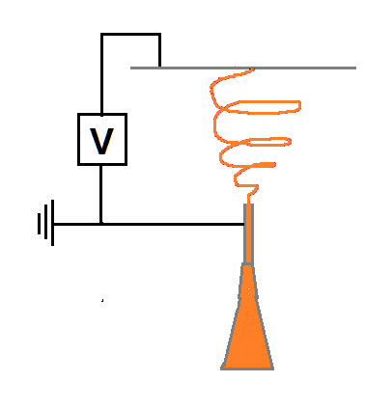
Figure 2.17. Diagram of the electrospinning rig set-up. The polymer jet is accelerated in the vertical plane to avoid blobbing due to gravity.

Figure 2.18. The electrospinning rig used to produce the membranes. The rig is housed in a fume hood with an inbuilt circuit breaker approximately 10 cm from the base of the sash. If the sash is raised above this point during spinning, the power automatically cuts out.

Various parameters affect the electrospinning process;
- Molecular weight: the viscosity of the dissolved polymer increases with an increasing molecular weight. The solution is stretched as the polymer jet travels towards the collecting plate. The polymer molecule chain entanglements prevent the jet from breaking up, thereby maintaining a continuous jet. The polymer length determines the amount of chain entanglement.
- Viscosity: a higher viscosity reduces fibre beading by reducing the tendency of the solvent molecules to come together under the influence of surface tension. The polymer jet cannot form if the solution viscosity is too low. Conversely, if the viscosity is too high, then the solution may dry out at the needle tip before the polymer jet can form.
- Voltage: a higher voltage leads to increased stretching of the solution. The magnitude of the applied electrostatic field can cause a change in crystallinity within the fibre. An increase in voltage increases the acceleration of the fibres, reducing the flight time of the polymer jet. A reduced flight time means that the polymer fibres are collected before the polymer molecules align.
- Needle-collector distance: if the distance between the needle tip and the collecting plate is not great enough, the solvent may not have evaporated by the time the fibre is collected. As the distance is decreased, the magnitude of the electric field is increased, thereby increasing the fibre acceleration, which reduces the time for the solvent to evaporate. Increasing the distance can result in a smaller average fibre diameter.

Rapid Prototyping and 3D Printing
Additive manufacturing (AM) technologies were first investigated in the 1980s. Amongst the different branches, 3-dimensional printing (3DP) has gained significant interest as a potential manufacturing process to create scaffolds for tissue engineering. Various other methods to produce tissue engineering scaffolds exist, including solvent casting, particulate leaching and gas foaming. However these methods cannot produce scaffolds with a precise pore size or pore network, due to the random distribution of the particulate throughout the polymer network (Seunarine et al., 2006). These problems also limit the reproducibility of scaffolds fabricated by these methods. Sol-gel processing, solid freeform fabrication and freeze casting methods have been used to manufacture scaffolds from 45S5 Bioglass (Fu et al., 2011).

3DP technologies have the ability to fabricate scaffolds with a specific pore size and porous structure with high accuracy and reproducibility (Mota et al., 2012). These technologies include fused deposition modelling, robocasting, selective laser sintering and 3D bioplotting (Yeong et al., 2004). As mentioned in section 2.8, the pore size has an important role in the success of a bone regeneration scaffold. Pore size not only controls the permeability of nutrients to the scaffold and their mechanical properties, but also has a role in ECM production and organisation (Bose et al., 2013).

3DP has potential applications for both soft and hard tissue engineering, including in adipose tissue restoration, cartilage and the delivery of cardiac cell therapy (Pati et al., 2015, Hung et al., 2016, Gaetani et al., 2015). The technology has been considered as a solution to organ donor shortages, with the idea of 3D printing of human hollow organs with lower architectural complexity (e.g. arteries, trachea, urethra and bile duct) being hypothesised (Radenkovic et al., 2016).

Polymers investigated for 3DP include PCL, PLGA, polyurethane, collagen and gelatin (Park et al., Lee et al., 2012, Hung et al., 2016, Inzana et. al., 2014, Billiet et al., 2014). Other materials include HA, β-TCP and calcium sulphate (Cox et. al., 2015, Zhou et al., 2014,). In addition to gelatin, other starch-based polymers that have been investigated include cornstarch and dextran (Lam et al., 2002). 3DP has been used to develop growth factor and drug delivery systems. Examples include a multi-drug pill with two independently controlled release profiles that has been developed as a cardiovascular treatment regime, and a composite 3D printed bioactive ceramic loaded with tuberculosis (TB) drugs for bone regeneration and local anti-TB therapy after osteoarticular TB debridement surgery (Khaled et al., 2015 Min et al., 2015). Akkineni et al., investigated the development of a VEGF-loaded 3D printed calcium phosphate cement scaffold for bone regeneration (Akkenini et al., 2015).

The ability to 3D print cells within a structure is another reason for the interest in the applications of 3DP in tissue engineering. Aortic valve conduits with alginate/gelatine hydrogels with encapsulated cells have been produced, and the cells were viable within the printed structure (Duan et al., 2012). Human nasal chondrocytes have been successfully printed in a nanocellulose and alginate-based bioink with good cell viability in vitro. 3DP can be used to incorporate two different cell types in one structure, as demonstrated by Lee et al., who printed rat embryonic neurons and astrocytes within a collagen structure for artificial neural tissue composites (Lee et al., 2009).

As discussed in section 2.8, ceramics are brittle when used on their own, but 3DP offers a method of combining the bioactive properties of ceramics, such as HA, with a polymer to improve mechanical properties of the scaffold. Composite scaffolds that have been produced by 3DP for BTE include magnesium-doped wollastonite/β-TCP intended for load-bearing bone repair, PEG/β-TCP for osteochondral applications, PLGA/nHA/β-TCP, PLA/HA and PCL/HA (Shao et al., 2016, Zhang et al., 2015, Roh et al., 2015, Senatov et al., 2016, Park et al., 2013). By selecting a polymer with an appropriate degradation rate, the properties of the scaffold can be more finely tailored to the requirements on the implant site. The initial mechanical properties and strength degradation rate should match that of the natural bone for optimal healing (Bandyopadhyay et al., 2006). If two or more materials are combined, the degradation rate and mechanical properties of the material can be tailored to suit the scaffold’s intended purpose.

PCL is an attractive polymer for 3DP due to its low melting temperature which makes it an attractive polymer for thermoplastic processing (Hutmacher et al., 2000). It has a T_{g} of 60 °C and a decomposition temperature of 350 °C, providing a wide range of temperatures for extrusion. PCL is currently regarded as a soft- and hard-tissue-compatible bioresorbable material (Perrin and English, 1997). As previously mentioned, it has a low processing cost and a slow degradation rate of 2-3 years for complete resorption. No weight change caused by degradation was reported on 3DP PCL scaffolds after three months implantation in vivo (Seyednejad et al., 2012). PCL can be blended with a range of other polymers including PLGA and PLA to improve properties such as stress crack resistance and adhesion (Chandra & Rustgi, 1998).

Use of surfactants
Surfactants are compounds that reduce surface tension when they are added to a liquid. Surfactants can be added to polymer/ceramic composites in order to produce materials with uniform ceramic distribution. Surfactants can be non-ionic, anionic or cationic. Non-ionic surfactants include Triton X-100, Tween 20 and Tween 80. Anionic include sodium dodecyl sulphate (SDS), sodium stearate and sodium and laureth sulphate. Cationic surfactants include benzalkonium chloride and centrimonium chloride.

Whilst no cases of surfactant addition in 3DP systems could be found in the literature, there are examples of research on the use of surfactants to create a homogenous distribution within the polymer nanofibres for electrospun materials. Kim et al., added hydroxyl stearic acid to a suspension of PL/HA in chloroform. The electrospun composite showed excellent cell attachment and proliferation in vitro (Kim et al., 2006). Surfactants have also been added to electrospinning solutions to improve the spinnability of solution to yield natural chitosan-poly(ethylene oxide) nanofibres (Kriegel et al., 2009).

The addition of non-ionic surfactants has been found to not significantly alter the crystallinity of the polymer. However, ionic surfactants were shown to decrease the crystallinity of electrospun mats of electrospun poly(3-hydroxybutyrate-co-3-hydroxyvalerate)/HA composite nanofibres. This change in crystallinity was attributed to the repulsion of the charges decreasing interaction between the polymer chains (Suslu et al., 2014). A decrease in crystallinity increases the rate of degradation.

SDS is a non-ionic surfactant that has FDA approval for uses in food in concentrations up to 1000 ppm, and has also been used in HA synthesis to control the shape and size of the particles (FDA, 2013), (Yan et al., 2001). SDS is reported to be toxic at concentrations around its critical micelle concentration (CMC), which has been reported as 2.6 - 8.0 mM (Inácio et al., 2011) (Brito and Vaz, 1986).

The CMC is the concentration of surfactant at which micelles will form. Micelles are spherical aggregations of surfactant molecules that form with the hydrophilic head of the surfactant facing out and the hydrophobic tails facing in, as demonstrated in Figure 2.19.


Figure 2.19. Surfactant micelle formation at the critical micelle concentration.

The surfactant-polymer interaction can depend on several factors, including the molecular structure of both components, as well as the net charges on either the polymer or surfactant separately, or the two combined (Wang and Tam, 2002). Anionic surfactants, such as SDS, have been found to have stronger interactions with non-ionic polymers, such as PCL, when compared to other types of polymer (Goddard, 1986). A critical aggregation concentration (CAC) exists in polymer-surfactant systems. The CAC is the point at which the polymer and surfactant begin to form mixed aggregates in the bulk. This aggregate has a similar structure to the surfactant micelles which associate with the polymer molecules (Bell et al., 2007). The CAC is reported to be lower than the CMC (Ghosh and Sharma, 2003).

Aims and objectives
To summarise the literature review, membranes and related devices used in musculoskeletal applications such as GBR do little to promote bone healing beyond acting as a physical barrier. The incorporation of osteoconductive biomaterials might address this shortcoming, but relatively little work has been reported to date on the development of more complex, heterogeneous membranes and scaffolds compared to devices fabricated using single materials such as collagen or PTFE. The relatively recent description of a range of nanoscale calcium phosphates and their use in bone surgery suggests that these would be an appropriate biomaterial to incorporate into a range of manufacturing processes with the goal of introducing osteoconductivity to an otherwise bioinert polymer structure. Several promising manufacturing processes were discussed in the literature review, and the two that offer some promise here are electrospinning and 3D printing. With respect to manufacturing, it would be relatively straightforward to develop a quality system and apply good manufacturing processes to the fabrication of a synthetic medical device. The aim of this PhD study was therefore to investigate the fabrication of novel polymer:nHA heterogeneous membranes and composite scaffolds using these two different approaches.

The specific objectives to achieve this goal were:
- To investigate the preparation of nHA via a number of different processes in order to select those that were most effective and appropriate for the manufacture of different membranes and scaffolds, and to characterise the nHA produced using conventional methods such as XRD and TEM.
- To further investigate the preparation of a nHA modified by the substitution of Ca with Sr in order to demonstrate the feasibility of preparing substituted materials to influence cell and tissue behaviour. In the longer term, it may be possible to prepare heterogeneous and composite devices with inorganically modified nano-ceramics to influence cell and tissue behaviour.
- Produce and characterise biodegradable electrospun membranes of PLGA (75:25).
- By combining the results of the first three objectives, to develop and effective manufacturing method to produce heterogeneous structures containing both ceramic and polymer components.
- To predict the bioactivity of the heterogeneous membranes and their osteoconductive potential compared to an electrospun commercial PLLA scaffold using mesenchymal stem cells from both human and rat sources.
- Produce 3D printed PCL-HA composite scaffolds at a range of ceramic weight percentages and evaluate their suitability bone tissue engineering by investigating their capacity to induce osteogenic differentiation of MSCs in vitro.
This multidisciplinary study will combine biomaterials preparation, manufacturing and in vitro testing to generate new knowledge that will help in the development of new membranes and scaffolds. On completion, this work will specifically add to the knowledge of the effect of a bioactive component on the ability of GBR membranes to promote an increased rate of bone regeneration, and the potential clinical application of polymer-ceramic membranes and scaffolds as a material for bone tissue regeneration.

Methods

Materials
All materials were supplied from Sigma Aldrich, Gillingham, UK, unless otherwise stated.

Hydroxyapatite synthesis
HA was synthesised via one sol-gel method and three different wet chemical precipitation methods. These had different chemical precursors and processing conditions, as described below. The success of the method was based on the production of HA, preferentially nanoscale, as characterised by XRD and TEM. The HA 2 method was selected after a review of the literature on the synthesis of nHA. Methods HA 3 and 4 were selected due to an interest in these methods by Ceramisys Ltd., a company producing synthetic bone graft materials that originally provided additional funding for this project.

Sol-gel method (HA 1)
Calcium nitrate tetrahydrate (22.48 g) was dissolved in 40 ml ethanol. 10 ml of triethyl phosphite (Fisher Scientific, Loughborough, UK) was added to 5.6 ml of distilled water (dH₂O) and 10 ml ethanol. Solutions with pH values of 9, 10 and 10.5 were produced by the addition of ammonium hydroxide (Alfa Aesar, Morecambe, UK). The calcium solution was then titrated into the phosphorous solution at a rate of 2 ml.min⁻¹ and the pH of the final solution was measured. After the titration was completed, vigorous stirring of the solution continued for 5 minutes. The solution was then left to age for 24 hours. The solution was then stirred on a hot plate at 60 °C until a solid white gel was formed. The gel was transferred to an oven to dry at 80 °C. The powders obtained were sintered at 500, 550 and 600 °C for 2 hours (Liu et al., 2001). This method shall henceforth be referred to as “HA 1”.

Wet precipitation method 1 (HA 2)
Calcium hydroxide (1.85 g) was dissolved in 250 ml dH₂O and was heated to 95 °C for one hour on a hot plate and stirred at 400 rpm. Phosphoric acid (1.73 g) was dissolved in 250 ml dH₂O and was then titrated into the calcium solution using a peristaltic pump at 3.5 ml.min⁻¹. The solution was stirred on a stirrer plate at 95 °C for 2 hours. The precipitate was filtered then rinsed with 500 ml dH₂O. The solution was left to settle for 2 hours before the excess liquid was poured off. This process was repeated twice more. The precipitate was then transferred to an oven to dry at 60 °C. The dried precipitate was then sintered at 1000 °C for 2 hours. This method was based on (Prakash et al., 2006). This method will henceforth be referred to as “HA 2”.

Wet precipitation method 2 (HA 3)
Calcium nitrate tetrahydrate (5.90 g) and ammonium phosphate (1.98 g) were each dissolved in 250 ml dH₂O. The pH values of the calcium and phosphorous solutions were adjusted to 11 and 12 respectively using potassium hydroxide (KOH). The phosphorous solution was then titrated into the calcium solution at a rate of 4 ml.min⁻¹. The solution was then left to stir for 1 hour at room temperature on a stirrer plate after the completion of the titration and was then allowed to settle overnight. The precipitate was washed three times using 500 ml dH₂O, with a 2 hour settling period in between, and the excess liquid was poured off each time. After the final rinse, the precipitate was transferred to an oven to dry at 60 °C, before being sintered at 1000 °C for 2 hours. this method shall henceforth be referred to as “HA 3”, and is based on patent 2008/007992 A2 (Brito et al., 2008).

Wet precipitation method 3 (HA 4)
(a) With ethanol
Potassium hydrogen phosphate (1.72 g) was dissolved in a mixture of 200 ml dH₂O and 50 ml ethanol. Calcium chloride (1.84 g) was dissolved in a mixture of 200 ml dH₂O and 50 ml ethanol. The pH of the calcium solution was adjusted to a value of pH 11 using KOH, and that of the phosphorous solution was adjusted to a value of pH 12. The phosphorous solution was then titrated into the calcium solution at 4 ml.min⁻¹. The solution was left to stir for 1 hour at room temperature on a stirrer plate after the completion of the titration, then allowed to settle overnight. The precipitate was washed three times using 500 ml dH₂O, with a 2 hour settling period in between, and the excess liquid was poured off each time. After the final rinse, the precipitate was transferred to an oven to dry at 60 °C, before being sintered at 1000 °C for 2 hours. This method will henceforth be referred to as “HA 4 ethanol”. This method is also based on patent 2008/007992 A2 (Brito et al., 2008).
(b) Ethanol-free
This method follows the same protocol as laid out in 4.2.4 (a) with the exception that both the calcium and phosphorous precursors are dissolved in 250 ml dH₂O. This method shall henceforth be referred to as “HA 4”.

Strontium-substituted hydroxyapatite methods

Strontium-substituted HA via HA 3 method
50 % strontium substitution
Strontium nitrate (2.65 g) and calcium nitrate tetrahydrate (2.95 g) were dissolved in 250 ml dH₂O. Ammonium phosphate (1.98 g) was also dissolved in 250 ml dH2₂O. The pH of the calcium/strontium solution was adjusted to 11, and the pH of the phosphate solution was adjusted to 12 using KOH. The phosphate solution was then titrated into the calcium/strontium solution at a rate of 4 ml.min⁻¹. Stirring was continued for 1 hour at room temperature on a stirrer plate after the completion of the titration and was then left to settle overnight. The precipitate was washed three times using 500 ml dH₂O, with a 2 hour settling period in between, and the excess liquid was poured off each time. After the final rinse, the precipitate was transferred to an oven to dry at 60 °C, before being sintered at 1000 °C for 2 hours.

Strontium-substituted HA via HA 4 method
(a) 10 % strontium substitution
Calcium chloride (3.31 g) and of strontium chloride (0.66 g) were dissolved in 250 ml dH₂O. Potassium hydrogen phosphate (3.42 g) was dissolved in 250 ml dH₂O. The pH of the calcium/strontium solution was adjusted to 11, and the phosphate solution was adjusted to 12 using KOH. The phosphate solution was then titrated into the calcium/strontium solution at a rate of 4 ml.min⁻¹. Stirring was continued for 1 hour at room temperature on a stirrer plate after the completion of the titration and was then allowed to settle overnight. The precipitate was washed three times using 500 ml dH₂O, with a 2 hour settling period in between, and the excess liquid was poured off each time. After the final rinse, the precipitate was transferred to an oven to dry at 60 °C, before being sintered at 1000 °C for 2 hours.

(b) 100 % strontium substitution
Strontium chloride (6.67 g) was dissolved in 250 ml dH₂O. Potassium hydrogen phosphate (3.42 g) was dissolved in 250 ml dH₂O. The phosphate solution was then titrated into the strontium solution at a rate of 4 ml.min⁻¹. The solution was left to stir for 1 hour after the completion of the titration at room temperature on a stirrer plate, then allowed to settle overnight. The precipitate was then washed three times using 500 ml dH₂O, with a 2 hour settling period in between, and the excess liquid was poured off each time. After the final rinse, the precipitate was transferred to an oven to dry at 60 °C, before being sintered at 1000 °C for 2 hour.

Fabrication of electrospun membrane

Polymer solution
Poly(lactide-co-glycolide) (PLGA) with a lactide: glycolide ratio of 75:25 was dissolved at 20 w/w% concentration in dichloromethane (DCM) (Fisher Scientific, Loughborough, UK) in a soda glass vial. The solution container was sealed with Parafilm (Bemis NA, Neenah, USA) and was left to dissolve overnight on a stirrer plate at room temperature before being kept in a fridge.

Electrospinning
The polymer solution was removed from the fridge an hour prior to use. The collecting plate in the electrospinning rig was covered with greaseproof paper. 1 ml of solution was drawn up into a 1 ml syringe (BD Plastipak, New Jersey, USA) and any air in the syringe removed. A blunt-tipped 2.54 cm tip crimp sealed 20 gauge needle (Fisnar, New Jersey, USA) was then fitted to the syringe. The syringe and needle were placed in the electrospinning rig, and connected to the circuit. The solution was electrospun between 15-17 kV at a flow rate of 2.5 ml.h⁻¹. The needle tip- collector plate separation distance was 20 cm. After electrospinning, the as-produced membrane was wrapped in aluminium foil and stored in a desiccator.

Membrane shrinkage
To shrink the membranes, a measured membrane (80 x 70 mm) was weighed and placed in a glass Petri dish, and 15 ml of either distilled water or PBS was added and covered with a lid. The Petri dish was transferred to an oven at 37 °C for 24 h. The membranes were then removed from the Petri dishes, blotted dry and returned to the oven in a clean, uncovered Petri dish to dry at 37 °C for 24 hours. After the drying period, the membranes were re-measured and re-weighed.

Fabrication of heterogeneous membrane

Entrapment method
Electrospun PLGA membranes were cut into measured squares (30 x 20 mm) and weighed before being placed in glass Petri dishes. The dish was filled with 15 ml of either dH₂O or phosphate buffered solution (PBS). Commercially available HA (Capital R) (Plasma Biotal, Buxton, UK) was weighed and added to the Petri dish. The square of electrospun PLGA was placed in the dish, and the lid replaced. The Petri dish was transferred to an oven at 37 °C for 24 h. The membranes were then removed from the Petri dishes, blotted dry and returned to the oven in a clean, uncovered Petri dish to dry at 37 °C for 24 h. After the drying period, the membranes were re-measured and re-weighed.

Coating methods
(a) Dipping method 1
Calcium chloride (2.94 g) was dissolved in 100 ml dH₂O. The pH of the solution was adjusted to pH 7.4 using tris-hydrochloric acid. Sodium phosphate (1.703 g) was dissolved in 100 ml dH₂O. A 30 x 20 mm square of electrospun PLGA membrane was cut out and weighed prior to dipping. The membranes were immersed in the calcium solution for 30 seconds, rinsed in dH₂O, and then immersed in the phosphorous solution for 30 seconds. This constituted one cycle. 5, 10 and 15 cycles were carried out. After the final cycle, the membrane was washed in dH₂O and transferred in a glass dish to dry in an oven for 24 hours at 37 °C. After drying, the membrane was re-weighed. The precipitates from both solutions were dried in an oven at 60 °C and kept for XRD analysis. This method was based on the one used by Taguchi et al., (Taguchi et al., 1999). This method shall henceforth be referred to as “DM 1”.
(b) Dipping method 2
Calcium chloride (7.35 g) was dissolved in 100 ml dH₂O (pH 7.2). Sodium phosphate (4.37 g) was dissolved in 100 ml dH₂O (pH 8.96). A measured square (30 x 20 mm) of electrospun PLGA membrane was cut out and weighed prior to dipping. The membranes were immersed in the calcium solution for 10 minutes, rinsed in dH₂O, immersed in the phosphorous solution for 10 minutes and then were rinsed in dH₂O. In the second and third cycles the membranes were immersed in each solution for 5 minutes. The membranes were then transferred to dry in an oven at 37 °C for 24 hours in a glass dish. After drying, the membrane was re-weighed. The precipitates from both solutions were dried in an oven at 60 °C and kept for XRD analysis. This method shall henceforth be referred to as “DM 2”.

(c) HA 3 dipping method
Calcium nitrate tetrahydrate (5.90 g) was dissolved in 250 ml dH₂O. Ammonium phosphate (1.98 g) was dissolved in 250 ml dH₂O. The pH of both solutions was adjusted to a value of pH 10 using potassium hydroxide. A measured square (30 x 20 mm) of electrospun PLGA membrane was cut out and weighed prior to dipping. The membrane was dipped in the calcium solution for 30 seconds before being rinsed in dH₂O. The membrane was then dipped in the phosphorous solution for 30 seconds. This constituted one cycle. 5, 10, 15 and 20 cycles were carried out. After the final cycle, the membrane was dried at 37 °C for 24 hours and then re-weighed. The precipitates from both solutions were dried in an oven at 60 °C and kept for XRD analysis.

(d) HA 4 dipping method
Potassium hydrogen phosphate (1.72 g) was dissolved in 250 ml dH₂O. Calcium chloride (1.84 g) was dissolved in 250 ml dH₂O. The pH of the calcium solution was adjusted to a value of pH 10 using potassium hydroxide. The pH of the phosphorous solution is around the value of pH 9 and so was left unadjusted. A measured square (30 x 20 mm) of electrospun PLGA membrane was cut out and weighed prior to dipping. The membrane was dipped in the calcium solution for 30 seconds before being rinsed in dH₂O. The membrane was dipped in the phosphorous solution for 30 seconds. This constituted one cycles. 5, 10, 15 and 20 cycles were carried out. After the final cycle, the membrane was dried at 37 °C for 24 hours and then re-weighed. The precipitates from both solutions were dried in an oven at 60 °C and kept for XRD analysis.

(e) HA 3 titration method
Calcium nitrate tetrahydrate (5.90 g) was dissolved in 250 ml dH₂O. Ammonium phosphate (1.98 g) was dissolved in 250 ml dH₂O. The pH of both solutions was adjusted to a value of pH 10 using KOH. A measured square (30 x 20 mm) of electrospun PLGA membrane was cut and weighed and placed in the calcium solution. The phosphate solution was titrated into the calcium solution at a rate of 4 ml.min⁻¹. Stirring continued for 1 hour after the completion of the titration at room temperature on a stirrer plate. The membrane was then transferred to an oven to dry at 37 °C for 24 hours before being re-weighed. The precipitate was left to settle overnight at room temperature, and then rinsed three times with 500 ml dH₂O before being dried at 60 °C.

(f) 2x HA 3 titration method
This method followed the same procedure as (e), with quantities of calcium and phosphorous doubled (i.e. 11.80 g calcium nitrate tetrahydrate and 3.96 g of ammonium phosphate).

(g) HA 4 titration method
Potassium hydrogen phosphate (1.71 g) was dissolved in 250 ml dH₂O. Calcium chloride (1.84 g) was dissolved in 250 ml dH₂O. The pH of the calcium solution was adjusted to a value of pH 10 using potassium hydroxide. The pH of the phosphorous solution is around the value of pH 9 and was left unadjusted. A measured square (30 x 20 mm) of electrospun PLGA membrane was cut out and weighed prior to dipping and placed in the calcium solution. The phosphate solution was titrated into the calcium solution at a rate of 4 ml.min⁻¹. Stirring continued for 1 hour at room temperature on a stirrer plate after the completion of the titration. The membrane was transferred to an oven to dry at 37 °C for 24 hours before being re-weighed. The precipitate was left to settle overnight, and then rinsed three times with 500 ml dH₂O before being dried at 60 °C.

Biocompatibility testing
All cell culture materials were supplied by Sigma Life Science (Gillingham, UK) unless stated otherwise.

Rat mesenchymal stem cell isolation
Prior to the collection of the rats (male Wistar, 4-5 weeks of age), a series of 20 ml vials containing 10 ml of cell culture medium with the following compositions were prepared: DMEM with 10% penicillin and streptomycin (P/S) (100 units/ml penicillin and 1 mg/ml streptomycin) i.e. 10 x the usual amount of antibiotics used for experiments. These vials were used to store the rat femora after dissection.

An equal number of 20 ml vials were prepared containing 10 ml of standard cell culture medium, composed of: DMEM supplemented with 1% P/S (10 units/ml of penicillin, 0.1 mg/ml of streptomycin), 20 mM L-alanyl glutamine and 10 % v/v of MSC qualified FCS.

After the rats were sacrificed, they were pinned by the limbs to a cork mat covered with tin foil and were sprayed with 70 % industrial methylated spirits (IMS). Sterile tweezers were used to cut the skin before the muscle was pulled up and a sterile scalpel used to sever the knee ligament to separate the femur from the tibia. Care was taken to remove as much muscle as possible from the femur. The ligament at the hip end of the femur was also severed, allowing the removal of the bone which was placed in a vial containing the 10 % P/S cell culture medium. After both femurs were removed in this way, the carcass was sent for disposal.

Working under sterile conditions, the two ends of the femur were removed, and the bone marrow was flushed using 5 ml of standard (1% P/S) cell culture medium expelled from a syringe through a 20 gauge needle. The medium containing the bone marrow was then transferred into T-75 flasks, and standard cell culture medium was seeded to bring the total volume to approximately 15 ml. The flasks were then incubated at 37 °C and 5 % CO₂ for 24 hours.

After the 24 hour incubation period, the flasks were checked for cell attachment and infections. Most of the medium was aspirated off (1-2 ml left in the flask) and replaced with freshly prepared standard cell culture medium. The flasks were incubated until 80-90 % confluency was achieved. The cell culture medium changed every 48-72 hours. The cells were then passaged until the required number of cells was obtained. This procedure was based on that reported by Maniatopoulos et al., (Maniatopoulos et al., 1988).

Expansion of rat mesenchymal stem cells
Cells were cultured in alpha Minimum Essential Medium Eagle (α-MEM) supplemented with 1 % P/S, 0.5 % L-glutamine and 10 % FCS (Biosera, Uckfield, UK). When cells reached approximately 80 % confluence, the media was aspirated from the T75 flask and the cell layer washed twice with PBS. 4 ml of a 1:1 solution of trypsin:PBS was added and the flasks incubated for 3-5 minutes at 37 °C and 5 % CO₂ until the cells had detached from the bottom of the flask. MSC serum was added at a concentration of 10 % of the 1:1 trypsin:PBS solution, which was aspirated and the solution transferred to the centrifuge tube to be spun down at 1000 rpm for 5 minutes. The cells were then re-suspended in 10 ml of media and counted using a haemocytometer and seeded at a concentration of 1 million cells per T75 flask.

Cell culture of rat mesenchymal stem cells on materials
Membranes were cut using a cork borer (diameter 11 mm) and placed in 24 well plates, before being sterilised in isopropanol for 15-20 minutes and rinsed twice with Dulbecco’s phosphate buffered saline (PBS). Cells were seeded at a density of 50,000/membrane. 750 µm of media was added to each well and changed twice a week. The basal media used was α-MEM + 10 % FCS, 0.5 % L-glutamine and 1 % P/S. Osteogenic media was made by supplementing basal media with dexamethasone (0.1 %, 100 nM), ascorbic acid (0.1 %, 50 μg/mL) and β-glycerophosphate (1 %, 10 mM). The dexamethasone solution was stored at -18 °C, whilst the ascorbic acid and β-glycerophosphate solutions were made fresh each time.

Cell culture of human mesenchymal stem cells
The basal media used for cell culture was DMEM (Gibco, Life Technologies, Paisley, UK) + 10 % FBS and 1 % P/S. The osteogenic media was made up as follows: DMEM (+ 10 % FBS + 1 % P/S), L-ascorbic acid -2- phosphate (0.1 %, 50 μg/mL), β-glycerophosphate (1 %, 10 mM) and 10 μl dexamethasone (0.1 %, 100 nM). The ascorbic acid, β-glycerophosphate and dexamethasone solutions were stored at -18 °C until needed. Membranes were cut using a cork borer (diameter 11 mm) and placed in 24 well plates, before being sterilised in isopropanol for 15-20 minutes and then rinsed twice with PBS. Cells were seeded at a density of 50,000/membrane. 750 µm of media was added to each well and was changed twice a week. Cells were cultured for 21 days on the membranes, with samples taken on days 0, 7, 14 and 21 time points. The hMSCs were obtained from osteoarthritic patients who have undergone hip or knee replacement surgeries. The cells used in these experiments were sourced from the knee.

3D printing

All 3D printing of scaffolds was conducted under the supervision of Dr A.G. Mikos in the Department of Bioengineering, Rice University, Houston, TX, USA. The 3D printer used was custom built by Jordan Trachtenberg, Rice University. The extruder (Bari-CUDA, Thingiverse.com) and the RepRap Mendel 3D printer (MendelMax 1.5, Maker’s Tools Works, Oklahoma City, OK, USA) were built using open-source electronics (RAMBo, Ultramachine, South Pittsburg, TN, USA). The extruder nozzle size used for printing all scaffolds was 18 gauge (0.84 mm inner diameter) (Trachtenberg et al., 2014).

Reference scaffolds
PCL (M_{w} = 10,000, Sigma Aldrich, St Louis, USA) pellets were added to a 50 ml syringe-based extruder and heated at 75 °C for 3 min. After melting, the extrusion temperature was then lowered to 60 °C for the duration of the printing process. Printing parameters were set as follows: extruder temperature (E): 60 °C, bed temperature (B_{T}): 32 °C, pressure (P): 82.7 kPa, printing speed (F): 400 mm/min. The scaffolds consisted of 6 horizontal and 6 vertical layers printed at 0-90 ° through an 18 gauge (0.84 mm inner diameter) stainless steel nozzle. The height between horizontal and vertical layers was 0.3 mm. Extrusion was paused for 30 seconds after the completion of each horizontal and vertical layer, to allow the printed polymer to cool. Nitrogen gas was used to control the printing pressure via a solenoid valve.

Composite scaffolds
20, 40, 50 and 60 wt% HA:PCL solutions were prepared for printing. 80:20 and 50:50 PCL:PLGA solutions were also prepared, as well as a 20:(80:10) HA:PCL:PLGA (M_{w} = 17,800, Purac, Gorinchem, Netherlands) solution. nHA synthesised via the HA 3 method and PCL were weighed to provide the appropriate HA:PCL ratio and added to a round bottomed flask. Chloroform (EMD, Darmstadt, Germany) and methanol (EMD, Darmstadt, Germany) were added in a 5:1 ratio. The solution was left to dissolve overnight on a magnetic stir plate at room temperature. The solution was sonicated for 2 minutes (60 % amplitude), then 120 µl of surfactant was added per 1 g of HA. The solution was sonicated for a further 2 minutes, left to stir for 10 minutes, and then poured onto an aluminium foil tray to dry. The resulting composite was ground using a mortar and pestle. Sodium dodecyl sulphate (SDS) (Sigma Aldrich, St Louis, USA) was made up at 0.1 M in dH₂O. Tween 20 (Sigma Aldrich, St Louis, USA), Tween 80 (Sigma Aldrich, St Louis, USA) and Triton X-100 (Fisher Biotech, Pittsburgh, Pennsylvania, USA). Table 4.1 summarises the properties of the four surfactants that were tested for this study. Table 4.2 and Table 4.3 (overleaf) summarise the combinations of polymer, ceramic and surfactant.

Table 4.1. Summary of surfactants used and their properties.
Surfactant | Charge | Concentration
SDS | Anionic | 120 µl/g of HA
Triton X-100 | Non-ionic | 5 µg/ ml
Tween 20 | Non-ionic | 5 µg/ ml
Tween 80 | Non-ionic | 5 µg/ ml

Table 4.2. Summary of sonication and surfactant combinations for weight percentages of HA:PCL printed. *sonicated for 4 minutes. All other solutions were sonicated for 2 minutes pre- and post-addition of the surfactant.
HA:PCL (wt% HA) | Surfactant | Sonication
0 | - | -
0 | SDS | Yes*
20 | - | -
20 | No | Yes
20 | SDS | Yes
20 | Tween 20 | Yes
20 | Tween 80 | Yes
20 | Triton X-100 | Yes
40 | SDS | Yes
40 | Tween 80 | Yes
Table 4.3. Summary of HA:PCL:PLGA and surfactant combinations. The solution containing HA was made so that the HA content was 20 wt% of an 80:20 PCL:PLGA solution- for example, 2 g of HA was mixed with 6.4 g of PCL and 1.6 g of PLGA.
HA:PCL:PLGA | Surfactant | Sonication
0:80:20 | SDS | Yes
0:50:50 | SDS | Yes
20:(80:20) | SDS | Yes

The ground composite was added to the syringe. Scaffolds were printed within the following parameters: extruder temperature (E) = 70 – 95 °C, bed temperature (B_{T}) = 32 °C, printing pressure (P) = 83-124 kPa, printing speed (F) = 400 mm/min. The scaffolds had the same structure as described in 4.7.1.

Cell culture of rat mesenchymal stem cells on scaffolds

Scaffolds were sterilised in isopropanol in 24 well plates for 15-20 minutes and rinsed twice with Dulbecco’s phosphate buffered saline (PBS). Cells were seeded at a density of 50,000/scaffold. 750 µm of media was added to each well and changed twice a week. The basal media used was α-MEM + 10 % FCS, 0.5 % L-glutamine and 1 % P/S. Osteogenic media was made by supplementing basal media with dexamethasone (0.1 %, 100 nM), ascorbic acid (0.1 %, 50 μg/mL) and β-glycerophosphate (1 %, 10 mM). The dexamethasone solution was stored at -18 °C, whilst the ascorbic acid and β-glycerophosphate solutions were made fresh each time.

Analysis methods

X-Ray diffraction
X-Ray diffraction (XRD) was used to analyse the HA powders produced by sol-gel and wet precipitation methods, as well as the powders obtained from the dipping solutions. An acetate disk was placed on a steel sample preparation plate and a small amount of Elmer’s glue was added and mixed with a small quantity of sample to make a slurry. The glue was spread so that it covered the whole visible area of the acetate evenly, and dried using a hot air blower. Once dried, the disk was mounted in a specimen holder and placed in the XRD machine. The sample was run for 28 minutes. A scan speed of 2 °/minute was used, within a range of 5 – 80 ° at every 0.02 °, using Cu Kα with a wavelength of 0.15406 nm, generated at 40 kV and 40 mA. The XRD machine used for this work was the STOE STADI P (CuIP) (STOE, Darmstadt, Germany). Results were analysed using WinXPOW software.

Scanning electron microscopy
A scanning electron microscope was used to study the membranes produced via electrospinning, for samples both with and without a CaP coating. The sample was fixed onto an aluminium SEM stub using a sticky carbon grid (both Agar Scientific, Standsted, UK) before a gold coating was applied (3 minutes, 15 mA, 24 nm coating thickness) (Emscope SC500, Quorum Technologies, Lewes, UK). Two SEM instruments were used for this work: FEI Inspect F (Sorby Centre, University of Sheffield) (FEI, Hillsboro, Oregon) and Philips XL20 (Department of Biomedical Sciences, University of Sheffield) (Philips, Eindhoven, Netherlands). Images taken using the XL20 will be noted accordingly.

Transmission electron microscopy
HA powders were ground using a pestle and mortar. A small quantity of powder was added to 1 ml of chloroform in an Eppendorf tube, which was sonicated for 1 minute to break up any aggregates. Two to three drops of the solution were pipetted onto a carbon grid (Agar Scientific, Standsted, UK) using a 1 ml Pasteur pipette and dried at room temperature. The TEM used for this work was the Philips CM100 (Philips, Eindhoven, Netherlands).

X-Ray fluorescence (XRF)
The samples were prepared by mixing 0.2 g of HA powder with 8 g of lithium tetraborate which was then melted on a glass disc at 1200 °C. The XRF spectrometer used in this work is the Philips PW 2440 (Philips, Eindhoven, Netherlands). XRF analysis was conducted at Sheffield Hallam University with the aid of Mr Robert Burton.

Biocompatibility analytical methods

pNPP alkaline phosphatase assay
Samples were taken at the selected time points and transferred to a 24 well plate before being washed with 0.2 M carbonate buffer (pH 10.2). 0.2 M carbonate buffer was made up as 2:1 (v/v) of 0.2 M sodium carbonate (Sigma Aldrich, Gillingham, UK) to 0.2 M sodium bicarbonate (Sigma Aldrich, Gillingham, UK). The cells were lysed with 150 µl 0.1 % Triton-X in 0.2 M carbonate buffer. The samples were then stored at -80 °C until required for analysis. Samples were subjected to three freeze/thaw (-80 °C/37 °C) cycles. The solution was pipetted up and down to ensure the cells were fully lysed. 50 µl was transferred from each sample to a clear 96 well plate. The pNPP stock substrate was created as follows: 10 mg pNP (Sigma Aldrich, Gillingham, UK) in 9 ml 0.2 M carbonate buffer and 1 ml 0.1 µM magnesium chloride (Sigma Aldrich, Gillingham, UK). The working substrate was created by diluting the stock substrate in dH₂O in a 1:2 v:v ratio. The pNP standards were made up as in Table 4.4.

Table 4.4. Range and concentration of pNPP standards.
Concentration pNP (µmol/ml) | pNP (µl) | 0.2 M carbonate buffer (µl)
0.5 | 20 | 380
0.3 | 12 | 388
0.2 | 8 | 392
0.1 | 4 | 396
0.05 | 2 | 398
0.025 | 1 | 399
0.0125 | 0.5 | 399.5
0 | 0 | 400

100 µl of each standard was added per well to a 96 well plate in triplicate. 50 µl of working substrate was then added to the wells and was incubated at 37 °C for up to one hour until colour change was seen. The length of incubation time was recorded. The absorbance was then read using a plate reader at 405 nm.

PicoGreen assay
PicoGreen assays were conducted using the same samples as for the pNPP assays, and are subjected to the same initial treatment up to and including the three freeze/thaw cycles. 50 µl of each sample was then added to a black 96 well plate. The standards were made up as in Table 4.5 overleaf. The DNA used was from herring sperm (10 mg/µl) (Life Technologies, Paisley, UK), made up in a 1:10 dilution to 100 mg/µl in Triton-X in 0.2 M carbonate buffer.

Table 4.5. Range and concentration of PicoGreen standards.
DNA conc (µl/ml) | Volume of DNA (µl) | Volume of 0.1 % Triton-X (µl) | Total (µl)
8 | 80 (µl of 100 µg/ml stock) | 920 | 1000 (A)
4 | 500 of A | 500 | 1000 (B)
2 | 500 of B | 500 | 1000 (C)
1 | 500 of C | 500 | 1000 (D)
0.5 | 500 of D | 500 | 1000 (E)
0.25 | 500 of E | 500 | 1000
0 | 0 | 500 | 500

50 µl of each standard was added in triplicate to the 96 well plate. The PicoGreen (Invitrogen, Life Technologies, Paisley, UK)) reagent was made up in 1:50 dilution in TE buffer (10 mM Tris, 1 mM EDTA, pH 7.5), and 50 µl was added to each standard and sample. The plate was then shaken before being covered in foil and left for a few minutes. The plate was then read at 485 nm excitation and 538 nm emission using a plate reader.

Von Kossa stain
Samples were taken at the chosen time points and transferred to a new 24 well plate before being washed twice with PBS. The samples were then covered with paraformaldehyde (PFA) and left at room temperature for 5-10 minutes. The PFA was removed and the samples were washed twice with PBS, covered with PBS and stored in a fridge until needed. After removal from the fridge, the samples were washed once with PBS and twice with dH₂O. 1 % silver nitrate (0.1 g silver nitrate in 10 ml dH₂O) was added. The samples were left on a light box for 10-60 minutes. The samples were then washed three times with dH₂O, then 2.5 % sodium thiosulphate was added and left for 5 minutes, before being rinsed twice more with dH₂O. The samples were left in 20 % glycerol in PBS until imaged using a stereomicroscope.

DAPI and actin cytoskeleton stains
DAPI and TRITC-conjugated Phalloidin were both provided as part of the actin cytoskeleton and focal adhesion staining kit (Millipore, Darmstadt, Germany). Samples were washed with PBS, covered with PFA and kept in the fridge until use. Samples were washed twice with 1x buffer (0.005 % Tween-20 in PBS) and then the cells were permeabilised with 0.1 % Triton X-100 in PBS for 5 minutes. Samples were then washed twice with the wash buffer. The blocking solution (1 % bovine serum albumin (BSA) in PBS) was applied for 30 minutes at room temperature. The samples were then washed once with 1x wash buffer. 350 µl of TRITC-conjugated Phalloidin was added to the samples at a dilution of 1:300 in PBS. The samples were covered with aluminium foil to protect from light and placed on a shaker plate at 40 rpm for 1 hour at room temperature. After three washes with 1x wash buffer (5-10 minutes per wash), 200 µl of DAPI (1:700 dilution in PBS) for 5 minutes at room temperature before being washed three times with 1x wash buffer (5-10 minutes per wash). The samples were mounted between two coverslips using ProLong Gold antifade reagent (Life Technologies, Paisley, UK). The samples were left covered for 30 minutes and then placed on glass slides to be imaged using a fluorescence microscope.

SEM preparation
Membranes were cut using an 11 mm diameter cork borer and affixed onto aluminium SEM stubs using carbon grids. Samples containing cells were washed with 0.1 M cacodylate buffer, then fixed in 3 % glutaraldehyde in 0.1 M cacodylate buffer for 30 minutes. Samples were then washed twice in 0.1 M cacodylate buffer before being left in osmium tetroxide for 90 minutes. Samples were then dehydrated through the alcohol gradients (70, 90, 100 and 100% ethanol + anhydrous copper sulphate) and left to dry overnight, before being affixed onto aluminium SEM stubs using carbon grids. 3DP scaffolds were cut using a scalpel and the sample affixed onto the aluminium stub using a carbon grid. All samples were gold coated prior to being imaged.

Statistical analysis
Significance between two groups of data was analysed using the Student’s t-test. A one-way ANOVA, followed by Tukey’s test, was used to assess the significant changes in the data between three or more groups. * P ≤ 0.05, ** P ≤ 0.01, *** P ≤ 0.001, **** P ≤ 0.0001.

Results

X-ray diffraction results

Table 5.1 below lists all the compounds identified in the powders produced in this work and their formulae with the ICCD card number and its associated quality.

Table 5.1. Summary of the compounds identified by XRD with the International Centre for Diffraction Data (ICCD) card and its quality: high quality data (*), reasonable data (I), low reliability (O), and calculated (C).
Compound | Formula | Card number | Quality
HA | Ca₁₀(PO₄)₆(OH)₂ | 9-432 | I
Monetite | CaPO₃(OH) | 9-80 | I
Octacalcium phosphate | Ca₈(HPO₄)₂(PO₄)₄5H₂O | 26-1056 | *
Calcium nitrate | Ca(NO₂)₂, CaN₂O₃ | 28-232, 47-642 | O, O
Strontiumapatite | Sr₅(PO₄)₃OH | 33-1348 | *
Calcium strontium phosphate hydroxide | Ca₅Sr₅(PO₄)₆(OH)₂ | 34-479 | I
Calcium oxide | CaO | 48-1467 | C
Beta-tricalcium phosphate (β-TCP) | Ca₃(PO₄)₂ | 70-2065 | C
Brushite | CaHPO₄5(H₂O) | 72-1240 | C
Calcium chloride phosphide | Ca₃PCl₃ | 84-1126 | C

XRD results for unsubstituted HA

X-ray diffraction spectra for sol-gel HA
Figure 5.1 -Figure 5.9 are the XRD spectra for the sintered sol-gel powders. See section 4.1.1 for the synthesis method. The sol-gel method produced powders with HA as the main phase. The pH 9 sample did not contain any secondary phases when sintered at 500 °C, however monetite was present in the samples sintered at both 550 and 600 °C. All three powders produced at pH 10 had secondary phases present: monetite for the samples sintered at 500 and 550 °C, and β-TCP for the sample sintered at 600 °C. The samples produced at pH 10.5 were identified as pure HA after sintering at 500 °C, but contained monetite at both 550 and 600 °C.

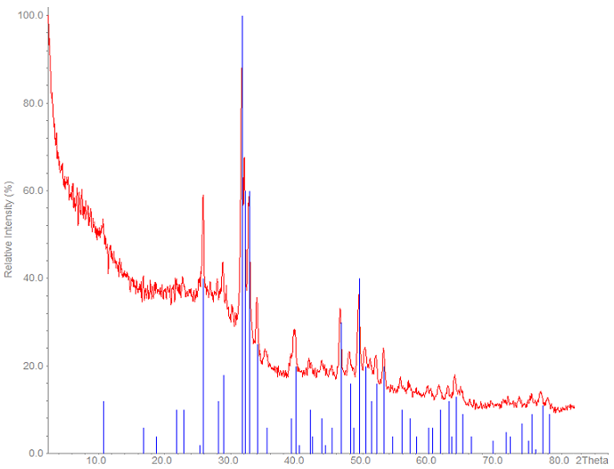
Figure 5.1. X-ray diffraction spectrum of sol-gel pH 9 hydroxyapatite sintered at 500 °C. Blue lines correspond to the X-ray diffraction card for hydroxyapatite. Baseline drift is due to sample preparation.

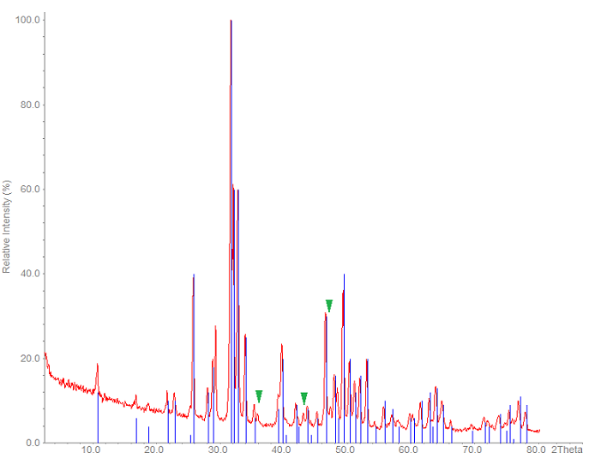
Figure 5.2. X-ray diffraction spectrum of sol-gel pH 9 hydroxyapatite sintered at 550 °C. Peaks marked with green are monetite. Blue lines correspond to the X-ray diffraction card for hydroxyapatite.

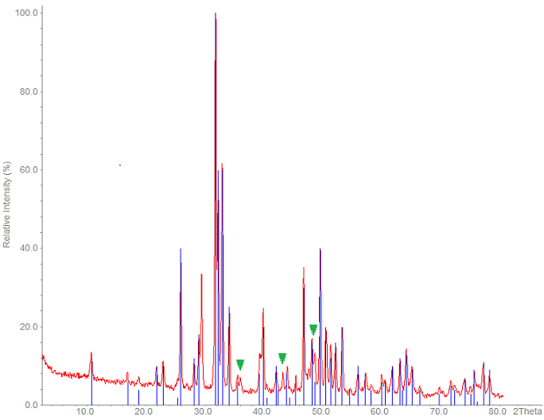
Figure 5.3. X-ray diffraction spectrum of sol-gel pH 9 hydroxyapatite sintered at 600 °C. Peaks marked with green are monetite. Blue lines correspond to the X-ray diffraction card for hydroxyapatite.

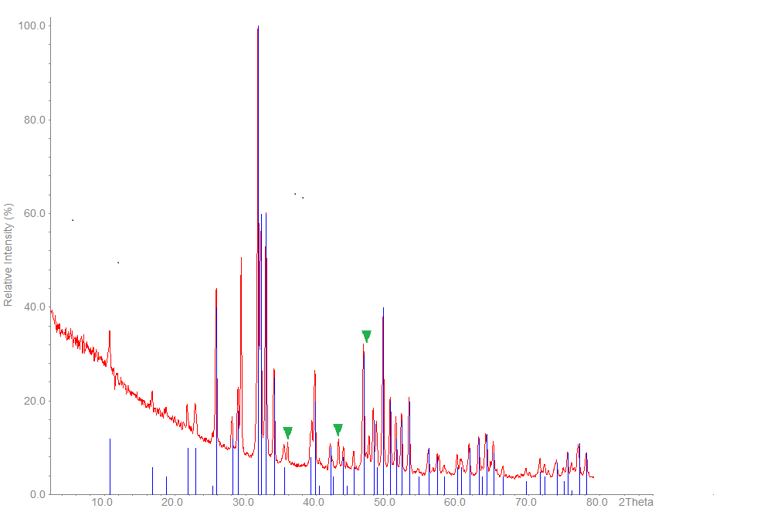
Figure 5.4. X-ray diffraction spectrum of sol-gel pH 10 hydroxyapatite sintered at 500 °C. Blue lines correspond to the X-ray diffraction card for hydroxyapatite.
Peaks marked with green are monetite.
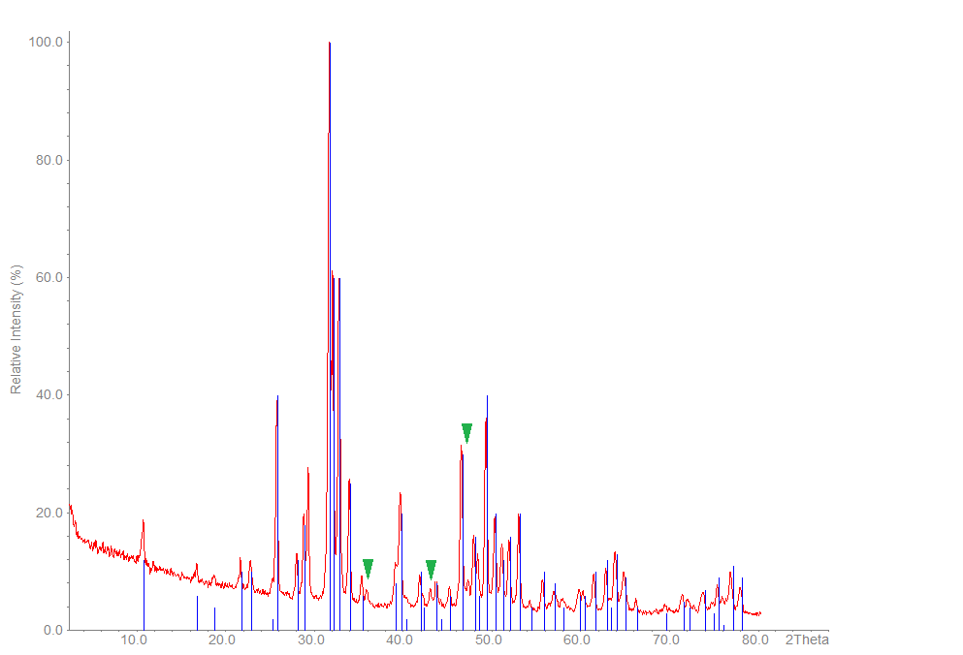
Figure 5.5. X-ray diffraction spectrum of sol-gel pH 10 hydroxyapatite sintered at 550 °C. Peaks marked with green are monetite. Blue lines correspond to the X-ray diffraction card for hydroxyapatite.
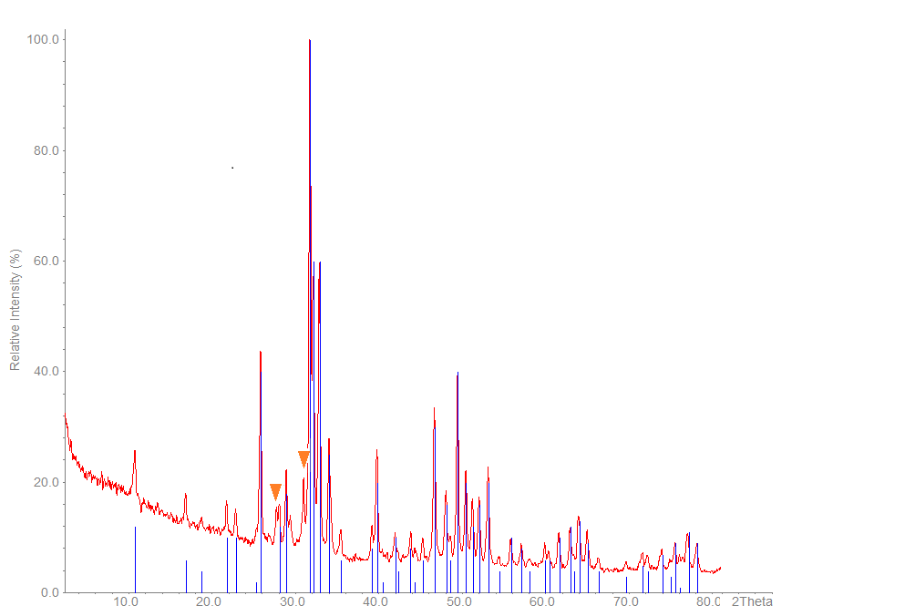
Figure 5.6. X-ray diffraction spectrum of sol-gel pH 10 hydroxyapatite sintered at 600 °C. Peaks marked with orange are beta-tricalcium phosphate. Blue lines correspond to the X-ray diffraction card for hydroxyapatite.

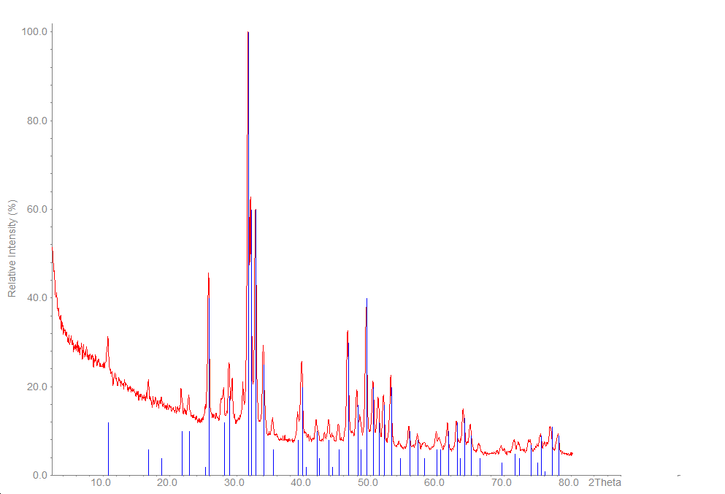
Figure 5.7. X-ray diffraction spectrum of sol-gel pH 10.5 hydroxyapatite sintered at 500 °C. Blue lines correspond to the X-ray diffraction card for hydroxyapatite.

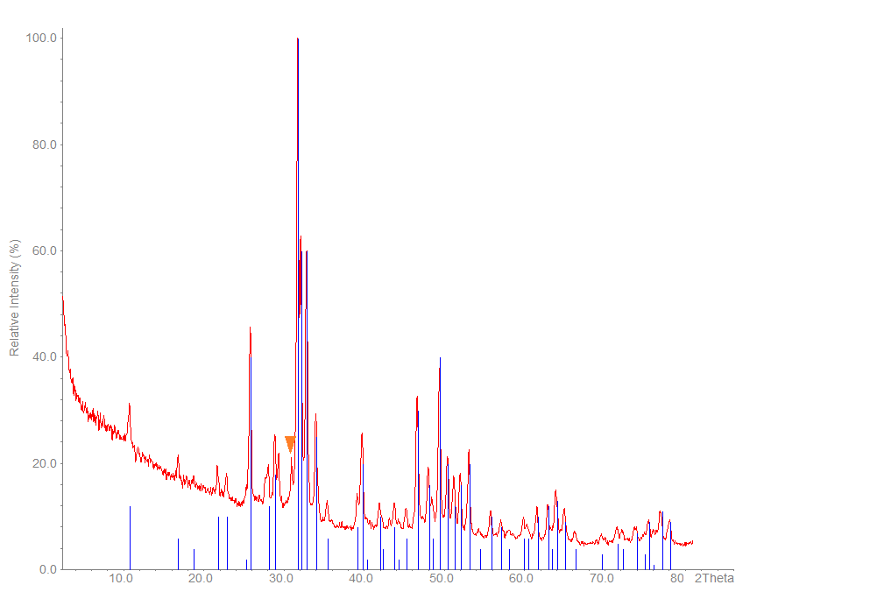
Figure 5.8. X-ray diffraction spectrum of sol-gel pH 10.5 hydroxyapatite sintered at 550 °C. Peaks marked with orange are beta tricalcium phosphate. Blue lines correspond to the X-ray diffraction card for hydroxyapatite.

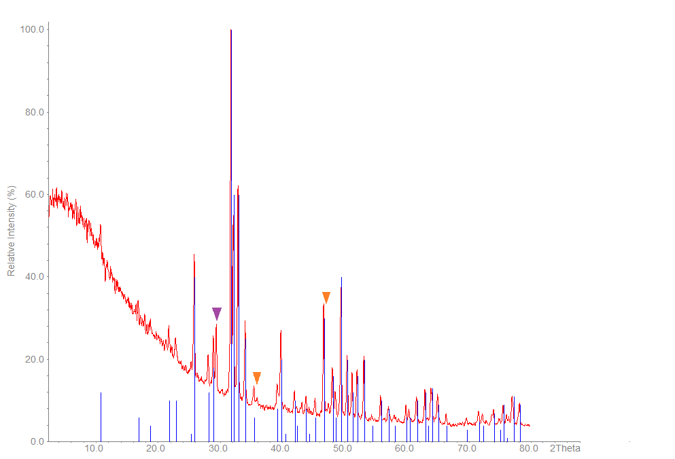
Figure 5.9. X-ray diffraction spectrum of sol-gel pH 10.5 hydroxyapatite sintered at 600 °C. Peaks marked with orange are beta tricalcium phosphate, peaks marked with purple are calcium oxide. Blue lines correspond to the X-ray diffraction card for hydroxyapatite.
X-ray diffraction spectra for hydroxyapatite prepared by the HA 2 method
Figure 5.10 and Figure 5.11 are for the unsintered and sintered powders respectively produced using the HA 2 method. For the method, see section 5.1. The unsintered powder was identified as HA with no secondary phases present. However, the sintering stage caused the formation of calcium oxide as an impurity.

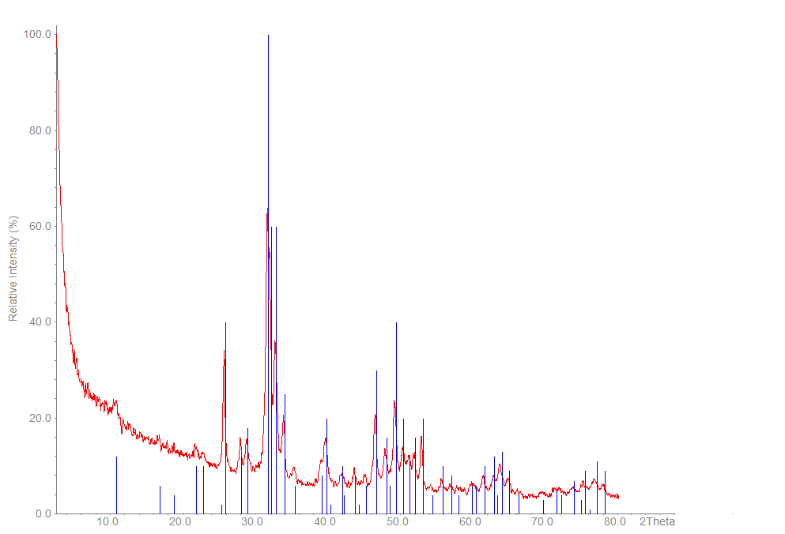
Figure 5.10. X-ray diffraction spectrum of unsintered HA 2 method hydroxyapatite. Blue lines correspond to the X-ray diffraction card for hydroxyapatite.

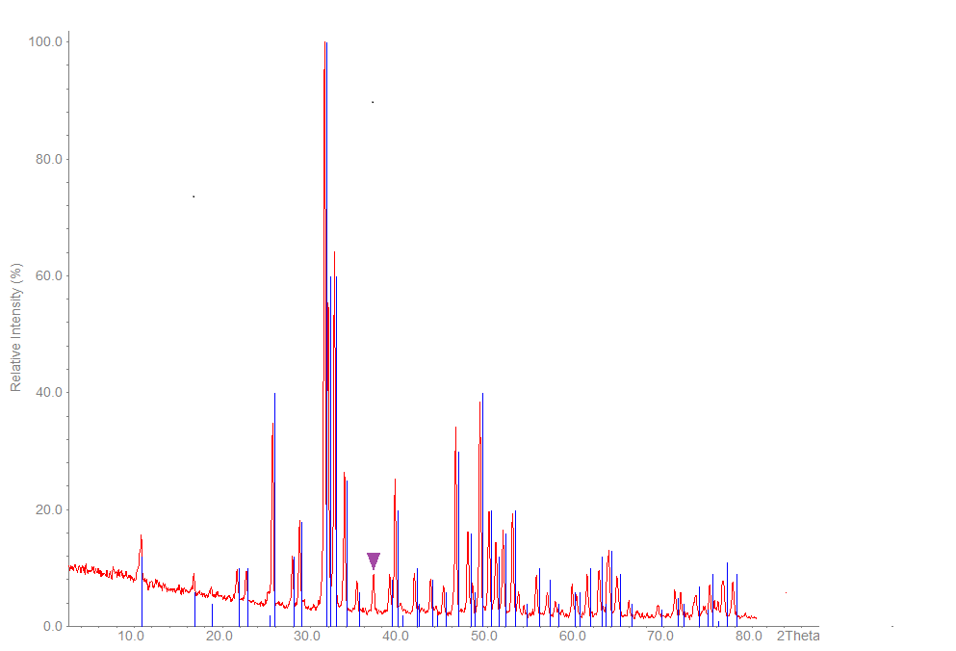

Figure 5.11. X-ray diffraction spectrum of 1000 °C sintered HA 2 method hydroxyapatite. Red lines correspond to the X-ray diffraction card for hydroxyapatite. Peak marked with purple indicates calcium oxide.

X-ray diffraction spectra for hydroxyapatite prepared by the HA 3 method
Figure 5.12 and Figure 5.13 are the XRD spectra for unsintered and sintered HA respectively, produced by the HA 3 method. See section 8.1.3 for the method used. The unsintered powder is HA with no secondary phases present, whilst the sintering stage led to the formation of calcium nitrate, with HA remaining the main phase.

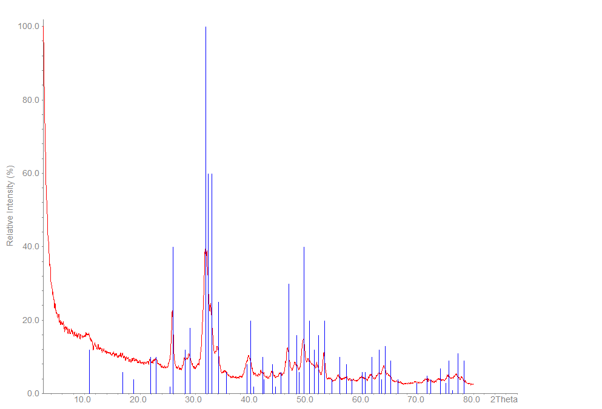
Figure 5.12. X-ray diffraction spectrum of unsintered HA 3 method hydroxyapatite. Blue indexing lines are hydroxyapatite.

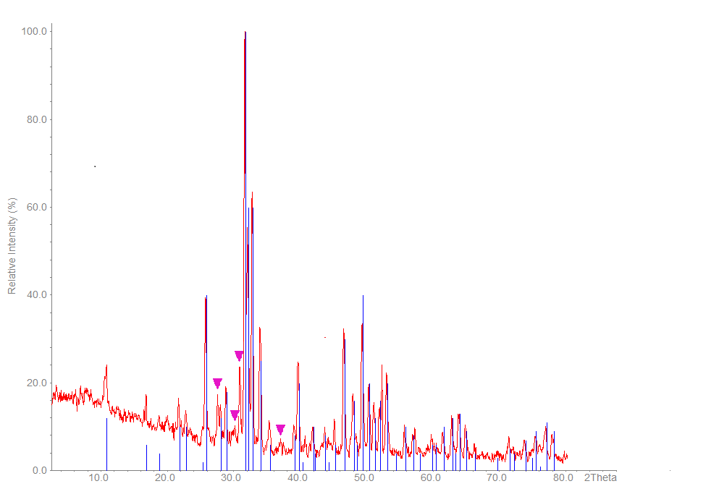
Figure 5.13. X-ray diffraction spectrum of 1000 °C sintered HA 3 method hydroxyapatite. Blue lines correspond to the X-ray diffraction card for hydroxyapatite. Peaks marked with pink are calcium nitrate.

X-ray diffraction spectra for hydroxyapatite prepared by the HA 4 method
Figure 5.14 and Figure 5.15 overleaf are for unsintered and sintered powders respectively, produced using the HA 4 method. See section 4.2.4 for the method. The unsintered powder had a main phase of HA, with a secondary phase of β-TCP present. However, upon sintering, the powder decomposed to β-TCP.

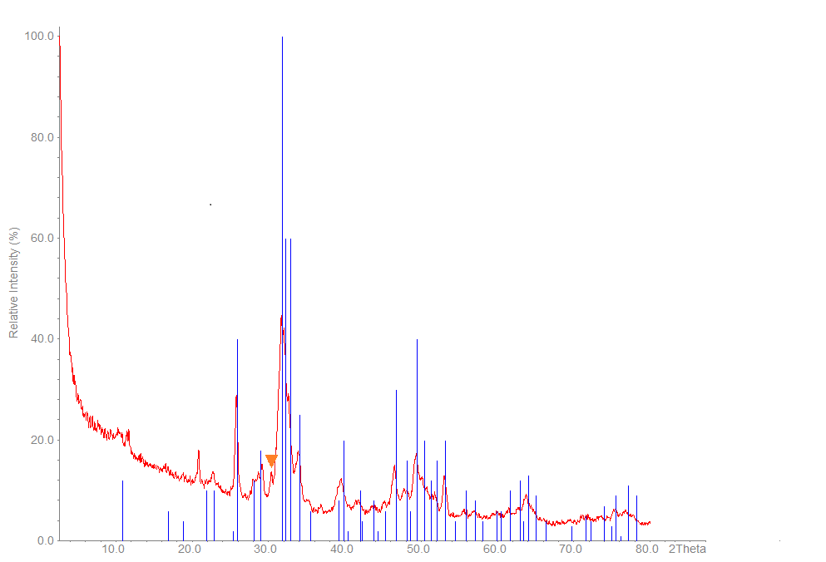
Figure 5.14. X-ray diffraction spectrum of unsintered HA 4 method hydroxyapatite. Blue lines correspond to the X-ray diffraction card for hydroxyapatite.
Peaks marked with orange are beta tricalcium phosphate.

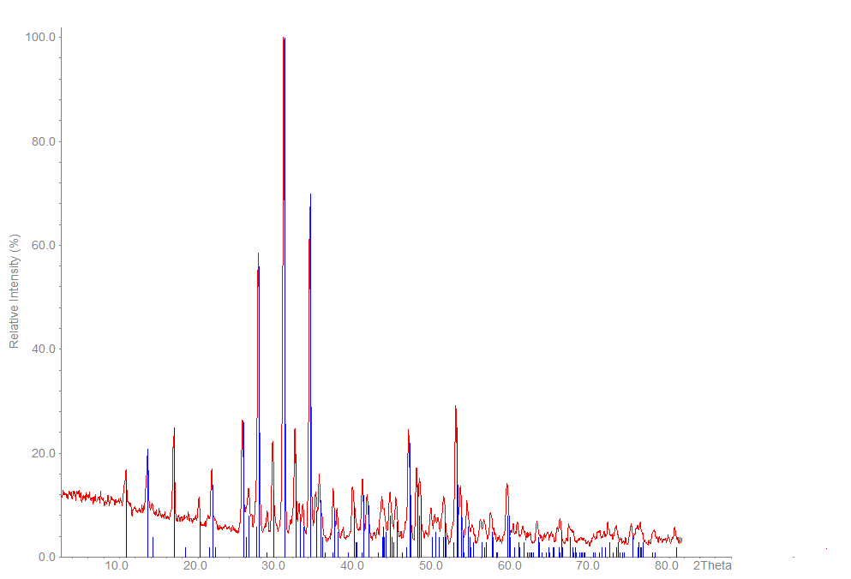
Figure 5.15. X-ray diffraction spectrum of 1000 °C sintered HA 4 method hydroxyapatite. Blue indexing lines are beta-tricalcium phosphate.

Table 5.2 summarises the unsubstituted HA powders produced by the different methods used, and includes the main phase as well as any secondary phases that were identified in the sample. Both unsintered and sintered powders are listed for the HA 2, HA 3 and HA 4 methods.

Table 5.2. Hydroxyapatite synthesis methods and the phases produced as identified by XRD analysis.
Synthesis method | Figure | Sintering temperature (°C) | Main phase | Secondary phases
Sol-gel pH 9 | Figure 5.1 | 500 | HA | -
Sol-gel pH 9 | Figure 5.2 | 550 | HA | Monetite
Sol-gel pH 9 | Figure 5.3 | 600 | HA | Monetite
Sol-gel pH 10 | Figure 5.4 | 500 | HA | Monetite
Sol-gel pH 10 | Figure 5.5 | 550 | HA | Monetite
Sol-gel pH 10 | Figure 5.6 | 600 | HA | β-TCP
Sol-gel pH 10.5 | Figure 5.7 | 500 | HA | -
Sol-gel pH 10.5 | Figure 5.8 | 550 | HA | β-TCP
Sol-gel pH 10.5 | Figure 5.9 | 600 | HA | β-TCP, CaO
HA 2 | Figure 5.10 | Unsintered | HA | -
HA 2 | Figure 5.11 | 1000 | HA | Calcium oxide
HA 3 | Figure 5.12 | Unsintered | HA | -
HA 3 | Figure 5.13 | 1000 | HA | Calcium nitrate
HA 4 | Figure 5.14 | Unsintered | HA | Brushite
HA 4 | Figure 5.15 | 1000 | β-TCP | -

The sol-gel hydroxyapatite batches were split into three and synthesised at the three different temperatures, so that the results at different temperatures were all from the same production batch. Hydroxyapatite produced from the HA 2, 3 and 4 methods were similarly split into two, with one half remaining unsintered whilst the second half was sintered at the specified temperature.

X-ray diffraction spectra for strontium-substituted hydroxyapatite
Strontium-substituted hydroxyapatite produced by the HA 3 method
Figure 5.16 below shows the XRD spectrum for unsintered 50 % Sr-HA produced using the HA 3 method. XRD revealed that the powder was 50:50 calcium strontium phosphate hydroxide. The sintered powder decomposed and was unidentifiable by XRD and thus the spectrum has not been included.
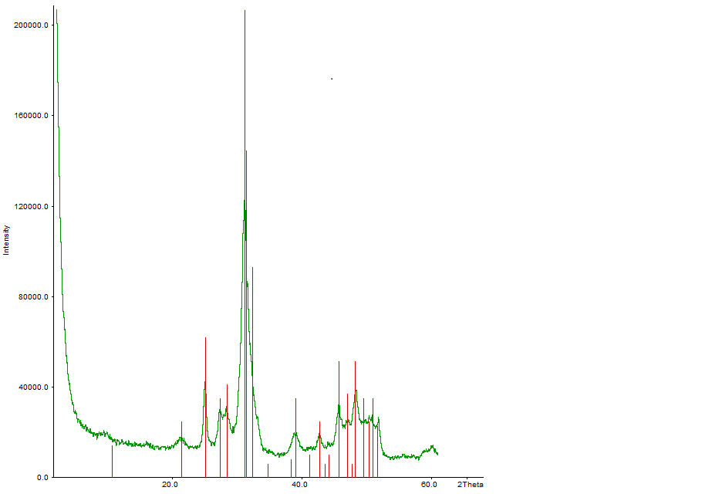
Figure 5.16. X-ray diffraction spectrum of unsintered HA 3 method 50 % strontium-substituted hydroxyapatite. Red indexing lines are 50:50 calcium strontium phosphate hydroxide.

Strontium-substituted hydroxyapatite produced by the HA 4 method
Figure 5.17 and Figure 5.18 are the spectra for unsintered 10 % and 100 % Sr-HA respectively, produced by the HA 4 method. See sections 8.2.2 (a) and (b) for the methods. The 10 % powder was identified as HA, and the 100 % sample as strontiumapatite.
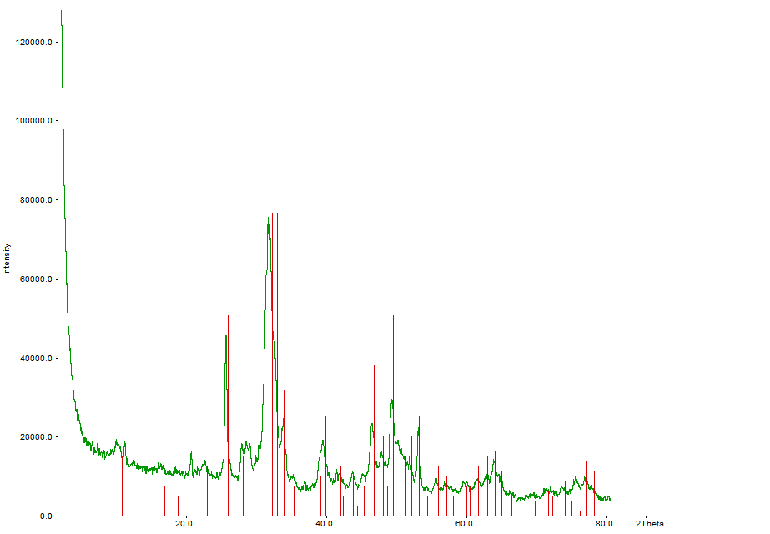
Figure 5.17. X-ray diffraction spectrum of unsintered HA 4 method 10 % strontium-substituted hydroxyapatite. Red lines correspond to the X-ray diffraction card for hydroxyapatite.

Figure 5.18. X-ray diffraction spectrum of unsintered HA 4 method 100% strontium-substituted hydroxyapatite. Red indexing lines are strontiumapatite.

Table 5.3. Strontium-substituted hydroxyapatite and the phases identified by X-ray diffraction analysis.
Synthesis method | % strontium substitution | Sintering temperature | Main phase | Secondary phases
HA 3 | 50 | Unsintered | Calcium strontium phosphate hydroxide | -
HA 4 | 10 | Unsintered | HA | -
HA 4 | 100 | Unsintered | Strontiumapatite | -

The levels of strontium substitution are the theoretical value based on the percentage of strontium precursor that was substituted for the calcium precursor in each method respectively.

X-ray fluorescence results
XRF was conducted on all unsubstituted HA powders produced and the values reported in Table 5.4 below. The stoichiometric value for HA is 1.67, whilst TCP has a value of 1.5, and that of octacalcium phosphate (OCP) is 1.33. The ratio for HA 1 pH 9 powder sintered at 500 °C was very low so the measurement was repeated. This powder was from the same batch as the two other samples synthesised at pH 9 which had slightly high Ca:P ratios.

Table 5.4. Calcium: phosphate ratios for sintered hydroxyapatite powders obtained by X-ray fluorescence.
Sample | Sintering temperature (°C) | Ca/P value | Main phase (XRD) | Secondary phase (XRD)
Reference powder* |  | 1.64
HA 1 pH 9 | 500 | 0.86 | HA | -
HA 1 pH 9 | 550 | 1.80 | HA | Monetite
HA 1 pH 9 | 600 | 1.88 | HA | Monetite
HA 1 pH 10 | 500 | 1.75 | HA | Monetite
HA 1 pH 10 | 550 | 1.93 | HA | Monetite
HA 1 pH 10 | 600 | 1.60 | HA | β-TCP
HA 1 pH 10.5 | 500 | 1.61 | HA | -
HA 1 pH 10.5 | 550 | 1.63 | HA | β-TCP
HA 1 pH 10.5 | 600 | 1.76 | HA | β-TCP
HA 2 | 1000 | 1.70 | HA | Calcium oxide
HA3 | 1000 | 1.51 | HA | Calcium nitrate
HA 4 | 1000 | 1.38 | β-TCP | -
*Plasma Biotal

Transmission electron microscopy images

Average particle size
Table 5.5. Average length and widths of HA particles measured from transmission electron microscopy images. All powders were unsintered. n = 50.
Powder | Average length ± SD (nm) | Average width ± SD (nm)
HA 3 pH 10 | 29.4 ± 8.2 | 10.9 ± 3.4
HA 3 pH 11 | 95.8 ± 37.4 | 14.7 ± 5.4
HA 4 pH 10 | 101.1 ± 44.0 | 16.4 ± 6.3
HA 4 pH 11 | 67.9 ± 24.3 | 16.4 ± 3.7
.
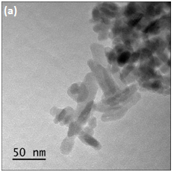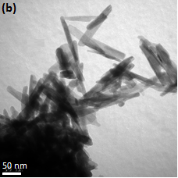
Figure 5.19. Transmission electron microscopy of hydroxyapatite produced by the HA 3 method. (a) unsintered, pH 10, (b) unsintered, pH 11. Scale bar is 50 nm in both images.

Particles showed a needle-like morphology, with an increase in width and length measured in the pH 11 powder compared to the pH 10 powder (Figure 5.19).

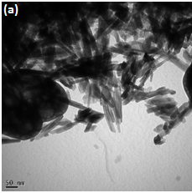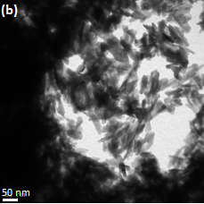
Figure 5.20. Transmission electron microscopy of hydroxyapatite produced by the HA 4 method. (a) unsintered, pH 10, (b) unsintered, pH 11.

The increase in pH caused an increase in particle length, but negligible change in width (Figure 5.20).

X-ray diffraction spectra of heterogeneous membrane coating
The powders used for XRD for the heterogeneous membrane formations were obtained from the dipping solutions of each method.

DM1
The powder used for XRD analysis for DM1 was obtained from the calcium solution (Figure 5.21). See section 4.5.2 (a) for the method. XRD revealed the main phase to be calcium chloride phosphide, with secondary phases of HA and OCP. However, as XRD was conducted on the precipitate from the solution and not that formed on the membrane, it cannot be said with conviction that the two substances will be the same.
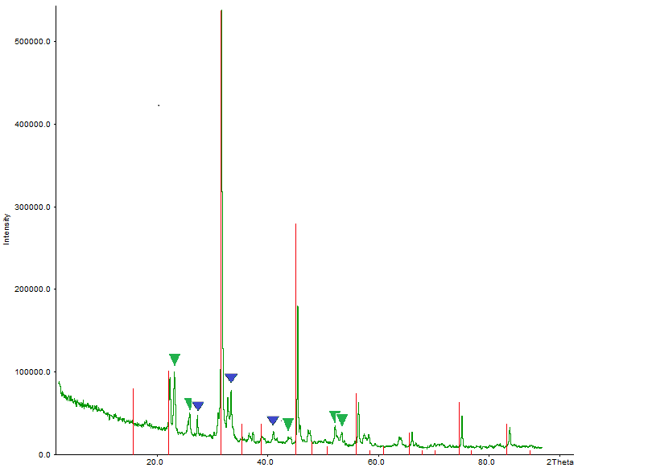
Figure 5.21. X-ray diffraction spectrum of precipitate obtained from calcium solution in DM1. Red indexing lines are calcium chloride phosphide. Peaks marked with green are associated with hydroxyapatite, those marked with blue are associated with octacalcium phosphate.

DM2
XRD analysis was carried out on the precipitate obtained from the calcium solution for DM2 (Figure 5.22). For the method, see section 4.4.2 (b). The phase identified is calcium chloride phosphide. Since the reagents used in both the calcium and the phosphorous solutions are the same as those used in DM1 (the two differences between the methods are the concentrations of the solutions, and the length and number of cycles), as would be predicted, the same compound was identified in the calcium solution for both methods.
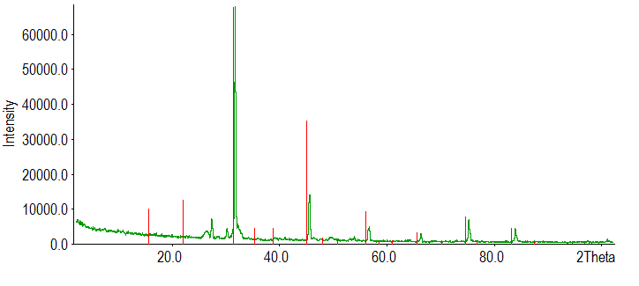
Figure 5.22. X-ray diffraction spectrum of precipitate obtained from the calcium solution in DM2. Red indexing lines are calcium chloride phosphide.

HA 3 dipping method
The XRD spectra for the precipitate obtained from the calcium solution in the HA 3 dipping method has been overlaid with the reference card to demonstrate that the phase present is not HA (Figure 5.23). For the method itself, see 4.4.2 (c).
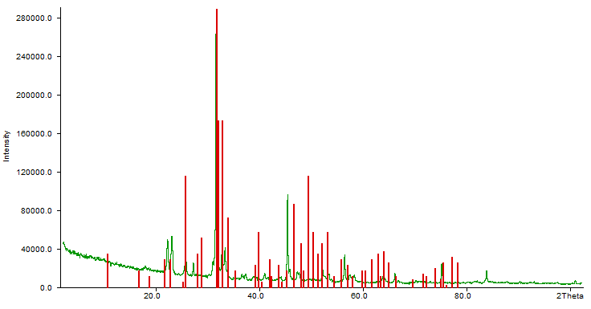
Figure 5.23. X-ray diffraction spectrum of precipitate obtained from calcium solution in HA 3 dipping method. Red lines correspond to the X-ray diffraction card for hydroxyapatite.

5.5.4 HA 4 dipping method
XRD analysis on the precipitate obtained from the calcium solution in the HA 4 dipping method showed it to be monetite, a calcium phosphate with a Ca:P of 1 (Figure 5.24). See section 4.5.2 for the method.
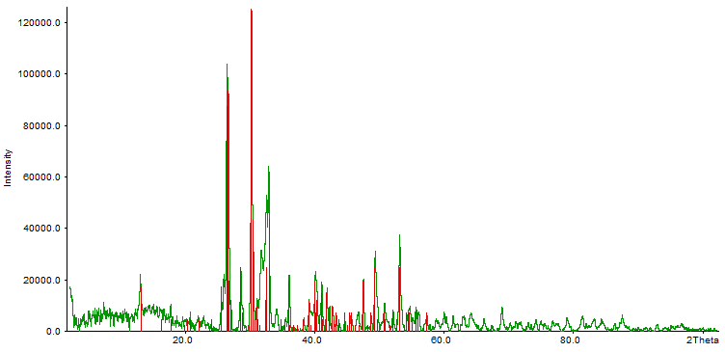
Figure 5.24. X-ray diffraction spectrum of precipitate obtained from calcium solution for HA 4 dipping method. Red indexing lines are monetite.

HA 3 titration method
The HA 3 titration method (see section 4.4.2 for method) produced pure HA (Figure 5.25). As the method is the same as that for the HA synthesis (section 4.1.3) except for using pH values of 10 for both the calcium and phosphorous solutions, as opposed to 11 and 12 respectively, this was to be expected.
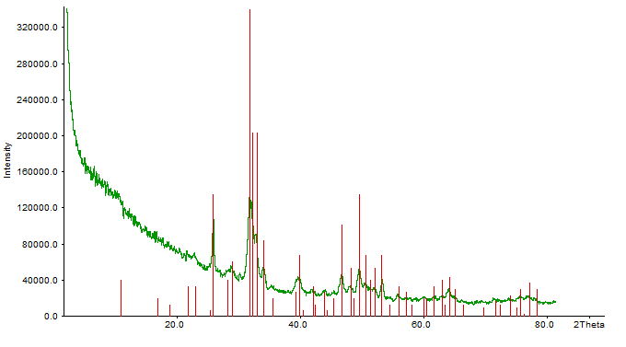Figure 5.25. X-ray diffraction spectrum of precipitate obtained from HA 3 titration method. Red indexing lines are hydroxyapatite.

HA 4 titration method
The HA 4 titration method also produced pure HA (Figure 5.26). Again, as the only difference between this and the HA synthesis method was the pH 10 for both solutions in the coating method, and pH 11 and 12 for the calcium and phosphorous solutions respectively in the HA synthesis method, this was to be expected.

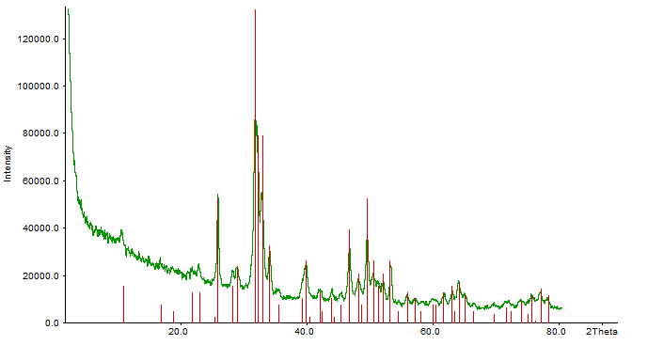
Figure 5.26. X-ray diffraction spectrum of precipitate obtained from HA 4 titration method. Red indexing lines are hydroxyapatite.

PLGA shrinkage results
Membranes were shrunk in both PBS (as reported in the literature) and dH₂O to ensure that the phosphate ions in PBS were not affecting the morphology of the PLGA fibres, or the weight change after shrinkage. The extent of shrinkage measured by change in surface area was greater for membranes shrunk in dH₂O, for both those shrunk with and without HA (Figure 5.27). The change in weight per surface area was greater for membranes shrunk in PBS (without HA), but this result was not significant (Figure 5.28). Membranes shrunk with HA in dH₂O had a significantly greater change in weight per surface area than those shrunk with HA in PBS. For the method, see section 4.3.3.

Figure 5.27. Comparison of change in surface area as percentage of original surface area prior to shrinkage.

Figure 5.28. Comparison of change in weight per change in surface area for membranes shrunk with and without hydroxyapatite in PBS and dH₂O. n = 9.

As would be expected, the differences between the membranes shrunk without HA were statistically different in comparison to the membranes shrunk in the same medium with hydroxyapatite (Figure 5.28). The variance between the weight change for membranes shrunk with hydroxyapatite between PBS and dH₂O was statistically different.

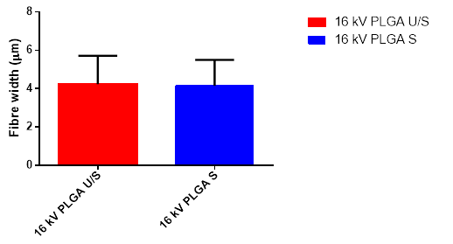
Figure 5.29. Comparison of average fibre widths for unshrunk and shrunk PLGA membranes electrospun at 16 kV. The membranes were shrunk in dH₂O. n = 20.

Heterogeneous membrane fabrication
Table 5.6. Comparison of average weight change per unit surface area for dipping and titration coating methods. The weight changes are in micrograms per millimetre squared. 15 cycles of DM1 produced the largest increase in weight per surface area. The HA 3 titration coating method was chosen as the coating method, due to evidence of brushite in the HA 4 titrations (XRD analysis), despite a greater weight change with the latter. Methods were first conducted on unshrunk PLGA to test efficacy. SEM analysis of unshrunk membranes revealed whether the coating was uniform in distribution and revealed the presence of suspected impurities (brushite, DM1 15 cycles) which could not be confirmed by X-ray diffraction. For these reasons, these methods were eliminated and not then applied to shrunk membranes.

Table 5.6. Comparison of average weight change per unit surface area for dipping and titration coating methods. n = 5.
 | Δμg/mm²
Method | 1 x 10, 2 x 5 | 5 x 2 | 10 x 2 | 15 x 2 | 20 x 2 | Titration
DM1 | - | 0.67 ± 0.36 | 2.63 ± 0.35 | 6.23 ± 2.95 | - | -
DM2 | 1.92 ± 1.29 | - | - | - | - | -
HA 3 | - | 0.35 ± 0.13 | 1.08 ± 0.66 | 1.20 ± 0.46 | 3.79 ± 1.22 | 1.47 ± 1.53
HA 3 shrunk | - | 0.48 ± 0.12 | 1.49 ± 0.89 | 10.97 ± 9.44 | - | 2.79 ± 0.8
HA 4 | - | 0.39 ± 0.21 | 0.61 ± 0.24 | 0.73 ± 0.67 | 1.33 ± 0.44 | 4.38 ± 1.84
HA 4 shrunk | - | 0.41 ± 0.19 | 0.62 ± 0.64 | 0.36 ± 0.23 | - | 4.33 ± 1.78

Figure 5.30. Comparison of average weight change per mm² for the HA 3, 2 x HA 3 and HA 4 coating methods on shrunk electrospun PLGA. n = 10.

Some evidence of brushite was found in scanning electron microscopy images of the HA 4 coating, so even though this method produced more coating on the membrane, it was decided to use the HA 3 coating method to fabricate the membranes used for in vitro testing. These results equate to percentage weight changes of 8.2 ± 2.3 %, 15.3 ± 8.6 % and 14.7 ± 12.4 % respectively (Figure 5.30).

Scanning electron microscopy images

Shrunk PLGA
Hydroxyapatite distribution throughout the membrane is non-uniform (Figure 5.31). Figure 5.31 (a) shows PLGA shrunk in PBS. The relaxing of the polymer chains to their coiled state can be seen in the decrease in porosity of the membrane. (b) shows PLGA shrunk with HA using the entrapment method (see section 4.4.1 for method). As can be seen from the image, the distribution of HA is non-uniform.

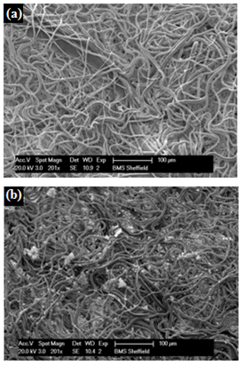
Figure 5.31. Scanning electron microscopy images of (a) PLGA shrunk in PBS and (b) PLGA shrunk with hydroxyapatite in PBS. Scale bar is 100 μm for both images. Philips XL20.

DM1
The SEM images for 5 cycles of DM1 suggest that the coating is reasonably uniform over the polymer fibres. The coating appears to have an HA-like structure. The images for 10 cycles of DM1 (Figure 5.33) show a sparser and less uniform coating than those for 5 cycles, which is against expectations. The coating still appears to have an HA-like morphology. The images for membranes treated with 15 cycles of DM1 (Figure 5.34) suggest the formation of a non-HA phase. This is most evident in (d), where flat, plate-like crystals with well-defined edges can be seen. Figure 5.31(a) shows a shrunk membrane prior to coating.

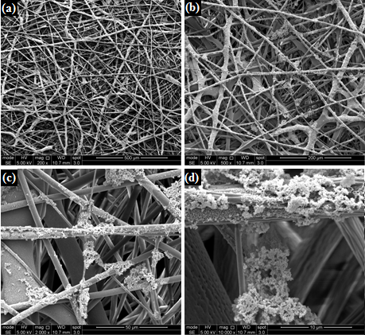
Figure 5.32. Scanning electron microscopy images of unshrunk PLGA membrane treated with DM1 5 cycles. (a) 100 x magnification, (b) 500 x, (c) 2000 x , and (d) 10,000 x.

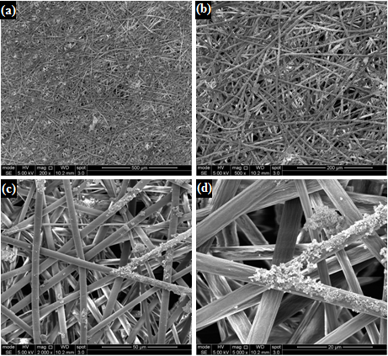
Figure 5.33. Scanning electron microscopy images of unshrunk PLGA membrane treated with DM1 10 cycles. (a) 100 x magnification, (b) 500 x, (c) 2000 x , and (d) 10,000 x.

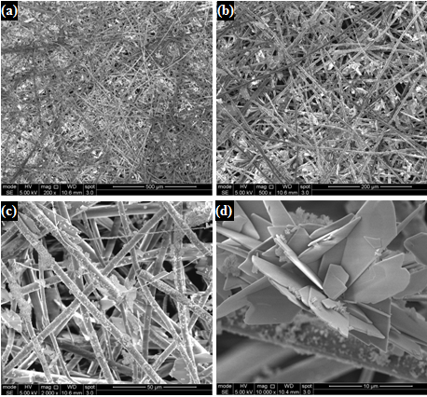
Figure 5.34. Scanning electron microscopy images of unshrunk PLGA membrane treated with DM1 15 cycles. (a) 100 x magnification, (b) 500 x, (c) 2000 x , and (d) 10,000 x.

DM2
Images of the membrane coated using DM2 reveal a less abundant coating than might be expected from the average weight change per unit area of the coated membranes (see table 12) (Figure 5.35). This suggests that the coating is comparable to that obtained with 10 cycles of DM1

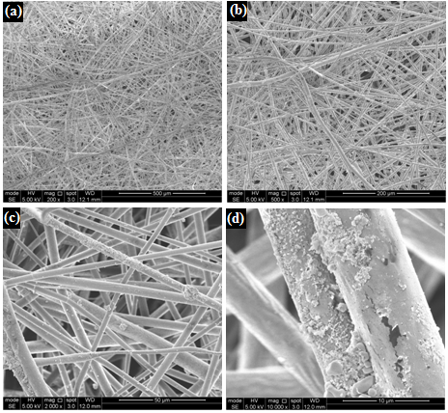
Figure 5.35. Scanning electron microscopy images of unshrunk PLGA membranes coated using DM2. (a) 100 x magnification, (b) 200 x, (c) 2000 x and (d) 10,000 x.

HA 3 dipping method
SEM images for 5 cycles of the HA 3 dipping method (Figure 5.36) show that the coating is sparse, as do the images for 10 cycles (Figure 5.37). Figure 5.38 shows a more substantial coating which is more uniform, but it appears to only be present on the surface of the polymer, as opposed to deeper within the membrane.

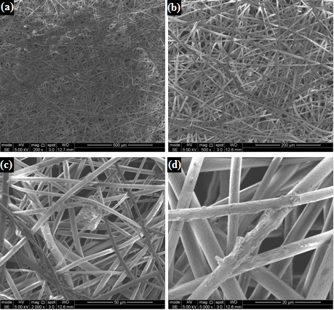
Figure 5.36. Scanning electron microscopy images of unshrunk PLGA membrane coated using HA 3 dipping method 5 cycles. (a) 200 x magnification, (b) 500 x, (c) 2000 x and (d) 10,000 x.

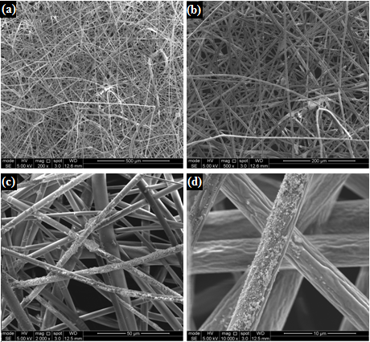
Figure 5.37. Scanning electron microscopy images of unshrunk PLGA membrane coated using HA 3 dipping method 10 cycles. (a) 200 x magnification, (b) 500 x, (c) 2000 x and (d) 10,000 x.

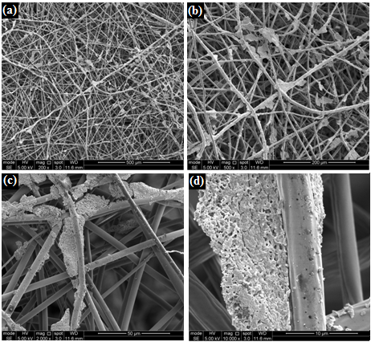
Figure 5.38. Scanning electron microscopy images of unshrunk PLGA membrane coated using HA 3 dipping method 15 cycles. (a) 200 x magnification, (b) 500 x, (c) 2000 x and (d) 10,000 x.

HA 4 dipping method
Figure 5.39 shows little evidence of coating, which relates to the negligible average weight change per unit area (Table 5.6). A more abundant coating is evident in the membranes treated with 10 cycles (Figure 5.40), and is increasingly apparent for 15 cycles (Figure 5.41). However, the coating on the membrane treated with 20 cycles appears to be less uniform (Figure 5.42).
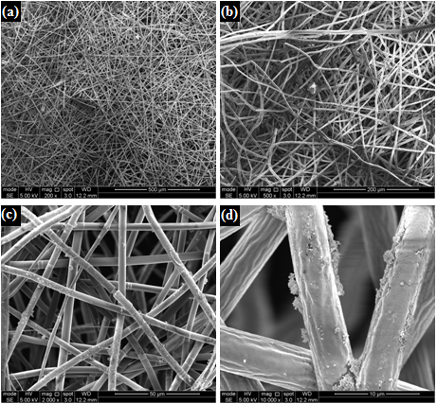
Figure 5.39. Scanning electron microscopy of unshrunk PLGA membrane coated using HA 4 dipping method 5 cycles. (a) 200 x magnification, (b) 500 x, (c) 2000 x and (d) 10,000 x.

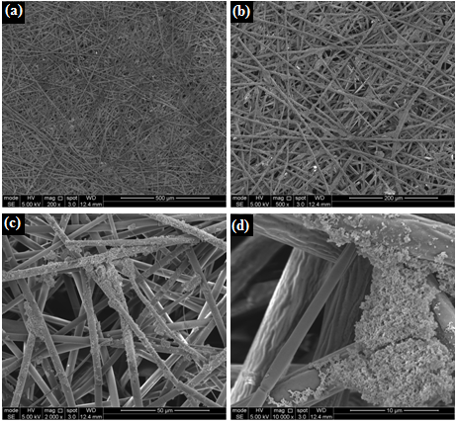
Figure 5.40. Scanning electron microscopy of unshrunk PLGA membrane coated using HA 4 dipping method 10 cycles. (a) 200 x magnification, (b) 500 x, (c) 2000 x and (d) 10,000 x.

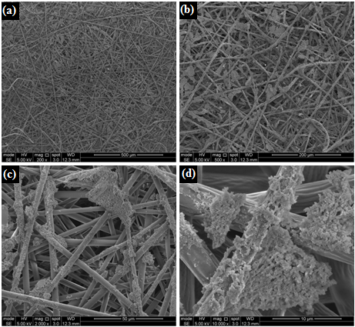
Figure 5.41. Scanning electron microscopy of unshrunk PLGA membrane coated using HA 4 dipping method 15 cycles. (a) 200 x magnification, (b) 500 x, (c) 2000 x and (d) 10,000 x.

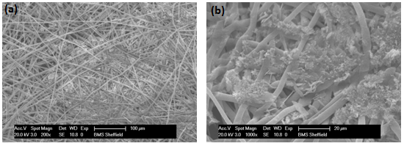
Figure 5.42. Scanning electron microscopy of unshrunk PLGA coated using HA 4 dipping method 20 cycles. (a) 200 x magnification, (b) 1000 x. Philips XL20.

HA 3 titration method
The HA 3 titration method appears to have created a more uniform coating over the whole membrane, both on the unshrunk and shrunk PLGA (Figures 5.43 and 5.44).
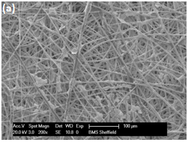
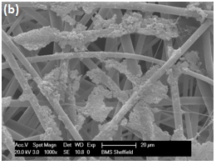
Figure 5.43. Scanning electron microscopy of unshrunk PLGA membrane coated using HA 3 titration method. (a) 200 x magnification, (b) 1000 x. Philips XL20.

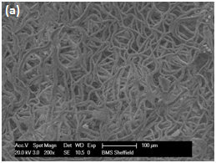
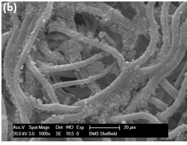
Figure 5.44. Scanning electron microscopy of shrunk PLGA coated using HA 3 titration method. (a) 200 x magnification, (b) 1000 x. Philips XL20.

HA 4 titration method
The majority of the coating in Figure 5.45 appears to be on the reverse of the membrane and can be seen as flat plate-like crystals beneath the polymer fibres. The shrunk membranes Figure 5.46 appear to show a more uniform coating across the membrane.

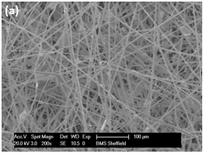
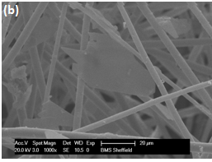
Figure 5.45. Scanning electron microscopy of unshrunk PLGA coated using HA 4 titration method. (a) 200 x magnification, (b) 1000 x. Philips XL20.

The flat, plate-like crystals shown in Figure 5.45(b) could be brushite. Whilst no brushite was identified via X-ray diffraction for the coating titration (pH 10 for calcium and phosphate solutions), it was identified at pH 11 and 12 respectively.

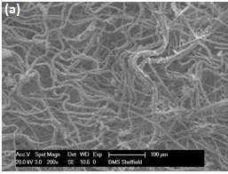
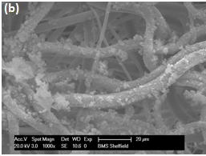
Figure 5.46. Scanning electron microscopy of shrunk PLGA coated using HA 4 titration method. (a) 200 x magnification, (b) 1000 x. Philips XL20.

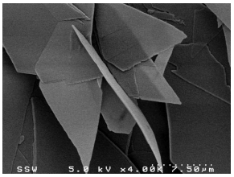
Figure 5.47. Scanning electron microscopy image of brushite (Arifuzzaman and Rohani, 2004).

In vitro tests on membranes

In all in vitro experiments, B refers to basal media and O to osteogenic media.

pNPP and PicoGreen assays

Human mesenchymal stem cell in vitro experiment one
These results and the Von Kossa stained samples (Figure 5.60) were from the same experiment. The hMSCs used in both experiment one and two were obtained from the patellae of osteoarthritic patients undergoing joint replacement surgery. j
Figure 5.48. dsDNA quantification by the PicoGreen assay for human mesenchymal stem cells cultured on hydroxyapatite-coated PLGA membranes for 21 days in basal and osteogenic media. n = 3.

Figure 5.48 shows an increase in the amount of DNA expressed by the cells cultured in the basal media across all time points, indicating proliferation was occurring. The decrease in amount of DNA between days 14 and 21 for the cells cultured in osteogenic media could be explained by the fact that the cells might have differentiated and were laying down a bone matrix by day 21.

Figure 5.49. Alkaline phosphatase expression quantified by pNPP assay for human mesenchymal stem cells cultured on electrospun hydroxyapatite-coated membranes for 21 days in basal and osteogenic media. n = 3.

Figure 5.49 shows a statistical difference at day 14 of the amount of alkaline phosphatase expressed by cells cultured in the osteogenic medium compared to the basal media, suggesting that the cells were differentiating. This level of expression for the samples cultured in osteogenic media had decreased by day 21, although this might be due to a decrease in the number of cells differentiating at this time point.

Figure 5.50. Alkaline phosphatase relative to dsDNA for human mesenchymal stem cells cultured on hydroxyapatite-coated shrunk electrospun PLGA membranes for 21 days in basal and osteogenic media. n = 3.

The increase in the ratio in Figure 5.50 between days 14 and 21 for the membranes cultured in the osteogenic media suggest an increase in osteogenic differentiation. The differences between samples cultured in basal and osteogenic media at both day 14 and 21 suggest that the osteogenic media promoted an increased rate of differentiation.

Human mesenchymal stem cell in vitro experiment two
Figure 5.51. dsDNA quantified by the PicoGreen assay for human mesenchymal stem cells cultured on uncoated and hydroxyapatite-coated electrospun PLGA membranes for 21 days in basal and osteogenic media. n = 3.

Figure 5.51 shows an increase in DNA expression for the HA 3 sample in osteogenic media at day 14, before a decrease by day 21. This is similar to the trend seen in Figure 5.48.

Figure 5.52. Alkaline phosphatase expression quantified by pNPP assay for human mesenchymal stem cells cultured on uncoated and hydroxyapatite-coated shrunk electrospun PLGA membranes in basal and osteogenic media for 21 days. There are no statistical differences in levels of alkaline phosphatase expressed between the uncoated and coated membranes, or between those cultured in basal media and osteogenic media. The PGA was too degraded by day 7 to be sampled. n = 3.

Alkaline phosphatase quantification by pNPP assay (Figure 5.52) showed no significant differences in levels of ALP between uncoated and coated membranes, or osteogenic and basal media, suggesting that the HA coating did not significantly affect the rate of differentiation of the hMSCs.

Figure 5.53. Alkaline phosphatase relative to dsDNA for human mesenchymal stem cells cultured on uncoated and hydroxyapatite-coated electrospun PLGA membranes for 21 days in basal and osteogenic media. n = 3.

The results (Figure 5.53) suggest that the greatest extent of differentiation occurred on the PLGA membranes that were cultured in osteogenic media, and that the level of differentiation of the cells cultured on this material in osteogenic media increased from day 14 to day 21. The amount of ALP expressed relative to DNA is significantly different between the coated and uncoated membranes in osteogenic media at day 21, which suggests that the HA coating has not influenced rate of differentiation of the cells.

Figure 5.54. dsDNA quantified by the PicoGreen assay for rat MSCs cultured days on uncoated and hydroxyapatite-coated shrunk electrospun PLGA membranes for 21 in basal and osteogenic media. n = 5.

As with the results from the hMSC experiments, Figure 5.54 also shows a peak in DNA levels at day 14 for the HA 3 sample cultured in osteogenic media. Levels of DNA expressed by the cells cultured on HA-coated membranes in basal media increased across the 21 day culture period, suggesting proliferation occurred up to day 21. These results suggest that after an initial period of proliferation up to day 7, cells cultured on uncoated PLGA did not undergo further significant proliferation. This could be either due to cell differentiation or cell death.

Figure 5.55. Alkaline phosphatase expression quantified by pNPP for rat mesenchymal stem cells cultured on uncoated and hydroxyapatite-coated shrunk electrospun PLGA membranes for 21 days in basal and osteogenic media. There was no statistical difference between membranes and medium conditions at day 21. n = 5.

A peak in levels of ALP at day 7 for uncoated membranes cultured in osteogenic media in comparison to days 14 and 21 suggests that cell death is occurring as opposed to cell proliferation (Figure 5.55)

Figure 5.56. Alkaline phosphatase relative to dsDNA for rat mesenchymal stem cells cultured on uncoated and hydroxyapatite-coated electrospun PLGA membranes for 21 days in basal and osteogenic media. n = 5.

Figure 5.56 suggests that when relative to levels of DNA, ALP expression is not significantly different between the different samples and media conditions at the same time point. This suggests that the HA coating had negligible effect on cell behaviour in comparison to the uncoated samples.

Rat mesenchymal stem cell in vitro experiment two
Figure 5.57. dsDNA quantified by the PicoGreen assay for rat mesenchymal stem cells cultured on uncoated and hydroxyapatite-coated electrospun PLGA membranes for 21 days in basal and osteogenic media. n = 6 (experiment conducted in triplicate in duplicate).

The HA 3 membrane showed a slight decrease in amount of DNA between days 14 and 21 (Figure 5.57), potentially suggesting differentiation, although the difference is not significant. The 2x HA 3 showed a large increase in DNA between days 1 and 7, followed by a decrease between days 7 and 14. These results suggest differentiation began between days 7 and 14.

Figure 5.58. Alkaline phosphatase expression quantified by pNPP for rat mesenchymal stem cells cultured on uncoated and hydroxyapatite-coated shrunk electrospun PLGA membranes for 21 days in basal and osteogenic media. n = 6 (experiment conducted in triplicate in duplicate).

At day 21, the cells cultured on PLLA membranes in osteogenic media produced a significantly larger amount of alkaline phosphatase than any of the other membranes cultured in the same media (Figure 5.58). There was little difference in the level of alkaline phosphatase produced by all 2x HA 3 samples across all time points.

Figure 5.59. Alkaline phosphatase relative to dsDNA for rat mesenchymal stem cells cultured on uncoated and hydroxyapatite-coated electrospun PLGA membranes for 21 days in basal and osteogenic media. n = 6 (experiment conducted in triplicate in duplicate).

Figure 5.59 shows that the ratio of alkaline phosphatase to dsDNA was significantly larger for PLLA membranes in osteogenic media in comparison to the other membranes cultured in the same media at day 21, suggesting that a larger proportion of cells on PLLA had differentiated.

Histology

Von Kossa stain
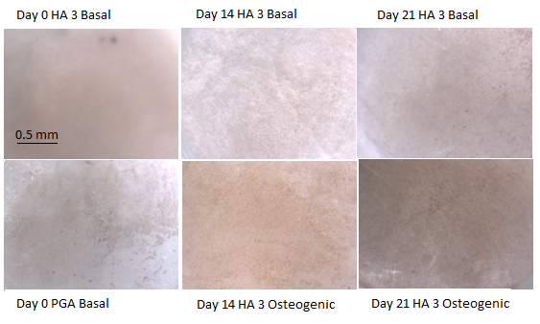
Figure 5.60. Von Kossa staining on hydroxyapatite-coated shrunk electrospun PLGA membranes at days 0, 14 and 21. hMSCs were cultured on the membranes in basal and osteogenic media. Scale bar is 0.5 mm for all images.

The darker the stain, the greater the extent of mineralisation. These results shown in Figure 5.60 indicate an increased level of mineralisation in the day 21 sample cultured in osteogenic media. This supports the pNPP assay results, where higher levels of alkaline phosphatase were quantified on the membranes cultured in osteogenic media. A significant increase in alkaline phosphatase was measured between the osteogenic samples at days 14 and 21, and the stain is darker on the day 21 samples. These are the same cells as used in human mesenchymal stem cell in vitro experiment one in the previous section.

DAPI and Phalloidin
DAPI is a fluorescent stain that binds to DNA, with an emission maximum at 461 nm (blue). Phalloidin binds to F-actin.
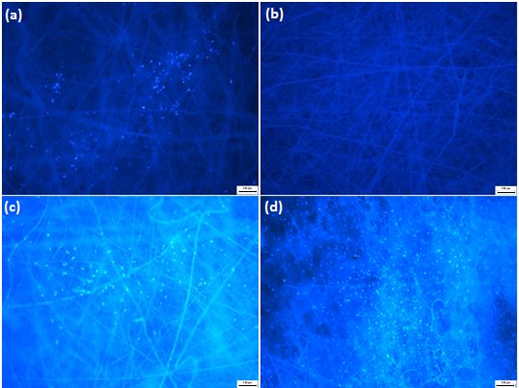
Figure 5.61. DAPI staining of membranes cultured with rat mesenchymal stem cells in osteogenic media at day 7. (a) PLLA, (b) PLGA, (c) HA 3, (d) 2x HA 3. Scale bar is 100 µm.

Figure 5.61(a) suggests a low cell number, with the cells in small groups. No cells were found on (b), but the image shows the autofluorescence of the material. (c) suggests a low cell distribution, with cells in small groups mainly near the centre of the material. (d) has a high number of cells more evenly distributed across the sample. A significantly larger amount of DNA was measured on the 2x HA 3 membranes in osteogenic media at this time point than the other types, and the DAPI staining is in agreement with this result.

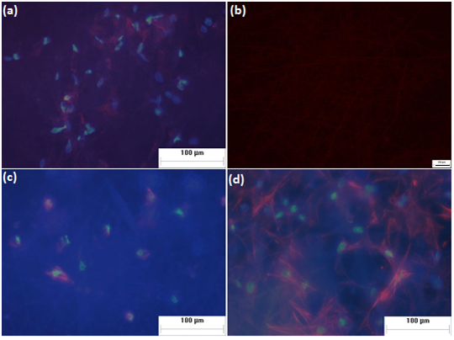
Figure 5.62. Combined images of DAPI and TRITC-conjugated Phalloidin staining of membranes cultured with rat mesenchymal stem cells in osteogenic media at day 7. (a) PLLA, (b) PLGA, (c) HA 3, (d) 2x HA 3. Note scale bar of (b) is 100 µm.

No cells were found in Figure 5.62(b), and the image was taken using the TRITC filter on the microscope to show the background fluorescence of the material. (a) suggests the F-actin fibres are relaxed and that the cells have adhered to the material. (c) Cells appear to be stretching around the material. (d) Cells show a clustered growth, with cells stretching around the electrospun fibres.

Scanning electron microscopy results
Rat mesenchymal stem cell in vitro experiment one
(b)
(a)
Figure 5.5.63. Scanning electron microscopy images at day 0 of membranes with rat mesenchymal stem cells in basal media. (a) PLGA, (b) HA 3.

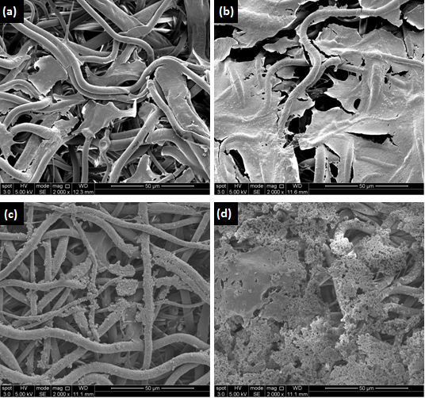
Figure 5.64. Scanning electron microscopy images of membranes with rat mesenchymal stem cells at day 7. (a) PLGA membrane in basal media, (b) PLGA membrane in osteogenic media, (c) HA 3 membrane in basal media, (d) HA 3 membrane in osteogenic media.
Figure 5.64 suggests that the most proliferation has occurred on the samples cultured in osteogenic media (b & d). Higher levels of DNA were measured on these samples in comparison to the samples cultured in osteogenic media at the same time point, although the difference in levels of DNA was not significant (Figure 5.54).

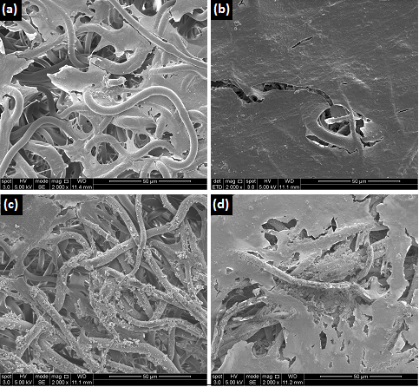
Figure 5.65. Scanning electron microscopy images of membranes with rat mesenchymal stem cells at day 14. (a) PLGA membrane in basal media, (b) PLGA membrane in osteogenic media, (c) HA 3 membrane in basal media, (d) HA 3 membrane in osteogenic media.

The images show that the MSCs are proliferating on samples, with an almost complete coverage of the membrane by a cell layer in (Figure 5.65b).

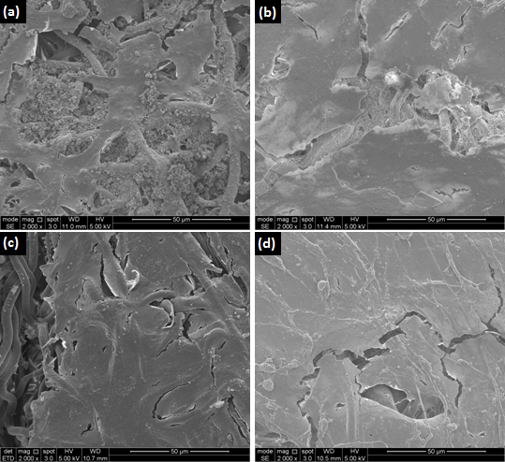
Figure 5.66. Scanning electron microscopy images of membranes with rat mesenchymal stem cells at day 21. (a) PLGA membrane in basal media, (b) PLGA membrane in osteogenic media, (c) HA 3 membrane in basal media, (d) HA 3 membrane in osteogenic media.

Figure 5.66 suggests that the lowest extent of cell coverage was on the uncoated membrane in basal media (b). This is in agreement with the PicoGreen results, in which the level of DNA measured on the uncoated membrane in basal media was significantly lower than that measured from the coated membrane in the same media conditions.

Rat mesenchymal stem cell in vitro experiment two
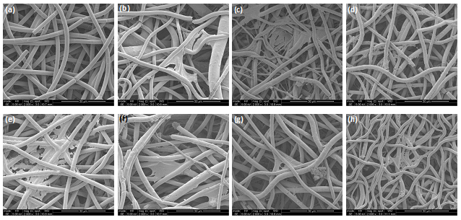
Figure 5.67. Scanning electron microscopy images of membranes at day 1 cultured with rat mesenchymal stem cells. (a-d) in basal media. (a) PLLA, (b) PLGA, (c) HA 3, (d) 2x HA 3. (e-h) in osteogenic media. (e) PLLA, (f) PLGA, (g) HA 3, (h) 2x HA 3. Scale bars are 50 μm.

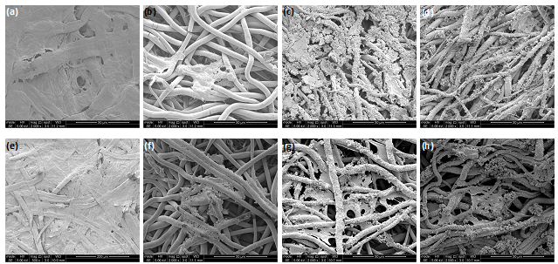
Figure 5.68. Scanning electron microscopy images of membranes at day 7 cultured with rat mesenchymal stem cells. (a-d) in basal media. (a) PLLA, (b) PLGA, (c) HA 3, (d) 2x HA 3. (e-h) in osteogenic media. (e) PLLA, (f) PLGA, (g) HA 3, (h) 2x HA 3. All scale bars are 50 μm.

Figure 5.68 shows that the cells are proliferating on the membranes in both basal and osteogenic media. The polymer fibres appear structurally unaltered after 7 days of in vitro culture, in comparison to day 1 samples (Figure 5.67).

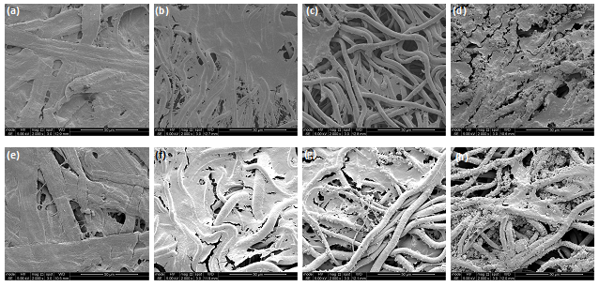
Figure 5.69. Scanning electron microscopy images of membranes at day 14 cultured with rat mesenchymal stem cells. (a-d) in basal media. (a) PLLA, (b) PLGA, (c) HA 3, (d) 2x HA 3. (e-h) in osteogenic media. (e) PLLA, (f) PLGA, (g) HA 3, (h) 2x HA 3. All scale bars are 50 μm.

Figure 5.69 shows evidence of the continuation of cell proliferation on the materials. The PLLA fibres are showing some evidence of fusion.

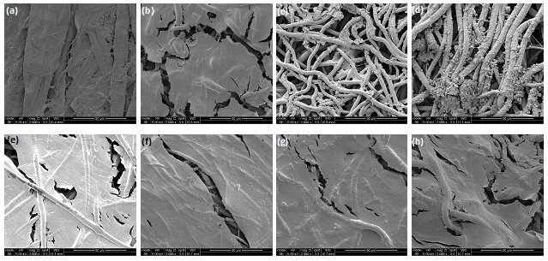
Figure 5.70. Scanning electron microscopy images of membranes at day 21 cultured with rat mesenchymal stem cells. (a-d) in basal media. (a) PLLA, (b) PLGA, (c) HA 3, (d) 2x HA 3. (e-h) in osteogenic media. (e) PLLA, (f) PLGA, (g) HA 3, (h) 2x HA 3. All scale bars are 50 μm.

Figure 5.70 shows a more extensive cell coverage on the membranes cultured in osteogenic media. The amount of DNA quantified by PicoGreen analysis was slightly higher for the PLGA, HA 3 and 2x HA 3 membranes in osteogenic media, but there was no significant difference (Figure 5.77).

3D printed scaffolds

Table 5.7. Summary of printing parameters for all HA:PCL and surfactant combinations printed. Those underlined failed to print. The pressures and extrusion temperatures (E) reported above are much lower than those reported in the literature- approximately 650 kPa and 130 °C for 40 wt% HA.
HA:PCL | Surfactant | Sonication | B (°C) | E (°C) | P (kPa) | F (mm/min)
0:100 | - | - | 32 | 60 | 82.7 | 400
0:100 | SDS | Y | 32 | 60 | 96.5 | 400
20:80 | - | - | 32 | - | - | 400
20:80 | SDS | Y | 32 | 70 | 96.5 | 400
20:80 | Tween-20 | Y | 32 | 70 | 110 | 400
20:80 | Tween-80 | Y | 32 | 70 | 96.5 | 400
20:80 | Triton X-100 | Y | 32 | 70 | 110 | 400
40:60 | - | - | 32 | 65-110 | 165 | 400
40:60 | - | Y | 32 | 70 | 96.5 | 400
40:60 | SDS | Y | 32 | 85-95 | 124 | 400
40:60 | Tween-80 | Y | 32 | 70 | 124 | 400
50:50 | SDS | Y | 32 | 90-115 | 124 | 400
60:40 | SDS | Y | - | - | - | -

Due to the failure of the 50 wt% HA solution to print, the decision was made not to attempt printing the 60 wt% HA solution. The limits of the printer were 276 kPa and 130 °C (Table 5.7).

Table 5.8. Summary of printing parameters for all HA:PCL:PLGA and surfactant combinations printed. Solutions underlined failed to print.
HA:PCL:PLGA | Surfactant | Sonication | B (°C) | E (°C) | P (kPa) | F (mm/min)
0:80:20 | SDS | Y | 32 | 60-75 | 96.5 | 400
0:50:50 | SDS | Y | - | - | - | -
20:(20:80) | SDS | Y | - | - | - | -
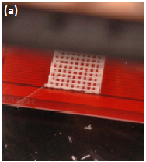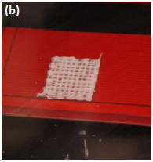
Figure 5.71. 3D printing of scaffolds. (a) 40 wt% HA:PCL with SDS (E = 95 °C, B_{T} = 32 °C, P = 124 kPa), (b) 40 wt% HA:PCL (E = 70 °C, P = 124 kPa). Scaffold size is 20 x 20 mm.

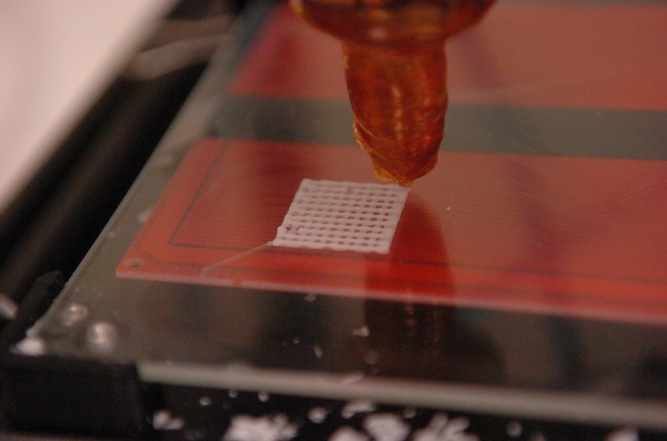
Figure 5.72. 40 wt % HA/PCL scaffold with SDS. Scaffold dimensions are 20 x 20 mm.

The composite with SDS printed more uniformly, with less fibre breakages within the scaffold (Figure 5.71). One complete layer has been printed (Figure 5.72). The extruder nozzle has an internal diameter of 0.84 mm. The orange jacket contains nichrome wires which act as a heating element around the entirety of the syringe, melting the polymer which enables printing.

Light microscopy results
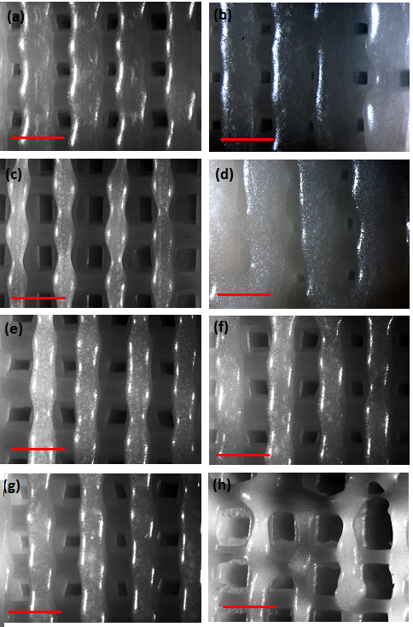
Figure 5.73. Light microscopy images of 3D printed scaffolds. (a) PCL, (b) PCL + SDS, (c) 20 wt% commercial HA, (d) 20 wt% HA sonication only, (e) 20 wt% HA + SDS, (f) 20 wt% HA + Triton X-100, (g) 20 wt% HA + Tween 80, (h) 40 wt% HA + SDS. Scale bar 2 mm for all images. Images taken using a Leica MZ6 stereomicroscope.

Scanning electron microscopy results
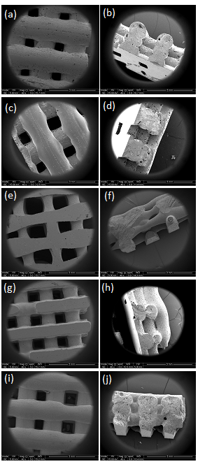

Figure 5.74. Scanning electron microscopy images of 3D printed scaffolds. (a, b) PCL, (c, d) PCL + SDS, (e, f) PCL + 10 wt% HA, (g, h) PCL + 20 wt% HA, (i, j) PCL + 40 wt% HA. All scale bars are 3 mm.

Figure 5.74 shows evidence of interconnected pores in the z direction, most notably in the 10 and 20 wt% HA compositions. The addition of SDS to the pure PCL scaffolds appears to have increased the fibre width (Figure 5.73).
Figure 5.75. Scanning electron microscopy image of 40 wt% HA:PCL + SDS. Arrows indicate suspected HA clusters. Image taken at 1000 x magnification with FEI Quanta 400F.

Figure 5.75 shows that the scaffolds had a microporous structure. The small agglomerations indicated by arrows were not seen in the images of samples with lower or no HA fraction.

Scaffold dimensions

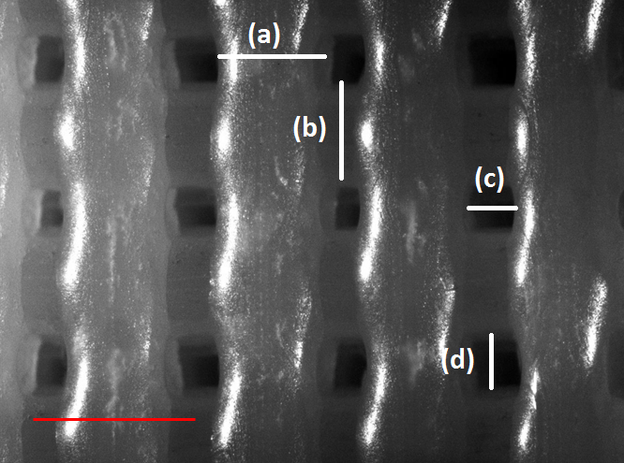
Figure 5.76. Light micrograph of pure PCL scaffold demonstrating how the fibre and pore dimensions were measured. (a) fibre width, x dimension, (b) fibre width, y dimension, (c) pore size, x dimension, (d) pore size, y dimension. Scale bar is 2 mm.

Table 5.9. Table summarising average fibre and pore diameters in the x and y directions for all compositions successfully printed. n = 8 for all measurements.
PCL (wt%) | HA (wt%) | HA synthesis method | Surfactant | Sonication (Y/N) | Average fibre width (x) (µm) | Average fibre width (y) (µm) | Average pore width (x) (µm) | Average pore width (y) (µm)
100 | 0 |  | - | N | 1100 ± 140 | 1140 ± 220 | 430 ± 100 | 650 ± 60
100 | 0 |  | SDS | Y | 1380 ± 110 | 1370 ± 70 | 360 ± 80 | 370 ± 90
80 | 20 | Commercial | - | N | 690 ± 200 | 650 ± 100 | 490 ± 60 | 940 ± 120
80 | 20 | HA 3 | - | Y | 1220 ± 820 | 410 ± 570 | 180 ± 60 | 260 ± 100
80 | 20 | HA 3 | SDS | Y | 800 ± 140 | 1000 ± 110 | 490 ± 110 | 390 ± 70
80 | 20 | HA 3 | Triton X-100 | Y | 970 ± 130 | 1120 ± 180 | 430 ± 260 | 550 ± 100
80 | 20 | HA 3 | Tween 80 | Y | 880 ± 95 | 950 ± 130 | 530 ± 110 | 450 ± 80
60 | 40 | HA 3 | SDS | Y | 720 ± 150 | 1320 ± 280 | 960 ± 170 | 540 ± 90

The scaffolds printed with the commercial HA had the smallest fibres. The PCL + SDS scaffolds had small pores because the fibres spread more than the pure PCL scaffolds, which was caused by the addition of the surfactant since they were printed with the same parameters (Table 5.9). Figure 5.76 demonstrates how the fibre and pore size measurements were made. . .

In vitro tests on 3DP scaffolds

DNA and alkaline phosphatase quantitative assays

Figure 5.77. dsDNA quantified by the PicoGreen assay for rat mesenchymal stem cells cultured on 3D printed scaffolds for 21 days in basal and osteogenic media. n = 9 (experiment conducted in triplicate in triplicate).

At day 1, the amount of DNA extracted from the cells cultured on the pure PCL scaffolds in osteogenic media was significantly different from the quantity extracted from the 40 wt% HA/PCL scaffolds in osteogenic media, suggesting that the cells preferred to attach to the pure polymer scaffold (Figure 5.77). The results for 20 wt% HA/PCL cultured in osteogenic media show a decrease from day 1 to day 7, but then show a slight increase across days 7-21, however there is no statistical difference between these results. Overall, the results suggest that the scaffolds were not effective at supporting cellular attachment and growth.

Figure 5.78. Alkaline phosphatase expression quantified by pNPP for rat mesenchymal stem cells cultured on 3D printed scaffolds for 21 days in basal and osteogenic media. No relevant statistical differences were found. n = 9 (experiment conducted in triplicate in triplicate).

ALP was detected on all samples at all time points (Figure 5.78). The highest levels of ALP was measured on the pure PCL scaffolds cultured in basal media, however these results were not significantly different.

Figure 5.79. Alkaline phosphatase relative to dsDNA for rat mesenchymal stem cells cultured on 3D printed scaffolds for 21 days in basal and osteogenic media. No statistical differences were found.

The results from Figure 5.79 suggest cells could be detected on the scaffolds in the initial 24 hours after seeding, yet, by day 7 the results suggest that no cells have survived on many of the samples. This could be an effect of pore size, or due to the surface chemistry of the materials. However, no valid conclusions can be drawn from the data. .

Scanning electron microscopy results

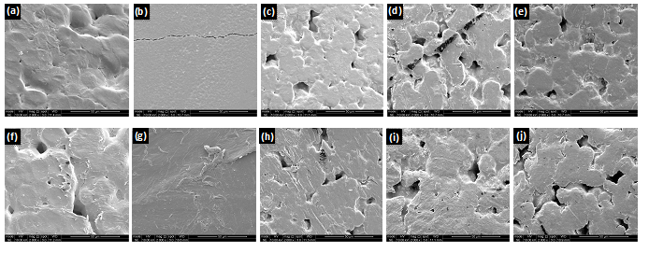

Figure 5.80. Scanning electron microscopy images of scaffolds cultured with rat mesenchymal stem cells at day 1. (a-e) in basal media: (a) PCL, (b) SDS, (c) PCL + 10 wt% HA, (d) PCL + 20 wt% HA, (e) PCL + 40 wt% HA. (f-j) in osteogenic media: (f) PCL, (g) SDS, (h) PCL + 10 wt% HA, (i) PCL + 20 wt% HA, (j) PCL + 40 wt% HA.

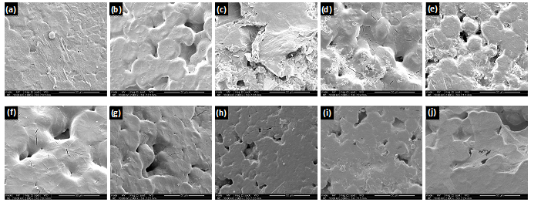

Figure 5.81. Scanning electron microscopy images of scaffolds cultured with rat mesenchymal stem cells at day 7. (a-e) in basal media: (a) PCL, (b) SDS, (c) PCL + 10 wt% HA, (d) PCL + 20 wt% HA, (e) PCL + 40 wt% HA. (f-j) in osteogenic media: (f) PCL, (g) SDS, (h) PCL + 10 wt% HA, (i) PCL + 20 wt% HA, (j) PCL + 40 wt% HA.

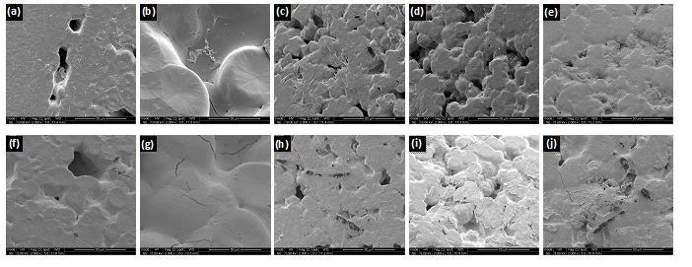
Figure 5.82. Scanning electron microscopy images of scaffolds cultured with rat mesenchymal stem cells at day 14. (a-e) in basal media: (a) PCL, (b) SDS, (c) PCL + 10 wt% HA, (d) PCL + 20 wt% HA, (e) PCL + 40 wt% HA. (f-j) in osteogenic media: (f) PCL, (g) SDS, (h) PCL + 10 wt% HA, (i) PCL + 20 wt% HA, (j) PCL + 40 wt% HA.

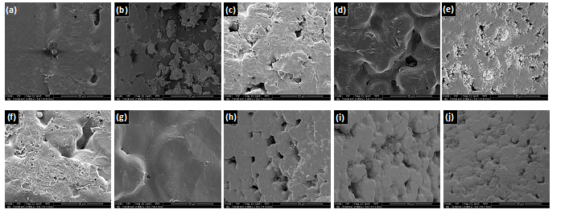
Figure 5.83. Scanning electron microscopy images of scaffolds cultured with rat mesenchymal stem cells at day 21. (a-e) in basal media: (a) PCL, (b) SDS, (c) PCL + 10 wt% HA, (d) PCL + 20 wt% HA, (e) PCL + 40 wt% HA. (f-j) in osteogenic media: (f) PCL, (g) SDS, (h) PCL + 10 wt% HA, (i) PCL + 20 wt% HA, (j) PCL + 40 wt% HA.

Figures 5.80-5.83 show little or no evidence of the presence of cells on the materials. This supports the dsDNA quantification (Figure 5.77) which suggests few or no cells were present on the scaffolds in vitro. .

Discussion
The repair and regeneration of alveolar and maxillofacial bone lost due to disease, trauma or tumour removal continues to pose challenges to surgeons. The current gold standard is a collagen membrane (Bio-Gide®), but disadvantages include risks of disease transmission, however small, and ethical concerns due to the bovine or porcine origins. Previously, the gold standards were PTFE or titanium reinforced PTFE membranes (Bottino et al., 2012). However, the limitations of these membranes include the need for a second surgical procedure because they cannot be resorbed, and their lack of bioactivity, as they have no role beyond providing a barrier function. This shift in the use of resorbable over non-resorbable suggests a change in preference by surgeons, and that the trend for the development of future membranes is in the resorbable direction. Both the collagen and PTFE membranes do little to promote bone tissue regrowth, so they do nothing to shorten the duration of the regeneration process. Therefore a resorbable and synthetic membrane with increased bioactive properties to promote BTR was investigated. The trace metal strontium is present in the mineral phase of bone within the human body, particularly in those regions with a high metabolic turnover. Effects of strontium on bone include the reduction of osteoclast activity and bone resorption, and the increase of several osteoblastic markers.

Hydroxyapatite synthesis
As previously mentioned, HA is a ceramic with excellent bioactivity. nHA is expected to have better biocompatibility than microscale HA to its biomimetic nature: HA found within the body’s natural bones is also nanoscale. Commercial HA bone filler products are already available on the market. The excellent biocompatibility and bioactivity of HA make it a good choice for the fabrication of a polymer-ceramic heterogeneous membrane with improved bioactivity.

All but one of the HA synthesis routes produced powders with HA as the main phase. The exception for this was the sintered HA 4 powder, which degraded to β-TCP (Ca₃(PO₄)₂). This could be explained by the fact that calcium-deficient HA undergoes transformation to β-TCP upon sintering at 700-800 °C, with loss of water, as shown in equation 3 shown below (Liou and Chen, 2002). The Ca:P value for this sample was 1.38. The Ca:P for the sintered HA 3 sample (1.51) also revealed it to be calcium deficient.

Ca₉(HPO₄)(PO₄)₅(OH) 3Ca₃(PO₄)₂ + H₂O (Equation 3)

Sintering improves the crystallinity and increases the crystallite size of HA. Calcium-deficient HA (CDHA) has been shown to be more effective at stimulating cell proliferation of MSCs compared to HA at up to 7 days in vitro (Guo et al., 2009). It has been reported that CDHA is more soluble than stoichiometric HA (LeGeros, 1995). CDHA is potentially more efficient in inducing the precipitation of bone-like apatite than stoichiometric HA (Monteiro et al., 2003). The lower sinterability of apatites on decreasing Ca:P has been reported in the literature (Champion, 2013).

Secondary phases characterised in the sol-gel HA samples sintered at higher temperatures suggest an instability of the HA crystal. When sintered at 500 °C, the sol-gel pH 10.5 sample was characterised as pure HA by XRD, whereas the powders sintered at 550 and 600 °C had a secondary phase of β-TCP (Figure 5.7- Figure 5.9). Sintering at higher temperatures can eliminate OH- from the hydroxyapatite matrix due to dehydration, which can lead to decomposition of the phase to form β-TCP.

Ca:P values for many of the samples obtained from XRF were close to the stoichiometric value HA (1.67) (Table 5.4). The sol-gel powder produced at pH 9 and sintered at 500 °C was analysed twice, as the value calculated is different from what was expected. Both times an extremely low Ca:P value was obtained (0.86). However, XRD confirmed that the powder was pure HA. The powders with Ca:P values greater than 1.67 are calcium-rich: it is possible that there was an excess of calcium in the precursors. Calcium oxide was detected in the sintered HA 2 powder, and the Ca:P value was 1.70. The sintered HA 4 powder had a Ca:P value of 1.38 and the stoichiometric Ca:P value for TCP is 1.5. HA powders produced by the sol-gel method that have a Ca:P greater than 1.67 may be calcium rich due to the loss of phosphorous during preparation. The sol-gel phosphorous precursor, TEP, is hygroscopic at 18 °C, so it is conceivable that some is lost during the preparation stages.

Energy dispersive spectroscopy (EDS) on either the SEM or TEM could be used to obtain the Ca:P if the system has been calibrated for calcium and phosphorous. However, above certain electron fluence levels, the electron beam of a TEM causes radiolytic damage that involves the loss of phosphorous and oxygen, amorphisation of the particles being studied, and eventually leads to the re-crystallisation of HA to calcium oxide (Eddisford, 2008). Hence, it is possible that the particle/s being studied undergo this transformation and that the resultant Ca:P has been altered by this change. When EDS was attempted on the Inspect F, the effects of charging due to the carbon coating were too great, and the sample was damaged by the electron beam. Carbon coating has to be used on the SEM for EDS as gold coating obscures phosphorous.

As reported in the literature review, nHA is expected to have better bioactivity than microscale HA. Naturally occurring HA within the body is in the order of 20 nm. Unsintered powders synthesised at pH 10 by the HA 3 method had an average particle size for of 36.5 x 15 nm; this was the smallest average particle size measured by TEM (Table 5.5).

All the strontium-substituted powders degraded upon sintering; their XRD spectra have not been included in this report. It is possible that the inclusion of the strontium ion into the lattice had made the structure more unstable, which can cause dehydroxylation and subsequent decomposition at lower temperatures during sintering (Curran et al., 2011). The 10 % Sr-Ha produced by the HA 3 method was identified as HA by XRD. It is also possible that the inclusion of only 10 % strontium into the HA lattice was not enough to cause a distortion great enough to be detected by XRD. The radius of the Ca²⁺ ion is 0.1 nm, whilst the Sr²⁺ has an ionic radius of 0.118 nm. Peak broadening on the XRD spectra can provide evidence for the inclusion of strontium into the lattice. This is more evident in samples with smaller strontium contents, which suggests that it is easier for Sr-HA to host the calcium ion than for HA to host the larger strontium ion, which would cause greater deformation of the lattice (Bigi et al., 2007). However, there is no identifiable broadening of the peaks when the XRD spectrum for the 10 % Sr-HA, produced by the HA 4 method, is compared to the spectrum for HA also produced using the HA 4 method (Figure 5.14 and Figure 5.17 respectively). Information on the crystal size could be calculated from the XRD spectra. Diffraction patterns obtained from a TEM could also be used to obtain information about the lattice structure and d-spacings of the crystals. The Sr-HA constituted a lesser part of this work, and therefore more detailed analysis would be conducted in future work utilising these methods.

Membranes

Heterogeneous membrane synthesis
PLGA is a copolymer of PLA and PGA, and has a degradation time that is dependent on the LA:GA unit ratio and molecular weight. PLGA has FDA approval and demonstrates good cell adhesion. Pure PLLA has a much longer degradation time (5-6 years for high M_{w}, whilst PGA degrades much faster (1-2 months (Bergsma et al., 1995)). The first of these two degradation rates is undesirably low, whilst a membrane with the increased rate would not provide a barrier function for enough time for bone regeneration to occur. At reviewed in Table 2.5, the degradation time for commercially available synthetic resorbable polymer membranes is between 2 weeks and 12 months. 75:25 PLGA has a suitable degradation time of 4-5 months. PLGA can be processed using various techniques, including electrospinning, gas-foaming and salt-leaching. To improve the biocompatibility properties of the membrane, a polymer-ceramic heterogeneous biomaterial was investigated.

As previously mentioned, current commercially available membranes do little to actively promote bone formation. Instead they merely provide a barrier function against soft tissue ingrowth. Therefore, a bioactive component was added to the polymer membrane. HA was chosen for this purpose. As previously mentioned, HA is a ceramic with excellent bioactive properties, and is already used in commercially available bone graft substitutes.

Electrospinning was chosen as the method of producing the membranes as it is a versatile technique and is capable of producing fibres with a range of diameters from micrometres to nanometres. Materials fabricated via electrospinning have the potential to physically mimic the extracellular matrix of bone tissue by replicating the structure and scale. Electrospun materials can be used to repair bone in non-load bearing applications.

PLGA membranes were electrospun at 16 kV and 2.5 ml.h⁻¹. Membranes fabricated with these parameters had an average fibre width of 4 µm (range of 1-10 µm). There was no significant difference between the average width of the shrunk and unshrunk fibre width (average of 4.2 and 4.15 µm for unshrunk and shrunk respectively). The membrane shrinkage is a result of the relaxation of the extended, amorphous polymer chains in the electrospun fibres. Electrospinning reduces the T_{g} of 75:25 PLGA to near the incubation temperature (37 °C) (Zong et al., 2003).

Plain PLGA membranes were shrunk as a control for weight gain against those shrunk with HA. The shrunk membranes had improved handling properties. As contraction of the membrane is not desirable after placement in a patient, it was decided to continue using shrunk membranes. Membranes were shrunk in dH₂O and PBS. The average percentage decrease in surface area was -46 and -49 % for dH₂O and PBS respectively. The average change in weight per unit surface was -0.18 ± 0.5 and -0.9 ± 3.4 µm/mm² respectively. The average percentage change in surface area was higher for the membranes shrunk with HA, with values of -58 and -61 % for H₂O and PBS with HA respectively. The weight changes were 3.67 and 6.29 µg/mm² respectively. All further electrospun membranes were shrunk in dH₂O due to the smaller weight and surface area changes compared to PBS. Additionally, the shrunk membranes are less porous, potentially aiding the barrier function against the infiltration of fibroblasts. Alternative coating methods were investigated due to the non-uniform coverage created by the entrapment method.

Two dipping methods based on protocols published in scientific journals were tested (DM1 and DM2). DM 1 consisted of dipping the membrane in a calcium solution for 30 s, rinsing in dH₂O, and then dipping in a phosphorous solution for 30 s. This was one cycle; 5, 10 and 15 cycles were carried out. DM2 involved immersing the membrane in a calcium solution for 10 minutes, rinsing in dH₂O, and immersion in a phosphorous solution for 10 minutes. This was repeated twice more, for a 5 minute immersion in each solution. XRD initially conducted on the precipitates obtained from the solutions, but there were concerns that the precipitate may not be the same as the compound formed on the membrane. Therefore XRD was attempted on the coated membranes (Philips PW1830), but there was not enough precipitate on the membrane to cause any X-ray diffraction. Possible brushite formation was revealed on the DM 1 (15 cycles) membranes: flat, plate-like crystals were found (Figure 5.47).

Dipping methods based on DM 1 and using the HA 3 and HA 4 reagents were investigated, and carried out for 5, 10, 15 and 20 cycles, to attempt to increase the weight gain. The pH values for the HA 3 and HA 4 dipping and titration methods were reduced to 10, as opposed to the values used in the HA 3 and HA 4 HA synthesis methods (pH 11 and 12 respectively for the calcium and phosphorous solutions). When the membrane was dipped in the solution with the higher pH values, it began to disintegrate due to the highly alkaline environment it was subjected to. This was observed with 10 cycles. At pH 10, the membrane remains intact, even after 20 cycles.

Similar crystals to those found on DM 1 (15 cycles) were also found in the membranes treated with 20 cycles using the HA 4 dipping method (Figure 5.47), suggesting that increasing the number of cycles further produces a biphasic CaP coating, as opposed to a larger weight percentage of HA with regards to the untreated membrane weight. Prior to this, the number of cycles for this method was going to be increased to 25, however, it appears that increasing the cycle number further will lead to further formation of unwanted phases. Brushite is used in bone cements so its presence in the CaP coating is not necessarily an issue (Hofmann et al., 2009). However, given the difficulties surrounding the use of XRD to analyse the coating composition, it would be difficult to calculate the ratio of brushite to HA, or indeed how much variance there is in the two quantities.

The HA 2 method was not used for the titration method of creating heterogeneous membranes as the process involves heating the calcium solution to temperatures ranging from 30- 95 °C. As previously mentioned, electrospinning reduces the T_{g} of 75/25 PLGA to 35 °C, which is below the incubation temperature of 37 °C. However, when a PLGA membrane was incubated at 60 °C for 24 h, it lost all flexibility and became very brittle. As a degree of flexibility is desirable in the membrane, temperatures close to or exceeding T_{g} have been avoided. Both the HA 3 and HA 4 methods were carried out at room temperature.

The titration coating method was selected as the method of creating a heterogeneous membrane, as the precipitate is formed with the membrane in situ. Therefore it can be reasonably assumed that the coating is the same as the precipitate, which can be analysed by XRD. Although the HA 4 titration method had the largest weight gain (2.79 µm/mm² for HA 3, 4.33 µm/mm² for HA 4), XRD showed evidence of brushite (Figure 5.14), thus the HA 3 method was chosen as the method to produce membranes for the biocompatibility work which was undertaken. A method using double the quantity of HA 3 reagents was tested (2x HA 3), producing an average weight change of 7.67 µg/mm² (15 %). To investigate whether more HA on the surface of the membrane would affect osteogenic differentiation of MSCs, this material was tested in the second rat MSC in vitro study. The HA coating remained on the membrane after sterilisation for cell culture experiments, as seen in SEM images of membranes cultured in vitro. It was predicted that the coated membranes would promote a greater extent of osteogenic differentiation due to the osteoconductive properties of HA.

In vitro testing of membranes
MSCs were selected as the chosen cells to use for the in vitro studies as they can be obtained from the human body using methods which cause less trauma than isolating osteoblasts from a patient (Salgado et al., 2004). MSCs can self-renew, and have multilineage differentiation potential (Liu et al., 2009). The hMSCs used in this work were from patients undergoing hip or knee replacement surgeries. Rat MSCs were harvested from male Wistar rats (4-5 weeks). The work using hMSCs was conducted in Dr Genever’s lab at the University of York, due to their expertise with these cells, whilst rat MSC experiments were conducted at the University of Sheffield.

DNA was quantified by using the PicoGreen assay, which can detect levels of dsDNA as low as 25 pg/ml. The level of DNA measured can be related to cell proliferation. ALP was quantified using the pNPP assay. ALP is a marker for osteogenic differentiation. It is widely found in newly formed bone as it is involved in the early stages of mineralisation. Combined, ALP relative to dsDNA is indicative of the degree of mineralisation relative to cell proliferation. Von Kossa stains for calcium, and thus can be used as a qualitative method for analysing the extent of mineralisation. DAPI selectively stains DNA, and therefore can be used as a tool for imaging cell nuclei. Phalloidin TRITC can be used to stain the cytoskeleton, as it selectively binds F-actin, which allows the morphology of the cell to be studied.

All four in vitro experiments showed that the membranes are capable of supporting cell growth and proliferation for up to 21 days. PLGA membranes were still easy to handle using forceps by day 21, whereas the reference electrospun PGA membranes degraded very rapidly (by day 7 the material was too degraded to remove from the 24 well plate) in both cell culture experiments using hMSCS, and thus is not suitable for the 21 day culture. This supports previous findings that PGA degrades more rapidly in the presence of cells. Thus uncoated electrospun shrunk PLGA was used as the reference material for the second hMSC and first rat MSC experiments. An electrospun PLLA material was used as a reference material for the second study using rat MSCs.

There was little difference between the levels of ALP expressed from the cells cultured on uncoated and coated membranes, and similarly little difference between the membranes cultured in basal and osteogenic media (Figure 5.52). It had been predicted that there would be an increase in the levels of ALP for the cells cultured on the HA-coated membranes in comparison to the uncoated membranes, and additionally it had been expected that there would be an increased level in expression for the cells cultured on osteogenic media compared to those cultured in basal media. The Von Kossa stains (Figure 5.60) suggest that greater mineralisation has occurred by day 21 in the samples in osteogenic media with hMSCs, which was expected. However, all the stains were quite dark due to the presence of calcium in the HA coating, which had been predicted. The PGA membrane degraded too quickly to be removed and analysed beyond day 0, so no control to the HA 3 membranes was available. Due to the extent of the darkness of the stain on the materials at all time points, the decision was made not to use Von Kossa staining for future experiments.

The second biocompatibility study using hMSCs showed a peak in micrograms of DNA measured from cells cultured on the HA 3 coated membrane in osteogenic media at day 14. This result was statistically different from coated samples in osteogenic media at day 7 and 21. Additionally, the difference found between levels of DNA extracted from cells cultured on the PLGA and HA 3 membranes cultured in osteogenic media at day 14 are caused by the HA coating. This suggests that the HA coating promotes an increased rate of proliferation over non-coated samples, as the result is also significantly different from the amount of DNA quantified from uncoated membranes in osteogenic media at day 14. The decrease by day 21 may be due to cell differentiation as opposed to proliferation, however no statistical differences were found between the quantities of ALP expressed by the cells across the samples or between the membranes cultured in basal or osteogenic media. This day 14 peak in DNA for the HA 3 samples cultured in osteogenic media was also seen in the repeat using rat MSCs, where it is statistically different from the result for the same conditions and day 7.

hMSCs were obtained from elderly osteoarthritic patients who had undergone knee and hip replacement procedures. Thus their potential for differentiation may be reduced. This suggests that whilst human MSCs are seen as more clinically relevant than those harvested from other sources such as rats, there are issues with the fact that these human cells are sourced from elderly patients with underlying health issues and not from younger donors. Therefore, it was decided to use rat MSCs for future in vitro experiments.

Furthermore, membranes coated via the 2x HA 3 method and cultured with rat MSCs in osteogenic media showed a peak in DNA at day 7. The amount of HA per unit surface area was calculated to be 2.27 ± 0.89 µg/mm² (8 %) and 7.67 ± 5.66 µg/mm² (15 %) for HA 3 and 2x HA 3 coatings respectively. The increase in amount of HA would appear to increase the rate of proliferation in comparison to HA 3 samples at the same conditions. However, these differences do not equate when ALP is considered relative to DNA, with the reference PLLA and uncoated PLGA showing a higher ratio of ALP to DNA.

SEM revealed that the rat MSCs attached and proliferated on both the coated and uncoated membranes. By day 14 a cell sheet covered most of the membrane surface, and by 21 the membrane was almost entirely covered by cells. On both in vitro experiments conducted using rat MSCs, the cell coverage was more complete on the membranes cultured in osteogenic media, on both coated and uncoated membranes. This observation correlates to the results from the PicoGreen assay for dsDNA. SEM images of rat MSC experiment one at day 14 show a more extensive cell coverage for both the uncoated and the HA coated membranes that were cultured in osteogenic media; the elevated level of dsDNA quantified from coated membranes was statistically different from that membrane cultured in basal media.

It had been expected that the in vitro tests conducted with rat MSCs would have produced a greater difference between the coated and uncoated membranes, as well as between those cultured in osteogenic versus basal media, given the limitations of the human MSCs as discussed above. A peak in dsDNA expressed by the rat MSCs on the coated membranes in osteogenic media at day 14 was observed, confirming the trend seen in both hMSC cell studies. DAPI staining of the membranes cultured in osteogenic media at day 7 (Figure 5.61) supported the results from the PicoGreen assay (Figure 5.57). A higher cell number was detected on the 2x HA 3 membranes by DAPI staining, and the amount of DNA quantified by PicoGreen was significantly higher than the other membranes with the same conditions.

Actin contained within the cytoskeleton can be stained using Phalloidin to detect changes in morphology as cells undergo osteogenic differentiation. Proliferating cells tend to have a more elongated shape, whilst osteogenic cells are more commonly spherical. During osteogenic differentiation, the actin cytoskeleton undergoes reorganisation, resulting in thick, non-aligned actin stress fibres (Born et al., 2009). The actin cytoskeletons imaged for the 2x HA 3 membrane at day 7 in osteogenic media show a more elongated morphology, suggesting that the cells are in proliferation, as opposed to differentiation (Figure 5.62). This supports the results from the PicoGreen and pNPP assays, which showed an increased rate of proliferation in comparison to the other membranes, but an insignificant degree of differentiation (Figure 5.57-Figure 5.59).

3D printed scaffolds

3D printed composite scaffold synthesis

3D printing offers an exciting alternative to the use of allo, auto and xenografts, with their associated drawbacks, to regenerate bone lost to disease and trauma. Pure PCL and 20 and 40 wt % HA/PCL scaffolds were successfully printed using a custom-built 3D printer.

Adding HA resulted in an increase in the printing pressure and extrusion temperature, and decreased the average fibre diameter. The pure PCL did not need to be dissolved in a solvent prior to being heated for printing, however the addition of HA to the PCL meant that a solvent system had to be used in order to mix the two materials together. Initial attempts to create the composite by heating and stirring HA and PCL with a surfactant were unsuccessful. Additionally, initial attempts to print HA:PCL composite scaffolds without surfactant were also unsuccessful as the addition of HA led to clogging of the extrusion nozzle. The decision to add a surfactant to the composite solution was taken with the expectation that its addition would reduce HA aggregation. Sonication was used both before and after the addition of the surfactant to break up any existing HA aggregates. Adding surfactant to pure PCL increased the fibre diameter, but the combination of HA and surfactant decrease the fibre diameter. This could be due to a change in surface tension of the molten HA-PCL composite. Surfactants decrease surface tension. Furthermore, scaffolds printed with commercial microscale HA with no surfactant or sonication treatment also had thinner fibres than the pure PCL.

The addition of the surfactant enabled the printing of 20 and 40 wt% HA:PCL composite scaffolds at much lower temperatures and/or pressures than reported in the literature (100 °C and 650 kPa (Park, 2014). Tween-20 and Triton X-100 were ruled out after the initial trials of surfactants as the scaffolds had poor morphology. A 20 wt% HA:PCL with SDS solution demonstrated superior printing abilities over Tween-80, and therefore was selected as the surfactant to be used to print the composite scaffolds. Triton X-100, Tween 20 and Tween 80 are all non-ionic surfactants; the fact that anionic surfactants have greater interactions with non-ionic polymers could explain why the scaffolds printed with SDS as the surfactant had better morphology.

Printing of a 50 wt% HA:PCL composite was attempted. However, the material remained solid even at 115 °C; the maximum printing temperature of the 3D printer used for this work was 130 °C. The printing of PLGA:PCL and HA:PLGA:PCL membranes was attempted, but problems were encountered. The 50:50 PLGA:PCL mixture appeared immiscible upon drying of the polymer-solvent solution, which was sticky with clear and opaque areas. This was judged to be undesirable, leading to the decision not to attempt to print this co-polymer solution. The 20:80 PLGA:PCL solution crystallised after printing at 60 °C (P = 96.5 kPa, B_{T} = 32 °C, F = 400 mm/min)

SEM analysis revealed that the printed scaffolds had microporous structures. Microporosity, and pore wall roughness, serves an important role. Microporosity increases the surface area, which is believed to facilitate higher bone-inducing protein adsorption , as well as increasing ion exchange and the formation of bone-like apatite through dissolution and re-precipitation (Yuan et al., 1999).

Error! Reference source not found. shows how the scaffold dimensions were measured. The average fibre dimension of the pure PCL scaffolds was in the order of 1100 µm (Table 5.9). The addition of HA decreased the average fibre dimensions, with the exception of the 20 wt% HA: PCL with sonication only: the average values were 1220 x 1370 µm in the x and y dimensions respectively. The addition of SDS increased the average fibre width to approximately 1400 µm (x and y directions). Surfactants decrease the surface tension of liquids, and the PCL is printed in the liquid phase so this increase was not unexpected. The addition of HA decreased the fibre sizes, most evident in the commercial HA sample (20 wt% HA). The average particle size for the commercial HA was 30 µm, compared to an average of 36 x 15 nm for the HA produced in this work using the HA 3 synthesis method.

Rather than defining the pore size in the G-code file, the space between the fibres is defined, measured from the centre of the fibre. This explains why the pore size decreases with increasing fibre width. The compositions with the small pore sizes (PCL + SDS, 20 wt% HA:PCL, sonication only) had the largest fibre widths. To an extent, a smaller pore size is desirable; if the pore size is too large, cells cannot bridge the gap to form a uniform layer over the surface of the scaffold.

In vitro testing of 3D printed scaffolds
Rat MSCs were used for the in vitro studies, and a pure PCL 3DP scaffold used as a reference. Cells seeding onto 3D scaffolds can be considered a passive technique. Cells disperse into the scaffold by diffusion and attach through weak molecular level driven forces e.g. adhesion. As previously mentioned in the literature review, PCL has excellent biocompatibility, and adding HA has been shown to improve cell activity. Therefore good cell attachment and proliferation was expected, particularly from the HA:PCL scaffolds.

dsDNA quantification was inconclusive beyond day 1; results suggest a decrease in DNA from day 1 to day 21, indicating that not many cells attached to and proliferated on the scaffolds. No DNA was found on some of the scaffolds, but this trend is not seen throughout the time points. DNA was found on the 40 wt% HA/PCL scaffolds in either basal or osteogenic media at day 7 or 14, yet DNA was measured for the samples cultured in basal media at day 21, but not from the scaffolds in osteogenic media. It is possible that some cells attached to the bottom of the tissue culture plate rather than onto the scaffold. The cells were seeded on the scaffolds statically; dynamic seeding could aid cell attachment (Xiao et al., 1999). For this attachment to occur, the pores should be within a certain size range.

The amount of DNA expressed on the 40 wt% HA:PCL scaffold in osteogenic media at day 1 was significantly lower in comparison to PCL, PCL + SDS and 20 wt% HA:PCL. The 40 wt% HA:PCL scaffolds had the largest pore sizes (960 x 540 µm, Table 5.9). As previously mentioned, 300 µm has been identified as an ideal pore size for the promotion of new bone formation. In a review of the effect of scaffold pore size and porosity, the largest pore size referred to was 800 µm (Karageorgiou and Kaplan, 2005). This suggests that the pore size of the 40 wt% HA:PCL scaffolds was too large for cells to attach, proliferate and differentiate.

An alternative explanation for the low level of cell attachment to the scaffolds could be due to the surface chemistry of the material. Cells attach preferentially to hydrophilic surfaces. The hydrophobicity of the surface could be measured by contact angle measurements; hydrophobicity could be reduced by plasma treatment of the samples. As discussed in the literature review, the addition of HA to PCL scaffolds increases the surface roughness. It is possible that cell attachment was low due to a combination of surface chemistry and pore size, as both these properties have been demonstrated to affect cell attachment.

Conclusions
The use of GBR membranes has been claimed to be clinically useful for the repair of defects in maxillofacial bone. However the membranes currently available do little or nothing to promote bone regeneration and merely perform a barrier function. If the defect is too large, then an additional scaffold may be required to provide further mechanical support to prevent collapse of the membrane into the defect. There are limitations associated both the source of the material of natural bone grafts and the reproducibility of synthetic grafts (section 2.4). This research has advanced this tissue engineering approach by investigating the effect of HA as a coating on a polymer membrane, and additionally the effect of HA on the biocompatibility of scaffolds for regenerating bone in larger voids. The specific conclusions from this work were:

- Four different methods for producing HA were evaluated for the purpose of preparing a component of a regenerative membrane for GBR. Three (HA 2, HA 3 and HA 4) appeared to be successful and reproducible, with the classical sol-gel method rejected on the basis of its complexity and therefore lack of suitability for scale-up. Of these three promising methods (HA 3 and 4), two appeared to be more suited to coating membranes with HA. The calcium phosphate products were characterised using XRD in all cases. These methods produced nHA which is expected to have better biomimetic properties due to a similar size to HA naturally occurring within the human body.
- Electrospinning has been used successfully to produce a number of membranes, with PLGA reported here on account of its good biocompatibility, the appropriate degradation properties of 75/25, and ease of fibre functionalisation. This was selected as the basic membrane for modification by addition of ceramic, and electrospinning chosen as the method for producing the membranes due to low set up costs..
- Seven different methods for coating membranes with calcium phosphate ceramics were considered. The two methods based on titration (in particular HA 3) were identified as the best in terms of adding the highest mass with the most consistency. An external coating on the fibres would expose more cells to HA, which could potentially increase the rate of bone formation due to the osteoconductive properties of the ceramic component.
- Biocompatibility studies using hMSCs have shown that the membranes will support cells for up to 21 days. While no significant difference in levels of ALP relative to DNA between the coated and uncoated membranes was detected using pNPP and PicoGreen assays, the modifications did not adversely affect in vitro biocompatibility.
- HA:PCL composite scaffolds were successfully fabricated via 3D printing at a range of HA weight concentrations (0-40 wt% HA:PCL) at lower pressure and temperature ranges than previously reported in the literature. This work showed that higher weight percentages of HA can be produced by a custom-built 3D printer with low start-up costs.
- In vitro testing of 3D printed scaffolds suggests that the pore size influences ability of scaffolds to support cell attachment, proliferation and differentiation. Initial levels of DNA were lowest on the scaffolds with the largest pore size (40 wt% HA:PCL). Any increase in biocompatibility due to the increase in HA content was countermanded by the large pore size.

In conclusion, this work has added to the knowledge of nHA synthesis and the incorporation of this osteoconductive biomaterial into manufacturing processes to produce membranes or scaffolds. This research therefore demonstrates the potential for the manufacture of a new generation of medical devices to actively promote bone tissue regeneration in complex defects.

Future work
The work carried out in this study demonstrates that nHA can be incorporated into polymeric membranes and scaffolds intended for GBR. However, to develop the impact of this study, further work could be carried out in several areas:

- Methods to produce Sr-HA were reported in this work. As discussed in section 2.10.2, Sr-HA has an improved level of bioactivity over HA. Therefore the suitability of Sr-HA as a membrane coating should be investigated, and its bioactive potential assessed by in vitro culture of MSCs on the biomaterial.
- The ability of 3D printing to create reproducible structures with defined pore sizes is one of the main advantages over other methods for producing 3D scaffolds. 3D printing was shown to be suitable to produce polymer:ceramic scaffolds at up to 40 wt% HA, although in vitro results suggested that the pore size was too large for cell attachment. Therefore, the production of scaffolds with smaller pore sizes should be investigated, although this would require a printer with a higher resolution than the one used in this work. The effect of an increasing concentration of HA could then be assessed in vitro.

References
A RANDOLPH & LARSON, M. 1988. Theory of particulate processes: analysis and techniques of continuous crystallization, Academic Press.
AIEDEH, K., GIANASI, E., ORIENTI, I. & ZECCHI, V. 1997. Chitosan microcapsules as controlled release systems for insulin. J Microencapsul, 14, 567-76.
AKKENINI, A. R., LUO, Y., SCHUMACHER, M., NIES, B. & LODE, A. 2015. 3D plotting of growth factor loaded calcium phosphate cement scaffolds. Acta Biomaterialia, 27, 264-274.
AL-ASSAF, S., NAVARATNAM, S., PARSONS, B. J. & PHILLIPS, G. O. 2003. Chain scission of hyaluronan by peroxynitrite. Arch Biochem Biophys, 411, 73-82.
ALSOUSOU, J., THOMPSON, M., HULLEY, P., NOBLE, A. & WILLETT, K. 2009. The biology of platelet-rich plasma and its application in trauma and orthopaedic surgery: a review of the literature. J Bone Joint Surg Br, 91, 987-96.
ALTMAN, G. H., DIAZ, F., JAKUBA, C., CALABRO, T., HORAN, R. L., CHEN, J., LU, H., RICHMOND, J. & KAPLAN, D. L. 2003. Silk-based biomaterials. Biomaterials, 24, 401-16.
AMIN, R. A. 2014. What is a membrane? Do I need one for my implant bone graft? My membrane fell out/sticking out and exposed [Online]. Burbank, California, USA. Available: http://www.burbankdentalimplants.com/what-is-a-membrane-do-i-need-one-for-my-implant-bone-graft-my-membrane-fell-out-sticking-out-and-exposed/ [Accessed 13/8/2015.
ANSELME, K. 2000. Osteoblast adhesion on biomaterials. Biomaterials, 21, 667-81.
APRUZZESE, D. & LONGONI, S. 1999. Stafne cyst in an anterior location. Journal of Oral and Maxillofacial Surgery, 57, 333-338.
ARAMWIT, P., KANOKPANONT, S., DE-EKNAMKUL, W. & SRICHANA, T. 2009. Monitoring of inflammatory mediators induced by silk sericin. Journal of Bioscience and Bioengineering, 107, 556-561.
ARIFUZZAMAN, S. M. & ROHANI, S. 2004. Experimental study of brushite precipitation. Journal of Crystal Growth, 267, 624-634.
ASAOKA, N., BEST, S., KNOWLES, J. C. & BONFIELD, W. 1995. Characterisation of hydroxyapatite precipitated from different reactants. Bioceramics, 8, 331-337.ASHAMMAKHI, N., MAKELA, E. A., VIHTONEN, K., ROKKANEN, P. & TORMALA, P. 1994. The effect of absorbable self-reinforced polyglycolide membrane on metaphyseal bone. An experimental study on rats. Ann Chir Gynaecol, 83, 328-34.
ASHAMMAKHI, N., MÄKELÄ, E. A., VIHTONEN, K., ROKKANEN, P. & TÖRMÄLÄ, P. 1995. Repair of bone defects with absorbable membranes. A study on rabbits. Ann Chir Gynaecol, 84, 309-315.
ASHAMMAKHI, N. A. 1996. Neomembranes: A concept review with special reference to self-reinforced polyglycolide membranes. J Biomed Mater Res, 33, 297-303.
AURER, A. & JORGIĆ-SRDJAK, K. . 2005. Membranes for periodontal regeneration. Acta Stomat Croat, 39, 107-112.
AVÉROUS 2008. Polylactic acid: synthesis, properties and applications. In: M N BELGACEM, A. G. (ed.) Monomers, Polymers and Composites from Renewable Resources. Elsevier.
BANDYOPADHYAY, A., BERNARD, S., XUE, W. & BOSE, S. 2006. Calcium phosphate-based resorbable ceramics: influence of MgO, ZnO and SiO₂ dopants. J Am Ceram Soc, 89, 2675-2688.
BARBER, H. D., LIGNELLI, J., SMITH, B. M. & BARTEE, B. K. 2007. Using a Dense PTFE Membrane Without Primary Closure to Achieve Bone and Tissue Regeneration. Journal of Oral and Maxillofacial Surgery, 65, 748-752.
BARBUCCI 2002. Integrated Biomaterials Science, Springer.
BARON, R. & TSOUDEROS, Y. 2002. In vitro effects of S12911-2 on osteoclast function and bone marrow macrophage differentiation. Eur J Pharmacol, 450, 11-7.
BARTEE, B. K. & CARR, J. A. 1995. Evaluation of a high-density polytetrafluoroethylene (n-PTFE) membrane as a barrier material to facilitate guided bone regeneration in the rat mandible. J Oral Implantol, 21, 88-95.
BASHUTSKI, J. D. & WANG, H. L. 2009. Periodontal and endodontic regeneration. J Endod, 35, 321-8.
BASILE, M. A., D'AYALA, G. G., MALINCONICO, M., LAURIENZO, P., COUDANE, J., NOTTELET, B., RAGIONE, F. D. & OLIVA, A. 2015. Functionalized PCL/HA nanocomposites as microporous membranes for bone regeneration. Materials Science and Engineering: C, 48, 457-468.
BECKER, W., BECKER, B. E., OCHSENBEIN, C., KERRY, G., CAFFESSE, R., MORRISON, E. C. & PRICHARD, J. 1988. A longitudinal study comparing scaling, osseous surgery and modified Widman procedures. Results after one year. J Periodontol, 59, 351-65.
BEHNIA, H., KHOJASTEH, A., SOLEIMANI, M., TEHRANCHI, A. & ATASHI, A. 2012. Repair of alveolar cleft defect with mesenchymal stem cells and platelet derived growth factors: A preliminary report. Journal of Cranio-Maxillofacial Surgery, 40, 2-7.
BELL, C. G., BREWARD, C. J., HOWELL, P. D., PENFOLD, J. & THOMAS, R. K. 2007. Macroscopic modeling of the surface tension of polymer-surfactant systems. Langmuir, 23, 6042-52.
BERGER, J., REIST, M., MAYER, J. M., FELT, O. & GURNY, R. 2004. Structure and interactions in chitosan hydrogels formed by complexation or aggregation for biomedical applications. Eur J Pharm Biopharm, 57, 35-52.
BERGLUNDH, T. & LINDHE, J. 1997. Healing around implants placed in bone defects treated with Bio-Oss. An experimental study in the dog. Clin Oral Implants Res, 8, 117-24.
BERGSMA, J. E., ROZEMA, F. R., BOS, R. R. M., BOERING, G., DE BRUIJN, W. C. & PENNINGS, A. J. 1995. In vivo degradation and biocompatibility study of in vitro pre-degraded as-polymerized polylactide particles. Biomaterials, 16, 267-274.
BEST, S. M., PORTER, A. E., THIAN, E. S. & HUANG, J. 2008. Bioceramics: Past, present and for the future. Journal of the European Ceramic Society, 28, 1319-1327.
BEZWADA, R. S., JAMIOLKOWSKI, D. D., LEE, I.-Y., AGARWAL, V., PERSIVALE, J., TRENKA-BENTHIN, S., ERNETA, M., SURYADEVARA, J., YANG, A. & LIU, S. 1995. Monocryl® suture, a new ultra-pliable absorbable monofilament suture. Biomaterials, 16, 1141-1148.
BHATTARAI, S. R., BHATTARAI, N., YI, H. K., HWANG, P. H., CHA, D. I. & KIM, H. Y. 2004. Novel biodegradable electrospun membrane: scaffold for tissue engineering. Biomaterials, 25, 2595-2602.
BIGI, A., BOANINI, E., CAPUCCINI, C. & GAZZANO, M. 2007. Strontium-substituted hydroxyapatite nanocrystals. Inorganica Chimica Acta, 360, 1009-1016.
Billiet, t., gevaert, e., de schryver, t., cornelissen, m. & dubruel, p. 2014. the 3D printing of gelatine methacrylamide cell-laden tissue-engineered constructs with high cell viability. Biomaterials, 35, 49-52.
BLAKE, G. M., ZIVANOVIC, M. A., MCEWAN, A. J. & ACKERY, D. M. 1986. Sr-89 therapy: strontium kinetics in disseminated carcinoma of the prostate. Eur J Nucl Med, 12, 447-54.
BOCCACCINI, A. R. & BLAKER, J. J. 2005. Bioactive composite materials for tissue engineering scaffolds. Expert Rev Med Devices, 2, 303-17.
BONZANI, I. C., ADHIKARI, R., HOUSHYAR, S., MAYADUNNE, R., GUNATILLAKE, P. & STEVENS, M. M. 2007. Synthesis of two-component injectable polyurethanes for bone tissue engineering. Biomaterials, 28, 423-33.
BORN, A. K., ROTTMAR, M., LISCHER, S., PLESKOVA, M., BRUININK, A., MANIURA-WEBER, K. 2009. Correlating cell architecture with osteogenesis: first steps towards live single cell monitoring. European Cells and Materials, 18, 49-60.
BOSE, S., ROY, M. & BANDYOPADHYAY, A. 2012. Recent advances in bone tissue engineering scaffolds. Trends Biotechnol, 30, 546-54.
BOSE, S., VAHABZADEH, S. & BANDYOPADHYAY, A. 2013. Bone tissue engineering using 3D printing. Materials Today, 16, 496-504.
BOTTINO, M. C., THOMAS, V., SCHMIDT, G., VOHRA, Y. K., CHU, T. M., KOWOLIK, M. J. & JANOWSKI, G. M. 2012. Recent advances in the development of GTR/GBR membranes for periodontal regeneration--a materials perspective. Dent Mater, 28, 703-21.
BOUYER, E., GITZHOFER, F. & BOULOS, M. I. 2000. Morphological study of hydroxyapatite nanocrystal suspension. Journal of Materials Science: Materials in Medicine, 11, 523-531.
BOYCE, T., EDWARDS, J. & SCARBOROUGH, N. 1999. Allograft bone. The influence of processing on safety and performance. Orthop Clin North Am, 30, 571-81.
BREITBART, A. S., GRANDE, D. A., KESSLER, R., RYABY, J. T., FITZSIMMONS, R. J. & GRANT, R. T. 1998. Tissue engineered bone repair of calvarial defects using cultured periosteal cells. Plast Reconstr Surg, 101, 567-74; discussion 575-6.
BRITO, L. J. C., GOMES, D. Q. D. M., DA SILVA VIVIA TENEDORIO, M., QUADROS, D. O. E. S. P., MENDES, M. F. J., DA, C. G. P. J. & PATAQUIVA, M. A. Y. 2008. Production method for calcium phosphate nano- particles with high purity and their use. Google Patents.
BRITO, R. M. M. & VAZ, W. L. C. 1986. Determination of the critical micelle concentration of surfactants using the fluorescent probe N-phenyl-1-naphthylamine. Analytical Biochemistry, 152, 250-255.
BRYDONE, A. S., MEEK, D. & MACLAINE, S. 2010. Bone grafting, orthopaedic biomaterials, and the clinical need for bone engineering. Proc Inst Mech Eng H, 224, 1329-43.
BUNYARATAVEJ, P. & WANG, H. L. 2001. Collagen membranes: a review. J Periodontol, 72, 215-29.
BURKE, A. & HASIRCI, N. 2004. Polyurethanes in Biomedical Applications. In: HASIRCI, N. & HASIRCI, V. (eds.) Biomaterials. Springer US.
CALVERT, M. 1997. The negative side of crystal growth. Nature, 386, 209-220.
CAO. L., ZHANG, C. & HUANG, J. 2005. Synthesis of hydroxyapatite nanoparticles in ultrasonic precipitation. Ceram Int, 31, 1041-1044.
CAPO, J. T. & TAN, V. 2013. Atlas of Minimally Invasive Hand and Wrist Surgery. Taylor & Francis.
CARBONELL, J. M., MARTÍN, I. S., SANTOS, A., PUJOL, A., SANZ-MOLINER, J. D. & NART, J. 2014. High-density polytetrafluoroethylene membranes in guided bone and tissue regeneration procedures: a literature review. Int J Oral Maxillofac Surg, 43, 75-84.CARSON, J. S. & BOSTROM, M. P. 2007. Synthetic bone scaffolds and fracture repair. Injury, 38 Suppl 1, S33-7.
CHAMPION, E. 2013. Sintering of calcium phosphate bioceramics. Acta Biomaterialia, 9, 5855-5875.
CHAN, C., THOMPSON, I., ROBINSON, P., WILSON, J. & HENCH, L. 2002. Evaluation of Bioglass/dextran composite as a bone graft substitute. Int J Oral Maxillofac Surg, 31, 73-7.CHANDY, T., DAS, G. S., WILSON, R. F. & RAO, G. H. R. 2002. Development of polylactide microspheres for protein encapsulation and delivery. Journal of Applied Polymer Science, 86, 1285-1295.
CHANG, P.-C. & LIM, L. P. 2012. Interrelationships of periodontitis and diabetes: A review of the current literature. Journal of Dental Sciences, 7, 272-282.
CHEN, J.-P., CHANG, G.-Y. & CHEN, J.-K. 2008a. Electrospun collagen/chitosan nanofibrous membrane as wound dressing. Colloids and Surfaces A: Physicochemical and Engineering Aspects, 313–314, 183-188.
CHEN, Y. W., UMEDA, M., NAGASAWA, T., TAKEUCHI, Y., HUANG, Y., INOUE, Y., IWAI, T., IZUMI, Y. & ISHIKAWA, I. 2008b. Periodontitis may increase the risk of peripheral arterial disease. Eur J Vasc Endovasc Surg, 35, 153-8.
CHIAPASCO, M., ABATI, S., ROMEO, E. & VOGEL, G. 1999. Clinical outcome of autogenous bone blocks or guided bone regeneration with e-PTFE membranes for the reconstruction of narrow edentulous ridges. Clin Oral Implants Res, 10, 278-88.
CHRISTOFFERSEN, J., CHRISTOFFERSEN, M. R., KOLTHOFF, N. & BÄRENHOLDT, O. 1997. Effects of strontium ions on growth and dissolution of hydroxyapatite and on bone mineral detection. Bone, 20, 47-54.
CHU, C., LIN, P., DONG, Y., XUE, X., ZHU, J. & YIN, Z. 2002. Fabrication and characterization of hydroxyapatite reinforced with 20 vol % Ti particles for use as hard tissue replacement. Journal of Materials Science: Materials in Medicine, 13, 985-992.
CHUNG, C. P., PARK, W. H., KIM, K. H. & JEONG, L. 2008. Nonwoven Nanofibrous Membranes of Silk Fibroin for Guided Bone Tissue Regeneration and Their Preparation Method. Google Patents.
CLARKE, B. 2008. Normal Bone Anatomy and Physiology. Clinical Journal of the American Society of Nephrology, 3, S131-S139.
CLOTHIER, B., STRINGER, M. & JEFFCOAT, M. K. 2007. Periodontal disease and pregnancy outcomes: exposure, risk and intervention. Best Pract Res Clin Obstet Gynaecol, 21, 451-66.
CM AGRAWAL, J. P., ST LIN 2000. Synthetic Bioabsorbable Polymers for Implants, American Society for Testing & Materials.
COONTS, B. A., WHITMAN, S. L., O'DONNELL, M., POLSON, A. M., BOGLE, G., GARRETT, S., SWANBOM, D. D., FULFS, J. C., RODGERS, P. W., SOUTHARD, G. L. & DUNN, R. L. 1998. Biodegradation and biocompatibility of a guided tissue regeneration barrier membrane formed from a liquid polymer material. Journal of Biomedical Materials Research, 42, 303-311.
CORNO, M., RIMOLA, A., BOLIS, V. & UGLIENGO, P. 2010. Hydroxyapatite as a key biomaterial: quantum mechanical simulation of its surfaes in interaction with biomolecules. Phys Chem Chem Phys, 12, 6309-6329.
COULOMBE, J., FAURE, H., ROBIN, B. & RUAT, M. 2004. In vitro effects of strontium ranelate on the extracellular calcium-sensing receptor. Biochemical and Biophysical Research Communications, 323, 1184-1190.
COX, S. C., THORNBY, J. A., GIBBONS, G. J., WILLIAMS, M. A. & MALLICK, K. K. 2015. 3D printing of porous hydroxyapatite scaffolds intended for use in bone tissue engineering applications. Mater Sci Eng C. 47, 237-247.
CUNNIFFE, G., DICKSON, G., PARTAP, S., STANTON, K. & O’BRIEN, F. 2010a. Development and characterisation of a collagen nano-hydroxyapatite composite scaffold for bone tissue engineering. Journal of Materials Science: Materials in Medicine, 21, 2293-2298.
CUNNIFFE, G. M., O'BRIEN, F. J., PARTAP, S., LEVINGSTONE, T. J., STANTON, K. T. & DICKSON, G. R. 2010b. The synthesis and characterization of nanophase hydroxyapatite using a novel dispersant-aided precipitation method. Journal of Biomedical Materials Research Part A, 95A, 1142-1149.
CURRAN, D. J., FLEMING, T. J., TOWLER, M. R. & HAMPSHIRE, S. 2011. Mechanical parameters of strontium doped hydroxyapatite sintered using microwave and conventional methods. Journal of the Mechanical Behavior of Biomedical Materials, 4, 2063-2073.
CZERNUSZKA, J. T., LAWSON, A. C. & SIMPSON, A. H. R. W. 2003. Composite material and methods of making the same. Google Patents.
DAVIS, D. M., FISKE, J., SCOTT, B. & RADFORD, D. R. 2000. Prosthetics: The emotional effects of tooth loss: a preliminary quantitative study. Br Dent J, 188, 503-506.
DE SMIT, M. J., BROUWER, E., VISSINK, A. & VAN WINKELHOFF, A. J. 2011. Rheumatoid arthritis and periodontitis; a possible link via citrullination. Anaerobe, 17, 196-200.
DECLERCQ, H. A., DESMET, T., BERNEEL, E. E., DUBRUEL, P. & CORNELISSEN, M. J. 2013. Synergistic effect of surface modification and scaffold design of bioplotted 3-D poly-epsilon-caprolactone scaffolds in osteogenic tissue engineering. Acta Biomater, 9, 7699-708.
DESAI, B. M. 2007. Osteobiologics. Am J Orthop (Belle Mead NJ), 36, 8-11.
DONG, Y., YONG, T., LIAO, S., CHAN, C. K., STEVENS, M. M. & RAMAKRISHNA, S. 2010. Distinctive degradation behaviors of electrospun polyglycolide, poly(DL-lactide-co-glycolide), and poly(L-lactide-co-epsilon-caprolactone) nanofibers cultured with/without porcine smooth muscle cells. Tissue Eng Part A, 16, 283-98.
DONG, Z., KENNEDY, S. J. & WU, Y. 2011. Electrospinning materials for energy-related applications and devices. Journal of Power Sources, 196, 4886-4904.
DUAN, B., HOCKADAY, L. A., KANG, K. H. & BUTCHER, J. T. 2012. 3D bioprinting of heterogeneous aortic valve conduits with alginate/gelatine hydrogels. J Biomed Mater Res A, 101, 1255-65.
ECHEVERRIA, J. J. & CAFFESSE, R. G. 1983. Effects of gingival curettage when performed 1 month after root instrumentation. A biometric evaluation. J Clin Periodontol, 10, 277-86.
EDDISFORD, B., BRYDSON 2008. Identifying and quantifying the mechanism of electron beam induced damage and recovery in hydroxyapatite. Journal of Physics: Conference Series, 126, 1-4.
EKE, P. I., DYE, B. A., WEI, L., THORNTON-EVANS, G. O. & GENCO, R. J. 2012. Prevalence of periodontitis in adults in the United States: 2009 and 2010. J Dent Res, 91, 914-20.
EL-GHANNAM, A. R. 2004. Advanced bioceramic composite for bone tissue engineering: design principles and structure-bioactivity relationship. J Biomed Mater Res A, 69, 490-501.
ELLIOT 1994. Structure and chemistry of the apatites and other calcium orthophosphates, Elsevier Science Ltd.
ELLIOTT, J .C. & YOUNG, R. A. 1967. Conversion of single crystals of chlorapatite into single crystals of hydroxyapatite. Nature, 214, 904-906.
ENGINEER, C., PARIKH, J. & RAVAL, A. 2011. Review on hydrolytic degradation behavior of biodegradable polymers from controlled drug delivery system. Trends in Biomaterials and Artificial Organs, 25, 79-85.
ENNEKING, W. F., EADY, J. L. & BURCHARDT, H. 1980. Autogenous cortical bone grafts in the reconstruction of segmental skeletal defects. J Bone Joint Surg Am, 62, 1039-58.
FDA 2013. Food and drugs. In: ADMINISTRATION, F. A. D. (ed.).
FOSCHI, D., CORSI, F., CELLERINO, P., RIZZI, A., MORANDI, E. & TRABUCCHI, E. 2001. Angiogenic effects of suture biomaterials. An experimental study in rats. Eur Surg Res, 33, 16-20.
FU, Q., SAIZ, E., RAHAMAN, M. N. & TOMSIA, A. P. 2011. Bioactive glass scaffolds for bone tissue engineering: state of the art and future perspectives. Mater Sci Eng C Mater Biol Appl, 31, 1245-1256.
FU, Y. C., NIE, H., HO, M. L., WANG, C. K. & WANG, C. H. 2008. Optimized bone regeneration based on sustained release from three-dimensional fibrous PLGA/HAp composite scaffolds loaded with BMP-2. Biotechnol Bioeng, 99, 996-1006.
FUJIHARA, K., KOTAKI, M. & RAMAKRISHNA, S. 2005. Guided bone regeneration membrane made of polycaprolactone/calcium carbonate composite nano-fibers. Biomaterials, 26, 4139-47.
FUTRAN, N. D. 2006. Peterson's principles of oral and maxillofacial surgery, 2nd edition by Michael Miloro, B.C. Decker, Inc., Hamilton, 2004, 1500 pp. Head & Neck. Wiley Subscription Services, Inc., A Wiley Company.
GAETANI, R., FEYEN, D. A. M., VERHAGE, V., SLAATS, R., MESSINA, E., CHRISTMAN, K. L., GIACOMELLO, A., DOEVENDANS, P. A. F. M. & SLUIJTER, J. P. G. 2015. Epicardial application of cardiac progenitor cells in a 3D-printed gelatine/hyaluronic acid patch preserves cardiac function after myocardial infarction. Biomaterials, 61, 339-348.
GAUTSCHI, O. P., FREY, S. P. & ZELLWEGER, R. 2007. Bone morphogenetic proteins in clinical applications. ANZ J Surg, 77, 626-31.
GEESINK, R. G. 1990. Hydroxyapatite-coated total hip prostheses. Two-year clinical and roentgenographic results of 100 cases. Clin Orthop Relat Res, 39-58.
GENTILE, P., CHIONO, V., CARMAGNOLA, I. & HATTON, P. V. 2014. An overview of poly(lactic-co-glycolic) acid (PLGA)-based biomaterials for bone tissue engineering. Int J Mol Sci, 15, 3640-59.
GENTILE, P., FRONGIA, M. E., CARDELLACH, M., MILLER, C. A., STAFFORD, G. P., LEGGETT, G. J. & HATTON, P. V. 2015. Functionalised nanoscale coatings using layer-by-layer assembly for imparting antibacterial properties to polylactide-co-glycolide surfaces. Acta Biomaterialia, 21, 35-43.
GERRISH, S. 2011. Pros & Cons of Guided Bone & Tissue Regeneration [Online]. Hoping Health. Available: http://www.hopinghealth.com/pros-cons-guided-bone-guided-tissue-regeneration/ [Accessed 8/10 2014].
GHOSH, K. K. & SHARMA, P. 2003. Reactivities of hydroxamic acid in surfactant-poly(ethylene glycol) couples. Colloids and Surfaces A: Physicochemical and Engineering Aspects, 231, 113-121.
GODDARD, E. D. 1986. Polymer—surfactant interaction Part I. uncharged water-soluble polymers and charged surfactants. Colloids and Surfaces, 19, 255-300.
GODIN, M. S. & DELLA TORRE, T. 2008. The use of expanded polytetrafluoroethylene (e-PTFE) implants in rhinoplasty. Operative Techniques in Otolaryngology-Head and Neck Surgery, 19, 285-289.
GOMEZ-MORALES, J., TORRENT-BURGUES, J. & RODRIGUEZ-CLEMENTE, R. 2001. Crystal Size Distribution of Hydroxyapatite Precipitated in a MSMPR Reactor. Crystal Research and Technology, 36, 1065-1074.
GOTFREDSEN, K., NIMB, L., BUSER, D. & HJORTING-HANSEN, E. 1993. Evaluation of guided bone generation around implants placed into fresh extraction sockets: an experimental study in dogs. J Oral Maxillofac Surg, 51, 879-84; discussion 885-6.
GOTTLOW, J., NYMAN, S., LINDHE, J., KARRING, T. & WENNSTROM, J. 1986. New attachment formation in the human periodontium by guided tissue regeneration. Case reports. J Clin Periodontol, 13, 604-16.
GREENWALD, A. S., BODEN, S. D., GOLDBERG, V. M., KHAN, Y., LAURENCIN, C. T. & ROSIER, R. N. 2001. Bone-graft substitutes: facts, fictions, and applications. J Bone Joint Surg Am, 83-A Suppl 2 Pt 2, 98-103.
GRUESSNER, U., CLEMENS, M., PAHLPLATZ, P. V., SPERLING, P., WITTE, J. & ROSEN, H. R. 2001. Improvement of perineal wound healing by local administration of gentamicin-impregnated collagen fleeces after abdominoperineal excision of rectal cancer. Am J Surg, 182, 502-9.
GUO, H., SU, J., WEI, J., KONG, H. & LIU, C. 2009. Biocompatibility and osteogenicity of degradable Ca-deficient hydroxyapatite scaffolds from calcium phosphate cement for bone tissue engineering. Acta Biomater, 5, 268-78.
GUPTA, M. & MAITRA, S. 2002. Bone grafts and bone morphogenetic proteins in spine fusion. Cell and Tissue Banking, 3, 255-267.
HAMMERLE, C. H. & JUNG, R. E. 2003. Bone augmentation by means of barrier membranes. Periodontol 2000, 33, 36-53.
HAMMERLE, C. H. & KARRING, T. 1998. Guided bone regeneration at oral implant sites. Periodontol 2000, 17, 151-75.
HAMMOUCHE, S., KHAN, W., DROUIN, H., PROCTER, H. & MCNICHOLAS, M. 2012. Calcium salts bone regeneration scaffolds: a review article. Curr Stem Cell Res Ther, 7, 336-46.
HAO, L., ZHU, G., LU, Y., WANG, M., JULES, J., ZHOU, X. & CHEN, W. 2015. Deficiency of cathepsin K prevents inflammation and bone erosion in rheumatoid arthritis and periodontitis and reveals its shared osteoimmune role. FEBS Letters, 589, 1331-1339.
HATTON, P. V., WALSH, J. & BROOK, I. M. 1994. The response of cultured bone cells to resorbable polyglycolic acid and silicone membranes for use in orbital floor fracture repair. Clin Mater, 17, 71-80.
HAVERTY, D., TOFAIL, S. A. M., STANTON, K. T. & McMONAGLE, J. B. 2005. Structure and stability of hydroxyapatite: density funtional calculation and Rietveld analysis. Phys Rev B, 71.
HENCH, L. L. 1991. Bioceramics: From Concept to Clinic. Journal of the American Ceramic Society, 74, 1487-1510.
HEO, S. J., KIM, S. E., WEI, J., HYUN, Y. T., YUN, H. S., KIM, D. H. & SHIN, J. W. 2009. Fabrication and characterization of novel nano- and micro-HA/PCL composite scaffolds using a modified rapid prototyping process. J Biomed Mater Res A, 89, 108-16.
HIRANO, S., ITAKURA, C., SEINO, H., AKIYAMA, Y., NONAKA, I., KANBARA, N. & KAWAKAMI, T. 1990. Chitosan as an ingredient for domestic animal feeds. Journal of Agricultural and Food Chemistry, 38, 1214-1217.
HIRSCH, A., BRAYER, L., SHAPIRA, L. & GOLDSTEIN, M. 2004. Prevention of gingival recession following flap debridement surgery by subepithelial connective tissue graft: consecutive case series. J Periodontol, 75, 757-61.
HOFMANN, M. P., MOHAMMED, A. R., PERRIE, Y., GBURECK, U. & BARRALET, J. E. 2009. High-strength resorbable brushite bone cement with controlled drug-releasing capabilities. Acta Biomater, 5, 43-9.
HOLLINGER, J. O., BREKKE, J., GRUSKIN, E. & LEE, D. 1996. Role of bone substitutes. Clin Orthop Relat Res, 55-65.
HOLTZCLAW, D., TOSCANO, N., EISENLOHR, L. & CALLAN, D. 2008. The safety of bone allografts used in dentistry: a review. J Am Dent Assoc, 139, 1192-9.
HOORNAERT, A., LAYROLLE, P. & SOHIER, J. 2013. Bone Regeneration Membrane and Method for Forming a Bone Regeneration Membrane. Google Patents.
HOU, L.-T., YAN, J.-J., TSAI, A. Y. M., LAO, C. S., LIN, S. J. & LIU, C.-M. 2004. Polymer-assisted regeneration therapy with Atrisorb® barriers in human periodontal intrabony defects. Journal of Clinical Periodontology, 31, 68-74.
HU, Y., JIANG, X., DING, Y., ZHANG, L., YANG, C., ZHANG, J., CHEN, J. & YANG, Y. 2003. Preparation and drug release behaviors of nimodipine-loaded poly(caprolactone)-poly(ethylene oxide)-polylactide amphiphilic copolymer nanoparticles. Biomaterials, 24, 2395-404.
HUNG, K., TSENG, C., DAI, L. & HSU, S. 2016. Water-based polyurethane 3D printed scaffolds with controlled release function for customized cartilage tissue engineering. Biomaterials, 83, 156-168.
HUTMACHER, D. W., SCHANTZ, T., ZEIN, I., NG, K. W., TEOH, S. H. & TAN, K. C. 2001. Mechanical properties and cell cultural response of polycaprolactone scaffolds designed and fabricated via fused deposition modeling. J Biomed Mater Res, 55, 203-216.
IACOPINO, A. M. 2001. Periodontitis and diabetes interrelationships: role of inflammation. Ann Periodontol, 6, 125-37.
IMBRONITO, A. V., TODESCAN, J. H., CARVALHO, C. V. & ARANA-CHAVEZ, V. E. 2002a. Healing of alveolar bone in resorbable and non-resorbable membrane-protected defects. A histologic pilot study in dogs. Biomaterials, 23, 4079-86.
IMBRONITO, A. V., TODESCAN, J. H., CARVALHO, C. V. & ARANA-CHAVEZ, V. E. 2002b. Healing of alveolar bone in resorbable and non-resorbable membrane-protected defects. A histologic pilot study in dogs. Biomaterials, 23, 4079-4086.
INÁCIO, Â. S., MESQUITA, K. A., BAPTISTA, M., RAMALHO-SANTOS, J., VAZ, W. L. C. & VIEIRA, O. V. 2011. <italic>In Vitro</italic> Surfactant Structure-Toxicity Relationships: Implications for Surfactant Use in Sexually Transmitted Infection Prophylaxis and Contraception. PLoS One, 6, e19850.
INZANA, J. A., OLVERA, D., FULLER, S. M., KELLY, J. P., GRAEVE, O. A., SCHWARZ, E. M., KATES, S. L. & AWAD, H. A. 2014. 3D printing of composite calcium phosphate and collagen scaffolds for bone regeneration. Biomaterials, 35, 4026-4034.
JANIK, H. & MARZEC, M. 2015. A review: Fabrication of porous polyurethane scaffolds. Materials Science and Engineering: C, 48, 586-591.
JARCHO, M. & BOLEN, C. H. 1976. Hydroxyapatite synthesis and characterization in dense polycrystalline form. J Mater Sci, 11, 2027-2035.
JENSEN, S. S., BROGGINI, N., HJORTING-HANSEN, E., SCHENK, R. & BUSER, D. 2006. Bone healing and graft resorption of autograft, anorganic bovine bone and beta-tricalcium phosphate. A histologic and histomorphometric study in the mandibles of minipigs. Clin Oral Implants Res, 17, 237-43.
JEON, O., SONG, S. J., YANG, H. S., BHANG, S. H., KANG, S. W., SUNG, M. A., LEE, J. H. & KIM, B. S. 2008. Long-term delivery enhances in vivo osteogenic efficacy of bone morphogenetic protein-2 compared to short-term delivery. Biochem Biophys Res Commun, 369, 774-80.
JIANG, W., SHI, J., LI, W. & SUN, K. 2012. Morphology, wettability, and mechanical properties of polycaprolactone/hydroxyapatite composite scaffolds with interconnected pore structures fabricated by a mini-deposition system. Polymer Engineering & Science, 52, 2396-2402.
JIANG, W., SHI, J., LI, W. & SUN, K. 2013. Three dimensional melt-deposition of polycaprolactone/bio-derived hydroxyapatite composite into scaffold for bone repair. J Biomater Sci Polym Ed, 24, 539-50.
JIN, H. J., CHEN, J., KARAGEORGIOU, V., ALTMAN, G. H. & KAPLAN, D. L. 2004. Human bone marrow stromal cell responses on electrospun silk fibroin mats. Biomaterials, 25, 1039-47.
JOVANOVIC, S. A. & NEVINS, M. 1995. Bone formation utilizing titanium-reinforced barrier membranes. Int J Periodontics Restorative Dent, 15, 56-69.
JP JAIN, W. Y. A., A J DOMB, N KUMAR 2011. Biodegradable polymers in drug delivery, John Wiley & Sons.
JS NIELD-GEHRIG, D. W. 2008. Tissues of the Periodontium in Health. In: JS NIELD-GEHRIG, D. W. (ed.) Foundations of Periodontics for the Dental Hygienist. 2nd ed.: Lippincott, Williams & Wilkins.
JUNG, R. E., PJETURSSON, B. E., GLAUSER, R., ZEMBIC, A., ZWAHLEN, M. & LANG, N. P. 2008. A systematic review of the 5-year survival and complication rates of implant-supported single crowns. Clin Oral Implants Res, 19, 119-30.
KANEKO, T., MASUDA, I., HORIE, N. & SHIMOYAMA, T. 2012. New Bone Formation in Nongrafted Sinus Lifting With Space-Maintaining Management: A Novel Technique Using a Titanium Bone Fixation Device. Journal of Oral and Maxillofacial Surgery, 70, e217-e224.
KARAGEORGIOU, V. & KAPLAN, D. 2005. Porosity of 3D biomaterial scaffolds and osteogenesis. Biomaterials, 26, 5474-91.
KARRING, T., NYMAN, S., GOTTLOW, J. & LAURELL, L. 1993. Development of the biological concept of guided tissue regeneration--animal and human studies. Periodontol 2000, 1, 26-35.
KASUGA, T., OTA, Y. & WAKITA, T. 2010. Guided bone regeneration membrane and manufacturing method thereof. Google Patents.
KELLOMAKI, M., NIIRANEN, H., PUUMANEN, K., ASHAMMAKHI, N., WARIS, T. & TORMALA, P. 2000. Bioabsorbable scaffolds for guided bone regeneration and generation. Biomaterials, 21, 2495-505.
KENAWY, E.-R., ABDEL-HAY, F. I., EL-NEWEHY, M. H. & WNEK, G. E. 2009. Processing of polymer nanofibers through electrospinning as drug delivery systems. Materials Chemistry and Physics, 113, 296-302.
KHALED, S. A., BURLEY, J. C., ALEXANDER, M. R., YANG, J. & ROBERTS, C. J. 2015. 3D printing of five-in-one dose combination polypill with defined immediate and sustained release profiles. Journal of Controlled Release, 217, 308-314.
KHAN, K., GOKHALE, S., TAHSEEN, M., SHANKAR, S., SINGH, G. & SAXENA, P. 2014. Ridge Augmentation by Guided Bone Regeneration Technique. Journal of Dental Sciences and Oral Rehabilitation 5, 99-102.
KIKUCHI, M., KOYAMA, Y., TAKAKUDA, K., MIYAIRI, H., SHIRAHAMA, N. & TANAKA, J. 2002. In vitro change in mechanical strength of β-tricalcium phosphate/copolymerized poly-L-lactide composites and their application for guided bone regeneration. Journal of Biomedical Materials Research, 62, 265-272.
KIKUCHI, M., KOYAMA, Y., YAMADA, T., IMAMURA, Y., OKADA, T., SHIRAHAMA, N., AKITA, K., TAKAKUDA, K. & TANAKA, J. 2004. Development of guided bone regeneration membrane composed of β-tricalcium phosphate and poly (l-lactide-co-glycolide-co-ε-caprolactone) composites. Biomaterials, 25, 5979-5986.
KIM, H.-W., KIM, H.-E. & KNOWLES, J. C. 2005a. Improvement of Hydroxyapatite Sol–Gel Coating on Titanium with Ammonium Hydroxide Addition. Journal of the American Ceramic Society, 88, 154-159.
KIM, H.W., LEE, H. H. & KNOWLES, J. C. 2006. Electrospinning of biomedical nanocomposite fibers of hydroxyapatite/poly(lactice acid) for bone regeneration. K Biomed Mater Res A, 79, 643-449.
KIM, H. W., KOH, Y. H., KONG, Y. M., KANG, J. G. & KIM, H. E. 2004. Strontium substituted calcium phosphate biphasic ceramics obtained by a powder precipitation method. J Mater Sci Mater Med, 15, 1129-34.
KIM, K.-H., JEONG, L., PARK, H.-N., SHIN, S.-Y., PARK, W.-H., LEE, S.-C., KIM, T.-I., PARK, Y.-J., SEOL, Y.-J., LEE, Y.-M., KU, Y., RHYU, I.-C., HAN, S.-B. & CHUNG, C.-P. 2005b. Biological efficacy of silk fibroin nanofiber membranes for guided bone regeneration. Journal of Biotechnology, 120, 327-339.
KIM, K., YU, M., ZONG, X., CHIU, J., FANG, D., SEO, Y. S., HSIAO, B. S., CHU, B. & HADJIARGYROU, M. 2003. Control of degradation rate and hydrophilicity in electrospun non-woven poly(D,L-lactide) nanofiber scaffolds for biomedical applications. Biomaterials, 24, 4977-85.
KIM, S. S., AHN, K. M., PARK, M. S., LEE, J. H., CHOI, C. Y. & KIM, B. S. 2007. A poly(lactide-co-glycolide)/hydroxyapatite composite scaffold with enhanced osteoconductivity. J Biomed Mater Res A, 80, 206-15.
KIM, Z., KUN, L., YUFANG, Z., JIANHUA, Z. & XIAOJIAN, Y. 2015. 3D-printed hierarchical scaffold for localized isoniazid/rifampin drug delivery and osteoarticular tuberculosis therapy. Acta Biomaterialia, 16, 145-155.
KLEIN, L. 1988. Multicomponent glasses from the sol-gel process. In: KLEIN, L. (ed.) Sol-gel technology for thin films, fibers, preforms, electronics and speciality shapes. William Andrew.
KONG, L. B., MA, J. & BOEY, F. 2002. Nano-sized hydroxyapatite powders derived from coprecipitation process. J Mater Sci, 37, 1131-1134.
KRAMER, E., PODURGIEL, J. & WEI, M. 2014. Control of hydroxyapatite nanoparticles morphology using wet synthesis techniques: reactant addition rate effects. Mater Lett, 131, 145-147.
KRIEGEL, C., KIT, K. M., McCLEMENTS, D. J. & WEISS, J. 2009. Influence of surfactant type and concentration on electrospinning of chitosan-poly(ethylene oxide) blend nanofibres. Food Biophysics, 4, 213-228.
KUNDU, B., RAJKHOWA, R., KUNDU, S. C. & WANG, X. 2013. Silk fibroin biomaterials for tissue regenerations. Adv Drug Deliv Rev, 65, 457-70.
LAM, C. X. F., MO, X. M., TEOH, S. H. & HUTMACHER, D. W. 2002. Scaffold development using 3D printing with a starch-based polymer. Mater Sci Eng C, 20, 49-56.
LANG, N. P., WILSON, T. G. & CORBET, E. F. 2000. Biological complications with dental implants: their prevention, diagnosis and treatment. Clin Oral Implants Res, 11 Suppl 1, 146-55.
LAURELL, L., GOTTLOW, J., ZYBUTZ, M. & PERSSON, R. 1998. Treatment of intrabony defects by different surgical procedures. A literature review. J Periodontol, 69, 303-13.
LAUSTRIAT, S., GEISS, S., BECMEUR, F., BIENTZ, J., MARCELLIN, L. & SAUVAGE, P. 1990. Medical history of Teflon. Eur Urol, 17, 301-3.
LAYPORT, C. 2010. Periodontal Diseas [Online]. Available: http://www.drcindylayport.com/index.asp?N=Periodontist-Tigard-OR-Periodontal-Disease&C=139&P=2299 [Accessed 09/05 2014].
LEE, B. K., YUN, Y. H., CHOI, J. S., CHOI, Y. C., KIM, J. D. & CHO, Y. W. 2012. Fabrication of drug-loaded polymer microparticles with arbitrary geometries using a piezoelectric inkjet printing system. Int J Pharm, 427, 305-310.
LEE, W., PINCKNEY, J., LEE, V., LEE, J. H., POLIO, S., PARK, J. K. & YOO, S. S. 2009. Three-dimensional bioprinting of rat embryonic neural cells. Neuroreport, 27, 798-803.
LEGEROS, R. 1983. Ultrastructural properties of human enamel apatite. In: LAZZARI, E. (ed.) Handbook of Experimental Aspects of Oral Biochemistry. CRC Press.
LEGEROS, R. Z., LEGEROS, J. P., KIJKOWSKA, R. 1995. Calcium phosphate biomaterials: preparation, properties and biodegradation. In: WISE, D. L. (ed.) Encyclopedic handbook of biomaterials and bioengineering. Illustrated ed. New York: CRC Press.
LEWANDROWSKI, K. U., HILE, D. D., THOMPSON, B. M., WISE, D. L., TOMFORD, W. W. & TRANTOLO, D. J. 2003. Quantitative measures of osteoinductivity of a porous poly(propylene fumarate) bone graft extender. Tissue Eng, 9, 85-93.
LI M, J. J., BOTSARIS GD, KAPLAN DL 2005. Silk Apatite Composites from Electrospun Fibers. Journal of Materials Research, 20, 3374-3384.
LI, S. 2003. Bioresorbable Hydrogels Prepared Through Stereocomplexation between Poly(L-lactide) and Poly(D-lactide) Blocks Attached to Poly(ethylene glycol). Macromolecular Bioscience, 3, 657-661.
LI, Y., WENG, W. & TAM, K. C. 2007. Novel highly biodegradable biphasic tricalcium phosphates composed of alpha-tricalcium phosphate and beta-tricalcium phosphate. Acta Biomater, 3, 251-4.
LIANG, D., HSIAO, B. S. & CHU, B. 2007. Functional electrospun nanofibrous scaffolds for biomedical applications. Adv Drug Deliv Rev, 59, 1392-412.
LINDE, A., THOREN, C., DAHLIN, C. & SANDBERG, E. 1993. Creation of new bone by an osteopromotive membrane technique: an experimental study in rats. J Oral Maxillofac Surg, 51, 892-7.
LIOU, S. C. & CHEN, S. Y. 2002. Transformation mechanism of different chemically precipitated apatitic precursors into beta-tricalcium phosphate upon calcination. Biomaterials, 23, 4541-7.
LIU, D.-M., TROCZYNSKI, T. & TSENG, W. J. 2001. Water-based sol–gel synthesis of hydroxyapatite: process development. Biomaterials, 22, 1721-1730.
LIU, D. M., TROCZYNSKI, T. & HAKIMI, D. 2002. Effect of hydrolysis on the phase evolution of water-based sol-gel hydroxyapatite and its application to bioactive coatings. J Mater Sci Mater Med, 13, 657-65.
LIU, H. S., CHIN, T. S., LAI, L. S., CHIU, S. Y., CHUNG, K. H., CHANG, C. S. & LUI, M. T. 1997. Hydroxyapatite synthesized by a simplified hydrothermal method. Ceramics International, 23, 19-25.
LIU, Y., JIANG, H., LI. Y. & ZHU, K. Control of dimensional stability and degradation rate in electrospun composite scaffolds composed of poly(D,L-lactide-co-glycolide) and ε-caprolactone. Chinese Journal of Polymer Science, 26, 63-71.
LIU, Y., WANG, G., CAI, Y., JI, H., ZHOU, G., ZHAO, X., TANG, R. & ZHANG, M. 2009. In vitro effects of nanophase hydroxyapatite particles on proliferation and osteogenic differentiation of bone marrow-derived mesenchymal stem cells. J Biomed Mater Res A, 90, 1083-91.
LU, J. M., WANG, X., MARIN-MULLER, C., WANG, H., LIN, P. H., YAO, Q. & CHEN, C. 2009. Current advances in research and clinical applications of PLGA-based nanotechnology. Expert Rev Mol Diagn, 9, 325-41.
MACHTEI, E. E., PELED, M., AIZENBUD, D. & LAUFER, D. 1999. Guided bone regeneration for the treatment of cleft palate defects: A report of two cases. Journal of Oral and Maxillofacial Surgery, 57, 604-608.
MANIATOPOULOS, C., SODEK, J. & MELCHER, A. H. 1988. Bone formation in vitro by stromal cells obtained from bone marrow of young adult rats. Cell Tissue Res, 254, 317-30.
MARIE, P. J., AMMANN, P., BOIVIN, G. & REY, C. 2001. Mechanisms of action and therapeutic potential of strontium in bone. Calcif Tissue Int, 69, 121-9.
MAROUF, H. A. & EL-GUINDI, H. M. 2000. Efficacy of high-density versus semipermeable PTFE membranes in an elderly experimental model. Oral Surgery, Oral Medicine, Oral Pathology, Oral Radiology, and Endodontology, 89, 164-170.
MARKSTEDT, K., MANTAS, A., TOURNIER, I., ÁVILA, H. M., HÄGG, D. & GATENHOLM, P. 2015. 3D bioprinting human chondrocytes with nanocellulose-alginate for cartilage tissue engineering applications. Biomacromolecules, 16, 1489-1496.
MASUDA, Y., MATUBARA, K. & SAKKA, S. 1990. Synthesis of Hydroxyapatite From Metal Alkoxides Through Sol--Gel Technique. Nippon Seramikkusu Kyokai Gakujutsu Ronbunshi(Journal of the Ceramic Society of Japan)(Previously: Yogyo-Kyokai-Shi(Journal of the Ceramic Society of Japan)), 98, 1255-1266.
MATTHEWS, J. A., WNEK, G. E., SIMPSON, D. G. & BOWLIN, G. L. 2002. Electrospinning of collagen nanofibers. Biomacromolecules, 3, 232-8.
MAURUS, P. B. & KAEDING, C. C. 2004. Bioabsorbable implant material review. Operative Techniques in Sports Medicine, 12, 158-160.
MEECHAISUE, C., WUTTICHAROENMONGKOL, P., WARAPUT, R., HUANGJING, T., KETBUMRUNG, N., PAVASANT, P. & SUPAPHOL, P. 2007. Preparation of electrospun silk fibroin fiber mats as bone scaffolds: a preliminary study. Biomed Mater, 2, 181-8.
MEENAN, P. A., ANDERSON, S. R. & KLUG, D. L. 2002. The influence of impurities and solvents on crystallisation. Handbook of Industrial Crystallization, 2nd edition, editor Myerson, A. S. Butterworth-Heinemann, 67-68.
MEIKLE, M. C. 2007. On the transplantation, regeneration and induction of bone: the path to bone morphogenetic proteins and other skeletal growth factors. Surgeon, 5, 232-43.
MEINEL, L., HOFMANN, S., KARAGEORGIOU, V., KIRKER-HEAD, C., MCCOOL, J., GRONOWICZ, G., ZICHNER, L., LANGER, R., VUNJAK-NOVAKOVIC, G. & KAPLAN, D. L. 2005. The inflammatory responses to silk films in vitro and in vivo. Biomaterials, 26, 147-155.
MEROLLI, A., GABBI, C., CACCHIOLI, A., RAGIONIERI, L., CARUSO, L., GIANNOTTA, L. & TRANQUILLI LEALI, P. 2001. Bone response to polymers based on poly-lactic acid and having different degradation times. J Mater Sci Mater Med, 12, 775-8.
MIDDLETON, J. C. & TIPTON, A. J. 2000. Synthetic biodegradable polymers as orthopedic devices. Biomaterials, 21, 2335-46.
MILOVAC, D., GALLEGO FERRER, G., IVANKOVIC, M. & IVANKOVIC, H. 2014. PCL-coated hydroxyapatite scaffold derived from cuttlefish bone: Morphology, mechanical properties and bioactivity. Materials Science and Engineering: C, 34, 437-445.
MO, X. M., XU, C. Y., KOTAKI, M. & RAMAKRISHNA, S. 2004. Electrospun P(LLA-CL) nanofiber: a biomimetic extracellular matrix for smooth muscle cell and endothelial cell proliferation. Biomaterials, 25, 1883-90.
MOBASHERPOUR, I., HESHAJIN, M. S., KAZEMZADEH, A. & ZAKERI, M. 2007. Synthesis of nanocrystalline hydroxyapatite by using precipitation method. J Alloys Compd, 430, 330-333.
MONMATURAPOJ, N. 2008. Nano-sized hydroxyapatite powders preparation by wet-chemical precipitation route. J Min Met Mat S, 18, 15-20.
MONTEIRO, M. M., CAMPOS DA ROCHA, N. C., ROSSI, A. M. & DE ALMEIDA SOARES, G. 2003. Dissolution properties of calcium phosphate granules with different compositions in simulated body fluid. J Biomed Mater Res A, 65, 299-305.
MORGAN, H., WILSON, R. M., ELLIOTT, J. C., DOWKER, S. E. & ANDERSON, P. 2000. Preparation and characterisation of monoclinic hydroxyapatite and its precipitated carbonate apatite intermediate. Biomaterials, 21, 617-27.
MOTA, C., PUPPI, D., CHIELLINI, F. & CHIELLINI, E. 2012. Additive manufacturing techniques for the production of tissue engineering constructs. J Tissue Eng Regen Med.
NAROTAM, P. K., JOSE, S., NATHOO, N., TAYLON, C. & VORA, Y. 2004. Collagen matrix (DuraGen) in dural repair: analysis of a new modified technique. Spine (Phila Pa 1976), 29, 2861-7; discussion 2868-9.
NAUTH, A., RISTEVSKI, B., LI, R. & SCHEMITSCH, E. H. 2011. Growth factors and bone regeneration: How much bone can we expect? Injury, 42, 574-579.
NOTODIHARDJO, F. Z., KAKUDO, N., KUSHIDA, S., SUZUKI, K. & KUSUMOTO, K. 2012. Bone regeneration with BMP-2 and hydroxyapatite in critical-size calvarial defects in rats. Journal of Cranio-Maxillofacial Surgery, 40, 287-291.
NYMAN, S., LANG, N. P., BUSER, D. & BRAGGER, U. 1990. Bone regeneration adjacent to titanium dental implants using guided tissue regeneration: a report of two cases. Int J Oral Maxillofac Implants, 5, 9-14.
OBIECHINA 2011. Understanding periodontics: a comprehensive guine to periodontal disease for dentists, dental hygienists and dental patients, Author House.
OONISHI, H., KUSHITANI, S., YASUKAWA, E., IWAKI, H., HENCH, L. L., WILSON, J., TSUJI, E. & SUGIHARA, T. 1997. Particulate bioglass compared with hydroxyapatite as a bone graft substitute. Clin Orthop Relat Res, 316-25.
OPHARDT, C. 2003. Tetrahedral Molecular Geometry [Online]. Virtual Chembook. Available: http://www.elmhurst.edu/~chm/vchembook/204tetrahedral.html [Accessed 12/05 2014].
OWEN, G. R., JACKSON, J., CHEHROUDI, B. & BRUNETTE, D. M. 2005. A PLGA membrane controlling cell behaviour for promoting tissue regeneration. Biomaterials, 26, 7447-56.
OWENS, K. W. & YUKNA, R. A. 2001. Collagen Membrane Resorption in Dogs: A Comparative Study. Implant Dentistry, 10, 49-58.
PAGE, R. C. 1991. The role of inflammatory mediators in the pathogenesis of periodontal disease. Journal of Periodontal Research, 26, 230-242.
PALMER, L. C., NEWCOMB, C. J., KALTZ, S. R., SPOERKE, E. D. & STUPP, S. I. 2008. Biomimetic systems for hydroxyapatite mineralization inspired by bone and enamel. Chem Rev, 108, 4754-83.
PARK, S. 22/04/14 2014. RE: 3D printing hydroxyapatite/PCL composite materials. Type to PARK, S.
PARK, S. A., LEE, S. H. & KIM, W. D. 2011. Fabrication of porous polycaprolactone/hydroxyapatite (PCL/HA) blend scaffolds using a 3D plotting system for bone tissue engineering. Bioprocess Biosyst Eng, 34, 505-13.
PARK, Y. J., LEE, Y. M., PARK, S. N., LEE, J. Y., KU, Y., CHUNG, C. P. & LEE, S. J. 2000a. Enhanced guided bone regeneration by controlled tetracycline release from poly(L-lactide) barrier membranes. Journal of Biomedical Materials Research, 51, 391-397.
PARK, Y. J., LEE, Y. M., PARK, S. N., SHEEN, S. Y., CHUNG, C. P. & LEE, S. J. 2000b. Platelet derived growth factor releasing chitosan sponge for periodontal bone regeneration. Biomaterials, 21, 153-9.
PATI, F., HA, D., JANG, J., HAN, H. H., RHIE, J. & CHO, D. 2015. Biomimetic 3D tissue printing for soft tissue regeneration. Biomaterials, 62, 164-175.
PAUDEL, S. 2013. Bone graft substitutes [Online]. SlideShare. Available: http://www.slideshare.net/lostpebble/bone-graft-substitutes-23113521 [Accessed 24/09/2015.
PÉREZ-RIGUEIRO, J., ELICES, M., LLORCA, J. & VINEY, C. 2002. Effect of degumming on the tensile properties of silkworm (Bombyx mori) silk fiber. Journal of Applied Polymer Science, 84, 1431-1437.
PERRIN, D. E. & ENGLISH, J. P. 1997. Polycaprolactone. In: Handbook of Biodegradable Polymers. Editors: Domb, A. J, Kost, J. & Wiseman, D. M. Harwood Academic Publishers, New York.
PERSSON, G. R., BERGLUND, J., PERSSON, R. E. & RENVERT, S. 2011. Prediction of hip and hand fractures in older persons with or without a diagnosis of periodontitis. Bone, 48, 552-6.
PHAM, Q. P., SHARMA, U. & MIKOS, A. G. 2006. Electrospinning of polymeric nanofibers for tissue engineering applications: a review. Tissue Eng, 12, 1197-211.
PIATTELLI, A., SCARANO, A., RUSSO, P. & MATARASSO, S. 1996. Evaluation of guided bone regeneration in rabbit tibia using bioresorbable and non-resorbable membranes. Biomaterials, 17, 791-6.
PORS NIELSEN, S. 2004. The biological role of strontium. Bone, 35, 583-8.
POSNER, A. S., PERLOFF, A. & DIORIO, A. F. 1958. Refinement of the hydroxyapatite structure. Acta Crystallographica, 11, 308-309.
PRAKASH, K. H., KUMAR, R., OOI, C. P., CHEANG, P. & KHOR, K. A. 2006. Apparent solubility of hydroxyapatite in aqueous medium and its influence on the morphology of nanocrystallites with precipitation temperature. Langmuir, 22, 11002-8.
PRECHEUR, H. V. 2007. Bone graft materials. Dent Clin North Am, 51, 729-46, viii.
QUINTESSENZA, J. A., JACOBS, J. P., CHAI, P. J., MORELL, V. O. & LINDBERG, H. 2010. Polytetrafluoroethylene bicuspid pulmonary valve implantation: experience with 126 patients. World J Pediatr Congenit Heart Surg, 1, 20-7.
RADENKOVIC, D., SOLOUK, A. & SEIFALIAN, A. 2016. Personalized development of human organs using 3D printing technology. Medical Hypotheses, 87, 30-33.
RAKHMATIA, Y. D., AYUKAWA, Y., FURUHASHI, A. & KOYANO, K. 2013. Current barrier membranes: Titanium mesh and other membranes for guided bone regeneration in dental applications. Journal of Prosthodontic Research, 57, 3-14.
RAMESH, S., NATASHA, A. N., TAN, C. Y., BANG, L. T., NIAKAN, A., PURBOLAKSONO, J., CHANDRAN, H., CHING, C. Y., RAMESH, S. & TENG, W. D. 2015. Characteristics and properties hydroxyapatite derived by sol-gel and wet chemical precipitation methods. Ceram Int, 41, 10434-10441.
RATCLIFFE, A. 2000. Tissue engineering of vascular grafts. Matrix Biology, 19, 353-357.
RAVI KUMAR, M. N. V. 2000. A review of chitin and chitosan applications. Reactive and Functional Polymers, 46, 1-27.
RAZZOUK, S. & SARKIS, R. 2012. BMP-2: biological challenges to its clinical use. N Y State Dent J, 78, 37-9.
RIZZI, S. C., HEATH, D. J., COOMBES, A. G., BOCK, N., TEXTOR, M. & DOWNES, S. 2001. Biodegradable polymer/hydroxyapatite composites: surface analysis and initial attachment of human osteoblasts. J Biomed Mater Res, 55, 475-86.
RODRIGUEZ, G., DIAS, J., d'ÁVILA, M. A. & BÁRTOLO, P. 2013. Influence of hydroxyapatite on extruded 3D scaffolds. Procedia Eng, 59, 263-269.
RODRÍGUEZ-CLEMENTE, R., LÓPEZ-MACIPE, A., GÓMEZ-MORALES, J., TORRENT-BURGUÉS, J. & CASTAÑO, V. M. 1998. Hydroxyapatite precipitation: A case of nucleation-aggregation-agglomeration-growth mechanism. Journal of the European Ceramic Society, 18, 1351-1356.
ROSEN, V. B., HOBBS, L. W. & SPECTOR, M. 2002. The ultrastructure of anorganic bovine bone and selected synthetic hyroxyapatites used as bone graft substitute materials. Biomaterials, 23, 921-8.
RZ LEGEROS, J. L. 1993. Dense Hydroxyapatite. In: LL HENCH, J. W. (ed.) An Introduction to Bioceramics. World Scientific Publishing Company Incorporated.
S AYAD, R. B.-H., MJ HUMPHRIES, KE KADLER, A SHUTTLEWORTH 1994. The Extracellular Matrix Facts Book. San Diego, CA, USA: Academic Press.
SAAD, B., HIRT, T. D., WELTI, M., UHLSCHMID, G. K., NEUENSCHWANDER, P. & SUTER, U. W. 1997. Development of degradable polyesterurethanes for medical applications: in vitro and in vivo evaluations. J Biomed Mater Res, 36, 65-74.
SAITO, N., OKADA, T., HORIUCHI, H., MURAKAMI, N., TAKAHASHI, J., NAWATA, M., OTA, H., NOZAKI, K. & TAKAOKA, K. 2001. A biodegradable polymer as a cytokine delivery system for inducing bone formation. Nat Biotechnol, 19, 332-5.
SAITO, N. & TAKAOKA, K. 2003. New synthetic biodegradable polymers as BMP carriers for bone tissue engineering. Biomaterials, 24, 2287-2293.
SALGADO, A. J., COUTINHO, O. P. & REIS, R. L. 2004. Bone tissue engineering: state of the art and future trends. Macromol Biosci, 4, 743-65.
SANTIN, M., MOTTA, A., FREDDI, G. & CANNAS, M. 1999. In vitro evaluation of the inflammatory potential of the silk fibroin. J Biomed Mater Res, 46, 382-9.
SAVARINO, L., BALDINI, N., GRECO, M., CAPITANI, O., PINNA, S., VALENTINI, S., LOMBARDO, B., ESPOSITO, M. T., PASTORE, L., AMBROSIO, L., BATTISTA, S., CAUSA, F., ZEPPETELLI, S., GUARINO, V. & NETTI, P. A. 2007. The performance of poly-epsilon-caprolactone scaffolds in a rabbit femur model with and without autologous stromal cells and BMP4. Biomaterials, 28, 3101-9.
SCHLIEPHAKE, H. 2002. Bone growth factors in maxillofacial skeletal reconstruction. Int J Oral Maxillofac Surg, 31, 469-484.
SCHLIEPHAKE, H., WEICH, H. A., DULLIN, C., GRUBER, R. & FRAHSE, S. 2008. Mandibular bone repair by implantation of rhBMP-2 in a slow release carrier of polylactic acid--an experimental study in rats. Biomaterials, 29, 103-10.
SCHMELTER, C., LIEBL, A., POULLOS, N., RUPPERT, V. & VORWERK, D. 2013. Suitability of Exoseal Vascular Closure Device for Antegrade Femoral Artery Puncture Site Closure. CardioVascular and Interventional Radiology, 36, 659-668.
SCHWARTZMANN, M. 2000. Use of collagen membranes for guided bone regeneration: a review. Implant Dent, 9, 63-66.
SENATOV, F. S., NIAZA, K. V., ZADOROZHNYY, M. Y., MAKSIMKIN, A. V., KALOSHKIN, S. D. & ESTRIN, Y. Z. 2016. Mechanical properties and shape memory effect of 3D-printed PLA-based porous scaffolds. J Mech Behav Biomed Mater, 57, 139-148.
SENGER, B., BRES, E. F., HUTCHISON, J. L., VOEGEL, J. C. & FRANK, R. M. 1992. Ballistic damages induced by electrons in hydroxyapatite (ohap). Philosophical Magazine A, 65, 665-682.
SEUNARINE, K., GADEGAARD, N., TORMEN, M., MEREDITH, D. O., RIEHLE, M. O. & WILKINSON, C. D. 2006. 3D polymer scaffolds for tissue engineering. Nanomedicine (Lond), 1, 281-96.
SEYEDNEJAD, H., GAWLITTA, D., KUIPER, R. V., de BRUIN, A., van NOSTRUM, C. F., VERMONDEN, T., DHERT, W. J. & HENNINK, W. E. 2012. In vivo biocompatibility and biodegradation of 3D-printed porous scaffolds based on a hydroxyl-functionalized poly(ε-caprolactone). Biomaterials, 33, 4309-18.
SHAO, H., HE, Y., FU, J., HE, D., YANG, X., XIE, J., YAO, C., YE, J., XU, S. &GOU, Z. 2016. 3D printing magnesium-doped wollastonite/β-TCP bioceramics scaffolds with high strength and adjustable degradation. J Eur Cera Soc,
SHEN, H., HU, X., YANG, F., BEI, J. & WANG, S. 2009. The bioactivity of rhBMP-2 immobilized poly(lactide-co-glycolide) scaffolds. Biomaterials, 30, 3150-3157.
SINHA, V. R., BANSAL, K., KAUSHIK, R., KUMRIA, R. & TREHAN, A. 2004. Poly-ϵ-caprolactone microspheres and nanospheres: an overview. International Journal of Pharmaceutics, 278, 1-23.
SOHIER, J., DACULSI, G., SOURICE, S., DE GROOT, K. & LAYROLLE, P. 2010. Porous beta tricalcium phosphate scaffolds used as a BMP-2 delivery system for bone tissue engineering. J Biomed Mater Res A, 92, 1105-14.
SORSA, T., TERVAHARTIALA, T., LEPPILAHTI, J., HERNANDEZ, M., GAMONAL, J., TUOMAINEN, A. M., LAUHIO, A., PUSSINEN, P. J. & MÄNTYLÄ, P. 2011. Collagenase-2 (MMP-8) as a point-of-care biomarker in periodontitis and cardiovascular diseases. Therapeutic response to non-antimicrobial properties of tetracyclines. Pharmacological Research, 63, 108-113.
STEINBERG, A. D., LEBRETON, G., WILLEY, R., MUKHERJEE, S. & LIPOWSKI, J. 1986. Extravascular clot formation and platelet activation on variously treated root surfaces. J Periodontol, 57, 516-22.
STERIGRAFT. 2010. Traditional bone allografts [Online]. San Antonio, Texas, USA: Bone Bank Allografts. Available: http://www.bonebank.com/cancellous-bone.html [Accessed 12/05/2014 2014].
STORY, B. J., WAGNER, W. R., GAISSER, D. M., COOK, S. D. & RUST-DAWICKI, A. M. 1998. In vivo performance of a modified CSTi dental implant coating. Int J Oral Maxillofac Implants, 13, 749-57.
SUAREZ, S., O'HARA, P., KAZANTSEVA, M., NEWCOMER, C., HOPFER, R., MCMURRAY, D. & HICKEY, A. 2001. Respirable PLGA Microspheres Containing Rifampicin for the Treatment of Tuberculosis: Screening in An Infectious Disease Model. Pharmaceutical Research, 18, 1315-1319.
SUSLU, A., ALBAYRAK, A. Z., URKMEZ, A. S., BAYIR, E. & COCEN, U. 2014. Effect of surfactant types on the biocompatibility of electrospun Hap/PHBV composite nanofibres. J Mater Sci: Mater Med, 25, 2677-2689.
SUN, J. P., SONG, Y., WEN, G. W., WANG, Y. & YANG, R. 2013. Softening of hydroxyapatite by vacancies: A first principles investigation. Materials Science and Engineering: C, 33, 1109-1115.
SUNG, H. J., SU, J., BERGLUND, J. D., RUSS, B. V., MEREDITH, J. C. & GALIS, Z. S. 2005. The use of temperature-composition combinatorial libraries to study the effects of biodegradable polymer blend surfaces on vascular cells. Biomaterials, 26, 4557-67.
SVERZUT, C. E., FARIA, P. E., MAGDALENA, C. M., TRIVELLATO, A. E., MELLO-FILHO, F. V., PACCOLA, C. A., GOGOLEWSKI, S. & SALATA, L. A. 2008. Reconstruction of mandibular segmental defects using the guided-bone regeneration technique with polylactide membranes and/or autogenous bone graft: a preliminary study on the influence of membrane permeability. J Oral Maxillofac Surg, 66, 647-56.
TAGUCHI, T., KISHIDA, A. & AKASHI, M. 1999. Apatite formation on/in hydrogel matrices using an alternate soaking process: II. Effect of swelling ratios of poly(vinyl alcohol) hydrogel matrices on apatite formation. J Biomater Sci Polym Ed, 10, 331-9.
TAGUCHI, Y., AMIZUKA, N., NAKADATE, M., OHNISHI, H., FUJII, N., ODA, K., NOMURA, S. & MAEDA, T. 2005. A histological evaluation for guided bone regeneration induced by a collagenous membrane. Biomaterials, 26, 6158-66.
TAPETY, F. I., AMIZUKA, N., UOSHIMA, K., NOMURA, S. & MAEDA, T. 2004. A histological evaluation of the involvement of Bio-Oss in osteoblastic differentiation and matrix synthesis. Clin Oral Implants Res, 15, 315-24.
TERRA, J., DOURADO, E. R., EON, J. G., ELLIS, D. E., GONZALEZ, G. & ROSSI, A. M. 2009. The structure of strontium-doped hydroxyapatite: an experimental and theoretical study. Phys Chem Chem Phys, 11, 568-77.
THERON, J. P., KNOETZE, J. H., SANDERSON, R. D., HUNTER, R., MEQUANINT, K., FRANZ, T., ZILLA, P. & BEZUIDENHOUT, D. 2010. Modification, crosslinking and reactive electrospinning of a thermoplastic medical polyurethane for vascular graft applications. Acta Biomater, 6, 2434-47.
TOMFORD, W. W. 1995. Transmission of disease through transplantation of musculoskeletal allografts. J Bone Joint Surg Am, 77, 1742-54.
TRACHTENBERG, J. E., MOUNTZIARIS, P. M., MILLER, J. S., WETTERGREEN, M., KASPER, F. K. & MIKOS, A. G. 2014. Open-source three-dimensional printing of biodegradable polymer scaffolds for tissue engineering. Journal of Biomedical Materials Research Part A, 102, 4326-4335.
TSIOUFIS, C., KASIAKOGIAS, A., THOMOPOULOS, C. & STEFANADIS, C. 2011. Periodontitis and blood pressure: the concept of dental hypertension. Atherosclerosis, 219, 1-9.
UEYAMA, Y., ISHIKAWA, K., MANO, T., KOYAMA, T., NAGATSUKA, H., SUZUKI, K. & RYOKE, K. 2002. Usefulness as guided bone regeneration membrane of the alginate membrane. Biomaterials, 23, 2027-2033.
VAZQUEZ, C. B., N MUNGUIA 2005. Stoichiometric hydroxyapatite obtained by precipitation and sol gel processes. Revista Mexicana De Fisica 51, 284-293.
VIGLER, M., WEIGL, D., SCHWARZ, M., BEN-ITZHAK, I., SALAI, M. & BAR-ON, E. 2006. Subtrochanteric femoral fractures due to simple bone cysts in children. J Pediatr Orthop B, 15, 439-42.
VON ARX, T. & BUSER, D. 2006. Horizontal ridge augmentation using autogenous block grafts and the guided bone regeneration technique with collagen membranes: a clinical study with 42 patients. Clin Oral Implants Res, 17, 359-366.
WANG, C. & TAM, K. C. 2002. New Insights on the Interaction Mechanism within Oppositely Charged Polymer/Surfactant Systems. Langmuir, 18, 6484-6490.
WANG, H. L. & CARROLL, M. J. 2001. Guided bone regeneration using bone grafts and collagen membranes. Quintessence international (Berlin, Germany : 1985), 32, 504-515.
WANG, J. & SHAW, L. L. 2009. Synthesis of high purity hydroxyapatite nanopowder via sol-gel combustion process. J Mater Sci Mater Med, 20, 1223-7.
WANG, P., CAIHONG, L., GONG, H., JIANG, X., WANG, H. & LI, K. 2010. Effects of synthesis conditions on the morphology of hydroxyapatite nanoparticles produced by wet chemical process. Powder Technol, 203, 315-321.
WANG, Y.-J., LIN, F.-H., SUN, J.-S., HUANG, Y.-C., CHUEH, S.-C. & HSU, F.-Y. 2003. Collagen-Hydroxyapatite Microspheres as Carriers for Bone Morphogenic Protein-4. Artificial Organs, 27, 162-168.
WARRER, K., KARRING, T., NYMAN, S. & GOGOLEWSKI, S. 1992. Guided tissue regeneration using biodegradable membranes of polylactic acid or polyurethane. J Clin Periodontol, 19, 633-40.
WILLIAMS, D. F. 2008. On the mechanisms of biocompatibility. Biomaterials, 29, 2941-53.
WILLIAMS, J. M., ADEWUNMI, A., SCHEK, R. M., FLANAGAN, C. L., KREBSBACH, P. H., FEINBERG, S. E., HOLLISTER, S. J. & DAS, S. 2005. Bone tissue engineering using polycaprolactone scaffolds fabricated via selective laser sintering. Biomaterials, 26, 4817-27.
WOODRUFF, M. A. & HUTMACHER, D. W. 2010. The return of a forgotten polymer—Polycaprolactone in the 21st century. Progress in Polymer Science, 35, 1217-1256.
WU, C., RAMASWAMY, Y., KWIK, D. & ZREIQAT, H. 2007. The effect of strontium incorporation into CaSiO3 ceramics on their physical and biological properties. Biomaterials, 28, 3171-81.
XIANMIAO, C., YUBAO, L., YI, Z., LI, Z., JIDONG, L. & HUANAN, W. 2009. Properties and in vitro biological evaluation of nano-hydroxyapatite/chitosan membranes for bone guided regeneration. Materials Science and Engineering: C, 29, 29-35.
XIAO, Y. L., RIESLE, J. & BLITTERSWIJK, C. A. V. 1999. Static and dynamic fibroblast seeding and cultivation in porous PEO/PBT scaffolds. Journal of Materials Science: Materials in Medicine, 10, 773-777.
Y YANG, K. B., KH KIM, SW PARK, JL ONG 2008. Hydroxyapatite Coatings. In: GE WNEK, G. B. (ed.) Encyclopedia of Biomaterials and Biomedical Engineering. 2nd ed.: CRC Press.
YAMAMOTO, T., LI, M., LIU, Z., GUO, Y., HASEGAWA, T., MASUKI, H., SUZUKI, R. & AMIZUKA, N. 2010. Histological review of the human cellular cementum with special reference to an alternating lamellar pattern. Odontology, 98, 102-9.
YAMAMOTO, T., UGAWA, Y., YAMASHIRO, K., SHIMOE, M., TOMIKAWA, K., HONGO, S., KOCHI, S., IDEGUCHI, H., MAEDA, H. & TAKASHIBA, S. 2014. Osteogenic differentiation regulated by Rho-kinase in periodontal ligament cells. Differentiation, 88, 33-41.
YAN, L., LI, Y., DENG, Z.-X., ZHUANG, J. & SUN, X. 2001. Surfactant-assisted hydrothermal synthesis of hydroxyapatite nanorods. International Journal of Inorganic Materials, 3, 633-637.
YEONG, W. Y., CHUA, C. K., LEONG, K. F. & CHANDRASEKARAN, M. 2004. Rapid prototyping in tissue engineering: challenges and potential. Trends Biotechnol, 22, 643-52.
YILGOR, P., TUZLAKOGLU, K., REIS, R. L., HASIRCI, N. & HASIRCI, V. 2009. Incorporation of a sequential BMP-2/BMP-7 delivery system into chitosan-based scaffolds for bone tissue engineering. Biomaterials, 30, 3551-3559.
YOSHIMOTO, H., SHIN, Y. M., TERAI, H. & VACANTI, J. P. 2003. A biodegradable nanofiber scaffold by electrospinning and its potential for bone tissue engineering. Biomaterials, 24, 2077-82.
YOSHIMURA, M., SUDA, H., OKAMOTO, K. & IOKU, K. 1994. Hydrothermal synthesis of biocompatible whiskers. Journal of Materials Science, 29, 3399-3402.
YOU, Y., MIN, B.-M., LEE, S. J., LEE, T. S. & PARK, W. H. 2005. In vitro degradation behavior of electrospun polyglycolide, polylactide, and poly(lactide-co-glycolide). Journal of Applied Polymer Science, 95, 193-200.
YUAN, H., KURASHINA, K., DE BRUIJN, J. D., LI, Y., DE GROOT, K. & ZHANG, X. 1999. A preliminary study on osteoinduction of two kinds of calcium phosphate ceramics. Biomaterials, 20, 1799-806.
ZHANG, W., LIAN, Q., LI, D., WANG, K., HAO, D., BIAN, W. & JIN, Z. 2015. The effect of interface microstructure on the interfacial shear strength for osteochondral scaffolds based on biomimetic design and 3D printing. Mater Sci Eng C, 46, 10-15.
ZHANG, Z., KUIJER, R., BULSTRA, S. K., GRIJPMA, D. W. & FEIJEN, J. 2006. The in vivo and in vitro degradation behavior of poly(trimethylene carbonate). Biomaterials, 27, 1741-8.
ZHOU, Z., BUCHANAN, F., MITCHEL, C. & DUNNE, N. 2014. Printability of calcium phosphate: Calcium sulphate powders for the application of tissue engineered bone scaffolds using the 3D printing technique. Mater Sci Eng C. 38, 1-10.
ZHU, K.-J., JIANG, H.-L., LI, Y. & LIU, Y.-J. 2008. CONTROL OF DIMENSIONAL STABILITY AND DEGRADATION RATE IN ELECTROSPUN COMPOSITE SCAFFOLDS COMPOSED OF POLY(D,L-LACTIDE-co-GLYCOLIDE) AND POLY(ε-CAPROLACTONE). Chinese Journal of Polymer Science, 26, 63-71.
ZHU, P., MASUDA, Y. & KOUMOTO, K. 2004. The effect of surface charge on hydroxyapatite nucleation. Biomaterials, 25, 3915-21.
ZIOLKOWSKI, T. 1976. The Telltale Teeth: Psychodontia to Sociodontia. PMLA, 91, 9-22.
ZONG, X., RAN, S., KIM, K. S., FANG, D., HSIAO, B. S. & CHU, B. 2003. Structure and morphology changes during in vitro degradation of electrospun poly(glycolide-co-lactide) nanofiber membrane. Biomacromolecules, 4, 416-23.

