

Accelerated Leaching Methods for Cementitious Nuclear Wasteforms and The Impact of Superplasticisers on the Leaching Behaviour

Wail Gashier

Thesis presented for the degree of Doctor of Philosophy

Department of Materials Science and Engineering
University of Sheffield

Dedication

To my mother and father, Najat and Dr.Fouad Gashier.
Thank you for your continuous support and encouragement.

Acknowledgements

The completion of this research project is credited to the support of several people. First and foremost my gratitude to my supervisors Dr.Hajime Kinoshita and Professor Russell J Hand, for their support throughout the project, their expertise, their insight and the time they dedicated to helping me.

My thanks go to Dr. Katsufumi Hashimoto and his research team at the University of Hokkaido. It was a pleasure working with you, and I am grateful that our work together lead to a publication.

I would like to thank Dr.Susan Bernal Lopez for her support with EPSRC National Solid-state NMR Service at Durham University.

Many thanks to the National Nuclear Laboratory and Mike Angus for allowing me to partake in a short term project within their Working facility.

I would like to extend my thanks to the post doc, technical and administrative staff in the Department of Engineering Materials, most importantly Claire Utton, Oday Hussain, Ian Watts, Andrew Mould, Bev Lane, Karen Burton and Anne Newbould.
Thank you to my ISL colleagues for their advice, support and discussions. A great office and fantastic support network, a credit to Prof. John Provis and Prof. Neil Hyatt.

Publication
Gashier, W., et al. "Leaching behaviour of cementitious nuclear wasteforms containing caesium and strontium." Advances in Applied Ceramics 113.8 (2014): 447-452.

Award
Best Student Paper - 2nd Prize at the 32nd Cement & Concrete Science Conference September 2012

Abstract

The Intermediate Level Wastes (ILW), produced during the reprocessing of spent nuclear fuel, are commonly encapsulated in a blast furnace slag (BFS) and Portland cement (PC) composite and stored in repositories. These cements are required to safely immobilise these wastes for long durations of time. Additives are used in the cementitious wastes to further enhance them for example superplasticisers are used in general cement industry to increase fluidity, resulting in large reductions of water required for mixing, giving high early strength development, a decrease in permeability and ultimately significant reduction in costs. However superplasticisers contain molecules that can complex insoluble radioelements such as plutonium and uranium increasing their solubility and in turn mobility. This can be problematic while the cementitious wastes are stored.
The standard storage conditions in the UK are that a cement is stored in a steel canister, then a backfill cement such as NRVB (Nirex Reference Vault Backfill cement) is poured over this cement, allowed to set after which the container is sealed. These conditions expose the waste forms to potential contact with ground water in the event of damage to the container. It is therefore important to study the leaching behaviour of these cementitious waste forms and simulate any resultant degradation that would occur over the very long durations they are expected to be stored. The impact of superplasticisers on these leaching behaviours is also investigated to understand the impact these additives have.
The project investigated the leaching behaviour of caesium (Cs) and strontium (Sr) within a 90wt% blast furnace slag (BFS) and 10wt% Portland cement (PC) system (9:1 BFS:PC). A static leaching method was used to monitor the behaviour of Cs and Sr in solution without changing it. Three accelerated leaching methods were then used, semi-static wherein the solution (deionised water) was changed at regular intervals, acidic using ammonium nitrate (NH₄NO₃) solution and electrical using a current of 5A/m² and 25 A/m². If successful these methods can help characterise the suitability of cement formulations for distant future use. The semi-static method showed small increases in leaching, replacing the solution reset the concentration gradient and kept the pH near neutral. The acidic leaching method increased leaching rates significantly however caused the formation of phases that would not occur naturally and also suppressed Al leaching. The electrical methods caused the largest increase in leaching rates, with the closest similarity to the non-accelerated leaching conditions, the crystal structure was similar to that in static leaching and the hydrate phases formed were similar. A current of 25 A/m² over a 1-3 day period would leach the same amount of Cs and Sr elements as static leaching for 2 years.
The leaching behaviour of Cs and Sr is dependent on how they are retained within the cement. The project found that Cs remains as CsNO_{3.} Sr(NO₃)₂, however, was not present in the hardened cement and retained within the hydrogarnet and a nitrated AFm phase.
Secondly the impact of superplasticisers on the leaching behaviour of the cement matrix containing cerium was also explored using ADVA cast 551. Cerium was chosen as opposed to caesium or strontium as the main concerns in industry due to superplasticisers is regarding the complexion of uranium and plutonium, and Ce is a good simulant for plutonium.
It was found that the introduction of ADVA cast 551 increased the fluidity and workability of the cement, did not alter the cement crystal structure however did increase the leached amounts of Ce by approximately 30%. In storage conditions this complexed Ce would come into contact with the cement backfill. A flow through leaching test was used on an NRVB cement sample and synthesised solutions of the leached Ce including the ADVA cast 551 to monitor how much Ce would pass through. It was found that similar amounts of Ce had passed through the NRVB whether the solution contained superplasticiser or not.
This project found that the leaching behaviour of ions was dependent on how the ion is present and in which phase. Due to Cs and Sr being incorporated differently the Cs leaches much faster than the Sr, as it is not incorporated into any phase. The Sr is associated with several phases, however is mainly found to be associated with AFm type phases. The most efficient leaching accelerant method is the electrical method; therefore with further investigation this could potentially be used to explore the optimal cement compositions for cementitious waste immobilisation. This could also be used in cement samples containing superplasticiser, given that this increases mobility over short durations, the next step would be to investigate the long-term impacts, via simulation using electrical leaching.
List of Abbreviations

Cement Nomenclature
AFm Alumino-ferrite-mono phase
AFt Ettringite
C-S-H Calcium silicate hydrate
C3S Tricalcium silicate, Ca3SiO5
C2S Dicalcium silicate, Ca2SiO4
C3A Tricalcium aluminate, Ca3Al2O6
C4AF Calcium aluminoferrite, Ca₄Al₂Fe₂O₁₀
Abbreviations
A Acidically leached samples
A551 ADVA cast 551
BFS Blast furnace slag
BSE Back scattered electron imaging
$\overline{c}$ Cement sample containing 3wt% caesium nitrate
CE Cement samples containing cerium nitrate
CEA Cement samples containing cerium nitrate and ADVA cast 551
$\overline{cs}$ Cement sample containing 3wt% CsNO₃ and 3wt% Sr(NO₃)₂
D Days
E Electrically leached samples
EDS Energy Dispersive X-ray Spectroscopy
ICP-MS Inductively coupled plasma mass spectroscopy
ILW Intermediate level waste
HC Hydrotalcite cement phase
HLW High level waste
LLW Low level waste
M Months
NRVB Nirex reference vault backfill
PC Portland cement
$\overline{s}$ Cement sample containing 3wt% strontium nitrate
SEM Scanning electron microscopy
SP Superplasticiser
TGA Thermo gravimetric analysis
W Statically leached samples
XRD X-ray diffraction
Y Years
Contents
Acknowledgements, Publication & Award ii
Abstract iii
List of Abbreviations v Contents vi

Chapter 1: Introduction 1
1.1 Introduction……………………………………………………………...............2

1.2 Project aims……………………………………………………………...............3
References (Chapter 1).........................................…………………….................6

Chapter 2: Literature Review 7
2.1 Introduction……………………………………………………………...............8

2.2 An Overview of Nuclear Energy.………………………………………….........8
2.2.1 Nuclear Power.............................................................................................8
2.2.2 Nuclear Reactors.........................................................................................9
2.2.3 Waste Management...................................................................................10
2.2.4 Transuranic Wastes (TRU) and Nuclear Fission Products........................12

2.3 Cements and Composite Cements......................................................................15
2.3.1 Portland Cement........................................................................................15
2.3.2 Hydration of Portland Cement...................................................................16
2.3.3 Blast Furnace slag composite cements.......................................................21
2.3.4 Use of Superplasticisers.............................................................................23

2.4 BFS:PC Cements in Waste Immobilisation........................................................24
2.4.1 General Use................................................................................................24
2.4.2 Interaction with Caesium...........................................................................26
2.4.3 Interaction with Strontium.........................................................................27

2.5 Cement Leaching................................................................................................29
2.5.1 Leaching behaviour of PC.........................................................................29
2.5.2 Leaching Tests...........................................................................................30
2.5.1 Leaching behaviour of PC.........................................................................30

2.6 Conclusions.........................................................................................................32
References (Chapter 2).........................................……………………...............34

Chapter 3: Experimental methods and materials 42
3.1 Introduction……………………………………………………………..............43

3.2 Leaching of Cementitious Waste forms containing Caesium and Strontium Nitrate.....44
3.2.1 Introduction................................................................................................44
3.2.2 Cement Sample Preparation.......................................................................44
3.2.3 Leaching Procedures...................................................................................47
3.2.4 Containers...................................................................................................48
3.2.5 Experimental Procedure.............................................................................49

3.3 Incorporation of Cs and Sr within the BFS:PC Matrix.........................................53
3.3.1 Tricalcium Aluminate (C₃A) Synthesis......................................................53
3.3.2 AFm synthesis............................................................................................55
3.3.3 Analysis......................................................................................................56
3.4 The Impact of Superplasticisers on Leaching Behaviour....................................59
3.4.1 Effect of Superplasticiser on Leaching of Cement Samples containing Cerium Nitrate......................................................................................................62
3.4.2 Effect of Superplasticiser on Flow-Through Leaching Test of Cerium..................................................................................................................63
3.4.3 Analysis.......................................................................................................68
References (Chapter 3).........................................…………………….................70

Chapter 4: Results & Discussion 71
4.1 Characterisation of Cement Samples..................................................................72
4.1.1 Results.......................................................................................................72
4.1.2 Discussion..................................................................................................90

4.2 Leaching of Cementitious Waste forms containing Caesium Nitrate and
Strontium Nitrate.................................................................................................96
4.2.1 Accelerated Leaching Experiments............................................................97
4.2.1.1 Results.............................................................................................97
4.2.1.2 Discussion.....................................................................................115
4.2.2 Cement Degradation During Leaching.....................................................125
4.2.2.1 Results...........................................................................................125
4.2.2.2 Discussion.....................................................................................150

4.3 Incorporation of Cs & Sr in BFS:PC Cement 156
4.3.1 Results.......................................................................................................156
4.3.1.1 Cement Analysis...........................................................................156
4.3.1.2 AFm Synthesis..............................................................................161
4.3.1.3 Solution Analysis..........................................................................164
4.3.2 Discussion.................................................................................................170

4.4 The Effect of Superplasticisers on Leaching Behaviour of Cementitious Waste Forms 175
4.4.1 Impact of ADVA Cast 551 on Cementitious Waste forms......................176
4.4.1.1 Results..........................................................................................176
4.4.1.2 Discussion....................................................................................179
4.4.2 NRVB Flow through Test Using Ce Solution..........................................181
4.4.2.1 Results..........................................................................................181
4.4.2.2 Discussion....................................................................................184
References (Chapter 4).............................................................................187

Chapter 5: Project Conclusions 194

Chapter 1: Introduction

1.1 Introduction
The project investigated the leaching behaviour of the elements within a cementitious matrix used to encapsulate intermediate level radioactive waste (ILW). The project also investigates the impact of using different methods and additives on the leaching behaviour. The core focus of the project was the leaching behaviour of caesium and strontium and the incorporation of both elements in the cement. Secondly the impact of superplasticisers on the leaching behaviour of the cement matrix containing cerium was explored. The cement system studied in both sections consisted of 90wt% blast furnace slag (BFS) and 10wt% Portland cement (PC) forming a 9:1 BFS:PC system. This BFS:PC blend was most commonly used in the nuclear industry to immobilise intermediate level wastes that in some cases require shielding. These wastes arise from reactor operation, decommissioning, spent fuel reprocessing and research facilities [1]. Encapsulation in PC offers several advantages such as low-cost, simplicity and flexibility. Additives such as BFS are introduced to improve the durability of the waste-forms and to reduce the heat evolution produced during hydration. The wastes are mixed with the cement paste and are encapsulated when the paste sets and hydration reactions occur. The new phases formed during hydration are responsible for the retention of the radionuclides.
The cementitious waste-forms are poured into stainless steel drums, allowed to set and are stored for an appropriate time prior to proposed deep underground disposal, this is to reduce the activity of radioactive decay whilst waiting for the repository to be built [1]. These waste-forms are sometimes combined with superplasticisers in order to enhance the cement paste fluidity. The highly mobile nature of elements plutonium and uranium, encapsulated within the cement, can cause significant concern if they are released into the environment and superplasticisers have been found to complex these elements and further increase the leaching rates. This could happen if there was early failure of the stainless steel drums during the storage period, or after their disposal in an underground repository, where eventually the waste-form will come into contact with groundwater. These stainless steel drums are vented to prevent the build-up of gases generated by the waste as it degrades [1]. The vents allow the slow diffusion of radionuclides out of the steel drum. In order to provide a barrier between the diffused radionuclides and the groundwater in a disposal environment, these steel drums are stacked in vaults and backfilled prior to vault closure and sealing. The backfill material is a cement-based grout, which has been specifically formulated to limit migration of radionuclides over long durations. The current proposed backfill to be commercially used is Nirex Reference Vault Backfill (NRVB).
Given that the radionuclides are to be immobilised for long durations of time, it is important to have an understanding of future leaching behaviours of these problematic elements within the waste storage environment. The leaching behaviour of the cements will be studied under leaching conditions modeled on those expected when the cementitious waste form is in contact with ground water. Varied leaching methods will be used in an attempt to accelerate the leaching behaviour and simulate long term leaching. The project will be assessing the impact of superplasticisers on leaching rates of cerium and the capabilities of NRVB to retain any leached cerium in a flow-through leaching experiment using a superplasticised solution.

1.2 Project Aims
- Compare different leaching methods, their impact on the cement matrix and their effect on leaching rates.
The project studies four methods. In the first method, referred to as semi-static leaching, cement samples were leached in deionised water and the solution was replaced at specific intervals. The second method was to apply an electrical current through the cement samples whilst leaching. This is based on the research by Saito and Nakane [2] on cements used in dams, where it was discovered that the ion diffusion rates increased significantly using the electrical method. The research undertaken by Saito, required water to be replaced regularly in an attempt to simulate the continuous water flow in the environment they were studying and this is why the water was replaced in the semi-static in this project. In the third leaching method the solution was not replaced; this is referred to as the static leaching method and is regarded as a more accurate representation of the behaviour within a repository. The ground water that comes into contact with the waste-forms is relatively immobile [2]. The static and semi-static methods were compared to study the impact of the solution concentration gradient on the leaching rates. Finally an acidic leaching method was studied, allowing a comparison to be drawn between the two accelerated methods. Using two different accelerating methods helped establish whether the changes in cement microstructure were due to the increase in leaching rate or due to the chemistry within the electrical/acidic methods themselves.

- Analyse the incorporation of caesium and strontium within the 9:1 BFS:PC matrix and to establish the relationship between the immobilisation mechanism and the leaching behaviour of each of the elements.
The behaviours of caesium and strontium in a BFS:PC system cured at 20ºC were studied, as there is a significant environmental concerns attributed to the radioisotopes of these elements. A comparison was drawn between four formulations, a blank, a sample containing only caesium (added as caesium nitrate), a sample containing only strontium (added as strontium nitrate) and finally a sample containing both simulants both added as nitrates. Past research on the behaviour of strontium presents different suggestions regarding the phase in which it is retained [3]. Studies into the behaviour of caesium, on the other hand, are very limited.
The hydration phase interaction with the waste simulant elements were studied, in particular the calcium aluminate monosulphate phase AFm (Al₂O₃-Fe₂O₃-mono). The phase was synthesised with the incorporation of different simulants and the product was analysed.
Finally Sr and Cs were added in the hydroxide form to establish/eliminate any phase changes or cement structure alterations caused by the nitrate.

- Introductory study on the impact of superplasticisers on the leaching behaviour of BFS:PC cementitious systems containing cerium.
Two cement 9:1 BFS:PC formulations were studied, the first contained Ce(NO₃)₃ while the second contained Ce(NO₃)₃ and ADVA Cast 551. Both cement samples were leached statically under the same conditions for a period of 28 days. The impact of ADVA Cast 551 on the cement crystal assemblage and cement paste fluidity was also studied. The Ce was used as simulant for Pu and U, as they are of main concern given how easily complexed they are by superplasticisers [4]. Ce was chosen for safety reason, as well as it being more cost efficient and due to the similarities in solubility [5] and crystal chemistry [6]. Furthermore the Ce redox couple makes it a
Ce³⁺ and Ce ⁴⁺ are similar to Pu3+ and Pu4+ for example the radii of Ce⁴⁺ and Pu⁴⁺_ are 1.11 and 1.10 respectively [7].
In proposed storage conditions the leached solution would come into contact with a cement backfill. NRVB was used and the credibility of this cement as a barrier for release of the leached complexed Ce was studied. A flow through leaching test was set up using NRVB cement samples and run for 28 days. Two solutions were synthesised separately and used in this test, the first containing only Ce(NO₃)₃ and the other containing both ADVA cast 551 and Ce(NO₃)₃.

References
Chapter 1: Introduction
[1] Ojovan, M. and Lee. W.E. (2005) Immobilisation of Radioactive Waste in Cement. An Introduction to Nuclear Waste Immobilisation. Oxford, Elsevier. 179-199.
[2] Saito, H. and Sunao N. (1999) Comparison between diffusion test and electrochemical acceleration test for leaching of cement hydration products, ACI Materials Journal. 96
[3] Evans, N.D.M. (2008) Binding mechanisms of radionuclides to cement, Cement and Concrete research, 38, 543-553
[4] Hayes, M., Angus, M., Garland, R. (2012) Current status paper on the potential use of Superplasticisers in a Geological Disposal Facility, National Nuclear Laboratory. 12, 14-15.
[5] Hyatt, N.C., Schwarz, R.R., Bingham, P.A., Stennett, M.C., Corkhill, C.L. (2104) Thermal treatment of simulant plutonium contaminated materials from the Sellafield site by vitrification in a blast-furnace slag, Journal of Nuclear Materials, 444, 186-199
[6] Bingham, A.P., Hand, R.S., Stennett, M.C., Hyatt, N.C., Harrison, M.T., (2008) The Use of Surrogates in Waste Immobilization Studies: A Case Study of Plutonium, MRS Proceedings, 1107, 421-428.
[7] Reid, D.P., Stennet, M.C., Hyatt, N.C., (2008) Synthesis and Structures of Gd₂(Zr_{2-x}Ce_{x})O₇ : A Model Ceramic System for Plutonium Disposition , Advances in Materials Science for Environmental and Nuclear Technology, 222, 421-428.

Chapter 2: Literature Review

2.1 Introduction
This chapter introduces nuclear power generation, the subsequent waste produced and the uses of cementitious systems to encapsulate and manage this waste. The focus will be on the Portland cement (PC) composite systems as waste encapsulants, in particular those mixed with blast furnace slags (BFS) and superplasticisers, discussing the chemical and physical properties as well as the microstructure of the hardened systems. This chapter also reviews the benefits and limitations of the BFS:PC systems as a waste encapsulant, as well as the issues linked to radionuclide leaching into the surrounding environment. Finally the leaching behaviour of cements will be studied, with an insight into the various methods used to simulate long term leaching of elements and the impact of additives such as nuclear waste and superplasticisers on the leaching behaviour of the cement matrix.

2.2 An Overview of Nuclear Energy
2.2.1 Nuclear Power
The energy consumption rate has risen by over 50% in the past 20 years according to the International Energy Agency (IEA) [1]. The major concerns are that renewable energy sources i.e. solar, wind and hydro are not providing sufficient energy to meet demand and non-renewable sources i.e. coal and crude oil. will eventually run out [1]. Furthermore the gases produced when burning the non-renewable fuels, pollute the air and can lead to global warming, thus making the use of these sources less attractive. Finally the issue of energy security poses another problem, wherein the uneven distribution of energy supplies has created vulnerabilities within certain countries. Therefore there is an increased interest in some countries in generating electricity using nuclear energy.
Nuclear energy is generated as a result of controlled nuclear reactions known as nuclear fission. The history of nuclear power originated in 1895 when ionising radiation was discovered by Röntgen in 1895, producing continuous x-rays by passing an electric current through an evacuated glass [2]. Progressive steps were taken in the research of radiation until 1902 when Ernest Rutherford illustrated that radioactivity creates a different element by emitting an alpha particle (2 protons & 2 neutrons) or beta particle (an electron) from the nucleus, known as nuclear fission [2]. In the 1930s research advanced further and scientists were experimenting with bombarding atoms with protons and neutrons in order to create artificial radionuclides. It was also illustrated that upon bombardment of the fissile nuclei with the neutron, the neutron is captured causing severe vibration and leading the nucleus to split into two unequal parts thus releasing significant amounts of energy [3]. This is called nuclear fission and it was discovered that this reaction could release furthermore neutrons, as shown in Figure 2.1, leading to more fission and resulting in a chain reaction with vast amounts of energy being released. Elements that undergo this phenomenon are known as fissile, and tend to be very heavy.

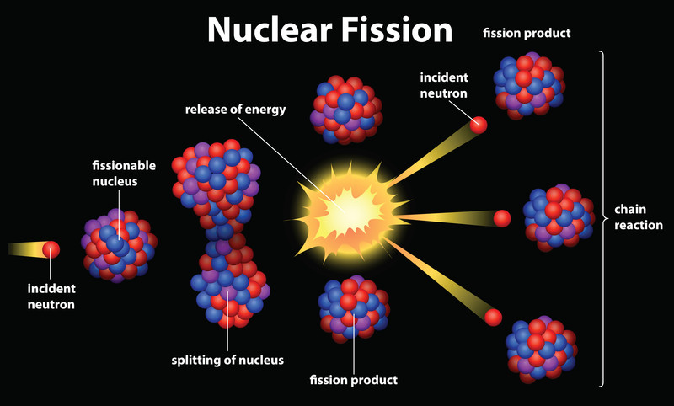
Figure 2.1*: Fission of an element
*Copyright to image purchased using canstockphoto

2.2.2 Nuclear Reactors
A nuclear reactor is used to control the energy produced from nuclear fission reactions [4], and ultimately produces electricity. In the UK two types of reactor are used, either gas cooled or water cooled. Originally the UK developed the Magnox reactors using uranium metal fuel rods coated in magnesium-based alloy. A 235U nucleus is bombarded with a neutron resulting in direct fission. The heavier 236U, is also a minor product during this process, with 236 nucleons present in the compound nucleus. This nucleus is unstable and as a result is likely to split. During this split neutrons are emitted allowing the chain reaction to continue. The neutrons are free to move at escalated velocity and collide with nearby atoms. Upon collision, the kinetic energy is converted to thermal energy heating the surrounding system [3]. A moderator is used to slow down the released neutrons to allow them to be captured effectively by further ²³⁵U. Magnox reactors are graphite moderated, whereas water cooled reactors use water as the moderator. Furthermore, in some reactors, in order to enhance the probability of these collisions the uranium is usually enriched to increase the proportion of ²³⁵U present [4].
The use of uranium metal in the Magnox reactors presented limitations due to a α-β phase transition of uranium at 661ºC, resulting in a volume change, surface deformation and cavity formation. Furthermore the melting temperature of Magnox is around 650ºC, therefore the cladding also limits the temperature to no higher than this [5,6]. This limits the maximum reactor coolant temperature, which limits the steam temperature. Therefore in future reactors and also in current PWRs the uranium is supplied in the form of uranium oxide (UO₂) pellets arranged in tubes to form fuel rods, which are then assembled to form the reactor core. The fuel rod life expectancy depends on the ratio of ²³⁵U to ²³⁸U in the fuel. This is because the majority of fuel used in nuclear reactors usually contains a small percentage of ²³⁵U, with ²³⁸U making up the rest. This ²³⁸U isotope does not split when absorbing neutrons, and forms ²³⁹U. Therefore as fission progresses the amount of ²³⁵U decreases, and the amount of neutron absorbing fission products increases, resulting in lower neutron bombardment efficiency on ²³⁵U and poisoning the fuel and reducing reactor efficiency, at which point the fuel rods must be replaced.
Once the nuclear fuel has been irradiated in a nuclear reactor, it is referred to as used or spent nuclear fuel. At the Sellafield site, Cumbria, UK, the spent fuel is reprocessed to recover reusable uranium.

2.2.3 Waste Management
Unlike the burning of fossil fuels the use of nuclear fission to produce energy does not result in any emissions of gases that are harmful to the environment. However the main concern attached to the use of nuclear power is the highly radioactive and significantly toxic waste produced. These wastes can be a product of uranium mining, reactor operation, fuel preparation, processing of fuel or the decommissioning of the actual nuclear facility. According to IAEA Safety Standards [7] the wastes are classed as primary or secondary. Primary wastes include products of fission reactions, fuel rod cladding and unwanted transuranic elements, whilst secondary wastes are usually reagents, solvents or contaminated worn-out equipment. There are three categories used in the UK to classify the nuclear wastes based on their radioactivity. The first is low level wastes (LLW), which encompasses wastes that contain very small activity of radionuclides usually having a radioactive content of up to 4000 Bq/g of alpha and 12000 Bq/g of beta activity. Examples include waste produced in the medical industry and contaminated garments. The radiation is sufficient to require disposal, and near surface storage is used as a shielding measure. The second category is intermediate level wastes (ILW). They are less abundant than LLW and contain a higher concentration of radionuclides, resulting in higher radioactivity. Anything above 4000 Bq/g alpha or 12000 Bq/g beta activity is classed as ILW [8]. As a result ILW require special measures for handling, storage and disposal. Finally high level wastes (HLW), are the least abundant of the three and are highly radioactive, however also produce heat, to the extent that the significant heat produced from radioactive decay is sufficient to require that waste to be cooled.
Various methods are used to safely contain the different types of nuclear wastes. LLW and ILW are usually in encapsulated in composite cements of differing compositions, whereas HLW are predominantly vitrified in glassy matrices [8].
The composite cement systems used in the UK to encapsulate ILW are Portland cement blends mixed with either blast furnace slag or pulverised fuel ash at various ratios [8]. The cementitious wastes are then poured into steel drums, as shown in Figure 2.2. These drums are currently stored above ground at Sellafield, Cumbria, UK until a suitable and sustainable storage facility is decided. Preliminary discussions finalised in 2006 by the Committee for Radioactive Waste management (CoRWM) proposed that the steel drums be stored geologically i.e. buried up to 1km below the surface of the earth [8]. The steel containers are filled with cementitous wasteform, sealed, stacked and backfilled using cement blends and then the LLW is stored in the Drigg Repository, Cumbria, UK and the ILW drums are stored at Sellafiled, on site. The purpose of the backfill serves to retain any radionuclides from the waste that escape the steel drums via leakage or otherwise.

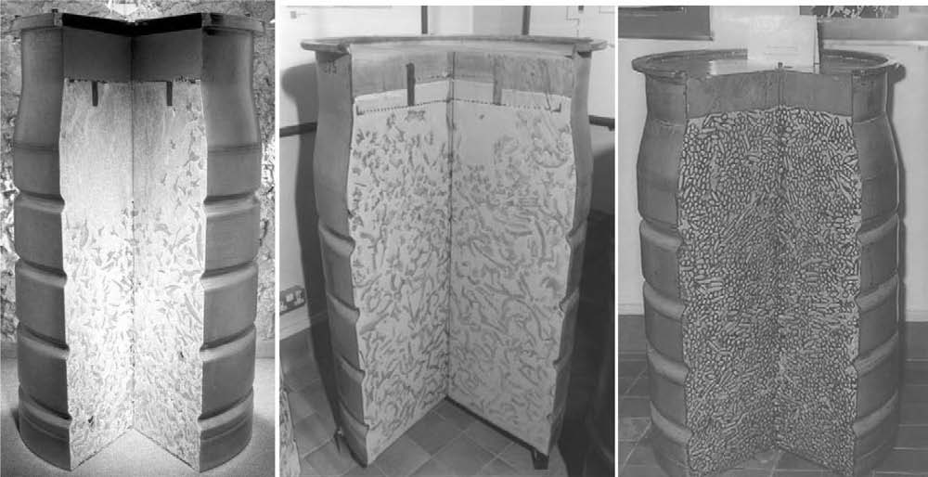
Figure 2.2: Cement-encapsulated ILW in 500-L drums [9]

2.2.4 Transuranic Wastes (TRU) and Nuclear Fission Products
i. Plutonium (TRU)
Plutonium (Pu) is a significant radioactive component of nuclear waste, although the reusable Pu is removed during reprocessing, it is still present as a contaminant. It is a transuranic metal and is generally considered a man-made element. In a nuclear reactor when ²³⁸U absorbs a neutron, ²³⁹U is formed and eventually decays to form ²³⁹Pu. Various isotopes of Pu are formed in a similar fashion, depending on the isotope of U that undergoes neutron absorption and decay. The common radioisotopes included in nuclear waste are ²³⁸Pu, ²³⁹Pu and ²⁴⁰Pu, ²⁴¹Pu and, with the longest half-life of 374,000 years, ²⁴²Pu [8]. Some of the radioisotopes in the fuel roads undergo fission to produce heat and ultimately electricity. The reaction products remain in the fuel pellets and absorb the neutrons, producing spent fuel rods containing radioactive plutonium. The fuel rods are dissolved in strong acid and treated the resultant solution with chemical in order to precipitate the plutonium. A significant percentage of plutonium production was for the purpose of nuclear weaponry which has now left a legacy waste of hazardous mixed chemicals, acids and radioactive fissions products that required immobilising and storing safely.
The isotopes of Pu undergo radioactive decay, forming other radioactive isotopes and emitting an alpha particle. Therefore external exposure to plutonium is a negligible health risk, internal exposure, however, is extremely hazardous and toxic. Once Pu enters the blood, it remains there for decades radiating organs and tissues. This introduces the risk of mutation to organs and increases cancer risks [7].
In nuclear research cerium (Ce) is commonly used as an inactive surrogate to study the behaviour of plutonium ions in certain waste forms. This is due to the similarities in solubility [9] and crystal-chemistry between some rare-earth metals and actinides. Due to this similarity of valency and ionic radii, Ce can be substituted directly for Pu . A study by Marra et al. researching the use of ceramics to immobilise plutonium for geological [10] found that the Ce in its oxide form performed very well as a surrogate in the batching process of the ceramics producing the same major phase as Pu [10]. However there were some differences in certain instances such as reactions with calcium, using Pu formed the calcium uranium oxide, however using Ce a perovskite phase was formed instead.

ii. Caesium (fission product)
Caesium (Cs) has a number of isotopes, of which only caesium-133 (¹³³Cs) is naturally occurring. All the other isotopes are man-made, one of which is caesium-137 (¹³⁷Cs) which occurs as a common product from the nuclear fission of ²³⁵U [8]. It has a half-life of approximately 30 years, and undergoes beta decay at annual decay rate of 2.3% [8] to form barium-137m and ultimately non-radioactive barium. The fission of uranium yields various by-products as shown in Figure 2.3 which illustrates the possible fission fragments based on mass number and their respective percentage yield. The diagram suggests that fragments with mass numbers of 95 and 137 are produced in the highest yield, thus ¹³⁷Cs is considered one of the major by-products of spent nuclear fuel.

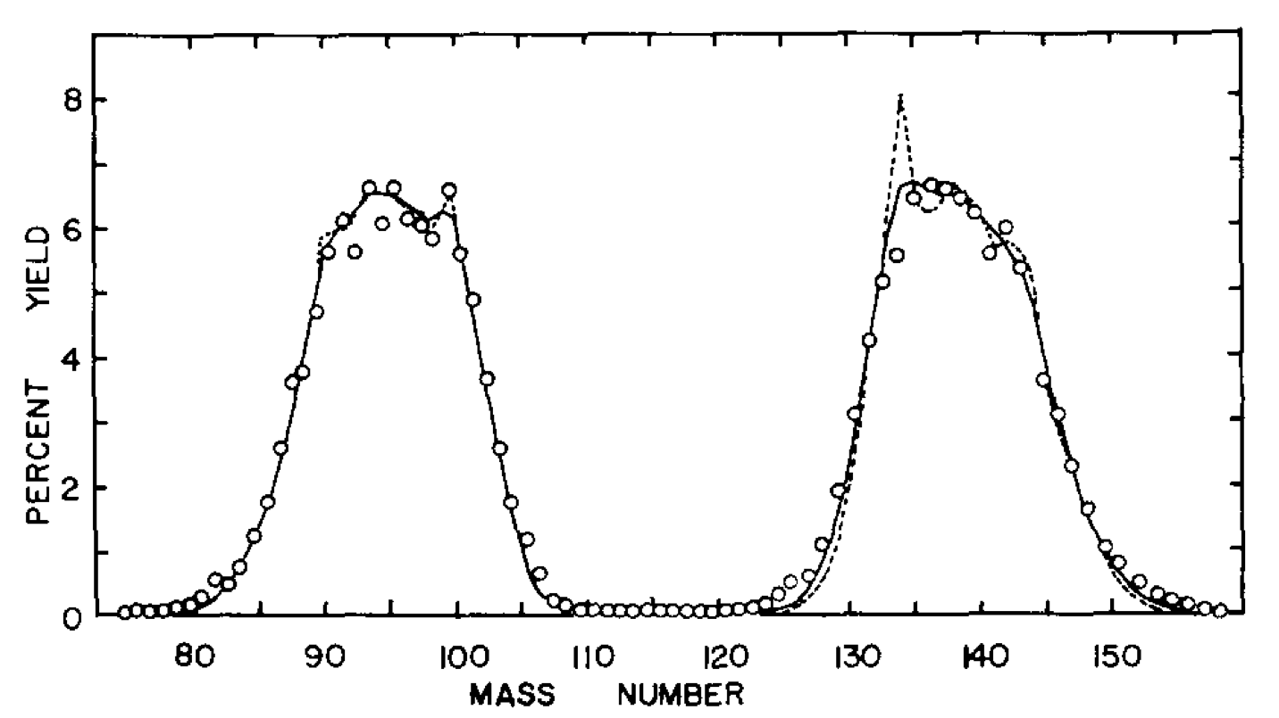
Figure 2.3: ²³⁵U Fission fragments [11]
In the past, several incidents have led to the release of Cs into the environment. A nuclear fuel reprocessing reactor was installed at the Windscale facility (now known as Sellafield) Cumbria, UK. In 1957 this reactor caught fire and burned for nearly two days [12]. This led to the release of ¹³⁷Cs into the surroundings. Although the concentrations were deemed negligible it allowed for a study into the radionuclides behaviour in the environment. In 1986 fallout from the Chernobyl incident was deposit in varying amounts over parts of Europe including the UK, research by Green et al [13] investigated the transfer of ¹³⁷Cs into herbage, soil and cow-milk from this fallout. They found that the Cs became immobilised in the soil by chemically binding to clay mineral particles of which the majority tend to be siliceous particulates. The ¹³⁷Cs which are chemically bound in this state will be unavailable for biological uptake. The rest, however, if consumed by cows would be eventually transferred to milk, and they estimated that around 50% of the ¹³⁷Cs intake through grazing would be available for gut uptake. This eventually would be transferred through to humans via milk ingestion.
In 2011, the Tohoku earthquake and tsunami in Japan lead to the Fukushima Daiichi nuclear disaster. It is the largest nuclear disaster since the 1986 Chernobyl incident. As a result approximately 40,000 TBq of ¹³⁴Cs and 360,000 TBq of ¹³⁷Cs was released into the environment. Figure 2.4 shows the spread of both ¹³⁴Cs and ¹³⁷Cs throughout Japan as of 25th November 2011 [14]. An incident of this scale would lead to further distribution of Cs through the environment posing a greater threat and increasing the possibilities of human exposure to this radionuclide.

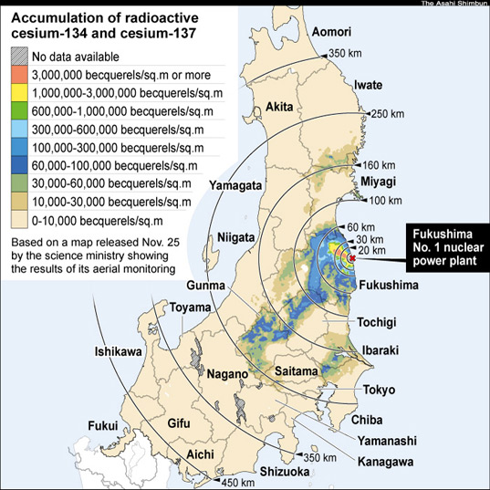
Figure 2.4: Distribution of released ¹³⁴Cs and ¹³⁷Cs released from the Fukushima Plant following the Tohoku earthquake [14]
The ingestion of ¹³⁷Cs can be dangerous as once it enters the body it is distributed uniformly throughout the body’s soft tissues [12]. This means the increased exposure/ingestion would result in mutation and increase in cancer risk throughout the body. If exposed to very high dosage burns could result even leading to death, however such instances are rare [12].

iii. Strontium (fission product)
A radioactive isotope of strontium, strontium-90 (⁹⁰Sr), is also a by-product of nuclear fission within reactors during energy production and in nuclear weapons. This radioisotope has a half-life of approximately 29 years and undergoes beta decay to form yttrium-90 which ultimately decays to form zirconium-90. In Figure 2.3 the fission product ⁹⁰Sr is produced in relatively high yields, however in a lower proportion in comparison to ¹³⁷Cs.
Significant amounts of ⁹⁰Sr were released during the Fukushima incident, and large amounts were found years later in nearby sea soil as reported by Tepco [15]. Very large amounts were also released during nuclear weaponry testing in the 1950’s and also as a result of the 1986 Chernobyl incident [12].
⁹⁰Sr can enter the body via inhalation from the environment or ingestion. The majority passes through the body, with the remaining amounts getting absorbed into the bone [16]. This radioisotope is known as a bone seeker, as it is chemically similar to calcium. Thus the main health concern is the increased risk of bone cancer and leukemia [16].

2.3 Cements and Composite Cements
2.3.1 Portland Cement
PC is a hydraulic binder composed of lime, alumina silica, iron and important sulphates. It is the product of mixing clay with limestone and firing them at approximately 1450ºC. When PC is mixed with water an exothermic reaction occurs to produce a strong, hard mass.
PC is commonly used to immobilise intermediate level nuclear waste because of the many different wastes that can be incorporated into the hardened cement paste [17]. The final wasteform has a high level of durability and the hardened cement matrix is also significantly resistant to degradation due to irradiation [17]. The cements are also readily available and relatively inexpensive. The low cost of limestone and the natural abundance of silica make PC one of the cheapest materials used globally [17]. PC also offers a chemical environment with a high pH of around 13.5, which is favourable for ion substitution and sorption, however during the blending of cements this pH tends to be reduced. It has very good initial fluidity to allow mixing, resulting in a homogeneous distribution of the waste throughout the final waste form with good thermal, chemical and physical stability [17]. Prior to hydration the PCs contain four major phases (shown in Table 1).

Table 1: Principal compounds in Portland cement [9]
Compound | Oxide Composition | Abbreviation
Tricalcium silicate | 3CaO•SiO₂ | C₃S
Dicalcium silicate | 2CaO•SiO₂ | C₂S
Tricalcium aluminate | 3CaO•Al₂O₃ | C₃A
Tetracalcium aluminoferrite | 4CaO•Al₂O₃•Fe₂O₃ | C₄AF

The C₃A component dictates the early hydration of the cement, it hydrates rapidly and influences the early bonding traits [9]. The reaction of water with C₃A is violent in nature and can result in stiffening of cement paste without subsequent strength development (this is known as flash setting), the introduction of CaSO₄ circumvents this issue. The ratio of C₃S to C₂S in cement has an impact on the development of the cement. Higher C₃S content results in rapid hydration and higher early strength; this however impedes future hydration and results in a lower ultimate strength [9]. In contrast, a higher C₂S results in slower hydration, leading to a denser structure with higher strength [9].

2.3.2 Hydration of Portland Cement
i. Hydration Products
Upon mixing the cement with water, at a given water to cement ratio or w/c, chemical reactions occur which result in the hardening of the paste. The C₃S and C₂S phases (which constitute around 85wt% of the cement [18]) react with water to produce calcium hydroxide (Ca(OH)₂) also known as Portlandite and calcium silicate hydrate (C-S-H) (Eqs.1, 2 [18].

2C₃S + 7H₂O → C₃-S₂-4H + 3Ca(OH)₂ (1)
2C₂S + 7H₂O → C₃-S₂-4H + Ca(OH)₂ (2)

C₃A reacts with water initially to form the hexagonal hydrates forming a protective barrier around the C₃A (Eq.3). It also reacts with the sulphate in the system to form the ettringite phase (trisulphate) (Eq.4), wherein $ denotes SO₃. This phase is known as an ettringite (AFt) (or alumina, ferric oxide tri-sulphate phase due to its ability to form with both Fe and Al). The ettringite phase then reacts with C₃A to form a mono-sulphate phase (AFm) phase (Eq.5).
2C₃A + 18H₂O → C₂AH₈ + C₄AH₁₀ (3)
2C₃A + 32H₂O + 3(Ca²⁺ (aq) + SO₄²⁻(aq)) → C₆A$₃H₃₂ (4)
C₆A$₃H₃₂ + 2C₃A → 3C₄A$H₁₂ (5)
The early stages of hydration are illustrated in Figure 2.5 [19], monitoring the hydration progress of each phase versus the porosity of the cement paste. As can be seen, these reactions are divided into three stages starting with the dormant period which spanning over a period of minutes until reaching the setting period which occurs over several hours. Finally the cement reaches the hardening phase which lasts several days, most likely longer. The figure shows that the highest yielding phase is C-S-H followed by Ca(OH)₂. The amount of ettringite begins to decrease during the hardening phase, as the production of monosulphate begins.
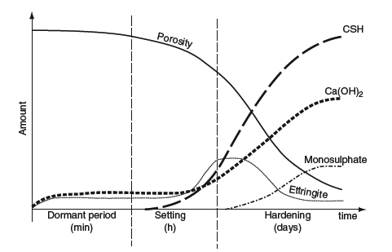
Figure 2.5: Development of the hydration products within Portland cement [19]

ii. Calcium Silicate Hydrates
The calcium silicate hydrates, and particularly the variable and poorly ordered C-S-H phase, are the main contributing phases to the cement strength as they are the main binding phases. They make up approximately 70wt% of the hydrated product and are therefore the most important phases for characterising the properties of the paste [19]. The C-S-H phase is not a well-defined compound with varying structural water content and a varied C/S ratio of 1.5-2 [18,19]. It is sometimes referred to as a gel due to the varying morphology and colloidal dimensions, with a crystal structure at times resembling the tobermorite mineral. Tobermorite is a crystalline calcium silicate hydrate with formula of Ca₄(Si₆O₁₈H₂).Ca.4H₂O. The factors that influence the way in which C-S-H is formed include the degree of hydration, curing temperature and certain chemical and mineral admixtures. Several models have been used to explain the properties that arise from C-S-H, one of which is the Powers-Brunauer model proposing that the material has a layer structure with a very high surface area and material strength attributed to van der Waals’ forces [19]. Whereas the Feldman-Sereda model suggests that C-S-H comprises of a random, irregular and kinked collection of layers arranged in a manner which creates interlayer spaces of varying size [20]. There are many other models compiled over the past 55 years, describing the nanostructure of the C-S-H in cements, which according Richardson [21] share a lot of similarities, with the consensus that the phases include elements of tobermite and jennite structure. The development of the C-S-H phase during hydration is showing in Figure 2.6 by Scrivener [22]. The formed C-S-H emits spines from each grain, which are forced to interlock when the C-S-H hydrates further. This interlocking creates solid bonds, and coats the C-S-H. The cement grains then bond together with this coating.
These hydration reactions release energy increasing the temperature in the system; this is known as the heat of hydration. This heat causes the cement to expand and then shrink as it cools. If there is a temperature gradient across the cement, cracking may occur [10]. This would compromise the suitability for the cement as a long term waste encapsulant and therefore must be avoided.
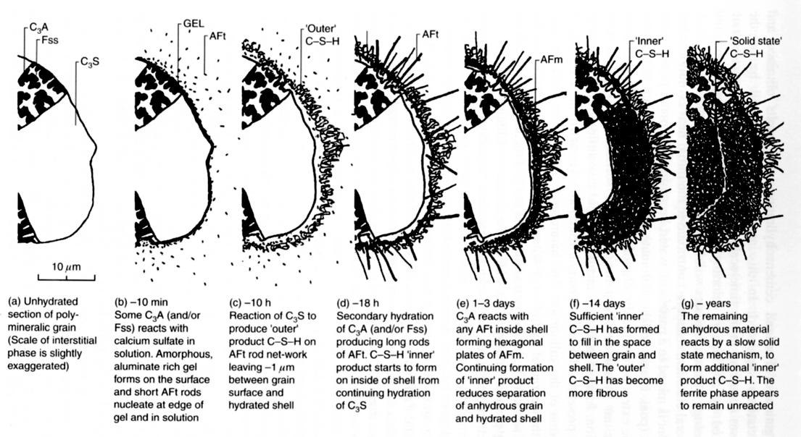 Figure 2.6: Microstructure development during the hydration of Portland cement [22].

ii. Portlandite (Calcium Hydroxide Ca(OH)₂)
The portlandite phase contributes to 20wt% of the final cement waste form [23]. Generally portlandite forms large crystals with distinctive hexagonal-prism morphology and a diameter of several tens of micrometres, evenly distributed within the hardened paste [18]. The crystal structure consists of octahedrally coordinated calcium ion layers and tetrahedrally coordinated oxygen layers. During hydration the crystals continually grow larger within water-filled voids and at times engulf areas of C-S-H thus limiting further hydration [23].
The contribution to the strength of the final cement form is relatively less than that of C-S-H due to the significantly lower surface area. This phase is highly alkaline and if leached in water can increase the pH of the leachate significantly.

iii. AFt/AFm phases
The AFt and AFm phases are also formed during hydration. In PC, the most commonly found AFt and AFm phases are ettringite and monosulphate, respectively. The general formula for AFt is [Ca₆(Al,Fe)(OH)₆·12H₂O]₂·X₃·nH₂O, X represents a doubly charged anion or two single charged anions and n ≤ 2 [23]. According to Bensted and Barnes [23] ettringite is the first stable hydration product, with its formation dependant on the presence of sulphate ions available for reaction. In ettringite X = SO₄²⁻, and as three are required this is where the tri-sulphate is derived from. These sulphate ions are held in along with the H₂O molecules in the channels created by the (Ca₆ [Al(OH)₆]₂.24H₂O)⁶⁺ as shown in Figure 2.7 a and b. The columns are made up of Al(OH)₆ octahedra alternating with groups of triangular edge-sharing CaO₈ polyhedra. This forms a needle-like morphology, these needles interlock and take up significant amounts of water, leading to the stiffening of the cement and contributing to the early strength. There is a possibility of partial substitution of the OH⁻ and SO₄²⁻ ions, therefore it is difficult to say that the exact stoichiometry will always present the ettringite form, as a result ettringite in PC is referred to as an AFt [24] as opposed to ettringite.
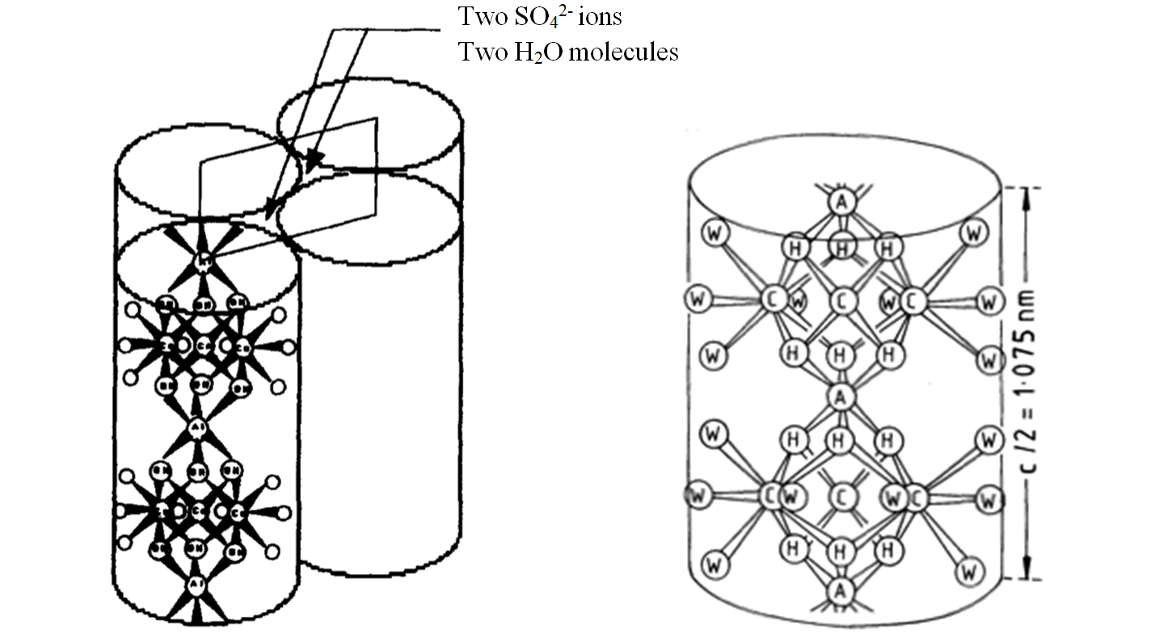
(a) (b)
Figure 2.7: (a) Schematic of AFt column structure (b) Part of a single column
(A = Al, C = Ca, H = O of an OH group, W = O of an H₂O molecule.)[25]
The ettringite concentration reaches its maximum after about 1 day, as shown in Figure 2.5, at which point the concentration of sulphate has been reduced and as a result mono-sulphate (AFm) begins forming. This phase has the general formula (Ca₂(Al,Fe)(OH)₆)∙X∙nH₂O. X represents a formula unit of a singly charged anion such as OH⁻, or half a unit of a doubly charged unit such as CO₃²⁻, within PC usually X=SO₄²⁻, however a mixture of various AFm phases can be formed within one cement matrix; this is dependent on the atmosphere in which the cement hydrates. This is because there is a solid solution due to the isostructrual relationship between C₄A$H₁₂ and C₄AH₁₃ in which the ions SO₄²⁻ and 2OH⁻ occupy the interlayer positions in a disorganised way. During preparation the cement could be carbonated and as a result the CO₃²⁻ could substitute with the OH⁻ or SO₄²⁼. In PC the Ca₂Al(OH)₆⁺ is ordered in layers that alternate with the layers of SO₄²⁻ or H₂O, as shown in Figure. 2.8, every layer of SO₄²⁻ has a layer of Ca₂Al(OH)₆⁺ above it and one below it to balance the charge. As only one sulphate anion is required to balance the charge, these phases are often referred to as monosulphate. [23,24].
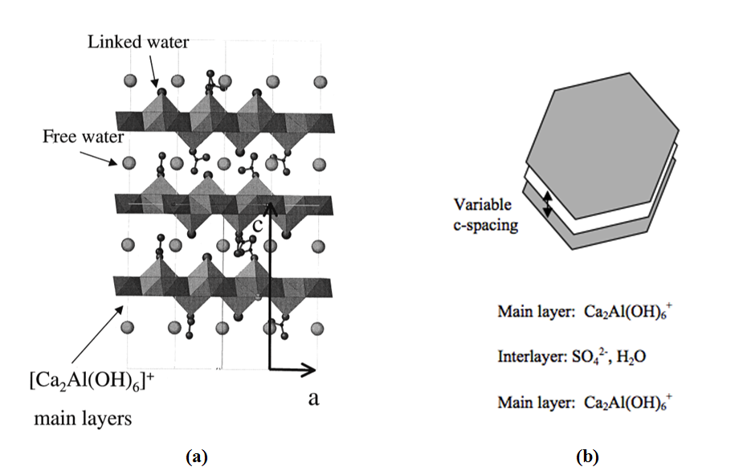
Figure 2.8: (a) Layered structure of AFm (b) Schematic of AFm structure [25]

2.3.3 Blast Furnace Slag Composite Cements
In waste immobilisation cements are usually mixed with other inorganic materials, known as supplementary cementitious materials (SCM), to enhance the cements properties. The SCMs include limestone, pozzolanic materials (e.g. silica fume, pulverised fly ash (PFA) etc.) and the hydraulic materials [9]. The most significant hydraulic material is BFS [23]. Introducing BFS into a cement mixture enhances the mechanical strength at a later stage as well as lowering the heat of hydration and the permeability of the cement matrix meaning lower diffusion of ions and enhanced durability in the presence of chlorides and sulphates [26], this also reduces the setting rate of the cement. These characteristics are desirable in casting larger cement structures in which internal cracking could be detrimental and where toxic or radioactive materials are immobilised via containment within the structure.
BFS is a byproduct of the smelting process in the steel industry. It is formed when iron ore/pellets are melted with coke and a flux of either limestone or dolomite in a blast furnace. Once the smelting is completed, the lime chemically combines with the aluminates and silicates of the ore and coke ash. As a result, BFS is rich in calcium oxide (approximately 40%) with small amounts of magnesium oxide (MgO) and various sulphides [27]. It is formed as a liquid at around 1350-1550ºC and is cooled rapidly using water/air to temperatures below 800ºC, forming a glassy material which is crushed and ground [27]. Usually the BFS is ground to a powder with similar fineness to PC, forming ground granulated blast furnace slag (GGBFS), however in the waste immobilization a coarser BFS is used to reduce reactivity and minimise the heat produced [28].
BFS reacts with water at room temperature. Further reactivity is reduced when a protective layer is formed on the outer surface of the BFS particles, as result slowing the reaction down. This can be offset by adding alkali activators such as Ca(OH)₂ or NaOH, which break down these layers on the surface of the BFS to eventually increase the rate of reaction [29]. In a reaction with PC these activators are supplied by (Na⁺, K⁺) increasing the concentration of OH⁻, resulting in a high pH of the pore solution and the breakdown of BFS glassy structure Table 2 shows the hydration phases formed when BFS reacts with these various activators.

Table 2: Phases formed from BFS and activator reactions [9]
Activator | Phases
Ca(OH)₂ | C-S-H, C₄H₁₃
Cement | C-S-H, AFm, AFt, hydrogarnet
NaOH, Na₂CO₃ | C-S-H, C₄AH₁₃, C₂AH₈, Mg-Al layered phases similar to hydrotalcite
Sulphate | C-S-H, AFt

The activators are not the only factors that affect reactivity; the content of the BFS and the PC contents also play a role, as well as the temperature, time and BFS characteristics (chemical composition, fineness etc.) [30] An increase in fineness from 300m²/kg to 500m²/kg, for example, was shown by Hindirchs and Odler [31] to increase the reactivity of BFS.

2.3.4 Use of Superplasticisers
A superplasticiser is a water-reducing cement admixture used to promote well-dispersed particle suspension; a plasticiser reduces the percentage of necessary water up to 5%, whereas a superplasticiser can reduce the percentage of necessary water by 5-15%. The introduction superplasticisers during the mixing of these cements introduces various beneficial properties [32]. For example the fluidity of the cement is improved when the cement particles are dispersed in the paste. A superplasticiser such as β-naphthalene sulphate (BNS) disperses the cement particles by electrostatic repulsion [33] and when polycarboxylic acid (PC) with graft chains (chains with segmented copolymers containing a linear backbone of one composite and randomly distributed branches of another composite [34]) is used the dispersion occurs as a result of the steric hindrance effect of the graft chain extension from the cement particle surface [35]. New superlasticisers are in development to activate both these dispersion mechanisms simultaneously. Yoshioka et al. [36] tested the effect of three superplasticisers (BNS, PC and polysulphonic acid) on the fluidity of commercial PC, using a flow cone method. They poured the cement pastes through the cone, then removed the cone and measured the maximum diameter of the spread paste and the width perpendicular to that diameter. They found that 0.5wt% of BNS increased the fluidity of the cement by approximately 100%, the other superplasticisers increased the fluidity by 30-40% at a dosage of 1-2wt%. Recent research by Jansen et al. [37] studied the impact of superplasticisers on cement hydration and found that the superplasticiser retards both the silicate and aluminate hydration reactions. They explained that this could be due to the complexation of Ca²⁺ ions from the pore solution, meaning a depletion of Ca²⁺ in the pore solution thus retarding both the aluminate and silicate reactions. Alternatively, they suggested this retardation could be due to the superplasticiser being absorbed on to the nuclei of the hydrate phases or into the interlayers of AFt and AFm phases, during the nucleation growth stage of hydration. This absorption prevents the progression of hydration potentially explaining the retardation behaviour [36]. The addition of ADVA cast 551, a commercially used superplasticiser ADVA Cast 551 (based on a polycarboxylated poly-ether comb polymer), to a BFS:CEM I cement has also been known to increase the fluidity of the cement paste and delayed the setting times, thus significantly increasing the workability of the cement. This allows for large reductions in the required water for mixing, resulting in high early strength development, a decrease in permeability and a significant reduction in costs [37]. The repeating monomer unit of ADVA Cast 551 is shown in figure 2.9.

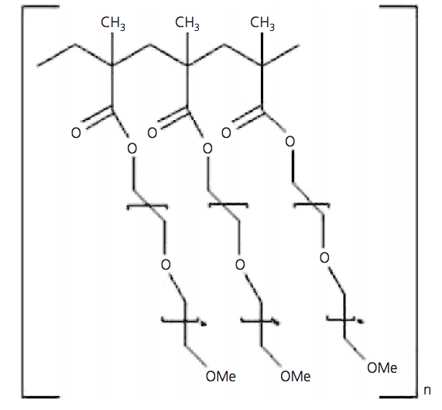
Figure 2.9: The repeating monomer unit of ADVA Cast 551
The complexation of ions with superplasticisers is of a major concern from a waste immobilisation perspective. Systems used to immobilize radionuclides such as Pu and U have shown that the introduction of the superplasticisers complexed these radionuclides and increased their leaching rate [32].

2.4 BFS:PC Cements in Waste Immobilisation
2.4.1 General Use
In the UK, the immobilisation of ILW is predominantly done within the BFS:PC composite cements, as previously mentioned. Various aspects of the cement matrix allow for an array of ions to be immobilised, however this strongly depends on the chemical environment and hydration reactions within the cement. There are three main reaction mechanisms for immobilising the radionuclides in a BFS:PC matrix, sorption, ion exchange and compound formation. Sorption occurs onto or into a gel like phase such as C-S-H, ion exchange or substitution occurs in one of the crystalline phase and finally if a reaction occurs between the radionuclides and one or more of the cement species they form a new compound [38]. The mechanism used is dependent on the radionuclide that is being immobilised. The waste ion interactions that may occur within the cement were illustrated by Cocke and Mollah [38] shown in Figure 2.10, stating that ions could chemisorb, precipitate, form a surface compound to any of several cement component surfaces, form inclusions or be chemically incorporated into the cement crystal phases, or a combination of these.

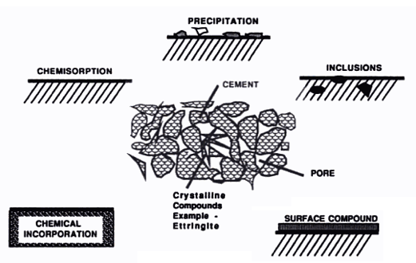
Figure 2.10: Possibilities of the interaction between hazardous substances within cement[38]
The presence of calcium hydroxide alongside sodium and potassium ions in PC produces a highly alkaline cement paste with a pH of approximately 13.5. This decreases the solubility of some radionuclides allowing for the removal of nuclides from the pore water solution by precipitation, and reducing their mobility [29]. Therefore when evaluating the immobilisation capability of the cement, it is important to consider the following factors which determine the solubility of the nuclides in the cement pore water:
- Precipitation as a simple salt
- Co-precipitation with other phases
- Lattice incorporation
- Sorption at hydrous surfaces
- Complex and colloid formation in the aqueous phase. [17]
This will allow for the control of the cement conditions accordingly and manage the mobility of the radioactive elements. Although these are often considered for PC cement only, they also applicable for BFS composites.
The introduction of BFS is necessary to counteract the high heats of hydration of PC and the resulting high porosity without compromising the workability of the cement as well as the quality of the final product. Adding BFS, reduces the pH of the pore solution to approximately 11 which increases the precipitation of some of the heavy metals, it also lowers the oxidation-reduction potential which in turn reduces the solubility of the radionuclides, avoiding corrosion of the steel containers and finally it reduces the permeability of the waste form [39,40]. Reducing the pH to levels between 10-12, however, does cause the dissolution of the calcium in the CSH [40] Furthermore, the BFS reacts with some of the metals to produce sulphides instead of hydroxides, these sulphides are much more insoluble.
The immobilising capabilities of the BFS:PC system are also dependent on the redox potential (E_{h}). This system is not a very reducing environment because cements are usually produced under oxidising conditions containing oxygen and traces of SO₃²⁻, iron (Fe²⁺) and manganese (Mn²⁺) (ions typically found in BFS) which are relatively insoluble due to the high pH. The BFS lowers the E_{h} and can reduce the solubility of some nuclides. Systems with low E_{h} allow for the reduction of multivalent metal ions, in turn allowing for the immobilisation of various radionuclides. For example at lower E_{h} CrO₄⁻ becomes unstable and precipitates to give Cr₂O₃ [41]. This usually occurs with elements that display multiple oxidation states, which are prone to speciation changes as E_{h} potential changes [41]. Glasser & Atkins [42] showed that a system containing 70wt% BFS had a lower E_{h}, this is because as it hydrates for longer periods of time increased amounts of S²⁻ are released, causing the pore fluid to change from oxidising to reducing after 3 months [43].
Hydration products also influence the immobilisation of radionuclides in BFS:PC systems. C-S-H, the major product (from a quantitative perspective) is responsible for immobilising various ions. Studies on Zn²⁺, Pb²⁺ and Sn²⁺ by Read et al [44], suggests that these ions can precipitate as distinct compounds or bind to the C-S-H silicate chains, although opinions differ on whether the binding occurs at the end of the silica chains or at the bridging locations [45]. According to Rose at al [45] ions, such as aluminium (Al³⁺), iron (Fe³⁺) and sulphates (SO₄²⁻), are contained within C-S-H in the cement system. Further investigation by Copeland et al. [46] found that Al enters the C-S-H in the tetrahedral form replacing the Si attaching to an H¹⁺ or by replacing Ca in its octahedral or pentahedral form after joining with another. However Taylor [20] concluded that the Al³⁺ ions alongside Mg^{2+,} Fe³⁺ and SO₄²⁻ are present in the AFm/AFt phase as opposed to C-S-H. This phase also allows substitution of Ca²⁺, Al³⁺and OH⁻ [46], which all occur at the aluminium and sulphate sites, where the aluminium site accommodates trivalent and tetravalent cations and the sulphate sites accommodating divalent and trivalent anions.

2.4.2 Interaction with Caesium
Research on the interaction of caesium with BFS:PC cement and its behaviour within the cement matrix is limited, with various theories and approaches [17,47,48,49,50,51,52,53]. The main focus has generally been on cements combined with zeolites, more so than interaction of Cs with cements [54,55,56,57,58]. The general consensus, however, is that Cs tends to be poorly immobilised within PC cement, as the majority of the Cs was found in cement the pore fluid. Any sorption that did occur, was on the calcium silicate compounds, and was dependent on the Ca:Si ratio (the lower the Ca:Si the better sorption of Cs) [59]. In one study [49] the pH impact on Cs retention was also monitored and it was found that a decrease in pH was concomitant with a decrease in Ca:Si ratio and in turn increasing the surface area of C-S-H sites with affinity for Cs. Presumably due to the pH induced leaching of Ca. Usually, hard to immobilise elements such as Cs, are sorbed on ion exchange resin before being cemented [54]. However in this case the high ion concentration of the pore fluid removes the Cs from the active sites in the resin [54]. Papadokostaki and Savidou [48] experimented with the sorption of the Cs⁺ ions on the cement granules, adding the Cs in its sulphate form as well as in its nitrate form. By measuring the Cs concentration profile in the samples they found that adsorption on the 20-30% of Cs⁺ immobilised by the cement (suggesting that it formed caesium aluminium silicates), while the rest was easily removed by elution [48]. Caesium sorption is generally believed to occur within the C-S-H phase [49,50,51,52,53]. It was observed by Iwaida et al [50] that silicate chains had shortened in the C-S-H that had sorbed the Cs, indicating that these chains had broken. They concluded that sorption onto C-S-H was inversely proportional to the Stokes radius of the hydrated ions, and that the sorption occurred on a negatively charged C-S-H site, suggested to be a silanol (Si-OH) site. This electronegativity arose from the density of silanol bonds and the sites' mean acidity, which was inversely proportional to the Ca:Si ratio. Further research by Iwaida et al [60] found that the Cs was sorbed onto the tobermorite-type layers within the C-S-H. Their XRD results showed that the Cs sorption caused a degradation of the tobermorite-type layer and shortening the layer intergrowths. However it was also suggested that the OH⁻ ions contributed to the breaking of the silicate chains [50,60].
The binding capacity for caesium and its corresponding bond strength decreases as the Ca/Si ratio increases within the cement paste, as a result pozzolanic additives are sometimes used [59]. The amorphous silica provided by the additive reacts with portlandite to form a C-S-H gel with a slightly lower Ca/Si ratio than that expected from C-S-H formed during hydration [51], which increases the binding capacity. Other additives such as densified silica fume increase the immobilisation of Cs ions in cement pastes, where energy dispersive spectroscopy analysis (EDS) shows that a greater concentration of Cs ions were present in the silica-fume agglomerates than in the surrounding paste [51]. If the Ca/Si ratio remains constant but the alumina content decreases then sorption of Cs again increases. An increase in CaO:Al₂O₃ ratio [52] also increases the Cs retention. However solid-state NMR by Hanna et al.[53] showed that the Cs in PC remained in solution regardless of any additives. On the other hand Atkinson and Nickerson’s conclusion found that the introduction of a zeolite caused an 80-fold reduction in Cs leaching [61].

2.4.3 Interaction with Strontium
In contrast to Cs, Sr is well retained within PC, with a retention percentage of up to 95% in the solid phase [17]. Various hydration phases can completely accommodate low levels of Sr, including the hydration products of C₄AF and C₃A [17]. An experiment by Atkins and Glasser [17] synthesising the AFt and AFm phases found that Sr can substitute for Ca in AFt phases to at least 10mol%, although they have suggested that Sr substitution in AFm is likely, their experimental results show that it was unsuccessful (they suggested this could be due to experimental error). The Sr substitution in AFt has also been reported by Bensted and Varma [62]. This study also showed that highly carbonated samples have resulted in a co-precipitation of SrCO₃. In other studies it was found that the major of sink of Sr seems to be the calcium aluminium hydrates. Therefore it is assumed that cements rich in Ca and Al such as high alumina cement (HAC), will have the highest Sr sorption [63]. The Sr can also be retained in other hydrate phases. Iwaida [50] showed that the sorption of Sr can also occur on the surface of C-S-H gel as well as in the interlaminer of the SiO₂ chain. Tits et al [64] have supported this through their study on the binding mechanism of the ion within the calcium silicate hydrates (C-S-H). They prepared two tests using synthesised C-S-H and Sr(OH)₂, the first was a co-precipitation test where the Sr(OH)₂ was added at the beginning to the solutions during the synthesis of C-S-H. The second was a desorption test, where the Sr(OH)₂ solution was equilibrated with the C-S-H already synthesised in H₂O. They concluded that the sorption was fast, the rates of sorption were similar in both tests, and were independent of C-S-H composition or water chemistry. The ethos of this approach was based on the partial substitution of Sr²⁺ for Ca²⁺, with a selectivity co-efficient of 1.2, thus giving the C-S-H equal affinities for both Ca²⁺ and Sr²⁺ [65].

2.5 Cement Leaching
Cement component leaching into water is one of the worst possible scenarios of degradation for cemented wastes in repositories. Typically, ground water has a lower pH than the pore water in the cement microstructure. If the cement were to come into contact with this ground water, the waste constituents will dissolve at specific rate [65]. Given the highly mobile nature of radioisotopes Cs, as it is not retained well within the cement matrix, this dissolution can cause significant concern if is released into the environment. Therefore it is important to understand the leaching behaviour of ions and radionuclides in cement.

2.5.1 Leaching Behaviour of PC
It was found in a sample of pure PC cement that removal of the Ca(OH)₂ in the cement lead to a significant decrease in mechanical strength [66,67]. After the Ca(OH)₂ had been completely removed from the system, the C-S-H phase undergoes decalcification, which also contributes to the loss in strength [68]. There is a chemical equilibrium between the two main hydrate phases (Ca(OH)₂ and C-S-H) in the cement and their component ions in pore water as shown in (Eqs. 7, 8)
Ca(OH)₂ $↔$ Ca²⁺ + 2OH⁻ (7)
xCaO.SiO₂.yH₂O $↔$ (1-b)SiO₂. (y-a)H₂O + xCa²⁺ + 2aOH⁻ + bSiO₂ (8)
Dissolution of the cement hydrates shifts the equilibrium toward the product side of the reactions. If there is decrease of Ca²⁺ or OH⁻ in the pore water the equilibrium shifts to the reactant side and further dissolution of the cement hydrate occurs. Initially only the Ca(OH)₂ dissolves to provide more Ca²⁺ and OH⁻ in order to maintain the equilibrium, once this has dissolved the C-S-H dissolution begins resulting in the degradation of the C-S-H phase into a silica gel [69]. Therefore the reactions in (7) and (8) do not occur simultaneously and only after the leaching of Ca(OH)₂ does the progressive decalcification of C-S-H begin [68,70]. It should be noted that the leaching of C-S-H is incongruent, wherein the Ca can be selectively removed while the Si remained within a C-S-H, which now has a lower C/S ratio. This creates a C/S ratio gradient across the leaching zone, which decreases closer to the leaching surface. The sorption of radionuclides is contingent on the C/S ratio as mentioned previously, therefore as decalcification occurs the level of radionuclide immobilisation in the cement may increase.
Carde et al. [68] found that in a pure PC cement the loss in strength due to dissolution of Ca(OH)₂ was around 70% as opposed to only 6% strength loss attributed to the decalcification of C-S-H. This difference is due to the variation in pores formed when each species is removed. The macro-pores produced in the cement after removal of Ca(OH)₂ are similar in size to capillary pores and therefore compromise the cement strength whereas the removal of Ca from C-S-H produces micro-pores. It was concluded that the loss of strength due to C-S-H is negligible relative to the loss of strength due to dissolution of Ca(OH)₂. However in a composite cement system this impact is not as significant as the Ca(OH)₂ only makes up a small percentage of the cement. Furthermore Carde and Francois [67] found that decalcification of C-S-H produced a C/S gradient in the leached zone whereas the calcium hydroxide had been completely dissolved. The C/S ratio was highest at the surface and decreased as the depth increased [67].

2.5.2 Leaching Tests
In order to better understand the leaching behaviour of cements and composite cements various leaching tests are used in industry and in research [65-73]. These tests simulate the leaching conditions of the cements in the conditions being studied. Two leaching tests in particular are of interest, acidic and electrical leaching. These tests are used to accelerate the leaching behaviour of the cements in order to simulate long term leaching.
i. Acidic Leaching
The chemical attack and eventual degradation of PC in solution is essentially governed by the dissolution of calcium hydroxide (Ca(OH)₂) and the decalcification of the C-S-H [69], causing a decrease in strength and an increase in porosity. The kinetics of these chemical reactions is slow when the cement is leaching in water under room temperature and pressure. This slow reaction would require significant experimentation times. Therefore Carde et al. [69] used ammonium nitrate (NH₄NO₃) in solution to accelerate the leaching of the cylindrical cement samples and established that the leaching behaviour of the cement in water and that in NH₄NO₃ solution is similar [69]. In acid the leaching environment became more aggressive and the chemical attack due to the following equation,
Ca(OH)₂ + 2NH₄NO₃ $↔$ Ca²⁺ + 2OH⁻ + 2H⁺ + 2NH₃ + 2NO₃⁻ $↔$ Ca(NO₃)₂ + 2NH₃ + 2H₂O(9)
This resulted in the precipitation of Ca in the form of a soluble calcium nitrate salt, meaning a quicker degrading process. This also resulted in the formation of an insoluble calcium alumino-nitrate and a white deposit of calcite CaCO₃ and vaterite (μ-CaCO₃) on the surfaces of the cement samples and the solution [70]. The formation of the calcite occurs as a result of carbonation of the cement system, when atmospheric carbon dioxide reacts with the hydration products, the CO₂ dissolves in the water to produce CO₃²⁻, when the Ca ions pass into the solution they react with CO₃²⁻ ions provided by the dissolved carbon dioxide (CO₂) in the solution or with CO₂ at the solution-air interface to form CaCO₃. The formation of calcium aluminonitrate needs to be avoided, as these phases are believed to induce splitting and compromise the structural integrity of the cement [71]. Torrenti et al [72] also propose that NH₄NO₃ dissociates when added to a basic environment into ammonium gas, leaving the nitric acid in solution this leads to the dissolution of portlandite. The Ca²⁺ associated with portlandite is attracted to NO₃⁻ ions forming a highly soluble Ca(NO₃)₂, which increases the rate of decalcification of the portlandite. The amount of NH₄NO₃ introduced into the system impacts the amount of free OH⁻ in the system [73]. NH₃ is also formed in an aqueous form in the solution; some of which turns into a gas. This was also found to cause swelling in the cement [72]. Acidic leaching of cements using NH₄NO₃ was also investigated by Agostini et al [73]. Using hollow cylindrical cement mortars filled with the solution, they found that the Ca(OH)₂ portlandite phase had completely dissolved within the first 4-8 days, which according to them was 300 times the rate of natural leaching. The acceleration factor seems to differ between various studies, Wan et al [74] found that leaching of Ca²⁺ ions had increased by a factor of 130, whereas Loukili [71] reported only a factor increase of 10. However this difference could be due to the fact that the original samples in the experiments varied in Ca concentration.
Recent studies experimenting with accelerated leaching by Yang et al used the slightly less aggressive ammonium chloride (in comparison to ammonium nitrate) as the leachate. This also showed a significant increase in the leaching rate of the calcium ions [75].

ii Electrical Leaching
The dissolution of cement hydrates corresponds to the movement of specific ions from the cement into the water; therefore one of the factors that govern the rate of dissolution is the speed of ionic movement [76]. If a potential gradient were to be introduced, the movement of ions would increase and therefore the dissolution speed should also increase. This is based on the electrolysis principle of ions moving towards the oppositely charged electrode, which is commonly used in industry to study the chloride diffusion in cements [77,78, 79,80].
The electrical leaching method was tested by Saito and Sunao [76] to study calcium leaching in PC in an attempt to predict the impact of leaching. They suspended a cement sample with two surfaces exposed to deionised water as shown in Figure 2.11. They then compared their results with a cement sample leached in water with no electrical current applied. In their experiment only one surface of the cement was exposed to continuously flowing water. As the dissolution of cement hydrates is strongly impacted by temperature, they attempted to control temperature as much as possible. The experiment was undertaken in an air-conditioned room at 25ºC. The temperature of the solution on the cathode side occasionally changed by around 2ºC however predominantly the temperature was maintained at 25ºC.
Their results showed that the amount of Ca²⁺ accumulated in the deionised water after leaching under an electrical potential was double to quadruple (depending on the voltage applied) the amount accumulated in the non-electrically leached sample. They also illustrated that the level of cement degradation reached after 125 days in the non-electrical leaching experiment was achieved after 33 days when leached under an electric potential. A limitation of this study is the difference in leaching environments. The cement was suspended in a static leachate for long durations under the electrical conditions and the water was changed after a period of months, however the leachate was continuously flowing in the non-electrical setup. Therefore this does not provide an accurate comparison, as it discounts the impact of the concentration gradient and solubility limits between the solution and the cement and its impact on leaching. Furthermore the water is electrolysed forming H⁺ and OH⁻ during electrical leaching, which results in the production of H₂ and O₂ gases; this phenomenon does not occur under natural conditions. Furthermore the H⁺ could also react with the excess sulfide in the system to liberate hydrogen sulfide gas. However Saito and Deguchi [81] state that these differences do not affect the dissolution mechanism of their cement samples.
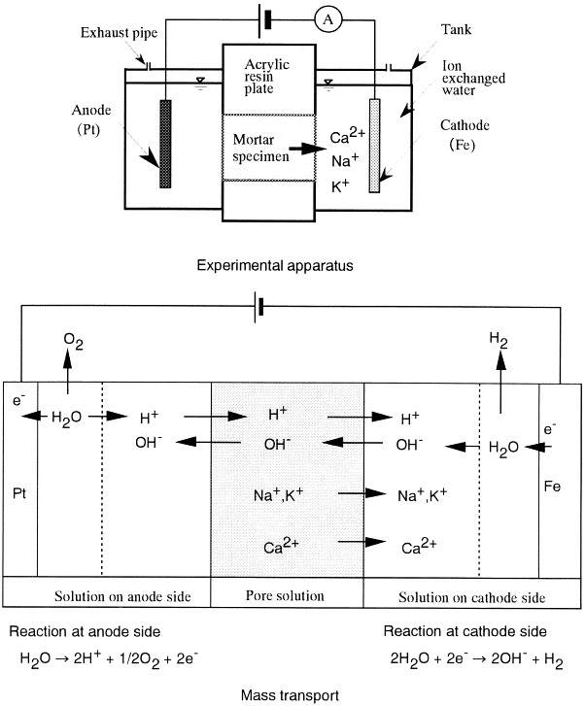
Figure 2.11: Experimental apparatus for leaching under an electric potential [82]
Further work investigating the use of an applied potential to model the long term leaching behaviour of cementitious materials was undertaken by Otsuki et al. [82]. Cement was used and the degradation caused by the dissolution of calcium ions was explored. The sample was leached in deionised water for a fixed period of time, replacing the leachate frequently. In the next stage an electrical current was applied through the sample over a maximum period of 1500 hours, again frequently changing the leachate. In order to verify the validity of this electrically leached technique they compared the electrically leached samples with a concrete sample of similar composition that had been in contact with water for 100 years as part of the floor system at a waterworks in Shiba, Tokyo. The results of the accelerated leaching test strongly correlated with that of the 100 year sample, showing similar degradation patterns, loss of compressive strength and Ca/Si gradients across the sample. The use of electrical fields to accelerate leaching, was researched by Castellote [60]. In situ accelerated leaching of cement paste, which found that when switching on the electrical field rapid dissolution of the main hydrate phases, especially the ettringite phase, occurred. This phase initially dissolves rapidly, but then stabilises. The portlandite phase was also found to precipitate at an accelerated rate, according to Castellote et al. this occurs due to the decrease in the amount of water in the pores as well as the increase of dissolved ions in solution. They suggest that the decrease of pore water could be due to the increase in temperature of the sample from applying the electrical field. However they did not measure the temperature of the sample, but concluded that this was unlikely as the expected d-spacing expansion of the unit cells due to thermal expansion was not present. Furthermore the sample was in contact with wet sponges and therefore any lost water via evaporation would have been replenished by these sponges. Finally when dismantling the container no heating of the sample was noticed.
Following this research, Ryu et al. [83] further investigated the leaching behaviour of Ca²⁺ over a maximum period of 1200 hours with or without an electric potential for the same duration. This worked expanded on the findings of Otsuki et al. Their experiments compared a real concrete structure that had been exposed to a leachate for 30 years compared with an electrically leached specimen. They found strong similarities in the Vickers hardness of both samples at different depths from the surface. They took measurements at different distances between 5mm and 20mm, for example the Vickers hardness of the 30 year old sample at 5mm was 14 HV 0.025, and 15 HV 0.025 in the electrical leached sample, the samples are assumed to be of same hardness as it was the same starting material used.
Although there are several studies on both the acidic and electrical leaching methods showing strong evidence of their accelerating impact on the cements, there is very little research on these methods being used on cementitious waste forms containing

2.6 Conclusions
Nuclear power and the resultant waste were highlighted in this literature review. There are several classifications of nuclear waste dependent on their radioactivity. This study focuses on ILW that are usually encapsulated in the composite cement system of Portland cement mixed with blast furnace slag. These cement composites are used to immobilise radionuclides such as caesium, strontium and cerium (a simulant for plutonium), all of which are highly radioactive with long durations of radioactive decay. Once encapsulated in the cements various factors can potentially expose these cement waste forms to ground water with lower pH. This could result in leaching of the immobilised radionuclides and releasing them into the environment. Therefore it is very important to understand the leaching behaviour of these radionuclides over the duration of their half-lives. This means an accelerated leaching method is required to simulate future behaviour. Two commonly used leaching methods used to accelerate ion diffusion are electrical and acidic, however their use in the waste immobilisation industry is very limited.
The literature review also looked at additives, such as superplasticisers, used in the cement matrices to improve workability and efficiency. One of the main benefits is the increased fluidity, meaning less water is required in the cement. A drawback of these superplasticisers however, is the complexion with the ions in the cement, which cause an increase in leaching.

References
Chapter 2: Literature Review
[1] International Energy Agency, World Energy Outlook 2012 Executive Summary, IAE, (2012)
[2] Bodansky. D. (2003) Early History of Nuclear Energy. Nuclear Energy: Principles, Practices and Prospects, 2nd edition. New York, Springer. 27-29.
[3] Murray, R.L. (2014) Nuclear Energy: An Introduction to the Concepts, Systems, and Applications of Nuclear Processes, Elsevier, 284-288.
[4] Ghosh, T.K. and Prelas, M.A. (2009) Fundamentals and Non-Renewable Resources. Energy Resources and Systems. Netherlands, Springer. 453-647.
[5] Kingery. T.B. (2011) Design Principles of Nuclear Materials. Nuclear Energy Encyclopedia: Science, Technology and Applications. New Jersey, John Wiley & Sons. 101-121.
[6] Mckeen, T. (2005) Advanced Gas Cool Reactors, Nuclear Energy Materials and Reactors, vol II
[7] International Atomic Energy Agency, (2009) IAEA Safety Standards: Classification of Radioactive Waste.
[8] Ojovan, M. and Lee. W.E. (2005) Immobilisation of Radioactive Waste in Cement. An Introduction to Nuclear Waste Immobilisation. Oxford, Elsevier. 179-199.
[9] Bingham, A.P., Hand, R.S., Stennett, M.C., Hyatt, N.C., Harrison, M.T., (2008) The Use of Surrogates in Waste Immobilization Studies: A Case Study of Plutonium, MRS Proceedings, 1107, 421-428.
[10] Marra, J.C. et al. (2012) Cerium as a Surrogate in the Plutonium Immobilized Form. Environmental issues and Waste Management Technologies in the Ceramic and Nuclear Industries. VII, 381-388.
[11] Shiraishi, F. and Hosoe, M. (1968) Energy ad Time-of-flight correlation experiments with solid-state detectors for mass distribution measurement of ²³⁵U fission fragments, Nuclear Instruments and Methods. 66, 130-136.
[12] Atwood, D.A. (2013) Radionuclides in the Environment, John Wiley & Sons
[13] Green, N. et al. (1996) Factors Affecting the Transfer of Radionuclides to Sheep Grazing on Pastures Reclaimed from the Sea, J.Environ. Radioactivity. 30, 173-183.
[14] Ishizuka, H. (2011, November 26). Caesium from Fukushima plant fell all over Japan, The Asahi Shimbun. Retrieved from http://ajw.asahi.com.
[15] Eisler, R. (2012) The Fukushima 2011 Disaster, CRC Press.
[16] Krebs, R.E., (2006) The History and Use of Our Earth’s Chemical Elements: A Reference guide, Greenwood publishing group.
[17] Atkins, M. and Glasser, F. (1992) Application of Portland Cement-Based Materials to Radioactive Waste Immobilization, Waste Management. 12, 105-131.
[18 ] Hewlett, P. (2004) Portland cement: Classification and Manufacture. Lea’s Chemistry of Cement and Concrete, Fourth Edition. Elsevier. 25-90.
[19] Feldman, R. and Sereda, P. (1968) A model for hydrated Portland cement paste as deduced from sorption-length change and mechanical properties, Materials and Structures. 1, 509-520.
[20] Taylor, H. (1997) Hydration of the calcium silicate phases. Cement Chemistry. London, Academic Press. 123-165.
[21] Richardson, I.G (2008) Calcium silicate hydrates, Cement and concrete research, 38, 2, 137-158
[22] Scrivener, K.L. (1984) Development of Microstructure during the Hydration of Portland Cement. PhD Thesis. University of London.
[23] Bensted, J, Barnes P. (2008) Hydration of Portland cement Structure and Performance of Cements, Second edition. 57-110.
[24] Gougar, M.L.D et al. (1996) Ettringite and C-S-H Portland cement phases for waste ion immobilization: a review, Waste Management. 16, 295-303.
[25] Renaudin, G et al. (2000) Thermal behaviour of the nitrated AFm phase Ca₄Al₂(OH)₁₂(NO₃)₂.4H₂O and structure determination of the intermediate hydrate Ca₄Al₂(OH)₁₂(NO₃)₃.2H₂O, Cement and concrete research. 30, 307-314.
[26] Balonis, M. (2010) The influence of inorganic chemical accelerators and corrosion inhibitors on the mineralogy of hydrated Portland cement systems. PhD Thesis. University of Aberdeen.
[27] Wang, L.K., Hung, Y., Shammas, N.K. (2009) Handbook of Advanced Industrial and Hazardous Wastes Treatment, CRC press.
[28] Bapat, J.D., (2012) Mineral Admixtures in Cement and Concrete, CRC Press.
[29] Lee, D.J. and Fenton, A. (1992) The development of cement formulations for radioactive waste encapsulation. Stabilization and solidification of hazardous, radioactive and mixed wastes, 2nd volume. Edited by Gillam, M. and Wiles, C.C. American Society for testing and Materials, Philadelphia. 348-358.
[30] Provis, J. Deventer, J. (2014) Alkali Activated Materials: State-of-the-Art Report, RILEM TC 224-AAM, Springer Netherlands.
[31] Hindirchs, W. and Odler, I. (1989) Investigation of the hydration of Portland blast furnace slag cement: hydration kinetics. Advances in Cement research, vol 2. 5, 9-13.
[32] Hayes, M., Angus, M., Garland, R., (2012) Current status paper on the potential use of Superplasticisers in a Geological Disposal Facility, NNL, 12, 11905 Issue 4.
[33] Ferrari, G., Basile, F., Dal Bo, A., Mantoni, A. (1994) The influence of the molecular weight of beta-napthalene sulfonate based polymers on the Rheological properties of cement mixes, Il Cemento, 83, 445-454
[34] Feng, Chun; Li, Yongjun; Yang, Dong; Hu, Jianhua; Zhang, Xiaohuan; Huang, Xiaoyu (2011). "Well-defined graft copolymers: from controlled synthesis to multipurpose applications". Chemical Society Reviews, 40, 3, 1282–95.
[35] Björnström, J., Chandara, S. (2003) Effect of superplasticizers on the rheological properties of cements, Materials and Structures, 36, 10, 685-692.
[36] Yoshioka, K. et al. (2002) Adsorption characteristics of superplasticizers on cement component minerals, Cement and concrete research. 32, 1507-1513.
[37] Jansen, D., Neubauer, J., Goetz-Neunhoeffer, F., Haerzschel, R., Hergeth, D., (2012) Change in reaction kinetics of a Portland cement caused by a superplasticizer -Calculation of heat flow curves from XRD data, Cement and concrete research, 42, 2, 327-332
[38] Cocke, D.L. and Mollah, M.Y.A. (1993) The BiChemistry and leaching mechanisms systems. Chemistry and Microstructure of Solidified waste forms. Edited by Spence, R.D, Lewis Publishers, USA.
[39] Regourd, M. (2001) Cements made from blast furnace slag. Lea’s chemistry of cement and concrete, 4th edition. Edited by P.C. Hewlett, Butterworth- Heinemann. 637-678
[40] Alonso, M.C., Fernandez Luco, L., Garcia, J.L., Hidalgo, A., Huertas, F. (2007) Low-pH Cementitious Materials Design and Characterisation, Instituo de Ciencias de la Construccion Eduardo Torroja, ENRESA
[41] Concrete in the Service of Mankind: Concrete for infrastructure and utilities (2003) edited by Ravindra Dhir, Neil Henderso, CRC Press
[42] Glasser, F.P. (2001) Mineralogical aspects of cement in radioactive waste disposal. Mineralogical Magazine. 65(5), 621-633.
[43] J.R. Conner. (1993) Chemistry of cementitious solidified/stabilized waste forms. Chemistry and microstructure of solidified waste forms. Edited by Spence, R.D, Lewis Publishers, USA. 41-82.
[44] Read, D., Johnson, A., Jantzen, C. & Stegemann, J. A. (2010) Cements in Waste Management. Advances in Cement Research, 22. Retrieved from http://dx.doi.org/10.1680/adcr.2010.22.4.225, 22, 225-226.
[45] J. Rose, I. Moulin, J.-L. Hazemann, A. Masion, P.M. Bertsch, J.-Y. Bottero, F. Mosnier, C. Haehnel, X-ray absorption spectroscopy study of immobilization processes for heavy metals in calcium silicate hydrates: 1. Case of Lead, Langmuir 16 (2000) 9900-9906.
[46] Copeland, L. E., Bodor, E., Chang, T. N. & Weise, C. H. (1967). J. PCA Res. Dev. Lab. 9, 61-74.
[47] Crawford, R.W.; Glasser, F.P.; Rahman, A.A.; Angus, M.J.; McCulloch, C.E. (1985) Diffusion mechanisms and factors affecting leaching of caesium-134 from cement-based waste matrices, Radioact. Waste Manage. Nucl. Fuel Cycle; 6, 2, 177-196.
[48] Papadokostaki, K.G. and Savidou, A. (2009) Study of leaching mechanisms of caesium ions incorporated in Ordinary Portland Cement. Journal of hazardous materials. 171, 1024-1031.
[49] Ochs, M. et al. (2006) Caesium sorption by hydrated cement as a function of degradation state: Experiments and modelling. Waste Management. 26(7), 725-732.
[50] Iwaida, T. (2001) Sorption of alkali metal ions onto C-S-H (calcium silicate hydrated phases). Cem Sci Concr Tech. 55, 21- 26.
[51] Bar-Nes, G. et al. (2008) The mechanism of cesium immobilization in densified silica-fume blended cement pastes. Cement and Concrete Research. 38, 667–674.
[52] Bagosi, S. and Csetenyil, L.J. Caesium immobilization in hydrated calcium– silicate–aluminate systems. Cem. Concr. Res. 28, 1753–1759.
[53] Hanna, J.V. et al. (2001) Cs speciation in cements. Mat. Res. Soc. Symp. Proc. 663, 89–101.
[54] Bagosi, S., Csetenyi, L. (1999) Immobilization of caesium-loaded ion exchange resins in zeolite-cement blends, Cement and concrete research, 29, 4, 479-485.
[55] El Kamash, A.M., El Naggar, M.R., El Dessouky, M.I. (2006) Immobilization of cesium and strontium radionuclides in zeolite-cement blends, Journal of hazardous materials, 136, 2, 310-316
[56] Goni, S., Geurrerro, A.M., Lorenzo, M,. (2006) Efficiency of fly ash belite cement and zeolite matrices for immobilizing cesium, Journal of hazardous materials, 1608-1617
[57] Matsuzuru, H., Ilto, A. (1978) Immobilization of cesium-137 in cement-waste composites by addition of mineral zeolites, Health physics, 34, 6, 643-648.
[58] Aldridge, L.P., Day, R.A., Leung, S., Ray, A.S., Stevens, M.G. Knight, R.S., Mapson, (1997) C.F. Cs retention in zeolites immobilized by Portland cement in: K.L. Scrivener, Mechanisms of Chemical Degradation of cement-based systems. 358-365
[59] Bagosi, S. and Csetenyi, L.J. (1999) Additives for increase caesium trapping, Modern Concrete Materials: Binders, Additions and Admixtures: Proceedings of the international conference held at the University of Dundee, Scotland, (1999) edited by Dhir, R.K, Dyer, D.D.
[60] Iwaida, T., Nagasaki, S., Tanaka, S., Yaita, T., Tachimori, S., (2002) Structure alteration of C-S-H (calcium silicate hydrated phases) caused by sorption of caesium, Radiochimica Acta, 90, 9, 677-681/
[61] Atkinson, A. and Nickerson, A.K. The diffusion of ions through water- saturated cement, J. Mat. Sci. 19, 3068–3078.
[62] Bensted, J. Varma, S.P. (1971) Ettringite and its derivatives, Cem. Technol. 2, 73-76.
[63] Evans, N.D.M., (2008). Binding mechanisms of radionuclides to cement. Cement and Concrete Research, 38 (4), 543-55
[64] Tits, J. et al. (2006) Strontium binding by calcium silicate hydrates. J Colloid Interface Sci. 300(1), 78-87.
[65] Borges, P.H.R, Costa, J., Milestone, N.B., Lynsdale, C.J., Streatfield, R.E. (2009) Carbonation of CH and C–S–H in composite cement pastes containing high amounts of BFS, Cement and concrete research, 40, 2, 284-292
[66] Wee, T.H. et al. (2001) Resistance of Blended Cement Pastes to Leaching in Distilled Water at Ambient and Higher Temperatures. ACI Materials Journal. 98(2), 184-194.
[67] Carde, C., Francois, R. (1997) Effect of the leaching of calcium hydroxide from cement paste on mechanical and physical properties, Cement and concrete research, 27, 4, 539-550
[68] Carde, C. et al. (1996) Leaching of Both Calcium Hydroxide and C-S-H from Cement Paste: Modelling the Mechanical Behvaiour, Cement and Concrete Research. 26, 1257-1268.
[69] Carde, C. et al. (1997) Use of ammonium nitrate solution to simulate and accelerate the leaching of cement pastes to deionized waters. Magazine of Concrete Research, 49, 295 – 301.
[70] Jauberthie, R. and Rendell, F. (2003) Physiochemical study of the alteration surface of concrete exposed to ammonium salts. Cement and Concrete Research. 33, 85-91.
[71] Self compacting concrete (2011) edited by Ahmed Loukili, Wiley.
[72] Torrenti, J.M. et al. (1999) La degradation des betons. Hermes Sciences Publications, Paris. 27-29.
[73] Agostini, F. et al. (2007) Experimental study of accelerated leaching on hollow cylinders of mortar. Cement and Concrete Research. 37, 71-78.
[74] Wan, K., Li, Y., Sun, W. (2013) Experimental and modelling research of the accelerated calcium leaching of cement paste in ammonium nitrate solution, Construction and building materials, 40, 832-846
[75] Yang, H. et al. (2012) Predicting the calcium leaching behaviour of cement pastes in aggressive environments. Construction and Building Materials. 29, 88-96.
[76] Saito, H. and Sunao N. (1999) Comparison between diffusion test and electrochemical acceleration test for leaching of cement hydration products, ACI Materials Journal. 96, 208-212.
[77] Szweda, Z., Zbyura, A., (2011) Analysis of chloride diffusion and migration in concrete part I - theoretical model, Architecture civil engineering environment, 5, 44-100
[78] Ghods, P., Hoseini, M., Chini, M., Alizadeh, .R., (2005) Evaluating the chloride diffusion of concrete by measuring electrical resistivity, Young Researchers Forum, 192-198.
[79] Halamickova, P., Detwiler, R.J., (1995) Water permeability and chloride ion diffusion in Portland cement mortars: relationship to sand content and critical pore diameter, cement and concrete research, 25, 4, 790-802.
[80] Marriaga, J.L., Claisse, P., (2009) Determination of the concrete chloride diffusion coefficient based on the electrochemical test and optimization model, Materials chemistry and physics, 117, 2, 526-543
[81] Saito, H., Deguchi, A., (2000) Leaching tests on different mortars using accelerated electrochemical method, Cement and concrete research, 30, 11, 1815-1825
[82] Otsuki, N. et al. (2001) Fundamental Study on Prediction on Concrete Deterioration Caused by Calcium Leaching Over 100 Years. JSCE. 51.
[83] Ryu, J. et al. Long-term forecast of Ca leaching from mortar and associated degeneration. Cement and Concrete Research. (32) 22, 1539–1544.

Chapter 3: Experimental Methods & Materials

3.1 Introduction
The project investigates the leaching behaviour of a 9:1 BFS:PC (CEMI) cement matrix using different leaching procedures. This cement formulation was mixed with caesium and strontium nitrate and the leaching behaviour of the Cs, Sr and several of the cement ions were investigated. In the second section of the project the cement formulation was mixed with cerium nitrate and ADVA cast superplasticser in order to monitor the impact of this additive on the leaching behaviour of Ce alongside some of the cements component ions.
In this chapter, the raw materials used in this project are listed, preparation of tested samples and testing methods described, and an overview of all the analysis techniques used is given. The following analysis techniques were used:

Solid analysis:
- X-ray diffraction (XRD)
- Scanning electron microscopy (SEM)
- Energy dispersive x-ray spectroscopy (EDX)
- Thermal gravimetric analysis (TGA)
- Nuclear magnetic resonance spectroscopy (NMR)
Solution analysis:
- Inductively coupled plasma - mass spectrometry (ICP-MS)
- pH Measurements
- Total Organic Carbon Analysis (TOC)

3.2 Leaching of Cementitious Waste forms containing Caesium and Strontium Nitrate

3.2.1 Introduction
Electrically accelerated leaching tests were set-up following the protocol of Saito and Nakane [1] along with the semi-static leaching tests, where samples were leached in deionised water that was changed at regular intervals, so that the results could then be compared with the electrical leaching tests where the water was also changed. However a leaching method in which the water was not changed would be a more accurate representation of the repository environment, as water mobility in these conditions is intended to be very low. As a result these leaching tests in which the water was not changed were also set up and these are referred to as the static tests. In order to investigate other methods of acceleration an acidic leaching experiment was also set up over a three month period. This allowed for a comparison to be made among the static, the semi-static, acidic and electrical leaching procedures to monitor the effects on leaching behaviour of elements, microstructural changes of the cement. Neither the MCC nor ASTM standardised leaching tests were used, as this experiment was modelled on that of Saito and Nakane, therefore the sample preparation and procedures followed were in line with their practices.

3.2.2 Cement Sample Preparation
Cement samples shown in table 3.1 were prepared using PC and BFS. PC was sourced from Castle Cement, UK, fineness 352m²/kg Blaine and BFS was sourced from Redcar Steelworks, Teeside, UK in ground granulated form to give a fineness of 286m²/kg Blaine. Caesium nitrate, CsNO₃ (Acros Organics, UK, 99.99%) and strontium nitrate, Sr(NO₃)₂ (BDH Chemicals, UK, 99.99%), were added to the cement matrices as waste simulants.
The blank sample, (labelled B), was prepared by weighing the distilled water on a Toledo Delta Range PG 4002-5 electronic balance and pouring it into the bowl of a Kenwood mixer. The designated amount of BFS was added followed by the PC to avoid any hydration of the PC before mixing with the BFS. The water to solid (W/S) ratio used was 0.37 as this is widely used in the UK nuclear industry [2]. The water and cement were mixed for approximately 7 minutes on mixer setting 1, until a homogenous cement paste was formed. In the samples containing either Cs or Sr or both (labelled C, S and CS respectively), the CsNO₃ and/or the SrNO₃ was added to the water prior to the BFS and mixed using a magnetic stirrer until dissolved to ensure homogenous distribution of the waste simulants throughout the cement. The rest of the mixing procedure was the same as for sample B. In preparation for most of the leaching tests this paste was then poured into 45 ml centrifuge tubes, which were then sealed and placed in a vortex mixer to remove any air bubbles within the paste, whereas for the electrical test the cement paste was poured into a several wooden moulds measuring 40×40×5mm. All samples were cured for 42 days in an environmental chamber at 20ºC and 95% relative humidity.

Table 3.1: Cement Formulations
Sample | Cement matrix (g) |  |  | Waste simulant (g) |  | Total (g)
 | PC | BFS | H₂O | CsNO₃ | Sr(NO₃)₂
Blank (B) | 80 | 720 | 296 | - | - | 1096
3wt% Cs & 3wt% Sr (CS) | 80 | 720 | 296 | 54.6* | 90.6* | 1241.2
3wt% Cs (C) | 80 | 720 | 296 | 49.8* | - | 1145.8
3wt% Sr (S) | 80 | 720 | 296 | - | 89.9* | 1206.3
* The amount of waste simulants were calculated to provide 3 wt% of elemental Cs and/or Sr with respect to the total weight of the mix (PC + BFS + water + nitrates).

At the end of the 42-day curing period the cement samples prepared in the centrifuge tubes were dissected into cylinders of 25mm in height without removal from the centrifuge tubes using an Isomet 5000 Linear Precision saw whilst continuously lubricating the sample with isopropanol to avoid overheating. The cement samples were then pushed out of the plastic casing, and each had a diameter of 27mm. The samples were cleaned using acetone in an ultrasonic bath. The cleaned samples were placed in acetone for 1 week to arrest hydration and then dried for 24 hours. The acetone is absorbed fast into the cement and penetrates the cement pores replacing the pore water and stopping the hydration [2]
Once dried the cylinder was placed in a mould and epoxy resin (using chemset clear base resin) cast round it which was left to set overnight. The epoxy resin covered the exterior of the cement sample, leaving only one surface exposed as illustrated in Figure 3.1. This ensures that the leaching occurs at this site only.

Figure 3.1: Typical cement sample used in acidic, static and semi-static leaching tests

The samples used in the electrical leaching tests were cut into square sheets in order to fit into the equipment used for electrical leaching, as in Figure 3.2, measuring 40mm×40mm×5mm using a Clipper EW2-55-3-DXS saw. Again, these were placed in acetone for 1 week and then dried.

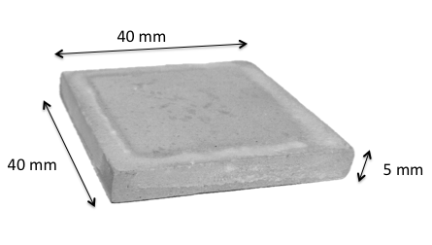
Figure 3.2: Typical cement sample used in electrical leaching test

3.2.3 Leaching Procedures
The different cement samples and their respective leaching tests are shown in Table 3.2 and the solutions used in these tests are shown in Table 3.3.

Table 3.2: Leaching experiments and cement samples
Leaching Experiment | B | CS | C | S
Static Leaching
Semi-static Leaching
Acidic Leaching
Electrical Leaching

Table 3.3: Leachate Compositions
Leaching Experiment | Leachant | Solution Composition
Static  Semi-static  Electrical | Deionised Water | H₂O
Acidic | Ammonium Nitrate Solution | 590g NH₄NO₃ per 1 litre H₂O

3.2.4 Containers
i. Static/Semi-Static/Acidic Leaching
The containers used to accommodate these leaching tests were heavy-duty polypropylene wide neck bottles 114mm in height, 61 mm in diameter with a volume of 250ml. In order to minimise contamination the containers were cleaned with a solution of 0.16mol nitric acid (HNO₃) per dm³ of deionised water (18.3 MΩ cm), using the following procedure:
- Each container was filled with 150ml of solution, sealed tightly and placed horizontally such that the base and lid were perpendicular with the surface the container rested on. The container remained in this position for 30 minutes, after which it was rotated 180ºC and left for another 30 minutes, this was known as the rolling method. The container was checked for any leakages during this method. The container was then emptied and rinsed out with 50ml of deionised water and dried.
- Once dried, 150ml of deioinsed water was poured into each container, repeating the rolling, rinsing and drying method from step 1.
- The containers were then filled to 90% of max volume (220ml) with deionised water, sealed and placed in an oven at 90ºC for 16 hours.
- Containers cooled, lid removed and emptied. They were then placed back in the oven with the lid removed and dried at 90ºC.
- Once dried the containers were ready to use. Extra care was taken to assure the containers were not contaminated by their surroundings by keeping the lid firmly sealed while stored.

ii. Electrical Leaching
The electrical leaching test required different equipment. The sample was suspended in the casing (Figure 3.3) with both sides exposed to 425ml of solution, the sample exposure surface area was 1024mm² (32mm×32mm). This gives a surface area to leachate volume ratio of 2.4. The container used to house the sample and the solution was designed in collaboration with Dr.Katsufumi Hashimoto at Hokkaido University and is shown in figure 3.4a with a detailed schematic in Figure 3.4b.

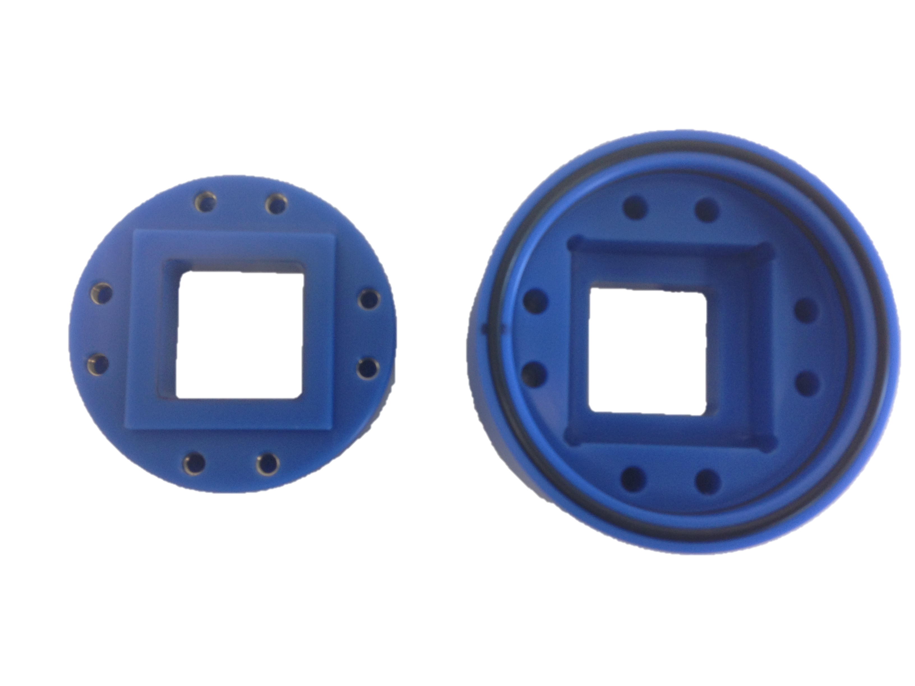
Figure 3.3: Cement sample housing

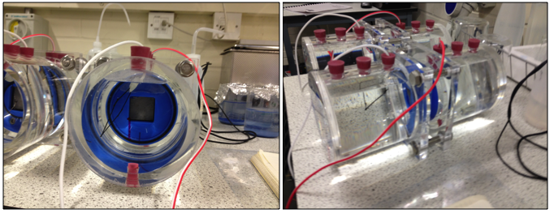
Figure 3.4a: Electrical leaching apparatus

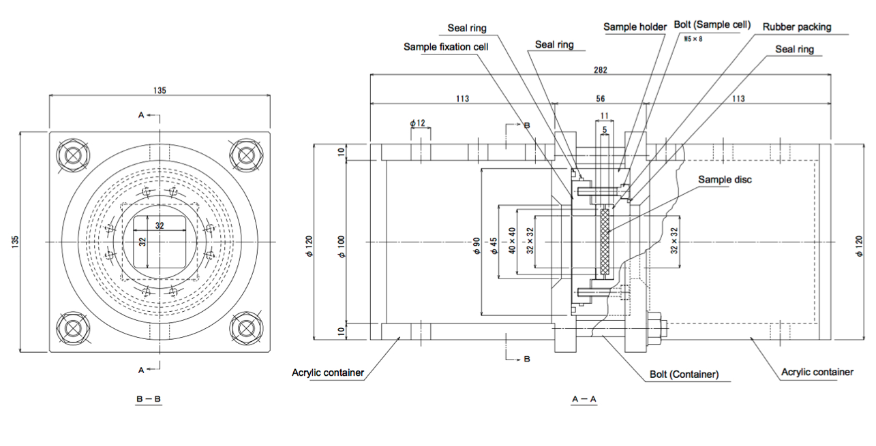Figure 3.4b: Schematic of electrical leaching apparatus (all dimensions are measured in mm)
3.2.5 Experimental Procedure
i. Static/Semi-Static
The containers used in this experiment could hold approximately 240ml of water. Based on this the surface area of sample to volume of water (SA/V) ratio was calculated at a value of 2.4 mm²/ml. As the cement samples used have a diameter of 27 mm and a surface area of 572 mm², 238.33 ml of water was required. Deionised water with purity of 18 MΩ cm was collected from a Millipore Direct QUV 3 water deioniser at 25ºC. Then 238.33g of this water was weighed out on a Toledo Delta Range PG 4002-5 electronic balance for each test. The weighed water was then poured into a polypropylene container along with the prepared cement sample, as illustrated in Figure 3.5. The samples were then stored at room temperature and allowed to leach for their respective periods.

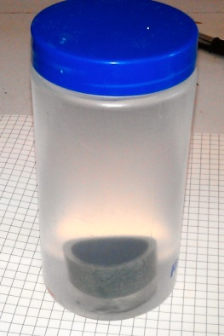
Figure 3.5: Polypropylene wide neck bottle containing deionised water and cement sample

In the semi-static leaching tests the water was replaced after day 2 initially, then after 4, 7, 14, 21, 22, 29, 39 days and then every 10 days until 179 days, as per the procedure followed by Saito and Nakane [1]. During each water replacement, 100ml of the leachate was saved, accumulated and mixed for each leaching period. Once each leaching period was completed, the accumulated leachate was shaken for approximately 20-30 seconds to ensure a homogeneous distribution of the diffused ions. The pH was measured and a 20ml sample of the accumulated leachate was separated for further analysis on elemental concentration.

ii. Acidic leaching
The acid used in this experiment was ammonium nitrate (NH₄NO₃) as shown in Table 3.4, in accordance with past research. A preliminary test using a block of epoxy resin was placed in a solution made up of 70g ammonium nitrate in 100ml of water, indicated that there was no sign of degradation or residue in the solution after 7 days, which supports the Manufacture’s information [3] i.e., the epoxy resin used is resistant to ammonium nitrate. The leachate solution was then prepared by weighing the NH₄NO₃ using a Toledo Delta Range PG 4002-5 electronic balance, and mixing with deionised water until fully dissolved. The prepared cement sample was then placed in the acidic solution without any replenishment or solution changes. The leaching tests were conducted over a 3 month period. Samples were taken out and analysed after 7, 14, 28 and 90 days.

iii. Electrical
The cement sample was held in the center of the housing (Figure. 3.3) with each side exposed to a pool of deioinsed water as shown in Figure 3.4a, so that the cement sample was in contact with water on either surface. This ensured electrical conductivity across the sample. A PMC-A series DC power supply was used to apply a maximum voltage capability of 500 V. The electrical leaching periods were 8 hours, 1 day and 3 days. Two currents were applied 5A/m² and 25A/m² to assess the impact of the current strength on leaching rates. At the end of each leaching period the solution was collected from either side of the sample and stored. The cement sample was then removed from the housing and placed in acetone for 1 week.

3.3 Incorporation of Cs and Sr within the BFS:PC matrix
To understand the behaviour of both strontium and caesium within the cement matrix, cement samples of varying curing periods were prepared and analysed. Synthesis of the AFm phase was also attempted with/out the waste simulant strontium nitrate in order to further understand the behaviour of Sr within this phase. The synthesis of AFm is a two stage process: the initial synthesis of the tricalcium aluminate clinker phase (C₃A), and the use of synthesised C₃A with calcium sulphate to obtain AFm.
3.3.1 Tricalcium Aluminate (C₃A) Synthesis
Two methods were used to produce C₃A in this project: a solid state synthesis and an aqueous synthesis. The procedures of the solid state synthesis are listed below. These are based on the procedures by Radwan et al. [4] and Matschei et al. [5]. The produced pellets were cooled, crushed and analysed using XRD.
i. Solid state synthesis
Materials:
- Calcium carbonate, CaCO₃, (99%+), Acros Organics, UK
- Aluminium oxide, Al₂O₃, (99%), Acros Organics, UK
- Isopropanol, C₃H₇OH, (99.5%), Acros Organics, UK
CaCO₃ was heated at 900ºC for approximately 12 hours to obtain CaO. The obtained CaO was then mixed with Al₂O₃ at 3:1 molar ratio. The mixture as pressed under 100kg/cm² for to create pellets which were then calcined for 3 hours at 1000ºC. The pellets were then cooled and ground in ethanol using a pestle and mortar. The powder/ethanol mixture was then mixed using ball milling in a 250ml container for approximately 2 hours. The mixture was vacuum filtered, dried in a furnace at 90ºC for 1 hour, pressed into pellets and fired at 1350ºC for 3 hours. The pellets were cooled, crushed and analysed using XRD, if the trace did not show pure C₃A formation the process was repeated (on average around 3-4 times) until XRD pattern showed pure C₃A.
The procedures of the aqueous synthesis are shown below. They are known as Pechini (polymeric precursor) method based on the work by Gaki et al [6].
ii. Aqueous synthesis (The Pechini Method)
Materials:
- Aluminium nitrate nonahydrate, Al(NO₃)₃ . 9H₂O, (99+%), Acros Organics, UK
- Calcium nitrate pentahydrate, Ca(NO₃)₂ . 4H₂O, (99+%), Fisher Scientific, UK
- Citric acid monohydrate, C₆H₈O₇ . H₂O (99.5+%), Fisher Scientific, UK
- Ethylene glycol, C₂H₆O₂, (99.5+%) Fisher Scientific, UK
Ca(NO₃)₂ and Al(NO₃)₃ were dissolved in deionised water at a molar ratio of 3:2, Ca(NO₃)₂:Al(NO₃)₃ at room temperature. Then citric acid was added at a molar ratio of 1:1 (C₆H₈O₇: total cations) followed by ethylene glycol at a molar ratio of 2:1 (C₂H₆O₂:C₆H₈O₇). The solution was then placed on the hoteplate mixer and mixed at 80ºC to evaporate excess water and accelerate the polyesterification (Figure 3.7a). After 1 hour the solution formed a gel (Figure 3.7b). Stirring for further 5 hours results in viscous foam (Figure 3.7c). This foam was dried at 150ºC in a furnace for 24 hours, cooled, crushed and ground into a powder. The powder was calcined at 400ºC for 2 hours to form the powder precursors, sintered at 800ºC for 3 hours, then 900ºC for 3 hours and finally 1000ºC for 3 hours. Finally the powder was cooled and prepared for XRD analysis.

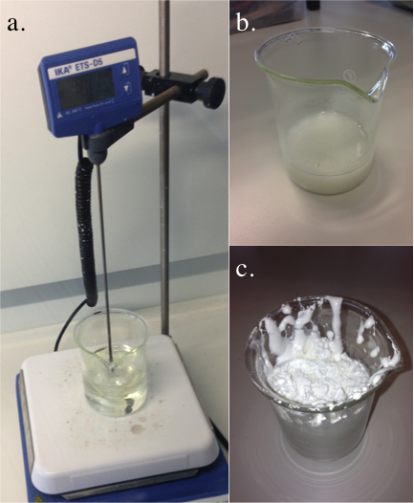
Figure 3.7: Aqueous synthesis of C₃A (a) Mixing of solution before heating, (b) Gel formed after 1 hour of stirring (c) Foam formed after 5 hours of stirring
3.3.2 AFm Synthesis
The process used to synthesise AFm is based on that used by Matschei et al [5]. The experiment was set up in a disposable glove bag Figure 3.8 to avoid carbonation of the sample during the mixing procedure. First a vacuum pump was used to remove the air inside the bag as shown in Figure 3.8a. The argon gas introduced with the vacuum pump still on for approximately 15-20 minutes to remove any excess air. The vacuum pump was then switched off, with the argon supply still on until the bag was filled to a satisfactory level Figure 3.8b.
The C₃A prepared (3.3.1) was mixed in a 1:1 molar ratio with CaSO₄ in a beaker of deionised water. The beaker was then placed on a magnetic heating plate and the mixture was heated to 80ºC and magnetically stirred for 5 hours. The mixture was then cooled to room temperature overnight and heated again the following day for 5 hours (the beaker of solution was covered with a glass lid with a small vent, so that the majority of evaporated water would condense back into the beaker). This procedure was repeated over a 7 day period at the end of which the sample was removed and vacuum filtered using Whatman 541 filter paper. The powder was then dried in a desiccator over saturated CaCl₂ solution.

Once the AFm synthesis was confirmed the procedure was repeated with the addition of strontium nitrate 3wt% of total mix, when mixing the C₃A and CaSO₄, in an attempt to produce the CAN phase.

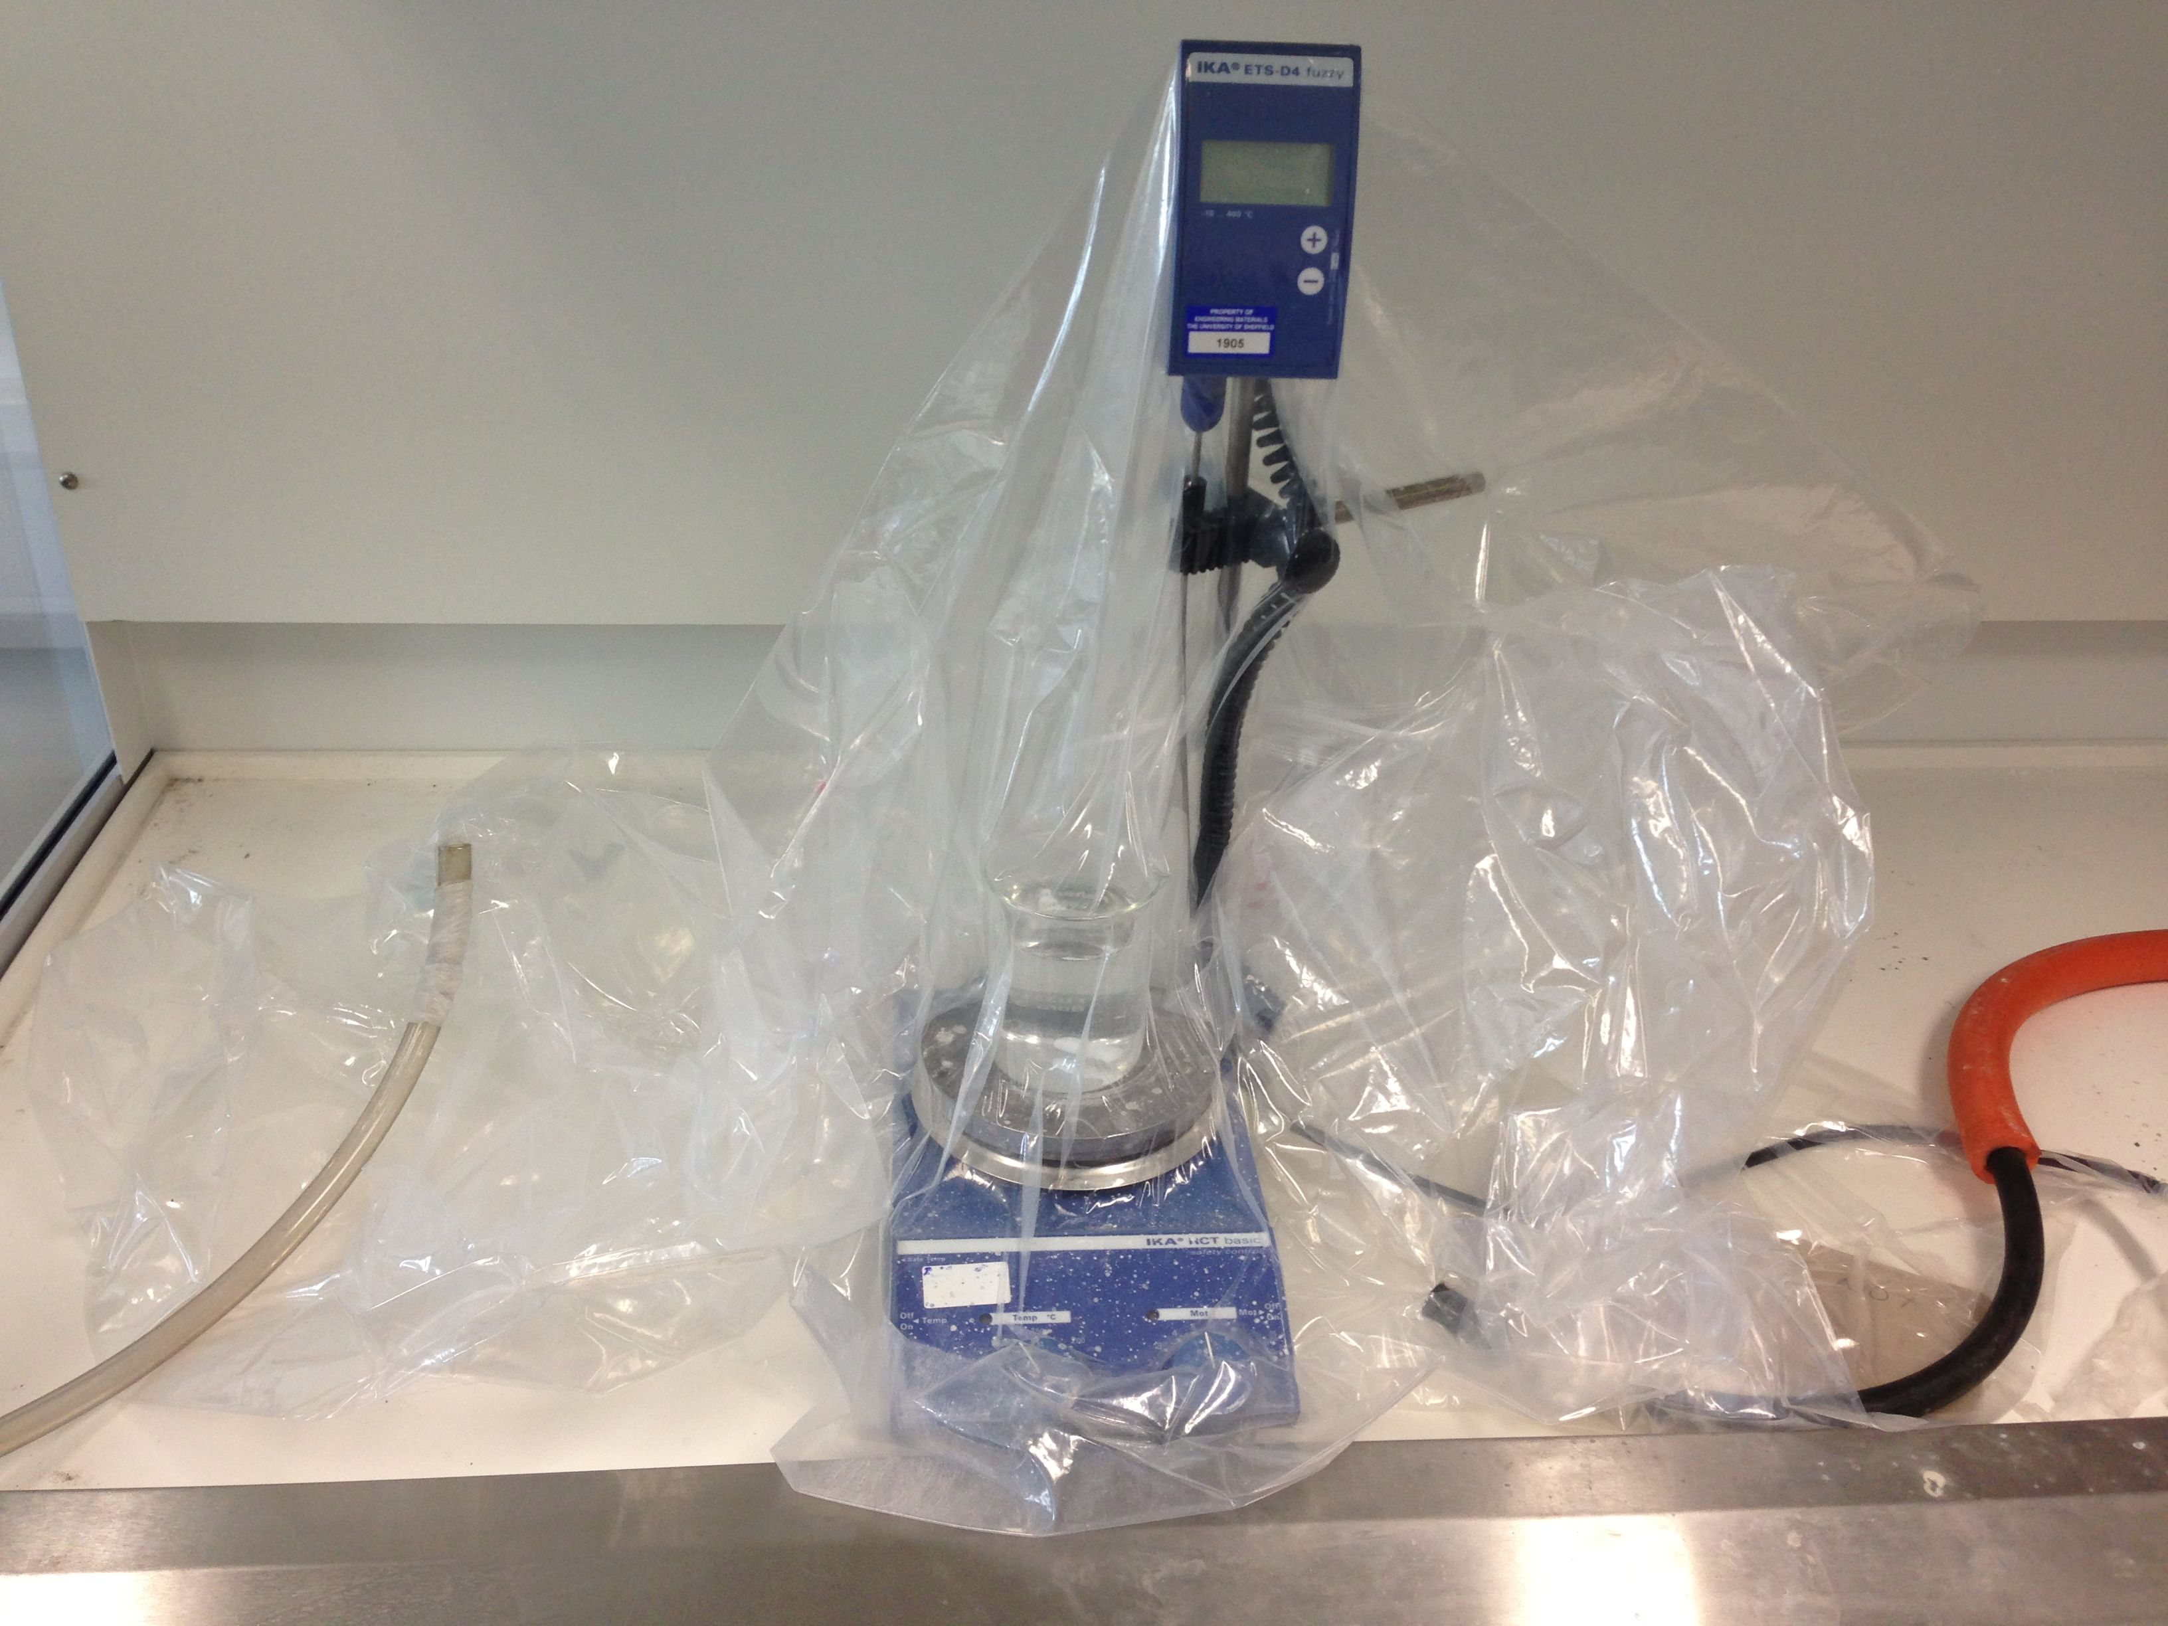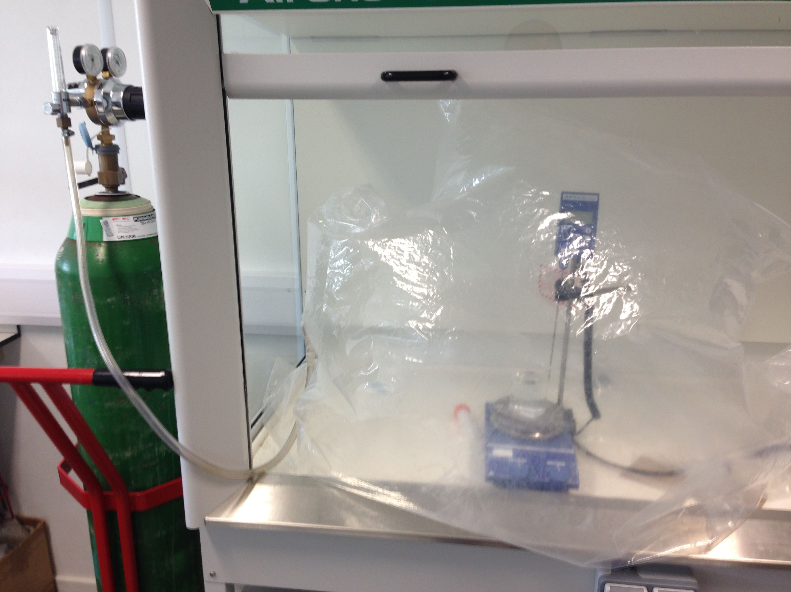
Figure 3.8: Left-(a) Equipment setup in glove bag with vacuum removal of excess air.
Right-(b) Sealed Glove bag filled with argon gas.

3.3.3 Analysis
Once curing was complete each of the samples was analysed before the leaching procedures commenced. The samples were also analysed once each leaching test was complete. For the semi-static test the samples were cut into three discs (1, 2 and 3) 5mm in thickness, as shown in Figure 3.9. In the acidic and static tests, initially only the exposure surface was inspected by analysing the outer surface disc 1, if significant differences were realized in the difference depths in the semi-static tests, then future work would investigate the deeper layers within the cement in the other tests.
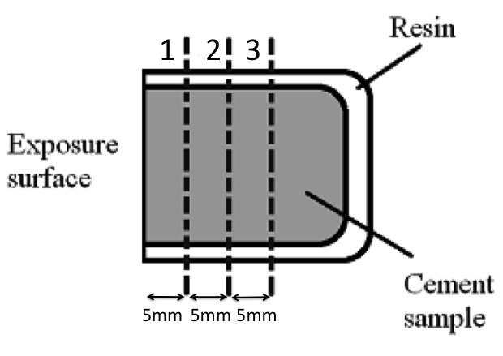
Figure 3.9: Cross section of typical cement sample displaying the sections that were cut for analysis

i. X-ray Diffraction (XRD)
XRD was used to investigate the crystalline phases present within the samples. Each sample was crushed and ground to a fine powder of <63 μm using a pestle, mortar and a sieve. The powder was then placed in a sample holder and the surface was flattened using a small glass slab ensure an evenly flat surface for the x-ray beam to hit. Samples were analysed using two diffractometers, a Philips PW1825 X-ray and a Siemens D500 diffractometer. Both machines used CuKα radiation and were set at 30kV and 40mA with a step size of 0.02º and scanning speed of 1º/min between 5º and 60º 2θ. The data obtained was analysed using the ICDD files in the JCPDF database within WinXPow.
XRD data was collected for unreacted PC and BFS and the results are shown in Figure 3.10 and 3.11, respectively.
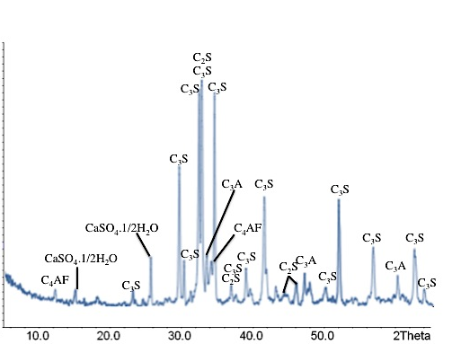
Figure 3.10: XRD trace of unreacted PC

All the clinker phases in the PC are characterised in the XRD trace. The XRD peaks for BFS in Figure 3.11 show an amorphous hump between 25-30º 2θ due to the glassy nature of BFS and distinct peaks attributed to the crystalline phase, gehlenite (Ca2Al2SiO₇).

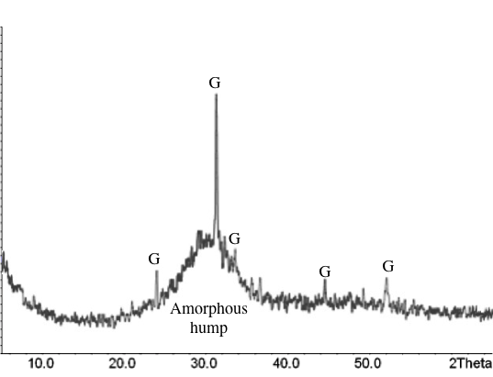
Figure 3.11: XRD trace of unreacted BFS

CsNO₃ and Sr(NO₃)₂ used in the present work were also analysed using XRD as the shown in Figure 3.12, and the traces produced showed strong correspondence with the peak data in WinXPOW. All the peaks were attributed to their respective phases and there no unidentified peaks.

Figure 3.12: XRD trace of strontium nitrate and caesium nitrate
ii. Thermogravimetric Analysis (TGA)
TGA was used to further analyse the phases formed in the samples, the effect of the caesium and strontium on the phases and to the leached quantity of each phase over the leaching durations. A fine powder was prepared as in section 3.3.4.i. A 50mg ±10mg of powder was placed in an alumina crucible and heated at a rate of 10oC/minute from 25oC to 900oC in an N2 atmosphere. The temperature and the subsequent mass change were recorded every 0.95s.
iii. Mercury Intrusion Porosimetry (MIP)
This method was used primarily to determine the total interconnected porosity, and to gain information related to the pore size distribution within the cement specimens. The sample is submerged in a given quantity of mercury and subjected to an increase in pressure. As the mercury is a non-wetting liquid for cement, it is not absorbed by the specimen and therefore the mercury is forced into the pores as pressure is applied to the system. The pore volume can be calculated by measuring the intruded mercury volume; the Washburn equation is then used to obtain the pore size distribution. The contact angle used was 130º and surface tension of 485.0 dyn/cm .
Each specimen was crushed into solid cement particles and immersed in acetone at 20°C for 30 minutes under reduced pressure (20°C, 2.33×10³ Pa) to arrest hydration, followed by crushing the sample and placing it in a sealed container that is evacuated using a vacuum pump (6.666×10⁻² Pa), for 24 hours prior to analysis in order to dry it. The prepared samples were then placed in a PoreMaster60 (Quantachrome Instruments). The pressure range was set from 0.14 to 228 MPa to estimate the pore size distribution from a diameter of 0.0065 to 10μm.
iv. Nuclear Magnetic Resonance (NMR) Spectroscopy
²⁷Al magic angle spinning (MAS) NMR was used to analyse the association of aluminium in the C-S-H and AFm phases in both the blank and waste loaded samples at various curing periods. ²⁹Si solid-state (MAS NMR) spectroscopy was also used to study the structure of the C-S-H gels. The cement samples were prepared as in section 3.3.4.i. The measurement was performed at Durham University using a VNMR400 spectrometer, at frequency of 79.5 MHz and a spin rate of 6800 Hz, with a one put pulse sequence and a recycle delay of 2 seconds. at ambient temperature
The charge movement known as spin of a nuclei creates a magnetic moment. This in turn creates a magnetic dipole. A collection of these dipoles within a sample is called the spin system. [7]. This system spins in a cone like form around the z axis [7]. An NMR experiment irradiates this system with plane-polarised radio-frequency radiation, creating a magnetic field was causes the spin system to tip. When the radio-frequency is turned off the spin system returns to its original position. The displacement of the spin-system, in order to return to its original position, creates a signal as a function of time which is used to create the NMR spectrum.
Magic angle spinning is used to overcome the peak broadening that arises from magnetic field strengths created by dipole-dipole interactions and chemical shift anisotropy [7]

iv. Scanning Electron Microscopy (SEM)
SEM was used to study the microstructure of the cement samples. Energy dispersive x-ray spectroscopy (EDX) was also used to study the microstructure of the material, Ca/Si ratio and distribution of caesium and strontium within the cements. The SEM scans a high-energy electron beam across the surface of the specimen, which collides with matter within the sample. As the electrons interact with the sample they result in secondary electrons (from the surface of the sample) and backscattered electrons (from deeper within the sample). When the electron beam hits the surface of the sample the atoms here absorb the energy of the electron beam and give off secondary electrons which are detected on the positively charged secondary electron detector. The secondary electrons are very low energy, when detected provide topographical information about the sample. The backscattered electrons are electrons deflected back from the sample from within the sample at higher energy levels giving better detail of the cement sample with varying contrasts. Electrons that are deflected deep within the sample and never get back out cause X-rays to be given off. These X-rays are analysed using EDX in order to obtain elemental information. A cross-section was cut from sample B and CS for SEM, mounted in epoxy resin and successively ground using SiC papers, of 120, 400, 800 and 1200 grits, polishing using diamond paste of 6, 3, 1 and ¼ microns and finally polished using 0.05 Micron Buehler Master Prep Polishing Suspension on a Kement 300 manual polisher. The polished surface was carbon coated using an Edwards ‘speedivac’ carbon coating unit and examined using an FEI Inspect F SEM in backscattered imaging mode. Energy dispersive spectroscopy (EDS, EDAX Genesis) was used for phase analysis and elemental mapping.
Figure 3.13 shows a typical sample prepared for SEM. The three silver stripes indicate the exposure surface of the samples whereas the two silver strips indicate the bottom of the sample.
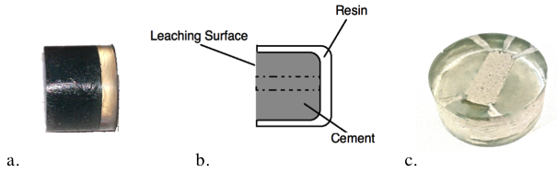
Figure 3.13: SEM Sample (a) Side profile of sample in resin (b) Cross section of sample in resin (c) Typical preparation of sample for SEM

v. pH Measurements
These measurements were used to monitor the alkalinity of the leachate and subsequently the OH⁻ level. This will give a good indication of the degree of portlandite leaching in the water. The pH of the leachate solutions was measured using an Orion Model 250 pH meter calibrated at 2 points (pH 4 and pH 10). The pH meter was placed in the solution and left for 5-10 minutes. The pH of a separate a container of deionised water was also measured at each occasion , which was approximately 7 each time. In the case of the semi static experiments the pH was measured at every water change.

ii. Inductively Coupled Plasma – Mass Spectrometry (ICP-MS)
ICP-MS analysis was used to derive the elemental concentration from the leachate solution. This technique utilizes an argon plasma in a high-energy field which creates intense heating as the gas is ionised. A nebulised mist from the leachate solution is injected into the center of the argon plasma, where temperatures reach nearly 10000ºC. At these temperatures chemical compounds of the mist dissociate into the component atoms and then ionised towards the end of the plasma. The ions are then brought into the mass spectrometer via the interface cones, where they are separated by their mass-to-charge ratio. The ions then exit individually and come into contact with a dynode of an electron multiplier, which detects the electrons released by the impact of the ions[8].
At the end of each leaching test a 20 ml sample from the leachate was collected in a centrifuge tube. The samples were filtered and acidified with nitric acid to ensure stability and comparability with calibration standards. The samples were submitted to the Sheffield Assay Office where the ICP-MS was performed. Table 3.5 summarises the solutions analysed.
Table 3.5: Solutions analysed using ICP-MS.
Solution | Elements Analysed
Blank (B) | calcium, aluminium, magnesium, sodium
Caesium Nitrate (C) | calcium, aluminium, magnesium, sodium, caesium
Strontium Nitrate (S) | calcium, aluminium, magnesium, sodium, strontium
Caesium Nitrate and Strontium Nitrate (CS) | calcium, aluminium, magnesium, sodium, caesium, strontium

3.4 The impact of superplasticisers on leaching behaviour

Introduction
The aforementioned complexing behavior of superplasticisers and its impact on leaching of radionuclides, was investigated by comparing the concentration of cerium in a leachate from two static leaching tests. Furthermore in the storage environment any leached radionuclides from the cement would then come into contact with cement backfill, this project also tested the permeability of the Nirex Reference Vault backfill (NRVB) used in industry to assess how much of the leached cerium will actually escape to the surrounding environment, and to investigate the impact of the superplasticiser on the cerium retention in NRVB.

3.4.1 Effect of Superplasticiser on Leaching of Cement Samples containing Cerium Nitrate
i. Materials
The type and ratio of PC and BFS used in this experiment were the same as in section 3.2. The most commonly used (v/w%) of superplasticiser to cement paste is 0.5 v/w% [9]. Given the total cement paste weight was 323.4g, the superplasticiser ADVA cast 551 (ADV) concentration was 1.62ml. The cerium containing product when adding Ce(NO₃)₃ to water is Ce(OH)_{3.} The amounts of Ce(NO₃)₃ was added to each based on the solubility limits of cerium hydroxide (Ce(OH)₃) to ensure optimal Ce inclusion within the solution. 10wt% Ce(NO₃)₃ was used and any precipitates were filtered. The cement compositions are shown in table 3.6.

Table 3.6: Cement sample compositions
Sample | Cement matrix (g) |  |  | Waste simulant (g) | Superplasticiser (ml)
Sample | PC | BFS | H₂O | Ce(NO₃)₃ | ADVA Cast 551
10wt% Ce(NO₃)₃ (CE) | 22 | 198 | 81.4 | 32 | -
10wt% Ce(NO₃)₃ + ADVA Cast 511 (CEA) | 22 | 198 | 81.4 | 32 | 1.62
* The amount of waste simulants were calculated to provide 10 wt% of elemental Ce with respect to the total weight of the mix (PC + BFS + water + nitrate).

ii. Sample Preparation & Procedure
The preparation of cement samples for this set of static leach tests was based on the procedure described in section 3.2.2. To allow comparisons to be drawn these samples were also cured for 42 days. There was an additional step to add the superplasticiser: once the Ce(NO₃)₃ was fully dissolved in the water, the superplasticisers were added and mixed using the Kenwood mixer for approximately 2-3 minutes. The static leaching procedure from 3.2.2 was then followed, with the samples placed in the containers to be leached statically for 28 days.

3.4.2 Effect of Superplasticiser on Flow-Through Leaching Test of Cerium
i Materials
A flow through leaching test was set up using NRVB cement samples and run for 28 days. Cerium added in the nitrate form was used as the inactive simulant for the insoluble radioelement. Two solutions were used, one blank containing only Ce(NO₃)₃ and the other containing both ADVA cast 551 and Ce(NO₃)₃.
NRVB samples were prepared in accordance to the industry standard [11], Table 3.7 shows the composition. The samples were prepared using water from the NNL Workington Laboratory mains supply.

Table 3.7: Mass Composition % of NRVB Cement Sample
Component | Mass %
Lime | 8.8
Limestone Flour | 28.9
Portland Cement | 26.3
Water | 36

ii. Preparation
The powders in Table 3.8 were weighed in their respective percentages to create a total batch weighing 500g. They were mixed with water using the Hobart mixer at speed setting 1 for 5 minutes, sheared with the Silverson mixer for 10 minutes at 3000 rpm and then finally mixed for a further 10 minutes. The paste was then moulded into a sample, 20mm in height with a diameter of 70mm (surface area 3846.5 mm²), as shown in Figure 3.14, and cured for 28 days at 80ºC. Three samples were prepared. They were then removed, placed in a plastic bag containing a damp tissue and a container of Carbosorb (used to absorb any carbon in the atmosphere, to protect sample from carbonation) and stored in a humidity chamber at 20ºC.

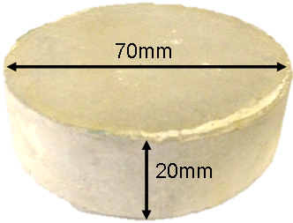
Figure 3.14: NRVB cement sample
The solution was designed to simulate the cement leachate that is produced when radioelements are complexed by the superplasticiser, become soluble and diffuse into the surrounding water [11].

The two solutions used were:
- Blank (BLANK) – comprising Ce(NO₃)₃ and deionised water
- Superplasticised solution (SCEA) – comprising ADVA cast 551, Ce(NO₃)₃ and deionised water
Table 3.7 shows the compositions of both solutions. Adding Ce(NO₃)₃ to water creates Ce(OH)_{3.} Therefore the amount of Ce(NO₃)₃ added to each solution was based on the solubility limits of cerium hydroxide (Ce(OH)₃). In deionised water the solubility limit is 0.00943 g/l. Therefore approximately 0.009g cerium nitrate was added per litre of deionised water to create solution BLANK. With regards to the solution SP, Ce(NO₃)₃ was added until the Ce(OH)₃ precipitated, as the solubility limit of Ce(OH)₃ was unknown in presence of superplasticiser. Approximately 0.34g of Ce(NO₃)₃ was required to obtain 0.01M Ce in 2 litres of water. Given that these solutions are simulating the leached solutions from an encapsulant cement, the concentration of ADVA cast 551 in the solution SCEA was calculated on the assumption that the superplasticiser had completely leached out of an encapsulant cement with a water:solid ratio of 0.37. An ADVA cast 551 concentration of approximately 0.5 v/w % is most commonly used when batching up the cement blends. Therefore based on this the concentration of ADVA cast 551 was calculated as 1.6% by volume per 1L of water.

Table 3.7: Solution Composition
Solution | Component
Solution | Water (ml) | Cerium Nitrate (g) | Advacast 551 (ml)
Blank (BLANK) | 2000 | 0.09 | -
ADVA cast 551 (SCEA) | 2000 | 0.34 | 32

iii Experimental Setup
Figure 3.15 shows the setup of the flow-through leaching test. The tests were performed using two standard water permeameters made of stainless steel manufactured by Impact Testing Services to minimise corrosion of its components. They are connected to a control panel as shown in fig. 3.15, to allow the adjustment of the flow pressure. The NRVB samples were placed within the sample holder vessel between two filter papers and two porous stones. Figure 3.16 shows an example of this arrangement.
Figure 3.15: Flow-through leaching test setup
Notes: (1) Pressure Control Panel, (2) Bladder Vessel, (3) Reservoir Pressure Vessel, (4) NRVB Sample Holder Vessel, (5) Solution Collector

Figure 3.16: NRVB sample arrangement (Notes: NRVB sample labelled E)
The bladder ((2) in Figure 3.15) within each of the vessels was contracted and the vessels filled with either solution BLANK or SCEA. The press control panel was then used to apply pressure to the bladder vessels and expand them, which in turn pushed the solution to the sample holder vessel (4 in Figure 3.15 and larger image in Figure 3.17) via the inflow tubes, passing through the porous stones and coming into the contact with NRVB sample. The membrane is placed around the cement sample and the water pressure in the vessel was kept at 3.7 bar using the pressure control panel. This is in order to maintain a strong seal between the membrane and the sample and prevent any contact between the water and the NRVB. Elasticised rubber O-rings were placed around the membrane to further reinforce the seal.

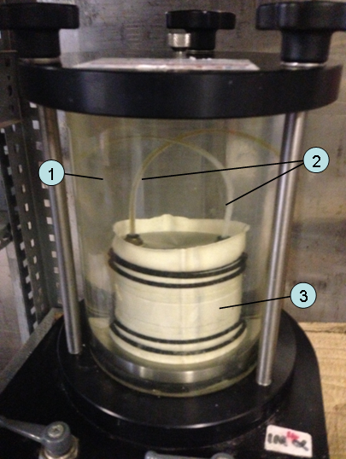
Figure 3.17: NRVB sample holder vessel
Notes: (1) Water Surrounding Membrane, (2) In-flow tubes for solution from bladder vessel (3) Latex Membrane
iv Procedure
The Ce(NO₃)₃ and water was weighed using a Mettler pm400. The ADVA cast 551 volume was measured using a pipette. The solutions were then mixed in a volumetric flask and placed in a HDPE container. The two containers were labelled and left in a furnace at 35ºC for 5 days. This allowed any excess Ce(OH)₃ to settle out, at which point the solution was filtered through Whatman No.4 filter paper using Buchner equipment. The solutions were then placed in their respective bladder vessels via the inlet tube emptying the container under gravity. The equipment was assembled as shown in Figure 3.15. The reservoir holding the NRVB sample was also filled through the inlet tube under gravity. The leachant pressure was set to 0.6 bar initially, giving a flow rate of around 10-20ml per day. The experiment was performed in an iso-freight with a controlled temperature of 28-35ºC. The solution was collected in 100 ml HDPE bottles which were replaced every 2-3 days. The target output of solution was around 50ml per day to ensure the longevity of the experiment for the required duration, equally if solution output was too low, it would be insufficient to analyse For this reason the pressure was altered when flow became too fast or slow. The tubing in the equipment sometimes encountered blockages, which resulted in the experiment pausing for a short period (20-30 minutes) whilst tubing was cleared up. Samples were removed from the setup after 28 days, sealed and prepared for the required analysis methods.

3.4.3 Analysis
i. X-ray Diffraction (XRD)
The cement samples were analysed using XRD to study the crystalline phases formed when cerium nitrate was introduced to the cement matrix. The same analysis equipment was used as in section 3.34. The crystal assemblage was compared to that in the caesium nitrate and strontium nitrate samples. XRD was also used to monitor the impact of ADVA cast 551 on the cement crystal phase assemblage if any.

ii Marsh Cone Test
The marsh cone test was used to study the change in viscosity of the NRVB paste when the ADVA cast 551 was added to the paste. A steel marsh cone with an output hole diameter of 1cm was used alongside a 500ml glass beaker and a stopwatch. Firstly the cement paste without the superplasticiser was prepared, a finger was placed on the output hole of the marsh cone and the cement paste poured into the cone. The cone was held above the glass beaker and the finger removed from the cone whilst simultaneously starting the stop watch. The beaker was allowed to fill until the 500ml level was reached, at which point the stopwatch was stopped and the time recorded. This procedure was then repeated with the superplasticised cement paste.

iii. pH Measurements
The pH of solutions was measured using an Orion Model 250 pH meter. The equipment was calibrated at 3 points (pH = 4, 7 and 10), and the buffer solutions were made up at the end of the experiment. The pH electrode was left in the tested solution until the reading settled, and data recorded.

iv. Inductively Coupled Plasma - Mass Spectrometry/Optical Emission Spectrometry (ICP-MS/ICP-OES)
Samples were acidified with ultrapure HNO₃ to a concentration of 1% (i.e. 1ml of cHNO3 per 100 ml and stored at 4ºC), to ensure stability and comparability with calibration standards. The ICP-MS analysis was to measure the concentration of cerium, sodium and potassium in the leached solution, whereas ICP-OES was used to measure the concentration of calcium. Samples were collected and analysed on the 2nd, 4th and 7th day of every week.

v. Total Organic Carbon (TOC)
Once breakthrough was detected using ICP-MS/ICP-OES (i.e. an increase of Ce concentration in the leachate solution), total organic carbon (TOC) analysis was used to monitor the concentration of organic species in the leached solution. In this analysis procedure, the samples are completely oxidised. This is achieved by adding an aliquot of acid to the samples and then purging with oxygen, the acid reacts with any carbon species, which are then converted to CO₂ which bubbles off, any remaining carbon species in the samples will be organic carbon. Six samples from different stages in the experiment were analysed including the solution within the bladder vessel to assess if any organic species have diffused from the rubber bladder. Again, the samples were acidified with ultrapure HNO₃ to a concentration of 1% i.e., 1 ml of HNO₃ per 100 ml and stored at 4ºC. The analysis was undergone by the National Nuclear Laboratory measurement and analysis department.

Solutions were collected 3 times a week for pH and ICP-MS analysis. Once ICP-MS analysis detects breakthrough (i.e. an increased concentration of the cerium is detected in the leachate) the samples were then analysed using TOC for organic species. The aim was to monitor the concentration of complexed cerium in the collected solution, indicating the amounts of cerium retained within the NRVB sample, if any.
The purpose of this analysis method is to measure the complexed organic products that are formed when the superplasticiser interacts with the cement.

References
Chapter 3: Experimental Methods and Materials
[1] Saito, H. and Sunao N. (1999) Comparison between diffusion test and electrochemical acceleration test for leaching of cement hydration products, ACI Materials Journal. 96, 208-212.
[2] Zhang, J. and Scherer, W., (2001) Comparison of methods for arresting hydration of
cement, Cement and Concrete Research, 41, 1024-1036
[3] Metprep Company website, product information. Retrieved from, (www.metprep.co.uk/consumables_mounting.php)
[4] Radwan, M.M. Heikal, M. (2005) Hydration characteristics of tricalcium aluminate phase in mixed containing β-hemihydrate and phosphgypsym, Cement and Concrete Research. 35, 1601-1608.
[5] Matschei, T., Lothenbach, B. and Glasser, F.P. (2007) The AFm phase in Portland cement, Cement and Concrete Research. 37, 118-130.
[6] Gaki, A., Chrysafi, R., Perraki, T.H., and Kakali, G. Synthesis of calcium aluminates through the polymeric precursor route, Scientific Paper. National Technical University of Athens, School of Chemical Engineering, Athens.
[7] P.T.F. Williamson, M. Ernst, B.H. Meier: MAS Solid-State NMR of Isotropically Enriched Biological Samples, Bio NMR in Drug Research, Ed. O. Zerbe, Wiley 2003, 16, 243-282.
[8] Montaser, A. (1998) An Introduction to ICP Spectrometries for Elemental Analysis. Inductively Coupled Plasma Mass Spectrometry. Canada, Wiley. 2-16.
[9] Hayes, M., Angus, M., Garland, R., (2012) Current status paper on the potential use of Superplasticisers in a Geological Disposal Facility, NNL, 12, 11905 Issue 4.

[11] Butcher, E.J., Borwick, J., Collier, N., Williams, S.J., (2012) Long term leachate evolution during flow-through leaching of a vault backfill, Mineralogical Magazine society, 76, 3023-3031.

Chapter 4: Results & Discussion

Introduction

In this chapter the analysis results are presented and discussed in four sections. Section 4.1 details the initial characterisation results of cement samples, and the effect of introducing the waste simulants on the cement phases is discussed. The second section, 4.2, presents the results from the leaching experiments, wherein the different leaching methods are compared, and the impact of leaching on the cement phase assemblage and crystal structure is discussed. The synthesis results of the AFm phases in the system are given in section 4.3 alongside an investigation into the incorporation of the strontium and caesium within the cement matrix. Finally the results on the Ce leach tests in presence of superplasticiser are discussed in section 4.4, as well as the credibility of NRVB as barrier between the leached solution and the storage container.

4.1: Characterisation of cement samples
This section focuses on the analysis of the cement samples and the leachate prior to leaching after 42 days of curing (referred to as the 0D samples meaning 0 days of leaching, i.e. no leaching). The cement samples were first analysed to characterise them and monitor the changes, if any, that were a result of introducing strontium and caesium nitrate.
4.1.1 RESULTS

i X-ray diffraction (XRD)

The XRD traces of the samples are shown in Figure 4.1 for the blank BFS:PC=9:1 cement matrix (denoted as B), the sample containing Cs (denoted as $\overline{c}$), the sample containing Sr (denoted as $\overline{s}$) and the sample containing both Cs and Sr (denoted as $\overline{\text{cs}}$). The labels used in Figure 4.1 are summarised in Table 4.1.

The trace for the blank cement sample (B), which excludes the waste simulants, agrees with literature reports [1,2,3]. There is a pronounced broad peak at roughly 30º2θ which, according to Wang and Scrivener [3], is attributed to the (110) reflection of the crystalline aspects of C-S-H(I). This suggestion is also supported by He et al [4]. This peak can also be partially attributed to the presence of calcium carbonate (CC), this could be the result of carbonation via the exposure to air (which was collectively around 1 hour) when the samples were prepared for analysis.

The other major phases identified were portlandite (P), hydrotalcite (HC), monosulphoaluminate (AFm) and a small peak for ettringite (E). A gehlenite (G) peak is present alongside the glassy amorphous hump at around 26-33º2θ both of which are attributed to the BFS as shown in Chapter 3 [5,6]
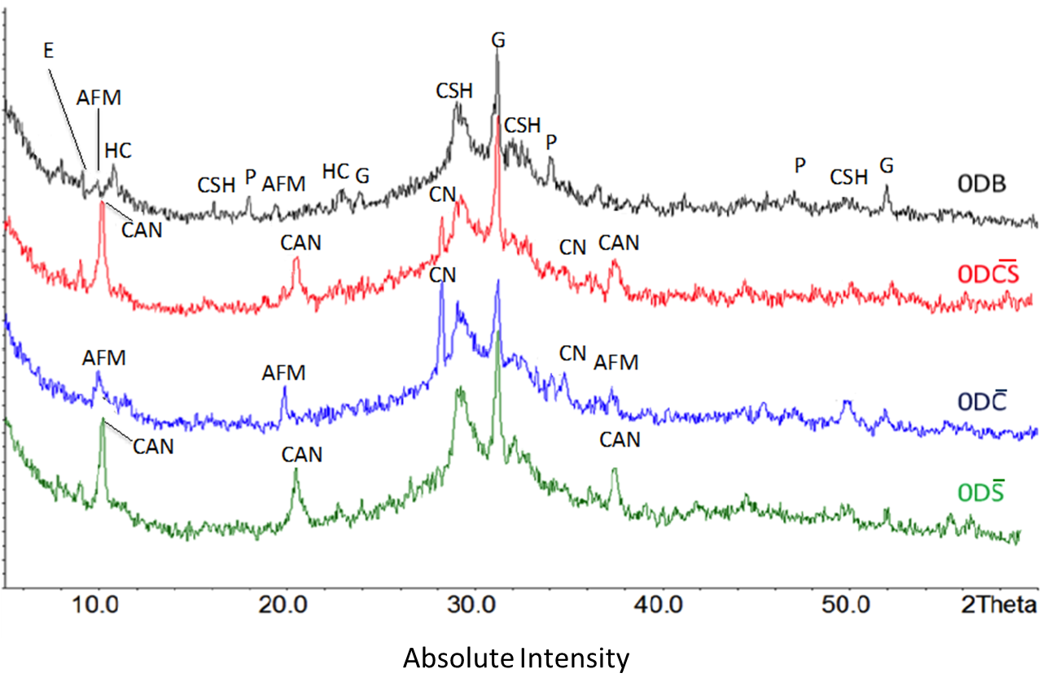

Figure 4.1: XRD traces for samples of each formulation before leaching (0D = 0 Days of leaching). The labels used are summarised in Table 4.1.

Label | Name | Formula | Main Peaks (º2θ) | Peak Information
C-S-H | Calcium silicate hydrate | Hydrated calcium silicate (tobermorite) | 7.07, 29.06, 31.94, 49.79 | Taylor [17], ICDD No. [9-210]
AFM | Monosulphate (AFm) | Ca₄Al₂(OH)₁₂(SO₄).6H₂O | 9.9, 19.64 | ICDD No. [50-1607]
E | Ettringite (AFt) | Ca₆Al₂(OH)₁₂(SO₄)₃ .26H₂O | 9.0, 15.78 | ICDD No. [41-1451]
G | Gehlenite | 2CaOAl₂O₃SiO₂.H₂O | 23.88, 31.37, 52.10 | ICDD No. [73-2041]
P | Portlandite | Ca(OH)₂ | 18.01, 28.6, 34.10, 47.12 | ICDD No. [44-1481]
HC | Hydrotalcite | Mg₆Al₂CO₃(OH)₁₆·4(H₂O) | 11.27, 22.70, 54.79 | ICCD No. [41-1428]
CC | Calcium carbonate (Calcite) | CaCO₃ | 29.41, 39.40 | ICCD No. [5-586]
CN | Caesium Nitrate | CsNO₃ | 19.9, 28.299 | ICDD No. [83-1138]
CAN | Calcium Aluminonitrate | Ca₄Al₂(OH)₁₂(NO₃)₂·4H₂O | 10.35, 20.8 | ICDD No.[50-652]
Table 4.1: XRD peak data and labels

In the sample $\overline{c}$ (labelled 0D$\overline{c}$) with the addition of CsNO₃ to the matrix, the peaks for P and HC could not be seen although the peaks attributed to the other phases present in 0DB were observed. Extra peaks of a relatively strong intensity associated with CsNO₃ can be seen. The AFm peaks within 0D$\overline{c}$ are more intense in comparison with 0DB suggesting an increased amount of this phase, whilst the ettringite peaks were not observed. [7,8]
The introduction of Sr(NO₃)₂ in the sample $\overline{s}$ (labelled 0D$\overline{s}$) also resulted in a different phase assemblage. Peaks for P and AFm were absent, and peaks considered to be for calcium alumino-nitrate (CAN) were observed. The CAN is a type of AFm, wherein the nitrate anions are substituting for the interlayer sulphate anions within the AFm phase. The ettringite peak (E) clearly observed at around 9º2θ suggest a significant amount of ettringite formation in the 0D$\overline{s}$. Peaks were expected for Sr(NO₃)₂ based on the behaviour of Cs, however neither of the Sr containing samples produced peaks associated with any Sr containing phases.
A mixture of the effects from CsNO₃ and Sr(NO₃)₂ was observed in sample $\overline{cs}$ (labelled 0D$\overline{cs}$). The XRD trace for this sample shows CAN and ettringite peaks, but no AFm peaks. The peaks attributed to the phases produced from BFS and the peaks associated with the C-S-H (I) crystals are present in all four cement sample formulations suggesting that the introduction of waste simulants does not impact the formation of these phases during hydration. [9]
ii Thermogravimetric Analysis (TGA)
Several components and phases were identified in the four samples, literature states that these components/phases dehydrate at the temperature ranges given in table 4.2. (information gathered from [10,11]). The thermogravimetry (TG) and differential thermogravimetry (DTG) curves for 0DB and 0D$\overline{cs}$ are shown in Figure 4.2. The TG and DTG heating profiles for the 0D$\overline{c}$ and 0D$\overline{s}$ samples are shown in Figure 4.3. They correspond strongly with the XRD results. In all samples the weight losses below 100ºC are partially attributed to the evaporation of free water.

Table 4.2: Cement components and corresponding dehydration/volatilisation temperatures
Label | Component | Formula | Temperature range ºC
C-S-H | C-S-H | Amorphous calcium silicate hydrate | 110-1000
AFM | Monosulphate | Ca₄Al₂(OH)₁₂(SO₄).6H₂O | 180-210, 220-270
CAN | Calcium Aluminonitrate | Ca₄Al₂(OH)₁₂(NO₃)₂·4H₂O | 100-120, 240-280, 510-590
P | Portlandite | Ca(OH)₂ | 440-500
CC | Calcite | CaCO₃ | 600-750
CN | Caesium Nitrate | CsNO₃ | 500-540
HC | Hydrotalcite | Mg₆Al₂CO₃(OH)₁₆·4(H₂O) | 300-375

The majority of the weight loss in sample 0DB was due to loss of free water and the dehydration of the C-S-H gel at 100ºC. The loss at 150ºC was due to the dehydration of AFm phase. There is a small peak in DTG curve at around 375ºC, corresponding to the dehydration of the hydrotalcite phase (HC) according to Ramachandran et al. [11], which causes approximately 1 % weight loss. The rest of the weight loss is due to the dehydroxylation of Portlandite (P) and the small weight loss associated with calcium carbonate (CC) at around 600-700ºC. The weight loss due to this phase is approximately < 1 %.
In contrast the majority of the weight loss in 0D$\overline{cs}$ is not only due to C-S-H but also the CAN phase and CsNO₃. The DTG curve supports the suggestion from the XRD results that a calcium aluminonitrate phase rather than a monosulphate phase was formed in 0D$\overline{cs}$.
Figure 4.2: TGA & DTG curves for $\overline{cs}$ and B before leaching (left Y axis associated with TG curves, right Y axis associated with DTG curves)

The weight loss in the 60-160ºC regions is attributed partially to the dehydration of C-S-H. It is known that CAN has a two stage dehydration process in this temperature region, losing two chemically bound H₂O molecules at 70ºC and the remaining two H₂O molecules at 110ºC, leaving Ca₄Al₂(OH)₁₂(NO₃)₂ [10]. Due to the overlap in the weight loss associated with different phases, it is difficult to establish the weight loss due to each phase.

At around 210-310ºC there is a peak due to the reduction of the dehydrated CAN phase causing around 2% weight loss. This is due to the dehydroxylation of CAN phase, wherein three molecules of water are released, and the reduction of nitrate liberating one O²⁻ forming the nitrite Ca₄Al₂O₃(OH)₆ (NO₂)₂ [10]. There is a further 2% weight loss at 310-380ºC is due to the dehydration of the hydrogarnet phase (HG) [11] as past literature has shown that the formation of the hydrogarnet phase within PC cements is possible [12,13]. This phase is known to have poor crystallinity [13], which could explain its presence in the TG even though there was a lack of attributable peaks in the XRD traces.

There was no weight loss due to the dehydroxylation of portlandite in 0D$\overline{cs}$, suggesting the absence of this phase and agreeing with the XRD results. The weight loss of approximately 6% over the range 460-660ºC is due to two events: the first being the melting and eventual decomposition of CsNO₃ liberating O₂ gas, leaving behind caesium nitrite (CsNO₂) [14,15]. The second is the decomposition of the nitrite in the Ca₄Al₂O₃(OH)₆(NO₂)₂ phase, producing Ca₄Al₂O₅(OH)₄, which according to Renaudin et al. [10] fully decomposes at 1300ºC to give a product with composition of Ca₄Al₂O₇.
The TG and DTG profiles for 0D$\overline{c}$shown in Figure 4.3 were very similar to those for 0DB, although the sample 0D$\overline{c}$ shows a small additional weight loss of approximately 3wt% at 480-600ºC attributed to CsNO₃ decomposition [14,15]. The 0D$\overline{c}$ data also shows a weight loss attributable to P. As this phase was not identified in the XRD trace, it was formed either in small amounts or with poor crystallinity.

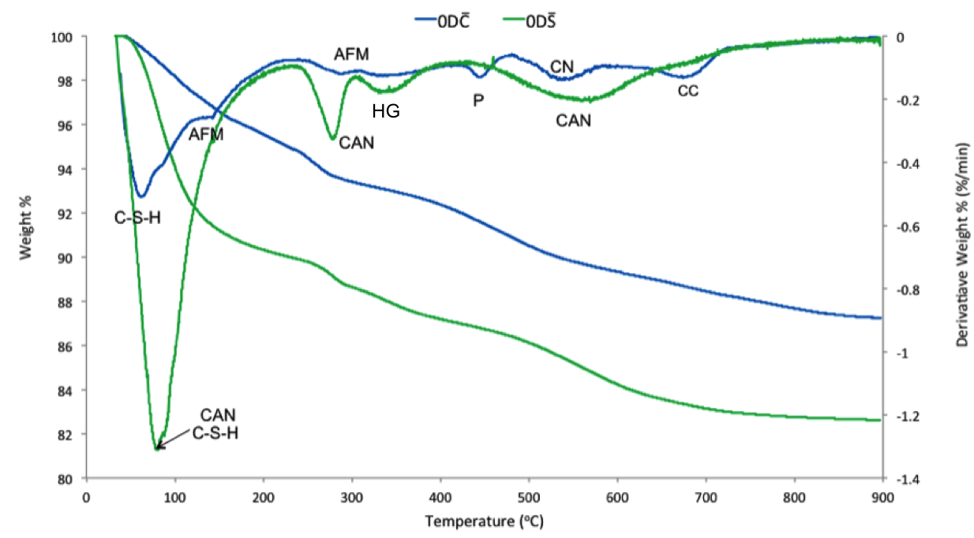Figure 4.3: TGA & DTG curves for $\overline{c}$ and $\overline{s}$ before leaching (left Y axis associated with TG curves, right Y axis associated with DTG curves)
The 0D$\overline{s}$ profiles were similar to those for in 0D$\overline{cs}$, showing that the majority of the weight loss was due to the C-S-H and the CAN phases. Decomposition of Sr(NO₃)₂, which should appear at 610-670ºC [16] was not observed. This confirms the observation in the XRD data that, unlike Cs, the Sr was associated with other phases in the cement matrix.
The total weight losses of samples 0D$\overline{s}$ and 0D$\overline{cs}$ were significantly larger than those of 0D$\overline{c}$ and 0DB. It can be surmised that this is due to the introduction of Sr(NO₃)₂ and will be investigated further in the discussion section of this chapter. The weight loss in the 60-100ºC region from heating the 0D$\overline{s}$ significantly higher than weight loss in the same region from the other three samples.

iii Mercury Intrusion Porosimetry (MIP)
The 0D$\overline{cs}$ and 0DB samples were analysed using MIP and Figure 4.4 shows the pore volume distribution for these samples. The relationship between the applied pressure and the pore size is based on the Washburn Equation 4.1[17]:
$r= \frac{-2 × γ_{m}× cosθ}{p }$ (4.1)
Where r is the pore radius, $γ_{m}$ is the surface tension between mercury and the pore wall (N/m), $θ$ is the contact angle between the mercury and the specifmen surface, p is the pressure

Figure 4.4: Incremental porosity for 0DB and 0D$\overline{cs}$

The majority of the pores within 0DB on average have a diameter of approximately 0.05-0.1 µm, these pores are known as capillary mesopores [18] and are a product of the initial water-filled spaces within the cement and they are dependent on the water/cement ratio. These remnants of water filled spaces are also the cause of the larger capillary pores at 0.1-0.3 µm.
The pores within 0D$\overline{cs}$ are widely distributed between 0.1 µm and 0.01 µm, with the largest population being 0.01-0.05 µm referred to as gel mesopores within the C-S-H gel [18]. The coarser pores at 0.4-0.9 µm are capillary macropores [17].
The total porosity of both samples was also compared. The total porosity was 0.064 ml/g for the 0DB sample and 0.096 ml/g for the 0D$\overline{cs}$. The porosity measurements account for pores down to only ~0.007µm, which is due to the maximum pressure set for the measurement.
Figure 4.5 shows the cumulative pore volume data for 0DB on first intrusion and extrusion (In 1 and Ex 1). The figure also shows the second intrusion and extrusion successively performed after the first ones (In 2 and Ex 2). A significant amount of mercury appears to be remaining in the inkbottle pores after the first extrusion [19]. Inkbottle pores are capillary pores consisting of a larger ‘head’ pore connected to the surface by a much smaller ‘neck’ pore as shown in Fig 4.6 [19, 20]. Since the ink bottle pores are already filled, no additional mercury is entrapped after the second intrusion and extrusion.
Figure 4.5: Cumulative pore volume compared with pore diameters for 0DB.

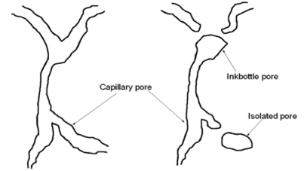
Figure 4.6: Change of capillary pore into the inkbottle pore [19]

Based on the difference between the cumulative porosity volume in the first intrusion (0.064 ml/g ) and that in the second intrusion (0.0284ml/g), the inkbottle pores appear to be responsible for approximately 44 % of the total porosity.
There is a difference in pore diameter distribution between the In2 and Ex2, which is referred to as contact angle hysteresis [21]. This is based on the difference in contact angle depending on whether the mercury meniscus is advancing (during intrusion) or receding (in extrusion), wherein the intrusion contact angle is larger than the extrusion contact angle. The obtained data was corrected, applying a contact angle shift of 100º [22,23] for the extrusion diameter to the original contact angle of 130º [24] for intrusion, which corresponds to the correction of the pore diameter by a factor of 3.75. The corrected data shown in Figure 4.7 is now in stronger agreement.

Figure 4.7: Cumulative pore volume compared with pore diameters for 0DB (corrected 2nd extrusion)
The cumulative porosity volume in 0D$\overline{cs}$ is 0.096 ml/g, of which approximately 75% appears to be inkbottle pores based on the first intrusion (In 1 and Ex 1) and second intrusion (In 2 and Ex 2) data shown in Figure 4.8 before the contact angle correction. Therefore the percentage of inkbottle pores in 0D$\overline{cs}$ is higher than in 0DB. Again, when the contact angle correction was implemented to the Ex2 values, the In2 and Ex2 data were better matched.
Figure 4.8: Cumulative pore volume compared with pore diameters for 0D$\overline{cs}$
The incremental pore volume for the second intrusion in the samples is compared in figure 4.9. Both samples show a similar pore size distribution, ranging from 0.2 – 0.01 µm. The 0D$\overline{cs}$ sample has less pores 0.01 µm in diameter than the 0DB.

Figure 4.9: Volume of pores compared with pore diameters for 2nd intrusion for 0DB and 0D$\overline{cs}$

iv. Nuclear Magnetic Resonance Spectroscopy (NMR)
The 0DB and 0D$\overline{cs}$ samples were analysed using NMR spectroscopy at different curing times to monitor the phase evolution up to 720 days. Figure 4.10 shows the ²⁹Si MAS spectra for 0DB samples cured at 28, 90 and 720 days and figure 4.11 shows the same for 0D$\overline{cs}$, also including 360 days (The 0DB samples cured for 360 days were not available). The spectrum for anhydrous BFS:PC mixed at 9:1 ratio is also shown as a reference. These data present information regarding the C-S-H gel formation present and the local silicate tetrahedral environment referred to as Q^{n}, where Q refers to the silicon tetrahedron bonded to four oxygen atoms (SiO₄) and ‘n’ refers to the number of other Q units the SiO₄ is connected to. The anhydrous BFS/PC in figure 4.10 shows a large hump between -70 and -80 ppm (parts per million) attributed to Q⁰. As hydration begins and progresses a peak starts to show in this region which is attributed with the monomeric orthosilicate anion (SiO₄⁴⁻) typically found in C₃S and C₂S [25]. The intensity of this peak decreases significantly in the 28 day sample and continues to decrease slightly in the 90 days sample, and then slightly increases in the 2 year sample. The initial significant decrease is due to the hydration of these clinker phases. The Q¹ resonance, representing the end group of a C-S-H chain [26] connected to one SiO₄ unit, also produces peaks within this region at around -74 ppm. The main peak in the hydrated samples at -81ppm is the resonance attributed to Q²(1Al) sites within C-S-H (i.e. a SiO₄ unit connected to one SiO₄ and one AlO₄ tetrahedron). As an example, Fig 4.12 shows a single layer in the crystal structure of tobermorite (believed to have the same layer structure as C-S-H), showing the location of these sites [27]. The Q²(1Al) peak intensity increases with time whilst the unreacted Q⁰ decreases as expected. The highest rate of hydration appears to have occurred within the first 28 days, there is little change when comparing the 28 day and 90 day peaks, therefore the selection of 42 day period for this project was a reasonable choice with reference to C-S-H gel formation. There is however a change in the peaks between 90 days and 720 days which suggests that hydration is continuing, or could also be due to the reintroduction of the cement to water. The Si bound to two SiO₄ units, usually found in the middle of the C-S-H chain, have a resonance that produces the Q² peak at around -84ppm [28]. There seems to be a larger amount of Q²(1Al) in comparison to the Q² suggesting that a significant amount of Al substitution into the C-S-H gel has occurred during hydration.
Figure 4.10: ²⁹Si MAS spectra for the 0DB sample at different curing periods
Figure 4.11 shows the ²⁹Si MAS spectra for the $\overline{cs}$ series. The Q⁰ hump initially decreases as hydration occurs similarly to the 0DB series, and the peak intensity of the Q¹ appears to increase after longer curing period.

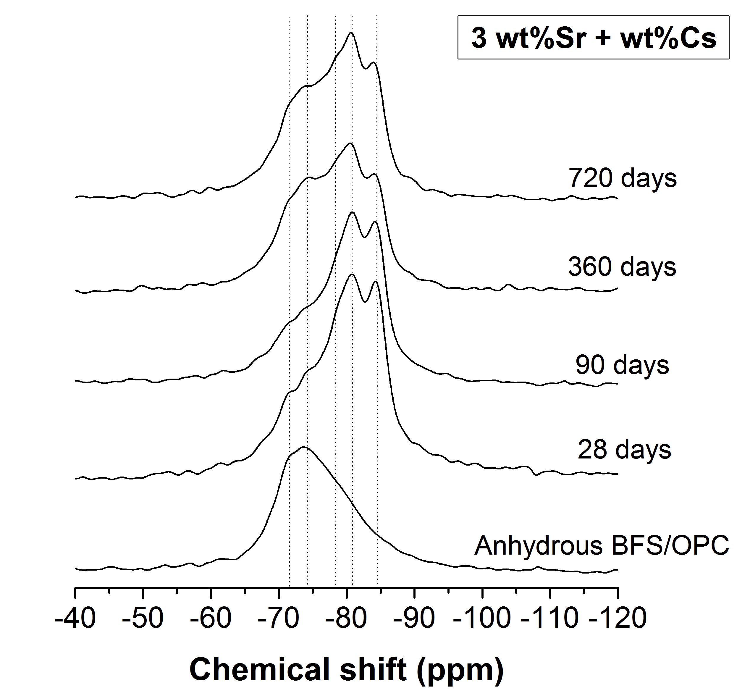
Figure 4.11: ²⁹Si MAS spectra for $\overline{cs}$, sample at different curing at 0D

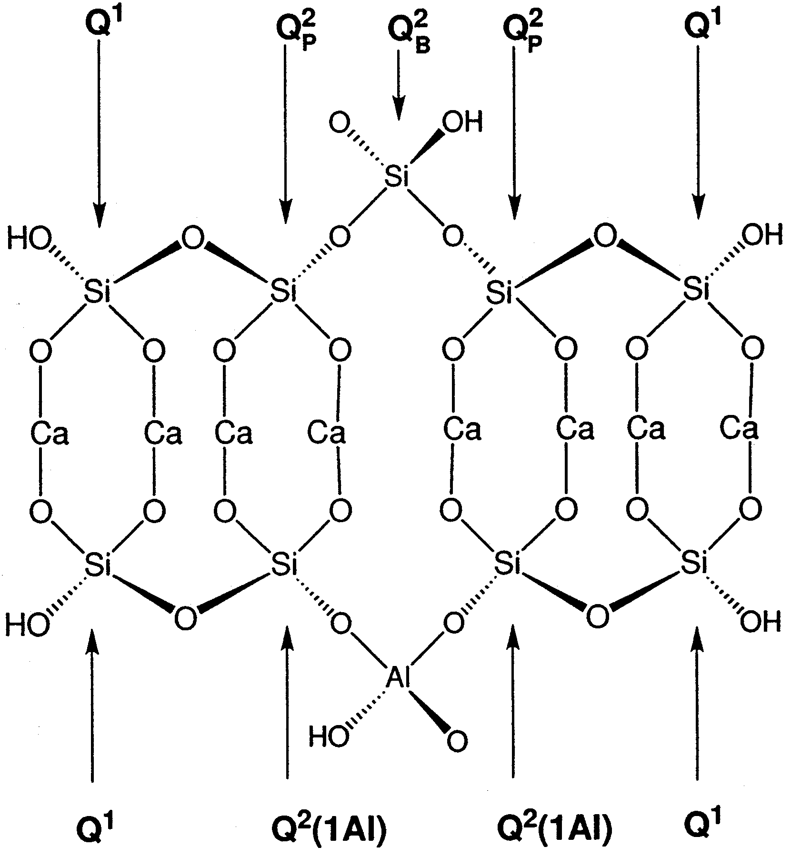

Figure 4.12: Schematic of part of a layer of crystal structure of tobermorite missing the external CaO layer [29]
The spectra of 0DB and 0D$\overline{cs}$ series for the first 90 days are compared in Figure 4.13 using peak intensities as a rough guide. The relative peak intensities for Q² and Q²(1Al) is higher to that in the 0DB series, the Q² peaks are significantly more intense in the 0D$\overline{cs}$ samples (figure 4.13). Furthermore the Q¹ peaks in 0DB are more intense than those in 0D$\overline{cs}$. Sun et al [30] explained the increase in Q²(Al) intensity and decrease of Q¹ was due to the Al entering the tetrahedral chain sites and the Al-Si chains becoming progressively more polymerised [28]. Because the bond length of Al-O is typically longer than that of Si-O, the Al substitutions occur at the bridging site (Q²) is this region is more favorable to accommodate these larger Al-O bonds as there would be more space available. This connects the Q¹ Si-sites to Q²(1Al) sites increasing polymerisation. This is supported by Brough et al. [31] who stated that more Al substitutions for Si into the tetrahedral sites in the mid-location of the C-S-H chain, forming Q² unit as opposed to Q¹. They also found that this substitution caused a shift of the Q² peaks to the left. However figure 4.13 shows a similar intensity in the Q²(1Al) sites, therefore suggesting that although the same amount of Q²(1Al) sites are present, the C-S-H chains in 0D$\overline{cs}$ are longer. Furthermore the hump for the unreacted slag is slightly more intense in the blank sample, suggesting that hydration is occurring faster in$\overline{cs}$sample, this is studied further in the discussion section of this chapter.
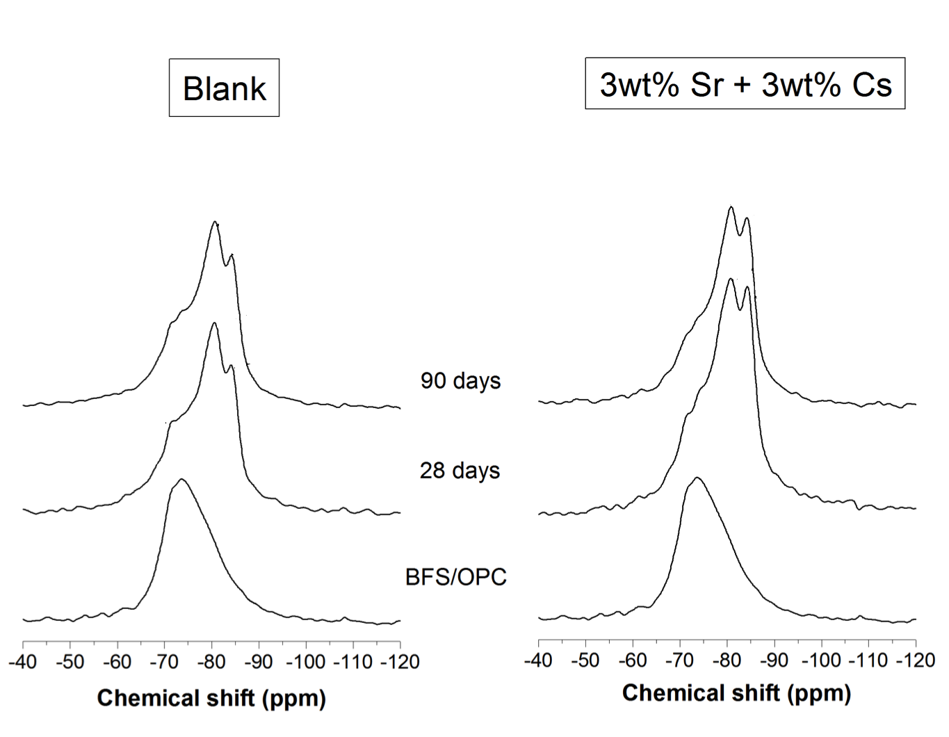
Figure 4.13: ²⁹Si MAS spectra for B compared with $\overline{cs}$ samples at different curing periods at 0D (The signal intensity values shown for Q¹, Q²(Al), Q²)

The 27Al MAS spectra were also collected for both the series. Figure 4.19 shows those for the 0DB series. These spectra help characterise the calcium aluminates and aluminate hydrates such as AFt and AFm [26,27]. The hump peaking 59-80 ppm is attributed to the tetrahedrally coordinated (Al(4)) incorporated in the C-S-H phase [32], which at 720 days shows a sharp peak at 59 ppm, according to [32] this is due to the Al(4) sites in unhydrated material. A broad peak at 37 ppm is a penta-coordinated AlO₅ (Al(5)) [31,33], which is due to the Al³⁺ substitution for the Ca²⁺ site in the C-S-H interlayers according to Faucon et al. [32].
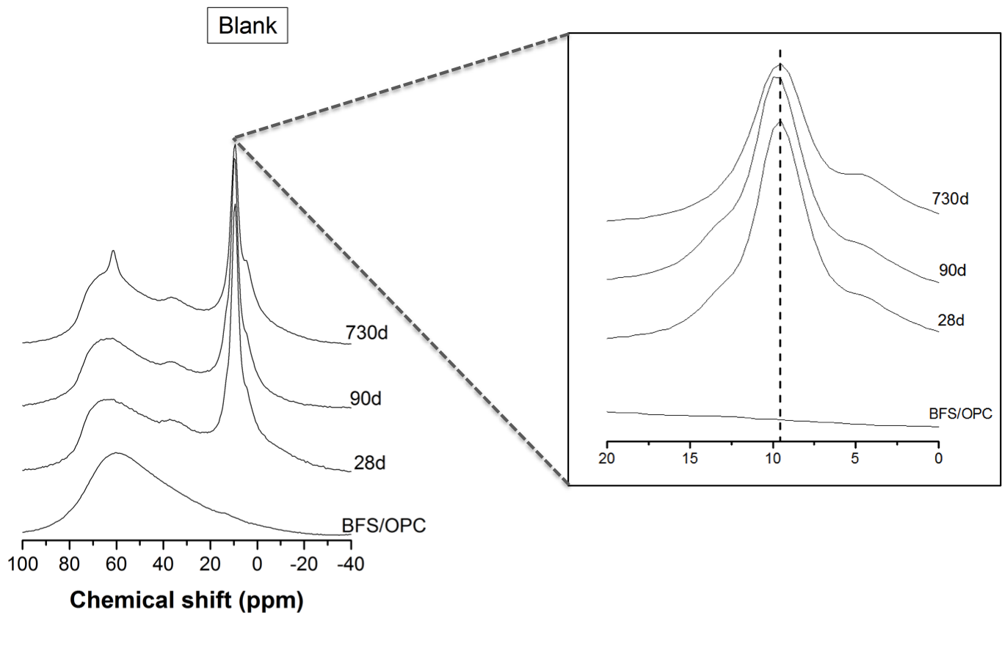
Figure 4.19: ²⁷Al MAS spectra for 0DB sample at different curing periods
A main peak around 9.5 ppm was observed in the hydrated samples. The resonance in this region for Portland cement has been reported as attributed to the AFm type phases [31,33], where Al is present as octahedrally coordinated (Al(6)) [33]. The spectra for the hydrated samples also show a small shoulder at around 5.6 ppm which becomes more pronounced as time progresses. Some reports state this as an Al³⁺ substitution for Ca²⁺ in the CaO₂ layer of the C-S-H [32,33], however after further investigation and analysis this was discounted by Andersen et al [29]. They found that the resonance in this region is due to either a less-crystalline alumina gel or a calcium aluminate hydrate phase [29]. . The resonance peak for AFt is expected at around 12-14ppm, which may correspond to the slight shoulder observed at 13 ppm. The peak expected at 1.6ppm produced by the octahedral coordination of Al was not present in figure 4.19. [33]
The ²⁷Al NMR spectra for the 0D$\overline{cs}$ series are shown in Figure 4.20. Using peak intensity values as a guide it can be seen that the C-S-H hump, between 60-80 ppm, in the 0D$\overline{cs}$ is smaller than in the 0DB series suggesting that less of the Al was in the C-S-H in comparison to 0DB, supporting the ²⁹Si MAS results. The peak attributable to AFm is much more intense. This suggests that more aluminium is incorporated into the AFm type phase in the 0D$\overline{cs}$ samples.

Figure 4.20: ²⁷Al MAS spectra for 0D$\overline{cs}$ sample at different curing periods

v. Scanning Electron Microscopy (SEM)
A backscattered electron image for 0DB is shown in Figure 4.21. Some of the cement particles have not been completely reacted, and in some particles, the hydrating rim resulting from these reactions can be seen, which is usually composed of inner product C-S-H gel [38]. Hydration rims were also observed around the BFS particles in Figure 4.21. The edges of the BFS particles were smooth with no obvious signs of degradation, suggesting that the glassy structure of the BFS has not been attacked which was not expected. The formation of Portlandite (Ca(OH)₂) was also observed, filling the water filled spaces [7] and was easy to differentiate as it is brighter. The image also shows unfilled voids and pores between the hydration products, as well as the large BFS particles.

Figure 4.21: Backscattered SEM image of 0DB (42 days cured)

A back scattered electron image for 0D$\overline{cs}$ after 42 days of hydration is shown Figure 4.22. The BFS particles in this sample also show hydration rims although the edges show some signs of pitting suggesting a more advanced stage of hydration. The sample also show unreacted cement particles although not as much as the 0DB sample. The formation of Portlandite was not observed. This absence of Portlandite corresponds with the XRD and TGA results.

Figure 4.22: Backscattered SEM image of 42 day cured 0D$\overline{cs}$

The elemental map in Figure 4.23 shows that the Cs and Sr have localised distributions within the cement matrix. Cs seems to be concentrated in a small area, whereas Sr is more dispersed. This may suggest that Cs has not been incorporated into any cement phases whereas Sr has been. The elemental map shows an overlap of Al and S, suggesting the formation of AFm/AFt phases in this area.The Sr dispersion seems to be in the region with less S, which may suggest that the Sr is incorporated in phases other than the AFt/AFm phase suggested in some literature [35]. However the elemental map does show regions where the Sr, Ca and Mg seem to overlap without the presence of S or Al.

Figure 4.23: Backscattered electron image with X-ray dot maps of area highlighted by dotted line and an EDS trace from a point within the highlighted region
(White regions are high concentration, black regions are low concentration

4.1.2 Discussion
The cement samples were analysed before the leaching experiments to better understand the cement microstructure, phase formation and obtain an idea of the location of retained caesium and strontium within the cement. The XRD results showed that the main peak, associated with the BFS and C-S-H phases, were present in all sample formulations, especially the pronounced peak at 29º2θ attributed to the (110) reflection of semi-crystalline C-S-H(I) [3,4]. In the 0D$\overline{s}$ sample, the tip of this peak has slightly shifted to the left and is relatively stronger in comparison to 0DB, 0D$\overline{c}$ and 0D$\overline{cs}$. The d-spacing of (110) positively correlated with the calcium/silica ratio [4]. Therefore as the calcium/silica ratio increases in the system we would expect (assuming Bragg’s law) the º2θ values to decrease and thus observe a shifting of this peak to the left. This suggests that the calcium to silica ratio in the 0D$\overline{s}$ sample is slightly higher than in other samples. Cement systems containing C-S-H should contain a network of micropores ranging in size between 0.0001µm and 0.001µm. These micropores are an intrinsic feature of the C-S-H gel [18] and are not accounted for in the MIP results. This limitation is however is of little significance in this project as Cheng et al [36] found that porosities of this size have been shown to contribute very little to the leaching profiles of ions within the cement. They also found that the increase of C-S-H gel within a cement sample could reduce the porosity [36]. The larger weight loss in the 100ºC region could be due to the dehydration of more C-S-H in the 0D$\overline{cs}$, however the sample is much less porous in comparison to 0DB. This suggests that the Sr substitutes into the C-S-H, leaving the nitrate to react and form AFm phases, while the CsNO3 is left in the pore solution and then crystallises when the samples are dried.
The large weight loss in the 100ºC region from 0D$\overline{cs }$could also be attributed to the CAN phase as opposed to more C-S-H being present. The NMR results however do not show this, indicating similar amounts of C-S-H in both samples.
The introduction of Cs and Sr into the cement system caused an absence in the portlandite (P). The introduction of the Cs and Sr in nitrate in the cement paste would form a NO₃⁻ solution, which is more acidic than the solution in the B series, this higher acidity could be the cause of this absence. The absence of the P is supported by the TGA data which showed weight loss in the 0DB at 150ºC due to the dehydration of the HC phase [11], and at 400-440ºC due to the dehydroxylation of P. Given that the percentage mass of PC decreases in the waste loaded samples, it is unlikely that this is the cause for the absence of P phase, as the fraction of PC was decreased by approximately 2-3% only. These events do not occur during the heating profile of 0D$\overline{s}$ or 0D$\overline{cs}$. The 0D$\overline{c}$ TGA data suggests a small presence of P. Therefore it seems the introduction of Sr caused an absence in the P phase. However Rahman et al [37] found that the introduction of Sr (in chloride form) did not impact any of the hydration phases or lead to the formation of any new phases. This is supported by Wieland et al [38] who added the strontium in its pure form and found that portlandite was one of the main hydrate phases formed. This suggests that adding Sr in the nitrate form is the causing the alteration in the cement hydrate phases. This absence of P seems to have impacted the porosity distribution when comparing 0DB and 0D$\overline{cs}$. The majority of the pores within 0DB on average have a diameter of approximately 0.05-0.1 µm, these pores are referred to as mesopores [18] which, although are attributed to the water-filled spaces within the cement, are also formed when phases such as P grow within cavities and subdivide the larger pores within the cement structure [18]. This would explain the significantly higher volume of 0.1µm pores in 0DB than in 0D$\overline{cs}$. These pores are also known to decrease as the rate of hydration decrease therefore suggesting that 0DB would hydrate at a slower rate. The 0DB sample was expected to have a lower porosity according to [18] higher porosity results in an increased leaching rate, and Chang [39] suggests that cements containing waste simulants such as strontium and caesium have a much higher leaching rate than those that do not contain any wastes. However, Glasser [18] proposed that rapid leaching is impacted by the volume of the mesopores and coarse pores as opposed to the finer pores. The 0D$\overline{cs}$ sample has a much higher volume of pores that impact the diffusion rate, meaning that the 0D$\overline{cs}$ will probably have a higher leaching rate.
The ettringite peak observed in 0DB, 0D$\overline{cs}$, and 0D$\overline{s}$ at 9.0º2θ was absent in 0D$\overline{c}$. Instead, in the 0D$\overline{c}$, the peaks for AFm were more intense. The TGA results also showed that the AFm was formed in the 0D$\overline{c}$ sample in comparison to the other samples. Ettringite is produced in Portland cement when the C₃A clinker phase hydrates [3]. As hydration progresses, the sulphate concentration in solution drops below a critical value usually after about one day, at which point the ettringite becomes unstable and further hydration forms the AFm phase as the stable hydration product, based on the following reaction,
AFt + 2C₃A → AFm
According to Schewiete et al [5] ettringite forms as a layer surrounding the C₃A particle impeding further contact between sulphate ions and the C₃A surface. This creates an induction and retards the hydration of the C₃A particle until the levels of SO₄²⁻ fall below a certain threshold at which point the ettringite layer ruptures causing a renewed hydration of C₃A to form AFm as shown in the schematic in figure 4.24 (left).
Figure 4.24: (Left) Schematic of AFm formation during C₃A hydration, (Right) heat evolution during respective stages [5]
These results suggest the caesium nitrate accelerates this hydration or similar process, promoting the AFm formation, which would result in an increase of sulphate in pore solution. The increased hydration in the 0D$\overline{cs}$ samples is also supported by the Si NMR results, which show that the Qº hump of the unhydrated clinker phases is smaller in the 0D$\overline{cs}$ than that 0DB after 28 days and 90 days of curing. Atkins and Glasser [40] found that the porosity of samples increased as the hydration rate increased, this was due to the growing volume of hydration products splitting the pores within the sample into smaller finer pores thus explaining the higher percentage of smaller pores in 0D$\overline{cs}$. According to the XRD and TGA results of 0D$\overline{cs}$, ettringite is formed along with the nitrated AFm phase CAN. This substitution of SO₄²⁻ by NO₃⁻ ions in AFm phase, will liberate even more SO₄²⁻ therefore prolonging the time period before which the ettringite layer is ruptured [9].

Both the 0D$\overline{c}$ and 0D$\overline{cs}$ analyses show that CsNO₃ is present in the solid cement sample. During sample preparation the CsNO₃ is dissolved in water where the nitrate dissociates to give Cs⁺ and NO₃⁻. The prominent presence of CsNO₃ in the XRD and TGA suggest that it was precipitated from a saturated solution. As water is used up during the hydration process the concentration of CsNO₃ surpasses the solubility limit, therefore this could also be the reason for its precipitation. Alternatively it could have also been crystalized from the pore solution during drying for analysis. During the early stages of hydration these grains form clumps or masses however due to their random geometry they do not do this in a particular order, thus producing larger voids that never become filled with hydrate products, which could explain the higher amount of intrinsic pores in the 0D$\overline{cs}$. The Cs was not immobilised in the cement and as can be seen in the SEM results seems to have concentrated in clusters within the sample which may result in acidic conditions in these concentrated regions.

The nitrated phase CAN seems to be the result of the Sr(NO₃)₂ introduction as it is only present in the 0D$\overline{cs}$ and 0D$\overline{s}$ samples. CAN is an AFm phase, the nitrate anions substituting for the interlayer sulphate anions within the AFm phase [6]. According to Balonis [9] the calcium aluminohydrate phases can incorporate various oxyanions attaching to Ca²⁺, forming various solid solutions. These can be described by the following general formulae 3CaO.Al₂O_{3.}CaX.4H₂O and 3CaO.Al₂O_{3.}CaY₂.4H₂O, depending on the oxyanions. In this instance X = SO₄²⁻ for AFm phase, Y = NO₃⁻ for CAN phase. The resulting structure after the substitution is shown in Figure 4.25 (left), a projection on (010) of the phase taken from Renaudin et al. [10], who identified the phase as tetrahydrated binitroaluminate. McCarthy et al. [7] suggest that the substitution of this type can also occur in the AFt phases although contradictory results have also been reported [8]. The symmetry and d-spacing in the crystal structure of CAN are different to those in AFm, and therefore the x-ray diffraction pattern is different. The TGA results indicate strongly the existence of CAN phase. The existence of the intermediate Ca₄Al₂(OH)₁₂(NO₃)₂.2H₂O phase found in the 70-100ºC range during the two step dehydration has been confirmed by Renaudin et al. using Raman spectroscopy [10]. The TGA data of 0D$\overline{s}$ and 0D$\overline{cs}$ showed weight loss in the range 60-120ºC regions. When heated to 70ºC, the main [Ca₂Al(OH)₆]⁺ layers, shown in Figure 4.5 (left) undergo a sideways translation due to the loss of the water molecules, decreasing the interlayer distances. These layers are then bridged by NO₃⁻ groups, and as a result, the crystal orientation changes from a two-dimensional layer structure to a pillar structure as shown in Figure 4.25 (right).
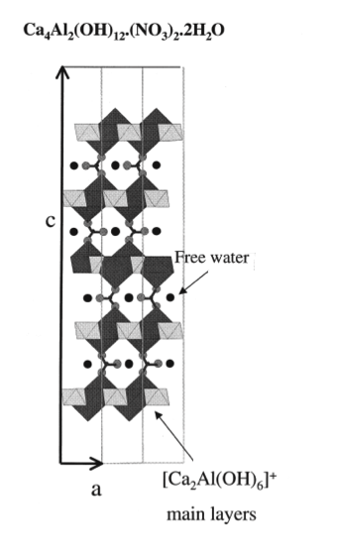
Figure 4.25: Projection on (010) layers of hydrated (left) and tetrahydrated binitroaluminate (right) [10]

The dehydroxylation of CAN at 240-310 ºC can be used to calculate the mass of CAN within the sample. Assuming that the majority weight loss in this region is due to this event and that none of the Sr is retained within this phase, Equation 4.2 could be used to roughly estimate the weight % of the dehydrated CAN in 0D$\overline{cs}$. By calculating the wt% of dehydrated CAN phase (CAN*)

$$Wt \% of CAN* in 0D\overline{cs}= \frac{Wt\% loss due to dehydroxlaytion and reduction}{(6 × \left(Wt \% of H^{+} in phase\right)+3 ×(Wt \% of O^{2-} in phase))}×100 (4.2)$$
During the dehydroxylation and reduction of Ca₄Al₂(OH)₁₂(NO₃)₂, three molecules of water⁻ are released. The % values in the equation are calculated using the dehydrated CAN* Ca₄Al₂(OH)₁₂(NO₃)₂. The wt% of H⁺ and O²⁻ in the dehydrated CAN* phase were 0.18% and 2.95% respectively which means that Ca₄Al₂(OH)₁₂(NO₃)₂ encountered a 9.93% weight loss during this event. The total sample weight loss in this region was estimated at 2%, when Ca₄Al₂(OH)₁₂(NO₃)₂ loses 9.93% the total sample loses 2%. Therefore the total wt% of the dehydrated CAN* phase (molecular mass= 542) within the sample is roughly estimated at 20%. A similar equation can then be used to calculate the wt% of the original hydrated CAN (Molecular mass=614) phase in the sample. The 4H₂O molecules lost during dehydration make up 11.7 wt% of the CAN phase. If the CAN loses 11.7 wt% when it dehydrates to form CAN* which is 8 wt% of the sample, this means CAN is 9wt %. Furthermore quantifying CAN, can allow for the calculation of the CsNO₃ in the 0D$\overline{cs}$ sample. Given that there is an overlap in the heating profile of CAN and CsNO₃ events between 460-660ºC it was difficult to quantify the CsNO_{3.} However the decomposition of the nitrate results in a 30 wt% loss of CAN*, given this is 8 wt% of the sample, we the can expect the decomposition behavior would result in a 2.4 wt% loss of the sample. Given the total weight loss within this region was around 6 wt%, this means roughly 4.6% wt% was due to the melting and decomposition of CsNO_{3.} This accounts for nearly all the original amount of CsNO₃ added within the 0D$\overline{cs}$ sample. Therefore it can be concluded that none of the Cs was retained in any of the cement hydrate phases.
The TGA data showed that the total weight loss associated with this CAN phase over its respective temperature range was more than that lost from AFm in 0DB in its respective temperature range. Suggesting more of this phase formed in 0D$\overline{cs}$ than AFm in 0DB. This was supported by the Al NMR results showing much more intense peaks in the 0D$\overline{cs}$ for the octahedrally Al found in these phases. Furthermore there is a significant increase in percentage weight loss in the range 60-100ºC in 0D$\overline{s}$ when compared to 0D$\overline{cs}$, suggesting an increase of the CAN phase in 0DS.
The introduction of Sr into the cement system also gave rise to what looks to be the hydrogarnet phase. Atkins & Glasser [40] found that Sr²⁺ could also be retained in the hydrogarnet phase by substituting for Ca²⁺, this is supported by Carlson [41] who found that this substitution occurred in various hydrogarnet type phases. Furthermore Carlson also concluded that the decomposition of these strontium containing calcium aluminate hydrates would occur in the temperature range of 350-450ºC depending on the phase. However this would not be expected as the CAN crystal structure is made up of (NO₃⁻)₂ ions in place of the SO₄²⁻, thus increasing the SO₄²⁻ content in solution and Kalousek et al. [41] found that with the addition of SO₄²⁻ into the system the formation of the hydrogarnet phase was suppressed. This was supported by the backscattered electron image, which shows association between Sr and Al without S, indicating the possible presence of Sr into a hydrogarnet phase.

Section 4.2: Leaching of Cementitious Waste forms containing Caesium Nitrate and Strontium Nitrate
This section presents and discusses the results of the leaching experiments. The first part compares the electrical leaching method (E series, 5E using a current of 5A/m² and 25E a current of 25A/m² ) to the static (W series), semi-static and acidic (A series). Both the cement and solution samples were analysed after each leaching method to draw a comparison with the results presented in section 4.1. The second part of this section investigates the impact of leaching on the cement surface, by studying the depth of leaching and its impact on the cement of the semi-static samples. The semi-static samples were chosen because these were the very first leaching experiments to be set up and as such their data spans a longer period of time.

4.2.1 Accelerated Leaching Experiments

4.2.1.1 Results
The solutions collected from each of the leaching experiments were analysed using inductively coupled plasma mass spectrometry (ICP-MS) to quantify the concentration of elements leached. This method was used to measure concentrations of Ca, Cs, Sr, Al, Na and Mg. Equation 4.3 was used to calculate the normalized leaching rate in solution. In the semi-static tests the number of water changes was factored into the calculations when estimating the total volume of solution. The leached amounts of Ca from the $\overline{\text{cs}}$ samples are shown in figure 4.26. These values have been rounded to the nearest whole number.

${NR}_{l}= \frac{\overline{M} }{A_{s} × T} ×m_{f}$ (4.3)^{[43]}

$\overline{M}$ is the average amount of element i in leachate (mg); m_{f} is the elemental mass fraction of element i in the cement; A_{s} is the surface area of cement exposed to solution (cm²) and T is the leaching interval (days).

Figure 4.26: Normalised accumulated Ca mass in solution after each respective leaching period

Comparing the results obtained from the static and the semi static leaching in figure 4.26 it can be seen that the in the semi–static procedure Ca leaching is slightly higher. The electrical leaching produces the largest amounts of leached Ca when comparing the mass amounts after 7 days for each method. An increase in the electrical current from 5A /m²to 25A/m² causes the leached amounts to increase by a factor of 1.5. The acidic leaching also has an accelerating impact, however the rate of increase seems to fall dramatically after 28 days, as the leached amounts at 3 months are only slightly higher than those leached at 28 days.
The normalised leaching rates of Ca for the W$\overline{cs}$ series were plotted over the 2-year course against the $\overline{cs}$ series in figure 4.27. Changing the solution increases leaching rate, as this can be seen within the first 14 days, the rate is higher in the $\overline{cs}$ series than in the W$\overline{cs}$ . This is expected given that by this point the solution had been changed 3 times. The curves show a sharp decrease in leaching rates at an early stage in both samples, with the W$\overline{cs}$ series decreasing more than the $\overline{cs}$.

Figure 4.27: Normalised leaching rates of Ca from waste loaded samples leached statically (W) and semi-statically

The curve also shows that the leaching rate of the W tests continues decreasing up until 1 year 6 months. This suggests that these cements can leach for more than 1 year 6 months in a static environment without saturating the leachate, assuming the leachate is immobile.
The pH for both the static and semi-static testing were compared. In the static leaching the pH results exhibited a continuous increase up until 14 days, after this period the pH change was negligible. In the semi-static results it was found that because the water was replaced the pH would need to be measured before and after each water change. Therefore a similar experiment was set up over a short period of time. In the semi-static leaching tests the pH was measured before and after each water change as well as measured at the end of each leaching stage. Figure 4.28 represents the data gathered. The yellow squares indicate the pH directly before the water change.
Figure 4.28: pH results of static (W) compared with semi-static leaching of B and CS over 2 weeks
The graph in figure 4.28 shows that water replacement lowers the pH of the leaching environment to approximately 7 in the B tests and 8 in the $\overline{cs}$ tests. In the first 7 days the pH does not surpass 9.5 in the$\overline{cs}$ sample however in the W$\overline{cs}$ it has reached around 10.7. It seems to reach a plateau at 11.5 for the $\overline{cs}$ and 10.5 for the B series. However these levels are surpassed in the W samples.
The normalised leached amounts of Ca from both the $\overline{cs}$ and B samples for static and semi-static methods are shown in figure 4.29, and it can be seen that in the semi-static method more Ca leaches out than in the static method for both the B and $\overline{cs}$ series. Furthermore the leached amount of Ca in the $\overline{cs}$ samples is larger than in the B samples in both the static and semi-static tests. On average the increase of Ca leached amounts from the $\overline{cs}$ samples is approximately double that in the B samples.
Figure 4.29: Normalised accumulated mass of Ca from B and CS for static and semi-static leaching
A comparison is drawn between all four different leaching procedures in figures 4.30 and 4.31 for Cs and Sr respectively. The normalised accumulated masses are shown for each leaching procedure and period. The acidic test is shown as A$\overline{cs}$. The two electrical tests are shown as 5E-$\overline{cs}$ (current of 5A/m²) and 25E-$\overline{cs}$ (current of 25A/m²). It can be seen that the leaching amounts of Cs and Sr within the $\overline{cs}$ samples are higher in the semi-static in comparison to the static method.

Figure 4.30: Normalised accumulated mass of Cs from waste loaded samples (CS) for each leaching procedure and their respective leaching periods

Figure 4.31: Normalised accumulated mass of Sr from waste loaded samples (CS) for each leaching procedure and their respective leaching periods

The electrical and acidic leaching tests, showed a significant increase in leaching when comparing to the static tests. Comparing leached amounts after 7 days, the electrical leaching method 25E-$\overline{cs}$ has the highest leached amounts of Ca, Cs and Sr leaching. It can be seen that the amounts diffused in 25E-$\overline{cs}$ after 7 days are almost triple the amounts of Cs diffused in W$\overline{cs}$ after 2 years. The leaching rates of all the tests is ranked as follows 25E-$\overline{cs}$ > 5E-$\overline{cs}$ >A-$\overline{cs}$ >$\overline{cs}$ > W$\overline{cs}$.
Furthermore comparing the leached amounts of Cs in fig 4.30 we can see that the amount of Cs leached after a 2-year period using semi-static or static leaching can be obtained by leaching the samples electrically for 3 days under a 5A/m² current or for a period between 1-3 days under 25A/m². The same amounts can also be obtained by leaching the sample acidically for a period of 7-14 days. These similarities in leached amounts tend to differ in the case of Sr, as shown in figure 4.31.
Samples with a similar level of Cs leaching, was selected from each leaching test, and they were compared using XRD data to investigate how the leaching of Cs influences the crystalline phases. The traces are given in figure 4.32.

Figure 4.32: XRD traces for cement samples from solutions with similar normalised Cs mass
The XRD traces for all the samples show a good correspondence with one another for certain phases. The CAN peak intensity in 25E-3D$\overline{cs}$ seems relatively weaker than in the other samples, to the point that it is barely visible. Also the CAN peak seems strongest in the W2Y$\overline{cs}$ sample suggesting a larger amount of this phase within this sample. The amounts of Sr leached out of W2Y$\overline{cs}$ is very small as shown in figure 4.31 in comparison to the leached Cs amounts. This supports the proposal that the Sr maybe immobilised within the cement, possibly the nitrated AFm phase (CAN) or another phase. A small peak for CsNO₃ is present in both W2Y$\overline{cs}$ and A14D$\overline{cs}$ . The peak intensities of the main phases in 5E-3D$\overline{cs}$ seem well matched to those of the 2Y$\overline{cs}$ . The electrically leached samples do however show a relatively stronger peak for the HC phase, as well as a more pronounced C-S-H hump. The A14DCS does not show a peak for CAN, and instead a peak for AFM is present.
The leached amounts of Sr increase by a much larger magnitude than Cs in the accelerated methods, for example the leached amounts of Sr after 7 days in 25E-CS is around nine times the amounts leached after 2 years in W-CS (as opposed to three times when comparing the Cs amounts). In the acidic methods the leached amounts of Sr are very similar to those of Cs. Given that Cs is 1.5 times heavier than Sr, this would suggest that more Sr is in the system as Cs, and therefore is leaching at a lower rate than the Cs. The difference between Cs and Sr leached amounts in the electrical leaching methods is also significantly smaller than in the static and semi-static leaching procedures. (Cs leaches at a rate of 4:1 in comparison to Sr in the static and semi-static series, however the ratio drops to around 2:1 in the electrical leached samples and approximately 1:1 in the acidic).
Therefore cement samples that take into account the similarities in leached amounts of both Cs and Sr were compared. The normalised mass amounts of both Cs and Sr from the W2Y$\overline{cs}$ samples were closest to the A7D$\overline{cs}$ , 1Y6M$\overline{cs}$ , 5E-1D$\overline{cs}$ . The XRD traces of these samples were compared in figure 4.33.
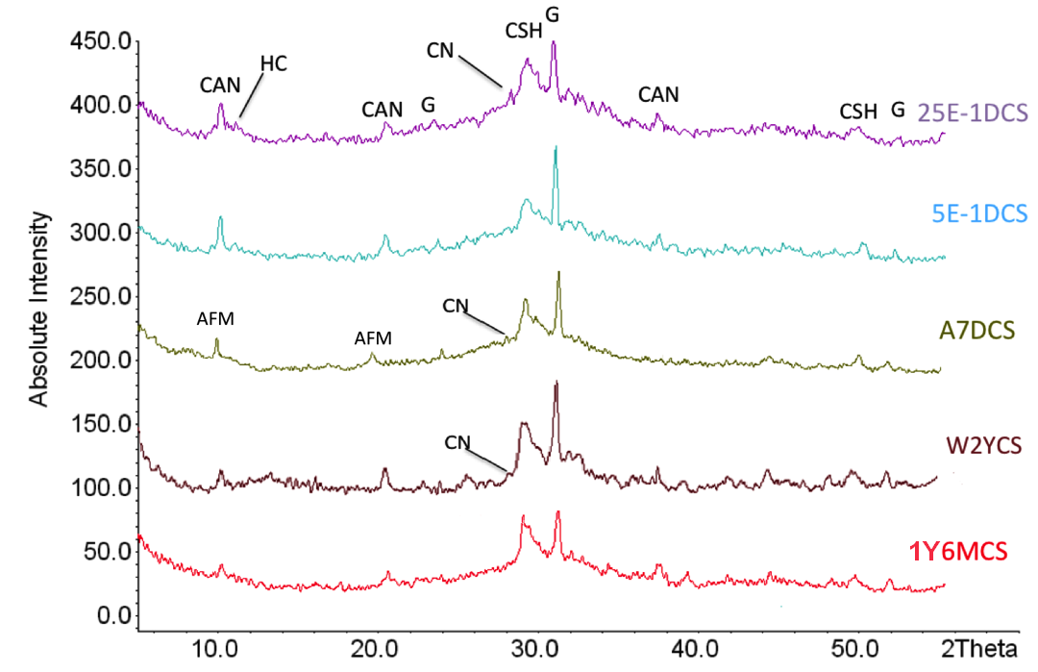
Figure 4.33: XRD traces for cement samples from solutions with the closest amounts of normalised Cs and Sr mass in solution in comparison to W2Y$\overline{cs}$
The XRD results show strong agreement, with similar peak intensities for the main crystal phases. Generally the 1Y6M$\overline{cs}$ sample seems to have relatively smaller peaks, this does comply with the results in figure 4.30 and 4.31 as the leached amounts for both Cs and Sr in this sample are higher than the other samples. The intensity of the CAN peak seems to be relatively stronger in both the E samples. These samples also show a peak for the HC again, whereas the other samples do not. The acidic method seems to alter the crystal structure phase assemblage by impacting the AFm phases. Again the increase in leached amounts between A28D$\overline{cs}$ and A3M$\overline{cs}$ was also very small for Cs and Sr in the acidic leaching procedure.
To further investigate the phase assemblage and the impacts of the various leaching methods, the semi-static and acidic leached samples DTG data were compared. The DTG curve of the 1Y6M$\overline{cs}$ sample compared with the A7D$\overline{cs}$ is shown in figure 4.34 and 2Y$\overline{cs}$ was compared with A14D$\overline{cs}$ in figure 4.5 as these had the closest similarities in leached amounts of Cs.

Figure 4.34: DTG curves from samples 1Y6$\overline{cs}$ and A7D$\overline{cs}$
The DTG curve for A7D$\overline{cs}$ shows a peak for AFm, similarly so does the W-1Y6$\overline{cs}$ sample. However as shown in the heating profile, the CAN phase is absent in DTG of the acidically leached sample supporting the XRD findings, instead there is a very strong peak at around 320-380ºC which could possibly be attributed to the dehydration of the hydrogarnet phase [40]. The XRD traces in figure 4.30 and 4.31 show no peaks for this phase, this could be, however, due to the fact that hydrogarnet is known to be poorly crystalline [46]. Ben Haha et al [45] stated that the hydrotalcite phase (HC) was responsible for the weight loss between 340-400ºC as opposed to hydrogarnet. As this DTG peak is considerably broad and falls between both events and as both of these phases are poor crystalline it is hard to distinguish which is responsible. However given that the heat loss begins at approximately 300ºC it is more likely this is due to the dehydration of the hydrogarnet phase.
The DTG curves in figure 4.35 show a very weak shoulder for the AF_{M} phase in W2Y$\overline{cs}$, whereas the shoulder for AFm in the A14D$\overline{cs}$ seems to be relatively larger than in A7DCS. The peak for CAN in the W2Y$\overline{cs}$ is smaller in comparison to W1Y6M$\overline{cs}$, as expected. Again the CAN peak is absent in the A14D$\overline{cs}$ DTG profile with a strong peak for what is suggested to be a result of the hydrogarnet dehydration.
Figure 4.35: DTG curves from samples W2Y$\overline{cs}$ and A14D$\overline{cs}$
In order to further study the suitability of the acidic leaching test the cement pore structure was studied. The porosity of A14D$\overline{cs}$ was compared with W2Y$\overline{cs}$ using the cumulative volume of pores found in each sample via MIP analysis as shown in figure 4.36.
It was found that the A14D$\overline{cs}$ was approximately 40% more porous than the W2Y$\overline{cs}$ sample, which corresponds favourably with the leached data in figs 4.26, 4.30 and 4.31. This in turn would cause an increase in degradation and leaching as it would increase the exposure surface of cement to the acidic solution.

Figure 4.36: MIP curves from samples W2Y$\overline{cs}$ and A14D$\overline{cs}$
The XRD traces show that applying the electrical accelerated leaching methods to these cement samples retains the same phases as in the samples leached under static/semi-static conditions, however the volumetric and surface characteristics might have been altered significantly. The Ca:Cs:Sr leached amount ratios in the static and semi-static methods with those in the electrical methods from figure 4.26, 4.30 and 4.31, shows that larger amounts of Cs and Sr leach out in comparison to Ca in the electrical methods than in the static methods.
To investigate this further the electrically leached samples DTG data were also compared with the static and semi-static method. The 2Y$\overline{cs}$ DTG curve was compared with that of the electrically leached samples 5E-3D$\overline{cs}$ and 25E-3D$\overline{cs}$ in figures 4.37 and 4.38 respectively.
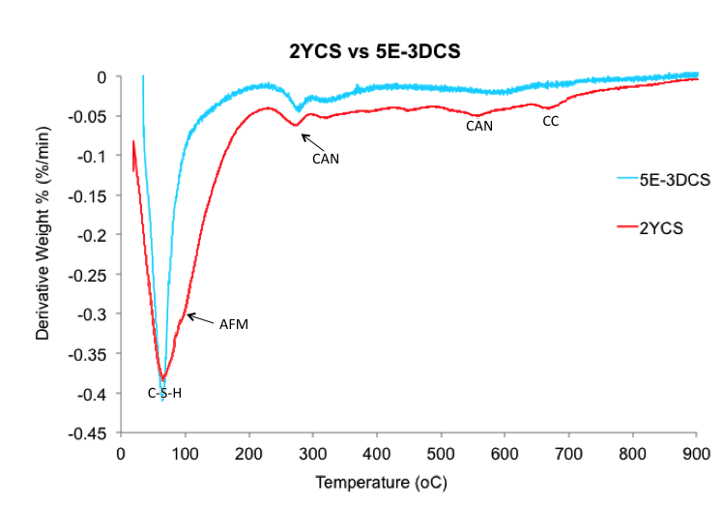
Figure 4.37: DTG curves from samples 2Y$\overline{cs}$ and 5E-3D$\overline{cs}$
There is a strong agreement between the 2Y$\overline{cs}$ and 5E-3D$\overline{cs}$ DTG curves showing a very similar phase assemblage with similar peak intensities for each phase. The main difference is that the shoulder for the AFM phase is not present in the electrically leached sample and the C-S-H peak is narrower in the electrical leached sample. In figure 4.38, however, this AFm phase is present in the 25E-3D$\overline{cs}$ sample and the peaks associated with the CAN phase are absent.
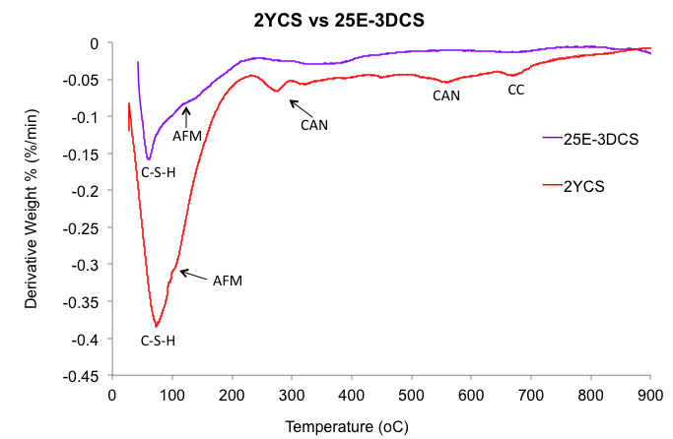
Figure 4.38: DTG curves from samples 2Y$\overline{cs}$ and 25E-3D$\overline{cs}$
In order to investigate C-S-H behaviour, the TG and DTG curves of the 7D samples for both electrical methods (5E and 25E) were compared to those of 1D and 3D, shown in fig. 4.39 and 4.40. These curves show a decrease in the peak associated with C-S-H after 1 day up until 3 days, as expected. However after 7 days the amount of C-S-H has significantly increased in both methods. The applied electrical current is known to have an accelerating effect on the cement hydration [47] therefore the samples were only cured for 42 days after which hydration was arrested, in which case C-S-H formation is not complete. Applying the electrical current may start hydration again as the hydrate ions are transferred through the sample at an accelerated rate and this could further accelerate production of C-S-H, off-setting the amount of C-S-H lost during the leaching process, and therefore increasing the total amount of C-S-H within the cement sample [48].
Figure 4.39: DTG curves for samples 5E-1D$\overline{cs}$, 5E-3D$\overline{cs},$5E-7D$\overline{cs}$
Figure 4.40: DTG curves for samples 25E-1D$\overline{cs}$, 25E-3D$\overline{cs},$ 25E-7D$\overline{cs}$
Another observation from the 25E-3D$\overline{cs}$ TG curve in figure 4.40 shows that the CAN phase was mostly leached out of the sample, given the high aluminium content of this phase the aluminium ICP-MS data was further studied. The normalised leached mass of Al is compared between the electrically leached samples, static and semi-static in figure 4.41.

Figure 4.41: Normalised accumulated mass of Al from waste loaded samples ($\overline{cs}$) for each leaching procedure and their respective leaching periods
The difference in leached amounts of Al between the $\overline{cs}$ and W$\overline{cs}$ are as expected and roughly follow that of the Ca, Cs and Sr behaviour. However there is a larger difference in leached amounts between the electrical leaching and non-electrical. It seems that the acceleration factor is much larger for Al in the electrical leaching process than for Ca, Cs and Sr. For example, when comparing the leached amounts of ions in the 2Y$\overline{cs}$ and 25E-3D$\overline{cs}$, in the 25E-3D$\overline{cs}$ the amount of leached Ca was higher by approximately 7%, Cs by 37%, Sr by 62% and Al by 114%. This significant increase is consistent in all leaching periods in both the 5E and 25E series. The leached amounts of Al in the acidic leaching procedure are significantly low, this does not correspond to the leaching behaviour of the other ions during this procedure, and is much lower than even the static procedure.
The exposure surface of the 2Y$\overline{cs}$ sample was analysed using SEM (figure 4.42) and compared with the exposure surface of 25E-3D$\overline{cs}$ (fig 4.43). The black area at the top of fig 4.42 is the exposure surface and shows the completely degraded regions of the cement sample. The degradation is staggered throughout the sample. The degraded area is made up of very porous C-S-H gel with traces of BFS particles.
Figure 4.42: SEM-BSE on 2Y$\overline{cs}$ exposure surface
The exposure surface of 25E-3D$\overline{cs}$ shows a more degraded cement sample, the cement particle depletion seems sudden whereas in the 2Y$\overline{cs}$ sample it is more of a gradual decrease in cement particles. Although both samples show similar patterns of degradation, the electrical leached sample in fig 4.43 is more degraded with more of the hydrated cement particles absent and a more porous structure, illustrating a significant change in microstructure due to the electrical current. There are dark voids surrounding the BFS particles at a deeper level in comparison to the 2Y$\overline{cs}$ sample.

Figure 4.43: SEM-BSE on 25E-3D$\overline{cs}$ exposure surface
4.2.1.2 discussion
The cement samples were subjected to various leaching methods over varying durations of time. Initially the calcium leached amounts were analysed and the semi-static method was compared to the static method. Calcium was chosen as an indicator of chemical deterioration as it is the main element in the majority of the hydrate phases and has a very significant impact on the cement chemistry [47,49]. The results showed that there was a slight acceleration in calcium ion leaching in the semi-static method. Further research showed that Cs and Sr leaching was also accelerated in the semi-static method. This is attributed to the change in concentration gradient when replacing the solution every 7 days initially and eventually every 10 days. Figure 4.44 simulates what happens when the exposure surface is in contact with the solution at the start of each test, the concentration of ions in solution is, of course, zero and the concentration of ions in the sample is optimal. This concentration gradient causes an affinity for ions to diffuse into solution. As leaching progresses the concentration of ions in solution increases and the difference in concentrations between the ions in solution and the ions in the sample decreases. This in turn causes a decrease in affinity for ions to leach out and reduces the leaching rate. Eventually the sample solution reaches saturation at which point the affinity for ion leaching is very low and close to 0. There are always ions coming out from the solid and those going back from the solution. The balance between those two flows results in a certain concentration of ions in solution at a certain time. When the concentration of the ion in the solution increases, the ones going back from the solution into the cement naturally increases. This results in the reduction of NET ion coming out from the solid. In the semi-static tests, however, the solution is replaced at regular intervals thus resetting the concentration gradient and increasing ion diffusion as illustrated by the schematic diagram in figure 4.44.
The Ca leached amounts were much less than the Cs and Sr. This could be due the leaching process described by Poon et al [50], explaining that heavy metals leach rapidly in the first stage until their respective steady leaching points are reached and then the leaching rates decrease. This is because in the second stage of leaching, the Ca first needs to leach out in order to degrade the matrices of the solidified wastes before any more of the heavy metals are leached out. However this is most probably because the Ca is better retained with the cement in comparison to Sr and Cs. Due to Sr and Cs being much larger than Ca and much more mobile.
Figure 4.44: Schematic illustrating the relation between solution concentration and ion diffusion speed
The alkalinity of the solution has a significant impact on the leaching rates. Bishop et al [46] found that an increase in pH increases the rate of silica dissolution, up until around a pH of 10. However they found that at a pH level of >11 the silica concentration in the solution decreased. According to Batchelor and McDevitt [51] when the solution is at a pH of >11 the calcium silicates begin to adsorb to calcium hydroxide and as a result form a barrier/obstacle for further leaching. This decreases the likelihood of cement degradation. Furthermore they found that at pH levels below 9, the solubility of silicates is very limited [49,51]. The leaching of alkalis from the cement sample will increase the pH. The pH of the water fluctuates with the water changes as can be seen in figure 4.28, every time the water is changed the pH drops by around 0.5-1. Therefore this means the pH remains below 11 phenomena in which silicate dissolution is slowed down is not inhibited in the semi-static tests. Based on this it can be expected that in the semi-static solutions there will be a higher concentration of silicate, as the silicate is mostly associated to the C-S-H phases within the cement an increase in Ca concentration would also be expected.
The acidic leaching procedure showed a significant increase in leached amounts of Ca, Cs and Sr. Comparing the leached amounts of Ca after 7 days in the static and semi-static with the acidic tests, it can be seen that the leaching rate on average is increased by a factor of approximately 80 in the $\overline{cs}$ samples and 110 in the B samples, which is comparable with the factor of 130 reported by Wan et al [52] and the factor of 121 reported by Moranille et al. [53]. Although this method does significantly increase the rate of leaching, it presents certain issues.
The introduction of nitrate in the acidic leaching solution interfered with the cement matrix as the XRD and DTG data showed different phase assemblages within the sample. A significant increase in what is suggested to be the hydrogarnet phase was shown in the DTG results. According to Rodger and Groves [54] small amounts of hydrogarnet are known to be present in these cement samples and small amounts have been detected in the past, more often in products made up of raw materials rich in alumina. This was found to be the case in systems where SiO₂ and Al₂O₃ in the cement sample, are readily available compared to Ca. There is a high likelihood of an abundance of Al₂O₃, as figure 4.41 shows that the leaching of Al from the cement sample was limited. They found that in such environments C-S-H of low Ca/Si ratio was formed together with stratlingite, hydrogarnet or both. Therefore the phase represented in the acid leached samples, and the TG data shown in figures 4.34 and 4.35, could arise from a mixture of phases consisting of significant amounts of C-S-H and a hydrogarnet similar in composition to that found by Rodger and Groves [54]. According to Roziere and Khelidj [55] the leaching of cements in NH₄NO₃ solutions could result in the formation of more CAN phases within the cement. However this does not seem to be the case in the A-$\overline{cs}$ samples as the peaks associated with CAN are not visible in either the XRD or TGA data. Also as acidic leaching progresses stronger peaks for AFm can be seen in the 14 day sample DTG curve. Acidic solutions rich in sulphate have shown that the sulphate can substitute back in the cement matrix to form ettringite alongside calcium sulphates and suggested that nitrates could also behave in the same manner. Park et al [6] found that diffused sulphate can re-enter the cement sample to form ettringite as suggested by Taylor [13]. However they state that although cements can remove sulphates from the solution, nitrates are much harder to remove by precipitation as metal nitrates are usually highly soluble and rarely complex with cations. Therefore the acidic solution could be causing a rapid leaching of the nitrates and sulphates, with only the sulphates returning into the cement explaining the absence of CAN along with the increase in AFm. Furthermore a significant amount of the nitrate in solution is expected to be driven off as ammonia gas and this was apparent by the very strong distinctive smell given off when opening the leaching containers. The increase in AFm peaks was also noticed in the DTG of acidically leached blank samples. Although the electrical leaching method causes an increase in certain phases, the acidic leaching method causes significant alterations in the cement phase assemblage creating new phases, this compromises its viability as an option to predict future leaching behaviour of cementitious wastes. The acidic attack on the cement sample also caused an increase in porosity, this is expected as the NO₃⁻ in solution accelerates the calcium and hydroxyl leaching and displaces the OH⁻ as shown by Roziere and Khelidj [55], to form Ca(NO₃)₂ . This reaction also explains the decrease in rate of leaching noticed between 28 days and 3 months in all the samples, the more these reactions occur and the more OH⁻ in solution causes an increase in pH making the solution less acidic. Another reason why the porosity is lower in the W-2Y$\overline{cs}$ sample could be due to the continued hydration over the 2 year period in comparison to the 14 days in A14D$\overline{cs}$, although the leaching amounts are the same. According to Liu et al. [56], an increase in hydration causes a decrease in porosity and an increase in sample density.
The electrical leaching tests showed significantly higher leaching rates with generally good agreement in the cement phase assemblage after degradation when comparing to the static leached samples. The increase in electrical current significantly increased the ion leaching as expected, without compromising the procedure although the phase assemblage was altered as showing in figure 4.32.
The microstructural analysis of the 2Y$\overline{cs}$ samples shows a gradual change in the cement structure as the distance from the surface increases, this is explained by Andac & Glasser [57] using their zonal description. They state the part of the cement that is immediately exposed to the leachate zone I, this zone is very thin and significantly low in Ca. This is followed by zone II which is deeper within the cement and it is where cracking of the cement occurs this can also be seen in figure 4.42. The figure also shows what is described by Andac & Glasser as zone III a moderately leached zone, followed by the calcium-rich zone IV and finally zone V the layer wherein very little or no leaching has occurred [57]. This gradual zoning does not occur in the electrical sample. The change is more aggressive and zone I is significantly larger than zone II and III, and because the leaching has reached a deeper level zone IV and V are not visible.
Although the electrical leaching method is a good option for accelerating ion diffusion, there are several limitations when using the method. The first being the increase in the rates of Al leaching. This could suggest that the Al leaches out earlier in the electrical leaching tests. Gordon & Brady [58] found that AFt and AFm phases leach Al from the very beginning of the test and explained that this could be due to the sulphate and calcium are easily separated due to the weak ionic binding between the them and the aluminate, therefore the sulphate would be attracted to the anode and the calcium the cathode. In the standard conditions it was found that the leaching behaviour of portlandite, C-S-H and AFm leaching depended on sample depth, with the phase closest to the surface leaching first. This also supported by Saito and Deguchi’s [59] findings when analysing the degraded cement sample they found that the original AFm and Ca(OH)₂ in the sample had completely diffused from the degraded region with only C-S-H remaining. This suggests that both these phases completely leach out before C-S-H. The results disagree, however, with the work of Castellote et al. [60], who found that although the portlandite and C-S-H behaved in this manner, the calcium aluminate phases leached from the sample independent of distance from the electrode. In the static samples however only portlandite leaches first with AFm leaching at a later stage. The second limitation is that the oppositely charged ions are separated. In accordance to basic electrochemical principles the cations will move towards the cathode and anions to the anode. This in turn would cause ions to leach in different directions from two surfaces of the sample. The positive Ca²⁺ ions remain in the solution on the opposite side to the OH⁻ whereas in the standard conditions the Ca²⁺ could react with the leached negative ions. Also the electrical method produces more OH- in solution than usual because of water electrolysis which could form Ca(OH)₂ precipitate. This would create a pH imbalance caused by the excess OH⁻. Gordon and Brady [58] found that a portlandite of lower crystallinity and higher density was precipitated in the electrical leached samples. This also means that the C-S-H layer found on the leaching surface in the static and semi-static leaching tests will only occur on the cathode side of the electrically leached samples as the Ca²⁺ will diffuse into the cathode side. Given that this barrier is only forming on one surface of the sample this means the cation leaching will decrease and as such the anions will leach at lower rate too, in order to keep a charge balance. Although the OH⁻ from the sample required to reform the C-S-H layer will diffuse into the solution on the anode side, electrolysis of the deionised water itself [57] will provide the required OH⁻ on the cathode side to form this C-S-H barrier, as shown here,
At cathode: 2H₂O + 2e⁻ → H₂ + 2OH⁻
At anode: H₂O → ½ O₂ + 2H⁺ + 2e⁻
Water electrolysis caused the liberation of O₂ and H₂ gases from the solution as shown by Saito et al, this however does not occur under natural conditions in the semi-static and static tests. However Saito explained that this has minimal effects on the ion movement efficiency. Although significant research is available [58,59,60,61], for the electrical leaching method, little emphasis has been placed on the effect of pH on the leaching rates. The pH of the solutions was studied for both the anode side and the cathode side. The pH of solutions from both the anode and cathode side are shown in figure 4.45 which compares the values for 5E-B and 25E-B, and figure 4.46 compares the CS samples. The first observation is that the higher current the greater the disparity in pH from the original value. This is expected as the rate of leaching increases with an increase current. The pH of the solution on the cathode side rapidly rises to 11 in the 5A/m² and 12 in the 25A/m² sample. Whereas the pH of the solution on the anode side rapidly drops to levels around 3 and 5 respectively, therefore creating a highly alkali solution on one side of the sample and a highly acidic solution on the other. This means on the side that is alkali the leaching rate would decrease, and on the side that is acidic the leaching rate would increase significantly as it was found by several sources that an acidic solution can significantly increase rates of leaching [6,53,62,63,64]. This large difference in pH means that ions leaching on the anode side would eventually diffuse at a different rate to ions the leaching on the cathode side.
Figure 4.45: Leachate pH over 7 day period for E-B samples

Figure 4.46: Leachate pH over 7 day period for E-CS samples
Gordon and Brady [58] also investigated the pH of pore solution of the cement itself, and found that once the OH⁻ was produced at the cathode side it moved towards the anode by travelling through the cement sample, while the H⁺ produced at the anode side moved to the cathode. They also found that H⁺ that flowed was neutralised by the excess OH⁻. The same amounts of OH⁻ were produced as a product of electrolysis on the cathode side as H⁺ on the anode side, therefore meaning there was excess OH⁻ from the portlandite diffusion. As a result acidification of the surface of the sample was highly unlikely. Again this will cause an impact on the degradation of either side of the sample. However it was found that in the middle of the sample, at equidistance from both exposure surfaces, contained a pH similar to the initial pH of the sample before leaching. Figures 4.42 and 4.43 also show that the pH reaches a constant at around 12 on the cathode side, this supports Dell’Orso et al [65].
The TGA data of the electrical leaching tests showed an increase in C-S-H. Castellote et al. [60] studied the microstructural changes in cement paste as a result of electrical leaching. They found that the leached crystalline phases (pore size of 0.07 ug), later precipitate as an amorphous phase in the smaller pores, with some being located in the C-S-H gel layers therefore increasing the amorphous fraction. This was further supported by Hindrichs and Odler [66] where it was considered the C-S-H and portlandite were in solid solution therefore with an increase in Ca and precipitation of portlandite, it is likely that new C-S-H would form.
A limitation of this study was the use of deionised water, as according to Glasser [67] deionised water may enhance cement matrix dissolution and it was found that it had the most pronounced effect on the Cs leach rate. This behaviour is different than what would be expected with some natural groundwaters that are of moderate hardness [12]. Furthermore it was found that the carbonate from groundwater can partially restore capillary pores and cracks reducing permeability. It also clogs pores and forms an obstructive calcite layer which in turn decreases the leach rate. Therefore the difference in leaching behaviour between samples in deionised water and samples in extracted groundwater should be investigated to quantify the differences in leaching between the methods, and establish whether they are significant [64].
Although the above mentioned methods are the generally recognised accelerated leaching methods, there is another factor which can also impact leaching and can be investigated in future work. Ojovan et al [69] studied the impact of the temperature on the leaching rates. They found that a repository temperature of between 4-14ºC decreased the leaching rate by a factor of approximately 10. They also found that as temperature increased the leaching rate increased also, this is important in experiments where a repository environment is simulated as temperatures vary, and therefore there is scope to study this further in the future. This is also a concern as elevated temperatures can have a compromising impact on the structural integrity of the cements, therefore in future work the temperature of the leachate solution could be monitored in the various leaching methods and then elevated to test the impact of this the leaching behaviour and the cement structure.

4.2.2 Cement Degradation During Leaching

The diffusion depth was investigated to understand the degradation behaviour over time with varying depth. The study focuses on the semi static leaching test, as it indicated a degree of acceleration in leaching without obvious alteration in the leaching mechanism. Cement samples were removed and cut at the end of each leaching cycle. Disc samples were dissected at every 5mm intervals from the exposure surface to a total of 15mm, these are respectively labelled 1, 2 and 3, with 1 being the sample at the top of the sample exposed to the leachate. This allows for the analysis at different depth within the samples.

4.2.2.1 Results

i. X-ray diffraction (XRD)
The 7DB trace is shown for all three samples in figure 4.44. The distinct peaks shown at 38 and 44º2θ are due to the sample holder used for measurement. All the original hydrate phases that were present in 0DB are also present in 7DB1, 7DB2 and 7DB3. There is possibly a slight decrease in intensity of the Portlandite peak in the 7DB1 sample.

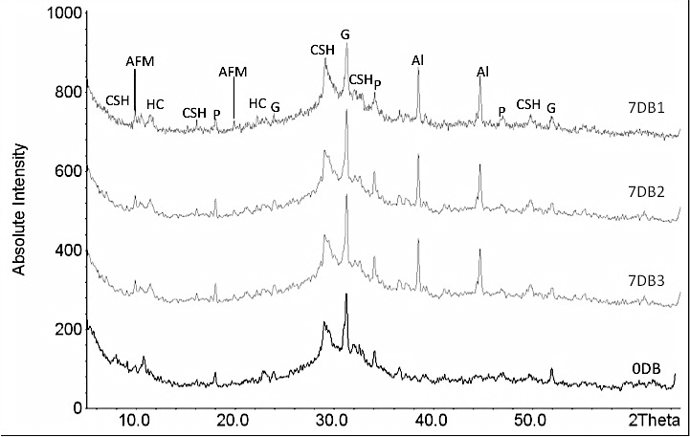

Figure 4.47: XRD analysis of 7DB series at 5mm, 10mm and 15mm from exposure surface compared with 0DB
The traces for samples analysed after 28 days of leaching is shown in figure 4.48, the 28DB1 sample shows a decrease in peak intensities for all phases. The peaks in 28DB2 are also slightly weaker than those in 0DB suggesting that leaching was significant at this depth The peaks associated with the Al sample holder are not present due to a change in sample holder.

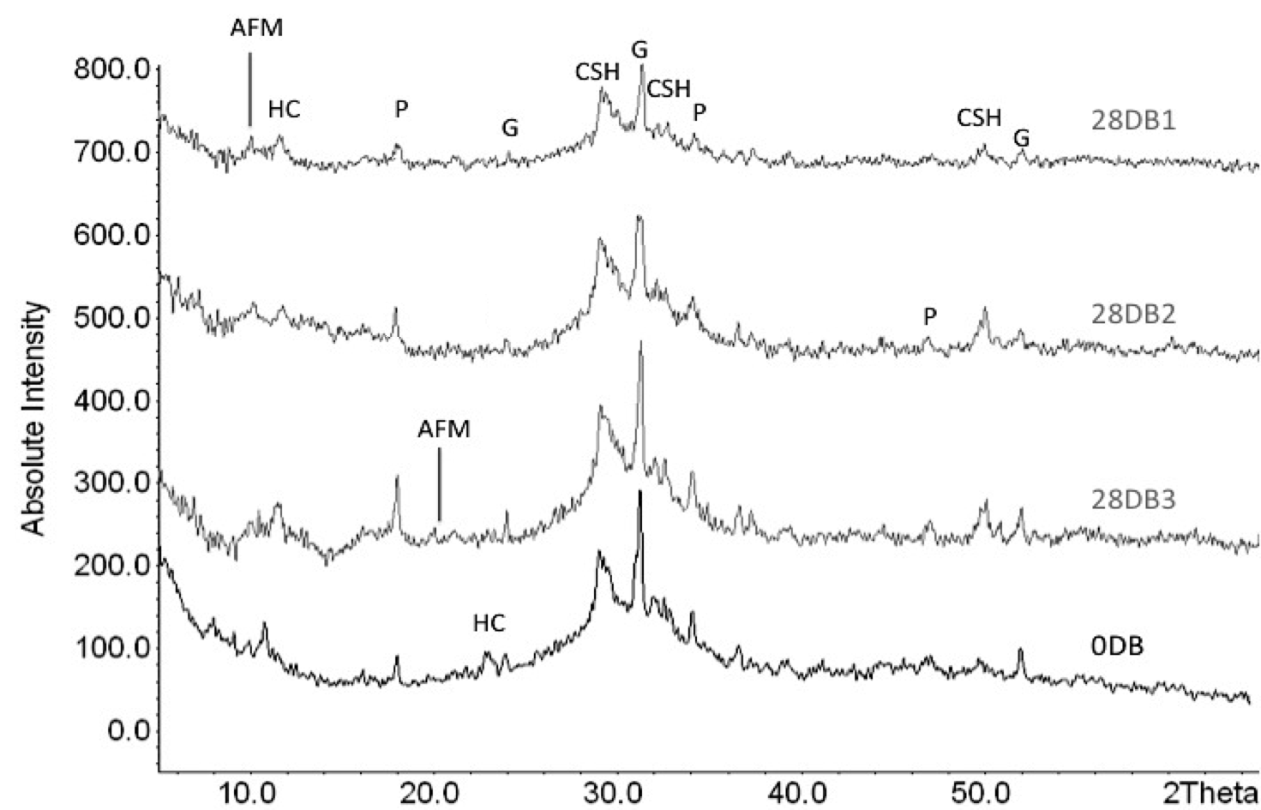

Figure 4.48: XRD analysis of 28DB series at 5mm, 10mm and 15mm from exposure surface compared with 0DB
The traces for the samples analysed for 6 months are given in figure 4.49, as expected the peaks for the phases are very weak and some are barely visible. The monosulphate peak is barely visible in both 6MB1 and 6MB2, this could possibly mean that components of the AFm phase are leaching out faster than components in the other phases. The overall patterns for the 6MB1 and 6MB2 are similar in intensity; however the 6MB3 peaks are significantly more intense. This suggests that leaching has still not surpassed a 10mm depth within the sample.
Comparing these traces with that of the 1Y6MB samples in fig. 4.50 it can be seen that only C-S-H and G are identifiable in the 1Y6MB1 samples, indicating that the component of the majority of the other phases have leached out from the sample. The 1Y6MB2 sample shows weak peaks for the phases originally presented, apart from the AFm and HC phases. The 1Y6MB3 trace shows weaker peaks in comparison to the 0DB sample, which means that the leaching has now reached third layer of the sample i.e. >10mm depth.

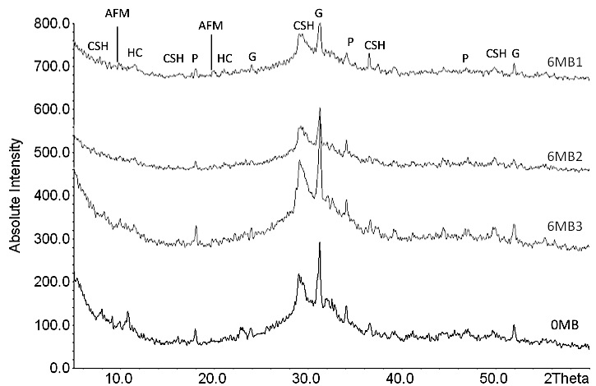

Figure 4.49: XRD analysis of 6MB series at 5mm, 10mm and 15mm from exposure surface compared with 0DB

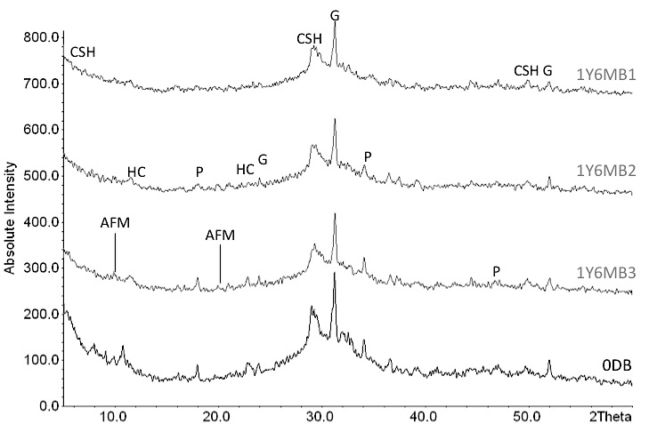

Figure 4.50: XRD analysis of 1Y6MB series at 5mm, 10mm and 15mm from exposure surface compared with 0DB

The XRD traces for the 2YB layers are shown in figure 4.51. The peak intensities in the 2YB3 are now significantly weaker, however portlandite is still present. This suggests that after 2 years of semi-static leaching portlandite, at a depth of 10-15mm, has still not fully degraded.

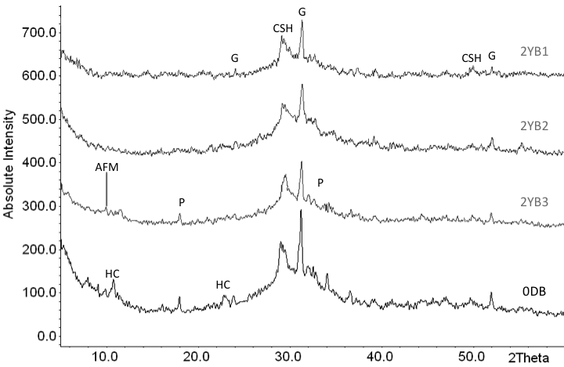 Figure 4.51: XRD analysis of 2YB series at 5mm, 10mm and 15mm from exposure surface compared with 0DB
The XRD traces of second layers representing a depth of 5mm-10mm have been compared in figure 4.52 to study the progress of the leaching process.
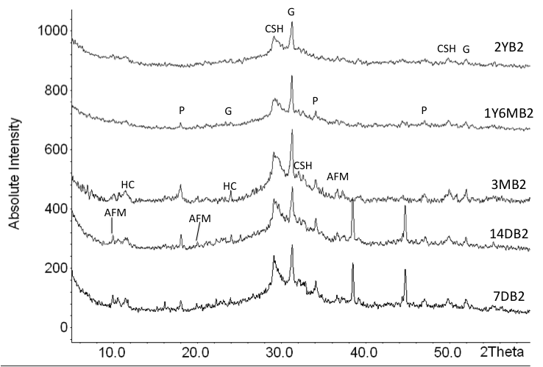

Figure 4.52: XRD analysis of the B samples at a depth of 5-10mm over various leaching periods
The XRD data for the $\overline{cs}$ series was analysed in the same manner, the top 3 layers of 7D$\overline{cs}$ are compared in figure 4.53. Again peaks from the aluminium sample holder can be seen. The majority of the peak intensities is similar for all samples, however the CsNO₃ peak is significantly weaker in the 7D$\overline{cs}$1 layer and moderately weaker in the 7D$\overline{cs}$2 sample but remains similar to 0D$\overline{cs}$ in the 7D$\overline{cs}$3 samples. There is a peak at ~40º2θ in the 7D$\overline{cs}$3 sample that was unidentifiable.

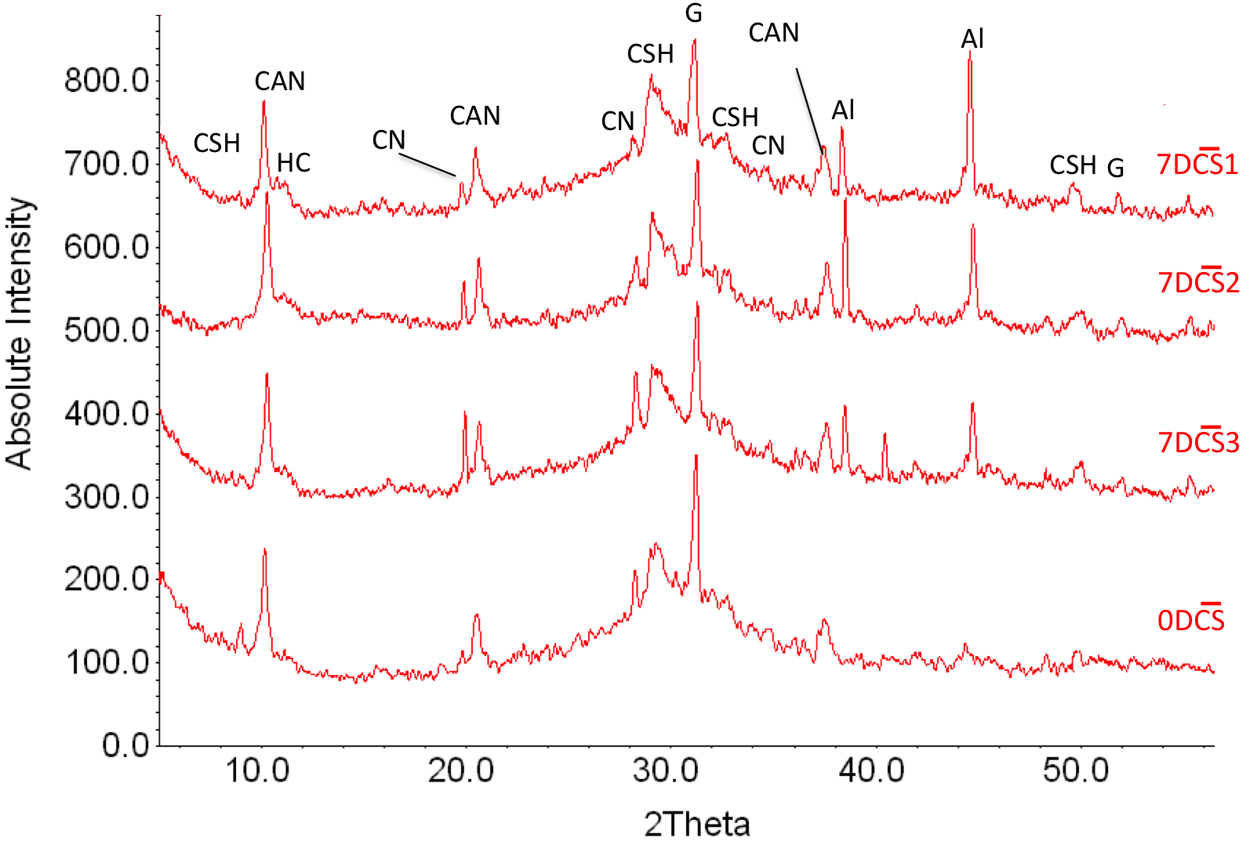 Figure 4.53: XRD analysis of 7DCS series at various distances from exposure surface compared with 0D$\overline{cs}$
The XRD traces of the 28D$\overline{cs}$ series in figure 4.54 show that after 28 days of semi-static leaching the top layer 28D$\overline{cs}$1 show weak peaks for all phases. There is a significant decrease in the CAN phase in comparison to the 28D$\overline{cs}$2, 28D$\overline{cs}$3 and 0D$\overline{cs}$ samples, suggesting that after 28 days there is considerable leaching of ions from this phase. The CN (CsNO₃) peaks are not observable, suggesting the depletion of the CsNO₃ from the 5mm of the sample after 28 days, however there are still peaks for this phase in the second 28D$\overline{cs}$2 layer, which unexpectedly seem to be stronger than those in 28D$\overline{cs}$3. This could be due to the concentration gradient drawing the phase components towards the surface. The shoulder/peak attributed with hydrotalcite is stronger in the 28D$\overline{cs}$3 in comparison with 0D$\overline{cs}$, which is probably the result of continued hydration in the 28 day leaching period. These results will be cross-referenced with the TG results to further investigate this.

Figure 4.54: XRD analysis of 28DCS series at 5mm, 10mm and 15mm from exposure surface compared with 0D$\overline{cs}$

The CAN peak intensity is not changed for 6M$\overline{cs}$3 as shown in figure 4.55, however has decreased significantly for 6M$\overline{cs}$2 in comparison to 28D$\overline{cs}$2. There is also a stronger peak in 6M$\overline{cs}$2 attributed to the crystalline C-S-H phase, which could be the result of hydration. The CN peak seems to be absent in all three layers suggesting that the leaching of this phase has reached a depth of 15mm within the sample, although 6M$\overline{cs}$3 shows strong peaks for all the other phases. The ettringite peak disappears in all samples after 7 days suggesting that the continuous hydration changed this into the AFm phase CAN.

Figure 4.55: XRD analysis of 6M$\overline{cs}$ series at various distances from exposure surface compared with 0D$\overline{cs}$

The 1Y6M$\overline{cs}$1 XRD traces shown in figure 4.56 show no clear peaks for CAN or CN, however HC peaks are still visible. This suggests that the CAN phase is depleted within 5mm of the cement sample. The CN is absent in the second layer 1Y6M$\overline{cs}$2 , however can be seen in the third layer 1Y6M$\overline{cs}$3. This does not follow the suggestions of figure 4.56 that the CsNO₃ diffusion has reached the third layer.

Figure 4.56: XRD analysis of 1Y6M$\overline{cs}$ series at 5mm, 10mm and 15mm from exposure surface compared with 0D$\overline{cs}$

Figure 4.58 shows the 2Y$\overline{cs}$ samples, the CN peaks are absent in all three layers, the distinctive CAN peaks are now absent in the second layer too. The HC as depleted from the top layer however still remains in the second layer. Finally the CAN phase is still clearly present in the third layer. This suggests that after 2 years of leaching HC depletion is not complete at a depth of 10mm, and CAN depletion is not complete at a depth of 15mm.

Figure 4.58: XRD analysis of 2Y$\overline{cs}$ series at 5mm, 10mm and 15mm from exposure surface compared with 0D$\overline{cs}$

Finally the data for the second layer at all leaching periods are compared for this series in figure 4.59. The traces show that the CAN and HC phases are still present in the second layer of the cement sample up until 1 year and 6 months. However the CN peaks disappear at the 6 month sample. Suggesting that the CsNO₃ is fully leached out within 10mm depth of the sample at this stage.

Figure 4.59: XRD analysis of the $\overline{cs}$ samples at a depth of 5-10mm over various leaching periods

ii. Thermogravimetric Analysis (TGA)
TGA was used to analyse layers 1,2 and 3 also. The results were collected for the samples at different depths to get a quantified idea of phase depletion at different depths during the leaching tests. Figure 4.60 shows the TG and DTG curves for 7DB.

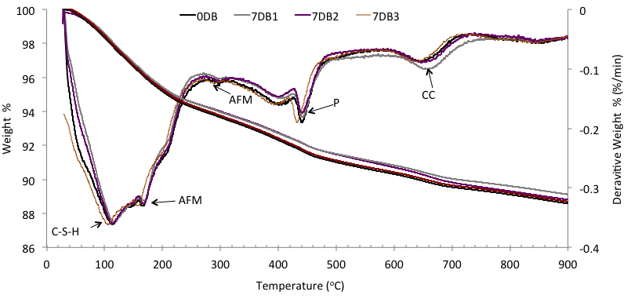Figure 4.60: TG/DTG analysis of 7DB series at various distances from exposure surface compared with 0DB (left Y axis associated with TG curves, right Y axis associated with DTG curves)
The total weight loss for 7DB1 is negligibly less than that of 0DB, 7DB2 and 7DB3. In the range 25-300ºC the TG curves show the weight loss to be similar for all 4 samples, at around 400ºC the weight loss due to the dehydroxylation of P is slightly less for 7DB1. These differences are negligible at this leaching period however with further leaching after 28 days we can see a decrease due to the dehydration of C-S-H and the dihydroxylation of P as shown in figure 4.61. The weight loss due to Portlandite decreases by around 3% and this is responsible for the majority of difference between the total weight loss in 28DB1 and 0DB. The weight loss in the 600-700ºC region is due to CC (CaCO₃).
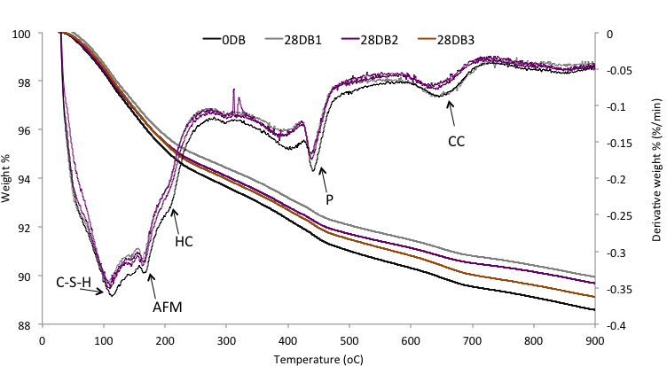Figure 4.61: TG/DTG analysis of 28DB series at various distances from exposure surface compared with 0DB (left Y axis associated with TG curves, right Y axis associated with DTG curves)
The weight loss in the region of 90-200ºC attributed to the dehydration of C-S-H and AFm decreases slightly in the 28DB samples whereas it remains similar in the 7DB samples. It appears that the leaching of C-S-H and AFm became significant after 7 days and reaches a depth <10mm in the sample by 28 days.
The TGA curves for 6MB are shown in figure 4.62. The difference in weight loss between 0DB and 6MB1, 6MB2 and 6MB3 begins to show at 100ºC, suggesting that ions from all the identified phases have now started leaching out up to a 15mm depth. The gradient of the TG curve at 400-450ºC is flatter in 6MB1 in comparison to 6MB2 and 6MB3 indicating less of the P phase in 6MB1, this further supports the proposal that ions from portlandite are the first to leach into the solution before ions from other phases. This is the main reason for the difference in total weight loss between the top layer 6MB1 and the deeper layers 6MB2 and 6MB3.
Figure 4.62: TG/DTG analysis of 6MB series at various distances from exposure surface compared with 0DB (left Y axis associated with TG curves, right Y axis associated with DTG curves)
The behaviour of the 2YB samples (shown in figure 4.63) is somewhat unexpected and does not follow the pattern of earlier samples. There seems to be an increase in weight loss for C-S-H dehydration in all 3 layers in comparison with 0DB, however the weight loss due to portlandite is less in the 2YB samples than 0DB as it is consumed by slag in a pozzolanic-type process. These two main factors seem to offset each other and as such all three samples have a very similar total weight loss. There is also a decrease in weight loss due to the CC phase,
Figure 4.63: TG/DTG analysis of 2YB series at various distances from exposure surface compared with 0DB

The TGA curves for the $\overline{cs}$ series were also collected, figure 4.64 shows the 7D$cs$ series. After 7 days of leaching, the total weight loss decreased by approximately 2.5% for all three discs, compared with that of the 0D$\overline{cs}$ sample. The difference in weight loss begins at around 300oC therefore this difference can be attributed to the leaching out of ions from the CAN phase, this difference increases at the other CAN events on the heating profile. The significant difference in weight loss starts at around 500ºC. This has also been attributed to the decomposition of CsNO₃ and the decomposition of the nitrite in the Ca₄Al₂(OH)₆(NO₂)₂ phase producing Ca₄Al₂(OH)₆. This difference in weight loss due to the leaching of CsNO₃, corresponds strongly with the XRD analysis, suggesting that the CsNO₃ is not well retained within the sample and leaches very easily at depths up to 15mm in the sample after only 7 days.
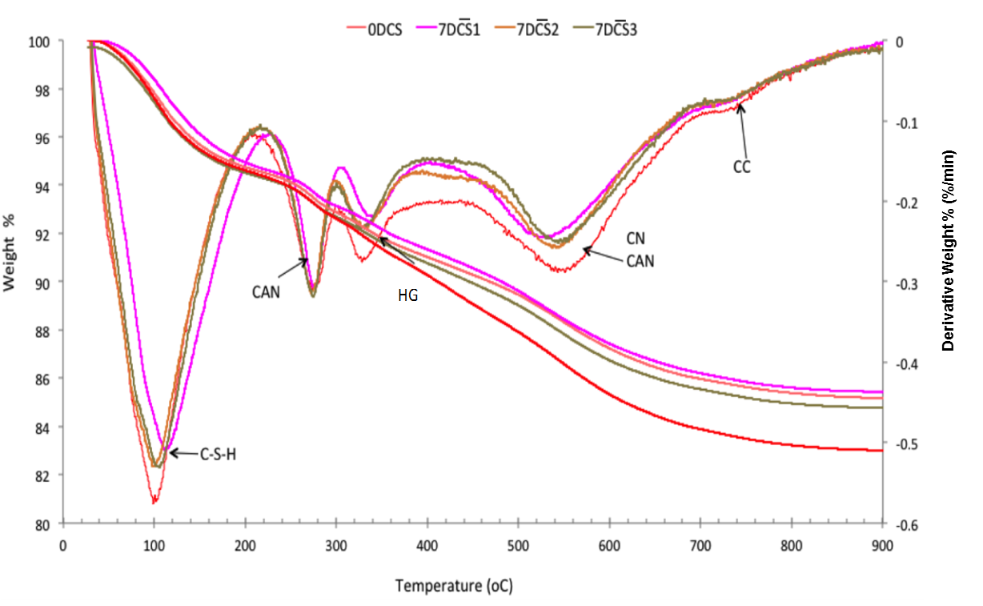
Figure 4.64: TG/DTG analysis of 7D$\overline{cs}$ series at various distances from exposure surface compared with 0D$\overline{cs}$ (left Y axis associated with TG curves, right Y axis associated with DTG curves)
The TGA for each of the 28D$\overline{cs}$ series is compared to 0D$\overline{cs}$ in figure 4.65. After 28 days the difference in weight loss becomes apparent much earlier in the heating profile at 100ºC. There is a negligible difference between total weight loss between 28D$\overline{cs}$1 and 28D$\overline{cs}$2; this suggests that ions from all the identified phases have started to leach from deeper within the sample.
Figure 4.65: TG/DTG analysis of 28D$\overline{cs}$ series at various distances from exposure surface compared with 0D$\overline{cs}$ (left Y axis associated with TG curves, right Y axis associated with DTG curves)
In comparison to figure 4.64, it can be seen here that there is less C-S-H and CAN, suggesting that ion leaching from these phases is occurring. Again the weight loss attributed to CsNO₃ starting at around 500ºC seems to be much higher for 28D$\overline{cs}$3 and 0D$\overline{cs}$ suggesting that after 28 days most of the CsNO₃ has leached from 10mm of the sample, as the heating profile seems very similar for both 28D$\overline{cs}$1 and 28D$\overline{cs}$2. The weight loss for both 0D$\overline{cs}$ and 28D$\overline{cs}$3 for this event is approximately 3wt%.
The 6 month sample analysis in figure 4.66 shows little difference in the heating profile between the top two discs, however the 6M$\overline{cs}$3 total weight loss is more than that in 28D$\overline{cs}$3. Could be due to C-S-H gradually losing weight, more C-S-H produced hydration reactivated in sample, or this seems to be due to an event at around 380ºC, due to the dehydration of the hydrogarnet phase (HG), which seems to have slightly shifted. 6M$\overline{cs}$3 shows a small hump at around 700ºC indicating signs of carbonation of the sample.

Figure 4.66: TG/DTG analysis of 6M$\overline{cs}$ series at various distances from exposure surface compared with 0D$\overline{cs}$ (left Y axis associated with TG curves, right Y axis associated with DTG curves)
The TGA heating profiles of the 2 year samples (figure 4.67), show an increase in weight loss due to C-S-H and CAN and a significant decrease in weight loss due to CN. The figure also shows some carbonation in the top layers, this assumed to be a reaction with the dissolved CO₂ in the water.
Figure 4.67: TG/DTG analysis of 2Y$\overline{cs}$ series at various distances from exposure surface compared with 0D$\overline{cs}$ (left Y axis associated with TG curves, right Y axis associated with DTG curves)
iii. Mercury Intrusion Porosimetry (MIP)
The cement samples were analysed using MIP. The cumulative pore volume for layer 1 after each leaching period for the blank series is shown in figure 4.68. As can be seen the total pore volume of the cement increases as leaching progresses. Therefore it seems that leaching and eventual degradation of the cement causes an increase in porosity, as expected. The difference in porosity is smaller towards the later stages of leaching which strongly agrees with the ICP results in section 4.2.1.
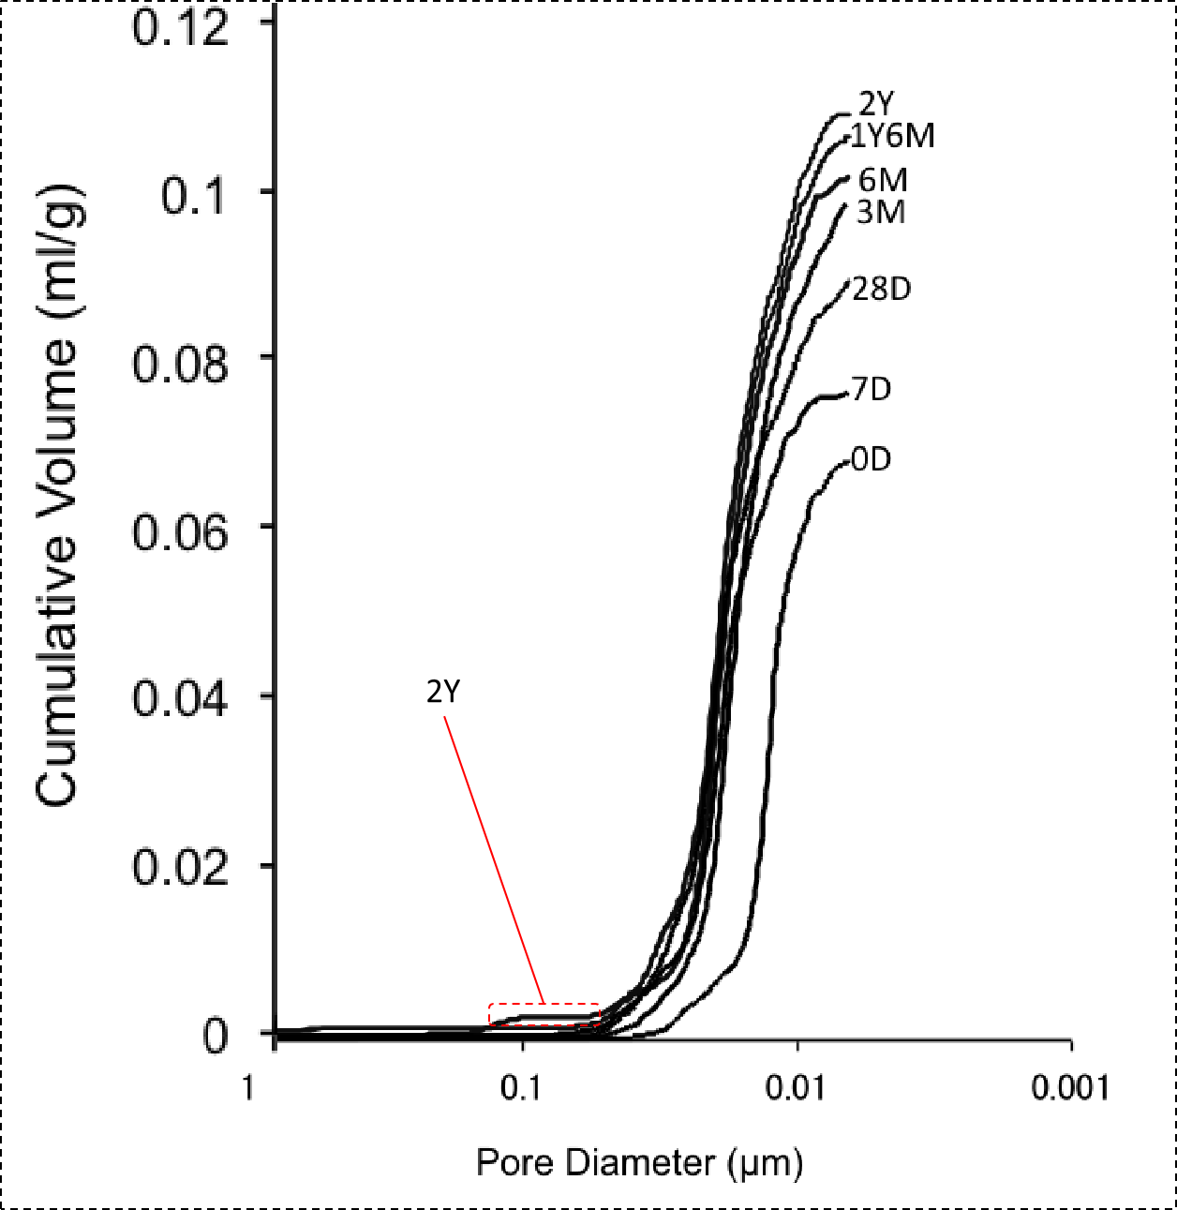
Figure 4.68: MIP analysis of B series exposure surface (i.e. B1) at various leaching stages
The same data was gathered for the $\overline{cs}$ series as shown in figure 4.69. Once again there is a positive correlation between the leaching period and the sample porosity. In comparison with the B series, the total porosity increase is larger in these samples. This could be due to the increased leaching rates, as well as the rapid diffusion of CsNO₃ leaving larger pores in the sample.
Figure 4.69: MIP analysis of $\overline{cs}$ series exposure surface (i.e. $\overline{cs}$1) at various leaching stages
Figure 4.70 shows the comparison between the total porosity in 28DB at different depths, and figure 4.71 shows the incremental pore volumes in order to obtain some indication of the pore size distribution and attempt to understand the phase attributed to these pores.

Figure 4.70: Cumulative pore distribution of 28DB1 and 28DB2
The top layer is more porous and as can be seen in figure 4.71 this is because of higher number of pores with size 0.015-0.025 microns in 28DB1 shown by the higher peak in this region.
Figure 4.71: Incremental pore distribution of 28DB1 and 28DB2 compared with 0DB
The incremental pore distribution of 0DB was also compared on this figure, as expected the peak at 0.015-0.025 is of similar height to 28DB2. However there seems to be a higher volume of smaller pores around the 0.011-0.012 region.
The same analysis was performed for the 6MB1 and 6MB2 samples as shown in figure 4.72. The cumulative porosity for both samples is similar and there is negligible difference. This suggests the leaching has reached the second layer and as such the sample has degraded and become as porous as the leaching surface.
Fig 4.72: Cumulative pore distribution of 6MB1 and 6MB2

The incremental porosity in figure 4.73, shows the majority of the pores are within the same region of 0.012 and 0.025 microns.
Fig 4.73: Incremental pore distribution of 6MB1 and 6MB2
The cumulative pore volume for the CS loaded samples shows that the 28D$\overline{cs}$1 is more porous than 28D$\overline{cs}$2 (fig 4.74) and 28D$\overline{cs}$2 is more porous than 0D$\overline{cs}$ suggesting the leaching is degrading the sample deeper within however the surface is leaching at higher rate. When comparing the incremental pore volumes in figure 4.75, it seems that the majority of pores have a size of 0.008-0.018 microns in the 28D$\overline{cs}$1 sample and this seems to be the reason for the higher porosity of 28D$\overline{cs}$1, whereas the pores in the 28D$\overline{cs}$2 sample have a relatively even distribution of pores between 0.008-0.04

Fig 4.74: Cumulative pore distribution of 28D$\overline{cs}$1 and 28D$\overline{cs}$2

Fig 4.75: Incremental pore distribution of 28D$\overline{cs}$1 and 28D$\overline{cs}$2

The cumulative porosity of 6M$\overline{cs}$1 and 6M$\overline{cs}$2 is similar and both are significantly higher than 28D$\overline{cs}$1 and 28D$\overline{cs}$2 respectively (figure 4.76). The incremental pore data (figure 4.77) shows that the 6M$\overline{cs}$2 has a higher amount of finer pores at around 0.03-0.05 μm than 6MCS1, with a sharp peak at 0.02 μm.

Fig 4.76: Cumulative pore distribution of 6MCS samples at 5mm and 10mm depth from exposure surface

Fig 4.77: Cumulative pore distribution of 6M$\overline{cs}$1 samples at 5mm and 10mm depth from exposure surface

iv. Scanning Electron Microscopy (SEM)
The exposure surface of the CS samples was studied using SEM-BSE before and after leaching to further understand the depth of leaching and the degradation that occurs within the samples. The backscattered image shown in figure 4.78, represents the exposure surface of 0D$\overline{cs}$. It can be seen that the cement hydrate phases are well intact and held firmly together.
Figure 4.78: SEM-BSE of 0D$\overline{cs}$
In comparison figure 4.79 shows the exposure surface of the 6M$\overline{cs}$ sample. There is a gradient of degradation from the exposure surface. The first observation is that the colour of the cement gets darker the closer to the surface and this suggests an increase association with water and increase in porosity. The C-S-H gel can still be seen nearer the surface however is scarce and in patches so this also contributes to the increase in porosity. The BFS particles are still present however show significant signs of pitting and degradation. The very bright regions in the image are attributed to the silver coating used for the sample as a pathway for electrons to travel.

Fig 4.79: SEM-BSE of 6M$\overline{cs}$ exposure surface

4.2.2.2 discussion
The leaching behaviours of cement samples during the semi-static tests were used to study the degradation of cement during the leaching process. The first observation is, as expected, that the ions leach out of the cement sample at a gradient from the leaching surface. This means that the ion leaching initially occurs from the closest part of the sample to the leachate and as time progresses the ions diffuse from further within the sample. The XRD and TGA results show that in the early stages (less than 28 days) at depths greater than 5mm the phase assemblage of both the B and $\overline{cs}$samples is very similar to that of the 0D counterparts. After 6 months the XRD traces show that degradation has reached depths of 10mm for both formulations. Furthermore the MIP results indicate a significant increase in porosity within the samples as leaching progresses, which could explain the gradual leaching from deeper within the sample. When the ions diffuse from the surface the hydrate phases leave behind a network of pores, this network allows the leachate solution to reach further within the sample [70]. The increased porosity also increases the surface area of cement exposed to solution which will further increase leaching rates and depth. According to Andac and Glasser [57] found that an increase in porosity in some of the cement outer zones, worsened by cracking, results in enhanced permeability. This increase in porosity within the deeper layers can be seen in the results suggesting that more and more of the cement sample is permeable.
The TGA data of the blank sample continuously shows a depletion of portlandite before the depletion of C-S-H. This is in agreement with Saito et al. [47] who stated that the Ca(OH)₂ leaches out into solution initially and only when it is completely leached out does the C-S-H leaching begin. This is also supported by Carde et al [64] and Revertegate et al [68]. Therefore a decrease in weight loss due to Portlandite is identified in the first 7 days but no change in C-S-H weight loss suggesting that the components in the portlandite phase has not completely leached out. The TG curves of 7DB2 and 7DB3 suggest that the leaching has not impacted these 2 discs as the weight loss is similar to that of the original sample, therefore it can be assumed that after 7 days of leaching, only ions from the top 5mm of the sample leach into the water. In contrast there is a change in weight loss in 28DB2 and 28DB3 suggesting that leaching has altered these samples. This means that in storage conditions, if a steel canister were to break and the cement would come into contact with groundwater, species would leach out of a 10mm depth of the sample within 28 days and past 15mm depths after 2 years.
These findings correspond to research by Adenot and Buil [70] who found that exposure of cement paste to deionized water for prolonged periods degrades the surface of the cement sample, however their XRD results showed that the core of the sample has exactly the same phase composition as an unleached counterpart. They did not specify how far the specimen core was from the exposure surface. The XRD and SEM showed that the immediate exposure zone was completely depleted of portlandite). The next two zones (deeper within the sample) are delimited by dissolution fronts of the monosulfoaluminate and ettringite. They also resulted in a gradient of calcium/silicon (C/S) ratio in the solid phase, from the uncorroded core to the specimen surface. This can also be seen in the SEM results of this project where the particles produced by portlandite decreases as the leaching surface is approached.
The $\overline{cs}$ TGA data shows a decrease due to the weight loss associated with CAN and CsNO₃ in the as time progresses deeper within the samples. A comparison of TGA of nirated AFm and other substituted AFm phase would have been useful in confirming the peaks in the DTG data associated with this phase. However due to time limitations of the project and prioritising of what experiments to do and not do, this was not pursued. There seems to be an increase in weight loss due to C-S-H on the top layer. This increase in weight loss due to C-S-H can also be seen in the 6MB1; this is the opposite of what was observed in earlier leached samples. According to Ekstrom [71], during the leaching process some of the diffused ions reform their original phases and crystallise on the leaching surface of the sample. Most commonly crystalline C-S-H forms, which also causes a barrier for further diffusion and decreases leaching rates. The samples did show an increasing amount of solid precipitate crystals on the surface after being removed from solution, as can be seen in figure 4.78, which compares sample 28DB (fig 4.78 left) sample 6MB (fig 4.78 right) immediately after removing them from their leaching containers. These crystals could be due to the C-S-H barrier formed during leaching.

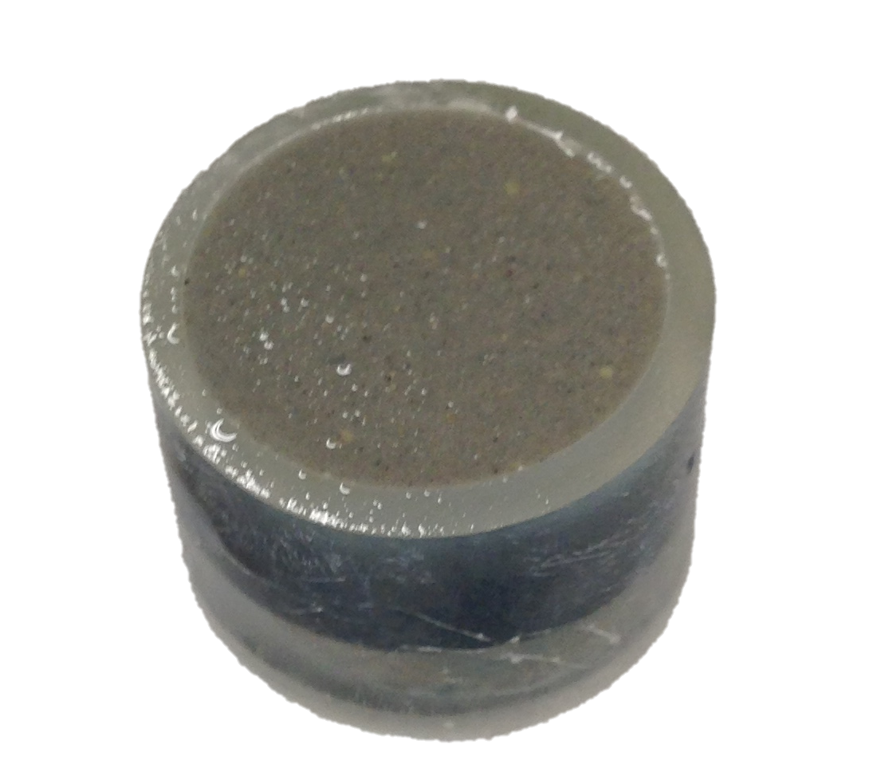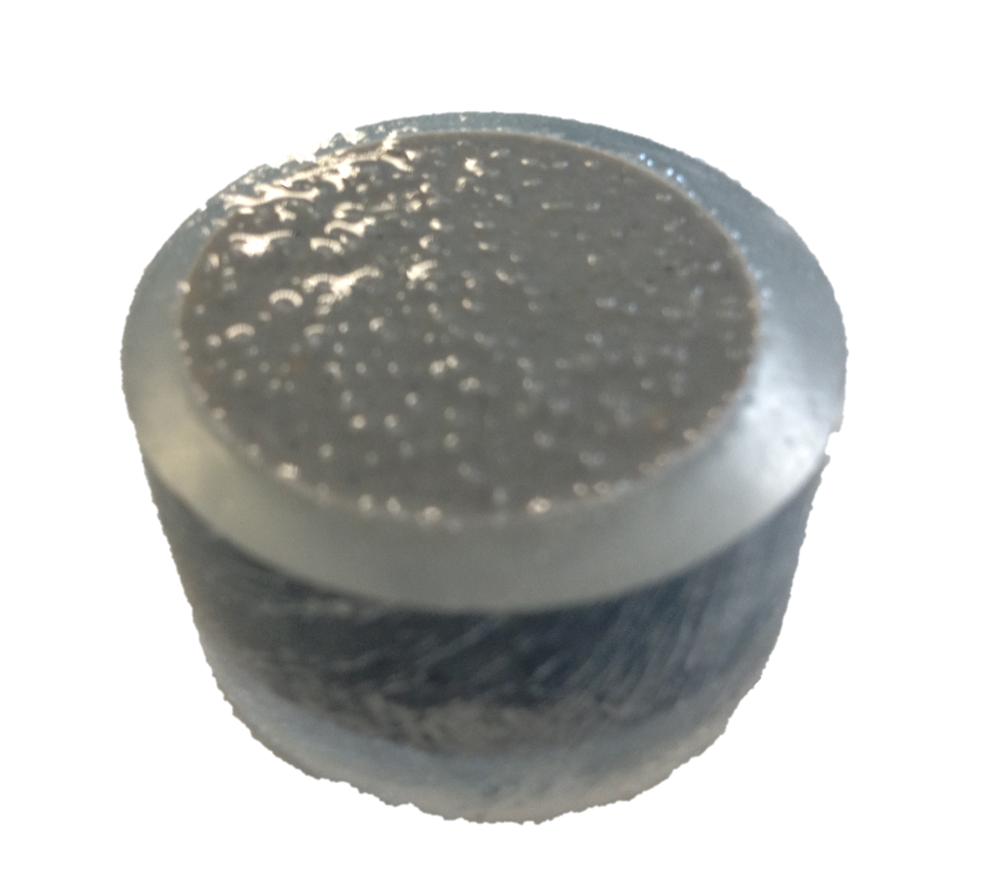
Fig 4.78: Surface of leached samples 28DB (left) and 6MB (right)
Given that the solution was replaced regularly with fresh water, it was assumed that this re-crystallisation of C-S-H would be more prominent in the static samples as there is a higher concentration of ions. Therefore the TGA of exposure surface layers of the W-B series were examined and it was found that C-S-H amounts decreased up until 28 days after which the amounts of C-S-H seem to increase as shown in figure 4.79 which compares the weight loss curve for both W-28DB1 and W-3MB1. This is much earlier than was noticed in the semi-static tests and therefore suggests that removal of solution slows down the C-S-H reformation. This is only an indication as the weight loss could be due to the higher amounts of entrapped water in porosity.

Fig 4.79: TG curves of W-28DB1 compared with W-3MB1
The increased weight loss as a result of higher C-S-H amounts could also be due to the increase in hydration or pore structure modification within the sample. To further investigate this the TGA profiles were compared for 0D samples with varying curing periods. Figure 4.80 shows TG curves for the original 0DB sample (cured for 42 days) alongside samples with the same composition but cured for 6 months, 1 and 2 years.

Fig 4.80: TG curves of 0DB samples at different curing periods
As the curing period increases, the total weight loss also increases. The difference in weight loss is primarily due to that lost at around 100-150ºC, which is attributed to the C-S-H phase. This phase increases within the sample as hydration progresses. This means that the C-S-H increase in the cement samples is a product of the continuation of hydration as well as potentially the reformation on the sample surface.
The CsNO₃ is not visible in the XRD after short durations of leaching due to its high leaching rate and given that it is not chemically bound to any cement phases. The CAN and CsNO₃ troughs overlap in the TGA results, therefore it is hard to establish whether the TGA data shows absence of CsNO₃ although it is strongly suggested by the XRD results that it is absent. This corresponds to the findings of Ojovan et al [69] who found that the leaching rates of Cs are much larger than that of the Ca hence the higher porosity of the cement sample after 28 days and the absence of Cs in the XRD and TGA data. However according to Poon [47] there is a second stage of leaching wherein the leachability of Ca is larger than Cs, and as such this will lead to the degradation of the cement before further Cs is leached out. This behavior can be seen in the XRD results. Usually on the top layers the Cs depletes before any peak decrease is noticed for CAN however, deeper within the cement sample at 3 months, when this second stage of leaching is reached it can be seen that the CsNO₃ and CAN peak are both reduced similarly, suggesting that that the rate of leaching of Cs has slowed down and the CAN has increased.
.

Section 4.3: Incorporation of Cs & Sr in BFS:PC cement

The location of both the Cs and Sr within the cement matrix is investigated in detail within this section. First the cement samples were studied using various analysis methods in order to locate both the Cs and Sr. This strongly indicates that the C₃A hydration products have quite a significant role to play, therefore in the second stage C₃A was synthesised in order to further study the relationship between Cs, Sr and the C₃A phase. The relationship between the retention of these radionuclides and their impact on leaching was also studied, the amounts and behavior of the leached Ca, Cs and Sr were compared to further understand this.

4.3.1 Results

4.3.1.1 Cement Analysis
As discussed in section 4.1 the preliminary XRD results of the 0D samples, show that with the introduction of strontium nitrate and caesium nitrate the cement phase composition and distribution is altered. The peaks associated with AFm slightly shift suggesting either an alteration of the AFm structure or the formation of a different crystal phase. This can be seen in fig. 4.81, which focuses on this particular region of the trace (with the new peak labeled X). In section 4.1 this phase was identified as CAN the nitrated AFm phase with the proposal that the SO₄²⁻ ions were substituted with NO₃⁻.
Although both strontium and caesium were added in nitrate form this behaviour only occurred in the presence of strontium nitrate. Therefore further investigation was carried out in this section to better understand the unique behaviours of both caesium and strontium in this cement system.

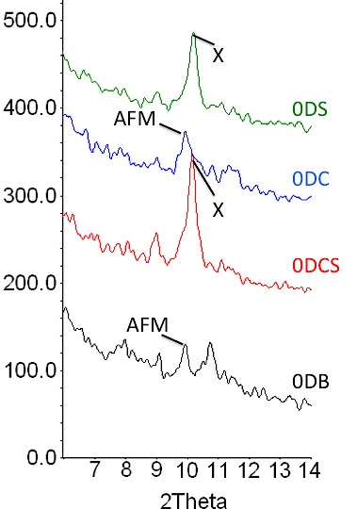
Figure 4.81: XRD trace of cement samples before leaching tests
The nitrate ions are smaller than the sulphate ions [10], therefore when the substitution occurs it would cause a decrease in the inter-planar (d) spacing. Applying Bragg’s Law (equation 4.4) it can be seen that a decrease in d-spacing causes an increase in 2θ. Therefore the shift of the AFm peak to the right and forming peak X in figure 4.81, is probably due to this substitution.
nλ/d = 2d sinθ (4.4)
Sin⁻¹ (n λ/2d) = θ
The XRD traces in fig 4.1 indicate that at least some of the caesium in the 0D$\overline{cs}$ and 0D$\overline{c}$ samples reforms as CsNO₃, however there is no indication of where the strontium is in the 0D$\overline{s}$ and 0D$\overline{cs}$ samples.
The TGA data in figure in chapter 4 section 1, shows that the heating profile produced by the strontium nitrate loaded sample is similar to that in the $\overline{cs}$ sample, whereas the sample only containing caesium nitrate has the same profile as the blank, with an additional peak for CN.
The MAS-NMR results in chapter 4 section 1 also showed that introducing the strontium into the matrix altered the C-S-H phase, wherein Al entered the tetrahedral chain sites and the Al-Si chains became progressively more polymerized. As a result the Q² peak attributed to the end groups of the C-S-H chain, had shifted from -84 to -81 indicating the formation of Q²(Al) [72].
To further study the behaviour of the Sr within the cement matrix, samples loaded with solely 3wt% strontium in the nitrate form were analysed and compared with the $\overline{cs}$ and B samples using MAS-NMR. The samples were analysed after a curing time of 28 days and 90 days. Figure 4.82 shows the ²⁹Si MAS-NMR spectra for each formulation for different curing periods compared with a 9:1 mixture of unreacted BFS:PC.
Figure 4.82: ²⁹Si MAS-NMR spectra for BFS:PC cement samples: blank; 3wt% Sr; 3wt% Sr + 3wt% Cs
The spectra produced in the 0D$\overline{s}$ sample are very similar to that of the 0D$\overline{cs}$ sample, once again producing a more intense Q² peak at -84ppm than that in the 0DB, which suggests it is the introduction of the strontium nitrate that causes this behaviour. Similar spectra between the 0D$\overline{s}$ and 0D$\overline{cs}$ sample are also produced when comparing the 27Al MAS-NMR spectra of these samples in figure 4.83. The sharper peaks attributed for the AFm phase are more intense in both 0D$\overline{s}$ and 0D$\overline{cs}$ compared with the 0DB sample, suggesting higher Al absorption in the AFm phase, whilst giving weaker C-S-H humps.
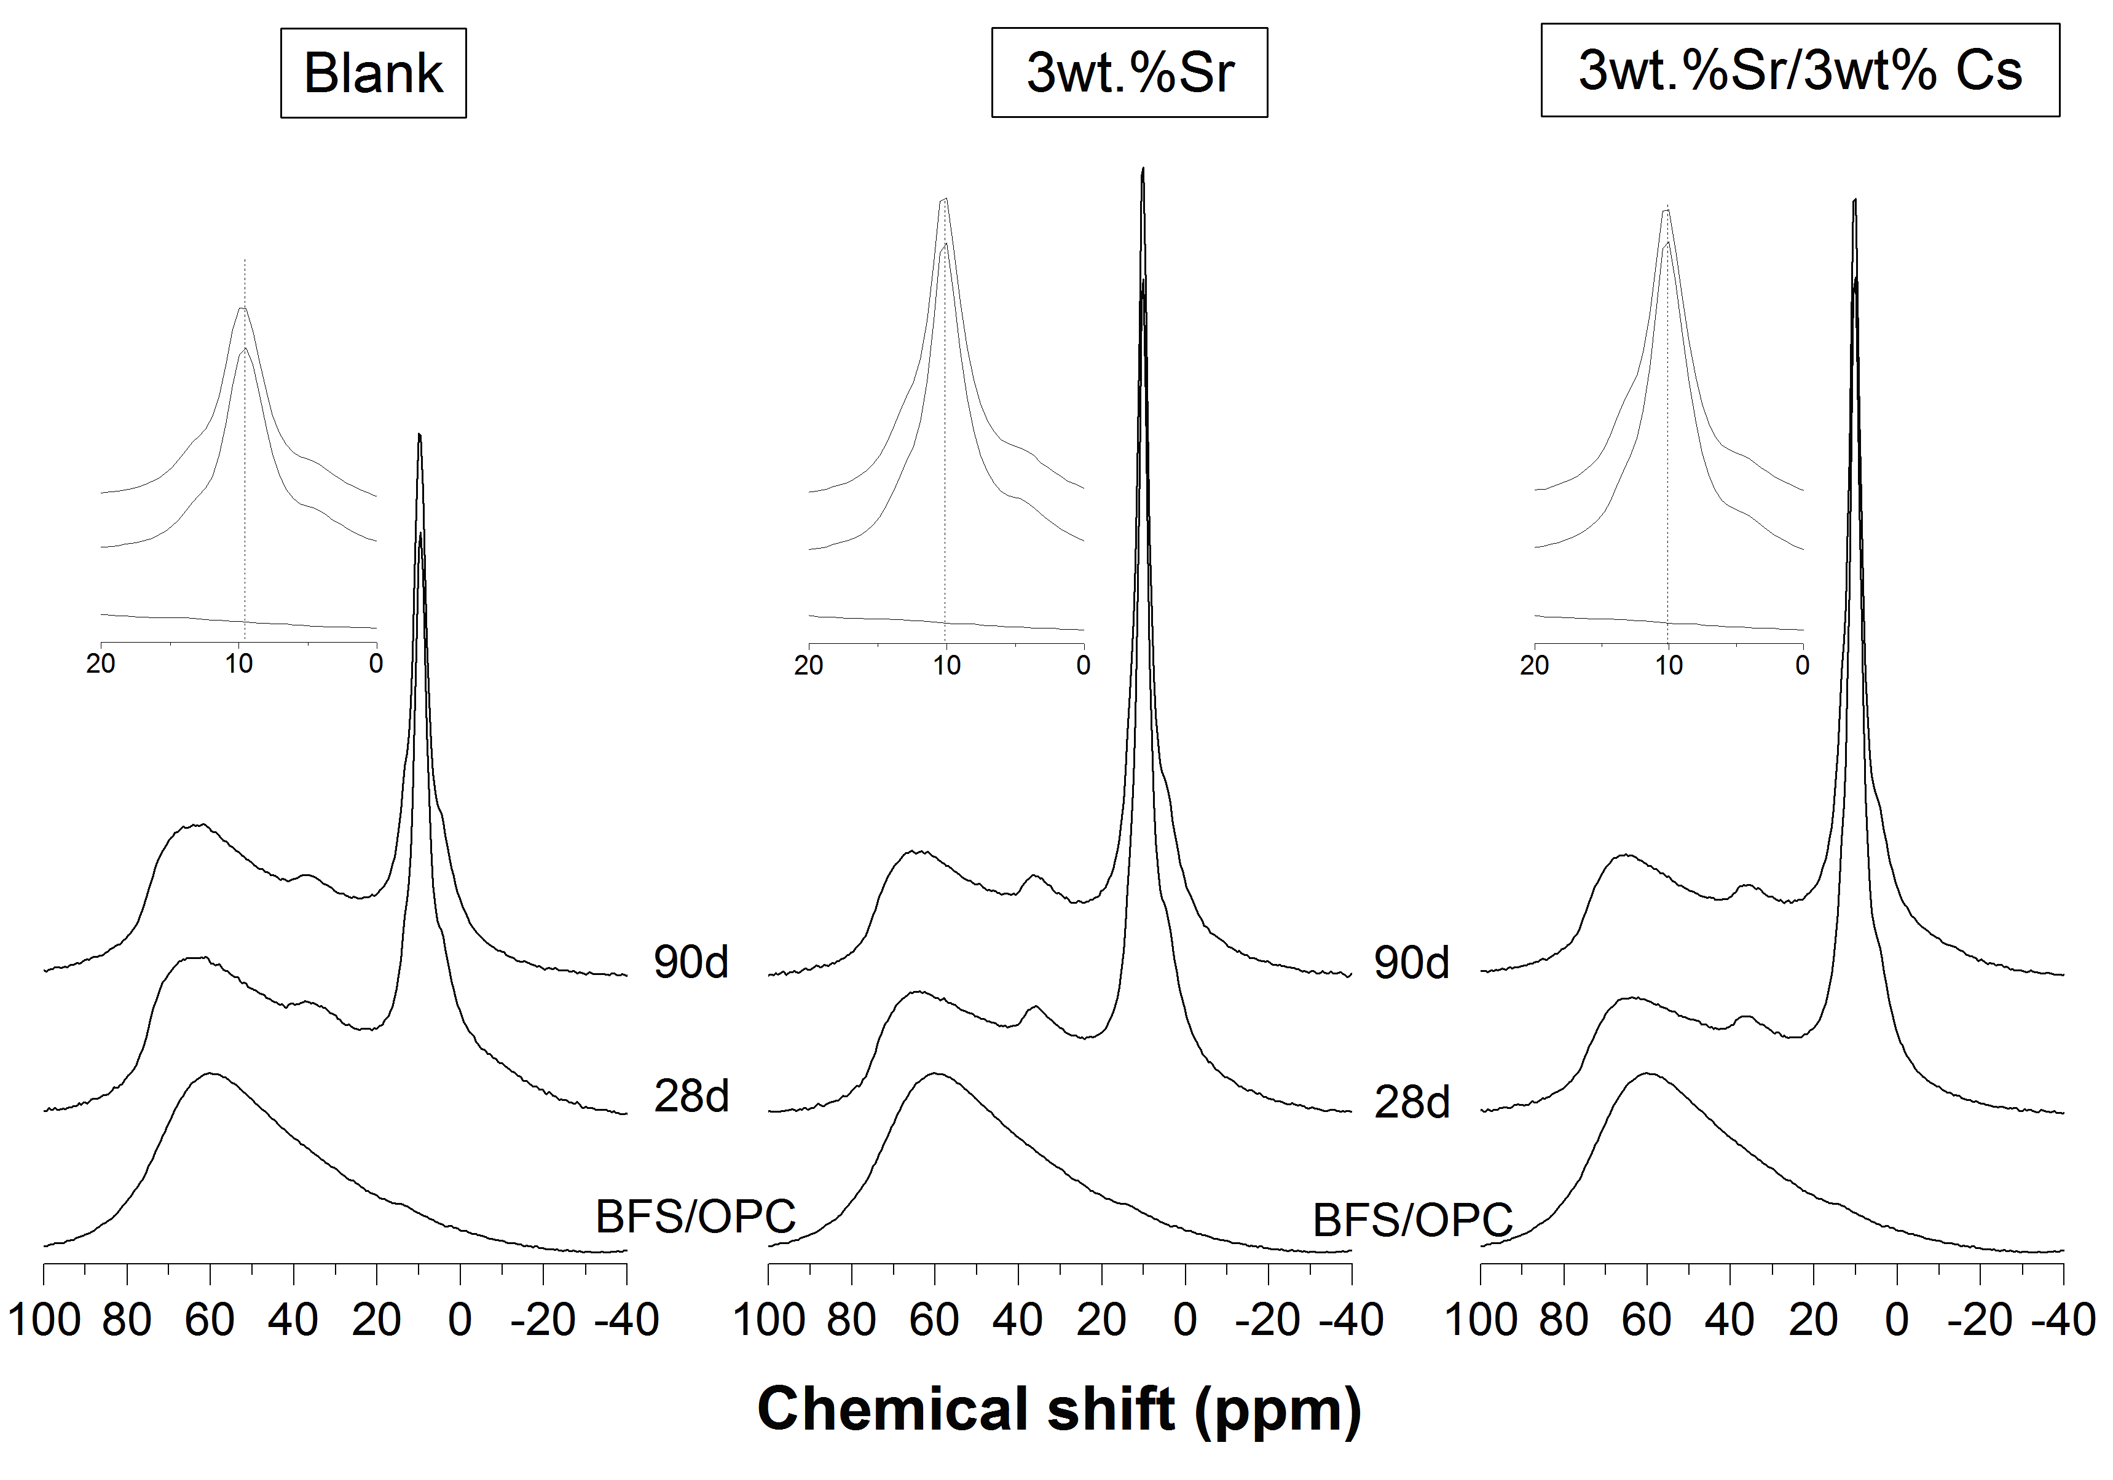Figure 4.83: ²⁷Al MAS-NMR spectra for BFS:PC cement samples blank, containing 3wt% Sr and 3wt% Sr + 3wt% Cs
Both figure 4.82 and 4.83 show that there is no difference between the spectra of Sr samples with and without CsNO₃. Suggesting that the CsNO₃ has no impact on any Al or C-S-H containing phases. However the introduction of Sr seems to increase the intensity of the Q² peak, suggesting that Sr promotes an increase in the formation of AFm type phases. The elemental map in chapter 4 section 1 showed that the Cs was concentrated in a small area whereas the Sr is slightly more dispersed, which suggested a better incorporation of the Sr within the cement phases. The edge of the bright Sr region was magnified further by 10x as shown in figure 4.84. Upon closer inspection this brighter region where the strontium resides, shows the needle like structure attributable to the ettringite phase, as opposed to the hexagonal plate structure expected from the monosulphate phase [73].

Figure 4.84: Backscattered electron image of 0D$\overline{cs}$

According to the backscattered electron image and the accompanied elemental traces, the caesium, however, does not seem to be associated to any phase and as can be seen in figure 4.85, is encapsulated in the voids within the cement. The elemental graph shows strong peaks for Cs, but no peaks for Ca, strongly suggesting the Cs is not chemically bound with a cement hydrate phase.

Figure 4.85: Backscattered electron image of 0D$\overline{cs}$ alongside an EDS trace of the highlighted region

The results suggest that the Sr could be associated with wither an AFm or AFt phase therefore further investigation was done looking at the interaction between Sr and a synthesised AFm phase.

4.3.1.2 AFm Synthesis

i. C₃A Synthesis
C₃A was synthesised using two procedures. The resultant powders were then analysed using XRD. The XRD traces for different phases formed during the preparation process of C₃A synthesis using the solid solution method are shown in figure 4.86. It can be seen from the XRD trace C₃A-i that initially the C₃A phase is formed alongside CaO and Ca₁₂Al₁₄O₃₃. The XRD trace C₃A-ii is for the powder produced after repeating steps 5-8 in section chapter 3 two consecutive times. This trace shows that the produced C₃A and had not reacted with the CaO and remain within the sample, and there are no peaks for the Ca₁₂Al₁₄O₃₃ phase. Repeating steps 5-8 three more times and analysing the powder gave the trace of C₃A-iii. The only visible peaks are the C₃A peaks therefore it is demonstrated that this was pure C₃A.
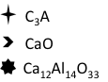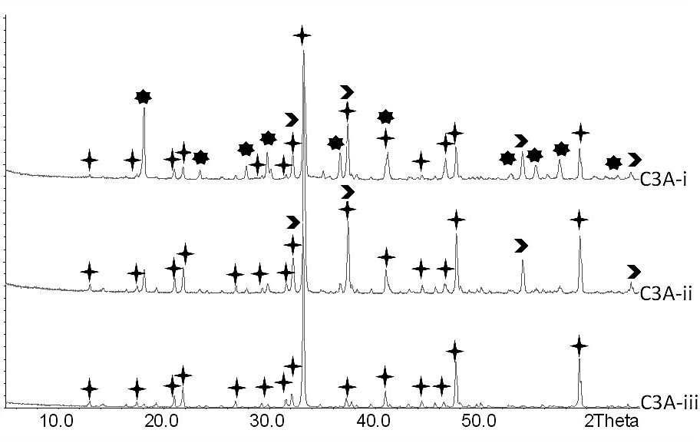
Figure 4.86: XRD traces from powders created during C₃A solid solution synthesis
The XRD traces in figure 4.87 are for the resultant powders of the Pechini synthesis method described in section 3. P-C3A-i is the trace for the first attempt, which shows that C₃A was formed, however contained some CaO contamination. In the second attempt the samples were heated to convert the remaining CaO to C₃A and the product of this synthesis produced the trace P-C3A-ii which indicates pure C₃A. Due to the time efficiency and relative simplicity of this method in comparison to the solid solution method, the Pechini method took precedence, and was used for the rest of the experiments with any required C₃A synthesis.

Figure 4.87: XRD traces from powders created during C₃A Pechini synthesis

ii. Monosulphate & CAN Synthesis
The AFm and CAN syntheses were confirmed using XRD, the traces produced are shown in figure 4.88. The peak pattern for CAN is very well matched to those found in the cement analysis samples, giving support that this phase is formed.

Figure 4.88: XRD traces for synthesised AFm and CAN phases (Sr(NO₃)₂ added to form CAN)
The CAN XRD trace shows characteristic peaks of the CAN phase only when compared with the ICCD file [54-849] and no trace of any other strontium or nitrate containing phases. This suggests that both the Sr²⁺ and NO₃⁻ are associated with the CAN phase, possibly substituting for Ca²⁺ and SO₄²⁻ respectively within the AFm. As stated earlier the nitrate substituting for sulphate could mean a decrease in d-spacing and thus a shift to the right. On the other hand the strontium substituting for calcium would cause an increase and thus a shift to the left. These opposing shifts make it difficult to confirm whether or not strontium substitution is occurring. As a result new samples were produced in which the strontium was added in the hydroxide form in the AFm synthesis to attempt to monitor the AFm peak shift without the disturbance of the nitrate substitution and to also investigate whether the nitrate presence has an impact on the Sr and Cs immobilisation. The samples were produced using the same procedure as the CS, C, and S samples, and cured for 42 days. The XRD traces in figure 4.89 compare the results for 0DB, 0D$\overline{cs}$, 0D$\overline{cs}$-OH, 0D$\overline{s}$-OH and 0D$\overline{c}$-OH. Where OH indicates samples in which the caesium and/or the strontium were added in hydroxide form. The results show that the strontium hydroxide (SOH) and caesium hydroxides (COH) were still present in the sample, with no peaks associated with the AFm phase. There is however a much stronger peak for the hydrotalcite phase in all 3 samples. One reason for this could be due to the increase in OH- in solution using up the Al to form HC, therefore leaving inefficient amounts to form AFm. Furthermore Sr has been known to substitute for Ca in calcite therefore there is a possibility that the Sr was partially retained in HC favouring the formation of this phase. Finally there is always the possibility that the strontium hydroxide was not soluble enough to actually to take part in any phase forming reactions within the cement.

Figure 4.89: XRD traces for various formulations of cements

4.3.1.3 Solution Analysis
This section investigates the differences in leaching behaviour of caesium and strontium, when they are added together and separately, with a view to discuss the retention mechanisms of the waste simulants and the cement matrix.

i. ICP-MS

The amounts of Ca, Cs and Sr leached into water for samples B and CS over a 720 day period were analysed. The normalised leaching rates, NR_{i}, were calculated using equation 4.3.
The calcium leaching behaviour is shown in figure 4.90 which shows that Ca leached from sample $\overline{cs}$ at a significantly higher rate than from sample B. Both rates decreased with time and became nearly constant at around 3 months. Figure 4.91 shows that the leaching rate of Cs was almost three times that of Sr. An indicator of the levels of retention of both Cs and Sr is their relative leaching behaviour. If Cs and Sr were leaching congruently the leaching rate of Cs is expected to be the same as that of Sr, as they were added at a weight proportion of 1:1. However it is much higher than this, suggesting the two are retained differently within the cement. It is also clear that these elements leach out at a significantly higher rate than Ca from the same sample.

Figure 4.90: Normalised leaching rates over 2 years of Ca
Figure 4.91: Normalised leaching rates over 2 years for Cs and Sr from $\overline{cs}$
The leaching rates of Cs and Sr are compared with those of Ca in Figure 4.92. For congruent leaching, based on weight proportions present in the sample a very high leaching rate of calcium is expected in comparison to Cs and Sr, if congruent leaching was occurring. However figure 4.92 does not show this behaviour and therefore incongruent leaching is occurring, with Cs leaching more readily than Sr, and Sr leaching more than Ca. The approximate ratio of leaching rates is 19.6:8.2:1.

Figure 4.92: Leaching rates of Cs and Sr with respect to Ca leaching rates within $\overline{cs}$ sample
The normalised leaching rates of Sr and Cs were compared when added to the combined CS sample and separately to the C and S samples for periods of up to 28 days. These rates are shown in figure 4.93. The leaching rates of strontium seem unchanged irrespective of whether Sr(NO₃)₂ was added individually or along with CsNO₃. However when CsNO₃ is added individually it seems that the leaching rate increases by around 20%.
Figure 4.93: Leaching rates of Cs and Sr within different cement formulations
The Al leached amounts were compared in both B and $\overline{cs}$ to monitor how the formation of the CAN phase as opposed to AFm would impact the leaching rate of Al. Figure 4.94 compares these results over a 2 year period, the line of best fit has a gradient of 1, indicating that the leaching rates of Al are very similar in both formulations over the duration with the Al leaching rates being slightly higher in the $\overline{cs}$ samples.

Figure 4.94: Leaching rates of Al in B with respect to Al leaching rates within $\overline{cs}$ sample

ii. pH Measurements

The pH of the leachates of the samples containing only one of the waste simulants was compared to that of the $\overline{cs}$and B samples in figure 4.95. These samples were leached statically.

Figure 4.95: pH results of static leaching of all cement formulations over a 28 day period
The pH of the blank sample is lower than the waste loaded samples. The pH of the $\overline{c}$, $\overline{s}$ and $\overline{cs}$ leachates are very similar and follow a similar pattern for the 28 day period reaching a plateau and constant pH at 14 days. The higher pH in the leachates containing the waste loaded samples, is in accordance with the proposal that elements are released from these samples at a higher rate. This would mean a higher concentration of OH⁻ in solution making it more alkali.

4.3.2 Discussion
The results show that the introduction of CsNO₃ and/or Sr(NO₃)₂ have different impacts on the cement phases formed and seem to be retained differently within the structure. The XRD results show strong peaks for CsNO₃, and these were the only peaks that could be directly associated with a Cs containing phase. All other peaks were characteristic of phases which did not contain Cs or contained very little. The SEM results further support this showing the CsNO₃ is located in the cements as clusters. This is in agreement with the literature [67] stating that sorption of Cs is very low in BFS/PC. The Cs similarly was not sorbed when added in the hydroxide form. Discounting the CsOH and CsNO₃ peaks the XRD trace for 0D$\overline{cs}$ is very similar to that of 0DC. Other research suggests that the C-S-H phase sorbs the Cs [74,75] which according to Iwaida [76] would cause a breakage and shortening in the silicate chains, however the Si NMR spectra results do not correspond with this as they show an increase in Q² peak intensity suggesting chain polymerisation as opposed to shortening. Given the negative charge on the surface of silicate-rich gels, there have been instances wherein Cs has weakly adsorbed on low Ca/Si C-S-H as opposed to disrupting the C-S-H chain.
The ICP-MS results show that the Cs leaches out at much higher rates than any other element, suggesting that the Cs is poorly retained within the matrix, and is rather encapsulated, therefore easily diffuses out of the cement upon contact with water. However the leaching rate decreases when it is introduced into the system combined with Sr, due to the increase in nitrates and lowering the acidic nature of the cement solution . Furthermore as shown in chapter 4 section 1 the introduction of the Sr(NO₃)₂ into the system lowers porosity. According to McCulloch et al [77] the Cs leach rates are highly dependent on the porosity of the cement. When the Sr(NO₃)₂ is added it caused a decrease in porosity and thus a decrease in the leaching rates of Cs, in comparison to the DC series. This contradicts the suggestion by Shrivastava et al [78] who tested the absorption of Sr and Cs into the C-S-H type phase, tobermorite, and found that in the presence of larger cations the Cs absorption into this C-S-H phase decreases and thus an increase in leach rate would be expected. Therefore the results suggest that majority of the Cs was not sorbed onto the C-S-H supporting findings by McCulloch et al [77], who state that although the C-S-H gel has very a high specific surface area, it does not offer any sorption potential for any monovalent ions. However, this is Ca/Si ratio dependent, as shown by Myers et al [78-2] who found that at low Ca/Si ratios, the C-S-H type phases have larger interlayer spaces which weakly incorporate monovalent cations.
The introduction of Sr(NO₃)₂ resulted in the absence of the portlandite phase Ca(OH)₂ and the formation of CAN instead of AFm. It is strongly suggested in the results that Sr(NO₃)₂ was incorporated in AFm phase to form CAN. According to Park et al.[6] the nitrate anions can substitute for the sulphate anions in AFm to form CAN. The increase in CAN is due to the increase in Sr(NO₃)₂, as there is an increase in elements that form this phase. Balonis et al [9] also suggest that the calcium aluminohydrate phases can incorporate various anions into an anion site and can be described by the following general formulae: 3CaO.Al₂O₃.CaX.nH₂O and 3CaO.Al₂O₃.CaZ₂.nH₂O where X=SO₄²⁻ and Z=NO₃⁻. It seems likely that Sr can substitute for the Ca in CaZ₂ within such a phase. This also shows that two nitrate ions would substitute for one sulphate ion, this would still mean a decrease in lattice size as the sulphate ion is more than twice the size of nitrate ion.
The weight loss due to the CAN phase in CS is larger than the weight loss due to the AFm phase in B. This could be explained by the formation of a larger amount of CAN in sample CS than AFm in sample B. This could also explain the absence of portlandite in the CS samples; in order to produce more CAN, more Ca would be required, and therefore, less is available to form the portlandite phase.
The literature is inconsistent as to which phase the Sr substition occurs within. Tits et al. [79] have shown that the C-S-H phase is responsible for Sr(II) retention. There are three possible sorption sites for this type of cation within C-S-H, the silandiol (Si(OH)₂) groups in the interlayers, the silanol end-groups at the surface of C-S-H particles and the Ca(II) sites in the CaO₂ octahedral sheets. Based on experiments and other literature Tits et al. [79] concluded that, due to its size, Sr(II) is only sorped onto the silanol sites, these sites are made up of negatively charged silica end-groups that carry an unshared oxygen atom. This negatively charged site is charge compensated by the Ca²⁺ which can exchange with Sr²⁺ as follows:
Ca-CSH + Sr²⁺ $↔$ Sr-CSH + Ca²⁺
These findings were also supported by Wieland et al.'s research on Sr retention within a hardened cement paste [80]. On the other hand, Atkins and Glasser [40] stated that although a small amount is immobilised in C-S-H, the majority of the substitution occurs in the calcium aluminate (sulphate) hydrates (AFt). The study discovered that significant substitution of Sr²⁺ for Ca²⁺ can occur in the ettringite phase. They also suggest that Sr²⁺ would similarly substitute into the AFm phases, which appears to consistent with the results obtained in the present study. Although further study is required to confirm the substitution of Ca with Sr, it is indicated that Sr was incorporated into AFm along with the nitrates to form CAN. Sr²⁺ is larger than Ca²⁺ which would significantly increase d-spacing resulting in a peak shift to the left. It has already been established that the substitution of SO₄²⁻ by NO₃⁻ would cause a shift to the right, if both these behaviours were to occur simultaneously it would make it very difficult to use XRD analysis alone to monitor this behaviour. Ultimately the AFm peak shifts to the right to form the CAN peak. This could be because the difference in radii size between one sulphate and two nitrates is larger than between Ca and Sr assuming these substitutions occurred at the same rate as the nitrate substitution. Alternatively it could be because there are more nitrate substitutions than strontium.
The individual synthesis of both the CAN (using strontium nitrate) and AFm phases strongly support that the Sr is retained within this CAN phase. The XRD trace in fig 4.79 shows peaks for the CAN phase only, no peaks for Sr(NO₃)₂ were identified, nor any other phase. However there is a possibility that this could be due to the Sr staying in the aqueous phase and not going into the sample.
The hydroxide samples show that the strontium hydroxide remains. A drawback of adding the strontium as a hydroxide is the impact of the extra OH⁻ on the system. According to Bensted [81] an increase in OH⁻ develops an efficient diffusion barrier of calcium hydroxyl aluminates on the surface of the C₃A which massively retards ettringite formation, furthermore the excess OH⁻ takes up a significant amount of the Ca²⁺ to form portlandite and the hydrotalcite, further hindering the production of calcium aluminates. This would explain the absence of the CAN phase in these samples, with no CAN phase it stands to reason that the Sr is not sorbed and is therefore encapsulated in its original hydroxide form.
The Si NMR spectroscopy results show that the introduction of the strontium nitrate alone causes the substitution of Al into the C-S-H chains forming tetrahedral Al sites, as this does not occur in the 0DB. Results from Andersen et al [29] were used to characterise the spectra. Therefore this suggests that the Sr(NO₃)₂ is responsible for this phenomenon. Richardson & Groves [82], stated that at high Ca:Si ratios Al substitutes for Ca in octahedral sites, however at low Ca:Si ratios Al substitutes for Si in tetrahedral sites, This corresponds with the Si NMR spectroscopy results of 0DB which show the Al substitution into C-S-H. This could be a result of the decrease in d-spacing due to the nitrate substitution, or it could also be because the Sr displaces the Ca rather than the Al.
The leaching of Sr causes an increase in the leaching rate of Ca from sample $\overline{cs}$ compared to sample B; as the leaching of Sr incorporated in CAN could result in an increase in Ca dissolution from the same phase, when the Sr leaves the CAN phase, it breaks down and thus the Ca becomes more mobile. Furthermore given that the introduction of Sr suppresses the formation of portlandite, forming a source of very soluble Ca. It is important to note that portlandite was not formed in the waste loaded sample $\overline{cs}$ due to the introduction of the waste simulants, which could also influence the leaching behaviour of the material. An increase in Ca leaching would be expected as portlandite very water soluble, however this was not the case. Furthermore when the cement is leached in water, initially the components of the portlandite leach out to replenish the Ca²⁺ ions removed from the pore solution, and only when the portlandite has been leached does leaching of the C-S-H begin [47]. Because of the lack of portlandite in sample $\overline{cs}$, leaching of C-S-H most likely occurred from the start of leaching. The leaching rate of Ca significantly decreases between 7 and 28 days. Usually as leaching progresses, the solubility limit of Ca is approached slowing down the leaching rate. However in these experiments the water was regularly replaced and thus the concentration of Ca in solution varied up and down. Thus the decreasing Ca leach rate for sample B could be because P from the top layer has fully leached out. P leaching from deeper within the cement bulk sample travels through longer pathways, thus decreasing the leaching rate. A similar decrease in the leaching rate of Sr was also observed. This is in agreement with Crawford et al. [83] who stated that when Sr²⁺ present in the cement surface is completely leached out into solution, ions from deeper within the cement sample diffuse into the solution in order to maintain the equilibrium. This means the ions take longer to reach the solution and thus slowing the rate of leaching. Shrivastava et al. [78] described this as the surface wash-off process. A similar phenomenon is likely to be the reason for the decrease in Cs leach rate by around 70% after the first 7 days.
The incongruent leaching of Cs and Sr agrees with the suggestion that the Cs is not retained into any of the cement phases. The leaching rates of Al, when comparing the B and CS samples, were very similar being higher in the waste loaded sample suggesting that the CAN phase is more readily leached out than AFm, however the Al could be leaching from other phases at different rates therefore it is not conclusive.

Section 4.4: The Effect of Superplasticisers on Leaching Behaviour of Cementitious Waste Forms
This chapter represents a secondary short term project undertaken during the PhD research into accelerated leaching of cements. Working with the National Nuclear Laboratory, this chapter studies the impact of superplasticiser additives on the cement leaching behaviour. The addition of superplasticisers is known to add beneficial characteristics to the cements such as allowing the use of standard construction industry powders for a range of applications including waste immobilisation [84]. The benefits include wasteform longevity, reduced permeability, increased strength and reduced water content which results in reduced corrosion rates [84]. However there have been drawbacks to this such as complexing of ions and increased leaching rates of radionuclides.
The effects of ADVA Cast 551, a superplasticiser which could be potentially used in cements retaining plutonium and uranium, is studied [84]. A BFS:PC (9:1) cement was used containing cerium nitrate (cerium is used a simulant for plutonium). The fluidity of the cement paste was measured, and the leaching rates of cerium, calcium, aluminium and sodium studied to compare the impact of the superplasticiser on both the fluidity and leaching. Finally the NRVB backfill behaviour was studied when in contact with this leached cerium solution via a permeability test. The permeability test is designed to simulate the contact between the superplasticiser solution and the NRVB cement under storage conditions. The chapter serves as an introduction to marrying the accelerated leaching procedures with superplasticised cements in order to study the impact of these additives on the leaching behaviour over long periods of time.

4.4.1 Impact of ADVA-Cast 551 on Cementitious Waste forms

The cement samples are labelled CE and CEA (the A denoting the sample containing ADVA-cast 551). The superplasticiser will be referred to as A551.

4.4.1.1 Results

i. XRD Results

The Ce(NO₃)₃ was analysed using XRD to obtain a trace that characterised the sample and serve as a reference for this phase in cement XRD traces. The resultant trace is shown in Figure 4.96.

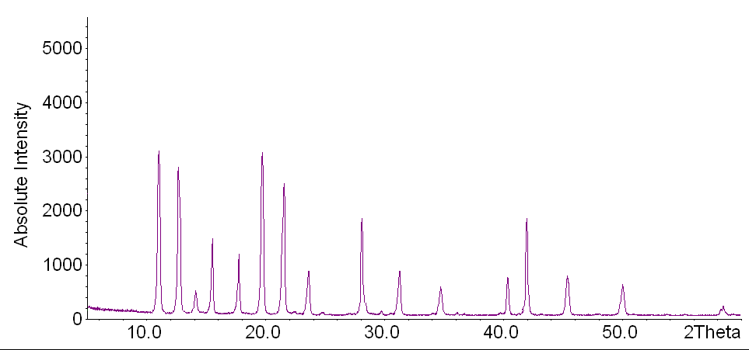

Figure 4.96: XRD trace of Ce(NO₃)₃

The XRD results of the CE and CEA samples cured for 42 days and analysed before the leaching test are shown in Figure 4.97. The peak formation of the two samples is very similar suggesting that the introduction of A551 has little impact on the crystal formation of the hydrate phases. Furthermore comparing these traces with that in fig 4.96, the peaks associated with the Ce(NO₃)₃ are not present, therefore the Ce is retained in the sample however it is not clear in which phase. There is an unidentified peak at 35º2θ in CEA and an unidentified hump at 16º2θ in CE.

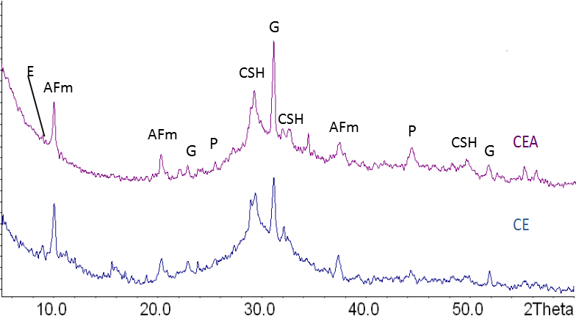
Figure 4.97: XRD trace of CE and CEA before the leaching experiments

The XRD patterns of the 28DCE and 28DCESP containing 10wt% Ce(NO₃)₃ were also compared in Figure 4.98. After the 28 days of leaching the phase composition for each sample has changed in comparison to the unleached sample. The peaks for ettringite, AFm and C-S-H decrease in intensity in the leached samples. Furthermore the peak formation differs between 28DCE and 28DCEA. The peak intensity for AFm at 10º2θ and the shoulder for C-S-H is much smaller in 28DCEA suggesting that possibly there is less of this phase in the sample (this only serves as an indicator as this not a quantitative XRD measurement), however this is unlikely as the second main peak associated with AFm at 22º2θ is of the same intensity in both samples. There are also peaks at 36, 43, 46 and 48º2θ which were unidentifiable in the 28DCE and 28DCEA, these are not present interaction of the sample with the leachate.

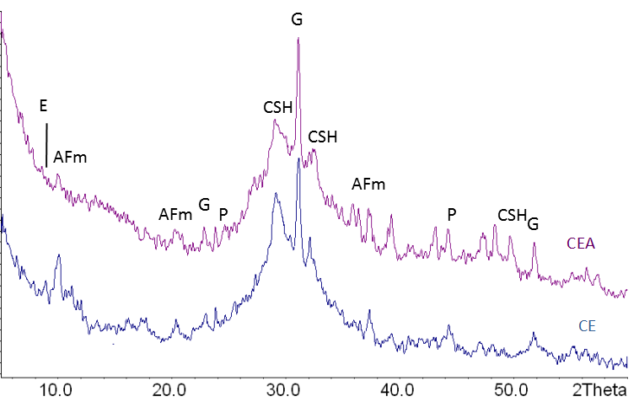
Figure 4.98: XRD trace of 28DCE and 28DCEA (after 28 days of leaching)

ii. Marsh Cone Test

This test was used to measure the cement pate fluidity before curing. The test was repeated once for each sample and an average time was taken for the beaker to be filled with the cement paste. The fluidity was calculated by dividing the total volume of the beaker (250ml) by the average time taken to fill it. The results are shown in table 4.5.

Table 4.5: Fluidity (ml/sec) of cement pastes before curing
Sample | Fluidity  (ml/sec)
CE | 17.84
CEA | 31.25

The table shows that the fluidity increases significantly; the CEA paste fills the beaker approximately 40% faster than the CE sample.

iii. ICP-MS

The leached amounts of the Ce in solution after 28 days were calculated for both CE and CEA from the gathered ICP-MS data and using Eq. 4.4 in chapter 4.2. The data is shown in Figure 4.99 comparing the normalised leached amounts of Ce alongside other elements.

The introduction of A551 seems to have impacted the leaching of Al and Ce the most. (Although generally a small amount of Al leaching occurs). There is slight increase in the leached amounts of Ca and Na when comparing the two solutions (the amounts increase by an around 4-10%). However the significant impact seems to be in the Ce leached amounts, wherein introducing the A551 has caused approximately a 45% in leached amounts of the Ce.

Figure 4.99: Normalised mass of elements in solution of 28DCE and 28DCEA sample

4.4.1.2 Discussion

The impact of adding A551 to the cement phase crystal assemblage was investigated using XRD and it was shown that the phase compositions of the cement are unaffected. This is in correspondence with the findings of Puertas et al [85] and Lothenbach et al [86], who found that the addition of a superplasticiser did not give rise to any significant mineralogical modification of hydrates, although the hydration of the silicates was slightly retarded in the superplasticised samples. They also found that the introduction of superplasticisers reduced sample porosity. The sample characterisation was unable to indicate any cerium containing compounds, and showed no peaks for Ce(NO₃)₃ therefore further research is required to establish where the Ce is within the sample, however this could be because it is absorbed weakly on the negatively charged surface of the C-S-H gel as shown by Dickinson and Glasser [87]. After 28 days of leaching the blank sample shows a stronger peak for AFm than the CEA sample for the main AFm reflection, this could suggest that this phase is leached out more readily in the CEA sample due to the introduction of A551. The results in figure 4.99 show that the introduction of A551 increases the leaching of Al significantly and Ca and therefore this could explain the smaller XRD peaks for this phase. However this is unlikely as the other AFm peaks in the XRD are of similar intensities. The introduction of the A551 causes a significant increase in the Ce leaching, this corresponds with findings by Clacher and Cowper [88]. They found that the variety of organic functional groups originally found in the superplasticiser formed mixed complexes with the radionuclides in solution and enhanced their solubility.

The fluidity of the cement paste increases significantly with the introduction of the A551, this corresponds with findings in literature such as that by Agullo et al [89]. They found that various superplasticisers enhanced the fluidity of the cement paste, they also found that up to a certain level the fluidity and the amount of superplasticiser added were positively correlated. However after this point they was found that the superplasticiser began to decrease fluidity, as can be seen in the results this point was not reached during the marsh cone test.

In conclusion introduction of A551, at the level introduced in this investigation, enhances fluidity, however it caused an increase in leaching of Ce by complexing the Ce and thus increasing its mobility. In storage conditions this leached Ce would then interact with NRVB and therefore the behaviour of this A551 solution containing Ce is investigated in the next section when in contact with NRVB.

4.4.2 NRVB Flowthrough Test Using Ce solution

The introduction of superplasticisers into the cement matrix can cause a significant increase in leached amounts of radionuclide simulants such as Ce. Furthermore it has been suggested [88] that when the leached solution containing superplasticiser is in contact with the NRVB the complexed compounds are not retained as well, causing easier leaching through the NRVB. In a waste immobilisation application this would be very problematic. The following investigates the permeability of NRVB when in contact with a solution containing Ce (BLANK) against one containing Ce and A551 (SCEA). The solutions were gathered and analysed using pH measurements, ICP-MS and TOC to monitor the amounts of Ce that had diffused through the NRVB cement sample. These are the preliminary results.

4.4.2.1 Results
i. pH Measurements
The pH was measured for each solution at different intervals. Figure 4.100 shows the pH change for both formulations during the entire leaching period of 21 days, with respect to the cumulative flow through measured in specimen volumes (the solution cumulative volume/the NRVB sample volume).

Figure 4.100: Leachate pH of Blank and SCEA
The pH of the SCEA solution initially is significantly higher than that of the blank sample, 13.5 at 1.3 specimen volumes. There is a slight increase in pH around 1.3 specimen volumes for both samples, and then there is a general decrease as leaching continues. The pH drops to and remains between 12.1 and 12.4 for both solutions, this level is maintained up to around 4 specimen volumes due to the portlandite (Ca(OH)₂) leaching out and releasing OH⁻ into solution. At around 5 specimen volumes the pH of the blank solution drops below 12, this is expected as the amounts of portlandite in the cement decreases therefore there is less to leach out. However in the SCEA the pH remains above 12 until the end of the experiment.

ii. Inductively Coupled Plasma Mass Spectrometry (ICP-MS)
The ICP analysis data was used to calculate the amounts of cerium that had passed through the NRVB sample. This was compared to that of the original amounts in the bladder vessel and is presented as a percentage of that amount. The Ce percentage concentration in the blank solution is shown in figure 4.101 whilst that of the SCEA solution is shown in figure 4.102. In the blank solution the concentration percentage of the Ce remains very low up until 2.8 specimen volumes at which point there is a significant increase, this increase continues steadily up until 3.4 specimen volumes, here the percentage concentration seems unchanged until 4 specimen volumes where it begins to steadily increase again albeit at a slower rate. The total Ce leached out in the BLANK solution is 3% of the original cerium amounts. The leaching percentage of cerium in SCEA solution is initially slightly lower than in the blank solution and remains at this level up until 2.9 specimen volumes. The leached percentage increases significantly at this point and continues to increase up until 5.4 specimen volumes. The total leached out is approximately 4%, which is only slightly higher than in the blank solution.

Figure 4.101: Leached cerium as percentage of original amount in Blank solution

Figure 4.102: Leached cerium as percentage of original amount in SCEA solution

iii. Total Organic Carbon (TOC)
The total organic carbon present in the composition was measured initially for both solutions within the bladder vessel and was found to be 10ppm for SCEA and 2ppm for the blank solution, this higher concentration of organic carbon in the SCEA is due to the complexing nature of the superplasticiser. The TOC concentration for the blank series remained at these levels throughout the test in the collected samples. The TOC of the SCEA solution however increases as shown in fig 4.103. The figure shows that there are already amounts of TOC in the solution collected by 3.4 specimen volumes. There is then a significant increase in TOC amounts in the solution collected at approximately 4.5 specimen volumes, gradually increasing thereafter until 6.6 specimen volumes.
Figure 4.103: Total organic carbon mass in SCEA solution

4.4.2.2 Discussion
The results compare the differences in flow through leaching behaviour within the NRVB sample using BLANK and SCEA solutions. As expected, both the collected solutions are highly alkaline, with the pH decreasing over time due to the decrease of alkaline components in the NRVB sample via leaching. The SCEA leachate solution seems to be much more alkaline initially. The first collection of deionized water (equivalent to 0.5 specimen volumes in SCEA and 0.79 in the blank) produced leachates that although highly alkaline, were not the highest pH samples recorded, with values of 13.2 and 12.3 respectively, increasing to 13.5 and 12.45 in the second samples (factor in error bars). The lower pH of the first leachate samples collected is attributed to the dilution of the highly alkaline pore solution by interstitial water present in the porous stones. These porous stones were wet with deionised water to remove air. The second leachate, were the most alkaline leachates collected. This high alkalinity is expected to be due to a combination of sodium and potassium hydroxides, with some calcium hydroxide from the dissolution of portlandite. ICP-MS data shows that the concentration of sodium and potassium corresponded with the pH levels. Figure 4.104 shows the concentration of sodium in leachate compared with the pH levels of SCEA and figure 4.105 shows the concentration of potassium leachate. The pH is then maintained at around 12-13 due to the leaching of portlandite.

Figure 4.104: concentration of sodium in leachate compared with the pH levels

Figure 4.105: concentration of potassium in leachate compared with the pH levels
The sodium and potassium could be leaching from the NRVB sample itself or passing through from the original SCEA solution. However given that the pH drops in the SCEA sample to levels similar to that of the blank sample this indicates that the high amounts of Na and K initially were leached from the NRVB as opposed to coming from the original solution, this is because breakthrough of organic compounds (complexed by the superplasticisers) was noticed around 3 specimen volumes and therefore if the Na and K amounts were linked to the SCEA solution we would expect the pH to increase sharply are around 3-4 specimen values. However Fig 4.104 and 4.105 show that this is not the case and the pH continues decreasing.
The TOC and ICP-MS results indicate that breakthrough occurs at around 2-3 specimen volumes, suggesting that for the first 2 specimen volumes the organic components were predominantly removed from solution and retained within the NRVB. The NRVB cement sample interacting with the SCEA allowed 1% more of the original cerium to pass through in than in the blank. The breakthrough of the organic compounds occurred at the same stage in both samples and the Ce seems to have diffused only marginally more readily out of NRVB in the SCEA sample. This was not expected as significantly more Ce was predicted to flow through based on past research by Clacher and Coopwer [88]. They found that the exposure of the cement matrix to superplasticisers causes complexing of radionuclides such as plutonium and uranium and an increase in organic compounds within the cement which caused both the radionuclides to leach more readily into solution.

Something must be concluded from the report – positive or negative. Even an interim report has a conclusion, e.g. The work is progressing to plan.

References
Chapter 4: Results and Discussion
[1] Gastuche, M.C. Brown, G. Mortland, M.M. (1967) Mixed magnesium-aluminium hydroxides I. Preparation and characterisation of compounds formed in dialysed systems, Clay Minerals, 7, 177-192.
[2] Taylor, H. (1997) Chapter 5: Hydration of the calcium silicate phases, Cement Chemistry, London, Academic Press. 123-165.
[3] Wang, S.D. and Scrivener K.L. (1995) Hydration products of alkali activated slag cements. Cement and Concrete Research, 25(3), 561-571.
[4] He, Y. Zhao, X. Lu, L. Struble, L. Hu, S. (2011) Effect of C/S ratio on morphology and structure of hydrothermally synthesized calcium silicate hydrate, Journal of Wuhan University of Technology-Materials Science, 26(4), 770-773.
[5] Schwiete, H.E. Ludwig, U. and Niel, E. (1965) Studies on the beginning of hydration of clinker and cement, Proc. 7th Conf. Silicate Ind., Budapest 221– 33.
[6] Park, J-Y. Byun, H.J. Choi, W.H. Kang, W.H (2007) Cement paste column for simultaneous removal of fluoride, phosphate, and nitrate in acidic wastewater, Chemosphere, 70, 1429–1437.
[7] McCarthy, G.J. Hassett, D.J. Bender, J.A. (1992) Synthesis, crystal chemistry and stability of ettringite, a material with potential applications in hazardous waste immobilization, Mater. Res. Soc. Symp. Proc. 245, 129–140.
[8] Balonis, M. (2010) ‘The Influence of Inorganic Chemical Accelerators and Corrosion Inhibitors on the Mineralogy of Hydrated Portland, Ph.D. Thesis
[9] Balonis, M. Glasser, F.P. Medala, M. (2011) Influence of calcium nitrate and nitrite on the constitution of AFm and AFt cement hydrates, Advances in cement research, doi: 10.1680/adcr.10.00002.
[10] Renaudin, G. Rapin, J-P. Humber, B. Francois, M. (2000) Thermal behaviour of the nitrated AFm phase Ca₄Al₂(OH)₁₂(NO₃)₂.4H₂O and structure determination of the intermediate hydrate Ca₄Al₂(OH)₁₂(NO₃)₂.2H₂O, Cement and Concrete Research, 30, 207-314.
[11] Ramachandran, V.S., Paroli, V.S., Beaudoin, J.J., Delgado, A.H. (2002) Chapter 3: Formation and Hydration of Cement and Cement Compounds, Handbook of Thermal Analysis of Construction Materials, 71-136.
[12] Utton, C.A. (2007) The encapsulation of BaCO₃ waste in composite cements, Ph.D Thesis, University of Sheffield.
[13] Taylor, H. (1997) Chapter 6: Hydrated aluminate, ferrite, sulfate phases, Cement Chemistry, 2nd Edition, London, Academic Press. 123-165.
[14] Nomura, N. Zhang, Y.H. Oi, T. (2008) Incorporation of cesium ion from CsNO₃ into NH₄Zr₂(PO₄)₃ studied by TG-IR Spectroscopy and powder XRD, Journal of Thermal analysis and calorimetry, 98, 234-247
[15] Ortner, M.H. Anderson, C.J. Campbell, P.F. (1961) Research and Development Studies on Waste Storage Process, Idaho Operations Office, U.S. Atomic Energy Commission.
[16] Stern, K.H (1972) High Temperature Properties and Decompostion of Inorganic Salts Part 3. Nitrates and Nitrites, J. Phys. Chem. Ref. Data, 1(3), 747-772.
[17] Aligizaki, K.K, (2005) Chapter 3: Mercury Intrusion Porosimetry, Pore Structure of Cement Based Materials: Testing, Interpretation and Requirements, Taylor and Francis, 66.
[18] Glasser, F.P. (1992) Chapter 1: Chemistry of Cement-Solidifed Waste Forms, Chemistry and Microstructure of Solidified Waste Forms, edited by Roger D. Spence, Lewis Publishers, 1-40.
[19] Kunimitsu, M. Noriko, T. (2003) Adsorption hysteresis in ink-bottle pore, Journal of Chemical Physics, 119 (4), 2301-2306.
[20] Zhou, J. Ye, G., Van Breugel, K. Hydration Process and Pore Structure of Portland Cement Paste Blended with Blastfurnace Slag, Delft University of Technology, Ghent University.
[21] Aligizaki, K.K (2006) Chapter 3: Mercury intrusion porosimetry, Pore Structure of Cement-Based Materials: Testing, Interpretation and Requirements, Modern Concrete Technology 12, 60-107.
[22] Adolphs, J., Setzer, M.J., Heine, P. (2002) Changes in pore structure and mercury contact angle of hardened cement paste depending on relative humidity,
[23] Kaufmann, J., Loser, R., Leemann, A. Analysis of cement-bonded materials by multi-cycle mercury intrusion and nitrogen sorption, Journal of Colloid Interface Science, 336, 730-737
[24] Shi D, Winslow DN. (1985) Contact angle and damage during mercury intrusion into cement paste. Cem Concr Res, 15, 645–54.
[25] Mendes, A., Gates, W.P., Sanjayan, J.G., Collins, F. (2011) NMR, XRD, IR and synchrotron NEXAFS spectroscopic studies of PC and PC/slags cement paste hydrates, Materials and Structures, 44, 1173-1791
[26] Murgier, S., Zanni, H., Gouvenot, D., (2004) Blast furnace slag cement: a 29Si and 27Al NMR study, Comptes rendus chimie, 7, 3, 389-394
[27] Anderesen, M.D., Jakobsen, H.J., Skibsted, J. (2003) Incorporation of Aluminium in the Calcium Silicate Hydrate (C-S-H) of Hydrated Portland Cements: A High-Field ²⁷Al and ²⁹Si MAS NMR Investigation, Inorganic Chemistry, 42, 2280-2287.
[28] MacLaren D.C., White M.A. (2003) Cement: its chemistry and properties. J Chem Edu 80:623–635
[29] Andersen, M.D., Jakobsen, H.J., Skibsted, J., (2004) Characterisation of white Portland cement hydration and the C-S-H structure in the presence of sodium aluminate by ²⁷Al and ²⁹Si MAS NMR Spectroscopy, Cement and concrete research, 34, 857-868
[30] Sun, G.K., Young, J.F., Kirkpatrick, R.J. (2006) the role of Al in C-S-H: NMR, XRD, and compositional results for precipitated samples, Cement and concrete research, 36 (1), 18-29.
[31] Brough, A.R., Katz, A., Sun, G.K., Struble, L.J., Kirkpatrick, R.J. (2001) Adiabatically cured alkali-activated cement-based waste forms containing high levels of fly ash, formation of zeolites and Al-substituted C-S-H, Cement and concrete research, 31, 993-1000.
[32] Schneider, J., Cincotto M.A., Panepucci, H. (2001) ²⁹Si and ²⁷Al high-resolution NMR characterization of calcium silicate hydrate phases in activated blast-furnace slag pastes, Cement and Concrete Research, 31, 993-1001
[33] Park, T.J., Choi, S.S., Kim, Y., (2009) ²⁷Al Solid-state NMR Structural Studies of Hydrotalcite Compounds Calcined at Different temperatures, Bull. Korean Chem. Soc., 30, 149-151
[34] Scrivener K.L, (2002) Backscattered electron imaging of cement microstructures: understanding and quantification, Cem. Concr. Res., 30(1), 1-6.
[35] Evans, N.D.M., (2008). Binding mechanisms of radionuclides to cement. Cement and Concrete Research, 38 (4), 543-55
[36] Cheng, A. Chao, Sao-Jeng, C. Wei-Ting, L. (2013) Effects of leaching behaviour of calcium ions on compression and durability of cement-based materials with mineral admixtures, Materials, 6, 1851-1872
[37] Abdel Rahman, R.O, Zin El Abidin, D.H.A, Abou-Shady, H., (2013) Assessment of strontium immobilisation in cement-bentonite matrices, chemical engineering journal, 228, 772-780
[38] Wieland, Kunz, D., Dahn, R., (2008) Strontium uptake by cementitious materials, Environ. Sci. Technology, 42, 403-409.
[39] Chang, H. Um, W. Rod, K. Thompson, A. (2013) Strontium and Cesium release mechanisms during unsaturated flow through waste-weathered Hanford sediments, Environmental Science & Technology, 45(19), 8313-8230
[40] Atkins, M. & Glasser, F.P. (1992) Application of cement-based materials to radioactive waste immobilization, Waste Management, 12, 105-131.
[41] Carlson, E.T. (1995) A study of some strontium aluminate and calcium-strontium aluminate solid solutions, Journal of research of the national bureau of standards, 54 (6), 329-334.
[42] Kalousek, G. L. Davis, C. W. Jr. Schmertz, W. E. (1949) An Investigation of Hydrating Cements and Related Hydrous Solids by Differential Thermal Analysis Proc. Amer. Conc. Inst., 45:693.
[43] Ojovan, M.I., Varlackova, G.A., Golubeva, Z.I., Burlaka, O.N (2011) Long-term field and laboratory leaching tests of cemented radioactive wastes, Journal of Hazardous Materials 187, 296-302.
[44] Sharp, J.H., Milestone, N.B., Hill, J., Miller, E.W., (2003) Cementitious systems for encapsulation of intermediate level waste, 9th International Conference on Radioactive Waste Management and Environmental Remediation,
[45] Ben Haha, M., Lothenbach, B., Le Saout, G., Winnefeld (2011) Influence of slag chemistry on the hydration of alkali-activated blast furnace slag, Cement and concrete research, 41, 9, 955-963.
[46] Bensted, J. & Varma, S.P. (1971) Ettringite and its derivatives, Cement Technology, 2, 73-76.
[47] Saito, H. and Sunao N. (1999) Comparison between diffusion test and electrochemical acceleration test for leaching of cement hydration products, ACI Materials Journal. 96, 208-212.
[48] Utton, C.A. (2007) The encapsulation of BaCO₃ waste in composite cements, Ph.D Thesis, University of Sheffield.
[49] Stumm, W. & Morgan, J.J. (1981) Aquatic Chemistry, John Wiley and Sons, NY.
[50] Poon, C.S., Chen, Z.Q. and Wai, O.W.H. (2001), The Effect of Flow-through Leaching on the Diffusivity of Heavy Metals in Stabilized/Solidified Wastes. J. Hazardous Materials, B81, 179-192.
[51] Batchelor, B. & McDevitt, M. (1984) Journal of Water Pollution Control Federation, 56, 1110-1117.
[52] Wan.K, Li.Y, Sun, W., (2013) Experimental and modeling research of the accelerated calcium leaching of cement paste in ammonium nitrate solution, Journal of Construction and Building Materials, 40, 832-846.
[53] Moranville, M., Kamali, S., Gullion, E., (2004) Physiochemical equilibria of cement-based materials in aggressive environments-experiment and modeling, Cement Concrete Research, 34, 1569-1578.
[54] Rodger, S.A., & Groves, G.W., (1988) Advanced Cement Research, 1, 84.
[55] Loukili, A. (2011) Chapter 4: Durability of Self-Compacting Concrete, Chemistry and Microstructure of Solidified Waste Forms, edited by Roziere, E. and Khelidj, A. Wiley Publishers, 177-178.
[56] Liu, J., Xing, F., Dong, B., Ma, D., Pan, D. (2014) Study on surface of permeability of concrete under immersion, Materials Journal ISSN 1996-1944, 7, 876-886.
[57] Andac, M. & Glasser, F.P., (1999) Long-term leaching mechanisms of Portland cement-stabilised municipal solid waste fly ash in carbonated water, Cement and concrete research, 29, 179-186.
[58] Gordon, S.J., Brady, P.V., (2002) In situ determination of long-term basaltic glass dissolution in the unsaturated zone, Chemical geology, 190, 113-122.
[59] Saito, H., Deguchi, A. (2000) Leaching tests on different mortars using accelerated electrochemical method, Cement and concrete research, 30, 1815-1825.
[60] Castellote ,M., Andrade, C., Alonso,C., Turrillas, X. (2002) Synchrotron Radiation Diffraction Study of the Microstructure Changes in Cement Paste due to Accelerated Leaching by Application of Electrical Fields, Journal of American ceramic society, 85, 631-635.
[61] Otsuki, N. et al. (2001) Fundamental Study on Prediction on Concrete Deterioration Caused by Calcium Leaching Over 100 Years. JSCE. 51.
[62] Wong, S.F., Chui, P.C., Cahyadi, J.H., Goh, C.P., (2003) An accelerated leaching test for cement mortar, Our World in Concrete & Structures, article ID:10028066
[63] Carde, C. et al. (1996) Leaching of Both Calcium Hydroxide and C-S-H from Cement Paste: Modelling the Mechanical Behvaiour, Cement and Concrete Research. 26, 1257-1268.
[64] Carde, C. et al. (1997) Use of ammonium nitrate solution to simulate and accelerate the leaching of cement pastes to deionized waters. Magazine of Concrete Research, 49, 295 – 301.
[65] Dell’Orso, M., Mangialardi, T., Paolini, A.E., Piga, L. (2012) Evaluation of the leachability of heavy metals from cement-based materials, Journal of Hazardous Materials, 27, 1-8.
[66] Hindirchs, W. and Odler, I. (1989) Investigation of the hydration of Portland blast furnace slag cement: hydration kinetics. Advances in Cement research, vol 2., 5, 9-13.s
[67] Ojovan, M.I. (2011), Chapter 4: Application of inorganic cements to the conditioning and immobilization of radioactive wastes by Glasser F.P, Handbook of Advanced Radioactive Waste Conditioning Technologies, Woodhead, Oxford, 67-135.
[68] Revertegate, E., Richet, C. and Gegout, P., (1992) Cement and Concrete Research, 22, 259-272.
[69] Ojovan, M.I., Varlackova, G.A., Golubeva, Z.I., Burlaka, O.N (2011) Long-term field and laboratory leaching tests of cemented radioactive wastes, Journal of Hazardous Materials 187, 296-302.
[70] Adenot, F., Buil, M., (1992) Modelling of the corrosion of cement paste by deionised water, Cement and Concrete Research, 22, 489-495.
[71] Ekstrom, T, (2000) Leaching of Concrete, Experiments and Modelling, Lund Institute of Technology, Division of Building Materials, Lund.
[72] Schneider J, Cincotto MA, Panepucci H (2001) 29Si and 27Al high-resolution NMR characterization of calcium silicate hydrate phases in activated blast-furnace slag pastes. Cem Concr Res 31:993–1001
[73] Tzevelekou, Th.V., Stvanakis, V., Papamantellos, D.C., Hofer, F., Haniotakis, E., Fragoulis, D., (2004) Properties of slags and Portland-slag-cements produced by smelting of metallurgical dusts and ore fines in steelmaking DC-HEP furnace, Advances in mineral resources management and environmental geotechnology, edited by Agioutanis, Z., 1, 396-393.
[74] Pointeau, I., Marmier, N., Fromage, F., Fedoroff, M., Giffaut, E., (2000) Cesium and lead uptake by CSH Phases of hydrated cement, Scientific Basis of Nuclear Waste Management XXIV, 663
[75] Hanna, J.V. et al. (2001) Cs speciation in cements. Mat. Res. Soc. Symp. Proc. 663, 89–101.
[76] Iwaida, T. (2001) Sorption of alkali metal ions onto C-S-H (calcium silicate hydrated phases). Cem Sci Concr Tech. 55, 21- 26.
[77] McCulloch, C.E., Angus, M.J., Crawford, R.W., Rahman, A.A., Glasser, F.P., (1985) Cements in radioactive waste disposal: some mineralogical considerations, Mineralogical Magazine, 49, 211-221.
[78] Shrivastava, O.P., Shrivastava, R., (2000) Cations exchange applications of synthetic tobermorite for the immobilization and solidification of cesium and strontium in cement matrix, Bull. Material Science, 23, 515-520.
[78-2] Myers, R.P., L'Hopital, E., Provis, J.L. and Lothenbach B. (2015) Composition-solubility-structure relationships in calcium (alkali) aluminosilicate hydrate (C-(N,K-)A-S-H), International journal for inorganic, organometallic and bioinorganic chemistry, Dalton Transactions, 44, 13530-13544
[79] Tits, J. et al. (2006) Strontium binding by calcium silicate hydrates. J Colloid
[80] Wieland, Kunz, D., Dahn, R., (2008) Strontium uptake by cementitious materials, Environ. Sci. Technology, 42, 403-409.
[81] Bensted, J, Barnes P. (2008) Hydration of Portland cement Structure and Performance of Cements, Second edition. 57-110.
[82] Richardson, I.G., Groves, G.W., (1993) The incorporation of minor and trace elements into calcium silicate hydrate (C-S-H) gel in hardened cement pastes, Cement and concrete research, 23, 131-138.
[83] Crawford, R.W.; Glasser, F.P.; Rahman, A.A.; Angus, M.J.; McCulloch, C.E. (1985) Diffusion mechanisms and factors affecting leaching of caesium-134 from cement- based waste matrices, Radioact. Waste Manage. Nucl. Fuel Cycle; 6, 2, 177-196.
[84] Hayes, M., Angus, M., Garland, R., (2012) Current status paper on the potential use of Superplasticisers in a Geological Disposal Facility, NNL, 12, 11905 Issue 4.
[85] Puertas, F., Santos, H., Palacios, M., & Martínez-Ramírez, S. (2005). Polycarboxylate superplasticiser admixtures: effect on hydration, microstructure and rheological behaviour in cement pastes. Advances in Cement Research, 17(2), 77-89.
[86] Lothenbach, B., Winnefeld, F., Figi, R., (2007) The influence of superplasticizers on the hydration of Portland cement." Proceedings of the 12th ICCC, Montreal, Canada, 9-12.
[87] Dickson, C. L., & Glasser, F. P. (2000). Cerium (III, IV) in cement: Implications for actinide (III, IV) immobilisation. Cement and concrete research, 30(10), 1619-1623.
[88] Clacher, A.P. and Cowper, M.M. (2011) Effect of ADVA Cast 551 on the Solubility of Plutonium (IV) and Uranium (VI). Serco Report SERCO/TAS/003145/ 001 Issue 02
[89] Agullo, L., Toralles-Carbonari, B., Gettu, R., & Aguado, A. (1999). Fluidity of cement pastes with mineral admixtures and superplasticizer—a study based on the Marsh cone test. Materials and Structures, 32(7), 479-485.
[90] Butcher, E.J., Borwick, J., Collier, N., Williams, S.J., (2012) Long term leachate volution during flow-through leaching of a vault backfill, Mineralogical society

Chapter 5: Project Conclusions

5.1 Characterisation of cement samples
The introduction of the caesium nitrate and strontium nitrate changed the crystal assemblage within the cement sample. The nitrated AFm phase (CAN) was formed in 0D$\overline{cs}$, which gave stronger XRD peak and larger TGA weight loss peaks in comparison to the AFm peaks in 0DB, suggesting more CAN was formed. This CAN phase was also formed in 0D$\overline{s}$ but not in 0D$\overline{c}$. In the 0D$\overline{c}$ sample the nitrate substitution in the AFm phase did not occur and therefore AFm peaks were identified as opposed to CAN. The waste loaded samples also altered the C-S-H phase, more Al substitutions occurred created a more polymerised C-S-H than in the 0DB. The Portlandite phase was absent in the samples containing SrNO₃ suggesting the introduction of Sr(NO₃)₂ suppresses the production of P. The introduction of Sr(NO₃)₂ also resulted in the production of the hydrogarnet phase. Atkins & Glasser [37] and Carlson [38] that Sr could be retained within this phase. This is feasible as the results showed no indication of Sr(NO₃)₂ and the strontium was dispersed in what was identified as an aluminium rich environment with no sulphur strongly contradicting the original notion that strontium is immobilised within the AFm phase, but instead indicating retention in the hydrogarnet hydration phases. The Cs on the other hand was found in CsNO₃ form, in amounts close to that originally added, suggesting that none of the Cs is chemically bound in any of the phases. The porosity of 0DB was, as expected, lower than 0D$\overline{cs}$, and the volume of pores known to impact diffusion were higher in the 0D$\overline{cs}$ sample [14]. Both samples inhibited inkbottle pores with 44% of the total porosity of 0DB being attributed to inkbottle pores and 75% in 0D$\overline{cs}$.

5.2 Leaching of Cementitious Waste forms containing Caesium Nitrate and Strontium Nitrate

There is a clear indication that replacement of the solution will serve to accelerate the ion leaching, this small increase is insufficient for practical applications in projecting or predicting future cement degradation behaviour. This increase is due to two factors. The first is the increase in pH of the static solution to levels higher than the semi-static results in the absorption of portlandite onto calcium silicates and creating a barrier on the surface obstructing ion leaching. The second is the resetting of the concentration gradient of ions in solution.
The acidic leaching method significantly increases leaching rates. Al leaching is very low, and as such large amounts of HG are formed within the sample, which would not form under normal leaching conditions. The acid attack creates a more porous sample exposing more of the sample to solution, which is one of the factors that cause an increase in leaching. Sulphates in acidic leachates can sometimes substitute back into the cement as there is a strong preference for them in comparison to the nitrates, therefore it means the nitrate from the CAN was leached out and the sulphate was sorbed back into the sample creating AFm instead. This method causes significant alterations to the cement chemical structure due to the and therefore does not present a very accurate model of realistic conditions
The electrical leaching method has on average increased the leaching rates of the cement pastes by a significant magnitude. On average leached amounts of elements after 2 years could be obtained by electrically leaching a sample for 1-3 days. However this method also alters the cement structure, phases such as HC and C-S-H for example increase. Given the various differences between this method and the semi/static methods used to model real storage conditions, the applications of electrical leaching should be used as a guide to degradation as opposed to being a direct accelerated aging process.

5.3 Cement Degradation During Leaching
The degradation of the cement samples during leaching occurs as a result of ion leaching, most importantly Ca. This causes the main hydrate phases to break down and the cement structure to be compromised. This dissolution and breakdown of phases causes an increase in porosity giving more surface exposure to the solution causing even more increase in leaching. Due to this, the degradation occurs most at the surface, however only starts to occur deeper within the sample once the solution has reached that depth due to cracking/increased porosity or when the leaching ions are completely removed from the layer. At this stage ions leach from deeper within the sample to maintain the chemical equilibrium between the sample and the solution. Up until 28 days only the top 5mm of the cement is reached by the leachate for both samples. This remains the case for the B samples after 3 months however the CAN phase from $\overline{cs}$ samples begins breaking down at this stage and elements from this phase begin diffusing into the leachate.
The leaching of strontium has shown some similar patterns that correspond with the decrease of CAN. These samples also showed, over the duration of the leaching process that the Cs has a much higher leaching rate than the Ca. Therefore, degradation and in turn aging of the $\overline{cs}$ samples occurred much more rapidly. The high amounts of Cs in leachate in comparison to Ca indicate that Ca from further within the sample does not leach out until the Cs is completely depleted. After 6 months up to 15mm of the both samples is breached by the leachate. As the ions diffused into the leachate a network of pores was created allowing increased permeability at further depths. This lead to more degradation of the cement. It was also found that the Portlandite phase began to breakdown before the C-S-H in correspondence with past research. Once the C-S-H did breakdown, the gel deposits were found on the surface of the samples. The deposits acted like a barrier between the leachate and the sample, reducing ion diffusion and contact area between solution and cement. The increased amounts of C-S-H detected could also by explained by a re-activation of hydration and thus more C-S-H was being produced as time progressed.
In the early stages of the leaching CsNO₃ was not detected by several analysis methods, suggesting that this had leached out of the sample very rapidly. This rapid initial leaching increased the porosity and in turn the surface area of cement exposed to leachate. As a result more elements diffused into solution therefore compromising the structural integrity of the cement. Therefore the poorly retained Cs within the cement not only poses a concern in terms of its highly mobile nature, but it also leaves behind very structurally weak and vulnerable sample which will break down more easily than a sample not containing Cs.

5.4 Incorporation Of Cs & Sr In Bfs:Pc Cement
The behavior between CsNO₃ and Sr(NO₃)₂ when introduced into a BFS:PC matrix differs significantly. The Cs does not seem to be chemically incorporated, as CsNO₃ is present during the hydration after which it is encapsulated within the hardened cement. As a result of this the cement crystal structure and phase assemblage is not altered. Due to encapsulation as opposed to immobilisation of this element the leaching rates of Cs are significantly higher than any of the other elements in the cement. The combination of Sr with Cs in the cement matrix caused a decrease in the Cs leaching rates due to a decrease in porosity caused by the Sr.
On the other hand the Sr(NO₃)₂ is not present, as no evidence of its presence was found from all analysis methods done, and the cement phase assemblage is altered. The portlandite phase is not formed but a new nitrated AF_{m} phase is formed (referred to as CAN). This is due to the NO₃⁻ substituting for the SO₄²⁻ and the Sr²⁺ substituting for the Ca²⁺. A synthesis of the AFm phase mixed with Sr(NO₃)₂ confirmed this. This CAN phase is produced in larger amounts than the AFm phase in the blank series and this could explain the absence of the portlandite phase, as more Ca is required for the CAN phase production. This better immobilisation of Sr resulted in a decreased leaching rate when compared to Cs. The C-S-H phases were also altered when Sr was introduced, wherein Si was substituted for Al in forming Al tetrahedral sites in the C-S-H chain. The Sr retention seems to only occur when added in the nitrate form adding it in the hydroxide form resulted in Sr(OH)₂ being formed during hydration due to the OH⁻ retarding the formation of any AFt/AFm phases and/or promoting the formation of other phases, which are responsible for retaining the Sr.
The leaching rates of Ca were much higher in the waste loaded samples when compared to the blank series, The Al leaching rates of the waste loaded samples were only slightly higher than in the blank series, and the leaching rate followed a similar pattern of behaviour as of leaching Al in the blank. However leaching rate of the Sr was much higher than that of Ca in the blank sample, if the Sr was exclusively retained within AFm type phases, a higher leaching rate of Al would be expected.
In conclusion the Cs and Sr are retained differently within the cement. Cs was very poorly retained, predominantly being encapsulated in the form in which it was added. Strontium showed indications of being associated with AFm types phases as well as hydrogarnet and C-S-H suggesting that it could be retained in more than one phase.

5.5 Impact of ADVA-Cast 551 on Cementitious Waste forms
The effect of ADVA cast 551 (A551) on the diffusion of Ce and the interaction between the resultant solution and the NRVB backfill it would ultimately be exposed to, was investigated. The introduction of A551 enhanced cement paste fluidity when the same amounts of water were used in this experiment, therefore in industry less water could be used for a more workable cement paste reducing the water/cement ratio. Furthermore this could improve working time by decreasing the viscosity of the cement fluid. The cement phases crystal structure was not altered, however the leaching of Ce increased significantly over a 28 day period in the cement sample containing A551. This is believed to be due to the compounds within the superplasticiser complexing with the Ce and enhancing its leaching.
The NRVB test showed that the Ce solutions both broke through the sample at similar stages, however the amounts of Ce in both end solutions was similar suggesting that the Ce is passes through the NRVB at a similar rate whether it is complexed or not.
In the preliminary tests issues with leakage of solutions and contamination were common therefore for further stages of investigation better and more reliable equipment should be used.
Future work within this project includes running further XRD analysis and other characteristic analysis such as DTG and NMR to find the unidentified peaks in the XRD. Further investigation into why there is the large amounts of Na initially in the SCEA solution, locating the phase(s) that are housing the Ce within the cement and finally performing the NRVB flow through experiment using the leachate from the original leaching tests as opposed to a synthesised precursor.

