

Ba(OH)₂-Na₂SO₄-BFS cement composites for the encapsulation of sulphate bearing nuclear waste

Neda Mobasher

A thesis submitted to the Faculty of Engineering in partial fulfilment of the requirements for the degree of
Doctor of Philosophy

Department of Materials Science and Engineering
University of Sheffield
August 2015

Abstract
Soluble sulphate ions in nuclear wastes can have detrimental effects on cementitious wasteforms and disposal facilities based on Portland cement. For safe immobilisation of sulphate-bearing nuclear wastes, Ba(OH)₂-Na₂SO₄-Blast Furnace Slag composites were synthesised via a newly developed single-step method and studied. These composites promote precipitation of insoluble BaSO₄ and the consequent activation of the BFS. Six month aged Ba(OH)₂-Na₂SO₄-BFS composite samples, successfully produced via the single-step method, revealed that phases formed are low solubility salts of BaSO₄ and BaCO₃, calcium aluminosilicate hydrate (C-A-S-H) with some barium substitution as the main binder phase, with barium also present in Ba-substituted AFt, and a hydrotalcite-type layered double hydroxide. Long term stability investigation, up to 18 months, showed that the BaCO₃ initially formed reacts with the sulphate contained in different phases to form less soluble BaSO₄ without disturbing the physical stability of the bulk materials.
Gamma irradiation resistance of the proposed composite cement system is the focus of the second half of this thesis. An early age BFS-PC system is studied as a reference to provide information regarding the expected behaviour of slag-rich cements under irradiation, and then early age Ba(OH)₂-Na₂SO₄-BFS composites are studied to evaluate their performance under exposure to gamma rays by comparison. Irradiated samples were compared with control and also heat-treated samples to identify potential effects of the temperature rise during irradiation exposure. The gamma irradiation resulted in the formation of cracks in the BFS-PC system as a result of the radiolysis of the free water, whereas Ba(OH)₂-Na₂SO₄-BFS composites could withstand gamma irradiation without any obvious reduction in the integrity of the products.

Acknowledgement
I would like to thank all of my supervisors Dr Hajime Kinoshita, Dr Susan Bernal, Professor John Provis and Dr Clint Sharrad for all of their support throughout this study.
I am very grateful to Dr Oday Hussein for his support, friendship and assistance from the first day of moving to the department up to now. I would also like to thank Dr Claire Utton for her valuable comments and discussions about this research. I would like to thank all the technical team in the Department of Materials Science and Engineering for providing laboratory facilities, help and support in particular Dr Nik Reeves, Dr Lisa Holland, Bev Lane, Ben Palmer, Andrew Mould and Dean Haylock.
My greatest appreciation is for all the staff and students in the Immobilisation Science Laboratory (ISL) for their advice, guidance and support throughout the project. I would like to thank specially Mrs Laura Casey Dixon and Miss Samira Bostanchi for providing me non- stop support and also constant supplies of cakes, teas and chocolates to keep the spirits up.

This study was sponsored by EPSRC through the ‘Nuclear FiRST’ Doctoral Training Centre (DTC) at The University of Sheffield and The University of Manchester. I would like to thank ‘Nuclear FiRST’ DTC staff and academics in both University of Manchester and University of Sheffield.

The NMR spectra were collected using the EPSRC UK National Solid-state NMR Service at Durham University, and the assistance of Dr David Apperley is gratefully acknowledged. Special thanks are due to Dr Ruth Edge and Dalton Cumbrian Facility for their great assistance in the gamma irradiation experiments.
Table of Contents
Abstract II
Acknowledgement III
Table of Figures IX
Table of Tables XIII
Acronyms XV
Cement Chemistry Nomenclature XVI
Chapter 1- Introduction 1
Chapter 2- Literature review 7
2.1 Introduction 8
2.2 Nuclear waste in the UK 9
2.3 Nuclear waste management 11
2.4 Cementation of nuclear waste 12
2.5 Portland cement (PC) and the hydration process 14
2.6 Composite cements for the encapsulation of nuclear waste 18
2.7 Sulphate bearing radioactive waste 19
2.8 Interactions of soluble sulphate with cementitious materials 23
2.8.1 Sulphate phases in the hydrated cement paste 23
2.8.2 Delayed ettringite formation (DEF) 26
2.8.3 External sulphate attack 27
2.8.4 Internal sulphate attack 29
2.8.5 Controlling factors of the interactions 30
2.9 Barium sulphate 30
2.10 Alkali activated slag cement (AAS) 32
2.10.1 Activation mechanism 33
2.10.2 Properties of the main reaction product: C-A-S-H phase 35
2.10.3 Secondary reaction products 37
2.10.4 Advantages of the AAS system for nuclear waste encapsulations 38
2.11 Effects of gamma irradiation on cement and concrete 40
Chapter 3- Materials and methods 45
3.1 Introduction 46
3.2 Key analytical techniques 46
3.2.1 Optical Microscopy 46
3.2.2 X-Ray Diffraction (XRD) 47
3.2.3 Thermogravimetric analysis (TGA) 49
3.2.4 Scanning electron microscopy (SEM) 50
3.2.5 Energy Dispersive X-ray Spectroscopy (EDS) 52
3.2.6 Magic Angle Spinning Nuclear Magnetic Resonance (MAS NMR) spectroscopy 52
3.3 Raw materials 56
3.3.1 Blast Furnace Slag (BFS) 56
3.3.2 Portland cement (PC) 57
3.3.3 Reagents 58
3.4 Formulations, sample preparation and mixing procedure 58
3.4.1 Aqueous sulphate waste simulant 59
3.4.2 Two step method (Method A) 59
3.4.3 One step method (Method B) 61
3.4.4 Reference systems for Method B 62
3.4.5 Radiation resistance experiment 63
3.5 Moulding and curing 64
3.6 Tests and characterisation 65
3.6.1 Vicat setting test 65
3.6.2 Compressive strength test 66
3.6.3 Dimensional stability 67
3.6.4 Gamma Irradiation Resistance 68
Chapter 4- Results and discussions: Development of a new composite cement system 71
4.1 Introduction 72
4.2 Method A (Two step method or Asano Method) 75
4.3 Method B (One step method or new proposed method) 81
4.3.1 Effect of sulphate content 81
4.3.2 Effect of barium to sulphate molar ratio 85
4.4 Comparison of the two studied methods 93
4.5 Reference systems for Method B 94
4.5.1 Sodium sulphate activation of BFS 95
4.5.2 Barium hydroxide activation of BFS 98
4.5.3 Sodium hydroxide activation of BFS 101
4.5.4 Comparisons of different reference systems 105
4.6. Conclusion 106
Chapter 5- Results and discussions: Characterisation of Ba(OH)₂–Na₂SO₄-blast furnace slag cement composites for the immobilisation of sulphate bearing nuclear wastes and their long term stability 109
5.1 Introduction 110
5.2 Characterisation of six month cured composite wasteforms 113
5.2.1 X-ray diffraction 113
5.2.2 Thermogravimetry 116
5.2.3 Solid-state ²⁹Si MAS NMR spectroscopy 119
5.2.4 Solid-state ²⁷Al MAS NMR spectroscopy 125
5.2.5 Solid-state ²³Na MAS NMR spectroscopy 128
5.2.6 Scanning electron microscopy 129
5.3 Long-term stability 133
5.3.1 Compressive strength 133
5.3.2 Dimensional Stability 135
5.3.3 Phase analysis 136
5.4 Conclusions 142
Chapter 6- Results and discussion: Gamma irradiation resistance of an early age slag-based cement matrix 145
6.1 Introduction 146
6.2 X-ray diffraction results 148
6.3 Solid state ²⁷Al and ²⁹Si MAS NMR spectroscopy 149
6.4 Thermogravimetric analysis 153
6.5 Microscopic inspection 156
6.6 Compressive strength 157
6.7 Conclusions 159
Chapter 7- Results and discussion: Gamma irradiation resistance of early age Ba(OH)₂-Na₂SO₄-BFS composite cements 161
7.1 Introduction 162
7.2 X-ray diffraction (XRD) results 162
7.3 Solid state ²⁷Al MAS NMR spectroscopy 165
7.4 Solid state ²⁹Si MAS NMR spectroscopy 169
7.5 Thermogravimetric analysis 172
7.6 Microscopic inspection 180
7.7 Compressive strength 186
7.8 Conclusions 189
Chapter 8- Conclusion and further work 191
Chapter 9- References 197

Table of Figures
Figure 2. 1 - Cementation of spent nuclear fuel cladding in 500L stainless steel drum. 14
Figure 2. 2 - Representation of silicate connectivity 17
Figure 2. 3 - Micrograph of the ion exchange resins solidified in the cement matrix. 21
Figure 2. 4 - Crystal structure of ettringite. 24
Figure 2. 5 - Schematic representation of cross-linked and non-crosslinked tobermorite. 36
Figure 2. 6 - Decay scheme of caesium 137 41

Figure 3. 1 - Optical microscope 47
Figure 3. 2 - Schematic of X-ray reflection on a set of parallel planes. 48
Figure 3. 3 - Illustration of energy absorption for the spin change in NMR, in the presence of an external magnetic field (B₀) 53
Figure 3. 4 - X-ray diffractograms of anhydrous BFS. 57
Figure 3. 5 - X-ray diffractograms of anhydrous Portland cement (PC). 58
Figure 3. 6 - Method A - process diagram 59
Figure 3. 7 - Method B – process diagram 61
Figure 3. 8 - Appearance of paste samples 64
Figure 3. 9 - Vicat setting test instrument 65
Figure 3. 10 - (A) and (B): Zwick Roell Z050 automatic compressive strength testing machine; (C) samples before and after conducting the test. 67
Figure 3. 11 - Digital length comparator used for measuring the dimensions of the samples. 68
Figure 3. 12 - The ⁶⁰Co irradiator in the Dalton Cumbrian Facility 69
Figure 3. 13 - Position of the samples in the irradiation chamber. 70

Figure 4. 1 - A typical X-ray diffractogram of the precipitate produced via step one of Method A (25 wt. % sodium sulphate solution). 76
Figure 4. 2 - An example of solidified samples produced via Method A, sample 5A after 30 days of curing. 76
Figure 4. 3 - X-ray diffractograms of unreacted BFS and BFS composite produced via Method A with various sulphate contents. 77
Figure 4. 4 - (A) Thermograms and (B) differential thermograms (mass loss downwards) of BFS composite produced via Method A with various sulphate contents. 79
Figure 4. 5 - Backscattered electron image and elemental maps of sample 10A. 81
Figure 4. 6 - An example of solid sample produced via Method B, sample 10B after 30 days of curing. 81
Figure 4. 7 - X-ray diffractograms of unreacted BFS and BFS composites produced via Method B with various sulphate contents. 82
Figure 4. 8 - (A) Thermograms and (B) differential thermograms (mass loss downwards) of BFS composite produced via Method B with various sulphate contents. 84
Figure 4. 9 - X-ray diffractograms of unreacted BFS composites produced via method B with various Ba²⁺:SO₄²⁻ molar ratios. 86
Figure 4. 10 - Correlation between Ba²⁺ to SO₄²⁻ molar ratio and setting times for the systems studied in Method B. 87
Figure 4. 11 - Compressive strength of the Method B composite samples after 30 days of curing, produced with various Ba²⁺:SO₄²⁻ molar ratios, compared with a Method A composite sample (10A). 89
Figure 4. 12 - Thermograms of Method B composite samples with various Ba²⁺:SO₄²⁻ molar ratios. 90
Figure 4. 13 - Differential thermograms (mass loss downwards) of Method B composite samples with various Ba²⁺:SO₄²⁻ molar ratios. 90
Figure 4. 14 - Backscattered electron image (A) and EDX spectrum (B) of BFS composite (M1.2) produced via method B. 93
Figure 4. 15 - Na₂SO₄ activated BFS monoliths with various Na₂SO₄ contents. 95
Figure 4. 16 - X-ray diffractograms of Na₂SO₄-activated slag samples with various sulphate contents. 96
Figure 4. 17 - (A) Thermograms and (B) differential thermograms (mass loss downwards) of the Na₂SO₄-activated slag pastes with various sodium sulphate solution concentrations. 97
Figure 4. 18 - Ba(OH)₂ activated BFS monoliths produced with various Ba(OH)₂ contents. 98
Figure 4. 19 - X-ray diffractograms of Ba(OH)₂-activated BFS pastes with various activator contents. 99
Figure 4. 20 - (A) Thermograms and (B) differential thermograms (mass loss downwards) of Ba(OH)₂ activated BFS samples with various activator contents. 101
Figure 4. 21 - Na(OH) activated BFS monoliths produced with various NaOH contents. 102
Figure 4. 22 - X-ray diffractograms of Na(OH) -activated BFS pastes with various activator contents. 103
Figure 4. 23 - (A) Thermograms and (B) differential thermograms (mass loss downwards) of sodium hydroxide activated samples with various activator’s content. 104

Figure 5. 1 - X-ray diffractograms of unreacted BFS, Na₂SO₄-activated BFS, NaOH-activated BFS and Ba(OH)₂-activated BFS pastes. 114
Figure 5. 2 - X-ray diffractograms of unreacted slag and Na₂SO₄-Ba(OH)₂-BFS composites as a function of the Ba²⁺ to SO₄²⁻ molar ratio. 115
Figure 5. 3 - Differential thermograms (mass loss downwards) of alkali-activated BFS with different alkaline activators. Dashed lines show the baseline for each data set. 117
Figure 5. 4 - Differential thermograms (mass loss downwards) for Na₂SO₄-Ba(OH)₂-BFS composites with different Ba²⁺:SO₄²⁻ molar ratios. 119
Figure 5. 5 - Deconvoluted ²⁹Si MAS NMR spectrum of composite M1.0. 121
Figure 5. 6 - ²⁹Si MAS NMR spectra of (A) Na₂SO₄-activated BFS, NaOH-activated BFS and Ba(OH)₂-activated BFS pastes, and (B) unreacted slag, and Na₂SO₄-Ba(OH)₂-BFS composites M1.0 and M1.3. 122
Figure 5. 7 - ²⁷Al MAS NMR spectra of (A) Na₂SO₄-activated BFS, NaOH-activated BFS and Ba(OH)₂-activated BFS pastes, and (B) unreacted slag, and Ba(OH)₂-Na₂SO₄ slag composites M1.0 and M1.3. 126
Figure 5. 8 - ²³Na MAS NMR spectra of Na₂SO₄, Na₂SO₄-activated BFS (M0), and Ba(OH)₂-Na₂SO₄-BFS composite cements (M1.0 and M1.3). 128
Figure 5. 9 - BSE image and elemental maps of Na₂SO₄-activated BFS. 130
Figure 5. 10 - BSE image and elemental maps of Ba(OH)₂-activated slag. 131
Figure 5. 11 - Backscattered electron image and elemental maps of sample M1.0. 133
Figure 5. 12 - Compressive strength test of samples over time produced via Method B with various Ba²⁺ to SO₄²⁻ molar ratios. 134
Figure 5. 13 - Dimensional stability of M1.3 (10B) and 10A. 136
Figure 5. 14 - X-ray diffractograms of M0, M1.0 and M1.3 samples cured for 12 months. 137
Figure 5. 15 - X-ray diffractograms of M0, M1.0 and M1.3 samples cured for 18 months. 138
Figure 5. 16 - Thermograms (A) and differential thermograms (B) (mass loss downwards) of M0, M1.0 and M1.3 samples cured for 12 months. 139
Figure 5. 17 - Thermograms (A) and differential thermograms (B) (mass loss downwards) of M0, M1.0 and M1.3 samples cured for 18 months. 141

Figure 6. 1 - X-ray diffractograms of anhydrous BFS-OPC powder and the samples studied. 148
Figure 6. 2 - Solid-state ²⁷Al MAS NMR spectra of (A) anhydrous BFS-PC powder mix and the samples studied, and (B) the Al^{(VI)} region of each spectrum. 150
Figure 6. 3 - ²⁹Si MAS NMR spectra of anhydrous BFS-PC powder mix, and the studied samples. 153
Figure 6. 4 - Thermograms (A) and differential thermograms (B) (mass loss downwards) of the Control, Heated and Irradiated BFS:PC samples. 154
Figure 6. 5 – Typical optical micrographs of (I) Irradiated, (H) Heated and (C) Control samples, and corresponding thresholded images showing pore and solid regions. 157
Figure 6. 6 - Compressive strength of BFS:PC pastes. Error bars show one standard deviation of three measurements. 158

Figure 7. 1 - X-ray diffractograms of control, heated and Irradiated samples (A) M0, (B) M1.0 and (C) M1.3. 164
Figure 7. 2 - Solid-state ²⁷Al MAS NMR spectra of the hardened cement waste forms (A) M0, (B) M1.0 and (C) M1.3 and anhydrous slag, after different treatments. 166
Figure 7. 3 - Solid-state ²⁹Si MAS NMR spectra of the sample sets studied, (A) M0, (B) M1.0 and (C) M1.3. 170
Figure 7. 4 - Thermograms (A) and differential thermograms (B) (mass loss downwards) of M0 samples: Control (M0-C), Heated (M0-H) and Irradiated (M0-I). 175
Figure 7. 5 - Thermograms (A) and differential thermograms (B) (mass loss downwards) of M1.0 samples: Control (M1.0-C), Heated (M1.0-H) and Irradiated (M1.0-I). 177
Figure 7. 6 - Thermograms (A) and differential thermograms (B) (mass loss downwards) of M1.3 samples: Control (M1.3-C), Heated (M1.3-H) and Irradiated (M1.3-I) 179
Figure 7. 7 - Typical optical micrographs of M0 samples: (I) Irradiated, (H) Heated and (C) Control. 181
Figure 7. 8 - Typical optical micrographs of M1.0 samples: (I) Irradiated, (H) Heated and (C) Control. 183
Figure 7. 9 - Typical optical micrographs of M1.3 samples: (I) Irradiated, (H) Heated and (C) Control. 185

Table of Tables
Table 2. 1 - Wastes at 1 April 2013 and estimated for future arising, in the UK. 11
Table 2. 2 - Total activity of all wastes (TBq) (NDA 2010) 11
Table 2. 3 - Clinker minerals in PC 15
Table 2. 4 - Phase composition of hydrated cement paste 16
Table 2. 5 - Crystal ionic radii in picometres (pm) of selected alkali earth metal cations. 25
Table 2. 6 - Molecular weight and volume of the various cement hydration products. 28
Table 2. 7 - Solubility of some compounds of alkali earth metals 31

Table 3. 1 - Composition of blast furnace slag (BFS). 56
Table 3. 2 - Composition of Portland cement (PC) 57
Table 3. 3 - Formulation of sulphate waste simulants, and amount of Ba(OH)₂∙8H₂O to be added in Step 1. 60
Table 3. 4 - Method A sample formulations based on fixed Ba²⁺/SO₄²⁻ = 1.3/1 molar ratio 60
Table 3. 5 - Method B sample formulations with various sodium sulphate solution contents, based on fixed Ba^{2+/}SO₄²⁻ = 1.3/1 molar ratio 62
Table 3. 6 - Method B sample formulations with various Ba²⁺/SO₄²⁻ molar ratios, based on 10 wt.% sulphate solution 62
Table 3. 7 - Formulations of reference systems 63
Table 3. 8 - Formulations of BFS-PC cement composites 64

Tabel 4. 1 - Method A sample formulations based on fixed Ba²⁺/SO₄²⁻ = 1.3/1 molar ratio 73
Tabel 4. 2 - Method B sample formulations with various sodium sulphate solution contents, based on fixed Ba^{2+/}SO₄²⁻ = 1.3/1 molar ratio 73
Tabel 4. 3 - Method B sample formulations with various Ba²⁺/SO₄²⁻ molar ratios, based on 10 wt.% sulphate solution 74
Tabel 4. 4 - Formulations of reference systems 74
Tabel 4. 5 - Total mass loss of the samples from the TGA results analysis 94

Table 5. 1 - Method B sample formulations with various Ba²⁺/SO₄²⁻ molar ratios, based on 10 wt.% sulphate solution 111
Table 5. 2 - Formulations of the reference systems based on the M1.3 sample 111
Table 5. 3 - Method A sample formulation based on fixed Ba²⁺/SO₄²⁻ = 1.3/1 molar ratio and 10 wt.% sulphate solution 111
Table 5. 4 - Quantification of Q^{n} environments identified in the ²⁹Si MAS NMR spectra of the specimens investigated 123
Table 5. 5 - Mass loss (%) of the studied samples in the different temperature regions 141

Table 7. 1 - 1 Mass loss (%) of the studied samples in the different temperature regions 173

Acronyms
IAEA |  | International Atomic Energy Agency
VLLW |  | Very Low level Waste
LLW |  | Low level Waste
ILW |  | Intermediate Level Waste
HLW |  | High Level Waste
NDA |  | Nuclear Decommissioning Authority
PC |  | Portland Cement
BFS |  | Blast Furnace Slag
PFA |  | Pulverized Fuel Ash
GGBFS |  | Ground Granulated Blast Furnace Slag
IER |  | Ion Exchange Resins
Gy |  | Gray
Bq |  | Becquerel
Experimental Techniques
XRD | X-Ray Diffraction
NMR | Nuclear Magnetic Resonance
MAS | Magic Angle Spinning
XRF | X-Ray Fluorescence
SEM | Scanning Electron Microscopy
BEI | Backscattered Electron Imaging
SEI | Secondary Electron Imaging
EDX | Energy Dispersive X-ray Spectroscopy
TG | Thermogravimetric Analysis
DTG | Derivative Thermogravimetric Analysis

Cement Chemistry Nomenclature
C | CaO | Calcium oxide
A | Al₂O₃ | Aluminum oxide
S | SiO₂ | Silicon dioxide
F | Fe₂O₃ | Iron(III) oxide
M | MgO | Magnesium oxide
S̅ | SO₃ | Sulphate
N | Na₂O | Disodium oxide
K | K₂O | Dipotassium oxide
Ĉ | CO₂ | Carbon dioxide
H | H₂O | Water

Chapter 1- Introduction

One of the most challenging aspects of the nuclear industry is the safe and secure disposal of the nuclear wastes generated through the nuclear fuel cycle, reprocessing of spent fuel and decommissioning. Due to the diversity in reactors and processing techniques, the nuclear waste generated has a range of chemical and physical properties. It is vital to understand the properties of wastes and identify suitable procedures for treatment, long term storage and safe disposal for each specific type of nuclear waste.
Sulphate is one of the non-radioactive compounds found in some radioactive nuclear waste streams, which can cause problems for safe immobilisation of the wastes. For the vitrification process, which is one of the most widely used techniques for immobilisation of nuclear waste, the presence of soluble sulphate during vitrification causes phase separation in a borosilicate glass matrix (Bingham and Hand 2008). In the case of traditional cementing processes applied for the encapsulation of low and intermediate level radioactive waste, sulphate can promote microstructural changes in the cement-based materials in the long term (Glasser 1992, Gollop and Taylor 1996, Taylor et al. 2001) such as expansion and cracking through the process of internal sulphate attack, which may result in the release of radionuclides into the environment. If sulphate-containing nuclear waste is not treated and encapsulated effectively, it can also interact with the Portland cement (PC)-based backfill or structural concrete used in a repository, potentially causing decay of the repository structure through sulphate attack processes.

The aim of this project is to develop a novel single-step process to produce BaSO₄-BFS composite cement-like systems for the safe encapsulation of sulphate-bearing nuclear wastes.

It has been reported by Asano et al. (2008) that Ba(OH)₂ and blast furnace slag (BFS) can be used for the stabilisation and solidification of aqueous low level wastes (LLW) rich in sulphate ions, to form a cement-like solid via a two-step process. As a further development from their process, this thesis proposes instead that Ba(OH)₂ and BFS are mixed with sulphate containing solutions in a single-step process, and the reaction between Ba(OH)₂ and the sulphate ions will stabilise the sulphate as BaSO₄, while the alkali hydroxide generated activates the BFS and leads to solidification. These reactions take place simultaneously as a single-step process.

The reaction scheme developed effectively results in an alkali-activation process, with the Ba(OH)₂ and Na₂SO₄, as well as NaOH generated in situ, interacting with the slag to form a hardened binder. A single-step approach has advantages from an operational point of view, compared with the two-step process proposed previously, (Asano et al. 2008) as less handling of the aqueous waste is favourable for adequate waste management and disposal. Cement-like systems of this type would be beneficial not only because of the formation of very low-solubility BaSO₄ (Lide 2005), but also because BaSO₄ can enhance the radiation shielding properties of a wasteform or concrete due to the high atomic number of Ba (Esen and Yilmazer 2011). Additionally, the presence of BaSO₄ in these binders can be useful for co-precipitation of radionuclides such as ⁹⁰Sr that can be present in the aqueous waste (IAEA 2001).

The objectives of this study are:
• To investigate the feasibility for immobilisation of soluble sulphate-bearing aqueous nuclear wastes, with a novel one-step method (Method B) through formation of Ba(OH)₂-Na₂SO₄-BFS composite cement-like wasteform.
• To understand extent of the reaction and reaction products formed in this new composite cement wasteform, and also in comparison with the conventional two-step method (Method A), with various sulphate concentrations and various Ba²⁺:SO₄²⁻ molar ratios.
• To examine the role of each component added to the studied composite cements in terms of the activation mechanism of the slag and reaction products formation, individual activators studied as set of reference systems.
• To assess full characterisation of the 6 months aged samples produced through the new method in comparison with the reference system.
• To determine long term stability of the produced samples through the new method up to 18 months of curing for physical properties and phase development.
• To examine gamma radiation stability of an early age BFS-PC (9:1 ratio) composite cement (BFS:PC=9:1) grout as a reference system by comparing the properties of the irradiated sample to control and heated only samples.
• To understand gamma radiation stability of an early age Ba(OH)₂-Na₂SO₄-BFS composite samples through comparisons of the properties of the irradiated sample to control and heated only samples.

A review of relevant literature is presented in chapter two, which is a comprehensive study of various aspects of past research in the field, briefly explaining the sources and characteristics of sulphate bearing nuclear waste, and the mechanism of sulphate attack in PC based materials. Alkali activation of slag is one of the key components of this research, and is also explored in chapter two, to bring understanding of the activation system and hydration products. The activation reaction of the slag in the proposed system is important, as the development of the main binding phase can have a significant influence on the chemistry and microstructure of the cemented wasteform, which in return, has a direct impact on radionuclide binding and the permeability of gases and liquids through the solid, and thus wasteform performance. In the last part of this chapter, the current knowledge regarding the interactions between gamma radiation and cement materials is discussed.

In chapter three, the materials and methods applied throughout this study are outlined. The main solid precursor material used in this work is BFS, which is blended with the simulated aqueous waste at various waste loadings, and Ba(OH)₂ at various barium to sulphate molar ratios. The formulations of samples are also outlined in this chapter. The principles and application of analytical techniques used in this study are explained.

Chapter four investigated the feasibility of the new single-step process through the phase analysis of the binders after 28 days of curing, using standard analytical techniques such as X-ray diffraction (XRD), thermogravimetric analysis (TGA), scanning electron microscopy (SEM) and energy dispersive X-ray spectroscopy (EDX), and comparison with the previously proposed two-step method. BFS-Ba(OH)₂, BFS-Na₂SO₄ and BFS-NaOH samples are produced as reference systems, and studied to investigate the respective roles of Ba(OH)₂, Na₂SO₄ and NaOH in the alkali-activation of the BFS-based system. Chapter five explores the characterisation of matured samples (6 month old) through XRD, TGA, ²⁹Si nuclear magnetic resonance (NMR), ²⁷Al NMR, ²³Na NMR, SEM and EDX in comparisons with the reference systems. These techniques are specified to investigate and identify not only the crystalline hydration products, but also poorly crystalline and amorphous phases. The activation mechanism in the composite samples is also discussed in comparison with the results from the evaluation of the reference samples.
Chapters six and seven focus on the gamma radiation resistance of composite cementing systems, and discuss the possible interactions at the early age of the curing. Chapter six studies a blend of BFS-PC (9:1 ratio), which is practised in the UK nuclear industry for the encapsulation of low and intermediate level nuclear wastes (LLW and ILW). Chapter seven focuses on the BaSO₄-BFS composite systems, with a BFS-Na₂SO₄ sample identified as a suitable reference for comparison. The irradiated samples are compared with the control, and also with heat-treated samples to identify potential effects of the temperature rise during irradiation exposure. Physical and chemical properties of the control, heated and irradiated samples are assessed and compared to identify the modifications caused by heating and gamma radiation.

Finally chapter eight provides concluding remarks and recommendations for future work. The main findings from each chapter are summarised and the overall picture of the process is discussed, to draw a conclusion regarding the feasibility of this new process and the resulting cement-like binder for the encapsulation of sulphate bearing nuclear waste.

Chapter 2- Literature review

2.1 Introduction
This chapter considers the appropriate literature regarding the theme of the thesis, first by looking into the UK nuclear waste management and unfolding the challenges regarding specific types of nuclear waste, which is in this case focusing on sulphate bearing aqueous waste or ion exchange resins. Where the cementation of nuclear waste is considered, sulphate chemical and physical interactions with the encapsulating materials need to be fully reviewed and understood. Related research regarding alkali activated materials is explored through existing literature. In the last section of the review, gamma radiation interactions with cementitious materials are considered and explained methodically. The objective of this chapter is to convey consistent information and understanding related to all aspects of this research.

2.2 Nuclear waste in the UK
Nuclear waste is the radioactive waste which is generated through the entire nuclear fuel cycle, from extraction and mining to reprocessing of the spent fuel and decommissioning. In more technical way, radioactive waste is defined as a material that contains, or is contaminated with, radionuclides at concentrations or activities greater than clearance levels as established by individual national regulatory authorities, and for which no use is foreseen (Ojovan and Lee 2005). The ‘clearance level’ of waste is the level which characterises an insignificant hazard to humans and the environment, and hence means that it can be released unconditionally into the environment (Rahman 2008). The safe management of the nuclear waste is a necessary regulatory requirement.

As the nuclear industry is widely practised globally with various techniques and methods generate different types of radioactive materials and waste in various physical and chemical compositions and they cause different levels of risks. These materials need to be classified correctly to manage them safely for handling, storage, transportation and disposal. There are many parameters considered in the classification schemes but the most important ones are radionuclide concentrations and half-lives. The International Atomic Energy Agency (IAEA) waste classification is based on the half-lives of the radionuclides, whereas the UK version is based on the activity concentration of the radionuclides.

According to Nuclear Decommissioning Authority (NDA 2010) UK radioactive waste is classified into three categories depending on the nature, concentration of the radioactivity, and also heat generating capacity:
- Low Level Waste (LLW): Radioactive content not exceeding 4GBq per tonne of alpha, or 12GBq per tonne of beta/gamma activity. The disposal option chosen for this type of waste is shallow surface disposal.

- Intermediate Level Waste (ILW): Waste which exceeds the upper limits for LLW for radioactivity without any thermal power. The ILW principally consists of metals such as fuel cladding and reactor components, graphite from reactor cores and sludge from radioactive effluent treatment plants.

- High Level Waste (HLW): Heat generating, highly radioactive waste for which the thermal power needs to be taken into account for disposal or storage. This type of waste is generated from irradiated nuclear fuels and their reprocessing.

Recently NDA (2014) has added a sub-category of ‘LLW ‘which is termed “Very Low Level Waste (VLLW)”. This category refers to (‘dustbin loads’) - wastes that can be carefully disposed of to an unspecified destination with municipal, commercial or industrial waste, each 0.1 cubic metre of material containing less than 400 kBq of total activity, or single items containing less than 40 kBq of total activity.

According to NDA (2014) the total radioactive waste generated from all UK sources is shown in Table 2.1 by the waste volumes and corresponding masses. Table 2.2 shows the estimated activities given for wastes to be accumulated at 1 April 2010, 2050, 2100 and 2150. The reference is the date of 1 April 2010 and the total activity of accumulated wastes is calculated for the future waste is by taking account of the radioactive decay of each waste stream. The period of decay for wastes that occurred at 1 April 2010 is from that date, and for waste ascending after 1 April 2010 is from the time that the waste arises. All radionuclide activity data contain contributions from short-lived daughter nuclides (NDA 2010).
Table 2. 1 - Wastes at 1 April 2013 and estimated for future arising, in the UK.
Reported volumes and masses (NDA 2014)
 | HLW | ILW | LLW | VLLW | Total
Volume (m³) | 1,080 | 286,000 | 1,370,000 | 2,840,000 | 4,490,000
Mass (tonnes) | 2,900 | 310,000 | 1,700,000 | 2,900,000 | 4,900,000

Table 2. 2 - Total activity of all wastes (TBq) (NDA 2010)
 | HLW | ILW | LLW | Total
At 1/4/2010 | 80,000,000 | 3,900,000 | 40 | 84,000,000
At 1/4/2050 | 31,000,000 | 1,800,000 | 310 | 33,000,000
At 1/4/2100 | 9,800,000 | 890,000 | 190 | 11,000,000
At 1/4/2150 | 3,200,000 | 550,000 | 150 | 3,800,000

2.3 Nuclear waste management
“The objective of radioactive waste management is to deal with radioactive waste in a way that protects human health and the environment, now and in the future, without imposing an undue burden on future generations” (Ojovan and Lee 2005).
In the first step, treatment is important so the waste can be dealt with securely and economically. There are three basic treatment objectives (Rahman 2008):
- Volume reduction (Evaporation, incineration and compaction)
- Removal of activity from the waste (Chemical precipitation, sorption and ion exchange)
- Change of composition (immobilisation in glass and ceramics)
There is a need for conditioning of the waste as well to yield a stable solid form that it is suitable for packaging, handling, transport, storage and final disposal. Each class of waste can have a variety of chemical and physical compositions with various radionuclides, and so choosing the most suitable waste form is a challenging task. As work with the radioactive materials is often conducted in remote operated conditions, it is vital to choose methods which are less complicated and easy to maintain. Vitrification is the most commonly practised for HLW encapsulation and immobilisation. Vitrification involves melting of waste materials with glass forming additives at high temperatures so that the final vitreous product integrates the contaminants in its macro and micro structure (Ojovan and Lee 2005). (NDA 2014) reports on the current practice for vitrified HLW, which is required to be stored for at least 50 years prior to disposal. The period of storage is required to allow the amount of heat generated by the waste to decrease, which makes it a more feasible wasteform to transport and dispose. Ceramics also can be used for the immobilisation of HLW. The cost of producing glass and ceramics by high temperature technologies for high volume of ILW and LLW is not currently considered economical, and therefore there is a drive for feasible economical options such as cementation.

2.4 Cementation of nuclear waste
Cement based materials are the preferred matrix in the UK for the encapsulation of certain ILW and LLW (Sharp et al. 2003, Ojovan and Lee 2005, Black et al. 2010). There are certain advantages associated with a cement based processing system:
• It is an inexpensive and relatively easy procedure at low temperatures.
• The high density of the matrix provides an adequate form of shielding with good chemical, physical and thermal stability.
• The high alkalinity of the cement lowers the solubility of the radionuclides. The main immobilising potential of cement system comes from high internal pH allowing precipitation of many radionuclides as hydroxides (Atkins and Glasser 1992).
• The solid product is relatively non-toxic and non-flammable.
• It is suitable for most of the various forms of radioactive waste such as sludge, liquors, emulsified organic liquids and dry solids (Ojovan and Lee 2005) Cement formulations can be modified and a variety of materials can be added to achieve specific conditions for encapsulation of specific types of radioactive waste.

Hydraulic cements are used as inorganic binding materials, reacting with water at ambient temperature to form solid wasteform and water resistant matrix. The most commonly used cement type is Portland Cement (PC). As nuclear waste covers a large area of materials in various forms and chemical properties, a number of PC based mixtures are used to improve the characterisation and compatibility of the wastes. Blast Furnace Slag (BFS) and Pulverised Fuel Ash (PFA) are normally used as additives to extend the long term durability and improve flow characteristics of cement grouts, and also help with the reduction of costs and heat evolution. Figure 2.1 shows an example of nuclear waste encapsulation within cement materials.

Figure 2. 1 - Cementation of spent nuclear fuel cladding in 500L stainless steel drum.
(Nirex 2005)

2.5 Portland cement (PC) and the hydration process
Portland cement clinker is manufactured by heating clay or shale materials (aluminosilicate) and limestone or chalk (calcium carbonate) at high temperatures around 1450°C. Partial fusion occurs and nodules of clinker are produced. After cooling down, gypsum (calcium sulphate) is added to approximately 5% and inter-ground with the clinker. Gypsum controls the rate of fast setting of cement by retarding and influences the rate of strength progress (Taylor 1997, Bye 1999). Table 2.3 shows the four main clinker phases of the PC raw materials.

Table 2. 3 - Clinker minerals in PC
Abbreviation | Name | Compound | Chemical formula | Weight %
C₃S | alite | Tricalcium silicate | Ca₃SiO₅ | 50-70
C₂S | belite | Dicalcium silicate | Ca₂SiO₄ | 15-30
C₃A | aluminate phase | Tricalcium aluminate | Ca₃Al₂O₆ | 5-10
C₄AF | ferrite phase | Tetracalcium aluminoferrite | Ca₄Al₂Fe₂O₁₀ | 5-15

The major constituent of the PC clinker is C₃S (alite) which reacts relatively fast with water and it is essential for the early strength development within 28 days. C₂S (belite) is the next major constituent, which reacts with water comparatively slowly and helps with the further strength developments in the longer term. The aluminate phase reacts very rapidly with water and can result in fast setting, this reaction rate is controlled by the addition of gypsum (CaSO₄∙2H₂O) (Taylor 1997). The ferrite phase: calcium aluminoferrite (C₄AF), lowers the kinetics of reaction.

In the presence of water, anhydrous PC powder becomes hydrated and it forms a number of phases with various composition and reactivity. The process of the cement hydration and the related reactions are complex as the products formed don’t follow full stoichiometry in their compositions. The reactions of the major constituents are as follows:
2(3CaO·SiO₂)(Alite)+ 6H₂O=3CaO·2SiO₂·3H₂O (CSH) + 3Ca(OH)₂ (Portlandite) (2.1)
2(2CaO·SiO₂)(Belite)+ 4H₂O =3CaO·2SiO₂·3H₂O(CSH)+ Ca(OH)₂ (Portlandite) (2.2) C₃A (Tricalcium aluminate) + 3CS̅H₂ (Gypsum) + 26H = C₆AS̅₃H₃₂ (Ettringite) (2.3)

The hydration products have crystalline and amorphous phases. Table 2.4 demonstrates the main phases and their compositions in the hydrated PC.
Table 2. 4 - Phase composition of hydrated cement paste
Phase | Description | Notation
Crystalline:  Ettringite  Monosulphate  Hydrogarnet  Portlandite | 3CaO·Al₂O₃·3CaSO₄·32H₂O  Ca₄Al₂(OH)₁₂·SO₄·6H₂O  Ca₃Al₂(OH)₁₂- Ca₃Al₂Si(OH)₈  Ca(OH)₂ | AFt  AFm  C₃AH₆-C₃ASH₄  CH
Amorphous :  Calcium silicate hydrate gel | 3CaO.2SiO₂.3H₂O | C-S-H

C-S-H makes up about 60%-70% of the weight of a fully hydrated paste and is the major strength contributing phase (Taylor 1990). It is known as a gel type, poorly crystalline phase, but depending on the molar ratio of CaO to SiO2 (Ca/Si ratio) and the structure of this phase, it can be presented as a semi-crystalline phase (Richardson 2004). The exact molecular structure and microstructure of C-S-H are ambiguous and variable. The Ca/Si ratio in this phase can cover a wide range from 0.7 to 2.0 (Richardson 1999, Richardson 2008). In a typical PC binder, two different types of C-S-H are found and referred to as type (I) and (II). The structure of the C-S-H (I) has been described as similar to tobermorite-1.4 nm (Ca₅Si₆O₂₆H₁₈) with a lower Ca/Si ratio (<1.5), while C-S-H (II) is described as a jennite-like structure (Ca₉Si₆O₃₂H₂₂) with a higher Ca/Si ratio (>1.5) (Taylor 1993, Richardson 2004, Richardson 2008). The addition of supplementary cementitious materials (SCMs) to PC can have a significant effect on the chemical composition and structure of the C-S-H. Aluminium containing SCMs with lower content of calcium can prompt formation of a lower Ca/Si ratio (<1.5) C-S-H (I) with incorporation of Al in the structure, which is termed a C-A-S-H phase (Richardson and Groves 1992b, Lothenbach et al. 2011); this will be explained more in detail in Section 2.10.

Another characteristic feature of this main binding phase is polymerisation. The silicate tetrahedra of the C-S-H structure can have various connectivity in the structure representing the mean length of the silicate chains or the silicate polymerisation. Solid state ²⁹Si Nuclear Magnetic Resonance (NMR) is often applied in cement research to distinguish this characteristic of the C-S-H phase (This technique and its principle is explained in Chapter3, Section 3.2.6). The changes in the chemical shift of a silicon atom which is bonded to ‘n’ bridging oxygens, denoted Q^{n}, are usually used for the analysis of the results, as is presented in Figure 2.2. Richardson and Groves (1992a) reported the observation of longer silicate chains in the 100% hydrated samples compared to at a 10% degree of hydration. This also shows the direct relationship of the polymerisation of the silicates and degree of hydration in the cement.
Figure 2. 2 - Representation of silicate connectivity
As regards the nuclear waste management, calcium silicate hydrate gel (C-S-H) is of interest because of its large surface area and large micro-pore volume, which is advantageous for physical adsorption of the radionuclides (Gougar et al. 1996, Taylor 1997, Odler 2003).

2.6 Composite cements for the encapsulation of nuclear waste
As nuclear waste covers a wide range of materials in various forms and chemical properties, a number of PC based mixtures are used to improve the characteristics and compatibility of the wastes. The hydration process of PC is an exothermic reaction, generating large amount of heat, typically 200 kJ/kg within the first 48 hours (Glasser 1992). In the situation of nuclear waste encapsulation, this thermal excursion alters the mineralogy and microstructure of cements, and may result in unnecessary cracking as a consequence of thermally-conditioned expansion (Atkins and Glasser 1992). In the cementation of nuclear waste, large additions of siliceous mineral called “Supplementary cementitious materials” such as BFS or PFA (also called fly ash) are incorporated to reduce the rate of reaction, as these materials react very slowly with water (Sharp et al. 2003).
BFS is the most common material used in the UK in composite cements for radioactive waste immobilisation. It is a by-product of the ironmaking industry, rich in calcium aluminium silicates, whose reactivity is strongly dependent on its thermal history, particle size and amorphous fraction. BFS can behave in a similar manner to PC upon hydration, but it requires a higher alkaline environment to dissolve, and thus promote the consequent formation of strength-giving phases. The large-volume addition of BFS (up to 90%) to PC in cementitious grouts is favoured in the nuclear waste encapsulation industry for several reasons including the significant reduction of the heat of hydration, a decreased amount of water required to achieve a workable cementitious grout that can be transferred into the canisters with the radioactive waste (Ojovan and Lee 2005), and also for the reducing environment provided by the sulphide present in BFS, which could contribute to decreasing the mobility of some radionuclides (Atkins and Glasser 1992). The mechanism of alkali activation of BFS will be explained more comprehensively in a later section of this Chapter (2.10)

2.7 Sulphate bearing radioactive waste
It is important to mention that sulphate bearing radioactive waste can be generated at different stages throughout the nuclear fuel cycle, but in this study the main focus is the ion exchange resins (IER).

Ion exchange resins are used widely in the nuclear industry in various forms and structures with the main principle being to remove the radionuclides from the liquid waste streams into the concentrated solid form of resins (IAEA 2002). When the IER becomes fully loaded, it is removed from service, and either classed as low level or intermediate level radioactive waste for direct disposal, or regenerated by washing, usually with an acid solution. There is no existing strategy for the encapsulation of this type of radioactive waste. Currently they are dried and stored in “ILW mini-stores” with the final disposal route yet be decided (Bingham and McGann 2011).

Vitrification is one of the most common and promising processes for immobilisation of many radioactive wastes but in the case of the spent IERs, this is a challenging process due to the high concentration of the sulphur and organic contaminants of the resins (IAEA 2002). Also caesium is known as a challenging volatile radionuclide in the vitrification process as it becomes a vapour at high temperatures (Bingham and McGann 2011). Sulphur and its species also have low solubility in the borosilicate glass compositions which have been researched extensively (Karlina et al. 1992, Manara et al. 2006, Bingham and Hand 2008). The incorporation of sulphate in these glasses leads to the formation of an immiscible layer which floats at the top of the melt when the sulphate capacity of the host glass is exceeded (more than 1 wt.% sulphate). In this case sulphate segregation occurs, resulting in accelerated melting vessel corrosion and partitioning of the radionuclides into the water- soluble molten salt layer (Kaushik et al. 2006). Furthermore at higher temperatures sulphate incorporated into the glass can be decomposed and evaporated from the matrix also releasing volatile radioactive species such as ¹³⁷Cs (Lenoir et al. 2009).

For economic reasons direct cementation of the spent ion exchange resins has been proposed and studied worldwide, but this process is challenging as the specific organic resins can absorb water and expand in the cement matrix (Glasser 1992). Swelling effects of the organic spent resins in the cement materials were studied comprehensively by Lafond et al (2015), and it was concluded that Portland cement shows poor compatibility with cationic resins in the Na-form resulting in swelling effects in the wasteform at an early age which can lead to cracking. The mechanism of swelling was described as the resins release calcium ions and fix sodium ions, resulting in decrease of the osmotic pressure of the external solution as it goes through the hydration process. The integration of the spent IER in the cement matrix is not a chemically, nor physically, an effective process. The same authors reported that the resins create a very heterogeneous microstructure within the cement wasteform with highly porous transition zones between the resin beads and the matrix. Duffo et al. (2013) reported on the poor encapsulation of both cationic and anionic resins in PC based materials as the resin particles were not solidified appropriately in the wasteform matrix. They reported that the particles of the resins are only physically incorporated rather than fully bonded (Figure 2.3).
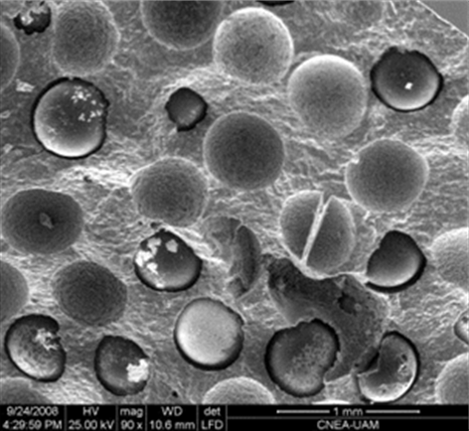
Figure 2. 3 - Micrograph of the ion exchange resins solidified in the cement matrix.
Some resin particles have dropped from the cement matrix leaving holes.
(Duffó et al. 2013)

Gordon et al. (2008) proposed for the encapsulation of inorganic type of IER, clinoptilolite which is used in Sellafield, UK within an alternative cement system, calcium sulfoaluminate, with additions of PFA or BFS. This system was suggested for the advantageous phase of ettringite to immobilise ¹³⁷Cs radionuclide but the experimental data showed unsuccessful results for this purpose. Frizon and Cau-dit-Coumes (2006) reported on the interactions of the gamma irradiation with the organic cationic resins with a basic structure functionalised with the addition of sulfonic groups, resulting in oxidation of sulphur to sulphate causing sulphate attack in cement matrix. (The effect of sulphate interactions with cement materials is explained comprehensively in the Section, 2.8)
An alternative solution for the effective treatment and encapsulation of all types of radioactive spent IER, is that the spent resins can be regenerated by strong acid such as sulphuric acid. The regeneration means stripping or eluting the radionuclides into an aqueous phase and transferring the activity on to an inorganic sorbent that can be easily be immobilised (IAEA 2001). Afterwards sodium hydroxide is added to neutralise the solution, therefore resulting in sodium sulphate formation in a radioactive wasteform. The presence of soluble sulphates which has been generated mostly from the sulphuric acid and also some from the spent IERs itself, in this type of waste-stream is problematic for disposal and direct encapsulation in cement therefore it is required to be treated effectively (Soluble sulphate salts interactions with cement materials is explained comprehensively in the Section, 2.8).

Asano et al. (2008) proposed an alternative method for the solidification/stabilisation of sulphate-rich aqueous low level wastes using Ba(OH)₂ and BFS, via a two-step process, in which a cement-like solid can be formed. In their method, Na₂SO₄ (simulated waste) solution was mixed with Ba(OH)₂ in the first step, stabilising the sulphate ions through the precipitation of the highly insoluble BaSO₄ and releasing NaOH (Equation 2.4) with reaction conditions at 60°C for 3 hours and a barium to sulphate molar ratio of 1.3. The second step of the process involved blending the alkaline BaSO₄-containing slurry (produced in the first step) with blast furnace slag (BFS) to produce a cement-like solid (Equation 2.5).

Ba(OH)₂ + Na₂SO₄ BaSO₄ + 2NaOH (2.4)
NaOH + BFS (+ any remaining/excess Ba(OH)₂ or Na₂SO₄) solid binder (2.5)

2.8 Interactions of soluble sulphate with cementitious materials

2.8.1 Sulphate phases in the hydrated cement paste
In general sulphate is added to PC clinker in the form of gypsum (CaSO₄·2H₂O) to retard and reduce the fast reaction of tricalcium aluminate (Ca₃Al₂O₆) with water in the hydration process which is called flash setting. Instead tricalcium aluminate reacts with gypsum in a slower rate to form sulphate containing hydration phases. In the hydrated cement paste two common calcium sulphoaluminate hydrate phases precipitate: ettringite or AFt (3CaO·Al₂O₃·3CaSO₄·32H₂O) and monosulfate or AFm (3CaO.Al₂O₃·CaSO₄·12H₂O) (Taylor 1997). Ettringite is the favoured hydration product among the above compounds at high sulphate content, as shown in Equation 2.6.

3CaO·Al₂O₃ +3(CaSO₄·2H₂O) + 26 H₂O = 3CaO·Al₂O₃·3CaSO₄·32H₂O (2.6)
Aluminate Gypsum Ettringite (AFt)
Ettringite formation occurs at the very early stages of hydration process of the cement materials. Black et al (2006) reported the first evidence of ettringite formation can occurs within the first 3 minutes of the hydration process. This is called “primary ettringite” formation. The crystal structure of ettringite is shown in Figure 2.4.

There are two characteristic structural components in this crystal structure:
- Columns: [Ca₆[Al(OH)₆]₂·24H₂O]⁶⁺
- Channels [(SO₄)₃·2H₂O]⁶⁻

The columns contains Al(OH)₆ octahedra alternating with triangular groups of edge sharing CaO₈ polyhedra.
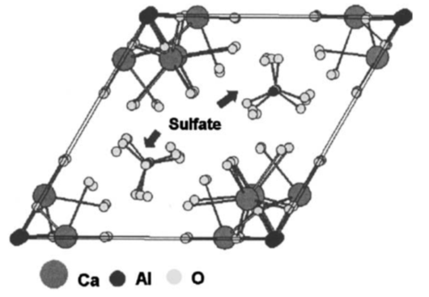
A
B
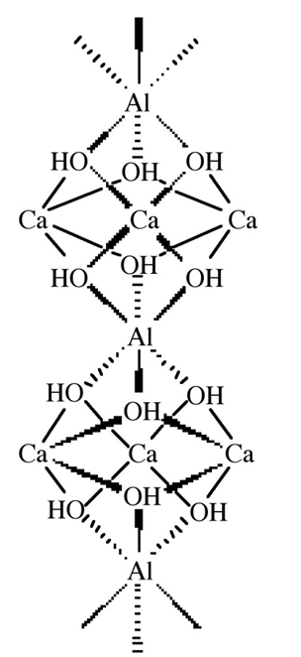
C

Figure 2. 4 - Crystal structure of ettringite.
(A) Schematic of AFt structure. (B) [001] projection showing stacks of sulphate ions rotated relative to one another. (C) [100] projection of ettringite structure showing apical water, hydroxyl and sulphate. The sulphate ions are not in the plane of the columns (Lachowski et al. 2003).

The channels provide four sites per formula; three of these sites are occupied by SO₄⁻² and one by two H₂O molecules (Taylor 1997). Ettringite is considered to be an important strength giving phase in the cement matrix. Recently, calcium sulpho-aluminate additives have been used to promote the early age ettringite formation resulting in early strength contributions (Glasser 1996, Zhou et al. 2006). Formation of ettringite is also considered to be desirable for nuclear waste encapsulation via cementation, as its large unit cell accommodates a large content of bound water, leaving less free water in the pore network available for radiolysis (Collier et al. 2014). Ettringite can also act as a host for a number of both positively and negatively charged ions in both the columnar and channel sections as isomorphous substituents within its structure. This mechanism can be beneficial for encapsulation of hazardous wastes of heavy metals such as AS, B, Cr, V, Cu, Cd, Pb, Zn and Fe (Kumarathasan et al. 1989, Albino et al. 1996), and also for many potentially problematic radionuclides. The ions which can undergo substitution in ettringite structure are Ca²⁺, Al³⁺, OH⁻ and SO₄²⁻. Gougar et al (1996) has reported on a review of previously studied list of ions that can be incorporated in this phase effectively. Sr²⁺ has been reported to be one of the ions that can be substituted for Ca²⁺ in this structure. Glasser (1993) reported that Ba²⁺ and Pb²⁺ also substitute for Ca²⁺ as well in ettringite structure. Table 2.5 shows the various alkali earth cations crystal ionic radii and how they are compared in a crystal structure to Ca²⁺.

Table 2. 5 - Crystal ionic radii in picometres (pm) of selected alkali earth metal cations.
Adapted from (Shannon 1976).
Cation | Atomic radii (pm)
Ca²⁺ | 114
Sr²⁺ | 132
Ba²⁺ | 149

Monosulfate (AFm) is another main hydration phase that contains sulphate but with a lower content. In the PC based materials where the sulphate content is limited, ettringite gradually converts to monosulfate (AFm) within the later stages of the hydration process. The presence and contributions of ettringite and monosulphate phases in the hydrated cement materials strongly depend on a few important parameters such as temperature and sulphate concentrations (Bye 1999). Formation of sulphate phases in the PC based cement can add stability to the matrix if they are formed under standard and controlled conditions, using standard amounts of clinker and aggregates. However if these conditions are altered, the durability of the cement or concrete matrix can be limited. The most significant undesirable interactions of sulphate with cementitious materials are listed and described below.

2.8.2 Delayed ettringite formation (DEF)
Delayed ettringite formation is an expansive effect after warm curing (about 70°C) of Portland cement compositions without the presence of sulphate from other sources. This phenomenon has been extensively studied by researcher worldwide (Glasser 1996, Kuzel 1996, Taylor et al. 2001, Collepardi 2003) and is called “delayed” ettringite formation as the AFt phase is produced at the later stages of hydration. The mechanism of this type of expansion and deterioration can be described as destruction of primary ettringite, which is formed in early stages of hydration by high temperatures (above 70°C), and then reforming in the later stages after the cement or concrete matrix cooled down (Taylor 1997). Taylor and Scrivener (2001) reported that the expansion occurs under these condition as a result of re-formation of ettringite in the paste where larger crystals were observed in cracks and voids causing crystal pressurisation.

2.8.3 External sulphate attack
External sulphate attack is the chemical intrusion and phase modifications that occur when cementitious materials with a certain age are exposed to sulphate rich environments, for example sewers, ground water, soil and contaminations, resulting in physical modifications of the solid material. Gollop and Taylor (1992) reported after analysing PC paste that had been stored for six months in solutions of sodium or magnesium sulphate: the disappearance of Ca(OH)₂; partial de-calcification of C-S-H phase; precipitation of gypsum and; replacement of monosulphate by ettringite. The alterations in the main hydrated phases induce weakening of the matrix along with cracking and expansion. These phase transformations have been studied extensively by various researchers globally, by various methods (Maltais et al. 2004, Kunther et al. 2013, Yu et al. 2013). Recently Whittaker and Black (2015) reported comprehensively on the current knowledge about external sulphate attack and the vital consideration of differences between field- and lab-based studies, putting some standards forward. In general, sulphate attack process is strongly dependent on various parameters such as sulphate concentration, time, pH and chemical composition of the cement, but the most important factor is initially the permeability of the matrix, which controls the diffusion of the sulphate ions and further interactions with the hydrated phases. Monteiro and Kurtis (2003) reported that a lower water/cement ratio (w/c) gave a lower permeability, resulting in a better resistance to sulphate attack, and also highlighted the importance of a low content of un-hydrated tricalcium aluminate (C₃A) (>8%) in the cement.
One of the main theories proposed for the disturbance of the cement matrix exposed to soluble sulphate ions is the crystallisation pressure theory (Eglinton 2003). This can be described as the conversion of calcium hydroxide to gypsum initially, then subsequently to ettringite with the interaction of the aluminate phase, with a growth in the solid volume. Reaction 2.8 and 2.9 demonstrate the chemical reaction process:

Ca(OH)₂ + Na₂SO₄ + 8H₂O = CaSO₄·2H₂O + 2NaOH (2.8)
Portlandite Gypsum

4CaO·Al₂O₃·19H₂O+3(CaSO₄·2H₂O)+16H₂O=3CaO·Al₂O₃·3CaSO₄· 32H₂O+Ca(OH)₂
Calcium Aluminate Hydrate Ettringite (2.9)

Table 2.6 shows the respective molecular weight and volume in each phase present in cement. The molecular volume change between aluminate phase, gypsum and ettringite can be responsible for the expansion mechanism as ettringite has a large molecular volume compared with phases.

Table 2. 6 - Molecular weight and volume of the various cement hydration products.
(Eglinton 2003)
Compound | Name | Molecular  Weight | Molecular  Volume (mL)
Ca(OH)₂ | Portlandite | 74.1 | 33.2
CaSO₄·2H₂O | Gypsum | 272.2 | 74.2
3CaO·Al₂O₃·Ca SO₄·12H₂O | AFm or  Monosulphate | 560 | 263
3CaO·Al₂O₃·3CaSO₄·32H₂O | AFt or Ettringite | 1236.6 | 714.9

Consequently to the sequenced reactions and volume expansion, calcium silicate hydrate (C-S-H), the main binding phase, is destroyed to provide calcium for this change, and large unit cells of ettringite are formed, causing expansion and cracking the structure. External sulphate attack can occur and cause cracking if the soluble sulphate ions in nuclear waste are not immobilised appropriately, and if they are exposed to the concrete used in the repository facilities such as floors and walls. British Standard states that for soluble sulphate being in contact with cement and concrete (PC based materials) from external sources, the acceptable limit is less than 400 mg/l to prevent sulphate attack (BSI 2015).

2.8.4 Internal sulphate attack
The presence of sulphate rich components in the cement mixtures inducing interference with the standard hydration process or modification of hydrated phases is referred to as internal sulphate attack. Gypsum contaminated aggregates used in concrete for economic reasons can be pointed out as one of the examples. Conventional concretes are allowed to contain only 3-4% of sulphate constituents to avoid this phenomenon (Skalny et al. 2002, Odler 2003). British Standards (BS 8500-1-2015) also states the importance of the limitations for mobile sulphate ions within the concrete matrix, for which only 4-5% is allowed:
“After hardening of the concrete, excessive amounts of mobile sulfate from aggregates or other constituents in concrete can cause expansion and disruption. To prevent this, specifications for many constituent materials put limits on the sulfate level.” (BSI 2015)
Crammond (1984) reported on the examination of mortar bars containing varying percentages of coarsely crystalline gypsum as aggregates. He suggested that controlling the total sulphate content below 4% of SO₃ prevents the deterioration but also that temperature can affect the degree of expansion, especially when high tricalcium aluminate concentrations are present in the clinker. Internal sulphate attack can also occur if the sulphate-bearing radioactive waste is not treated appropriately and encapsulated in the PC based materials, thus acting as a source of soluble sulphate disturbing the wasteform matrix.

2.8.5 Controlling factors of the interactions
Ouyang et al. (1988) and Monteiro et al. (2003) reported that the most important parameters for sulphate intrusion and interaction with the cement hydration phases can be summarised as:
- The content of aluminate phase in cement clinker. Larger amounts of this phase in the clinker used in the cement promote higher aluminium availability for formation of ettringite in the future.
- Water to cement ratio. As the water to cement ratio increases, the expansion increases over time. This is due to more free water in the system, which assists the sulphate ion to diffuse freely and interact with the hydration products of the hardened cement.
Eglinton (2003) states that the maximum limitation for the expansion caused due to sulphate attack is 5%. Also he emphasises that Plain Portland cement is the most vulnerable type of material to sulphate attack, whereas sulphate resisting Portland (with lower level of tri calcium aluminate) and PC/BFS cements have greater resistance, but they are not completely immune to attack in all situations and at all concentrations of sulphate.

2.9 Barium sulphate
The comprehensive literature studies on natural sulphate deposits indicate that barium sulphate (barite) is the most insoluble form of sulphate salt, and a thermodynamically stable and chemically durable phase. In nature barite bearing rocks are as old as ~3.5 billion years (Hanor 1973). Table 2.7 shows the various solubility constants of chemical compounds found in PC compared to that of barite. BaSO₄ has the lowest solubility among all and also in the most insoluble form of sulphate salts. In general it has been reported that in the concrete mixes, a sulphate salt can be introduced as an aggregate in the concrete mixes without concern, in a sufficiently insoluble form such as barite (BaSO₄), whereas aggregates containing soluble sulphate phase such as CaSO₄ should not be used (Skalny et al. 2002).
Table 2. 7 - Solubility of some compounds of alkali earth metals
(Lide 2005)
Chemical Compound | K_{SP} (25°C)
Ca(OH)₂ | 5.02×10⁻⁶
CaCO₃ | 3.36×10⁻⁹
CaSO₄·2H₂O | 3.14×10⁻⁵
BaCO₃ | 2.58×10⁻⁹
BaSO₄ | 1.08×10⁻¹⁰

Composite concrete systems containing barite are well-known as radiation shielding materials used for nuclear safety and shielding structures in power plants (Akkurt et al. 2010, Esen and Yilmazer 2011) due to its high attenuation coefficient. BaSO₄ is also known as a thermoluminescent material suitable for radiation detection and dosimetry (Manam and Das 2009). For the nuclear industry, IAEA (2001) suggested that BaSO₄ has applications for co-precipitation of the radionuclide ⁹⁰Sr in nuclear waste management.

2.10 Alkali activated slag cement (AAS)
Alkali-activated binders are materials produced through the chemical reaction between an aluminosilicate source and an alkali activator. These cements can develop high mechanical strength, along with reduced permeability, at early times of curing. In recent years it has been suggested that alkaline activated slag (AAS) might be a better option for stabilisation/solidification of low/intermediate level nuclear waste (LLW/ILW) than PC due to its low permeability, low reaction heat, and high resistance to aggressive chemical attack (Wu et al. 1991, Milestone 2006, Shi et al. 2006).

Blast furnace slag (BFS) is a non-metallic by-product of the iron industry consisting mainly of silicates and alumino-silicates of calcium. In 1862, Emil Langen discovered the latent hydraulic properties of ground granulated blast furnace slag. “Latent Hydraulic” means that, once activated, the slag reacts with water to give a cementitious materials (Lang 2002). Although the abbreviation GGBS (Ground Granulated Blast Furnace Slag) is broadly used by civil engineers, the abbreviation BFS is preferred in the UK nuclear industry and is adopted here (Sharp et al. 2003). The chemical composition of the BFS can generally be defined as CaO-MgO-Al₂O₃-SiO₂ but it can be varied depending on the source. Other additional elements such as sulphur, titanium, and manganese can be found depending on the chemical composition of the iron ore (Bernal et al. 2014a). BFS in comparison to PC has smaller amounts of CaO but relatively larger amounts of MgO and Al₂O₃ with a glassy nature. Talling et al. (1989) reported that BFS with CaO/SiO₂ ratios between 0.5 - 2.0, and Al₂O₃/SiO₂ ratios between 0.1 - 0.6, can be appropriate for alkali activation.

2.10.1 Activation mechanism
As described in the previous section, water can react with BFS but it requires a prolonged period of time to produce a hardened binder, which is not desirable in practise. To accelerate this reaction and promote formation of a hardened binder over a moderate curing time, an alkaline activator is necessary to provide higher pH for the dissolution of the slag.

The activator is normally a strong alkaline solution such as alkali hydroxides and silicates, but moderate alkaline solutions of alkali sulphates and carbonates can also function for this process. The anionic compounds of an alkaline activator react with the Ca²⁺ from the BFS, resulting in the precipitation of the Ca-rich reaction products (Bernal et al. 2014a). The pH of an alkaline activator plays a vital role for the effectiveness of the chemical reaction in this process. The high pH of the activator promotes a higher dissolution rate for the Ca²⁺ ions from the BFS, resulting in a greater dissolution of the precursor and more precipitation of the reaction products (Zhou et al. 1993, Shi and Day 1996, Shi 2003). NaOH solution is one of the most common activators used in the activation process as it provides the relatively high alkalinity for the reaction.

In the case of the conventional cement composite that is used for the encapsulation of the nuclear waste, as was explained earlier in the section 2.6, large amounts of BFS are added to PC. This can also be considered another example of an AAS cement system. With the addition of water to this mix, the Ca(OH)₂, which is one of the hydration products of PC, plays the important role of an activator for the slag. This is called indirect-activation as the activation of the BFS relies completely on the hydration of the PC primarily. Milestone et al. (2006) and Taylor et al. (2010) reported similar results on the analysis of the aged BFS-PC composite samples, as large amounts of unreacted BFS was observed. It is suggested that a direct activation of the slag could be more effective rather than using the PC.

It has been reported that NaOH activation can promote a relatively high degree of reaction owing to its high pH, giving a moderate compressive strength, but silicate activation of the similar BFS results in a higher compressive strength despite its moderate pH (Roy et al. 1992, Wang et al. 1994, Fernández-Jiménez et al. 1999, Escalante-Garcia et al. 2003). This influence on the strength is the consequence of the activator type; in this case silicate activators provide supplementary silicate species to the system, promoting a denser binding product of C-A-S-H phase (Fernández-Jiménez and Puertas 2003). Mixtures of the activators with various concentrations can also be used to retain the high pH and also to deliver specific chemical species into the reaction products. This can be an advantage compared to the ordinary PC based materials where there is less flexibility in chemical composition of the reaction products and their properties (Douglas and Brandstetr 1990, Shi et al. 2006, Bernal et al. 2014a).

When BFS reacts with an activator to form a hardened binder, the main reaction product and strength-giving phase is a calcium-silicate-hydrate (C-S-H) type phase with a low Ca/Si ratio and a significant degree of aluminium substitution, termed C-A-S-H type gel, with a disordered tobermorite-like C-S-H (I) structure (Taylor 1997, Shi et al. 2006). The structure and composition of the C-A-S-H and the secondary reaction products forming in alkali-activated slag binders are strongly dependent on the nature of the activator selected (Richardson and Groves 1992a, Wang and Scrivener 1995, Richardson 1999, Fernández-Jiménez and Puertas 2003), the activation conditions adopted (Burciaga-Díaz et al. 2010), and the chemical composition of the slag used (Ben Haha et al. 2011, Ben Haha et al. 2012).

2.10.2 Properties of the main reaction product: C-A-S-H phase
Similarly to C-S-H gel described in Section 2.5 for the PC binders, the main binding phase in AAS is a C-A-S-H gel, which consists of layers of tetrahedrally coordinated aluminosilicate chains. The interlayer areas are rich in Ca and also water of hydration. The main binding phase, C-A-S-H formed in the AAS system, is distinct from that of the PC system, as it tends to have higher crystallinity and a lower Ca/Si ratio, as well as a high Al content. Shi et al. (2006) reports that the compositions of the C-A-S-H type gels formed in the AAS cement system diverge depending on the activation conditions, but in general it is near Ca/Si = 1. Puertas et al. (2011) reported that that the C-A-S-H type gels formed in the sodium silicate and sodium hydroxide activated BFS systems consist of coexisting structures of 11 and 14 Å tobermorite like phases.

Aluminium incorporation plays a primary role in the structure of the C-A-S-H phase, providing a link between the silicon tetrahedra resulting in polymerisation and cross-linking of this main binding phase. This influence has been studied widely (Richardson et al. 1993, Wang and Scrivener 2003, Sun et al. 2006, Oh et al. 2011, Ben Haha et al. 2012, Myers et al. 2013) and solid state ²⁷Al NMR is one prominent technique applied for this investigation. In general, Al uptake in the C-S-H phase can vary from Al/Si ratio = 0.11-0.34 depending on the structure of the silicate chains (Chen et al. 2007, Pardal et al. 2009, Oh et al. 2011). Figure 2.5 illustrates schematic representation of crosslinked and non-crosslinked tobermorite-like C-A-S-H structures proposed by Myers et al. (2013) where the inclusion of Al tetrahedra in the Q³ silicates sites demonstrates cross-linking of the main binding phase in the general AAS binders. They proposed this structural model to calculate the degree of crosslinking, chain lengths and Al/Si ratios for tobermorite-like C-S-H gels.

Figure 2. 5 - Schematic representation of cross-linked and non-crosslinked tobermorite.
Red triangles show silicon tetrahedra and grey triangles show Al tetrahedra.
Adopted from (Myers et al. 2013).

Puertas (2011) reported on an experimental and computational study for a model to describe C-A-S-H gels in the AAS paste and highlighted the importance of the nature of the alkali activator type. They stated that when NaOH solution is used as an activator, the C-A-S-H gel encloses Al in its composition (in bridge positions) with high Q²(1Al) content and low Q³ unit, but when Na₂SiO₃ is used as an activator for the same slag, the C-A-S-H gel formed has high percentages of Al in tetrahedral position, resulting in the Q³ unit with a longer mean chain length. The presence of Q³ units in the binding gels is an indication of the chain crosslinking, with the formation of laminar structures in some areas resulting in higher mechanical strength.
In tobermorite-like structure of C-A-S-H, with the inclusion of Al^{[4]}, there is need for a charge balance for compensation between Al³⁺ and Si⁴⁺ sites. Alkali ions such as Na⁺, K⁺, Ca²⁺, or H⁺ can provide the charge balance and be incorporated in the C-A-S-H gel in the interlayer or surface (Hong and Glasser 2002, Sun et al. 2006). The notation C-(N-)A-S-H reflects the increased sodium content in addition to the high levels of Al incorporated into this phase. Recently Myers et al. (2014) proposed a thermodynamic model for the C-(N-)A-S-H gel in Na₂SiO₃-activated slag binders for the structurally-incorporated Al and Na species in this phase.

2.10.3 Secondary reaction products
Secondary reaction products in AAS systems also depend strongly on the type and concentration of the activator used. In general for alkali silicate- and alkali hydroxide-activated slags, for instance, layered double hydroxide, hydrotalcite-like compounds [Mg₆Al₂(CO₃)(OH)₁₆·4H₂O] have been observed (Schilling et al. 1994, Wang and Scrivener 1995, Bonk et al. 2003, Ben Haha et al. 2011). In alkali-activated slags with moderate to high MgO contents, such layered double hydroxides are usually produced as a secondary reaction product (Ben Haha et al. 2011, Bernal et al. 2014b). It has also been reported that the hydrotalcite phase can also be present, finely mixed with C-S-H gel in the silicate and hydroxide activated binders (Escalante-Garcia et al. 2003).

When Na₂SO₄ is used as the sole activator, the main secondary product is ettringite because of the increased content of sulphate available in the system (Gruskovnjak et al. 2008, Bai et al. 2011, Rashad et al. 2013). Less attention has been paid to the near neutral salts to be used as activators, as their utilisation compromises the early strength development of these binders, and the initial hardening of the cement can take several days or longer. Even though the strength development of Na₂SO₄ activated slag cement can be optimised and improved to fit the needs of the construction industry, for some specialised applications, rapid setting is not considered a key factor controlling the application of a cementitious system in nuclear waste immobilisation. For instance, Na₂SO₄ activated slag has been evaluated as a potential matrix for the disposal of low and intermediate level nuclear waste for its low heat of reaction and moderate pH, which is proposed to be beneficial in reducing corrosion of radioactive metals (Bai et al. 2011). Na₂SO₄-activated slags can be used for other applications where the early setting times are less important. Recent studies have shown that these binders are more resistant to degradation caused by exposure to elevated temperatures up to 600°C, in comparison to PC (Rashad et al. 2012).

2.10.4 Advantages of the AAS system for nuclear waste encapsulations
Some of the available literature suggests that AAS cement system may be a better option for stabilisation and solidification of hazardous and nuclear waste than PC. The advantages of this system can be summarised as:
- Cement production is a greatly energy demanding process and also contributor to carbon dioxide generation. As the global warming effects and reducing carbon foot prints are more of a concern these days, recently the attention is towards materials with less energy consumption and less CO₂–output comparing to cement clinkers such as BFS (Lang 2002, Taylor et al. 2006, Juenger et al. 2011). As BFS is a by-product material, it is environmentally advantageous to be used as an alternative to PC.
- BFS has a low heat of hydration compared to PC, due to the lower Ca/Si ratio present in this material. This is beneficial for nuclear waste applications. As it was explained in Section 2.6, in nuclear applications, a thermal gradient caused by heat of hydration is detrimental as it amplifies the structural instability and crack development which can result in the release of radionuclides from the matrix (Milestone 2006).
- The water demand in the AAS binder is lower than PC system; this is due to the surface-active effect of the alkaline component in the AAS system (Bai et al. 2011). This decreased water to cement ratio leads to a lower permeability of the formed wasteform (Taylor 1990, Milestone 2006).
- AAS binder has a dense structure and stability at high temperatures, and also in dry and wet conditions (Spence and Shi 2005).
- AAS binder has been reported as a successful matrix for immobilising hazardous waste including Hg²⁺, Zn²⁺, Cr⁶⁺, Cd²⁺, Pb²⁺, Cs⁺, Sr²⁺ (Spence and Shi 2005, Milestone 2006). The other utilisation of these binders in the area of radioactive waste treatment includes stabilisation/ solidification (S/S) of radioisotopes including ⁹⁹Tc and ¹²⁹I (Guangren et al. 2002).
- The activation of slag using near-neutral salts such as Na₂CO₃ and Na₂SO₄ has been considered a potential alternative for the immobilisation of nuclear wastes including reactive metals (Bai et al. 2011).
- The leachability of contaminants from AAS cement wasteforms with solidified/stabilised hazardous and radioactive waste is lower than from hardened PC stabilised wasteforms (Shi et al. 2006). The experimental data from the literature display that leached fraction of Cs⁺ from PC is higher than that from AAS binders (Spence and Shi 2005, Shi and Fernández-Jiménez 2006). This phenomenon can be associated to the formation of a low Ca/Si ratio C-A-S-H phase structure in these binders with the Al substitution, being able to adsorb cations such as Cs⁺ in charge balancing roles.

It can be concluded that these alternative cements have the potential to play an important role in the current and future radioactive waste management.

2.11 Effects of gamma irradiation on cement and concrete
Nuclear radiation is produced when an unstable nucleus goes through decay, forming other more stable nuclei and emitting radiation energy. There are various types of nuclear radiation such as: alpha, beta, gamma and neutron. Gamma radiation is an ionising form of electromagnetic radiation. Gamma radiation has very high energy and is the most penetrating ionising radiation, and so is harder to shield than alpha and beta radiation. One of the main radionuclides found in the ion exchange resins and accountable for gamma radiation is caesium-137, which is a fission product of uranium-235 isotope. Figure 2.5 shows the decay scheme for ¹³⁷Cs. The half-life of this radionuclide is 30.23 years; the initial decay is beta to ¹³⁷Ba (meta-stable) and then gamma rays to ¹³⁷Ba (stable) with 0.662 MeV energy produced per decay. One gram of ¹³⁷Cs has an activity of 3.215 Tera-Becquerel (TBq); the Becquerel is the unit of radioactivity in the SI system equal to one disintegration or nuclear transformation per second.

Encapsulated nuclear wasteforms are exposed to ionising radiation throughout their lifetime. It is essential to understand the effects of radiation on the applied materials, to determine if they can withstand such service conditions. However, there is little information available in the literature regarding the radiation effects on cement materials that have been used for the encapsulation of nuclear wastes. Most of the reported studies focus on hardened cements and concretes based solely on PC, which are used for nuclear safety and shielding structures in power plants, and assess the effects of gamma irradiation on mechanical properties and physical deterioration.
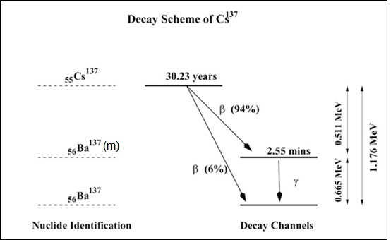
Figure 2. 6 - Decay scheme of caesium 137

Soo and Milan (2001) investigated the influence of the dose rate on the compressive strength of PC based materials at 10ºC, identifying that strength of the irradiated materials exposed to rather low dose rates (31 Gy/h) falls rapidly once the total dose exceeds about 0.1 MGy. Conversely, exposure to higher dose rates (380 kGy/h) for the same materials led to an increased in mechanical strength up to total dose of 10 MGy. The mechanisms of strength loss due to radiation exposure are not well understood, but it can be related to the loss of water from the cement hydrate components, which is described as radiolytic dehydration. However, if a moderate degree of heat is also generated or applied during irradiation, the kinetics of cement and slag hydration are accelerated, leading to a larger extent of reaction, which consequently promotes an increase in strength. This elucidates the complexity of understanding radiation effects in cementitious materials, as several phenomena will take place simultaneously, and depending on which one prevails in the system studied, it can lead to modification of the properties of the cement wasteform in different ways.
One of the main concerns related to the use of cement for the encapsulation of nuclear waste is the interaction of gamma rays with the water present in the pores of the hardened cement, which can induce radiolysis of water (Bouniol and Aspart 1998). Radiolysis of water is the dissociation of water molecules by ionising radiation as described in general as series of equations below:
Radiation + H₂O = H₂O⁺ + e⁻
H₂O⁺ = H⁺ + OH°
e⁻ +H₂O = H₂O⁻
H₂O⁻ =H° + OH⁻

The reactions and formed radiolytic products are complicated but the final main critical radiolytic products concerned as a result of reactions above are H₂ and H₂O₂, in the context of the storage and disposal of nuclear waste in cementitious materials. Bouniol et al. (2008) stated that when the alkaline medium in concrete pores undergoes radiolysis, H₂ gas is produced as a primary product. As O₂ was not detected in their study, it was assumed that the other primary product of radiolysis is H₂O₂, which is mostly captured by the calcium present in the PC to form calcium peroxide octahydrate (CaO₂·8H₂O); this can then favour calcite (CaCO₃) formation in the grout. Consistent with this, Vodak et al.(2005) observed increased calcite formation in aged concrete samples exposed to high doses of gamma radiation, up to 1 MGy over 83 days. They also noted reductions in mechanical strength and pore volume. Bar-Nes et al. (2008) also identified formation of calcium carbonates in gamma irradiated PC samples, when exposed to 10 MGy for a period of 6 months.
In a later study, Vodak et al. (2011) speculated that, in addition to the effect of pore water radiolysis, the presence of micro-cracks due to radiolytic dehydration of the reaction products in the cement, favours the ingress of CO₂ into the monolithic material, and its consequent reaction with the hydration products towards formation of calcium carbonates, especially at lower dose rates of radiation over a longer period of exposure. Higher total doses of gamma radiation from 130 to 836 MGy were found to reduce the fraction of crystalline reaction products formed during cement hydration, and even induced the decomposition of the cement clinker phases (Lowinska-Kluge and Piszora 2008).

It has also been reported that BFS-PC wasteforms (Pottier and Glasser 1986) can show occasional spallation and cracking when irradiated at a dose rate of 10 kGy/h to a total dose of 6-9 MGy, with no identifiable variation in the reaction products. Richardson et al. (1990) evaluated the microstructure of BFS-PC composites at a dose rate of 10 kGy/h to a total dose of 87 MGy over two years at 50ºC. The formation of additional ettringite (Ca₆Al₂(OH)₁₂(SO₄)₃∙26H₂O) in the irradiated samples was observed when compared to the control samples, suggesting that gamma radiation may accelerate the oxidation of the sulphide (S²⁻) provided by the slag, to form sulphate SO₄²⁻ and promote further formation of ettringite. No alteration in the morphology and composition of the calcium silicate hydrate (C-S-H) was identified in their study. Palmer et al. (1992) reported similar results on the same composite formulation with gamma ray interactions, and indicated that pore solution chemistry was mainly unaffected by gamma irradiation, although at higher doses (10 MGy) there was evidence of an escalation in sulphate concentrations, which was again a result of oxidation of the sulphides present in the slag by the radiolysis effect. Craeye et al. (2015) also observed similar results of formation of ettringite under gamma irradiation for a BFS based cement system which was designed for the encapsulation of high level radioactive waste. The same phenomena did not occur when PC was used in the formulations, linked to the limited amounts of sulphur and aluminium availability in the PC to promote ettringite formation.
The information gathered from the literature review regarding the gamma radiation interaction with cement is rather dispersed, not systematic. The main parameters affecting the interactions of cementitious materials and gamma rays are noted as: the water to binder ratio, thee type of binding material and applied formulations, age of the materials when exposed to irradiation, dose rate and total dose received over a specific time.

Chapter 3- Materials and methods

3.1 Introduction
This chapter provides information about the experimental work carried out in the present study. First, the key analytical techniques used for the characterisation of raw materials and specimens assessed in this project are listed in detail with their principles.
Second, the raw materials and reagents used in the experiments are described followed by the formulations applied, sample preparation and mixing procedures. Lastly the tests and characterisations used explained accordingly.

3.2 Key analytical techniques

3.2.1 Optical Microscopy
Microscopic inspection was carried out for the samples used in the irradiation resistance test to observe the effects of gamma irradiation and heat-treatment on their macroscopic features. An optical microscope, Nikon Eclipse LV150, shown in Figure 3.1 with 50× magnification was used with Buehler Omnimet Enterprise 9.5 software, to identify any pores and cracks forming in the specimens. Thresholding of the micrographs was carried out using Image-J. A threshold range was established to distinguish the objects of interest (in this case pores and cracks) apart from the background. All pixels in the image whose values lie under the threshold are converted to black and all pixels with values above the threshold are converted to white to highlight the features of interest.

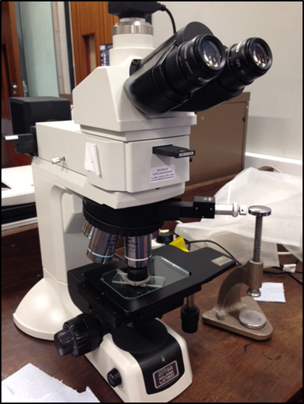
Figure 3. 1 - Optical microscope

3.2.2 X-Ray Diffraction (XRD)
Principle
X-rays are electromagnetic radiation of small wavelengths. Crystals have collections of atoms or molecules arranged in a 3-dimensional set, which are repeated. As these bond distances between the atoms in a crystal have regular replication, they can behave as a diffraction grating for incident X-rays with comparable wavelengths.

This replication of bond distance in the crystals can be considered as being built up in layers or planes with varying inter-planar distances d as shown in Figure 3.2. When the difference in the path distance of X-rays, e.g. JE+EK for X-rays ABC and DEF, is an integer multiple of the wavelength, they interfere constructively. Based on this principle, the condition for diffraction from a set of parallel planes of interlayer spacing d is shown in Equation 3.1 (Bragg’s equation), where θ is the angle of incidence for the X-rays to the planes, and λ is their wavelength.

nλ = 2d sinθ Equation 3.1

In powder samples, the crystals are randomly arranged in various orientations, so there should be crystals complying with Bragg’s law at certain angles θ, and consequently diffraction takes place when a monochromatic beam of X-rays strikes the sample.

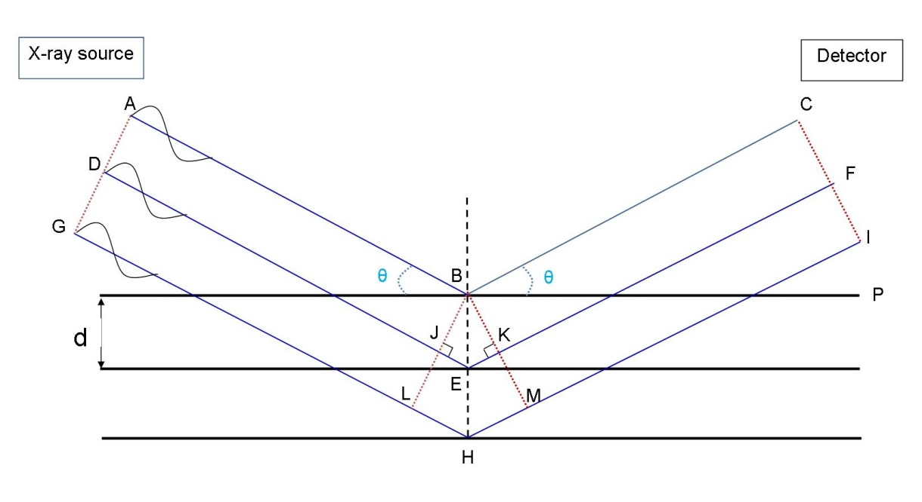
Figure 3. 2 - Schematic of X-ray reflection on a set of parallel planes.
From Clearfield et al. (2008).
Measurement
XRD was used to characterise crystalline phases present in the samples. During the present study, two X-ray diffractometers were used: a Siemens D500 and a Siemens D5000. In both cases, a Cu long fine focussed X-ray tube operating at 40kV and 40mA was used, producing Kα radiation (wavelength = 1.5419 Å). Both instruments were fitted with secondary beam monochromators to suppress fluorescence and reduce background noise. A Siemens D5000 was used to conduct 2θ scans over the range 5-55° with a step size of 0.02° and scanning speed of 0.5° 2θ /min. The specimens were prepared by crushing samples using a percussion mortar, then grinding using an agate mortar and pestle, sieving with a brass sieve, to a particle size less than 63 µm. Phase analysis was conducted using STOE's WinX^{POW} software and the International Center for Diffraction Data (ICDD) Powder Diffraction File (PDF).

3.2.3 Thermogravimetric analysis (TGA)
Principle
This technique measures the mass change of the sample as a function of either time or temperature, by setting a defined temperature program under a specific gas atmosphere.
The mass loss is associated with the decomposition of certain cement phases at specific temperatures and is beneficial to quantify the amount of phases present in the sample.
Differential ThermoGravimetric (DTG) curves are recognised as the derivatives of TG curves and are also displayed. The DTG curves demonstrate the temperature series of weight loss measures to be determined more precisely.
Measurements
TGA was used to identify the phases present in each sample based on their dehydration and decomposition profiles upon heating. The analysis was carried out using a PerkinElmer Pyris 1 TGA. Powder was obtained by crushing specimens with an agate mortar and pestle. Samples were sieved to <63μm, and approximately 40 mg of sample was weighed in an alumina crucible. The samples were heated under flowing nitrogen at a rate of 20 mL/min. A uniform heating rate of 10°C/min was applied from room temperature up to 1000°C. Temperature and mass measurements were taken every 0.1 s.

3.2.4 Scanning electron microscopy (SEM)
Principle
To study the microstructure, morphology and composition of the composite cement samples, scanning electron microscopy (SEM) was used (Richardson 2002). In this technique, accelerated electrons are generated from an electron gun, which in this case, for the JEOL JSM6400 models, is a tungsten filament. In most electron microscopes a loop of tungsten is used for a source of electron which is called the filament (Flegler et al. 1993). When the filament is heated, a cloud of electrons is generated at the tip of the filament which is also a cathode. With a voltage difference electrons are accelerated towards an anode. The accelerated electrons become condensed and focused into a monochromatic electron beam by assistance of a series of lenses and apertures. A vacuum is necessary to maintain a stable electron beam without interactions with the gas molecules and becoming ionised. The electron beam goes through a set of scanning coils which guide the beam into a scanning array across the surface of the sample. When the high energy electrons bombard a specimen, emission of secondary electrons with the backscattering of incident electrons and the emission of X-rays take place in the near surface.

In this thesis, SEM was used in two imaging modes: Secondary Electron Imaging (SEI) and Backscattered Electron Imaging (BEI). For the SEI mode low energy secondary electrons (normally < 50 eV) are released from the interface between the incident beam of high energy electrons and the atoms of the sample through inelastic collisions. Inelastic interactions takes place between the incident electrons and the orbital shell electrons of the atoms of the samples and have a small angle deflection (Bowen and Hall 1975). These produced low energy secondary electrons are detected and applied to create an image from the apparent topography of the studied sample. As these secondary electrons have moderately low energies, they can only arise from the surface of the sample for tens of nanometres.

For the BEI mode, the image is formed from backscattered electrons as high energy electrons, with an average of 60% to 80% of the original energy of the electron beam (Flegler et al. 1993), and they are generated as result of elastic collision. Elastic interactions occur, between incident electrons and the nucleus of atoms of the samples and have large angle deflection. Therefore, atomic number of the sample plays an important role for the assembly of the backscattered electrons. Elements with higher atomic number, replicate a higher fraction of the electrons, therefore they appear brighter. Elements with lower atomic number generate lower fraction of electrons and appear darker. In the final produced image, the contrast specifies the average atomic number of the elements existing within the microstructure and is expressive of the variable elemental compositions. For porous materials such as cements, porosity appears as black.
Measurements
SEM analysis was carried out by JEOL JSM6400 scanning electron microscope. The acceleration voltage was 20 KeV, with a spot size of 9 and working distance of 12mm. Analysis was conducted on polished surfaces of the samples. The samples were previously prepared by first arresting the hydration of small pieces in acetone and then air dried. They were mounted in epoxy resin and allowed to set for a minimum of 48 hours, ground using silicon carbide grinding paper of increasing fineness (P240, P400, P800, P1200) and then polished using polishing cloths and diamond paste of 6 μm,
3 μm, 1 μm, and ¼ μm fineness. Silver dag was applied to paint around the circumference of the cylindrical mount to create a conductive path between each sample and the circumference to avoid accumulation of charge on the samples. The painted samples were dried for a minimum of 24 hours and were then carbon coated to reduce the build-up of the electric charge and improve conductivity.

3.2.5 Energy Dispersive X-ray Spectroscopy (EDS)
Energy Dispersive X-ray spectroscopy (EDS) was applied for point spectral analysis and elemental mapping to investigate the elemental composition of some of the cement samples. For this technique, the sample is bombarded by electrons of appropriately high energy which is higher than the critical excitation energy, resulting in the inner shell electrons ionisation and being ejected (Flegler et al. 1993). X-rays are released as a consequence of electron transition from an outer shell to occupy the vacancy. The exact energy emitted as X-rays from a specimen can be measured by an energy-dispersive spectrometer. EDS allows the elemental composition of the sample to be measured, as the energies of the X-rays are representative of the alteration in energies between the two shells of the atomic structure of the emitting element. The resultant data are presented as single images for each element of interest, or as a composite image in order to determine phase distributions. A Link ISIS EDX analyser integrated with the JEOL JSM6400 scanning electron microscope was used throughout the work presented.

3.2.6 Magic Angle Spinning Nuclear Magnetic Resonance (MAS NMR) spectroscopy
The main advantage of the solid-state MAS NMR technique is the capability to conduct structural examination of phases, focusing directly on the environment of a specific element. This technique can be applied not only to ordered phases but also amorphous and poorly crystalline phases, to complement XRD and other analysis.

Principle
This technique utilises the fact that a specific nucleus of non-zero spin, in a magnetic field under suitable conditions, can absorb electromagnetic radiation in the radio frequency region at frequencies characteristic to the nuclide (Silverstein and Webster 1996). Atomic nuclei have a positive charge from the protons they contain, and spin along the axis of the nucleus. In some nuclei, the spinning charge on protons generates a magnetic dipole along the axis, resulting in a magnetic moment. Although these magnetic moments, or “spins”, are usually randomly oriented, in the presence of an external magnetic field (B₀), they split into two directions along the B₀ due to the Zeeman effect: parallel to B₀ (α-spin) and anti-parallel (β-spin) as shown in Figure 3.3. The β-spin state is higher in energy than the α-spin state, and the transition of the α-spin state to the β -spin state can occur when electromagnetic radiation at a frequency corresponding to this energy difference is applied. This is the basic principle of nuclear magnetic resonance (NMR).

ΔE = hν =
E₂
β-spin
B₀
E₁
α-spin
hγB₀
2π

Figure 3. 3 - Illustration of energy absorption for the spin change in NMR, in the presence of an external magnetic field (B₀)

The energy difference between the two spin states (ΔE) is expressed using Equation 3.2

ΔE = E₂ –E₁ = h ν = h γ B₀/2π Equation 3.2

where E₁ and E₂ are the energies of α- and β–spin states, respectively; h is the Planck constant, ν is resonance frequency, and γ is the gyromagnetic ratio, which is a constant for each nuclide. Therefore, the energy difference between the two spin states is proportional to the external applied magnetic field, and the proportionality constant is specific to each nuclide. Nuclides with even mass number and even charge have zero overall spin (e.g. ¹²C and ¹⁶O) and are not useful for NMR spectroscopy.

The signal in NMR spectroscopy is obtained by recording the energy absorbed through the transition of spin states over a range of electromagnetic radiation frequency. The frequency of resonance slightly changes depending on the chemical environment of the nucleus. This slight change is called chemical shift (δ), and it takes place because of the change in the electron density due to the different chemical environments of the nuclei. Electrons flow under the effect of a magnetic field and as they are circulating, they create their own magnetic field opposing the applied field, causing a shielding effect (Silverstein and Webster 1996).

The results of NMR spectroscopy are shown as an absorption spectrum plotted against the chemical shift (δ, in units of parts per million, ppm) relative to the absorption position of a reference. For example, tetramethylsilane (TMS) is used as the reference for ²⁹Si NMR spectroscopy, as it is chemically inert, symmetrical and soluble in organic solvents, which gives a single, intense and sharp absorption peak. The chemical shift for TMS is defined as 0.00 ppm, and the chemical shift is defined as:
Chemical shift (δ, ppm) = Shift downfield from TMS (Hz) / Total frequency (MHz)
An NMR spectrum is plotted with increasing magnetic field towards the right. Therefore, a more shielded nucleus with a higher electron density will be recorded further to the right (upfield), and a less shielded nucleus with lower electron density will be recorded further to the left (downfield).

Magic Angle Spinning (MAS) is the technique that is applied for solid samples. For the solid samples, various numbers of interactions occur simultaneously leading to very broad and undistinguished lines. By spinning the samples at the magic angle θm, towards the direction of the magnetic field, these interactions can be averaged and the resolution of the spectrum is increases for the analysis of the spectrum.
Measurements
Solid-state ²⁹Si MAS NMR spectra were collected at 59.56 MHz on a Varian Unity Inova 300 (7.05 T) spectrometer using a probe for 7.5 mm o.d. zirconia rotors and a spinning speed of 5 kHz. The measurements employed a 90° pulse of duration 5 µs, a relaxation delay of 5s and 14000 scans. Solid-state ²⁷Al MAS NMR spectra were acquired at 104.198 MHz, using a Varian VNMRS 400 (9.4T) spectrometer and a probe for 4 mm o.d. zirconia rotors and a spinning speed of 14 kHz with a pulse width of 1 µs (approximately 25°), a relaxation delay of 0.2 s, and a minimum of 7000 scans. ²³Na MAS NMR spectra were collected on the VNMRS spectrometer at 105.78 MHz using a probe for 4 mm o.d. zirconia rotors and a spinning speed of 10 kHz with a pulse width of 1 µs (approximately 25°), a relaxation delay of 1 s, and a minimum of 2000 scans. ²⁹Si, ²⁷Al and ²³Na chemical shifts are referenced to external samples of tetramethylsilane (TMS), a 1.0 M aqueous solution of Al(NO₃)₃, and a 0.1M aqueous solution of NaCl, respectively.

3.3 Raw materials

3.3.1 Blast Furnace Slag (BFS)
The BFS used in this project was supplied by BNFL, subsequently known as Nexia solutions and currently NNL, in 2002/2003. It is used for the encapsulation of low level radioactive waste, usually blended with Portland cement, on the Sellafield site in Cumbria. This slag is sourced from Redcar steel works, and has a Blaine fineness (specific surface area) of 286 m²/kg. The chemical composition of the slag, reported on an oxide basis and determined from X-ray fluorescence analysis, is presented in Table 3.1.

Table 3. 1 - Composition of blast furnace slag (BFS).
LOI is loss on ignition at 1000°C
Component  as oxide | CaO | SiO₂ | Al₂O₃ | Fe₂O₃ | MgO | K₂O | Na₂O | SO₃ | others | LOI
Weight % | 38.8 | 35.8 | 13.4 | 0.9 | 7.6 | 0.4 | 0.3 | 0.7 | 1.5 | 0.9

Figure 3.4 illustrates the X-ray diffraction (XRD) diffractograms of the anhydrous BFS used in this study. The unreacted slag is predominantly amorphous, and contains traces of a melilite type phase, åkermanite (Ca₂MgSi₂O₇, powder diffraction file, PDF, #076-0841), and calcite (CaCO₃, PDF #005-0586) due to slight weathering.

Figure 3. 4 - X-ray diffractograms of anhydrous BFS.
Peaks marked are åkermanite (A) and calcite (CC)

3.3.2 Portland cement (PC)
Portland cement (PC) purchased from Hanson Ribblesdale, specific only to the nuclear industry which contains no limestone nor organics, with a Blaine fineness (specific surface area) of 385 m²/kg, used to produce BFS-PC composites, corresponding to the formulation range typically used by the nuclear industry for the encapsulation of intermediate level waste (Glasser 1992). The chemical composition of this material, reported on an oxide basis and determined from X-ray fluorescence analysis, is presented in Table 3.2.

Table 3. 2 - Composition of Portland cement (PC)
Component  as oxides | CaO | SiO₂ | Al₂O₃ | Fe₂O₃ | MgO | K₂O | Na₂O | SO₃ | Others | LOI
Weight % | 65.4 | 20.0 | 4.6 | 3.1 | 2.1 | 0.7 | 0.3 | 3.2 | 0.6 | 1.7

Figure 3.5 illustrates the XRD patterns of the anhydrous PC used in this study. Four crystalline clinker phases are identified: tricalcium silicate (C₃S) (Ca₃SiO₅, PDF, #031-0301), dicalcium silicate (C₂S) (β-Ca₂SiO₄, PDF #031-0299), tricalcium aluminate (C₃A) (Ca₃Al₂O₆, PDF, #032-0150) and tetracalcium aluminoferrite (C₄AF) (Ca₂AlFeO₅, PDF #030-0226). The calcium sulphate phase present is hemihydrate (CaSO₄∙½H₂O) rather than gypsum (CaSO₄∙2H₂O), indicating that the gypsum had been dehydrated, probably during grinding in cement production.
Figure 3. 5 - X-ray diffractograms of anhydrous Portland cement (PC).
Peaks marked are C₃S (a), β-C₂S (b), C₃A (Al), C₄AF (Fe) and hemihydrate (H)

3.3.3 Reagents
Barium hydroxide octahydrate (Ba(OH)₂∙8H₂O, 97% purity, Chemical Abstract Service (CAS) 12230-71-6) and sodium sulphate (Na₂SO₄, 99% purity, CAS 7757-82-6) from Alfa Aesar, and sodium hydroxide (NaOH, general purpose grade, CAS 7757-82-6) from Fisher Scientific, were used in this study.

3.4 Formulations, sample preparation and mixing procedure
Two different methodologies were adopted in the present study: two-step method (method A) and one-step method (method B). For both approaches, sulphate waste simulants, with different concentrations of sodium sulphate, were produced. Detailed description of the formulations, sample preparation and mixing procedure are described in the following sections.

3.4.1 Aqueous sulphate waste simulant
Simulated aqueous sulphate-bearing wastes were prepared by dissolving anhydrous Na₂SO₄ in distilled water at 40°C, at various weight percentages: 5%, 10% and 25% (equivalent molarity of 0.37M, 0.78M and 2.35M) allowing the solution to cool down to room temperature after dissolution.

3.4.2 Two step method (Method A)
This method is based on the methodology used by Asano et al. (2008), (as discussed in Section 2.7.1) and is illustrated in Figure 3.6.
Figure 3. 6 - Method A - process diagram

Step One (Conversion into insoluble sulphate)
Ba(OH)₂∙8H₂O was weighed according to Table 3.3 and added to the sodium sulphate solutions shown in Table 3.3 with a molar ratio of Ba²⁺/SO₄²⁻ = 1.3/1, mixed and stirred for 3 hours at 60°C. This molar ratio was used by Asano et al. (2008). The resulting sludge was washed with distilled water and the precipitate was collected by hot vacuum filtration using filter paper, then left in a drying oven at 90°C for 4-5 days. The dried precipitate was weighed for the calculation of “extent of reaction”.

Table 3. 3 - Formulation of sulphate waste simulants, and amount of Ba(OH)₂∙8H₂O to be added in Step 1.
Na₂SO₄ solution |  |  | Ba(OH)₂∙8H₂O to be added in Step 1
Na₂SO₄  (g) | Water  (g) | Total  (g) | Ba(OH)₂∙8H₂O  (g) | Ba²⁺/SO₄²⁻ molar ratio
5 | 95 | 100 | 14.43 | 1.3
10 | 90 | 100 | 28.87 | 1.3
25 | 75 | 100 | 72.17 | 1.3
Note: The amount is normalised to 100g of Na₂SO₄ solution.

Step Two (Solidification)
The slurry produced from step one was weighed and added to BFS according to Table 3.4, keeping the water to cement ratio close to 0.35 including the water present in the slurry. The mixture was then placed in a sealed plastic centrifuge tube (50 mL), manually shaken for 2 to 5 min at room temperature (23°C), and then further mixed for 5 min using a Vortex mixer. The samples were left at room temperature for different curing times of 1, 6, 12 and 18 months.

Table 3. 4 - Method A sample formulations based on fixed Ba²⁺/SO₄²⁻ = 1.3/1 molar ratio
Sample  ID | BFS  (g) | Sludge added |  |  | Water/binder  ratio
Sample  ID | BFS  (g) | Na₂SO₄  (g) | Ba(OH)_{2.}8H₂O  (g) | water  (g) | Water/binder  ratio
5A | 100 | 1.71 | 4.93 | 35 | 0.34
10A | 100 | 3.34 | 9.64 | 35 | 0.33
25A | 100 | 7.81 | 22.94 | 35 | 0.30
Note: The formulations are normalised to 100g of BFS. The water/binder (w/b) ratio is based on water from the sludge and water incorporated as part of the hydrated barium hydroxide. Binder represents total solids added.

3.4.3 One step method (Method B)
Homogeneous blends of unreacted BFS and powdered Ba(OH)₂∙8H₂O were produced in a plastic container according to Table 3.5. The powders were placed in a sealed centrifuge tube (50 mL) and manually mixed for 2 to 5 min at room temperature, and then the mixture of Na₂SO₄ solution as prepared in Section 3.3.1 was added to the blended mix, keeping the water to BFS ratio constant of 0.35, based on the water present in the sulphate solution. The samples were then mixed for 5 min using a Whirh Mixer. The samples were left at room temperature for specified curing times. A schematic of this process is shown in Figure 3.7.
Figure 3. 7 - Method B – process diagram

Table 3.5 shows the formulations for three samples produced via method B with various sodium sulphate solution concentrations at a fixed Ba²⁺/SO₄²⁻ = 1.3/1 molar ratio.

Table 3. 5 - Method B sample formulations with various sodium sulphate solution contents, based on fixed Ba^{2+/}SO₄²⁻ = 1.3/1 molar ratio
Sample  ID | BFS  (g) | Ba(OH)_{2.}8H₂O  (g) | Na₂SO₄ solution |  | Water/binder  ratio
Sample  ID | BFS  (g) | Ba(OH)_{2.}8H₂O  (g) | Na₂SO₄  (g) | water  (g) | Water/binder  ratio
5B | 100 | 5.31 | 1.84 | 35 | 0.36
10B | 100 | 11.23 | 3.89 | 35 | 0.37
25B | 100 | 33.71 | 11.67 | 35 | 0.41
Notes: The formulations are normalised to 100g of BFS. The water/binder (w/b) ratio is based on: water used to produce the Na₂SO₄ solution and water incorporated as part of the hydrated barium hydroxide. Binder represents total solids added.

Table 3.6 shows formulations for five additional composite cement samples produced via method B with a fixed 10 wt.% concentration of sodium sulphate solution and various Ba²⁺/SO₄²⁻ molar ratios from 0 to 1.3.

Table 3. 6 - Method B sample formulations with various Ba²⁺/SO₄²⁻ molar ratios, based on 10 wt.% sulphate solution
Sample  ID | BFS  (g) | Ba(OH)₂∙8H₂O  (g) | Na₂SO₄ solution |  | Water/binder ratio | Ba²⁺/SO₄²⁻  molar ratio
Sample  ID | BFS  (g) | Ba(OH)₂∙8H₂O  (g) | Na₂SO₄  (g) | water  (g) | Water/binder ratio | Ba²⁺/SO₄²⁻  molar ratio
M0 | 100 | 0 | 3.89 | 35 | 0.36 | 0
M1.0 | 100 | 8.64 | 3.89 | 35 | 0.37 | 1.0
M1.1 | 100 | 9.51 | 3.89 | 35 | 0.37 | 1.1
M1.2 | 100 | 10.37 | 3.89 | 35 | 0.37 | 1.2
M1.3 | 100 | 11.23 | 3.89 | 35 | 0.37 | 1.3

3.4.4 Reference systems for Method B
Reference systems, composed of BFS with Ba(OH)₂, Na₂SO₄ or NaOH as shown in Table 3.7, were prepared to study the role of Ba(OH)₂, Na₂SO₄ and NaOH in the system, especially in terms of alkali-activation of BFS. A similar procedure to that described for Method B was followed to prepare these samples
The contents of Ba(OH)₂ and Na₂SO₄ in the reference specimens were based on the formulations of samples 5B, 10B and 25B (Table 3.5), but using Ba(OH)₂ or Na₂SO₄ individually. The amount of NaOH used in the reference sample was calculated assuming that NaOH and BaSO₄ would form though a stoichiometric chemical reaction between Na₂SO₄ and Ba(OH)₂ present in samples B5 and B10 (Chapter 2, Eq 2.4)

Table 3. 7 - Formulations of reference systems
Sample  ID | BFS  (g) | Na₂SO₄  (g) | Ba(OH)₂∙8H₂O  (g) | NaOH  (g) | H₂O  (g) | Water/binder  ratio
Na₂SO₄ (1.8 g) | 100 | 1.8 | 0 | 0 | 35 | 0.34
Na₂SO₄ (3.9 g) | 100 | 3.9 | 0 | 0 | 35 | 0.34
Na₂SO₄ (11.7 g) | 100 | 11.7 | 0 | 0 | 35 | 0.31
Ba(OH)₂ (5.3 g) | 100 | 0 | 5.3 | 0 | 35 | 0.37
Ba(OH)₂ (11.2 g) | 100 | 0 | 11.2 | 0 | 35 | 0.39
Ba(OH)₂ (33.7 g) | 100 | 0 | 33.7 | 0 | 35 | 0.45
NaOH (1.0 g) | 100 | 0 | 0 | 1.1 | 35 | 0.35
NaOH (2.2 g) | 100 | 0 | 0 | 2.2 | 35 | 0.34
NaOH (13 g) | 100 | 0 | 0 | 13 | 35 | 0.31
Notes: The formulations are normalised to 100g of BFS. The water/binder (w/b) ratio includes water from the sulphate solution and water incorporated as part of the hydrated barium hydroxide. Binder represents total solids added.

3.4.5 Radiation resistance experiment
Selected formulations from Table 3.6 were subjected to gamma irradiation. For comparison, BFS-PC composite samples were also prepared at a mass ratio of 9:1 and water/binder ratio of 0.35 as shown in Table 3.8, and cured in a sealed plastic container.

Table 3. 8 - Formulations of BFS-PC cement composites
Sample ID | BFS (g) | PC (g) | H₂O (g) | w/b
BFS-PC | 90 | 10 | 35 | 0.35

3.5 Moulding and curing
Most of the samples were cured in 50 mL plastic centrifuge tubes (Figure 3.8) at room temperature for up to 18 months. After the completion of curing, the samples were de-moulded from the plastic tubes for visual inspection. The samples were then crushed into smaller pieces and immersed in acetone to arrest the hydration process. After three days of immersion, the samples were removed from acetone, air dried and desiccated under vacuum to remove the acetone. The dried samples were kept in sealed containers prior to analysis to avoid carbonation.
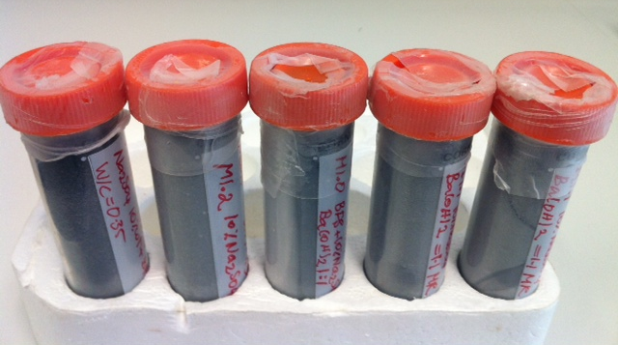
Figure 3. 8 - Appearance of paste samples

In some cases, e.g., for dimensional stability measurement (Section 3.6.3), samples were mixed on a larger scale, using a Kenwood mixer. For these tests, the materials were weighed and mixed for 10-15 minutes to obtain a paste of approximately 1200 g, poured into triplicate 160 mm x 40 mm x 40 mm stainless steel prism moulds which were pre-lubricated with Vaseline. Cling film was used to avoid the leakage of slurry. Reference studs were placed inside the mould at the end of each prism and fastened by a screw from outside. Samples were cast immediately after mixing and placed in a curing chamber at 20°C and 95% RH for 48 h. The specimens were then de-moulded with studs remaining at the end of each prism.

3.6 Tests and characterisation

3.6.1 Vicat setting test
This technique was used to investigate initial and final setting times for hydrating cementitious mixtures (Sleiman et al. 2010), with emphasis on the effect of Ba(OH)₂ content. A Vicatronic automatic recording apparatus shown in Figure 3.9 was used, and tests were performed in accordance with the Vicat needle method using apparatus with a modified version of the British standard (BS EN 196-3: 2005) to suit the formulations.
Figure 3. 9 - Vicat setting test instrument

200 g of cement slurry was prepared for each measurement according to the formulations described in the preceding sections, and poured into a wide-mouth polypropylene mould (height 40 mm; diameter 60 mm at top) that was greased and lubricated in preparation, and placed on the rotating platform of the apparatus. A free falling needle, 1.13 mm in diameter, was dropped on various positions in the cement paste for 26 penetrations; each 10 mm apart from each other, at intervals of 30 min. Initial setting time was defined in the current study as the time when the needle penetration is 35 mm ± 0.5 mm. The final setting time corresponds to a penetration of less than 0.5 mm.

3.6.2 Compressive strength test
Compressive tests were performed on 27 mm Ø x 27 mm cylindrical specimens shown in Figure 3.10 C, and at least three specimens were tested for each formulation. Silicon carbide grinding paper with 400 grit was used to produce smooth parallel surfaces. The measurements were carried out using a Zwick Roell Z050 machine, shown in Figure 3.10 A and B, with a normal loading capacity of 50 kN and a cross head rate of 0.5mm/min. The compressive strength was calculated for each specimen based on the maximum load measured prior to failure, divided by the cross sectional area of the sample. Because the aspect ratio of the cylinder specimens tested was 1.0, the results obtained were corrected with a multiplicative shape factor of 0.85 applied to the measured data. An average compressive strength value was then calculated from the specimens tested for each formulation.

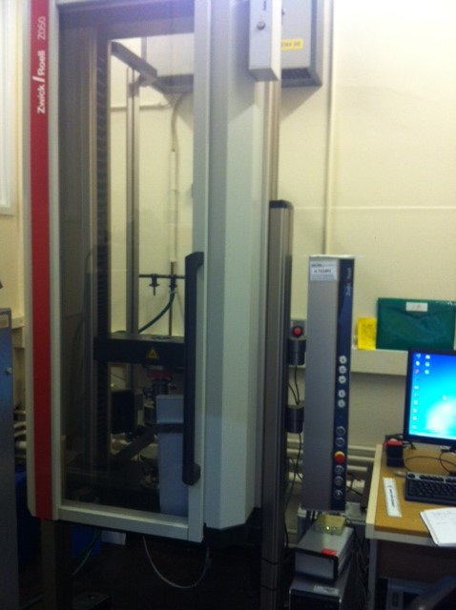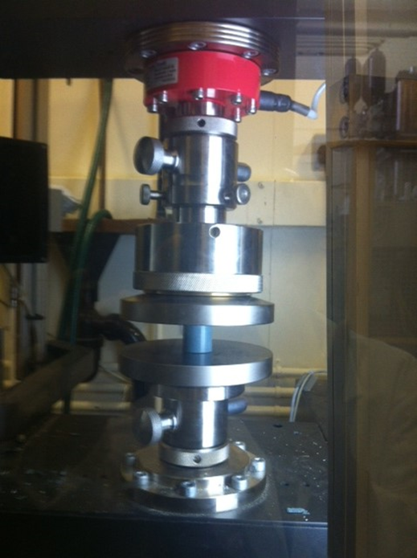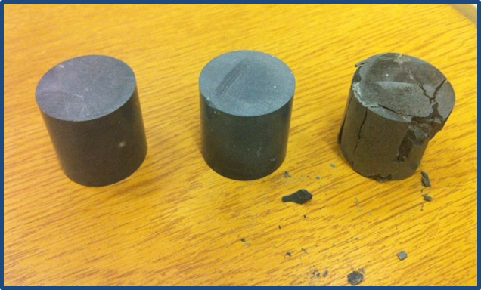
C
B
A
Figure 3. 10 - (A) and (B): Zwick Roell Z050 automatic compressive strength testing machine; (C) samples before and after conducting the test.

3.6.3 Dimensional stability
Dimensional stability was studied for samples 10A and 10B. A digital length comparator, precise to ±0.001 mm, was used, as shown in Figure 3.11, to monitor changes in length over two years. The change in the length of each specimen was expressed relative to a 160 mm stainless steel reference rod held under the same temperature conditions as the samples.
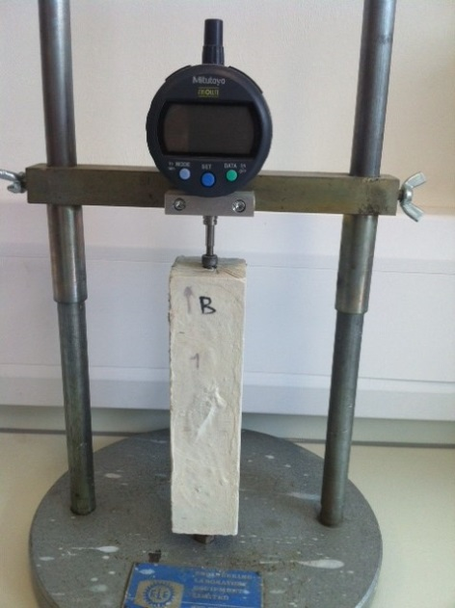
Figure 3. 11 - Digital length comparator used for measuring the dimensions of the samples.

3.6.4 Gamma Irradiation Resistance
After the completion of the curing period, selected samples (BFS-PC, M0, M1.0 and M1.3) were de-moulded from the plastic container, cut into a cylinder of 27mm Ø × 27mm height, wrapped in aluminium foil and transfered by postage to the Dalton Cumbrian Facility. The gamma radiation source used in this experiment was the ⁶⁰Co irradiator shown in Figure 3.12; a self-shielded model 812 ⁶⁰Co irradiator developed and installed by Foss Therapy Services, Inc.

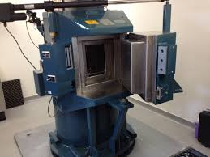
Figure 3. 12 - The ⁶⁰Co irradiator in the Dalton Cumbrian Facility

Figure 3.13 illustrates the positions of the samples in the chamber, total dosage received in Mega Gray (MGy) and dose rate over 256 hours of irradiation. Gray (Gy) is an SI unit which is defined as absorption of one joule of radiation energy per one kilogram of mass and applied in this experiment. In regards with nuclear waste, the activity of the radioactive waste is generally measured in Becquerel (Bq) which is nucleus decays per second (explained in Chapter 2, Section 2.11). Focusing only on ¹³⁷Cs radionuclide as a gamma emitter in this study and taking its half-live into consideration, according to literature, a total dose of 10MGy is approximately equivalent to 100 years storage for an ILW wasteform (Curwen and Ridley 1989).

It is also important to mention that the temperature of the chamber for the experiment was 50ºC ±5°C for the front row of samples. The other spaces not marked were left empty or were occupied with other experiments. “A” and “C” marking on the map refer to the source tubes that were filled, as source tube B was empty. In order to evaluate the potential effects of the elevated temperature reached in the irradiation chamber, another set of samples were also prepared, wrapped with aluminium foil and kept at 50ºC in an oven without irradiation for an equivalent time.

Figure 3. 13 - Position of the samples in the irradiation chamber.
The positions are marked with the total dose received in MGy over 256 hours

Chapter 4- Results and discussions: Development of a new composite cement system

4.1 Introduction
Note: The results reported in the middle section of this chapter correspond to those presented in Mobasher N. et al. “Ba(OH)₂ – blast furnace slag composite binders for the encapsulation of sulphate bearing nuclear waste” Advances in Applied Ceramics. 2014; 113(1):42-49

Contributions:
Neda Mobasher: Data collection and analysis. Writing and reporting of the results.
Dr Susan Bernal: Assistance with the data analysis and structure of the paper
Dr Hajime Kinoshita: Assistance with the analysis of the results and proof reading
Dr Clint Sharrad: Assistance with the analysis of the results and proof reading

This chapter investigates the feasibility of a one-step method to produce BaSO₄-BFS composite cement-like wasteforms for the immobilisation of sulphate bearing radioactive wastes. A two-step immobilisation process based on the work of Asano et al. (2008) was studied, with initial mixing of a sulphate-containing waste stimulant (Na₂SO₄) and Ba(OH)₂ to form BaSO₄ slurry and successive blending with BFS for solidification (‘Method A’). An alternative one-step process (‘Method B’) is developed in the present study, where the Na₂SO₄ and Ba(OH)₂ are blended directly with BFS to promote the simultaneous formation of BaSO₄ and solidification via the alkali activation of the BFS. The reaction products formed from both methods are studied through different analytical techniques including X-ray diffraction, thermogravimetry and scanning electron microscopy, in order to determine the phases obtained and the micro-structural features of the BFS-BaSO₄ cement composites produced, after a month of curing. The effects of sulphate content were studied in both methods, as well as the effects of the Ba²⁺ to SO₄²⁻ molar ratios for a selected content of Na₂SO₄ in the system obtained via method B. To further understand the mechanisms governing the alkali activation of BFS, and consequently the nature of the reaction products forming in these cementitious wasteforms, the pastes produced with the sole activators, Na₂SO₄, Ba(OH)₂ or NaOH, were studied as the ‘reference systems’, with various concentrations of the activators. Formulations of the cement compositions in this chapter are shown as below in order:

Tabel 4. 1 - Method A sample formulations based on fixed Ba²⁺/SO₄²⁻ = 1.3/1 molar ratio
Sample  ID | BFS  (g) | Sludge added |  |  | Water/binder  ratio
Sample  ID | BFS  (g) | Na₂SO₄  (g) | Ba(OH)_{2.}8H₂O  (g) | water  (g) | Water/binder  ratio
5A | 100 | 1.71 | 4.93 | 35 | 0.34
10A | 100 | 3.34 | 9.64 | 35 | 0.33
25A | 100 | 7.81 | 22.94 | 35 | 0.30
Note: The formulations are normalised to 100g of BFS. The water/binder (w/b) ratio is based on water from the sludge and water incorporated as part of the hydrated barium hydroxide. Binder represents total solids added.

Tabel 4. 2 - Method B sample formulations with various sodium sulphate solution contents, based on fixed Ba^{2+/}SO₄²⁻ = 1.3/1 molar ratio
Sample  ID | BFS  (g) | Ba(OH)_{2.}8H₂O  (g) | Na₂SO₄ solution |  | Water/binder  ratio
Sample  ID | BFS  (g) | Ba(OH)_{2.}8H₂O  (g) | Na₂SO₄  (g) | water  (g) | Water/binder  ratio
5B | 100 | 5.31 | 1.84 | 35 | 0.36
10B | 100 | 11.23 | 3.89 | 35 | 0.37
25B | 100 | 33.71 | 11.67 | 35 | 0.41
Notes: The formulations are normalised to 100g of BFS. The water/binder (w/b) ratio is based on: water used to produce the Na₂SO₄ solution and water incorporated as part of the hydrated barium hydroxide. Binder represents total solids added.

Tabel 4. 3 - Method B sample formulations with various Ba²⁺/SO₄²⁻ molar ratios, based on 10 wt.% sulphate solution
Sample  ID | BFS  (g) | Ba(OH)₂∙8H₂O  (g) | Na₂SO₄ solution |  | Water/binder ratio | Ba²⁺/SO₄²⁻  molar ratio
Sample  ID | BFS  (g) | Ba(OH)₂∙8H₂O  (g) | Na₂SO₄  (g) | water  (g) | Water/binder ratio | Ba²⁺/SO₄²⁻  molar ratio
M0 | 100 | 0 | 3.89 | 35 | 0.36 | 0
M1.0 | 100 | 8.64 | 3.89 | 35 | 0.37 | 1.0
M1.1 | 100 | 9.51 | 3.89 | 35 | 0.37 | 1.1
M1.2 | 100 | 10.37 | 3.89 | 35 | 0.37 | 1.2
M1.3 | 100 | 11.23 | 3.89 | 35 | 0.37 | 1.3

Tabel 4. 4 - Formulations of reference systems
Sample  ID | BFS  (g) | Na₂SO₄  (g) | Ba(OH)₂∙8H₂O  (g) | NaOH  (g) | H₂O  (g) | Water/binder  ratio
Na₂SO₄ (1.8 g) | 100 | 1.8 | 0 | 0 | 35 | 0.34
Na₂SO₄ (3.9 g) | 100 | 3.9 | 0 | 0 | 35 | 0.34
Na₂SO₄ (11.7 g) | 100 | 11.7 | 0 | 0 | 35 | 0.31
Ba(OH)₂ (5.3 g) | 100 | 0 | 5.3 | 0 | 35 | 0.37
Ba(OH)₂ (11.2 g) | 100 | 0 | 11.2 | 0 | 35 | 0.39
Ba(OH)₂ (33.7 g) | 100 | 0 | 33.7 | 0 | 35 | 0.45
NaOH (1.0 g) | 100 | 0 | 0 | 1.1 | 35 | 0.35
NaOH (2.2 g) | 100 | 0 | 0 | 2.2 | 35 | 0.34
NaOH (13 g) | 100 | 0 | 0 | 13 | 35 | 0.31
Notes: The formulations are normalised to 100g of BFS. The water/binder (w/b) ratio includes water from the sulphate solution and water incorporated as part of the hydrated barium hydroxide. Binder represents total solids added.

4.2 Method A (Two step method or Asano Method)
a) Step One (Conversion into insoluble sulphate)
5, 10 and 25 wt.% Na₂SO₄ solutions were chosen and Ba(OH)_{2·}8H₂O was added at the fixed molar ratio of Ba²⁺:SO₄²⁻ = 1.3:1 (Table 4.1), in accordance with the method employed by Asano et al. (2008) in the first step of the process. For the purpose of analysis, the resulting slurry was washed with distilled water and the precipitate was collected by hot vacuum filtration using filter paper, then left in a drying oven at 90°C for 4-5 days. The collected precipitate was weighed and compared with the weight of the starting materials based on Equation 4.1; the calculation showed that the reaction yield was 100 %.

Na₂SO₄ + Ba(OH)₂ = BaSO₄ + 2 NaOH Equation 4.1

The XRD analysis of the collected precipitation confirms the formation of BaSO₄, Figure 4.1 illustrating the dominant peaks corresponding to barium sulphate (BaSO₄) matching with the powder diffraction file (PDF) #24-1035.

Figure 4. 1 - A typical X-ray diffractogram of the precipitate produced via step one of Method A (25 wt. % sodium sulphate solution).

b) Step Two (Solidification)
The slurry produced from step one was weighed and added to BFS without washing or drying according to the ratios in Table 4.1, keeping the water to cement ratio close to 0.35 including the water present in the slurry as explained in section 3.3.2 for the solidification process. Visual observations confirmed the successful solidification after 30 days of curing, as shown in Figure 4.2
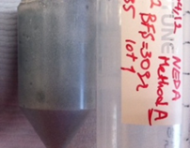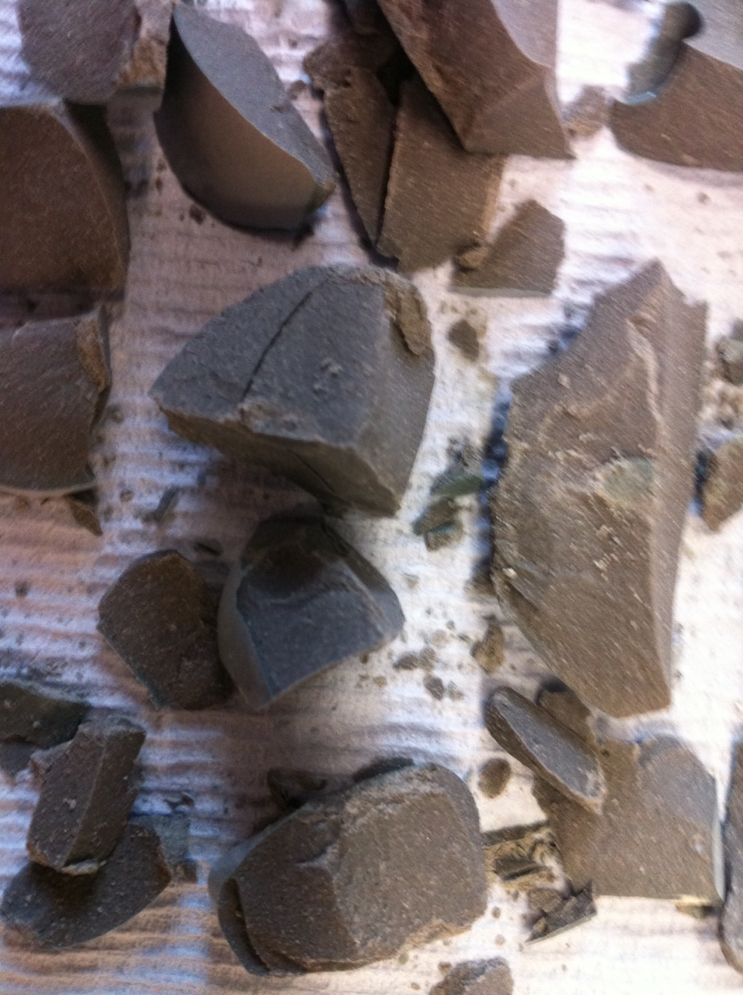
Figure 4. 2 - An example of solidified samples produced via Method A, sample 5A after 30 days of curing.
This process, was carried out for the sulphate solutions containing 5, 10 and 25 wt.% Na₂SO₄ (5A, 10A and 25A, respectively Table 3.4.) and the solidification process was successful for all samples. Figure 4.3 compares the X-ray diffractograms of the solidified samples with that of the anhydrous slag. The unreacted slag is predominantly amorphous, and contains minor traces of the melilite type phase åkermanite (Ca₂Mg(Si₂O₇), PDF #076-841), and calcite (CaCO₃, PDF # 005-586).

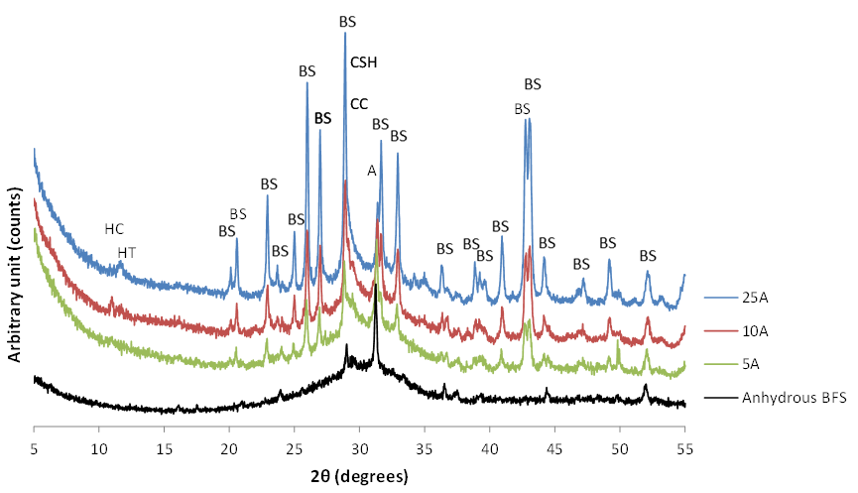
Figure 4. 3 - X-ray diffractograms of unreacted BFS and BFS composite produced via Method A with various sulphate contents.
Peaks marked are BaSO₄ (BS), åkermanite (A), hydrotalcite (HT), calcite (CC), hemicarbonate (HC) and C-S-H (CSH).

The peaks assigned to BaSO₄ become dominant in the samples with higher sulphate content. As the sulphate content increases in the samples, the diffuse scattering corresponding to unreacted BFS (25-35° 2θ) appeared to decrease. This may be attributed to the larger amount of NaOH produced in the slurry additional to the BaSO₄ (Equation 4.1), which assists with increasing the pH of the system and promotes more dissolution of the slag for a specific of curing. For sample 10A, formation of hemicarbonate ((CaO)₃·Al₂O₃·0.5CaCO₃·12H₂O, PDF#036-0129), was observed through the peak at 10.8º 2θ (Le Saoût et al. 2013), but this peak is decreased with the higher amount of the activator in sample 25A and instead a peak at 11.3º 2θ is also detected, which is assigned to hydrotalcite (Mg₆Al₂(CO₃)(OH)₁₆·4H₂O, PDF #89-0460). This layered double hydroxide compound is usually observed as a secondary reaction product in alkali-activated slags with moderate to high MgO contents (Odler 2003, Ben Haha et al. 2011). Disordered calcium silicate hydrate (C-S-H) type gel products are also identified in all samples as a very broad reflection centred just below 30° 2θ. This type of reaction product is the main binding phase in alkali-activated slag binders (Bernal et al. 2013).

Figure 4.4 shows the thermogravimetry results for the Method A samples. As shown in Figure 4.4A, the total mass loss up to 1000°C is 8.6% for sample 5A sample, 13.9% for 10A and 17.7% for 25A. The larger mass loss observed in the samples with a larger sulphate content indicates the increased formation of the reaction products, and higher extent of reaction of the BFS, consistent with the observations in the XRD results (Figure 4.3).

Figure 4. 4 - (A) Thermograms and (B) differential thermograms (mass loss downwards) of BFS composite produced via Method A with various sulphate contents.

Figure 4.4B shows the differential thermograms for the same samples. A significant mass loss is observed between 25°C and 100°C, associated with release of evaporable water in the system. Thermal decomposition of hydrotalcite occurs in two stages: dehydration around 200°C and de-hydroxylation 380-400°C (Wang and Scrivener 1995, Ben Haha et al. 2011) in agreement with the XRD data (Figure 4.3). Decomposition of hemicarbonate occurs approximately just before 200°C (Schöler et al. 2015, Scrivener and Favier 2015).
The progressive mass loss between 100°C and 250°C could be assigned to the dehydration of water from small pores in C-S-H, or potentially from disordered hydrotalcite or AFm type phases (Rey and Fornes 1992). C-S-H is the main binding phase in the alkali activated The thermal decomposition of highly crossed linked C-S-H occurs at temperatures between 250°C and 400°C, where water is more tightly bound to the C-S-H structure. Decomposition of CaCO₃ covers a wide range from 500°C to 700°C temperature, depending on the crystallinity of CaCO₃ (Maciejewski et al. 1994). The mass loss observed in all the samples from 550°C to 650°C is associated with the poorly crystalline CaCO₃ which it occurs at the lower temperatures (Thiery et al. 2007).

C-S-H and hydrotalcite are typical products in the slag system activated by NaOH (Ben Haha et al. 2011). Therefore, the results obtained suggest that, in Method A, the NaOH was produced as a secondary product during the formation of BaSO₄ in the first step as shown in Reaction 4.1, and acted as an alkaline activator to promote the hardening of the BaSO₄-BFS composite. It is clear that as the concentrations of the simulate sulphate solution increases in the preliminary step, the concentration of the produced NaOH will be higher in the slurry, therefore it will promote a higher pH in the system, resulting in more dissolution of slag and formation of a higher amount of reaction products.

Figure 4.5 is a backscattered electron image of the specimen 10A, illustrating the typical microstructural features of the solidified samples. Unreacted BFS is identified as light grey angular particles, and they correspond to the areas enriched in Ca and Si in the elemental maps. The small white particles intermixed with the binding phase are confirmed to be BaSO₄ by the distribution of Ba and S in the elemental map.

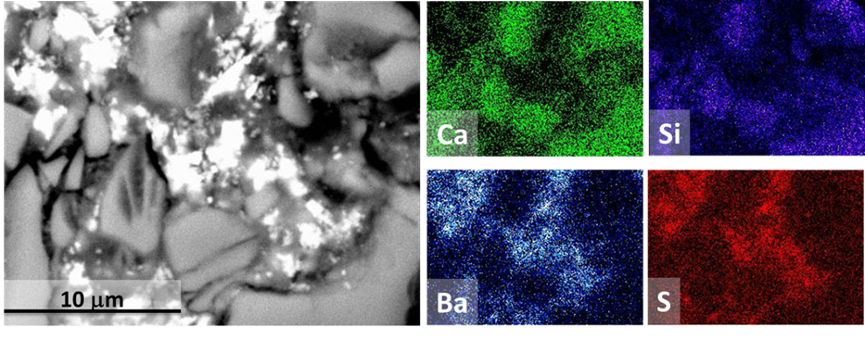
Figure 4. 5 - Backscattered electron image and elemental maps of sample 10A.
The elemental maps show the same region as the backscattered electron image.

4.3 Method B (One step method or new proposed method)

4.3.1 Effect of sulphate content
As previously mentioned, Method B is a single step process, mixing all the raw materials with the sodium sulphate solution at once, according to the formulation reported in Table 4.2, with a fixed molar ratio of Ba²⁺:SO₄²⁻ = 1.3:1. The Method B resulted in the formation of solid products, as shown in Figure 4.6.

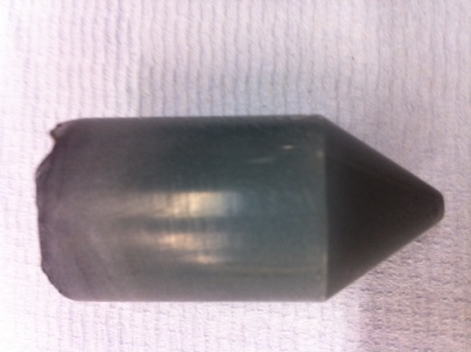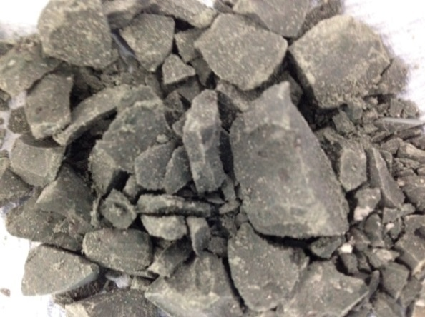

Figure 4. 6 - An example of solid sample produced via Method B, sample 10B after 30 days of curing.
Figure 4.7 shows the X-ray diffractograms of the samples produced via Method B with various sodium sulphate contents, compared to the anhydrous slag. The crystalline phases of åkermanite and calcite, assigned to the unreacted slag, are identified in these samples. Upon activation in all the solidified samples, high-intensity peaks corresponding to barite (BaSO₄, PDF #24-1035) are observed, confirming the formation of this salt in this procedure. These peaks are more prominent in the higher sulphate content samples, as observed for Method A. As the sulphate content increases in the samples the diffuse scattering of BFS appeared to decrease, similarly to the trend identified in samples produced via Method A, which is associated with the higher amount of NaOH produced in these systems, resulting in the escalation of the pH and leading to more dissolution of the slag.
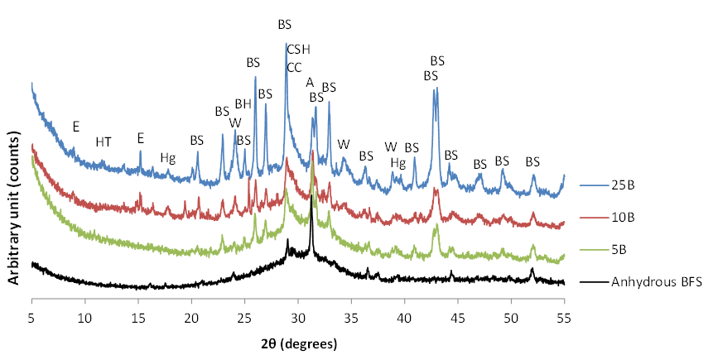
Figure 4. 7 - X-ray diffractograms of unreacted BFS and BFS composites produced via Method B with various sulphate contents.
Peaks marked are åkermanite (A), BaSO₄ (BS), witherite (W), ettringite (E), hydrotalcite (HT), hydrogarnet (Hg), calcite (CC), and C-S-H (CSH).

Witherite (BaCO₃, PDF #45-1471) peaks were also observed in these binders, whose intensity increases with a higher content of sulphate, as the Ba²⁺:SO₄²⁻ molar ratio used in these system is 1.3:1.0, and the stoichiometric reaction requires 1.0:1.0 ratio (Reaction 4.1), so the excess Ba(OH)₂ that is not reacting to form BaSO₄ can be present in the pore solution. Therefore the formation of BaCO₃ might also be indicating the preferential carbonation of Ba²⁺ in the pore solution instead of carbonation of Na⁺ or Ca²⁺. This salt is highly insoluble and thermodynamically stable (Utton et al. 2011).

In addition to these crystalline phases, formation of ettringite (Ca₆Al₂(SO₄)₃.32H₂O, PDF #041-1451), a layered double hydroxide similar to hydrotalcite (Mg₆Al₂(CO₃)(OH)₁₆·4H₂O, PDF #89-460) and a disordered calcium silicate hydrate (C-S-H) type gel were also observed. A hydrogarnet type phase (Ca₃Al₂(OH)₁₂, PDF#24-217) is also observed in these systems. Formation of hydrogarnet phases are normally observed in the PC based materials as a stable form at 20°C (Dilnesa et al. 2014). In the high slag composite of BFS-PC (9:1) which is used for nuclear waste encapsulation with inclusion of BaCO₃, formation of hydrogarnet is also observed in the higher temperatures of 60°C (Utton et al. 2011) as a phase modification. In these composites, formation of an aluminate rich phase is indicating on the free aluminium available within the system as result of preclusions to ettringite formation.

Figure 4.8 shows the thermogravimetry data for the samples produced via Method B, with various sulphate contents. As shown in Figure 4.8A, the total mass loss up to 1000°C is 10.5 % for sample 5B, 16 % for 10B and 21 % for 25B. In agreement with the Method A samples (Figure 4.4), the samples with a larger content of sulphate show a higher mass loss, indicating an increased amount of the reaction products and thus, a higher extent of reaction as observed in the XRD results (Figure 4.7).

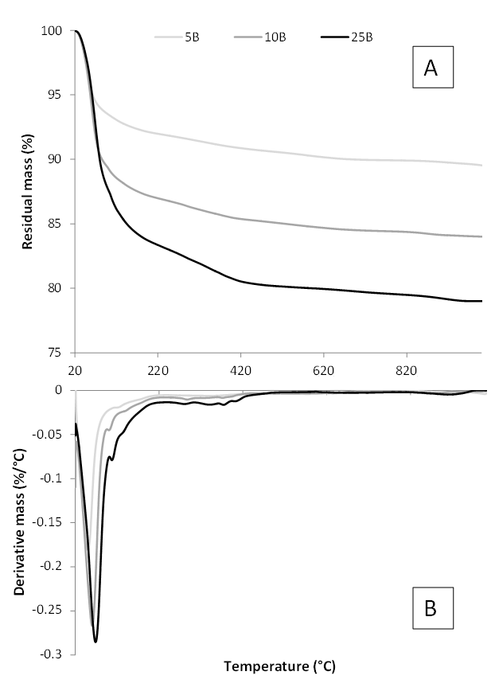
Figure 4. 8 - (A) Thermograms and (B) differential thermograms (mass loss downwards) of BFS composite produced via Method B with various sulphate contents.

Figure 4.8B shows the differential thermograms of the composite cements produced via Method B. A high intensity peak between 70 and 100°C was detected, which is attributed to the release of evaporable water and the dehydration of the ettringite (Hall et al. 1996) identified through XRD. The thermal decomposition of hydrotalcite which was identified in the XRD results (Figure 4.7) occurs in two stages: dehydration around 200°C and de-hydroxylation 380-400°C (Ben Haha et al. 2011). The progressive mass loss between 100°C and 250°C could be assigned to the dehydration of water from small pores in C-S-H, or potentially from disordered hydrotalcite or AFm type phases (Rey and Fornes 1992). The thermal decomposition of highly crossed linked C-S-H occurs at temperatures between 250°C and 400°C, where water is more tightly bound to the C-S-H structure (Myers et al. 2015).

De-hydroxylation of hydrogarnet type phases occurs around 300°C (Dilnesa et al. 2014). The low intensity shoulder observed around 800°C is associated with the decomposition of BaCO₃ (Utton et al. 2011) which was identified in the XRD results (Figure 4.7). It is clear from the results that a higher concentration of sodium sulphate solution, along with larger amounts of Ba(OH)₂ within the system, promotes a larger extent of reaction of the slag.

4.3.2 Effect of barium to sulphate molar ratio
To evaluate the effect of the Ba(OH)₂ concentration in the proposed system, additional samples were produced via method B with 10 wt.% Na₂SO₄ solution. The formulations used for the composite cements are given in Table 4.3.

Figure 4.9 shows the XRD patterns of the samples produced, along with the anhydrous slag. The notations, M0, M1.0, M1.1, M1.2 and M1.3 shown in the figure represent the Ba²⁺ to SO₄²⁻ molar ratio for each system e.g., M1.3 shows Ba²⁺:SO₄²⁻ = 1.3:1.0. As previously mentioned, the unreacted slag is predominantly amorphous, and contains minor traces of the melilite type phase åkermanite and calcite.
Figure 4. 9 - X-ray diffractograms of unreacted BFS composites produced via method B with various Ba²⁺:SO₄²⁻ molar ratios.
Peaks marked are BaSO₄ (BS), åkermanite (A), hydrotalcite (HT), calcite (CC), wittherite (W), ettringite (E), hydrogarnet (Hg) and C-S-H (CSH).

For the M0 sample formation of ettringite is significant in the absence of Ba(OH)₂, consistent with the high concentration of sulphates present in the system (Mobasher et al. 2015) . In this sample all the peaks fit the AFt phase as the secondary reaction product, along with C-S-H type gel as the main reaction product. For the rest of the samples with the addition of Ba(OH)₂ (M1.0, M1.1, M1.2 and M1.3) the main crystalline products are BaSO₄, ettringite and witherite (BaCO₃), hydrotalcite and hydrogarnet in addition to C–S–H type gel.

Reduction in the intensity of the ettringite peaks was observed with increasing Ba(OH)₂ content, probably due to the consumption of sulphate ions in the system by formation of BaSO₄. Witherite peaks were also observed in the systems containing Ba(OH)₂, whose intensity increases with the content of Ba²⁺ ions in the system, and as discussed above, this might again be indicating the preferential carbonation of Ba²⁺ in the pore solution instead of carbonation of Na⁺ or Ca²⁺.

The effect of Ba²⁺:SO₄²⁻ molar ratio can also be seen in the setting behaviour of the samples. Figure 4.10 shows the results of Vicat setting time measurements for the above samples. The paste solely based on sodium sulphate solution and BFS, thus no Ba(OH)₂ content (M0), exhibited initial and final setting times of 25 hours and 30 hours, respectively, but did not fully harden within this time frame. The addition of Ba(OH)₂ to the system resulted in a significant decrease in the initial and final setting time of the cement composites. This can be associated with the increase of pH in the system with the addition of barium hydroxide, promoting a faster reaction of the slag and its consequent hardening.

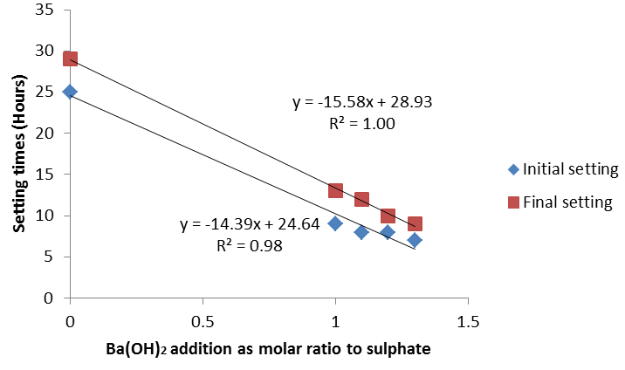
Figure 4. 10 - Correlation between Ba²⁺ to SO₄²⁻ molar ratio and setting times for the systems studied in Method B.

Figure 4.11 compares the compressive strengths of samples produced via Method B, with various Ba²⁺ to SO₄²⁻ ratios after 30 days of curing. The figure also shows the data for sample 10A that is produced via Method A with the same formulation as the M1.3 sample, for comparison. Despite the slow setting behaviour (Figure 4.10), the sample M0 with the absence of Ba(OH)₂ exhibited the highest average strength of 17± 2.8 MPa after 30 days. With the introduction of Ba(OH)₂ the strength of the BFS composite samples decreases by an average of 30%. A possible explanation for the difference in the strength among these samples is the amount of ettringite formed. It has been reported (Bensted 1994) in calcium sulphoaluminate cement based systems, which are comparable to the M0 system (sulphate activated slag system), that ettringite formation governs the early strength properties of these cements, and the formation of C-S-H is accountable specifically for the later strength. Ettringite is a strength giving phase with a large molar volume, and therefore it is able to close the pores in the microstructure. In a sulphate-rich environment, such as in an alkali-sulphate activated slag, it is expected that ettringite is formed almost instantly in the early part of the hydration process (Juenger et al. 2011), and therefore contributing to the strength gain of these binders. Although there is a decline in the strength of the composite samples with the inclusion of Ba(OH)₂, they are still well above the minimum strength required for nuclear waste encapsulation (Ojovan and Lee 2005).

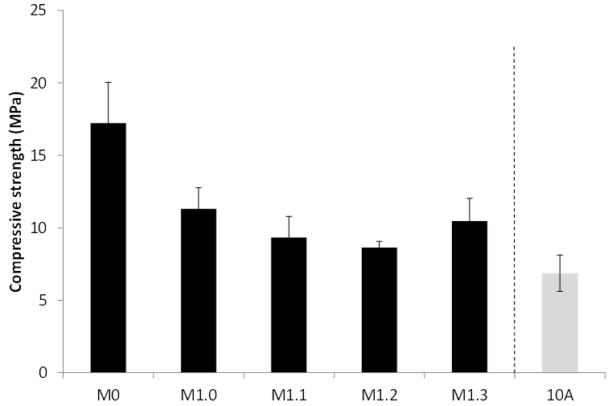
Figure 4. 11 - Compressive strength of the Method B composite samples after 30 days of curing, produced with various Ba²⁺:SO₄²⁻ molar ratios, compared with a Method A composite sample (10A).
Error bars show one standard deviation of three measurements.

In general all the samples produced via Method B, with various Ba²⁺:SO₄²⁻ molar ratios, gained higher average compressive strength after 30 days of curing, comparing to the sample produced via Method A. Sample M1.3, which has identical Ba²⁺:SO₄²⁻ molar ratios to sample 10A, has exhibited the highest average strength of 10.5±1.5 MPa, where sample 10A has only reached highest average strength of 6.8±1.3 MPa. This is also in agreement with the TGA results in the previous Sections, as sample M1.3 (10B) had 16% total mass loss (Figure 4.8), as sample 10A had only 13.9% for the total mass loss (Figure 4.4) respectively. These results are signifying on the higher amounts of reactions products and increased extend of reaction of BFS for the samples produced via Method B.

Figures 4.12 and 4.13 show the thermogravimetry data of the Method B composite cement samples with Ba²⁺:SO₄²⁻ molar ratios.
Figure 4. 12 - Thermograms of Method B composite samples with various Ba²⁺:SO₄²⁻ molar ratios.

Figure 4. 13 - Differential thermograms (mass loss downwards) of Method B composite samples with various Ba²⁺:SO₄²⁻ molar ratios.
Dashed lines show the baseline for each data set.

The total mass loss for these samples varies between 10% and 11%, shown in Figure 4.12. These values are different from the previous TGA results (Figure 4.8) in Section 4.3.1. Specifically for sample 10B in the previous Section 4.3.1 the total mass loss showed 16%, and in this section for sample M1.3, which is precisely identical shows 10%. These differences observed in this analysis are due to storing the samples in the desiccator prior to analysis where the samples subjected to dehydration.

Figure 4.13 shows the derivative thermograms (DTG) of the above composite binders.
In the specimen produced without Ba(OH)₂ addition (M0), a high intensity peak between 70°C to 100°C is observed, which is attributed to the release of evaporable water in the system, and the dehydration of the ettringite (Hall et al. 1996), as identified through XRD (Figure 4.9). Samples including low concentrations of Ba(OH)₂ (sample M1.0) shows a significant reduction in intensity of the mass loss peak between 70°C and 100°C, compared with the specimen without Ba(OH)₂ (M0). Taking the XRD data for these systems into account, this could indicate less ettringite formation within this system.

De-hydroxylation of hydrogarnet phase is observed around 300°C (Dilnesa et al. 2014) as identified in XRD results (Figure 4.9). The progressive mass loss between 100°C and 250°C could be assigned to the dehydration of water from small pores in C-S-H, or potentially from disordered hydrotalcite or AFm type phases (Rey and Fornes 1992).
The thermal decomposition of highly crossed linked C-S-H occurs at temperatures between 250°C and 400°C, where water is more tightly bound to the C-S-H structure.

Decomposition of CaCO₃ covers a wide range from 500°C to 700°C temperature, depending on the crystallinity of CaCO₃ (Maciejewski et al. 1994). Figure 4.13 shows loss of carbonate occurring at the lower temperatures of the range, around 550-600°C. This has been reported to the decomposition of amorphous or poorly crystalline CaCO₃ which is associated with CSH carbonation, which decomposes at a lower temperature (Thiery et al. 2007).

The low intensity mass loss observed around 850°C is associated with decomposition of witherite (Utton et al. 2011), in specimens with higher Ba(OH)₂ concentrations and in agreement in the XRD results (Figure 4.9). The excess Ba(OH)₂ that is not reacting to form BaSO₄ can be present in the pore solution. Therefore the formation of BaCO₃ might also be indicating the preferential carbonation of Ba²⁺ in the pore solution instead of carbonation of Na⁺ or Ca²⁺. This salt is highly insoluble and thermodynamically stable (Utton et al. 2011).

Figure 4.14 shows a backscattered electron image and corresponding EDX spectrum of sample M1.2. Fine white particles intermixed in the binding matrix of activated BFS were identified, similar to the specimens produced via Method A (Fig. 4.5). However, unlike Method A, less BaSO₄ agglomeration was identified in the Method B specimen, which might suggest better intermixing and distribution of the BaSO₄ particles.
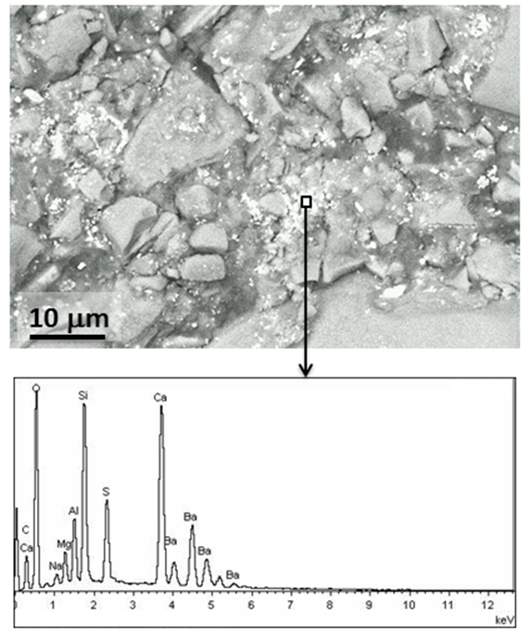
Figure 4. 14 - Backscattered electron image (A) and EDX spectrum (B) of BFS composite (M1.2) produced via method B.

4.4 Comparison of the two studied methods

In both Method A and Method B, BaSO₄–BFS composite cement-like samples were successfully formed. In Method A, the two-step Method, the soluble sulphate ions converted into BaSO₄ in step one of the process with a minor excess of Ba(OH)₂ within the system where NaOH forms as a secondary product and plays as an activator for the dissolution of the BFS in the second step.In Method B, the one-step Method, the formation of BaSO₄ occurs in one process with the dissolution of BFS and the consequent formation of reaction products derived from the alkali-activation reaction. This means that Ba(OH)₂ plays a double role in these systems: it is acting as activator to promote the hardening of the slag, and as a precursor reacting with Na₂SO₄ to form BaSO₄.

The TGA results of the two methods collected from Figure 4.4 and Figure 4.8 are highlighted in comparison in Table 4.5, demonstrating the total mass losses for the that similar formulations of the samples produced in two different methods. Correspondingly in agreement, the results for compressive strength after 30 days of curing (Figure 4.11), demonstrate average higher compression strength for samples produced via Method B in comparisons with Method A. These results are demonstrating on the higher amounts of reactions products and improved extend of reaction of BFS for the samples produced via Method B.

Tabel 4. 5 - Total mass loss of the samples from the TGA results analysis
Sulphate content of the samples (%) | Method A samples  Total mass loss (%) | Method B samples  Total mass loss (%)
5% | 8.6 | 10.5
10% | 13.9 | 16
25% | 17.7 | 21

4.5 Reference systems for Method B
In order to study the role of Ba(OH)₂, Na₂SO₄ and NaOH in terms of alkali-activation of the BFS in the Method B, reference samples were produced using Ba(OH)₂, Na₂SO₄ and NaOH, following the procedure described in Section 3.4.4 of Chapter 3. The amount of each activator was adjusted in accordance with the formulations of samples 5B, 10B and 25B (Table 4.2), but using Ba(OH)₂ or Na₂SO₄ individually. The amount of NaOH used in the reference sample was calculated assuming that NaOH and BaSO₄ would form though the stoichiometric reaction shown in Equation 4.1 between Na₂SO₄ and Ba(OH)₂ present in samples 5B, 10B and 25B.

4.5.1 Sodium sulphate activation of BFS
Figure 4.15 shows photographs of the solidified sodium sulphate activated slag samples after 30 days of curing. Increasing amount of Na₂SO₄ (11.7 g per 100 g of BFS), promoted a darker colour of the product formation. Few reports make reference to the dark coloration of alkali-activated slag binders (Roy 2009, Sakulich et al. 2009), and this phenomenon has also been reported in hydrated synthetic glasses with similar compositions to BFS (Mascolo 1973), and slag-blended concretes (Sioulas and Sanjayan 2001), where factors such as curing conditions and level of slag replacement affect the final coloration of the specimens. This is associated with the permeability of the samples, and consequently with the oxidation rate of ferrous to ferric salts, and sulphides to sulphates present in slag-based cements.
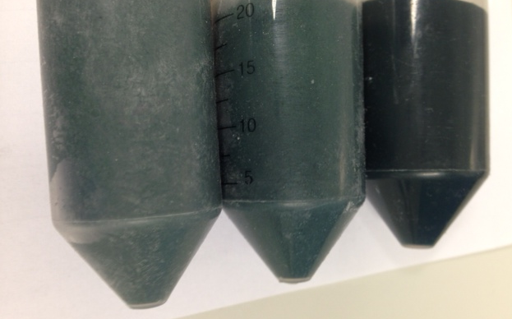
1.8 g
3.9 g
11.7 g
Figure 4. 15 - Na₂SO₄ activated BFS monoliths with various Na₂SO₄ contents.

Figure 4.16 shows X-ray diffractograms of Na₂SO₄-activated slag pastes with various sodium sulphate solution concentrations. All the samples show formation of ettringite (Ca₆Al₂(SO₄)₃.32H₂O, PDF #041-1451), in agreement with previous reports for similar systems (Gruskovnjak et al. 2006, Bai et al. 2011). It appears that the peak intensity of this phase increased with a higher sulphate content within the system (e.g. 23° and 32° 2θ). A low intensity peak at 11.3° 2θ is also observed only in the sample with the higher amount of the activator (11.7 g 100 g), and is assigned to a layered double hydroxide type phase (LDH). In alkali-activated slags with moderate to high MgO contents, such
layered double hydroxides are usually identified as hydrotalcite Mg₆Al₂(CO₃)(OH)₁₆·4H₂O (Odler 2003). Disordered calcium silicate hydrate (C-S-H) type gel products are also identified in all samples as a very broad reflection centred just below 30° 2θ. This type of product is the main binding phase in alkali-activated slag systems (Bernal et al. 2013). Traces of calcite are also identified in these samples, which was previously identified in the anhydrous slag and also can be formed as a result of carbonation of the hydrated samples during sample preparation.

Figure 4. 16 - X-ray diffractograms of Na₂SO₄-activated slag samples with various sulphate contents.
Peaks marked are åkermanite (A), calcite (CC), C-S-H (CSH) and ettringite (E) and hydrotalcite (HT).

Thermogravimetry results for the above samples are shown in Figure 4.17. The total mass losses, up to 1000°C, for samples with 1.8 g, 3.9 g and 11.7 g of Na₂SO₄ were 10.23%, 15.12% and 14.48% respectively. The slightly larger mass loss of the 3.9 g sample compared with that of the 11.7g sample is associated with the significant amount of the thermal decomposition of highly crystalline calcite which occurs around 700°C (Maciejewski et al. 1994), which was identified in these samples by XRD (Figure 4.16).

Figure 4. 17 - (A) Thermograms and (B) differential thermograms (mass loss downwards) of the Na₂SO₄-activated slag pastes with various sodium sulphate solution concentrations.

A high intensity mass loss between 70°C and 100°C is observed for all the samples, and it is attributed to the release of evaporable water in the system, and the decomposition of ettringite (Hall et al. 1996). The total mass loss up to 100°C for samples increases with an increase of Na₂SO₄ content, indicating that a larger content of sodium sulphate promotes the formation of a larger amount of ettringite formation, as observed in the XRD results (Figure 4.16). The progressive mass loss between 100°C and 250°C could be assigned to the dehydration of water from small pores in C-S-H, or potentially from disordered hydrotalcite or AFm type phases (Rey and Fornes 1992). The thermal decomposition of highly crossed linked C-S-H occurs at higher temperatures, between 250°C and 400°C, where water is more tightly bound to the C-S-H structure (Myers et al. 2015).

4.5.2 Barium hydroxide activation of BFS
Figure 4.18 shows a photograph of Ba(OH)₂ activated BFS samples after 30 days of curing with various activator contents. As a higher amount of Ba(OH)₂ is added to the system, a darker colour is observed in the samples, similar to the Na₂SO₄-activated samples (Figure 4.15). As mentioned before, the colouration of slag-rich cements is associated with the oxidation rate of ferrous to ferric salts, and sulphides to sulphates present in these samples.
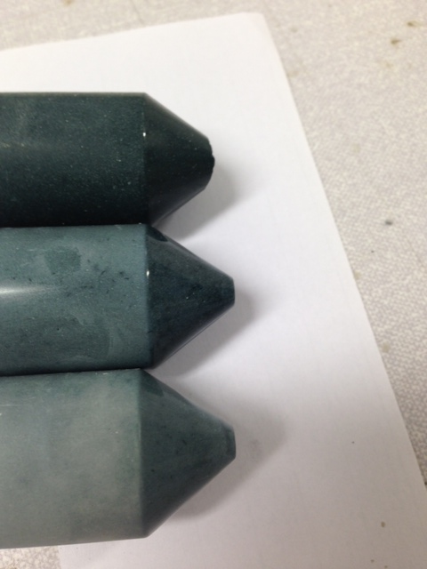
33.7 g
11.2 g
5.3 g
Figure 4. 18 - Ba(OH)₂ activated BFS monoliths produced with various Ba(OH)₂ contents.

Figure 4.19 shows the XRD patterns of BFS activated with Ba(OH)₂·8H₂O. The formulations of these samples are shown in Table 3.7. Formation of hemicarbonate ((CaO)₃·Al₂O₃·0.5CaCO₃·12H₂O, PDF # 036-0129) was observed through the peak at 10.8º 2θ (Le Saoût et al. 2013) for all the samples, but this peak is decreased with the higher amount of the activator in sample 25A and instead a peak at 11.3º 2θ is also detected, which is assigned to hydrotalcite. This effect is similar to the results for Method A samples (Figure 4.3), which suggests that a highly ordered hydrotalcite type phase might be forming when the alkalinity of the activator is increasing and promoting more dissolution of the slag. Disordered C-S-H was also identified in all samples, as a very broad reflection centred just below 30° 2θ as the main reaction product in this AAS system.
Figure 4. 19 - X-ray diffractograms of Ba(OH)₂-activated BFS pastes with various activator contents.
Peaks marked are åkermanite (A), calcite (CC), hydrotalcite (HT), hemicarbonate (HC), witherite (W), and C-S-H (CSH).

The sample with the highest amount of activator (33.7 g) has distinctive peaks for witherite, which could be due to the large amounts of Ba(OH)₂ within the system resulting in carbonation of the unreacted remnants. The intensity of the diffuse scattering between 25° 2θ and 35° 2θ in this particular sample is also decreased comparing to the other samples, which is likely to indicate a higher degree of reaction of the slag in the system, or formation of more ordered C-S-H type phases. It is worth noting that there is no information available in the open literature regarding chemical or microstructural characterisation of Ba(OH)₂-activated slags, and therefore the role of Ba(OH)₂ in the activation and structural development of these materials requires further investigation.

Thermogravimetric results of the above samples are shown in the Figure 4.20A, and Figure 4.20 B shows the differential thermograms of the same samples. The total mass loss, up to 1000°C, for 5.3 g, 11.2 g and 33.7 g samples are 13%, 16% and 21% respectively. The decomposition of layered double hydroxide (LDH) with a hydrotalcite like-phase, as it was reported in XRD results (Figure 4.19) occurs in two stages: dehydration around 200°C and de-hydroxylation 380-400°C (Ben Haha et al. 2011). The mass loss assigned to the thermal decomposition of this phase is more intense in the samples with higher amount of activator, in agreement with the XRD results (Figure 4.19). Decomposition of hemicarbonate occurs approximately around 200°C (Schöler et al. 2015, Scrivener and Favier 2015). The mass loss of around 800ºC is assigned to BaCO₃ decomposition.
Figure 4. 20 - (A) Thermograms and (B) differential thermograms (mass loss downwards) of Ba(OH)₂ activated BFS samples with various activator contents.

4.5.3 Sodium hydroxide activation of BFS
Figure 4.21 shows a photograph of the solidified monoliths with NaOH activation after 30 days of curing. Samples with the highest amount of NaOH (13 g per 100 g of BFS) present darker colour compared with samples produced with lower contents of hydroxide, which is consistent with the previously observed when using Na₂SO₄ (Figure 4.15) and Ba(OH)₂ (Figure 4.18) activators.

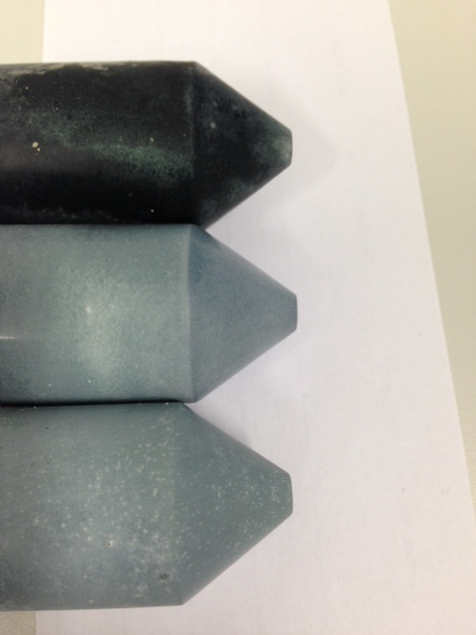
1.0 g
13 g
2.2 g
Figure 4. 21 - Na(OH) activated BFS monoliths produced with various NaOH contents.

Figure 4.22 shows the XRD patterns of BFS activated with NaOH with various activator contents. The formulation of these samples is shown in Table 3.7. In the 1.0 g and 2.2 g samples, formation of hemicarbonate is observed, but with increasing dose of the activator formation of hydrotalcite was observed instead as the secondary reaction product alongside disordered C-S-H as the main reaction product, which is in agreement with the literature (Ben Haha et al. 2011). This is the most studied system in the alkali activation of slag, as NaOH solution provides a high pH for the dissolution of the slag (Wang et al. 1995).
It is clear from the results (Figure 4.22) that as the concentration of the activator increases, the intensity of the peaks for the reaction product hydrotalcite increases also, Therefore higher concentration of [OH]⁻, increases the pH of the activator, resulting in higher extent of reaction, more dissolution of the slag particles and additional precipitation of hydrotalcite as the reaction product. In parallel, the peaks for the disordered C-S-H phase are clearly visible in the sample with the largest amount of the activator (13 g).
Figure 4. 22 - X-ray diffractograms of Na(OH) -activated BFS pastes with various activator contents.
Peaks marked are åkermanite (A), calcite (CC), hydrotalcite (HT), hemicarbonate (HC) and C-S-H (CSH). For the peak marked with a star, the identification of this phase is unknown.

Thermogravimetric results of the above samples are shown in Figure 4.23A. The total mass loss, up to 1000°C, for 1.0 g, 2.2 g and 13.0 g samples are 10%, 14% and 25% respectively, indicating as before that the higher amount of activator promotes higher amounts of reaction products as a result of increased pH and more dissolution of the slag. Figure 4.23 B shows the differential thermograms of the same samples. The progressive mass loss up to 100ºC is associated with the release of evaporable water in the system within the system, which is significantly higher in the 13 g sample. As the water to binder ratio for all the samples is constant, it is clear that this difference is attributed to the dehydration of water from small pores in C-S-H, or potentially from AFm type phases as was identified in the XRD results (Figure 4.22). The decomposition of hydrotalcite occurs in two stages: dehydration around 200°C and de-hydroxylation 380-400°C. The mass loss assigned to the thermal decomposition of this phase is more intense in the samples with higher amount of activator, in agreement with the XRD results (Figure 4.22). Decomposition of CaCO₃ covers a wide range from 500°C to 700°C temperature, depending on the crystallinity of CaCO₃.
Figure 4. 23 - (A) Thermograms and (B) differential thermograms (mass loss downwards) of sodium hydroxide activated samples with various activator’s content.

4.5.4 Comparisons of different reference systems
The results from the reference systems are revealing in that of all the AAS systems, the main reaction product and the binding phase is a calcium silicate hydrate (C-S-H) type phase. The secondary reaction products of the AAS system depend strongly on the type of the activator, where an Na₂SO₄ activator promotes ettringite formation, while Ba(OH)₂ and NaOH promote layered double hydroxides (LDH), either a hydrotalcite-like phase or hemicarbonate.

It is straightforward to conclude that the higher concentration of the activator encourages larger amount of reaction products. For NaOH and Ba(OH)₂ activator solutions, increasing the concentration clearly increases the pH, resulting in additional dissolution of the slag and producing more reaction products. In the case of Na₂SO₄ activator, there is not a systematic variation among the quantities of reaction products after a month of curing, calculated from the TG results (Figure 4.17A), i.e. for samples with 1.8 g, 3.9 g and 11.7 g of Na₂SO₄ were 10.23%, 15.12% and 14.48%, respectively, and only increase in the AFt formation. This phenomenon can be explained by the near neutral alkalinity of the Na₂SO₄ activator, as increasing the activator concentration does not promote the larger amount of the reaction products dramatically.

From these results it can be gathered that in the BFS composite samples produced via method B, as the formation of ettringite is observed, the activation can be arising from the Na₂SO₄ solution but Ba(OH)₂ promotes the higher pH within the system for the supplementary dissolution of the slag.

4.6. Conclusion
The results presented in this chapter reveal that the immobilisation of soluble sulphate-bearing aqueous wastes is effectively achievable through Ba(OH)₂-Na₂SO₄-BFS composite cement-like wasteform through a novel one-step method (Method B).

This new method was studied, in comparison with a conventional two-step method (Method A), in various sulphate concentrations and various Ba²⁺:SO₄²⁻ molar ratios, resulting in the formation of BaSO₄ and the activation of the BFS in stable cement-like composite. The order of mixing of Ba(OH)₂ in the system has a strong effect on the phase development of the products. In the conventional two-step method (Method A), where Ba(OH)₂ is added in the first step of the process, it reacts with sulphate ions and forms a slurry of BaSO₄ and NaOH which is added to the BFS in the second step of the process. This method favours the formation of hydrotalcite and C-S-H, typically identified as main reaction products in NaOH-activated BFS binders.

In the new one step process (Method B), ettringite and barium carbonate are formed. The direct inclusion of Ba(OH)₂ with the BFS and sulphate seems to provide extra alkalinity to the system, favouring an extended reaction of the BFS, and more formation of C-S-H products, along with the formation of BaSO₄.

The TGA results of the studied two methods in parallel, signifying on the higher total mass losses for the samples produced via one step method (Method B). These results are indicating on the higher amounts of reactions products formed and improved extend of reaction of BFS for the samples produced via Method B, consequently resulting in the higher compressive strength after 30 days of curing in comparisons with Method A.
The reference samples provide additional information to comprehend the role of each component added to the composite cements in terms of reaction products formation and extent of reaction of the slag. As ettringite formation is observed in the BaSO₄–BFS samples produced via Method B, this can be related to the Na₂SO₄ activation, and also the role of Ba(OH)₂ which is important for the effective dissolution of the slag effectively.

Next undertakes a into full characterisation of six months aged, selected cement composite samples produced via Method B more in detail with comparison to the selected reference samples.

Chapter 5- Results and discussions: Characterisation of Ba(OH)₂–Na₂SO₄-blast furnace slag cement composites for the immobilisation of sulphate bearing nuclear wastes and their long term stability

5.1 Introduction
Note: The results reported in the first section of this chapter correspond to those presented in Mobasher N. et al. ‘Characterisation of Ba(OH)₂-Na₂SO₄-blast furnace slag cement-like composites for the immobilisation of sulfate bearing nuclear wastes’, Cement and Concrete Research, 66 (2014): 64-74.

Contributions:
Neda Mobasher: Data collection and analysis. Writing and reporting of the results.
Dr Susan Bernal: Assistance with the analysis of the NMR sections and the
de-convolution of the ²⁹Si NMR.
Dr Oday Hussein: Accompany and assistance with the collection of the SEM/EDX images.
Dr David Apperley: Collection of the NMR spectra at the Slid-State NMR group, Durham University.
Dr Hajime Kinoshita: Assistance with the analysis of the results and proof reading
Professor John Provis: Assistance with the analysis of the results and proof reading

This chapter focuses mainly on the detailed characterisation of the selected six month-cured composite samples produced via Method B with (10 wt.% Na₂SO₄), and comparisons with related reference samples produced via activation of the slag with NaOH, Na₂SO₄ or Ba(OH)₂, in order to understand the governing activation mechanism and, therefore, what controls reaction product formation in the composite systems. The formulations used in this chapter are highlighted as below which are identical to the previous chapter. Samples with the fixed 10 wt.% Na₂SO₄ waste stream, produced via Method B with are chosen with highest and lowest Ba²⁺/SO₄²⁻ molar ratios shown in Table 5-1 and their corresponding reference in Table 5-2. The long term stability of the Method B composite samples is also discussed through the evaluation of compressive strength development, dimensional changes and phase assemblages up to 18 months of curing, in comparison with the corresponding Method A composite sample from the previous chapter, which the formulation shown in Table 5-3 with a identical content of Na₂SO₄.

Table 5. 1 - Method B sample formulations with various Ba²⁺/SO₄²⁻ molar ratios, based on 10 wt.% sulphate solution
Sample  ID | BFS  (g) | Ba(OH)₂∙8H₂O  (g) | Na₂SO₄ solution |  | Water/binder ratio | Ba²⁺/SO₄²⁻  molar ratio
Sample  ID | BFS  (g) | Ba(OH)₂∙8H₂O  (g) | Na₂SO₄  (g) | water  (g) | Water/binder ratio | Ba²⁺/SO₄²⁻  molar ratio
M0 | 100 | 0 | 3.89 | 35 | 0.36 | 0
M1.0 | 100 | 8.64 | 3.89 | 35 | 0.37 | 1.0
M1.3 | 100 | 11.23 | 3.89 | 35 | 0.37 | 1.3

Table 5. 2 - Formulations of the reference systems based on the M1.3 sample
Sample  ID | BFS  (g) | Na₂SO₄  (g) | Ba(OH)₂∙8H₂O  (g) | NaOH  (g) | H₂O  (g) | Water/binder  ratio
Na₂SO₄ (3.9 g) | 100 | 3.9 | 0 | 0 | 35 | 0.34
Ba(OH)₂ (11.2 g) | 100 | 0 | 11.2 | 0 | 35 | 0.39
NaOH (2.2 g) | 100 | 0 | 0 | 2.2 | 35 | 0.34
Notes: The formulations are normalised to 100g of BFS. The water/binder (w/b) ratio includes water from the sulphate solution and water incorporated as part of the hydrated barium hydroxide. Binder represents total solids added.

Table 5. 3 - Method A sample formulation based on fixed Ba²⁺/SO₄²⁻ = 1.3/1 molar ratio and 10 wt.% sulphate solution
Sample  ID | BFS  (g) | Sludge added |  |  | Water/binder  ratio
Sample  ID | BFS  (g) | Na₂SO₄  (g) | Ba(OH)_{2.}8H₂O  (g) | water  (g) | Water/binder  ratio
10A | 100 | 3.34 | 9.64 | 35 | 0.33
Note: The formulations are normalised to 100g of BFS. The water/binder (w/b) ratio is based on water from the sludge and water incorporated as part of the hydrated barium hydroxide. Binder represents total solids added.

The assessment of the role of each individual alkali component of these composites is of particular interest, and so is described in detail in this chapter. The published literature does not report detailed chemical or microstructural characterisation of Ba(OH)₂-activated slags, and therefore the role of Ba(OH)₂ in the activation and structural development of these materials is still unknown. Firstly, it is important to understand the activation reaction of the slag in these cementitious wasteforms, as the progress of the main binding phase can have a significant influence on the chemistry and microstructure of the produced binder, which in return has a direct impact on the permeability of gases and liquids through the solid, and thus the wasteform performance. Secondly, it is imperative to assess physical properties and phase development of the material over a long time to develop a better understanding of the long term durability of the wasteform, including its potential interaction with the radionuclides and its environment.

For the characterisation part, selected six month-cured composite pastes and related reference materials are evaluated via X-ray diffraction (XRD), thermogravimetric analysis (TGA), solid state nuclear magnetic resonance (NMR) spectroscopy, and scanning electron microscopy (SEM) coupled with energy dispersive X-ray (EDX) spectroscopy.

To enable assessment of the long term stability of the produced composite samples, the mechanical properties such as compressive strength and dimensional stability were determined, and compared with the sample produced via the two-step Method A. The phase assemblage of the samples produced is also assessed by XRD and TGA analysis after 12 months and 18 months of curing.

5.2 Characterisation of six month cured composite wasteforms

5.2.1 X-ray diffraction
The X-ray diffractograms of the reference samples of BFS activated with Na₂SO₄, NaOH and Ba(OH)₂ are compared with that of the unreacted slag in Figure 5.1. The unreacted slag is predominantly amorphous, and contains minor traces of the melilite type phase åkermanite (Ca₂MgSi₂O₇, PDF #076-0841), and some calcite (CaCO₃, PDF #005-0586) due to slight weathering. Upon activation with Na₂SO₄, formation of ettringite (Ca₆Al₂(SO₄)₃.32H₂O, PDF # 041-1451) is identified, in agreement with what has previously been reported for similar systems (Gruskovnjak et al. 2008, Bai et al. 2011). A small peak at 11.3° 2θ is also observed, and is assigned to a layered double hydroxide in the hydrotalcite group (Mg₆Al₂(CO₃)(OH)₁₆·4H₂O, PDF # 089-0460). In alkali-activated slags with moderate to high MgO contents, such layered double hydroxides are usually produced as a secondary reaction product (Ben Haha et al. 2011, Bernal et al. 2014b). C-S-H type gel products are also identified in this sample (and others) from a very broad peak centred just below 30° 2θ.

In the NaOH-activated slag, ettringite is not forming, consistent with the absence of sulphates in the system, and instead hemicarbonate ((CaO)₃·Al₂O₃·0.5CaCO₃·12H₂O, PDF # 036-0129), an AFm type phase, is observed along with hydrotalcite. Formation of this type of phase has been identified in NaOH-activated slag binders analysed by NMR spectroscopy (Bonk et al. 2003, Wang and Scrivener 2003), and it has been suggested to mainly be present as a crystallographically disordered phase intermixed with the C-S- H products (Richardson et al. 1993). In the Ba(OH)₂ activated slag sample, a reflection consistent with the position of the main hydrotalcite peak (11.3° 2θ) was observed as the secondary reaction product, with C-S-H as the main reaction product. The peak marked with matches one of the stronger reflections of dresserite (BaAl₂(CO₃)₂(OH)₄·H₂O); however, the main dresserite reflection (8.09° 2θ) is not observed, and so the identification of this phase is considered tentative.
Figure 5. 1 - X-ray diffractograms of unreacted BFS, Na₂SO₄-activated BFS, NaOH-activated BFS and Ba(OH)₂-activated BFS pastes.
Peaks marked are åkermanite (A), calcite (CC), ettringite (E), hemicarbonate (HC), hydrotalcite (HT) and C-A-S-H (CSH).

In the composite binders M1.0 and M1.3 (Figure 5.2), åkermanite and calcite from the unreacted slag are again identified, along with formation of barite (BaSO₄, PDF #24-1035) and witherite (BaCO₃, PDF #45-1471). This indicates that barium is reacting with the sulphate and carbonates present in the system to form Ba-rich compounds. The intensities of the peaks assigned to BaSO₄ appear to increase with larger contents of Ba(OH)₂, suggesting that the addition of Ba(OH)₂ promotes a larger extent of BaSO₄ formation. A layered double hydroxide with a hydrotalcite type structure is also formed as a secondary reaction product in these systems, indicating that the formation of BaSO₄ is not hindering the development of secondary phases in the alkali-activated composite. A hydrogarnet type phase (Ca₃Al₂(OH)₁₂, PDF#24-217) is also observed in these systems. Hydrogarnet phases are sometimes observed in PC based materials rich in Al, as a stable form at 20°C (Dilnesa et al. 2014). In these composites, formation of an aluminate rich phase is indicating that there is free aluminium available within the system, as result of limited ettringite formation.
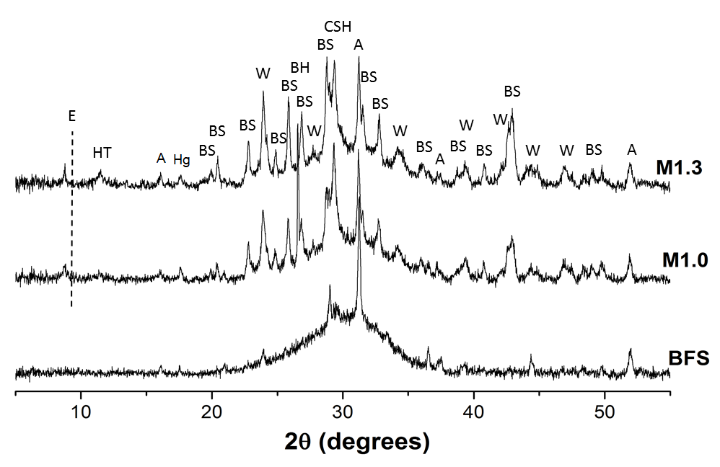
Figure 5. 2 - X-ray diffractograms of unreacted slag and Na₂SO₄-Ba(OH)₂-BFS composites as a function of the Ba²⁺ to SO₄²⁻ molar ratio.
Peaks marked are BaSO₄ (BS), åkermanite (A), calcite (CC), witherite (W), ettringite (E), hydrotalcite (HT), hydrogarnet (Hg) and C-A-S-H (CSH). The dashed line indicates the position of the main (100) peak of ettringite.

In these composites, the formation of a compound with a peak at 8.50º 2θ is observed (Figure 5.2). As the peak position is slightly shifted to lower 2θ when compared with the main reflection peak of ettringite (9.0º 2θ, indicted with a dashed line), it is likely that in the presence of Ba(OH)₂, formation of a Ba-containing AFt type phase takes place. The substitution of Ba²⁺ onto the Ca²⁺ sites in the ettringite structure has previously been reported (Glasser 1993, Gougar et al. 1996), and Ba-bearing ettringite has a larger d-spacing than pure ettringite (Jun et al. 2005), shifting the peak to lower angles as observed in these samples. Utton et al. (2011) identified, in a 1:9 Portland cement/BFS system containing BaCO₃, that the formation of ettringite and precipitation of BaSO₄ occur simultaneously, competing for the sulphate ions in the solution. After extended times of curing in their systems, ettringite decomposed to form calcium monocarboaluminate (AFm), calcite and BaSO₄, by reacting with the free Ba²⁺ ions.

In the composites assessed in this study, as formation of ettringite takes place, it is evident that not all of the sulphate is directly consumed by BaSO₄ precipitation according to Equation 4.1 (Chapter 4). Na₂SO₄ will continue promoting the formation of ettringite in the system when its amount exceeds the capacity of Ba(OH)₂ to immediately form BaSO₄. This observation differs from the trends identified in studies evaluating the effects of Ba(OH)₂ or BaCO₃ on the structures of synthetic ettringite and thaumasite (Dermatas and Meng 2003, Ciliberto et al. 2008, Carmona-Quiroga and Blanco-Varela 2013) where the formation of ettringite was supressed or ettringite is completely decomposed.

5.2.2 Thermogravimetry
Figure 5.3 shows the differential thermograms (DTG) of Na₂SO₄-activated BFS, NaOH-activated BFS and Ba(OH)₂-activated BFS 6 months cured samples. The total loss of mass up to 1000°C was 13.9% for Na₂SO₄-activated BFS, 12.1% for NaOH-activated BFS, and 16.4% for Ba(OH)₂-activated BFS. These values are different and lower in comparison with the one month cured samples of the same formulations from the previous Chapter, Section 4.5 for 15.1% for Na₂SO₄-activated BFS, 14% for NaOH-activated BFS, and 16% for Ba(OH)₂-activated BFS. The samples with the extended time of curing are expected to have higher mass losses due to higher extent of reaction over time but as these samples after completions of curing were kept in the desiccator prior to the TGA analysis, they were subjected to dehydration.

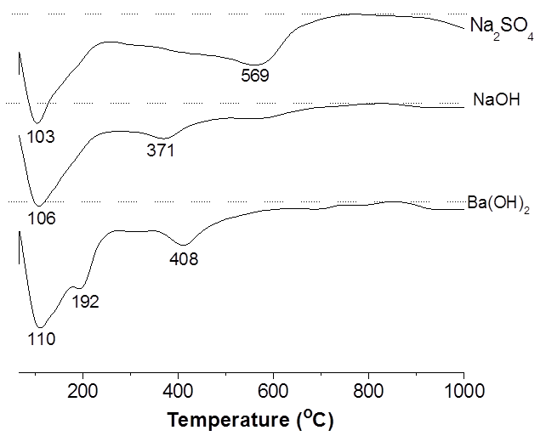
Figure 5. 3 - Differential thermograms (mass loss downwards) of alkali-activated BFS with different alkaline activators. Dashed lines show the baseline for each data set.

In the Na₂SO₄-activated BFS, a high intensity peak between 70°C and 100°C is observed, which is attributed to the release of evaporable water in the system, and the start of the dehydration of ettringite (Hall et al. 1996) as it was identified through XRD (Figure 5.1). In this sample, the low intensity shoulder around 569°C is attributed to the decomposition of CaCO₃ (Maciejewski et al. 1994). This has been reported to the decomposition of amorphous or poorly crystalline CaCO₃ which is associated with CSH carbonation, which decomposes at a lower temperature (Thiery et al. 2007).

In NaOH-activated and Ba(OH)₂-activated samples, the decomposition of hydrotalcite occurs in two stages: dehydration around 200°C and de-hydroxylation 380-400°C (Ben Haha et al. 2011). The hydrotalcite peaks are more distinct in the BFS+Ba(OH)₂ sample, which might suggest a larger extent of reaction of the slag, and potentially more ordering of the structure of this phase when using Ba(OH)₂ as the alkaline activator.

Figure 5.4 shows the differential thermograms (DTG) of unreacted slag and Na₂SO₄-Ba(OH)₂-BFS composites with different Ba²⁺ to SO₄²⁻ molar ratios. The total weight loss up to 1000°C was 14.58 % for M1.0, and 10.25 % for M1.3. The BaSO₄ decomposition temperature is above 1000°C (Carmona-Quiroga and Blanco-Varela 2013) and therefore it is not observed in these thermogravimetry data. Some of these values are different in comparison with the one month cured samples of the same formulations from the Chapter 4, Section 4.3.2 (Figure 4.12). The samples with the extended time of curing are expected to have higher mass losses due to higher extent of reaction over time but for example sample M1.3 mass loss from one month to six months of curing is comparable and not significantly changed. This is due to the dehydration after completions of the curing period, where samples were kept in the desiccator prior to the TGA analysis.

A high intensity peak between 70 and 100°C was detected, which is attributed to the release of evaporable water and the dehydration of the ettringite (Hall et al. 1996). Decomposition of the hydrotalcite type phase observed in the XRD data in these composites is detected. The decomposition of hydrotalcite occurs in two stages: dehydration around 200°C and de-hydroxylation 380-400°C (Ben Haha et al. 2011).
De-hydroxylation of hydrogarnet which was identified in the XRD results occurs around 300°C (Dilnesa et al. 2014). Decomposition of CaCO₃ covers a wide range from 500°C to 700°C temperature, depending on the crystallinity of CaCO₃. Mass losses at lower range, 568ºC, are assigned to the decomposition of the poorly crystalline or amorphous CaCO₃ and at the higher range around ~ 730ºC are assigned to the thermal decomposition of highly crystalline CaCO₃ products present in the composite samples (Thiery et al. 2007). Carbonation was present in the anhydrous slag and also can occur during the samples preparation. The minor weight loss above 800°C is assigned to decomposition of witherite (Carmona-Quiroga and Blanco-Varela 2013) in agreement with the XRD results (Figure 5.2).
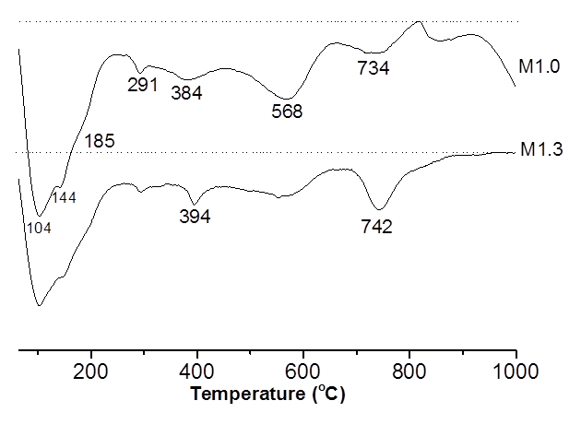
Figure 5. 4 - Differential thermograms (mass loss downwards) for Na₂SO₄-Ba(OH)₂-BFS composites with different Ba²⁺:SO₄²⁻ molar ratios.
Dashed lines show the baseline for each data set.

5.2.3 Solid-state ²⁹Si MAS NMR spectroscopy
Solid state ²⁹Si MAS NMR can provide information regarding the fractions of silicon present in various tetrahedral environments in silicates (Engelhardt and Michel 1987). It directly examines the environment of the silicon in the structures of amorphous and poorly crystalline materials as well as crystalline phases, and thus complements the XRD results. Deconvolutions of the spectra collected here were carried out according to the procedure described by Bernal et al (2013), by using Gaussian line shapes for quantification, the component peaks and simulated spectra are presented along with the experimental data in Figure 5.5. Microsoft Excel was used for the deconvolution of the spectra by including the minimum probable number of component peaks to label the spectrum correctly, and limiting peak widths to be < 10 ppm full width at half height.
The resonances identified in the de-convoluted spectra are assigned to connectivity states based on the information available for cements (Barnes et al. 1985, Richardson et al. 1993), alkali-activated slags (Bernal et al. 2013, Bernal et al. 2014a) and aluminosilicate zeolite systems (Engelhardt and Michel 1987).

It has been proposed that it is possible to determine the degree of reaction in alkali-activated slag binders through the deconvolution of ²⁹Si MAS NMR spectra, as the spectral line shape of the remnant unreacted slag in the activated samples is similar to the line shape of the anhydrous slag (Le Saoût et al. 2011), and a similar approach was adopted in this study, considering that the alkalinity of the composite binders is likely to promote congruent dissolution of the slag.

The line-shape in the downfield region (-60 to -70 ppm) in all reaction product spectra is consistent with the hypothesis of congruent or near-congruent dissolution of the slag, as there is not a notable change in the profile in this region between the spectra of the anhydrous slag and the composite cements. In conducting the deconvolution of the spectra, it was anticipated that the line-shape of the remnant anhydrous slag does not change throughout the time of reaction, and so the spectrum of the unreacted slag was rescaled by a single factor in each spectrum, to deliver the suitable input in this region.
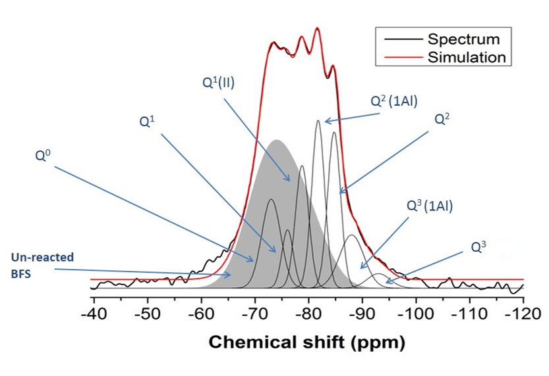
Figure 5. 5 - Deconvoluted ²⁹Si MAS NMR spectrum of composite M1.0.
The grey area corresponds to the fraction of unreacted slag.

Figure 5.6A shows the ²⁹Si MAS NMR spectra of Na₂SO₄-activated BFS, NaOH-activated BFS and Ba(OH)₂-activated BFS pastes, while Figure 5.6B shows those of the unreacted slag, and the composites M1.0 and M1.3. The unreacted slag has a line shape comparable to the spectrum reported for åkermanite (Bernal et al. 2013), which is identified as the main crystalline phase in the slag used in this study (Figure 5.2) with a resonance centred at -74 ppm. A reduction of this peak indicates the reaction of the slag in the hydrated samples. In the activated samples shown in Figure 5.6A, resonances between -80 ppm and -90 ppm are observed, which are often identified with the formation of a C-A-S-H type phase.

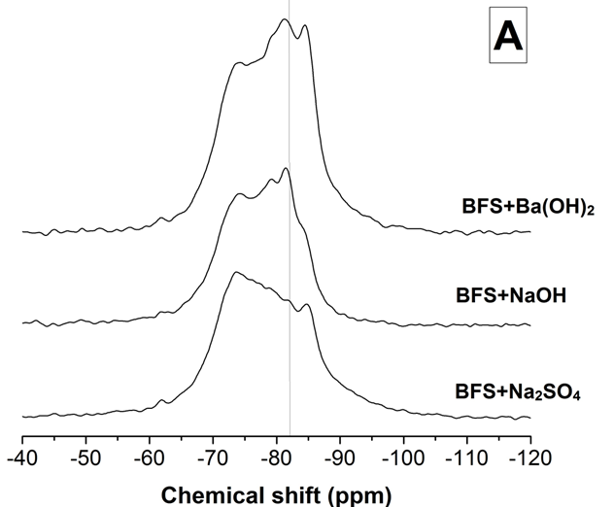
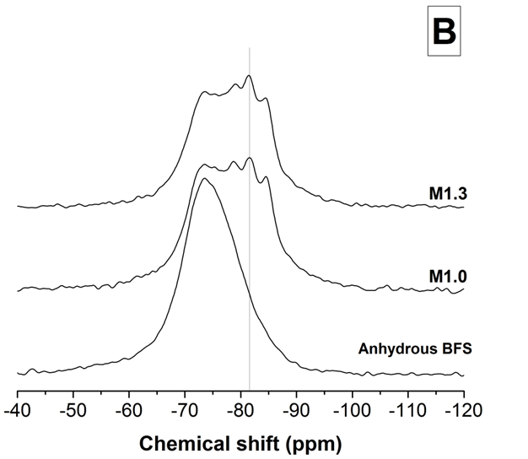
Figure 5. 6 - ²⁹Si MAS NMR spectra of (A) Na₂SO₄-activated BFS, NaOH-activated BFS and Ba(OH)₂-activated BFS pastes, and (B) unreacted slag, and Na₂SO₄-Ba(OH)₂-BFS composites M1.0 and M1.3.
Grey lines indicate the position of Q²(1Al) sites.

In particular, resonances between -82 ppm and -85 ppm, corresponding to Q²(1Al) and Q² sites respectively, are assigned to this Al-substituted C-S-H type gel with a tobermorite type structure (Richardson et al. 1993, Andersen et al. 2003).

From Figure 5.6A it can be seen that there is a reduced intensity of the Q²(1Al) site (-82 ppm) in the spectrum of the Na₂SO₄-activated sample compared to the other activated samples, indicating a reduced degree of Al incorporation in the C-A-S-H product. This could be associated with the fact that most of the Al available in the system is consumed in the significant formation of ettringite in this activated paste (Figure 5.1). In the spectra of the composites M1.0 and M1.3, shown in Figure 5.6B, the intensity of the broad unreacted slag feature centred at -74 ppm decreases with the increased addition of Ba(OH)₂, suggesting a potentially higher extent of reaction, consistent with the decrease in slag component clarified in the deconvolution results in Table 5.1.

Table 5. 4 - Quantification of Q^{n} environments identified in the ²⁹Si MAS NMR spectra of the specimens investigated
Sample ID | Unreacted slag | Site type in reaction productsª
Sample ID | Unreacted slag | Q⁰ | Q¹(I) | Q¹(II) | Q²(1Al) | Q² | Q³(1Al) | Q³(0Al)
Sample ID | Unreacted slag | -74 | -78 | -80 | -82 | -85 | -89 | -94
M1.0 | 47 | 9 | 4 | 9 | 12 | 11 | 7 | 2
M1.3 | 45 | 9 | 5 | 9 | 11 | 13 | 6 | 2
Na₂SO₄ | 53 | 10 | 6 | 3 | 7 | 12 | 7 | 3
NaOH | 49 | 10 | 5 | 11 | 12 | 10 | 3 | -
Ba(OH)₂ | 39 | 9 | 5 | 9 | 13 | 16 | 7 | 2
ª Estimated uncertainty in all site percentages is ± 2%, based on the influence of the signal/noise ratio of the spectra on the deconvolution procedures.

The addition of Ba(OH)₂ in the composite samples seems to favour the incorporation of Al in the C-A-S-H type gel, which is associated with the increasing intensity of the Q²(1Al) peak, and the identification of Q³(1Al) sites, as reported in Table 5.1. The observation of Q³(1Al) sites in these materials is an indication of crosslinking taking place in the C-A-S-H phase (Myers et al. 2013). Although these composites contain some ettringite, which consumes some of the Al supplied by the slag, the amount is small. The content of hydrotalcite is also notably lower than in the Ba(OH)₂-activated and NaOH-activated pastes (Figure 5.1), and so the availability of Al appears sufficient for this degree of substitution into the C-A-S-H. The fate of the Mg is, however, unclear at this stage. These results suggest that the structure of the C-A-S-H type gel forming in the composite binders is a result of a combined activation process involving both Na₂SO₄ and Ba(OH)₂, as the reaction phase assemblages do not match what would be observed if the slag was solely activated by the NaOH produced in reaction 4.1. The C-A-S-H type binders forming in the composite specimens have a high degree of crosslinking associated with the high fractions of Q² and Q³ species.

According to the quantification of Si sites presented in Table 5.1, it is observed from the remnant unreacted slag fraction that the lowest degree of reaction is achieved in the specimen activated solely with Na₂SO₄, and the highest degree of reaction when Ba(OH)₂ is used as the sole activator. These observations are in agreement with the thermogravimetry results (Section 5.2), where the highest mass loss was identified in the Ba(OH)₂-activated specimens among all single-activator systems analysed. This demonstrates that Ba(OH)₂ can act as an effective activator for producing alkali-activated materials. Consequently, it is likely that the reaction of the composites assessed here is not exclusively governed by the formation of NaOH as a secondary product during the reaction of Ba(OH)₂ and Na₂SO₄ to form BaSO₄ (Reaction 4.1), but rather that the original Ba(OH)₂ and Na₂SO₄ components are also having a significant impact. The higher reaction extent observed in M1.3 compared to M1.0 also indicates that the excess Ba(OH)₂ present in this mix leads to an increased extent of reaction..

5.2.4 Solid-state ²⁷Al MAS NMR spectroscopy
Figure 5.7 shows the ²⁷Al MAS NMR spectra of the samples evaluated. The unreacted BFS shows a broad resonance between 40 and 80 ppm, centred around 60 ppm. This region is assigned to tetrahedral Al environments, but cannot be assigned to a well-defined single site type due to structural disorder in the slag. It is attributed to the glassy phases which comprise the majority of the BFS, as observed as the diffuse scattering and low crystalline phase content identified by XRD in the unreacted BFS (Figure 5.1).

In the Na₂SO₄-activated BFS sample (Figure 5.7A), there are two distinguishable peaks in the region associated with octahedrally coordinated Al. The larger peak in this region, at around 13 ppm, is assigned to ettringite (Andersen et al. 2006) as identified by XRD (Figure 5.1). The shoulder at 10 ppm is assigned to the hydrotalcite type phase (Bernal et al. 2013) also observed by XRD in this sample, which may also contain minor contributions from AFm type phases as suggested by the DTG analysis, although these are not positively identifiable by XRD. In the NaOH-activated and Ba(OH)₂-activated pastes, a single peak at 10 ppm is observed in this region of the spectra, and attributed to the layered double hydroxide and AFm type phases, which have very similar ²⁷Al resonance positions, both identified by XRD in this sample (Figure 5.5). The main effect of the activator is identified in the region between 40 ppm and 80 ppm in Figure 5.7A, which is associated with the tetrahedrally coordinated Al. Upon activation, a sharpening of the Al(IV) region is identified in all the samples compared with the unreacted BFS; as not all of the slag has reacted, part of the intensity of this band should be assigned to the remnant unreacted BFS.

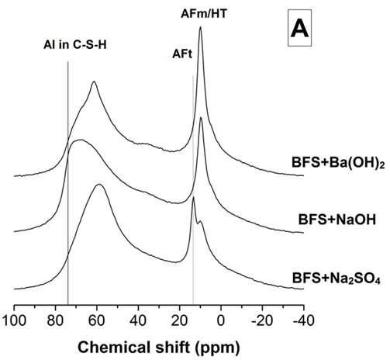
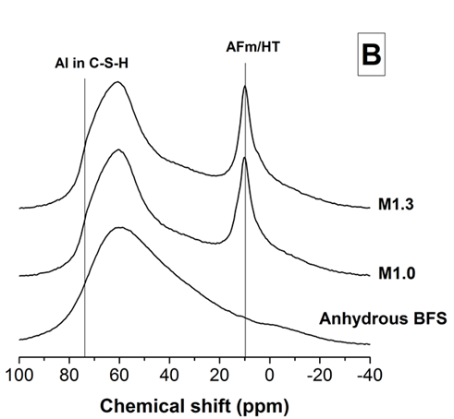
Figure 5. 7 - ²⁷Al MAS NMR spectra of (A) Na₂SO₄-activated BFS, NaOH-activated BFS and Ba(OH)₂-activated BFS pastes, and (B) unreacted slag, and Ba(OH)₂-Na₂SO₄ slag composites M1.0 and M1.3.

In C-A-S-H products, Al is tetrahedrally coordinated and usually identified at 74 ppm in ²⁷Al MAS NMR spectra (Richardson et al. 1993, Andersen et al. 2003). This resonance is observed in NaOH and Ba(OH)₂ activated pastes, consistent with the identification in the ²⁹Si MAS NMR results (Table 5.1) of high intensity peaks assigned to Q²(1Al) sites.

In the Na₂SO₄-activated paste, an asymmetric Al(IV) band with a maximum at 60 ppm is instead observed. This resonance is assigned to highly crosslinked Al-rich sites in the C-A-S-H type gel, in agreement with the identification of Q³(1Al) sites by ²⁹Si MAS NMR. In the Ba(OH)₂-activated sample a high intensity peak centred at 61 ppm is identified. Resonances at this specific chemical shift value are consistent with the formation of poorly ordered AFm type phase (strätlingite) in Al-rich cementitious systems formed under high alkalinity conditions (Kwan et al. 1995); however, studies of Ba-bearing AFm and/or hydrogarnet phases are very limited, and ²⁷Al MAS NMR spectra of compounds with such chemistry are not available in the open literature to corroborate the assignment of this peak. Considering that Q³ type sites are observed in the Ba(OH)₂ activated sample in the ²⁹Si MAS NMR spectra, and these sites can be also present in hydrogarnet type phases (Rivas Mercury et al. 2007), it is suggested that the formation of a Ba-bearing AFm or hydrogarnet type phase might be occurring. Further investigation to validate this hypothesis is required.

In the spectra of the Ba(OH)₂-Na₂SO₄-BFS composite samples (Figure 5.7B), features resembling these different activation systems were also identified. A broad band around 10 ppm was observed, but less distinct than those identified in the NaOH-activated or Ba(OH)₂-activated slags, and is assigned to the contributions of hydrotalcite type-and ettringite phases as identified through XRD (Figure 1). The lineshape of the Al(IV) region of the composite spectra appears to be similar to the case of BFS activated with Na₂SO₄, which does not change significantly with the different amounts of Ba(OH)₂ added, suggesting that the C-A-S-H products are forming in these systems and that they have similar structures in M1.0 and M1.3, as identified via ²⁹Si MAS NMR (Figure 5.6).

5.2.5 Solid-state ²³Na MAS NMR spectroscopy
Figure 5.8 shows the ²³Na MAS NMR results for anhydrous Na₂SO₄ (M0), Na₂SO₄-activated slag and Ba(OH)₂-Na₂SO₄ slag composite cements (M1.0 and M1.3). The spectrum collected for anhydrous Na₂SO₄ is used here as a reference to identify unreacted Na₂SO₄ in the samples. The line shape of the Na₂SO₄ spectrum is in good agreement with those reported in the literature (Koller et al. 1994).

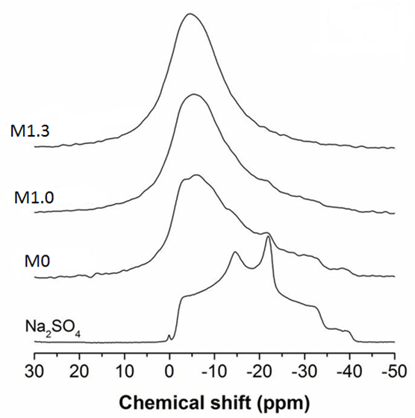
Figure 5. 8 - ²³Na MAS NMR spectra of Na₂SO₄, Na₂SO₄-activated BFS (M0), and Ba(OH)₂-Na₂SO₄-BFS composite cements (M1.0 and M1.3).

It is clear from the spectra of the Na₂SO₄-activated slag and the composite M1.0 sample that there is some unreacted Na₂SO₄ present in both of these mixes, particularly visible in the resonance at -21 ppm. This indicates that in the absence of Ba(OH)₂, although some of the sulphate in the waste simulant is chemically bonded through the formation of ettringite, there is an excess of sulphate that is likely to be remaining in the pore solution, and then precipitating as Na₂SO₄ when the samples are dried for analysis. The inclusion of Ba(OH)₂ in M1.0 reduces the remnant Na₂SO₄ in the sample, owing to the formation of BaSO₄ as observed by other analytical techniques; however, there is not complete consumption of Na₂SO₄. This suggests the need for larger Ba(OH)₂ contents in the system in order to incorporate all of the sulphate into cement phases, as in composite M1.3, where ²³Na resonances assigned to remnant Na₂SO₄ are no longer identified.

In the alkali-activated composites studied here, a ²³Na resonance at around -6 ppm is observed (Figure 5.8), consistent with the results reported by Bonk et al (2003) for the alkalis in C-A-S-H type gels in alkali-activated slag binders, analysed at a comparable magnetic field. Formation of C-(N)-A-S-H binding phases has been identified in alkali-activated slags and it has been proposed that the inclusion of alkalis in the C-A-S-H gel can occur by balancing the charge deficit associated with the replacement of a bridging SiO₄ tetrahedron with an AlO₄ unit, as an alkali ion adsorbed or bonded in the interlayer region of the C–S–H phase (Ben Haha et al. 2012, Skibsted and Andersen 2012, Myers et al. 2014).It is also clear from the ²³Na MAS NMR spectra that the peak at -6 ppm is narrowed in the composite sample M1.3, indicating a more ordered gel structure with a higher amount of Ba(OH)₂.

5.2.6 Scanning electron microscopy
Figure 5.9 shows a backscattered electron (BSE) image of the BFS activated with Na₂SO₄, and elemental distribution in the region of the image. Regions enriched in Ca, Si, Al and Mg correspond to the unreacted slag, whose angular morphology is clearly observed as light grey isolated regions. The binder matrix is mainly composed of Ca, Si and Al, consistent with the formation of a C-A-S-H product, as discussed in the previous sections. An even distribution of Na throughout the binding phase is also observed, consistent with the inclusion of Na in the C-A-S-H type phase as discussed in the analysis of the ²³Na MAS NMR results. The regions poor in Si but rich in S (white circles in Figure 5.9) are identified as ettringite.
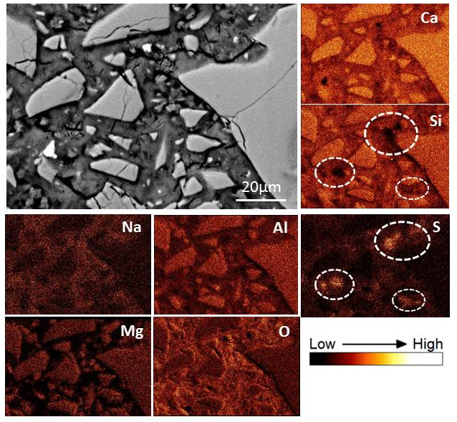
Figure 5. 9 - BSE image and elemental maps of Na₂SO₄-activated BFS.
The elemental maps (Ca, Si, Na, Al, S, Mg and O) show the same region as the backscattered electron image.

Figure 5.10 shows a BSE image of the BFS sample activated by Ba(OH)_{2,} and the elemental maps corresponding to this image. This binder shows a highly heterogeneous matrix, with cavities due to the pull-out of unreacted slag particles during sample polishing, as the unreacted slag grains are surrounded by a low-density reaction rim which appears to give little binding to the bulk gel. This is supported by the fact that the cavities (black areas) observed in the BSE have an angular shape consistent with the shape of unreacted slag particles, which would not be the case if those cavities were pores.
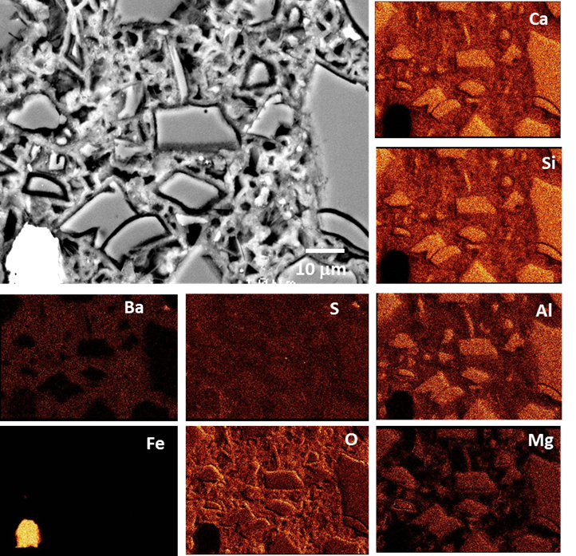
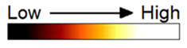
Figure 5. 10 - BSE image and elemental maps of Ba(OH)₂-activated slag.
The elemental maps show the same region as the backscattered electron image.
Dashed circles in Ba and S maps highlight a BaSO₄ particle forming in this system.

The Ba elemental mapping shows that Ba is incorporated relatively homogenously throughout the binding matrix. As there was no BaCO₃ identified in this sample from the XRD results (Figure 5.1), there is a possibility for the inclusion of some Ba in the C-A-S-H which might be occurring in this system. Formation of a C-(Ba)-A-S-H gel has not been observed before, but it has been reported that the inclusion of BaCO₃ in Ca-rich cementitious systems, Ba is able to influence sulphate and carbonate rich phases. (Utton et al. 2011, Carmona-Quiroga and Blanco-Varela 2013). There is a possibility for Ba participation in the C-A-S-H type phase but this needs further investigation for confirmation.

In Figure 5.10, there is also a small region (dashed circles in Ba and S maps) with an increased concentration of Ba and S, indicating the formation of BaSO₄, with the sulphate presumably made available through oxidation of the sulphide supplied by the slag as the sulphate waste simulant was not included in this system. Sulphur appears to be homogenously distributed in the unreacted slag particles and also the matrix, but it is particularly concentrated around the edge of what appears to be a metallic Fe particle observed in the bottom left of the micrograph (the bright white particle in the BSE image). On the edge of the metallic Fe particle, there is Fe-S rich region, which is likely to correspond to an iron sulphide FeS_{x} (1≤x≤2), consistent with the highly reducing environment in slag-rich cements (Atkins and Glasser 1992).

Figure 5.11 shows a BSE image of the M1.0 sample, together with the elemental distributions of sulphur and barium in the corresponding region. Angular BFS particles are dispersed throughout the binding C-A-S-H phase. The formation of BaSO₄ is observed as both small and larger white particles in the BSE image, confirmed by the corresponding elemental maps. Some of the BaSO₄ particles appear to form on the slag particles (indicated by the dotted square). This indicates that Ba will react not just with the sulphur supplied by the sulphate bearing solution, but also with the sulphur present in the slag, as noted above.
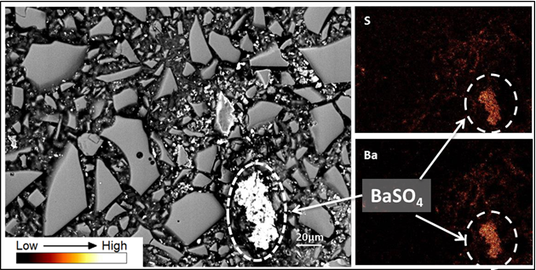
Figure 5. 11 - Backscattered electron image and elemental maps of sample M1.0.
Ba and S elemental maps confirm the formation of BaSO₄.

5.3 Long-term stability

5.3.1 Compressive strength
Figure 5.12 compares the compressive strengths of the composite samples over a period of 18 months of curing. Sample M0, without Ba(OH)₂, exhibited the highest strength among the composites tested at 30 days of curing. Extended curing led to a notable increase of the compressive strength, reaching to 43 MPa at 18 months. This strength is significantly higher than all the other samples tested. It has been reported in the calcium sulphoaluminate cement based system (Bensted 1994), which is in many ways comparable to the M0 (sulphate activated slag) system, that ettringite formation governs the early strength properties of these cements, and the formation of C-S-H is accountable specifically for the later strength. Ettringite is a strength giving phase with a large molar volume, and therefore it is able to close the pores in the microstructure. In a sulphate-rich environment, such as in an alkali-sulphate activated slag, it is expected that ettringite is formed almost instantly in the early times of the hydration process (Juenger et al. 2011), and therefore is contributing to the strength gaining of these binders.

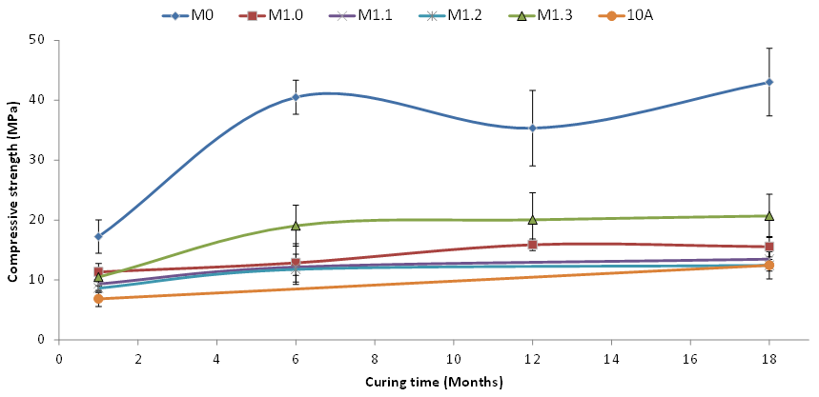
Figure 5. 12 - Compressive strength test of samples over time produced via Method B with various Ba²⁺ to SO₄²⁻ molar ratios.
Sample 10A had the same formulation as M1.3 but was produced via the two-step method A (Chapter 4) for comparison. Error bars show one standard deviation of three measurements.

The composite samples M1.0, M1.1, M1.2 and M1.3 have a lower compressive strength compared to M0. This could be a result of the reduced ettringite content formed in these systems, and the potential substitution of barium ions in the C-A-S-H phase modifying the microstructure of the main binding phase and consequently reducing the compressive strength. At one month of age, all the specimens showed strength of approximately 10 MPa. Although these values are significantly lower than the reported values for other alkali-activated slag cements produced with sodium hydroxide or silicate activators (Wang et al. 1994), they are considered sufficient for waste immobilisation purposes. As a guide, the UK nuclear industry considers compressive strength of 7 MPa after 90 days of curing as the minimum value for hardened cementitious wasteforms (Swift 2013).

After longer curing periods up to 18 months, all the Ba(OH)₂-Na₂SO₄-BFS composite cement samples of M1.0, M1.1, M1.2, M1.3 and 10A have comparable compressive strength within the error. The strength of these samples was stable after 6 months up to 18 months, except the M0 sample, where apparent fluctuation in the strength was identified during the curing periods analysed.

5.3.2 Dimensional Stability
Figure 5.13 illustrates the dimensional changes of the M1.3 or (10B) sample produced via the single-step Method B and the 10A sample produced via the two step Method A, which have comparable formulation (Table 5.1 and 5.2). The dimensional measurement was carried out over 850 days, for hardened paste specimens under standard conditions (25°C humidity chamber). The first measurement was carried out at the 7 days of specimen curing.

Both samples showed negligible dimensional alterations during 850 days of curing (<0.005 mm) on a 160 mm sample. The shrinkage and expansion of both samples produced through two various methods, are comparable within error, which is a reasonable indication for the suitable long-term dimensional stability of the sample.

Figure 5. 13 - Dimensional stability of M1.3 (10B) and 10A.
Error bars show one standard deviation of three measurements.

5.3.3 Phase analysis
Figure 5.14 shows the X-ray diffractograms of the 12 months aged samples M0, M1.0 and M1.3. All the peaks identified are identical to those previously observed in the 6 month cured samples (Figure 5.1 and Figure 5.2). The peak intensities were also similar to the 6 month data for BaSO₄, BaCO₃, hydrotalcite, hydrogarnet and Ba-substituted ettringite. However, after 18 months, significant changes were observed. Figure 5.15 shows the X-ray diffractograms of the 18 months aged samples M0, M1.0 and M1.3. For sample M0, all the peaks are identical to those described above for 6 and 12 months cured samples, without any significant change in the peak intensities (Figure 5.1 and Figure 5.16). For the M1.0 and M1.3 samples that contain Ba(OH)₂, the peaks for witherite (BaCO₃) decrease significantly, compared with 6 and 12 months cured composites, along with the disappearance of the peaks assigned to the Ba-substituted ettringite, and the appearance of a low intensity but distinctive peak at 10.9 2θ, assigned to hemicarbonate.

Figure 5. 14 - X-ray diffractograms of M0, M1.0 and M1.3 samples cured for 12 months.
Peaks marked are BaSO₄ (BS), åkermanite (A), calcite (CC), witherite (W), ettringite (E), hydrotalcite (HT), hydrogarnet (Hg) and C-A-S-H (CSH)

A similar phenomenon was previously identified by Utton et al. (2011) and Rickerby at al. (2013) in 1:9 Portland cement/BFS systems doped with BaCO_{3.} It was observed in Portland cement blended cements that, with the formation of ettringite, precipitation of BaSO₄ initially occurred simultaneously, competing for the sulphate ions in the solution, and over an extended time of curing, ettringite decomposed fully in the presence of BaCO₃ to produce the more stable BaSO₄. As a result of this reaction soluble carbonate anions are released, to form new phases such as monocarboaluminate, hemicarbonate and traces of hydrotalcite in Portland cement/slag blends reported by Rickerby at al. (2013). The observations here are consistent with these data from the literature, and the final barium-containing product is the more insoluble and thermodynamically stable BaSO₄, and the carbonate from witherite is converted to hemicarbonate.
Figure 5. 15 - X-ray diffractograms of M0, M1.0 and M1.3 samples cured for 18 months.
Peaks marked are BaSO₄ (BS), åkermanite (A), calcite (CC), witherite (W), ettringite (E), hydrotalcite (HT), hemicarbonate (HC) and C-A-S-H (CSH).

Figure 5.16 shows the thermograms of M0, M1.0 and M1.3 after 12 months of curing. The total mass loss up to 1000°C is 22.56 % for M0, 18.75% for M1.0 and 20.10 % for M1.3, which is indicating the continued reaction of the slag over the time of curing, as the total mass loss of these aged samples is significantly higher than was identified in the 6 months samples (section 5.2.2).

A high intensity peak between 70 and 100°C was detected, which is attributed to the release of evaporable water and the dehydration of the ettringite. For M0 sample a distinctive mass loss around 100ºC is observed which is absent for M1.0 and M1.3, and which can be attributed to ettringite in agreement with XRD results (Figure 5.14).
Figure 5. 16 - Thermograms (A) and differential thermograms (B) (mass loss downwards) of M0, M1.0 and M1.3 samples cured for 12 months.

The decomposition of hydrotalcite occurs in two stages: dehydration around 200°C and de-hydroxylation 380-400°C. The thermal decomposition of highly crossed linked C-S-H occurs at temperatures between 250°C and 400°C, where water is more tightly bound to the C-S-H structure. Decomposition of CaCO₃ covers a wide range from 500°C to 700°C temperature, depending on the crystallinity of CaCO_{3.} The mass loss above 800ºC is attributed to the decomposition of BaCO₃ (Carmona-Quiroga and Blanco-Varela 2013) which is in agreement with the corresponding XRD results (Figure 5.15).

Figure 5.17 shows the thermograms of M0, M1.0 and M1.3 after 18 months of curing. The total mass loss up to 1000°C for M0 sample is 22.43%, for M1.0 sample is 13.73% and M1.3 samples is 15.43%. The total mass loss for M0 sample at 18 months of curing is comparable to that at 12, but it is significantly decreased for M1.0 and M1.3. This is can be attributed to the loss of Ba substituted-ettringite and witherite (BaCO₃) between 12 to 18 months as identified in the XRD results (Figure 5.16), resulting in the formation of more insoluble and thermodynamically stable BaSO₄ which has a higher decomposition temperature (~1500°C) and therefore cannot identified within the range of temperatures tested. Conversely, looking into the mass loss percentages of the samples showing with various ages in various regions in Table 5.2, there is also a possibility that 18 months cured samples could have been dehydrated prior to the test.

Figure 5. 17 - Thermograms (A) and differential thermograms (B) (mass loss downwards) of M0, M1.0 and M1.3 samples cured for 18 months.

Table 5. 5 - Mass loss (%) of the studied samples in the different temperature regions
Sample | 25-100°C | 100-500°C
M0- 12 months | 13.05 | 6.43
M1.0- 12 months | 11.64 | 4.86
M1.3- 12 months | 11.28 | 6.63
M0- 18 months | 12.00 | 6.56
M1.0-18 months | 7.73 | 6.27
M1.3- 18 months | 6.84 | 5.73

5.4 Conclusions

For the characterisation of the six months aged samples, X-ray diffraction results confirm the successful binding of sulphate in very insoluble crystalline phases such as BaSO₄ and BaCO₃ in the composite samples produced via method B, offering the potential for good binder stability in the long term. The microstructure of the composites is dominated by the strength giving phase C-A-S-H, along with layered double hydroxides (hydrotalcite and AFm type) and Ba-substituted ettringite forming as secondary reaction products.

The NMR results are revealing that comparing the reaction products formed in the Ba(OH)₂–Na₂SO₄–BFS composite wasteforms with those identified when activating BFS with either Ba(OH)₂, Na₂SO₄ or NaOH as a sole activator, it is seen that both Na₂SO₄ and Ba(OH)₂ are acting as alkaline activators in the composite system. An increased content of Ba(OH)₂ in the composite binders seems to favour a higher extent of reaction of the slag, and a 30% excess of Ba(OH)₂ over Na₂SO₄ is seen to be sufficient to prevent the presence of free Na₂SO₄ in the pore network of the binder. Gathered from SEM results and the related elemental mapping that there also some possibilities for substitution of Ba²⁺ for Ca²⁺ in C-A-S-H gel, particularly when no sulphate is added but needs further investigation.

Long term stability of the composite samples is essential in terms of variations in mechanical and phase properties over time. For the mechanical properties, the reference M0 sample, solely produced with Na₂SO₄, developed the highest compressive strength from early age up to 18 months, compared to the composite cement samples produced with addition of Ba(OH)₂. This is probably attributed to the formation of ettringite as a strength giving phase from the early stage of reaction (30 days) and remaining stable up to 18 months. All the Ba(OH)₂–Na₂SO₄–BFS composite samples have comparable sufficient compressive strength up to 18 months within error, for nuclear waste immobilisation.

Phases analysis results (XRD) and (TGA) of M0, M1.0 and M1.3 samples show no alterations up to 12 months in phase assemblage. However, from 12 to 18 months of curing, some alterations are occurring to the M1.0 and M1.3 samples. The results are representing the decomposition of less insoluble BaCO₃ and Ba-substituted ettringite to form very insoluble and thermodynamically stable BaSO₄ over an extended period of time. As the main purpose of this study is to form a BaSO₄-BFS composite cement system to immobilise sulphate as stable BaSO₄, this finding is particularly significant, as it demonstrates that the system developed can successfully achieve this in 18 months without compromising its mechanical properties, as shown in the compressive strength and dimensional stability of the products.

Chapter 6- Results and discussion: Gamma irradiation resistance of an early age slag-based cement matrix

6.1 Introduction
Note: The results reported in this chapter correspond to those presented in Mobasher N. et al. ‘Gamma irradiation resistance of an early age slag-blended cement matrix for nuclear waste encapsulation’ Journal of Materials Research, 2015, 30(9):1593-1571.

Contributions:
Neda Mobasher: Data collection and analysis. Writing and reporting of the results.
Dr Susan Bernal: Assistance with the analysis of the NMR data and Optical microscope images.
Dr Clint Sharrad: Assistance with the analysis of the results and proof reading
Dr Hajime Kinoshita: Assistance with the analysis of the results and proof reading
Professor John Provis: Assistance with the analysis of the results and proof reading

The wasteforms are exposed to ionizing radiation throughout their lifetime, and it is essential to understand the effects of radiation, and determine if they can withstand such service conditions. This chapter focuses on the gamma radiation resistance of an early age blast furnace slag (BFS) and Portland cement (PC) composite (BFS:PC=9:1) grout (cured for 8 days prior to irradiation). This system was chosen and studied as a reference system for the BFS-BaSO₄ composite system developed in the present study for two reasons; firstly as BFS-PC systems are currently applied in the UK for the encapsulation of intermediate and low level radioactive nuclear wastes (Atkins and Glasser 1992, Sharp et al. 2003), and therefore it is beneficial to understand their potential changes induced by gamma irradiation; secondly, with the large BFS component, this system is also considered as an alkaline activated BFS system (activated by PC). Therefore the information presented in this chapter sets the foundation for a direct comparison of the gamma irradiation performance of the activated slag based composite waste forms developed in this thesis, whose results will be reported and discussed in Chapter 7.

The irradiation effects at early age of cementitious waste forms are of particular interest because the cement system has a significant amount of free water at this stage, which can be subjected to radiolysis and consequent H₂ gas generation (Bouniol and Aspart 1998). A set of samples were subjected to the gamma irradiation for 256 hours to receive total dose of 4.77 MGy (dose rate of 18.6 kGy/h) as explained previously in Chapter 3, Section 3.6.4. The effects of the irradiation was studied by comparing their properties with those without the exposure to the irradiation. Another set of samples were heat-treated at 50°C for the corresponding time, to study the effects of temperature reached inside the gamma radiation chamber used in this study, and evaluated as a second control (in addition to unheated specimens), to distinguish the potential effects of elevated temperature from those associated solely with irradiation.

6.2 X-ray diffraction results
Figure 6.1 illustrates the X-ray diffractograms of the studied samples compared with the un-irradiated anhydrous 9:1 BFS-PC powder. The anhydrous mix is predominantly amorphous due to the large fraction of slag present. Reflection peaks of crystalline åkermanite (Ca₂MgSi₂O₇, powder diffraction file, PDF, #076-0841), contributed by the slag, were also identified along with the PC clinker phases alite (Ca₃SiO₅, PDF #031-0301) and belite (β-Ca₂SiO₄, PDF #031-0299). Upon initial hydration (control), heating and irradiation treatments, all samples showed a clear reduction in the intensity of the reflections assigned to the clinker phases, suggesting that a significant amount of the PC reacted.
Figure 6. 1 - X-ray diffractograms of anhydrous BFS-OPC powder and the samples studied.
Peaks marked are åkermanite (A), calcite (CC), hydrotalcite (H). portlandite (P), alite (a), belite (b) and calcium silicate hydrate (CSH).

A small peak at 11.3° 2θ was observed in all samples, assigned to a hydrotalcite (Mg₆Al₂(CO₃)(OH)₁₆·4H₂O, PDF #89-0460) with a layered double hydroxide structure. This phase is commonly formed in slag-rich PC blends and alkali-activated slags, when the slag has a moderate to high MgO content (> 5 wt.% MgO in the slag) (Bernal et al. 2014b). A poorly crystalline calcium silicate hydrate (C-S-H) phase is also identified, assigned to the broad peak centred at 29° 2θ. This phase is derived from the reaction of both BFS and PC. Reflections assigned to portlandite (Ca(OH)₂, PDF #-044-1481), one of the main products of PC hydration, were also observed along with traces of calcite (CaCO₃, PDF #005-0586).

The XRD pattern for the irradiated sample (dose rate of 18.6 kGy/h), shows no significant difference from those of the other specimens analysed, suggesting that the crystalline reaction products formed at this early stage of hydration are able to withstand gamma irradiation exposure. This is in accordance with the observations made for similar systems at different ages of curing, where a slightly lower radiation dose rate (10 kGy/h) compared with the present study (18.6 kGy/h) was applied (Pottier and Glasser 1986, Richardson et al. 1990). The formation of crystalline ettringite (main reflection at 9.09° 2θ) was not observed in our samples, conversely to the trends identified by Richardson et al (1990), which might be a consequence of the difference in age of the materials evaluated, or it may indicate that this phase is not sufficiently ordered to enable its identification by XRD; the possible presence of ettringite in the samples is further discussed in more detail below.

6.3 Solid state ²⁷Al and ²⁹Si MAS NMR spectroscopy
Figure 6.2 shows the ²⁷Al MAS NMR spectra of the anhydrous mix and the hydrated samples studied. ²⁷Al MAS NMR spectra of minerals and glasses typically show three distinct aluminium coordination environments (Al^{(IV)}, Al^{(V)} and Al^{(VI)}), which are located at chemical shifts at 50 to 80 ppm, 30 to 50 ppm and -10 to 30 ppm, respectively (Kirkpatrick 1988). The anhydrous mix presents mainly a broad resonance between 40 and 80 ppm centred around 60 ppm that cannot be attributed to a sole aluminium environment, and corresponds to the glassy fraction that comprises the majority of the BFS, as previously identified in the XRD data for the anhydrous BFS-PC mix (Fig 6.1).

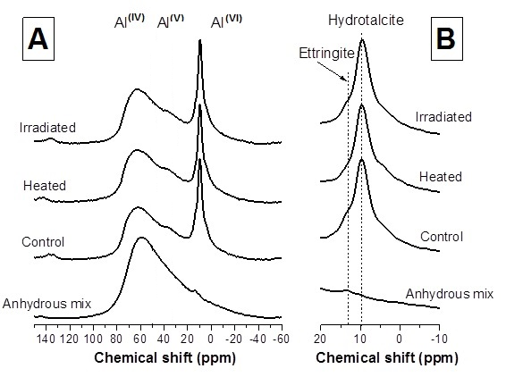
Figure 6. 2 - Solid-state ²⁷Al MAS NMR spectra of (A) anhydrous BFS-PC powder mix and the samples studied, and (B) the Al^{(VI)} region of each spectrum.

Upon hydration, a high intensity band in the Al^{(VI)} region centred at 9.5 ppm is identified. This resonance is assigned to the hydrotalcite type phase (MacKenzie et al. 1993), which was identified by XRD (Fig 6.1). A low intensity, but well resolved, shoulder centred at 13 ppm is also observed in the control sample. A band at this chemical shift corresponds to ettringite (Andersen et al. 2006), confirming the formation of this phase in the early age BFS-PC evaluated in this study, even though it was not identified by XRD.
In the Al^{(IV)} region a significant contribution of the remnant unreacted slag is observed; however, the line shape of this band differs from that observed in the anhydrous mix. This indicates the potential overlap of resonances assignable to hydration reaction products containing tetrahedral aluminium environments, in particular an aluminium-substituted C-S-H type phase. Such a phase is typically identified as the dominant reaction product of BFS-OPC grouts, and its Al is present in tetrahedral coordination (Taylor et al. 2010).

In the heat-treated samples, similar resonances to those observed in the control sample are identified, however, the shoulder assigned to ettringite is not clearly observed. This indicates that the heat treatment adopted in this study is sufficient to promote the full dehydration and potential decomposition of this hydrated phase, consistent with the known instability of ettringite at temperatures around 50°C (Lothenbach et al. 2008).

However, in the irradiated sample (which has also been held at 50°C due to irradiation), the ettringite resonance is still observable, although slightly less intense than in the control sample. This indicates that the irradiation is stabilising the ettringite in spite of the heating conditions reached during the irradiation exposure, similar to the observations of Richardson et al.(1990), in an older BFS-PC grout specimen.

The stability of ettringite is strongly dependent on temperature and the concentration of SO₄²⁻, so that higher concentrations of sulphates are required for its precipitation at increased temperatures (Barbarulo et al. 2003). Richardson (1990) proposed that radiolytic oxidation of the sulphides from the BFS to sulphates is likely to take place in this type of grout, and this increased concentration of sulphates is then sufficient to stabilise ettringite under the temperature conditions reached upon gamma radiation exposure. This explains why ettringite is not observed in the heat-treated samples, where there is no mechanism to induce oxidation of sulphides. The stability of ettringite upon irradiation is of particular interest for the immobilisation of nuclear wastes in cements, as this phase can chemically bind different radionuclides via ion exchange mechanisms (Evans 2008). The Al environments in the hydrotalcite-type and possible C-S-H type phases are also seen to remain largely unchanged under irradiation, and these are also important contributors to the retention of radionuclides within these wasteforms.

The ²⁹Si MAS NMR spectra of the BFS-PC specimens are shown in Fig 6.3. The unreacted BFS-PC blend has two broad but distinctive resonances centred at -71 ppm and -74 ppm, assigned to the PC phase belite (Poulsen et al. 2009), as previously identified by XRD (Fig 6.1), and the åkermanite present in the anhydrous slag (Kirkpatrick 1988). These bands remain in the hydrated samples although with a reduced intensity, indicating that a significant fraction of unreacted material is still present in these cements, reasonable with the early age of the cementitious grouts studied here. Upon hydration, new bands centred at -81 ppm and -85 ppm are observed, and these are assigned to the Q²(1Al) and Q² sites typically identified in C-A-S-H type products (Andersen et al. 2003). This confirms that even at early ages of curing, the main binding phase forming in the BFS-PC grout is an Al-substituted C-S-H (C-A-S-H) product. Very similar resonances are identified in the heat-treated and irradiated samples, indicating that notable changes are not taking place in the aluminosilicate chains composing the C-A-S-H phase in this system, and therefore it is concluded that this phase can withstand gamma irradiation exposure. These results are in good agreement with those reported by Richardson et al (1990), where the Si environments in the C-S-H type phase remained unchanged after 2 years of irradiation and a total dose of 84 MGy.
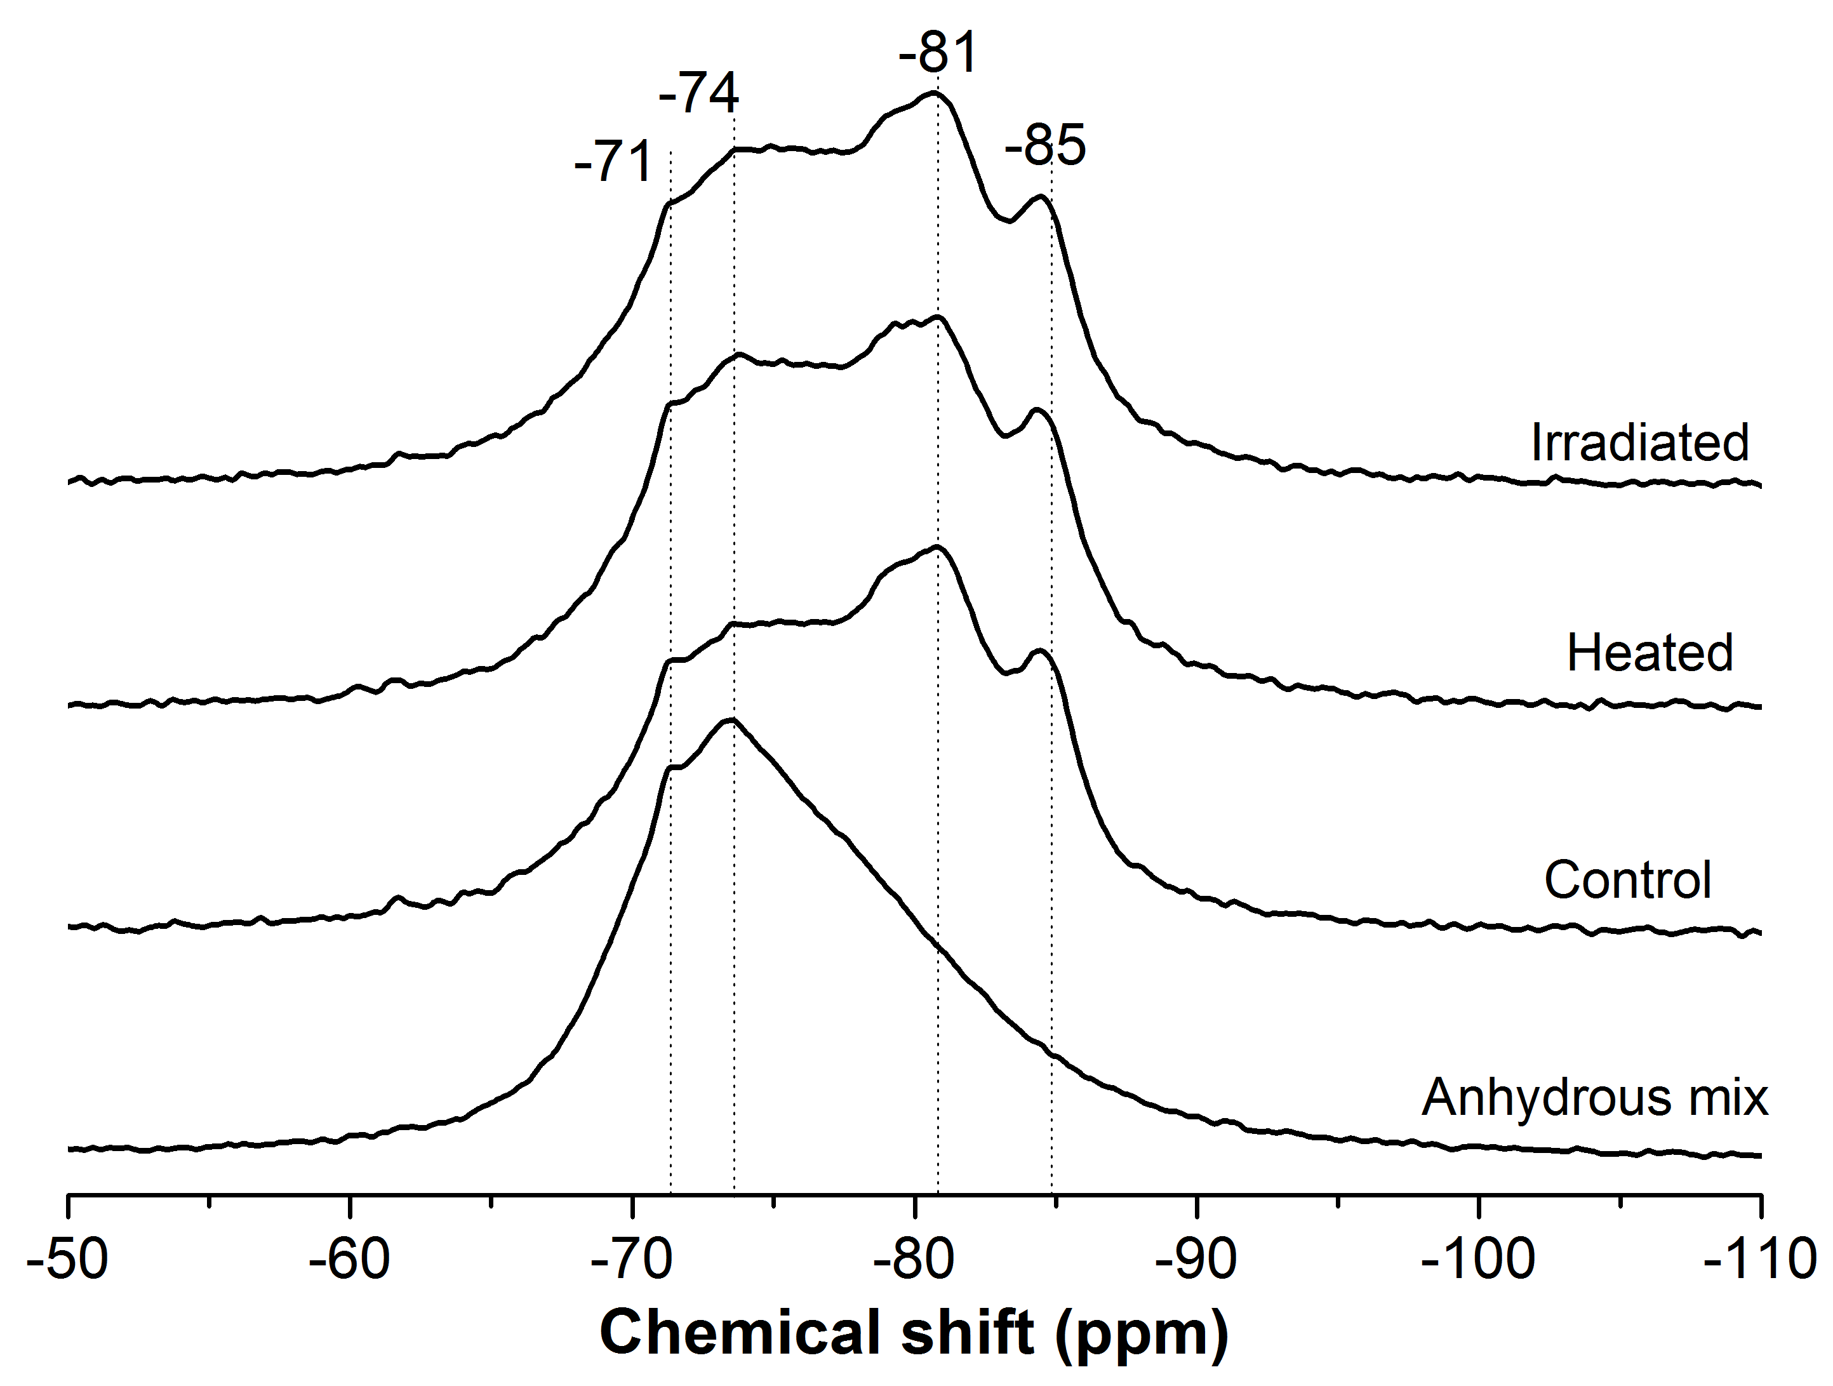
Figure 6. 3 - ²⁹Si MAS NMR spectra of anhydrous BFS-PC powder mix, and the studied samples.

6.4 Thermogravimetric analysis
Figure 6.4 shows the thermograms and differential thermograms of the samples studied. Differences among the samples can be observed below 100°C (inset, Fig 6.4B), mainly associated with the release of free water from the specimens (Alarcon-Ruíz et al. 2005). The distinctive mass loss at 80°C is attributed to the removal of physisorbed water in hydrotalcite (Mokhtar et al. 2010). The mass loss up to 100ºC was 5.9 % for the irradiated sample, and 5.5 % for the heated sample, being smaller than that of the control sample (7.6 %), indicating a reduced content of free water in the irradiated and heated specimens.
Figure 6. 4 - Thermograms (A) and differential thermograms (B) (mass loss downwards) of the Control, Heated and Irradiated BFS:PC samples.

The slightly larger weight loss in the irradiated samples can be considered to be within the uncertainty of the temperature in the irradiation chamber, as it has been estimated as 50 +/- 5°C whereas the heated samples are kept as 50°C precisely in the oven. The 0.4% difference mass loss between the heated and irradiated samples can be related to 5°C difference in the temperatures. This variation may also be explained by the fact that the irradiation is inducing either a slightly higher extent of hydration of the BFS-OPC grout, or less desiccation of the hydration products present in this cement while being held at a corresponding temperature for the same duration.
Above 100°C, all samples show very similar profiles of mass loss, the progressive mass loss between 100°C and 250°C could be assigned to the dehydration of water from small pores in C-S-H, or potentially from disordered hydrotalcite or AFm type phases (Rey and Fornes 1992). The thermal decomposition of highly crossed linked C-S-H occurs at temperatures between 250°C and 400°C, where water is more tightly bound to the C-S-H structure (Myers et al. 2015). The mass loss around 430°C is associated with the thermal decomposition of portlandite as identified in XRD results (Figure 6.1).
. The measured mass loss from 100ºC to 1000ºC was 7.4 % for the irradiated sample, 7.0 % for the heated sample and 7.7 % for the control. This is consistent with the report of Pottier and Glasser (1986) for irradiated BFS-PC grouts, in which there were no changes observed by thermal analysis in irradiated samples compared with control specimens.

The mass loss associated with the presence of calcite appears at 500-700°C (Villain et al. 2007); the differential thermogram profile of the irradiated sample did not show any significant differences in this region compared with the heated and control specimens. Although formation of calcium carbonates by chemical reaction of atmospheric CO₂ with the calcium rich phases in cements, referred to as carbonation, has been reported for neat PC samples upon gamma irradiation (Vodák et al. 2005) it appears that irradiation of an early age BFS-PC specimen does not favour carbonation.

It has been reported (Bouniol and Bjergbakke 2008) that the irradiation causes the formation of calcium peroxide octahydrate in irradiated PC paste through the interaction between Ca(OH)₂ and the H₂O₂ produced via radiolysis, which promotes carbonation. The BFS-PC grout evaluated here has only 10 wt.% PC in the formulation, thus the majority of the Ca(OH)₂ formed during the hydration of PC is consumed by reaction with the BFS. The TGA results shows for all the cured samples; control, heated and irradiated, only around 0.4% of mass loss related to portlanidte which is a minor amount. This is reducing the probability of calcium peroxide octahydrate formation, and consequently minimising the susceptibility to carbonation of the blended grouts upon gamma irradiation.

6.5 Microscopic inspection
Figure 6.5 presents typical optical micrographs, and the corresponding thresholded images, showing pores (in black) and solid regions (in white) of the samples evaluated. The relatively large pores observed in all the samples are likely to be associated with the air which is entrapped during mixing and paste casting. It is clear from the images that the irradiated sample (I) has more open pores and cracks compared with the heated (H) and control (C) samples, in good agreement with the literature for similar samples at later age (Pottier and Glasser 1986). As discussed in the previous section, both the irradiated and heated samples had reduced contents of free water compared with the control sample. Although the level of water reduction caused by the irradiation and by the heat-treatment was similar, the dehydration mechanisms in these treatments appear to be different, resulting in the different observed microstructures. Pottier and Glasser (1986) explained the process of microcrack formation upon irradiation of cement grouts as a consequence of pressurisation of the radiolytic gases inside the cement matrix, leading to its collapse.

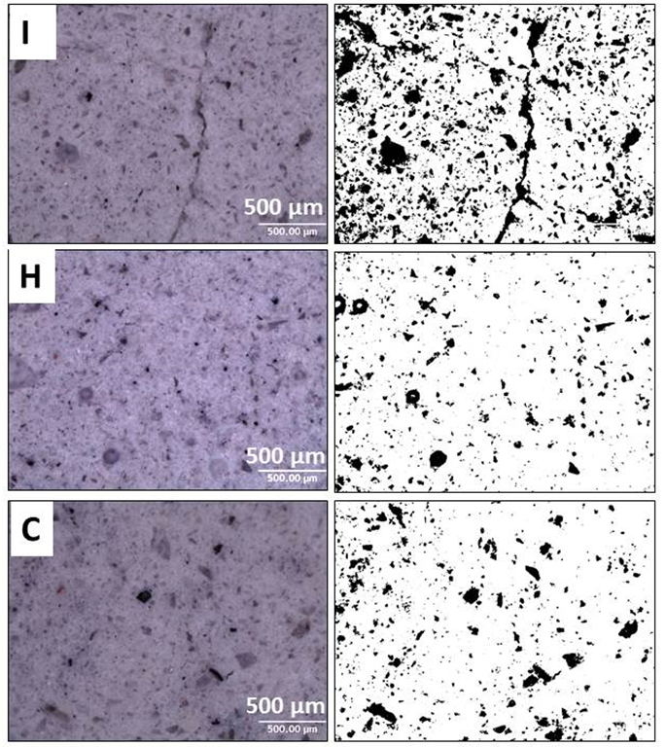
Figure 6. 5 – Typical optical micrographs of (I) Irradiated, (H) Heated and (C) Control samples, and corresponding thresholded images showing pore and solid regions.

6.6 Compressive strength
Figure 6.6 shows the compressive strengths of the samples studied. The average compressive strength of the heated and control samples are comparable within the errors. The irradiated samples appears to have an increase of 19 % in compressive strength compared with the control grout but also still comparable within the errors. An increased strength in irradiated cements was also observed in a PC based system (Nowakowski 1972). However, this trend differs from that which has been identified in PC cured at high temperatures, where reductions in the compressive strength have been reported as curing temperature increases. Gallucci et al.(2013) identified significant changes in the microstructure of C-S-H phase in cements depending on the temperature of curing, so that increased polymerisation and apparent densification of this phase was observed upon curing at 60ºC, compared with samples cured at 25°C. This increased the apparent density of C-S-H was associated with a decrease in the amount of structural water in this binding phase when forming at high temperatures, leading to a coarser and more porous microstructure, which induces reductions in compressive strength.
Figure 6. 6 - Compressive strength of BFS:PC pastes. Error bars show one standard deviation of three measurements.

Further investigation is required to elucidate the mechanisms leading to the strength development of irradiated cementitious grouts; it may be that the stabilisation of ettringite (which is a highly voluminous phase) contributed in a significant way to increase the strength of the irradiated specimens or the gamma radiation can have enhancements effects in curing and/or the densification of the material, but this cannot yet be confirmed. The results show that the early age BFS-PC system retains, and can potentially improves, its mechanical strength upon irradiation, even though cracks and increased porosity were observed post-irradiation.

6.7 Conclusions

The effects of gamma radiation and heat-treatment on a BFS-PC composite cement at early age were studied. The crystalline phases presented in the system were able to withstand the dose rate and total degree of gamma irradiation tested in the present study (4.77 MGy over 256 h), without notable modifications; the irradiated samples retained ettringite in their structure, which was present at 20°C but not when specimens were heated at 50°C for a length of time equal to the duration of irradiation. The Si and Al environments in the C-S-H type gel and secondary hydrate phases retained their stability upon irradiation. Irradiation-induced carbonation, previously reported for PC-based systems, was not identified in the specimens evaluated here. The reduced amount of Ca(OH)₂ in the system, owing to the small amount of PC used, appears to have minimised the formation of calcium peroxide octahydrate which is an important intermediate in the radiation-induced carbonation process.

Gamma radiation caused a reduction in the content of physically bonded water within the binder, resulting in microcracking. Although exposure to 50°C also caused a similar level of water reduction in the cement, microcracks were not observed in that sample, which elucidates that the elevated temperature in the radiation chamber is not the main cause of the microcracks. The dehydration mechanisms in these two environments appear to be different, resulting in the different microstructures. Gamma irradiation also to some extent, increased the compressive strength of the cement despite the increased porosity and microcracks, which may be due to enhancements in curing and/or the densification of the material.

Chapter 7- Results and discussion: Gamma irradiation resistance of early age Ba(OH)₂-Na₂SO₄-BFS composite cements

7.1 Introduction
This chapter focuses on the gamma irradiation resistance of early age Ba(OH)₂-Na₂SO₄-BFS composite cement samples, which have been formulated and studied previously in Chapters 4 and 5, for the encapsulation of sulphate bearing nuclear waste. To evaluate the applicability of this system as a potential nuclear wasteform, it is essential to understand the effects of radiation on the material, and to determine if they can withstand such service conditions. Two specific formulations were chosen to be investigated, at Ba²⁺ to SO₄²⁻ molar ratios of 1.0:1.0 and 1.3:1.0 (corresponding to samples M1.0 and M1.3 in the preceding chapters) for this study, and irradiated with up to 2.9 MGy over 256 hours (dose rate of 11.5 kGy/h). Sodium sulphate activated BFS (M0) was also included in this study for comparison purposes and irradiated with the same radiation dose.

Similar to the work reported in Chapter 6, the irradiation effects at early age are of particular interest because the composite cement systems have a significant amount of free water at this time, which can be subject to radiolysis and consequent H₂ gas generation. Another set of samples were heat-treated (50°C) for 256 hours, and evaluated as a second control (in addition to unheated specimens) to distinguish the potential effects of elevated temperature from those associated solely with irradiation effects.

7.2 X-ray diffraction (XRD) results
Figure 7.1 illustrates X-ray diffractograms of control, heated and irradiated samples 28 days after mixing (8 days sealed cured, 4 days sample preparation prior to the irradiation or heat treatment, 11 days treatment, and 5 days before XRD analysis). All the samples show reflection peaks of crystalline åkermanite (Ca₂MgSi₂O₇) (PDF, #076-0841) contributed by the slag, and ettringite ((CaO)₃(Al₂O₃)(CaSO₄)₃·32H₂O) (PDF, # 041-1451) previously identified as a secondary reaction product forming in these systems, along with a disordered calcium silicate hydrate (C-S-H) type gel as the main reaction product. The irradiated samples show no significant difference from the control specimens. This suggests that the crystalline reaction products formed at this early stage of reaction are not significantly affected by gamma irradiation exposure, to the degree detectable by this analytical technique.

Sodium sulphate activated slag, M0 sample (Figure 7.1A) has raised interest in the nuclear industry in recent years, as an alternative cementitious matrix for unconventional wastestreams because of its relatively moderate alkalinity and the formation of ettringite as the main crystalline reaction product (Bai et al. 2011). The formation of ettringite is desirable as its large unit cell accommodates a large content of bound water, leaving less free water in the pore network available for radiolysis (Gougar et al. 1996). However, the large content of bound water can still be susceptible to ionising radiation. The results obtained here for the M0 system are significant, as these are the first reported data on the gamma radiation resistance of such ettringite rich systems. No obvious alteration in the reflection peaks for the crystalline ettringite (main reflection at 9.09° 2θ) is observed in the XRD data of the irradiated or heated samples compared with the reference system that was neither irradiated nor heated.
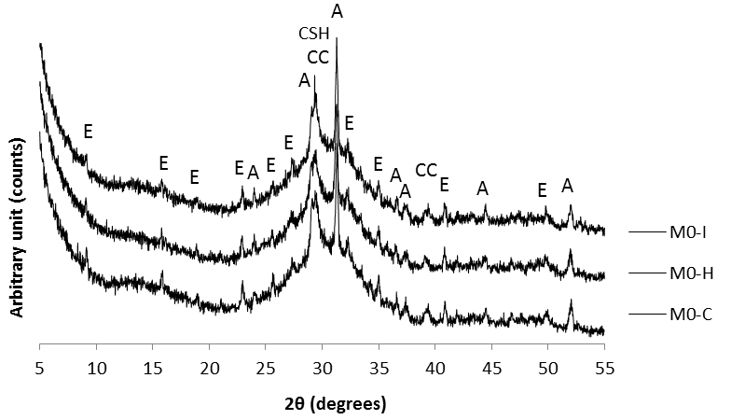
A
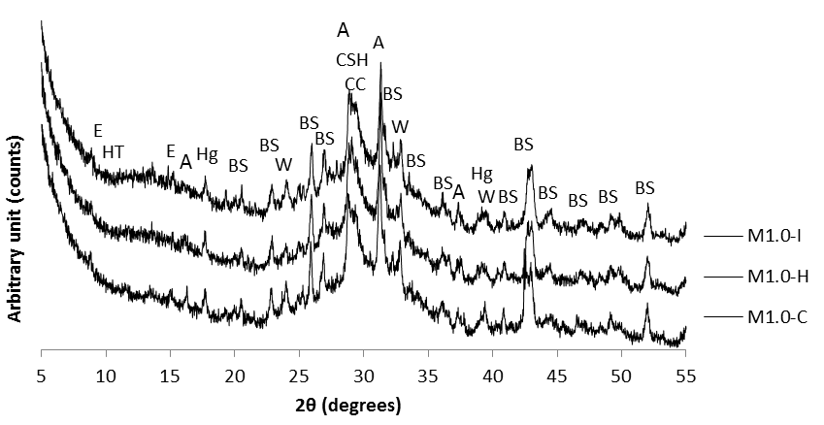
B
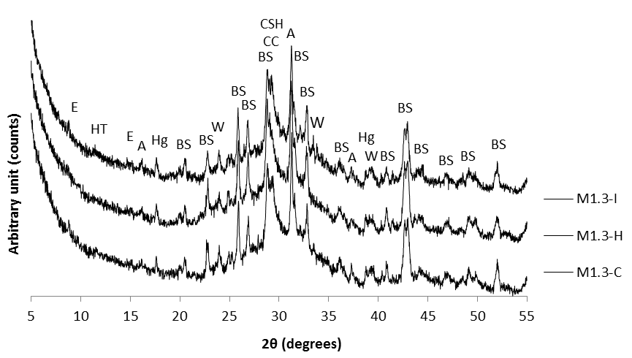
C
Figure 7. 1 - X-ray diffractograms of control, heated and Irradiated samples (A) M0, (B) M1.0 and (C) M1.3.
Peaks marked are åkermanite (A), calcite (CC), hydrotalcite (HT), ettringite (E), barite (BS), witherite (W), hydrogarnet (Hg), and calcium silicate hydrate (CSH).
It is worth nothing that it took 14 days for the M0 sample assessed here to harden (Mobasher et al. 2015), and therefore, the degree of reaction of the slag at the time of radiation or heating exposure is expected to be lower compared with M1.0 and M1.3 (as discussed in Chapter 4).

Figure 7.1 B and C show the XRD patterns for M1.0 and M1.3 samples, respectively. All the samples show reflections corresponding to åkermanite, barite, witherite, Ba-substituted ettringite, hydrotalcite, hydrogarnet and C-A-S-H type phases, consistent with the results reported previously in Chapters 4 and 5. The XRD patterns of the irradiated samples show no obvious alteration from their control and heated specimens. The crystalline reaction products in these systems also seem to be able to withstand gamma irradiation exposure, and irradiation or heating are not promoting changes in the phase assemblage, as previously identified for OPC/BFS samples (Chapter 6). As XRD technique has its own limitations and cannot detect small amounts of crystalline phases (less than 3%), there is a need for a technique such as NMR that has been applied in here, which can detect smaller disparities.

7.3 Solid state ²⁷Al MAS NMR spectroscopy
Figure 7.2 shows the solid state ²⁷Al MAS NMR spectra of the anhydrous slag and the reacted samples (M0, M1.0 and M1.3) with different treatments. As previously mentioned, ²⁷Al MAS NMR spectra of minerals and glasses typically show three distinct aluminium coordination environments (Al^{(IV)}, Al^{(V)} and Al^{(VI)}), which are located at chemical shifts of
50 to 80 ppm, 30 to 50 ppm and -10 to 30 ppm, respectively (Kirkpatrick 1988). The unreacted slag shows a broad resonance between 40 and 80 ppm, centred around 60 ppm. This region is assigned to tetrahedral Al environments, but cannot be assigned to a well-defined single site type due to structural disorder in the slag. This broad peak is attributed to the glassy phases which comprise the majority of the BFS, as observed as the amorphous hump and low crystalline phase content identified in the XRD data for the unreacted BFS (Figure 3.1).

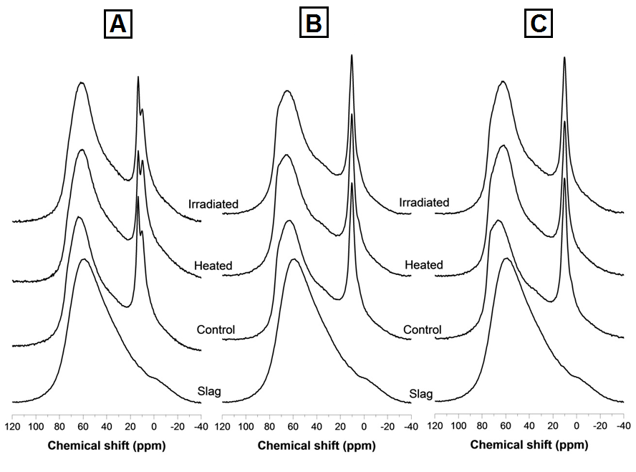
Figure 7. 2 - Solid-state ²⁷Al MAS NMR spectra of the hardened cement waste forms (A) M0, (B) M1.0 and (C) M1.3 and anhydrous slag, after different treatments.

Upon reaction and treatment, all the M0 samples (Figure 7.2A) indicated two high intensity resonance peaks in the octahedrally coordinated Al environment (-10 to 30 ppm). The one centred at 13 ppm is assigned to ettringite (Andersen et al. 2006), which is in agreement with the XRD results for these samples (Figure 7.1 A). This band is less intense in the M0 sample heated at 50°C, compared with the control and irradiated samples, potentially as a consequence of the dehydration of ettringite upon heating. There was no alteration identified with ettringite peaks in the XRD results (Figure 7.1 A). This can be associated with limitations of the XRD techniques with minor amounts of crystalline phases present.

The band centred at 9.5 ppm is assigned to the AFm and hydrotalcite type phases, and its intensity in the heated sample appears to be higher, compared to the control and irradiated samples. Similar results were reported for a PC based material heated to 40°C (Lothenbach et al. 2007, Lothenbach et al. 2008), where the stability of ettringite decreased, due to the increased solubility at the increased temperature, resulting in the detection of an escalation of sulphate concentration in the pore solution and the precipitation of calcium monosulphoaluminate in place of some of the ettringite. Although the formation of monosulphoaluminate was not identified in the XRD results in the heated specimen, it has been suggested that this phase is mainly present as a crystallographically disordered phase intermixed with the C-A-S-H products (Richardson et al. 1993). In the young PC/BFS grouts exposed to the same heating conditions (Chapter 6), it was identified that that ettringite is fully decomposed. Conversely, in the M0 system presented in the present chapter, only a slight reduction in the intensity of the band assigned to ettringite is observed in the heated sample. This could be a consequence of a larger content of ettringite forming in the M0 system compared with PC/BFS grouts, requiring a longer time of heat exposure to fully dehydrate.

On the other hand, in the M0 system, the band assigned to ettringite in the irradiated sample has a comparable intensity to that identified for the control paste, which indicates that the gamma irradiation is not destabilising the ettringite, in spite of the heating conditions reached during the irradiation exposure. This is consistent with the observations of Richardson et al.(1990) for aged PC-BFS grouts, and the results reported by Mobasher et al. (2015) in young PC/BFS grout samples, which were discussed in detail in Chapter 6. Craeye et al.(2015) also reported on the formation of ettringite in a specific cement composite formulation with large amounts of BFS replacement for the encapsulation of high radioactive waste under exposure to gamma radiation. Richardson et al. (1990) proposed the radiolytic oxidation of the sulphides from the BFS to sulphates as the likely cause of the increase in the concentration of sulphates and the consequent stabilisation of ettringite. As previously mentioned, in the M0 system, the concentration of sulphates is very high, and thus the stabilisation of ettringite is most likely associated with the larger sulphate content in the system.

In contrast, ettringite is not observable in M1.0 (Figure 7.2B) and M1.3 (Figure 7.2C) samples, as the addition of Ba(OH)₂ promotes formation of BaSO₄ and Ba-substituted ettringite, rather than pure ettringite, as was identified by XRD results from Chapter 5 results. Instead a high intensity band in the Al^{(VI)} region centred at 9.5 ppm is identified. This resonance is assigned again to the hydrotalcite type phase and the monosulphoaluminate (AFm) phase (MacKenzie et al. 1993) and it may be that the Ba substitution in the ettringite shifts the peak of that phase to overlap with these as well, although there are no conclusive data in the literature to confirm this. This resonance appears unmodified in the heated and irradiated samples, which suggests that in the Ba(OH)₂-Na₂SO₄-BFS composite samples, the formed layered double hydroxides (hydrotalcite and AFm phases) withstand heat and gamma radiation exposure, at this early stage of activation reaction.

In the tetrahedrally coordinated Al environment (80-50 ppm), two distinct resonance sites at 74 and 68 ppm are also observed for all the samples evaluated, associated with the the Al substitution in the C-S-H phase and the fraction of unreacted slag still present in the samples, respectively. For M0 (Figure 7.2A), the resonance at 74 ppm is not very distinct. It is expected in this formulation that a significant fraction of the Al available in the system is incorporated in the ettringite structure and AFm phases rather than C-S-H.

For M1.0 and M1.3 systems, the formation of a distinct site at 74 ppm and a broad band at 68 ppm is clearly observed. The resonance for 74 ppm is more intense and less symmetrical compared to M0, which must be related to the absence of ettringite in this system, allowing more Al to be available for the formation of Al-rich C-A-S-H type gels. For M1.0 and M1.3 samples upon heat and irradiation treatment, the intensity in the tetrahedrally coordinated Al region, associated with the formation of a C–A–S–H gel, is slightly higher compared to the control samples. This indicates a larger content of Al rich sites in this phase. As the incorporation of the Al increases within the C-A-S-H phase, the absorption of the Na within the system is likely (Hong and Glasser 2002) resulting in a highly polymerised and cross-linked binding phase within these samples.

7.4 Solid state ²⁹Si MAS NMR spectroscopy
Figure 7.3 illustrates the ²⁹Si MAS NMR spectra of the M0, M1.0 and M1.3 specimens. The unreacted slag has a line shape comparable to the spectrum reported for åkermanite (Kirkpatrick 1988) with a resonance centred at -74 ppm, consistent with the XRD results of the anhydrous slag (Figure 3.1). In all the activated samples, resonances between -80 ppm and -90 ppm are identified, associated with the formation of a C-A-S-H type phase. In particular, resonances centred at -82 ppm and -85 ppm, corresponding to Q²(1Al) and Q² sites respectively, are assigned to the Al-substituted C-S-H type gel, with a tobermorite type structure (Richardson et al. 1993, Andersen et al. 2003) forming in these cements.

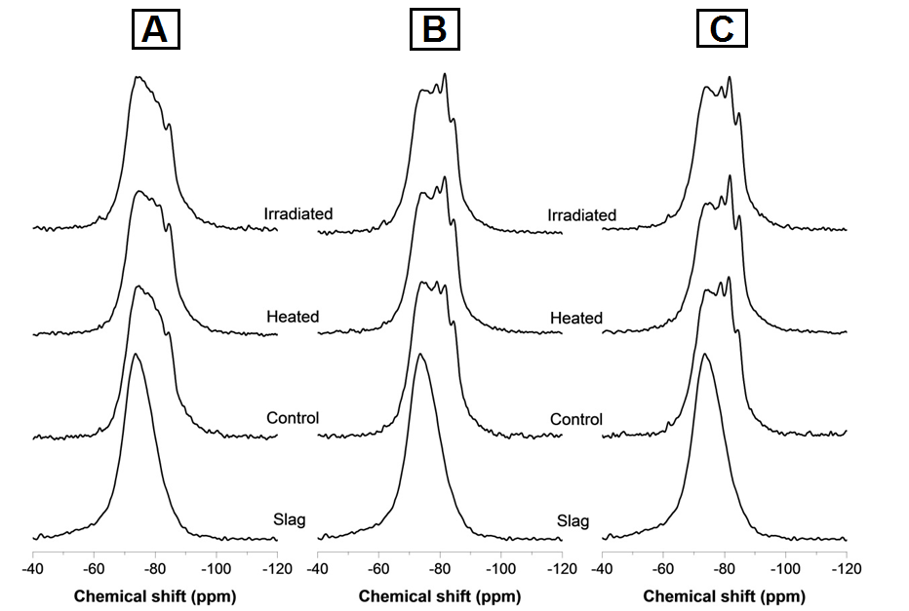
Figure 7. 3 - Solid-state ²⁹Si MAS NMR spectra of the sample sets studied, (A) M0, (B) M1.0 and (C) M1.3.

The spectrum for the sample M0 (Figure 7.3A) shows mainly the contribution of the unreacted slag, along with traces of Q²(1Al) and Q² sites, which indicates limited formation of a C-A-S-H type phase in this sample, at this early age of curing. The delayed reaction of this slag, with sodium sulphate activation, has been demonstrated using isothermal calorimetry (Mobasher et al. 2015). The acceleration-deceleration period of reaction for this cement, associated with the nucleation, growth and precipitation of reaction products, was identified between three and 10 days of reaction. These results are in agreement with the ²⁷Al MAS NMR results discussed in the previous section, where most of the Al seems to be consumed in the formation of ettringite rather than C-A-S-H phase.

Upon heating, a slight increase in the intensity of the Q²(Al) and Q² sites is observed in the M0 sample (Figure 7.3A), indicating that this thermal treatment is likely to be increasing the kinetics of reaction of this cement, favouring the formation of C-A-S-H type gel, compared with the unheated control sample. Conversely, the ²⁹Si MAS NMR spectrum of the irradiated M0 sample does not display this change in the intensity of the Q² sites, and it resembles the spectra of the control sample.

In the control samples of M1.0 and M1.3, Figure 7.3B and 7.3C respectively, well resolved bands corresponding to Q¹ (centred at -80 ppm), Q²(Al) and Q² sites are observed, whose intensity is significantly higher than the observed in the M0 control sample (Figure 7.3A). Similar results were observed in these cements with extended curing (6 months, Chapter 4) (Mobasher et al. 2014), where the Ba(OH)₂ added in the system is acting as an activator, and promotes a larger extent of reaction of the slag as it increases the alkalinity of the system, compared with the system using sodium sulphate as sole activator. The intensities of the Q²(1Al) and Q² sites seem to be slightly higher in the control M1.3 pastes compared with control M1.0 samples, consistent with a larger Ba(OH)₂ addition.

The intensities of the Q¹, Q²(1Al) and Q² sites observed in the M1.0 and M1.3 samples are higher for the heated and irradiated samples, which suggests that there are changes in either in the amount or microstructure of the C-A-S-H phase forming in these binders, in agreement with the ²⁷Al NMR results (Figure 7.2). It has been reported that an increase in temperature can promote the cross-linking and polymerisation of the C-A-S-H type phase (Myers et al. 2015). The increased temperature in the heated and irradiated samples can also promote the reaction, resulting in more dissolution of the slag. Lothenbach et al. (2007) reported for PC based materials cured at 50°C that the composition of the pore solution reflects faster progress of hydration at higher temperatures.

7.5 Thermogravimetric analysis
Table 7.1 summarises the results obtained by TG, showing the mass loss % for the studied samples in the three temperature ranges: 25-100°C, 100-500°C and 500-800°C which indicate different features. The main effects of different treatments seem to appear in the region of 25-100°C. The mass loss observed within this range is associated with the release of free water from the specimens, the initial dehydration of the C-S-H phase or C-A-S-H type phases, and ettringite decomposition (Alarcon-Ruíz et al. 2005, Myers et al. 2015). Although the weight loss in this temperature range is less in the heated and irradiated samples compared with the control samples, the irradiated and heated samples are not significantly different.

The mass loss between 100 and 500°C can be associated with the decomposition of hydrotalcite and hydrogarnet phases which are identified in some of the samples by XRD (Figure 7.1) and full decomposition of the C-A-S-H phase. The thermal decomposition of highly crossed linked C-A-S-H occurs at higher temperatures between 250°C and 500°C, where water molecules are more tightly bonded to the structure than in C-S-H (Myers et al. 2015). Differing from the weight loss behaviour in the 25-100°C temperature regions, the irradiated and heated samples are not significantly different from the control samples. However, it is observed that the M1.3 samples have a larger mass loss in this region compared with M0 and M1.0. This can be a result of more formation of cross-linked C-A-S-H phase and the presence of hydrotalcite in this formulation, in agreement with the ²⁹Si NMR results (Figure 7.3).

Table 7. 1 - 1 Mass loss (%) of the studied samples in the different temperature regions
Temperatures  Samples | 25°C-100°C | 100°C-500°C | 500°C-800°C
M0 - Control | 7.7 | 4.4 | 2.6
M0 - Heated | 5.4 | 4.2 | 2.2
M0 - Irradiated | 3.9 | 4.3 | 2.3
M1.0 - Control | 9.1 | 4.4 | 4.3
M1.0 - Heated | 8.3 | 4.2 | 3.6
M1.0 - Irradiated | 8.8 | 4.3 | 3.2
M1.3 - Control | 7.3 | 5.3 | 2.7
M1.3 - Heated | 5.5 | 5.4 | 2.2
M1.3 - Irradiated | 4.8 | 5.3 | 2.9

The mass loss associated with the decarbonation of calcite appears at 500°C to 800°C (Villain et al. 2007). Formation of calcite has been reported in neat PC samples upon gamma irradiation (Vodák et al. 2005, Vodák et al. 2011), as previously discussed in chapter 6. It has been reported that irradiation can cause the formation of calcium peroxide octahydrate in irradiated PC paste through the interaction between Ca(OH)₂ and the H₂O₂ produced via radiolysis, which promotes carbonation (Bouniol and Bjergbakke 2008). As Ca(OH)₂ is one of the main hydration products and present abundantly in the neat PC system, calcite is likely to form in this system upon irradiation.

In the Na₂SO₄-BFS (M0) and Ba(OH)₂-Na₂SO₄-BFS (M1.0 and M1.3) systems studied here, the formation of Ca(OH)₂ was not observed. Therefore, enhanced calcite formation is not expected in these systems upon irradiation. The data shown in Table 7.1 reflect this, showing no obvious effects of irradiation and heat treatment on the mass loss in this temperature range.

Figure 7.4 illustrates the thermograms and differential thermograms of system M0, for the control, heated and irradiated samples. The mass loss up to 100ºC was 7.7 % for the control sample, 5.4 % for the heated sample and 3.9 % for the irradiated sample. As discussed in section 4.3.2 (Figure 4.10), the setting of this sodium sulphate activated slag (M0) takes a long time as the activator has a near neutral pH, therefore there is a significant amount of free water present in this system at the early stage of reaction, which can be affected by the heat and irradiation. It appears that the effect of irradiation is larger, which can be a result of the combined effect from the irradiation and the temperature increase.

There is a distinctive peak identified in the DTG curves of the M0 samples (Figure 7.4B) around 75ºC which is assigned to the decomposition of ettringite (Lothenbach et al. 2007) as identified in the XRD and ²⁷Al MAS NMR results (Figure 7.1 and Figure 7.2). This peak appears to be shifting toward lower temperature for the heated and irradiated samples. Ettringite formation has been reported to decrease at the curing temperatures of 40°C and above, where the ettringite needles become smaller in those conditions (Lothenbach et al. 2007). DTG results are in agreement with these reported effects for the heated sample as ettringite formation is decreased and in agreement with the ²⁷Al MAS NMR results (Figure 7.2).
Figure 7. 4 - Thermograms (A) and differential thermograms (B) (mass loss downwards) of M0 samples: Control (M0-C), Heated (M0-H) and Irradiated (M0-I).

For the irradiated sample, the mass loss around 75ºC which is associated with AFt, appears to be marginally higher than the heated sample in agreement with the ²⁷Al MAS NMR results (Figure 7.2) but slightly at the lower temperatures. This process can be a explained where decomposition of ettringite occurs due to the heat but reformation of the crystals take place due to the gamma irradiation and oxidation of sulphide species as it was described before in Section 7.3 but as smaller needles.

Figure 7.5 illustrates the thermograms and differential thermograms of the M1.0 system, for the control, heated and irradiated samples. The total mass loss up to 100ºC was 8.8 % for the irradiated sample, 8.3 % for the heated sample and 9.1 % for the control. The slightly larger mass loss in the irradiated samples can be considered to be within the uncertainty of the temperature in the irradiation chamber, as it has been estimated as 50 +/- 5°C whereas the heated samples are kept as 50°C precisely in the oven. The 0.5% difference mass loss between the heated and irradiated samples can be related to 5°C difference in the temperatures. This variation may also be explained by the fact that the irradiation is inducing either a slightly higher extent of hydration of the BFS grout, or less desiccation of the hydration products present in this cement while being held at a corresponding temperature for the same duration.
Figure 7. 5 - Thermograms (A) and differential thermograms (B) (mass loss downwards) of M1.0 samples: Control (M1.0-C), Heated (M1.0-H) and Irradiated (M1.0-I).

Figure 7.6 illustrates the thermograms and differential thermograms of the M1.3 system, for the control, heated and irradiated samples. The total mass loss up to 100ºC was 4.8 % for the irradiated sample, 5.5 % for the heated sample and 7.3 % for the control sample. The larger weight loss in the irradiated sample again can be considered to be within the uncertainty of the temperature in the irradiation chamber, as it has been estimated as 50 +/- 5°C whereas the heated samples are kept as 50°C precisely in the oven. The 0.7% difference mass loss between the heated and irradiated samples can be related to 5°C difference in the temperatures. This variation may also be explained by the fact that the irradiation is inducing either a slightly higher extent of hydration of the BFS grout, or less desiccation of the hydration products present in this cement while being held at a corresponding temperature for the same duration.

Another explanation for this formulation can be explained as the Ba(OH)₂∙8H₂O used for this formulation brings additional water, this system has a slightly larger amount of water incorporated compared with the M1.0 system. Despite the slightly larger amount of water present, the dehydration due to the heating and irradiation are less compared with M0, most likely because of the faster hardening reaction of this formulation, resulting in a lesser amount of free water left in the system compared with M0. There is a small peak at 100ºC which can be associated with the decomposition of Ba-substituted ettringite, in agreement with the XRD results (Figure 7.1C).

Figure 7. 6 - Thermograms (A) and differential thermograms (B) (mass loss downwards) of M1.3 samples: Control (M1.3-C), Heated (M1.3-H) and Irradiated (M1.3-I)

7.6 Microscopic inspection

Figures 7.7, 7.8 and 7.9 present typical optical micrographs of the evaluated samples. The corresponding thresholded images show pores (in black) and solid regions (in white). The relatively large pores observed in all the samples are likely to be associated with the air entrapped during mixing and paste casting.

In the M0 samples, as shown in Figure 7.7, the irradiated sample (I) has more open pores and cracks compared with the heated (H) and control (C) samples. As already discussed for the M0 formulation in the previous section (Figure 7.4), the irradiated sample had a significantly reduced content of free water compared with the heated and control samples, most likely due to the combined effects of irradiation and temperature increase. The temperature increase would cause dehydration as in the heated sample, whereas the irradiation would also cause the generation of H₂ gas. Bouniol et al.(1998) reported for the PC system that gamma radiation appears to affect the free water within the young cement matrix, resulting in the radiolysis of water and H₂ gas generation. In addition to the increased dehydration, the H₂ gas generated could have caused the increased open pores and cracks in the material, through pressurisation inside the cement matrix, which may eventually lead to its collapse (Pottier and Glasser 1986). A similar phenomenon was observed in the BFS-PC system (9:1 ratio), which also has a large amount of slag content, as discussed in the previous chapter.

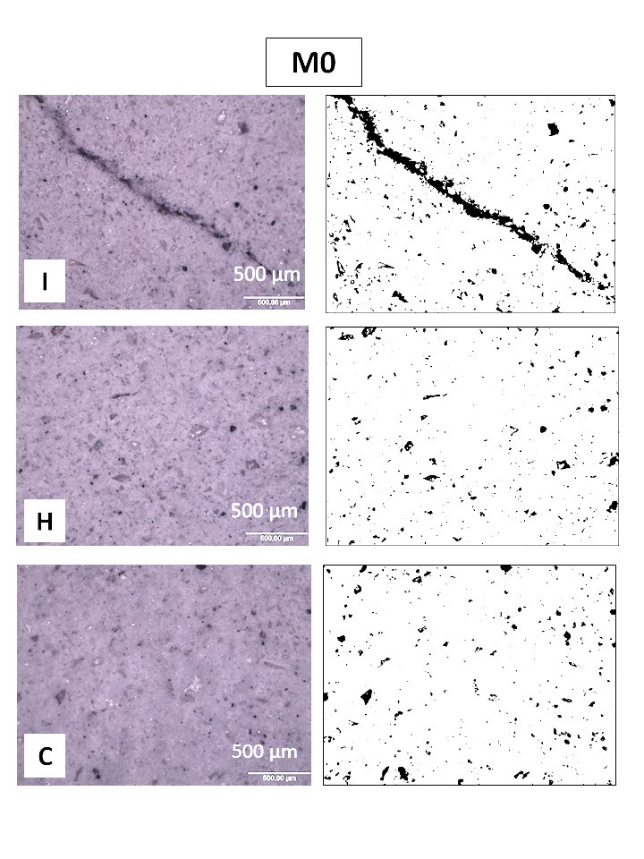
Figure 7. 7 - Typical optical micrographs of M0 samples: (I) Irradiated, (H) Heated and (C) Control.
Corresponding thresholded images show pores (black) and solid (white) regions.

Figure 7.8 shows typical optical micrographs of M1.0 samples. All the samples appear mostly identical, the irradiated sample (I) potentially showing slightly more porosity compared with the heated (H) and control (C) samples. The white BaSO₄ particles of ~100 µm are also observable embedded in the matrix. As identified in the thermogravimetry section, the amount of free water in these three samples was very similar, but they were significantly larger than in the M0 and M1.3 samples. More free water in the system should lead to the larger amount of water loss and radiolysis upon irradiation, but the effects of irradiation and heating treatment was minimal. The micrographs appear to follow the trend observed in the TG data, showing no obvious effects of heating and irradiation on the microstructure.

Barium sulphate (barite) composites are used widely for the production of the structural concrete in the nuclear reactors worldwide for shielding the radiation (Akkurt et al. 2005, Akkurt et al. 2010, Esen and Yilmazer 2011). The quality of the shielding effect can be seen in the high attenuation coefficient of BaSO_{4,} where the mass attenuation coefficient of a given material is related to its ability to absorb the energy of a ray passing through it. It is most likely that the presence of BaSO₄ in Ba(OH)₂-Na₂SO₄-BFS composites is contributing to enhance the radiation resistance of this composite cement, compared to the behaviour previously observed in PC:BFS grouts (Mobasher et al. 2015) and the sodium sulphate activated slag M0. Measurements of the radiation attenuation in Ba(OH)₂-Na₂SO₄-BFS composites would be required to validate this statement.
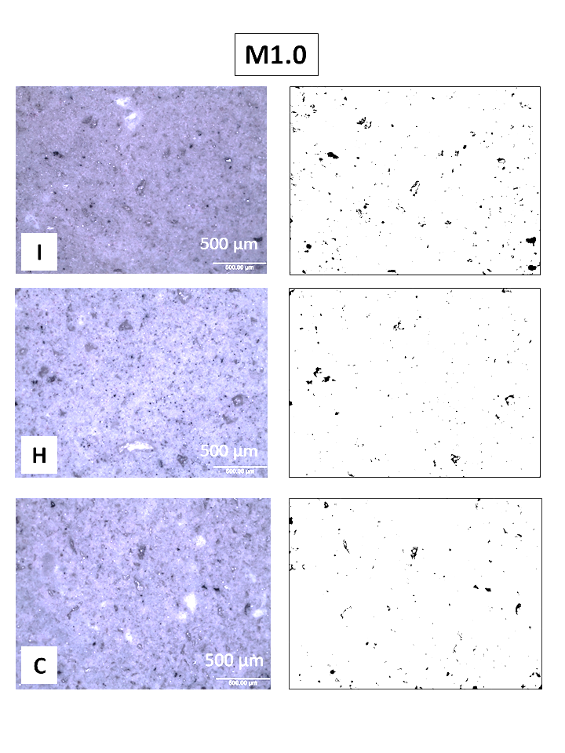
Figure 7. 8 - Typical optical micrographs of M1.0 samples: (I) Irradiated, (H) Heated and (C) Control.
Corresponding thresholded images show pores (black) and solid (white) regions.

Figure 7.9 shows typical optical micrographs of the M1.3 specimens. All the samples appear similar. The white BaSO₄ spots of ~100 µm are also observable embedded in the matrix. The irradiated sample (I) appears slightly more porous compared with the heated (H) and control (C) samples, but the structure of the material indicates no significant alteration such as the microcracks observed in M0. As identified by thermogravimetry (Table 7.1), this formulation is more susceptible to dehydration upon heating or exposure to the gamma irradiation compared with the M1.0 formulation, and the effects of irradiation observed as the loss of free water was slightly larger than that of heating treatment, which was similar to that observed in the M0 system. The increase in the porosity must be a reflection of the dehydration.

The effect of the irradiation on the microstructure is smaller in the M1.3 system compared with the M0 system. One of the possible reasons is the amount of free water in the system. As discussed in the TG section, less free water was likely to be left in the system compared with the M0 system, despite the slightly larger amount of water in the formulation, because of the faster hardening reaction of this formulation. Another possible reason is the attenuation of gamma radiation by the Ba content in the system, as mentioned above for M1.0. Differing from the M0 formulation, the M1.3 system contains BaSO₄, and thus, this system can attenuate the gamma irradiation and reduce the effective irradiation which could interact with the water present in the system, preventing the damages of the cementitious matrix. Measurements of the radiation attenuation in Ba(OH)₂-Na₂SO₄-BFS composites would be required to validate this statement.

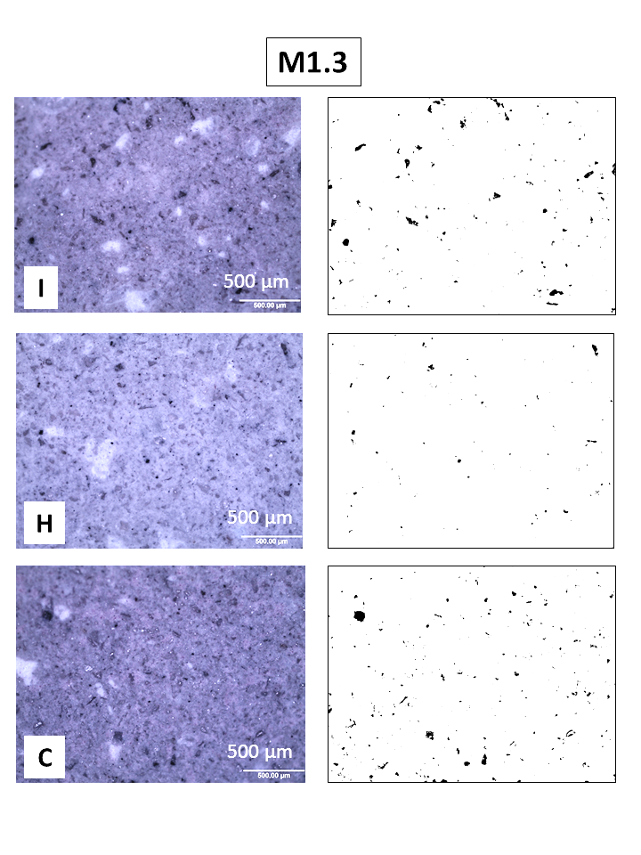
Figure 7. 9 - Typical optical micrographs of M1.3 samples: (I) Irradiated, (H) Heated and (C) Control.
Corresponding thresholded images show pores (black) and solid (white) regions.

7.7 Compressive strength

Figure 7.10 shows the compressive strengths of the samples studied. Despite the slower setting behaviour, the M0 system developed a higher compressive strength than the M1.0 and M1.3 composite samples. Although the higher compressive strength was previously identified in chapters 4 and 5, they were for the materials after longer curing periods. The early compressive strength development of the M0 system is attributed probably to the formation of ettringite in addition to the formation of C-S-H (Bensted 1994).

In this system (M0), the compressive strength of the control, heated and irradiated samples are comparable (within the testing error) and above 25 MPa. Although the irradiated M0 sample has lost free water in significant amounts (Table 7.1), which resulted in an increase in pores and cracks, the compressive strength of this sample is maintained without any obvious impacts from these treatments. This can be related to the stabilisation of ettringite as a volumetric phase. As discussed previously, ettringite formed in the system was maintained both under heating and irradiation, although a possible reduction was observed in the NMR results under heating.

For M1.0 and M1.3 samples, there is a significant increase in the compressive strength of the heated samples compared with the control samples. These results may be associated with a larger degree of reaction of the slag at an increased temperature, although the analytical results were not fully conclusive in this regard. Similar results have been reported in PC based materials cured at 50°C, where an increased temperature led to an initially fast hydration and a high early compressive strength (Lothenbach et al. 2007).

For M1.0 and M1.3 samples, the irradiated samples also indicated an increase in the compressive strength compared with the control samples. Since the level of the increase was similar, possibly slightly more, to that in the heated samples, the gamma radiation is likely having a similar effect to the heating, increasing the kinetics of reaction, but leading to the higher degrees of reaction than in the heated samples. Although the loss of free water for M1.3 was slightly more in the irradiated sample than in the heated sample, it seems not to have a significant negative impact on the strength development.

It was also observed in the ²⁷Al and ²⁹Si NMR results (Figure 7.2 and Figure 7.3) that the structure of C-A-S-H phase was modified in the irradiated samples resulting in calcium (alkali) aluminosilicate hydrate (C–(N-)A–S–H) gels type which is more cross-linked, ordered and polymerised. This mechanism may not be effectively taking place in the M0 sample, as aluminium is mostly incorporated in the AFt phase rather than C-S-H as discussed in the ²⁷Al NMR results (Figure 7.2). Further investigation is required to elucidate the mechanisms leading to the strength development of irradiated cementitious grouts at early stages of hydration. The results show that the early age Ba(OH)₂-Na₂SO₄-BFS system retains, and in fact improves, its mechanical strength upon irradiation.
Figure 7.10 Compressive strength of M0, M1.0 and M1.3 samples.
Error bars show the standard deviation of three measurements

7.8 Conclusions

The effects of gamma radiation on sodium sulphate activated slag (M0) and Ba(OH)₂-Na₂SO₄-BFS composites (M1.0 and M1.3), at early age of curing were studied. The XRD results suggested that the crystalline reaction products formed in these systems at this early stage of reaction are able to withstand gamma irradiation exposure tested in the present study, showing no significant difference induced by heating or irradiation from the control specimens analysed.

For the sodium sulphate activated slag (M0) sample, the ²⁷Al MAS NMR results reveal that ettringite can be partially dehydrated at 50°C, favouring the formation of monosulphate instead, but ettringite seems to be stabilised with gamma irradiation at the corresponding temperature. As most of the aluminium is consumed in AFt/AFm phases in this system, it seems that there is less substitution of Al in the main binding phase C-S-H, compared with the composite cements studied.

As the activator has near neutral pH in M0, the rate of the reaction is slow and there is a significant amount of free water within the samples at the early curing age tested. TGA results confirm that this formulation is the most susceptible to dehydration through heating and irradiation, which results in a porous and cracked matrix. For the irradiated sample, despite a damaged matrix comparing to the heated and control samples, the compressive strength is maintained after the heat and irradiation treatment. This can be related to the ettringite stabilisation under gamma radiation, which contributes to retention of the compressive strength.

For Ba(OH)₂-Na₂SO₄-BFS composite cement samples, M1.0 and M1.3, ²⁷Al MAS NMR results are revealing a higher degree of aluminium incorporation in the C-A-(N)-S-H phase with heat and irradiation treatments. Considering the ²⁹Si MAS NMR results, a higher degree of reaction is estimated for these samples due to the presents of Ba(OH)₂ within the system, which increases the pH and promotes the dissolution of the slag. The degree of reaction also seems to be increased with the present of heat and irradiation, resulting in higher compressive strength comparing to the control samples. The M1.0 formulation appears to be the most stable binder as it is not being dehydrated upon gamma radiation, but this result is not conclusive. This aspect also needs further investigation. The matrixes of both M1.0 and M1.3 are stable upon irradiation as they do not show any cracks or structural modifications after the irradiation up to 2.9 MGy over 256 hours. The results may suggest that the BaSO₄ forming in the Ba(OH)₂-Na₂SO₄-BFS binders plays an important role in gamma radiation attenuation, preventing the matrix from alternation by potential radiolysis of the free water.

Chapter 8- Conclusion and further work

The concluding statements for each section of this research were presented in the related chapters. The most remarkable achievements are:
- Successful development of a new composite cement system for the encapsulation of sulphate bearing aqueous nuclear waste via a single-step method
- Proof of long-term sulphate immobilisation capability as BaSO₄
- Demonstration of gamma irradiation resistance of these new composite cements

The concluding remarks of the various chapters are summarised in this chapter.

Chapter 4- The feasibility of the immobilisation of soluble sulphate-bearing aqueous nuclear wastes was investigated in BFS composites via a novel single step method and compared with a two step method described in the literature. The solidification process was practicable via both methods, in various sulphate concentrations (5%, 10% and 25%), promoting the simultaneous formation of BaSO₄ and the activation of the BFS, favouring the formation of a stable cement composite. The compressive strength and setting times of the proposed new system satisfy the requirements in setting time and mechanical strength for the encapsulation of nuclear waste. The activation process of the BFS and the secondary reaction products in this proposed new method are dissimilar from the previous method.

Pastes with various concentrations of the sole activators Na₂SO_{4,} Ba(OH)₂ or NaOH were also studied. This study offers further understanding the mechanisms governing the alkali activation of BFS, and consequently the nature of the reaction products forming in these cementitious wasteforms. These results are valuable and correlated to the behaviour of the new composite binders produced, which utilised three different types of activators combined together. As ettringite formation is observed in the new cement composites produced via the single-step method, this can be related to the Na₂SO₄ activation, and the role of Ba(OH)₂ is also important in raising the pH and thus inducing the dissolution of the slag.

Chapter 5- The Ba(OH)₂–Na₂SO₄-BFS composite samples produced via the newly developed single-step method were fully characterised after six months of curing. X-ray diffraction results confirmed the successful binding of sulphate in insoluble crystalline BaSO₄ in the composite samples, offering the potential for good resistance to internal sulphate attack in the long term. The microstructure of the composites is dominated by the strength giving phase C-A-S-H, along with layered double hydroxides (hydrotalcite and AFm type) and there is a possibility of Ba substitution for Ca in ettringite and also C-A-S-H gel.

Long term stability assessment of the studied composite samples has revealed the dimensional and strength stability of the developed composites up to 18 months of curing. The results of the phase analysis have indicated the formation of insoluble and thermodynamically stable BaSO₄ over extended amount of time through the decomposition of less insoluble BaCO₃ and Ba-substituted ettringite. .

Chapter 6- The effects of gamma radiation and heat-treatment on a BFS-PC (9:1) composite cement at early age were investigated. As this system is a conventional system in the current UK nuclear industry and includes a large amount of BFS, it sets the foundation for a direct comparison of the gamma irradiation performance of the activated slag based composites developed in this study. The XRD results revealed that the crystalline phases presented in this system were able to withstand the dose rate and total degree of gamma irradiation imposed (4.77 MGy over 256 h), without notable modifications. Gamma radiation instigated microcracking in the material as a result of radiolytic dehydration where the free water within the binder was most targeted.

Chapter 7- The effects of gamma radiation on sodium sulphate activated slag (M0) and Ba(OH)₂-Na₂SO₄-BFS composites (M1.0 and M1.3), at early age of curing were studied. The XRD results suggested that the crystalline reaction products formed in all the studied systems at the early stage of reaction are able to withstand gamma irradiation exposure tested in the present study, showing no significant difference induced by the heating or irradiation from the control specimens analysed. The irradiated sodium sulphate activated slag (M0) sample was affected most by the radiolytic de-hydration, resulting in cracking of the matrix. For the Ba(OH)₂-Na₂SO₄-BFS formulations, both M1.0 and M1.3 were stable upon irradiation as they did not show any cracks or structural modifications after irradiation up to 2.9 MGy over 256 hours. The results may suggest that the BaSO₄ forming in the Ba(OH)₂-Na₂SO₄-BFS binders plays an important role in gamma radiation attenuation, preventing the matrix from alteration by potential radiolysis of the free water.

The feasibility of producing Ba(OH)₂-Na₂SO₄-BFS composites for the encapsulation of sulphate bearing nuclear wastes, via a one-step method, has been proven in this thesis. The study presented here contributes to understand this newly developed system, but also opened several questions which could be addressed in the future to gain further understanding of the key properties of the material as a nuclear wasteform. Based on the current findings and understanding of these systems presented in this thesis, the following areas of future work are identified.

- It will be valuable to assess the fresh state properties of the activated Ba(OH)₂-Na₂SO₄-BFS binder system, including workability and heat evolution, which are essential to evaluate its applicability for industrial application.

- A detailed leaching study of key radionuclides from these grouts is also required, including the effects of curing age, grout formulation, and pore network structure.

- Sulphur speciation in the Ba(OH)₂-Na₂SO₄-BFS composite cements and reference samples needs to be investigated. Different oxidation states of sulphur can be present in the systems containing BFS and sulphate bearing nuclear wastes, and their oxidation states can induce reducing or oxidising environments within these grouts. This is important for radionuclide immobilisation as well as for reasons related to corrosion processes within a store or repository.

- Further optimisation of the formulation of the Ba(OH)₂-Na₂SO₄-BFS composites to maximise the formation of insoluble BaSO₄ from early age in this single-step process, rather than initially forming an ettringite-like product which is later converted to BaSO₄. It would be ideal if the entire sulphate component is immobilised as BaSO₄ from the beginning, to minimise the possibility for dimensional or microstructural instability over time. This will require further investigation of the behaviour of excess Ba, in particular, the Ba incorporation in C-A-S-H phases and in ettringite.

- Evaluation of any changes in the pore network of the irradiated samples will be of great value to determine if the permeability of these samples is modified as consequence of radiation exposure. The use of non-destructive techniques such as X-ray microtomography is recommended for this purpose, to eliminate sample conditioning as a potential source of error.

- It will also be of interest to determine the degree of reaction of Ba(OH)₂-Na₂SO₄-BFS grouts, upon curing, heating and irradiation, to further elucidate the influence of gamma radiation upon the degree of reaction, which was inferred from the results obtained in this study.

For the evaluation of the practical applicability and industrial importance of this novel cementing system which has been proposed in this research work, this supplementary information provides significant follow-ups. Concluding from the data presented to date, the proposed material have high potentials as a nuclear wasteform cement, however before this knowledge and technology put into practise at the industry scale, further confirmation of the material characteristic and performance is necessary.

Chapter 9- References

Akkurt, I., H. Akyildirim, B. Mavi, S. Kilincarslan and C. Basyigit (2010). "Gamma-ray shielding properties of concrete including barite at different energies." Progress in Nuclear Energy 52(7): 620-623.
Akkurt, I., C. Basyigit, S. Kilincarslan and B. Mavi (2005). "The shielding of γ-rays by concretes produced with barite." Progress in Nuclear Energy 46(1): 1-11.
Alarcon-Ruíz, L., G. Platret, E. Massieu and A. Ehrlacher (2005). "The use of thermal analysis in assessing the effect of temperature on a cement paste. ." Cement and Concrete Research 35(3): 609-613.
Albino, V., R. Cioffi, M. Marroccoli and L. Santoro (1996). "Potential application of ettringite generating systems for hazardous waste stabilization." Journal of Hazardous Materials 51(1-3): 241-252.
Andersen, M. D., H. J. Jakobsen and J. Skibsted (2003). "Incorporation of aluminum in the calcium silicate hydrate (C−S−H) of hydrated Portland cements: A high-field ²⁷Al and ²⁹Si MAS NMR investigation." Inorganic Chemistry 42(7): 2280-2287.
Andersen, M. D., H. J. Jakobsen and J. Skibsted (2006). "A new aluminium-hydrate species in hydrated Portland cements characterized by ²⁷Al and ²⁹Si MAS NMR spectroscopy." Cement and Concrete Research 36(1): 3-17.
Asano, T., T. Kawasaki, N. Higuchi and Y. Horikawa (2008). "Feasibility study of solidification for low-level liquid waste generated by sulfuric acid elution treatment of spent ion exchange resin." Journal of Power and Energy Systems 2(1): 206-214.
Atkins, M. and F. P. Glasser (1992). "Application of Portland cement-based materials to radioactive waste immobilization." Waste Management 12(2): 105-131.
Bai, Y., N. Collier, N. Milestone and C. Yang (2011). "The potential for using slags activated with near neutral salts as immobilisation matrices for nuclear wastes containing reactive metals." Journal of Nuclear Materials 413(3): 183-192.
Bar-Nes, G., A. Katz, Y. Peled and Y. Zeiri (2008). "The combined effect of radiation and carbonation on the immobilization of Sr and Cs ions in cementitious pastes." Materials and Structures 41: 1563-1570.
Barbarulo, R., H. Peycelon and S. Prene (2003). "Experimental study and modelling of sulfate sorption on calcium silicate hydrates." Annales De Chimie - Science Des Materiaux 28: S5-S10.
Barnes, J. R., A. D. H. Clague, N. J. Clayden, C. M. Dobson, C. J. Hayes, G. W. Groves and S. A. Rodger (1985). "Hydration of Portland cement followed by ²⁹Si solid-state NMR spectroscopy." Journal of Materials Science Letters 4(10): 1293-1295.
Ben Haha, M., G. Le Saout, F. Winnefeld and B. Lothenbach (2011). "Influence of activator type on hydration kinetics, hydrate assemblage and microstructural development of alkali activated blast-furnace slags." Cement and Concrete Research 41(3): 301-310.
Ben Haha, M., B. Lothenbach, G. Le Saout and F. Winnefeld (2011). "Influence of slag chemistry on the hydration of alkali-activated blast-furnace slag -- Part I: Effect of MgO." Cement and Concrete Research 41(9): 955-963.
Ben Haha, M., B. Lothenbach, G. Le Saout and F. Winnefeld (2012). "Influence of slag chemistry on the hydration of alkali-activated blast-furnace slag — Part II: Effect of Al₂O₃." Cement and Concrete Research 42(1): 74-83.
Bensted, J. (1994). "A discussion of the paper “hydraulic behaviour of calcium sulphoaluminate-based cements derived from industrial process wastes” by J. Beretka, B. de Vito, L. Santora, N. Sherman and G.L. Valenti." Cement and Concrete Research 24(2): 391-392.
Bernal, S. A., J. L. Provis, A. Fernández-Jiménez, P. V. Krivenko, E. Kavalerova, M. Palacios and C. Shi (2014a). Alkali-Activated Materials. Binder chemistry-High-Calcium Alkali-Activated Materials. J. L. Provis and J. S. J. van Deventer. Dordrecht, Springer: 59-91.
Bernal, S. A., J. L. Provis, B. Walkley, R. San Nicolas, J. D. Gehman, D. G. Brice, A. R. Kilcullen, P. Duxson and J. S. J. van Deventer (2013). "Gel nanostructure in alkali-activated binders based on slag and fly ash, and effects of accelerated carbonation." Cement and Concrete Research 53: 127-144.
Bernal, S. A., R. San Nicolas, R. J. Myers, R. Mejía de Gutiérrez, F. Puertas, J. S. J. van Deventer and J. L. Provis (2014b). "MgO content of slag controls phase evolution and structural changes induced by accelerated carbonation in alkali-activated binders." Cement and Concrete Research 57: 33-43.
Bingham, P. and R. Hand (2008). "Sulphate incorporation and glass formation in phosphate systems for nuclear and toxic waste immobilization." Materials Research Bulletin 43(7): 1679-1693.
Bingham, P. A. and O. McGann (2011). Spent ion exchange resins disposal route. N. Mobasher. Personal communication. The University of Sheffield.
Black, L., C. Breen, J. Yarwood, C. S. Deng, J. Phipps and G. Maitland (2006). "Hydration of tricalcium aluminate (C₃A) in the presence and absence of gypsum-studied by Raman spectroscopy and X-ray diffraction." Journal of Materials Chemistry 16(13): 1263-1272.
Black, L., P. Purnell and J. Hill (2010). "Current themes in cement research." Advances in Applied Ceramics 109(5): 253-259.
Bonk, F., J. Schneider, M. A. Cincotto and H. Panepucci (2003). "Characterization by multinuclear high-resolution NMR of hydration products in activated blast-furnace slag pastes." Journal of the American Ceramic Society 86(10): 1712-1719.
Bouniol, P. and A. Aspart (1998). "Disappearance of oxygen in concrete under irradiation: the role of peroxides in radiolysis." Cement and Concrete Research 28(11): 1669-1681.
Bouniol, P. and E. Bjergbakke (2008). "A comprehensive model to describe radiolytic processes in cement medium." Journal of Nuclear Materials 372(1): 1-15.
Bowen, D. K. and C. R. Hall (1975). Microscopy of materials : modern imaging methods using electron, x-ray and ion beams. London, Macmillan.
BSI (2015). Concrete - Complementary British Standard to BS EN 206. Part 1: Method of specifying and guidance for the specifier, British Standards Institution. BS 8500-1:2015.
Burciaga-Díaz, O., J. I. Escalante-García, R. Arellano-Aguilar and A. Gorokhovsky (2010). "Statistical analysis of strength development as a function of various parameters on activated metakaolin/slag cements." Journal of the American Ceramic Society 93(2): 541-547.
Bye, G. C. (1999). Portland cement: composition, production and properties. London, Thomas Telford.
Carmona-Quiroga, P. M. and M. T. Blanco-Varela (2013). "Ettringite decomposition in the presence of barium carbonate." Cement and Concrete Research 52(0): 140-148.
Chen, X., I. Pochard and A. Nonat (2007). Thermodynamic and structural study of the substitution of Si by Al in C-S-H. 12th International Congress on the Chemistry of Cement, Montreal, Canada.
Ciliberto, E., S. Ioppolo and F. Manuella (2008). "Ettringite and thaumasite: A chemical route for their removal from cementious artefacts." Journal of Cultural Heritage 9(1): 30-37.
Clearfield, A., J. H. Reibenspies and N. Bhuvanesh, Eds. (2008). Principles and applications of powder diffraction. Oxford, Blackwell.
Collepardi, M. (2003). "A state-of-the-art review on delayed ettringite attack on concrete." Cement and Concrete Composites 25(4–5): 401-407.
Collier, N. C., N. B. Milestone, L. E. Gordon and S. C. Ko (2014). "The suitability of a supersulfated cement for nuclear waste immobilisation." Journal of Nuclear Materials 452(1–3): 457-464.
Craeye, B., G. De Schutter, C. Vuye and I. Gerardy (2015). "Cement-waste interactions: Hardening self-compacting mortar exposed to gamma radiation." Progress in Nuclear Energy 83: 212-219.
Crammond, N. J. (1984). "Examination of mortar bars containing varying percentages of coarsely crystalline gypsum as aggregate." Cement and Concrete Research 14(2): 225-230.
Curwen, S. and F. Ridley (1989). Generic report on the properties of BFS/OPC and PFA/OPC as encapsulation matrices for ILW. Sellafield, BNFL, Research and Development Department. 89: 66.
Dermatas, D. and X. Meng (2003). "Utilization of fly ash for stabilization/solidification of heavy metal contaminated soils." Engineering Geology 70(3–4): 377-394.
Dilnesa, B. Z., B. Lothenbach, G. Renaudin, A. Wichser and D. Kulik (2014). "Synthesis and characterization of hydrogarnet Ca₃(Al_{x}Fe_{1−x})₂(SiO₄)_{y}(OH)_{4(3−y)}." Cement and Concrete Research 59: 96-111.
Douglas, E. and J. Brandstetr (1990). "A preliminary study on the alkali activation of ground granulated blast-furnace slag." Cement and Concrete Research 20(5): 746-756.
Duffó, G. S., S. B. Farina and F. M. Schulz (2013). "Corrosion of steel drums containing cemented ion-exchange resins as intermediate level nuclear waste." Journal of Nuclear Materials 438(1–3): 116-125.
Eglinton, M. (2003). 7 - Resistance of Concrete to Destructive Agencies. Lea's Chemistry of Cement and Concrete (Fourth Edition). P. C. Hewlett. Oxford, Butterworth-Heinemann: 299-342.
Engelhardt, G. and D. Michel (1987). High-Resolution Solid-State NMR of Silicates and Zeolites. Chichester, John Wiley & Sons.
Escalante-Garcia, J., A. F. Fuentes, A. Gorokhovsky, P. E. Fraire-Luna and G. Mendoza-Suarez (2003). "Hydration products and reactivity of blast-furnace slag activated by various alkalis." Journal of the American Ceramic Society 86(12): 2148-2153.
Esen, Y. and B. Yilmazer (2011). "An investigation of X-ray and radio isotope energy absorption of heavyweight concretes containing barite." Bulletin of Materials Science 34(1): 169-175.
Evans, N. D. M. (2008). "Binding mechanisms of radionuclides to cement." Cement and Concrete Research 38(4): 543-553.
Fernández-Jiménez, A., J. G. Palomo and F. Puertas (1999). "Alkali-activated slag mortars. Mechanical strength behaviour." Cement and Concrete Research 29: 1313-1321.
Fernández-Jiménez, A. and F. Puertas (2003). "Effect of activator mix on the hydration and strength behaviour of alkali-activated slag cements." Advances in Cement Research 15(3): 129-136.
Fernández-Jiménez, A. and F. Puertas (2003). "Structure of calcium silicate hydrates formed in alkaline-activated slag: Influence of the type of alkaline activator." Journal of the American Ceramic Society 86(8): 1389-1394.
Flegler, S. L., J. W. Heckman and K. L. Klomparens (1993). Scanning and transmission electron microscopy: an introduction. New York, Oxford University Press.
Frizon, F. and C. Cau-dit-Coumes (2006). "Cementation of ILW ion exchange resins: Impact of sulfate ions released by radiolysis on hydrated matrix." Journal of Nuclear Materials 359(3): 162-173.
Gallucci, E., X. Zhang and K. L. Scrivener (2013). "Effect of temperature on the microstructure of calcium silicate hydrate (C-S-H)." Cement and Concrete Research 53: 185-195.
Glasser, F. P. (1992). "Progress in the immobilization of radioactive wastes in cement." Cement and Concrete Research 22(2-3): 201-216.
Glasser, F. P. (1993). Chemistry of cement solidified wastforms. Chemistry and microstructure of solidified waste forms. R. D. Spence, Lewis Publishers: 1-39.
Glasser, F. P. (1996). "The role of sulfate mineralogy and cure temperature in delayed ettringite formation." Cement and Concrete Composites 18(3): 187-193.
Gollop, R. S. and H. F. W. Taylor (1992). "Microstructural and microanalytical studies of sulfate attack. I. Ordinary portland cement paste." Cement and Concrete Research 22(6): 1027-1038.
Gollop, R. S. and H. F. W. Taylor (1996). "Microstructural and microanalytical studies of sulfate attack. IV. Reactions of a slag cement paste with sodium and magnesium sulfate solutions." Cement and Concrete Research 26(7): 1013-1028.
Gordon, L. E., N. B. Milestone and M. J. Angus (2008). "The Immobilisation of Clinoptilolite Within Cementitious Systems." MRS Online Proceedings Library 1107.
Gougar, M. L. D., B. E. Scheetz and D. M. Roy (1996). "Ettringite and C-S-H Portland cement phases for waste ion immobilization: A review." Waste Management 16(4): 295-303.
Gruskovnjak, A., B. Lothenbach, L. Holzer, R. Figi and F. Winnefeld (2006). "Hydration of alkali-activated slag: comparison with ordinary Portland cement." Advances in Cement Research 18(3): 119-128.
Gruskovnjak, A., B. Lothenbach, F. Winnefeld, R. Figi, S. C. Ko, M. Adler and U. Mäder (2008). "Hydration mechanisms of super sulphated slag cement." Cement and Concrete Research 38(7): 983-992.
Guangren, Q., L. Yuxiang, Y. Facheng and S. Rongming (2002). "Improvement of metakaolin on radioactive Sr and Cs immobilization of alkali-activated slag matrix." Journal of Hazardous Materials 92(3): 289-300.
Hall, C., P. Barnes, A. D. Billimore, A. C. Jupe and X. Turrillas (1996). "Thermal decomposition of ettringite Ca₆[Al(OH)₆]₂(SO₄)₃.26H₂O." Journal of the Chemical Society, Faraday Transactions 92(12): 2125-2129.
Hanor, J. S. (1973). "Synthesis of barite, celestite and barium-strontium sulfate solid solution crystals." Geochimica et Cosmochimica Acta 37(12): 2685-2687.
Hong, S.-Y. and F. P. Glasser (2002). "Alkali sorption by C-S-H and C-A-S-H gels: Part II. Role of alumina." Cement and Concrete Research 32(7): 1101-1111.
IAEA (2001). Handling and Processing of Radioactive Waste for Nuclear Applications. Technical Report. Vienna.
IAEA (2002). Application of ion exchange processes for the treatemnet of radioactive waste and management of spent ion exchangers. Technical Reports Series Vienna.
Juenger, M. C. G., F. Winnefeld, J. L. Provis and J. Ideker (2011). "Advances in alternative cementitious binders." Cement and Concrete Research 41(12): 1232-1243.
Jun, C., C. Xin, L. Lingchao, H. Shifeng and Y. Zhengmao (2005). "High water content material based on Ba-bearing sulphoaluminate cement." Journal of Wuhan University of Technology-Mater. Sci. Ed. 20(3): 88-90.
Karlina, O. K., M. I. Ozhovan, I. A. Sobolev, A. V. Ovchinnikov, G. A. Varlakova and A. S. Polyakov (1992). "Solidifying sulfate-bearing wastes to make glass composite materials." Atomic Energy 72(2): 159-162.
Kaushik, C. P., R. K. Mishra, P. Sengupta, A. Kumar, D. Das, G. B. Kale and K. Raj (2006). "Barium borosilicate glass – a potential matrix for immobilization of sulfate bearing high-level radioactive liquid waste." Journal of Nuclear Materials 358(2–3): 129-138.
Kirkpatrick, R. J. (1988). "MAS NMR-Spectroscopy of minerals and glasses." Reviews in mineraogy 18: 341-403.
Koller, H., G. Engelhardt, A. P. M. Kentgens and J. Sauer (1994). "²³Na NMR Spectroscopy of solids: Interpretation of quadrupole interaction parameters and chemical shifts." The Journal of Physical Chemistry 98(6): 1544-1551.
Kumarathasan, P., G. J. McCarthy, D. J. Hassett and D. F. Pflughoeft-Hassett (1989). "Oxyanion Substituted Ettringites: Synthesis and Characterization; and their Potential Role In Immobilization of As, B, Cr, Se and V." MRS Online Proceedings Library 178: null-null.
Kunther, W., B. Lothenbach and K. L. Scrivener (2013). "On the relevance of volume increase for the length changes of mortar bars in sulfate solutions." Cement and Concrete Research 46(0): 23-29.
Kuzel, H. J. (1996). "Initial hydration reactions and mechanisms of delayed ettringite formation in Portland cements." Cement and Concrete Composites 18(3): 195-203.
Kwan, S., J. LaRosa and M. W. Grutzeck (1995). "²⁹Si and ²⁷Al MASNMR study of strätlingite." Journal of the American Ceramic Society 78(7): 1921-1926.
Lachowski, E. E., S. J. Barnett and D. E. Macphee (2003). "Transmission electron optical study of ettringite and thaumasite." Cement and Concrete Composites 25(8): 819-822.
Lafond, E., C. Cau Dit Coumes, S. Gauffinet, D. Chartier, P. Le Bescop, L. Stefan and A. Nonat (2015). "Investigation of the swelling behavior of cationic exchange resins saturated with Na⁺ ions in a C₃S paste." Cement and Concrete Research 69: 61-71.
Lang, E. (2002). Blast furnace cements. Structure and performance of cements. J. Bensted and P. Barnes, Spon Press: 310-325.
Le Saoût, G., M. Ben Haha, F. Winnefeld and B. Lothenbach (2011). "Hydration degree of alkali-activated slags: A ²⁹Si NMR study." Journal of the American Ceramic Society 94(12): 4541-4547.
Le Saoût, G., B. Lothenbach, A. Hori, T. Higuchi and F. Winnefeld (2013). "Hydration of Portland cement with additions of calcium sulfoaluminates." Cement and Concrete Research 43: 81-94.
Lenoir, M., A. Grandjean, S. Poissonnet and D. R. Neuville (2009). "Quantitation of sulfate solubility in borosilicate glasses using Raman spectroscopy." Journal of Non-Crystalline Solids 355(28–30): 1468-1473.
Lide, D. R., Ed. (2005). CRC Handbook of Chemistry and Physics. USA, Taylor and Francis Group.
Lothenbach, B., T. Matschei, G. Möschner and F. P. Glasser (2008). "Thermodynamic modelling of the effect of temperature on the hydration and porosity of Portland cement." Cement and Concrete Research 38(1): 1-18.
Lothenbach, B., K. Scrivener and R. D. Hooton (2011). "Supplementary cementitious materials." Cement and Concrete Research 41(3): 217-229.
Lothenbach, B., F. Winnefeld, C. Alder, E. Wieland and P. Lunk (2007). "Effect of temperature on the pore solution, microstructure and hydration products of Portland cement pastes." Cement and Concrete Research 37(4): 483-491.
Lowinska-Kluge, A. and P. Piszora (2008). "Effect of gamma irradiation on cement composites observed with XRD and SEM methods in the range of radiation dose 0-1409 MGy." Acta Phys. Pol. 114(2): 399.
Maciejewski, M., H.-R. Oswald and A. Reller (1994). "Thermal transformations of vaterite and calcite." Thermochimica Acta 234: 315-328.
MacKenzie, K. J. D., R. H. Meinhold, S. B.L. and Z. Xu (1993). "²⁷Al and ²⁵Mg solid-state magic-angle spinning nuclear magnetic resonance study of hydrotalcite and its thermal decomposition sequence." Journal of Materials Chemistry 3(12): 1263-1269.
Maltais, Y., E. Samson and J. Marchand (2004). "Predicting the durability of Portland cement systems in aggressive environments—Laboratory validation." Cement and Concrete Research 34(9): 1579-1589.
Manam, J. and S. Das (2009). "Determination of kinetic parameters of thermally stimulated luminescence of Cu-doped BaSO₄." Journal of Physics and Chemistry of Solids 70(2): 379-384.
Manara, D., A. Grandjean, O. Pinet, J. L. Dussossoy and D. R. Neuville (2006). "Factors influencing the sulphate incorporation in radioactive waste glasses." MRS Online Proceedings Library 932.
Mascolo, G. (1973). "Hydration products of synthetic glasses similar to blast-furnace slags." Cement and Concrete Research 3(2): 207-213.
Milestone, N. B. (2006). "Reactions in cement encapsulated nuclear wastes: Need for toolbox of different cement types." Advances in Applied Ceramics 105(1): 13-20.
Mobasher, N., S. A. Bernal, O. H. Hussain, D. C. Apperley, H. Kinoshita and J. L. Provis (2014). "Characterisation of Ba(OH)₂–Na₂SO₄–blast furnace slag cement-like composites for the immobilisation of sulfate bearing nuclear wastes." Cement and Concrete Research 66: 64-74.
Mobasher, N., S. A. Bernal, H. Kinoshita, C. A. Sharrad and J. L. Provis (2015). "Gamma irradiation resistance of an early age slag-blended cement matrix for nuclear waste encapsulation." Journal of Materials Research 30(09): 1563-1571.
Mobasher, N., S. A. Bernal and J. L. Provis (2015). "Structural evolution of an alkali sulfate activated slag cement." Journal of Nuclear Materials Submitted.
Mokhtar, M., A. Inayat, J. Ofili and W. Schwieger (2010). "Thermal decomposition, gas phase hydration and liquid phase reconstruction in the system Mg/Al hydrotalcite/mixed oxide: A comparative study." Applied Clay Science 50(2): 176-181.
Monteiro, P. J. M. and K. E. Kurtis (2003). "Time to failure for concrete exposed to severe sulfate attack." Cement and Concrete Research 33(7): 987-993.
Myers, R. J., S. A. Bernal and J. L. Provis (2014). "A thermodynamic model for C-(N-)A-S-H gel: CNASH_ss. Derivation and validation." Cement and Concrete Research 66: 27-47.
Myers, R. J., S. A. Bernal, R. San Nicolas and J. L. Provis (2013). "Generalized Structural Description of Calcium–Sodium Aluminosilicate Hydrate Gels: The Cross-Linked Substituted Tobermorite Model." Langmuir 29(17): 5294-5306.
Myers, R. J., E. L'Hôpital, J. L. Provis and B. Lothenbach (2015). "Effect of temperature and aluminium on calcium (alumino)silicate hydrate chemistry under equilibrium conditions." Cement and Concrete Research 68: 83-93.
NDA (2010). The 2010 UK Radioactive Waste Inventory: Main Report.
NDA (2014). 2013 UK Radioactive Waste Inventory: Waste quantities from all sources.
Nirex (2005). The 2004 United Kingdom Radioactive Waste Inventory-Main Report.
Nowakowski, B. (1972). "Influence of penetrating ionizing radiation on the curing of grouts and cement mortars. Build. Sci. 7(4), 271." Building Science 7(4): 271.
Odler, I. (2003). 6 - Hydration, Setting and Hardening of Portland Cement. Lea's Chemistry of Cement and Concrete (Fourth Edition). P. C. Hewlett. Oxford, Butterworth-Heinemann: 241-297.
Oh, J. E., S. M. Clark and P. J. M. Monteiro (2011). "Does the Al substitution in C-S-H(I) change its mechanical property?" Cement and Concrete Research 41(1): 102-106.
Ojovan, M. I. and W. E. Lee (2005). An Introduction to Nuclear Waste Immobilisation Oxford, Elsevier.
Ouyang, C., A. Nanni and W. F. Chang (1988). "Internal and external sources of sulfate ions in portland cement mortar: two types of chemical attack." Cement and Concrete Research 18(5): 699-709.
Palmer, J. D. and G. A. Fairhall (1992). "Properties of cement systems containing intermediate level wastes." Cement and Concrete Research 22(2–3): 325-330.
Pardal, X., I. Pochard and A. Nonat (2009). "Experimental study of Si–Al substitution in calcium-silicate-hydrate (C-S-H) prepared under equilibrium conditions." Cement and Concrete Research 39: 637-643.
Pottier, P. E. and F. P. Glasser (1986). Characterization of low and medium-level radioactive waste forms. Final report-2nd programme 1980-84. Luxembourg, Commission of the European Communities.
Poulsen, S. L., V. Kocaba, G. Le Saoût, H. J. Jakobsen, K. L. Scrivener and J. Skibsted (2009). "Improved quantification of alite and belite in anhydrous Portland cements by ²⁹Si MAS NMR: Effects of paramagnetic ions." Solid State Nuclear Magnetic Resonance 36(1): 32-44.
Puertas, F., M. Palacios, H. Manzano, J. S. Dolado, A. Rico and J. Rodríguez (2011). "A model for the C-A-S-H gel formed in alkali-activated slag cements." Journal of the European Ceramic Society 31(12): 2043-2056.
Rahman, A. A. (2008). Decommissioning and radioactive waste management, Dunbeath : Whittles.
Rashad, A. M., Y. Bai, P. A. M. Basheer, N. C. Collier and N. B. Milestone (2012). "Chemical and mechanical stability of sodium sulfate activated slag after exposure to elevated temperature." Cement and Concrete Research 42(2): 333-343.
Rashad, A. M., Y. Bai, P. A. M. Basheer, N. B. Milestone and N. C. Collier (2013). "Hydration and properties of sodium sulfate activated slag." Cement and Concrete Composites 37: 20-29.
Rey, F. and V. Fornes (1992). "Thermal decomposition of hydrotalcites." Journal of the Chemical Society, Faraday Transactions 88(15): 2233-2238.
Richardson, I., G. Groves and C. Wilding (1990). "Effect of γ-Radiation on the Microstructure and Microchemistry of GGBFS/OPC Cement Blends." Proceedings of the Materials Research Society Symposium 176.
Richardson, I. G. (1999). "The nature of C-S-H in hardened cements." Cement and Concrete Research 29: 1131-1147.
Richardson, I. G. (2002). Electron microscopy of cement. Structure and Performance of Cements. J. Bensted and P. Barnes. London, Spon Press: 500-556.
Richardson, I. G. (2004). "Tobermorite/jennite- and tobermorite/calcium hydroxide-based models for the structure of C-S-H: applicability to hardened pastes of tricalcium silicate, β-dicalcium silicate, Portland cement, and blends of Portland cement with blast-furnace slag, metakaolin, or silica fume." Cement and Concrete Research 34(9): 1733-1777.
Richardson, I. G. (2008). "The calcium silicate hydrates." Cement and Concrete Research 38(2): 137-158.
Richardson, I. G., A. R. Brough, R. Brydson, G. W. Groves and C. M. Dobson (1993). "Location of aluminum in substituted calcium silicate hydrate (C-S-H) gels as determined by ²⁹Si and ²⁷Al NMR and EELS." Journal of the American Ceramic Society 76(9): 2285-2288.
Richardson, I. G. and G. W. Groves (1992a). "Microstructure and microanalysis of hardened cement pastes involving ground granulated blast-furnace slag." Journal of Materials Science 27(22): 6204-6212.
Richardson, I. G. and G. W. Groves (1992b). "Models for the composition and structure of calcium silicate hydrate (C-S-H) gel in hardened tricalcium silicate pastes." Cement and Concrete Research 22(6): 1001-1010.
Rickerby, J. A., I. G. Richardson and L. Black (2013). Characterisation of blended cements incorporating simulant intermediate level nuclear wastes. 33rd Cement and Concrete Science Conference. S. J. Barnett. Portsmouth, UK, University of Portsmouth: 43-47.
Rivas Mercury, J. M., P. Pena, A. H. De Aza, X. Turrillas, I. Sobrados and J. Sanz (2007). "Solid-state ²⁷Al and ²⁹Si NMR investigations on Si-substituted hydrogarnets." Acta Materialia 55(4): 1183-1191.
Roy, A. (2009). "Sulfur speciation in granulated blast furnace slag: An X-ray absorption spectroscopic investigation." Cement and Concrete Research 39(8): 659-663.
Roy, A., P. J. Schilling, H. C. Eaton, P. G. Malone, W. N. Brabston and L. D. Wakeley (1992). "Activation of ground blast-furnace slag by alkali-metal and alkaline-earth hydroxides." Journal of the American Ceramic Society 75(12): 3233-3240.
Sakulich, A. R., E. Anderson, C. Schauer and M. W. Barsoum (2009). "Mechanical and microstructural characterization of an alkali-activated slag/limestone fine aggregate concrete." Construction and Building Materials 23(8): 2951-2957.
Schilling, P. J., L. G. Butler, A. Roy and H. C. Eaton (1994). "²⁹Si and ²⁷Al MAS-NMR of NaOH-activated blast-furnace slag." Journal of the American Ceramic Society 77(9): 2363-2368.
Schöler, A., B. Lothenbach, F. Winnefeld and M. Zajac (2015). "Hydration of quaternary Portland cement blends containing blast-furnace slag, siliceous fly ash and limestone powder." Cement and Concrete Composites 55: 374-382.
Scrivener, K. and A. Favier, Eds. (2015). Calcined Clays for Sustainable Concrete: Proceedings of the 1st International Conference on Calcined Clays for Sustainable Concrete. RILEM Bookseries, Springer.
Shannon, R. D. (1976). "Revised effective ionic radii and systematic studies of interatomic distances in halides and chalcogenides." Acta Crystallographica A32: 751-767.
Sharp, J., J. Hill, N. Milestone and E. Miller (2003). Cementitious systems for encapsulation of intermediate level waste. Proceedings 9th International Conference on Radioactive Waste Management and Environmental Remediation.
Shi, C. (2003). On the state and role of alkalis during the activation of alkali-activated slag cement. Proceedings of the 11th International Congress on the Chemistry of Cement. Durban, South Africa.
Shi, C. and R. L. Day (1996). "Selectivity of alkaline activators for the activation of slags." Cement, Concrete and Aggregates 18(1): 8-14.
Shi, C. and A. Fernández-Jiménez (2006). "Stabilization/solidification of hazardous and radioactive wastes with alkali-activated cements." Journal of Hazardous Materials B137(3): 1656-1663.
Shi, C., P. V. Krivenko and D. M. Roy (2006). Alkali-Activated Cements and Concretes. Abingdon, UK, Taylor & Francis.
Silverstein, R. M. and F. X. Webster (1996). Spectrometric identification of organic organic compounds. USA, John Wiley & Sons.
Sioulas, B. and J. G. Sanjayan (2001). "The coloration phenomenon associated with slag blended cements." Cement and Concrete Research 31(2): 313-320.
Skalny, J., J. Marchand and I. Odler (2002). Sulfate Attack on Concrete: Modern Concrete Technology New York, Spon Press.
Skibsted, J. and M. D. Andersen (2012). "The effect of alkali ions on the incorporation of aluminum in the calcium silicate hydrate (C–S–H) phase resulting from Portland cement hydration studied by ²⁹Si MAS NMR." Journal of the American Ceramic Society 96(2): 651-656.
Sleiman, H., A. Perrot and S. Amziane (2010). "A new look at the measurement of cementitious paste setting by Vicat test." Cement and Concrete Research 40(5): 681-686.
Soo, P. and L. M. Milian (2001). "The effect of gamma radiation on the strength of Portland cement mortars." Journal of Materials Science Letters 20(14): 1345-1348.
Spence, R. D. and C. Shi (2005). Stabilization and solidification of hazardous, radioactive, and mixed waste, CRC Press.
Sun, G. K., J. F. Young and R. J. Kirkpatrick (2006). "The role of Al in C-S-H: NMR, XRD, and compositional results for precipitated samples." Cement and Concrete Research 36(1): 18-29.
Swift, P. D. (2013). The development of calcium aluminate phosphate cement for radioactive waste encapsulation. PhD, University of Sheffield.
Talling, B. and J. Brandstetr (1989). Present state and future of alkali-activated slag concretes. 3rd International Conference on Fly Ash, Silica Fume, Slag and Natural Pozzolans in Concrete, ACI SP114, Trondheim, Norway, American Concrete Institute.
Taylor, H. (1990). Chapter 7: Hydration of Portland cement in Cement Chemistry. . Cement Chemistry. H. Taylor. London, Thomas Telford 187-226.
Taylor, H. (1990). Chapter 9: Composite Cement. Cement chemistry. H. Taylor. London, Thomas Telford Publishing 261-272.
Taylor, H., C. Famy and K. Scrivener (2001). "Delayed ettringite formation." Cement and Concrete Research 31(5): 683-693.
Taylor, H. F. W. (1993). "Nanostructure of C-S-H: Current status." Advanced Cement Based Materials 1(1): 38-46.
Taylor, H. F. W. (1997). Cement Chemistry, 2nd Ed. London, UK, Thomas Telford.
Taylor, M., C. Tam and D. Gielen (2006). Energy efficiency and CO₂ emissions from the global cement industry. Korea, International Energy Agency.
Taylor, R., I. G. Richardson and R. M. D. Brydson (2010). "Composition and microstructure of 20-year-old ordinary Portland cement-ground granulated blast-furnace slag blends containing 0 to 100% slag." Cement and Concrete Research 40(7): 971-983.
Thiery, M., G. Villain, P. Dangla and G. Platret (2007). "Investigation of the carbonation front shape on cementitious materials: Effects of the chemical kinetics." Cement and Concrete Research 37(7): 1047-1058.
Utton, C. A., E. Gallucci, J. Hill and N. B. Milestone (2011). "Interaction between BaCO₃ and OPC/BFS composite cements at 20°C and 60°C." Cement and Concrete Research 41(3): 236-243.
Villain, G., M. Thiery and G. Platret (2007). "Measurement methods of carbonation profiles in concrete: Thermogravimetry, chemical analysis and gammadensimetry." Cement and Concrete Research 37(8): 1182-1192.
Vodák, F., K. Trtík, V. Sopko, O. Kapičková and P. Demo (2005). "Effect of γ-irradiation on strength of concrete for nuclear-safety structures." Cement and Concrete Research 35(7): 1447-1451.
Vodák, F., V. Vydra, K. Trtík and O. Kapičková (2011). "Effect of gamma irradiation on properties of hardened cement paste." Materials and Structures 44(1): 101-107.
Wang, S.-D. and K. L. Scrivener (2003). "²⁹Si and ²⁷Al NMR study of alkali-activated slag." Cement and Concrete Research 33(5): 769-774.
Wang, S.-D., K. L. Scrivener and P. L. Pratt (1994). "Factors affecting the strength of alkali-activated slag." Cement and Concrete Research 24(6): 1033-1043.
Wang, S. D., X. C. Pu, K. L. Scrivener and P. L. Pratt (1995). "Alkali activated slag cement and concrete: a review of properties and problems." Advances in Cement Research 7(27): 93-102.
Wang, S. D. and K. L. Scrivener (1995). "Hydration products of alkali-activated slag cement." Cement and Concrete Research 25(3): 561-571.
Wang, S. D., K. L. Scrivener and P. L. Pratt (1994). "Factors affecting the strength of alkali-activated slag." Cement and Concrete Research 24(6): 1033-1043.
Whittaker, M. and L. Black (2015). "Current knowledge of external sulfate attack. ." Advances in Cement Research.
Wu, X., S. Yen, X. Shen, M. Tang and L. Yang (1991). "Alkali-activated slag cement based radioactive waste forms." Cement and Concrete Research 21(1): 16-20.
Yu, C., W. Sun and K. Scrivener (2013). "Mechanism of expansion of mortars immersed in sodium sulfate solutions." Cement and Concrete Research 43: 105-111.
Zhou, H., X. Wu, Z. Xu and M. Tang (1993). "Kinetic study on hydration of alkali-activated slag." Cement and Concrete Research 23(6): 1253-1258.
Zhou, Q., N. B. Milestone and M. Hayes (2006). "An alternative to Portland Cement for waste encapsulation—The calcium sulfoaluminate cement system." Journal of Hazardous Materials 136(1): 120-129.

