The Role of Adrenomedullin signalling through RAMP3 in Cancer

by

Emad H. Kutbi
(BSc, MSc)

Submitted for the degree of Doctor of Philosophy (PhD)

Department of Human Metabolism
Medical School

University of Sheffield


December 2015

ABSTRACT

Adrenomedullin is a pluripotent peptide hormone (AM) involved in many physiological actions. Also, AM is considered to be an important signal transduction hormone in 80% of malignant cells regardless of cell type. AM plays an important role in many processes such as metastasis, proliferation, invasion, angiogenesis and acts as an apoptosis survival factor in cancer cells. AM functions are mediated by two different receptors which are complexes of receptor activity-modifying proteins (RAMPs) and the calcitonin like receptor (CLR), where AM1 (RAMP2+CLR) and AM2 (RAMP3+CLR). The majority of the current studies suggest AM1 is responsible for the physiological actions of AM, while AM2 is suggested to be involved in pathophysiological conditions. Since AM plays an important role and is involved in tumour progression, it was hypothesised that a component of the AM2 receptor which is RAMP3 is involved in signalling between the tumour and stromal tissues, promoting tumour growth and development.
The BMA-178-2 cell line expressed AM1 (RAMP2 and CLR) and AM2 receptor components (RAMP3 and CLR). Possibly the expression of the AM2 receptor has contributed to the proliferation, migration and invasion of BMA178-2 cells. The expression of RAMP3 was inhibited using lentiviral particles containing shRNA of 70% at the gene and protein level. This result was confirmed using RT-PCR, Q-PCR and western blotting. In vitro, the proliferation, migration, invasion and cAMP production of the RAMP3 knockdown cells were decreased significantly compared to the control cells. Also, the clonogenic assay revealed that the RAMP3 knockdown cells formed smaller and fewer colonies than the control cells. Interestingly, the chemosensitivity of the RAMP3 knockdown cells to an anti-cancer drug called 5-Fluorouracil was increased compared to the control cells. The effects of knocking down RAMP3 on the proliferation, metastasis and invasion of the cells in vivo was determined by injecting the RAMP3 stable knockdown cells and the control cells into the prostate of wild type mice 129S6/SvEv as well as RAMP3 knockout mice. The histology sections of the lung, bladder and bone shows that the RAMP3 knockout mice injected either with control cells or RAMP3 stable knockdown cells have smaller and fewer metastasised tumours compared to the wild type mice injected either with control cells or RAMP3 stable knockdown cells.
Collectively, RAMP3 plays an important role in cancer development as a result of its role in the communication between cells and tumours and communication between tumours and the host cells via the AM2 receptor.

ACKNOWLEDGEMENTS

First of all, I would like to thank the most compassionate and generous God “Allah” for providing this precious bounty. Allah has given me the strength to convert my ambitious dream into reality. My acknowledgment goes to my father “Husni” and mother “Faten” for believing in my abilities and their endless support even through the darkest stages of my research, you have always stood by my side and shown me that the sun will always rise after a dark night. Additionally, my thanks go to my brothers Rafat, Ahmed and Mohammed for being highly supportive, as their contribution has positively influenced my life. You are all very important and valuable.
Secondly, my appreciation goes to my supervisor Prof. Tim Skerry for his endless support, guidance and scientific input and also for encouraging my research and allowing me to grow as a research scientist. Your smart questions every Monday lab meeting enhanced my thoughts and taught me how to work under pressure. The knowledge I gained from you during the course of this PhD not only helped me to develop scientifically and academically but also developed my personality. You have taught me how to learn from mistakes and to look for the bright side in every problem. Being one of your students has been a pleasure. Also, my deepest gratitude extends to Dr. Gareth
Richards for his excellent guidance, caring attitude, patience and for providing me with an excellent atmosphere to conduct my research.
I would like to thank Dr. Ning Wang and Mrs Anne Fowles for helping me with the in vivo work and injecting the cells into the mice. My warm thanks to Mr Mark Kinch for preparing sections with the bone, soft tissue and tumour samples.
My sincere thanks to my precious friends Nouran Jan, Razan Jan, Uzma Reem, Sufana A. Al-Mashhadi, Reem Mallawi, Brindah Kumar, Ziyad Al-Hilabi and Mohand Al-Abdi for being there for me, and for being attentive and listening carefully to my complaints and personal issues. Also, for their friendship and tremendous encouragement.
Last but not least, my loving thanks to my fiancée Lama Hariri, for her understanding and love during the past two years, her care and encouragement. Without your huge sacrifices I would never have been able to write this thesis. Every second I spend with you really is a dream come true.

“The only place where success comes before work is in the dictionary.”
(Donald M. Kendall)

كلمات شكر وتقدير وإمتنان
الحمد والشكر أولاً وأخيراً لله عز وجل لإعطائي القوة والصبر والإلهام للوصول لهذه المرحلة ،الحمد لله الذي بعزته و جلاله تتم الصالحات ،واللهم إني أعوذ بك من علم لا ينفع , و قلب لا يخشع , و دعاء لا يُسمع , و نفس لا تشبع.
قال المصطفى عليه الصلاة والسلام: ( من لا يشكر الناس لا يشكر الله)
فكيف بمن كانا بعد الله السند والمعين ، و كانا بلا شك الملاذ الذي ألجأ إليه بعيداً عن صخب الحياة ومتاعبها.. وكانا من بدد كل سحابات الحزن التي تجتمع في سماء غربتي.
يقف اليوم قلمي حائر و تخونني كلماتي فكيف أكتب كلمات شكر لمن قدما كل غالٍ وقيم حتى أكمل مشواري الذي بدأته والذي لولاهما بعد الله .. ماكنت سأصل لنهايته التي أعتبرها بداية لحياة جديدة .. حياة هما محورها .. حياة لا تحلو بدون وجودهما فيها.
أمي الحبيبة.. التي أقف تمجيداً أمام نبع عطائها الذي لا ينضب .. وحنانها الذي لا ينتهي .. أمي التي تجرعت كأس الشقاء لتسقيني السعادة.
أمي التي بها ولها حياتي اتوسل إلى الله أن يحفظك ويديمك لي ..فلك أخط أرق و أروع حروف الأمتنان لأقدمها لك من صميم فؤادي بكل إجلال وتقدير.
أبي الغالي.. النور الذي يضيء حياتي .. مرشدي وعضدي .. أبي الذي غمرني بالحب والحنان وسعادة العمر الرغيد ..
أبي مثلي و فخري في الحياة لك أكتب أفخم وأصفى كلمات الشكر لأقدمها بين راحتي يديك التي تحملت المشاق من أجل راحتي.
ملائكتي أمي وأبي..
لا أملك ما أقابل به عطاؤكم الا أن ارفع أكف الضراعة إلى الله بأن يغمركم بالسعادة والرضا وأن يجزيكم عني خير الجزاء
أعدكم أن أعمل جاهداً لأكن عند حسن ظنكم بي .. فرضاكم هو جل ما أتمنى وغاية ما أطلب
أخواني يا سندي وعزوتي بعد الله.. يا مصدر قوتي واعتزازي .. لولا دعمكم لي .. ومشاركتكم لي لتحمل عناء الغربة وبعد المسافة.. لما كنت قد وصلت لهذه المرحلة .. رأفت، أحمد و محمد .. أنتم نعمة أشكر الله عز وجل على وجودها في كل صلاة.
أخيرًا وليس آخِرًا..
أشكر لمن كان لها الفضل بعد الله سبحانه وتعالى في تغيير حياتي إلى الأفضل .. لمن تحملت تقلبات مزاجي وبعدي .. لمن كانت السند والداعم .. الأخت والأم و الحبيبة .. لمن كانت الدافع الإيجابي لتحمل ضغوط الغربة وهوائلها .. شكراً لمن أريدها أن تكون ملكةً لعرشي وتاج على رأسي .. شكراً لمى.

(عِلْمًا زِدْنِي رَّبِّ وَقُل)

This thesis is dedicated to my loving parents,
Faten and Husni

PUBLICATIONS & ABSTRACTS

Kutbi E, Richards G, Skerry T. The Role of Adrenomedullin signalling through RAMP3 in Cancer. Mellanby Center for Bone Biology Opening, Sheffied, UK, June 9th 2011 & University of Sheffield School Research Day, Sheffield, June 15th 2011.
Kutbi E, Richards G, Skerry T. The Role of Adrenomedullin signalling through RAMP3 in Cancer. Mellanby Center for Bone Biology Opening, Sheffied, UK, June 9th 2012 & University of Sheffield School Research Day, Sheffield, June 15th 2012.
Kutbi E, Richards G, Skerry T. The Role of Adrenomedullin signalling through RAMP3 in Cancer. Mellanby Center for Bone Biology Opening, Sheffied, UK, June 9th 2013
Kutbi E, Richards G, Skerry T. The Role of Adrenomedullin signalling through RAMP3 in Cancer. Mellanby Center for Bone Biology Opening, Sheffied, UK, June 9th 2014
Kutbi E, Richards G, Skerry T. The Role of Adrenomedullin signalling through RAMP3 in Cancer. 5th Saudi Students Conference, Coventry , UK, February 1st- 2nd 2012
Kutbi E, Richards G, Skerry T. The Role of Adrenomedullin signalling through RAMP3 in Cancer. 6th Saudi Students Conference, Warwick, UK, February 1st- 2nd 2013
Kutbi E, Richards G, Skerry T. The Role of Adrenomedullin signalling through RAMP3 in Cancer. 7th Saudi Students Conference, Edinburgh, UK, February 1st- 2nd 2014
Kutbi E, Richards G, Skerry T. The Role of Adrenomedullin signalling through RAMP3 in Cancer. 8th Saudi Students Conference, London, UK, February 1st- 2nd 2015

DECLARATION

The work presented in this thesis was carried out by the candidate, with the following exceptions: the processing of tissue samples and staining them with Hematoxylin and Eosin for scanning was performed by Mr Mark Kinch¹. The work with mice in the animal house was performed by Mrs Anne Fowles¹ and Dr. Ning Wang¹.
¹Department of Human Metabolism, University of Sheffield, Sheffield.

Table of Contents

ABSTRACT I
ACKNOWLEDGEMENTS III
PUBLICATIONS & ABSTRACTS III
DECLARATION IV
LIST OF FIGURES I
LIST OF TABLES I
LIST OF ABBREVIATIONS II
CHAPTER 1: INTRODUCTION AND BACKGROUND 2
1.1 Cancer 3
1.2 Hormones and cell communication 9
1.2.1 Discovery of Adrenomedullin 10
1.2.2 Gene location and the protein structure of adrenomedullin 10
1.3 G protein Coupled Receptor (GPCRs) 14
1.3.1 Calcitonin Like Receptor (CLR) 18
1.4 Receptor Activity Modifying Proteins (RAMPs) 21
1.4.1 RAMPs structure 22
1.4.2 The transmembrane and extracellular domain of RAMPs 24
1.4.3 The intracellular domain of RAMPs 28
1.5 AM Signal Transduction 29
1.6 The physiological roles of Adrenomedullin 34
1.7 The pathophysiological roles of Adrenomedullin 43
1.8 AM and Cancer 44
1.8.1 AM and proliferation 45
1.8.2 AM and Angiogenesis 46
1.8.3 AM and Metastasis 48
1.8.4 AM and apoptosis 49
1.9 AM and prostate cancer 52
1.10 Background to Project 55
Hypothesis and Aims of the Project 58
CHAPTER 2: GENERAL MATERIALS AND METHODS 59
2.1 Cell lines 60
2.1.1 Prostate cancer cell line 60
2.1.2 Cell lines maintenance and sub culturing 61
2.1.3 Cell harvesting 61
2.1.3.1 Trypsinisation 61
2.1.3.2 Thawing and freezing cell lines 62
2.1.3.3 Freezing cells 62
2.1.3.4 Cell counting 63
2.2 Proliferation assay using cells counting 65
2.2.1 Proliferation assay with serum titration 65
2.2.2 Proliferation assay with AM stimulation 66
2.2.3 Proliferation assay with AM ₂₂₋₅₂ inhibition 66
2.3 Proliferation assay using Vybrant® DiD cell labelling solution 66
2.4 Wound healing assay/Scratch test 68
2.4.1 Wound healing assay with AM stimulation 69
2.4.2 Wound healing assay with AM₂₂₋₅₂ 69
2.5 Invasion assay 70
2.6 Clonogenic Assays (monolayer Clonogenic assay) 72
2.7 Cell toxicity assay 75
2.8 cAMP assay 76
2.9 Molecular Biology techniques 79
2.9.1 Trizol RNA extraction 79
2.9.2 DNase treatment 80
2.9.3 Complementary DNA (cDNA) synthesis 81
2.9.4 End point PCR 81
2.9.5 Electrophoresis gel 84
2.9.6 Quantitative PCR (Q-PCR) 84
2.9.6.1 Gene of interest (GOI) 85
2.9.6.2 Reference gene 86
2.9.6.3 CT Value 88
2.9.6.4 Calculating relative expression of a gene of interest 89
2.9.7 Generating a stable RAMP3 knockdown cell line 90
2.9.8 Protein extraction and quantification 94
2.9.9 Protein quantification assay 95
2.9.10 Western Blotting (WB) 97
2.9.10.1 Sample preparation 99
2.9.10.2 Sodium-Dodecyl-Sulphate Poly-Acrylamide Gel Electrophoresis (SDS-PAGE) 99
2.9.10.3 Transfer 101
2.9.10.4 Blocking and immune-probing 102
2.9.10.5 Quantification of protein expression 105
2.10 In vivo experiment 105
2.10.1 Mice 105
2.10.2 Injection of tumour cells 105
2.10.3 End of Treatment 107
2.11 Micro computed Tomography (MicroCT) Analysis 107
2.11.1 Bone processing 107
2.11.2 MicroCT scanning 107
2.11.3 Reconstruction 108
2.11.4 Regions of Interest (ROIs) for analysis 108
2.12 The Histology 110
2.12.1 Haemotoxylin and Eosin (H&E) Staining 110
2.12.1.1 Dewaxing 110
2.12.1.2 Hydration 111
2.12.1.3 Staining 111
2.12.1.4 Dehydrating and Mount 111
2.13 Statistical analysis 111
CHAPTER 3: CHARACTERISATION OF BMA178-2 CELLS 113
3.1 Introduction 114
3.2 Hypothesis and objectives 116
3.2.1 Hypothesis 116
3.2.2 The objectives of this chapter: 116
3.3 Specific material and methods 117
3.3.1 Cell lines maintenance and sub culturing 117
3.3.2 RNA isolation, DNase treatment and cDNA synthesis 117
3.3.3 End point PCR 117
3.3.4 Western blotting 117
3.3.5 Proliferation assay 118
3.3.5.1 Proliferation assay with serum titration 118
3.3.5.2 Proliferation assay with AM stimulation 118
3.3.5.3 Proliferation assay with AM 22-52 inhibition 118
3.3.6 Wound healing assay/scratch test 118
3.3.6.1 Wound healing assay 119
3.3.6.2 Wound healing assay with AM stimulation 119
3.3.6.3 Wound healing assay with AM22-52 inhibition 119
3.4 Results 120
3.4.1 End point PCR 120
3.4.1.1 End point PCR to detect RAMPs cDNA in the BMA178-2 cell line 120
3.4.1.2 Endpoint PCR to detect CLR, AM and LOXL-2 cDNA in the BMA178-2 cell line 124
3.4.1.3 Endpoint PCR to detect PTH1R and PTH2R cDNA in the BMA178-2 cell line 127
3.4.1.4 Endpoint PCR to detect CTR and VIPR-1 cDNA in the BMA178-2 cell line 129
3.4.1.5 Endpoint PCR to detect CaSR and GlucagonR cDNA in the BMA178-2 cell line 131
3.4.1.6 Endpoint PCR to detect SCTR cDNA in the BMA178-2 cell line 133
3.4.2 Western blotting to detect RAMPs and CLR protein in the BMA178 cell line 135
3.4.3 Proliferation assay 139
3.4.3.1 Proliferation assay with serum titration 139
3.4.3.2 Proliferation assay with AM stimulation 141
3.4.3.3 Proliferation assay with AM 22-52 142
3.4.4 Wound healing assay 143
3.4.4.1 Wound healing assay 143
3.4.4.2 Wound healing assay with AM stimulation 145
3.4.4.3 Wound healing assay with AM₂₂₋₅₂ inhibition 147
3.5 Discussion 148
CHAPTER 4: RAMP3 KNOCKDOWN IN BMA178-2 CELLS AND FUNCTIONAL CHARACTERISATION IN VITRO 156
4.1 Introduction 157
4.2 Hypothesis and Objectives 158
4.2.1 Hypothesis 158
4.2.2 Objectives 158
4.3 Specific material and methods 159
4.3.1 Knockdown RAMP3 using lentiviral delivered shRNA 159
4.3.2 RAMP3 knockdown cell line maintenance with selection 159
4.3.3 RAMP3 knockdown cell line maintenance without selection 159
4.3.4 Quantitative PCR (Q-PCR) and reference gene selection 159
4.3.5 Proliferation assay using Vybrant® DiD cell labelling solution 160
4.3.6 Invasion assay 160
4.3.7 Clonogenic assay 160
4.3.8 Cell toxicity assay 160
4.3.9 cAMP assay 161
4.4 Results 162
4.4.1 Puromycin optimisation 162
4.4.2 End point PCR 163
4.4.2.1 RAMP3 expression in RAMP3 knockdown cells 163
4.4.2.2 RAMPs expression in RAMP3 knockdown cells 164
4.4.2.3 RAMP3 expression in RAMP3 knockdown cells for five weeks out of the selection media 167
4.4.2.4 CLR, AM and LOXL-2 expression in the RAMP3 knockdown cells 172
4.4.2.5 PTH1R and PTH2R expression in the RAMP3 knockdown cells 175
4.4.2.6 CTR and VIPR-1 expression in the RAMP3 knockdown cells 177
4.4.2.7 CaSR and GlucagonR expression in the RAMP3 knockdown cells 179
4.4.2.8 SCTR expression in the RAMP3 knockdown cells 181
4.4.3 Q-PCR 183
4.4.3.1 The identification of the reference gene using the geNorm TM kit 183
4.4.3.2 GeNorm M value 184
4.4.3.3 GeNorm V value 185
4.4.3.2 Expression of mRNA RAMP2 in the RAMP3 knockdown cells 187
4.4.3.3 Expression of mRNA RAMP3 in the RAMP3 knockdown cells 188
4.4.4 Western blotting 189
4.4.4.1 RAMP3 expression in the RAMP3 knockdown cells 189
4.4.4.2 RAMPs expression in the RAMP3 knockdown cells 191
4.4.4.3 CLR expression in the RAMP3 knockdown cells 195
4.4.4.4 RAMP3 expression in the RAMP3 knockdown cells out of selection media for 5 weeks 197
4.4.5 Proliferation assay 199
4.4.5.1 Proliferation assay of RAMP3 knockdown cells in 10% and 4% FCS. 199
4.4.5.2 Proliferation assay with AM stimulation 203
4.4.5.3 Proliferation assay with AM ₂₂₋₅₂ inhibition 204
4.4.6 Proliferation assay using the Vybrant® DiD cell labelling solution 205
4.4.7 Wound healing assay 207
4.4.7.1 Wound healing assay with AM stimulation 210
4.4.7.2 Wound healing assay with AM ₂₂₋₅₂ inhibition 211
4.4.8 Invasion assay 211
4.4.9 Clonogenic assay 215
4.4.10 Cell toxicity assay 217
4.4.11 cAMP assay 220
4.5 Discussion 221
CHAPTER 5: TUMOUR FORMATION BY WILD-TYPE AND RAMP3 KNOCKDOWN CELLS IN 129S6/SvEv WILD-TYPE AND RAMP3 KNOCKOUT MICE 234
5.1 Introduction 235
5.2 Hypothesis Objectives of this chapter 237
5.3 Specific material and methods 238
5.3.1 Injection of tumour cells 238
5.3.2 µCT analysis 238
5.3.3 Histology 238
5.4 Results 239
5.5 Tumour numbers and weight 239
5.6 Histology 242
5.6.1 Primary tumours 242
5.6.2 Lung histology 242
5.6.3 Bladder histology 246
5.6.4 Liver histology 248
5.6.5 Bone histology 249
5.7 µCT results 251
5.7.1 Bone marrow area 252
5.7.2 Cortical bone area (Ct.Ar) 253
5.7.3 Average cortical thickness (Ct.Th) 254
5.7.4 BV/TV 255
5.7.5 Trabecular number 256
5.7.6 Trabecular thickness 257
5.8 Discussion 258
CHAPTER 6: GENERAL DISCUSSION 269
6. Discussion 270
a. Study challenges and limitations 281
b. Future Work 283
c. Conclusion 284
BIBLIOGRAPHY 285
APPENDICES 313

LIST OF FIGURES

Figure 1.1 | Most common cancer types in males (CRUK 2011). | 4
Figure 1.2 | Most common cancer types in Females (CRUK 2011). | 5
Figure 1.3 | Factors responsible for causing cancer. | 7
Figure 1.4 | Acquired abilities of cancer. | 8
Figure 1.5 | AM structure. | 11
Figure 1.6 | The production of AM in the body | 13
Figure 0.7 | The structure of GPCRs | 15
Figure 1.8 | CLR knock out mice embryos. | 20
Figure 1.9 | The interaction between RAMPs and CLR | 22
Figure 1.10 | The three different domains of RAMPs | 23
Figure 1.11 | The structure of the three human RAMPs. | 27
Figure 1.12 | The relaxed state of the RAMPs and GPCR | 31
Figure 1.13 | The active state of the RAMPs and GPCR | 32
Figure 1.14 | Disassociation of AM from its receptor and the GαGβγ complex | 33
Figure 1.15 | The adrenomedullin signaling pathway in the physiological functions. | 35
Figure 1.16 | The effect of the deletion of AM gene in mouse embryos at E14. | 39
Figure 1.17 | AM knock out mouse embryos of day 14 | 40
Figure 1.18 | WT and RAMP2^{-/-} embryos at E13.5 days. | 41
Figure 1.19 | The role of AM in tumour development. | 52
Figure 1.20 | Overview of the importance of AM and its receptor in the body. | 56
Figure 1.21 | The role of AM1 receptor and AM2 receptor in health and disease. | 57
Figure 2.1 | Haemocytometer | 64
Figure 2.2 | The diagram illustrates the principle of the invasion assay. | 72
Figure 2.3 | The steps of the Clonogenic assay. | 74
Figure 2.4 | The correct dispensing of A) the cell suspension and B) Agonist/ Antagonist | 78
Figure 2.5 | The qPCR amplification plot | 89
Figure 2.6 | The delivery of shRNA by lentiviral particles and the pathway of siRNA. | 91
Figure 2.7 | Example of protein quantitation standard curve. | 97
Figure 2.8 | A picture and a diagram represent the transfer device for western blotting. | 102
Figure 2.9 | The schematic represent the in vivo experiment plan. | 106
Figure 2.10 | Outline of the physical markers | 109
Figure 3.1 | The expression of RAMP1, RAMP2 and RAMP3 by BMA178-2 | 121
Figure 3.2 | End point PCR products sequencing of RAMP1, RAMP2 and RAMP3 products sequencing. | 122
Figure 3.3 | GAPDH expression illustrating the equal loading of the cDNA samples. | 123
Figure 3.4 | End point PCR products sequencing of GAPDH. | 123
Figure 3.5 | The expression of CLR, AM and LOXL-2. | 124
Figure 3.6 | End point PCR products sequencing of CLR, AM and LOXL-2. | 125
Figure 3.7 | GAPDH expression demonstrates the equal loading of the samples. | 126
Figure 3.8 | The expression of PTH1 and PTH2 receptors in BMA178-2. | 128
Figure 3.9 | End point PCR products sequencing of the PTH1 and PTH2 receptors. | 129
Figure 3.10 | The expression of the CTR and VIP-1 receptors in BMA178-2. | 130
Figure 3.11 | End point PCR products sequencing of the CTR and VIP-1 receptors. | 130
Figure 3.12 | The expression of the CaSR and Glucagon receptors in BMA178-2 cell line. | 131
Figure 3.13 | End point PCR products sequencing of the Casr and Glucagon receptors. | 132
Figure 3.14 | The expression of SCTR in BMA178-2 cell line. | 133
Figure 3.15 | End point PCR products sequencing of SCTR. | 134
Figure 3.16 | The expression of RAMP1, RAMP2 and RAMP3 in SDS-PAGE. | 135
Figure 3.17 | The expression of RAMPs normlised to 𝜷-actin. | 136
Figure 3.18 | The expression of CLR in SDS-PAGE. | 137
Figure 3.19 | The expression of CLR normlised to 𝜷-actin. | 138
Figure 3.20 | The effects of different FCS concentration (range 0%-10%) on the growth of BMA178-2. | 140
Figure 3.21 | The proliferation of the BMA178-2 at day 13. | 141
Figure 3.22 | The proliferation of BMA178-2 after stimulation with three doses of AM. | 142
Figure 3.23 | The proliferation of BMA178-2 after being inhibited by AM22-52. | 143
Figure 3.24 | Optimising the required Mitomycin C concentration to stop the proliferation of the cells. | 144
Figure 3.25 | The wound healing assay of BMA178-2 for 72 hours. In 0 hours the picture shows the open scratch. | 144
Figure 3.26 | The percentage of the scratch (wound) closure in the wound healing assay. | 145
Figure 3.27 | The effect of AM stimulation on the migration of BMA178-2. | 146
Figure 3.28 | The effect of AM22-52 on the migration of BMA178-2. | 147
Figure 4.1 | Puromycin titration | 162
Figure 4.2 | Agarose gel electrophoresis (1.5%) for end point PCR to detect RAMP3 cDNA in BMA178-2. | 164
Figure 4.3 | Agarose gel electrophoresis (1.5%) for end point PCR to detect RAMP1, RAMP2 and RAMP3 cDNA | 165
Figure 4.4 | Agarose gel electrophoresis (1.5%) for end point PCR to detect GAPDH cDNA expression in mouse brain | 166
Figure 4.5 | Agarose gel electrophoresis (1.5%) for end point PCR to detect RAMP3 cDNA expression in RAMP3 knock down cells out of selection for two weeks. | 168
Figure 4.6 | Agarose gel electrophoresis (1.5%) for end point PCR to visualise GAPDH cDNA expression in control virus cells, water control and RAMP3 knock down cells for two weeks out of selection. | 169
Figure 4.7 | 1.5% Agarose gel electrophoresis for end point PCR to visualise RAMP3 cDNA expression in RAMP3 knock down cells out of selection for 5 weeks. | 170
Figure 4.8 | 1.5 % Agarose gel electrophoresis for end point PCR to detect the expression of GAPDH cDNA in control virus cells, water control and RAMP3 knock down cells | 171
Figure 4.9 | Agarose gel electrophoresis for end point PCR to visualise the expression of CLR, AM and LOXL-2 cDNA in the positive control (mouse brain), RAMP3 knock down cells and the water control. | 173
Figure 4.10 | Agarose gel electrophoresis for end point PCR to detect the GAPDH cDNA expression in positive control (mouse brain), RAMP3 knock down cells and water control. | 174
Figure 4.11 | Agarose gel electrophoresis for end point PCR indicates the expression of the PTH1R, PTH2R and GAPDH cDNA in RAMP3 knock down cells, positive control and water control. | 176
Figure 4.12 | Agarose gel electrophoresis (1.5%) for end point PCR to visualise CTR, VIPR-1 and GAPDH cDNA in RAMP3 knock down cells, positive control (mouse brain) and water control. | 176
Figure 4.13 | Agarose gel electrophoresis for end point PCR indicates the expression of the CaSR, Glucagon and GAPDH cDNA in RAMP3 knock down cells, positive control and water control. | 180
Figure 4.14 | Agarose gel electrophoresis for end point PCR to visualise the expression of SCTR and GAPDH cDNA in RAMP3 knock down cells and the positive control (mouse pancreas), water control. | 182
Figure 4.15 | A graphical demonstration of relative cDNA expression of the reference genes | 184
Figure 4.16 | Graphical demonstration of average expression stability of geNorm “M” value of the reference genes in the control cells and RAMP3 knockdown cells. | 185
Figure 4.17 | Graphical demonstration of geNorm “V” value to determine the optimal number of reference target genes to form the experiments. | 186
Figure 4.18 | cDNA RAMP2 expression in the RAMP3 knock down cells and BMA 178-2 cells normalized to GAPDH by using Q-PCR. | 188
Figure 4.19 | The cDNA RAMP3 expression in the RAMP3 knock down cells and the control virus cells normalized to GAPDH by using Q-PCR. | 189
Figure 4.20 | The expression of RAMP3 in the RAMP3 knock down cells, the control virus cell and BMA178-2 at the protein level by using Western bloting. | 191
Figure 4.21 | Protein expression of RAMPs in control virus cells and RAMP3 knock down cells at the protein level by using Western blotting. | 194
Figure 4.22 | The expression of CLR in the positive control (mouse brain), the control virus cells and the RAMP3 knock down cells. | 196
Figure 4.23 | Expression of RAMP3 in the control virus cells and the RAMP3 knock down cells out of selection media for 5 weeks. | 198
Figure 4.24 | The proliferation assay of BMA 178-2 cells, control virus cells and RAMP3 knock down cells for 14 days in 10% FCS. | 200
Figure 4.25 | The proliferation assay of BMA 178-2 cells, control virus cells and RAMP3 knock down cells for 14 days in 4% FCS. | 201
Figure 4.26 | The cells number of control virus cells, BMA 178-2 cells and knock down cells in 10% FCS at day 13. | 202
Figure 4.27 | The cells number of control virus cells, BMA 178-2 cells and knock down cells in 4% FCS at day 13. | 203
Figure 4.28 | AM stimulation of the proliferation of the control virus cells and the RAMP3 knock down cells in a dose dependent manner. | 204
Figure 4.29 | AM 22-52 inhibition of the proliferation of control virus cells and the RAMP3 knock down cells in a dose dependent manner. | 205
Figure 4.30 | The DID labelling of the control virus cells and the RAMP3 knock down cells as analysed with the FACS Calibur. | 206
Figure 4.31 | The percentage of control virus cells and RAMP3 knockdown cells which were labelled with DID staining on days 0, 3, 7, 10, 14 and 17. | 207
Figure 4.32 | The migration assay shows the motility and the ability of the control cells and the RAMP3 knock down cells to close a wound made in the monolayer of the cells in 72h | 208
Figure 4.33 | A bar graph representing the percentage of wound closure by control virus cells and RAMP3 knock down cells in 72 hours. | 209
Figure 4.34 | Stimulating the control virus and RAMP3 knock down cells migration by using AM in dose dependent manner. | 210
Figure 4.35 | Inhibiting the control virus and RAMP3 knock down cells migration by AM22-52. | 211
Figure 4.36 | The invasion assay of the control cells and the RAMP3 knock down cells for 48h through basement membrane transwell. | 212
Figure 4.37 | The optical density (OD) of control virus and RAMP3 knock down cells that invaded the basement membrane transwell. | 213
Figure 4.38 | The invasion of control virus cells and RAMP3 knock down cells to the transwell. | 214
Figure 4.39 | The clonogenic assay of control virus cells and RAMP3 knock down cells. | 216
Figure 4.40 | The viable cells number of control virus and RAMP3 knock down cells after 5FU treatment. | 218
Figure 4.41 | The number of dead cells of control virus cells and RAMP3 knock down cells after 5FU treatment. | 219
Figure 4.42 | The cAMP assay of RAMP3 knock down cells and control virus cells. | 220
Figure 4.43 | The percentage of cAMP in RAMP3 knock down cells and control virus cells. | 221
Figure 5.1 | The schematic represents the in vivo experimental plan. | 237
Figure 5.2 | The average weight of the tumours | 240
Figure 5.3 | The effect of knocking down RAMP3 on the tumour formation in 129S6/SvEv. | 241
Figure 5.4 | The histology sections stained with Hematoxylin and eosin stain (H&E) from the primary tumour | 242
Figure 5.5 | Lung sections from four different groups of mice injected with two different cells types. | 244
Figure 5.6 | Size of open area in the lungs of four groups of mice | 245
Figure 5.7 | Different sections of bladder and prostate (primary site of cancer cells injection) from four groups of mice injected with two different cell types. | 247
Figure 5.8 | Liver sections from two different groups of mice injected with two different cell types. | 248
Figure 5.9 | Bone sections of mice tibias of four mice groups | 249
Figure 5.10 | Bone sections of mice femurs of four mice groups | 250
Figure 5.11 | The bone marrow area of the right femur cortical. | 252
Figure 5.12 | The marrow area of the right tibia cortical | 252
Figure 5.13 | The cortical bone area of the right femur cortical. | 253
Figure 5.14 | The cortical bone area of the right tibia cortical. | 253
Figure 5.15 | The average cortical thickness of the right femur cortical. | 254
Figure 5.16 | The average cortical thickness of the right tibia cortical | 254
Figure 5.17 | The BV/TV percentages of the right femur trabecular | 255
Figure 5.18 | The BV/TV percentages of the right tibia trabecular | 255
Figure 5.19 | The trabecular numbers of the right femur trabecular | 256
Figure 5.20 | The number of trabecular bone of the trabecular tibia of the right side | 256
Figure 5.21 | The trabecular thickness of the right femur trabecular | 257
Figure 5.22 | The thickness of trabecular of the right tibia trabecular | 257

LIST OF TABLES

Table 2.1 | Splitting the ratio and the number of days to get 70%-80% confluency. | 61
Table 2.2 | Volumes of trypsin, media and PBS needed in harvesting cells. | 62
Table 2.3 | DID dye procedure for 17 days | 68
Table 2.4 | The components of cDNA synthesis reaction | 81
Table 2.5 | The components of End point PCR reaction | 82
Table 2.6 | List of End point PCR primers | 82
Table 2.7 | The thermocycler setting for PCR | 83
Table 2.8 | Double dye probe primer sequence was customized by Primerdesign®. | 86
Table 2.9 | The reaction mix of the qPCR. | 88
Table 2.10 | The setup of the thermocycler for the qPCR. | 88
Table 2.11 | The contents of the protease inhibitor cocktail. | 95
Table 2.12 | Standard protein concentration using BCA and lysis buffer used to construct standard curve. | 96
Table 2.13 | Separating and Stacking gel composition used in western blot. | 101
Table 2.14 | The type of blocking solution used for each antibody. | 103
Table 2.15 | The list of antibodies used in Western blotting. | 104
Table 2.16 | Outline the resolutions and threshold levels utilized for reconstruction and 3D analysis for various areas of different bones. | 108

LIST OF ABBREVIATIONS

∆CT | Delta cycle threshold
µCT | Micro computed Tomography
5-FU | 5-Fluorouracil
AC | Adenylate Cyclase
ACTB | Beta actin
ACTH | Adrenocorticotropic Hormone
ADT | Adrenotensin
AIPC | Androgen-Independent Prostate Cancer
AM | Adrenomedullin
AMY | Amylin
Anti-AM | Antibody Against AM
AP | Activator Protein
AT | Antithrombin
B2M | Beta-2-Microglobulin
BCA | Bicinchoninic
bFGF | Basic Fibroblast Growth Factor
BV | Segmented Bone Volume
cAMP | Cyclic Adenosine MonoPhosphate
CasR | Calcium Sensing Receptor
cDNA | Complementary DNA
cGMP | Cyclic Guanosine Mono Phosphate
CGRP | Calcitonin Gene Related Peptide
chRCC | Chromophobe Renal Carcinomas
CLR | Calcitonin Like Receptor
cRCC | Clear-cell Renal Carcinoma
CT | Calcitonin
Ct. Ar | Cortical Bone Area
Ct.Th | Cortical Thickness
DEPC | Diethylpyrocarbonate
DMSO | Dimethyl Sulfoxide
EB | Ethidium Bromide
ECD | Extracellular Domain
ECL | Extracellular loop
ECs | Endothelial Cells
EOC | Epithelial Ovarian Cancer
FACS | Fluorescence-Activated Cell Sorting
FCS | Fetal Calf Serum
FVIIa | Factor VII/VIIa
GAPDH | Glyceraldehyde 3-Phosphate Dehydrogenase
GDP | Guanosine Di Phosphate
GOI | Gene Of Interest
GPCRs | G protein Coupled Receptors
GTP | Guanosine Triphosphate
H&E | Hematoxylin and Eosin stain
HMC | Human Mast Cells
HRP | Horseradish Peroxidase
HSPG | Heparan Sulfate Proteoglycan
IGFR | Insulin Like Growth Factor Receptor
IL | Interleukin
KD | KnockDown
KO | KnockOut
LOXL-2 | Lysyl Oxidase-Like-2
MAPK | Mitogen-Activated Protein Kinase
MoAb-G6 | Monoclonal Antibody
MOI | Multiplicity of Infection
MPR | Mouse Prostate Reconstitution
NO | Nitric Oxide
NSF | Sensitive Factor
OD | Optical Density
P/S | Penicillin/Streptomycin
PAM | Peptidyl-glycine α-Amidating Monooxygenase
PAMP | Proadrenomedullin N-20 terminal peptide
PBS | Phosphate Buffered Saline
PCR | Polymerase Chain Reaction
PDGF | Platelet-Derived Growth Factor
PKA | Protein Kinase A
PLC | Phospholipase C
PSA | Prostate Specific Antigen
PTHR1 | Parathyroid 1 Receptor
PVDF | Polyvinylidene Fluoride
Q-PCR | Quantitative Polymerase Chain Reaction
RAMPs | Receptor Activity Modifying Proteins
RCP | Receptor Component Protein
Real time PCR | Real time Polymerase Chain Reaction
ROIs | Regions Of Interest
Rα2 | Receptor Alpha2
SCTR | Secretin Receptor
SDS | Sodium-Dodecyl-Sulphate
SDS-PAGE | Sodium-Dodecyl-Sulphate Poly-Acrylamide Gel Electrophoresis
SNAREs | Soluble NSF-attachment Protein Receptors
STAT | Signal Transducer and Activator of Transcription
TAM | Antiestrogen Tamoxifen
TF | Tissue Factor
TFPI | Tissue Factor Pathway Inhibitor
TK/MAPK | Tyrosin Kinase/Mitogen Activated Protein Kinase
TMD | Transmembrane Domain
TV | Total Volume
uPA | Urokinase type Plasminogen Activator
VEGF | Vascular Endothelial Growth Factor
VEGFR | Vascular Endothelial Growth Factor Receptor
VPAC | Vasoactive intestinal Polypeptide receptor
VSMC | Vascular Smooth Muscle Cells
WB | Western Blotting
WHO | World Health Organization
WT | Wild-Type
αAMRs | Anti-AM Receptors Antibodies

CHAPTER 1: INTRODUCTION AND BACKGROUND

Cancer
Cancer is a multifactorial disease defined as an uncontrolled proliferation of cells resulting in a mass made up of cancer cells called a tumour. Cancer is a disease that is considered to be a major worldwide health problem. According to the World Health Organization (WHO), in 2008 cancer was the cause of death for 7.6 million people in the USA, which was 13% of all deaths. In 2008, lung cancer caused 1.4 million deaths, followed by stomach cancer with 740,000 deaths, liver cancer with 700,000 deaths, colorectal cancer with 610,000 deaths, and breast cancer with 460,000 deaths. The incidence of death caused by cancer are expected to rise to more than 11 million by 2030 (WHO, 2011). According to Cancer Research UK, the most common cancer in 2011 in men was prostate with 41,736 incidences (25%), followed by lung with 23,770 incidences (14%) and bowel with 23,171 incidences (14%) (Figure 1.1). In women, the most common cancer in 2011 was breast with 49,936 incidences (30%), followed by lung and bowel with 19,693 (12%) and 18,410 (11%) respectively (Figure 1.2). In men, lung cancer was the most common cancer death in 2012 followed by prostate and bowel. In women the highest rates of cancer death were also caused by lung cancer followed by breast and bowel (see Figure 1.2)
Figure 1.1 : Most common cancer types in males (CRUK 2015).

Figure 1.2: Most common cancer types in females (CRUK 2015).

Cancer is caused by multiple factors. They are categorized under two different groups, genetic factors and external factors that interact with each other (Figure 1.3) (Hanahan and Weinberg, 2000, Urbach, 1997, Partanen et al., 1997, Eckhart, 1998). After the localization of cancer cells in one site and the formation of a tumour (primary tumour), a small number of cancer cells have the ability to get into the blood stream or the lymphatic system and form another tumour mass (secondary tumour) in a different organ or part of the body. Such a process is termed metastasis (Chambers et al., 2002, Martin et al., 2000, Hanahan and Weinberg, 2000). The Human DNA is constantly exposed to different types of mutagens throughout life which make alterations in the DNA that affect its replication and cause mutations. According to Futreal et al., normal epithelial cells need to have six to seven successive mutations to convert into an invasive carcinoma (Futreal et al., 2001). Common genes that experience mutations in order to transform normal cells into cancer cells can be classified into two families.
The first is the Proto-oncogenes that have an essential role in normal cell proliferation, therefore any mutations in them will convert them into oncogenes, resulting in uncontrolled cell proliferation (Eng, 1999). The second is the Tumour Suppressor (TS) genes. The normal function of these genes prevents mutations, keeping the replication rate normal and sending unrepaired cells to death (Ward and Thompson, 2012, Hanahan and Weinberg, 2011). The mutations in these genes cause cancer, for example p53 gene in which 60% of cancers have a mutation (Bourdon, 2007).
Figure 1.3: Factors responsible for causing cancer. Adapted from (Eng, 1999, Hanahan and Weinberg, 2011, Ward and Thompson, 2012, Urbach, 1997, Partanen et al., 1997, Eckhart, 1998)
Deficiency in the regulatory circuits results in the conversion of a normal cell into a cancer cell. The main purpose of the regulatory circuits is to manage and control proliferation and the cellular process. There are ten fundamental features cancer cells sustain in order to progress and develop (Figure 1.4):
- Self-sufficiency in growth signals
- Insensitivity to growth-inhibitory (anti-growth) signals
- Evasion of programmed cell death (apoptosis)
- Limitless replicative potential
- Sustained angiogenesis
- Tissue invasion and metastasis
- Genome instability
- Tumour promoting inflammation
- Reprogramming of energy metabolism
- Avoiding immune destruction (Hanahan and Weinberg, 2011).
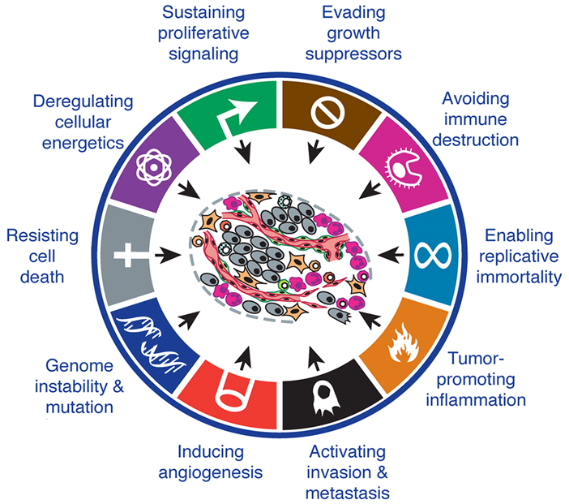
Figure 1.4: Acquired abilities of cancer. Most cancer types if not all of them develop these functions in their progression. Picture taken from (Hanahan and Weinberg, 2011) with permission.
Signalling pathways are essential in cancerous cells as they aid their pathogenesis. When the carcinogenic mutation in cells starts, cell-cell signalling carries the regulation process depending on cytokines, growth factors and hormones. Cancer cells can have the potential to proliferate and grow in a destructive and uncontrolled manner by producing growth factors that are either released by the same tumour cells or by the stromal tumour, containing non-cancerous cells, triggered by signals sent from neoplastic cells (Bhowmick et al., 2004, Cheng et al., 2008). In response to the excessive presence of growth factors, an up-regulation of the receptor proteins expression occurs, “acting as ligands “ (Hanahan and Weinberg, 2011).

Hormones and cell communication
Hormones are chemical substances that are secreted by specific types of cells into the extracellular matrix as well as the blood circulation. Hormones are able to stimulate and affect the metabolism of other cells due to the specificity of the secreted substances to the corresponding receptors of a cell; this process is called cell-cell signalling (Crisp et al., 1998). Hormones are divided into two broad groups, the first group is known as endocrine hormones which are produced by a group of cells or glands called endocrine glands, for example Growth hormones and Calcitonin. The second group of hormones are secreted by glands called exocrine glands into ducts to organs or the external environment, for example the pancreas secretes digestive enzymes. Endocrine hormones can be further subdivided into autocrine or paracrine hormones. Autocrine hormones are released by cells and have an effect on themselves by having the corresponding receptors on their cell surface that respond to the same hormone. Paracrine hormones have a local effect on neighbouring cells. An example of a hormone with both endocrine and paracrine functions is Adrenomedullin (AM) which is secreted by endothelial cells in rats and suppresses the apoptosis of the surrounding cells as well as the secreted cells themselves (Kato et al., 1999). AM is one of the endocrine hormones which is secreted ubiquitously in the body. It has both autocrine and paracrine functions such as to control vascular tonus, regulate cell growth, and protect cells from apoptotic death among other physiological functions. The influence of different hormones in cancer is a large subject and beyond the scope of this introduction (Henderson and Feigelson, 2000). Here I will focus on the role of the peptide hormone adrenomedullin (AM).

Discovery of Adrenomedullin
A new regulatory peptide termed Adrenomedullin (AM), discovered in 1993 by a group of scientists in Japan, was found by screening a panel of peptides extracted from human pheochromocytoma, a rare benign tumour in the adrenal medulla (containing an abundant amount of AM). These peptides were analysed to examine their biological activity in rising platelet Cyclic Adenosine MonoPhosphate (cAMP) levels leading to elevated hypertension. The trial showed that AM is responsible for the rise of cAMP by binding to a receptor present on the surface of the platelets (Kitamura et al., 1993c).

Gene location and the protein structure of adrenomedullin
The human AM gene is located on chromosome 11 (Kitamura et al., 1994d, Hinson et al., 2000) and contains 4 exons and 3 introns, with TATA, CAAT and GC boxes in the 59-flanking region (Ishimitsu et al., 1994, Kitamura et al., 1993c). The AM gene has two activator protein-1 (AP-1) binding sites, seven sites to bind activator protein-2 (AP-2) and cAMP-regulated enhancer elements (Ishimitsu et al., 1994, Samson, 1998).
AM consists of a 52-amino acid peptide and possesses a ring structure which contains six amino acids with a disulfide bridge between two Cysteine residues in positions 16 and 21 respectively as well as an amidated C terminus (Figure 1.5). The ring structure of AM is essential for binding to its receptors and the N terminus is important for transducing signals (Kuwasako et al., 2011).
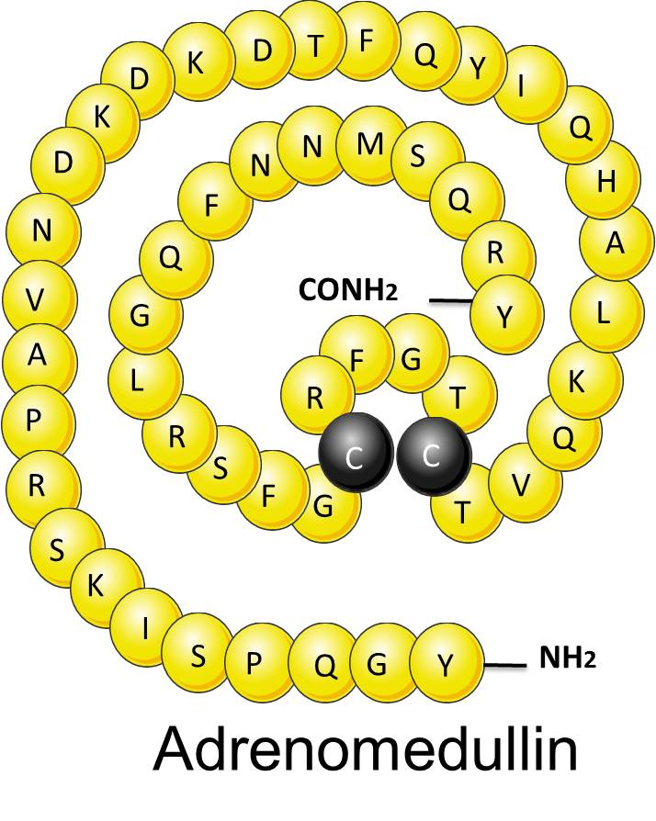
Figure 1.5: AM structure. The diagram illustrates the structure of AM (52aa), the ring structure with the disulfide bridge between two Cysteine residues in positions 16 and 21 respectively and the amidated C terminus. Picture drawn by the author and adapted from (Kitamura et al., 1994a).

The AM gene produces a number of biologically active peptides. The first gene product is a 185 amino acid peptide known as Preproadrenomedullin, which contains 185 amino acids (Kitamura et al., 1994a). An enzymatic cleavage between the threonine in position 21 and the alanine in position 22 of preproadrenomedullin results in the removal of the N-terminal signal peptide, which in turn converts preproadrenomedullin into proadrenomedullin. The cleavage of the lysine–arginine pairing at positions 93 and 94, and the arginine doublet at positions 148 and 149 of proadrenomedullin results in the production of immature AM, Adrenotensin (ADT), Proadrenomedullin N-20 terminal peptide (PAMP) and preproAM45-92 (Figure 1.6). A subsequent enzymatic cleavage between positions 43 (lysine) and 44 (arginine) produces functionally active PAMP (Hinson et al., 2000, Samson, 1998). An enzyme called Peptidyl-glycine α-Amidating Monooxigenase (PAM) amidates the C terminal of AM to convert it from an immature AM into a mature biologically active AM. PAM has a local effect and does not exist in a ubiquitous form but some cells such as immature rat thymocytes express it (Belloni et al., 2003). AM was initially only believed to be expressed in adrenal medulla but it has been found that AM is expressed ubiquitously in the human body (Hinson et al., 2000).
The other peptides, including Adrenotensin (ADT), PAMP and preproAM₄₅₋₉₂ have different effects than AM, even though they originate from the same AM gene (Qi et al., 2002). PAMP is a 20 amino acid peptide (Samson, 1998). PAMP is a weak vasodilator and has many functions in the human body; it has been shown to inhibit aldosterone secretion and basal adrenocorticotropic hormone (ACTH) secretion as well as the proliferation of vascular smooth muscle cells (VSMC) (Samson, 1998), in addition to the inhibition of AM secretion. PAMP is localised in most tissues and organs in the body such as adrenal medulla, heart ventricle, kidney, lung, and brain (Kitamura et al., 1993a, Samson, 1998). PreproAM₄₅₋₉₂ is a weak vasodilator and stimulates AM hypotensive activity. ADT increases blood pressure as a result of its vasoconstriction property and enhances AM secretion in the VSMC (Qi et al., 2002).
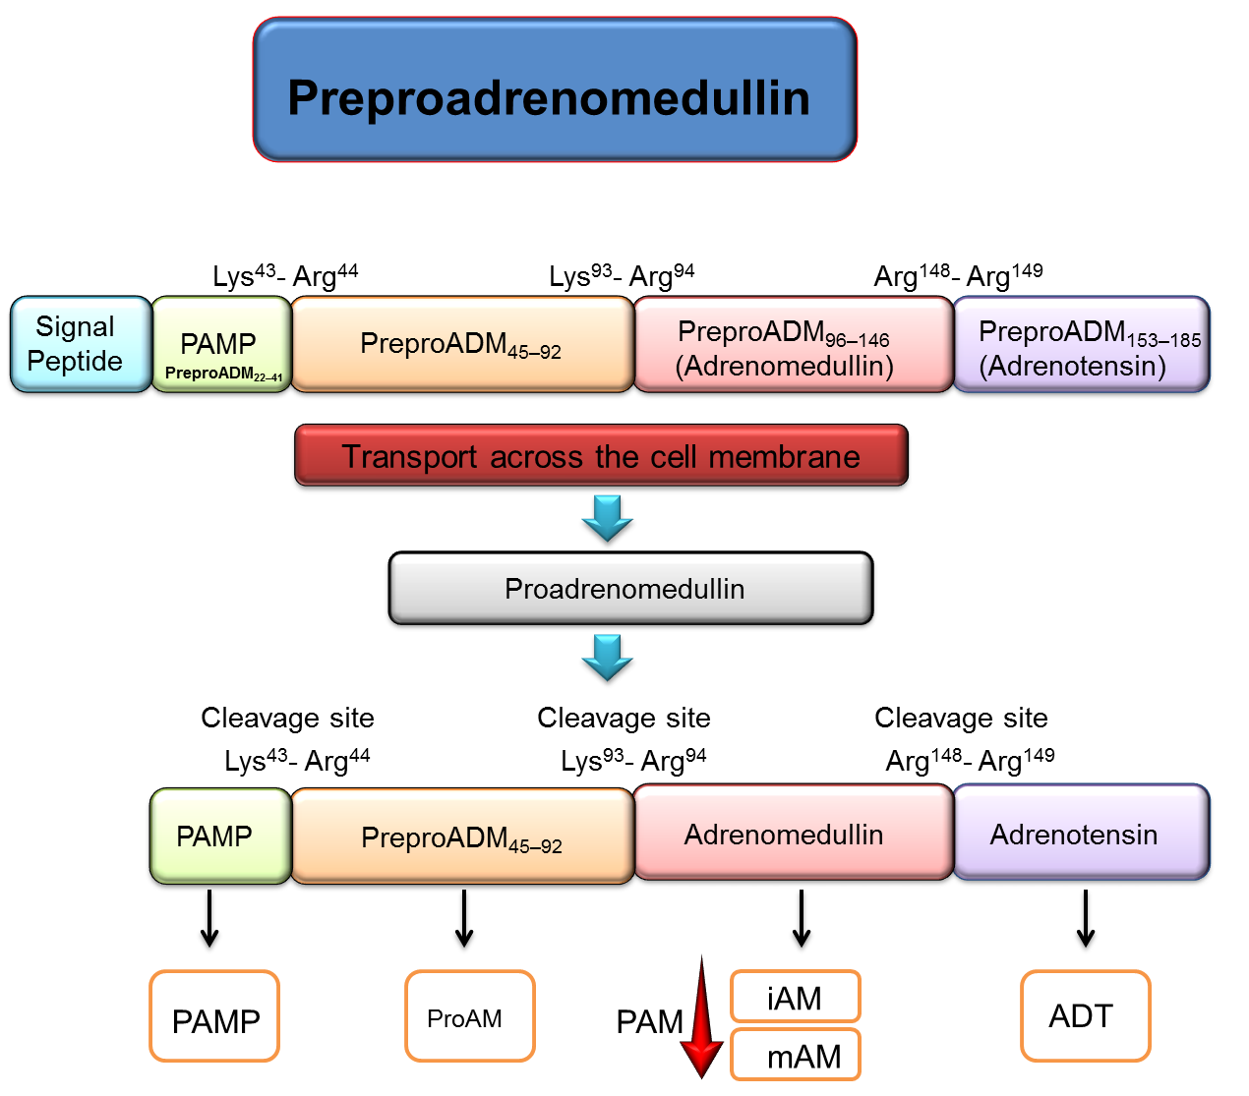
Figure 1.6: The production of AM in the body. This figure shows how adrenomedullin, PAMP, preproAM45-92 and Adrenotensin (ADT) are derived from preproadrenomedullin. This process involved many enzymatic cleavages which converted Preproadrenomedullin to proadrenomedullin and afterwards to immature AM and PAMP. Then, is the conversion of immature AM into mature AM by the PAM enzyme. Picture drawn by the author, adapted from (Samson, 1998).

G protein Coupled Receptor (GPCRs)
GPCRs are a large family of receptors that communicate via extracellular signals which include hormones such as AM, neurotransmitters and chemokines. These are then transmitted to different intracellular signalling pathways which regulate a broad variety of cellular processes.
The GPCRs consist of seven transmembrane domains, which consist of 20 to 28 hydrophobic amino acids as a single polypeptide in α-helical structure that is vertical to the membrane (Bockaert et al., 2002, Fredriksson et al., 2003, Palczewski et al., 2000), three extracellular loops and three intracellular loops (Ji et al., 1998)( Figure 1.7). The fourth intracellular loop is formed when the palmitoylation of a C-terminal segment at a cysteine site covalently attaches them to a palmitic acid group that is important for the desensitization and internalization of the receptor (Ji et al., 1998, Oldham and Hamm, 2008). Over 5% of the mammalian genome is encoded for GPCRs and 80% of all hormones signal through GPCRs. The amino terminus of a GPCR has many glycosylation sites (Asn-11, Asn17, and Asn21) that are positioned on the extracellular side of the membrane. The carboxy terminus is located on the intracellular side of the membrane and has several phosphorylation sites (Thr-72, Ser-231, Thr235, and Ser 351) which have been shown to control receptor desensitization and internalization. The transmembrane domain of the GPCRs is linked to three extracellular loops and three intracellular loops. The second and third extracellular loops possess a highly conserved disulphide bond between the cysteine residues. This bond is required for protein folding and to control the high affinity site in binding (Karnik and Khorana, 1990, Perez and Karnik, 2005).
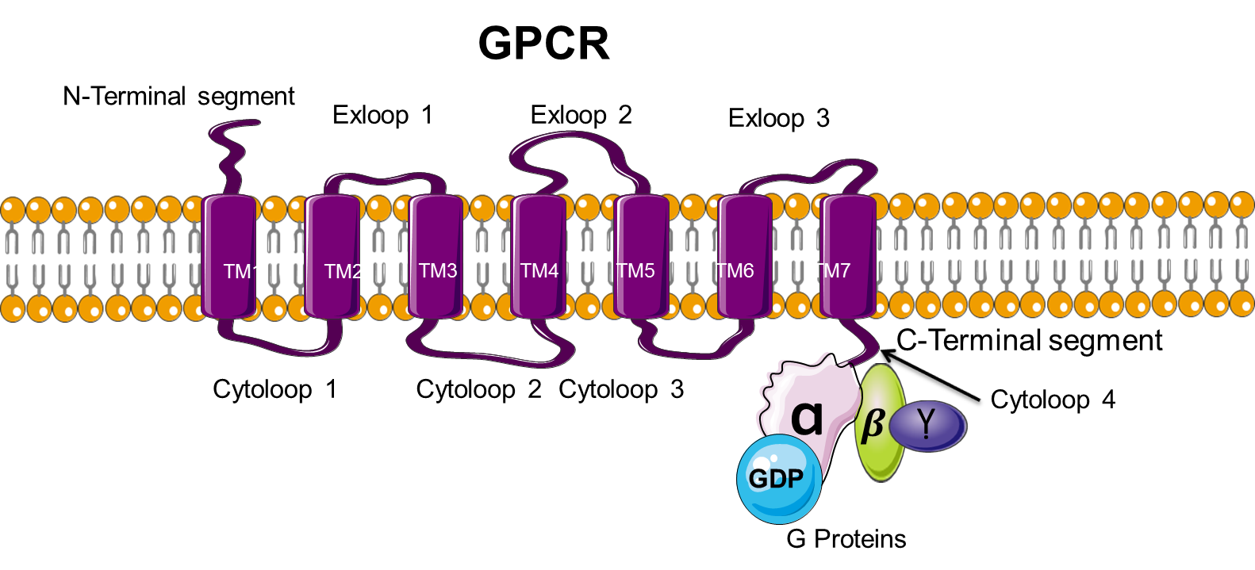
Figure 1.7: The structure of GPCRs consists of seven transmembrane domains, three extracellular loops, 3 intracellular loops and finally an intracellular C-terminus loop. Picture drawn by the author, adapted from (Ji et al., 1998).

GPCRs mediate their functions via G proteins and hence they are called G protein coupled receptors. G proteins consist of three subunits which are called α, β, and γ where α subunit is bound to Guanosine Di Phosphate (GDP) in the inactive state. βγ complex cannot dissociate from each other even after the activation of the receptor by a ligand (Post and Brown, 1996, Wettschureck and Offermanns, 2005a). The binding of a ligand or drug to GPCRs causes conformation changes which lead to the activation of the heterotrimeric G-protein by intracellular loops of the receptor. This activation leads to the exchange of guanosine diphosphate (GDP) with guanosine triphosphate (GTP) and the dissociation of α subunit form βγ complex. Next, a second messenger response will be activated by α and βγ subunits by inhibiting or activating different effector molecules such as phospholipases, enzymes or ion channels (Bockaert et al., 2003). The hydrolysis of GTP by GTPase terminates the signal, resulting in the re-association of GDP, α subunit to the βγ complex (Post and Brown, 1996, Wettschureck and Offermanns, 2005c).
The α subunit can be divided into four families: Gαs, Gαi/Gαo, Gαq/Gα11, and Gα12/Gα13, while each family consists of a number of members. The members of the same family share the same properties of functions as well as structure. The β subunit consists of 5 families (β1, β2, β3, β4, and β5), while the γ subunit consists of 12 families. Mainly, a βγ associated complex has the ability to regulate phospholipase Cβ, ion channels, voltage-gated calcium channels, PI3K isoform, Kir3 and particular isoforms of adenylate cyclase (Post and Brown, 1996, Wettschureck and Offermanns, 2005c). Recently, many new interacting proteins have been recognised which transduce G βγ dependent signals in other subcellular compartments, for example nucleus [AP-1, R7BP, AEPB1 (adipocyte enhancer-binding protein), GR, and possibly HDAC], cytoskeleton (tubulin, ElmoE), and Golgi apparatus (Raf kinase, PKD) (Khan et al., 2013).
The α subunit the Gαi/Gαo family is the most commonly expressed and the three members of Gα_{i} (Gi₁, Gi₂ and Gi₃) are responsible for the inhibition of a range of adenylate cyclase types which in turn inhibit cAMP accumulation. Due to the high expression of Gα_{i}/Gα_{o}, the activation of their receptors results in disassociation and the release of a high amount of βγ complex. Thus, Gα_{i}/Gα_{o} is believed to be responsible for the activation of βγ mediated signalling processes (Post and Brown, 1996, Wettschureck and Offermanns, 2005c).
In another family of Gα, the Gαq/Gα₁₁ are able to regulate β-isoforms of phospholipase C (PLC) except the β2-isoform β-isoform. Additionally, the Gα₁₂/Gα₁₃ family is activated by the same receptor coupling with the Gαi/Gαo and is able to induce high levels of signalling, leading to the activation of numerous effectors downstream such as phospholipase A2 and the Na+/H+ exchanger (Oldham and Hamm, 2008). The activation of the Gαs signalling pathway results in the increase of cAMP, through activation of adenylate cyclase (Post and Brown, 1996, Wettschureck and Offermanns, 2005c).
Different to the usual concept of a single ligand – single receptor, AM binds to a combination of a member of the G-Protein Coupled Receptors called Calcitonin Like Receptor (CLR) and an accessory protein called receptor activity modifying proteins (RAMPs) (Zimmermann et al., 1996, McLatchie et al., 1998a). AM receptors and signalling mechanisms are reviewed in the next sections.

Calcitonin Like Receptor (CLR)

AM functions are mediated by its receptors. AM binds to two different receptors that consist of CLR and RAMPs.
The human CLR gene that is found on chromosome 2q31 contains fifteen exons and has a length of approximately 100kbps (Conner and Poyner, 2001, Nikitenko et al., 2003). CLR has a structure that is similar to its class B GPCRs members that consists of a large N terminal domain with six cysteine highly conserved residues, leading to the formation of disulphide bonds (Gether, 2000). This N terminal domain participates in ligand binding, functioning in a similar way to rest of the GPCRs as receptors for parathyroid, glucagon and secretin hormone (Chauhan et al., 2005). Since there is a high expression of CLR in the heart, lungs and kidneys (Elshourbagy et al., 1998), the death of mice mid-gestation by Hydrops Fetalis and severe cardiovascular defects is caused by the deficiency of mice CLR, which has a 54% similarity to Human CLR. In Figure 1.8 a, the edema is seen in the whole embryo body at E12.5 days. At E13.5 days, the edema develops to become a severe Hydrops Fetalis which is shown in Figure 1.8 b. Compared to the wild-type, the proliferation of ventricular cells for CLR^{-/-} was reduced significantly. Also, the apoptosis rate was very high in CLR^{-/-} mice. This revealed the importance of CLR in the development of the embryo and the growth of its cardiac and vascular smooth muscle cells (Dackor et al., 2006a).
The difference between CLR and its class members lies in the need for Receptor Activity Modifying Proteins (RAMPs) to guide the movement of CLR from endoplasmic reticulum to the cell surface and then for the specificity of the ligand (McLatchie et al., 1998a). The transportation and functioning of CLR is regulated by glycosylation (Ho et al., 1999, Walsh et al., 1998). There are three types of RAMP associated with CLR; RAMP1 is responsible for terminal glycosylation, whereas RAMP2 and RAMP3 are responsible for the core glycosylation of CLR (McLatchie et al., 1998). In the extracellular domain of CLR, there are three putative Asn glycosylation sites at positions 66, 118 and 123 (Aiyar et al., 1996b, Fluhmann et al., 1995). The expression of CLR on the cell surface was reported to be determined by the glycosylation sites at Asn66 and/or Asn118 (Bühlmann et al., 2000). However, the Kamitani and Sakata group disagreed with these findings (Kamitani and Sakata, 2001).
The CLR structure consists of five loops connecting N-terminal α helix (α1) and two anti-parallel β sheets (β1 and β2) and it maintains its stabilisation by three disulphide bonds that are located between Cys-48-Cys74, Cys 65-Cys105 and Cyc88-Cys127 (Kusano et al., 2012b). One of the extracellular loops (ECL3) has an important role in the binding of AM and the subsequent signal transduction (Kuwasako et al., 2012), while the ECLs in class A and B GPCRs are essential in ligand binding and receptor activation (Hawtin et al., 2006, Peeters et al., 2011). Moreover, family B GPCRs containing ECL1 and ECL2 are recognised to have a conserved disulphide bond that controls receptor stability (Kuwasako et al., 2003c). Furthermore, there is an involvement of CLR Helix 8 in Gs signalling (Kuwasako et al., 2010) in addition to ECL3 which regulates Gs activation that triggers the cAMP accumulation (Kuwasako et al., 2012).
In the transportation of RAMP+CLR to the plasma membrane, the role of 1 to 5 domains of the transmembrane has been revealed as essential. The determination of the trafficking interaction variation occurring between the three RAMPs can be done by the third intracellular loop and/or the transmembrane domain and/or the N terminal domain (Kuwasako et al., 2009). Although the role of the two former domains is known in the RAMPs, it is still uncertain in the CLR (Wheatley et al., 2012). As mentioned previously, the CLR is incapable of signal transduction mediation. So, the need for associated RAMPs for the CLR guiding to the cell surface and regulating ligand specificity is necessary (McLatchie et al., 1998).

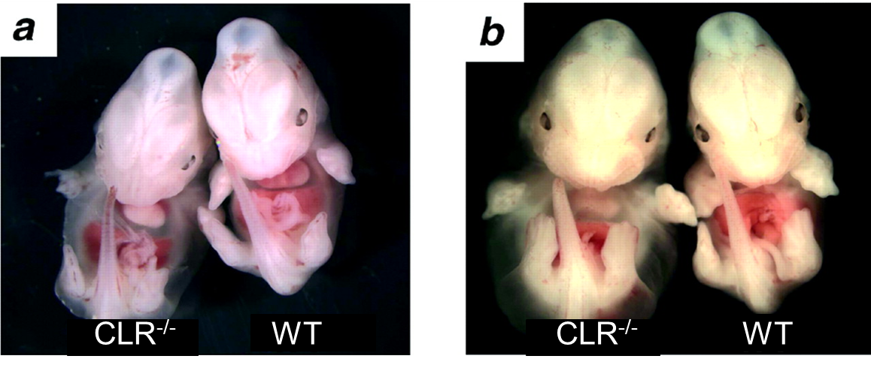

Figure 1.8: CLR knockout mice embryos. Figure A shows CLR-/- mice embryos at embryonic day E12.5 with body edema, and figure B shows the development of Hydrops Fetalis at E13.5 days. Picture taken from (Dackor et al., 2006b) with permission.

Receptor Activity Modifying Proteins (RAMPs)
RAMPs are single transmembrane proteins that are essential for the appropriate localization and functions of certain GPCRs. RAMPs have been shown to be able to change the specificity of two members of family B GPCRs. The first member is called Calcitonin Like Receptor (CLR). For instance, the heterodimer, which consists of CLR/RAMP1, CLR/RAMP2 and CLR/RAMP3 form functional CGRP, Adrenomedullin1 (AM1) and Adrenomedullin2 (AM2) receptors, respectively (Figure 1.9) (Hay et al., 2004, Kuwasako et al., 2004, McLatchie et al., 1998, Poyner et al., 2002). The second member is called Calcitonin (CT) receptors. The interactions between RAMPs and CT receptors lead to the generation of three amylin receptors (AMY1, AMY2, and AMY3). However, RAMPs are not required for CT binding. An AM induced cAMP response is shown to be controlled by an intracellular peripheral membrane protein called Receptor Component Protein (RCP) which connects the AM receptors (AM1 and AM2) with their cellular signal transduction pathway. Also, RCP is shown to be important for mediating CGRP signalling downstream from the activation of the receptor complex (CLR/RAMP1) (Prado et al., 2002, Evans et al., 2000).
RAMPs were defined as chaperones controlling the forward trafficking of CLR to the cell surface from the endoplasmic reticulum (McLatchie et al., 1998f). This role was identified in the HEK-293 cell line which expresses RAMP1. After the transfection of HEK cells with CLR, RAMP1 works as a chaperone and helps CLR to traffic to the cell surface to form a CGRP receptor. Upon stimulation by Calcitonin Gene Related Peptide (CGRP), cAMP production was increased 60 fold (Aiyar et al., 1996a, Kuwasako et al., 2003a, Kuwasako et al., 2004). However, COS-7 transfected with CLR alone was unable to bind to CGRP, suggesting the absence of RAMP1 affected the localization of CLR on the cell surface of this cell line and as a consequence of this, CGRP receptors were not formed. This led to the hypothesis that CLR needs a co-factor in order to be expressed on the cell surface (McLatchie et al., 1998).
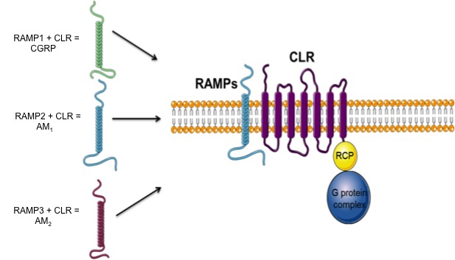

Figure 1.9: The interaction between RAMPs and CLR. RAMP1+CLR generates CGRP receptors, RAMP2+CLR generates AM1 receptors and RAMP3+ CLR generates AM2 receptors. Picture drawn by the author, adapted from (Brain and Grant, 2004).

RAMPs structure
RAMPs share a common structure consisting of a short C terminal tail (9 amino acids), a single α helix transmembrane domain (22 amino acids) which contributes to the affinity of the interaction of the receptor with RAMPs (Zumpe et al., 2000) and a large extracellular domain (ECD) consisting of three α-helices (α-helix 1, 2 and 3). RAMP2 possesses the largest ECD (102 amino acids), while the ECD of RAMP1 and RAMP3 consists of 91 amino acids (McLatchie et al., 1998). All RAMPs have disulphide bonds which are formed as a result of their possession of 4 highly conserved cysteine residues. Two extra cysteines are found in RAMP1 and RAMP3 (Figure 1.10) (Parameswaran and Spielman, 2006).
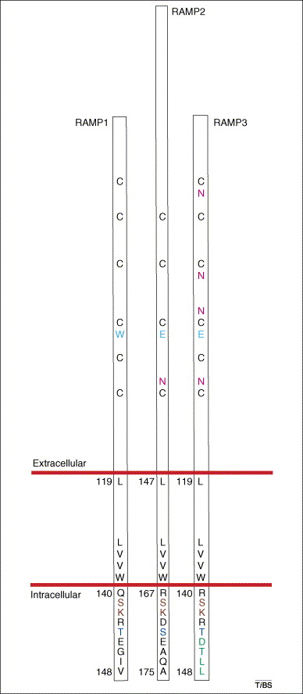

Figure 1.10: The three different domains of RAMPs (RAMP1, RAMP2 and RAMP3) are shown (Extracellular domain (ECD), transmembrane domain and intracellular domain). RAMP2 has the largest extracellular domain with 102 amino acids and RAMP1 and RAMP3 have 91 amino acids. The C and N are expressing the conserved cysteine residues and glycosylation sites respectively. In the transmembrane domain the conserved amino acids are shown in black. The PDZ motif in RAMP3 is shown in green and the putative phosphorylation sites are shown in blue. Picture taken from (Parameswaran and Spielman, 2006) with permission.
The hydrophobicity plots of the RAMP primary amino acid sequence shows they share a similar structure, with all of them possessing an amino-terminal signal sequence and single putative transmembrane domain adjacent to the carboxy terminus. However, there are some important differences between the RAMPs such as that the RAMP3 C terminal tail possesses a PDZ-binding motif (Asp-Thr-Leu-Leu) which is important for receptor complex recycling, which cannot be found in either RAMP1 or RAMP2 (Bomberger et al., 2005c, Bomberger et al., 2005a), suggesting that the regulation of the three CLR-RAMPs complexes could be different from one to another through interactions with CGRP and AM (Hay et al., 2006, Hay et al., 2010).
There is a predicted N terminal signal peptide in RAMP1 and RAMP3 between 22 and 35 amino acids in length, while in RAMP2 it is between 24 and 60 amino acids in length. Moreover, RAMP3 possesses N-glycosylation sites (Asn29, Asn58, Asn71, and Asn104) and (Asn58 and Asn104) in RAMP2, while no glycosylation sites are found in RAMP1 (Flahaut et al., 2003, Flahaut et al., 2002). Such glycosylation sites make RAMP2 and RAMP3 traffic to the cell surface in the absence of their partner. The introduction of N-glycosylation sites similar to RAMP3 to RAMP1 allow RAMP1 to reach the cell surface on its own, in contrast with wild-type RAMP1 (Flahaut et al., 2002).

The transmembrane and extracellular domain of RAMPs
Extracellular domain (ECD) of RAMP1 and RAMP3 is stabilized by 3 disulphide bonds (Cys27–Cys82, Cys40–Cys72 and Cys57–Cys104) (Hay et al., 2006) (Figure 1.11), while the RAMP2 ECD has two disulphide bonds, Cys68–Cys99 and Cys84–Cys131 (Kusano et al., 2012a) which connect α1 with αβ and loop 1 with the C-terminal tail, respectively.
The role of ECD in agonist-binding efficacy and specificity (Kuwasako et al., 2003a) was clarified by the deletion of 91–94, 96–100 or 101–103 amino acid residues of the ECD of RAMP1 which resulted in abolishing AM or CGRP binding and reducing the cAMP production. This also resulted in AM binding to CLR+RAMP1. Moreover, removing 78–80 or 88–90 residues of RAMP1 ECD decreased the AM-induced cAMP response (Hay et al., 2006).
The N-terminus of RAMP1 is essential in determining the ligand selectivity and the binding potency of CGRP to CLR in association with RAMP1. Three different chimeras were used to investigate the function of the three domains (ECD, TM, and tail) of RAMPs. The first chimera had RAMP1 ECD and TM, however the tail end was missing, the second chimera included TM and the tail from the platelet-derived growth factor (PDGF) receptor with the RAMP1 ECD, and the third chimera contained ECD of RAMP1. The first mutant did not show any effect on CGRP binding. However, the second mutant negatively affected the potency of the signalling and binding of CGRP with a tenfold reduction, the third mutation also reduced the binding potency by ~4000 fold and this leads to the fact that ECD is essential for signalling and CGRP binding (Fitzsimmons et al., 2003).
RAMPs have four Cys residues that are conserved at locations 40, 57, 72 and 104. In RAMP1 and RAMP2 the four conserved Cys are required for the translocation of CLR to the cell surface (Hay et al., 2006, Kusano et al., 2008). The disulphide bonds in the extracellular domain of RAMPs between Cys27 and Cys82, which are conserved in RAMP1 and RAMP3 but not RAMP2, regulate CGRP and AM selectivity (Simms et al., 2009, Simms et al., 2006).
The extracellular region of RAMPs determines the pharmacology of the receptor, while the transmembrane region determines the ligand binding affinity (Hay et al., 2006). The deletion of amino acid residues at positions 86-92 and 59-65 in RAMP2 and RAMP3 respectively resulted in the loss of AM binding and response to AM-induced cAMP, however these deletions do not affect the trafficking of the receptor complexes to the cell surface (Kuwasako et al., 2001).

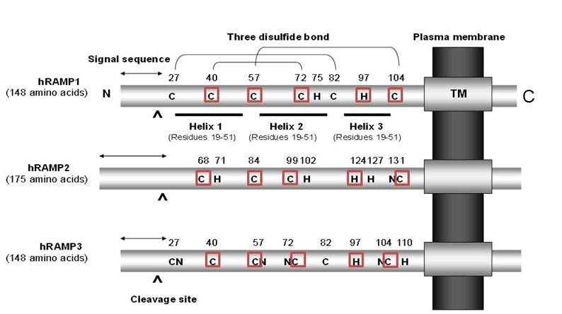

Figure 1.11: The structure of the three human RAMPs. A large extracellular N-terminal domain (ECD) with a signalling sequence and cleavage site, a single transmembrane (TM) domain and a very short cytoplasmic C-terminal tail are possessed by the three RAMPs. RAMP1 and RAMP3 consist of 148 amino acids, while RAMP2 is composed of 175 amino acids. The three α-helices (helix 1, 2, and 3) and three disulfide bonds (Cys27–Cys82, Cys40–Cys72, and Cys57–Cys104) were demonstrated by hRAMP1 ECD by analysing the crystal structure (Kusano et al., 2008). All three RAMPs preserve the four Cys(C) residues and one His (H) residue (shown in bold italic); also demonstrated are the N-terminal glycosylation sites (N; Asn. Note that the number of His residues is the smallest among the amino acids forming each RAMP.Picture drawn by the author. Adapted from (Kuwasako et al., 2011) with permission.

The intracellular domain of RAMPs
The intracellular domain of RAMPs has an essential role in determining some functions of RAMPs as well as their GPCR partners, for example, AM-induced internalization of the receptor complex is improved by removing the C-terminal tail of RAMP3. This deletion does not affect the cell surface targeting of the receptor, AM binding or AM signalling (Kuwasako et al., 2006). The interaction of the C-tail of RAMP3 with a protein called N-ethylmaleimide sensitive factor (NSF) results in the recycling of the AM1 and AM2 receptors. However, in the absence of NSF, the degradation of the heterodimeric complex occurs (Bomberger et al., 2005b, Bomberger et al., 2005a). In most membrane-fusion events in a cell, NSF is a hexameric ATPase that has the ability to protect soluble NSF-attachment protein receptors (SNAREs). Encouraging rapid re-sensitization of the receptors at the plasma membrane is assisted by NSF in order to recycle membrane receptors (Whiteheart and Matveeva, 2004). The serine and lysine are conserved in the C tail of RAMPs. In RAMP3 the existence of Ser-Lys leads to less-efficient internalization, whereas the conserved Leu-Leu motif is important for the internalization of other GPCRs (Schulein et al., 1998).
The serine or threonine residues in the intracellular domain of RAMPs are considered to be phosphorylation sites. However, these residues are not involved in agonist-induced phosphorylation, example, when HEK-293 cells where transfected with CLR-RAMP1, stimulation with CGRP resulted in the phosphorylation of CLR but not RAMP1 (Hilairet et al., 2001).
The trafficking of CLR to the plasma membrane is not impaired as a result of the deletion of RAMP1 and RAMP3 C-terminal. Also, CLR function and CGRP signalling are not affected by the C tail of RAMP1 (Fitzsimmons et al., 2003). For example, the removal of 4 amino acids (8, 9, 10, and 16) from the C tail of RAMP1 does not attenuate its function. However, the removal of the cytoplasmic tail of RAMP2 inhibits the ability of CLR to reach the cell surface, leading to reduced AM binding and signalling (Barwell et al., 2012, Bomberger et al., 2012, Parameswaran and Spielman, 2006).
The importance of the C tail of RAMPs in the stimulation of cAMP has been tested using a RAMP1 chimera with the C tail of RAMP2. This resulted in a tenfold reduction in cAMP production after CT and CGRP binding, when RAMP1 was co-expressed with CTR (Udawela et al., 2006). However, using a RAMP2 chimera with RAMP1 C tail resulted in increased cAMP production and the RAMP1 phenotype was exhibited by CGRP simulation. This result suggests that the signalling pathway of RAMP–GPCR complex activation is determined by the cytoplasmic tails of RAMPs (Parameswaran and Spielman, 2006, Barwell et al., 2012).

AM Signal Transduction

AM signalling is perceived by the cells using specific receptors for AM. AM signalling is mediated by a G protein coupled receptor (GPCR), specifically CLR in combination with an accessory protein called Receptor Activity Modifying Proteins (RAMPs) specifically (RAMP2 and RAMP3). The combination of both of these proteins produces a ligand binding pocket that binds AM (Figure 1.5.12) (Pierce et al., 2002, Rana and Insel, 2002). As stated previously, the AM1 receptor contains CLR and RAMP2, and the AM2 receptor contains CLR and RAMP3.
GPCRs are transmembrane receptors that consist of an extracellular domain that receives the signal, the transmembrane domain, which is important for ligand binding and signalling through the receptor and an intracellular domain to pass the signal to the effector molecules. The G proteins consist of α, β and γ subunits, and the molecular sizes are around 39-45, 35-39 and 6-8kDa respectively (Figure 1.12) (Kristiansen, 2004). In the case of AM, when AM binds to the extracellular domain of its receptor, the Gα subunit disassociates from the Gβγ subunits, causing the activation of adenylate cyclase (effector) resulting in the conversion of guanosine diphosphate (GDP) to guanosine triphosphate (GTP) and the Adenylate cyclase becomes activated and this increases cAMP levels (intracellular signal) which in turn activates the signalling cascade and increases the proliferation of cells (Figure 1.13). In order to terminate the signalling, the G α subunit converts GTP into GDP, therefore restoring the inactive state of the G protein (Figure 1.14) (Vassilatis et al., 2003, Gibbons et al., 2007, Wettschureck and Offermanns, 2005a, Poyner et al., 2002, Bockaert et al., 2003).

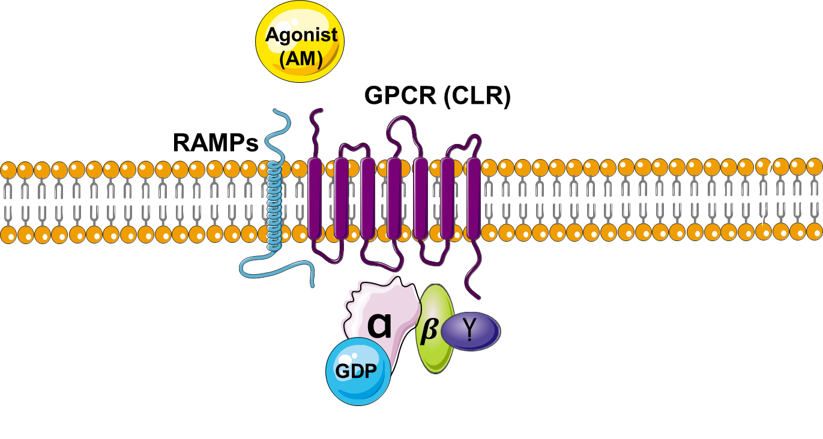

Figure 1.12: The relaxed state of the RAMPs and GPCR showing that the RAMPs and the GPCR form the binding pocket for AM to bind. In the relaxed state, the Gα and Gβγ subunits will be associated together. Picture drawn by the author. Adapted from (Kuwasako et al., 2000, Prado et al., 2002).

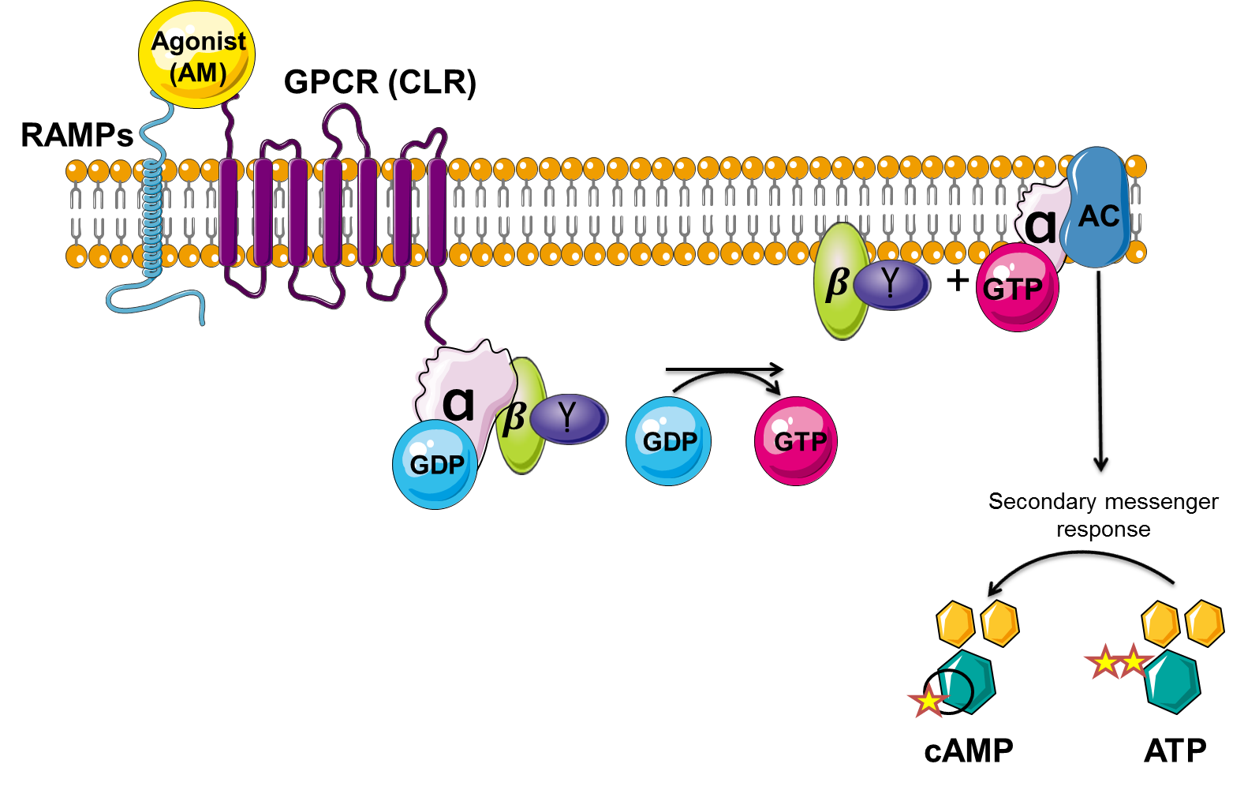

Figure 1.13: The active state of the RAMPs and GPCR showing that AM binds to the binding pocket formed by RAMPs and GPCR and this results in replacing the GDP with GTP and the disassociation of Gα from the Gβγ complex and that the adenylate cyclase pathway will be activated. This results in the accumulation of cAMP and the activation of the signalling cascade. Picture drawn by the author. Adapted from (Kuwasako et al., 2000, Prado et al., 2002).

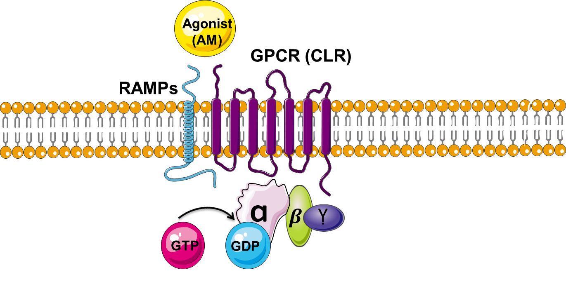

Figure 1.14: Disassociation of AM from its receptor and the GαGβγ complex will be formed again and the GTP will be replaced by GDP and the adenylate cyclase pathway will be deactivated. Picture drawn by the author. Adapted from (Kuwasako et al., 2000, Prado et al., 2002).

The physiological roles of Adrenomedullin
AM is involved in many physiological actions in the human body. It is considered to be an effective vasodilator and the administration of AM systemically leads to a rapid decrease in blood pressure and enhances the flow of pulmonary blood (Njuki et al., 1993). AM acts as a bronchodilator through the inhibition of acetylcholine and histamine (Kanazawa et al., 1994). The secretion of aldosterone is inhibited by an increase in the concentration of intracellular free calcium caused by AM (Yamaguchi et al., 1995). The average plasma concentration of AM is 17.2 ± 6.4 pg/ml (Ichiki et al., 1994) and it has a circulating half-life of 22 ± 1.6 min (Meeran et al., 1997).
Three different mechanisms are involved in the biological effects of AM, which are cAMP, Nitric Oxide (NO) and calcium. These three different mechanisms are primarily mediated through AM receptors, AM1 and AM2. AM increases cAMP in platelets and activates G_{s} as a result of AM stimulation, resulting in Adenylate Cyclase (AC) activation leading to the elevation of cAMP and protein kinase A (PKA) production in smooth muscle and endothelial cells (Figure 1.15) (Mittra and Bourreau, 2006, Gibbons et al., 2007, Shimekake et al., 1995). AM also mediates Cyclic Guanosine Mono Phosphate (cGMP) formation which in turn activates intracellular Ca²⁺ and upregulates NO in endothelial cells (ECs) (Figure 1.15) (Hinson et al., 2000, Shimekake et al., 1995). AM stimulates Mitogen-Activated Protein Kinase (MAPK) in vascular smooth muscle cells resulting in increased cell proliferation and angiogenesis (Nikitenko et al., 2006).
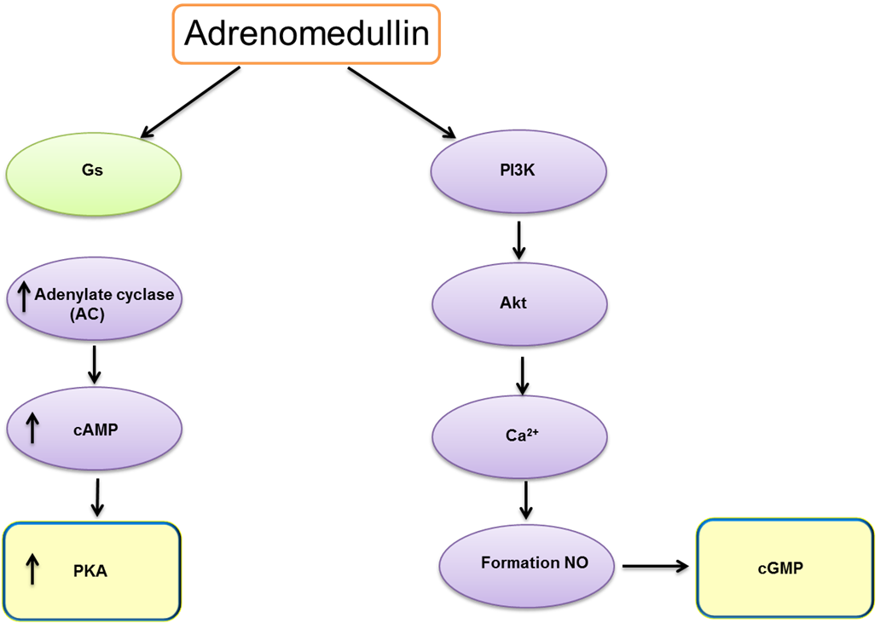

Figure 1.15: The adrenomedullin signalling pathway in the physiological functions.

AM plays a role in the maintenance of blood circulation and has antithrombotic effects. There are two important factors that regulate blood coagulation which are plasma protease factor VII/VIIa (FVIIa) and tissue factor (TF). Their binding initiates the blood coagulation cascade (Nemerson, 1988). The Tissue Factor Pathway Inhibitor (TFPI) is an inhibitor for TF-FVIIa complex which is secreted and synthesized by endothelial cells where the Heparan Sulfate Proteo Glycan (HSPG) helps TFPI to express at the cell surface. In thrombotic diseases the levels of AM and TFPI are increased, illustrating the possibility of existing correlations between them (Broze, 1995). The cationic charge provided by the amino acid of AM is responsible for inducing the release of TFPI from the surface of ES, where TFPI binds to cell surface HSPG via the positively charged C-terminal region of the TFPI sequence. Additionally, in the ECs AM has the ability to induce antithrombin (AT) and urokinase type plasminogen activator (uPA) release (Marutsuka et al., 2003).
AM has been shown to be a protection factor for organs in hypertension, oxidative stress, atherosclerosis, ischemia, and sepsis which results in multi organ failure. In rodent models, prolonged infusion or the overexpression of AM prevented thickness of the internal part of the capillary which is called intima by preventing the formation of fatty streaks and perivascular hyperplasia in order to protect the blood vessels. This shows AM is an important regulator for maintaining the circulatory system function (Kato et al., 2005b).
The administration of AM systemically into the mouse model of tail lymphoedema resulted in an improvement of lymphoedema compared to controls. The blood and lymphatic vessels number were shown to be increased at the site of injury. This finding emphasises the role of AM in angiogenic and lymphogenic processes (Jin et al., 2008). AM has many other biological actions such as increasing cAMP in the cell, the mobilization of intracellular Ca²⁺ (Kuwasako et al., 2000, Kato et al., 2005b), the stimulation of NO production (Hiragushi et al., 2004, Kato et al., 2005b), reducing blood pressure (Chao et al., 1997, Kitamura et al., 1993a, Tam et al., 2006), reducing vascular and cardiac oxidative stress (Nakamura et al., 2004b, Shimosawa and Fujita, 2005), protection from vascular hypertrophy and inflammation (Kato et al., 2005a, Liang et al., 2009), inhibiting vascular apoptosis (Kato et al., 2005b), inhibiting the hypertrophy and remodelling of the left ventricle (Chao et al., 1997, Tsuruda et al., 1998, Nakamura et al., 2004a), promoting diuresis and natriuresis (Eto, 2001, Nishikimi, 2007), inhibiting the secretion of aldosterone (Yamaguchi et al., 1995, Yamaguchi et al., 1996), inducing angiogenesis (Nikitenko et al., 2006, Ichikawa-Shindo et al., 2008d) and regulating placentation and fertility in mice (Li et al., 2006).
AM has also been shown to be a very important factor in the maturation and development of the vascular system. The AM^{-/-} mice (Caron and Smithies, 2001) and RAMP2^{-/-} mice (Ichikawa-Shindo et al., 2008) were shown to die mid-gestation due to abnormalities of their vascular system development as a result of a disruption in the angiogenic process. A key feature of this phenotype was the thinning of blood vessels walls, resulting in haemorrhagic changes and internal bleeding, in addition to the disruption of lymphatic vessels maturation which leads to a condition called Hydrops Fetalis (Figure 1.16 and Figure 1.17). However, the AM^{+/-} mice survived to adulthood but had high blood pressure associated with reduced NO production. Similarly to AM^{-/-} and RAMP2^{-/-} embryos, the knocking out of CLR was also embryonically lethal and the embryos died between embryonic day E13.5 and E14.5 due to defects of the cardiovascular system, severe hydrops fetalis and disorganized hearts (Figure 1.18). However, the CLR^{-/+} mice were healthy and grew to adulthood (Dackor et al., 2006, Ichikawa-Shindo et al., 2008).
This result illustrates the critical role of AM in vascular system development as well as the contribution of the AM1 (RAMP2 and CLR) receptor in AM signalling which is important for lymphatic and blood vessel development (Dackor et al., 2006, Shindo et al., 2008). The previous result also indicates that the AM1 receptor plays an essential role in the normal development process.

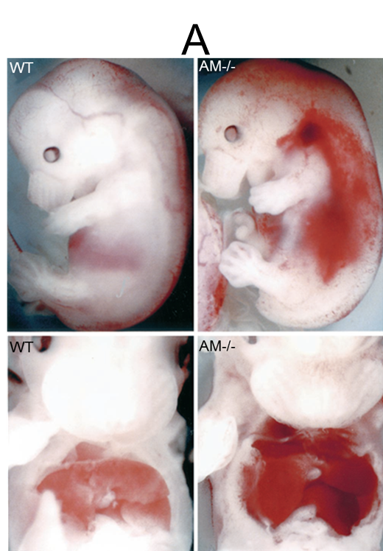
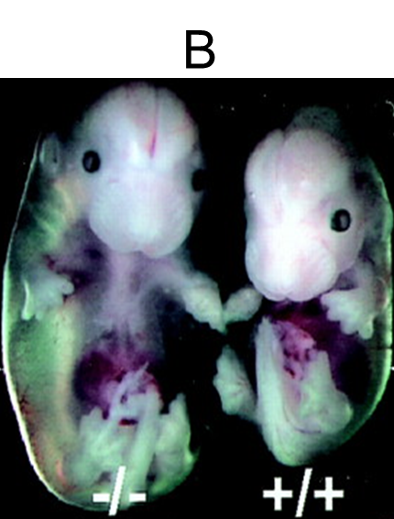

Figure 1.16: The effect of the deletion of the AM gene in mouse embryos at E14. A) AM^{-/-} shows haemorrhagic changes and B) edema observed in different organs compared to wild-type. Taken from (Shindo et al., 2001) with permission.
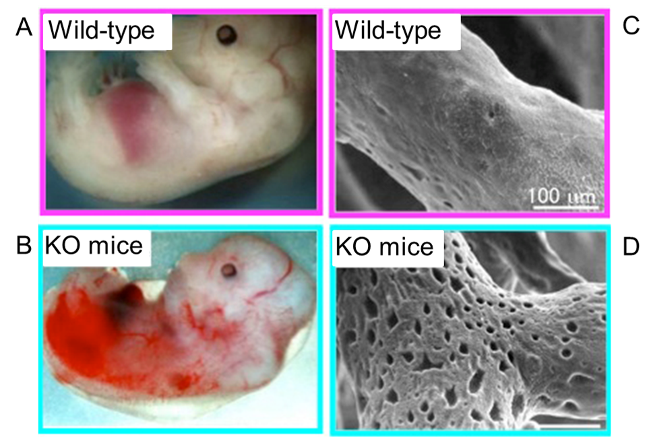
Figure 1.17: AM knockout mouse embryos on day 14, when wild-type mice are viable but AM^{-/-} die because the vascular structure is fragile (A+B). Electron microscopy of blood vessels shows many pores in AM^{-/-} mouse embryos compared with wild-type (C+D). Taken from (Shinshu University) with permission.

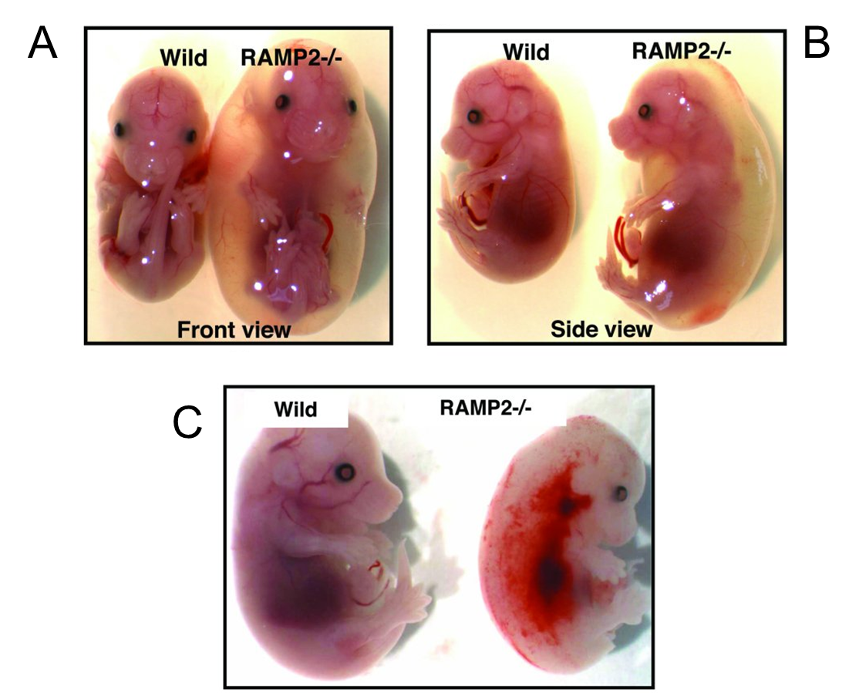

Figure 1.18: WT and RAMP2^{-/-} embryos at E13.5 days. The progression of systemic edema to Hydrops Fetalis results in the death of RAMP2 ^{-/-} mice embryos mid-gestation, which can be seen in pictures A and B. The disruption of the cardiovascular system in RAMP2^{-/-} causes hemorrhages, compared to WT, as can be seen in Figure C. Taken from (Shindo et al., 2001) with permission.

RAMP2 and AM are essential for vascular maturation and organ homeostasis. In endothelial cell–specific RAMP2 and AM knockout mice, 5% of the mice were able to live to adulthood and the rest died due to severe edema in the late stage of development. The adult mice had accelerated vascular senescence, cardiac fibrosis and severe organ fibrosis with marked oxidative stress as well as chronic organ dysfunction. In vitro analysis showed that RAMP2 deletion was responsible for the down regulation of cAMP, thereby increasing the oxidative stress. It also resulted in the down regulation of Rac1-GTP, resulting in a decrease of the cortical acting ring and the weakening of the endothelial barrier function. It was also reported that AM and RAMP2 signalling through the AM1 receptor prevents oxidative stress. The oxidative stress causing cellular senescence was supressed in the endothelial cells by overexpressing RAMP2 by AM (Koyama et al., 2013). This result suggests that RAMP2 endothelial cells can be targeted to regulate oxidative stress.
In contrast to RAMP2, RAMP3 does not play a role in the vascular development since RAMP3 knockout mice are born healthy without detectable angiogenesis or lymphangiogenesis defects (Yamauchi et al., 2014). RAMP3^{-/-} mice had thicker bone densities and less fat than the wild-type mice. Collectively, these findings indicate that AM and RAMP3 signalling through the AM2 receptor are not important for vascular system development and progression.
However, there is a study by the Lenhart et al. group which showed RAMP3 interacts with a member of GPCR called GPR30, which mediated cardioprotection. The GPR30 was enhanced by the localization of RAMP3 on the cell surface of HEK293. Also, mislocalisation of GPR30 in both normal mouse heart tissue and in heart tissue from a background of cardiovascular disease was seen in the RAMP3 ^{-/-} mice. Importantly, the cardiac hypertrophy and perivascular fibrosis was reduced when GPR30 was activated in the presence of RAMP3 in male mice. While the cardioprotective effect was eliminated in the RAMP3^{-/-}. This shows RAMP3 plays an essential role in GPR30-mediated cardioprotection (Lenhart et al., 2013).

The pathophysiological roles of Adrenomedullin
As stated in section 1.6, AM is normally secreted in the body and regulates many essential physiological functions. However, in the case of diseases and cancer, AM plays an important role in the pathogenesis and development of diseases. For example, the mean plasma level of AM in normal subjects is 8.2 pmol/l (Halawa and Mazurek, 1998). However, directly after the onset of myocardial infarction, AM level is increased higher than the normal level and is gradually decreased after the infarct event. In the early stages of myocardial infarction, there is a positive relationship between the level of plasma AM and pulmonary capillary wedge pressure, pulmonary arterial pressure, right atrial pressure and heart rate. These findings suggest that the increase of AM in plasma is associated with increasing pulmonary vascular bed pressure, the improvement of sympathetic activity, and the retention of the volume of body fluid (Kobayashi et al., 1996).
In class II congestive heart failure the plasma level of AM correlates with the severity of the disease. The normal level of AM in plasma is 2.52 ± 0.75 pmol/litre, while in class II congestive heart failure the level of AM increases to 3.54 ± 0.82 pmol/litre (Nishikimi et al., 1995, Hirayama et al., 1999). A comparison of the level of plasma AM in normotensive to hypertensive revealed that the level of plasma AM in hypertension was higher than in normotensive and this increase correlates with the severity of the hypertension (Kitamura et al., 1994a, Kato et al., 1999).
In patients with hypertension, the elevation of AM level in plasma correlates with the increasing plasma renin activity level but not with plasma aldosterone concentration which plays an important role in increasing blood pressure if it was decreased as a result of an increasing renin level. AM could be considered as a humoral factor which is able to regulate blood pressure and neutralize pressor factors which will possibly develop and induce hypertension such as aldosterone (Kita et al., 1998).
As well as in many diseases, AM is also overexpressed in most cancer types and implicated in cancer development. The development of cancer involves cell proliferation, metastasis, angiogenesis and the evasion of apoptosis. The implication of AM in these processes will be discussed in the next section.

AM and Cancer

As mentioned previously, AM is deregulated in cancer. AM does not cause cancer but has ability to stimulate growth, metastasis, and invasion and inhibits the apoptosis of cancer cells. AM is highly expressed in most cancer types such as lung (Martinez et al., 1995), breast (Martinez et al., 2002), colon (Nakayama et al., 1998), glioblastoma (Ouafik et al., 2002), prostate (Miller et al., 1996) and pancreatic cancer cells (Ramachandran et al., 2009). AM is expressed ubiquitously in the body, for example, it is expressed by endothelial cells, which makes AM extensively distributed all over the body (Hay et al., 2010). The level of AM is strongly upregulated, particularly in an environment with a low level of oxygen (Hypoxic) in several different tumours (Zudaire et al., 2003).
The ability of the immune system to attack foreign bodies such as tumours is reduced by AM. This process is achieved by decreasing the expression of pro-inflammatory cytokines and by binding to complement factor H, which inhibits the activation of the alternative complement pathway and supports the tumour cells to evade complement-mediated lysis (Pio et al., 2001).
The development of cancer involves four main processes: proliferation, metastasis, angiogenesis and evade apoptosis. The implications of AM and its receptors in these processes will be discussed in the next section.

AM and proliferation
Proliferation is the growth or division of cells and AM has the capability to increase the proliferation of cancer cells. The administration of AM increased the proliferation rate of clear-cell Renal Carcinomas (cRCC) as well as chromophobe Renal Carcinomas (chRCC). cRCC expresses CLR, RAMP2 and RAMP3 and this supports the idea that AM functions are mediated through the activation of its receptors (AM1 and AM2). The proliferation of the cRCC was inhibited by using antibodies towards CLR, RAMP2 and RAMP3, suggesting the role of the AM1 and AM2 receptors in the proliferation of cancer cells (Park et al., 2008b, Deville et al., 2009).
The ability of AM to induce tumour growth and proliferation has been shown to be inhibited by the use of anti-AM receptor antibodies (αAMRs) in a study using three different cell lines. Glioblastoma U87 cells, lung tumour A549 cells, and colon tumour HT-29 cells were shown to be sensitive to treatment. The treatment of U87 cells and HT-29 cells with αAMRs resulted in the inhibition of growth in vitro as well as in corresponding in vivo tumour xenografts. However, A549 cells were not affected by αAMRs in vitro, while the treatment of αAMRs in the corresponding tumour showed significant inhibition of the tumour in vivo. These results suggest that AM receptors can be an effective therapeutic target for cancer (Kaafarani et al., 2009).

AM and Angiogenesis
The process of forming new blood vessels from pre-existing ones is called angiogenesis, which is one of the fundamental processes for tumour growth. Tumour angiogenesis is linked to a switch in the equilibrium between positive and negative regulators. Examples of positive regulators are Vascular Endothelial Growth Factor (VEGF), basic Fibroblast Growth Factor (bFGF) and acidic fibroblast growth factor αFGF. Examples of negative regulators are thrombospondin, interferon α/β, platelet factor-4 and angiostatin. The stimulation of the blood vessels of the host by the release of specific growth factors from neoplastic cells of endothelial cells (EC) triggers the switch (Hanahan and Folkman, 1996).
The importance of AM as an angiogenic agent is clearly demonstrated in the AM^{-/-} mice where major disruption in normal angiogenesis is observed (Caron and Smithies, 2001a, Shindo et al., 2001d). The administration of a polyclonal antibody against AM into xenograft tumours in mice (U87 glioblastoma cells) reduced the density of the blood vessels (Ouafik et al., 2002, Kaafarani et al., 2009). The angiogenic potential could be regulated by AM where the angiogenesis and pleiotropic morphology of breast cancer were increased by AM. This illustrates the role of AM as a stimulator of angiogenesis (Martínez et al., 2002).
Angiogenesis can be stimulated by activating mast cells in a receptor-independent manner with AM. The angiogenic ability of AM has been demonstrated in Human Mast Cells (HMC), where angiogenic response has been induced by HMC, which are activated by AM. This activation resulted in the upregulation of VEGF, MCP-1, and bFGF which promotes angiogenesis. By using an antibody against AM (Anti-AM monoclonal antibody MoAb-G6) this response was blocked. Consequently, AM release is responsible for HMC activation which stimulates the angiogenesis in the neoplastic lesion (Zudaire et al., 2006).
AM stimulates the capillary formation in a co-culture of endothelial cells and fibroblasts where AM administration resulted in the upregulation of VEGF expression and led to the activation of the serine/threonine protein kinase, resulting in accelerated angiogenesis (Iimuro et al., 2004). The ability of AM to enhance VEGF expression and angiogenesis has been examined in vivo using AM^{-/+} mice. It was observed that there was less recovery of blood flow with less development of collateral capillary and expression of VEGF. Subcutaneous administration of AM to AM^{-/+} mice was able to induce the expression of VEGF and the activation of Akt which acts as an angiogenic factor in tumour cells. Blocking AM in AM^{+/-} mice with a competitive inhibitor (AM₂₂₋₅₂) negatively affected the development of capillary formation in tumour cells. The blood flow and capillary formation were recovered after the administration of VEGF or AM. This result demonstrates the role of AM in inducing VEGF which activates Akt, resulting in an increase in the angiogenesis of tumour capillaries (Iimuro et al., 2004).

AM and Metastasis
Metastasis is the ability of cancer to move from one part of the body to another or from one organ to another or from one tissue to another. AM has been examined to verify its ability as a pro-invasion factor in trophoblast. The human choriocarcinoma JAr cells and first-trimester cytotrophoblast HTR-8/SV neo cells expressed AM receptor components such as the mRNA of the CLR and RAMPs. The ability of cells to metastasise to another part of the body was improved by adding AM exogenously, showing that AM is a pro-invasion factor in cancer (Zhang et al., 2005).
The critical role AM plays in the metastasis of cancer can be seen in cRCC cells where two different cell lines of cRCC were incubated with an antibody against AM1 (RAMP2+CLR) and AM2 (RAMP3+CLR). Inhibition of the proliferation, migration and invasion of these cell lines was the result of blocking the activity of AM1 and AM2 receptors. These findings suggest that AM receptors could be a possible target for reducing metastasis in cRCC (Deville et al., 2009). It was also reported that the motility of ovarian cancer cells (ECV) increased after treatment with AM in comparison with saline-treated ECV cells, suggesting that AM expression increased the capability of ECV cells to metastasise (Martinez et al., 2002).
Lysyl oxidase-like-2 (LOXL-2) has the capability to strongly stimulate the invasiveness and metastasis of cancer cells (Peinado et al., 2005). RAMP3 which is part of the AM2 receptor was reported to be regulated by LOXL2. RAMP3 expression in MDA-MB-231 breast cancer cells was inhibited as a result of LOXL2 inhibition by using specific shRNA and this resulted in the inhibition of invasiveness and tumour development in vivo. The invasiveness and tumour developing ability of cancer cells were restored by re-expressing RAMP3. However, inhibiting RAMP3 in MDA-MB-231 cells by using specific shRNA did not affect the LOXL-2 expression and the invasiveness and tumour developing ability of the cancer cells were restored by re-expressing LOXL-2. This finding suggested that RAMP3 works downstream to LOXL2. RAMP3 and LOXL2 are expressed in different types of cancer such as human gastric, colon, and breast carcinomas. These findings highlighted the importance of RAMP3 in the invasiveness and metastasis of cancer cells (Brekhman et al., 2011a).

AM and apoptosis
Apoptosis is a programmed cell death where the cell, after reaching a specific state, dies. It has been reported that AM has an anti-apoptotic function in cancer cells. One of the studies that demonstrate the role of AM was done on two different human breast cancer cell lines, T47D and MCF7, which secrete low levels of AM. When T47D and MCF7 were transfected with AM, their phenotype had the ability to change when compared to the controls, which were transfected with empty vectors. The former demonstrated lower levels of pro-apoptotic proteins such as Bax and Bid in comparison to the latter. Additionally, the levels of Stat3, an anti-apoptotic protein, were increased in the AM transfected cells compared to cells transfected with empty vectors as well as many oncogene products such as Ras and Raf (Martinez et al., 2002).
In another study, the role of AM in preventing apoptosis was evaluated by using prostate cancer cells. The apoptosis in these cells was induced either by serum deprivation or treatment with the chemotherapeutic agent etoposide (Abasolo et al., 2006). In this experiment, three different prostate cancer cell lines, PC-3, DU145 and LNCaP, were transfected with a vector containing AM in vitro. The apoptosis of the DU145 and PC-3 cells was prevented by AM after serum deprivation but not in the LNCaP cells. Whereas after treating the three cell lines with etoposide, AM prevented the apoptosis in the PC-3 and LNCaP cells but not in the DU145 cells. These findings suggest that AM works as a protective hormone by inhibiting the apoptosis of cancer cells. Moreover, in parental PC-3 cells the levels of phosphorylated ERK1/2 increased after etoposide treatment, while the PC-3 cells transfected with the AM gene were not affected by the etoposide treatment, resulting in plateau levels of phosphorylated ERK1/2 (Abasolo et al., 2006) despite the fact that the levels of phosphorylated ERK1/2 in the PC-3 cells transfected with AM were lower than the basal levels of the parental PC-3 cells before the etoposide treatment. This illustrates that the cells overexpressing AM are more resistant to the gene toxicity caused by etoposide, while the cleaving of PARP in the parental PC3 cells was increased significantly. However, a mild increase in fragmented PARP was demonstrated in etoposide-treated AM overexpressing PC-3 clones. This elucidates that AM prevented the cells from repairing gene mutation and undergoing apoptosis. The etoposide treatment for parental or mock-transfected PC-3 reduced the Bcl-2/Bax ratio. In contrast with the PC-3 clones with AM overexpression treated with etoposide, there was no reduction in the Bcl-2/Bax ratio. These results showed that using AM can prevent apoptosis as well as the ability of AM to interfere with and inhibit the functions of chemotherapeutic agents (Figure 1.19) (Abasolo et al., 2006).
One of the common features of solid tumours is the presence of hypoxic regions. The ability of AM to prevent apoptosis of the cells in these hypoxic regions was studied (Oehler et al., 2001). After transfecting vectors containing AM to Ishikawa cells, an increase in the cells’ resistance against hypoxia-induced apoptosis was noticed. The transfection of AM into these cells also resulted in the upregulation of the oncoprotein Bcl-2 which prevented the same Ishikawa cells from hypoxic death. Rescuing malignant cells from hypoxia has been achieved by AM with the consecutive upregulation of Bcl-2. Interestingly, the nonsteroidal antiestrogen tamoxifen (TAM) upregulates AM. This implicates that this peptide is a stimulator of tumour growth and a promising target for anticancer strategies (Oehler et al., 2001).

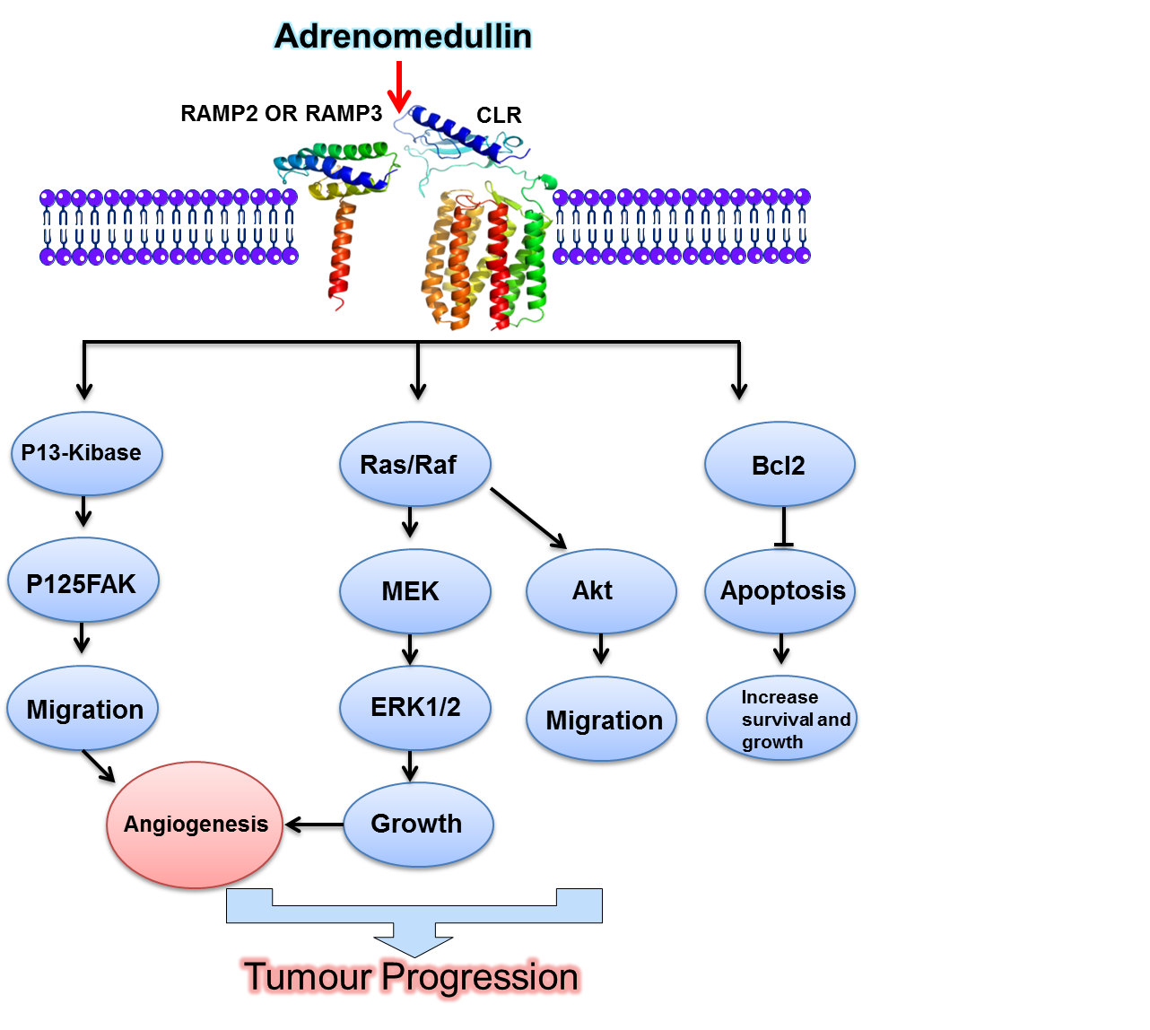
Figure 1.19: The role of AM in tumour development. AM binds either to AM1 (RAMP2+CLR) or AM2 (RAMP3+CLR) which results in the activation of different signalling pathways. The angiogenesis will be activated through P13-Kinase or Ras/Raf MEK/ERK1/2 or Akt, while AM will upregulate Bcl2, resulting in the evasion of apoptosis of tumour cells leading to an increase in survival and the growth of tumour cells.

AM and prostate cancer
Prostate cancer was one of the most common causes of cancer death in 2011 in the UK according to Cancer Research UK. The standard prostate cancer treatment is hormone therapy, which is also called standard androgen-deprivation therapy. This treatment has indicated that it diminishes tumour size, decreases the pain associated with bone metastases, and extends survival. The effect of the hormonal therapy may vary from patient to patient. In some patients, this could result in a reduction in the progression of the disease (prostate cancer), while in others it may keep the cancer under control for two months (Sharifi et al., 2005). In the end, prostate cancer cells start to resist the treatment. At this point, the cancer is classified as androgen-independent prostate cancer (AIPC) or hormone-refractory prostate cancer, meaning that the cancer is still able to grow and proliferate despite the hormone treatment (Feldman and Feldman, 2001). Although the localized prostate tumour can be treated and cured successfully, androgen independent metastatic prostate cancer has no available treatment and carries a hopeless prognosis. Microarray analysis of molecular mechanisms involved in the growth of androgen independent metastatic prostate cancer cells suggested that the growth factors involved in cell interactions could play a role in the growth of tumour cells after the withdrawal of the androgen. One of these growth factors was AM.

The effect of AM on the proliferation of two human prostate cancer cell lines (PC-3 and DU-145) was investigated. PC-3 expressed CLR, RAMP1 and RAMP2, while DU-145 expressed CLR, RAMP1, RAMP2 and RAMP3. The proliferation of PC-3 was not affected by the AM exogenous addition, but the proliferation of DU-145 was increased significantly. The effect of AM was not only seen in the proliferation but also the apoptosis rate of DU-145 cells was decreased. These effects were neutralised by two different antagonists for AM receptors, CGRP₈₋₃₇ and AM₂₂₋₅₂. The CGRP₈₋₃₇ is more selective for the AM2 receptor than for the AM1 receptor. The result shows that the basal growth of DU-145 was decreased slowly but significantly by inhibiting the proliferation and inducing apoptosis as a result of the addition of both antagonists. However, the CGRP₈₋₃₇ was more effective than AM₂₂₋₅₂. Collectively, these findings suggest that the endogenous AM system plays an important autocrine-paracrine role in the growth of human prostate cancer and the AM signalling in the prostate cancer is mainly mediated by the AM2 receptor (RAMP3+CLR) (Mazzocchi et al., 2004).
AM acts as an anti-apoptotic and protective factor for PC-3 and LNCaP, but not for DU145 cells after serum deprivation and the induction of apoptosis with a cytotoxic anti-cancer drug called etoposide (Abasolo et al., 2006a). In prostate carcinomas, the PAM enzyme that converts immature AM to mature AM was upregulated, suggesting biologically active AM may play a role in prostate carcinoma progression (Calvo et al., 2002).
Interleukin-13 (IL-13) Receptor alpha2 (IL-13Rα2) is a subunit of Interleukin-13 (IL-13). IL-13α2 is a tumour antigen and cytokine which controls immunity and is overexpressed in many solid tumours such as breast, lung, glioma and ovarian cancers (Joshi et al., 2000, Debinski et al., 1999). The treatment of PC-3 cells with AM upregulated the expression of IL-13 α2 in vitro and in vivo, suggesting that AM plays a role in the development of prostate cancer (Joshi et al., 2008). More than 100 genes were upregulated as a result of overexpressing AM in PC-3. Those genes are involved in the cellular transcription, adhesion, apoptosis, immune function, extracellular matrix and cell cycle (Gonzalez‐Moreno et al., 2005).

Background to Project

Adrenomedullin is overexpressed at a high level in around 80% of cancers through various mechanisms (Cuttitta et al., 2002). This high level of AM suggests it is a potentially important therapeutic target. However, AM plays important roles in physiological processes such as in the regulation of blood pressure, angiogenesis, embryogenesis and vascular system development. This can be seen clearly in studies where the systemic administration of AM₂₂₋₅₂ (a truncated peptide antagonist) causes a profound increase in blood pressure (Ren et al., 2006, Juhl et al., 2006). The development role of AM is illustrated in AM^{-/-} mouse embryos where they die mid-gestation due to a condition called hydropsy fetalis. This suggests that a systemic blockade of AM signalling is not a viable therapeutic option. Therefore, AM signalling can be disturbed either by a local blockade of the hormone within tumours or by discriminating between the physiological and pathological roles of AM. AM binds to two variants of the orphan Calcitonin-like receptor (CLR) and one of two receptor activity modifying proteins (RAMPs). AM1 receptor (CLR+RAMP2) components are as important as AM itself, where CLR^{-/-} and RAMP2^{-/-} mice have the same phenotype of AM^{-/-} and die mid-gestation (Figure 1.20). However, RAMP3^{-/-} mice live to old age without major cardiovascular system defects. This indicates that a blockade of RAMP3 could offer a target to disturb some AM signalling in cancer without serious side effects (Figure 1.21). The studies performed in this thesis investigate that possibility.

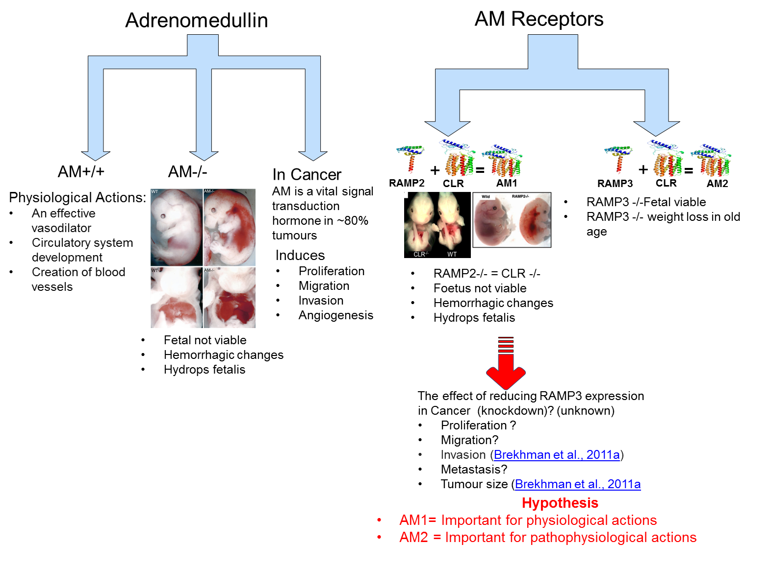
Figure 1.20: Overview of the importance of AM and its receptor in the body.

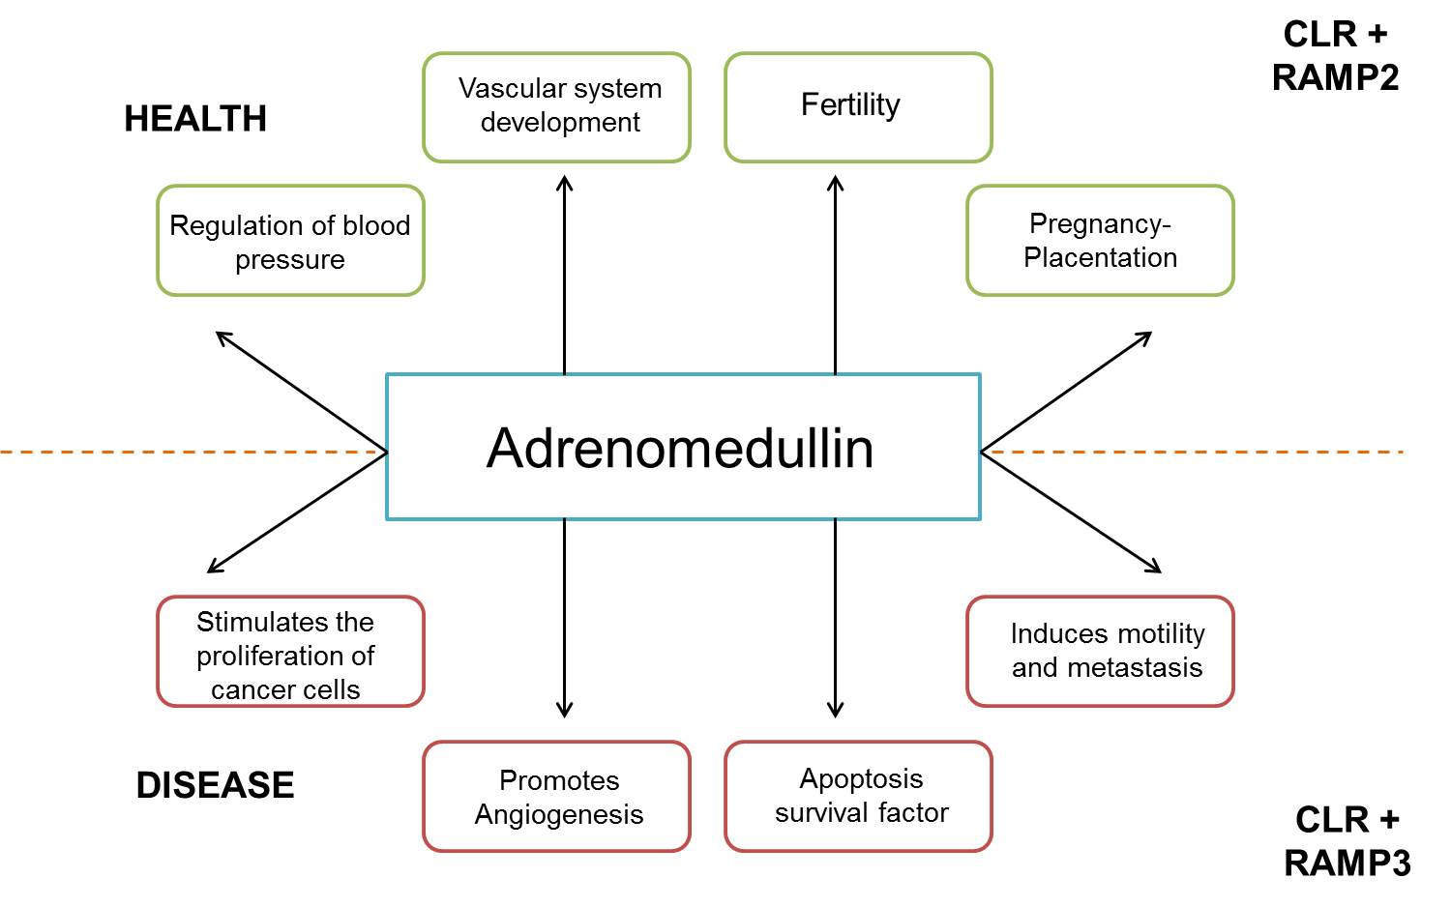
Figure 1.21: The role of the AM1 receptor and the AM2 receptor in health and disease. Original sketch by Dr. Gareth Richards.

Hypothesis and Aims of the Project

It was hypothesised that,
RAMP3 plays an essential role in cancer progression as a result of its role in:
- Communication between cells within the tumour via AM2 receptors (CLR+RAMP3) in tumours
And
- Communication between the tumour and local host cells by AM2 receptors (CLR+RAMP3) in the host
In order to test the hypothesis, three different sub-hypotheses are proposed.
They are,
- The prostate cancer cell line BMA178-2 which is syngeneic to RAMP3^{-/-} SvEv129 mice, expresses RAMP3 at gene and protein level.
- The knockdown of RAMP3 reduces proliferation, migration, invasion, colony formation, cAMP production by BMA 178-2 cells and increases the sensitivity of the cells to an anti-cancer drug in vitro.
- Tumours formed as a result of injecting RAMP3 knockdown cells into wild-type and RAMP3 ^{-/-} mice are smaller in size and number than the wild-type cells injected into wild-type and RAMP3 ^{-/-} mice.

CHAPTER 2: GENERAL MATERIALS AND METHODS

Cell lines

Disposable equipment
Items | Supplier
Stripipettes (5ml, 10ml, and 25ml) | Costar
Pipette tips (10ul, 20ul, 200ul, 1000ul) | Costar
Flasks (T25, T75, T175) | Thermo scientific
Multi well plates (6, 12, 24, 48, 96 wells) | Corning Costar
Eppendorph tubes (0.5 ml, 1.5 ml) | Sarstedt
Tubes (5 ml, 15 ml, 25 ml, 50 ml) | BD Falcon
Cell scraper | Sarstedt
Materials used in the experiment

Tissue culture materials and media
Items | Supplier
70% Industrial methylated spirits | Fisher Scientific
Phosphate buffered saline (PBS) | Gibco®
DMEM (Private +) | Gibco® 31966-021
Penicillin/Streptomycin | Sigma Aldrich
HEPES | Fisher Scientific
Foetal calf serum | Gibco®
DMSO | Invitrogen
Trypsin/EDTA | Sigma Aldrich
Haemocytometer
Nalgene Cryofreeze | Nalgene Nunc Ltd.
Cryovial | Nalgene Nunc Ltd.
TITAN SANITIZER | Diversey
Materials used in the experiment

Prostate cancer cell line
The BMA178-2 cell line was obtained from Dr Timothy C. Thompson from the University of Texas MD Anderson Cancer Centre. The mouse prostate cancer cell line 178-2 BMA was from a bone metastasis derived from a primary carcinoma arising within Zipras/myc-infected urogenital sinus tissue obtained from p53 heterozygous 129S6/SvEv mice using the metastatic mouse prostate reconstitution (MPR) model system (Tahir et al., 2001).

Cell lines maintenance and sub culturing
Cell lines were maintained in T175 flasks in a sterile environment and kept in incubators at 37°C and 5% CO2. Cells were grown in Dulbecco's Modified Eagle Medium (DMEM) with high glucose and sodium pyruvate contents and 10% Foetal Calf Serum (FCS), 1% HEPES and 1% penicillin/streptomycin (P/S). The cells were harvested by trypsinization, when the flasks were 80%-90% confluent and passaged into new flasks with fresh medium. The cells were split into different ratios to get them ready for the assay on the same day of the experiment, which follows Table 2.1. An inverted phase contrast microscope was used in order to check the confluency and phenotype of the cells. Mycoplasma tests were regularly performed on the BMA178-2 cell line to rule out any danger of contamination of the cell line by mycoplasma using the Venor GeM system.
Table 2.1: Splitting ratio and the number of days to get 70%-80% confluency.
Ratio | Number of days to get 70-80% confluency
1:2 | 1-2 days
1:5 | 2-4 days
1:10 | 4-6 days

Cell harvesting

Trypsinisation
The subculturing of cells needs to use a trypsinisation step which makes the cells detach from the flasks’ surface to either resubculture them again or to use them in an assay. The amount of trypsin depends on the surface area and the amount of trypsin needed can be seen in Table 2.2. After the flask was removed from the incubator the media was discarded in the waste pot which contained TITAN SANITIZER. The flasks were washed twice with PBS and the trypsin was added according to the table and the flasks were placed in the incubator for 5 min to activate the trypsin. The flasks were removed from the incubator and the 5-10 ml of media was added to the flasks to deactivate the trypsin. The detachment of the cell from the cell surface was assessed using inverted phase microscope observation.
Table 2.2: Volumes of trypsin, media and PBS needed in harvesting cells.
Trypsinisation |  | 175cm ² Flask | 75cm ² Flask | 25cm ² Flask
PBS washing (2X) | PBS | 15 ml | 10 ml | 5 ml
Trypsin detachment | Trypsin | 10 ml | 5 ml | 1 ml
Neutralization | Standard media | 10 ml | 5 ml | 1 ml

Thawing and freezing cell lines
The regular freezing of cell lines is not only used for long-term storage but also done to reduce the cells’ evolution and adaption to the experimental conditions after elongated cultures.

Freezing cells
The freezing down medium was prepared by adding 10% DMSO (Dimethyl sulfoxide) to FCS. The cells were trypsinized and kept in the incubator at 37°C to complete the trypsinsation. The flasks were removed from the incubator and 5-10 ml of media was added to each flask. The cells were removed from the flasks and added to a 15ml tube to spin them down at 1500 rpm for 5 minutes to remove the trypsin and media. The cell pellet was resuspended in the freezing media at the concentration of 1X10⁶/ml. The cells were added to cryovial and placed into Nalgene Cryofreeze and transferred to an -80 °C freezer overnight followed by permanent storage in liquid nitrogen.

Cell counting
Items | Supplier
Haemocytometer
The Vi-CELL Cell Viability Analyzer (731050) | Beckman Coulter
Trypan blue (0.4%) | Sigma Aldrich
Gilson pipette tips | Gilson
Materials used in the experiment

The cells were counted using two different methods once the cells were trypsinized. The first method was the improved Neubauer Haemocytometer and the second was the Beckman Vi- cell coulter counter which provides an Automated Cell Viability Analysis. The haemocytometer requires (10 μL) of the cell suspension and is quick and easy to use. However, when the numbers of samples increase, it is time consuming to use this method and reducing human intervention and error become very important elements necessitating the use of an automated analysis machine with high accuracy and precision. The Vi-cell coulter counter requires 500 μL of the cell suspension and it has a high precision and accuracy to count the viable cells within no longer than 2 min.

Haemocytometer
In order to use the haemocytometer the following steps were carried out:
The haemocytometer preparation:
The haemocytometer was cleaned using 75% ethanol and left to air dry. The cover slip was placed on top of the haemocytometer with a little bit of pressure and circular motion to fix the cover slip.
Cell suspension preparation:
The cell suspension was mixed well to avoid cell aggregation. 100ul of cell suspension was mixed well with 100ul of trypan blue for the viability test (1:1 dilution).
Counting:
Gently 10ul of the cell suspension containing trypan blue was dispensed by using a Gilson pipette in the haemocytometer. The cells unstained with blue (healthy cells) were counted, while cells stained with blue were not counted in the four green corners in the figure (Figure 2.1). However, the cells stained with blue can be counted for the percentage of viable cells. The total viable cells were obtained using the following equation:
Total viable cells/ml= Average cells per square X dilution factor X 10⁴
Percentage of viable cells (%) = Viable cells (unstained cells) X 100 / Total cells (stained cells + unstained cells)
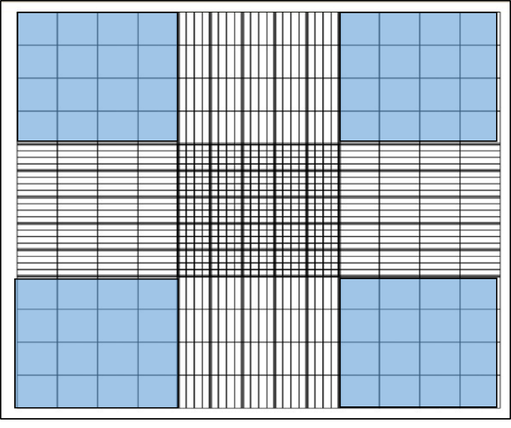
Figure 2.1: Haemocytometer and the highlighted four squares indicating the area which should be used for counting the cells.

Cell counting using the Vi-cell coulter counter
The Vi-cell counter is an automated method to count cells in a suspension according to the size and the number as well as the viability of the cells by using trypan blue. The machine requires 0.5 ml of the cell suspension and takes 2.5 min to analyse each sample. The outcome contains the number of total cells, viable cells and the size of the counted cells.

Proliferation assay using cells counting
Items | Supplier
DMEM (Private +) | Gibco®
Phosphate buffered saline (PBS) | Gibco®
Penicillin/Streptomycin | Sigma Aldrich
HEPES | Fisher Scientific
The Vi-CELL Cell Viability Analyzer (731050) | Beckman Coulter
Foetal calf serum | Gibco®
Materials used in the experiment
The proliferation assay was used to determine the doubling time of the cells as well as their responses to serum titration and different treatments. All the proliferation assays were performed in the same atmosphere - 37ºC in 5% CO₂.

Proliferation assay with serum titration
Using trypsin, BMA178-2 cells were harvested from an 80% confluent flask. The cells were spun down by centrifuging at 300 xg for 5 minutes. Then, the cells were resuspended in serum free DMEM media and counted using a haemocytometer, as described in 2.1.3.4.1. 1X10⁴ cells /ml suspension was created in DMEM containing 10% of FCS. Cells were seeded 1 mL/well in 12-well plates (3plates/FCS concentration were intended to be used) and left to grow for 48 hours to allow cells to settle down and recover after trypsinization for 48 hours. Then, the media in the 12 well plates were discarded and the cells were washed twice with PBS. Each wash was for 2 minutes. Media (DMEM) containing different concentrations of 0%, 1%, 2%, 5% or 10% of FCS were added to each plate. There were three plates for each concentration and they were placed in the incubator. Three wells per FCS concentration were counted every day for 11 days using a Vi-cells coulter counter. Data was analysed and the parameters of the growth curve and cell population and statistical analyses were carried out using GraphPad Prism5 software.

Proliferation assay with AM stimulation
The same procedure as in 2.2.1 was followed. However, 48 hours after the cells was incubated in 10% FCS, the media was removed and replaced with new fresh media with 4% FCS, which contained the concentration of AM needed. The media was replaced every 12 hours with the specific concentration of AM for 72 hours (Andreis et al., 2000, Cornish et al., 1997). The concentrations of AM used were 1µM, 1nM and 1pM.

Proliferation assay with AM ₂₂₋₅₂ inhibition
The same procedure as in 2.2.1 was followed, but instead of using AM, AM₂₂₋₅₂ (1µM, 1nM and 1pM) was used in the same concentration as AM (Drimal et al., 2005).

Proliferation assay using Vybrant® DiD cell labelling solution
Items | Supplier
DMEM (Private +) | Gibco®
Phosphate buffered saline (PBS) | Gibco®
Penicillin/Streptomycin | Sigma Aldrich
HEPES | Fisher Scientific
The Vi-CELL Cell Viability Analyzer (731050) | Beckman Coulter
Foetal calf serum | Gibco®
Vybrant® DiD | Life Technologies
BD Falcon tubes and Bijoux (5, 15, 25, 50mL) | Sarstedt
BD FACS calibur | BD Biosciences (San, Jose, USA)
Materials used in the experiment

A Vybrant® DiD cell labelling solution was used to label cells with a dye in order to differentiate between cells type according to doubling time, as well as to visualise any subpopulation of cells inside the cell line itself. After labelling the cells, the density of the dye was measured with Fluorescence-activated cell sorting (FACS). The density of the dye was reduced as a result of cell division, thus the doubling time of different cell types was determined and if any subpopulation present was observed. The T175 flask from each cell type was used. The media from the flasks were discarded and the flasks were washed twice with PBS. The cells were trypsinized and transferred to a 25 ml BD Falcon tube to spin them down at 300 xg for 5 min. The pellet was resuspended in serum free media and the cells were counted using the Vi-CELL Cell Viability Analyzer to make the final concentration of 1x10⁶ cells/ml. 5ul of DiD was added per 1x10⁶ cells/ml and light was avoided by wrapping the tube with foil and the tube was placed in the incubator at 37ºC in 5% CO₂ for 20 min to allow the dye solution to label the cells. The cells were removed from the incubator and centrifuged at 300xg for 5 min. The pellet was washed three times with 5ml serum free media to get rid of the excess cell labelling dye and in the final wash the cells were counted using the Vi-CELL Cell Viability Analyzer to create 1x10⁵ cells/ml suspension in standard media. 1x10⁵ cells were seeded into 5 T25 flasks in 6ml of standard media. The cells were cultured for 24 days and the percentage of cells labelled with DiD was assessed using BD FACS calibur flow cytometry at time points 0, 3, 7, 10, 14 and 17 days. Cells were kept at a high density by following the procedure in Table 2.3.

Table 2.3: DID dye procedure for 17 days
Day | Procedure
0 | Cell stain 5x T25 flasks set-up, FACS Calibur analysis.
3 | 1x T25 flask was analysed with FACS Calibur.
7 | 1x T25 was analysed with FACS Calibur, 3x flasks of T25 were transferred to 3x T75 flasks.
10 | 1x T75 flask was analysed with FACS Calibur, 2 flasks of T75 were transferred to 3x T125 flasks.
14 | FACS Calibur analysis of 1x T125 flask, the remaining T125 flask was split 1in3.
17 | FACS Calibur analysis 1x T125.

Wound healing assay/Scratch test
Items | Supplier
DMEM (Private +) | Gibco®
Phosphate buffered saline (PBS) | Gibco®
Penicillin/Streptomycin | Sigma Aldrich
HEPES | Fisher Scientific
Foetal calf serum | Gibco®
200 ul pipette tips | Costar
Mitomycin C | Sigma Aldrich
1% crystal violet | Sigma Aldrich
Ice cold methanol | Fisher Scientific
Materials used in the experiment

The assay was used to measure the ability of the cells to migrate to close a scratch made intentionally using a hard substance. Such ability differs from one cell type to another depending on their motility.
In 12 well plate 0.5 X 10⁶ cells/wells were seeded in quadruplicate for each cell type with fresh warm media and left until the wells became 80-90% confluent. Once the wells became confluent, the media were removed and the wells were washed twice with PBS very carefully and incubated with 10µg/ml mitomycin C in warm serum free media for 1 hour, which works as an effective DNA cross linker to stop the cells from closing the scratch by proliferation rather than migration. Then, the scratch was made for each well using a 200µl pipette tip, and each time the scratch tip was replaced with a new one to retain the consistency of the scratch in all wells. The cells were washed twice with PBS gently without tearing up the monolayer of cells to remove any cell debris left after making the scratch and warm media was added to each well. The cells were incubated in the incubator at 37ºC in a 5% CO₂ atmosphere. At each time point the plate was removed from the incubator. Then, the cells were fixed using ice cold methanol for 5 min followed by washing the wells with PBS twice and the cells were stained with 1% crystal violet for 5 min. The wells were washed twice with water to get rid of the excess stain and left to air dry. The pictures of the wells were taken at 10x magnification by the Leica DMB4000B microscope using Leica Application Suite V3 software. The area of the scratch was measured using Tscratch software. The time point 0 h was considered as 100% and when the area was fully closed the area was considered as 0%.

Wound healing assay with AM stimulation

The assay was performed as mentioned in 2.4. After the cells were incubated with Mitomycin C, the cells were stimulated with three different doses of AM which are 1µM, 1nM and 1pM every 12 hours for 72 hours.
The concentrations were made in 1ml of fresh media every 12 hours.

Wound healing assay with AM₂₂₋₅₂

In order to examine the effect of the antagonist (AM₂₂₋₅₂) to inhibit the migration ability of BMA178-2 cells, three different doses of AM₂₂₋₅₂ were used (1µM, 1nM and 1 pM). 1 ml of the media containing the specific concentration of the antagonist was added to each well every 72 hours.

Invasion assay
Items | Supplier
DMEM (Private +) | DEMEM (Purivate +)
The Vi-CELL Cell Viability Analyzer (731050) | Beckman Coulter
Trypan blue (0.4%) | Sigma Aldrich
Phosphate buffered saline (PBS) | Gibco®
Penicillin/Streptomycin | Sigma Aldrich
HEPES | Fisher Scientific
Foetal calf serum | Gibco®
Invasion chamber plate | Cell bio lab
Cell Stain Solution | Cell bio lab
Extraction Solution | Cell bio lab
Cotton Swabs | Cell bio lab
Forceps | Cell bio lab
Plate reader | Spectramax MSC MVE 02012
Materials used in the experiment

The capability of cancer cells to invade the surrounding tissue and organs contributes hugely to morbidity and mortality cases in cancer. The invasiveness involves many cellular functions including motility and secreting different proteases which degrade proteins as part of their function. The invasion assay designed to examine the ability of the cell line of interest to invade the basement membrane that is made of matrix of proteins.
At room temperature and under sterile conditions the invasion chamber plates were opened and left to warm up for 10 min. 300µl of serum free warm media was used to rehydrate the basement membrane of the invasion chamber and was incubated at room temperature for 1 hour. Meanwhile, the T175 flask containing BMA178 cells serum starved for 24 hours was used in the assay. The media was discarded and the flasks were washed twice with PBS and trypsinized. The media was added to the trypsin to neutralize its effect and the cell suspension was transferred into centrifuge tubes. The cell suspension was centrifuged at 1000rpm for 5 min and the media was discarded. The pellet was resuspended in fresh serum free warm media and the cell suspension was counted using a haemocytometer. The rehydration medium was removed from the insert without disrupting the basement membrane. At the lower well of the invasion plate, 500µl of serum free media was added to the control well and 500ul of media containing 10% FCS was added to the sample well. Then, 300µl of 0.5 X10⁶ cells suspension was added to each insert and the plate was incubated for 48 hours in the incubator at 37ºC in a 5% CO₂ atmosphere. At specific time points the non-invasive cells in the insert wells containing the basement membrane were removed using cotton swabs. The inserts were put in a clean well containing 400ul of the cell stain solution to stain the invaded cells for 10 min followed by washing the inserts several times with water and then left to air dry (Figure 2.2). In order to quantify the number of cells invaded, each insert was transferred to a clean well containing 200µl extraction solution to remove the stained invaded cells and then the inserts were incubated for 10 min in an orbital shaker. Two different quantification methods were carried out. The first one using 100ul of the extraction solution containing invaded cells from the basement membrane was transferred to a 96-well microtiter plate to measure their optical density at 560nm using a plate reader. The second method counted the invaded cells using the haemocytometer from the extraction solution.

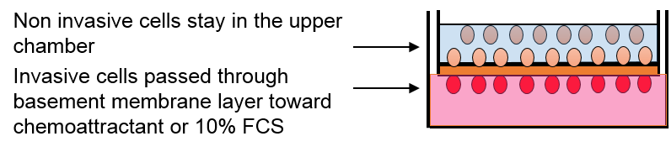

Figure 2.2: The diagram illustrates the principle of the invasion assay.

Clonogenic Assays (monolayer Clonogenic assay)
Items | Supplier
DMEM (Private +) | DEMEM (Purivate +)
The Vi-CELL Cell Viability Analyzer (731050) | Beckman coulter
Trypan blue (0.4%) | Sigma Aldrich
Phosphate buffered saline (PBS) | Gibco®
Penicillin/Streptomycin | Sigma Aldrich
HEPES | Fisher Scientific
Foetal calf serum | Gibco®
60mm² Petri dishes | Corning Costar
Methanol | Fisher Scientific
Giemsa (VWR 350 864X) | Sigma Aldrich
BioCount Colony Counter | Parrett
GeneTool | SynGene
Materials used in the experiment

The clonogenic assay is an assay used to measure the ability of a cell to form a colony, which is defined as a group of cells containing at least 50 cells. In severe conditions it is summed up by growing 1000 cells in 60mm² Petri dishes for a period of time. The ability of a cancer cell line to form colonies under such a condition can be correlated with its malignancy and ability to form a tumour in vivo.
The media was removed carefully from a T75 flask containing BMA 178 cells. The flask was washed twice with PBS to wash away dead cells and the cells were trypsinized and 10 ml of media was added to neutralize the effect of the trypsin. The cell suspension was transferred to centrifuge tubes and spun down at 300 xg for 5 min. The supernatant was removed and the pellet was resuspended in fresh media and counted using a haemocytometer. 1000 cells/ml were added to 60 mm² petri dishes containing 5 ml of fresh warm media and left in the incubator at 37°C and 5% CO₂ for two weeks. On day 14, the petri dishes were removed from the incubator and the media was discarded carefully followed by washing each petri dish with 2 ml of PBS without touching the inner side of the dish. Then, the petri dishes were left to air dry for 5 min and 2ml of 100% methanol was used to fix the colonies for 5 min and to air the methanol for another 5 min. The colonies were stained with 1 ml of Giemsa solution for 2 min and afterwards the petri dishes were washed with water to get rid of the excess staining and left to air dry completely before being prepared for counting (Figure 2.3). The colonies were counted by taking pictures of them using the BioCount Colony Counter and counting the number of colonies as well as the area of each colony per dish using GeneTool software.

Figure 2.3: The steps of the Clonogenic assay.

Cell toxicity assay
Items | Supplier
5-Fluorouracil (F6627-1G ) | Sigma Aldrich
Phosphate Buffered Saline (PBS) | Gibco®
DMEM (Private +) | Gibco®
Phosphate buffered saline (PBS) | Gibco®
Penicillin/Streptomycin | Sigma Aldrich
HEPES | Fisher Scientific
The Vi-CELL Cell Viability Analyzer (731050) | Beckman Coulter
Foetal calf serum | Gibco®
Flasks (T25) | Thermo scientific
Materials used in the experiment

The cell toxicity assay was used to test the modifications that might have occurred in the sensitivity of cells against the anti-cancer drug, as a result of knocking down RAMP3. 2X10⁵ cells/ml were seeded in T25 Flasks in 5 ml of Dulbecco's Modified Eagle Medium (DMEM) with high glucose and sodium pyruvate contents and 10% Foetal Calf Serum (FCS) (Zhang et al., 2010, Kalinina et al., 2010), 1% HEPES and 1% penicillin/streptomycin (P/S). The cells were incubated at 37ºC in 5% CO₂ for 24 hours. On the second day, serial concentration of 5-Fluorouracil (5-FU) was created in PBS prior to being added to complete media with 10% FCS. The final concentrations of 5-FU were 10 fg/ml, 100 fg/ml, 1pg/ml, 10 pg/ml, 100 pg/ml, 1 ng/ml, 10 ng/ml, 100 ng/ml and 1µg/ml. The medium was replaced by the drug containing medium for 72 hours (Zhang et al., 2010, Kalinina et al., 2010). The number of live and dead cells was counted using the Vi-CELL Cell Viability Analyzer following the protocol in section 2.1.3.4. Each experiment was performed in triplicate.

cAMP assay
Items | Supplier
HBSS(w/Ca, Mg) | Fisher Scientific
HEPES 1M | Gibco®
Perkin Elmer BSA solution (7.5%) | Perkin Elmer
IBMX (3-Isobutyl-1-Methylxanthine) | Sigma Aldrich
Forskolin | Sigma Aldrich
Concentrated Sodium Hydroxide | Fisher Scientific
Perkin Elmer OptiPlate-384 white | Perkin Elmer
Time resolved FRET compatible plate reader | Spectramax MSC MVE 02012
Water bath | -
Centrifuge | Eppendorf centrifuge 5804R
1.5mL tubes (peptide compatible low retention and normal Eppendorf) | Fisher Scientific
Perkin Elmer Lance cAMP Assay kit | Perkin Elmer
Materials used in the experiment

Adrenomedullin (AM 1-52) was defrosted on ice before the assay started. The stimulation buffer was created by adding 14mL HBSS, 75μL 1M HEPES, 200μL 7.5% BSA and 100μL IBMX (250mM in DMSO) at the final concentration of 0.5mmolL⁻¹. The pH was modified to be pH 7.4 using Sodium Hydroxide and HBSS was used to make the total volume 15 ml. The agonist, AM was made up four times concentrated in the stimulation buffer. 3µl of the AM was pipetted into the bottom corner of the well, see Figure 2.4. Three controls were used in the assay:the positive control forskolin which was made at the final concentration of 10⁻⁵ M in the stimulation buffer, the negative control which was just a stimulation buffer and AM which was made at maximum stimulation at a final concentration of 40nM in stimulation buffer. The plate was spun down in a centrifuge at 300g for 3 min; meanwhile the cells were prepared to be added to the plate. In this assay 750,00 cells were used per cell type in 30µl of warmed stimulation buffer to give 2,500 cells/6µl. Alexa Fluor® was added in 1:100 dilution to the cell suspension. 6µl of the cell suspension with Alexa Fluor® was dispensed into each well, see Figure 2.4. The plate was covered with aluminium foil and spun down at 300 xg for 5 min and incubated at room temperature for 30 min. Then, the detection mix was created by adding 1μL Europium-w8044-chelate (Eu-SA) to 16μL of the detection buffer and 1μL biotin cAMP to 4μL of the detection buffer was added in a separate tube. Afterwards, 5μL of Eu-Sa dilution was added to 615μL of the detection buffer as well as 5μL biotin of the cAMP solution. The tube was mixed well and incubated in the dark for 20 min. 12µl of the detection mix was pipetted into each well and the plate was spun down for 3 min at 300g and incubated in the dark and after the plate was covered with aluminium foil for 1 hour. The plate was read at 665nm using the TR FRET compatible plate reader.

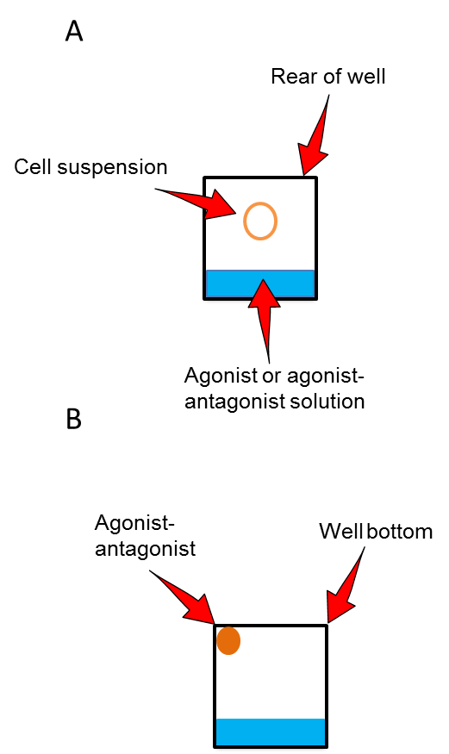

Figure 2.4: The correct dispensing of A) the cell suspension and B) Agonist/ Antagonist

Molecular Biology techniques

Trizol RNA extraction
Items | Supplier
TRI Reagent ® | Sigma Aldrich
Chloroform | Sigma Aldrich
Iso propanol | Sigma Aldrich
Ethanol | Sigma Aldrich
Diethylpyrocarbonate (DEPC) treated water | Ambion
NanoDrop-1000 Spectrophotometer | Thermo-Fisher
Materials used in the experiment

A Trizol reagent (Sigma Aldrich) was used to perform the RNA extraction procedure on the cells. A T75 flask at 70-80% confluency was washed twice with PBS to get rid of the dead cells. 5 ml of trypsin according to the trypsinization section was added to the cells to detach them from the flask surface and the flask was incubated for 5 min at 37ºC in 5% CO₂. 5 ml of standard media was added to the flask to neutralize the trypsin effect. Then the cells were centrifuged at 300 xg for 5 min and the media was removed. 1ml of the Trizol reagent was added to each 5-10 X 10⁶ cells and incubated for 5 minutes at room temperature. 0.5ml of chloroform was added and the tubes were shaken vigorously for 15 sec and incubated for 2-5 minutes at room temperature. The mixture was centrifuged at 12,000 xg for 15 min at 4˚C. Three phases were obtained, a lower phase with red colour, an interphase and an aqueous phase containing RNA. The aqueous phase was removed by pipetting the solution out and it was transferred into a sterile RNase free tube. 0.5ml of isopropanol was added (Per 1 ml of Trizol) and the samples were incubated at room temperature for 5-10 min followed by centrifugation at 12,000 xg for 8 minutes at 4˚C. RNA was precipitated at the bottom of the tube. After removal of the supernatant, 1 ml of (75%) ethanol was added to the tube. The sample was vortexed and then centrifuged at 7,500xg for 5 min at 4 ˚C. The supernatant was removed and the precipitated RNA was left to air dry for 5-10 min. The RNA pellet was resuspended in Diethylpyrocarbonate (DEPC) treated water to prevent any RNase activity. The RNA was quantified and the quality was checked using a Nanodrop Spectrophotometer.

DNase treatment

Items | Supplier
TURBO™ DNase (2 Units/µL) | Ambion
10✕ TURBO DNase Buffer | Ambion
DNase Inactivation Reagent | Ambion
Nuclease free water | Ambion
Materials used in the experiment

A DNase enzyme was used to eliminate genomic DNA contamination from the RNA sample. 50µl RNA was mixed with 0.1 volume of 10X TURBO DNase buffer and 2 units of TURBO DNase in a 0.5 ml clean autoclaved tube. The enzyme was activated by incubating the mixture for 20-30 min at 37˚C. The reaction was stopped by adding 0.1 volume of DNase inactivation reagent to the mixture and was mixed well. The tube was incubated for 5 min at room temperature and the mixture was centrifuged at 10,000 xg for 1.5 min at 4˚C and the supernatant was transferred to a clean tube.

Complementary DNA (cDNA) synthesis
Items | Supplier
High Capacity cDNA Reverse Transcription Kits | Applied Biosystem  Applied Biosystem
Thermocycler | Applied Biosystem
Materials used in the experiment

The synthesis of cDNA from RNA was achieved using a high capacity RNA-to-cDNA kit. The reaction requires up to 2μg of RNA per 20μL reaction. The volume of the component needed to set up the reaction was calculated using the following table (Table 2.4)
Table 2.4: The components of cDNA synthesis reaction
Components | Component Volume/Reaction (μL)
Components | + RT reaction | - RT reaction
20X Enzyme Mix | 1.0 | 0
2X RT Buffer | 10 | 10
Nuclease-free H2O | Q.S* to 20 μl | Q.S* to 20 μl
RNA Sample | up to 9 μl | up to 9 μl
Total per Reaction | 20.0 | 20.0
**Quantity Sufficient

The synthesis of cDNA was completed by using the thermocycler at different temperatures in the following steps. In the first step the thermocycler was heated up to 37˚C, in the second step the reaction was incubated for 1 hour at 37˚C, in the third step the temperature was increased to 95˚C for 5 min to deactivate the enzymatic reaction and in the fourth step the sample was stored at -20 ˚C.

End point PCR
End point PCR was carried out to evaluate the expression of different genes in different cell lines. Using GoTaq Flexi DNA polymerase (Promega), RT-PCR was performed by following the manufacturer’s instructions. The primers used in the End point PCR were designed using Primer3 software (http://frodo.wi.mit.edu/ primer3/) and ordered from Eurofins/MWG (www.eurofinsdna.com) (Table 2.6). 100pmol/μL concentration of the primers was made by dissolving the primers in Diethylpyrocarbonate (DEPC) treated water. A 50ul reaction mixture was prepared, as explained in Table 2.5.
Table 2.5: The components of End point PCR reaction
Component | Volume | Final concentration
5X Green flexi buffer | 10µl | 1X
Nuclease free water | 34µl
dNTPs (10mM) | 1µl | 0.2mM each
MgCl2 (25mM) | 1.5ul | 1.5-2.0mM
Forward primer | 0.5µl | 0.8-1.0 pM
Reverse primer | 0.5µl | 0.8-1.0 pM
Template cDNA | 2µl | <0.01μg/μl
Go Taq polymerase (Enzyme) | 0.5µl | 1.25 units

Table 2.6: List of End point PCR primers
Gene ID | Sequence 5’ 3' | Tm ˚C | Product size (bp) | Annealing ˚C
RAMP1 | F:CACCATCTCTTCATGGTCACTG  R:CAATCGTGTGCGCCACGTGC | 60.3  63.5 | 187 | 54.5˚C
RAMP 2 | F: CATCCCACTGAGGACAGCCT  R:GATCATGGCCAGGAGCACAT | 62.6.  63.4 | 312 | 60.0˚C
RAMP 3 | F:AAAGCCTTCGCTGACATGAT  R:CCATCTCGGTGCAGTTAGTG | 55.3  59.4 | 103 | 50.0˚C
AM | F:GTTTCCATCACCCTGATGTTATT  R:GTAGTTCCCTCTTCCCACGACTTAG | 57.1  64.6 | 130 | 52.0˚C
LOXL-2 | F:GCCCTCCGATGTGGTCAAG  R:CCCTCCTTCACCTCCACGTAG | 61.0  63.7 | 486 | 56.0˚C
CTR | F:AGTGCAGAAACCCACTTGCT  R:GCCTTCACAGCCTTCAGGTA | 57.3  59.4 | 158 | 52.3˚C
CLR | F: GGCAGTGGCCAATAACCAGG  R:ATGAGTGTCTGAGCTGATCCAGCA | 61.4  62.7 | 280 | 56.4˚C
Glucagon receptor | F:CTGTGTTGGTCATCGATTGG  R:TCTCAGAGAAGGTGGCAAGG | 57.3  59.4 | 213 | 52.3˚C
VIPR-1 | F:GGATCCTGACAATCGTCCAT  R:CGTCATGGCCAACTTCTTCT | 57.3  57.3 | 161 | 55.3˚C
PTH1R | F:ACAGCGTCCTTCACGAAGAT  R:AGCGAGTGCCTCAAGTTCAT | 57.3  57.3 | 227 | 55.3˚C
PTH2R | F:ACAGTGGGGAAAATGTCAGC  R:ATCAGGCTGCAGAAAGCAGT | 57.3  57.3 | 162 | 55.3˚C
CaSR | F: GCCAAGGTCATTGTCGTTTT  R:TTCCTGGGATGGACTTTCTG | 55.3  57.3 | 233 | 50.3˚C
SCTR | F:CTCCAGCCATTTTTGTTGCT  R:AATGACCCACCAGATGGAAG | 55.3  57.3 | 638 | 50.3˚C
GAPDH | F:TTGTCAGCAATGCATCCTGC  R: GCTTCACCACCTTCTTGATG | 57.3  57.3 | 354 | 52.0 ˚C

After the reaction was created in a PCR tube, the tube was transferred to the thermocycler with the following setup (Table 2.7).
Table 2.7: The thermocycler setting for PCR
PCR Step | T (˚C) | Time
Initial denaturation | 95.0˚C | 01:30
Denaturation | 94.0˚C | 00:30
Annealing | From the primers table | 00:30
Elongation | 72.0˚C | 00:45
The cycle was repeated 35 times starting from denaturation
Denaturation | 94.0˚C | 00:30
Annealing | From the primers table | 00:30
Elongation | 72.0˚C | 00:45
Final elongation | 72.0˚C | 03:00
Storage | 4.0˚C | ∞

Electrophoresis gel
Items | Supplier
5X TBE buffer | National Diagnostics
Agarose | Sigma Aldrich
Ethidium bromide | Sigma Aldrich
DNA ladder (100 bp) | New England Biolabs
Gel Doc XR+ System | BioRad
Quantity One software | BioRad
Materials used in the experiment

Electrophoresis gel was used to confirm the presence of the PCR amplicon. 1.5% agarose gel was made in the TBE buffer and 0.01% ethidium bromide (EB) was added to the agarose gel to visualize and detect the PCR product, where EB binds to DNA and fluoresces under UV light. In the gel- tray with a comb, the gel was left to solidify for 25 min. 10µl of the PCR product and 10µl of the DNA ladder were loaded and the gel was run for 45 min with 110V. Then the gel was visualized under the UV light using the Gel Doc XR+ System (BioRad) and the Quantity One software.

Quantitative PCR (Q-PCR)
The quantitative polymerase chain reaction (Q-PCR) or the real time polymerase chain reaction (Real time PCR) is a molecular biology technique that allows scientists to monitor the amplification steps of the DNA (PCR) as they occurs and it quantifies the copy number of the DNA of a gene of interest. Therefore, the data are collected all the way through the PCR procedure rather than at the end of the process (end point PCR). The amplified DNA sequence in Q-PCR is quantified using two different methods.
Non–specific quantification: In this method the non-specific fluorescent dyes intercalate with newly amplified DNA. An example of such a dye is SYBR green. Specific quantification: The second method is commonly known as double dye probe or Taqman which uses primers that are specific for the gene of interest labelled with a fluorescent reporter such as 6-carboxyfluorescein (FAM), allowing to detect the newly synthesised complementary DNA after the hybridization with the primers. The double dye probe QPCR technique was used in our study.
Items | Supplier
Primers | Primerdesign®
geNormTM reference gene selection kit labelled with FAM | Primerdesign®
qbase+ | Biogazelle®
Sterile MicroAMP® Optical 384-Well Reaction Plate | Life Technologies TM
Scie-Plas UV sterilisation PCR cabinet | Topac, USA
7900 Real Time PCR machine | Applied BiosystemTM
Materials used in the experiment

Gene of interest (GOI)
Primer design® designed the double dye probes – FAM labelled (Taqman style) for Q-PCR/Real time PCR which was used in this experiment. The primers were validated and a validated copy number positive control was provided for each qPCR assay. The most stably expressed and the most suitable reference gene through the samples was identified using geNormTM kit by Primer design® where the expression of the gene of interest was normalized to it. Each sample was run in triplicate per gene of interest, per reference gene, per plate. The sequence of the primers used which was designed by Primer design® is shown in Table 2.8.

Table 2.8: Double dye probe primer sequence was customized by Primer design®.
Gene ID | Sequence 5’ 3' | Tm ˚C | Product size (bp) | Position
RAMP2 | F: CCAACTGCTCCCTGGTGC  R:GGAAGGGGATGAGGCAGATG | 58.1  57.9 | 93 | 454  546
RAMP3 | F: CCAACTGCACCGAGATGGAG  R:GGAGAAGAACTGCCTGTGGAT | 58.8  58.0 | 98 | 270  367

Reference gene
Using stably expressed reference gene in the qPCR is very essential and important to get accurate relative quantification of the expression of the gene of interest. Much evidence has suggested that that most commonly used reference genes are not consistently expressed (VanGuilder et al., 2008). The expression of the house keeping genes may vary due to the origin of the disease or the tissues origin or the parameter of the experiment. Therefore, a wide range of reference genes need to be screened to identify the most stably expressed reference gene to be used for a particular experimental set-up. More than one reference gene may be used to validate the gene of interest expression (Nygard et al., 2007, VanGuilder et al., 2008).
A big range of standard housekeeping genes included in the mouse geNormTM reference gene selection kit labelled with FAM (Primer design®) was used to determine the most stable reference gene. The kit has 6 different housekeeping genes which are Glyceraldehyde 3-phosphate dehydrogenase (GAPDH), β₂ macroglobulin (B2M), 60S ribosomal protein L13a (RLP13A), eukaryotic initiation factor-4A (eIF4A), Beta actin (ACBT) and 18s ribosomal RNA. Analysing the CT values of the geNormTM leads to identifying the most stable reference gene in all cell lines. The analysis was performed using qbase+ software by Biogazelle® which evaluates two values: geNorm “M’’ and geNorm “V’’.
The “M’’ value points out the average expression stability of a certain reference gene at each step through stepwise exclusion of the less stable expressed reference gene. The ‘”V’’ indicates the number of reference genes required for a certain experiment. If the number of reference genes is not identified, then the three most stably expressed references gene run along with the gene of interest each time.
The setup and reaction of the qPCR was set up in a sterile MicroAMP® Optical 384-Well Reaction Plate (Life technologiesTM), on ice in a Scie-Plas UV sterilisation PCR cabinet (Topac, USA). An Applied Biosystem^{M} 7900 Real Time PCR machine was used to analyse all qPCR assays with a maximum absorbance of 492nm and maximum emission of 517 nm. The amplification was quantified using FAM detectors (Table 2.9).

Components of the Reaction Mixture of the qPCR
Table 2.9: The reaction mix of the qPCR.
Components | Volume
Primer mix | 1.0µl
Precision TM | 10.0µl
RNAse/DNAse free water | 4.0µl
cDNA | 5.0µl

Thermocycler setup used in Applied BiosystemTM 7900 Real Time PCR machine (Table 2.10)
Table 2.10: The setup of the thermocycler for the qPCR.
Steps | Temperature | Time
Enzyme Activation | 95 ˚C | 10min
Denaturation | 95 ˚C | 15sec
Data collection | 60 ˚C | 60sec
Steps 2 and 3 were repeated 40 times

CT Value
The term CT in qPCR is the cycle threshold value. CT is also defined as the number of cycles required to cross the amplification threshold. The CT value is inversely proportional to the expression of the gene of interest. Therefore, the lower CT value is the higher expression of the gene of interest in the sample. An example of an amplification plot created by the qPCR machine is shown and defined overleaf (Figure 2.5).

Figure 2.5: The qPCR amplification plot demonstrating the gene of interest (RAMP3) and the fluorescent probe (FAM) detector used, the curve of amplification and the threshold of the amplification. The x value (30) at the point where the amplification curve crosses the threshold is the CT value.

Calculating relative expression of a gene of interest
The CT values were determined for all the reference genes and the genes of interest. The mean of multiple values of reference genes was calculated.
- The relative expression/normalised expression of a gene of interest is calculated as “Delta CT” (∆CT):
∆CT= CT value (gene of interest) – mean CT value of all the reference genes.
- Fold change in expression and calculation of “Delta delta CT” (∆∆ CT)
∆∆ CT= ∆ CT value (one genotype/timepoint) - ∆ CT value (other genotype/timepoint)
Fold change = 2^{-∆∆ CT}

Generating a stable RAMP3 knockdown cell line
Items | Supplier
DMEM (Private +) | Gibco®
Phosphate buffered saline (PBS) | Gibco®
Penicillin/Streptomycin | Sigma Aldrich
HEPES | Fisher Scientific
The Vi-CELL Cell Viability Analyzer (731050) | Beckman Coulter
Foetal calf serum | Gibco®
RAMP3 shRNA Lentiviral Particles (sc-40897-V) | Santa Cruz Biotechnology
Materials used in the experiment

RAMP3 was knocked down using lentiviral delivered shRNA (Santa Cruz Biotechnology). The process of delivering shRNA is shown in Figure 2.6. The shRNA lentiviral particles transduce and inject the shRNA into the target cells. The dicer binds to the shRNA and removes the loop of shRNA, resulting in double strands of siRNA followed by unwinding the double strand and disassociation of the sense strand by RISC complex. As a consequence of this step, the antisense strand will be contained in activated RISC complex which binds to target mRNA to destroy it and the RISC complex will be released (Lima et al., 2009, Rutz and Scheffold, 2004).

Figure 2.6: The delivery of shRNA by lentiviral particles and the pathway of siRNA. After the shRNA has been delivered, it is subjected to Dicer digestion into <30 RNA nucleotide (nt) siRNA duplexes. The double strands siRNA then unwind and the guide siRNA strand is associated with RISC (RNA-induced silencing complex) and mediates the silencing of the targeted gene (Rutz and Scheffold, 2004, Lima et al., 2009).
In order to determine the optimum number of lentiviral particles that are able to knockdown the mRNA successfully, a different number of lentiviral particles per cell were required, called multiplicity of infection (MOI). The MOI is the number of lentiviral particles used per cell. A range of MOI was used (5-50). The equations which were used to find out the number of particles, cells and volume required are:
The number of cells per well X MOI wanted = the number of lentiviral particles needed.
The number of lentiviral particles needed/the number of lentiviral particles/ml = total volume of (ml) of lentiviral particles to add to each well.
The MOI range was performed as follows:
10,000 cells (number of cells per well) X 5 (MOI wanted) = 50,000 lentiviral particles.
10,000 cells (number of cells per well) X10 (MOI wanted) = 100,000 lentiviral particles.
10,000 cells (number of cells per well) X15 (MOI wanted) = 150,000 lentiviral particles.
10,000 cells (number of cells per well) X20 (MOI wanted) = 200,000 lentiviral particles.
10,000 cells (number of cells per well) X25 (MOI wanted) = 250,000 lentiviral particles.
10,000 cells (number of cells per well) X50(MOI wanted) =500,000 lentiviral particles.
The stock concentration of the lentiviral particles was 1X10⁶/200ul.
In order to add the previous number of lentiviral particles to each well, the following volume of lentiviral particles was added to each well:
50,000 / 5000 = 10µl
100,000 / 5000 = 20µl
150,000 / 5000 = 30µl
200,000 / 5000 = 40µl
250,000 / 5000 = 50µl
500,000 / 5000 = 100µl
Generating the RAMP3 knockdown cell line provided the ability to understand and study the role of RAMP3 in cancer progression and its importance to be used as a therapeutic target.
On the first day, 24 hours before infecting the cells with lentivirus, which has the shRNA to target RAMP3, the cells were seeded in 12 well plates with 1 ml of standard media (contains antibiotic, FCS and HEPES). The confluency of the cells was 50% on the day of infection. On the second day, a mixture of polybrene and standard media at the final concentration of 5µg/ml was prepared and added (1ml to each well) to increase the binding between the virus and the cell membrane by neutralising the charge on the cell. The lentiviral particles were thawed and mixed at room temperature to infect the cells by adding them to the culture media directly. The plate was incubated overnight after the plate was swirled and mixed. On the third day, the media was replaced with fresh warm standard media without polybrene. On the fourth day, the cells were split 1:5 in complete media to select the colonies expressing RAMP3 shRNA and incubated for 48 hours, and 1 X 10⁴ cells/well of BMA178-2 were seeded in 12 well plates to identify the optimum concentration of puromycin dihydrochloride which is sufficient to kill non- transduced cells. On the fifth day, puromycin dihydrochloride titration was performed on the BMA178-2 with serial concentration starting from 2µg-10µg/ml in complete media and was incubated for 24 hours. On the sixth day, 7µg/ml of the puromycin dihydrochloride was successfully able to kill the non-transduced cells. Then, the media was replaced with complete media with puromycin dihydrochloride at the final concentration of 7µg/ml in complete media in the plate which has the cells infected with lentiviral particles. The media was changed every three days with fresh Puromycin containing media until resistant colonies were observed. Several colonies were picked and expanded to be assayed for stable RAMP3 shRNA expression.

Protein extraction and quantification

Items | Supplier
NP40 | Flucka
Sodium chloride | Sigma Aldrich
Tris | Sigma Aldrich
Cell scraper | Nalgene Nunc Ltd
Protease inhibitor | Calbiochem
Materials used in the experiment

An NP40 reagent was made up and used to lyse the cells and extract protein from the cell. A T-175 cm² flask at 80-90% confluency was washed twice with 5ml of PBS and then 1mL of NP40 buffer (1.0% NP40 reagent (Fluka) +150 mM sodium chloride +50 mM Tris, pH 8.0) was added to the flask and the cells were scraped off the flask gently using a cell scraper. 1x of Protease Inhibitor Cocktail set 1 which contains the products listed in Table 2.11 was added directly to the cells to prevent protein degradation. The cells were then centrifuged for 5 min at 300xg. The mixture was placed in the sonicator for 10 min at 4˚C and centrifuged for 10 min at 7500g. The supernatant which contained the protein was transferred into a clean tube to be quantified and the pellet which contained cell debris was discarded. All procedures were carried out at a low temperature (at 4˚C) in order to avoid protein degradation.

Table 2.11: The contents of the protease inhibitor cocktail.
Product | Cat.No | Mol.Wt. | 1X Concentration | Target Protease
AEBSF, Hydrochloride | 101500 | 239.5 | 500μM | Serine Proteases
Aprotinin, Bovine Lung, Crystalline | 616370 | 6512 | 150μM | Serine Proteases and Esterases
E-64 Protease Inhibitor | 324890 | 357.4 | 1μM | Cysteine Proteases
EDTA, Disoduim | - | 372.2 | 0.5μM | Metalloproteases
Leupeptin, Hemisulfate | 108975 | 475.6 | 1μM | Cysteine Proteases and Trypsin-like Proteases

Protein quantification assay
A bicinchoninic (BCA) is a quantification assay to measure the protein concentration in a sample. The protein reduces the Copper (Cu²⁺) ions into Copper (Cu¹⁺) ions due to the presence of peptide bonds. The BCA chelates with the Cu¹⁺ ions which leads to a colour change from the green colour associated with the Cu²⁺ ions to a purple colour associated with Cu¹⁺. Hereby, the colour change in the sample after adding BCA and Cu²⁺ ions will be equal to the protein concentration and by comparing the change in the colour of the unknown sample to colour changes in a serial dilution of protein standards, the unknown protein concentration can be calculated.

Items | Supplier
NP40 | Fluka
Sodium chloride | Sigma Aldrich
Tris | Sigma Aldrich
NP40 Lysis buffer 1.0% NP40 reagent (Fluka) +150 mM sodium chloride +50 mM Tris, pH 8.0) | Made up manually
Bicinchoninic Acid Solution | Sigma Aldrich
Copper (II) Sulphate Solution | Sigma Aldrich
Protein Standards, Micro Standard  (1mg BSA/mL in 0.15% NaCl, 0.05% NaN3) | Sigma Aldrich
MRX II Plate Reader | Dynex Technologies
Materials used in the experiment
A BCA work solution was prepared by diluting Copper II sulphate (CuSO4) 1:50 in the BCA reaction solution. The BSA standard protein 1mg/ml and cell lysis buffer containing no protease inhibitor was mixed to obtain serial dilutions of 1000, 800, 600, 400, 200, 100 and 0μg/ml of BSA (Table 2.12).
Table 2.12: Standard protein concentration using BCA and lysis buffer used to construct standard curve.
Protein Concentration (µg) | Amount of BSA (µl) | Amount of lysis (NP40) buffer (µl)
1000 | 10 | 0
800 | 8 | 2
600 | 6 | 4
400 | 4 | 6
200 | 2 | 8
100 | 1 | 9
0 | 0 | 10

In a 96 well ELISA plate 10μl of each standard protein concentration (Table 2.12) was added in duplicate. 10μl of the unknown sample was added in duplicate to the same 96 well plate. 200µl of BCA/CuSo4 solution was added to each well and incubated at 37 ˚C for 30 min or room temp for 1 hr. The plate was read on a plate reader (DYNEX technologies, MRX II) at 562nm. The unknown protein was calculated using standard curve and linear regression on graph pad prism 5 (Figure 2.7).
Figure 2.7: Example of protein quantitation standard curve.

Western Blotting (WB)
Western blotting is a very important proteomic technique used by researchers to identify specific proteins from a mixture of proteins. This technique has three important steps. The first step is to separate the mixture of proteins based on their size, the second step is to transfer the proteins to solid material such as Polyvinylidene fluoride (PVDF) or nitrocellulose membrane and the third step is to detect the protein of interest by using commercially available antibodies and visualising them.

Western blotting
Item | Supplier
Phosphate Buffered Saline (PBS) - tablets | OXOID
Tween 20 | Fisher Scientific
Biotinylated Protein Ladder Detection | Cell Signalling
Precision Plus Protein Standards | Bio Rad
Immobilon Transfer Membrane  (PVDF membrane) | Millipore
SuperSignal®West Dura  Extended Duration Substrate | Thermo Scientific
Mini-PROTEAN Tetra Cell | BioRad
Mini Trans-Blot® Electrophoretic Transfer Cell | BioRad
Film | Hyperfilm™ Amersham
Developer | AGAFA
Fixer | AGAFA
GS-900™ Calibrated Densitometer | BioRad
1.5 mm cast plates | (Bio RAD)
Materials used in the experiment

Tris/Glycine 10X
Item | Amount per Litre | Supplier
Tris 250mM | 30.3g | Fisher Scientific
Glycine 1.92M | 144.1g | Fisher Scientific
Deionised water | Up to 1 Litre | -
Materials used in the experiment
Running Buffer
Item | Volume | Supplier
10% SDS | 20 ml | Sigma Aldrich
Tris/Glycine 10X | 200 ml | -
Deionised water | Up to 2 Litres | -
Materials used in the experiment

Transfer Buffer
Item | Volume | Supplier
Methanol | 400 | Fisher Scientific
Tris/Glycine 10X | 200 ml | -
Deionised water | Up to 2 Litres | -
Materials used in the experiment
5X Laemmli buffer
Item | Volume | Supplier
SDS 10% | 1g | Sigma Aldrich
0.5 mM Tris-HCl (pH 6.8) | 2.13ml | Fisher Scientific
0.7% bromophenol Blue | 0.02g | Sigma Aldrich
B-mercaptoethanol | 2.56ml | Sigma Aldrich
Glycerol | 5.0ml
Materials used in the experiment

Sample preparation
The complex mixture protein extracted from the cells along with the biotinylated protein ladder detection was prepared and denatured by using a loading buffer (5X Laemmli buffer) and was heated up in a hot plate for 5 min at 95 ˚C. 25 µg of the protein was loaded in each lane.

Sodium-Dodecyl-Sulphate Poly-Acrylamide Gel Electrophoresis (SDS-PAGE)
The SDS-PAGE separates the mixture of complex proteins based on their size by using an electric current. After giving the proteins a negative charge in the loading buffer from SDS they were migrated in an acrylamide gel. Then the smaller protein migrated faster than the bigger one. In this way, the protein was separated and the size of the protein was determined by the concentration of the acrylamide used, where the big proteins need a low concentration of acrylamide and the small proteins need a high concentration of acrylamide.
In this study 10% and 15% separating gels were used depending on the size of the protein of interest. The exact volume of the materials used is displayed in Table 2.13. Then, the mixture of the separating gel components was loaded into two 1.5 mm cast plates (Bio Rad) and 1 ml of ethanol was dropped on top of the separating gels to get rid of air bubbles as well as to flatten the surface of the gel. The separating gels were left for 30 min to solidify, the methanol was removed and 1 ml of distilled water was used to wash off the residues of the methanol three times and a filter paper was used to absorb the rest of the water after the wash. 5% stacking gel was prepared according to Table 2.13 and was set on top of the separating gel and suitable sized combs (1.5 mm 10 well combs or 1.5mm 5 well combs, Bio Rad) were used. 30 min later after the stacking gel had solidified, the gel was left to equilibrate for 45 min in 1x running buffer (25 mM Tris-base, 192 mM glycine 10% SDS) and the combs were removed. Equal protein concentration and volume were used in the Western blotting and 10ul of the biotinylated ladder and the prestained marker were used to identify the size of the proteins. The gel was electrophoreised at 60V for 40 min until the samples were passed through the stacking gel and then the voltage was increased to 150V for 60 min until the samples reached the bottom of the separating gel.

Table 2.13: Separating and stacking gel composition used in Western blot.
SDS Page electrophoresis | 10%  Separating gel | 15%  Separating gel | 5%  Stacking gel
Distilled H₂O | 8.6ml | 4.6ml | 5.4ml
1.5Tris HCl pH8.8 | 5ml | 5ml | 1ml
10%SDS | 200µl | 200µl | 80µl
30% Acrylamide | 6ml | 10ml | 1.340ml
10% ammonium persulphate (APS) | 200µl | 200µl | 80µl
TEMED | 8µl | 8µl | 8µl

Transfer
Polyvinylidene fluoride (PVDF) membrane (Amersham) was used to transfer the proteins in the SDS-PAGE. Prior to transferring the SDS-PAGE, the PVDF membrane was pre-soaked in 100% methanol for 5 min to make the membrane permissible and the sponge, filter paper and the acrylamide gels were equilibrated in a transfer buffer. The sandwich for electroblotting was assembled as described in Figure 2.8 and the cassette was positioned in the transfer tank filled with ice cold transfer buffer (25mM Tris-base, 192 mM glycine, 20% methanol). The bio ice cooling unit and a stirrer were placed in the transfer tank to keep the horizontal protein transfer to the PVDF membrane at a low temperature in order to prevent the degradation of the proteins. The acrylamide gels were transferred at 70 V for 1 hour in the cold room (4 ˚C) on top of the magnetic stirrer plate for mixing the buffer.

Figure 2.8: A picture and a diagram represent the transfer device for Western blotting. The protein with negative charge due to SDS migrates towards positive charge when the electric field is applied and the proteins will be arrested in the PVDF membrane. The Mini Trans-Blot® Electrophoretic Transfer Cell is assembled in the following order: the cassette on the cathode side (black), sponge, two filter papers, the acrylamid gel, PVDF membrane, two filter papers, sponge and the cassette on the anode side (red).

Blocking and immune-probing
After the transfer, the PVDF membrane was washed with 0.05% PBS/tween20 to eliminate any methanol residues left in the membrane. The PVDF membrane was blocked in an appropriate blocking solution to reduce the nonspecific binding of the primary antibody for 1 hour at room temperature on a shaker. The type of primary antibody was determined based on the nature of the blocking solution that was chosen Table 2.14.

Table 2.14: The type of blocking solution used for each antibody.
Protein | Blocking solution
β-Actin | 3% BSA in 0.05% PBST
RAMP1 | 3% BSA in 0.05% PBST
RAMP2 | 3% BSA in 0.05% PBST
RAMP3 | 3% BSA in 0.05% PBST
CLR | 5% non-fat milk in 0.05% PBST
AM | 5% non-fat milk in 0.05% PBST

After the blocking step the PVDF membrane was washed once with 0.05% PBS/tween20 and incubated with the primary antibody against the protein of interest (Table 2.15) overnight at 4 ˚C with gentle rotation on a roller. The next day, the PVDF membrane was washed thrice with 0.05% PBS/tween20, each time for 10 min to remove excess primary antibody. The biotinylated marker was cut and incubated in an anti-biotinylated marker (Cell signalling, #7727) at the dilution of 1:2000 in 3% BSA in 0.05% PBST for 1 hour at room temperature and the PVDF membrane was incubated with the secondary antibody for 1 hour at room temperature with gentle rotation on a roller. After incubation the membranes were washed thrice, each time for 10 min in 0.05%PBST to get rid of excess secondary antibody. The membrane was dried briefly and incubated for 5 min with the horseradish peroxidase (HRP) substrate (SuperSignal®West Dura Extended Duration Substrate, Thermo Scientific). The membranes was placed in the x-ray film cassette and in the dark room an X-ray film (Hyperfilm™, Amersham) was placed on top of the PVDF to detect the chemiluminescence. Different exposure times were required depending on the protein of interest and the secondary antibody concentration. Then the X-ray was placed in the developer (AGAFA-Gevaert N.V: G153-REF HT536 developer, Belgium) until the bands of the protein of interest appeared with appropriate intensities. The film was washed briefly in water for 5 min and placed in the fixer for 5 min (AGAFA-Gevaert N.V: G354-REF 2828Q Rapid Fixer, Belgium) and washed in water for 5 min and left to dry for at least 4 hours.
Table 2.15: The list of antibodies used in Western blotting.
Primary antibody | The product details | Source | Dilution of the primary | Secondary antibody | Dilution Secondary
Β-Actin | Abcam 16039-500 | Rabbit | 1:5000 in 3% BSA in 0.05% PBST | Anti-rabbit-HPR  DAKO®#P04498 | 1:15000
Anti-RAMP1 | Abcam 156575 | Rabbit | 1:1000 in 3% BSA in 0.05% PBST | Anti-rabbit-HPR  DAKO®#P04498 | 1:15000
Anti-RAMP2 | Abcam 96546 | Rabbit | 1:500 3% BSA in 0.05% PBST | Anti-rabbit-HPR  DAKO®#P04498 | 1:15000
Anti-RAMP3 | Abcam 123598 | Rabbit | 1:100 3% BSA in 0.05% PBST | Anti-rabbit-HPR  DAKO®#P04498 | 1:30,000
Anti-CLR | CRLR Antibody (H-42): sc-30028  Santa Cruz Biotechnology | Rabbit | 1:500 in 1% non-fat milk in 0.05% PBST | Anti-rabbit-HPR  DAKO®#P04498 | 1:15000
AM | ADM(C-20) sc-16496  Santa Cruz Biotechnology | Goat | (1:200) in 5% non-fat milk in 0.05% PBST | Anti-goat-HPR  Sigma Aldrich# A4174 | 1:15000
Anti-biotinylated marker | (Cell signalling, #7727) | - | 1:2000 in 3% BSA in 0.05% PBST | - | -

Quantification of protein expression
The densitometry was utilized to quantify the expression of the protein of interest on the immunoblots. The peak band density was identified using GS-900™ Calibrated Densitometer-BioRad. The destiny of the protein of interest peaks were normalized to the intensities of the house keeping protein peaks which were used as a loading control. These values of the normalized expression were subjected to statistical analysis.

In vivo experiment

Mice

12 weeks old 129S6/SvEv and RAMP3^{-/-} from the same strain of male mice were obtained from Dr. Kathleen Caron (Department of Cell and Molecular Physiology, University of North Carolina). BMA 178-2 cell prostate cancer cell lines (RAMP3 knockdown cells and scrambled control virus cells) syngeneic to 129S6/SvEv were used to test the role of RAMP3 in the tumour growth.

Injection of tumour cells

RAMP3 knockdown cells and scrambled control virus cells were cultured under standard cell culture conditions. Cells were counted and 1x10⁵ cells were resuspended in 4ml ml PBS (5000cells/ 200µl). General anaesthesia was induced using Isofluorane in a glass chamber. 5000 cells/mouse in 200µl PBS of BMA178-2 (RAMP3 knockdown cells and scrambled control virus cells) was injected into the prostate of two different groups of mice using a 23G needle. The first group is wild-type mice and the second group is RAMP3^{-/-} mice. Four different groups of mice were generated as a result of injecting RAMP3 knockdown cells and scrambled control virus cells into wild-type mice and RAMP3^{-/-} mice (Figure 2.9).
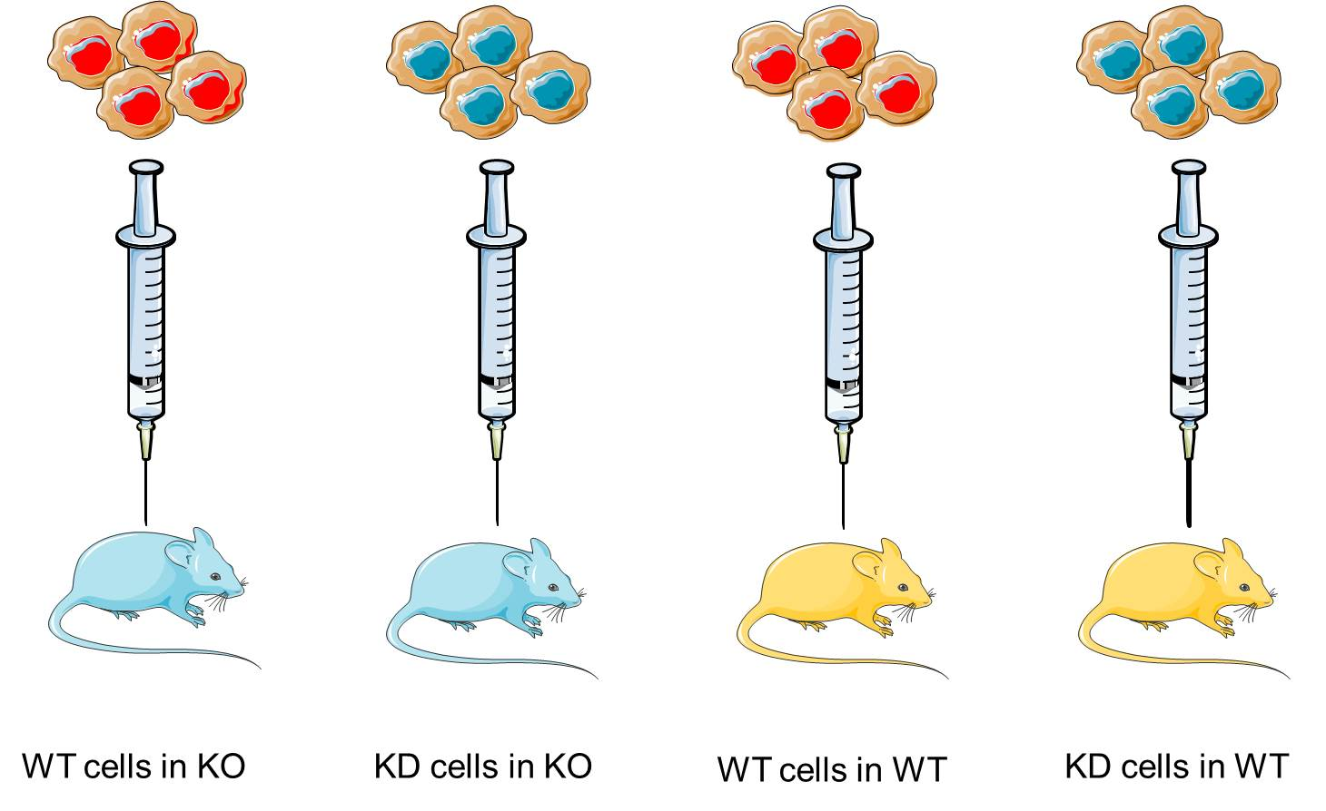
Figure 2.9: The schematic represents the in vivo experiment plan. The RAMP3 knockout mice were injected with two different types of cell. The first type is the control virus cells which are the wild-type cells and the second type is the RAMP3 knockdown cells. Also, the wild-type mice were injected with control virus cells (wild-type cells) and the RAMP3 knockdown cells.

End of Treatment

The mice were sacrificed in a humane way after four weeks post injection. Tumours were removed, weighed and stored in 10% formalin for histology. Also, the bone, lung, liver and bladder were stored in 10% formalin for histology.

Micro computed Tomography (MicroCT) Analysis
Computed tomography is one of the greatest techniques to create 3D modelling of a physical object by using X-ray without destroying the original object. The cross sections made by the X-ray can be interpolated in different ways to study the varied internal structures. Micro computed tomography is the same system but the pixel sizes of the cross sections are in micrometres.
A high resolution µCT scanner (model 1172; Skyscan, Belgium) was used to scan the right femur and tibia bones. The system has two sources of X-rays with two different powers. The first one is 20-100 kV for less than a 5µm spot size and the second one is 20-80 kV for less than 1µm spot size. It also has a 12-bit cooled X-ray camera.

Bone processing
For each animal, the right and left femur and tibia were fixed in 10% formalin immediately after dissection and kept at 4 ˚C while waiting to be processed and scanned.

MicroCT scanning
Before the scanning was performed, each bone was covered with cellophane wrap and inserted into a plastic holder which was placed in the microCT scanner. The medium camera (2000X1024) with a 0.5mm filter and a 4.3um pixel size was used to scan each bone.

Reconstruction
In order to convert raw images into greyscale cross-section images, NRecon® (Version 1.4.1.0) was used to reconstruct the images. Then the region of interest was identified and analysed in the CT analyser Version 1.7.0.5. The threshold levels for reconstruction and analysis for different bones are summarised in Table 2.16.
Table 2.16: Outline of the resolutions and threshold levels utilized for reconstruction and 3D analysis for various areas of different bones.
Age | Resolution  (µm) | Reconstruction threshold  (Arbitrary value) | 3D analysis threshold  (Arbitrary value)
Adult Femur/Tibia trabecular | 4.5 µm | 0.16 | 80 - 255
Adult Femur/Tibia cortical | 4.5 µm | 0.16 | - - 255

Regions of Interest (ROIs) for analysis

For entire bone analysis, regions of interest (ROIs) were drawn around the entire bone in every cross section all through the dataset, while for cortical and trabecular analysis, just a distinct section of the entire bone was chosen. This was performed by setting an offset and height (1.0mm) for the region of the bone to be analyzed. The offset was from a specific reference point, which is commonly a physical marker of the bone. Reference point physical markers utilized for tibia and femur trabecular and cortical analysis are represented in Figure 2.10 and Table 2.17 which outline the offset and height values utilized in a particular bone.
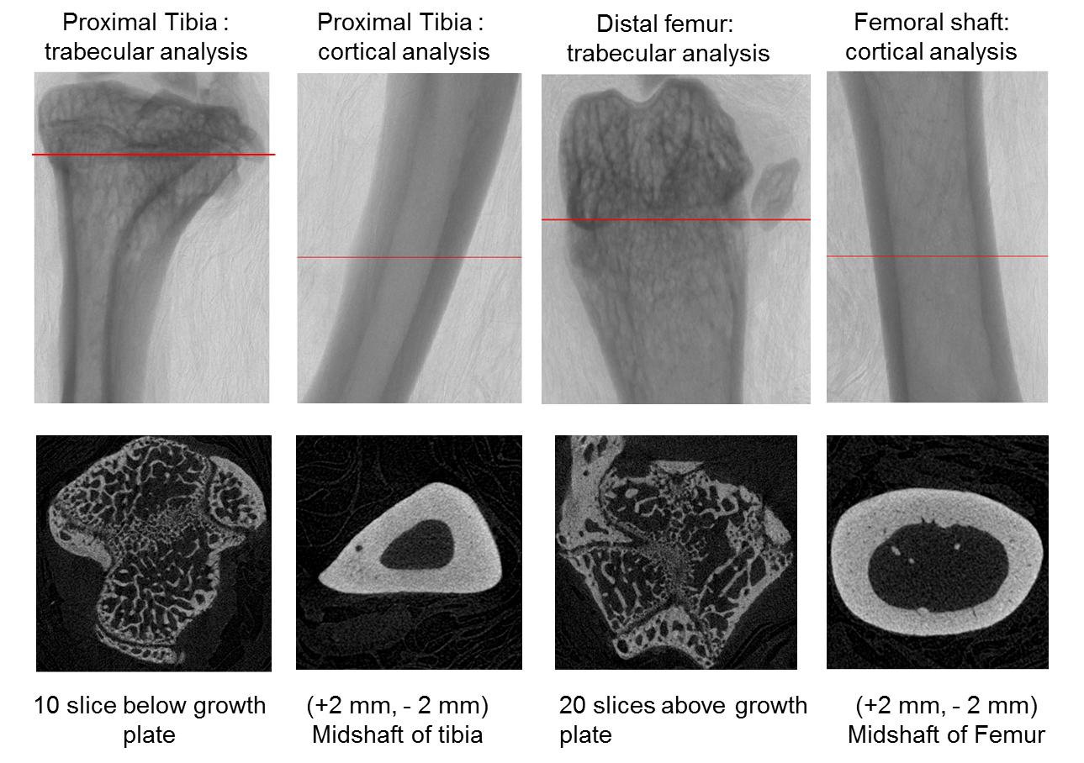
Figure 2.10: Outline of the physical markers utilized to define regions of interest prior to cortical and trabecular analysis. Each top panel (X-ray image produced by microCT) represents the part of the bone scanned at 4.5 µm resolution with a 0.5mm aluminum filter and medium camera. The bottom panels (black) show the bone cross segment produced on a reconstruction of microCT scans, at the marked levels (red lines) in the top panels.

Table 2.17: Outline of the physical markers and ROI settings utilised to measure high resolution bone area in MicroCT.
Bone Analysis | Reference point | Offset value | ROI height
Femur trabecular | 20 slices above growth plate (distal end) | 46 (0.2 mm) | 229 (1.00mm)
Femur cortical | (+2 mm, -2 mm) Midshaft of femur | - | 229 (1.00mm)
Tibia trabecular | 10 slices below growth plate (proximal end) | -275 | 229 (1.00mm)
Tibia cortical | (+2 mm, -2 mm) Midshaft of femur | - | - .00mm)

The Histology
Tumours, soft tissues and bone stored in 10% formalin were processed for paraffin embedding. The tissues were embedded in paraffin and serial sections of 3µm thickness were cut at the Histology Unit of the University of Sheffield, United Kingdom. Each tumour, soft tissue and bone were cut into three levels and scanned using Aperio CS2 (Leica biosystem) after staining with Hematoxylin and eosin stain (H&E). The analysis of the scanned slides was performed using ImageScope®.

Haemotoxylin and Eosin (H&E) Staining
The following is the preparation of the tissue cut sections for H&E staining:

Dewaxing
With the use of xylene, the sections were rinsed twice for 5 mins each time.

Hydration
Sectioned tissue hydration occurred from 99% IMS to 70% IMS, for 5 mins each time.

Staining
The rehydrated tissue was briefly washed in tap water followed by staining the nucleus with Gill’s haemotoxylin for 90-120 secs. In order to give the cytoplasm a better contrast, the stain turned blue by rinsing with tap water for 3 mins. Next, the sections were stained with 1% aqueous eosin with 1% calcium carbonate for 5 mins to dye the cytoplasm.

Dehydrating and Mount
Since eosin fades quickly, the sections were dehydrated through 70% IMS to xylene in a quick manner. Then, using DPX mountant, the sections were covered by glass coverslips. Finally, the sections were left to air dry for the next analytic use.

Statistical analysis

Statistical analyses were carried out in statistical softwareGraphPad Prism6 version 6.05-MSI for Windows. Firstly, the data were examined to see if they were normally distributed or not by using the D'Agostino and Pearson normality test. The date were analysed using a t test for two group comparisons or with an ANOVA test (one-way analysis of variance) for more than two group comparisons if the data was distributed normally. Tukey's test was used as post-hoc analysis, while the ANOVA test was used for normal distribution data. When the distribution of data was not normal, the non-parametric Mann-Whitney test was used for two group comparisons or the ANOVA test (non-parametric Kruskal-Wallis test) was used for more than two group comparisons. The Dunn test was used for post-hoc analysis when the ANOVA test was used in non-normally distributed data. p-value ≤ 0.05 data were considered statistically significant. Data are expressed as mean ± values of standard deviation.

CHAPTER 3: CHARACTERISATION OF BMA178-2 CELLS

Introduction

AM signalling is facilitated through two different receptors which are AM1 and AM2 receptors as described in Chapter 1. AM is considered to be a very important peptide hormone for vascular system development. AM^{-/-} mice embryos die mid-gestation due to very severe hydrops fetalis and cardiovascular irregularities (Caron and Smithies, 2001, Shindo et al., 2001). The yolk sac of AM ^{-/-} embryos lacks well-developed vessels and there is basement structure detachment of the endothelial cells in vitelline vessels and hepatic capillaries (Caron and Smithies, 2001, Shindo et al., 2001). However, AM ^{+/-} mice lived to old age but exhibited high blood pressure with a reduction in nitric oxide production (Shindo et al., 2001a, Caron and Smithies, 2001c). The AM receptors are no less important than AM itself in cardiovascular development, especially the AM1 receptor. The AM1 receptor consists of CLR and RAMP2. Each component of this receptor is shown to be important during embryonic development. CLR^{-/-} and RAMP2 ^{-/-} mice embryos have similar phenotypes to AM^{-/-} mice, and they died mid-gestation as a result of vascular fragility (Dackor et al., 2006, Ichikawa-Shindo et al., 2008). However, RAMP2^{+/-} mice survived to adulthood with vascular hyperpermeability and a reduction in neovascularization (Shindo et al., 2008, Ichikawa-Shindo et al., 2008). On the contrary to the AM1 receptor, the AM2 receptor is believed to contribute more to the disease condition and RAMP3 -/- embryos did not have major abnormalities in their cardiovascular system, their yolk sac had well-developed vessels and they lived to old age without noticeable illness (Yamauchi et al., 2014). These results lead to the fact that AM signalling is mediated through the AM1 receptor in the physiological condition such as vascular maturation during embryonic development and the AM2 receptor is mediating the pathophysiological condition such as cancer and other diseases. RAMP3 is expressed in different tissues at variable levels and expression is different from one species to another. RAMPs associate with other GPCRs receptors to form many different pharmacologically distinct receptors. For example, RAMP1, RAMP2 and RAMP3 interact with the calcitonin receptor (CTR) to form amylin receptors 1, 2 and 3. RAMP2 and RAMP3 interact with parathyroid 1 receptor (PTHR1) and parathyroid 2 receptor (PTHR2) respectively. RAMP2 interacts with Vasoactive intestinal polypeptide receptor 1 (VPAC1). RAMP2 interacts with Glucagon receptor, RAMP3 interacts with secretin receptor (SCTR), while RAMP1 and RAMP3 interact with calcium sensing receptor (CasR) (Christopoulos et al., 2003, Harikumar et al., 2009, Foord et al., 2005, Sexton et al., 2009, Archbold et al., 2011). The aim of this chapter is to identify the receptors that are expressed in the BMA 178-2. Also, the aim is to determine the proliferation and migration ability of the BMA178-2 prostate cancer cell line in response to AM stimulation and inhibition.

Hypothesis and objectives

Hypothesis
We hypothesised that AM plays an important role in the proliferation and migration of the BMA178-2 cell line through AM2 receptor.

The objectives of this chapter:
- To determine the expression of AM2 receptor in the BMA178-2 cell line.
- To determine the effect of serum titration on the doubling time of the BMA178-2 cell line.
- To determine the effect of AM and the AM antagonist AM ₂₂₋₅₂ on the cell proliferation.
- To determine the ability and the duration of the BMA178-2 cells to migrate and close the wound in the wound healing assay with AM and its antagonist (22-52) and without it.

Specific materials and methods

Cell lines maintenance and sub culturing
The cells were maintained in the conditions and the media mentioned in section 2.1.2. Early passage (1-9) cells were used in order to extract RNA and to perform RT-PCR.

RNA isolation, DNase treatment and cDNA synthesis
The RNA was extracted from the BMA178-2 cell line using the TRIzol reagent. The process is explained in detail in Chapter 2. The degradation of RNA was prevented by keeping all the equipment and the tubes during the procedure in a box of ice (4 ˚C) and the RNA extracted was stored at -20 ˚C. Afterwards, the RNA sample was treated with DNase to eliminate any DNA contamination to avoid DNA amplification rather than cDNA amplification. Hence, cDNA was synthesised by following the steps in section 2.8.1 in order to investigate the expression of the genes of interest.

End point PCR
The primers were designed to cross boundaries of exons to prevent DNA amplification (section 2.8.4). After the amplification steps using the thermocycler, the PCR products were sequenced at the University of Sheffield’s Core Genomic Facility as a confirmation step of the result.

Western blotting
25 ug of protein was loaded in each lane. The exposure time of the film was varied from the protein of interest to other proteins of interest. The density of each band was normalized to reference proteins such as B-actin.

Proliferation assay
All the proliferation assays were performed in the same atmosphere at 37ºC in 5% CO₂.

Proliferation assay with serum titration
In 12 well plates 1X10⁴ cells were seeded in triplicate for each serum concentration. Cells were seeded 1 mL/well in 12 well plates per FCS concentration and placed in the incubator. The cells were counted every day using the Vi-cell coulter counter.

Proliferation assay with AM stimulation
The same procedure as in section 2.2.2 was followed. However, 48 hours after the cells were incubated in 10% FCS, the media was removed and replaced with new fresh media, with 4% FCS containing the concentration of AM (1µM, 1mM and 1pM) needed. The media was replaced every 12 hours with the specific concentration of AM for 72 hours (Andreis et al., 2000, Cornish et al., 1997).

Proliferation assay with AM 22-52 inhibition
The same procedure as in section 2.2.3 was followed. AM₂₂₋₅₂ was used in three different concentrations - 1µM, 1nM and 1pM. The experiment was performed for 72 hours (Drimal et al., 2005).

Wound healing assay/scratch test
The migration assay was used to determine the ability and the time needed for BMA178-2 to close the wound, which used a 200ul pipette tip. However, the cells are able to close the wound in two different ways. The first way is by proliferating and this result will not represent the migration ability of the cells. The second way is by filling the wound with the migrated cells and this result represents the motility of the cells. Therefore, Mitomycin C was used to stop the cells from proliferating and three different concentration - 5ug/ml, 10ug/ml and 15ug/ml were used to determine the concentration which was able to stop cells from proliferating (Lee et al., 2005, Brem et al., 2009).

Wound healing assay
The assay was performed for 72 hours after the scratch was made. Every 12 hours one plate was removed from the incubator and the experiment was proceeded as mentioned in section 2.4.

Wound healing assay with AM stimulation
The assay was performed as mentioned in section 2.4.1. After the cells were incubated with Mitomycin C, the cells were stimulated with three different doses of AM - 1µM, 1nM and 1pM every 12 hours for 72 hours.

Wound healing assay with AM22-52 inhibition
The assay was performed as mentioned in section 2.4.2. Three different concentrations of AM22-52 were used (1µM, 1nM and 1 pM). The media was replaced every 12 hours with the antagonist concentration for 72 hours.

Results

End point PCR

End point PCR to detect RAMPs cDNA in the BMA178-2 cell line

All RAMPs were expressed in the BMA178-2 cell line cDNA (Figure 3.1). An H₂O control of each sample was used to make sure the primers were not contaminated with genomic DNA and GAPDH primers were used to clarify the equal loading of the cDNA in the experiment (Figure 3.3). RAMP1, RAMP2 and RAMP3 were amplified in the BMA178-2 cDNA as well as in the positive control cDNA (mouse brain cDNA). No amplification was observed in the H₂O control. All amplicons were confirmed to be RAMP1, RAMP2 and RAMP3 cDNA sequences by sequencing (Figure 3.2).

Figure 3.1: The expression of RAMP1, RAMP2 and RAMP3 by the BMA178-2 cell line. Agarose gel electrophoresis (1.5%) for end point PCR to detect RAMP1, RAMP2 and RAMP3 cDNA expression in the BMA178-2 and positive control (mouse brain). 187bps, 312bps and 103 bps cDNA amplicons corresponding to RAMP1, RAMP2 and RAMP3 were detected in the positive control cDNA (mouse brain) as well as BMA178-2 cDNA. None of the H₂O controls amplified a product. Repeated n=4.

Figure 3.2: End point PCR products sequencing of RAMP1, RAMP2 and RAMP3 products sequencing. The products were sequenced by the Core Genomic Facility at the University of Sheffield and were blasted in NCBI browser (http://blast.ncbi.nlm.nih.gov/Blast.cgi). The results showed 100% homology. The accession numbers for RAMP1, RAMP2 and RAMP3 were NM_016894.3, NM_019444.2 and NM_019511.3 receptively. The blast showed a 95-100% match with the gene of interest.

Figure 3.3: GAPDH expression illustrating the similar loading of the cDNA samples. Agarose gel electrophoresis (1.5%) for end point PCR to detect GAPDH cDNA expression in the BMA178-2 and positive control (mouse brain). bps cDNA amplicons were amplified in the BMA178-2 cDNA and positive control (mouse brain). None of the H₂O controls amplified a product. Repeated n=4.
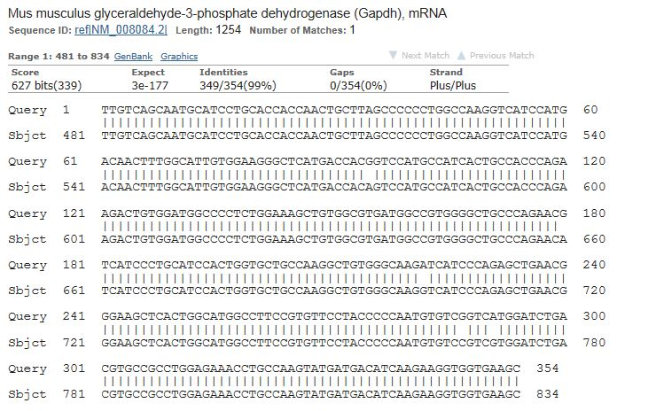

Figure 3.4: End point PCR products sequencing of GAPDH. The sequence of the PCR product shows a 99% match, identical to the house keeping gene GAPDH and the accession number is NM_008084.2.

Endpoint PCR to detect CLR, AM and LOXL-2 cDNA in the BMA178-2 cell line
CLR, AM and LOXL-2 cDNA were expressed in the BMA 178-2 cell line (Figure 3.5). An H2O control was used to clarify the primers not contaminated with genomic DNA and GAPDH primers were used to illustrate the equal loading of the cDNA in the experiment (Figure 3.6). CLR, AM and LOXL-2 were amplified in the BMA178-2 cDNA as well as in the positive control cDNA (mouse brain cDNA). No amplification was observed in the H2O control. All amplicons were confirmed to be CLR, AM and LOXL-2 cDNA sequences by sequencing (Figure 3.7).

Figure 3.5: The expression of CLR, AM and LOXL-2. Agarose gel electrophoresis (1.5%) for end point PCR to detect CLR, AM and LOXL-2 cDNA expression in the BMA178-2 and positive control (mouse brain). 280bp, 130bp and 486bp cDNA amplicons corresponding to CLR, AM and LOXL-2 were observed in the positive control cDNA (mouse brain) as well as BMA178-2 cDNA. None of the H₂O controls amplified a product. Repeated n=4.

Figure 3.6: End point PCR products sequencing of CLR, AM and LOXL-2. Blasting the sequences into the NCBI genome browser shows 100% match identities. The accession number for CLR is NM_018782.2, LOXL-2 is NM_033325.2 and AM is NM_009627.1.

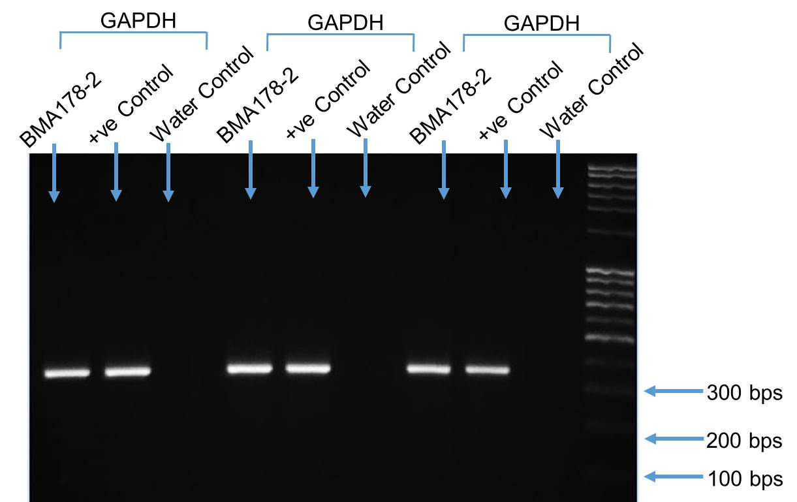

Figure 3.7: GAPDH expression demonstrates the equal loading of the samples. End point PCR is to detect GAPDH in the cDNA of BMA178-2 and positive control (mouse brain). The (1.5%) agarose gel electrophoresis shows six bands of the same size (354bp) corresponding to GAPDH in cDNA of BMA178-2 and cDNA of the positive control respectively. The bands have the same density which means the loading of the cDNA samples was the same. None of the H₂O controls amplified a product. Repeated n=4.

Endpoint PCR to detect PTH1R and PTH2R cDNA in the BMA178-2 cell line

The PTH1 receptor cDNA was expressed in the BMA 178-2 cell line (Figure 3.8). However, the PTH2 receptor was not expressed in the BMA 178-2 cell line. The H2O control was used to clarify the primers not contaminated with genomic DNA and GAPDH primers were used to illustrate the equal loading of the cDNA in the experiment (Figure 3.8). The PTH1 receptor was amplified in the BMA178-2 cDNA as well as in the positive control cDNA (mouse brain cDNA). No amplification was observed for the PTH2 receptor in BMA178-2, but a band in the positive control was observed. All the H2O controls did not amplify any amplicons. All amplicons were confirmed to be PTH1, PTH2 and GAPDH cDNA sequences by sequencing (Figure 3.9).

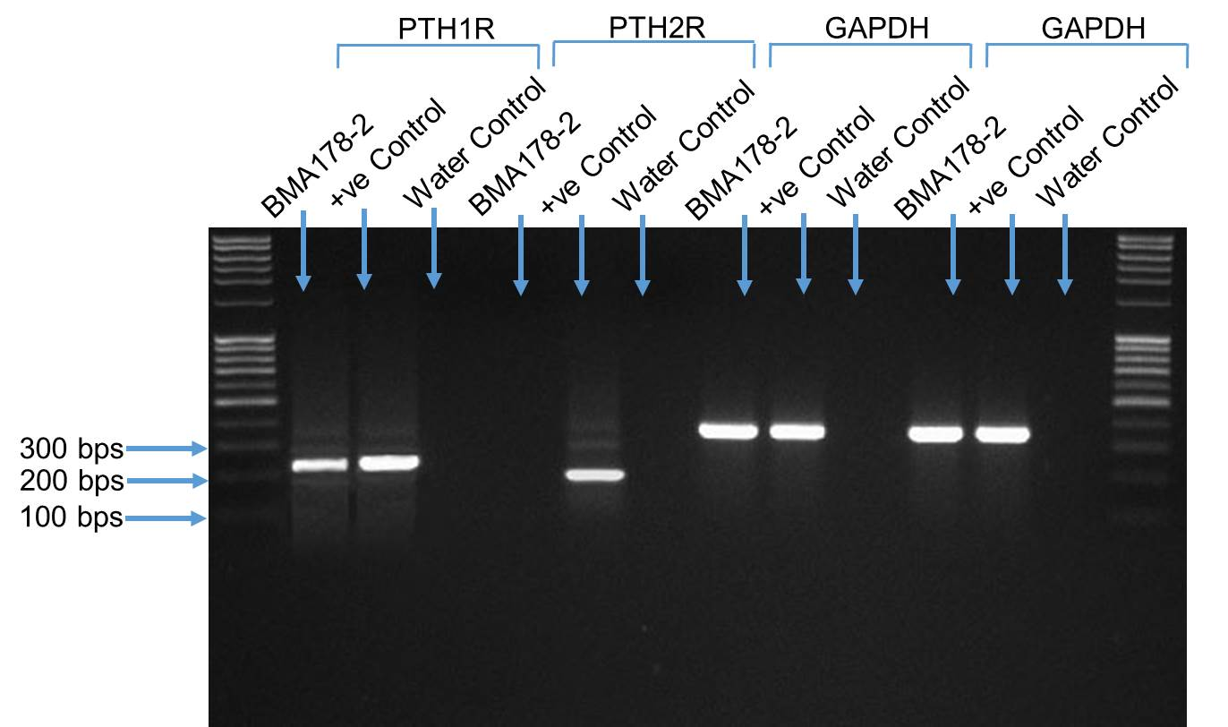
Figure 3.8: The expression of the PTH1 and PTH2 receptors in BMA178-2. Agarose gel electrophoresis (1.5%) of end point PCR illustrates a band of the size 277bp corresponding to the PTH1 receptor was observed in the BMA178-2 cDNA as well as in the positive control (mouse kidney). In contrast, a band corresponding to the PTH2 receptor was detected in the positive control (mouse brain) of the size 162bp, but no product was amplified that corresponded to the cDNA of BMA-178 with PTH2 primers. Four bands with the same densities corresponding to GAPDH were observed. The water controls were clear which clarified that the primers were not contaminated. Repeated n=4.

Figure 3.9: End point PCR products sequencing of the PTH1 and PTH2 receptors. The amplicons sequences are 100% identical to the PTH1 and PTH2 receptors. Moreover, the accession number for the PTH1 receptor is NM_011199.2 and for the PTH2 receptor it is NM_139270.2

Endpoint PCR to detect CTR and VIPR-1 cDNA in the BMA178-2 cell line
CTR and VIPR-1 cDNA were not expressed in BMA-178 (Figure 3.10), but they were expressed in the cDNA of the positive control (mouse brain). GAPDH primers were used as a loading control and H₂O was used as a control for the primers’ contamination (Figure 3.10). The primers were not contaminated with genomic DNA and the samples were loaded equally. All the PCR products were confirmed to be CTR and VIPR-1 by sequencing (Figure 3.11).
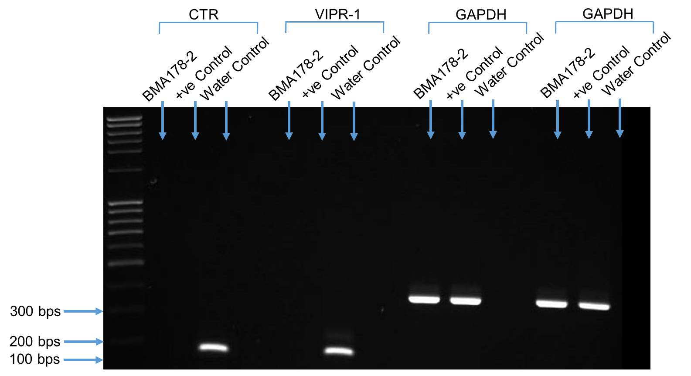

Figure 3.10: The expression of the CTR and VIP-1 receptors in BMA178-2. The CTR and VIP-1 receptors were not detected in the cDNA of BMA178-2. However, two bands of the sizes 158bp and 161bp corresponding to the CTR and VIP-1 receptors respectively were detected in the cDNA of the positive controls (mouse brain). The GAPDH illustrated that the samples were loaded equally and no contamination of the primers was observed by using water control. Repeated n=4.

Figure 3.11: End point PCR products sequencing of the CTR and VIP-1 receptors. The results of matching the sequences to the Genebank show 100% homology to the CTR and VIP-1 receptors. The accession number for CTR is NM_ 007588.2 and for VIP-1 it is NM_011703.4.

Endpoint PCR to detect CaSR and GlucagonR cDNA in the BMA178-2 cell line

CaSR cDNA was expressed in the BMA178-2 cell line cDNA as well as in the positive control (mouse kidney) (Figure 3.12). Conversely, the Glucagon receptor was not expressed in the BMA-178-2 and it was expressed in the positive control (mouse liver). The H2O control of each sample was used to make sure the primers were not contaminated with genomic DNA and GAPDH primers were used to clarify the equal loading of the cDNA in the experiment (Figure 3.12). No amplification was observed in the H₂O control. All amplicons were confirmed to be CaSR and Glucagon sequences by sequencing (Figure 3.13).

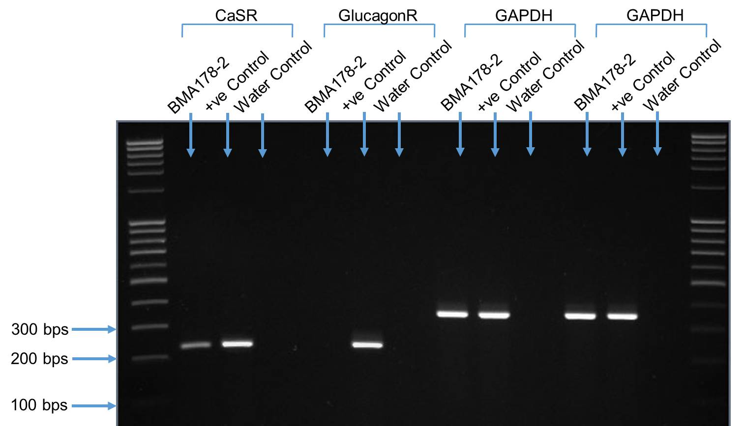

Figure 3.12: The expression of CaSR and Glucagon receptors in the BMA178-2 cell line. Agarose gel electrophoresis (1.5%) of end point PCR demonstrates that the CaSR amplicon was detected in the cDNA of the BMA178-2 cell line as well as in the cDNA of the positive control (mouse kidney) of the size of 233bp. However, there was no amplification of the Glucagon receptor in the BMA178-2 but there was in the cDNA of the positive control (mouse liver). The loading of both the cDNA of the BMA178-2 and the positive control were equal shown by GAPDH. Repeated n=4.
Figure 3.13: End point PCR products sequencing of the Casr and Glucagon receptors. The homology sequences show a 100% match. The accession number for the CaSR is NM_013803.2 and for the Glucagon receptor it is NM_008101.2.

Endpoint PCR to detect SCTR cDNA in the BMA178-2 cell line

The SCTR receptor was expressed in cDNA of the BMA178-2 and the positive control (mouse pancreas) (Figure 3.14). The GAPDH was used as a loading control and H₂O was used as a primer contamination control (Figure 3.14). The cDNA of the BMA178-2 and the positive control were loaded equally, where the GAPDH bands have the same density. No band was observed in the water control; therefore the primers were not contaminated with genomic DNA. All amplicons were confirmed to be SCTR sequences by sequencing (Figure 3.15).
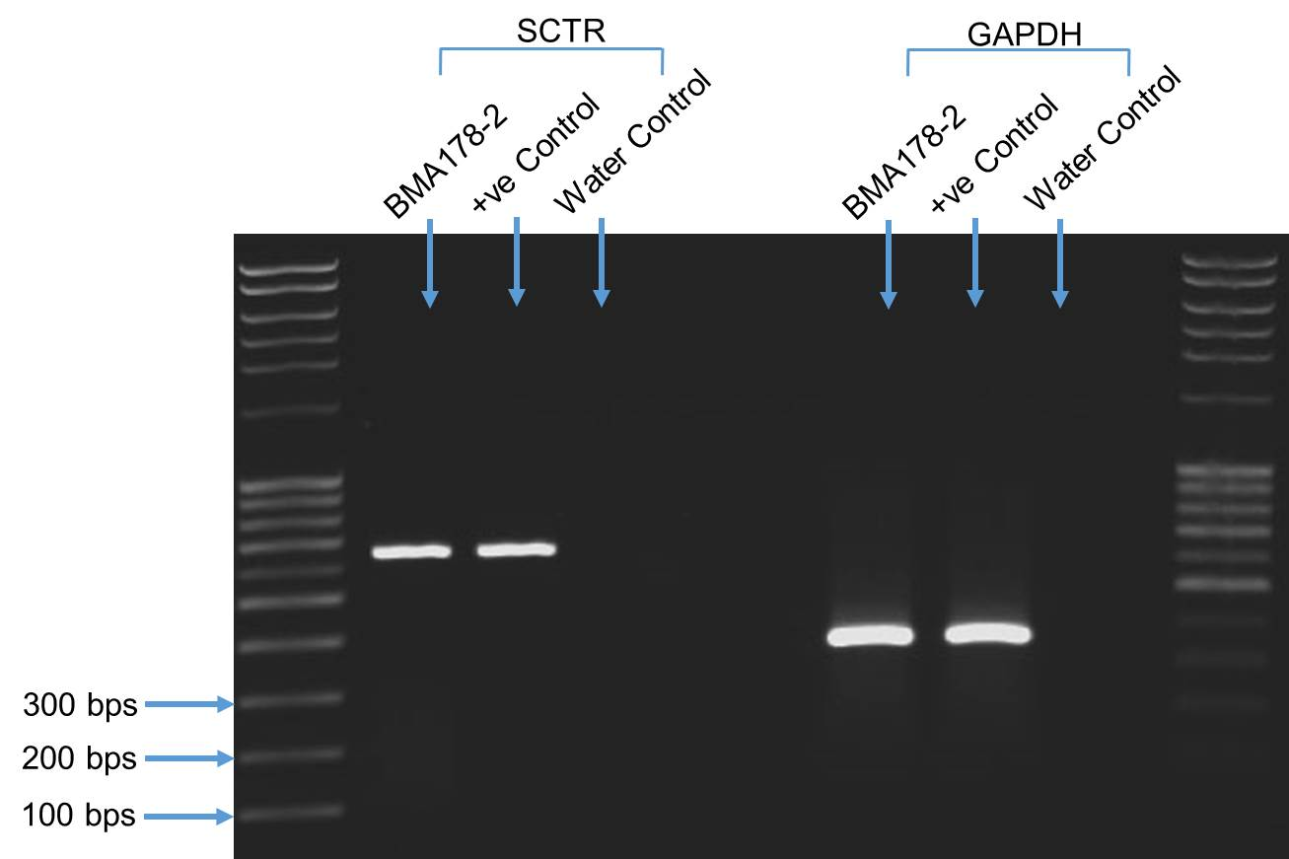

Figure 3.14: The expression of SCTR in the BMA178-2 cell line. Agarose gel electrophoresis (1.5%) for end point PCR detects the cDNA of SCTR in BMA178-2 and the positive control (mouse pancreas). A 638 bp band was observed in the cDNA of BMA178-2 and the positive control. The GAPDH primers were used to show that the samples were loaded equally. Repeated n=4.

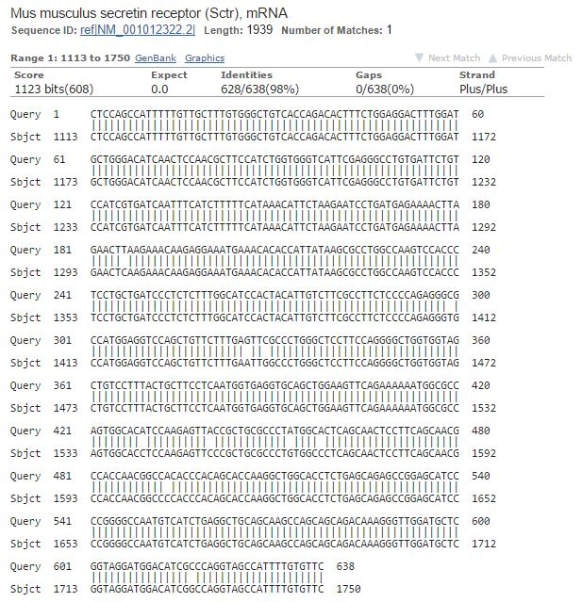

Figure 3.15: End point PCR products sequencing of SCTR. 98% of the blast sequence matched with SCTR. The accession number for the SCTR was NM_001012322.2.

Western blotting to detect RAMPs and CLR protein in the BMA178 cell line

RAMP1, RAMP2 and RAMP3 were expressed in BMA178-2 along with CLR. Western blotting showed that three bands of the size ~20 kDa, ~20kDa and ~19 kDa which correspond to RAMP1, RAMP2 and RAMP3 respectively appear in 15% SDS-PAGE (Figures 3.16 and 3.17). Also, a 10% SDS-PAGE showed two bands for CLR of the size 60 kDa and 70 kDa (Figures 3.18 and 3.19). In both gels 10% and 15%, a loading control antibody was used (𝜷-actin), which appears at the size of 45 kDa (Figures 3.16 and 3.18).

Figure 3.16: The expression of RAMP1, RAMP2 and RAMP3 in SDS-PAGE. RAMPs monormers were expressed of the size 22 kDa in the BMA178-2 as well as in the positive control (mouse brain). The 𝜷-actin was used to clarify the loading of proteins and a band of the size 45 kDa corresponded to B-actin which shows the loading was equal in all samples. Repeated n=3.

Figure 3.17: The expression of RAMPs normalised to 𝜷-actin. The expression of RAMP1 and the positive control, RAMP2 and the positive control, RAMP3 and the positive control had the same level of protein in the BMA178-2. Repeated n=3.

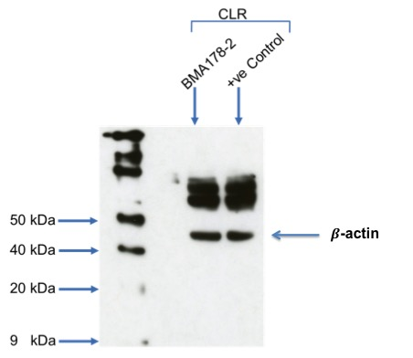

Figure 3.18: The expression of CLR in SDS-PAGE. CLR bands can be seen at the size of 60 kDa and 70 kDa in the BMA178-2 as well as in the positive control (mouse brain). The B-actin band of the size 45 kDa can be seen and this illustrates the equal loading of the protein samples. Repeated n=3.

Figure 3.19: The expression of CLR normalised to 𝜷-actin. CLR was expressed higher in the positive control compared to the BMA178-2 protein. Repeated n=3.

Proliferation assay

Proliferation assay with serum titration

The growth of BMA178-2 cells was modulated significantly in a dose independent manner by different FCS concentrations (Figure 3.20). The concentrations of FCS used ranged between 0% and 10%. At the concentration of 10% FCS DMEM, the BMA178-2 cells had their maximum growth rate (doubling time 1.17 days; cell population at day 13: 3.8 X 10⁶). The doubling time of the cells grown in 8% of FCS DMEM were very similar to the cells grown in 10% of FCS, whose doubling time was 1.18 days and cell population was 3.5 X 10⁶. BMA178-2 cells in 6% of FCS DMEM had a doubling time of 1.24 days and the cell population at day 13 was 3.2X10⁶. Moreover, the doubling time of the cells in 4% FCS DMEM was 1.3 days and the population of the cells was 2.6X10⁶ at day 13. Decreasing the concentration of FCS DMEM to 2% slowed the ability of the cells to duplicate, demonstrating the effect of the serum concentration on the growth as well as the doubling time of the cells, where the doubling time of the cells was 1.3 days and the population of the cells at day 13 was 2.2X10⁶. Interestingly, the cells were able to grow without FCS DMEM and the doubling time for them was 3.83 days and the population number at day 13 was 6.8X10⁴. The cell numbers cultured in different FCS concentrations were significantly different at day 13 (P<0.05). However, the differences in the cells numbers between the cells in 2% and 4% as well as 8% and 10% were not significantly different (Table 3.1, Figure 3.20 and 3.21).

Table 3.1: The effect of serum titration on BMA178-2 growth. The table illustrates the proliferation rate expressed in hours and the final population of BMA178-2 in different concentrations of FCS. Interestingly, the cells cultured in 6%, 8% and 10% had a similar doubling time even though they are significantly different in the cells population at the end of the experiment.
FCS concentration | Doubling time (hours) | Number of cells at day 13
0% | 92 | 6.8X10⁴
2% | 32 | 2.2X10⁶
4% | 31 | 2.6X10⁶
6% | 29 | 3.2X10⁶
8% | 28 | 3.5 X 10⁶
10% | 28 | 3.8 X 10⁶

Figure 3.20: The effects of different FCS concentrations (range 0%-10%) on the growth of BMA178-2. The BMA178-2 cells were grown in several different FCS concentrations and the cells numbers were counted for 14 days. Repeated n=3.

Figure 3.21: The proliferation of the BMA178-2 at day 13. BMA178-2 proliferation was analysed by using Graphpad prism6® at day 13. One way ANOVA and the Turkey post-test were used for the statistics and all the differences were statistically significant (P<0.05), with the exception of the differences between 2% and 4%, 8% and 10% which were not. The data are demonstrated with ± SEM (N=3).

Proliferation assay with AM stimulation

In order to study the effect of AM on the proliferation of the BMA178-2, three different doses were used (1uM, 1nM and 1pM). The assay was performed for 72 hours after the cells were seeded in 12 well plates and incubated with 4% FCS to reduce the proliferation rate of the cells. The cells were stimulated and counted every 12 hours. However, the proliferation of the cells was not increased as a response to AM stimulation and the stimulated cells had the same population as non-stimulated cells (Figure 3.22).
Figure 3.22: The proliferation of BMA178-2 after stimulation with three doses of AM. The cells were stimulated every 12 hours with different concentrations of AM (1uM, 1nM and 1pM) in 4% FCS DMEM. The proliferations of the stimulated cells were compared to non-stimulated cells. Repeated n=3.

Proliferation assay with AM 22-52

In order to examine the effect of AM on the BMA178-2 cells, an AM antagonist was used with different concentrations (1uM, 1nM and 1pM) to block the activity of AM. The cells were seeded in 4% FCS DMEM and the antagonist (AM22-52) was added to the media every 12 hours. The assay was carried out for 72 hours and the cells were counted every 12 hours. Interestingly, the growth of the BMA178-2 was inhibited significantly in a dose response manner and compared to the non-inhibited cells after 72 hours of adding the antagonist (Figure 3.23). One way ANOVA and the Tukey post-test were used for the statistics and all the differences were statistically significant (P<0.05), with the exception of the differences between the cells inhibited with 1µM and 1nM, non-inhibited cells and the cells inhibited with 1pM.
Figure 3.23: The proliferation of BMA178-2 after being inhibited by AM22-52. The cells were grown in 4% FCS DMEM and inhibited with three different doses of AM22-52 (1uM, 1nM and 1pM) and counted every 12 hours. The proliferations of the cells were inhibited significantly in a dose dependent manner. Repeated n=3.

Wound healing assay

The migration assay was used to assess the ability of the BMA178-2 cells to migrate and the effect of the AM on their motility.

Wound healing assay
In order to determine the ability of BMA178-2 to migrate, the cells were grown in a monolayer and Mitomycin C with three different concentrations were used to stop the proliferation of the BMA1778-2 completely. The cells were incubated with three different concentrations of Mitomycin C (5µg/ml, 10µg/ml and 15µg/ml) in serum free media for 1 hour. 10µg/ml and 15µg/ml of Mitomycin C were able to stop the cells proliferating ((Figure 3.24). Hence, a 200µl pipette tip was used to scratch a cross in the well in the middle and the scratch closure was measured every 24 hours, as described in Chapter 2. 90% of the scratch was closed within 24 hours, 96% of the scratch was closed within 48 hours and the scratch was fully closed within 72 hours (Figure 3.25 and Figure 3.26).

Figure 3.24: Optimising the required Mitomycin C concentration to stop the proliferation of the cells. The cells were treated with three different concentrations for 1 hour (5µg/ml, 10µg/ml and 15µg/ml). Two concentrations of Mitomycin C were able to stop cells proliferating which are 10µg/ml and 15µg/ml, in comparison with the non-treated cells and the cells treated with 5µg/ml. Repeated n=3.

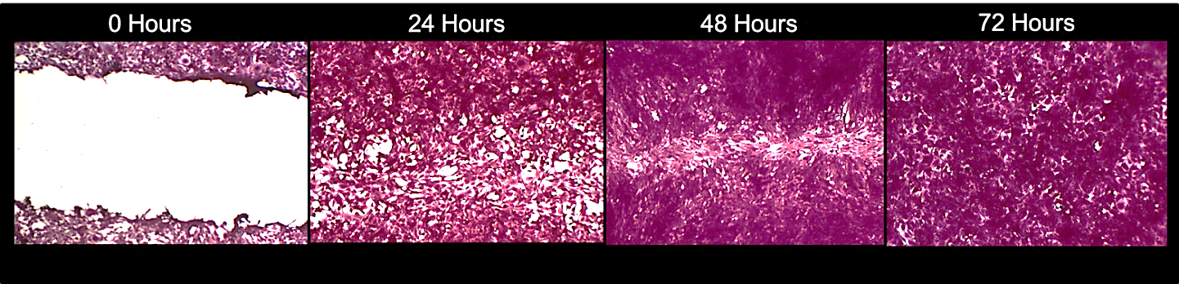

Figure 3.25: The wound healing assay of BMA178-2 for 72 hours. In 0 hours the picture shows the open scratch. The scratch was closed by 90%, 96% and 100% in 24 hours, 48 hours and 73 hours respectively. The picture represents the migration of the BMA178-2 cells, where the proliferation was prevented by using Mtiomycin C.

Figure 3.26: The percentage of the scratch (wound) closure in the wound healing assay. The scratch was fully closed within 72 hours and the area of the scratch was measured using Tscratch software after scanning the plates. Repeated n=4.

Wound healing assay with AM stimulation

To determine the effect of AM on the migration rate of the BMA178-2 cells, three doses of AM were used to stimulate the migration of the BMA178-2 (1µM, 1nM and 1pM). The BMA178-2 did not respond to the stimulation of AM. The cells stimulated with AM had the same migration rate as the non-stimulated cells, as can be seen in Figure 3.27. The scratch was closed by 90%, 96% and 100% in 24 hours, 48 hours and 72 hours respectively.

Figure 3.27: The effect of AM stimulation on the migration of BMA178-2. The migration of BMA178-2 was not affected by AM stimulation with three different concentrations in comparison with non-stimulated cells. Repeated n=4.

Wound healing assay with AM₂₂₋₅₂ inhibition

To determine the sensitivity of the BMA178-2 to AM and its effect on the migration, three doses of AM antagonist (AM₂₂₋₅₂) were used, which are 1µM, 1nM and 1pM. The migration of BMA178-2 was not affected by AM₂₂₋₅₂ (1µM, 1nM and 1pM) in comparison to non-inhibited cells, as seen in Figure 3.28. The cells fully closed the scratch within 72 hours.

Figure 3.28: The effect of AM22-52 on the migration of BMA178-2. Three concentrations of AM₂₂₋₅₂ (1µM, 1nM and 1pM) were used to study their effect on the migration of BMA178-2. However, no effect was observed on the migration of BMA 178-2 with AM₂₂₋₅₂ in comparison with non-inhibited cells. Repeated n=4.

Discussion
The expression of AM and related receptors in the BMA-178 mice prostate cancer cell line at the mRNA level and protein level
In the BMA 178-2 mice prostate cancer cell line, AM, its AM1 (RAMP2 + CLR) and AM2 (RAMP3 + CLR) receptors were expressed (Figures 3.1 and 3.4). Additionally, many other receptors which are able to associate with RAMPs to form other receptors or control RAMPs expression were expressed such as RAMP1, PTH1R, SCTR, CaSR and LOXL-2 (Figures 3.1, 3.4, 3.7, 3.11 and 3.11). RAMP1 interacts with CLR to form the CGRP receptor, the PTH1 receptor interacts with RAMP2, SCTR interacts with RAMP3, CaSR interacts with RAMP1 and RAMP3 and LOXL-2 regulates RAMP3 expression. Many studies have demonstrated that AM and its AM1 and AM2 receptors are expressed in different cancer cells (Kaafarani et al., 2009, Deville et al., 2009, Cuttitta et al., 2002, Metellus et al., 2011, Buyukberber et al., 2007, Ramachandran et al., 2007, Miller et al., 1996) and the co-expression of AM1 and AM2 in BMA 178-2 is leading to the fact that AM and its receptor might be implicated in the progression and the growth of BMA 178-2 mice prostate cancer cells.
Also, RAMPS and CLR were detected at the protein level by using Western blotting. The RAMP1 protein band was detected at ~20 kDa in the BMA178-2 whole lysate as a monomer, as can be seen in Figure 3.16 and this result is consistent with the findings of Sexton et al. and Cueille et al. (Sexton et al., 2001, Cueille et al., 2002). However, many groups have reported seeing a higher band as a form of RAMP1 ~ 30 kDa which mostly corresponds to a homodimer of RAMP1, since RAMP1 is lacking in glycosylation sites (Granholm et al., 2008, Csati et al., 2012, McLatchie et al., 1998a, Steiner et al., 2002).
Also, a monomer of the size ~20 kDa for RAMP2 was detected in the whole cell lysate of BMA178-2, as can be seen in Figure 3.16 and this is consistent with the results of Blom et al., Hipolito et al. and Pan et al. (Blom et al., 2012, Hipolito et al., 2011, Pan et al., 2010), although RAMP2 can be expressed in different forms, for example a band of 35 kDa may represent a heterogeneously glycosylated form of RAMP2 and a homodimer at 50 kDa (Metellus et al., 2011, Granholm et al., 2008, Fernandez‐Sauze et al., 2004). RAMP3 was expressed as a monomer in BMA178-2 at a size of ~19 kDa (Figure 3.16) and this result has already been reported by (Sexton et al., 2001, Fernandez‐Sauze et al., 2004, Cueille et al., 2002) However, RAMP3, due to different molecular weights and the four glycosylation sites Asn²⁹, Asn⁵⁸, Asn⁷¹, and Asn¹⁰⁴, may be expressed as a monomer or homo or heterodimer (Flahaut et al., 2002, Flahaut et al., 2003). For instance, a heterogeneously glycosylated monomer of 28 kDa, a homodimer of ~40 kDa and a heterodimer of ~73 kDa (Metellus et al., 2011, Sexton et al., 2001).
BMA178-2 expressed CLR as two bands, one corresponding to a monomer of ~60 kDa (Csati et al., 2012, Ramachandran et al., 2009, Dong et al., 2004) and another band of ~70 corresponding to a glycosylated monomer (Figure 3.18) (Granholm et al., 2008) due to three putative glycosylation sites at Asn⁶⁰, Asn¹¹² and Asn¹¹⁷ at the N terminal extracellular domain (Bühlmann et al., 2000, Muff et al., 2001) or a heterodimer form of either CLR/RAMP2 or CLR/RAMP3 (Metellus et al., 2011). Also, the appearance of RAMP1 in the BMA178-2 at the gene level as well as the protein level might alter the terminal glycosylation of CLR which resulted in a higher molecular weight form of CLR. It was reported that in the absence of RAMP1, CLR is usually expressed as a monomer. However, the expression of RAMP1 with CLR resulted in a glycosylated form of CLR (McLatchie et al., 1998a, Sexton et al., 2001).
The Growth Characteristics of BMA178-2
One of the important conditions before setting up the proliferation and the growth assays were the effects of agents on cell growth and the determination of the growth characteristics of cells. Understanding the standard behaviour of cells through producing growth curves is also essential to guarantee that malignancy cell lines are behaving in a reproducible way. The importance of understanding the standard behaviour is extending to be an indication of any change or alteration that might occur to the cells or the environment that the cells grow in or contamination of the culture media. Thus, generating growth curves is required to understand the standard growth of BMA178-2.
The BMA178-2 cells were growing relatively with constant rates and performing a sigmoidal curve under regular growth conditions using DMEM medium containing 10% Fetal Calf Serum (FCS), see Figure 3.20. The exponential phase of the cells lasted between day 2 and day 11. Different concentrations of FCS were tested on the growth of BMA178-2 cells. 10% FCS gave the maximal growth rate followed by 8%, 6%, 4% and 2%. The doubling time for the cells in 10% and 8% is 28 hours and the doubling time increased by decreasing the FCS% concentration to 92 hours with 0% FCS. Interestingly, the cells grew in 0% FCS concentration. This means the media has a low level of nutrients and that the cells did not stop dividing as a result of the cells starvation which illustrates that this cell line is highly aggressive. Another explanation for this result could be that the AM secreted by the cells protected them from undergoing apoptosis, where AM was seen to downregulate pro-apoptotic factors which contribute to the survival of cancer cells (Oehler et al., 2001, Martínez et al., 2002).
The proliferative and inhibitory effects by using AM and AM ₂₂₋₅₂
The BMA178-2 cells were stimulated by using three different concentrations of AM - 1µM, 1nM and 1pM. The rational for using these three concentrations is to see the gradual increase or decrease of the proliferation rate and whether there is any stimulation or inhibition response effect of AM. To determine any inhibitory or proliferative effects of a drug, 4% FCS was used as the number of cells grown in this concentration is half of the number of cells in 10% FCS at day 3. Therefore, any change in the cell numbers would be noticeable. Thus, by using this concentration the inhibitory or proliferative effects can be noticeable and easy to observe.
It was noted that all three concentrations of AM had no effect on the proliferation rate of the BMA178-2. AM was added to complete 4% media every 12 hours, see Figure 3.22 (Ramachandran et al., 2007, Cornish et al., 1997, Ouafik et al., 2002).
This result indicates that BMA178-2 cells may be secreting a high concentration of AM into the media. As reported by many groups, AM stimulates proliferation in a paracrine/autocrine manner and is secreted in the media by different types of cancer cells such as pancreatic and glioblastoma cancer cells (Ramachandran et al., 2007, Miller et al., 1996, Ouafik et al., 2002, Berenguer et al., 2008). Therefore, it is possible that the concentration of AM made by the cells endogenously and secreted into the media was higher than the concentration of the AM added exogenously, which resulted in no effect on the growth of the cells. This result was in agreement with those reported by Takahashi et al. (Takahashi et al., 2002, Takahashi et al., 1997).

Another explanation for this result is that 3 days may not be enough to see the effect of AM stimulation, which is in agreement with the findings of Ouafik et al. (Ouafik et al., 2002). They used 2 X 10 ⁻⁷ mol/L of AM and the cells were stimulated 6 days after the daily addition of AM. However, AM is shown to increase the proliferation of variety of cancer cells such as pancreatic cancer (Ramachandran et al., 2009), human endometrial adenocarcinoma (Oehler et al., 2001), breast cancer (Martínez et al., 2002) and human colon carcinoma (Nouguerède et al., 2013). In contrary to this, AM is shown to have an inhibitory effect on PC3 cells, both in vitro and in vivo. It also did not elevate intracellular cAMP production (Abasolo et al., 2003, Abasolo et al., 2004).
On the other hand, AM₂₂₋₅₂ was used to examine its effect on BMA178-2 with three different doses - 1µM, 1nM and 1pM. AM₂₂₋₅₂ was added to the culture medium every 12 hours. AM₂₂₋₅₂ was shown to inhibit the proliferation of BMA178-2 in a dose dependent manner, see Figure 3.23. The highest concentration (1µM) caused the bigger reduction in the proliferation rate followed by 1nM and 1pM. This result is consistent with the results from the Ishikawa et al. group where it was observed that using AM₂₂₋₅₂ reduced the growth of the pancreatic cancer cells in vivo (Ishikawa et al., 2003). tAM₂₂₋₅₂ was also observed to inhibit the cell growth of colorectal tumours, both in vitro and in vivo (Nouguerède et al., 2013).

Cell migration characteristics of BMA178-2
Cell migration is the first step for metastatic cells to migrate from one part to another part in the body. Cell movement and migration occurs by the activation of vascular endothelial growth factor receptor 1 (VEGFR1) and vascular endothelial growth factor receptor 2 (VEGFR2) and by the vascular endothelial growth factor (VEGF) (Lu et al., 2012, Chen et al., 2004, Qi et al., 2002). Such activation leads to the activation of Phosphatidylinositol (3, 4, 5)-trisphosphate (PIP3) which activates actin polymerization, resulting in cell migration and movement (Cantley, 2002, Liu et al., 2009, Vivanco and Sawyers, 2002). Many prostate cancer cell lines express VEGF, such as PC3 and DU-145 (Harper et al., 1996, Qi et al., 2002, Chen et al., 2004). In order to explore and examine the normal migration behaviour of a new cell line, a migration experiment has to be performed to test the effect of a drug or any compound on the cell migration. A migration assay on BMA 178-2 cells shows that the wound/scratch closed to 90%, 96% and 100% in 24 hours, 48 hours and 72 hours respectively, see Figures 3.25 and 3.26. However, the addition of AM exogenously with three different doses (1µM, 1nM and 1pM) was not able to stimulate or inhibit the migration rate of BMA178-2 cells when compared to the controls, see Figure 3.27. This result is similar to that of the Martínez et al. group, where they found that two different human breast cancer cell lines (T47D and MCF7) transfected with the AM gene did not alter their motility and migration rate, but it was shown to affect the human ovarian cancer cell line (ECV) transfected with the same AM construct (Martínez et al., 2002). AM₂₂₋₅₂ which is known as the AM antagonist shows no effect on the migration of BMA178-2 in three different doses - 1µM, 1nM and 1pM compared to the control cells, see Figure 3.28. From these results it is plausible to conclude that the concentration of the AM secreted in the media by the BMA178-2 cells was high enough to prevent that action of AM₂₂₋₅₂. This contradicts the result of Deng et al. (Deng et al., 2012), where the AM₂₂₋₅₂ inhibited the migration of the ovarian cancer cell line HO8910 cells and antagonized the stimulation effect of AM on migration.

Conclusion
It can be concluded that the BMA178-2 cells express RAMP1, RAMP2, RAMP3 and CLR at the mRNA and protein level which leads to the presence of the AM1, AM2 and CGRP receptors. This result suggests that AM may work in an autocrine manner to stimulate proliferation, migration and invasion as well as to reduce the apoptosis of the BMA178-2 cells through the AM2 receptor because the AM1 receptor, as illustrated in Chapter 1, plays an important role in physiology rather than pathophysiology. Also, the proliferation of BMA178-2 was inhibited in a dose dependent manner by using the AM antagonist (AM₂₂₋₅₂). This result demonstrates that AM is important for the proliferation of the BMA178-2 cells. Contrary to the previous result, exogenously adding AM every 12 hours did not affect the proliferation of the cells, which could be because the concentration of the production of endogenous AM is higher than the doses that AM was stimulated with.
Furthermore, the AM and AM antagonist (AM₂₂₋₅₂) had no effects on the migration of AM, which suggests that the concentration of AM present in the media by endogenous secretion was high enough not to be affected by AM and AM₂₂₋₅₂.
In this chapter many technical issues were faced. Western blotting proved to be time consuming and there was difficulty in identifying the right antibodies for
RAMP1, RAMP2 and RAMP3 as well as the troubleshooting. Also, counting the cells daily for 13 days was tedious as well as making the scratches for the scratch assay in a consistent way.
In this chapter, the BMA178-2 cells were shown to express the AM1 and AM2 receptors and this leads to the fact that AM may contribute to the progression of this cell line. In the next chapter we hypothesise that preventing the cells from receiving AM signalling through the AM2 receptor will reduce the cell proliferation, migration and invasion and will increase the cells apoptosis. Therefore, the aim of the next chapter is to investigate the role of the AM2 receptor through knocking down one of its component RAMP3 where CLR is shared with the AM1 receptor and is shown to play an important role in vascular system development, as demonstrated in Chapter 1. We will also study the effect of such a knockdown on the proliferation, migration, invasion and apoptosis of BMA178-2.

CHAPTER 4: RAMP3 KNOCKDOWN IN BMA178-2 CELLS AND FUNCTIONAL CHARACTERISATION IN VITRO

Introduction

The AM2 receptor (RAMP3+CLR) plays an important role as a signal transducer for AM in diseases, particularly in cancer progression. RAMP3^{-/-} mice are viable and do not exhibit abnormalities showing the progression of angiogenesis and lymphangiogenesis, suggesting that RAMP3 is not essential for the angiogenic function of AM (Yamauchi et al., 2014).
In a study by the Berkhman et al. group, their findings were able to identify the role of RAMP3 in cancer metastasis and development. In the study RAMP3 was induced as a result of the over-expression of a gene called LOXL-2. LOXL-2 was demonstrated to play an important role in the invasion and the development of tumours. The knockdown of LOXL-2 in the MCF-7 breast cancer cell line resulted in the down regulation of RAMP3. LOXL-2 functions were completely restored after RAMP3 was re-expressed in the knockdown cells. However, LOXL-2 expression was not affected as a result of the over-expression of RAMP3 which suggests that RAMP3 is working downstream of LOXL-2. The knockdown of RAMP3 was able to reduce the phosphorylation status of p38 MAPK which is very important for the invasiveness of tumour cells as well as the blood vessel density in the inhibited RAMP3 tumours (Brekhman et al., 2011).
Collectively, it is noted that RAMP3 is a very important element for cancer progression and targeting RAMP3 might be a powerful tool for inhibiting cancer cell development.

Hypothesis and Objectives

Hypothesis
It is hypothesised that blocking AM signalling by knocking down RAMP3 will have an effect on cancer development.

Objectives
- To knockdown RAMP3 using lentiviral delivered shRNA.
- To confirm the knockdown of RAMP3 by using RT-PCR, Q-PCR and Western blotting.
- To confirm the stability of the knockdown of RAMP3 in the cell line for 5 weeks by using RT-PCR and Western blotting.
- To determine the effect of the knockdown of RAMP3 in BMA178-2 on proliferation, migration, invasion and clonogenicity.
- To determine the effect of the knockdown RAMP3 on the sensitivity of the cells to the anticancer drug.

Specific materials and methods

Knockdown of RAMP3 using lentiviral delivered shRNA
RAMP3 was knocked down using lentiviral delivered shRNA (Santa Cruz Biotechnology). The process of delivering shRNA is shown in section 2.8.7.

RAMP3 knockdown cell line maintenance with selection
The cells were maintained in the conditions and media, as mentioned in section 2.8.7. RAMP3 knockdown cells were maintained in selection media which contained DMEM media and 7µg/ml of puromycin dihydrochloride with high glucose and sodium pyruvate content and 10% foetal calf serum (FCS), 1% HEPES and penicillin/streptomycin (P/S).

RAMP3 knockdown cell line maintenance without selection
The cells were cultured as mentioned in section 2.8.7. The cells were cultured for 5 weeks in complete culture media without adding puromycin dihydrochloride, to examine the stability of the knockdown of RAMP3 in this cell line. The expression of RAMP3 was tested using RT-PCR and Western blotting, as explained in sections 2.8.4 and 2.8.10.

Quantitative PCR (Q-PCR) and reference gene selection
In order to determine the percentage of RAMP3 mRNA that was silenced in BMA178-2, Q-PCR was used. The reference genes used in Q-PCR were selected using the geNormTM reference gene selection kit labelled with FAM (Primer design®), as explained in section 2.8.7. The analysis was performed using qbase+ software by Biogazelle® which evaluates two values: geNorm “M’’ and geNorm “V’’.

Proliferation assay using Vybrant® DiD cell labelling solution
The proliferation rate of RAMP3 knockdown cells was determined by labelling cells with DID. This experiment was used as a confirmation test for the proliferation assay by counting the cells. Both RAMP3 knockdown cells and control virus cells were labelled with DID. The percentage of cells labelled with DID was determined at 6 time points which are 0, 3, 7, 10, 14 and 17 days. The cells were labelled with DID following the steps in section 2.3.

Invasion assay
The effect of knocking down RAMP3 in the invasion of the cells was tested using this assay. The cells were serum starved for 24 hours and seeded in the top of the chamber in serum free media. The cells were left to invade the basement membrane towards media containing 10% FCS. Also, media containing 0% FCS was used as a control for the experiment. The number of RAMP3 knockdown cells were counted under the microscope and compared to the control virus cells, as explained in section 2.5.

Clonogenic assay
The ability of the cells to form colonies after knocking down RAMP3 was determined using this assay. The cells were left to grow for two weeks in the incubator at 37°C and 5% CO_{2,} as explained in section 2.4. The number of colonies was counted and compared to the number of colonies formed by control virus cells.

Cell toxicity assay
The effect of knock down RAMP3 on the sensitivity of the cells against the anti-cancer drug was investigated using different concentrations of 5-Fluorouracil (5-FU). The cells were cultured, as mentioned in section 2.7. Cells were incubated with 5-FU for 72 hours and counted using the Vi-CELL Cell Viability Analyzer. The number of live and dead cells of the RAMP3 knockdown cell line was compared to the control virus cell.

cAMP assay
The cAMP production was investigated to assess the effect of the knockdown of RAMP3 on the cAMP production. RAMP3 knockdown cells and control virus cells were stimulated by different concentrations of AM (10⁻⁷, 10⁻⁸, 10⁻⁹, 10⁻¹⁰, 10⁻¹¹ M). Then, afterwards cAMP production was measured, as mentioned previously in section 2.7.

Results

Puromycin optimisation

Puromycin dihydrochloride was used to determine the transduced cells and non-transduced cells. A titration of puromycin started from 0 µg/ml – 10 µg/ml, as shown in Figure 4.1. 7 µg/ml was used to select the transduced cells.
Figure 4.1: Puromycin titration was used in order to discriminate the transduced cells from the non-transduced cells. Repeated n=4.

End point PCR

RAMP3 expression in RAMP3 knockdown cells

The knockdown of RAMP3 was verified by using end point-PCR. The cDNA of RAMP3 knockdown cells was probed with RAMP3 primers. BMA178-2 and control virus cells cDNA were used as a positive control for RAMP3. Three bands 103 bp in size were observed, corresponding to BMA178-2, the control virus cells and the RAMP3 knockdown cells respectively. The band corresponding to RAMP3 in the RAMP3 knockdown cells was fainter than the RAMP3 band in BMA178-2 and the control virus cells (Figure 4.2). GAPDH primers were used in order to determine the loading of cDNA in each well. Three bands corresponding to GAPDH in BMA178-2, the control virus cells and the RAMP3 knockdown cells were expressed, which were 354 bp in size. The loading amount of the cDNA in each well was the same.

Figure 4.2: Agarose gel electrophoresis (1.5%) for end point PCR to detect RAMP3 cDNA in BMA178-2, the control virus cells and the RAMP3 knockdown cells. 103bp cDNA amplicons were amplified in BMA178-2, the control virus cells and the RAMP3 knockdown cells. 354 bp cDNA amplicons were amplified in BMA 178-2, the control virus cells and the RAMP3 knockdown cells corresponding to GAPDH. Repeated n=4.

RAMPs expression in RAMP3 knockdown cells
There is no compensatory increase in RAMP1 and RAMP2 expression in the cells where RAMP3 has been knocked down. RAMP1 and RAMP2 amplicons were detected in both the positive control (mouse brain) and RAMP3 knockdown cells. Also, RAMP3 cDNA was amplified in both the RAMP3 knockdown cells and the positive control (mouse brain). However, the band in the RAMP3 knockdown cells was fainter than the band in the positive control. Water control was used to detect any primer contamination. No amplification was detected in the water control, see Figure 4.3. GAPDH was used to determine the load of the cDNA which was equal in all wells (Figure 4.4).
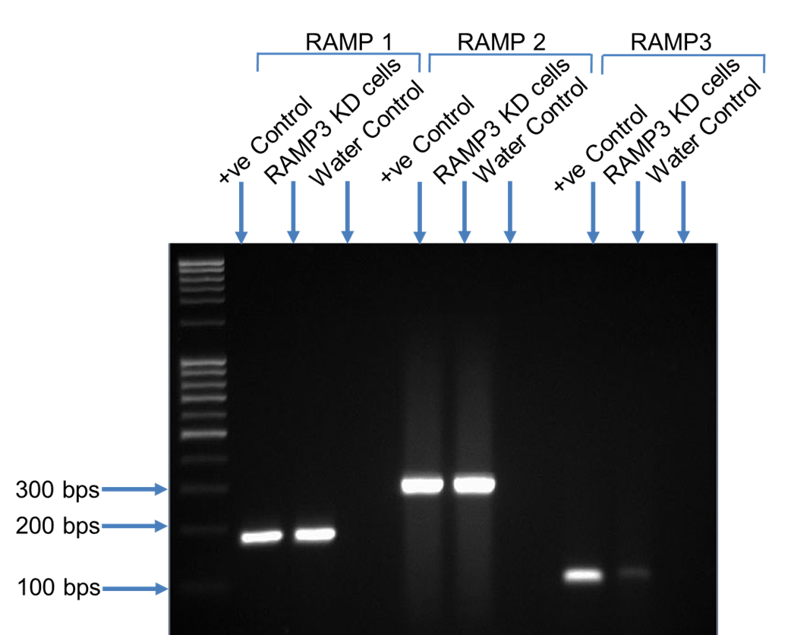

Figure 4.3: Agarose gel electrophoresis (1.5%) for end point PCR to detect RAMP1, RAMP2 and RAMP3 cDNA. RAMP1 (187 bp), RAMP2 (312 bp) and RAMP3 (103 bp) amplicons were amplified in the RAMP3 knockdown cells as well as positive controls (mouse brain). No amplification was detected in the water control samples. Repeated n=4.

Figure 4.4: Agarose gel electrophoresis (1.5%) for end point PCR to detect GAPDH cDNA expression in the mouse brain, the RAMP3 knockdown cells and the water control samples. 354 bp cDNA amplicons were amplified in BMA 178-2, the control virus cells and the RAMP3 knockdown cells corresponding to GAPDH. The primers were not contaminated as no amplification was detected in the water control. Repeated n=4.

RAMP3 expression in RAMP3 knockdown cells for five weeks out of the selection media

In order to assess the stability of RAMP3 knockdown in BMA 178-2, the RAMP3 knockdown cells were left for 5 weeks without selection, which means without adding antibiotics to the culture medium. mRNA samples were taken each week from the RAMP3 knockdown cells and converted to cDNA. The end point PCR shows that the RAMP3 knockdown cells have stable knockdown for 5 weeks. RAMP3 cDNA was amplified in the control virus cells (positive control) and the RAMP3 knockdown cells from week 1 to week 5 (Figures 4.5 and 4.7). The band for RAMP3 in the RAMP3 knockdown cells was fainter than the band for RAMP3 in the control virus cells as expected. Water control was used as an indicator for primer contamination. No amplification was observed in the water control samples. GAPDH primers were used to determine the loading of the cDNA in each well (Figures 4.6 and 4.8).

Figure 4.5: Agarose gel electrophoresis (1.5%) for end point PCR to detect RAMP3 cDNA expression in the RAMP3 knockdown cells out of a selection for two weeks. 103bp amplicons were amplified in the control virus cells and the RAMP3 knockdown cells in week 1 cDNA as well as week 2 cDNA. However, the band in the control virus cells was stronger than the band in the RAMP3 knockdown cells. No amplification was observed in the water control samples. Repeated n=4.

Figure 4.6: Agarose gel electrophoresis (1.5%) for end point PCR to visualise GAPDH cDNA expression in the control virus cells, the water control and the RAMP3 knockdown cells for two weeks out of the selection. The 354 bp DNA product was visualised in the control virus cells and the RAMP3 knockdown cells in week 1 and week 2. No amplification was observed in the water control samples which was indicator the primers not contaminated by genomic DNA. Repeated n=4.

Figure 4.7: 1.5% agarose gel electrophoresis for end point PCR to visualise RAMP3 cDNA expression in the RAMP3 knockdown cells out of a selection for 5 weeks. The RAMP3 cDNA products were amplified in the cells out of a selection for the third week, the fourth week and the fifth week. A band 103 bp in size was detected in the control virus cells and the RAMP3 knockdown cells cDNA in the third, fourth and fifth weeks. However, the band in the RAMP3 knockdown cells was fainter than the band in the control virus cells. Water control was used as a primer contamination control. No band was amplified in the water control. Repeated n=4.

Figure 4.8: 1.5 % Agarose gel electrophoresis for end point PCR to detect the expression of GAPDH cDNA in the control virus cells, the water control and the RAMP3 knockdown cells. A band 354bp in size was observed in the control virus cells and the knockdown cells for three, four, and five weeks out of the selection. However, no band was observed in any of the water controls which means the primers are not contaminated with genomic DNA. The density of the band was the same all the way through the samples. Repeated n=4.

CLR, AM and LOXL-2 expression in the RAMP3 knockdown cells

In order to determine the effect of knocking down RAMP3 on the expression of CLR, AM and LOXL-2, the cDNA was subjected to end point PCR. CLR, AM and LOXL-2 were expressed in cDNA of the positive control (mouse brain) and the RAMP3 knockdown cells (Figure 4.9). The water control was used to confirm that the primers were not contaminated with genomic DNA. The house keeping gene GAPDH primers were used as a loading control. The loading of cDNA was shown to be equal between samples (Figure 4.10). This indicates the knockdown of RAMP3 in BMA 178-2 did not affect the expression of CLR, AM and LOXL-2 at gene level.

Figure 4.9: Agarose gel electrophoresis for end point PCR to visualise the expression of CLR, AM and LOXL-2 cDNA in the positive control (mouse brain), the RAMP3 knockdown cells and the water control. Three bands 280 bp, 130 bp and 486 bp in size corresponding to CLR, AM and LOXL-2 respectively were observed in the positive control and the RAMP3 KD cells cDNA. However, no bands were observed in the water controls. Repeated n=4.

Figure 4.10: Agarose gel electrophoresis for end point PCR to detect the GAPDH cDNA expression in the positive control (mouse brain), the RAMP3 knockdown cells and the water control. The cDNA of the positive control and the RAMP3 knockdown cells were loaded equally, and it can be seen that the intensity of the bands 354 bp in size which corresponds to GAPDH were the same. Nevertheless, no bands were observed in the water controls. Repeated n=4.

PTH1R and PTH2R expression in the RAMP3 knockdown cells

PTH1R was expressed in the RAMP3 knockdown cells but PTH2R was not. However, PTH1R and PTH2R were expressed in the positive control for PTH1R (mouse kidney) and for PTHR2 (mouse brain) (Figure 4.11). The water control was used as a primer contamination control. In order to determine the cDNA loading for each sample, a house keeping gene GAPDH primer was used (Figure 4.11). The loading of cDNA was equal in all samples, as indicated by GAPDH. This result shows that the knockdown of RAMP3 did not affect PTH1R and PTH2R expression at the gene level.

Figure 4.11: Agarose gel electrophoresis for end point PCR indicates the expression of PTH1R, PTH2R and GAPDH cDNA in the RAMP3 knockdown cells, the positive control and the water control. 227pb cDNA amplicon was detected in the RAMP3 knockdown cells and the positive control (mouse kidney). However, no amplification was observed in the knockdown cells corresponding for PTH2R but 162 bp amplicon was observed in the positive control (mouse brain). Equal loading of cDNA was used in this experiment, as indicated by using GAPDH primers. 354bp band corresponding to GAPDH with the same density in all samples showed the equal loading. No amplification was detected in the water controls. Repeated n=4.

CTR and VIPR-1 expression in the RAMP3 knockdown cells

CTR and VIPR-1 expression was not detected in the RAMP3 knockdown cells. However, CTR and VIPR-1 were expressed in the positive control (mouse brain) (Figure 4.12). The water control was used as a primer contamination control. In order to determine the cDNA loading for each sample, a house keeping gene GAPDH primer was used. The loading of cDNA was equal in all samples, as indicated by GAPDH (Figure 4.12). This result shows that the knockdown of RAMP3 did not affect CTR and VIPR-1 expression at gene level.

Figure 4.12: Agarose gel electrophoresis (1.5%) for end point PCR to visualise CTR, VIPR-1 and GAPDH cDNA in the RAMP3 knockdown cells, the positive control (mouse brain) and the water control. The RAMP3 knockdown cells did not express CTR or VIPR-1 as there was no amplification of amplicons detected that corresponded to them. However, 158 bp and 161 bp cDNA amplicons were detected in the positive control (mouse brain) which corresponded to CTR and VIPR-1 respectively. The loading of the cDNA in the experiment was equal, as indicated by the same intensity of 354 bp amplicons which corresponded to the cDNA of the RAMP3 knockdown cells and the positive control. No amplification was observed in the water control. Repeated n=4.

CaSR and GlucagonR expression in the RAMP3 knockdown cells

The expression of CaSR and Glucagon cDNA was detected using specific primers. The result shows that CaSR was expressed in both the RAMP3 knockdown cells and the positive control (mouse kidney). On the other hand, the amplicon corresponding to GlucagonR was only observed in positive control cDNA (mouse brain) (Figure 4.13). The primer contamination was determined by using the water control and no amplification was observed. Equal loading of cDNA was determined using the housekeeping gene GAPDH (Figure 4.13). This result indicates that the expression of CaSR and Glucagon was not altered as a result of knocking down RAMP3.

Figure 4.13: Agarose gel electrophoresis for end point PCR indicates the expression of CaSR, Glucagon and GAPDH cDNA in the RAMP3 knockdown cells, the positive control and the water control. 233bp cDNA amplicon was detected in the RAMP3 knockdown cells and the positive control (mouse kidney). However, no amplification was observed in the knockdown cells corresponding to GlucagonR but 213bp amplicon was observed in the positive control (mouse brain). Equal loading of cDNA was used in this experiment, as indicated by using GAPDH primers. 354bp band corresponding to GAPDH with the same density in all samples showed the equal loading. No amplification was detected in the water controls. Repeated n=4.

SCTR expression in the RAMP3 knockdown cells

The secretin receptor (SCTR) expression was detected in the RAMP3 knockdown cells and positive control (mouse pancreas) (Figure 4.14). The primers were not contaminated with genomic DNA, as indicated by the water control where no amplification was observed in it. GAPDH primers were used as a loading control for cDNA (Figure 4.14). This result indicates that reducing the expression of RAMP3 by knocking down did not change the expression of SCTR in the RAMP3 knockdown cells.

Figure 4.14: Agarose gel electrophoresis for end point PCR to visualise the expression of SCTR and GAPDH cDNA in the RAMP3 knockdown cells, the positive control (mouse pancreas) and the water control. single bands 638bp in size corresponding to SCTR were observed in the RAMP3 KD cells and the positive control cDNA. No bands were observed in the water controls. The loading of the cDNA in the experiment was equal, as indicated by the same intensity of 354bp amplicon which corresponded to the cDNA of the RAMP3 knockdown cells and the positive control. Repeated n=4.

Q-PCR

The identification of the reference gene using the geNorm TM kit

Determination of the most stably expressing housekeeping genes in BMA178-2, the control cells and the RAMP3 knockdown cells was performed using the geNorm TM kit from Primer design ®. As mentioned in Chapter 2, the mouse geNorm TM reference gene selection kit contained 6 reference genes: GAPDH, B2M, ACTB, RPL13A, 18s and EIF4A2. The CT values of the reference genes were used to calculate and determine the stability of the reference genes in the samples. The most stably expressing genes across the control, the RAMP3 knockdown cells (geNorm M) and the minimum number of reference genes required for the experimental set up (geNorm V) were calculated using the CT values obtained from each reference gene.
The relative expression of each reference gene in the control and the RAMP3 knockdown cells is shown in Figure 4.15 which was generated by qBase+ software.

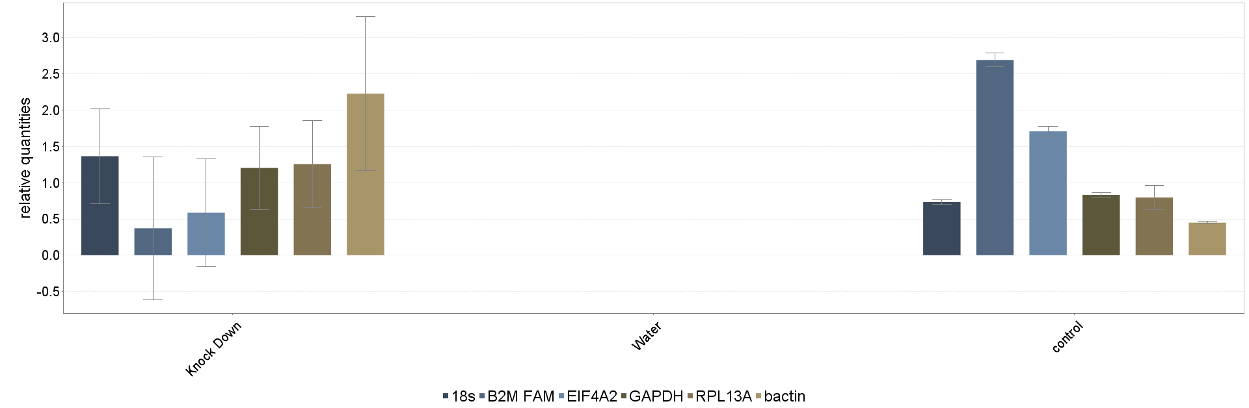

Figure 4.15: A graphical demonstration of the relative cDNA expression of the reference genes (from left to right): 18s, B2M, EIF4A2, GAPDH, RPL13A and 𝜷-actin, at each control cell and the RAMP3 knockdown cells. Each sample was run in triplicate, per gene, and three independent experimental repeats were performed (n=4).

4.4.3.2 GeNorm M value

Determination of the most stably expressing housekeeping genes in BMA178-2, the control cells and the RAMP3 knockdown cells was performed by using the geNorm TM kit from Primer design ®. As mentioned in Chapter 2, the mouse geNorm TM reference gene selection kit contained 6 reference genes: GAPDH, B2M, ACTB, RPL13A, 18s and EIF4A2. The CT values of the reference genes were used to calculate and determine the stability of the reference genes in the samples. The most stably expressing genes across the control and the RAMP3 knockdown cells (geNorm M) and the minimum number of reference genes required for the experimental set up (geNorm V) were calculated using the CT values obtained from each reference gene.
The geNorm “M” value which presents the average expression stability of each reference gene was determined by the relative expression. The geNorm "M" value of the control cells and the RAMP3 knockdown cells were generated in Figure 4.16 using qBase+ software. In this figure the genes are ranked according to their increasing stability, and the values start with the least stable reference gene to the left and end with the most stable reference gene to the right. The determined “geNorm M” value suggests that the least stable reference gene in both the control and the knockdown cells is beta-2-microglobulin (B2M). The increasing order of the gene stability in both the control and the RAMP3 knockdown cells is: B2M, EIF14A2, 𝜷actin, 18s, Glyceraldehyde 3-phosphate dehydrogenase (GAPDH) and RPL13A (most stable).
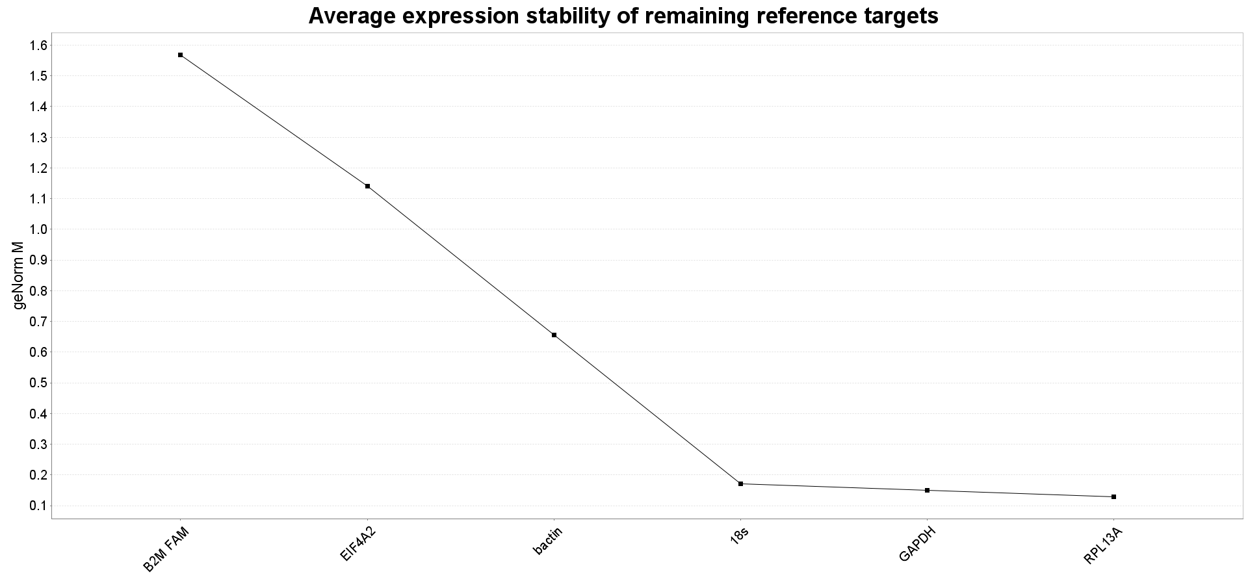

Figure 4.16: Graphical demonstration of average expression stability of geNorm M value of the reference genes in control cells and the RAMP3 knockdown cells. The values on the graph start with the least stable reference gene to the left and end with the most stable reference genes to the right. The least stable gene expressed in WT across all time points is RPL13A, while the most stably expressing gene is B2M. Repeated n=4.

4.4.3.3 GeNorm V value

Determination of the optimal reference gene number for a specific experiment is performed using geNorm analysis to calculate the geNorm V value for different pairwise variations. The pairwise variations are defined as the “V“ (n/n+1), where “n” is the number of reference genes considered. The threshold 0.15 of the geNorm V value determines the number of reference gene that should be used. The optimal number of reference genes is the genome V value <0.15. The graphical output generated by the qBase+ control cells and the RAMP3 knockdown cells with respect to the geNorm M values determined for each gene is as follows (Figure 4.17).

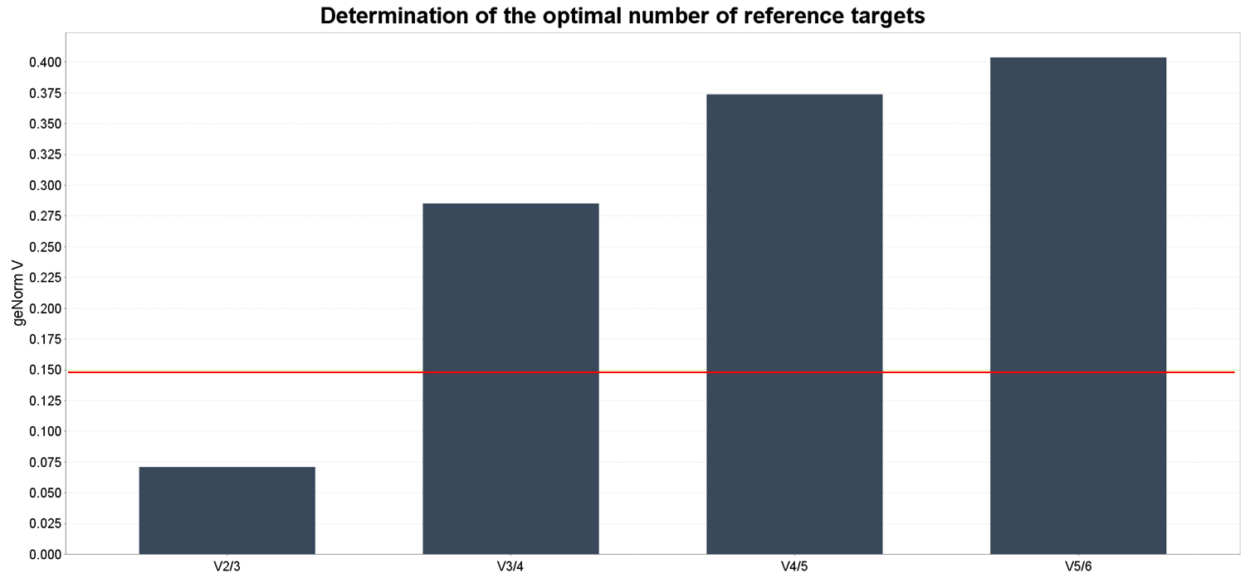
Figure 4.17: Graphical demonstration of “geNorm V value” to determine the optimal number of reference target genes to form the experiments. The Y-axis is showing the geNorm V value and the X-axis is presenting the pairwise variations “V (n/n+1)”, where n corresponds to the number of reference genes studied. The first bar on the left is showing that the “n” value = 2 to 3 leads to a geNorm V value below 0.15 and the red line points out the threshold. Repeated n=4.
Since the first bar of the “V (n/n+1)” results in a geNorm V value below 0.15, the optimal number of reference target genes for the experiment is two reference genes, which according to the geNorm M graph Figure (4.16) are considered to be RPL13A and GAPDH. Hence, the sample expression of all genes of interest was normalised to those two selected reference genes. However, if the “V (n/ n+1) result in value over the threshold (0.15), the optimal reference gene number will remain undetermined. Therefore, qBase+ recommends using a minimum of the three most stably expressed reference genes for that specific experiment.

Expression of mRNA RAMP2 in the RAMP3 knockdown cells

RAMP2 mRNA expression in the control virus cells and the RAMP3 knockdown cells were normalized to GAPDH. This value (∆CT, is used to calculate the relative expression of RAMP2 in each cell type). The∆∆CT value was calculated by following the formula 2^{-∆∆CT} to calculate the fold change. The experiment was repeated 3 times and the samples were run in triplicate. The result indicates that there were no differences in the expression of mRNA RAMP2 in the BMA 178-2 cells or the RAMP3 knockdown cells (Figure 4.18). Therefore, the knockdown of RAMP3 did not alter the expression of mRNA RAMP2.
Figure 4.18: cDNA RAMP2 expression in RAMP3 knockdown cells and BMA 178-2 cells normalized to GAPDH by using Q-PCR. There was no significant difference in RAMP2 expression between the BMA178-2 cells and the RAMP3 knockdown cells. The knockdown of RAMP3 did not affect the expression of RAMP2. Repeated n=3.

Expression of RAMP3 mRNA in the RAMP3 knockdown cells
In order to confirm the knockdown of RAMP3 in BMA178-2 at the mRNA level, Q-PCR was utilised. Similarly to RAMP2 mRNA, the fold change in the expression of RAMP3 mRNA between the control virus cells and the RAMP3 knockdown cells was calculated by using ∆∆CT. The result indicates that the expression of mRNA of the RAMP3 knockdown cells was significantly reduced as a result of the RAMP3 knockdown in comparison to the expression of RAMP3 mRNA in the control virus cells (Figure 4.19).
Figure 4.19: cDNA RAMP3 expression in RAMP3 knockdown cells and control virus cells normalised to GAPDH by using Q-PCR. RAMP3 expression was significantly reduced in the RAMP3 knockdown cells in comparison to the virus control cells. Significance of p value: ** ≤ 0.001. Repeated n=3.

Western blotting

RAMP3 expression in the RAMP3 knockdown cells
In order to confirm the knockdown of RAMP3 in BMA178-2 at the protein level, Western blotting was carried out. RAMP3 protein was detected in the blot by using the anti RAMP3 antibody (see Chapter 2). RAMP3 was expressed in the RAMP3 knockdown cells, the control virus cells and BMA178-2 as there is a band detected that is ~ 25 kDa in size. However, the band detected in the RAMP3 knockdown cells was fainter than the band in the control virus cells and the BMA 178-2. B-actin antibody was used to show that the loading of the protein was equal in all wells. B-actin was detected and was ~ 45 kDa in size and the intensity of the band was the same in all samples, which is an indicator of the equal loading (Figure 4.20 A). Moreover, the quantification of the RAMP3 expression level was normalised to B-actin in the RAMP3 knockdown cells, the control virus cells and BMA178-2. The RAMP3 expression was significantly reduced in the RAMP3 knockdown cells compared to in the control virus cells and BMA178-2 (Figure 4.20 B). 25µg of protein was loaded in each well and B-actin was used as a loading control and the exposure time was 1-2 min. The result showed that the expression level of RAMP3 in the RAMP3 knockdown cells was reduced significantly in comparison to the control virus cells and the positive control (mouse brain).

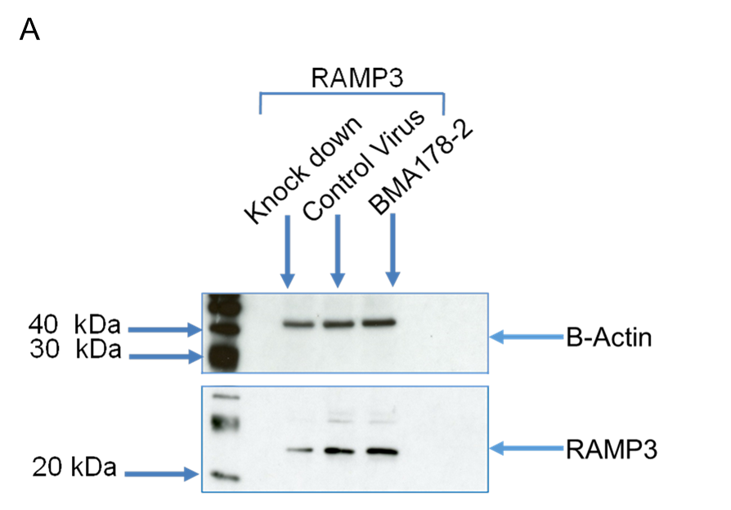
Figure 4.20: A) The expression of RAMP3 in the RAMP3 knockdown cells, the control virus cell and BMA178-2 at the protein level by using Western blotting. RAMP3 protein was detected in the blot by using the anti RAMP3 antibody (see Chapter 2). RAMP3 is expressed in the RAMP3 knockdown cells, the control virus cells and BMA178-2 as there is a band detected that is ~ 25 kDa in size. However, the band detected in the RAMP3 knockdown cells was fainter than the band in the control virus cells and BMA 178-2. The B-actin antibody was used to show that the loading of the protein was equal in all wells. B-actin was detected that was ~ 45 kDa in size and the intensity of the band was the same in all samples, which is an indicator of the equal loading. B) Quantification of the RAMP3 expression level was normalised to 𝜷-actin in the RAMP3 knockdown cells, the control virus cells and BMA178-2. The RAMP3 expression was significantly reduced in the RAMP3 knockdown cells compared to in the control virus cells and BMA178-2. 20µg of protein was loaded in each well and B-actin was used as a loading control. The exposure time was 1-2 min. Significance of p value: **** ≤ 0.0001. Repeated n=4.

RAMPs expression in the RAMP3 knockdown cells
The level of RAMPs protein expression was quantified in the RAMP3 knock down cells. RAMP1, RAMP2 and RAMP3 protein was detected in the blot by using RAMP1, RAMP2 and RAMP3 antibody. RAMP1, RAMP2 and RAMP3 were detected in both the control virus cells and the knockdown cells. ~20 kDa, ~20kDa and ~25 kDa bands corresponding to RAMP1, RAMP2 and RAMP3 protein respectively were seen in the blot in both the control virus cells protein and the knockdown cells proteins. However, the band of RAMP3 was fainter in the RAMP3 knockdown cells in comparison to in the control virus cells as a result of knocking down RAMP3. B-actin was used as a loading control for the protein samples. 𝜷-actin was detected ~ 45 kDa in size and the intensity of the band was the same in all samples, which is an indicator that the loading was equal in all wells. The result shows no alteration of the RAMP1 and RAMP2 protein expression as a result of knocking down RAMP3. The low expression of RAMP3 indicates that the knockdown procedure was performed effectively and the expression of RAMP3 in the RAMP3 knockdown cells was significantly reduced compared to in the control virus cells (Figure 4.21 A). Moreover, the quantification of RAMPs expression level normalised to B-actin in the RAMP3 knockdown cells and the control virus cells, which shows that RAMP1 and RAMP2 expression was not significantly different between the RAMP3 knockdown cells and the control virus cells. Nevertheless, RAMP3 expression was significantly reduced in the RAMP3 knockdown cells in comparison to the expression of RAMP3 in the control virus cells. 30ug of protein was loaded in each well and the exposure time is 1-2 min (Figure 4.21 B).

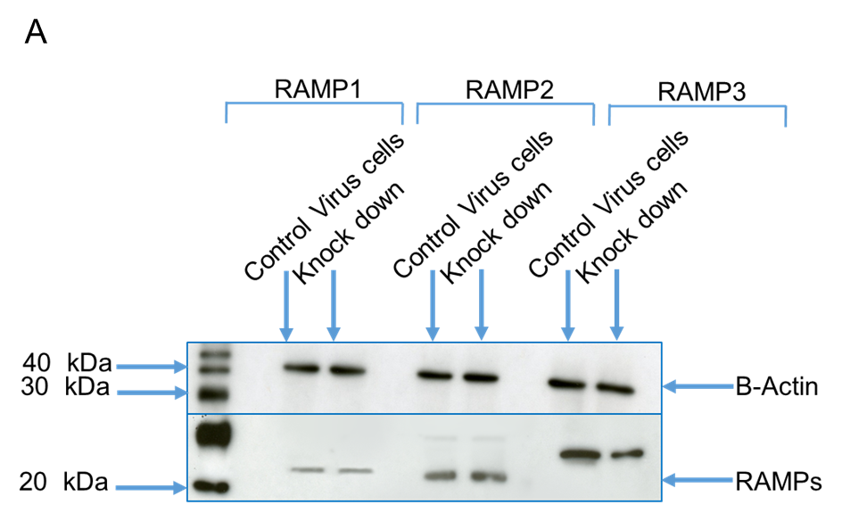

Figure 4.21: Protein expression of RAMPs in control virus cells and RAMP3 knockdown cells at the protein level by using Western blotting. A) The Western blot indicates the protein expression of RAMP1, RAMP2, RAMP3 and 𝜷- actin. B) Quantification of RAMPs expression level was normalised to B-actin in the RAMP3 knockdown cells and the control virus cells. Significance of p value: **** ≤ 0.0001. n=4

CLR expression in the RAMP3 knockdown cells

In order to determine any alteration in the expression of the AM receptor’s component as a consequence of RAMP3 silencing, CLR protein expression was investigated. The CLR expressed in the positive control (mouse brain), the control virus cells and the RAMP3 knockdown cells and two bands ~55kDa in size corresponding to CLR was observed in all samples. 𝜷-actin was used as a loading control to show the equal loading of protein which was in this experiment equal, as~45kDa band corresponded to 𝜷-actin and the intensity of it was the same throughout all the samples (Figure 4.22 A). Also, the quantification of CLR expression level normalised to 𝜷-actin in the positive control (mouse brain), the control virus cells and the RAMP3 knockdown cells shows that CLR expression was not significantly different between all samples (Figure 4.22 B). Hence, CLR expression was not altered in the RAMP3 knockdown cells and the expression of CLR in the RAMP3 knockdown cells and the control virus cells was almost the same. The result shows no changes in CLR protein expression in the RAMP3 knockdown cells.
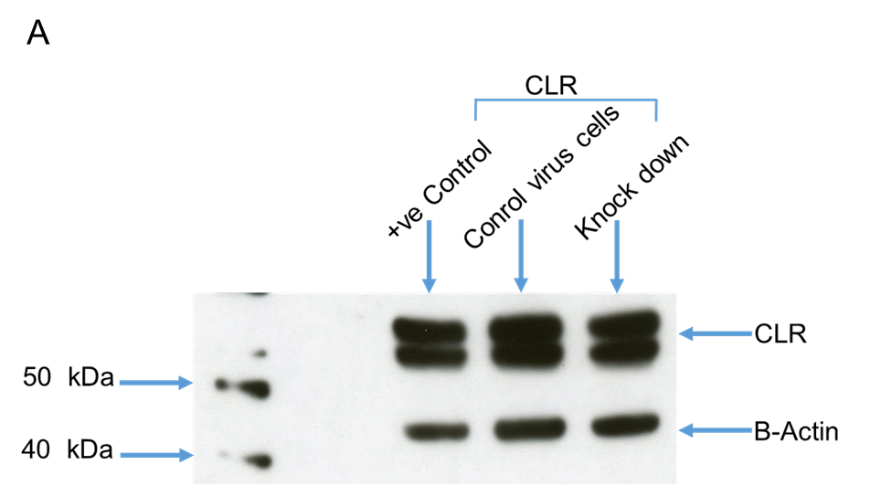
Figure 4.22: A) The expression of CLR in the positive control (mouse brain), control virus cells and RAMP3 knockdown cells. A) The blot shows the expression of CLR as well as the 𝜷-actin in the positive control (mouse brain), the control virus cells and the RAMP3 knockdown cells. B) Quantification of CLR expression level normalised to 𝜷-actin in the positive control (mouse brain), the control virus cells and the RAMP3 knockdown cells. Repeated n=4.

RAMP3 expression in the RAMP3 knockdown cells out of selection media for 5 weeks

In order to determine the stability of the RAMP3 knockdown in the cells out of the selection media prior to being injected into the mice model for in vivo study, the cells were left out of the selection media for 5 weeks. The protein was extracted from cells weekly and frozen at -80 ºC to prevent any enzymatic activity and degradation of the sample. The samples were run together in the same gel and the experiments were repeated 4 times independently with 4 different protein extractions. The result showed that 25~kDa bands corresponding to RAMP3 appeared in the control virus cells and the RAMP3 knockdown cells (Figure 4.23 A). The intensity of the bands corresponding to RAMP3 in the RAMP3 knockdown cells was consistent all the way from week 1 to week 5 as well as the control virus cells showing that the knockdown of RAMP3 was stable in the cells without antibiotics for 5 weeks. 𝜷-actin was used as a loading control. The loading of the protein was equal in all samples where the bands corresponding to B-actin ~45 kDa in size had similar density. Furthermore, the quantification of the RAMP3 expression level normalised to B-actin in the control virus cells has no significant difference between the samples from week 1 to week 5 (Figure 4.23 B). However, the expression of RAMP3 in the RAMP3 knockdown cells was significantly reduced in comparison to the control virus cells. The reduction of the RAMP3 expression in the RAMP3 knockdown cells was stable for 5 weeks. 25µg of protein was loaded into each well and the exposure was 1-2 min. The result shows that the knockdown of RAMP3 was stable for 5 weeks and the expression of RAMP3 in the RAMP3 knockdown cells was significantly reduced in comparison with the control virus cells.
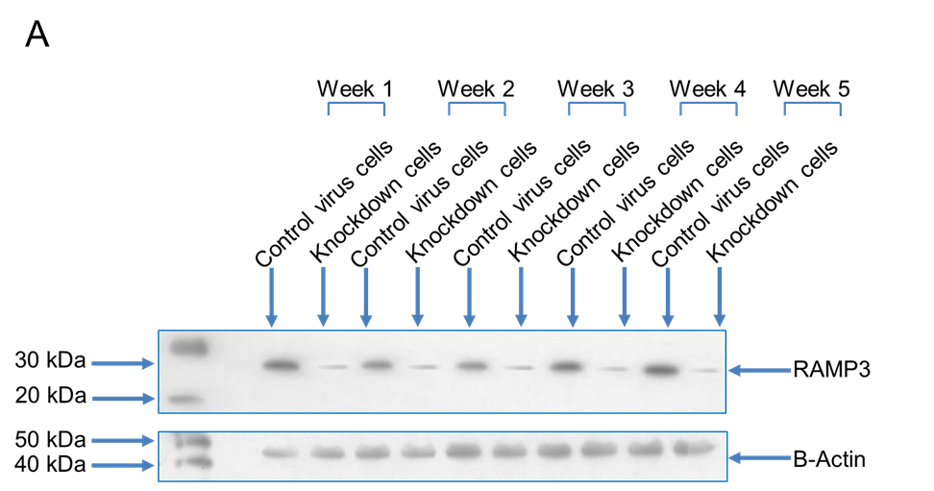
Figure 4.23: A) Expression of RAMP3 in control virus cells and RAMP3 knockdown cells out of the selection media for 5 weeks. A) Representative Western blot showing the expression of RAMP3 in the control virus cells and the RAMP3 knockdown cells out of selection for 5 weeks. B) Quantification of the level of expression of RAMP3 normalised to B-actin in the control virus cells and the RAMP3 knockdown cells. Significance of p value: **** ≤ 0.0001. Repeated n=4.

Proliferation assay

Proliferation assay of RAMP3 knockdown cells in 10% and 4% FCS.

In order to determine the effect of knocking down RAMP3 on the proliferation of the prostate cancer cells, the cells were grown in media with two different concentrations of FCS along with control virus cells and BMA 178-2 cells as controls. The purpose behind using two different concentrations of FCS was to allow the cells to settle down and regrow again in a complete media with 10% FCS, then to slow down the proliferation rate of the cells by growing them in 4% FCS to be able to notice the differences in the proliferation rates between the groups. The number and the doubling time of the RAMP3 knockdown cells growing in 10% FCS on 13th day were reduced significantly and the doubling time was 40 hours in comparison with the control virus cells and BMA 178-2 where the doubling time for them was 29 and 28 respectively (Figure 4.24, Figure 4.26 and Table 4.1). Likewise, the number of RAMP3 knockdown cells which were grown in complete media with 4% FCS was significantly decreased as a result of knocking down RAMP3 in comparison with the number of control virus cells and BMA 178-2. Also, the doubling time of the RAMP3 knock down cells was significantly higher than the control virus cells and BMA178-2, where the doubling time of the RAMP3 knockdown cells was 49 hours, while the control virus cells and BMA178-2 was 39 and 38 respectively (Figure 4.25, Figure 4.27 and Table 4.2). This result indicates that reducing the expression of RAMP3 by knockdown resulted in a reduction in proliferation and increases in the doubling time of the BMA 178-2 cells.

Figure 4.24: The proliferation assay of BMA 178-2 cells, the control virus cells and the RAMP3 knockdown cells for 14 days in 10% FCS. The proliferation of the RAMP3 knockdown cells was reduced significantly in comparison to the proliferation of BMA 178-2 and the control virus cells. n=3

Figure 4.25: The proliferation assay of the BMA 178-2 cells, the control virus cells and the RAMP3 knockdown cells for 14 days in 4% FCS. The proliferation of the RAMP3 knockdown cells was reduced significantly in comparison with the proliferation of BMA 178-2 and the control virus cells. Repeated n=3.

Table 4.1: The effect of knocking down RAMP3 on the proliferation of the RAMP3 knockdown cells in 10% FCS in comparison with BMA178-2 and the control virus cells. The table illustrates the doubling time of the cells expressed in hours and the final population of the cells on day 13. Interestingly, the doubling time of the RAMP3 knockdown cells was reduced as a result of decreasing the expression of RAMP3. The doubling time of the RAMP3 knockdown cells was 40 hours and the number of cells on day 13 was 2.2 X 10⁶. However, the doubling time of BMA178-2 and the control virus cells was 28 and 29 respectively and the number of cells on day 13 was 3.8 X 10⁶ and 3.6 X 10⁶ respectively.
Cell type | Doubling time (hours) | Number of cells at day 13 (10% FCS)
BMA 178-2 | 28 | 3.8 X 10⁶
Control virus cells | 29 | 3.6 X 10⁶
Knockdown cells | 40 | 2.2 X 10⁶

Table 4.2: The effect of knocking down RAMP3 on the proliferation of the RAMP3 knockdown cells in 4% FCS in comparison with BMA178-2 and the control virus cells. The table shows the doubling time of the cells expressed in hours and the final population of the cells on day 13. Interestingly, the doubling time of the RAMP3 knockdown cells was reduced as a result of decreasing the expression of RAMP3. The doubling time of the RAMP3 knockdown cells was 49 hours and the number of cells on day 13 was 8 X 10⁵. However, the doubling time of BMA178-2 and the control virus cells was 38 and 39 respectively and the number of cells on day 13 was 2.7 X 10⁶ and 2.5 X 10⁶respectively.
Cell type | Doubling time (hours) | Number of cells at day 13  (4% FCS)
BMA 178-2 | 38 | 2.7 X 10⁶
Control virus cells | 39 | 2.5 X 10⁶
Knockdown cells | 49 | 8 X 10⁵
Figure 4.26: The number of control virus cells, BMA 178-2 cells and knockdown cells in 10% FCS at day 13. The number of RAMP3 knockdown cells was significantly lower than the BMA 178-2 as well as the control virus cells. Significance of p value: ** ≤ 0.0034. Repeated n=3.
Figure 4.27: The number of control virus cells, BMA 178-2 cells and knockdown cells in 4% FCS at day 13. The number of RAMP3 knockdown cells was significantly lower than the BMA 178-2 as well as the control virus cells. Significance of p value: **** ≤ 0.0001. Repeated n=3.

Proliferation assay with AM stimulation

The sensitivity of the RAMP3 knockdown cells to AM stimulation was tested using three different doses of AM (1µM, 1nM and 1pM). The cells did not respond to AM stimulation and the proliferation of the control virus cells did not respond to such stimulation either, which indicates that the knockdown of RAMP3 did not alter the sensitivity of the cells being stimulated with AM (Figure 4.28).
Figure 4.28: AM stimulation of the proliferation of the control virus cells and the RAMP3 knockdown cells in a dose dependent manner. Three different doses of AM were used to stimulate the proliferation of the control virus cells and the RAMP3 knockdown cells which are 1µM, 1nM and 1pM. However, neither the control virus cells nor the RAMP3 knockdown cells were stimulated with AM doses. Repeated n=3.

Proliferation assay with AM ₂₂₋₅₂ inhibition

The response of the RAMP3 knockdown cells to the AM₂₂₋₅₂ antagonist was verified using three different doses of AM₂₂₋₅₂ and the control virus cells were used as a control. Interestingly, the proliferation of the RAMP3 knockdown cells was not affected by the AM 22-52 inhibition. However, the proliferation of the control virus cells was inhibited in a dose dependent manner. This result illustrates that silencing the RAMP3 gene expression affected the proliferation of BMA 178-2 as well as the formation of the AM2 receptor, resulting in insensitivity of the cells to AM₂₂₋₅₂ inhibition (Figure 4.29).
Figure 4.29: AM 22-52 inhibition of the proliferation of the control virus cells and the RAMP3 knockdown cells in a dose dependent manner. Three different doses of AM ₂₂₋₅₂ were used to inhibit the proliferation of the control virus cells and the RAMP3 knockdown cells which are 1µM, 1nM and 1pM. The proliferation of the control cells was inhibited in a dose dependent manner and the higher dose of AM ₂₂₋₅₂ (1uM) slowed down the proliferation effectively. However, the AM 22-52 did not affect the proliferation of the RAMP3 knockdown cells. n=3

Proliferation assay using the Vybrant® DiD cell labelling solution

In order to clarify the effect of knocking down RAMP3 in the proliferation of BMA 178-2, both the control virus cells and the RAMP3 knockdown cells were labelled with DID staining. The result shows that on day 0, 95% of cells in Figure 4.30 A and Figure 4.30 B were labelled with the stain. On day 3 staining on both cell types decreased to 90%. However, on day 7 the control virus cells lost a significant amount of the DID labelling as a result of their short doubling time, where just 9% of the cells kept the DID label, while 33% of the RAMP3 knockdown cells were labelled with DID as a result of their slow growth. On day 10, less than 2% of the control virus cells were labelled with DID, while 20% of the RAMP3 knockdown cells were labelled with DID. On day 14 and day 17 most of the control virus cells and the RAMP3 knockdown cells were not labelled with DID. On day 7, 33% of the knockdown cells were labelled with DID, while 9% of the control virus cells were labelled with DID. On day 10, the knockdown cells had significantly more labelled cells (20%) than the control virus cells (2%). On days 14 and 17 most of the RAMP3 knockdown cells and the control virus cells lost their labels with DID staining (Figure 4.31). This result shows that the control virus cells have a higher proliferation rate than the RAMP3 knockdown cells and that they lost their labels with DID faster than the RAMP3 knockdown cells which indicates that knocking down RAMP3 reduces the proliferation of BMA 178-2.

A B

Figure 4.30: The DID labelling of the control virus cells and the RAMP3 knockdown cells as analysed with the FACS Calibur. A) The first picture shows that on 0 day most of the control virus cells were labelled with DID. The second picture shows the negative control, where the control virus cells were not labelled with DID. B) The first picture shows that most of the RAMP3 knockdown cells were labelled with DID on day 0. The second picture is of a negative control, where most of the RAMP3 knockdown cells were not labelled with DID.
Figure 4.31: The percentage of control virus cells and RAMP3 knockdown cells which were labelled with DID staining on days 0, 3, 7, 10, 14 and 17. Significance of p value: **** ≤ 0. 05. Repeated n=4.

Wound healing assay
In order to study the effect of reducing the expression of RAMP3 on the migration of BMA 178-2, a migration assay (wound healing assay) was carried out. A scratch was made using a 200µl pipette tip in the middle of the cell monolayer and was treated with mitomycin C to stop cell proliferation. The control cells were able to migrate and close the scratch in 72 hours (Figure 4.32 A and Figure 4.33). The ability of the RAMP3 knockdown cells to close the scratch was significantly reduced and the RAMP3 knockdown cells were able to close 73% of the scratch in 72 hours (Figure 4.32 B and Figure 4.33).

Figure 4.32: The migration assay shows the motility and the ability of the control cells and the RAMP3 knockdown cells to close a wound made in the monolayer of the cells in 72h. A) The control virus cells were able to close a wound made in the monolayer of the cells by a 200µl pipette tip in 72 hours. B) The RAMP3 knockdown cells were not able to fully close the wound which was made by a 200ul pipette tip in the monolayer of the cells in 72 hours. Repeated n=4.

Figure 4.33: A bar graph representing the percentage of wound closure by control virus cells and RAMP3 knockdown cells in 72 hours. The motility and ability of the cells to close the wound was affected significantly as a result of the knockdown of RAMP3. 24 hours after the scratch was made, the control cells were able to close ~95% of the scratch, while the RAMP3 knockdown cells were able to close almost 50% of the scratch. 48 hours later the control cells were able to close ~98% of the scratch, while the RAMP3 knock down cells were able to close 65% of the scratch. 72 hours later 100% of the scratch was closed by control cells, while the RAMP3 knockdown cells were able to close 73% of the scratch. Significance of p value: **** ≤ 0. 05. Repeated n=4.

Wound healing assay with AM stimulation

As BMA178-2 cells has all the components of AM1 and AM2 receptors, cells were stimulated using three doses of AM - 1µM, 1nM and 1pM. The RAMP3 knockdown cells and the control cells were stimulated for 72 hours. No significant differences were observed on the migration of the RAMP3 knockdown cells or on the control virus cells (Figure 4.34). This indicates that AM has no effect on the migration of the RAMP3 knockdown cells or the control virus cells.
Figure 4.34: Stimulating the control virus and the RAMP3 knockdown cells migration by using AM in a dose dependent manner. Three different doses of AM were used to stimulate the migration of the control virus cells and the RAMP3 knock down cells (1µM, 1nM and 1pM). However, the migration of both the control virus cells and the RAMP3 knockdown cells was not affected by AM stimulation. Repeated n=4.

Wound healing assay with AM ₂₂₋₅₂ inhibition

In order to investigate the role of knocking down RAMP3 to alter the motility of the cells in response to AM ₂₂₋₅₂, a migration assay was used. Three different doses of AM ₂₂₋₅₂ were used (1µM, 1nM and 1pM) and added to the RAMP3 knockdown cells and control cells for 72 hours. No significant differences in the migration rate and the motility of the RAMP3 knockdown cells or the control cells were observed (Figure 4.35). This shows that the AM₂₂₋₅₂ has no effect on the migration of RAMP3 knockdown cells or control virus cells.
Figure 4.35: Inhibiting the control virus and the RAMP3 knockdown cells migration by AM22-52. Three different doses of AM₂₂₋₅₂ were used to inhibit the migration of the control virus cells and the RAMP3 knock down cells (1uM, 1nM and 1pM). However, the migration of both the control virus cells and the RAMP3 knockdown cells was not affected by AM22-52 inhibition. Repeated n=4

Invasion assay

The invasion assay was performed in order to investigate the role of RAMP3 in the invasion of BMA 178-2. The RAMP3 knockdown cells and the control virus cells were starved in 0% FCS for 24 hours prior to starting the assay. The cells were allowed to invade the basement membrane towards 10% FCS as a chemoattractant for 48 hours. Interestingly, the number of control cells that invaded through the basement membrane was significantly higher than the number of RAMP3 knockdown cells (Figure 4.36, Figure 4.37 and Figure 4.38). This result shows that the invasion ability of the BMA178-2 was diminished as a result of knocking down RAMP3.
Figure 4.36: The invasion assay of control cells and RAMP3 knockdown cells for 48h through the basement membrane transwell. The cells were separated into 2 groups of each type of cell. The first group is the control virus cells incubated in 0% FCS and left to invade the basement membrane transwell for 48 hours and 10% FCS was used as a chemoattractant. The second group was a control of the first group, where the control virus cells were incubated in 0% and 0% FCS was used as a chemoattractant. Similarly, RAMP3 knockdown cells were incubated in 0% FCS and left to invade the basement membrane transwell for 48 hours toward 10% of FCS as chemoattractant. Also, a control group of the first group was used and the cells starved in 0% FCS and left to invade the basement membrane for 48 hours towards 0% FCS as a chemoattractant. 48 hours later the number of cells that had invaded the basement membrane transwell was counted. The number of control virus cells that invaded the basement membrane was significantly higher than the number of RAMP3 knockdown cells. Significance of p value: *** ≤ 0. 05. Repeated n=3.

Figure 4.37: The optical density (OD) of control virus cells and RAMP3 knockdown cells that invaded the basement membrane transwell. The cells were separated into 2 groups of each type of cell. The first group is the control virus cells incubated in 0% FCS and were left to invade the basement membrane transwell for 48 hours and 10% FCS was used as a chemoattractant. The second group was a control of the first group, where the control virus cells were incubated in 0% and 0% FCS was used as a chemoattractant. Similarly, the RAMP3 knockdown cells were incubated in 0% FCS and were left to invade the basement membrane transwell for 48 hours towards 10% FCS as a chemoattractant. Also, a control group of the first group was used and the cells were starved in 0% FCS and were left to invade the basement membrane for 48 hours towards 0% FCS as a chemoattractant. 48 hours later the number of cells that had invaded the basement membrane transwell were stained and subjected to a plate reader in order to measure the optical density of the invaded control virus cells and they were compared with the number of RAMP3 knockdown cells. The number of control virus cells that invaded the basement membrane was significantly higher than the number of RAMP3 knockdown cells. Significance of p value: ** ≤ 0. 05. Repeated n=3.
Figure 4.38: The invasion of the control virus cells and the RAMP3 knockdown cells to the transwell. A) Image from the middle of the transwell shows the control virus cells invasion towards 0% FCS. B) Image from the corner of the transwell shows the control virus cells invasion towards 0% FCS. C) Image from the middle of the transwell shows the control virus cells invasion towards 10% FCS. D) Image from the corner of the transwell shows control virus cells invasion towards 10% FCS. E) Image from the middle of the transwell shows the RAMP3 knockdown cells invasion towards 0% FCS. F) Image from the corner of the transwell shows the RAMP3 knockdown cells invasion towards 0% FCS. G) Image from the middle of the transwell shows the RAMP3 knockdown cells invasion towards 10% FCS. H) Image from the corner of the transwell shows RAMP3 knockdown cells invasion towards 10% of FCS. The invasion ability of the cells was reduced as a consequence of knocking down RAMP3, as it can be seen that the number of cells that invaded the basement membrane in G and H was less than the number of invaded cells in C and D.

Clonogenic assay

In order to assess the impact of knocking down RAMP3 in the BMA 178-2 prostate cancer cell line, the RAMP3 knockdown cells were subjected to a clonogenic assay. 1000 RAMP3 knockdown cells and control virus cells were left to grow in complete media in a 60 mm² petri dish. The result shows that the number and size of the control virus cells were significantly higher and bigger in comparison to the RAMP3 knockdown cells (Figure 4.39). The result indicates that the knockdown of RAMP3 reduces the colony size and number and reduces the tendency of the cells to form a tumour in vivo.

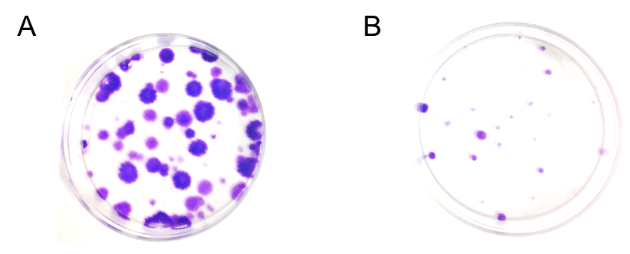

C D
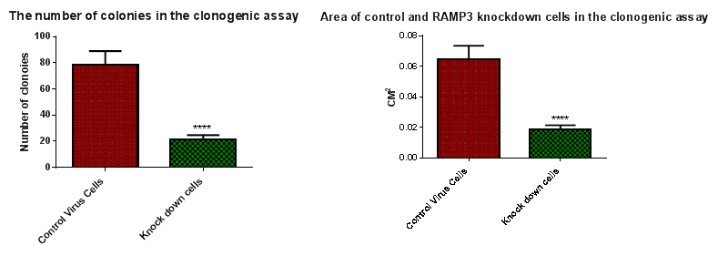

Figure 4.39: The clonogenic assay of the control virus cells and the RAMP3 knockdown cells. A) The size of the the RAMP3 cells colony was significantly smaller than the control virus cells. The size of the RAMP3 knockdown cells colony was around 0.02 CM², while the size of the control virus cells colony was 0.06 CM². B) The number of RAMP3 knockdown colonies was significantly lower than the control virus cells colony. The number of RAMP3 knockdown cell colonies was ~ 20 colonies, while the number of control virus cell colonies was ~ 80 colonies. C) The control virus cells colony. D) The RAMP3 knockdown cells colony. Significance of p value: **** ≤ 0. 05. Repeated n=4.

Cell toxicity assay

The effect of RAMP3 knockdown on cells sensitivity to 5FU was determined using a cell toxicity (viability) assay. A range of 5FU concentrations were added to the cells on the second day of seeding the cells and the cells were left to grow for three days. The RAMP3 knockdown cells were gradually decreased as a result of 5FU treatment and the higher dose of 5FU killed most of the cells (Figure 4.40 and Figure 4.41). The control virus cells were less sensitive to 5FU treatment and the cells were more sensitive at 1µg/ml and 100ng/ml doses. This result indicates that the knockdown of RAMP3 made the cells more sensitive to 5FU in comparison to the control virus cells.

Figure 4.40: The number of viable control virus cells and RAMP3 knockdown cells after 5FU treatment. The number of RAMP3 knockdown cells (B) was reduced in a dose dependent manner and was more sensitive to 5FU than the control virus cells (A). Different doses of 5FU (10 fg/ml – 1 µg /ml) were used to determine the sensitivity of the cells to 5FU. 1ug /ml of 5FU was able to kill up to 90% of the RAMP3 knockdown. However, the same dose did not affect the control virus cells as much as the RAMP3 knockdown cells and more than 50% of the cells survived.

Figure 4.41: The number of dead control virus cells and dead RAMP3 knockdown cells after 5FU treatment. C) The different concentrations of 5 FU did not affect the viability of the control virus cells except at 1ug/ml and 100ng/ml doses. The number of dead cells as a result of 5FU treatment with concentration 1µg/ml was ~ 6 X10⁵ and 100 ng/ml was~ 5.7X10⁵. D) The number of dead cells was gradually increased along with increasing the dose of 5FU from 10 fg/ml to 1ug/ml in the RAMP3 knockdown cells.

cAMP assay

The cAMP production was investigated using a cAMP assay to assess the effect of the knockdown of RAMP3 on the cAMP production. The RAMP3 knockdown cells and the control virus cells were stimulated by different concentrations of AM. The result illustrated that the RAMP3 knockdown cells have less cAMP production than the control virus cells which might have changed the downstream signalling, affecting the proliferation, migration, invasion and apoptosis of BMA 178-2 (Figure 4.42 and Figure 4.43). The EC80 of forskolin was considered as the maximum stimulation agonist and the cAMP production (%) results were normalised to it.

Figure 4.42: The cAMP assay of the RAMP3 knockdown cells and the control virus cells. The RAMP3 knockdown cells have less cAMP production than the control virus cells as a result of knocking down RAMP3.

Figure 4.43: The percentage of cAMP in the RAMP3 knockdown cells and the control virus cells. The RAMP3 knockdown cells have less cAMP than the control virus cells. The data was normalised to the cAMP content in the cells stimulated with forskolin.

Discussion

In the previous chapter, the AM1 and AM2 receptor components were found to be expressed in the BMA178-2 cell line. The aim of this chapter was to identify the role of the AM2 (CLR+RAMP3) receptor in BMA178-2, specifically RAMP3, where CLR is shown to play an important role in the development of the vascular system. The CLR^{-/-} embryos died mid-gestation due to hydrops fetalis and this component is shared with the AM1 receptor components which it is believed receive the AM signalling in health rather than disease situation, as mentioned in Chapter 1. The role that RAMP3 plays in cancer cells development was studied through reducing the expression of RAMP3 at the gene level by knocking down RAMP3 using lentivirus which eventually affected the RAMP3 protein expression. The effects of the reduction of RAMP3 expression at the gene level and protein level on cell behaviour were studied by using different experiments.
The knockdown of RAMP3 at the mRNA and protein level
RAMP3 was knocked down by using 50 MOI shRNA lentiviral particles and the cells which have shRNA lentiviral particles were selected by using puromycin. The concentrations of puromycin used were determined by using various concentrations of puromycin (Figure 4.1). Afterwards the resistant colonies were identified and expanded to be assayed (Taxman et al., 2010).
Using RT-PCR showed that the mRNA of RAMP3 was reduced, as the band which corresponded to RAMP3 in BMA178-2 was fainter than the band corresponding to RAMP3 in the positive control (mouse brain) and the control virus cells, as was shown by the electrophoresis gel (Figure 4.2).
q-PCR was performed using custom primers to detect RAMP3 and to validate the previous findings by RT-PCR using the Taqman qPCR technique. The result shows that the expression of RAMP3 was decreased significantly as a consequence of knocking down RAMP3 by using lentivirus in comparison to the control virus cells (Figure 4.19). So, in order to investigate the effect of knocking down RAMP3 on the protein level, Western blotting was carried out. A band corresponding to RAMP3 was fainter in the knockdown cells compared to the BMA178-2 and the control virus cells which showed the expression of RAMP3 decreased in the knockdown cells in comparison to the BMA178-2 cells and the control virus cells (Figure 4.20).

The stability of knocking down RAMP3
In order to test the stability of the RAMP3 knockdown cells, the RAMP3 knockdown cells were treated without antibiotic selection for 5 weeks in vitro. The result shows that the knocking down of RAMP3 was stable for 5 weeks out of selection media, as was indicated by using RT-PCR and Western blotting. The band corresponding to RAMP3 was fainter in the knockdown cells in comparison to the control virus cells (Figures 4.5, 4.7 and 4.23). This result can conclude that the knockdown of RAMP3 was stable for 5 weeks. This experiment was performed prior to the in vivo study to predict the stability of the knockdown of RAMP3 in the mice after injecting the cells. Therefore, any effect that might be seen in tumour development in vivo can be seen as a result of knocking down RAMP3.
Investigate the effect of knockdown RAMP3 on the related receptors at the mRNA level and the protein level
The effect of knocking down RAMP3 on the expression of mRNA of the related receptors was studied by RT-PCR. The knockdown of RAMP3 was not compensated by the expression of RAMP1, RAMP2, CLR, AM, LOXL-2, PTH1R, PTH2R, CTR, VIPR-1, CaSR, Glucagon and SCTR, as shown in Figures 4.9, 4.11, 4.12, 4.13 and 4.14. In addition, the Q-PCR showed that there was no effect on the expression of RAMP2 in the RAMP3 knockdown cells.
On the protein level, our focus was on the expression of AM receptor components which are CLR, RAMP1 and RAMP2. The knockdown of RAMP3 was shown to have no effect on the protein expression of CLR, RAMP1 and RAMP2 in comparison to the positive control which was control virus cells (Figures 4.21 and 4.22). The result suggested that any alteration in the expression of RAMP3 would not affect the expression of the related receptor, specifically RAMP1, RAMP2 and CLR. Similar findings were reported by Brekhman, Lugassie et al. (Brekhman et al., 2011), that the inhibition of RAMP3 by using ShRNA did not affect the expression of LOXL-2. Also, the gene expression of CLR and RAMP2 in adult mice showed no significant compensatory increase as a result of the genetic deletion of RAMP3. This was indicated by measuring the gene expression of CLR and RAMP2 in the heart and kidneys (Dackor et al., 2007). Collectively, these results point out that RAMP3 is a good therapeutic target for cancer, while targeting RAMP3 would not disrupt the normal signalling and does not cause a homeostatic compensation in the expression of other receptors.

The effect of the knockdown of RAMP3 on the proliferation of BMA178-2
AM was shown to increase the proliferation of many cancer cell types such as pancreatic cancer (Ramachandran et al., 2007), ovarian cancer (Hata et al., 2000, Miller et al., 1996), breast cancer (Miller et al., 1996) and prostate cancer (Mazzocchi et al., 2004, Rocchi et al., 2001). AM signalling is facilitated through two different receptors, as mentioned previously. The AM1 receptor is believed to receive AM signalling and transfers it inside the cells in normal physiology, while AM2 is believed to be activated and receives AM signalling in disease or under pressure. Here we report that the proliferation of BMA178-2 was reduced as a result of knocking down RAMP3 significantly. The doubling time of the RAMP3 knockdown cells was 40 hours, while the doubling time for the control virus cells was 29 hours and for the BMA178-2 cells it was 28 hours. This result shows that RAMP3 is plays an important role as a transducer for AM signalling in vitro.
Also, by using DID dye which is able to label the RAMP3 knockdown and control virus cells, we were able to determine how fast both RAMP3 knockdown cells and control virus cells lose the dye. The result shows that on the 7th day, 33% of the RAMP3 knockdown cells retained the DID dye, while 9% of the control virus cells kept the DID dye. on the 10th day the RAMP3 knockdown cells retained 20% of the DID dye, while the control virus cells retained 2% of the DID dye. Both RAMP3 knockdown cells and the control virus cells lost their labelling on the 14th day (Figure 4.31). This result suggests that the proliferation rate of the RAMP3 knockdown cells was significantly lower than the proliferation of the control virus cells and that the cells were not receiving enough AM signalling through the AM2 receptor. Therefore, the pathophysiological effect of AM through the AM2 receptor was diminished as a result of knocking down RAMP3. Other studies have shown that blocking AM signalling by blocking AM itself or its receptors results in inhibiting the proliferation of cancer cells. For instance, the proliferation of pancreatic cancer cells was inhibited by using adrenomedullin antagonist AM₂₂₋₅₂ and ShRNA targeting AM in vitro and in vivo (Ramachandran et al., 2007, Ramachandran et al., 2009). Also, the proliferation of the DU145 prostate cancer cell line was reduced significantly by using AM₂₂₋₅₂ which was expresses AM2 (CLR+RAMP3). In contrast, the proliferation of PC3 was not affected by the external addition of AM₂₂₋₅₂ which was expresses the AM1 receptor (CLR+RAMP2) only (Mazzocchi et al., 2004). Another study shows that the human adrenocortical carcinoma-derived SW-13 cell line expresses the AM2 receptor components (CLR+RAMP3) but not RAMP1 or RAMP2, and the proliferation of the cells was increased as a consequence of AM stimulation (Albertin et al., 2005).
These results suggest that AM2 is mediating the AM signalling which resulted in increasing the proliferation of BMA178-2.
The proliferative and inhibitory effects of AM and AM₂₂₋₅₂ on the RAMP3 knockdown cells
Exogenously added AM at three different doses - 1uM, 1nM and 1pM did not affect the proliferation of the RAMP3 knockdown cells. This might be as a result of reducing the expression of RAMP3 which in turn reduces the ability of the AM2 receptors to receive AM signalling. Such a result was reported by Malendowicz et al. (Mazzocchi et al., 2004) and the proliferation of PC3 was not stimulated with AM due to their lacking of RAMP3 expression in comparison to DU145 which was stimulated with AM and expressed RAMP3. Also, the addition of AM exogenously did not affect the proliferation of the control virus cells. This might be as a result of the AM production endogenously being at a higher concentration than the concentration of the AM that the cells were stimulated with (Takahashi et al., 2002).
The addition of the adrenomedullin antagonist (AM₂₂₋₅₂) to the media culture of the RAMP3 knockdown cells with three different doses - 1uM, 1nM and 1pM did not alter the proliferation rate of the cells. This result could indicate that the cells are not receiving enough AM signalling through the AM2 receptor due to the knockdown of RAMP3 which in turn reduces proliferation when compared to the control virus cells. Therefore, using AM22-52 does not have an effect on the proliferation of the RAMP3 knockdown cells because the cells are already not receiving AM signalling. However, the AM22-52 was able to decrease the proliferation of the control cells significantly in a dose dependent manner due to these cells expressing RAMP3 protein which forms the AM2 receptor in combination with CLR.
These data indicate that the proliferation of BMA178-2 is mainly controlled by the AM2 receptor and that the knockdown of RAMP3 impairs the ability of BMA178-2 cells to receive AM signalling resulting in increased proliferation. Also, the proliferation of the control virus cells was decreased by using AM₂₂₋₂ due to the presence of RAMP3. However, the proliferation of RAMP3 knockdown cells was not affected as a result of using AM22-52 due to the reduction of the RAMP3 expression.
The effect of the knockdown of RAMP3 on the migration of cells
The detachment of cancer cells from the basement membrane and migration is essential in metastasis. The activation of Vascular Endothelial Growth Factor Receptor 1 (VEGFR1) and Vascular Endothelial Growth Factor Receptor 2 (VEGFR2) by the Vascular Endothelial Growth Factor (VEGF) causes cell migration and movement (Harper et al., 1996). Epithelial ovarian cancer (EOC) patients with a high expression of AM have higher metastatic incidences than those with a normal expression of AM. Also, the migration rate of the AM treated epithelial ovarian cancer HO8910 cell line was increased significantly in comparison to the non-treated group (Deng et al., 2012). The motility of the human ovarian (ECV) cancer cell was increased significantly compared to saline-treated ECV cells. The AM receptor antagonist AM22-52 inhibited the migration of the HO8910 cell line significantly as well as the effect of AM on the migration of the cells (Martínez et al., 2002).
Moreover, the expression of the AM and AM2 receptor components (CLR+RAMP3) and the absence of RAMP2 in the clear-cell renal carcinoma (cRCC) cells BIZ and 786-O showed that the binding of AM to its receptor could be responsible for cell migration. Stimulating the cells with AM increased cell migration significantly and using a combination of anti-CLR, anti-RAMP2, and anti-RAMP3 antibodies caused complete inhibition of cell motility (Deville et al., 2009).
Our result shows that the migration of the RAMP3 knockdown cells was reduced significantly in comparison to the control virus cells. The RAMP3 knockdown cells closed ~70% of the scratch (wound) in 72 hours, while the control virus cells closed ~100% of the scratch in 72 hours and this result indicates that reducing the expression of RAMP3 has an effect on the motility of the BMA178-2, which might be due to the cells not receiving the AM signal through the AM2 receptor, resulting in the deactivation of VEGFRs and downstream signalling. This finding supports the idea that the AM2 receptor is responsible for the cancer development of the BMA178-2 mouse prostate cancer cells. However, the addition of AM exogenously did not have an effect on the migration of either the RAMP3 knockdown cells or the control virus cells when stimulated with three different doses (1uM, 1nM and 1pM). This might indicate the low expression of RAMP3 as a result of the knockdown which has impaired the ability of the cells to receive AM stimulation. It might also indicate that the amount of AM secreted endogenously by the control virus cells into the media might be high enough to be able to prevent the control virus cells from being stimulated, as seen in Chapter 3. Collectively, it can be concluded that the knockdown of RAMP3 might prevent the cells from receiving AM signalling, resulting in a decrease in the migration of cells in comparison to the control virus cells. Moreover, using the AM antagonist (22-52) with three different doses showed no significant alteration in the migration of both the RAMP3 knockdown cells and the control virus cells. AM22-52 binds to RAMP3+CLR, which causes a reduction in the migration of many cancer cell types, as stated previously. The knockdown of RAMP3 reduced the expression of RAMP3 on the gene and protein levels, as mentioned earlier. Therefore, using AM22-52 would not be effective or have an effect on the migration of the RAMP3 knockdown since the migration of the cells had already been reduced as a result of the RAMP3 knockdown. Also, the AM22-52 did not affect the migration of the control virus cells and this could be because the cells stimulated themselves to migrate with a high concentration of AM, so the inhibition might be not noticeable due to the high migration rate of the cells.
The effect of the knockdown of RAMP3 on cell invasion
The transformation of a local growing tumour into a systemic, metastatic, and live threatening disease is called invasion (Friedl and Alexander, 2011). In order to indicate the role of the AM2 receptor in the invasion of BMA178-2, RAMP3 was inhibited by using lentiviral shRNA. The result shows that the invasion of the RAMP3 knockdown cells was inhibited significantly compared to the control virus cells (Figures 4.36, 4.37 and 4.38). Similarly, the Brekhman et al. group shows the inhibition of RAMP3 in MDA-MB-231 human breast cancer cells by using shRNA generated by using lentiviral vector inhibited cell invasiveness (Brekhman et al., 2011a). Also, the invasion of clear-cell renal carcinomas (cRCC), BIZ and 786-O cells was increased significantly as a result of AM stimulation. In contrast, the invasion of the cells was inhibited completely by using a combination of anti-CLR, anti-RAMP2, and anti-RAMP3 antibodies (Deville et al., 2009). Moreover, the invasive ability of the human colon carcinoma cells HT-29 was inhibited completely by using anti-CLR, anti-RAMP2, and anti-RAMP3 antibodies or AM22-52. According to Martínez et al., there are two factors that enhance the cell invasion. First, the gelsolin protein that is responsible for the cytoskeletal restructuring of cells is elevated as a result of AM expression. Second, the level of cell adhesion is reduced as a result of an increase in the dynamics of the plasma membrane as a consequence of AM expression. Both factors together will enhance the cell migration and as a result the cells over-expressing AM will become more invasive (Martínez et al., 2002). Thus, it can be concluded that the cell invasion was decreased significantly as a consequence of reducing the expression of gelsolin and increasing the adhesion ability of the cells as a result of reducing the ability of cells to receive AM signalling by the knockdown of RAMP3 in the cells. These data predict that the RAMP3 knockdown cells would be less invasive and aggressive in vivo. All these findings clearly show that AM and its receptor, more specifically the AM2 (CLR+RAMP3) receptor, are implicated in the invasiveness of BMA178-2.
The effect of the knockdown of RAMP3 on the colony formation ability of cells
The clonogenic assay is an in vitro cell survival assay to determine the ability of a cell to form a colony (50 cells) in 1-3 weeks. The clonogenic assay is widely used to test the effectiveness of an anti-cancer drug on cell reproductive death after treatment and the colony formation ability of the cells. Also, this assay gives an indication of the ability of cells to form tumours in vivo (Rafehi et al., 2011, Franken et al., 2006). The ability of RAMP3 knockdown cells to form colonies was reduced significantly when compared to the control virus cells. The number of colonies that the RAMP3 knockdown cells formed was significantly less than those the control virus cells formed. Also, the size of the colonies in the RAMP3 knockdown cells was significantly smaller than the size of the colonies that were formed by the control virus cells. This result shows that the proliferation, survival and colony formation ability of the BMA178-2 was diminished as a result of the knockdown of RAMP3, which in turn reduces the ability of the cells to receive AM signalling through the AM2 receptor. This result also indicates that RAMP3 is important for the communication between the cancer cells themselves to develop and form tumours. The absence or reduction of RAMP3 expression could result in decreasing the number of tumours that would form in vivo similar to what was seen in vitro.

The effect of RAMP3 knockdown on the sensitivity of cells to anti-cancer drug
In different cancer types AM is shown to be an anti-apoptotic factor and the Breast cancer cells that overexpressed AM were shown to have less expression of pro-apoptotic proteins such as Bax, Bid and caspase 8 (Martínez et al., 2002). AM is shown to be a protective factor for tumour cells undergoing apoptosis, either by upregulating bcl-2 oncoprotein which is protective against hypoxic cell death under hypoxia or serum deprivation or by activation of the phosphatidylinositol 3-kinase/Akt pathway (Oehler et al., 2001, Oehler et al., 2003, Kim et al., 2002, Abasolo et al., 2006a). So, we hypothesise that neutralising BMA178-2 cells from receiving AM signalling through AM2 receptors by knocking down RAMP3 would affect the apoptosis of the cells by increasing sensitivity to the anti-cancer drug. The result shows that the number of RAMP3 knockdown cells decreased in a dose dependent manner in response to 5FU treatment compared to the control virus cells. It was noted that there were significantly more dead cells in the RAMP3 knockdown cells than in the control virus cells (Figures 4.40 and 4.41). This result shows that the knockdown of RAMP3 increases the sensitivity of the BMA178-2 cells to the anti-cancer drug and this might be due to an increase in one of the pro-apoptotic proteins such as Bax, Bid and caspase 8 or by down regulation of the bcl-2 protein or by the inactivation of the phosphatidylinositol 3-kinase/Akt pathway.
The effect of RAMP3 knockdown on cAMP production
AM is a multifunctional peptide hormone that has the ability to increase the cAMP production of many cancer cells. AM increased cAMP production in a dose dependent manner in the androgen-independent prostate cancer cell line DU145 which resulted in increased cell proliferation (Berenguer-Daizé et al., 2013). Also, the treatment of glial cell tumours and other human tumour cell lines with AM increased intracellular cAMP (Takahashi et al., 1997, Miller et al., 1996). Our result indicated that stimulating the RAMP3 knockdown cells with AM had less intracellular cAMP production than the control virus cells. This result illustrates that the reduction of the cAMP in RAMP3 knockdown may result in reducing the proliferation of the cells (Figures 4.42 and 4.43).
Conclusion
It can be concluded that RAMP3 was successfully knocked down in the BMA178-2 mouse prostate cancer cell line. The knockdown of RAMP3 did not affect the expression of other related receptors such as CLR, RAMP1, RAMP2, LOXL-2 , PTH1R, PTH2R, CTR, VIPR-1, CasR, GlucagonR and SCTR at the gene level and CLR, RAMP1 and RAMP2 at the protein level. The knockdown of RAMP3 was stable for five weeks. The significant inhibition of proliferation, migration, invasion, colony formation and cAMP production as well as the increased sensitivity of cells to the anti-cancer drug 5-FU obtained by the knockdown of RAMP3 indicated that AM modulates tumour cell proliferation and motility via a mechanism requiring the activation of the CLR/RAMP3 receptor.

CHAPTER 5: TUMOUR FORMATION BY WILD-TYPE AND RAMP3 KNOCKDOWN CELLS IN 129S6/SvEv WILD-TYPE AND RAMP3 KNOCKOUT MICE

Introduction

Adrenomedullin (AM) is a pro-tumorigenic pluripotent hormone that plays an important role in cancer progression and metastasis. Two different endometrial carcinoma cell lines, Ishikawa and RL95.2, were used to indicate the role that AM plays in cancer progression. The two cell lines were transfected with vectors containing AM in order to make them over-express AM and xenografting cells into athymic mice (Oehler et al., 2002). In another study, blocking AM activities by using an antagonist specific for its receptors (AM₂₂₋₅₂), supressed the growth of pancreatic cancer cells and glial tumour cells xenografted into immunodeficient mice (Ishikawa et al., 2003). Taken together, these data show that AM was seen to enhance the tumour growth in vivo blocking its action, and either blocking AM or its receptors would result in inhibiting cancer development. As shown in the literature, knocking out adrenomedullin (AM) or RAMP2 or CLR, the components of the AM1 (RAMP2+CLR) receptor, causes vascular abnormalities and is embryonically lethal. This makes targeting AM, RAMP2 and CLR not applicable to humans. However, RAMP3 knockout mice appear normal until old age and CLR and RAMP2 showed no significant compensatory increase (Dackor et al., 2007). This indicates the importance of investigating the role that RAMP3 plays in the progression of cancer cells in vivo.

Orthotropic tumour models are considered to be more predictable and clinically related to the cancer cells growth, metastasis and invasion than the conventional subcutaneous xenograft tumour models. The implantation of tumour cells into the organ of origin makes mimicking the real situation superior to the subcutaneous xenograft tumour models. The non-invasive vital visualization of these tumour cells is possible by transfecting them with the luciferase gene to follow tumour growth, distribution and growth of metastatic cells (Killion et al., 1998, Bibby, 2004). In this project a specific orthotropic tumour model was chosen due to its highly metastatic and aggressive phenotype as well as because it is syngeneic to the 129S6/SvEv mice we have. The mouse prostate cancer cell line 178-2 BMA was derived from a bone metastasis derived from a primary carcinoma arising within Zipras/myc-infected urogenital sinus tissue obtained from p53 heterozygous 129S6/SvEv mice using the metastatic mouse prostate reconstitution (MPR) model system (Hanahan and Folkman, 1996a, Valkenburg and Williams, 2011). The experimental plan was described in detail in Chapter 2. Thus, the aim of this chapter is to identify the role of RAMP3 in cancer progression, either in the tumour cells site (BMA178-2) or in the host tissue site (129S6/SvEv). This was done by injecting the RAMP3 knockdown (KD) cells (generated using lentivirus to produce stable 70% RAMP3 knockdown cells) as described in the previous chapter and the control virus cells which is the wild-type cells (BMA178-2) transfected with the scrambled control virus in the RAMP3 knockout mice (generated from the 129S6/SvEv (KO) and wild-type mice 129S6/SvEv (WT)), see Figure 5.1.

Figure 5.1: The schematic represents the in vivo experiment plan. The RAMP3 knockout mice were injected with two different types of cells. The first type is the control virus cells, which is the wild-type cells and the second type is the RAMP3 knockdown cells. Also, the wild-type mice were injected with the control virus cells (wild-type cells) and the RAMP3 knockdown cells.

Hypothesis Objectives of this chapter

We hypothesised that the RAMP3 in the tumour site as well as in the host tissue has an effect on the tumour growth and development.
- To inject RAMP3 knockdown and control virus cells into the prostate of RAMP3 knockout mice and wild-type mice.
- To analyse the bone obtained from the treated mice by using µCT to determine the effect of tumour growth on bone.
- To analyse tissue sections obtained from mice organs to investigate the effect of the tumour growth on different tissues.

Specific material and methods

Injection of tumour cells

Four groups of mice were generated by injecting 5000 cells of either RAMP3 knockdown cells or control virus cells into the prostate of either RAMP3 knockout mice or wild-type mice as explained in detail in section 2.10. The mice were sacrificed four weeks post injection. The organs, bones and tumours were stored in 10% formalin for histology.

µCT analysis
The bones were scanned using µCT in order to see any changes that might have occurred in bones as a result of tumour cells metastasis. For each animal, the right femur and tibia were scanned for analysis. The bones were scanned following the procedure in section 2.11.

Histology
The organs, bones and tumours were processed by the Histology Unit of the University of Sheffield, United Kingdom. Tissues were embedded in paraffin and serial sections of 3µm thickness were cut. Once the sections were prepared, they were stained using Hematoxylin and eosin stain (H&E). Then, the sections were scanned using Aperio CS2 (Leica biosystem) and analysed using ImageScope®. The process is described in detail in section 2.12.

Results

Tumour numbers and weight

After injecting both the control virus cells and the RAMP3 knockdown cells into the prostate of wild-type mice and RAMP3 knockout mice, the mice were sacrificed and dissected 4 weeks later. The number of tumours was counted and weighted. Interestingly, the RAMP3 knockdown cells and control virus cells injected into RAMP3 knockout mice hardly formed any tumours and their average weight was 0.032 g for the RAMP3 knockdown cells group and 0.031 g for the control virus cells group. In the RAMP3 knockdown cells and control virus cells injected into wild-type mice the average size of the tumours of the RAMP3 knockdown cells injected into the wild-type mice group was 0.056 g, while the average size of the tumours of the control virus cells injected into wild-type mice was 0.377 g (Figure 5.2 and Figure 5.3). This result indicates that the RAMP3 in the host tissue reduces the ability of the cancer cells to grow and that reducing the expression of RAMP3 in the cancer cells decreases the size of the tumour mass.
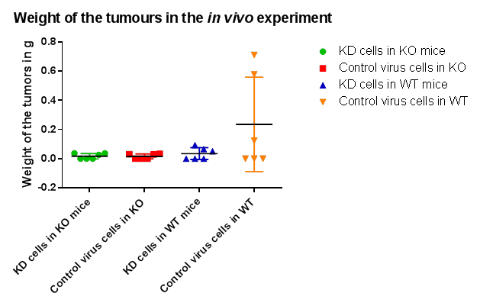
Figure 5.2: Average weights of tumours grown in the knockout mice injected with knockdown cells was 0.032g, the knockout mice injected with control virus cells was 0.031g, the WT mice injected with knockdown cells was 0.377g and the WT mice injected with control virus cells was 0.056g.

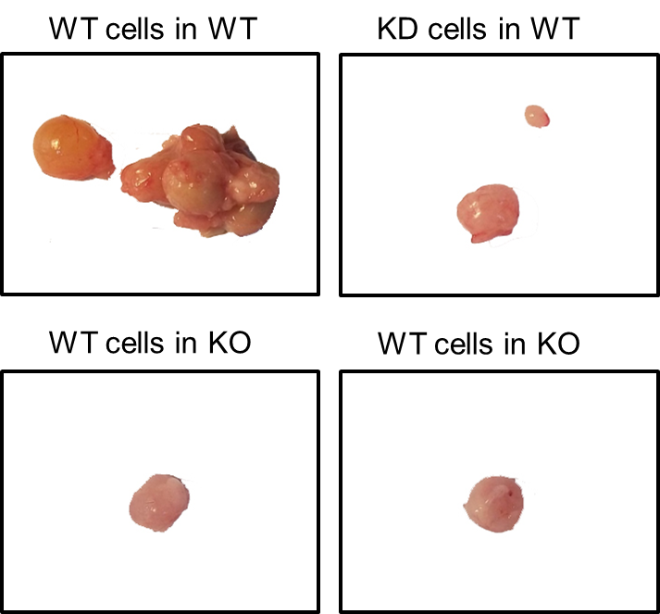

Figure 5.3: The effect of knocking down RAMP3 on the tumour formation in 129S6/SvEv. The tumour size of the wild-type mice group injected with wild-type cells is larger than that in the wild-type mice injected with RAMP3 knockdown cells, RAMP3 knockout mice injected with wild-type cells and RAMP3 knockout mice injected with RAMP3 knockdown cells.

Histology

Primary tumours

All mice groups injected either with control virus cells (wild-type) or RAMP3 knockdown cells successfully developed primary tumours in their prostate, as can be seen in Figure 5.4.
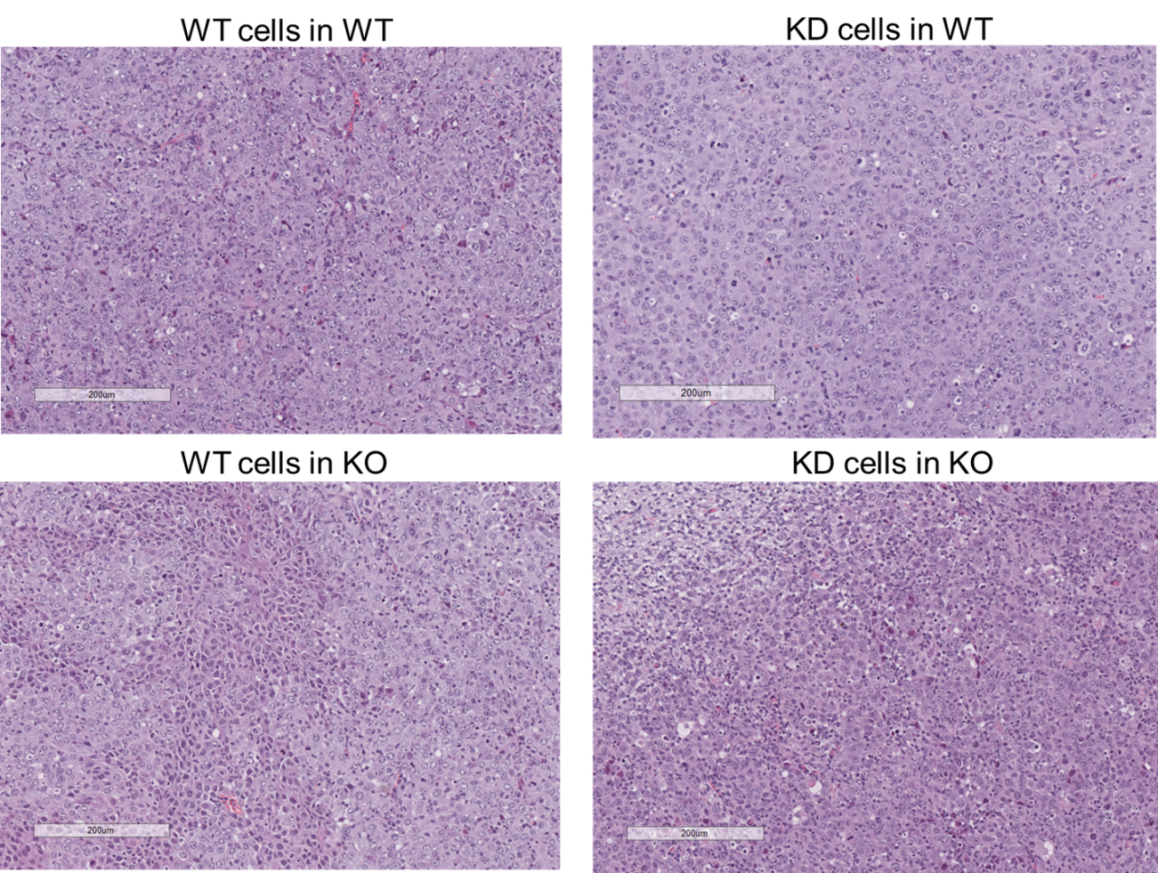

Figure 5.4: The histology sections stained with Haematoxylin and eosin stain (H&E) from the primary tumour developed in the two mice groups with two different cells types. The groups of mice are the RAMP3 knockout mice and the wild-type mice, while the cell types are the RAMP3 knockdown cells and the control virus cells (wild-type) (the scale is 200µM).

Lung histology

The mice lungs from four different groups - RAMP3 knockout mice injected with the control virus cells, the RAMP3 knockout mice injected with the RAMP3 knock down cells, the wild-type mice injected with the control virus cells and the wild-type cells injected with knockdown cells were examined in order to observe any changes the lungs might have as a result of injecting two different cell types in two different mouse types. The result shows that the control cells injected into wild-type mice have unhealthy lungs with small airspaces with a clear accumulation of infiltrated cells and the average size of the airspaces was 6.8 X 10⁻⁴ µm². However, the RAMP3 knockdown cells injected into the RAMP3 knockout mice, the control virus cells injected into the RAMP3 knockout mice and the RAMP3 knockdown cells injected into wild-type mice have healthy lungs with large air spaces and open alveolus with fewer infiltrated cells in comparison to the control virus cells injected in wild-type mice (Figure 5.5). Additionally, the average air space size of the RAMP3 knockdown cells injected into the RAMP3 knockout mice, the control virus cells injected into the RAMP3 knockout mice and the RAMP3 knockdown cells injected into wild-type mice were 2.31 X 10⁻² µm², 4.9 X 10⁻³ µm² and 5.24 X 10⁻³ µm² respectively which were significantly higher than the airspaces of the lungs of the wild-type mice injected with the control virus cells (Figure 5.6).

Figure 5.5: Lung sections from four different groups of mice injected with two different cells types. The air spaces in the wild-type mice injected with the control virus cells were too small, many infiltration cells can be observed and the lung looks unhealthy. However, the air spaces in the three other groups of lung sections from the wild-type mice injected with the RAMP3 knockdown cells, the RAMP3 knockout mice injected with the RAMP3 knockdown cells and the RAMP3 knockout mice injected with the control virus cells looked normal and the air spaces were big and had open alveoli (the scale is 500µM).

Figure 5.6: Size of open area in the lungs of four groups of mice. The four mice groups: RAMP3 knockout mice injected with the control virus cells, the RAMP3 knockout mice injected with the RAMP3 knockdown cells, the wild-type mice injected with the control virus cells and the wild-type cells injected with knockdown cells were subjected to analysis by ImageScope software in order to determine the air spaces size in µm². The air spaces in the RAMP3 knockout mice injected with the RAMP3 knockdown cells were significantly larger than the airspaces in the RAMP3 knockout mice injected with the control virus cells and the wild-type cells injected with the knockdown cells. Also, the airspaces in the RAMP3 knockout mice injected with the RAMP3 knockdown cells, the RAMP3 knockout mice injected with the control virus cells and the wild-type cells injected with the knockdown cells were significantly bigger than the airspaces in the wild-type mice injected with the control virus cells.

Bladder histology

The sections of mice bladder of two different groups of mice were injected with two different cell types - RAMP3 knockout mice injected with RAMP3 knockdown cells and RAMP3 knockout mice injected with control virus cells, the third group was wild-type mice injected with RAMP3 knockdown cells and the fourth group was wild-type mice injected with control virus cells. The result of the first group shows that the bladder has a tumour mass that was growing as a result of injecting the RAMP3 knockdown cells into the prostate of the mice. Interestingly, the tumour was an encapsulated shape. The RAMP3 knockout mice injected with control virus cells has a tumour mass growing as a consequence of injecting control virus cells into wild-type mice and the tumour mass appears to be spreading to another organs. However, the third and fourth groups do not have any tumour mass growing in them and such a result indicates the importance of the RAMP3 in the host tissue for cancer cells developing and progressing (Figure 5.7).
Figure 5.7: Different sections of bladder and prostate (primary site of cancer cells injection) from four groups of mice injected with two different cell types. The wild-type mice injected with control virus cells have a blue mass which corresponds to the tumour growth in the prostate site. The wild-type mice injected with RAMP3 knockdown cells have a tumour mass growth in the prostate site and the tumour was a capsulated shape. The RAMP3 knockout mice injected with both control virus cells and RAMP3 knockdown cells have no masses growing in the bladder (the scale is 1mm).

Liver histology

The sections of the mice livers of the RAMP3 knockout mice injected with control virus cells, the RAMP3 knockout mice injected with RAMP3 knockdown cells, the wild-type mice injected with control virus cells and the wild-type cells injected with knockdown cells show no signs of tumour growth and the livers look healthy. This result indicates that the primary tumours in the different groups were not able to undergo metastasis or to invade the liver (Figure 5.8).
Figure 5.8: Liver sections from two different groups of mice injected with two different cell types. The four different sections were taken from wild-type mice injected with control virus cells, wild-type mice injected with RAMP3 knockdown cells, RAMP3 knockout mice injected with control virus cells and RAMP3 knockout mice injected with RAMP3 knockdown cells. The four sections show there is no indication or sign of any mass growth in the livers and the livers look healthy (the scale is 200µM).

Bone histology
The bone sections of the tibias (Figure 5.9) and femurs (Figure 5.10) of the RAMP3 knockout mice injected with control virus cells, the RAMP3 knockout mice injected with RAMP3 knockdown cells, the wild-type mice injected with control virus cells and the wild-type cells injected with knockdown cells show no indication of tumour growth or cancer cells invasion or metastasis. The result shows that the prostate cancer cells were unable to metastasise to the bone in this model.

Figure 5.9: Bone sections of mice tibias of four mice groups which are the RAMP3 knockout mice injected with control virus cells, the RAMP3 knockout mice injected with RAMP3 knockdown cells, the wild-type mice injected with control virus cells and the wild-type cells injected with knockdown cells. The sections of the four groups show healthy bone marrow of the mice without any signs of strange growth or tumour mass (the scale is 200µM).
Figure 5.10: Bone sections of mice femurs of four mice groups which are the RAMP3 knockout mice injected with control virus cells, the RAMP3 knockout mice injected with RAMP3 knockdown cells, the wild-type mice injected with control virus cells and the wild-type cells injected with knockdown cells. The sections of the four groups show healthy bone marrow of the mice without any signs of strange growth or tumour mass (the scale is 200µM).

µCT results

The RAMP3 knockout and the wild-type mice were subjected to µCT analysis after being injected with RAMP3 knockdown cells (KD) and control virus cells (wild-type) and were sacrificed 4 weeks after injection. The µCT was used to determine any alteration in the bone as a result of injecting prostate cancer cells into the prostate of the mice. The results show that the marrow area of the wild-type cells injected into wild-type mice increased significantly as an indicator of tumour cells growth in the marrow in comparison to the marrow area of the other groups (Figure 5.12). However, the marrow area of the right femur cortical showed no significant differences between the groups (Figure 5.11). Moreover, the cortical bone area and the cortical thickness were increased significantly in the right tibia cortical of the RAMP3 knockout mice injected with both control virus cells and RAMP3 knockdown cells (Figure 5.14) (Figure 5.16), while the cortical bone area was significantly increased in the right femur cortical (Figure 5.13) but the cortical thickness did not increase (Figure 5.15). However, no significant changes were observed in the bone volume fraction (BV/TV) in the right femur trabecular and right tibia trabecular of all groups (Figure 5.17) (Figure 5.18). Similarly, the trabecular number (Figures 5.19 and 5.20) and thickness of the right femur and tibia of all groups of mice were almost the same (Figure 5.21) (Figure 5.22).

Bone marrow area

Figure 5.11: The bone marrow area of the right femur cortical. No significant differences were observed between the groups.

Figure 5.12: The marrow area of the right tibia cortical showing significant differences between the groups.

Cortical bone area (Ct.Ar)
Figure 5.13: The cortical bone area of the right femur cortical. There was a significant increase in two groups which are the RAMP3 knockout mice injected with control virus cells and the RAMP3 knockout mice injected with RAMP3 knockdown cells in comparison to the wild-type mice injected with control virus cells and the wild-type mice injected with RAMP3 knockdown cells.
Figure 5.14: The cortical bone area of the right tibia cortical. The result indicates a significant increase in two groups which are the RAMP3 knockout mice injected with control virus cells and the RAMP3 knockout mice injected with RAMP3 knockdown cells in comparison to the wild-type mice injected with control virus cells and the wild-type mice injected with RAMP3 knockdown cells.

Average cortical thickness (Ct.Th)

Figure 5.15: The average cortical thickness of the right femur cortical. No significant differences were observed between the groups.
Figure 5.16: The average cortical thickness of the right tibia cortical in the RAMP3 knockout mice injected with control virus cells and RAMP3 knockdown cells was higher than the wild-type mice injected with control virus cells and RAMP3 knockdown cells.

BV/TV

Figure 5.17: The BV/TV percentages of the right femur trabecular. There were no significant differences between the four groups of mice.

Figure 5.18: The BV/TV percentages of the right tibia trabecular. There were no significant differences between the four groups of mice.

Trabecular number

Figure 5.19: The trabecular numbers of the right femur trabecular have no significant variance between the four groups of mice.
Figure 5.20: The number of trabecular bone of the trabecular tibia of the right side shows no significant differences between the four mice groups.

Trabecular thickness

Figure 5.21: The trabecular thickness of the right femur trabecular indicates no differences between the four groups of mice.

Figure 5.22: The thickness of the right tibia trabecular does not point out any differences between the four groups of mice.

Discussion

The aim of this chapter was to check whether the RAMP3 in the tumour site or in the host tissue have an effect on the tumour growth and development. The most common sites of prostate cancer metastasis are lung, liver and bone.
Tumour numbers and weight
In order to investigate the role of RAMP3 in cancer progression and development, 5000 BMA178-2 cells were injected into the prostate of adult male syngeneic mice (129S6/SvEv mice). Two different types of cells were injected into two different mice types - RAMP3 knockdown cells of BMA178-2 cell line and control virus cells (wild-type), while the two different types of mice were RAMP3 knockout mice of 129S6/SvEv strain and wild-type mice (129S6/SvEv mice).
According to the in vitro studies, the knockdown of RAMP3 significantly decreased the proliferation and the colony formation of the cells. This suggests RAMP3 would have the same effect on the growth and the size of the tumours in vivo. The number of tumours in the RAMP3 knockout mice was less than the number of tumours in the wild-type mice, regardless of what type of cells was injected. The average weights of all tumours in both mice types were almost the same. The average weight of the tumours from RAMP3 knockout mice injected with RAMP3 knockdown cells was 0.032 g, while the average weight of tumours from wild-type mice injected with control virus cells (wild-type) was 0.031g.
The number of tumours in both the RAMP3 knockout mice injected either with RAMP3 knockdown cells or with control virus cells (wild-type) was 1. This result suggests that the RAMP3 in the host tissue plays an important role in tumour growth. Also, this result indicates how important the stromal cells are for the tumour to grow, while the disability of the surrounding cells to receive AM signalling was affecting the growth of the tumours themselves even if they had AM receptors, which strongly suggests that RAMP3 could be a target for cancer treatment.
Also, the average size of the tumours in the wild-type mice injected with RAMP3 knockdown cells (0.056g) was smaller than the average size of the tumours in the wild-type mice injected with control virus cells (wild-type) (0.377g) (Figure 5.2 and Figure 5.3). This result pointed out the importance of RAMP3 for tumour growth and progression where the knockdown of RAMP3 affected the size of the tumours and the mice injected with RAMP3 knockdown cells developed smaller tumours than the other group. This result may indicate that the cells which received less AM signalling have less ability to grow. Considering all these results, RAMP3 could be considered as a potential target for cancer therapy. Further experiments are required to understand the mechanism by which RAMP3 blockade reduces the progression of cancer in vivo as well as to investigate the affected downstream signalling.

Histology analysis of different tissue sections from the four mice groups
Primary Tumours
In order to test the effect of RAMP3 on the tumour growth and development in vivo, RAMP3 knockdown cells and wild-type cells (control virus cells) were injected into the prostate of two mice groups and left for 4 weeks to develop before sacrifice. The first group is the RAMP3 knockout mice and the second group is the wild-type mice 129S6/SvEv. The injection of cancer cells into the prostate of the mice was one of the challenges we faced due to the small size of the mice prostate as well as the location of the prostate in the mice. Developing a primary tumour in the prostate is a sign of having accomplished the experiment successfully. The injection of the BMA178-2 mouse prostate cancer cell line and the RAMP3 knockdown cells into the prostate of both the wild-type 129S6/SvEv mice and the RAMP3 knockout mice successfully developed primary tumours in the prostates of all mouse groups (WT cells injected in WT mice, WT cells injected in RAMP3 knockout mice, RAMP3 knockdown cells injected in WT mice, RAMP3 knockdown cells injected in RAMP3 knockout mice), as can be seen in Figure 5.4. These results indicate that the experiment was performed successfully.
Lung Histology
One of the signs that indicate the health state of the mice is the lung. In order to decide how healthy the lung is, an air space measurement can be applied (Wu et al., 2002). Most of the lungs diagnosed with cancer have less air space than the healthy lungs due to the accumulation of tumour masses and inflammatory cells (Davis et al., 1992). The role of RAMP3 either in the tumour site or in the host tissue, in tumour progression is currently unknown. The tissue sections from the lungs of four mice groups, 4 weeks after injection showed that the group containing WT cells (control virus cells) injected into WT mice (129S6/SvEv) have unhealthy lungs with very small air space (6.8 X 10⁻⁴ µm²) and an accumulation of infiltrated cells. Interestingly, the lungs of the mice in the three other groups (WT cells injected in RAMP3 knockout mice, RAMP3 knockdown cells injected in WT mice, RAMP3 knockdown cells injected in RAMP3 knockout mice) were shown to be normal (Figure 5.5). The air spaces in the RAMP3 knockdown cells injected in the RAMP3 knockout mice groups was shown to have significantly more air spaces (2.31 X 10⁻² µm²) than the WT cells injected in the RAMP3 knockout mice (4.9 X 10⁻³ µm²) and the RAMP3 knockdown cells injected in the WT mice (5.24 X 10⁻³ µm²) groups (Figure 5.6). For the first time I have shown that a reduction in the expression of RAMP3 in both the tumour site and the host tissue site decreased the metastasis of mouse prostate cancer cells in the lungs of RAMP3 knockout mice as well as in the WT mice injected with RAMP3 knockdown cells 4 weeks after the injection. Also, it is possible to conclude that the WT cells injected into the prostate of WT mice have tumours metastasised in their lungs as well as macrophages which resulted in reducing the alveolar space in comparison to other groups. However, the Wang et al. group reported that both bone and lung metastasis was established 3 days after injecting BMA178-2 via tail vein into adult male syngeneic mice and progressed to lethality beyond 3 weeks (Wang et al., 2007). Further experiments remain to determine whether the reduction of the air space was as a result of the metastatic cancer cells in the lung or the disease that was caused by the injection of cancer cells. This can be performed by using immunohistochemistry techniques to detect and visualise specific markers for prostate cancer such as prostate specific antigen (PSA), T cells and macrophages such as CD4⁺ T cells, CD8⁺ T cells and F4/80⁺ macrophage (Wang et al., 2007, Oesterling, 1991, Wald et al., 2006). The air spaces of the lungs of RAMP3 knockout mice injected either with WT cells or with RAMP3 knockdown cells were significantly bigger than the air spaces of the lungs of WT mice injected with WT cells. Also, the air spaces of the lungs of WT mice injected with RAMP3 knockdown cells were significantly bigger than the air spaces of the lungs of WT mice injected with WT cells. These findings suggest that the expression of RAMP3 in both stromal tissue and cancer cells plays an important role in the cancer progression, and the air spaces in the lungs was an indication of the health of the mice as well as the metastasis state of the cancer cells.
Bladder Histology
The bladder histology sections show that the bladders of both WT mice (129S6/SvEv mice) injected either with RAMP3 knockdown cells or WT cells (control virus cells) (Figure 5.7) have tumours in them. The tumours observed in the WT mice injected with RAMP3 knockdown cells were encapsulated, while the tumours developed in the WT mice injected with WT cells (control virus cells) were not encapsulated. This result suggests that knocking down RAMP3 affected the spread of tumour cells when compared to WT cells. Interestingly, the RAMP3 knockout mice injected either with the RAMP3 knockdown cells or with the WT cells (control virus cells) did not develop tumours (Figure 5.7). This result indicates that RAMP3 in the tumour site may play an important role in tumour metastasis and growth.

Liver Histology
The liver sections of the four mice groups are shown to be normal without any observable tumour growth (Figure 5.8). However, more investigation should be carried in the future by using immunohistochemistry and markers for prostate cancer cells such as Prostate-Specific Antigen PSA as a confirmation step.
Bone Histology
The bone sections of the tibias and femurs of the four mice groups had no visible tumours (Figure 5.9) (Figure 5.10). In contrast, Wang et al. reported that the injection of 5000 cells of BMA178-2 into the tail vein of adult male syngeneic mice 129S6/SvEv resulted in bone metastasis as well as invasion of the surrounding muscles (Wang et al., 2007). This result suggests that the injection of cancer cells into the blood stream has faster metastasis than injecting the cells directly into the prostate. Another explanation is that the metastatic cancer cells in the bone marrow were not detectable without using appropriate markers.

uCT results
Bone marrow area
The bone marrow area of the right femur cortical had no significant difference between the groups (Figure 5.11). However, the bone marrow area of the right tibia cortical showed that the wild-type mice injected with control virus cells has a significantly bigger marrow area compared to the RAMP3 knockout mice injected with control virus cells, the RAMP3 knockout mice injected with RAMP3 knockdown cells and the wild-type mice injected with knockdown cells (Figure 5.12). This result strongly indicates that there is metastasis of cancer cells into the bone marrow of the tibia of wild-type mice injected with wild-type cells (control virus cells) in comparison to the other groups. This suggests that both the RAMP3 in the host as well as in the cells are essential for tumour growth and development. Further experiments are necessary to confirm that the significant increase of the bone marrow area was as a result of cancer cells metastasis such as using immunohistochemistry. Also, wild-type mice need to be used as a control to confirm the normal bone marrow area.
Cortical bona area (Ct. Ar)
RAMP3 knockout mice models were shown to be viable without any major vascular system deficiencies (Yamauchi et al., 2014). However, the body weight of aged RAMP3 knockout mice (9-10 months) was reduced significantly in comparison to wild-type mice (Dackor et al., 2007). Our results showed that the cortical bone area of the femurs and tibias of the RAMP3 knockout mice injected either with RAMP3 knockdown cells or with wild-type cells (control virus cells) was significantly greater than the wild-type mice injected either with RAMP3 knockdown cells or wild-type cells (control virus cells) (Figures 5.13 and 5.14). Therefore, the knockout of RAMP3 affected the cortical bone area of mice aged 88 days and the mechanism of the effect of the absence of RAMP3 on the cortical bone area needs to be studied further.
Average cortical thickness (Ct.Th)
The average cortical thickness of the femurs of both the RAMP3 knockout mice and wild-type mice injected with RAMP3 knockdown cells or wild-type cells (control virus cells) was the same in all groups (Figure 5.15). The average cortical thickness of the tibias of the RAMP3 knockout mice injected with either RAMP3 knockdown cells or wild-type cells (control virus cells) were significantly bigger than the wild-type mice injected with either RAMP3 knockdown cells or wild-type cells (control virus cells) (Figure 5.16). This indicates that RAMP3 plays an important role in increasing bone thickness and RAMP3 plays a different role in the femur than in the tibia. This may be because the bone cells of the tibia respond differently to AM signalling than the femur. More experiments need to be performed in order to investigate the role of RAMP3 in the tibia and femur and the differences between the tibia and femur in response to AM stimulation.
BV/TV
BV/TV can be defined as the ratio of the segmented bone volume to the total volume of the region of interest or bone volume fraction (Bouxsein et al., 2010). The bone volume fraction of the tibias and femurs of RAMP3 knockout mice and wild-type mice injected with either RAMP3 knockdown cells or wild-type cells (control virus cells) show no significant differences in all groups (Figures 5.17 and 5.18). This result suggested that the RAMP3 does not play an essential role in the bone volume fraction.
Trabecular number and thickness
The trabecular number and thickness of the tibias and femurs of RAMP3 knockout mice and wild-type mice injected with either RAMP3 knockdown cells or wild-type cells (control virus cells) shows no significant differences in all groups (Figures 5.19 and 5.20) (Figures 5.21 and 5.22). There are two explanations for this result. The first is that the knockout of RAMP3 has no effect on the trabecular number and thickness. The second explanation is that there is a difference in the trabecular number and thickness but it cannot be detected without comparing all groups to wild-type mice (129S6/SvEv mice).
Conclusion
It can be concluded that compared to RAMP1 and RAMP2, little is known about the role of RAMP3 in cancer progression and development. First I showed that RAMP3 in both the tumour cells site and the stromal cells site plays an important role in the cancer cell invasion and metastasis. I investigated the difference between the RAMP3 knockout mice and wild-type mice injected with either RAMP3 knockdown cells or control virus cells (wild-type). I indicated that the RAMP3 knockout mice had healthy lungs and their bladders were clear from any tumour metastasis. In contrast, the wild-type mice injected with control virus cells (wild-type) had unhealthy lungs, while the mice injected with knockdown cells had healthy lungs. Also, the wild-type mice injected with RAMP3 knockdown cells and control virus cells had tumours in their bladders. However, the tumours in the mice injected with RAMP3 knockdown cells were encapsulated in comparison to the mice injected with control virus cells. The liver and bone histology shows that there were no visible tumours detected. Although the bone marrow area of the wild-type mice injected with control virus cells (wild-type cells) was significantly bigger than in the other groups, which suggests there might be undetectable metastasised cancer tumours, however more experiments are required to confirm this finding.
It was observed that the cortical bone areas of the tibias and femurs of the RAMP3 knockout mice aged 88 days were significantly bigger than those of the wild-type mice regardless of what cells they were injected with. Also, the average cortical thicknesses of the tibias of the RAMP3 knockout mice were significantly bigger than those of the wild-type mice. However, the average cortical thicknesses of the femurs of the RAMP3 knockout mice and wild-type mice injected with either RAMP3 knockdown cells or control virus cells (wild- type cells) have no significant difference between all groups. These findings suggest that RAMP3 plays an important part in bone development.
Finally, it was noted that the RAMP3 knockout mice injected with RAMP3 knockdown cells or with control virus cells developed fewer tumours than the wild-type mice injected with RAMP3 knockdown cells or with control virus cells.
Also, the average tumour weight in the wild-type mice injected with RAMP3 knockdown cells was smaller than in the wild-type mice injected with control virus cells (wild-type cells). Collectively, these results indicate that RAMP3 in the tumour site and stromal tissue site plays an essential role in cancer development and progression.

CHAPTER 6: GENERAL DISCUSSION

Discussion
The experiments described in this thesis were designed to test one major hypothesis and 3 sub-hypotheses:
RAMP3 plays an essential role in cancer progression:
- The prostate cancer cell line BMA178-2, which is syngeneic to RAMP3^{-/-} 129S6/SvEv mice, expresses RAMP3 at gene and protein level.
- The knockdown of RAMP3 reduces proliferation, migration, invasion, colony formation, and cAMP production by BMA 178-2 cells and increases the sensitivity of the cells to the anti-cancer drug in vitro.
- Tumours formed as a result of injecting RAMP3 knockdown cells into wild-type and RAMP3 ^{-/-} mice are smaller in size and number than the wild-type cells injected into wild-type and RAMP3 ^{-/-} mice.
The overall conclusion that can be drawn from these studies is that RAMP3 does represent a potential target for the development of cancer therapies that could be expected not to have major effects on homeostatic physiological mechanisms.
The results from Chapter 4 unequivocally indicate that RAMPs and the CLR that are expressed in BMA-178 cells were derived from a prostate tumour in a SvEv strain mouse. This cell line was obtained from Dr Timothy C. Thompson from The University of Texas MD Anderson Cancer Centre. The 178-2 BMA cell line was derived from a bone metastasis derived from a primary carcinoma arising within Zipras/myc-infected urogenital sinus tissue obtained from p53 heterozygous 129S6/SvEv mice using the metastatic mouse prostate reconstitution (MPR) model system. The generation of BMA 178-2 cells was achieved by injecting cells into the prostates of male mice (Tahir et al., 2001){Tahir, 2001 #1159}. The model is therefore well-developed and characterised.
The results of our studies are robust because we used 2 independent methods to determine the expression of the molecules, PCR and Western blotting. By using RT-PCR, three bands were detected in BMA178-2, 187 bp, 312 bp and 103 bp in size. These bands corresponded to RAMP1, RAMP2 and RAMP3 respectively (Figure 3.1). Also, CLR was detected in the same cell line and a band 280 bp in size was detected (Figure 3.5).This result was confirmed by sequencing PCR products and the results showed 100% homology.
By using Western blotting, a monomer form of RAMP1 and RAMP2 proteins was detected in the BMA178-2 cell line at the appropriate sizes (both ~20kDa). Also, RAMP3 was expressed as a monomer ~19 kDa in size (Figures 3.16 and 3.17). CLR was detected as two bands; one could correspond to a monomer ~60 kDa in size (Csati et al., 2012, Ramachandran et al., 2009, Dong et al., 2004) and the other band ~70 in size (Figures 3.18 and 3.19) could correspond to a glycosylated monomer (Granholm et al., 2008) due to three putative glycosylation sites at Asn⁶⁰, Asn¹¹² and Asn¹¹⁷ at the N terminal extracellular domain (Bühlmann et al., 2000, Muff et al., 2001) or a heterodimer form of either CLR/RAMP2 or CLR/RAMP3 (Metellus et al., 2011).The conclusions from this part of the work are that BMA-178 cells express RAMPs 1, 2 and 3 and the CLR.
In Chapter 4, I described the process to develop and then characterise knockdown cells expressing lower than WT levels of RAMP3. ShRNA knockdown is a technique that has been used for some time to perform such studies and it is clear what is needed to be certain that the method has worked (Van den Haute et al., 2003, Tiscornia et al., 2003, Cheng et al., 2006). In my studies I created the knockdowns by introducing lentiviral constructs in plasmid form into the cells and then cultured the cells in media containing antibiotic (puromycin) that would kill the cells not transfected with the construct which also contains an antibiotic resistance marker contained in the expression vector construct. Different numbers of lentivirus particles per cell were used in order to determine the optimum number that results in effective reduction in the mRNA of RAMP3. 5, 10, 25 MOI did not reduce the mRNA of RAMP3 significantly, so 50 MOI was used to increase the percentage of RAMP3 mRNA reduction.
Q-PCR and Western blotting were used again to determine the levels of expression in scrambled transfected (control virus) and KD cells and the results indicated (by quantifying the mRNA of RAMP3 and the measurement of band intensity on WB) that there was a 70% knockdown of RAMP3 expression. As the eventual plan was to use the cells for an in vivo experiment, it was essential to determine whether the knockdown cells remained in the majority if the cells were cultured out of the antibiotic selection medium. I grew cells under non-selection conditions and assayed RAMP3 expression by RT-PCR and Western blotting at time points 1, 2, 3, 4 and 5 weeks. Those studies showed that at the longest time in culture there was still effective RNA knockdown by 70% for RAMP3, and this is also important in order to predict the outcome results from the in vivo study and to ensure that we have a high enough margin of stability of the RAMP3 knockdown in cells. We can conclude that the knockdown cultures were suitable for longer-term 4-week in vivo studies.
The characterisation of the RAMP3 KD cells clearly showed that the effect of the genetic manipulation in vitro was to reduce many relevant markers of cancer cell line progression. For the first time we showed that the proliferation of the mouse prostate cancer cell line was reduced significantly as a result of the knockdown of RAMP3. The proliferation of RAMP3 knockdown cells was reduced significantly compared to BMA178-2 and the control virus cells. This reduction in the proliferation may be as a result of preventing the cells from receiving AM signalling through the AM2 receptor but could involve other receptors that interact with RAMP3. The doubling time of RAMP3 knockdown cells was 40 hours; while WT BMA178-2 was 28 hours and the control virus cells was 29 hours. This result was confirmed by using a DID dye labelling technique (Sutton et al., 2008), where the RAMP3 knockdown cells lost the dye significantly slower than the control virus cells (control), indicating that the control virus cells divided more rapidly than the RAMP3 knockdown cells. The proliferation of RAMP3 knockdown cells and control virus cells was not affected by adding AM exogenously at three different doses (1µM, 1nM and 1pM). Nevertheless, AM was seen to significantly increase the proliferation of two pancreatic cancer cells which are HPSC and Panc-1. Using a serial concentration of AM starting from 1 nM to 500 nM, 200 uM of AM was shown to increase the proliferation rate of both cell lines to the maximum rate (Ramachandran et al., 2007, Ramachandran et al., 2009). The addition of AM₂₂₋₅₂ at three different concentrations (1µM, 1nM and 1pM) reduced the proliferation of the control virus cells in a dose dependent manner but had no effect on the proliferation of the RAMP3 knockdown cells. This suggests that most of the reduction in the proliferation of knockdown RAMP3 was AM-mediated.
We found that the knockdown of RAMP3 also significantly inhibited the migration of the BMA178-2 mouse prostate cancer cells in comparison to the control cells (Figure 4.32 and 4.33). Neither AM nor AM22-52 treatment affected the motility and the migration of the cells, which suggests that the effect of knocking down RAMP3 is irreversible (Figures 4.34 and 4.35). The migration of the clear-cell renal carcinomas (cRCC) cells BIZ and 786-O was increased as a result of the AM addition in the absence of RAMP2 and the presence of RAMP3 and CLR (Deville et al., 2009). These results are in agreement with our findings which led to the fact that the AM2 receptor plays an important role in the cancer cells migration.
Interestingly, the knockdown of RAMP3 in BMA178-2 mouse prostate cancer cells significantly reduced the invasion of these cells in comparison to the control virus cells. The ability of primary tumours to be motile and spread to secondary tumours within the human body requires a reversible phenomenon called-Epithelial-Mesenchymal
Transition (EMT). During EMT, many factors that are important for tumour migration and invasion change, such as the cytoskeletal proteins and various transcription factors. One of the cytoskeletal proteins is gelsolin. This protein is responsible for many physiological processes involving control cells morphology and motility (Yilmaz and Christofori, 2009). AM elevated the gelsolin level in breast cancer cells (T47D) that over-expressed AM (Martínez et al., 2002). In another study, AM has a significant correlation in intensity with one of the adhesion molecules which is involved in cell motility and invasion, called N-cadherin in hepatocellular carcinoma tissue samples from patients (Park et al., 2008). Also, the invasion of highly metastatic breast cancer cell line LM2-4 and the p38 mitogen-activated kinase (p38) phosphorylation were reported to be inhibited significantly by using shRNA to knockdown RAMP3. The phosphorylation of p38 is associated with the induction of tumour cell invasiveness (Brekhman et al., 2011).
It is very likely that the knockdown of RAMP3 alters downstream signalling, which in turn results in the reduction of cells invasion. More experiments need to be performed in order to determine which signalling pathways are altered and the molecules which are up/down regulated.
Noticeably, we showed that the knockdown of RAMP3 decreased the colony size and number of BMA178-2 significantly in comparison to the virus control which may indicate that the ability of the RAMP3 knockdown cells to form tumours in vivo was decreased compared to the control. The colony formation assay is widely used to test the effectiveness of the anti-cancer drug on cell reproductive death after treatment and tumour formation ability of the cells. This result indicated that the ability of cells to form tumors was reduced significantly as a result of knocking down RAMP3 compared to the control cells. Also, using an anti-cancer drug would be more effective in the RAMP3 knockdown cells rather than in the control virus cells.
The cAMP production of the RAMP3 knockdown cells was less than the control virus cells, suggesting that reducing the expression of RAMP3 affected the ability of the cells to receive AM signalling, resulting in a reduction in the cAMP production. This reduction in the cAMP could be responsible for decreasing the proliferation, migration, invasion and colony formation. The effect of RAMP3 knockdown on downstream signalling needs to be investigated further to determine the alteration that might be occurring as a result of the gene knock down.
All of these assays are well-established and robust so we can be confident that they represent a real indication of the role of RAMP3 in tumour cell growth.
DNA replication requires the existence of the thymidylate synthase enzyme. The inhibition of this enzyme causes DNA damage. 5-fluorouracil is an anti-cancer drug which works as an inhibitor of thymidylate synthase, resulting in more rapidly dividing cancerous cells experiencing cell death through thymineless death. The finding that the knockdown cells were more sensitive to the effects of 5-FU treatment is an exciting result. It has been suggested that AM plays a role in assisting cells to resist both host defence mechanisms but also potentially the effects of such cytotoxic drugs. The result shows profound increased sensitivity to 5FU in terms of its effect to inhibit proliferation. Similarly, AM expression was seen to be upregulated in cisplatin-resistant non-small-cell lung cancer cell lines H460. This result revealed that there is a link between the resistance of some cancer cells to anti-cancer drugs such as cisplatin (Lopez‐Ayllon et al., 2014). AM also increased the chemosensitivity of HO8910 ovarian cancer cells to carboplatin (chemotherapy drug). By using shRNA to knockdown AM, the anti-apoptotic Bcl-2 protein was downregulated. Also, the expression of ERK which controls proliferation and apoptosis was reduced as a result of AM knockdown (Chen et al., 2012). Another study indicated that silencing AM in the SMMC-7721 hepatocellular carcinoma (HCC) cell line resulted in increasing the apoptosis of the cells compared to the control cells (untransfected). Also, the sensitivity of the tumours to cisplatin (anti-cancer drug) was increased and the tumour growth was decreased in vivo as a result of AM knock down, in comparison to treatment with cisplatin or AM-shRNA alone. This suggests that AM could be implicated in the resistance of cancer cells against anti-cancer drugs and disturbing AM signalling through RAMP3 could be an effective therapy for cancer (Li et al., 2014).
Taken together, these studies provide a strong rationale for the in vivo experiments we performed. The method of injecting cells into the prostate gland is technically demanding but was performed by two expert in vivo researchers (thanks to Ms. Anne Fowles and Dr. Ning Wang) who were able to perform the technique with great reliability. The rapid course of the disease development and the metastasis from the prostatic primary tumours to other sites was an advantage, but we selected the BMA-178/SvEv mouse model because it was the background strain on which we have the RAMP3 knockout as a congenic strain with a well-characterised phenotype.
The development of the disease in these studies was slightly less rapid and severe than in slightly older animals used previously in Sheffield and by the originators of the model, but this is an advantage because in those earlier studies mice became moribund in under 3 weeks.
The results of the experiment were clear. Control cells in WT mice developed the most serious disease, as measured by tumour burden and lung metastasis. Both RAMP3 KD cells in WT mice and control cells in RAMP3 KO mice produced intermediate disease, and RAMP3 KD cells in RAMP3 KO mice produced the mildest disease. The control cells injected in wild-type mice have unhealthy lungs with small airspaces with a clear accumulation of infiltrated cells and the size of the airspaces was significantly smaller than in other groups. Also, the airspace sizes of the RAMP3 knockdown cells injected in RAMP3 knockout mice and the control virus cells injected in RAMP3 knockout mice were bigger than the airspaces of the lungs of RAMP3 knockdown cells injected in wild-type mice and WT in WT. Moreover, the control cells in WT mice have bigger tumours than the RAMP3 KD cells in WT mice. The average sizes of the tumours of the control virus cells injected into wild-type mice were almost 80% greater than in other groups. While, the average size of the tumours of the RAMP3 knockdown cells injected into the wild-type mice group were 50% bigger than the RAMP3 knockdown cells injected into RAMP3 KO mice and the control virus cells injected in RAMP3 KO mice. The KD cells in RAMP3 KO mice and the control cells in RAMP3 KO mice hardly formed tumours. The tumours in RAMP3 KD cells injected in WT mice and the control virus cells injected in WT mice were found to be metastasised from the primary site of injection to the abdominal cavity. On the contrary, tumours generated by injecting RAMP3 KD cells in RAMP3 KO mice and control cells in RAMP3 KO mice did not metastases and remained in the primary site of injection. This result indicates the essential role of RAMP3 in the host tissue in the progression and development of prostate cancer tumours.
The use of orthotopic syngeneic models for such studies is a considerable advance in relation to human disease over subcutaneous injection of cancer cells in immune compromised mice. First, the injection site is the organ in which the disease developed originally, and second, the mice had immune functions and so could be expected to mount a more comprehensive and relevant response to the challenge of the tumour formation and spread.
There is a complication in the interpretation of the results though. RAMP3 interacts with several known receptors. With the CLR, it forms an AM2 receptor, but it is also clear that a CTR/RAMP3 Amylin receptor would be affected by the knockdown in the cells and in the RAMP3 knockout mice. Both of these examples are where the interaction alters the ligand selectivity of the complex. However, there are also interactions of RAMP3 with other receptors affecting the trafficking of the receptors to the cell surface and signalling activated inside the cell in response to the same ligand (functional selectivity). This means that the RAMP3 knockdown in cells and the RAMP3 knockout in the mice both represent a complex intervention that may have an effect via several signalling systems, not merely the AM induced effects. Since PTH1R, CasR and SCTR are expressed in BMA178-2 cells and they interact with RAMP3 (Huang and Miller, 2007, Archbold et al., 2011), the knockdown of RAMP3 could have an effect on the downstream signalling of those receptors, resulting in the effect that we have seen in the cancer cells in vitro and in vivo. Further investigation is required to understand the signalling pathways which might be altered as a result of knocking down RAMP3.
The results shown here are not without precedent. One group in particular has focused on the use of anti-AM strategies for cancer treatment. Ouafik’s group in France has performed several similar studies, although in some papers the details are sketchy so a full interpretation of the results is difficult. The group used subcutaneous xenograft models for their studies and their treatment groups either received systemic doses of antibodies to CLR, RAMP2 or RAMP3 or a mixture of those. The data on dosage and effects is not clear from the articles, and some animals died, possibly as a result of the effects of a physiological AM blockade (either by a blockade of CLR or AM1 receptors). However, the results indicate that a RAMP3 polyclonal antibody is effective in reducing tumour volume, though less effective than a more comprehensive AM blockade via CLR and AM1R. Further studies show that the injection of these agents into the tumours leads to reductions in tumour volume growth (Kaafarani et al., 2009, Nouguerède et al., 2013). Finally, a Japanese group has shown that the AM truncated peptide antagonist AM₂₂₋₅₂ reduces tumour volume if injected into the tumour mass. The pancreatic cancer cells PCI-43 were injected in SCID mice. 8 days after the cancer cells were injected subcutaneously into the right flanks of the mice, AM₂₂₋₅₂ was injected directly into the tumour (intratumoral injection). The injection of AM₂₂₋₅₂ continued to day 17. The result showed that tumour formation was inhibited significantly compared to the control (PBS). Also, the diameter of the blood vessels of the formed tumours was reduced hugely compared to control group (Ishikawa et al., 2003). This data illustrates that AM is important for the in vivo tumour formation of pancreatic cancer cells.
The implications of this research could be pervasive. While many tumours now carry a much better prognosis than 20 years ago, the use of cytotoxic drugs is almost invariably unpleasant for the patient, frequently severely so. While the development of new agents to counter tumour growth and metastasis is a rapidly moving and successful field, many new agents (particularly biologicals such as monoclonal antibodies) are very expensive and often offer too little clinical benefit for justification of the cost to the NHS by NICE. An agent that enhances the sensitivity of tumours to cytotoxics could provide a substantial clinical benefit. Therefore, a key experiment to perform next is to implant cells into mice as before but with a 5FU arm in the design in order to determine whether the effects seen in vitro are replicated in vivo.
In the Sheffield lab two programmes of research are addressing this issue. A mouse monoclonal antibody to RAMP3 has been developed and recently engineered to make it suitable for human use. That antibody causes many parallel effects to RAMP3 knockdown, with effects on proliferation and migration in vitro and on tumour development in vivo (in s/c xenograft models). In addition, a drug discovery programme has recently been supported by the Wellcome Trust to identify selective inhibitors of the CLR/RAMP3 AM2 receptor for use in cancer. The RAMP3 antibody leaves similar uncertainties about the precise target of its effect as the studies here have shown, but the drug development programme aims to make small molecule antagonists to the CLR/RAMP3 heteromeric receptor that are inactive or many folds less active on the CLR/RAMP2 AM1 receptor and with additional selectivity over the CLR/RAMP1 CGRP and CTR/RAMP3 Amylin receptors.

Study challenges and limitations
Without further investigation the findings of the project are not conclusive evidence for what has been discussed. The discussion only proposes the promising results of the outcomes obtained.
The challenges faced and the limitations of the project are discussed below:
- RAMPs is not a well explored area and is poorly understood. Finding specific antibodies for RAMPs was a challenge, especially as there is not much information about antibodies published in papers in this area. Also, after finding suitable antibodies, optimising these antibodies was time consuming.
- Due to limited information about the role of RAMP3 in cancer progression, we faced difficulties to determine the Multiplicity of Infection (MOI) to knockdown RAMP3. Serial titrations of MOI were used which were 5, 10 and 25. After the colony selection to determine the stable transfected cells with shRNA, the result shows the expression of RAMP3 was not decreased as we expected. Then, we decided to use 50 MOI. This process was costly and it took a long time to determine the stable transfected cells and the best MOI which knocked down RAMP3.
- The knockdown of RAMP3 resulted in decreasing the proliferation rate of the cells which in turn affected the other experimental procedures which resulted in other related experiments being delayed.
- The cell counting was performed on a daily basis to determine the proliferation rate of the cells. This procedure requires effort and time to be performed.
- Mice organs (lung, liver, bladder and prostate) were embedded in wax before sectioning for histology examination and this procedure takes roughly 2-4 weeks.
- Mice bones went through the bone decalcification procedure to remove calcium ions and to make the bone flexible for cutting after wax embedding for histology examination. The bone decalcification is a lengthy process that takes up to 8 weeks to be completed.
- Scanning the organ histology sections was time consuming and required effort due to the large number of histology sections which totalled 528 slides.
- Scanning mice bones with µCT was a prolonged experiment; each bone took 15 minutes to be scanned.
- Due to the limited time and resources, we were not able to use wild-type mice 129S6/SvEv as a control for the other mice groups which were wild-type mice injected either with RAMP3 knockdown cells or control virus cells (control) and examine if there are differences between the three groups due to the cell type which they were injected with.

Future Work
Since blocking RAMP3 in vitro and in vivo in the project has significant potential in reducing cancer development, further investigation needs to be done in order to understand how blocking RAMP3 affected the intracellular signalling cascades. CRISPR (Cas9) could be utilised in order to produce the RAMP3 knockout cell line, to compare the effect of this technique on the phenotypes of the cell and to compare it to the RAMP3 knockdown cell phenotypes to investigate if the knockout of RAMP3 has more advantages over the knockdown of RAMP3. Microarray analysis of the RAMP3 knockdown cells and the RAMP3 knockout cells would provide information on the differential signalling mechanisms between them in comparison with the controls. Also, epigenetics techniques can be used to study the effect of the knockdown and knockout of RAMP3 on the DNA methylation of cancer cells.
In the project it was indicated that RAMP3 is a potential therapeutic target for cancer; therefore would be beneficial to design an antibody against the RAMP3 and RAMP3+CLR complex. Then, the effect of these different antibodies on the proliferation, migration, invasion, tumour formation, and cAMP production was supposed to be investigated. Also, information on the toxicity, stability and potency of the antibody would establish it as a potential therapeutic agent.

Conclusion
In conclusion, the present study has shown that one of the components of the AM2 receptor, RAMP3, induced cancer development. The knockdown of RAMP3 reduced the proliferation, migration, invasion, colony formation and cAMP production and increased the sensitivity of the cells to the anti-cancer drug in vitro. Also, the RAMP3 knockout mice have lower tumours, weight and metastasis in comparison to wild-type mice. Moreover, the wild-type mice injected with RAMP3 knockdown cells have smaller tumours and healthier lungs in comparison to wild-type mice injected with control cells. This suggests that targeting RAMP3 using an antibody could be an optimal cancer drug. More investigation into the toxicity, reactivity, pharmacokinetics and pharmacodynamics of the RAMP3 antibody is essential in order to establish it as a potential anti-cancer therapeutic agent.

BIBLIOGRAPHY

Abasolo, I., Montuenga, L. M. & Calvo, A. 2006a. Adrenomedullin prevents apoptosis in prostate cancer cells. Regulatory peptides, 133, 115-122.
Abasolo, I., Wang, Z., Montuenga, L. M. & Calvo, A. 2004. Adrenomedullin inhibits prostate cancer cell proliferation through a cAMP-independent autocrine mechanism. Biochemical and Biophysical Research Communications, 322, 878-886.
Abasolo, I., Yang, L., Haleem, R., Xiao, W., Pio, R., Cuttitta, F., Montuenga, L. M., Kozlowski, J. M., Calvo, A. & Wang, Z. 2003. Overexpression of adrenomedullin gene markedly inhibits proliferation of PC3 prostate cancer cells in vitro and in vivo. Molecular and Cellular Endocrinology, 199, 179-187.
Aiyar, N., Rand, K., Elshourbagy, N. A., Zeng, Z., Adamou, J. E., Bergsma, D. J. & Li, Y. 1996a. A cDNA encoding the calcitonin gene-related peptide type 1 receptor. J Biol Chem, 271, 11325-9.
Albertin, G., Carraro, G., Petrelli, L., Guidolin, D., Neri, G. & Nussdorfer, G. G. 2005. Endothelin-1 and adrenomedullin enhance the growth of human adrenocortical carcinoma-derived SW-13 cell line by stimulating proliferation and inhibiting apoptosis. International journal of molecular medicine, 15, 469-474.
Andreis, P. G., Markowska, A., Champion, H. C., Mazzocchi, G., Malendowicz, L. K. & Nussdorfer, G. G. 2000. Adrenomedullin enhances cell proliferation and deoxyribonucleic acid synthesis in rat adrenal zona glomerulosa: receptor subtype involved and signaling mechanism. Endocrinology, 141, 2098-2104.
Archbold, J. K., Flanagan, J. U., Watkins, H. A., Gingell, J. J. & Hay, D. L. 2011. Structural insights into RAMP modification of secretin family G protein-coupled receptors: implications for drug development. Trends in pharmacological sciences, 32, 591-600.
Barwell, J., Wootten, D., Simms, J., Hay, D. L. & Poyner, D. R. 2012. RAMPs and CGRP receptors. RAMPs. Springer, 744,13-24.
Belloni, A. S., Trejter, M., Malendowicz, L. K. & Nussdorfer, G. G. 2003. Adrenomedullin stimulates proliferation and inhibits apoptosis of immature rat thymocytes cultured in vitro. Peptides, 24, 295-300.
Berenguer-Daizé, C., Boudouresque, F., Bastide, C., Tounsi, A., Benyahia, Z., Acunzo, J., Dussault, N., Delfino, C., Baeza, N. & Daniel, L. 2013. Adrenomedullin Blockade Suppresses Growth of Human Hormone–Independent Prostate Tumor Xenograft in Mice. Clinical Cancer Research, 19, 6138-6150.
Berenguer, C., Boudouresque, F., Dussert, C., Daniel, L., Muracciole, X., Grino, M., Rossi, D., Mabrouk, K., Figarella-Branger, D. & Martin, P. 2008. Adrenomedullin, an autocrine/paracrine factor induced by androgen withdrawal, stimulates ‘neuroendocrine phenotype’in LNCaP prostate tumor cells. Oncogene, 27, 506-518.
Bhowmick, N. A., Neilson, E. G. & Moses, H. L. 2004. Stromal fibroblasts in cancer initiation and progression. Nature, 432, 332-337.
Bibby, M. 2004. Orthotopic models of cancer for preclinical drug evaluation: advantages and disadvantages. European Journal of Cancer, 40, 852-857.
Blom, J., Giove, T. J., Pong, W. W., Blute, T. A. & Eldred, W. D. 2012. Evidence for a functional adrenomedullin signaling pathway in the mouse retina. Molecular vision, 18, 1339.
Bockaert, J., Claeysen, S., Becamel, C., Pinloche, S. & Dumuis, A. 2002. G protein-coupled receptors: dominant players in cell-cell communication. Int Rev Cytol, 212, 63-132.
Bockaert, J., Marin, P., Dumuis, A. & Fagni, L. 2003. The 'magic tail' of G protein-coupled receptors: an anchorage for functional protein networks. FEBS Lett, 546, 65-72.
Bomberger, J. M., Parameswaran, N., Hall, C. S., Aiyar, N. & Spielman, W. S. 2005a. Novel function for receptor activity-modifying proteins (RAMPs) in post-endocytic receptor trafficking. J Biol Chem, 280, 9297-307.
Bomberger, J. M., Parameswaran, N. & Spielman, W. S. 2012. Regulation of GPCR trafficking by RAMPs. RAMPs. Springer, 744, 25-37.
Bomberger, J. M., Spielman, W. S., Hall, C. S., Weinman, E. J. & Parameswaran, N. 2005b. Receptor activity-modifying protein (RAMP) isoform-specific regulation of adrenomedullin receptor trafficking by NHERF-1. J Biol Chem, 280, 23926-35.
Bourdon, J.-C. 2007. p53 and its isoforms in cancer. British journal of cancer, 97, 277-282.
Bouxsein, M. L., Boyd, S. K., Christiansen, B. A., Guldberg, R. E., Jepsen, K. J. & Müller, R. 2010. Guidelines for assessment of bone microstructure in rodents using micro–computed tomography. Journal of bone and mineral research, 25, 1468-1486.
Brain, S. D. & Grant, A. D. 2004. Vascular actions of calcitonin gene-related peptide and adrenomedullin. Physiol Rev, 84, 903-34.
Brekhman, V., Lugassie, J., Zaffryar-Eilot, S., Sabo, E., Kessler, O., Smith, V., Golding, H. & Neufeld, G. 2011a. Receptor activity modifying protein-3 mediates the protumorigenic activity of lysyl oxidase-like protein-2. FASEB J, 25, 55-65.
Brem, H., Kodra, A., Golinko, M. S., Entero, H., Stojadinovic, O., Wang, V. M., Sheahan, C. M., Weinberg, A. D., Woo, S. L. & Ehrlich, H. P. 2009. Mechanism of sustained release of vascular endothelial growth factor in accelerating experimental diabetic healing. Journal of Investigative Dermatology, 129, 2275-2287.
Broze, G. J., Jr. 1995. Tissue factor pathway inhibitor. Thromb Haemost, 74, 90-3.
Bühlmann, N., Aldecoa, A., Leuthäuser, K., Gujer, R., Muff, R., Fischer, J. A. & Born, W. 2000. Glycosylation of the calcitonin receptor-like receptor at Asn 60 or Asn 112 is important for cell surface expression. FEBS letters, 486, 320-324.
Buyukberber, S., Sari, I., Camci, C., Buyukberber, N., Sevinc, A. & Turk, H. 2007. Adrenomedullin expression does not correlate with survival in lung cancer. Medical Oncology, 24, 245-249.
Calvo, A., Abasolo, I., Jimenez, N., Wang, Z. & Montuenga, L. 2002. Adrenomedullin and proadrenomedullin N‐terminal 20 peptide in the normal prostate and in prostate carcinoma. Microscopy research and technique, 57, 98-104.
Cantley, L. C. 2002. The phosphoinositide 3-kinase pathway. Science, 296, 1655-1657.
Caron, K. M. & Smithies, O. 2001a. Extreme hydrops fetalis and cardiovascular abnormalities in mice lacking a functional Adrenomedullin gene. Proc Natl Acad Sci U S A, 98, 615-9.
Chambers, A. F., Groom, A. C. & Macdonald, I. C. 2002. Metastasis: dissemination and growth of cancer cells in metastatic sites. Nature Reviews Cancer, 2, 563-572.
Chao, J., Jin, L., Lin, K. F. & Chao, L. 1997. Adrenomedullin gene delivery reduces blood pressure in spontaneously hypertensive rats. Hypertens Res, 20, 269-77.
Chauhan, M., Rajarathnam, K. & Yallampalli, C. 2005. Role of the N-terminal domain of the calcitonin receptor-like receptor in ligand binding. Biochemistry, 44, 782-789.
Chen, J., De, S., Brainard, J. & Byzova, T. V. 2004. Metastatic properties of prostate cancer cells are controlled by VEGF. Cell communication and adhesion, 11, 1-11.
Chen, P., Pang, X., Zhang, Y. & He, Y. 2012. Effect of inhibition of the adrenomedullin gene on the growth and chemosensitivity of ovarian cancer cells. Oncology reports, 27, 1461-1466.
Cheng, H., Snoek, R., Ghaidi, F., Cox, M. E. & Rennie, P. S. 2006. Short hairpin RNA knockdown of the androgen receptor attenuates ligand-independent activation and delays tumor progression. Cancer research, 66, 10613-10620.
Cheng, N., Chytil, A., Shyr, Y., Joly, A. & Moses, H. L. 2008. Transforming growth factor-β signaling–deficient fibroblasts enhance hepatocyte growth factor signaling in mammary carcinoma cells to promote scattering and invasion. Molecular Cancer Research, 6, 1521-1533.
Christopoulos, A., Christopoulos, G., Morfis, M., Udawela, M., Laburthe, M., Couvineau, A., Kuwasako, K., Tilakaratne, N. & Sexton, P. M. 2003. Novel receptor partners and function of receptor activity-modifying proteins. Journal of Biological Chemistry, 278, 3293-3297.
Conner, A. C. & Poyner, D. R. 2001. The perils of using the human genome sequence: lessons from CALCRL. Trends in Pharmacological Sciences, 22, 272.
Cornish, J., Callon, K. E., Coy, D. H., Jiang, N.-Y., Xiao, L., Cooper, G. J. & Reid, I. R. 1997. Adrenomedullin is a potent stimulator of osteoblastic activity in vitro and in vivo. American Journal of Physiology-Endocrinology And Metabolism, 273, E1113-E1120.
Crisp, T. M., Clegg, E. D., Cooper, R. L., Wood, W. P., Anderson, D. G., Baetcke, K. P., Hoffmann, J. L., Morrow, M. S., Rodier, D. J., Schaeffer, J. E., Touart, L. W., Zeeman, M. G. & Patel, Y. M. 1998. Environmental endocrine disruption: an effects assessment and analysis. Environ Health Perspect, 106 Suppl 1, 11-56.
Csati, A., Tajti, J., Tuka, B., Edvinsson, L. & Warfvinge, K. 2012. Calcitonin gene-related peptide and its receptor components in the human sphenopalatine ganglion—interaction with the sensory system. Brain research, 1435, 29-39.
Cueille, C., Pidoux, E., De Vernejoul, M.-C., Ventura-Clapier, R. & Garel, J.-M. 2002. Increased myocardial expression of RAMP1 and RAMP3 in rats with chronic heart failure. Biochemical and biophysical research communications, 294, 340-346.
Cuttitta, F., Pío, R., Garayoa, M., Zudaire, E., Julian, M., Elsasser, T. H., Montuenga, L. M. & Martinez, A. 2002. Adrenomedullin functions as an important tumor survival factor in human carcinogenesis. Microscopy research and technique, 57, 110-119.
Dackor, R., Fritz-Six, K., Smithies, O. & Caron, K. 2007. Receptor activity-modifying proteins 2 and 3 have distinct physiological functions from embryogenesis to old age. Journal of Biological Chemistry, 282, 18094-18099.
Dackor, R. T., Fritz-Six, K., Dunworth, W. P., Gibbons, C. L., Smithies, O. & Caron, K. M. 2006a. Hydrops fetalis, cardiovascular defects, and embryonic lethality in mice lacking the calcitonin receptor-like receptor gene. Mol Cell Biol, 26, 2511-8.
Davis, S. D., Yankelevitz, D. F. & Henschke, C. I. 1992. Radiation effects on the lung: clinical features, pathology, and imaging findings. AJR. American journal of roentgenology, 159, 1157-1164.
Debinski, W., Gibo, D. M., Hulet, S. W., Connor, J. R. & Gillespie, G. Y. 1999. Receptor for interleukin 13 is a marker and therapeutic target for human high-grade gliomas. Clinical Cancer Research, 5, 985-990.
Deng, B., Zhang, S., Miao, Y., Han, Z., Zhang, X., Wen, F. & Zhang, Y. 2012. Adrenomedullin expression in epithelial ovarian cancers and promotes HO8910 cell migration associated with upregulating integrin alpha5beta1 and phosphorylating FAK and paxillin. J Exp Clin Cancer Res, 31, 19.
Deville, J. L., Bartoli, C., Berenguer, C., Fernandez‐Sauze, S., Kaafarani, I., Delfino, C., Fina, F., Salas, S., Muracciole, X. & Mancini, J. 2009. Expression and role of adrenomedullin in renal tumors and value of its mRNA levels as prognostic factor in clear‐cell renal carcinoma. International Journal of Cancer, 125, 2307-2315.
Dong, Y.-L., Vegiraju, S., Chauhan, M., Gangula, P. R., Hankins, G. D., Goodrum, L. & Yallampalli, C. 2004. Involvement of calcitonin gene-related peptide in control of human fetoplacental vascular tone. American Journal of Physiology-Heart and Circulatory Physiology, 286, H230-H239.
Drimal, D., Drimal, J. & Drimal Jr, J. 2005. The regulation of human adrenomedullin (AM) and tumor necrosis factor alpha (TNF-alpha) receptors on human epithelial carcinoma (HeLa) cells. The role of AM secretion in tumor cell sensitivity. Neoplasma, 53, 144-149.
Eckhart, W. 1998. Viruses and human cancer. Science progress, 81, 315.
Elshourbagy, N. A., Adamou, J. E., Swift, A. M., Disa, J., Mao, J., Ganguly, S., Bergsma, D. J. & Aiyar, N. 1998. Molecular cloning and characterization of the porcine calcitonin gene-related peptide receptor. Endocrinology, 139, 1678-1683.
Eng, C. 1999. RET proto-oncogene in the development of human cancer. Journal of Clinical Oncology, 17, 380-380.
Eto, T. 2001. A review of the biological properties and clinical implications of adrenomedullin and proadrenomedullin N-terminal 20 peptide (PAMP), hypotensive and vasodilating peptides. Peptides, 22, 1693-711.
Evans, B. N., Rosenblatt, M. I., Mnayer, L. O., Oliver, K. R. & Dickerson, I. M. 2000. CGRP-RCP, a novel protein required for signal transduction at calcitonin gene-related peptide and adrenomedullin receptors. Journal of Biological Chemistry, 275, 31438-31443.
Feldman, B. J. & Feldman, D. 2001. The development of androgen-independent prostate cancer. Nature Reviews Cancer, 1, 34-45.
Fernandez‐Sauze, S., Delfino, C., Mabrouk, K., Dussert, C., Chinot, O., Martin, P. M., Grisoli, F., Ouafik, L. H. & Boudouresque, F. 2004. Effects of adrenomedullin on endothelial cells in the multistep process of angiogenesis: involvement of CRLR/RAMP2 and CRLR/RAMP3 receptors. International journal of cancer, 108, 797-804.
Fitzsimmons, T. J., Zhao, X. & Wank, S. A. 2003. The extracellular domain of receptor activity-modifying protein 1 is sufficient for calcitonin receptor-like receptor function. J Biol Chem, 278, 14313-20.
Flahaut, M., Pfister, C., Rossier, B. C. & Firsov, D. 2003. N-Glycosylation and conserved cysteine residues in RAMP3 play a critical role for the functional expression of CRLR/RAMP3 adrenomedullin receptor. Biochemistry, 42, 10333-10341.
Flahaut, M., Rossier, B. C. & Firsov, D. 2002. Respective roles of calcitonin receptor-like receptor (CRLR) and receptor activity-modifying proteins (RAMP) in cell surface expression of CRLR/RAMP heterodimeric receptors. Journal of Biological Chemistry, 277, 14731-14737.
Fluhmann, B., Muff, R., Hunziker, W., Fischer, J. A. & Born, W. 1995. A human orphan calcitonin receptor-like structure. Biochemical and biophysical research communications, 206, 341-347.
Foord, S. M., Bonner, T. I., Neubig, R. R., Rosser, E. M., Pin, J.-P., Davenport, A. P., Spedding, M. & Harmar, A. J. 2005. International Union of Pharmacology. XLVI. G protein-coupled receptor list. Pharmacological reviews, 57, 279-288.
Franken, N. A., Rodermond, H. M., Stap, J., Haveman, J. & Van Bree, C. 2006. Clonogenic assay of cells in vitro. Nature protocols, 1, 2315-2319.
Fredriksson, R., Lagerström, M. C., Lundin, L.-G. & Schiöth, H. B. 2003. The G-protein-coupled receptors in the human genome form five main families. Phylogenetic analysis, paralogon groups, and fingerprints. Molecular pharmacology, 63, 1256-1272.
Friedl, P. & Alexander, S. 2011. Cancer invasion and the microenvironment: plasticity and reciprocity. Cell, 147, 992-1009.
Futreal, P. A., Kasprzyk, A., Birney, E., Mullikin, J. C., Wooster, R. & Stratton, M. R. 2001. Cancer and genomics. Nature, 409, 850-852.
Gether, U. 2000. Uncovering molecular mechanisms involved in activation of G protein-coupled receptors. Endocrine reviews, 21, 90-113.
Gibbons, C., Dackor, R., Dunworth, W., Fritz-Six, K. & Caron, K. M. 2007. Receptor activity-modifying proteins: RAMPing up adrenomedullin signaling. Molecular Endocrinology, 21, 783-796.
Gonzalez‐Moreno, O., Calvo, A., Joshi, B. H., Abasolo, I., Leland, P., Wang, Z., Montuenga, L., Puri, R. K. & Green, J. E. 2005. Gene expression profiling identifies IL‐13 receptor α2 chain as a therapeutic target in prostate tumor cells overexpressing adrenomedullin. International journal of cancer, 114, 870-878.
Granholm, S., Lundberg, P. & Lerner, U. H. 2008. Expression of the calcitonin receptor, calcitonin receptor‐like receptor, and receptor activity modifying proteins during osteoclast differentiation. Journal of cellular biochemistry, 104, 920-933.
Halawa, B. & Mazurek, W. 1998. [Levels of adrenomedullin in plasma of patients with chronic congestive heart failure]. Polskie Archiwum Medycyny Wewnetrznej, 99, 2-8.
Hanahan, D. & Folkman, J. 1996a. Patterns and emerging mechanisms of the angiogenic switch during tumorigenesis. Cell, 86, 353-64.
Hanahan, D. & Weinberg, R. A. 2000. The hallmarks of cancer. Cell, 100, 57-70.
Hanahan, D. & Weinberg, R. A. 2011. Hallmarks of cancer: the next generation. cell, 144, 646-674.
Harikumar, K. G., Simms, J., Christopoulos, G., Sexton, P. M. & Miller, L. J. 2009. Molecular basis of association of receptor activity-modifying protein 3 with the family BG protein-coupled secretin receptor. Biochemistry, 48, 11773-11785.
Harper, M., Glynne-Jones, E., Goddard, L., Thurston, V. & Griffiths, K. 1996. Vascular endothelial growth factor (VEGF) expression in prostatic tumours and its relationship to neuroendocrine cells. British journal of cancer, 74, 910.
Hata, K., Takebayashi, Y., Akiba, S., Fujiwaki, R., Iida, K., Nakayama, K., Nakayama, S., Fukumoto, M. & Miyazaki, K. 2000. Expression of the adrenomedullin gene in epithelial ovarian cancer. Molecular human reproduction, 6, 867-872.
Hawtin, S. R., Simms, J., Conner, M., Lawson, Z., Parslow, R. A., Trim, J., Sheppard, A. & Wheatley, M. 2006. Charged extracellular residues, conserved throughout a G-protein-coupled receptor family, are required for ligand binding, receptor activation, and cell-surface expression. Journal of Biological Chemistry, 281, 38478-38488.
Hay, D. L., Conner, A. C., Howitt, S. G., Smith, D. M. & Poyner, D. R. 2004. The pharmacology of adrenomedullin receptors and their relationship to CGRP receptors. J Mol Neurosci, 22, 105-13.
Hay, D. L., Poyner, D. R. & Sexton, P. M. 2006. GPCR modulation by RAMPs. Pharmacol Ther, 109, 173-97.
Hay, D. L., Walker, C. S. & Poyner, D. R. 2010. Adrenomedullin and calcitonin gene-related peptide receptors in endocrine-related cancers: opportunities and challenges. Endocr Relat Cancer, 18, C1-14.
Henderson, B. E. & Feigelson, H. S. 2000. Hormonal carcinogenesis. Carcinogenesis, 21, 427-433.
Hilairet, S., Belanger, C., Bertrand, J., Laperriere, A., Foord, S. M. & Bouvier, M. 2001. Agonist-promoted internalization of a ternary complex between calcitonin receptor-like receptor, receptor activity-modifying protein 1 (RAMP1), and beta-arrestin. J Biol Chem, 276, 42182-90.
Hinson, J. P., Kapas, S. & Smith, D. M. 2000. Adrenomedullin, a multifunctional regulatory peptide. Endocr Rev, 21, 138-67.
Hipolito, U. V., Rocha, J. T., Martins-Oliveira, A., Tirapelli, D. P., Jacob-Ferreira, A., Batalhao, M. E., Tanus-Santos, J. E., Carnio, E. C., Cunha, T. M. & Queiroz, R. H. 2011. Chronic ethanol consumption reduces adrenomedullin-induced relaxation in the isolated rat aorta. Alcohol, 45, 805-814.
Hiragushi, K., Wada, J., Eguchi, J., Matsuoka, T., Yasuhara, A., Hashimoto, I., Yamashita, T., Hida, K., Nakamura, Y., Shikata, K., Minamino, N., Kangawa, K. & Makino, H. 2004. The role of adrenomedullin and receptors in glomerular hyperfiltration in streptozotocin-induced diabetic rats. Kidney Int, 65, 540-50.
Hirayama, N., Kitamura, K., Imamura, T., Kato, J., Koiwaya, Y., Tsuji, T., Kangawa, K. & Eto, T. 1999. Molecular forms of circulating adrenomedullin in patients with congestive heart failure. J Endocrinol, 160, 297-303.
Ho, H. H., Gilbert, M. T., Nussenzveig, D. R. & Gershengorn, M. C. 1999. Glycosylation is important for binding to human calcitonin receptors. Biochemistry, 38, 1866-1872.
Huang, C. & Miller, R. T. 2007. The calcium‐sensing receptor and its interacting proteins. Journal of cellular and molecular medicine, 11, 923-934.
Ichikawa-Shindo, Y., Sakurai, T., Kamiyoshi, A., Kawate, H., Iinuma, N., Yoshizawa, T., Koyama, T., Fukuchi, J., Iimuro, S. & Moriyama, N. 2008a. The GPCR modulator protein RAMP2 is essential for angiogenesis and vascular integrity. The Journal of clinical investigation, 118, 29.
Ichiki, Y., Kitamura, K., Kangawa, K., Kawamoto, M., Matsuo, H. & Eto, T. 1994. Distribution and characterization of immunoreactive adrenomedullin in human tissue and plasma. FEBS Lett, 338, 6-10.
Iimuro, S., Shindo, T., Moriyama, N., Amaki, T., Niu, P., Takeda, N., Iwata, H., Zhang, Y., Ebihara, A. & Nagai, R. 2004. Angiogenic effects of adrenomedullin in ischemia and tumor growth. Circ Res, 95, 415-23.
Ishikawa, T., Chen, J., Wang, J., Okada, F., Sugiyama, T., Kobayashi, T., Shindo, M., Higashino, F., Katoh, H. & Asaka, M. 2003. Adrenomedullin antagonist suppresses in vivo growth of human pancreatic cancer cells in SCID mice by suppressing angiogenesis. Oncogene, 22, 1238-1242.
Ishimitsu, T., Kojima, M., Kangawa, K., Hino, J., Matsuoka, H., Kitamura, K., Eto, T. & Matsuo, H. 1994. Genomic structure of human adrenomedullin gene. Biochem Biophys Res Commun, 203, 631-9.
Jemal, A., Siegel, R., Ward, E., Hao, Y., Xu, J. & Thun, M. J. 2009. Cancer statistics, 2009. CA Cancer J Clin, 59, 225-49.
Ji, T. H., Grossmann, M. & Ji, I. 1998. G protein-coupled receptors I. Diversity of receptor-ligand interactions. Journal of Biological Chemistry, 273, 17299-17302.
Jin, D., Harada, K., Ohnishi, S., Yamahara, K., Kangawa, K. & Nagaya, N. 2008. Adrenomedullin induces lymphangiogenesis and ameliorates secondary lymphoedema. Cardiovasc Res, 80, 339-45.
Joshi, B. H., Leland, P., Calvo, A., Green, J. E. & Puri, R. K. 2008. Human Adrenomedullin Up-regulates Interleukin-13 Receptor α2 Chain in Prostate Cancer In vitro and In vivo: A Novel Approach to Sensitize Prostate Cancer to Anticancer Therapy. Cancer research, 68, 9311-9317.
Joshi, B. H., Plautz, G. E. & Puri, R. K. 2000. Interleukin-13 receptor α chain: a novel tumor-associated transmembrane protein in primary explants of human malignant gliomas. Cancer research, 60, 1168-1172.
Juhl, L., Petersen, K. A., Larsen, E. H., Jansen-Olesen, I. & Olesen, J. 2006. The in vivo effect of adrenomedullin on rat dural and pial arteries. European journal of pharmacology, 538, 101-107.
Kaafarani, I., Fernandez-Sauze, S., Berenguer, C., Chinot, O., Delfino, C., Dussert, C., Metellus, P., Boudouresque, F., Mabrouk, K. & Grisoli, F. 2009. Targeting adrenomedullin receptors with systemic delivery of neutralizing antibodies inhibits tumor angiogenesis and suppresses growth of human tumor xenografts in mice. The FASEB Journal, 23, 3424-3435.
Kalinina, T., Güngör, C., Thieltges, S., Möller-Krull, M., Penas, E. M. M., Wicklein, D., Streichert, T., Schumacher, U., Kalinin, V. & Simon, R. 2010. Establishment and characterization of a new human pancreatic adenocarcinoma cell line with high metastatic potential to the lung. BMC cancer, 10, 295.
Kamitani, S. & Sakata, T. 2001. Glycosylation of human CRLR at Asn123 is required for ligand binding and signaling. Biochimica et Biophysica Acta (BBA)-Molecular Cell Research, 1539, 131-139.
Kanazawa, H., Kurihara, N., Hirata, K., Kudoh, S., Kawaguchi, T. & Takeda, T. 1994. Adrenomedullin, a newly discovered hypotensive peptide, is a potent bronchodilator. Biochem Biophys Res Commun, 205, 251-4.
Karnik, S. S. & Khorana, H. G. 1990. Assembly of functional rhodopsin requires a disulfide bond between cysteine residues 110 and 187. J Biol Chem, 265, 17520-4.
Kato, J., Kitamura, K., Matsui, E., Tanaka, M., Ishizaka, Y., Kita, T., Kangawa, K. & Eto, T. 1999. Plasma adrenomedullin and natriuretic peptides in patients with essential or malignant hypertension. Hypertens Res, 22, 61-5.
Kato, J., Tsuruda, T., Kita, T., Kitamura, K. & Eto, T. 2005a. Adrenomedullin a protective factor for blood vessels. Arteriosclerosis, thrombosis, and vascular biology, 25, 2480-2487.
Khan, S. M., Sleno, R., Gora, S., Zylbergold, P., Laverdure, J.-P., Labbé, J.-C., Miller, G. J. & Hébert, T. E. 2013. The expanding roles of Gβγ subunits in G protein–coupled receptor signaling and drug action. Pharmacological reviews, 65, 545-577.
Killion, J. J., Radinsky, R. & Fidler, I. J. 1998. Orthotopic models are necessary to predict therapy of transplantable tumors in mice. Cancer and Metastasis Reviews, 17, 279-284.
Kim, W., Moon, S.-O., Sung, M. J., Kim, S. H., Lee, S., Kim, H. J., Koh, G. Y. & Park, S. K. 2002. Protective effect of adrenomedullin in mannitol-induced apoptosis. Apoptosis, 7, 527-536.
Kita, T., Kitamura, K., Kuwasako, K., Kawamoto, M. & Eto, T. 1998. Short-term modulation of the renin-angiotensin system does not alter plasma adrenomedullin concentration in humans. J Hypertens, 16, 2057-62.
Kitamura, K., Kangawa, K., Kawamoto, M., Ichiki, Y., Nakamura, S., Matsuo, H. & Eto, T. 1993a. Adrenomedullin: a novel hypotensive peptide isolated from human pheochromocytoma. Biochem Biophys Res Commun, 192, 553-60.
Kitamura, K., Kangawa, K., Kojima, M., Ichiki, Y., Matsuo, H. & Eto, T. 1994a. Complete amino acid sequence of porcine adrenomedullin and cloning of cDNA encoding its precursor. FEBS letters, 338, 306-310.
Kobayashi, K., Kitamura, K., Hirayama, N., Date, H., Kashiwagi, T., Ikushima, I., Hanada, Y., Nagatomo, Y., Takenaga, M., Ishikawa, T., Imamura, T., Koiwaya, Y. & Eto, T. 1996. Increased plasma adrenomedullin in acute myocardial infarction. Am Heart J, 131, 676-80.
Koyama, T., Ochoa-Callejero, L., Sakurai, T., Kamiyoshi, A., Ichikawa-Shindo, Y., Iinuma, N., Arai, T., Yoshizawa, T., Iesato, Y. & Lei, Y. 2013. Vascular endothelial adrenomedullin-RAMP2 system is essential for vascular integrity and organ homeostasis. Circulation, 112.000756.
Kristiansen, K. 2004. Molecular mechanisms of ligand binding, signaling, and regulation within the superfamily of G-protein-coupled receptors: molecular modeling and mutagenesis approaches to receptor structure and function. Pharmacology & therapeutics, 103, 21-80.
Kusano, S., Kukimoto-Niino, M., Akasaka, R., Toyama, M., Terada, T., Shirouzu, M., Shindo, T. & Yokoyama, S. 2008. Crystal structure of the human receptor activity-modifying protein 1 extracellular domain. Protein Sci, 17, 1907-14.
Kusano, S., Kukimoto‐Niino, M., Hino, N., Ohsawa, N., Okuda, K. I., Sakamoto, K., Shirouzu, M., Shindo, T. & Yokoyama, S. 2012b. Structural basis for extracellular interactions between calcitonin receptor‐like receptor and receptor activity‐modifying protein 2 for adrenomedullin‐specific binding. Protein Science, 21, 199-210.
Kuwasako, K., Cao, Y. N., Chu, C. P., Iwatsubo, S., Eto, T. & Kitamura, K. 2006. Functions of the cytoplasmic tails of the human receptor activity-modifying protein components of calcitonin gene-related peptide and adrenomedullin receptors. J Biol Chem, 281, 7205-13.
Kuwasako, K., Cao, Y. N., Nagoshi, Y., Kitamura, K. & Eto, T. 2004. Adrenomedullin receptors: pharmacological features and possible pathophysiological roles. Peptides, 25, 2003-12.
Kuwasako, K., Hay, D. L., Nagata, S., Hikosaka, T., Kitamura, K. & Kato, J. 2012. The third extracellular loop of the human calcitonin receptor‐like receptor is crucial for the activation of adrenomedullin signalling. British journal of pharmacology, 166, 137-150.
Kuwasako, K., Kitamura, K., Ito, K., Uemura, T., Yanagita, Y., Kato, J., Sakata, T. & Eto, T. 2001. The seven amino acids of human RAMP2 (86) and RAMP3 (59) are critical for agonist binding to human adrenomedullin receptors. J Biol Chem, 276, 49459-65.
Kuwasako, K., Kitamura, K., Nagata, S., Hikosaka, T. & Kato, J. 2010. Function of the cytoplasmic tail of human calcitonin receptor-like receptor in complex with receptor activity-modifying protein 2. Biochemical and biophysical research communications, 392, 380-385.
Kuwasako, K., Kitamura, K., Nagata, S., Hikosaka, T., Takei, Y. & Kato, J. 2011 Shared and separate functions of the RAMP-based adrenomedullin receptors. Peptides, 32(7), 1540-50.
Kuwasako, K., Kitamura, K., Nagata, S. & Kato, J. 2009. Flow cytometric analysis of the calcitonin receptor-like receptor domains responsible for cell-surface translocation of receptor activity-modifying proteins. Biochemical and biophysical research communications, 384, 249-254.
Kuwasako, K., Kitamura, K., Nagoshi, Y., Cao, Y. N. & Eto, T. 2003a. Identification of the human receptor activity-modifying protein 1 domains responsible for agonist binding specificity. J Biol Chem, 278, 22623-30.
Kuwasako, K., Kitamura, K., Uemura, T., Nagoshi, Y., Kato, J. & Eto, T. 2003b. The function of extracellular cysteines in the human adrenomedullin receptor. Hypertension Research, 26, S25-S31.
Kuwasako, K., Shimekake, Y., Masuda, M., Nakahara, K., Yoshida, T., Kitaura, M., Kitamura, K., Eto, T. & Sakata, T. 2000. Visualization of the calcitonin receptor-like receptor and its receptor activity-modifying proteins during internalization and recycling. J Biol Chem, 275, 29602-9.
Lee, B., Vouthounis, C., Stojadinovic, O., Brem, H., Im, M. & Tomic-Canic, M. 2005. From an enhanceosome to a repressosome: molecular antagonism between glucocorticoids and EGF leads to inhibition of wound healing. Journal of molecular biology, 345, 1083-1097.
Lenhart, P. M., Broselid, S., Barrick, C. J., Leeb-Lundberg, L. F. & Caron, K. M. 2013. G-protein-coupled receptor 30 interacts with receptor activity-modifying protein 3 and confers sex-dependent cardioprotection. Journal of molecular endocrinology, 51, 191-202.
Li, F., Yang, R., Zhang, X., Liu, A., Zhao, Y. & Guo, Y. 2014. Silencing of hypoxia‑inducible adrenomedullin using RNA interference attenuates hepatocellular carcinoma cell growth in vivo. Molecular medicine reports, 10, 1295-1302.
Li, M., Yee, D., Magnuson, T. R., Smithies, O. & Caron, K. M. 2006. Reduced maternal expression of adrenomedullin disrupts fertility, placentation, and fetal growth in mice. Journal of Clinical Investigation, 116, 2653.
Liang, L., Tam, C. W., Pozsgai, G., Siow, R., Clark, N., Keeble, J., Husmann, K., Born, W., Fischer, J. A., Poston, R., Shah, A. & Brain, S. D. 2009. Protection of angiotensin II-induced vascular hypertrophy in vascular smooth muscle-targeted receptor activity-modifying protein 2 transgenic mice. Hypertension, 54, 1254-61.
Lima, W. F., Murray, H., Nichols, J. G., Wu, H., Sun, H., Prakash, T. P., Berdeja, A. R., Gaus, H. J. & Crooke, S. T. 2009. Human Dicer binds short single-strand and double-strand RNA with high affinity and interacts with different regions of the nucleic acids. Journal of biological Chemistry, 284, 2535-2548.
Liu, P., Cheng, H., Roberts, T. M. & Zhao, J. J. 2009. Targeting the phosphoinositide 3-kinase pathway in cancer. Nature reviews Drug discovery, 8, 627-644.
Lopez‐Ayllon, B. D., Moncho‐Amor, V., Abarrategi, A., Cáceres, I. I., Castro‐Carpeño, J., Belda‐Iniesta, C., Perona, R. & Sastre, L. 2014. Cancer stem cells and cisplatin‐resistant cells isolated from non‐small‐lung cancer cell lines constitute related cell populations. Cancer medicine, 3, 1099-1111.
Lu, K. V., Chang, J. P., Parachoniak, C. A., Pandika, M. M., Aghi, M. K., Meyronet, D., Isachenko, N., Fouse, S. D., Phillips, J. J. & Cheresh, D. A. 2012. VEGF inhibits tumor cell invasion and mesenchymal transition through a MET/VEGFR2 complex. Cancer cell, 22, 21-35.
Martin, T. A., Ye, L., Sanders, A. J., Lane, J. & Jiang, W. G. 2000. Cancer Invasion and Metastasis: Molecular and Cellular Perspective.
Martinez, A., Miller, M., Unsworth, E. J., Siegfried, J. M. & Cuttitta, F. 1995. Expression of adrenomedullin in normal human lung and in pulmonary tumors. Endocrinology, 136, 4099-4105.
Martínez, A., Vos, M., Guédez, L., Kaur, G., Chen, Z., Garayoa, M., Pío, R., Moody, T., Stetler-Stevenson, W. G. & Kleinman, H. K. 2002. The effects of adrenomedullin overexpression in breast tumor cells. Journal of the National Cancer Institute, 94, 1226-1237.
Marutsuka, K., Hatakeyama, K., Yamashita, A., Sato, Y., Sumiyoshi, A. & Asada, Y. 2003. Adrenomedullin augments the release and production of tissue factor pathway inhibitor in human aortic endothelial cells. Cardiovasc Res, 57, 232-7.
Mazzocchi, G., Malendowicz, L. K., Ziolkowska, A., Spinazzi, R., Rebuffat, P., Aragona, F., Ferrazzi, E., Parnigotto, P. P. & Nussdorfer, G. G. 2004. Adrenomedullin (AM) and AM receptor type 2 expression is up-regulated in prostate carcinomas (PC), and AM stimulates in vitro growth of a PC-derived cell line by enhancing proliferation and decreasing apoptosis rates. International journal of oncology, 25, 1781-1787.
Mclatchie, L. M., Fraser, N. J., Main, M. J., Wise, A., Brown, J., Thompson, N., Solari, R., Lee, M. G. & Foord, S. M. 1998. RAMPs regulate the transport and ligand specificity of the calcitonin-receptor-like receptor. Nature, 393, 333-339.
Meeran, K., O'shea, D., Upton, P. D., Small, C. J., Ghatei, M. A., Byfield, P. H. & Bloom, S. R. 1997. Circulating adrenomedullin does not regulate systemic blood pressure but increases plasma prolactin after intravenous infusion in humans: a pharmacokinetic study. J Clin Endocrinol Metab, 82, 95-100.
Metellus, P., Voutsinos-Porche, B., Nanni-Metellus, I., Colin, C., Fina, F., Berenguer, C., Dussault, N., Boudouresque, F., Loundou, A. & Intagliata, D. 2011. Adrenomedullin expression and regulation in human glioblastoma, cultured human glioblastoma cell lines and pilocytic astrocytoma. European Journal of Cancer, 47, 1727-1735.
Miller, M. J., Martínez, A., Unsworth, E. J., Thiele, C. J., Moody, T. W., Elsasser, T. & Cuttitta, F. 1996. Adrenomedullin Expression in Human Tumor Cell Lines ITS POTENTIAL ROLE AS AN AUTOCRINE GROWTH FACTOR. Journal of Biological Chemistry, 271, 23345-23351.
Mittra, S. & Bourreau, J.-P. 2006. Gs and Gi coupling of adrenomedullin in adult rat ventricular myocytes. American Journal of Physiology-Heart and Circulatory Physiology, 290, H1842-H1847.
Muff, R., Born, W. & Fischer, J. A. 2001. Adrenomedullin and related peptides: receptors and accessory proteins. Peptides, 22, 1765-1772.
Nakamura, R., Kato, J., Kitamura, K., Onitsuka, H., Imamura, T., Cao, Y., Marutsuka, K., Asada, Y., Kangawa, K. & Eto, T. 2004a. Adrenomedullin administration immediately after myocardial infarction ameliorates progression of heart failure in rats. Circulation, 110, 426-31.
Nakayama, M., Takahashi, K., Murakami, O., Shirato, K. & Shibahara, S. 1998. Induction of adrenomedullin by hypoxia and cobalt chloride in human colorectal carcinoma cells. Biochem Biophys Res Commun, 243, 514-7.
Nemerson, Y. 1988. Tissue factor and hemostasis. Blood, 71, 1-8.
Nikitenko, L. L., Fox, S. B., Kehoe, S., Rees, M. C. & Bicknell, R. 2006. Adrenomedullin and tumour angiogenesis. Br J Cancer, 94, 1-7.
Nikitenko, L. L., Smith, D. M., Bicknell, R. & Rees, M. C. 2003. Transcriptional regulation of the CRLR gene in human microvascular endothelial cells by hypoxia. The FASEB journal, 17, 1499-1501.
Nishikimi, T. 2007. Adrenomedullin in the kidney-renal physiological and pathophysiological roles. Current medicinal chemistry, 14, 1689-1699.
Nishikimi, T., Saito, Y., Kitamura, K., Ishimitsu, T., Eto, T., Kangawa, K., Matsuo, H., Omae, T. & Matsuoka, H. 1995. Increased plasma levels of adrenomedullin in patients with heart failure. J Am Coll Cardiol, 26, 1424-31.
Njuki, F., Nicholl, C. G., Howard, A., Mak, J. C., Barnes, P. J., Girgis, S. I. & Legon, S. 1993. A new calcitonin-receptor-like sequence in rat pulmonary blood vessels. Clin Sci (Lond), 85, 385-8.
Nouguerède, E., Berenguer, C., Garcia, S., Bennani, B., Delfino, C., Nanni, I., Dahan, L., Gasmi, M., Seitz, J. F. & Martin, P. M. 2013. Expression of adrenomedullin in human colorectal tumors and its role in cell growth and invasion in vitro and in xenograft growth in vivo. Cancer medicine, 2, 196-207.
Nygard, A.-B., Jørgensen, C. B., Cirera, S. & Fredholm, M. 2007. Selection of reference genes for gene expression studies in pig tissues using SYBR green qPCR. BMC molecular biology, 8, 67.
Oehler, M., Fischer, D., Orlowska-Volk, M., Herrle, F., Kieback, D., Rees, M. & Bicknell, R. 2003. Tissue and plasma expression of the angiogenic peptide adrenomedullin in breast cancer. British journal of cancer, 89, 1927-1933.
Oehler, M., Norbury, C., Hague, S., Rees, M. & Bicknell, R. 2001. Adrenomedullin inhibits hypoxic cell death by upregulation of Bcl-2 in endometrial cancer cells: a possible promotion mechanism for tumour growth. Oncogene, 20, 2937-2945.
Oehler, M. K., Hague, S., Rees, M. & Bicknell, R. 2002. Adrenomedullin promotes formation of xenografted endometrial tumors by stimulation of autocrine growth and angiogenesis. Oncogene, 21, 2815-2821.
Oesterling, J. E. 1991. Prostate specific antigen: a critical assessment of the most useful tumor marker for adenocarcinoma of the prostate. The Journal of urology, 145, 907-923.
Oldham, W. M. & Hamm, H. E. 2008. Heterotrimeric G protein activation by G-protein-coupled receptors. Nature Reviews Molecular Cell Biology, 9, 60-71.
Ouafik, L. H., Sauze, S., Boudouresque, F., Chinot, O., Delfino, C., Fina, F., Vuaroqueaux, V., Dussert, C., Palmari, J. & Dufour, H. 2002. Neutralization of adrenomedullin inhibits the growth of human glioblastoma cell lines in vitro and suppresses tumor xenograft growth in vivo. The American journal of pathology, 160, 1279-1292.
Palczewski, K., Kumasaka, T., Hori, T., Behnke, C. A., Motoshima, H., Fox, B. A., Le Trong, I., Teller, D. C., Okada, T., Stenkamp, R. E., Yamamoto, M. & Miyano, M. 2000. Crystal structure of rhodopsin: A G protein-coupled receptor. Science, 289, 739-45.
Pan, C. S., Zhang, J., Yu, F., Teng, X., Cao, C. Q., Wu, W., Tang, C. S. & Qi, Y. F. 2010. Adrenomedullin ameliorates the development of atherosclerosis in apoE−/− mice. Peptides, 31, 1150-1158.
Parameswaran, N. & Spielman, W. S. 2006. RAMPs: the past, present and future. Trends in biochemical sciences, 31, 631-638.
Park, S. C., Yoon, J.-H., Lee, J.-H., Yu, S. J., Myung, S. J., Kim, W., Gwak, G.-Y., Lee, S.-H., Lee, S.-M. & Jang, J. J. 2008a. Hypoxia-inducible adrenomedullin accelerates hepatocellular carcinoma cell growth. Cancer letters, 271, 314-322.
Partanen, T. J., Vainio, H. U., Ojajärvi, I. A. & Kauppinen, T. P. 1997. Pancreas cancer, tobacco smoking and consumption of alcoholic beverages: a case-control study. Cancer letters, 116, 27-32.
Peeters, M., Van Westen, G., Li, Q. & Ijzerman, A. 2011. Importance of the extracellular loops in G protein-coupled receptors for ligand recognition and receptor activation. Trends in pharmacological sciences, 32, 35-42.
Peinado, H., Del Carmen Iglesias-De La Cruz, M., Olmeda, D., Csiszar, K., Fong, K. S., Vega, S., Nieto, M. A., Cano, A. & Portillo, F. 2005. A molecular role for lysyl oxidase-like 2 enzyme in snail regulation and tumor progression. EMBO J, 24, 3446-58.
Perez, D. M. & Karnik, S. S. 2005. Multiple signaling states of G-protein-coupled receptors. Pharmacol Rev, 57, 147-61.
Pierce, K. L., Premont, R. T. & Lefkowitz, R. J. 2002. Seven-transmembrane receptors. Nat Rev Mol Cell Biol, 3, 639-50.
Pio, R., Martinez, A., Unsworth, E. J., Kowalak, J. A., Bengoechea, J. A., Zipfel, P. F., Elsasser, T. H. & Cuttitta, F. 2001. Complement factor H is a serum-binding protein for adrenomedullin, and the resulting complex modulates the bioactivities of both partners. J Biol Chem, 276, 12292-300.
Post, G. R. & Brown, J. H. 1996. G protein-coupled receptors and signaling pathways regulating growth responses. Faseb Journal, 10, 741-9.
Poyner, D. R., Sexton, P. M., Marshall, I., Smith, D. M., Quirion, R., Born, W., Muff, R., Fischer, J. A. & Foord, S. M. 2002. International Union of Pharmacology. XXXII. The mammalian calcitonin gene-related peptides, adrenomedullin, amylin, and calcitonin receptors. Pharmacological Reviews, 54, 233-246.
Prado, M. A., Evans-Bain, B. & Dickerson, I. M. 2002. Receptor component protein (RCP): a member of a multi-protein complex required for G-protein-coupled signal transduction. Biochem Soc Trans, 30, 460-4.
Qi, L., Robinson, W. A., Brady, B. & Glode, L. M. 2002. Migration and invasion of human prostate cancer cells is related to expression of VEGF and its receptors. Anticancer research, 23, 3917-3922.
Rafehi, H., Orlowski, C., Georgiadis, G. T., Ververis, K., El-Osta, A. & Karagiannis, T. C. 2011. Clonogenic assay: adherent cells. Journal of visualized experiments: JoVE.
Ramachandran, V., Arumugam, T., Hwang, R. F., Greenson, J. K., Simeone, D. M. & Logsdon, C. D. 2007. Adrenomedullin is expressed in pancreatic cancer and stimulates cell proliferation and invasion in an autocrine manner via the adrenomedullin receptor, ADMR. Cancer research, 67, 2666-2675.
Ramachandran, V., Arumugam, T., Langley, R., Hwang, R. F., Vivas-Mejia, P., Sood, A. K., Lopez-Berestein, G. & Logsdon, C. D. 2009. The ADMR receptor mediates the effects of adrenomedullin on pancreatic cancer cells and on cells of the tumor microenvironment. PloS one, 4, e7502.
Rana, B. K. & Insel, P. A. 2002. G-protein-coupled receptor websites. Trends Pharmacol Sci, 23, 535-6.
Ren, Y.-S., Yang, J.-H., Zhang, J., Pan, C.-S., Yang, J., Zhao, J., Pang, Y.-Z., Tang, C.-S. & Qi, Y.-F. 2006. Intermedin 1–53 in central nervous system elevates arterial blood pressure in rats. Peptides, 27, 74-79.
Rocchi, P., Boudouresque, F., Zamora, A. J., Muracciole, X., Lechevallier, E., Martin, P.-M. & Ouafik, L. H. 2001. Expression of adrenomedullin and peptide amidation activity in human prostate cancer and in human prostate cancer cell lines. Cancer research, 61, 1196-1206.
Rutz, S. & Scheffold, A. 2004. Towards in vivo application of RNA interference-new toys, old problems. Arthritis Research and Therapy, 6, 78-78.
Samson, W. K. 1998. Proadrenomedullin-derived peptides. Front Neuroendocrinol, 19, 100-27.
Schulein, R., Hermosilla, R., Oksche, A., Dehe, M., Wiesner, B., Krause, G. & Rosenthal, W. 1998. A dileucine sequence and an upstream glutamate residue in the intracellular carboxyl terminus of the vasopressin V2 receptor are essential for cell surface transport in COS.M6 cells. Mol Pharmacol, 54, 525-35.
Sexton, P. M., Albiston, A., Morfis, M. & Tilakaratne, N. 2001. Receptor activity modifying proteins. Cellular signalling, 13, 73-83.
Sexton, P. M., Poyner, D. R., Simms, J., Christopoulos, A. & Hay, D. L. 2009. Modulating receptor function through RAMPs: can they represent drug targets in themselves? Drug discovery today, 14, 413-419.
Sharifi, N., Gulley, J. L. & Dahut, W. L. 2005. Androgen deprivation therapy for prostate cancer. Jama, 294, 238-244.
Shimekake, Y., Nagata, K., Ohta, S., Kambayashi, Y., Teraoka, H., Kitamura, K., Eto, T., Kangawa, K. & Matsuo, H. 1995. Adrenomedullin stimulates two signal transduction pathways, cAMP accumulation and Ca2+ mobilization, in bovine aortic endothelial cells. Journal of Biological Chemistry, 270, 4412-4417.
Shimosawa, T. & Fujita, T. 2005. Adrenomedullin as a potent antioxidative and antiatherosclerotic substance. Drug News Perspect, 18, 185-189.
Shindo, T., Ichikawa-Shindo, Y., Sakurai, T. & Kamiyoshi, A. 2008. Receptor Activity-Modifying Protein 2 (RAMP2) is Essential for Angiogenesis and Vascular Integrity. Circulation, 118, S_522.
Shindo, T., Kurihara, Y., Nishimatsu, H., Moriyama, N., Kakoki, M., Wang, Y., Imai, Y., Ebihara, A., Kuwaki, T. & Ju, K.-H. 2001a. Vascular abnormalities and elevated blood pressure in mice lacking adrenomedullin gene. Circulation, 104, 1964-1971.
Shinshu University. Cardiovascular Research [Online]. Available: http://www.shinshu-u.ac.jp/faculty/medicine/eng/graduate/course/36482.html [Accessed 09 June 15 2015].
Simms, J., Hay, D. L., Bailey, R. J., Konycheva, G., Bailey, G., Wheatley, M. & Poyner, D. R. 2009. Structure-function analysis of RAMP1 by alanine mutagenesis. Biochemistry, 48, 198-205.
Simms, J., Hay, D. L., Wheatley, M. & Poyner, D. R. 2006. Characterization of the structure of RAMP1 by mutagenesis and molecular modeling. Biophys J, 91, 662-9.
Steiner, S., Muff, R., Gujer, R., Fischer, J. A. & Born, W. 2002. The transmembrane domain of receptor-activity-modifying protein 1 is essential for the functional expression of a calcitonin gene-related peptide receptor. Biochemistry, 41, 11398-11404.
Sutton, E. J., Henning, T. D., Pichler, B. J., Bremer, C. & Daldrup-Link, H. E. 2008. Cell tracking with optical imaging. European radiology, 18, 2021-2032.
Tahir, S. A., Yang, G., Ebara, S., Timme, T. L., Satoh, T., Li, L., Goltsov, A., Ittmann, M., Morrisett, J. D. & Thompson, T. C. 2001. Secreted caveolin-1 stimulates cell survival/clonal growth and contributes to metastasis in androgen-insensitive prostate cancer. Cancer research, 61, 3882-3885.
Takahashi, K., Satoh, F., Hara, E., Sone, M., Murakami, O., Kayama, T., Yoshimoto, T. & Shibahara, S. 1997. Production and secretion of adrenomedullin from glial cell tumors and its effects on cAMP production. Peptides, 18, 1117-1124.
Takahashi, K., Totsune, K., Kitamuro, T., Sone, M., Murakami, O. & Shibahara, S. 2002. Three vasoactive peptides, endothelin-1, adrenomedullin and urotensin-II, in human tumour cell lines of different origin: expression and effects on proliferation. Clinical Science, 103, 35S.
Tam, C. W., Husmann, K., Clark, N. C., Clark, J. E., Lazar, Z., Ittner, L. M., Gotz, J., Douglas, G., Grant, A. D., Sugden, D., Poston, L., Poston, R., Mcfadzean, I., Marber, M. S., Fischer, J. A., Born, W. & Brain, S. D. 2006. Enhanced vascular responses to adrenomedullin in mice overexpressing receptor-activity-modifying protein 2. Circ Res, 98, 262-70.
Taxman, D. J., Moore, C. B., Guthrie, E. H. & Huang, M. T.-H. 2010. Short hairpin RNA (shRNA): design, delivery, and assessment of gene knockdown. RNA Therapeutics. Springer, 629, 141-58.
Tiscornia, G., Singer, O., Ikawa, M. & Verma, I. M. 2003. A general method for gene knockdown in mice by using lentiviral vectors expressing small interfering RNA. Proceedings of the National Academy of Sciences, 100, 1844-1848.
Tsuruda, T., Kato, J., Kitamura, K., Kuwasako, K., Imamura, T., Koiwaya, Y., Tsuji, T., Kangawa, K. & Eto, T. 1998. Adrenomedullin: a possible autocrine or paracrine inhibitor of hypertrophy of cardiomyocytes. Hypertension, 31, 505-10.
Udawela, M., Christopoulos, G., Tilakaratne, N., Christopoulos, A., Albiston, A. & Sexton, P. M. 2006. Distinct receptor activity-modifying protein domains differentially modulate interaction with calcitonin receptors. Mol Pharmacol, 69, 1984-9.
Urbach, F. 1997. Ultraviolet radiation and skin cancer of humans. Journal of Photochemistry and Photobiology B: Biology, 40, 3-7.
Valkenburg, K. C. & Williams, B. O. 2011. Mouse models of prostate cancer. Prostate cancer, 2011.
Van Den Haute, C., Eggermont, K., Nuttin, B., Debyser, Z. & Baekelandt, V. 2003. Lentiviral vector-mediated delivery of short hairpin RNA results in persistent knockdown of gene expression in mouse brain. Human gene therapy, 14, 1799-1807.
Vanguilder, H. D., Vrana, K. E. & Freeman, W. M. 2008. Twenty-five years of quantitative PCR for gene expression analysis. Biotechniques, 44, 619.
Vassilatis, D. K., Hohmann, J. G., Zeng, H., Li, F., Ranchalis, J. E., Mortrud, M. T., Brown, A., Rodriguez, S. S., Weller, J. R., Wright, A. C., Bergmann, J. E. & Gaitanaris, G. A. 2003. The G protein-coupled receptor repertoires of human and mouse. Proc Natl Acad Sci U S A, 100, 4903-8.
Vivanco, I. & Sawyers, C. L. 2002. The phosphatidylinositol 3-kinase–AKT pathway in human cancer. Nature Reviews Cancer, 2, 489-501.
Wald, O., Izhar, U., Amir, G., Avniel, S., Bar-Shavit, Y., Wald, H., Weiss, I. D., Galun, E. & Peled, A. 2006. CD4+ CXCR4highCD69+ T cells accumulate in lung adenocarcinoma. The Journal of Immunology, 177, 6983-6990.
Walsh, M. T., Foley, J. F. & Kinsella, B. T. 1998. Characterization of the Role of N-Linked Glycosylation on the Cell Signaling and Expression of the Human Thromboxane A2Receptor Alpha and BetaIsoforms. Journal of Pharmacology and Experimental Therapeutics, 286, 1026-1036.
Wang, H., Yang, G., Timme, T., Fujita, T., Naruishi, K., Frolov, A., Brenner, M., Kadmon, D. & Thompson, T. 2007. IL-12 gene-modified bone marrow cell therapy suppresses the development of experimental metastatic prostate cancer. Cancer gene therapy, 14, 819-827.
Ward, P. S. & Thompson, C. B. 2012. Metabolic reprogramming: a cancer hallmark even warburg did not anticipate. Cancer cell, 21, 297-308.
Wettschureck, N. & Offermanns, S. 2005a. Mammalian G proteins and their cell type specific functions. Physiological reviews, 85, 1159-1204.
Wheatley, M., Wootten, D., Conner, M. T., Simms, J., Kendrick, R., Logan, R., Poyner, D. R. & Barwell, J. 2012. Lifting the lid on GPCRs: the role of extracellular loops. British journal of pharmacology, 165, 1688-1703.
Whiteheart, S. W. & Matveeva, E. A. 2004. Multiple binding proteins suggest diverse functions for the N-ethylmaleimide sensitive factor. J Struct Biol, 146, 32-43.
Wu, M.-T., Pan, H.-B., Chiang, A. A., Hsu, H.-K., Chang, H.-C., Peng, N.-J., Lai, P.-H., Liang, H.-L. & Yang, C.-F. 2002. Prediction of postoperative lung function in patients with lung cancer: comparison of quantitative CT with perfusion scintigraphy. American Journal of Roentgenology, 178, 667-672.
Yamaguchi, T., Baba, K., Doi, Y. & Yano, K. 1995. Effect of adrenomedullin on aldosterone secretion by dispersed rat adrenal zona glomerulosa cells. Life Sci, 56, 379-87.
Yamaguchi, T., Baba, K., Doi, Y., Yano, K., Kitamura, K. & Eto, T. 1996. Inhibition of aldosterone production by adrenomedullin, a hypotensive peptide, in the rat. Hypertension, 28, 308-14.
Yamauchi, A., Sakurai, T., Kamiyoshi, A., Ichikawa-Shindo, Y., Kawate, H., Igarashi, K., Toriyama, Y., Tanaka, M., Liu, T. & Xian, X. 2014. Functional differentiation of RAMP2 and RAMP3 in their regulation of the vascular system. Journal of molecular and cellular cardiology, 77, 73-85.
Yilmaz, M. & Christofori, G. 2009. EMT, the cytoskeleton, and cancer cell invasion. Cancer and Metastasis Reviews, 28, 15-33.
Zhang, L., Yang, S., He, Y.-J., Shao, H.-Y., Wang, L., Chen, H., Gao, Y.-J., Qing, F.-X., Chen, X.-C. & Zhao, L.-Y. 2010. Fluorouracil selectively enriches stem-like leukemic cells in a leukemic cell line. International journal of biological sciences, 6, 419.
Zhang, X., Green, K. E., Yallampalli, C. & Dong, Y. L. 2005. Adrenomedullin enhances invasion by trophoblast cell lines. Biol Reprod, 73, 619-26.
Zimmermann, U., Fischer, J. A., Frei, K., Fischer, A. H., Reinscheid, R. K. & Muff, R. 1996. Identification of adrenomedullin receptors in cultured rat astrocytes and in neuroblastboma× glioma hybrid cells (NG108-15). Brain research, 724, 238-245.
Zudaire, E., Martinez, A. & Cuttitta, F. 2003. Adrenomedullin and cancer. Regul Pept, 112, 175-83.
Zudaire, E., Martinez, A., Garayoa, M., Pio, R., Kaur, G., Woolhiser, M. R., Metcalfe, D. D., Hook, W. A., Siraganian, R. P., Guise, T. A., Chirgwin, J. M. & Cuttitta, F. 2006. Adrenomedullin is a cross-talk molecule that regulates tumor and mast cell function during human carcinogenesis. Am J Pathol, 168, 280-91.
Zumpe, E. T., Tilakaratne, N., Fraser, N. J., Christopoulos, G., Foord, S. M. & Sexton, P. M. 2000. Multiple ramp domains are required for generation of amylin receptor phenotype from the calcitonin receptor gene product. Biochemical and biophysical research communications, 267, 368-372.

APPENDICES

Figure 1 Appendices shows the serial titration of lentivirus to determine the concentration of MOI needs to be used in order to have considerable reduction in the mRNA of RAMP3.
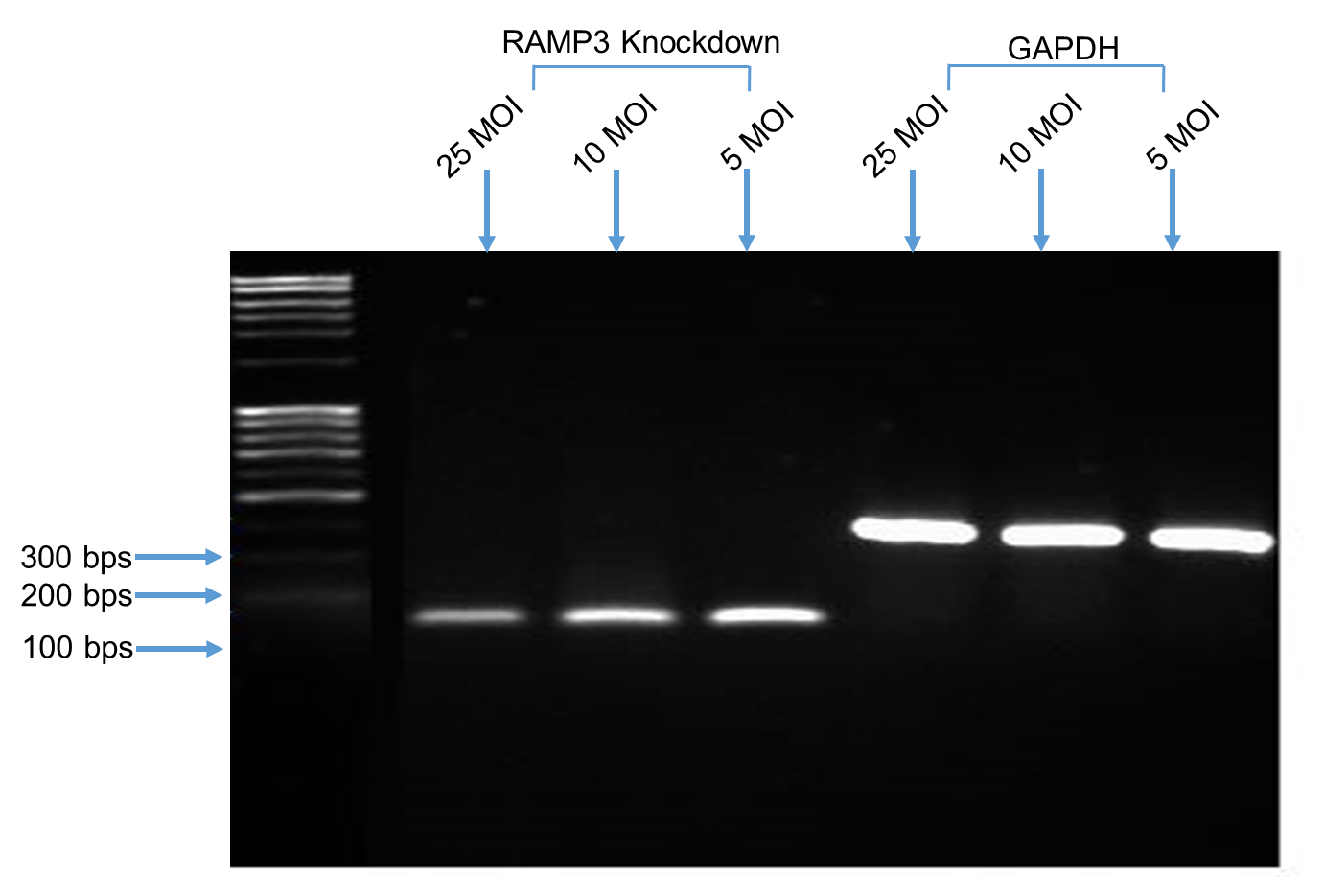
Figure1 Appendix: MOI titration. Serial Titration of lentivirus to determine the optimum MOI to be used.

Figure 2 and Figure 3 Appendices show the optimum concentration of protein which illustrates the difference between the RAMP3 knockdown and the control virus cells band.

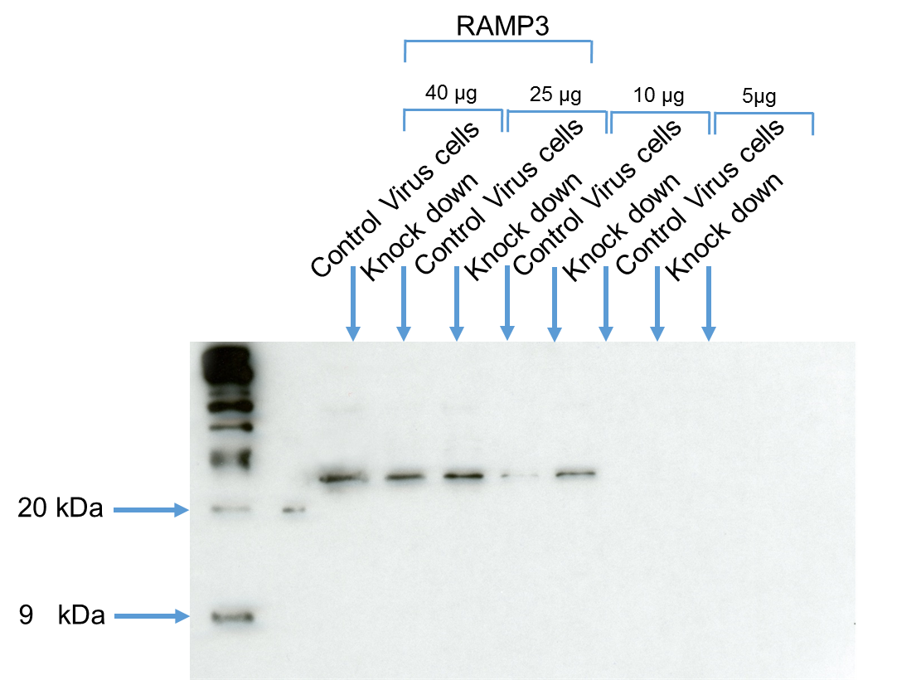
Figure 2 Appendix: Different concentrations of RAMP3 knockdown and control virus cells loaded protein.
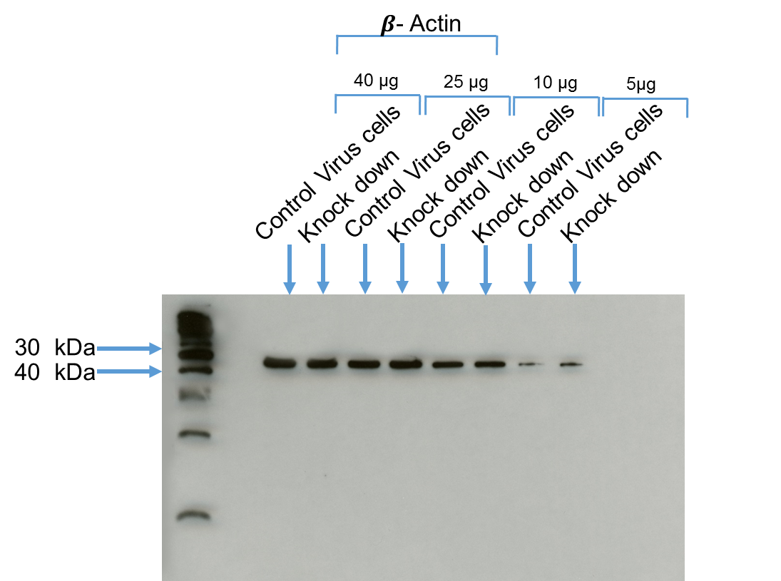
Figure 3 Appendix: 𝜷- actin showing different concentrations of loaded protein.

The Figure 4 Appendix shows that the heat inactivated FCS has no detectable AM compared to the positive control (AM peptide).

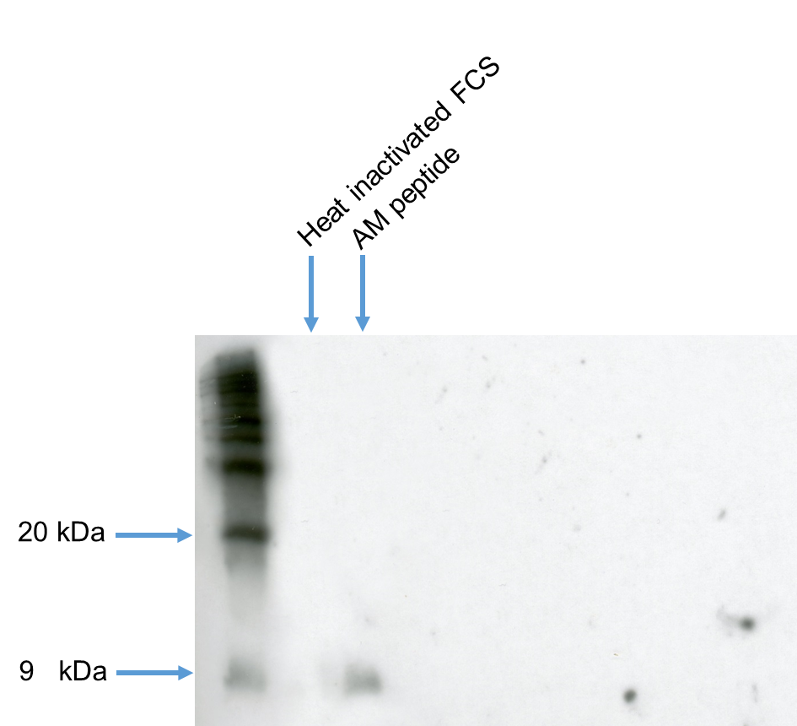
Figure 4 Appendix: Heat inactivated FCS has no band that corresponds to AM, while the positive control (AM peptide) has a band ~9 kDa in size which corresponds to AM.

Figures Permissions
The following are images of the permissions that were taken for Figures 1.4, 1.10, 1.11, 1.16 and1.18.
