Alkaline-based extraction of Mg(OH)₂ from magnesium silicate minerals for
CO₂ capture and storage

Silvia Madeddu

A thesis presented for the Degree of Doctor of Philosophy

Department of Materials Science and Engineering
Faculty of Engineering
The University of Sheffield

October 2015

To Made,
my brilliant friend

Acknowledgments
I would like to thank my supervisor, Dr. Hajime Kinoshita, for his immeasurable help during the past 4 years and for his precious contribution to this project. I am grateful for the opportunity to collaborate with an indefatigable and brilliant scientist who has always been present, supporting my work and making more enjoyable this PhD.
I would like to thank Michael Priestnall, who first conceived the idea of this project, for his contribution to the research, for his enthusiasm and passion which I have always admired, and for the continuous support and encouragement.
I would like to thank all the people who have contributed to this study with their work, ideas or through financial support: A. Rahman Badrol, Dr. Susan Bernal Lopez, Dr. Neil Bramall, Dr. Michael Evans, Dr. Erik Godoy, Prof. Shinobu Hashimoto and the Department of Environmental and Materials Engineering at Nagoya Institute of Technology, Dr. Oday Hussein, Dr. Claire Hutton, Prof. Atsushi Iizuka and the Institute of Multidisciplinary Research for Advanced Materials at Tohoku University, Prof. R. Vasant Kumar, Alexandros. G. Malioglou, Seabelo Manenye, Hilmy Mayzan, Dr. Ben Palmer, Prof. John Provis, Dr. Sugat Raymahasay, Dr. Nik Reeves-McLaren, Dr. Haiami Takeda and Ruofan Wang.
My gratitude also goes to: Regione Autonoma della Sardegna, Agenzia Regionale per il Lavoro, Italy, and Master and Back Programme 2011, Percorsi di Alta Formazione, P.O.R. FSE 2007–2013. Cambridge Carbon Capture Ltd, Polarcus Ltd, The UK CCS Research Centre, The Armourers & Brasiers Gauntlet Trust, and The University of Sheffield for the financial support.

I would like to thank the colleagues from PGR3 office, who have made my PhD so much better. I will remember those Friday nights forever, although my life expectancy is now shorter.
Thanks to the UK for welcoming me and showing that it is possible to live in a multicultural society where the differences are not a weakness but instead a resource. Also, thanks for giving us the Spice Girls.
Thanks to all the people who have made the three months in Japan some of the happiest of my life and to Japan for being my second home and for its great culture.
Thanks to all the people that I have met around the world in the past 4 years, who shared their culture and opinions contributing to open my mind and making my life more interesting, you are worth this PhD.
Last but not least, my deepest gratitude goes to my parents who taught me to love life and be passionate and to my friends who are my roots and saved me in the darkest moments of this PhD.

Abstract
Magnesium hydroxide, Mg(OH)₂, has great potential for CO₂ capture and storage (CCS) as it can capture CO₂ in aqueous and solid systems. However, the utilisation of Mg(OH)₂ for CCS has been hindered due to its rare occurrence in mineral deposits, and Mg silicate minerals, despite their slow kinetics of carbonation, have been the prime focus of the investigations for CO₂ sequestration owing to their abundance in nature.
In the present study, the extraction of Mg(OH)₂ from Mg silicate minerals was investigated in NaOH aqueous and solid systems. The effective extraction of Mg(OH)₂ from Mg silicate minerals is beneficial because it would offer not only a large CO₂ storage capability but also a faster kinetics of carbonation. The direct alkaline-based extraction of Mg(OH)₂ is also beneficial, as the acidic extraction commonly used requires the addition of an alkaline reactant to favour the precipitation of Mg(OH)₂ and successive carbonation process.
81% yield of Mg(OH)₂ extraction was achieved from dunite, an ultramafic rock mainly composed of Mg silicate minerals, reacted with NaOH aqueous systems. Despite the high efficiency of extraction, the large amount of NaOH consumed was identified as a potential obstacle for the implementation of the process.
Dunite was reacted with NaOH solid systems aiming the reduction of NaOH usage. The consumption of NaOH in solid systems was effectively reduced by 94.5 – 97% respect to the aqueous systems, maintaining significant rates of Mg(OH)₂ extraction (65 – 73%). The H₂O consumption was also reduced or avoided.
Mg(OH)₂ carbonation was investigated in aqueous and solid systems. A significant fraction of Mg(OH)₂ was converted into hydromagnesite Mg₅(CO₃)₄(OH)₂·4H₂O when reacted with added H₂O under supercritical CO₂. The dissolution of Mg in the products from Mg(OH)₂ extraction significantly improved respect to Mg silicate minerals previously tested without alkaline pre-treatment. CO₂ was captured from a gas mixture of CO₂ and N₂ at ambient conditions using an aqueous slurry of Mg(OH)₂. Mg(OH)₂ and CO₂ dissolved in H₂O and reacted by forming soluble Mg(HCO₃)₂ which remained in solution under controlled pH.
Contents
Acknowledgments |  |  | i
Abstract |  |  | iii
Contents |  |  | iv
1. Introduction |  |  | 1
 |  | 1.1. Carbon Capture and Storage (CCS) | 1
 |  | 1.2. Mg(OH)₂ for CCS | 1
 |  | 1.3. Alkaline extraction of Mg(OH)₂ | 2
 |  | 1.4. Aims and objectives | 2
2. Literature Review |  |  | 5
 | 2.1. Introduction |  | 5
 | 2.2. Current state of CO₂ emissions |  | 5
 |  | 2.2.1. The environmental risk from anthropogenic CO₂ emissions | 5
 |  | 2.2.2. Technologies for the abatement of CO₂ emissions | 6
 |  | 2.2.3. A global responsibility | 7
 | 2.3. Carbon Capture and Storage (CCS) |  | 8
 |  | 2.3.1. CO₂ capture | 9
 |  | 2.3.2. CO₂ geological storage | 10
 |  | 2.3.3. CO₂ ocean storage | 10
 |  | 2.3.4. CO₂ mineral carbonation | 12
 | 2.4. CO₂ mineral carbonation |  | 12
 |  | 2.4.1. Mineral resources | 12
 |  | 2.4.2. Ex-situ mineral carbonation | 14
 | 2.5. Direct ex-situ mineral carbonation |  | 16
 |  | 2.5.1. Direct gas-solid carbonation | 16
 |  | 2.5.2. Direct aqueous carbonation | 16
 | 2.6. Extraction of Mg component for ex-situ mineral carbonation |  | 18
 |  | 2.6.1. Acidic dissolution | 18
 |  | 2.6.2. Alkaline dissolution | 22
 |  | 2.6.3. NaOH production via chlor-alkali process | 23
 |  | 2.6.4. Solid state reaction | 26
 |  | 2.6.5. Summary: extraction technologies for ex-situ mineral carbonation | 28
 | 2.7. Ex-situ mineral carbonation of waste materials |  | 31
 | 2.8. Commercial application of ex-situ mineral carbonation |  | 33
 | 2.9. Mg(OH)₂ for Carbon Capture and Storage |  | 34
 |  | 2.9.1. Current status of Mg(OH)₂ applications | 34
 |  | 2.9.2. Mg carbonate minerals | 34
 |  | 2.9.3. Gas-solid carbonation of Mg(OH)₂ | 35
 |  | 2.9.4. Aqueous carbonation of Mg(OH)₂ | 37
 |  | 2.9.5. Ocean liming with Mg(OH)₂ | 37
 |  | 2.9.6. Carbonation of Mg(OH)₂ with supercritical CO₂ | 38
 |  | 2.9.7. Capture of CO₂ with Mg(OH)₂ | 39
 | 2.10. Summary |  | 40
3. Materials and Methods |  |  | 41
 | 3.1. Introduction |  | 41
 | 3.2. Materials |  | 41
 |  | 3.2.1. Dunite | 41
 |  | 3.2.2. Sodium hydroxide, NaOH | 45
 |  | 3.2.3. Magnesium hydroxide, Mg(OH)₂, reagent grade | 45
 |  | 3.2.4. Magnesium hydroxide, Mg(OH)₂, derived from dunite | 47
 | 3.3. Mg(OH)₂ extraction from dunite |  | 48
 |  | 3.3.1. Aqueous systems | 48
 |  | 3.3.2. Solid systems | 50
 | 3.4. Mg(OH)₂ carbonation |  | 52
 |  | 3.4.1. Gas-solid carbonation | 52
 |  | 3.4.2. Carbonation with supercritical CO₂ | 53
 |  | 3.4.3. Carbonation via CO₂ pressure swing | 53
 |  | 3.4.4. CO₂ capture with Mg(OH)₂ suspension | 56
 | 3.5. Raw materials and products analysis |  | 58
 |  | 3.5.1. X-ray Diffraction | 58
 |  | 3.5.2. Rietveld Refinement Quantitative Phase Analysis | 59
 |  | 3.5.3. Thermogravimetry | 61
 |  | 3.5.4. X-ray Fluorescence | 62
 |  | 3.5.5. Scanning Electron Microscopy and Energy Dispersive X-ray Spectroscopy | 62
 |  | 3.5.6. Inductively Coupled Plasma Optical Emission Spectrometry | 64
 |  | 3.5.7. Carbon Hydrogen Nitrogen Elemental analysis | 65
 |  | 3.5.8. Particle size analysis via Laser Diffraction | 65
 | 3.6. Analysis of extraction reaction |  | 66
 |  | 3.6.1. Thermodynamic analysis | 66
 |  | 3.6.2. Extent of reaction | 66
4. Mg(OH)₂ extraction from dunite in NaOH aqueous systems |  |  | 69
 | 4.1. Introduction |  | 69
 | 4.2. Effect of NaOH concentration and temperature |  | 69
 | 4.3. Quantification of forsterite and brucite |  | 73
 | 4.4. NaOH aqueous systems |  | 76
 | 4.5. Extraction of elements |  | 78
 | 4.6. Kinetics of reaction |  | 82
 |  | 4.6.1. Reaction with 30 mol/kg NaOH aqueous system | 82
 |  | 4.6.2. Reaction with 50 mol/kg NaOH aqueous system | 88
 |  | 4.6.3. Morphological alteration in 50 mol/kg NaOH aqueous system | 89
 | 4.7. Efficiency of Mg(OH)₂ extraction |  | 94
 | 4.8. Summary |  | 96
5. Mg(OH)₂ extraction in NaOH solid systems |  |  | 99
 | 5.1. Introduction |  | 99
 | 5.2. Extraction of Mg(OH)₂ |  | 99
 | 5.3. Effect of NaOH |  | 102
 | 5.4. Effect of H₂O |  | 105
 | 5.5. Effect of NaOH concentration in H₂O |  | 108
 | 5.6. Effect of temperature and time |  | 111
 | 5.7. Extraction of elements |  | 113
 | 5.8. Kinetics of reaction |  | 118
 |  | 5.8.1 Reaction in dry solid systems | 118
 |  | 5.8.2. Reaction in solid system assisted with H₂O | 122
 | 5.9. Efficiency of extraction |  | 125
 | 5.10. Summary |  | 127
6. Mg(OH)₂ carbonation |  |  | 129
 | 6.1. Introduction |  | 129
 | 6.2. Gas-solid carbonation |  | 130
 |  | 6.2.1. High temperature dry carbonation | 130
 |  | 6.2.2. High temperature wet carbonation | 135

 |  | 6.2.3. Reactivity of Mg(OH)₂ for high temperature carbonation | 139
 | 6.3. Carbonation with supercritical CO₂ |  | 141
 |  | 6.3.1. Dry carbonation | 141
 |  | 6.3.2. Wet carbonation | 143
 |  | 6.3.3. Conversion of carbonation product | 147
 | 6.4. Carbonation via CO₂ pressure swing |  | 148
 | 6.5. CO₂ capture with Mg(OH)₂ |  | 155
 | 6.6. Summary |  | 158
7. Implications of Mg(OH)₂ extraction from Mg silicate minerals |  |  | 153
 | 7.1. Introduction |  | 153
 | 7.2. Effect of NaOH recycling in aqueous systems |  | 153
 | 7.3. Effect of NaOH, temperature and duration of reaction in solid systems |  | 159
 | 7.4. Comparison of Mg(OH)₂ production technologies |  | 162
 | 7.5. Summary |  | 163
8. Conclusions |  |  | 165
 | 8.1. Overview |  | 165
 | 8.2. Extraction of Mg(OH)₂ with NaOH aqueous and solid systems |  | 165
 | 8.3. Mechanism of extraction |  | 166
 | 8.4. Mg(OH)₂ carbonation |  | 167
 | 8.5. Implications of Mg(OH)₂ extraction for CCS |  | 168
 | 8.6. Summary |  | 169
References |  |  | 171
Appendix 1 – Supporting data for Chapter 4 |  |  | 189
Appendix 2 – Supporting data for Chapter 5 |  |  | 193
Appendix 3 – Supporting data for Chapter 6 |  |  | 205

1. Introduction
1.1. Carbon Capture and Storage (CCS)
Carbon Capture and Storage (CCS) is a portfolio of technologies developed for the abatement of anthropogenic CO₂ emissions via permanent isolation of CO₂ from the atmosphere. CCS includes the separation of CO₂ from exhaust flue gases and its storage either underground (geological storage), in seawater (ocean storage), or through the fixation into stable mineral carbonates via mineral carbonation [1]. The existing capture technologies are based on the chemisorption of CO₂, mostly with amine solvents, to obtain a concentrated stream of gaseous CO₂ ready to be stored [1]. Despite the large sequestration potential of geological and ocean storage, the leakage of CO₂ is a potential environmental risk associated with these technologies [1]. CO₂ mineralisation via chemical reaction with Ca- or Mg-bearing materials is considered to be the only storage technology currently available which assures the safe and permanent sequestration of CO₂ [1]. The preferred feedstock materials have been Mg silicate minerals owing to their wide availability in nature. Although, the slow kinetics of carbonation are deemed not suitable for large scale applications and have been limiting the implementation of mineral carbonation technologies.
1.2. Mg(OH)₂ for CCS
Ultramafic rocks such as dunite and serpentinite provide large potential for CO₂ sequestration as they contain a high wt% of Mg and are widely available in natural deposits [2]. The main components of dunite and serpentinite are forsterite, Mg₂SiO₄, and the polymorphs of the serpentine group, Mg₃Si₂O₅(OH)₄ [2]. Although the carbonation of these minerals is energetically favoured, the kinetics of reaction of such Mg silicate minerals are too slow to be applied for large scale operations, and thus, Mg component is usually extracted via chemical pre-treatment to accelerate the reaction [1]. Mg can be extracted as Mg(OH)₂ with the following advantages:
(1) Mg(OH)₂ has a faster kinetics of carbonation reaction compared with the original Mg silicate minerals [1];
(2) Mg(OH)₂ is a rare compound in nature, and the effective extraction from Mg silicate minerals offers a large potential access to the material [1];
(3) Mg(OH)₂ has already been used for flue gases desulphurisation and it could be potentially applied for CO₂ capture without an expensive CO₂ pre-separation from other flue gas components and pre-compression operations [3, 4, 5].
1.3. Alkaline extraction of Mg(OH)₂
Mg(OH)₂ can be extracted from Mg silicate minerals via reaction with acidic solutions or salts [6, 7]. These processes involve a second step to increase the pH of the system and favour the formation of Mg(OH)₂, and thus an alkaline reactant is also consumed [6, 7]. The direct alkaline-based extraction of Mg(OH)₂ is interesting because it would not require the secondary pH shift, and the process can be simplified to a single-step reaction. However, the research in this area is highly limited, and the process proposed by Blencoe et al. [8] is the only established technique currently available in the open literature. The authors used highly concentrated NaOH solutions to produce Mg(OH)₂ from magnesium silicate minerals at 200 °C [8]. A few drawbacks have been identified in this technique, i.e. the large amount of NaOH required (30 – 80 percent by weight of NaOH in water) and the long reaction time (72 hours), and the technology is considered unsuitable for CCS [8, 9]. To establish an alkaline-based extraction of Mg(OH)₂ from natural minerals applicable for CCS, the improvement of this technology is essential.
1.4. Aims and objectives
The present study aims to develop a novel technology for the alkaline-based extraction of Mg(OH)₂ from Mg silicate minerals. Dunite composed of approximately 73 wt% forsterite was used throughout the project as a feedstock material with NaOH as extracting agent. Dunite was selected due to the large availability in natural deposits while NaOH was selected as extracting agent after some preliminary tests with other reagents, e.g. KOH and NaHCO₃, resulted in low efficiencies of extraction.
The extraction of Mg(OH)₂ from dunite was firstly investigated in NaOH aqueous systems. The objective of the study was to achieve significant rates of extraction with suitable conditions to improve the process proposed by Blencoe et al.. The effects of NaOH concentration, reaction temperature and duration were investigated, and the efficiency of Mg(OH)₂ extraction was assessed. The kinetics aspects of the reaction were also studied to obtain insight into the mechanism of reaction.
The second part of the study focused on the extraction of Mg(OH)₂ from dunite-NaOH solid systems aiming at the reduction of NaOH consumption to the stoichiometric ratio with dunite (the theoretical minimum amount for the complete extraction of Mg(OH)₂ from dunite). The feasibility of reaction was thermodynamically studied and the effects of reaction conditions, i.e. NaOH content, water content, reaction temperature and duration, were investigated. The kinetics aspects of the reaction were studied also for the solid systems and discussed in comparison with that for the aqueous systems.
The third part of the study focused on the feasibility of CO₂ capture and storage with Mg(OH)₂. Mg(OH)₂ carbonation was tested via gas-solid carbonation under atmospheric pressure and with supercritical CO₂. The aqueous carbonation of Mg(OH)₂ slurries was also studied. The products from dunite alkaline digestion enriched in Mg(OH)₂ were carbonated in H₂O via CO₂ pressure swing, a method developed for the precipitation of CaCO₃ from cement waste aqueous slurries [10]. Gas-liquid carbonation was also tested to separate CO₂ from a 4 – 5% CO₂ gas mixture with N₂ via gas-liquid scrubbing and simulate the capture of CO₂ from exhaust flue gases.
Then, the implications of using Mg(OH)₂ derived from dunite for CCS were discussed. For the aqueous extraction, the CO₂ balance was analysed considering the NaOH consumption, temperature, duration of the extraction and theoretical CO₂ capture potential of Mg(OH)₂ produced. An improvement of the system is discussed based on the recycling of the alkaline solutions for multiple digestion batches. A similar analysis was conducted for the solid extraction and the effect of temperature and duration on the CO₂ balance was discussed.
Finally, conclusions are drawn based on the obtained outcomes, and some recommendations are provided for further study.

2. Literature Review
2.1. Introduction
The literature review provides a general overview of the Carbon Capture and Storage (CCS) technologies and their roles for the abatement of CO₂ anthropogenic emissions. Ex-situ mineral carbonation technologies are discussed with specific regard to the extraction of Mg from Mg silicate minerals and Mg(OH)₂ carbonation, as they are of particular interest for the subject of this study.
2.2. Current state of CO₂ emissions
2.2.1. The environmental risk from anthropogenic CO₂ emissions
From the beginning of the industrial revolution, i.e. 1750, the greenhouse gas (GHG) emissions have steadily increased, forcing a significant perturbation of the environment [11]. The human activities are responsible for the majority of the greenhouse gas emissions, mostly constituted by CO₂, CH₄ and N₂O [11, 12, 13, 14]. The accumulation of anthropogenic emissions in the atmosphere has changed the energy balance of the earth through a process commonly known as the greenhouse effect [11, 12]. The Earth surface constantly absorbs and emits the solar radiation, maintaining the environment habitable. However, the greenhouse gases and aerosols present in the atmosphere absorb these radiations and partially radiate them back to the Earth surface [11]. The increase of anthropogenic emissions has enhanced this phenomenon causing the unnatural over-heating of the earth surface leading to climate change [11].
CO₂ is the major contributor to the greenhouse effect [11, 12, 14]. The main sources of anthropogenic CO₂ emissions are the burning of fossil fuels, cement and steel making industry, deforestation and land use [11, 12, 14]. From the beginning of the industrial revolution the concentration of atmospheric CO₂ has increased by 40%, reaching a concentration of 390.5 ppm in 2011 [11]. It has been estimated that by 2050 the greenhouse gas emissions will increase by 50% with a major contribution from CO₂ which will increase by 70% [13]. Consequently, the global mean temperature is expected to rise by 2 – 3 °C [13]. This alarming prospect requires an immediate intervention on the global scale to reverse the trend of the anthropogenic emissions.
2.2.2. Technologies for the abatement of CO₂ emissions
The burning of fossil fuels, mainly coal and oil, is the primary source for power generation and is responsible for two-thirds of the global CO₂ emissions which are expected to further increase due to the future rise of the energy demand [13]. The strategies for the reduction of CO₂ anthropogenic emissions include the introduction of new green technologies for the energy supply, the improvement of the efficiency of existing technologies and the reduction of energy demand and consumption [14, 15].
Low-carbon technologies already exist such as nuclear power or renewable energies, i.e. biomass, wind power, solar power, geothermal energy and hydropower, although it is unlikely that these technologies will fully substitute fossil fuels within a short time scale [13, 16]. The main obstacles for the implementation of the renewable energy are the large cost and dependence on the environmental conditions, whereas for nuclear power the prime concerns are the safety and waste management [14, 17].
The International Energy Agency (IEA) calculated that 80% of the emissions projected by 2020 will be produced by power plants currently operating [13]. The integration of Carbon Capture and Storage (CCS) and Carbon Capture and Utilisation (CCU) technologies is considered the most effective strategy for the decarbonisation of existing power plants until alternative energy sources are implemented [18].
CCS technologies are based on the separation, transport and long-term storage of exhaust CO₂, which will be thoroughly discussed in Section 2.3 [1]. CO₂ is isolated from the atmosphere via injection in the underground or the deep ocean, or via chemical fixation into solid and stable mineral carbonates [1].
An alternative to CCS are CCU technologies which are based on the utilisation of exhaust CO₂ for the production of chemicals such as urea, polymers, methanol and products for pharmaceuticals industries [19]. The potential scale of CCU implementation is considered too small to make a significant impact on the abatement of CO₂ anthropogenic emissions [5]. Moreover, CCU is based on the recycling of exhaust CO₂ to form new chemical products which will eventually re-emit the CO₂ in the atmosphere when decomposed [5].
New technologies based on the capture and storage of CO₂ with biomass and living organisms are also attractive. Microalgae and cyanobacteria have been proposed as vehicles for the fixation of CO₂ through photosynthetic processes [20, 21], whereas the pyrolysis of biomass produces biochar which is a low cost carbon sink with large storage potential [22, 23].
2.2.3. A global responsibility
The United Nations Climate Change Conference held in 2010 determined the limit to the greenhouse gases concentration in the atmosphere to be achieved within 2100, i.e. 450 – 550 ppm [24]. This threshold was established from studies and projections which determined that higher concentrations of greenhouse gases would irreparably damage the environment [12].
In 2014, China was responsible for 29% of the global CO₂ emissions, becoming the largest CO₂ emitter and followed by the United States, at 16%, the EU, at 11% and India, at 6% [25]. China is the largest consumer of coal in the world and in 2012 consumed almost the same quantity of coal used in the rest of the world, i.e. 46% [26]. The Chinese government has expressed the intention to improve green policies and China is currently one of the countries majorly involved in the development of CCS technologies and renewable technologies [27, 28, 29].
The CO₂ emissions of the US have registered an opposite trend, decreasing by over 12% from 2005 to 2012, thanks to the substitution of coal and petroleum with natural gas, hydropower and renewables energies [14, 25]. The price of coal in Europe is much lower than that of natural gas and only the carbon tax could encourage the exploitation of new energy sources [27]. Nevertheless, the UK and the majority of the countries of the European Union have seen a reduction of the CO₂ emissions since 2005 thanks to the introduction of the Emissions Trading System (ETS) [30]. The ETS is based on a cap and trade system which imposes limitations on the CO₂ emissions to power and industrial plants and allows the trade of emissions allowances among them. The cap decreases in time and it is expected to achieve a reduction of the greenhouse gas emissions of the EU by 21% in 2020 [30].
The Department of Energy and Climate Change estimated that in 2013 the total CO₂ emissions in the UK were 467.5 million tonnes [31]. The main sources of these emissions were the energy supply, transport, and residential sectors [31]. The UK strongly relies on the carbon consumption and 60% of the emissions from the energy supply are from the burning of fossil fuels, and thus, an immediate intervention is necessary for the decarbonisation of the energy system [32].
2.3. Carbon Capture and Storage (CCS)
CCS is a portfolio of technologies which includes the separation, transport and storage of exhaust CO₂ [1]. CO₂ is separated from the flue gas to obtain a relatively pure gas which is compressed and moved through pipelines or stored in tanks and transported to the storage location [1]. The CO₂ can be stored in oil and gas fields, deep saline formation, coal beds, in geological formations or into the ocean [1]. CO₂ can also be sequestered via mineral carbonation, also called carbon mineralisation, which consists of the conversion of gaseous CO₂ into stable and solid mineral carbonates via carbonation reaction with suitable feedstock materials [1].
CCS can be integrated into existing and new generation power plants, or to industrial plants such as chemicals, cement, steel, iron and refineries, and potentially lead to net negative CO₂ emissions [18, 25, 33]. The implementation of CCS would enable to use the fossil fuels, on which many economies rely, and have a sustainable energy supply system [33]. For these characteristics, CCS has earned a primary position in the agenda for CO₂ emissions reduction over the next 20 – 50 years, until the renewable technologies substitute the fossil fuels as prime source of energy [18, 25, 28, 33].
According to the Intergovernmental Panel on Climate Change (IPCC) [1], a power plant equipped with CCS would reduce the net CO₂ emissions by 80 – 90% but it would also cause the increase of the energy consumption by 10 – 40% compared with the same plant operating without CCS [1].
The integration of CCS technologies is energy and cost demanding and has hindered their implementation on a large scale. The capture technologies require the large consumption of chemicals which can only be partially recovered [1]. The research so far has focused on the reactivity of the capture agents with CO₂, although the chemistry of the exhaust flue gases is complex and the interaction with NO_{x}, SO_{x} and other components should also be assessed [1, 34]. The storage technologies require the large consumption of solid materials, e.g. minerals and rocks, chemicals which are only partially recoverable and the application of high temperatures and pressure which are energy intensive conditions [1]. Furthermore, the storage of CO₂ under rocks and in sea water presents environmental constraints due to the potential risk of leakage from the storage sites [1].
2.3.1. CO₂ capture
CO₂ can be captured from exhaust flue gases via post- or pre-combustion chemisorption, CaO looping and oxyfuel combustion. The direct capture of CO₂ from air using NaOH – KOH is considered less efficient while other promising sorbents are being developed for possible future applications, e.g. physical sorbents, membranes, zeolite [1, 19, 34, 35].
CO₂ capture via chemisorption has been already applied for natural gas treatment and ammonia production [1, 34]. Gaseous CO₂ reacts with aqueous solutions of amine solvents, mainly alkanolamine and monoethanolamine (MEA), by forming water-soluble salts [34]. Then, the solution is heated to separate the CO₂ from the solution and the solvent is partially recovered [34, 36]. The amine-based chemisorption allows the separation of 85 – 95% of the CO₂ processed in a plant and currently is the preferred option for CO₂ capture [1]. Nevertheless, this technology has some drawbacks. The amines tend to degrade due to thermal stress or by reaction with some of the flue gases components, i.e. O₂, NO_{x} and SO_{x}, and thus only part of the solvents consumed can be recovered [34, 36]. Moreover, some of the amines degradation products are severe pollutants, e.g. ammonia, aldehydes, volatile amines, polyamines, and their safe disposal has yet to be assessed [34, 36].
Calcium looping uses CaO as sorbent of CO₂ [34, 37]. CaO reacts with CO₂ by forming CaCO₃, CaCO₃ is then calcined at around 900 – 950 °C to produce CaO and a highly concentrated CO₂ stream, i.e. <90 vol% CO₂, ready to be stored [34]. The CaO is reused in multiple capture cycles although the capture capacity gradually decreases due to the continue exposure to high temperatures which reduces the reactive surface area and the porosity [34]. Moreover, the presence of sulphur impurities in the gas stream leads to the formation of CaSO₄, reducing the capture capacity [34]. The carbon looping process is particularly suitable for the cement industry because the exhaust CaO can be reused for cement production [34].
The CO₂ capture via chemisorption with amines or CaO is used for post-combustion and pre-combustion capture. The post-combustion capture involves separation of CO₂ directly from the exhaust flue gases and is considered the most suitable for retrofitting the operating power plants [1]. However, the low concentration of CO₂ in the flue gas, i.e. 3 – 15 vol%, requires the pre-compression of CO₂ before the transport and storage, increasing the energy penalty of the process [1, 34]. It has been estimated that a coal-power plant equipped with amine-based post-combustion capture would see a reduction of the thermal efficiency by 25 – 34%, which corresponds to a cost-increase of the electricity by 70% [36].
The pre-combustion capture involves the pre-treatment of the flue gas to achieve an outlet gas composed of H₂ and highly concentrated CO₂. This process simplifies the chemisorption of CO₂ but is energy intensive [34].
The oxyfuel capture is still in the research phase. It involves the fuel combustion in a mixture of ~95% pure oxygen and exhaust CO₂ [34]. The product of this process is constituted by CO₂ and H₂O which can be easily separated via condensation, giving an outlet stream of pure CO₂ [34]. The main drawback of the oxyfuel capture is the production of pure oxygen from air which is an energy intensive process and adds severe energy penalties to the process [34].
The capture of CO₂ constitutes the majority of the overall cost of CCS technologies and constitutes the main obstacle for their deployment in industrial and power plants [5, 38, 39].
2.3.2. CO₂ geological storage
CO₂ geological storage is the most viable sequestration method because it offers a storage capacity of the order of millions of tonnes CO₂ per year and is based on a mature technology which has been previously used in oil and gas industries [1, 17, 36]. A few geological storage projects are already fully operative such as the Sleipner project in Norway and the Weyburn project in Canada [1, 36].
The locations suitable for geological storage require the presence of a caprock with low permeability, which allows the physical trapping of CO₂ [1, 36]. In presence of H₂O, e.g. deep saline aquifers, the injected CO₂ can dissolve and re-precipitate as mineral carbonate. In this case the storage occurs via chemical trapping and it is also known as in-situ mineral carbonation [1, 36].
The factors currently preventing the implementation of geological storage are the potential risk of CO₂ leakage from the storage location and the lack of dedicated policies and regulations for the treatment of CO₂ [1, 17].
2.3.3. CO₂ ocean storage
Oceanic waters have been identified as an alternative sink for exhaust CO₂ [1]. According to model calculations the storage capacity of the oceans is of the order of thousands of GtCO₂ [1]. CO₂ can be injected in the sea water at different depths, i.e. below 1000 or 3000 m [1]. CO₂ injected below 1000 m is sequestered via aqueous dissolution. The water rich in CO₂ is denser and is transported in the deep sea from the oceanic currents where it remains isolated. CO₂ has to be fully dissolved or it will be re-emitted in the atmosphere [15].
Below 3000 m, CO₂ liquefies and forms a layer which is trapped from the surrounding water [1]. An alternative option is to release the CO₂ into the ocean in forms of solid or hydrate phases [15]. Gaseous CO₂ can be converted into dry ice and dumped into the ocean where it sinks at the bottom due to the high density [15]. Based on the same principle, CO₂ hydrate can be released into the ocean and gradually release the CO₂ in the deep water where it remains isolated [15]. The main drawback of these methods is the high cost to convert gaseous CO₂ into dry ice or hydrate CO₂ [15].
CO₂ storage into oceanic waters is still in the research phase due to potential environmental risks such as the perturbation of the ocean’s ecosystems and the possible release of CO₂ back in the atmosphere during the circulation of the water [17, 40, 41, 42, 43]. The consequences of ocean acidification on the marine ecosystem are difficult to predict, although several studies have pointed out that the acidification of the seawater affects the living organisms and lowers their growth and reproduction rate [40, 41, 42, 43]. The major issue for the implementation of ocean storage is the utilisation of sea water for the storage of waste substances which is currently forbidden by international laws [44]. If the safety of CO₂ storage in sea water should be demonstrated, it could be authorised by special permits but at this stage further research is necessary [44].
2.3.4. CO₂ mineral carbonation
Mineral carbonation for CO₂ sequestration was first proposed by Seifritz in 1990 [45] and consists of the fixation of CO₂ into solid and stable mineral carbonates. Carbon mineralisation reproduces the same chemical reactions involved in the weathering of natural rocks [1]. When CO₂ dissolves in H₂O it forms an acidic solution according to Reaction 2.1 [46]:
(2.1)
The acidic aqueous solution in contact with Ca and Mg bearing rocks, hydrolyses Ca and Mg which are leached in solution and react with CO₃²⁻ forming Ca and Mg carbonate minerals, e.g. CaCO₃ and MgCO₃ [47, 48].
CaO and MgO bearing materials are considered the most suitable feedstock materials for carbon mineralisation because CaCO₃ and MgCO₃ are thermodynamically stable and assure the safe and permanent sequestration of CO₂ [1].
The mineral carbonation can take forms of in-situ and ex-situ [1]. The former consists of the chemical reaction of the CO₂ retained underground with the host rock or brines to form solid and stable carbonate minerals [49]. The ex-situ mineral carbonation technology involves the reaction of CO₂ with minerals which have been previously mined or with waste materials from industrial processes [49, 50]. It has been estimated that the storage capacity of ex-situ mineral carbonation is higher than geological storage and would allow the sequestration of CO₂ anthropogenic emissions over thousands of years [5].
2.4. CO₂ mineral carbonation
2.4.1. Mineral resources
The suitable rocks for CO₂ sequestration via mineral carbonation are rich in Ca and Mg and form large deposits which allow the storage of large quantities of CO₂ [17]. Mafic and ultramafic rocks have been targeted for in-situ mineral carbonation [49], while ultramafic rocks rich in forsterite and serpentine have been the preferred feedstock materials for ex-situ mineral carbonation [1].
Mafic rocks are silicate rocks with high concentration of Mg, Fe and Ca [2]. Basalt is one of the mafic rocks suitable for in-situ mineral carbonation. It contains SiO₂ <52 wt% and the principal mineral components are from the plagioclase group, i.e. albite, NaAlSi₃O₈, and anorthite, CaAl₂Si₂O₈, and pyroxene group, XYSi₂O₆ where X and Y can be Ca²⁺, Mg²⁺, Fe²⁺ [2, 51].
In the US, several tests have been conducted on CO₂ injection in basalts, i.e. in the outcrop of the Palisade Sill [52] and in the aquifer of the Columbia River flood basalt [53]. Other suitable basalt deposits have been identified offshore the US coasts, e.g. 917 GtCO₂ and 900 MtCO₂ could be stored in the Juan Fuca Plate and Sandy Hook Basin, respectively [49, 54, 55].
One of the most important CCS pilot-scale projects is CarbFix in Iceland which involves the capture of CO₂ from flue gas emitted from a geothermal power plant and the injection of CO₂ dissolved in water under a basaltic formation at a rate of 2200 tonnes per year [56]. Between 2011 and 2012, 175 tonnes of CO₂ were injected for a preliminary test, and additional injection tests were conducted in 2013 at different depths and temperatures [57]. The complete dissolution of CO₂ in water has been demonstrated, whereas the chemical fixation into mineral carbonates is currently under investigation [57].
Ultramafic rocks have low concentration of SiO₂, i.e. <45 wt%, and high content of Mg, Ca and Fe [58]. The most abundant ultramafic rocks are peridotites which are primarily constituted by the Mg-rich end member of the olivine group, i.e. forsterite, Mg₂SiO₄, spinel, MgAl₂O₄ and the minerals of the pyroxene group [2, 51]. When the content of olivine is >90 wt%, peridotites are classified as dunite [2].
The Samail Ophiolite in Oman is the largest ophiolitic outcrop in the world and is constituted by 30 vol% peridotite partially serpentinised [59]. The deposit naturally carbonates and it has been estimated that ~10⁵ tonnes of CO₂ are captured and fixed as mineral carbonates every year [59]. Currently, the site is subject to investigation to further enhance the CO₂ storage capacity [59, 60].
Serpentinites are ultramafic rocks generated from the metamorphic transformation of peridotites, and the principal mineral components are the polymorphs of the serpentine group, i.e. antigorite, chrysotile, and lizardite, Mg₃Si₂O₅(OH)₄, forsterite, magnetite, Fe₃O₄, and brucite, Mg(OH)₂ [2, 51]. Some of the major outcrops of serpentinite are found in Finland, Australia, Kazakhstan, South Africa and California [58].
Deposits of peridotite and serpentinite are rare and scattered in the UK territory and the implementation of ex-situ mineral carbonation of Mg silicate minerals would require the import of feedstock minerals from overseas. Finland, Norway, Spain and Greece are the closest countries which present ultramafic outcrops sufficiently extended to be exploited for mineral carbonation [58, 61].
2.4.2. Ex-situ mineral carbonation
The ex-situ mineral carbonation technologies involve the reaction of CO₂ with feedstock materials rich in Ca and Mg, in a reactor above ground [1]. The carbonate minerals produced can be safely disposed of or reused in the construction industry, for land reclamation projects and restoration of mining sites [1, 5].The ex-situ mineral carbonation is considered the most secure option for CO₂ sequestration because it avoids any risk of leakage which is intrinsic to the other storage technologies [1]. Moreover, when CO₂ is fixed into carbonate minerals, the post-storage operations such as monitoring of the storage site, are not required and the liability of the operators is minimised [49].
Suitable feedstock materials include minerals or waste materials from industrial processes [1]. This paragraph focuses on the usage of minerals as it is of prime interest for this study, while the usage of waste materials is discussed Section 2.7.
CaO, Ca(OH)₂, MgO and Mg(OH)₂ are the most suitable reactants for ex-situ mineral carbonation as they have a faster kinetics of carbonation reaction compared with other Mg and Ca bearing minerals [1, 62, 63]. However, Ca and Mg oxides and hydroxides are almost unknown in nature, and Ca and Mg silicates are commonly used instead, in particular forsterite, wollastonite, CaSiO₃, and serpentine [64, 65]. Wollastonite is more reactive than forsterite and serpentine but it is less common in natural deposits [64, 65]. Forsterite and serpentine are the most abundant MgO bearing minerals in nature [64] and contain large amounts of MgO, i.e. 40 – 50 wt% [2, 66].
The carbonation reactions of these silicate minerals are energetically favoured and exothermic as shown from the standard Gibbs free energy and standard enthalpy of reaction reported in Table 2.1.
Table 2.1: Standard enthalpy of carbonation normalised per 1 mole of CO₂ [62, 67].
Mineral | Carbonation reaction | ΔG°  (kJ/mole) | ΔH°  (kJ/mole)
Forsterite |  | ̶ 34.7 | ̶ 88
Chrysotile |  | ̶ 18.1 | ̶ 35
Wollastonite |  | ̶ 39.5 | ̶ 87
Although energetically favoured, the carbonation of these minerals occurs over a geological timescale [64]. The acceleration of the kinetics of carbonation requires the mechanical, thermal or chemical pre-treatment of the raw materials [1]. The mechanical pre-treatment consists of the reduction of the particle size to increase the surface area and improve the reactivity [49]. In most cases, the particle size is reduced below 100 μm via mechanical grinding [5].
The thermal pre-treatment is primarily used to increase the reactivity of serpentine by removing the water chemically bound through heating at 600 – 630 °C [64].
The chemical pre-treatment is used to extract Ca and Mg from the feedstock materials in order to accelerate the kinetics of carbonation reaction and maximise the conversion into carbonate minerals [1]. Several methods have been tested, i.e. dissolution with inorganic [6, 64, 68] and organic acids [69, 70], alkaline aqueous solutions [8], and solid state reactions [48]. Nowadays, the majority of the ex-situ mineral carbonation technologies rely on the chemical pre-treatments of the feedstock materials, although the large amounts of chemicals consumed is a major burden for the scalability of these processes [1, 5, 49, 71, 72].
In order to capture significant amounts of CO₂, large quantities of minerals would have to be mined and ground, i.e. 2.5 – 3.6 tonnes of rock per tonne of CO₂ converted into mineral carbonate [5]. The mining, grinding and transport of such large amounts of minerals present logistic constraints and have a significant impact on the energy and costs demand of mineral carbonation [5]. These characteristics make ex-situ mineral carbonation practicable only for specific cases: small scale plants (2.5 MtCO₂ emitted per year), CO₂ emission point close to a mine site or other sources of feedstock materials, and when other storage technologies are not applicable.
In the past 20 years, several ex-situ mineral carbonation technologies have been investigated in two main categories, direct and indirect mineral carbonation. In the direct mineral carbonation, the feedstock material reacts with CO₂ in a single-step process [9], whereas, in the indirect mineral carbonation, the raw material is chemically pre-treated to obtain an intermediate product which is carbonated in a separate stage [9].
2.5. Direct ex-situ mineral carbonation
The direct mineral carbonation technologies are (1) gas-solid carbonation, based on the reaction of the feedstock materials with gaseous CO₂, and (2) aqueous carbonation based on the reaction of the raw materials and gaseous CO₂ in water to precipitate carbonate minerals [9].
2.5.1. Direct gas-solid carbonation
The low efficiency of this type of carbonation has been reported [9].
Lackner et al. [64] first studied the direct gas-solid carbonation of forsterite and serpentine. In their study, the minerals did not carbonate at atmospheric conditions and showed negligible carbonation rates when carbonated at 340 bar and 140 – 300 °C [64, 73].
The direct gas-solid carbonation of mineral silicates has been abandoned due to the low rates of carbonation achievable even under high temperature and CO₂ pressure, and the research has focused on direct aqueous carbonation [9, 72, 74].

2.5.2. Direct aqueous carbonation
The direct aqueous mineral carbonation has been developed to enhance the carbonation rate through the dissolution of feedstock materials and gaseous CO₂ in water [9].
O’Connor et al. [66] studied the direct aqueous carbonation of serpentine and olivine while Huijgen et al. [65] used wollastonite as feedstock material. Serpentine and olivine were mixed with 0.5 – 0.64 M NaHCO₃ and 1 M NaCl aqueous solutions while wollastonite was mixed with distilled water and the slurries were placed in a stirred autoclave pressurised with CO₂. NaHCO₃ was added to shift the equilibrium in solution and favour the formation of CO₃²⁻ ions, required for the precipitation of MgCO₃. NaCl improved the dissolution of Mg by forming Mg chloride complexes and reducing the activity of Mg²⁺ in solution [66].
Three reactions occurred simultaneously: the dissolution of CO₂ in water (Reaction 2.1), the mineral dissolution (Reactions 2.2 and 2.3) and the precipitation of carbonate minerals (Reactions 2.4 and 2.5).
(2.2)
(2.3)
(2.4)
(2.5)
The carbonation of wollastonite into CaCO₃ was faster and required lower CO₂ pressure (20 bar at 200 °C) than the carbonation of olivine and serpentine into MgCO₃ (117 – 187 bar at 155 – 185 °C), due to the higher precipitation rate and lower saturation concentration of CaCO₃ with respect to MgCO₃ [65, 66, 75]. Nevertheless, wollastonite natural deposits are less common than those of olivine and serpentine [75], and further energy and investments may be required to provide sufficient quantities of this mineral.
Gerdemann et al. [75] estimated the energy required to integrate the direct aqueous carbonation of olivine, serpentine and wollastonite with a coal-fired power plant.
The carbonation of serpentine was the most energy demanding, i.e. 1009 and 2431 GWh/MtCO₂ sequestered for antigorite and lizardite, respectively, whereas the carbonation of olivine and wollastonite required 633 and 429 GWh/MtCO₂ sequestered, respectively.
Large quantities of feedstock minerals are consumed to achieve 100% sequestration of the CO₂ emitted, e.g. 5.3 tonnes of olivine per 1 tonne of coal burned. Therefore, scaling-up the direct aqueous carbonation would not be energetically sustainable. The high temperatures and P_{CO2} of reaction, the mechanical and thermal pre-treatment of the minerals all contribute to improve the carbonation efficiency but also cause high energy consumption and the overall process results in net positive CO₂ emissions [75]. In order to improve the efficiency of the carbonation, the chemical pre-treatment of silicate minerals has been studied aiming the extraction of Ca or Mg in solution or solid Mg(OH)₂.
2.6. Extraction of Mg component for ex-situ mineral carbonation
The ex-situ indirect mineral carbonation technologies are often categorised by the solvent used, i.e. acidic or alkaline, and by the chemical process, i.e. solid state reactions or aqueous dissolution. The following sections describe the most relevant indirect mineral carbonation technologies currently reported in the open literature, underlining advantages and points to improve. Special attention is paid to the alkaline-based processes and utilisation of NaOH as extracting agent for their relevance to the subject of this thesis.
2.6.1. Acidic dissolution
The acidic dissolution of serpentine and olivine was first proposed by Lackner et al. [64] who used HCl aqueous solutions to extract Mg and SiO₂ (Reaction 2.6). The authors suggested two alternatives routes, (1) the precipitation of magnesite, MgCO₃, by purging CO₂ into the solution, (2) the precipitation of Mg(OH)₂ as intermediate product. Mg(OH)₂ is produced by heating the solution of MgCl₂·6H₂O to form MgCl(OH) and HCl (Reaction 2.7). Subsequently, HCl is separated and H₂O is added to precipitate Mg(OH)₂ (Reaction 2.8). Mg(OH)₂ has a faster rate of carbonation than serpentine or olivine and can be converted into Mg carbonate minerals via gas-solid reaction [64]. This technology has not been further explored because it requires large amounts of HCl and the precipitation of Mg(OH)₂ and Mg carbonate minerals in acidic environment requires the addition of a second alkaline reactant to control the pH of the system [9].
(2.6)
(2.7)
(2.8)
Organic acids are considered a better option than HCl because they are less corrosive and have good chelating properties which should enhance the extraction of Ca and Mg [9].
Park and Fan [70] used a mixture of organic and inorganic acids to extract Mg from serpentine and developed a new process based on the pH swing. The extraction was conducted in acidic solution, where the dissolution of serpentine is faster, and then the pH was shifted to alkaline, where the precipitation of Mg carbonate minerals is favoured [70]. In their process, the serpentine with particle size <75 μm was treated for 1 hour at 70 °C and atmospheric pressure with a mixture of 1 vol% orthophosphoric acid, 0.9 wt% oxalic acid and 0.1 wt% EDTA. The acidic solution containing Mg and Fe extracted from serpentine was separated from the solid product enriched in SiO₂ via filtration. NH₄OH was added to the aqueous filtrate to increase the pH to ~8.6 and precipitate iron oxide. Afterwards, CO₂ was purged at atmospheric conditions and the pH was further raised to ~9.5 to favour the precipitation of MgCO₃·3H₂O. 65 percent by weight of the Mg contained in serpentine was extracted and three potentially useful products were obtained in separate stages, i.e. SiO₂, iron oxide and MgCO₃·3H₂O [70].
Park and Fan demonstrated the feasibility of Mg extraction with a mixture of organic and inorganic solvents, however the process involves the consumption of multiple chemical reactants and the authors have not addressed their recovery. For this reason, the technology was considered unsustainable for CCS and it was not further investigated, although the pH swing has been applied to other mineral carbonation technologies which use different extracting agents.
Lin et al. [6] developed a new pH swing technology to extract Mg(OH)₂ from serpentine. The process presents similar constraints to those identified for the study of Park and Fan but is one of the few studies focused on the extraction of Mg(OH)₂ for mineral carbonation.
Serpentine with particle size 50 μm was dissolved with a solution 1 M of HCl at 150 °C for 24 hours. After the acidic dissolution, NaOH was added to the solution to raise the pH to 8 and precipitate SiO₂. The precipitate was separated from the solution and the pH of the aqueous filtrate was further increased at pH ~11 by adding NaOH to form solid Mg(OH)₂. About 90 percent by weight of Mg contained in serpentine was extracted and converted into Mg(OH)₂.
A new mineral carbonation technology based on the pH swing was investigated by Maroto-Valer and co-workers who integrated a chemical process for recycling the reactants consumed [76]. Powdered serpentine (mainly antigorite) with particle size between 75 – 150 μm, was placed in an autoclave with an aqueous solution of NH₄HSO₄, with 2 mol NH₄HSO₄ per 1 mol of Mg [77, 78]. The slurry was heated at 100 °C for ~3 hours under 45 psi (3 bar) pressure originated from the evaporation of water. Serpentine dissolved to form soluble MgSO₄ and solid SiO₂ according to Reaction 2.9. Other metals such as Fe, Al and Cr were extracted, which also formed the respective sulphate salts [77, 78].
(2.9)
The aqueous solution of MgSO₄ and (NH₄)₂SO₄ was cooled down, the unreacted serpentine and silica were removed via filtration and the pH of the aqueous filtrate was raised by adding NH₄OH to remove the impurities such as Fe, Al and Cr, which precipitated forming metal hydroxides [77, 78]. In a separate stage, CO₂ was captured from the flue gas with NH₃ which reacted forming (NH₄)₂CO₃ and NH₄HCO₃ (Reactions 2.10 and 2.11) [76, 79].
(2.10)
(2.11)
Subsequently, NH₄HCO₃/(NH₄)₂CO₃ and NH₄OH were added to the Mg-rich solution to raise the pH at 9 and precipitate Mg carbonate minerals (Reaction 2.12) [78]. This reaction was conducted at 80 °C for 1 hour duration. After the Mg carbonate minerals were separated via filtration, the residual solution was heated to regenerate NH₄HSO₄ and NH₃ [76, 78].
(2.12)
In their process, 71.3 percent by weight of Mg contained in serpentine was extracted and 46.6% carbonation efficiency was achieved [75]. The efficiency of carbonation was measured using the following equation:
(2.13)
Where C(wt%) is the weight percentage of carbon contained in the reaction products, m is the mass (grams) of the product, m_{serp} is the initial amount of serpentine used, w_{Mg} is the weight percentage of Mg originally contained in serpentine and 12 and 24 are the molecular weights of carbon and magnesium, respectively [78].
The authors calculated that 4.9 tonnes of serpentine would be required to sequester 1 tonne of CO₂, consuming 11.3 tonnes of NH₄HSO₄ (0.6 tonnes with recovery), 4.7 tonnes of (NH₄)₂CO₃ and 16 tonnes of H₂O [78]. Rocks rich in olivine, pyroxene (mainly diopside CaMgSi₂O₆) and amphibole (mainly actinolite Ca₂(Mg,Fe)₅Si₈O₂₂(OH)₂) were also tested using the same technique but only olivine gave dissolution rates comparable to serpentine [76].
Wang et al. [79] conducted a preliminary energy evaluation of the NH₄HSO₄-based technology applied to serpentine and estimated an energy input of 1044 kWh/ton of CO₂ sequestered. The energy consumption is comparable with that estimated by Gerdemann et al. for the direct aqueous carbonation of serpentine (antigorite), i.e. 1009 GWh/MtCO₂ sequestered [75, 79]. The data reported by Wang et al. are inclusive of the energy for CO₂ capture which was excluded from the assessment of Gerdemann et al.. Therefore, the indirect carbonation of serpentine developed by Maroto-Valer and co-workers could be energetically comparable or more viable than the direct aqueous carbonation of serpentine [38, 49, 65, 75].
2.6.2. Alkaline dissolution
The alkaline dissolution of silicate minerals is based on the attack of the metal-oxygen bonds by the hydroxyl ion, OH⁻, which causes the release of the metal cations in solution where they react forming hydroxide species [80, 81]. The second stage involves the attack of the bonds between silica tetrahedra which causes the release of SiO₄⁴⁻ group in solution where it forms hydrolysis products, e.g. H₄SiO₄(aq) [81].
Blencoe et al. [8] developed a new mineral carbonation technology based on the alkaline dissolution of mineral silicates containing Ca, Mg and Fe. The first step of the process involved the reaction of the feedstock materials with highly concentrated solutions of caustic alkali-metal hydroxides at 200 °C for 72 hours. An example of the chemical reaction of forsterite and NaOH is given in Reaction 2.14.
(2.14)
The solid Mg(OH)₂ was filtered and separated from the caustic solution. The liquid filtrate was reused to dissolve CO₂ which formed soluble NaHCO₃ (or Na₂CO₃) while SiO₂ precipitated (Reaction 2.15). In the final stage, Mg(OH)₂ was mixed with the NaHCO₃/Na₂CO₃ solution at temperatures between 100 – 300 °C and pressure between 1 – 60 atm (1 – 61 bar) for 72 hours to precipitate MgCO₃ (Reaction 2.16) and the residual solution was recycled.
(2.15)
(2.16)
The 3 steps technology can be reduced to a 2 steps process when Mg(OH)₂ is not separated from the caustic solution and CO₂ is purged to precipitate simultaneously MgCO₃ and SiO₂ [8], but the utilisation of MgCO₃ and SiO₂ as commercial products requires an additional energy input to separate the two species [8].
The alkaline dissolution of mineral silicates such as Blencoe’s allows the formation of mineral carbonates without the addition of chemicals to shift the pH from acidic to alkaline which is required in the pH swing technologies based on the acidic dissolution.
Despite the advantages of the alkaline dissolution, the process developed by Blencoe et al. has been classified too energy intensive for CO₂ sequestration due to the large amount of alkaline solvent consumed, i.e. 30 – 80 percent by weight of NaOH in water (11 – 100 mol/kg NaOH) and long duration of reaction, i.e. 72 hours [9]. The alkaline dissolution of silicate minerals for mineral carbonation has not been further investigated.
2.6.3. NaOH production via chlor-alkali process
NaOH is mainly produced via chlor-alkali electrolysis [82, 83]. In this process, NaCl is dissolved in water to forma a concentrated brine which is electrolysed through the application of an electric current according to Reaction 2.17 and converted into NaOH aqueous solution, chlorine, Cl₂, and hydrogen, H₂ [82, 83].
(2.17)
Three types of electrolytic cells can be used: mercury cells, diaphragm cells and membrane cells [83]. The new plants are normally equipped with membrane cells as they avoid the mercury emissions produced with the mercury cells and the utilisation of asbestos for the diaphragm in diaphragm cells [83]. This section will mainly focus on membrane cells.
A schematic representation of a membrane cell is shown in Figure 2.1 [83]. The anode and cathode are separated by an ion-conducting membrane. The Na⁺ ions produced from the dissociation of NaCl move through the membrane toward the cathode whereas the Cl⁻ ions are oxidised to Cl₂ (chlorine gas). Meanwhile, H₂O is electrolysed into H⁺ and OH⁻. H⁺ is reduced into H₂, whereas OH⁻ combines with Na⁺ to form NaOH, caustic soda, in solution. The NaOH aqueous solution produced with a membrane cell has an average concentration at about 33 wt% and is then concentrated up to 50 wt% by evaporation which is an energy intensive process. On the contrary the mercury cells allow the direct production of caustic soda solutions concentrated at 50 wt% [83].
Figure 2.1: membrane cell for chlor-alkali process, image modified from [83].
The chlor-alkali process requires the large consumption of electricity. In 2010, 1% of the electricity consumed in Europe was used in chlor-alkali plants [83]. This technology also has a severe ecological impact as hydrogen, chlorine and other harmful chemicals are emitted [82, 83]. Table 2.2 shows the consumption and emission levels from the chlor-alkali process using mercury, diaphragm and membrane cells in Europe between 2008 and 2011 [83].

Table 2.2: Consumption and emission levels from the chlor-alkali process in Europe between 2008 and 2011 [83].
 | Mercury cell | Diaphragm cell | Membrane cell
Consumption per 1 tonne of chlorine produced
NaCl | 1610 – 2340 kg
H₂O | 0 – 2.7 m³
Steam for caustic concentration | - | 2.7 – 5.3 t* | 0.5 – 1.7 t*
Electricity for electrolysis | 3000 – 4400 kwh | 2600 – 3100 kwh | 2300 – 3000 kwh
Asbestos | - | 0.1 – 0.3 kg | -
Emission to air per 1 tonne of chorine produced
Hydrogen | < 0.3 – 14 kg
Chlorine | 0.010 – 15 g
Mercury | 0.11 – 1.78 g | - | -
* at 50 wt% NaOH aqueous solution
Figure 2.2 shows the major fields of NaOH application in Europe. The production of NaOH is about 1:1 mass ratio with Cl₂. In 2012, 76.8 Mt of Cl₂ were produced [83]. China was the major contributor with 41% of the production, followed by US and Canada with 18% and then Europe with 16% [83]. Cl₂ is used as bleaching agent or for the production of organic compounds such as PVC while the hydrogen produced (purity of about 99.9%) is normally used in site as source of energy but it can also be commercialised [83].

Figure 2.2: NaOH application in Europe, 2010 [83].
2.6.4. Solid state reaction
The research group based at the Åbo Akademi University (ÅAU) in Finland, developed an indirect mineral carbonation process based on the extraction of Mg(OH)₂ from serpentine via solid state reaction [48]. The serpentine was mixed with ammonium sulphate, (NH₄)₂SO₄, with a mass ratio of 2:3 and placed in a temperature controlled oven heated at 400 – 440 °C under atmospheric pressure for 30 to 60 minutes [48]. The reaction resulted in the formation of MgSO₄ and SiO₂ (Reaction 2.18).
(2.18)
The NH₃ produced was recovered and dissolved in water to form NH₄OH, whereas SiO₂ was separated via filtration from the solution containing the soluble MgSO₄. NH₄OH was added to the aqueous filtrate to raise the pH at 10 – 11 and precipitate Mg(OH)₂ (Reaction 2.19).
(2.19)
Mg(OH)₂ was separated from the liquid phase via vacuum filtration and dried, while the aqueous solution of (NH₄)₂SO₄ was heated below 100 °C and water was evaporated to recover up to 72% of (NH₄)₂SO₄ [7, 48]. They reported that 70 percent by weight of Mg contained in serpentine was extracted which corresponds to 0.34 g of Mg(OH)₂ produced per 1 g of serpentine processed [48].
They also used Mg(OH)₂ extracted from serpentine to capture CO₂ via gas-solid carbonation reaction (Reaction 2.20) [48]. Mg(OH)₂ was carbonated in a pressurised fluidised bed (PFB) reactor which vibrates and improves the attrition of the particles [48]. This mechanism breaks the Mg carbonate layers that form on the surface of Mg(OH)₂ crystals and improves the progress of the carbonation reaction. Mg(OH)₂ derived from serpentine with a particle size of ~250 – 450 μm reached 50 percent by weight conversion into MgCO₃ within 10 minutes in a PFB at 500 °C and P_{CO2} 20 bar, whereas only 29 wt% of Mg(OH)₂ reagent grade was carbonated.
(2.20)
Romão et al. [84] performed the energy assessment for the integration of ÅAU mineralisation process to a power plant. The solid state extraction is the highest energy demanding step in the ÅAU mineral carbonation process. It was first suggested to fuel the solid state reaction using the energy released from the exothermic carbonation of Mg(OH)₂ but it was demonstrated that the extraction requires 3 – 4 times more energy than that produced from the carbonation reaction and thus additional energy would be consumed [84, 85]. Large amounts of (NH₄)₂SO₄ are consumed, i.e. 43.7 kg/ton of CO₂ stored, which cannot be fully recovered on a large operational scale [84].
The ÅAU technology successfully accelerates the kinetics of Mg(OH)₂ carbonation reaching a high rate of conversion within minutes, which is the best result achieved so far [85]. However, the carbonation is conducted at high temperature of reaction and, together with the high temperature used for the extraction, it contributes to make the process energy intensive.
Giannoulakis et al. [86] conducted a life cycle assessment to compare the technology developed at the ÅAU with the direct aqueous mineral carbonation. The assessment includes the energy required for mining, grinding and transport the feedstock materials, the capture of CO₂ with amine based solvents, and the disposal of the solid products as backfill in mining sites. The results are expressed as net CO₂ emissions per MW of electricity produced. The lowest net CO₂ emissions are generated from the direct aqueous carbonation of wollastonite and olivine while, if serpentine is used as feedstock material, the ÅAU technology could potentially be preferable than the direct aqueous carbonation [86].
2.6.5. Summary: extraction technologies for ex-situ mineral carbonation
The indirect ex-situ mineral carbonation technologies discussed so far are summarised in Table 2.3 to compare the temperature, pressure and duration of reaction used for the extraction Mg and Mg(OH)₂ from olivine or serpentine. The efficiency of Mg extraction corresponds to the weight percentage of Mg extracted from the feedstock material. The conditions of reaction used for the carbonation of Mg and Mg(OH)₂ extracted are also shown. The procedure used to assess the efficiency of carbonation was reported only by Maroto-Valer and co-workers and the group from ÅAU [48, 78]. Maroto-Valer measured the efficiency of carbonation based on the fraction of Mg contained in serpentine which was converted into MgCO₃ (Equation 2.13) while the ÅAU group calculated the weight percentage of Mg(OH)₂ (previously extracted from serpentine) which was converted into MgCO₃ [48, 78].
The technology developed by Blencoe et al. requires the most energy intensive conditions for the overall process and the data reported in the open literature do not provide information on the efficiency of Mg(OH)₂ extraction and carbonation reactions [8].
The technology developed by Park and Fan [70] requires milder conditions of reaction compared with the others and gives lower efficiency of extraction. The extraction of Mg with organic acids appears less effective than HCl or ammonium salts and the recovery of the multiple reactants consumed throughout the process is not addressed.
The study by Lin et al. [6] demonstrated that HCl is the most effective solvent and 90 wt% of Mg was extracted from serpentine and converted into Mg(OH)₂.
The mineral carbonation processes developed by Maroto-Valer and co-workers [76, 77, 78], and at ÅAU [7, 48, 84] use ammonium salts as extracting agents. These technologies result in high rates of extraction while the carbonation reaction remains the critical phase as low efficiencies are achieved. These technologies integrate a chemical process for the partial recovery of the reactants consumed and the energy assessments have shown that they could be competitive with the direct aqueous carbonation in terms of energy requirements, when serpentine is used as feedstock material [76, 77, 78, 79].

Table 2.3: Ex-situ indirect mineral carbonation technologies [6, 7, 8, 48, 70, 77, 78, 79, 84]. | Efficiency (%) | Carbonation | - | - | - | 46.6 | 50
 | Efficiency (%) | Extraction | - | 65 | 90 | 71.3 | 70
 | Time (hour) | Carbonation | 72 | - | - | 1 | 0.17
 | Time (hour) | Extraction | 72 | 1 | 24 | 3 | 0.5 – 1
 | Pressure (bar) | Carbonation | 1 – 61 | 1 | - | >20 | 20
 | Pressure (bar) | Extraction | <15 | 1 | - | 3 | 1
 | Temperature (°C) | Carbonation | 100 – 300 | Room temp. | - | 80 | 500
 | Temperature (°C) | Extraction | 200 | 70 | 150 | 100 | 400 – 440
 | Reactant |  | NaOH | EDTA + orthophosphoric  + oxalic acid & NH₄OH | HCl & NaOH | NH₄HSO₄  & NH₃ | (NH₄)₂SO₄  & NH₃
 | Raw  mineral |  | Olivine | Serpentine | Serpentine | Serpentine | Serpentine
 | Mineral carbonation technology |  | Alkaline dissolution | pH swing  with acidic dissolution | pH swing  with acidic dissolution | pH swing  with acidic dissolution | Solid state reaction with pH swing
 | Authors |  | Blencoe et al. | Park and Fan | Lin et al. | Maroto-Valer and co-workers | Åbo Akademi University
2.7. Ex-situ mineral carbonation of waste materials
Ex-situ mineral carbonation has been applied to waste materials rich in CaO and MgO. Waste materials do not require mining, and the crushing and grinding are often avoided as they are produced with fine particle size [87]. The industries for materials production such as steel and cement are large sources of CO₂ emissions, and recycling their waste materials for CO₂ sequestration could be a useful way to reduce the net CO₂ emissions of the manufacturing process [10, 50].
A wide range of waste materials have been tested for CO₂ sequestration: steelmaking slags [38, 88, 89, 90, 91], cement [10], recycled concrete aggregate [92], municipal solid waste incineration ash [93], air pollution control residue [94], coal and lignite fly ashes [95, 96, 97], red mud [98, 99], mine tailings [100, 101, 102] and alkaline papermill wastes ash [103].
The slags are a by-product of steel and iron production and are mainly composed of Ca, Mg, and Al silicates [104]. Steelmaking slags tested via direct aqueous carbonation showed high reactivity with CO₂ and 93.5% was carbonated in 30 minutes at 65 °C under a P_{CO2} of 1 bar [87, 105]. The research group based at the ÅAU produced precipitated calcium carbonate (PCC) from the indirect carbonation of steelmaking slags using ammonium salts as extracting agent [91, 104].
Maroto-Valer and co-workers applied the pH swing technology for the carbonation of Ca-rich waste from the production of steel, iron and yellow phosphorous [90]. The extraction of Ca from the waste materials required milder conditions of reaction than Mg extraction from serpentine [90]. However, the CaCO₃ produced contained impurities such as SiO₂ and CaSO₄, and required additional chemical treatment to be commercialised [90].
Baciocchi et al. [94] demonstrated the feasibility of CO₂ capture from biogas using air pollution control (APC) residues from incineration plants rich in Ca(OH)₂. The limited availability of APC residues and the uncertainty of their chemical compositions are the main obstacles for the commercialisation of the process [94].
Iizuka and co-workers [10, 106] designed a new aqueous carbonation process of waste cement based on the CO₂ pressure swing. The process involved two stages, (1) the dissolution of waste cement in water at high CO₂ pressure and (2) the precipitation of CaCO₃ at low CO₂ pressure. The cement waste was mixed with water and the slurry was pressurised with CO₂. The dissolution of CO₂ created an acidic solution which favoured the extraction of Ca. After the extraction, the pressure of CO₂ was reduced to 0.1 – 0.2 MPa (1 – 2 bar) and CaCO₃ precipitated in solution as the saturated concentration of CaCO₃ in solution decreased with P_{CO2} [10, 106]. The integration of cement waste recycle and CO₂ sequestration is suitable because cement industry is among the largest sources of CO₂ anthropogenic emissions and the CaCO₃ produced could be reused in the production of cement, avoiding the consumption of additional limestone.
Asbestos are hazardous materials mainly composed of chrysotile and characterised by a fibrous structure [107]. Asbestos are dangerous for the human health and their mining and utilisation have been banned in many countries, although asbestos tailings or dumps still exist which have to be disposed of [101]. Many chemical processes have been proposed for the treatment of asbestos before landfilling, e.g. dissolution with strong acids (H₂SO₄ or HCl), or thermal treatment at 620 – 750 °C [107]. Asbestos could be processed via mineral carbonation with the additional benefit of capturing CO₂ [107]. Sergeeva and Kerestedjian investigated the alkaline dissolution of asbestos with NaOH, using similar conditions to those reported by Blencoe et al. [8, 108]. The asbestos were completely digested and Mg(OH)₂ was obtained which is a secure and potentially valuable material [108].
Despite the many advantages, the utilisation of waste materials for CO₂ capture has been hindered due to their limited availability, the variability of the chemical composition, and the chemical refinement often required for the removal of the impurities [5, 49, 109].

2.8. Commercial application of ex-situ mineral carbonation
Ex-situ mineral carbonation technologies are generally considered expensive and energy demanding and the research and development has been limited to a laboratory scale [1]. Only few projects have succeeded in the realisation of demonstration plants, becoming fully marketable.
Alcoa Inc. developed a technology which uses red mud as carbon sink [110, 111]. A demonstration plant was built in Kwinana, Australia, where the red mud slurry produced from an alumina refinery is used to capture CO₂ emitted from an ammonia production plant. The carbonation reaction decreases the alkalinity of the red mud and makes it safer for disposal or reusable as filler or fertiliser [110, 111].
Carbon8 Systems Ltd. in the UK is currently producing and commercialising aggregates obtained from the accelerated carbonation of waste materials, i.e. APC dusts, slags and quarry fines [112].
Skyonic Corporation developed a new CO₂ capture and storage technology and in October 2014 opened the Capitol Skymine plant which is the first profitable industrial-scale CO₂ sequestration plant [113]. The Capitol Skymine plant is integrated with an existing cement plant in San Antonio, USA, and it will capture 75,000 tonnes of CO₂ per year [113]. The technology is based on the direct capture of CO₂ from exhaust flue gas with an aqueous solution of NaOH which results in the formation of NaHCO₃ and Na₂CO₃ [114]. The Na-salts are separated from the liquid phase, dried and sold as commercially valuable products. NaOH is produced via chlor-alkali process (Reaction 2.17) together with H₂ and Cl₂. H₂ and Cl₂ constitute valuable by-products which can be sold or in the case of hydrogen reused to generate heat consumed during the process. Alternatively, they can be recycled for the production of HCl [114].

2.9. Mg(OH)₂ for Carbon Capture and Storage
2.9.1. Current status of Mg(OH)₂ applications
Mg(OH)₂ is a valuable material with a variety of applications, i.e. production of magnesia, MgO, filler for plastics, fire retardant, desulphurisation of exhaust flue gas and treatment of wastewaters [4, 115]. Mg(OH)₂ has also great potential for CO₂ capture and storage and the possible applications are discussed in the following paragraphs.
The scarcity of mineral Mg(OH)₂, brucite, has hindered its direct utilisation on industrial scale, and other Mg-bearing minerals, e.g. CaMg(CO₃)₂, MgCO₃ or Mg silicate minerals, are preferred for various industrial applications [116, 117]. These minerals have a lower content of Mg than Mg(OH)₂ and, in the case of Mg carbonates, CO₂ is released during their chemical processing.
In many countries Mg(OH)₂ used for industrial applications is produced via precipitation from sea water, e.g. in the UK, or brines rich in Mg²⁺ which is an energy intensive process [4, 116]. As previously discussed, the existing technologies for the extraction of Mg(OH)₂ from Mg silicate minerals have significant energy penalties which have hindered their implementation. Simandl et al. [115] estimated the current demand of Mg(OH)₂ to be about 100,000 ton/year and the price to be 1800 – 2700 US$/ton [118]. The market of Mg(OH)₂ has wide margins of growth and the low-cost and low-energy production of Mg(OH)₂ would encourage its utilisation [115, 118]. CO₂ capture and storage would be one of the sectors to benefit of the larger availability of Mg(OH)₂.
2.9.2. Mg carbonate minerals
Mg carbonate minerals include anhydrous and hydrate species which are listed in Table 2.4. Magnesite is thermodynamically stable, whereas the other Mg carbonate hydrates are metastable and if disposed of in the environment they might be subject to chemical weathering and re-emit the CO₂ captured [119, 120]. A study on the natural deposits of Mg carbonate hydrates has proven the stability of these phases over a geological timescale [121] while several experimental studies conducted under a wide range of temperatures, pressure and relative humidity, have demonstrated the safety of Mg carbonate hydrates for CO₂ storage [120, 122, 123]. Although, the debate on the utilisation of Mg carbonate hydrates as carbon sinks is still ongoing.
Mg carbonate hydrates are the principal products of Mg(OH)₂ carbonation close to ambient temperature and pressure. On the contrary, magnesite formation is observed at minimum temperatures between 60 – 100 °C and CO₂ pressures ≥3 bar [119].
The precipitation of Mg carbonate minerals in solution is kinetically controlled but Mg carbonate hydrates form more easily and normally act as precursors of magnesite [119, 120]. This behaviour has been attributed to the strong tendency of Mg²⁺ to form a hydration shell that favours the formation of Mg carbonate hydrates over magnesite [119, 120]. The conversion from hydrate to anhydrous Mg carbonate occurs via dehydration or by coupled dissolution-precipitation [124].
Table 2.4: List of natural magnesium carbonate minerals [119, 120, 125].
Phase | Chemical Formula
Magnesite | MgCO₃
Barringtonite | MgCO₃·2H₂O
Nesquehonite | MgCO₃·3H₂O
Lansfordite | MgCO₃·5H₂O
Artinite | Mg₂(CO₃)(OH)₂·3H₂O
Hydromagnesite | Mg₅(CO₃)₄(OH)₂·4H₂O
Dypingite | Mg₅(CO₃)₄(OH)₂⋅5H₂O
2.9.3. Gas-solid carbonation of Mg(OH)₂
Butt et al. [126] studied the carbonation of reagent grade Mg(OH)₂ at 0.76 atm (0.77 bar), close to atmospheric pressure. First, the thermal behaviour of Mg(OH)₂ was studied using a thermogravimetric analyser under a controlled atmosphere of pure CO₂ or He. Under He flow, Mg(OH)₂ completely decomposed via dehydroxylation reaction (Reaction 2.21) between ~350 and 450 °C. Under CO₂ flow, instead, Mg(OH)₂ started decomposing at ~400 °C and partially carbonated. The weight gain was too small to be attributed exclusively to the CO₂ captured and the authors suggested that under CO₂ atmosphere Mg(OH)₂ only partially dehydroxylated and the decomposition occurred at a lower rate than under He.
(2.21)
They also conducted carbonation of Mg(OH)₂ for 12 hours under isothermal conditions at different temperatures of reaction between 350 and 475 °C. In this temperature range two reactions simultaneously occur, (1) the dehydroxylation of Mg(OH)₂ and (2) the carbonation of Mg(OH)₂ (Reaction 2.20).
The slow kinetics of Mg(OH)₂ carbonation near atmospheric pressure resulted in the maximum CO₂ capture of 16.7 wt% and was achieved at 375 °C. The reaction products showed the presence of a carbonate layer around the Mg(OH)₂ crystals which acted as a barrier for the diffusion of CO₂ toward the bulk on the crystals and for the release of H₂O from the dehydroxylation reaction [126].
Béarat et al. [127] also observed the formation of a carbonate passivating layer around the Mg(OH)₂ crystals. Moreover, the crystals showed translamellar cracking and delamination originating from the dehydroxylation reaction which continuously exposed unreacted Mg(OH)₂ to CO₂ and might have contributed to enhance the carbonation [127].
Zevenhoven et al. [62] conducted a thorough investigation to compare the kinetics of carbonation for Mg(OH)₂ and MgO produced from the dehydroxylation of Mg(OH)₂. The study revealed that MgO is characterised by a slower rate of reaction than Mg(OH)₂ [62]. In their following studies, they focused on Mg(OH)₂ carbonation in a pressurised fluidised bed (PFB), achieving the fastest rate of reaction reported so far in the open literature, i.e. 50% conversion into MgCO₃ within 10 minutes at 500 °C and P_{CO2} 20 bar or 65% conversion into MgCO₃ at 540 °C and P_{CO2} 50 bar [85].
Fricker and Park [128] studied the carbonation of Mg(OH)₂ via gas-solid carbonation under high CO₂ pressure between 1.03 and 1.45 MPa (10 – 14.5 bar), and temperature at 473 – 673 K (200 – 400 °C). The experiments were conducted with and without addition of small volumes of H₂O. In presence of H₂O, the carbonation of Mg(OH)₂ was significantly enhanced. Within the range of conditions tested, the main reaction products were constituted by nesquehonite and hydromagnesite at lower temperatures, low P_{CO2} and low P_{H2O}, while magnesite was the predominant phase at high temperatures, high P_{CO2} and high P_{H2O}. They suggested that the large extent of Mg(OH)₂ conversion into MgCO₃ observed at high temperature, high P_{CO2} and in presence of H₂O, occurred through the intermediate formation of Mg carbonate hydrate precursors [128].
2.9.4. Aqueous carbonation of Mg(OH)₂
Zhao et al. [129] studied the carbonation of Mg(OH)₂ in water pressurised with CO₂ under 15 atm (15 bar) pressure at room temperature. 98 wt% of Mg(OH)₂ was converted into nesquehonite within 2.5 hours. The authors speculated that Mg(OH)₂ and CO₂ rapidly dissolved in water forming CO₃²⁻ and Mg²⁺ ions which reacted by precipitating nesquehonite [129].
Harrison et al. [130] studied the carbonation of Mg(OH)₂ in aqueous solutions at room temperature and total pressure of 1 atm (1 bar). The experiments were conducted by purging pure CO₂ or a gas mixture of CO₂ and N₂ at different CO₂ partial pressures. Mg(OH)₂ carbonation occurred via formation of nesquehonite and increased with the concentration of CO₂ in solution. When pure CO₂ was used nesquehonite formed after 2 hours of reaction. The authors found that the rate limiting step of Mg(OH)₂ carbonation was the CO₂ uptake in water and suggested the acceleration of CO₂ hydration, e.g. with biological catalysts, to favour the carbonation of Mg(OH)₂ [130].
2.9.5. Ocean liming with Mg(OH)₂
Ocean liming is a technology developed for the reduction of atmospheric CO₂ by adding CaO to the ocean. CaO in water forms soluble Ca(HCO₃)₂ and captures 2 moles of CO₂ per 1 mol of CaO. Consequently, the P_{CO2} in the sea water is reduced and CO₂ migrates from the atmosphere to the ocean to maintain the equilibrium [131]. Mg(OH)₂ can also be used for ocean liming as it reacts in water by forming magnesium bicarbonate, Mg(HCO₃)₂, which only exists as soluble phase [3, 132].
Renforth and Kruger [131] discussed the utilisation of MgO for ocean liming. MgO in water rapidly hydrates and forms Mg(OH)₂ which is then converted into Mg(HCO₃)₂ achieving the capture of 2 moles of CO₂ per 1 mole of MgO. Despite the large capture capacity, MgO is rare in nature and it would have to be extracted from MgCO₃ or Mg silicate minerals, with a significant increase in the energy penalty of the process [131]. The same constraint exists if Mg(OH)₂ is used instead of MgO.
The addition of alkaline reactants and CO₂ in sea water might cause a variation of the pH and further studies are necessary to predict the environmental impact of ocean liming [131].
2.9.6. Carbonation of Mg(OH)₂ with supercritical CO₂
The research group at the Pacific Northwest National Laboratory (PNNL), USA, thoroughly investigated the carbonation of Mg(OH)₂ with supercritical CO₂ [133, 134].
Schaef et al. [133] tested the carbonation reaction at 50 and 75 °C under CO₂ pressure of 82 bar over 80 hours. Mg(OH)₂ was almost inert under these reaction conditions when the system was dry. The experiments conducted at 50 °C by adding water in the pressurised reactor above the saturation level in the supercritical CO₂ gave the best results. Nesquehonite formed after 3 hours and the almost complete carbonation of Mg(OH)₂ was achieved within 10 hours of reaction. The carbonation of Mg(OH)₂ increased with the amount of water. The experiments performed at 75 °C, showed that nesquehonite formed and then was converted into magnesite [133].
Loring et al. [134] continued the similar investigation but at 30, 50 and 70 °C and CO₂ pressure of 100 bar over the durations of reaction of maximum 24 hours. The dry experiments confirmed the results of the previous study, showing negligible reaction of Mg(OH)₂. On the other hand, 90% of Mg(OH)₂ was converted into magnesite at 70 °C when H₂O was above the saturation level in the supercritical CO₂ whereas, at lower H₂O concentrations, nesquehonite and an unidentified amorphous carbonate hydrate were detected.
The formation of magnesite increased with the amount of H₂O added and it was suggested that H₂O favours the release of Mg²⁺ from Mg(OH)₂ and the dissolution of CO₂ to form CO₃²⁻ ions. When Mg²⁺ hydrates, H₂O acts by enhancing the exchange of the carbonate ions in the Mg²⁺ hydration cell, accelerating the kinetics of magnesite formation [134].
2.9.7. Capture of CO₂ with Mg(OH)₂
Mg(OH)₂ is already used for desulphurisation of exhaust flue gases [4]. The successful application of Mg(OH)₂ for CO₂ capture might result in the development of a new coupled desulphurisation-decarbonisation technology which would enhance the efficiency of the post-processing operations currently applied for the treatment of exhaust flue gases.
Keener et al. [135] used Mg(OH)₂ aqueous slurries to separate CO₂ from a 15% CO₂ gas mixture, the typical CO₂ concentration found in exhaust flue gases. The tests were conducted at 52 °C and pressure of 1 atm. Three reactions occurred simultaneously in the aqueous slurry, i.e. dissolution of CO₂ (Reaction 2.1) and Mg(OH)₂ (Reaction 2.22) in water, and formation of soluble magnesium bicarbonate (Reaction 2.23).
(2.22)
(2.23)
The CO₂ captured in solution as soluble Mg(HCO₃)₂ was then released in a flash evaporator operated at 65°C and pressure of 5.1 atm (5.2 bar) to recover CO₂ and regenerate Mg(OH)₂. The best results were achieved at pH included between 8 and 9 where the formation of Mg(HCO₃)₂ is thermodynamically favoured [135].

2.10. Summary
The continuous increase of anthropogenic emissions requires a fast intervention and CO₂ capture and storage is among the candidate technologies for the abatement of CO₂ emissions.
Ex-situ mineral carbonation is one of the methods developed for the long-term sequestration of exhaust CO₂. Mg silicate minerals are the preferred feedstock materials but are characterised by the slow kinetics of carbonation reaction. Mg silicate minerals can be carbonated in H₂O at high temperatures and pressures of CO₂ (direct ex-situ mineral carbonation). Alternatively, the Mg silicate minerals are chemically pre-treated (indirect ex-situ mineral carbonation) to extract Mg in solution or solid Mg(OH)₂, aiming the acceleration of the carbonation kinetics.
The extraction of Mg(OH)₂ from Mg silicate minerals has been conducted via acidic dissolution with HCl, solid state reaction with (NH₄)₂SO₄, and alkaline dissolution with NaOH. In the former two methods, the products of the extraction react with an alkaline reactant to favour the precipitation of Mg(OH)₂. On the contrary, the alkaline-based extraction requires a single reactant and Mg(OH)₂ is obtained in a single-step reaction. These technologies are currently considered too energy demanding and require further improvement for the implementation on industrial scale.
Mg(OH)₂ has great potential for CCS. Mg(OH)₂ can be carbonated with gas-solid or aqueous reactions, or with supercritical CO₂. Mg(OH)₂ has been proposed as feedstock material for ocean liming to store CO₂ in sea water as soluble Mg(HCO₃)₂ and for direct capture of CO₂ from exhaust flue gases via gas-liquid scrubbing.
The industrial application of Mg(OH)₂ has been hindered due to the scarcity of Mg(OH)₂ mineral deposits. The development of a low-cost and low-energy technology for large scale production of Mg(OH)₂ could encourage the applications of Mg(OH)₂ with great benefit for CCS technologies.

3. Materials and Methods
3.1. Introduction
The research project focused on the alkaline-based extraction of Mg(OH)₂ from Mg silicate minerals for CO₂ capture and storage. Dunite, an ultramafic rock composed of Mg silicate minerals, was used as feedstock material and reacted in NaOH aqueous and solid systems to produce Mg(OH)₂. The feasibility of CO₂ sequestration with Mg(OH)₂ reagent grade and derived from dunite was assessed via carbonation in solid and aqueous systems.
The present chapter is an overview of the materials and methods used for the study and thoroughly describes the samples preparation, extraction conditions, carbonation procedures and analytical techniques used.
3.2. Materials
3.2.1. Dunite
The dunite mined in Åheim, Norway, was provided by Sibelco Ltd in a powdered form and is shown in Figure 3.1. For the use in the present study, the rock was further ground in an agate mortar with a pestle and sieved to obtain a homogeneous powder with particles of <63 μm.
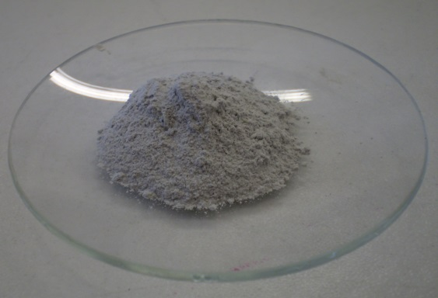
Figure 3.1: powdered dunite.
After being ground and sieved, the powdered dunite was analysed by laser diffraction with dry dispersion, which showed an average distribution of the particle size around 25 μm, with 90% of the particles <58 μm (Figure 3.2 (A)). These results were confirmed via Scanning Electron Microscopy (SEM). One of the secondary electrons (SE) images is shown in Figure 3.2 (B).
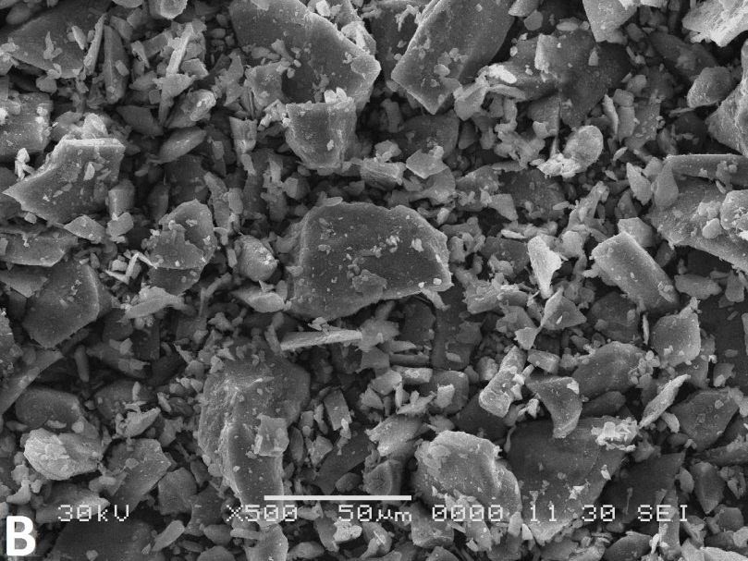
Figure 3.2: (A) Particle size distribution and (B) SE image of dunite.

The elemental composition was determined by X-ray Fluorescence (XRF) and is reported in Table 3.1.
Table 3.1: Composition of dunite in oxide form determined by XRF analysis.
Constituent | Composition  (wt%)
MgO | 48.30
SiO₂ | 42.35
Fe₂O₃ | 6.16
Al₂O₃ | 0.68
CaO | 0.19
Na₂O | 0.04
K₂O | 0.05
Mn₃O₄ | 0.10
SO₃ | 0.22
Cr₂O₃ | 0.38
SrO | 0.01
BaO | 0.01
Total | 98.49
The X-ray diffraction (XRD) pattern of raw dunite is shown in Figure 3.3. Dunite was mainly composed of forsterite, Mg₂SiO₄, the Mg-rich member of the olivine group. The minor components were also Mg-bearing minerals, i.e. clinochlore Mg₅Al(Si₃Al)O₁₀(OH)₈, serpentine Mg₃Si₂O₅(OH)₄, enstatite MgSiO₃, talc Mg₃Si₄O₁₀(OH)₂ and hornblende (Ca,Na)₂₋₃(Mg,Fe,Al)₅(Al,Si)₂Si₆O₂₂(OH)₂.
Figure 3.3: XRD pattern of dunite.
Thermogravimetric (TG) analysis detected three main weight loss events which are visible in the TG and derivative (DTG) curves, in Figure 3.4. The first weight loss between 25 – 180 °C is attributed to the adsorbed H₂O, the second between 300 – 400 °C is attributed to the Mg(OH)₂ dehydroxylation and corresponds to a concentration of Mg(OH)₂ at 0.42 wt%. The third weight loss between 440 – 820 °C is attributed to the decomposition of serpentine and clinochlore [136]. The total weight loss detected via TG in raw dunite is about 3.3 wt% whereas the XRF analysis showed that 98.27 wt% of the sample was constituted by non-volatile species. This discrepancy might be attributed to the different analytical conditions used. For TG, the samples were heated under N₂ flow while, before the XRF analysis, dunite was fused under oxidising conditions which likely caused the full oxidisation of Fe into Fe₂O₃ [137].
Figure 3.4: TG and DTG curves of dunite.
3.2.2. Sodium hydroxide, NaOH
Sodium hydroxide, NaOH, reagent grade in pellets, purity ≥97%, was provided by Sigma-Aldrich and used as an extracting agent in aqueous systems. Sodium hydroxide reagent grade in pearls, 98% pure, was also sourced from Fisher Chemicals and used as an extracting agent in solid systems.
3.2.3. Magnesium hydroxide, Mg(OH)₂, reagent grade
Commercial magnesium hydroxide, Mg(OH)₂, reagent grade 95% pure, provided by Sigma-Aldrich (referred as Mg(OH)₂_RG) was used as a reference material for the carbonation tests with gaseous and supercritical CO₂. Laser diffraction analysis with dry dispersion showed a bimodal distribution of Mg(OH)₂ particle size with 90% of the particles <30 μm and 50% <2.5 μm (Figure 3.5 (A)). On the other hand, SE images showed a homogeneous particle size distribution and the crystals of Mg(OH)₂ had an average dimension ≤1 μm (Figures 3.5 (B) and (C)). Mg(OH)₂ crystals tend to agglomerate in clusters, indicated with arrows in Figure 3.5 (B), which might have caused the bimodal distribution observed via laser diffraction.
Figure 3.5: (A) Particle size distribution and (B – C) SE images of Mg(OH)₂_RG.
The XRD pattern of Mg(OH)₂_RG and the Rietveld Refinement results are shown in Figure 3.6. XRD analysis revealed the presence of brucite, the mineral form of Mg(OH)₂, and hydromagnesite, Mg₅(CO₃)₄(OH)₂·4H₂O. Other low intensity peaks remained unidentified and indicated the presence of additional minor components. Rietveld Refinement Quantitative Phase Analysis (QPA) conducted on the XRD pattern indicated that brucite formed 89 ± 3 wt% of the material.
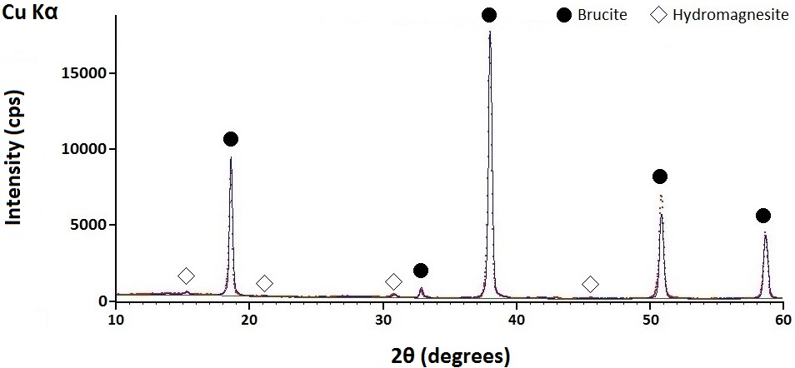
Figure 3.6: XRD pattern and Rietveld Refinement of Mg(OH)₂_RG. Data points profile = experimental pattern, continuous profile = calculated model.
The CO₂ content in Mg(OH)₂_RG was estimated at 3.96 wt% based on the average carbon content of 1.08 wt% obtained via Carbon Hydrogen Nitrogen (CHN) elemental analysis.
Mg(OH)₂ with 98% purity was provided by Lehmann & Voss & Co and used for the tests on CO₂ capture from a gas-mixture in H₂O. The material had average particle size of 7 µm, and also contained 0.5% CaO and smaller amounts of SiO₂ and Fe₂O₃ as impurities.
3.2.4. Magnesium hydroxide, Mg(OH)₂, derived from dunite
Mg(OH)₂ obtained from the alkaline digestion of dunite in aqueous system with 50 mol/kg NaOH, (referred as Mg(OH)₂_D), was also used for the carbonation tests. Table 3.2 summarises the Mg(OH)₂ content determined via TG and residual fraction of dunite in Mg(OH)₂_D. The table also shows, enclosed in brackets, the CO₂ content in the residual dunite determined via CHN elemental analysis. Mg(OH)₂_D1 and D2 were used for gas-solid carbonation tests while Mg(OH)₂_D3, D4 and D5 for carbonation via CO₂ pressure swing.
Table 3.2: Mg(OH)₂_D samples composition.
Sample | Carbonation | Mg(OH)₂  (wt%) | Residual dunite (CO₂)*  (wt%)
Mg(OH)₂_D1 | Gas-solid | 76.0 | 24.0 (2.60)
Mg(OH)₂_D2 | Gas-solid | 57.0 | 43.0 (7.00)
Mg(OH)₂_D3 | CO₂ pressure swing | 34.0 | 66.0 (0.04)
Mg(OH)₂_D4 | CO₂ pressure swing | 38.7 | 61.3 (1.00)
Mg(OH)₂_D5 | CO₂ pressure swing | 51.2 | 48.8 (0.00)
*The residual dunite in the samples contains traces of carbonate species.
3.3. Mg(OH)₂ extraction from dunite
3.3.1. Aqueous systems
NaOH pellets were dissolved in H₂O at different concentrations, i.e. 15 – 50 mol/kg NaOH, and then powdered dunite was added at a solid to liquid ratio of either 50 or 100 g per litre of NaOH aqueous solution. The sample compositions and the conditions of reaction are reported in Table 3.3. The temperature of the oven was maintained constant at 90, 180 or 190 °C. The digestion reaction was conducted for 6 hours in most of the cases. The samples with 30 mol/kg NaOH reacted at 190 °C and those with 45 and 50 mol/kg NaOH reacted at 180 °C were tested for different durations of reaction.

Table 3.3: Sample compositions and conditions of reaction.
NaOH concentration  (mol/kg) | Solid/Liquid  (g/L) | Temperature  (°C) | Time  (hour)
15 | 50 | 90, 180 | 6
20 | 50 | 90, 180 | 6
25 | 50 | 90, 180 | 6
30 | 50 | 90, 180 | 6
30 | 50 | 190 | 1, 2, 3, 4, 5
40 | 50 | 90, 180 | 6
45 | 50 | 180 | 6, 24
50 | 50 | 90, 180 | 6
50 | 100 | 180 | 1, 2, 3, 4, 5, 6
The mixed reactants were placed into a steel vessel lined with Teflon (Figure 3.7 (A)) which was sealed with a screw (Figure 3.7 (B)) and heated in a Carbolite electric oven, series PF30. After the reaction, the solid product was mixed with distilled water using a magnetic stirrer, and the solid phase was separated from the solution via vacuum filtration performed using a Büchner funnel lined with Whatman filter paper, Grade No. 542. The solid filtrate was dried in a furnace at 90 °C for 24 hours and stored to be analysed via XRD, TG, and SEM coupled with Energy Dispersive X-ray Spectrometry (EDS). The solutions separated from the solid products were analysed via Inductively Coupled Plasma Optical Emission Spectrometry (ICP-OES).
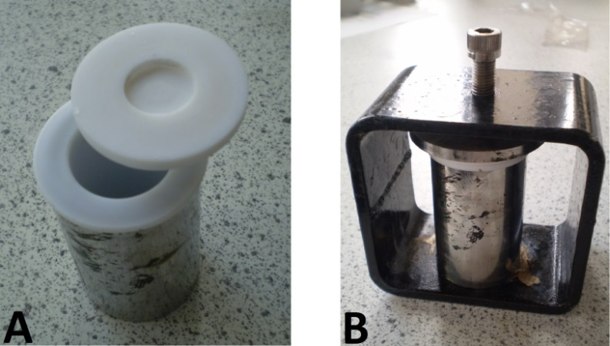
Figure 3.7: (A) steel vessel lined with Teflon, (B) sealed steel vessel containing the reactants.
3.3.2. Solid systems
NaOH pearl, reagent grade was mixed with powdered dunite in an agate mortar with a pestle, with or without addition of distilled H₂O. The mole ratio of the reactants in the samples and the conditions of reaction are summarised in Table 3.4.
Three series were prepared at different dunite:NaOH mole ratio, i.e. 1:1, 1:1.5, and 1:2 which are referred to as Series 1, 1.5 and 2, respectively. The moles of dunite were estimated based on the chemical formula of forsterite, Mg₂SiO₄. The samples prepared with the addition of H₂O were mixed with NaOH:H₂O mole ratio of 4:1, 2:1, 1:1, and 1:2. Series 2 also includes a sample reacted without H₂O addition. When the reactants were well blended, the mixture was transferred in a steel vessel lined with Teflon which was sealed and heated at 180 °C in a Carbolite electric oven, series PF30, for 6 hours. Series 2 with 0.5 moles of H₂O was replicated at different durations of reaction, i.e. 1 and 3 hours, and different temperatures, i.e. 130 and 250 °C. Figure 3.8 (A) and (B) show the images of dunite-NaOH-H₂O systems before and after reaction, respectively.
Table 3.4: Sample compositions and conditions of reaction in solid systems.
 | Dunite*  (mole) | NaOH  (mole) | H₂O**  (mole) | Temperature  (°C) | Time  (hour)
Series 1 | 1 | 1 | 0.25, 0.5, 1, 2 | 180 | 6
Series 1.5 | 1 | 1.5 | 0.375, 0.75, 1.5 , 3 | 180 | 6
Series 2 | 1 | 2 | 0 | 180 | 6
Series 2 | 1 | 2 | 0.5, 1, 2, 4 | 130, 180, 250 | 1, 3, 6
* Approximate mole of dunite was estimated based on the chemical formula of forsterite, Mg₂SiO₄.
** Different amounts of H₂O were tested at NaOH:H₂O mole ratio of 4:1, 2:1, 1:1 or 1:2 for each series. Series 2 also includes a dry system without H₂O.
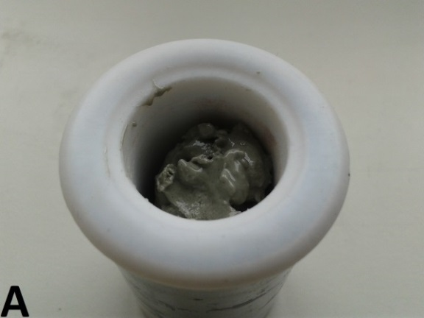 | 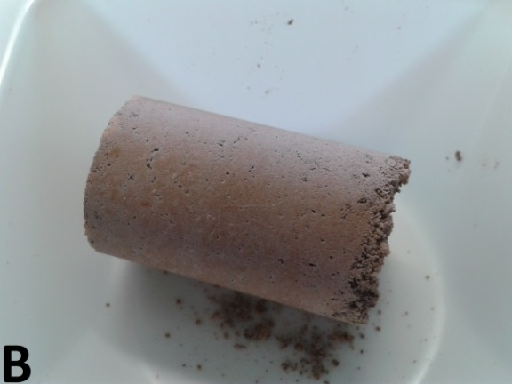
Figure 3.8: (A) Dunite-NaOH-H₂O system before reaction and (B) after reaction at 180 °C for 6 hours.
The reaction in the solid system was also performed using the pelletised starting materials. 1, 1.5 and 2 moles of NaOH were mixed with 1 mole of dunite in dry conditions and the mixtures were pelletised using a hand press at 3 tonnes for 1 minute. An additional series with 0.5 moles of NaOH per 1 mole dunite was also prepared. The composition and the conditions of reaction are summarised in Table 3.5. The pellets were placed into a steel vessel lined with Teflon and heated at 180 °C for 6 hours. The sample with 2 moles of NaOH was replicated at different durations of reaction, i.e. 1 and 3 hours. Figure 3.9 (A) and (B) show an example of pellet before reaction and three pellets reacted at 180 °C for 6 hours.
Table 3.5: Pellet compositions and conditions of reaction.
Dunite*  (mole) | NaOH  (mole) | H₂O  (mole) | Temperature  (°C) | Time  (hour)
1 | 0.5 | 0 | 180 | 6
1 | 1 | 0 | 180 | 6
1 | 1.5 | 0 | 180 | 6
1 | 2 | 0 | 180 | 1, 3, 6
* Approximate mole of dunite was estimated based on the chemical formula of forsterite, Mg₂SiO₄.
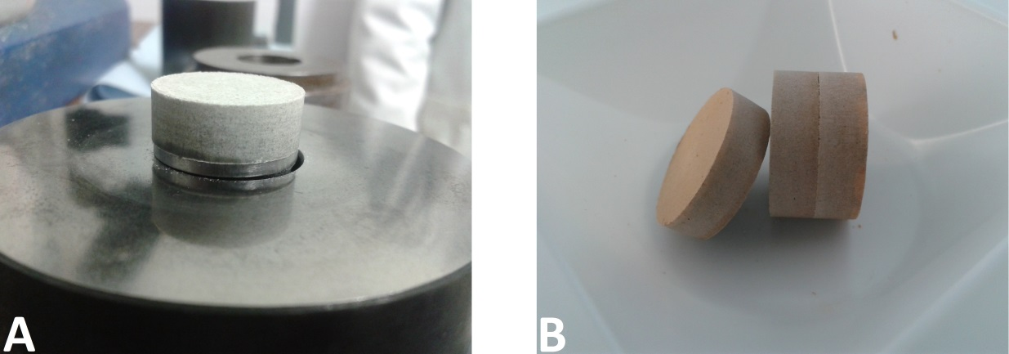
Figure 3.9: (A) Dunite-NaOH pellet before reaction and (B) pellets reacted at 180 °C for 6 hours.
After the reaction, the solid products were ground and washed with distilled water with the aid of a magnetic stirrer. The solid component was separated from the liquid phase via the vacuum filtration using a glass funnel lined with Whatman filter paper, Grade No. 542. The solid filtrate was dried for 1 hour at 90 °C and stored for XRD, TG and SEM analysis. The solutions used to wash the products were analysed via ICP-OES.
3.4. Mg(OH)₂ carbonation
3.4.1. Gas-solid carbonation
A series of carbonation tests was conducted under atmospheric pressure of CO₂ in a tube furnace with 99% CO₂ flow, and the effects of temperature was examined. The test conditions are summarised in Table 3.6. The samples for this test were Mg(OH)₂_RG, Mg(OH)₂_D1 or Mg(OH)₂_D2. 1 g of each was placed in an alumina boat and heated in the tube furnace at a rate of 5 °C/minute, under a constant CO₂ flow rate of 0.2 L/minute, up to the desired temperature, i.e. 200, 300, 400, 500, 600 or 680 °C. The temperature was kept constant for 1 hour. The CO₂ flow was stopped after 1 hour, and the furnace was cooled down at 5 °C/minute. The reaction products were retrieved from the furnace and analysed via XRD, TG, TG-MS and CHN elemental analysis. Another series of carbonation experiments was performed to study the effect of H₂O on Mg(OH)₂ carbonation. 1 g of Mg(OH)₂ was mixed with 0.5 g of H₂O, and the reaction was conducted at 400 °C following the same procedure described above.
Table 3.6: Carbonation tests conditions.
Reactant | Sample  (g) | H₂O  (g) | Temperature  (ºC) | CO₂ pressure  (bar) | CO₂ exposure*  (hour)
Mg(OH)₂_RG | 1.0 | 0 | 200 – 680 | 1 | 1
Mg(OH)₂_D1 | 1.0 | 0 | 400 | 1 | 1
Mg(OH)₂_RG | 1.0 | 0.5 | 400 | 1 | 1
Mg(OH)₂_D2 | 1.0 | 0.5 | 400 | 1 | 1
*CO₂ exposure does not include the heating period.
3.4.2. Carbonation with supercritical CO₂
For the carbonation with supercritical CO₂, 3 g of Mg(OH)₂_RG was placed into a pressurised autoclave either in dry conditions or after mixing with 1 g of H₂O. CO₂ with 99% purity was then introduced into the system to achieve a supercritical CO₂ atmosphere with CO₂ pressure at 90 bar and temperature at 70 °C. The system was left to react for either 1 or 3 hours. The reaction products were analysed via XRD, TG, TG-MS and CHN elemental analysis. Rietveld Refinement QPA was also conducted on selected samples.
3.4.3. Carbonation via CO₂ pressure swing
The reaction products from dunite alkaline digestion were tested for carbonation via CO₂ pressure swing, a method developed by Iizuka and co-workers to recover CaCO₃ from cement waste aqueous slurries [10, 106]. The sample compositions and the conditions of reaction used in the present study are summarised in Table 3.7.
The solid products from dunite reacted with NaOH, were filtered, washed, dried and analysed via TG and XRD. Subsequently, the powdered samples were dispersed in H₂O at a solid to liquid ratio of 5 g/L and the aqueous slurry was fed into an autoclave pressurised with gaseous CO₂. The temperature was maintained constant at 32 °C and the solution was constantly stirred. The CO₂ pressure was set at 20 bar and maintained constant for 1 hour, subsequently the pressure was reduced to 2.1 bar and kept constant over 1.5 hours. Small amounts of aqueous phase were sampled at different time intervals throughout the experiment and the pH was measured with the aid of a pH-meter, then the samples were stored to be analysed via ICP-AES. After 2.5 hours, the slurries were removed from the autoclave and filtered to separate the solid fraction which was dried at 60 °C for 24 hours and analysed via XRD, TG-MS and CHN elemental analysis.
Table 3.7: Samples composition and conditions of reaction.
Sample | Temperature | Solid/Liquid | Phase 1 |  | Phase 2
Sample | (°C) | (g/L) | P_{CO2}  (bar) | Time  (hour) | P_{CO2}  (bar) | Time  (hour)
Mg(OH)₂_D3 | 32 | 5 | 20 | 1 | 2.1 | 1.5
Mg(OH)₂_D4 | 32 | 5 | 20 | 1 | 2.1 | 1.5
Mg(OH)₂_D5 | 32 | 5 | 20 | 1 | 2.1 | 1.5
The saturated concentration of Mg²⁺ in the Mg²⁺-H₂O-CO₂ system was calculated for magnesite, nesquehonite and brucite. The calculation was based on the equilibrium reactions and respective equilibrium constants shown in Table 3.8 [138, 139]. H₂CO₃* in Reactions 3.1 and 3.2 represents the total amount of CO₂ dissolved, i.e. CO₂ (aq) + H₂CO₃ [138]. The other Mg carbonate hydrates were excluded from this calculation due to the variability of the published Ksp values [138, 140, 141, 142].

Table 3.8: Equilibrium reactions and respective equilibrium constants [138].
Reactions |  | Equilibrium constant  (log)
 | (3.1) | K₁ | -1.47
 | (3.2) | K₂ | -6.35
 | (3.3) | K₃ | -10.33
 | (3.4) | K_{w} | -14
 | (3.5) | K_{sp, brucite} | -11.16
 | (3.6) | K_{sp, magnesite} | -7.46
 | (3.7) | K_{sp, nesquehonite} | -4.67
A system of 5 equations was obtained for each of brucite, magnesite and nesquehonite, (Reactions 3.8 – 3.14), additionally, the electroneutrality condition was expressed with Eq. 3.15 [138]. The systems were solved for pH 1 to 14 to calculate the saturated concentration of Mg²⁺ as a function of P_{CO2} [139].
(3.8)
(3.9)
(3.10)
(3.11)
(3.12)
(3.13)
(3.14)
(3.15)
3.4.4. CO₂ capture with Mg(OH)₂ suspension
A Downflow Gas Contactor (DGC) reactor, designed by WRK Design & Engineering Ltd, with a liquid volume of 10 litres was used as the liquid-gas reactor to test the feasibility of Mg(OH)₂ slurry to capture CO₂ from a flowing gas-mixture. A schematic image of the DGC reactor is shown in Figure 3.10 (A) while Figure 3.10 (B) provides a more detailed description of the column. In this reactor, the gas-mixture at atmospheric pressure enters at the top of the bubble column, entrained (at 0.81 bar) in the downward circulating liquid flow, and exits at 1 bar from the bottom of the column after reaction and separation from the recirculating liquid phase. After the liquid leaves the column it flows to a receiver where it is heated at about 50 °C to separate the gas dissolved. The clean gas is directed to an analyser while the remaining liquid is recirculated through the column in a continuous cycle. The rate at which the liquid recirculates is very fast, e.g. 10 L/minute, so that the inlet stream generates a vigorously agitated gas-liquid dispersion at the top of the column (Figure 3.10 (B)) avoiding the formation of gas pockets at the inlet and allowing an efficient mass transfer. The downflow liquid velocity in the column is maintained at a value below the rise velocity of the gas bubbles so that there is no tendency for the bubbles to be carried downwards. The gas-liquid bubble dispersion slowly expands down the column where there is a higher degree of bubble coalescence. The lower section of the column is far from the inlet stream and thus larger bubbles form which rise up the column where they are progressively broken.
A gas-mixture of N₂ and 4 – 5% CO₂ was injected at the top of the column at a fixed flow-rate of 2.25 ± 0.07 L/minute and bubbled through the column at approximately 10 °C and under ambient pressure. The rate of liquid recirculation was typically 10 L/minute to maintain a stable bubble-liquid interface. In this experiment the average bubbles size was 3 – 4 mm. When the solution was saturated with CO₂, i.e. the concentration of CO₂ in the outlet gas became the same in the inlet gas, 50.8 g of powdered Mg(OH)₂ was added to the circulating H₂O.
The CO₂ concentration in the inlet and outlet gas was periodically monitored using a calibrated inline infrared data logger, and the monitoring continued until the concentration of CO₂ in the outlet gas had increased and become equal to that in the inlet gas, indicating that no further reaction was occurring. The experiment took approximately 12 hours to complete and it was run over the course of two days with an overnight shut-down. Samples of the circulating liquid were also taken periodically to monitor the change in pH.
Figure 3.10: (A) DGC reactor, (B) detailed design of the column.
3.5. Raw materials and products analysis
3.5.1. X-ray Diffraction
X-ray diffraction is based on the property of crystalline materials to diffract X-rays. Minerals consist of atoms arranged in a three-dimensional ordered structure. When a monochromatic X-ray beam is irradiated to a powdered sample constituted by randomly oriented mineral particles, it can be scattered at different angles. In case of constructive interference of the X-rays, a characteristic diffraction pattern is observed [51]. Each crystalline phase has a characteristic diffraction pattern and the composition of a sample can be determined by cross referencing the recorded pattern with a database, normally the Powder Diffraction File (PDF) provided by the International Centre for Diffraction Data [143].
Figure 3.11 shows two X-ray beams diffracted by a sequence of atomic planes [51]. The incident angle of the X-rays, θ, is the same as the angle of reflection (although this is not always the case) and the distance between the planes, d, is constant. The diffraction occurs when the difference between the paths of the X-rays, GE+EH, is equal to an integral number of wavelengths, nλ. This is known as Bragg’s law (Eq. 3.16) [51].
(3.16)
Bragg’s law establishes that for a phase with a characteristic d and for a given nλ, the X-rays are in phase only at a specific angle θ, whereas at different angles the X-rays are reflected with destructive interference and cannot be detected [143]. The particles of a powdered sample are randomly oriented so that some of the atomic planes are found at the angle which satisfies Bragg’s law and diffraction occurs [143].
Figure 3.11: Mechanism of X-ray diffraction [51].
In the present study XRD was conducted using a Siemens D500, a Siemens D5000 and a Shimadzu XD-D1 with Cu Kα X-ray source, λ = 1.54 Å or with a Siemens D500 with Co Kα X-ray source, λ = 1.79 Å. The powdered samples were placed in a sample holder and the scans were run from 10° to maximum 70° 2θ with step size 0.05° 2θ and scan rate of 1 or 2°/min. The Diffractometer STOE STADI P with Mo Kα X-ray source with λ= 0.709 Å was used to collect high resolution XRD patterns for the Rietveld Refinement QPA. The samples were loaded in a glass capillary and the scans were run from 0° to 70° 2θ with step size 0.02° 2θ. Alternatively, a Siemens D5000 with Cu Kα X-ray source, λ = 1.54 Å, was also used. The scans were from 10 to 60° 2θ at 0.5°/minute with a step size of 0.02° 2θ.
3.5.2. Rietveld Refinement Quantitative Phase Analysis
XRD is usually not considered a quantitative technique and several methods have been developed to obtain quantitative data from the analysis of diffraction patterns. Among these, the Rietveld Refinement QPA is considered one of the most reliable techniques [144].
Rietveld Refinement is mainly used to refine crystal structures but when the phases and their structure are known, the refinement can provide quantitative data [144].
The Refinement is based on the least squares regression analysis of a calculated pattern to achieve the best fitting with the experimental pattern recorded. The crystallographic data of the phases present in a sample are used to generate the calculated pattern and the fitting is obtained through the refinement of various parameters [144]. The fundamental refinable parameters are listed in Table 3.9 and are divided into the global parameters which can be refined for the entire system, and the individual parameters which should be refined for each phase in the system [145].
Table 3.9: Refinable parameters [145].
 | Refinable Parameters
Global parameters | Background function | Determines the contribution of the background to the intensity of the peaks
Global parameters | Zero shift | Corrects systematic instrumental error
Global parameters | Specimen Displacement | Corrects sample preparation error
Global parameters | POL (Lorentz Polarization Factor) | Corrects the polarisation of the X-ray beam
Individual parameters refined for each phase | Scale factor | Determines the contribution of each phase to the diffraction pattern and is proportional to the wt%
Individual parameters refined for each phase | Preferred orientation | Reduces the effect of preferred orientation of the particles
Individual parameters refined for each phase | Thermal parameter | Corrects the effect of thermal motion of the atoms
Individual parameters refined for each phase | Peak profile: | Describe the peak over a range of θ angles, define shape and width, and correct asymmetry and broadening.
Individual parameters refined for each phase | · Cagliotti peak width function  (U,V, and W)
Individual parameters refined for each phase | · Profile shape  (Pseudo Voight function)
Individual parameters refined for each phase | · Peak asymmetry profile
Individual parameters refined for each phase | · Anisotropic broadening function
Rietveld Refinement QPA was conducted on selected samples using X’Pert HighScore Plus software to calculate the amount of selected phases. The samples were spiked with 10 wt% Si standard for the XRD measurement and the Refinement was repeated to verify the quality of the phase quantification.
3.5.3. Thermogravimetry
Thermogravimetric analysis monitors the weight change of a sample as a function of temperature or time. The weight variation is associated with the reactions which occur in the sample at different temperatures, e.g. dehydration, decomposition, absorption [143]. The technique can be used to identify the phases which have a characteristic thermal behaviour over specific temperature ranges. Moreover, the quantification of the weight loss from the TG curve can be used to calculate the concentration of the species in a sample [143].
In the present study, TG was primarily used to quantify the amount of Mg(OH)₂ extracted from dunite and for a qualitative analysis of the reaction products from the carbonation tests. Mg(OH)₂ decomposes via dehydroxylation between 300 and 450 °C according to Reaction 3.17 [136]. The weight loss in this temperature range was detected from the TG curves and assisted with the calculation of the DTG curve which eases the identification of the weight loss events.
(3.17)
The weight loss equivalent to the H₂O wt% from Mg(OH)₂ dehydroxylation was measured and the wt% of Mg(OH)₂ in the samples was calculated using Eq. 3.18, with 58.2 and 18.0 the molecular weights of Mg(OH)₂ and H₂O, respectively.
(3.18)
TG was conducted using a PerkinElmer Pyris 1 under N₂ flow and a NETZSCH STA449 TG/DSC which uses an Ar flow. The samples were placed in an alumina crucible and heated at a rate of 10 °C/minute from room temperature to 1000 °C.
Thermogravimetry can be coupled with mass spectrometry (TG-MS) to identify the volatile species released during the thermal decomposition. The gaseous species released are transferred to the mass spectrometer where they are ionized and accelerated under a magnetic field. The accelerated particles move on circular trajectories and the distance at which they are revealed from the detector depends on their mass. The species are identified based on the characteristic mass to charge ratio [146].
In the present study, a Perkin Elmer TGA 4000 thermogravimetric analyser coupled with a mass spectrometer Hiden Analytical HPR-20 QIC was used to analyse the products from Mg(OH)₂ carbonation under supercritical CO₂. The samples were heated under N₂ flow at 10 °C/minute. Thermogravimetric analyser NETZSCH5 STA 409 CD coupled with a mass spectrometer QMS 403/5 SKIMMER was used to analyse the solid products from the carbonation via the CO₂ pressure swing tests. The samples were analysed under Ar flow at heating rate of 1 °C/minute.
3.5.4. X-ray Fluorescence
The elemental composition of raw materials was determined via XRF. The atoms irradiated with X-rays can absorb the radiation and expel the electrons in the inner shells. The vacancies left by the electrons are filled by other electrons from the outer shells, and in turn, cause the emission of secondary X-rays with characteristic energies for each element [143]. This phenomenon is called X-ray fluorescence. The secondary X-rays can be detected and generate a spectrum which allows the identification of the elemental composition of samples. The intensity of the peaks in the spectrum is proportional to the concentration of the elements in the sample and provides quantitative data [143].
In the present study a wavelength dispersive Philips PW2440 sequential spectrometer was used to analyse the raw dunite.
3.5.5. Scanning Electron Microscopy and Energy Dispersive X-ray Spectroscopy
Scanning Electron Microscopy uses a focused electron beam to scan the surface of the samples. The interaction of the electrons with the atoms generates different types of radiation which provide morphological or compositional information [51, 147]. The electron microscope is constituted by a high vacuum column in which the electrons are accelerated through a high voltage, i.e. 5 – 50 keV [51, 143]. The electrons are collimated through a series of electromagnetic lenses and focused to a small spot with diameter of 50 – 500 Å [143].
Depending on the energy of the electrons and on the elemental composition of the material, the electrons interact in different ways and penetrate at different depths [143]. Figure 3.12 shows different types of signals which can be generated and detected from the interaction of the electrons with a sample surface [51, 143]. The electrons can interact with the atoms via inelastic scattering. In this case the electrons lose part of their energy which is transmitted to the atoms and cause the emission of secondary electrons (SE). The secondary electrons have low energy, i.e. 0 - 50 eV, and are emitted from around 10 nm below the surface of the sample. They are attracted to the detector with a positive bias and travel through different paths at different angles, resulting in high resolution three-dimensional images, useful to study the morphology of the sample [51, 143, 147]. When the primary electrons interact with the atoms via elastic scattering, there is only a limited loss of energy and the electrons are reflected or backscattered. The backscattered electrons (BE) are mostly reflected at high angles from the sample surface and generate images with lower resolution than the secondary electrons [51, 143, 147]. The scattering of the electrons is stronger when they interact with elements of higher atomic number Z. This translates into the contrast of the image, i.e. brighter areas are associated with heavier elements and vice versa. Consequently, the backscattered electrons images provide compositional information [51, 143, 147]. When secondary electrons are emitted from the inner shells of an atom, the other electrons in the outer shells can fill the vacancy generating characteristic X-rays. This signal can be used to identify the chemical composition of the sample when the SEM is coupled with an Energy Dispersive X-ray Spectrometer and provides semiquantitative data [143].
Figure 3.12: Reflected signals in SEM, image adapted from West [143].
In the present study, SEM was used to analyse dunite, Mg(OH)₂_RG and products of reaction. The powdered samples were distributed onto an adhesive carbon disk and coated to improve the surface conductivity with gold, before the image analysis, and with carbon for the chemical analysis. JEOL 6400 and JEOL JSM 6360 were used to acquire secondary electron images for raw dunite and products of dunite alkaline digestion. Chemical analysis was conducted by an Energy Dispersive X-ray Spectrometer mounted on a JEOL-6010 InTouchScope and elemental maps were acquired on selected areas of the samples. Philips XL-20 SEM was used for the SE image analysis of Mg(OH)₂_RG.
3.5.6. Inductively Coupled Plasma Emission Spectrometry
Inductively Coupled Plasma Emission Spectrometry uses a plasma torch to generate atoms and ions in their excited state which emit photons of characteristic energy [148]. The photons are detected with an optical (ICP-OES) or atomic spectrometer (ICP-AES) and the chemical composition of the sample can be determined both qualitatively and quantitatively [148].
The samples in gas or liquid phase are converted to an aerosol and injected into the inductively coupled plasma torch. Argon gas flows inside the torch and is ionized due to an intense electromagnetic field. When the samples reach the core of the plasma torch, at temperature of the order of 10000 °C, the collision with Ar atoms and charged particles causes their ionization and promotes the particles to an excited state. The decay from the metastable excited state releases characteristic energy for each element [148].
In the present study, a Spectro Ciros Vision ICP-ES W was used to determine the chemical composition of dunite and residual solutions separated from the products of the alkaline digestion tests. For the analysis, the powdered dunite was digested with aqua regia (HNO₃+3HCl) and hydrofluoric acid (HF), while the residue solutions were diluted with aqua regia. A Shimadzu ICPS-7500 was used to analyse the aqueous slurries from the carbonation reaction via the CO₂ pressure swing.

3.5.7. Carbon Hydrogen Nitrogen Elemental analysis
The amount of carbon in Mg(OH)₂ and reaction products from the carbonation tests was determined using the Perkin Elmer 2400 CHNS/O Series II Elemental Analyser. The samples were combusted at 975 °C under oxygen environment. The gases released were reduced by copper and separated through a chromatographic column. The amount of carbon was measured from the gases eluting off the column based on their thermal conductivity [149]. The amount of carbon detected was converted into CO₂ wt% to assess the CO₂ uptake occurred during the carbonation experiments.
3.5.8. Particle size analysis via laser diffraction
The particle size distribution of raw materials and reaction products was determined via laser diffraction.
Laser diffraction measures the variation of the scattering angles of a laser beam which strikes the particles of a sample. Larger particles scatter the light at lower angles than small particles and thus, when a pattern is recorded the scattering intensity at different angles can be used to estimate the average particle size distribution of the sample [150]. Laser diffraction can be conducted via wet and dry dispersion of the particles. In a wet dispersion, the sample is suspended into a liquid dispersant, e.g. H₂O, to favour the particles separation through surface wetting. The liquid suspension is stirred or agitated to avoid the formation of particles clusters [150]. In a dry dispersion, the particles are dispersed in a pressurised gas, e.g. air. In these conditions the dispersion is favoured by the collision between the particles or with the container [150].
In the present study, the particle size analysis was conducted with a Malvern Particle size analyser in dry dispersion in Ar and with a COULTER® LS230 in wet dispersion in H₂O. Before the analysis, the powdered samples were dried for 2 days in an oven at 90 °C and then placed in an ultrasonic bath for 15 minutes to avoid particle agglomeration. The analysis was repeated several times for each sample in order to obtain representative results.

3.6. Analysis of extraction reaction
3.6.1. Thermodynamic analysis
Feasibility of different reactions for the extraction of Mg(OH)₂ from dunite with NaOH in the solid systems was analysed with the thermodynamic consideration. The change in the Gibbs free energy and enthalpy for the possible reactions were calculated using SGTE Substances Database (SSUB5) in Thermo-Calc [151]. The calculation was also performed for the minor mineral phases for which data were available in SSUB5.
3.6.2. Extent of reaction
Based on the TG data, the extent of reaction was estimated. The estimation was based on 100 g of feedstock material consisting of 0.42 g of Mg(OH)₂ and 99.58 g of dunite. The wt% of Mg(OH)₂ in the reaction products determined via TG, Mg(OH)_{2(%)}, can be expressed according to Eq. 3.19, where Mg(OH)₂ _{(rp)} and Dunite _{(rp)} represent the amount of Mg(OH)₂ and dunite in the reaction products, respectively. On the other hand, Eq. 3.20 calculates the amount of MgO involved in the reaction. Dunite_{(i)} is the initial feed of dunite (100 g in this example), and 48.3 is the wt% of MgO in Dunite_{(i)}. 48.21 is the wt% of MgO in dunite excluding the MgO initially present as 0.42 wt% of Mg(OH)₂, and 40.2 and 58.2 are the molecular weights of MgO and Mg(OH)₂, respectively.
(3.19)
(3.20)

Once Mg(OH)_{2(%)} and the amount of the initial feed Dunite_{(i)} were obtained, the amount of Mg(OH)₂ and dunite remaining in the system, i.e. Mg(OH)₂ _{(rp)} and Dunite _{(rp)}, were calculated using Eqs. 3.19 and 3.20. The extent of reaction a was calculated based on the amount of dunite reacted, using Eq. 3.21.
(3.21)
The kinetics of reaction were studied by fitting the extent of reaction (a) into the integral rate equations of different kinetic models [152, 153, 154]. The linear regression was performed in Microsoft Excel and the quality of the fitting was estimated with the multiple regression coefficient R².

4. Mg(OH)₂ extraction from dunite in NaOH aqueous systems
4.1. Introduction
As previously discussed, despite the wide range of possible applications, Mg(OH)₂ utilisation for CO₂ capture and storage has been hindered due to its rare occurrence in natural outcrops [1, 117]. The extraction of Mg(OH)₂ from Mg silicate minerals via chemical processing benefits from the large availability of Mg silicate minerals, in particular forsterite and serpentine [1, 2].
The only study on the alkaline-based extraction of Mg(OH)₂ from Mg silicate minerals was conducted by Blencoe et al. [8], who used highly concentrated NaOH solutions to remove silicon from magnesium silicate minerals and produce solid Mg(OH)₂ at 200 °C, according to Reaction 4.1 [9]. The understanding of this process is limited and the lack of quantitative data makes it difficult to evaluate the efficiency of Mg(OH)₂ extraction and identify the factors which can be enhanced.
(4.1)
Based on the technique used by Blencoe et al., the extraction of Mg(OH)₂ from dunite was studied using NaOH aqueous systems with concentrations between 15 – 50 mol/kg NaOH at 90, 180 and 190 °C, for durations between 1 and 6 hours. The effect of NaOH concentration and temperature, the kinetics of reaction and the efficiency of Mg(OH)₂ extraction are discussed. Part of the results presented in this chapter was published in Madeddu et al. [155] and has been updated according to the progress made in the research and complemented by new data.
4.2. Effect of NaOH concentration and temperature
The solid products from dunite digestion at different NaOH concentrations and temperatures were analysed using XRD. Figure 4.1 (A) shows the XRD patterns of selected samples reacted at 90 °C for 6 hours. The two main reflection peaks for brucite are found at 21.61° 2θ and 44.44° 2θ. The former is overlapping with a peak attributed to clinochlore whereas the second only partially overlaps with one of the forsterite peaks. In the pattern for 20 mol/kg NaOH, a reflection peak for brucite is detectable at 44.44° 2θ, forming a shoulder beside the forsterite reflection at 44.74° 2θ. The intensity of this reflection peak slightly increases with the increase of NaOH concentration, but it remains very low even at 40 mol/kg NaOH.
Figure 4.1 (B) shows the XRD patterns of selected products from digestion of dunite at 180 °C for 6 hours. Increasing the NaOH concentration, the reflection peaks of forsterite and other Mg bearing minerals progressively decrease in intensity while the reflections for brucite become more intense. In the reaction with 50 mol/kg NaOH, brucite was the main phase in the solid product and almost fully replaced the starting mineral components, with forsterite being the only detectable species remained from dunite.
Figure 4.1: XRD patterns of raw dunite and selected products from dunite reaction with NaOH aqueous systems for 6 hours at (A) 90 °C and (B) 180 °C.
The TG and DTG curves of selected samples from the series at 180 °C are shown in Figure 4.2. The weight loss between 300 and 450 °C, attributed to the dehydroxylation of Mg(OH)₂, increases at higher NaOH concentration, suggesting that the concentration of Mg(OH)₂ in the solid products increases when dunite is digested in aqueous systems with higher NaOH concentration. These results are consistent with the XRD data. The TG data for the series at 90 °C are also in agreement with the XRD results (shown in Appendix 1).
Figure 4.2: (A) TG and (B) DTG curves for selected products from dunite reaction with NaOH aqueous systems at 180 °C for 6 hours.
Particle size analysis was conducted via laser diffraction in wet dispersion on selected products from dunite reacted at 180 °C for 6 hours in aqueous systems of 15 to 45 mol/kg NaOH. The results are compared with that for raw dunite in Figure 4.3. The median value of the particle diameter, 25 μm in the raw dunite, decreases with the increase of NaOH concentration in the systems and is equal to 3 µm in the product from digestion with 45 mol/kg NaOH. The product reacted with 30 mol/kg NaOH shows a bimodal trend with 90% of the particles with diameter <11 µm and 50% <3 µm. This might be caused by the presence of unreacted dunite with larger particle size respect to Mg(OH)₂ or by the agglomeration of powdered sample in H₂O which resulted in an overestimation of the particles dimension.
These results indicate that the particle size of the reaction products decreased with the progress of Mg(OH)₂ extraction. The morphology of the reaction products was further analysed via SEM and the results are discussed in Section 4.6.3.
Figure 4.3: Particle size distribution of raw dunite and products from dunite reaction with NaOH aqueous systems at 180 °C for 6 hours.
4.3. Quantification of forsterite and brucite
The weight percentages of Mg(OH)₂ obtained from the TG analyses on the solid products of reaction for 6 hours at 90 and 180 °C are plotted with the NaOH concentration values in Figure 4.4. The dissolution conducted at 90 °C resulted in low concentration of Mg(OH)₂ even at the highest concentrations of NaOH in solution and the maximum concentration of Mg(OH)₂ in the solid products is 6.7 wt% with 40 mol/kg NaOH. The weight percentage of Mg(OH)₂ formed at 180 °C increases linearly with the increase of NaOH concentration used for the dissolution tests, reaching the maximum of 75.3 wt% when dunite was dissolved with 50 mol/kg NaOH solution. The temperature of reaction is clearly affecting the rate of conversion and significant Mg(OH)₂ wt% were achieved only at 180 °C.
Figure 4.4: Mg(OH)₂ concentration estimated via TG in products from dunite reaction with 15 – 50 mol/kg NaOH aqueous systems at 90 and 180 °C for 6 hours.
Rietveld Refinement QPA was utilised to calculate the amount of forsterite in dunite before and after the alkaline digestion. The same method was applied to quantify the brucite produced and compare the data with TG results. Figure 4.5 shows an example of Rietveld Refinement QPA on raw dunite, the other refined patterns are shown in Appendix 1. A good agreement between the experimental data and the model has been achieved with low Residual Weighted Profile (8.5%). The small differences between the model and the experimental pattern may be attributed to elemental substitutions in the mineral structure which were not accounted in the refinement. The wt% of forsterite in the raw dunite was calculated from ten different refinements conducted on the original material and on Si spiked samples. Forsterite was estimated to approximately 73 ± 2 wt% in the dunite.
The weight percentage of forsterite in the feedstock material is lower than that expected in dunite, i.e. 90 wt%. Forsterite is often altered and converted into serpentine through a process called serpentinisation [156]. As serpentine has been detected in raw dunite, it can be hypothesised that part of the forsterite forming dunite was converted into serpentine and the lithotype used in the present study could be better classified as serpentinised dunite [157].
The curve in Figure 4.6 (A) represents the wt% of forsterite in the samples analysed via Rietveld Refinement QPA. The percentage of forsterite in the reaction products decreases with the formation of brucite when the NaOH concentration in solution increases, which confirms the trend previously observed from XRD and TG results.
The weight percentages of Mg(OH)₂ obtained with Rietveld Refinement QPA and those with TG on selected samples from dissolution of dunite are compared in Figure 4.6 (B). The concentrations calculated with the two methods are in good agreement, confirming the reliability of the phase quantification conducted.
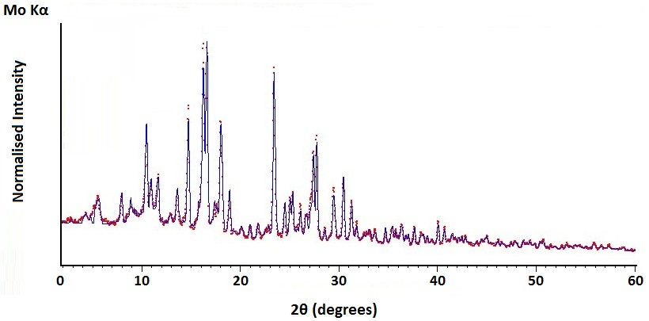
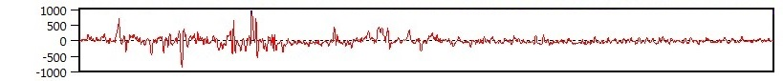
Figure 4.5: Rietveld Refinement of raw dunite and respective difference plot.
Data points profile = experimental pattern. Continuous profile = calculated model.
Figure 4.6: (A) Forsterite and brucite concentrations obtained via Rietveld Refinement QPA of selected samples. (B) Brucite concentration estimated via Rietveld Refinement QPA and TG in selected samples.
4.4. NaOH aqueous systems
The concentrations of NaOH used in this study fell in the region of hydrate melt systems [158, 159]. Such highly concentrated water-salt systems deviate from the ideal dilute solutions and have different thermodynamic properties, e.g. activity, enthalpy of dissolution, molar volume [160, 161, 162]. The concentration of NaOH in H₂O also affects the viscosity and, at the elevated concentrations used in the present study, it is expected that the viscosity of the systems was considerably higher than a standard solution [163].
Figure 4.7 shows the NaOH-H₂O phase diagram [164] with additional information to display the range of NaOH concentrations and temperatures of reaction used in the present study. Molality of 15 – 50 mol/kg NaOH corresponds to approximately 38 – 67% NaOH by weight. At these concentrations, the NaOH-H₂O systems were liquid at 90 °C, whereas, at 180 °C and 190 °C, the liquid systems could contain a larger gaseous fraction. Since the reaction was conducted in closed vessels, it is expected that the systems reacted at higher temperatures were also subject to a higher pressure, which may have contributed to improve the extraction of Mg(OH)₂ [165]. The viscosity of the NaOH aqueous systems also decreases with the increase of the temperature of reaction which likely eased the diffusion of the reactants and favoured the extraction [166].
Figure 4.7: NaOH-H₂O phase diagram, modified from Kurt and Bittner [164].

4.5. Extraction of elements
The composition of reaction products from the 50 mol/kg NaOH series were analysed via SEM-EDS to clarify the mechanism of Mg(OH)₂ extraction from dunite in NaOH aqueous systems. The analysis was conducted on dunite before and after 1 hour reaction. EDS spectra and elemental maps were collected on several areas of the samples and the average weight percentages of Mg, Si, Na, Al and Fe were estimated. Figure 4.8 (A) and (B) show two representative examples of the EDS spectra and elemental maps acquired on selected areas of the raw dunite and the product from 1 hour reaction, respectively.
The peak height of Si-K in the EDS spectrum of the reaction product (Figure 4.8 (B)) has lower intensity than that of raw dunite (Figure 4.8 (A)) in relation to that of Mg-K. Comparing the elemental maps between the two samples, it is evident that Si was removed from dunite during the reaction as a direct effect of the alkali attack [80]. This was confirmed by the average wt% of Si measured before and after reaction on different areas of the samples which decreased from 15.3 to 4.4 wt% while the concentration of Mg in dunite remained almost constant, i.e. 25 wt% before reaction and 24.5 wt% after 1 hour of reaction.
The peak for Na-K had higher intensity in the product and the Na wt% increased from 0.2 wt% in raw dunite to 2.6 wt% in the product from the reaction for 1 hour. These data indicate that Na was not fully removed from the solid product during the washing and separation. No appreciable differences were observed for the other elements and the Al and Fe wt% remained constant at 0.3 and 4.6 wt%, respectively, after 1 hour reaction.
Figure 4.8: EDS spectra, SE and elemental mapping images for Na, Mg, Al, Si and Fe in (A) raw dunite and (B) product from dunite reaction with 50 mol/kg NaOH aqueous system at 180 °C for 1 hour.
The elemental concentrations in the raw dunite and the aqueous solutions separated from the solid reaction products were measured via ICP-OES, and the percentage of extraction in solution was calculated for each element. The percentage of Na extracted was calculated based on the sum of Na contained in raw dunite and NaOH used for the digestion. The analysis was conducted on 5 separate reactions with 50 mol/kg NaOH at 180 °C for 6 hours, and the average values are shown in Figure 4.9 with the respective standard deviations.
More than 50% of Sr, Ca, Al, Si and Ba contained in the feedstock material were extracted in solution as result of the alkali attack of Si-O and metal-oxygen bonds [80, 167, 168]. Na was mostly removed from the system during the washing but between 3 – 15 % remained with the solid products.
Less than 1% of Mg was present in solution which indicates that the Mg extracted from dunite was almost entirely converted into solid Mg(OH)₂. The transition metals, i.e. Ni, Fe, Cr, Mn and Co, were extracted in percentages <10% and thus the larger fraction remained in the solid product. These metals were present either as substitutional elements of Mg in Mg silicate minerals structure or as separate oxides, e.g. small amounts of chromite, FeCr₂O₄, are normally found in dunite [2, 51]. It is not clear whether these metals remained stable or reacted to form new compounds, similarly to Mg. The transition metals are chromophores and a change in their oxidation state or chemical bonds is often associated with a change in colour [169]. The samples with a high rate of Mg(OH)₂ extraction were coloured powders which varied from yellow to red or brown, as shown in Figure 4.10 (A) and (B). These observations might indicate a complex behaviour of the transition metals in dunite exposed to alkaline solutions, and the role of Fe will be discussed in Section 5.7.
Small amounts of K and B were also present in dunite before digestion, i.e. <0.4 g/kg of dunite. The content of these metals in the residue solution was higher than in raw dunite, which may be originated from the limitation of analysis or the contamination during the tests. The alkaline solutions were prepared by dissolving NaOH in H₂O into beakers made of pyrex glass and it is possible that the highly alkaline solutions partially dissolved the glass which contains Si, B, Al, Na, and sometimes smaller amounts of K and Ba [170]. This hypothesis is corroborated by the observation of pits and traces of corrosions in the beakers used to prepare the solutions. Using Eqs. 3.19 and 3.20 it was possible to estimate the amount of dunite reacted from which it was calculated that maximum ~81% of Si, Al and Ba can be extracted in solution. Therefore, the percentages of extraction reported in Figure 4.9 for Al and Si are reasonably matching whereas that for Ba was overestimated.
The ICP-OES results show that during the alkali attack the transition metals, i.e. Ni, Fe, Cr, Mn and Co, remained in the solid product, whereas, Al, Si and the alkaline earth metals Sr, Ca and Ba, were selectively removed from the mineral matrix and leached in solution. Mg is an exception among the alkali earth metals and it was mostly converted into Mg(OH)₂. These results are in agreement with other studies on alkaline-based extraction of metals from ores [167, 168].
Figure 4.9: Percentage of metals extracted in solution from dunite digested with 50 mol/kg NaOH at 180 °C for 6 hours.
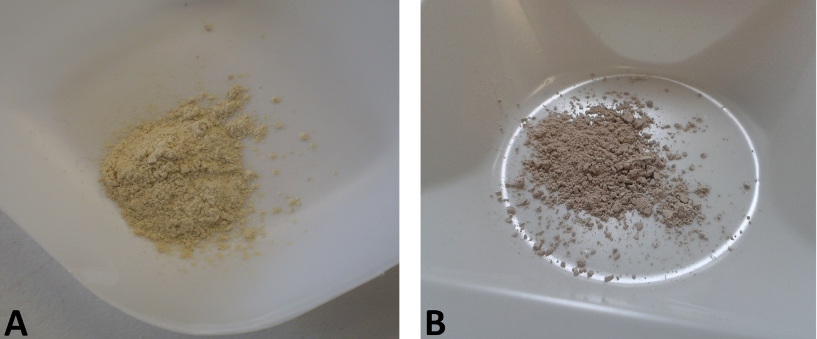
Figure 4.10: reaction product from dunite digestion with 50 mol/kg NaOH, 180 °C for 2 hours (A) and 6 hours of reaction (B).
4.6. Kinetics of reaction
4.6.1. Reaction with 30 mol/kg NaOH aqueous system
The solid products from the 30 mol/kg NaOH series reacted at 190 °C for 1 to 5 hours were analysed via XRD, and the patterns are compared with that of raw dunite in Figure 4.11. The main reflection peak for brucite is detected at 44.44° 2θ in the sample reacted for 1 hour. With the increase of reaction time, the reflection peaks for brucite progressively increase in intensity, while the intensity of the reflection peaks for dunite constituents decreases. The extraction clearly increased with time and after 5 hours brucite was the main phase in the products. Na₂SiO₃ is also detected in the sample reacted for 5 hours. Na₂SiO₃ is a by-product of the reaction between Mg silicate minerals and NaOH (Reaction 4.1) which is soluble and normally removed by washing the samples with distilled water. The presence of Na₂SiO₃ in the washed sample indicates that the washing was insufficient to fully dissolve this phase.
Figure 4.11: XRD patterns of raw dunite and solid products from reaction of dunite with 30 mol/kg NaOH aqueous system at 190 °C for different durations of reaction.
The reaction products were also analysed via TG as shown in Figure 4.12 (A) and (B). The weight loss for Mg(OH)₂ dehydroxylation between 300 and 450 °C increases with time, and the content of Mg(OH)₂ in the products increases from 23.3 wt% after 1 hour to 51.5 wt% after 5 hours of reaction. These data are in agreement with the XRD results.
Figure 4.12: (A) TG and (B) DTG curves for solid products from reaction of dunite with 30 NaOH mol/kg aqueous system at 190 °C for different durations of reaction.
The amount of Mg(OH)₂ and dunite in the reaction products was calculated from TG data using Eqs. 3.19 and 3.20, and the extent of reaction a was estimated with Eq. 3.21. Figure 4.13 (A) shows the amount of Mg(OH)₂ and dunite in the reaction products at different durations of reaction, assuming that 100 g of dunite is processed. The amount of Mg(OH)₂ formed increases with time while dunite is consumed, and both exhibit asymptotic trend. Figure 4.13 (B) shows the extent of reaction a at different durations of reaction. Similarly to the trend in the Mg(OH)₂ production depicted in Figure 4.13 (A), the extent of reaction increases in asymptotic manner, often observed in the diffusion controlled reactions [152], and shows that the rate of reaction is faster during the first hour and then progressively decreases.
Figure 4.13: Mg(OH)₂ extraction from dunite reaction with 30 mol/kg NaOH aqueous system at 190 °C based on 100 g of dunite: (A) amount of dunite and Mg(OH)₂ in the products, (B) extent of reaction.
A wide number of reaction kinetic models were taken into consideration for the kinetic analysis and are reported in Table 4.1. These models are categorised into three groups, i.e. nucleation-controlled, contracting (interface-controlled), and diffusion-controlled models [152, 153, 154]. Based on the extent of reaction obtained, the kinetics of the extraction reaction were studied using the integral rate equations of the three dimensional reaction kinetic models, i.e. Eqs. 4.3, 4.5 and 4.8. These models describe the reaction of spherical particles and were selected to approximate the kinetics of reaction of the small dunite particles used in the present study. The f(a) values were plotted against reaction time t, and the linear regression was performed to obtain apparent reaction constant k.

Table 4.1: Kinetic models and integral rate equations [152, 153, 154].
Kinetic models |  | f (a) = kt
Nucleation models* | Power law |  | (4.2)
Nucleation models* | Avrami-Erofeyev |  | (4.3)
Contraction models | Contracting area |  | (4.4)
Contraction models | Contracting volume |  | (4.5)
Product diffusion  controls models | One-dimensional (1-D),  flat particles |  | (4.6)
Product diffusion  controls models | Two-dimensional (2-D),  cylindrical particles |  | (4.7)
Product diffusion  controls models | Three-dimensional (3-D),  spherical particles, Jander Model |  | (4.8)
Product diffusion  controls models | Three-dimensional (3-D),  spherical particles, Ginstling – Brounshtein model |  | (4.9)
Film diffusion  controls models | Flat, cylindrical and  spherical particles | a= kt | (4.10)
Film diffusion  controls models | Small particles |  | (4.11)
*n included between 2 – 4.
The results of the kinetic analysis with these models are shown in Figures 4.14 (A), (B) and (C). The best fitting was achieved with the Jander model (Eq. 4.8) and k is equal to 0.013 h⁻¹ (180 °C). The diffusion-controlled models assume that a product layer forms at the interface of reaction and acts as a barrier between the reactants, and the kinetics of reaction are controlled by the diffusion of reactants through the product layer [152, 154]. In Jander’s three dimensional model, the interface of reaction is assumed to be spherical and decreases with the progress of the reaction. The results confirm that the reaction was diffusion-controlled and suggest that Mg(OH)₂ formed on dunite surface and restricted the reaction of remaining dunite with the alkaline aqueous system, causing the decrease of the reaction kinetics after the first hour.
Figure 4.14: Potential kinetic models for the reaction of dunite with 30 mol/kg NaOH aqueous system at 190 °C: (A) Avrami-Erofeyev model, (B) Contracting volume model and (C) 3-D Jander diffusion model.
4.6.2. Reaction with 50 mol/kg NaOH aqueous system
The TG analysis of the products obtained from the reaction with 50 mol/kg NaOH aqueous system at 180 °C for 1 to 6 hours (shown in Appendix 1) indicated a similar trend as in the 30 mol/kg series and the weight loss for Mg(OH)₂ dehydroxylation increased with the reaction time.
However, a different behaviour was observed in terms of kinetics of reaction. Figure 4.15 (A) shows the amount of Mg(OH)₂ and dunite in the products estimated from the TG data, assuming that 100 g dunite is processed. Although the amount of Mg(OH)₂ increases and that of dunite decreases, these changes appear to slow down after around 2 hours and become faster again at around 4 hours. This trend is clearly observed in the extent of reaction plotted in Figure 4.15 (B), showing three possible stages during the duration of the extraction studied.
Figure 4.15: Mg(OH)₂ extraction from dunite with 50 mol/kg NaOH aqueous system at 180 °C: (A) amount of dunite and Mg(OH)₂ in the products, (B) extent of reaction.
The obtained extent of reaction for 50 mol/kg series was applied to the Jander model (Eq. 4.8) and analysed for 5 and 6 hours of reaction in Figure 4.16 (A) and (B), respectively. Although this model was best matched for the 30 mol/kg series, it is clear that the fitting to this model is not particularly good for the 50 mol/kg series. The apparent reaction constant k is 0.021 and 0.025 h⁻¹ (180 °C) for the first 5 and 6 hours, respectively, whereas that in the 30 mol/kg series is 0.013 when fitted with the same model for 5 hours (Figure 4.14 (C)). It appears that, although the lower temperature of reaction of 10 °C, the reaction in 50 mol/kg series has a faster kinetics than the 30 mol/kg series, suggesting that a difference of 20 mol/kg in the NaOH concentration has a more significant impact on the kinetics of reaction. The higher solid to liquid ratio of 100 g/L used for 50 mol/kg series could also be a reason for the higher reaction kinetics compared to the 30 mol/kg series where the solid to liquid ratio was 50 g/L.
These results indicate that the simple three dimensional diffusion model does not provide an accurate kinetic description of the reaction for 50 mol/kg series for the duration of the extraction studied. The reaction of dunite with the 50 mol/kg NaOH aqueous system appears to involve more complex reactions which cannot be represented with a single kinetic model.
Figure 4.16: Potential kinetic models for the reaction of dunite with 50 mol/kg NaOH aqueous system at 180 °C: 3-D Jander diffusion model fitted for (A) 5 hours of reaction and (B) 6 hours of reaction.
4.6.3. Morphological alteration in 50 mol/kg NaOH aqueous system
Figure 4.17 shows the SE images of raw dunite and products from the reactions at 180 °C with the 50 mol/kg NaOH aqueous system. In Figure 4.17 (A) it is noticeable that dunite is formed by particles with prismatic shape. Figure 4.17 (B) shows the reaction product from 2 hours of extraction. Two particles of dunite are recognised in the middle of the image which are fully covered with small Mg(OH)₂ crystals indicated with red arrows in the figure. This suggests that, with the progress of Mg(OH)₂ extraction, the direct contact of dunite with the NaOH solution was progressively reduced, likely causing the decrease in the apparent rate of the reaction which became significant after around 2 hours. From Figure 4.17 (C) it is evident that after 5 hours of reaction the product is mainly constituted of clusters of Mg(OH)₂ crystals which were not observed in the raw material, and the average particle size is significantly reduced. The reduction of the particle size with the increase of Mg(OH)₂ extraction was also observed in the samples reacted at different NaOH concentrations (Section 4.2).
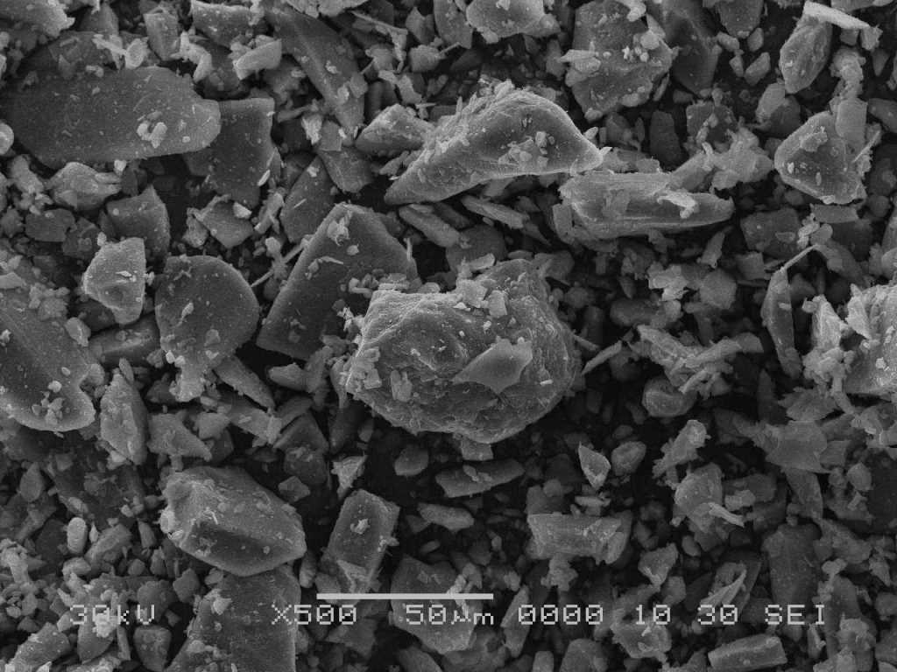
(A) Raw dunite
(B) 2 hours
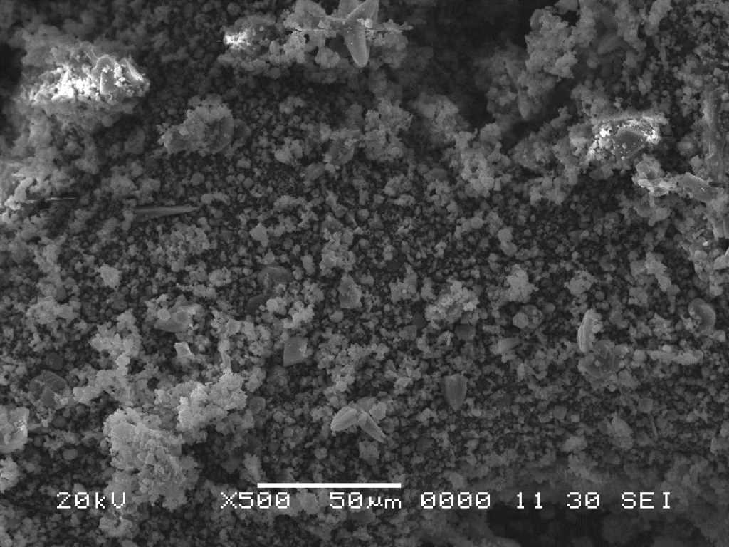
(C) 5 hours
Figure 4.17: SE images of raw dunite (A), and products from dunite reaction with 50 mol/kg NaOH aqueous system at 180 °C for 2 hours (B), and for 5 hours (C).
A more detailed observation can be made on the morphology of reaction products at different durations of reaction through the SE images with a higher magnification shown in Figure 4.18.
The first stage of the alkali attack caused the formation of notches and cracks on the surface of dunite particles which can be observed in Figure 4.18 (A), after 1 hour of reaction. Some parts of the surface were covered with a coating of Mg(OH)₂, recognisable from the typical flaky crystals in Figure 4.18 (B). The coating is partially fractured and through the cracks, a second layer of Mg(OH)₂ is visible. The presence of fractures on the coating could be associated with the local increase in the volume due to the crystallisation of Mg(OH)₂, which has been observed in the serpentinisation of olivine in alkaline solutions [156]. The fractures could have favoured the penetration of the alkaline solution and allowed the crystallisation of a second layer of Mg(OH)₂. It could also be possible that the alkaline solution diffused through the Mg(OH)₂ coating and attacked the underlying dunite. The growth of Mg(OH)₂ crystals below the Mg(OH)₂ coating could also have caused a local volumetric expansion which resulted in the further fractures observed in Figure 4.18 (B).
Figure 4.18 (C) shows a particle of dunite after 4 hours of reaction. The volume of the particle has been reduced, the edges appear consumed and the external surface presents notches and diffused irregularities caused by the alkali attack, similar to those observed in Figure 4.18 (A). Most noticeably, the Mg(OH)₂ coating observed in Figure 4.18 (B) appears to be lacking. It is speculated that the volumetric expansions caused the cracks and fractures on the Mg(OH)₂ coating seen in Figure 4.18 (B), led to the scaling of the particles surface and detachment of the Mg(OH)₂ coating and exposed a larger surface area of remaining dunite. With the exposure of fresh dunite, more Mg(OH)₂ can be extracted, which might explain the increase in kinetics observed after about four hours of reaction. Figure 4.18 (C) also shows that the particle of dunite has significantly larger size than the surrounding clusters of Mg(OH)₂ which could explain the bimodal trend in the particle size distribution observed in the product reacted with 30 mol/kg NaOH for 6 hours (Figure 4.3).
The processes observed in Figures 4.18 (A) and (B) appear to be repeated on the newly exposed surface of dunite. Figure 4.18 (D) shows a particle of dunite after 6 hours of reaction. The size of the particle is smaller compared with those in Figure 4.17 (A), 4.18 (A) and 4.18 (C), which confirms the reduction of the particle size. On the top surface of the particle, the initial stages of the alkaline digestion can be observed taking place progressively from the left to the right side, i.e. the formation of notches and irregularities caused by the alkali attack and the progressive crystallisation of Mg(OH)₂. The image also shows the presence of overlapping layers of Mg(OH)₂ which cover the particle, as in Figure 4.18 (B). The pseudo-hexagonal morphology of Mg(OH)₂ crystals can be better appreciated in Figure 4.18 (E) [171, 172].
It appears that the variation in the rate of Mg(OH)₂ extraction with 50 mol/kg NaOH aqueous system was related to the extent of Mg(OH)₂ crystallisation on dunite surface. Initially the rate of reaction might have been controlled by the reduction of the reaction interface, similar to the contraction models [152], and then by the formation of a Mg(OH)₂ coating on dunite particles which limited the contact with the NaOH aqueous system, as in the diffusion models [152]. The displacement of the Mg(OH)₂ coating layers exposed the fresh dunite surfaces and the kinetics of reaction increased again. These observations might explain the general features in the Mg(OH)₂ extraction in the 50 mol/kg series. Further study is required to understand the detailed mechanism of the extraction in this condition.
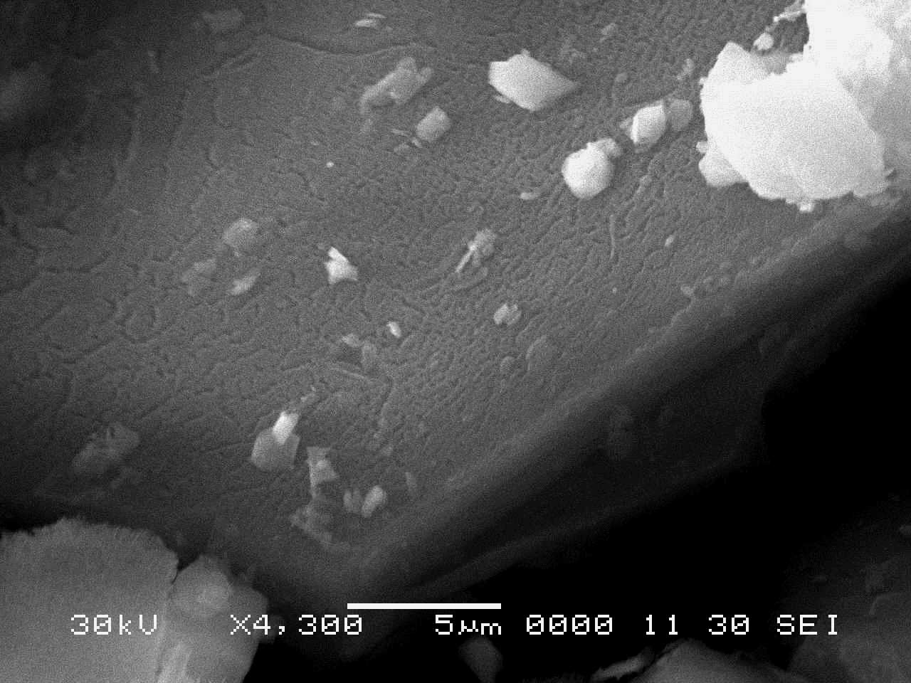
- 1 hour
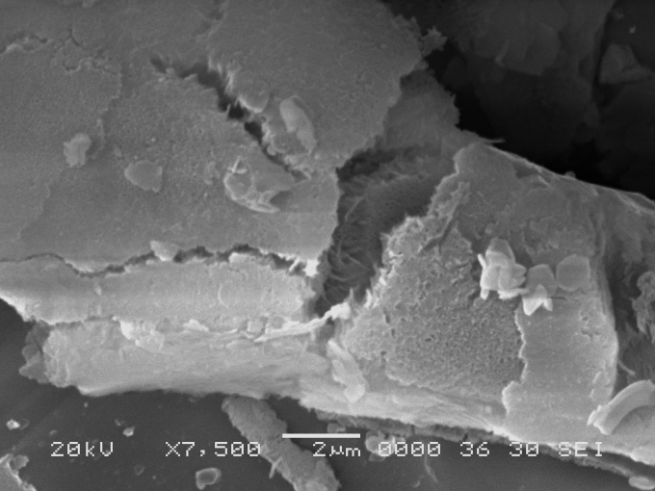
- 1 hour
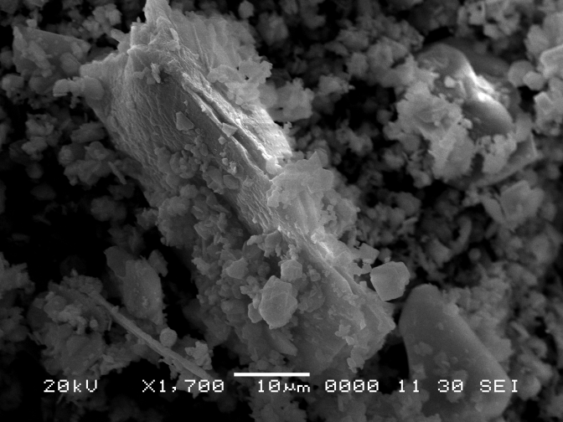
- 4 hours
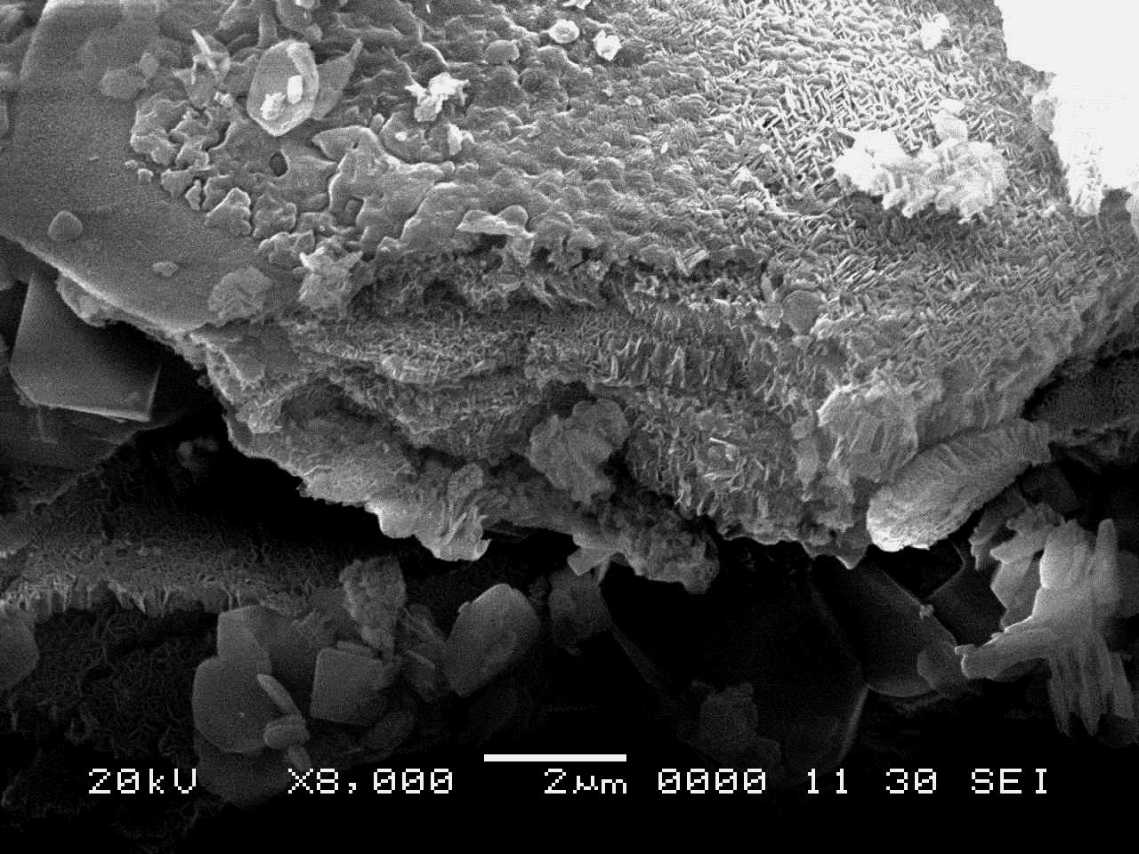
- 6 hours
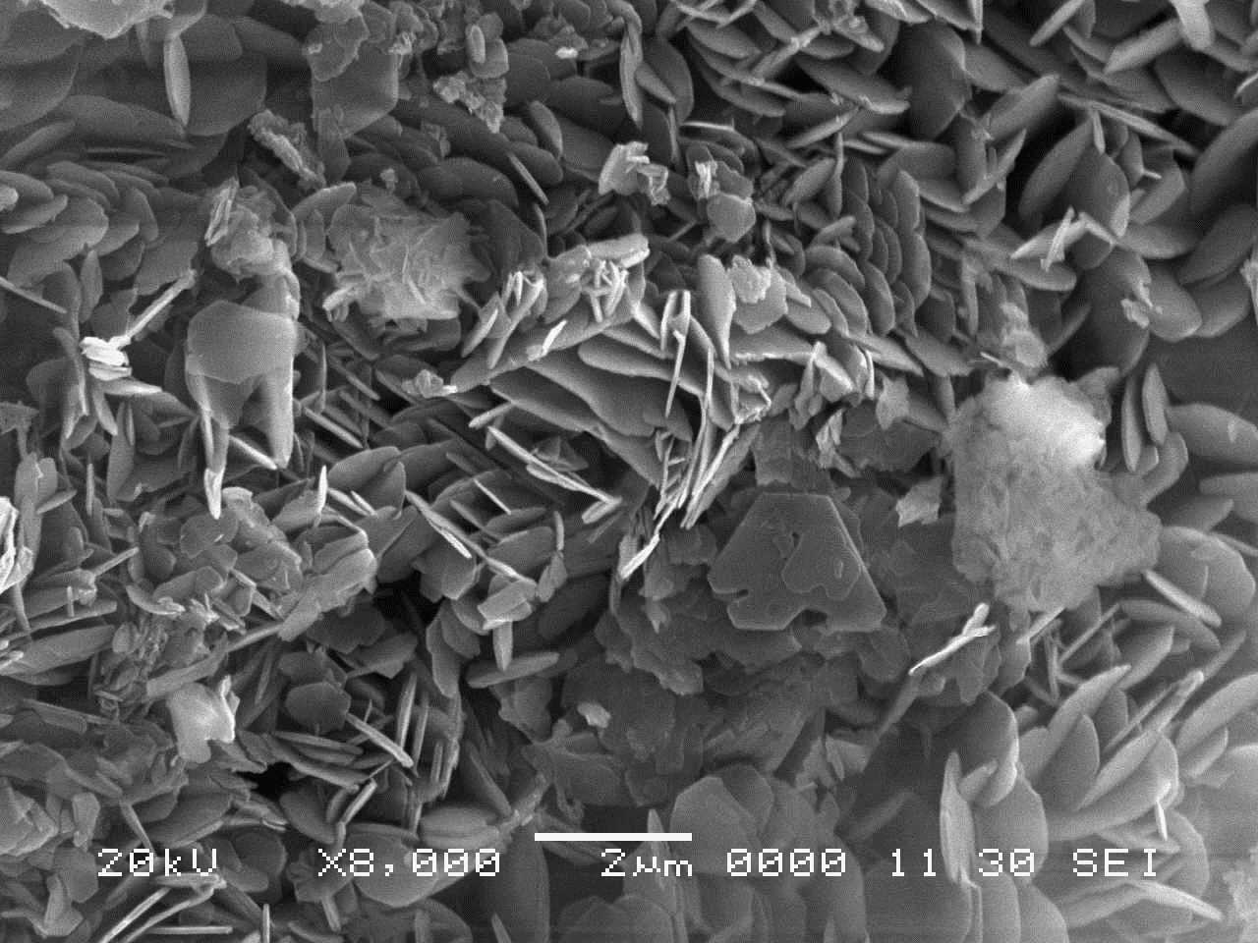
- 6 hours
Figure 4.18: SE images of selected products from dunite reaction with 50 mol/kg NaOH aqueous system at 180 °C for (A) – (B) 1 hour, (C) 4 hours, (D) – (E) 6 hours of reaction.
4.7. Efficiency of Mg(OH)₂ extraction
The efficiency of extraction was estimated, calculating the percent yield of reaction using Eq. 4.12 [146].
(4.12)
The theoretical yield of product was calculated based on Reaction 4.13.
(4.13)
According to Reaction 4.13, 58.2 g of Mg(OH)₂ can be theoretically produced from 40.2 g of MgO in presence of H₂O. The mass of MgO in dunite is calculated from the XRF analysis, therefore the achievable mass of Mg(OH)₂ (theoretical yield of product) can be derived. The mass of Mg(OH)₂ produced (actual yield of reaction) was calculated according to the procedure described in Section 3.6.2 using the quantitative TG data and solving Eqs. 3.19 and 3.20.
The yield of Mg(OH)₂ extraction was estimated for the experimental series at 180 °C and is plotted with the wt% of Mg(OH)₂ in the solid reaction products in Figure 4.19. Figure 4.19 (A) compares the reactions with different NaOH concentration, 15 to 50 mol/kg NaOH, conducted for 6 hours, and Figure 4.19 (B) compares the duration of reaction for the reaction with 50 mol/kg NaOH. The maximum yield of Mg(OH)₂ extraction is 81% and it was achieved in the aqueous systems with 50 mol/kg NaOH after 6 hours of reaction at solid to liquid ratio of 100 g/L. A similar yield was achieved under the same conditions at a solid to liquid ratio of 50 g/L, i.e. 80%.
Figure 4.19 (B) shows that after 2 hours of reaction with 50 mol/kg NaOH, the yield is 53%, and thus, more than half of the overall Mg(OH)₂ was extracted and increasing the time of reaction to 6 hours only resulted in a yield of reaction 28% higher. The data shown in Figure 4.19 (A) and (B) indicate that the efficiency of extraction can be controlled by NaOH concentration and duration of reaction, e.g. 53% yield was achieved either with 30 mol/kg NaOH, 50 g/L, after 6 hours of reaction or with 50 mol/kg NaOH, 100 g/L, after 2 hours.
These results show that a high efficiency of Mg(OH)₂ extraction can be achieved when dunite is digested at 180 °C in highly concentrated NaOH aqueous systems, although between 10.65 and 21.30 g of NaOH are required to process 1 g of dunite depending on the solid to liquid ratio and NaOH concentration. NaOH is produced via chlor-alkali process which is a highly energy intensive technology and entails the large consumption of electricity [82]. The usage of large quantities of NaOH significantly affects the energy requirement of the extraction process and the reduction of NaOH is essential to scale up the technology. The implications of the alkali based extraction of Mg(OH)₂ for CCS application are thoroughly discussed in Chapter 7.
Figure 4.19: Yield of Mg(OH)₂ extraction for products of dunite reaction at 180 °C: (A) 15 to 50 mol/kg NaOH, 50 g/L solid to liquid ratio, 6 hours, (B) 50 mol/kg NaOH, 100 g/L solid to liquid ratio, 1 – 6 hours.
4.8. Summary
Significant amounts of Mg(OH)₂ can be extracted from dunite using highly concentrated NaOH aqueous systems, i.e. 15 – 50 mol/kg NaOH, reacted at 180 – 190 °C. The increase of NaOH concentration, temperature and duration of reaction are beneficial to improve the efficiency of extraction. At 90 °C, the concentration of Mg(OH)₂ in the reaction products was negligible, i.e. maximum 6.7 wt% obtained with 40 mol/kg NaOH after 6 hours of reaction. At 180 °C, Mg(OH)₂ extraction considerably improved and the maximum concentration was obtained with 50 mol/kg NaOH after 6 hours of reaction, i.e. 75.3 wt%. From the NaOH-H₂O phase diagram, it was speculated that at 180 – 190 °C the pressure in the systems increased and the viscosity of the solutions decreased respect to the systems reacted at 90 °C, which could also have contributed to the improvement of the extraction rate.
The NaOH solution attacked the Si-O and metals-oxygen bonds and Si, Al and the alkaline earth metals Sr, Ca, and Ba, were preferentially extracted from the minerals matrix and leached in solution with the exception of Mg which formed Mg(OH)₂. The transition metals present in dunite, i.e. Ni, Fe, Cr, Mn and Co, appeared to remain stable in the solid products.
The reaction with 30 mol/kg NaOH aqueous system at 190 °C was diffusion-controlled. A good agreement was observed with Jander’s three dimensional diffusion model. The 50 mol/kg NaOH aqueous system, on the other hand, deviated from the diffusion model. The SEM analysis of the products of this experimental series revealed a complex mechanism of reaction: Mg(OH)₂ initially formed a coating on the dunite particles and limited the contact with the aqueous system, and, with the progress of Mg(OH)₂ crystallisation, the local volumetric expansions caused the displacement of Mg(OH)₂ coating and exposed the fresh dunite underneath which allowed the continuation of the reaction.
The efficiency of Mg(OH)₂ extraction was assessed through the yield of reaction. The highest yield was 81% and it was achieved when dunite was digested with 50 mol/kg NaOH and 100 g/L solid to liquid ratio, over 6 hours at 180 °C. At this NaOH concentration, more than half of the overall Mg(OH)₂ was extracted within the first 2 hours of reaction, i.e. 53% yield of extraction. Between 10.65 and 21.30 g of NaOH per 1 g of dunite processed are required to achieve a significant rate of Mg(OH)₂ extraction and thus, the large quantity of NaOH required was identified as the main obstacle for the implementation of the process.
The reduction of NaOH consumption was investigated by reacting dunite with NaOH in solid systems and the results are discussed in the next chapter.

5. Mg(OH)₂ extraction in NaOH solid systems
5.1. Introduction
The large amount of NaOH required for the extraction of Mg(OH)₂ from dunite in aqueous systems is a potential obstacle for the large scale implementation of the alkaline dissolution process. Therefore, this part of the study focused on the minimisation of the NaOH usage, and dunite-NaOH solid systems were tested aiming for the reduction of NaOH to a stoichiometric ratio of the expected reaction with dunite. The solid state reaction was conducted in dry conditions or assisted with the addition of small amounts of H₂O and the results are presented in this chapter.
The extraction reaction was studied with the aid of thermodynamic considerations using SGTE Substances Database (SSUB5) in Thermo-Calc [151]. The effect of NaOH and H₂O content, temperature and duration of reaction were investigated. The kinetics of reaction in dry conditions and in presence of H₂O were analysed with the possible mechanisms of Mg(OH)₂ extraction. The amount of Mg(OH)₂ produced was estimated via TG analysis and the yield of reaction was calculated.
Part of the data presented in this chapter was published in Madeddu et al. [173, 174] and has been integrated with new results.
5.2. Extraction of Mg(OH)₂
The reactions of dunite with NaOH in solid system resulted in formation of brucite, Na₂SiO₃ and natrite (Na₂CO₃), together with the mineral components from unreacted dunite. Figure 5.1 shows the XRD patterns of reaction products from pelletised samples with dunite:NaOH mole ratio of 1:2 reacted at 180 °C for 6 hours before and after being washed with distilled H₂O. The by-products, Na₂SiO₃ and natrite are usually detected before washing the reaction products as demonstrated in Figure 5.1. These by-products are soluble in water and can be removed by washing the reaction products. After the washing and successive filtration, the samples are typically left with a solid fraction composed of Mg(OH)₂ and remaining dunite components (Figure 5.1).
Figure 5.1: XRD patterns of reaction products before and after washing, from pelletised samples with dunite:NaOH mole ratio of 1:2 reacted at 180 °C for 6 hours.
The formation of Na₂CO₃ is most likely to be ascribed to the partial carbonation of NaOH during the samples preparation. It is well known that NaOH rapidly carbonates when exposed to air [164]. Since the closed vessels were almost entirely filled with the reactants and sealed, the small amount of CO₂ present in the trapped air (average concentration at 400 ppm) was not the prime source for NaOH carbonation. Carbonation after the reaction cannot be excluded when the samples were fully exposed to air and analysed via XRD for about 1 hour.
Thus, the prime products observed from the reaction of Mg₂SiO₄ with NaOH are Na₂SiO₃ and Mg(OH)₂. Such reaction cannot be easily balanced, and thus other species must have been involved in the reaction. It could be other mineral phases in dunite or water introduced in the system due to the highly hygroscopic nature of NaOH [164]. It is also possible that, together with Na₂SiO₃, other amorphous phases including amorphous sodium silicates formed but were not identified. A wide range of sodium silicates, nNa₂O·mSiO₂, exist with different stoichiometry which form amorphous compounds that would have not been detected via XRD [80].
For the dunite-NaOH systems which reacted with added H₂O, Reaction 5.1 can be written. This reaction is energetically favourable as indicated by the negative Gibbs free energy, i.e. ΔGº = - 34 KJ/mol of Mg(OH)₂ formed at 180 °C.
(5.1)
The ΔGº for the reactions of NaOH and minor phases in the dunite, i.e., serpentine (Mg₃Si₂O₅(OH)₄), talc (Mg₃Si₄O₁₀(OH)₂), and enstatite (MgSiO₃), are shown in Figure 5.2 and suggests that the formation of Mg(OH)₂ and Na₂SiO₃ from these Mg silicate minerals is also thermodynamically possible (ΔGº <0). The thermodynamic feasibility of Mg(OH)₂ extraction from serpentine with NaOH is particularly relevant because serpentine is widely available in natural deposits and contains high wt% of Mg which makes it a suitable alternative feedstock material to dunite [48].
Figure 5.2: ΔGº per 1 mole Mg(OH)₂ produced calculated for possible reactions for serpentine (Mg₃Si₂O₅(OH)₄), talc (Mg₃Si₄O₁₀(OH)₂), and enstatite (MgSiO₃) with NaOH. Data for forsterite (Mg₂SiO₄) is also shown as closed data points for comparison.

5.3. Effect of NaOH
The effect of NaOH content in the solid reactants was studied in pelletised samples which compositions are shown in Table 5.1 and the XRD patterns of the raw dunite and reaction products are shown in Figure 5.4.
Table 5.1: Pellet compositions and conditions of reaction.
Dunite*  (mole) | NaOH  (mole) | H₂O  (mole) | Temperature  (°C) | Time  (hour)
1 | 0.5 | 0 | 180 | 6
1 | 1 | 0 | 180 | 6
1 | 1.5 | 0 | 180 | 6
1 | 2 | 0 | 180 | 6
* Approximate mole of dunite was estimated based on the chemical formula of forsterite, Mg₂SiO₄.
The two main reﬂection peaks for brucite are found at 18.6° 2θ and 38° 2θ and partially overlap with those for clinochlore and forsterite, respectively. The presence of brucite is distinguishable based on the proportion of the other peaks’ intensity. The XRD patterns show that increasing the amount of NaOH mixed with dunite, the intensity of brucite reflection peaks progressively increases whereas the intensity of the reflection peaks from the dunite mineral components decreases, suggesting that more brucite was extracted in the pellets with larger content of NaOH.
Figure 5.4: XRD patterns of raw dunite and products from pelletised dunite-NaOH solid systems reacted at 180 °C for 6 hours.
The TG and DTG curves of the reaction products are shown in Figure 5.5 (A) and (B), respectively. The weight loss between 300 and 450 °C, attributed to the Mg(OH)₂ dehydroxylation, increases with NaOH in the solid systems and indicates that more Mg(OH)₂ was extracted, in agreement with the XRD data.
Figure 5.5: TG (A) and DTG (B) curves of products from pelletised dunite-NaOH solid systems reacted at 180 °C for 6 hours.
The concentration of Mg(OH)₂ in the products was estimated via TG and is plotted in Figure 5.6 with the moles of NaOH used to digest 1 mole of dunite. The extraction of Mg(OH)₂ increased linearly with the increase of NaOH used, and the maximum of 46.8 wt% Mg(OH)₂ was obtained in the sample at dunite:NaOH mole ratio of 1:2.
These results indicate that a significant rate of Mg(OH)₂ extraction can be achieved from the reaction of dunite with NaOH solid systems when the mixtures are pelletised and that NaOH can be reduced to a stoichiometric ratio with dunite, assuming the Reaction 5.5, to achieve comparable Mg(OH)₂ extraction. Reaction 5.5 involves H₂O which could have been adsorbed from NaOH during the sample preparation, from the air trapped in the closed vessel or originated from the carbonation of NaOH (Reaction 5.7).
Figure 5.6: Mg(OH)₂ concentration estimated via TG in products from pelletised dunite-NaOH solid systems reacted at 180 °C for 6 hours.
5.4. Effect of H₂O
The effect of H₂O was studied in Series 2 (dunite:NaOH=1:2 mole ratio, not pelletised) by adding small amounts of H₂O to the dunite-NaOH solid systems at NaOH:H₂O mole ratios of 1:2, 1:1, 2:1 and 4:1. At 180 °C, the NaOH in the systems should be fully dissolved at NaOH:H₂O mole ratio of 1:2 and 1:1, or constitute a solid system with partially dissolved NaOH at NaOH:H₂O mole ratio of 2:1 and 4:1 [164].
The introduction of H₂O into the system had a significant effect on the extraction of Mg(OH)₂. Figure 5.7 compares the XRD patterns of the reaction products from the dry reaction and those with added H₂O. The extraction of brucite in the dry dunite-NaOH system appears to be limited when the reactants are not pelletised. The only reflection peaks identified are for the mineral components of dunite, while the reflection peaks for brucite are not observed. On the other hand, the systems with added H₂O all indicate the presence of brucite which two main reﬂection peaks are detected at 18.6 ° and 38° 2θ. The introduction of H₂O is beneficial and the intensity of the reflection peaks for brucite considerably increases in systems with 0.5, 1 and 2 moles of H₂O, although the intensity significantly decreases in the system with 4 moles of H₂O. A similar trend was observed also in Series 1 and 1.5 (dunite:NaOH=1:1 and 1:1.5 mole ratio, respectively), which XRD patterns are shown in Appendix 2.

Figure 5.7: XRD patterns of reaction products from Series 2.
The TG and DTG curves of the reaction products from Series 2 are shown in Figure 5.8 (A) and (B), respectively. The sample reacted in dry conditions has a small weight loss between 300 and 450 °C for the dehydroxylation of Mg(OH)₂, whereas those reacted in presence of water show a larger weight loss in this temperature region, indicating that more Mg(OH)₂ is produced when H₂O is added to the system.
The calculated concentration of Mg(OH)₂ in the reaction product was 19 wt% for the dry dunite-NaOH mixture, and 57.6, 55.4, 51.2 and 28.0 wt% with 0.5, 1, 2 and 4 mole of H₂O added per 1 mole of dunite, respectively. Thus, the amount of Mg(OH)₂ in the products decreases with the increase in H₂O content. The TG/DTG data for Series 1 and 1.5 (shown in Appendix 2) also indicate a similar trend. The TG results are in agreement with the XRD data and indicate that the addition of H₂O was beneficial compared to the dry conditions, likely because the dissolution of NaOH in H₂O favoured the ion exchange and the diffusivity of materials involved in the reaction [175, 176]. The addition of smaller amounts of H₂O, i.e. higher NaOH:H₂O mole ratio, was a more preferable condition for Mg(OH)₂ formation, which suggests that the concentration of NaOH in H₂O played a decisive role for the extraction of Mg(OH)₂ from dunite.
It should be noted that the concentration of Mg(OH)₂ in the product from Series 2 reacted in dry conditions is considerably lower than in the pelletised sample with the same composition, i.e. 46.8 wt%. These results indicate that the compaction of the reactants was necessary to achieve a significant efficiency of Mg(OH)₂ extraction from dunite-NaOH solid systems reacted without added H₂O, likely because the interface of dunite-NaOH reaction increased and favoured the formation of Mg(OH)₂ [143].
Figure 5.8: (A) TG and (B) DTG curves of reaction products from Series 2.

5.5. Effect of NaOH concentration in H₂O
The Mg(OH)₂ content in the reaction products was estimated via TG for Series 1, 1.5, and 2, which composition is shown in Table 5.2.
Table 5.2: Sample compositions and conditions of reaction in solid systems.
 | Dunite  (mole) | NaOH  (mole) | H₂O**  (mole) | Temperature  (°C) | Time  (hour)
Series 1 | 1 | 1 | 0.25, 0.5, 1, 2 | 180 | 6
Series 1.5 | 1 | 1.5 | 0.375, 0.75, 1.5 , 3 | 180 | 6
Series 2 | 1 | 2 | 0.5, 1, 2, 4 | 180 | 6
** Different amounts of H₂O were tested at NaOH:H₂O mole ratio of 4:1, 2:1, 1:1 or 1:2 for each series.
The TG results are compared in Figure 5.9. The data are plotted against NaOH:H₂O mole ratio to study the effects of NaOH concentration in H₂O.
The reaction products from Series 2 show the highest concentration of Mg(OH)₂, followed by those from Series 1.5 and 1, and confirm the advantage of having higher NaOH content in the system. The three series show the same trend in presence of H₂O, and the wt% of Mg(OH)₂ in the reaction products increases with the increase of NaOH:H₂O mole ratio. However, this effect becomes less significant at higher NaOH:H₂O mole ratio. In fact, at higher NaOH:H₂O mole ratio the concentration of NaOH in H₂O is higher but the amount of H₂O in the system is lower, and thus the positive effect of H₂O, such as the improvement of the reactants diffusion is reduced.
Figure 5.9: Mg(OH)₂ concentrations estimated via TG in reaction products from
Series 1, 1.5, and 2.
The data shown in Figure 5.9 are also plotted against the amount of H₂O added to the system in Figure 5.10 (A), grouped by the same NaOH:H₂O mole ratio.
The gradients of the linear fitting for these data sets are proportional to the NaOH:H₂O mole ratio as shown in Figure 5.10 (B). Based on these results, it is possible to estimate the approximate wt% of Mg(OH)₂, Mg(OH)₂(%), expected in the reaction product under the condition studied, using the following empirical equation with the amount of NaOH (X_{NaOH}) and H₂O (X_{H2O}).
(5.9)

Figure 5.10: Mg(OH)₂ concentrations estimated via TG in reaction products: (A) effect of H₂O content for different NaOH:H₂O mole ratio, and (B) gradient of the linear fitting for datasets shown in (A).
These data, together with those previously discussed for Series 2, indicate that the extraction of Mg(OH)₂ from dunite in NaOH-H₂O solid systems is the result of a combined effect of NaOH concentration in H₂O and amount of liquid phase present in the system. The optimal conditions for the extraction of Mg(OH)₂ appears to be found when H₂O is present in sufficient quantity to help the diffusion of the reactants but not in excess to reduce the relative concentration of NaOH in the liquid.

5.6. Effect of temperature and time
Amongst the compositions investigated, the system with the mole ratio of dunite:NaOH:H₂O = 1:2:0.5 gave the highest Mg(OH)₂ extraction. The effect of reaction conditions was further investigated for this system, using three durations of reaction, i.e. 1, 3 and 6 hours, at different temperatures, i.e. 130, 180 and 250 °C. The XRD patterns and TG/DTG curves of these products are shown in Appendix 2.
The wt% of Mg(OH)₂ in the reaction products, estimated via TG, are compared in Figure 5.11. As expected, increasing the duration and temperature of reaction was beneficial for the extraction of Mg(OH)₂. At 130 °C the formation of Mg(OH)₂ was limited, achieving only 18.5 wt% after 6 hours which is comparable with 18.2 wt% obtained at 180 °C in 1 hour. The reaction conducted at 180 °C resulted in a significant Mg(OH)₂ extraction of 46.4 wt% after 3 hours of reaction. Increasing the temperature to 250 °C significantly improved the extraction of Mg(OH)₂, and a concentration of 56.4 wt% Mg(OH)₂ was achieved after 1 hour, which increased to 65.6 wt% in 6 hours. The Mg(OH)₂ extraction obtained within 1 hour at 250 °C is comparable with 57.6 wt% attained at 180 °C over 6 hours of reaction. The reaction at 250 °C is faster than at the other temperatures, and the majority of reaction appears to have taken place in the first hour. This is highly advantageous for the industrial application of the process, as it would allow the reduction of reaction time from 6 to 1 hour to achieve the same degree of Mg(OH)₂ extraction obtained at 180 °C.

Figure 5.11: Mg(OH)₂ concentration estimated via TG in reaction products of dunite:NaOH:H₂O systems with 1:2:0.5 mole ratio at different temperatures and times of reaction.
Figure 5.12 shows the NaOH-H₂O phase diagram [164]. The diagram has been adapted to show the temperatures and NaOH concentration used in this study. The NaOH:H₂O mole ratio of 4:1 corresponds to a NaOH concentration in H₂O of approximately 90% by weight. The diagram shows that there could be a solid portion remaining at 130 and 180 °C in the NaOH-H₂O system at 90 wt% NaOH whereas only liquid or gas can be present at 250 °C, similar to molten salt systems [164]. Consequently, at 250 °C dunite reacted with a highly alkaline melt instead of a solid system with a limited amount of NaOH dissolved in H₂O, which should have favoured the diffusion of reactants [143], contributing to the much faster kinetics of Mg(OH)₂ extraction observed within the first hour of reaction at this temperature. Although the increase of pressure in the closed vessel at higher temperature may shift the melting temperature, based on the obtained results it appears to be still below 250 °C.
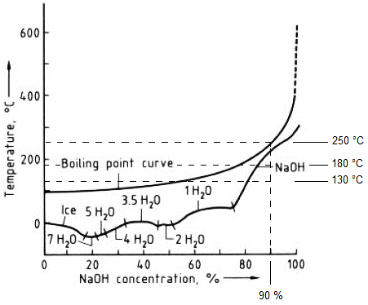
Figure 5.12: NaOH-H₂O phase diagram, modified from Kurt and Bittner [164].
5.7. Extraction of elements
The residual solutions used to wash the products from dunite-NaOH reaction in pellets were analysed via ICP-OES, and the percentage of extraction for selected elements was calculated based on the concentration of the elements in the solution and the composition of the reactant (mixture of dunite and NaOH). The results are plotted at different dunite-NaOH mole ratios in the pellets in Figure 5.13 (A) for Na and Si, and in Figure 5.13 (B) for Al, Ba, Sr, Ca, Mn, Fe and Mg. It should be noted that the extraction of Mg(OH)₂ has a linear correlation with the amount of NaOH in the system as previously discussed (Figure 5.6).
The percentage of Na extraction decreased from 90 to 58% with the increase in the NaOH content in the system (and Mg(OH)₂ extracted), while the percentage of Si showed an opposite trend and increased from 22% to 39%. Because the reaction of dunite with NaOH produces soluble Na₂SiO₃, it was expected to observe a linear increase of Si extraction in solution when more Mg(OH)₂ is extracted. On the contrary, the Si released in solution increased and remained between 35 and 39% without a further rise. The data for Na and Si may suggest that, when a larger fraction of dunite reacted and more Na₂SiO₃ formed, the washing of the samples became less effective to fully dissolve this phase which partially remained in the solid products. This may also explain the decrease in the weight loss of the products recorded after the washing process from 74 to 63, 56 and 49% with the increase of Mg(OH)₂ extracted.
Overall, less than 4% of Mg, Fe and Mn were extracted in solution, whereas Al and the alkaline earth metals Ca, Ba, and Sr, showed higher percentages of extraction. Co, Cr, and Ni were also present in solution but with concentrations below the detection limit of ICP-OES, i.e. <0.1 – 0.05 mg/L. Even though it was not possible to calculate the exact percentage of extraction for these elements, it was estimated that maximum of 0.5% were present in solution. These results are in agreement with those from the NaOH aqueous systems discussed in Chapter 4. Similarly to Si, also Al and the alkali earth metals Ca, Ba, and Sr, were extracted from dunite and released in solution during the washing, presumably forming soluble phases which were partially dissolved with water. On the contrary, the transition metals Fe, Mn, Co, Ni and Cr, mainly remained in the solid fraction.
The general trend observed in Figures 5.13 (B) indicates that the extraction of the elements significantly increased with the increase of NaOH in the system up to dunite:NaOH=1:1 mole ratio (and Mg(OH)₂ extraction) but then decreased again with the further increase in the NaOH (and Mg(OH)₂ extraction). The similar trend observed in the Na and Si suggests that the washing of the products affected also the release of Al, Ba, Sr, Ca, Mn and Fe.

Figure 5.13: Extraction of elements in solution for dunite-NaOH pellets reacted at 180 °C for 6 hours and washed with distilled water: (A) Na and Si, (B) Al, Ba, Sr, Ca, Mn, Fe and Mg.
Figure 5.14 shows some examples of products from the reactions in solid systems. The colour of the samples with low concentration of Mg(OH)₂ was pale grey and resembled that of raw dunite, as visible in Figures 5.14 (A), (B) and (C) for the products of reaction at 130 °C for 1 and 6 hours and 180 °C for 1 hour, respectively. On the other hand, the products with a significant content of Mg(OH)₂ were mostly brown/red and some examples are shown in Figures 5.14 (D), (E) and (F) for products of reaction at 180 °C for 3 and 6 hours and 250 °C for 1 hour, respectively. A similar colour was observed in the pellets reacted in dry conditions at 180 °C for 6 hours shown in Figure 5.14 (G). The products reacted at 250 °C for 3 and 6 hours appeared grey despite a significant content of Mg(OH)₂, as visible in Figure 5.14 (H).

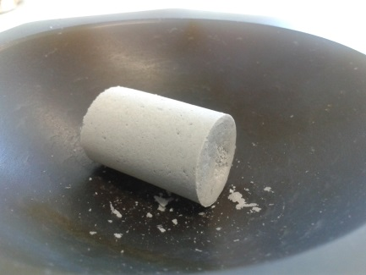 | 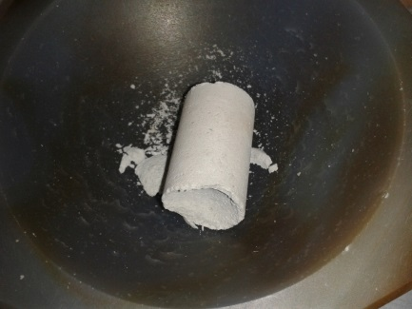 | 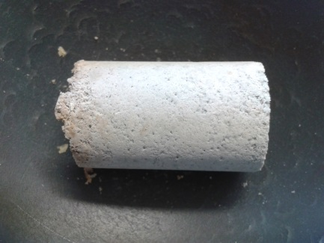
- 130 °C, 1 hour | - 130 °C, 6 hours | - 180 °C, 1 hour
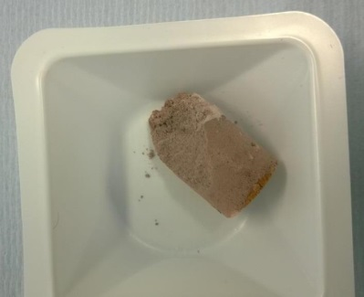 | 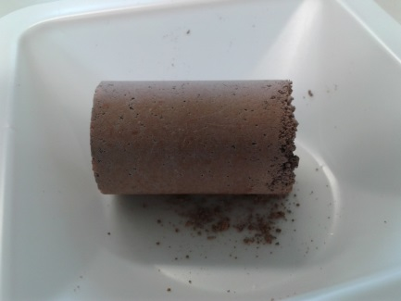 | 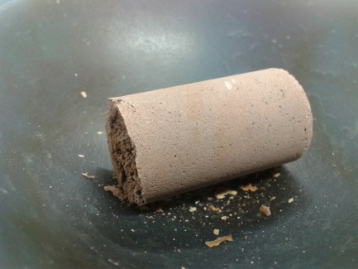
- 180 °C, 3 hours | - 180 °C, 6 hours | - 250 °C, 1 hour
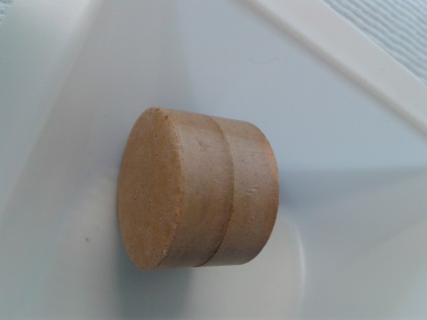 | 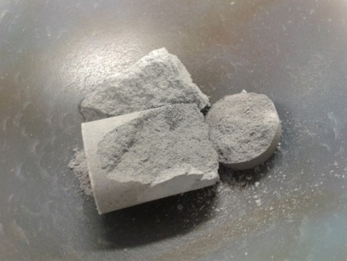 | 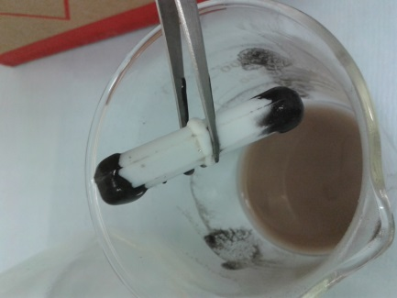
- 180 °C, 6 hours | - 250 °C, 6 hours | - 250 °C, 3 hours
Figure 5.14: Products from reactions in solid systems at dunite:NaOH 1:2 mole ratio with 0.5 moles of H₂O or as dry pellets: (A) 130 °C, 1 hour, (B) 130 °C, 6 hours, (C) 180 °C, 1 hour, (D) 180 °C, 3 hours, (E) 180 °C, 6 hours, (F) 250 °C, 1 hour, (G) 180 °C, 6 hours, (H) 250 °C, 6 hours. Magnetite extracted via magnetic separation in the product reacted at 250 °C for 3 hours is also shown in (I).
The colour of these samples can be related to the characteristics of the transition metals [169] as discussed previously, in particular Fe might have had a dominant effect as it is the third most abundant element in dunite after Mg and Si. Fayalite, Fe₂SiO₄, is the Fe-rich end member of the olivine group [51] and it cannot be excluded that small percentages of this phase were contained in dunite. It is also possible that Fe²⁺ partially substituted Mg in forsterite structure or in the other dunite components, i.e. enstatite, hornblende, serpentine, talc and clinochlore [51]. At low Mg(OH)₂ extraction, the Fe extracted was also negligible and the products maintained the same colour as dunite. At higher Mg(OH)₂ extraction a larger amount of Fe was extracted and partially oxidised to Fe³⁺ which conferred a red/brown shade to the products. Fe³⁺ is a chromophore cation and Fe³⁺-bearing species often have a characteristic red/brown colour [177, 178]. After 3 and 6 hours of reaction at 250 °C, a significant amount of magnetite Fe₃O₄ was extracted with Mg(OH)₂. At these conditions the colour of the products was dark grey which indicates that most of the Fe extracted was converted into Fe₃O₄.
Fe₃O₄ could be easily removed from the other solid components via magnetic separation as visible in Figure 5.14 (I) and can be a valuable by-product with a variety of commercial applications, e.g. magnetic media, catalyst, pigment [179, 180]. XRD analysis shown in Figure 5.15 confirms the presence of magnetite in the samples reacted at 250 °C for 3 and 6 hours. Smaller amounts of magnetite were observed via magnetic separation also in the samples reacted at lower temperatures and for shorter durations of reaction, although this phase was never detected via XRD.
Figure 5.15: XRD patterns of products from solid systems at dunite:NaOH:H₂O 1:2:0.5 mole ratio, reacted at 250 °C for 1, 3 and 6 hours.

5.8. Kinetics of reaction
5.8.1 Reaction in dry solid systems
The reaction kinetics of Mg(OH)₂ extraction in dry conditions were studied through the analysis of the reaction products from pelletised samples at dunite:NaOH mole ratio of 1:2, reacted at 180 °C for 1, 3 and 6 hours. The products were analysed via XRD after being washed, and the patterns are compared in Figure 5.16. The main reflection peak from brucite at 38.02° 2θ is detected after the first hour reaction. The full brucite pattern is clearly detected at 3 hours, and the intensity of the reflection peaks increases with time while the reflection peaks from dunite components progressively decrease in intensity.
Figure 5.16: XRD patterns of solid products from pelletised samples at dunite:NaOH 1:2 mole ratio.
The TG and DTG curves for the reaction products from the pelletised samples are shown in Figure 5.17 (A) and (B), respectively. The weight loss between 300 and 450 °C increases with time, indicating more Mg(OH)₂ formed in the products from longer durations of reaction, in agreement with the XRD data.
Figure 5.17: (A) TG and (B) DTG curves for solid products from pelletised samples at dunite:NaOH 1:2 mole ratio.
The amount of Mg(OH)₂ and dunite in the reaction products and the extent of reaction have been calculated with the same procedure used for the aqueous systems in Chapter 4, and the results are plotted in Figure 5.18 (A) and (B), respectively. The Mg(OH)₂ contained in the reaction products and the extent of reaction both increase with asymptotic trend, similar to that observed in Figure 4.13 for the 30 mol/kg series, suggesting that the dry reaction of dunite and NaOH could also be diffusion controlled.

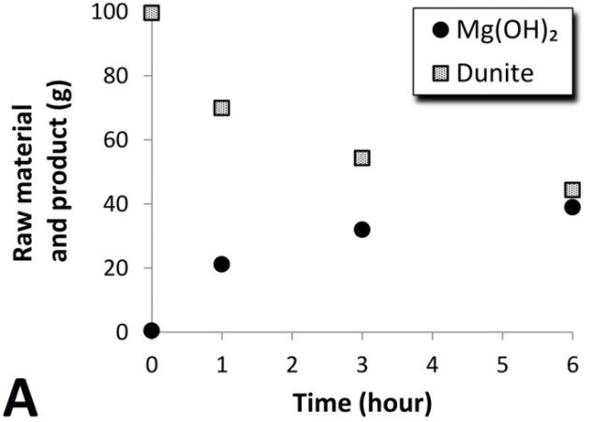 | 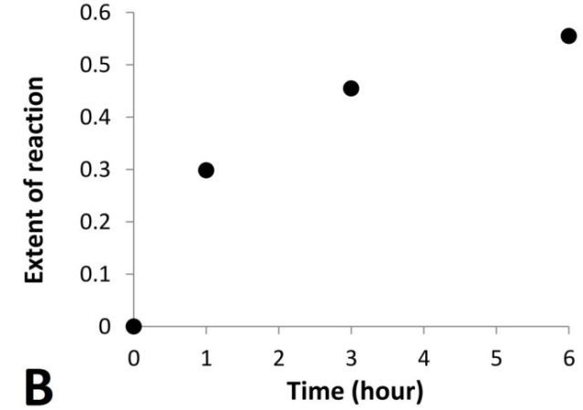
Figure 5.18: Mg(OH)₂ extraction for pelletised samples at dunite:NaOH 1:2 mole ratio: (A) amount of dunite and Mg(OH)₂ in the products, (B) extent of reaction.
The obtained extent of reaction for the pelletised samples was applied to the Jander model (Eq. 4.8) as shown in Figure 5.19. Although the number of data points is limited, the data show a reasonable match to the model with the value of R² = 0.983, and the reaction appears to be diffusion-controlled. Moreover, the value of k, i.e. 0.010 h⁻¹ (180 °C), is comparable to that obtained from the fitting with the same model for 30 mol/kg series, i.e. 0.013 h⁻¹ (180 °C).
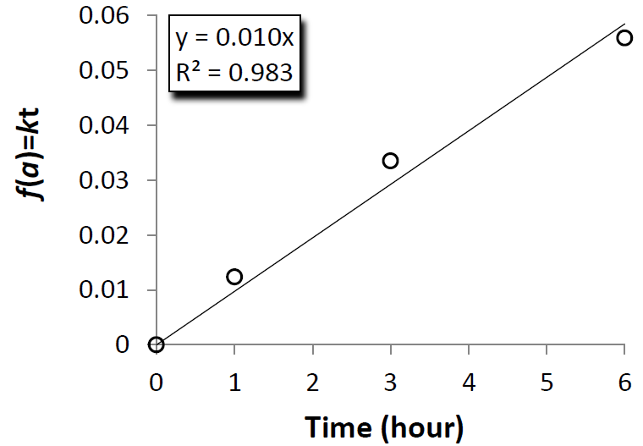
Figure 5.19: Potential kinetic model for pelletised samples at dunite:NaOH 1:2 mole ratio: 3-D Jander diffusion model.
Figure 5.20 shows the SE images of the raw dunite and the pellets at dunite:NaOH 1:2 mole ratio reacted for 6 hours. Comparing raw dunite in Figures 5.20 (A) and the product in Figure 5.20 (B) which were acquired at the same magnification, it can be noticed that the average particle size was significantly reduced after the reaction and the morphology was completely altered. A closer look to the product in Figure 5.20 (C) reveals a partially amorphous texture and a morphology which resembles that observed for NaOH molten salt systems [181] although it is difficult to identify any phase or a possible mechanism of reaction from these images.
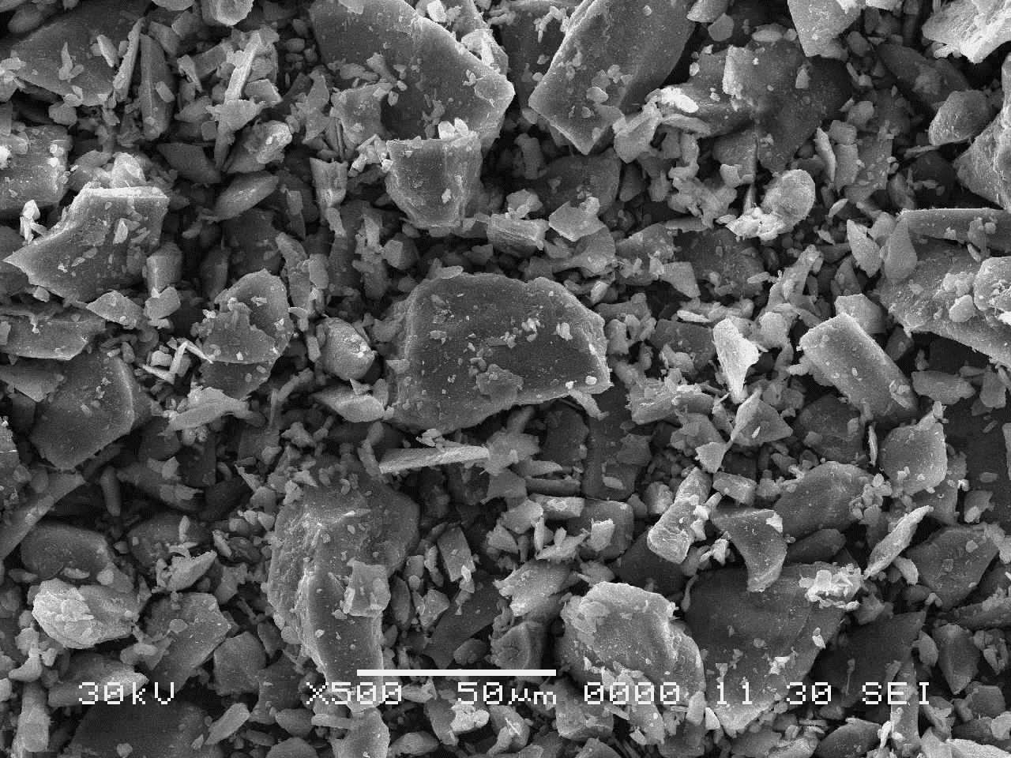
- Raw dunite
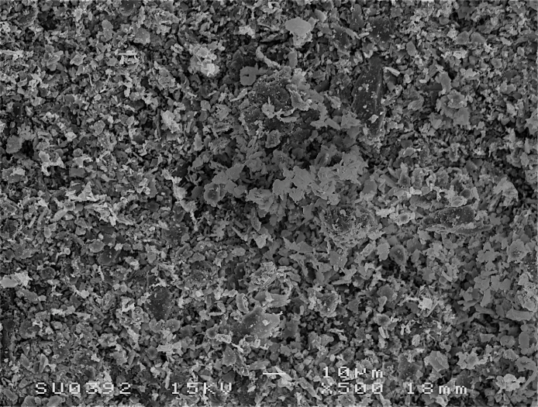
- 6 hours
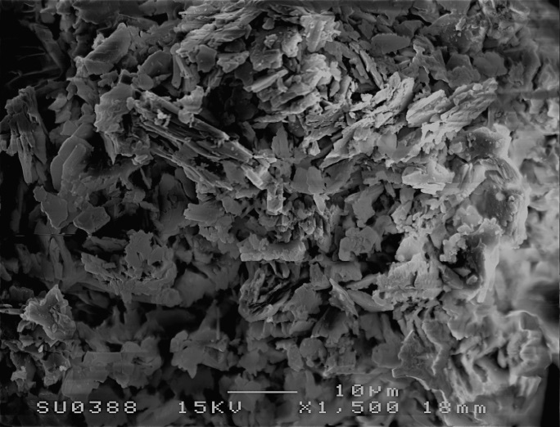
- 6 hours
Figure 5.20: SE images of raw dunite (A) and product from pelletised samples at dunite:NaOH mole ratio of 1:2 reacted for 6 hours: (B) x500 magnification, (C) x1500 magnification.
5.8.2. Reaction in solid system assisted with H₂O
The kinetic analysis was conducted also for Series 2 reacted at NaOH:H₂O mole ratio of 1:2, 1:1, 2:1 and 4:1 for 1, 3 and 6 hours at 180 °C. The increase in Mg(OH)₂ extraction with time observed in the other extractions studied was again observed in Series 2 and the XRD and TG/DTG data are shown in Appendix 2. The extent of reaction was estimated based on the TG data and compared with that for the pelletised samples reacted in dry conditions in Figure 5.21. The products from Series 2 at different H₂O content show an asymptotic trend comparable with that observed for the pellets. As previously discussed, the introduction of H₂O appears to be beneficial for the extraction of Mg(OH)₂ and the extent of reaction increases with the decrease of H₂O content.
Figure 5.21: Comparison of extent of reaction for Series 2 with 0.5, 1, 2 and 4 moles of H₂O with the dry pellets.
The obtained extent of reaction were applied to the Jander model (Eq. 4.8), and analysed in Figure 5.22. The products from Series 2 reacted with 2 and 4 moles of H₂O show a very good match with this model as indicated by R²=0.996 and 0.995, respectively, whereas those with 0.5 and 1 mole of H₂O indicate a lower match.
The value of k for Series 2 reacted with 2 moles of H₂O, i.e. 0.012 h⁻¹ (180 °C), is very close to the values obtained for the reaction in dry conditions, i.e. k = 0.010 h⁻¹ (180 °C), and for 30 mol/kg series, i.e. k = 0.013 h⁻¹ (180 °C). From these results, it appears that the reaction in the systems with larger content of H₂O could be diffusion-controlled like the reaction in dry conditions or the 30 mol/kg NaOH aqueous system, whereas the systems at lower H₂O content may deviate from this model.
Figure 5.22: Potential kinetic model for Series 2 with 0.5, 1, 2 and 4 moles of H₂O:
3-D Jander diffusion model.
The extent of reaction for Series 2 reacted with 0.5 and 1 mole of H₂O are compared with that for the 50 mol/kg series in Figure 5.23, all of which showed a poor fitting with the 3-D diffusion model. Due to the limited number of data points for Series 2, it is difficult to draw clear conclusions, but the extent of reaction in the first 3 hours seems to follow a similar path in these series. This may suggest that the mechanism of reaction in these solid systems was similar to that observed in the 50 mol/kg series in the first three hours of reaction.
After 3 hours, the 50 mol/kg series is characterised by an acceleration of the Mg(OH)₂ extraction, which is not clearly observed in the solid system with 0.5 and 1 mole of H₂O. As already discussed in Section 4.6.3, the increase of reaction kinetics is likely to be attributed to the local volumetric expansions which caused the displacement of the Mg(OH)₂ coating and exposed the fresh dunite surface to the aqueous system. This phenomenon could have taken place easily in the aqueous system where small amounts of dunite were dispersed in a large volume of liquid, i.e. 100 g of dunite per 1 litre of NaOH aqueous solution, while it was hindered in the solid systems where dunite particles were surrounded by other particles with only small volumes of liquid phase present, i.e. 0.5 – 1 moles of H₂O per 1 mole of dunite.
Figure 5.23: Comparison of extent of reaction for Series 2 with 0.5 and 1 mole of H₂O with 50 mol/kg NaOH aqueous system.
5.9. Efficiency of extraction
The efficiency of Mg(OH)₂ extraction was estimated through the yield of reaction according to the procedure used for the NaOH aqueous systems described in Section 4.7.
Figure 5.24 compares the yield of reaction obtained for the dry pellets with that for Series 1, 1.5 and 2 reacted with added H₂O at NaOH:H₂O 4:1 mole ratio. The systems reacted with H₂O resulted in higher yield of reaction than the pelletised samples. The highest efficiency of extraction was obtained in the systems at dunite:NaOH mole ratio of 1:2, i.e. 55% in the pelletised sample and 66% in Series 2.
Figure 5.24: Yield of reaction at different dunite:NaOH mole ratio reacted at 180 °C for 6 hours: dry pellets (black pattern column) and Series 1, 1.5 and 2 with NaOH:H₂O mole ratio of 4:1 (black columns).
Figure 5.25 compares the yield of reaction of solid systems at dunite:NaOH:H₂O mole ratio of 1:2:0.5 reacted at 130, 180 and 250 °C for 1, 3 and 6 hours with that achieved with the NaOH aqueous system at 50 mol/kg NaOH reacted at 180 °C for 6 hours. The yield of reaction increased with temperature and duration, similarly to the concentration of Mg(OH)₂ discussed in Section 5.6 (Figure 5.11). The system reacted at 250 °C reached a yield of 65% within 1 hour of reaction, which is comparable to the 66% achieved at 180 °C over 6 hours. Among the solid systems the maximum yield of reaction was achieved at 250 °C after 6 hours of reaction, i.e. 73%, which is slightly lower than the yield of 81% obtained in the NaOH aqueous system at 50 mol/kg NaOH.
Although the efficiency of extraction obtained in NaOH solid systems is lower than in the aqueous systems, the NaOH consumption was successfully reduced to a stoichiometric ratio with dunite, according to Reaction 5.5. In the 50 mol/kg NaOH aqueous system, from 10.65 to 21.30 g of NaOH are consumed to process 1 g of dunite at solid to liquid ratio of 50 and 100 g/L whereas in the solid system with dunite:NaOH mole ratio of 1:2, only 0.57 g NaOH per 1 g of dunite are required, which corresponds to a reduction of NaOH usage by 94.5 – 97%. The H₂O consumed is also reduced by ~99% in the solid systems with 0.5 moles of H₂O, or completely avoided in the pellets.
The reduction of the reactants required for the extraction in the solid systems represents a significant improvement of the process and the implications for CCS will be discussed in Chapter 7.
Figure 5.25: Yield of reaction for dunite reaction in NaOH solid systems at dunite:NaOH:H₂O 1:2:0.5 mole ratio, reacted for 1, 3 and 6 hours at 130 °C (white columns), 180 °C (black columns) and 250 °C (grey columns). The yield of reaction obtained with 50 mol/kg NaOH aqueous system, 100 g/L solid to liquid ratio, at 180 °C for 6 hours is also shown for comparison (white pattern column).
5.10. Summary
The NaOH required to extract Mg(OH)₂ from dunite can be reduced to a stoichiometric ratio of the expected reaction in the solid systems.
The dunite-NaOH pellets reacted in dry conditions at 180 °C resulted in a significant rate of extraction over 6 hours reaction. The compaction was beneficial for the extraction of Mg(OH), likely due to the increase of the interface of reaction between dunite and NaOH.
The introduction of H₂O considerably improved the extraction of Mg(OH)₂ compared with the reaction in dry conditions, favouring the diffusion of the reactants involved. Both NaOH concentration in H₂O and the amount of liquid phase in the system played a significant role in the extraction of Mg(OH)₂ from dunite and the best results were achieved in systems with dunite:NaOH:H₂O 1:2:0.5 mole ratio. Decreasing the NaOH resulted in less Mg(OH)₂ extraction.
The analysis of the separated solution revealed that the Si extracted which formed Na₂SiO₃, a soluble phase, was partially removed by washing the solid products with distilled water. Similarly, Al and the alkali earth metals Ca, Ba and Sr, were released in solution during the washing of the samples while the transition metals, Fe, Mn, Co, Ni and Cr, mainly remained in the solid products. Fe was extracted and partially converted into Fe₃O₄ which concentration in the products increased with temperature and duration of reaction.
The kinetic behaviour of the extraction in the solid system was diffusion controlled when reacted at 180 °C in dry conditions or with 2 and 4 moles of H₂O in Series 2. The apparent reaction constant k for these systems was similar to that for the reaction in 30 mol/kg NaOH aqueous system. The kinetic behaviour of the solid systems with 0.5 and 1 mole of H₂O showed a deviation from the diffusion-controlled model. Although not conclusive, their behaviour was similar to the 50 mol/kg NaOH aqueous system.
At 180 °C and over 6 hours of reaction, the maximum yield of Mg(OH)₂ extraction was 55% for the pellets at dunite:NaOH 1:2 mole ratio, and 66% for the system at dunite:NaOH:H₂O 1:2:0.5 mole ratio. At 250 °C, the extraction of Mg(OH)₂ was significantly accelerated and 65% yield was achieved in 1 hour for solid systems at dunite:NaOH:H₂O mole ratio of 1:2:0.5. After 6 hours of reaction at these conditions, the yield further increased to 73% which is the highest obtained in the solid systems. Although the efficiency of extraction obtained was slightly lower than in the aqueous systems, the NaOH consumption was reduced by 94.5 – 97% and the H₂O consumption was either reduced by 99% or completely avoided.

6. Mg(OH)₂ carbonation
6.1. Introduction
In this chapter, the feasibility of CO₂ capture by Mg(OH)₂ in aqueous and solid systems was studied. The utilisation of Mg(OH)₂ for mineral carbonation is advantageous, as previously discussed, because of the high magnesium content, i.e. 41.7 wt%, and the faster kinetics of carbonation reaction compared with other magnesium bearing minerals such as periclase, MgO, serpentine and forsterite [9, 62, 117, 182].
The carbonation of reagent grade Mg(OH)₂ and Mg(OH)₂ derived from the alkaline digestion of dunite was studied under CO₂ flow at atmospheric pressure. The relative simplicity of the experimental set up was ideal for the preliminary comparison of the samples, although, at atmospheric pressure, the carbonation of Mg(OH)₂ is limited due to the slow kinetics of reaction [48, 128].
Carbonation of Mg(OH)₂ with CO₂ in its supercritical state, i.e. >70 bar and >30 °C, was also studied. The number of studies reported in the open literature is highly limited [133, 134, 183], but the carbonation of Mg(OH)₂ under supercritical CO₂ seems effective when H₂O is added, achieving high rates of Mg(OH)₂ carbonation at temperatures of reaction ≤75 °C for durations ≥24 hours. In the present study, Mg(OH)₂ was reacted with supercritical CO₂ at 70 °C and for shorter times, which would be more suitable for the practical application.
The reactivity of some products from the alkaline dissolution of dunite with NaOH were tested for carbonation via CO₂ pressure swing technique. Iizuka and co-workers have developed this technique based on CO₂ pressure control to produce high purity CaCO₃ from cement waste in aqueous slurries [10, 106]. Ca²⁺ is first extracted from the cement waste via aqueous dissolution at ~30 °C under high pressure of CO₂, e.g. 3 MPa (30 bar). Subsequently, the pressure of CO₂ in the system is reduced to 0.1 – 0.2 MPa (1 – 2 bar) to favour the precipitation of calcite by reducing the saturated concentration of Ca²⁺ with P_{CO2} [10, 106]. Similar conditions were applied in the present study.
The feasibility of CO₂ sequestration using Mg(OH)₂ was also demonstrated using a Downflow Gas Contactor (DGC) reactor. CO₂ was captured from a flow of CO₂-N₂ mixture at ambient conditions using an aqueous slurry of reagent grade Mg(OH)₂. Mg(OH)₂ and CO₂ dissolved in H₂O can react to form Mg(HCO₃)₂ which remains in solution as soluble phase under controlled pH [3, 132]. This technology combines the separation and storage of CO₂ into a single stage, which is favourable because it avoids the capture and conversion of CO₂ into a pure CO₂ stream, as well as the compression and transport operations, all of which are expensive and energy demanding [5, 79]. The results of this test have been published in Madeddu et al. [174].
6.2. Gas-solid carbonation
6.2.1. High temperature dry carbonation
The carbon content in the products was determined with CHN analysis after the reaction of Mg(OH)₂_RG at different temperatures in CO₂ flow under atmospheric pressure. The outcomes of the analysis are shown in Figure 6.1 (A). Limited carbon uptake is observed and the highest carbon concentration is 1.72 wt% at 400 °C whereas at 200, 500, 600 and 680 °C the carbon concentration is comparable or lower than raw Mg(OH)₂_RG. Mg(OH)₂ dehydroxylates between 300 and 450 °C and the weight loss from H₂O affects the relative concentration of carbon in the products reacted above these temperatures.
The extent of Mg(OH)₂ carbonation was assessed by calculating the C/Mg mole ratio and the results are shown in Figure 6.1 (B). The C represents the moles of carbon in the product after carbonation while Mg corresponds to the moles of Mg forming Mg(OH)₂ in Mg(OH)₂_RG, estimated based on the Rietveld Refinement QPA. The level of C in the products is lower than in the raw Mg(OH)₂_RG for the reaction at 200, 500, 600 and 680 °C, indicating that part of the carbon originally contained in Mg(OH)₂_RG was released during the carbonation and the carbon uptake was either negligible or did not occur. Such result is expected at temperatures above ≥500 °C as hydromagnesite contained in raw Mg(OH)₂_RG and MgCO₃ (possible product of carbonation) are not stable at such high temperatures [136, 184]. On the other hand, hydromagnesite is not expected to release CO₂ at 200 °C and Mg(OH)₂_RG must have contained C-bearing impurities while MgCO₃ formation was highly limited at this temperature. The maximum C/Mg mole ratio is 0.08 at 400 °C, i.e. 33% higher than in raw Mg(OH)₂_RG (C/Mg = 0.06). The carbonation of Mg(OH)₂_D1 at 400 °C also appears to be limited and the carbon content is 1.21 wt% with a C/Mg mole ratio of 0.06, i.e. 20% higher than raw Mg(OH)₂_D1 (C/Mg = 0.05) and 25% lower than Mg(OH)₂_RG carbonated in the same conditions.
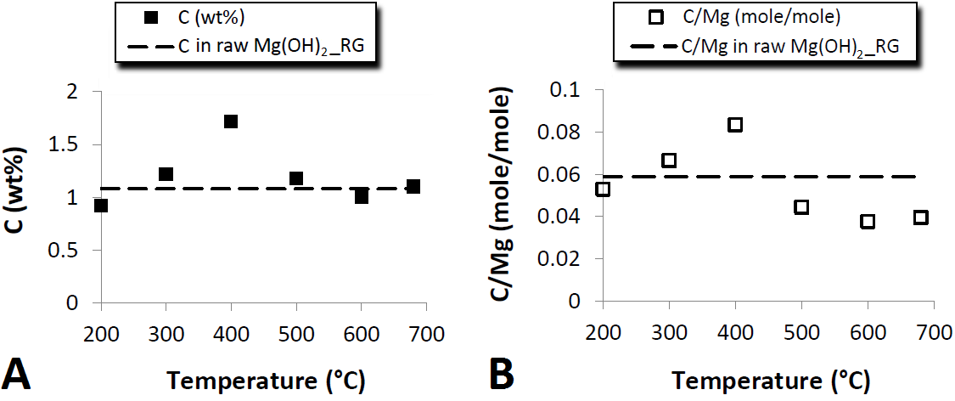
Figure 6.1: (A) Carbon content and (B) C/Mg mole ratio in reaction products from Mg(OH)₂_RG dry carbonation under CO₂ flow at 1 bar. The dotted lines represent the carbon content (A) and the C/Mg mole ratio (B) in Mg(OH)₂_RG before the carbonation reaction.
The XRD patterns of Mg(OH)₂_RG, Mg(OH)₂_D1 and respective reaction products from the dry carbonation at 400 °C are shown in Figure 6.2. XRD did not detect the presence of Mg carbonate minerals in the reaction products, most likely due to the limited carbonation reaction and concentration of these species in the samples.
The raw Mg(OH)₂_RG shows the reflection peaks for brucite and low intensity reflection peaks for hydromagnesite. After carbonated at 400 °C, it shows an additional reflection peak for periclase at 42.9° 2θ, originated from the partial decomposition of brucite [128], whereas the reflection peaks for hydromagnesite disappear. Under CO₂ atmosphere at ambient pressure, hydromagnesite starts to decompose via dehydration below 300 °C, and at 400 °C it starts to decarbonate and forms an amorphous carbonate phase which cannot be detected by XRD [185].
Mg(OH)₂_D1 has similar XRD patterns both before and after carbonation at 400 °C, with only reflection peaks for brucite and low intensity peaks from the mineral components of unreacted dunite. Periclase is not detected in Mg(OH)₂_D1 carbonated at 400 °C, indicating that brucite present in Mg(OH)₂_D1 did not decompose to the similar extent to that in Mg(OH)₂_RG.
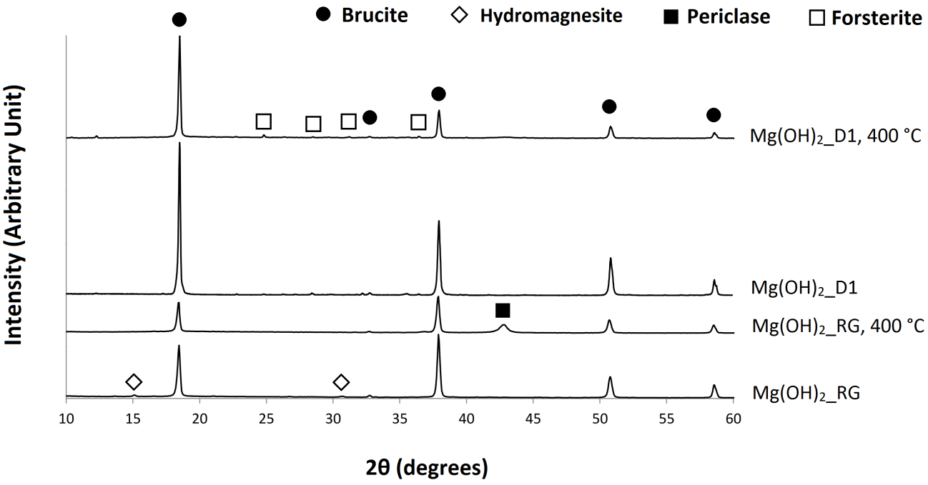
Figure 6.2: XRD patterns of Mg(OH)₂_RG, Mg(OH)₂_D1 and respective reaction products from dry carbonation under CO₂ flow at 1 bar and 400 °C.
The TG and DTG curves for Mg(OH)₂_RG, Mg(OH)₂_D1 and their reaction products from dry carbonation at 400 °C are compared in Figure 6.3. The DTG curve of Mg(OH)₂_RG shows a broad peak centred at 350 °C with evident shoulders at lower and higher temperatures. The weight loss at 350 °C is attributed to the dehydroxylation of brucite [128]. The small amounts of hydromagnesite in the Mg(OH)₂_RG can thermally decompose via dehydration below 300 °C and the dehydroxylation and decarbonation above 300 °C [186, 187]. It is likely that the small weight loss centred at 265 °C is from the dehydration of hydromagnesite, and the decomposition continued at higher temperatures partially overlapping with brucite dehydroxylation. After carbonated at 400 °C, the DTG curve of Mg(OH)₂_RG shows two partially overlapped weight loss events centred at 360 and 390 °C, and a smaller weight loss at 490 °C. The double weight loss at 360 and 390 °C may be attributed to a two steps dehydroxylation of Mg(OH)₂. A similar DTG curve was observed by Fricker and Park in the Mg(OH)₂ carbonated at 300 °C, P_{CO2} = 1.24 MPa (12.4 bar) [128]. It is actually interesting to observe these dehydroxylation events of Mg(OH)₂ in this sample because it had already been heated at 400 °C for carbonation reaction prior to the TG analysis. According to the TG/DTG data for the raw Mg(OH)₂_RG, most of the dehydroxylation of Mg(OH)₂ in this material should be completed when it is heated at 400 °C. The data suggests that, under CO₂ atmosphere, the dehydroxylation did not proceed sufficiently. It has been reported that, under CO₂ atmosphere, Mg carbonate passivating layers can form on the Mg(OH)₂ particles and restrict the penetration of CO₂ through the bulk and the release of H₂O from Mg(OH)₂ dehydroxylation [126, 128, 184]. This must be one of the reasons for the limited extent of carbonation reaction of this system, which resulted in the small weight loss at 490 °C attributed to the decomposition of a Mg carbonate compound formed during the carbonation reaction. Mg(OH)₂ does not decompose at such high temperature, while most of Mg carbonate minerals are reported to decarbonate above 400 °C [136].
The DTG curves of Mg(OH)₂_D1 and its reaction product from the carbonation at 400 °C shows a single weight loss event for Mg(OH)₂ dehydroxylation at 375 °C and 400 °C, respectively. Comparing the DTG curves of the raw reactants, Mg(OH)₂_RG and Mg(OH)₂_D1, it can be noticed that overall Mg(OH)₂ dehydroxylation is slightly shifted towards higher temperature in Mg(OH)₂_D1. This may explain the XRD data which showed that, at 400 °C, brucite partially decomposed into periclase in Mg(OH)₂_RG, while it was not positively observed in Mg(OH)₂_D1. Dehydroxylation of Mg(OH)₂ is observed in the Mg(OH)₂_D1 after carbonation reaction at 400 °C, as in Mg(OH)₂_RG, and it is shifted towards higher temperature. These results also suggest the formation of Mg carbonate passivating layers on the particle surface of Mg(OH)₂_D1.
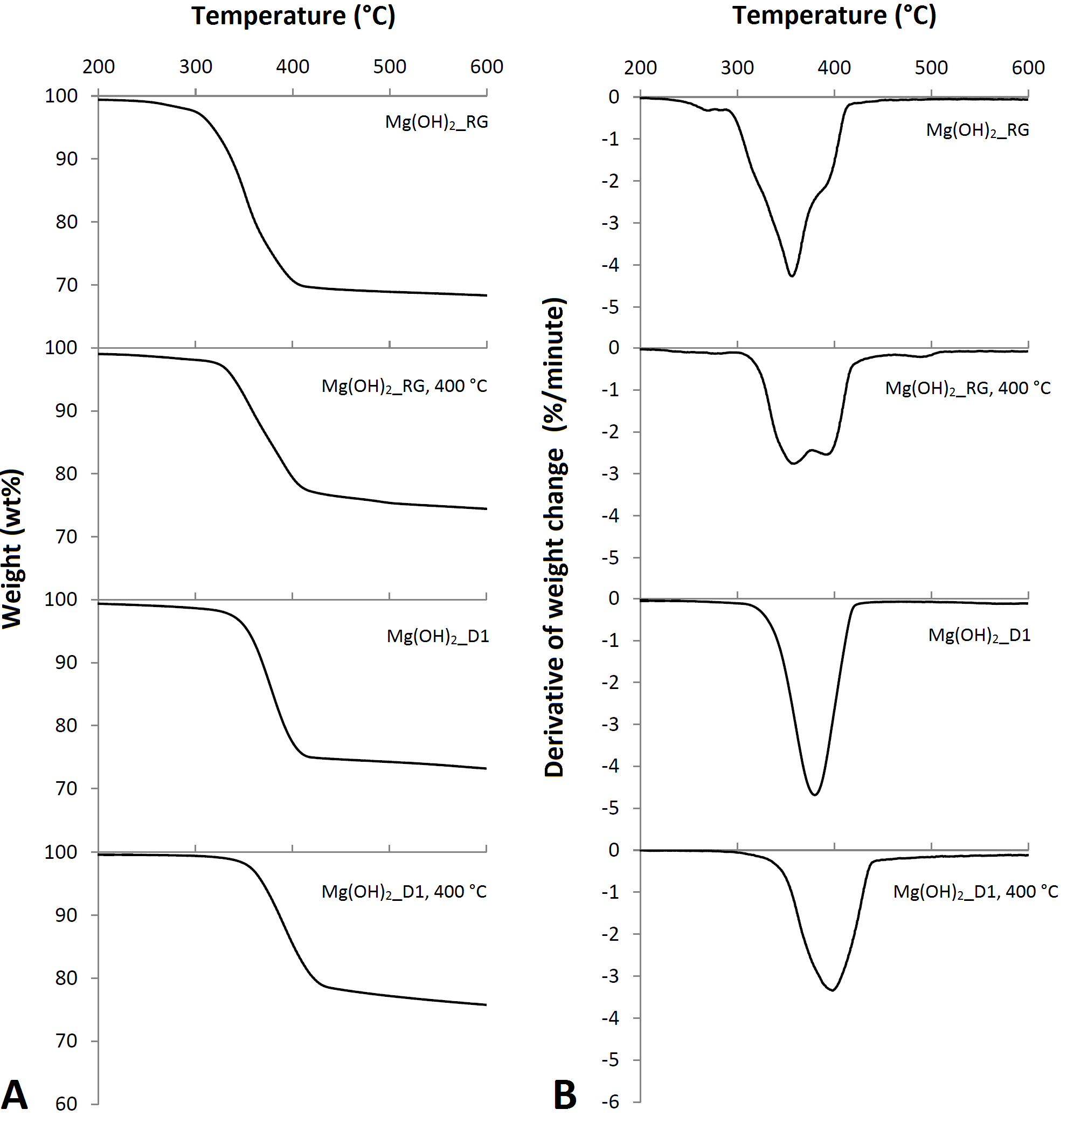
Figure 6.3: (A) TG and (B) DTG curves of Mg(OH)₂_RG, Mg(OH)₂_D1 and respective reaction products from dry carbonation under CO₂ flow at 1 bar and 400 °C.
Mg(OH)₂_D1 captured less carbon than Mg(OH)₂_RG, suggesting that, in the conditions tested in the present study, the reagent grade Mg(OH)₂ was more reactive than the Mg(OH)₂ derived from the dunite. This could be ascribed to the different temperature of Mg(OH)₂ dehydroxylation in the two samples observed from TG data. More dehydroxylation can occur in Mg(OH)₂_RG than in Mg(OH)₂_D1 at 400 °C, which resulted in more carbonation. More dehydroxylation suggests not only the increase of MgO to react with CO₂ but also more mobility of the materials through the passivating layers on the particles such as release of H₂O and penetration of CO₂. It is currently uncertain whether the H₂O released during the dehydroxylation of Mg(OH)₂ acts similarly to the adsorbed H₂O which favours the carbonation [128, 182]. Materic and Smedley [188], studied the thermal decomposition of Ca(OH)₂ under CO₂ and proposed that the H₂O released during the dehydroxylation reaction migrates to the surface of Ca(OH)₂ particles and forms a layer of adsorbed H₂O which enhances the carbonation.
Other factors might have affected the different reactivity of the samples such as different particle size distribution or the presence of residue alkalis in the Mg(OH)₂ extracted from dunite.
6.2.2. High temperature wet carbonation
Mg(OH)₂_RG and Mg(OH)₂_D2 were carbonated with the addition of 0.5 g H₂O to investigate the effect of moisture on CO₂ capture at 400 °C. The CHN data for Mg(OH)₂_RG, Mg(OH)₂_ D1 and D2 before and after dry or wet carbonation are shown in Table 6.1. A positive effect of H₂O on carbonation is observed from the increase of carbon content in the reaction products. The carbon content of Mg(OH)₂_RG after wet carbonation is 4.76 wt% and the C/Mg mole ratio is 0.26, i.e. over 3 times of the dry carbonation at 400 °C. The addition of water was beneficial also for the carbonation of Mg(OH)₂ derived from the dunite. The Mg(OH)₂_D2 has a carbon content of 3.76 wt% and a C/Mg mole ratio of 0.26, i.e. over 4 times of Mg(OH)₂_D1 carbonated in dry conditions. The C/Mg mole ratio in the Mg(OH)₂_D2 and Mg(OH)₂_RG carbonated with added H₂O is the same (C/Mg = 0.26), but the carbon uptake by Mg(OH)₂_RG is higher than that by Mg(OH)₂_D2 as it can be appreciated by comparing the C/Mg mole ratio of the respective raw reactants in Table 6.1. The initial C/Mg mole ratio in the raw Mg(OH)₂_RG is 0.06, while in the raw Mg(OH)₂_D2 the C/Mg mole ratio is 0.16.

Table 6.1: CHN data for Mg(OH)₂_RG, Mg(OH)₂_D1 and Mg(OH)₂_D2 before and after carbonation under CO₂ flow at 1 bar and 400 °C.
Sample | Added H₂O  (g) | Carbon  (wt%) | C/Mg  (mole/mole)
Raw Mg(OH)₂_RG | - | 1.08 | 0.06
Mg(OH)₂_RG | 0.0 | 1.72 | 0.08
Mg(OH)₂_RG | 0.5 | 4.76 | 0.26
Raw Mg(OH)₂_D1 | - | 0.71 | 0.05
Mg(OH)₂_D1 | 0.0 | 1.21 | 0.06
Raw Mg(OH)₂_D2 | - | 1.93 | 0.16
Mg(OH)₂_D2 | 0.5 | 3.96 | 0.26
The XRD patterns of the reaction products from the wet carbonation are compared with those from the dry carbonation in Figure 6.4. The XRD pattern for Mg(OH)₂_D2 before carbonation is also shown for comparison. XRD analysis was conducted using diffractometers with different wavelengths and, thus, the patterns were compared by plotting against the 1/d spacing values on the horizontal axis. The reaction products from Mg(OH)₂_RG and Mg(OH)₂_D2 wet carbonation show a reflection peak for periclase at 0.475 Å⁻¹, suggesting that brucite in these samples partially decomposed during the carbonation reaction at 400 °C, similarly to the product from the Mg(OH)₂_RG dry carbonation. All the reaction products show the reflection peaks from brucite, and the reaction product from the Mg(OH)₂_D2 wet carbonation also shows low intensity peaks for the mineral components of unreacted dunite. Although the wet carbonation of Mg(OH)₂_RG and Mg(OH)₂_D2 resulted in a considerably higher carbon uptake than the dry carbonation samples, the XRD did not detect Mg carbonate minerals. The lack of the reflection peaks for Mg carbonate minerals suggests that only a limited amount of Mg carbonates formed crystalline compounds and mainly amorphous Mg carbonates formed. Similar results were observed also by Fricker and Park, in which Mg(OH)₂ samples gave a significant rate of carbonation attributed to the formation of amorphous carbonate compounds [128].
Figure 6.4: XRD patterns for reaction products from Mg(OH)₂_RG dry and wet carbonation, Mg(OH)₂_D1 dry carbonation and Mg(OH)₂_D2 wet carbonation under CO₂ flow at 1 bar and 400 °C. The XRD pattern of Mg(OH)₂_D2 before carbonation is also shown for comparison.
The TG and DTG curves of Mg(OH)₂_RG, Mg(OH)₂_D2 and respective products from the wet carbonation at 400 °C are shown in Figure 6.5. The product from the Mg(OH)₂_RG shows a main weight loss centred at 375 °C for Mg(OH)₂ dehydroxylation, and a smaller weight loss at 508 °C. The weight loss at 508 °C is likely attributed to the loss of CO₂ captured during the carbonation reaction, as other weight loss events are not detected. It should be noted that the CO₂ content based on the weight loss at 508 °C in TG data is 1 wt%, which is considerably smaller than the 17 wt% measured via CHN analysis in this sample. This aspect is further discussed later.
The dehydroxylation of Mg(OH)₂ in the raw Mg(OH)₂_D2 occurs in two stages forming a double peak centred at 335 and 400 °C, whereas after carbonation Mg(OH)₂_D2 shows a single weight loss event for Mg(OH)₂ dehydroxylation centred at 410 °C with an evident shoulder at 425 °C. The weight loss at 508 °C observed in the reaction products from the Mg(OH)₂_RG wet carbonation is not detected in the product of Mg(OH)₂_D2 wet carbonation and no other weight loss events ascribable to the decarbonation of Mg carbonate minerals are detected either in this sample.
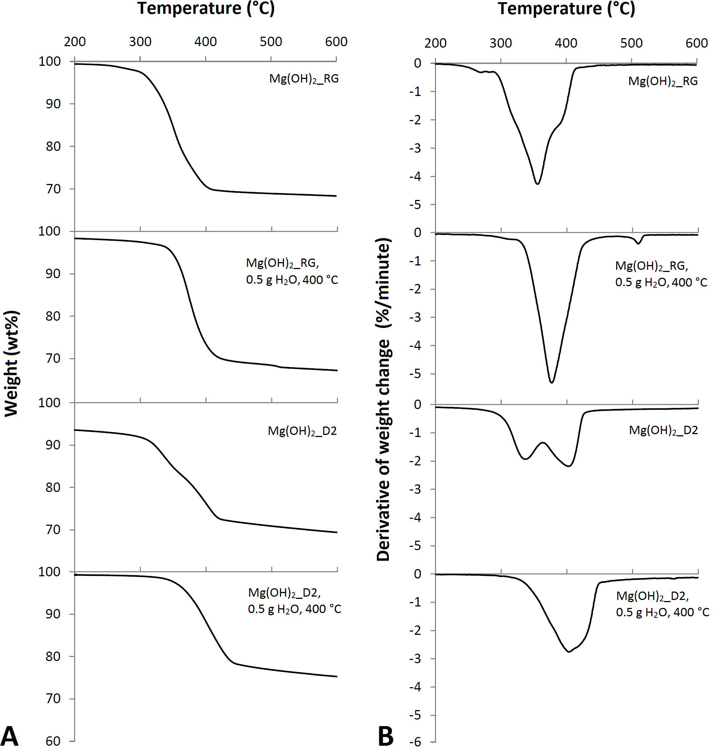
Figure 6.5: (A) TG and (B) DTG curves of Mg(OH)₂_RG, Mg(OH)₂_D2, and respective reaction products from wet carbonation under CO₂ flow at 1 bar and 400 °C.
The carbon content measured in the products via CHN analysis for the Mg(OH)₂_RG and Mg(OH)₂_D2 wet carbonation was considerably larger than those for the dry carbonation, and it was expected to detect some weight loss events above 400 °C related to the decarbonation of Mg carbonate species. To clarify this, the product from Mg(OH)₂_D2 wet carbonation was further investigated via TG-MS conducted under N₂ flow. The results shown in Figure 6.6 reveal that the CO₂ contained in the sample is released simultaneously with H₂O from Mg(OH)₂ dehydroxylation between 350 and 450 °C. The carbonation was conducted at 400 °C and although it should not be possible to observe the decomposition of the Mg carbonate species at temperatures ≤400 °C, the stability of the Mg carbonate compounds is influenced by the atmosphere to which they are exposed [189]. Similarly to what observed for Mg(OH)₂ dehydroxylation in the present study and previous investigations [126, 128], Mg carbonate species remain stable at 400 °C under CO₂ atmosphere while, under static air (used for TG) and N₂ (used for TG-MS), they are less stable and release CO₂ around 400 °C. This is supported by Sawada et al. who found that hydromagnesite decarbonation is affected by the partial pressure of CO₂ [189].
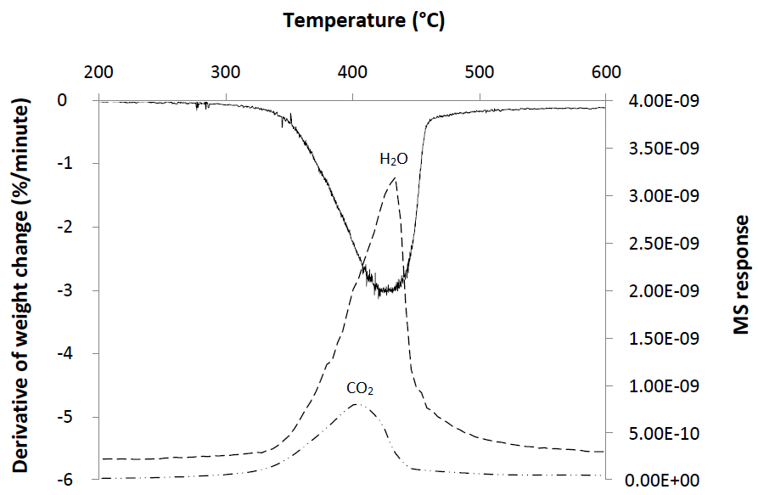
Figure 6.6: DTG curve and MS response for H₂O and CO₂ from the reaction product of Mg(OH)₂_D2 wet carbonation under CO₂ flow at 1 bar and 400 °C.

6.2.3. Reactivity of Mg(OH)₂ for high temperature carbonation
The dehydroxylation of Mg(OH)₂ at approximately 300 – 400 °C was observed in the reaction products of both dry and wet carbonation for Mg(OH)₂_RG, Mg(OH)₂_D1 and Mg(OH)₂_D2, indicating that the majority of Mg(OH)₂ is remaining in the system although they had already been heated at 400 °C for the carbonation reaction prior to the TG analysis. As mentioned previously, this is believed to be caused by Mg carbonate passivating layers formed on the Mg(OH)₂ particles under CO₂ atmosphere which restrict not only the release of H₂O from Mg(OH)₂ dehydroxylation but also the penetration of CO₂ through the bulk for further carbonation [126, 128, 184]. It appears that this passivating layer is an important controlling factor for the carbonation of Mg(OH)₂.
Mg(OH)₂ derived from dunite (Mg(OH)₂_D1 and Mg(OH)₂_D2) systematically captured less carbon than Mg(OH)₂_RG in dry and wet carbonation at 400 °C. This is likely originated from the formation of passivating layers. As observed in the TG data (Figure 6.3), Mg(OH)₂_D1 dehydroxylates at slightly higher temperature than Mg(OH)₂_RG, which implies the more significant effect of the passivating layer on the Mg(OH)₂ derived from dunite. It appears to be easier to form the passivating layer on the Mg(OH)₂ derived from dunite than on the Mg(OH)₂_RG.
The addition of H₂O resulted in a higher carbon uptake than the carbonation in the dry condition. It is expected that the added H₂O was fully evaporated at 400 °C. Therefore, most of the carbonation must have occurred at temperatures below 100 °C during the heating. The role of H₂O in the improvement of Mg(OH)₂ carbonation has been a subject of many studies but the understanding of the mechanism of reaction is still limited. Beruto and Botter [190], studied the gas-solid carbonation of Ca(OH)₂ with added H₂O and suggested that, at the solid-liquid interface, the carbonation reaction occurred between partially dissolved Ca(OH)₂ and CO₂, benefitting from the advantages of aqueous carbonation. A similar effect could be expected in the gas-solid carbonation of Mg(OH)₂-H₂O systems investigated.
Although the addition of H₂O was beneficial, the extent of CO₂ fixation was still limited and thus the carbonation of Mg(OH)₂ via gas-solid reaction under atmospheric pressure of CO₂ at 200 – 680 °C is impractical for CCS.

6.3. Carbonation with supercritical CO₂
6.3.1. Dry carbonation
The CHN analysis on the reaction product revealed that only a limited carbonation took place when Mg(OH)₂_RG was exposed to a supercritical CO₂ at 70 °C under 90 bar CO₂ pressure. The CHN data are shown in Table 6.2 together with those from the wet carbonation with supercritical CO₂ which will be discussed in the next section. The carbon content in the products for the 1 and 3 hour dry carbonation is 1.17 and 1.08 wt%, respectively, while the C/Mg mole ratio is 0.06 in both products and is the same as the Mg(OH)₂_RG before carbonation. These results indicate that the carbon uptake in these samples was negligible or did not occur.
Table 6.2: Results of CHN analysis on products from Mg(OH)₂_RG carbonation under supercritical CO₂ at 70 °C and P_{CO2} 90 bar.
Added H₂O  (g) | Time  (hour) | Carbon  (wt%) | C/Mg  (mole/mole)
0.0 | 1 | 1.17 | 0.06
0.0 | 3 | 1.08 | 0.06
1 | 1 | 8.45 | 0.76
1 | 3 | 7.77 | 0.69
The inert behaviour of Mg(OH)₂_RG under supercritical CO₂ was confirmed by XRD and TG which did not detect the presence of Mg carbonate phases. The XRD patterns in Figure 6.7 only show the reflection peaks for Mg(OH)₂ and low intensity peaks for hydromagnesite and appear very similar to the pattern of Mg(OH)₂_RG before carbonation (Figure 6.2). The TG and DTG curves in Figures 6.8 (A) and (B) show a small weight loss event at 250 °C and a large one between 300 and 450 °C and resemble those of raw Mg(OH)₂_RG (Figure 6.3). The DTG curve of Mg(OH)₂_RG carbonated for 3 hours under supercritical CO₂ shows a double weight loss event at 300 – 450 °C which suggests a double-step dehydroxylation of Mg(OH)₂. The XRD and TG results are in agreement with Schaef et al. and Loring et al. who also observed the limited carbonation of Mg(OH)₂ reacted under supercritical CO₂ in dry conditions [133, 134].
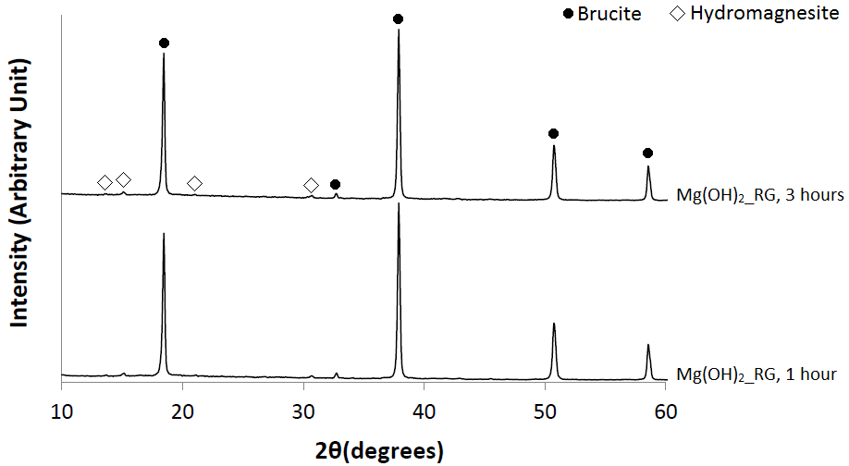
Figure 6.7: XRD patterns of the reaction products from Mg(OH)₂_RG carbonated under supercritical CO₂ at 70 °C, P_{CO2} 90 bar, for 1 and 3 hours.
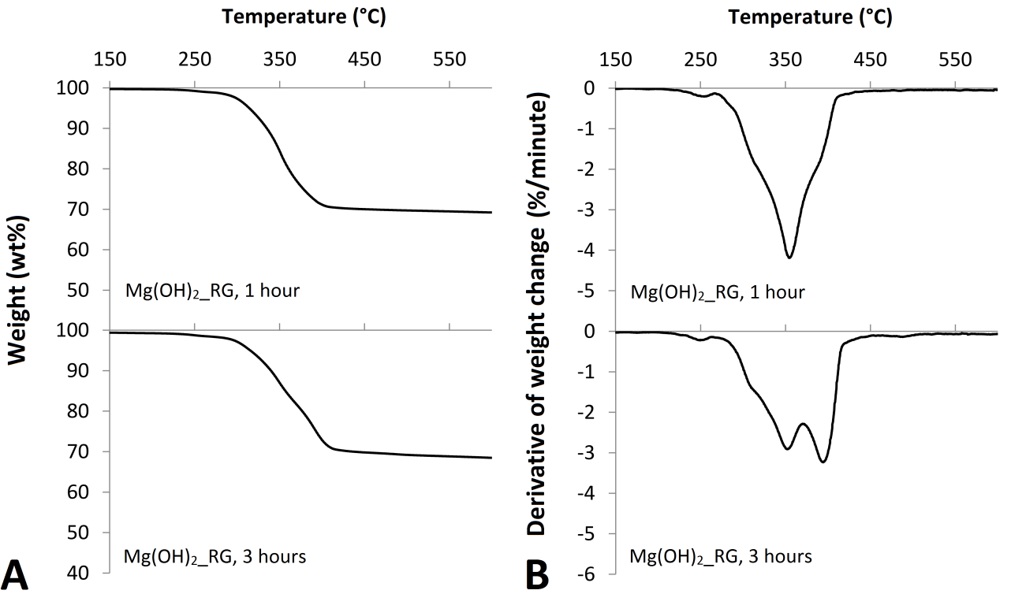
Figure 6.8: (A) TG and (B) DTG curves of the reaction products from Mg(OH)₂_RG carbonated under supercritical CO₂ at 70 °C, P_{CO2} 90 bar, for 1 and 3 hours.

6.3.2. Wet carbonation
The carbonation of Mg(OH)₂_RG with 1 g of H₂O in supercritical CO₂ at 70 °C under P_{CO2} of 90 bar showed a considerable increase in the carbon captured. The CHN analysis results are shown in Table 6.2, in the previous section. The products from the Mg(OH)₂_RG carbonated for 1 and 3 hours have a carbon content of 8.45 and 7.77 wt%, respectively, and the C/Mg mole ratio is 0.76 and 0.69, which correspond to 13 – 12 times the dry carbonation under supercritical CO₂, and 3 times the wet carbonation under atmospheric pressure.
The results of XRD from the wet carbonation under supercritical CO₂ are shown in Figure 6.9. The patterns of the products reacted for 1 and 3 hours both exhibit the characteristic reflection peaks for brucite and hydromagnesite. The intensity of the reflection peaks for hydromagnesite respect to brucite is considerably higher than those observed in the products from dry carbonation under supercritical CO₂ condition (Figure 6.7), confirming a larger extent of carbonation in the wet carbonation. It should be noted that the sample carbonated for 3 hours indicates less intense and broader reflection peaks for hydromagnesite compared with the sample reacted for 1 hour. These data suggest that, the hydromagnesite formed during the first 1 hour became less crystalline in the following 2 hours and a part of it could have been converted into something else. The C/Mg mole ratio indicated a slight reduction of Mg(OH)₂ carbonation after 3 hours and thus, the conversion of hydromagnesite may have involved the release of CO₂.
The Rietveld Refinement QPA was conducted on the XRD pattern of the sample carbonated for 1 hour to quantify the hydromagnesite and the refined pattern is shown in Appendix 3. The refinement indicated that the sample was constituted by 60 ± 3 wt% hydromagnesite. Assuming that the amount of hydromagnesite present in raw Mg(OH)₂_RG is negligible respect to that formed during the carbonation reaction, it can be estimated that at least 66 wt% of the original Mg(OH)₂ was converted into hydromagnesite. 60 ± 3 wt% hydromagnesite contains 5.8 – 6.5 wt% carbon which is less than the concentration detected via CHN analysis (C = 8.45 wt%) and suggests that other carbonate species formed.
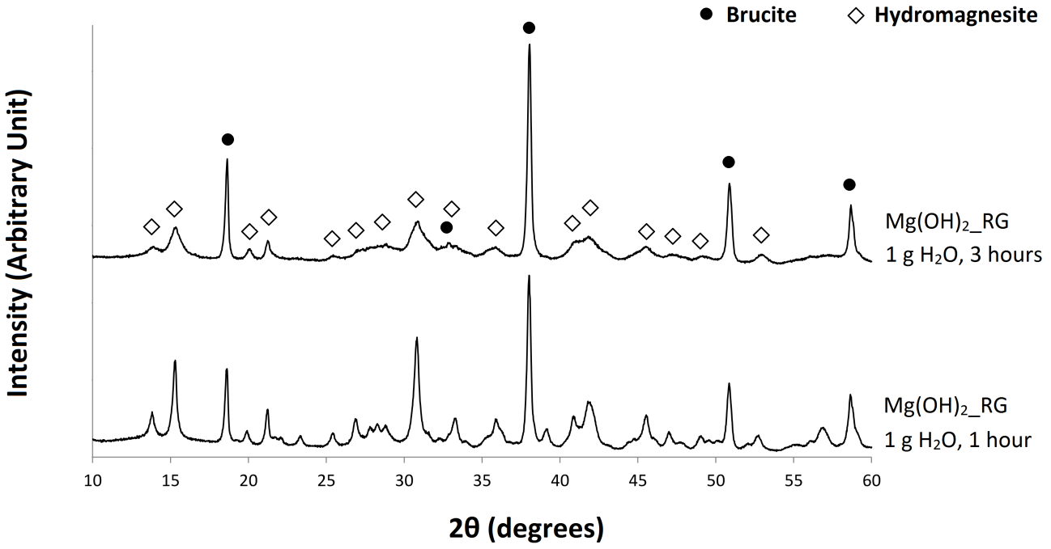
Figure 6.9: XRD patterns of the reaction products from Mg(OH)₂_RG mixed with 1 g H₂O and carbonated under supercritical CO₂ at 70 °C at P_{CO2} 90 bar for 1 and 3 hours.
The products were analysed via TG under static air and the obtained TG and DTG curves are shown in Figure 6.10. The DTG curves of these samples are very similar and exhibit three main weight loss events centred at 260 °C, 390 °C and 510 °C, which correspond to the typical thermal decomposition of hydromagnesite in air [186, 187]. These samples contain Mg(OH)₂, as proved from the XRD analysis, and the weight loss from its dehydroxylation must be overlapping with that for hydromagnesite at 390 °C.

Figure 6.10: (A) TG and (B) DTG curves of reaction products from Mg(OH)₂_RG mixed with 1 g H₂O and carbonated under supercritical CO₂ at 70 °C, P_{CO2} 90 bar, for 1 and 3 hours. The measurements were conducted in static air atmosphere.
The decomposition of hydromagnesite occurs through dehydration, Reaction 6.1, dehydroxylation, Reaction 6.2, and decarbonation, Reaction 6.3 [187]. The dehydration reaction occurs below 300 °C while dehydroxylation and decarbonation reactions are always above ~300 °C but the temperatures vary depending on the P_{CO2} [186, 187, 191].
(6.1)
(6.2)
(6.3)
Assuming that the hydromagnesite in the reaction products fully dehydrates in the weight loss event centred at 260 °C, it is possible to estimate the wt% of hydromagnesite in the samples based on Reaction 6.1. Mg(OH)₂_RG carbonated for 1 hour showed 9.6 wt% loss in the weight loss event centred at 260 °C, which corresponds to 62.3 wt% of hydromagnesite concentration in the sample. This figure is in good agreement with 60 ± 3 wt% quantified via Rietveld Refinement QPA. The same calculation was conducted for the product reacted for 3 hours and the weight loss at 260 °C was 9.1 wt%, i.e. 59 wt% hydromagnesite concentration. The weight loss centred at 510 °C, ascribable to the hydromagnesite decarbonation (Reaction 6.3) [186, 187, 189, 191, 192], is equal to 3.7 and 2.8 wt% in the products from 1 and 3 hours carbonation, respectively, which is considerably smaller than the CO₂ detected in these samples via CHN analysis, i.e. 31 wt% and 28 wt%. Hydromagnesite in the reaction products releases CO₂ (Reaction 6.3) simultaneously with its dehydroxylation (Reaction 6.2) at 350 – 450 °C where the dehydroxylation of remaining Mg(OH)₂ also takes place, as observed from TG-MS data which are discussed below. Overall, the TG data suggest that the sample reacted for 3 hours captured less carbon than the sample reacted for 1 hour, in agreement with the CHN data.
The thermal decomposition of the sample reacted for 1 hour was further studied via TG-MS under N₂ flow, and the DTG curve and the MS response for the CO₂ and H₂O release are plotted in Figure 6.11. It should be noted that the weight loss for the decarbonation at around 510 °C observed in Figure 6.10 is not observed in Figure 6.11. As previously mentioned, the temperatures of dehydroxylation (Reaction 6.2) and decarbonation (Reaction 6.3) are strongly affected by the P_{CO2} under which the thermal decomposition is performed whereas the dehydration of hydromagnesite (Reaction 6.1) is unanimously reported to occur below 300 °C [185, 187, 189, 191, 192]. It appears that CO₂ can remain in the system up to around 510 °C under the static air heating (TG data in Figure 6.10), resulting in the hydromagnesite releasing the CO₂ in two step, whereas CO₂ can be released in a single step at lower temperature under N₂ flow due to the lower P_{CO2} than in air (TG data in Figure 6.11).
The MS response in Figure 6.11 shows that H₂O was released in two stages, i.e. the weight loss centred at 250 °C from the hydromagnesite dehydration and the weight loss at 410 °C from the simultaneous dehydroxylation of hydromagnesite and that of Mg(OH)₂ remained unreacted during the carbonation reaction. The CO₂ is released only at around 410 °C which confirms that hydromagnesite fully decarbonates at this temperature range. These results are in agreement with Sawada et al. and Padeste et al., who studied the thermal decomposition of hydromagnesite under He and N₂ [185, 189]. The weight loss centred at 250 °C attributed to the dehydration of hydromagnesite was equal to 9.3 wt% which is very close to 9.6 wt% calculated from the TG data under air at 260 °C. It confirms that the temperature of hydromagnesite dehydration is not affected by the P_{CO2} difference.
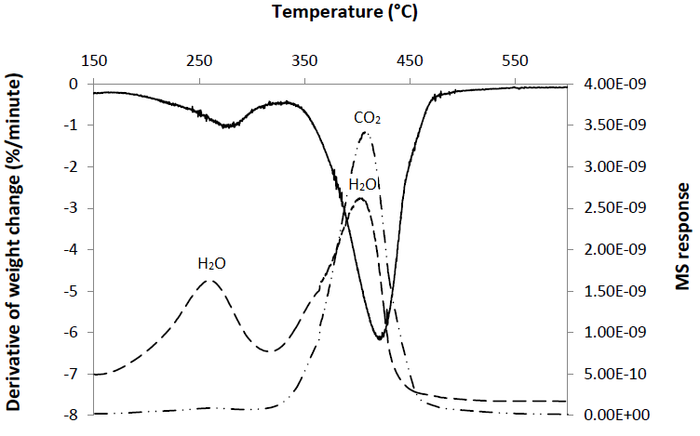
Figure 6.11: DTG curve and respective MS response of the reaction product from Mg(OH)₂_RG mixed with 1 g H₂O and carbonated under supercritical CO₂ at 70 °C, P_{CO2} 90 bar, for 1 hour. The measurement was conducted under N₂ flow.
6.3.3. Conversion of carbonation product
The addition of H₂O considerably increased the carbonation of Mg(OH)₂_RG under supercritical CO₂ at 70 °C and P_{CO2} 90 bar, and ≥66 wt% of Mg(OH)₂ was reacted into hydromagnesite within the first 1 hour of the reaction. While this is beneficial for the development of fast-kinetic Mg(OH)₂ carbonation reactions, further reaction resulted in the reduced crystallinity of the hydromagnesite and the partial release of CO₂ in the following 2 hours as observed in the CHN, XRD and TG data. The decrease in the carbon content could be associated to the conversion of hydromagnesite into another phase through the partial release of CO₂. This phase has not been identified and further study is required to clarify the process involved.
The phase conversion which potentially took place in the reaction products could also be the intermediate formation of an amorphous phase prior to the final conversion into magnesite, which was not completed due to the insufficient time of reaction. Prigiobbe and Mazzotti [193] have observed the conversion of hydromagnesite into magnesite in aqueous solution over 20 hours duration at temperatures ≥90 °C and P_{CO2} 100 bar. Schaef et al. and Loring et al. [133, 134], observed a similar phase conversion during the carbonation of natural brucite with wet supercritical CO₂ at 75 °C and 70 °C under 82 and 100 bar, respectively. The reaction products were mainly constituted by nesquehonite which partially converted into magnesite with an intermediate amorphous phase within 3 hours of reaction. The absence of nesquehonite in the reaction products obtained in the present study could be due to the different nature of Mg(OH)₂ and experimental conditions tested [133, 134].
6.4. Carbonation via CO₂ pressure swing
Some products from the dunite reacted with NaOH were tested for carbonation via CO₂ pressure swing to investigate their reactivity. Mg(OH)₂_D3, D4 and D5 which contain Mg(OH)₂ in 34.0, 38.7 and 51.2 wt%, respectively, were tested in aqueous slurries at P_{CO2} = 20 bar and 32 °C. The reactivity was assessed based on the extent of Mg dissolution in the liquid phase.
The results of Mg dissolution from the Mg(OH)₂_D3, D4 and D5 are shown in Figure 6.12. The results from the dissolution of olivine and phlogopite under similar conditions reported by Abe et al. [194] are displayed in Figure 6.13 for comparison. 45, 55 and 48% of Mg in the materials were extracted from Mg(OH)₂_ D3, D4, and D5, respectively, whereas only 0.97 and 0.35% of Mg was dissolved from olivine and phlogopite [194]. The results clearly show that much more Mg is dissolved, readily available for carbonation, from the Mg(OH)₂_ D3, D4, and D5 samples compared with the Mg silicate minerals. Even in the least efficient system, Mg(OH)₂_D3 with 34.0 wt% Mg(OH)₂ content and 66 wt% dunite, the dissolution of Mg into the solution was improved over 45 times compared with the dissolution from the olivine, demonstrating the advantage of the Mg(OH)₂ extraction.
Figure 6.12: Concentration of Mg dissolved in solution determined via ICP-AES from Mg(OH)₂_D3 (white circles), Mg(OH)₂_D4 (grey circles) and Mg(OH)₂_D5 (black circles) at 32 °C, 5 g/L solid to liquid ratio and P_{CO2} = 20 bar.
Figure 6.13: Concentration of Mg dissolved in solution determined via ICP-AES from olivine (A) and phlogopite (B) dissolved at 30 °C, 4 g/L solid to liquid ratio, at various P_{CO2}: 10 bar (black diamond), 20 bar (open square) and 30 bar (black triangle). The graphs have been modified from Abe et al. [194].
After 1 hour of dissolution, the Mg(OH)₂_D3, D4 and D5 samples were tested successively for carbonation via the CO₂ pressure swing. The concentration of Mg is plotted in Figure 6.14 (A) for Mg(OH)₂_D4, while the results from Mg(OH)₂_D3 and D5 are shown in Figure 6.14 (B). The pH data for the Mg(OH)₂_D4 is also indicated in Figure 6.14 (A). The dotted line represents the change of P_{CO2} from 20 to 2.1 bar after 1 hour of dissolution period.
The Mg released from Mg(OH)₂_D4 increased throughout the duration of the experiment with a parabolic trend. Mg continued to be released in solution after the pressure of CO₂ was reduced to 2.1 bar, although at a significantly lower rate. The pH of the solution progressively increased from 5.6 to 6.6 at 20 bar and from 6.6 to 7 at 2.1 bar. These data suggest that the dissolution of CO₂ initially caused the acidification of the solution which favoured the dissolution of Mg(OH)₂ [130]. As more Mg(OH)₂ is dissolved, the released of OH⁻ ions partially reacted with H⁺ and shifted the equilibrium in solution, resulted in an increase of pH.
Figure 6.14 (B) shows that Mg(OH)₂_D3 dissolved faster within the first 20 minutes of reaction at P_{CO2} = 20 bar, then the concentration of Mg in solution remained almost constant and may appear to decrease in the last 50 minutes. At 20 minutes the amount of Mg present in the solution corresponded to 90% of Mg contained in the Mg(OH)₂ fraction. Thus, the decrease of extraction rate observed after 20 minutes of reaction could be ascribed to the almost complete dissolution of Mg(OH)₂ contained in the sample. The decrease in the Mg concentration in the last 50 minutes of the experiment suggests that part of the Mg extracted might have precipitated.
Mg(OH)₂_D5 showed a linear increase of Mg extraction at P_{CO2} = 20 bar, and when P_{CO2} shifted to 2.1 bar, the concentration of Mg first slightly decreased and then increased again. Assuming that all the Mg in solution was released from Mg(OH)₂ dissolution, after 1 hour of dissolution, the sample still maintained 23 wt% of Mg(OH)₂ as solid which continued to dissolve after the pressure swing. The decrease of P_{CO2} shifted the equilibrium in solution and caused the increase of OH⁻ ions concentration, as observed in Figure 6.14 (A), and the decrease of Mg(OH)₂ dissolution rate.
Figure 6.14: Concentration of Mg in solution determined via ICP-AES during the carbonation via CO₂ pressure swing of (A) Mg(OH)₂_D4 (grey circles) and (B) Mg(OH)₂_D3 (white circles) and Mg(OH)₂_D5 (black circles). The pH of Mg(OH)₂_D4 aqueous slurry is also shown in (A), (white diamonds).
The TG data for Mg(OH)₂_D3, D4 and D5 after 2.5 hour (150 minutes) testing period are compared with the respective products from carbonation in Figure 6.15. After the carbonation, the weight loss for Mg(OH)₂ dehydroxylation is significantly reduced or absent in Mg(OH)₂_D3 and D4, suggesting that Mg(OH)₂ was mostly or fully dissolved. These results were confirmed via XRD analysis, which patterns are shown in Appendix 3. The product of Mg(OH)₂_D5 carbonation indicates a weight loss centred at 300 °C. The shift of Mg(OH)₂ dehydroxylation at lower temperature observed in this sample occurred probably because the TG analysis was conducted at a lower heating rate of 1 °C/minute instead of 10 °C/minute. This also makes the DTG values smaller, to approximately 1/10 comparing with the measurement at 10 °C/minute. TG-MS analysis confirmed that H₂O is released at this temperature (Figure 6.16) and residual Mg(OH)₂ was detected via XRD analysis (Figure 6.17).
TG did not reveal the presence of characteristic weight loss events for Mg carbonate species in the solid products from the Mg(OH)₂_D3, D4 and D5 carbonation and XRD did not reveal the presence of reflection peaks for Mg carbonate minerals. CHN analysis was also conducted on the products from carbonation but carbon was not detected, in agreement with the TG and XRD results.
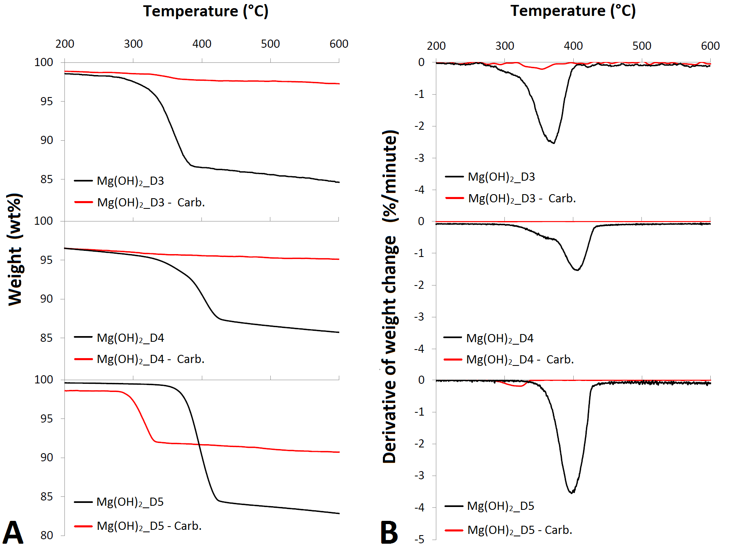
Figure 6.15: TG (A) and DTG (B) curves of Mg(OH)₂_D3, D4 and D5 and respective reaction products from carbonation via CO₂ pressure swing over 2.5 hours at 32 °C.
Figure 6.16: DTG curve and respective MS response of the reaction product from Mg(OH)₂_D5 carbonated via CO₂ pressure swing over 2.5 hours at 32 °C.
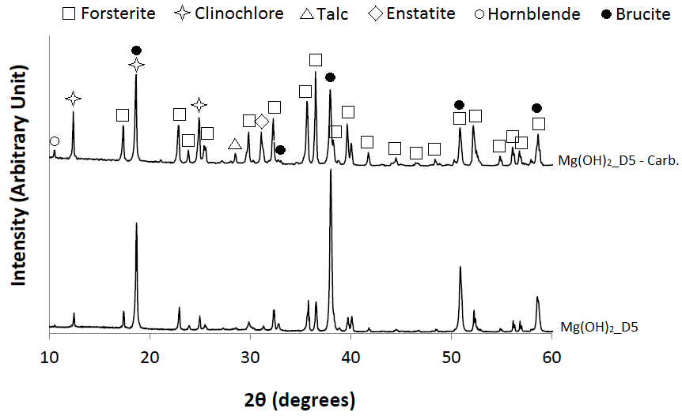
Figure 6.17: XRD patterns of Mg(OH)₂_D5 and the respective reaction product from carbonation via CO₂ pressure swing over 2.5 hours at 32 °C.
The saturated concentration of Mg²⁺ in solution was calculated for brucite, magnesite, and nesquehonite as a function of CO₂ pressure, and the results are shown in Figure 6.18. The concentration of Mg measured in Mg(OH)₂_D3, D4 and D5 aqueous slurries are also displayed. The maximum concentration of Mg in solution at P_{CO2} = 20 bar was below the saturated concentration for magnesite, nesquehonite and brucite while, at P_{CO2} = 2.1 bar, the system was supersaturated in magnesite and the precipitation of this phase was thermodynamically favoured. However, in the present study, the formation of magnesite was not observed. The precipitation of nesquehonite would have been favoured by further decreasing the pressure of CO₂. Nesquehonite precipitation has been observed at room temperature and atmospheric pressure while magnesite requires higher P_{CO2} and temperature of reaction [119]. One of the factors which might have hindered the precipitation of Mg carbonate species was the low pH of the solution. The highest pH measured during Mg(OH)₂_D3 carbonation was 7 while the precipitation of carbonate species is normally observed at higher pH [3, 4, 138].
Despite the significant improvement of Mg dissolution achieved, the fixation of CO₂ into Mg carbonate minerals did not occur and the aqueous carbonation of the products from dunite alkaline digestion was unfeasible under the conditions tested.
Figure 6.18: Saturated concentration of Mg²⁺ calculated for magnesite, nesquehonite and brucite as a function of P_{CO2} at 25 °C.

6.5. CO₂ capture with Mg(OH)₂
A Mg(OH)₂ aqueous slurry was tested to capture CO₂ from a 4 – 5% CO₂ gas-mixture with N₂ at 10 °C and atmospheric pressure .
Figure 6.19 shows the CO₂ concentration in the flow gas measured at the inlet and outlet of DGC reactor during the experiment. The CO₂ concentration at the outlet was initially negligible, and all CO₂ in the flow gas appeared to be retained in the circulating solution by reacting with Mg(OH)₂ in the system. The CO₂ concentration started increasing after approximately 200 minutes due to the consumption of Mg(OH)₂ in the system, and became equal to that in the inlet gas at 720 minutes where the system no longer captures CO₂. The overnight shut down period did not cause any obvious change in the system. The obtained results clearly show the CO₂ capture capability of this system.
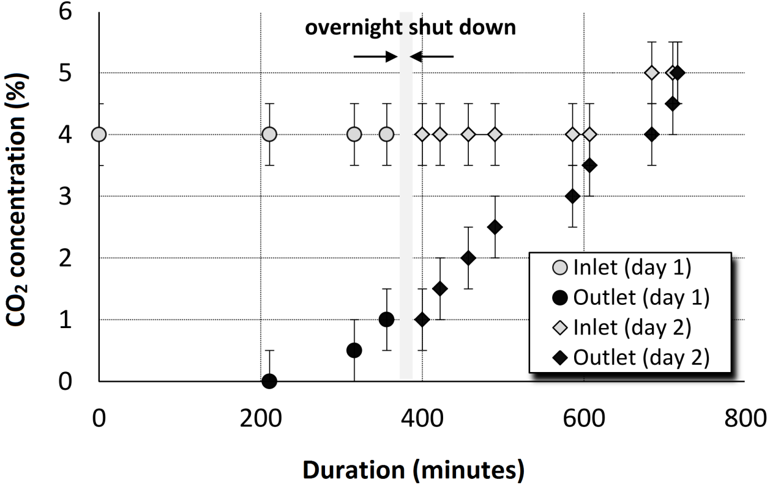
Figure 6.19: CO₂ concentration in the flow gas at the inlet and outlet of DGC reactor.
The amount of CO₂ captured from the flowing gas was estimated using Equation 6.4 where CO₂i % and CO₂o % are the concentration of CO₂ in the inlet and outlet gas, respectively. The volume of gas under atmospheric pressure at 10 °C was estimated from the ideal gas equation as 23.2 L/mole.
(6.4)
The amount of captured CO₂ is plotted in Figure 6.20 together with the pH of the circulating solution. CO₂ was steadily captured up to around 400 minutes, and then the rate of capture slightly decreased. The significant reduction in pH at this period suggests the exhaustion of the dissolved Mg(OH)₂ available for reaction.
In total, 1.80 ± 0.19 moles of CO₂ were sequestered over the 2 days of experimental run.
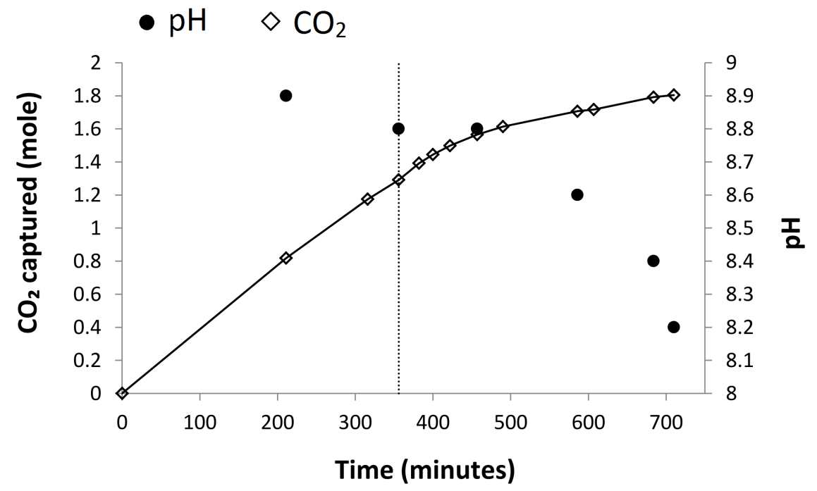
Figure 6.20: Amount of CO₂ captured and pH of the circulating solution in the liquid-gas scrubbing with Mg(OH)₂-H₂O slurry.
Since the circulating solution used in the present study contained approximately 0.85 mole of Mg(OH)₂, the maximum CO₂ to be captured is 1.71 mole (1.72 mole if CaO presented as an impurity is also counted) assuming the reaction product is Mg(HCO₃)₂, and 0.86 mole if MgCO₃ was produced. Although our estimation, 1.80 ± 0.19 mole, contains a significant deviation, it is clear that the reaction product in the tested system was mainly Mg(HCO₃)₂. It is known that the formation of Mg(HCO₃)₂ is favoured when the pH of the solution is around 8.4 where HCO₃⁻ ions are the predominant species of CO₂ dissolution, whereas MgCO₃ preferentially forms when the pH of the solution is above 9 as the CO₃²⁻ ions are the predominant species [3, 4, 138]. The obtained results confirms that Mg(HCO₃)₂ can form in the pH ranging between 8.2 – 8.9 recorded in the present study (Figure 6.20).
The amount of solid material collected upon completion of the experiment was 2 g (initial amount of Mg(OH)₂ was 50.8 g). The XRD analysis shown in Figure 6.21 indicates that the solid residue was constituted by brucite, poorly crystalline hydromagnesite and another poorly crystalline phase which was not identified.
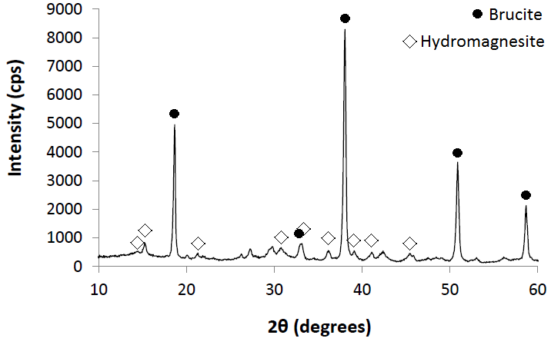
Figure 6.21: XRD pattern of the solid residue from the Mg(OH)₂ aqueous suspension.
The amount of CO₂ in the collected solid was determined via CHN analysis and estimated as 0.01 mole. These results indicate that Mg(OH)₂ almost fully dissolved and captured CO₂ by forming Mg(HCO₃)₂ which remained in equilibrium in solution while only a small fraction reacted forming Mg carbonate phases.
The exact quantification of CO₂ captured by the reaction with Mg(OH)₂ is challenging and requires further analysis. Nevertheless, these preliminary results suggest that at least 93.6% of CO₂ potentially capturable by the Mg(OH)₂ slurry was effectively captured.

6.6. Summary
The gas-solid carbonation of Mg(OH)₂ in dry and wet conditions under atmospheric pressure at temperatures between 200 and 680 °C was highly limited and is considered impractical for CO₂ sequestration. The maximum carbon uptake was achieved at 400 °C. The addition of H₂O at Mg(OH)₂:H₂O = 2:1 mass ratio was beneficial for the improvement of Mg(OH)₂ carbonation compared to the dry carbonation. It is possible that the partial dissolution of Mg(OH)₂ and CO₂ at the solid-liquid interface might have favoured the carbonation of Mg(OH)₂, similarly to what suggested in other studies for Ca(OH)₂-H₂O-CO₂ systems. In the high temperature gas-solid carbonation, Mg carbonate passivating layers formed on the Mg(OH)₂ particles appear to be one of the main obstacles for the sufficient carbonation reaction. Mg carbonate passivating layers can form on the Mg(OH)₂ particles and restrict the penetration of CO₂ through the bulk and the release of H₂O from Mg(OH)₂ dehydroxylation. Mg(OH)₂ derived from dunite was also tested under the same conditions and systematically showed lower carbonation rates. It appears that it is easier to form Mg carbonate passivating layers on the Mg(OH)₂ derived from dunite.
The reagent grade Mg(OH)₂ was carbonated under supercritical CO₂ at a P_{CO2} of 90 bar, 70 °C, over 1 and 3 hours. The samples were almost inert when carbonated in dry conditions proving that the storage of CO₂ via Mg(OH)₂ carbonation under supercritical CO₂ would not be feasible in absence of H₂O. When H₂O was added at Mg(OH)₂:H₂O = 3:1 mass ratio, the carbonation rate significantly improved and at least 66% of Mg(OH)₂ was carbonated into hydromagnesite within 1 hour, which appeared to convert into amorphous phase in the following 2 hours.
During the carbonation via CO₂ pressure swing, approximately half of the Mg contained in Mg(OH)₂_D3, D4 and D5 dissolved with a considerable improvement respect to previous studies which used olivine and phlogopite. Despite the higher extent of Mg dissolution, the aqueous carbonation of dunite pre-treated via alkaline digestion was proved to be unfeasible. In fact, the precipitation of Mg carbonate species was not observed after the CO₂ pressure was reduced to 2.1 bar even though, at this pressure of CO₂, the solution was supersaturated in magnesite. Magnesite does not precipitate at low CO₂ pressure and temperature used in this study, moreover, the low pH of the solution may have hindered the formation of this phase.
CO₂ was successfully captured from a gas mixture composed of 4 – 5% CO₂ and N₂ via liquid-gas scrubbing using a Mg(OH)₂ aqueous slurry and stored in the solution as Mg(HCO₃)₂. At least 93.6% capture efficiency was achieved over 12 hours of duration at ambient conditions. This technology integrates the separation and capture of CO₂ in one single step and may improve the efficiency of the overall CCS process.

7. Implications of Mg(OH)₂ extraction from Mg silicate minerals
7.1. Introduction
The extraction of Mg(OH)₂ from Mg silicate minerals becomes an option for CCS when the CO₂ capture potential of Mg(OH)₂ produced is larger than the CO₂ emitted for the extraction process. The CO₂ balance of the process developed in the present study was assessed based on the NaOH production, the temperature and duration of Mg(OH)₂ extraction and the CO₂ capture potential of the Mg(OH)₂ extracted. In this chapter, the implications for CCS are discussed both for NaOH aqueous and solid systems, and a basic comparison is also provided for the alkaline-based extraction with the existing Mg(OH)₂ production technology based on the extraction in solid systems with ammonium salts.
7.2. Effect of NaOH recycling in aqueous systems
In Chapter 4, it was identified that the consumption of NaOH is one of the key issues for Mg(OH)₂ extraction in aqueous systems. The highest rates of Mg(OH)₂ extraction in NaOH aqueous systems, i.e. 80 and 81% were obtained when 1 L of 50 mol/kg NaOH solution was used to digest 50 or 100 g of dunite at 180 °C for 6 hours, respectively. The volume of the aqueous solutions was calculated using the apparent molar volume of NaOH(aq) provided by Petrenko and Pitzer [162], i.e. approximately 15 cm³/mol for a solution with 50 mol/kg NaOH at 180 °C. The total volume of 1 kg of H₂O (ρ=0.887 g/cm³ at 180 °C) with 50 mol NaOH was estimated to be 1.877 L. Therefore, 10.65 and 21.30 g of NaOH are consumed per 1 g of dunite processed at a solid to liquid ratio of 100 and 50 g/L, respectively.
According to Reaction 4.1, the complete reaction of 140.7 g Mg₂SiO₄, which is the main mineral component of dunite, requires 80 g of NaOH. Assuming all the MgO is present as Mg₂SiO₄ in dunite, the minimum NaOH:MgO mass ratio required for the digestion equals to ~1, which corresponds to ~0.48 g of NaOH for 1 g of dunite. Thus, the aqueous systems studied had NaOH:MgO mass ratio from over 21 to 43 times higher than the ideal case shown in Reaction 4.1. Since the system involves NaOH in excess, the recycling of NaOH for consecutive digestion batches of fresh dunite becomes important. This would allow to process more feedstock materials and produce more Mg(OH)₂ without further consumption of NaOH.
The CO₂ balance of the process was estimated based on the emissions associated with the NaOH production, Mg(OH)₂ extraction at 180 °C and the sequestration potential of Mg(OH)₂ derived from the processed dunite. The mining of dunite, the grinding <63 µm and the potential transport of the material were excluded from the calculation. It should be noted that such operations are among the most energy intensive in mineral carbonation technologies and thus the CO₂ balance in the present study is only a partial estimate of the actual net CO₂ emissions of the process [75, 86].
The CO₂ emissions for the production of NaOH were calculated from the mass balance to process 1 kg of dunite in aqueous systems with 30 or 50 mol/kg NaOH at a solid to liquid ratio of 50 or 100 g/L. It was assumed that 2.9 kWh of electricity are consumed to produce 1 kg of NaOH, and at least 250 g of CO₂ are emitted for 1 kWh of electricity when natural gas is used [195, 196]. The CO₂ emissions for the extraction of Mg(OH)₂ were calculated based on the power consumption of an electric oven with 28 litres capacity to operate at 180 °C which corresponds to 0.26 kWh, according to the manufacturer’s specification [197]. The CO₂ capture potential was estimated from the amount of Mg(OH)₂ derived from the dunite processed according to the efficiency of extraction achieved in the present study and the theoretical yield of 100%, and it was assumed that Mg(OH)₂ was fully reacted to form either MgCO₃ or Mg(HCO₃)₂. The CO₂ balance was calculated assuming that consecutive digestion cycles are repeated using the same aqueous system until the NaOH in the system becomes insufficient in quantity to react with a new batch of dunite (at least 0.48 g of NaOH per 1 g of dunite are required). These calculations assume that for each digestion cycle the efficiency of Mg(OH)₂ extraction remains unvaried.
Figure 7.1 (A) shows the example of the CO₂ balance calculated for the theoretical 100% yield extraction of dunite with 50 mol/kg NaOH at a solid to liquid ratio of 100 g/L at 180 °C for 6 hours. The graph displays the amount of CO₂ emitted for NaOH production (dotted line) and Mg(OH)₂ extraction at 180 °C for 6 hours (white diamonds) together with the CO₂ captured from the conversion of Mg(OH)₂ extracted into MgCO₃ (black diamonds) and Mg(HCO₃)₂ (grey diamonds). As each digestion cycle consumes NaOH, the maximum number of digestion cycles was determined based on the remaining NaOH in the solution, i.e. at least 0.48 g of NaOH per 1 g of dunite, which corresponds to 22 cycles at 50 mol/kg NaOH and 100 g/L solid to liquid ratio. The CO₂ emitted for the initial NaOH production (CO₂ = 7.7 kg) remains constant because no further NaOH is added during the digestion cycles. The CO₂ emitted for heating the system for digestion and the CO₂ to be captured increase with the number of digestion cycles. Figure 7.1 (B) shows the sum of these components, indicating the
net CO₂ emissions for two cases, when MgCO₃ or Mg(HCO₃)₂ is produced. Under the conditions considered, after 1 digestion cycle the CO₂ emitted is larger than the CO₂ captured. As the CO₂ produced from Mg(OH)₂ extraction process (CO₂ = 390 g) per cycle is smaller than the CO₂ captured as MgCO₃ (CO₂ = 530.5 g) and Mg(HCO₃)₂ (CO₂ = 1061 g), increasing the number of digestion cycles leads to the progressive decrease of the net CO₂ emissions. The process becomes carbon negative after 12 digestion cycles when Mg(OH)₂ is converted into Mg(HCO₃)₂, while the CO₂ captured is insufficient to offset the CO₂ produced when MgCO₃ forms.
Figure 7.1: CO₂ balance calculated for Mg(OH)₂ extraction from 1 kg of dunite reacted at 180 °C for 6 hours with 50 mol/kg NaOH solution, at 100 g/L solid to liquid ratio, with 100% yield of extraction: (A) CO₂ emitted for initial NaOH production (dotted line), and Mg(OH)₂ extraction (white diamonds); CO₂ captured by Mg(OH)₂ conversion into MgCO₃ (black diamond) and Mg(HCO₃)₂ (grey diamonds. (B) Net CO₂ emissions for Mg(OH)₂ conversion into MgCO₃ (black diamonds) and Mg(HCO₃)₂ (white diamonds).
In the present study 81% yield of Mg(OH)₂ extraction was achieved from dunite when reacted at 180 °C for 6 hours with 50 mol/kg NaOH solution and 100 g/L solid to liquid ratio. The net CO₂ emissions for this system were calculated based on the same methodology discussed above, and the results are shown in Figure 7.2. Similarly to what observed in Figure 7.1, increasing the number of the recycle of NaOH solution leads to a steady decrease in the net CO₂ emissions when CO₂ is captured as Mg(HCO₃)₂, and after approximately 17 batches the process is carbon neutral. The formation of MgCO₃ is not sufficient to offset the CO₂ emitted.
Figure 7.2: Net CO₂ emissions for the digestion of 1 kg of dunite at 180 °C for 6 hours with 50 mol/kg NaOH solution, at 100 g/L solid to liquid ratio, with 81% yield of extraction. The calculation is based on NaOH production, Mg(OH)₂ extraction and potential CO₂ capture by Mg(OH)₂ extracted and converted into MgCO₃ (black diamonds) or Mg(HCO₃)₂ (white diamonds).
Dunite digestion at 180 °C for 6 hours with 30 mol/kg NaOH solution at 50 g/L solid to liquid ratio resulted in yield of 53%, the same yield achieved at the same temperature over 2 hours of reaction with 50 mol/kg NaOH solution at 100 g/L. The net CO₂ emissions for these series were calculated and the results are compared in Figure 7.3 (A) and (B). With 30 mol/kg NaOH and 6 hours of reaction (Figure 7.3 (A)), increasing the number of the NaOH recycle leads to a further increase in the CO₂ emission when MgCO₃ is formed. The amount of CO₂ to be captured as MgCO₃ after 1 digestion cycle (CO₂ = 288 g) is smaller than the CO₂ produced for heating the system at 180 °C for 6 hours (CO₂ = 390 g), and thus, increasing the number of cycles results in the further CO₂ emission. When CO₂ is captured as Mg(HCO₃)₂ (CO₂ = 576 g), the net CO₂ emissions decrease but remain positive even after 34 digestion cycles, which is the maximum number of times the NaOH solution can be reused in this particular example. On the other hand, with 50 mol/kg NaOH and 2 hours of reaction (Figure 7.3 (B)), the process becomes carbon neutral after 18 batches when Mg(HCO₃)₂ forms, while the net CO₂ emissions are positive with MgCO₃. The calculation shows that even if the same yield

of extraction is achieved, reducing the heating time for digestion is more beneficial than reducing the amount of NaOH used under the conditions studied.
These data highlight the importance of the CO₂ balance calculation for a preliminary evaluation of the environmental impact of the process at different conditions of reaction.
Figure 7.3: Net CO₂ emissions for the digestion of 1 kg dunite at 180 °C for 6 hours with 30 mol/kg NaOH solution and 50 g/L solid to liquid ratio (A), and for 2 hours with 50 mol/kg NaOH and 100 g/L solid to liquid ratio (B). The calculation is based on NaOH production, Mg(OH)₂ extraction and CO₂ potentially captured by Mg(OH)₂ extracted and fully converted into MgCO₃ (black diamonds) or Mg(HCO₃)₂ (white diamonds).

7.3. Effect of NaOH, temperature and duration of reaction in solid systems
The CO₂ balance for the extraction of Mg(OH)₂ in NaOH solid systems discussed in Chapter 5 was evaluated with the same methodology used for the NaOH aqueous systems. The assessment is based on the mass balance of the materials used assuming that 1 kg of dunite is processed with the corresponding amount of NaOH used for Series 1, 1.5 and 2 (details in Chapters 3 and 5). The amount of Mg(OH)₂ extracted was estimated from the yield of reaction achieved for each series reacted at 130, 180 and 250 °C at NaOH:H₂O mole ratio of 4. In addition to the CO₂ emissions from the NaOH production, the extraction of Mg(OH)₂ using an electric oven at different temperatures were also calculated. The oven consumes 0.17, 0.26 and 0.385 kWh of energy to operate at 130, 180 and 250 °C, respectively, according to the manufacturer’s specification [197]. The CO₂ sequestration was calculated based on the full conversion of Mg(OH)₂ into either MgCO₃ or Mg(HCO₃)₂. Because the extraction in the solid system consumes much less NaOH compared with the aqueous extraction, the assessment was conducted only for a single extraction process.
Figure 7.4 compares the CO₂ potentially captured by the Mg(OH)₂ extracted at 180 °C in 6 hours for Series 1, 1.5, and 2 at NaOH:H₂O mole ratio of 4, together with that achievable at 100% yield of extraction. The dotted lines represent the sum of the CO₂ emissions from the NaOH production and the Mg(OH)₂ extraction. The graph shows that the potential CO₂ capture naturally increases with the improvement of the yield of Mg(OH)₂ extraction, but the estimated CO₂ emissions from NaOH production and Mg(OH)₂ extraction are still larger, indicating the importance of process optimisation. The achievement of 100% yield at 180 °C in 6 hours would effectively reduce the CO₂ emissions for all series when Mg(OH)₂ is fully converted into Mg(HCO₃)_{2.} On the other hand, the CO₂ capture into MgCO₃ would not be sufficient to offset the CO₂ emissions even at the maximum yield of Mg(OH)₂ extraction. According to Reaction 5.5, 1 mole of Mg(OH)₂ requires the consumption of 1 mole of NaOH, and from the amount of Mg(OH)₂ in the reaction products it was estimated that only 60, 59 and 55% NaOH reacted with dunite in Series 1, 1.5 and 2, respectively, suggesting that there is still a wide margin for improvement of Mg(OH)₂ extraction.
Figure 7.4: CO₂ balance for Series 1, 1.5 and 2 at NaOH:H₂O mole ratio of 4 reacted at 180 °C, for 6 hours: CO₂ emissions associated with NaOH production and Mg(OH)₂ extraction (red squares); potential CO₂ capture at 100% yield of Mg(OH)₂ extraction and conversion into MgCO₃ (grey dotted line) and Mg(HCO₃)₂ (black dotted line); potential CO₂ capture of Mg(OH)₂ extracted at experimental yield (Series 1 = 36%, Series 1.5 = 53%, Series 2 = 66%) and converted into MgCO₃ (green triangles) and Mg(HCO₃)₂ (green circles).
Figures 7.5 (A), (B) and (C) show the CO₂ balance for dunite:NaOH:H₂O solid systems at 1:2:0.5 mole ratio, reacted at 130, 180 and 250 °C, respectively. As shown in Figure 7.5 (A), the yield of Mg(OH)₂ extraction at 130 °C is too low and the CO₂ emission from the power consumption is considerably larger. Figure 7.5 (B) shows that the CO₂ balance is significantly improved at 180 °C. At this temperature the potential CO₂ capture becomes close to the CO₂ produced in the case of 3 hours of extraction, when CO₂ is captured as Mg(HCO₃)₂. Thus, a small improvement of the extraction condition could result in a carbon neutral process. Extending the duration of reaction to 6 hours is not energetically beneficial as more CO₂ is emitted for heating during the longer extraction process. The CO₂ balance for the extraction at 250 °C is much better. As shown in Figure 7.5 (C), at 1 and 3 hours extraction, the CO₂ capture exceeds the CO₂ produced from the NaOH production and the Mg(OH)₂ extraction, and CO₂ is successfully reduced. At this temperature, a shorter duration is clearly more beneficial.

It should be noted that the CO₂ capture exceeds the CO₂ emissions only when Mg(HCO₃)₂ is produced as a reaction product under the conditions examined. The achievement of 100% yield of extraction at 130, and 180 °C would reduce CO₂ when Mg(HCO₃)₂ is formed, while at 250 °C, this occurs only for the extraction of 1 and 3 hours, and with 6 hours, CO₂ is emitted. When MgCO₃ is produced as the reaction product, the amount of CO₂ to be captured is less than the CO₂ produced during the process, even at 100% yield, and thus, the production of Mg(HCO₃)₂ is a key factor to offset the CO₂ produced during the extraction.
Figure 7.5: CO₂ balance for dunite:NaOH:H₂O solid systems at 1:2:0.5 mole ratio, reacted at 130 °C (A), 180 °C (B), and 250 °C (C) for 1, 3 and 6 hours: CO₂ emissions associated with NaOH production and Mg(OH)₂ extraction (red squares); potential CO₂ capture at 100% yield of Mg(OH)₂ extraction and conversion into MgCO₃ (grey dotted line) and Mg(HCO₃)₂ (black dotted line); potential CO₂ capture of Mg(OH)₂ extracted at experimental yield and converted into MgCO₃ (green triangles) and Mg(HCO₃)₂ (green circles).
7.4. Comparison of Mg(OH)₂ production technologies
The research group at the Åbo Akademi University in Finland has developed a two-step process for the extraction of Mg(OH)₂ from serpentine based on the solid state reaction with ammonium salts and it is of particular interest to see how this technology compares with the one developed in the present study. In the ÅAU process, 1.5 kg of (NH₄)₂SO₄ (AS) is consumed per 1 kg of Finnish serpentine with 36 wt% MgO content [48]. The extraction of Mg(OH)₂ from dunite with NaOH in solid system requires 0.57 kg of NaOH per 1 kg of dunite used in the present study with 48.3 wt% MgO content. The AS-based process results in the maximum extraction of 0.34 kg of Mg(OH)₂ per 1 kg of serpentine reacted at 400 – 440 °C for 30 – 60 minutes [48], while, with the NaOH solid extraction, 0.45 kg of Mg(OH)₂ is produced from 1 kg of dunite reacted at 250 °C for 1 hour.
The NaOH solid extraction appears to be comparable with the AS-based process as it requires significantly lower temperatures and a higher efficiency of extraction is achievable. A larger amount of AS is consumed to process 1 kg of feedstock material in comparison with that of NaOH in the NaOH solid systems, although the utilisation of AS can have a lower environmental impact on the extraction process than NaOH, because it can be obtained as a by-product from the manufacture of chemicals such as caprolactam [(CH₂)₅COHN] and coke [198].
7.5. Summary
The CO₂ balance of Mg(OH)₂ extraction from dunite was assessed based on the energy consumption for NaOH production, temperature and duration of the extraction reaction, and the CO₂ capturable by the Mg(OH)₂ derived from dunite and fully converted into MgCO₃ or Mg(HCO₃)₂. The CO₂ emitted for mining, grinding and potential transport of dunite was not accounted for in the calculation.
For the extraction in NaOH aqueous systems, the process can become carbon neutral only when Mg(OH)₂ is converted into Mg(HCO₃)₂, and at least 17 batches are required with 50 mol/kg NaOH at 100 g/L solid to liquid ratio, at 180 °C for 6 hours of reaction. The required batch cycles are estimated to be 18 for 2 hours of reaction under the same conditions. On the contrary, the fixation of CO₂ into MgCO₃ always results in positive net CO₂ emissions.
The CO₂ balance was estimated for Mg(OH)₂ extraction in solid systems. For the 130 and 180 °C extractions to be carbon neutral, the yield of reaction needs to be higher than those achieved in the present study and Mg(OH)₂ has to be converted into Mg(HCO₃)₂. The CO₂ balance becomes negative when dunite is processed at 250 °C for 1 or 3 hours and CO₂ is captured as Mg(HCO₃)₂. This is promising for the possible application of Mg(OH)₂ derived from dunite for CO₂ separation from flue gases and storage in H₂O.
From a basic comparison of the conditions of reaction, efficiency of extraction and raw materials consumption, the extraction of Mg(OH)₂ with dunite-NaOH solid systems appears to be a valid alternative to ammonium sulphate based extraction from serpentine. Further analysis is recommended for a more accurate assessment of the energy requirements of these processes.

8. Conclusions
8.1. Overview
The present study provides an assessment of Mg(OH)₂ extraction from dunite with NaOH aqueous and solid systems for CO₂ capture and storage. A wide range of temperatures and durations of reaction were tested, varying the NaOH concentration in the systems and the efficiency of extraction was calculated. The carbonation of Mg(OH)₂ was also studied. Reagent grade Mg(OH)₂ was carbonated with gaseous CO₂ under atmospheric pressure and with CO₂ in supercritical state. The carbonation of Mg(OH)₂ derived from dunite was also studied under atmospheric pressure for comparison. The aqueous carbonation of the products from Mg(OH)₂ extraction was conducted via CO₂ pressure swing while reagent grade Mg(OH)₂ aqueous slurries were tested for CO₂ capture via gas-liquid scrubbing. The net CO₂ emissions of Mg(OH)₂ extraction were calculated based on the NaOH consumption, temperature, duration of the extraction and CO₂ capture potential of the Mg(OH)₂ produce. Finally, the implications for CO₂ capture and storage were discussed.
8.2. Extraction of Mg(OH)₂ with NaOH aqueous and solid systems
The extraction of Mg(OH)₂ from dunite was first conducted using highly concentrated NaOH aqueous systems, i.e. 15 – 50 mol/kg NaOH. The extraction of Mg(OH)₂ at 90 °C was highly limited and significantly improved at 180 – 190 °C, most likely owing to the increase in reaction kinetics. The pressure in the closed vessels and lower viscosity of the systems at higher temperature might have also contributed. The extraction also improved by increasing the concentration of NaOH in H₂O and the duration of reaction. The maximum of 81% yield of extraction was achieved at 180 °C with 50 mol/kg NaOH solution at 100 g/L solid to liquid ratio over 6 hours of reaction. The large consumption of NaOH (10.65 to 21.30 g of NaOH per 1 g of dunite) and long duration of reaction are not deemed suitable for industrial applications and make the process environmentally unsustainable.

Dunite-NaOH solid systems were reacted in dry conditions or with the addition of small amounts of H₂O, aiming the reduction of NaOH usage. The consumption of NaOH was reduced by 94.5 – 97% respect to the NaOH aqueous systems and, at dunite:NaOH mole ratio of 1:2 (stoichiometry of reaction), only 0.57 g of NaOH were used per 1 g of dunite processed. H₂O consumption was also reduced by ~99% or completely avoided. The extraction of Mg(OH)₂ improved in presence of H₂O which favours the diffusivity of the reactants involved. It was found that small amounts of liquid were preferable, i.e. NaOH:H₂O mole ratio of 4:1, presumably because the relative concentration of NaOH in H₂O increases, which leads to a beneficial effect for the extraction of Mg(OH)₂. Increasing the temperature of reaction to 250 °C allowed the reduction of the reaction time to 1 hour maintaining significant yield of Mg(OH)₂ extraction, i.e. 65%.
8.3. Mechanism of extraction
The reaction of dunite with NaOH involves the alkali attack of the silicon-oxygen bonds with the consequent extraction of Si which forms soluble Na₂SiO₃. This phase can be removed by washing the products with distilled water while the Mg extracted as Mg(OH)₂ remains in the solid products. Al and alkali earth metal contained in dunite can be removed by washing the samples, which suggests that, similarly to Si, they might form soluble species. On the other hand, the transition metals mainly remain in the solid products. For example, at 250 °C the Fe extracted is converted into Fe₃O₄ which can be removed from the other components of the solid products via magnetic separation.
The extraction of Mg(OH)₂ with 30 mol/kg NaOH solution at 190 °C and solid systems at dunite:NaOH mole ratio of 1:2 reacted in dry conditions and with 2 or 4 moles of added H₂O, is diffusion controlled (Jander three-dimensional diffusion model). The concentration of NaOH and the amount of liquid phase seem to affect the reaction. The products reacted with 50 mol/kg NaOH solution, at 180 °C over 1 to 6 hours, exhibited a complex mechanism of reaction. Mg(OH)₂ initially formed a coating on the dunite particles and limited the contact with the aqueous system, and, with the progress of Mg(OH)₂ crystallisation, the local volumetric expansions caused the displacement of Mg(OH)₂ coating and exposed the fresh dunite underneath which allowed the continuation of the reaction. It was not possible to identify the stages of the reaction occurred in the dunite-NaOH solid systems due to their complex morphology and further study is recommended.
8.4. Mg(OH)₂ carbonation
The gas-solid carbonation of reagent grade Mg(OH)₂ and Mg(OH)₂ derived from dunite under atmospheric pressure is limited due to the formation of Mg carbonates passivating layers which hinder the penetration of CO₂ through the bulk of the samples and the release of H₂O from Mg(OH)₂ dehydroxylation. The carbon uptake was largest at 400 °C and it significantly decreased above this temperature as MgCO₃ becomes unstable. The Mg(OH)₂ derived from dunite captured less carbon than reagent grade Mg(OH)₂ because of the higher temperature of dehydroxylation due to the more significant effect of the Mg carbonates passivating layers. The carbonation of Mg(OH)₂ under atmospheric pressure at 400 °C improved with the addition of small amounts of H₂O (Mg(OH)₂:H₂O = 2:1 mass ratio) but the carbon capture was still limited. Therefore, the gas-solid carbonation of Mg(OH)₂ in dry and wet conditions under atmospheric pressure and between 200 and 680 °C is not a viable option for CO₂ sequestration.
Reagent grade Mg(OH)₂ was inert to carbonation under supercritical CO₂ at 70 °C and 90 bar in dry conditions. The addition of H₂O at Mg(OH)₂:H₂O mass ratio of 3:1 significantly improved the carbon uptake, and at least 66% of Mg(OH)₂ was converted into hydromagnesite within 1 hour of reaction. Another carbonate phase also formed which was not identified. Even though a significant carbonation of Mg(OH)₂ was achieved within 1 hour of reaction, after 3 hours hydromagnesite seemed to convert into a less crystalline phase, and this transformation may have involved the release of part of the CO₂ previously captured. This is not ideal for CO₂ sequestration and the stability of the product from Mg(OH)₂ carbonation must be carefully assessed.
The products of Mg(OH)₂ alkaline extraction from dunite were carbonated in H₂O via CO₂ pressure swing at 32 °C. Under CO₂ pressure of 20 bar, Mg dissolved at much larger extent than from olivine and phlogopite tested in a previous study, demonstrating the beneficial effect of Mg(OH)₂ extraction from dunite. The systems were supersaturated in magnesite but the precipitation of Mg carbonate species was not observed and further study aiming the control of P_{CO2} and pH in solution is recommended.
The gas-liquid scrubbing of CO₂ from a 4 – 5% CO₂-N₂ gas mixture was tested with a reagent grade Mg(OH)₂ aqueous slurry and at least 93.6% of the CO₂ potentially capturable was successfully converted into soluble Mg(HCO₃)₂. These results are promising for the direct decarbonisation of exhaust flue gases with Mg(OH)₂ which does not require the pre-compression of CO₂ and reduces the cost of the capture process. If the long-term stability of Mg(HCO₃)₂ in H₂O should be demonstrated, the simultaneous capture and storage of CO₂ into a single step could be achieved using Mg(OH)₂ aqueous slurries. This would constitute a significant improvement of CCS technologies, particularly for small scale power plants and industries located nearby the coast which could store the CO₂ emitted directly into the sea as Mg(HCO₃)₂.
8.5. Implications of Mg(OH)₂ extraction for CCS
The extraction of Mg(OH)₂ from dunite with NaOH aqueous systems results in positive net CO₂ emissions after a single digestion cycle with theoretical 100% yield of extraction due to the major contributor to the CO₂ emissions from the NaOH consumption. The aqueous systems used in the present study contain NaOH in excess respect to the processed dunite, and therefore, the NaOH could be recycled in consecutive digestion batches of fresh dunite. The process would become carbon neutral after 16 – 17 cycles with 50 mol/kg NaOH solution at 100 g/L solid to liquid ratio, reacted at 180 °C for 2 or 6 hours (yield of extraction = 53 and 81%, respectively), assuming that the Mg(OH)₂ extracted is fully converted into Mg(HCO₃)₂.
The extraction of Mg(OH)₂ from dunite with NaOH solid systems is preferable than NaOH aqueous systems because the net CO₂ emissions of the process are negative after a single extraction reaction conducted at 250 °C over 1 or 3 hours of reaction (yield of extraction = 65 and 70%, respectively) when Mg(OH)₂ is converted into Mg(HCO₃)₂.
The amount of CO₂ captured from the conversion of Mg(OH)₂ into MgCO₃ is never sufficient to offset the CO₂ emitted under the conditions tested. These results underline the importance of the aqueous carbonation for the conversion of Mg(OH)₂ into Mg(HCO₃)₂.
It should be noted that the CO₂ balance estimated is not inclusive of the CO₂ emissions produced during energy intensive operations such as mining, grinding and potential transport of dunite. Therefore, further analysis is recommended to provide a more realistic calculation of the net CO₂ emissions of the process.
8.6. Summary
The conditions of reaction used in the present study constitute an improvement respect to the previous work by Blencoe et al., who first proposed the utilisation of an alkaline extracting agent for Mg(OH)₂. The large consumption of NaOH and long duration of reaction, recognised as main obstacles for the implementation of Blencoe’s process, have been successfully addressed, and a new extraction process based on solid systems has been developed. For the first time the efficiency of Mg(OH)₂ alkaline-based extraction were reported and the mechanism of reaction and implications for CCS discussed.
The feasibility of Mg(OH)₂ extraction from dunite reacted with NaOH was demonstrated, achieving a significant yield of extraction with aqueous and solid systems, i.e. 65 – 81%. The extraction of Mg(OH)₂ in NaOH solid systems is preferable over the aqueous systems because it requires smaller amounts of NaOH and shorter duration of reaction, resulting in the negative net CO₂ emissions at 250 °C over 1 – 3 hours of reaction when Mg(OH)₂ is converted into Mg(HCO₃)₂.
The capture of CO₂ through conversion of Mg(OH)₂ into soluble Mg(HCO₃)₂ is a key factor to offset the CO₂ emissions of the alkaline-based extraction process. The tests conducted on the CO₂ capture from a 4 – 5% CO₂-N₂ gas mixture with Mg(OH)₂ aqueous slurry demonstrated that a significant amount of CO₂ can be captured via gas-liquid scrubbing through the formation of Mg(HCO₃)₂ in solution. This is promising for the future implementation of the alkaline-based extraction of Mg(OH)₂ from Mg silicate minerals for CCS.

References
- Metz, B., Davidson, O., De Coninck, H. C., Loos, M., and Meyer, L. A., (eds.), IPCC Special report on carbon dioxide capture and storage. Prepared by working group III of the Intergovernmental Panel on Climate Change. 2005, Cambridge University Press, Cambridge, United Kingdom.
- Best, M. G., Igneous and metamorphic petrology, 2nd Ed. 2003, Blackwell Science Ltd, Oxford, United Kingdom.
- Jung, K. S., Keener, T. C., Khang, S.-J., and Lee, S.-K., A technical and economic evaluation of CO₂ separation from power plant flue gases with reclaimed Mg(OH)₂. Clean Technologies and Environmental Policy, 2004, 6, 201 – 212.
- Shand, M. A., The chemistry and technology of magnesia. 2006, John Wiley & Sons, Hoboken, NJ, USA.
- Sanna, A., Hall, M. R., and Maroto-Valer, M. M., Post-processing pathways in carbon capture and storage by mineral carbonation (CCSM) towards the introduction of carbon neutral materials. Energy and Environmental Science, 2012, 5, 7781 – 7796.
- Lin, P.-C., Huang, C.-W., Hsiao, C.-T., and Teng, H., Magnesium hydroxide extracted from a magnesium-rich mineral for CO₂ sequestration in a gas-solid system. Environmental Science and Technology, 2008, 42, 2748 – 2752.
- Nduagu, E., Björklöf, T., Fagerlund, J., Wärnå, J., Geerlings, H., and Zevenhoven, R., Production of magnesium hydroxide from magnesium silicate for the purpose of CO₂ mineralisation – Part 1: Application to Finnish serpentinite. Minerals Engineering, 2012, 30, 75 – 86.
- Blencoe, J. G., Palmer, D. A., Anovitz, L. M., and Beard, J. S., Carbonation of metal silicates for long-term CO₂ sequestration. United States Patent No. US 2004/0213705 A1. October, 28, 2004.
- Huijgen, W. J. J., and Comans, R. N. J., Carbon dioxide sequestration by mineral carbonation, literature review update 2003-2004. 2005, ECN-C--05-022, ECN.
- Iizuka, A., Fujii, M., Yamasaki, A., and Yanagisawa, Y., Development of a new CO₂ sequestration process utilising the carbonation of waste cement. Industrial and Engineering Chemistry Research, 2004, 43, 7880 – 7887.
- Stocker, T. F., Qin, D., Plattner, G.-K., Tignor, M., Allen, S. K., Boschung, J., et al., (eds.), Climate Change 2013: The physical science basis. Contribution of working group I to the fifth assessment report of the Intergovernmental Panel on Climate Change. 2013, Cambridge University Press, Cambridge, United Kingdom.
- Karl, T. R., Melillo, J. M., and Peterson, T. C., (eds.), Global climate change impacts in the United States. 2009, Cambridge University Press, Cambridge, United Kingdom.
- Marchal, V., Dellink, R., Van Vuuren, D., Clapp, C., Château, J., Lanzi, E., Magné, B., and Van Vliet, J., Climate change in OECD Environmental Outlook to 2050. November 2011, OECD. Available from: http://www.oecd.org/env/cc/49082173.pdf, access date: 29/09/2015.
- United States of America, U. S. Department of State, 2014 CAR, United States Climate Action report 2014, first Biennal Report of the United States of America. 2014. Available from: http://www.state.gov/e/oes/rls/rpts/car6/index.htm, access date: 29/09/2015.
- Yamasaki, A., An overview of CO₂ mitigation options for global warming-emphasizing CO₂ sequestration options. Journal of Chemical Engineering, 2003, 36, 361 – 375.
- Arent, D. J., Wise, A., and Gelman, R., The status and prospects of renewable energy for combating global warming. Energy Economics, 2011, 33, 584 – 593.
- Bachu, S., CO₂ storage in geological media: Role, means, status and barriers to deployment. Progress in Energy and Combustion Science, 2008, 34, 254 – 273.
- OECD/IEA 2008 Energy technology perspective, in support of the G8 Plan of Action, Scenarios & Strategies to 2050, IEA Publishing.
- Element Energy Ltd, Carbon Counts Ltd, Process Systems Enterprise Ltd, Imperial College London Department of Chemical Engineering, Prof. Styring, The University of Sheffield, Demonstrating CO₂ capture in the UK cement, chemicals, iron and steel and oil refining sectors by 2025: A techno-economic study. 30/04/2014. Final report for DECC and BIS. Available from: https://www.gov.uk/government/publications, access date: 29/09/2015.
- Zeng, X., Danquah, M. K., Chen, X. D., and Lu, Y., Microalgae bioengineering: From CO₂ fixation to biofuel production. Renewable and Sustainable Energy Reviews, 2011, 15, 3252 – 3260.
- Li, S., Luo, S., and Guo, R., Efﬁciency of CO₂ ﬁxation by microalgae in a closed raceway pond. Bioresource Technology, 2013, 136, 267 – 272.
- Matovic, D., Biochar as a viable carbon sequestration option: Global and Canadian perspective. Energy, 2011, 36, 2011 – 2016.
- Fang, Y., Singh, B. P., and Singh, B., Temperature sensitivity of biochar and native carbon mineralisation in biochar-amended soils. Agriculture, Ecosystems and Environment, 2014, 191, 158 – 167.
- Kriegler, E., Weyant, J. P., Blanford, G. J., Krey, V., Clarke, L., Edmonds, J., et al., The role of technology for achieving climate policy objectives: Overview of the EMF 27 study on global technology and climate policy strategies. Climatic Change, 2014, 123, 353 – 367.
- European Commission, Communication from the Commission of the European Parliament, the Council, the European Economic and Social Committee and the Committee of the Regions, A policy framework for climate and energy in the period from 2020 to 2030. 22/01/2014, Brussels, Belgium.
- Ayoub, J., China produces and consumes almost as much coal as the rest of the world. 2014. Available from: http://www.eia.gov/todayinenergy/detail.cfm?id=16271, access date: 29/09/2015.
- OECD/IEA 2013 Tracking clean energy progress 2013, IEA input to the clean energy ministerial, IEA Publishing.
- Global CCS Institute, The global status of CCS, February 2014. 2014. Available from: http://www.globalccsinstitute.com/publications/global-status-ccs-february-2014, access date: 29/09/2015.
- Buckley, C., China’s Plan to limit coal use could spur consumption for years. 24th July 2014. Available from: http://www.nytimes.com/2014/07/25/world/asia/chinese-plan-to-reduce-coal-use-could-allow-increases-for-years.html?_r=0, access date: 29/09/2015.
- European Commission, The EU Emissions Trading System (ETS). Available from: http://ec.europa.eu/clima/policies/ets/faq_en.htm, access date: 24/11/2015
- United Kingdom government, Department of Engineering and Climate Change, 2013 UK greenhouse gas emissions: final figures. 3rd February 2015. Available from: https://www.gov.uk/government/publications/final-uk-emissions-estimates, access date: 29/09/2015.
- United Kingdom government, Department of Engineering and Climate Change, Next step in CCS: Policy Scoping Document, Developing an approach for the next phase of Carbon Capture & Storage projects in the UK. August 2014. Available from: https://www.gov.uk/government/publications, access date: 29/09/2015.
- United Kingdom House of Commons, Energy and Climate Change Committee, Carbon capture and storage Ninth Report of Session 2013–14. 21st May 2014. Available from: http://www.publications.parliament.uk/pa/cm201314/cmselect/cmenergy/742/742.pdf, access date: 29/09/2015.
- MacDowell, N., Florin, N., Buchard, A., Hallett, J., Galindo, A., Jackson, G., et al., An overview of CO₂ capture technologies. Energy & Environmental Science, 2010, 3, 1645 – 1669.
- House, K. Z., Baclig, A. C., Ranjan, M., Van Nierop, E. A., Wilcox, J., and Herzog, H. J., Economic and energetic analysis of capturing CO₂ from ambient air. Proceedings of the National Academy of Science, 2011, 108, 20428 – 20433.
- Orr Jr, F. M., CO₂ capture and storage: are we ready?. Energy & Environmental Science, 2009, 2, 449 – 458.
- Wang, Q., Luo, J., Zhong, Z., and Borgna, A., CO₂ capture by solid adsorbents and their applications: Current status and new trends. Energy & Environmental Science, 2011, 4, 42 – 55.
- Huijgen, W. J. J., Comans, R. N. J., and Witkamp, G.-J., Cost evaluation of CO₂ sequestration by aqueous mineral carbonation. Energy Conversion and Management, 2007, 48, 1923 – 1935.
- Slotte, M., Romão, I., and Zevenhoven, R., Integration of a pilot-scale serpentinite carbonation process with an industrial lime kiln. Energy, 2013, 62, 142 – 149.
- Seibel, B. A., and Walsh, P. J., Potential Impacts of CO₂ injection on deep-sea biota. Science, 2001, 294, 319 – 320.
- Hall-Spencer, J. M., Rodolfo-Metalpa, R., Martin, S., Ransome, E., Fine, M., Turner, S. M., et al., Volcanic carbon dioxide vents show ecosystem effects of ocean acidification. Nature, 2008, 454, 96 – 99.
- Pörtner, H.-O., Ecosystem effects of ocean acidification in times of ocean warming: A physiologist’s view. Marine Ecology Progress Series, 2008, 373, 203 – 217.
- Garrard, S. L., and Beaumont, N. J., The effect of ocean acidification on carbon storage and sequestration in seagrass beds; a global and UK context. Marine Pollution Bulletin, 2014, 86, 138 – 146.
- Heinrich, J., Legal implications of CO₂ ocean storage, Laboratory for Energy and the Environment, Massachusetts Institute of Technology, Cambridge, MA, USA, July 2002.
- Seifritz, W., CO₂ disposal by means of silicates. Nature, 1990, 345, 486.
- Kheshgi, H. S., Sequestering atmospheric carbon dioxide by increasing ocean alkalinity. Energy, 1995, 20, 915 – 922.
- Chen, Z.-Y., O’Connor, W. K., and Gerdemann, S. J., Chemistry of aqueous mineral carbonation for carbon sequestration and explanation of experimental results. Environmental Progress, 2006, 25, 161 – 166.
- Fagerlund, J., Nduagu, E., Romão, I., and Zevenhoven, R., CO₂ ﬁxation using magnesium silicate minerals part 1: Process description and performance. Energy, 2012, 41, 184 – 191.
- Sanna, A., Uibu, M., Caramanna, G., Kuusik, R., and Maroto-Valer, M. M., A review of mineral carbonation technologies to sequester CO₂. The Royal Society of Chemistry, 2014, 83, 8049 – 8080.
- Renforth, P., Washbourne, C.-L., Taylder, J., and Manning, D. A. C., Silicate production and availability for mineral carbonation. Environmental Science & Technology, 2011, 45, 2035 – 2041.
- Klein, C., Manual of Mineral Science, 22nd Ed. 2002, John Wiley & Sons, New York, NY, USA.
- Matter, J. M., Takahashi, T., and Goldberg, D., Experimental evaluation of in situ CO₂-water-rock reactions during CO₂ injection in basaltic rocks: Implications for geological CO₂ sequestration. Geochemistry, Geophysics, Geosystems, 2007, 8, 1 – 29.
- Zakharova, N. V., Goldberg, D. S., Sullivan, E. C., Herron, M. M., and Grau, J. A., Petrophysical and geochemical properties of Columbia River flood basalt: Implications for carbon sequestration. Geochemistry, Geophysics, Geosystems, 2012, 13, 1 – 22.
- Goldberg, D. S., Takahashi, T., and Slagle, A. L., Carbon dioxide sequestration in deep-sea basalt. Proceedings of the National Academy of Science, 2008, 105, 9920 – 9925.
- Goldberg, D. S., Kent, D. V., and Olsen, P. E., Potential on-shore and off-shore reservoirs for CO₂ sequestration in Central Atlantic magmatic province basalts. Proceedings of the National Academy of Science, 2010, 107, 1327 – 1332.
- Matter, J. M., Broecker, W. S., Gislason, S. R., Gunnlaugsson, E., Oelkers, E. H., Stute, M., et al., The CarbFix pilot project - Storing carbon dioxide in basalt. Energy Procedia, 2011, 4, 5579 – 5585.
- Sigfusson, B., CarbFix – mineral storage of CO₂ in basalt. 8th CO2GeoNet Open Forum, 9 – 11 April, 2013, San Servolo, Italy.
- Picot, J.C., Cassard, D., Maldan, F., Greffié, C., and Bodénan, F., Worldwide potential for ex-situ mineral carbonation. Energy Procedia, 2011, 4, 2971 – 2977.
- Paukert, A. N., Matter, J. M., Kelemen, P. B., Shock, E. L., and Havig, J. R., Reaction path modeling of enhanced in situ CO₂ mineralisation for carbon sequestration in the peridotite of the Samail Ophiolite, Sultanate of Oman. Chemical Geology, 2012, 330–331, 86 – 100.
- Kelemen, P. B., and Matter, J., In situ carbonation of peridotite for CO₂ storage. Proceedings of the National Academy of Science, 2008, 105, 17295 – 17300.
- Henning, R. J., Olivite and Dunite in Industrial Minerals and Rocks, 6th Ed. 1994, Carr, D. D., ed. Society for Mining, Metallurgy and Exploration, Littleton, CO, USA.
- Zevenhoven, R., Teir, S., and Eloneva, S., Heat optimisation of a staged gas-solid mineral carbonation process for long-term CO₂ storage. Energy, 2008, 33, 362 – 370.
- Garenne, A., Montes-Hernandez, G., Beck, P., Schmitt, B., Brissaud, O., and Pommerol, A., Gas-solid carbonation as a possible source of carbonates in cold planetary environments. Planetary and Space Science, 2013, 76, 28 – 41.
- Lackner, K. S., Wendt, C. H., Butt, D. P., Joyce Jr, E. L., and Sharp, D. H., Carbon dioxide disposal in carbonate minerals. Energy, 1995, 20, 1153 – 1170.
- Huijgen, W. J. J., Witkamp, G.-J., and Comans, R. N. J., Mechanisms of aqueous wollastonite carbonation as a possible CO₂ sequestration process. Chemical Engineering Science, 2006, 61, 4242 – 4251.
- O’Connor, W. K., Dahlin, D. C., Nilsen, D. N., Walters, R. P., and Turner, P. C., Carbon dioxide sequestration by direct mineral carbonation. Proceedings of the 25th International Technical Conference on Coal Utilization & Fuel Systems, Coal Technology Association, 5 – 8 March, 2001, Clear Water, FL, USA.
- Daval, D., Martinez, I., Corvisier, J., Findling, N., Goffé, B., and Guyot, F., Carbonation of Ca-bearing silicates, the case of wollastonite: Experimental investigations and kinetic modelling. Chemical Geology, 2009, 262, 262 – 277.
- Teir, S., Kuusik, R., Fogelholm, C.-J., and Zevenhoven, R., Production of magnesium carbonates from serpentinite for long-term storage of CO₂. International Journal of Mineral Processing, 2007, 85, 1 – 15.
- Kakizawa, M., Yamasaki, A., and Yanagisawa, Y., A new CO₂ disposal process via artificial weathering of calcium silicate accelerated by acetic acid. Energy, 2001, 26, 341 – 354.
- Park, A.-H. A., and Fan, L.-S., CO₂ mineral sequestration: physically activated dissolution of serpentine and pH swing process. Chemical Engineering Science, 2004, 59, 5241 – 5247.
- Torróntegui, M. D., Assessing the mineral carbonation science and technology. 2010, MSc Thesis, ETH-Zurich, Swiss Federal Institute of Technology, Institute of Process Engineering.
- Olajire, A. A., A review of mineral carbonation technology in sequestration of CO₂. Journal of Petroleum Science and Engineering, 2013, 109, 364 – 392.
- Lackner, K. S., Butt, D. P., and Wendt, C. H., Progress on binding CO₂ in mineral substrates. Energy Conversion and Management, 1997, 38, 259 – 264.
- Sipilä, J., Teir, S., and Zevenhoven, R., Carbon dioxide sequestration by mineral carbonation Literature review update 2005 - 2007. Report VT 2008-1, 2008, Åbo Akademi University, Faculty of Technology Heat Engineering Laboratory, Turku, Finland.
- Gerdemann, S. J., O’Connor, W. K., Dahlin, D. C., Penner, L. R., and Rush, H., Ex situ aqueous mineral carbonation. Environmental Science and Technology, 2007, 41, 2587 – 2593.
- Sanna, A., Lacinska, A., Styles, M., and Maroto-Valer, M. M., Silicate rock dissolution by ammonium bisulphate for pH swing mineral CO₂ sequestration. Fuel Processing Technology, 2014, 120, 128 – 135.
- Wang, X., and Maroto-Valer, M. M., Dissolution of serpentine using recyclable ammonium salts for CO₂ mineral carbonation. Fuel, 2011, 90, 1229 – 1237.
- Wang, X., and Maroto-Valer, M. M., Optimization of carbon dioxide capture and storage with mineralisation using recyclable ammonium salts. Energy, 2013, 51, 431 – 438.
- Wang, X., Maroto-Valer, M. M., Shiwang, G., and Shisen, X., Preliminary cost evaluation of integrated aqueous ammonia capture with mineralisation using recyclable salts for distributed CCS. Energy Procedia, 2013, 37, 2529 – 2535.
- Iler, R. K., The Chemistry of Silica. 1979, John Wiley and Sons, New York, NY, USA.
- Crundwell, F. K., The mechanism of dissolution of minerals in acidic and alkaline solutions: Part II, application of a new theory to silicates, aluminosilicates and quartz. Hydrometallurgy, 2014, 149, 265 – 275.
- Lindley, A. A., An economic and environmental analysis of the chlor-alkali production process, mercury cells and alternative technologies. European Commission, DG III C-4, Chemicals, plastics, rubber, Final Report, 30 June 1997.
- Joint Research Centre European Commission, Best Available Techniques (BAT), reference document for the production of chlor-alkali, 2013.
- Romão, I., Slotte, M., Gando-Ferreira, L. M., and Zevenhoven, R., CO₂ sequestration with magnesium silicates-Exergetic performance assessment. Chemical Engineering Research and Design, 2014, 92, 3072 – 3082.
- Zevenhoven, R., Fagerlund, J., Nduagu, E., Romão, I., Jie, B., and Highfield, J., Carbon storage by mineralisation (CSM): Serpentinite rock carbonation via Mg(OH)₂ reaction intermediate without CO₂ pre-separation. Energy Procedia, 2013, 37, 5945 – 5954.
- Giannoulakis, S., Volkart, K., and Bauer, C., Life cycle and cost assessment of mineral carbonation for carbon capture and storage in European power generation. International Journal of Greenhouse Gas Control, 2014, 21, 140 – 157.
- Chang, E.-E., Chiu, A.-C., Pan, S.-Y., Chen, Y.-H., Tan, C.-S., and Chiang, P.-C., Carbonation of basic oxygen furnace slag with metalworking wastewater in a slurry reactor. International Journal of Greenhouse Gas Control, 2013, 12, 382 – 389.
- Chang, E.-E., Pan, S.-Y., Chen, Y.-H., Tan, C.-S., and Chiang, P.-C., Accelerated carbonation of steelmaking slags in a high-gravity rotating packed bed. Journal of Hazardous Materials, 2012, 227 – 228, 97 – 106.
- Santos, R. M., Bouwel, J. V., Vandevelde, E., Mertens, G., Elsen, J., and Van Gerven, T., Accelerated mineral carbonation of stainless steel slags for CO₂ storage and waste valorisation: Effect of process parameters on geochemical properties. International Journal of Greenhouse Gas Control, 2013, 17, 32 – 45.
- Dri, M., Sanna, A., and Maroto-Valer, M. M., Mineral carbonation from metal wastes: Effect of solid to liquid ratio on the efﬁciency and characterization of carbonated products. Applied Energy, 2014, 113, 515 – 523.
- Mattila, H.-P., Hudd, H., and Zevenhoven, R., Cradle-to-gate life cycle assessment of precipitated ca carbonate from steel converter slag. Journal of Cleaner Production, 2014, 84, 611 – 618.
- Dri, M., Sanna, A., and Maroto-Valer, M. M., Dissolution of steel slag and recycled concrete aggregate in ammonium bisulphate for CO₂ mineral carbonation. Fuel Processing Technology, 2013, 113, 114 – 122.
- Hamano, S., Okumura, S., Yamamoto, T., and Kondo, M., Development of a process for aqueous mineral carbonation on municipal solid waste incinerator bottom ash with recovery of useful chemicals. Energy Procedia, 2013, 37, 6696 – 6703.
- Baciocchi, R., Carnevale, E., Costa, G., Lombardi, L., Olivieri, T., Paradisi, A., Zanchi, L., and Zingaretti, D., Pilot-scale investigation of an innovative process for biogas upgrading with CO₂ capture and storage. Energy Procedia, 2013, 37, 6026 – 6034.
- Uliasz-Bocheńczyk, A., Mokrzycki, E., Piotrowski, Z., and Pomykała, R., Estimation of CO₂ sequestration potential via mineral carbonation in fly ash from lignite combustion in Poland. Energy Procedia, 2009, 1, 4873 – 4879.
- Montes-Hernandez, G., and Renard, F., Co-utilisation of alkaline solid waste and compressed-or-supercritical CO₂ to produce calcite and calcite/Se⁰ red nanocomposite. Journal of Supercritical Fluids, 2011, 56, 48 – 55.
- Muriithi, G. N., Petrik, L. F., Fatoba, O., Gitari, W. M., Doucet, F. J., Nel, J., Nyale, S. M., and Chuks, P. E., Comparison of CO₂ capture by ex-situ accelerated carbonation and in- situ naturally weathered coal fly ash. Journal of Environmental Management, 2013, 127, 212 – 220.
- Sahu, R. C., Patel, R. K., and Ray, B. C., Neutralization of red mud using CO₂ sequestration cycle. Journal of Hazardous Materials, 2010, 179, 28 – 34.
- Yadav, V. S., Prasad, M., Khan, J., Amritphale, S. S., Singh, M., and Raju, C.B., Sequestration of carbon dioxide (CO₂) using red mud. Journal of Hazardous Materials, 2010, 176, 1044 – 1050.
- Bobicki, E. R., Liu, Q., Xu, Z., and Zeng, H., Carbon capture and storage using alkaline industrial wastes. Progress in Energy and Combustion Science, 2012, 38, 302 – 320.
- Oskierski, H. C., Dlugogorski, B. Z., and Jacobsen, G., Sequestration of atmospheric CO₂ in chrysotile mine tailing of the Woodsreef Asbestos Mine, Australia: Quantitative mineralogy, isotopic ﬁngerprinting and carbonation rates. Chemical Geology, 2013, 358, 156 – 169.
- Meyer, N. A., Vögeli, J. U., Becker, M., Broadhurst, J. L., Reid, D. L., and Franzidis, J.-P., Mineral carbonation of PGM mine tailings for CO₂ storage in South Africa: A case study. Minerals Engineering, 2014, 59, 45 – 51.
- Pérez-López, R., Montes-Hernandez, G., Nieto, J. M., Renard, F., and Charlet, L., Carbonation of alkaline paper mill waste to reduce CO₂ greenhouse gas emissions into the atmosphere. Applied Geochemistry, 2008, 23, 2292 – 2300.
- Said, A., Mattila, H.-P., Järvinen, M., and Zevenhoven, R., Production of precipitated calcium carbonate (PCC) from steelmaking slag for fixation of CO₂. Applied Energy, 2013, 112, 765 – 771.
- Chang, E.-E., Pan, S.-Y., Chen, Y.-H., Tan, C.-S., and Chiang, P.-C., Accelerated carbonation of steelmaking slags in a high-gravity rotating packed bed. Journal of Hazardous Materials, 2012, 227 – 228, 97 – 106.
- Katsuyama, Y., Yamasaki, A., Iizuka, A., Fujii, M., Kumagai, K., and Yanagisawa, Y., Development of a process for producing high-purity calcium carbonate (CaCO₃) from waste cement using pressurised CO₂. Environmental Progress, 2005, 24, 162 – 170.
- Gadikota, G., Natali, C., Boschi, C., and Park, A.-H. A., Morphological changes during enhanced carbonation of asbestos containing material and its comparison to magnesium silicate minerals. Journal of Hazardous Materials, 2014, 264, 42 – 52.
- Sergeeva, I., and Kerestedjian, T., Experimental dissolution of asbestos, aimed on passivation of asbestos waste dumps. Joint 5th Mineral Sciences in the Carpathians Conference and 3rd Central-European Mineralogical Conference, 20 – 21 April, 2012, University of Miskolc, Miskolc, Hungary.
- Zingaretti, D., Costa, G., and Baciocchi, R., Assessment of the energy requirements for CO₂ storage by carbonation of industrial residues. Part 1: Definition of the process layout. Energy Procedia, 2013, 37, 5850 – 5857.
- Alcoa Inc., Research and Development, Carbon Capture. Available from: http://www.alcoa.com/australia/en/info_page/pots_rd.asp, access date: 29/09/2015.
- Davidson, S., A red mud remedy. ECOS magazine, 2005, 127, 35.
- Carbon 8 Aggregate, Available from: http://www.c8a.co.uk/, access date: 29/09/2015.
- Skyonic Corporation, Capitol Skymine Plant. Available from: http://skyonic.com/projects/capitol-skymine-plant, access date: 29/09/2015.
- Jones, J. D., Removing carbon dioxide from waste streams through co-generation of carbonate and/or bicarbonate minerals. United States Patent No. 7,727,374 B2. June, 1, 2010.
- Simandl, G. J., Paradis, S., and Irvine, M., Brucite – uses, exploration guidelines and selected grass-root exploration targets. Canadian Institute of Mining, Metallurgy and Petroleum CIM Bulletin, 2008, 101, 1 – 7.
- Commodity Profile, Magnesium. British Geological Survey, 2004. Available from: http://www.bgs.ac.uk/mineralsUK/statistics/mineralProfiles.html, access date: 29/09/2015.
- Simandl, G. J., Paradis, S., and Irvine, M., Brucite - Industrial mineral with a future. Geoscience Canada, 2007, 34, 57 – 64.
- Simandl, G. J., Simandl, J., Rotella, M., Fournier, M., and Debrecini, A., Hydromagnesite in British Columbia, Canada. 37th Annual Forum on Industrial Minerals Proceedings, Industrial Minerals with emphasis on Western North America, 23 – 25 May, 2004, Victoria, BC, Canada.
- Hänchen, M., Prigiobbe, V., Baciocchi, R., and Mazzotti, M., Precipitation in the Mg-carbonate system – effects of temperature and CO₂ pressure. Chemical Engineering Science, 2008, 63, 1012 – 1028.
- Wilson, S. A., and Maynard-Casely, H. E., Influence of relative humidity on the hydration state of magnesium carbonate minerals: Outlook for optimizing stability of CO₂ storage in minerals. Proceedings of the 4th International Conference on Accelerated Carbonation for Environmental and Materials Engineering, ACEME, 9 – 12 April, 2013, Leuven, Belgium.
- Power, I. M., Wilson, S. A., Thom, J. M., Dipple, G. M., Gabites, J. E., and Southam, G., The hydromagnesite playas of Atlin, British Columbia, Canada: A biogeochemical model for CO₂ sequestration. Chemical Geology, 2009, 206, 302 – 316.
- Ballirano, P., De Vito, C., Ferrini, V., and Mignardi, S., The thermal behaviour and structural stability of nesquehonite, MgCO₃·3H₂O, evaluated by in situ laboratory parallel-beam X-ray powder diffraction: New constraints on CO₂ sequestration within minerals. Journal of Hazardous Materials, 2010, 178, 522 – 528.
- Ballirano, P., De Vito, C., Mignardi, S., and Ferrini V., Phase transitions in the Mg-CO₂-H₂O system and the thermal decomposition of dypingite, Mg₅(CO₃)₄(OH)₂·5H₂O: Implications for geosequestration of carbon dioxide. Chemical Geology, 2013, 340, 59 – 67.
- Zhang, P.-C., Anderson, H. L., Kelly, J. W., Krumhansl, J. L., and Papenguth, H. W., Kinetics and mechanism of formation of magnesite from hydromagnesite in brine. Technical Report SAN099-1946J, 2002, Sandia National Laboratories, Albuquerque, NM, USA.
- Seeger, M., and Werke, D., Magnesium Compounds in Ullmann's Encyclopedia of Industrial Chemistry. 2007, Wiley-VCH, Weinheim, Germany.
- Butt, D. P., Lackner, K. S., Wendt, C. H., Conzone, S. D., Kung, H., Lu, Y.-C., and Bremser, J. K., Kinetics of thermal dehydroxylation and carbonation of magnesium hydroxide. Journal of American Ceramic Society, 1996, 79, 1892 – 1898.
- Béarat, H., McKelvy, M. J., Chizmeshya, A. V. G., Sharma, R., and Carpenter, R. W., Magnesium hydroxide dehydroxylation/carbonation reaction processes: Implications for carbon dioxide mineral sequestration. Journal of American Ceramic Society, 2002, 85, 742 – 748.
- Fricker, K. J., and Park, A.-H. A., Effect of H₂O on Mg(OH)₂ carbonation pathways for combined CO₂ capture and storage. Chemical Engineering Science, 2013, 100, 332 – 341.
- Zhao, L., Sang, L., Chen, J., Ji, J., and Teng, H. H., Aqueous carbonation of natural brucite: Relevance to CO₂ sequestration. Environmental Science and Technology, 2010, 44, 406 – 411.
- Harrison, A. L., Power, I. M., and Dipple, G. M., Accelerated carbonation of brucite in mine tailings for carbon sequestration. Environmental Science and Technology, 2013, 47, 126 – 134.
- Renforth, P., and Kruger, T., Coupling mineral carbonation and ocean liming. Energy & Fuels, 2013, 27, 4199 – 4207.
- Bharadwaj, H. K., Lee, J.-Y. , Li, X., Liu, Z., and Keener, T. C., Dissolution kinetics of magnesium hydroxide for CO₂ separation from coal-fired power plants. Journal of Hazardous Materials, 2013, 250 – 251, 292 – 297.
- Schaef, H. T., Windisch Jr, C. F., McGrail, B. P., Martin, P. F., and Rosso, K. M., Brucite [Mg(OH)₂] carbonation in wet supercritical CO₂: An in situ high pressure X-ray diffraction study. Geochimica et Cosmochimica Acta, 2011, 75, 7458 – 7471.
- Loring, J. S., Thompson, C. J., Zhang, C., Wang, Z., Schaef, H. T., and Rosso, K. M., In situ infrared spectroscopic study of brucite carbonation in dry to water-saturated supercritical carbon dioxide. The Journal of Physical Chemistry A, 2012, 116, 4768 – 4777.
- Keener, T. C., Khang, S.-J., and Lee, J.-Y., Efficient and cost effective CO₂ separation from power plant flue gases with regenerable magnesium solutions. 10 April 2008, CFDA Number: 81.089, Fossil Energy Research and Development.
- Földvári, M., Handbook of thermogravimetric system of minerals and its use in geological practice. Occasional Papers of the Geological Institute of Hungary, 2011, 213, Geological Institute of Hungary, Budapest, Hungary.
- Homma, H., Inoue, H., Feeney, M., Oelofse, L., and Kataoka, Y., Strategy of fusion bead correction in XRF analysis of powders. 61st Conference on applications of X-ray analysis, Denver, USA, 2012.
- Stumm, W., and Morgan, J. J., Aquatic Chemistry, Chemical Equilibria and Rates in Natural Waters, 3rd Ed., 1970, John Wiley & Sons, New York, NY, USA.
- Iizuka, A., Development of a new total recycling process of waste concrete with a carbonic acid treatment. 2006, Doctoral thesis of the University of Tokyo, Japan.
- Langmuir, D., Stability of carbonates in the system MgO-CO₂-H₂O, The Journal of Geology, 1965, 73, 730 – 754.
- Königsberger, E., Königsberger, L. C., and Gamsjäger, H., Low-temperature thermodynamic model for the system Na₂CO₃-MgCO₃-CaCO₃-H₂O. Geochimica et Cosmochimica Acta, 1999, 63, 3105 – 3119.
- Gautier, Q., Bénézeth, P., Mavromatis, V., and Schott, J., Hydromagnesite solubility product and growth kinetics in aqueous solution from 25 to 75 °C. Geochimica et Cosmochimica Acta, 2014, 138, 1 – 20.
- West, A. R., Solid State Chemistry and its Applications. 1984, John Wiley & Sons, New York, NY, USA.
- Young, R.A., The Rietveld Method. 1993, Oxford University Press, Oxford, United Kingdom.
- PANalytical B. V., HighScore Plus Help system, Version 3.0d, 2011.
- Whitten, K. W., Davis, R. E., Peck, M. L., and Stanley, G. G., Chemistry, 9th Ed. 2010, Brooks/Cole, Cengage Learning, Belmont, CA, USA.
- Jeol, A guide to Scanning Microscope observation
- Hou, X., and Jones, B. T., Inductively Coupled Plasma/Optical Emission Spectrometry in Encyclopedia of Analytical Chemistry. 2000, John Wiley & Sons, Chichester, United Kingdom.
- PerkinElmer, 2400 Series II CHNS/O Elemental Analysis Manual.
- Malvern Instrument Limited, A basic guide to particles characterisation, 2012, Malvern, United Kingdom.
- Shi, P., and Sundman, B., Eds. Thermo-Calc Software User’s Guide, Version S. 1995, Royal Institute of Technology, Sweden.
- Bamford, C. H., and Tipper, C. F. H., (eds.), Reactions in the solid state, in Comprehensive Chemical Kinetics. 1980, Elsevier, Oxford, United Kingdom.
- Levenspiel, O., Chemical Reaction Engineering, 3rd Ed. 1999, John Wiley & Sons, New York, NY, USA.
- Khawam, A., and Flanagan, D. R., Solid-state kinetic models: Basics and mathematical fundamentals. The Journal of Physical Chemistry B, 2006, 110, 17315 – 17328.
- Madeddu, S., Priestnall, M., Kinoshita, H., and Godoy, E., Alkaline digestion of dunite for Mg(OH)₂ production: An investigation for indirect CO₂ sequestration. Minerals Engineering, 2014, 59, 31 – 38.
- Lafay, R., Montes-Hernandez, G., Janots, E., Chiriac, R., Findling, N., and Toche, F., Mineral replacement rate of olivine by chrysotile and brucite under high alkaline conditions. Journal of Crystal Growth, 2012, 347, 62 – 72.
- Moore, A. C., and Hultin, I., Petrology, mineralogy, and origin of Feragen ultramafic body, Sør-Trøndelag, Norway. Norsk Geologisk Tidsskrift, 1980, 4.
- Braunstein, J., Some aspects of solution chemistry in liquid mixtures of inorganic salts with water. Inorganica Chimica Acta Reviews, 1968, 2, 19 – 30.
- Voigt, W., and Zeng, D., Solid–Liquid equilibria in mixtures of molten salt hydrates for the design of heat storage materials. Pure and Applied Chemistry, 2002, 74, 1909 – 1920.
- Pabalan, R. T., and Pitzer, K. S., Thermodynamics of NaOH(aq) in hydrothermal solutions. Geochimica et Cosmochimica Acta, 1987, 51, 829 – 837.
- Pitzer, K. S., Thermodynamics, 3rd Ed. 1992, McGraw-Hill, New York, NY, USA.
- Petrenko, S. V., and Pitzer, K. S., Thermodynamics of aqueous NaOH over the complete composition range and to 523 K and 400 MPa. The Journal of Physical Chemistry B, 1997, 101, 3589 – 3595.
- Laliberté, M., Model for calculating the viscosity of aqueous solutions. Journal of Chemical & Engineering Data, 2007, 52, 321 – 335.
- Kurt, C., and Bittner, J., Sodium Hydroxide in Ullmann’s Encyclopedia of Industrial Chemistry. 2007, Wiley-VCH, Weinheim, Germany.
- Wang, M., Wei, C., Fan, G., Li, M., Deng, Z., and Wang, S., Selective extraction of Mo from a Ni-Mo ore using pressure alkaline leaching. Hydrometallurgy, 2015, 153, 6 – 11.
- Zhou, S., Shiraiwa, M., McWhinney, R. D., Pöschl, U., and Abbatt, J. P. D., Kinetic limitations in gas-particle reactions arising from slow diffusion in secondary organic aerosol. Faraday Discussions, 2013, 165, 391 – 406.
- Moradkhani, D., Rasouli, M., Behnian, D., Arjmandfar, H., and Ashtari, P., Selective zinc alkaline leaching optimization and cadmium sponge recovery by electrowinning from cold filter cake (CFC) residue. Hydrometallurgy, 2012, 115 – 116, 84 – 92.
- Ntumba Malenga, E., Mulaba-Bafubiandi, A. F., and Nheta, W., Alkaline leaching of nickel bearing ammonium jarosite precipitate using KOH, NaOH and NH₄OH in the presence of EDTA and Na₂S. Hydrometallurgy, 2015, 155, 69 – 78.
- Christie, R. M., Colour Chemistry. 2001, The Royal Society of Chemistry, Cambridge, United Kingdom.
- Callister Jr, W. D., Foundamentals of Materials Science and Engineering, An interactive e text, 5th Ed. 2001, John Wiley & Sons, New York, NY, USA.
- Yan, H., Zhang, X.-H., Wu, J.-M., Wei, L.-Q., Liu, X.-G., and Xu, B.-S., The use of CTAB to improve the crystallinity and dispersibility of ultraﬁne magnesium hydroxide by hydrothermal route. Powder Technology, 2008, 188, 128 – 132.
- Beall, G. W., Duraia, E.-S. M., El-Tantawy, F., Al-Hazmi, F., and Al-Ghamdi, A. A., Rapid fabrication of nanostructured magnesium hydroxide and hydromagnesite via microwave-assisted technique. Powder Technology, 2013, 234, 26 – 31.
- Madeddu, S., Priestnall, M., Godoy, E., Kumar, V., Evans, M., Badrol, A. R., Wang, R., and Kinoshita, H., Alkali-based extraction of Mg(OH)₂ from Mg silicate minerals via solid state reaction with NaOH. Proceedings of the 5th International Conference on Accelerated Carbonation for Environmental and Materials Engineering, ACEME, 21 – 24 June, 2015, New York, NY, USA.
- Madeddu, S., Priestnall, M., Godoy, E., Kumar, R. V., Raymahasay, S., Evans, M., Wang, R., Manenye, S., and Kinoshita, H., Extraction of Mg(OH)₂ from Mg silicate minerals with NaOH assisted with H₂O: Implications for CO₂ capture from exhaust flue gas. Faraday Discussions, 2015, DOI: 10.1039/C5FD00047E.
- Boubaker, H. B., Mhamdi, M., Marceau, E., Khaddar-Zine, S., Ghorbel, A., Che, M., Taarit, Y. B., and Villain, F., Effect of water on cobalt speciation during solid-state synthesis of Co²⁺/ZSM5 catalysts: Quantitative study by TPR and XAS. Microporous and Mesoporous Materials, 2006, 93, 62 – 70.
- Zhang, J., Huang, M., Yanagisawa, K., and Yao, S., NaCl-H₂O-assisted preparation of SrTiO₃ nanoparticles by solid state reaction at low temperature. Ceramics International, 2015, 41, 5439 – 5444.
- Eastaugh, N., Walsh, V., Chaplin, T., and Siddall, R., Pigment compendium, A Dictionary of Historical Pigments. 2004, Elsevier, Oxford, United Kingdom.
- Deraz, N. M., and Abd-Elkader, O. H., Investigation of magnesium ferrite spinel solid solution with iron-rich composition. International Journal of Electrochemical Science, 2013, 8, 9071 – 9081.
- Qu, S., Yang, H., Ren, D., Kan, S., Zou, G., Li, D., and Li, M., Magnetite nanoparticles prepared by precipitation from partially reduced ferric chloride aqueous solutions. Journal of Colloid and Interface Science, 1999, 215, 190 – 192.
- Lu, J.-F., and Tsai, C.-J., Hydrothermal phase transformation of hematite to magnetite. Nanoscale Research Letters, 2014, 9, 230.
- Dong, W., Jinglong, C., Jie, L., Tao, Q., and Weijing, W., Anti-caking in the production of titanium dioxide using low-grade titanium slag via the NaOH molten salt method. Powder Technology, 2012, 232, 99 – 105.
- Highfield, J., Chen, J., Bu, J., Åbacka, J., Fagerlund, J., and Zevenhoven, R., Steam promoted gas-solid carbonation of magnesia and brucite below 200 °C. Proceedings of the 4th International Conference on Accelerated Carbonation for Environmental and Materials Engineering, ACEME, 9 – 12 April, 2013, Leuven, Belgium.
- Fagerlund, J., and Zevenhoven, R., An experimental study of Mg(OH)₂ carbonation. International Journal of Greenhouse Gas Control, 2011, 5, 1406 – 1412.
- Butt, D. P., Pile, D. S., Park, Y., Vaidya, R., Lackner, K. S., Wendt, C. H., and Nomura, K., The kinetics of binding carbon dioxide in magnesium carbonate. Proceedings of the 23rd International Technical Conference on Coal Utilisations and Fuel Systems, 9 – 13 March, 1998, Clearwater, FL, USA.
- Sawada, Y., Yamaguchi, J., Sakurai, O., Uematsu, K., Mizutani, N., and Kato, M., Thermogravimetric study on the decomposition of hydromagnesite 4MgCO₃·Mg(OH)₂·4H₂O. Thermochimica Acta, 1979, 33, 127 – 140.
- Haurie, L., Fernández, A. I., Velasco, J. I., Chimenos, J. M., Lopez Cuesta, J.-M., and Espiell, F., Synthetic hydromagnesite as ﬂame retardant. Evaluation of the ﬂame behaviour in a polyethylene matrix. Polymer Degradation and Stability, 2006, 91, 989 – 994.
- Hollingbery, L. A., and Hull, T. R., The thermal decomposition of huntite and hydromagnesite – A review. Thermochimica Acta, 2010, 509, 1 – 11.
- Materic, V., and Smedley, S. I., High temperature carbonation of Ca(OH)₂. Industrial and Engineering Chemistry Research, 2011, 50, 5927 – 5932.
- Sawada, Y., Uematsu, K., Mizutani, N., and Kato, M., Thermal decomposition of hydromagnesite 4MgCO₃·Mg(OH)₂·4H₂O under different partial pressure of carbon dioxide. Thermochimica Acta, 1978, 27, 45 – 59.
- Beruto, D. T., and Botter, R., Liquid-like H₂O adsorption layers to catalyze the Ca(OH)₂/CO₂ solid-gas reaction and to form a non-protective solid product layer at 20 °C. Journal of the European Ceramic Society, 2000, 20, 497 – 503.
- Vágvölgyi, V., Frost, R. L., Hales, M., Locke, A., Kristóf, J., and Horváth, E., Controlled rate thermal analysis of hydromagnesite. Journal of Thermal Analysis and Calorimetry, 2008, 92, 893 – 897.
- Padeste, C., Oswald, H. R., and Reller, A., The thermal behaviour of pure and nickel-doped hydromagnesite in different atmospheres. Materials Research Bulletin, 1991, 26, 1263 – 1268.
- Prigiobbe, V., and Mazzotti, M., Precipitation of Mg-carbonates at elevated temperature and partial pressure of CO₂. Chemical Engineering Journal, 2013, 223, 755 – 763.
- Abe, Y., Iizuka, A., Nagasawa, H., Yamasaki, A., and Yanagisawa, Y., Dissolution rates of alkaline rocks by carbonic acid: Influence of solid/liquid ratio, temperature, and CO₂ pressure. Chemical Engineering Research and Design, 2013, 91, 933 – 941.
- Parliamentary Ofﬁce of Science and Technology, Carbon footprint of electricity generation, postnote. October 2006, Number 268, United Kingdom.
- Kiros, Y., and Bursell, M., Low energy consumption in chlor-alkali cells using oxygen reduction electrodes. International Journal of Electrochemical Science, 2008, 3, 444 – 451.
- Carbolite, Installation, operation & maintenance instructions, Ovens Peak Series, MF15 – 3.14. Available from: http://www.carbolite.com/downloads/operating-manuals/, access date: 29/09/2015.
- US Environmental Protection Agency, Inorganic Chemical Industry, in AP-42, 5th Ed. Volume 1. Available from: http://www.epa.gov/ttnchie1/ap42/ch08/, access date: 29/09/2015.

Appendix 1 – Supporting data for Chapter 4
Figure a.1.1: (A) TG and (B) DTG curves for selected products from dunite reaction with NaOH aqueous systems at 90 °C for 6 hours.

Figure a.1.2: Rietveld Refinement and respective difference plot for products from dunite reaction at 180 °C: (A) 15 mol/kg NaOH reacted for 6 hours, (B) 30 mol/kg NaOH reacted for 6 hours, (C) 45 mol/kg reacted for 6 hours, (D) 40 mol/kg reacted for 24 hours. Data points profile = experimental pattern. Continuous profile = calculated model.
Figure a.1.3: (A) TG and (B) DTG curves of products from dunite reaction with 50 mol/kg NaOH aqueous system, 100 g/L solid to liquid ratio at 180 °C for different durations of reaction.

Appendix 2 – Supporting data for Chapter 5
Figure a.2.1: XRD patterns of reaction products from Series 1 at NaOH:H₂O mole ratio of 0.5, 1, 2 and 4.
Figure a.2.2: XRD patterns of reaction products from Series 1.5 at NaOH:H₂O mole ratio of 0.5, 1, 2 and 4.
Figure a.2.3: (A) TG and (B) DTG curves of reaction products from Series 1 at NaOH:H₂O mole ratio of 0.5, 1, 2 and 4.
Figure a.2.4: (A) TG and (B) DTG curves of reaction products from Series 1.5 at NaOH:H₂O mole ratio of 0.5, 1, 2 and 4.
Figure a.2.5: XRD patterns for solid systems at dunite:NaOH:H₂O 1:2:0.5 mole ratio reacted at 130 °C for 1, 3 and 6 hours.
Figure a.2.6: XRD patterns for solid systems at dunite:NaOH:H₂O 1:2:0.5 mole ratio reacted at 180 °C for 1, 3 and 6 hours.
Figure a.2.7: (A) TG and (B) DTG curves for solid systems at dunite:NaOH:H₂O 1:2:0.5 mole ratio reacted at 130 °C for 1, 3 and 6 hours.
Figure a.2.8: (A) TG and (B) DTG curves for solid systems at dunite:NaOH:H₂O 1:2:0.5 mole ratio reacted at 180 °C for 1, 3 and 6 hours.

Figure a.2.9: (A) TG and (B) DTG curves for solid systems at dunite:NaOH:H₂O 1:2:0.5 mole ratio reacted at 250 °C for 1, 3 and 6 hours.

Figure a.2.10: XRD patterns for solid systems at dunite:NaOH:H₂O 1:2:1 mole ratio reacted at 180 °C for 1, 3 and 6 hours.
Figure a.2.11: XRD patterns for solid systems at dunite:NaOH:H₂O 1:2:2 mole ratio reacted at 180 °C for 1, 3 and 6 hours.
Figure a.2.12: XRD patterns for solid systems at dunite:NaOH:H₂O 1:2:4 mole ratio reacted at 180 °C for 1, 3 and 6 hours.

Figure a.2.13: (A) TG and (B) DTG curves for solid systems at dunite:NaOH:H₂O 1:2:1 mole ratio reacted at 180 °C for 1, 3 and 6 hours.
Figure a.2.14: (A) TG and (B) DTG curves for solid systems at dunite:NaOH:H₂O 1:2:2 mole ratio reacted at 180 °C for 1, 3 and 6 hours.

Figure a.2.15: (A) TG and (B) DTG curves for solid systems at dunite:NaOH:H₂O 1:2:4 mole ratio reacted at 180 °C for 1, 3 and 6 hours.

Appendix 3 – Supporting data for Chapter 6
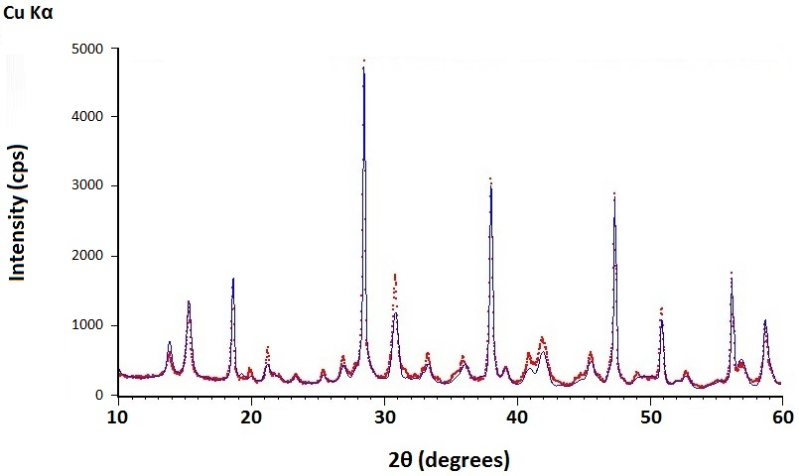
Figure a.3.1: Rietveld Refinement of product from Mg(OH)₂_RG mixed with 1 g H₂O and carbonated under supercritical CO₂ at 70 °C, P_{CO2} 90 bar, for 1 hour.
Figure a.3.2: XRD patterns of Mg(OH)₂_D3 and the respective reaction product from carbonation via CO₂ pressure swing over 2.5 hours at 32 °C.
Figure a.3.3: XRD patterns of Mg(OH)₂_D4 and the respective reaction product from carbonation via CO₂ pressure swing over 2.5 hours at 32 °C.

