Table of Contents (including figure legends):
Acknowledgments 7
Abstract 8
Chapter 1: General introduction 9
1.1 What are the Orchids? A historical overview 9
1.2 Functional classes of orchid 9
1.2.1 Epiphytic Orchids 9
1.2.2 Terrestrial orchids 11
1.3 Functional classes of mycorrhizal symbioses 11
1.4 Orchid mycorrhizas and the orchid lifecycle 12
Figure 1.1 Diagrammatic representation of the orchid lifecycle (Based information from Bidartondo and Read 2008; Smith and Read 2008 and Cameron et al. 2006). 14
1.4.1 Germination stages of orchids 15
Figure 1.2 Diagrammatic representation of the orchid germination showing five defined stages: 1 - imbibition; 2 - testa rupture; 3 - rhizoid development, usually proceeded by fungal colonisation (in epiphytic species with green protocorms, chlorophyll synthesis begins); 4 - initiation of the shoot meristem; 5 - development of first leaf (reproduced from Brandner (2005)). 15
1.5 Nitrogen and carbon relations in orchid mycorrhizal symbioses 16
1.6 Aims of the research 17
1.6.1 Overarching aim 17
1.6.2 Key questions and aims of Chapter 2 18
1.6.3 Key questions and aims of Chapter 3 19
1.6.4 Key questions and aims of Chapter 4 20
1.7 Study species of orchid 20
1.7.1 Goodyera repens (terrestrial) 20
1.7.2 Orchis mascula (terrestrial) 21
1.7.3 Dactylorhiza fuchsii (terrestrial) 21
1.7.4 Encyclia phoenicea (epiphytic) 21
Figure 1.3 Images of the terrestrial study orchid species a) Goodyera repens, b) Orchis mascula, c) Dactylorhiza fuchsii and the epiphyte d) Encyclia phoenicea. Licence information is given at the bottom of each image. 22
Chapter 2: The ecological importance of mycorrhizal fungi in overcoming light-induced inhibition of seed germination and early growth in terrestrial and epiphytic orchids. 23
2.1 Introduction 23
2.1.1 Aims and hypotheses: 24
2.2 Material and Methods. 25
2.2.1 Plant and fungal material 25
2.2.2 Testing seed viability 26
2.2.3 Experimental microcosms 26
2.2.4 Fungal growth rates 28
2.2.5 Data analysis 29
2.3 Results 29
2.4 Discussion 32
2.5 Tables 38
Table 2.1. Light, sugar and fungus treatments imposed on all species of orchid seed in in vitro culture on agar plates containing appropriate nutrients (species specific: all terrestrial species were grown on Rorison’s nutrient agar and the epiphyte on modified Knudsen’s C). 38
Table 2.2. Three-way ANOVA table comparing the growth of orchid mycorrhizal fungi in in vitro culture (without the associated orchid seedling) over 8 days in the light and dark. 39
2.6 Figures 40
Figure 2.1 Effect of light and carbon supply on the asymbiotic and symbiotic Goodyera repens (a), Dactylorhiza fuchsii (b), Orchis mascula (c) and Encyclia phoenicea (d) seedling volume. Error bars represent one standard error of treatment means. Within each graph, differences between mean volumes at 56 days were resolved using 2-way ANOVA followed by Tukey’s multiple comparison test; bars with differing letter are significantly different at P < 0.05 (Table 2). 40
Figure 2.2 Effect of light on the growth of the fungal symbiont without the orchid protocorm over an 8 day period. Error bars represent one standard error of treatment means. Differences between mean colony diameter at 2, 4, 6 and 8 days were resolved using 3-way ANOVA (Table 3). 41
Chapter 3: Allocation of carbon and nitrogen to juvenile orchids from three species (two terrestrial and one epiphytic species) in the light and dark 42
3.1 Introduction 42
3.2 Hypotheses 44
3.3 Materials and methods 44
3.4 Results 47
3.4.1 Biomass of juvenile orchid shoots 47
3.4.2 Mass and tissue ¹⁵N and ¹³C concentration and content of juvenile orchid shoots 48
3.4.3 Biomass and ¹⁵N and ¹³C content of juvenile orchid roots 52
3.4.4 Mass and tissue concentration and ¹⁵N and ¹³C content of juvenile orchid roots 53
3.4.5 Relationship between ¹⁵N and ¹³C content of juvenile orchid shoots and roots 54
3.4.6 Relationship between root and shoot ¹⁵N and ¹³C content of G. repens 55
3.4.7 Relationship between shoot ¹⁵N and ¹³C content and biomass 56
3.5 Discussion 57
3.5.1 Conclusions 61
3.6.1 Tables 62
Table 3.1 Table C and N sources ¹³C,¹⁵N, ¹²C and ¹⁴N quantities in the experiment. (NB: These values provide the same amount of nitrogen and carbon and ¹⁵N-labelled nitrogen and ¹³C-labelled carbon to each microcosm irrespective of the chemical form used). 62
Table 3.2 3-way ANOVA table for Shoot biomass of three orchid species 63
Table 3.3 3-way ANOVA table for Shoot mass of ¹³C of three orchid species 64
Table 3.4 3-way ANOVA table for Shoot concentration of ¹³C of three orchid species 65
Table 3.5 3-way ANOVA table for Shoot mass of ¹⁵N of three orchid species 66
Table 3.6 3-way ANOVA table for Shoot concentration of ¹⁵N of three orchid species 67
Table 3.7 3-way ANOVA table for Root biomass, ¹³C and ¹⁵N content of Goodyera repens 68
Table 3.8 continued: 3-way ANOVA table for Root biomass, ¹³C and ¹⁵N content of Goodyera repens 69
3.7 Figures 70
Figure 3.1 Photograph of the experimental set up: The first compartment contained labelled-unlabelled different sources of C and N incorporating with Rorison's nutrient. The seedlings were grown in the second and third compartment containing only plant agar. G. repens in the dark after one week. The same case in the light. 70
Figure 3.2. Goodyera repens shoot biomass of connected and disconnected from the isotopically labelled C and N sources when grown in the dark and in the light. Error bars represent one standard error of dry weight means. Within each graph, differences between mean dry weight were resolved using 3-way ANOVA followed by Tukey’s multiple comparison test; bars with differing letter are significantly different at P < 0.05 (Table 3.2). 71
Figure 3.3. The biomass of shoots of D. fuchsii plants connected with the isotopically labelled C and N sources via their fungal partners or disconnected in the dark and in the light. Error bars represent one standard error of dry weight means. Within each graph, differences between mean dry weight were resolved using 3-way ANOVA followed by Tukey’s multiple comparison test; bars with differing letter are significantly different at P < 0.05 (Table 3.2). 72
Figure 3.4. The biomass of Encyclia phoenicea shoots grown with different sources of ¹⁵N and ¹³C labelled inorganic and organic compounds or disconnected from the isotopically labelled C and N sources when grown in the light or in total darkness. Within each graph, differences between mean dry weight were resolved using 3-way ANOVA followed by Tukey’s multiple comparison test; bars with differing letter are significantly different at P < 0.05 (Table 3.2). 73
Figure 3.5. Mass of ¹³C in Goodyera repens shoots after adding different sources of ¹⁵N and ¹³C labelled inorganic and organic compounds or disconnected from the isotopically labelled C and N sources when grown in the dark and in the light. Within each graph, differences between mean dry weight were resolved using 3-way ANOVA followed by Tukey’s multiple comparison test; bars with differing letter are significantly different at P < 0.05 (Table 3.2). 74
Figure 3.6. Goodyera repens shoot ¹³C concentration of connected and disconnected from the isotopically labelled C and N sources when grown in the dark and in the light. Error bars represent one standard error of dry weight means. Within each graph, differences between mean dry weight were resolved using 3-way ANOVA followed by Tukey’s multiple comparison test; bars with differing letter are significantly different at P < 0.05 (Table 3.4). 75
Figure 3.7. The mass of ¹³C in shoots of Dactylorhiza fuchsii plants connected with the isotopically labelled C and N sources via their fungal partners or disconnected in the dark and in the light. Error bars represent one standard error of dry weight means. Within each graph, differences between mean dry weight were resolved using 3-way ANOVA followed by Tukey’s multiple comparison test; bars with differing letter are significantly different at P < 0.05 (Table 3.3). 76
Figure 3.8. The concentration of ¹³C in shoots of Dactylorhiza fuchsii plants connected with the isotopically labelled C and N sources via their fungal partners or disconnected in the dark and in the light. Error bars represent one standard error of dry weight means. Within each graph, differences between mean dry weight were resolved using 3-way ANOVA followed by Tukey’s multiple comparison test; bars with differing letter are significantly different at P < 0.05 (Table 3.4). 77
Figure 3.9. Mass of ¹³C in Encyclia Phoenicea shoots after connected and disconnected to ¹³C and ¹⁵N sources when grown in the dark and in the light. Error bars represent one standard error of dry weight means. Within each graph, differences between mean dry weight were resolved using 3-way ANOVA followed by Tukey’s multiple comparison test; bars with differing letter are significantly different at P < 0.05 (Table 3.3). 78
Figure 3.10. The concentration of ¹³C in Encyclia phoenicea shoots connected and disconnected from the isotopically labelled C and N sources when grown in the dark and in the light. Error bars represent one standard error of dry weight means. Within each graph, differences between mean dry weight were resolved using 3-way ANOVA followed by Tukey’s multiple comparison test; bars with differing letter are significantly different at P < 0.05 (Table 3.4). 79
Figure 3.11. The mass of ¹⁵N in shoots of Goodyera repens plants connected with the isotopically labelled C and N sources via their fungal partners or disconnected in the dark and in the light. Error bars represent one standard error of dry weight means. Within each graph, differences between mean dry weight were resolved using 3-way ANOVA followed by Tukey’s multiple comparison test; bars with differing letter are significantly different at P < 0.05 (Table 3.5). 80
Figure 3.12. The concentration of ¹⁵N in Goodyera repens shoots of connected and disconnected from the isotopically labelled C and N sources when grown in the dark and in the light. Error bars represent positive standard error of mass means. Within each graph, differences between mean concentration were resolved using 3-way ANOVA followed by Tukey’s multiple comparison test; bars with differing letter are significantly different at P < 0.05 (Table 3.6). 81
Figure 3.13. The mass of ¹⁵N in shoots of Dactylorhiza fuchsii plants connected with the isotopically labelled C and N sources via their fungal partners or disconnected in the dark and in the light. Error bars represent one standard error of dry weight means. Within each graph, differences between mean dry weight were resolved using 3-way ANOVA followed by Tukey’s multiple comparison test; bars with differing letter are significantly different at P < 0.05 (Table 3.5). 82
Figure 3.14. Dactylorhiza fuchsii shoot ¹⁵N concentration of connected and disconnected from the isotopically labelled C and N sources when grown in the dark and in the light. Error bars represent one standard error of dry weight means. Within each graph, differences between mean dry weight were resolved using 3-way ANOVA followed by Tukey’s multiple comparison test; bars with differing letter are significantly different at P < 0.05 (Table 3.6). 83
Figure 3.15. The mass of ¹⁵N in shoots of Encyclia phoenicea plants connected with the isotopically labelled C and N sources via their fungal partners or disconnected in the dark and in the light. Error bars represent one standard error of dry weight means. Within each graph, differences between mean dry weight were resolved using 3-way ANOVA followed by Tukey’s multiple comparison test; bars with differing letter are significantly different at P < 0.05 (Table 3.5). 84
Figure 3.16. Encyclia phoenicea shoot ¹⁵N concentration of connected and disconnected from the isotopically labelled C and N sources when grown in the dark and in the light. Error bars represent one standard error of dry weight means. Within each graph, differences between mean concentration were resolved using 3-way ANOVA followed by Tukey’s multiple comparison test; bars with differing letter are significantly different at P < 0.05 (Table 3.6). 85
Figure 3.17. Goodyera repens root biomass of connected and disconnected from the isotopically labelled C and N sources when grown in the dark and in the light. Error bars represent one standard error of dry weight means. Within each graph, differences between mean dry weight were resolved using 3-way ANOVA followed by Tukey’s multiple comparison test; bars with differing letter are significantly different at P < 0.05 (Table 3.7). 86
Figure 3.18. Goodyera repens root mass of connected and disconnected from the isotopically labelled C and N sources when grown in the dark and in the light. Error bars represent one standard error of dry weight means. Within each graph, differences between mean mass were resolved using 3-way ANOVA followed by Tukey’s multiple comparison test; bars with differing letter are significantly different at P < 0.05 (Table 3.7). 87
Figure 3.19. Goodyera repens root ¹³C concentration of connected and disconnected from the isotopically labelled C and N sources when grown in the dark and in the light. Error bars represent one standard error of dry weight means. Within each graph, differences between mean concentration were resolved using 3-way ANOVA followed by Tukey’s multiple comparison test; bars with differing letter are significantly different at P < 0.05 (Table 3.7). 88
Figure 3.20. Mass of ¹⁵N in Goodyera repens roots connected and disconnected from the isotopically labelled C and N sources when grown in the dark and in the light. Error bars represent one standard error of dry weight means. Within each graph, differences between mean mass were resolved using 3-way ANOVA followed by Tukey’s multiple comparison test; bars with differing letter are significantly different at P < 0.05 (Table 3.8). 89
Figure 3.21. Goodyera repens root ¹⁵N concentration of connected and disconnected from the isotopically labelled C and N sources when grown in the dark and in the light. Error bars represent one standard error of dry weight means. Within each graph, differences between mean concentration were resolved using 3-way ANOVA followed by Tukey’s multiple comparison test; bars with differing letter are significantly different at P < 0.05 (Table 3.8). 90
Figure 3.22 Regression line between total ¹³C and total ¹⁵N in the shoots and roots of Goodyera repens with C and N compounds in the dark. 91
Figure 3.23. Regression line between total ¹³C and total ¹⁵N in the shoots of Goodyera repens with C and N compounds in the light 92
Figure 3.24. Regression line between total ¹³C and total ¹⁵N in the shoots of Goodyera repens with C and N compounds in the dark and light 93
Figure 3.25. Regression line between total ¹³C and total ¹⁵N in the shoots of Encyclia phoenicea with C and N compounds in the dark. 94
Figure 3.26. Regression line between total ¹³C and total ¹⁵N in the shoots of Encyclia phoenicea with C and N compounds in the light 95
Figure 3.27. Regression line between total ¹³C and total ¹⁵N in the shoots of Encyclia phoenicea with C and N compounds in the dark and in the light. 96
Figure 3.28. Regression line between total ¹³C and total ¹⁵N in the shoots of Dactylorhiza fuchsii with C and N compounds in the dark. 97
Figure 3.29. Regression line between total ¹³C and total ¹⁵N in the shoots of Dactylorhiza fuchsii with C and N compounds in the light 98
Figure 3.30. Regression line between total ¹³C and total ¹⁵N in the shoots of Dactylorhiza fuchsii with C and N compounds in the dark and in the light. 99
Figure 3.31. Relationship between mass of ¹³C in plant tissues and biomass in three orchid species grown in the dark and the light. 100
Figure 3.32. Relationship between mass of ¹⁵N in plant tissues and biomass in three orchid species grown in the dark and the light. 101
Chapter 4: Allocation of carbon from green seedlings of three orchid species to their mycorrhizal fungal partners (two terrestrial and one epiphyte) 102
4.1 Introduction 102
4.2 Aim of study and hypothesis 103
4.3 Materials and methods 103
4.3.1 Data analysis 105
4.5 Results 106
4.6 Discussion 106
4.7 Table 109
Table 4.1 2-way ANOVA table for Shoot biomass of three orchid species 109
4.8 Figures 110
Figure 4.1 Compartmentalized 9-cm Petri-dish microcosm used to supply a radiolabelled (¹⁴C) to the orchid mycorrhizal mycelial network, the plant enclosed in a gas-tight labelling chamber, a, Perspex labelling chamber with neoprene seal; b, clamps to facilitate a gas-tight seal; c, Petri dish with lid and base sealed with sterile anhydrous lanolin; d, orchid plants; e, septum in the HC to allow for gas sampling; f, Subaseal to allow the introduction of ¹⁴C-labelled sodium bi-carbonate and for gas sampling of the labelling chamber. 110
Figure. 4.2 False-colour digital autoradiographs obtained after 24 h of exposure of the shoot to ¹⁴CO₂ in microcosms (a) E. phoenicea (b) D. fuchsii (c,d) G. repens shows ¹⁴C allocation through external mycorrhizal mycelium along with a diagram of the experimental set up (e). The colour scale indicates the number of counts detected in pixel areas of 0.25 mm² in a period of 60 min. 111
Figure. 4.3 The total amount of carbon over the labelling period movement from Goodyera repens, Dactylorhiza fuchsii and Encyclia phoenicea plants to their fungal partners. Error bars represent one standard error of dry weight means. Within each graph, differences between mean dry weight were resolved using 2-way ANOVA followed by Tukey’s multiple comparison test; bars with differing letter are significantly different at P < 0.05 (Table 4.1). 112
Chapter 5: General discussion 113
5.1 Why is the interaction between orchids, their fungi and light poorly understood? 113
5.2 Carbon sources for juvenile terrestrial orchids 114
5.3 Carbon sources for juvenile epiphytic orchids 115
5.4 Carbon and nitrogen metabolism in orchids and their mycorrhizas 116
5.5 Understanding the status of the symbiosis 118
5.5 Conclusions 119
6.1 References 121
7.1 Appendix 1 - Chapter 2 135
Supplementary table A1.1. Composition of Fungal Isolation Medium (FIM) (based on Clements et al. 1986) as in 1L of nutrient solution. 135
Supplementary table A1.2. Nutrient composition of 1/10 strength Rorison's mineral solution (based on Hewitt, 1966) as in 1L of nutrient solution. 135
Supplementary table A1.3. Knudson C modified orchid medium (based on Knudson, 1946) as in 1L of nutrient solution. 135
Supplementary figure A1.1: Histogram of residuals (A) and plot of fitted values against residuals (B) arising from a three-way repeated measures ANOVA of seedling volume responses of G. repens to mycorrhizal inoculum, exogenous carbohydrate and light over a time course demonstrating (A) normal distribution of the data and (B) homogeneity of variance. 136
Supplementary figure A1.2: Histogram of residuals (A) and plot of fitted values against residuals (B) arising from a three-way repeated measures ANOVA of seedling volume responses of D. fuchsii to mycorrhizal inoculum, exogenous carbohydrate and light over a time course demonstrating (A) normal distribution of the data and (B) homogeneity of variance. 137
Supplementary figure A1.3: Histogram of residuals (A) and plot of fitted values against residuals (B) arising from a three-way repeated measures ANOVA of seedling volume responses of O. mascula to mycorrhizal inoculum, exogenous carbohydrate and light over a time course demonstrating (A) normal distribution of the data and (B) homogeneity of variance. 138
Supplementary figure A1.4: Histogram of residuals (A) and plot of fitted values against residuals (B) arising from a three-way repeated measures ANOVA of seedling volume responses of E. phoenicea to mycorrhizal inoculum, exogenous carbohydrate and light over a time course demonstrating (A) normal distribution of the data and (B) homogeneity of variance. 139
7.2 Appendix 2 - Chapter 3 140
Supplementary figure A2.1: Petri dish with three compartments for measuring ¹³C and ¹⁵N enrichment of (A) Goodyera repens, (B) Dactylorhiza fuchsii and (C) Encyclia phoenicea juveniles their fungal partners access to isotope labelled ¹⁵N and ¹³C ammonium nitrate plus sugar in the first compartments. The plant agar in the second compartment barrier to avoid fungal partners access to isotope labelled compounds. 140
Supplementary table A2.1: Chemical composition of the commercially available (Sigma-Aldrich) ¹³C and ¹⁵N 99 atom %-labelled amino acid mixture. 141
Supplementary figure A2.2: Relationship between root and shoot ¹⁵N and ¹³C content 142

Acknowledgments
My study was financial by King Abdulaziz University, Jeddah, Saudi Arabia. I thank to my supervisors, Prof. Duncan Cameron and Prof, Jonathan Leake for their support.
Prof. Duncan Cameron encouraged me and has done so many things for me to reach my goals. I really appreciate his support, and that’s meant everything to me. Because of him I’m here submitting my PhD project.
Many thanks to technical assistance Irene Johnson, of her patience and help. She was my guide in the laboratory, and she was supportive when I got stressed, she was always there for me. Thanks again for being beside me for the whole period of my study.
Heather Walker, thank you for helping me to analyses the data with the stable isotope enrichment.
Thank you to Phil Seaton in Kew Gardens, London, UK, for supplying me with the seeds of Encyclia phoenicea.
Finally, many thanks to my family for encouraging me to achieve my aims and objectives. Also all members of lab C57.

Abstract
In the early life-stages, both epiphytic and terrestrial orchid seeds obtain carbon and nitrogen from mycorrhizal fungi for germination and seedling development. Epiphytic orchids are exposed to comparatively high light levels from an early stage of development and often produce green seeds therefore their responses to light and requirements for mycorrhiza-supplied C is likely to be different from terrestrial orchids. The effect of exogenous C, light and fungal partner on germination and establishment were studied in vitro for three terrestrial orchid and one epiphyte orchid. I found that terrestrial orchids require their fungal partner for development and that light inhibits this process. In epiphytic species, light only inhibited germination and early development in the absence of the mycorrhizal symbiont. The findings in this study shows for the first time the potential ecological importance of mycorrhizal fungi in overcoming light inhibition of seed germination and growth in both terrestrial and epiphytic orchid. I also investigate the impact of light, C and N budgets of terrestrial and epiphytes (using ¹³C and ¹⁵N tracers) and the amount of C and N the plant obtains from fungus to the adult orchid plants. The biomass and transfer of C and N from fungus to plant was increased upon exposure to light but only after germination had been already begun. The most cost benefit of mycorrhizal symbioses was examined as other studies have ignored C flow from plant to fungus. All three species gave C back to the fungus but in different quantities. Encyclia phoenicea provided significantly more C to its mycorrhizal fungi; twice the amount of G. repens and 2.4 times greater than D. fuchsii by mass. This confirms the mutualistic nature of G. repens-mycorrhiza interactions and reveals that this same trophic strategy operates in two additional orchid species for the first time.

Chapter 1: General introduction

1.1 What are the Orchids? A historical overview
The family Orchidaceae is the largest family of flowering plants with approximately 32,000 species in around 800 genera and an average of a hundred discoveries of new species are made each year (Arditti, 1992). As well as being specious, orchids are extremely successful in ecological terms, colonising the majority of terrestrial ecosystems, from temperate grasslands to tropical rain forests (Moore et al. 1980; Arditti and Ghani, 2000). This reflects the orchid family’s extraordinary success in dispersing and adaptation to a wide variety of habitats and environments, largely due to their minute, wind-dispersed dust like seeds. Two specialised groups have been recognised within family; the terrestrial species, which germinate underground in soil and represent around 25% of species, widely distributed in forest and grassland biomes, and the epiphytes, which use other plants for mechanical support growing on branches within their canopies, constituting at least 70% of all known orchid species (Ackerman, 1983) and are found mainly in tropical forests.

1.2 Functional classes of orchid

1.2.1 Epiphytic Orchids
Epiphytic orchids grow on trees and branches and they dependent on trees for support and represent approximately 75% of orchid species. They are not parasitic on the host and have roots sheathed in a sponge-like layer for water absorption, called the velamen. The epiphytic habit has lead to the evolution of a remarkable array of anatomical and physiological adaptations in orchids, including modified roots and photochemistry. There are two types of roots, roots that are attached to the host plant and have free roots that dangle in the air to absorb moisture. Epiphytic orchid roots are modified to enable plants to anchor to its host, absorb episodic pulses of water and nutrients using a velamen root sheath, a sponge-like material adapted to intercept canopy through-flow (Whitford, 1906) and in many cases, for the roots themselves to be green and photosynthetic. In extreme cases, some orchids, such as Harrisella porrecta, have abandoned leafy-shoot production altogether, and rely exclusively on their roots for photosynthesis (Benzing et al. 1983). The typical epiphyte shoots have thick leaves that permit water storage (Luttge, 1989), and many epiphyte species, for example Grammatophylum spreciosum and Bletia purpurea, engage in crassulacean acid metabolism (CAM) as adaptations to water limitation (Hietz et al.1999; Johnson et al. 2010; Khampa et al. 2010).
Epiphytic species have thicker leaves than other types of orchids that help the plant to store water. Many epiphytic orchids are found in tropical, they are dependent on rainfall for their nutrients and water, develop storage organs which serve as protection against drought such as Dendrobium aemulum Most epiphytic orchids have specific adaptations allowing them to acquire nutrients and water in the canopy (Luttge, 1989).
Ecologically, orchids are very important species; their relationship with mycorrhizas and their velamentous roots intercept canopy through flow of organic and inorganic nitrogen providing a key mechanisms recycling nitrogen in the low-nutrient canopy environment (Luttge, 1989). Moreover, orchids support the canopy ecosystem is some unexpected ways; for example by providing resources and refugia for insects such as ants (Krömer et al, 2007). Finally, orchids can be considered as indicators of ecosystem health. Indicator species usually can only live in specific conditions, unpolluted by nitrogen and acid rain for example, so they provide an indication the overall health or biodiversity of the ecosystem.

1.2.2 Terrestrial orchids
In contrast terrestrial orchids germinate and spend their early years below ground as protocorms before accruing sufficient C and nutrients to produce leaves. Most terrestrial orchids are green and photosynthetic but others have lost the ability to photosynthesise and/or produce chlorophyll and are so parasitic on their fungal partners over the course of their lifecycles (mycoheterotrophy) (Figure 1.1 [Page14]; Cameron et al. 2009)

1.3 Functional classes of mycorrhizal symbioses
Mycorrhizas are classically defined as the reciprocal exchange of plant C for fungal-aquired nutrients (N and P). Mycorrhizasare usually divided into seven functional types; arbuscular mycorrhiza, ectomycorrhiza, ericoid mycorrhiza, ectendomycorrhizas, arbutoid mycorrhizas, monotropoid mycorrhizas and orchid mycorrhizas. Among these, the arbuscular mycorrhiza, ectomycorrhizal, ericoid mycorrhiza are considered the most important (Read, 1991).
Ectomycorrhizas predominate in temperate and northern forests. Many species of ectomycorrhizal fungi can grow in laboratory, making them easier to study, although they often grow very slowly. The hyphae of ectomycorrhizal fungi do not penetrate cells in the root, the fact that these hyphae do not enter the cells but instead stay outside them forming a fungal sheath call the hartig net.
In contrast, the hyphae of endomycorrhizal fungi penetrate the cell wall, and although the hyphae do penetrate the cortical cell walls, they do not penetrate the cell membrane. The fungus penetrates the cortex root forming endophytic structures in each of the cells. In the case of arbuscular mycorrhizal fungi, which enter into plant without changes on the surface of root (Terashita and Kawakami, 1991), tree-like transfer structures, termed arbuscules are formed but the exact morphology of these is determined by the interaction between the plant species and fungal species concerned. In contrast to many ectomycorrhizal fungal species, arbuscular mycorrhizas cannot survive without the host plant, making it difficult to grow of arbuscular mycorrhizal fungi in the laboratory without a host. This is because arbuscular mycorrhizal fungi are obligate biotrophs meaning that they cannot obtain their carbon by decomposition. The majority species of the plants in the world are associated with arbuscular mycorrhizas (Allen, 1991; Masuhara, 1994).
Ericoid mycorrhiza are another class of endomycorrhizas formed between fungi and the roots of hosts from the order Ericales. Ericoid mycorrhizal fungi, are formed in general ascomycetes and hyphomycete fungi, and predominate in grow in heathland habitatis. Ericoid mycorrhiza penetrates the plant through root hairs (Harley and Smith, 1983; Schmidt and Stewart 1999; Read, 1996).

1.4 Orchid mycorrhizas and the orchid lifecycle
Orchids are critically reliant on the provision of carbon and nutrients for germination by symbiotic fungi called mycorrhiza (Leake, 1994). This reliance on resource provisioning by fungi is because orchids produce thousands of tiny seeds per capsule that contain no or limited energy reserves for germination and early growth in their vestigial endosperms (Arditti, 1979; Eriksson and Kainulainen, 2011; Fig. 1 [Page14]). Therefore, for most terrestrial orchid species, autotrophy occurs only after a expanded stage of heterotrophic growth (Leake and Cameron 2010; Phillips et al. 2011).
Orchid species are unable hydrolyse starch or cellulose and so cannot directly access carbon saprotrophically as has been historically suggested (Blamey et al. 2003). As a result, orchids are entirely dependent upon compatible fungal partners to supply the essential carbon and nutrients required for successful establishment and germination in nature (Leake, 1994; Fig. 1 [Page14]). Orchid plants are thus described as mycoheterotrophic for part or all of their lives. The initially mycoheterotrophic nutrition in orchid seedlings normally changes to autotrophy in adult green orchid (lifestage-dependent trophic switch; Fig. 1 [Page14]) and therefore any reliance on the association with fungi for carbon subsidies is reduced or lost (Cameron et al. 2008). Achlorophyllous orchid species remain completely parasitic upon their fungal partner for all of their life cycle; these are accordingly termed fully mycoheterotrophic (Arditti, 1992; Leake, 1994; 2004; Cameron et al. 2006).
At this stage there is not much known about critical roles played by the fungus mycorrhizal in the green orchids and the level of adoption on fungal partners to obtain nutrients. While transport of N (Cameron et al. 2006) and phosphorus (P) (Cameron et al. 2006; Alexander et al. 1984) has been shown from fungus to plant, this is limited to a few species, most notably, G. repens. Thus it is surprising that research of orchids is under represented in the literature when compared to that of the other important mycorrhizas. The role of mycorrhizal fungi in the nutrition of adult orchids is more fully resolved however, with recent advances suggesting that some green terrestrial orchids form a mutualistic association with their fungal partners, taking carbon in order to germinate only to repay the carbon debt once they are able to fix carbon through autotrophy as well as receiving nutrients from the fungus in the adult life stage (Cameron et al. 2006; 2008), although this trophic strategy has not been investigated in any epiphytic species at the physiological level.
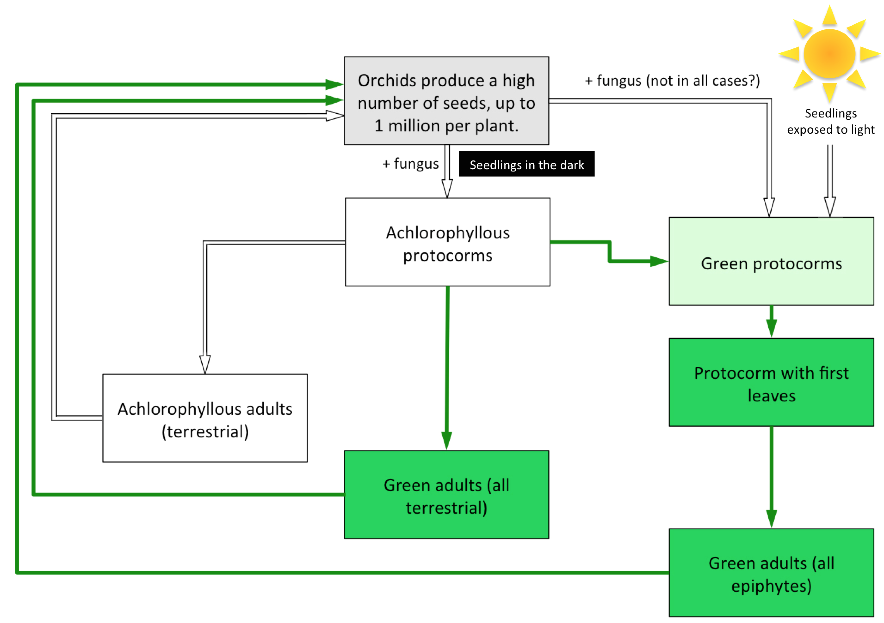

Figure 1.1 Diagrammatic representation of the orchid lifecycle (Based information from Bidartondo and Read 2008; Smith and Read 2008 and Cameron et al. 2006).

It is assumed that mycorrhizal fungi provide a carbon subsidy to support the germination and establishment of all orchid seeds in the early stage (Leake, 1994). The mycelium of the mycorrhizal fungus access external carbon sources and make them available to the orchid seeds. While the critical importance of mycorrhizas in orchid germination for terrestrial species is relativity well understood, the role of mycorrhizas in the germination of epiphytes orchids that germinates in the canopy that is exposed to light, and develops chlorophyll at a much earlier stage is largely ignored, despite this group representing the majority of orchid species (Leake and Cameron 2012). For example, it is still debated as to whether epiphytic orchids need fungi to germinate at all (Leake and Cameron 2012). Moreover, the role of environmental conditions such as light and carbon availability in regulating orchid germination is unresolved for both epiphytic and terrestrial orchid species.

1.4.1 Germination stages of orchids
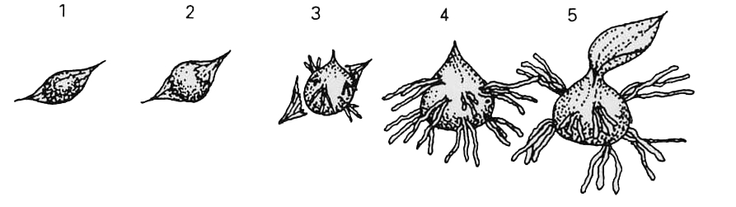

Figure 1.2 Diagrammatic representation of the orchid germination showing five defined stages: 1 - imbibition; 2 - testa rupture; 3 - rhizoid development, usually proceeded by fungal colonisation (in epiphytic species with green protocorms, chlorophyll synthesis begins); 4 - initiation of the shoot meristem; 5 - development of first leaf (reproduced from Brandner (2005)).

Orchid germination proceeds in 5 stages (Fig. 1.2 [Page15]), firstly dry seeds absorb water and the embryo imbibes (stage 1). Following this, cell division occurs and the embryo grows rupturing the testa, this usually occurs prior to fungal colonisation. In the absence of the fungus, germination arrests in most orchids at this stage (stage 2). Following fungal colonisation, the embryo continues to grow and differentiate, forming rhizoids (stage 3), this is followed by the differentiation of the apical (shoot) meristem (stage 4) and the development of the first fully formed leaf (stage 5) (Brandner 2005).

1.5 Nitrogen and carbon relations in orchid mycorrhizal symbioses
While the life histories of mycoheterotrophic plants are increasingly well defined, the underlying mechanisms that facilitate plant parasitism of fungi, in contrast, are poorly understood and the physiological pathways of fungus-to-plant C transfers have not been resolved. Using isotope tracers to map the flow of C and mineral nutrients between plant and fungus partners, it has been possible to investigate the functional basis of orchid-mycorrhiza associations in terms of bulk transfers of C and mineral nutrients (Kuga et al. 2014). For example, the green-leaved orchid Goodyera repens, which is mycoheterotrophic as a juvenile and photosynthetic as an adult (Cameron et al. 2006), is known to obtain C from its fungal symbionts in the juvenile life stage. As an adult, although some C continues to be transferred from fungus-to-plant, the net flow of C is from plant-to-fungus (Cameron et al. 2006; Cameron et al. 2008) in return for the provision of both nitrogen (N) (Cameron et al. 2006) and phosphorus (Cameron et al. 2007). Although this net polarity of C flow from adult plant to fungus has only been demonstrated for G. repens. While these approaches have been crucial to determine the trophic status of the symbiosis in a representative adult green orchid, they do not shed light on the fundamental mechanisms by which orchid seedlings are able to acquire C from their fungal symbionts.
Central to understanding the mechanisms of mycoheterotrophy is observation that it is the mode of parasitism in plants that has the largest number of independent evolutionary origins (Merckx and Freudenstein, 2010) and upon which the largest number of vascular plant species depend (Leake and Cameron, 2010; Merckx, 2013). The fact that mycoheterotrophy is so common leads to the prediction that its physiological basis involves exploitation of one or more essential metabolic pathways involved in core fungal biochemistry (Cameron and Bolin, 2010). This hypothesis is strongly supported by the discovery that the fungal sugar trehalose accumulates in colonised regions of orchid protocorms and so represents a potential candidate transport metabolite (Smith, 1967). In addition, recent studies reveal that N is accumulated in significant quantities in orchid protocorms, however this N enrichment is largely lost after the onset of autotrophy (Stockel et al. 2014). These data suggest that organic nitrogen could act as a potential transfer compound, with N accumulating as a result of the orchid utilising the C skeleton, of an amino acid for example, for heterotrophic growth and thus liberating inorganic N in the process. However, the physiology underpinning this requires substantiating.

1.6 Aims of the research

1.6.1 Overarching aim
The objective of this thesis is to understand and extend knowledge of the physiology and ecology on orchid seed germination and development in orchids. This study focuses on two different orchid kinds epiphytic or terrestrial orchids, three species of terrestrial orchid and one epiphytic species grown symbiotically under axenic conditions in the laboratory.
In chapter two, I investigate the interaction between the roles of light and the mycorrhiza in influencing the germination and development of orchid seedlings. I hypothesised that light would negatively influence germination and early development of the terrestrial species and enhance that of the epiphyte. In addition, I hypothesised that the fungal symbionts would be more beneficial to the germination and early growth of the terrestrial species when compared with the epiphyte.
In the chapter three, I investigate the mechanisms underpinning mycorrhizal effects on orchid seedling development determining the assimilation and transport of carbon (C) and nitrogen (N) from an amino acid compared with ammonium nitrate and sugar to the orchid plant. My study also attempts to determine a preference for organic compounds as sources of C and N over ammonium nitrate.
In the chapter four, I determine the flow of C back to the fungus by young orchids with green leaves using ¹⁴C to determine transfer of C from plant to fungus in the same orchid speices in association with their mycorrhizal fungi. This design complemnts previous results indicating the net polarity of C flow between the orchid Goodyera repens and its fungal partner to be from plant to fungus.

1.6.2 Key questions and aims of Chapter 2
In the early stages both epiphytic and terrestrial orchid seeds obtain C and N from associating with ubiquitous saprotrophic fungi. Many studies have focused on impact of C source (from a fungus or from exogenous carbohydrates such as sugars) on orchid germination but ignore the important interaction with light in regulating germination. The focus of this study is to understand the role of fungal partner on orchid seed germination and early establishment in orchids with terrestrial or epiphytic orchids in both the light and the dark. Specifically, I predicted that light will reduce the germination and growth of terrestrial orchid seedlings which spend their early life underground but will enhance the germination and growth of epiphytic species which are always exposed to light.

- Are Epiphytic Orchids less dependent on fungi for germination and establishment than terrestrial orchids?
- Do terrestrial and epiphytic orchids depend on the fungus for nutrients and / or carbon as adults?
- What is the role of light in seed germination?

1.6.3 Key questions and aims of Chapter 3
The purpose of the study is to extend our knowledge of mycorrhizal associations in terrestrial and epiphytic orchids and to understand the function of fungus in uptake and transfer of C and N into orchid species G. repens, D. fuchsii and E. phoenicea. The study aims to compare the assimilation of C and N into these three species (terrestrial and epiphytic) via their mycorrhizas and determine the amount of C and N obtained by these orchids from different external sources of C and N. A few studies have been published concerning the use of such organic and inorganic compounds by orchids species. In this study organic and inorganic compounds are used as sources of carbon and nitrogen under conditions of light and darkness. These experiments also focused on identifying the impact of light on concentrations of N and C in plant tissues as little is poorly understood.

- How much carbon does the plant get from the fungus?.
- In what form is carbon transported from the fungus to adult orchid plants?.
- How much N and C does the plant get from its fungal partner?
- Do both terrestrial and epiphytic adult orchids with receive carbon from their fungal partner in the form of amino acids?

1.6.4 Key questions and aims of Chapter 4
The assessment carbon (C) ‘cost’ of orchid mycorrhizas have been made but are dependent on indirect measurements or incomplete studies. In the current study I supply ¹⁴C and trace the flow between plant and fungus in an orchid mycorrhizal symbiosis. This design complemented previous findings the net polarity of C flew between the orchid and mycorrhizal symbiosis to be available for understand the parasitism and mutualism (Francis and Read, 1995; Smith and Smith, 1996). The measurement of the C cost ‘down flow-up flow’ is important for understanding mycorrhizal operation. The opposite direction of movement of ¹⁴C maybe means dynamic transfer for C flux.
- Are the plants autotrophic do they transfer C from plant to fungus? Resolving a carbon budget of terrestrial and epiphytic orchids (¹³C and ¹⁴C).
- How much carbon does the adult and juvenile plant get from the fungus?
- Do the orchid species studies support their fungi equally with C?
- Is it that epiphytes do not need their fungal partners as adults and thus do not support them with significant C?

1.7 Study species of orchid
In this study, I will use three species of UK terrestrial orchids and one species of tropical epiphytic orchid:

1.7.1 Goodyera repens (terrestrial)
Goodyera repens (L.) R. Br. (Fig. 1.3a [Page22]) is a perennial, evergreen species widely distributed throughout Europe (including Russia, China, Germany, Poland and the United Kingdom), Asia and North America (including Canada and the United States). While G. repens is locally abundant, it is considered to be a rare species. Goodyera repens typically inhabits bogs but is more commonly found in the understory of evergreen pine forests. Goodyera repens reproduces by seed, being pollenated by bumble bees, but may also reproduce vegetatively by means of long underground stolons (Fitter and Peat 1994). Goodyera repens has been shown to form mycorrhizal associations with the rhizoctonia fungus, Ceratobasidium cornigerum (basidiomycota) (Cameron et al. 2006).

1.7.2 Orchis mascula (terrestrial)
Orchis mascula L. (Fig. 1.3b [Page22]) is a perennial, herbaceous species widely distributed throughout (but limited) to Europe. Orchis mascula typically inhabits mesotrophic grasslands, open heath and can be found at the margins of deciduous woodlands (Fitter and Peat 1994).

1.7.3 Dactylorhiza fuchsii (terrestrial)
Dactylorhiza fuchsii (Druce) Soó (Fig. 1.3c [Page22]) is a perennial, herbaceous species widely distributed throughout (but limited) to Europe. Dactylorhiza fuchsii typically inhabits open habitats including mesotrophic grasslands, open heath and mires and can be found at the margins of deciduous woodlands (Fitter and Peat 1994).

1.7.4 Encyclia phoenicea (epiphytic)
Encyclia phoenicea (Lindl.) (Fig. 1.3d [Page22]) Neumann is a perennial tropical epiphytic species, growing on trees or shrubs, but can occasionally be lithophytic. Encyclia phoenicea is native to the Cayman Islands (specifically Cayman Brac and Little Cayman islands) and to Cuba (Roberts 2015).
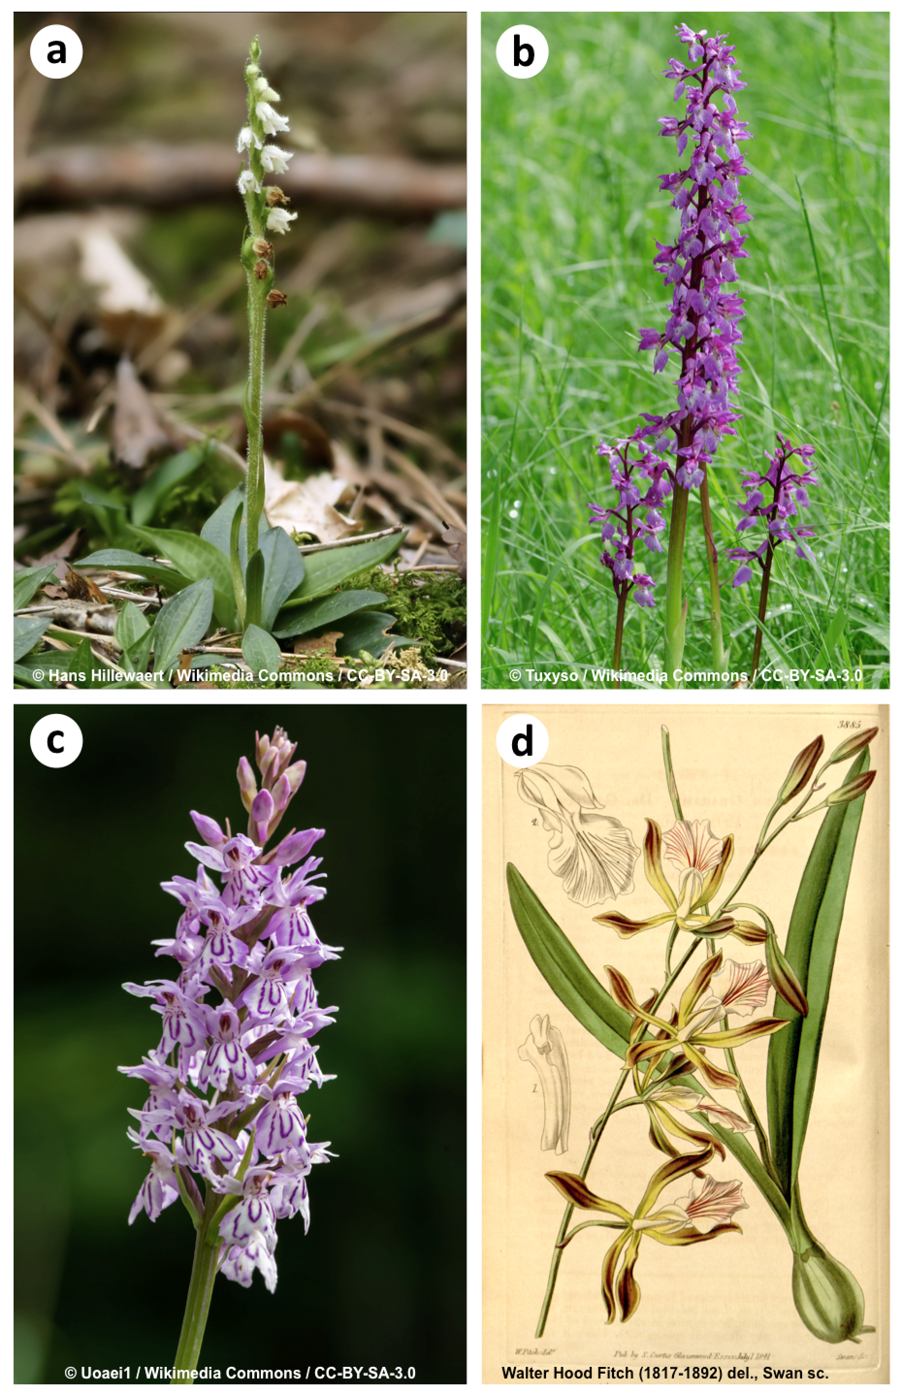

Figure 1.3 Images of the terrestrial study orchid species a) Goodyera repens, b) Orchis mascula, c) Dactylorhiza fuchsii and the epiphyte d) Encyclia phoenicea. Licence information is given at the bottom of each image.

Chapter 2: The ecological importance of mycorrhizal fungi in overcoming light-induced inhibition of seed germination and early growth in terrestrial and epiphytic orchids.

2.1 Introduction
In the early stages of their life cycle, all terrestrial orchids are non-photosynthetic, totally lacking chlorophyll and relying on carbon (C) acquired from a fungal symbiont for growth until the production of the first green leaves above ground, a nutritional strategy termed mycoheterotrophy (Leake 1994; Leake and Cameron 2010). This is underpinned by the prodigious production of thousands of tiny seeds per plant containing minimal C and nutrient reserves for germination and growth leaving them totally dependent on a mycorrhizal fungal partner for the provision of C and mineral nutrients (Arditti, 1979). After initiation of the symbiosis, each embryo develops into a protocorm, a specialised organ that defines the first stage of germination. In terrestrial orchids the protocorms are achlorophyllous but in epiphytic species, the portocorm rapidly becomes green upon exposure to light and is presumably photosynthetic (Leake and Cameron 2012). In in vitro culture, some orchid species can be grown asymbiotically when sugars, amino acids and vitamins are exogenously provided in culture media, however, it is assumed these are normally obtained from the fungal partners in nature (Read, 1991; Arditti and Ghani, 2000; Bayman et al. 2002). With the exception of 1% of species that remain fully mycoheterotrophic throughout their life cycle (Leake 1994), terrestrial orchids eventually emerge from the soil after months or even years, to synthesise chlorophyll and become photosynthetic. In the autotrophic adult phase of terrestrial orchids, mycorrhiza can be important in uptake of mineral nutrients such as phosphorus (P) and N (N) (Cameron et al. 2006; 2007; Alexander et al. 1984).
In contrast, the functional importance of mycorrhizal fungi throughout the life cycles of epiphytic orchids is less well known, and may be distinct from that in terrestrial species, especially during germination, since epiphytic orchids develop in the canopy and are thus exposed to relatively high light levels from an early stage of development (Leake and Cameron 2012). Recent studies of the fungal associates of over 150 tropical orchid species (Martos et al. 2012) have revealed a major ecological barrier between above- and belowground mycorrhizal fungal networks, with only about 10% of the fungal taxa partnering both epiphytic and terrestrial orchids, raising the hypothesis that there are important functional differences in mycorrhiza between the two kinds of orchid related to their distinct habitats (Leake and Cameron, 2012). Light intensity during seedling germination may play a role in this. The optimum light requirement growth varies between epiphytic as well as terrestrial orchid species (Heifetz et al. 2000). In some terrestrial orchid species such as Goodyera repens even low levels of light inhibit germination, whereas other species such as Dactylorhiza purpurella germination appears to be insensitive to light. Some studies have found that light can stimulate germination and early seedling establishment in the absence of exogenous C (Downie, 1941; Smith, 1973; Harvais, 1974).

2.1.1 Aims and hypotheses:
Despite these early investigations, there remains no comparative study that investigates the role of light, and exogenous C supply of the germination and early development of terrestrial and epiphytic orchids. In this study, we investigate effects of light, exogenous C and colonisation by mycorrhizal fungi on four orchids species studied in vitro for 56 days using the terrestrial orchids Goodyera repens, Dactylorhiza fuchsii and Orchis mascula and the epiphytic orchid Encyclia phoenicea. We hypothesised that: (a) germination rate and protocorm formation by all orchids would increase when germinated in the presence of a fungal symbiont or exogenous C (supplied as sucrose) and (b) light will significantly reduce the germination and growth of terrestrial orchid seeds but enhance the germination and growth of the epiphytic species.

2.2 Material and Methods.

2.2.1 Plant and fungal material
Three temperate terrestrial orchid species were selected, Goodyera repens, Orchis mascula and Dactylorhiza fuchsii. These species range in their habitat requirements from being exclusively being found in shaded forests to growing in a range of ecosystems from woods to scrub, fens and short grassland in full sun (Davies et al. 1995). The epiphytic orchid, Encyclia phoenicea, which grows throughout tropical areas of Mexico, Cuba and other islands in the Caribbean, typically on tree branches, close to sea level.
Seed capsules of G. repens were collected from beneath a stand of Pinus sylvestris at Tentsmuir Forest, Fife, UK, D. fuchsii capsules were collected from a grassland in the Rivelin Valley, Sheffield and O. mascula capsules were collected from a grassland at Lathkill Dale, Derbyshire, UK. Encyclia phoenicea, was supplied by Phil Seaton, Kew Gardens, London, UK. Cultures of mycorrhizal fungi for each terrestrial orchid species were obtained from intracellular hyphal pelotons isolated from surface-sterilized pieces of orchid root and transferred aseptically to Petri dishes containing non-nutrient agar (Plant agar; Duchefa, Haarlem, the Netherlands). Vegetative hyphae growing from these pelotons were sub-cultured onto Fungal Isolation Medium (supplementary table A1.1 [Page138]) to obtain pure cultures for long-term storage at a constant temperature of 18ºC (Clements et al. 1986). Prior to use in this experiment, new cultures were established on non-nutrient plant agar from these stock plates that were then used for the inoculation of the experimental microcosms.

2.2.2 Testing seed viability
Prior to the study, all seed were subjected to 2,3.5-trypheyltetrazolium chloride (Sigma-Aldrich UK, Gillingham) vital staining to investigate viability. The seeds were placed in five replicate small mesh bags and treated with 4% (w/v) calcium hypochlorite solution for 10 min to weaken the testa. The seeds were then put in sterile water for 24 h in darkness. They were then treated with 2% (w/v) tetrazolium, the pH of tetrazolium solution was adjusted to 7 and then left for 24 h in darkness. Seeds were examined under a microscope; seeds containing embryos with red staining were considered viable while unstained (white) embryos were considered non-viable (van Waes and Debergh, 1986). Seed from all four species were at least 50% viable (data not shown) and thus included in the study.

2.2.3 Experimental microcosms
One hundred and twenty plates were prepared for the terrestrial species. Due to a lack of seeds for E. phoenicea, half of the number of replicate plates with the same seed density as the other species were used. Plates were prepared using 9 cm diameter vented Petri dishes containing 50 ml of either Rorison’s nutrient agar (for terrestrial species, supplementary table A1.2 [Page138]) of Knudson’s C nutrient agar (for the epiphyte, supplementary table A1.3 [Page138]). Forty of these plates contained sucrose at a concentration of 1g L⁻¹, the remainder were supplied with no sugar (see table 1 [Page38]). All plates contained plant agar (Duchefa) at a concentration of 12g L⁻¹ and the pH of the media was adjusted to 5.5 prior to autoclaving for 45 mins at 121ºC.
Forty sucrose-free plates were inoculated in the centre with a 5-mm disc of the fungus from established colonies isolated from adult plants (described above). In the case of Encyclia phoenicea, fungi isolated from D. fuchsii adults was used as this yielded the best germination in preliminary trials and roots of adult orchids in the wild were not available. The remaining 40 plates contained only plant agar with nutrients (either Knudson’s C or Rorison’s). This gave three experimental treatments each with 40 replicates replicated for each of the four study species outlined in table 1. Approximately 200 seeds were then transferred onto each dish in a UV-sterilised laminar flow (Holten model-TL 2448). Prior to transfer, seeds were sterilised with 4% (w/v) calcium hypochlorite contained two drops of Tween 80 (Sigma-Aldrich UK) solution shaken continuously for 10 minutes in a rotary shaker. Seed suspensions were filtered with Whatman N⁰ 1 filter paper (GE Healthcare, UK) and rinsed with 100 ml of sterile distilled water. The plates were immediately sealed in Parafilm and incubated at a constant 18ºC with light provided at a photon flux density, 150 μmol m⁻² s⁻¹ with 85% relative humidity. Half of the plates for each treatment were wrapped in aluminium foil to exclude light with the remainder exposed to the light (see table 2.1 [Page38]for details). Ten embryos per dish randomly selected by superimposing a grid over the dish, generating random coordinates and selecting the closest seed to that coordinate location and the lid of the dish marked. The length and breadth of each selected seed was measured after 14, 28, 42 and 56 days under the light microscope (Nikon Dissecting Microscope coupled to a Leica fibre optic light source- CLS150). The volume of each embryo was calculated using equation 1.1 (Hadley and Williamson, 1971; Dutra et al. 2008; 2009).

Equation 1.1
Where v = volume (mm³), l= length (mm) and b= breadth at the widest point (mm) See figure 1 for definitions.
Mean seedling volume per individual plate was then calculated and used as the primary replicate variable in subsequent analyses to overcome pseudo replication. One plate containing D. fuchsii seeds was discarded from analysis after contamination by an additional fungus.

2.2.4 Fungal growth rates
Fungal isolates for all species described above were used to inoculate 9 cm diameter vented Petri dishes containing 50 ml of nutrient-free, water agar (N = 5). Dishes were either maintained in darkness (light excluded from dishes with aluminium foil) or in the light in growth cabinets (conditions as above). Dishes were viewed 2, 4, 6 and 8 days post inoculation and the diameter of the resulting colony recorded across two axes at right angles to one another. The average diameter per dish was then calculated.

2.2.5 Data analysis
Differences between treatment means of seedling volume were analysed by three-way repeated measures Analysis of Variance (ANOVA) (Minitab release 17) at P < 0.05. Tukey’s multiple comparison test was subsequently applied the 56 days data across all treatment-species combinations. Autocorrelation over time was considered in the ANOVA model introducing the factor 'time' as a random factor. ANOVA was performed using Log₁₀-transformed data as raw data failed to meet the ANOVA assumption of a centred Gaussian distribution. A histogram of residuals and a plot of fitted values to residuals as tests of normality and homogeneity of variance respectively of the transformed data are given in Appendix 1.1. Seedling volumes in all figures are presented as untransformed means. Differences between mean fungal colony diameter at 2, 4, 6 and 8 days were resolved using 3-way repeated measures ANOVA, again autocorrelation over time was considered in the ANOVA model introducing the factor 'time' as a random factor. Data for fungal colony diameter met the ANOVA assumptions of a centred Gaussian distribution and homogeneity of variance so were untransformed.

2.3 Results
In general, the germination responses of the orchids studied to fungal colonisation, sucrose and light are strongly species. Light suppressed the germination of all species studied in the absence of the fungal partner. However, the presence of fungus restored germination to differing extents in the four species studied; the greatest recovery was seen in E. phoenicea where germination in the presence of the fungus in the light was almost equal to those germinated with the fungus in the dark (Fig. 2.1 a [Page40]). Goodyera repens did not germinate in the light in the absence of the fungus, germination in the light in the presence of the fungal partner recovered to 50% of that observed in the dark with the fungus present (Fig. 2.1 b [Page40]). Some fungus-induced recovery of germination was seen in D. fuchsii while O. mascula never germinated in the light, even if the fungus was present (Fig. 2.1 c [Page40]and d [Page40]respectively).
The three factors, trophic status (aseptic plates, plates supplied with sucrose and plates inoculated with the fungus) as well as light and growth period significantly increased G. repens seed germination (d.f. =3, 477; F = 584.02; P<0.001). Seedlings of G. repens that were germinated with their mycorrhizal fungus experienced higher germination in the dark whereas those with sucrose only showed limited germination, even when cultured in darkness. The seeds cultured with fungus in the light gave lowest germination rate and did not develop significantly over the 56-day growth period (Fig. 2.1a [Page40]).
Almost all of the G. repens seeds that were in contact with the mycorrhizal fungus and cultured in darkness germinated within two weeks, whereas those that were supplied with sucrose in the dark did not begin germinating until three weeks after imbibition. Testa rupture occurred at 28 days, and by day 42, rhizoids were observed. On day 56, the apical meristem had developed in mycorrhizal plants in darkness, however no greening was evident based on a visual inspection of the seedlings. Germination and early development was limited when seeds were cultured in darkness without the mycorrhizal fungus. Growth of seedlings of this species was strongly inhibited by light in the absence of the fungal partner (Fig. 2.1a [Page40]).
Both light and C supply significantly affected the rate of germination of D. fuchsii (df = 3; 475 F = 124.80; P<0.001). With sucrose, D. fuchsii germination was stimulated after two weeks in the dark (Fig. 2.1b [Page40]), but the greatest growth was achieved by mycorrhizal plants by 56 days. Poorest growth occurred in the light in the absence of the fungus or sucrose (Fig. 2.1b [Page40]). D. fuchsii seeds were able to germinate under both light and dark conditions although their growth in the light was very slow. In contrast to G. repens, the fungus did not substantially enhance orchid germination in the light although growth of these plants was significantly greater then those grown without the fungus (Fig. 2.2 [Page41]).
c
a
b
b
There was no germination or growth of O. mascula in the light in any treatment (Fig. 2.1c [Page40]). In the dark, this species showed low rates of germination and growth across all treatments. O. mascula achieved its best growth in the dark with a fungal partner. Sucrose was unable to fully replace the benefits of symbiotic germination (d.f. = 3; 477 F = 44.06; P<0.001) (Fig. 2.1c [Page40]).
b
c
a
Light and fungus/C treatments had highly significant interaction effects germination of E. phoenicea germination (ANOVA: df = 3; 237 F =76.45; P<0.001) (Table 2.2 [Page39]). With fungus, seeds started to increase in size after 14 days and the testa ruptured by 28 days, irrespective of darkness or light treatment, although light exposure slightly reduced the rate of seedling development. In contrast, under asymbiotic conditions germination and seedling development was strongly inhibited by light, even in the presence of sucrose (Fig. 2.1d [Page40]). Seedling development was extremely limited when seeds were cultured in the light without a fungal or sugar source of C.
Exposure to light lead significantly reduced the radial growth rates of the fungal symbionts of G. repens and D. fuchsii over 8 days (Fig. 2.2 [Page41], Table 2.2 [Page39]). These fast growing fungi grew across the full area of the agar plates within 8 days, whereas the fungal symbiont from O. mascula grew much slower (Fig. 2.2 [Page41], Table 2.2 [Page39]).

2.4 Discussion
I examined the impact of different light and C sources on the of germination and early seedling development over a time course in three terrestrial orchid species Goodyera repens, Dactylorhiza fuchsii and Orchis mascula and one species of epiphytic orchid, Encyclia phoenicea. Based on these differential life histories, I hypothesised that terrestrial orchid germination would be greatest in the dark in the presence of fungi and lowest under irradiated conditions in the absence of mycorrhizal partners, as this situation is furthest from their natural growth conditions. To exclude the possibility that a lack of exogenous C availability would prevent germination in the absence of mycorrhizal fungi, I provided orchid seeds with sucrose under these conditions. Unsurprisingly, we found that the germination of G. repens (terrestrial orchid) seeds occurred in the presence of fungus when seeds were cultured in darkness, with the fungus also stimulating subsequent growth of G. repens seedlings. However, asymbiotic seed germination, even in the presence of exogenous carbohydrates was reduced, suggesting limited access of the plant to simple carbohydrates in the culture medium (Majerowicz and Kerbauy, 2002; Stewart and Kane 2010). Goodyera repens seeds did not germinate under irradiated conditions in the absence of the fungus. Even in association with its fungal symbiont, germination in the light was not only reduced in absolute terms, but delayed in initiation with symbiotic seeds cultured in darkness germinating within the first 14 days post-imbibition while symbiotic seeds cultured exposed to light did not germinate until 42 days post-imbibition. A similar pattern was observed for the terrestrial D. fuchsii, although seeds of this species were able to germinate under all conditions, the greatest germination and subsequent growth was achieved symbiotically in darkness with light and the absence of the fungal symbiont acting to dramatically reduce germination and growth. Again, O. mascula did not germinate in the light although the presence of its fungal symbiont enhanced germination and growth over those individuals supplied only with exogenous carbohydrate but did not mitigated suppression of germination by light.
In direct contrast, the epiphytic orchid, E. phoenicea, germinated readily in the dark, both with and without the fungal symbiont, although unsurprisingly, germination was enhanced in this asymbiotic state by the provision of sugar in the culture medium. While, in the light, germination was reduced to a quarter of the levels achieved in the dark when grown symbiotically, when grown with its fungal partner in the light, germination and subsequent growth was restored to levels comparable with those individuals grown in the dark (Johnson et al. 2007; 2011).
In nature, most orchids are critically reliant upon fungi for germination, establishment and early growth as they are lacking in sufficient seed reserves. However, the symbiotic status of terrestrial orchid mycorrhizal associations can be temporally dynamic within a single generation; for example, Cameron et al. (2006; 2007; 2008) showed that the green terrestrial orchid, G. repens, is supported by heterotrophic (parasitic) C and nutrient acquisition from its mycorrhizal partner at the protocorm stage, before switching to a mutualistic association underpinned by reciprocal exchange of plant C for fungal nutrients (both N and P). This relationship, while a key feature of soil-dwelling terrestrial orchid species that produce achlorophylous seedlings (termed protocorms), is poorly understood in epiphytic species with photosynthetic protocorms (Leake and Cameron 2010). In spite of the paucity of data, it seems logical that in the epiphytic habitat, mycorrhizas may be less important for germination and development of orchids as they are exposed to light in the canopy at an early stage and produce green, and presumably photosynthetic, protocorms. In contrast to this view, recent evidence showing intensive fungal colonisation in epiphytic species growing in the aerial environment (Martos et al. 2012) has led to the suggestion that the mycorrhizal symbiosis may be more important in the epiphytic environment than has been previously acknowledged (Leake and Cameron 2012). A hypothesis supported by our results.
In order to understand the dynamics of this complex relationship, a number of studies have focused on in vitro asymbiotic and symbiotic germination of orchids (Dutra et al. 2009; 2008; Arditti 1979; Downie 1941) but they ignore the important interaction between light and C supply in the regulation of orchid seed germination; whether germination is influenced by diurnal cycles of irradiance in epiphytic, or indeed terrestrial species is poorly understood in relation to mycorrhizal colonisation. Given the vital role of fungi in orchid establishment and the potential for environmental modulation of orchid germination, there is an urgent need to ascertain whether the relationship between the fungal symbiont and the plant is essential for germination and growth in the earliest stages of epiphytic orchid development. Indeed, orchid conservation efforts are dependent on such data for ex-situ conservation and reintroduction projects (Ramsay and Stewart 1998).
The underpinning mechanisms for this sensitivity of orchids to light remain unclear (Andrews, 1997; Baskin and Baskin 1998). Inhibition via light signalling, possibly mediated by phytochromes or other photoreceptors known to play a role in the regulation of seed germination (Stewart and Kane 2010) could represent candidate mechanism as they are able to regulate plant responses to red and far-red light, and are moderated during seedling emergence (Bae and Choi, 2008; Sharrock, 2008). This is further supported by the observation that the phytochrome spectrophotometric signal rapidly increases through seed imbibition as a result of rehydration of inactive phytochrome (Kendnck and Spruit, 1977). In the case of the terrestrial orchids G. repens and D. fuchsii, the presence of the fungus partially mitigated the negative effects of light with germination and early growth greater in mycorrhizal individuals exposed to light compared to either the sucrose or no carbohydrate treatments exposed to light. In both cases however, germination and early growth was not restored to the levels attained when plants were cultured in darkness. Orchis mascula plants however, did not germinate under irradiated conditions. These observations are likely underpinned by a range of factors, including direct modulation of plant metabolism through bilateral signalling between symbiotic partners, potentially influencing phytochrome sensitivity, or by the enhanced nutrition of symbiotic individuals compared with asymbiotic co-specifics grown in the light facilitating enhanced photosynthetic activity via increased synthesis of photochemical pigments and proteins such as Rubisco (Fukai et al. 1997). The latter explanation is particularly applicable to the epiphytic E. phoenicea, which forms green protocorms and so presumably initiates photosynthesis at a much earlier growth stage.
An allied hypothesis to explain reduced orchid germination under irradiated conditions lies with the basal physiology of the fungal symbiont. We hypothesised that growth of the heterotrophic fungal isolates would be reduced when exposed to light and concurrent with our hypothesis, fungal growth was reduced when cultured under diurnal irradiation in all cases, most dramatically in fungi isolated from O. mascula. This reduced fungal growth rate, and presumably impaired physiology, is one of the likely drivers of reduced germination of orchid seeds and growth of symbiotic seedlings in the light. Furthermore, this provides an additional insight into the extreme suppression of O. mascula germination and early growth when exposed to light. Given that the fungi we have studied varied in the magnitude of their responses to light exposure, the role of multiple fungal species simultaneously co-infecting both terrestrial and epiphytic species (Leake and Cameron 2012) potentially buffering orchid responses to a dynamic light environment certainly warrants further investigation.
In conclusion, it is clear that the terrestrial orchid seeds need to establish a relationship with an appropriate fungal symbiont(s) to facilitate germination and support the earliest stages of growth in order to obtain the necessary C to reach maturity, at which point they become autotrophic. It is then surprising that the germination responses of the terrestrial orchids to light differed so significantly between the three terrestrial species studied. My data provide no direct explanation for this variability. However the ecology of the species may provide some further insight (see chapter 1, section 1.4.1). Orchis mascula, inhabits mesotrophic grasslands and is one of the earliest emerging species. In this habitat, seeds may be exposed to light prior to burial thus light inhibition of germination is a logical ecological strategy to ensure seedling survival. In contrast, D. fuchsii and G. repens are more commonly found in closed habitats; late-stage grasslands and evergreen forest understories respectively, and so their seeds, once on the soil surface, will be exposed to very low light levels negating the need for germination suppression by light. Encyclia phoenicea however, is an epiphyte and is likely to be constantly exposed to light, indeed this species forms green and presumably photosynthetic protocorms prior to initiation of the shoot meristem. Here the role of light inhibition of germination and its reversal by mycorrhization is less clear. However, if the mycorrhizal fungus is capable of delivering substantial N and P to the developing orchid, mycorrhizal alleviation of nutrient limitation and the subsequent facilitation of the synthesis of photosynthetic pigments may provide a possible explanation. In any case, the ecological implications of my work warrant further study.

2.5 Tables

Table 2.1. Light, sugar and fungus treatments imposed on all species of orchid seed in in vitro culture on agar plates containing appropriate nutrients (species specific: all terrestrial species were grown on Rorison’s nutrient agar and the epiphyte on modified Knudsen’s C).
Day length (h) | Light  (mmol m⁻² s⁻¹) | Sugar  (g L⁻¹) | Fungus | Replicate plates
0 | None | None | None | 20
0 | None | None | Present | 20
0 | None | 1 | None | 20
16 | 150 | None | None | 20
16 | 150 | None | Present | 20
16 | 150 | 1 | None | 20

Table 2.2. Three-way ANOVA table comparing the growth of orchid mycorrhizal fungi in in vitro culture (without the associated orchid seedling) over 8 days in the light and dark.
Source | d.f | F | P
Fungal Species | 2 | 3051 | <0.001
Light | 1 | 675.3 | <0.001
Time | 3 | 1502 | <0.001
Species*Light | 2 | 144.8 | <0.001
Species*Time | 6 | 363.0 | <0.001
Light*Time | 3 | 106.4 | <0.001
Species*Light*Time | 6 | 26.26 | <0.001
Total | 119

2.6 Figures

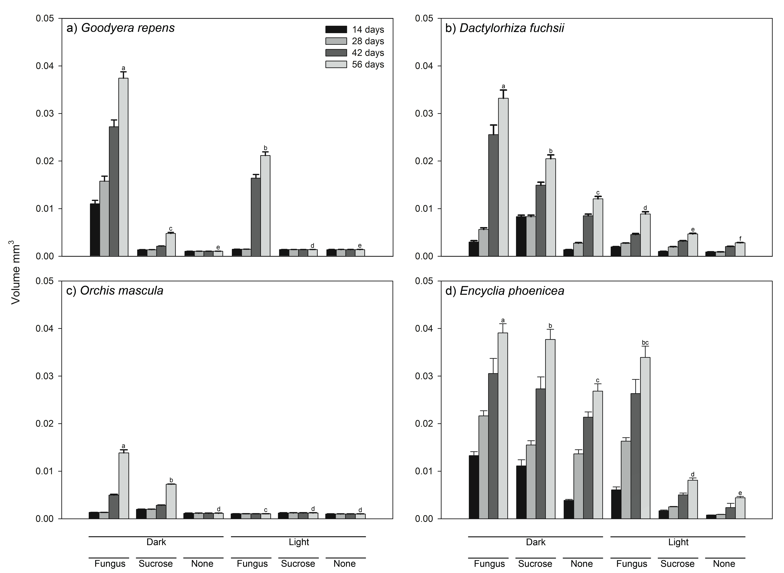

Figure 2.1 Effect of light and carbon supply on the asymbiotic and symbiotic Goodyera repens (a), Dactylorhiza fuchsii (b), Orchis mascula (c) and Encyclia phoenicea (d) seedling volume. Error bars represent one standard error of treatment means. Within each graph, differences between mean volumes at 56 days were resolved using 2-way ANOVA followed by Tukey’s multiple comparison test; bars with differing letter are significantly different at P < 0.05 (Table 2).

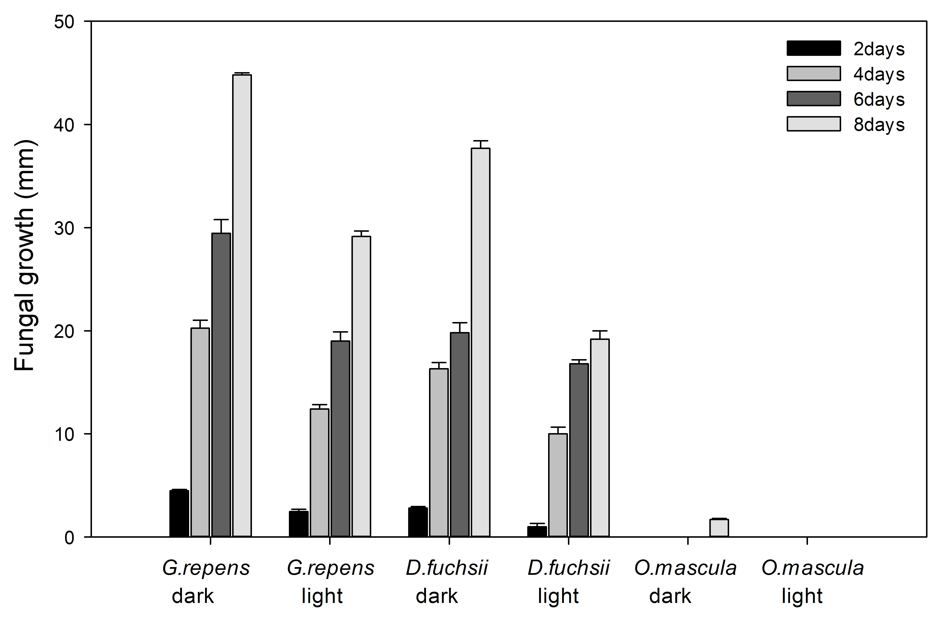
e
c
d
b
a

Figure 2.2 Effect of light on the growth of the fungal symbiont without the orchid protocorm over an 8 day period. Error bars represent one standard error of treatment means. Differences between mean colony diameter at 2, 4, 6 and 8 days were resolved using 3-way ANOVA (Table 3).

Chapter 3: Allocation of carbon and nitrogen to juvenile orchids from three species (two terrestrial and one epiphytic species) in the light and dark

3.1 Introduction
Orchid seeds consist only of undifferentiated tissues with no endosperm or cotyledon. An individual orchid plant produces millions of these tiny seeds with limited reserves of necessary nutrients and carbon (C). This leaves the orchid dependent on mycorrhizal fungi for the provision of C and mineral nutrients sources necessary for germination and growth to the protocorm (seedling) life stage (Rasmussen, 1995; Dixon et al. 2003; Arditti and Ghani, 2000). Once the orchid has accrued sufficient resources from the fungus, it will produce green shoots and may develop a mutualistic symbiosis with its fungal symbiont, returning C invest in the earliest life stages (Cameron et al. 2006; 2008). In addition to these initially mycoheterotrophic plants, fully mycoheterotrophic orchid species depend on their mycorrhizal partner for their C supply throughout their lives (Leake, 1994; Smith and Read, 1997; Merckx and Freudenstein, 2010).
In Chapter two I investigated orchid responses to light and their requirements for exogenous C heterotrophically or via mycorrhizal fungi for three terrestrial orchid species and one tropical epiphyte in vitro during germination and establishment. Chapter two revealed that the terrestrial species are generally more dependent on their mycorrhizal fungi for early growth than the epiphyte; moreover exogenous sucrose was not an equivalent replacement for the mycorrhizal partner in terms of orchid growth and development. The presence of both mycorrhizal and exogenous sucrose in the dark increased the growth of epiphytic species. Exposure to light inhibited growth, whereas mycorrhiza encouraged growth, even in the light for Encyclia phoenicea. However, for Orchis mascula, growth rates achieved in the dark were never reached in the light, even in the presence of the mycorrhizal fungus.
A number of studies have estimated that 10% of all plant species are mycoheterotrophic at some point in their life depending on fungi for C at a range of stages throughout their life cycle (Leake and Cameron, 2010). Despite the prevalence of this trophic strategy, many questions remain regarding the fundamental biology of the symbiosis; for example, the metabolic basis of mycoheterotrophy is still unknown, and little is known of dependence on fungal partners to obtain nutrients in the adult stage. Some insights however, have been gained through the measurement natural abundance isotopic enrichments revealing that mycoheterotrophic plants, such as orchids, have high enrichment of tissues in ¹³C and ¹⁵N and also elevated tissue concentrations of tissue nitrogen (N) suggesting that C and N are co-transported from fungus-to-plant (Arditti, 1992; Leake, 1994; 2004; Cameron et al. 2006,2008; Gebauer and Meyer, 2003; Cameron and Bolin, 2010). However, the effects of light and thus the onset of photosynthesis on mycorrhizal transport of C and N to the host plant are unknown. Understanding the mechanistic basis for the differences in orchid seedling growth induced by irradiance in terrestrial and epiphytic species (demonstrated in Chapter 2) was the focus of chapter 3. Here, I investigated the prediction that the transport of C and nutrients from-fungus-to-plant was influenced by irradiance using agar-based microcosms coupled to ¹⁵N and ¹³C isotope tracers to resolve the dynamics of C and N transport from fungus-to-plant.

3.2 Hypotheses
The fungal mycelia of the orchid can acquire considerable amounts of C and N from an amino acid and N ammonium nitrate and the fungus facilitates transport of these elements to the plant. ¹³C and ¹⁵N enrichment of plant tissue cultures can be enhanced by small amounts of organic nutrients. The measurements of the assimilation and transport of amino acids as organic sources of C and N or ammonium nitrate as inorganic sources of N with or without sources of C by fungal mycelia and accumulation in orchid plant tissues will indicate a preference for organic compounds as sources of C and N over ammonium nitrate. Mycorrhizal fungi will differ in uptake and transfer of C to terrestrial and epiphytic orchids with light having a significant effect on C accumulation from the fungus in both groups.

3.3 Materials and methods
Two terrestrial orchid species were selected, Goodyera repens and Dactylorhiza fuchsii and one epiphytic orchid, Encyclia phoenicea. After two months of germination, the terrestrial orchid as described in chapter two, one hundred and twenty seeds with their mycorrhizal fungi were selected for transfer to new petri dishes five seeds for each petri dishes in a UV-sterilised laminar flow (Holten model-TL 2448) on the media which contained plant agar (Duchefa) at a concentration of 12g L⁻¹ and quarter strength Rorison's nutrient solutions and the same number of epiphytic orchid seeds were grown on media which contained plant agar (Duchefa) at a concentration of 12g L⁻¹ with added Knudson’s C nutrient agar. The pH of the media was adjusted to 5.5 prior to autoclaving for 45 minutes at 121ºC. Protocorms were left to grow for four months with their fungal partners, in the dark or in the light. Sixty plates were prepared for each of the three species in 9cm diameter three compartment Petri dishes (Figure 3.1 [Page70] and see supplementary Figure A2.1 [Page143] in the appendix). The first compartment contained 12g L⁻¹ plant agar incorporating a quarter-strength Rorison's nutrient solutions with C and N sources supplied as double stable isotopes labelled ¹³C and ¹⁵N amino acid mixture (99 atom % enriched in ¹³C and ¹⁵N, see supplementary table A2.1 [Page] for the chemical composition of the mixture), which acted as organic source or stable isotope labelled N ¹⁵N ammonium nitrate (99 atom % enriched in ¹⁵N), integrated with labelled ¹³C glucose (99 atom % enriched in ¹³C), at a concentration of 1g L⁻¹ or without glucose were provided for estimating ¹³C and ¹⁵N enrichment in vitro. All labelled microcosms contained the same amount of N and ¹⁵N (and of C and ¹³C where added), irrespective of the chemical form in which the isotopes were supplied (see table 3.1 for the amounts of C and N added). In the other thirty petri dishes C and N were supplied as unlabelled ¹²C and ¹⁴N amino acids mixture or ¹⁴N ammonium nitrate with added ¹²C glucose or no glucose. The solutions of ammonium nitrate were sterilized in the agar in an autoclave, while the amino acids mixture was filtered sterilized using a 0.2 µm pore membrane (Nalgene, syringe filter, modified acrylic housing) and were then added to autoclaved agar. The pH of the media was adjusted to 5.5 prior to autoclaving for 45 minutes at 121ºC.
All seedlings were approximately the same size to provide uniform material for the study. The seedlings were grown in the compartment containing only plant agar (Duchefa) at a concentration of 12g L⁻¹ with access to C and N compounds in the second compartment. The third compartment contained plant agar which was cut off two sides to provide a hydrophobic barrier to prevent passive diffusion of nutrients from the second compartment that contained C and N sources into the part of dish containing the plant or prevent access the hyphae of fungi to the nutrients compartment as a basis for comparison (Table 3.1).
The plates were immediately wrapped in Parafilm to avoid contamination. Thirty petri dishes were covered by aluminium foil and incubated in the dark in polyethylene bags and then protected in a controlled growth chamber at 18 ºC for two months during which time an extensive hyphal network extended to colonize the Petri dish. The remainder were exposed to the light in a controlled chamber provided at a photon flux density, 150 μmol m⁻² s⁻¹ with 85% relative humidity until harvesting after two months. There were five replicate plates for each treatment. G. repens was cut at the root-shoot junction. For D. fuchsii and E. phoenicea the whole plant was measured. After measuring the fresh weight of each individually plant, the samples were put in 1.5ml eppendorf tubes, which were immediately placed in a freezer for two days. The lid of each tube was later quickly opened, covered with parafilm, and holes punctured in this before lyophilisation for approximately five days. The dry weight of all samples were measured and the samples placed into tin cups. The element isotope ratios were analysed in orchid plant tissues by isotope ratio mass spectrometry (IRMS). Three technical replicates for each biological replicates and every 50 samples and poplar leaf standard of know ¹³C and ¹⁵N content was analysed as a control for machine drift. All values were subsequently corrected for any drift detected. Enrichment was recorded as atom % to 4 decimal places.

Differences between mean biomass and isotope enrichment as a function of Connection to the label, labeled substrate type or irradiance (Light or Dark) were resolved using 3-way ANOVA. Data met the ANOVA assumptions of a centred Gaussian distribution and homogeneity of variance so were untransformed.

3.4 Results

3.4.1 Biomass of juvenile orchid shoots
The biomass of shoots of G. repens plants disconnected from the isotopically labelled C and N sources was significantly lower than those with their connections intact when grown in the light however there was no significant difference between G. repens shoot biomass of connected and disconnected from the isotopically labelled C and N sources when grown in the dark (Figure 3.2 [Page 71], Table 3.2 [Page 63]). The type of N source (ammonium or amino acids) and supply of carbohydrate (glucose) did not significantly affect shoot biomass of G. repens when grown either in the light or dark.
The biomass of shoots of D. fuchsii plants connected with the isotopically labelled C and N sources via their fungal partners was significantly different from those disconnected from the labelled sources (Figure 3.3 [Page 72], Table 3.2 [Page 63]). When connected to the labelled N and C sources, D. fuchsii plants grown in the light achieved a significantly higher biomass than those grown in the dark while there was no significant difference in the biomass of D. fuchsii shoots in the light compared to the dark when disconnected from the labelled C and N sources (Figure 3.3 [Page 72], Table 3.2 [Page 63]). The C and N sources (ammonium, amino acids and carbohydrate) did not significantly affect D. fuchsii shoot biomass apart from the amino acid treatment grown in the dark where shoot biomass was significantly greater than plants grown with ammonium or ammonium and glucose (Figure 3.3 [Page 72], Table 3.2 [Page 63]).
The biomass of E. phoenicea shoots grown with different sources of ¹⁵N and ¹³C labelled inorganic and organic compounds was significantly affected by the light environment with the ammonium, ammonium + sugar and the amino acid treated plants being 226%, 141% and 253% bigger respectively in the light when compared with the dark (Figure 3.4 [Page 73], Table 3.2 [Page 63]). This result was different from two terrestrial species. There were significant differences between biomass in the shoots of E phoenicea grown with amino acids in the light and with highest biomass, it was significantly high than in the dark, (Figure 3.4 [Page 73], Table 3.2 [Page 63]). There was no significant difference in biomass in E. phoenicea shoots in the dark. Generally the biomass of E. phoenicea shoots was higher in the light than in the dark with shoots plants supplied with access to ammonium nitrate compounds, (Figure 3.4 [Page 73], Table 3.2 [Page 63]).

3.4.2 Mass and tissue ¹⁵N and ¹³C concentration and content of juvenile orchid shoots
Unsurprisingly, juvenile G. repens shoots did not assimilate significant amounts (in terms of either mass or tissue concentration) of ¹³C when disconnected from the labelled source and little ¹³C enrichment was seen plants supplied only with ¹⁵N-labelled ammonium either in the light or the dark (Figure 3.5 [Page 74], Table 3.3 [Page 64]). The total ¹³C delivered to the shoots with fungal partners accessing amino acids was 33.17ug, greater than ammonium nitrate plus glucose treatment which only transferred 26.88 ug in the light, although this difference was not significant (Figure 3.5 [Page 74], Table 3.3 [Page 64]). There was a significantly greater mass of ¹³C detected in G. repens shoots of plants supplied with ¹³C-labelled amino acids in the light compared with those grown in darkness. However, this was not recorded for plants supplied with ¹³C-labelled glucose and ammonium nitrate (Figure 3.5 [Page 74], Table 3.3 [Page 64]).
The concentration of the isotopes in shoot tissues revealed a different relationship, with no significant difference in the %¹³C content of shoots irrespective of whether plants were grown in the light or dark or supplied with ammonium nitrate and ¹³C-labelled glucose or amino acids (Figure 3.6 [Page 75], Table 3.4 [Page 65]).
The juvenile D. fuchsii shoots did not assimilate significant amounts of ¹³C when disconnected from the labelled source. The total ¹³C delivered to the shoots with fungal partners accessing amino acids was 16.66 ug in the light, significantly greater than in the dark which only transferred 15.26 ug (Figure 3.10 [Page 79], Table 3.3 [Page 64]). There was a significantly greater mass of ¹³C detected in D. fuchsii shoots of plants supplied with ¹³C-labelled amino acids compared with those supplied with ammonium nitrate plus sugar 12.76 ug grown in light (Figure 3.10 [Page 76], Table 3.3 [Page 64]).
The concentration of the isotopes in shoot tissues of D. fuchsii had significant difference in the %¹³C content of shoots (Figure 3.8 [Page 77], Table 3.4 [Page 65]). Generally the total ¹³C content of D. fuchsii shoots was higher in the dark than in the light with amino acids. Moreover, D. fuchsii plants supplied with glucose assimilate significantly more ¹³C from the labelled ammonium nitrate than plants without glucose.
The total of shoots of E. phoenicea plants connected to the isotopically labelled C and N sources was significantly higher in ¹³C enrichment than those with disconnection (Figure 3.9[Page 78], Table 3.3 [Page 64]). In addition, plants grown in the light achieved significantly higher mass than those grown in the dark with amino acids and ammonium nitrate plus sugar organic and inorganic compounds (Figure 3.9[Page 78], Table 3.3 [Page 64]). The same result with E. phoenicea shoots did not assimilate significant amounts (in terms of either mass or tissue concentration) of ¹³C when disconnected from the labelled source. The total ¹³C founded in the shoots with fungal partners accessing ammonium nitrate plus glucose was 26.21ug, significantly greater than amino acids treatment, which only transferred 20.32 ug in the light (Figure 3.9[Page 78], Table 3.3 [Page 64]).
The concentration of the isotopes in E. phoenicea shoot tissues had a significant difference in the %¹³C content of shoots (Figure 3.10 [Page 79], Table 3.4 [Page 65]). The concentration ¹³C content of E. phoenicea shoots was lower in the light than in the dark with shoots plants supplied with access to C compounds (Figure 3.10 [Page 79], Table 3.4 [Page 65]). The concentration ¹³C content of E. phoenicea shoots was highest with amino acids in the dark. Moreover, E. phoenicea plants supplied with glucose assimilate significantly more ¹³C from the labelled ammonium nitrate than plants without glucose (Figure 3.10 [Page 79], Table 3.4 [Page 65]).
The total ¹⁵N found in the shoots of G. repens was not significantly affected by the N sources (Figure 3.11 [Page 80], Table 3.5 [Page 66]), and there was no significant interaction between N source and light on total 15N in the shoots (Figure 3.11 [Page 80], Table 3.5 [Page 66]). Generally the total ¹⁵N content of G. repens shoots was higher in the light than in the dark with plants supplied with a N compounds, but only significantly so in plants supplied with ¹⁵N-labelled amino acids (Figure 3.14 [Page 83], Table 3.5 [Page 66]). Moreover, G. repens plants supplied with glucose did not assimilate significantly more ¹⁵N from the labelled ammonium nitrate than plants without glucose (Figure 3.11 [Page 80], Table 3.5 [Page 66]).
Again, this trend was not mirrored in the concentration of ¹⁵N in shoots of G. repens. Plants grown in the light assimilated significantly more of the ¹⁵N from the ammonium nitrate and amino acids compared with G. repens plants grown in the dark but there was no significant increase in ¹⁵N assimilation in plants supplied with glucose and ammonium nitrate (Figure 3.12 [Page 81], Table 3.6 [Page 67]).
The mass of ¹⁵N in shoots of D. fuchsii grown in the light assimilated significantly more of the ¹⁵N from the ammonium nitrate and ammonium nitrate plus sugar compared with D. fuchsii plants grown in the dark (Figure 3.13 [Page 82], Table 3.5 [Page 66]) but there was no significant increase in ¹⁵N assimilation in plants supplied with glucose and ammonium nitrate in the light (Figure 3.13 [Page 82], Table 3.5 [Page 66]). The amount¹⁵N transferred to the shoots with fungal partners accessing ammonium was 2.90ug, significantly greater than with glucose transferred 2.87ug in the light (Figure 3.13 [Page 82], Table 3.5 [Page 66]).
D. fuchsii shoots did not assimilate significant amounts of ¹⁵N when connected from the labelled source of N (Figure 3.14 [Page 83], Table 3.6 [Page 67]) There was a significantly greater concentration of ¹⁵N detected in D. fuchsii shoots of plants supplied with ammonium nitrate plus sugar in the light compared with those grown in darkness. Moreover, D. fuchsii plants supplied with glucose did not assimilate significantly more ¹⁵N from the labelled ammonium nitrate than plants without glucose in the light (Figure 3.14 [Page 83], Table 3.6 [Page 67])
The mass of E. phoenicea grown with different sources of ¹⁵N-labelled inorganic and organic compounds was significantly affected by the light environment (either grown in the light or in total darkness) (Figure 3.15 [Page 84], Table 3.5 [Page 66]). There were significant difference in¹⁵N enrichments in the shoots of E. phoenicea grown with amino acids in the light and with highest mass, it was significantly high than ammonium nitrate plus sugar. There were no significant difference in ¹⁵N enrichments in the shoots of E. phoenicea when disconnected to access to N compounds(either in the dark or in the light) (Figure 3.15 [Page 84], Table 3.5 [Page 66]).
The concentration ¹⁵N found in the shoots of E. phoenicea was significantly affected by the N sources (Figure 3.16 [Page 85], Table 3.6 [Page 67]), and there was significant interaction between N source and light on concentration ¹⁵N in the shoots (Figure 3.16 [Page 85], Table 3.6 [Page 67]). The concentration¹⁵N content of E. phoenicea shoots was higher in the dark than in the light with shoots plants supplied with access to N compounds (Figure 3.16 [Page 85], Table 3.6 [Page 67]). Moreover, E. phoenicea plants supplied with glucose assimilate significantly more ¹⁵N from the labelled ammonium nitrate than plants without glucose (Figure 3.16 [Page 85], Table 3.6 [Page 67]).

3.4.3 Biomass and ¹⁵N and ¹³C content of juvenile orchid roots
The biomass of G. repens roots grown with different sources of ¹⁵N and ¹³C labelled inorganic and organic compounds was not significantly affected by the light environment (either grown in the light or in total darkness) (Figure 3.17 [Page 86], Table 3.7 [Page 68]),There were significant difference between the ¹³C and ¹⁵N enrichments in the roots of G. repens grown with amino acids in the light and with highest biomass, it was significantly high than ammonium nitrate plus sugar. There were not significantly different in ¹⁵N and ¹³C enrichments in the roots of G. repens in the dark.

3.4.4 Mass and tissue concentration and ¹⁵N and ¹³C content of juvenile orchid roots
The mass of ¹³C in the G. repens root with different labelled sources of ¹³C was (Figure 3.18 [Page 87], Table 3.7 [Page 68]). There were no significant difference between ¹³C enrichment in the G. repens grown connection with ¹³C in the dark and also with ammonium nitrate in the light. Although there was significant difference between ¹³C enrichment with ammonium nitrate plus glucose in the light and amino acids in the light too.
Both light and nutrient supply not significantly affected the concentration of ¹³C (Figure 3.19 [Page 88], Table 3.7 [Page 68]). Roots of G. repens that were connected by their mycorrhizal fungi with ammonium nitrate plus sugar experienced higher ¹³C concentration in the light whereas those with ammonium nitrate only showed lower ¹³C concentration in the dark and in the light with no significant difference in G. repens that were severed with nutrients , even when cultured in darkness. The Seedlings of G. repens cultured with amino acids had not significant effect with amino acids in the dark and in the light.
There were not significantly increased in G. repens roots mass of ¹⁵N (Figure 3.20 [Page 89], Table 3.8 [Page 69]). All of the G. repens roots that were in contact with the cultured in the light had no significant difference, and also there were no significant difference in ¹⁵N mass in the darkness, whereas those that were supplied with nutrient compounds in the light were significantly difference on the G. repens roots in the darkness.
The concentration of ¹⁵N of G. repens roots was significantly affected by N sources (Figure 3.21 [Page 90], Table 3.8 [Page 69]), protocorms supplied with ammonium nitrate plus sugar in the dark had the highest enrichment of ¹⁵N followed by ammonium in the light. Lowest concentration of ¹⁵N occurred in the dark with ammonium only.

3.4.5 Relationship between ¹⁵N and ¹³C content of juvenile orchid shoots and roots
A regression analysis was undertaken to discover the relationship between the two isotopes, ¹³C and ¹⁵N in seedlings labeled with ¹³C and ¹⁵N sources. The regression analysis showed a highly significant linear relationship between ¹³C and ¹⁵N uptake (R² = 0.907, P<001) (Figure 3.22 [Page 91]) in G. repens seedlings. Moreover regression analysis confirmed a significant liner regression relationship with D. fuchsii (R² = 0.840, P<001) (Figure 3.23 [Page 92]) also E. phoenicea presented a highly significant linear relationship between ¹³C and ¹⁵N carbon and nitrogen sources (R² = 0.846 , P<001) (Figure 3.24 [Page 93]). A strong linear relationship between ¹³C and ¹⁵N was seen in G. repens seedlings (R² = 0.907 , P<001) (Figure 3.25 [Page 94]).
In order to understand the relationship between the total carbon and nitrogen sources of G. repens, the behavior of its shoots and roots in the light and dark was investigated. Figure 3.22, 3.23 and 3.24 show the regression analysis of G. repens in the dark, light and both, respectively. A more significant relationship exists between the carbon and nitrogen compounds in the light (R² = 0.9021) than in the dark (R² = 0.8442). The higher intake of N and C compounds in the light suggest that G. repens shoots and roots expand broader and respond to light more than in the dark. In combination, a more significant relationship (R² = 0.9078%) exists than the plant in the light only (R² = 0.9021).
As opposed to G. repens, E. phoenicea shoots react differently to the uptake of C and N compounds in the light and dark and in both. In the dark, a highly significant relationship (R² = 0.938) exists between the uptake of carbon and nitrogen in the shoots of E. phoenicea as against the uptake in the light (R² = 0.8856) (Figure. 3.25 [Page 94] and 3.26 [Page 95]). When analysed together, as in (Figure. 3.27 [Page 96]), the significance of the relationship between the C and N uptake is lowest (R² = 0.8402) as compared to its behavior in the light or dark separately. This also contrasts the behavior observed in G. repens, which is higher (R² =0.9078%) than when observed in light (R² =0.9021) or dark (R² =0.8442) separately.
Figure. 3.28, 3.29 and 3.30 [Pages 97, 98 and 99] show the regression analysis between the total uptake of carbon and nitrogen D. fuchsii, in the dark, light and in both. In the dark, the relationship is more significant (R² =0.938) than in the light (R² =0.7651). The relationship of C and N compounds in the shoots in light is considerably less and the least recorded in all three species. When compared in both, the significance (R² =0.8462) is higher than when in the dark but lower than in the light. Higher values of the relationship were recorded in the light and lower values of the relationship were obtained in the dark.
The relationship between the carbon and nitrogen compounds in D. fuchsii, when compared with G. repens and E. phoenicea, in the dark is the same with the latter (R² =0.938) and higher than the former (R² =0.8442). As earlier stated, D. fuchsia recorded the least significant relationship between the C and N compounds in the light with (R² = 0.7651%), G. repens (R² =0.9021) and in E. phoenicea (R² =0.8856).
The regression analysis when all species are analyzed in the light and dark together shows that a higher significant relationship exist in G. repens (R² = 0.9078), followed by in D. fuchsia (R² =0.8642) and the least, E. phoenicea (R² =0.8402).

3.4.6 Relationship between root and shoot ¹⁵N and ¹³C content of G. repens
Comparing the uptake of ¹⁵N and ¹³C into roots can only be done in G. repens as the other orchid species did not produce any easily discernable of root tissue over the course of the experiment. In G. repens there was no significant relationship between the ¹⁵N enrichment of roots and shoots (R² = 0.0006, P=0.969) (supplementary figure A2.2a [Page 142]), there was however a significant linear relationship between significant relationship between the ¹³C enrichment of roots and shoots (R² = 0.95, P=0.006) (supplementary figure A2.2b [Page 142]).

3.4.7 Relationship between shoot ¹⁵N and ¹³C content and biomass
Figure 3.31 [Page 100] reveals that there was a significant positive linear relationship between biomass and ¹³C content of both D. fuchsii (Dark - R² = 0.83, P=0.031; Light - R² = 0.95, P=0.004) and E. phoenicea (Dark - R² = 0.94, P=0.007; Light - R² = 0.88, P=0.019) in both the light and dark. In contrast there was no significant relationship between biomass and ¹³C content in G. repens either in the light or dark (Dark - R² = 0.70, P=0.077; Light - R² = 0.003, P=0.931).
Figure 3.32 [Page 101] also reveals that there was a significant positive linear relationship between biomass and ¹⁵N content of D. fuchsii in both the dark and light (Dark - R² = 0.92, P=0.009; Light - R² = 0.85, P=0.026). There was also a significant positive linear relationship between biomass and ¹⁵N content of G. repens in the dark (R² = 0.90, P=0.015) but not in the light (R² = 0.17, P=0.492). In contrast, there was a weaker but non-significant relationship between biomass and ¹⁵N content of E. phoenicea in the dark (R² = 0.89, P=0.094) or in the light (R² = 0.59, P=0.128).

3.5 Discussion
In this chapter, I investigated the effects of light, C and nutrients on the growth and nutrition of orchids seedlings. In all orchid species, biomass was increased upon exposure to light but only after germination had been initiated beforehand. In general, after germination and when connected to the resource patch, light increases the biomass accumulation of all orchid species studied. Light significantly enhanced the mass of ¹³C taken up by all species but this is not a function of refixation of respired ¹³CO₂ for the fungal compartment as light did not influence ¹³C content in plants disconnected from the labelled patch. The concentration of ¹³C in plant tissues was not influenced by light however. In contrast, the effects of light on ¹⁵N uptake were species specific. In contrast, there was no repeatable trend in the effects of light on the tissue concentrations of either of the isotopes, in most cases there was in fact little effect.

Unsurprisingly, the greatest increase in biomass upon exposure to light was achieved by the epiphytic E. phoenicea as protocorms of this species become green prior to shoot emergence, in direct contrast with the terrestrial species G. repens and D. fuchsii, which only become photosynthetic upon the production of shoots (Stewart and Kane 2010; Martos et al. 2012). However, disconnection of the fungus from the nutrient and/or carbohydrate resources led to significant reductions in growth of all species relative to plants connected to the supplies resources, clearly indicating the strong reliance of the young orchid plants on their mycorrhizal fungi for growth. In light of this, the question remains as to the nature of the resources provided by the fungus in the early stages of growth; are the young orchid plants simply receiving nutrients from their mycorrhizas or are they still partially heterotrophic, receiving substantial C subsidy? The dependence of orchids on mycorrhizal fungi can be substantially different from species to species especially at the earliest growth stages as terrestrial orchids remain mycorrhizal throughout their life cycle. Cameron et al. (2006; 2007; 2008) found that in adult orchids, mycorrhizas supply nutrients, especially N and phosphorus, in return for C. The study confirmed that C and N, obtained from an amino acid, was assimilated by the orchid mycorrhizal fungus and transferred to the adult orchid plant. In protocorms, it is presumably this pathway that supports heterotrophic growth. The question remains, in what form does the C move from plant-to-fungus? Smith (1967) suggests that the C flux from the fungal partner to the orchid plant occurs via the fungal sugar trehalose, while Cameron (2006 and 2008) prefer an amino acid as the candidate transfer molecule. Using a co-labeling approach with ¹⁵N and ¹³C-labelled substrates, I set out to resolve the fluxes of C and N from their fungus to the epiphytic and terrestrial orchids, investigate the effects of post-germination light exposure on the process and shed light on the transfer mechanisms involved.
I investigated whether post germination increases in protocorm growth were associated with a concurrent reduction in the supply of C to the plant partner. Surprisingly, the greatest amount of ¹³C transported from plant-to-fungus occurred in the light then in the dark in all three species. The epiphyte, E. phoenicea, becomes photosynthetic at an earlier stage in its life cycle than the two terrestrials and thus I hypothesized that the import of ¹³C would be suppressed by light as the plants switch from being principally heterotrophic to autotrophic (Leake and Cameron 2012). In fact, the opposite trend was observed in terms of mass of ¹³C transferred, which, was actually greatest in the light, irrespective of whether the C source was from an amino acid or sugar. On face value, this seems counter intuitive but must reflect increased metabolic C demand at the initial onset of plant photosynthesis before the becoming fully autotrophic. I can exclude simple re-fixation of ¹³CO₂ respired by the fungus as plants disconnected from the isotopes did not become enriched in ¹³C on exposure to light (Alexander et al. 1984; Cameron et al. 2006). The same trend was seen in ¹⁵N translocation, adding weight to Cameron’s hypothesis of co-transport of C and N via an amino acid (Cameron et al. 2006; 2008; Leake and Cameron 2010).
While I consistently observed similarly enhanced ¹³C transfer to both terrestrial species upon exposure to light, the greatest increase in the mass of ¹³C transported to the protocorm upon illumination was seen in G. repens in the presence amino acids. This therefore suggests that the plant is dependent on organic compounds, such as amino acids, assimilated from the supplied inorganic N and carbohydrate sources. Here, both N and C were transported to the plant both in the light and dark. The higher concentration of ¹³C enrichment in protocorms supplied with the amino acid source in the dark as opposed to sugar and mineral N indicates that the amino acids can essentially be used as a C source by the fungus, potentially as they can be taken up and transported intact (Cameron et al. 2006). Furthermore, the positive relationship between ¹³C or ¹⁵N uptake and biomass seen in most species suggests source-sink relations drive this process, the growth of the plant driving resource uptake.
Using ¹⁵N isotope tracers, I show that all species received substantial amounts of N from their mycorrhizal fungi. There is clear evidence that orchids species under study are particularly dependent upon their fungal partners for N nutrition. Orchid roots are very weakly adapted for nutrient absorption directly from the soil due to that coarse nature and restricted size, indicating that the fungal partner is the major pathway of nutrient transfer from soil into the orchid plants (Leake, 1994). The higher amount of ¹⁵N in G. repens and E. phoenicea supplied with the amino acid source in the light indicates that amino acids are also used as a N source by the fungus. Previous work on Catasetum fimbriatum by Majerowicz et al. (2000), who supplied organic and inorganic sources of N to orchid seedlings, reported that the highest growth rates of non-mycorrhizal plants occurred with amino acids, indicating these compounds are important natural sources of N for C. fimbriatum. These data are indicative that C and N are transported to the plant intact. My work provides strong support for this hypothesis; my work shows strong linear relationships between the amount of ¹³C and ¹⁵N transported into shoots of G. repens (R² = 0.9, P<0.001) when the ¹⁵N and ¹³C are provided in the separate agar compartments as amino acids or ammonium nitrate with or without glucose. Whereas the linear relationships between the transport of ¹³C and ¹⁵N into shoots of D. fuchsii (R² = 0.76%, P<0.001) and E. phoenicea (R² = 0.75%, P<0.001) were lower but still showed a highly linear positive relationship between ¹³C and ¹⁵N. These findings provide evidence of co-transfer of C and N, strongly implicating an amino acid(s) as the transport compound. The results presented in this study therefore indicate the probable links between C and N metabolism in plants and fungi.
This study indicated that terrestrial and epiphytic protocorms are totally reliant on fungi for the provision of N. The higher concentration of ¹⁵N enrichment with amino acids in G. repens shoots whereas the higher concentration of ¹⁵N enrichment with ammonium nitrate plus glucose in D. fuchsii in the light. In contrast, the higher concentration of ¹⁵N enrichment in the tropical plants with ammonium nitrate plus glucose in the dark. The fungal partner then, clearly has a vital role in provisioning epiphytic species with N and C as seedlings growing in the aerial environment, in contrast to the notion that this symbiosis may be less important in the epiphytic environment.
Some studies have found that light can stimulate seedling establishment in the orchids species (Smith, 1973; Harvais, 1974). In contrast, my work in Chapter 2 showed that light inhibited the germination and development of terrestrials and only had no effect on epiphyte germination in the presence of the fungus. I initially hypothesised that this could be a function of a negative effect on the physiology of the fungal symbiont; clearly the data presented above do not support this notion and hint at a more plant-based mechanism in regulating orchid seed germination, for example as a result of phytochrome signalling (Chapter 2).

3.5.1 Conclusions
The important interaction between light and C and N supply in regulating growth allows us to understand the dynamics of relationship, as the assimilation and transfer of C and N influenced by light/dark treatments. The question remains as to the status of the symbiosis, is this a mutualistic or parasitic association, even in earliest stages of autotrophy? Cameron et al. (2006) show that adult G. repens plants are mutualistic as adults, supplying C in return for N (Cameron et al. 2006; 2008) and P (Cameron et al. 2007) however such evidence is lacking for E. phoenicea and D. fuchsii. In chapter 4, I will investigate the allocation of C to the mycorrhizal fungus in mature associations in order to resolve this key outstanding issue.

3.6.1 Tables

Table 3.1 Table C and N sources ¹³C,¹⁵N, ¹²C and ¹⁴N quantities in the experiment. (NB: These values provide the same amount of nitrogen and carbon and ¹⁵N-labelled nitrogen and ¹³C-labelled carbon to each microcosm irrespective of the chemical form used).

Carbon and nitrogen sources | Isotopes | Labelled (mg l⁻¹) | Unlabelled (mg l⁻¹)
Amino acids | ¹⁴N, ¹²C | 0 | 351.50
Ammonium nitrate +  sugar | ¹⁴N, ¹²C | 0  0 | 120.06  444.51
Ammonium nitrate only | ¹⁴N | 0 | 120.06
Amino acids | ¹⁴N, ¹⁵N, ¹²C, ¹³C | 39.56 | 316.39
Ammonium nitrate +  sugar | ¹⁴N, ¹⁵N, ¹²C, ¹³C | 13.17  48.23 | 108.05  400.25
Ammonium nitrate only | ¹⁴N, ¹⁵N | 13.17 | 108.05

Table 3.2 3-way ANOVA table for Shoot biomass of three orchid species
Species | Factor | d.f. | F | P
G. repens | Connection | 1,59 | 31.59 | <0.001
G. repens | Substrate | 2,59 | 4.48 | 0.016
G. repens | Light or Dark | 1,59 | 63.07 | <0.001
G. repens | Connection x Substrate | 2,59 | 5.22 | 0.009
G. repens | Connection x Light or Dark | 1,59 | 0.20 | 0.660
G. repens | Substrate x Light or Dark | 2,59 | 3.43 | 0.041
G. repens | Connection x Substrate x Light or Dark | 2,59 | 4.19 | 0.021
D. fuchsii | Connection | 1,59 | 66.57 | <0.001
D. fuchsii | Substrate | 2,59 | 0.02 | 0.980
D. fuchsii | Light or Dark | 1,59 | 83.21 | <0.001
D. fuchsii | Connection x Substrate | 2,59 | 4.21 | 0.021
D. fuchsii | Connection x Light or Dark | 1,59 | 22.81 | <0.001
D. fuchsii | Substrate x Light or Dark | 2,59 | 8.50 | 0.001
D. fuchsii | Connection x Substrate x Light or Dark | 2,59 | 0.57 | 0.567
E. phoenicea | Connection | 1,59 | 146.30 | <0.001
E. phoenicea | Substrate | 2,59 | 1.64 | 0.206
E. phoenicea | Light or Dark | 1,59 | 310.54 | <0.001
E. phoenicea | Connection x Substrate | 2,59 | 6.47 | 0.003
E. phoenicea | Connection x Light or Dark | 1,59 | 40.91 | <0.001
E. phoenicea | Substrate x Light or Dark | 2,59 | 4.07 | 0.023
E. phoenicea | Connection x Substrate x Light or Dark | 2,59 | 9.16 | <0.001

Table 3.3 3-way ANOVA table for Shoot mass of ¹³C of three orchid species
Species | Factor | d.f. | F | P
G. repens | Connection | 1,59 | 133.41 | <0.001
G. repens | Substrate | 2,59 | 27.90 | <0.001
G. repens | Light or Dark | 1,59 | 12.15 | <0.001
G. repens | Connection x Substrate | 2,59 | 24.98 | <0.001
G. repens | Connection x Light or Dark | 1,59 | 9.06 | 0.004
G. repens | Substrate x Light or Dark | 2,59 | 4.30 | 0.019
G. repens | Connection x Substrate x Light or Dark | 2,59 | 2.91 | 0.064
D. fuchsii | Connection | 1,59 | 202.31 | <0.001
D. fuchsii | Substrate | 2,59 | 51.36 | <0.001
D. fuchsii | Light or Dark | 1,59 | 10.43 | 0.002
D. fuchsii | Connection x Substrate | 2,59 | 52.01 | <0.001
D. fuchsii | Connection x Light or Dark | 1,59 | 13.98 | <0.001
D. fuchsii | Substrate x Light or Dark | 2,59 | 6.6 0 | 0.003
D. fuchsii | Connection x Substrate x Light or Dark | 2,59 | 5.06 | 0.010
E. phoenicea | Connection | 1,59 | 113.32 | <0.001
E. phoenicea | Substrate | 2,59 | 19.40 | <0.001
E. phoenicea | Light or Dark | 1,59 | 34.47 | <0.001
E. phoenicea | Connection x Substrate | 2,59 | 18.79 | <0.001
E. phoenicea | Connection x Light or Dark | 1,59 | 34.47 | <0.001
E. phoenicea | Substrate x Light or Dark | 2,59 | 7.66 | <0.001
E. phoenicea | Connection x Substrate x Light or Dark | 2,59 | 7.16 | <0.001

Table 3.4 3-way ANOVA table for Shoot concentration of ¹³C of three orchid species
Species | Factor | d.f. | F | P
G. repens | Connection | 1,59 | 156.85 | <0.001
G. repens | Substrate | 2,59 | 30.71 | <0.001
G. repens | Light or Dark | 1,59 | 0.08 | 0.776
G. repens | Connection x Substrate | 2,59 | 28.66 | <0.001
G. repens | Connection x Light or Dark | 1,59 | 0.03 | 0.863
G. repens | Substrate x Light or Dark | 2,59 | 2.43 | 0.099
G. repens | Connection x Substrate x Light or Dark | 2,59 | 2.18 | 0.124
D. fuchsii | Connection | 1,59 | 233.07 | <0.001
D. fuchsii | Substrate | 2,59 | 58.00 | <0.001
D. fuchsii | Light or Dark | 1,59 | 1.36 | 0.249
D. fuchsii | Connection x Substrate | 2,59 | 58.32 | <0.001
D. fuchsii | Connection x Light or Dark | 1,59 | 4.60 | 0.037
D. fuchsii | Substrate x Light or Dark | 2,59 | 8.70 | <0.001
D. fuchsii | Connection x Substrate x Light or Dark | 2,59 | 5.33 | 0.008
E. phoenicea | Connection | 1,59 | 144.65 | <0.001
E. phoenicea | Substrate | 2,59 | 26.96 | <0.001
E. phoenicea | Light or Dark | 1,59 | 1.26 | 0.268
E. phoenicea | Connection x Substrate | 2,59 | 22.81 | <0.001
E. phoenicea | Connection x Light or Dark | 1,59 | 1.38 | 0.246
E. phoenicea | Substrate x Light or Dark | 2,59 | 3.36 | 0.043
E. phoenicea | Connection x Substrate x Light or Dark | 2,59 | 3.54 | 0.037

Table 3.5 3-way ANOVA table for Shoot mass of ¹⁵N of three orchid species
Species | Factor | d.f. | F | P
G. repens | Connection | 1,59 | 236.80 | <0.001
G. repens | Substrate | 2,59 | 10.79 | <0.001
G. repens | Light or Dark | 1,59 | 62.06 | <0.001
G. repens | Connection x Substrate | 2,59 | 10.34 | <0.001
G. repens | Connection x Light or Dark | 1,59 | 60.07 | <0.001
G. repens | Substrate x Light or Dark | 2,59 | 3.25 | 0.048
G. repens | Connection x Substrate x Light or Dark | 2,59 | 2.97 | 0.061
D. fuchsii | Connection | 1,59 | 91.61 | <0.001
D. fuchsii | Substrate | 2,59 | 0.69 | 0.504
D. fuchsii | Light or Dark | 1,59 | 3.39 | 0.072
D. fuchsii | Connection x Substrate | 2,59 | 0.72 | 0.493
D. fuchsii | Connection x Light or Dark | 1,59 | 3.40 | 0.071
D. fuchsii | Substrate x Light or Dark | 2,59 | 2.69 | 0.078
D. fuchsii | Connection x Substrate x Light or Dark | 2,59 | 2.67 | 0.080
E. phoenicea | Connection | 1,59 | 165.77 | <0.001
E. phoenicea | Substrate | 2,59 | 38.82 | <0.001
E. phoenicea | Light or Dark | 1,59 | 31.83 | <0.001
E. phoenicea | Connection x Substrate | 2,59 | 38.60 | <0.001
E. phoenicea | Connection x Light or Dark | 1,59 | 31.53 | <0.001
E. phoenicea | Substrate x Light or Dark | 2,59 | 11.69 | <0.001
E. phoenicea | Connection x Substrate x Light or Dark | 2,59 | 11.78 | <0.001

Table 3.6 3-way ANOVA table for Shoot concentration of ¹⁵N of three orchid species
Species | Factor | d.f. | F | P
G. repens | Connection | 1,59 | 643.10 | <0.001
G. repens | Substrate | 2,59 | 17.1 8 | 0.016
G. repens | Light or Dark | 1,59 | 35.44 | <0.001
G. repens | Connection x Substrate | 2,59 | 16.84 | 0.009
G. repens | Connection x Light or Dark | 1,59 | 33.93 | 0.660
G. repens | Substrate x Light or Dark | 2,59 | 2.68 | 0.041
G. repens | Connection x Substrate x Light or Dark | 2,59 | 2.70 | 0.021
D. fuchsii | Connection | 1,59 | 152.57 | <0.001
D. fuchsii | Substrate | 2,59 | 2.85 | 0.068
D. fuchsii | Light or Dark | 1,59 | 0.00 | 0.994
D. fuchsii | Connection x Substrate | 2,59 | 2.94 | 0.063
D. fuchsii | Connection x Light or Dark | 1,59 | 0.00 | 0.999
D. fuchsii | Substrate x Light or Dark | 2,59 | 2.14 | 0.129
D. fuchsii | Connection x Substrate x Light or Dark | 2,59 | 2.11 | 0.132
E. phoenicea | Connection | 1,59 | 324.93 | <0.001
E. phoenicea | Substrate | 2,59 | 59.72 | <0.001
E. phoenicea | Light or Dark | 1,59 | 23.06 | <0.001
E. phoenicea | Connection x Substrate | 2,59 | 62.92 | <0.001
E. phoenicea | Connection x Light or Dark | 1,59 | 30.19 | <0.001
E. phoenicea | Substrate x Light or Dark | 2,59 | 9.14 | <0.001
E. phoenicea | Connection x Substrate x Light or Dark | 2,59 | 7.28 | 0.002

Table 3.7 3-way ANOVA table for Root biomass, ¹³C and ¹⁵N content of Goodyera repens
 | Factor | d.f. | F | P
Biomass | Connection | 1,59 | 15.64 | <0.001
Biomass | Substrate | 2,59 | 3.42 | 0.041
Biomass | Light or Dark | 1,59 | 106.44 | <0.001
Biomass | Connection x Substrate | 2,59 | 3.13 | 0.053
Biomass | Connection x Light or Dark | 1,59 | 0.87 | 0.350
Biomass | Substrate x Light or Dark | 2,59 | 0.43 | 0.690
Biomass | Connection x Substrate x Light or Dark | 2,59 | 1.42 | 0.253
¹³C mass | Connection | 1,59 | 45.67 | <0.001
¹³C mass | Substrate | 2,59 | 6.3 2 | 0.004
¹³C mass | Light or Dark | 1,59 | 12.36 | <0.001
¹³C mass | Connection x Substrate | 2,59 | 5.97 | 0.005
¹³C mass | Connection x Light or Dark | 1,59 | 11.62 | <0.001
¹³C mass | Substrate x Light or Dark | 2,59 | 2.22 | 0.120
¹³C mass | Connection x Substrate x Light or Dark | 2,59 | 1.85 | 0.168
¹³C concentration | Connection | 1,59 | 56.51 | <0.001
¹³C concentration | Substrate | 2,59 | 9.53 | <0.001
¹³C concentration | Light or Dark | 1,59 | 0.0 6 | 0.0806
¹³C concentration | Connection x Substrate | 2,59 | 9. 72 | <0.001
¹³C concentration | Connection x Light or Dark | 1,59 | 0.0 2 | 0.885
¹³C concentration | Substrate x Light or Dark | 2,59 | 0.53 | 0.594
¹³C concentration | Connection x Substrate x Light or Dark | 2,59 | 0.34 | 0.715

Table 3.8 continued: 3-way ANOVA table for Root biomass, ¹³C and ¹⁵N content of Goodyera repens
 | Factor | d.f. | F | P
¹⁵N mass | Connection | 1,59 | 97.76 | <0.001
¹⁵N mass | Substrate | 2,59 | 2.45 | 0.097
¹⁵N mass | Light or Dark | 1,59 | 26.90 | <0.001
¹⁵N mass | Connection x Substrate | 2,59 | 2.39 | 0.102
¹⁵N mass | Connection x Light or Dark | 1,59 | 24.60 | <0.001
¹⁵N mass | Substrate x Light or Dark | 2,59 | 0.58 | 0.566
¹⁵N mass | Connection x Substrate x Light or Dark | 2,59 | 0.71 | 0.498
¹⁵N concentration | Connection | 1,59 | 396.03 | <0.001
¹⁵N concentration | Substrate | 2,59 | 5.33 | 0.008
¹⁵N concentration | Light or Dark | 1,59 | 0.80 | 0.377
¹⁵N concentration | Connection x Substrate | 2,59 | 4. 45 | 0.017
¹⁵N concentration | Connection x Light or Dark | 1,59 | 0.32 | 0.577
¹⁵N concentration | Substrate x Light or Dark | 2,59 | 4.85 | 0.012
¹⁵N concentration | Connection x Substrate x Light or Dark | 2,59 | 6.02 | 0.00 5

3.7 Figures

Diffusion barrier
Plant with agar
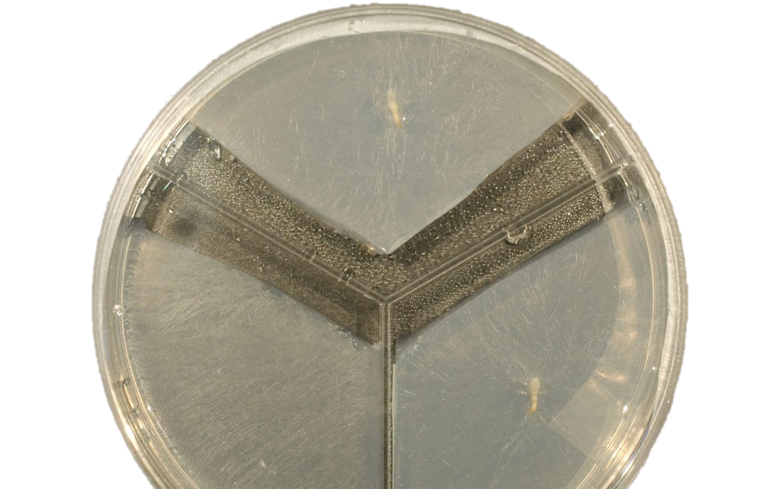
C and N
sources
Plant with agar

Figure 3.1 Photograph of the experimental set up: The first compartment contained labelled-unlabelled different sources of C and N incorporating with Rorison's nutrient. The seedlings were grown in the second and third compartment containing only plant agar. G. repens in the dark after one week. The same case in the light.

Figure 3.2. Goodyera repens shoot biomass of connected and disconnected from the isotopically labelled C and N sources when grown in the dark and in the light. Error bars represent one standard error of dry weight means. Within each graph, differences between mean dry weight were resolved using 3-way ANOVA followed by Tukey’s multiple comparison test; bars with differing letter are significantly different at P < 0.05 (Table 3.2).

Figure 3.3. The biomass of shoots of D. fuchsii plants connected with the isotopically labelled C and N sources via their fungal partners or disconnected in the dark and in the light. Error bars represent one standard error of dry weight means. Within each graph, differences between mean dry weight were resolved using 3-way ANOVA followed by Tukey’s multiple comparison test; bars with differing letter are significantly different at P < 0.05 (Table 3.2).

Figure 3.4. The biomass of Encyclia phoenicea shoots grown with different sources of ¹⁵N and ¹³C labelled inorganic and organic compounds or disconnected from the isotopically labelled C and N sources when grown in the light or in total darkness. Within each graph, differences between mean dry weight were resolved using 3-way ANOVA followed by Tukey’s multiple comparison test; bars with differing letter are significantly different at P < 0.05 (Table 3.2).

Figure 3.5. Mass of ¹³C in Goodyera repens shoots after adding different sources of ¹⁵N and ¹³C labelled inorganic and organic compounds or disconnected from the isotopically labelled C and N sources when grown in the dark and in the light. Within each graph, differences between mean dry weight were resolved using 3-way ANOVA followed by Tukey’s multiple comparison test; bars with differing letter are significantly different at P < 0.05 (Table 3.2).

Figure 3.6. Goodyera repens shoot ¹³C concentration of connected and disconnected from the isotopically labelled C and N sources when grown in the dark and in the light. Error bars represent one standard error of dry weight means. Within each graph, differences between mean dry weight were resolved using 3-way ANOVA followed by Tukey’s multiple comparison test; bars with differing letter are significantly different at P < 0.05 (Table 3.4).

Figure 3.7. The mass of ¹³C in shoots of Dactylorhiza fuchsii plants connected with the isotopically labelled C and N sources via their fungal partners or disconnected in the dark and in the light. Error bars represent one standard error of dry weight means. Within each graph, differences between mean dry weight were resolved using 3-way ANOVA followed by Tukey’s multiple comparison test; bars with differing letter are significantly different at P < 0.05 (Table 3.3).

Figure 3.8. The concentration of ¹³C in shoots of Dactylorhiza fuchsii plants connected with the isotopically labelled C and N sources via their fungal partners or disconnected in the dark and in the light. Error bars represent one standard error of dry weight means. Within each graph, differences between mean dry weight were resolved using 3-way ANOVA followed by Tukey’s multiple comparison test; bars with differing letter are significantly different at P < 0.05 (Table 3.4).

Figure 3.9. Mass of ¹³C in Encyclia Phoenicea shoots after connected and disconnected to ¹³C and ¹⁵N sources when grown in the dark and in the light. Error bars represent one standard error of dry weight means. Within each graph, differences between mean dry weight were resolved using 3-way ANOVA followed by Tukey’s multiple comparison test; bars with differing letter are significantly different at P < 0.05 (Table 3.3).

Figure 3.10. The concentration of ¹³C in Encyclia phoenicea shoots connected and disconnected from the isotopically labelled C and N sources when grown in the dark and in the light. Error bars represent one standard error of dry weight means. Within each graph, differences between mean dry weight were resolved using 3-way ANOVA followed by Tukey’s multiple comparison test; bars with differing letter are significantly different at P < 0.05 (Table 3.4).

Figure 3.11. The mass of ¹⁵N in shoots of Goodyera repens plants connected with the isotopically labelled C and N sources via their fungal partners or disconnected in the dark and in the light. Error bars represent one standard error of dry weight means. Within each graph, differences between mean dry weight were resolved using 3-way ANOVA followed by Tukey’s multiple comparison test; bars with differing letter are significantly different at P < 0.05 (Table 3.5).

Figure 3.12. The concentration of ¹⁵N in Goodyera repens shoots of connected and disconnected from the isotopically labelled C and N sources when grown in the dark and in the light. Error bars represent positive standard error of mass means. Within each graph, differences between mean concentration were resolved using 3-way ANOVA followed by Tukey’s multiple comparison test; bars with differing letter are significantly different at P < 0.05 (Table 3.6).

Figure 3.13. The mass of ¹⁵N in shoots of Dactylorhiza fuchsii plants connected with the isotopically labelled C and N sources via their fungal partners or disconnected in the dark and in the light. Error bars represent one standard error of dry weight means. Within each graph, differences between mean dry weight were resolved using 3-way ANOVA followed by Tukey’s multiple comparison test; bars with differing letter are significantly different at P < 0.05 (Table 3.5).

Figure 3.14. Dactylorhiza fuchsii shoot ¹⁵N concentration of connected and disconnected from the isotopically labelled C and N sources when grown in the dark and in the light. Error bars represent one standard error of dry weight means. Within each graph, differences between mean dry weight were resolved using 3-way ANOVA followed by Tukey’s multiple comparison test; bars with differing letter are significantly different at P < 0.05 (Table 3.6).

Figure 3.15. The mass of ¹⁵N in shoots of Encyclia phoenicea plants connected with the isotopically labelled C and N sources via their fungal partners or disconnected in the dark and in the light. Error bars represent one standard error of dry weight means. Within each graph, differences between mean dry weight were resolved using 3-way ANOVA followed by Tukey’s multiple comparison test; bars with differing letter are significantly different at P < 0.05 (Table 3.5).

Figure 3.16. Encyclia phoenicea shoot ¹⁵N concentration of connected and disconnected from the isotopically labelled C and N sources when grown in the dark and in the light. Error bars represent one standard error of dry weight means. Within each graph, differences between mean concentration were resolved using 3-way ANOVA followed by Tukey’s multiple comparison test; bars with differing letter are significantly different at P < 0.05 (Table 3.6).

Figure 3.17. Goodyera repens root biomass of connected and disconnected from the isotopically labelled C and N sources when grown in the dark and in the light. Error bars represent one standard error of dry weight means. Within each graph, differences between mean dry weight were resolved using 3-way ANOVA followed by Tukey’s multiple comparison test; bars with differing letter are significantly different at P < 0.05 (Table 3.7).

Figure 3.18. Goodyera repens root mass of connected and disconnected from the isotopically labelled C and N sources when grown in the dark and in the light. Error bars represent one standard error of dry weight means. Within each graph, differences between mean mass were resolved using 3-way ANOVA followed by Tukey’s multiple comparison test; bars with differing letter are significantly different at P < 0.05 (Table 3.7).

Figure 3.19. Goodyera repens root ¹³C concentration of connected and disconnected from the isotopically labelled C and N sources when grown in the dark and in the light. Error bars represent one standard error of dry weight means. Within each graph, differences between mean concentration were resolved using 3-way ANOVA followed by Tukey’s multiple comparison test; bars with differing letter are significantly different at P < 0.05 (Table 3.7).

Figure 3.20. Mass of ¹⁵N in Goodyera repens roots connected and disconnected from the isotopically labelled C and N sources when grown in the dark and in the light. Error bars represent one standard error of dry weight means. Within each graph, differences between mean mass were resolved using 3-way ANOVA followed by Tukey’s multiple comparison test; bars with differing letter are significantly different at P < 0.05 (Table 3.8).

Figure 3.21. Goodyera repens root ¹⁵N concentration of connected and disconnected from the isotopically labelled C and N sources when grown in the dark and in the light. Error bars represent one standard error of dry weight means. Within each graph, differences between mean concentration were resolved using 3-way ANOVA followed by Tukey’s multiple comparison test; bars with differing letter are significantly different at P < 0.05 (Table 3.8).

Figure 3.22 Regression line between total ¹³C and total ¹⁵N in the shoots and roots of Goodyera repens with C and N compounds in the dark.

Figure 3.23. Regression line between total ¹³C and total ¹⁵N in the shoots of Goodyera repens with C and N compounds in the light

Figure 3.24. Regression line between total ¹³C and total ¹⁵N in the shoots of Goodyera repens with C and N compounds in the dark and light

Figure 3.25. Regression line between total ¹³C and total ¹⁵N in the shoots of Encyclia phoenicea with C and N compounds in the dark.

Figure 3.26. Regression line between total ¹³C and total ¹⁵N in the shoots of Encyclia phoenicea with C and N compounds in the light

Figure 3.27. Regression line between total ¹³C and total ¹⁵N in the shoots of Encyclia phoenicea with C and N compounds in the dark and in the light.

Figure 3.28. Regression line between total ¹³C and total ¹⁵N in the shoots of Dactylorhiza fuchsii with C and N compounds in the dark.

Figure 3.29. Regression line between total ¹³C and total ¹⁵N in the shoots of Dactylorhiza fuchsii with C and N compounds in the light

Figure 3.30. Regression line between total ¹³C and total ¹⁵N in the shoots of Dactylorhiza fuchsii with C and N compounds in the dark and in the light.

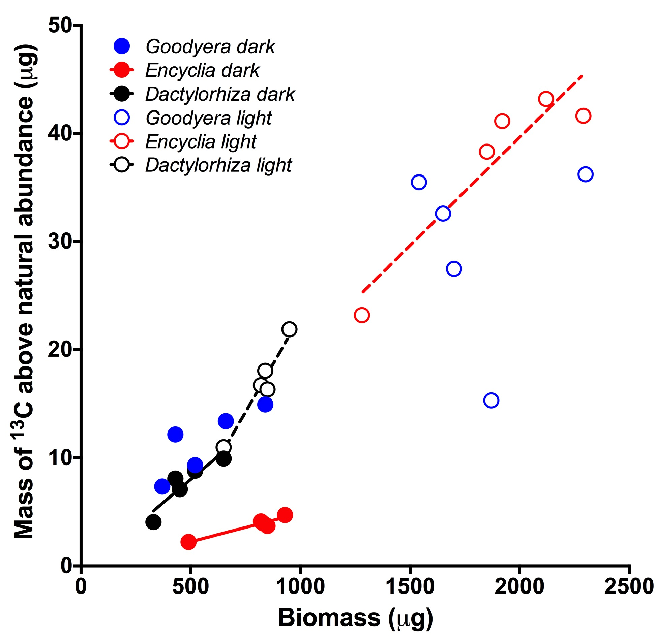

Figure 3.31. Relationship between mass of ¹³C in plant tissues and biomass in three orchid species grown in the dark and the light.

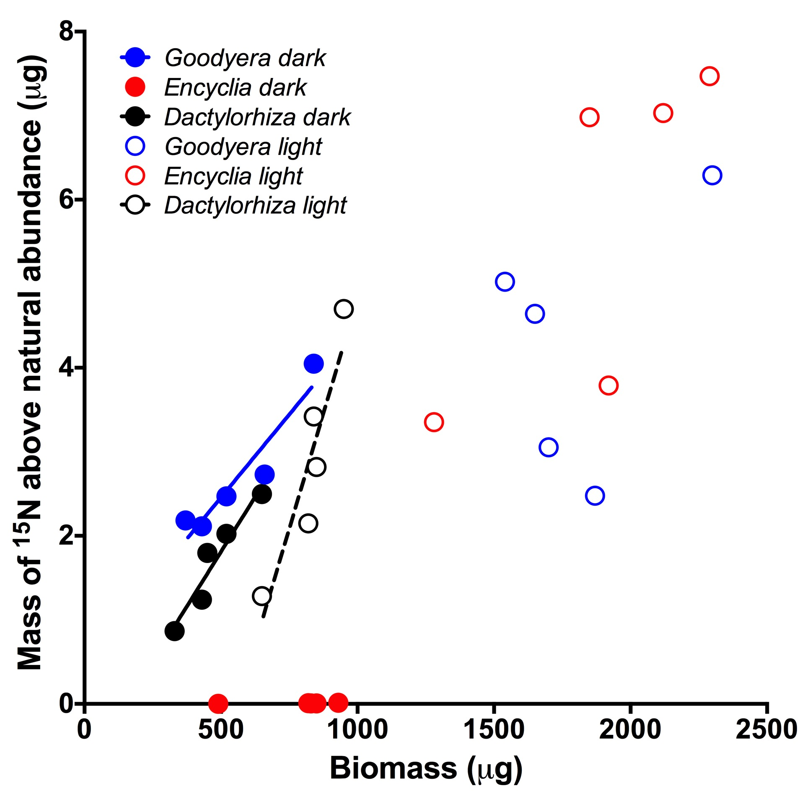

Figure 3.32. Relationship between mass of ¹⁵N in plant tissues and biomass in three orchid species grown in the dark and the light.

Chapter 4: Allocation of carbon from green seedlings of three orchid species to their mycorrhizal fungal partners (two terrestrial and one epiphyte)

4.1 Introduction
Photosynthesis occurs in most of the chlorophyllous orchids at adulthood and it is assumed that this is sufficient, as with most other green plants, to exceed metabolic C demand (Cameron et al. 2006; Smith and Read, 2008). The situation is very different in juvenile orchids. Orchid seeds measure from 0.05 to 6.0 mm in length, and these dust seeds have minimal carbon reserves with few embryonic cells and rely on C acquired from the mycorrhizal fungal partners until they become green and photosynthetic. It has now been confirmed that the polarity of C flow shifts from fungus-to-plant in the fully mycoheterotrophic below-ground stage of development (Smith, 1966) to plant-to-fungus in green-leaved adult life stage of the terrestrial species, Goodyera repens (Cameron et al. 2006; 2008). In the adult life stage, the C ‘cost’ of maintaining the symbiosis is then reciprocated by the provision of mineral nutrients such as phosphorus (Cameron et al. 2007) and nitrogen (Cameron et al. 2006) (Smith and Read, 2008).
While clear for this one terrestrial species, there is no confirmation that, at any orchid growth phase of, net C flux occurs from plant-to-fungus in other species of terrestrial or indeed, epiphytic orchids. In chapter two I studied the effect of light and exogenous carbon and mycorrhizal colonisation on terrestrial and epiphytic orchid germination and development in vitro reveling that the terrestrial and epiphytic species depend on their mycorrhizal fungi for germination and early growth to differing extents. In the chapter three I investigated the effects of light, carbon and nutrients on the growth and nutrition of orchids seedlings. In all orchid species, biomass was increased upon exposure to light but only after germination had been initiated previously. I also studied whether post germination increases in protocorm growth were associated with a synchronous decrease in the amount of C given to the plant by the fungal partner. The missing piece of the story now lies with the amount of C transferred from plant to fungus once the orchid has matured as my data do not provide an insight into the C allocated back to the fungus as proposed by Cameron et al. (2006), once the orchid has formed green leaves. Therefore the trophic status of the symbiosis remains in question for all species apart from G. repens.

4.2 Aim of study and hypothesis
Here, I will assess the C ‘cost’ of orchid mycorrhiza in the orchids G. repens and Dactylorhiza fuchsii (both terrestrial species) and one epiphyte, Encyclia phoenicea. Specifically, I measure the flow of radioactive C, assimilated from ¹⁴CO₂, from plant to mycorrhizal fungus. I hypothesized in that when the orchids become autotrophic, they will supply C from plant to fungus in all species studied.

4.3 Materials and methods
Two terrestrial orchid species were selected, Goodyera repens and Dactylorhiza fuchsii and one epiphytic orchid, Encyclia phoenicea. All species were germinated on agar as described previously. Once they produced green shoots, each plant was incorporated into a petri dish microcosm. Four replicate 9-cm Petri dish microcosms were provided with 10 ml of 1% w : v Plant agar (Duchefa, Haarlem, the Netherlands) at pH 5.5 and used for each species. The orchid plants were put, with their roots and their fungal partner on the agar in the top of each dish. The shoots of the plants could then protrude through a lanolin-sealed groove into the headspace of the labeling chambers into which they were subsequently enclosed (Fig. 4.1 [Page 110]).
The microcosms were incubated in a controlled environment chamber (Conviron Ltd, Winnipeg, Canada) at 18°C with a photon flux density of 150 μmol m⁻² s⁻¹ and under 85% relative humidity one month (Fig. 4.1 [Page 110]) at which point a widespread network of fungus had expanded to colonize the surface of the agar in the Petri dish. The replicate microcosms were closed into labelling chambers into which ¹⁴CO₂ was liberated from 1 MBq of ¹⁴C -labelled sodium bicarbonate (specific activity 4.2 GBq mmol⁻¹) with 2 ml of 27% (v/v) lactic acid. Microcosms were incubated in an illuminated fume hood (PFD = 150 μmol m⁻² s⁻¹ at canopy height) for one photoperiod.
The plant agar (representing the fungus), roots and shoots of the three species were removed from the agar plates and imaged for the distribution of ¹⁴C for 4 hours using real time radio-isotope imaging (Packard Instant Imager; Isotech) after which they were freeze-dried separately for 72 h and their dry weights recorded. Each tissue fraction was oxidized (Model 307 Packard Sample Oxidiser; Isotech) and the resultant ¹⁴CO₂ released was trapped and the radioactively measured using liquid scintillation counting.
The amount of C from fixed in the labelling chamber was calculated from the ¹⁴C content of tissues using equations 4.1 and 4.2 below, previously published by Cameron et al. (2006).
T_{pf} = [[A/A_{sp}] m_{a}] +( P_{r} x m_{c} )
Equation 4.1
(T_{pf}, total carbon transferred from plant to fungus in any given pool (g); A, radioactivity (Bq); Asp, specific activity of the source (Bq Mol⁻¹); and m_{a}, atomic mass of the element, in this case the isotope ¹⁴C; P_{r}, proportion of the total ¹⁴C label supplied (as ¹⁴CO₂) that is present in the tissue; m_{c}, mass of C in the CO₂ present in the labelling chamber in m³ (from the ideal gas law, Eqn 4.2))

m_{cd =} M_{cd} (PV_{cd}/RT) thus m_{c} = m_{cd}×0.27292
(m_{cd}, mass of CO₂; M_{cd}, molecular mass of CO₂; P, pressure; V_{cd}, volume of CO₂ in the chamber (V_{cd} = 0.044% of the total chamber volume based on an atmospheric [CO₂] of 440 ppm); m, mass of unlabelled C in the labelling chamber; M, molar mass (M of C = 12.011 g); R, universal gas constant; T, absolute temperature; m_{c}, mass of C in the CO₂ present in the labelling chamber in m³; 0.27292 represents the proportion of C in CO₂ on a mass fraction basis).
Equation 4.2

4.3.1 Data analysis
Differences between treatment means were analysed by three-way ANOVA followed by Tukey’s multiple comparison test using Minitab 16 at P < 0.05. Data met the ANOVA assumptions of a centred Gaussian distribution and homogeneity of variance so were untransformed.

4.5 Results
Orchid-to-fungus C transport was visualised in all three orchid species by radioisotope imaging (Figure 4.2 [Page 111]) and quantified using liquid scintillation counting (Figure 4.3 [Page 112, Table 4.1 [Page 109]) revealing all species assimilated the¹⁴CO₂. The ¹⁴C was transferred to the external fungal mycelium growing out of the orchid roots (Figure 4.2 [page 112]).
There was no significant difference between the amounts of the ¹⁴C assimilated from the ¹⁴C-labled CO₂ by the orchid shoots in the three species. There was also no significant difference in the amount of ¹⁴C transported to the fungal mycelium by each of the 3 species (Figure 4.3 [Page 112, Table 4.1 [Page 109]).

4.6 Discussion
The most terrestrial orchids are dependent upon mycorrhizal partner for germination and during their seedling establishment phases. Orchids are defined by the production of millions of tiny seeds that contain minimal carbon and nutrient reserves for growth. In the early stages of their life cycle terrestrial orchids are non-photosynthetic because they lack chlorophyll. Later in the life cycle most terrestrial become green but some remain achlorophyllous. The epiphytic orchids have been considered less reliant on mycorrhizal fungi for germination and development although recent work (Martos et al. 2012; Leake and Cameron 2012) including my own research (Chapters 2 and 3) casts doubt on this assertion.
Carbon transfer from plant to fungus in orchids has been hotly debated. Initially, it was suggested that orchids never gave carbon back to their mycorrhizal fungi. This hypothesis is based on a study by Hadley and Purves (1974) in which mycorrhiza-infected and uninfected plantlets of G. repens were supplied with ¹⁴CO₂. They found very tiny amounts ¹⁴C transported to the rhizomes. When transplanted onto agar, the fungus easily grew out from infected plantlets on to Pfeffer agar and small quantities of radioactivity was detected in the resultant mycelium. ¹⁴C leakage from uninfected plantlets was also small. On the basis of this, Alexander and Hadley (1985) suggested that ¹⁴C fixed by shoots stayed in the root even after enhancement of the fungal sink strength by incubation in darkness. The results of study give evidence that carbon transfer only from fungus to orchid and that this transfer of C ends when the host achieves a certain period of growth. In contrast, Cameron et al. (2006; 2008) demonstrated significant net flux of C from green plant to fungus in the same species, G. repens, using more sophisticated C budgeting methods.
In my study I traced ¹⁴C from orchid photosynthate passing from orchid plant to the fungus in three species. I confirmed the plant to fungus C flux in G. repens but also show this C transfer to the fungus occurs in D. fuchsii and E. phoenicea, two species in which C allocation to the fungal symbiont had never previously been recorded.
Goodyera and Dactylorhiza gave approximately the same proportion of the C they fixed to the fungus (with G. repens 1.2 fold greater than D. fuchsii). In contrast, E. phoenicea gave substantially more carbon to its fungus partner; double the allocation of G. repens and 2.4 times greater than D. fuchsii by mass. The percentage of the total carbon fixed by the plant and allocated to the fungus is 1%, 6% and 10% for G. repens, D. fuchsii and E. phoenicea respectively.
The products of photosynthesis can be used to support nutrient acquisition by the fungus and transfer to the plant. For example, Smith (1966) made important progress in understanding of orchid mycorrhizal demonstrating ³²P and ¹⁴C assimilation and active transfer through mycorrhizal mycelium to orchid seedlings. This pathway was further investigated by Cameron et al. (2007) confirming P transfer from fungus to plant and by Cameron et al. (2006) who also showed nitrogen transfer from fungus to plant.
My study shows that C transfer from plant to fungus in orchids is not unusual and is certainly not restricted to G. repens. I also reveal that the functionality of the epiphyte I studied, in terms of plant to fungus C transfer, functions in the same way as for the terrestrial species studied.

4.7 Table

Table 4.1 2-way ANOVA table for Shoot biomass of three orchid species

 | d.f. | F | P
Species | 2,35 | 2.93 | 0.070
Tissue | 2,35 | 17.16 | <0.001
Interaction | 4,35 | 1.34 | 0.281

4.8 Figures

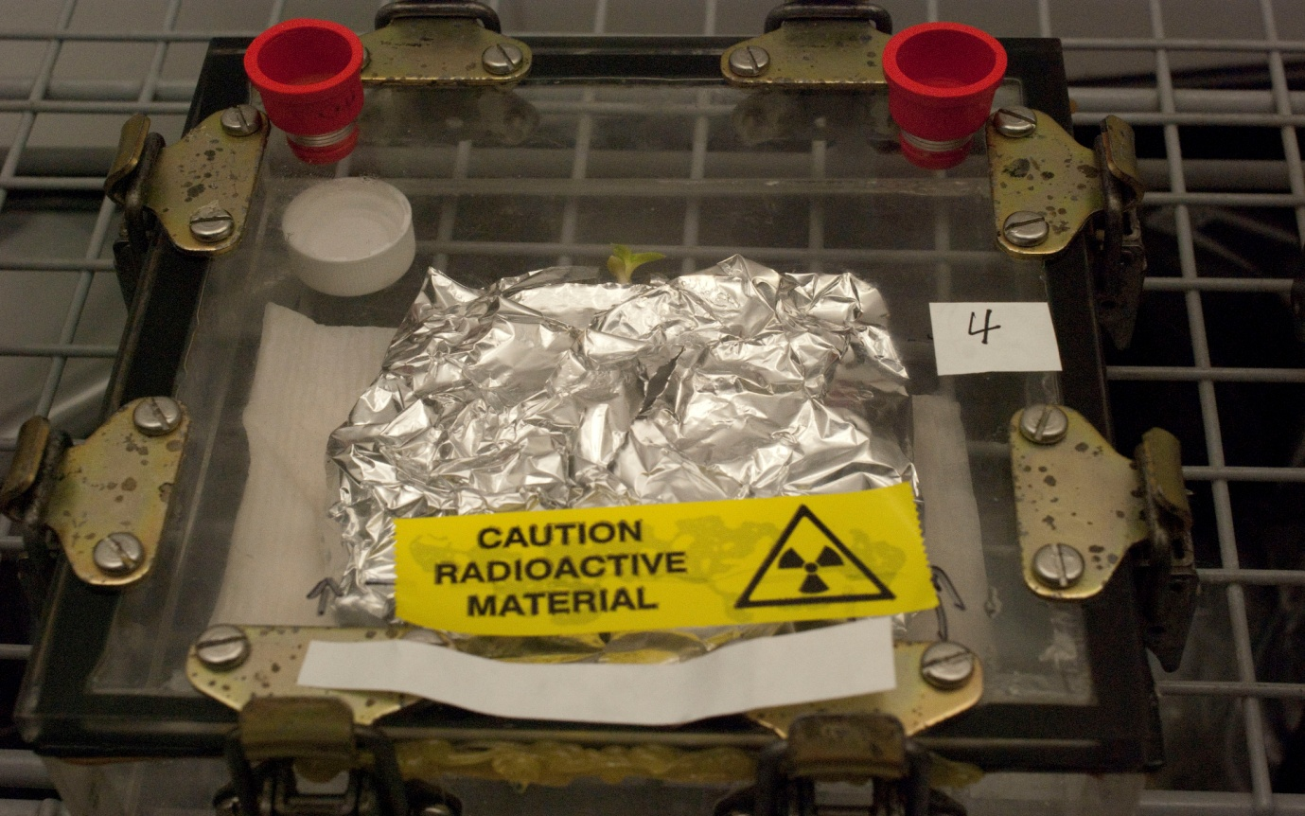
c
f
e
b
a
d

Figure 4.1 Compartmentalized 9-cm Petri-dish microcosm used to supply a radiolabelled (¹⁴C) to the orchid mycorrhizal mycelial network, the plant enclosed in a gas-tight labelling chamber, a, Perspex labelling chamber with neoprene seal; b, clamps to facilitate a gas-tight seal; c, Petri dish with lid and base sealed with sterile anhydrous lanolin; d, orchid plants; e, septum in the HC to allow for gas sampling; f, Subaseal to allow the introduction of ¹⁴C-labelled sodium bi-carbonate and for gas sampling of the labelling chamber.

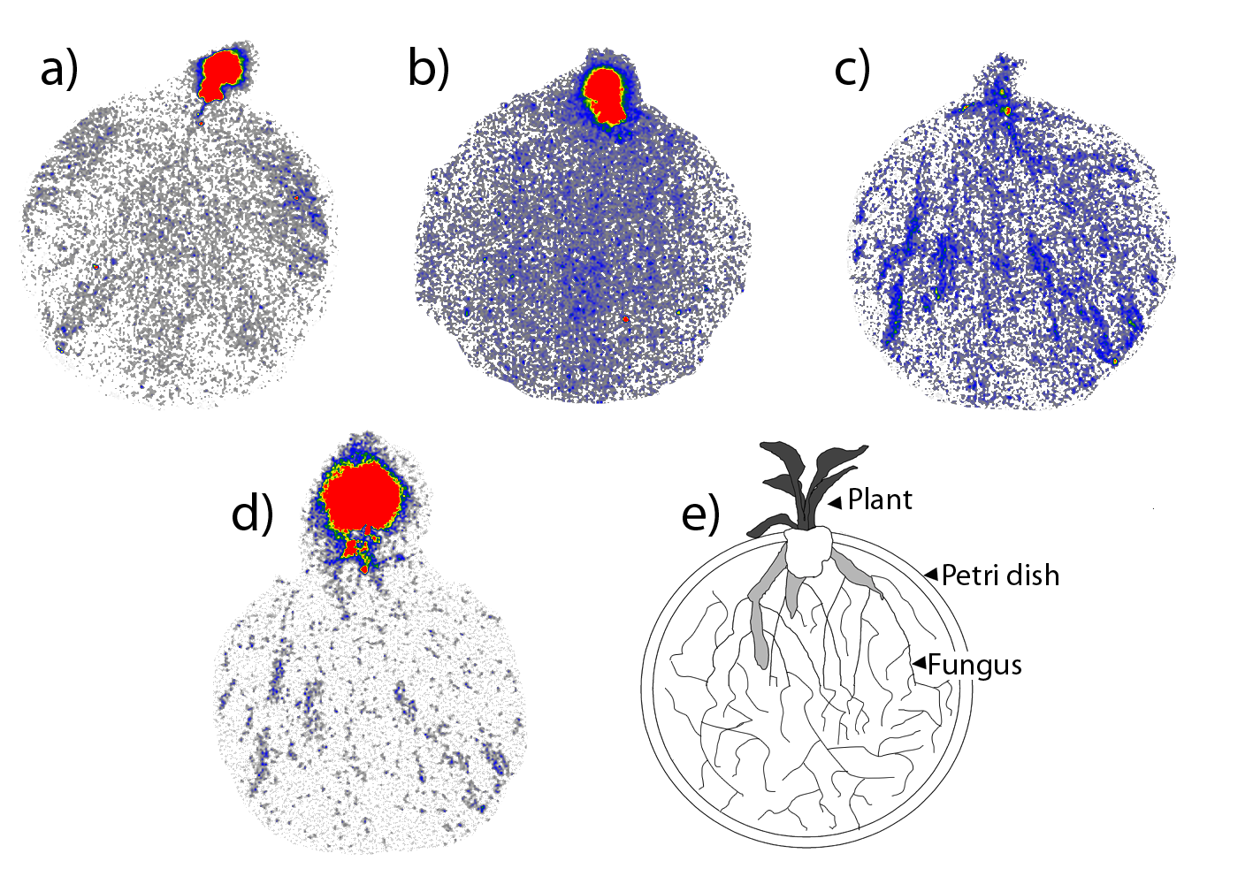

Figure. 4.2 False-colour digital autoradiographs obtained after 24 h of exposure of the shoot to ¹⁴CO₂ in microcosms (a) E. phoenicea (b) D. fuchsii (c,d) G. repens shows ¹⁴C allocation through external mycorrhizal mycelium along with a diagram of the experimental set up (e). The colour scale indicates the number of counts detected in pixel areas of 0.25 mm² in a period of 60 min.

Figure. 4.3 The total amount of carbon over the labelling period movement from Goodyera repens, Dactylorhiza fuchsii and Encyclia phoenicea plants to their fungal partners. Error bars represent one standard error of dry weight means. Within each graph, differences between mean dry weight were resolved using 2-way ANOVA followed by Tukey’s multiple comparison test; bars with differing letter are significantly different at P < 0.05 (Table 4.1).

Chapter 5: General discussion
This study aimed to understand the degree to which terrestrial and epiphytic orchids differ in the extent to which they depend on mycorrhizal fungus. To do this, I investigated the interaction between the roles of light and mycorrhiza in influencing the germination and development of orchid seedlings, the mechanisms underpinning light and mycorrhizal effects on orchid seedling development by determining the assimilation and transport of carbon (C) and nitrogen (N) and finally the status of the symbiosis in the adult phase by determining the flow of C back to the fungus by young orchids.

5.1 Why is the interaction between orchids, their fungi and light poorly understood?
Many of orchids, particularly terrestrial species that mature in soil, have proved difficult to germinate on any synthetic media in the without their natural fungal partner (Rasmussen, 1995). In addition, progress in understanding the factors driving orchid germination, growth and physiology using asymbiotic cultures gives a very incomplete, and possibly poor understanding of the biology of the plants which, in nature, are usually critically reliant on symbiotic fungal symbiotic for germination growth. Although an increasing number of studies but they have focussed on the development of methods for symbiotic germination of orchid seeds from the 1960’s, generally many studies of orchid physiology are still dependent on industrial production using asymbiotic culture methods (Yam and Arditti. 2009; Pereira et al. 2011; Valadares et al, 2012). The selection of appropriate fungal partners and their isolation have been a crucial innovations symbiotic germination research.
Some orchids such as Goodyera repens, appeared to have a high specificity for a given species of fungus (Hadley, 1970). Others such as Dactylorhiza purpurella associate symbiotically with a number of fungi. As a source of a carbon, agar medium with powdered cellulose was used to study the role of fungal partner to stimulate germination of some Australian terrestrial orchids (Warcup, 1971 Warcup, 1973). Previous studies by Johnson et al. (2007) germinated the terrestrial orchid Endophia on complex media to resolve the growth realized with fungal symbiont compared with asymbiotic germination and development. The study found the higher benefits of the symbiosis for seed germination than for plant growth (Johnson et al, 2007). My work reveals that asymbiotic orchids are physiologically different to symbiotic orchids in terms of their responses to light and this then raises the question as to how relevant asymbiotic studies are in understanding other aspects of orchids physiology.

5.2 Carbon sources for juvenile terrestrial orchids
Hadley (1969) demonstrated that seeds germination of the terrestrial orchids Goodyera repens and Dactylorhiza purpurella and the tropical terrestrial orchid Spathoglottis plicata could germinate in vitro if they are given an exogenous provision of sugar, however symbiotic infection is important for further growth of protocorms as well as for the development of shoots or roots in juvenile orchid plants. In nature, terrestrial orchids protocorms usually develop underground and lack chlorophyll and therefore have a mycoheterotrophic stage of their life cycles in which their essential nutrient and carbon demands depend upon provision from their mycorrhizal fungal partners (Leake, 2005). The green leaves and onset of autotrophy in orchid adults occurs when seedling emergence above the ground, therefore orchids are usually only initially mycoheterotrophic through their underground growth stage (Leake and Cameron, 2010).

5.3 Carbon sources for juvenile epiphytic orchids
The role of mycorrhizas in the germination of epiphytes, the majority of orchid species, is mainly ignored although this relationship may play an important role in the germination epiphytes in the canopy (Leake and Cameron 2012), especially as they become green much earlier in their lifecycle. It is still unknown as to whether epiphytic orchids require mycorrhizal fungi to germinate at all (Leake and Cameron 2012). In chapter two I study three terrestrial orchid species and one tropical epiphyte in vitro during germination and growth how reactions to light and their conditions for exogenous carbon heterotrophically or using fungal partner. In all three terrestrial orchid species and one tropical epiphyte, the effects of the presence of fungal partner or sucrose on germination was more clear when seeds were germinated in darkness. It is therefore a challenge to understand the dynamics of this complex relationship. Much research has focused on in vitro asymbiotic and symbiotic germination of orchids but they ignore the important interaction between light and C provide in the progression of orchid seed germination (Downie 1941; Arditti 1979; Dutra et al. 2008; 2009). The response orchids to light is unclear meaning much research is required to understand the regulatory mechanisms of germination (Andrews, 1997; Baskin and Baskin 1998). Inhibition through light signalling, perhaps underpinned by phytochromes or other photoreceptors has been identified to play a role in the regulation of seed germination (Stewart and Kane 2010). This underpins the mechanism through which plants react to red and far-red light, and are moderated through seedling appearance (Bae and Choi, 2008; Sharrock, 2008). However it is clear that the terrestrial orchid seeds need to establish a relationship with an appropriate fungal partner to aid germination and help the earliest phases of development in order to get the essential carbon to achieve maturity, at which after that they become autotrophic. The epiphyte become photosynthetic in the earlier life phase, previous to maturity and substantially before the development of leaves, therefore it appears probable that epiphytic species are less dependent on the fungus for the providing of C in the post-germination points of their lifecycle but the presence of the fungal partner remains an essential condition for germination.

5.4 Carbon and nitrogen metabolism in orchids and their mycorrhizas
Plants have many mechanisms to maximise the success of C and N metabolism but we have little information about how orchids obtain C and N from their environment. For example many vascular plants get nitrogen as NO₃ or NH₄ which are the main forms of N in soil (Marschner, 1995). In the chapter three I investigated the fungal mycelia of the orchid can get large amounts of C and N from an amino acid and ammonium nitrate and the fungus supports transfer of C and N elements to the orchid plant. ¹³C and ¹⁵N enrichment of orchid plant tissue cultures can be improved by small amounts of organic nutrients. I investigated whether post germination rates of protocorm development were associated with a concurrent reduction in provide of carbon to the plant partner. Unsurprisingly, the highest amount of ¹³C transferred from plant-to-fungus happened in the light then in the dark in all three species. In earlier phase in its life cycle the epiphyte, E. phoenicea, grow to be photosynthetic than the two terrestrials and therefore I hypothesized that the import of ¹³C would be stopped by light as the plants change from being principally heterotrophic to autotrophic (Leake and Cameron 2012). Smith (1967) suggests that this carbon flux from the fungal symbionts to the orchid plants occurs through the fungal sugar trehalose, whereas Cameron (2006; 2008) choose an amino acid as the transfer molecule. Using a co-labeling move toward with ¹⁵N and ¹³C-labelled substrates, I set out to resolve the fluxes of carbon and nitrogen from their fungus to the epiphytic and terrestrial orchids, investigate the consequences of post-germination light contact on the development and shed light on the move mechanisms involved. There was a highly linear relationship between ¹⁵N and ¹³C transferred from the labeled sources suggesting that the carbon transfer compound is likely to be and organic N compound, most probably one or many amino acids.
The highest increase in the mass of ¹³C transported to the protocorm upon illumination was seen in G. repens supplied with amino acids. This result gave option that the plant is reliant on organic compounds, such as amino acids, assimilated from the complete inorganic N and carbohydrate sources. In my study nitrogen and carbon were transferred to the plant both in the light and dark.
By using ¹⁵N isotope tracers, I confirmed that all species receive extensive quantities of N from their fungal partner. There is apparent confirmation that all species under experiment are mainly reliant upon their mycorrhizal fungi for nitrogen nutrition. Orchid roots are not for adapted to directly get nutrients from the soil because the roots of these plants are of a coarse nature and restricted size, representing that the mycorrhizal fungi is the most important pathway of nutrient shift from soil into the orchid plants (Leake, 1994). The upper quantity of ¹⁵N in G. repens and E. phoenicea provided with the amino acid source in the light shows that amino acids are could used as a nitrogen source by the mycorrhizal fungi.
My experiments confirmed that terrestrial and epiphytic protocorms are completely dependent on fungi for the acquisition of nitrogen. The rising concentration of ¹⁵N enrichment with amino acids in G. repens shoots whereas the rising concentration of ¹⁵N enrichment with ammonium nitrate plus glucose in D. fuchsii in the light. In contrast, the rising concentration of ¹⁵N enrichment in the epiphytic species with ammonium nitrate plus glucose in the dark. The fungal partner obviously plays a critical role in supplying epiphytic species with N and C as seedlings, that this support may be less significant in the epiphytic environment however.

5.5 Understanding the status of the symbiosis
My work, along with the other studies discussed above, shows that orchids are dependent of mycorrhizal C in their earliest life stages. Moreover, this extended heterotopic stage is longer in terrestrial orchids than in epiphytes thus mycorrhizas might be less important for early C nutrition in these epiphytic species. In the chapter four, I investigated whether the orchids were able to supply their fungal partners with C as in a classical mycorrhizal association (such as in arbuscular mycorrhizas). In my study I examined the flux of ¹⁴C from orchid photosynthate crossing from orchid to fungal partner through the external mycelium of its mycorrhizal fungi. The results of photosynthesis may be applied to assist nutrient supplying by the fungus. Smith (1966) study provided essential evolution in knowledge of orchid mycorrhizal. She exercised a diffusion barrier of ³²P and ¹⁴C to determine fungal absorption and active shift during mycorrhizal mycelium to orchid plants. The experiment system was developed by Cameron et al. (2006, 2008) who details for the first time full bidirectional C budget and gaseous changes for fungal partner. Their research proven that C insert to the orchid shoots as ¹⁴CO₂ was assimilated and stimulated to the roots after that to the external mycelial system of the mycorrhizal fungi in G. repens and is confirm in Chapter 4. Thus this research assistances the previously research of move of C in the photosynthetic orchid G. repens. However, until my study, this remained the only case where C transfer from orchid to mycorrhiza was confirmed. My work subsequently shows the fluxes observed for G. repens are actually lower than the amount of C provide to the fungus by either E. phoenicea or D. fuchsii and so suggesting that this might be more common than first thought.

5.5 Conclusions
My research shows, for the first time, that light has a significantly negative effect on orchid germination and early development in the terrestrial and epiphytic species I studied. In most species, including the epiphyte E. phoenicea, germination and early development was improved over and above that observed in plants supplied with exogenous carbohydrate. This suggest that the orchid mycorrhiza might have and important non-nutritional role in breaking seed dormancy. I also showed that light negatively influenced the transport of C and N to the plant. Moreover, in the dark and in the light, the relationship between the transfer of ¹⁵N and ¹³C form labeled sources was highly linear, suggesting strongly that C and N are co-transported from fungus-to-plant as organic N.
To finally resolve the trophic status of the symbiosis, whether mutualistic or otherwise, I directly measure C allocation form current photosynthate to the mycorrhizas. All species transfer C to their fungal partners, an important result as this has only ever been show in two species before, G. repens (Cameron et al. 2006) and D. purpurella (Smith 1967), and that the most C was allocated by the epiphyte E. phoenicea. This was surprising given epiphytic orchids are believed to be less reliant on their fungal symbionts. This is unlikely to be true in light of my data as they need the fungus to germinate efficiently in their light, received significant C and N as juveniles from their fungal symbiont and give substantial amounts of C back to their fungal partners once adult. Thus the epiphytic species studied is remarkably similar to most other green orchid-mycorrhizal associations.

6.1 References

Ackerman, J. 1983. On the Evidence for a Primitively Epiphytic Habit in Orchids. American Society of Plant Taxonomists, 8, 474-477.
Adams, M. A. and Attiwill, P.M. 1982. Nitrogen mineralization and nitrate reduction in forests. Soil Biol. Biochem, 14, 197-202.
Alexander, C. and Hadley, G. 1984. The effect of mycorrhizal infection of Goodyera repens and its control by fungicide. New Phytologist, 97, 391-400.
Alexander, C. and Hadley, G. 1985. Carbon movement between host and mycorrhizal Endophyte during the development of the orchid Goodyera repens Br. New phytologist, 101, 657-665.
Alexander, C., Alexander, I. J. and Hadley, G. 1984. Phosphate-uptake by Goodyera repens in relation to mycorrhizal infection. New Phytologist, 97, 401-411.
Allen, M. F. 1991. The Ecology of Mycorrhizae. Cambridge University Press, Science: pp184.
Andrews, T. S. 1997. Factors affecting the germination of Giant Parramatta grass. Australian Journal of Experimental Agriculture, 37, 439-446.
Arditti, J. 1979. Factors affecting the germination of orchids. The Botanical review, 33, 1-97.
Arditti, J. 1992. Fundamentals of orchid biology. John Wiley and Sons, New York : pp. 691.
Arditti, J. and Ernst, R. 1984. Physiology of germinating orchid seeds. In Arditti. J. (ed):Orchid biology. Reviews and perspectives. Comstock publishing Associates, Ithaca. USA, 3. Chapter 4, 177-222.
Arditti, J. and Ghani, A. 2000. Tansley review, 110 – Numerical and physical properties of orchid seeds and their biological implications. New Phytologist, 145, 367–421.
Avolio, M., Müller, T., Mpangara, A., Fitz, M., Becker, B., Pauck, A., Kirsch, A. and Wipf, D. 2012. Regulation of genes involved in nitrogen utilization on different C/N ratios and nitrogen sources in the model ectomycorrhizal fungus Hebeloma cylindrosporum. Mycorrhiza. 22(7): 515-24.
Bae, G. and Choi, G. 2008. Decoding of light signals by plant phytochromes and their interacting proteins. Annual Review of Plant Biology, 59, 281–311.
Bago, B. and Zipfel, W. 2002. Translocation and utilization of fungal storage lipid in arbuscular mycorrhizal symbiosis. Plant physiology, 128(1): 108-124.
Bago, B. and Pfefer, P. E. 2003. Carbon export from arbuscular mycorrhizal roots involves the translocation of carbohydrate as well as lipid. Plant physiology, 131 (3): 1496-1507.
Baskin, J. M. and Baskin, C. C. 1998. Seeds: ecology, biogeography, and evolution of dormancy and germination. Academic Press, San Diego, California, USA.
Bayman, P., Eduardo, J., González José, J. F. and Raymond, L.T. 2002. Are Fungi Necessary? How Fungicides Affect Growth and Survival of The Orchid Lepanthes rupestris in the Field. Journal of Ecology, 90,1002-1008.
Benzing, D. H., Hutton, S.L., Whitmore, T.C. and Chadwick, A.C. 1983. Vascular epiphytes: A survey with special reference to their interaction with other organisms. Tropical Rain Forest: Ecology and Management. British Ecological Soc. Oxford, pp, 11-24.
Blamey M, Fitter R, Fitter A. 2003. Wild Flowers of Britain and Ireland: A New Guide to Our Wild Flowers. A and C Black, London.
Blaudez, D., Botton, B., Dizengremel, P. and Chalot, M. 2001. The fate of [¹⁴C]glutamate and [¹⁴C]malate in birch roots is strongly modified under inoculation with paxillus involutus. Plant Cell Environ, 24, 449-457.
Bougoure, J.J., Ludwig, M., Brundrett. M. and Grierson, P.F. 2010. Identity and specificity of the fungi forming mycorrhizas with rare, mycoheterotrophic Rhizanthella gardneri (Orchidaceae). Mycological Research, 113, 1097–1106.
Bidartondo, M.I. and Read, D.J. 2008. Fungal specificity bottlenecks during orchid germination and development. Molecular Ecology, 17, 3707–3716.
Brandner, S. 2005. An assessment of the fungal specificity of the orchid sub-tribe Pterostylis. Summer Scholarship Project Reports from the Australian National Herbarium Dec 2004 - Feb 2005.
Cameron, D.D., Leake, J.R. and Read, D.J. 2006. Mutualistic mycorrhiza in orchid: evidence from plant-fungus carbon and nitrogen transfers in the green-leaved terrestrial orchid Goodyera repens. New phytologist, 171, 405-416.
Cameron, D.D. and Leake, J.R. 2007. A different kind of parasitic plant: a brief history of mycoheterotrophy and epiparasitism. Haustorium, 50, 4-6.
Cameron, D.D., Johnson, I., Leake, J.R. and Read, D.J. 2007. Mycorrhizal acquisition of inorganic phosphorus by the green-leaved terrestrial orchid Goodyera repens. Annals of Botany, 99: 831-834.
Cameron, D.D., Johnson, I., Read, D.J. and Leake, J.R. 2008. Giving and receiving: measuring the carbon cost of mycorrhizas in the green orchid, Goodyera repens. New Phytologist, 180, 176-184.
Cameron, D.D., Preiss, K., Gebauer, G. and Read, D. J. 2009. The chlorophyll containing orchid Corallorhiza trifida derives little carbon through photosynthesis. New Phytologist, 183, 358-364.
Cameron, D.D. and Bolin, J. F. 2010. Isotopic evidence of partial mycoheterotrophy in the gentianaceae: Bartonia virginica and Obolaria virginica as case studies. American Journal of Botany, 97(8), 1272–1277.
Chapin, F. S., Kellar, A. and Pugnaire, F. 1993. Evolution of Suites of Traits in Response to Environmental Stress. The American Naturalist vol. 142. The University of Chicago Press, pp, 78-92.
Clements, M. A., Muir. H. and Cribb, P. J. 1986. A Preliminary Report on the Symbiotic Germination of European Terrestrial Orchids. Kew Bulletin, 41, 437- 445.
Davies, C., Lazell, B., Hughes, M., and Cooper, L. (1995). Time is just another attribute- or at least, just another dimension. In [Clifford and Tuzhilin, 1995], pp175-193.
Dixon, K. W. and Pate, J. S. 1984. Biology and distributional status of Rhizanthella gardneri Rogers. The Western Australian Underground orchid. Kings Park Research Notes, 9-154.
Downie, D.G. 1941. Notes on the germination of some British orchids. Transactions of the Botanical Society of Edinburgh, 33, 94-103.
Dutra, D., Johnson, T.R., Kauth, P.J., Stewart, S.L., Kane, M.E. and Richardson. L. 2008. Asymbiotic seed germination, in vitro seedling development, and greenhouse acclimatization of the threatened terrestrial orchid Bletia purpurea. Plant Cell, Tissue and Organ Culture, 94:11–21.
Dutra, D., Kane, M. E. and Richardson, L. 2009. Asymbiotic seed germination and in vitro seedling development of Cyrtopodium punctatum: a propagation protocol for an endangered Florida native orchid. Plant Cell, Tissue and Organ Culture, 96, 235-243.
Eriksson, O. and Kainulainen, K. 2011. The evolutionary ecology of dust seeds. Perspectives in Plant. Ecology Evolution and Systematics, 13, 78-87.
Fitter, A . H. and Peat , H. J.. 1994. The Ecological Flora Database, Journal of Ecology, 82, 415-425.
Francis R., Read D.J. 1995. Mutualism and antagonism in the mycorrhizal symbiosis with special reference to impacts on plant community structure. Canadian Journal of Botany 73, S1301–S1309
Fukai, S., Fujiwara, K., Okamoto, K., Hasegawa, A. and Goi, M. 1997. Effects of red and blue light on germination and protocorm growth of Calanthe Satsuma. Lindleyana 12: 169-171.
Gebauer , G. and Meyer, M. 2003. ¹⁵ N and ¹³ C natural abundance of autotrophic and myco
heterotrophic orchids provides insight into N and C gain from fungal association.
New Phytologist, 160, 209 – 223 .
Hadley, G. 1969. Cellulose as a carbon source for orchid mycorrhiza. New Phytologist, 68, 933 –939.
Hadley, G. 1970. Non-specificity of symbotic infection in orchid mycorrhiza. New phytologist, 69, 1015-1023.
Hadley, G. and Williamson, B. 1971. Analysis of the post-infection growth stimulus in orchid mycorrhiza. New Phytologist: 70: 445-455.
Hadley, G. and Purves, S. 1974. Movement of 14C from host to fungus in orchid mycorrhiza New phytologist, 73, 475-482.
Harley, J. L. and Smith, S. E. 1983. Mycorrhizal Symbiosis. London and New York: Academic Press, pp 483.
Harvais, G. 1974. Notes on the biology of some native orchids of Thunder Bay, their endophytes and symbionts. Canadian Journal of Botany, 52, 451-460.
Heifetz, P.B., Förster, B., Osmond, C.B., Giles, L.J. and Boynton, J.E. 2000. Effects of acetate on facultative autotrophy in Chlamydomonas reinhardtii assessed by photosynthetic measurements and stable isotope analyses. Plant Physiology, 122, 1439–1445.
Heitz, P., Wanek, W. and Popp, M. 1999. Stable isotopic composition of carbon and nitrogen and nitrogen content in vascular epiphytes along an altitudinal transect. Plant, Cell and Environment, 22, 1435-1443.
Hewitt, E.J. 1966. Sand and water culture methods used in the study of plant nutrition. Commonwealth Agricultural Bureaux Technical Communication, 22, 190-191.
Johnson, T.R. and Kane, M.E. 2007. Asymbiotic germination of ornamental Vanda: in vitro germination and development of three hybrids. Plant Cell, Tissue and Organ Culture, 91, 251-261
Johnson, T.R., Kane, M.E. and Perez, H.E. 2011. Examining the interaction of light, nutrients and carbohydrates on seed germination and early seedling development of Bletia purpurea (Orchidaceae). Plant Growth Regulation, 63, 89-99.
Julou, T., Burghardt, B., Gebauer, G., Berveiller, D., Damesin, C. and Selosse, M. 2005. Mixotrophy in orchids: insights from a comparative study of green individuals and non photosynthetic individuals of Cephalanthera damasonium. New Phytologist, 166, 639–653.
Kendrick, R. E. and Spruit, C. J. P. 1977. Phototransformations of Phytochrome. Photochemistry and Photobiology, 26, 201–214.
Khampa, S., Wangsomnuk, P. and Wangsomnuk, P. 2010. Factors affecting seed germination of Grammatophylum speciosum cultured in vitro. Asia-Pacific Journal of Molecular Biology and Biotechnology, 18, 193-197.
Knudsen, L. 1946. A new solution for germination of orchid seeds. American Orchid Society bulletin, 15, 214-217.
Kuga Y, Sakamoto N, Yurimoto H. 2014. Stable isotope cellular imaging reveals that both live and degenerating fungal pelotons transfer carbon and nitrogen to orchid protocorms. New Phytologist 202: 594-605
Krömer, T. Kessler M, Gradstein SR. 2007. Vertical stratification of vascular epiphytes in submontane and montane forest of the Bolivian Andes: the importance of the understory. Plant Ecology, 189, 261-278.
Leake, J. R. 1994. The biology of mycoheterotrophic (`saprophytic') plants. New Phytologist, 127, 171-216.
Leake, J.R. 2005. Plants parasitic on fungi: unearthing the fungi in mycoheterotrophs and debunking the ‘Saprophytic’ plant myth. Mycologist, 19, 113–122.
Leake, J. R., McKendrick, S. L., Bidartondo, M. and Read, D. J. 2004. Symbiotic germination and development of the mycoheterotroph Monotropa hypopitys in nature and its requirement requirement for locally distributed Tricholoma spp. New Phytologist, 163, 405–423.
Leake, J. R. and Cameron, D. D. 2010. Physiological ecology of mycoheterotrophy. New Phytologist, 185, 601-605.
Leake, J, R. and Cameron, D. D. 2012. Untangling above and below ground mycorrhizal fungal networks in tropical orchids. Molecular Ecology, 21, 4921- 4924.
Lüttge, U. 1989. Vascular plants as epiphytes: evolution and ecophysiology. Springer-Verlag, Incorporated, Berlin, Germany.
Majerowicz, N. and Kerbauy, G. B. 2002. Effects of nitrogen forms on dry matter genotypes of Catasetum fimbriatum (Orchidaceae). Environmental and Experimental Botany 47: 249-258.
Majerowicz, N., Kerbauy, G. B., Nievola, C. C. and Suzuki, R. M. 2000. Growth and nitrogen metabolism of Catasetum fimbriatum (orchidaceae) grown with different nitrogen sources. Environ Exp Bot, 44, 195-206.
Martos, F., Dulormne, M., Pailler, T., Bonfante, P., Faccio, A., Fournel, J., Dubois, M. P. and Selosse, M. A. 2009. Independent recruitment of saprotrophic fungi as mycorrhizal partners by tropical achlorophyllous orchid. New Phytologist, 184, 668-681.
Martos, F., Munoz, F., Pailler, T., Kottke, I., Gonneau, C. and Selosse, M. A. 2012. The role of epiphytism in architecture and evolutionary constraint within mycorrhizal networks of tropical orchids. Molecular Ecology, 21, 5098–5109.
Marschner, H. 1995. Mineral Nutrition of Higher Plants, 2nd edn. Academic Press, London.
Masuhara, G., Katsuya, K. 1994. In situ and in vitro specificity between Rhizoctonia spp. and Spiranthes sinensis (Persoon) Ames, var. amoena (M. Bieberstein) Hara (Orchidaceae). New Phytologist 127, 711-718.
Merckx VSFT. 2013. Mycoheterotrophy. The biology of plants living on fungi: Springer New York.
Merckx, V. and Freudenstein, J. 2010. Evolution of mycoheterotrophy in plants: a phylogenetic perspective. New Phytologist, 185, 607-610.
Moore, D. M., Tutin, T. G., Heywood, V. H., Burges, N.A., Valentine, D. H., Walters, S. M. and Webb, D. A. 1980. Orchidaceae in Flora Europaea Vol.5. Cambridge University Press, UK.
Pereira, M. C., Vieira, N. M., Totola, M. R. and Kasuya, M. C. M. 2011. Total fatty acid composition in the characterization and identification of orchid mycorrhizal fungi Epulorhiza spp. Revista Brasileira de Ciencia do Solo, 35, 1159-1166.
Phillips, R. D., Barrett, M. D., Dixon, K. W. and Hopper, S. D. 2011. Do mycorrhizal symbioses cause rarity in orchid? Journal of Ecology, 99,858-869.
Purves, S. and Hadley, G. 1976. Movement of ¹⁴C from host to fungus in orchid mycorrhiza. New phytologist, 73, 475-482.
Ramsay, M.M. and Stewart, J. 1998. Re-establishment of the lady., (Cypripedium calceolus L.) in Britain. Botanical Journal of the Linnean Society, 126, 173-181.
Rasmussen, H. N. 1995. Terrestrial Orchids: From Seed to Mycotrophic, Plant First ed. Cambridge, UK: Cambridge University Press.
Read, D. J. 1991. Mycorrhizas in ecosystems. Experientia, 47, 376-391.
Read, D. J., Leake, J. R. and Perez-Moreno, J. 2004. Mycorrhizal fungi as drivers of ecosystem processes in heathland and boreal forest biomes. Canadian Journal of Botany, 82, 1243-1263.
Read, D.J. 1996. The structure and function of the ericoid mycorrhizal root. Annals of Botany 77, 365–391.
Roberts, A. 2014. Encyclia phoenicea. The IUCN Red List of Threatened Species. Version 2015.2. <www.iucnredlist.org>. Downloaded on 25 August 2015.
Schmidt, S. and Stewart, G. R. 1999. Glycine metabolism by plant roots and its occurrence in Australian plant communities. Australian Journal of Plant Physiology, 26, 253-264.
Selosse, M., Baudoin, E. and Vandenkoornhuyse, P. 2004. Symbiotic microorganisms, a key for ecological success and protection of plants. Plant biology and pathology. C. R. Biologies, 327, 639–648.
Sharrock, R. A. 2008. The phytochrome red/far-red photoreceptor superfamily. Genome Biology, 9: 230.
Simard, S. W., Perry, D. A., Jones, M. D., Myrold, D. D. Durall, D.M., and Molina, R. 1997a. Net transfer of carbon between ectomycorrhizal tree species in the field. Nature, 388, 579–582.
Simard, S. W., Jones, M. D., Durall, D.M., Perry DA, Myrold, D.D. and Molina, R. 1997b. Reciprocal transfer of carbon isotopes References between ectomycorrhizal Betula papyrifera and Pseudotsuga menziesii. New Phytologist, 137, 529–542.
Smith, S. E. 1966. Physiology and ecology of orchid mycorrhizal fungi with reference to seedling nutrition. New phytologist, 65, 488-499.
Smith, S. E. 1967. Carbohydrate translocation in orchid mycorrhizas. New phytologist, 66, 371-378.
Smith, S. E. 1973. Asymbiotic germination of orchid seeds on carbohydrates of fungal origin. New Phytologist 72, 497-499.
Smith, F. A. Smith, S. E. 1996. Mutualism and parasitism diversity funcation and structure
In the arbuscular (VA) mycorrhizal symbiosis. Advances in Botanical Research, 22, 1-43.
Smith, S.E. Read, D. J. 1997. Mycorrhizal symbiosis. London, UK: Academic Press.
Smith, S.E. Read, D. J. 2008. Mycorrhizal symbiosis. Three ed: Academic Press.
Stewart, S. L. and Kane, M. E. 2010. Effect of carbohydrate source on the in vitro asymbiotic seed germination of the terrestrial orchid Habenaria macroceratitis. Journal of Plant Nutrition, 33, 1-11.
Stockel M, Tesitelova T, Jersakova J, Bidartondo MI, Gebauer G. 2014. Carbon and nitrogen gain during the growth of orchid seedlings in nature. New Phytologist 202: 606-615.
Taylor, A. F. S., Gebauer, G. and Read, D. J. 2004. Uptake of nitrogen and carbon from
double-labelled (¹⁵N and¹³C) glycine by mycorrhizal pine seedlings. New phytologist,
164, 383-388.
Terashita, T and Kawakami, Y. 1991. An endomycorrhizal fungus of Burmannia liuliuensis.
Trans nMycol Soc Japan, 32, 207–215.
Trudell, S. A., Rygiewicz, P. T. and Edmonds, R. L. 2003. Nitrogen and Carbon stable iso-
tope abundances support the myco-heterotrophic nature and host-specificity of certain
achlorophyllous plants. New phytologist, 160, 391-401.
Valadares, R. B., Pereira, M. C., Otero, J. T and Cardoso, E. J. 2012. Narrow fungal mycorrhizal diversity in a population of the orchid Coppensia doniana. Biotropica, 44, 144-122.
van Waes, J. M. and Debergh, P. C. 1986. Adaptation of the tetrazolium method for testing the seed viability, and scanning electron microscopy study of some Western European orchids. Physiologia Plantarum, 66, 435-442.
Warcup, J. H. 1971. Specificity of mycorrhizal association in some australian terrestrial orchids. New Phytologist, 70, 41-46.
Warcup, J. H. 1973. Symbiosis germination of some Australian Terrestrial Orchid. New Phytologist, 72, 387-392.
Whitford, H. N. 1906. The vegetation of the Lamao forest reserve. Bureau of Printing, Harvard University, USA.
Yagame, T., Orihara, T., Selosse, M.-A., Yamato, M. and Iwase, K. 2012. Mixotrophy of Platanthera minor, an orchid associated with ectomycorrhiza forming ceratobasidiaceae fungi. New Phytologist, 193, 178-187.
Yam, T. and Arditti, J. 2009. History of orchid propagation: a mirror of the history of biotechnology. Plant Biotechnology Reports, 3, 1-56.
Zimmer, K., Meyer, C. and Gebauer, G. 2008. The ectomycorrhizal specialist orchid Corallorhiza trifida is a partial mycoheterotroph. New Phytologist, 178, 395-400.

7.1 Appendix 1 - Chapter 2

Supplementary table A1.1. Composition of Fungal Isolation Medium (FIM) (based on Clements et al. 1986) as in 1L of nutrient solution.
Compound | g L⁻¹
NaNO₃ | 0.3
KH₂PO₄ | 0.2
MgSO₄. 7H₂O | 0.1
KCl | 0.1
Yeast extract | 0.1
Sucrose | 5.0
Plant agar | 10.0

Supplementary table A1.2. Nutrient composition of 1/10 strength Rorison's mineral solution (based on Hewitt, 1966) as in 1L of nutrient solution.
Compound | mg L⁻¹ in final solution
CaCl | 29.35
MgSO₄. 7H₂O | 24.73
K₂HPO₄.3H₂O | 22.76
Fe EDTA | 1.97
MnSO₄.4H₂O | 0.20
H₃BO₃ | 0.29
NaMoO₄.2H₂O | 0.025
ZnSO₄.7H₂O | 0.044
CuSO₄.5H₂O | 0.039

Supplementary table A1.3. Knudson C modified orchid medium (based on Knudson, 1946) as in 1L of nutrient solution.
Compound | mg L⁻¹ in final solution
(NH4)2SO4 | 500.00
MgSO₄. 7H₂O | 122.125
K2HPO4.3H2O | 250.00
FeSO₃. 7H₂O | 25.00
MnSO₄.4H₂O | 5.682
H₃BO₃ | 0.056
Ca(NO₃)₂ | 694.4
ZnSO₄.7H₂O | 0.331
CuSO₄.5H₂O | 0.0624

A
B

Supplementary figure A1.1: Histogram of residuals (A) and plot of fitted values against residuals (B) arising from a three-way repeated measures ANOVA of seedling volume responses of G. repens to mycorrhizal inoculum, exogenous carbohydrate and light over a time course demonstrating (A) normal distribution of the data and (B) homogeneity of variance.

B
A

Supplementary figure A1.2: Histogram of residuals (A) and plot of fitted values against residuals (B) arising from a three-way repeated measures ANOVA of seedling volume responses of D. fuchsii to mycorrhizal inoculum, exogenous carbohydrate and light over a time course demonstrating (A) normal distribution of the data and (B) homogeneity of variance.

A
B

Supplementary figure A1.3: Histogram of residuals (A) and plot of fitted values against residuals (B) arising from a three-way repeated measures ANOVA of seedling volume responses of O. mascula to mycorrhizal inoculum, exogenous carbohydrate and light over a time course demonstrating (A) normal distribution of the data and (B) homogeneity of variance.

B
A

Supplementary figure A1.4: Histogram of residuals (A) and plot of fitted values against residuals (B) arising from a three-way repeated measures ANOVA of seedling volume responses of E. phoenicea to mycorrhizal inoculum, exogenous carbohydrate and light over a time course demonstrating (A) normal distribution of the data and (B) homogeneity of variance.

7.2 Appendix 2 - Chapter 3
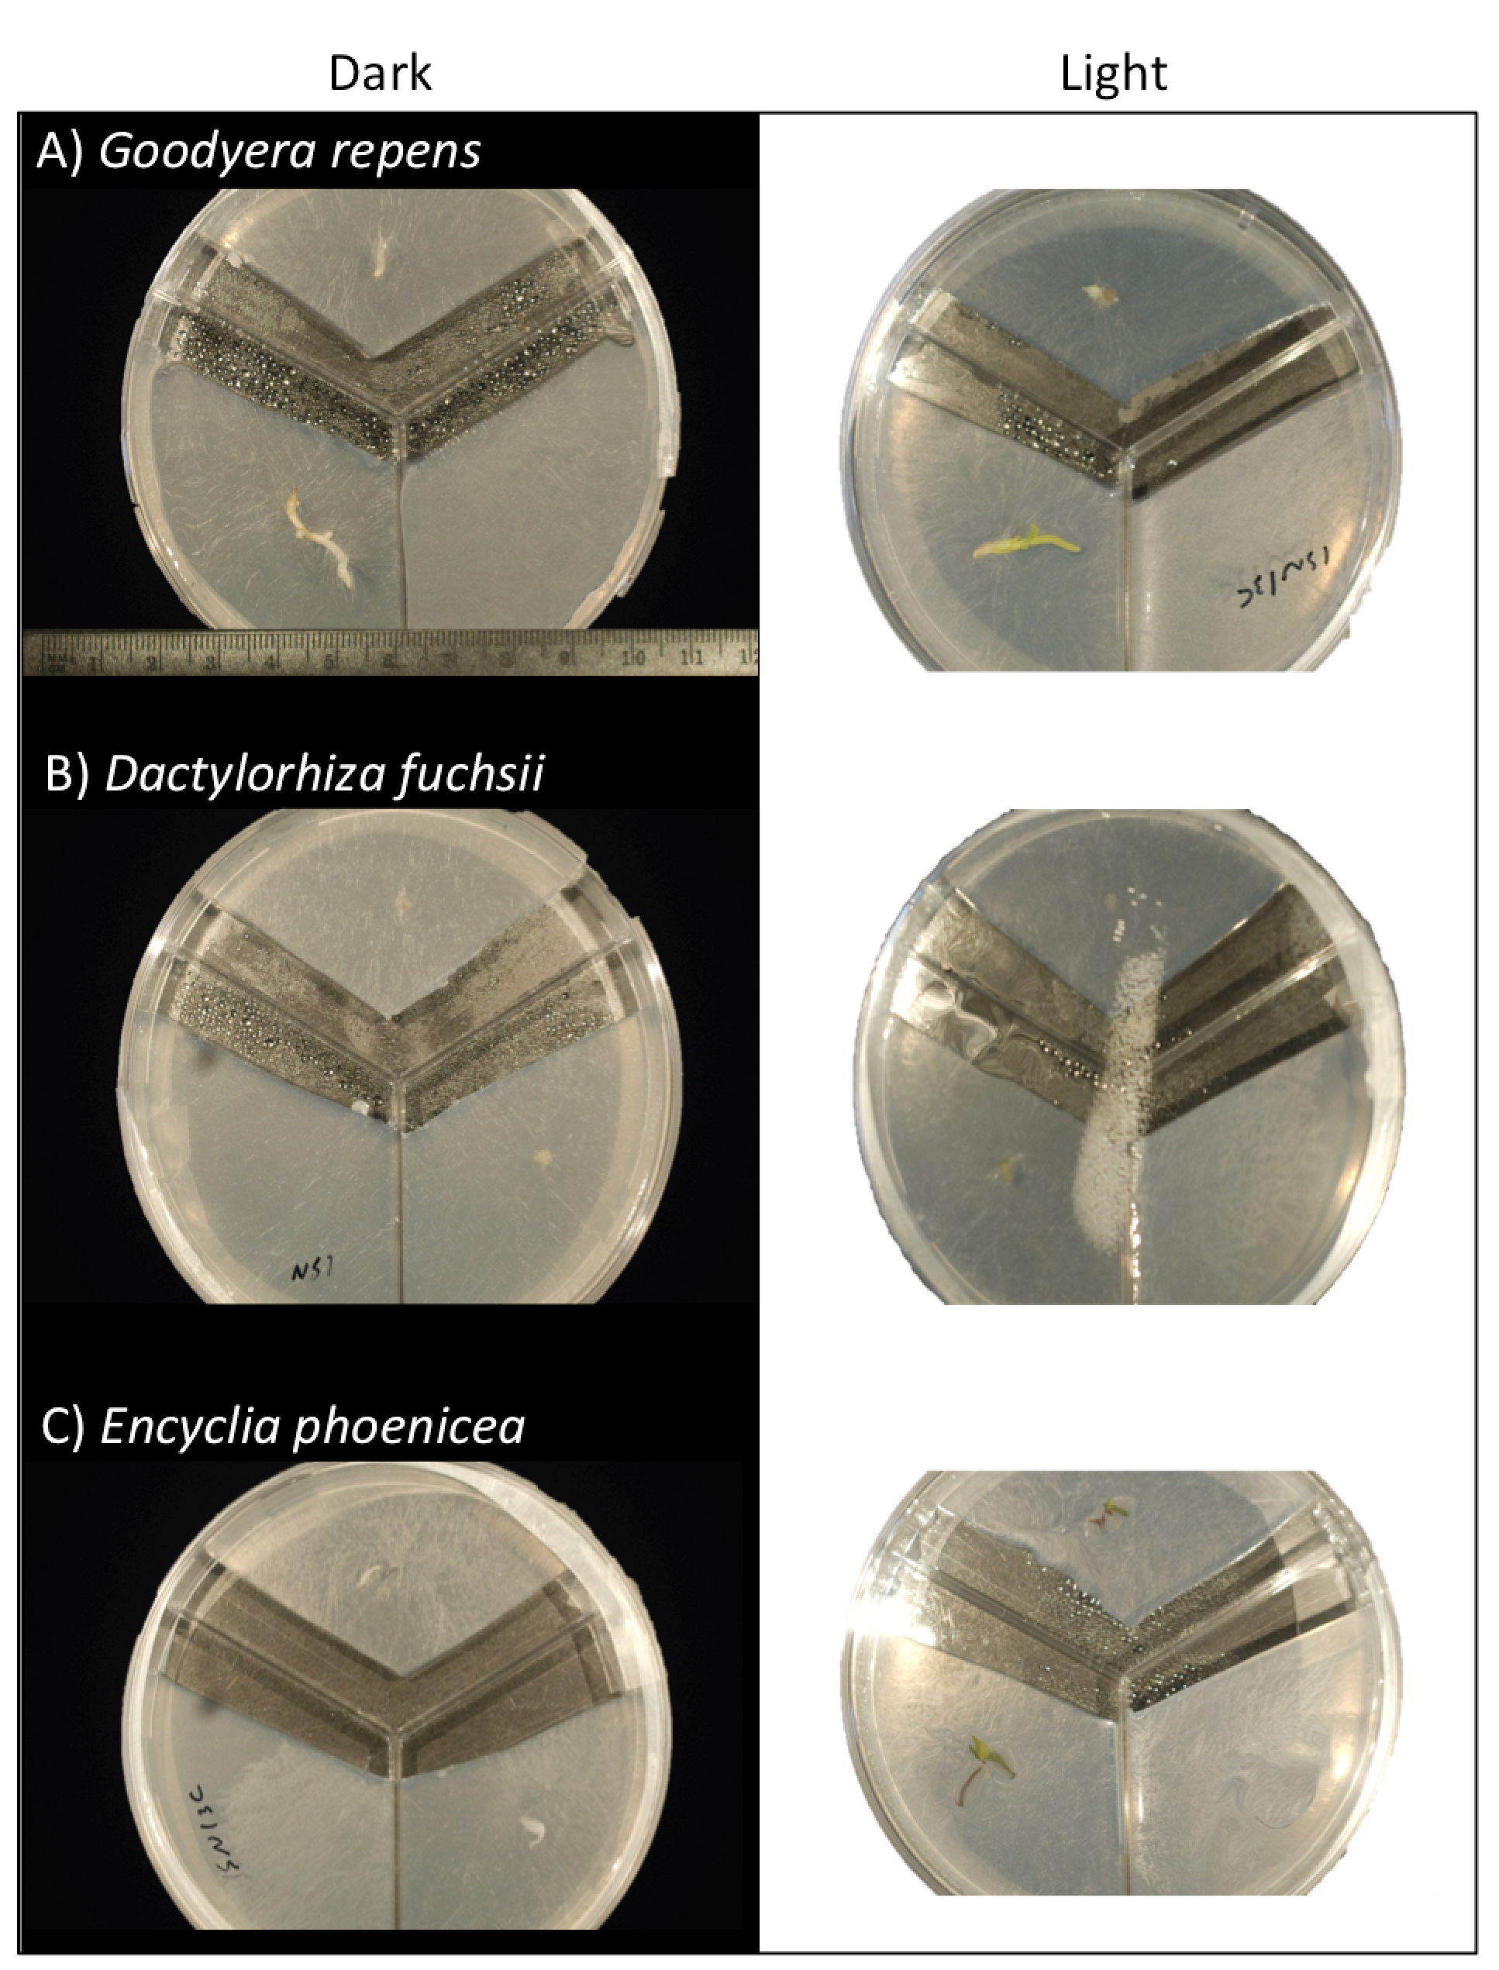
1st
2nd
3rd

Supplementary figure A2.1: Petri dish with three compartments for measuring ¹³C and ¹⁵N enrichment of (A) Goodyera repens, (B) Dactylorhiza fuchsii and (C) Encyclia phoenicea juveniles their fungal partners access to isotope labelled ¹⁵N and ¹³C ammonium nitrate plus sugar in the first compartments. The plant agar in the second compartment barrier to avoid fungal partners access to isotope labelled compounds.

Supplementary table A2.1: Chemical composition of the commercially available (Sigma-Aldrich) ¹³C and ¹⁵N 99 atom %-labelled amino acid mixture.
Amino acid | Composition by mass (%)
L-Alanine | 2.72
L-Arginine | 6.90
L-Aspartic acid | 12.09
L-Glutamic acid | 13.59
Glycine | 13.24
Histidine | 0.81
Isoleucine | 4.23
Leucine | 13.89
Lysine | 12.39
Methionine | 6.63
Phenylalanine | 2.82
Proline | 3.97
Serine | 2.60
Threonine | 4.13

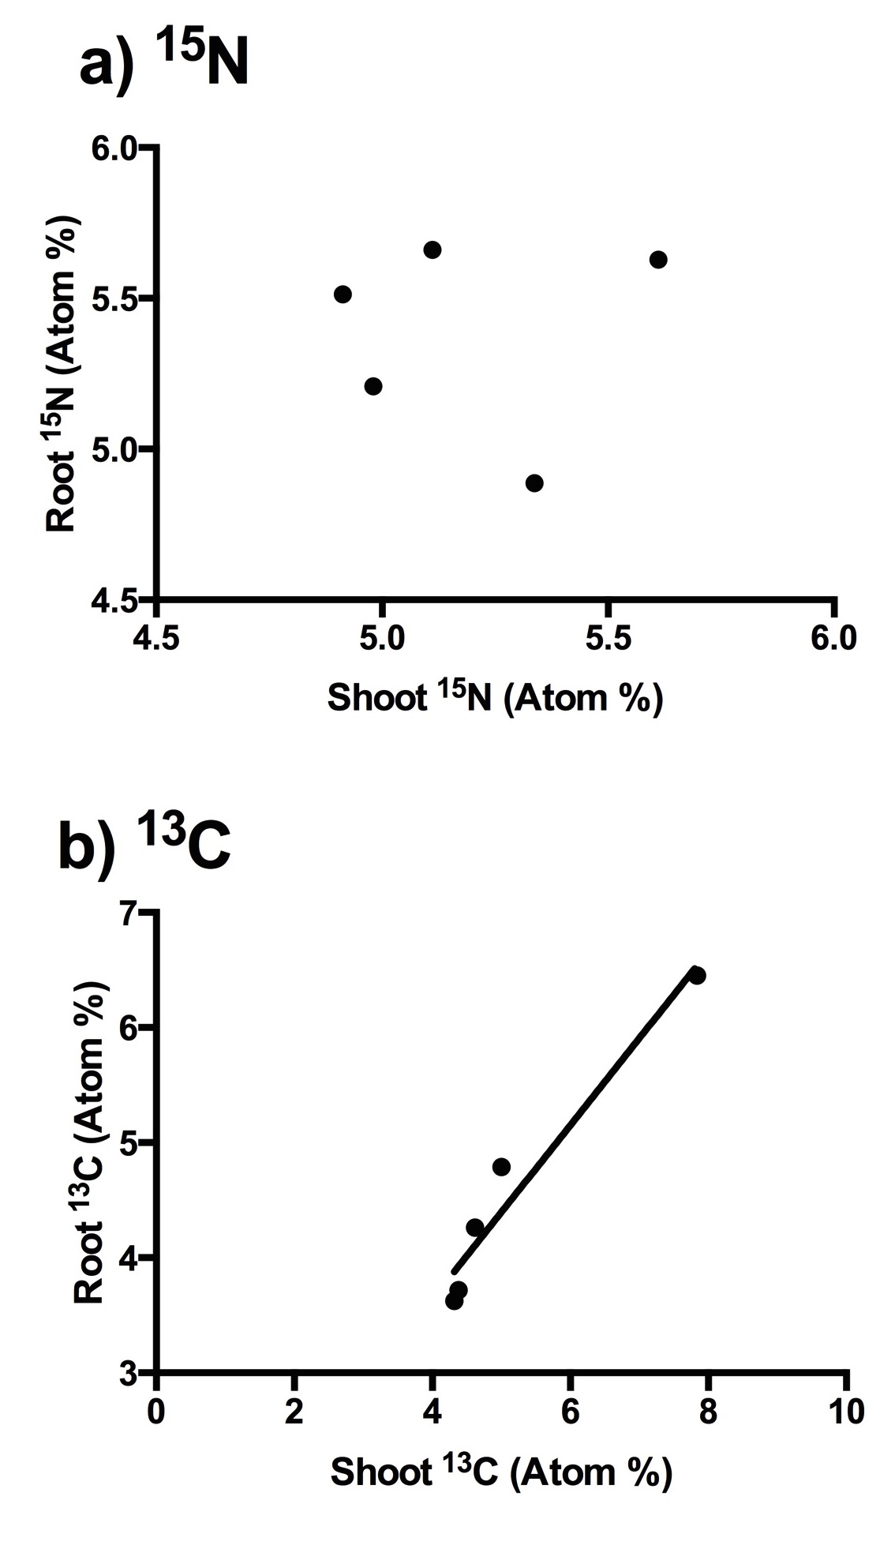

Supplementary figure A2.2: Relationship between root and shoot ¹⁵N and ¹³C content

