Asian Students of English at an International University in Japan:
a study of attitudes to the use and study of English

Christopher G. Haswell

A thesis submitted to satisfy the requirements of the University of Sheffield for the degree of Doctor of Philosophy

September 2014

Abstract

International university education is now a significant and growing part of tertiary education worldwide. In the Asia Pacific region, internationalization is viewed as a lifeline for universities to secure their long-term survival in an increasingly competitive education market. The use of English as a global and academic lingua franca is connected to both international student interaction and institutional outreach.

This thesis reports the findings of a large-scale research project investigating attitudes towards the English language of university students from Japan, Korea and China studying at an international university in Japan. The context for this study is Japan’s most internationalized university, an institution in which greater interest has been engendered by recent governmental and sector efforts to increase the internationalization of all Japanese universities. Previous research has focused on a single population’s attitudes about the study of the English language, utility value of the language, or preferred English variety. My study compares students’ views about these issues with the attitudes of their counterparts studying at non-international, domestic universities in their home countries (China, Korea). More than 800 students from six universities in three countries participated in this research into linguistic attitudes, a study supported qualitatively by focus group-style interviews.

This research found that the internationalization of tertiary education in Japan has affected students’ attitudes towards English language use. At the same time, despite exposure to different varieties of English on a campus where almost half of the students come from overseas, the students from the international university continued to view American English and British English as their preferred performance targets. Chinese and Korean students studying abroad at the international university acknowledged Asian English varieties, but also reported these varieties as causing problems. Internationalized study environments do not appear to change the status of well-established standard varieties as preferred performance models.

Acknowledgements

I would like to thank the gracious staff at Ritsumeikan Asia Pacific University for allowing me to undertake this study at their university, and also the teachers for allowing some of their class time to be used for student surveys. I would also like to express my sincere gratitude to Professor Max Praver (Shizuoka University, formerly of Tsukuba University), Professor Jun Omi (Tokyo Keizai University), Professor Grace Wang (Yonsei University), Professor Andee Pollard (Kangwon University), and Professor Jianbin Huang (Zhejiang University), without whose assistance my project would never have been possible.

I would like to thank Professor Susan Fitzmaurice of the School of English Literature, Language and Linguistics at the University of Sheffield for her advice and supervision throughout my whole project. In addition, the staff at the University of Sheffield have been unfailingly helpful over the past six years.

I would like to take this opportunity to thank my amazing wife, Michiko, for her patience and understanding. Eight years is such a long time that between beginning this project and ending it we had time to share many events together: we married, and experienced the joy (and subsequent slight inconvenience) of the arrival of our two boys, Ira and Senna; I changed my job three times; and we moved to a new city. All the while, the PhD was continuing for both of us. She could only watch and wonder what was taking so long.

Thank you, my lovely boys, for pulling Papa away from the computer and reminding me that there was a whole other world going on out there. Thank you, Mum and Dad, for being unrecompensed proofreaders. Thank you, Claire, Matt and Harry, for inviting me for lovely family dinners after hard days at university. Thank you, Shimako-san, for allowing me to disappear upstairs and work, and for looking after the boys when I needed to meet a deadline.

Finally, a big thank you to all the students who responded to my survey, and for the others who attended a focus group or gave a little of their time to complete the questions online. People whose faces I may never know have helped to make this journey complete.

Thank you, wherever you are.

Author’s Declaration

I declare that the work contained within this document is my own,
unless otherwise stated in the body of the text.

September 2014

Table of Contents
Abstract 2
Acknowledgements 3
Author’s Declaration 4
Table of Contents 5
List of Tables 11
Chapter 1: Introduction 18
1.1 Background 18
1.2 Context of study 21
1.3 English as an international language 22
1.4 Terminology 26
1.5 Research trends 28
1.6 ‘International University’ 29
1.7 The importance of this research 30
1.8 Method and chronology 31
1.9 Key findings 32
1.10 Practical implications of the work 33
1.11 Thesis organization 34
Chapter 2: Literature Review 35
2.1 Introduction 35
2.2 Global English 35
2.2.1 International lingua franca 35
2.2.2 ELF and the internationalization of European higher education 38
2.2.3 Use of English in the Asia Pacific region 41
2.2.4 Linguistic Imperialism and linguistic hegemony 43
2.2.4.1 Consideration of ‘linguicism’ and ‘linguicide’ in the Asia Pacific region 44
2.2.4.2 Opposition to the Linguistic Imperialism view of English 45
2.2.5 Globalized English 48
2.2.5.1 Models of English development and variety 49
2.2.5.1.1 The Kachruvian Model 49
2.2.5.1.2 Later models 50
2.2.5.1.3 Future models 50
2.2.5.2 Asian variety and ‘standards’ 51
2.3 Context of this research project: Japan, Korea and China 53
2.3.1 The position of English in Japan, Korea and China 54
2.3.2 Specific uses of English in Japan, Korea, and China 56
2.3.2.1 Forms of English 56
2.3.2.2 English in context 57
2.3.2.3 Loaned English 57
2.3.2.4 Performance variety 59
2.4 English language education and language policy in Japan, China and Korea 65
2.4.1 Internationalized university education 66
2.4.2 Teaching English in Japan, China and Korea 68
2.4.3 Responses to systemic problems: ALTs and private language schools 70
2.4.4 Future directions in Asian higher education 73
2.5 English attitudes, language utility, and English variety research in the Asia Pacific region 75
2.5.1 Personal, academic, and utility attitude research 77
2.5.2 Standards and varieties of English 80
2.6 Section Conclusion 85
Chapter 3: Methodology 87
3.1 Introduction: Purposes of study 87
3.2 Research overview 88
3.2.1 Instrumentation used in previous studies of language attitudes 88
3.2.2 Development of my methodology from previous iterations of this study 92
3.2.3 Focus of research 93
3.2.4 Research questions 95
3.2.4.1 Research Question 1: What are Asian students’ personal attitudes regarding English? 95
3.2.4.2 Research Question 2: What is the perceived utility value of English for Asian students? 95
3.2.4.3 Research Question 3: What are Asian students’ opinions of Asian varieties of English and other Asian students’ performance of English? 96
3.2.5 Research sites 97
3.2.6 Research instruments 101
3.2.7 Study research questions, and related survey and focus group propositions 102
3.3 Research instruments 105
3.3.1 Quantitative research instrument - Survey 105
3.3.1.1 Design introduction 105
3.3.1.2 Survey administration 105
3.3.2 Qualitative research instruments – Focus groups and qualitative survey 108
3.3.2.1 Introduction 108
3.3.2.2 Face to Face (FTF) focus groups 110
3.3.2.2.1 Formation and institution 110
3.3.2.2.2 Recruitment 110
3.3.2.2.3 Group formation and administration 111
3.3.2.3 Computer Mediated Interaction (CMI) survey 112
3.3.2.3.1 Background to the use of an online qualitative instrument 112
3.3.2.3.2 CMI survey administration 112
3.3.3 Ethical considerations 113
3.3.3.1 Survey and FTF focus groups 113
3.3.3.2 Ethics of on-line qualitative data collection 114
3.3.4 Reliability 114
3.3.4.1 Survey and FTF focus groups 114
3.3.4.2 Reliability of online data 115
3.3.5 Validity 117
3.3.5.1 Survey and FTF focus groups 117
3.3.5.2 Validity of online qualitative data 118
3.4 Data analysis 119
3.4.1 Introduction 119
3.4.2 Survey data 120
3.4.2.1 Quantitative data preparation 120
3.4.2.2 Descriptive statistics 120
3.4.2.3 Comparative statistical analysis of survey data - Mann-Whitney test 121
3.4.3 Qualitative data 122
3.4.3.1 FTF focus group data preparation 122
3.4.3.2 CMI survey data preparation 123
3.4.3.3 FTF / CMI qualitative analysis 123
3.5 Section Conclusion 123
Chapter 4: Findings 124
4.1 Introduction 124
4.2 Survey demographic overview 124
4.2.1 Introduction 124
4.2.2 Age of the subjects 124
4.2.3 Gender of research subjects 126
4.2.4 Length of time studying English 127
4.2.5 Experience visiting an English-speaking country 129
4.2.6 The English-speaking country respondents had visited 130
4.2.7 The English-speaking country respondents were interested in visiting 131
4.2.8 Demographic Summary 132
4.3 Research Question 1: What are Asian students’ orientations towards English? 133
4.3.1 Japanese responses to items in Research Question 1 133
4.3.1.1 Descriptive statistics for Japanese responses to survey items relating to Research Question 1 133
4.3.1.2 Analysis of Japanese responses to Research Question 1 134
4.3.1.3 Survey breakdown and FTF/CMI comments for Japanese responses to Research Question 1 137
4.3.1.4 Key findings for Japanese respondents to Research Question 1 141
4.3.2 Chinese respondents to items in Research Question 1 143
4.3.2.1 Descriptive statistics for Chinese responses to survey items relating to Research Question 1 143
4.3.2.2 Analysis of Chinese responses to Research Question 1 144
4.3.2.3 Survey breakdown and FTF/CMI comments for Chinese responses to Research Question 1 145
4.3.2.4 Key findings for Chinese respondents to Research Question 1 149
4.3.3 Korean respondents to items in Research Question 1 150
4.3.3.1 Descriptive statistics for Korean responses to survey items relating to Research Question 1 150
4.3.3.2 Analysis of Korean responses to Research Question 1 151
4.3.3.3 Survey breakdown and FTF/CMI comments for Korean responses to Research Question 1 153
4.3.3.4 Key findings for Korean respondents to Research Question 1 157
4.4 Research Question 2: What is the utility value of English for Asian students? 159
4.4.1 Japanese responses to items in Research Question 2 159
4.4.1.1 Descriptive statistics for Japanese responses to items in Research Question 2 159
4.4.1.2 Overview of analysis of Japanese responses to Research Question 2 159
4.3.1.3 Survey breakdown and FTF/CMI comments for Japanese responses to Research Question 2 160
4.4.1.4 Key findings for Japanese respondents to Research Question 2 164
4.4.2 Chinese responses to items in Research Question 2 167
4.4.2.1 Descriptive statistics for Chinese responses to survey items relating to Research Question 2 167
4.4.2.2 Analysis of Chinese responses to Research Question 2 167
4.4.2.3 Survey breakdown and FTF/CMI comments for Chinese responses to Research Question 2 168
4.4.2.4 Key findings for Chinese respondents to Research Question 2 170
4.4.3 Korean Responses to Research Question 2 171
4.4.3.1 Descriptive statistics for Korean responses to survey items relating to Research Question 2 171
4.4.3.2 Overview of analysis of Korean responses to survey items relating to Research Question 2 171
4.4.3.3 Survey breakdown and FTF/CMI comments for Korean responses to Research Question 2 172
4.4.3.4 Key findings for Korean respondents to Research Question 2 175
4.5 Research Question 3: What are Asian students’ opinions of other Asian students of English and Asian varieties of English? 177
4.5.1 Japanese responses to items in Research Question 3 177
4.5.1.1 Descriptive statistics for Japanese responses to survey items relating to Research Question 3 177
4.5.1.2 Overview of analysis of Japanese responses to Research Question 3 178
4.5.1.3 Survey breakdown and FTF/CMI comments for Japanese responses to Research Question 3 181
4.5.1.4 Key findings for Japanese respondents to Research Question 3 186
4.5.2 Chinese responses to items in Research Question 3 188
4.5.2.1 Descriptive statistics for Chinese responses to survey items relating to Research Question 3 188
4.5.2.2 Overview of analysis of Chinese responses to Research Question 3 189
4.5.2.3 Survey breakdown and FTF/CMI comments for Chinese responses to Research Question 3 191
4.5.2.4 Key findings for Chinese respondents to Research Question 3 194
4.5.3 Korean responses to items in Research Question 3 196
4.5.3.1 Descriptive statistics for Korean responses to survey items relating to Research Question 3 196
4.5.3.2 Analysis of Korean responses to Research Question 3 197
4.5.3.3 Survey breakdown and FTF/CMI comments for Korean responses to Research Question 3 200
4.5.3.4 Key findings for Korean respondents to Research Question 3 204
Chapter 5: Discussion of Findings 207
5.1 Introduction 207
5.2 Research Question 1 207
5.2.1 Japanese Respondents to Research Question 1 207
5.2.2 Chinese respondents to Research Question 1 212
5.2.3 Korean respondents to Research Question 1 215
5.3.4 Discussion of all three APU populations’ responses to Research Question 1 218
5.2.5 Further consideration of the concept of ‘Weakness’ discussed by APU students in the FTF focus groups 221
5.2.6 Further consideration of the concept of ‘Coolness’ discussed by APU students in the FTF focus groups 222
5.3 Research Question 2 224
5.3.1 Japanese respondents to Research Question 2 224
5.3.2 Chinese respondents to Research Question 2 230
5.3.3 Korean responses to Research Question 2 232
5.3.4 Discussion of all three APU populations’ responses to Research Question 2 234
5.3.5 Further consideration of the concept of ‘Better’ discussed by APU students in the FTF focus groups 236
5.4 Research Question 3 239
5.4.1 Japanese respondents to Research Question 3 239
5.4.2 Chinese respondents to Research Question 3 244
5.4.3 Korean respondents to Research Question 3 245
5.4.4 Discussion of all three APU populations’ responses to Research Question 3 247
5.4.5 Further consideration of the concept of ‘Confusion’ discussed by APU students in the FTF focus groups 250
5.5 Section Conclusion 252
Chapter 6: Conclusion 255
6.1 Overview 255
6.2 Japanese students at APU and domestic Japanese students 255
6.3 International students at international universities 258
6.4 Future policies and initiatives 260
6.5 Continued linguistic hegemony of ENL varieties 261
6.6 Recommendations 263
6.6.1 Active orientation of all students towards the benefits of experiencing internationalized English 263
6.6.2 Regular workshops to help international students deal with problems on campus 265
6.7 Limitations 266
6.7.1 Geography 266
6.7.2 Participants 266
6.8 Further research 267
Appendices 268
Appendix A: Tables of survey responses separated by selections 269
A1: Research Question 1: What are Asian students’ orientations towards English? 269
A1a - Japanese respondents 269
A1b - Chinese respondents 271
A1c - Korean Respondents 272
A2 - Research Question 2: What is the utility value of English for Asian students? 274
A2a - Japanese respondents 274
A2b - Chinese respondents 276
A2c - Korean respondents 278
A3 - Research Question 3: What are Asian students’ opinions of other Asian students of English and Asian varieties of English? 280
A3a - Japanese responses 280
A3b - Chinese Responses 282
A3c - Korean Responses 284
Appendix B: 2007 Pre-pilot survey items 286
Appendix C: 2008 Pilot study survey items 287
Appendix D: Order of items on the 2008 focus group handout 288
Appendix E: 2008 Pilot study research questions 289
Appendix F: 2011 Research design 290
Appendix G: 2011 Survey items 291
Appendix H: 2011 FTF Focus Group Handout 292
Appendix I: APU’s Opening Statement 293
Appendix J: Sections from APU’s guidelines for ethical research 294
References 296

List of Tables
Table 1: Use of English in political, professional, media and personal domains 36
Table 2: The overall percentage of ALTs coming from selected English-speaking countries since 1997 (Source: MEXT, 2008) 71
Table 3: The 2011 percentage of ALTs coming from selected English-speaking countries 71
Table 4: Survey and focus group items used for demographic data collection 104
Table 5: Survey and focus group items used for attitudinal data collection grouped by research question 104
Table 6: Survey design elements 105
Table 7: Respondent populations for the 2011 survey 107
Table 8: Respondent populations for the 2011 CMI qualitative survey 109
Table 9: Age of survey respondents 124
Table 10: Gender of survey respondents 126
Table 11: Length of study of survey respondents 127
Table 12: Experience of survey respondents 129
Table 13: Countries visited by the survey respondents 130
Table 14: Countries survey respondents were interested in visiting 131
Table 15: J1-1 Descriptive statistics for Japanese respondents to survey items relating to Research Question 1 133
Table 16: J1-2 Descriptive statistics for Japanese responses to survey items relating to Research Question 1 133
Table 17: J1-Item 10MW Results of Mann-Whitney paired sample analysis for Japanese responses to the proposition "English is cool" 134
Table 18: J1-Item 11MW Results of Mann-Whitney paired sample analysis for Japanese responses to proposition "I think studying English is a good idea" 134
Table 19: J1-Item 12MW results of Mann-Whitney paired sample analysis for Japanese responses to proposition "My friends think studying English is a good idea" 135
Table 20: J1-Item 21MW results of Mann-Whitney paired sample analysis for Japanese responses to proposition "I enjoy studying English" 135
Table 21: J1-Item 15MW results of Mann-Whitney paired sample analysis for Japanese responses to proposition "If I have to speak English I feel weak" 136
Table 22: J1-Item 16MW results of Mann-Whitney paired sample analysis for Japanese responses to proposition "English makes other language weaker" 136
Table 23: Table of charts relating to the key findings for Japanese respondents to Research Question 1 142
Table 24: C1-1 Descriptive statistics for Chinese responses to survey items relating to Research Question 1 143
Table 25: C1-2 Descriptive statistics for Chinese responses to survey items relating to Research Question 1 143
Table 26: C1-Item 10MW results of Mann-Whitney paired sample analysis for Chinese responses to proposition "English is cool" 144
Table 27: C1-Item 11MW results of Mann-Whitney paired sample analysis for Chinese responses to proposition "I think studying English is a good idea" 144
Table 28: C1-Item 12MW results of Mann-Whitney paired sample analysis for Chinese responses to proposition "My friends think that studying English is a good idea" 144
Table 29: C1-Item 21MW results of Mann-Whitney paired sample analysis for Chinese responses to proposition "I enjoy studying English" 145
Table 30: C1-Item 15MW results of Mann-Whitney paired sample analysis for Chinese responses to proposition "If I have to speak English I feel weak" 145
Table 31: C1-Item 16MW results of Mann-Whitney paired sample analysis for Chinese responses to proposition "English makes other languages weaker" 145
Table 32: Table of charts relating to the key findings for Chinese respondents to Research Question 1 149
Table 33: K1-2 Descriptive statistics for Korean responses to survey items relating to Research Question 1 150
Table 34: K1-Item 10MW results of Mann-Whitney paired sample analysis for Korean responses to proposition "English is cool" 151
Table 35: K1-Item 11MW results of Mann-Whitney paired sample analysis for Korean responses to proposition "I think studying English is a good idea" 151
Table 36: K1-Item 12MW results of Mann-Whitney paired sample analysis for Korean responses to proposition "My friends think studying English is a good idea" 152
Table 37: K1-Item 21MW results of Mann-Whitney paired sample analysis for Korean responses to proposition "I enjoy studying English" 152
Table 38: K1-Item 15MW results of Mann-Whitney paired sample analysis for Korean responses to proposition "If I have to speak English I feel weak" 153
Table 39: K1-Item 16MW results of Mann-Whitney paired sample analysis for Korean responses to proposition "English makes other languages weaker" 153
Table 40: Table of charts relating to the key findings for Korean respondents to Research Question 1 158
Table 41: J2-1 Descriptive statistics for Japanese responses to items to Research Question 2 159
Table 42: J2-Item 17MW results of Mann-Whitney paired sample analysis for Japanese responses to proposition "I want to learn correct English" 159
Table 43: J2-Item 18MW results of Mann-Whitney paired sample analysis for Japanese responses to proposition "If I can speak English I will be a better person" 160
Table 44: Table of charts relating to the key findings for Japanese respondents to Research Question 2 165
Table 45: C2-1 Descriptive statistics for Chinese responses to survey items relating to Research Question 2 167
Table 46: C2-Item 17MW results of Mann-Whitney paired sample analysis for Chinese responses to proposition "I want to learn correct English" 167
Table 47: C2-Item 18MW results of Mann-Whitney paired sample analysis for Chinese responses to proposition "If I can speak English I will be a better person" 167
Table 48: Table of charts relating to the key findings for Chinese respondents to Research Question 2 170
Table 49: K2-1 Descriptive statistics for Korean responses to survey items relating to Research Question 2 171
Table 50: K2-Item 17MW results of Mann-Whitney paired sample analysis for Korean responses to proposition "I want to learn correct English" 171
Table 51: K2-Item 18MW results of Mann-Whitney paired sample analysis for Korean responses to proposition "If I can speak English I will be a better person" 172
Table 52: Table of charts relating to the key findings for Korean respondents to Research Question 1 176
Table 53: J3-1 Descriptive statistics for Japanese responses to survey items relating to Research Question 3 177
Table 54: J3-2 Descriptive statistics for Japanese responses to survey items relating to Research Question 3 177
Table 55: J3-Item 20MW results of Mann-Whitney paired sample analysis for Japanese responses to proposition "English is the world standard language" 178
Table 56: J3-Item 19MW results of Mann-Whitney paired sample analysis for Japanese responses to proposition "I want to study English with other Asian students" 178
Table 57: J3-Item 13MW results of Mann-Whitney paired sample analysis for Japanese responses to proposition "In my experience, people in different places speak different varieties of English" 179
Table 58: J3-Item 14MW results of Mann-Whitney paired sample analysis for Japanese responses to proposition "I am interested in the English of other Asian countries" 179
Table 59: J3-Item 22MW results of Mann-Whitney paired sample analysis for Japanese responses to proposition "I think studying about Asian varieties of English is a good idea" 180
Table 60: J3-Item 23MW results of Mann-Whitney paired sample analysis for Japanese responses to proposition "Having different varieties of English is confusing" 180
Table 61: J3-Item 24MW results of Mann-Whitney paired sample analysis for Japanese responses to proposition "I think it is difficult to speak to other Asian students of English" 181
Table 62: Table of charts relating to the key findings for Korean respondents to Research Question 1 187
Table 63: C3-1 Descriptive statistics for Chinese responses to the survey items relating to research Question 3 188
Table 64: C3-2 Descriptive statistics for Chinese responses to the survey items relating to research Question 3 188
Table 65: C3-Item 20MW results of Mann-Whitney paired sample analysis for Chinese responses to proposition "English is the world standard language" 189
Table 66: C3-Item 19MW results of Mann-Whitney paired sample analysis for Chinese responses to proposition "I want to study English with other Asian students" 189
Table 67: C3-Item 13MW results of Mann-Whitney paired sample analysis for Chinese responses to proposition "In my experience, people from different places speak different varieties of English" 189
Table 68: C3-Item 14MW results of Mann-Whitney paired sample analysis for Chinese responses to proposition "I am interested in the English of other Asian countries" 189
Table 69: C3-Item 22MW results of Mann-Whitney paired sample analysis for Chinese responses to proposition "I think studying about Asian varieties of English is a good idea" 190
Table 70: C3-Item 23MW results of Mann-Whitney paired sample analysis for Chinese responses to proposition "Having different varieties of English is confusing" 190
Table 71: C3-Item 24MW results of Mann-Whitney paired sample analysis for Chinese responses to proposition "It is difficult to speak to other Asian students in English" 190
Table 72: Table of charts relating to the key findings for Chinese respondents to Research Question 3 195
Table 73: K3-1 Descriptive statistics for Korean responses to the survey items relating to Research Question 3 196
Table 74: K3-2 Descriptive statistics for Korean responses to the survey items relating to Research Question 3 196
Table 75: K3-Item 20MW results of Mann-Whitney paired sample analysis for Korean responses to proposition "English is the world standard language" 197
Table 76: K3-Item 19MW results of Mann-Whitney paired sample analysis for Korean responses to proposition "I want to study English with other Asian students" 197
Table 77: K3-Item 13MW results of Mann-Whitney paired sample analysis for Korean responses to proposition "In my experience, people from different places speak different varieties of English" 198
Table 78: K3-Item 14MW results of Mann-Whitney paired sample analysis for Korean responses to proposition "I am interested in the English of other Asian countries" 198
Table 79: K3-Item 22MW results of Mann-Whitney paired sample analysis for Korean responses to proposition "I think studying about Asian varieties of English is a good idea" 199
Table 80: K3-Item 23MW results of Mann-Whitney paired sample analysis for Korean responses to proposition "Having different varieties of English is confusing" 199
Table 81: K3-Item 24MW results of Mann-Whitney paired sample analysis for Korean responses to proposition "I think it is difficult to speak to other Asian students in English" 200
Table 82: Table of charts relating to the key findings for Korean respondents to Research Question 3 205
Table 83: J1-Item 10P: Summary of Japanese student responses to the proposition “English is cool” grouped by site 269
Table 84: J1-Item 21P: Summary of Japanese student responses to the proposition “I enjoy studying English” grouped by site 269
Table 85: J1- Item 11P: Summary of Japanese student responses to the proposition “I think studying English is a good idea” grouped by site 269
Table 86: J1- Item 12P: Summary of Japanese student responses to the proposition “My friends think studying English is a good idea” grouped by site 269
Table 87: J1- Item 15P: Summary of Japanese student responses to the proposition “If I have to speak English I feel weak” grouped by site 270
Table 88: J1- Item 16P: Summary of Japanese student responses to the proposition “English makes other languages weaker” grouped by site 270
Table 89: C1-Item 10P: Summary of Chinese student responses to the proposition “English is cool” grouped by site 271
Table 90: C1-Item 11P: Summary of Chinese student responses to the proposition “I think studying English is a good idea” grouped by site 271
Table 91: C1-Item 12P: Summary of Chinese student responses to the proposition “My friends think studying English is a good idea” grouped by site 271
Table 92: C1-Item 21P: Summary of Chinese student responses to the proposition “I enjoy studying English” grouped by site 271
Table 93: C1-Item 15P: Summary of Chinese student responses to the proposition “If I have to speak English, I feel weak” grouped by site 271
Table 94: C1-Item 16P: Summary of Chinese student responses to the proposition “English makes other languages weaker” grouped by site 271
Table 95: K1- Item 10P: Summary of Korean student responses to the proposition “English is cool” grouped by site 272
Table 96: K1- Item 11P: Summary of Korean student responses to the proposition “I think studying English is a good idea” grouped by site 272
Table 97: K1-Item 12P: Summary of Korean student responses to the proposition “My friends think studying English is a good idea” grouped by site 272
Table 98: K1-Item 21P: Summary of Korean student responses to the proposition “I enjoy studying English” grouped by site 272
Table 99: K1-Item 15P: Summary of Korean student responses to the proposition “If I have to speak English I feel weak” grouped by site 272
Table 100: K1-Item 16P: Summary of Korean student responses to the proposition “English makes other languages weaker” grouped by site 273
Table 101: J2-Item 8P: Summary of Japanese student responses to the question “Why are you studying English?” grouped by site 274
Table 102: J2-Item 17P: Summary of Japanese student responses to the proposition “I want to learn correct English” grouped by site 274
Table 103: J2-Item 27P: Summary of Japanese student responses to the question “What variety of English do you want to learn?” grouped by site 274
Table 104: J2-Item 18P: Summary of Japanese student responses to the proposition “If I can speak English, I will be a better person” grouped by site 274
Table 105: J2-Item 25P: Summary of Japanese student responses to the question “What do you use English for now?” grouped by site 274
Table 106: J2-Item 26P: Summary of Japanese student responses to the question “What will you use English for in the future?” grouped by site 275
Table 107: C2-Item 8P: Summary of Chinese student responses to the question “Why are you studying English?” grouped by site 276
Table 108: C2-Item 17P: Summary of Chinese student responses to the proposition “I want to learn correct English” grouped by site 276
Table 109: C2-Item 27P: Summary of Chinese student responses to the question “What variety of English do you want to learn?” grouped by site 276
Table 110: C2-Item 18P: Summary of Chinese student responses to the proposition “If I can speak English, I will be a better person” grouped by site 276
Table 111: C2-Item 25P: Summary of Chinese student responses to the question “What do you use English for now?” grouped by site 276
Table 112: C2-Item 26P: Summary of Chinese student responses to the question “What will you use English for in the future?” grouped by site 277
Table 113: K2-Item 8P: Summary of Korean student responses to the question “Why are you studying English?” grouped by site 278
Table 114: K2-Item 17P: Summary of Korean student responses to the proposition “I want to learn correct English” grouped by site 278
Table 115: K2-Item 27P: Summary of Korean student responses to the question “What variety of English do you want to learn?” grouped by site 278
Table 116: K2-Item 18P: Summary of Korean student responses to the proposition “If I can speak English, I will be a better person” grouped by site 278
Table 117: K2-Item 25P: Summary of Korean student responses to the question “What do you use English for now?” grouped by site 278
Table 118: K2-Item 26P: Summary of Korean student responses to the question “What will you use English for in the future?” grouped by site 279
Table 119: J3-Item 20P: Summary of Japanese student responses to the proposition “English is the world standard language” grouped by site 280
Table 120: J3-Item 27P: Summary of Japanese student responses to the question “Which variety of English should be the world standard?” grouped by site 280
Table 121: J3-Item 19P: Summary of Japanese student responses to the proposition “I want to study English with other Asian students” grouped by site 280
Table 122: J3-Item 13P: Summary of Japanese student responses to the proposition “In my experience, people from different places speak different varieties of English” grouped by site 280
Table 123: J3-Item 14P: Summary of Japanese student responses to the proposition “I am interested in the English of other Asian countries” grouped by site 280
Table 124: J3-Item 22P: Summary of Japanese student responses to the proposition “I think studying about Asian varieties of English is a good idea” grouped by site 281
Table 125: J3-Item 23P: Summary of Japanese student responses to the proposition “Having different varieties of English is confusing” grouped by site 281
Table 126: J3-Item 24P: Summary of Japanese student responses to the proposition “It is difficult to speak to other Asian students in English” grouped by site 281
Table 127: C3-Item 20P: Summary of Chinese student responses to the proposition “English is the world standard language” grouped by site 282
Table 128: C3-Item 27P: Summary of Chinese student responses to the question “Which variety of English should be the world standard?” grouped by site 282
Table 129: C3-Item 19P: Summary of Chinese student responses to the proposition “I want to study English with other Asian students” grouped by site 282
Table 130: C3-Item 13P: Summary of Chinese student responses to the proposition “In my experience, people from different places speak different varieties of English” grouped by site 282
Table 131: C3-Item 14P: Summary of Chinese student responses to the proposition “I am interested in the English of other Asian countries” grouped by site 282
Table 132: C3-Item 22P: Summary of Chinese student responses to the proposition “I think studying about Asian varieties of English is a good idea” grouped by site 282
Table 133: C3-Item 23P: Summary of Chinese student responses to the proposition “Having different varieties of English is confusing” grouped by site 283
Table 134: C3-Item 24P: Summary of Chinese student responses to the proposition “It is difficult to speak to other Asian students in English” grouped by site 283
Table 135: K3-Item 20P: Summary of Korean student responses to the proposition “English is the world standard language” grouped by site 284
Table 136: K3-Item 27P: Summary of Korean student responses to the question “Which variety of English should be the world standard?” grouped by site 284
Table 137: K3-Item 19P: Summary of Korean student responses to the proposition “I want to study English with other Asian students” grouped by site 284
Table 138: K3-Item 13P: Summary of Korean student responses to the proposition “In my experience, people from different places speak different varieties of English” grouped by site 284
Table 139: K3-Item 14P: Summary of Korean student responses to the proposition “I am interested in the English of other Asian countries” grouped by site 284
Table 140: K3-Item 22P: Summary of Korean student responses to the proposition “I think studying about Asian varieties of English is a good idea” grouped by site 285
Table 141: K3-Item 23P: Summary of Korean student responses to the proposition “Having different varieties of English is confusing” grouped by site 285
Table 142: K3-Item 24P: Summary of Korean student responses to the proposition “It is difficult to speak to other Asian students of English” grouped by site 285

Chapter 1: Introduction

1.1 Background
The domains of English use in the Asia Pacific region are increasing in number and breadth as the language becomes the dominant international lingua franca. English is a required subject for students from nine years old through to the university level in most Asian countries (Nunan, 2003). Therefore, as EFL is a required component of not only gaining entry to university but also graduation, students may study the language without any intrinsic motivation to do so. If students in the Asia Pacific region have a personal motivation to learn the English language, it is likely to be tied to the language’s utility value. In the context of Japan, current university students will move into their professional careers within a few years of completing their compulsory language study and join a working environment where English is the language of business not only internationally (Y. Kachru & Nelson, 2006) but increasingly domestically (Stanlaw, 2004; Seargeant, 2011).

My research reported in this thesis investigates students at an international university in Japan. Due to the focus that the Japanese Ministry of Education (also known as the Mombukagakusho or MEXT) has on the use of English as a foreign language, attitudes towards the English language in Japan exist at the intersection of government policy and student aspiration. Students in Japan are at the hub of a large industry built around the premise that learning English is of both personal and national benefit. This premise has conferred privilege on English as both a language for academic advantage and as a method of social improvement even in countries where English remains a foreign language. A central issue in this connection between language and attitude is that the history of English, particularly within the Asia Pacific region, has links to both the British Empire (Crystal, 2003) and claims of continued linguistic and cultural hegemony, in relation to the United States in particular (Phillipson, 1992; Kubota, 1998; Tsuda, 2000, 2008). In this sense, the presence of the English language in Asia is complicated by its history and current cultural connections.

A reason for taking an interest in international students in Japan is the widespread concern regarding the decline in the pool of university-age students in that country. The falling Japanese birthrate means that the number of ‘customers’ for the tertiary education industry in Japan will decline in the coming decades (Butler & Iino, 2005; Sakai & D’Angelo, 2005). There are 778 universities in Japan, of which 597 are private institutions (MEXT, 2013). Private universities make up around 80% of all university student places in Japan (MEXT, 2012). National and public universities in Japan have a certain degree of independence, and are managed by independent university presidents, but they are still under the control of the Ministry of Education (MEXT) and as such have a financial organization and support that extends beyond the institutions themselves. Public universities receive over 50% of their income from public funds from MEXT (Maruyama, 2008: 9), while private institutions’ main source of revenue is student fees, as they receive only 12% of their funding from MEXT (ibid: 5). For this reason, although all universities are likely to experience some difficulty with regard to shrinking domestic intake, private universities, whose livelihoods depend primarily on fee-paying students, will have relatively far higher financial difficulties.

Recruitment is not the only major concern facing Japanese institutions, particularly those who rely on outside investment for their financial future. In Japan, “many Japanese observers argue that the majority of their higher education institutions are not sufficiently internationalized compared with those of other industrialized countries” (Ninomiya, Knight & Watanabe 2009:118). Japanese universities are low ranked compared with institutions in Europe and North America, with only two universities in the top 100 of the Times Higher Education (THE) rankings, and only one in the top 50. This compares with the United States and Europe who make up 24 of the top 25 spaces, with the USA accounting for 15 of the top 20 places in the THE rankings. The methodologies of the THE rankings, and those of the competitor ranking organization Quacquirelli Symonds (QS), have been reported to favour English-speaking countries (Ishikawa, 2009), and the low rankings for a higher education system which is rated as one of the best funded in the world (OECD, 2012) clearly suggest that Japanese universities have a problem connecting with the international academic community.

Low university rankings are now a cause for concern in Japan. Among Japanese universities “[t]here is growing fear that the failure to do well in global rankings may negatively affect their future in the face of growing competition among universities while the nation’s population rapidly ages and college age population continues to decline” (Ishikawa, 2009:168). Rankings affect domestic and international university recruitment, as well as their institutional esteem in the eyes of private investors, as these rankings are capable of inflating the university’s appeal by what Ishikawa terms a “manufacturing of prestige” (ibid: 164). Universities in Japan face increasing pressure to follow international trends more than ever before, and as Ninomiya, Knight and Watanabe, (2009:123) state “[i]t is not an exaggeration to say that … internationalization is a lifeline of the university in Japan in terms of increasing low enrolments and optimizing its research output and competitiveness”. To this end “Asian social science scholars are motivated to publish in the English language, to communicate with wider audience (sic) and to build strong publication records for internal evaluation or to improve university standings in the rankings” (Ishikawa, 2009: 170). Climbing the international rankings is now of paramount concern to help universities maintain their prestige.

Japanese universities have identified the recruitment of foreign students as the solution to their twin concerns of falling domestic admissions and lack of institutional internationalization. In an effort to increase student enrollment and improve the standing of their universities in international rankings, the Japanese Ministry of Education has moved to increase foreign recruitment of students with its Global 30 initiative (MEXT, 2008, 2009, 2010), in an effort to reach 300,000 international students by 2020. This would be a doubling of the number of international students from the current rate. However, even prior to the Global 30, international student numbers had been rising quickly in Japan, with the Japanese Student Services Organization (JASSO) reporting an increase from 55,755 in 1998 to 118,498 in 2008, the year the Global 30 project started. This number has since risen to the current number of 137,756 (JASSO, 2013).

Although there are many international students in Japan, the majority of these students come from a narrow range of countries. In Japan, Korean and Chinese students together make up almost 75% of the foreign students, with Chinese students alone making up 62.7% of the international student population with Korean students at 12.1% (Yamagami & Tollefson, 2011:27). These two populations therefore merited the most interest alongside the Japanese student population when I decided to investigate the effect of an internationalized environment on the attitudes of university students, as these are the countries most likely to be recruited from by Japanese universities. After Korean and Chinese, the next most common international student nationalities in Japan are Taiwanese and Vietnamese, with 3.4% and 3.2% respectively (JASSO, 2013).

1.2 Context of study
The project to internationalize Japanese universities can be seen in a microcosm at Ritsumeikan Asia Pacific University (APU). This university was opened in 2000 and accepts a large propotion its student intake from outside of Japan. Previous research into student attitudes in Japan has considered a single location or single population of students (Chihara & Oller, 1978; Benson, 1991; Koizumi & Matsuo, 1993; Takeshita, 2000; Matsuda, 2000; Yoshikawa 2005; Tokumoto & Shibata, 2011), but a large-scale consideration of all students at an international university has not been undertaken until now. APU’s international student population remains highly unusual in Japan. APU has 45% of its student population entering the university from outside Japan, compared to the current proportion of international students in Japan of less than 3% of the total university student population (MEXT, 2013).

Ritsumeikan Asia Pacific University (APU) was opened in 2000 with the intent of, as is stated in their opening address, being “a place where the young future leaders from countries and regions throughout the world will come to study together, live together, and understand each other's cultures and ways of life, in pursuit of goals which are common to all mankind” (see Appendix I of this thesis for the full text). In furtherance of this mission, students at the university are given the opportunity to meet students from more than 80 different countries and regions of the world. The university operates a dual language policy, which is to say that students entering the university have the opportunity to take the majority of their credits, and complete their major courses of study required for graduation, in either Japanese or English. A similar policy of allowing students to choose their language of instruction for major subjects was deemed important enough to be included in MEXT’s action plan for the facilitation of foreign students entering Japanese universities (MEXT, 2010). However, students entering Ritsumeikan APU are not required to take a majority of their credit requirements in the alternative language. Students at the university who attend using Japanese as their first language are required to take a number of language credits in English, and vice versa. However, unlike in Korea where “university administrators have encouraged or mandated their faculty to use English exclusively in delivering lectures and interacting with students across different academic areas, ranging from humanities and social sciences to engineering and hard sciences” (Kang, 2012: 30), APU provides its major courses in both Japanese and English so the alternative language is an option rather than a requirement.

Official Korean education policies regarding English-medium instruction (EMI) are an example of how countries in Asia are handling the perceived need for internationalization of tertiary education. EMI lectures are a large part of the developing dynamic of English use in tertiary education in Asia, and an important principle of national policy with regard to international outreach of universities. The difference is that in Japanese universities the systems have been adopted to facilitate additive internationalization, which is to say that they offer English as the means to facilitate more students entering the university system rather than require domestic students to study more English, either in EFL classes or EMI lectures. Kang (2000), Lee (2010), and Cho (2011) all argue that damage has been done to the Korean university system by the requirement for students to take a certain number of credits, up to 30% of their chosen majors, in English. In the case of APU, the quality of the Japanese students’ work is not likely to be affected by the linguistic make-up of the university as a whole, as they always have their first language available to them for their major course studies.

1.3 English as an international language
Japan, Korea and China are three examples of economically successful countries in the Asia Pacific region. However, all three are outside the ASEAN economic group, an organization that uses English as an official language (Kirkpatrick, 2011), meaning Japan, Korea and China have no immediate official uses for English (Kachru & Nelson, 2006). All three also have strong domestic languages and therefore their adoption of English as a foreign language is for practical purposes outside their domestic contexts. As English grows as an international language, the effect of the language can be observed in all three countries, as part of the media, as a donor of loan words, and as performance varieties of English developed from contact with the domestic language. Outside Asia, the widespread adoption of English as the medium of international communication has been increasing for some time. In Europe, English is generally no longer considered to be a ‘foreign’ language (Erling, 2007), as the use of English as the nationally accepted first foreign language and language of international business is English. Such a feeling has meant that attempts to assist with international student mobility have been accused of being moves to further the entrenchment of English as the international language (Ljosland, 2005).

English is now the predominant language of international communication; this means that the terms ‘international’ and ‘internationalized’ appear to be equated with ‘use of English’ in relation to tertiary education in particular. As an example of this conflation, Kuwamura states “[b]y offering programs in English, Japanese universities will be able to enroll more students from English-speaking countries who may otherwise choose other English-speaking nations as their study abroad destinations” (Kuwamura, 2009:195). The Republic of Korea has also implemented measures designed to increase the number of English-medium courses in their universities (Cho, 2011). Increasing the number of English medium courses for foreign recruitment was also part of the Global 30 initiative (MEXT, 2009), and was in fact Point 1 of its ‘Action Plan’ for the core universities (ibid.).

Problems with the implementation of a national policy to increase internationalization are not without historical precedent in Japan. The country has experienced difficulties with the use and study of English domestically that have been likened to an ‘allergy’ to the language (Tsuda, 1990; Kubota, 1998), suggesting that although it is being taught more widely than before learners are unable to master the use of the English language and grasp the opportunities of having such a skill. Japan currently has the lowest average international TOEIC scores compared to their closest economic rivals, Korea and China, with an average score of 70 out of 120, compared with 77 for China and 84 for Korea (ETS, 2013).

The study of English in China has faced similar problems to those in Japan. The situation in China with regard to efforts to improve and expand English language education is encapsulated by Ruan and Jacob’s 2009 metaphor of the ‘magic kettle’: “no matter how much wood you add to the fire, the water never boils” (p.469). Despite efforts since the 1980s to increase the number of English teachers and courses in the country, capacity mismatches and unequal access to education still means that improvements for some populations of students is not indicative of the opportunities or abilities of the average Chinese student of English.

The problems faced by Japan in its efforts to internationalize have been conceptualized as the interaction between the notions of ‘nihonjinron’, (‘Japanese-ness’, construed as “theories on the Japanese” (Kubota, 1998) or “nationalist uniqueness” (Seargeant, 2005)) and ‘kokusaika’ (internationalization), discussed at length by Kubota (1998) and McKenzie (2008). This area of anthropological research has yielded the view that even though Japanese people feel that Japan, and the Japanese language, is unique and as such remains a source of national pride, the future development of Japan requires a more open attitude towards the inclusion of international elements. This openness would also incorporate the use of the English language, as “linguistically and ideologically, English continues to be a major influence on both the Japanese language and Japanese society, not least in helping to maintain the myth of the uniqueness of Japanese language and culture” (McKenzie, 2008:283). The focus on English has caused what Kubota termed a “triangular tension” in relation to “Anglicization, nationalism and diversity” (Kubota, 2002:28). Subsequent to this was the call to further investigate the “spread and use of, and attitudes towards, English and its varieties” (McKenzie, 2008: 283) as part of a greater recognition of the more regionalized facets of ‘kokusaika’ and the use of English for practical purposes in Japan.

The use of English in Korea has been viewed more positively than in Japan and China. Researchers have termed the focus on English a ‘fever’ in Korea (Park and Abelmann, 2004; Lee, 2007; Park, 2009), in reference to the rush to learn the language as it is motivated by a perceived need for English language studies in both state-run schools and private language academies. Despite this energy, efforts on both a national and regional level to increase Korean users’ abilities in the English language have met with overwhelming problems. Korean President Lee Myung Bak’s proposal for ‘English immersion’ and for higher English ‘competence’ among Korean school children (Lee, 2010), and Jeju island’s attempt to make English a co-official language (Lawrence, 2012) were both radically scaled down from their initial plans. This being the case, the project of bringing students from Japan, Korea and China together at an international university in Japan adds further challenges to the relationship these populations have with the use of English.

The final issue with regard to the difficulties related to the study and use of English internationally in Japan and the Asia Pacific region that was investigated in my research is how the growth of English has led to the development of localized varieties. Contact varieties of English that are developing in the Asia Pacific region are the final consideration of my research. Studies among ‘expanding circle users of English’ (Matsuda, 2003; Yoshikawa, 2005; Jenkins, 2006) have continued to find a focus on native varieties of English as a performance model. In the Asia Pacific region, there are a great many of what are termed ‘developing’ or ‘performance’ varieties of English. The difference between varieties of English is well explained by this quote:
[A]n institutionalized variety of English [is] one which has official status and is used both intranationally as well as internationally. A performance variety of English, on the other hand, tends to be used for international communication purposes, especially at the political, economic, cultural, and scientific levels (He & Miller, 2009:71)
In Japan, Korea and China, the performance varieties of English that have developed from the domestic use of English are not standards; in other words, they are not models used in other countries, but they exhibit identifiable linguistic features of the domestic languages of their respective countries. Such features can include aspects of pronunciation as well as lexical borrowing and grammatical constructions that locate performance varieties in particular countries. In an environment where students come from different cultural and linguistic backgrounds, issues related to their respective performance abilities in the common foreign language are relevant for careful consideration.

My research investigates student attitudes towards their experiences of localized Asian varieties of English, an issue that I believe will become more important as interactions between international students increaseß. Research at the internationally-oriented Japanese university of Chukyo by Yoshikawa (2006), Sakai and D’Angelo (2005), and Tokumoto and Shibata (2011), found that there are advantages to understanding more about Asian English varieties, specifically those from Japan and other local Asian countries. Yoshikawa found that students of World Englishes reported a more positive evaluation of Japanese English and Japanese users of English working as English teachers. Sakai and D’Angelo concluded that an appreciation of World Englishes allowed Japanese students of English to “retake control of and responsibility for our use of [English]” (2005:327). Tokumoto and Shibata argued that an appreciation for English as an international language (EIL) would give students greater confidence in English as it would be “freeing them from being concerned about speaking a ‘correct’ variety of English” (2011: 398) i.e. comparing their performance to native speakers of English. However, not all studies have found that courses designed specifically to increase the appreciation of ESL and EFL English varieties have this outcome, as is illustrated in the case of Yoshikawa (2005) at Chukyo University’s Department of World Englishes. In the same study, an appreciation of ESL and EFL varieties did not lead to students being interested in learning these varieties as opposed to aiming for a Standard English that is not geographically proximate.

Universities are the point at which the youth of today are growing into the working populace of tomorrow, a future where the use of English will be relevant even in jobs that are ostensibly domestically centred. The internationalization of Japanese universities, and the encouragement of students from other countries to join Japanese universities for the purposes of increasing student numbers and improving international prestige of institutions, is becoming an increasingly important part of this area of Japanese education. Accordingly, English will be one of the two common languages of communication on university campuses, the other being Japanese. In order to investigate the intersection of national policy, language development and student attitudes, this study focuses on how attitudes towards the English language, perceptions of linguistic utility, and opinions related to regionalized English are manifested and affected by time spent in an international university environment in Japan.

1.4 Terminology
English varieties are often region-specific and therefore while common linguistic terms such as ‘native’ or ‘Inner Circle English’ are useful descriptors, they are not always relevant contextually. Writing over 20 years ago on the subject of ‘the native speaker mystique’, Rampton suggested considering use of terms in relation to users of the English language very carefully, saying we should “not assume that nationality and ethnicity are the same as language ability and language allegiance” (1990:100), that ability in the language is not guaranteed by place of birth. In the Asia Pacific region, the utility value of English can often lead to learners to seek to achieve high levels of language competence for professional or academic purposes and also to focus on the model that they believe will be most advantageous to achieving their goals. According to Kirkpatrick, a belief that ‘native’ varieties are “innately superior to ESL and EFL varieties” (2007: 28) perpetuates the privileging of ‘native-speaker English’ as a model of performance.

The terminology used in this thesis is intended to be descriptive and non-pejorative. While attempting to avoid native-speaker biases, previous studies have had difficulty with labelling territories, varieties, and users of English. He and Miller highlight the fact that this issue continues to be of concern researchers in the field of ‘World Englishes’:
The terms ‘native speakers’ and ‘non-native speakers’ have been greatly problematized in the literature in recent years…despite this we have chosen to retain these terms in this paper as earlier research has been based on the dichotomy…nevertheless, we realize such terms are ideologically loaded and are often the source of skewed discussions and debate (2011: 440).

Mindful of these points, I will use terms ‘native speaker’ and ‘non-native speaker’ but will do so with the following specific meanings. English varieties are generally classified, particularly within English language teaching, into English as a native language (ENL), English as a second language (ESL) and English as a foreign language (EFL) (Kirkpatrick, 2007). Countries can also be divided roughly into these same three categories. English as a native language (ENL) countries are those where English is predominant, even though there may be other significant minority languages, such as Spanish in the United States (Schiffman, 1996). English as a second language (ESL) countries are those where English is used as an official language, often along with other languages such as in the case of Singapore, which has four official languages – Malay, Mandarin, Tamil and English (Rubdy et al., 2007). English as a foreign language (EFL) countries are those which select English for study in their state education, but where there is no official domestic use of the language in the functions of government, as in the case of Japan, Korea and China. Where the acronyms ENL, ESL and EFL are used in this thesis they will refer to these groups of countries.

It is also important to raise the issue of ethnicity when asking students to self-identify their country of origin, as the research instruments used in my investigation required participants to do. It is not possible to classify all participants from one particular country as a wholly homogenous group. To take the example of Japan, there over half a million un-naturalized Korean residents, referred to as ‘Zainichi’ Korean, who are classified as ‘Permanent Residents’ (Tamura, 2003). These citizens of Japan have been part of the society for many generations, with some commentators saying that “third and fourth generation Zainichi Koreans have become so “Japanized” that they are no longer interested in remote “homeland” politics” (Suzuki, 2014), which is to say that they consider themselves to be an integrated part of the Japanese population. Therefore, when asked for their ‘Home Country’, Zainichi Koreans will likely respond ‘Japan’, whereas Korean students studying in Japanese universities will likely respond ‘Korea’. As Zainichi Koreans are registered as ‘Permanent Residents’ of Japan, and JASSO classifies international students as “a student from a foreign country who is receiving education at any Japanese university…and who resides in Japan with “College student” visa status” (JASSO, 2013), Zainichi Koreans are not classified as international students in Japan. While accepting the complications that can stem from having significant minority populations in research into personal attitudes, when students are referred to as ‘Japanese’, ‘Korean’ or ‘Chinese’ in this thesis, they are being referred to by the country with which they choose to be ethnically identified.

1.5 Research trends
Previous research in the field of international and internationalized universities in Asia has found positive outcomes from the exposure to varieties of English through the use of study abroad programs and direct instruction on different varieties of English. In the case of Chukyo University’s Department of World Englishes, the varieties tended to be Asian varieties of English. The exposure provided to students in an internationalized university environment, as in the case of Ritsumeikan APU, can be likened to that experienced by students experiencing international travel or even ‘study abroad’ programs. The intent of exposure is generally, to greater or lesser extent, to provide students with an international perspective. The corollary to this experience is the express hope of those interested in the spread of World Englishes that students, particularly those from countries where English is a significant, but minority, language, will become more positive about their own performance of English and, in turn or in time, more positive about their particular country’s performance variety of English. However, previous research in this field has not found that exposure to more varieties of English, and specifically Asian varieties to Asian students, increases those students’ long-term interest in using these varieties as performance models.

The use of an international university as a research site affords the chance to investigate a population of students who live their entire academic careers working on the same campus, and often in the same classrooms, with students from other countries, mostly from other Asian countries. Until this point, the research done into students’ attitudes with regard to English in Asia has focused on individual populations of students or on students at a large number of institutions in the same country. The comparison of international students with their counterparts in their home countries and also their counterparts at the same international university is something that was intended to be a new avenue of investigation, and certainly one that would not have been possible until recently, particularly not on this scale.

The research questions of my study come from a review of literature and the wide range of use and orientations towards English in the Asia Pacific region. The field of study is large, and the opportunity to investigate this particular population of students was available to me at the time. My intent was to provide a picture of students studying at an international university. In addition, I saw the need to compare them to other populations to highlight and elucidate any possible differences between the population of students at the international university and those students who had not chosen to study either abroad, in the case of the Korean and Chinese APU students, but also those students who had not chosen to study at an international university.

1.6 ‘International University’
The label ‘international’ is taken to mean a university that has as its core principle to bring students to the institution from overseas. This can create a learning environment different from that at a university that follows a more traditional, domestic student focused, recruitment model. As is clear from the trends in international recruitment in the last 30 years, there has been a large, in some periods rapid, increase in the number of foreign students studying in Japanese universities (JASSO, 2013), and it is likely that no university in Japan is without students enrolled from overseas. The classification of universities as being international or domestic is not a binary concept. In Maringe and Foskett (2010), Foskett categorized universities globally into five groups: Domestic universities, which “focus on their own local … context”; Imperialist universities, which “have strong international recruitment activities…but have done relatively little to change their organization…”; Internationally aware universities, which are “changing their organization and culture”; Internationally engaged universities, which are “driving an agenda of internationalization”…; and Internationally focused universities where “the level of progress and achievement in internationalization is strong in many dimensions” (from Jenkins, 2013: 3).

What makes the ethnic make-up at APU especially remarkable, particularly in the context of accelerated efforts by MEXT to recruit international students to Japan, is that the proportion of foreign students in the APU population is so large. To use the Foskett terminology, it is arguably the most ‘internationally focused’ university in Japan. The universities of Yonsei, Tsukuba, Kangwon, Zhejiang and Tokyo Keizai were used as comparison institutions in my study of APU. All have international students as part of their student populations but the initial mission of these universities was not based upon the need for international students. However, that is not to say that these universities have not worked to improve their international outreach. Yonsei University is part of the IEQAS international accreditation scheme, and has 618 partner institutions worldwide (Study in Korea, 2014), and Tsukuba University is connected internationally with 263 institutions (Tsukuba University Website, 2014). Zhejiang University lists a number of international activities and outreach projects (Zhejiang University Website, 2014), but does not include exact figures. These universities could be considered at best to be ‘internationally aware’. However, recent research by Bradford (2014) suggests that Global 30 universities may be ‘Imperial’ universities as they have made few effective changes to their university organization. However they are labeled, these comparison universities can be said to be less internationalized than the main research site of Ritsumeikan APU.

The importance of being active in international relations and associations is a reflection of the state of modern tertiary education. The existence of societies such as APAIE, the Asia Pacific Association of International Education, a group set up specifically to “activate and reinforce the internationalization of higher education in the Asia-Pacific region and around the world” (APAIE Website, 2014) is indicative of internationalization being an important factor in the organization of global tertiary education, and a factor that is being facilitated by the universities themselves as part of their business strategy. In the modern era, it would appear that internationalization is the trend, but that having a high proportion of your students come from overseas is by no means the norm. Therefore, the use of the term ‘international’ in relation to APU is not to suggest that the comparison universities lack international outreach, but that the mission of the comparison universities is not predicated on the presence of international students in their university population. Therefore, wheren the label ‘international’ is used in relation to APU, it is done with an understanding of the complex nature of labeling in this internationalized era.

1.7 The importance of this research
By identifying and focusing on the location of APU as the hub of my research, I am isolating a unique location and group of students. APU has a unique student make-up for a Japanese university, a large number of English-speaking students on the campus, and yet there is need for a focus on English for the Japanese or non-English speaking university students. This made it the perfect location to investigate the claims made by World English supporters that English varieties be used in EFL classrooms, and be included in EFL teacher training, for the purposes of increasing awareness of these varieties and thereby engendering more confident interaction using one’s own variety of the language with other non-native speakers of English. If such an approach is to be a success, then the opinions of the students in an environment that maximizes exposure without requiring use of the language outside classroom as part of the university experience is an excellent place to investigate the effect of such an environment on the opinions that students have towards various aspects of English language study.

The research questions selected for my study were grounded in the review of previous literature on studies of attitudes towards English, internationalized university education, and also World Englishes. Previous research on student attitudes has focused on the use of English and the reactions that students have towards its nature as an international language. The first research question was “What are Asian students’ personal attitudes regarding English?” and it focused on students’ personal reactions to the use of English, both potentially positive and negative. These opinions were related to the students’ current situation at university and generally in relation to English language use in the students’ respective countries. The second research question was “What is the perceived utility value of English for Asian students?” and it focused on use and utility, which is to say it asked how and how much they used English, and also which variety they had in mind when considering this utility value. The third research question was “What are Asian students’ opinions of Asian varieties of English and other Asian students’ performance of English?” and it focused on English’s presence as an international language and also a language that existed on international campuses. This final research question was intended to investigate the experiences of the students from the international university in comparison with those other universities with regard to the use of English by international students.

The intent behind these three research questions was to provide assistance for universities considering increasing the number of international students attending their institutions, or changing their university mission from a generally domestic base to one more focused on international recruitment as a business model. While the use of English has already been highlighted as an important factor in facilitating international recruitment in Japan, the reactions of the students to the increased use of English on campus, and their experiences of performance varieties of English, are pertinent issues that were not getting enough attention.

1.8 Method and chronology
I conducted initial pilot studies of my survey items and methodology in 2007 and 2008, which suggested that the students at APU had experienced an English-use environment that was unlike those at other universities in Japan, when compared to other research being conducted in Japan and other Asian countries. These early findings suggested APU to be a unique environment to investigate student attitudes towards the use of English. However, without comparisons to other populations, conclusions regarding the areas of difference between the APU students and those from other universities could not be drawn. For this reason, the study was expanded from a single location to include several comparison universities. In order that the Korean and Chinese students, representatives of the two largest foreign student ethnicities in Japan, could be adequately compared, universities in Korea and China needed to be found. The time taken finding research locations and research partners was the reason that no further pilots studies were conducted between 2008 and the main data collection in 2011.

1.9 Key findings
The key findings of this study cover the domains of personal opinion, academic utility, and linguistic attitudes. The key findings of Research Question 1 were that students at the international university, particularly the Japanese and Chinese students, were positively affected by their time in the internationalized environment. The students from Korea compared favourably to their counterparts studying in Korea, but less so to their counterparts at APU. Such a finding suggests that the situation in Korean universities, with their increased use of English in the majority of courses, is closer to that of international universities than the situations in the non-international universities in Japan and China. These findings also suggest that the model of having an internationalized student population can have positive effects on the attitudes of students with regard to the study of the English language.

The key findings of Research Question 2 were that the students from APU, regardless of their ethnicity, had very similar levels of current utility, and that this utility was linked primarily to academic uses. When asked about the future utility of English, their focus switched to an interest in professional utility, with which the Chinese students, both in APU and in Zhejiang, had higher levels of agreement than their counterparts from Japan or Korea. The Korean and Japanese APU students had higher levels of current and future utility than their domestic counterparts, but there was not a large difference between the reponses of these students from these two countries. Chinese students appeared to perceive that they had greater ‘mobility’ through their abilities in English (Chang, 2006; Pan & Seargeant, 2012; Gao, 2014) when compared to students in Korea and Japan, suggesting that the ‘premium’ on English abilities, as Grin (2001) termed it, is greater for English users in China than in Korea or Japan. The findings of the second research question also suggest that regardless of their place of study, ENL varieties of English still maintain prestige status over other varieties from other locations such as those from Asia. The students from APU, regardless of population, were as interested in the varieties of America and Britain as their counterparts studying in non-international universities.

Research Question 3 concerned the effects of the reported exposure that the students at APU had to different varieties of English, and in particular Asian varieties of English. Although there were positive comments made regarding the study of Asian varieties, there were also negative, often pejorative, comments made about the performance of other English-speaking Asian students at the international university. The increase in exposure to Asian varieties of English at APU appeared to give the students experience that may prove valuable if these students’ reported interest in future professional utility continues. Neverthess, findings of negative opinions are a warning for other universities that when students are confronted with performance varieties of English that are unlike those that they personally equated with being ‘correct’, such as ENL varieties, there may be tensions that students are not equipped to deal with. Such a conclusion is particularly important with regard to students from non-international universities, who may harbor similar opinions but have yet to have the necessary exposure to make them apparent. If such an exposure were to occur post university education, i.e. during the current students’ professional use of English, it could potentially have a far more negative effect on their ability to use English in the future.

In short, my study found that although there are advantages to studying at an international university in terms of exposure to different varieties of the English language and the practical benefits of having such experience, the experiences of the students, particularly the foreign students at the university, were not universally positive. These experiences could lead to negative effects on the students’ long-term orientation towards non-ENL varieties of English. In conclusion, the internationalization of universities is about more than increasing the number of international students. It requires a concerted approach, involving institutions, staff and faculty, to build a support network for students from all backgrounds to use the environment of an international university for the benefit of all students.

1.10 Practical implications of the work
As English continues to be used as the international language for business, media, and academia, the next generation of language users from countries where English does not have a daily function are the next wave of users who will potentially interact with each other internationally using the language. Their opinions of the English language, and in particular their opinions regarding other users of the language, should be of interest to both institutions interested in internationalizing and also to researchers looking at how the spreading use of English is affecting the opinions of students. Findings of positive attitudes towards the English language along with negative experiences of non-Native users of the language complicate the image of current and future English use. The practical implications of my work should be to raise awareness of this complicated intersection of language and culture.
I would like to encourage universities to address these potential complications in their students’ lives in their student counseling and course planning. Such an approach has the potential to mitigate negative impressions and encourage positive impressions of the students’ own performance in English.

1.11 Thesis organization
This chapter has laid out the background to my research, where efforts to internationalize Japan’s tertiary education system is leading to a future in which the consideration of international students’ position in Japan, and the use of English by all students in Japanese universities, will become increasingly relevant. Chapter 2 of my thesis surveys the relevant literature, specifically literature of the use of English as a language of international academia and how this has become relevant in the Asia Pacific region and Japan. I cover the modern uses for English in Japan, Korea and China and how these relate to decisions made by the Japanese Ministry of Education (MEXT) with regard to the teaching of English in Japanese institutes of higher education and efforts to recruit international students in Japan. I then survey research into the attitudes of students in Japan, Korea and China with regard to the personal, utilitarian and linguistic aspects of English in the Asia Pacific region. Chapter 3 describes the methodology of my research, designed to investigate the attitudes of students in multiple locations in Japan, Korea and China. In Chapter 4, I will present my findings for the student populations from the three countries covered in this study. These findings are discussed in Chapter 5 with regard to the ethnicity of the participants and research question themes. This thesis concludes with a review of findings in Chapter 6, leading to recommendations based on these findings for improving the experiences of students not only at international universities but also at institutions with a growing cohort of international students.

Chapter 2: Literature Review

2.1 Introduction
This chapter first looks at the background to English as a global lingua franca and its role in international communication, particularly in relation to academia, and specifically in the Asia Pacific region. This chapter moves on to consider the present state of English use in Japan, Korea and China, and how the foreign language education policies of these three countries are affected by their respective efforts to internationalize through the use of English. The final consideration of this chapter is the prior research into the attitudes and opinions held by users of English in the Asia Pacific region, with a particular focus on the utility value of English and Asian varieties of the language.

2.2 Global English

2.2.1 International lingua franca
Over the course of several hundred years, English has grown from a regional language in northern Europe to a language of international communication. English is now widely considered a global lingua franca (Widdowson, 1997; Jenkins, 2009; Graddol 2010; Meierkord, 2012). This development has included the rise and collapse of the British Empire, a period which caused English to be used more widely around the globe as a way of maintaining control over disparate territories. With the passing of the colonial era of English, post-colonial English has remained in use globally as a native or official language in dozens of countries worldwide, and a foreign language in many dozens more (Crystal, 2003).

The use of English is not the same in all contexts. Given below is a table of the domains within which English is used internationally in three different categories of country. These are the official uses of English, rather than those of individuals within these groups of countries. The three country categories that were used in the original source were the ‘Three Circles’ of English popularized by Braj Kachru’s 1985 paper “Standards, codification and sociolinguistic realism: The English language in the Outer Circle” which described the diaspora of English from a small number of donor countries (Inner Circle), to ex-colonies of these donor countries (Outer Circle), to countries that use English as a foreign language (Expanding Circle). I have also included in Table 1 the alternative categories of ENL (English as a native language), ESL (English as a second language) and EFL (English as a foreign language), introduced in Section 1.4, as these acronyms are also more commonly used categories but correspond to the table’s original source categories.

Table 1: Use of English in political, professional, media and personal domains
Functions | Inner Circle  (ENL) | Outer Circle  (ESL) | Expanding Circle  (EFL)
Government | + | +/- | -
Corporate trade | + | + | +
Scientific research | + | + | +/-
Literary creativity | + | +/- | +/-
Advertising | + | +/- | +/-
News broadcasting | + | +/- | +/-
Social interaction | + | +/- | +/-
Adapted from a chart from Y. Kachru and Cecil L. Nelson “English in Asian Contexts” (2006:13). In this table both the original labels of ‘Inner Circle’, ‘Outer Circle’ and ‘Expanding Circle’ are used along with the alternative labels in parentheses.
Key:
+ Exclusive use of English
+/- Co-existence of English with other languages
- Absence of English

As is clear from Table 1, English is an international business lingua franca, with extensive use in ENL, ESL and EFL contexts. In respect of corporate trade, countries as a whole, and individual companies wishing to do business internationally, will require English as part of their plans. Addressing the issue of corporate use of English and personal economic utility, Grin (2001) stated that “the data shows that the rates of return are specifically higher…for those employed in internationally-oriented firms” (2001:74), meaning that personal investment in the development of one’s English has a better pay-off when part of an internationalized institution. As Berns (2005) put in relation to choosing English as a foreign language skill: “a popular motto has become ‘know English, have work, earn money’” (2005:87). Commercial advertising now increasingly uses English (Gerritsen, Nickerson, Van Hooft, Van Meurs, Nederstigt, Starren, & Crijns, 2007) and publication in business journals often requires a high standard of English (Ferguson, Perez-Llantada, & Plo, 2011). English ability can therefore still prove to be a standard of entry into business, particularly international business.

In relation to scientific research, Table 1 also demonstrates that English is used extensively in ENL and ESL countries, and at least has a shared use with the first language of EFL countries. The most commonly used language in the sciences is English (de Swaan, 2001), even in EFL countries with strong domestic languages such as China (Wang & Song, 2003) and Japan (Yamagami & Tollefson, 2011), meaning that researchers and medical professionals must also reach a high level of foreign language proficiency to first gain access to the profession and then subsequently to maintain an up-to-date understanding of their specialist field. Virtually all European scientific societies write their annual reports in English (Crystal, 2003). English is used in the majority of academic papers and journals, and the majority of all information available from internationally accessible sources is written in English (McArthur, 2002).

About 50% of all Internet content (Graddol, 2006) is available in English. As English is the language of international academia, students wishing to study internationally, or continue domestically into graduate schools, will require English to complete their research using internationally available academic resources. However, the current level of English use internationally is not a guarantee that its position will remain unchallenged. One example of a change in language use internationally can be found in the languages used on the Internet, a readily available source of international contact, and a medium where, until recently, English was used in a large majority of communication. Graddol tracked the changes in Internet demographics, finding that English accounted for 85% of Internet communication in 1998, 72% in 1999, and 68% in 2000 (Graddol, 2006:44). This suggests that as accessibility to the Internet increases other languages are making up a larger proportion of the overall percentage of online language use. A joint UNESCO, OECD and ISOC study reports that the use of Chinese as a first language on the Internet has grown to 24% and that the proportion of people using English as a first language on the Internet has fallen to around 27% (The Broadband Commission, 2012). The same report predicts that Chinese will overtake English as the most used language on the Internet at some point in 2014 (ibid.)

The obstacles that face other potential international languages are their respective orthographies (Mandarin, Arabic), cultural disconnection (Esperanto), pronunciation (German, Mandarin), religious and political connections (Arabic) or historical aspects (all above-mentioned competitor languages) (Bruthiaux, 2002:129). English would appear well suited to maintain its dominance outside of some “catastrophic event” (Crystal, 2003:123). Graddol (2010) points out that it is English’s history that allowed it to develop in its current manner, in that no authority emerged to standardize it. Instead what was left were “continued cultural and linguistic tensions which ensured that the project was never quite completed” (2010:4). Graddol goes on to point out that “this liberal attitude to international variation in English is envied by speakers of some other European languages” (ibid: 4) such as French or Spanish, which have ‘academies’ to make determinations on how the language should develop. The flexibility of English can be viewed as a particular strength, and that it was the language’s “hybridity and permeability that helped it expand quickly as a world language” (Yano 2001:120). The hybridity of English is the basis of variety, and the beginning of the discussion of what forms an acceptable, utilitarian, and positively viewed standard for English users.

2.2.2 ELF and the internationalization of European higher education
‘English as a Lingua Franca’ (ELF) is a term used to describe the function of English as a common language throughout a number of domains. Although it has been used as a term for a form of the English language, as in the case of Rubdy and Saraceni (2006, reported in Jenkins 2009), where ELF was equated to a variety of English, the more commonly attributed use of this acronym is for the activity of using English to communicate where there is no other common language. This is to say that ELF is most often used to refer to what English is used for in a variety of contexts. This wide range of uses for English as a lingus franca has led to a wide number of projects tracking the language’s development. The ICE (International Corpus of English), VOICE (Vienna-Oxford International Corpus of English), and ELFA (English as a Lingus Franca in Academic Settings corpus) have helped build large corpora of English language performance across a variety of domains.

The hope among World Englishes advocates is that ELF research will increase appreciation of non-ENL varieties of English. However, as Seidlhofer rightly points out, the common opinion remains that “instead of a different perspective with an acknowledgement of plurality, English in the Expanding Circle is by and large approached, from both inside and outside the circle, from a tenacious deficit perspective in which variation is perceived as deviation from ENL norms” (2009: 238). In this respect, English varieties and ELF still have a long way to go before non-academic users of the English language accept what is generally held to be the status quo in terms of English linguistic development: English is an international lingua franca, and as such there are many more people who use the language as a second or foreign language than as a native language.

English as an international language and ELF are as relevant in Europe as they are around the world, probably even more so. As Berns (2009) notes, English is used as for ‘instrumental, interpersonal, institutional, and innovative purposes’ (2009: 195). While such classifications do not suggest the depth and proficiency of these uses, their broad scope gives the English language in Europe a more significant role than in Asia. Despite having long-standing national languages, the use of English in Europe is a cause of growing concern, particularly with regard to its use in university education, which is “currently under-going a fast-moving process of internationalization” (Doiz, Lasagabaster & Sierra, 2013).

The concept of ‘internationalization’ in respect of higher education, within which ELF plays a major role, has two potential, and interconnected, meanings. The first meaning relates to ‘student mobility’, the ability of students to move between countries during their higher education career. This form of internationalized higher education could involve the students studying for a large portion, or the whole of their university term, outside their home country, as in the case of many of the students attending the main research site of Ritsumeikan APU. In other contexts, as was also the case at APU, student mobility includes study abroad programs, with students choosing to spend a semester, or longer portion, of their university life outside of their home country. A common language facilitates both of these examples of student mobility, which in the case of most international education is the use of English.

A different interpretation of international university education is the expansion of English medium lectures (EMLs) and English medium instruction (EMI). The study of Airey (2011) concerned EMIs, a common part of Korean university courses and a growing part of Japanese universities’ attempts to internationalize, and how these courses were received by the European academic community. In the Airey study, the students were freshman students who had not been previously taught in English at the university level, and found that students had difficulties using English when it was applied to the ‘disciplinary concepts’ of their major subjects. As Airey (2011) points out “we can no longer assume that the students will take a change in language ‘in their stride’”(p.12), and that the lack of fine control of the language would make it difficult to obtain the same quality of education in English as one would receive in one’s first language. Airey concluded that “disciplinary literacy is in fact achieved through control of disciplinary language for two complementary domains: the academy and society” (Airey, 2011: 15). In this, Airey is stating that being able to use a language in daily discourse is not the same as being able to comprehend tertiary education level disciplinary concepts in real time. This is a recent and succinct example of the reasons that EMIs have been criticized for bringing about a lower standard of overall education in one’s chosen discipline.

The issues of EMLs and the use of English as an academic lingua franca in Europe are inextricably connected to the most recent innovations in European academic mobility. As described in the review of European education policies by Sedgwig (2011), “The Bologna Agreement to harmonize degree qualifications across Europe is an ambitious project aimed at promoting transparency of degree-level qualifications to enable mobility for work and study” (Sedgwick, 2011: 147). The creation of “a common European Higher Education Area” (Faber & Westerheijden, 2011: 13) was in response to the perceived need to assist student mobility within Europe: “The goal of the 46 countries implementing the Bologna Process is that by 2020 at least 20% of their graduates will have spent some time studying abroad” (Airey, 2011: 4).

All the signatories of the Agreement are European, and only one, the United Kingdom, uses English as a native language. The use of English as part of the Bologna Agreement was not an intended outcome of the process, but given the use of English as the language of international academia, the result was predictable. The Bologna Process has been criticized at the national policy level as promoting ‘Anglicization as internationalization’, with Ljosland stating “Norway’s interpretation of the Bologna Process seems to contribute to a language shift from Norwegian to English in higher education, despite the absence of such a goal in the Bologna Declaration itself” (2005, n/a). The criticism of such a move is that is solidifies the already dominant position of English.

The increase in the number of EMLs being offered in European universities in response to internationalization efforts such as the Bologna Accord was one attempt to give students greater access to tertiary education across the continent at a time when, as in other places around the world, “[a]cademic mobility faces particular challenges at a time when many governments seek to limit migration and make no exceptions for academic mobility” (Bergen, 2011: 58). Even so, as is highlighted by the findings of Airey (2011) and Ljosland (2005), it is not a given that students intending to make use of the Bologna Agreement and exercise their ability to become more mobile in their education will be either expecting to use, nor be largely proficient in, English.

In the context of this study, ELF is relevant for its position in the lives of the students in international universities. In the context of the main research site, English is a language, along with Japanese, which the majority of students on campus can be expected to have some ability in as it is the most commonly selected language for foreign language instruction in Asian education (Nunan, 2003), but does not have the depth or history of use as in Europe.
Although mine is not a study of contact linguistics, it is a sociolinguistic study of language attitudes. Therefore, it should be noted that ELF is a phenomenon at APU that provides a context for the students’ attitudes towards English that form the basis of my study. My research asks students to consider their experiences of using English on campus, specifically with other Asian users of English, and investigating what effect these experiences may have on these students.

2.2.3 Use of English in the Asia Pacific region
In an area like the Asia Pacific region, there are other international lingua francas apart from English. Graddol (2006) found that Mandarin, also known as Putongua, is the new “must-have language” (p.63) in Asia, and equated its popularity in South Korea to the fervor of those wishing to master English. However, this increased interest still leaves Mandarin behind English in global significance, meaning that for those interested in working or communicating outside Asia, English remains the most important international language.

According to Table 1, the only domain where English does not have an extensive or shared influence in EFL countries is in government. While this is true in regard to daily government business in the Asia Pacific region, the Japanese, Korean and Chinese governments all have extensive web portals written entirely in English, containing information not only about government services but also government reports and papers (see http://www.mofa.go.jp/ (Japan), www.korea.net (Korea), and http://english.gov.cn/ (China)). Despite English not being part of the medium of daily business, the governments in these three countries use the language as part of their efforts to disseminate official information.

English has maintained relevance throughout Asia, and specifically in the Asia Pacific region, due to the continued development of former colonies, with India, Malaysia, Singapore, and the Philippines all using English as a second or official language. There is also a need for English as a common language of interaction in trade organizations in the region. This includes APEC, which has representatives of ENL, ESL and EFL countries and therefore uses English extensively (along with other languages), and ASEAN, which uses English as its official language (Kirkpatrick, 2007). Therefore, even countries outside these associations (Japan, China and Korea are outside ASEAN) have a motivation to give particular regard to English in order to participate in intracontinental trade.

The use of English in the Asia Pacific region was begun by colonial expansion, perpetuated by the British Empire’s continued presence, retained even after the collapse of the Empire, and then later accelerated by new economic opportunities. For example, former British and US colonies like India, Pakistan and Bangladesh have maximized their benefit of using English through investment in education. This investment, coupled with a growth in international telecommunications, has enabled internationalization in these countries (Vaish, 2005; Rassool, 2007). In 2007, Rassool found that the utility value of English remained high in post-colonial India and was welcomed as it opened opportunities. Gargesh (2006) reports that more than 90% of Indians consider English to be necessary in education for reasons of “enhancing social mobility” (p.102). Bolton states that “[t]he spread of English in Asia has been linked to the emergence and growth of sizeable middle classes throughout a number of Asian countries” (2008:8), referring to Hong Kong, Singapore and India, but also saying that the growth in China’s middle class has been connected to access to English and therefore wider international and even domestic opportunity.

While English is being used for economic reasons in former British colonies, English has a utilitarian benefit outside of the purely economic throughout the Asia Pacific region. In Asian universities as in the case of Europe, the focus is now on English as the language with the greatest academic value. Gargesh (2006) described the stratification of language use in Asian universities as “the mother tongues forming the base, the regional standards occurring in the middle, and English emerging as the sole language at the top” (p.96). For students at an international university in a developed country such as Japan, the amount of material available in English has never been greater and is continuing to increase. For their domestic academic future, or for those with aspirations of overseas study, English would appear to be of benefit. An investigation of the private language school industry in Japan shows that even where people choose to take language classes after compulsory education they invariably choose English (METI, 2005).

Expanding its social role beyond even economic or academic utility, English has become a class marker in Korea leading to three forms of English use - academic achievement within Korea, gaining opportunities internationally, and “cosmopolitan striving” (Abelmann & Park, 2004: 666), increasing English learners’ social standing by the study and subsequent use of English, much as Gargesh (2006) found in India. Plumlee (2004) found in Korea that the use of English was seen as a mark of being more highly educated.

In the professional, academic and personal domains outlined here, English can transcend the role of foreign language and becomes a greater part of the social fabric. This can occur in countries, even those in the Asia Pacific region, where there is little official domestic use for the language. Where businesses, groups or people seek to internationalize, English is a beneficial linguistic resource. I will now move on to how this use of English as an international language has been viewed as a negative influence on both other languages and on English language users, in the form of ‘linguistic imperialism’ and ‘ENL hegemony’.

2.2.4 Linguistic Imperialism and linguistic hegemony
The spread of English internationally has led to claims that the use of English is a method of continuing imperial influence over former colonies, and extending the influence of a small number of countries over the rest of the world. This claim has become known as “linguistic imperialism”, a term coined by Robert Phillipson, and was the title of his 1992 book. His thesis can be best be summarized by this quotation:
Dependence on a Western language and Western principles in education interlocks with economic, military and cultural dependence. The asymmetrical relationship that leads to continued strength in the rich West also causes the underdevelopment of economies and cultures – and languages – of poor countries. (Phillipson, 1992:19)

The argument of ‘linguistic imperialism’ is two-fold. The first part is that extensive international use of English means that language donor countries such as the USA and UK maintain linguistic relevance beyond the era of their economic and political significance, in essence maintaining an imperialistic control without physical occupation. This factor of the argument is supported by the continued use of English as a lingua franca for international business, politics and academia, as outlined in Table 1 and Section 2.2 above. The second part of the ‘imperialism’ argument is that the use of English internationally leads to linguistic damage domestically, both in the downgrading of the prestige of one’s own language and the death of less extensively used domestic languages due to an increased use of English.

The colonial history of English means that some nations receive disproportionate returns from the use of English globally. Phillipson (2008) estimated that English was worth 1.3 billion pounds to Britain, meaning that an agenda to promote the use of English throughout the EU and beyond would continue this financial benefit. Phillipson termed the book exports that began after the Second World a “cartel” (1992:156) that were part of an expansion in ELT from the mid-1950s, and which ultimately “ensured that the agenda was decided on by the Centre” (ibid: 279).

‘Linguicism’ is a corollary to linguistic imperialism, and refers to pejorative views of other languages and language varieties. This form of linguistic discrimination has the effect of inflating the value of ENL varieties even when the learner has no intention or opportunity to use it in an ENL context. The ‘linguicism’ argument furthers the position that this disproportionate reward means English is rationally malevolent. Phillipson has been joined in his position by Tove Skutnabb-Kangas, who argued for “an awareness of linguistic rights” (2001: 212) to combat linguicism and protect domestic languages from the overuse of English.

2.2.4.1 Consideration of ‘linguicism’ and ‘linguicide’ in the Asia Pacific region
Native speaker-centric attitudes have formed barriers to personal and professional advancement in the Asia Pacific region. Users of English moving to other parts of the world can find themselves disadvantaged by their heritage before their proficiency in the English language has even been gauged. When speakers of English from the Philippines, an ESL country, attempt to gain employment in ENL countries they are judged to have a lower standard of speaking against the domestically performed Standard American variety (Tollefson, 2000). Tollefson also argues his case from an economic standpoint, stating that those students who don’t have access to “high-quality English language education” are presented with a “formidable obstacle to education, employment, and other activities requiring English proficiency” (ibid: 9).

The most commonly referenced variety of English used in Japan is American Standard English (Matsuda, 2003). Similar findings have been made in Korea (Jong, 2003) for textbooks and EFL television programs. The majority of foreign sourced textbooks in Japan come from American publishing companies, as reported in research in the early 1990s (Benson 1991) and also in the mid-2000s (Matsuda, 2005; Moody, 2006), suggesting a stable focus on American English in language education in Japan during the time the students investigated in my research have been studying English. In 2000, Tsuda defined the group of countries responsible for linguicism as “United States, the United Kingdom, Australia, and other English-speaking countries” (2000: 32). He said that linguicism was closely linked to political influence, as these countries had “a better chance to express their ideas in international politics and conferences” (ibid: 32). Both Kubota (1998) and Tsuda (2008) use the word ‘hegemony’ to describe this control by predominantly American English. Tsuda used emotive rhetoric to argue the case of non-English speaking countries, claiming “Human dignity is at risk [Speakers of languages other than English] become, in a sense, mute, deaf, and blind” (ibid: 35). Strong complaints about language choices outside the domestic vernacular also extend to use of English in the media, with popular Korean singing artist BoA criticized for using Japanese and English, languages viewed as having a ‘colonial’ agenda in Korea (Lee, 2006).

2.2.4.2 Opposition to the Linguistic Imperialism view of English
Research since the publication of Phillipson’s work in the early 90s into the effect of English has provided an opposition to the rhetorical positions of Phillipson and Skutnabb-Kangas. Bisong (1995) and Canagarajah (1999) questioned the general accuracy of Phillipson’s claims. Bisong (1995) investigated Phillipson’s claims in Nigeria, where parents chose English medium nursery schools. Bisong concluded that this was an “attempt to ensure a good future for the child, to make certain that the child does not lose out on anything good that is going” (1995:125), rather than evidence of linguistic imperialism as Phillipson had claimed.

Canagarajah’s work in Sri Lanka, published in 1999, considered the concern expressed by Phillipson that ex-colonies of Britain often have limited resources and therefore use books that are donated from Britain or America. Phillipson’s argument was that such textbooks would not be contextually relevant, and in fact present a biased view of the donor country. Canagarajah found evidence of students writing in textbooks, adding localized names and characteristics to the characters and texts, in essence creating the students’ own alternative gloss on the ‘Western’ contents. Canagarajah suggested that the situation of Western publishing dominance could be rectified locally, and that such dominace did not automatically lead to control of the classroom from donor countries, arguing that there was no proportional relationship between the provisions of resources such as textbooks to an increase in English-extrinsic power for the donor country (1999:191). Much like Bisong, Canagarajah was presenting an alternative, contextualized perspective of findings that had been used by Phillipson to support the ‘Linguistic Imperialism’ argument.

In a country like Singapore, where English is used as a co-official language, it is the historical roots of the language that can prove a detriment to local variety, but these roots can also provide opportunity. Rubdy et al. (2008) state that the norms placed on Singapore are exonormative, not from within the country but from “international centres of language development … notably the UK” (2008:342). At the same time, she reports that English is viewed as a “neutral” language in Singapore (ibid: 343) as it is the only official language that is not originally Asian, and therefore it’s use would not advantage one ethnic group in the country. Rubdy’s 2008 study also found that it was instrumental economic motivation that spurred both the ‘Speak Mandarin Campaign’ in 1979 and the ‘Speak Good English Campaign’ in 2000: these language varieties were selected to be in the national self-interest of Singapore. A conclusion providing a positive view of varietal selection and language use attitudes counters the argument that a focus on ENL varieties are in some way universally ‘negative’ as has been suggested by Matsuda (2000, 2002) and Yoshikawa (2005) in Japan.

Addressing the issue of ‘linguicide’, Yamuna Kachru and Smith (2008) observe that English has not always been found to be the culprit of language loss. While there is an argument to be made that having a strong, external linguistic influence is not conducive to the continuation of regional, sometimes highly regionalized, local languages and dialects, it is often the linguistic forces within the country that cause language marginalization and ultimately language death (Y. Kachru & Smith, 2008). In addition, linguicide is not possible in countries with languages with a “high level of vitality” (Plumlee, 2004:164) such as in the case of Japanese, Korean and Putongua, and “there is good reason to believe that as the English language and Korean come into increasingly frequent contact, borrowings, code-mixing and code-switching will become increasingly prominent but without leading to an actual diglossia or the even more dramatic shift (i.e. language death)” (Plumlee, 2004:165). Such logic can be extended to Japanese and Putongua (Mandarin Chinese). Therefore, for different reasons, these three languages are likely to remain stable in their dominant domestic positions. Internationally, English is certainly a dominant linguistic force, but strong domestic vernaculars are not in particular danger, and English is displacing other potential international lingua francas rather than well-entrenched national languages.

A final rebuttal to the concept of linguistic imperialism is that of Holliday (2005), who noted that the claim of imperialistic behavior with regard to language and variety choice suggests that that Asia Pacific region countries are only passive recipients of language, and that the actions of Britain and America meet with little or no resistance. Holliday stated that considering non-native speakers to be “‘indirect’, ‘reticent’, ‘passive’, ‘docile’” (2005:385) stems from ENL academics who see themselves as having a better insight into how to teach the language in an “active, self-directed and collaborative” style (ibid:385). Holliday concluded that undoing such biased thinking in ENL academics would address the prejudices that are inherent in research into linguistic imperialism or hegemony.

There are clear parallels between the growing use of English as an academic lingua franca in Europe and the Asia Pacific region. English has been used as a tool of internationalization, and therefore the English language and the process or internationalization is often equated, and it is this perceived equation that has been criticized. In turn, this criticism has led to calls for resistance to the spread of English for these international communication purposes. However, there are differences between the uses of English in these two contexts, as there is not the long-standing history of proficient use of English in the Asia Pacific, thereby leading to a lower overall utility value when compared to the English language in Europe.

Such a difference in utility arguably gives more support to claims of linguistic hegemony in the Asia Pacific region, as the language does not have the daily presence that it has in Europe. According to the Merriam-Webster Dictionary (On-line Edition, 2014) the word ‘hegemony’ means ‘the social, cultural, ideological or economic influence exerted by a dominant group’, in this case the domination of other languages by English, and of English language itself by British and American standard varieties. My impression is that English, like any other language, continues to develop through contact with different influential local vernaculars, but that it remains inextricably linked to its history; the impression that users have of the language is connected to its long-established donor countries. Until the language becomes further disconnected from ENL varieties through a longer contact history with formerly non-English using countries and regions, the historically dominant ENL standards will remain to provide exonormative stabilization. The English language should eventually become less hegemonistically dominated by a few prestige varieties as the use of English increases globally. However, as that process continues a certain amount of focus upon one or two varieties over those with shorter linguistic histories is to be expected.

2.2.5 Globalized English
Becoming a global language has had an effect on English, and it has developed into a language with a great number of localized contact varieties. This development has encouraged the academic appreciation of English as an agent with great cultural, and ultimately economic, power. World Englishes, or ‘WE’ as it is sometimes termed, is the study of English in localized historical, cultural, and linguistic contexts, and how these contexts join together to form a global language of interlinked varieties. This has led to the study of international English use being termed the study of ‘glocalized’ English (Rajandai, 2005; Pennycook, 2006; Kubota, 2011). The term ‘glocalized’ encapsulates the concept of an international entity that can also exist in highly contextualized forms. Categorization of English users has become increasingly difficult as older models of English, and the manner in which these older models labeled English users, lose their relevance.

WE research is connected with the improvement of the image of emerging local varieties for the purposes of promoting a pluralistic view of the language. As Park and Wee state, WE research has the role of “inculcating recognition of the systematicity, creativity, and legitimacy of new forms of English that emerged in the post-colonial and globalizing world” (Park & Wee, 2011:360). This in turn is intended to encourage acceptance of contextually relevant varieties around the world. The journal World Englishes began in 1981 and was joined by English Today in 1985, and Asian Englishes in 1998. An example of academic support for an emerging local variety would be Meilin and Xiaoqiong’s 2006 report of China English. The “ultimate step” of emergence they identified was that of “acceptability” (Meilin & Xiaoqiong, 2006:45). The debate centers on when ‘the ultimate step’ of acceptance has been made, and who is able to make this determination. Work similar to that of Meilin and Xiaoqiong has been undertaken with reference to Korean English (Lawrence, 2012) and Japanese English (Takeshita, 2000; Stanlaw, 2004; D’Angelo, 2005; French, 2005), to add to the canon of emerging English varieties from the Asia Pacific region.

2.2.5.1 Models of English development and variety
Due to its international development, the use of English, particularly in a culturally and linguistically diverse region such as the Asia Pacific region, is now complicated to describe. The models of English that have historically been used to define the phenomenon of language spread, development, utility, and acceptability are no longer capable of describing the exact intersection of user, variety and location in the current era of World Englishes. This section outlines the relevant models of English used in this area of research, and how their terminology and influence relate to current research trends.

2.2.5.1.1 The Kachruvian Model
Modeling the use and varieties of English has a history approaching one century, with Daniel Jones’s ‘cone of comprehensibility’ (Ward, 1929, reproduced in B. B. Kachru, 1985) highlighted as a key foundation in Kachru’s oft-cited ‘Three Circles’ model of English (1985). Kachru’s work provided a model with three concentric circles representing the three levels of English development: the Inner Circle were the countries donating the language; the Outer Circle were those ex-empire countries who had begun using English as part of this imperial enterprise; the Expanding Circle were all other countries that used English as a language of international communication. Of these three circles, only the Expanding Circle could continue to grow and accept new member countries. The other two circles were closed by their respective histories. While Kachru’s work was not the first to provide a model that organized English use into particular groups or strands, with Streven’s ‘Map-and-Branch’ concept being published in 1980, the Kachruvian model is the most often referenced. Even today, nearly 30 years removed from the publication of Kachru’s paper, a scan of the journals World Englishes, Asian Englishes, or English Today will yield the terms ‘Inner Circle’ or ‘Expanding Circle’ being commonly used as academic shorthand for groups of countries.

2.2.5.1.2 Later models
Models developed since the 1980s reflect a wider acceptance of the dynamic nature of internationalized English development. Modiano’s ‘centripetal’ model (1999) of English use, with the most proficient users drawn towards a ‘core’, demonstrated that it is the users’ ability and performance relative to other users that is judged internationally, rather than the variety of English that they use. This model was represented in Graddol’s 2006 report ‘English NEXT’ using the label ‘inner’ for those users transcending ‘high proficiency’ (p.110). Yano’s 2001 cylindrical model classified the development varieties of English by depth and distance from mutually comprehensible English. This was true of ENL, ESL and EFL varieties, as users of American English cannot be said to be automatically comprehensible even to proficient users of the language from a different location. Schneider’s 2007 ‘Dynamic Model’ focused on the stages of language development leading from ‘exonormatively stabilized’ to ‘endonormatively stabilized’ varieties, meaning varieties that initially draw on sources outside the variety for lexical and grammatical control but later can stand alone (2007:31). This concurrent focus on the user and the variety highlights the importance of both in the current discussion of international development, and also suggests of how little importance location is in the current sociolinguistic climate.

2.2.5.1.3 Future models
The modeling of English has two main driving factors, namely the dynamic nature of the development of English, requiring a model that recognizes shifts in usage patterns over time, and recognition of the user and their performance of a variety, rather than the variety in relation to a location. The most recent models use the capital markets to describe the dynamism of English variety. Park and Wee’s 2009 ‘market model’ of English places relative hypothetical values on the different varieties of English, values that would change depending on the needs of the user. It is becoming increasingly apparent that discussions about, and representations of, use of English in linguistically and historically diverse regions, such as the Asia Pacific region, require consideration of the user, the context, the variety, and the environmental factors involved. Researchers must provide impressions of who the users are, with regard to their English ability and the use of variety, rather than simply where they are when they are being investigated.

My main research location at Ritsumeikan APU is a microcosm of linguistic interaction in the Asia Pacific region. The use of English at APU is one context of interaction where the ‘inculcation’, to use Park and Wee’s phrase, of a positive, WE-mindset could be undertaken, and wider ‘acceptability’ of localized varieties might be expected to occur. While not an aim of the project to internationalize Japanese universities, a potential side-effect is the greater experience that Japanese university students will have of English language users from other countries. Contexts of interaction in the Asia Pacific region with regard to English are of deep enough complexity currently, but the internationalizing of universities provides further complications, and in turn opportunity in this area of research.

2.2.5.2 Asian variety and ‘standards’
The maintaining of an ENL-centric mindset by EFL and ESL users of the English language presents the possibility of students’ and users’ perspectives of the language being affected, in the manner of both a downgrading of their own performance and potentially the performance of those students and users around them who are not ENL-speakers. In the context of Japan, Korea and China, where hegemony remains it is in the form of a focus on one or very few ENL varieties of English as performance models. A concern is that such a focus causes the formation of pejorative views with regard to non-ENL varieties.

One area of rapid development in the investigation of WE and its modeling is that of varieties and standards of English. Strevens’s 1980 ‘Map-and-Branch model’ of English provided two standards in the discussion - American Standard English and British Standard English (Strevens, 1992). In contrast, by 1987 McArthur’s ‘wheel’ of English listed 52 localized variations from eight standard or ‘standardizing’ regional forms of the language. There are a number of ways to classify these varieties, but it is clear that dozens of varieties are in use around the world. There are emerging varieties of English within the Asia Pacific region. Prominent examples are in India (B. B. Kachru, 1976, 1996), Malaysia (Bokhorst-Heng, Alsagoff, McKay, & Rubdy, 2007), and Singapore (Rubdy, McKay, Alsagoff, & Bokhorst-Heng, 2008).

Unlike other language communities that may choose to regulate input into the language from external sources, English has no body to adjudicate the ‘English-ness’ of new words and grammars (Crystal, 2003). While performance varieties may not ultimately supersede ENL varieties, they are arguably more culturally relevant in the Asia Pacific region than American or British standards. If one includes Oceania, the Asia Pacific region has numerous examples of ENL, ESL and EFL countries working in close proximity. As Kachru asks, “if the vast majority of readers and writers are not native speakers of English, perhaps qualities such as clarity and effectiveness of communication should be considered from their perspective rather than that of the native speaker minority?” (1992: 184). The issue of acceptance of variety is relevant in the context of the main research site of Ritsumeikan Asia Pacific University, an international university with around 45% of its students coming from outside Japan, where there are numerous intersecting varieties of English in use. Viewing the development of local varieties from a such a perspective, Mauranen et al. (2010) discussed concerns about a falling standard of learning and a falling standard of English language use among those who work and study in ‘an international environment’ (p.187) and called for “research-based evidence from actual programs” of problems caused by these environments, a call my research project addresses.

In order to give concrete examples of what Asian varieties of English look and sound like, WE research investigates patterns of linguistic performance. To see how well this local varietization of English can be defined, given below are some examples of phonological variations of developing Asian varieties (from Deterding & Kirkpatrick, 2006, with added examples and comments):
- reduction of consonant clusters, such as ‘cl’/kl/, ‘br’ /br/, and ‘fl’/fl/.
- dental fricatives, such as the ‘th’ /θ/ð/ phoneme
- merging of long and short vowel sounds, reduced initial aspiration, and lack of reduced vowels, thereby reducing the required productive pronunciation range and making the pronunciation closer to the written word.
- stressed pronouns, common in syllable-timed languages.
- heavy end-stress, also related to syllable timing.

Given here are more recent examples of grammatical variations in an ASEAN meeting (from Kirkpatrick 2011, with added comments):
- The flexible use of definite and indefinite articles, and copula absence or deletion, a transfer-error from non-use languages.
- Absence of plural marking on nouns of measurement, and non-marking of part-tense forms, for ease of fluent speech.
- Use of prepositions in different contexts, an issue in the discussion of ‘Singlish’ (Lowenburg, 2012).

As identifiable patterns emerge through repeated investigation, varieties and standards begin to emerge over time as they gain academic support. The development of varieties of English is a sociolinguistic reality and of growing relevance. What is not clear is how this process will continue over time, what path it will take, and what real life effect it will have on Asia Pacific region users of English. Development is clearly occurring, but it is not always the case that every user is aware of such patterns. Students at an international university are more likely to become aware of these developments, and appreciate the realities of the English language in the Asia Pacific region, of which the performance varieties of English of different Asian users form a large part.

A potential distinction between a positively viewed localized variety and a negatively viewed localized variety may be the extent of its use. Sharma cites evidence that Indians have developed a preference for “Ordinary Indian English” (2005:196) accents over American or British accents in India. This contrasts with Kachru’s claims almost 20 years earlier that a majority of English users in India favored a British model of English (1985). Sharma’s findings reflect a change in attitudes towards local variety, a finding that demonstrates the process by which local varieties develop into regionally significant standards. Cowie (2007) investigated the opinions of Indian call center workers and found that older workers viewed British and Educated Indian standards as more desirable than American Standard English as a model for their use at work. Younger workers expressed a preference for American Standard English.

2.3 Context of this research project: Japan, Korea and China
Having established the current position of English use and its development internationally and within the Asia Pacific region, I will now move on to outline how these issues affect my main research context. This section outlines how the use of English in Japan, Korea and China has spread to become part of the daily lives of people living in these three countries. Although English was not introduced as an imperial force to Japan, China or Korea, it was first introduced by activities linked to Empire-building. Seargeant (2008) recounts the story of a British warship arriving in Nagasaki, Japan, in the early nineteenth century, prompting the government to add English to Dutch as required international languages (p.127), thereby accelerating English’s utility value. In China, Adamson (2002) notes the Opium Wars of the early nineteenth century against the British formed the basis of what became known as the “self-strengthening movement” (p.234) with the slogan of ‘study China for essence, study the West for utility’. This movement included foreign language study, especially English. Song (2002) highlights the “Treaty of Amity” (p.48), signed in 1882 between Korea and the USA, as the beginning of English study in Korea, but notes that it was the Japanese annexation of Korea in 1910 that eventually lead to English being part of the national curriculum on the direction of the controlling Japanese administration.

2.3.1 The position of English in Japan, Korea and China
Japan has had over a century of sustained official contact with English-speaking nations, beginning with the normalization of relations with the West during the Meiji Era from 1868 to 1912 (Seargeant, 2008). The Second World War brought about a great deal of social and political upheaval in the country (Dower, 1999). However, the restoration efforts made by the McArthur administration and continued by the resurrected democratic government placed English as an important part of the education system of the new Japan (Schiffman, 1996; Hood, 2001; Shintani, 2010). This has not always been viewed as positive, for there has not always been an understanding of English’s purpose in Japan. In his study of freshman university students’ motivation to study English, Benson (1991) concluded that “students in Japan find themselves caught up in a massive language-learning exercise whose full implications may be unclear to them” (1991: 37). Since then, there have been repeated efforts to update the curricula of English language education programs in Japan (Shintani, 2010), however, methodologies which favour a heavy reliance on grammar and grammar-translation remain (Seargeant, 2008).

McKenzie (2008) described the sociolinguistic position of English in Japan as “complex and rapidly changing” (2008:283), with the language occupying a number of roles within the society without having official status. This adheres to the model of English use across ENL, ESL and EFL countries provided by Yamuna Kachru and Nelson (2006) (see Table 1, Section 2.2), and as such Japan can be categorized as an EFL country. However, even as recently as 2008, as the position of English in Japanese society continued to develop, McKenzie was calling for “further empirical research to be conducted investigating the spread and use of, and attitudes towards, English and its varieties” (2008:283) in Japan, suggesting that research such as my current project would be “likely to broaden understanding of the changing sociolinguistic position of English in Japan and [would] undoubtedly have major pedagogical and language-planning implications for educators and policy-makers involved in English teaching and learning in Japan” (ibid:283).

Korea is very similar to Japan in that it is a monolingual country using English for international communication. English was first introduced as a foreign language in Korea in 1882 (Song, 2002), but “English language education was accessible only to a very small number of Koreans through government (language) schools or a few private schools run by American missionaries” (Song, 2002: 48). English became a compulsory subject during Japanese colonial rule (Song, ibid.), including the adoption of Japanese methodology, most notably the ‘grammar-translation’ method (Nunan, 2003), that remained despite the updating of the curriculum after Japanese rule ended in 1945 (Shim, 1999). Even in the face of calls for communicative language teaching by the education ministry (McKay, 2002), grammar-translation is still part of the current curriculum and methodology of EFL classes (Park, 2009). Beginning in the 1980s, English gained momentum as a force for increasing international exposure for Korea (Yim, 2007). English is now seen as a ‘crucial asset’ in gaining entry to high level universities and corporate employment (Lee, 2010). Under the Bak administration, from 2007 onwards, Korean education officials worked to implement an ambitious policy that would make “every High School graduate conversational in English” (Lee, 2010:247). That the policy was later abandoned in the face of public criticism regarding cost and lack of trained teachers (Lee, ibid.) can be attributed to the problems inherent in such a policy, but the attempt was a demonstration of the national importance Korean politicians place upon the study of the English language.

China has had a long utilitarian appreciation for English that continues to this day. While the primary language of foreign language classes was Russian until 1966, English language education was reinstituted after the Cultural Revolution as a means to learn more about the West (Li, 2006; Adamson, 2008). The utility value of English in China was greeted as a chance for opportunity, but there have been periods when English was excluded and viewed with a great deal of suspicion and as a potential “threat to national integrity” (Adamson, 2002: 231). Chang (2006) makes the point that there has been a link between the focus on English and the perceived benefit for the learners, as decided by policy-makers: “the dominance in China’s foreign language education has gone through a zigzagged path and it is closely connected with the emergence of English as a global language on the broad background of globalization and English language policies in China” (2006: 514).

It was not only English but the outside world in general that was viewed as something that should be mistrusted in China. However, English has been a mandatory subject in Chinese undergraduate courses since the early 1980s, when China again opened itself to the opportunities of contact with European countries and the USA (Ruan & Jacob, 2009). English study is considered an instrument of opportunity (Hu, 2005), and ever since its inclusion in state education has been considered a ‘non-official, important language’ (Zhaoixiong, 2002; Chang, 2006). As stated by Adamson (2002): “At present, the role and status of English in China is higher than ever in history as evidenced by its position as a key subject in the curriculum, and as a crucial determinant for university entrance and procuring well-paid jobs in the commercial sector” (p.241). The Chinese Ministry of Education lists 34 universities offering exclusively English-taught programs as part of their listed courses. While the majority are doctoral programs, there is a significant minority of humanities courses offered exclusively in English (Ministry of Education, 2011), an indication of the value of English as a foreign language in China.

Japan and Korea have both had official discussions about whether it would be in their national interests to adopt English as an official language or in some way formalize their relationship to the language. As far back as the late 19th century Japanese officials debated the potential impact of adopting English as a second language (Stanlaw, 2004), and considerations continue even today in as far as the recent Prime Minister’s Commission in 2000 mentioned the adoption of English as a second language. Similar discussions have taken place in Korea (Plumlee, 2004:163) with the actual effect of the island of Jeju encouraging its citizens to adopt English as the ‘second official language’ (Lawrence, 2012:7). Reassessment of these efforts in 2012 suggests that it will require more commitment from the local populace to make significant progress with such a policy.

2.3.2 Specific uses of English in Japan, Korea, and China

2.3.2.1 Forms of English
Within Japan, Korea and China, where there has been no official adoption of the English language, there are three specific forms of English use, English in context, loaned English, and local performance English. A fourth form of English, nativized variety, is widely discussed with reference to all three countries, as noted in section 2.2.4 above, but none of these countries have yet had their local performance variety recognized as having ascended to the level of an endonormative, standardizing variety, meaning that it would be both internally stable and would affect the English varieties of other contexts.

English has a more influential role in Japanese life than as merely a foreign language. This role is what Seargeant termed a “prominent alternative presence within society which does not conform in any sense to ideals of universal linguistic communion” (2005: 316). That is to say that English is used not only as a medium of international communication, and also that English is used for intra-national purposes that are uniquely Japanese. As mentioned by Berns (2005) above, English use in the media and extensive loaning from English means that Japan has more use for English than as a medium of international communication alone.

2.3.2.2 English in context
‘English in context’ could best be described as English that is experienced in that local country. In Japan, English is often used in advertising to make phrases for their sound and look rather than their meaning (Stanlaw, 2004), or is used in pop music, known as ‘J-pop’ (Moody 2006), for similar reasons in Japan (Pennycook, 2003). The same is true in Korea with ‘K-pop’ (Lee, 2004) and in Hong Kong, in a genre known as ‘Cantopop’ (Chan, 2009). Rodriguez, Cargile and Takai (2006) found that much of the appreciation of native standards of English among the students they surveyed in Japan came from exposure to English in the media, through movies, music and TV dramas. This ‘lowbrow culture’ (Berns, 2005: 87) has been made even more accessible by the expansion of the Internet, a widely available medium in all locations in this study.

2.3.2.3 Loaned English
The second form of English is that of English ‘loans’ into the domestic language. The use of loaned English words means that English is increasing its integration into Asian societies and culture one word at a time. The loaning of words and contextualizing of English is part of the process of creating definable dialects within Asian countries. Both Korean and Japanese use a phonological orthography that allows for written and spoken approximations of foreign words to be integrated into their language. In Japan, a specific script called katakana is used; in Korean,the regular hanguel orthography is used. This common system of phonetic transposition means that words such as “apato” /ɑpɑtɔ/ (Korea) and apaato /ɑpɑːtɔ/ (Japan) for “apartment”, or “kopi” /kɑpɪ/ (Korea) and “korhee” /koːhɪː/ (Japan) for “coffee”, have similar pronunciations to each other, even if these words are not always similar to the original English pronunciation. These loans are phonologically similar enough to form a mutually intelligible loaned lexicon.

Linguistic loaning is not a uniformly consistent process, which is to say that words are not always introduced into the language in the same manner, nor are conventions of performance consistently applied. Stanlaw (2004) notes that in Japan there are three categories of loans - sight loans, sound loans, and loans that adhere to neither of these categories. Sight loans are words that have their pronunciation derived from how they are spelled. These would be words that were seen before they were heard, such as those that came from literary sources. Sound loans are words that are spelled out phonetically in katakana closer to their donor pronunciation, and these would be words that were only spoken and not written down until later, such as those used in ports for trade. A similar situation occurred in the formation of pidgin Chinese English as it was used as a trade language (Yun & Jia, 2003). There are other loan words in Japanese whose pronunciation is derived neither from the look of their original spelling nor the katakanization of their sound. An example is the fast food chain McDonald’s which is transposed as ‘Macudonarudo’ /mɑkunodɑɹudo/ in Japan, which is accurate to the original in neither sight nor sound. This complexity means that it is not always obvious to Japanese speakers of English which loans are accurate to their original source and which are not. Using the example of ‘McDonald’s’ above, it would not be possible for a Japanese speaker of English to see the word written or hear the word pronounced and understand how one came from the other. Not knowing the root source, spelling or pronunciation of words in their original, pre-loaned form causes incorrect pronunciation and grammar when Japanese speak English using words that have been loaned into Japanese.

Loan words in Japan are mostly nouns or noun phrases (Stanlaw, 2004). This was also reported as being the case for English loans into Chinese (Yang, 2005). These nouns and noun phrases in Japanese are either ‘gairaigo’, words that transfer the same meaning but are written with Japanese lexemes, or ‘wasei-eigo’, loans “which performs a further act of naturalization by significantly altering the semantic meaning of the original” (Seargeant 2005: 315). An example of ‘wasei-eigo’ is the Japanese loan phrase ‘morning service’ written モーニングサービスand pronounced ‘moruningu saabisu’ /moːnɪŋɡusɑːbɪsu/. This noun phrase is used to mean ‘breakfast menu’ in Japan. An English speaker would be unclear as to this phrase’s semantic meaning on first hearing it; a Japanese tourist, however otherwise fluent in English, would not be able to use this phrase outside Japan. Kirkpatrick makes the observation that loaning tends to be one-way, in that no Japanese words have been taken to replace nouns or noun phrases in English, and those Japanese words in common English usage are for real nouns relating to Japan and Japanese items, for example “sushi” or “sumo” (Kirkpatrick 2007:21).

There are still issues of domestic acceptance of loan words, which is to say they are not always viewed as positive additions to the Japanese language. Kubota (1998), reporting Ishino (1996), stated that 81% of Japanese interviewed said that they had encountered loans in regular everyday use that they did not know how to use. This would mean that they had come across spoken and written words from ostensibly their own language that they could not understand due to the fact of them being loaned from other languages. Daulton (2004) investigated the use of loaned English in the Japanese media, specifically in the popular newspaper the Mainichi Shinbun, and the comprehensibility of katakana loans among university age students. He reported that his study “confirmed the over liberal use of Western loans in the media” because “of the 1231 words tested, about one quarter was not recognized by young Japanese adults” (p.291). The findings from both these studies suggest that there has been a recognizable effect on the comprehensibility of Japanese loaned words. It is therefore not only the use by Japanese of loaned English when they speak English, but the use of Japanese that has been sourced from other languages.

Concern about the use of loans is an ongoing issue in Japan. Only recently, The Japan Times reported a claim filed for distress caused by “excessive use of foreign words” (The Japan Times, June 27th, 2013) against the state broadcaster NHK. This story noted that “loan words, such as “risku” (risk), “toraboru” (trouble), and “shisutemu” (system)” were specifically mentioned in the complaint, which “accused NHK of irresponsibility by refusing to use native Japanese equivalents” (ibid.). While this story is anecdotal, it is an example of one way that English can be perceived to weaken the domestic vernacular in Japan, and how Japanese react to the increasing inclusion of foreign words, mostly from English, into the language.

2.3.2.4 Performance variety
The third use of English in Japan, Korea and China is developing “performance varieties”. These are forms of English that have developed through the interaction between the English language and other local vernaculars. The aim of one of the research questions of my project was to identify the acceptability of EFL performance varieties of English as compared to ENL standards among university age students in Japan, Korea and China, with a specific focus upon those students studying at an international university in Japan. The development of a variety of English is a progression, from loaning to performance varieties, to standard (or standardizing) varieties, as in Schneider’s ‘Dynamic Model’ (Schneider, 2007). Performance varieties transcend single words to the inclusion of local, which is to say geographically identifiable, grammar and pronunciation. The words of Yano (2000), Crystal (2003), and Jenkins (2007) echo through this process - the great advantage of English as a global language over its rivals was its flexibility and lack of codifying body, meaning that the language is always a work-in-progress. Kachru provided alternative labels for the three circles, the terms ‘norm-providing’, ‘norm-dependent’, and ‘norm-developing’ (1985:16) taking the place of ‘Inner’, ‘Outer’ and ‘Expanding’ circles. These terms could be used in relation to location but also in relation to variety, and these labels provided a route for varieties to move between categories. Using these alternative labels, varieties became dynamic within the ‘Three Circles’, meaning that a performance variety can develop into a norm-providing variety once its contextual utility value increases. Part of this process is the development of the performance variety, and its development into an acceptable regional standard over time, allowing for stable replication. Once the variety is geographically identifiable, acceptable and stable, it can be said to be a standard variety (Kirkpatrick, 2007:31).

Performance varieties are varieties of English linked to location. The emergence of Asian varieties of English has long been researched, but considerations of localized performance varieties are confused by opinions of what constitutes a variety and what is an errant deviation from an accepted and stable standard. In 2008, Bolton stated that “[d]espite the ground-breaking interest in individual Asian Englishes over the last thirty years, the degree of acceptance that such varieties have gained has varied a great deal (Bolton, 2002:9). Studies in Korea (Shim, 1994; Jung & Min, 1999), Japan (Stanlaw, 2004; French, 2005) and China (Kirkpatrick & Zhichang, 2002; You, 2008) have found consistent deviation and patterns that could be claimed to be varieties. It is the above-mentioned ‘wasei-eigo’ that is often thought of as ‘Japanese English’. The difference between a mistake and a deviation is the key pivot in the discussion of whether emerging Asia Pacific region varieties will find support in the academic and then wider community. This demonstrates the depth a variety must display in order to satisfy the requirements for international acceptance.

A guide to identifying performance varieties over an error in language acquisition can be found in Kachru’s description of the difference between a mistake and a deviation in his 1992 book “The Other Tongue”:
A “mistake” may be unacceptable by a native speaker since it does not belong to the linguistic “norm” of the English language; it cannot be justified with reference to the sociocultural context of a non-native variety; and it is not the result of the productive processes used in an institutionalized non-native variety of English. On the other hand, a “deviation” has the following characteristics: it is different from the norm in the sense that it is the result of the new “un-English linguistic and cultural setting in which the English language is used; it is the results of a productive process which marks the typical variety-specific features; and it is systemic within a variety, and it is not idiosyncratic (p.62)
An even more simplified explanation was provided by Bamgbose (1998) who stated “an innovation is seen as an acceptable variant, while an error is simply a mistake or uneducated usage” (p.2). These are the academic definitions, and not necessarily the test employed by regular users of the language when determining their personal impressions of what is ‘right’ or ‘wrong’.

Another way to view this would be to say that an error may well be common among less proficient students of English in any part of the world, whereas a variation is common only to that one location, and its cause can be identified within the local vernacular. It is this point that forms the basis of calls for education regarding varieties of English from WE and ELF advocates (McKay, 2002; Jenkins, 2006): variety is deviation but is not a mistaken, lazy or wrong use of the language. The key to the recognition of a variety is that it is predictable and stable. The longer this stability is recognized the more embedded into the local use of the language it becomes and standardizes. In time, this becomes academically accepted and a variety is identified as being of that area (B.B. Kachru, 1992; Gupta, 1999; Deterding & Kirkpatrick, 2006). This foregrounds the issue of ‘acceptance’ as a key component of variety development. It is the decision of the language community in context as to what is and is not acceptable, and the internationalization of the English language takes this decision further from the language’s geographical origins with every passing year.

The first globalized varieties of English came through colonial expansion and the need to have local administrators who could assist the colonizers. They also developed where English speakers needed goods and services. An Asian example is ‘Chinese Pidgin English’ that was developed to assist local people working with English-speaking traders in the Asia Pacific region used by sailors in Chinese ports (Yun & Jia 2003). In the case of Chinese Pidgin English, this vernacular donated phrases to common English use (for example ‘no can do’, ‘long time no see’) and was the basis of the now academically, but not officially, recognized ‘China English’ (Kirkpatrick, 2002; Xiaoxia, C., 2006; He & Li, 2008).

The pattern of linguistic variation is not peculiar to English. Other languages that cover large areas or have become globalized have variations. In Bruthiaux’s 2002 critique of the three circles model, he noted that China has acted in a ‘pragmatic’ manner in its approach to sociolinguistics, especially in relation to the territories of Hong Kong and Macau. He suggests that it is only ‘political expediency’ that makes the rest of the world believe that there is a Chinese language rather than versions that “could be described as distinct languages” (p.144). The approach that China has towards its domestic vernaculars would be an interesting model for English to follow: China has used a policy of pragmatic acceptance of regional variation in the interest of a unifying linguistic umbrella.

The use of ‘Chinese’ as a title for the language spoken in China is analogous to the use of the title ‘English’ for the language used worldwide in diverse contexts. The understanding in China is that Mandarin, the most common vernacular closer to Beijing, is the official language, but that other varieties of the language, including Cantonese, which is more popular in the south of the country, particularly in Hong Kong, are significant parts of the linguistic make-up of the country. A similar approach can be taken in the appreciation of English, as an understanding is required that the ‘English’ spoken in London, Britain is not exactly the same as, although not entirely dissimilar to, that spoken in parts of the United States, or in Australia, or in Singapore, India and elsewhere. The more widespread the understanding of the existence of difference, if not the actual technical differences themselves, could give rise to greater acceptance of, and potentially greater legitimacy for, regionalized varieties of English, wherever they may be.

Similar points regarding pragmatic linguistic acceptance were touched on in He and Li’s investigation of Sinicized Englishes (2009). They concluded that the development of a stable and norm-providing standard of a Chinese variety of English was an inevitability based on the number of learners and users of English in China. This recent research suggested that ‘China English’, as they termed it, was one of the first varieties to develop independently of a colonial past and in an environment where the use of the language had been barred for large periods of the last century (Adamson, 2002). The demographics of the learning population are driving the variety into existence. As a performance variety, China English is useful “not only to learn the culture of its native speakers but also, importantly, to communicate our own culture within the world community” (Yun & Jia 2003: 47).

There inevitably exists the possibility for developing performance varieties to be viewed negatively, both abroad and also domestically. Dovring used the term “body-snatched English” (1997:2) in reference to English loans, especially in relation to English loans that have their meanings, spellings and their correct grammatical use altered. Bruthiaux’s 2003 conclusion about Korean English as an endonormative local variety, a variety that does not look to other standards of English for input to stabilize it, gives an example of the negative perception of loan words outside their domestic context: “On closer examination, such periodic sightings of emerging varieties appear to have more in common with corn circles than with sociolinguistic ones” (p.168), suggesting that these developments through loans are localized linguistic phenomena rather than evidence of a larger developmental trend. Seargeant addressed the issue of wasei-eigo (Japanese-made English) in 2005 in his overview of the use of English in Japan. In his conclusion, the ‘Japanizing’ of English had the potential to further alienate Japanese users of English by the production of a variety that is syntactically, lexically, and phonologically distant from other varieties and academically accepted standards. Bolton (2008) concluded that despite recent improvements, business and political bodies in Japan still view performance varieties of Englishes negatively in comparison to ENL varieties.

While research into performance varieties continues, research into the attitudes of students regarding developing varieties of English has found that there does not exist a high regard for them in comparison to native varieties. Takeshita (2000) found that Japanese university students’ reactions to Japanese English were overwhelmingly negative, in that only 6 of the 337 students questioned in her study expressed a positive opinion about Japanese performance of English, which was what Takeshita defined ‘Japanese English’ as (Takeshita, 2000: 6). Qiong (2004) found little knowledge of English variety among Chinese university students, as only 5.8% of respondents to a survey of 1,261 university students had any knowledge that English existed in a plural form. The survey also revealed that 100% of the students believed that British or American English were ‘standard’ English (Qiong, 2004:30). Such findings suggest a continuing trend of focus on exonormative standards rather than developing endonormative varieties.

It will be difficult for positive opinions of local varieties to be fostered if the users of the variety consider themselves deficient in their use of the language as a whole. Seargeant (2005) pointed out “explicit racial stereotyping” (p.336) in promotional material for a foreign language school in Japan. This material included:
The truth is that the English and Japanese languages exist on different wavelengths. For this reason, a normal Japanese person’s brain cannot distinguish English which is on the non-Japanese wave length from noise, and thus can’t catch what is spoken in English . . . It is important to listen repeatedly to and speak with native speakers in order to activate the language field within our brain (reported in Seargeant, 2005: 336).
Such opinions, if accepted, can lead to the pejorative treatment of local varieties, domestically and internationally. Opinions of racial differences in language acquisition are also manifestations of the linguicism highlighted by both Phillipson (1992, 2008) and Skutnabb-Kangas (1996, 2001)

Acceptance of localized English varieties has serious implications for standardized tests of English. Lowenberg suggested that the stability of deviations from American Standard in Malaysian English could allow it to be viewed as a separate variety, while at the same time Malaysian students were being tested to a different standard of grammar for their standardized tests of TOEFL and TOEIC. He pointed out that even in the use of something as minor as prepositions there were issues that would cause disagreement between British and American users of the language. He concluded that holding ‘outer circle users’ of English to an ‘inner circle standard’ was “no longer valid” (Lowenberg, 1992: 117).

Since Lowenburg’s work, similar arguments have been raised in Korea by Shim (1999) relating to TOEIC and TOEFL tests: “the major consequence of learning codified Korean English is that Korean students go through the education system learning one variety of English, but are tested on another variety when they become members of the working society” (Shim, 1999: 255). The issue of stable deviations forming a recognizable regional variety was again raised by Kirkpatrick (2008, 2011) in his research into the use of English as the official language of ASEAN. Given the development of academic understanding of localized varieties of English, judging local performance varieties against native speaker standards now appears to be increasingly unfair to takers of standardized tests in the Asia Pacific region. In response to this, the IELTS test developed by Cambridge ESOL, the British Council and IELTS Australia now recognizes ‘World Englishes’ in its assessment of speaking, giving assessors some latitude when determining candidates’ grammatical accuracy (IELTS, 2013). Such developments suggest that the acceptance of varieties is shifting from the purely academic to the professional and rateable.

Where regionalized varieties have been in use for a longer period of time, as in an ESL country like India, these varieties suggest themselves as viable alternatives to American and British Standard varieties to the local English-using population. Localized varieties from EFL countries still have not had the opportunity to develop into academically accepted standards. However, these issues set the stage for potential future debates and research. Internationalization through the use of the English language as a lingua franca brings together issues of national policies, decisions made by individual institutions, and attitudes of the users of the language. However these issues have not yet reached the stage where the use of the language for localized purposes is a generally understood premise, i.e. by users who have little experience of internationalized English or by EFL learners of English who have had limited exposure to non-ENL varieties of English.

2.4 English language education and language policy in Japan, China and Korea
The world the students in my study have grown up in, and within which they are now being educated as young adults, is one where English has international importance. In response to this need, the education policies of the three countries included in this study, Japan, Korea and China, all focus on English as the premier foreign language in state education. Nunan’s exhaustive 2003 study of language policies in the Asia Pacific region found that most of the countries he investigated began their English language education at between 6 and 9 years of age, and that no countries began their English language education after 12 years old. He concluded that “[u]nderlying the shift is an assumption on the part of the governments and ministries of education that when it comes to learning a foreign language, younger is better” (Nunan, 2003: 605).

Japan, Korea and China are no exception to the trend of EFL classes beginning from younger ages. China, Korea and Japan currently start mandatory EFL classes from 9 years of age. At the time of Nunan’s study, Korea and China started English language education from Elementary school age. The 2003 Japanese Ministry of Education (MEXT) policy required “experiential learning activities that are suitable for primary school students” (MEXT, 2003) which was intended “foster positive attitudes” towards English (Butler & Iino, 2005:37) but not necessarily begin language instruction from this age. However, this was followed by a shift to beginning EFL from the fifth year of primary school (9 or 10 years of age), from 2011 (Esaki & Shintani, 2010). This moved language lessons beyond ‘experiential learning activities’ to more formal study. Subsequent to these policy changes in Japan, English language classes are now given the same amount of class time as mathematics, the sciences, and social studies (Esaki & Shintani, 2010), indicative of its relative importance conferred by MEXT.

In regard to tertiary education, universities in Japan are viewed as a part of the process of maintaining a healthy economy: “Japanese industries prefer to recruit their future employees from among university students. Japanese universities provide a bridge between job-seeking students and industry. Many third-year students who have decided to work immediately after graduating from university commence activities to seek their future employment” (Asaoka &Yano, 2009: 177). This passage succinctly summarizes the role of Japanese universities in the working lives of their students, and also the students’ appreciation of the task ahead of them in university: they should study for four years in order to graduate and gain employment. What they are learning is not the priority; that they are being educated is what is important to their future employers. Japanese universities serve as the link between mandated high school study and jobs in Japanese companies. Korea and Japan are 1st and 2nd in the OECD rankings of 25-34 year olds having attained university-level qualifications (OECD, 2012), a testament to the importance of universities in these countries. Mandatory English classes form part of this preparation for employment.

2.4.1 Internationalized university education
In the most widely-reported international university rankings, the Times Higher Education (THE) Rankings and the Quacquirelli Symonds (QS) Rankings, Asian universities rank far lower than their European and North American competitors. In the THE rankings there are only two Japanese universities in the top hundred, and only one in the top 50. In the QS rankings, there are six Japanese universities in the top one hundred, with three in the top fifty. The differences in the methodologies of the two rankings account for the differences in their rankings, but what is clear is that the weighting of 15% given to global citations of work from the university given by QS (QS, 2013) and 30% weighting given to the same metric by the Times (THE, 2013) has an effect on Japanese universities relative global standing. Both rankings give scores related to ‘international outlook’, 10% for QS and 7.5% for the THE, which also has an effect given the traditionally low numbers of international students enrolling in Japanese universities. The importance of the use of the English language is inherent in the metrics of these rankings.

That university rankings play a significant part in the promotion of universities around the world is beyond question. The rankings of universities, and even the rankings of individual departments and colleges within universities, give rise to competition and become points of institutional pride. I have been present at many a seminar or presentation where these numbers have been used to support the ‘success’ of one institution over another, presentations that are generally delivered by administrators rather than educators. A better understanding of the metrics of these rankings, particularly by teachers, the people at the forefront of effecting institutional policy, could help to them to understand how efforts can best be channeled, and also better comprehend the decisions that institutions make with regard to their recruitment policies and funding priorities. The only way to do this reliably is to publicize the metrics more widely and their relation to the institutions’ actions.

As was noted in the Introduction chapter, internationalization has a practical financial benefit for private universities in Japan, as international recruitment can help fill the gap left by a shrinking domestic intake caused by the chronically low Japanese birthrate, which is expected to fall as low as 1.16 children per family in the next decade (Yamagami & Tollefson, 2011:23). As this has a commensurate benefit of filling the skills gaps likely to be left by retiring skilled Japanese workers with foreign workers trained in Japanese universities, changes in Japanese immigration and education policy were instituted in 2008 with increases in funding and international promotion.

One method of internationalization is having students experience study programs overseas. Asaoka and Yano (2009) highlight the fact that private universities in Japan promote study abroad programs for their students to achieve a more international perspective. This is true for the universities included in this study, namely Ritsumeikan Asia Pacific University, Tsukuba University and Tokyo Keizai University, all of whom offer study abroad courses to their students, both short and long term. Study abroad programs constitute one category that is used to assess the degree of internationalization of universities (Paige, 2005). Thus, promoting “study abroad programs at Japanese universities has importance in this respect as well.” (Asaoka & Yano, 2009: 175). Dolby (2007) found that the experience of American university students studying abroad led students to think critically about their own impressions of what it meant to be ‘American’, suggesting that studying abroad leads to positive introspection and consideration of one’s own place in a wider world. Asaoka and Yano affirmed the finding of advantages to studying abroad among Japanese university students. In response to the Asaoka and Yano survey, Japanese university students reported feeling that they improved their language skills, cultural understanding and even learned more about themselves (2009: 181). However, findings by Kobayashi (2007), who studied Japanese female professionals studying abroad suggest that if students have no clear purpose for their overseas studies, such efforts meet with limited success.

2.4.2 Teaching English in Japan, China and Korea
English language teachers are the first point of institutional contact between the language policies of the three countries included in this study and the students being researched. The language education policies of the three countries discussed here, and their intention to teach compulsory classes in English to children from a younger age, has caused what Kirkpatrick termed a “chronic shortage” (2007:151) of trained teachers throughout Asia. In fact, Japan, Korea and China are all suffering similar problems in relation to language teachers. Hu found that there has been a great increase in the number of teachers with professional qualifications in China, but that “the quality of the teaching force is still rather low and cannot adequately meet the demands of ELT reforms initiated in recent years” (2006:19). A similar situation has been reported in Japan, caused by “the widespread nature of required English instruction” (Warden & Lin, 2000:536) referring to the compulsory state EFL classes. When the most recent reforms were introduced in Japan, there were non-compulsory additional training sessions for elementary school teachers (Esaki & Shintani, 2010). The problems finding qualified teachers in Korea also stem from government policies to provide EFL classes to younger children, as teachers had not studied English since they graduated from university (Kim, 2009). The lack of trained teachers led to the abandonment of a major Lee Myung Bak policy initiative to improve the international competitiveness of Korean high school and university graduates in 2008 (Lee, 2010).

Problems with language education are not just related to teaching capacity but also methodology. Johnson (2006) uses the example of South Korea to demonstrate how “legislative bodies continue to import Western methods without taking into account the local constraints that will ultimately affect the extent to which L2 teachers are willing or able to implement curricula innovations” (p.245). She points out that although teachers in 6th and 7th grade are expected to use “communicative language teaching” to “engage learners in practical English use” the examination system is still very “grammar-translation-oriented” (ibid, p.246). According to Jong (2003), it isn’t just ‘Western’ methods but also western standards that are imported into Korea as ‘idealized English norms’. In Jong’s study, American English was found to be “consistently reinforced and sustained through TV instructional English programs in Korea” (p.197). The teaching of American English as ‘English’ has implications with regard to student attitudes insofar as they may have experience of very little else except American English.

Reviews in China of their language education curricula have found problems at each stage. In China, the official government policy remains that all citizens are entitled to have a university education (Zhaoxiang, 2002: 63). Since the 1960s, English has gained importance since the break with Russia and the commensurate push for foreign interaction (Chang, 2006). English is now a required subject for Chinese tertiary students, even those on non-English major subjects (Ruan & Jacob, 2009), just as it is in Japan, Korea, Vietnam, Thailand and Taiwan (Nunan 2003). University students in China are required, regardless of their major subject, to have a major component of their study be English (Chang, J., 2006:520). Despite the official policy of entitlement to education, Chuntian and Yujuan (1997) found that there were inconsistencies between levels of the syllabus, which targeted higher scores in standardized tests, an approach concluded to be “not a pedagogically sound process” (p.73). According to Chang (2006) concluded that not only are Chinese graduates not reaching the required levels of skill, they are losing their former advantage in the labour market leading to a ‘brain drain’ of 7% per annum to better paid jobs or better funded research abroad. Yuanyuan Hu’s (2008) review of the decision to require EFL to be taught from primary schools, implemented in 2004, found similar inequalities between schools, and that “unequal access to English provision not only perpetuates but exacerbates educational inequality” (Hu G., 2005:21). Rapid changes in the system are causing capacity problems in China, as demand for and supply of trained teachers became increasingly mismatched (Chang, 2006). The resources issue is now so severe that the ratio of English teachers to students in Chinese colleges is now 1:130 (Ruan & Jacob, 2009).

2.4.3 Responses to systemic problems: ALTs and private language schools
In order to reinforce the teaching resources in Japanese schools, since 1987 English language education in Japan has been supplemented by ALTs (Assistant Language Teachers), who provide support in English language classes taught by school teachers as well as bringing a fresh perspective to the methodology of English language teaching (Hood, 2001). The guidelines provided by the Japanese Ministry of Education (MEXT) require that an ALT “have excellent pronunciation, rhythm, intonation and voice projection skills in the required language [of English]” (CLAIR, 2010). The presence of such guidelines suggests that the image of what a foreign/native speaker, with regard to their speaking ability in English, should be has been decided by MEXT.

The ALT program in Japan has been continuing in its present form since 1987 (Kaplan & Baldauf, 2003), a time before most current Japanese university students were born. Despite representatives from at least 26 countries having participated in the program, the ALTs students may have encountered in their junior high schools and high school English classes would mostly likely have come from ENL nations. Since 1987, 48.3% of ALTs have been from the US, 18.2% from the UK, 15.1% from Canada, 6.6% from Australia, and 5% from New Zealand (CLAIR, 2010). This represents 93.2% of all ALTs who have served in Japan. Given the relative populations of these countries, the US is not over-represented (in fact, it is the other nations listed here who appear to be relatively over-represented), however with participants in the program from India and Singapore only representing 2.6% of the ALTs ever to have participated in the program, English-speakers from ESL countries would appear in comparison to be vastly under-represented.

Table 2: The overall percentage of ALTs coming from selected English-speaking countries since 1997 (Source: MEXT, 2008)

The percentages of Table 2 suggest that, given the fact that all Japanese students in the study will have come into contact with a foreign user of English regularly during their time in standard public education that person is more likely to have been from a small number of countries. However, this proportion is declining up the present day, as can be seen from the most recent figures:

Table 3: The 2011 percentage of ALTs coming from selected English-speaking countries
(Source: CLAIR, 2011)

The percentage of ALTs coming from the five ENL countries of the USA, UK, Canada, Australia, and New Zealand are 76.3% in the most recent figures, down compared with the 93.2% all-time percentages. As a proportion, excluding the US intake, it is becoming less likely that the ALTs students will come meet, in current state schools, would be from the five core countries. From 2000, participants from Jamaica, Singapore and the Philippines have been accepted to the program, indicating an “a new awareness among policy-makers in Japan of the advantages of also exposing high school students to outer-circle varieties of English” (McKenzie, 2008:274).

The Japanese Exchange and Teaching (JET) website introduces the goal of the program as “to promote internationalization in Japan's local communities by helping to improve foreign language education and developing international exchange at the community level” (CLAIR, 2010). Hood’s 2001 analysis of the ALT/JET program after 15 years of its current form suggested that its greatest success had been “the improved understanding of foreign countries” (p.56). He concluded that this success had been overlooked in the other analyses, which had focused on just the language ability of the students.

The changing demographics of the ALT program (see Table 3), as evidenced by both the reduction in the number of candidates coming from Britain, Australia and Canada are consistent with a broadening of the appreciation of English use internationally, and also an (tacit) acceptance that non-native, ESL or EFL English speakers, have as much to offer the role of assistant language teacher as native speakers. It is also an indication of a broadening of the concept of ‘international’ to include people from all countries not Japan, rather than international being conflated with ‘Western’. These demographic changes will take some time to manifest in attitude changes, but it is one way that students will become more widely-aware of the internationalized nature of English use.

Teachers from other countries have a significant role to play in the internationalizing of Japanese English language education. The shift in the demographics of these groups are important and are, in my opinion, in the long-term best interests of the English language in Japan and the students served by MEXT’s policies. A better job should be done educating the ALTs as to their role in this exercise in order that the recruitment from a wider base of countries is maximized. However, the use of ALTs in Japan has the potential to cause stress caused by the differences in the expectations placed on native and non-native English teachers. Duff and Uchida (1997) found that ENL teachers recruited overseas felt more freedom to entertain their students than Japanese English teachers. Tsui (2007) commented on problems with regard to foreign language teaching in China, where “a large number of native speakers of English have been recruited since the eighties from the West to teach English…and they have been referred to as foreign experts” (p.662). Where teachers are being brought in to assist, supplement, or even replace domestically educated teachers, mismatched expectations, standards of qualifications, or even differences in language proficiency have the potential to hold back a successful language education policy.

In order to deal with capacity mismatches and public interest in English, private industry has reacted to increased demand. Japan and Korea have a large industry of afterschool or after-work study schools. These are known in Japan as ‘juku’ (cram schools), ‘hagwon’ in Korean, or ‘zemi’ (a katakana transposition of ‘seminar’ classes). Parents in Korea pay 73% of all English education costs, with only 24% borne by the state schools’ language course costs (Lawrence 2012:71). This makes private English schools a $10 billion a year industry in Korea (Lee, 2010). There are also a great number of eikaiwa in Japan (English language schools) (Shintani, 2010) which service the market for language study as a form of personal skill improvement, which could either be professional, for career advancement in companies that have overseas business, or for personal achievement.

2.4.4 Future directions in Asian higher education
Decisions on future changes to the higher education policy in the three countries covered by this study are hinged upon their being able to make changes relevant to their particular contexts. As previously identified, there is the falling domestic birthrate in Japan (Butler & Iino, 2005; Sakai & D’Angelo, 2005). This means that the number of ‘customers’ for the tertiary education industry will decline in the coming decades. This drop forced the consideration of how best to deal with the loss of incoming students. Japan introduced the Global 30 project in 2008, a policy aiming to increase the number of foreign students studying in Japan to 300,000 by the year 2020. This would be a near doubling of the number of foreign students (MEXT, 2008, 2009), and is a project aimed at the increasing educational internationalization directly at the student level.

An increase in the use of English for ‘internationalization’ is being targeted as methods of boosting the public profile of Asian universities. This “academic capitalism” (Choi 2010:234) has been the cause of protests and legal action in Hong Kong (Choi, 2010), but is an indication of the commitment to the use of English as the language of university education in Asia. In moves to address this issue, Korean universities have been increasing the number of English-medium instruction courses (Cho, 2011), English-medium instruction as being a way to attract international students, and they have set the target of having 30% of all courses taught in English by 2010 (Kim, 2009: 111). Plumlee reported in 2004 that business leaders ranked “lack of English proficiency on the part of the Korean workforce as one of the major impediments” to economic improvement (p.160). Increasing the number of courses taught in English has placed a demonstrable strain on the resources of the universities for language support, and has even been blamed for suicides among students who are selected for courses on their ability in the subject but find their progress hampered by the requirement to use English (Cho, 2011). Without the support of teachers and students, attempts to become more globally competitive and internationally recognized will continue to cause problems for some time to come.

The examples presented here show that English is now the most common international language in the Asia Pacific region, despite the historical, social, and continuing economic influence of China on the region. At this point in time, students in Japan, China and Korea will also have received between 6 and 10 years of compulsory English language courses in their home countries prior to entering university. Their entry into university will also have been in some way affected by their proficiency in English. Their exposure is therefore of a similar length and with a similar level of personal extrinsically applied importance, regardless of their personal background: if they are at university they will have been required, and are currently required, to study English. In this way, their future employment will also already have been influenced by their English proficiency when they graduate. Given that the use of English as a language of international communication, this influence is likely to continue. The extent of this influence will be determined by the industry they choose to enter. Nevertheless, university-age students in Japan, Korea and China will have been required, are currently required, and will more than likely be required in the future to give English some degree of personal consideration. Given the evidence presented in this chapter, these trends are likely to continue.

The internationalizing of Japanese universities involves not only an increase in foreign recruitment. Chukyo University in Japan has been a test case for the teaching of ‘World Englishes’ in Japan. Chukyo University has a two semester course in Language Contact and Change, to “inform students’ attitudes towards English” (D’Angelo, 2012: 126) in the WE era. The aim is to “get the students out there”, meaning out into the world, to help with their “international exposure” (p.127). While there have been positive findings, there are still challenges. In a similar effort to increase exposure to English variety in China, Jin (2005) found an increased acceptance of localized standards after a lecture on ‘China English and the ‘ownership’ of English given by the researcher in a Chinese university. This study concluded that there was an increase in the disagreement with ‘native speaker norms’ from 17.7% to 76.5% after the lecture, as well as the number of students “seeking to get rid of a Chinese accent” decreasing from 82.3% to 29.4% (Jin, 2005: 41). These are interesting anecdotal findings based on a single lecture, but reflect an openness to positive representations of English use in EFL contexts. D’Angelo has said of Chukyo’s World Englishes course that it should be considered a long-term project as “[a]ge-old ideologies linger on, providing significant challenges” (2009:151) to changing the minds of policy-makers, teachers and students alike.

The main research location of Ritsumeikan Asia Pacific University represents what is simultaneously an extension of the policies of the Japanese Ministry of Education, a unique approach to university education and student recruitment that was a decade ahead of its time. The university sought to have almost half of their student intake from outside Japan, a feat that predated the Global 30 Initiative by 10 years, and although the dual language policy was intended to improve foreign students’ Japanese skills at the same time as Japanese students’ skills in English, the net effect was to give Japanese students a greater focus on English than other non-English major students. As a research location in the Asia Pacific region in the era of World Englishes it was an intriguing opportunity.

2.5 English attitudes, language utility, and English variety research in the Asia Pacific region
Language attitude research can be defined as an investigation of the principle that, as a user of a language, “one knows or believes something [about the language], has some emotional reaction to it and, therefore, may be assumed to act on this basis” with regard to that language (Edwards, 1994: 97). Research into language attitudes encompasses orientations towards languages, learner motivation, and reasons for studying, language choice, and language shift. In relation to linguistic orientation, there are orientations that may or may not be related to motivation. My research project seeks to investigate attitudes towards English, a question that touches on issues of motivation but is not exclusively concerned with this particular element of orientation. With respect to work in classrooms in Korea, Kang (2000) explained the difference between ‘motivation’ and ‘orientation’ by using motivation in relation to Gardner’s 1985 definition of ‘integrative’ motivation, as an interest to identify with a language community whereas ‘orientation’ was taken to mean “reasons to study an L2” (Kang, 1990: 3). As pointed out by Masgoret and Gardner “[o]rientations do not necessarily reflect motivations…one might profess an instrumental orientation and be motivated to learn a language or not” (2003:129). In this thesis, ‘orientation’ is used to mean opinions relating to English in personal, professional, academic, and linguistic domains of English use, which are investigated as the basis for opinions held by the students covered by this study.

There have been notable shifts in the discussion of motivation and orientation in the Asia Pacific region in the past 25 years. Willard Shaw in 1985 questioned “must [an integrative motivation] always be in terms of a native-speaker group or can it be interpreted to also mean a desire to become a member of an English speaking elite”? (p.25). Sridhar and Sridhar’s work in the early 1990s helped to clearly define motivational research in the Asia Pacific region. According to their work, students studying English as an international, foreign or additional language are doing so because they are a) required to do so, b) see some benefit in doing so, or c) wish to join an international language use community. That is to say that these categories of learners are ‘instrumentally’ motivated (1992:96). The students in my study are definitely in category a), with categories b) and c) forming part of research questions in this study.

With regard to the issue of English development, standards and local variety, the context of this research study provides the opportunity to investigate a microcosm of English interaction within the Asia Pacific region. English has the potential to be a ‘pluricentric language’ (Y. Kachru & Smith, 2008: 3) on an international campus that has more users and therefore models of speech from within the region that are more relevant historically and culturally to Asian speakers than ENL models. Investigation into student attitudes in other Asian locations regarding students’ attitudes towards English variety has yielded consistent findings of a focus by Japanese students of English on ENL varieties, which my study was intended to add to and give additional information regarding the effect of providing the research subjects with regular interactions across cultures and language performance.

2.5.1 Personal, academic, and utility attitude research
World Englishes (WE) research is heavily influenced by the Kachruvian perspective of English development, an approach that “offers a politics that is balanced between the pragmatic recognitions of the spread of English(es) and the critical scrutiny of native speaker ideologies from the inner circle” (Bolton, 2003:390). WE researchers recognize that the expansion of English language education and English use is present and in some ways necessary, but this use should be investigated to determine the extent of its effect in the contexts of its use.

Language attitude and language shift are two concepts that helped to inform how I approached the design of my research. Studies of language attitudes investigate language users’ opinions in respect of aspects of language use, such as selection of the language or variety, language change and language utility. Language attitude studies are designed to investigate underlying opinions upon which the judgements of the survey-takers are based. They are constructed on hypotheses that have been investigated exhaustively for the past half-century, a background of research that has led to the following findings: the first is that “the correlation of motivation with achievement in the language is higher than for other measures” (Masgoret & Gardner, 2003:132), meaning that that the higher a student’s motivation to learn the language, the higher their achievement level is likely to be; the second major finding in this field of research is that “the relationship of attitudes, motivation, and orientations to language achievement will be stronger in second language than in foreign language environments” (ibid: 135), therefore meaning that in circumstances where students have a greater opportunity to use the language they are learning, their motivation will be stronger and their attitudes more positive.

Prior studies of personal orientation towards English among Japanese, Chinese and Korean students of English have generally concluded that students are extrinsically motivated by the requirement to study English, but that there is also a recognition of future professional utility of English. In Japan, orientation research has found that the perceived utility value of English has become increasingly important as time has passed, a finding consistent with the growing domestic influence of the English language. Benson’s 1991 investigation of freshman Japanese university students concerned not only integrative and instrumental motivation but also personal motivation specifically in relation to Japanese students of English. Benson concluded that Japanese schoolchildren, at all levels of state education, were “virtually given a Hobson’s Choice: English” (p.35) with respect of foreign language education. Benson’s investigation of student self-rated ability, reasons for study and the personal utility value used a survey of 311 university freshman students, and concluded that the impressions of English language classes that the students held were no different than their impressions of their other mandatory subjects. Benson’s central conclusion was tied to his assessment his ‘Hobson’s Choice’ view of English language teaching in Japan at that time:
While students overwhelmingly endorsed the usefulness of English for modern, urban and scientific purposes, it was not on account of instrumental motivation…ambiguities suggest that many freshman students remain unclear as to any larger purpose for studying English, and are simply doing it because it is required (Benson, 1991:45).
As the Japanese students in my study were not affected by the 2011 changes in elementary school English classes, with regard to Japanese EFL policy very little has changed between the experiences of the students in Benson’s study and those in mine. What has changed in the 20 years between Benson’s study and mine is the international use of English, the regionalization of the language, and the spread and ubiquity of English use in Japan.

Studies since Benson’s in Japan, Korea and China have found that appreciation for the utility value of English is becoming more nuanced in domains from high school through to university as students’ familiarity with the international and domestic uses of English continues to grow. A longitudinal study of Japanese 7th graders in 1993 indicated that the more familiar with the utility value the students became, and the need for the language to pass exams became more evident, their rating of instrumental motivation increased (Koizumi & Matsuo, 1993). The same study suggested that it would be difficult for integrative motivation to be rated highly due to the limited opportunities to meet English-speakers even after the introduction of the ALT program in 1987. A study by Dwyer and Heller-Murphy in 1996 of Japanese students overseas found no evidence of intrinsic motivation to become part of the foreign language learners’ speech community. When interviewed, the students in the study reported not having much opportunity to speak in their English classes in Japan, but that the lack of speaking opportunities did not dissatisfy them. The investigation of Chinese and Japanese students of English by Tachibana, Matsukawa, and Zhong in 1996 found a high degree of instrumental motivation. The study revealed that from the 801 students they surveyed, the students were interested in studying English for the purpose of scoring highly on their final high school examinations. The study also found that their interest in English was vastly reduced once this examination was complete, suggesting a higher academic than professional utility.

In the current century, Aya Matsuda (2000, 2003) investigated the orientation of Japanese high school students of English concerning varieties and utility of the language. Her study included a survey, interviews with students and teachers, and class observations. The students were “especially attracted to the increased opportunities in intercultural understanding and communication” (Matsuda, 2003: 486). Norris-Holt’s 2002 study found that Japanese students study not only for exams, unlike the researcher’s prediction, but also had an interest in ‘value and importance’ of English post-education. A more recent study by Rian (2007) of middle schools in Japan found an interest in utility for ‘employment’ or ‘meeting foreigners’ even before students begin to consider university entrance examinations. Such findings reflect a growing appreciation of the importance of English outside the requirement to study it as a foreign language from the time of Benson’s study until now.

Studies of orientation and utility in China also consistently find high instrumental motivation. This is due to instrumental motivation being a component of the curriculum (Hu G., 2005) as the English is viewed as a key component of economic mobility for the country as a whole. A large-scale study of Chinese students found a focus on instrumental motivation in three of the seven factors investigated, and that none of the seven factors included integrative motivation as a goal of the students (Yihong, Yuan, & Ying, 2007). The findings of an earlier study by mostly the same researchers (Yihong, Ying, Yuan & Yan, 2005) found examples of ‘additive bilingualism’, where the language and identity are added to the subject’s native language, and increases in self-confidence, particularly among English language majors in Chinese undergraduates. This motivation was found to be highest among English major students with higher levels of proficiency (Yihong, Ying, Yuan & Yan, 2005: 146).

When Kang investigated the motivation of Korean middle school students, she found that the orientation being demonstrated was extrinsic, in that it was linked to the learning environment and expectations, and was therefore termed a “classroom-related orientation” (2000:14) rather than intrinsic or integrative motivations. One might consider this to be a product of the stated aim of the teaching of English in Korea “to develop basic communicative competence” (Goto-Butler 2004) in that the product was ‘classroom related’ competence rather than out-of-class opportunity and utility. Such a finding was supported at the university level by Kim K. J.’s survey of college-age students and the relationship between motivation and achievement found that the students were extrinsically motivated because of English’s ‘marketability’ or that it ‘fulfilled course requirements’ (Kim K. J., 2004:67) rather than because they liked the language or were interested in English culture. Kim (2004) suggested “Korean students tended to have certain reasons to cause them to learn English… [t]hey spend considerable time on preparing for the TOEFL or TOEIC, which are primary indicators of proficiency used in the business sector. Consequently, they are likely to feel stressed about their abilities in English…they concentrate their efforts on attaining higher English achievement scores out of necessity rather than experiencing pleasure or enjoyment from the English learning process” (Kim K.J., 2004:73). The finding of extrinsic motivation is also supported by investigations into the image of English presented in Korean media, and the use of American English as the media model for English performance (Jong, 2003).

2.5.2 Standards and varieties of English
In examining the attitudes of students with regard to personal opinions of English in my research, the final consideration was student attitudes in relation to standard, developing and performance varieties of English. On an international campus, all three forms of the language outlined in section 2.3.2 above are likely to be encountered, but this is not the limit of the opportunities for students in this era of internationalized English to experience the language. Previous studies investigating the opinions of teachers and students with regard to varieties and the performance of non-native users of English have not painted a positive picture for the appreciation of emerging varieties in the Asia Pacific region. In Sandra Lee McKay’s 2002 review of the state of English language teaching in relation to English language variety, she concluded “whereas all varieties of English are linguistically equal, they are not considered to be socially equal” (2002:55), due to negative or pejorative opinions connected to them.

Earlier studies showed a positive orientation towards English and loaned English words in Korea (Shim, 1996), suggesting that English was accepted as having a place as both a tool of international communication and as an influence on the domestic language. In the most up-to-date comparative study of the attitudes of students in the Asia Pacific region, Tokumoto and Shibata (2011) found the aforementioned acceptance had not waned, and that “the Korean participants appeared to be more positive about their variety of English than the Japanese…they value their own Korean-accented English as a functional tool of communication to some degree, even though they have native-oriented attitudes” (ibid: 402). The confidence of the Korean students studying domestically was significantly higher than that of the Japanese, who had lower levels of confidence in their own performance and the acceptability of their performance varieties of the language to speakers of English from other countries.

This finding is consistent with past research into Japanese attitudes towards English. Takeshita in 2000 used a survey of 337 university students to investigate these students opinions with regard to their satisfaction with their current level of English skill and their attitudes towards ‘Japanese English’, which she defined as “the kind of English [the students] could use for communication not only with native speakers but also with non-native speakers” (Takeshita, 2000:6). The majority of students were unhappy with the use of ‘Japanese English’ as defined by the research, which Takeshita concluded was because “many Japanese still believe that English is the property of the U.S.A. and Britain…[Japanese students] are ashamed if they do not speak English the way native speakers do” (ibid:7).

Richards defined language attitude as “attitudes that speakers of different languages or language varieties have towards each other’s languages or to their own language…attitudes towards a language may also show what people feel about speakers of that language” (1992:199). In Japan, acceptance of English language varieties was investigated by Chiba, Matsuura and Yamamoto (1995), who found that when compared to the Asian-accented Englishes of Japan, Hong-Kong Cantonese, Sri-Lankan and Malaysian, Japanese college students reacted more favourably to the American and British accented Englishes. In Japan, Okumura (2005), reported in Butler (2007), investigated the attitudes of elementary school and college students regarding “factors [such] as the perceived coolness, smartness, honesty, and sincerity of the speakers” and “found that both groups showed more positive attitudes toward American English than toward Indian English” (Butler, 2007: 736). Butler concluded that “[t]his result suggests that learners' attitudes may indeed develop at an early age” (ibid: 736). Both of these findings show that there has been very little change in the findings of language attitude studies in Japan over the last several decades of research.

In a review of the previous decade’s research into how the English language is represented in Japan, Kubota (1998) concluded that “although the Japanese are Asians, they have wished to identify themselves with Westerners” (Kubota, 1998: 298) and that “[t]he non-native English speaker … is viewed as uncivilized and inferior to the Anglo speaker of English” (ibid: 298). Tsuda (2008) found the same focus on native speaker varieties, his report coming 10 years after Kubota suggesting that there had been little shift in opinions of English learners from Asia in the intervening years. Tsuda in fact reports an increase in the focus upon English coming from America in particular, as “[t]he spread of American products goes hand in hand with the spread of English, thus buying and using American products facilitates the spread of English” (Tsuda, 2008: 52).

Timmis (2002) surveyed groups of students and teachers in 45 different countries to find if similarities between opinions of native-speaker spoken and written grammar, and pronunciation. His conclusions were that students were focused on native-speaker standards, which he suggested were still ‘idealized’, but that the main motivation was to be competent communicators using the language rather than the “traditional idea of ‘mastering a language’” (p.248). He also concluded that teachers were more open to change than their students, and were “moving away from native-speaker norms faster than their students are (p.248). Such a conclusion suggests that the role of the teacher is crucially important in determining future appreciation of English varieties among students.

Among Japanese high school English students, Matsuda found that “[f]or many students, North Americans and Europeans (mainly Britons) were the two groups that came to mind when they heard the term native speakers” (Matsuda, 2002: 487). Matsuda also found that students were either unaware of varieties of English from Asian countries, or were uninterested in learning them once they were made aware of them (ibid: 489). Jenkins’s 2007 survey of ‘Expanding Circle users of English’ found “The respondents even showed little sign of acknowledging the fact that Outer Circle Englishes are now, in the main, firmly established varieties with their own norms…they consistently oriented more positively to ‘standard’ British and American English accents” (p. 204). This would suggest that there is low acceptance of World Englishes and that students and users of English as a foreign language still attach higher prestige to British and American standards.

Stapleton (2005) investigated the opinions of foreign university English teachers in Japan. He found that the teachers believed that the teaching of culture, specifically culture foreign to Japan, had “an important part to play in their classes” (p. 301). Stapleton acknowledged that in doing so foreign teachers might “open themselves up to criticisms of stereotyping” (p.297), in that they may represent aspects of other countries’ culture that they were not personally familiar with. Stapleton did however report that the foreign teachers had changed their style of teaching to adapt to Japan, were also resistant to an exclusive reliance on materials coming from the USA, and therefore were open to a more inclusive, one might say more ‘WE’, educational mindset. Although a small-scale study, it suggests that teachers from other countries in Japan already feel that there might be a danger in an over-reliance on a single ENL country as the representative performance model. They appreciate that their methods should become more in-tune with the expectations of their students, presenting additional domestically-relevant uses of the language rather than relying exclusively on ENL examples.

As Bolton recently observed “despite the patient explanations of many linguists, the use of such terms as ‘Hong Kong English’, ‘Indian English’, ‘Malaysian English’, ‘Philippine English’, and ‘Singapore English’ have typically evoked negative reactions from business and political leaders” (2011: 9). The key word here is ‘patient’, as Bolton juxtaposes ‘business and political leaders’ with ‘academics and educators’, whose attitudes, he says “may have softened (and become better informed) in recent years” (ibid: 9). Given the wider appeal of WE research and its importance in the field of sociolinguistics, it is easy to assume that he is correct. While this demonstrates in some manner a progression from Randolph Quirk’s charge of accepting variety being academic ‘quackery’ (1990: 9), there is still further to go. Bolton concludes that “misunderstandings still abound and the popular discussion of English in many Asian communities often revolves around ‘standards’ of English” (ibid: 9). With the influx of ENL English teachers into Asia, for example the ALT program in Japan (CLAIR, 2011) and the ELA program in use in China (British Council, 2013), such a discussion is relevant where domestic teachers are placed in comparison to less academically qualified foreign teachers. This discussion also demonstrates disconnection between the academic mainstream and regular language users.

Findings of ENL-focused learning are a reflection of institutionalized teacher practice and the classroom environment. Addressing classroom environments in relation to World Englishes, Kachru’s rationale for changing teachers’ approaches was clear: he stated that “the paradigms of pedagogy…have yet to catch up with the new challenges that world Englishes provide” (1996:142). These calls have been regularly echoed over the last 15 years. Brown (2002) stated that World Englishes training would positively affect teachers’ ability to interact with other teachers in different contexts, and also make them better able to make “paradigm shifts” (2002:445). Such a call puts the onus upon the teachers to change the paradigm. A failure to instruct teachers in the need for tolerance would be would be an “ethical lapse” according to Baumgardener & Brown (2003: 248). Tsuda (2008) still felt that teachers and students tended to “gravitate towards inner circle varieties” which promoted “Westernization in various aspects of Japanese life while failing to provide global sociolinguistic perspectives” (2008:302).

Matsuda’s studies of Japanese high school students generally concluded that there was ambivalence towards non-native speaker English or varieties ‘outside the inner circle’ (Matsuda, 2003; 2011). As Matsuda (2003) stated “(the students in the study) perceived American and British English as the standard varieties. Those are the varieties they wanted to acquire and preferred them to Outer Circle varieties such as Singapore English…” (2003:489). She makes the point that “Countries from Central and South America and Africa were never mentioned during the interviews” (Matsuda, 2002:488). In the same Tokumoto and Shibata study quoted above in relation to student appreciation of Japanese and Korean varieties of English, it was found that there is still a perception that a native standard of performance in English is desirable among Japanese and Korean students (Tokumoto & Shibata, 2011).

The findings surveyed here demonstrate that students in Japan, and in EFL countries more widely, have a greater interest in ENL varieties of English than of those from ESL countries. Among students in the Asia Pacific region, the findings of ENL varieties of English being selected as performance models do not appear to have changed from earlier studies to those published most recently. WE researchers are viewing a move away from ENL-centric course materials use by teachers as one avenue to affect student opinions. The Internet is easily accessible and contemporary source of material for World Englishes courses is being used to the advantage of educators. Baik and Shim concluded “the issue of how to teach World Englishes has continued to be a major concern for those of us who wish to be recognized as professionals” (Baik & Shim, 2002:427). The use of Internet has been classed as a success by those involved in such programs: “The result has been a great success. Student reactions are positive and the discussions are active about the further study of World Englishes” (Baik & Shim, 2002: 430). Caine (2008) suggested there was a need for “sensitivity toward local contexts” (2008:5) in materials and models. Caine stated “what is most evident is the need for ELT professionals worldwide to enact the changes recommended by researchers and scholars lest pedagogical practices incompatible with their sociocultural context persist in denying English language learners culturally appropriate English language education” (Caine, 2008: 9). The argument being made is that teachers should follow what is considered to be academic ‘best practice’ with regard to their materials and methodologies.

While respecting the rationale for WE calls for greater teacher involvement in re-orientation of attitudes towards localized variety, and believing that appreciation of a wider range of English performance are a necessary part of EFL study, I also personally believe that the opinions of the students themselves are important in this process. As a teacher, the call for research followed by my study is best summarized by Kuo (2006):
Interacting more often with other L2 learners than with native speakers in current and arguably future contexts, [students] all continued to push themselves towards more target-like production, referring to a native-speaker model, i.e. British English, as a point of reference. Rather than anticipating, creating, or participating in any form of ‘NNS English’, they showed an apparent interest in and made an apparent effort to approximate to a native-speaker English norm. What seems, therefore, to be largely neglected in current ELF research is L2 learners’ perceptions of their own and other people’s use of English (p.218).
In this, Kuo is stating both an honest impression of the status quo in EFL teaching, and an understanding that student opinions are an important consideration when designing language policy, regardless of the teachers’ interest in non-ENL-centric classroom materials. If the student attitudes are not known and accounted for, then an effective course of study will be difficult to fashion. Investigating both a new context for further clarifying past and recent findings, and using students as the main voices of my research were my central aims with this research project. My aspiration was to then be able to recommend effective future actions to assist all interested groups.

2.6 Section Conclusion
The literature in this field is extensive and constantly growing, however the trends in the use of English as an international language are clear. Throughout the world, with the Asia Pacific being no exception, English is the language most often chosen across a variety of domains to facilitate international communication. In the field of internationalized education, and specifically tertiary education, the policies of national and transnational organizations aimed at internationalizing education invariably involve English fulfilling some role. It is therefore not surprising that research into student attitudes in the Asia Pacific region relating to English has a link to internationalization, in that English is to these students a foreign language. This is true even where there is manifest evidence of the growing presence of English in the students’ own country, and its use in domains outside those generally viewed as for the students’ mother tongue only.

The evidence of a growing interest in English, and a growing belief that English has a higher professional and academic utility suggests that English is becoming a more mainstream linguistic tool than it might first appear. However, in conclusion, there are few signs that English varieties outside of ENL donor countries are seen as anything other than additional forms of the language, despite efforts from the World Englishes community to improve the appreciation and acceptance of non-ENL varieties.

This thesis now moves on to outline how the concepts identified in the review of sociolinguistic literature relevant to international university education in Japan were investigated.

Chapter 3: Methodology

3.1 Introduction: Purposes of study
As highlighted by previous research outlined in Chapter 2, the process of internationalization is one that is clearly facilitated by the use of English, and particularly as an academic lingua franca in the domain of internationalized education. Such findings lead to the conclusion that efforts to internationalize Japanese university education will require the consideration of the use of English in institutional policies, and also of how students in an internationalized environment react to the increasing use of English on campus. This is a particularly important consideration as English performance varieties from Asian countries, not ENL standards, will be the most commonly encountered varieties.

The purpose of my study was to investigate this area of students’ attitudes, considering potential areas of difference between those students who choose to enter an international university, and their experiences on campuses, compared with students from institutions with lower levels of internationalization. If student attitudes were found to have orientations towards English then it could facilitate greater use of the language on campus, and therefore assist in the use of English as an international academic lingua franca. However, if this were not the case, it would require serious reconsideration of policies for internationalization that prominently feature the use of, and are increasing reliance upon, the English language.

The process of constructing this research project required the implementation of two complete pilot surveys of several hundred students, and trialing a series of qualitative methodologies including interviews, focus groups, and the use of social media as a data-gathering tool. This process first required knowing if the use of a survey was a possibility in the main research site. Once this had been established, I decided to supplement the survey with a method of qualitative data collection that helped to elucidate the findings. After these methods had been trialed successfully, I strongly believed that in order to contextualize the findings from the main research site at the international university, some comparison would be required. This belief, coupled with the fact that I had already decided to use the three largest populations of the university (Japanese, Korean and Chinese), I would also require comparison populations from Korea and China in addition to those in Japan. This added further complexity to the project, due to the requirement of not only recruiting willing assistance from those countries, but also the implementation of a data collection methodology that as closely as possible replicated the data collection from the main research site.

This chapter describes how this project was designed for the purposes of completing the research objectives. The chapter first outlines the focus of the research, how previous instrumentation was used to address this subject, and then the three research questions being investigated. This chapter then introduces the specific populations being studied and reports how they fulfill the requirements for completing the focus of research. The next section covers the research design, the three research instruments used in this study, and how these instruments were designed for the maximum possible data quality and consistency. The final section covers the methods of analysis used and how they were applied to the data collected by the research instruments.

3.2 Research overview

3.2.1 Instrumentation used in previous studies of language attitudes
Language attitude research relies on research instruments designed to pursue specific research objectives. The instruments used in previous studies have taken the form of surveys using Likert scales to respond to propositions, questionnaires requesting written or spoken information, and interviews of representative samples of the population being investigated. Items in surveys can be designed to accept a single selection, multiple selections or rankings of given options depending on the information required by the researcher. Given here is an overview of previous studies and research instrumentation used in investiagtions similar to mine.

Benson’s 1991 investigation of Japanese freshman university students used a survey instrument that first requested students to rank their reasons for studying English from 12 that were offered, including those he termed ‘instrumental options’ such as ‘pass university exams’ and ‘read university textbooks’, those he termed ‘integrative’ such as ‘allows me to understand how foreigners think and behave’, and those he termed ‘personal’ such as ‘allows me to understand entertainment more’ (1991: 41). In his selection of these reasons, Benson was mostly associating instrumental reasons with university education and integrative motivations with ‘foreign people’. Benson’s research also used 20 five-point Likert scale items for the students’ selections of the perceived utility of English, with options ranging from professional utility such as ‘doing business’ and ‘doing office work’ to personal activities such as ‘getting married and ‘talking to babies’ (1991:43). This type of instrumentation was intended to help Benson to identify whether the students were exhibiting more instrumental or integrative motivations for study.

Koizumi and Matsuo’s longitudinal 1993 study of 7th grade Japanese EFL students’ motivations also used a questionnaire; they used a five-point Likert scale for 35 propositional items relating to personal attitudes towards the study and use of English. The propositions were categorized as ‘interest and emotion’, ‘parental encouragement’, ‘perceived utility of English’, ‘study habits’, and ‘extroversion’ (1993:5). These propositions were both positively worded, for example ‘Learning English is enjoyable’, and negatively worded, for example ‘I think that leaning English is tough’. Using both types of wording allowed for the nuances of personal opinions to be expressed in the respondents selections of their agreement or disagreement with propositions on a questionnaire.

Yihong et al.’s 2005 study of over 2,000 Chinese students also used a survey with both positive and negatively-worded propositions relating to personal opinions of how English related to the self-identity of the students in relation to their use of English, both in their current situation and in their future. These propositions were more complex than those in earlier studies, with propositions including ‘I feel terrific when I find my command of English is better than that of others’ and ‘When I have difficulties in English learning, I begin to doubt my own ability’. The complexity of the wording of these propositions was intended to allow the researchers to use a MANOVA analysis of variance test having separated the respondents into the categories of ‘self-confidence change’, ‘additive change’, ‘subtractive change’, ‘productive change’, ‘split change’, and ‘zero change’ based on the students’ responses to the detailed propositions.

In Japan, Yoshikawa’s 2005 study used a seven-point Likert scale for 8 propositions relating to attitudes towards World Englishes, specifically the reasons students were learning the English language, the teachers the respondents preferred, and the models of English the students had for their own performance, including a rating of the acceptability of ‘Japanese English’. The wording of these propositions used the word ‘English’ or a clearly identified variety of English, such as ‘American Standard English’ and ‘Singaporean English’, as the subject of the proposition sentence, which made the concept being investigated clear. The propositions included ‘English is the most popular language among Japanese foreign language learners’ and ‘Singaporean English or Indian English is suitable as a model language for Japanese learners’ as a counterpoint to the proposition ‘American Standard English or British Standard English is the most suitable as a model for Japanese learners’ (2005:353).

Rian’s 2007 study of over 300 Japanese middle-schoolers also relied exclusively on 6-point Likert-scale items using 38 positively-worded and negatively-worded propositions to investigate student attitudes towards English language study and its current and future utility. The items on his survey related to 7 different categories including ‘Attitudes towards studying English’, ‘Perceived utility of English’ and ‘Attitudes towards English class’. The propositions were a mixture of short opinions, as in ‘I am interested in English-speaking countries’ and more complex sentences, such as ‘If I were to meet a non-Japanese-speaking foreigner … I’d like to try talking in English just a little’. The study relied only on a survey, which is to say only on quantitative results, and as was noted in Rian’s ‘Limitations’ section of his report, relying on student self-reports in a survey meant that he had no additional opportunity to investigate opinions.

While these examples of student language attitude research from East Asia were survey based, using questionnaires requesting elucidating background information on the populations being investigated can also help to give a clearer impression of the subjects being investigated. Two questionnaires were used in Butler’s (2007) research into young Korean students’ attitudes towards their teachers of English, specifically the teachers’ spoken performance of English and attitudes related to native and non-native teachers of English in Korea. This research came in the light of the planned increase in the number of native English speakers (NES) in Korean elementary schools (2007:737). The aim of the research was to identify how the teacher’s performance and appearance affected the students’ performance and opinions with regard to their English classes.

Butler’s study used a bi-dialectical comprehension test combined with attitudinal rating of teacher behaviours, and finally a questionnaire of student backgrounds including their experience of both overseas travel and of learning English from a ‘native-speaker’. The comprehension test used recorded speech from Korean-accented and American-accented English, but was only intended to introduce main ideas rather than what Butler terms “higher order thinking skills” (2007:740). The first questionnaire asked students how ‘good’ the pronunciation of the speakers was, having identified the accents to the students. The second questionnaire asked about the English language study background of the students. The responses were analyzed using a MANOVA analysis of variance test, allowing the research to identify relationships between the attitudes and abilities of the students. While no differences in comprehension were found between the Korean and American-accented English, there were significant differences in the attitudes of the students in connection to these two accents. The linked instrumentation allowed Butler to draw distinctions between student performance and student attitude.

Investigation of language attitudes can be taken to the ethnographic level. McMahill’s 1996 study investigated two feminist EFL classes in Japan with a smaller population size than the other studies noted above, but with an open-ended questionnaire rather than Likert-scale survey. McMahill’s questionnaire included 11 open-ended questions regarding the participant’s background of EFL study, their reasons for studying, their thoughts on Japanese feminism, and also the differences they perceived in expressive freedom in English compared with Japanese. Open-ended questioning supports a research objective where the investigator is seeking deeper information on the research subjects’ personal background. This was also true in the case of Kobayashi’s 2007 study of Japanese working women studying abroad, the dichotomy between the message of “English being the ticket to a more successful life” (2007: 69) in Japan, and the experiences of women who had decided to leave their careers in Japan to study English in Canada. This study used long-form interviews of three women studying in Canada to investigate their motivations for study and their long-term impressions of their use of English once they had returned to Japan. Both studies collected a great deal of written and spoken data that allowed the researcher to draw specific conclusions about these particular populations, such as that the women in the Kobayashi study had failed to “ride the wave of English study for personal empowerment” (Kobayashi, 2007:70). However, with larger population sizes and use of remote comparison sites, it would be difficult to draw such specific conclusions and therefore this form of ethnographic investigation would not be appropriate for my research purposes.

The use of qualitative investigation clearly has an advantage where the voices of the research populations are necessary to help explain findings from other forms of investigation in the research. Shintani’s 2010 study of Japanese Elementary and Junior High School students’ attitudes towards learning English in preparation for the EFL reforms of 2011 used a mixed quantitative and qualitative methodology. This research was in the form of case studies of schools from a single area of Japan and their efforts to implement an updated EFL curriculum and syllabi. Shintani used structured interviews and informal questioning, such as the recording of comments offered in conversations, of both teachers and students, to provide supplementary data to support her surveys of both populations. This mixed methodology was instructive in showing how these two methods of data collection interacted to form a more complete picture of the subject and populations being investigated.

My research required instruments that would allow data collection both at the main research site and in locations remote from the main site. The research of McMahill and Kobayashi yielded highly detailed responses as they worked with smaller sample populations and relied heavily on qualitative research instruments. In contrast, the quantitatively-based instruments of Yihong et al. and Rian had larger sample populations and focused on finding trends in the data. Based on the review of relevant literature and my own experiences from my pilot studies, I also knew that my survey instrument would require qualitative corroboration to help with the interpretation of the quantitative data. Therefore a mixed methodology was the best solution. However, as will be outlined in the introduction of the subject populations below, in order to complete my research objectives, my study also required instruments that could be conducted from a remote location i.e. at research sites where I could not physically be present.

3.2.2 Development of my methodology from previous iterations of this study
My study design stems from work in 2007 and 2008 on pilot studies, which will here forth be referred to as the 2007 pre-pilot study, a test of the survey methodology and use of online data collection, and the 2008 pilot study, a further development of the survey instrument and piloting of focus group qualitative methodology. The use of both survey and qualitative data was intended to help answer questions about student responses that remained from the pre-pilot studies. The decision to incorporate comparisons with other institutions was motivated by my understanding that although a mixed methodology approach could provide a very clear impression of the students at the international university, this impression would not be as clear in a vacuum as it was when compared with other institutions that did not have the same ethnic and linguistic make-up as the international university. To this end, I sought to find research partners who could assist in this project. I was able to make contact with professors from Tsukuba University and Tokyo Keizai University in Japan through mutual acquaintances at universities in Japan, Kangwon University and Yonsei University in Korea, through presenting earlier findings of my pilot studies at conferences in Korea, and Zhejiang University in China through contacts at my university of APU.

3.2.3 Focus of research
This study investigated the opinions of Asian students at Ritsumeikan Asia Pacific University (APU), an international university in Japan, and compared them with Japanese, Korean and Chinese students studying in non-international domestic universities in Japan, Korea and China. As outlined in Section 1.6, ‘international’ and ‘non-international’ are not binary concepts that can be easily applied as labels to universities. In light of the five stages of internationalization used by Foskett (2010), I mentioned previously that the main research site of Ritsumeikan APU was an example, and possibly the only example, of a Category 5, internationally-focused university, in Japan. The universities used for comparison were not Category 5 universities, and as previously noted were at best Category 3, internationally aware universities, but were most likely to be classified as Category 2, imperial universities. Having clarified this labeling of the universities, I will use the label ‘international’ for APU and ‘non-international’ for those universities that were used as comparisons.

The other universities used as comparison sites to the main site were selected for features that made interesting counterpoints to Ritsumeikan APU. The main comparison university in Japan was Tsukuba University, one of the members of the Japanese Global 30 initiative outlined in sections 1.1 and 2.4.4. Tsukuba University has been the recipient of additional government funding to improve their international recruitment and an increased number of international students. It is also the ninth-ranked university in Japan (THE, 2012), making it academically superior to the main research site of the international university. Yonsei University is the fourth-ranked university in Korea (THE, 2012). The university in China, used as comparison to the Chinese students studying in Japan, was Zhejiang University, the seventh-ranked university in China (THE, 2012).

The research instruments used in this study were designed to elicit a consistent quality of data from six different research sites, APU and two others in Japan, two in Korea, and one in China. These instruments were tested twice before the main study, and changes were made to the contents and methodology of these instruments using feedback from the 2007 pre-pilot and 2008 pilot studies. This study differs from others reported in the literature review chapter in two important ways, the second influenced by the first. The first is that this research compared several populations representing different countries in locations remote from each other, thereby presenting a wider perspective of the students’ opinions rather than students all from one country or from a single location. The second difference from previous quantitative studies was that my research used non-parametric methods of statistical analysis rather than parametric tests, such as ANOVA, due the populations of students used as the research sample. Parametric tests require that “certain assumptions about the shape of the distribution (i.e. assume a normal distribution) in the underlying population and about the form or parameters (i.e. means and standard deviation) of the assumed distribution” (Hoskins, 2010). Where the populations are not so closely matched, parametric tests are inappropriate.

Within Asia, ‘international’ students are more likely to come from Asia, and specifically China, than from other places in the world. Chinese students make up 68.6% of all foreign students in Korea (Meierkord, 2012:142), and 64.9% of all foreign students in Japan (Yamagami & Tollefson, 2011), meaning that international universities in Asia are likely to have a large proportion of Chinese students in their international cohort. With Koreans making up a further 13.5% of foreign students in Japan (Yamagami & Tollefson, 2011), almost 80% of all foreign students in Japan come from these two countries.

Past research into orientations towards English and English varieties in Asia has looked at single populations of students in one location (Chihara & Oller, 1978; Benson, 1991; Koizumi & Matsuo, 1993; Takeshita, 2000; Matsuda, 2000; Jin, 2005; Yoshikawa 2005), or several populations of students in different locations (He & Li, 2009; Tokumoto & Shibata, 2011; He & Miller, 2011). These previous studies did not compare students of the same nationality in different locations with different study environments. My research project was on a much larger scale in terms of both research scope and geographical outreach. My project therefore required a methodology that would allow this wide-scale project to be completed in a consistent manner.

3.2.4 Research questions
The three research questions were:
- What are Asian students’ personal attitudes regarding English?
- What is the perceived utility value of English for Asian students?
- What are Asian students’ opinions of Asian varieties of English and other Asian students’ performance of English?

3.2.4.1 Research Question 1: What are Asian students’ personal attitudes regarding English?
This first question was intended to establish what forms of orientation, opinions and motivation, towards English were present among Asian university students. I included propositions in the survey that investigated opinions of English in relation to personal, academic, and professional domains. This research question is designed to test the findings of previous studies of student opinions and motivation of Asian students of English, which have found personal and academic orientations towards English in Japan, Korea and China (Koizumi & Matsuo, 1993; Matsuda, 2000, 2003; Norris-Holt, 2002), but not always positive attitudes, such as findings of stress and pressure to use English (Kim, 2004). The results from the international university could then be compared to other students studying in other universities to make a determination of the effect of studying at an international university on these opinions.

3.2.4.2 Research Question 2: What is the perceived utility value of English for Asian students?
The governments of the countries in which these students are studying have determined that English is important to the knowledge base and broader economy of their country (Nunan, 2003; Adamson, 2004; Hu, 2008; Yim, 2009; Esaki & Shintani, 2010). The second research question investigates what value the students themselves perceive that they receive personally or professionally from their study of English. This question expands on the first research question, as it was found in my pilot studies that students could have negative impressions of the language and yet have a utilitarian interest in studying it. Previous studies have also found a large, and increasing, appreciation of utility among Japanese, Korean and Chinese students of English (Tachibana, Matsukawa & Zhong, 1996; Kim, 2004; Yihong, Ying, Yuan & Yan, 2005; Yihong, Yuan & Ying, 2007; Ryan, 2007). This research question allows for the investigation of the utility value of English separately from personal opinions of the language.

Students were not asked directly as part of this research question about the utility value of English on their respective campuses, which would have gathered data regarding the use of English as an academic lingua franca in each population’s specific context. In hindsight, this appears to have been an omission. However, in order to keep my study as focused as possible, I did not include this extra level of student-evaluated utility, as I was not able to travel to the remote locations to independently verify what they would have been reporting.

3.2.4.3 Research Question 3: What are Asian students’ opinions of Asian varieties of English and other Asian students’ performance of English?
The Asia Pacific region is a part of the world at the intersection of several different stages of English development in regard to the local variety. The presence of ENL, ESL, and EFL users of English makes it a linguistically complex place to be a student or teacher (B. B. Kachru, 1985, 1992; Jenkins, 2007, 2009; Kirkpatrick, 2006, 2010). The students at an international university come into contact with a larger number of foreign students than students at regular, non-international domestic Japanese universities. Unlike students in universities with few international students, students at an international university have the added requirement to use English as a language of common communication in classes, in informal on-campus interactions, and even in administrative interactions with university employees.

Previous research supports the view that Asian students are interested in varieties from the ‘inner circle’ of English-speaking countries, but lack of interest in Asian varieties (Matsuda, 2000; Goto-Butler, 2004; Yoshikawa, 2005; Jenkins, 2007). Studies of university students in Asia and their opinions of other varieties of Asian English have found that they have negative opinions of these Asian varieties. The additional context for this research question is the widespread view among World Englishes researchers that local varieties be a part of English curricula (Baik & Shim, 2002; Matsuda, 2003; Yoshikawa, 2005; Sakai & D’Angelo, 2005; Wenfeng & Gao, 2008; D’Angelo, 2009). In an age of internationalized university education, this research question is aimed at investigating student attitudes towards the other students on their campus and potentially, as in the case of APU, in their EFL classes, for the purpose of hearing what the students themselves think about the real-world exposure to varieties of English language performance.

Students were not asked directly what they knew of Asian varieties of English as their linguistic knowledge of these varieties was not at issue. Whether the students could explain the varieties was not the question; students were asked whether they were interested in learning these varieties. Given that the students from APU were likely to have had more first-hand experience with these varieties, the question was whether this experience had increased their interest in varieties of English other than those of the ENL. Students were not given a definition of ENL varieties either; that is to say that they were not given definitions of what American English or British English were. Very few students would be able to define these varieties, and I determined that such information would make little difference. The question was, given the option of different models for their English performance, and their judgement of the relative value of being able to perform more closely to those models than others, which model or models would the students select.

3.2.5 Research sites
In total, six sites were covered by this research, three in Japan, two in Korea, and one in China. The university introductions given in this section come from information provided by the instructors who assisted my research in those locations, supplemented with details from the respective universities’ websites, and international education-related websites.

‘International’ universities are not a recent or rare phenomenon in Japan, with prominent examples being International University of Tokyo, opened in 1965 and NIC International College of both Tokyo and Osaka, opened in 1988. There have also been previous studies of students studying World Englishes and Asian Englishes (Yoshikawa, 2005; D’Angelo, 2009) at Chukyo University in Nagoya in Japan. However, the main research site of Ritsumeikan APU is unique in the sheer number and percentage of students from overseas, and mine is the first large-scale study of different country populations at the same international university, comparing them to students in regular, non-international domestic universities in Japan. International universities, and the internationalization of Japanese universities through overseas recruitment and use of English in university courses, are a growing concern in the Asia Pacific. In addition, as was outlined in Section 2.3.1 of the previous chapter, English use in Japan is now so ubiquitous it is difficult to term it as only an ‘international’ or ‘foreign’ language; English is becoming part of everyday life throughout the country. I felt it necessary to investigate the current state of affairs in an area of linguistic interaction that is likely to grow, and the environment of an international university was an ideal site within which to undertake a project with this specific focus.

The focus of the study is Ritsumeikan Asia Pacific University (hereafter referred to as APU), a small private university in the south of Japan, and 800 kilometers west of Tokyo. This university was selected for investigation as it is unlike other institutions of higher education in Japan, and its enrollment model was enacted in advance of the more recent national policy changes designed to increase the number of international students. Its current enrollment of students is 5,268 (APU website, 2012). Almost half of the study population comes from outside of Japan (APU website, 2012), a highly unusual student population demographic in Japan.

APU students have a number of opportunities to travel and study abroad as part of their studies, including short-term study abroad programs and long-term exchange programs. Students are able to study abroad and transfer their credits to their APU studies.
There are two languages of instruction at this university, Japanese and English. Students who use one language as their main language of instruction for their major subject are required to take 20 language instruction credits in the other language (Japanese for the English-based students and English for the Japanese-based students). The students are then mandated to take a further 20 credits of major courses in this alternate language. There are no language majors at APU, meaning that no student at the university was studying for an undergraduate degree in the English language.

In Japan, two other universities were used as comparison sites. The first was Tsukuba University, a large national university located in eastern Japan about 50 kilometers north of Tokyo (Tsukuba University website, 2011). The majority of the 20,000 students come from Japan. Tsukuba University was also a useful comparison as it is a highly respected university in Japan, ranked 9th in the country (TES, 2012). As such, it is academically on a different level to APU, which was not ranked at all on the same list at the time of my study. Tsukuba University was selected for investigation because it is part of the Japanese Education Ministry’s Global 30 Project (MEXT, 2012). The number of foreign students has been increasing rapidly recently. This number however is still less than 10% of the total student population as of 2011 (MEXT, 2011), compared to 45% of the APU student population. Students at Tsukuba University have the opportunity to take major courses in English, although only as part of the Global 30 and therefore these courses are mostly for foreign students (Global 30, 2011) None of the students who took the survey from Tsukuba University were English-medium course students, and students are not mandated to take major course credits in English-medium courses. Like APU, Tsukuba University students have the opportunity to study abroad in partner institutions in the U.S.A., Europe, Asia, and Australasia (Tsukuba University website, 2011) and transfer their credits back to their courses in Japan.

Tokyo Keizai University is a small private university within Tokyo. It has a student enrollment of 6,393 undergraduate students (personal communication, November 8th 2012). This number is very similar to the number of APU students, but much smaller than the size of Tsukuba University. Tokyo Keizai University was selected as it is similar in size to Ritsumeikan APU, and as it is also a private university like Ritsumeikan APU. Unlike APU and Tsukuba University, it does not have a large number of foreign students, fewer than 100 as of 2011 (Tokyo Keizai University website, 2011) less than 2% of the student population. Tokyo Keizai University is not part of the Global 30 initiative, and students are not mandated to take credits in English-medium courses. However, like both APU and Tsukuba University, students are offered the opportunity to study abroad as part of their undergraduate studies, within Asia in China, Korea, Malaysia, Taiwan, Vietnam and Thailand, and outside of Asia in the United Kingdom, the USA, Australia, New Zealand and Germany (Tokyo Keizai University website, 2013). Japanese is the only language of instruction at Tokyo Keizai University for Japanese students.

In Korea, two comparison universities were used. The first was Yonsei University located in Seoul. This university was selected as it is one of the best in the country, ranked 4th in Korea and 20th in Asia in 2012 (TES, 2012) and therefore is academically more highly ranked than APU in its relative position, and in this respect much like Tsukuba University. Yonsei University is located on a campus near the center of the capital city of Seoul (Yonsei University Website, 2011). The university has a student population of 28,148 (personal communication, April 5th, 2012). Korean and English are the languages of instruction at Yonsei University for Korean students, however students are not mandated to take credits in English-medium courses. Yonsei prides itself on its international programs, and states on its website that “Yonsei maintains the most extensive international network in Korea with 603 partner institutions in 59 countries and educates the largest number of international students among Korean universities, with nearly 4,000 students (Yonsei University Website 2013). This number represents approximately 15% of the student numbers at the university.

The second Korean university was Kangwon National University (hereafter referred to as Kangwon University). It is a large national university located 75 kilometers south of Seoul. Kangwon has a student population of 20,000 students (Kangwon University Website, 2011). Students from Kangwon are able to travel abroad for student exchanges to partner universities in the Americas, Asia, Europe, Africa and Australia (Kangwon University Website, 2011). Kangwon has around 450 foreign students (Kangwon University Website, 2011), but this is less than 2.5% of the student population, much lower than APU or Yonsei University. Korean and English are languages of instruction at Kangwon University for Korean students.

There are an increasing number of English-medium lectures now being conducted at both Korean universities (personal communication, April 24th 2012). This is in line with the research presented by Cho (2011) regarding the internationalization of regular Korean universities. Kangwon University was selected for comparison as it is a well-respected university in Korea, one of the ten ‘Core National Universities’ of Korea (Kangwon University website, 2011), but is not as highly ranked internationally as Yonsei University. Kangwon provided a useful comparison as a university that is in a similar location and size to Yonsei, but not as academically or internationally recognized.

In China, the university used for comparison was Zhejiang University. Zhejiang University is located in Hangzhou, Zhejiang Province, 1,100 kilometers south of Beijing. There are currently 45,000 students enrolled at the university (Zhejiang University website, 2013). The university has around 4,000 foreign students enrolled at the university (Zhejiang University website, 2013), which constitutes just fewer than 10% of the student population. This university was selected as it is one of the best in China, ranked 8th in China and 45th in Asia in 2013 (TES, 2012) meaning that much like Yonsei and Tsukuba University, Zhejiang is much more highly rated academically than APU.

It was noted by instructors in both Korea and China that students come to their universities with 10 years of mandated English study behind them (personal communication, 2011). The current generation of Japanese students has around 5 or 6 years of mandated study before they enter university (Nunan, 2003). This will change in the future as students who have taken mandatory English study from elementary school move into universities (Esaki & Shintani, 2010). However, what is apparent from the descriptions of these universities above is that the students at APU are much more closely aligned academically with regular, domestic universities like Tokyo Keizai University and Kangwon than the highly academically ranked universities of Tsukuba University, Yonsei and Zhejiang. It would be reasonable to expect that students at these three elite universities would be more academically and professionally motivated than students studying at APU.

3.2.6 Research instruments
The research questions were investigated using three research instruments:
- A survey administered at all six research sites.
- Face-to-face (FTF) focus groups conducted at Ritsumeikan Asia Pacific University (APU)
- Computer mediated interaction (CMI) interviews conducted online at three comparison universities in Japan (Tsukuba University), Korea (Yonsei University) and China (Zhejiang University).

This project compared APU students to students studying at regular, non-international domestic universities in order to investigate the differences between responses, if any, to propositions and questions related to their orientation towards English and Asian English students. The main research instrument was a survey, developed to investigate the three research questions. This survey was developed from two pilot studies. From the pilot studies, the survey was found to be a useful and flexible instrument, and one that could be administrated remotely without having to travel to other research locations. This allowed the main research project to be expanded from one research location to six locations.

Two qualitative research instruments, specifically focus groups and an on-line open-ended response survey were conducted. These qualitative elements were designed to provide additional data for interpreting the responses to the survey. The on-line open-ended response survey was designed to allow for qualitative data to be collected from research sites in Korea and China without me having to travel and host focus groups. The qualitative instruments were also extensively trialed in pilot studies prior to their use in this research project.

3.2.7 Study research questions, and related survey and focus group propositions
The research questions suggested certain propositions to be put to the respondents. Following my experiences from two pilot studies, the number of items was distilled into the fifteen attitudinal propositions and the four multiple-choice questions used in the main research study reported here. From these nineteen survey items, nine items were discussed in the focus groups and included in the open-response survey, and these were the items that covered the central issue of the research question and had been found in the pilot studies to provoke the most discussion. Responses to these items in the focus group pilot studies included consideration of points similar to those questions and propositions in the survey that were not selected to be included in the qualitative instrument, and these additional propositions were therefore unnecessary for direct discussion. The experience with the pilot studies also suggested that participants would respond to all propositions and therefore having too many would make the focus groups and online open-response survey take longer than was conducive for maintaining the motivation of the group to complete the task. Presented here are those propositions that suggested themselves in the pilot studies to be the most helpful in addressing the research questions of the survey.

Items were not grouped in the survey by research question but distributed throughout the survey. Clustering similar items together in the 2007 pilot study led to items on the same survey page receiving the same responses, suggesting that respondents had responded automatically to all the items i.e. without consideration. The pilot studies and trials of the items and format with colleagues and students also provided helpful feedback regarding arrangement and inclusion of items. A complete final list of the survey items can be found in Appendix G and a sample of the final survey at http://www.surveymonkey.com/s/JGDJ3Q8. The items as they relate to the research questions can be seen in Table 4 below.

Six items in the survey were designed to answer Research Question 1, four representing positive opinions relating to personal and academic orientations towards English. These were the propositions “English is cool”, “I think studying English is a good idea”, “My friends think studying English is a good idea” and “I enjoy studying English”. Two Research Question 1 items presented negatively-worded propositions relating to issues of personal anxiety. These were the propositions “If I have to use English I feel weak” and “English makes other languages weaker”. These two propositions allowed students to register a range of personal opinions about their experiences with English. From these six survey items, three were used in the FTF and CMI focus groups. These were the propositions “English is cool”, “I think studying English is a good idea” and “If I have to use English I feel weak”.

Six items in the survey were designed to answer Research Question 2. There were two attitudinal items relating to personal, academic, and professional utility. These were the propositions “If I can speak English I will be a better person” and I want to learn correct English”. There were also four multiple response question items which supplement the attitudinal items. These were the questions “Why are you studying English?”, “What type of English do you want to learn?”, “What do you use English for now?” and “What will you use English for in the future?”. There were two items from these that were used in the FTF and CMI focus groups. These were the propositions “If I can speak English I will be a better person” and “What will you use English for in the future?”

The largest number of survey items and discussion topics was reserved for Research Question 3. There were eight items in the survey that were designed to answer Research Question 3, seven of them attitudinal items, and one multiple response item. The propositions were: “English is the world standard language”, “I want to study English with other Asian students”, “In my experience, people from different places speak different varieties of English”, “I am interested in the English of other Asian countries”, “I think studying about Asian varieties of English is a good idea”, “Having different varieties of English is confusing”, “It is difficult to speak to other Asian students in English” and the question “Which variety of English should be the world standard?”

From these last eight survey items, four were included in the in-room focus groups at APU and the online qualitative survey at Tsukuba University and Yonsei. These were the propositions “I want to study English with other Asian students”, “I think studying about other Asian varieties of English is a good idea”, “Having different varieties of English is confusing” and the question “Which English should be the world standard?”

Table 4: Survey and focus group items used for demographic data collection
Demographic Data | Survey items | Focus Group items
Grouping items | Where is your home country?  Age  Gender | Where is your home country?
Experience items | How long have you been studying English?  What is your major subject of study?  Have you ever visited an English-speaking country?  If you answered YES to Question 7, where have you visited?  Which English speaking country would you like to visit most? | How long have you been studying English?

Table 5: Survey and focus group items used for attitudinal data collection grouped by research question
Research Question | Survey items | Focus group items
1) What are Asian students’ personal attitudes regarding English? | English is cool  I enjoy studying English  I think that studying English is a good idea  My friends think that studying English is a good idea  If I have to use English I feel weak  English makes other languages weak | English is cool  I think studying English is a good idea  If I have to speak English I feel weak
2) What is the perceived utility value of English for Asian students? | Why are you studying English?  If I can speak English I will be a better person  I want to learn correct English  What variety of English do you want to learn?  What do you use English for now?  What will you use English for in the future? | If I can speak English I will be a better person  What will you use English for in the future?
3) What are Asian students’ opinions of Asian varieties of English and other Asian students’ performance of English? | English is the world standard language  Which variety of English should be the world standard?  I want to study English with other Asian students.  In my experience, people from different places speak different varieties of English.  I am interested in the English of other Asian countries  I think studying about Asian varieties of English is a good idea  Having different varieties of English is confusing  It is difficult to speak to other Asian students in English | I want to study English with other Asian students  I think studying about other Asian varieties of English is a good idea.  Having different varieties of English is confusing.  Which variety of English should be the standard?

3.3 Research instruments

3.3.1 Quantitative research instrument - Survey

3.3.1.1 Design introduction
The main research instrument of the study was a 29 item survey. This instrument was based on surveys used in two pilot projects, administered in 2007 and 2008.

Table 6: Survey design elements
Item numbers | Item format
Items 1 – 9: Demographics | Multiple choice
Items 10 – 24: Attitude | 7-point Likert scale
Items 25 – 28: Domain of use & Selection of variety | Multiple choice
Item 29: Email for contact regarding follow-up interview | Text box

The nine demographic information items allowed for a clear profile of the respondents and participants to be drawn. The 15 attitudinal items had a 7 point Likert scale. These items gave a numerical output that could be used with data analysis software. The scale ran from 1 to 7, with 1 being the lowest level of agreement, Very Strongly Disagree, and 7 being the highest level of agreement, Very Strongly Agree. Between these was level 4, which had the label No Opinion.

The four domain and variety items gave the respondents the opportunity to select multiple current and future uses of English, and then the varieties of English they were interested in learning. The final item on the survey was a text box for respondents to voluntarily include their email address to be contacted for ‘follow-up interview’. This voluntary item allowed for an easy transition from the survey instrument stage to the focus group instrument stage. This item was also translated into the relevant language.

3.3.1.2 Survey administration
The quantitative data was collected using an online survey tool, Survey Monkey. This software can hold several versions of the same survey, which allowed for the reproduction of new versions from previous iterations. Survey Monkey also allowed several collectors to be employed for the same survey version and for data to be quickly separated by research location while still having all the responses fed to a single bank of data. This software was first used for the initial pilot survey in 2007 and the survey was then progressively updated and refined online from that time. The final iteration of the survey had five items on each survey page so the respondent could view all the items without scrolling up and down browser pages.

The administration of the survey was adjusted for different sites depending on the available mode of delivery. In the three sites in Japan and the two sites in Korea, potential respondents were given access to the survey link in their classes and told there was a voluntary survey for them to complete. Due to restricted access to computers in Zhejiang University, China, the professor assisting with the collection printed the survey. This was the only variation in the survey administration. The professor then collected the responses and shipped them to me in Japan. I then entered these responses into a Survey Monkey collector. Thus, the quality of the data received from the surveys in Zhejiang was unaffected by this variation in the mode of survey access.

The administration of the survey took place in several stages through 2011. The first stage was the data collection that was administered at three sites in Japan: Ritsumeikan Asia Pacific University, Tsukuba University, and Tokyo Keizai University. These surveys were completed in the summer of 2011, the second half of the spring semesters of these universities. The second stage of the survey administration covered the universities in China (Zhejiang) and Korea (Yonsei and Kangwon), and was undertaken in the autumn of 2011. By winter of 2011, all quantitative data collection had been completed and organized in the online collector.

In total, there were eight distinct populations who responded to the survey instrument:
Table 7: Respondent populations for the 2011 survey
Japanese (N=630)

Korean (N=77)

Chinese (N=173)

3.3.2 Qualitative research instruments – Focus groups and qualitative survey

3.3.2.1 Introduction
To assist with the interpretation of the main survey data, face-to-face on-campus focus groups, hereafter referred to as FTF focus groups, and a qualitative computer-mediated interaction survey, hereafter referred to as the CMI survey, were used. In this section, these specific instruments and their administration will be outlined.

Both the FTF and CMI instruments allowed for open-ended discussions of propositions from the survey. These propositions were selected to provide responses for each of the three research questions. The number of propositions and the propositions to be discussed were trialed in pilot studies before the main study in both FTF and CMI forms.

The qualitative research instruments targeted representative subsets of the survey respondents. In total, there were six populations:

Table 8: Respondent populations for the 2011 CMI qualitative survey
Japanese (N=30)

Korean (N=14)

Chinese (N=13)

3.3.2.2 Face to Face (FTF) focus groups

3.3.2.2.1 Formation and institution
The pre-pilot study of 2007 used interviews to supplement the survey data, but this method of qualitative data collection had problems of consistency and corroboration, meaning that in order to cover all the pertinent questions, which at this early stage were not necessarily clear, the interviews were extremely time consuming for both myself and the interview participants.

In order to collect data more efficiently and in a more consistent manner, which is to say that the data be collected in a way that was consistent in each participant’s case, I selected the focus group method as the appropriate means of collecting supplementary qualitative data, following the work of Morgan (1998) and Denzin and Lincoln (2005), and my experiences of the pilot studies. Morgan (1998) states that the strengths of focus groups “draw on three of the fundamental strengths that are shared by all qualitative methods: (1) exploration and discovery, (2) context and depth, and (3) interpretation” (p. 12). These advantages fit the needs of my research project, as the findings from the survey could not be thoroughly interpreted through the reporting of the survey findings and statistics alone. Corroboration of these findings was required and an understanding of the underlying experiences influencing the students’ responses to the survey. This corroborative interpretation also needed to be done in the context where the survey was undertaken in order to provide the best support for the quantitative data.

To state clearly, I did not intend to quantify the responses from the FTF focus groups. I followed the advice of Morgan that “the samples in focus groups are almost always too small and unrepresentative to generate meaningful numbers” (1998: 62). I therefore required a representative subset of the respondent population to help with the analysis of the survey findings. The use of FTF focus groups provided this opportunity.

3.3.2.2.2 Recruitment
The students who volunteered to attend the FTF focus groups were organized into groups divided by their country of origin. Morgan (1998) and Shaw (1999) both agree that it is better to group participants in populations grouped by specific commonalities, such as ethnicity, for the purpose of comfort and familiarity. In the pilot studies, participants were grouped only by the times they could attend or were interviewed individually. I observed in this pilot study that participants were more relaxed to speak about their opinions of other users of English when they were with participants from the same ethnicity. As Morgan notes, it is often “highly desirable” to have participants who know each other “such as when you want to re-create some of the context you are trying to understand” (ibid: 49). Shaw calls this the “benefits of homogenous group membership” (ibid. p.15). The purpose of the qualitative research methods was to corroborate findings from groups of Japanese, Korean or Chinese students. Therefore the FTF focus groups in this research consisted exclusively of Japanese, Korean, or Chinese students from APU separated into groups by their country. It cannot be said with certainty that the participants were a ‘homogenous’ population simply because they were from the same location and shared the same nationality. However, the students were separated into separate groups by self-declared nationality, and by their responses they did not declare that they had ethnic backgrounds that were either different from those reported in the survey or that were different from each other in that particular group.

Participants in the qualitative study were respondents to the survey who provided me with a contact email address in the final text box item on the survey. This meant that all students who were contacted to participate in the FTF focus groups had undertaken the survey at Ritsumeikan APU. Respondents were contacted by email inviting them to select from a list of times which time would be the most convenient for them to attend a focus group meeting. In order to ensure attendance, promptness and focus, FTF focus group participants were paid a voucher of 1000yen (about 7.50 pounds sterling) and their attendance was confirmed through pre-meetings or confirmatory emails.

3.3.2.2.3 Group formation and administration
Groups were limited to three members so that the focus group meetings could be completed in less than 30 minutes as was promised in the original recruitment email. The decision to limit the number of members was taken following the pilot studies where mixed groups of various sizes led to problems completing the meetings in less than 45 minutes and being able to hear answers from everyone in the group. The items from the survey, propositions and questions as summarized in Tables 4 and 5 above, were presented to the groups on one side of a sheet of A4 paper. This is included in Appendix H. Students were directed to respond to the propositions, whether they agreed or disagreed, provide reasons for their responses, and to answer the questions with their own opinions.

3.3.2.3 Computer Mediated Interaction (CMI) survey

3.3.2.3.1 Background to the use of an online qualitative instrument
Computer-mediated research methodology was used to enable the comparison of Japanese students at APU with Japanese students at other domestic universities, and international student populations at APU with university students studying in those international students’ respective home countries. In order to complete a qualitative study of students distant from the main study in a manner that could gather a similar quality of data as the focus groups at APU there were three options available: one, I could travel to each site and conduct the data collection personally; two, research could be undertaken on-site by a proxy researcher; three, the data collection could be completed through computer-mediated interaction allowing me to be the main agent of recruitment and administration of the data collection process.

3.3.2.3.2 CMI survey administration
For the CMI survey, participants were recruited in the same way as for the FTF focus groups at Ritsumeikan APU. Respondents to the original survey who had included their email address in their survey were contacted by email with the link to the survey. Just as in the FTF focus groups, respondents to the CMI survey were offered 1,000yen (or the local equivalent) for their participation. This yielded higher than expected responses, with five from Yonsei University in Korea, seven from Zhejiang University in China, and nine from Tsukuba University in Japan. My expectation was that five from each other site would have been sufficient. Based on feedback from the on-site assistants, and the participants themselves, the money helped in the recruitment of participants.

There were three copies of the CMI qualitative survey, identical in item content and arrangement. The only difference was that the front page of each survey was translated into the language of that location, Japanese in Tsukuba University, Korean in Yonsei, and Chinese in Zhejiang. This page gave directions on how the survey should be completed. Each subsequent page had these instructions repeated in the respondent’s native language. As noted above, APU’s ethics policy concerning the student’s anonymity and the student’s right to request to have their responses removed from the research were also stated in the relevant language.

3.3.3 Ethical considerations

3.3.3.1 Survey and FTF focus groups
All research activities undertaken in this project adhered to APU’s ethical research guidelines, which is included in Appendix J of this thesis. For the survey, particular attention was paid to the need to maintain the anonymity, the ‘security and safety’, of the research subjects. Apart from those students who volunteered their email addresses to be part of the qualitative follow-up to the survey, there was no way to identify who had taken the survey, and thereby attribute opinions to individual people. However, it was necessary that all data be collected with the informed consent of the research subjects, and I was therefore careful to include in the survey and CMI instrument the information regarding this area of research ethics in both English and their native language. The use of third party assistance required that I inform my research associates of the APU ‘Guidelines for Ethical Research’ and provide me with a signed agreement that they would also adhere to the same principles that I was required to follow.

For the FTF and CMI data collection, the students’ opinions were revealed only to me, either directly in the focus group or through the online qualitative survey instrument. I audio recorded the FTF groups and took field notes for use in the case of a mechanical failure of the recorder. These notes also enabled me to track that each participant responded to each item on the discussion direction sheet. To ensure there was informed consent for this recording, participants were shown the recorder prior to the focus group discussion beginning, and asked to sign a release form specifying that they were aware that they were being recorded for research purposes, but that their comments would only be used anonymously, and that they were able to contact me and ask for their comments to be removed from the research project at any time. As required by APU’s ethics guidelines, this same option for rescinding consent for their data to be used was made to the respondents to the survey instrument. No participant has contacted me to ask for his or her responses or comments to be removed from the research data.

3.3.3.2 Ethics of on-line qualitative data collection
There were added benefits in relation to ethical considerations in the selection of a computer-mediated interaction method of qualitative data collection. The ethical collection of data was a stipulation for the use of APU as a site for research. In addition, the collection of data in other sites also had to be considered carefully for its ethical implications. In their research, Delorne, Zinkhan and French (2001) categorized four main ethical considerations related to on-line research: fraud, privacy, verification, and accuracy. These considerations were central to the selection of the CMI survey. As outlined above, privacy was a key concern as was maintaining quality of data. In their review of computer-mediated interaction, Thurlow, Lengel & Tomic, (2004) identified anonymity and interactivity as important advantages of computer mediated interaction. The former was important in replicating ethical considerations of the focus groups used in APU. Firstly, the CMI survey was anonymous by design as students were contacted individually by separate emails. The emails were sent to respondents to the survey from Tsukuba University in Japan, Yonsei University in Korea and Zhejiang University in China. Each location had a unique survey link, which allowed for populations to be firewalled from each other, which meant that responses were easy to separate and collate. Secondly, students who responded to the CMI survey were also informed that their responses would never be attributed to them, and as such their name and email addresses were only used to arrange payment. This information was never transferred into the Excel form used for analysis of their responses.

3.3.4 Reliability

3.3.4.1 Survey and FTF focus groups
As had been the case in my pilot studies of 2007 and 2008, the survey proved to be a reliable tool for the requirements of this research, both in terms of delivery of the instrument and in the quality of the data that was collected. The survey was provided in English only, but with the introductory page and heading of each page provided in the language of the country the survey was being administered in. That is to say that APU, Tsukuba and Tokyo Keizai students received the survey with Japanese instructions, Yonsei University and Kangwon University students received the survey with Korean instructions, and Zhejiang University students received it with Chinese instructions. The same was true for the CMI survey. These translations were completed by students from APU, who were paid a small fee for translating the short text from English into the relevant language. These translations were then cross-checked by the researchers in the different locations for its correctness before being used with students. As all subsequent responses were collected in English, there was no further use of translation as part of the methodology of this research.

There was, however, one problem with the paper-based survey. Due to a mis-communication with my research associate in Zhejiang, an incomplete first draft of the survey was used for some classes and then the final version was used with others, meaning that the number of respondents for certain items was lower than for others as the first set of data collected was done so using versions of the survey that differed from the final version and were therefore missing items or had differently worded items that could not be analyzed alongside the other items. Most items therefore had a respondent count of 103, meaning that these items were included in the first, incomplete survey, or 59, meaning that they were from the second round of data collection with the complete version.

It is my sincere belief that the quality of the data collected in China was not affected by it being conducted by a paper-based printed version of the survey, nor by there being two versions of the survey of which one version could be only partially used. The prints were identical in their layout, and the manner in which they were completed did not change between the two versions. These responses were then hand-entered into the online survey collector as they would have been had the survey been conducted online in China. I am confident that the data collected from the survey was reliable.

3.3.4.2 Reliability of online data
The one potential problem with providing consistency was checking that Chinese students had access to the online CMI survey. As the students at Tsukuba University and Yonsei University had completed the attitudinal survey using the same website that was employed for the CMI survey, access to the Internet was not a concern for these two locations. The Zhejiang students had completed paper copies of the survey, but I was assured by my research partner at Zhejiang University that the CMI survey would be accessible to Zhejiang students, and it proved to be accessible without any reported problems. There were no reported problems with accessing the online resources used in this study in any of the six locations. The CMI survey data collection began in late December 2011 and was completed by the end of January 2012.

Once the response data had been transferred to Excel, each respondent was given a unique code and never identified by either their name or email address in the data analysis from that point forward. The students were contacted individually regarding receiving their payment from the professors assisting me in Tsukuba University, Yonsei University and Zhejiang University. However, this was the only contact from an agent other than myself in the project, and at no time were the individual participants’ responses to the survey made available to the professors in Japan, Korea, and China. By providing the respondents with an individual survey to complete, there was no chance of the privacy of the respondents being violated. By contacting the respondents individually using contact information given by the individual in response to an item in the original survey, their responses could be verified and the possibility of fraud and therefore inaccurate information was mitigated.

Although the CMI survey method has the limitation of not having the element of interaction between focus group participants, there was no discourse analysis element to this study. The CMI survey instrument has the advantage of being anonymous and verifiable: the person responding to the survey was not in communication with other students and as such had their identity protected; the person completing the CMI survey was, as far as could be verified, the respondent who had completed the original survey. The main advantage of the CMI survey instrument was that it allowed for the research administrator, delivery method (email link), appearance of the survey, and recompense for their time was the same regardless of the location.

As was offered to the participants in the FTF focus groups, participants of the CMI were given a mail address to contact if they wanted their responses to be removed from the study. No requests rescinding permission has been received. The final potential problem, accuracy, identified by Delorne, Zinkhan and French (2004), cannot be controlled for with certainty. However, as the respondents were volunteers and had no motivation to lie about their opinions, this problem is not as serious as it might first appear.

3.3.5 Validity

3.3.5.1 Survey and FTF focus groups
One issue related to the validity of the survey was that the numbers for the students from APU and Tsukuba University vastly exceeded those from Tokyo Keizai. As the classes at APU were mixed, in order to collect a sufficient number of student responses from the Korean and Chinese students, a large number of APU students overall had to be surveyed. This requirement was discovered through the pilot studies. I knew before the administration of the final survey in 2011 that a large number of responses would be required, as each class at APU would have only two or three students from other countries. In Tsukuba University, as in Zhejiang University, several classes of students were surveyed by my research associates, whereas in Tokyo Keizai University, Yonsei University and Kangwon University only one class was surveyed by the research associate in that site. The decision about how many studnets could be surveyed in a remote location was out of my control.

Related to validity of the data collected, the populations could not be further controlled due to the lack of institutional support provided at the different locations. The comparison populations were those that were made available to me through my own personal connections. The demographic overview was provided to demonstrate the similarities between the populations, and also the differences. The gender, age, and overseas experience of the students was provided as illustrative data of the students background, but also a demonstration of how the populations’ distributions did not provide a research population that could readily be compared using parametric analyses. The selection of non-parametric methods of analysis stems from my prediction that the populations would not be normally distributed prior to data collection, an assumption that was affirmed by the collection of this demographic data. This is also a reason why the demographic data is not used more extensively in the analysis of the findings from my research.

I was also not present when most of the survey data was collected, particularly that from the comparisons sites, so I was not able to affect the responses given by the students. My presence was required to administrate the FTF focus groups, but I limited my interaction with the students to the minimum required to begin the discussion. The FTF focus groups were told prior to beginning the session, and reminded by instructions on the sheet, that they were free to ask each other questions and follow up each other’s comments. In other words, the groups could have a discussion rather than answer all the questions in a sequence. I was to have no part of the groups and did not speak until all propositions and questions had been responded to. The recording device was set in the middle of the table where the participants sat, while I sat away from the table so as not to interfere with the discussion of the group members. Once the group had completed their discussion of all the propositions and questions on the sheet, I intervened to end the group, thank them for their time, and to organize payment of their participation voucher.

3.3.5.2 Validity of online qualitative data
University students in the modern era are now firmly linked to the Internet, and therefore interactivity through the use of the Internet is the norm in the daily lives of students from countries such as Japan and Korea, and increasingly in China. What was once termed ‘new media’ (Thurgow, Lengel & Tomic, 2004) is now very common media, at least as common as telephone conversations for this current generation. It is not necessarily appropriate to consider such media to be novel when students are very familiar with this medium of communication, and therefore some of the disadvantages considered in earlier studies are mitigated. As in fact are some of the advantages, as students are often as familiar with CMI as with FTF. Therefore, mediums of communication over the Internet should be able to take the place of FTF discussion, particularly when younger people are involved.

The computer-mediated interaction survey was a qualitative instrument that could replace the FTF focus groups by approximating the key features of the FTF focus groups. The option of using social-networking sites for online focus groups was considered, trialed in 2010, but ultimately rejected due to difficulties regarding recruitment, time commitments for the respondents, and privacy. The CMI survey allowed for responses to the same propositions and questions to be collected in the same sequence as those given in the FTF focus groups. Just as with the FTF focus groups, the respondents were drawn from the population who had answered the survey. The CMI survey method allowed respondents to be offered the same conditions as the focus groups in APU, specifically that their voluntary assistance would take no longer than 30 minutes of their time and that they would receive the same remuneration as the participants in the FTF focus groups. Using a CMI survey meant that the same method of interaction between the participants in remote locations and myself could be replicated in Japan, Korea and China, making this the best choice for the collection of consistent qualitative data from a location separate from the main research site. Consistency of data collection could not be guaranteed through the use of proxy researchers in the remote locations. While the depth and quality of the data from the CMI could not be guaranteed to be the same as that collected through the use of FTF focus groups, travelling to the three locations in Japan, Korea and China was not a practical or economic possibility. Therefore, the CMI survey was selected to replicate the function of the FTF focus groups as closely as possible in Tsukuba University, Yonsei University and Zhejiang University.

Time was an important element relating to the quality of the responses to the propositions in both qualitative research instruments. The quality of the responses in relation to the research outcome might therefore be enhanced by the use of CMI due to the focus that the respondents have on responding to a single question. As noted in Reid and Reid’s comprehensive comparison of in-room and online qualitative interaction, there is also the advantage of having time to consider responses before typing, and review them prior to submission (Reid & Reid, 2005).

3.4 Data analysis

3.4.1 Introduction
Because the project involves several populations of students, the data analysis methods were selected for their appropriacy for the data and providing results that could lead to better-supported conclusions. Following extensive analysis of the data from the 2008 pilot study, I selected a two-stage analysis method for the final survey data, first descriptive statistics for all the survey, and secondly a test of mean variance on the attitudinal items. These decisions were made with reference to the methodologies of previous studies in this research field, and were finalized following consultation with the Sheffield University Maths and Statistics Department Help (MASH) drop-in centre.

The main study expanded the number of populations from the three groups of students at APU (Japanese, Korean, and Chinese) used in the pilot study to nine groups, by including Japanese students from Tsukuba University and Tokyo Keizai University in Japan, Korean students from Yonsei University and Kangwon University in Korea, and Chinese students from Zhejiang University in China. For the reasons outlined in the collection of data section above, the quantitative and qualitative research methods used in this study were selected to allow for consistent collection and compilation of data from these remote locations.

3.4.2 Survey data

3.4.2.1 Quantitative data preparation
The data from the survey was compiled from the Survey Monkey online collection tool and downloaded as Excel files. The survey data was therefore identical regardless of the research location. Even the Zhejiang survey data, which had been collected on paper and mailed from China by my research assistant, had been entered into Survey Monkey as though the Survey Monkey tool had been employed in that location. This meant that the data quality was the same from all locations.

With reference to the data from the pilot studies, a model for statistical analysis was designed in advance of the data collection in the main study. This was made using SPSS Version 18 (at the time called PASW 18) for the purposes of extracting the descriptive statistics and conducting simple statistical analysis. For this reason, the arrangement of the data from Excel to SPSS was straightforward: the downloaded Excel form was arranged in the same way as the variables in SPSS. Once the time stamps and IP addresses of the respondents were erased from the data, an identifying code was added to each individual population that aligned with the population codes in SPSS to allow the data to be easily sorted according to country and location. This data was then imported into the SPSS model and the data arrangement was complete.

3.4.2.2 Descriptive statistics
The first stage of the quantitative analysis was the descriptive statistics of mean scores and standard deviation (SPSS version 18). These descriptive statistics would be the first comparison of the populations, and demonstrate not only the differences in levels of agreement or patterns of selection, but also how stable the responses were – large standard deviation numbers indicate the presence of more outliers than in populations with smaller figures.

3.4.2.3 Comparative statistical analysis of survey data - Mann-Whitney test
The survey output for the Likert-scale attitudinal items gave a score between 1 and 7 depending on the level of agreement with the propositions in those items. A higher score indicated a higher level of agreement with the proposition. The reason for the seven point Likert scale was to give a broad range of possible responses, without spreading the responses too thinly between the possible responses. Likert-scale data is continuous, i.e. it is on a scale, and can therefore be analyzed using a mean variance test.

From the experience of the pilot studies, I knew before data collection began that there might be small numbers of Korean or Chinese respondents from APU. When the data of the 2008 pilot study was analyzed for normality using the Shapiro-Wilk test the assumptions of normality of distribution could not be satisfied. In such cases, non-parametric tests are appropriate as they “rely on no or few assumptions about the shape or parameters of the population distribution from which the sample was drawn” (Hoskin, 2010). Non-parametric tests are “preferable when the assumption of random sampling from known populations, central to most conventional parametric statistics, cannot be assumed” (Robson, 2011: 452). This research design requires non-parametric statistical tests as they do not depend on the assumption of normal distribution.

As the Mann-Whitney test is a paired-samples test, it was administered by first splitting the data set into the three countries’ populations, and then using the location as the grouping variable in the statistical analysis. Each analysis the university populations were paired as outlined below:
Japanese Populations
Japanese APU – Tsukuba University
Japanese APU – Tokyo Keizai University
Tsukuba University – Tokyo Keizai University
Korean Populations
Korean APU – Yonsei
Korean APU – Kangwon
Yonsei – Kangwon

Chinese Populations
Chinese APU – Zhejiang

This sequence of paired samples analyses had as their null hypotheses that there would be no significance in the difference of means between the responses of the two populations to the items containing propositions with which students were asked to register their agreement or disagreement. If there was a p-value of less than 0.05 the null hypothesis would be rejected and it could be stated that there was a significant difference between the levels of agreement of the paired populations. The variable being tested in these analyses was the location of the students. This method of analysis was intended to give an impression of the effect of the location on the students’ responses and therefore their opinions of English, use of English, and the performance of their Asian student counterparts, that could then be further investigated by the qualitative responses.

These results will be presented in this report along with the actual selections of each level of agreement or pattern of selections in the survey. This presentation of both the statistical analysis and the actual selection would identify where, if any, the pattern of selections on the Likert scale accounted for the statistical difference between the means. That is to say that if the distribution showed students from one research site selecting one level of agreement rather than another.

3.4.3 Qualitative data

3.4.3.1 FTF focus group data preparation
The FTF focus group responses to the item was transcribed and then arranged by respondent into a single text block for each response to each question or proposition. These single responses were then given a code for the question or proposition being responded to. These text blocks were then put into an Excel matrix that allowed the textboxes to the sorted by respondent, country, question/proposition, and type of response (positive, negative, or otherwise). The responses could then be grouped for analysis as required.

3.4.3.2 CMI survey data preparation
For the CMI data, this was also collected through Survey Monkey as with the quantitative survey data. This was downloaded as an Excel file, coded in exactly the same manner as the FTF data for responses, country, question/proposition, and response type. This was then imported into the same Excel matrix as the FTF data. Both sets of quantitative data were now in the same matrix and could be analyzed in exactly the same manner.

3.4.3.3 FTF / CMI qualitative analysis
Every student who participated in both qualitative instruments offered an opinion. One group member tended to take charge in the absence of my direction, meaning that there were no gaps in the FTF data. One of the main advantages of the CMI survey instrument, in relation to the analysis of the data collected from it, was that the students were self-selecting, having first given their email and then responded when sent the CMI survey link in the email. There were no gaps in the data and therefore it assisted in the analysis of the data later to have a full pool of responses to work from.

The nature of the qualitative data arrangement in Excel meant that the responses to individual questions and propositions could be isolated and sorted by country of respondent and type of response. This meant that patterns of responses in the text could be identified, both for the in-room and on-line responses. The FTF and CMI qualitative data was analyzed for patterns in the types of responses and specific language used once the quantitative analysis had been completed, and the findings presented in the following chapter reflect this sequence. The qualitative data was analyzed after the quantitative data to investigate observed patterns of responses to the survey, which was how this part of the methodology was designed to be used, and not the other way around.

3.5 Section Conclusion
This chapter outlined the research questions, the research instruments designed to investigate them, and the methods of analysis used to investigate the data. This thesis now moves on to report the findings of this project for the three ethnicities, Japanese, Chinese and Korean, included in this research.

Chapter 4: Findings

4.1 Introduction
In this chapter, I will report the results from the survey and qualitative research instruments. The demographic data for each of the eight populations will be reported first, then the survey results are presented as frequency tables, and then the statistical analysis of the survey data is reported. For clarification, I will provide a short comment on the results of the individual items, supported by qualitative data where relevant in the reporting. Finally, each section will conclude with a review of key points from the data and additional charts to clarify statements of findings.

Multiple response quiz item tables and the tables of Likert scale breakdowns referenced in the survey breakdown section of this chapter are included in Appendix A.

4.2 Survey demographic overview

4.2.1 Introduction
Detailed here is an overview of the demographic data for the eight populations included in this thesis, followed by a short profile based on this demographic data for the three country groups. Where relevant, this demographic data will be used in the analysis and discussion of my research findings.

4.2.2 Age of the subjects
Table 9: Age of survey respondents

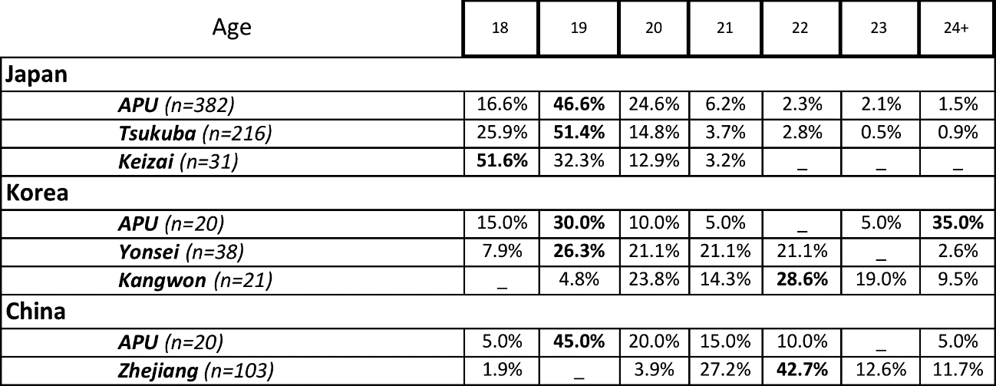

The majority of Japanese respondents to the survey were 20 or younger. At the time of the survey, 46% of the APU students were 19 and 16.6% were 18, meaning that 87.8% of APU respondents were in their first two years of university study. The number of respondents 20 or younger from the comparison sites was 92% for Tsukuba University students and 96.8% for Tokyo Keizai University students. The most often selected age for Tsukuba University students was 19, with 51.4% selecting this age. The most often selected age for Tokyo Keizai University students was 18 with 51.6% of respondents reporting this age.

Korean APU students tended to belong to one of two age groups. The first were younger (18-20 years old), which represented 55% of the total population, whereas those 23 or older represented 40% of the total number. This older group was likely to have completed their compulsory military service and to have returned to their studies, a point that was raised by some Korean members of the FTF focus groups. Although not as marked as the split between younger and older respondents among the Korean APU respondents, the students from Yonsei could also be divided into 20 or younger, 55.3%, and 21 or older, 44.7%. Kangwon students were a little older, with 28.6% 20 or younger and 71.4% 21 or older.

The majority of Chinese APU students were also in their first two years of study, with 70% of them 20 or younger. This was different from the students at Zhejiang who tended to be older, with 94.2% of them reporting as 21 or older.

4.2.3 Gender of research subjects
Table 10: Gender of survey respondents

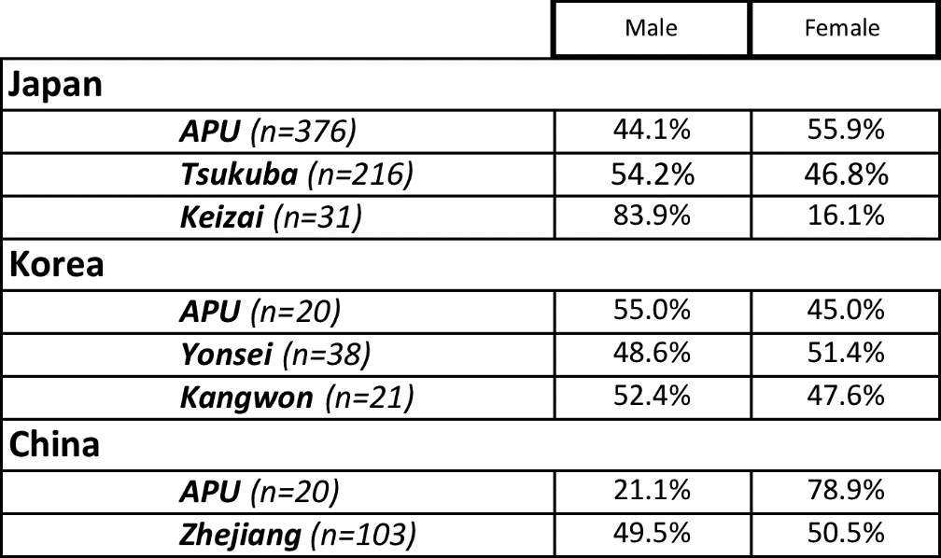

For the three Japanese populations, 44.1% of APU students were male and 55.9% were female, 54.2% of Tsukuba University students were male and 46.8% were female, and 83.9% of Tokyo Keizai University students were male, 16.1% were female. For the three Korean populations, 55% of APU students were male, with 45% female, 48.6% of Yonsei students were male, and 51.4% female, and Kangwon students were 52.4% male and 47.6% female. For the two Chinese populations, 21.1% of APU students were male and 78.9% female, and Zhejiang students were 49.5% male and 50.5% female.

4.2.4 Length of time studying English
Table 11: Length of study of survey respondents

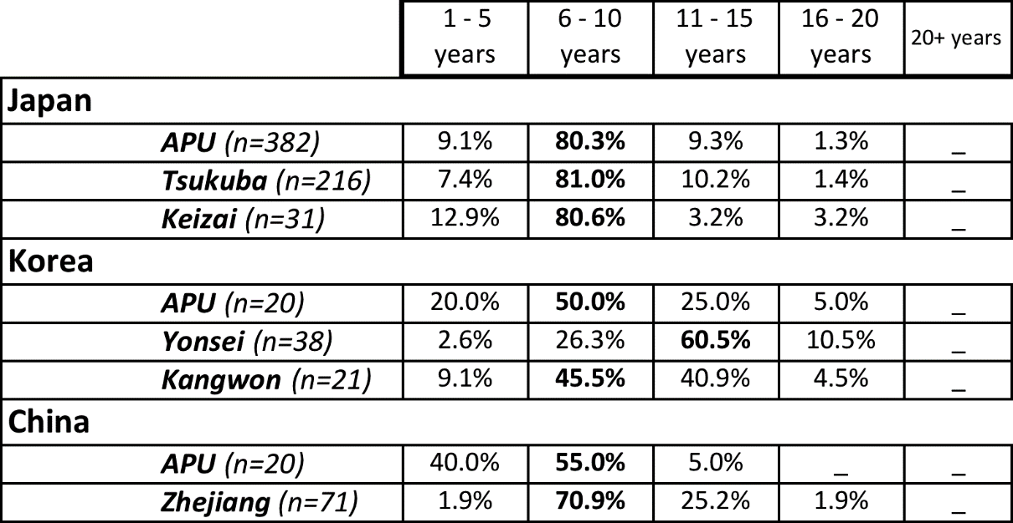

The three Japanese populations in this study had studied English for a similar length of time, as 80 % of APU students, 81% of Tsukuba University students, and 80.6% of Tokyo Keizai University students reported having studied English for 6-10 years.

Korean APU students had generally studied English for less time than their counterparts in Korea, with 80% of APU students reporting to have studied for 6 years or longer compared with 97.4% of Yonsei students having studied for 6 years or longer, with 71% of them having studied for longer than 11 years. Students from Kangwon were more evenly split, with 54.6% of Kangwon respondents having studied for 10 years or less, and 45.4% reporting having studied for 11 years or more.

It is also interesting to note that despite the similar age profile displayed in the Table 9 above, Yonsei University students report having studied for noticeably longer on average that APU students, suggesting that they have had longer than the minimum required schooling, and perhaps additional language learning experience in hagwon or other such private language schools.

The Chinese APU students were also generally younger than their counterparts at Zhejiang. The most often selected range was 6-10 years for both populations, with 55% of APU students and 70.9% of Zhejiang students selecting this range. The second most often selected range for APU students was 1-5 years with 40% selecting this option, whereas the second most often selected range for Zhejiang students was 11-15 years with 25.2% of students selecting this option.

4.2.5 Experience visiting an English-speaking country
Table 12: Experience of survey respondents
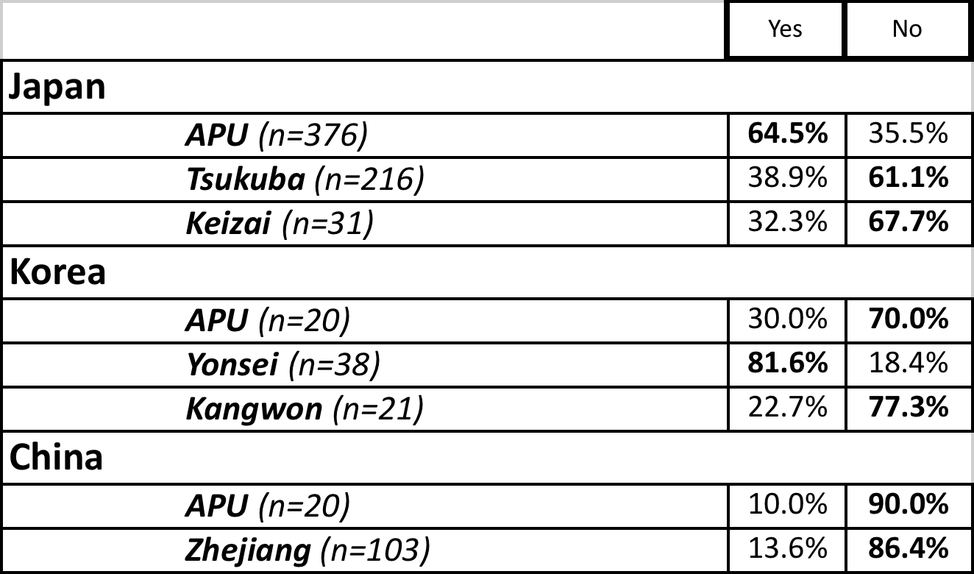

Among Japanese students, APU students had traveled most often to English-speaking countries, with 64.5% of students responding that they had visited an English-speaking country, compared to only 38.9% of Tsukuba University students and 32.2% of Tokyo Keizai University students responding this.

Among Korean students, Yonsei students were the most likely to have visited an English-speaking country, with 81.6% of students responding that they had, compared with 30% of APU Korean students and only 22.7% of Kangwon students.

For Chinese respondents, Zhejiang students had a little more travel experience to English-speaking countries than APU students, with 13.6% reporting they had visited such a place compared with only 10% of Chinese APU students. However, there was very little difference between the two populations with regard to their experience of traveling to English-speaking countries.

4.2.6 The English-speaking country respondents had visited
Table 13: Countries visited by the survey respondents

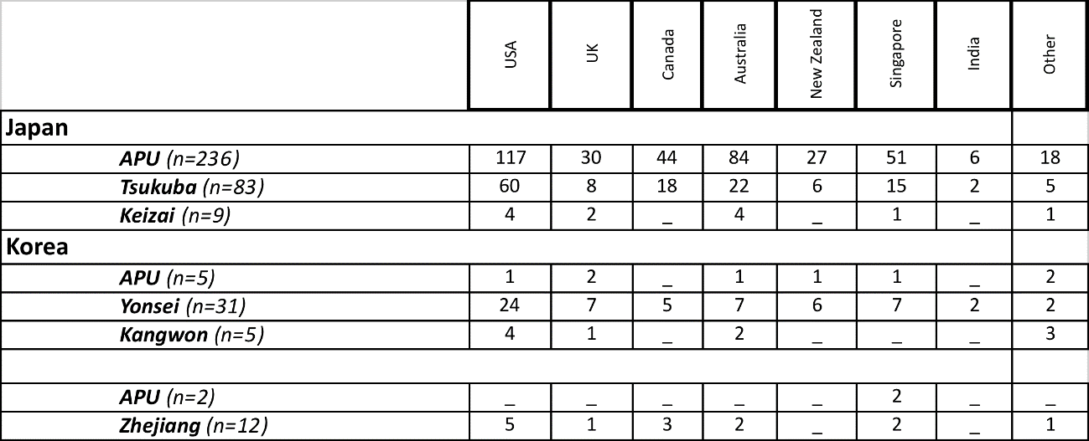
For Japanese respondents, APU students had the highest number of selections of countries visited, with the USA as the country most-often selected. Of the 236 APU students who reported having visited an English-speaking country, 117 selected the USA compared with 60 students out of the 83 who responded to the question from Tsukuba University and 4 students out of the 9 from Tokyo Keizai University.

Of the 5 Korean APU students who responded to the question, 1 had visited the USA and 2 had visited Britain, compared with 24 of the 31 Yonsei students who responded who had visited the USA, and 4 of the 5 students from Kangwon who responded that they had visited the USA. The joint highest selected option for the APU students was ‘Other’, and these two locations were ‘Fiji’ and ‘Philippine’.

For the Chinese respondents, only 2 APU students responded to the question of which English-speaking country they had visited, and both respondents selected ‘Singapore’. Of the 12 Zhejiang students who responded that they had visited an English-speaking country, 5 had visited the USA and 3 had visited Canada.

4.2.7 The English-speaking country respondents were interested in visiting
Table 14: Countries survey respondents were interested in visiting

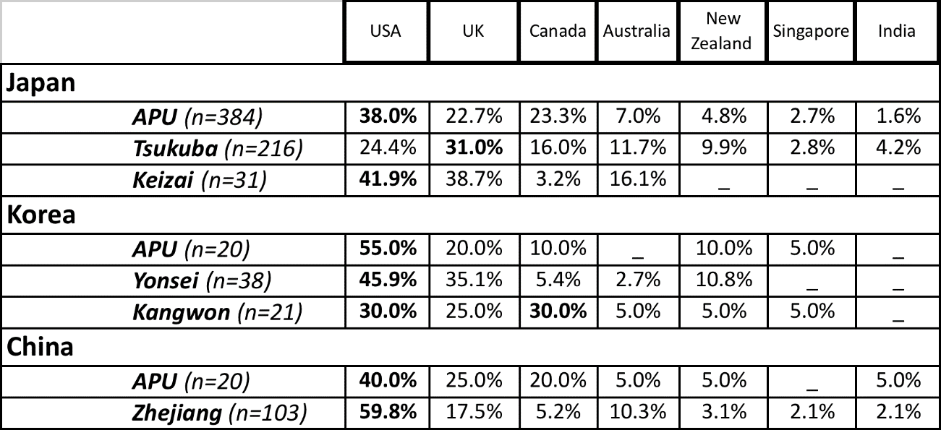
For Japanese respondents, the most popular response for the English-speaking country they would most like to visit was the USA for APU students and Tokyo Keizai University students, with 38% and 41.9% respectively selecting this option, compared with 24.4% of Tsukuba University students. Tsukuba University students selected the UK ahead of the USA, with 31% selecting this option compared with 38.7% of Tokyo Keizai University students and 22.7% of APU students. The UK was not the second most popular option for APU students, who selected Canada ahead of the UK.

For the Korean respondents, the most popular selection was the USA, with 55% of APU students, 45.9% of Yonsei students and 30% of Kangwon students selecting this option. Kangwon students had an equal interest in Canada, with 30% of Kangwon respondents selecting this option compared with 10% of APU student and only 5.4% of Yonsei respondents. The second most popular response for APU students and Yonsei students was the United Kingdom, with 20% of APU students and 35.1% of Yonsei students selecting this option. Yonsei students had no interest in visiting either Singapore or India above other options, whereas 5% of both APU and Kangwon respondents did express such an interest in these countries

For Chinese respondents, all three populations selected U.S.A. as the place they were most interested in visiting, with 40% of Chinese APU respondents and 59.8% of Zhejiang respondents selecting this option. Zhejiang students showed more interest than APU respondents in visiting Singapore or India, with 2.1% of Zhejiang students selecting these options, compared with 5% of APU respondents selecting India. No Chinese students from APU selected Singapore.

4.2.8 Demographic Summary
Although some of the populations are quite diverse demographically, there were some shared characteristics among each country’s group. For the Japanese respondents to the survey, the majority of students were under 20 and had been studying English for between 6 to 10 years. The majority of all three populations of Japanese students were interested in visiting either the USA or the UK. One noticeable difference between the three populations was that Japanese APU students were more likely than the students from Tsukuba University or Tokyo Keizai University to have traveled to an English speaking country.

For the Chinese respondents to the survey, very few of either population had any experience traveling to an English-speaking country, and the majority of both populations were interested in visiting either the USA or the UK in the future. The majority of the APU students were under 20 whereas the majority of the Zhejiang students were over 20, and therefore the statistically lower interest from Zhejiang University students in studying English and learning ‘correct’ English suggests that future use of English is less necessary for these older students.

Korean students were the most diverse. The majority of APU and Yonsei students were 20 or under, whereas the majority of Kangwon students were over 21. All three Korean populations were fairly evenly divided male and female. Whereas the majority of both Kangwon and APU students had studied English for less than 10 years, the majority of Yonsei students had studied English for 11 to 15 years. This reported length of time studying English would mean, coupled with their reported ages, that they had studied English for the majority of their compulsory school. The large majority of Yonsei students also had experience of visiting an English speaking country, whereas the majority of APU and Kangwon students did not.

4.3 Research Question 1: What are Asian students’ orientations towards English?

4.3.1 Japanese responses to items in Research Question 1

4.3.1.1 Descriptive statistics for Japanese responses to survey items relating to Research Question 1
Table 15: J1-1 Descriptive statistics for Japanese respondents to survey items relating to Research Question 1
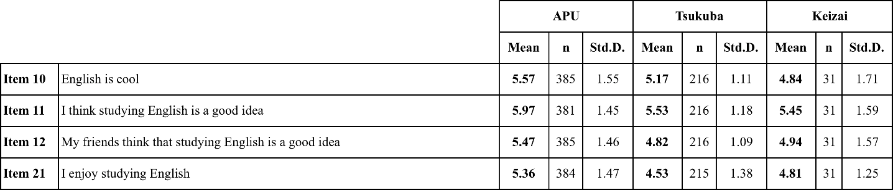

The APU respondents had a higher agreement than Tsukuba University students and Tokyo Keizai University students with the four propositions represented in Table 15. The APU students registered the highest level of agreement with the (Item 11) ‘Good idea’ proposition (M = 5.97, SD = 1.45). This proposition was also the most well-supported by Tsukuba University (M = 5.53, SD = 1.18) and Tokyo Keizai University (M = 5.45, SD = 1.59) students.

Table 16: J1-2 Descriptive statistics for Japanese responses to survey items relating to Research Question 1
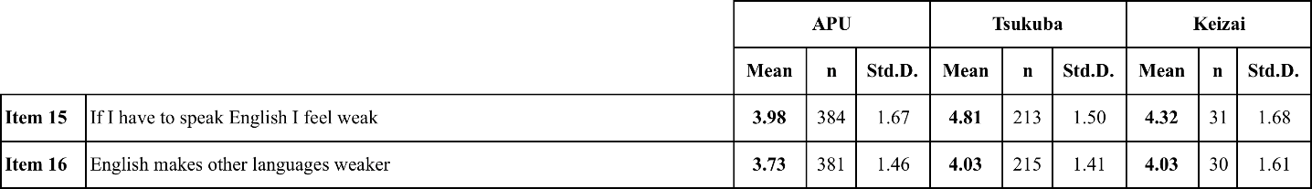

Tsukuba University and Tokyo Keizai University respondents had higher levels of agreement with the propositions represented in Table 16 than the APU students. For the (Item 15) ‘Weak’ proposition, Tsukuba University students had a higher level of agreement (M = 4.81, SD – 1.50) than Tokyo Keizai University (M = 4.32, SD = 1.68) or APU students (M = 3.98, SD = 1.67). For the (Item 16) ‘Weaker’ proposition, Tsukuba University (M = 4.03, SD = 1.41) and Tokyo Keizai University (M = 4.03, SD = 1.61) students had a higher level of agreement than APU students (M = 3.73, SD = 1.46).

4.3.1.2 Analysis of Japanese responses to Research Question 1
Table 17: J1-Item 10MW Results of Mann-Whitney paired sample analysis for Japanese responses to the proposition "English is cool"
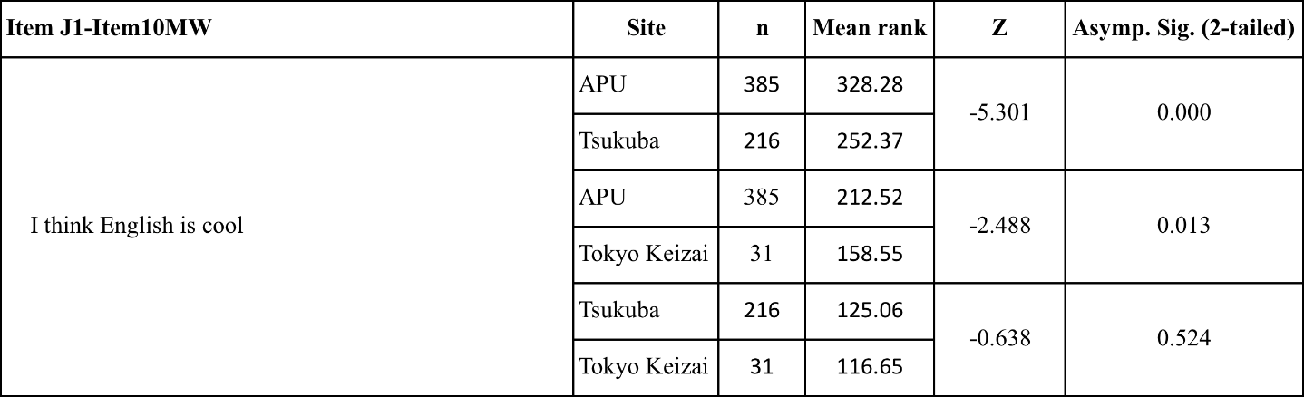
There was a significant difference in the level of agreement with the proposition “English is cool” for APU students and Tsukuba University students (z = -5.301, p = 0.000) and Tokyo Keizai University students (z = -2.488, p = 0.013). There were no significant differences in the responses of Tsukuba University and Tokyo Keizai University students.

Table 18: J1-Item 11MW Results of Mann-Whitney paired sample analysis for Japanese responses to proposition "I think studying English is a good idea"
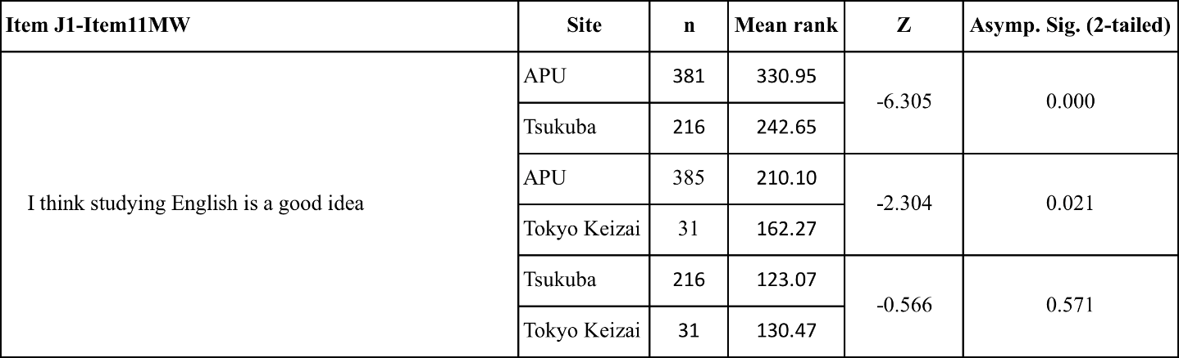
There was a significant difference in the level of agreement with the proposition “I think studying English is a good idea” for APU students compared to Tsukuba University students (z = -6.305, p = 0.000) and Tokyo Keizai University students (z = -2.304, p = 0.021). Responses from Tsukuba University and Tokyo Keizai University showed no statistically significant differences in the level of agreement.

Table 19: J1-Item 12MW results of Mann-Whitney paired sample analysis for Japanese responses to proposition "My friends think studying English is a good idea"
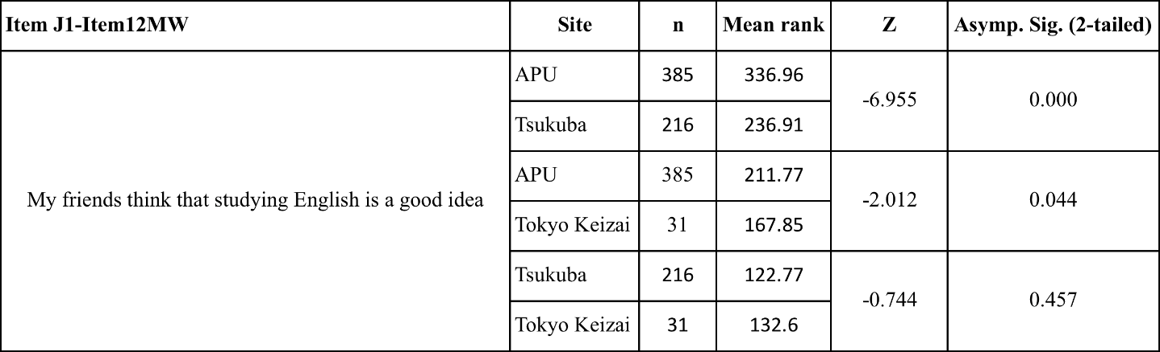
There was a significant difference in the level of agreement with the proposition “My friends think that studying English is a good idea” for APU students compared to Tsukuba University students (z = -6.955, p = 0.000) and Tokyo Keizai University students (z = -2.012, p = 0.044) respectively. There were no significant differences in the responses of Tsukuba University and Tokyo Keizai University students.

Table 20: J1-Item 21MW results of Mann-Whitney paired sample analysis for Japanese responses to proposition "I enjoy studying English"
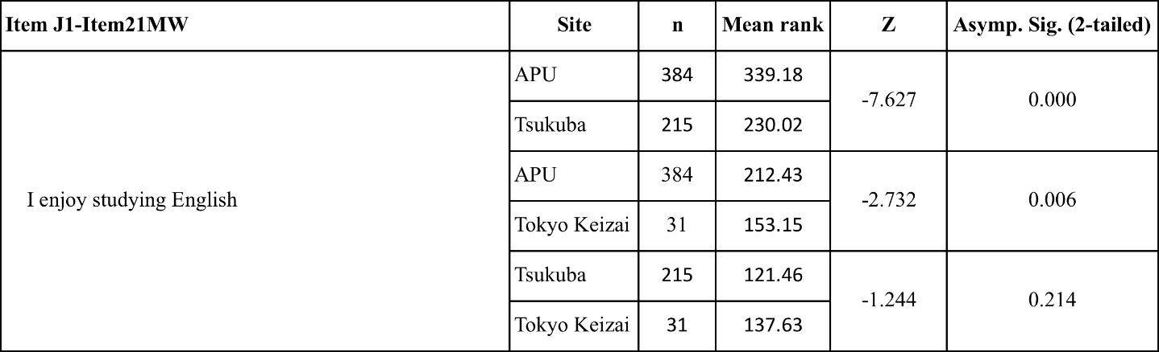
There was a significant difference in the level of agreement with the proposition “I enjoy studying English” for APU students compared to Tsukuba University students (z = -7.627, p = 0.000) and Tokyo Keizai University students (z = -2.732, p = 0.006). There were no significant differences in the responses of Tsukuba University and Tokyo Keizai University students.

Table 21: J1-Item 15MW results of Mann-Whitney paired sample analysis for Japanese responses to proposition "If I have to speak English I feel weak"
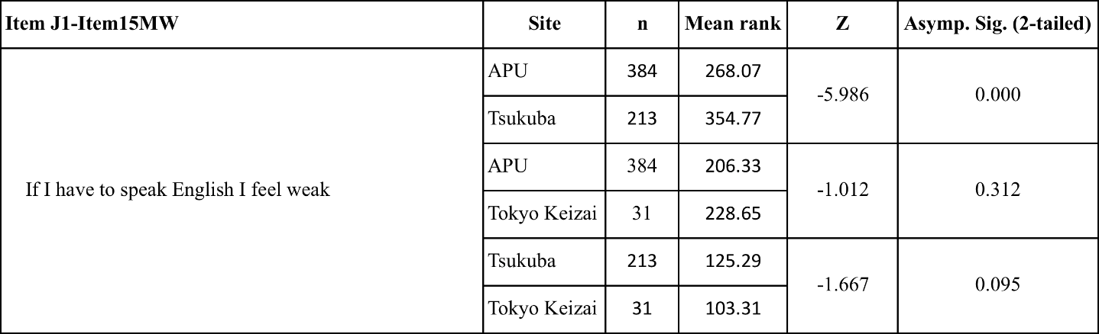
There was a significant difference in the level of agreement with the proposition “If I have to speak English I feel weak” registered by APU students and Tsukuba University students (z = -5.986, p = 0.000). There were no significant differences in the responses of APU and Tokyo Keizai University students, or in the responses of Tsukuba University and Tokyo Keizai University students.

Table 22: J1-Item 16MW results of Mann-Whitney paired sample analysis for Japanese responses to proposition "English makes other language weaker"
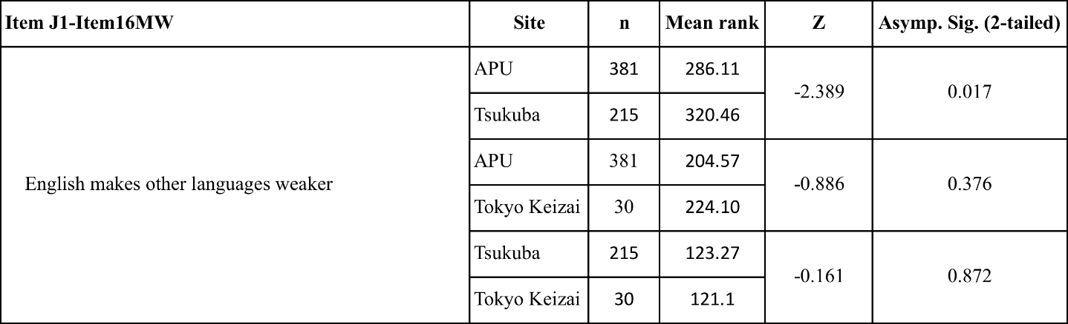
There was a significant difference in the level of agreement with the proposition “English makes other languages weaker” for APU students compared to Tsukuba University students (z = -2.389, p = 0.017). There were no significant differences in the responses of APU and Tokyo Keizai University students, or in the responses of Tsukuba University and Tokyo Keizai University students.

4.3.1.3 Survey breakdown and FTF/CMI comments for Japanese responses to Research Question 1
APU Japanese students registered 80.9% agreement and only 9.4% disagreement with the ‘Cool’ proposition (Item 10), compared with 76.4% agreement and 4.3% disagreement for Tsukuba University students, and 61.4% agreement with 22.6% disagreement for Tokyo Keizai University students (Table 83). Referring to Table 75 (in Appendix A), the significant difference between the APU student survey responses and those from Tsukuba University and Tokyo Keizai University can be attributed to the fact that 36.4% of the APU respondents selected the option ‘Very Strongly Agree’ on the survey, compared with 19.4% of Tokyo Keizai University students and only 11.6% of Tsukuba University students.

APU students responding to the ‘Cool’ proposition in the FTF focus groups at APU said that their main consideration when responding was that English gave them more opportunities to communicate internationally. The majority of focus group participants referred to the opportunity to communicate with people “all over the world”, and talking “to a lot of international students”. They also said that English was a “common language” internationally. There were some respondents who disagreed, and those who did said English was “just a tool” and therefore did not have any other qualities such as ‘coolness’.

CMI survey respondents from Tsukuba University who agreed with the ‘Cool’ proposition said they that they liked the ‘sound’ of the language; those students who disagreed with this proposition felt that English was a “common language” in Japan, meaning they had no impression of English beyond its use as an academic subject. Other students from both APU and Tsukuba University expressed the opinion that it was how the use of English made other students look that gave them the impression that English was ‘cool’: a student at APU said, “when I see a person who can speak English fluently I think that person is better than me”; a Tsukuba University student who agreed with the cool proposition supported their opinion by saying “because [people speaking English] looks (sic) like clever”.

Japanese APU and Tsukuba University students both had high levels of agreement with the ‘Good idea’ proposition (Item 11). 88.7% of APU students and 90.2% of Tsukuba University students agreed with the proposition, compared with 80.6% of Tokyo Keizai University students (Table 85). The most popular selection among APU students was ‘Very Strongly Agree’ with 49.6% of respondents from APU selecting the option, compared with only 18.5% of Tsukuba University students and 25.8% of Tokyo Keizai University students (Table 85). The number of respondents from APU selecting the higher levels of agreement caused a significant difference in the mean scores between the three populations.

In the FTF focus groups at APU and CMI survey at Tsukuba University there were no respondents who expressed disagreement with the ‘Good idea’ proposition. Japanese APU students said that studying English was an “opportunity” to communicate with people from many countries. One student spoke about the opportunity for new information that comes from learning English that they did not have when receiving news from “the Japanese government and Japanese mass media”. When responding to the ‘Good idea’ proposition, Tsukuba University CMI respondents mostly used references to ‘communication’ because English was a widely-spoken public language, but unlike the APU students, who used examples from their experiences at APU in their responses, the motivations of the Tsukuba University students were expressed abstractly: one student said “we can get the opportunity to communicate” or “encountering various people will bring you more possibilities”. These references to ‘opportunity’ were made without Tsukuba University students including details of their university environment or studies as the APU students had done. In this, the reason for their agreement was the same, but their level of agreement and personal experience clearly differ.

Japanese APU students had high levels of agreement with the ‘Friends’ proposition (Item 12), with 78% of them agreeing and only 8.1% disagreeing (Table 86). This compared with 59.2% of Tsukuba University students and 58% of Tokyo Keizai University students who agreed. The most popular response for APU students was ‘Very Strongly Agree’ with 29.9% of APU respondents selecting this option, compared with 16.1% of Tokyo Keizai University students and only 4.6% of Tsukuba University students (Table 86). This selection of the higher levels of agreement accounts for the significance in the difference between their responses.

Japanese APU students registered 80.4% agreement with the ‘Enjoy’ proposition (Item 21) and only 10.9% disagreement, compared with 77.5% agreement from Tokyo Keizai University students and only 60.9% agreement from the Tsukuba University students (Table 84). Similar to the circumstances noted above, APU students selecting the higher levels of agreement on the survey meant that APU students’ responses were significantly more positive than their counterparts in Tsukuba University or Tokyo Keizai University: 24.2% of APU students selected ‘Very Strongly Agree’ compared with only 6.5% of Tsukuba University students and 6.5% of Tokyo Keizai University students selecting that higher level option (Table 84).

APU students in the FTF focus groups said that their university environment was a motivation for their English studies. Some respondents referred to the university directly. One student said “In APU, almost everyone can speak English so it is very useful to communicate with all people”; another said the university provided an experience of “talking to international students”. The reference to the international campus environment provided by APU was sometimes indirect: one student said, “there are a lot of English (sic) all around us”; another student said, “we have to speak English and share our ideas”. Tsukuba University students did not use their current university in any of their responses to the Research Question 1 propositions in the CMI survey.

The ‘Weak’ (Item 15) and ‘Weaker’ (Item 16) propositions received the lowest levels of agreement among all Japanese respondent groups. The level of agreement was particularly low among APU students when compared to the two other Japanese universities. In fact, APU students had significantly lower levels of agreement than Tsukuba University students to both the ‘Weak’ and ‘Weaker’ propositions. APU students were in overall agreement with the ‘Weak’ proposition of 40.7% compared with 51.6% of Tokyo Keizai University students and 68.6% of Tsukuba University students (Table 87). The most popular selection for all groups was ‘Agree’, with 21.9% of APU students, 29% of Tokyo Keizai University students, and 35.7% of Tsukuba University students selecting this option (Table 87). APU students had a low level of agreement with the ‘Weaker’ proposition, with only 28.8% agreeing compared with 36.7% of Tokyo Keizai University students agreeing and 42.8% of Tsukuba University students agreeing (Table 88). The most common response for APU and Tokyo Keizai University students was ‘No Opinion’, with 28.9% of APU respondents and 26.7% of Tokyo Keizai University respondents selecting this option (Table 88).

In the FTF focus groups, those students who agreed with the ‘Weak’ proposition said that their confidence was particularly low when they spoke with “native speakers”. Several students said that their response to the ‘Weak’ proposition would depend on with whom they were speaking: one student said “when I talk to Asian people in English I don’t feel weak but when I talk to native speakers sometimes I feel weak”. APU respondents often referred to APU itself. One student said “In APU there are many people from many countries so we have to improve each other”. Another student said, “in this semester I took English psychology class and I have to use English”.

The FTF participants who disagreed with the ‘Weak’ proposition gave reasons for their answers that showed them to be more confident in their English abilities than those who students who agreed with the ‘Weak’ proposition. One student who disagreed with the ‘Weak’ proposition said “In our workshop we have a lot of meetings with international students and Japanese students don’t try to speak English, so I have to translate and some people think it is a bother, but I am happy to practice”. However, the same student said that speaking with Chinese students at APU made him ‘feel weak’ as the Chinese students were “speaking English but too fast”. The same point was raised by another student, who despite disagreeing with the ‘Weak’ proposition, said “when I am talking with international friends like me or like other international students, if they talk and use [English] very fluently I feel weak.”

Most CMI respondents from Tsukuba University agreed that they ‘felt weak’ when using English, and all those students who agreed with the proposition used the word “confidence”, or spoke about not being “good” at English. One student reported that speaking English made them “feel tired”. The one student who disagreed with the ‘Weak’ proposition gave the opinion that English was “already part of my life”, but did say that when they had traveled abroad when they were younger their lack of ability to communicate had made them “feel weak”. Much like the students at APU, if the Tsukuba University students’ confidence or self-reported ability was low they ‘felt weak’ when required to use English.

4.3.1.4 Key findings for Japanese respondents to Research Question 1
- The APU students had significantly higher agreement with the ‘Cool’ proposition, and also significantly higher agreement with the ‘Good idea’ proposition than the Tsukuba University and Tokyo Keizai University students, while using a similar rationale to the Tsukuba University students for their opinions.
- APU students used their university experiences for their examples to support several of their opinions, whereas the Tsukuba university students did not.
- ‘Weakness’ for both populations of students who were part of the qualitative investigation was linked to reported self-confidence, which the environment at APU appears to have assisted the Japanese APU students in overcoming. The Tsukuba University students, with far fewer opportunities to practice the use of English, had to rely on their classes alone for their experience of using English.

Table 23: Table of charts relating to the key findings for Japanese respondents to Research Question 1

4.3.2 Chinese respondents to items in Research Question 1

4.3.2.1 Descriptive statistics for Chinese responses to survey items relating to Research Question 1
Table 24: C1-1 Descriptive statistics for Chinese responses to survey items relating to Research Question 1
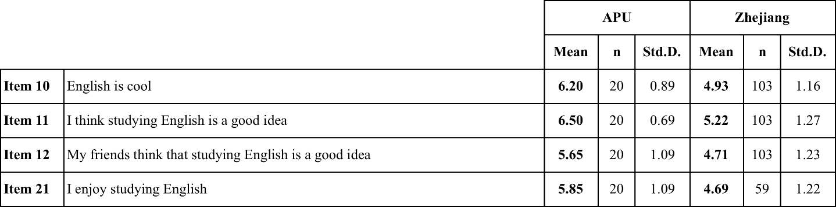

The Chinese APU respondents registered a higher level of agreement than Zhejiang students with the four propositions represented in Table 24. The APU students registered their highest level of agreement with the proposition (Item 11) “I think studying English is a good idea (M = 6.50, SD = 0.69), whereas the level of agreement from Zhejiang students (M = 5.22, SD = 1.27) was lower, but was also the proposition that received the highest level for agreement for this group.

Table 25: C1-2 Descriptive statistics for Chinese responses to survey items relating to Research Question 1

The Zhejiang respondents registered a higher level of agreement with the two propositions represented in Table 25 than the APU students. The Zhejiang students’ highest level of agreement was with the proposition (Item 15) “If I have to speak English I feel weak” (M = 3.93, SD = 1.40) whereas the level of agreement from APU students (M = 3.65, SD = 1.66) with this proposition was lower.

4.3.2.2 Analysis of Chinese responses to Research Question 1
Table 26: C1-Item 10MW results of Mann-Whitney paired sample analysis for Chinese responses to proposition "English is cool"
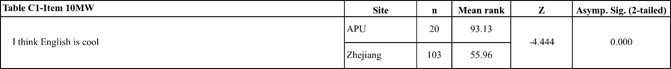

There was a significant difference in the level of agreement with the proposition “English is cool” registered by APU students and Zhejiang students (z = -4.444, p = 0.000).

Table 27: C1-Item 11MW results of Mann-Whitney paired sample analysis for Chinese responses to proposition "I think studying English is a good idea"
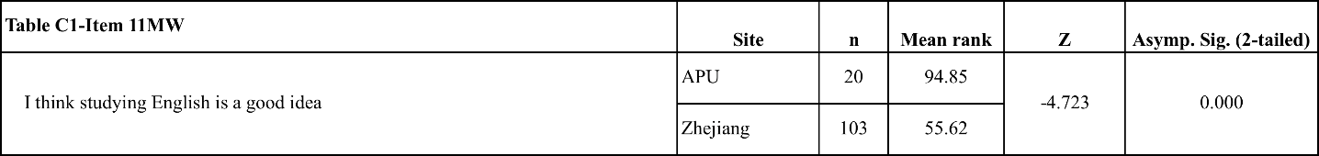

There was a significant difference in the level of agreement with the proposition “I think studying English is a good idea” registered by APU students and Zhejiang students (z = -4.723, p = 0.000).

Table 28: C1-Item 12MW results of Mann-Whitney paired sample analysis for Chinese responses to proposition "My friends think that studying English is a good idea"
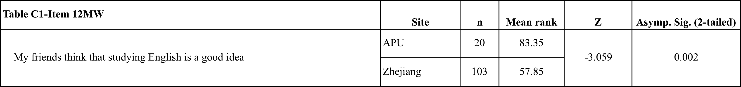

There was a significant difference in the level of agreement with the proposition “My friends think studying English is a good idea” registered by APU students and Zhejiang students (z = -3.059, p = 0.002).

Table 29: C1-Item 21MW results of Mann-Whitney paired sample analysis for Chinese responses to proposition "I enjoy studying English"
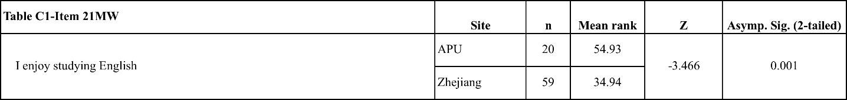
There was a significant difference in the level of agreement with the proposition “I enjoy studying English” registered by APU students and Zhejiang students (z = -3.466, p = 0.001).

Table 30: C1-Item 15MW results of Mann-Whitney paired sample analysis for Chinese responses to proposition "If I have to speak English I feel weak"
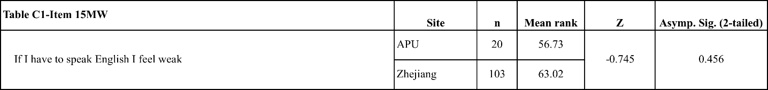

There was no significant difference between levels of agreement registered by APU students and Zhejiang students with the proposition “If I have to speak English I feel weak”.

Table 31: C1-Item 16MW results of Mann-Whitney paired sample analysis for Chinese responses to proposition "English makes other languages weaker"
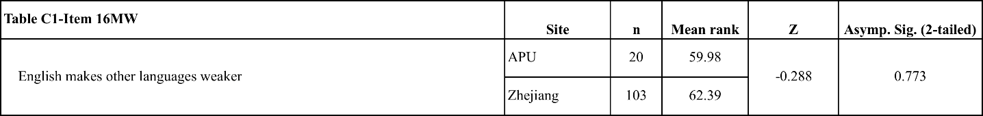
There was no significant difference between levels of agreement registered by APU students and Zhejiang students with the proposition “English makes other languages weaker”.

4.3.2.3 Survey breakdown and FTF/CMI comments for Chinese responses to Research Question 1
In response to the ‘Cool’ proposition (Item 10), the APU Chinese students had significantly higher levels of agreement, as 95% of APU students agreed with the proposition compared with 67% of Zhejiang students (Table 89). The most popular response to the ‘Cool’ proposition from APU students was ‘Very Strongly Agree’ (45% of respondents), compared with 42.7% of Zhejiang students who selected ‘Agree’ (Table 89).

All the Chinese FTF focus group participants from APU agreed with the ‘Cool’ proposition whereas only four of the seven CMI survey respondents from Zhejiang agreed. The majority of the APU respondents expressed their support for the ‘Cool’ proposition with explicit reference to APU or their experiences overseas. Two students said they felt that APU was “international” and therefore ‘cool’, and one of students praised “Korean students” at APU for being good at English, thereby giving these students the impression that English was ‘cool’ from these Korean students’ use of the language. Two other students at APU noted that English was being used worldwide and as an “international language”. The other two APU focus group participants used the examples of “American movies” and “dramas” as the reason they agreed that English was ‘cool’.

The opinions expressed by respondents to the CMI survey from Zhejiang were less uniform in their response to the ‘Cool’ proposition than those of the APU students. The Zhejiang students who agreed with the proposition said that it was the expressions and pronunciation of the language that were ‘cool’, or they referred to the image of the language being used in “American movies”, a similar reason to the one given by one APU student. The Zhejiang students who disagreed with the proposition referred to the fact that English was “just a language”, and that other languages could be thought of as cool, with two respondents saying that Chinese was also cool. Unlike the APU students, none of the respondents from Zhejiang used their experiences or current study environment as reasons for their response to the ‘Cool’ proposition.

In response to the ‘Good idea’ proposition (Item 11), APU students were significantly more positive than Zhejiang students, with 100% of APU students agreeing with the proposition compared with 84.4% of Zhejiang students agreeing (Table 90). Although there was a high level of agreement from both populations, the significant difference can be attributed to 60% of APU respondents selecting ‘Very Strongly Agree’, while the most popular option from Zhejiang students was ‘Agree’ (Table 90) with 45.6% selecting this level of agreement.

As with the ‘Cool’ proposition, all the FTF focus group participants at APU agreed with the ‘Good idea’ proposition. Three of the students said that being able to speak English would give them more “opportunities” internationally or when dealing with “foreigners” in Asia. Two students said that their time at APU had reinforced their feelings that studying English was important and necessary. One said “After I joined this university, I thought [English] was important to me”; the other student said “My mother wants me to take English lectures after the 3rd year” therefore “English is very necessary”. One student agreed with the ‘Good idea’ proposition because they said English was “really fun”. Once again, in response to the ‘Good idea’ proposition APU students are using examples of their study environment at APU to provide support for their opinions. The respondents to the CMI survey in Zhejiang all agreed with the ‘Good idea’ proposition, and all but one of the students said that studying English was a ‘good idea’ because it gave them a more “international” perspective. The one student who did not say that English was international said that learning English was “useful”. The Zhejiang students equated English use with ‘international’, whereas for the Chinese APU students the language was more immediate in their daily university environment.

In response to the ‘Friends’ proposition (Item 12), APU students had the highest level of agreement, with 80% of APU students agreeing with the proposition compared with only 66.1% of Zhejiang students (Table 91). The most popular response from the APU respondents was ‘Strongly Agree’ with 35% of students selecting this option, compared with Zhejiang students whose most popular response was ‘Agree’ with 44.7% of students selecting this option (Table 91).

In response to the ‘Enjoy’ proposition (Item 21), APU students showed a high level of agreement while the Zhejiang students were significantly less positive, with 85% of APU students agreeing with the proposition compared with only 57.6% of Zhejiang students agreeing (Table 92). The most popular response for APU students was ‘Very Strongly Agree’ with 35% of APU respondents selecting this option, while the most popular response from Zhejiang students was ‘Agree’ with 32.2% selecting this option (Table 92).

In response to the ‘Weak’ proposition (Item 15), Zhejiang students had a higher level of agreement than APU students. 39.9% of Zhejiang students agreed with the proposition compared with 35% of APU students (Table 85). Relative to the other propositions in this research question, this proposition had high levels of disagreement from both populations, with 45% of APU students and 46.7% of Zhejiang students disagreeing (Table 93).

In response to the ‘Weaker’ proposition (Item 16), APU students had the highest level of agreement, with 30% of respondents agreeing compared with 23.3% of Zhejiang students who agreed (Table 94). Both APU and Zhejiang respondents registered high levels of disagreement with this proposition relative to both the positively phrased propositions in Table 24 (C1-1) and the ‘Weak’ proposition, with 50% of APU students disagreeing and 52.4% of Zhejiang students disagreeing with the ‘Weaker’ proposition (Table 94).

The Chinese APU students from the focus groups who agreed with the ‘Weak’ proposition said that their feelings of ‘weakness’ came from their lack of “confidence” in using English, and that practice was important to overcome “shyness”. One APU student who agreed with the proposition said they wanted to “speak Japanese” instead of English. This was a reference to their personal situation at APU: Japanese may hold more immediate appeal for Chinese students in Japan. The APU students who disagreed with the ‘Weak’ proposition all used their personal experiences as reasons, either through having to modulate their choice of words to maximize their communication abilities, or speaking about their time at APU giving them opportunities to overcome their previous lack of confidence. They used the phrases “difficult situations”, and “English and Japanese”, and expressed the opinion that “before APU I could not speak English well” are references to their time spent among other international students or in on-campus situations that require them to perform in English.

The Zhejiang CMI survey respondents who agreed with the ‘Weak’ proposition supported their response by saying that their skills in English were not enough to make them feel confident in the language, in that they had “gaps” in their knowledge of English “words” and “structures”. Of the students in the CMI survey from Zhejiang who disagreed with the ‘Weak’ proposition, two said they disagreed because they enjoyed speaking or learning English, and two said they would take their “chances” and “frequently” practice because this practice would help them improve their use of English.

4.3.2.4 Key findings for Chinese respondents to Research Question 1
- The APU students were significantly more positive in their personal and academic orientation towards English than the Zhejiang University students.
- The APU students reported that the environment at APU provided them students with experiences of English use whereas the Zhejiang University students did not mention their university when considering these propositions.
Table 32: Table of charts relating to the key findings for Chinese respondents to Research Question 1

4.3.3 Korean respondents to items in Research Question 1

4.3.3.1 Descriptive statistics for Korean responses to survey items relating to Research Question 1
Table 33: K1-1 Descriptive statistics for Korean responses to survey items relating to Research Question 1
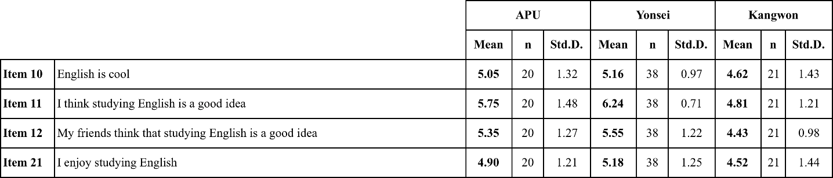
The Yonsei students had a higher agreement with the four propositions represented in Table 33 (K1-1). The highest level of agreement among Yonsei students was with the (Item 11) proposition “I think studying English is a good idea (M = 6.24, SD = 0.71), whereas APU students (M = 5.75, SD = 1.48) and Kangwon students (M = 4.81, S = 1.21) were lower.

Table 33: K1-2 Descriptive statistics for Korean responses to survey items relating to Research Question 1
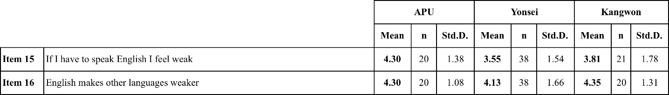
For the (Item 15) proposition “If I have to speak English I feel weak”, APU students registered the highest levels of agreement (M = 4.30, SD = 1.38) compared with Kangwon students (M = 4.81, SD = 1.78) and Yonsei students (M = 3.55, SD = 1.54). For the (Item 16) proposition “English makes other languages weaker”, Kangwon students registered the highest levels of agreement (M = 4.35, SD = 1.31) compared with APU students (M = 4.30, SD = 1.08) and Yonsei students (M = 4.13, SD = 1.66).

4.3.3.2 Analysis of Korean responses to Research Question 1
Table 34: K1-Item 10MW results of Mann-Whitney paired sample analysis for Korean responses to proposition "English is cool"
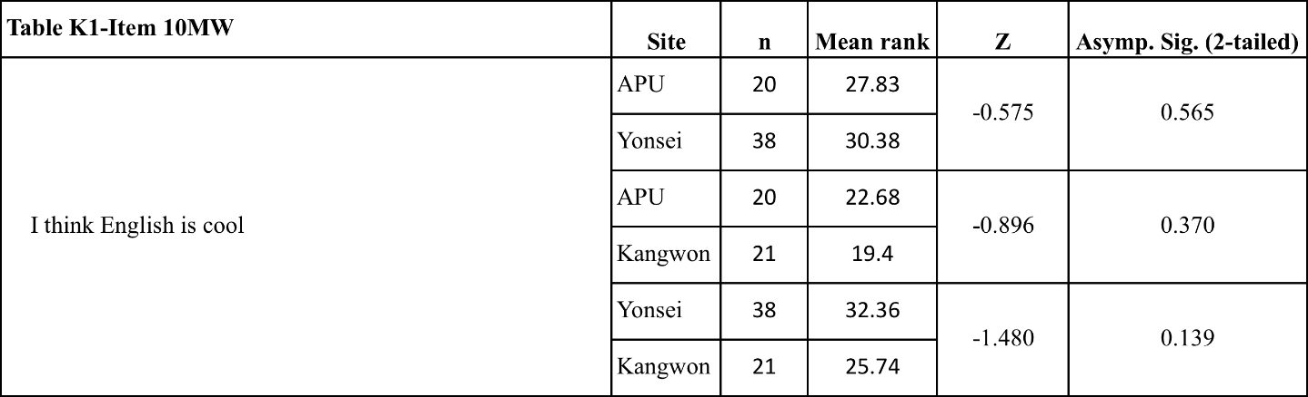
There was no significant difference between the levels of agreement in responses of APU students, Yonsei students or Kangwon students with the proposition “English is cool”.

Table 35: K1-Item 11MW results of Mann-Whitney paired sample analysis for Korean responses to proposition "I think studying English is a good idea"
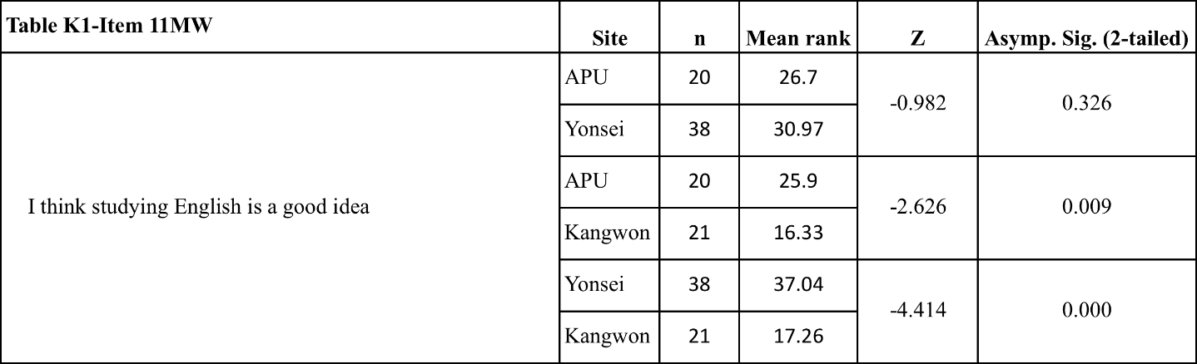
There was a significant difference in the level of agreement with the proposition “I think studying English is a good idea” registered by APU students and Kangwon students (z = -2.626, p = 0.009). There was also a significant difference in the level of agreement registered by Yonsei students and Kangwon students (z = -4.414, p = 0.000). There were no significant differences in the responses of APU and Yonsei students.

Table 36: K1-Item 12MW results of Mann-Whitney paired sample analysis for Korean responses to proposition "My friends think studying English is a good idea"
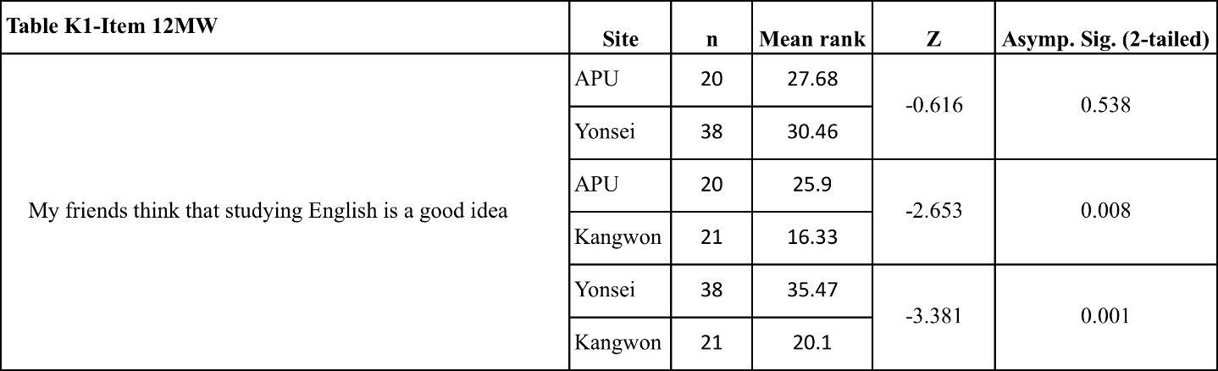
There was a significant difference in the level of agreement with the proposition “My friends think that studying English is a good idea” registered by APU students and Kangwon students (z = -2.653, p = 0.008). There was also a significant difference in the level of agreement registered by Yonsei students and Kangwon students (z = -3.381, p = 0.001). There were no significant differences in the responses of APU and Yonsei students.

Table 37: K1-Item 21MW results of Mann-Whitney paired sample analysis for Korean responses to proposition "I enjoy studying English"
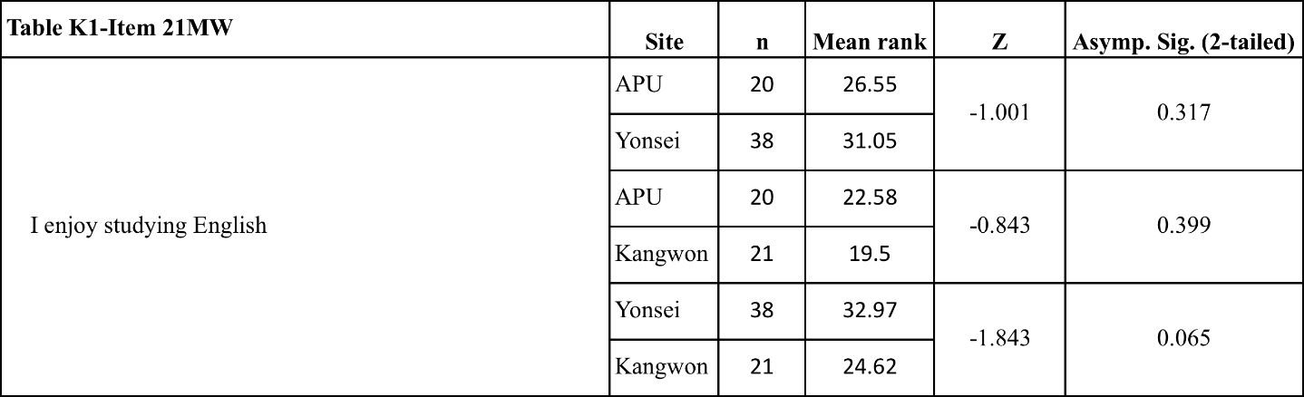
There was no significant difference between level of agreement registered by APU students, Yonsei students or Kangwon students with the proposition “I enjoy studying English”.

Table 38: K1-Item 15MW results of Mann-Whitney paired sample analysis for Korean responses to proposition "If I have to speak English I feel weak"
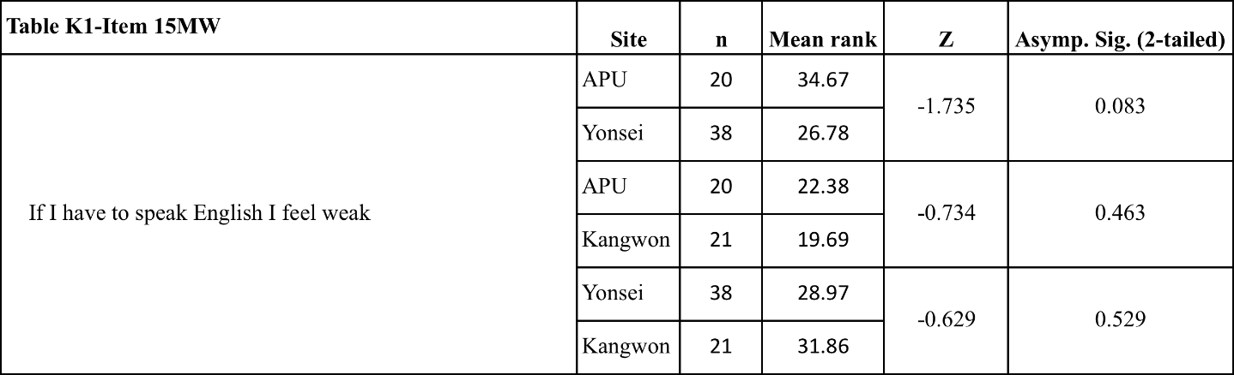
There was no significant difference between the levels of agreement registered by APU students, Yonsei students or Kangwon students with the proposition “If I have to speak English I feel weak”.

Table 39: K1-Item 16MW results of Mann-Whitney paired sample analysis for Korean responses to proposition "English makes other languages weaker"
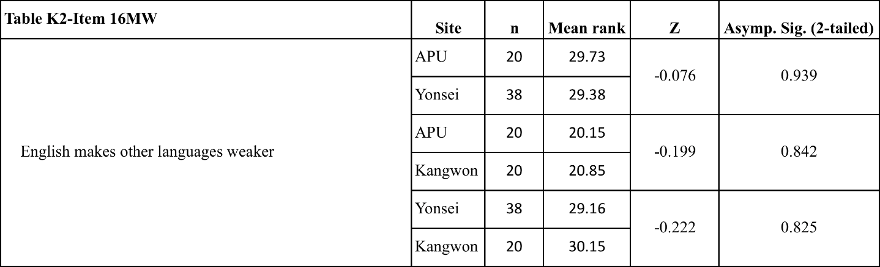
There was no significant difference between level of agreement registered by APU students, Yonsei students or Kangwon students with the proposition “English makes other languages weaker”.

4.3.3.3 Survey breakdown and FTF/CMI comments for Korean responses to Research Question 1
In their responses to the ‘Cool’ proposition (Item 10), there were no significant differences between the levels of agreement among three Korean respondent populations. The Yonsei respondents had the highest level of agreement with the ‘Cool’ proposition, with 81.6% agreeing with the proposition compared with 65% of APU students and 57.1% of Kangwon respondents (Table 95). Kangwon students had the highest levels of disagreement with 28.6% of Kangwon respondents disagreeing compared with only 7.9% of Yonsei students and 5% of APU students disagreeing (Table 95).

In the FTF focus groups, three students who agreed with the ‘Cool’ proposition said that English was useful for “communication”, while another APU student who agreed with the proposition said English was “helpful”, while yet another said that they just “feel [English] is just cool”. APU students who disagreed with the ‘Cool’ proposition stated “English is an international language” and “many countries use English but I don’t think [English is cool]”. Two Yonsei CMI respondents who agreed with the ‘Cool’ proposition did so for different reasons: one student said that the image of “American movies” was ‘cool’, and that “English sounds cool when my favorite American stars speak”; the other student who agreed said that English was a “powerful communication tool”, and she therefore agreed that it was ‘cool’. One Yonsei student who disagreed with the ‘Cool’ proposition said that it was the “difficulty” of the language that caused her to disagree. The other student who disagreed said that “English is a fine tool to communicate but I don’t think it’s cool”. These two comments from the Yonsei students who disagreed were similar to those of the APU students who disagreed with the ‘Cool’ proposition. Finally, one student from Yonsei said, “being able to speak any foreign language is cool” but did not feel that English was any ‘cooler’ than other languages. In response to the ‘Cool’ proposition, both APU and Yonsei students expressed similar reasons for their responses, that English was an important communication tool for them and for others internationally.

In response to the ‘Good idea’ proposition (Item 11), Yonsei students had the highest levels of agreement, as 100% of Yonsei respondents agreed, compared with 85% agreement from APU respondents and 66.7% agreement from Kangwon respondents (Table 96). The most popular responses for APU students were ‘Strongly Agree’ and ‘Very Strongly Agree’ with 35% of the respondents selecting these options. ‘Strongly Agree’ was the most popular response for Yonsei students, with 44.7% of students selecting this option. In contrast, the most popular response for Kangwon students was ‘Agree’, with 42.9% of students selecting this option (Table 96). Thus, not only were the APU and Yonsei students more likely to agree than the Kangwon students, they selected higher levels of agreement.

In the focus groups at APU, students who agreed with the ‘Good idea’ proposition said that it was for reasons of “communication” or for their “future”. Two APU students used the examples of “Asian students” or speaking “languages like Japanese” as their reasons why language study was a good idea, both of which were references to their environment at APU. The one APU student who disagreed with the ‘Good idea’ proposition said that it was “up to the person” and that if they needed English for their job or travel then study was important, but that without a need studying was not important. In the CMI survey responses from Yonsei students, all five of the respondents to the survey agreed with the ‘Good idea’ proposition. Three students said that it was important for “communication”, with one student saying that English allowed access to information such as “books, TED.com lectures, and other informative data”. Another student said English was necessary for “success”. One student, although they agreed with the ‘Good idea’ proposition, said that studying English “could be a waste of time for some people…we cannot generalize that statement”. This response was similar to that of the APU student who disagreed, who felt that it was up to the decision of the individual. No Yonsei students made reference to either Asian speakers of English or their own study environment in response to the ‘Good idea’ proposition, suggesting that the APU students were more likely to find support for their agreement with English study being a ‘good idea’ in their time at the university.

In response to the ‘Friends’ proposition (Item 12), APU students and Yonsei students also had very similar levels of agreement, with 81.5% of Yonsei students agreeing and 80% of APU students agreeing compared with only 42.9% of Kangwon students (Table 97). The most commonly selected option among APU students was ‘Agree’ with 35% of students selecting this option, among Yonsei students the highest selected option was ‘Strongly Agree’ with 28.9% of students selecting this option, whereas the highest selected option among Kangwon students was ‘No Opinion’, with 47.6% of students selecting this option.

In response to the ‘Enjoy’ proposition (Item 21), Yonsei students again had the highest levels of agreement with 78.9% of Yonsei students agreeing compared with 65% of APU students agreeing and only 52.4% of Kangwon students agreeing (Table 98). The most popular response from all three populations was ‘Agree’, with 35% of APU students, 36.8% of Yonsei students, and 28.6% of Kangwon students selecting this option (Table 98).

In response to the ‘Weak’ proposition (Item 15), 55% of APU students agreed compared with 42.8% of Kangwon students and only 34.2% of Yonsei students (Table 99). The most popular response for APU students was ‘Agree’, with 45% of respondents selecting this option, whereas the most popular response to the ‘Weak’ proposition for Yonsei students was ‘Disagree’ with 26.3% of respondents selecting this response, and the most popular responses from Kangwon students to the ‘Weak’ proposition were ‘Disagree’ and ‘Strongly Agree’, which both had 23.8% of the responses (Table 99). In response to the ‘Weaker’ proposition (Item 16), all three groups had similar responses, with 55.3% of Yonsei students, 55% of Kangwon students and 50% of APU students agreeing (Table 100). The most popular response for each population was ‘Agree’, with 40% of the APU respondents, 39.5% of Yonsei respondents, and 45% of Kangwon respondents selecting this option (Table 100).

In the FTF focus groups, most students expressed some degree of agreement with the ‘Weak’ proposition. The students in the groups who agreed with the ‘Weak’ proposition said that it was their experiences in class, at APU, or in a foreign country when they noticed this weakness. Most referenced APU or their current English classes directly. One said, “In APU, I have to speak English in a lot of case (sic)”, and another said, “Class always uses English”. One other student who agreed said “In APU…with native [speakers] it makes me feel some weakness because they speak fast”, with another saying “sometimes I feel confusing (sic), so I feel weak”. Even those students who initially said they disagreed with ‘feeling weak’ used examples of past problems with English that they had overcome. The two students who expressed partial agreement said that they experienced difficulty because English was not their first language. The two students who disagreed with the ‘Weak’ proposition also drew from their experiences to explain why they disagreed. One student spoke about being a Residence Assistant in APU and having to use English frequently thereby losing confidence. The other student said that they disagreed with the ‘Weak’ proposition because “sometimes I feel strong…in a foreign country where they use English I can use English to communicate”. The students from APU, whether they agreed or disagreed, almost always used the example of APU to explain their opinion.

Four of the five respondents to the CMI survey in Yonsei expressed some agreement with the ‘Weak’ proposition. One student said it was because English was not their first language, and another said it was because they were “not comfortable” with it. Another student who agreed said that they felt weak even though they had lived abroad in America “for a year”. One student said that they did not feel ‘weak’ with native speakers but that when they compared their abilities in English to “other Korean students” they felt ‘weak’.

4.3.3.4 Key findings for Korean respondents to Research Question 1
- There were similar levels of agreement with the propositions in this research question from both the APU and Yonsei University students, reflecting a similarity in both the students’ opinions of themselves and their counterparts in their respective universities.
- APU students expressed higher agreement with the ‘Weak’ proposition compared to Yonsei University students, and used their situation at APU for their examples and anecdotes to support their responses to this proposition in the FTF focus groups.

Table 40: Table of charts relating to the key findings for Korean respondents to Research Question 1

4.4 Research Question 2: What is the utility value of English for Asian students?

4.4.1 Japanese responses to items in Research Question 2

4.4.1.1 Descriptive statistics for Japanese responses to items in Research Question 2
Table 41: J2-1 Descriptive statistics for Japanese responses to items to Research Question 2
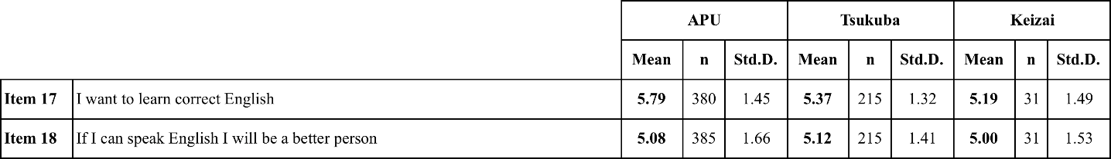

For the ‘Correct’ proposition (Item 17), Japanese APU respondents had the highest level of agreement when compared to Tsukuba University students and those from Tokyo Keizai University, with a mean score of 5.79 compared with 5.37 for Tsukuba University and 5.19 for Tokyo Keizai University. Tsukuba University students had the highest level of agreement with the ‘Better’ proposition (Item 18) when compared with APU and Tokyo Keizai University students, although the difference between the three populations was not significantly large. Tsukuba University students had a mean score of 5.12 compared to 5.08 for APU and 5.00 for Tokyo Keizai University. Tokyo Keizai University students had the lowest levels of agreement with both of the propositions included in this research question.

4.4.1.2 Overview of analysis of Japanese responses to Research Question 2
Table 42: J2-Item 17MW results of Mann-Whitney paired sample analysis for Japanese responses to proposition "I want to learn correct English"
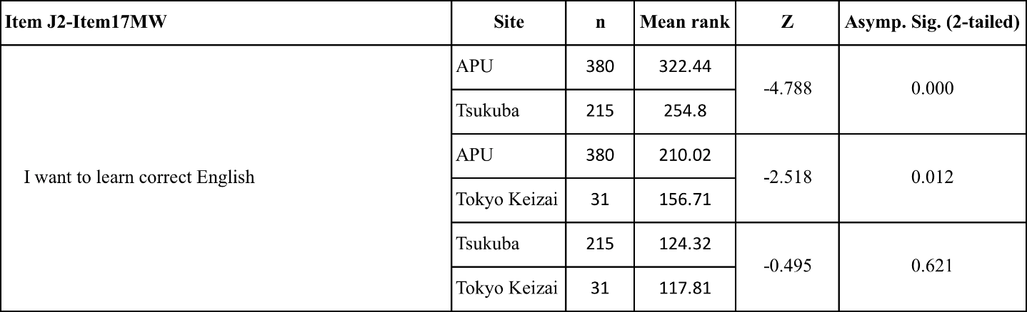
There was a significant difference in the level of agreement with the ‘Correct’ proposition for APU students compared to Tsukuba University students (z=-4.788. p=0.000) and Tokyo Keizai University students (z=-2.518. p=0.012) respectively. There were no significant differences in the responses of Tsukuba University and Tokyo Keizai University students.

Table 43: J2-Item 18MW results of Mann-Whitney paired sample analysis for Japanese responses to proposition "If I can speak English I will be a better person"
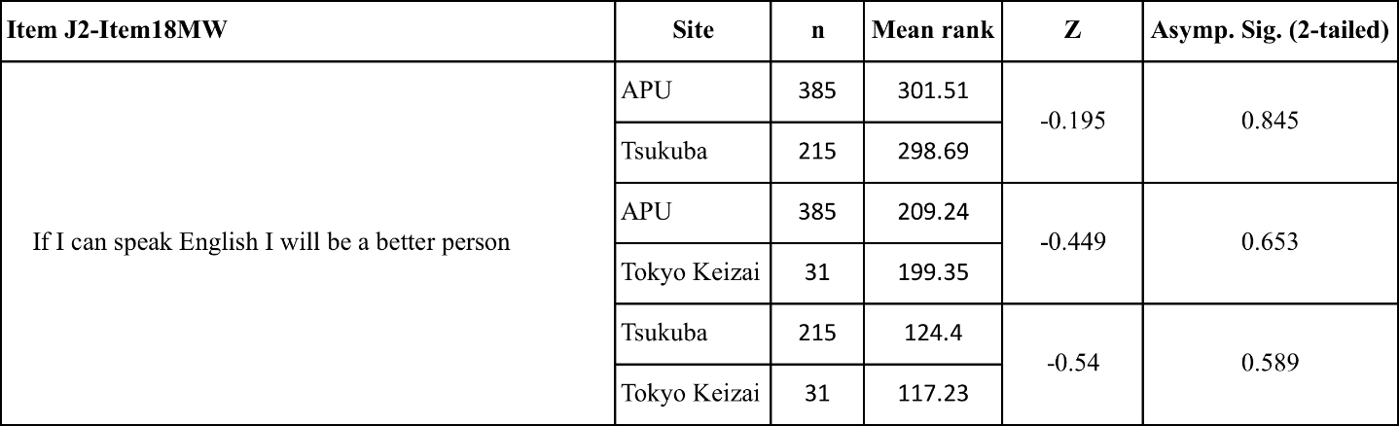
There was no significant difference in level of agreement registered by APU students, Tsukuba University students or Tokyo Keizai University students with the ‘Better’ proposition.

4.3.1.3 Survey breakdown and FTF/CMI comments for Japanese responses to Research Question 2
In response to the (Item 18) ‘Better’ proposition, 66.3% of APU students agreed compared with 67.8% of Tokyo Keizai University students, and 73.5% of Tsukuba University students agreeing (Table 104). The FTF focus group participants from APU were evenly split between those who agreed with the ‘Better’ proposition and those who disagreed or had reservations about agreeing. Those who agreed indicated that they felt that students of English were made ‘better’ through gaining a skill, such as “communication”; or the ‘ability to know ideas’ or ‘relate to people’ through the use of English. Even those who did not necessarily agree with the proposition said that they could “think more deeply” or that “English is global” so they would be able to communicate more widely through the use of English. APU students who disagreed did so because they felt that using English gave them “opportunities” but did not think they would “become a better person”. These disagreeing students used the used the words “smarter” or “mature” to explain their understanding of ‘better’, personal qualities that they did not think that their use of English would change.

The Tsukuba University CMI respondents mostly disagreed with the ‘Better’ proposition, using the words ‘tool’ or ‘skill’ in relation to English in opposition to the suggestion of personal improvement. One respondent said “I completely do not think only language skills make your character better or worse”. The two students who agreed said that they could “do various work” or that they could “talk with many people” and be ‘cool’, a reference back to the earlier proposition. In this regard, Tsukuba University and APU students had similar reasons for their levels of agreement with the ‘Better’ proposition, in that those who agreed equated ‘better’ with opportunity, and those who disagreed equated it with personal characteristics, meaning that utility for the Japanese students was an extrinsic concept rather than anything that altered their personality through the use of English; to them English was a skill whose value was manifested through greater opportunity rather than something that affected their personality.

The ‘Correct’ proposition (Item 17) received relatively high levels of agreement from all three Japanese populations, with 85% of APU students, 82.7% of Tsukuba University students and 80.7% of Tokyo Keizai University students agreeing (Table 102). The APU students had a more strongly positive level of agreement than their comparison populations, with 42.1% of APU students selecting ‘Very Strongly Agree’, whereas the most popular answer for both Tsukuba University and Tokyo Keizai University students was ‘Agree’, with 35.3% of Tsukuba University students and 38.7% of Tokyo Keizai University students selecting this option (Table 102). This selection of the higher levels of agreement accounted for the significant difference between the APU responses and those from Tokyo Keizai University and Tsukuba University.

The most popular option in response to the question “What variety of English do you want to learn?” (Item 27) was ‘American English’ for both APU and Tsukuba University students, with 75.2% of APU students and 78.4% of Tsukuba University students selecting this option (Table 95).The most popular response for Tokyo Keizai University students was ‘British English’ with 54.8% of students selecting this option, but ‘American English’ was the second most population selection with 51.6% (Table 103). Both Tsukuba University and APU students showed interest in all the varieties of English provided as options in the survey item, whereas no Tokyo Keizai University students indicated an interest in ‘Indian English’, ‘Singapore English’ or ‘Korean English’. The percentage of APU and Tsukuba University students selecting these options were not particularly high, however, with less than 10% of the students from these two universities selecting ‘Indian English’ or ‘Singapore English’, and only 4.2% of APU student and 2.3% of Tsukuba University students selecting ‘Korean English’.

The two major differences in selections between APU and Tsukuba University respondents was the interest that APU students had in ‘Canadian English’ when compared to Tsukuba University students, with 29% of APU students selecting this option compared to 12.7% of Tsukuba University students, and the interest in ‘Japanese English’ that Tsukuba University students had when compared to APU student, with 21.1% of Tsukuba University students selecting this option compared with only 8.1% of APU students (Table 103). That is to say that less than half as many APU students as Tsukuba University students equated Japanese English with being ‘Correct’.

When the responses to the ‘What variety of English do you want to learn?” question are viewed with reference to the reported experience that Japanese students have of visiting English-speaking countries (Table 13), it becomes easier to see that the direct experience of varieties in their ENL context, i.e. experience of Australian English in Australia, does not appear to affect the students’ interest in studying those varieties. This was only observable with the less popular varieties, such as Australian and Singaporean English, as American and British English were overwhelmingly the most popular regardless of student experience. Also, only the responses from the Japanese APU students and Tsukuba University students could be investigated in this manner as the number of respondents was large enough to analyze for patterns. Of the 84 APU students who reported having visited Australia, only 10 said that they were also interested in studying that variety, and all but one those 10 students also indicated an interest in either American or British English. Eight of these ten students indicated an interest in both ENL standards. Of the 51 APU students who reported having visited Singapore, only 4 were interested in studying that variety of English. To put this in perspective, of the 15 Tsukuba University students who reported having visited Singapore, 4 of them also said they were interested in studying Singapore English, the same number as from APU but a much higher proportion of the students with experience of this variety in context. It can be said that experience of varieties of English in their context of daily use does not appear to effect students’ interest in studying them over more popular ENL standard varieties.

With regard to the long-term utility of English for the Japanese students, their responses to the question “Why are you studying English?” (Item 8) was revealing of these students’ perceived future uses of English. The most popular response for APU students was ‘Travel/Work Abroad’, which 37.6% of the APU respondents selected. Only 19.9% of Tsukuba University students and 9.7% of Tokyo Keizai University students selected this option (Table 101). The very low levels of support for the option of ‘Travel/Work Abroad’ from Tokyo Keizai University students suggest a low level of perceived utility for English from this population for the use of English outside their university study.

The most popular response for Tsukuba University students to the ‘Why’ question (Item 8) was ‘Course’ with 33.8% of respondents selecting this option, compared with only 8.4% of APU students selecting this option (Table 101). The fact that the levels of agreement were so low for the APU students leads to the inference that these students had something more important in mind as they studied: they saw a value in the language beyond its immediate impact on their university careers. The most popular option for Tokyo Keizai University students was ‘Job’, with 41.9% of respondents selecting this option. This was the second most popular selection for the APU students with 29.2% of them selecting this, and also the second most popular response for Tsukuba University students with 26.9% of them selecting this (Table 101).

For the question “What are you using English for now?” (Item 25), 85.2% of APU students selected ‘Study’, similar to the 93.9% of Tsukuba University students and 80.6% of Tokyo Keizai University students who selected this option (Table 105). The main differences between the response patterns were in the selection of options relating to personal rather than academic utility. Their second most popular selection for APU students was ‘Meeting People’ with 46.4% selecting this option compared with 10.7% of Tsukuba University students and only 3.2% of Tokyo Keizai University students (Table 105). ‘Joining sports teams’ was also selected by 13.3% of APU students compared with 6.5% of Tokyo Keizai University students and 2.3% of Tsukuba University students. The third most popular response from APU students was ‘Travel’, with 41.7% of students selecting this option compared with 23.4% of Tsukuba University students and 16.1% of Tokyo Keizai University students (Table 105).

Responding to the question “What will you use English for in the future?” (Item 26), the most popular response for APU students was ‘Work’, with 81.4% of APU respondents selecting this option, compared with 65% of Tsukuba University students and 58.1% of Tokyo Keizai University students (Table 106). When the focus group participants were asked the question regarding their future use of English, the majority of APU students gave an answer using the word “job”, “work” or gave the specific field of employment in which they were interested in using English, for example “wish to be a pilot” or “work for an NGO”. Among the CMI respondents from Tsukuba University, those who felt that they would use English for their employment were in the minority, with only two students using the word “work” in their responses. The most popular response was that they wanted to use English to “communicate” or “read information in English”, a more common use for English in Japan, which does not yet require English to be used in all jobs but where there is access to a great deal of English-medium material through the internet and other media. Two students from Tsukuba University also wanted to use English for future “study” rather than in employment.

4.4.1.4 Key findings for Japanese respondents to Research Question 2
- APU students had very similar interest in learning ‘Correct’ English and in learning Native varieties of English to their counterparts from Tsukuba University and Tokyo Keizai University.
- APU students selected ‘Work’ more often than their counterparts from Tsukuba University and Tokyo Keizai University with regard to their both their current and future use of English.

Table 44: Table of charts relating to the key findings for Japanese respondents to Research Question 2

4.4.2 Chinese responses to items in Research Question 2

4.4.2.1 Descriptive statistics for Chinese responses to survey items relating to Research Question 2
Table 45: C2-1 Descriptive statistics for Chinese responses to survey items relating to Research Question 2

In response to both the proposition (Item 17) “I want to learn correct English” and (Item 18) “If I can speak English I will be a better person”, Chinese APU students had a much higher level of agreement than the students from Zhejiang. The standard deviations of the responses from the APU Chinese students also demonstrate closely grouped responses and therefore similar opinions from the population.

4.4.2.2 Analysis of Chinese responses to Research Question 2
Table 46: C2-Item 17MW results of Mann-Whitney paired sample analysis for Chinese responses to proposition "I want to learn correct English"
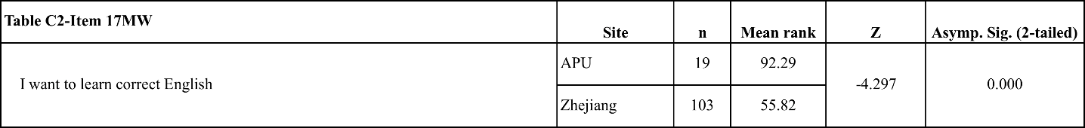
There was a significant difference in the level of agreement with the proposition “I want to learn correct English” for APU students and Zhejiang students (z = -4.297, p = 0.000)

Table 47: C2-Item 18MW results of Mann-Whitney paired sample analysis for Chinese responses to proposition "If I can speak English I will be a better person"
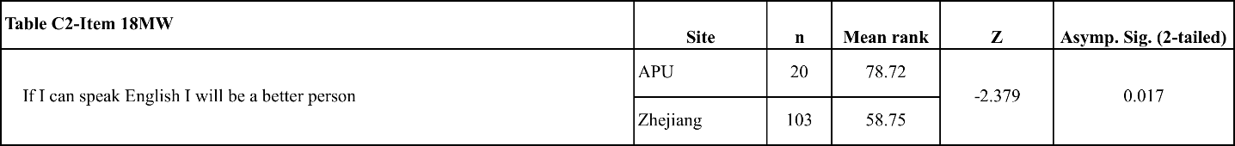
There was a significant difference in the level of agreement with the proposition “If I can speak English I will be a better person” for APU students and Zhejiang students (z = -2.379, p = 0.017)

4.4.2.3 Survey breakdown and FTF/CMI comments for Chinese responses to Research Question 2
The Chinese APU students agreed with the ‘Better’ proposition (Item 18) more than their Zhejiang counterparts, with 80% of respondents agreeing compared to 60% of Zhejiang students agreeing and 18.5% of Zhejiang disagreeing. No Chinese APU students disagreed with the proposition (Table 110). In the FTF focus groups, all the Chinese participants agreed with the ‘Better’ proposition, saying that they could learn “skills” from the use of English, or even learn “values” or become more “popular”. Although they gave different reasons for their answers, the Chinese APU students demonstrated an opinion that their lives currently were improved through the use of English and, by extension, their opportunities in life. The Zhejiang students who responded to the CMI survey were not as positive as their APU counterparts, with only one of the students agreeing with the ‘Better’ proposition, saying that English made it “easy to communicate with foreigners”. Those who disagreed said that they felt English was a useful “tool” but that ‘better’ related to “character” and that language was not part of judging someone’s personality.

The ‘Correct’ proposition (Item 17) received 100% agreement from the Chinese APU students, with their most popular response being ‘Very Strongly Agree’, which received 52.6% of the selections. This proposition received 82.5% agreement from the Zhejiang students, but with a further 10.7% selecting that they had ‘No Opinion’. Their most popular response was ‘Agree’, with 39.8% of them selecting this option (Table 108). The Chinese APU students were strongly focused on ‘American English’ as the variety they were most interested in learning (Item 27), with 90% of APU respondents selecting this option. Zhejiang students also selected ‘American English’ as their most popular response, with 82.5% of students selecting this option compared to 68.9% selecting ‘British English’. ‘Chinese English’ was the third most popular selection with 18.4% of the Zhejiang population expressing an interest in learning this variety compared with 10% of APU students (Table 109). APU students were also more interested in ‘Canadian English’, ‘Australian English’, ‘New Zealand English’, and ‘Indian English’ than their counterparts in Zhejiang as all of these options registered higher levels of interest for APU students than Zhejiang students. The average number of selections from Chinese APU students was 2.3 per respondent compared with the Zhejiang average of 2.09 selections per respondent. The APU students had an interest in a narrower range of varieties than the Zhejiang students.

When asked, “Why are you studying English?” (Item 8) the responses from APU students were markedly different from their Zhejiang counterparts. No Chinese APU students responded that they were studying English for their ‘Course’, whereas 40.8% of Zhejiang students selected this option (Table 107). The joint most popular responses from APU student were “Work”, which 40% of APU respondents selected compared with 22.5% of Zhejiang respondents, and “Travel/Work Abroad”, which 40% of APU respondents selected compared with only 8.5% of Zhejiang students (Table 107). This difference is a reflection of how APU students view their circumstances and how they continue to see English providing them with academic mobility in the future.

In response to the question “What do you use English for now?” (Item 25), 100% of Chinese APU students selected that they used it for ‘study’. No Chinese APU students selected that they currently use English for ‘Work’. When asked the question “What will you use English for in the future?” the average number of selections increased for both populations of Chinese students, but the APU students increased more, up from an average of 2.35 to an average of 3.55 selections compared with 3.46 from Zhejiang students, up from an average of 2.78 selections (Table 111). The most popular response to this question of future use of English from APU student was ‘Work’, which no student had selected in response to the question about their current use for English. The second largest increase from the responses to the question of their current use of English was ‘Travel’, increasing from 20% to 90%. The only response from Zhejiang students to show a very large increase from the question about current use to the question regarding future use was with regard to “Joining sports teams” which increased from 6% to 34.3%.

When the focus groups responded to the question “What will you use English for in the future?” (Item 26) the responses from the FTF groups and CMI survey respondents were very similar. The APU participants felt that they would use English in the future either for they employment as it would be “good for career”, or acknowledged that their ability to “know a lot of foreign people” would be enhanced by their experience with the use of English. The Zhejiang students who responded to the CMI survey had a similar balance of opinions, with half mentioning “job opportunities” or “using English to work”, and the other half saying they can use English to “communicate with foreigners” in the future.

4.4.2.4 Key findings for Chinese respondents to Research Question 2
- All Chinese APU students were more interested in ‘correct’ English, which they defined more narrowly with regard to ENL varieties, than the students from Zhejiang University.
Table 48: Table of charts relating to the key findings for Chinese respondents to Research Question 2

4.4.3 Korean Responses to Research Question 2

4.4.3.1 Descriptive statistics for Korean responses to survey items relating to Research Question 2
Table 49: K2-1 Descriptive statistics for Korean responses to survey items relating to Research Question 2
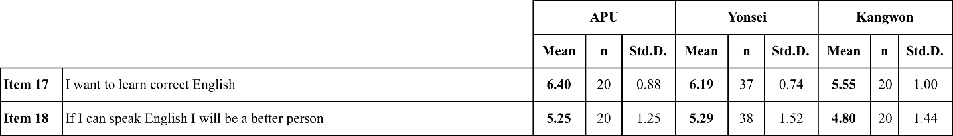
In response to the proposition (Item 17) “I want to learn correct English”, APU students had the highest level of agreement when compared with Yonsei and Kangwon students. Yonsei students had the highest level of agreement with the proposition “If I can speak English I will be a better person” when compared with APU and Kangwon students. The difference between APU and Yonsei students was very small, but the responses from Kangwon were of a much lower level of agreement than both the other populations of Korean students. While the APU and Yonsei averaged scores of 6 or over for the ‘Correct’ proposition, Kangwon had an average of 5; APU and Yonsei both averaged 5 or more for the ‘Better’ proposition, while Kangwon averaged a score of 4.8. For both of the propositions included in Table 49 (K2-1), APU and Yonsei students had responses that were more similar to each other than they were to Kangwon.

4.4.3.2 Overview of analysis of Korean responses to survey items relating to Research Question 2
Table 50: K2-Item 17MW results of Mann-Whitney paired sample analysis for Korean responses to proposition "I want to learn correct English"
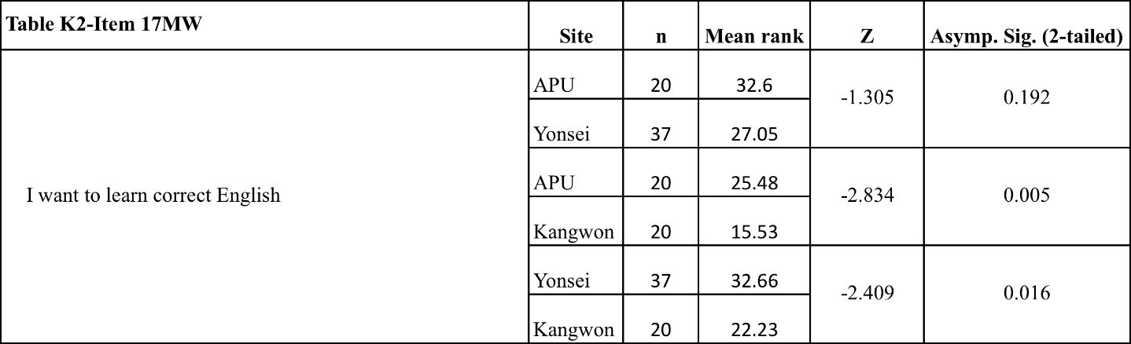
There was a significant difference in the level of agreement with the proposition “I want to learn correct English” for APU students and Kangwon students (z = -2.834, p = 0.005) and Yonsei students and Tokyo Keizai University students (z = -2.409, p = 0.016). There were no significant differences in the responses of APU and Tsukuba University students.

Table 51: K2-Item 18MW results of Mann-Whitney paired sample analysis for Korean responses to proposition "If I can speak English I will be a better person"
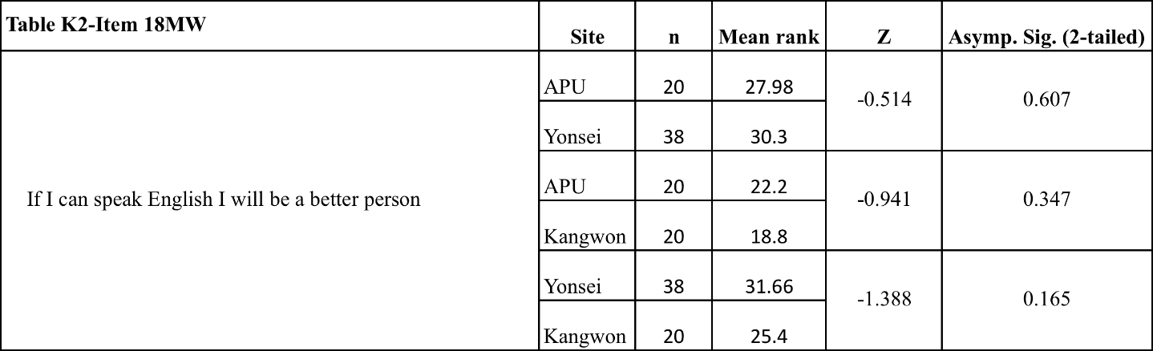
There was no significant difference between levels of agreement registered by APU students, Yonsei students or Kangwon students with the proposition “If I can speak English I will be a better person”.

4.4.3.3 Survey breakdown and FTF/CMI comments for Korean responses to Research Question 2
The Korean APU students and Yonsei students had very similar responses to the ‘Better’ proposition (Item 18), with 75% of APU students and 73.7% of Yonsei students agreeing with the proposition, compared with only 55% of Kangwon students. The Yonsei students agreed with the ‘Better’ proposition more strongly than the APU students, with the most popular response from Yonsei students being ‘Strongly Agree’ with 42.1% of students selecting this option compared with APU where the most popular response was ‘Agree’ with 35% of students selecting this option (Table 116).

The FTF focus group participants had a lower level of agreement relative to Yonsei students to the ‘Better’ proposition, where the majority of APU students in the groups disagreed. The Korean FTF focus group participants who disagreed with the ‘Better’ proposition spoke about English being “just a language” and also about their experience in Korea where they reported that Korean people “speak English well”, and that “getting a good TOEIC score is normal”, but also that “Korean people are afraid of English” and that it is helpful “just for hunting for a job”. The students who disagreed in response to the ‘Better’ proposition did not say anything to suggest that they believed that their future use of English would be anywhere other than Korea. The one student who agreed with the ‘Better’ proposition said “If you have no TOEIC/TOEFL score you can still find a job”, an opinion that does not contradict the reasons given by the students who disagreed and said that high TOEIC scores were “normal”, but suggest that this student saw greater personal utility in the use of English despite not seeing any guaranteed advantage in the job market. This student did say “we can use [English] in more countries so it is more global”, equating ‘better’ with ‘international’. These responses indicate that the impression of English in Korea is the same whether the students agreed with the ‘Better’ proposition or not.

The ‘Correct’ proposition (Item 17) received very high levels of agreement from all three Korean populations, with 95% of APU students, 90% of Kangwon students and 100% of Yonsei students agreeing with this proposition. The most popular response from APU students was ‘Very Strongly Agree’ with 60% of respondents selecting this option. The most popular response for both Yonsei and Kangwon students was ‘Strongly Agree’, with 40% of Kangwon students and 43.2% of Yonsei students selecting this option (Table 114). When asked the question “Which variety of English do you want to learn?” (Item 27), all three populations selected ‘American English’ as their most popular choice, with 80% of APU students, 85.7% of Kangwon students and 86.5% of Yonsei students also selecting this option (Table 115).

The average number of selections for the three populations was also similar, with APU students selecting an average of 2.45 varieties compared with 2.32 for Yonsei students and 2.38 for Kangwon students. The responses from Yonsei and APU students had a higher concentration of their selections on ‘American English’ and ‘British English’, with 65% of APU students and Yonsei students selecting ‘British English’ compared with only 33.3% of Kangwon students. There did appear to be an effect of having studied with students from other countries at APU on the Korean APU students’ responses, as these students were slightly more likely to have selected ‘Japanese English’, ‘Chinese English’ and ‘Singapore English’ than their counterparts studying in Korea.

In response to the question “Why are you studying English?” (Item 8), APU and Yonsei students had very similar responses, with the most popular response for both populations being ‘Travel/Work Abroad’ with 45% of APU students and 44.7% of Yonsei students selecting this option. Only 5% of APU students and 5.3% of Yonsei students selected the option ‘Enjoy’ while 28.6% of Kangwon students selected this option (Table 113). It can be inferred from these patterns of responses that although they are currently attending an academically lower level university, the APU students have a similar professional motivation to study English to those students at a highly ranked domestic university. The similarity in the responses and selection of ‘Travel/Work Abroad’ as their most popular response is a reflection of APU students’ interest in the utility value of English beyond their current studies (Table 113).

When asked “What are you using English for now?” (Item 25) the most popular response for all three populations was ‘Study’ with 95% of APU students, 95.2% of Yonsei University students and 100% of Kangwon University students selecting this option. Both APU and Yonsei selected ‘Meeting People’ as their second most popular response, with 40.5% of Yonsei students and 45% of APU students selecting this option (Table 117). In response to the question “What will you use English for in the future?” (Item 26), the most popular selection from all three populations was ‘Work’. Yonsei and APU students had similarly high numbers, with 95% of APU students and 91.9% of Yonsei students selecting this option, Kangwon students had a lower number of responses with 81% selecting ‘Work’ (Table 118). This is somewhat surprising as the Kangwon University students tended to be older than both the APU and Yonsei University students (Table 9), with the majority of the respondents over 21 years of age, which suggested that they were closer to graduation than the students from the other two universities. However, the Kangwon University students were seemingly less professionally oriented, meaning that they saw less professional utility in English, perhaps related to their relatively lower academic standard overall. The second most popular response from both Yonsei and Kangwon students was ‘Meeting people’ with 70.3% of Yonsei students selecting this option and 57.1% of Kangwon students selecting this. 60% of APU students selected ‘Meeting People’, but the second most popular responses from APU students was ‘Travel’ with 75% of students selecting this option (Table 118). The main difference between the Yonsei University and APU students, and the reason that Yonsei students had a higher average number of responses, was the selection of the option ‘Study’ by 64.9% by Yonsei students compared to only 15% of APU students, indicating that APU students attribute to English a much lower future academic utility than Yonsei students, but have a similarly high professional orientation.

When the focus groups were asked about their future use of English, the majority of the APU students in the FTF focus groups said that they intended to use English with their job in the future, using the words “job”, “job-hunting”, “career”, and “business”. One student said they would go to “graduate school in America”, and another said that they thought “English will be a very useful language in my future”. Four of the five CMI survey respondents from Yonsei said that they were interested in using English for their future employment, using the words “job”, “working career”, “foreigner’s company”, and “business work” in their responses. These students’ responses also included the phrases “also communicating with foreigners” and “writing good science papers”, meaning that the Yonsei CMI respondents’ opinions were closely matched with the findings from the survey, where Yonsei students selected ‘Study’ more often than either Kangwon or particularly APU students when responding to the question of their future English use.

4.4.3.4 Key findings for Korean respondents to Research Question 2
- APU students had higher levels of agreement with the ‘Correct’ proposition than Yonsei University students, and significantly high levels of agreement than the Kangwon University students with the same proposition.
- APU and Yonsei University students had higher percentages of their respondents select ‘Work’ for their ‘Future’ use of English than Kangwon University students.
- Yonsei University students reported much higher interest in ‘Study’ for their future use of English than the students from either APU or Kangwon University.

Table 52: Table of charts relating to the key findings for Korean respondents to Research Question 1

4.5 Research Question 3: What are Asian students’ opinions of other Asian students of English and Asian varieties of English?

4.5.1 Japanese responses to items in Research Question 3

4.5.1.1 Descriptive statistics for Japanese responses to survey items relating to Research Question 3
Table 53: J3-1 Descriptive statistics for Japanese responses to survey items relating to Research Question 3
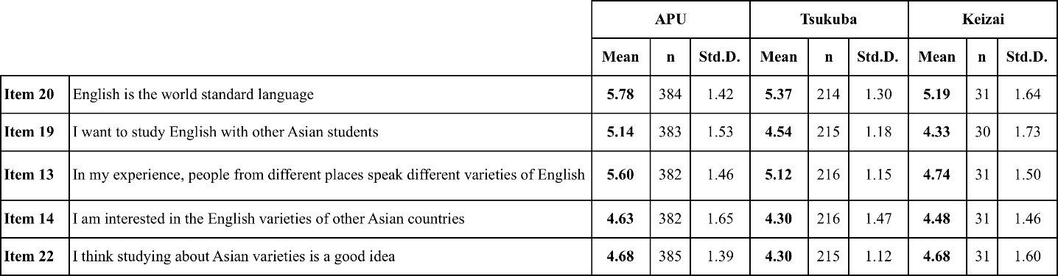
In response to the items in Table 53 (J3-1), the APU students were more positive than the Tsukuba University and Tokyo Keizai University students, with the exception of “I think studying about Asian varieties of English is a good idea” (Item 22), where APU and Tokyo Keizai University students had the same mean score of 4.68. All three populations of Japanese students agreed most uniformly with “English is the world standard language” (Item 20) with APU students having a mean score of 5.78 compared with a mean score of 5.37 for Tsukuba University students and 5.19 for Tokyo Keizai University students.

Table 54: J3-2 Descriptive statistics for Japanese responses to survey items relating to Research Question 3
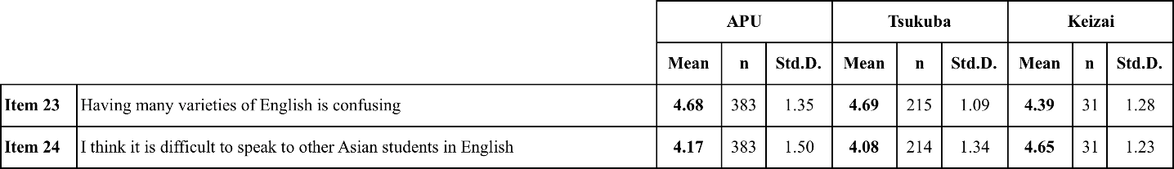
Items represented in Table 54 (J3-2) were better supported by respondents from Tsukuba University and Tokyo Keizai University than students from APU. Tsukuba University students had the highest level of agreement with the proposition “Having many varieties of English is confusing” (Item 23) of all three populations, although the difference in the mean scores of the APU and Tsukuba University responses was not large. In response to the ‘Difficult’ proposition, Tokyo Keizai University students had the highest level of agreement when compared with APU students and Tsukuba University students.

4.5.1.2 Overview of analysis of Japanese responses to Research Question 3
Table 55: J3-Item 20MW results of Mann-Whitney paired sample analysis for Japanese responses to proposition "English is the world standard language"
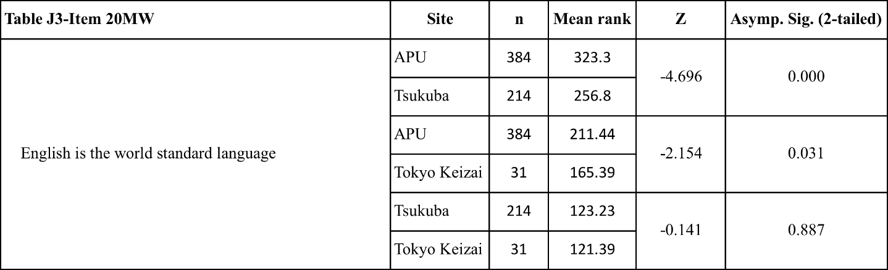
There was a significant difference in the level of agreement with the proposition “English is the world standard language” for APU students and Tsukuba University students (z = -4.696, p = 0.000) and Tokyo Keizai University students (z = -2.154, p = 0.031). There were no significant differences in the responses of Tsukuba University and Tokyo Keizai University students to the ‘Standard’ proposition.

Table 56: J3-Item 19MW results of Mann-Whitney paired sample analysis for Japanese responses to proposition "I want to study English with other Asian students"
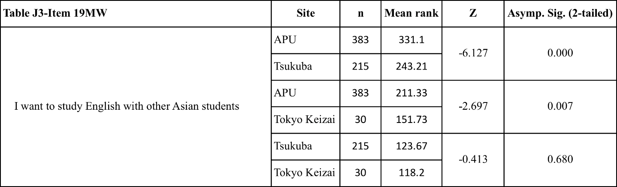
There was a significant difference in the level of agreement with the proposition “I want to study English with other Asian students” for APU students and Tsukuba University students (z = -6.127, p = 0.000) and Tokyo Keizai University students (z = -2.697, p = 0.007). There were no significant differences in the responses of Tsukuba University and Tokyo Keizai University students.

Table 57: J3-Item 13MW results of Mann-Whitney paired sample analysis for Japanese responses to proposition "In my experience, people in different places speak different varieties of English"
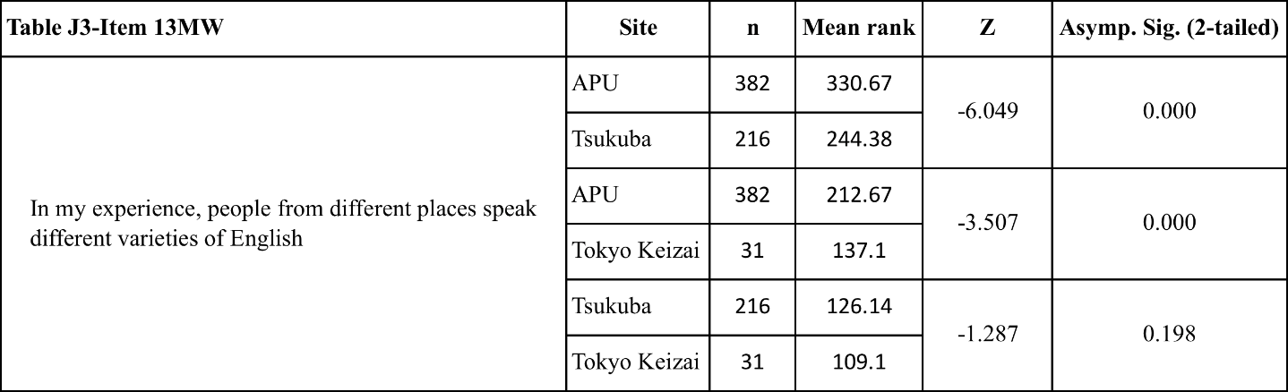
There was a significant difference in the level of agreement with the proposition “In my experience, people from different places speak different varieties of English” for APU students and Tsukuba University students (z = -6.049, p = 0.000) and Tokyo Keizai University students (z = -3.507, p = 0.013). There were no significant differences in the responses of Tsukuba University and Tokyo Keizai University students.

Table 58: J3-Item 14MW results of Mann-Whitney paired sample analysis for Japanese responses to proposition "I am interested in the English of other Asian countries"
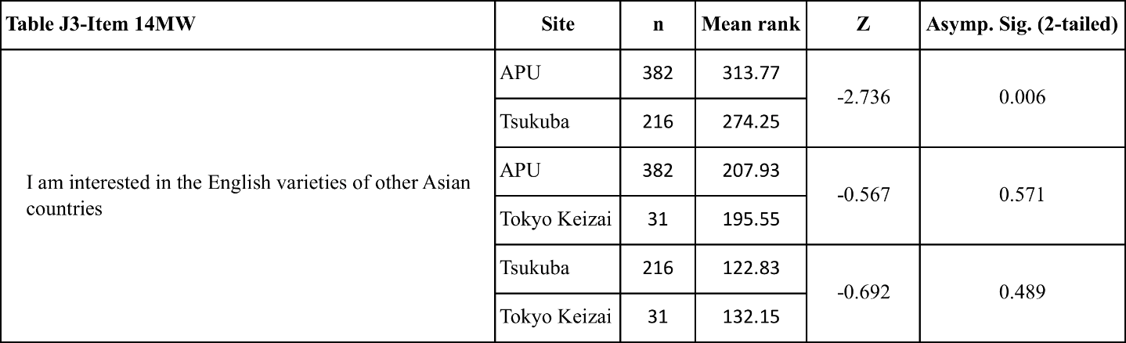
There was a significant difference in the level of agreement with the proposition “I am interested in the English of other Asian countries” for APU students and Tsukuba University students (z = -2.736, p = 0.006). There were no significant differences in the responses of APU and Tokyo Keizai University, and Tsukuba University and Tokyo Keizai University students.

Table 59: J3-Item 22MW results of Mann-Whitney paired sample analysis for Japanese responses to proposition "I think studying about Asian varieties of English is a good idea"
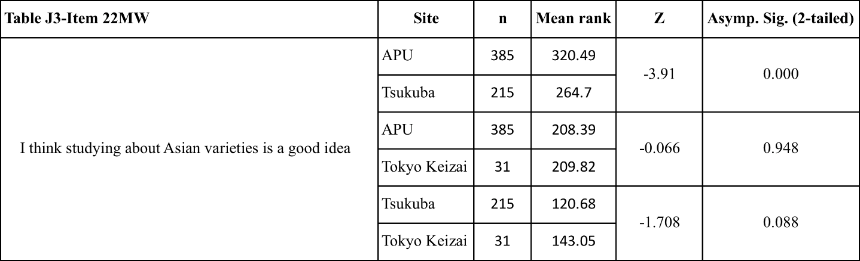
There was a significant difference in the level of agreement with the proposition “I think studying about Asian varieties of English is a good idea” for APU students and Tsukuba University students (z = -3.91, p = 0.000). There were no significant differences in the responses of APU and Tokyo Keizai University students, and Tsukuba University and Tokyo Keizai University students.

Table 60: J3-Item 23MW results of Mann-Whitney paired sample analysis for Japanese responses to proposition "Having different varieties of English is confusing"
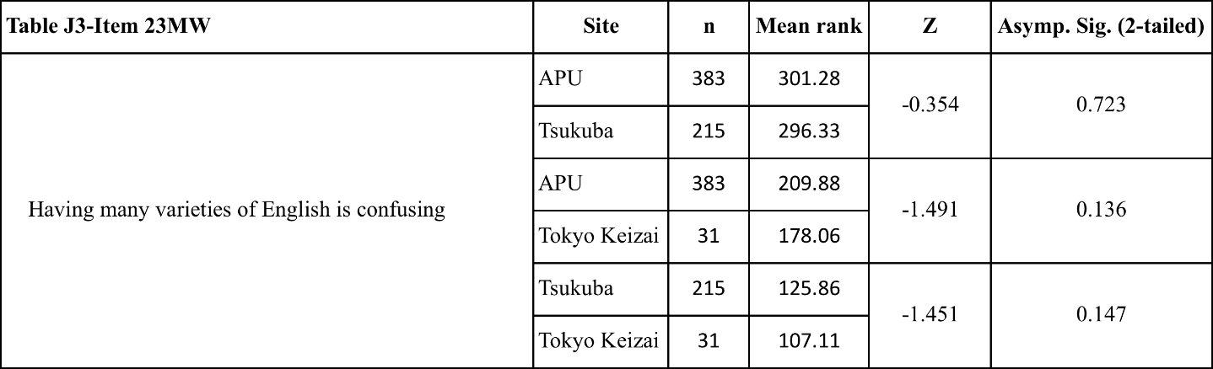
There was no significant difference between level of agreement registered by APU students, Tsukuba University students or Tokyo Keizai University students with the proposition “Having many varieties of English is confusing”.

Table 61: J3-Item 24MW results of Mann-Whitney paired sample analysis for Japanese responses to proposition "I think it is difficult to speak to other Asian students of English"
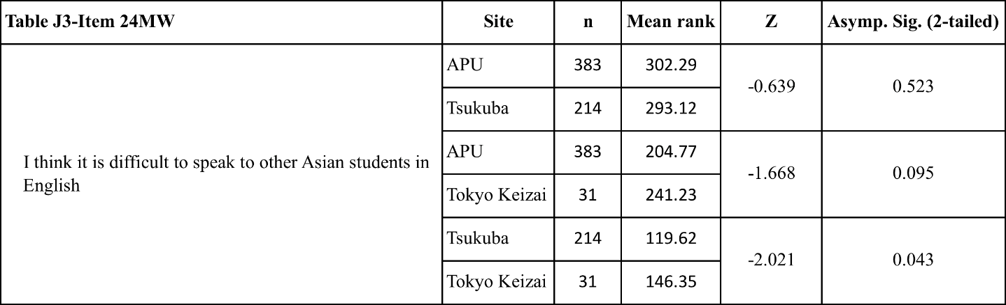
There was a significant difference in the level of agreement with the proposition “I think it is difficult to speak to other Asian students in English” for Tsukuba University and Tokyo Keizai University students (z = -2.021, p = 0.043). There were no significant differences in the responses of APU and Tsukuba University students, and APU and Tokyo Keizai University students.

4.5.1.3 Survey breakdown and FTF/CMI comments for Japanese responses to Research Question 3
APU students strongly agreed with the ‘Standard’ proposition (Item 20), with 88.6% of APU students agreeing, compared with 85.5% of Tsukuba University students and 80.7% of Tokyo Keizai University students. The most popular response from APU students was ‘Very Strongly Agree’, with 40.1% of respondents selecting this option, compared with 22.6% of Tokyo Keizai University students and 19.6% of Tsukuba University students (Table 119).

When asked which variety should be the world standard (Item 27), 53% of APU students, 55.9% of Tsukuba University students and 74.2% of Tokyo Keizai University students selected ‘American English’ (Table 120). ‘British English’ was the second most popular response from APU students with 21.6% of the respondents selecting this option, compared with 16% of Tsukuba University respondents and 3.2% of Tokyo Keizai University respondents (Table 120). However, the second most popular response for both Tsukuba University and Tokyo Keizai University students was that there should be ‘no Standard English’, with 16.1% of Tokyo Keizai University students and 27.7% of Tsukuba University students selecting this option (Table 120).

The same question of which variety of English should be the ‘standard’ was given to the FTF focus group and CMI survey participants. Half of the students from the APU FTF groups responded that there should be ‘no standard’. These students said that a standard was “not necessary”, because, as one student put it, a standard “does not matter”. Other students from APU said that it would be “difficult” or “impossible” to decide which variety would be an acceptable standard in all places. One student said that if a standard were chosen then there “is going to be a gap” between regional varieties and the geographically detached theoretical world standard. Students who selected ‘American English’, ‘British English’, or some combination of both, supported their decision by saying what it was about that particular variety that attracted them to it. For ‘American English’, students from APU said it was “getting more popular” as “America is getting stronger”, that they “had learned” American English or that “almost all people learn American English”. The student who supported ‘British English’ said that it was “more clear than American English”. Students who said that either standard could work said that they were “linked to history” or that these countries “economically have great power”. One student who said “of course maybe British or American” said that “British is better for me” because they had “learned English from a British professor”.

The respondents from Tsukuba University responding to the CMI survey were divided as to whether there should be a standard or not. Students who indicated a preference for either ‘American English’ or ‘British English’ used the reason of the “pronunciation” because these varieties were “easy to hear”. One student, who said that English should not be based on a single variety, said it was because they “know nothing about varieties of English”. Another said that variety was a “racial symbol” meaning that differences were based on location and should not therefore be overridden. Another student said that “having a standard is enough” meaning that they supported the idea of having a standard but that it should not necessarily be taken exclusively from one country’s variety.

APU students were significantly more in agreement with the ‘Other Asian Students’ proposition (Item 19) than their counterparts from Tsukuba University or Tokyo Keizai University, with 72.1% of APU students agreeing with the proposition compared with 52.5% of Tsukuba University students and 50% of Tokyo Keizai University students. Only 12.2% of APU students disagreed compared with 14.9% of Tsukuba University students and 23.4% of Tokyo Keizai University students (Table 121). The ‘Experience’ proposition (Item 13) asked students directly to respond based on their past experience and knowledge of English from different places. As might be expected, 84.9% of APU students agreed compared with 70.3% of Tsukuba University students and only 54.9% of Tokyo Keizai University students (Table 122). The question of experience is linked to the length of time the students have studied English, and therefore their overall academic exposure to the language in general, and also their experience of overseas travels to English-speaking countries. These were covered in Tables 11 and 12 at in Section 4.2 of this chapter, and provide useful additional details about the Japanese students’ background with English, and in turn the effect that this has had on their opinions. Table 11, which reports the number of years the students reported having studied English, demonstrates that all three Japanese populations have studied English for a very similar length of time, basically the minimum required by state education. Therefore, their experience of ALTs in their classrooms, the most common experience of non-Japanese performance of the English language in Japan pre-university, will have been very similar. The fact that the most popular response from Tokyo Keizai University students was ‘No Opinion’, with 32.3% of Tokyo Keizai University students selecting this option, is an indication of these students’ lack of experience of different varieties of English, and in turn a demonstration of the relatively high level of experience of varieties of English among APU students.

Compared with the responses to the ‘Standard’ (Item 27), ‘Other Asian students’ (Item 19) and ‘Experience’ (Item 13) propositions, the APU responses to the ‘Interest in Asian varieties’ proposition (Item 14) were noticeably different from the Tsukuba University students’ responses. This can be attributed to the relative low level of agreement and high level of disagreement by the Tsukuba University students, with only 45.8% of Tsukuba University students agreeing compared with 54.9% of APU students and 56.9% of APU students agreeing with the ‘Interest in Asian varieties’ proposition (Item 14) (Table 123).

The test of ‘interest’ in studying was if the students agreed that they wanted to study Asian varieties of English (Item 22). Of the three Japanese populations, APU students expressed the most interest in ‘Studying Asian Varieties’ with 59.7% of students agreeing with the proposition. However, these levels of response were not very different from Tokyo Keizai University students, 58.1% of whom expressed agreement with this proposition, compared with 47.5% of Tsukuba University students (Table 124).

As they were students studying on an international campus, one might expect that propositions relating to personal confusion or stress would receive higher levels of agreement from the APU students than students studying at regular domestic universities, as APU students have more contact with difficulties relating to the use of English. The APU students did register the highest level of agreement with the ‘Confusing’ proposition (Item 23), with 64.7% of respondents agreeing, but it was not very much higher than students at other Japanese universities. Tsukuba University students registered 64.6% agreement and Tokyo Keizai University students registered 51.7% agreement (Table 125).

The majority of FTF participants agreed with the ‘Confusing’ proposition (Item 23), and most used personal experiences from APU to explain their agreement. They had a specific person in mind when they responded to the proposition and gave examples of “roommates”, “instructors” and “friends” who speak with an “accent” or use different “grammar” or “pronunciation”. The comments from the FTF focus group students who agreed were not always negative about the person they used as an example in their response. Some participants said that the students from other countries speak English “very well” or that they personally “got used to it”. Several students also said that “Japanese English is bad” or “confusing”, which demonstrated an appreciation of communication problems caused by their own performance in English. In relation to their personal improvement, one student saw this “confusion” and difference as a chance for “my English to improve”, and another said “in APU I can learn how they (other Asian students) pronounce so learning English at APU is very important”. Another student said “we have to learn different variety of English for our future”.

There were some negative opinions in the FTF focus groups among the students who agreed with the ‘Confusing’ proposition. One student said “I want to focus on correct native English…I don’t want to waste time studying English”. This student was collocating and therefore equating the label ‘correct’ with ENL varieties. One student spoke about confusion between ENL standards, saying “In Japanese (sic) we learn American English for 6 years, and when we speak to people who speak Australian English I totally can’t understand what they are saying. When I listen to people who speak British English I feel comfortable because they speak very clear” (sic).

The students in the FTF focus groups who disagreed to the ‘Confusing’ proposition in the focus groups all gave APU as the reason they did not feel there was confusion caused by different varieties. All three students said that they “got used to it”, in reference to differences in English language performance, during their time at APU. This was exactly the same phrase used by all the students who agreed with this proposition, as in “I think it is because I entered APU there are so many Asian countries or other countries so I got used to it”, and “I got used to varieties”. This concept of ‘getting used to it’ is in contrast to the expressed opinions from the CMI survey of students from Tsukuba University. Tsukuba University students who agreed with the ‘Confusing’ proposition did not reference any personal experiences of confusion, other than one student who said that she personally spoke “with a slight Russian accent” because of her time overseas and that this caused some confusion. One student who disagreed with the ‘Confusing’ proposition said “I cannot understand my grandmother” a reference to differences in Japanese performance, and an understanding that differences between linguistic performances within all languages is natural and to be expected. This was also recognition that variety is a phenomenon that is not unique to English. Those Tsukuba University students who disagreed with the ‘Confusing’ proposition also said that it was a normal condition of geographical differences, saying that differences were caused “between country to country”. However, all the students who disagreed said that they could overcome any confusion with “knowing” it or being “taught” these differences, suggesting they expected their studies to assist with overcoming differences in performance, something that a review of literature suggests is not always likely to occur in EFL classes (D’Angelo, 2005; Yoshikawa, 2005).

The final proposition discussed in this section is the ‘Difficult’ proposition (Item 24). There was virtually no difference in the levels of agreement from the three populations, with 45.7% of APU students, 45.7% of Tsukuba University students, and 48.5% of Tokyo Keizai University students agreeing with the proposition (Table 126). The ‘Difficult’ proposition was the only proposition in the whole survey for which there was a significant difference in the levels of agreement between Tsukuba University and Tokyo Keizai University, a significance that can be attributed to 41.9% of Tokyo Keizai University students registering ‘No Opinion’ in response to this proposition. This can be partly explained by the low numbers of foreign students on the Tokyo Keizai University campus and the fact that only 32.3% of the students reported having experience of visiting an English speaking country.

4.5.1.4 Key findings for Japanese respondents to Research Question 3
- APU students were more focused on ENL varieties, as evidenced by their greater interest in American and British English than the students of either Tsukuba University or Tokyo Keizai University.
- APU students did not have a significantly higher agreement with the ‘Confusing’ proposition, but there was also little difference between interest in studying Asian varieties of English when compared to the students from the other universities.
- The similar levels of agreement with the ‘Confusing’ proposition from all populations, despite the APU students’ significantly higher experience of English varieties, can be attributed to APU students’ reporting that the international environment at APU helped them ‘get used to’ different varieties of English.
Table 62: Table of charts relating to the key findings for Korean respondents to Research Question 1

4.5.2 Chinese responses to items in Research Question 3

4.5.2.1 Descriptive statistics for Chinese responses to survey items relating to Research Question 3
Table 63: C3-1 Descriptive statistics for Chinese responses to the survey items relating to research Question 3
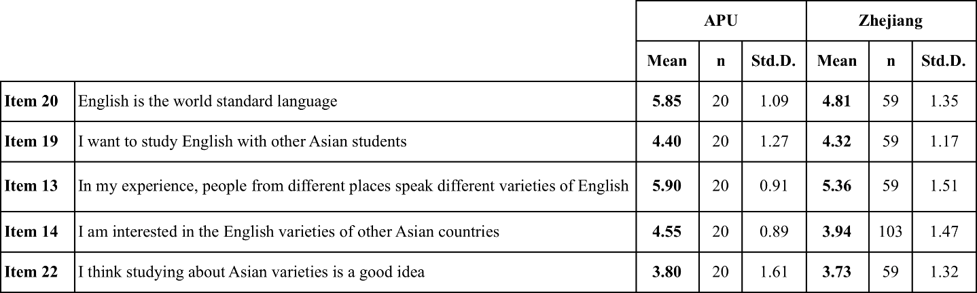

Table 64: C3-2 Descriptive statistics for Chinese responses to the survey items relating to research Question 3
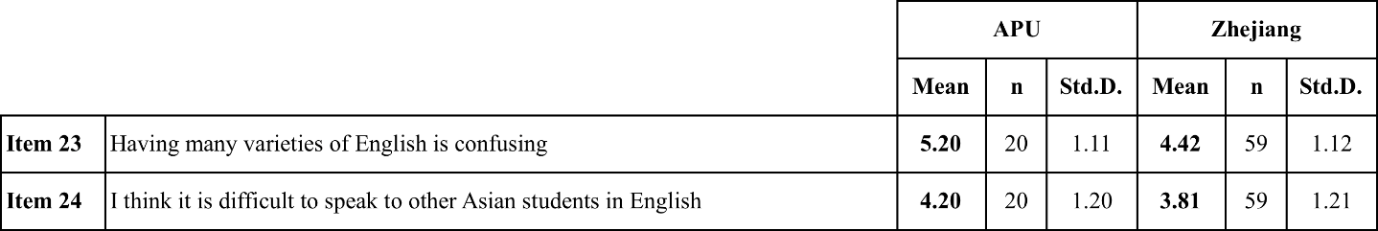

In response to all propositions relating to Research Question 3 represented in Tables 63 (C3-1) and 64 (C3-2), Chinese APU students had the highest levels of agreement when compared with their counterparts in Zhejiang for both the positive and negative propositions. The lowest level of agreement from both the Chinese APU students and the Zhejiang students came in response to the proposition ‘I think studying about Asian varieties is a good idea’ (Item 22) proposition. Neither population had a mean score higher than 4, which equates to an average response of ‘Disagree’.

4.5.2.2 Overview of analysis of Chinese responses to Research Question 3
Table 65: C3-Item 20MW results of Mann-Whitney paired sample analysis for Chinese responses to proposition "English is the world standard language"
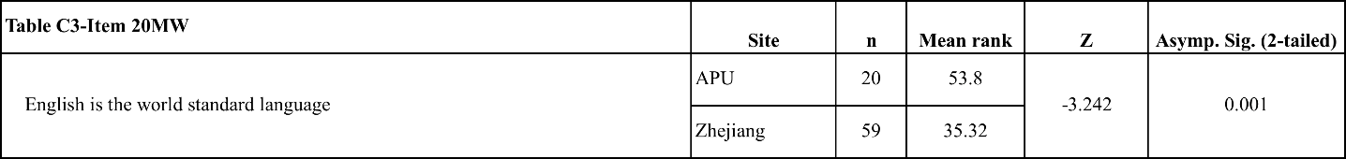
There was a significant difference in the level of agreement with the proposition “English is the world standard language” for APU students and Zhejiang students (z = -3.242, p = 0.001).

Table 66: C3-Item 19MW results of Mann-Whitney paired sample analysis for Chinese responses to proposition "I want to study English with other Asian students"
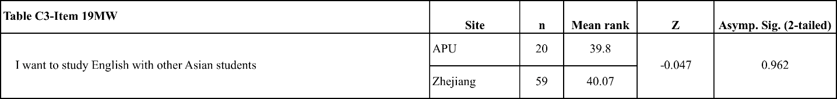
There was no significant difference between level of agreement registered by APU students and Zhejiang students with the proposition “I want to study English with other Asian students”.

Table 67: C3-Item 13MW results of Mann-Whitney paired sample analysis for Chinese responses to proposition "In my experience, people from different places speak different varieties of English"
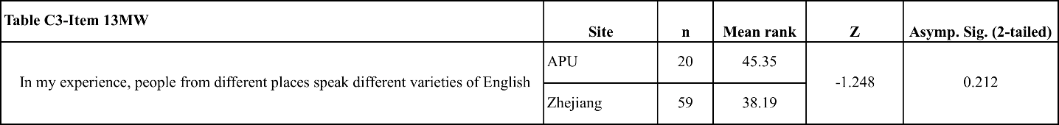
There was no significant difference between level of agreement registered by APU students and Zhejiang students with the proposition “In my experience, people from different places speak different varieties of English”.

Table 68: C3-Item 14MW results of Mann-Whitney paired sample analysis for Chinese responses to proposition "I am interested in the English of other Asian countries"
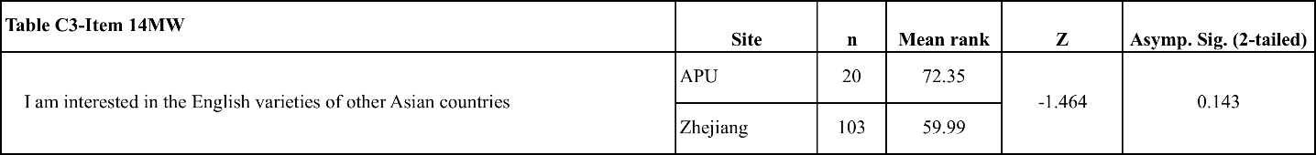
There was no significant difference between level of agreement registered by APU students and Zhejiang students with the proposition “I am interested in the English varieties of other Asian countries”.

Table 69: C3-Item 22MW results of Mann-Whitney paired sample analysis for Chinese responses to proposition "I think studying about Asian varieties of English is a good idea"
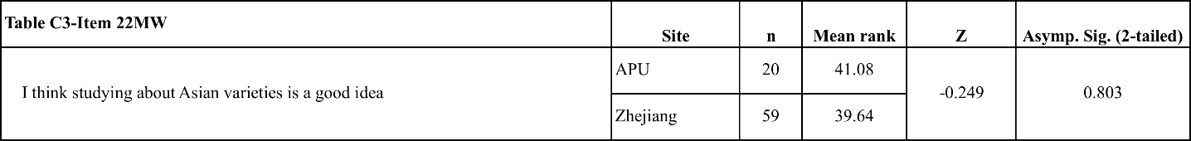
There was no significant difference between level of agreement registered by APU students and Zhejiang students with the proposition “I think studying about Asian varieties of English is a good idea”.

Table 70: C3-Item 23MW results of Mann-Whitney paired sample analysis for Chinese responses to proposition "Having different varieties of English is confusing"
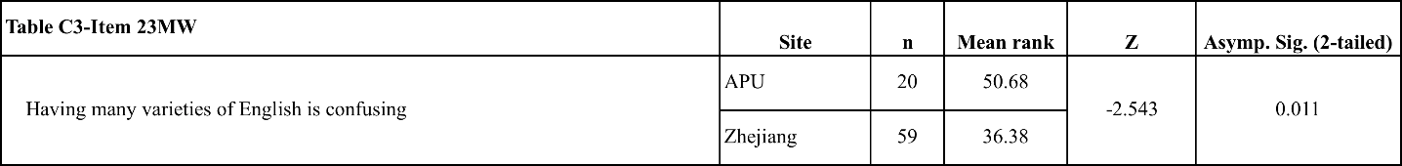
There was a significant difference in the level of agreement with the proposition “Having many varieties of English is confusing” for APU students and Zhejiang students (z = -2.543, p = 0.011).

Table 71: C3-Item 24MW results of Mann-Whitney paired sample analysis for Chinese responses to proposition "It is difficult to speak to other Asian students in English"
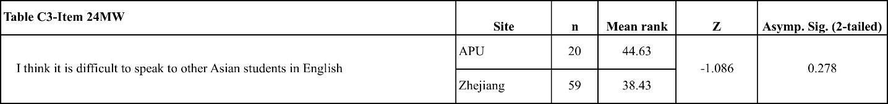
There was no significant difference between level of agreement registered by APU students and Zhejiang students with the proposition “I think it is difficult to speak to other Asian students in English”.

4.5.2.3 Survey breakdown and FTF/CMI comments for Chinese responses to Research Question 3
Chinese APU students had significantly higher levels of agreement with the ‘Standard’ proposition (Item 20), with 90% of the APU respondents agreeing compared with only 76.2% of Zhejiang students. 18.7% of Zhejiang students disagreed with the proposition compared with only 5% of APU students (Table 127). When asked which variety they felt should be the standard English (Item 27), APU and Zhejiang students gave similar responses, with 45% of APU students and 47% of Zhejiang students selecting ‘American English’ (Table 128). The difference in their responses was in their second most popular responses. For APU students, their second most popular response to the ‘Variety’ question (Item 27) was ‘British English’ with 40% of responses. Only 17% of Zhejiang students selected ‘British English’, whereas 35% of them responded that there should be ‘no Standard English’ compared with only 10% of APU students selecting the ‘no standard’ option (Table 128). The Chinese students studying abroad were more interested in a standard to work towards than those students studying in China. Neither Chinese population selected a standard variety other than British or North American English. If the respondents had a standard in mind when they responded to the ‘Standard’ proposition then it was an ENL variety.

The respondents to the FTF focus group selected either ‘American English’, ‘British English’ or that there should be ‘no standard’. The students who supported American English said it was because “most people study American English”, whereas the student who supported British English did so because “maybe British English is better because it is more standard”. There was some support for other ENL standards. One student said, “My friends said American, but I try to speak English English”, and another said “There should be no single standard but not lots…maybe three: British, American and Australian”.

The CMI survey respondents from Zhejiang were divided almost equally between those who selected one variety or those who said that there should be ‘no standard’. Those students who selected either ‘British’ or ‘American English’ said “I hold the US English as the authentic one” or “American because it is widely used”. One student said, “compared with American English, British English sounds more comfortable and formal”, and another said “I think British English should be the world standard, because it has something more connected with British culture”. The three students who disagreed all felt to some degree that selecting one variety to be the standard would give that variety too much “power” and that being “diverse” was linked to “culture” that was unique to each country and therefore variety was more valuable than having a standard.

Compared with their strong support of other propositions, the responses to the ‘Asian students’ proposition (Item 19) were much less positive. For APU students, only 40% agreed compared with 44.1% of Zhejiang students. Another noticeable difference from the response patterns for other survey items was that 40% of the APU students selected ‘No Opinion’, along with 35.6% of Zhejiang students (Table 129). The APU students demonstrated a difference in experience from the Zhejiang students, with 95% of them agreeing with the ‘Experience’ proposition (Item 13) compared with 79.6% of Zhejiang students (Table 130). No APU students disagreed with the ‘Experience’ proposition, demonstrating the impact that their time at APU has had on their understanding of different performance varieties of English. As outlined in the introduction to the items in Research Question 3 in section 3.2.3.3, this item did not specifically mention the kind of experience included in their consideration of the ‘Experience’ proposition, but one can infer from their near complete agreement that the APU students and FTF focus group participants were responding using their experience of studying and using English at APU.

Despite having more direct experience of different varieties of English at APU, and specifically students from different Asian countries, the interest that APU students expressed in their responses to the ‘Interest in Asian varieties’ proposition (Item 14) were not very different from the students in Zhejiang. In total, 45% of APU students agreed with the proposition, but 50% of the students selected ‘No Opinion’, compared with 44.7% of Zhejiang students agreeing and 38.9% of them disagreeing with the ‘Interest in Asian varieties’ proposition (Table 131). Related to this lack of interest, only 30% of APU students agreed with the ‘Studying Asian varieties’ proposition (Item 22) and 40% disagreed, continuing the pattern from the earlier ‘Interest in Asian varieties’ proposition. Chinese APU students were less in agreement with propositions relating to performance varieties of English with which they had had direct interactions. In fact, these levels of agreement were similar to the responses from Zhejiang, where 28.8% of students agreed and 47.5% of students disagreed with the ‘Studying Asian varieties’ proposition (Table 132).

When the ‘Studying Asian varieties’ proposition was put before the FTF focus groups for discussion, the majority of the Chinese APU participants disagreed, with two of the participants saying that studying different Asian varieties of English would make them ‘confused’ and another saying “maybe it is easy to understand but it is not very good”. Another student said that they did not want to study non-ENL varieties because they would not be relevant to them outside that country as it is “not useful so we don’t need to learn that”. The Chinese respondents to the CMI survey were almost evenly split between those who agreed and those who disagreed with the ‘Studying Asian varieties’ proposition. Those respondents who agreed said they could “expand their horizons”, that it would “promote communication or exchanges”, or “mainly for communication”. One Zhejiang student who agreed did add the warning that “I strongly oppose anyone to learn Asian varieties who has not form his (sic) or her own oral pronunciation, because the various Asian accents perhaps will confuse him or her”. The Zhejiang students who disagreed said that it would be “confusing” or lead to “misunderstanding”. One student said that they “like studying pure and original English more”. Another students responded “I think learning English is to communicate with Western countries”.

From their significantly higher agreement with the ‘Confusing’ proposition (Item 23), the Chinese APU students demonstrate a specific problem that they have when compared to their domestic counterparts. In response to this proposition, 75% of APU respondents agreed and only 5% disagreed, compared with 54.3% of Zhejiang students who agreed and 22% who disagreed (Table 133). The difference in the experience of these two groups is demonstrated by these responses, with the students from the international university reporting a higher level of difficulty caused by their personal circumstances than their counterparts at other universities.

The source of ‘difficulty’ can be found in the responses of the FTF focus group participants to the ‘Confusing’ proposition (Item 23), where all the Chinese participants agreed that having different varieties of English was ‘confusing’. Two students used examples from their ‘classes’ to explain their point of view, with one saying “I think a standard is best”. In this response they are assuming a ‘standard’ exists, which can be inferred to be an ENL standard. Two students spoke about differences between ‘American English’ and ‘British English’ as being a basis for confusion, which could be attributed to their teachers or their experience with foreign students on campus.

The CMI survey respondents from Zhejiang mostly agreed with the ‘Confusing’ proposition. One student used “Asian varieties” as an example of what caused the confusion, and said “it is quite necessary to learn authentic pronunciation from the US or Britain”. This is unlike the responses from APU, in that this student is looking to the US or Britain as a model rather than an example of the potential confusion. The two students from Zhejiang who disagreed both acknowledged that there were different varieties of English, but one student said that this was “interesting”, and the other said it was an “inevitable phenomenon”, a sentiment also expressed by Japanese respondents to the same item.

When responding to the ‘Difficult’ proposition (Item 24), there was not a large difference between the two Chinese populations, with 40% of APU students agreeing compared with 35.6% of Zhejiang students agreeing (Table 134). Neither group expressed a high level of agreement with the idea that differences in varieties, despite sometimes being confusing, make it ‘difficult’ to communicate in English with other Asian students.

4.5.2.4 Key findings for Chinese respondents to Research Question 3
- There was more interest in ENL varieties among the Chinese APU students than the students from Zhejiang University.
- APU students had more self-reported experience of varieties of English when compared to the students from Zhejiang University, but they had no increased interest in studying Asian varieties of English.
- The responses from the APU students were significantly higher in response to the ‘Confusing’ proposition, which the respondents in the FTF focus groups attributed to their experiences at APU.

Table 72: Table of charts relating to the key findings for Chinese respondents to Research Question 3

4.5.3 Korean responses to items in Research Question 3

4.5.3.1 Descriptive statistics for Korean responses to survey items relating to Research Question 3
Table 73: K3-1 Descriptive statistics for Korean responses to the survey items relating to Research Question 3
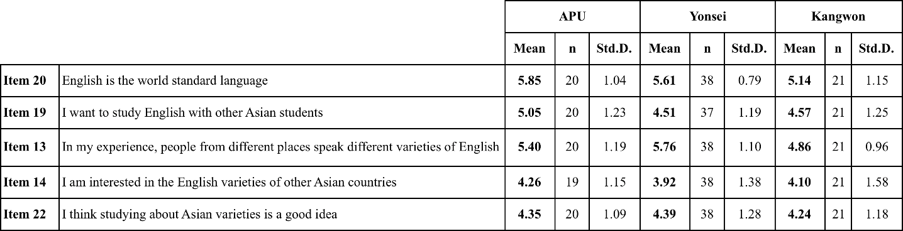
The highest level of agreement among APU Korean students was with the (Item 20) ‘Standard’ proposition, which was higher than the responses from Yonsei and Kangwon. The highest level of agreement from Yonsei students was with the (Item 13) ‘Experience’ proposition.

Table 74: K3-2 Descriptive statistics for Korean responses to the survey items relating to Research Question 3
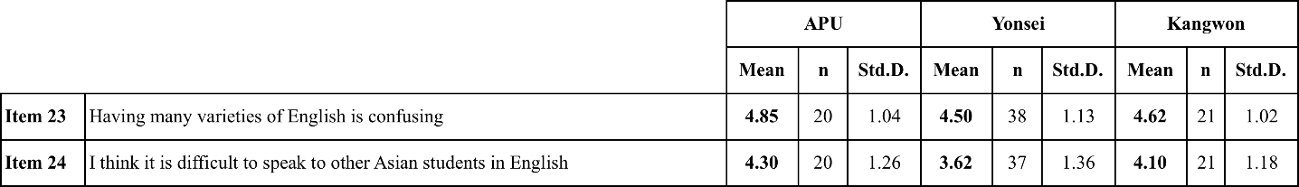
In response to the two items in Table 74 (K3-2), which both expressed negative opinions of Asian varieties of English, APU Korean students had higher levels of agreement when compared with Yonsei and Kangwon students.

4.5.3.2 Analysis of Korean responses to Research Question 3
Table 75: K3-Item 20MW results of Mann-Whitney paired sample analysis for Korean responses to proposition "English is the world standard language"
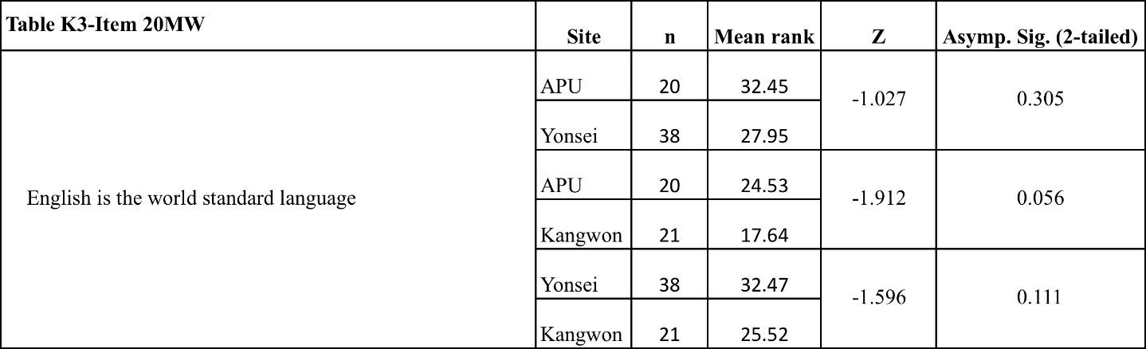
There was no significant difference between level of agreement registered by APU students, Yonsei students or Kangwon students with the proposition “English is the world standard language”.

Table 76: K3-Item 19MW results of Mann-Whitney paired sample analysis for Korean responses to proposition "I want to study English with other Asian students"
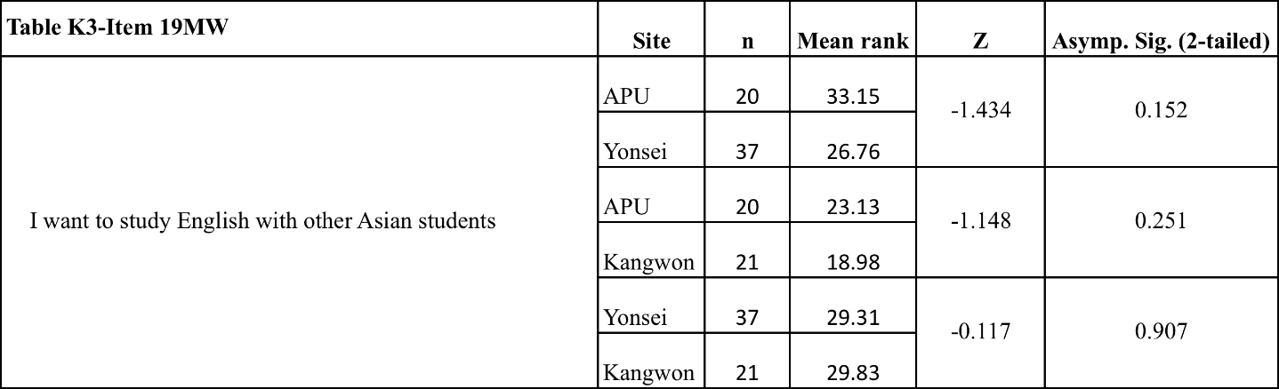
There was no significant difference between level of agreement registered by APU students, Yonsei students or Kangwon students with the proposition “I want to study English with other Asian students”.

Table 77: K3-Item 13MW results of Mann-Whitney paired sample analysis for Korean responses to proposition "In my experience, people from different places speak different varieties of English"
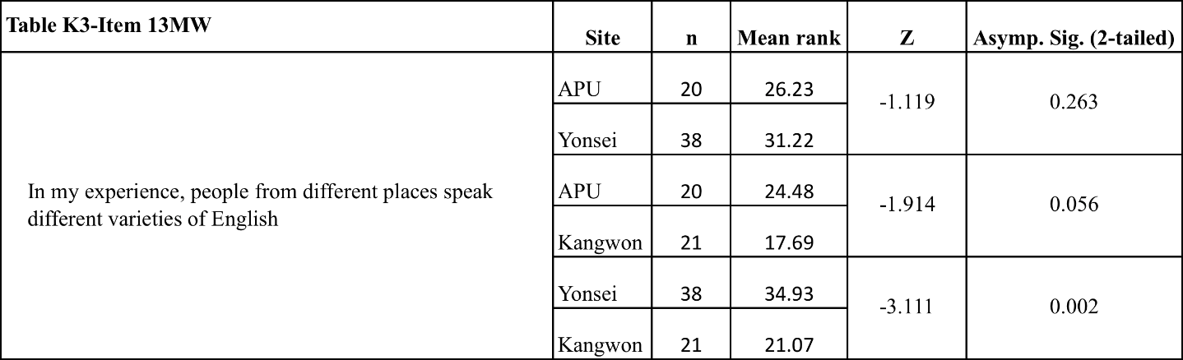
There was a significant difference in the level of agreement with the proposition “I want to learn correct English” for Yonsei and Kangwon students (z = -3.111, p = 0.002). There were no significant differences in the responses for APU and Yonsei students, and APU and Kangwon students.

Table 78: K3-Item 14MW results of Mann-Whitney paired sample analysis for Korean responses to proposition "I am interested in the English of other Asian countries"
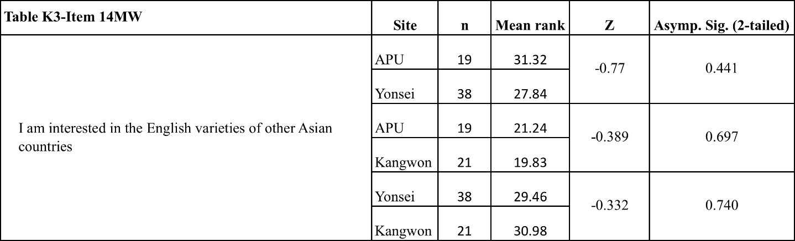
There was no significant difference between level of agreement registered by APU students, Yonsei students or Kangwon students with the proposition “I am interested in the English of other Asian countries”.

Table 79: K3-Item 22MW results of Mann-Whitney paired sample analysis for Korean responses to proposition "I think studying about Asian varieties of English is a good idea"
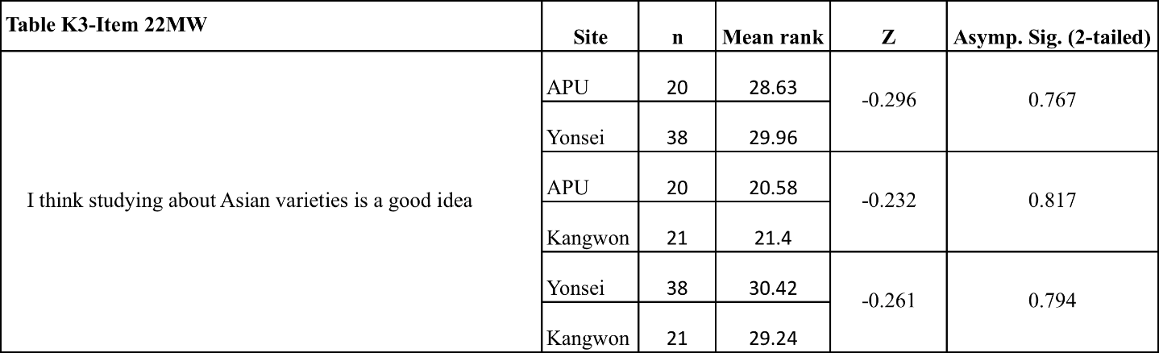
There was no significant difference between level of agreement registered by APU students, Yonsei students or Kangwon students with the proposition “I think studying about Asian varieties of English is a good idea”.

Table 80: K3-Item 23MW results of Mann-Whitney paired sample analysis for Korean responses to proposition "Having different varieties of English is confusing"
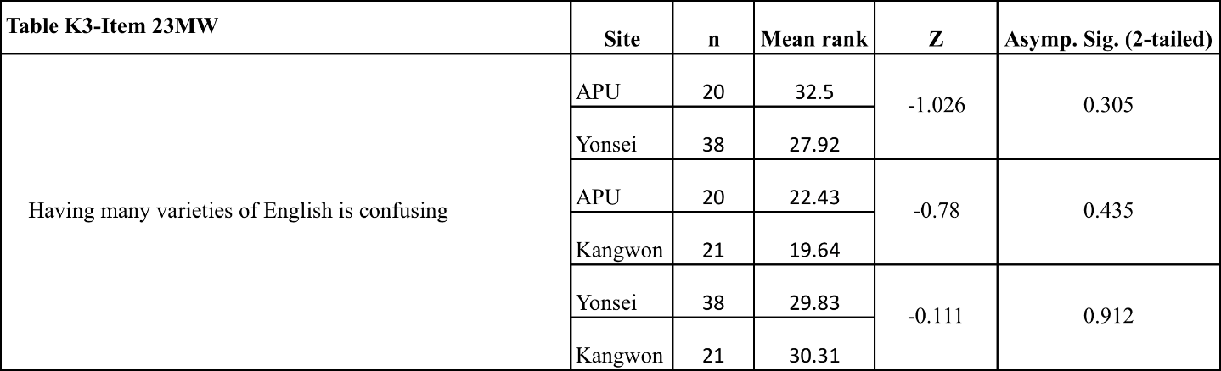
There was no significant difference between level of agreement registered by APU students, Yonsei students or Kangwon students with the proposition “Having many varieties of English is confusing”.

Table 81: K3-Item 24MW results of Mann-Whitney paired sample analysis for Korean responses to proposition "I think it is difficult to speak to other Asian students in English"
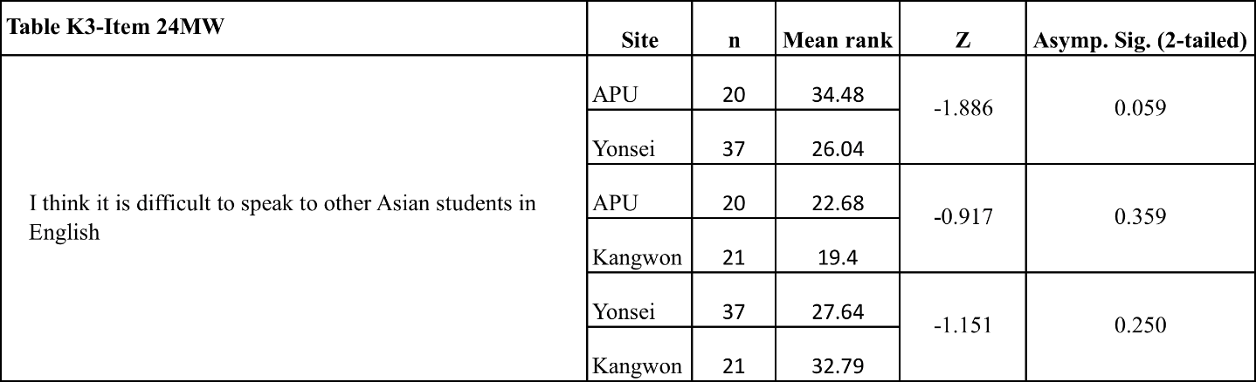
There was no significant difference between level of agreement registered by APU students, Yonsei students or Kangwon students with the proposition “I think it is difficult to speak to other Asian students in English”.

4.5.3.3 Survey breakdown and FTF/CMI comments for Korean responses to Research Question 3
Korean APU students and Yonsei students were the most strongly in agreement responding to the ‘Standard’ proposition (Item 20), with 90% of APU students and 97.4% of Yonsei students agreeing with the proposition compared with 76.2% of Kangwon students (Table 135). Although more Yonsei students agreed with the proposition the most popular response was ‘Agree’ from Yonsei students, with 50% of students selecting this option, whereas the most popular option for APU students was ‘Very Strongly Agree’ with 35% of students selecting this option. No APU or Yonsei students disagreed with the ‘Standard’ proposition.

The APU, Yonsei and Kangwon students all selected ‘American English’ as their most popular option for the ‘Standard’ variety (Item 27) of English. However, for the Yonsei students and the Kangwon students it was the majority opinion, with 59.5% of Yonsei students and 66.7% of Kangwon students selecting ‘American English’, whereas 47.1% of APU students selected this option (Table 136). Yonsei students were the most limited in their selections in response to the question of which variety they would select as a ‘Standard’ variety, as they only selected either ‘American English’ or ‘No Standard English’. Some APU students and Kangwon students selected ‘British’ and ‘Canadian English’, with one APU student selecting ‘Australian English’. While the selection of ‘No standard English’ was the second most popular option for both APU students and Kangwon students, APU students gave more consideration to alternative standards, other than American or British English, than Yonsei students.

Responding to the same question, FTF focus group participants from APU were divided into either selecting ‘American English’ or ‘No standard English’. The students who selected ‘American English’ supported their decision by saying that it already was the “standard English” or that “America is the strongest” and therefore should be the standard. Two students who selected ‘No standard’ said that “we can try…but we cannot [have a standard]” and “even if we make a standard we cannot keep it”, both of them expressing the opinion that varieties of English will make it difficult or impossible to standardize an already globalized language. One student said “sorry to native speaker, but this can make discrimination (sic)…there will be no single standard”, meaning they were aware to some extent of the negative effects of ENL hegemony, and therefore though ‘no standard’ was preferred.

The majority of CMI survey respondents from Yonsei said there should not be a standard, saying that there was “no reason”, or it would be a “waste of time” to try and make a standard, expressing the opinion, much like several of the students from APU, that the effort to make a single standard would be unsuccessful. Another student who said there should be no standard said they “have not found a single barrier to learning” from there being no standard. One student said that it should be ‘Indian English’ because “they will have the top number of people above China” and they “are good at IT service”. This student was focusing on local Asian utility with this response, but it is reflective of the opinion that students from Yonsei have an appreciation of local variety even without the same experiences as APU students. One other student gave the opinion that “American, British or Australian English will do” because “the most majority of materials with English, such as soap operas, books, academic papers, and internet contents, learning their English would be plausible since that's the reason why we learn English”.

The ‘Asian students’ proposition (Item 19) was included to gauge the students’ interest in being in a learning environment with other Asian students, and the Korean APU students demonstrated an interest in this with 75% of them agreeing with the proposition, compared with 48.6% of Yonsei University students and 57.2% of Kangwon students (Table 129). As they are studying overseas in an international environment, one might expect that Korean APU students would have more experience than their domestic counterparts. However, the students from Yonsei registered slightly higher agreement with the ‘Experience’ proposition (Item 13), with 92.1% of them agreeing compared with 85% of APU students. Kangwon students registered the lowest level of agreement with 71.5% of them agreeing with the ‘Experience’ proposition and 19.0% selecting ‘No Opinion’ (Table 138), a level of agreement significantly lower than that from the Yonsei students. In fact, these were the only paired results that were significantly different for the Korean respondents to the propositions in Research Question 3.

There was virtually no difference in the level of agreement with the ‘Other Asian students’ proposition (Item 14) for the three populations. Kangwon students registered the most interest, with 38.1% of students agreeing compared to 36.8% of APU students and 34.2% of Yonsei students (Table 139). This apparent lack of interest in Asian varieties of English is supported by the Korean responses to the ‘Studying Asian varieties’ proposition (Item 14). 44.8% of Yonsei students agreed and only 35% of APU students agreed with this proposition, with the most popular response for both populations being ‘No Opinion’ (Table 139).

When the ‘Studying Asian varieties’ proposition was given to the FTF focus groups, the majority of students disagreed. Those students who disagreed stated their opposition to the idea using specific examples from their experiences with Asian performance varieties. As mentioned in the discussion of findings from the Japanese students, my decision to have only students of one country in the focus groups was rewarded in the openness of the comments of the students in the group. One student who disagreed said “In APU, I’m studying in English class… [Asian students’] pronunciation is so different and difficult”. Another who disagreed said “I experienced [Asian varieties of English]…when I met an Indian person their pronunciation is too difficult to understand…we can’t conversation (sic), we can’t talk English”. These problems are certainly a negative effect of the experience on the APU campus in these students’ opinion. Several students who disagreed said “we have to study standard” or “If we have to learn English we should learn about American or British English” or “If I am learning English I must learn American English or England English”. One student who disagreed said “I don’t want to say the Asian varieties of English is bad or not good, but as a foreigner I believe we have to study standard”. This sentiment does not express negativity, but does suggest that the student does not think that Asian varieties can be a standard for Asian students of English, or cannot provide as much value as an ENL variety can.

Some of the students who disagreed used pejorative terms for non-native performance varieties of English, with one student using the term “freaky pronunciation” and another saying “learning so many kinds of English…you don’t know what is real English”, suggesting non-ENL varieties were not ‘real’. Among the respondents from Yonsei to the CMI survey, the response was more balanced. Three students agreed, with one saying “it would be a great way of studying English” and another saying “I want to know how to overcome [language problems]”. The students who disagreed said that “The reason I study American English is that it’s one of ‘official languages’…if [Asian varieties] are said to be ‘official’ I can consider, but for now, not interested”.

There was little difference between the levels of agreement with the ‘Confusing’ proposition (Item 23) between the different Korean populations, with 60% of APU students, 63.2% of Yonsei students, and 66.7% of Kangwon students agreeing with the proposition (Table 141). All the APU students agreed with the proposition, with some of them using APU as an example. One student said, “In APU many international students’ pronunciation is not good”. Another student “almost all my classmates are Japanese and sometimes she or he speak English (sic) and sometimes I don’t understand what they say”. The opinion expressed by most of the participants was that they had experienced confusion, but that it was that it “comes from [the speaker’s] own culture” or “may be connected to culture” or that “each country has a typical way of speaking English” and that “I don’t want to say we should make one standard”. That is to say that although these students agreed that having varieties of English caused confusion they generally did not express their opinions negatively. The CMI survey respondents from Yonsei were more evenly divided between agreement and disagreement. One student who agreed with the ‘Confusing’ proposition used a similar reason to the APU students and said “although it is confusing I think that’s cultural variety”. The other student who agreed was much more negative, and used the example of “Indian English because it sounds different from real English and our Korean English”.

The personal experience and opinions expressed by the Korean APU in the survey and focus groups students means it was no surprise that they expressed higher levels of agreement with the ‘Difficult’ proposition than their counterparts studying in Korea. The APU students were the only population of whom the majority agreed with the ‘Difficult’ proposition (Item 24), with 55% in agreement compared with 42.9% of Kangwon students and only 32.4% of Yonsei students. In contrast, 45.9% of Yonsei students and 38.1% of Kangwon students disagreed, compared with only 20% of APU students (Table 142).

4.5.3.4 Key findings for Korean respondents to Research Question 3
- From their responses to the ‘Confusing’ and ‘Difficult’ propositions, it would appear that Korean APU students had problems with the English performance of other students at their university than the students from Yonsei Univeristy and Kangwon University.
- Yonsei University and Kangwon University students were more focused on American English as the standard than APU students. APU students were more open to alternatives, but still overwhelmingly interested in ENL varieties.
- Pejorative opinions with regard to other students’ performance in English were strongest from the Korean APU students, and these opinions stemmed directly from these students’ experiences at APU.

Table 82: Table of charts relating to the key findings for Korean respondents to Research Question 3

Chapter 5: Discussion of Findings

5.1 Introduction
This section brings together the elements of the literature review, the methodology and the data analysis to provide a discussion of the findings of this study. Work in the earlier chapters will be referenced to provide as clear a profile as possible of the findings and the populations. The findings will first be discussed for each ethnicity and for each research question. After each research question, there will be a general discussion of all three APU populations and how their responses and data compare with each other. For the purposes of further exploring the qualitative data from this study, each research question breakdown will include discussion of themes from the propositions included in the research question from the perspective of the overall responses to the proposition from students from APU rather than the ethnic background of the respondents. In total, there were 37 participants in the FTF focus groups at APU. The consideration of themes other than ethnic background is intended to give an alternative lens through which to view the opinions of the students at APU. Looking at the propositions covered in the FTF focus groups, the considerations of ‘coolness’, ‘weakness’, ‘better’ and ‘confusing’, provide an even clearer indication that the environment at APU is both different from that of other universities in Japan, and is having a profound effect on its students.

5.2 Research Question 1

5.2.1 Japanese Respondents to Research Question 1
APU students are encountering something quite new in the Japanese university experience, which can be observed to be having an effect on their opinions of English both personally and academically. All the Japanese students included in the study had undertaken the same mandated length of English study prior to entering university, a point of comparison reflected in their demographic profile (see section 4.2.8). All the Japanese students in this study were in regular English classes, and none of them were English majors. Therefore, the explicit references to the international environment by students at APU in the FTF focus groups supports the conclusion that the APU students’ experiences, both positive and negative, of using English in their daily lives is the major variable in their current attitudes towards the English language between these three populations of Japanese students.

Japanese students at APU were significantly more positive in their orientation towards English in personal and academic domains when compared to their counterparts studying in regular domestic universities. Conversely, Tsukuba University respondents showed significantly higher levels of agreement than APU students with regard to the propositions connected to personal ‘weakness’. Although it can be inferred from the responses of APU students that they in fact had ‘felt weak’ in certain circumstances they experienced at APU in class or on campus, these experiences did not lead to a personal impression of English that was more negative than that of students from other universities in Japan. It can be concluded that these experiences reaffirmed the Japanese APU students’ opinion that the study of English was a ‘good idea’, in that their English studies were preparing them for potential daily uses of English rather than an undefined utility value sometime in their future.

Although APU students were more likely to mention their current university environment in their responses to the ‘Cool’ and ‘Good idea’ propositions, they were also more likely than their counterparts at Tsukuba University to think beyond their current university context in response to the focus group propositions related to Research Question 1. APU students referred to English being useful in their ‘future’ for ‘employment’ in response to the Research Question 1 propositions, which was a point not raised by any of the Tsukuba University CMI respondents in connection to these propositions. The students from non-international domestic universities may only see people using English outside their classroom in the movies or on the Internet. In the case of Tsukuba University, as it is part of the Global 30 Project, there may be a number of foreign students on campus, but they are far fewer than those at APU; the students at Tsukuba University have very few chances to interact with foreign students, and never within their EFL classes. The appreciation of future use of English and professional utility value will be discussed further in Research Question 2, but the APU students’ consideration of these factors in relation to their current course is an indication of the broader personal appreciation that APU students have for their English studies due to their study environment.

Use of English for wider consumption of international media was referred to in the FTF groups but not in the CMI survey. Such references are an indication that APU students appear to regard their studies as more than just academically helpful, as their English competence also assists some of them in other domains of media. As reported in Section 2.2.1, using English as a supplementary language while online gives users access to a majority of all web content (Graddol, 2006), a fact alluded to in the FTF focus groups at APU when they spoke about using “international media” on the Internet rather than digesting only Japanese news sources. The APU students’ lower reported feelings of ‘weakness’ may also lead to more confidence to use international media. APU students are not more academically able than Tsukuba University students, but they are given more frequent opportunities to experience ‘weakness’ in regard of the use of English, thereby having more exposure to situations where they can use English than students in non-international Japanese universities. The fact that Tsukuba University students did not talk about their study environment when responding to the CMI survey suggests that they did not think about where they were studying as having an effect on their personal attitudes towards English.

The significantly higher agreement from APU students with the ‘Friends’ proposition gives an impression of a university environment at APU that is more positively oriented towards English than classes at either Tsukuba University or Tokyo Keizai University. These findings of positive personal orientation, both directly from the students themselves and the students’ opinion of their classmates’ attitudes, is not particularly surprising given that these students had selected to attend an international university. However, it is the high level of the APU students’ positive responses when compared to their counterparts in other universities that is remarkable. The closest study to this research project with regard to monitoring student attitudes about English after sustained exposure to different English varieties was the Yoshikawa (2005) study of students at Chukyo University. Yoshikawa investigated the attitudes of students from different years of their university English studies regarding their interest in studying English. Chukyo is the first university in Japan to have a ‘College of World Englishes’. As reported by Yoshikawa (2005), Sakai and D’Angelo (2005) and D’Angelo (2009, 2012), students at Chukyo University are expected to study abroad in Singapore for three weeks in their freshman year, and also have a ‘study tour’ to MacQuarie University in Australia. This latter visit was selected because “MacQuarie has a world-class linguistics department and is firmly rooted in Asia (25% of the population of Greater Sydney was not born in Australia!)” (Sakai & D’Angelo, 2005:327). The intent behind these overseas study trips is to “give an early awareness of new varieties” (Sakai & D’Angelo, 2005:327) because “[the students] learn about the New Englishes in the class lectures and actually experience them in Singapore” (Yoshikawa, 2005:352). Therefore, the intent of the programs at Chukyo is to provide an experience through classes and overseas travel similar to that experienced by APU students every day on campus.

Yoshikawa concluded that students in the World Englishes (WE) program had a “higher interest in English itself and learning it … it can be said that WE students are unique in their recognition of English” (Yoshikawa, 2005:355). Therefore, if Yoshikawa was correct that it was the influence of the WE program that affected the students’ opinions, then the results of the APU students when compared to the Japanese students at Tsukuba University and Tokyo Keizai University universities support his findings. Although Yoshikawa’s method of statistical analysis was never reported in the World Englishes journal, the findings of significant differences between the attitudes of APU, Tsukuba University and Tokyo Keizai University students in my study are consistent with Yoshikawa’s findings of “significant” differences between WE and non-WE students at Chukyo with regard to “the importance of learning English” (ibid:354).

My findings are also consistent with the findings of the ‘study abroad’ research of Asaoka and Yano (2009), who investigated the attitudes of students returning from study abroad programs. The Asaoka and Yano study reported that 97.9% of students (325 out of 332 students surveyed) reported a positive outcome of their time studying English abroad, including “deepened intercultural understanding”, “increased maturity” and even “improved self-esteem” (Asaoka & Yano, 2009:182). Despite remaining in Japan, the Japanese APU students are experiencing a similar effect on their attitudes towards English by studying at an international university as would be expected of students who were studying abroad and using English. In short, exposure to the need for English and greater opportunities to use English appears to lead to more positive attitudes about the language when compared with populations who have neither the exposure nor the opportunity. In the case of APU, the students are experiencing a form of domestic-based international immersion in English, and while they are not required to speak English out of class, it would appear that most do and are affected by the experience.

Similar to their responses to the ‘Good idea’ proposition, the APU students in the FTF focus groups also used examples of their time at APU to explain their feelings of ‘weakness’. APU students said that they used their negative experiences as motivation to improve their English skills. They spoke about their appreciation for the opportunities to test their abilities in English that were presented to them at APU. For APU students, the university environment, with its high proportion of foreign students, faculty and staff, gives them more opportunity to observe the common use of English than is available to respondents from Tsukuba University or Tokyo Keizai University. The APU students’ reported experiences at APU have afforded them the opportunity to be very specific about when they felt uncomfortable in their use of English.

With regard to ‘weakness’, the responses to the ‘Weak’ and ‘Weaker’ propositions suggest an appreciation for both the personal effect of the need to speak English, and the effect that the language has on Japanese. APU students registered a mean score of less than 4 in their responses to both ‘Weak’ and ‘Weaker’ propositions, an average response of ‘Disagree’. Neither Tsukuba University nor Tokyo Keizai University students had such a low level of agreement with these two propositions. The finding that Tsukuba University students agreed with both ‘Weak’ and ‘Weaker’ propositions to a significantly higher level than APU students suggests that concerns about the effect of English on users in Japan and Japanese is felt more prominently where other performance varieties of English are present but where the students have no regular opportunity to interact with people who use them. In this situation, such as at Tsukuba University, the students have enough exposure to highlight their lack of ability in the language but not enough exposure to reduce their anxiety. As reported in Sections 1.2 and 3.2.4, the proportion of foreign students at APU is about 45%, compared to less than 10% of Tsukuba University students. Tsukuba University students represented in my study have less opportunity to use English and therefore when they have to use it they are not as confident as their counterparts at APU. Foreign students make up less than 2% of the student population at Tokyo Keizai University, and therefore occasions when students at Tokyo Keizai University ‘have to’ speak English are most likely limited to their English classes.

It would appear that the proportion of foreign students at Tsukuba University has reached a level that creates a need to use English more often on campus than the students had expected before entry, but not to a level where the interactions are so common as to result in the increased confidence exhibited by the APU respondents. Such a finding has implications for initiatives such as the Global 30, or any such project on an institution or national level that has the intent of increasing foreign student numbers. As noted most recently by Cho (2011) and Choi (2012) in Section 2.4.4 when commenting on the use of English at universities in Korea and Hong Kong, mismatched expectations and linguistic stress can have serious consequences for students and institutions alike.

With regard to personal and academic orientation, my findings support what had been found in previous studies. However, there are some specific concerns, such as a rise in feelings of personal weakness in Tsukuba University, which should concern universities attempting to internationalize through wider recruitment. These ‘weaknesses are likely to be felt most prominently where international student populations reached noticeable but still relatively low levels. Should institutions such as Tsukuba University attempt to further internationalize through the increasing use of English on campus, together with wider international recruitment, similar problematic patterns of linguistic stress might be expected to occur.

5.2.2 Chinese respondents to Research Question 1
Among the Chinese respondents, there were unanimously positive responses to the ‘Good idea’ proposition, and a lack of disagreement with the ‘Cool’, ‘Friends’ and ‘Enjoy’ propositions. With significantly higher levels of agreement with these propositions from Chinese APU students when compared to the Zhejiang University students, one could conclude that this group of APU Chinese students have more positive personal and academic orientations towards English than their domestic counterparts. The Chinese APU students are studying abroad, meaning that they have had to make a personal effort to select a university in Japan. As noted in the discussion of Japanese APU students above, study abroad programs have the potential to encourage more positive attitudes towards the study of English, both personally and academically (Asaoka & Yano, 2009). However, it will have been the Chinese APU students’ abilities in Japanese that allowed them to take the opportunity at APU. Their skill in English was of secondary concern to the university, as foreign students are enrolled into regular APU English classes that are commensurate with their English level once entering university, and they are treated equally to Japanese domestic students

Both Chinese populations demonstrated a positive academic orientation towards English in their responses, but APU students in the focus groups used their study environment at APU as a reason or example to support their opinions, whereas Zhejiang students used opportunities outside their university, and outside their country, that are opened up by the use of English as reasons in their responses. The significant difference between the responses of the two populations to the ‘Good idea’ proposition is further evidence, in addition to the comments from the FTF and CMI respondents, of the difference in the learning environments of the two universities.

The APU students were also younger than their counterparts in Zhejiang University (see Table 9), and youth may have been a factor in their positive responses. As the Chinese students from Zhejiang have matured, the opportunities they have to use their English studies, to enable them to travel as part of their education, will have narrowed and disappeared. This is also supported by the reportedly much longer experience of learning English from the students in Zhejiang University (Table 11). Over 25% of the Zhejiang University students reported that they had studied English for over 11 years, from before the start of compulsory EFL, compared with only 5% of the APU students. The younger students at APU used the mobility afforded to them by their education, in their case their use of Japanese, but the students from Zhejiang, being older, may have seen those opportunities close, and therefore their interest in English for academic purposes wane.

A study of over 2,000 Chinese students from over 30 universities found that the students experienced personal changes though the study of English, but that these were positive ‘additive’ changes, such as “immediate achievement” in their language courses, or “individual development” that correlated with “self-confidence” (Yihong, Yuan & Ying, 2007:144). Positive responses from Chinese APU students was the expected finding, but, as with the Japanese APU students responses, it is the high levels of agreement for propositions related to personal and academic domains of English that make the findings remarkable. Separated from the consideration of utility and varieties of English considered in Research Questions 2 and 3, the responses of the Chinese APU students, compared to both their APU counterparts and comparison population at Zhejiang University, suggest that the Chinese students from APU are a particularly positive population with regard to personal orientation towards English. Referring to university students who had studied abroad, Dolby (2007) found that “understanding themselves…was a significant component of studying abroad” (Dolby, 2007:138). In addition, Asaoka and Yano (2009) found that studying abroad can have positive results not only on a student’s impressions of English, but also on their impressions of themselves as international citizens. From the perspective of MEXT, the Chinese APU students represent a population of international students who are positive examples that could be referred to in support of the Ministry’s efforts to internationalize Japanese higher education. Not only this, but they are possible role models and ambassadors for future Chinese enrollees at APU.

It can be concluded that the Chinese students’ study environment at APU had a formative influence on their opinions, a finding supported by the high levels of agreement with the ‘Friends’ proposition, an indication of their peer group’s positive attitude towards the study of English. Although the Chinese APU students have access to Japanese as a language resource, having been accepted into the university on the basis of their capacity to undertake a four-year university course primarily in Japanese, these students’ impressions of English suggest how important the role English also plays in their daily lives at APU. This supports the findings of the earlier Yihong, Yuan and Yang (2005) study of ‘additive bilingualism’ among Chinese students of English, whereby the learner improves their abilities in a second language without feeling they lose their connection to their first language. The Chinese APU students’ responses suggest that they felt they were undertaking an activity that was positive for them and one that was not weakening their linguistic attachment to their native language. Zhejiang students had lower levels of agreement with the ‘Friend’ proposition, and they made no references to their time at university in their responses to the CMI survey. It can be concluded that the attitudes towards English of these students studying in a non-internationalized environment have not been noticeably affected by their place of study.

With regard to the ‘Weak’ and ‘Weaker’ propositions, both APU students and Zhejiang students had low levels of agreement and high levels of disagreement. All of the mean responses for the two propositions included in Table 25 (C1-2) were less than 4, meaning that the average response for both Chinese populations to these propositions was ‘Disagree’. However, the differences between the two populations in their responses to these propositions were not statistically significant. The difference between the two populations can be seen in an analysis of the qualitative data, in that Chinese APU students spoke about their time at university whereas the Zhejiang students did not. APU students’ references to their time at APU, and their experiences of having to use English, gave the impression that even though the Chinese APU students had some negative impressions of their experiences with English they had taken positive reinforcement from them in the form of increased confidence in their abilities to use English. It is these difficult situations that have helped these students feel that they are not ‘weak’ when using English, and therefore feel they can disagree with the ‘Weak’ proposition.

The Chinese APU students were the most positive population of students in response to the prepositions supporting Research Question 1, and this research question elicited the most positive responses when viewed alongside the same group’s responses to subsequent research questions in my study. It can be concluded that these Chinese APU students are most positive in their personal and academic orientations towards English, a situation that was affected positively by their study environment at APU. The added component of a comparison between the students at APU and their counterparts at Zhejiang compounds such a conclusion. It also suggests that the findings are consistent with those from previous studies, but that the added element of studying abroad with international students increases positive personal attitudes towards the study and use of English, including an increase in personal confidence among this population of Chinese students. This positive personal orientation combined with confidence in their abilities in the English language is a positive finding for groups with an interest in promoting international study for Chinese students in Japan, the largest international student population in the country.

5.2.3 Korean respondents to Research Question 1
The Yonsei students, representing a population of students studying at a top-ranked domestic university, were unsurprisingly highly academically oriented towards English. However, Korean APU students were just as academically oriented, despite the fact that it was their abilities in Japanese, not English, that facilitated their entrance into APU. Whereas Japanese and Chinese APU students registered much, often significantly, higher agreement with the propositions related to Research Question 1 than their counterparts in non-international domestic universities, Korean APU students were closer in their attitudes towards English to the students from Yonsei University. Although not significantly so, it was the respondents from Kangwon University that had attitudes that were noticeably different from those of the Korean APU students.

The responses in the FTF focus groups and CMI survey from APU and Yonsei University students to the ‘Good idea’ propositions demonstrate a similar academic orientation towards English from these two populations. The only noticeable difference in the responses was with the APU students in the FTF groups using their experiences at APU to support their opinions. Speaking about their attitude towards the study of English, the Korean FTF focus group respondents used the fact that English was an international language to support their answers, and said that they felt English was an important part of international communication. These responses were very similar to the CMI responses from Yonsei Univeristy student. From these response patterns, it can be inferred that APU and Yonsei University students have a similar academic orientation towards English, an orientation that is more positive than for students from Kangwon University, and an orientation that is based on broadly similar principles. If the Korean APU students’ principles were affected by exposure to an international study environment they were confirmed rather than changed by this exposure. In their native Korea, the APU students worked hard to get to an international university abroad, and so their similarly positive academic orientations to students at a top-ranked university in Korea is not a surprising finding, but it helps to place subsequent findings from this research into a wider perspective.

Where APU and Yonsei University students differed in their orientation towards the language was exhibited in their responses to the ‘Cool’, Enjoy’, and ‘Weak’ propositions, and these responses were the first indications of particular concerns that the Korean APU students had about the study environment at APU. In comparison to their own responses to the ‘Good idea’ proposition, the Korean APU students’ responses to the ‘Enjoy’ proposition are noticeably different. The reported low level of enjoyment among Korea APU students of their English classes, compared to the Yonsei University students, is an indication of the APU students’ personal problems with regard to English study in Japan. In the classes at APU, Korean and Chinese students are often the lone representatives of their country in a class of 20 Japanese students. The reasons given in the FTF focus groups and CMI survey also demonstrate the differences in the basis for the two populations’ different levels of agreement with the ‘Good idea’ and ‘Enjoy’ propositions. APU Korean students were much more likely to mention their study environment, their classes, classmates, and experiences at APU, in their responses to the ‘Good idea’ proposition than the students from Yonsei University, suggesting that the Korean APU students had their classes in mind specifically when they were responding whereas Yonsei University students were less concerned with their classes than with their use of English generally. Uses of English in students’ daily lives would fall into the categories of required classroom activities, incidental use of English on campus when they have opportunities to meet an English speaker who does not have the linguistic resource to communicate in another language, and finally in some, as yet undefined, future need for the English language, either professionally or academically.

Responding to the ‘Weak’ and ‘Weaker’ propositions, the Korean APU students used specific instances from their time at APU as examples of problems with their English studies, again suggesting that their study environment at APU was the main cause of their opinions. In Yonsei University, students do not have as much opportunity to compare their abilities to speakers of English from other countries. When such circumstances arise the Yonsei University students are therefore less prepared, whereas APU Korean students have daily opportunities to interact in English in class with students from other Asian countries and thereby regularly experience ‘weakness’ or difficulty.

In response to the propositions supporting Research Question 1, Korean APU students had similar academic orientations towards English as their counterparts at Yonsei University, but were less positive when asked to consider their personal enjoyment of classes. These opinions were influenced by their time at APU. However, unlike the Japanese and Chinese APU students, the Korean APU students appear to have experienced more personal challenges related to English at APU. Despite these reported challenges, the APU students were more positive in their personal and academic orientations than students from Kangwon University. In can be inferred that APU students exhibit a more positive personal and academic orientation towards English than academically comparable domestic students related to their decision to study abroad at an international university.

However, the experiences of the Korean students at APU reported in the FTF focus groups and manifested in their levels of agreement with the ‘Enjoy’ and ‘Weak’ propositions in the survey are a cause for concern for APU if this institution is interested in maintaining a positive attitude among their Korean student population. A positive academic orientation may be sufficient for them to complete their studies but in an era when international students are becoming an important customer base for internationalized universities, and particularly at an international university that recruits a large number of enrollees from overseas, ensuring a positive attitude among their students is of direct long-term benefit to the institution.

5.3.4 Discussion of all three APU populations’ responses to Research Question 1
The Japanese and Chinese APU students had several significantly different responses to the propositions relating to Research Question 1 when they were compared to the students studying in non-international universities. The lack of so many significant differences between the responses of the three Korean populations is not necessarily indicative of similarity, but it does show a lower level of agreement with the positively worded propositions among the Korean APU students than the other populations at APU.

Considering only the foreign APU students, whereas the Chinese APU students did not agree as strongly as their counterparts in Zhejiang with the propositions referring to ‘weakness’, the Korean APU students agreed with the proposition relating to personal ‘weakness’ more strongly than either Yonsei University or Kangwon University students. This was a key difference from the Chinese APU students, in that both the non-Japanese APU populations appeared well motivated to study the language, but the Korean APU students were more concerned by personal problems than the Chinese students at APU. In the same study environment, in the same classes and with the same course requirements, the university environment had a more negative effect on Korean APU students than on their Chinese APU counterparts.

It appears that the Korean APU students are less confident in their position as overseas students than the Chinese students at APU. The recent, multi-location study by Tokumoto & Shibata (2011) using a series of propositions connected to student attitudes towards English study and performance, students in Korea, Japan and Malaysia suggested that the Korean students were more confident than the Japanese students in relation to their pronunciation for “business”, “teaching” and “cross-cultural communication” (Tokumoto & Shibata, 2011:398). The Korean students in the Tokumoto and Shibata study were being investigated while they studied in Korea, and therefore this comparatively high level of confidence does not appear to continue among students studying abroad, as the Korean APU students in my study exhibited comparatively low levels of confidence or enjoyment with the English studies when viewed alongside the responses from the Chinese, or even Japanese, APU students.

Korean APU students are not as positive about their studies as their Japanese or Chinese counterparts with regard to personal opinions of English, but their academic orientation is as strong as their APU counterparts. This is not surprising, as they are students who have studied hard to be in Japan for mainly academic purposes. However, it is likely that these Korean students did not come to Japan specifically to study English; therefore, personal interest would not be improved in the event of their reported difficulties on campus. Whereas the Chinese and Japanese students spoke in the FTF focus groups about APU giving them opportunities to use English and therefore improve their attitudes towards the language, the Korean respondents appeared tested by the environment at APU and their attitudes were negatively affected. While it cannot be said that this finding would hold true for all Korean students studying abroad, it is certainly an issue that should be of concern for institutions planning courses for overseas students, especially courses where large numbers of students from different countries are expected to interact.

As noted in the discussion of the Japanese students’ responses to Research Question 1, the intent of APU’s founders to bring foreign students into Japan as part of building an international campus had the same process, but not the same rationale, as the Global 30 initiative, which was to increase foreign recruitment, not as a campus model but as a sustainable business model. As part of this foreign recruitment, the Korean students included in this study appear to have maintained a positive academic orientation, but their time at the university has not provided them with the commensurate increase in positive personal attitudes expressed by their counterparts at the same university.

As discussed in Section 2.3.1 and 2.3.2, English has a position in Korean society that rivals an alternative national language, and has an effect on the society that goes beyond that of a foreign language, a point emphasized by references to “cosmopolitan striving” (Park & Abelmann, 2004: 646), indicating that an ability in English has a personal, not just professional, impact upon users. Repeated attempts to make English a viable alternative language in Korea have as yet met with resistance (Lee, 2008) or outright rejection (Lawrence, 2012), a trend that appears to be continuing with the students in my study, as Korean students agreed with the need for English study but were concerned about the personal effect of widespread use. The three Korean populations all had levels of agreement with the ‘Weaker’ proposition (Item 16) that were higher than those from Japanese or Chinese respondents, which suggests a greater sensitivity to the issue of ‘linguicism’ (as discussed in Section 2.2.4.1) from Korean respondents than from Japanese or Chinese respondents.

Before considering the utility value in Research Question 2, it should be noted that issues relating to utility, particularly in response to the ‘Good idea’ proposition, were included in the responses to the FTF and CMI propositions from Research Question 1. In their personal and academic orientations, there was an underlying suggestion from the Korean APU students that the utility of English was of far greater concern for them than the personal attitudes. This research project was not intended to compare responses across research questions, but my sense was that Research Question 2 propositions were of far more importance to the Korean students than those of Research Question 1, and that whilst the Chinese and Japanese students were similarly concerned with utility while considering academic orientations towards English. Their eyes went beyond their current circumstances when considering their studies in response to Research Question 1 propositions.

5.2.5 Further consideration of the concept of ‘Weakness’ discussed by APU students in the FTF focus groups
Of the 37 students who took part in the FTF focus group interviews at APU, almost half agreed with the proposition “If I have to use English, I feel weak”. Of those, the vast majority used APU as the reason for their ‘weakness’, referencing often very specific moments in both their classes and time on the APU campus to respond to the proposition. These specific examples were when “speaking to Chinese or Japanese students”, when “explaining something to another person”, “in psychology class”, when “speaking to a European or Native person”, having a ‘briefing in English’, when in a “situation where I have to use English with a fluent person”, when giving a “presentation in front of other students”, or when “in APU”, a phrase used by the majority of students who agreed with the ‘Weak’ proposition.

APU was not exclusively the reason given for feelings of ‘weakness’ when having to use English. The few students who did not use APU as the reason for their feelings of ‘weakness’ said they were concerned with making ‘mistakes’, that they had ‘no confidence’, or that they were “not good at listening”. These reasons suggest an internalization of the consideration of ‘weakness’ when responding to the proposition, focusing on the word ‘feeling’ and addressing their emotion rather than the event that precipitated the feeling.

The effect of their study environment on the attitudes of students with a feeling of weakness in relation to English was a point that was covered in the discussion of the individual APU populations, but the point becomes very clear when all the APU students are looked at as a whole group. The experiences that these students have had, and directly referenced, were clearly at the forefront of their minds when they were considering their response to this proposition. Several of the comments were related to classroom activities that may be present at other universities, such as making a ‘presentation’ or in a class for a specific subject. However, the large majority of the comments were made with references to situations that are not likely to be present as often in other universities, such as speaking with ENL users of English, having to explain things in English outside classes, speaking with fluent speakers of English from other countries, and potentially having to use English to communicate with students from other Asian countries. These situations do not happen or happen with far less regularity at other universities.

If students are feeling ‘weak’ based on situations that only occur at APU, then there should be additional support given students with regard to their on-campus English use than is available at other universities. The sheer number of languages in use at the university, and the volume of users of English, with varying degrees of fluency, mean that a finding that the environment at the university is a major cause of linguistic ‘weakness’ is not surprising. The concern is that 10 years into the university’s life, there has not been a university policy concerning interactions in English. During my time at the university, the point was not officially raised, nor was the consideration of differing ethnicities and fluency levels of English included in official teacher guidelines.

A feeling of ‘weakness’, with particular reference to use of English, is a situation that should be addressed, but it is not necessarily an issue that is entirely negative. It is a manifestation of not being sufficiently prepared for the situations present on an international campus such as that at APU. However, such a feeling could be an important part of the process of being a student at an international university; ‘Weakness’ is potentially a stage that students pass through. The students who did not agree with the ‘Weak’ proposition used the word ‘experience’ with regard to APU or overseas study programs that they had undertaken that had helped them get over earlier problems with the language. Several students who disagreed also said that they needed ‘practice’ in order to ‘improve’ their skills in English. Therefore, the environment at APU, as an example of international experience, can provide students with situations where they must use English, potentially feel ‘weak’ or low in confidence, and use this situational ‘weakness’ as an opportunity to improve as an English speaker.

5.2.6 Further consideration of the concept of ‘Coolness’ discussed by APU students in the FTF focus groups
Discussed here is the APU students’ consideration of the concept of ‘Coolness’, expressed in response to the proposition “English is cool”. As was noted in the Methodology chapter, the ‘Cool’ proposition was included as an encouragement for respondents to consider the larger social presence of the English language in their lives and their impression of it outside its role as an academic or professional skill. It was included as the first proposition to be considered by both the survey respondents and the focus group participants.

A large majority of APU students agreed with the ‘Cool’ proposition. The few students who disagreed said it was either ‘just a language’, a ‘tool’, or said that they did not think of the language in that way, but that it was still something that was ‘important’ or ‘international’. One student noted that before coming to APU they had felt the language was ‘cool’, but since studying at the university they had come to feel that it was ‘normal’. Interestingly, only two other students out of the 37 who participated in the FTF focus groups directly referenced APU in their responses to this proposition. Both agreed with the ‘Cool’ proposition, with one saying that they thought English was cool because they were currently “studying at APU, which is an international university”, and the other saying that “in APU, some people can speak well”, and then used Korean students as an example. The low number of students referencing APU in response to this proposition is in contrast to the number of students who used APU as their primary source of ‘weakness’ in their responses to the previously discussed proposition.

If it is not the environment of APU that gives the students their impression of English’s ‘coolness’, then what is it? Of the other students who agreed, all but one could provide a reason for their opinion; this one person said that they agreed but ‘did not know’ why. The majority of reasons given referred to English as being an ‘international’, ‘global’, or ‘worldwide’ language, with the most commonly used phrase being some variation of ‘we can use English all over the world’. Only two students, both Japanese, spoke about English in relation to Japan, with one using the example of ‘English on T-shirts’ and the other saying that one could live in Japan ‘without English’. No references were made to English in either Korea or China in response to this proposition. Other comments related to the ‘sound’ of English, and one student said that “all languages are cool”.

Therefore, it can be concluded that English is viewed as being ‘cool’ by the students at APU because it is ‘international’. It would appear that English is considered to be a world language, an international language, but specifically not one that is related to domestic linguistic activity in any of the three countries represented in this study. Although this was a point that was reinforced in their responses to later research questions, in the eyes of APU students, English is an interesting part of world culture, but it is not necessarily an interesting part of Japanese, Chinese, Korean or Asian culture. Viewing the students of APU as a whole gives this impression very clearly: English is from outside of domestic culture, and its ‘coolness’ is derived from the links it provides to international culture and opportunity.

The ‘coolness’ of English being perceived as disconnected from the environment at APU, in direct contrast to the responses regarding ‘weakness’, are a reflection of both the nature of the proposition being considered and the students’ daily interactions using English. The ‘Cool’ proposition objectified English and required students to define their opinion of what ‘cool’ was in relation to the language. This made it an external concept, different from the consideration of ‘weakness’. ‘Coolness’ also requires students to think about the language as a whole, not just their use of it, and therefore they thought beyond their immediate surroundings when responding to the proposition.

5.3 Research Question 2

5.3.1 Japanese respondents to Research Question 2
The use of English in Japan has grown from a purely international language to one that McKenzie was recently quoted as saying has a position that is “complex and rapidly changing” (2008:283). This position includes the use of English in the media and also as a language that has an influence on the development of Japanese through loans and the growing academic interest in ‘Japanese English’. Following on from the findings of previous research, the expected findings from this research question in my study were that English would have utility value for Japanese students of English. The question was how much utility and in what areas, and whether the APU students would register more perceived utility than their counterparts at other Japanese universities.

My finding that Japanese students recognize the utility value of English was not surprising. Norris-Holt’s 2002 study found a ‘range’ of value and importance placed upon English among junior high school Japanese students, mostly for “communicating with foreigners” or “travel purposes” (Norris-Holt, 2002) rather than for academic reasons such as class scores or university entrance exams. Rian (2007) found that utility ‘perceived utility’ of English began in ‘middle school’, which is to say that these perceptions of utility were present years before the serious issue of studying for university entrance exams, for which English plays an important part, were due to begin. Rian’s study found that uses of English included using the language to watch movies, listen to music, as well as attending out of school English classes, and finally “getting good grades” (Rian, 2007:32). It is fair to conclude that Japanese students, from an increasingly young age, place a utility value on English that exceeds that of just a foreign language. English utility extends beyond students’ work in the classroom and into their future with English skill appearing to endow further opportunities to travel and communicate more widely.

Despite my findings of perceived utility, English remains a foreign language that is not ultimately necessary in completing daily life in Japan. The findings of previous studies found uses of English that were either in the students’ future or outside of their immediate contexts. As Bolton (2008) estimates, only 20% of Japanese people can speak English to a competent standard, a number that he states explains “the low levels of attainment by Japanese students” (Bolton, 2008:6), suggesting that this number is based mainly on the percentage of the population that has recently passed through compulsory education. English is not a daily necessity in Japan, merely an alternative language with prestige stemming from its international use that transcends its domestic utility. As such, if students are not interested in seeking employment connected to the use of English, they may have very little perceived need to pursue their studies of English in the future.

With respect to current utility, the responses to the question “What do you use English for now?” demonstrate the difference between the attitudes of Japanese students at an international university and those studying at domestic universities without large international populations. These differences in responses cumulatively lead to the large difference between the APU students and their comparison populations in Tsukuba University and Tokyo Keizai University. APU students were twice as likely as Tsukuba University students to select ‘travel’ for a current use, and four times more likely to select ‘meeting people’. Each APU respondent selected an average of 2.2 options to answer the ‘Now’ question, compared with 1.53 options selected by Tsukuba University students and 1.35 selections by Tokyo Keizai University students. That is to say that the APU students selected on average almost one more use each compared to their counterparts in other universities. It can therefore be stated that APU students did have more current utility for English than their comparison populations, and by extension more uses for English currently than the Japanese population at large. Other then ‘Travel’ and ‘Meeting people’, the number of selected uses were similar, meaning that the differences in the number of their responses between populations came from opportunities afforded to the APU students by their university environment.

The responses from APU students to the ‘Now’ question helps elucidate not only the responses to this research question, but also the findings of Research Questions 1 and 3. The responses of the FTF focus groups from Japanese APU students tended to be more grounded in the current circumstances of the students, whether they were discussing personal, academic or linguistic issues in relation to English. Having established that the Japanese APU students have more current uses of English than their domestic counterparts, and that this use includes much more on-campus interaction with people using of English, the conclusion is that many of the Japanese APU students opinions are informed or reinforced by this current utility of English, in that these students are using English not only for their ‘course’ but also in ‘teams’ and for ‘meeting people’.

The APU students continued to select more domains for the use of English in their responses to the ‘Future’ use question than their counterparts at either Tsukuba University or Tokyo Keizai University. The average number of selections per respondent for APU students in response to the ‘Future’ use question was 2.93 compared with 2.49 for Tsukuba University students and 1.94 for Tokyo Keizai University students. All three populations increased their number of selections for the ‘future’ utility of English from their selection for the use of English ‘now’. Tsukuba University and Tokyo Keizai University students both foresaw more future utility than their current utility, which is a further reflection of their university environment and the relatively low number of potential uses of English and opportunities to interact with English-users when compared to Japanese students from APU.

All the Japanese participants in the FTF groups and CMI survey felt that they would have a use for English in their future. Those who did not say that they were interested in using English for employment used the phrase ‘world’ or ‘global language’ to describe their future opportunities in English. As Grin (2001) pointed out, English as a professional skill has yet to lose its premium and therefore “especially in internationally-oriented firms” (2001:74) or jobs, the experience of having used English can be an advantage. Japanese students indicated their interest in pursuing this premium, with APU showing interest in English in a wider number of domains.

The relatively low levels of Tsukuba University and Tokyo Keizai University students interested in using their English studies overseas, with 19.9% of Tsukuba University students and only 9.9% of Tokyo Keizai University students selecting ‘Travel/Study Abroad’ compared with 37.6% of Japanese APU students, suggests that these students from Tsukuba University and Tokyo Keizai University see very few immediate overseas opportunities. This is despite both Tsukuba University and Tokyo Keizai University offering opportunities to study abroad, as reported in section 3.2.4, and even the option to transfer their credits back to their courses in their current university. Either the Tsukuba University students and Tokyo Keizai University students are unaware of this option, uninterested in it, or lacking in confidence, but the difference between the APU students and their counterparts in other universities on the matter of overseas study opportunities is another indication of the effect that the APU study environment has on its students. Unlike the Chukyo University language program, which has two mandatory courses of overseas study, APU has no mandate for foreign travel but nearly half of the students surveyed are interested in traveling either as part of their studies or at some point in the future, twice as many as those from the other Japanese universities.

It should be remembered that none of the students included in this study were English majors, and the APU students were taking the courses as part of their compulsory language credit in addition to their actual major courses. Therefore, the difference between APU and their counterparts at Tsukuba University and Tokyo Keizai University indicates a greater confidence in English having future professional utility despite the fact that the APU students’ eventual university qualifications are unconnected to English. That is not to say that these students could not choose future employment that required them to use English. There are also a great number of employment opportunities available to qualified, competent or experienced users of English, and these are not reserved for people with an undergraduate qualification in English. The skills learned when using English as a common language of interaction are not only linguistic, but may be semantic or pragmatic in nature. Increased exposure to English, practice using the language, and confidence-building experience of its use outside the classroom appears to be something the Japanese APU students are interested in pursuing after graduation.

With regard to the varieties of English the Japanese students were interested in learning, there was a noticeable difference between the populations in their selection of varieties of English they wanted to study (Item 27) i.e. those varieties they equated with ‘Correct’. The average number of selections for APU students was 2.19 options per respondent compared with an average of 2.27 for Tsukuba University students and 1.61 for Tokyo Keizai University students, which is to say that despite having a significantly higher agreement with the ‘Correct’ proposition than their domestic counterparts, APU students consider a narrower range of English varieties to have utility value. These varieties were predominantly ENL varieties, and within those varieties the majority of students selected ‘American English’ or ‘British English’. The fact that they were as interested in American and British English as the students from Tsukuba University, and in fact selected fewer varieties of English on average than the students from Tsukuba University, is indicative of wanting only to study English varieties that they perceived as being helpful. The low number of selections from Tokyo Keizai University students is indicative of a generally lower motivation to study English than that of their counterparts in either APU or Tsukuba University, and when considered together with the relatively high number of students selecting that they were studying English for their ‘courses’, their responses to the ‘Correct’ proposition suggest that the Tokyo Keizai University students want to study a variety that will help them pass their compulsory language credits.

The response patterns to the ‘which variety’ question are consistent with claims of “linguistic hegemony” (Tsuda, 2000, 2008) connected to the interest in studying ENL varieties. Much like in the Matsuda (2000) study, where she concluded that the majority of Japanese students were interested in studying ENL varieties, most notably American and British English, my study would support a conclusion that the impression of global English is dominated by a small number of ENL varieties. Tsuda claimed that “the existing hegemony of English is first of all anti-democratic as it is creating a structure of linguistic hierarchy” (2000:32), which can be viewed in the dominance of English as a foreign language over other languages that could be seen as more geographically relevant for foreign language study in Japan, such as Korean or Chinese. Tsuda said that it was “the United States, the United Kingdom, Australia, and other English-speaking countries” (ibid: 32) that were the beneficiaries of this hegemony, although the ‘Big 3’ of the US, the UK and Australia would appear to be the target of this claim more so than Canada, New Zealand, or South Africa, to give three other examples of prominent English-speaking countries whose citizens can be found working in Japan. Tsuda followed this claim in 2008 with further claims that it was not only political and economic hegemony, but also cultural hegemony that lead to ‘Americanization’ (Tsuda, 2008:51). In this argument, Tsuda is close to the claim of ‘Anglicization as internationalization’ (Ljosland, 2005) made in relation to the Bologna Accord for internationalization of European universities. Tsuda concluded his work by stating that people who presented the argument that selection of English was a ‘free choice’ were “completely wrong” (ibid: 54). Honna (2008) concluded that the “nativist” goal was a reason for the low achievement of EFL students in Japan as students felt they were directed as though “Do not speak English until you can speak it like an American” (Honna, 2008:2).

In the light of the conclusions of Tsuda and Honna, and also the statements of Matsuda (2003) and Yoshikawa (2005) that American Standard English is the model taught in schools, the findings of my question of which English varieties students are interested in learning were to be expected, and they may be interpreted as a reflection of a continuing linguistic hegemony. However, the fact that the environment at APU does not promote a more pluralistic impression of the utility value of non-ENL varieties also provides support for the argument that experience of Asian varieties of English does little to increase the appreciation of utility of non-ENL standard among university students. In terms of personal utility, these findings do not support calls for Asian varieties of English to be included in EFL classes for non-language majors as there is little perceived utility for them by those who are ostensibly customers for this education service.

It is interesting to note that Tsukuba University and Tokyo Keizai University students were twice as likely to select ‘Japanese English’ than APU students, accounting for the difference in the average number of selections between APU and Tsukuba University students. It can be inferred that the environment at APU actually reduces the belief that a Japanese performance variety of English has utility value when speaking with students in English from other countries. Whether such a conclusion can be counteracted with changes in teacher training, as called for by Caine who said that to do so would ensure “culturally appropriate English language education” (2008) cannot be addressed in my findings or in this discussion, but it does not appear that exposure to non-ENL performance by other students alone increases the perceived utility of non-ENL varieties among Japanese students.

Findings that reinforce a conclusion of hegemony are not necessarily negative, in that hegemony is not automatically malevolent, but it is a concern given that the majority of future occasions when the Japanese students are likely to use English will be with non-ENL speakers of English. Kingsley Bolton estimates that the number of English users in Asia exceeds 800 million, an estimate he suggests is ‘conservative’ (Bolton, 2008: 6), and a number that highlights the “astonishing spread of English within societies and across the region over recent decades” (ibid: 7). Although the students do not seem to want to learn additional varieties, there may be a case for making Bolton’s point more clearly in classes in an attempt to expose more of the realities of the world that these students will be graduating into a few short years. While teaching Asian varieties is not strictly necessary, making students in all contexts aware of just how widespread the use of English is may well be of professional benefit in the Asia Pacific region.

5.3.2 Chinese respondents to Research Question 2
As was noted in the above discussion of the Japanese students’ responses to Research Question 2, all Chinese APU students were non-English major students who were required to take English language courses as part of their university study. They are also students studying in Japan whose entry to the university was dependent on their abilities in Japanese. They are therefore taking their compulsory language credits in English in regular language classes. Therefore, one might assume that Japanese would be of more value to these Chinese students than the English language.

As was also true in the discussion of findings among Japanese students’ responses to Research Question 2 propositions, previous studies of Chinese students have shown that they value the personal and economic utility of English. Hu’s 2005 study concluded that English as a foreign language was a key factor in economic improvement in China. Chang concluded that abilities in English were the cause of an annual “brain drain” of 7% (Chang, 2006:523) as skilled graduates availed themselves of opportunities that are afforded to high performing users of English in China, including the opportunity to study and potentially work abroad. Therefore, the finding that Chinese students saw utility value in English was not surprising. The details of where this utility could be found did highlight differences between students at APU and those studying in Zhejiang University.

The difference between the APU students and Zhejiang University students in response to the ‘Better’ proposition is similar to the APU students’ decision to follow their studies abroad to Japan. Although the APU students are not English majors, their ability in language (in their case Japanese) has given them opportunities that their counterparts studying in China do not have or have yet to avail themselves of. The Chinese APU students have a very good reason for being aware of the impact on personal opportunities made available by the ability to speak English well. Without a context of use for Zhejiang University students, the immediate utility value of a language is diminished relative to that of their counterparts in APU. In Zhejiang University, with its low number of foreign students, there is very little perceived personal utility value in the use of English beyond language study. Students studying in China don’t have a need for English to assist in meeting people domestically while in China, although the 26% of Zhejiang University students who responded to the ‘Now’ question that they were using English for ‘Work’ suggests that there are opportunities for these students to use English in their employment.

The Chinese APU students are clear in their appreciation of the utility value of English, although more for its future utility than its current value, when their responses are compared with their counterparts at Zhejiang University. Their selection of ‘work’ as their future aim, despite their major subjects at university being non-English based, suggests that the Chinese APU students will return to China with international experience in Japan, China’s second largest individual trade partner after the United States of America, and with greater confidence in their use of English professionally. The Chinese APU students are setting themselves up to be internationally oriented and well prepared for their potential future professional use of English.

Chinese students continue to be focused on ENL varieties, specifically American English, for their model of future performance. Meilin and Xiaoqiong (2006) reported that this focus on ENL standards was changing in China, but the findings of my research suggest otherwise for both these populations of Chinese students. This leads to the inference that the Chinese APU students, with greater exposure to the existence of different varieties of English due to their time at APU, notice a higher utility value in ENL standards over an interest in varieties of English from Asian countries. They therefore selected ENL varieties, and only these, when asked which variety they would be interested in learning.

The conclusion continues to be that even where students are given the opportunity to select an alternative standard, they choose an ENL standard. At APU there are English teachers representing 10 different countries (Personal communication, 2013), representing ENL, ESL or EFL countries. In fact, very few of the teachers students will encounter at APU are American or are users of ‘American Standard English’. Therefore, the impressions of ‘American English’ as the ‘correct’ or sought after model was either decided before they began their studies at APU, or this decision is reinforced by factors outside the influence of their teacher, such as their environment and their perceived need for a standard that has the most available utility.

5.3.3 Korean responses to Research Question 2
There is arguably a greater interest in English as a foreign language in Korea in both public policy and private industry than in Japan. The recent efforts to increase English proficiency of Korean school children were far wider reaching than the Japanese education reforms of the same period (Lee, 2009). The Japanese policy changes, concerning the age of starting EFL lessons (Esaki & Shintani, 2010) and increasing English medium lectures in universities (MEXT, 2009) were essentially following what Korea had done a decade before. The investment in language education in Korean households, including hagwon private language schools (see Section 2.4.3) is greater than that in Japan (OECD, 2012). For these reasons, an expressed interest in the utility value of English is not a surprising finding for this research question. The interest comes from how this interest is manifested in the responses regarding the study and use of English.

The average number of selections in response to the ‘Varieties’ question (Item 27) from the three Korean populations was not very different from each other, but it was the APU students who indicated an interest in all of the varieties included as options in the question. However, the ENL varieties received much more interest than the Asian varieties, regardless of respondent population. Therefore, it can be suggested that the utility value that the Korean students appreciate in English comes primarily in the form of ‘American English’, or alternatively ‘British English’ for the APU and Yonsei Univeristy students: the Korean students see ENL varieties as the target for their current studies.

The Korean APU students reported more current opportunities to use English than their counterparts attending regular domestic universities. Overall, Korean APU students had the highest number of average responses to the ‘Now’ question, with 2.3 selections on average for APU respondents compared with 2.0 for Yonsei University students and 1.57 for Kangwon University students, and these responses were consistent with the responses of the other APU populations. With regard to ‘future’ utility, Yonsei University students had the highest average number of responses, with each respondent selecting an average of 3.27 future uses, compared with an average of 3.05 selections by APU students and 2.62 selections by Kangwon University students. APU FTF focus group participants spoke about TOEIC and TOEFL in connection with future employment, and they were the only population to do this. Although the participants in the FTF groups were quick to point out that there were employment opportunities for those without TOEFL or TOEIC, their use of those tests as examples of relevant skills in Korea is indicative of a culture that values, and is very well aware of the utilitarian benefit of, the English language.

When viewed with the responses to the ‘Why’ question and ‘Correct’ proposition, the perceived future utility for APU students can be concluded to be professional rather than academic. Yonsei University were much more likely to select ‘Study’, whereas APU students were more interested in ‘Travel’ or ‘Job’. It can be inferred from these responses and average number of selections that the Yonsei University students had more perceived future utility from English, both professional and academic, but also that the APU students were just as focused on the professional utility of English post-university as students from a high-level domestic university.

Although their responses to Research Question 1 did not suggest as positive a personal orientation as Yonsei University students, the Korean APU students had a reported need for the language that they learn to be ‘correct’. This finding is consistent with their responses in Research Question 1 that suggested that they have a more positive academic orientation than personal orientation. In their responses to the items of Research Question 2, the Korean APU students’ academic orientation, although not as high as the responses from Yonsei Univeristy students, will be carried into their professional careers after graduation from university. Korean students at APU are studying overseas, and that they perceive as much professional utility value in English as top-ranked domestic students studying in their home country demonstrates their commitment to language learning for personal improvement.

5.3.4 Discussion of all three APU populations’ responses to Research Question 2
Given the known proliferation of English as an international language into Japan, Korea and China, all three populations exhibited the expected recognition of the utility value of English, but of the three populations the Japanese and Chinese from APU had the largest observable difference from their counterparts. Tsukuba University and Zhejiang University both represent high-ranking universities in Japan and China respectively, but the Japanese and Chinese students at APU were more positive about their future utility of English as represented by their responses to their responses to the ‘Why’ and ‘Future’ questions, with both Japanese and Chinese APU students showing more interest in future travel and employment than their domestic counterparts.

When the results of the three populations are considered with regard to present and future utility, the Japanese, Korean and Chinese APU students have very similar levels of current utility, with Japanese APU students selecting on average 2.2 responses for the ‘Now’ question, compared with 2.35 for the Korean APU students and 2.3 for the Chinese APU students. These results demonstrate a similar profile of on-campus use of English for all APU students. The average number of selections increased to 2.93 selections for Japanese students in response to the ‘Future’ question, compared to 3.05 for Korean APU students and 3.55 selections for Chinese APU students. These averages, combined with the fact that 95% of both Korean and Chinese APU students selected ‘work’ for future use compared with 81.4% of Japanese APU students, suggests a higher confidence among the Chinese and Korean APU populations for professional utility of English post-graduation.

With regard to the selection of English varieties for study, the three APU populations have as high an interest in ENL varieties as their counterparts studying in non-international universities. In fact, in the case of the Chinese APU students they were much more focused on ENL varieties than the students from Zhejiang University, and the Japanese APU students had an interest in a narrower range of Englishes than the students from Tsukuba University. The Korean APU students had a very similar pattern of responses to the students from Yonsei University. In short, the time at the international university did not appear to negatively affect the focus that these three populations have on ENL varieties as having the highest utility value. Considering this point, in the light of recent World Englishes research trends, internationalization will undoubtedly bring more users of English together, and if past research trends continue these users will be a) non-native users, and b) motivated instrumentally. This means that universities should take note of both of these trends, in combination with the opinions of students to provide the most effective responses to these requests.

There exists a further alternative conclusion to be drawn in relation to the responses to Research Question 2, one that casts the responses to both Research Question 1 and Research Question 3 in a different, and arguably more significant, light. The possibility exists that the APU student populations, with the Japanese students having chosen to study at an international university and the Chinese and Korean APU students having chosen to study abroad, are interested in using English for employment and had been so from before their time at APU. My study is only of a single moment in their academic career at the university, and was not designed to observe any changes over time. It may be that it was not their environment that made them more interested in the future utility of English but this opinion was from before these students’ time at the university. Their time at APU may have reinforced their opinions but not necessarily inspired them. If this is the case, then considerations of the effect of their time at the university, both positive and negative, in responses to both Research Questions 1 and 3 suggests that there is a more profound effect on the opinions in relation to personal appreciation and varietal considerations, if not necessarily utility.

If this is the case, it puts the responses to the following research question into even clearer perspective. The third, and final, research question considers the effect of studying at an international university on the opinions that students of English hold towards the performance of English of other Asian users of English. In the case of the populations from APU, these opinions may very well be informed by their direct contact with users of English from throughout Asia, whereas the opinions of students from other universities are more likely to be informed by experiences such as from interactions with other media such as the Internet or on their travels.

5.3.5 Further consideration of the concept of ‘Better’ discussed by APU students in the FTF focus groups
For Research Question Two, the concept that gave the most interesting range of opinions was the students’ opinions of the word ‘better’. This polysymous word was included in the focus groups specifically for its ability to provoke discussion in the pilot study focus groups, and was used in the proposition “If I can speak English, I will be a better person”. Just over half of the 37 students from the APU FTF focus groups agreed with the ‘Better’ proposition, although this proposition garnered more undecided responses than the other propositions discussed in this chapter, with around 10% of respondents saying they were ‘not sure’ or that it would ‘depend on the situation’.

The students who agreed with the proposition demonstrated certain patterns in their responses, and their reasons for agreeing can be divided into three categories: the first category of responses were from participants who equated ‘better’ with a personal, internal change related to personal use of the language; the second category contained participants who equated ‘better’ with more professional or academic opportunity, an external demonstration of, and reward for, their linguistic ability; the third category were participants who equated better with being able to communicate with other people, an externalization of language skill.

Those students who interpreted ‘better’ as being related to something internal used words and phrases such as ‘ability’, ‘language, ‘a tool to learn’, ‘we can think more deeply about things’ and about their personal ‘values’. These students were interpreting the concept of improvement as relating to their own personal qualities. This category of responses was the least popular of the three my analysis identified, and suggests that although personal improvement could be used as a reason for learning the language, the belief that there will be a positive internal change brought about by the study and use of English is not likely to be prevelant in the population at large.

Those students who thought that ‘better’ was related to their opportunities talked about ‘better jobs’, ‘study abroad’, English as a “weapon to get a job”, and English being related to “job, home and family”. This was the second most popular category of responses, but as it was not the most popular suggests that English is viewed increasingly as more than for academic or professional purposes, and that the language’s utility value goes beyond that of a qualification across a number of countries.

The third category, where students equated ‘better’ with communication, was the most popular reason for agreeing with the proposition. This group of students spoke about ‘world communication’, ‘speaking with other people’, ‘talking to foreigners’, and learning about the ‘thinking’ of ‘foreigners’, ‘Americans’ or ‘Europeans’. The interesting thing to note with this category of responses is how closely it relates to the current stated rationale for the teaching of English in Japan, as commented on extensively by Butler and Iino (2005) and Hashimoto (2013) – the ability to express ideas about one’s own country and learn about others through the use of English, or more precisely the perceived lack of this ability, is felt by the country’s policy-makers to be part of the reason why Japanese have a difficult time being heard in international discourse.

Hashimoto’s thesis is that the reforms enacted in 2003 to create ‘Japanese with English abilities’ had the effect of creating or solidifying a mindset that English was a foreign language. Being a foreign language, different from the Japanese national language, use of it would require explicit instruction in the existence of and strategies to cope with these differences. Hashimoto points out that not once but three times in the opening instructions to the course of study for English language education the differences in ‘languages, ways of living, and culture’ are emphasized by MEXT: “The Course of Study sets up a dichotomy of Japan versus foreign country(ies) or Japanese culture versus foreign culture(s)” (2013: 186). Stating clearly her position on the issue being addressed, Hashimoto lays out the basis of the issue being discussed: “The unsuccessful delivery of English as a second (or foreign) language programs in primary education in some Asian countries is a result of resistance or objections to the spread of English” (ibid: 176). This statement is making the point that as the decision has been made by the national policy makers that English be the language of foreign communication, so the delivery of its teaching has been curtailed in its effectiveness by resistance to the use of this language.

The long-term effects of low-achieving EFL classes would appear, in Hashimoto’s estimation, to be the rationale behind updating the courses students are required to study, as he states “The concern that Japanese people’s voices are not heard internationally because of inadequate language skills is the ultimate reason for the promotion of communicative ability in TEFL, according to the Ministry of Education, Culture, Science, Sports and Technology (MEXT)” (p.178). Hashimoto argues that while the Japanese word for communication is used in connection to the use of Japanese, the loan word “komunikeshon” is used in connection to language skills in English, but that the meaning is not explained, nor is it possible from the context to know what “English communication” actually means (Hashimoto herself suggests six possible interpretations. She concludes “in other words, the entire document is based on the assumption that everyone agrees on the meaning of “English communication” (p.181). This assumption is at odds with the earlier statement that Japanese EFL classes have not sufficiently prepared Japanese students to use the language effectively, thereby meaning that they would not be able to understand the concept of “English communication”. Nevertheless, Hashimoto goes on to state “The discourse of the plan suggests that the ultimate purpose of equipping Japanese youth with English language skills was to make them able to voice Japanese views to the rest of the world” (p.187). The students who agreed with the ‘Better’ proposition for the reason that the language gave them better opportunities to communicate appeared to be following this way of thinking.

As almost half of the students who responded to the ‘Better’ proposition in the focus groups disagreed, it would be instructive to look at their reasons for doing so. An investigation of the students who disagreed with the ‘better’ proposition could being divided into two categories, those who equated ‘better’ with a personal quality and therefore felt that English could not change this, and the second category, who equated ‘better’ with the opportunities that English might give you, and therefore felt that the language was a skill like any other. The former students used phrases such as ‘it depends on the person’, ‘you can’t say the person is better’, and said that if one could not speak English it did “not make you a bad person”. The latter category of students said that an English speaker might have ‘more opportunities to improve’, that they had ‘opportunities’ but it ‘didn’t change the person’, that opportunity ‘depends on ability not just English’.

The important thing to notice is that the reasons given for those who disagree are not dissimilar from those students who agreed, it is only the initial positive or negative expression given by the student to the proposition that changes, which is to say that the two primary reasons given by the students who disagreed are the same as those who agreed, it is only how the student responded to the equation that they made between their concept of ‘better’ and their opinion of that interpretation that differed.

What can be said is that where students are inclined to view English as making them ‘better’ through its ability to increase their opportunities to communicate across cultures, they are more likely to agree that being able to speak English has had a positive effect for them. For this reason, the ‘Japanization’ of EFL spoken of by Hashimoto (2013) could be expanded to include the ‘Asianization’ of EFL for the purposes of increasing one’s ability to communicate across cultures. If this were to be the stated rationale of foreign language education, then communicating it to the students and encouraging an organization of language education around this principle would appear to be an approach to which students are already receptive.

5.4 Research Question 3

5.4.1 Japanese respondents to Research Question 3
The findings for Japanese respondents for the items designed to answer Research Question 3 suggest that time at an international university, including studying English in classrooms which have mixed populations including Korean, Chinese, Myanmarese, Mongolian, and Thai students, is not sufficient to improve non-language majors’ interest in studying aspects of Asian English varieties. However, there does appear to be a wider recognition of there being some value to being exposed to different varieties, in that the students recognized that they had been given the opportunity to experience and ‘get used to’, become familiar with, performance varieties of English. Exposure can be said to improve familiarity with Asian varieties, but not necessarily interest in the study of these varieties.

While negative attitudes towards some aspects of performance varieties remain, the students in the FTF focus groups appeared to appreciate the opportunity to learn more about the users of the language rather than just the language itself, focusing on personal rather than linguistic aspects of Asian students’ performance. As noted in the discussion of Research Question 2, knowing more about issues of variety, performance, and non-native users of English will be an important part of these students’ development into users of English in the Asia Pacific region. As was seen in their responses to propositions linked to Research Question 2, Japanese APU students attached utility value to their skills in English in relation to their future careers. If they are to have a use for English in the future, these students will have to deal with differences in English performance, a fact that may not be immediately known to their counterparts in other universities, but a reality that the Japanese students at APU will have an advantage with if, and when, such a situation arises. In this sense, greater exposure and experience leads to higher confidence and lower anxiety when working and speaking with other Asian users of English. This is a positive finding from my study in that it supports the wider aims of WE to engender positive views of non-ENL varieties and users, and also the founding principles of Ritsumeikan Asia Pacific University to increase the amount of cross-cultural communication.

APU students had a higher level of interest in the need for a ‘standard’ of English to work towards than their counterparts at Tsukuba University and Tokyo Keizai University. This was similar to their significantly higher interest in studying ‘Correct’ English in their responses to Research Question 2. However, Japanese APU students are more open to the alternative standard of ‘British English’ to ‘American English’ than their comparison students at domestic universities. The conclusion is that although APU students are more open to alternative standards to American English, and less Americo-centric in their opinions, both standards are ENL varieties and not Asian ESL standards. The conflation of ‘correct’ and ‘native’ in the focus group discussion was a clear indication of this continued interest in ENL varieties in relation to the discussion of Asian performance varieties.

APU students spoke about their time at APU giving them the experience of ‘confusion’ or the ability to ‘get used to’ performance differences; Tsukuba University students spoke abstractly about experience being necessary, while not referring to any experience that they had of different performance varieties of English. Therefore, it can be said that the interest in varieties expressed by Tsukuba University students was not supported by motivation to study these varieties, or any direct experience to inform this decision. The responses from APU students suggest that there is a genuinely different environment at an international university as the responses to the FTF questions invariably included some reference to a time at the university, meaning that the propositions included in Research Question 3 invoked an immediacy in the students’ recollections. That is to say that the feelings that the Japanese APU students had when responding to the propositions and questions were linked directly to their experiences at the university.

For those Japanese students studying at an international university, their immediate environment suggests to them that English is an alternative medium of interaction to Japanese. Most of the students, staff and faculty on the campus will be able to speak Japanese to a level necessary for communication. APU is after all a university in Japan, and not a campus that practices a policy of immersion into English as a foreign language. The resource of the Japanese APU students’ first language is therefore almost always available to them. However, it is clear from their responses that the second most common language on campus is English, and the students are regularly exposed to a performance of English that is truly internationalized and not always analogous to that heard in their textbooks, in music, in movies, or performed by their teachers. Therefore, the students are reminded daily of the international nature of English and also of its value in their daily lives, hence their high levels of agreement with the ‘Standard’ proposition. The experience of studying in a mixed nationality environment does not appear to have negatively affected the APU students and caused them to feel they would rather not study with other Asian students.

The pattern established by the responses to the propositions discussed above is that the Japanese students at APU have a lot more personal experience of interactions with students from different countries, mostly Asian countries, and these Asian students’ different varieties of English performance in English classes and on campus. These APU students’ experiences, though more extensive than their counterparts at regular Japanese universities, have not led to a significant increase in the interest in Asian varieties of English, a belief that studying these varieties of English would be a ‘good idea’, or that they are overly ‘confused’ by differences in the performance of English. It can be inferred that while APU students experience more problems caused by the international campus environment, they are not more negative about these problems.

The conclusion to be drawn from these responses is that even though there is a need on campus at APU to show more understanding of, and attend to any difficulties caused by, varieties of English, interest in actually studying these varieties is no higher for the APU students than those at a regular domestic university. The study of Yoshikawa (2005), reaffirmed by D’Angelo (2012), concluded that exposure to Asian varieties within English courses does not lead to increased interest in studying or using these varieties. Even at APU, where there would appear to be a manifest need for appreciation of variety, this does not extend to an interest in studying these varieties for personal academic or professional benefit among domestic Japanese students. APU students are just as focused on American or British English as the model for their performance as their counterparts in non-international universities.

D’Angelo has stated that the intent behind the founding of the College of World Englishes at Chukyo University was to create an environment and system that “works” (D’Angelo, 2005:32). Nevertheless, the repeated findings by D’Angelo, Sakai and Yoshikawa in their studies of students in Chukyo, combined with my research finding, is that such exposure does not necessarily ‘work’ to increase interest in studying varieties of English in Asia. Arguably, the approach should be addressed and reformed, or the intent should be changed. This is not to say that such exposure to varieties would not be successful in reducing anxiety. The conclusion to be drawn is that by the time university students are in university their opinions have cemented, and therefore introducing the issues of variety for non-linguistic major university students does nothing to affect their long-term opinions with regard to the performance of English.

The most important consideration may be to allow the twin pressures of demographics and time to work upon the Japanese populace as a whole. Teaching Asian varieties may be an interesting experience for students in a World Englishes course, but it does not lead to an increased interest in learning varieties. In the case of APU, as opposed to Chukyo University, it would appear to have met at least some of its initial aims after 10 years of existence. The opening vision statement of the university includes the lines:
Given that the 21st century will see the emergence of a global society, we firmly believe that coexistence between mankind and nature, as well as between diverse cultures, will be indispensable for the peaceful and sustainable development of the Asia Pacific region.
Our hope is that it will be a place where the young future leaders from countries and regions throughout the world will come to study together, live together, and understand each other's cultures and ways of life, in pursuit of goals which are common to all mankind.
In this sense, APU has succeeded in its goal with regard to difference of linguistic performance. APU was not founded on the principles that understanding and acceptance of World Englishes was to be the outcome of students from different locations studying together, but that it was to be the students who understood each other better, thereby leading to mutual acceptance and respect of personal differences. While the focus on ENL varieties of English for individual performance has remained, the study environment at APU has improved the acceptance of differences in performance of English. Therefore, APU has succeeded due to its aim being focused on the individuals rather than on the contents of their courses. The criteria I outlined for successful future models of English development (see Section 2.2.5.1.3), included the need for dynamism in the face of internationalization, and also a multifaceted approach to the consideration of English development, where the variety, location and user were all considered simultaneously. Such an appreciation is part of the daily experience for APU students.

On the wider issue of international universities in Japan, whatever these students’ attitudes were when they came to the university, whether they came to study with international students or chose the university for an entirely different reason, their experience at the university is an important consideration in a competitive university marketplace. For students to want to continue coming to a university like APU, their experiences should reflect both expectation and aspiration. That is to say students entering the university should know what they are likely to experience at the university, but also how these experiences will benefit their future goals of using English for successful employment. The findings of this research question for Japanese students give a clearer impression that the university should be addressing this facet of freshman students’ preparation.

5.4.2 Chinese respondents to Research Question 3
The responses that the Chinese students at APU gave to the propositions and questions related to Research Question 3 suggest that their time at APU has either given them a negative impression of non-ENL varieties of English or has reinforced pre-existing negative opinions. The Chinese APU students were more focused on ENL varieties of English as their model than students from Zhejiang, and there was very little difference between the Chinese APU students’ interest in Asian varieties and those of the Zhejiang University students either as a concept or with regard to studying them.

Only two of the propositions designed to answer this research question received levels of agreement from the two populations that were significantly different. These were the ‘Standard’ proposition and the ‘Confusing’ proposition, both of which received a higher level of agreement from the Chinese APU students than the Zhejiang University students. The APU students were more positive about the fact that English is the standard language for international communication more than their counterparts who were studying exclusively in China. Considered in the light of the Chinese APU respondents’ level of agreement with propositions relating to the previous research questions, this is likely due to a combination of positive opinions regarding English and also more experience of the issue being considered. Such a conclusion is supported by the fact that the proposition relating to Research Question 3 that received the highest level of agreement from APU Chinese students was the ‘Experience’ proposition. This reported experience also helps to answer why Chinese APU students had higher levels of agreement with the ‘Confusing’ proposition and the ‘Difficult’ proposition.

From the APU students’ responses to the ‘Standard’ and ‘Confusing’ propositions, it can be concluded that the daily exposure to English varieties on an international campus, despite the value that these students place upon the language for its current and future utility, does not lead to an increased need in the Chinese APU students to study varieties, specifically Asian varieties. As was seen in the comparisons of the responses to the ‘Interest in Asian varieties’ and the ‘Studying Asian varieties’ propositions, an interest in different varieties did not transfer to an interest in studying English for the APU students. It should be noted that the Chinese APU students’ responses to the ‘Good idea’ proposition in Research Question 1 had a mean score of 6.5, the highest recorded level of agreement with any proposition by any population in this study. This mean score represents an average response of ‘Very Strongly Agree’. The same proposition construction with the word ‘Asian varieties of English’ incorporated within it had a mean score of 3.8, which is an average response of ‘Disagree’. The Chinese APU students were very positive about English study, but not the study of English varieties. The difference between the context in which the Chinese APU students gave their responses and the context within which those from Zhejiang Univeristy were offered is that the Chinese APU students have already expanded their horizons and had the opportunity to communicate and exchange with other Asian students of English and they are less interested after this experience than they were before it.

However, China is in a unique position as the largest economy in Asia to set the terms of the modes of interaction with their economic interlocutors. They are outside the ASEAN group of countries that uses English as its official language (Kirkpatrick, 2007), and their economic presence gives them a better bargaining position to request interactions in Chinese. Also, Chinese (Putonghua) does exist as an alternative lingua franca within Asia for interaction with people from Malaysia, Singapore, and Vietnam, something that is not true for either the Korean or Japanese respondents. For this reason, it could be concluded that the experience of the APU students from China reinforces the felt need for English as an alternative to Japanese as a mode of interaction on campus and also internationally. The increased exposure to varieties of English has given the Chinese APU students difficulty during their time on the international campus. The experiences that these students have had at APU, repeatedly spoken about in the FTF focus groups, gave these students more reason to focus on ENL varieties for their performance models.

5.4.3 Korean respondents to Research Question 3
The trend in the results of the Korean student populations suggests that Korean students agree less with the studying of Asian English varieties the more experience they have. The amount of on-campus contact that the students had with students from other Asian countries was inversely related to their belief that studying Asian varieties of English was a ‘good idea’: Kangwon University, with 2.5% foreign enrollment, had 57.2% agreement; Yonsei University, with 15% foreign recruitment, had 44.8% agreement; APU, with 45% foreign recruitment, had 35% agreement. Korean APU students, with more experience of Asian students’ performance of English on a daily basis, have a more negative impression of Asian performance varieties of English. As reported in Demographic Table 12, 81.6% of Yonsei University students had travelled abroad to an English speaking country, compared with only 30% of Korean APU students and 22.7% of Kangwon University students, suggesting that the experience that they based their opinions on comes from observations made mostly outside Korea.

The focus on American English as the ‘Standard’ among Korean students, reported in the research of Jong (2003) and confirmed by my study, combined with the issues of studying abroad in an international environment, appears to have placed additional stress on this population of APU students. Their academic interest in English for personal utilitarian purposes is undiminished, as indicated by their responses to propositions relating to Research Question 2, and as strong as the students from Yonsei University, but the personal effect of studying with other Asian students and having to use English was more pronounced that the other APU populations. In their responses to the question of which variety should be the ‘standard’, the Yonsei students demonstrated similar opinions with regard to not needing a standard, and used very similar reasons to support such an opinion. However, the number of respondents from APU selecting ‘American English’ suggests a narrowing of the focus from these students at an international university, in that their experiences have given them first-hand experience of the perceived need for one standard to give all non-native users a focus for their performance.

Of even greater concern to administrators hoping to improve the integration of Korean students into their internationalized student bodies are the comments from the APU students in response to propositions regarding Asian varieties. Comments such was “you don’t know what is real English” or “freaky pronunciation” in relation to their perceptions of Asian English suggest that Korean students of English do not consider Asian performance varieties of English to be ‘real’ English, or that Asian performance varieties are ‘freaks’ rather than acceptable alternatives to ENL varieties. Moreover, students with experience of international English were the people offering these opinions; the fact that they were offered publicly also suggests that they are confidently held.

In addition to the roles of academic and professional utility, English continues to be more a part of daily linguistic interaction in Korea than in Japan or China. Recently, this has this has become a noted phenomenon in Korean entertainment television, as recently commented on by Shinhee Lee (2014): “when English is used in verbal humor, it contributes significantly to the overall semantic make-up of a discourse, since Korean humorists have some knowledge of English” (Lee, 2014: 35). This has the commensurate effect of making those who attempt to use English and fail the target of humour in these shows, and “[l]anguage anxiety about English speaking skills is frequently focalized and viewed as a personal challenge by Korean celebrities but they often transform their linguistic ‘complex’ into humourous talk” (Lee, 2014: 47). Such developments in regular daily use of English are an indication of how much the English language is spreading in Korea, and evidence of the changing relationship between users of the language and their linguistic identity: English ability is becoming part of their expected linguistic performance.

The Korean students from Yonsei and APU have a positive orientation towards the study and utility value of English (Research Questions 1 and 2), but far less interest in studying the varieties of English in the countries around them. The conclusion that can be drawn from these results is that the Korean students at APU, even more so than the Chinese students at APU, had a more difficult time with their experience of Asian performance varieties at the university, which led to more negative feelings about these varieties and other Asian students during their time at the university. The APU students are focused on ENL standard for their performance models, and the experience of studying at an international university can be concluded to have been a major factor in cementing this focus.

5.4.4 Discussion of all three APU populations’ responses to Research Question 3
Students at APU are exposed to different performance varieties of English on a daily basis. Their responses to the survey, corroborated by the FTF focus group responses, suggest that this is a reality that does not go unnoticed, nor is it an experience with which the students are neutral in their opinions. The voices of students are of paramount concern to policy-makers at universities such as Ritsumeikan Asia Pacific University. These students are the paying customers at a for-profit institution. The mission of APU, as elucidated it their opening statement, was to bring together people from all over the world to foster “international mutual understanding” (APU University Website, 2013). The additional side-effect of bringing together students from all over the world, but mostly Asia, has been to introduce all members of this campus to different performance varieties of English and, in the medium term, to reduce the anxiety that students have of interacting with these varieties. However, in regard to increasing interest in varieties as a subject of study, not an aim of the university but an outcome envisioned by advocates of World Englishes, there has been no noticeable increase. This study adds to the findings of the studies at Chukyo University that, even where the difference in English performance and the existence of English varieties is obvious, there is no increase in the perceived long-term importance of studying these varieties among university students.

A difference between the qualitative responses of all three APU student populations and those from Tsukuba University, Yonsei University and Zhejiang University students’ responses was the lack of nuance in the responses from the non-APU student responses to the proposition “I think studying Asian varieties of English is a good idea”. The responses to this proposition from the APU students included at least one student who hedged their answer, as in the case of the Japanese APU student who said “It depends on the purpose” in reference to “speaking English like fluent native speakers” as opposed to “an international situation like APU” and another student who said “depends on the situation…[I] agree because in the future if I work and I have to talk with people in the foreign country, I have to speak English with Asian people”. A Korean APU student said “Kind of agree…maybe Singapore English is quite different”, and a Chinese APU student said “According to the situation…[i]n APU, we hear Korean pronunciation [of English], Japanese pronunciation [or English], sometimes I think it’s cool or interesting…[but for most Japanese people] speaking English are not so good so I misunderstand”. The CMI respondents from Zhejiang University, Yonsei University and Tsukuba University all either agreed or disagreed with the proposition. The experience of the APU students gave them a further ability to consider the intersection of English language varieties that exist, rather than make decisions in the abstract and therefore without reference to the complexity of the EFL environment in the Asia Pacific region.

The experience of English varieties is likely to become more evident to all users of the English language due to demographic changes in the coming years. The similarities between the different users of English will become obvious but these similarities are not something that can be taught to people who have no interest in learning them. Even if the argument is made that the students who came to APU are either domestic students interested in language or foreign students wanting an international experience, and therefore hould be expected to be more positive about the use of English than regular domestic students, the conclusion still holds that interest in English varieties cannot be promoted for non-language majors where there is no interest in such varieties. English is to these students a foreign language, and is therefore perceived to be exonormatively stabilized by ENL standards.

The findings from the Korean population in response to the propositions relating to Research Questions 3 were noticeably different from those of the Japanese and Chinese populations. Of the three APU populations, Korean APU students were reportedly the most negatively affected by their exposure to the performance varieties at APU. Their experience, as expressed in their answers in the APU focus groups, was similar to their counterparts at the university from Japan and China. However, this exposure appears to have negatively affected them more than other students.

The performance varieties of English directly referenced by the APU students as having given them comprehension problems were as follows: Japanese students spoke about students from China, Korea, Vietnam, Thailand, Singapore, India, Sri Lanka, Bangladesh, Nepal, and also ‘international students’; Chinese students mentioned students from Korea, Vietnam, and also ‘Chinglish’; Korean students mentioned students from Singapore, China, Japan, The Philippines, India, and even Korea. In total, 22 references to students from other countries being perceived to have deficient English performance were made in the FTF focus groups, one from Zhejiang, and one from Yonsei University, compared with only two in the CMI, both of which were in reference to ‘Indian English’. With such comments, these students are providing similar findings to those from Jenkins’s 2009 survey of ‘Expanding Circle users of English’, and how with each pejorative comment of another’s performance in English, they were becoming “‘complicit in the process’ of their own subordination” (Jenkins, 2009: 204, using the phrase of Lippi-Green, 197: 242).

With Research Question 3, the Chinese and Korean students’ responses suggest that the effect of exposure to different English varieties is more pronounced on international students, given that these students are studying abroad and therefore they don’t have their first language as an alternative to Japanese or English as a medium of communication. That is to say that these students are already outside of their native country and experiencing the stresses of living abroad. In addition to these stresses that the Japanese students don’t have, the international students are exposed to the same confusion and difficulties of experiencing performance varieties of English but without the linguistic support of being at home and having a domestic language resource. English (or Japanese) is the common medium of interaction on the APU campus, and when both are foreign but one is performed outside a norm that one had come to expect, the differences between the expected and the performed language varieties are likely to stand out starkly enough to cause particular problems. Korean and Chinese students at APU gained entry to the university on the merits of their Japanese ability, and therefore while they may appreciate the academic and utilitarian aspects of increased opportunities to use English on an international campus, the differences in English performance between their expectations and what they encounter could be more pronounced than with the Japanese students at APU.

5.4.5 Further consideration of the concept of ‘Confusion’ discussed by APU students in the FTF focus groups
Consideration of the ‘confusion’ experienced by APU students in relation to varieties of English again demonstrates the importance of the environment at this university in providing experiences unlike other institutions in Japan. Of the 37 participants in the FTF focus groups at APU, 32 of them agreed that having different varieties of English was ‘confusing’ for them. This is an overwhelming majority of the APU students represented in this study, and highlights a key issue related to the internationalizing of university education. Almost two thirds of those students who agreed gave a specific variety of English as an example of the confusion, with all of those specific examples being from Asian users of English.

To put this finding into perspective, only slightly less than half of the students from APU reported that they felt ‘weak’ when they had to use English as reported and discussed in Section 5.2.5. This was explained by comparing their personal abilities to use the language with other, often highly proficient, users of English. However, a large majority of the same students in this study judge the performance of other Asian users of English more harshly than they do their own problems with using the language, and label these differences ‘confusing’. It is true that the Asian users of English of whom they are thinking when responding to this proposition are likely to be lower on the cline of proficiency than users of English from ENL countries. However, the students that they were making reference to were international students who were using English at APU, and were generally from countries where English is used as an official second language, such as India, the Philippines, or students who study their major subjects in English at the university, such as students from Vietnam, and are therefore presumably linguistically able to undertake undergraduate or postgraduate studies in what is for them a second, or possibly third, language. It is likely that the confusion does not come from the students’ lack of proficiency in the language but rather from the witnessed performance of the English language being different from that represented as the norm in textbooks and in media. In the current internationalized era, with access to cable television and streaming Internet sites, TV shows and movies are an easily available source of the English language, I would therefore contend that it is the comparison between the expectation and the reality of ‘international’ English that causes student difficulties and ‘confusion’ in their interactions with other Asian students.

Although this was also the conclusion to the earlier discussion of ‘confusion’ in Section 4.3, consideration of this concept of ‘confusing’ with all students from APU gives an even clearer indication of the opinions of these APU students. A program of some linguistic norming or exposure to varieties of English in a positive manner is required to counteract these impressions. It does not appear that the open-mindedness of the students alone is enough to ensure that issues such as ‘confusion’ do not occur. As was noted in the discussion of ‘weakness’ in Research Question 1, ‘confusion’ is not necessarily always a negative experienced as it could lead to more introspection in their performance and in a wider understanding of the global issues related to using English as an international medium of communication. However, it cannot be concluded that this is the most likely outcome, or that the university can ignore what is a clear problem with the use of English on its campus, and a problem that has the potential to engender negative opinions of other students on campus.

5.5 Section Conclusion
The findings from this research question suggest that there is widespread and strongly established interest in the study of English, and that this interest is similarly prevalent in Japan, Korea and China. While the students at the international university in Japan may have a higher level of interest in studying the language, there was a general orientation towards the language that was positive. The question remains whether this positive orientation will translate into improved use of English as an international lingua franca for these three countries that have had a troubled relationship with the language up to this point.

The lowering of the starting age of English language education, first in Korea, and now in Japan will likely have an effect on the students’ familiarity with the language, but it has by no means guaranteed that this earlier start will have a significant impact of the English proficiency of students from these three countries. The systemic problems with language education courses in all three countries, and the resistance to an expansion of English language use in post-high school education (Hashimoto, 2013), means that it will remain the responsibility of the individual student to make the decision to work harder in their studies: compulsory education alone will not be sufficient to make them highly proficient, and thereby to create comparable status to English proficiency in Europe. International universities will be instrumental in this process but they are at the end of the education line, coming ten years after the initial start of compulsory language courses.

The use of English in Japan, Korea and China, at least when considering the language as one of wider social and professional communication, is still very limited in comparison to the use of English in Europe. For this reason, it is likely that even where students have a professional orientation towards the future use of English, this could still be a fairly limited role. The real value in English is its ability to differentiate between a professional candidate, which is to say that it does provide a clear difference between those focused on using it and those who are not. Although all Japanese students will have completed 6-10 years of compulsory education, the level of control and fluency is mostly governed by personal effort; a truly proficient user of English in any of these three countries will have out-performed the schooling that they have been required to undertake.

University education is the point at which state-mandated education meets student-oriented education, which is to say the stage of education when students begin to make personal choices regarding the subjects they would like to study for their future professional success. Although in the cases of Japan, Korea and China the state still requires English be part of their requirements for graduation, and in Korea this is a significant part of their studies, there is always the option for students to continue beyond this minimum requirement. In international universities, this option would appear to be increasingly relevant and therefore popular, but without greater interest in English language education from the beginning of students’ tenure in education, the use of English as an international lingua franca will continue to be difficult for the average student in these countries.

With regard to the developing state of World Englishes in the Asia Pacific region, it is not my belief that APU, or any university, be part of a program to forcibly promulgate an ELF or World Englishes ideology among its students. This opinion reflects both my pre-research observations and relates to my findings that the students at APU do not demonstrate a particular interest in such a program. However, it would be remiss of an institution interested in having, or increasing, the number of international students on its campus, and particularly those institutions attempting to increase the amount of on-campus English use, to ignore the existence of performance varieties in their student population that would have the potential to cause on-campus stress.

My argument is not that universities should avoid exposing their students to a wider variety of English performance because the students are not interested in learning them, but the institutions should approach the issue with the prior knowledge of this lack of interest, and prepare their courses accordingly. The chances are high that a lack of exposure to, or knowledge of, English varieties would cause disadvantages for these students, given that the probable interlocutors for these students when they come to use English in the future will not be ENL users of English.

The benefits of a more open, and research-based, approach to the presence of Asian performance varieties of English in Japanese universities are three-fold. Firstly, it would be an acceptance of the long-standing reality that has been widely discussed academically; English spoken on Japanese campuses is most certainly not American or British English. Unless this point is made clearly, then the opinions that relate to the use of performance varieties of English will continue. A second benefit would be a more open attitude to the performance of English, and therefore a more open discussion of issues leading to solutions. Once a group of students no longer feels under stress or no longer made to feel less than their peers, then this will act as a better recruiting tool for the universities and the society as a whole. The third advantage would be that the students themselves would be able to notice their own performance varieties as something that empowers rather than weakens them. A feeling of weakness when required to use English often stems from the students feeling of personal inadequacy in relation to their own skills and performance of English, particularly when compared to native speakers of English in their own university. The hope would be that the students at the university would form a more realistic linguistic community than one that was based on their performance relative to a distant, self-styled and generally accepted, standard.

Chapter 6: Conclusion

6.1 Overview
My research project was designed to investigate the attitudes towards English, the dominant language of international communication, of students studying at an international university in Japan. It was conceived as a project to observe the effect that initiatives put in place to internationalize Japanese tertiary education will potentially have on the students at these universities. Particular regard was given to their attitudes towards the English language itself and their opinions of other students’ performance of English. The research design allowed for a comparison of attitudes with those of students studying at non-international universities. My findings suggest that there are positive outcomes for the domestic students who choose to attend institutions that adopt internationalization as a recruitment model. However, there were also findings, particularly in the APU focus groups, with regard to students’ opinions of localized performance varieties of English, which should be a cause for concern for universities seeking to internationalize through increasing their international student enrollment. The continued focus that these students had on ENL varieties of English over ESL or EFL varieties as performance models also suggests that exposure to localized varieties of English on an international campus is not enough to engender more positive interest in their use.

6.2 Japanese students at APU and domestic Japanese students
The findings of my study suggest that the students at APU and similar institutions, despite some challenges, recognize that their experiences of both an internationalized environment and a wider a range of linguistic performances are valuable for their development towards being academic and professional users of the English language. Given that English is now widely regarded as not only a ‘tool of international communication’, a phrase used repeatedly by the participants in my research, but also as a conveyer of international and domestic professional opportunity, the promotion of universities using their population of international students as a positive aspect of their linguistic environment will be of interest to more institutions. If the model of the recruitment of students from throughout Asia by Japanese tertiary institutions is to be more widely adopted for the purposes of internationalization, international outreach and prestige, then the experiences of the students at APU are instructive in these policy decisions. The APU website promotes their university in this manner, stating “Sharing a common dream and working together with fellow students of different nationalities could be your first step towards becoming the kind of graduate who can make a real contribution to international society” (APU Website, 2013). Positive opinions regarding the study and use of English on the campus are an indication of an environment that supports such a promotional claim. Not all universities will have as large a proportion of their students from overseas, but knowing more about the environment of internationalized universities is informative when making decisions to promote greater international recruitment.

In the comparisons with other institutions, my findings indicate that there is a distinction between the experiences of domestic Japanese students studying at an international university and those studying at a university that does not have a large cohort of international students. There are significant differences in the attitudes of the students from APU and those studying at Tsukuba University and Tokyo Keizai University towards the study and use of English, and also differences with respect to their views of their current and future uses of English. APU students appear to have lower feelings of personal weakness in situations where they must use English. Drawing conclusions from the Japanese APU students’ responses in the focus groups, the environment at APU has had an effect on these attitudes. However, it is evident that difficulties persist for Japanese APU students in their interactions with ‘native’ speakers of English or very fluent international students on campus. These reported problems were balanced by the opportunities the students said they experienced on campus to use and improve their personal competence in English. All these differences between the experiences of the Japanese APU students and the students from the comparison Japanese universities bring to the fore the complexity of the linguistic environment at an international university. In particular, my findings are instructive as to how the intersection of varieties, of what is a second or third language for most users of English on campus, complicates the lives of students in this environment.

When introducing this project, I commented on the analogy of the ‘allergy’ to the study of English in Japan, a word introduced by Tsuda (1990) and commented on by Kubota (1998). According to Kubota, “English ‘allergy’ and xenophobic attitudes [of the Japanese] reflect a reaction against excessive or unsuccessful attempts to acquire English and identify with English speakers” (1998: 300). With increased exposure to varieties of English, and an experience of particular examples of English users from categories outside the ‘inner circle’, the chance that APU students and those from other internationalized institutions will identify more personally as ‘English speakers’ will increase. At the very least, feelings of xenophobia referenced by Kubota leading to an allergy with regard to the study of English should be reduced over time.

The environment at APU provides the opportunity for a form of domestic immersion, which is to say that the students who choose to attend this university experience a similar exposure to the use of English outside Japan as students who travel abroad. The Japanese students at APU however have the extra support of living and studying in their home country while receiving this exposure, rather than living overseas. This has the effect of providing them with a context for their English language studies along with extra-linguistic support. This means that the domestic students at an international university can observe how their experiences match their expectations for their future careers, and how different the experience of studying alongside students from other countries is from their counterparts at other universities, all whilst never having to leave their home country.

Domestic students may come to an international university, or to a university that recruits internationally, predisposed both to the study of English and to the use of English with international students, without actually intending to undertake a major course that requires English language study. For this reason, the positive attitudes of particularly the Japanese APU students could be a reflection of this predisposition. However, the findings of my research suggest that the students’ time at the university solidifies what may have been a pre-existing belief that English study will be valuable for them in their future, while also giving them increased current utility and thereby opportunities to use and improve their English skill. For domestic students, the experience of studying in an internationalized environment does not undermine their opinions that English is a positive part of their studies. The Japanese APU students are therefore able to experience internationalization without compromising their identity as Japanese, the ‘harmonious’ intersection of ‘nihonjinron’ and ‘kokusaika’ that Kubota (1998: 300) spoke about with regard to ideologies of English use in Japan. However, what it does not appear to do is increase interest in WE varieties, i.e. non-ENL varieties, as a subject of study.

6.3 International students at international universities
For the overseas students at an international university in Japan, the ‘harmony’ of their international experience at APU was affected, and in some reported cases marred, by the additional challenge of studying abroad. This challenge was manifested in negative and pejorative opinions regarding the English performance of their fellow students at the international university. This conclusion may be drawn as it was only the APU students who reported such experiences as part of their explanations of their opinions. Japanese APU students’ experience is therefore different from their international counterparts at APU, in that the Chinese and Korean students at APU lack the support of being in their home country. Indeed, at an international university these foreign students experience the twin pressures of studying abroad and studying in an institution where English is the de facto second language.

The noticeable difference between the students at APU, both domestic and international, and their counterparts at the comparison sites of Yonsei University, Tsukuba University or Zhejiang University was the inclusion of their recent experiences into their responses to the qualitative research instruments. If the Yonsei, Tsukuba and Zhejiang students chose to speak about their opinions in a more contextualized manner, they referred to other places, such as ‘foreign’ countries, or the future, in their responses rather than their immediate university surroundings. The reported experience among APU students was particularly noticeable with regard to attitudes related to varieties of English. If these attitudes were based on the experiences that students have at the international university, I would contend that such a finding should have an effect on the policy of institutions towards language use, as it is within the remit of the university to ensure it provides as comfortable a learning environment as possible for its students. In particular, university staff and faculty tasked with actually designing and implementing a successful policy of bringing international students into a university should account for problems of linguistic acclimatization in their orientation sessions and non-academic counselling of international students regarding their opinions of other users of English.

Similar to the comparison of Japanese APU students with those from non-international Japanese universities, the Chinese students studying at APU had more positive attitudes towards the study and use of English when compared with those of their counterparts studying in their home country. On a national policy level, the Japanese governmental interest in these positive attitudes from international students should be in how to harness this energy and confidence to assist Japanese domestic efforts to internationalize. If, as reported by Chang in 2006, large numbers of qualified Chinese university graduates leave China for better working conditions, Japan as a country can benefit from having the graduates of international universities join their domestic workforce, thereby increasing the number of skilled graduates and qualified English users available for internationally oriented firms.

Korean APU students’ answers highlighted the most issues of concern. These students demonstrated a similarly high level of agreement regarding the study and use of English when compared to academically highly ranked Yonsei University. However, negative and pejorative opinions expressed about the performance abilities of other Asian users of English on the APU campus, with the use of words such as ‘freaky’ or ‘not real’ by the Korean focus group participants, suggest a need to address ways to better support international students’ integration into a campus with a large number of performance varieties of English in evidence. Relatively high feelings of personal ‘weakness’ among the Korean students when compared with their counterparts at APU are an issue of concern for APU. It is also an opportunity for other institutions to learn the lessons of prior experiences of international students at an internationalized university in Japan. While opinions expressed in Zhejiang, Yonsei, and Tsukuba Universities were not positive about performance varieties of English, it was from the Korean APU students that the most negative comments emerged, often directly associated with the speaker’s experience at APU. These comments were made in connection to specific dialects and varieties represented at APU, suggesting that such opinions could be similarly held by other international students both now and in the future.

The driving motivations of internationalization in Japan are related to increasing the revenue for domestic universities, i.e. the ‘lifeline’ spoken about by Ninomiya, Knight and Watanabe (2009: 123), firstly by increasing the number of students in general, and then increasing global competitiveness in the international rankings. For the internationalization of Japanese universities to be a success, it is important to ensure that students from Japan’s neighboring countries have a positive experience and ‘customer satisfaction’ at Japanese universities. Given their responses to the academic orientation and utility items, the Korean APU students are clearly motivated to study English; however, they seemed stressed and somewhat disappointed by their study environment. With universities bringing in more international students, there is a risk of those students not matching with the educational organization of the university, one that may require them to study alongside other international students at the university. The APU experience for the Korean students in my study is an example of problems that can be faced by any international students.

6.4 Future policies and initiatives
The concerns embedded within the history of the study of English in Asia, issues of prior use of English as tool of empire, continued linguistic imperialism, and the hegemony of ENL varieties of English over ESL varieties, are brought to the surface at an international university. This means that that efforts to increase internationalization need to consider this complexity of both the role that English currently has in Japanese society and the effect that such complexity has on the experiences of the people within it. The historical, political, and linguistic tensions situated at the center of my research project were evident in the responses from both the students at the international university and their counterparts at non-international universities. International exposure should help reduce some of this tension, in that students could ‘get used to’ some of the differences in performance they had not experienced prior to entering the university. However, I would also contend that exposure to varieties of English was a cause of additional stress and the consolidation of previously held negative opinions regarding non-ENL users of English.

Initiatives to increase the number of international students in Japan and other countries are beginning to gain momentum, with further policies being announced during the finalizing of this research. The Global 30 project was one initiative to accelerate the process and it had what one commentator recently described as a ‘catalyzing’ effect (Bradford, 2013: 227) on other universities’ independent efforts to recruit internationally. The next round of government investment, entitled “The Super Global University Project” is currently taking shape and will begin in Academic Year 2014 (The Japan Times, September 2nd, 2013). The recent Japan Times interview with the Japanese Minister for Education, Mr. Hakubun Shimomura, was instructive of how MEXT views the extension of programs to encourage international students to come to Japanese universities (The Japan Times, September 2nd, 2013). The Ministry’s emphasis on both internationalization and the use of English in this process is demonstrated by the requirements for universities in the new Super Global University Project to be “strongly committed to advancing internationalization by collaborating with overseas universities, hiring more foreign faculty members, increasing the number of degree programs in English and so on” (Hakubun Shimomura, quoted in The Japan Times, ibid). This quote also highlights the fact that MEXT has an interest in the organization of the universities who seek funding, as Mr. Shimomura suggests measures to increase the internationalization of institutions themselves, from their course structures to their recruitment of foreign faculty. While not a root and branch reformation of the university structure in Japan, the efforts to internationalize through the use of English are an attempt to graft an additional structure onto the existing template of university enrollment.

The APU mission was started a decade before the Global 30 initiative. That the Japanese Ministry of Education followed with their own initiative is indicative of how necessary the endeavor was, and how groundbreaking the model of APU was at the time. With MEXT efforts to boost internationalization being extended through the coming decade, the usage of English on campus is of relevant and growing concern from the perspective of both the universities themselves and how they choose to market themselves or increase their marketability internationally for students and faculty alike. Prior to institutions making decisions to change their recruitment strategies to include more of a focus on international students, the lessons of APU and the voices of its cohort of international students from China and Korea, the two countries from which most international students are likely to come to Japan, should be given serious consideration.

6.5 Continued linguistic hegemony of ENL varieties
My findings of a continued and in some cases intensified focus upon ENL varieties of English at the international university provide no counterargument to the charge of international linguistic hegemony. That is to say that APU students reported that ENL varieties, specifically American English or British English, are the performance goals of their studies due to the utility that these varieties provide. The problem is not that these opinions exist, as their roots have been sown far back in the students’ education history. The issue is now how best to raise awareness, not of the existence of different varieties of English, but of the utility value of being positively oriented toward them.

In consideration of ENL varieties, I demonstrated in Section 2.4.3 that the demographics of the ALT program in Japan were already changing to match global sociolinguistic norms. The internationalizing of university education in Japan will also go some way towards increasing the wider exposure of the general student populace in Japan to English language variety. As policy-makers and academic stakeholders were educated in the older paradigm under “earlier sociolinguistic theorizing” (Pennycook, 2003: 515), they are unaffected by newer ways of thinking, such as those advocated for by World English-oriented academics. As these stakeholders are replaced, by students educated with the newer members of the ALT program, or in internationalized universities, the received wisdom will potentially change.

World Englishes is an academic discipline for the ‘linguistic liberal’ (Schneider, 2007: 211) who would prefer to see endonormative varieties of English be given broader recognition and thereby accelerate the replacement of hegemonistic exonormative standards with localized varieties. The internationalization of universities, and the broadening of the demographic base of incoming language professionals is part of this process, but even this does not guarantee that the students who have studied in ENL-centric EFL courses will change their attitudes when they experience linguistic variety. International universities can be a tool in the furthering of World Englishes development, but they are not yet a guarantee of altering current student perceptions.

The importance of my findings is that they indicate that the opportunity at an internationalized university for exposure to Asian performance varieties of English, which are not generally in evidence in Japanese society, has not yet been capitalized upon. The fact that users of Asian varieties of English are likely to be the most common interlocutors during future interactions in English for students in Japan, Korea and China and therefore these varieties should be part of the students’ university-organized orientation towards English language use, regardless of whether students are language majors or not. The environment on campuses such as that of Ritsumeikan APU is part of the developing paradigm. However, it can only accelerate the WE process if those present at the university with the authority to change it are interested in working within the WE paradigm or even leading such a movement. It is not necessarily the students’ responsibility to take this step alone.

6.6 Recommendations
Universities in Japan are moving towards being either internationalized, whether as institutions that supplement their student numbers with international intake, such as Tsukuba University, or as potentially fully ‘international’ universities which take a relatively large number of students from outside Japan, such as APU. Universities like Tokyo Keizai University are already behind the national average of international students, and without using other measures to find sustainable income, small private universities such as Tokyo Keizai University will struggle to maintain their student numbers with domestic admissions alone. Consideration should therefore be given to how findings such as those from my research can inform efforts to improve the circumstances in these universities for both domestic and international students.

6.6.1 Active orientation of all students towards the benefits of experiencing internationalized English
As I outlined in sections 1.1 and 2.3, ‘English in Japan’ is a complex concept, and this is also the case in Korea and China. If there is an expressed interest in Asian varieties of English then the aim of WE should be to improve not the observation or the appreciation of varieties at an internationalized university, which already appears to be there, but to reduce possible pejoration. Previous efforts to include World Englishes in taught programs have needed to find materials to assist these courses. Baik and Shim (2002) noted that the Internet was a good source for materials on WE, with one recent example being the ‘2 billion word’ GloWbE corpus designed by Mark Davies of Brigham Young University, available at http://corpus2.byu.edu/glowbe/ lists 20 varieties of English, drawing exclusively on web-based sources (1.8 million websites). This is just one example of the huge amount of material available online for users of English, but in contexts such as APU the international campus itself becomes a source of materials for WE. Universities should work to bring students together to use and demonstrate their English performance to raise awareness of variety, reduce potential stress when experiencing non-ENL performance varieties, and give students the opportunity to feel more part of a linguistic community, which recognizes, respects and promotes linguistic flexibility.

In connection with an orientation towards the benefits of WE, the labeling of Englishes from this point forward, in particular how the use of the English language is demonstrated and explained to potential students before enrollment at the university, should be addressed. Even the most recent work continues to make the suggestion that “[r]egarding its pedagogy in WEs, Englishes of the inner-circle countries may no longer be the ultimate objective for the majority of learners” (K. Y. Lee, 2012:192). My findings suggest that we have not yet reached the point where a statement like Lee’s can be made. The reality is still that ENL varieties are preferred, and acknowledgement of this finding is necessary in order to ensure that student expectations are correctly catered for. If student expectations are not going to be met on an international campus, in that students come to experience ENL varieties and instead experience performance varieties that are markedly different, then this fact must be made clear to the students and that this is used to re-orientate both the students’ perspective and their perceived outcomes from their courses.

As Japan becomes more international in its outlook and aspirations, the students themselves can become the resource to assist in the changing of other opinions. The facts of internationalization in the Asia Pacific region are that as more universities bring in higher numbers of foreign students, they are likely to come from other Asian countries. The business that is likely to be conducted internationally in Asia in the coming decades will use English as its medium of communication, but this communication is unlikely to be conducted in American, or British or Australian English. The time for discussion of whether there are emerging Asian varieties of English has passed. Experience in working with the developing localized varieties of countries like China and Korea will be relevant to the hiring plans of companies in Japan intent on doing business in these countries and throughout Asia. The words of Grin (2001) echo through this conclusion: in internationally oriented firms, English still has a ‘premium’. In internationally oriented firms, internationally oriented English users will be in demand. For these reasons, labels such ‘Japanese English’, ‘Chinese English’ or ‘Asian English’ need to be destigmatized. The use of the words ‘Chinglish’, or even labels like ‘Chinese English’ or ‘Japanese English’, as derogatory labels should be addressed in the guidelines given to students in freshman orientation. By doing so it will provide students with a more positive mindset and context about the English varieties and language users they are likely to meet both on campus and in their future employment.

6.6.2 Regular workshops to help international students deal with problems on campus
Considering the methodology I employed for this research, the focus groups proved an effective method of investigating the data from the survey. Recruitment at APU was straightforward, and the dynamic of having only participants from one country in the FTF focus groups meant that, unlike the pilot studies, the students appeared to more freely discuss their opinions than when the groups were mixed. Whether positive, negative or neutral, the comments helped to explain the students’ experiences at the university more than their responses to the survey alone could have been expected to do.

Methodologically, Research Question 3 gained the most from changes made in the administration of the focus groups. The decision to separate students into different ethnicities for the focus groups was a positive move in that it led to greater specificity in the students’ comments. Students in the separate groups were much more likely to mention the country or person whose ‘pronunciation’ was difficult or confusing for them. Had this not been the case, it would have been more difficult to make the conclusion that it was the environment at APU that was causing the students’ problems. That is not to say that this is a conclusion without alternative readings, but the present problems the students were having with English that were reported by the students at APU are clearly different from those at the other universities.

For this reason, replicating this part of my methodology as part of the university’s pastoral responsibilities towards its students would be an important recommendation. The concern of the university should be with addressing the stresses of overseas students. As the university’s aim is not the engenderment of positive attitudes towards varieties of English but towards people, regardless of English language ability, this should be of primary importance with future academic and pastoral considerations for the university. These sessions could be designed around the principle of using the students’ reported problems as the basis for university action. This approach has already been adopted in one university included in Global 30 with the work of Professor Salem Hicks at Ritsumeikan University in Kyoto (Hicks, 2013). Professor Hicks is using an ethnographic methodology to interview students from different countries and at different stages in their university life to see how the students are interacting (Hicks, 2013). Whilst it is unlikely that all Japanese universities will have the same demographics as Ritsumeikan APU, growing numbers of international students will require a series of approaches in order to make the transition into Japanese university life as smooth as possible for these students. Providing a forum for their issues that also forms the basis of targeted university action is one such approach.

6.7 Limitations
While acknowledging the extraordinary assistance I received from friends and associates in the universities used as comparison sites in my study, there remained several limitations that I was unable to overcome in the undertaking of this research.

6.7.1 Geography
Living in Japan and working completely from my then home university of APU meant that I was distant from all other sites of study. This made me dependent on people in remote locations, which lead to problems of distribution of materials and control over the environment of their use. While it would undoubtedly be in the best interests of a fully consistent delivery for the primary researcher to be present in each of the sites, actions consistent with the ethics policy of my university were followed to mitigate deviation from correct and consistent procedure. Future studies might seek to control these factors with more coaching from the primary researcher, but in reality these deviations were the natural byproduct of differences in university structure and the constraints of researcher time.

6.7.2 Participants
I had little control over the participants who could be encouraged to join the study, as this was at the discretion of the assisting professor and teachers at each site. Although all efforts were made to select appropriate comparison populations, there were differences in the size of the populations in the comparison locations. Although this was not a statistically based study, the selection of tests prior to the final data collection meant that there was no opportunity to use parametric methods of analysis. The number of participants, especially for the qualitative portion of the study in Korea and China, was also dictated by the timing of the surveys, as few respondents could be found at the time due to the beginning of winter recess (Korea) and the New Year holiday (China). Although enough responses were gathered for useable data to be extracted, this is certainly a consideration for future studies.

6.8 Further research
This research project has suggested several areas of future investigation. Observing the patterns of government policies and from my interactions with other researchers, I believe that the efforts to internationalize Japanese education at all levels, and Japanese universities in particular, will continue. Therefore, the effect on the students in these institutions and the changes in their attitudes towards the English language, but particularly in relation to other students’ performance of English, will be of interest not only to institutions but teachers and other researchers. These research projects should be focused on institutions themselves in concert with the projects from other universities to ensure that changes in attitudes, if any, are accurately tracked.

The demographic shifts in university populations, and the increasing interest in English by universities and employers in the Asia Pacific mean that, in order to ensure that there are no mis-matches in expectation and contextual performance that have the potential to cause students additional stress such as that reported in this thesis, universities must work harder to understand the attitudes of their students, the people who are ostensibly their customers. Research not only into student attitudes but also university policies and strategies of international recruitment is required. While our motivations may be different, researchers and universities alike share the goal of providing for their students as enjoyable and academically fulfilling a university career as possible. Collaborative research, with teacher/researchers investigating the development of students’ opinions for the purpose of tracking the ever-evolving use of English in Japan and the Asia Pacific region, and working together with institutions interested in a successful and sustainable business model, will lead towards a common and achievable goal: the best university experience for all students, both foreign and domestic.

Appendices

Appendix A: Tables of survey responses separated by selections

A1: Research Question 1: What are Asian students’ orientations towards English?

A1a - Japanese respondents
Table 83: J1-Item 10P: Summary of Japanese student responses to the proposition “English is cool” grouped by site
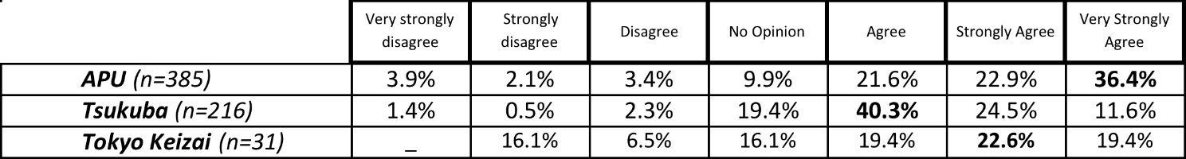

Table 84: J1-Item 21P: Summary of Japanese student responses to the proposition “I enjoy studying English” grouped by site
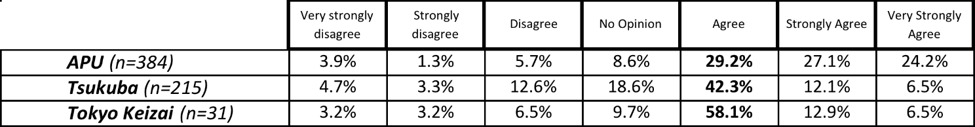

Table 85: J1- Item 11P: Summary of Japanese student responses to the proposition “I think studying English is a good idea” grouped by site
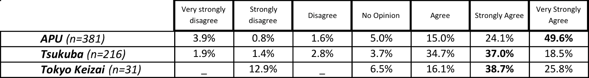

Table 86: J1- Item 12P: Summary of Japanese student responses to the proposition “My friends think studying English is a good idea” grouped by site
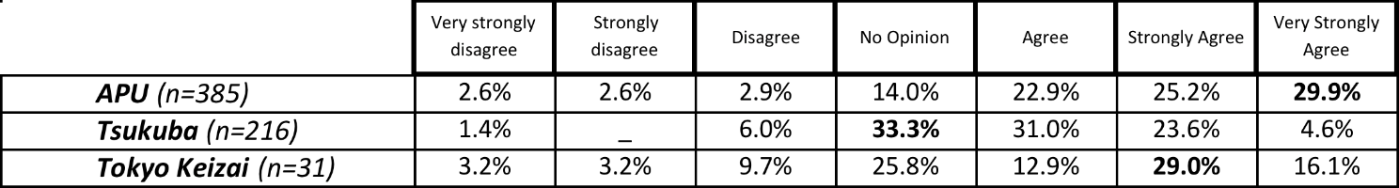

Table 87: J1- Item 15P: Summary of Japanese student responses to the proposition “If I have to speak English I feel weak” grouped by site
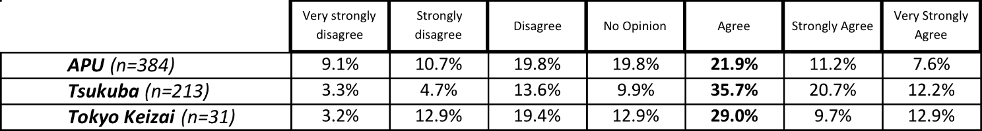

Table 88: J1- Item 16P: Summary of Japanese student responses to the proposition “English makes other languages weaker” grouped by site
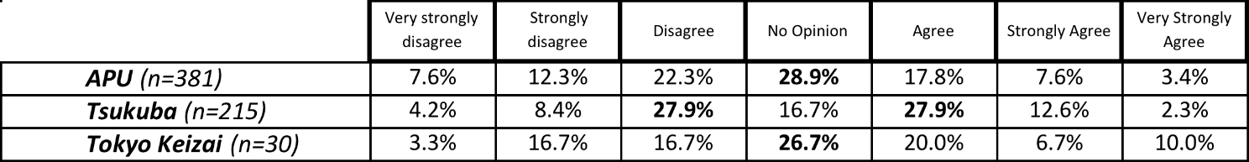

A1b - Chinese respondents
Table 89: C1-Item 10P: Summary of Chinese student responses to the proposition “English is cool” grouped by site
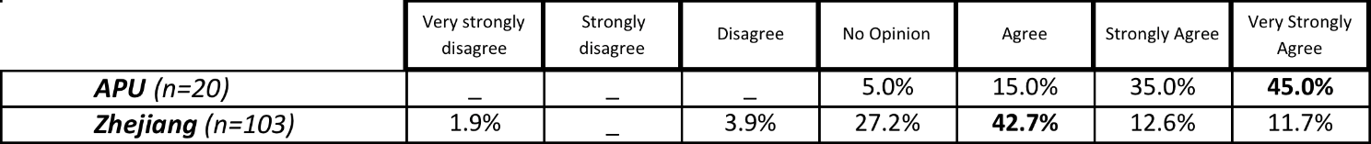
Table 90: C1-Item 11P: Summary of Chinese student responses to the proposition “I think studying English is a good idea” grouped by site
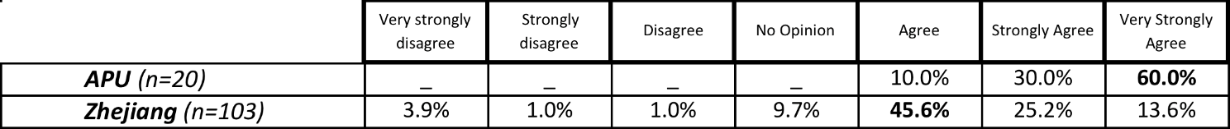
Table 91: C1-Item 12P: Summary of Chinese student responses to the proposition “My friends think studying English is a good idea” grouped by site
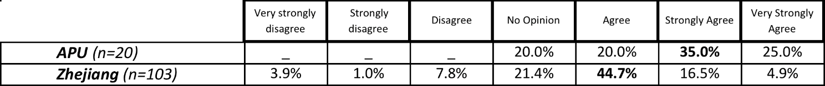
Table 92: C1-Item 21P: Summary of Chinese student responses to the proposition “I enjoy studying English” grouped by site
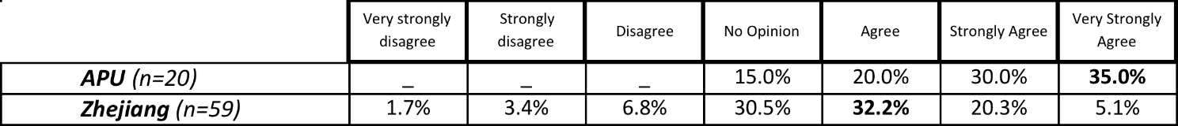
Table 93: C1-Item 15P: Summary of Chinese student responses to the proposition “If I have to speak English, I feel weak” grouped by site
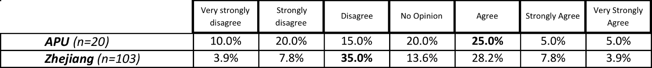
Table 94: C1-Item 16P: Summary of Chinese student responses to the proposition “English makes other languages weaker” grouped by site
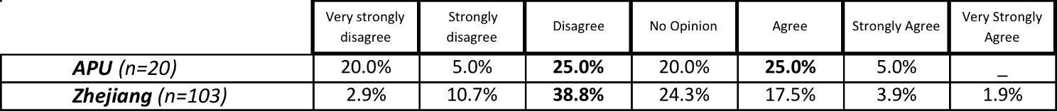

A1c - Korean Respondents
Table 95: K1- Item 10P: Summary of Korean student responses to the proposition “English is cool” grouped by site
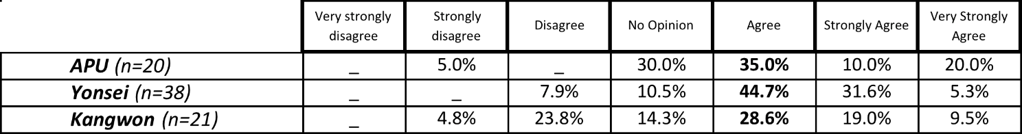
Table 96: K1- Item 11P: Summary of Korean student responses to the proposition “I think studying English is a good idea” grouped by site
Table 97: K1-Item 12P: Summary of Korean student responses to the proposition “My friends think studying English is a good idea” grouped by site
Table 98: K1-Item 21P: Summary of Korean student responses to the proposition “I enjoy studying English” grouped by site
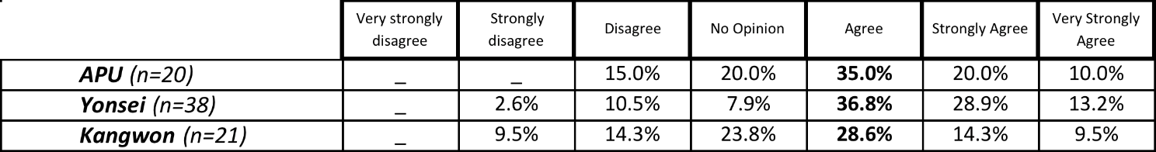
Table 99: K1-Item 15P: Summary of Korean student responses to the proposition “If I have to speak English I feel weak” grouped by site
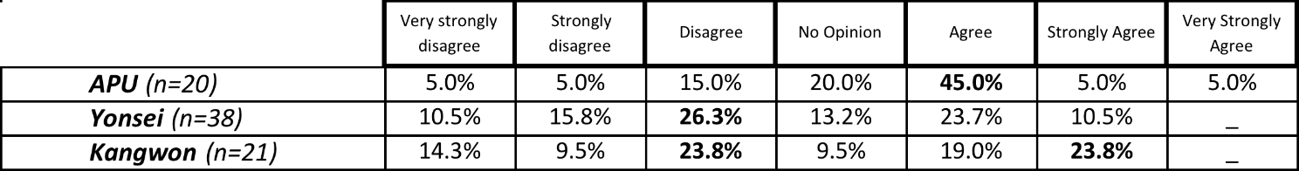

Table 100: K1-Item 16P: Summary of Korean student responses to the proposition “English makes other languages weaker” grouped by site
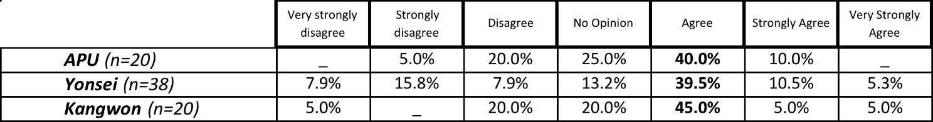

A2 - Research Question 2: What is the utility value of English for Asian students?

A2a - Japanese respondents
Table 101: J2-Item 8P: Summary of Japanese student responses to the question “Why are you studying English?” grouped by site
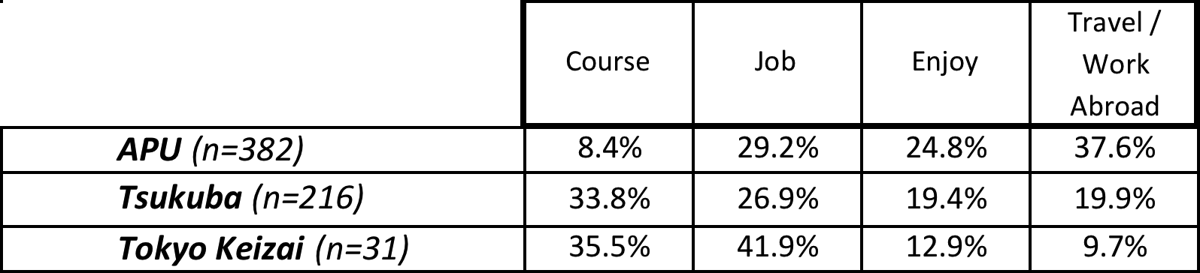
Table 102: J2-Item 17P: Summary of Japanese student responses to the proposition “I want to learn correct English” grouped by site
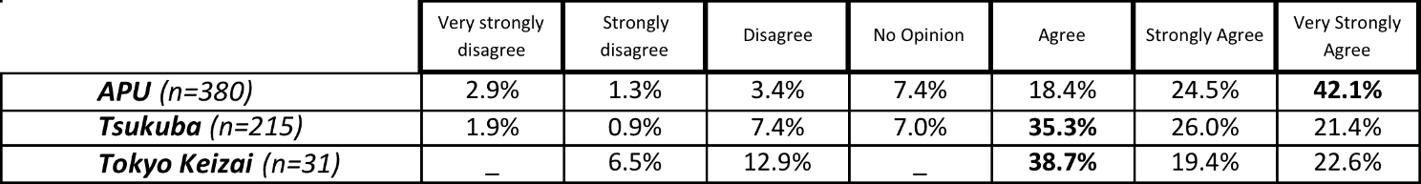
Table 103: J2-Item 27P: Summary of Japanese student responses to the question “What variety of English do you want to learn?” grouped by site
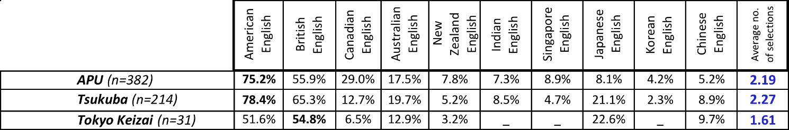
Table 104: J2-Item 18P: Summary of Japanese student responses to the proposition “If I can speak English, I will be a better person” grouped by site
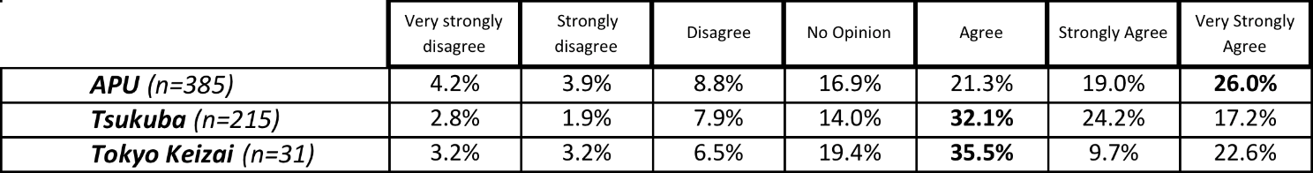
Table 105: J2-Item 25P: Summary of Japanese student responses to the question “What do you use English for now?” grouped by site
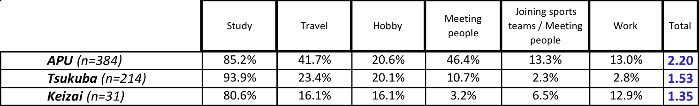
Table 106: J2-Item 26P: Summary of Japanese student responses to the question “What will you use English for in the future?” grouped by site
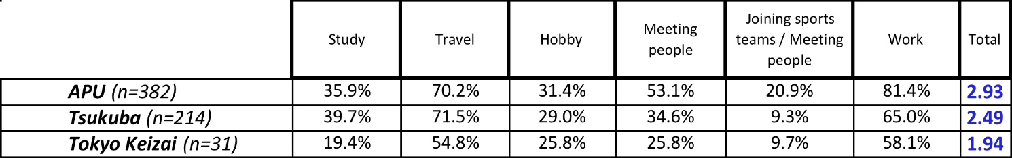

A2b - Chinese respondents
Table 107: C2-Item 8P: Summary of Chinese student responses to the question “Why are you studying English?” grouped by site
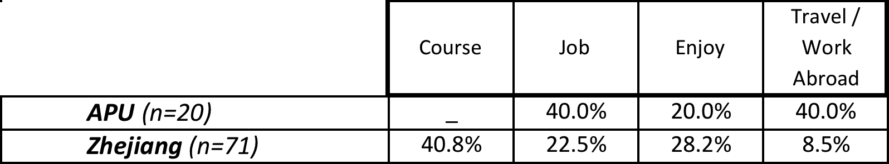
Table 108: C2-Item 17P: Summary of Chinese student responses to the proposition “I want to learn correct English” grouped by site
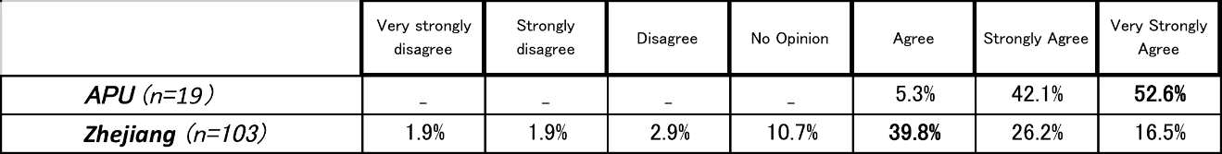
Table 109: C2-Item 27P: Summary of Chinese student responses to the question “What variety of English do you want to learn?” grouped by site
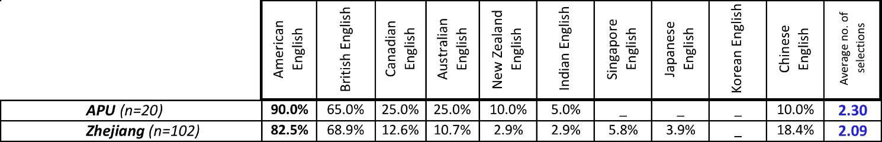
Table 110: C2-Item 18P: Summary of Chinese student responses to the proposition “If I can speak English, I will be a better person” grouped by site
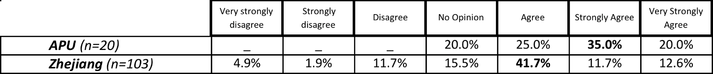
Table 111: C2-Item 25P: Summary of Chinese student responses to the question “What do you use English for now?” grouped by site
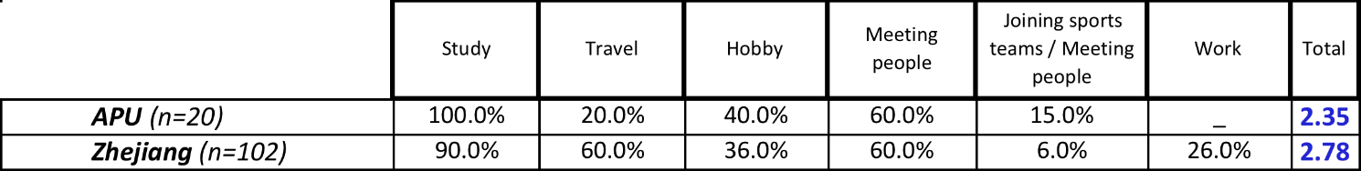

Table 112: C2-Item 26P: Summary of Chinese student responses to the question “What will you use English for in the future?” grouped by site
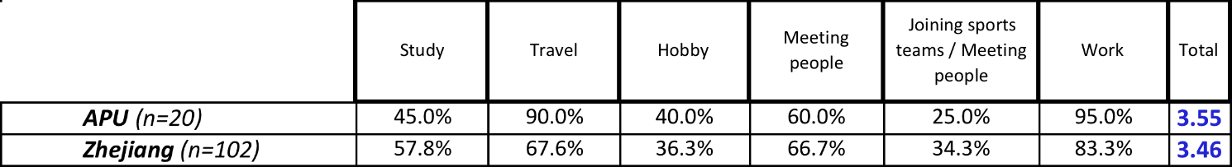

A2c - Korean respondents
Table 113: K2-Item 8P: Summary of Korean student responses to the question “Why are you studying English?” grouped by site
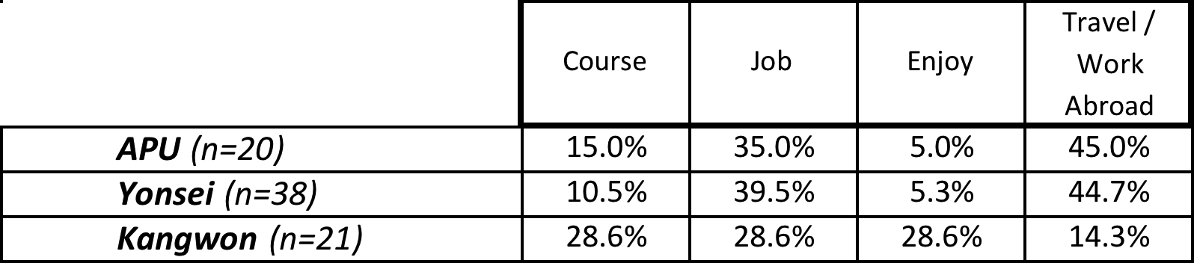
Table 114: K2-Item 17P: Summary of Korean student responses to the proposition “I want to learn correct English” grouped by site
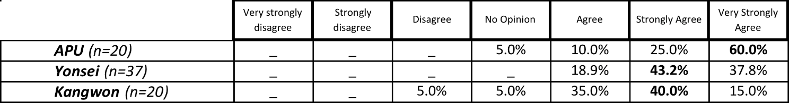
Table 115: K2-Item 27P: Summary of Korean student responses to the question “What variety of English do you want to learn?” grouped by site
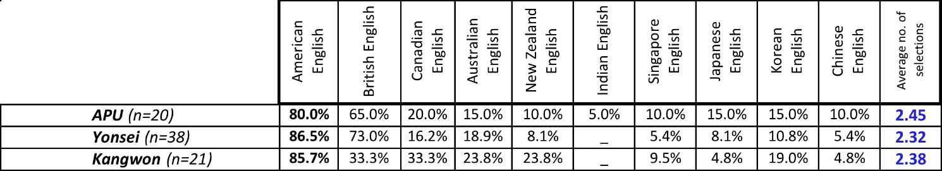
Table 116: K2-Item 18P: Summary of Korean student responses to the proposition “If I can speak English, I will be a better person” grouped by site
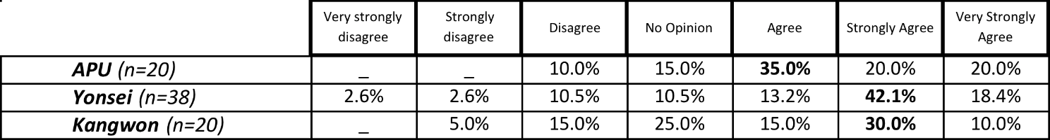
Table 117: K2-Item 25P: Summary of Korean student responses to the question “What do you use English for now?” grouped by site
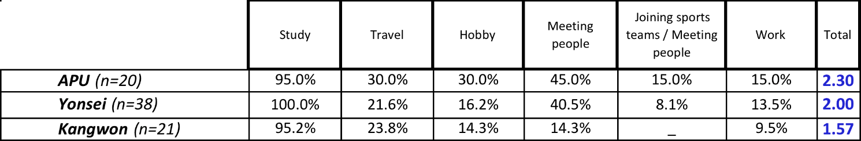

Table 118: K2-Item 26P: Summary of Korean student responses to the question “What will you use English for in the future?” grouped by site
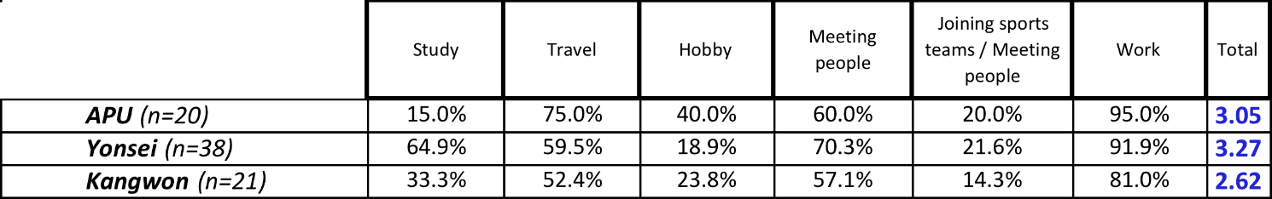

A3 - Research Question 3: What are Asian students’ opinions of other Asian students of English and Asian varieties of English?

A3a - Japanese responses
Table 119: J3-Item 20P: Summary of Japanese student responses to the proposition “English is the world standard language” grouped by site
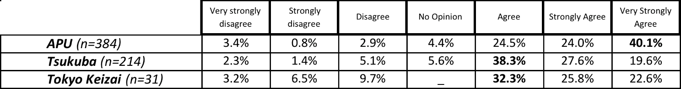
Table 120: J3-Item 27P: Summary of Japanese student responses to the question “Which variety of English should be the world standard?” grouped by site
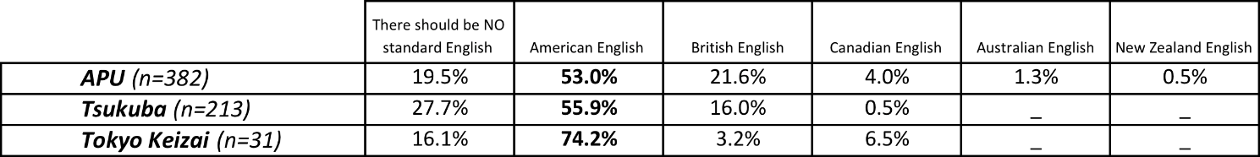
Table 121: J3-Item 19P: Summary of Japanese student responses to the proposition “I want to study English with other Asian students” grouped by site
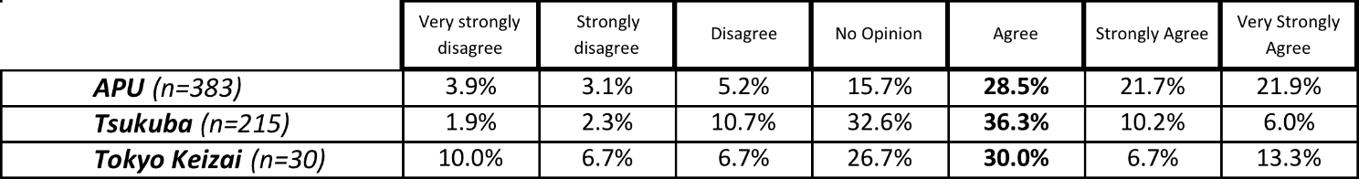
Table 122: J3-Item 13P: Summary of Japanese student responses to the proposition “In my experience, people from different places speak different varieties of English” grouped by site
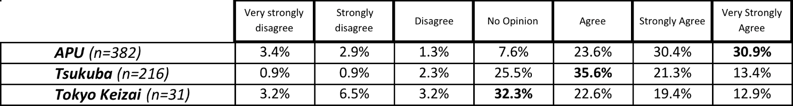
Table 123: J3-Item 14P: Summary of Japanese student responses to the proposition “I am interested in the English of other Asian countries” grouped by site
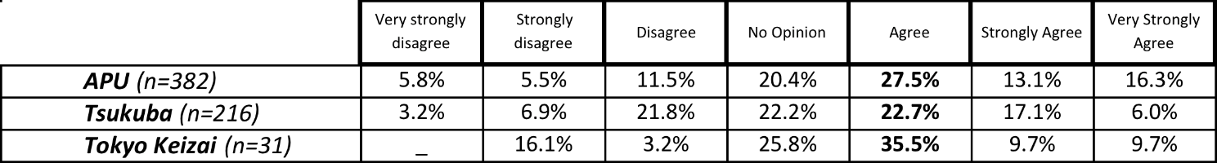

Table 124: J3-Item 22P: Summary of Japanese student responses to the proposition “I think studying about Asian varieties of English is a good idea” grouped by site
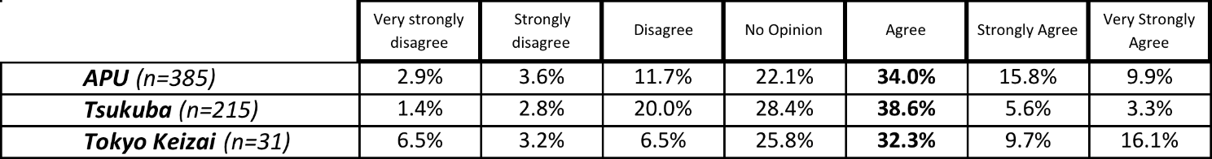
Table 125: J3-Item 23P: Summary of Japanese student responses to the proposition “Having different varieties of English is confusing” grouped by site
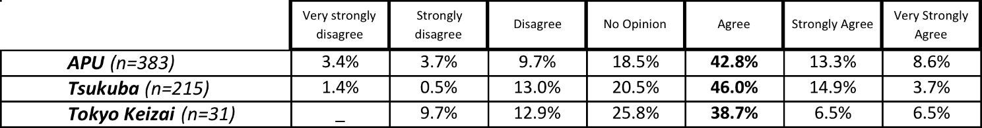
Table 126: J3-Item 24P: Summary of Japanese student responses to the proposition “It is difficult to speak to other Asian students in English” grouped by site
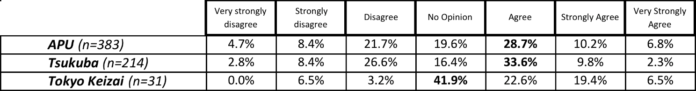

A3b - Chinese Responses
Table 127: C3-Item 20P: Summary of Chinese student responses to the proposition “English is the world standard language” grouped by site
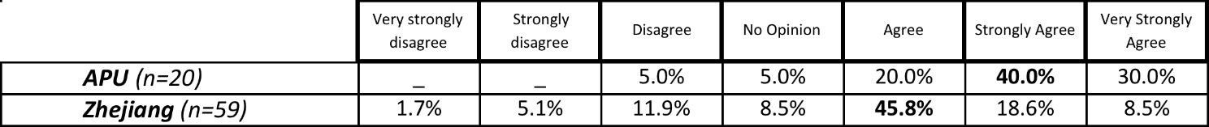
Table 128: C3-Item 27P: Summary of Chinese student responses to the question “Which variety of English should be the world standard?” grouped by site
Table 129: C3-Item 19P: Summary of Chinese student responses to the proposition “I want to study English with other Asian students” grouped by site
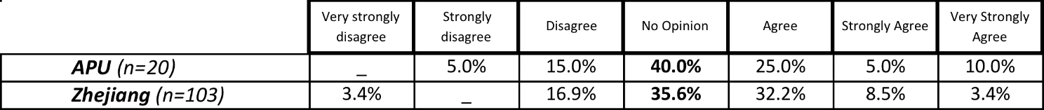
Table 130: C3-Item 13P: Summary of Chinese student responses to the proposition “In my experience, people from different places speak different varieties of English” grouped by site
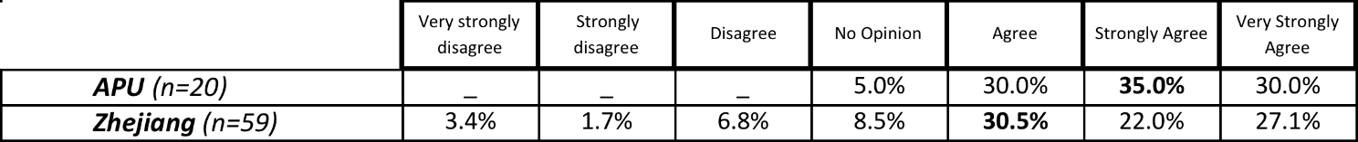
Table 131: C3-Item 14P: Summary of Chinese student responses to the proposition “I am interested in the English of other Asian countries” grouped by site
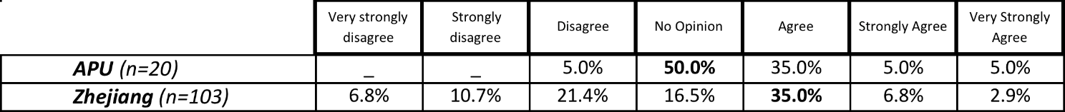
Table 132: C3-Item 22P: Summary of Chinese student responses to the proposition “I think studying about Asian varieties of English is a good idea” grouped by site
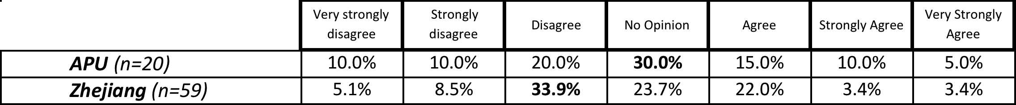

Table 133: C3-Item 23P: Summary of Chinese student responses to the proposition “Having different varieties of English is confusing” grouped by site
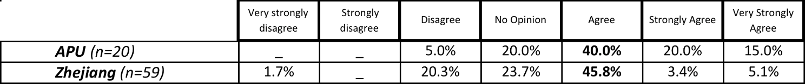

Table 134: C3-Item 24P: Summary of Chinese student responses to the proposition “It is difficult to speak to other Asian students in English” grouped by site
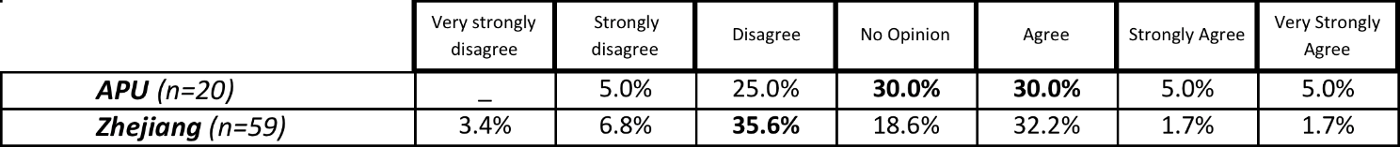

A3c - Korean Responses
Table 135: K3-Item 20P: Summary of Korean student responses to the proposition “English is the world standard language” grouped by site
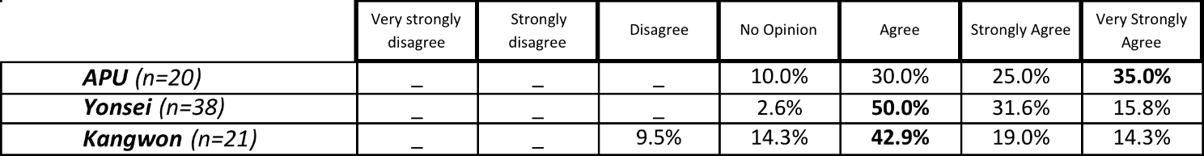
Table 136: K3-Item 27P: Summary of Korean student responses to the question “Which variety of English should be the world standard?” grouped by site
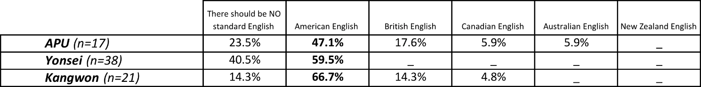
Table 137: K3-Item 19P: Summary of Korean student responses to the proposition “I want to study English with other Asian students” grouped by site
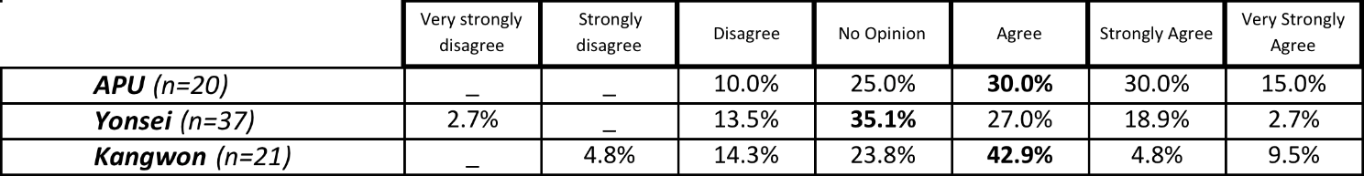
Table 138: K3-Item 13P: Summary of Korean student responses to the proposition “In my experience, people from different places speak different varieties of English” grouped by site
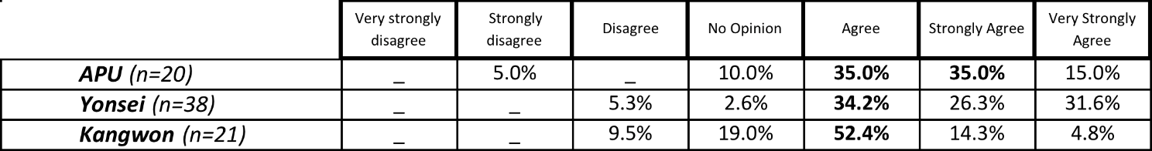
Table 139: K3-Item 14P: Summary of Korean student responses to the proposition “I am interested in the English of other Asian countries” grouped by site
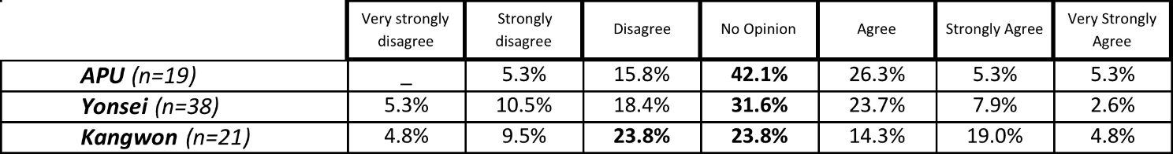

Table 140: K3-Item 22P: Summary of Korean student responses to the proposition “I think studying about Asian varieties of English is a good idea” grouped by site
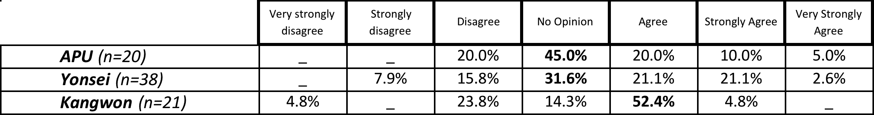
Table 141: K3-Item 23P: Summary of Korean student responses to the proposition “Having different varieties of English is confusing” grouped by site
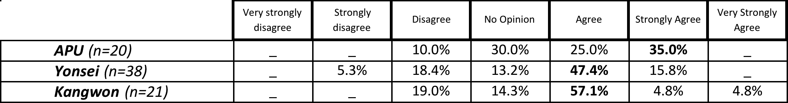
Table 142: K3-Item 24P: Summary of Korean student responses to the proposition “It is difficult to speak to other Asian students of English” grouped by site
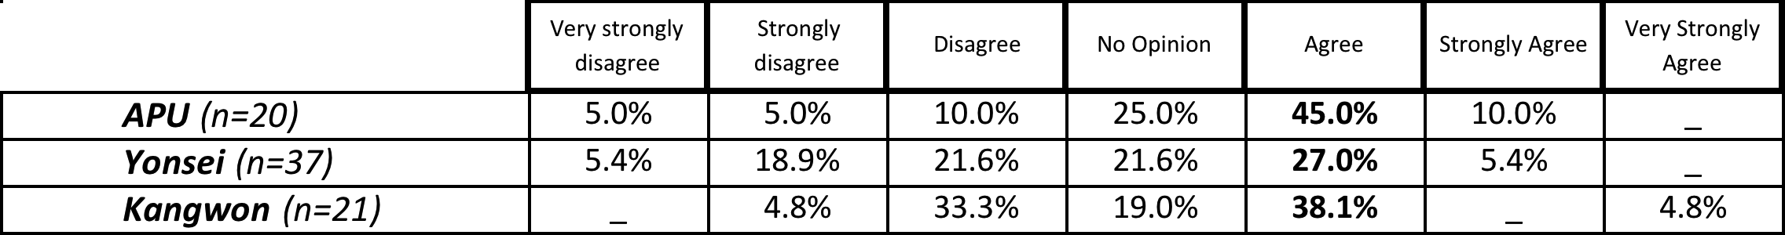

Appendix B: 2007 Pre-pilot survey items
Demographic subject data
- Where is your home country?
- How long have you been studying English? Please give your answer in years and months
- Speaking English is cool
- I want to use English to make international friends
- My friends think that studying English is a good idea
- If I can speak English, I will be a better person
- I came to APU to meet international people
- English is the language of the future
- Learning English will help me get a good job.
- English is a key to learning about the world.
- A good understanding is important to understand people from other countries.
- A good understanding of English is important to understand people from other cultures.
- English should not be the world standard language.
- If I have to use English, I feel uncomfortable.
- English is more important than other languages.
- English makes other languages less important.
- English is a tool for politics
- English is a tool for international law
- English is a tool for international communication
- English is a key part of globalization
- Carlos Ghosn (CEO of Nissan) made English the official language of Nissan. Do you agree with this decision?
- English is a tool for business
- English is a tool for politics
- English is a tool for international law
- English is a tool for international communication
- I want to pronounce English like American people.
- I want to pronounce English like British people.
- I want to learn American English, not British English.
- I want to learn British English, not American English.
- I want to learn perfect English.
- I want to learn formal English.
- I want to learn informal English.
- American English is a higher standard than Japanese English.

Appendix C: 2008 Pilot study survey items
Demographic subject data
- Where is your home country?
- How old are you?
- How long have you been studying English?
- Have you ever visited an English-speaking country?
- If you answered Yes to Question 4, where have you visited?
- Which English-speaking countries would you like to visit?

Likert scale statements – Attitudinal Data
- English is cool
- I think that studying English is a good idea
- My friends think that studying English is a good idea
- If I can speak English, I will be a better person
- English is the language of the future
- If I have to use English, I feel weak
- English makes other languages weaker
- English is the world standard language
- I want to learn correct English
- I am interested in the English of other Asian countries (such as Singapore, Malaysia, etc..)
- Katakana Eigo (カタカナ英語) is confusing.
- In the next 50 years, Japanese English will become a new kind of English (like Singapore English, American English, etc...)
- Japanese people speak Japanese English
- APU should teach a course of Asian English
- APU should teach a course of World English

Multiple option questions – Domain of Use Data
- What do you use English for now?
- What will you use English for in the future?
- What type of English do you want to learn?
- Which English should be the world standard?

Appendix D: Order of items on the 2008 focus group handout

Demographic Subject Data
- What is your name?
- What are you studying?
- How long have you been studying English?
Attitudinal Data
- English is cool
- English is the world standard language
- English is the language of the future
- If I can speak English I will be a better person
- Katakana Eigo (カタカナ英語) is confusing.
- In the next 50 years, Japanese English will become a new kind of English (like Singapore English, American English, etc...)
- APU should teach a course of Asian English
- APU should teach a course of World English

Appendix E: 2008 Pilot study research questions
Research Question | Survey | Focus groups
- What are Asian students’ opinions of English? | 7. English is cool  8. I think that studying English is a good idea  9. My friends think that studying English is a good idea  11. English is the language of the future  12. If I have to use English I feel weak  13. English makes other languages weak | 7. English is cool  11. English is the language of the future
2) What do Asian students view as the instrumentality of English for them? | 10. If I study English I will be a better person  15. I want to learn correct English  24. What type of English do you want to learn?  22. What do you use English for now?  23. What will you use English for in the future? | 10. If I study English I will be a better person  11. English is the language of the future
3) What are Asian students’ judgments of other varieties of English in Asia, and specifically their opinions of English in Japan? | 15. I want to learn correct English  24. What type of English do you want to learn?  14. English is the world standard language  25. Which English should be the world standard?  16. I am interested in the English of other Asian countries  20. APU should teach a course of Asian English  21. APU should teach a course of World English  17. Katakana eigo is confusing  18. In the next 50 years, Japanese English will become a new kind of English  19. Japanese people speak Japanese English | 17. Katakana eigo is confusing  18. In the next 50 years, Japanese English will become a new kind of English  20. APU should teach a course of Asian English  21. APU should teach a course of World English

Appendix F: 2011 Research design
FTF focus groups
FTF focus group recruitment
C

CMI survey recruitment
A
B
CMI survey
Quantitative analysis
Survey (on-line or paper-based)
Chapter 5: Conclusion & Recommendations
Chapter 4: Report of findings
Compilation & data analysis
Research Questions
Scenario 1: Survey followed by A Course (APU)
Scenario 2: Survey followed by B Course (Tsukuba University, Yonsei University, Zhejiang University)
Scenario 3: Survey followed by C Course (Tokyo Keizai University, Kangwon University)

Appendix G: 2011 Survey items
Demographic items
1. Home country
2. Age
3. Gender
4. How long have you been studying English?
5. Have you ever visited an English-speaking country?
6. Is you answered Yes to Question 5, where have you visited?
7. Which English-speaking country do you want to visit MOST?
8. Why are you studying English? Which response BEST describes your situation?
9. What is your MAJOR subject of study at university?
7-point Likert scale attitudinal propositions
10. English is cool
11. I think that studying English is a good idea
12. My friends think that studying English is a good idea
13. In my experience, people from different places speak different varieties of English
14. I am interested in the English varieties of other Asian countries (such as Singapore English, Malaysian English, etc..)
15. If I have to use English, I feel weak
16. English makes other languages weaker
17. I want to learn correct English
18. If I can speak English, I will be a better person
19. I want to study English with other Asian students
20. English is the world standard language
21. I enjoy studying English
22. I think studying about Asian varieties of English is a good idea
23. Having different varieties of English is confusing
24. I think it is difficult to speak to other Asian students in English
Multiple option Items
25. What do you use English for NOW?
26. What will you use English for IN THE FUTURE?
27. What variety of English do you want to learn?
Single option item
28. Which English variety should be the world standard?
Request for assistance with the focus groups / CMI survey
29. If you would be interested in being a volunteer to help with my research, please put your email address here.

Appendix H: 2011 FTF Focus Group Handout
Discussion Questions
You are free to ask each other questions and discuss any points you think are interesting.

- First, please introduce yourselves:
- What is your name?
- What is your major here at APU?
- How many years have you been studying English?
- What do you think you will use English for in your future?

- Next, do you agree or disagree with these statements? Why?
- English is cool.
- I think studying English is a good idea.
- I want to study English with other Asian students.
- If I can speak English I will be a better person.
- If I have to use English I feel weak.
- I think studying about other Asian varieties of English is a good idea.
- Having different varieties of English is confusing.

- Final question:
- Which variety of English should be the world standard?
(or should there be no single standard?)

Appendix I: APU’s Opening Statement

Since the beginning of human history, human beings have attempted to create their own distinctive cultures and develop civilizations in the various regions of the world. They have also had to overcome many constraints and obstacles in order to achieve their goal of living in conditions of freedom, peace and humanity.

The twentieth century was an era of rapid progress and unprecedented advance in the political, economical and cultural fields, as human activity increasingly took place on a global scale. Through the experience of the two World Wars, the United Nations and other international organizations were formed to enhance cooperation in order to maintain peace and to promote international understanding.

Given that the 21st century will see the emergence of a global society, we firmly believe that coexistence between mankind and nature, as well as between diverse cultures, will be indispensable for the peaceful and sustainable development of the Asia Pacific region. This is why we are now establishing a university here, to nurture the young talent and to create a new academic discipline which will help shape the region's future.

April 1, 2000 therefore marked the birth of the Ritsumeikan Asia Pacific University, based on a vision of freedom, peace and humanity, international mutual understanding, and the future shape of the Asia Pacific region. The establishment of the University at Jumonjibaru, in Beppu City, has been made possible through the cooperation of the people of Beppu and Oita Prefecture, together with many others both within and outside Japan.

Our hope is that it will be a place where the young future leaders from countries and regions throughout the world will come to study together, live together, and understand each other's cultures and ways of life, in pursuit of goals which are common to all mankind.

The Ritsumeikan Asia Pacific University is hereby declared open.

Appendix J: Sections from APU’s guidelines for ethical research

2-1 Any researcher conducting research involving human subjects must have respect for the life, dignity and fundamental human rights of the individual, and engage in his/her research using methods and techniques that are both scientifically and socially legitimate.
2-2 Any researcher conducting research involving human subjects must use methods that are secure and safe, and endeavor to minimize any physical or psychological burden and/or discomfort experienced by the subject.
…
4-1 When gathering or collecting personal information or data, the researcher must explain to the research subject matters including the aims and plans of the research and the methods for presentation of research findings, using language that is comprehensible to the subject.
…
5-1 It is a basic rule that when gathering or collecting personal information or data, the researcher must obtain the consent of the research subject in advance.
5-2 “The consent of the research subject” must include matters pertaining to the handling of personal information or data and the methods for presentation of findings.
5-3 The researcher must inform the research subject that he/she has the right to withdraw consent and cease cooperating with the research and the right to demand disclosure of any personal information or data already obtained, and that these rights can be exercised at any time during the period in which the research is undertaken and with no disadvantage to the subject.
5-4 If the research subject is judged unfit to provide consent, the researcher must obtain consent from a person acting on behalf of the subject.
5-5 The consent of the research subject must in principle be recorded in writing, and the researcher must store this record of consent for a minimum of five years counting from the date on which the record was created.
5-6 If the research subject withdraws his/her consent, the researcher must destroy all information and data relating to the subject.
…
(Third party involvement)
6 If the researcher engages a third party to gather or collect personal information or data on his/her behalf, the researcher and third party must enter into a contract in conformity with the aims of these guidelines.
…
(Remuneration)
8 If the researcher intends to provide the research subject with remuneration in money or kind, he/she must determine a remuneration that ensures proper administration of its disbursement and receipt.

References
Adamson, B. (2002). Barbarian as a foreign language: English in China’s schools. World Englishes, 21(2), 231-243. doi:10.1111/1467-971X.00244
Adamson, B. (2004). China’s English: a history of English in Chinese education. Hong Kong: Hong Kong University Press.
Airey, J. (2011). The relationship between teaching language and student learning in Swedish university physics. In Preisler, Klitgaard & Fabricius (Eds.) Language learning in the international university: from English uniformity to diversity and hybridity (pp. 3-18). Bristol: Multilingual Matters
Asaoka, T., & Yano, J. (2009). The contribution of “study abroad” programs to Japanese internationalization. Journal of Studies in International Education, 13(2), 174–188. doi:10.1177/1028315308330848
Baik, M. J., & Shim, R. J. (2002). Teaching world Englishes via the Internet. World Englishes, 21(3), 427–430. Wiley Online Library. Retrieved from http://onlinelibrary.wiley.com/doi/10.1111/1467-971X.00260
Bamgbose, A. (1998). Torn between the norms: innovations in world Englishes. World Englishes, 17(1), 1-14. doi:10.1111/1467-971X.00078
Baumgardner, R. J., & Brown, K. (2003). World Englishes: ethics and pedagogy. World Englishes, 22(3), 245–251. doi:10.1111/1467-971X.00294
Benson, M. J. (1991). Attitudes and motivation towards English: a survey of Japanese freshmen. RELC Journal, 22(1), 34-48. doi:10.1177/003368829102200103
Bergen, S. (2011). The European higher education area: challenges for the next decade. In Bergen, S. (Ed.) Not by bread alone (Council of Europe higher education series, No. 17) (pp. 49-72). Strasbourg: Council of Europe
Berns, M. (2005). Expanding on the expanding circle: where do WE go from here? World Englishes, 24(1), 85–93. doi:10.1111/j.0883-2919.2005.00389.x
Berns, M. (2009). English as lingua franca and English in Europe. World Englishes, 28(2), 192–199. doi:10.1111/j.1467-971X.2009.01578.x
Bhatia, V. K. (1997). The power and politics of genre. World Englishes, 16(3), 359-371. doi:10.1111/1467-971X.00070
Bisong, J. (1995). Language choice and cultural imperialism: a Nigerian perspective. ELT Journal, 49(April), 122–132.
Bokhorst-Heng, W. D., Alsagoff, L., McKay, S., & Rubdy, R. (2007). English language ownership among Singaporean Malays: going beyond the NS/NNS dichotomy. World Englishes, 26(4), 424-445. doi:10.1111/j.1467-971X.2007.00521.x
Bolton, K. (2002). Chinese Englishes: from Canton jargon to global English. World Englishes, 21(2), 181-199. doi:10.1111/1467-971X.00241
Bolton, K. (2008). English in Asia, Asian Englishes, and the issue of proficiency. English Today, 24(02), 3-12. doi:10.1017/S026607840800014X
Bolton, K., Graddol, D., & Meierkord, C. (2011). Towards developmental world Englishes. World Englishes, 30(4), 459–480.
Bradford, A. (2013). Adopting English-taught degree programs. International Higher Education, 69, 225–240.
Bradford, A. (2014). English-taught degree programs in Japan. Paper presented at the 2014 APAIE Conference, Seoul, Korea.
British Council. (2013). English language assistants abroad. Retrieved from http://www.britishcouncil.org/languageassistants-ela.htm
Brown, K. (2002). Ideology and context: world Englishes and EFL teacher training. World Englishes, 21(3), 445-448. doi:10.1111/1467-971X.00264
Broadband Commission. (2013). The state of broadband in 2012. Retrieved from http://www.broadbandcommission.org/Documents/bb-annualreport2013.pdf
Bruthiaux, P. (2002). Predicting challenges to English as a global language in the 21st century. Language Problems & Language Planning, 26(2), 129–157. John Benjamins Publishing Company. Retrieved from http://www.ingentaconnect.com/content/jbp/lplp/2002/00000026/00000002/art00002
Bruthiaux, P. (2003). Squaring the circles: issues in modeling English worldwide. International Journal of Applied Linguistics, 13(2), 159-178. doi:10.1111/1473-4192.00042
Butler, Y. G. (2004). What level of English proficiency do elementary school teachers need to attain to teach EFL? Case studies from Korea, Taiwan, and Japan. TESOL Quarterly, 38(2), 245. doi:10.2307/3588380
Butler, Y. G. (2007). Foreign language education in elementary schools in Japan: searching for solutions amidst growing diversification. Current Issues in Language Planning, 8(2), 129-147.
Butler, Y. G., & Iino, M. (2005). Current Japanese reforms in English language education: the 2003 action plan. Language Policy, 4(1), 25-45. doi:10.1007/s10993-004-6563-5
Caine, T. M. (2008). Do you speak global?: the spread of English and the implications for English language teaching. CJNSE/RCJCÉ, 1(1), 1-11. Retrieved from http://cjnse-rcjce.synergiesprairies.ca/ojs2/index.php/cjnse/article/viewArticle/22
Canagarajah, A. S. (1999). Resisting linguistic imperialism in English language classrooms. London: Oxford University Press.
Chan, B. H. K. (2009). English in Hong Kong cantopop: language choice, code-switching and genre. World Englishes, 28 (1), 107-129
Chang, J. (2006). Globalization and English in Chinese higher education. World Englishes, 25 (3-4), 513-525
Chen, C., & Zhang, Y. (1998). A perspective on the college English teaching syllabus in China. TESL Canada Journal, 15(2), 69-74.
Cheng, Z. (2002). English departments in Chinese universities: purpose and function. World Englishes, 21(2), 257-267.
Chiba, R., Matsuura, H., & Yamamoto, A. (1995). Japanese attitudes towards English accents. World Englishes, 14, 77–86.
Chihara, T., & Oller Jr, J. W. (1978). Attitudes and attained proficiency in EFL: a sociolinguistic study of adult Japanese speakers. Language Learning, 28(1), 55–68. John Wiley & Sons. Retrieved from http://www3.interscience.wiley.com/journal/119615002/
Cho, J. (2011). Expansion of English-medium lectures in Korea. Paper presented at the 2011 Asia TEFL Conference, Seoul, Korea.
Cho, J. (2012). Campus in English or campus in shock. English Today, 28(2), 18–25.
Choi, P. K. (2010). “Weep for Chinese university”: a case study of English hegemony and academic capitalism in higher education in Hong Kong. Journal of Education Policy, 25(2), 233–252. doi:10.1080/02680930903443886
Christians, C. G. (2005). Ethics and politics in qualitative research. In N. K. Denzin & Y. S. Lincoln (Eds.), The Sage Handbook of Qualitative Research (3rd Edition). (pp. 139 - 164). Sage: Thousand Oaks
Chuntian, C., & Yujuan, Z. (1997). A perspective on the college English teaching syllabus in China. TESL Canada Journal, 15(2), 69. Retrieved from http://journals.sfu.ca/tesl/index.php/tesl/article/view/703/534
CLAIR. (2010). JET Program Eligibility Criteria. Retrieved from http://www.jetprogramme.org/e/aspiring/eligibility.html
Cogan, J., Torney-Purta, J., & Anderson, D. (1988). Knowledge and attitudes toward global issues: students in Japan and the United States. Comparative Education Review, 32(3), 282. doi:10.1086/446778
Cohen, R. (2005). English in Mongolia. World Englishes, 24(2), 203-216. doi:10.1111/j.1467-971X.2005.00404.x
Cowie, C. (2007). The accents of outsourcing: the meanings of “neutral” in the Indian call centre industry. World Englishes, 26(3), 316-330. doi:10.1111/j.1467-971X.2007.00511.x
Creswell, J. W., & Clark, V. L. P. (2011). Designing and conducting mixed methods research (2nd Edition.). Sage: Thousand Oaks
Crystal, D. (2003). English as a global language (2nd Ed.). Cambridge: Cambridge University Press.
D’Angelo, J. F. (2005). Educated Japanese English: expanding oral/aural core vocabulary. World Englishes, 24(3), 329–349. doi:10.1111/j.0083-2919.2005.00415.x
D’Angelo, J. F. (2012). WE-informed EIL curriculum at Chukyo: towards a functional, educated, multilingual outcome. In A. Matsuda (Ed.), Principles and Practices of Teaching English as an International Language (pp. 121–139). Bristol: Multilingual Matters.
Daulton, F. E. (2004). The creation and comprehension of English loanwords in the Japanese media. Journal of Multilingual and Multicultural Development, 25(4), 285–296.
Davies, M. (2013). GloWbE: Corpus of Global Web-Based English. Retrieved from http://corpus2.byu.edu/glowbe/
DeLorme, D. E., Zinkhan, G. M., & French, W. (2001). Ethics and the Internet issues associated with qualitative research. Journal of Business Ethics, 33(4), 271–286. Springer. Retrieved from http://www.springerlink.com/index/R3701R2G8172H412.pdf
Demont-Heinrich, C. (2008). American “prestige press” representations of the global hegemony of English. World Englishes, 27(2), 161-180. doi:10.1111/j.1467-971X.2008.00550.x
Denzin, N. K., & Lincoln, Y. S. (2005). The discipline and practice of qualitative research. In N. K. Denzin & Y. S. Lincoln (Eds.), The Sage Handbook of Qualitative Research (3rd Edition). (pp. 1 - 33). Thousand Oaks: Sage
Deterding, D., & Kirkpatrick, A. (2006). Emerging South-East Asian Englishes and intelligibility. World Englishes, 25(3-4), 391-409. doi:10.1111/j.1467-971X.2006.00478.x
Doiz A., Langabaster, D. & Sierra, J. M. (2013). English medium instruction at universities. Bristol: Multilingual Matters
Dolby, N. (2007). Reflections on nation: American undergraduates and education abroad. Journal of Studies in International Education, 11(2), 141-156
Dovring, K. (1997). English as Lingua Franca: Double Talk in Global Persuasion. Westport: Praeger Publishers.
Dower, J. W. (1999). Embracing Defeat: Japan in the Wake of World War II. W. W. Norton & Company.
Duff, P. A., & Uchida, Y. (1997). The negotiation of teachers’ sociocultural identities and practices in postsecondary EFL classrooms. TESOL Quarterly, 31(3), 451–486. JSTOR. Retrieved from http://www.jstor.org/stable/3587834
Dwyer, E., & Heller-Murphy, A. (1996). Japanese learners in speaking classes. The Japanese Learner, 7(10), 46–55. Retrieved from http://www.brookes.ac.uk/schools/education/eal/jl-archive/jl-bestof/22.pdf
Edwards, J. (1994). Multilingualism. London: Penguin.
English Language Assistants Abroad. (2013). British Council. Retrieved February 09, 2013, from http://www.britishcouncil.org/languageassistants-ela.htm
ETS. (2013). Test and score data summary for TOEFL iBT tests and PBT tests. Retrieved from http://www.ets.org/s/toefl/pdf/94227_unlweb.pdf
Esaki, Y., & Shintani, R. B. (2010). English education in Japan`s elementary schools: reforms and challenges. Asia Pacific World, 1(1), 133-153.
Faber, M. & Westerheijden, D.F. (2011). European degree structure and national reform: constitutive dynamics of the Bologna Process. In Enders, J., de Boer H. F., & Westerheijden, D. F. (Eds.) Reform of higher education in Europe (pp. 11-28) Rotterdam: Sense
Ferguson, G., Perez-Llantada, C., & Plo, R. (2011). English as an international language of scientific publication: a study of attitudes. World Englishes, 30(1), 41–59. Wiley Online Library. Retrieved from http://onlinelibrary.wiley.com/doi/10.1111/j.1467-971X.2010.01656.x/full
Foskett, N. (2010). Global markets, national challenges, local strategies: the challenge of internationalization. In F. Maringe & N. Foskett (Eds.) A review of Globalization and Internationalization in Higher Education: Theoretical, Strategic and Management Perspectives. Abingdon: Taylor and Francis
French, G. (2005). A cline of errors in the writing of Japanese university students. World Englishes, 24(3), 371–382.
Gargesh, R. (2006). South Asian Englishes. In B. B. Kachru, Y. Kachru, & C. L. Nelson (Eds.), The handbook of world Englishes (pp. 90 – 113). Oxford: Wiley.
Garson, G. D. (2006). Chi-square significance tests. Retrieved March 9, 2011, from http://nsdl.org/resource/2200/20110201123804377T
Gerritsen, M., Nickerson, C., Van Hooft, A., Van Meurs, F., Nederstigt, U., Starren, M., & Crijns, R. (2007). English in product advertisements in Belgium, France, Germany, the Netherlands and Spain. World Englishes, 26(3), 291–315. doi:10.1111/j.1467-971X.2007.00510.x
Graddol, D. (2006). English next (Vol. 3076). British Council. Retrieved from http://hi.sses.tc.edu.tw/blog/gallery/4/study03.pdf
Graddol, D. (2010). Will Chinese take over from English as the world's most important language ? English Today, 26(4), 3-4. doi:10.1017//S0266078410000386
Grin, F. (2001). English as economic value: facts and fallacies. World Englishes, 20(1), 65-78. doi:10.1111/1467-971X.00196
Gupta, A. F. (2006). Standard English in the world. In R. Rubdy & M. Saraceni (Eds.), English in the world: global rules, global roles (pp. 95–109). King’s Lynn: Continuum.
Hashimoto, K. (2013). The Japanization of English language education: promotion of the national language within foreign language policy. In Tollefson, J. W. (Ed.) Language Policies in Education: Critical Issues (2nd Ed.) (pp. 175-190). New York: Routledge
He, D., & Li, D. C. S. (2009). Language attitudes and linguistic features in the “China English” debate. World Englishes, 28(1), 70-89. doi:10.1111/j.1467-971X.2008.01570.x
He, D., & Miller, L. (2011). English teacher preference: the case of China’s non-English-major students. World Englishes, 30(3), 428–443.
Hegemony [Def. 2]. 2013. In Merriam-Webster. Retrieved September 10th, 2013, from http://www.merriam-webster.com/dictionary/hegemony.
Hicks, S. (2013). Towards a multicultural campus. Paper presented at the 2013 JALT National Conference, Kobe, Japan.
Hiraga, Y. (2005). British attitudes towards six varieties of English in the USA and Britain. World Englishes, 24(3), 289-308. doi:10.1111/j.0883-2919.2005.00411.x
Holliday, A. (2006). Native-speakerism. ELT Journal, 60(4), 385–387. doi:10.1093/elt/ccl030
Hood, C. P. (2001). Japanese Education Reform: Nakasone’s Legacy. Journal of Japanese Studies (Vol. 28). London: Routledge. doi:10.2307/4126838
Honna, N. (2008). English as a mutlicultural language in Asian contexts: issues and ideas. Tokyo: Kurosio Publishers.
Hoskin, T. (2010). Parametric and nonparametric: demystifying the terms. Retrieved from http://ctsa.mayo.edu/resources/upload/berd-5-6.pdf
Hu, G. (2005). English language education in China: policies, progress, and problems. Language Policy, 4(1), 5-24. doi:10.1007/s10993-004-6561-7
Hu, Y. (2008). China’s English language policy for primary schools. World Englishes, 27(3-4), 516–534. John Wiley & Sons. Retrieved from http://www3.interscience.wiley.com/journal/121495961/
IELTS. (personal communication, October 10th, 2013)
Ishikawa, M. (2009). University rankings, global models, and emerging hegemony: critical analysis from Japan. Journal of Studies in International Education, 13(2), 159–173. doi:10.1177/1028315308330853
JASSO. (2013). Result of an annual survey of international students in Japan 2012. Retrieved from http://www.jasso.go.jp/statistics/intl_student/documents/data12_e.pdf
Jenkins, J. (2006). Current perspectives on teaching world Englishes and English as a lingua franca. TESOL Quarterly, 40(1), 157–181.
Jenkins, J. (2007). English as a lingua franca: attitude and identity. Oxford: Oxford University Press.
Jenkins, J. (2009). English as a lingua franca: interpretations and attitudes. World Englishes, 28(2), 200–207. doi:10.1111/j.1467-971X.2009.01582.x
Jenkins, J. (2013). English as a lingua franca in the international university, Oxon: Routledge
Jin, J. (2005). Which is better in China, a local or a native English-speaking teacher?. English Today, 21(3), 39-46. doi: 10.1017/S0266078405003081
Johnson, K. E. (2006). The sociocultural turn and its challenges for second language teacher education. TESOL Quarterly, 40(1), 235–257.
Jong, O. E. (2003). How idealized American English norms are created and reinforced in English lessons on television: a discourse analysis of two popular English language TV shows in Korea. Unpublished doctoral dissertation, Pennsylvania State University, State College, USA.
Jung, K., & Min, S. J. (1999). Some lexico-grammatical features of Korean English newspapers. World Englishes, 18(1), 23-37. doi:10.1111/1467-971X.00119
Kachru, B. B. (1976). Models of English for the third world: white man’s linguistic burden or language pragmatics? TESOL Quarterly, 10(2), 221–239. JSTOR. Retrieved from http://www.jstor.org/stable/3585643
Kachru, B. B. (1985). Standards, codification and sociolinguistic realism: the English language in the Outer Circle. In R. Quirk & H. G. Widdowson (Eds.), English in the world: teaching and learning the language and literatures (pp. 11-30). Cambridge: Cambridge University Press
Kachru, B. B. (1992). Models for non-native English. In B. B. Kachru (Ed.), The other tongue: English across cultures (pp. 48–74). Illinois: University of Illinois
Kachru, B. B. (1996). World Englishes: agony and ecstasy. Journal of Aesthetic Education, 30(2), 135-155. doi:10.2307/3333196
Kachru, Y., & Nelson, C. L. (2006). World Englishes in Asian contexts. Hong Kong: Hong Kong University Press.
Kachru, Y., & Smith, L. E. (2008). Cultures, contexts and world Englishes. New York: Routledge.
Kamberelis, G., & Dimitriades, G. (2005). Focus groups: strategic articulations of pedagogy, politics, and inquiry. In N. K. Denzin & Y. S. Lincoln (Eds.), The Sage Handbook of Qualitative Research (3rd Edition) (pp. 887 – 908). Thousand Oaks: Sage
Kang, D.-H. (2000, January 1st). Motivation and foreign language learning in Korean EFL context. Retrieved from http://files.eric.ed.gov/fulltext/ED442284.pdf
Kangwon National University. (2011) Retrieved from http://www.kangwon.ac.kr/english/main/main.php
Kaplan, R. B. (2001). English - the accidental language of science? In Urich Ammon (Ed.), The dominance of English as a language of science: effects on other languages and language communities (pp. 3-26). Berlin: Mouton de Gruyter.
Kaplan, R. B., & Baldauf, R. B. (2003). Language and language-in-education planning in the Pacific basin (2nd Edition). Dordrecht: Kluwer Academic Publishers.
Kim, J. K. (2004). A structural model for English achievement based on motivation, gender, and academic majors. Korean Journal of Applied Linguistics, 20(1), 59-80.
Kim, Y. M. (2009). English medium instruction in higher education: does it promote cultural correction or cultural continuity. English Language & Literature Teaching, 15(4), 109–136.
Kirkpatrick, A. (2007). World Englishes: implications for international communication and English language teaching. Cambridge: Cambridge University Press.
Kirkpatrick, A. (2010). English as a lingua franca in Asia. Which model of English should we teach and when should we teach it? TESOL Conference 2010. Retrieved from http://www.vnseameo.org/TESOLConference2010/Downloads/AndyKirkpatrick.pdf
Kirkpatrick, A. (2011). English as a lingua franca in ASEAN: a multilingual model. Hong Kong: Hong Kong University Press.
Kirkpatrick, A., & Zhichang, X. (2002). Chinese pragmatic norms and “China English.” World Englishes, 21(2), 269-279. doi:10.1111/1467-971X.00247
Kitzinger, J. (1994). The methodology of focus groups: the importance of interaction between research participants. Sociology of Health and Illness, 16(1), 103-121. doi:10.1111/1467-9566.ep11347023
Kobayashi, Y. (2007). Japanese working women and English study abroad. World Englishes, 26(1), 62–71. doi:10.1111/j.1467-971X.2007.00488.x
Koizumi, R., & Matsuo, K. (1993). A longitudinal study of attitudes and motivation English among Japanese of English among Japanese seventh-grade students. Japanese Psychological Research, 35(1), 1-11.
Kranzler, J. H. (2003). Statistics for the terrified (3rd Edition). New Jersey: Prentice Hall.
Kubota, R. (1998). Ideologies of English in Japan. World Englishes, 17(3), 295-306. doi:10.1111/1467-971X.00105
Kubota, R. (2001). Teaching world Englishes to native speakers of English in the USA. World Englishes, 20(1), 47-64. doi:10.1111/1467-971X.00195
Kubota, R. (2011). Immigration, diversity and language education in Japan: toward a glocal approach to teaching English. In P. Seargeant (Ed.), English in Japan in the era of globalization (pp. 101–124). New York: Palgrave Macmillan.
Kuo, I. V. (2006). Addressing the issue of teaching English as a lingua franca. ELT Journal, 60(July), 213–221. doi:10.1093/elt/ccl001
Kuwamura, A. (2009). The challenges of increasing capacity and diversity in Japanese higher education through proactive recruitment strategies. Journal of Studies in International Education, 13(2), 189–202. doi:10.1177/1028315308331102
Lawrence, C. B. (2012). The Korean English linguistic landscape. World Englishes, 31(1), 70–92. doi:10.1111/j.1467-971X.2011.01741.x
Lee, J. (2010). Ideologies of English in the South Korean “english immersion” debate. In Prior, M.T. (Ed.), Selected Proceedings of the 2008 Second Language Research Forum (pp. 246–261). Somerville: Cascadia Proceedings Project
Lee, J. S. (2004). Linguistic hybridization in K-Pop: discourse of self-assertion and resistance. World Englishes, 23(3), 429–450. doi:10.1111/j.0883-2919.2004.00367.x
Lee, S.-H. (2007). TOEFL tours. The New York Times, p. 12. New York: The New York Times.
Lippi-Green, R. (1997). English with an accent. London: Routledge
Ljosland, R. (2005). Norway's misunderstanding of the Bologna Process: when internationalization becomes Anglicisation. Retrieved from http://www.palmenia.helsinki.fi/congress/bilingual2005/presentations/Ljosland.pdf
Lowenburg, P. (1992). Testing English as a world language: issues in assessing non-native proficiency. In B. B. Kachru (Ed.), The other tongue: English across cultures (pp. 108–121). Chicago: University of Illinois Press.
Lowenburg, P. (2012). Assessing proficiency in EIL. In A. Matsuda (Ed.), Principles and practicies of teaching English as an international language (pp. 84–102). Bristol: Multilingual Matters.
McArthur, T. (2002). The Oxford guide to world Englishes. London: Oxford University Press.
McDonough, J., & McDonough, S. (1997). Research methods for English language teachers. Kundli: Arnold.
McKay, S. L. (2002). Teaching English as an international language. Oxford: Oxford University Press.
McKenzie, R. M. (2008). The complex and rapidly changing sociolinguistic position of the English language in Japan : a summary of English language contact and use. Japan Forum, 20(2), 267–286. doi:10.1080/09555800802047525
McMahill, C. (1996). Communities of resistance : a case study of two feminist English classes in Japan. TESOL Quarterly, 612–622.
Markham, A. N. (2005). The methods, politics, and ethics of representation in online ethnography. In N. K. Denzin & Y. S. Lincoln (Eds.), The Sage Handbook of Qualitative Research (3rd Edition). (pp. 793 - 820). Sage: Thousand Oaks
Maruyama, F. (2008). Japanese national university reform in 2008. Center for National University Finance and Management. Retrieved from http://www.zam.go.jp/n00/n000k001.htm
Masgoret, A. & Gardner, R. (2003). Attitudes, motivation, and second language learning: a meta-analysis of studies conducted by Gardner and associates. Language Learning, 53(1), 123-163
Matsuda, A. (2000). Japanese attitudes toward English: A case study of high school students. ETD Collection for Purdue University. Retrieved from http://docs.lib.purdue.edu/dissertations/AAI3018243/
Matsuda, A. (2002). Representation of users and uses of English in beginning Japanese EFL textbooks. JALT Journal, 24(2), 182–200. JALT. Retrieved from http://www.jalt-publications.org/archive/jj/2002b/art5.pdf
Matsuda, A. (2003). The Ownership of English in Japanese Secondary Schools. World Englishes, 22(4), 483-496. doi:10.1111/j.1467-971X.2003.00314.x
Matsuura, H., Fujieda, M., & Mahoney, S. (2004). The officialization of English and ELT in Japan: 2000. World Englishes, 23(3), 471-487. doi:10.1111/j.0883-2919.2004.00369.x
Mauranen, A., Hynninen, N., & Ranta, E. (2008). English as an academic lingua franca: The ELFA project. Nordic Journal Of English Studies, 7(3), 199 – 202. doi:10.1016/j.esp.2009.10.001
Mauranen, A., Hynninen, N., & Ranta, E. (2010). English as an academic lingua franca: The ELFA project. English for Specific Purposes, 29(3), 183–190. doi:10.1016/j.esp.2009.10.001
Meierkord, C. (2012). Interactions across Englishes: Linguistic choices in local and international contact situations. Cambridge: Cambridge University Press.
METI. (2005). White paper on international economy and trade 2005: towards a new dimension of economic prosperity in Japan and East Asia. Retrieved from http://www.meti.go.jp/english/report/data/gWT2005fe.html
MEXT. (2003). Regarding the establishment of an action plan to cultivate “Japanese with English abilities”. Retrieved from http://warp.ndl.go.jp/info:ndljp/pid/286794/www.mext.go.jp/b_menu/houdou/15/03/03033101/001.pdf
MEXT. (2007). Number of JET participants since 1987. Retrieved September 21, 2010, from http://www.mofa.go.jp/j_info/visit/jet
MEXT. (2010). Launching the project for establishing core universities for internationalization (Global 30). Retrieved from http://www.mext.go.jp/english/highered/1302274.htm
MEXT. (2010). History of the JET program. Retrieved from http://www.jetprogramme.org/e/introduction/history.html
MEXT. (2013). Japanese universities. 2013. Retrieved from http://www.mext.go.jp/a_menu/koutou/shinkou/main5_a3.htm
Meilin, C., & Xiaoqiong, H. (2006). Towards the acceptability of China English at home and abroad. English Today, 22(04), 44. doi:10.1017/S0266078406004081
Modiano, M. (1999). Standard English(es) and educational practices for the world’s lingua franca. English Today, 15(04), 3. doi:10.1017/S0266078400011196
MOE. (2013). List of English-taught programmes in Chinese higher education institutions. Retrieved from http://www.moe.edu.cn/publicfiles/business/htmlfiles/moe/moe_2812/200906/48835.html
Mollin, S. (2006). English as a lingua franca: a new variety in the new expanding circle? Nordic Journal Of English Studies, 5(2), 41 - 57. Retrieved from http://gupea.ub.gu.se/dspace/handle/2077/3149
Moody, A. (2006). English in Japanese popular culture and J-Pop music. World Englishes, 25(2), 209-222
Morgan, D. L. (1995). Why Things (Sometimes) Go Wrong in Focus Groups. Qualitative Health Research, 5(4), 516-523. doi:10.1177/104973239500500411
Morgan, D. L. (1998). The focus group guidebook. Thousand Oaks: Sage
Murray, P. J. (1997). Using virtual focus groups in qualitative research. Qualitative Health Research, 7(4), 542-549. doi:10.1177/104973239700700408
National Bureau of Statistics of China. (2011), Statistical communiqué on the 2011 national economic and social development. Retrieved from http://www.stats.gov.cn/english/pressrelease/t20120222_402787469.htm
Ninomiya, A., Knight, J., & Watanabe, A. (2009). The past, present, and future of internationalization in Japan. Journal of Studies in International Education, 13(2), 117–124. doi:10.1177/1028315308331095
Norris-Holt, J. (2002). An investigation of Japanese high school students’ attitudes towards the study of English. Second Language Learning and Teaching, 2. Retrieved from http://www.apacall.org/member/sonjb/sllt/2/Norris-Holt02.htm
Nunan, D. (2003). The impact of English as a global language on educational practices in the Asia-Pacific region. TESOL Quarterly, 37(4), 589-613.
OECD. (2012). Education at a glace: OECD indicators. Retrieved from http://www.oecd.org/edu/EAG%202012_e-book_EN_200912.pdf
Okumura, S. (2005). Eigo akusento-ni taisuru nihonjin jido-no taido [Japanese elementary school students’ attitudes toward varieties of English accents]. JAFLE Bulletin, 1, 1–11.
Osaki, T. (2013, June 27). Gifu man, 71, sues NHK for distress over its excess use of foreign words. The Japan Times. Retrieved from http://www.japantimes.co.jp/news/2013/06/27/national/gifu-man-71-sues-nhk-for-distress-over-its-excess-use-of-foreign-words/
Paige, R. M. (2005). Internationalization of higher education: Performance assessment and indicators. Nagoya Higher Education, 5, 99–122.
Park, J. S., & Wee, L. (2011). A practice-based critique of English as a Lingua Franca. World Englishes, 30(3), 360–374.
Park, J. S.-Y., & Wee, L. (2009). The three circles redux: a market-theoretic perspective on world Englishes. Applied Linguistics, 30(3), 389–406. doi:10.1093/applin/amp008
Park, J.-K. (2009). “English fever” in South Korea: its history and symptoms. English Today, 25(01), 50. doi:10.1017/S026607840900008X
Park, S. J., & Abelmann, N. (2004). Class and cosmopolitan striving: mothers’ management of English education in South Korea. Anthropological Quarterly, 77(4), 645–672. doi:10.1353/anq.2004.0063
Pennycook, A. (1998). English and the discourses of colonialism. London: Routledge.
Pennycook, A. (2003). Global Englishes, rip slyme, and performativity. Journal of Sociolinguistics, 7(4), 513–533. Wiley Online Library. Retrieved from http://onlinelibrary.wiley.com/doi/10.1111/j.1467-9841.2003.00240.x
Phillipson, R. (1992). Linguistic imperialism. Oxford University Press: Oxford
Phillipson, R., & Skutnabb-Kangas, T. (1996). English only worldwide or Language ecology? TESOL Quarterly, 30(3), 429–452.
Phillipson, R. (2008). Lingua franca or lingua frankensteinia? English in European integration and globalisation. World Englishes, 27(2), 250-267. doi:10.1111/j.1467-971X.2008.00555.x
Pierson, H. D., Fu, G. S., & Lee, S. (1980). An analysis of the relationship between language attitudes and English attainment of secondary students in Hong Kong. Language Learning, 30(2), 289–305. John Wiley & Sons. Retrieved from http://www3.interscience.wiley.com/journal/119586515/
Plumlee, M. (2004). Lingua franca or language of domination? - implications of the two faces of English. Language Research Journal, 159-181. Retrieved from http://maincc.hufs.ac.kr/~lri/contents/lal/32-07.pdf
Qiong, H. X. (2004). Why China English should stand alongside British, American, and the other “World Englishes.” English Today, 20(2), 26-33. doi:10.1017/S0266078404002056
Quacquarelli Symonds. (2013). Quacquarelli Symonds – Ranking Methodology. Retrieved September 04, 2013, from http://www.iu.qs.com/university-rankings/world-university-rankings/?__hstc=238059679.f78c9479dfbd4f1c34e395013ec01a12.1388837753429.1388837753429.1388837753429.1&__hssc=238059679.3.1388837753429&__hsfp=1467009229
Quirk, R. (1990). Language varieties and standard language. English Today, 6(1), 3-10
Rajandai, J. (2005). Revisting the concentric circles: conceptual and sociolinguistic considerations. Asian EFL Journal, 7(4), 111-130.
Rampton, M. B. H. (1990). Displacing the “native speaker”: expertise, affiliation, and inheritance. ELT Journal, 44(2), 97-101. doi:10.1093/elt/44.2.97
Rasinger, S. M. (2008). Quantitative research in linguistics (p. 75). London: Continuum.
Rassool, N. (2007). Global issues in language, education and development. Bristol: Multilingual Matters.
Reid, D. J., & Reid, F. J. M. (2005). Online focus groups: an in-depth comparison of computer-mediated and conventional focus group discussions. International Journal of Market Research, 47(2), 131-162.
Rian, J. P. (2007). Attitudes toward English and English learning at three rural Japanese middle schools: a preliminary survey. Macquarie University. Retrieved from http://www.asian-efl-journal.com/Thesis/Thesis-Rian.pdf
Richards, J. C., Platt, J., & Platt, H. (1992). Longman dictionary of language teaching and applied linguistics (2nd ed.). Essex: Longman Publishing Group.
Ritsumeikan APU. (2011). Retrieved from http://www.apu.ac.jp/home/?lang=english
Robson, C. (2011). Real world research (3rd Edition.). Padstow: John Wiley & Sons.
Rodriguez, J. I., Cargile, A. C., & Takai, J. (2006). Attitudes toward African-American vernacular English: a US export to Japan?. Journal of Multicultural Development, 27(6), 443–456. doi:10.2167/jmmd472.1
Ruan, Y., & Jacob, W. J. (2009). The transformation of College English in China. Frontiers of Education in China, 4(3), 466-487. doi:10.1007/s11516-009-0025-y
Rubdy, R., McKay, S. L., Alsagoff, L., & Bokhorst-Heng, W. D. (2008). Enacting English language ownership in the Outer Circle: a study of Singaporean Indians’ orientations to English norms. World Englishes, 27(1), 40-67. doi:10.1111/j.1467-971X.2008.00535.x
Sakai, S., & F. D’Angelo, J. (2005). A Vision for world Englishes in the Expanding Circle. World Englishes, 24(3), 323–327. doi:10.1111/j.0883-2919.2005.00414.x
Schiffman, H. F. (1996). Linguistic culture and language policy. Abingdon: Taylor & Francis. doi:10.4324/9780203273487
Schneider, E. W. (2007). Postcolonial English: varieties around the world. New York: Cambridge University Press.
Seargeant, P. (2005). Globalisation and reconfigured English in Japan. World Englishes, 24(3), 309-319. doi:10.1111/j.0083-2919.2005.00412.x
Seargeant, P. (2008). Ideologies of English in Japan: the perspective of policy and pedagogy. Language Policy, 7(2), 121-142
Seargeant, P. (2011). English in Japan in the era of globalization. In Seargeant, P (Ed.), English in Japan in the era of globalization (pp. 1-14). New York: Palgrave Macmillan
Sedgwick, C. (2011). Crossing borders: the feasibility of harmonizing academic literacy standards across Europe. In Preisler, Klitgaard & Fabricius (Eds.) Language learning in the international university: from English uniformity to diversity and hybridity (pp. 147-168). Bristol: Multilingual Matters
Seidlhofer, B. (2009). Common ground and different realities: world Englishes and English as a lingua franca. World Englishes, 28(2), 236-245
Sharma, D. (2005). Dialect stabilization and speaker awareness in non-native varieties of English. Journal of Sociolinguistics, 9(2), 194–224. Retrieved from http://webspace.qmul.ac.uk/dsharma/JOS05sharma.pdf
Shaw, I. F. (1999). Qualitative evaluation. London: Sage
Shaw, W. D. (1985). Asian student attitudes towards English. In L. E. Smith (Ed.), English for cross-cultural communication. Basingstoke: Macmillan
Shim, R. J. (1994). Englishized Korean: structure, status, and attitudes. World Englishes, 13(2), 225–244.
Shim, R. J. (1999). Codified Korean English: process, characteristics and consequence. World Englishes, 18(2), 247–258. doi:10.1111/1467-971X.00137
Shimomura, H. (2013, September 2). Making Japanese higher education more international. The Japan Times, p. B1. Retrieved from http://info.japantimes.co.jp/ads/pdf/20130902_global_30_universities.pdf
Shintani, R. B. (2010). A study on English education in public elementary and junior high schools in two prefectures in Japan. Ritsumeikan Asia Pacific University.
Skutnabb-Kangas, T. (2001). The globalisation of (educational) language rights. International Review of Education/Internationale Zeitschrift fur Erziehungswissenschaft/Revue internationale l’éducation, 47(3), 201–219. Retrieved from http://www.springerlink.com/index/J48339880G4J3226.pdf
Sridhar, K. K., & Sridhar, S. N. (1992). Bridging the paradigm gap. In B. B. Kachru (Ed.), The other tongue: English across cultures (pp. 91–107). Chicago: University of Illinois Press.
Sridhar, S. N. (1994). A reality check for SLA theories. TESOL Quarterly, 28(4), 800. doi:10.2307/3587565
Song, J. J. (2002). The Juche ideology: English in North Korea. English Today, 18(01). doi:10.1017/S0266078402001050
Stanlaw, J. (2004). Japanese English: language and culture contact. Hong Kong: Hong Kong University Press.
Stapleton, P. (2005). Language, culture and curriculum culture’s role in TEFL: an attitude survey in Japan culture's role in TEFL: an attitude survey in Japan. Language, Culture and Curriculum, 13(3), 291–305.
Strevens, P. (1992). English as an international langauge. In B. B. Kachru (Ed.), The other tongue: English across cultures (pp. 27–47). Illinois: University of Illinois
Suzuki, K. (2014). Koreans in Japan (Zainichi Koreans) [PDF document]. Retrieved from Expanding East Asian Studies (Columbia University) website: http://www.columbia.edu/cu/weai/exeas/resources/pdf/koreans-in-japan.pdf
Swaan, A. de. (2001). English in the Social Sciences. In Urich Ammon (Ed.), The dominance of English as a language of science: effects on other languages and language communities (pp. 71-84). Berlin: Mouton de Gruyter.
Tachibana, Y., Matsukawa, R., & Zhong, Q. (1996). Attitudes and motivation for learning English: a cross-cultural comparison of Japanese and Chinese high school students. Psychology Reports, 79, 691-700.
Takeshita, Y. (2000). Japanese English as a variety of Asian Englishes and Japanese students of English. Intercultural Communication Studies, 1-8. Retrieved from http://www.uri.edu/iaics/content/2000v10n1/01 Yuko Takeshita.pdf
Tamura, T. (2003). The status and role of ethnic Koreans in the Japanese economy. In C F. Bergsten & I. Choi (Eds.), The Korean diaspora in the world economy (pp.77-97). Retrieved from http://www.piie.com/publications/chapters_preview/365/5iie3586.pdf
Thurlow, C., Lengel, L. & Tomic, A. (2004). Computer mediated communication: social interaction and the Internet. London: Sage
Times Higher Education. (2013). Times Higher Education Ranking - Methodology. Retrieved September 04, 2013, from http://www.timeshighereducation.co.uk/world-university-rankings/2012-13/world-ranking/methodology
Timmis, I. (2002). Native-speaker norms and Iinternational English : a classroom view. ELT Journal, 56(3), 240–249.
Tokumoto, M., & Shibata, M. (2011). Asian varieties of English: attitudes towards pronunciation. World Englishes, 30(3), 392–408. doi:10.1111/j.1467-971X.2011.01710.x
Tokyo Keizai University. (2011). Retrieved from http://www.tku.ac.jp/english/
Tollefson, J. W. (2000). Policy and ideology in the spread of English. In J. K. Hall & W. G. Eggington (Eds.), The sociopolitics of English language teaching. Clevedon: Multilingual Matters.
Tsuda, Y. (2000). Envisioning a democratic linguistic order. TESL Reporter, 33(1), 32–38.
Tsuda, Y. (2008). English hegemony and English divide. China Media Research, 4(1), 47-55.
Tsui, A. B. M. (2007). Complexities of identity formation : a narrative inquiry of an EFL teacher. TESOL Quarterly, 41(4), 657–680.
Tsukuba University. (2011). Retrieved from http://www.tsukuba.ac.jp/english/
Vaish, V. (2005). A peripherist view of English as a language of decolonization in post-colonial India. Language Policy, 4(2), 187-206. doi:10.1007/s10993-005-3523-7
Wang, Z.-Ai, & Song, J.-Wu. (2003). Chinglish in English medical papers: problem and its possible solution. (Di jun yi da xue xue bao). Academic Journal of the First Medical College of PLA, 23(8), 875-6. Retrieved from http://www.ncbi.nlm.nih.gov/pubmed/12919928
Warden, C. A., & Lin, H. J. (2000). Existence of integrative motivation in an Asian EFL setting. Foreign Language Annals, 33(5), 535-545. doi:10.1111/j.1944-9720.2000.tb01997.x
Wenfeng, W., & Gao, X. (2008). English Language education in China: a review of selected research. Journal of Multilingual and Multicultural Development, 29(5), 380–399. doi:10.1080/01434630802147908
Widdowson, H. G. (1997). EIL, ESL, EFL: global issues and local interests. World Englishes, 16(1), 135-146. doi:10.1111/1467-971X.00054
Xiaoxia, C. (2006). An understanding of “China English” and the learning and use of the English language in China. English Today, 22(04), 40. doi:10.1017/S026607840600407X
Yamagami, M. & Tollefson, J. (2011). Elite discourses of globalization in Japan: the role of English. In Seargeant, P (Ed.), English in Japan in the era of globalization. New York: Palgrave Macmillan
Yang, J. (2005). Lexical innovations in China English. World Englishes, 24(4), 425–436. Wiley Online Library. Retrieved from http://onlinelibrary.wiley.com/doi/10.1111/j.0883-2919.2005.00424.x/
Yano, Y. (2001). World Englishes in 2000 and beyond. World Englishes, 20(2), 119-132. doi:10.1111/1467-971X.00204
Yihong, G., Ying, C., Yuan, Z., & Yan, Z. (2005). Self-identity changes and English learning among Chinese undergraduates. World Englishes, 24(1), 39–51. doi:10.1111/j.0883-2919.2005.00386.x
Yihong, G., Yuan, Z., & Ying, C. (2007). Relationship between English learning motivation types and self-identity changes among Chinese students. TESOL Quarterly, 41(1), 133-155. Retrieved from http://www.ingentaconnect.com/content/tesol/tq/2007/00000041/00000001/art00006
Yim, S. (2007). Globalization and language policy in South Korea. In J. W. Tollefson & A. B. M. Tsui (Eds.), Language policy, culture and identity in Asian contexts. New Jersey: Lawrence Erlbaum Associates.
Yonsei University. (2011). Retrieved from http://www.yonsei.ac.kr/eng/
Yoshikawa, H. (2005). Recognition of world Englishes: changes in Chukyo University students’ attitudes. World Englishes, 24(3), 351-360. doi:10.1111/j.0083-2919.2005.00416.x
You, X. (2008). Rhetorical strategies, electronic media, and China English. World Englishes, 27(2), 233-249. doi:10.1111/j.1467-971X.2008.00554.x
Yun, W., & Jia, F. (2003). Using English in China. English Today, 19(4), 42–47. doi:10.1017/S0266078403004073
Zhaoxiang, C. (2002). English departments in Chinese universities: purpose and function. World Englishes, 21(2), 257-267. doi:10.1111/1467-971X.00246
Zhejiang University. (2011). Retrieved from http://www.zju.edu.cn/english/

The name “Global 30” comes from ‘30万’, the Japanese kanji meaning 10,000. Therefore, the title of the initiative literally means ‘30 x 10,000’, equaling 300,000 students.

