The Role of the Bone Mineral Axis in Non-Uraemic Vascular Disease

Timothy Ellam

Department of Cardiovascular Science
Faculty of Medicine, Dentistry and Health
University of Sheffield

Thesis submitted for the degree of Doctor of Philosophy
June 2014

Acknowledgements

Firstly, I sincerely thank my supervisors Professor Sheila Francis and Dr Timothy Chico for their continued support and guidance throughout all the work leading to this thesis. Their encouragement to a nephrologist dabbling in cardiovascular science has made this time far less stressful and far more rewarding than it would otherwise have been. I could not have hoped for better mentors.
A number of colleagues in the Department of Cardiovascular Science have generously given up their time to show me techniques; in particular Laura West patiently guided me through my initial attempts at murine tissue preparation and histological staining. Dr Abdul Hameed kindly performed the echocardiography for the vitamin D manipulation study and Risat ul Haque processed the nitric oxide oxidation products assay.
Dr Barbara Mickelson at Harlan Teklad was a great source of advice in the design of the phosphate- and vitamin D-modified test diets and I was very fortunate to have her enthusiastic assistance.
The population albuminuria analyses were made possible by the open access to data provided by the US National Centre for Health Statistics. I thank the NHANES participants, staff and investigators for the opportunity to use this resource.
I am also very grateful to the British Heart Foundation, the National Institute for Healthcare Research and the Sheffield Kidney Research Foundation for funding the research presented in this thesis.
Finally, my sincere thanks go to my understanding wife Helena, who has supported me throughout this work, foregoing the pleasure of my company on many an evening when the lab, the laptop or the ward demanded.

Table of Contents
Table of contents.............................................................................................................iii
List of tables...................................................................................................................viii
List of figures...................................................................................................................ix
List of abbreviations........................................................................................................xi
Summary........................................................................................................................xiii
1. Background 1
1.1 Chapter acknowledgement 1
1.2 Introduction: The bone mineral axis and non-uraemic cardiovascular disease 1
1.3 Serum phosphate and cardiovascular disease 2
1.3.1 Associations between serum phosphate and metabolic syndrome components 5
1.3.2 Determinants of serum phosphate 6
1.3.3 Could fasting serum phosphate be a cardiovascular risk factor? 9
1.3.4 Possible mechanisms linking higher serum phosphate to cardiovascular disease 9
1.4 Dietary phosphate intake and cardiovascular disease 14
1.5 Phosphate-regulatory hormones as possible mediators of cardiovascular phosphate-toxicity 16
1.6 Fibroblast growth factor-23 and cardiovascular disease 19
1.6.1 Summary of FGF-23 physiology 19
1.6.2 Associations between FGF-23 and cardiovascular disease 19
1.6.3 Possible mechanisms of FGF-23- mediated cardiovascular toxicity 20
1.6.4 FGF-23 and left ventricular hypertrophy 22
1.7 Vitamin D and cardiovascular disease 25
1.7.1 Summary of vitamin D physiology 25
1.7.2 Paracrine vitamin D signalling 26
1.7.3 Vitamin D, lifestyle and observational data; confounding or mis-setting? 27
1.7.4 Vitamin D and cardiovascular risk factors 27
1.7.5 Vitamin D and cardiovascular disease outcomes 30
1.7.6 Vitamin D and atherosclerosis 31
1.7.7 Vitamin D and vascular calcification 33
1.7.8 Vitamin D and left ventricular hypertrophy 33
1.8 Parathyroid hormone and cardiovascular disease 36
1.8.1 Summary of PTH physiology 36
1.8.2 Associations between PTH and cardiovascular outcomes 36
1.8.3 PTH and cardiovascular risk factors 37
1.8.4 PTH and atherosclerosis 37
1.9 Alkaline phosphatase and cardiovascular disease 39
1.10 Calcium 40
1.11 Bone mineral parameters and albuminuria 41
1.12 Summary of evidence and unanswered questions 41
1.13 Aim and objectives 42
2 Methods 44
2.1 Summary of animal models 44
2.1.1 Dietary phosphate manipulation study 44
2.1.2 Vitamin D manipulation study 44
2.2 Animal study general methods 44
2.2.1 Mice –husbandry 44
2.2.2 Blood pressure measurement 45
2.2.3 Obesity and organ weights 45
2.2.4 Tail vein blood sampling 45
2.2.5 Tissue collection and preparation 46
2.2.6 Histological staining 48
2.2.7 Image analysis 49
2.2.8 Echocardiography 54
2.2.9 Microtomography 54
2.2.10 Plasma biochemistry and ELISAs 55
2.2.11 Statistical analysis 55
2.3 Albuminuria analyses in NHANES 56
2.3.1 Summary of the NHANES observational study 56
2.3.2 Technical note; phosphate versus phosphorus 56
2.3.3 The NHANES cohort 56
2.3.4 Study population selection 57
2.3.5 Albuminuria measurements 57
2.3.6 Biochemical analyses 58
2.3.7 Clinical history and demographic data 58
2.3.8 Dietary intake estimates 59
2.3.9 Statistical methods 59
2.3.10 Covariate adjustments 59
2.4 Endothelial cell culture studies 61
2.4.1 Human umbilical vein endothelial isolation and culture 61
2.4.2 Phosphate modification of culture media 62
2.4.3 PTH, FGF-23 and calcitriol modification of culture media 62
2.4.4 Hydrogen peroxide and glucose co-stressors 63
2.4.5 Reactive oxygen species quantification 64
2.4.6 Measurement of apoptosis 64
2.4.7 Culture supernatant nitrite measurements 64
2.4.8 Statistical analyses of HUVEC culture experiments 66
3 The Effects of Manipulating Dietary Phosphate Intake on Metabolic Phenotype and Atherogenesis in ApoE^{-/-} Mice 67
3.1 Chapter acknowledgement 67
3.2 Introduction 67
3.3 Chapter methods summary 68
3.3.1 Phosphate-modified atherogenic diets 69
3.4 Results 70
3.4.1 Manipulation of serum phosphate, PTH and FGF-23 by dietary phosphate intervention 70
3.4.2 Low dietary phosphate intake increases weight gain, adiposity and insulin resistance 71
3.4.3 Low dietary phosphate induces hepatic steatosis 73
3.4.4 Dietary phosphate content and blood pressure 75
3.4.5 Dietary phosphate content and atherosclerosis in ApoE^{-/-} mice 75
3.5 Discussion 77
4 Vitamin D Manipulation in ApoE^{-/-} Mice 81
4.1 Chapter acknowledgement 81
4.2 Introduction 81
4.3 Chapter methods summary 82
4.3.1 Vitamin D deficient diet 82
4.3.2 Paricalcitol intervention 82
4.3.3 Phenotypic characterisation 83
4.4 Results 84
4.4.1 The effects of vitamin D deficient diet and paricalcitol on plasma biochemistry and bone structure 84
4.4.2 The effects of vitamin D manipulation on metabolic profile, blood pressure and nitric oxide metabolites 88
4.4.3 The effects of vitamin D manipulation on atheroma burden and character 90
4.4.4 Vitamin D manipulation and atherosclerotic calcification 91
4.4.5 Vitamin D manipulation and osteopontin 94
4.4.6 Vitamin D manipulation and left ventricular hypertrophy 94
4.5 Discussion 96
5 Relationships between Bone Mineral Axis Parameters and Albuminuria in a Representative US Population Sample 101
5.1 Chapter acknowledgement 101
5.2 Introduction 101
5.3 Chapter methods summary 102
5.4 Results 103
5.4.1 Participant characteristics 103
5.4.2 Associations between serum phosphate and albuminuria 105
5.4.3 Dietary phosphorus density and albuminuria 105
5.4.4 Associations between PTH and albuminuria 108
5.4.5 Associations between vitamin D and albuminuria 108
5.4.6 Associations between alkaline phosphatase and albuminuria 111
5.4.7 Associations between bone-specific ALP and albuminuria 112
5.4.8 Odds ratios of microalbuminuria 113
5.5 Discussion 113
6 The Effects of Manipulating Bone Mineral Axis Parameters on Endothelial Cells in Vitro 118
6.1 Introduction 118
6.2 Chapter methods summary 119
6.2.1 Cell culture 119
6.2.2 Manipulation of culture medium phosphate, PTH, FGF-23 and calcitriol 119
6.2.3 Assessment of oxidative stress, apoptosis and nitric oxide generation 120
6.2.4 Statistical analysis 120
6.3 Results 120
6.3.1 The effects of phosphate concentration on endothelial cell oxidative stress and apoptosis 120
6.3.2 The effects of PTH on endothelial cell apoptosis and oxidative stress 123
6.3.3 The effects of calcitriol and FGF-23 on endothelial cell oxidative stress and apoptosis 123
6.3.4 The effects of phosphate concentration on endothelial cell nitric oxide production 125
6.3.5 The effects of PTH, calcitriol and FGF-23 on endothelial nitric oxide production 128
6.4 Discussion 130
7 General Discussion 133
7.1 Manipulation of phosphate exposure for cardiovascular disease prevention 133
7.2 Cardiovascular effects of vitamin D deficiency 135
7.3 Parathyroid hormone and albuminuria 137
7.4 Bone mineral axis parameter manipulation in vitro 138
7.5 Concluding remarks 140
8 References 141
9 Appendix 175
9.1 Experimental diet composition 175
9.2 Characteristics of the US population represented by NHANES cohorts according to bone mineral axis parameters 176
9.3 Sample NHANES analysis statistical analysis codes 182
9.3.1 Specifying quintiles: 183
9.3.2 Descriptive statistics 183
9.3.3 Multivariate linear regression model of log-transformed ACR 183
9.3.4 Binary logistic regression to determine odds ratios of moderately elevated albuminuria by PTH quintile 184
9.4 Abstracts of publications arising from the presented work 185

List of Tables
Table 1.1 Studies reporting cardiovascular outcomes or mortality by serum phosphate concentrations within the normal range 3
Table 3.1 The effects of dietary phosphate content on plasma biochemistry. 70
Table 3.2 The effects of dietary phosphate content on weight gain, body length and chow consumption. 71
Table 4.1 Effects of vitamin D deficient diet and paricalcitol on calcium, phosphate and parathyroid hormone. 86
Table 4.2 The effects of vitamin D deficient diet and paricalcitol on metabolic profile. 88
Table 5.1 Characteristics of the US population represented by NHANES 1999-2010, 2003-2006 and 1999-2004 selected for analyses. 103
Table 5.2 Fold-changes in measures of albuminuria according to quintile of serum phosphate. 105
Table 5.3 Fold-changes in measures of albuminuria according to quintile of dietary phosphorus density. 106
Table 5.4 Fold-changes in measures of albuminuria according to quintile of parathyroid hormone. 108
Table 5.5 Fold-changes in measures of albuminuria by quintile of 25(OH) vitamin D. 109
Table 5.6 Fold-changes in measures of albuminuria by quintile of total alkaline phosphatase. 110
Table 5.7 Fold-changes in measures of albuminuria by quintile of bone-specific alkaline phosphatase. 111
Table 5.8 Odds ratios of having moderately increased albuminuria by quintiles of bone mineral axis parameters. 112
Table 9.1 Lipid and mineral contents of phosphate-modified atherogenic diets. 174
Table 9.2 Lipid and mineral contents of vitamin D-modified atherogenic diets. 174
Table 9.3 Characteristics of the US population represented by NHANES 1999-2010, by quintile of serum phosphate. 175
Table 9.4 Characteristics of the US population represented by NHANES 1999-2010, by quintile of dietary phosphorus density. 176
Table 9.5 Characteristics of the US population represented by NHANES 2003-2006, by quintile of PTH. 177
Table 9.6 Characteristics of the US population represented by NHANES 2003-2006, by quintile of 25(OH)D. 178
Table 9.7 Characteristics of the US population represented by NHANES 1999-2010, by quintile of total alkaline phosphatase. 179
Table 9.8 Characteristics of the US population represented by NHANES 1999-2004, by quintile of bone-specific alkaline phosphatase. 180

List of Figures
Figure 1.1 Hormonal regulation of serum phosphate concentration. 8
Figure 1.2 Summary of postulated pathways between excessive blood phosphate exposure and cardiovascular disease. 18
Figure 1.3 Summary of possible pathways underlying the association between FGF-23 and cardiovascular events. 24
Figure 1.4 Summary of possible pathways underlying the association between vitamin D and cardiovascular outcomes. 35
Figure 1.5 Summary of possible pathways underlying the association between PTH and cardiovascular outcomes. 39
Figure 2.1 Tissue collection 47
Figure 2.2 Atheroma characterisation. 52
Figure 2.3 Histological measurement of left ventricular wall thickness and cardiomyocyte dimensions. 53
Figure 2.4 Microtomography of mouse tibia 55
Figure 2.5 Correlations between cell density and fluorescent/luminescent assay outputs. 66
Figure 3.1 Summary of the mouse dietary phosphate manipulation study protocol. 69
Figure 3.2 The effects of dietary phosphate content on adiposity, insulin resistance and adiponectin. 72
Figure 3.3 The effects of dietary phosphate content on liver mass, alanine transaminase and hepatic steatosis. 74
Figure 3.4 Tail cuff blood pressure by dietary phosphate group. 75
Figure 3.5 The effects of dietary phosphate content on aortic sinus atheroma burden. 76
Figure 3.6 The effects of dietary phosphate content on thoracic aorta lipid content. 77
Figure 4.1 Summary of vitamin D manipulation study protocol. 84
Figure 4.2 Effects of 12 weeks vitamin D deficient diet on plasma 25(OH)D and bone structure. 85
Figure 4.3 Effects of 20 weeks of vitamin D deficient diet and paricalcitol on 25(OH)D and bone structure. 87
Figure 4.4 The effects of vitamin D manipulation on tail cuff blood pressure in ApoE^{-/-} mice. 89
Figure 4.5 The effects of vitamin D manipulation on atheroma burden and character. 90
Figure 4.6 Patterns of atheromatous calcification in ApoE^{-/-} mice. 91
Figure 4.7 The effects of vitamin D deficiency and excess on atherosclerotic calcification. 92
Figure 4.8 Vitamin D manipulation and aortic valve calcification. 93
Figure 4.9 The effects of vitamin D manipulation on atherosclerotic and valvular osteopontin staining. 94
Figure 4.10 The effects of vitamin D manipulation on left ventricular morphology and function. 95
Figure 6.1 The effects of phosphate concentration on HUVEC oxidative stress. 120
Figure 6.2 The effects of phosphate concentration on HUVEC apoptosis. 121
Figure 6.3 Effects of PTH on HUVEC oxidative stress and apoptosis 122
Figure 6.4 The effects of FGF-23 and calcitriol on HUVEC oxidative stress and apoptosis. 123
Figure 6.5 The effects of phosphate concentration on HUVEC nitric oxide production and cell density. 125
Figure 6.6 The effects of phosphate concentration on HUVEC nitric oxide production in the presence of elevated glucose. 126
Figure 6.7 The effects of PTH, calcitriol and FGF-23 on HUVEC nitric oxide production. 128

List of Abbreviations
1,25(OH)₂D 1,25-dihydroxyvitamin D (calcitriol)
25(OH)D 25-hydroxyvitamin D
ABPI ankle brachial pressure index
ACR urine albumin:creatinine ratio
ALP alkaline phosphatase
ALT alanine transaminase
ApoE^{-/-} apolipoprotein E knockout
BAP bone-specific alkaline phosphatase
BMD bone mineral density
BMI body mass index
BP blood pressure
CIMT carotid intima-media thickness
CKD chronic kidney disease
CM-H₂DCFDA 5-(and-6)-chloromethyl-2',7'-dichlorodihydrofluorescein diacetate,
acetyl ester
CT computed tomography
CV cardiovascular
CVD cardiovascular disease
dL decilitres
DMSO dimethyl sulphoxide
eGFR estimated glomerular filtration rate
eNOS endothelial nitric oxide synthase
FE_{alb} fractional excretion of albumin relative to creatinine
FGF-23 fibroblast growth factor-23
FMD flow mediated dilation
g grams
HDL high density lipoprotein
HOMA-IR homeostatic model assessment of insulin resistance
HUVEC human umbilical vein endothelial cells
IMS industrial methylated spirit
IQR interquartile range
IU international units
Kcal kilocalories
Kg kilograms
LDL low density lipoprotein
LDLR^{-/-} LDL receptor knockout
mg milligrams
min minutes
mM millimolar
mmol millimoles
ng nanograms
NHANES National Health and Nutrition Examination Surveys
NO nitric oxide
PBS phosphate buffered saline
pg picograms
Pi phosphate
PKC protein kinase C
PTH parathyroid hormone
RFU relative fluorescence units
RLU relative luminescence units
SEM standard error of the mean
SVCAM soluble vascular cell adhesion molecule
TIA transient ischaemic attack
U units
VDR vitamin D receptor
VSMC vascular smooth muscle cells

Summary
Higher serum phosphate concentration and dietary phosphate intake are independent predictors of cardiovascular mortality. Variations in the hormones that regulate serum phosphate (higher fibroblast growth factor-23 and parathyroid hormone, lower active vitamin D) also predict adverse cardiovascular events. If these observations reflect causal relationships then manipulating this bone mineral axis might help prevent cardiovascular disease.
Firstly, the effects of manipulating dietary phosphate content on metabolic profile and atherosclerosis were studied in an apolipoprotein E-knockout (ApoE^{-/-}) mouse model of atherosclerosis. Low dietary phosphate content induced greater obesity and insulin resistance, reproducing clinical associations between lower serum phosphate and components of the metabolic syndrome. However, higher dietary phosphate content significantly increased aortic sinus atheroma burden.
In a second study, vitamin D deficiency was induced in ApoE^{-/-} mice. Despite a sufficiently severe degree of vitamin D deficiency to modify bone structure, there was no significant change in atheroma burden, left ventricular morphology/function or metabolic profile. Diffuse atherosclerotic calcification was, however, increased by vitamin D deficiency and to a similar extent as with a hypercalcaemic dose of active vitamin D analogue.
Using a representative sample of the US population, associations between bone mineral axis parameters and higher-normal albuminuria (considered a marker of subclinical vascular disease) were examined. Higher parathyroid hormone (PTH) was the only parameter associated with greater albuminuria, suggesting higher-normal PTH is accompanied by vascular pathology, perhaps reflecting a mis-setting of the ‘normal’ range of PTH. However, manipulating PTH, phosphate, fibroblast growth factor-23 and active vitamin D had no effects on endothelial cell apoptosis, oxidative stress or nitric oxide generation in vitro.
In conclusion, interventions to re-set the bone mineral axis, particularly via limiting dietary phosphate exposure, might be of cardiovascular benefit. However, evidence that subtle differences in bone mineral axis parameters contribute to clinical disease remains elusive. Clinical interventional studies are required to clarify this and are in progress.

Background

Chapter acknowledgement
Parts of this chapter have been published previously as Phosphate: The new cholesterol? The role of the phosphate axis in non-uraemic vascular disease. Ellam, T. and Chico, TJA. Atherosclerosis 2012 Feb;220(2):310-8. Inclusion herein is with the permission of the publishers and with the approval of the co-author. All work is the candidate’s own.

Introduction: The bone mineral axis and non-uraemic cardiovascular disease
Serum inorganic phosphate concentration and the hormones that regulate it, i.e. fibroblast growth factor-23, parathyroid hormone and active vitamin D (calcitriol), are each associated with cardiovascular disease (CVD) events, independently of traditional risk factors. These associations are evident in populations even without disease of the phosphate regulatory system (referred to hereafter as the ‘bone mineral axis’). This raises the possibility that the bone mineral axis is commonly mis-set in a manner that promotes CVD. If this is the case then interventions to re-set the axis could represent novel therapies for prevention of CVD. However, causal relationships have not yet been demonstrated to underlie these associations.
In the setting of advanced chronic kidney disease (CKD), disordered bone mineral metabolism is believed to have pathological cardiovascular consequences primarily as a result of vascular calcification. Associations between more subtle changes in bone mineral metabolism and common atherosclerotic cardiovascular endpoints may reflect a different underlying mechanism. This thesis considers the role of the bone-mineral axis in cardiovascular disease in the absence of kidney disease. Emphasis is placed on the potential pathological effects of excessive phosphate exposure and deficiency of vitamin D since these are most amenable to manipulation.

Serum phosphate and cardiovascular disease
Inorganic phosphate plays essential roles in every cell of every species. Energy metabolism, signal transduction, storage and translation of genetic information and maintenance of lipid membrane structure are all phosphate-dependent. The majority of phosphate in humans (85%) is found in bone, complexed with calcium as hydroxyapatite. Disturbances in serum phosphate outside the normal range (0.8-1.5mM) are well-recognised to have clinical sequelae; very low serum phosphate levels occurring in the setting of malnutrition/refeeding cause muscle weakness and circulatory collapse, whilst hyperphosphataemia in advanced kidney disease is believed to contribute to vascular calcification and secondary hyperparathyroidism (Block et al., 2004).
Recent observational studies associate higher serum phosphate levels, even within the normal range, with substantially increased risks of CVD and mortality (Tonelli et al., 2005, Dhingra et al., 2007, Foley et al., 2009b, Foley et al., 2008, Chonchol et al., 2009, Foley et al., 2009a, Larsson et al., 2010, Abramowitz et al., 2010, Kestenbaum et al., 2005, McGovern et al., 2013, Dhingra et al., 2010, Aronson et al., 2013, Tuttle and Short, 2009) (Table 1.1). The risk increases are apparent in populations with or without previous CVD and persist after adjusting for other risk factors. In fact, since lower serum phosphate levels within the normal range are associated with components of the metabolic syndrome (discussed below) and greater traditional cardiovascular risk score (Lippi et al., 2009, Kestenbaum et al., 2009), adjusting for traditional risk factors strengthens the association between higher-normal phosphate and cardiovascular outcomes (Dhingra et al., 2007). Kidney disease is seemingly not an underlying confounder since the association is apparent in healthy populations with intact kidney function (Dhingra et al., 2007, Foley et al., 2008, Foley et al., 2009b) and is not abolished by adjusting for estimated glomerular filtration rate (Dhingra et al., 2007, Tonelli et al., 2005, Foley et al., 2008, Foley et al., 2009b, Foley et al., 2009a, Larsson et al., 2010, Chonchol et al., 2009, Abramowitz et al., 2010). Early stages of kidney impairment are actually associated with lower levels of serum phosphate (Isakova et al., 2011b).

Table 1.1 Studies reporting cardiovascular outcomes or mortality by serum phosphate concentrations within the normal range. | Adjusted Risk Increase (95% CI) | HR 1.32 (1.09-1.61) for Pi 1.13-1.29mM vs. 0.81-0.97mM  HR 1.35 (1.09-1.66) for each 0.32mM Pi increase | HR for each 0.32mM Pi increase:  1.27 (1.02-1.58)  1.22 (0.95-1.57)  1.24 (1.00-1.53) | HR 1.31 (1.05-1.63) per 0.32mM Pi increase  HR 1.55 (1.16-2.07) for quartile 4 vs. quartile 1 | HR for Pi quintile 5 vs. quintile 1:  1.03 (0.88-1.21, NS)  1.28 (0.97-1.70, NS)  1.35 (1.16-1.57) | HR 4.25 (1.15-16.65) for time-averaged Pi quartile 4 vs. quartile 1 | OR per SD Pi increase 1.30  (1.10-1.54) | Adjusted OR 1.17 (1.01-1.34) for each 0.16mM increase in baseline Pi
 | Outcome | Mortality  Myocardial Infarction | Mortality  New symptomatic heart failure  Myocardial infarction | Composite outcome; myocardial infarction, angina, stroke, TIA, heart failure or peripheral vascular disease | Coronary heart disease  Stroke  Death | Cardiovascular mortality | LVH on echo 5 years later | Increased coronary calcification
 | F/U | 2y | 5y | 16y | 13y | 5y | 5y | 15y
 | N | 3,490 | 4,127 | 3,368 | 13,822 | 950 | 4,055 | 3,015
 | Population | Patients with early CKD; median estimated creatinine clearance 41ml/min | Post myocardial infarction statin trial | Healthy population without CKD or symptomatic CVD mean age 44 | Community cohort | Type II diabetic patients in a blood pressure trial | Healthy young adults; mean age 25 | Healthy young adults; mean age 25
 | Author  year | Kestenbaum  2005 | Tonelli  2005 | Dhingra  2007 | Foley  2008 | Chonchol  2009 | Foley  2009a | Foley  2009b
Table 1.1 Studies reporting cardiovascular outcomes or mortality by serum phosphate concentrations within the normal range

Table 1.1 (cont.) Studies reporting cardiovascular outcomes or mortality by serum phosphate concentrations within the normal range. | Adjusted Risk Increase (95% CI) | HR 1.10 (1.02-1.18) per 0.32mM Pi increase | HR 1.29 (1.07-1.55) for Pi quartile 4 vs. 1 | HR 1.38 (1.09-1.73) for Pi 1.25-1.50mM vs. 1.00-1.25mM | HR 1.74 (1.17-2.59) per 0.32mM Pi increase | HR for Pi quartile 4 vs. 2  1.75 (1.27–2.40)  1.73 (1.22–2.45) | OR 1.61 (1.20-2.14) per 0.32mM Pi increase | CI, confidence interval; HR, hazard ratio; OR, odds ratio; Pi, phosphate; SD, standard deviation; MI, myocardial infarction; TIA, transient ischaemic attack.
 | Outcome | Cardiovascular mortality | Mortality | Composite outcome; mortality, incident stroke, myocardial infarction, TIA, cardiac failure, coronary revascularisation procedure | Clinical heart failure | Mortality  Heart failure/MI/stroke | Coronary calcification
 | F/U | 30y | 7y | 2.5y | 17y | 4y | 6y
 | N | 2,176 | 10,743 | 24,184 | 3,300 | 1,663 | 883
 | Population | Community cohort; males only | Medical outpatients with measures of creatinine, Pi and alkaline phosphatase | Nationally representative community population. Normal renal function. | Healthy community population without kidney disease, heart failure or myocardial infarction | Post myocardial infarction | Healthy adults, mean age 49
 | Author  year | Larsson  2010 | Abramowitz  2010 | McGovern  2013 | Dhingra  2009 | Aronson  2013 | Tuttle  2009

Despite intra-individual variability of serum phosphate levels (de Boer et al., 2009b), the reported risk increases linked to a single higher-normal serum phosphate measurement are not dissimilar to those attributed to well established vascular risk factors. For example, in the Framingham Offspring cohort there was an increase in the composite cardiovascular outcome of 31% for each 0.32mM increment in serum phosphate apparent across the normal range (0.8-1.5mM)(Dhingra et al., 2007). Patients with type 2 diabetes in the highest time-averaged serum phosphate quartile showed a fourfold increase in cardiovascular death compared to those in the lowest (Chonchol et al., 2009). Also noteworthy is the fact that a single higher-normal serum phosphate measurement predicts adverse outcomes over follow up periods of 13-30 years (Foley et al., 2008, Foley et al., 2009b, Dhingra et al., 2007, Larsson et al., 2010).
The association between increasing serum phosphate and adverse cardiovascular events/mortality has been reported to extend even to comparisons between the 2nd and 1st quartiles of serum phosphate (Dhingra et al., 2007, McGovern et al., 2013). In the largest study to date, serum phosphate <0.75mM, i.e. even below the normal range, independently predicted lower CVD risk (McGovern et al., 2013).
Adverse cardiovascular events predicted by higher-normal serum phosphate include incident atherosclerotic endpoints (myocardial infarction, stroke, TIA, peripheral vascular disease) and left ventricular failure (Dhingra et al., 2010). Cross sectional studies have reported associations between higher-normal serum phosphate and cardiovascular pathologies including: the extent of occlusive coronary atheroma (Cancela et al., 2012, Narang et al., 1997), carotid intima media thickness (Ruan et al., 2010), low ankle-brachial pressure index (reflecting peripheral vascular disease)(Ix et al., 2009), abnormally high ankle brachial pressure index (suggesting vascular stiffness)(Kendrick et al., 2010, Ix et al., 2009), valvular calcification (Linefsky et al., 2011) and left ventricular hypertrophy (Dhingra et al., 2010, Foley et al., 2009a).

Associations between serum phosphate and metabolic syndrome components
Paradoxically, although higher-normal serum phosphate is associated with adverse cardiovascular outcomes, some studies report associations of lower-normal serum phosphate with features of the metabolic syndrome. For example, in a Korean cohort (N=46,798) Park et al. found inverse relationships between serum phosphate and waist circumference, body mass index (BMI), blood pressure, insulin resistance, triglycerides and low HDL cholesterol (Park et al., 2009). In the Framingham Offspring cohort, lower serum phosphate was independently associated with a higher systolic blood pressure and higher BMI, although a lower total:HDL cholesterol ratio (Dhingra et al., 2007). Haglin et al. found gender-specific associations between lower serum phosphate and some metabolic syndrome components (Haglin et al., 2001), whereas in a large US population sample lower phosphate was associated with higher BMI but lower cholesterol (de Boer et al., 2009b).
Following an oral glucose load in healthy subjects without diabetes (N=881), Haap et al. reported that higher serum phosphate was independently associated with both lower blood glucose and greater insulin sensitivity (Haap et al., 2006). In other studies hypophosphataemia (a serum phosphate level below the normal range) has been associated with insulin resistance (Paula et al., 1998, DeFronzo and Lang, 1980). Under the conditions of a ‘euglycaemic clamp’ insulin/glucose infusion, accompanied by a fall in serum phosphate levels to below normal, a concomitant infusion of sodium phosphate increased glucose disposal rate, suggesting that low phosphate levels may limit glucose disposal (Nowicki et al., 1996). Glycolysis generates phosphorylated metabolites, so flux through the glycolytic pathway could be limited by intracellular phosphate depletion. Hypophosphataemia elicited by dietary phosphate restriction in rats upregulated the gluconeogenic enzyme glucose 6-phosphatase and increased hepatic glucose export (Xie et al., 2000), providing another mechanism by which hypophosphataemia might contribute to glucose intolerance.
Phosphate concentration might also influence metabolism, resting energy expenditure and thus obesity through effects on oxidative phosphorylation and adenosine triphosphate synthesis. Addition of inorganic phosphate to an in vitro mitochondrial suspension accelerated oxidative phosphorylation (Bose et al., 2003), whilst induction of hypophosphataemia by dietary phosphate restriction in rats impairs myocardial fatty acid metabolism (Brautbar et al., 1984). Whether subtle differences in serum/cellular phosphate affect metabolic rate in humans or animal models has not been reported.

Determinants of serum phosphate
Serum phosphate concentration is regulated by the coordinated actions of fibroblast growth factor-23 (FGF-23), parathyroid hormone (PTH) and calcitriol (1,25 (OH)₂D)(Figure 1.1). Fibroblast growth factor-23 increases renal phosphate excretion by downregulating tubular sodium-phosphate cotransporters. Parathyroid hormone increases calcium and phosphate release from bone and also increases renal phosphate excretion, whilst calcitriol increases phosphate absorption from the intestine (jejunum) and renal tubule. Feedback pathways exist between these hormones as discussed below.
A mammalian blood-phosphate sensing mechanism responsible for initiating phosphate-regulatory hormone responses and maintaining the normal range of phosphate remains to be identified (Bergwitz, 2012). Other, currently unidentified, regulatory hormones may exist; a rapid phosphaturic response to a duodenal phosphate load occurs before changes in FGF-23 or plasma phosphate even in parathyroidectomised animals (Berndt et al., 2007), though this intestinal-specific phosphaturic phenomenon has not been duplicated in human subjects (Scanni et al., 2014).
There is a diurnal rhythm of serum phosphate concentration, with peaks at around midnight and 4pm (Pocock et al., 1989, Portale et al., 1987). Combining a sustained (10 days) low dietary phosphate intake with a phosphate binder, Portale et al. found a 40% reduction in 24h time-averaged serum phosphate could be achieved (Portale et al., 1987). The reduction in serum phosphate achieved with dietary restriction was least apparent in the morning; when only a single fasting morning serum phosphate concentration is measured, dietary phosphate restriction has little or no apparent effect, even when FGF-23 and PTH are significantly altered (Antoniucci et al., 2006, Portale et al., 1987). Observational studies similarly report minimal changes in morning serum phosphate concentration associated with differences in estimated 24h dietary phosphate intake (de Boer et al., 2009b) or 24h urine phosphate excretion (considered a measure of dietary phosphate intake)(Palomino et al., 2013). This is also the case in studies of phosphate binders in early chronic kidney disease (CKD), where although 24h urine phosphate excretion can be lowered, effects on serum phosphate are minimal (Block et al., 2012). Measuring time-averaged 24h serum phosphate might again reveal a greater impact of dietary and binder interventions.
In the absence of severely impaired renal function or a prolonged altered dietary phosphate intake it is unknown why one individual has a phosphate concentration at the upper limit of normal (1.5mM) whilst another has a concentration at the lower limit (0.8mM). Polymorphisms in components of the homeostatic mechanism may be responsible; a number of common genetic variants have been associated with serum phosphate (Kestenbaum et al., 2010), though in aggregate these account for only 1.5% of the total variation. Despite the fact that, as I have demonstrated elsewhere, men have a greater dietary phosphate burden for their natural kidney function endowment (Ellam et al., 2014), postmenopausal women have a slightly higher average serum phosphate concentration (0.13mM) than men; this appears to reflect a permissive effect of estradiol on the phosphaturic action of FGF-23 (Ix et al., 2011a).

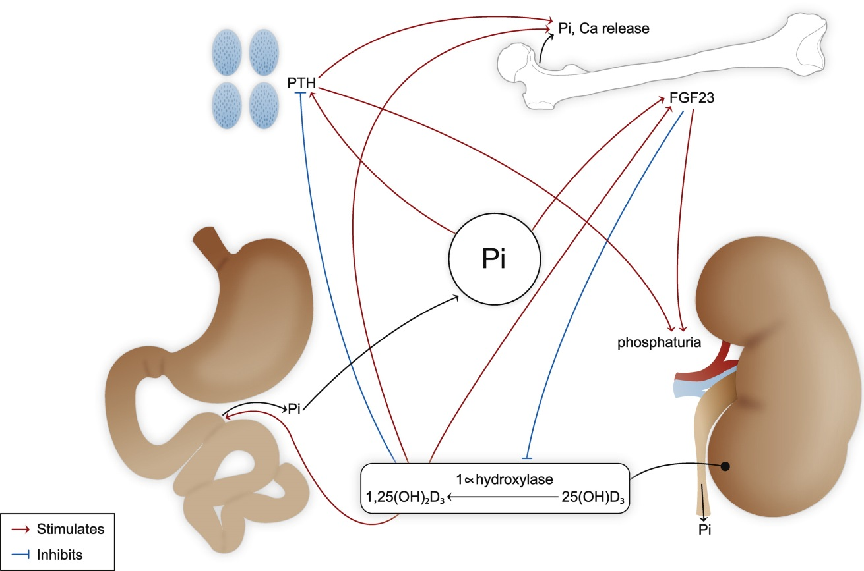

Figure 1.1 Hormonal regulation of serum phosphate concentration.
Control of blood phosphate levels by the parathyroid gland, bone, intestine and kidney.
PTH, parathyroid hormone; FGF-23, fibroblast growth factor-23; Pi, phosphate; Ca, calcium; 25(OH)D₃, 25-hydroxy vitamin D3; 1,25(OH)₂D₃, calcitriol.

Could fasting serum phosphate be a cardiovascular risk factor?
It may seem counterintuitive to postulate that prediction of CVD risk by increments in fasting serum phosphate within a ‘natural’ homeostatically-regulated range could reflect pathological effects of phosphate exposure. However, an analogy could be made with cholesterol; interventions to reduce the levels of low density lipoprotein cholesterol below those occurring ‘naturally’ (i.e. even in the setting of a low cholesterol diet) are associated with vascular benefits. The paradigm of such ‘normal’ biology playing a major contributing role in even a common pathology such as atherosclerotic vascular disease is quite plausible for two reasons:
Firstly, cardiovascular disease commonly manifests at a post-reproductive age when normal biology naturally gives rise to senescence and loss of optimal function anyway. Secondly, the CVD epidemic is a recent phenomenon consequent upon the lifestyle of modern man. The natural set point for phosphate control may have little effect on vascular disease in the absence of other insults, but play a significant role when other factors contribute to vascular injury. Excessive phosphate intake may be such a factor; although excessive dietary phosphate intake appears not to be a determinant of fasting phosphate concentration, it is plausible that other determinants of higher fasting phosphate would render an individual more vulnerable to non-fasting diurnal phosphate peaks which are affected by phosphate intake.

Possible mechanisms linking higher serum phosphate to cardiovascular disease

Serum phosphate and arterial calcification
In the advanced stages of kidney disease serum phosphate can climb well above the normal range to >2.5mM. Although no prospective trial data exist to show a benefit of lowering serum phosphate, observational data link hyperphosphataemia with vascular calcification and cardiovascular mortality in these patients (Block et al., 1998). Phosphate binders and dietary phosphate restriction are used routinely to limit hyperphosphataemia in this setting. Animal models of uraemia demonstrate a benefit of phosphate binders in reducing vascular calcification (Phan et al., 2005, Phan et al., 2008), providing some support for this strategy. In vitro, vascular smooth muscle cells undergo osteochondroblastic transformation and calcification when cultured in phosphate concentrations similar to those seen in renal failure (Jono et al., 2000), but this has not been demonstrated at higher-normal concentrations. The vascular calcification that is highly prevalent in dialysis patients is classically ‘Monckeberg sclerosis’ i.e. calcification of the arterial media occurring independently of atheroma and believed to cause arterial stiffening (Guerin et al., 2000). Cardiovascular death in this population is considered to occur predominantly through heart failure/arrhythmias on a background of myocardial hypertrophy/fibrosis resulting from arterial stiffening and other uraemic factors (Ritz and Wanner, 2008); this is in contrast to the atherosclerotic plaque rupture which causes cardiovascular events in non-uraemic populations. Therefore it is not straightforward to extrapolate the paradigm of hyperphosphataemic arterial medial calcification/stiffening to the association of higher-normal phosphate with traditional athero-occlusive events. Nevertheless, arterial stiffness is a predictor of both cardiovascular mortality and coronary disease in populations without kidney disease (Sutton-Tyrrell et al., 2005) so could mediate a link between high-normal phosphate and atherosclerotic events.
Observational data relating higher-normal serum phosphate to arterial calcification and stiffening in the absence of kidney disease are inconclusive: Associations between higher-normal serum phosphate concentrations and elevated ankle brachial pressure index (>1.3) have been interpreted as reflecting an association with arterial stiffness (Kendrick et al., 2010, Ix et al., 2009). However, simultaneous alternative measures of arterial stiffness (pulse pressure and arterial elasticity) were not independently associated with serum phosphate (Ix et al., 2009); higher-normal phosphate is in fact associated with a lower systolic blood pressure (Dhingra et al., 2007, Park et al., 2009) which does not favour a vascular stiffening effect. Valvular calcification has been independently associated with a higher-normal serum phosphate in one cross-sectional study (Linefsky et al., 2011), suggesting the normal range does not need to be surpassed to induce calcification. However, this associative data is not proof of a causal relationship and may reflect a different process to that governing arterial calcification.
Whether hyperphosphataemia (and high-normal phosphate) contribute to atheromatous intimal calcification is also unclear, though in animal models of uraemia both intimal and medial calcification are reduced by phosphate binders (Phan et al., 2008, Phan et al., 2005). Differentiation of intimal versus medial calcification has not been possible in the human studies that have included CKD patients treated with non-calcium containing phosphate binders. In healthy young adults with normal kidney function, higher-normal baseline serum phosphate levels predict development of coronary calcification 15 years later (Foley et al., 2009b). However, this could reflect increased intimal calcification, medial calcification or simply a greater atheroma burden. Likewise, the prediction of cardiovascular events by coronary artery calcification in the general population may reflect either measurement of the underlying atherosclerotic plaque burden or a pathologic effect of greater calcification. Calcium phosphate crystals stimulate a pro-inflammatory atherogenic secretome from macrophages in vitro (Nadra et al., 2005) and such crystals derived from calcified human atherosclerotic lesions promote apoptosis in vascular smooth muscle cells (Ewence et al., 2008). Intimal calcification could therefore play an active role in promoting plaque progression or destabilization. However, increasing phosphate concentration alone does not reproduce these toxic effects (Ewence et al., 2008), which were proposed to reflect increased intracellular calcium concentration following crystal uptake and dissolution. A causal pathway linking greater serum phosphate to plaque calcification or plaque vulnerability therefore remains to be shown. Targeting phosphate exposure to suppress such a pathway would clearly constitute a significant paradigm shift in atherosclerosis management.

Serum phosphate and atherosclerosis
Since traditional athero-occlusive outcomes associated with high-normal phosphate, such as myocardial infarction or angina, are not currently readily explained by calcification, the possibility must be considered that phosphate promotes plaque development or rupture independently of calcification. In uraemic atheroma-prone apolipoprotein E knockout (ApoE^{-/-}) mice a reduction in serum phosphate induced by the phosphate binder sevelamer reduced atheroma burden, consistent with a proatherogenic role for higher phosphate (Phan et al., 2005). However, this effect was not duplicated with the use of calcium carbonate as a phosphate binder (Phan et al., 2008) so the benefits of sevelamer may have been independent of phosphate-binding. Furthermore, as discussed below, manipulating dietary phosphate has secondary effects on phosphate regulatory hormones that may mediate vascular disease. Therefore, conclusions relating to vascular effects of dietary phosphate manipulation are not necessarily the result of changes in serum phosphate. Manipulation of serum phosphate by non-dietary means has not been used to investigate effects on atherosclerosis. The phenotype of hyperphosphataemic FGF-23 knockout mice includes vascular calcification and intimal proliferation, but not atherosclerosis. However, atherosclerosis would not be expected in the absence of an atherogenic (such as ApoE^{-/-}) genetic background.

Serum phosphate and endothelial dysfunction
Dysfunction of vascular endothelium is an early event in the development of atherosclerosis. In vitro, endothelial cells cultured at concentrations of phosphate seen in renal failure (2.5mM) display impaired nitric oxide synthesis (Shuto et al., 2009), increased reactive oxygen species generation and apoptosis (Di Marco et al., 2008). Activation of endothelial cell protein kinase C (PKC) by increased phosphate is reported to cause phosphorylation and inactivation of nitric oxide synthase (Shuto et al., 2009). However, the mechanism by which phosphate loading causes PKC activation is unknown. Other cell types including bronchial epithelium (Jin et al., 2009) and epidermal cells (Camalier et al., 2010) have been reported to show phosphorylation and activation of kinases when cultured in elevated phosphate. Induction of NADPH-oxidase activity was reported to be the primary source of phosphate-induced reactive oxygen species generation in bovine aortic endothelial cells (Shuto et al., 2009). Direct effects of phosphate on oxidative phosphorylation and cellular energy metabolism (discussed in section 1.3.1) might also contribute to oxidative stress and endothelial damage (Bose et al., 2003, Kuro-o, 2010).
Like the osteochondroblastic changes induced in cultured vascular smooth muscle cells, no effects on endothelial cells have been demonstrated in vitro by manipulating phosphate concentrations within the normal range. Changes in cellular phosphate transporter expression might render cells more vulnerable to smaller increases in extracellular phosphate so that the normal range does not need to be exceeded to induce pathology; the phosphate transporter Pit-1 is transcriptionally upregulated in vascular smooth muscle cells by bone morphogenetic protein-2 and platelet-derived growth factor, with accompanying increases in phosphate uptake (Lau et al., 2010). Regulation of phosphate uptake by endothelial cells has not been studied, but it is possible that other co-stimuli, such as oxidative stress, may predispose endothelial cells to high-normal phosphate toxicity.
Toxic endothelial effects of elevated phosphate in vitro are consistent with uraemic animal models demonstrating impaired endothelium-dependent vasorelaxation of ex-vivo mesenteric vessels accompanying hyperphosphataemia (Koobi et al., 2006). However, since dietary phosphate intake was used to manipulate the serum phosphate concentration, the effects may have been secondary to hormonal responses (FGF-23, PTH etc.) rather than changes in phosphate concentration per se.
Shuto et al. showed that in healthy human subjects an oral phosphate supplement that increased serum phosphate to the upper limit of the normal range caused an acute reduction in endothelium-dependent (flow-mediated) brachial artery dilation (Shuto et al., 2009). Post-prandial peaks in serum phosphate might therefore cause cumulative endothelial injury. The high bioavailability of phosphate in western diets could predispose to such post-prandial peaks, though other studies of dietary phosphate manipulation have not shown convincing effects on postprandial serum phosphate (Portale et al., 1987). The small study by Shuto et al. constitutes the only prospective interventional evidence in humans for an adverse effect of phosphate on the vasculature. However, since the intervention was dietary it is again possible that endothelial dysfunction was mediated by hormonal consequences of phosphate exposure rather than through the change in serum phosphate concentration itself.

Phosphate and ageing
Evidence from animal models that very high levels of phosphate exposure exert adverse effects on diverse cell types has contributed to enthusiasm for the concept that phosphate toxicity is not mediated solely by calcification. In mice with genetic deletion of FGF-23 or its coreceptor, klotho, hyperphosphataemia is accompanied by atrophy of multiple organ systems, likened to a progeric phenomenon (Kuro-o et al., 1997, Razzaque et al., 2006). Prevention of hyperphosphataemia by dietary phosphate restriction or renal phosphate transporter knockout prevents this phenotype (Stubbs et al., 2007, Ohnishi and Razzaque, 2010). Serum phosphate concentrations of different species have also been correlated inversely with their longevity (Kuro-o, 2010) and phosphate deprivation extends the lifespan of Drosophila (Bergwitz, 2012). Since tissue metabolic rate is inversely correlated with species longevity (Speakman, 2005), effects of phosphate on energy metabolism postulated above (section 1.3.1) might underlie the phosphate-longevity relationship. However, observations relating to hyperphosphataemia or across species may be irrelevant to clinical associations with subtle phosphate increments.

Serum phosphate and heart failure
Several studies have reported an association between higher-normal serum phosphate and incident heart failure (Dhingra et al., 2010, Tonelli et al., 2005, Aronson et al., 2013). Associated differences in phosphate regulatory hormones, which themselves are associated with left ventricular hypertrophy (discussed below), may be responsible. These hormones were not measured in the above reports. Direct pathological effects of higher-normal phosphate on cardiomyocytes have not yet been described.

Dietary phosphate intake and cardiovascular disease
The observational data associating higher-normal serum phosphate concentration with adverse cardiovascular outcomes come principally from studies that measured fasting morning serum phosphate. Since, as discussed above, variation in dietary phosphate has little effect on this parameter, it is difficult to attribute possible adverse CV effects of serum phosphate to excessive dietary intake. Similarly, demonstration of a causative link between higher-normal morning serum phosphate and cardiovascular disease would not necessarily imply a significant benefit from reducing phosphate intake. Nevertheless, the merits of limiting dietary phosphate exposure for CVD prevention should be tested as a priority, for several reasons: Firstly, if morning serum phosphate concentration plays a causal role in CVD then it would seem likely that the 24h serum phosphate profile would also be relevant and this is modifiable by diet. Secondly, regardless of serum phosphate concentration, dietary phosphate manipulation affects levels of phosphate-regulatory hormones. As discussed below, these hormones may themselves mediate cardiovascular pathology. Thirdly, dietary phosphate exposure is the obvious starting point for interventions because it can be altered safely. Western diets are high in bioavailable phosphate as a consequence of phosphate-containing preservatives and high animal protein content (Calvo and Uribarri, 2013, Kalantar-Zadeh et al., 2010). Public health interventions to limit phosphate-containing additives and excessive animal protein consumption thus might be beneficial at the population level. Intestinal phosphate binders are also available to reduce phosphate exposure.
A single study has demonstrated an association between dietary phosphate intake and cardiovascular mortality: In a large representative sample of the US population without CVD or diabetes (N=9,686), Chang et al. reported that estimated 24h dietary phosphate density (reported as phosphorus intake per calorie) was a significant predictor of cardiovascular mortality (Chang et al., 2014). Hazard ratios of total and cardiovascular mortality both increased progressively with dietary phosphate density above the 5th percentile, independently of traditional cardiovascular risk factors, other dietary intakes and serum phosphate. It is striking that in this analysis dietary intake estimated by recall over a single 24h period independently predicted mortality over a median follow-up of 14.7 years.
Contrasting conclusions have been reported when urinary phosphate excretion is used as a measure of dietary phosphate exposure. In patients with a history of CVD and normal or mildly impaired kidney function, Palomino et al. found a higher 24h urinary phosphate excretion independently predicted a lower risk of CVD events (Palomino et al., 2013). Dominguez et al. found that whilst the top quartile of serum phosphate concentration was a predictor of total or cardiovascular mortality in men, increasing urinary phosphate:creatinine ratio was not (Dominguez et al., 2013a).
The relationship between dietary phosphate intake and traditional cardiovascular risk factors is uncertain. In a large combined cohort from the Multi Ethnic Study of Atherosclerosis and the Atherosclerosis Risk in Communities Study, higher baseline dietary phosphate intake was associated with a slightly lower blood pressure, but this was only significant for phosphate of dairy origin, suggesting confounding by other dietary factors (Alonso et al., 2010). In the US population sample studied by Chang et al, higher absolute dietary phosphate intake was associated with lower prevalence of hypertension but no difference in body mass index in unadjusted analyses (Chang et al., 2014). Whether dietary phosphate intake associates with other cardiovascular risk factors such as dyslipidaemia and insulin resistance has not been reported.
In a cross-sectional analysis of healthy subjects, there was a significant association between greater dietary phosphate intake and slightly greater LV mass (1.06g greater LV mass per 20% increase in dietary phosphate intake, compared to a 2.7g greater LV mass associated with a 10mmHg increase in systolic blood pressure)(Yamamoto et al., 2013). There are currently no reports of an association between dietary phosphate intake and heart failure incidence.
Intestinal phosphate absorption can be reduced by high-dose oral niacin, which lowers serum phosphate concentration in populations without kidney disease (Maccubbin et al., 2010). Since niacin also has favourable effects on lipid profile, a number of studies have tested whether niacin reduces cardiovascular disease events. Although a recent large trial was stopped prematurely due to lack of efficacy and concerns regarding increased stroke incidence, the aggregate of interventional data to date supports a reduction in cardiovascular events by niacin (Lavigne and Karas, 2013). This reduction is disproportionate to effects on lipid profile, a finding supported by animal models demonstrating suppression of atherosclerosis independently of lipid changes (Holzhauser et al., 2011). Attenuation of dietary phosphate exposure therefore might contribute to the vascular benefits of niacin, though other properties such as an antioxidant effect could also be responsible (Wu et al., 2010).
Thus, although it has been suggested that reducing dietary phosphate exposure may be beneficial for cardiovascular disease prevention (Ferro et al., 2009, Ellam and Chico, 2012), observational data to support this (distinct from associations between CVD and serum phosphate) are currently very limited.

Phosphate-regulatory hormones as possible mediators of cardiovascular phosphate-toxicity
Higher serum concentrations of FGF-23 or PTH and lower concentrations of calcitriol each predict increased risk of CVD, independently of traditional risk factors (as summarised below). These hormonal changes are observed in response to increased dietary phosphate and act to prevent hyperphosphataemia. Therefore adverse cardiovascular effects of excessive phosphate exposure might be mediated via changes in these hormones.
Increases in serum FGF-23 in response to increased dietary phosphate have been reported in several healthy volunteer studies (Antoniucci et al., 2006, Burnett et al., 2006, Ferrari et al., 2005). However, a distinction must be made between intervention studies that set out to maximise the achieved differences in phosphate intake/absorption and the more modest differences that might be observed naturally in non-study populations. Manipulation of dietary protein intake to achieve a 30% increase in phosphate intake did not increase (and actually slightly lowered) FGF-23 in another study (Kremsdorf et al., 2013). A single observational study has examined the relationship between estimated (i.e. not manipulated) dietary phosphate intake and serum FGF-23 (Gutierrez et al., 2011); in this cohort of healthy subjects the increase in FGF-23 associated with a higher estimated dietary phosphate intake was significant but small and less than that associated with age, higher BMI and smoking. Therefore it is not clear how much the differences in FGF-23 concentration that have been associated with CVD could be a result of spontaneous differences in phosphate intake.
The link between variation in fasting serum phosphate concentration and serum FGF-23 is even more uncertain: In the Heart and Soul Study and the Health Professionals Follow Up Study higher FGF-23 was associated with a small but significantly greater serum phosphate concentration (Parker et al., 2010, Gutierrez et al., 2011). However, in other studies of populations without kidney disease there has been no clear relationship between FGF-23 and serum phosphate concentration (Weber et al., 2003, Mirza et al., 2009a, Westerberg et al., 2013). Although FGF-23 has phosphate-lowering effects and responds to dietary phosphate changes, increased serum phosphate has not been shown to be the trigger for FGF-23 production; in fact intravenous phosphate infusion or gonadal steroid deprivation-related increases in serum phosphate fail to increase FGF-23 (Ito et al., 2007, Burnett-Bowie et al., 2007). Therefore, although elevations in FGF-23 might mediate adverse effects of excessive dietary phosphate, it is not established that subjects with higher fasting serum phosphate have a higher serum FGF-23 that could mediate the putative toxic effects of higher serum phosphate.
Similarly, although experimentally increased phosphate ingestion increases parathyroid hormone (Kemi et al., 2006) and suppresses serum calcitriol (Portale et al., 1989, Antoniucci et al., 2006), the impact of moderate changes or spontaneous variation in dietary phosphate intake on the levels of these hormones is less clear (Kremsdorf et al., 2013). There is some evidence that greater observed dietary phosphate intake, particularly in the form of bioavailable inorganic phosphate additives, is associated with a higher PTH (Kemi et al., 2009). However, calcitriol concentrations have not been correlated with estimated dietary phosphate intake in observational studies.
The interrelationship between serum phosphate concentration, calcitriol and PTH is also unclear. In populations where the bone mineral axis is influenced predominantly by a relative deficiency of vitamin D, a lower serum calcitriol concentration would be expected to associate with a lower serum phosphate concentration, since calcitriol increases serum phosphate levels. However, where another factor, such as excessive dietary phosphate intake, dominates the equilibrium of the bone mineral axis, a higher average 24h serum phosphate concentration might be associated with a compensatory lower calcitriol level.
Thus, with regard to the above observations, there are two limitations of the current literature: Firstly, the observational data relating bone mineral axis parameters to cardiovascular outcomes have not included comprehensive assessments of all relevant variables, i.e. bioavailable phosphate intake, 24h serum phosphate concentration profile, PTH, calcitriol and FGF-23. Secondly, the interventional studies manipulating dietary intake and demonstrating effects on circulating hormones may not inform the interpretation of observational population data where these factors may relate differently.
Postulated pathways linking phosphate exposure to CVD are summarised in Figure 1.2:

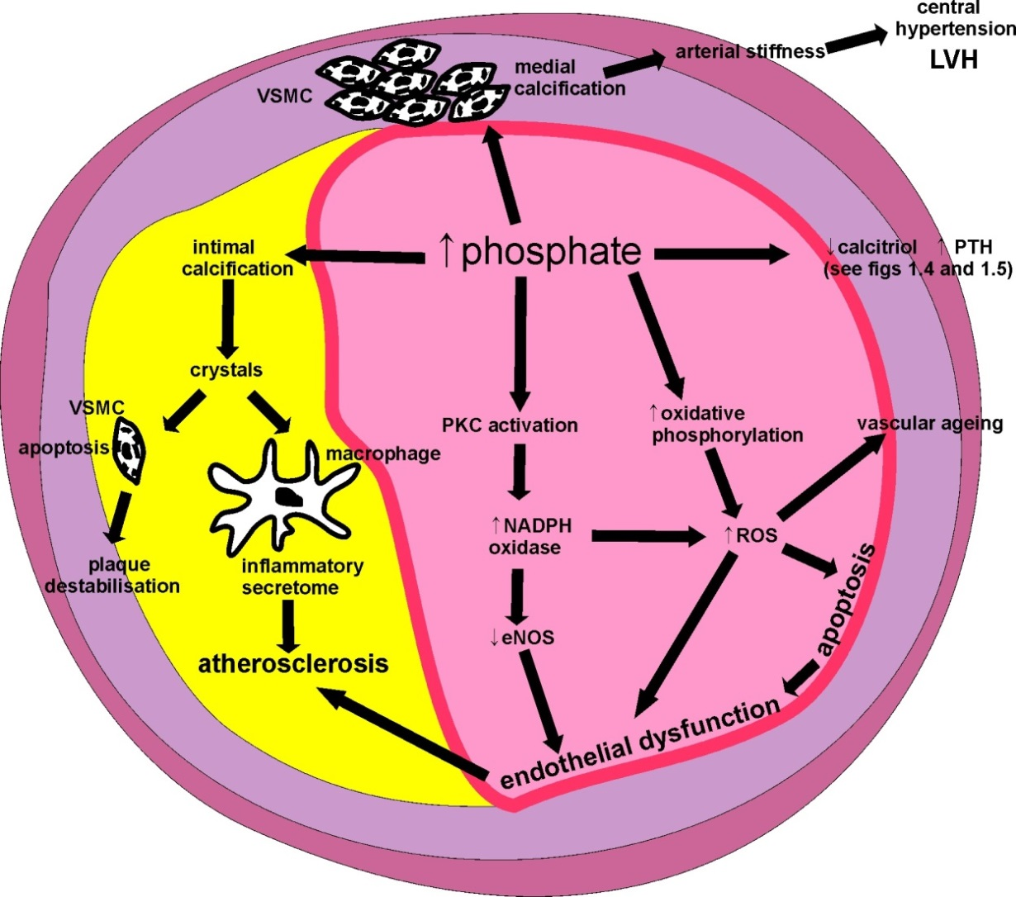

Figure 1.2 Summary of postulated pathways between excessive blood phosphate exposure and cardiovascular disease.
(Represented as an arterial cross-section with atherosclerotic plaque.)
VSMC, vascular smooth muscle cell; PKC, protein kinase C; NADPH, nicotinamide adenine dinucleotide phosphate; ROS, reactive oxygen species; eNOS, endothelial nitric oxide synthase; NO, nitric oxide; LVH, left ventricular hypertrophy.

Fibroblast growth factor-23 and cardiovascular disease

Summary of FGF-23 physiology
Secretion of FGF-23 by osteocytes is stimulated by increased oral phosphate intake (though the mechanism underlying this response in unknown), calcitriol, PTH and calcium (Hu et al., 2013). The FGF-23 coreceptor klotho interacts with cell surface FGF receptors 1, 3 and 4 to increase their affinity for FGF-23 and allow tissue-specific FGF-23 signalling (Urakawa et al., 2006). In the renal proximal tubule, FGF-23 suppresses expression of sodium-phosphate cotransporters and 1-alpha hydroxylase, lowering tubular phosphate reabsorption and plasma calcitriol concentrations respectively. Klotho is also expressed by the parathyroid and allows FGF-23-mediated suppression of PTH synthesis.

Associations between FGF-23 and cardiovascular disease
In the Heart and Soul Study of prevalent coronary disease patients, subjects in the highest tertile of serum FGF-23 had double the risk of mortality and cardiovascular events compared to those in the bottom tertile, despite adjusting for kidney function and other risk factors (Parker et al., 2010). Adjusting for fasting serum phosphate concentration also did not attenuate this association, suggesting that FGF-23 is not simply reflecting risk attributable to higher-normal serum phosphate; although it has been suggested that FGF-23, as a phosphate-responsive hormone, might be a better marker of time-averaged serum phosphate concentration than a single fasting phosphate measurement, this is unproven (Ix, 2011). Adjustment for serum calcitriol also did not abolish the association, so that FGF-23-mediated suppression of calcitriol apparently does not underlie the finding. Again, given the short half-life of calcitriol and difficulty in measuring it accurately, FGF-23 could theoretically be a better predictor of calcitriol status than a single calcitriol result, though this has not been shown. Other studies have found similar prediction of cardiovascular events independently of phosphate, 25(OH)D and PTH (Arnlov et al., 2013).
In populations without kidney disease, cross-sectional analyses have shown independent associations between FGF-23 and atherosclerotic burden measured by MR angiography at multiple vessels (Mirza et al., 2009a) or by coronary angiography (Dalal et al., 2011, Xiao et al., 2013). Higher FGF-23 is itself associated with atherosclerotic risk factors including smoking, hypertension, obesity and higher triglycerides (Gutierrez et al., 2011, Mirza et al., 2010). Residual confounding by these (or other unidentified) factors thus might mediate the associations of FGF-23 with cardiovascular outcomes.
In subjects with CKD, higher FGF-23 is a predictor of atherosclerotic events and heart failure, independently of traditional cardiovascular risk factors, kidney function, phosphate, PTH and medication use (Scialla et al., 2014, Kendrick et al., 2011, Seiler et al., 2010). Total mortality is also predicted independently by FGF-23 in patients with CKD (Isakova et al., Kendrick et al., 2011) and in haemodialysis cohorts (Gutierrez et al., 2008, Jean et al., 2009). As is the case with non-CKD populations, higher FGF-23 has been associated independently with coronary atheroma burden in cross-sectional studies of patients with early CKD (Kanbay et al., 2010).
A Mendelian randomisation approach does not help shed light on the possible contributory role of FGF-23 in cardiovascular pathology. Although a polymorphism in the FGF-23 gene has been associated with the likelihood of developing cardiac complications of Kawasaki disease (Falcini et al., 2013), there are no reports of whether FGF-23 gene polymorphisms predict atherosclerotic or other adult cardiovascular disease. A klotho polymorphism (the KL-VS allele) has been associated with hypertension (Arking et al., 2005), dyslipidaemia (Arking et al., 2005), stroke (Majumdar et al., 2010, Arking et al., 2005), and occult inducible myocardial ischaemia (Arking et al., 2003). In vitro there is some evidence that this polymorphism affects the klotho-FGF-receptor interaction that is required for FGF-23 signalling (Tucker Zhou et al., 2013). However, since klotho is now recognised to have multiple effects independently of FGF-23 (Kuro-o, 2008), it cannot be concluded from these findings that the FGF-23 signalling pathway plays a causative role in the development of atherosclerosis. If secondary changes in calcitriol, parathyroid hormone and serum phosphate accompanied the KL-VS polymorphism, this would support an FGF-23 mediated pathway underlying the findings. However, these data were not included in the above publications.

Possible mechanisms of FGF-23- mediated cardiovascular toxicity
There are several possible pathways through which higher FGF-23 could cause cardiovascular toxicity. Firstly, the suppression of renal calcitriol synthesis by FGF-23 may have secondary effects on the heart and vasculature (see below). However, as discussed above, since FGF-23 has been reported to predict cardiovascular mortality independently of calcitriol (Ix et al., 2012), this hypothesis requires that FGF-23 is a better marker of calcitriol signalling than is a single plasma calcitriol measurement. Paracrine vitamin D signalling following vascular synthesis of calcitriol has been postulated to play a role in cardiovascular disease prevention (Artaza et al., 2009); consequently tissue calcitriol levels may be more important than measured systemic plasma concentrations. Peripheral blood mononuclear cells were found to suppress calcitriol synthesis in response to FGF-23 (Bacchetta et al., 2013), but calcitriol production in other extrarenal tissues has not yet been demonstrated to be controlled by FGF-23.
Secondly, FGF-23 might act directly on vascular cells through the FGFR/klotho-coreceptor signalling pathway to cause detrimental effects. The extent and significance of vascular klotho expression has, however, been the subject of debate. Although previously considered to be largely confined to the kidney and parathyroid, klotho mRNA expression has been detected at low levels in endothelial cells (Kusaba et al., 2010), arterial vascular smooth muscle cells (Lim et al., 2012) and whole arterial preparations (Lindberg et al., 2013, Donate-Correa et al., 2013). Immunohistochemical klotho protein detection in vascular tissue is not consistent, perhaps reflecting technical differences in antibodies used, species differences and/or low expression levels (Lindberg et al., 2013, Lim et al., 2012, van Venrooij et al., 2014). Since soluble klotho has been reported to facilitate FGF-23 signalling in cells that do not express transmembrane klotho (Shalhoub et al., 2011), vascular klotho expression may not necessarily be an absolute requirement for FGF-23 signalling.
Endothelial dysfunction, measured as impaired flow-mediated dilation at the brachial artery, has been associated with higher FGF-23 in populations with (Yilmaz et al., 2010) and without (Mirza et al., 2009b) kidney disease. However, functional analyses of the consequences of FGF-23 addition to vascular tissue are inconsistent: Lim et al. found that addition of FGF-23 to vascular smooth muscle cell cultures upregulated phosphorylation of extracellular signal related kinase (ERK) and protein kinase B (recognised downstream signalling pathways of FGF-23-FGFR-klotho signalling in tubule cells), accompanied by proliferation (Lim et al., 2012). These effects were abolished by siRNA klotho knockdown. In contrast, Lindberg et al found no evidence of egr-1 transcriptional change (another downstream component of FGF-23 signalling) in mice aortae following FGF-23 infusion (Lindberg et al., 2013). These authors also did not detect any effect of FGF-23 on contractile responses of isolated vessels. Stevens et al. reported FGF-23 increased E-selectin expression in human umbilical vein endothelial cell (HUVEC) cultures only when combined with IL-1 stimulation and excess phosphate (3mM)(Stevens et al., 2011). Thus, a role for FGF-23 signalling directly on the vasculature is not yet established.
If increased FGF-23 does not itself play a causal role in cardiovascular disease it may be acting as a marker of novel risk pathways. Given the various vasculoprotective properties attributed to soluble klotho, an association between higher FGF-23 and attenuated soluble klotho function could be an explanation for the observational data. A generalised state of transmembrane/soluble klotho deficiency would be expected to result in a compensatory increase in plasma FGF-23 (due to renal FGF-23 resistance). In the Cardiovascular Health Study, fractional phosphate excretion, considered a marker of renal FGF-23 sensitivity, was a modifier of the relationship between FGF-23 and cardiovascular events/mortality; subjects with higher FGF-23 were more likely to experience an adverse event if they also had a lower fractional excretion of phosphate, independently of excretory function (Dominguez et al., 2013b). However, studies linking FGF-23 to adverse outcomes have not concomitantly reported soluble klotho. In fact, the relationship between plasma FGF-23, soluble klotho and tissue klotho expression remains unclear (Drueke and Massy, 2013). With the recent development of soluble klotho assays it is likely that this will be clarified.

FGF-23 and left ventricular hypertrophy
In patients with CKD or on dialysis, multiple studies have reported an association between higher levels of FGF-23 and the presence of left ventricular hypertrophy (Gutierrez et al., 2009, Kirkpantur et al., 2011, Faul et al., 2011). Faul et al. demonstrated in mouse models that intravenous or intramyocardial injection of FGF-23 causes LVH (Faul et al., 2011). This effect appears to be direct, i.e. not mediated by secondary changes in calcitriol or PTH, since intramyocardial injection of FGF-23 did not change plasma concentrations of FGF-23, calcium, phosphate or PTH. Furthermore, addition of FGF-23 to isolated neonatal rat cardiomyocytes in vitro induced hypertrophy and a hypertrophy-associated foetal gene expression programme. Notably, these changes were dependent on FGF receptor signalling pathways, though no cardiomyocyte expression of klotho was detected. This study thus supports the concept that at sufficiently high concentrations of FGF-23, tissue effects may be mediated independently of klotho. Plasma FGF-23 levels following intravenous FGF-23 administration in the Faul study were similar to those observed in CKD and less than commonly observed in the setting of endstage renal disease (where FGF-23 may be 1000-fold higher than in healthy subjects (Larsson et al., 2003)). Touchberry et al. also reported a direct hypertrophic effect of FGF-23 on cardiomyocytes in vitro, as well as an acute increase in calcium influx (Touchberry et al., 2013). However, in contrast to the study by Faul et al., these authors found low-level klotho expression in adult mouse cardiomyocytes.
Two studies have reported associations between higher ‘normal’ FGF-23 and LVH even in the absence of kidney disease (Seiler et al., 2011, Mirza et al., 2009c), though that of Mirza et al. found the association was weaker among those with intact kidney function. In the Cardiovascular Health Study cohort, FGF-23 was only associated with LVH among individuals with impairment of excretory function and not in those with estimated glomerular filtration rate >60ml/min/1.73m² (Agarwal et al., 2014). Since the studies of Faul et al. and Touchberry et al. did not specifically address the effects of increasing FGF-23 concentrations across the range seen in non-CKD populations, it is unclear whether FGF-23 can cause LVH at these levels.
Possible pathways linking increased FGF-23 to adverse cardiovascular outcomes are summarised in Figure 1.3.

Figure 1.3 Summary of possible pathways underlying the association between FGF-23 and cardiovascular events.
CV, cardiovascular; VSMC, vascular smooth muscle cell; LVH, left ventricular hypertrophy.

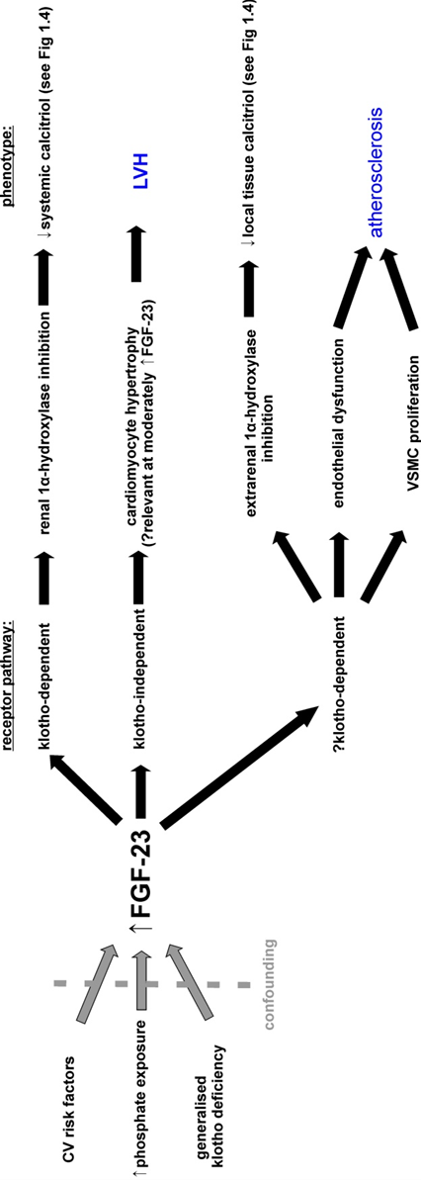

Vitamin D and cardiovascular disease

Summary of vitamin D physiology
Vitamin D (specifically vitamin D₃, cholecalciferol) is synthesized in the skin through the action of ultraviolet-B light on 7-dehydrocholesterol to yield precholecalciferol, which spontaneously isomerises to cholecalciferol. Ingestion of vitamin D₃ or vitamin D₂ (ergocalciferol), found in dairy products, oily fish and eggs, is an additional source of circulating vitamin D. Hepatic hydroxylation of vitamin D₃ and D₂ yields 25-hydroxy vitamin D₃ and D₂ respectively, referred to collectively as 25(OH) vitamin D (25(OH)D). This circulating form of vitamin D is readily measured and is considered to reflect the body’s vitamin D status (Artaza et al., 2009). However, 25(OH)D must undergo further hydroxylation to 1,25-dihydroxyvitamin D (calcitriol) for biological activity. This hydroxylation takes place primarily in cells of the renal proximal tubule, catalysed by the mitochondrial enzyme 1-alpha hydroxylase. Calcitriol acts on the nuclear vitamin D receptor (VDR) to stimulate intestinal calcium and phosphate absorption, osteoclast activity, renal tubular phosphate reabsorption and to inhibit PTH synthesis. Together these actions maintain adequate blood levels of calcium and phosphate for bone formation. Regulation of circulating calcitriol concentrations occurs at the level of renal 1-alpha hydroxylase, the expression of which is inhibited by calcitriol and FGF-23, and stimulated by PTH (Thadhani, 2008). The enzyme 24-hydroxylase converts 25(OH)D to the inactive metabolite 24,25(OH)₂D and is regulated in a reciprocal manner.
Since calcitriol circulates at levels approximately 1000-fold lower than 25(OH)D and has a short half-life, the vitamin D compound most commonly reported in clinical studies and clinical practice is the more easily measured 25(OH)D. This may give a better measure of vitamin D stores, which in the setting of deficiency may predict changes in active vitamin D levels (Bouillon et al., 1987). However, since the regulation of calcitriol synthesis is downstream of 25(OH)D synthesis, measurement of the latter does not necessarily reflect active vitamin D signalling, particularly in the face of disturbances elsewhere in the bone mineral axis. A poor correlation between 25(OH)D and calcitriol concentrations has been reported in the context of cardiovascular risk prediction by lower levels of both metabolites (Dobnig et al., 2008).

Paracrine vitamin D signalling
The contributions of vitamin D to the maintenance of bone mineral homeostasis and bone health are mediated through VDR expression in bone, intestine, parathyroid and kidney. However, the VDR is also expressed in endothelium (Talmor et al., 2008b), myocardium (Chen et al., 2011), vascular smooth muscle (Chen et al., 2010), macrophages (Nelson et al., 2010) and multiple (in fact most) other cell types (Verstuyf et al., 2010). The finding that 1-alpha hydroxylase is also expressed in many of these tissues raises the possibility that autocrine/paracrine calcitriol signalling plays a role in maintaining their healthy function (Verstuyf et al., 2010). However, there is no established rationale for the existence of such a pathway; no benefit to the organism has been shown of having a calcitriol-dependent permissive signalling system for tissue health.
Although FGF-23 has been reported to inhibit calcitriol synthesis within peripheral blood mononuclear cells (Bacchetta et al., 2013), it is generally not known whether extrarenal 1-alpha hydroxylase expression is regulated by the same factors that control systemic calcitriol levels via renal 1-alpha hydroxylase. It is also unknown whether lower plasma 25(OH)D concentrations are commonly a limiting factor in extrarenal calcitriol synthesis. Consequently, when considering the relationship between vitamin D and cardiovascular disease it must be remembered that: 1.) 25(OH)D measurements reflect vitamin D stores but not necessarily systemic or autocrine/paracrine active vitamin D signalling. 2.) Plasma calcitriol measurements also do not necessarily reflect localised tissue calcitriol signalling. 3.) The relationship between 25(OH)D and calcitriol is likely to be influenced by the level of 25(OH)D i.e. more severe deficiency of 25(OH)D seems more likely to impact on calcitriol synthesis.
A scenario where these issues are of particular clinical relevance is in the setting of CKD. Patients with CKD are commonly deficient in 25(OH)D, but also have a defect in renal conversion of 25(OH)D to calcitriol (Artaza et al., 2009). Replacement of systemic calcitriol signalling with 1-alpha hydroxylated forms of vitamin D bypasses the need for renal activation and can correct bone mineral disturbances such as hypocalcaemia and secondary hyperparathyroidism. However, if adequate circulating 25(OH)D is important as a precursor for autocrine/paracrine calcitriol signalling then simply correcting systemic calcitriol levels may not be the best approach.

Vitamin D, lifestyle and observational data; confounding or mis-setting?
Extensive data associate lower plasma/serum 25(OH)D concentrations with adverse cardiovascular outcomes and other disease states. The fact that these associations are evident even across quartiles of 25(OH)D in community populations has given rise to debate regarding the definition of vitamin D ‘deficiency’ and ‘insufficiency’ (Rosen, 2011). As for the other bone mineral parameters discussed herein, there would appear to be a difference between distribution-defined ‘normal’ and ‘optimal’ if the associations reflect causal relationships. Since 25(OH)D levels are determined by lifestyle factors (diet and sun exposure) it can be envisaged that there is a prevalent mis-setting of ‘normal’ vitamin D status as a consequence of an unhealthy western lifestyle. Conversely, observational data relating lower 25(OH)D concentration to adverse health outcomes may reflect confounding; less healthy individuals are less likely to choose to go outside and receive sun exposure. Behavioural patterns are particularly difficult to adjust for in observational analyses so that even when attempts are made to perform such adjustment, residual confounding remains a concern.

Vitamin D and cardiovascular risk factors

Hypertension
A number of observational studies have reported an independent association between lower plasma 25(OH)D concentration and hypertension, as reviewed by Pilz et al. (Pilz et al., 2009). In some studies a significant association is apparent even well above 25(OH)D levels considered indicative of deficiency (Bhandari et al., 2011). Lower calcitriol concentration was also independently associated with higher systolic blood pressure in a study of healthy normotensive individuals (Kristal-Boneh et al., 1997). Whether these findings reflect a causal relationship or residual confounding is unclear. Prospective studies of the relationship between lower plasma 25(OH)D and the risk of incident hypertension have been inconsistent (van Ballegooijen et al., 2014). A small number of interventional studies have also not consistently shown a benefit of vitamin D therapy in lowering blood pressure (Margolis et al., 2008). The largest of these studies, the Women’s Health Initiative, randomised over 36,000 postmenopausal women to treatment with either calcium and daily cholecalciferol 400IU or placebo. Over a median follow-up period of 7 years there was no significant difference in the change in blood pressure or incidence of hypertension (Margolis et al., 2008). This study has been criticised for using a suboptimal dose of vitamin D and achieving poor compliance; some other studies using short-term higher doses found a modest but significant reduction in blood pressure (Pfeifer et al., 2001, Forman et al., 2013), though not all (Witham et al., 2013).
A causal mechanism by which attenuation of vitamin D signalling could contribute to clinical hypertension has been established; cell culture studies and VDR knockout mouse models demonstrate that calcitriol signals through the VDR to suppress renal renin expression and prevent hyperreninaemic hypertension (Li et al., 2002, Zhou et al., 2008). However, the phenotype of the VDR knockout mouse is severe and also includes alopecia, growth retardation and osteomalacia (Bouillon et al., 2008). Consequently observations in this model may not be relevant to the clinical associations of more mildly attenuated VDR signalling. Nevertheless, cholecalciferol treatment lowers blood pressure in spontaneously hypertensive rats (Borges et al., 1999).

Obesity
Obesity is independently associated with lower plasma concentrations of both 25(OH)D and calcitriol (Konradsen et al., 2008, Parikh et al., 2004). However, there is no identified mechanism by which lower vitamin D signalling causes obesity. In fact, calcitriol inhibits the expression of human adipocyte oxidative phosphorylation uncoupling protein 2 (Shi et al., 2002); VDR knockout mice consequently manifest uncoupling of oxidative phosphorylation in adipose tissue and are protected from obesity (Wong et al., 2009). Mendelian randomisation, employing allelic determinants of serum 25(OH)D, also does not demonstrate a causal relationship between lower 25(OH)D and obesity (Vimaleswaran et al., 2013). Therefore residual confounding by reduced outdoor activity and sun exposure may underlie the contrasting observational data.
Since vitamin D is a lipid-soluble hormone, an alternative explanation hypothesized to account for its inverse association with measures of obesity is that a greater volume of distribution somehow contributes to a lower circulating 25(OH)D concentration (Drincic et al., 2012). Whilst greater distribution volume would per se explain a lesser increment in 25(OH)D concentration following supplementation (Wortsman et al., 2000), a steady-state concentration reduction must require an increase in catabolism if biosynthesis is not impaired. This has not been demonstrated.

Impaired glucose tolerance
Lower circulating 25(OH)D concentration is associated with higher glycated haemoglobin (Hypponen and Power, 2006), higher fasting glucose (Fraser et al., 2010), insulin resistance (Kabadi et al., 2012) and risk of developing type II diabetes (Afzal et al., 2013). Although these associations are not fully explained by a confounding effect of obesity, there is a synergistic interaction between obesity and lower 25(OH)D in their mutual association with measures of impaired glucose metabolism (Hypponen and Power, 2006, Kabadi et al., 2012). Animal models of vitamin D deficiency or VDR deletion demonstrate impaired insulin secretion and glucose intolerance (Bouillon et al., 2008). Pancreatic beta cells express the VDR and beta cell insulin secretion in vitro is attenuated by vitamin D deficiency (Cade and Norman, 1986). However, interventional clinical studies of vitamin D supplementation for the improvement of glucose metabolism parameters have not shown a consistent meaningful benefit (George et al., 2012). Small studies of patients with inactivating VDR mutations have not reported abnormal insulin secretion (Malloy et al., 1999) and Mendelian randomisation in a large cohort (N=96,423) failed to show a significant association with type II diabetes risk for genotypes predicting lower plasma 25(OH)D (Afzal et al., 2014). The extent to which lower circulating vitamin D leads to impairment of insulin secretion and glucose intolerance in humans is thus still unclear.

Dyslipidaemia
In cross-sectional studies, higher plasma 25(OH)D concentrations are associated with a more favourable serum lipid profile, i.e. lower total cholesterol, LDL cholesterol and triglycerides and higher HDL cholesterol, independently of body mass index (Jorde et al., 2010). Interventional trial data do not support a benefit of vitamin D supplementation for improving lipid profile, though studies have typically been underpowered and may have used inadequate doses of vitamin D (Jorde and Grimnes, 2012, Wang et al., 2012). In a cohort with repeated 25(OH)D and lipid measurements, Ponda et al. found that among subjects with 25(OH)D deficiency (<20ng/ml) at baseline there was no association between lipid profile changes and 25(OH)D status changes (>30ng/ml versus persisting <20ng/ml)(Ponda et al., 2012). There is no established mechanism by which attenuation of VDR signalling would cause dyslipidaemia independently of obesity/diabetes. In fact, in keeping with their leaner phenotype, VDR knockout mice have been reported to have lower plasma triglycerides and cholesterol (Wong et al., 2009).

Vitamin D and cardiovascular disease outcomes
Multiple large observational studies report that 25(OH)D deficiency is an independent predictor of cardiovascular events and mortality (Wang et al., 2008, Dobnig et al., 2008, Giovannucci et al., 2008). In a meta-analysis incorporating 82,982 subjects, the lowest versus highest quartile of 25(OH)D was associated with a 39% greater risk of ischaemic heart disease events (Brondum-Jacobsen et al., 2012). Among 42,565 subjects included in a mortality meta-analysis, the fourth versus first 25(OH)D quartile had a 21% lower vascular mortality (Tomson et al., 2013). Independent associations with cardiovascular mortality are not confined to a small minority with exceptionally low plasma 25(OH)D concentration; the degree of ‘deficiency’ associated with cardiovascular mortality is common in outpatient settings. For example Dobnig et al. reported a significantly greater hazard ratio for cardiovascular mortality in both the 2nd and 1st versus 4th quartiles of season-adjusted 25(OH)D (Dobnig et al., 2008), independent of phosphate, calcium and parathyroid hormone. Specific adverse cardiovascular events associated with lower 25(OH)D include myocardial infarction (Giovannucci et al., 2008, Karakas et al., 2013), stroke(Pilz et al., 2008, Brondum-Jacobsen et al., 2013) and sudden cardiac death (Thomas et al., 2012).
Simultaneous measurements of 25(OH)D and calcitriol have only been performed in one large prospective cardiovascular outcomes study; the Ludwigshafen Risk and Cardiovascular Health (LURIC) study. In this cohort, Pilz and colleagues reported that 25(OH)D and calcitriol predict cardiovascular mortality (Dobnig et al., 2008) and stroke (Pilz et al., 2008) independently of one another. This suggests that the association between lower 25(OH)D and cardiovascular events is not mediated entirely by limitation of systemic calcitriol signalling. Paracrine calcitriol signalling may be limited by lower 25(OH)D availability before changes in plasma calcitriol levels are evident (as discussed in 1.7.2). Alternatively, residual confounding could explain an association between 25(OH)D and outcomes independently of calcitriol.
If the prediction of cardiovascular events and mortality by lower 25(OH)D reflects a causal relationship then supplementation would be an important public health intervention for cardiovascular disease prevention. However, clinical benefits of vitamin D supplementation for CVD prevention remain to be demonstrated. Data relating specifically to atherosclerotic disease and LVH are considered below.

Vitamin D and atherosclerosis

Clinical data
Since lower 25(OH)D predicts the atherosclerotic endpoints of myocardial infarction and stroke, a cross-sectional association with atheroma burden might be expected. Subclinical carotid artery atheroma (measured as carotid intima-media thickness, CIMT) has been associated with lower 25(OH)D in some small studies, but large cohorts have failed to show an association between lower 25(OH)D and CIMT extent or progression (Blondon et al., 2013, Deleskog et al., 2013). Coronary artery calcification has been studied as an alternative measure of atherosclerosis burden and is also predicted by lower 25(OH)D in some cohorts (de Boer et al., 2009a). However, as with CIMT, findings from different studies are conflicting (Carbone and Montecucco, 2013). A polymorphism in the gene encoding 24-hydroxylase, the enzyme inactivating 25(OH)D, was independently associated with coronary calcification score in 2 cohorts, but was not itself associated with lower 25(OH)D concentrations (Shen et al., 2010); other polymorphisms in the vitamin D signalling system did not predict coronary calcification score. Since coronary calcification scores do not distinguish between differences in plaque calcification versus total plaque burden, any associations with lower 25(OH)D might reflect effects on calcification independent of atherogenesis.
The Women’s Health Initiative found no reduction in myocardial infarction, stroke or coronary death among women randomised to a combination of vitamin D and calcium carbonate (Hsia et al., 2007). However, in addition to the criticisms regarding the low dosage of cholecalciferol used in this study (400IU daily), compliance was poor and many were taking personal supplements. Other studies using larger supplementation doses do not support a clinical benefit (Elamin et al., 2011), but have been small and underpowered. Mendelian randomization studies also have not thus far found evidence to support a causal role for lower 25(OH)D in myocardial infarction and stroke (Kuhn et al., 2013, Jorde et al., 2012).
Endothelial dysfunction, measured by flow-mediated brachial artery dilation (FMD), has been associated with lower 25(OH)D in a number of studies (Jablonski et al., 2011, Yiu et al., 2011, Al Mheid et al., 2011, Carbone and Montecucco, 2013). Soluble markers of endothelial inflammation/activation such as vascular cell adhesion molecule and intercellular adhesion molecule 1 have also been correlated inversely with 25(OH)D and calcitriol (Dobnig et al., 2008). As a more dynamic phenomenon than arterial calcification and atheroma, endothelial dysfunction lends itself to short-term interventional studies; some of these have shown benefits of oral vitamin D supplementation (Sugden et al., 2008) but others found no change in FMD despite achieving increases in plasma 25(OH)D concentration (Yiu et al., 2013, Witham et al., 2010b).

Animal models
Animal models have given conflicting results regarding the effects of vitamin D supplementation on atherogenesis. Takeda et al. reported that oral calcitriol administration significantly reduced aortic sinus atherosclerosis in atheroma-prone apolipoprotein E-knockout (ApoE^{-/-}) mice (Takeda et al., 2010). This effect was apparent in the absence of any significant changes in blood pressure, LDL cholesterol or triglyceride and was attributed to manipulation of regulatory T lymphocytes and dendritic cells. In contrast, Becker et al. found no atherosuppressive benefit of intraperitoneal administration of either calcitriol or paricalcitol (a calcitriol analogue) in ApoE^{-/-} mice (Becker et al., 2011). When mice were uninephrectomised, there was evidence of a benefit from paricalcitol only. A distinction must be made between the consequences of correcting 25(OH)D deficiency and the administration of exogenous active vitamin D (or analogues) on a vitamin D replete background. Whether nutritional vitamin D deficiency accelerates atherogenesis in animal models has not previously been addressed. Transgenic overexpression of 24-hydroxylase led to aortic atherosclerosis in rats (Kasuga et al., 2002). However, this was associated with hyperlipidaemia, so does not necessarily support an independent atheroprotective action of physiological vitamin D signalling.

Cellular mechanisms
There are a number of plausible cellular mechanisms through which vitamin D signalling could limit atherosclerosis, supported by in vitro evidence: Oh et al. reported that calcitriol inhibited lipid uptake and foam cell formation in macrophages from diabetic subjects with 25(OH)D deficiency and in peritoneal macrophages from 25(OH)D-deficient LDL receptor knockout (LDLR^{-/-}) mice (Oh et al., 2009). (Notably, this group did not publish an analysis of the effect of nutritional 25(OH)D deficiency on the atheroma burden in LDLR^{-/-} animals.) Addition of calcitriol to macrophages from 25(OH)D-deficient diabetic subjects downregulated adhesion molecule expression and reduced adhesion to endothelial cells, an important event in atheroma development (Riek et al., 2012).
Calcitriol signalling in endothelial culture supresses the pro-inflammatory and adhesion molecule responses to tumour necrosis factor alpha (Kudo et al., 2012, Martinesi et al., 2006). This might play a role in limiting the initiation of atherogenic interactions with other cell types.
In vascular smooth muscle cells (VSMC), calcitriol inhibits proliferative responses to angiotensin II and endothelin, providing another possible atherosuppressive mechanism (Chen et al., 2010). The suppression of renal renin transcription (thus angiotensin activation) by VDR signalling might also protect VSMC from other atherogenic consequences of angiotensin II exposure, including increased oxidative stress (Griendling et al., 1994); higher plasma levels of oxidative stress markers are associated with lower 25(OH)D in humans (Dobnig et al., 2008).

Vitamin D and vascular calcification
The clinical association of lower 25(OH)D with arterial calcification, although inconsistent (Carbone and Montecucco, 2013), is supported by some in vitro evidence of an inhibitory effect of vitamin D signalling on calcification. Addition of calcitriol to vascular smooth muscle cell-macrophage cocultures inhibits phosphate-induced smooth muscle cell calcification via a mechanism involving stimulation of macrophage osteopontin expression (Li et al., 2010). This finding may be of relevance primarily to the process of medial calcification driven by hyperphosphataemia in the context of renal impairment and does not necessarily imply an inhibitory effect on atherosclerotic calcification. However, in partially nephrectomised mice, vitamin D agonists have been reported to attenuate both medial (Lau et al., 2012) and atherosclerotic (Mathew et al., 2008) calcification.

Vitamin D and left ventricular hypertrophy
In animal models, attenuation of vitamin D signalling by genetic VDR deletion results in LVH (Bouillon et al., 2008). Chen et al. reported LVH and histological cardiomyocyte hypertrophy were induced by cardiomyocyte-specific deletion of the VDR, thus demonstrating that LVH is not simply a consequence of systemic hypertension (Chen et al., 2011). As discussed above, the phenotypic severity of VDR knockout mice limits the translation of conclusions from this model to clinical situations. When dietary manipulation was used to induce vitamin D deficiency in rats (by feeding a vitamin D-deficient diet to the offspring of mothers also maintained on a vitamin D deficient diet) cardiomegaly and increased contractility were observed (Weishaar et al., 1990). However, cardiomyocyte cross sectional area was unchanged and the cardiomegaly was a consequence of increased extracellular matrix. Using a 2-generation dietary vitamin D depletion approach may also result in changes in vitamin D signalling that are more severe than are clinically relevant. Taking the alternative approach of administering exogenous active vitamin D does provide some support for a role of VDR activation in suppression of LVH; administration of paricalcitol attenuated LVH induced by sodium loading in salt-sensitive rats (Bodyak et al., 2007) and in spontaneously hypertensive rats (Kong et al., 2010), without changing blood pressure.
In populations without kidney disease there is actually little reported evidence of an independent association between lower 25(OH)D and LVH (Pilz et al., 2010a). Whilst lower 25(OH)D is common in patients with heart failure and predicts worse outcomes (Gotsman et al., 2012), this association may be a reflection of confounding by functional status and lifestyle. Interventional studies to date have failed to demonstrate benefits of vitamin D administration on functional status or echocardiographic parameters in heart failure patients (Witham et al., 2010a, Schleithoff et al., 2006).
Possible pathways underlying the association between lower 25(OH)D and adverse cardiovascular outcomes are summarised in Figure 1.4.

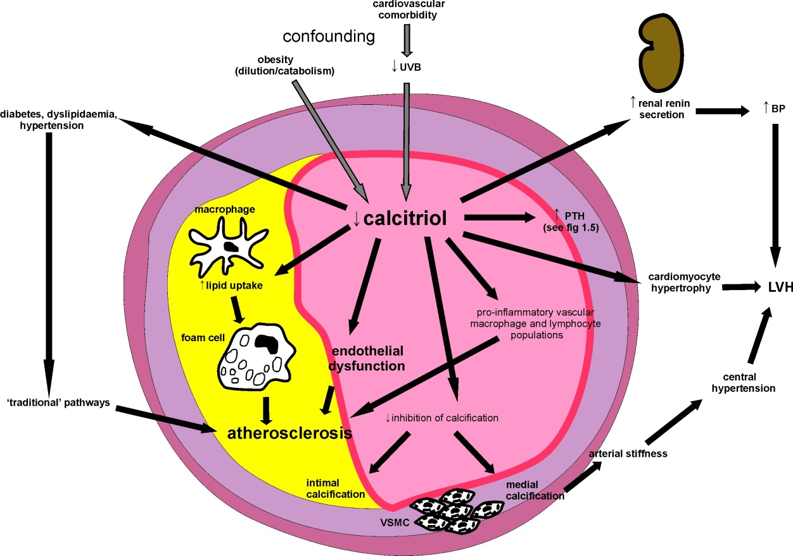

Figure 1.4 Summary of possible pathways underlying the association between vitamin D and cardiovascular outcomes.
Grey arrows denote confounding pathways.
UVB, ultraviolet B light; VSMC, vascular smooth muscle cells; LVH, left ventricular hypertrophy; PTH, parathyroid hormone.

Parathyroid hormone and cardiovascular disease

Summary of PTH physiology
Parathyroid hormone secretion by the parathyroid gland is stimulated by lower plasma ionized calcium and higher phosphate, and inhibited by calcitriol and FGF-23 (Kumar and Thompson, 2011). The actions of PTH are: 1) to increase bone reabsorption with release of calcium and phosphate, 2) to increase renal tubular calcium reabsorption and suppress phosphate reabsorption and 3) to increase renal calcitriol synthesis. The net consequences of these effects are an increase in plasma calcium concentration and a decrease in phosphate concentration.

Associations between PTH and cardiovascular outcomes
Even within the normal range a higher PTH is associated with substantial increases in cardiovascular events and mortality. For example, in a large population referred for coronary angiography (N=3,232) Pilz et al. reported the hazard ratio for cardiovascular mortality was 2.0 for the 4th versus 1st PTH quartile (Pilz et al., 2010b). This finding remained significant when subjects with PTH above the normal range (>65pg/ml) were excluded. Furthermore, there was a significantly greater risk of cardiovascular mortality for the 3rd versus 1st quartile, despite adjusting for traditional cardiovascular risk factors, kidney function, calcium, phosphate and 25(OH)D. In a population of elderly men, Hagstrom et al. found a progressive increase in cardiovascular mortality risk with increasing PTH, within the normal range of PTH and in subjects without 25(OH)D deficiency or abnormalities of serum calcium or phosphate (Hagstrom et al., 2009). Other studies have also reported associations between higher PTH and increased risk of both fatal and non-fatal cardiovascular events (van Ballegooijen et al., 2013). However, some studies have found PTH only predicted cardiovascular events at concentrations above the normal range (Grandi et al., 2011). Specific outcomes associated with higher PTH include sudden cardiac death (Pilz et al., 2010b) and incident heart failure (Kestenbaum et al., 2011).
Overt primary hyperparathyroidism is well known to be associated with CVD (Andersson et al., 2004), but whether this reflects a pathological effect of PTH itself or confounding by other factors is unknown; there are no randomised studies of the effects of PTH lowering (e.g. by parathyroidectomy or a calcimimetic agent) on cardiovascular outcomes in the setting of primary hyperparathyroidism. In dialysis patients with secondary hyperparathyroidism, the EVOLVE trial found no significant benefit of the calcimimetic cinacalcet on death or major cardiovascular events (Chertow et al., 2012). However, this does not mean that elevated PTH does not contribute to vascular disease in non-uraemic populations.

PTH and cardiovascular risk factors
Higher PTH within the normal range has been associated with components of an adverse cardiovascular risk profile including obesity (Ahlstrom et al., 2009), lower insulin sensitivity (Chiu et al., 2000), higher blood pressure (He and Scragg, 2011) and higher serum triglycerides (Ahlstrom et al., 2009). However, these findings are not consistent, with some large population studies failing to replicate many of the associations (Fraser et al., 2010, Kayaniyil et al., 2011). When adjusted for 25(OH)D concentration, the largest prospective community study to date reported that PTH only predicted incident hypertension at concentrations above the normal range and this association was attenuated by adjustment for BMI (van Ballegooijen et al., 2014).
Primary hyperparathyroidism is commonly accompanied by hypertension and an infusion of parathyroid hormone induces hypertension in healthy subjects (Hulter et al., 1986). However, a causative role for primary hyperparathyroidism in inducing other cardiovascular risk factors is unproven; small studies of the effects of parathyroidectomy on insulin sensitivity have reported conflicting results (Norenstedt et al., 2013, Ishay et al., 2011).

PTH and atherosclerosis
In the Tromso community study, higher PTH was associated with symptomatic ischaemic heart disease (Kamycheva et al., 2004). However, measures of atheroma burden such as carotid intima media thickness (Reis et al., 2009, Blondon et al., 2013) and angiographic coronary artery disease (Pilz et al., 2010b) have been reported not to be associated independently with higher PTH in other cohorts. In uraemic ApoE^{-/-} mice, a calcimimetic attenuated both atherosclerosis and vascular calcification (Joki et al., 2009), though this may reflect better control of phosphate and calcium disturbance, or a direct calcimimetic effect on vascular calcium-sensing receptors. The effects of PTH administration on atheroma burden in ApoE^{-/-} mice have not been tested.
In the large Multi Ethnic Study of Atherosclerosis cohort, higher PTH within the normal range was associated with a significant but small reduction in brachial artery FMD and large artery elasticity (Bosworth et al., 2013). Surgical correction of primary hyperparathyroidism has been reported to improve endothelial function (Osto et al., 2012, Nilsson et al., 1999, Kosch et al., 2000), suggesting that adverse effects of PTH on endothelium might be a contributor to atherosclerotic vascular disease. The PTH receptor is expressed by endothelial cells and there is limited in vitro evidence that PTH changes the phenotype of endothelial cultures: Rashid et al. reported a significant increase in interleukin-6 (Rashid et al., 2007a) and vascular endothelial growth factor (Rashid et al., 2008) transcription on addition of high-normal/pathological PTH concentrations to human umbilical vein endothelial cell (HUVEC) cultures. However, protein levels were not shown to change, so the relevance of these findings is unclear. Conversely, the same group found an increase in the expression and activity of endothelial nitric oxide synthase induced by PTH, consistent with an observed short term vasodilatory effect of PTH (Rashid et al., 2007b).
Vascular smooth muscle cells also express the PTH receptor. At high levels (10-20x normal) PTH was reported to stimulate VSMC collagen production in vitro (Perkovic et al., 2003), though overexpression of the PTH receptor on VSMC in a diabetic mouse model produced opposite and favourable effects (Cheng et al., 2010).
Another mechanism by which increased PTH could contribute to vascular disease is via increasing cellular oxidative stress through excessive intracellular calcium accumulation and consequent mitochondrial dysfunction (Tomaschitz et al., 2012). Cross-talk with the mineralocorticoid axis has been proposed to play a role in inducing adverse vascular effects of elevated PTH by this pathway: Aldosteronism is accompanied by renal calcium loss which may lower serum calcium, increase PTH secretion and paradoxically increase intracellular calcium. In a rat model of aldosteronism elevated PTH was accompanied by increased intracellular calcium in cardiomyocytes, peripheral blood mononuclear cells and skeletal muscle, despite a lowering of plasma calcium (Vidal et al., 2006). Parathyroidectomy prevented the intracellular calcium accumulation and attenuated an associated increase in oxidative stress. Increased PTH thus may play a permissive role in oxidative vascular damage induced by aldosterone. Parathyroid hormone is itself also reported to increase aldosterone secretion directly from the adrenals, so the PTH-mineralocorticoid interaction could work bidirectionally to contribute to vascular pathology (Tomaschitz et al., 2012).
Possible pathways underlying the associations between higher PTH and adverse cardiovascular outcomes are summarised in Figure 1.5.

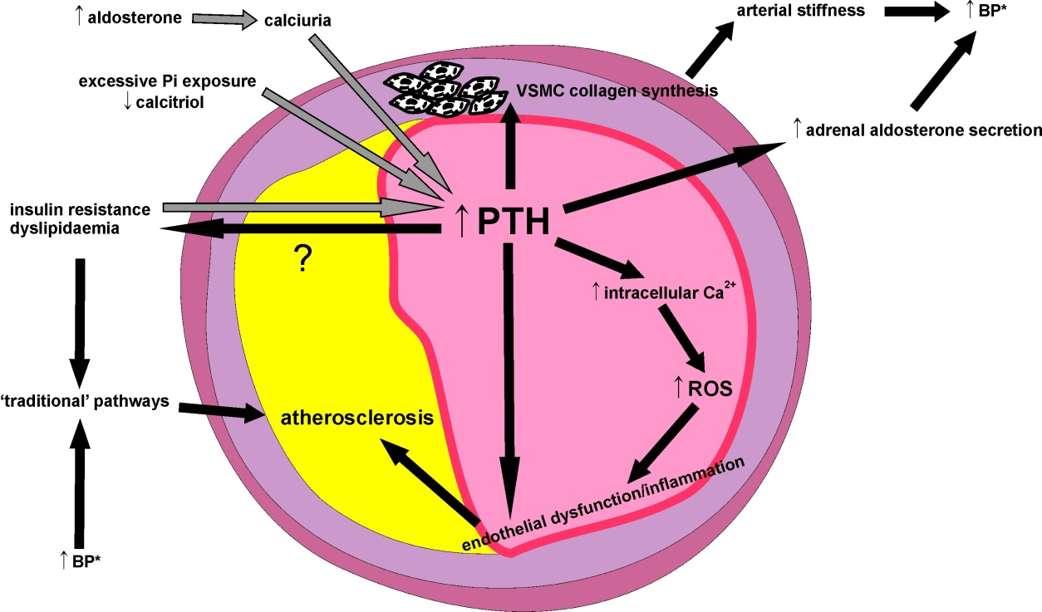

Figure 1.5 Summary of possible pathways underlying the association between PTH and cardiovascular outcomes.
Grey arrows indicate confounding pathways.
VSMC, vascular smooth muscle cell; BP, blood pressure; Pi, phosphate; ROS, reactive oxygen species. *Indicates elevated BP is a consequence of increased PTH that acts via traditional pathways.

Alkaline phosphatase and cardiovascular disease
Another bone mineral metabolism biomarker that has been associated with cardiovascular risk is serum alkaline phosphatase (ALP). Alkaline phosphatase is released by osteoblasts, and higher serum levels are seen in the setting of increased bone formation/turnover states such as hyperparathyroidism. Studies in community populations report higher ALP to be an independent predictor of myocardial infarction, cardiovascular events and cardiovascular mortality (Wannamethee et al., 2013, Tonelli et al., 2009, Abramowitz et al., 2010). Although increasing ALP is itself associated with a number of CVD risk factors including higher blood pressure, LDL cholesterol, inflammatory markers and smoking, adjustment for these does not abolish the above associations between higher ALP and adverse cardiovascular outcomes.
Since ALP is synthesized and released by a number of extra-osseous tissues, including liver, kidney, intestine and leucocytes, it is a non-specific marker of bone metabolism. It is not known which of these sources underlie(s) the association between higher ALP and CVD. A bone-specific ALP isoform can be measured, but most population studies assessing cardiovascular outcomes did not have measurement data for this. In a dialysis population bone-specific ALP was a stronger predictor of cardiovascular mortality than total ALP (Drechsler et al., 2011), perhaps reflecting a link between bone-type ALP and the arterial calcification which is highly prevalent in patients with advanced renal disease. Transition of VSMC to an osteoblastic phenotype involves the induction of bone-type ALP (Steitz et al., 2001), so circulating bone-type ALP may be at least partly of vascular origin. Alternatively, since lower bone mineral density is associated with vascular calcification in kidney disease (Toussaint et al., 2008), bone-specific ALP may be acting as a marker of disordered bone metabolism that contributes to uraemic vascular calcification. In contrast, in the United States National Health and Nutrition Examination Survey (NHANES), a representative general population sample, total ALP but not bone-specific ALP was a predictor of mortality (Filipowicz et al., 2013). Thus the other non-uraemic population observations may also not be related to bone-specific ALP.

Calcium
Serum calcium concentration is regulated by the same hormones as serum phosphate (Rosen, 2011, Kumar and Thompson, 2011). However, the associations of serum phosphate, dietary phosphate intake, PTH, FGF-23 and lower 25(OH) with CVD described above are all independent of serum calcium concentration. Prediction of some CVD outcomes by higher-normal serum calcium has been reported, but this is inconsistent (Foley et al., 2008, Dhingra et al., 2007). Therefore, the associations between bone mineral axis parameters and CVD reviewed in this chapter have been considered from a ‘phosphate-centric’ viewpoint. Nevertheless, any interventions to manipulate the bone mineral axis may affect calcium metabolism and this should be considered in the assessment of such interventions.

Bone mineral parameters and albuminuria
Higher urinary albumin excretion rates, even at levels well below the definition of moderately increased (previously ‘micro’) albuminuria (30mg/24h or a urine albumin:creatinine ratio of 30mg/g), predict cardiovascular disease events and mortality (Klausen et al., 2004, Matsushita et al., 2010). The basis for this finding is uncertain, but has been attributed to endothelial inflammation/dysfunction or glycocalyx disruption leading to increased glomerular permeability (de Zeeuw et al., 2006, Stehouwer and Smulders, 2006, Salmon et al., 2012). Given the postulated adverse effects of derangements in phosphate, 25(OH)D, FGF-23 and PTH on the endothelium, associations between these parameters and higher-normal or moderately increased urinary albumin excretion might be expected.
A single study has reported an association between increasing serum phosphate concentration and higher low grade albuminuria, quantified as the urine albumin:creatinine ratio (ACR), in a population without excretory kidney impairment (Lee et al., 2012). However, since higher serum phosphate concentration is itself associated with lower urine creatinine excretion (Ix et al., 2011b), this association might not actually reflect a difference in albumin leak. A reduction in 24h urine phosphate, considered a reflection of lower dietary phosphate intake, was an independent predictor of albuminuria reduction in the PREMIER study of lifestyle interventions in obese subjects with preserved kidney function (though this study did not report serum phosphate data)(Chang et al., 2013). Lower 25(OH)D concentrations have been associated with higher ACR (de Boer et al., 2007), but this may reflect confounding by muscle mass as the determinant of creatinine excretion rate; as might be expected, lower 25(OH)D is associated with sarcopaenia (Visser et al., 2003). Whether higher-normal PTH and FGF-23 are associated with higher urine albumin excretion has not been reported.

Summary of evidence and unanswered questions
In summary, in general population samples without recognised metabolic bone pathology, variations in bone mineral axis parameters predict substantial increases in CVD and mortality. Although some bone mineral parameters are associated with traditional cardiovascular risk factors, adjusting for traditional risk factors does not abolish the prediction of adverse cardiovascular outcomes; higher serum phosphate predicts cardiovascular events despite being inversely associated with likelihood of metabolic syndrome components. Plausible pathophysiological mechanisms involving endothelium and other cardiovascular tissues have been proposed, but causal relationships have not been proven to underlie the clinical observations. If causal relationships exist this would have public health implications for cardiovascular disease prevention.
The important unanswered questions in this field are therefore:
- Do the observed associations between bone mineral axis parameters and CVD reflect pathological effects of bone mineral axis disturbance?
- What is the most important parameter to optimise and how should this be done?
- What are the mechanisms by which bone mineral axis disturbance causes cardiovascular disease?
- How do these pathways interact with traditional paradigms of cardiovascular disease pathogenesis?

Aim and objectives
The aim of this work was to investigate the role played by bone mineral axis disturbances on cardiovascular disease pathogenesis. Since excessive dietary phosphate and inadequate vitamin D are the two reversible primary disturbances most likely to interrupt normal physiology in the context of an unhealthy western lifestyle, these were prioritised for investigation. The work is divided into the following objectives, each with a dedicated results chapter:

Objective 1: To determine the effects of dietary phosphate manipulation on cardiovascular risk profile and atherogenesis in ApoE^{-/-} mice.
Male ApoE^{-/-} mice were fed atherogenic high-fat diets with low, standard or high phosphate content. The effects of these diets on plasma phosphate, calcium, PTH and FGF-23 were determined. Metabolic profile was assessed in terms of insulin resistance, obesity, tail cuff blood pressure and lipid profile. Atheroma burden was measured in cross sections through the aortic sinus.

Objective 2: To determine the metabolic and cardiovascular phenotypes of dietary vitamin D deficiency and active vitamin D analogue administration in ApoE^{-/-} mice, with concomitant analysis of structural bone changes to place the findings in the context of the severity of the intervention.
Male ApoE^{-/-} mice were fed high-fat atherogenic diets either replete or deficient in vitamin D. The active vitamin D analogue paricalcitol or vehicle was also administered to test the effects of systemic active vitamin D signalling on 25(OH)D deficient- and replete backgrounds. Metabolic profile and atheroma burden were assessed as for objective 1. Left ventricular hypertrophy was quantified by echocardiography/histology and aortic sinus calcification by von Kossa staining. Microtomography of the tibia was used for analysis of structural bone changes.
Objective 3: To investigate the associations between bone mineral axis parameters and low grade albuminuria in a representative general population sample.
Using data from the United States National Health and Nutrition Examination Surveys (NHANES) 1999-2010, associations of each parameter with albuminuria were examined by linear regression, adjusting for other relevant covariates.
Objective 4: To investigate the effects of manipulating bone mineral axis parameters on endothelial cells in vitro.
Human umbilical vein endothelial cell (HUVEC) cultures were exposed to different concentrations of phosphate, FGF-23, PTH and calcitriol. The effects were assessed in terms of cellular oxidative stress, apoptosis, proliferation and nitric oxide generation.

Methods

Summary of animal models

Dietary phosphate manipulation study
To investigate the effects of dietary phosphate intake on metabolic phenotype and atherosclerosis, 8 week old male ApoE^{-/-} mice were commenced on atherogenic diets with low, standard, or high phosphate content (described in 3.3.1). After dietary intervention periods of 12 weeks or 20 weeks, atheroma burden was assessed in cross sections through the aortic sinus and en face preparations of the thoracic aorta. Metabolic phenotype was characterised as body mass index, fat pad mass, insulin resistance, plasma lipids, blood pressure and hepatic steatosis. Changes in plasma PTH and FGF-23 induced by altered dietary phosphate intake were also measured.

Vitamin D manipulation study
In a second study the vitamin D status of male ApoE^{-/-} mice was manipulated to investigate the effects on atherosclerosis, metabolic phenotype and left ventricular hypertrophy. Dietary vitamin D deficiency was induced by commencing a vitamin D3-deficient diet at age 8 weeks. To investigate the effects of increased vitamin D signalling, the active vitamin D analogue paricalcitol was administered to mice on a vitamin D replete diet. Since local activation of 25(OH)D may be important independently of systemic vitamin D levels, the phenotype of 25(OH)D deficiency in the presence of adequate systemic active vitamin D was also examined by combining paricalcitol and vitamin D deficient diet. There were thus 4 intervention groups: 1.) vitamin D replete diet + vehicle, 2.) vitamin D deficient diet + vehicle, 3.) vitamin D replete diet + paricalcitol, and 4.) vitamin D deficient diet + paricalcitol (n=7-8 per group).

Animal study general methods

Mice –husbandry
Male ApoE^{-/-} mice on a C57BL/6 background were obtained from a breeding colony maintained within the University of Sheffield Biological Services Unit (original source Jax Labs; JAX2052). From weaning until the commencement of atherogenic test diets, all mice were fed standard vitamin D replete (1.5IU/kg) rodent chow (Special Diet Services, UK) containing 0.6% w/w phosphorus. Chow consumption was determined by weighing the amount provided and remaining for each cage on a weekly basis. Free access to food and water was maintained throughout all studies. Animals were housed in a humidity-controlled environment at 22°C with a 12h fluorescent light/dark cycle. All animal experiments were approved by the University of Sheffield Project Review Committee and conformed to UK Home Office Regulations (Animal Scientific Procedures Act 1986; Project Licence PPL40/3307).

Blood pressure measurement
Blood pressure measurements were performed using the Visitech 2000 tail cuff analysis system (Visitech Systems, NJ, USA) on 4 animals from each intervention group. Animals were acclimatized to the technique by one week of daily training (readings taken but data not analysed). Animals were placed on a pre-warmed surface maintained at 32°C in quiet surroundings. Measurements were performed at the same time of day (morning) and an initial set of 10 acclimatization measurements taken on each occasion. Results were based on the subsequent 20 attempted measurements (cuff inflations), with a mean number of successful measurements of 12 per mouse per session. Mean arterial blood pressure was calculated from each pair of systolic/diastolic measurements according to the formula: mean BP = diastolic + 1/3*(systolic-diastolic).

Obesity and organ weights
Obesity was assessed in terms of absolute weight gain and final body weight, body mass index ((weight in kg)/(length in m)²) and epididymal fat pad mass; both epididymal fat pads were dissected free of the associated tissues. Weights of the liver, heart, kidneys, lungs and spleen were also determined.

Tail vein blood sampling
For collection of tail vein blood samples, animals were placed on a controlled heating platform maintained at 32°C for 20 minutes to induce cutaneous vasodilation. Petroleum jelly was applied to facilitate blood droplet collection and a lateral tail vein punctured with a size 11 straight blade. Blood (150μl) was collected into an Eppendorf tube and immediately centrifuged at 10,000g for 10 minutes. A small volume of whole blood (0.3μl) was tested directly for fasting glucose assessments by applying a test strip (Optium plus, Medisense, UK) to the tail vein puncture site at the commencement of blood collection. Supernatant plasma was aliquoted and stored at -80°C prior to all analyses. For fasting sample collection, mice were fasted from 8am and samples collected at 4-5pm.

Tissue collection and preparation
Following intraperitoneal injection of an overdose of pentobarbitone (4mg), loss of pedal reflex was confirmed before the aspiration of blood via transthoracic left ventricular puncture. Thoracotomy and laparotomy were then performed and the vasculature flushed with 1ml phosphate buffered saline (PBS) injected via the apex of the left ventricle. The inferior vena cava was identified and transected to allow efflux of remaining blood and flushing solution. Perfusion fixation was then performed by left ventricular injection of 1ml 10% v/v formalin in PBS. Thoracic aortae were dissected free of connective tissue from the aortic origin to the level of the diaphragm (Figure 2.1) and fixed in 4% w/v paraformaldehyde in PBS for 24h before transferring to PBS. Heart, liver, kidneys, spleen, lungs and epididymal fat pads were dissected free of connective tissue before weighing and fixing in 10% v/v formalin for 24h. Following dehydration in increasing concentrations of alcohol and then xylene, these organs were embedded in paraffin wax. Sections for histological analysis were cut at 7μm thickness with a microtome (Leica RM1235, Leica Microsystems, UK). Tibiae were dissected free of most connective tissue, but without separating from fibula and distal femur, then stored in 10% v/v formalin in PBS at 4°C until scanned. As a measure of adiposity, epididymal fat pads were dissected free of the epididymis and weighed. A second measure of adipose mass, the mesenteric visceral fat pad, was dissected from the mesenteric intestinal border from the level of the proximal duodenum to the colon.

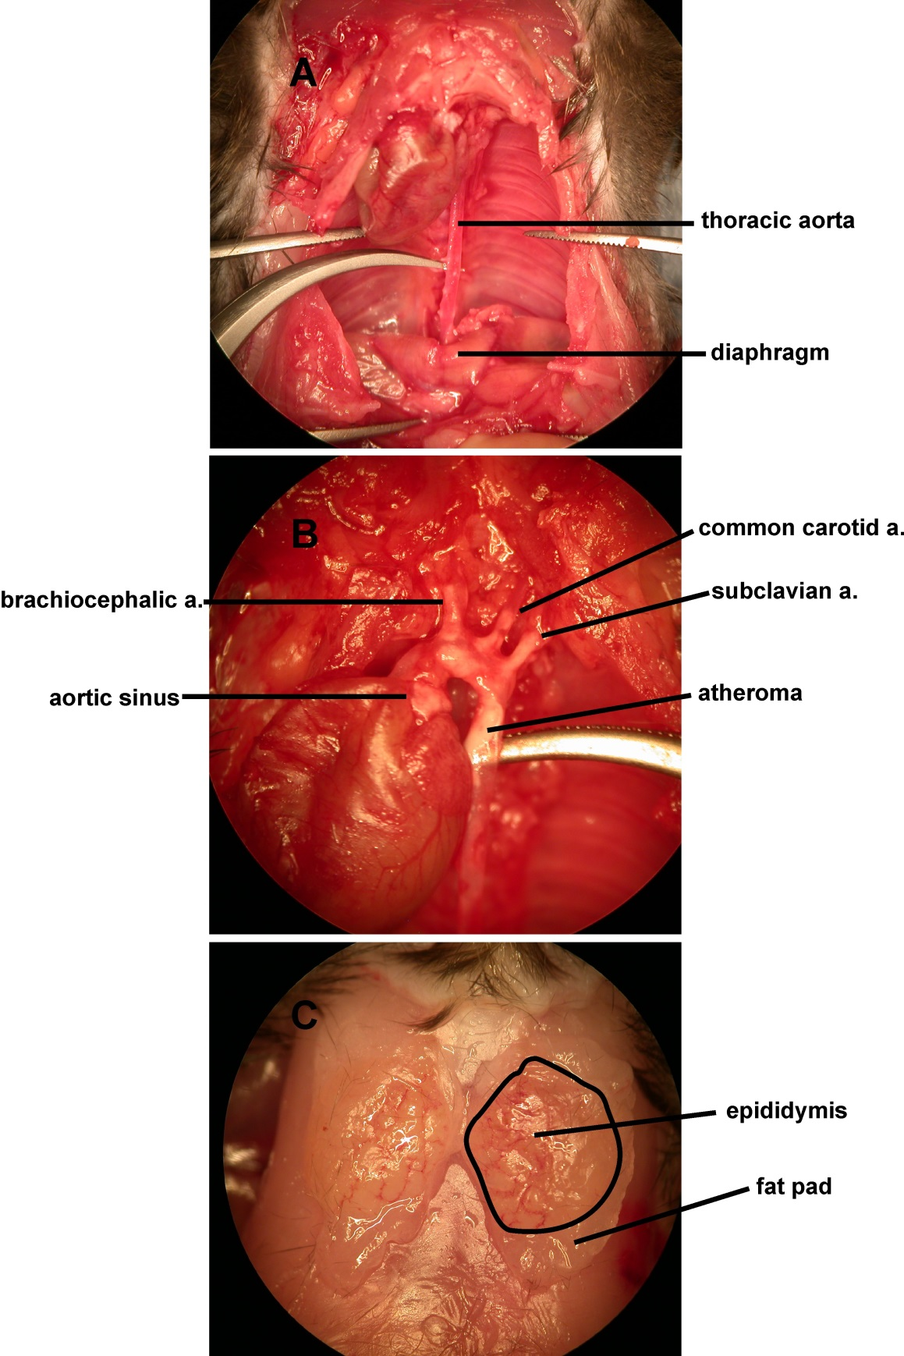
Figure 2.1 Tissue collection
A, isolation of thoracic aorta. B, isolation of aortic arch with evidence of atheroma. C, epididymal fat pads with overlying epididymis

Histological staining
For all the following staining procedures, paraffin embedded sections were first rehydrated by sequential immersion in 100% xylene, 100% ethanol, 90% v/v ethanol, 70% v/v ethanol and water (2min each). Following staining sections were dehydrated by the reverse sequence and mounted using dibutylphthalate in xylene.

Miller’s Elastin/van Gieson staining (for atheroma area quantification)
Staining sequence: Sections were oxidised with 0.25% w/v potassium permanganate (3min), rinsed with water, bleached with 1% v/v oxalic acid (3min), nuclei stained with Carazzi’s haematoxylin (2min), differentiated in acid alcohol (1% v/v hydrochloric acid in 70% v/v industrial methylated spirit (IMS), 10s), nuclei ‘blued’ with hot water (5min), stained with 1% w/v Alcian blue in 3% v/v aqueous acetic acid (5min), rinsed with water, stained with Miller’s elastin (30min), rinsed and differentiated in 95% v/v aqueous denatured ethanol, rinsed with water, stained with Curtis’ modified van Gieson stain (0.01% w/v ponceau S in saturated picric acid, 1% v/v glacial acetic acid, 6min).
Interpretation: Elastin stained blue/black, collagen stained red, muscle stained yellow, cell nuclei stained blue.

Von Kossa staining (for vascular calcification)
Staining sequence: Sections were immersed in 1% w/v aqueous silver nitrate under a 60 watt lamp for 60min, rinsed with 3 changes of distilled water, cleared of excess silver using 2.5% w/v sodium thiosulphate (5min), rinsed with water and counterstained with nuclear fast red (3min). Using this protocol calcification staining was minimal in aortic sinuses from the phosphate modification study. Therefore for the vitamin D manipulation study a 2% w/v aqueous silver nitrate solution was used.
Interpretation: Calcification (phosphate) stained black, other tissue (nucleic acids) red.

Haematoxylin and eosin staining (cardiomyocyte dimensions, hepatic steatosis, acellular atheroma fraction)
Staining sequence: Sections were stained with Carazzi’s haematoxylin (3min), rinsed in water, destained with acid alcohol (1% v/v hydrochloric acid in 70% v/v IMS, 10s), rinsed in water and stained with 1% v/v aqueous eosin (45s).
Interpretation: Nuclei stained blue, protein and carbohydrate (cytoplasm) stained red/pink.

Oil red O staining (en face aorta atheroma quantification)
Following rinsing in water and 60% v/v isopropanol (2min), aortae were immersed in 60% w/v oil red O in propanol (12min) then rinsed again in 60% v/v isopropanol and water.
Interpretation: Lipid stained dark red.

Immunohistochemistry
For immunohistochemistry of aortic sinus sections endogenous peroxidases were blocked by immersion in 3% v/v hydrogen peroxide (Sigma, UK) in PBS for 10 min. Antigen retrieval was performed with 10% v/v pH6 citrate buffer (Dako, Germany) in water at 95°C for 20 min and sections were then permeabilised with 0.5% v/v triton X-100 (Sigma) for 5 min at room temperature. Incubation in milk buffer for 30 min was used to block nonspecific antibody binding. Following washing in PBS, sections were incubated with primary rabbit polyclonal antibodies to osteopontin (ab8488, Abcam, UK) at 1:150 dilution overnight at 4°C, then incubated with horseradish peroxidase-conjugated goat anti-rabbit secondary antibody (P0448, Dako, Denmark) at 1:200 dilution for 30 min. After repeated washing in PBS, complexes were visualized with diaminobenzidine and sections counterstained with Carazzi’s haematoxylin. Polyclonal rabbit anti-porcine antibodies (R0156 Dako, Germany) were used as an isotype control. Absence of non-specific staining was also confirmed using the secondary antibody without primary antibody.

Image analysis
All image analysis was performed using NIS-elements BR 3.0 software (Nikon Instruments, USA) by the candidate, blinded to the intervention group.

Cross sectional atheroma burden analysis
Cross sectional atheroma burden was quantified at 10x magnification on a series of 7μm sections taken at 42μm intervals (i.e. every 6th section) through the aortic sinus and stained with Miller’s elastin/van Gieson stain. The region of interest was defined by the presence of 3 aortic valve leaflets. Lumen area was calculated from perimeter measurements to correct for fixation and sectioning errors. Atheroma burden (cross sectional area) was quantified as absolute area and as a percentage of the lumen cross sectional area.

Lesion character analysis
The necrotic (acellular) proportion of atherosclerotic lesion was measured on haematoxylin and eosin-stained sections of aortic sinus adjacent to the section found to contain the greatest atheroma burden on Miller’s elastin/van Gieson staining. Necrotic plaque was quantified by tracing around the regions of the lesion that did not stain for nuclei, as described previously (Yamamoto et al., 2011). Plaque lipid content was measured on the Miller’s elastin/van Gieson–stained section containing the greatest amount of atheroma by tracing around the lipid crystal ‘ghosts’ left by fixation and processing (Cuerrier et al., 2013) (Figure 2.2).

Calcification analysis
Calcification analysis was performed in the vitamin D manipulation study on 5 von Kossa-stained sections taken across the aortic sinus. Staining was detected automatically at 10x magnification using a binary threshold of blue colour intensity set to identify the black positive (silver salt) von Kossa stain. Calcification was assessed in terms of the number of calcifications present and the calcified area, both normalised to the total atheroma lesion area measured on neighbouring Miller’s elastin/van Gieson-stained sections as above. A small number of large calcifications dominated the total calcified lesion area measurements so that meaningful statistical comparisons of percentage calcified area between groups were not possible. Therefore, ‘diffuse’ atheromatous calcification was examined with the approach adopted by Schmidt et al. of quantifying the number of distinct calcifications (subanalysed by size ≥/<100μm²), indexed to atherosclerotic lesion area (Schmidt et al., 2012). The total number of calcifications per mm² atheroma area was considered a measure of diffuse calcification density. Percentage calcified area attributable to calcifications <100 μm² was also compared across intervention groups. The large number of calcifications <100 μm², distributed diffusely in all plaques, allowed a more robust statistical comparison of calcification character by these measures.

En face aorta lipid quantification
For en face analysis of thoracic aorta lipid content, oil red O-stained thoracic aortae were pinned onto wax and photographed at 1.5x magnification (Figure 2.2). Quantification of lipid stained area was performed using the NIS Elements software, with red colour intensity and saturation thresholds optimised for each study but kept constant for all aortae across intervention groups.

Hepatic steatosis assessment
Sections were taken through the liver in transverse plane and stained with haematoxylin and eosin as described above. The presence of hepatic steatosis was assessed under low power magnification (10x), blinded to the dietary phosphate group. Global hepatic steatosis was considered present if the majority of tissue showed lipid droplets and attenuation of eosinophilic cytoplasmic carbohydrate staining.

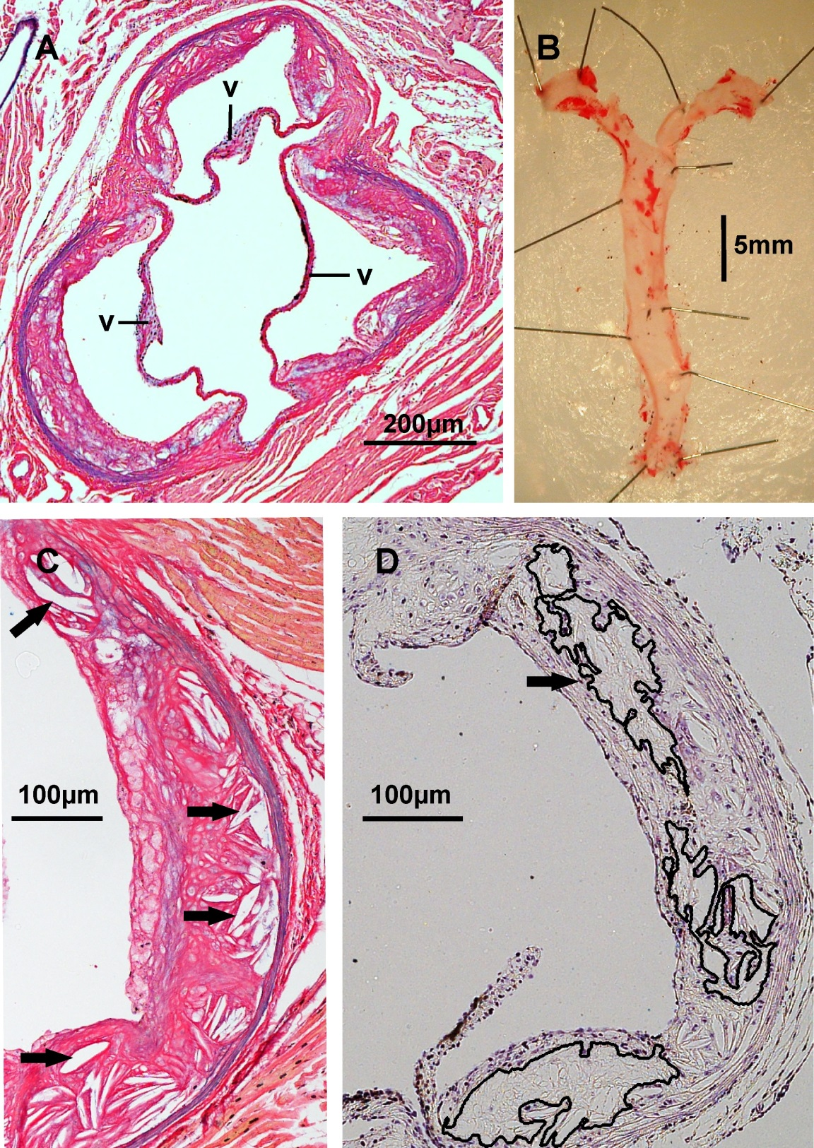
Figure 2.2 Atheroma characterisation.
A, aortic sinus atheroma stained with Miller’s elastin/van Gieson, showing aortic valve leaflets (V). B, thoracic aorta stained for lipid with oil red O. C, Millers’ elastin/van Gieson-stained section with example lipid clefts indicated by arrows. D, haematoxylin and eosin-stained lesion with some areas of acellularity marked.

Left ventricular hypertrophy analysis
Transverse sections were cut at 100μm intervals in a caudal direction from the base of the left ventricle. Left ventricular morphology was assessed on haematoxylin and eosin-stained sections taken 500μm below the level of the mitral valve. Cross-sectional area of the left ventricle was determined at 4x magnification by subtracting the cavity cross section from the total area. Mean left ventricular wall thickness was calculated from the free wall, opposite wall and the 2 perpendicular walls. To assess cardiomyocyte size differences between treatment groups, 50 transverse cardiomyocyte cross-sectional areas and 50 longitudinal cardiomyocyte widths were measured across the 4 walls of the left ventricle at 40x magnification (Figure 2.3).
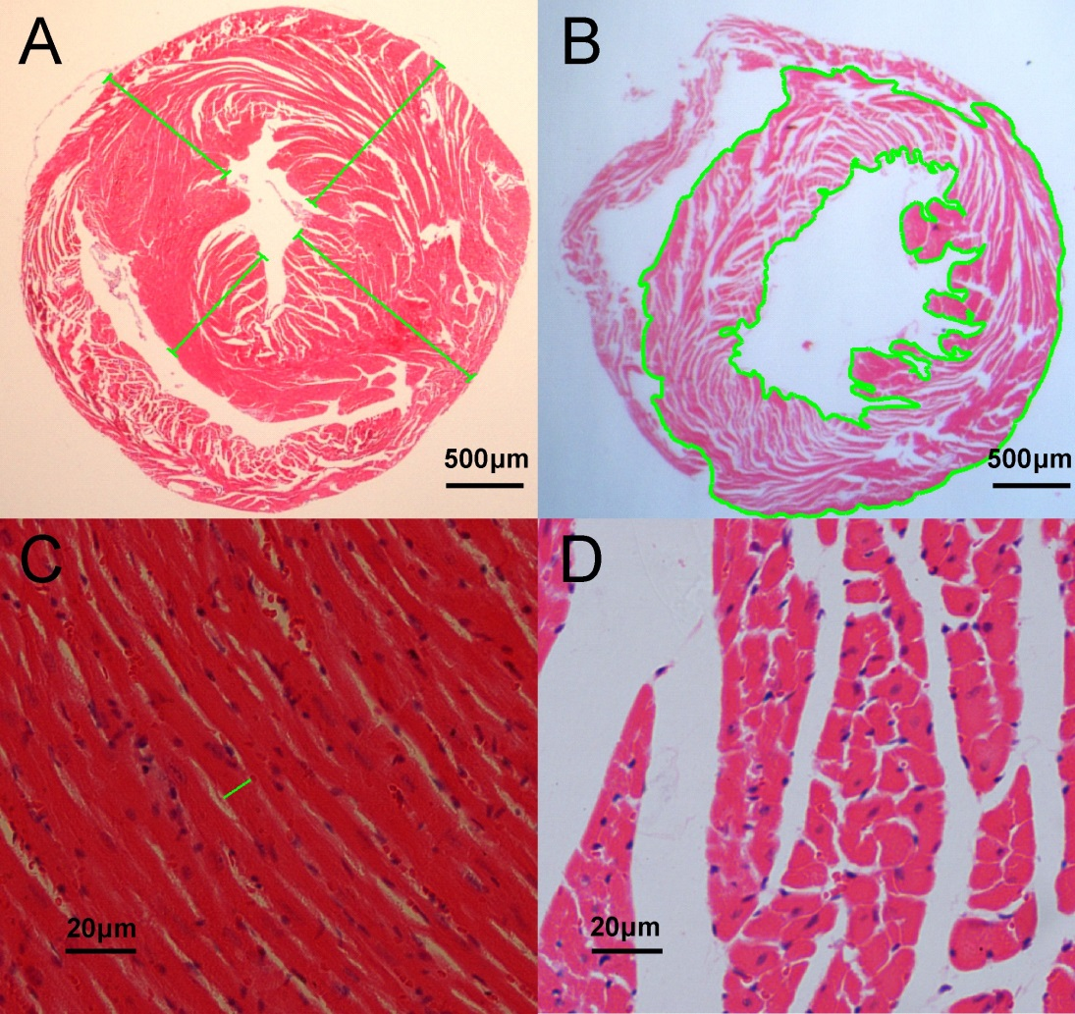
Figure 2.3 Histological measurement of left ventricular wall thickness and cardiomyocyte dimensions.
A, left ventricular wall measurements. B, left ventricular cross-sectional wall area. C, cardiomyocytes in longitudinal section (for width measurements). D, transverse section through cardiomyocytes (for cross-sectional area measurements).

Echocardiography
Echocardiography was performed by Dr Abdul Hameed (Department of Cardiovascular Science, University of Sheffield) on 5-6 animals per group from the vitamin D intervention study. Assessments were undertaken during the 19th week of the intervention and performed with blinding to the intervention group. Under isofluorane anaesthesia, short axis views of the left ventricle were obtained at the mid papillary muscle level (Vevo 770 ultrasound, Visual Sonics, Toronto, Canada). A heart rate of approximately 500bpm was maintained throughout the studies by titrating the isofluorane flow rate. Body temperature was controlled using a heated platform with monitoring of rectal temperature. Left ventricular fractional area change was determined by manual tracing of the LV wall end diastolic and end systolic areas. Ventricular wall and cavity dimensions were assessed with M-mode measurements; ejection fraction was determined from these measurements by automated software.

Microtomography
The effects of vitamin D manipulation on bone structure were determined by high resolution microtomography (Skyscan MicroCT, Skyscan, Belgium). The right tibia was dissected free of most connective tissue and fixed in formalin prior to scanning. For analysis of trabecular bone structure, images were obtained with an element voltage of 50kV, a 0.5mm aluminium filter and 4.3μm/pixel resolution, with an average taken from 2 scans per 0.7° rotation step through a total rotation of 180°. The region of interest for trabecular bone analyses was defined as a 1mm length of bone extending distally from a point 0.2mm distal to the proximal growth plate (Figure 2.4). For cortical bone analysis a region of interest of 1mm extending distally from a point 3mm distal to the proximal growth plate was used. Cortical bone analyses were performed on images obtained at lower resolution (17.2μm/pixel) in order to scan a greater length of bone.
Microtomography cross-sectional images were reconstructed using dedicated software (NRECON, Skyscan, Belgium), with automated compensation for rotatory misalignment and ring artefacts. Subsequent image analyses were performed with CTAnalyzer software (Skyscan, Belgium). Trabecular and cortical bone components were defined in cross section by manually tracing around the trabecular bone beneath the cortical bone at a depth equal to the cortical bone thickness.

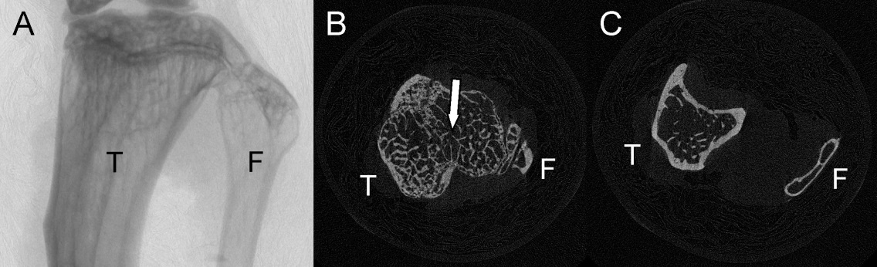
Figure 2.4 Microtomography of mouse tibia
A, proximal tibia (T) and fibula (F). B, proximal growth plate margin defined by loss of continuity in trabecular bridge between anterior and posterior cortex (arrow). C, shaft of tibia with thicker cortical bone and less trabecular bone.

Plasma biochemistry and ELISAs
Commercial sandwich ELISA assays were used to quantify plasma insulin (Crystalchem, USA), adiponectin (R&D systems, UK), soluble vascular cell adhesion molecule-1 (sVCAM-1, R and D Systems, UK) PTH (Immutopics, USA) and FGF-23 (KAINOS Laboratories, Japan), according to the manufacturers’ instructions. Plasma nitric oxide oxidation products were quantified using a Sievers Bioanalyser (GE Healthcare, UK) by Mr Risat ul Haque (University of Sheffield). Whole blood fasting glucose concentration was measured using a portable glucometer (Optium Xceed, Medisense, UK). All other plasma biochemistry measurements were performed by autoanalyser (Beckman Coulter DxC) in the biochemistry laboratories of Sheffield Teaching Hospitals NHS Trust. Low density lipoprotein cholesterol was calculated from other lipid fractions according to the Friedewald formula (Warnick et al., 1990): LDL = total cholesterol – HDL cholesterol –0.45x triglyceride (all in mM). Insulin resistance was measured by standard homeostatic model assessment (Bonora et al., 2000): (HOMA-IR) = fasting glucose (mmol/l) × fasting insulin (mU/l)/22.5.

Statistical analysis
Data from the animal model studies are presented as mean and standard error. Comparisons across the intervention groups for continuous variables were made by one-way ANOVA with a Bonferroni correction for multiple comparisons. The proportion of livers with evidence of steatosis was compared across groups by a Chi-squared test for trend.

Albuminuria analyses in NHANES

Summary of the NHANES observational study
To look for evidence that disturbances of the bone mineral axis contribute to cardiovascular disease through endothelial dysfunction, associations were examined between metabolic bone parameters (serum phosphate, dietary phosphate intake, PTH, 25(OH)D and ALP) and higher low grade albuminuria (taken as a marker of endothelial dysfunction). For this analysis a US population-representative sample, the National Health and Nutrition Examination Survey (NHANES) was used.

Technical note; phosphate versus phosphorus
Since the element phosphorus is found in serum/plasma/diet entirely in the form of phosphate, serum phosphorus concentration (in mg/dl) and serum phosphate concentration (in mM) are used interchangeably to represent the same parameter, where 1mg/dl phosphorus = 0.32mM phosphate (Iheagwara et al., 2013). The US convention adopted by NHANES and previous similar publications is to report phosphorus concentration in mg/dl, though the assay used to measure this is in fact measuring phosphate (via a reaction between phosphate and ammonium molybdate to give a phosphomolybdate complex that absorbs UV light at 340nm). For this work, serum phosphate concentrations were reported according to the UK convention in mM, using the above correction, for consistency across experiments. Dietary phosphorus content, absolute intake and density were reported as % w/w, mg and mg/kcal respectively, for ease of reference to previous work.

The NHANES cohort
The US NHANES study programme is conducted by the National Centre for Health Statistics to monitor the health and nutritional status of the US population. Data are obtained by interview, examination and blood/urine sample collection. Surveys are conducted continuously in 2-year data collection cycles and a complex multi-stage sampling methodology is used to generate survey samples representative of the US noninstitutionalised population. Certain population subgroups (non-Hispanic blacks, Mexican-Americans, and the over 60s) are oversampled to increase the reliability of statistical estimates in these groups. Sample weights are assigned to each participant and incorporated into statistical analyses to produce estimates applicable to the general US population. Anonymized data are made freely available on the NHANES website and were downloaded for the analyses described below.

Study population selection
For the purposes of this analysis, data from the continuous NHANES cycles 1999-2010 were combined. The study cohort was confined to non-pregnant adults aged at least 20y with complete demographic, dietary, examination and biochemical data. Since albuminuria can only be considered a marker of endothelial dysfunction in the absence of primary renal pathology, participants with an estimated glomerular filtration rate (eGFR) <60ml/min/1.73m² according to the Chronic Kidney Disease Epidemiology Collaboration eGFR equation (Levey et al., 2009) were excluded. Similarly, since severely increased albuminuria (a urine ACR >300mg/g) is a reflector of renal pathology rather than endothelial dysfunction, participants with this degree of albuminuria were also excluded from the analyses.
Parathyroid hormone, 25(OH)D and bone-specific ALP measurements were only available for participants in the NHANES cycles 2003-2006, 2003-2006 and 1999-2004 respectively. Analyses involving these variables were therefore confined to participants from those cycles meeting the other criteria above.

Albuminuria measurements
Albuminuria is quantified in NHANES by spot urine ACR, using urine creatinine concentration to adjust the albumin concentration for differences in tonicity. This conventional approach has the advantage of avoiding the inconvenience and inaccuracy of timed urine collections. However, a significant disadvantage is that muscle mass (as the main determinant of creatinine generation/excretion rate) becomes a confounding factor in associations. (I have published on this issue and potential solutions elsewhere (Ellam, 2011, Ellam and El Nahas, 2011, Fotheringham et al., 2013).) Confounding by creatinine excretion rate is a particular issue with regard to bone metabolism parameters; higher serum phosphate has been identified as a predictor of lower creatinine excretion rate (Ix et al., 2011b) whilst lower serum 25(OH)D and greater PTH are both associated with sarcopaenia (Visser et al., 2003). In view of these concerns, fractional excretion of albumin relative to creatinine (FE_{alb}, i.e. albumin clearance divided by creatinine clearance, calculated from paired serum and urine concentrations of both) was used as a second measure of urine albumin leak. A disadvantage of this approach is that increasing tubular creatinine secretion affects results in the setting of kidney impairment. However, it may be considered a more logical measurement of renal albumin permeability(Ellam and El Nahas, 2011) and abolishes the confounding effects of muscle mass.

Biochemical analyses
Detailed descriptions of biochemical assay procedures are available on the NHANES website (www.cdc.gov/nchs/nhanes/htm) . For the principal analyses of interest, methods were as follows: Serum phosphate and intact PTH concentrations were measured by a kinetic ammonium molybdate reaction and a chemiluminescent sandwich antibody approach respectively. Serum 25(OH)D concentrations were assayed by radioimmunoassay (Diasorin inc., MN), recalibrated for assay drift across cycles. Total ALP concentration was determined by quantification of enzymatic p-Nitrophenylphosphate hydrolysis and BAP was measured as the activity of antibody-captured enzyme on colorimetric/fluorescent substrates, with recalibration of results obtained by different methods. Serum creatinine was (measured by the Jaffe rate method) was recalibrated across cycles according to NHANES recommendations (Selvin et al., 2007). Urine creatinine and albumin were measured by Jaffe rate method and solid-phase fluorescent immunoassay respectively.

Clinical history and demographic data
Diabetes was defined as answer ‘yes’ to the question ‘Have you ever been told by a doctor or other health professional that you have diabetes or sugar diabetes?’ or current use of insulin or oral hypoglycaemic agents. Current smoking status was classified according to the question ‘Have you used tobacco or nicotine in the last 5 days?’ and a history of CVD was defined by ‘Yes’ to any of ‘Have you ever been told you had coronary heart disease/angina/heart attack?’ Race and ethnicity were self-reported and for the purposes of this work were categorised as non-Hispanic White, non-Hispanic Black, Hispanic or other.
Weight, waist circumference and standing height were measured on attendance at a mobile examination centre. Blood pressure was taken as the average of the 2nd and 3rd of 3 attempted readings; if only one measurement was obtained successfully, this was used; if only two readings were obtained, the second was used.

Dietary intake estimates
Nutrient intakes in NHANES are estimated on the basis of a 24h dietary intake recall questionnaire; food types and estimated portion sizes are used to calculate nutrient intakes with the Food and Nutrient Database for Dietary Studies (US Department of Agriculture Food Research Group, http://www.ars.usda.gov/ba/fsrg). Dietary phosphate density (expressed as phosphorus intake in mg per calorie) was used as the primary measure of dietary phosphate exposure since this was previously shown to have a stronger association with cardiovascular mortality than absolute phosphate intake (Chang et al., 2014). However, in secondary analyses the relationship of absolute phosphate intake (in mg phosphorus per 24h) to measures of albuminuria was also examined.

Statistical methods
Associations between quintiles of each metabolic bone parameter and measures of albuminuria were assessed in linear regression models. Log transformation was applied to non-normally distributed variables prior to this analysis. Since spot urine albumin and creatinine concentrations, ACR and FE_{alb} were all positively skewed and log transformed for the regression analyses, back-transformed results are reported as the fold-change increase in these measures relative to the reference quintile of each metabolic bone parameter. Linear regression analyses were performed using SAS version 9.3 (SAS Institute, US) incorporating participant sample weights to account for the complex study design.
The odds ratio of having moderately increased (previously ‘micro-’) albuminuria (ACR>30mg/g) by quintile of each test variable was determined by binary logistic regression. Confidence intervals for these odds ratios were derived using STATA version 11 (StataCorp LP) since SAS software does not have the facility for this calculation. Software and codes for the STATA analysis were provided by Dr James Fotheringham (University of Sheffield).

Covariate adjustments
Age, gender and race were included a priori in all regression analyses because these are known predictors of creatinine excretion rate (Ix et al., 2011b). The first regression model (model 1) adjusted only for these covariates. Since associations have previously been reported between bone metabolism parameters and metabolic syndrome components (Park et al., 2009, Reis et al., 2007, Reis et al., 2008), model 2 additionally adjusted for body mass index (BMI), weight, waist circumference, blood pressure, diabetes status, glycated haemoglobin and serum lipids. In model 3 further adjustment was made for predictors of albuminuria, including smoking status, history of CVD, poverty:income ratio, eGFR and C-reactive protein. This model was also tailored to include further covariates relevant to each individual test parameter, as follows:

- Since serum phosphate and PTH concentrations follow a diurnal pattern (Pocock et al., 1989, el-Hajj Fuleihan et al., 1997), model 3 analyses for these variables included time of day of venepuncture.
- Analyses of 25(OH)D incorporated season of measurement.
- Analyses of total ALP included hepatic transaminases.
- Analyses of PTH adjusted for use of loop and thiazide diuretics, since both may affect PTH (Isakova et al., 2011a).
- Analyses of dietary phosphate density were adjusted for estimated protein intake; protein and phosphate intakes are correlated, but there is some evidence that protein ingestion may affect albuminuria through glomerular haemodynamic changes independently of phosphorus (Tuttle and Bruton, 1992).
- Dietary phosphate density analyses were also adjusted for estimated intakes of sodium and saturated fat, which have both been associated with albuminuria in other studies (Forman et al., 2012, Lin et al., 2010).

Because fasting status is a recognised determinant of serum phosphate (de Boer et al., 2009b), associations between serum phosphate and albuminuria were also tested in the subpopulation of NHANES participants assessed in the morning after overnight (at least 9 hours) fast.

Endothelial cell culture studies

Human umbilical vein endothelial isolation and culture
Human umbilical vein endothelial cells (HUVEC) were isolated from umbilical cords donated at the Sheffield Teaching Hospitals Jessop Wing Maternity Unit. Written informed consent was obtained from donors and the cord donation protocol approved by the North Sheffield Research Ethics Committee (reference 10/H1308/25NRES). Cords were stored and transported in minimum essential medium (Invitrogen, UK) at 4°C.
HUVEC were isolated from umbilical cords according to the standard procedure (Jaffe et al., 1973) as follows: cords were allowed to warm to room temperature and cleaned externally with isopropyl alcohol; the umbilical vein was then cannulated and rinsed with warmed unsupplemented M199 endothelial culture medium. A clamp was applied to the uncannulated end of the vein, which was then inflated with 0.1% w/v type IV collagenase (isolated from C. histolyticum, Sigma, UK) in medium M199 (Gibco, UK) and incubated for 20 minutes at 37°C. The released HUVEC were then eluted with medium M199, centrifuged at 1000g for 5 minutes, resuspended in M199 then seeded into gelatin-coated tissue culture flasks.
HUVEC were grown in M199 medium (Invitrogen, UK) supplemented with 20 μg/ml endothelial cell growth supplement (Harbour Bio-Products, US), 95μg/ml heparin (Sigma), 0.23% w/v sodium bicarbonate, 100 U/ml penicillin (Gibco), 2.5μg/ml amphotericin B (Fisher, UK), 100μg/ml streptomycin (Gibco), 10% v/v foetal calf serum (Gibco) and 10% v/v newborn calf serum (Gibco). Endothelial cell type was confirmed by typical morphology (‘cobblestone’ appearance). At 70-90% confluence, cells were dissociated by incubating with 0.05% w/v trypsin/0.02% w/v EDTA in PBS (GE Healthcare, UK). The trypsin was then neutralised with serum-supplemented M199 prior to centrifugation at 1000g and resuspension in M199. Since PBS contains 12mM phosphate a repeat centrifugation/resuspension step was added to prevent carry-over of elevated phosphate concentration from the trypsinisation step.
For analyses of the effects of phosphate, FGF-23 and PTH manipulation, HUVEC were plated in 24- and 96-well tissue culture plates coated with 1% gelatin at seeding densities of 2x10⁴ and 1x10⁴ cells/well respectively.

Phosphate modification of culture media
For most culture medium phosphate modifications, Promocell endothelial growth medium MV (Promocell, UK) was used as the starting solution. This contains a lower phosphate concentration (0.5mM, manufacturer specification) than other endothelial cell culture media. Following addition of low-serum growth supplement (Promocell endothelial cell growth supplement C39215), phosphate concentration measured on a Beckman Coulter bioanalyser (Sheffield Teaching Hospitals Biochemistry Laboratory) remained only 0.53mM (average of 3 samples), allowing phosphate concentrations from 0.8mM to 5mM to be achieved by the addition of sodium phosphate. Where phenol red-free medium was required (e.g. reactive oxygen species quantification), medium M199 (Life Technologies, UK) was used, with a phosphate concentration of 1mM, limiting the lowest concentration that could be examined to 1mM.
To change the phosphate concentration of culture medium, a pH 7.4 solution of 0.5M phosphate was created by titrating 0.5M solutions of NaH₂PO₄ and Na₂HPO₄. The appropriate quantity of this solution was added to culture media to achieve final phosphate concentrations of 0.8mM, 1.5mM, 2.0mM, 3.0mM and 5mM. In order to minimise differences in sodium concentration and osmolarity caused by this manipulation, a solution of 0.5M sodium chloride was added to all media to equal the final sodium concentration of the 5mM phosphate medium.
Since an optimal phosphate concentration has not been identified and since proliferating cultures may consume phosphate, HUVEC were cultivated for the initial passages in supplemented M199 culture medium (described above), which has a phosphate concentration of 1.3mM, i.e. above the midpoint of the ‘normal’ range (0.8-1.5mM). The phosphate concentration of this medium was confirmed by testing (Sheffield Teaching Hospitals Biochemistry Laboratory). For the final passage prior to the phosphate manipulation interventions, a phosphate concentration of 1mM was used and medium replaced every 24h. This approach was adopted so that cells would be spared from putative toxic effects of high-normal phosphate but would have a buffer to limit the likelihood of medium/cellular phosphate deficiency associated with proliferation.

PTH, FGF-23 and calcitriol modification of culture media
Culture medium PTH content was adjusted by the addition of the N-terminal 1-34 amino acid fragment (Teriparatide, Tocris Bioscience, UK) that has been demonstrated to contain the biological activity of this hormone (Dobnig and Turner, 1997). From a stock aqueous solution of 20μg/ml, PTH was diluted at 1:1215 to 1:121500 in culture medium and then added to cell culture plates to final concentrations of 10⁻¹² to 10⁻¹⁰M.
FGF-23 (R and D Systems) was diluted in culture medium at 1:10 and 1:1000 from a stock solution of 5μg/ml in PBS. The resulting solutions were then added to cell cultures to final concentrations of 50pg/ml and 50ng/ml. These concentrations were chosen as the reported upper limit of normal in healthy subjects (Imel et al., 2007) and a level seen in patients with endstage renal disease (Urena Torres et al., 2008) respectively.
Calcitriol (Sigma) was dissolved in ethanol to a concentration of 1μg/ml then diluted at 1:250 and 1:2500 in culture medium. These solutions were added to cell cultures to final test concentrations of 40pg/ml and 400pg/ml.
All the above interventions were applied for 24h before assessment of apoptosis and oxidative stress responses.

Hydrogen peroxide and glucose co-stressors
If phosphate exerts toxic effects on endothelium through increasing oxidative stress, other oxidative stressors might render endothelial cultures more vulnerable to phosphate toxicity and reveal adverse effects of increasing phosphate. Therefore, culture medium phosphate manipulation studies were repeated in the presence of 30μM hydrogen peroxide (Sigma), prepared fresh and added at the same time as the phosphate intervention as an oxidative stressor.
Increased oxidative phosphorylation rate at higher phosphate concentration is a potential pathway to reactive oxygen species generation (sections 1.3.1 and 1.3.4.3). Phosphate manipulation studies were therefore also repeated in the presence of elevated glucose, to determine whether increased metabolic substrate levels reveal/accentuate adverse effects of higher phosphate concentration. A sterile-filtered solution of 0.7M D-glucose (Sigma) in unsupplemented M199 was added to increase the final medium glucose concentration from 5mM to 25mM. This concentration has itself also previously been reported to increase oxidative stress in HUVEC cultures (Quagliaro et al., 2003).

Reactive oxygen species quantification
Cellular oxidative stress was quantified using 5,6-chloromethyl-2,7-dichlorodihydrofluorescein diacetate, acetyl ester (CM-H₂DCFDA, Molecular Probes, US). Following passive diffusion into cells, acetate groups are removed from this precursor substrate by intracellular esterases; oxidation of the resulting accumulated probe by reactive oxygen species (ROS) creates a fluorescent compound. Confluent HUVEC cultures in 96-well plates were loaded with CM-H₂DCFDA by incubation for 45 minutes in serum-free, phenol red-free M199 medium containing 10μM CM-H₂DCFDA (prepared immediately prior to use from a solution of 10mM in dimethyl sulphoxide, DMSO). For studies of the effects of phosphate concentration on oxidative stress, phosphate concentration differences were maintained throughout the CM-H₂DCFDA loading. Cells were then washed in serum-free medium and cultured for a further 4h in phosphate modified serum-free, phenol red-free M199 prior to ROS measurement. In additional studies, HUVEC cultures were exposed to different phosphate concentrations for 24h prior to CM-H₂DCFDA loading, then ROS measurement performed 4h after loading. Fluorescence was quantified using a Varioskan Flash plate reader (Thermo Scientific, UK) with excitation at 490nm and measurement at 520 nm. As a positive control, hydrogen peroxide (Sigma) was added to a final concentration of 100μM for 4h prior to ROS measurement. Wells with CM-H₂DCFDA and culture medium but no cells served as blank samples for fluorescence correction.

Measurement of apoptosis
Apoptosis was quantified in HUVEC cultures grown in 96 well plates by means of a caspase 3/7 activity assay (Caspase Glo, Promega, USA). After 24h exposure to the test conditions, 100μl of combined cell lysis buffer/luminogenic caspase substrate/luciferase enzyme mixture was added per well. Cleavage of the provided substrate by caspase releases aminoluciferin; this was quantified at 2h as the luminescence resulting from the luciferase reaction using a Varioskan Flash plate reader. As a positive control the DNA topoisomerase I inhibitor camptothecin (Sigma, prepared from a stock solution of 5mg/ml in DMSO) was added to a final concentration of 5ng/ml, 24h before apoptosis assessment.

Culture supernatant nitrite measurements
Nitrite content of HUVEC culture supernatants was measured using the Griess reaction (described below). For this purpose 300μl of HUVEC culture medium was aspirated from a total of 1ml in wells of 24-well plates and stored at -20°C prior to analysis. In order to test the effects of interventions on increased nitric oxide synthesis in response to acetylcholine, acetylcholine (Sigma, prepared immediately prior to use as an aqueous solution of 150μM) was added to a final concentration of 5μM. One hour after this addition, a further 500μl supernatant was aspirated for repeat nitrite measurement.
Griess reaction: To 50μl of supernatant, an equal volume of 1% w/v sulphanilamide in 5% w/v phosphoric acid (Promega) was added and incubated for 10 minutes at room temperature. Following the subsequent addition of 0.1% w/v N-1-napthylethylenediamine dihydrochloride in water (Sigma), samples were incubated for a further 10 minutes at room temperature. The concentration of the azo compound generated by the incorporation of nitrite in sequential reactions with these two substrates was measured as light absorbance at 520nm in a Varioskan Flash plate reader. A standard curve was generated by the addition of known nitrite concentrations to culture medium.
Culture supernatant nitrite concentrations were normalised to the cell density of the corresponding well. For this purpose, cells were labelled with the fluorescent stains Sapphire700 (LICOR-Biosciences) and DRAQ-5 (Biostatus). Sapphire700 stains both cytoplasm and nucleus, whilst DRAQ-5 is a cell permeable DNA marker. Simultaneous staining with both agents is reported to result in a linear relationship between cell density and fluorescence (LICOR-Biosciences, 2013). Cells were fixed by the addition of 3.7% v/v formaldehyde in PBS for 20 minutes at room temperature, then permeabilised by 5 washes of 5 minutes each with 0.1% v/v Triton (Sigma) in PBS. Sapphire700 and DRAQ-5 were diluted together in Odyssey Blocking Buffer (LICOR-Biosciences) to final concentrations of 1:1,000 and 1:10,000 respectively and cells incubated in this staining mixture for 1h at room temperature. Following 5 washes with 0.1% v/v Tween 20 (Sigma) in PBS, fluorescence intensity was read at 700nm using an Odyssey SA imaging system (LICOR-Biosciences). To obtain a standard curve relating fluorescence intensity to cell number, HUVEC were plated at serial twofold dilutions from 6x10⁴ to 3.75x10³ cells per well in 24 well plates. Two hours later (allowing time for cell adherence but not proliferation) the above protocol was followed. Consistent with the manufacturer’s literature a linear relationship between fluorescence intensity and cell density was evident (Figure 2.5A).
For the normalisation of supernatant nitrite concentrations in PTH, FGF-23 and calcitriol manipulation studies, cell density was quantified using the Promega Cell Titer Glo assay (Promega, UK). This assay uses utilises the ATP-dependent oxygenation of luciferin to luminogenic oxyluciferin catalysed by the proprietary Ultra-Glo recombinant luciferase. Cell density is considered the main determinant of the amount of ATP in cell lysates and the manufacturer reports a linear relationship between cell density and luminescence (Promega, 2012)(Promega, 2012)(Promega, 2012)(Promega, 2012). This was confirmed for HUVECs by plating cells at serial dilutions as for the LICOR cell density normalisation described above (Figure 2.5B). (The cell density normalisation procedure was switched from the LICOR fluorescence approach to the Cell Titer Glo assay in view of the much greater simplicity of this procedure.)

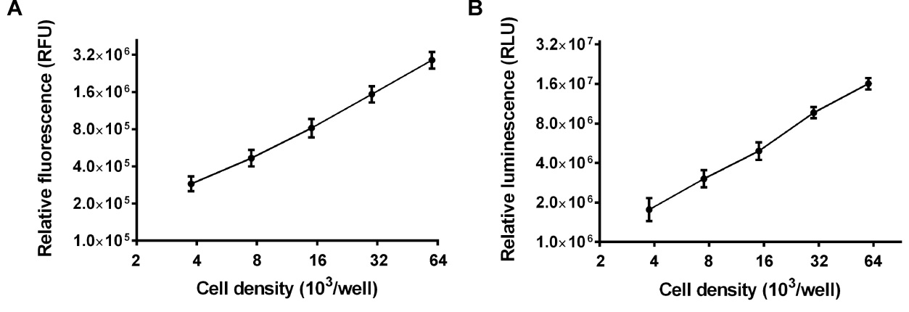
Figure 2.5 Correlations between cell density and fluorescent/luminescent assay outputs.
A, relationship between cell density in wells of a 24-well plate and fluorescence measured at 700nm following staining with the sapphire 700 and DRAQ5 stains (N=3 separate experiments). B, relationship between cell density and lysate luminescence with the Cell Titer Glo assay (N=6 separate experiments).
RFU, relative fluorescence units; RLU, relative luminescence units. Data presented as mean (SEM).

Statistical analyses of HUVEC culture experiments
The effects of interventions on HUVEC cultures were analysed by repeated measures ANOVA with a Dunnett’s multiple comparison test, considering p<0.05 statistically significant. Each test manipulation was applied to 3 wells and the average result taken. Independent replicates were performed using cultures derived from different donor umbilical cords.

The Effects of Manipulating Dietary Phosphate Intake on Metabolic Phenotype and Atherogenesis in ApoE^{-/-} Mice

Chapter acknowledgement
Parts of this chapter have been published previously as: Dietary Phosphate Modulates Atherogenesis and Insulin Resistance in Apolipoprotein E Knockout Mice Ellam T, Wilkie M, Chamberlain J, Crossman D, Eastell R, Francis S, Chico TJ. Arteriosclerosis, Thrombosis and Vascular Biology 2011 31(9) 1988-90. Inclusion herein is with the permission of the publishers and with the approval of the co-authors. All work is the candidate’s own.

Introduction
Among the bone mineral axis parameters associated with adverse cardiovascular outcomes, dietary phosphate intake is a factor of particular potential clinical relevance for several reasons. Firstly, the high bioavailable phosphate content of western diets is plausibly partly responsible for mis-setting the bone mineral axis away from its optimum equilibrium. Secondly, dietary phosphate exposure could be readily and safely manipulated for public health benefit by dietary education, by limiting the use of phosphate-containing food additives and by the use of phosphate binders. Thirdly, although the evidence of an association between dietary phosphate intake and cardiovascular pathology is sparse, manipulation of this parameter uniquely has the potential to exert favourable effects on all the other bone mineral axis components; limiting dietary phosphate exposure tends to lower FGF-23 (Antoniucci et al., 2006), lower serum phosphate (at least the 24h profile)(Portale et al., 1987), increase calcitriol (Portale et al., 1989) and lower PTH (Kemi et al., 2006). In contrast, supplementing calcitriol or lowering PTH directly (e.g. with a calcimimetic) tends to raise serum phosphate concentration, which might have adverse cardiovascular consequences if this is a more important determinant of CVD.
It is thus important to establish whether there is a causal relationship between increased dietary phosphate exposure and cardiovascular disease. In particular, associations of atherosclerosis-driven endpoints with bone mineral axis parameters raise the question of whether excessive phosphate exposure accelerates atherogenesis.
Determining the effects of dietary phosphate restriction on metabolic syndrome phenotype and thus traditional atherosclerotic risk factors is also important in understanding the potential merits of this intervention. The effects of dietary phosphate restriction on metabolic syndrome phenotype could act in either direction. On one hand, given the observed associations between lower serum phosphate and metabolic syndrome components, lower time-averaged serum phosphate accompanying dietary restriction might favour metabolic syndrome development. On the other hand, given the associations between metabolic syndrome components and FGF-23, calcitriol and PTH, secondary changes in these hormones induced by phosphate restriction might oppose a metabolic syndrome phenotype.
To address these questions, dietary phosphate intake was manipulated in an ApoE^{-/-} mouse model of atherogenesis.
Specific hypotheses tested:
- Lowering dietary phosphate intake induces components of the metabolic syndrome
- Increasing dietary phosphate intake accelerates atherogenesis

Chapter methods summary
Eight week-old male ApoE^{-/-} mice were commenced on high-fat diets with low, standard and high phosphate content. After 12 or 20 weeks of this dietary intervention, animals were sacrificed under pentobarbitone anaesthesia and tissues collected for histological analysis (Figure 3.1). Atheroma burden was measured in cross-section at the aortic sinus and en-face in the thoracic aorta, as described in section 2.2.7.
Metabolic syndrome phenotype was also characterised in the 20 week study in terms of obesity, blood pressure, insulin resistance and lipid profile. Obesity was assessed as final body weight, body mass index (BMI) and epididymal fat pad weight. Insulin resistance was calculated as the homeostatic model assessment (HOMA) from fasting whole blood glucose and plasma insulin concentrations. For this purpose, a tail vein blood sample was collected in the afternoon, following a 6h fast after 16 weeks of dietary intervention. Other plasma analyses were performed on samples collected via cardiac puncture at terminal anaesthesia. Blood pressure was measured twice weekly as described in 2.2.2.
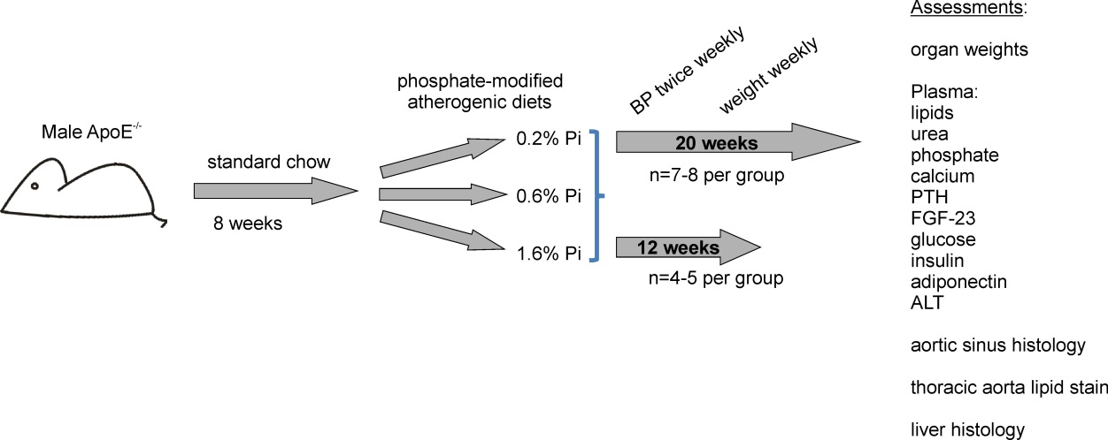

Figure 3.1 Summary of the mouse dietary phosphate manipulation study protocol.

Phosphate-modified atherogenic diets
Phosphate-modified atherogenic diets were custom-made (Harlan Teklad, USA, see appendix Table 9.1) with fixed content of lipid (21% w/w milkfat, 0.2% w/w cholesterol and 0.03% w/w cholate), calcium (1% w/w) and vitamin D (1.5IU/kg). The phosphate content was modified by varying the relative contributions of calcium monophosphate, calcium diphosphate and calcium carbonate, allowing uniform total calcium content. Standard phosphorus content of laboratory rodent chow is 0.6% w/w, though there is little evidence that this is the natural optimum (Reeves et al., 1993). For the low-, standard- and high-phosphate test diets, phosphorus contents of 0.2% w/w, 0.6% w/w and 1.6% w/w were selected. Low and high phosphate contents of 0.2% w/w and 1.6% w/w were chosen based on previous studies demonstrating modest changes in serum phosphate and regulatory hormones with these dietary intakes (Perwad et al., 2005, Camalier et al., 2010). Sodium content of the diets was matched, and the diets were isocaloric (calories per gram differences <2%). Dietary phosphorus densities (phosphorus intake per calorie) of the low, standard and high phosphate diets were 0.4, 1.3 and 3.6mg/kcal respectively. Independent laboratory assessment confirmed the phosphorus contents of the test diets (N.P Analytical Laboratories, USA).

Results

Of the 7-8 animals randomised per group for the 20-week study, 3 animals were not included in the final analyses for the following reasons: one was found dead (high dietary phosphate group), one was withdrawn due to problematic dental malocclusion (low dietary phosphate group) and one was found to have a cystic renal mass at termination (high dietary phosphate group). This left 5-8 per group for the final analyses, as indicated in the results tables.

Manipulation of serum phosphate, PTH and FGF-23 by dietary phosphate intervention
Manipulating dietary phosphate intake modulated the phosphate regulatory axis: Greater dietary phosphate content (1.6% vs 0.2% w/w phosphorus) caused a significant increase in plasma phosphate, accompanied by a small but significant reduction in plasma calcium (Table 3.1). Parathyroid hormone and FGF-23 increased substantially in response to greater dietary phosphate intake, being approximately 9-fold and 7-fold higher for high versus low dietary phosphate intake groups respectively. There were no significant differences in plasma lipid profile or urea.

Table 3.1 The effects of dietary phosphate content on plasma biochemistry.
Dietary phosphorus content: (w/w) | 0.2%  (n=6) | 0.6%  (n=8) | 1.6%  (n=5) | P value  0.2% vs. 1.6%
Phosphate (mM) | 2.02 (0.28)* | 3.11 (0.20)* | 3.59 (0.23) | p<0.01
Calcium (mM) | 2.27 (0.04) | 2.16 (0.05) | 2.07 (0.01) | p<0.05
PTH (ng/L) | 26 (5) | 100 (17) | 225 (58) | p<0.05
FGF 23 (ng/L) | 58 (18) | 127 (12) | 409 (98) | p<0.005
Total cholesterol (mM) | 33.5 (1.8) | 33.7 (2.2) | 35.3 (2.1) | NS
LDL cholesterol (mM) | 23.6 (1.5) | 24.8 (1.7) | 25.4 (1.6) | NS
HDL cholesterol (mM) | 6.47 (0.20) | 6.34 (0.43) | 6.26 (0.35) | NS
Triglycerides (mM) | 7.60 (0.98) | 5.68 (0.70) | 8.16 (1.26) | NS
Urea (mM) | 7.30 (0.46) | 7.95 (0.47) | 7.04 (0.54) | NS

Data presented as mean (SEM) for 20 week dietary intervention study. NS=not significant, *p<0.05 also for comparison between 0.2% and 0.6% w/w phosphorus dietary groups.

Low dietary phosphate intake increases weight gain, adiposity and insulin resistance
Mice fed a low phosphate diet gained more weight and had a greater final body weight than mice on standard or high phosphate diets (Table 3.2 and Figure 3.2A). Body length was also increased, but the weights of heart, kidneys and spleen did not differ significantly between groups. Average daily chow consumption was numerically higher for diets with lower phosphate content, but this was statistically nonsignificant. There was a greater mean epididymal fat pad mass in the low dietary phosphate group compared to the high phosphate group (Figure 3.2B). Fasting blood glucose concentration did not differ between groups, but there was a significant 4-fold increase in insulin resistance in mice on the low phosphate diet compared to both other groups (Figure 3.2C-E). Suppression of the insulin-sensitising hormone adiponectin was examined as a potential underlying mechanism for this insulin resistance; adiponectin is synthesised by adipocytes and levels are reduced in obesity (Kadowaki et al., 2006). However, although significantly higher adiponectin levels were observed in the high c.f. standard dietary phosphate group, the low dietary phosphate group did not manifest lower adiponectin levels and thus insulin resistance was not attributable to adiponectin changes.

Table 3.2 The effects of dietary phosphate content on weight gain, body length and chow consumption.
Dietary phosphorus content: (w/w) | 0.2%  (n=6) | 0.6%  (n=8) |  | 1.6%  (n=5) |  | P value  0.2% vs. 1.6%
Final BMI (kg/m²) | 1.03(0.03) |  | 0.94(0.03) |  | 0.91(0.03) |  | NS
Total weight gain on diet (g) | 11.2(1.3) |  | 9.4(0.8) |  | 6.5(0.8) |  | <0.05
Final weight (g) | 34.7(1.5) |  | 30.3(1.03) |  | 28.7(1.3) |  | <0.05
Tail length (mm) | 89.7(0.7) |  | 90.0(1.3) |  | 89.3(0.5) |  | NS
Body length (mm) | 183(1.9) |  | 180(1.1) |  | 177(1.4) |  | <0.05
Daily chow consumption (g) | 2.66(0.09) |  | 2.51(0.07) |  | 2.40(0.09) |  | NS
Heart weight (mg) | 183 (7) |  | 177 (4) |  | 185 (16) |  | NS
Total kidney weight (mg) | 387 (14) |  | 346 (10) |  | 377 (28) |  | NS
Spleen weight (mg) | 121 (6) |  | 100 (4) |  | 132 (6) |  | NS

Data presented as mean (SEM) for 20 week dietary intervention study.

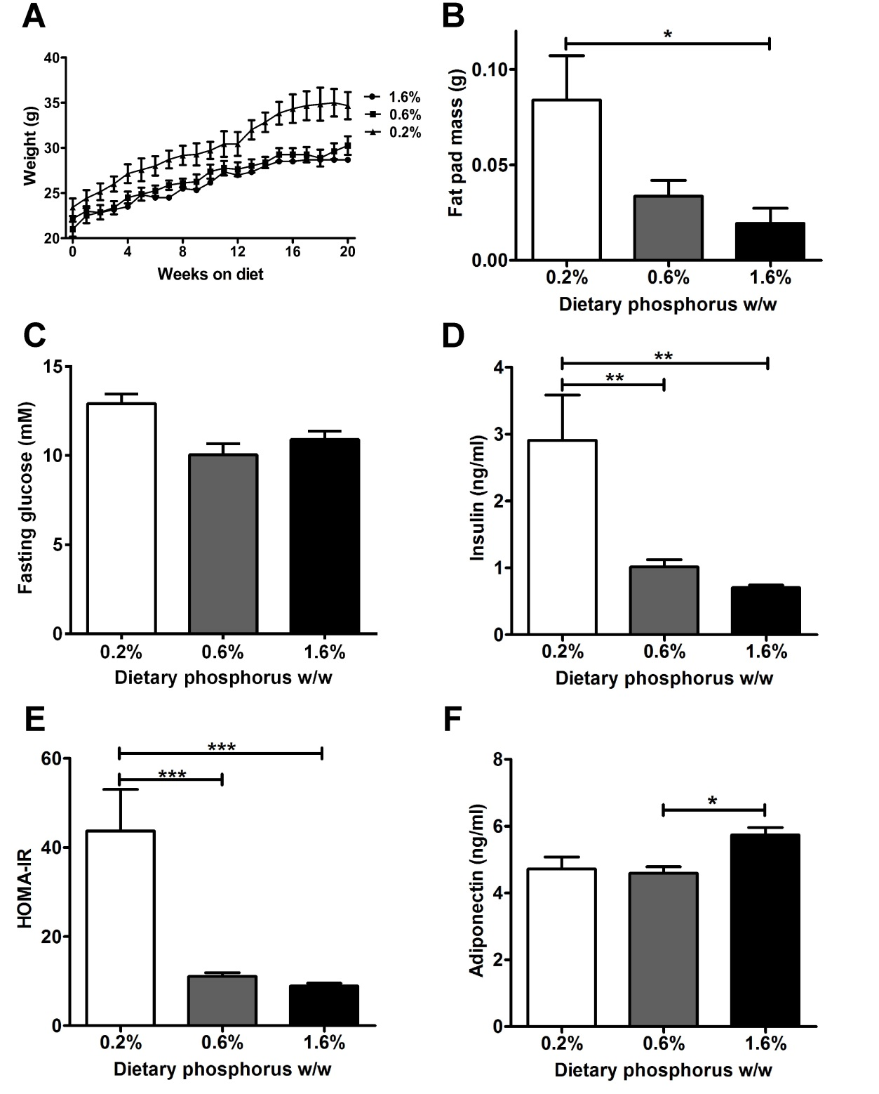

Figure 3.2 The effects of dietary phosphate content on adiposity, insulin resistance and adiponectin.
A, weight curves by dietary intervention (% w/w phosphorus) group. B, epididymal fat pad mass at 20 weeks. C to F, fasting glucose, insulin, insulin resistance, and adiponectin at 20 weeks.
HOMA-IR, homeostatic model assessment of insulin resistance. Data presented as mean (SEM).
(From Ellam et al. ATVB 2011 Sep;31(9):1988-1990 with permission)

Low dietary phosphate induces hepatic steatosis
Mice fed a low phosphate diet had a significantly greater liver mass and elevated levels of the hepatic enzyme alanine transaminase (Figure 3.3A,B). Therefore liver tissue was examined with haematoxylin and eosin staining to look for evidence of hepatic steatosis as a manifestation of metabolic target organ damage. There was global hepatic steatosis (lipid deposition and attenuation of cytoplasmic eosinophilic carbohydrate staining, Figure 3.2 C,D) in 4/6 livers in the low dietary phosphate group compared to 1/8 in the standard dietary phosphate group and 0/5 in the high phosphate group (Chi square test for trend p=0.009). There was also evidence of ‘ballooning’ hepatocyte degeneration, a recognised pathological appearance of steatosis-associated necrosis (Nishida et al., 2013), in the low dietary phosphate group livers (Figure 3.3E).

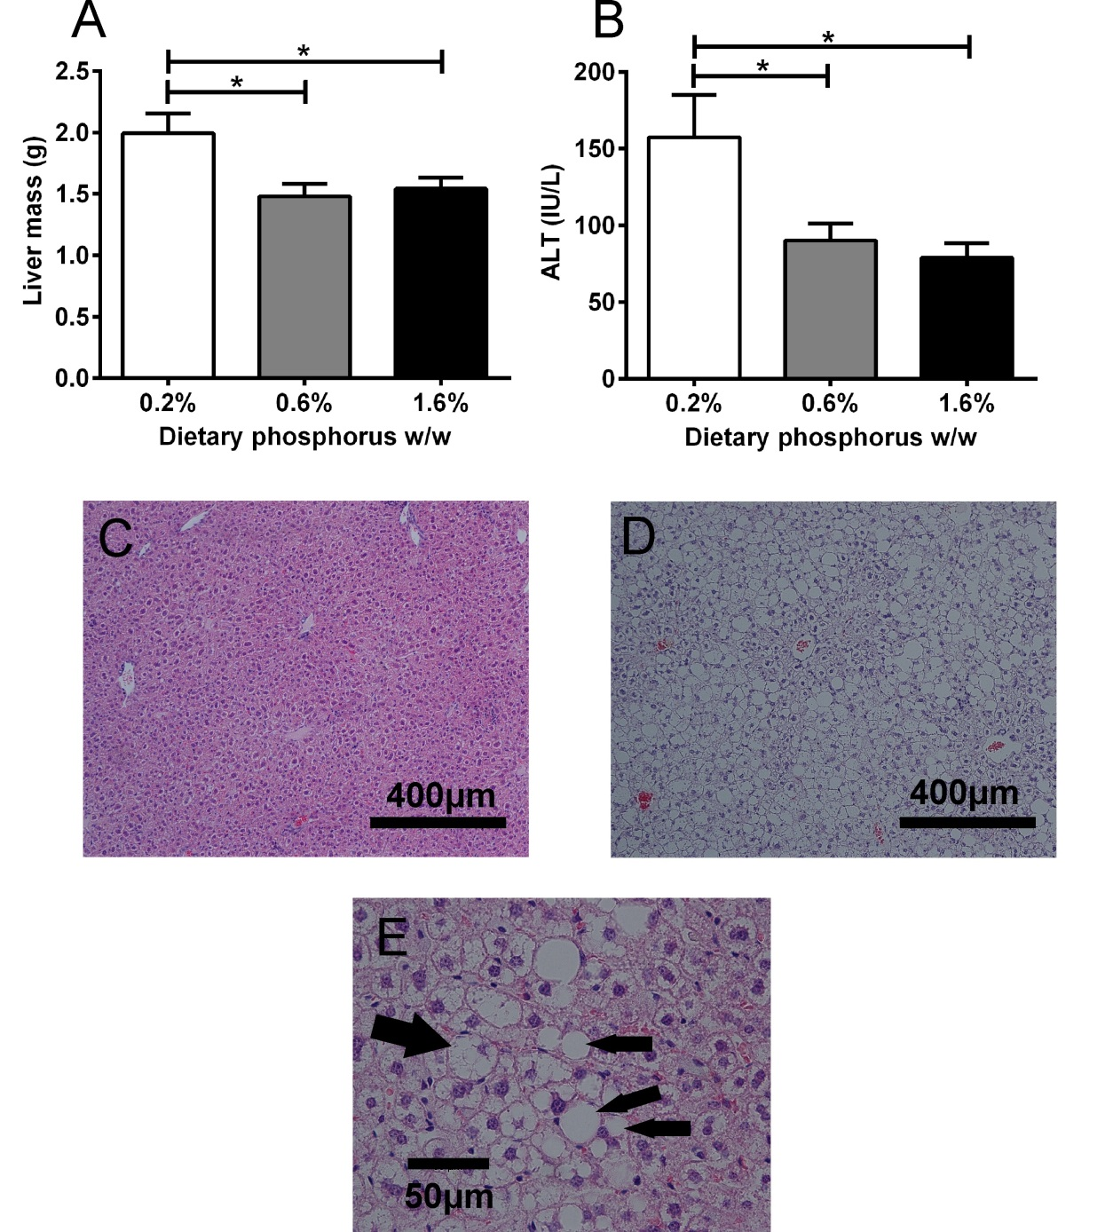

Figure 3.3 The effects of dietary phosphate content on liver mass, alanine transaminase and hepatic steatosis.
A, liver mass by dietary phosphate group. B, alanine transaminase (ALT) by dietary phosphate group. Examples of normal hepatic tissue (C) and hepatic steatosis (D) from standard and low phosphate content dietary groups respectively. Haematoxylin and eosin-stained sections demonstrating the replacement of eosinophilic carbohydrate by lipid. E, higher magnification of hepatic steatosis demonstrating multiple lipid droplets (small arrows) and ‘ballooning’ cellular degeneration (large arrow). Data presented as mean (SEM), n=5-8 per group.
(Modified from Ellam et al. ATVB 2011 Sep;31(9):1988-1990 with permission)

Dietary phosphate content and blood pressure
Tail cuff blood pressures did not differ significantly in terms of systolic, diastolic or mean values at any point during the study (Figure 3.4).
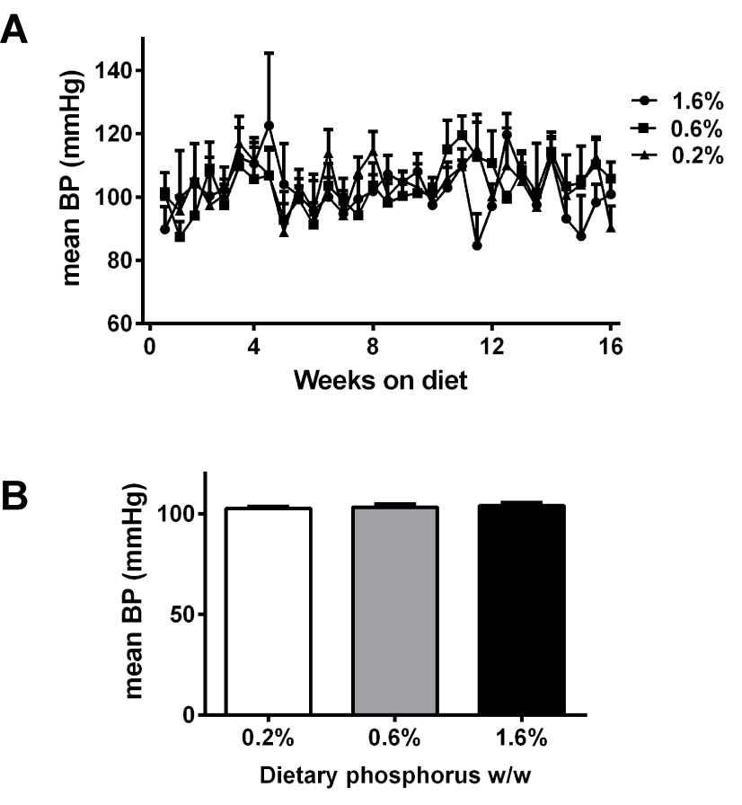
Figure 3.4 Tail cuff blood pressure by dietary phosphate group.
A, mean tail cuff blood pressure by % w/w dietary phosphorus content, measured twice weekly (n=4 per group). B, time averaged mean BP over the entire measurement period. Data presented as mean (SEM).

Dietary phosphate content and atherosclerosis in ApoE^{-/-} mice
After 12 weeks’ dietary phosphate manipulation there was no difference in aortic sinus atheroma burden (Figure 3.5B). However, increased dietary phosphate induced significantly more atheroma at 20 weeks: 30±2%, 33±2%, and 42±2% of the cross sectional area for low-, standard-, and high dietary phosphate groups, respectively (p<0.01 for low versus high), corresponding to a 40% relative increase in atheroma burden for the high versus low dietary phosphate groups. En face staining of the thoracic aorta did not show a significant difference in lipid deposition (Figure 3.6).
Calcification staining using 1% w/v silver nitrate (von Kossa method) was minimal on all aortic sinus sections and so it was not possible to perform a robust assessment of calcification density for comparison between groups.

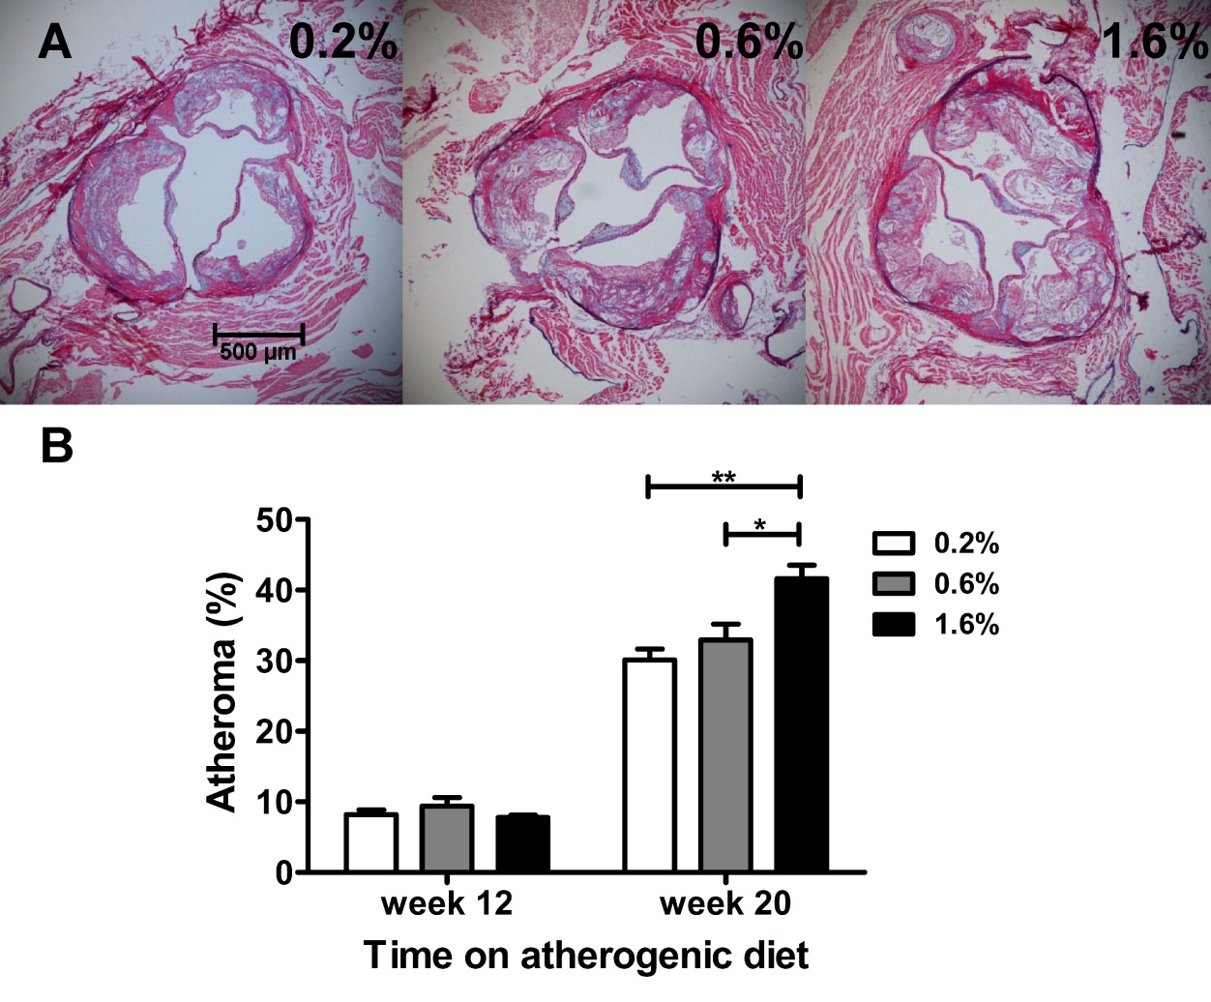
Figure 3.5 The effects of dietary phosphate content on aortic sinus atheroma burden.
A, representative aortic sinus sections from mice fed atherogenic diets containing 0.2%, 0.6% and 1.6% w/w phosphorus respectively for 20 weeks. B, cross-sectional atheroma burden as a percentage of the vessel lumen. Data presented as mean (SEM), n=4-8 per group.
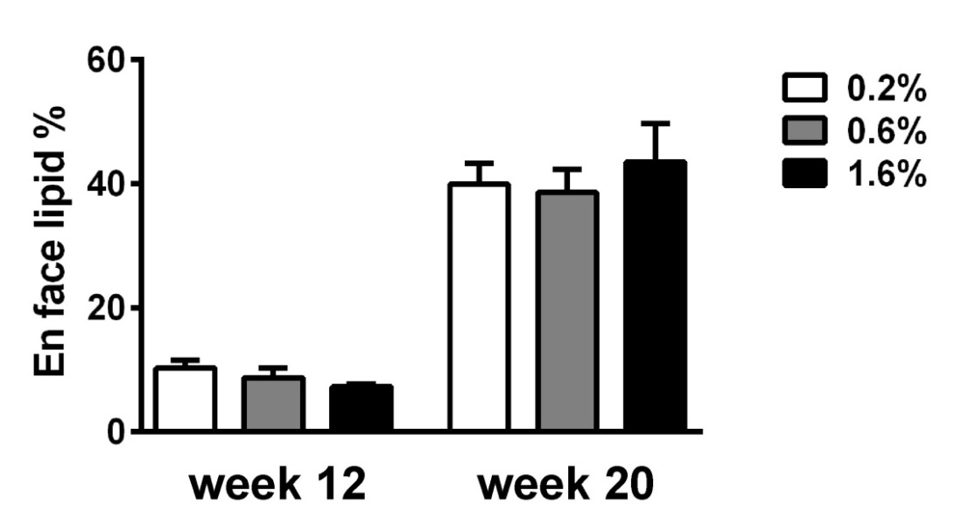
Figure 3.6 The effects of dietary phosphate content on thoracic aorta lipid content.
Percentage internal surface area of the thoracic aorta staining positive for lipid with oil red O, according to dietary phosphorus content. Data presented as mean (SEM), n=4-8 per group.

Discussion
The results presented in this chapter demonstrate for the first time that sustained low dietary phosphate intake contributes to the development of an adverse metabolic phenotype, but high dietary phosphate intake potentiates atherogenesis. In the experimental model used, dietary phosphate manipulation changed plasma phosphate concentration significantly. These results thus parallel to some extent the clinical observational data associating lower serum phosphate concentration with metabolic syndrome components and higher serum phosphate with atherosclerotic cardiovascular endpoints. However, it is not shown that changes in serum phosphate concentration themselves play a causal role in the metabolic and atherosclerotic effects; changes in FGF-23, PTH or other factors induced by altering dietary phosphate exposure may have been responsible. As discussed in section 1.3.2, the clinical associations between fasting serum phosphate and cardiovascular outcomes seem unlikely to be driven primarily by differences in dietary phosphate intake, which have minimal effect on fasting serum phosphate. In this study plasma phosphate was not measured in the fasting state and the observed relative changes in plasma phosphate concentration were similar to those that can be induced in the diurnal phosphate profile of healthy humans by experimental dietary phosphate intervention (Portale et al., 1987).
Although differences in chow consumption between groups were not statistically significant, the higher average chow consumption accompanying lower dietary phosphate content (11% higher for the low versus high dietary phosphate groups) may have been responsible for the greater weight gain and adiposity. Previous work showed that rats offered combinations of diets with differing phosphate content self-regulated their phosphate intake (Siu et al., 1981). This raises the possibility that dietary phosphate content affects appetite. In this respect, measurement of hormonal regulators of satiety such as ghrelin, leptin and glucagon-like peptide-1 would be relevant in future studies of dietary phosphate manipulation.
Alternatively, the induction of obesity by a lower dietary phosphate content could be mediated through effects on metabolic rate. As discussed in section 1.3.1, intracellular phosphate availability might influence rates of glycolysis and oxidative phosphorylation, so phosphate depletion may lower resting energy expenditure. Dietary phosphate deprivation has been reported to lower myocyte intracellular phosphate concentration before hyphosphataemia occurs (Thompson and Kemp, 1995), thus profound hypophosphataemia may not necessarily be required for cellular metabolic consequences of dietary phosphate restriction. Whether dietary phosphate manipulation affects metabolic rate could be tested in future work by calorimetry. Small studies of obese women report increased postprandial metabolic rate in response to oral magnesium-phosphate, potassium-phosphate, or calcium-phosphate supplementation (Jaedig and Henningsen, 1991, Kaciuba-Uscilko et al., 1993), though these findings might reflect effects of the associated cation rather than altered intracellular phosphate concentration.
The increase in insulin resistance observed in mice fed a low-phosphate diet could be a consequence of greater obesity, reduced glycolytic phosphometabolite synthesis due to intracellular phosphate depletion, or another mechanism. Previous work reporting that phosphate infusion increases the euglycaemic glucose disposal rate (insulin sensitivity) in healthy subjects (Nowicki et al., 1996) suggests that obesity is not the only pathway between lower phosphate and insulin resistance. Since the low dietary phosphate group had a significantly lower plasma PTH than the high dietary phosphate group, any effect of higher PTH on insulin resistance (as discussed in section 1.8.3) must have been less in magnitude than an opposing mechanism relating low phosphate intake to insulin resistance.
Not all components of the metabolic syndrome were induced by low dietary phosphate intake; blood pressure and dyslipidaemia were not significantly different between groups. However, there was evidence of metabolic end-organ damage in terms of hepatic steatosis. This pathology is associated clinically with the presence of obesity and insulin resistance; its induction by low dietary phosphate intake could be a secondary consequence of obesity or a reflection of a more direct effect on hepatic lipid metabolism. Following the publication of these findings, Tanaka et al. reported that low dietary phosphate content (0.1% versus 1.2% w/w) increased the weight and cholesterol content of livers from C57BL/6-strain mice fed a high cholesterol diet (Tanaka et al., 2013). These changes were evident after just 12 days’ dietary intervention and in the absence of significant differences in total body weight, suggesting that obesity is not required for this phenomenon. Low dietary phosphate content also suppressed hepatic expression (at mRNA level) of several enzymes involved in lipid metabolism, including cholesterol 7α-hydroxylase (CYP7A1). Since the knockout and overexpression of CYP7A1 have been shown respectively to induce and prevent hepatic steatosis (Miyake et al., 2002), this is a potential mechanism underlying the induction of steatosis by low dietary phosphate content.
Non-alcoholic hepatic steatosis can lead to fulminant liver failure (albeit in a minority of cases), so phosphate supplementation of patients with evidence of hepatic injury in the context of steatosis could be an important intervention. Whether hypophosphataemia, lower-normal serum phosphate concentration, or lower dietary phosphate intake are independent predictors of hepatic steatosis in clinical cohorts has not been reported. Hepatic steatosis is a recognised feature of the ‘refeeding syndrome’ of metabolic derangement induced by caloric intake after a period of malnutrition (Klein et al., 1998). Refeeding syndrome is commonly accompanied by hypophosphataemia, so phosphate depletion could be a contributor to the association with hepatic steatosis.
On the basis of clinical observational data and the previous demonstration that genetic insulin resistance accelerates atherogenesis in ApoE^{-/-} mice (Galkina et al., 2012), the induction of obesity and insulin resistance by a low-phosphate diet might also have been expected to increase atheroma. However, the low-phosphate diet group had the least aortic sinus atheroma and the high dietary phosphate group had a significantly greater atheroma burden than both low- and standard dietary phosphate groups. The proatherogenic effects of high dietary phosphate content therefore appear to exceed any proatherogenic effects of obesity and insulin resistance.
In the absence of significant effects on blood pressure or lipid profile, the proatherogenic effect of increased dietary phosphate content appears to be mediated by other mechanisms. Following publication of these findings, Six et al. reported that high dietary phosphate content (1.3% vs 0.65%) induced endothelial dysfunction, loss of aortic endothelial integrity and increased endothelial adhesion molecule expression in mice (Six et al., 2012). These effects may account for the increased atherosclerosis observed in our study and are consistent with the clinical observational data relating endothelial dysfunction to bone mineral axis parameters.
As discussed in Chapter 1, there are a number of plausible pathways through which elevated plasma phosphate, PTH, FGF-23 or lower calcitriol could cause endothelial dysfunction and contribute to atherogenesis. Plasma active vitamin D (calcitriol) was not measured in this study since it is challenging to measure in lipaemic samples in view of its low circulating concentration, lipid solubility and short half-life. However, since FGF-23 and PTH were both predictably manipulated by dietary phosphate manipulation, it seems likely that calcitriol levels were also modulated. In view of the therapeutic potential of vitamin D supplementation, the role of vitamin D signalling in CVD pathogenesis was studied in a second mouse study (Chapter 4).

Vitamin D Manipulation in ApoE^{-/-} Mice

Chapter acknowledgement
Parts of this chapter have been published previously as: ‘Vitamin D Deficiency and Exogenous Vitamin D Excess Similarly Increase Diffuse Atherosclerotic Calcification in Apolipoprotein E Knockout Mice’ Ellam T, Hameed A, ul Haque R, Muthana M, Wilkie M, Francis S, and Chico TJ. (2014) PLoS ONE 9(2): e88767. doi:10.1371/journal.pone.0088767. Inclusion herein is with the permission of the publishers and with the approval of the co-authors. All work is the candidate’s own, except the echocardiography reported in 4.4.6, which was performed by Dr Abdul Hameed.

Introduction
As discussed in section 1.7, extensive observational clinical data associate lower levels of 25(OH)D with adverse cardiovascular outcomes, but a causal role for lower 25(OH)D in cardiovascular disease pathogenesis is largely unproven. Although VDR^{-/-} mice manifest hyperreninaemic hypertension, LVH and glucose intolerance (Bouillon et al., 2008), this model is severe and may not be relevant to observations in populations without osteomalacia. Therefore the clinical associations between lower 25(OH)D and metabolic syndrome, atherosclerosis, coronary calcification and endothelial dysfunction may reflect confounding by lifestyle.
The aim of the work presented in this chapter was to investigate the cardiovascular phenotype of a more relevant (moderate) degree of attenuated vitamin D signalling. To this end, male ApoE^{-/-} mice were fed atherogenic diets either replete or deficient in vitamin D3 (cholecalciferol).
Specific hypotheses tested:
- Dietary vitamin D deficiency accelerates atherogenesis
- Dietary vitamin D deficiency increases vascular calcification
- Dietary vitamin D deficiency induces insulin resistance and hypertension
- Dietary vitamin D deficiency induces LVH
To further test the effects of modulating vitamin D signalling on cardiovascular phenotype, the active vitamin D analogue paricalcitol was administered. Paracrine actions of locally synthesized 1,25(OH)₂D (calcitriol) may be important for cardiovascular health independently of systemic calcitriol signalling (as discussed in section 1.7.2). Therefore the phenotype of dietary 25(OH)D deficiency combined with adequate systemic active vitamin D signalling (provided by exogenous paricalcitol) was also examined.

Chapter methods summary

Vitamin D deficient diet
In order to test the effects of a moderate degree of vitamin D deficiency, male ApoE^{-/-} mice were commenced on vitamin D(3)-replete or -deficient atherogenic diets at the age of 8 weeks. Cocoa butter was chosen as a fat source since although less atherogenic than the more commonly used milkfat (Nishina et al., 1993), it does not contain vitamin D. Cocoa butter-based diets were custom made (Harlan Teklad, USA, see appendix Table 9.2) with fixed content of lipids (20% w/w fat, 0.2% w/w cholesterol and 0.03% w/w cholate), calcium (1% w/w) and phosphorus (0.6% w/w). The vitamin D deficient diet contained no vitamin D; cholecalciferol was added to a final quantity of 1.5IU/kg to create the equivalent vitamin D-replete diet. Since the aim was not to induce profound osteomalacia (which would be less relevant to the clinical observational data relating vitamin D levels to cardiovascular outcomes), vitamin D replete diets were administered until 8 weeks of age, thus allowing normal development to this stage.
In a preliminary experiment the effects of 12 weeks of vitamin D-deficient diet on plasma 25(OH)D concentration and bone structure were assessed. After confirmation that a meaningful degree of deficiency was induced with this diet (see results), a 20 week dietary intervention was performed prior to cardiovascular/metabolic phenotype assessment.

Paricalcitol intervention
Paricalcitol 5μg/ml (Zemplar, Abbott, UK) in an excipient solution of propylene glycol (30% v/v), ethanol (20% v/v) and water (50% v/v) was diluted 40-fold into an identical excipient solution to a final concentration of 125ng/ml. Dilution and syringe preparation were performed in a sterile laminar flow chamber and syringes were stored at room temperature until use. Paricalcitol at 125ng/ml or an equal volume of the excipient vehicle was administered 3x weekly by intraperitoneal injection commencing at 8 weeks for a 20 week period. The paricalcitol dose given was 400ng per kg body weight, corresponding to a volume of 3.2μl/g. Doses were calculated according to body weight measured on a weekly basis. This paricalcitol dosing regime was selected on the basis of previous reports that similar doses are well tolerated and correct secondary hyperparathyroidism in partial renal ablation models (Deb et al., 2010, Mathew et al., 2008).

Phenotypic characterisation
The vitamin D manipulation model is summarised in Figure 4.1. After 20 weeks of the test diets and paricalcitol/vehicle, metabolic and cardiovascular phenotypes were characterised. The primary outcome measure was the percentage of aortic sinus cross section occupied by atheroma. Based on the overall mean and standard deviation of this parameter obtained from the phosphate manipulation study, a power of 80% to detect a 30% difference with alpha = 0.05 required n=7 per group (http://www.stat.ubc.ca/~rollin/stats/ssize/n2.html). Therefore 7-8 mice were allocated to each intervention group. Atheroma character was assessed as described in sections 2.2.6-7. The von Kossa calcification staining protocol was modified for the vitamin D manipulation study, using a more concentrated (2% w/v rather than 1%) silver nitrate solution in order to maximise the detection of calcification.
Metabolic phenotype was characterised in terms of body weight, organ weights, BMI, HOMA-IR and plasma lipids. For this study, tissue and blood sample collection was performed after an overnight fast in order to minimise the degree of lipaemia, which might interfere with 25(OH)D measurement. Tail cuff blood pressure was measured fortnightly during the intervention phases.
Microtomography of the tibia was used to examine the effects of the interventions on bone structure and thus place the cardiovascular findings in the context of a measure of model severity.

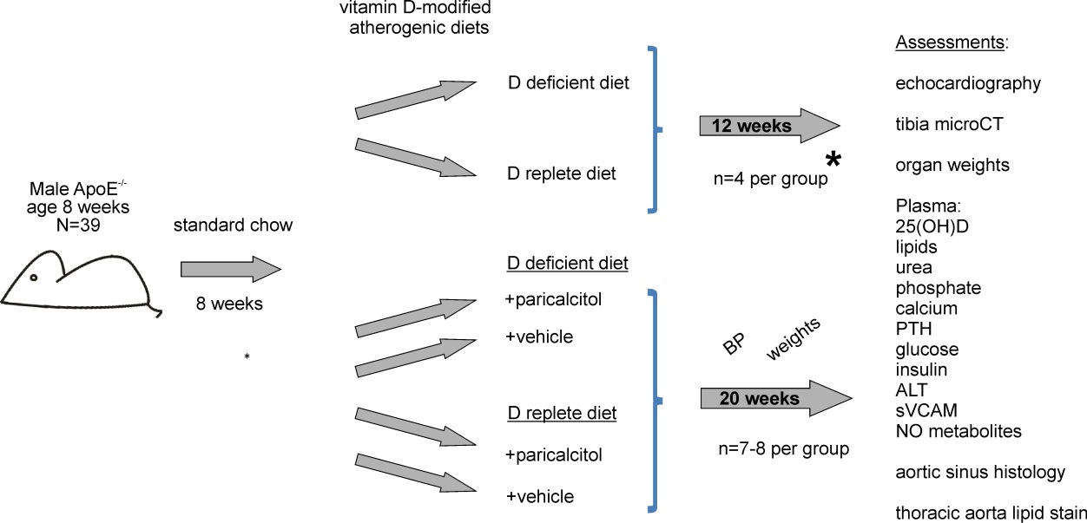

Figure 4.1 Summary of vitamin D manipulation study protocol.
*preliminary study to demonstrate effects of vitamin D-deficient diet on plasma 25(OH)D and bone structure. sVCAM, soluble vascular cell adhesion molecule.

Results

The effects of vitamin D deficient diet and paricalcitol on plasma biochemistry and bone structure

12 week study
To confirm that the vitamin D deficient diet used induced meaningful alterations in vitamin D status, the effects of a 12 week dietary intervention period on plasma 25(OH)D levels, trabecular bone volume and bone mineral density were assessed. Significant differences in these parameters were induced by 12 weeks’ vitamin D-deficient versus replete diet (Figure 4.2). Therefore the cardiovascular effects of vitamin D manipulation were examined after a 20-week intervention, ensuring exposure of the cardiovascular system to a period of significant vitamin D deficiency before phenotypic characterisation. Administration of paricalcitol or matched vehicle was undertaken for the same interval to determine the effects of exogenous active vitamin on 25(OH)D-deficient and replete backgrounds.

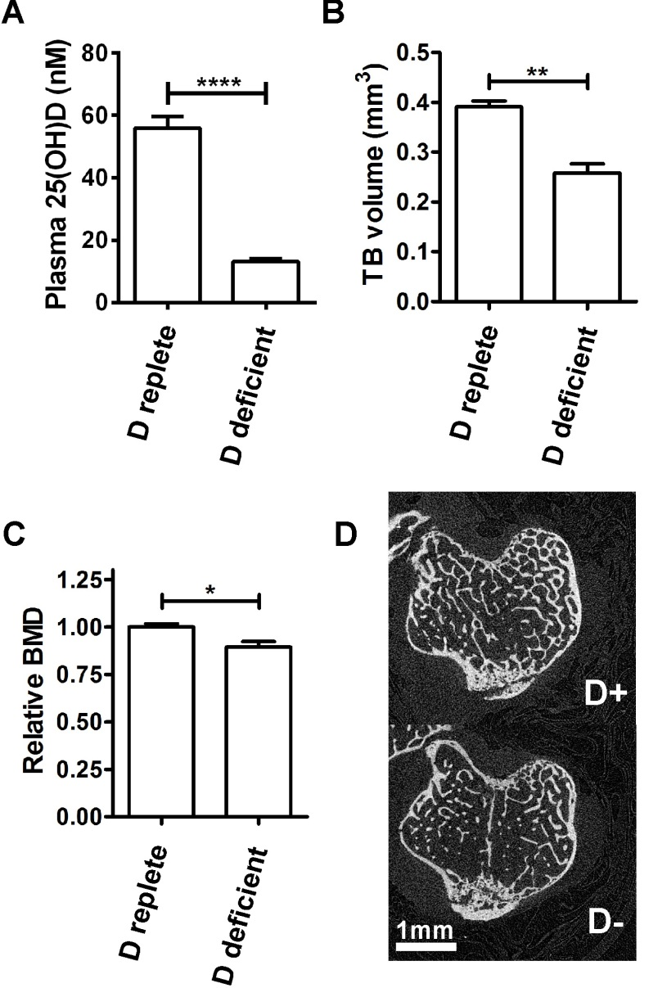
Figure 4.2 Effects of 12 weeks vitamin D deficient diet on plasma 25(OH)D and bone structure.
A, plasma 25(OH)D by intervention. B, trabecular bone volume by intervention. C, trabecular bone mineral density relative to that of mice fed a vitamin D replete diet. D, representative microCT images of trabecular bone after 12 weeks of dietary intervention.
BMD, bone mineral density; TB, trabecular bone. Data presented as mean (SEM), n=4 per group. *p<0.05, **p<0.01, ****p<0.001.

20 week study
The effects of 20 weeks of vitamin D deficient diet on plasma 25(OH)D and bone structure were similar to those observed after the 12 week intervention (Figure 4.3). Vitamin D deficient diet did not change plasma calcium or phosphate levels (Table 4.1). However, administration of paricalcitol caused a significant increase in plasma calcium concentration and calcium x phosphate product, accompanied by suppression of PTH. When given to mice on a vitamin D replete diet paricalcitol also reduced plasma 25(OH)D levels, consistent with negative feedback induction of 25(OH)D catabolism (Omdahl et al., 2002). Despite the increase in plasma calcium induced by administration of paricalcitol to animals with dietary vitamin D deficiency, trabecular bone changes were not reversed.

Table 4.1 Effects of vitamin D deficient diet and paricalcitol on calcium, phosphate and parathyroid hormone at 20 weeks.
Intervention group | D replete  vehicle | D deficient vehicle | D replete paricalcitol | D deficient paricalcitol
Calcium (Ca), mM | 2.33 (0.02) | 2.31 (0.03) | 2.72 (0.10)*** | 2.53 (0.05)***
Phosphate (Pi), mM | 2.37 (0.16) | 2.32 (0.12) | 2.67 (0.13) | 2.86 (0.15)
Ca x Pi product, μM² | 4.91 (0.70) | 5.36 (0.31) | 7.30 (0.57)*** | 7.25 (0.45)***
PTH, ng/L | 165 (17) | 194 (16) | 77 (7)**** | 68 (3)****

PTH, parathyroid hormone
Data presented as mean (SEM), n=7-8 per group. ***p<0.005 vs. D replete vehicle, ****p<0.001 vs. D replete vehicle.

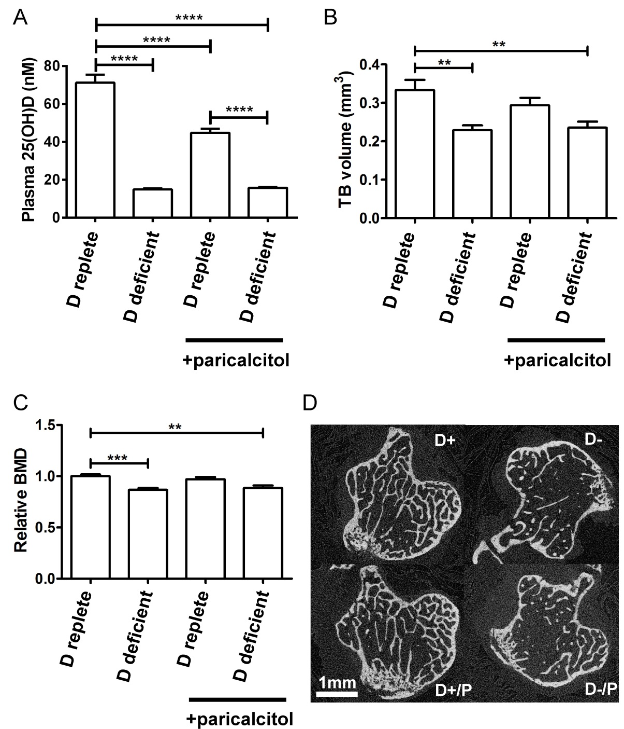
Figure 4.3 Effects of 20 weeks of vitamin D deficient diet and paricalcitol on 25(OH)D and bone structure.
A, plasma 25(OH)D by intervention. B, trabecular bone volume by intervention. C, trabecular bone mineral density relative to that of mice fed a vitamin D replete diet. D, representative microCT images of trabecular bone after 20 weeks of interventions. D+, vitamin D replete diet; D-, vitamin D deficient diet; D+/P, vitamin D replete diet with paricalcitol, D-/P, vitamin D deficient diet with paricalcitol; BMD, bone mineral density; TB, trabecular bone.
Data presented as mean (SEM), n=7-8 per group. *p<0.05, **p<0.01, ***p<0.005, ****p<0.001.

The effects of vitamin D manipulation on metabolic profile, blood pressure and nitric oxide metabolites
Manipulation of vitamin D status by feeding a vitamin D deficient diet or the administration of paricalcitol resulted in significantly lower average chow consumption, but did not significantly change the lipid profile, fasting glucose, insulin resistance or body mass index (Table 4.2). Epididymal fat pads were much smaller in this study than in the phosphate manipulation study, perhaps reflecting the longer fasting period before sample collection (Izumida et al., 2013). As a consequence it was not possible to dissect and weigh them. Instead the visceral fat pad was dissected from the mesenteric intestinal border and weighed; this did not differ significantly between groups.
Table 4.2 The effects of 20 weeks of vitamin D deficient diet and paricalcitol on metabolic profile.
Intervention group: | D replete  vehicle | D deficient vehicle | D replete paricalcitol | D deficient paricalcitol
Cholesterol, mM | 23.5 (1.8) | 20.7 (0.9) | 27.2 (1.6) | 24.9 (3.0)
HDL cholesterol, mM | 7.0 (0.4) | 6. 9 (0.4) | 7.9 (0.8) | 7.5 (0.9)
LDL cholesterol, mM | 15.5 (1.5) | 13.2 (0.5) | 18.9 (1.3) | 16.8 (2.6)
Triglyceride, mM | 1.0 (0.2) | 1.2 (0.2) | 1.1 (0.1) | 1.0 (0.1)
Urea, mM | 8.8 (0.5) | 9.9 (0.4) | 9.4 (0.8) | 8.6 (0.4)
Chow consumption, g/day | 3.0 (0.0) | 2.6 (0.0) **** | 2.6 (0.0) **** | 2.7 (0.0)**
Fasting glucose, mM | 11.9 (0.5) | 12.7 (0.8) | 11.8 (0.8) | 11.6 (0.8)
HOMA-IR | 0.18 (0.03) | 0.24 (0.03) | 0.25 (0.06) | 0.24 (0.05)
ALT, IU/L | 73 (30) | 110 (127) | 116 (106) | 78 (66)
NO metabolites, μM | 6.5 (1.7) | 6.6 (1.4) | 6.3 (0.9) | 10.8 (3.3)
sVCAM, ng/ml | 17.9 (0.6) | 19.3 (0.9) | 20.3 (0.6) | 19.4 (0.5)
Final weight, g | 31.8 (1.3) | 30.0 (1.0) | 32.3 (0.7) | 29.5 (0.8)
Liver weight, g | 1.35 (0.16) | 1.25 (0.08) | 1.37 (0.04) | 1.28 (0.06)
Body length, mm | 177.8 (1.4) | 178.3 (2.2) | 182.0 (0.8) | 176.8 (1.2)
Final BMI, kg/m² | 0.94 (0.04) | 0.90 (0.03) | 0.90 (0.02) | 0.90 (0.01)
Visceral fat pad weight, g | 0.60 (0.06) | 0.73 (0.14) | 0.77 (0.25) | 0.73 (0.17)

NO, nitric oxide; sVCAM, soluble vascular cell adhesion molecule.
Data presented as mean (SEM), n=7-8 per group. **p<0.01 vs. vitamin D replete vehicle, ****p<0.001 vs. vitamin D replete vehicle.
Since lower plasma 25(OH)D has been associated with endothelial dysfunction in clinical observational studies, nitric oxide metabolites and soluble vascular cell adhesion molecule-1 (sVCAM-1) were measured as markers of endothelial function/dysfunction respectively. Total plasma nitric oxide metabolites were not suppressed by dietary vitamin D deficiency nor significantly increased by paricalcitol administration (Table 4.2). Soluble VCAM-1 levels were also not significantly different between groups. Tail cuff systolic, diastolic and mean blood pressure did not differ significantly by intervention at any stage (Figure 4.4).
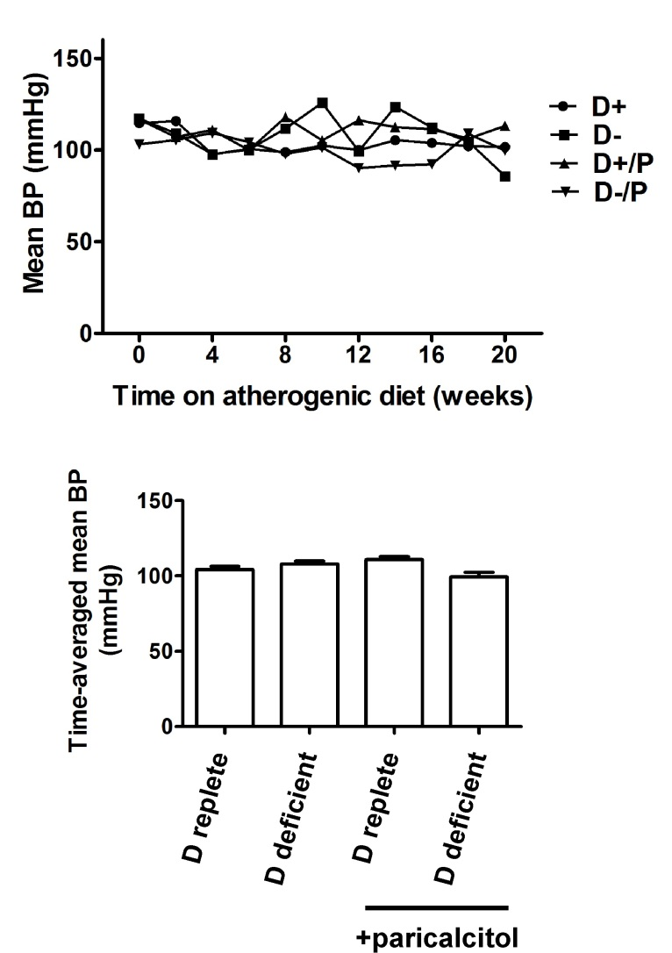
Figure 4.4 The effects of vitamin D manipulation on tail cuff blood pressure in ApoE^{-/-} mice.
A, mean tail cuff blood pressure by week. B, time-averaged mean blood pressures over 20 weeks.
D+, vitamin D replete diet; D-, vitamin D deficient diet; D+/P, vitamin D replete diet with paricalcitol, D-/P, vitamin D deficient diet with paricalcitol. Data presented as mean (SEM), n=4 per group.

The effects of vitamin D manipulation on atheroma burden and character
Atheroma burden measured in cross sections at the aortic sinus and lipid content in en face preparations of the thoracic aorta were not significantly different between groups (Figure 4.5 A,B). Atheroma cellularity and the percentage area occupied by lipid clefts were also unaffected by vitamin D manipulation (Figure 4.5 C,D and see Figure 2.2 for representative staining images).
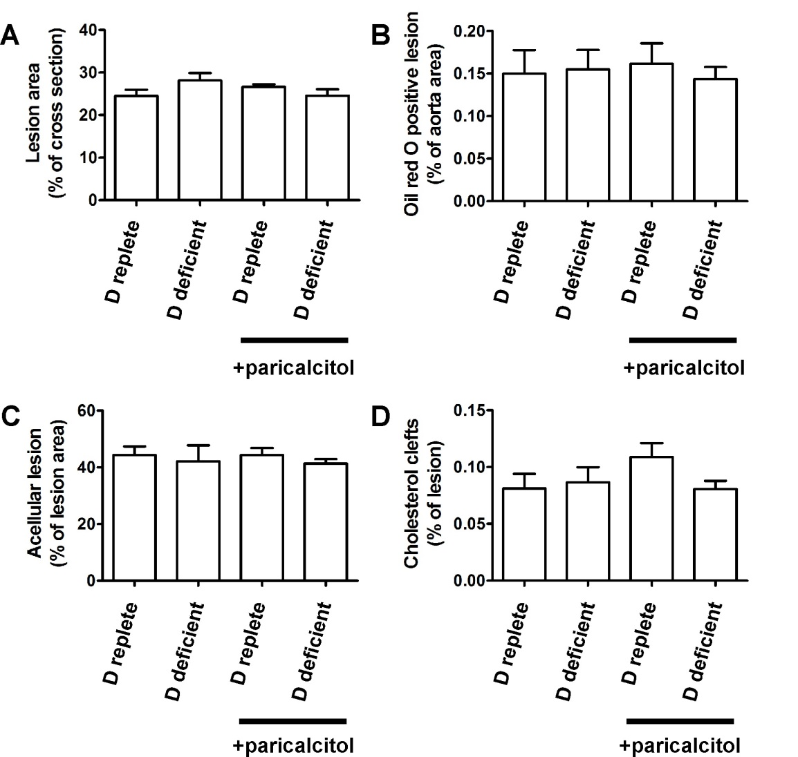

Figure 4.5 The effects of vitamin D manipulation on atheroma burden and character.
Assessments performed after 20 weeks of intervention. A, aortic sinus cross sectional atheroma burden. B, thoracic aorta en face atheroma burden. C, percentage of acellular atherosclerosis. D, percentage atheroma cross sectional area occupied by lipid clefts.
Data presented as mean (SEM), n=7-8 per group.

Vitamin D manipulation and atherosclerotic calcification
There was a significant increase in the diffuse calcification of aortic sinus atherosclerosis assessed by von Kossa staining in mice fed a vitamin D deficient diet or administered paricalcitol (Figures 4.6 and 4.7). Small calcifications (<100μm²) were present diffusely throughout the atherosclerotic lesions (Figure 4.6A-D); a small number of much larger calcifications were also present in association with necrotic regions in all groups (Figure 4.6E-G).
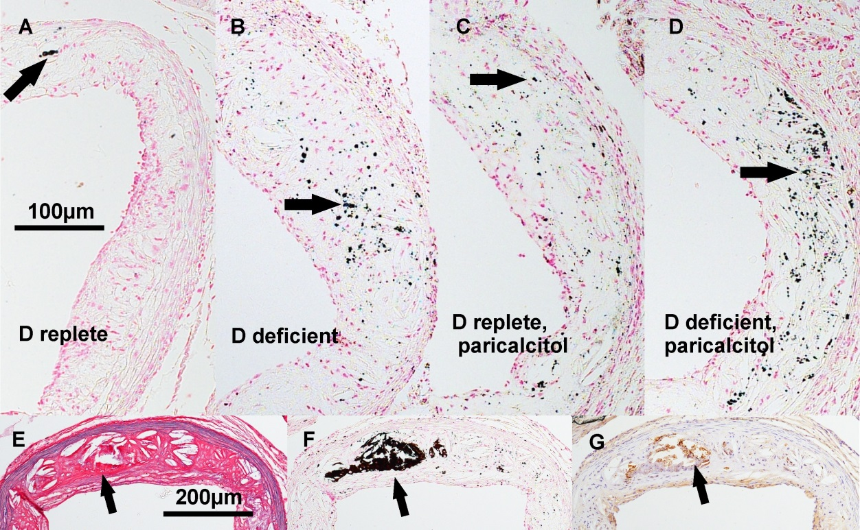
Figure 4.6 Patterns of atheromatous calcification in ApoE^{-/-} mice.
Images from the aortic root of mice exposed to 20 weeks of vitamin D interventions. A-D, representative atherosclerotic lesions demonstrating diffuse calcification (stained black by von Kossa method, arrows) from mice fed vitamin D replete and vitamin D deficient diets and coadministered vehicle (A and B respectively) or paricalcitol (C and D respectively). E-G, sequential sections stained with Miller’s elastin van Gieson, von Kossa method and osteopontin-specific antibody respectively, demonstrating a necrotic area of lesion (E) containing a large calcification (F) with associated osteopontin staining (G) (arrows), taken from a vitamin D replete mouse administered paricalcitol.

The total number of calcifications per mm² lesion area was more than doubled in mice fed a vitamin D deficient diet or administered paricalcitol compared to mice fed a vitamin D replete diet (Figure 4.7). Total percentage calcified lesion area was also greater in vitamin D-deficient mice and mice administered paricalcitol, but this was not statistically significant, reflecting the small number of very large calcifications dominating the total calcified area measurement. The number of large calcifications (≥100 μm²) was also nonsignificantly greater in atheroma from vitamin D deficient and paricalcitol-treated mice versus D-replete diet vehicle-treated mice. When the percentage calcified lesion area attributable to the diffuse small lesions (<100 μm²) was considered, this was significantly greater for vitamin D deficient mice (p<0.05 vs. mice on vitamin D replete diet) and paricalcitol-administered mice (p<0.01 vs. mice on a vitamin D replete diet).
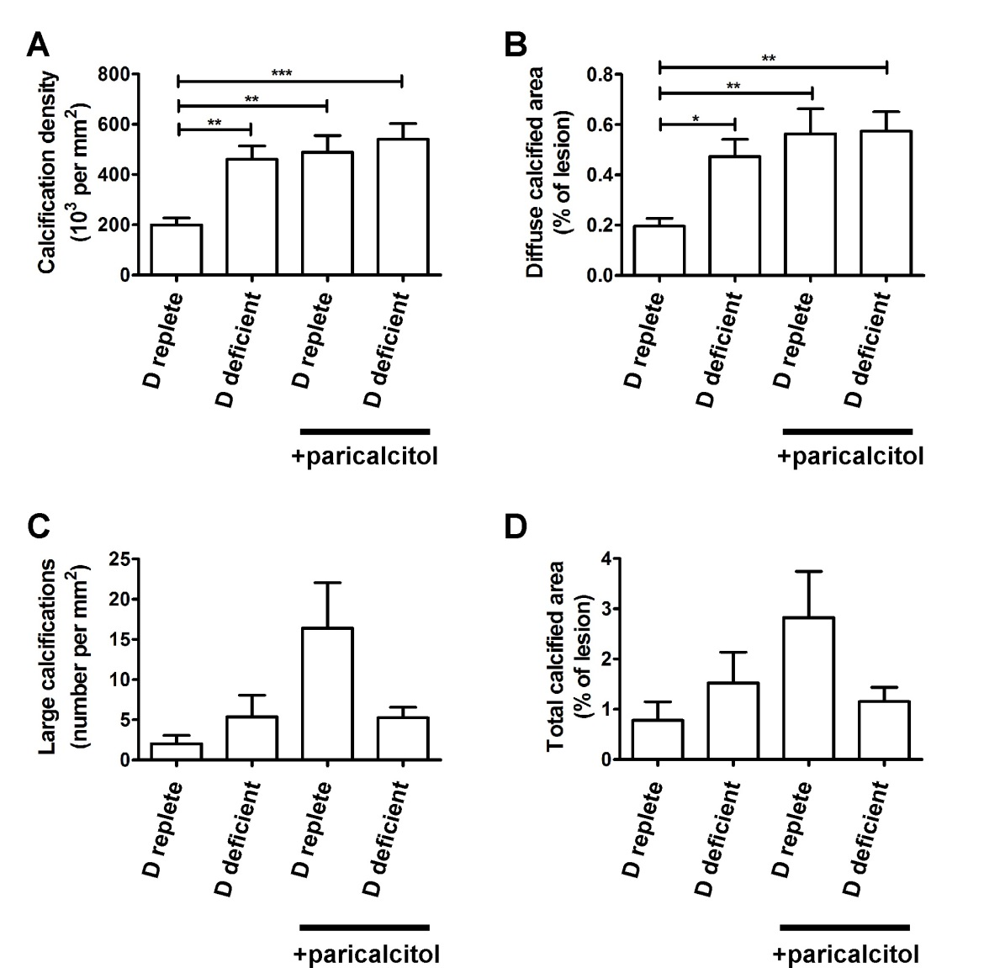
Figure 4.7 The effects of 20 weeks of vitamin D deficiency and excess on atherosclerotic calcification.
A, number of calcifications normalised to lesion area. B, percentage calcified lesion area due to calcifications <100 μm². C, number of very large calcifications (≥100μm²). D, total calcified area due to diffuse and large calcifications.
Data presented as mean (SEM), n=7-8 per group. *p<0.05, **p<0.01, ***p<0.005.
Aortic valves were calcified more densely than atheroma, but there were no significant differences between groups in the number or area of calcifications (Figure 4.8).

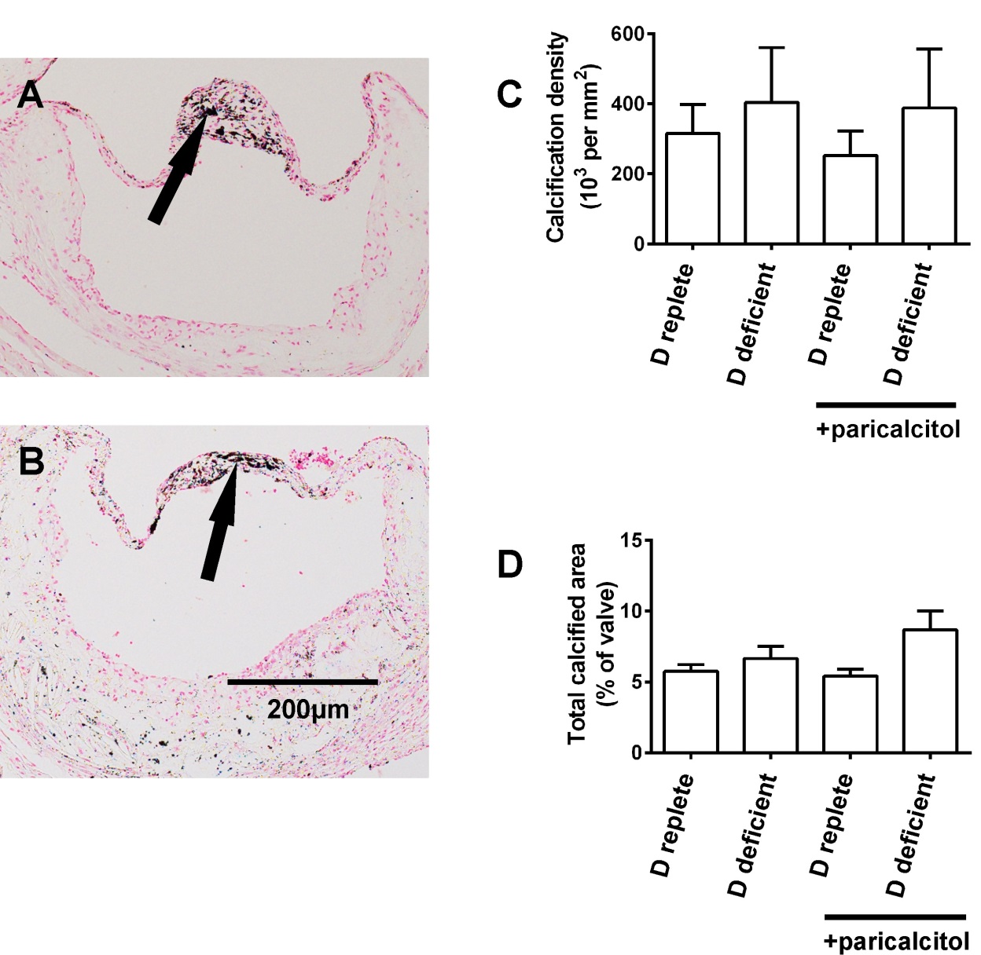
Figure 4.8 Vitamin D manipulation and aortic valve calcification.
Representative images of aortic valves stained by von Kossa method from A, vitamin D replete mouse and B, vitamin D deficient mouse, following 20 weeks of dietary interevention. C, number of calcifications per mm² valve area. D, percentage calcified valve area.
Data presented as mean (SEM), n=7-8 per group.

Vitamin D manipulation and osteopontin
Immunostaining did not show any significant differences in osteopontin expression within atheroma or valves (Figure 4.9). As previously reported (Scatena et al., 2007), intense staining for osteopontin was evident at sites of dystrophic calcification (Figure 4.7E-G).

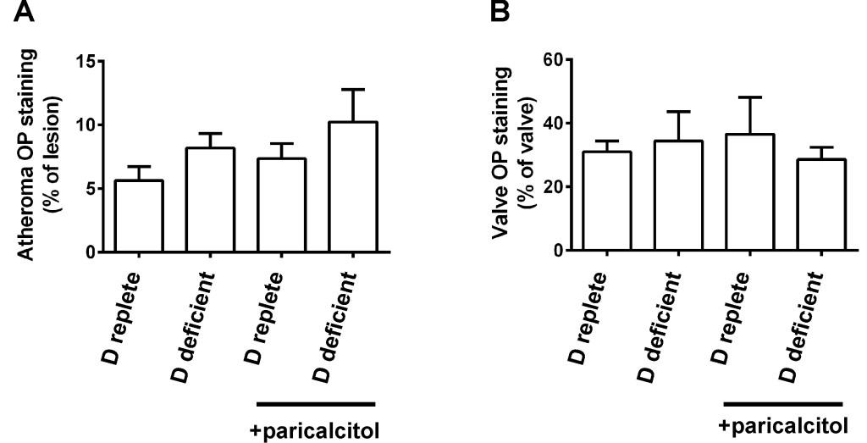
Figure 4.9 The effects of vitamin D manipulation on atherosclerotic and valvular osteopontin staining.
Assessments performed after 20 weeks of vitamin D manipulation. A, immunostaining of atheroma. B, immunostaining of aortic valves. OP, osteopontin. Data presented as mean (SEM), n=7-8 per group.

Vitamin D manipulation and left ventricular hypertrophy
Cardiac weights did not differ between the intervention groups (Figure 4.10). Histological assessment of LV morphology including mean LV wall thickness, LV wall cross sectional area, cardiomyocyte transverse area and cardiomyocyte diameter also did not show any differences between groups. Echocardiographic functional parameters of ejection fraction, fractional area change and cardiac index were similarly unchanged.

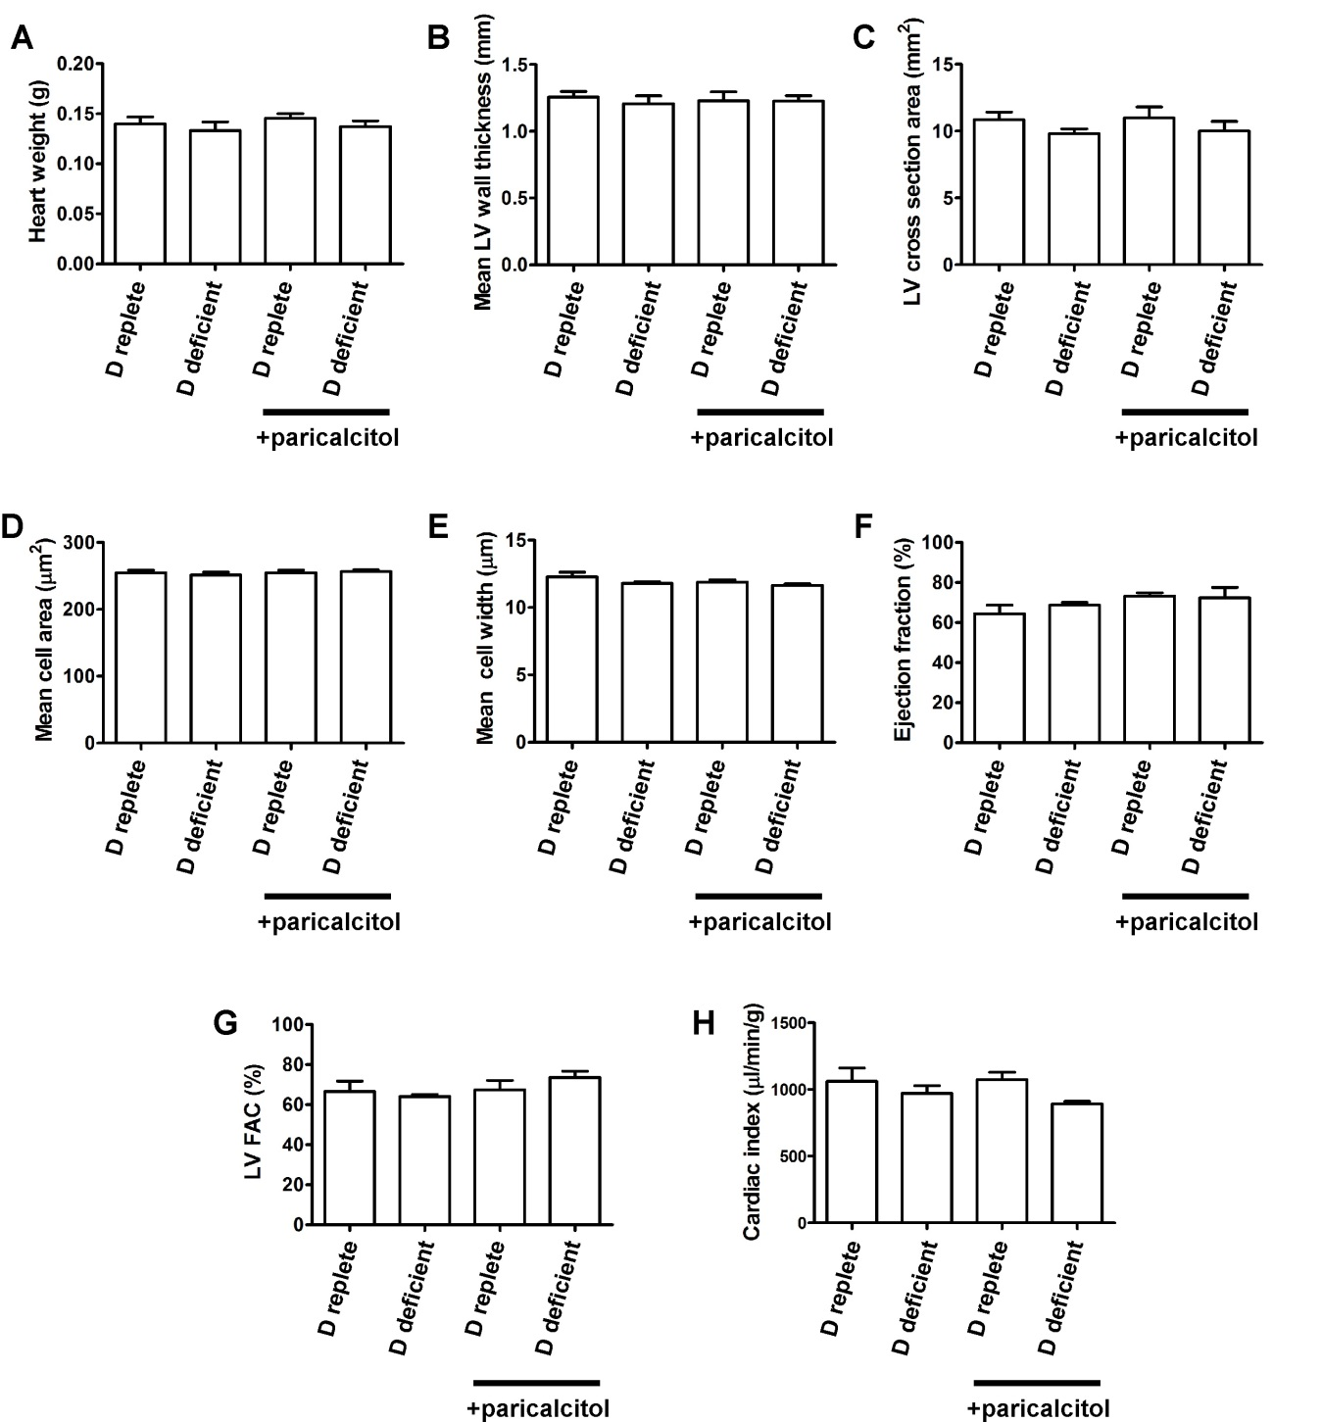
Figure 4.10 The effects of vitamin D manipulation on left ventricular morphology and function.
Assessments performed after 19 weeks of vitamin D manipulation. A, heart weights by intervention. B and C, mean LV wall thickness and LV cross sectional area measured histologically. D and E, cardiomyocyte cross sectional area and transverse diameter. F, left ventricular ejection fraction. G, left ventricular fractional area change. H, cardiac index.
n=7-8 per group for histological analyses and weights, n=5-6 per group for echocardiography. Data presented as mean (SEM).

Discussion
The results reported in this chapter demonstrate that the predominant cardiovascular phenotype of moderate dietary vitamin D deficiency in ApoE^{-/-} mice is an increase in diffuse atherosclerotic calcification. The extent of this increase is similar to that induced by the administration of a VDR agonist dose sufficient to raise the plasma calcium phosphate product, a recognised stimulus to arterial calcification in nonatheromatous animal models (Bas et al., 2006). The increase in diffuse atherosclerotic calcification induced by vitamin D deficiency occurred at a degree of deficiency where no increases in atheroma burden, metabolic derangement or left ventricular hypertrophy were evident.
These results with regard to calcification are consistent with some clinical observational data reporting an independent association between lower serum 25(OH) vitamin D levels and the development of coronary artery calcification (de Boer et al., 2009a, Young et al., 2011). However, standard clinical assessments do not distinguish between calcification differences due to changes in atheroma character, atheroma burden and nonatherosclerotic medial calcification. Whether vitamin D status predicts atheroma calcification on intravascular ultrasound has not been reported.
Following the commencement of this work, Schmidt et al. published data demonstrating that dietary vitamin D deficiency increases the calcification density of aortic sinus sections in LDL receptor knockout (LDLR^{-/-}) mice (Schmidt et al., 2012). That report did not, however, determine whether the location of the increased calcification was in atheroma or the aortic valves. The findings of this chapter thus support and extend the observations of Schmidt et al. in a similar model. Also consistent with our findings, Mathew et al. reported suppression of aortic atherosclerotic calcification by low doses of active vitamin D in partially nephrectomised LDLR^{-/-} mice, suggesting restoration of a calcification-inhibitory effect of VDR signalling (Mathew et al., 2008). High doses of paricalcitol increased aortic calcium content in their model, as in this work, consistent with there being an optimum range of VDR signalling for calcification prevention.
The finding that vitamin D deficiency increases atherosclerotic calcification is consistent with some evidence for a beneficial effect of VDR signalling in the prevention of arterial medial calcification (as occurs in kidney disease). Although atherosclerotic and medial calcification are distinct pathologies, there are likely to be similarities in their biology. Vitamin D receptor agonists (at non-hypercalcaemic/hyperphosphataemic doses) have been shown to suppress medial calcification in a high-phosphate diet partial renal ablation mouse model (Lau et al., 2012). Whether dietary vitamin D deficiency accelerates arterial medial calcification is unknown; nonatherosclerotic medial calcification requires induction by precipitating factors in animal models (such as renal ablation combined with high phosphate intake (Lau et al., 2012)) and was not studied in this work. However, some evidence of a bi-modal relationship between vitamin D status and vascular calcification score has been reported in paediatric dialysis patients (Shroff et al., 2008).
Addition of paricalcitol or calcitriol to vascular smooth muscle cell-macrophage cocultures has previously been demonstrated to inhibit phosphate-induced smooth muscle cell calcification via a mechanism involving stimulation of macrophage osteopontin expression(Li et al., 2010). However, Schmidt et al. reported increased osteopontin expression accompanying the calcification induced by vitamin D deficiency in LDLR^{-/-} mice (Schmidt et al., 2012). In the work reported in this thesis, aortic sinus atherosclerotic osteopontin expression was least in the vitamin D replete mice (though not significantly different between groups), suggesting that an osteopontin-independent process contributes to the inhibition of atherosclerotic calcification by vitamin D.
The type of vitamin D therapy as well as the dose could be clinically important for calcification prevention. Activated vitamin D (calcitriol) or analogues (such as paricalcitol) act systemically to increase intestinal calcium and phosphate uptake, bypassing the regulatory control of renal vitamin D activation. As seen in this work and that of others (Bas et al., 2006, Mathew et al., 2008), the resulting increase in plasma calcium and phosphate levels may be accompanied by an increase in vascular calcification. Replenishing instead the precursor, 25(OH)D, could restore paracrine vitamin D signalling in cardiovascular tissue without necessarily raising plasma calcium phosphate product. This is of particular clinical relevance in the setting of chronic kidney disease, where a deficiency of renal vitamin D activation is commonly accompanied by nutritional vitamin D deficiency (LaClair et al., 2005). The findings of this chapter suggest that correcting 25(OH) vitamin D deficiency might be beneficial for the prevention of atherosclerotic calcification in these patients. Treating with an active vitamin D analogue without replenishing 25(OH)D theoretically risks combining the adverse consequences of increased calcium phosphate product with persisting deficiency of paracrine vitamin D signalling. In the model used here, combining paricalcitol administration with 25(OH)D deficiency did not result in a greater degree of atherosclerotic calcification than either intervention alone. However, surprisingly, although the dose of paricalcitol chosen was sufficient to raise calcium phosphate product, it did not restore structural bone changes resulting from 25(OH)D deficiency. Bone marrow stromal cells express 1-alpha hydroxylase (Zhou et al., 2010) so these findings may reflect an important role for local 25(OH)D activation in maintaining bone structure. There are currently no reported clinical studies examining differential effects on bone structure of 25(OH)D replacement versus active vitamin D administration in the setting of 25(OH)D deficiency.
As in the LDLR^{-/-} model of Schmidt et al. (Schmidt et al., 2012), this work found no significant increase in aortic atherosclerosis burden in ApoE^{-/-} mice fed a vitamin D-deficient diet. In another study published after this work was commenced, Szeto et al. crossed LDLR^{-/-} mice with VDR^{-/-} mice (Szeto et al., 2012); despite elevated plasma renin, an increase in atherosclerosis in VDR^{-/-}LDLR^{-/-} mice was restricted to the innominate artery and not seen at the aortic sinus or ascending/descending aorta. Furthermore, the difference at the innominate artery was only evident after 8 weeks’ high fat diet; after 12 weeks of high fat diet no atheroma lesion sites were significantly different. Thus, the current work and two other studies suggest attenuation of vitamin D signalling plays a limited role in acceleration of atherogenesis.
In contrast, a further recent study reported an increase in en-face aortic atheroma burden induced by dietary vitamin D deficiency in LDLR^{-/-} and ApoE^{-/-} models (Weng et al., 2013). The reason for this difference is unclear. Although vitamin D deficiency was induced at an earlier stage in the study of Weng et al. than in our model, the severity cannot have been greater than that resulting from VDR knockout, which failed to accelerate aortic atherogenesis in the study of Szeto et al. Furthermore, both the dietary intervention used in this thesis and that of Schmidt et al. achieved relative reductions in 25(OH)D greater than those associated with adverse cardiovascular outcomes clinically.
The failure of paricalcitol administration to suppress atherosclerosis in this work is consistent with a previous study reporting the same finding (Becker et al., 2011). However, two other recent studies found that calcitriol administration reduced aortic aortic atheroma (Takeda et al., 2010, Ish-Shalom et al., 2012). It is possible that too high a dose of VDR agonist nullifies potential atherosuppressive benefits of augmented VDR signalling. Unlike our regime, the calcitriol doses administered by Takeda et al. had no effect on plasma phosphorus and calcium concentrations. Considering the acceleration of atherosclerosis by higher dietary phosphate content reported in chapter 3, increased intestinal phosphate uptake accompanying excessive VDR agonist use might counteract atheroprotective benefits.
The absence of left ventricular histological or echocardiographic changes induced by vitamin D deficiency in this study contrasts with findings from global and cardiomyocyte-specific VDR^{-/-} mice (Bouillon et al., 2008, Chen et al., 2011). This may reflect differences in the degree of attenuation of VDR signalling.
A strength of this work is the simultaneous characterisation of the effects of dietary vitamin D deficiency on bone and the cardiovascular system. Observational clinical data associate cardiovascular outcomes with lower 25(OH)D levels across a range that is also associated with significant but small reductions in bone mineral density (Giovannucci et al., 2008, Dobnig et al., 2008, Bischoff-Ferrari et al., 2004). In the current model dietary vitamin D deficiency induced changes in bone mineral density by 12 weeks (i.e. 8 weeks before the cardiovascular assessments) greater than those associated with variation in vitamin D levels in community populations (Bischoff-Ferrari et al., 2004). This suggests that the degree of vitamin D deficiency attained by the dietary intervention approach was sufficiently severe to be physiologically relevant. Consequently, cardiovascular pathology induced in more severe models of vitamin D deficiency may not relate to clinical observations, though there may be species differences in tissue-specific susceptibility to vitamin D deficiency.
The absence of any effect of dietary vitamin D deficiency on obesity, plasma lipids and glycaemia in this study is consistent with the results of the other mouse studies lowering 25(OH)D by deficient diets (Schmidt et al., 2012, Weng et al., 2013). In contrast to the observational clinical data, VDR^{-/-}LDLR^{-/-} mice actually had lower plasma cholesterol and triglycerides than LDLR^{-/-} mice (Szeto et al., 2012), whilst of the studies that administered active vitamin D, none found favourable effects on lipid profile (Takeda et al., 2010, Becker et al., 2011, Ish-Shalom et al., 2012). In fact, low dose calcitriol actually significantly increased total cholesterol and fasting glucose in one report (Ish-Shalom et al., 2012). Therefore, the results presented in this chapter add to an aggregate of animal data which does not support a causal role underlying the associations between lower 25(OH)D/calcitriol and adverse metabolic profile. The lack of any effect of vitamin D manipulation on plasma sVCAM-1 concentration in this work is also in agreement with findings from VDR^{-/-}LDLR^{-/-} mice, which did not demonstrate a significant increase in aortic VCAM-1 mRNA relative to LDLR^{-/-} mice (Szeto et al., 2012).
In summary, this chapter demonstrates that although dietary deficiency of 25(OH)D modifies bone structure, it has little effect on metabolic profile, atherogenesis or LVH in ApoE^{-/-} mice. Therefore, caution is needed in extrapolating findings from VDR^{-/-} models to explain the clinical associations of lower 25(OH)D with CVD and adverse metabolic profile. The finding that diffuse atherosclerotic calcification is increased by 25(OH)D deficiency warrants further investigation to clarify the underlying mechanisms and clinical significance.
To investigate whether lower 25(OH)D and other subtle bone mineral axis disturbances are accompanied by evidence of vascular dysfunction, associations of bone mineral axis parameters with albuminuria were examined in a general population sample (chapter 5).

Relationships between Bone Mineral Axis Parameters and Albuminuria in a Representative US Population Sample

Chapter acknowledgement
Parts of this chapter have been published previously as: Bone Mineral Metabolism Parameters and Urinary Albumin Excretion in a Representative US Population Sample Ellam T, Fotheringham J, Wilkie M, Francis S, and Chico TJ. (2014) PLoS ONE 9(2): e88388. doi:10.1371/journal.pone.0088388. Inclusion herein is with the permission of the publishers and with the approval of the co-authors. All work is the candidate’s own.

Introduction
As discussed in chapter 1, adverse effects of disturbances in bone mineral axis parameters on the endothelium have been postulated to underlie associations between these parameters and CVD. Increasing low-grade albuminuria is an independent predictor of adverse cardiovascular outcomes and is believed to reflect endothelial dysfunction (Matsushita et al., 2010, de Zeeuw et al., 2006). Therefore, if mis-setting of the bone mineral axis causes cardiovascular disease through endothelial damage, associations between bone mineral axis parameters and higher low-grade albuminuria would be expected.
The US National Health and Nutrition Examination Surveys (NHANES) dataset provides an opportunity to examine this question since participants provide paired blood and urine samples, together with demographic, clinical and estimated dietary intake data. Also, because the NHANES data is representative of the non-institutionalised US population, associations between bone mineral axis parameters and albuminuria in this dataset would be consistent with a prevalent mis-setting of the bone mineral axis in western populations without recognised primary metabolic bone disease. The 3rd NHANES cohort (studied 1988-1994) provided the dataset in which dietary phosphate density was demonstrated to predict cardiovascular mortality (Chang et al., 2014).
A limitation of the previous studies associating higher serum phosphate and lower 25(OH)D with increased urine albumin excretion is the use of spot urine albumin:creatinine ratio (ACR) alone to quantify urinary albumin leak. These studies may actually have been detecting associations with lower urinary creatinine excretion. For the purposes of the analyses in this chapter, the fractional excretion of albumin relative to creatinine (FE_{alb}) was added as an alternative measure of albumin leak that is not affected by muscle mass.
Specific Hypotheses Tested:
- Higher serum phosphate, PTH and estimated dietary phosphate density are each associated with increased ACR and FE_{alb}, independently of other factors.
- Lower 25(OH)D is associated with increased ACR and FE_{alb}, independently of other factors.
Although alkaline phosphatase (ALP) and bone-specific alkaline phosphatase (BAP) have not been associated with endothelial dysfunction, they have both been reported to be predictors of cardiovascular mortality (as discussed in section 1.9). Therefore the associations between these parameters and measures of albuminuria were also examined.

Chapter methods summary
The methodology applied to generate the results of this chapter is described in detail in section 2.3. Separate datasets for participant demographics, height, weight, blood pressure, clinical history, smoking status, poverty:income ratio, medication use, serum biochemistry, urine biochemistry and estimated dietary intakes from each 2-year NHANES cycle were first downloaded from the NHANES website (http://www.cdc.gov/nchs/nhanes/nhanes_ questionnaires.htm). These data were then merged using a unique anonymised participant reference number and sequential survey cycles appended to create a single dataset. New variables were calculated as described in section 2.3.
Linear regression was used to examine the relationship between quintiles of each metabolic bone parameter and measures of albuminuria. The multilevel sampling strategy of the NHANES survey design results in complexities of this analysis: Firstly, sampling weights are assigned to each participant by the NHANES centre in order to relate the selected sample to the total US noninstitutionalised US population. These sample weights reflect the reciprocal of the probability of participant selection, adjusted for non-responders to the participation invitation. Secondly, since sampling is conducted at a set of defined geographic locations (‘primary sampling units’) within a small number of US state regions (‘strata’), parameter variance estimates require adjustment for intracluster correlation. (Variation in participant characteristics within geographical clusters may be less than if participants were selected at random from the whole population.) An example outline statistical code for performing linear regression with incorporation of sample weights and adjustment for NHANES cluster sampling is provided in online tutorials from the Incorporation of the sampling weights required for the analysis of the NHANES dataset was performed as per the statistical guidelines of the US National Centre for Health Statistics (NCHS, http://www.cdc.gov/nchs/nhanes/about_nhanes.htm). The linear regression analyses described in this chapter are based on this command code, but all analyses are original for the variables/outcomes of interest. Covariate adjustments are described and justified in section 2.3.10 and sample statistical analysis codes are shown in the appendix section 8.3.
The odds ratio of having an ACR defining moderately increased albuminuria (>30mg/g) was determined by binary logistic regression. This analysis was also based on an outline sample code provided by the NCHS online tutorial system.

Results

Participant characteristics
Of the 27,003 non-pregnant participants >20y of age in NHANES 1999-2010 with complete dietary intake and biochemistry data, 3,657 (13.5%) had eGFR <60ml/min/1.73m² and 310 (1.3%) with preserved eGFR had severely increased albuminuria (ACR>300mg/g). These were excluded from the analysis (section 2.3.4). Further confining the analysis to participants with complete data for BMI, waist circumference, blood pressure, smoking status, diabetes status, history of CVD, poverty:income ratio and time of day of venepuncture gave a total of n= 19,383 included in the analyses of serum phosphate, total ALP and estimated dietary phosphorus density. Similar proportions were excluded from the NHANES cycles combined for PTH, 25(OH)D and BAP analyses, leaving N=6,005 (NHANES 2003-2006) and N=7,384 (NHANES 1999-2004). Characteristics of the US population represented by these participants are shown in Table 5.1.

Table 5.1 Characteristics of the US population represented by NHANES 1999-2010, 2003-2006 and 1999-2004 participants selected for analysis.
 | 1999-2010 | 2003-2006 | 1999-2004
N | 19,383 | 6,005 | 7,384
Age, y, mean (SEM) | 44.8 (0.3) | 45.2 (0.4) | 41.4 (0.3)
Male, % (SEM) | 50.3 (0.3) | 50.2 (0.7) | 50.9 0.7)
Race, % (SEM)  Nonhispanic White  Nonhispanic Black  Hispanic  Other | 76.8 (1.1)  9.7 (0.6)  8.0 (0.7)  4.9 (0.3) | 76.4 (2.2)  10.4 (1.3)  7.9 (1.1)  5.0 (0.6) | 77.3 (1.3)  9.8 (0.9)  7.8 (1.0)  4.5 (0.5)
BMI, kg/m², mean (SEM) | 28.3 (0.1) | 28.2 (0.2) | 27.8 (0.1)
Systolic BP, mmHg, mean (SEM) | 121.4 (0.2) | 122.3 (0.4) | 120.8 (0.4)
Diastolic BP, mmHg, mean (SEM) | 71.6 (0.2) | 71.3 (0.3) | 72.7 (0.2)
Diabetes, % (SEM) | 6.2 (0.2) | 6.0 (0.4) | 4.3 (0.3)
Cardiovascular disease, % (SEM) | 4.5 (0.2) | 4.9 (0.4) | 3.9 (0.3)
Smoking, % (SEM) | 29.8 (0.6) | 31.4 (1.1) | 32.6 (1.1)
eGFR, ml/min/1.73m², mean (SEM) | 96.8 (0.3) | 96.1 (0.6) | 98.4 (0.5)
Serum phosphate, mM, mean (SEM) | 1.20 (0.00) | 1.24 (0.00) | 1.18 (0.00)
24h phosphorus intake, mg, mean (SEM) | 1393 (7) | 1383 (16) | 1387 (13)
Serum calcium, mM, mean (SEM) | 2.37 (0.00) | 2.39 (0.00) | 2.37 (0.0)
PTH, pg/mL, median (IQR) | NA | 38 (21) | NA
Total ALP, U/L, median (IQR) | 66 (26) | 64 (24) | 67 (27)
25(OH) vitamin D, ng/mL, mean (SEM) | NA | 24.0 (0.4) | NA
Bone-specific ALP, μg/L, median (IQR) | NA | NA | 13.8 (6.8)
ACR, mg/g, median (IQR) | 5.8 (6.2) | 5.9 (6.2) | 5.6 (5.9)
Urine albumin, mg/L, median (IQR) | 6.8 (9.1) | 6.9 (9.3) | 6.9 (9.5)
Moderate albuminuria, % (SEM) | 10.2 (0.3) | 10.1 (0.4) | 9.4 (0.5)

Data are given as mean (SEM) or median (IQR) for parametric and non-parametrically distributed variables respectively. N/A, not available.

Since independent associations between bone mineral parameters and cardiovascular risk factors have been examined previously in NHANES cohorts, this analysis was not duplicated. However, characteristics of the cohort by quintiles of each metabolic bone parameter are provided in the appendix Tables 8.3-8.8.
Urine ACR, creatinine concentration, albumin concentration and FE_{alb} were all positively skewed and were natural log-transformed for parametric analyses.

Associations between serum phosphate and albuminuria
Firstly, the relationships between serum phosphate concentration and measures of albuminuria in the general population were examined. There was no increase in log-transformed ACR or FE_{alb} with increasing quintile of serum phosphate concentration (Table 5.2). In fact, following pre-specified adjustment for metabolic syndrome components (models 2/3), quintiles 2-5 were associated with a statistically significantly lower FE_{alb} than quintile 1. Spot urine concentrations of both albumin and creatinine were significantly lower with increasing phosphate quintile, although differences were somewhat attenuated by full covariate adjustment. Elevations of serum phosphate within the normal range therefore are not associated with increased albuminuria and there is some evidence that the reverse may be the case for FE_{alb}. Repeating the analyses in the subpopulation assessed fasting in the morning did not change the above conclusions (not shown).

Dietary phosphorus density and albuminuria
Increasing dietary phosphorus density was also not associated with albuminuria (Table 5.3). In model 1, the lowest quintile of estimated dietary phosphorus density over the preceding 24h actually had a significantly greater log ACR and FE_{alb} than quintiles 2-5. However, full covariate adjustment (model 3) rendered these associations nonsignificant. When dietary phosphorus intake was assessed indexed to weight or as absolute unindexed intake there remained no association with greater albuminuria (not shown). Thus there was no evidence that a greater dietary phosphorus exposure over the preceding 24h increases albuminuria.

Table 5.2 Fold-changes in measures of albuminuria according to quintile of serum phosphate (N=19,383).
 | Serum phosphate quintile (mM)
 | <1.07 | 1.07-<1.16 | 1.16-<1.26 | 1.26-<1.36 | ≥1.36
Model 1
uAlb | 1.00 | 0.96 (0.89, 1.02) p=0.20 | 0.90 (0.84, 0.96) p=0.003 | 0.84 (0.78, 0.90) p<0.001 | 0.86 (0.80, 0.92) p<0.001
uCr | 1.00 | 0.96 (0.92, 1.00) p=0.056 | 0.94 (0.90, 0.98) p=0.004 | 0.88 (0.84, 0.82) p<0.001 | 0.89 (0.86, 0.94) p<0.001
ACR | 1.00 | 1.00 (0.95, 1.05) p=0.94 | 0.96 (0.91, 1.01) p=0.11 | 0.96 (0.91, 1.01) p=0.089 | 0.96 (0.92, 1.01) p=0.15
FE_{alb} | 1.00 | 0.99 (0.94, 1.04) p=0.74 | 0.95 (0.91, 1.00) p=0.071 | 0.94 (0.90, 0.99) p=0.03 | 0.96 (0.91, 1.01) p=0.10
Model 2
uAlb | 1.00 | 0.97 (0.90, 1.03) p=0.29 | 0.92 (0.86, 0.99) p=0.018 | 0.85 (0.79, 0.91) p<0.001 | 0.87 (0.81, 0.93) p<0.001
uCr | 1.00 | 0.97 (0.93, 1.01) p=0.12 | 0.95 (0.91, 0.99) p=0.022 | 0.90 (0.86, 0.94) p<0.001 | 0.91 (0.87, 0.95) p<0.001
ACR | 1.00 | 1.00 (0.95, 1.05) p=0.94 | 0.97 (0.92, 1.02) p=0.22 | 0.95 (0.90, 1.00) p=0.033 | 0.96 (0.91, 1.01) p=0.095
FE_{alb} | 1.00 | 0.99 (0.94, 1.04) p=0.75 | 0.97 (0.92, 1.01) p=0.16 | 0.94 (0.89, 0.99) p=0.016 | 0.95 (0.90, 1.00) p=0.032
Model 3
uAlb | 1.00 | 0.97 (0.92, 1.03) p=0.36 | 0.94 (0.89, 1.00) p=0.051 | 0.93 (0.87, 0.99) p=0.016 | 0.92 (0.87, 0.98) p=0.010
uCr | 1.00 | 0.97 (0.94, 1.01) p=0.12 | 0.97 (0.93, 1.01) p=0.10 | 0.95 (0.92, 0.99) p=0.017 | 0.96 (0.93, 1.00) p=0.066
ACR | 1.00 | 1.00 (0.96, 1.05) p=0.49 | 0.97 (0.93, 1.02) p=0.72 | 0.97 (0.93, 1.02) p=0.58 | 0.96 (0.91, 1.00) p=0.62
FE_{alb} | 1.00 | 0.93 (0.89, 0.98) p=0.008 | 0.94 (0.89, 0.98) p=0.006 | 0.93 (0.89, 0.98) p=0.004 | 0.93 (0.88, 0.98) p=0.006

model 1: adjusted for age, gender and race.
model 2: as model 1 but additionally adjusted for BMI, weight, waist circumference, systolic and diastolic blood pressures, total:HDL cholesterol ratio, eGFR, diabetes status, HbA1C.
model 3: as model 2 but additionally adjusted for history of CVD, poverty:income ratio, smoking, CRP, haemoglobin, calcium, time of day of venepuncture.

uAlb, urine albumin concentration; uCr, urine creatinine concentration; ACR, urine albumin:creatinine ratio; FE_{alb}, fractional excretion of albumin relative to creatinine.
p<0.05 versus quintile 1 highlighted by bold font.

Table 5.3 Fold-changes in measures of albuminuria according to quintile of dietary phosphorus density (N=19,383).
 | Dietary phosphorus density quintile (mg/kcal)
 | <0.49 | 0.49-<0.57 | 0.57-<0.66 | 0.66-<0.77 | ≥0.77
Model 1
uAlb | 1.00 | 0.88 (0.82, 0.94) p<0.001 | 0.86 (0.80, 0.92) p<0.001 | 0.81 (0.75, 0.86) p<0.001 | 0.77 (0.71, 0.82) p<0.001
uCr | 1.00 | 0.94 (0.90, 0.98) p=0.005 | 0.92 (0.88, 0.96) p<0.001 | 0.87 (0.83, 0.91) p<0.001 | 0.83 (0.79, 0.87) p<0.001
ACR | 1.00 | 0.93 (0.89, 0.98) p=0.008 | 0.94 (0.89, 0.98) p=0.006 | 0.93 (0.89, 0.98) p=0.004 | 0.93 (0.88, 0.98) p=0.006
FE_{alb} | 1.00 | 0.93 (0.88, 0.98) p=0.004 | 0.93 (0.89, 0.98) p=0.004 | 0.93 (0.88, 0.97) p=0.003 | 0.92 (0.87, 0.97) p=0.002
Model 2
uAlb | 1.00 | 0.90 (0.84, 0.96) p=0.002 | 0.88 (0.82, 0.95) p=0.001 | 0.84 (0.78, 0.90) p<0.001 | 0.81 (0.74, 0.88) p<0.001
uCr | 1.00 | 0.94 (0.90, 0.99) p=0.01 | 0.92 (0.88, 0.96) p=0.001 | 0.86 (0.82, 0.91) p<0.001 | 0.82 (0.78, 0.87) p<0.001
ACR | 1.00 | 0.95 (0.90, 1.00) p=0.04 | 0.96 (0.92, 1.01) p=0.14 | 0.97 (0.92, 1.02) p=0.26 | 0.98 (0.92, 1.04) p=0.50
FE_{alb} | 1.00 | 0.95 (0.90, 0.99) p=0.03 | 0.96 (0.91, 1.01) p=0.11 | 0.96 (0.91, 1.02) p=0.19 | 0.97 (0.91, 1.03) p=0.39
Model 3
uAlb | 1.00 | 0.91 (0.85, 0.97) p=0.007 | 0.90 (0.84, 0.97) p=0.005 | 0.86 (0.80, 0.92) p<0.001 | 0.83 (0.76, 0.90) p<0.001
uCr | 1.00 | 0.95 (0.91, 0.99) p=0.02 | 0.93 (0.89, 0.97) p=0.001 | 0.87 (0.83, 0.92) p<0.001 | 0.84 (0.79, 0.89) p<0.001
ACR | 1.00 | 0.96(0.91, 1.01) p=0.09 | 0.98 (0.93, 1.04) p=0.34 | 0.98 (0.93, 1.04) p=0.55 | 0.99 (0.93, 1.05) p=0.73
FE_{alb} | 1.00 | 0.96 (0.91, 1.01) p=0.08 | 0.98 (0.93, 1.03) p=0.32 | 0.98 (0.93, 1.04) p=0.52 | 0.99 (0.93, 1.05) p=0.72

model 1: adjusted for age, gender and race.
model 2: as model 1 but additionally adjusted for BMI, weight, waist circumference, systolic and diastolic blood pressures, total:HDL cholesterol ratio, eGFR, diabetes status, HbA1c and estimated 24h calorie-indexed dietary intakes of sodium, protein and saturated fat.
model 3: as model 2 but additionally adjusted for history of CVD, poverty:income ratio, smoking, CRP, haemoglobin, calcium.
uAlb, urine albumin concentration; uCr, urine creatinine concentration; ACR, urine albumin:creatinine ratio; FE_{alb}, fractional excretion of albumin relative to creatinine.

Associations between PTH and albuminuria
NHANES participants in the top quintile of serum PTH (≥54pg/ml) had significantly greater log ACR and FE_{alb} compared to quintile 1 (<27pg/ml) in model 1 (Table 5.4). Adjusting for covariates including metabolic syndrome components, cardiovascular risk factors, eGFR, poverty:income ratio, smoking status, CRP, haemoglobin, calcium, time of day of venepuncture, diabetes, diuretic use, season of measurement, and 25(OH)D (model 4) strengthened these associations, with statistically significant increases in ACR in the highest three quintiles of serum PTH (1.11, 1.11 and 1.19-fold respectively).
In case the excess of albuminuria in the highest quintile was influenced by primary hyperparathyroidism, subjects with PTH levels outside the reference range (i.e. above the 95th centile of PTH, 75pg/ml) were excluded. This did not materially alter the findings; the fold-change in geometric mean ACR adjusted for all other covariates was only slightly reduced to 1.16 (1.05-1.28, p=0.003) for the 5th versus 1st PTH quintile (N=5,704). Therefore, even within the range considered ‘normal’ higher PTH is associated with increased low-grade albuminuria.

Associations between vitamin D and albuminuria
On examining the relationship between serum vitamin 25(OH)D and albuminuria, the lowest quintile of serum 25(OH)D (<16ng/ml) compared with the highest quintile (≥31ng/ml) was found to be associated with increased log-transformed ACR and FE_{alb} in model 1 (Table 5.5). However, following adjustment for additional covariates (models 2-4) these associations were no longer significant.

Table 5.4 Fold-changes in measures of albuminuria according to quintile of parathyroid hormone (N=6,005).
 | Parathyroid hormone quintile (pg/ml)
 | <27 | 27-<34 | 34-<42 | 42-<54 | ≥54
Model 1
uAlb | 1.00 | 1.09 (0.97, 1.24) p=0.15 | 1.16 (1.03, 1.31) p=0.018 | 1.28 (1.12, 1.45) p<0.001 | 1.34 (1.18, 1.52) p<0.001
uCr | 1.00 | 1.08 (0.99, 1.18) p=0.07 | 1.13 (1.04, 1.23) p=0.005 | 1.22 (1.12, 1.33) p<0.001 | 1.19 (1.10, 1.30) p<0.001
ACR | 1.00 | 1.01 (0.93, 1.10) p=0.80 | 1.03 (0.94, 1.12) p=0.55 | 1.05 (0.95, 1.15) p=0.33 | 1.12 (1.02, 1.23) p=0.015
FE_{alb} | 1.00 | 1.02 (0.93, 1.11) p=0.71 | 1.03 (0.94, 1.12) p=0.58 | 1.05 (0.96, 1.15) p=0.33 | 1.14 (1.04, 1.25) p=0.005
Model 2
uAlb | 1.00 | 1.10 (0.97, 1.24) p=0.13 | 1.16 (1.02, 1.31) p=0.019 | 1.26 (1.11, 1.42) p<0.001 | 1.30 (1.15, 1.47) p<0.001
uCr | 1.00 | 1.07 (0.99, 1.17) p=0.091 | 1.10 (1.01, 1.20) p=0.022 | 1.20 (1.10, 1.30) p<0.001 | 1.16 (1.06, 1.26) p<0.001
ACR | 1.00 | 1.02 (0.94, 1.11) p=0.63 | 1.05 (0.96, 1.14) p=0.32 | 1.05 (0.96, 1.15) p=0.31 | 1.12 (1.02, 1.23) p=0.009
FE_{alb} | 1.00 | 1.02 (0.94, 1.12) p=0.60 | 1.04 (0.95, 1.13) p=0.40 | 1.04 (0.95, 1.14) p=0.36 | 1.13 (1.03, 1.23) p=0.009
Model 3
uAlb | 1.00 | 1.14 (1.02, 1.29) p=0.027 | 1.24 (1.10, 1.40) p<0.001 | 1.34 (1.18, 1.52) p<0.001 | 1.39 (1.22, 1.57) p<0.001
uCr | 1.00 | 1.08 (0.99, 1.17) p=0.076 | 1.12 (1.03, 1.22) p=0.006 | 1.21 (1.11, 1.31) p<0.001 | 1.17 (1.07, 1.27) p<0.001
ACR | 1.00 | 1.06 (0.97,1.16) p=0.18 | 1.10 (1.01, 1.20) p=0.032 | 1.11 (1.01, 1.21) p=0.031 | 1.19 (1.09, 1.30) p<0.001
FE_{alb} | 1.00 | 1.05 (0.97, 1.15) p=0.24 | 1.09 (1.00, 1.18) p=0.062 | 1.09 (0.99, 1.19) p=0.069 | 1.17 (1.06, 1.28) p<0.001
Model 4
uAlb | 1.00 | 1.14 (1.01, 1.28) p=0.029 | 1.23 (1.09, 1.40) p<0.001 | 1.33 (1.17, 1.51) p<0.001 | 1.37 (1.20, 1.55) p<0.001
uCr | 1.00 | 1.07 (0.99, 1.16) p=0.10 | 1.11 (1.02, 1.21) p=0.011 | 1.19 (1.10, 1.30) p<0.001 | 1.15 (1.05, 1.25) p=0.002
ACR | 1.00 | 1.07 (0.98, 1.16) p=0.14 | 1.11 (1.02, 1.21) p=0.020 | 1.11 (1.01, 1.22) p=0.029 | 1.19 (1.08, 1.31) p<0.001
FE_{alb} | 1.00 | 1.06 (0.97, 1.15) p=0.20 | 1.09 (1.00, 1.19) p=0.043 | 1.09 (1.00, 1.20) p=0.068 | 1.17 (1.07, 1.28) p=0.001
model 1: adjusted for age, gender and race.
model 2: as model 1 but additionally adjusted for BMI, weight, waist circumference, systolic and diastolic blood pressures, total:HDL cholesterol ratio, eGFR, diabetes status, HbA1c.
model 3: as model 2 but additionally adjusted for history of CVD, poverty:income ratio, smoking status, CRP, haemoglobin, calcium, time of day of venepuncture.
model 4: as model 3 but additionally adjusted for 25(OH)D quintile, season of measurement, loop diuretic and thiazide diuretic.

uAlb, urine albumin concentration; uCr, urine creatinine concentration; ACR, urine albumin:creatinine ratio; FE_{alb}, fractional excretion of albumin relative to creatinine.

Table 5.5 Fold-changes in measures of albuminuria by quintile of 25(OH) vitamin D (N=6,005).
 | 25(OH) vitamin D quintile (ng/ml)
Model 1 | <16 | 16-<22 | 22-<26 | 26-<31 | ≥31
uAlb | 1.37 (1.19, 1.57) p<0.001 | 1.15 (1.02, 1.29) p=0.021 | 1.20 (1.06, 1.36) p=0.0039 | 1.08 (0.95, 1.23) p=0.22 | 1.00
uCr | 1.18 (1.08, 1.29) p<0.001 | 1.13 (1.04, 1.22) p=0.0037 | 1.10 (1.01, 1.19) p=0.029 | 1.09 (1.00, 1.19) p=0.041 | 1.00
ACR | 1.16 (1.05, 1.28) p=0.003 | 1.03 (0.94, 1.11) p=0.63 | 1.09 (1.00, 1.20) p=0.049 | 0.99 (0.91, 1.09) p=0.86 | 1.00
FE_{alb} | 1.12 (1.01, 1.23) p=0.028 | 1.00 (0.92, 1.09) p=0.94 | 1.07 (0.98, 1.17) p=0.12 | 0.98 (0.90, 1.08) p=0.69 | 1.00
Model 2
uAlb | 1.20 (1.04, 1.39) p=0.011 | 1.07 (0.95, 1.20) p=0.26 | 1.14 (1.01, 1.29) p=0.038 | 1.06 (0.93, 1.20) p=0.38 | 1.00
uCr | 1.11 (1.01, 1.21) p=0.026 | 1.08 (0.99, 1.17) p=0.072 | 1.05 (0.97, 1.15) p=0.20 | 1.06 (0.98, 1.16) p=0.14 | 1.00
ACR | 1.08 (0.98, 1.20) p=0.11 | 0.99 (0.92, 1.08) p=0.88 | 1.08 (0.99, 1.18) p=0.085 | 0.99 (0.91, 1.08) p=0.87 | 1.00
FE_{alb} | 1.03 (0.93, 1.14) p=0.57 | 0.97 (0.89, 1.05) p=0.42 | 1.05 (0.96, 1.14) p=0.28 | 0.98 (0.89, 1.07 p=0.59 | 1.00
Model 3
uAlb | 1.21 (1.05, 1.39) p=0.010 | 1.08 (0.96, 1.22) p=0.19 | 1.15 (1.02, 1.30) p=0.025 | 1.07 (0.94, 1.21) p=0.31 | 1.00
uCr | 1.15 (1.05, 1.25) p=0.032 | 1.10 (1.02, 1.19) p=0.019 | 1.07 (0.99, 1.16) p=0.085 | 1.08 (0.99, 1.17) p=0.079 | 1.00
ACR | 1.05 (0.95, 1.16) p=0.31 | 0.98 (0.91 1.07) p=0.71 | 1.07 (0.98, 1.17) p=0.11 | 0.99 (0.91, 1.08) p=0.84 | 1.00
FE_{alb} | 1.05 (0.95, 1.16) p=0.30 | 0.99 (0.91, 1.07) p=0.76 | 1.07 (0.98, 1.16) p=0.13 | 0.99 (0.91, 1.08) p=0.084 | 1.00
Model 4
uAlb | 1.15 (0.99, 1.33) p=0.067 | 1.04 (0.93, 1.17) p=0.50 | 1.14 (1.00, 1.29) p=0.042 | 1.05 (0.93, 1.19) p=0.40 | 1.00
uCr | 1.13 (1.03, 1.23) p=0.010 | 1.08 (1.00, 1.17) p=0.053 | 1.07 (0.99, 1.16) p=0.088 | 1.07 (0.99, 1.16) p=0.080 | 1.00
ACR | 1.02 (0.92, 1.13) p=0.72 | 0.96 (0.89, 1.05) p=0.38 | 1.06 (0.97, 1.16) p=0.19 | 0.98 (0.90, 1.07) p=0.67 | 1.00
FE_{alb} | 1.03 (0.93, 1.14) p=0.61 | 0.97 (0.89, 1.05) p=0.47 | 1.06 (0.97, 1.16) p=0.18 | 0.98 (0.90, 1.07) p=0.72 | 1.00

model 1: adjusted for age, gender and race.
model 2: as model 1 but additionally adjusted for BMI, weight, waist circumference, systolic and diastolic blood pressures, total:HDL cholesterol ratio, eGFR, diabetes status, HbA1c.
model 3: as model 2 but additionally adjusted for history of CVD, poverty:income ratio, smoking status, 25(OH)vitamin D, CRP, haemoglobin, calcium and season of measurement.
model 4: as model 3 but additionally adjusted for PTH quintile and time of day of venepuncture.

uAlb, urine albumin concentration; uCr, urine creatinine concentration; ACR, urine albumin:creatinine ratio; FE_{alb}, fractional excretion of albumin relative to creatinine.

Associations between alkaline phosphatase and albuminuria
The top quintile of total serum ALP (≥83U/L) was associated with significantly greater log-transformed ACR and FE_{alb} (Table 5.6). This association was attenuated when adjusted for diabetes status, BMI, lipids, blood pressure and eGFR (model 2), and was abolished with adjustment for further covariates including CRP (model 3).
Table 5.6 Fold-changes in measures of albuminuria by quintile of total alkaline phosphatase (N=19,383).
 | Total ALP quintile (U/L)
Model 1 | <51 | 51-<61 | 61-<71 | 71-<83 | ≥83
uAlb | 1.00 | 1.01 (0.95, 1.08) p=0.63 | 1.12 (1.06, 1.19) p<0.001 | 1.13 (1.06, 1.21) p<0.001 | 1.31 (1.23, 1.39) p<0.001
uCr | 1.00 | 1.02 (0.98, 1.06) p=0.45 | 1.08 (1.03, 1.12) p<0.001 | 1.10 (1.05, 1.14) p<0.001 | 1.10 (1.05, 1.14) p<0.001
ACR | 1.00 | 1.00 (0.96, 1.04) p=0.97 | 1.05 (1.00, 1.09) p=0.046 | 1.03 (0.99, 1.08) p=0.16 | 1.19 (1.14, 1.25) p<0.001
FE_{alb} | 1.00 | 0.99 (0.95, 1.04) p=0.72 | 1.04 (1.00, 1.09) p=0.068 | 1.02 (0.98, 1.07) p=0.32 | 1.18 (1.13, 1.24) p<0.001
Model 2
uAlb | 1.00 | 0.98 (0.91, 1.05) p=0.53 | 1.05 (0.98, 1.12) p=0.18 | 1.05 (0.98, 1.13) p=0.14 | 1.12 (1.05, 1.20) p=0.001
uCr | 1.00 | 1.00 (0.96, 1.05) p=0.88 | 1.05 (1.00, 1.10) p=0.064 | 1.07 (1.02, 1.12) p=0.007 | 1.06 (1.01, 1.11) p=0.015
ACR | 1.00 | 0.97 (0.93, 1.02) p=0.30 | 1.00 (0.95, 1.05) p=0.92 | 0.99 (0.94, 1.04) p=0.63 | 1.06 (1.01, 1.11) p=0.024
FE_{alb} | 1.00 | 0.97 (0.93, 1.02) p=0.27 | 1.00 (0.95, 1.05) p=0.97 | 0.98 (0.93, 1.03) p=0.45 | 1.06 (1.00, 1.11) p=0.032
Model 3
uAlb | 1.00 | 0.97 (0.91, 1.03) p=0.29 | 1.03 (0.97, 1.10) p=0.29 | 1.01 (0.95, 1.07) p=0.74 | 1.08 (1.01, 1.15) p=0.018
uCr | 1.00 | 1.00 ( 0.96, 1.04) p=0.94 | 1.04 (1.00, 1.09) p=0.039 | 1.06 (1.02, 1.10) p=0.007 | 1.04 (1.00, 1.09) p=0.037
ACR | 1.00 | 0.97 (0.93, 1.01) p=0.17 | 0.99 (0.95, 1.03) p=0.67 | 0.96 (0.91, 1.00) p=0.046 | 1.03 (0.99, 1.09) p=0.18
FE_{alb} | 1.00 | 0.97 (0.93, 1.01) p=0.16 | 0.99 (0.95, 1.03) p=0.66 | 0.96 (0.91, 1.00) p=0.030 | 1.03 (0.98, 1.08) p=0.19

model 1: adjusted for age, gender and race.
model 2: as model 1 but additionally adjusted for BMI, weight, waist circumference, systolic and diastolic blood pressures, total:HDL cholesterol ratio, eGFR, diabetes status, HbA1c.
model 3: as model 2 but additionally adjusted for history of cardiovascular disease, poverty:income ratio, smoking, CRP, alanine transaminase, aspartate transaminase, haemoglobin, calcium, phosphorus.
uAlb, urine albumin concentration; uCr, urine creatinine concentration; ACR, urine albumin:creatinine ratio; FE_{alb}, fractional excretion of albumin relative to creatinine.

Associations between bone-specific ALP and albuminuria
An association between quintile 5 versus quintile 1 of bone-specific ALP and log-transformed ACR was attenuated by full covariate adjustment (model 3) though still just significant (Table 5.7). However, the accompanying association with FE_{alb} did not persist.
Table 5.7 Fold-changes in measures of albuminuria by quintile of bone-specific alkaline phosphatase (N=7,384).
 | Bone-specific ALP quintile (μg/L)
Model 1 | <3.3 | 3.3-<3.6 | 3.6-<3.9 | 3.9-<4.2 | ≥4.2
uAlb | 1.00 | 1.18 (1.05, 1.32) p=0.004 | 1.15 (1.04, 1.29) p=0.013 | 1.22 (1.09, 1.36) p<0.001 | 1.46 (1.30, 1.64) p<0.001
uCr | 1.00 | 1.11 (1.02, 1.19) p=0.014 | 1.11 (1.03, 1.21) p=0.007 | 1.14 (1.05, 1.24) p=0.001 | 1.14 (1.05, 1.23) p=0.001
ACR | 1.00 | 1.07 (0.99, 1.16) p=0.086 | 1.03 (0.96, 1.12) p=0.40 | 1.07 (0.98, 1.16) p=0.13 | 1.29 (1.18, 1.40) p<0.001
FE_{alb} | 1.00 | 1.06 (0.98, 1.14) p=0.15 | 1.01 (0.93, 1.09) p=0.82 | 1.04 (0.96, 1.13) p=0.29 | 1.24 (1.14, 1.35) p<0.001
Model 2
uAlb | 1.00 | 1.14 (1.01, 1.27) p=0.025 | 1.08 (0.97, 1.21) p=0.17 | 1.12 (1.00, 1.26) p=0.050 | 1.28 (1.14, 1.44) p<0.001
uCr | 1.00 | 1.09 (1.01, 1.18) p=0.024 | 1.09 (1.01, 1.18) p=0.034 | 1.13 (1.04, 1.22) p=0.002 | 1.14 (1.05, 1.23) p=0.002
ACR | 1.00 | 1.04 (0.96, 1.12) p=0.84 | 0.99 (0.92, 1.08) p=0.86 | 0.99 (0.92, 1.08) p=0.84 | 1.13 (1.04, 1.23) p=0.004
FE_{alb} | 1.00 | 1.03 (0.95, 1.11) p=0.49 | 0.97 (0.89, 1.05) p=0.39 | 0.97 (0.90, 1.06) p=0.53 | 1.09 (1.01, 1.19) p=0.037
Model 3
uAlb | 1.00 | 1.12 (1.01, 1.26) p=0.038 | 1.07 (1.05, 1.19) p=0.26 | 1.09 (1.02, 1.23) p=0.12 | 1.24 (1.11, 1.40) p<0.001
uCr | 1.00 | 1.09 (1.01, 1.18) p=0.024 | 1.09 1.01, 1.18) 0.024 | 1.12 (1.04, 1.21) p=0.004 | 1.14 (1.05, 1.23) p=0.002
ACR | 1.00 | 1.03 (0.95, 1.11) p=0.45 | 0.97 0.90, 1.05) p=0.50 | 0.98 (0.90, 1.06) p=0.57 | 1.10 (1.01, 1.19) p=0.035
FE_{alb} | 1.00 | 1.02 (0.95, 1.10) p=0.55 | 0.96 (0.89, 1.04) p=0.33 | 0.96 (0.88, 1.04) p=0.30 | 1.07 (0.99, 1.17) p=0.11

model 1: adjusted for age, gender and race
model 2: as model 1 but additionally adjusted for BMI, weight, waist circumference, systolic and diastolic blood pressures, total:HDL cholesterol ratio, eGFR, diabetes status, HbA1c
model 3: as model 2 but additionally adjusted for history of cardiovascular disease, poverty:income ratio, smoking status, CRP, haemoglobin, calcium

Odds ratios of microalbuminuria
In binary logistic regression analyses, the odds ratios of moderately increased albuminuria (ACR>30mg/g) were not significantly different by quintile of any bone mineral metabolic parameter following covariate adjustment. These findings are summarised in Table 5.8, with data presented for full covariate adjustment.

Table 5.8 Odds ratios of having moderately increased albuminuria by quintiles of bone mineral axis parameters.
Quintile | 1 | 2 | 3 | 4 | 5
Serum phosphate  (N=19,383) | 1.00  (ref) | 0.98  (0.80, 1.21) | 0.94  (0.76, 1.16) | 0.88  (0.70, 1.11) | 0.83  (0.66, 1.05)
Dietary phosphorus density  (N=19,383) | 1.00  (ref) | 0.93  (0.76, 1.13) | 0.86  (0.70, 1.07) | 0.94  (0.76, 1.16) | 1.08  (0.79, 1.46)
Serum PTH  (N=6,005) | 1.00  (ref) | 0.79  (0.51, 1.22) | 0.94  (0.64, 1.37) | 0.96  (0.66, 1.37) | 1.17  (0.83, 1.65)
Serum 25(OH)D  (N=6,005) | 1.15  (0.73, 1.82) | 0.81  (0.54, 1.22) | 1.15  (0.77, 1.72) | 0.85  (0.58, 1.24) | 1.00  (ref)
Serum ALP  (N=19,383) | 1.00  (ref) | 1.01  (0.80, 1.27) | 0.94  (0.75, 1.19) | 0.89  (0.67, 1.18) | 1.03  (0.81, 1.30)
Serum bone-specific ALP  (N=7,384) | 1.00  (ref) | 0.73  (0.37, 1.44) | 0.42  (0.16, 1.15) | 1.05  (0.46, 2.38) | 1.42  (0.61, 3.29)

Data presented as odds ratio (95% confidence interval), p>0.05 for all. Ref: referent group.
All odds ratios presented with full covariate adjustments as described for the final models in Tables 5.2-5.7.

Discussion
The independent association between higher-‘normal’ PTH and increasing low grade albuminuria reported in this chapter suggests that the higher-normal range of PTH may be associated with poorer vascular health. The magnitude of the albuminuria increase associated with PTH is modest (16% higher for the 5th versus 1st quintile within the normal range), but an independent linear relationship between log ACR and cardiovascular mortality exists even at the lowest levels of ACR (Matsushita et al., 2010). Although this observational analysis does not demonstrate a causative relationship, the findings are consistent with some evidence that surgical correction of hyperparathyroidism improves endothelial/microvascular function (Osto et al., 2012, Nilsson et al., 1999, Kosch et al., 2000). Even across the normal range, higher PTH is accompanied by a substantially increased risk of cardiovascular events independently of traditional risk factors and a previous history of CVD (Hagstrom et al., 2009, Pilz et al., 2010b, van Ballegooijen et al., 2013). The association between higher-normal PTH and increased low-grade albuminuria reported herein is also independent of other cardiovascular risk factors and CVD history.
The use of both ACR and FE_{alb} to quantify urinary albumin leak adds to the robustness of the findings. Although the odds ratios of having albuminuria >30mg/g were not significantly different for any of the parameters examined, this is perhaps not surprising; the mean ACR for the entire cohort was only 6mg/g and so if the top PTH quintile is accompanied by a 16% increase in albuminuria the resulting number of individuals making the transition to ACR>30mg/g will be small. Even a large cohort thus might not detect a modest difference in the odds of having moderate albuminuria.
As discussed in section 1.8.4, there are several possible pathways through which higher PTH could have microvascular toxicity. It is also possible that confounding underlies the observed association; PTH may itself be acting as an oxidative stress marker since oxidised PTH is inactive but not distinguished by standard PTH assays (Hocher et al., 2012). Although subjects with excretory renal impairment were excluded and adjustment was performed for eGFR, proximal tubular dysfunction is another potential confounder that could result in both reduced albumin reabsorption and less production of PTH-suppressing calcitriol.
Notably, the findings linking PTH to albuminuria were independent of 25(OH)D, which was not itself associated with urinary albumin leak. This is consistent with the results of a recent study from the Korean National Health and Nutrition Examination Survey, where ascending quartile of PTH in participants >50y was associated with increased odds of ACR>10mg/g, but lower 25(OH)D quartile did not associate with albuminuria (Kim et al., 2013). In contrast, a previous report from the third US NHANES cohort showed an association between lower 25(OH)D and the prevalence of moderately increased albuminuria (de Boer et al., 2007). However, that analysis was not confined to participants with preserved excretory renal function and did not adjust for pre-existing CVD or inflammatory markers. Consequently, the reported association may at least partly have reflected residual confounding by lifestyle or creatininuria; subjects with cardiovascular or other comorbidity are less physically active and so have less muscle mass (thus increasing ACR independently of albumin excretion) and less sun exposure (thus lower 25(OH)D). Another recently identified potential confounder is the association between Black race and lower levels of vitamin D binding protein, which result in a similar bioavailable 25(OH)D concentration despite lower total serum 25(OH)D concentration (Powe et al., 2013). Since Black race is independently associated with greater albuminuria (Fiscella and Franks, 2010), the lack of vitamin D binding protein measurements or bioavailable 25(OH)D measurements would favour an apparent association between lower 25(OH)D and albuminuria.
In contrast to a previous report from the Korean NHANES cohort (Lee et al., 2012), this study did not find any association between increasing serum phosphate and greater albuminuria. If anything, the reverse was observed. Other than the different populations studied, the reasons for this discrepancy are not clear. However, the authors of the Korean study did not log-transform the ACR prior to parametric regression analyses despite the evident positive skew of this parameter, which may have influenced the findings. Higher-normal serum phosphate has recently been reported to predict attenuation of the antiproteinuric benefits of ACE inhibition in the setting of CKD. The mechanism underlying this observation is unknown, but the findings from this NHANES analysis demonstrate that any pro-proteinuric effect of higher normal serum phosphate does not extend to non-CKD populations with low grade albuminuria.
The relationship between 24h dietary phosphorus density and albuminuria has not previously been studied. In this large representative general population sample there was no evidence that higher dietary phosphorus exposure is associated with increased low grade albuminuria. In contrast, Chang et al. previously reported an association between reduction in 24h urinary phosphate (taken to be a measure of dietary phosphate exposure) at 6 months’ follow up and a reduction in 24h urinary albumin (Chang et al., 2013). Measured 24h urinary phosphate excretion might be considered a better measure of dietary bioavailable phosphate exposure than a questionnaire-based assessment. However, the association of urinary phosphate and albumin reported by Chang et al. may simply reflect confounding by the completeness (or lack thereof) of timed 24h urine collections.
The NHANES dietary phosphorus intake estimates do not attempt to distinguish inorganic phosphates from organic phosphates, though the greater bioavailability of the former could have physiological consequences (Karp et al., 2007). Nevertheless, Chang et al. were able to demonstrate an association between a single 24h dietary total phosphorus density estimate and cardiovascular mortality in the 3rd NHANES cohort (Chang et al., 2014). Since endothelial function and albuminuria can change over short time periods, confining the dietary assessment to a single 24h period would be expected to have less impact on the detection of associations with albuminuria than with the detection of long term vascular risk. Therefore if the prediction of cardiovascular mortality by a single 24h estimated dietary phosphorus density reflects a causative pathway, it would seem that this pathway does not impact on microvascular function in a manner that increases albumin leak.
As discussed in section 1.9, in the NHANES 1999-2004 cohort the non-bone fraction of ALP, but not bone-specific ALP, was shown to be a mortality predictor (Filipowicz et al., 2013), perhaps acting as a marker of inflammation and neutrophil activation. Conversely, in dialysis patients bone-specific ALP is a stronger predictor of cardiovascular mortality than total ALP, which may reflect an important link between bone-specific ALP and arterial calcification (Drechsler et al., 2011). In the analyses presented above, adjustment for covariates including CRP, metabolic syndrome factors and history of cardiovascular disease renders an association between total ALP and greater low grade albuminuria nonsignificant. An association between the 5th versus 1st quintile of bone-specific ALP and greater albuminuria remained just significant despite full covariate adjustment. However, quantifying renal albumin permeability as FE_{alb} did not confirm this finding, which was thus less robust than the association between albuminuria and higher-normal PTH.
Although PTH was the only metabolic bone parameter that demonstrated a robust association with increasing low grade albuminuria, this does not mean that the ‘normal’ ranges of the other parameters are optimal for vascular health. There may be important adverse effects of subtle bone metabolic disturbances on endothelium or other vascular tissues that do not lead to increased albumin leak. Cardiovascular risk might also be mediated through other factors for which adjustment was performed, for example hypertension, insulin resistance and systemic inflammation (Fraser et al., 2010, Filipowicz et al., 2013, Kayaniyil et al., 2011).
This study has some limitations. Firstly, albuminuria assessments were performed on only a single urine sample from each participant. Since there is known to be intra-individual variation on repeat testing (Selvin et al., 2013) this may have limited the ability to detect associations of modest magnitude. Similarly, given the variation of serum phosphate concentration over time within individuals (de Boer et al., 2009b), single measurements of this parameter may also limit the capture of associations. Another limitation is the lack of FGF-23 and calcitriol measurements, preventing assessment of whether these hormones are themselves associated with albuminuria or underlie the observed association between higher-normal PTH and increased low grade albuminuria.
Although endothelial dysfunction is considered a likely explanation for the association between small increments in urine albumin leak and CVD, increasing albuminuria is by no means synonymous with endothelial damage. Differences in intrarenal haemodynamics, podocyte function or tubular albumin reabsorption could underlie the increased albumin leak associated with higher-normal PTH. To investigate whether PTH, phosphate, calcitriol and FGF-23 have direct effects on endothelial cells, these parameters were manipulated in endothelial cell cultures in vitro (chapter 6).

The Effects of Manipulating Bone Mineral Axis Parameters on Endothelial Cells in Vitro

Introduction
Since manipulating one component of the bone mineral axis has secondary effects on the other components, an in vivo approach is needed to demonstrate the net effects on cardiovascular health of any intervention. However, defining which component(s) of the bone mineral axis are principally responsible for mediating any beneficial/harmful effects is difficult in the context of a coordinated homeostatic bone mineral axis response. An in vitro approach allows assessment of the effects of manipulating individual bone mineral axis parameters together with the mode of cellular toxicity/protection. As discussed in Chapter 1, various cell types are implicated in the cardiovascular consequences of bone mineral axis disturbances, including endothelial cells, vascular smooth muscle cells, macrophages and cardiomyocytes. Endothelial dysfunction, a precursor of atherogenesis, has been associated clinically with phosphate exposure (Shuto et al., 2009), FGF-23 (Mirza et al., 2009b), PTH (Nilsson et al., 1999) and lower 25(OH)D (Jablonski et al., 2011). The finding that higher-normal PTH is associated with greater low grade albuminuria also might reflect a toxic effect on endothelium. Therefore, the effects of manipulating bone mineral axis parameters on endothelial cells in vitro were examined.
Although elevated phosphate concentrations (≥2.5mM) have previously been reported to induce apoptosis and increase oxidative stress in endothelial cells in vitro (discussed in section 1.3.4.3), no significant differences have been detected between high-normal (1.5mM) and low-normal (0.8-1mM) phosphate concentrations. Since observational clinical data demonstrate atherosclerotic endpoint prediction by increasing phosphate concentrations across the normal range, it is important to determine whether phosphate increments at this level have adverse effects on endothelium. Therefore, effects of higher-normal phosphate concentration on human umbilical vein endothelial cells (HUVEC) were tested with a greater number of biological replicates (N=8-9) than used in the previously published studies, to see whether greater statistical power would reveal significant effects. Co-stressors of hyperglycaemia and low-concentration H₂O₂ were also added to determine whether this would predispose to toxic effects of higher-normal phosphate.
Since increased oxidative stress has been implicated as a pathway to cardiovascular disease resulting from elevated PTH (Vidal et al., 2006) and from vitamin D deficiency (Dobnig et al., 2008), the effects of PTH and calcitriol on HUVEC oxidative stress were also measured. As an in vitro measure of endothelial function corresponding to in vivo vasodilatory function, nitric oxide generation by HUVEC cultures was tested in the presence of differing concentrations of phosphate, PTH, calcitriol and FGF-23. Stimulation of nitric oxide production by acetylcholine was also assayed.
Specific hypotheses tested:
- Increasing culture medium phosphate, FGF-23, or PTH concentration increases endothelial oxidative stress and apoptosis; increasing culture medium calcitriol concentration reduces oxidative stress and apoptosis.
- Increasing culture medium phosphate, FGF-23, or PTH concentration suppresses endothelial nitric oxide generation; increasing calcitriol concentration increases endothelial nitric oxide generation.

Chapter methods summary
Detailed methods are described in section 2.4.

Cell culture
Human umbilical vein endothelial cells were isolated from umbilical veins and propagated as described in section 2.4.1. Cells at passage 4 were plated into 24 well plates for studies of supernatant nitrite concentration and into 96-well plates for all other assays.

Manipulation of culture medium phosphate, PTH, FGF-23 and calcitriol
Prior to the phenotypic assessments described below, HUVEC cultures at 70-90% confluence were exposed to altered concentrations of the respective bone mineral parameters for 24h. Phosphate concentrations tested were 0.8 or 1mM, 1.5mM, 2.0mM, 3.0mM and 5mM, spanning both the normal range and severe hyperphosphataemia. The effects of PTH on endothelium were tested with the addition of 10⁻¹¹M, corresponding to 91pg/ml intact PTH, i.e. just above the normal range and well above the US population 5th quintile threshold of ≥54pg/ml reported in section 5.6. A markedly elevated concentration of PTH as seen in patients with endstage renal disease (10⁻¹⁰M) was also tested. In separate experiments, concentrations of FGF-23 corresponding to the upper limit of normal (50pg/ml)(Imel et al., 2007) and to levels seen in dialysis patients (50ng/ml)(Urena Torres et al., 2008) were tested. Calcitriol concentrations corresponding to the upper limit of the reference range (40pg/ml) and a 10-fold excess (400pg/ml) were chosen for addition.

Assessment of oxidative stress, apoptosis and nitric oxide generation
Oxidative stress was measured using the fluorescent reactive oxygen species (ROS) sensor CM-H₂DCFDA. Apoptosis quantification was by means of the Caspase Glo (Promega) luminescent caspase activity assay. For the measurement of endothelial nitric oxide production, supernatant nitrite concentration was determined via the Griess reaction and indexed to the cell density of the corresponding well.

Statistical analysis
All assay measurements were taken as the average of 3 wells and each replicate represents a separate experiment using cells derived from a different HUVEC donor cord. Where indicated, results are presented referenced to the control mean, rather than to the intra-experiment control. Comparison between groups was performed by repeated measures ANOVA with a Dunnett’s multiple comparison test, taking p<0.05 as statistically significant.

Results

The effects of phosphate concentration on endothelial cell oxidative stress and apoptosis
Increasing the culture medium phosphate concentration did not increase endothelial cell oxidative stress as measured using the ROS sensor CM-H₂DCFDA (Figure 6.1A). In fact, oxidative stress was slightly (nonsignificantly) lower following 24h exposure to 5mM versus 1mM phosphate. Since transient peaks in phosphate concentration could have adverse consequences in vivo and since prolonged exposure could allow intracellular buffering, oxidative stress was measured after 6h phosphate manipulation. This gave the same results as after 24h (6.1C).
Since altered phosphate concentration might affect cellular oxidative stress via flux through metabolic pathways, these studies were repeated with the addition of excessive glucose as a co-stressor (Figure 6.1B and D). Again, there was no evidence that higher phosphate concentration increased oxidative stress.
There was also no evidence of an effect of increasing phosphate concentration on HUVEC apoptosis (Figure 6.2). The addition of excessive glucose did not affect this finding, nor did the addition of H₂O₂ as an oxidative co-stressor.

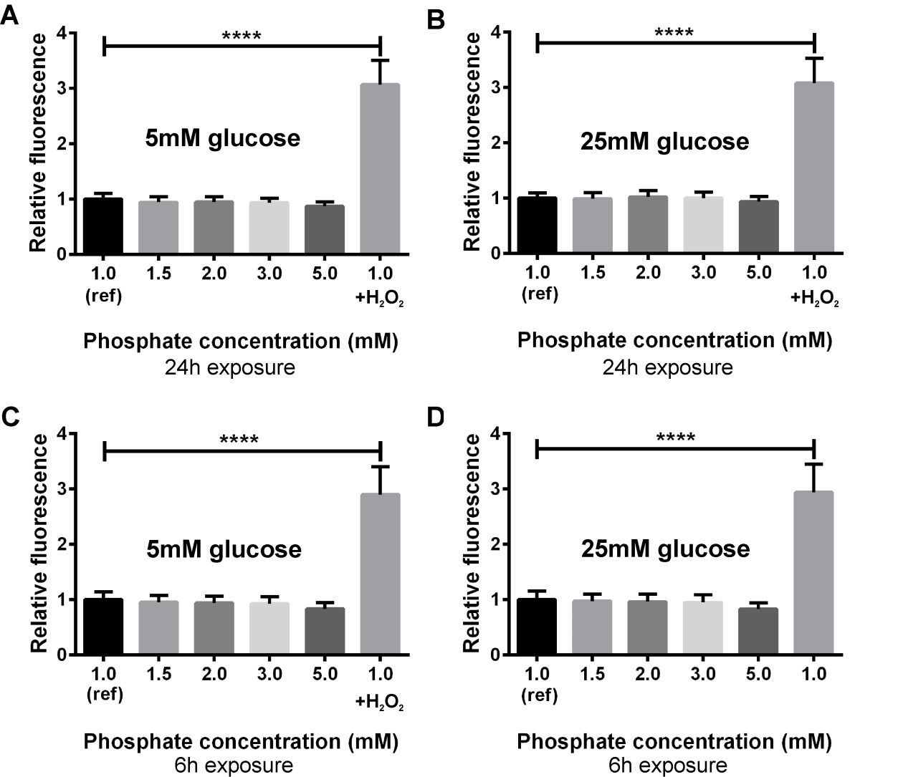

Figure 6.1 The effects of phosphate concentration on HUVEC oxidative stress.
Oxidative stress measured after 24h (A) and 6h (C) manipulation of culture medium phosphate concentration using the fluorescent ROS marker CM-H₂DCFDA. Repeat studies performed in the presence of 25mM glucose combined with manipulation of phosphate concentration for 24h (B) and 6h (D). As a positive control 100μM H₂O₂ was added to 1mM phosphate for 6h. ref, referent exposure to which the mean fluorescence intensities of other exposures are indexed. Data presented as mean (SEM), ****p<0.001, based on 9 separate experiments.

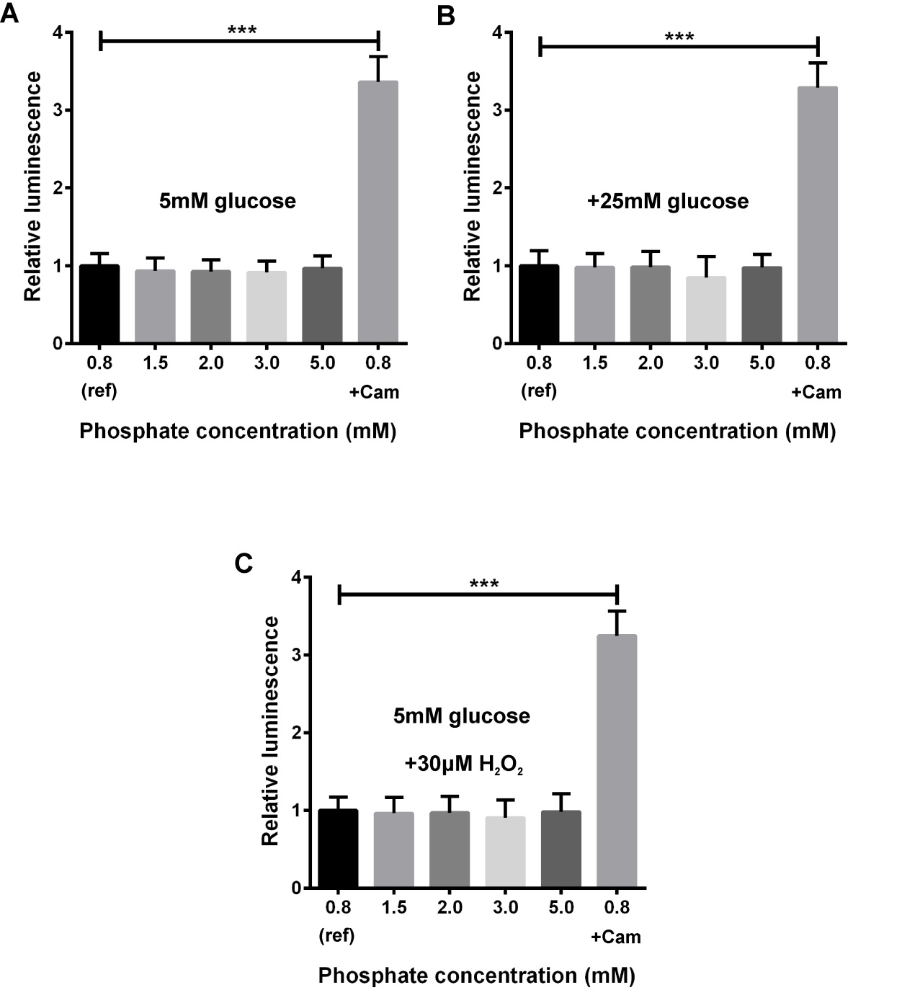
Figure 6.2 The effects of phosphate concentration on HUVEC apoptosis.
HUVEC apoptosis measured by luminescent caspase 3/7 assay after 24h exposure to altered medium phosphate concentration (A), combined with elevated glucose (B) or H₂O₂ (C). Cam, camptothecin (5ng/ml) positive control; ref, referent exposure to which the mean luminescence intensities of other exposures are indexed. Data presented as mean (SEM), ***p<0.005, based on 9 separate experiments.

The effects of PTH on endothelial cell apoptosis and oxidative stress
Following 24h exposure to exogenous PTH concentrations of 10⁻¹¹ or 10⁻¹⁰M, there was no increase in either ROS generation or apoptosis compared with a referent added concentration of 10⁻¹²M (Figure 6.3).

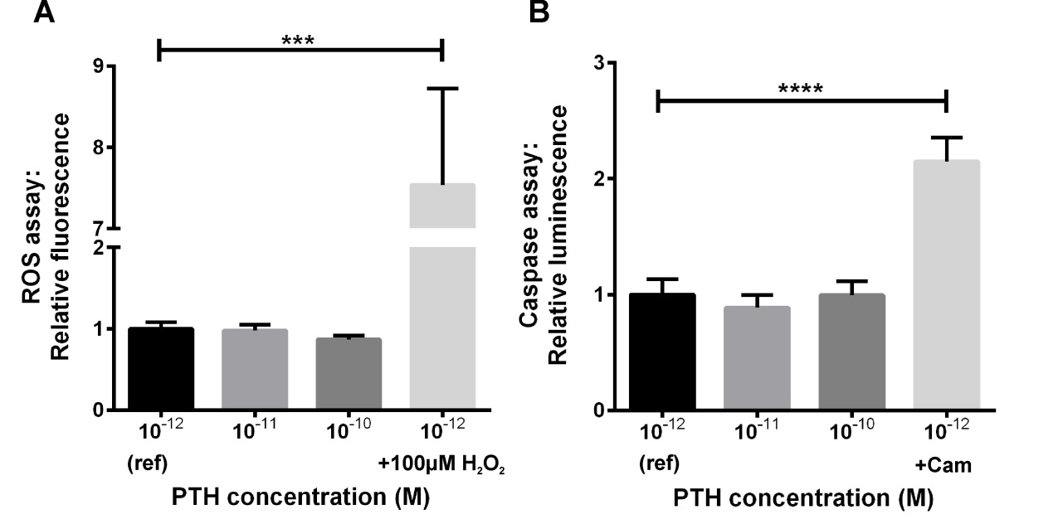
Figure 6.3 Effects of PTH on HUVEC oxidative stress and apoptosis
Oxidative stress (A) and apoptosis (B) measured by fluorescent CM-H₂DCFDA and luminescent caspase 3/7 assays respectively, following 24h exposure to altered PTH concentrations. Cam, camptothecin (5ng/ml) apoptosis positive control; ref, referent exposure. Data presented as mean (SEM), ***p<0.005, based on 9 separate experiments.

The effects of calcitriol and FGF-23 on endothelial cell oxidative stress and apoptosis
Oxidative stress and apoptosis were neither significantly increased by the addition of FGF-23, nor significantly reduced by the addition of calcitriol (Figure 6.4).
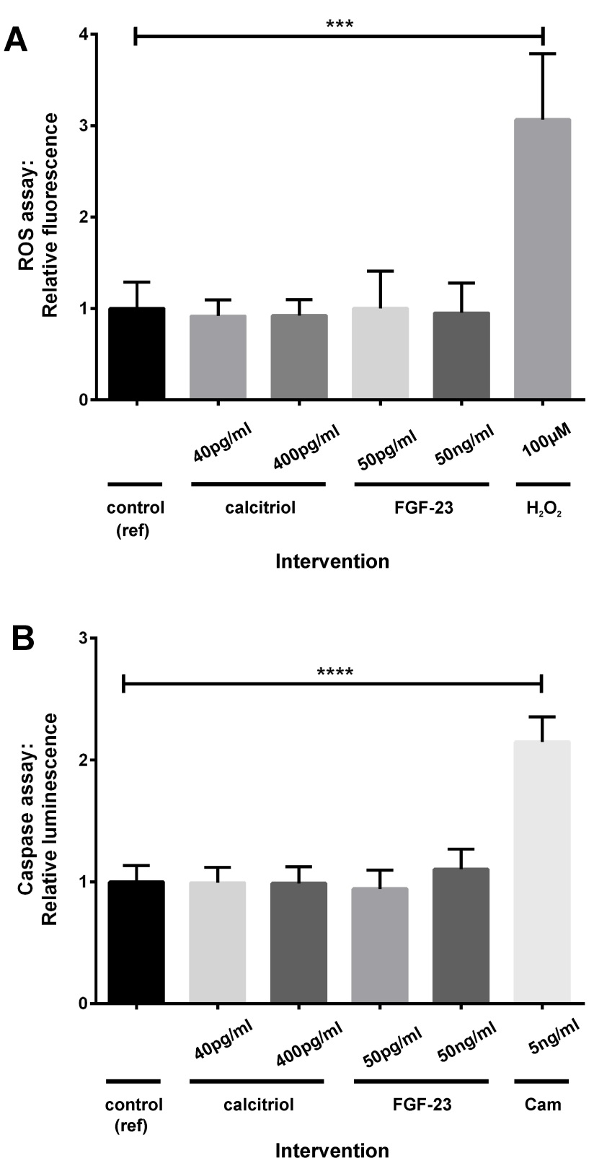
Figure 6.4 The effects of FGF-23 and calcitriol on HUVEC oxidative stress and apoptosis.
Oxidative stress (A) and apoptosis (B) measured by fluorescent CM-H₂DCFDA and luminescent caspase 3/7 assays respectively, following 24h exposure to exogenous FGF-23 or calcitriol. Cam, camptothecin (5ng/ml) apoptosis positive control; ref, referent exposure. Data presented as mean (SEM), ***p<0.005, ****p<0.001, based on 9 separate experiments.

The effects of phosphate concentration on endothelial cell nitric oxide production
Supernatant nitrite concentration was significantly lower in HUVEC cultures exposed to 24h 2mM or 3mM versus 0.8mM phosphate (Figure 6.5A). However, cell density measured by fluorescent assay was also lower in cultures exposed to high phosphate concentrations, significantly so for 3mM versus 0.8mM phosphate (6.5B). Consequently the nitrite concentration indexed to the cell density of the corresponding well did not differ significantly between groups (6.5C). The increment in supernatant nitrite concentration following 1h incubation with 5μM ACh was also not significantly affected by phosphate concentration, whether or not indexed to cell density (6.5D,E). Repeating these experiments in the presence of an elevated glucose concentration (25mM) did not change the findings (Figure 6.6).

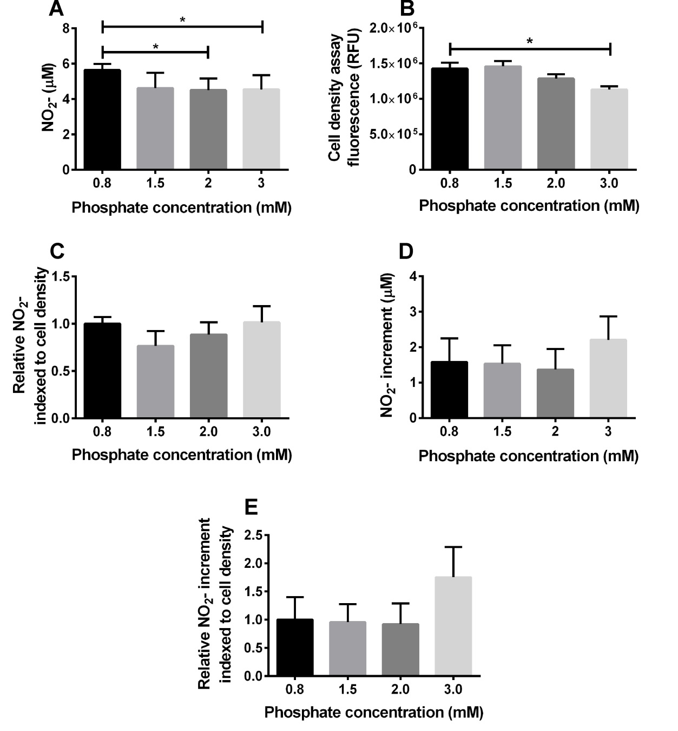

Figure 6.5 The effects of phosphate concentration on HUVEC nitric oxide production and cell density.
A, nitrite concentration at baseline. B, cell density. C, nitrite concentration at baseline, indexed to cell density. D, nitrite concentration increment following 1h 5μM acetylcholine. E, nitrite concentration increment indexed to cell density Data presented as mean (SEM), *p<0.05, based on 8 separate experiments.

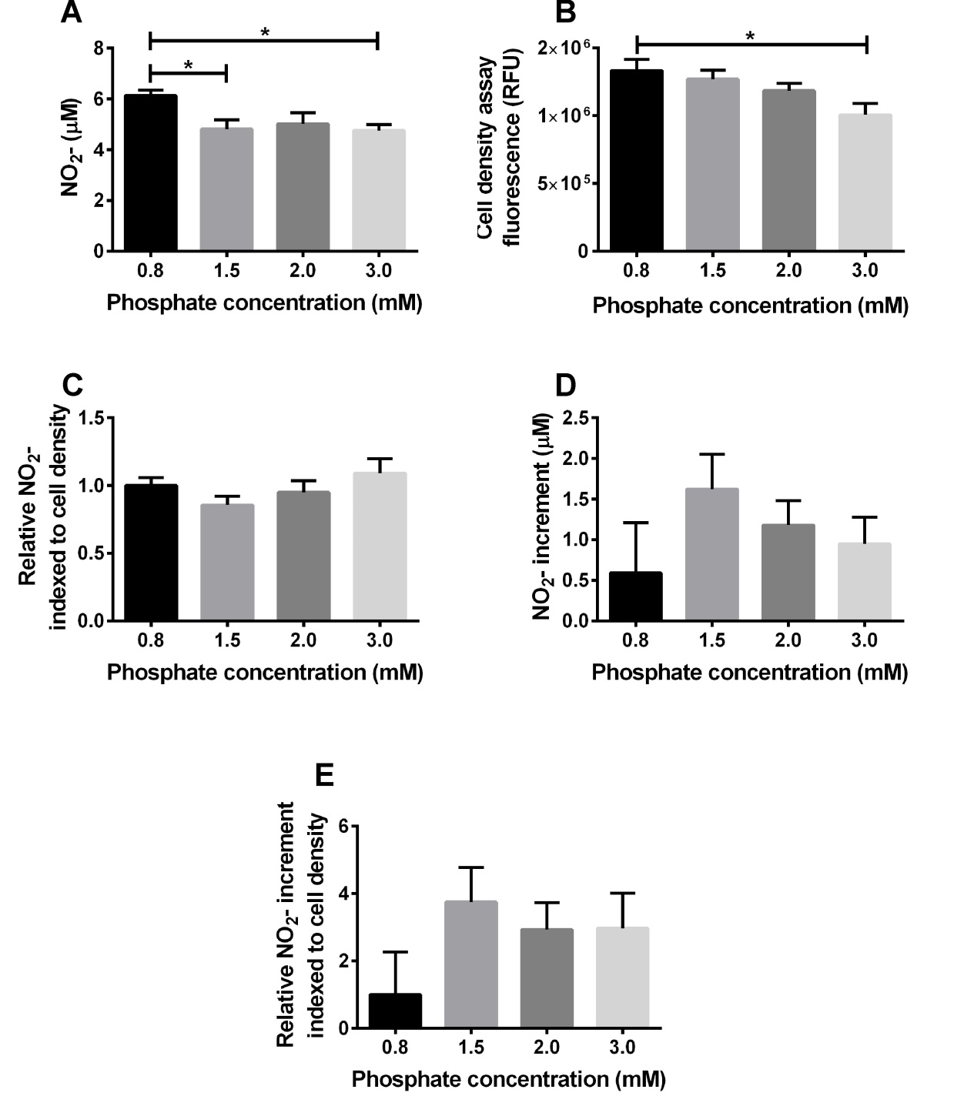
Figure 6.6 The effects of phosphate concentration on HUVEC nitric oxide production in the presence of elevated glucose.
A, nitrite concentration at baseline. B, cell density. C, nitrite concentration at baseline, indexed to cell density. D, nitrite concentration increment following 1h 5μM acetylcholine. E, nitrite concentration increment indexed to cell density. Data presented as mean (SEM), *p<0.05, based on 8 separate experiments.

The effects of PTH, calcitriol and FGF-23 on endothelial nitric oxide production
Exposure of HUVECs to 50pg/ml FGF-23 was accompanied by a significant reduction in supernatant nitrite concentration (Figure 6.7A). However, the reduction associated with a 50ng/ml FGF-23 exposure was not significant. Exposure to PTH or calcitriol did not significantly change supernatant nitrite concentration.
Cell density was not affected by PTH, calcitriol or FGF-23 (6.7B) so that when nitrite concentration was indexed to cell density these findings were unchanged (6.7C). The increase in nitrite concentration following incubation with acetylcholine was lowest following exposure to 50ng/ml FGF-23, but there was a high level of variation in this parameter and no significant difference was evident for any intervention.
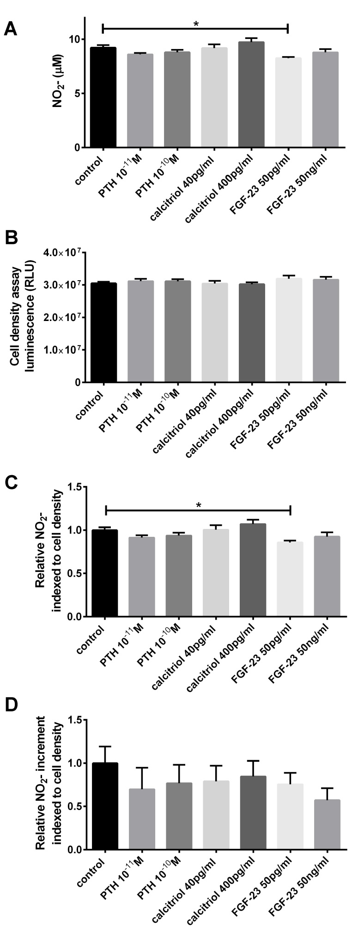
Figure 6.7 The effects of PTH, calcitriol and FGF-23 on HUVEC nitric oxide production.
A, supernatant nitrite concentration by intervention.
B, cell density by intervention.
C, supernatant nitrite concentration indexed to cell density.
D, acetylcholine-induced increment in supernatant nitrite concentration, indexed to cell density.
Data presented as mean (SEM), *p<0.05, based on 9 separate experiments.
RLU, relative luminescence units.

Discussion
The results presented in this chapter find no evidence for adverse effects of increasing extracellular phosphate concentration on endothelium in terms of oxidative stress, apoptosis, or suppression of nitric oxide synthesis. Consistent with this conclusion, Six et al. recently reported no effect of 3mM versus 1mM phosphate exposure on ROS generation or nitric oxide synthesis in HUVEC (Six et al., 2012, Six et al., 2014). In contrast, other groups previously found increased ROS generation and caspase-dependent apoptosis on exposure to ≥2.5mM phosphate (Di Marco et al., 2008, Shuto et al., 2009). These conflicting findings may partly reflect different cell types (human coronary artery and bovine aortic endothelial cells versus HUVEC) and the use of different ROS/apoptosis assays. However, Peng et al. found both induction of apoptosis and suppression of nitric oxide synthesis (measured by Griess assay of supernatant nitrite) in HUVEC exposed to 3mM versus 1mM phosphate (Peng et al., 2011).
A limitation of all these studies is that the culture medium phosphate concentration was not measured at the end of the phosphate manipulation period, so the effects of cell proliferation/metabolism on extracellular phosphate concentration are unknown. Contrasting study findings thus could be a consequence of differences in the phosphate exposures actually delivered. Another significant limitation is the lack of intracellular phosphate concentration data. Inhibition of cellular phosphate uptake with phosphonoformic acid abolishes the reported adverse effects (Shuto et al., 2009, Di Marco et al., 2008), suggesting that increased cellular phosphate content mediates toxic sequelae. Nuclear magnetic resonance spectroscopy could be used to determine whether and how quickly intracellular phosphate concentration changes in response to altered extracellular phosphate (Auesukaree et al., 2004). Since blood phosphate concentration follows a diurnal rhythm in vivo, in vitro manipulation studies using a static phosphate concentration may be inadequate to model disease pathways. It is unknown, for example, whether the prediction of cardiovascular outcomes by higher-normal fasting serum phosphate reflects accompanying greater diurnal peaks in phosphate concentration profile and whether intracellular phosphate concentration also fluctuates with a diurnal rhythm.
Common to all published studies to date is the absence of a demonstrated significant effect of high-normal versus low normal-phosphate. Where high-normal versus low-normal concentrations have been compared there has been either no effect (Di Marco et al., 2008) or a nonsignificant trend (Peng et al., 2011). In the results presented in this chapter, there is no evidence of any trend to greater apoptosis, ROS generation or suppression of nitric oxide synthesis at higher phosphate concentration. Demonstration of an adverse effect of high-normal versus low-normal phosphate on any cell type in vitro to parallel the clinical observational data remains elusive.
The only significant effect of elevated phosphate exposure evident in this work is a reduction in cell density following 24h exposure to 3mM versus 1mM phosphate. This could reflect either attenuation of proliferation or an increase in non-apoptotic cell death. It is possible that this phenomenon masked effects of higher phosphate concentration on ROS generation and apoptosis; based on the observed differences in cell density and the minimal effect on ROS generation/apoptosis, adjusting the ROS/apoptosis assays to cell density would likely have resulted in higher measured levels of ROS/apoptosis. If attenuation of proliferation underlies the differences in cell density, manipulating phosphate concentration when cells were completely confluent (rather than at 70-90% confluence as in this work) would have less effect on density. This is thus another potential source of the discrepancy between study findings.
The only other significant in vitro effect of bone mineral axis manipulation demonstrated in this work is a reduction in HUVEC supernatant nitrite concentration following exposure to 50pg/ml FGF-23. This could be relevant to the observed clinical association between higher FGF-23 concentration and endothelial dysfunction (Mirza et al., 2009b). However, the addition of a much higher concentration of FGF-23 (50ng/ml) did not elicit a more marked suppression of nitric oxide synthesis and the effect was actually nonsignificant with the higher concentration. Recently, FGF-23 at 10ng/ml was reported not to increase HUVEC nitric oxide synthesis or ROS generation (Six et al., 2014), consistent with previous reports that FGF-23 does not signal directly to isolated vessel preparations (Lindberg et al., 2013).
Even at a concentration of PTH more than 10-fold higher than the top of the normal range there was no significant effect on ROS formation. The postulated mechanism of PTH-driven intracellular calcium accumulation and consequent ROS formation (Tomaschitz et al., 2012, Vidal et al., 2006) therefore may not apply to endothelial cells. Nitric oxide generation, apoptosis and cell density were also unaffected by PTH exposure, thus a pathway to explain the associations of higher-normal PTH with albuminuria (chapter 5), endothelial dysfunction (Bosworth et al., 2013) and cardiovascular mortality (Pilz et al., 2010b) is not provided by this work.
A limitation of the PTH and FGF-23 manipulation studies reported here (and in other publications) is that the extent of cross-species signalling by bovine PTH and FGF-23 contained in the 20% bovine serum-supplemented medium is unknown. It is possible that background signalling by bovine PTH and FGF-23 prevented the detection of effects of adding additional hormone.
Since bovine and human calcitriol are identical, the use of serum-supplemented media for cell culture is a particular concern for calcitriol manipulation studies. Calcitriol concentration is not higher in the serum of newborn calves than in humans (Rajaraman et al., 1997) so it is likely that the use of 20% serum-supplemented media resulted in a low level of calcitriol, equating to deficiency. However, since calcitriol measurements were not available for the serum supplements it is possible that the apparent lack of effects of culture medium calcitriol supplementation reflected adequate background calcitriol signalling.
Possible beneficial effects of calcitriol signalling in endothelial cells may also only be evident when playing a protective role against other factors: Dong et al. recently reported that calcitriol did not increase HUVEC nitric oxide synthesis, consistent with the findings presented above, but prevented the suppression of nitric oxide synthesis by a thromboxane-prostanoid receptor agonist (Dong et al., 2013). Uberti et al. found no effect of calcitriol on HUVEC superoxide generation, but protection from oxidative-stress induced cell death (Uberti et al., 2014). The absence of significant changes in nitric oxide synthesis, ROS generation and apoptosis in response to calcitriol reported in this chapter therefore does not exclude an important role for calcitriol signalling in endothelial protection in the context of other insults in vivo. Different endpoints, such as endothelial adhesion molecule expression or cytokine secretion, are also relevant to atherogenesis and were not tested here.

General Discussion

Targeting the bone mineral axis for CVD prevention is an attractive but unproven strategy. This thesis has examined several aspects of the bone mineral axis-CVD relationship, but further work is needed to determine whether there is a clinical benefit to bone mineral axis manipulation for CVD prevention. In this chapter the implications of the principle findings are discussed in the context of recent publications and possible future work.

Manipulation of phosphate exposure for cardiovascular disease prevention
The work presented here was initially stimulated by a series of publications describing an association between higher-normal fasting serum phosphate and adverse CVD outcomes (Table 1.1). Determining whether higher-normal fasting serum phosphate actually plays a role in CVD pathogenesis is made difficult by the fact that manipulating fasting serum phosphate concentration is itself not straightforward. A genetic approach could be adopted; for example, generating FGF-23^{-/-} ApoE^{-/-} double knockout mice would create a model of hyperphosphataemia on an atherogenic background and has not yet been reported. However, as with all available interventions to modulate serum phosphate, any resulting cardiovascular pathology might reflect hormone effects mediated independently of serum phosphate concentration. Mendelian randomisation would be another means of addressing this question, though identified associated polymorphisms account for only 0.13mM of the variation in fasting serum phosphate (Kestenbaum et al., 2010); this increment is less than the difference demonstrated to be accompanied by significantly increased CVD risk in most studies (Table 1.1), so a large sample size would be required to test for an association between these polymorphisms and CVD with adequate power.
Although dietary phosphate intake appears to have minimal effect on fasting serum phosphate concentration, it has been demonstrated to change diurnal phosphate concentration profile substantially (Portale et al., 1987). If fasting serum phosphate concentration plays a role in CVD pathogenesis, then it would seem likely that non-fasting serum phosphate concentration, which reaches higher levels than fasting morning concentration, is also important. Higher fasting serum phosphate concentration may reflect a predisposition to higher non-fasting peak concentrations. In this regard, further observational studies could contribute useful information, determining: 1) does an individual’s fasting serum phosphate predict features of the non-fasting diurnal phosphate concentration profile? and 2) how does phosphate concentration measured non-fasting and at specific times of day (for example, corresponding to diurnal peaks) predict CVD events/mortality? The latter question could be addressed using linked NHANES mortality data (Chang et al., 2014).
In the mouse study reported in chapter 3, dietary phosphate manipulation was used to modulate (non-fasting) plasma phosphate. This model reproduced some of the metabolic clinical associations of lower-normal serum phosphate (insulin resistance and obesity) as well as demonstrating an increase in atheroma burden on high-phosphate diet that occurred independently of traditional risk factors. It is not shown whether these findings were a result of changes in serum phosphate concentration or not. Regardless of the mechanism, since as much as 30% of western dietary phosphate content originates from food additives (Uribarri and Calvo, 2003), limiting the use of phosphate-containing additives is potentially a public health target for CVD prevention. (Bioavailable phosphate content labelling could be encouraged, as is often provided for salt, sugar, saturated fat, etc.).
When assessing the relevance of these findings to humans, several issues must be considered:
Firstly, the serum phosphate concentration in this mouse model (2.0mM and 3.6mM for low and high dietary phosphate intake groups respectively, Table 3.1) is much higher than in humans (mean 1.2mM, Table 5.1). Markedly different normal ranges for phosphate concentration in different species are presumably accompanied by different susceptibilities to vascular phosphate toxicity.
Secondly, the dietary phosphorus density was higher in the mouse model (0.44-3.56mg/kcal) than in human diets (<0.49 and ≥0.77mg/kcal for quintiles 1 and 5 respectively of the US population, Table 5.3) and was manipulated to a greater extent than might be tolerated in humans. The standard phosphorus content of laboratory rodent chow is 0.6% w/w, but this may not be the ‘natural’ normal. Previous work demonstrating rats self-select a phosphorus content of 0.2% w/w (Siu et al., 1981) suggests that this may be closer to optimal. Therefore the mouse dietary groups of ‘low’, ‘normal’ and ‘high’ phosphate may in fact have been ‘normal’, ‘high’ and ‘very high’ (though the energy density of the high-fat atherogenic diets is approximately 50% higher than standard rodent chow and may have resulted in less total weight of chow ingested). A further consideration is the fact that the phosphate added to the experimental mouse diets was the in the form of inorganic phosphate, which is more bioavailable than the phosphate fraction contained in phytates in human diets (Uribarri and Calvo, 2003). Changes in FGF-23 and PTH were greater than observed in human dietary phosphate manipulation studies (Antoniucci et al., 2006), also suggesting the dietary intervention may have been more severe than can realistically be achieved in clinical situations.
Thirdly, since 24h phosphate profile was not measured in the mouse model, the effects of the dietary intervention on time-averaged or peak phosphate concentrations are unknown, so cannot be compared directly to the findings in clinical studies. However, relative changes in single time-point plasma phosphate concentration induced in the mouse model were similar to the observed difference in time-averaged 24h serum phosphate profile achieved by altering human phosphate intake (Portale et al., 1987).
Clinical studies of the cardiovascular effects of manipulating dietary phosphate exposure are needed to determine whether there is a benefit to this intervention. A long-term intervention study manipulating dietary phosphate exposure and assessing clinical endpoints would be extremely expensive and difficult to conduct due to the problems with ensuring dietary compliance over long time periods. Short term studies measuring surrogate markers of CV health are more feasible; I am currently conducting a crossover study randomising healthy volunteers to periods of high and low dietary phosphate exposure (Sandoz phosphate and the phosphate binder calcium carbonate respectively). Outcome measures include endothelial microvascular function, oxidative stress markers, albuminuria, inflammatory markers and endothelial microparticle concentration.
Considering that the acceleration of atherosclerosis by increased dietary phosphate exposure is accompanied by adaptive changes in phosphate regulatory hormones, it is logical also to test the effects of directly manipulating these hormones on atherogenesis. Whether infusing or overexpressing PTH or FGF-23 in ApoE^{-/-} mice accelerates atherogenesis has yet to be reported and would be of interest for future work, particularly since these hormones are themselves independent predictors of CVD.

Cardiovascular effects of vitamin D deficiency
The effects of vitamin D manipulation on CVD were chosen for investigation in the second mouse study because, despite the substantial literature associating low vitamin D levels with CVD outcomes, there had been no previous studies of the effects of dietary vitamin D deficiency on atherosclerosis. The ease and safety of vitamin D supplementation also make this a question of particular clinical importance.
Despite a sufficiently severe degree of 25(OH)D deficiency to modify bone structure, the only detected change in cardiovascular phenotype was an increase in diffuse atherosclerotic calcification. Even this is of uncertain clinical relevance, since the implications of atherosclerotic calcification for CVD outcomes are unknown. As discussed in section 4.5, other groups published results of similar studies whilst this work was in progress: Schmidt et al. found no change in LDLR^{-/-} mouse aortic sinus atheroma burden with dietary induction of 25(OH)D deficiency, but an increase in aortic sinus cross-section calcification density (Schmidt et al., 2012). Szeto et al. also found no acceleration of aortic atherosclerosis even when LDLR^{-/-} mice were crossed with VDR^{-/-} mice, though there was a localised increase in atheroma at the innominate artery (Szeto et al., 2012). In contrast, Weng et al. reported that aortic atheroma was substantially increased in both ApoE^{-/-} and LDLR^{-/-} models (Weng et al., 2013). The reason for these conflicting findings is unclear.
Systemic and tissue-specific calcitriol measurements were not available for either mouse model reported in this thesis. Consequently, although manipulation of vitamin D did not modulate atherogenesis, this does not exclude a role for suppression of calcitriol synthesis in mediating the acceleration of atherosclerosis by a high phosphate diet.
In contrast to the phenotype of VDR^{-/-} mice, dietary vitamin D deficiency did not induce LVH, hypertension or insulin resistance in ApoE^{-/-} mice in this work. Regarding translation to humans, it should be recognised that there may be species differences in the tissue-specific consequences of attenuating vitamin D signalling. Although not formally reported, the relative contribution of the UVB-driven cutaneous vitamin D synthesis pathway is presumably less important in mice since they are naturally furred and nocturnal. Therefore, although the VDR is widely expressed in both mice and humans (Bouillon et al., 2008), it would not be surprising if there were different degrees of vulnerability to vitamin D deficiency. Also, as discussed below (section 7.4), inflammatory insults contributing to vascular pathology may be antagonised by VDR signalling. Consequently, if human CVD is driven by inflammatory pathways that are relatively less important in the ApoE^{-/-} mouse model, then pathological effects of vitamin D deficiency might be missed. Similarly, contrasting findings from different mouse manipulation models might reflect differences in costimuli, for example dietary sodium/potassium contents and thus angiotensin II signalling.
The negative findings described in chapter 4 nevertheless question the relevance of previous results from VDR^{-/-} models to more clinically relevant degrees of vitamin D deficiency/insufficiency. This leaves the evidence for a pathological role of vitamin D deficiency in CVD confined to observational data, in vitro findings and conflicting results from small clinical trials (as discussed in section 1.7.6.1). With regard to LVH, although cardiomyocyte-specific VDR deletion induces LVH (Chen et al., 2011), recent clinical trials administering active vitamin D analogues to cohorts with resistant hypertension (Witham et al., 2014) or CKD (Thadhani et al., 2012, Wang et al., 2014) failed to show a reduction in LVH.
Of note, no benefits of VDR-regulation of gene expression in cardiovascular tissue have yet been described; all the consequences of attenuated VDR signalling appear to be detrimental, so it is not clear why VDR-dependence of a healthy gene expression profile apparently exists. Carry-over of VDR signalling pathways following a role in embryonic development is unproven but theoretically possible, though the viability of VDR^{-/-} mice suggests this is not of fundamental importance.
A large (N>25,000) trial is currently underway investigating the effects of 2000U daily cholecalciferol on major CVD outcomes in subjects without a previous history of CVD (http://clinicaltrials.gov/show/NCT01169259). This should provide by far the most definitive evidence to date regarding whether vitamin D supplementation has clinically significant benefits for CVD prevention. It may also contribute information regarding possible pathways, for example by demonstrating effects on endothelial function, inflammatory markers and blood pressure.

Parathyroid hormone and albuminuria
Of the bone mineral axis parameters studied, only PTH was associated robustly with higher-normal albuminuria in a general US population sample. Prediction of cardiovascular mortality by higher albuminuria at even the lowest levels is postulated to reflect underlying subclinical vascular damage (Matsushita et al., 2010, Weir, 2007). Therefore, the association between PTH and albuminuria suggests that higher-normal PTH may be accompanied by vascular pathology, perhaps reflecting a mis-setting of the ‘normal’ range of PTH. There has been less interest in manipulating higher-normal PTH for CVD prevention than in targeting phosphate exposure and vitamin D. However, greater albuminuria is by no means proven to be an inevitable consequence of vascular/endothelial dysfunction; in fact, endothelial dysfunction can be induced in some animal models without an accompanying increase in albumin excretion (Vasko et al., 2014). Therefore, the fact that phosphate concentration, phosphate intake and lower 25(OH)D were not associated with higher albuminuria does not mean that these do not cause endothelial damage.
Of course, the association between higher-normal PTH and albuminuria does not demonstrate a causative relationship. Targeted lowering of PTH using calcitriol or the calcimimetic agent cinacalcet might help determine whether a higher-normal PTH plays a causal role in vascular dysfunction and low grade albuminuria. However, both of these interventions may have PTH-independent effects on the vasculature (Talmor et al., 2008a, Thakore and Ho, 2011). Although a number of factors are associated with a higher-normal PTH (Paik et al., 2012), what causes a healthy individual to have a PTH in the top quintile (thus what might best be targeted to lower PTH) is unclear. As for phosphate, identification of polymorphisms associated with higher PTH and utilisation of Mendelian randomisation could help establish the nature of the relationship between higher-normal PTH and CVD.
Albuminuria responses to dietary phosphate exposure are being examined in the ongoing healthy volunteer study described in section 7.1.

Bone mineral axis parameter manipulation in vitro
If a higher-normal phosphate concentration is toxic to endothelium or other cardiovascular tissues, the effects are likely to be subtle. Although the post-reproductive age of CVD onset implies little selection pressure for an optimal CVD-preventive phosphate concentration range, it would be surprising to find induction of pronounced apoptosis or necrosis at phosphate concentrations to which all cells are naturally exposed in vivo. In fact, the normal serum phosphate range for a healthy infant extends well into the hyperphosphataemic range for adults, where phosphate binders would be used to prevent vascular calcification in a dialysis patient (Soldin, 1999). Exposure to higher-normal phosphate concentration over many years may allow subtle consequences to contribute significantly to atherosclerosis. Other inflammatory/metabolic insults also might sensitise cells to pathological effects of phosphate exposure.
Considering all this, it is not surprising that demonstrating toxic effects of short–term higher-normal phosphate concentrations in vitro remains elusive. Reported effects of phosphate concentrations ≥2.5mM may be clinically relevant to hyperphosphataemic patients, but cannot be extrapolated to explain observed associations with higher-normal phosphate concentration. Further work to investigate the impact of higher-normal phosphate concentration on endothelial cells may therefore need to use exposure over longer time periods and multiple culture passages. Senescence is another potential outcome measure for in vitro studies that might be affected before apoptosis or necrosis (and is of particular interest in view of the putative progeric effects of hyperphosphataemia). As discussed in section 6.4, dynamic manipulation of extracellular phosphate concentration to mimic more closely the in vivo diurnal rhythm may be important in understanding the potential consequences of excessive phosphate exposure.
Regarding calcitriol, publications from other groups whilst this work was in progress highlighted the importance of an inflammatory milieu in revealing benefits of calcitriol supplementation on endothelial cells in vitro: Angiotensin II (Dong et al., 2012), oxidative stress (Uberti et al., 2014), thromboxane-prostanoid receptor agonist (Dong et al., 2013) and tumour necrosis factor-alpha (Kudo et al., 2012) have all been reported to exert adverse endothelial effects that are antagonised by calcitriol. The absence of a demonstrable effect of calcitriol supplementation in this work therefore does not mean that VDR signalling in endothelium is not protective against a proatherosclerotic phenotype. Conversely, where costimuli are needed to reveal an effect, the relevance to the in vivo situation is more unclear.
Defining any adverse effects of higher-normal PTH concentration on endothelium in vitro is likely to be challenging for the same reasons as described above for phosphate. Only a few studies have previously been published on the endothelial effects of PTH and these have not shown a clear pathway to account for increased CVD (as described in section 1.8.4). Even at very high PTH concentrations, no significant effect on HUVEC was evident in the work reported here. However, other measures of endothelial phenotype, such as adhesion molecule expression or cytokine secretion, might have been affected. As for calcitriol, co-stressors may reveal effects of PTH, so the absence of changes in HUVEC phenotype in this work does not mean that PTH has no pathological endothelial actions to account for the association with albuminuria in vivo. Regarding all the HUVEC studies reported in this thesis, it should be remembered that HUVEC have a different phenotype from arterial endothelial cells (Aird, 2007); bone mineral axis parameter manipulation may therefore have different effects on endothelial cells of arterial origin. Future work could examine global gene expression profile changes in arterial endothelial cells exposed to high-normal and supra-normal PTH.

Concluding remarks
In recent years there has been intense interest in the concept of manipulating the bone mineral axis for CVD prevention. The potential benefits are substantial, based on the CVD risk associated with relatively subtle differences in bone mineral axis parameters. However, demonstrating pathological consequences of these subtle differences is proving difficult. Investigators have naturally begun by manipulating bone mineral axis parameters in vitro and in animal models, employing interventions that are more severe than the reported observational clinical context. Results from these models provide some evidence for pathological cardiovascular effects of bone mineral axis mis-setting. However, translation of the findings to explain clinical observations is limited both by the degree of severity used and by species differences in bone mineral metabolism. Defining whether subtle differences in bone mineral axis parameters are appropriate therapeutic targets for CVD prevention is therefore likely to require:
- Greater attention to testing the consequences of subtle differences in bone mineral axis parameters
- Prospective clinical intervention studies with (initially) surrogate measures of CV health
A successful conclusion to this field of enquiry will either demonstrate the observed associations to be simply due to confounding factors, or will establish a novel strategy for CVD prevention.

References

Centers for Disease Control and Prevention. NHANES Analytic Guidelines. 2010. Accessed at http://www.cdc.gov/nchs/nhanes/nhanes2003-2004/analytical_guidelines.htm 21st January 2014.
Centers for Disease Control and Prevention; National Health and Nutrition Examinations Survey. Accessed at http://www.cdc.gov/nchs/nhanes.htm 1st August 2014.
ABRAMOWITZ, M., MUNTNER, P., COCO, M., SOUTHERN, W., LOTWIN, I., HOSTETTER, T. H. & MELAMED, M. L. 2010. Serum alkaline phosphatase and phosphate and risk of mortality and hospitalization. Clin J Am Soc Nephrol, 5, 1064-71.
AFZAL, S., BOJESEN, S. E. & NORDESTGAARD, B. G. 2013. Low 25-hydroxyvitamin D and risk of type 2 diabetes: a prospective cohort study and metaanalysis. Clin Chem, 59, 381-91.
AFZAL, S., BRONDUM-JACOBSEN, P., BOJESEN, S. E. & NORDESTGAARD, B. G. 2014. Vitamin D concentration, obesity, and risk of diabetes: a mendelian randomisation study. The Lancet Diabetes and Endocrinology, 2, 298-306.
AGARWAL, I., IDE, N., IX, J. H., KESTENBAUM, B., LANSKE, B., SCHILLER, N. B., WHOOLEY, M. A. & MUKAMAL, K. J. 2014. Fibroblast growth factor-23 and cardiac structure and function. J Am Heart Assoc, 3, e000584.
AHLSTROM, T., HAGSTROM, E., LARSSON, A., RUDBERG, C., LIND, L. & HELLMAN, P. 2009. Correlation between plasma calcium, parathyroid hormone (PTH) and the metabolic syndrome (MetS) in a community-based cohort of men and women. Clin Endocrinol (Oxf), 71, 673-8.
AIRD, W. C. 2007. Phenotypic heterogeneity of the endothelium: II. Representative vascular beds. Circ Res, 100, 174-90.
AL MHEID, I., PATEL, R., MURROW, J., MORRIS, A., RAHMAN, A., FIKE, L., KAVTARADZE, N., UPHOFF, I., HOOPER, C., TANGPRICHA, V., ALEXANDER, R. W., BRIGHAM, K. & QUYYUMI, A. A. 2011. Vitamin D status is associated with arterial stiffness and vascular dysfunction in healthy humans. J Am Coll Cardiol, 58, 186-92.
ALONSO, A., NETTLETON, J. A., IX, J. H., DE BOER, I. H., FOLSOM, A. R., BIDULESCU, A., KESTENBAUM, B. R., CHAMBLESS, L. E. & JACOBS, D. R., JR. 2010. Dietary phosphorus, blood pressure, and incidence of hypertension in the atherosclerosis risk in communities study and the multi-ethnic study of atherosclerosis. Hypertension, 55, 776-84.
ANDERSSON, P., RYDBERG, E. & WILLENHEIMER, R. 2004. Primary hyperparathyroidism and heart disease--a review. Eur Heart J, 25, 1776-87.
ANTONIUCCI, D. M., YAMASHITA, T. & PORTALE, A. A. 2006. Dietary phosphorus regulates serum fibroblast growth factor-23 concentrations in healthy men. J Clin Endocrinol Metab, 91, 3144-9.
ARKING, D. E., ATZMON, G., ARKING, A., BARZILAI, N. & DIETZ, H. C. 2005. Association between a functional variant of the KLOTHO gene and high-density lipoprotein cholesterol, blood pressure, stroke, and longevity. Circ Res, 96, 412-8.
ARKING, D. E., BECKER, D. M., YANEK, L. R., FALLIN, D., JUDGE, D. P., MOY, T. F., BECKER, L. C. & DIETZ, H. C. 2003. KLOTHO allele status and the risk of early-onset occult coronary artery disease. Am J Hum Genet, 72, 1154-61.
ARNLOV, J., CARLSSON, A. C., SUNDSTROM, J., INGELSSON, E., LARSSON, A., LIND, L. & LARSSON, T. E. 2013. Serum FGF23 and risk of cardiovascular events in relation to mineral metabolism and cardiovascular pathology. Clin J Am Soc Nephrol, 8, 781-6.
ARONSON, D., KAPELIOVICH, M., HAMMERMAN, H. & DRAGU, R. 2013. The relation between serum phosphorus levels and clinical outcomes after acute myocardial infarction. PLoS One, 8, e58348.
ARTAZA, J. N., MEHROTRA, R. & NORRIS, K. C. 2009. Vitamin D and the cardiovascular system. Clin J Am Soc Nephrol, 4, 1515-22.
AUESUKAREE, C., HOMMA, T., TOCHIO, H., SHIRAKAWA, M., KANEKO, Y. & HARASHIMA, S. 2004. Intracellular phosphate serves as a signal for the regulation of the PHO pathway in Saccharomyces cerevisiae. J Biol Chem, 279, 17289-94.
BACCHETTA, J., SEA, J. L., CHUN, R. F., LISSE, T. S., WESSELING-PERRY, K., GALES, B., ADAMS, J. S., SALUSKY, I. B. & HEWISON, M. 2013. Fibroblast growth factor 23 inhibits extrarenal synthesis of 1,25-dihydroxyvitamin D in human monocytes. J Bone Miner Res, 28, 46-55.
BAS, A., LOPEZ, I., PEREZ, J., RODRIGUEZ, M. & AGUILERA-TEJERO, E. 2006. Reversibility of calcitriol-induced medial artery calcification in rats with intact renal function. J Bone Miner Res, 21, 484-90.
BECKER, L. E., KOLEGANOVA, N., PIECHA, G., NORONHA, I. L., ZEIER, M., GELDYYEV, A., KOKENY, G., RITZ, E. & GROSS, M. L. 2011. Effect of paricalcitol and calcitriol on aortic wall remodeling in uninephrectomized ApoE knockout mice. Am J Physiol Renal Physiol, 300, F772-82.
BERGWITZ, C. 2012. Dietary phosphate modifies lifespan in Drosophila. Nephrol Dial Transplant, 27, 3399-406.
BERNDT, T., THOMAS, L. F., CRAIG, T. A., SOMMER, S., LI, X., BERGSTRALH, E. J. & KUMAR, R. 2007. Evidence for a signaling axis by which intestinal phosphate rapidly modulates renal phosphate reabsorption. Proc Natl Acad Sci U S A, 104, 11085-90.
BHANDARI, S. K., PASHAYAN, S., LIU, I. L., RASGON, S. A., KUJUBU, D. A., TOM, T. Y. & SIM, J. J. 2011. 25-hydroxyvitamin D levels and hypertension rates. J Clin Hypertens (Greenwich), 13, 170-7.
BISCHOFF-FERRARI, H. A., DIETRICH, T., ORAV, E. J. & DAWSON-HUGHES, B. 2004. Positive association between 25-hydroxy vitamin D levels and bone mineral density: a population-based study of younger and older adults. Am J Med, 116, 634-9.
BLOCK, G. A., HULBERT-SHEARON, T. E., LEVIN, N. W. & PORT, F. K. 1998. Association of serum phosphorus and calcium x phosphate product with mortality risk in chronic hemodialysis patients: a national study. Am J Kidney Dis, 31, 607-17.
BLOCK, G. A., KLASSEN, P. S., LAZARUS, J. M., OFSTHUN, N., LOWRIE, E. G. & CHERTOW, G. M. 2004. Mineral metabolism, mortality, and morbidity in maintenance hemodialysis. J Am Soc Nephrol, 15, 2208-18.
BLOCK, G. A., WHEELER, D. C., PERSKY, M. S., KESTENBAUM, B., KETTELER, M., SPIEGEL, D. M., ALLISON, M. A., ASPLIN, J., SMITS, G., HOOFNAGLE, A. N., KOOIENGA, L., THADHANI, R., MANNSTADT, M., WOLF, M. & CHERTOW, G. M. 2012. Effects of phosphate binders in moderate CKD. J Am Soc Nephrol, 23, 1407-15.
BLONDON, M., SACHS, M., HOOFNAGLE, A. N., IX, J. H., MICHOS, E. D., KORCARZ, C., GEPNER, A. D., SISCOVICK, D. S., KAUFMAN, J. D., STEIN, J. H., KESTENBAUM, B. & DE BOER, I. H. 2013. 25-Hydroxyvitamin D and parathyroid hormone are not associated with carotid intima-media thickness or plaque in the multi-ethnic study of atherosclerosis. Arterioscler Thromb Vasc Biol, 33, 2639-45.
BODYAK, N., AYUS, J. C., ACHINGER, S., SHIVALINGAPPA, V., KE, Q., CHEN, Y. S., RIGOR, D. L., STILLMAN, I., TAMEZ, H., KROEGER, P. E., WU-WONG, R. R., KARUMANCHI, S. A., THADHANI, R. & KANG, P. M. 2007. Activated vitamin D attenuates left ventricular abnormalities induced by dietary sodium in Dahl salt-sensitive animals. Proc Natl Acad Sci U S A, 104, 16810-5.
BONORA, E., TARGHER, G., ALBERICHE, M., BONADONNA, R. C., SAGGIANI, F., ZENERE, M. B., MONAUNI, T. & MUGGEO, M. 2000. Homeostasis model assessment closely mirrors the glucose clamp technique in the assessment of insulin sensitivity: studies in subjects with various degrees of glucose tolerance and insulin sensitivity. Diabetes Care, 23, 57-63.
BORGES, A. C., FERES, T., VIANNA, L. M. & PAIVA, T. B. 1999. Recovery of impaired K+ channels in mesenteric arteries from spontaneously hypertensive rats by prolonged treatment with cholecalciferol. Br J Pharmacol, 127, 772-8.
BOSE, S., FRENCH, S., EVANS, F. J., JOUBERT, F. & BALABAN, R. S. 2003. Metabolic network control of oxidative phosphorylation: multiple roles of inorganic phosphate. J Biol Chem, 278, 39155-65.
BOSWORTH, C., SACHS, M. C., DUPREZ, D., HOOFNAGLE, A. N., IX, J. H., JACOBS, D. R., JR., PERALTA, C. A., SISCOVICK, D. S., KESTENBAUM, B. & DE BOER, I. H. 2013. Parathyroid hormone and arterial dysfunction in the multi-ethnic study of atherosclerosis. Clin Endocrinol (Oxf), 79, 429-36.
BOUILLON, R., CARMELIET, G., VERLINDEN, L., VAN ETTEN, E., VERSTUYF, A., LUDERER, H. F., LIEBEN, L., MATHIEU, C. & DEMAY, M. 2008. Vitamin D and human health: lessons from vitamin D receptor null mice. Endocr Rev, 29, 726-76.
BOUILLON, R. A., AUWERX, J. H., LISSENS, W. D. & PELEMANS, W. K. 1987. Vitamin D status in the elderly: seasonal substrate deficiency causes 1,25-dihydroxycholecalciferol deficiency. Am J Clin Nutr, 45, 755-63.
BRAUTBAR, N., TABERNERO-ROMO, J., COATS, J. C. & MASSRY, S. G. 1984. Impaired myocardial lipid metabolism in phosphate depletion. Kidney Int, 26, 18-23.
BRONDUM-JACOBSEN, P., BENN, M., JENSEN, G. B. & NORDESTGAARD, B. G. 2012. 25-hydroxyvitamin d levels and risk of ischemic heart disease, myocardial infarction, and early death: population-based study and meta-analyses of 18 and 17 studies. Arterioscler Thromb Vasc Biol, 32, 2794-802.
BRONDUM-JACOBSEN, P., NORDESTGAARD, B. G., SCHNOHR, P. & BENN, M. 2013. 25-hydroxyvitamin D and symptomatic ischemic stroke: an original study and meta-analysis. Ann Neurol, 73, 38-47.
BURNETT-BOWIE, S. M., MENDOZA, N. & LEDER, B. Z. 2007. Effects of gonadal steroid withdrawal on serum phosphate and FGF-23 levels in men. Bone, 40, 913-8.
BURNETT, S. M., GUNAWARDENE, S. C., BRINGHURST, F. R., JUPPNER, H., LEE, H. & FINKELSTEIN, J. S. 2006. Regulation of C-terminal and intact FGF-23 by dietary phosphate in men and women. J Bone Miner Res, 21, 1187-96.
CADE, C. & NORMAN, A. W. 1986. Vitamin D3 improves impaired glucose tolerance and insulin secretion in the vitamin D-deficient rat in vivo. Endocrinology, 119, 84-90.
CALVO, M. S. & URIBARRI, J. 2013. Public health impact of dietary phosphorus excess on bone and cardiovascular health in the general population. Am J Clin Nutr, 98, 6-15.
CAMALIER, C. E., YOUNG, M. R., BOBE, G., PERELLA, C. M., COLBURN, N. H. & BECK, G. R., JR. 2010. Elevated phosphate activates N-ras and promotes cell transformation and skin tumorigenesis. Cancer Prev Res (Phila Pa), 3, 359-70.
CANCELA, A. L., SANTOS, R. D., TITAN, S. M., GOLDENSTEIN, P. T., ROCHITTE, C. E., LEMOS, P. A., DOS REIS, L. M., GRACIOLLI, F. G., JORGETTI, V. & MOYSES, R. M. 2012. Phosphorus is associated with coronary artery disease in patients with preserved renal function. PLoS One, 7, e36883.
CARBONE, F. & MONTECUCCO, F. 2013. The role of the intraplaque vitamin D system in atherogenesis. Scientifica (Cairo), 2013, 620504.
CHANG, A., BATCH, B. C., MCGUIRE, H. L., VOLLMER, W. M., SVETKEY, L. P., TYSON, C. C., SANGUANKEO, A., ANDERSON, C., HOUSTON, J. & APPEL, L. J. 2013. Association of a reduction in central obesity and phosphorus intake with changes in urinary albumin excretion: The PREMIER Study. Am J Kidney Dis, 62, 900-7.
CHANG, A. R., LAZO, M., APPEL, L. J., GUTIERREZ, O. M. & GRAMS, M. E. 2014. High dietary phosphorus intake is associated with all-cause mortality: results from NHANES III. Am J Clin Nutr, 99, 320-7.
CHEN, S., LAW, C. S., GRIGSBY, C. L., OLSEN, K. & GARDNER, D. G. 2010. A role for the cell cycle phosphatase Cdc25a in vitamin D-dependent inhibition of adult rat vascular smooth muscle cell proliferation. J Steroid Biochem Mol Biol, 122, 326-32.
CHEN, S., LAW, C. S., GRIGSBY, C. L., OLSEN, K., HONG, T. T., ZHANG, Y., YEGHIAZARIANS, Y. & GARDNER, D. G. 2011. Cardiomyocyte-specific deletion of the vitamin D receptor gene results in cardiac hypertrophy. Circulation, 124, 1838-47.
CHENG, S. L., SHAO, J. S., HALSTEAD, L. R., DISTELHORST, K., SIERRA, O. & TOWLER, D. A. 2010. Activation of vascular smooth muscle parathyroid hormone receptor inhibits Wnt/beta-catenin signaling and aortic fibrosis in diabetic arteriosclerosis. Circ Res, 107, 271-82.
CHERTOW, G. M., BLOCK, G. A., CORREA-ROTTER, R., DRUEKE, T. B., FLOEGE, J., GOODMAN, W. G., HERZOG, C. A., KUBO, Y., LONDON, G. M., MAHAFFEY, K. W., MIX, T. C., MOE, S. M., TROTMAN, M. L., WHEELER, D. C. & PARFREY, P. S. 2012. Effect of cinacalcet on cardiovascular disease in patients undergoing dialysis. N Engl J Med, 367, 2482-94.
CHIU, K. C., CHUANG, L. M., LEE, N. P., RYU, J. M., MCGULLAM, J. L., TSAI, G. P. & SAAD, M. F. 2000. Insulin sensitivity is inversely correlated with plasma intact parathyroid hormone level. Metabolism, 49, 1501-5.
CHONCHOL, M., DALE, R., SCHRIER, R. W. & ESTACIO, R. 2009. Serum phosphorus and cardiovascular mortality in type 2 diabetes. Am J Med, 122, 380-6.
CUERRIER, C. M., CHEN, Y. X., TREMBLAY, D., RAYNER, K., MCNULTY, M., ZHAO, X., KENNEDY, C. R., DE BELLEROCHE, J., PELLING, A. E. & O'BRIEN, E. R. 2013. Chronic over-expression of heat shock protein 27 attenuates atherogenesis and enhances plaque remodeling: a combined histological and mechanical assessment of aortic lesions. PLoS One, 8, e55867.
DALAL, M., SUN, K., CAPPOLA, A. R., FERRUCCI, L., CRASTO, C., FRIED, L. P. & SEMBA, R. D. 2011. Relationship of serum fibroblast growth factor 23 with cardiovascular disease in older community-dwelling women. Eur J Endocrinol, 165, 797-803.
DE BOER, I. H., IOANNOU, G. N., KESTENBAUM, B., BRUNZELL, J. D. & WEISS, N. S. 2007. 25-Hydroxyvitamin D levels and albuminuria in the Third National Health and Nutrition Examination Survey (NHANES III). Am J Kidney Dis, 50, 69-77.
DE BOER, I. H., KESTENBAUM, B., SHOBEN, A. B., MICHOS, E. D., SARNAK, M. J. & SISCOVICK, D. S. 2009a. 25-hydroxyvitamin D levels inversely associate with risk for developing coronary artery calcification. J Am Soc Nephrol, 20, 1805-12.
DE BOER, I. H., RUE, T. C. & KESTENBAUM, B. 2009b. Serum phosphorus concentrations in the third National Health and Nutrition Examination Survey (NHANES III). Am J Kidney Dis, 53, 399-407.
DE ZEEUW, D., PARVING, H. H. & HENNING, R. H. 2006. Microalbuminuria as an early marker for cardiovascular disease. J Am Soc Nephrol, 17, 2100-5.
DEB, D. K., SUN, T., WONG, K. E., ZHANG, Z., NING, G., ZHANG, Y., KONG, J., SHI, H., CHANG, A. & LI, Y. C. 2010. Combined vitamin D analog and AT1 receptor antagonist synergistically block the development of kidney disease in a model of type 2 diabetes. Kidney Int, 77, 1000-9.
DEFRONZO, R. A. & LANG, R. 1980. Hypophosphatemia and glucose intolerance: evidence for tissue insensitivity to insulin. N Engl J Med, 303, 1259-63.
DELESKOG, A., PIKSASOVA, O., SILVEIRA, A., GERTOW, K., BALDASSARRE, D., VEGLIA, F., SENNBLAD, B., STRAWBRIDGE, R. J., LARSSON, M., LEANDER, K., GIGANTE, B., KAUHANEN, J., RAURAMAA, R., SMIT, A. J., MANNARINO, E., GIRAL, P., GUSTAFSSON, S., OSTENSON, C. G., HUMPHRIES, S. E., TREMOLI, E., DE FAIRE, U., OHRVIK, J. & HAMSTEN, A. 2013. Serum 25-hydroxyvitamin D concentration in subclinical carotid atherosclerosis. Arterioscler Thromb Vasc Biol, 33, 2633-8.
DHINGRA, R., GONA, P., BENJAMIN, E. J., WANG, T. J., ARAGAM, J., D'AGOSTINO, R. B., SR., KANNEL, W. B. & VASAN, R. S. 2010. Relations of serum phosphorus levels to echocardiographic left ventricular mass and incidence of heart failure in the community. Eur J Heart Fail, 12, 812-8.
DHINGRA, R., SULLIVAN, L. M., FOX, C. S., WANG, T. J., D'AGOSTINO, R. B., SR., GAZIANO, J. M. & VASAN, R. S. 2007. Relations of serum phosphorus and calcium levels to the incidence of cardiovascular disease in the community. Arch Intern Med, 167, 879-85.
DI MARCO, G. S., HAUSBERG, M., HILLEBRAND, U., RUSTEMEYER, P., WITTKOWSKI, W., LANG, D. & PAVENSTADT, H. 2008. Increased inorganic phosphate induces human endothelial cell apoptosis in vitro. Am J Physiol Renal Physiol, 294, F1381-7.
DOBNIG, H., PILZ, S., SCHARNAGL, H., RENNER, W., SEELHORST, U., WELLNITZ, B., KINKELDEI, J., BOEHM, B. O., WEIHRAUCH, G. & MAERZ, W. 2008. Independent association of low serum 25-hydroxyvitamin D and 1,25-dihydroxyvitamin D levels with all-cause and cardiovascular mortality. Arch Intern Med, 168, 1340-9.
DOBNIG, H. & TURNER, R. T. 1997. The effects of programmed administration of human parathyroid hormone fragment (1-34) on bone histomorphometry and serum chemistry in rats. Endocrinology, 138, 4607-12.
DOMINGUEZ, J. R., KESTENBAUM, B., CHONCHOL, M., BLOCK, G., LAUGHLIN, G. A., LEWIS, C. E., KATZ, R., BARRETT-CONNOR, E., CUMMINGS, S., ORWOLL, E. S., IX, J. H. & OSTEOPOROTIC FRACTURES IN MEN STUDY RESEARCH, G. 2013a. Relationships between serum and urine phosphorus with all-cause and cardiovascular mortality: the Osteoporotic Fractures in Men (MrOS) Study. Am J Kidney Dis, 61, 555-63.
DOMINGUEZ, J. R., SHLIPAK, M. G., WHOOLEY, M. A. & IX, J. H. 2013b. Fractional excretion of phosphorus modifies the association between fibroblast growth factor-23 and outcomes. J Am Soc Nephrol, 24, 647-54.
DONATE-CORREA, J., MORA-FERNANDEZ, C., MARTINEZ-SANZ, R., MUROS-DE-FUENTES, M., PEREZ, H., MENESES-PEREZ, B., CAZANA-PEREZ, V. & NAVARRO-GONZALEZ, J. F. 2013. Expression of FGF23/KLOTHO system in human vascular tissue. Int J Cardiol, 165, 179-83.
DONG, J., WONG, S. L., LAU, C. W., LEE, H. K., NG, C. F., ZHANG, L., YAO, X., CHEN, Z. Y., VANHOUTTE, P. M. & HUANG, Y. 2012. Calcitriol protects renovascular function in hypertension by down-regulating angiotensin II type 1 receptors and reducing oxidative stress. Eur Heart J, 33, 2980-90.
DONG, J., WONG, S. L., LAU, C. W., LIU, J., WANG, Y. X., DAN HE, Z., FAI NG, C., YU CHEN, Z., YAO, X., XU, A., NI, X., WANG, H. & HUANG, Y. 2013. Calcitriol restores renovascular function in estrogen-deficient rats through downregulation of cyclooxygenase-2 and the thromboxane-prostanoid receptor. Kidney Int, 84, 54-63.
DRECHSLER, C., VERDUIJN, M., PILZ, S., KREDIET, R. T., DEKKER, F. W., WANNER, C., KETTELER, M., BOESCHOTEN, E. W., BRANDENBURG, V. & GROUP, N. S. 2011. Bone alkaline phosphatase and mortality in dialysis patients. Clin J Am Soc Nephrol, 6, 1752-9.
DRINCIC, A. T., ARMAS, L. A., VAN DIEST, E. E. & HEANEY, R. P. 2012. Volumetric dilution, rather than sequestration best explains the low vitamin D status of obesity. Obesity (Silver Spring), 20, 1444-8.
DRUEKE, T. B. & MASSY, Z. A. 2013. Circulating Klotho levels: clinical relevance and relationship with tissue Klotho expression. Kidney Int, 83, 13-5.
EL-HAJJ FULEIHAN, G., KLERMAN, E. B., BROWN, E. N., CHOE, Y., BROWN, E. M. & CZEISLER, C. A. 1997. The parathyroid hormone circadian rhythm is truly endogenous--a general clinical research center study. J Clin Endocrinol Metab, 82, 281-6.
ELAMIN, M. B., ABU ELNOUR, N. O., ELAMIN, K. B., FATOURECHI, M. M., ALKATIB, A. A., ALMANDOZ, J. P., LIU, H., LANE, M. A., MULLAN, R. J., HAZEM, A., ERWIN, P. J., HENSRUD, D. D., MURAD, M. H. & MONTORI, V. M. 2011. Vitamin D and cardiovascular outcomes: a systematic review and meta-analysis. J Clin Endocrinol Metab, 96, 1931-42.
ELLAM, T., FOTHERINGHAM, J. & KAWAR, B. 2014. Differential scaling of glomerular filtration rate and ingested metabolic burden: implications for gender differences in chronic kidney disease outcomes. Nephrol Dial Transplant, 29, 1186-94.
ELLAM, T. J. 2011. Albumin:creatinine ratio--a flawed measure? The merits of estimated albuminuria reporting. Nephron Clin Pract, 118, c324-30.
ELLAM, T. J. & CHICO, T. J. 2012. Phosphate: the new cholesterol? The role of the phosphate axis in non-uremic vascular disease. Atherosclerosis, 220, 310-8.
ELLAM, T. J. & EL NAHAS, M. 2011. Proteinuria thresholds are irrational: a call for proteinuria indexing. Nephron Clin Pract, 118, c217-24.
EWENCE, A. E., BOOTMAN, M., RODERICK, H. L., SKEPPER, J. N., MCCARTHY, G., EPPLE, M., NEUMANN, M., SHANAHAN, C. M. & PROUDFOOT, D. 2008. Calcium phosphate crystals induce cell death in human vascular smooth muscle cells: a potential mechanism in atherosclerotic plaque destabilization. Circ Res, 103, e28-34.
FALCINI, F., RIGANTE, D., MASI, L., COVINO, M., FRANCESCHELLI, F., LEONCINI, G., TARANTINO, G., MATUCCI CERINIC, M. & BRANDI, M. L. 2013. Fibroblast growth factor 23 (FGF23) gene polymorphism in children with Kawasaki syndrome (KS) and susceptibility to cardiac abnormalities. Ital J Pediatr, 39, 69.
FAUL, C., AMARAL, A. P., OSKOUEI, B., HU, M. C., SLOAN, A., ISAKOVA, T., GUTIERREZ, O. M., AGUILLON-PRADA, R., LINCOLN, J., HARE, J. M., MUNDEL, P., MORALES, A., SCIALLA, J., FISCHER, M., SOLIMAN, E. Z., CHEN, J., GO, A. S., ROSAS, S. E., NESSEL, L., TOWNSEND, R. R., FELDMAN, H. I., ST JOHN SUTTON, M., OJO, A., GADEGBEKU, C., DI MARCO, G. S., REUTER, S., KENTRUP, D., TIEMANN, K., BRAND, M., HILL, J. A., MOE, O. W., KURO, O. M., KUSEK, J. W., KEANE, M. G. & WOLF, M. 2011. FGF23 induces left ventricular hypertrophy. J Clin Invest, 121, 4393-408.
FERRARI, S. L., BONJOUR, J. P. & RIZZOLI, R. 2005. Fibroblast growth factor-23 relationship to dietary phosphate and renal phosphate handling in healthy young men. J Clin Endocrinol Metab, 90, 1519-24.
FERRO, C. J., CHUE, C. D., STEEDS, R. P. & TOWNEND, J. N. 2009. Is lowering phosphate exposure the key to preventing arterial stiffening with age? Heart, 95, 1770-2.
FILIPOWICZ, R., GREENE, T., WEI, G., CHEUNG, A. K., RAPHAEL, K. L., BAIRD, B. C. & BEDDHU, S. 2013. Associations of serum skeletal alkaline phosphatase with elevated C-reactive protein and mortality. Clin J Am Soc Nephrol, 8, 26-32.
FISCELLA, K. & FRANKS, P. 2010. Vitamin D, race, and cardiovascular mortality: findings from a national US sample. Ann Fam Med, 8, 11-8.
FOLEY, R. N., COLLINS, A. J., HERZOG, C. A., ISHANI, A. & KALRA, P. A. 2009a. Serum phosphate and left ventricular hypertrophy in young adults: the coronary artery risk development in young adults study. Kidney Blood Press Res, 32, 37-44.
FOLEY, R. N., COLLINS, A. J., HERZOG, C. A., ISHANI, A. & KALRA, P. A. 2009b. Serum phosphorus levels associate with coronary atherosclerosis in young adults. J Am Soc Nephrol, 20, 397-404.
FOLEY, R. N., COLLINS, A. J., ISHANI, A. & KALRA, P. A. 2008. Calcium-phosphate levels and cardiovascular disease in community-dwelling adults: the Atherosclerosis Risk in Communities (ARIC) Study. Am Heart J, 156, 556-63.
FORMAN, J. P., SCHEVEN, L., DE JONG, P. E., BAKKER, S. J., CURHAN, G. C. & GANSEVOORT, R. T. 2012. Association between sodium intake and change in uric acid, urine albumin excretion, and the risk of developing hypertension. Circulation, 125, 3108-16.
FORMAN, J. P., SCOTT, J. B., NG, K., DRAKE, B. F., SUAREZ, E. G., HAYDEN, D. L., BENNETT, G. G., CHANDLER, P. D., HOLLIS, B. W., EMMONS, K. M., GIOVANNUCCI, E. L., FUCHS, C. S. & CHAN, A. T. 2013. Effect of vitamin D supplementation on blood pressure in blacks. Hypertension, 61, 779-85.
FOTHERINGHAM, J., CAMPBELL, M. J., FOGARTY, D. G., EL NAHAS, M. & ELLAM, T. 2013. Estimated albumin excretion rate versus urine albumin-creatinine ratio for the estimation of measured albumin excretion rate: derivation and validation of an estimated albumin excretion rate equation. Am J Kidney Dis doi10.1053/j.ajkd.2013.08.009.
FRASER, A., WILLIAMS, D. & LAWLOR, D. A. 2010. Associations of serum 25-hydroxyvitamin D, parathyroid hormone and calcium with cardiovascular risk factors: analysis of 3 NHANES cycles (2001-2006). PLoS One, 5, e13882.
GALKINA, E. V., BUTCHER, M., KELLER, S. R., GOFF, M., BRUCE, A., PEI, H., SAREMBOCK, I. J., SANDERS, J. M., NAGELIN, M. H., SRINIVASAN, S., KULKARNI, R. N., HEDRICK, C. C., LATTANZIO, F. A., DOBRIAN, A. D., NADLER, J. L. & LEY, K. 2012. Accelerated atherosclerosis in ApoE-/- mice heterozygous for the insulin receptor and the insulin receptor substrate-1. Arterioscler Thromb Vasc Biol, 32, 247-56.
GEORGE, P. S., PEARSON, E. R. & WITHAM, M. D. 2012. Effect of vitamin D supplementation on glycaemic control and insulin resistance: a systematic review and meta-analysis. Diabet Med, 29, e142-50.
GIOVANNUCCI, E., LIU, Y., HOLLIS, B. W. & RIMM, E. B. 2008. 25-hydroxyvitamin D and risk of myocardial infarction in men: a prospective study. Arch Intern Med, 168, 1174-80.
GOTSMAN, I., SHAUER, A., ZWAS, D. R., HELLMAN, Y., KEREN, A., LOTAN, C. & ADMON, D. 2012. Vitamin D deficiency is a predictor of reduced survival in patients with heart failure; vitamin D supplementation improves outcome. Eur J Heart Fail, 14, 357-66.
GRANDI, N. C., BREITLING, L. P., HAHMANN, H., WUSTEN, B., MARZ, W., ROTHENBACHER, D. & BRENNER, H. 2011. Serum parathyroid hormone and risk of adverse outcomes in patients with stable coronary heart disease. Heart, 97, 1215-21.
GRIENDLING, K. K., MINIERI, C. A., OLLERENSHAW, J. D. & ALEXANDER, R. W. 1994. Angiotensin II stimulates NADH and NADPH oxidase activity in cultured vascular smooth muscle cells. Circ Res, 74, 1141-8.
GUERIN, A. P., LONDON, G. M., MARCHAIS, S. J. & METIVIER, F. 2000. Arterial stiffening and vascular calcifications in end-stage renal disease. Nephrol Dial Transplant, 15, 1014-21.
GUTIERREZ, O. M., JANUZZI, J. L., ISAKOVA, T., LALIBERTE, K., SMITH, K., COLLERONE, G., SARWAR, A., HOFFMANN, U., COGLIANESE, E., CHRISTENSON, R., WANG, T. J., DEFILIPPI, C. & WOLF, M. 2009. Fibroblast growth factor 23 and left ventricular hypertrophy in chronic kidney disease. Circulation, 119, 2545-52.
GUTIERREZ, O. M., MANNSTADT, M., ISAKOVA, T., RAUH-HAIN, J. A., TAMEZ, H., SHAH, A., SMITH, K., LEE, H., THADHANI, R., JUPPNER, H. & WOLF, M. 2008. Fibroblast growth factor 23 and mortality among patients undergoing hemodialysis. N Engl J Med, 359, 584-92.
GUTIERREZ, O. M., WOLF, M. & TAYLOR, E. N. 2011. Fibroblast growth factor 23, cardiovascular disease risk factors, and phosphorus intake in the health professionals follow-up study. Clin J Am Soc Nephrol, 6, 2871-8.
HAAP, M., HELLER, E., THAMER, C., TSCHRITTER, O., STEFAN, N. & FRITSCHE, A. 2006. Association of serum phosphate levels with glucose tolerance, insulin sensitivity and insulin secretion in non-diabetic subjects. Eur J Clin Nutr, 60, 734-9.
HAGLIN, L., LINDBLAD, A. & BYGREN, L. O. 2001. Hypophosphataemia in the metabolic syndrome. Gender differences in body weight and blood glucose. Eur J Clin Nutr, 55, 493-8.
HAGSTROM, E., HELLMAN, P., LARSSON, T. E., INGELSSON, E., BERGLUND, L., SUNDSTROM, J., MELHUS, H., HELD, C., LIND, L., MICHAELSSON, K. & ARNLOV, J. 2009. Plasma parathyroid hormone and the risk of cardiovascular mortality in the community. Circulation, 119, 2765-71.
HE, J. L. & SCRAGG, R. K. 2011. Vitamin D, parathyroid hormone, and blood pressure in the National Health and Nutrition Examination Surveys. Am J Hypertens, 24, 911-7.
HOCHER, B., ARMBRUSTER, F. P., STOEVA, S., REICHETZEDER, C., GRON, H. J., LIEKER, I., KHADZHYNOV, D., SLOWINSKI, T. & ROTH, H. J. 2012. Measuring parathyroid hormone (PTH) in patients with oxidative stress--do we need a fourth generation parathyroid hormone assay? PLoS One, 7, e40242.
HOLZHAUSER, E., ALBRECHT, C., ZHOU, Q., BUTTLER, A., PREUSCH, M. R., BLESSING, E., KATUS, H. A. & BEA, F. 2011. Nicotinic acid has anti-atherogenic and anti-inflammatory properties on advanced atherosclerotic lesions independent of its lipid-modifying capabilities. J Cardiovasc Pharmacol, 57, 447-54.
HSIA, J., HEISS, G., REN, H., ALLISON, M., DOLAN, N. C., GREENLAND, P., HECKBERT, S. R., JOHNSON, K. C., MANSON, J. E., SIDNEY, S., TREVISAN, M. & WOMEN'S HEALTH INITIATIVE, I. 2007. Calcium/vitamin D supplementation and cardiovascular events. Circulation, 115, 846-54.
HU, M. C., SHIIZAKI, K., KURO-O, M. & MOE, O. W. 2013. Fibroblast growth factor 23 and Klotho: physiology and pathophysiology of an endocrine network of mineral metabolism. Annu Rev Physiol, 75, 503-33.
HULTER, H. N., MELBY, J. C., PETERSON, J. C. & COOKE, C. R. 1986. Chronic continuous PTH infusion results in hypertension in normal subjects. J Clin Hypertens, 2, 360-70.
HYPPONEN, E. & POWER, C. 2006. Vitamin D status and glucose homeostasis in the 1958 British birth cohort: the role of obesity. Diabetes Care, 29, 2244-6.
IHEAGWARA, O. S., ING, T. S., KJELLSTRAND, C. M. & LEW, S. Q. 2013. Phosphorus, phosphorous, and phosphate. Hemodial Int, 17, 479-82.
IMEL, E. A., HUI, S. L. & ECONS, M. J. 2007. FGF23 concentrations vary with disease status in autosomal dominant hypophosphatemic rickets. J Bone Miner Res, 22, 520-6.
ISAKOVA, T., ANDERSON, C. A., LEONARD, M. B., XIE, D., GUTIERREZ, O. M., ROSEN, L. K., THEURER, J., BELLOVICH, K., STEIGERWALT, S. P., TANG, I., ANDERSON, A. H., TOWNSEND, R. R., HE, J., FELDMAN, H. I., WOLF, M. & CHRONIC RENAL INSUFFICIENCY COHORT STUDY, G. 2011a. Diuretics, calciuria and secondary hyperparathyroidism in the Chronic Renal Insufficiency Cohort. Nephrol Dial Transplant, 26, 1258-65.
ISAKOVA, T., WAHL, P., VARGAS, G. S., GUTIERREZ, O. M., SCIALLA, J., XIE, H., APPLEBY, D., NESSEL, L., BELLOVICH, K., CHEN, J., HAMM, L., GADEGBEKU, C., HORWITZ, E., TOWNSEND, R. R., ANDERSON, C. A., LASH, J. P., HSU, C. Y., LEONARD, M. B. & WOLF, M. 2011b. Fibroblast growth factor 23 is elevated before parathyroid hormone and phosphate in chronic kidney disease. Kidney Int, 79, 1370-8.
ISAKOVA, T., XIE, H., YANG, W., XIE, D., ANDERSON, A. H., SCIALLA, J., WAHL, P., GUTIERREZ, O. M., STEIGERWALT, S., HE, J., SCHWARTZ, S., LO, J., OJO, A., SONDHEIMER, J., HSU, C. Y., LASH, J., LEONARD, M., KUSEK, J. W., FELDMAN, H. I. & WOLF, M. Fibroblast growth factor 23 and risks of mortality and end-stage renal disease in patients with chronic kidney disease. JAMA, 305, 2432-9.
ISH-SHALOM, M., SACK, J., VECHOROPOULOS, M., SHAISH, A., ENTIN-MEER, M., KAMARI, Y., MAYSEL-AUSLENDER, S., KEREN, G., HARATS, D., STERN, N. & TORDJMAN, K. 2012. Low-dose calcitriol decreases aortic renin, blood pressure, and atherosclerosis in ApoE-null mice. J Atheroscler Thromb, 19, 422-34.
ISHAY, A., HERER, P. & LUBOSHITZKY, R. 2011. Effects of successful parathyroidectomy on metabolic cardiovascular risk factors in patients with severe primary hyperparathyroidism. Endocr Pract, 17, 584-90.
ITO, N., FUKUMOTO, S., TAKEUCHI, Y., TAKEDA, S., SUZUKI, H., YAMASHITA, T. & FUJITA, T. 2007. Effect of acute changes of serum phosphate on fibroblast growth factor (FGF)23 levels in humans. J Bone Miner Metab, 25, 419-22.
IX, J. H. 2011. New insights to fibroblast growth factor 23 in kidney transplant. J Am Soc Nephrol, 22, 799-801.
IX, J. H., CHONCHOL, M., LAUGHLIN, G. A., SHLIPAK, M. G. & WHOOLEY, M. A. 2011a. Relation of sex and estrogen therapy to serum fibroblast growth factor 23, serum phosphorus, and urine phosphorus: the Heart and Soul Study. Am J Kidney Dis, 58, 737-45.
IX, J. H., DE BOER, I. H., PERALTA, C. A., ADENEY, K. L., DUPREZ, D. A., JENNY, N. S., SISCOVICK, D. S. & KESTENBAUM, B. R. 2009. Serum phosphorus concentrations and arterial stiffness among individuals with normal kidney function to moderate kidney disease in MESA. Clin J Am Soc Nephrol, 4, 609-15.
IX, J. H., KATZ, R., KESTENBAUM, B. R., DE BOER, I. H., CHONCHOL, M., MUKAMAL, K. J., RIFKIN, D., SISCOVICK, D. S., SARNAK, M. J. & SHLIPAK, M. G. 2012. Fibroblast growth factor-23 and death, heart failure, and cardiovascular events in community-living individuals: CHS (Cardiovascular Health Study). J Am Coll Cardiol, 60, 200-7.
IX, J. H., WASSEL, C. L., STEVENS, L. A., BECK, G. J., FROISSART, M., NAVIS, G., RODBY, R., TORRES, V. E., ZHANG, Y. L., GREENE, T. & LEVEY, A. S. 2011b. Equations to estimate creatinine excretion rate: the CKD epidemiology collaboration. Clin J Am Soc Nephrol, 6, 184-91.
IZUMIDA, Y., YAHAGI, N., TAKEUCHI, Y., NISHI, M., SHIKAMA, A., TAKARADA, A., MASUDA, Y., KUBOTA, M., MATSUZAKA, T., NAKAGAWA, Y., IIZUKA, Y., ITAKA, K., KATAOKA, K., SHIODA, S., NIIJIMA, A., YAMADA, T., KATAGIRI, H., NAGAI, R., YAMADA, N., KADOWAKI, T. & SHIMANO, H. 2013. Glycogen shortage during fasting triggers liver-brain-adipose neurocircuitry to facilitate fat utilization. Nat Commun, 4, 2316.
JABLONSKI, K. L., CHONCHOL, M., PIERCE, G. L., WALKER, A. E. & SEALS, D. R. 2011. 25-Hydroxyvitamin D deficiency is associated with inflammation-linked vascular endothelial dysfunction in middle-aged and older adults. Hypertension, 57, 63-9.
JAEDIG, S. & HENNINGSEN, N. C. 1991. Increased metabolic rate in obese women after ingestion of potassium, magnesium- and phosphate-enriched orange juice or injection of ephedrine. Int J Obes, 15, 429-36.
JAFFE, E. A., NACHMAN, R. L., BECKER, C. G. & MINICK, C. R. 1973. Culture of human endothelial cells derived from umbilical veins. Identification by morphologic and immunologic criteria. J Clin Invest, 52, 2745-56.
JEAN, G., TERRAT, J. C., VANEL, T., HUROT, J. M., LORRIAUX, C., MAYOR, B. & CHAZOT, C. 2009. High levels of serum fibroblast growth factor (FGF)-23 are associated with increased mortality in long haemodialysis patients. Nephrol Dial Transplant, 24, 2792-6.
JIN, H., XU, C. X., LIM, H. T., PARK, S. J., SHIN, J. Y., CHUNG, Y. S., PARK, S. C., CHANG, S. H., YOUN, H. J., LEE, K. H., LEE, Y. S., HA, Y. C., CHAE, C. H., BECK, G. R., JR. & CHO, M. H. 2009. High dietary inorganic phosphate increases lung tumorigenesis and alters Akt signaling. Am J Respir Crit Care Med, 179, 59-68.
JOKI, N., NIKOLOV, I. G., CAUDRILLIER, A., MENTAVERRI, R., MASSY, Z. A. & DRUEKE, T. B. 2009. Effects of calcimimetic on vascular calcification and atherosclerosis in uremic mice. Bone, 45 Suppl 1, S30-4.
JONO, S., MCKEE, M. D., MURRY, C. E., SHIOI, A., NISHIZAWA, Y., MORI, K., MORII, H. & GIACHELLI, C. M. 2000. Phosphate regulation of vascular smooth muscle cell calcification. Circ Res, 87, E10-7.
JORDE, R., FIGENSCHAU, Y., HUTCHINSON, M., EMAUS, N. & GRIMNES, G. 2010. High serum 25-hydroxyvitamin D concentrations are associated with a favorable serum lipid profile. Eur J Clin Nutr, 64, 1457-64.
JORDE, R. & GRIMNES, G. 2012. Vitamin D and lipids: do we really need more studies? Circulation, 126, 252-4.
JORDE, R., SCHIRMER, H., WILSGAARD, T., JOAKIMSEN, R. M., MATHIESEN, E. B., NJOLSTAD, I., LOCHEN, M. L., FIGENSCHAU, Y., BERG, J. P., SVARTBERG, J. & GRIMNES, G. 2012. Polymorphisms related to the serum 25-hydroxyvitamin D level and risk of myocardial infarction, diabetes, cancer and mortality. The Tromso Study. PLoS One, 7, e37295.
KABADI, S. M., LEE, B. K. & LIU, L. 2012. Joint effects of obesity and vitamin D insufficiency on insulin resistance and type 2 diabetes: results from the NHANES 2001-2006. Diabetes Care, 35, 2048-54.
KACIUBA-USCILKO, H., NAZAR, K., CHWALBINSKA-MONETA, J., ZIEMBA, A., KRUK, B., SZCZEPANIK, J., TITOW-STUPNICKA, E. & BICZ, B. 1993. Effect of phosphate supplementation on metabolic and neuroendocrine responses to exercise and oral glucose load in obese women during weight reduction. J Physiol Pharmacol, 44, 425-40.
KADOWAKI, T., YAMAUCHI, T., KUBOTA, N., HARA, K., UEKI, K. & TOBE, K. 2006. Adiponectin and adiponectin receptors in insulin resistance, diabetes, and the metabolic syndrome. J Clin Invest, 116, 1784-92.
KALANTAR-ZADEH, K., GUTEKUNST, L., MEHROTRA, R., KOVESDY, C. P., BROSS, R., SHINABERGER, C. S., NOORI, N., HIRSCHBERG, R., BENNER, D., NISSENSON, A. R. & KOPPLE, J. D. 2010. Understanding sources of dietary phosphorus in the treatment of patients with chronic kidney disease. Clin J Am Soc Nephrol.
KAMYCHEVA, E., SUNDSFJORD, J. & JORDE, R. 2004. Serum parathyroid hormone levels predict coronary heart disease: the Tromso Study. Eur J Cardiovasc Prev Rehabil, 11, 69-74.
KANBAY, M., NICOLETA, M., SELCOKI, Y., IKIZEK, M., AYDIN, M., ERYONUCU, B., DURANAY, M., AKCAY, A., ARMUTCU, F. & COVIC, A. 2010. Fibroblast growth factor 23 and fetuin A are independent predictors for the coronary artery disease extent in mild chronic kidney disease. Clin J Am Soc Nephrol, 5, 1780-6.
KARAKAS, M., THORAND, B., ZIERER, A., HUTH, C., MEISINGER, C., RODEN, M., ROTTBAUER, W., PETERS, A., KOENIG, W. & HERDER, C. 2013. Low levels of serum 25-hydroxyvitamin D are associated with increased risk of myocardial infarction, especially in women: results from the MONICA/KORA Augsburg case-cohort study. J Clin Endocrinol Metab, 98, 272-80.
KARP, H. J., VAIHIA, K. P., KARKKAINEN, M. U., NIEMISTO, M. J. & LAMBERG-ALLARDT, C. J. 2007. Acute effects of different phosphorus sources on calcium and bone metabolism in young women: a whole-foods approach. Calcif Tissue Int, 80, 251-8.
KASUGA, H., HOSOGANE, N., MATSUOKA, K., MORI, I., SAKURA, Y., SHIMAKAWA, K., SHINKI, T., SUDA, T. & TAKETOMI, S. 2002. Characterization of transgenic rats constitutively expressing vitamin D-24-hydroxylase gene. Biochem Biophys Res Commun, 297, 1332-8.
KAYANIYIL, S., VIETH, R., HARRIS, S. B., RETNAKARAN, R., KNIGHT, J. A., GERSTEIN, H. C., PERKINS, B. A., ZINMAN, B. & HANLEY, A. J. 2011. Association of 25(OH)D and PTH with metabolic syndrome and its traditional and nontraditional components. J Clin Endocrinol Metab, 96, 168-75.
KEMI, V. E., KARKKAINEN, M. U. & LAMBERG-ALLARDT, C. J. 2006. High phosphorus intakes acutely and negatively affect Ca and bone metabolism in a dose-dependent manner in healthy young females. Br J Nutr, 96, 545-52.
KEMI, V. E., RITA, H. J., KARKKAINEN, M. U., VILJAKAINEN, H. T., LAAKSONEN, M. M., OUTILA, T. A. & LAMBERG-ALLARDT, C. J. 2009. Habitual high phosphorus intakes and foods with phosphate additives negatively affect serum parathyroid hormone concentration: a cross-sectional study on healthy premenopausal women. Public Health Nutr, 12, 1885-92.
KENDRICK, J., CHEUNG, A. K., KAUFMAN, J. S., GREENE, T., ROBERTS, W. L., SMITS, G., CHONCHOL, M. & INVESTIGATORS, H. 2011. FGF-23 associates with death, cardiovascular events, and initiation of chronic dialysis. J Am Soc Nephrol, 22, 1913-22.
KENDRICK, J., IX, J. H., TARGHER, G., SMITS, G. & CHONCHOL, M. 2010. Relation of serum phosphorus levels to ankle brachial pressure index (from the Third National Health and Nutrition Examination Survey). Am J Cardiol, 106, 564-8.
KESTENBAUM, B., GLAZER, N. L., KOTTGEN, A., FELIX, J. F., HWANG, S. J., LIU, Y., LOHMAN, K., KRITCHEVSKY, S. B., HAUSMAN, D. B., PETERSEN, A. K., GIEGER, C., RIED, J. S., MEITINGER, T., STROM, T. M., WICHMANN, H. E., CAMPBELL, H., HAYWARD, C., RUDAN, I., DE BOER, I. H., PSATY, B. M., RICE, K. M., CHEN, Y. D., LI, M., ARKING, D. E., BOERWINKLE, E., CORESH, J., YANG, Q., LEVY, D., VAN ROOIJ, F. J., DEHGHAN, A., RIVADENEIRA, F., UITTERLINDEN, A. G., HOFMAN, A., VAN DUIJN, C. M., SHLIPAK, M. G., KAO, W. H., WITTEMAN, J. C., SISCOVICK, D. S. & FOX, C. S. 2010. Common genetic variants associate with serum phosphorus concentration. J Am Soc Nephrol, 21, 1223-32.
KESTENBAUM, B., KATZ, R., DE BOER, I., HOOFNAGLE, A., SARNAK, M. J., SHLIPAK, M. G., JENNY, N. S. & SISCOVICK, D. S. 2011. Vitamin D, parathyroid hormone, and cardiovascular events among older adults. J Am Coll Cardiol, 58, 1433-41.
KESTENBAUM, B., SAMPSON, J. N., RUDSER, K. D., PATTERSON, D. J., SELIGER, S. L., YOUNG, B., SHERRARD, D. J. & ANDRESS, D. L. 2005. Serum phosphate levels and mortality risk among people with chronic kidney disease. J Am Soc Nephrol, 16, 520-8.
KESTENBAUM, B. R., ADENEY, K. L., DE BOER, I. H., IX, J. H., SHLIPAK, M. G. & SISCOVICK, D. S. 2009. Incidence and progression of coronary calcification in chronic kidney disease: the Multi-Ethnic Study of Atherosclerosis. Kidney Int, 76, 991-8.
KIM, H. W., PARK, H., CHO, K. H., HAN, K. & KO, B. J. 2013. Parathyroid hormone, vitamin D levels and urine albumin excretion in older persons: the 2011 Korea National Health and Nutrition Examination Survey (KNHANES). Clin Endocrinol (Oxf).
KIRKPANTUR, A., BALCI, M., GURBUZ, O. A., AFSAR, B., CANBAKAN, B., AKDEMIR, R. & AYLI, M. D. 2011. Serum fibroblast growth factor-23 (FGF-23) levels are independently associated with left ventricular mass and myocardial performance index in maintenance haemodialysis patients. Nephrol Dial Transplant, 26, 1346-54.
KLAUSEN, K., BORCH-JOHNSEN, K., FELDT-RASMUSSEN, B., JENSEN, G., CLAUSEN, P., SCHARLING, H., APPLEYARD, M. & JENSEN, J. S. 2004. Very low levels of microalbuminuria are associated with increased risk of coronary heart disease and death independently of renal function, hypertension, and diabetes. Circulation, 110, 32-5.
KLEIN, C. J., STANEK, G. S. & WILES, C. E., 3RD 1998. Overfeeding macronutrients to critically ill adults: metabolic complications. J Am Diet Assoc, 98, 795-806.
KONG, J., KIM, G. H., WEI, M., SUN, T., LI, G., LIU, S. Q., LI, X., BHAN, I., ZHAO, Q., THADHANI, R. & LI, Y. C. 2010. Therapeutic effects of vitamin D analogs on cardiac hypertrophy in spontaneously hypertensive rats. Am J Pathol, 177, 622-31.
KONRADSEN, S., AG, H., LINDBERG, F., HEXEBERG, S. & JORDE, R. 2008. Serum 1,25-dihydroxy vitamin D is inversely associated with body mass index. Eur J Nutr, 47, 87-91.
KOOBI, P., VEHMAS, T. I., JOLMA, P., KALLIOVALKAMA, J., FAN, M., NIEMELA, O., SAHA, H., KAHONEN, M., YLITALO, P., RYSA, J., RUSKOAHO, H. & PORSTI, I. 2006. High-calcium vs high-phosphate intake and small artery tone in advanced experimental renal insufficiency. Nephrol Dial Transplant, 21, 2754-61.
KOSCH, M., HAUSBERG, M., VORMBROCK, K., KISTERS, K., GABRIELS, G., RAHN, K. H. & BARENBROCK, M. 2000. Impaired flow-mediated vasodilation of the brachial artery in patients with primary hyperparathyroidism improves after parathyroidectomy. Cardiovasc Res, 47, 813-8.
KREMSDORF, R. A., HOOFNAGLE, A. N., KRATZ, M., WEIGLE, D. S., CALLAHAN, H. S., PURNELL, J. Q., HORGAN, A. M., DE BOER, I. H. & KESTENBAUM, B. R. 2013. Effects of a high-protein diet on regulation of phosphorus homeostasis. J Clin Endocrinol Metab, 98, 1207-13.
KRISTAL-BONEH, E., FROOM, P., HARARI, G. & RIBAK, J. 1997. Association of calcitriol and blood pressure in normotensive men. Hypertension, 30, 1289-94.
KUDO, K., HASEGAWA, S., SUZUKI, Y., HIRANO, R., WAKIGUCHI, H., KITTAKA, S. & ICHIYAMA, T. 2012. 1alpha,25-Dihydroxyvitamin D(3) inhibits vascular cellular adhesion molecule-1 expression and interleukin-8 production in human coronary arterial endothelial cells. J Steroid Biochem Mol Biol, 132, 290-4.
KUHN, T., KAAKS, R., TEUCHER, B., HIRCHE, F., DIERKES, J., WEIKERT, C., KATZKE, V., BOEING, H., STANGL, G. I. & BUIJSSE, B. 2013. Plasma 25-hydroxyvitamin D and its genetic determinants in relation to incident myocardial infarction and stroke in the European prospective investigation into cancer and nutrition (EPIC)-Germany study. PLoS One, 8, e69080.
KUMAR, R. & THOMPSON, J. R. 2011. The regulation of parathyroid hormone secretion and synthesis. J Am Soc Nephrol, 22, 216-24.
KURO-O, M. 2008. Klotho as a regulator of oxidative stress and senescence. Biol Chem, 389, 233-41.
KURO-O, M. 2010. A potential link between phosphate and aging--lessons from Klotho-deficient mice. Mech Ageing Dev, 131, 270-5.
KURO-O, M., MATSUMURA, Y., AIZAWA, H., KAWAGUCHI, H., SUGA, T., UTSUGI, T., OHYAMA, Y., KURABAYASHI, M., KANAME, T., KUME, E., IWASAKI, H., IIDA, A., SHIRAKI-IIDA, T., NISHIKAWA, S., NAGAI, R. & NABESHIMA, Y. I. 1997. Mutation of the mouse klotho gene leads to a syndrome resembling ageing. Nature, 390, 45-51.
KUSABA, T., OKIGAKI, M., MATUI, A., MURAKAMI, M., ISHIKAWA, K., KIMURA, T., SONOMURA, K., ADACHI, Y., SHIBUYA, M., SHIRAYAMA, T., TANDA, S., HATTA, T., SASAKI, S., MORI, Y. & MATSUBARA, H. 2010. Klotho is associated with VEGF receptor-2 and the transient receptor potential canonical-1 Ca2+ channel to maintain endothelial integrity. Proc Natl Acad Sci U S A, 107, 19308-13.
LACLAIR, R. E., HELLMAN, R. N., KARP, S. L., KRAUS, M., OFNER, S., LI, Q., GRAVES, K. L. & MOE, S. M. 2005. Prevalence of calcidiol deficiency in CKD: a cross-sectional study across latitudes in the United States. Am J Kidney Dis, 45, 1026-33.
LARSSON, T., NISBETH, U., LJUNGGREN, O., JUPPNER, H. & JONSSON, K. B. 2003. Circulating concentration of FGF-23 increases as renal function declines in patients with chronic kidney disease, but does not change in response to variation in phosphate intake in healthy volunteers. Kidney Int, 64, 2272-9.
LARSSON, T. E., OLAUSON, H., HAGSTROM, E., INGELSSON, E., ARNLOV, J., LIND, L. & SUNDSTROM, J. 2010. Conjoint effects of serum calcium and phosphate on risk of total, cardiovascular, and noncardiovascular mortality in the community. Arterioscler Thromb Vasc Biol, 30, 333-9.
LAU, W. L., FESTING, M. H. & GIACHELLI, C. M. 2010. Phosphate and vascular calcification: Emerging role of the sodium-dependent phosphate co-transporter PiT-1. Thromb Haemost, 104, 464-70.
LAU, W. L., LEAF, E. M., HU, M. C., TAKENO, M. M., KURO-O, M., MOE, O. W. & GIACHELLI, C. M. 2012. Vitamin D receptor agonists increase klotho and osteopontin while decreasing aortic calcification in mice with chronic kidney disease fed a high phosphate diet. Kidney Int, 82, 1261-70.
LAVIGNE, P. M. & KARAS, R. H. 2013. The current state of niacin in cardiovascular disease prevention: a systematic review and meta-regression. J Am Coll Cardiol, 61, 440-6.
LEE, H., OH, S. W., HEO, N. J., CHIN, H. J., NA, K. Y., KIM, S. & CHAE, D. W. 2012. Serum phosphorus as a predictor of low-grade albuminuria in a general population without evidence of chronic kidney disease. Nephrol Dial Transplant, 27, 2799-806.
LEVEY, A. S., STEVENS, L. A., SCHMID, C. H., ZHANG, Y. L., CASTRO, A. F., 3RD, FELDMAN, H. I., KUSEK, J. W., EGGERS, P., VAN LENTE, F., GREENE, T. & CORESH, J. 2009. A new equation to estimate glomerular filtration rate. Ann Intern Med, 150, 604-12.
LI, X., SPEER, M. Y., YANG, H., BERGEN, J. & GIACHELLI, C. M. 2010. Vitamin D receptor activators induce an anticalcific paracrine program in macrophages: requirement of osteopontin. Arterioscler Thromb Vasc Biol, 30, 321-6.
LI, Y. C., KONG, J., WEI, M., CHEN, Z. F., LIU, S. Q. & CAO, L. P. 2002. 1,25-Dihydroxyvitamin D(3) is a negative endocrine regulator of the renin-angiotensin system. J Clin Invest, 110, 229-38.
LICOR-BIOSCIENCES. 2013. Using Sapphire700 Stain and DRAQ5 Stain for Cell Number Normalization [Online]. Available: http://biosupport.licor.com/docs/Sapphire700_PI_08933.pdf accessed 1st February 2014.
LIM, K., LU, T. S., MOLOSTVOV, G., LEE, C., LAM, F. T., ZEHNDER, D. & HSIAO, L. L. 2012. Vascular Klotho deficiency potentiates the development of human artery calcification and mediates resistance to fibroblast growth factor 23. Circulation, 125, 2243-55.
LIN, J., JUDD, S., LE, A., ARD, J., NEWSOME, B. B., HOWARD, G., WARNOCK, D. G. & MCCLELLAN, W. 2010. Associations of dietary fat with albuminuria and kidney dysfunction. Am J Clin Nutr, 92, 897-904.
LINDBERG, K., OLAUSON, H., AMIN, R., PONNUSAMY, A., GOETZ, R., TAYLOR, R. F., MOHAMMADI, M., CANFIELD, A., KUBLICKIENE, K. & LARSSON, T. E. 2013. Arterial klotho expression and FGF23 effects on vascular calcification and function. PLoS One, 8, e60658.
LINEFSKY, J. P., O'BRIEN, K. D., KATZ, R., DE BOER, I. H., BARASCH, E., JENNY, N. S., SISCOVICK, D. S. & KESTENBAUM, B. 2011. Association of serum phosphate levels with aortic valve sclerosis and annular calcification: the cardiovascular health study. J Am Coll Cardiol, 58, 291-7.
LIPPI, G., MONTAGNANA, M., SALVAGNO, G. L., TARGHER, G. & GUIDI, G. C. 2009. Relationship between serum phosphate and cardiovascular risk factors in a large cohort of adult outpatients. Diabetes Res Clin Pract, 84, e3-5.
MACCUBBIN, D., TIPPING, D., KUZNETSOVA, O., HANLON, W. A. & BOSTOM, A. G. 2010. Hypophosphatemic effect of niacin in patients without renal failure: a randomized trial. Clin J Am Soc Nephrol, 5, 582-9.
MAJUMDAR, V., NAGARAJA, D. & CHRISTOPHER, R. 2010. Association of the functional KL-VS variant of Klotho gene with early-onset ischemic stroke. Biochem Biophys Res Commun, 403, 412-6.
MALLOY, P. J., PIKE, J. W. & FELDMAN, D. 1999. The vitamin D receptor and the syndrome of hereditary 1,25-dihydroxyvitamin D-resistant rickets. Endocr Rev, 20, 156-88.
MARGOLIS, K. L., RAY, R. M., VAN HORN, L., MANSON, J. E., ALLISON, M. A., BLACK, H. R., BERESFORD, S. A., CONNELLY, S. A., CURB, J. D., GRIMM, R. H., JR., KOTCHEN, T. A., KULLER, L. H., WASSERTHEIL-SMOLLER, S., THOMSON, C. A., TORNER, J. C. & WOMEN'S HEALTH INITIATIVE, I. 2008. Effect of calcium and vitamin D supplementation on blood pressure: the Women's Health Initiative Randomized Trial. Hypertension, 52, 847-55.
MARTINESI, M., BRUNI, S., STIO, M. & TREVES, C. 2006. 1,25-Dihydroxyvitamin D3 inhibits tumor necrosis factor-alpha-induced adhesion molecule expression in endothelial cells. Cell Biol Int, 30, 365-75.
MATHEW, S., LUND, R. J., CHAUDHARY, L. R., GEURS, T. & HRUSKA, K. A. 2008. Vitamin D receptor activators can protect against vascular calcification. J Am Soc Nephrol, 19, 1509-19.
MATSUSHITA, K., VAN DER VELDE, M., ASTOR, B. C., WOODWARD, M., LEVEY, A. S., DE JONG, P. E., CORESH, J. & GANSEVOORT, R. T. 2010. Association of estimated glomerular filtration rate and albuminuria with all-cause and cardiovascular mortality in general population cohorts: a collaborative meta-analysis. Lancet, 375, 2073-81.
MCGOVERN, A. P., DE LUSIGNAN, S., VAN VLYMEN, J., LIYANAGE, H., TOMSON, C. R., GALLAGHER, H., RAFIQ, M. & JONES, S. 2013. Serum phosphate as a risk factor for cardiovascular events in people with and without chronic kidney disease: a large community based cohort study. PLoS One, 8, e74996.
MIRZA, M. A., ALSIO, J., HAMMARSTEDT, A., ERBEN, R. G., MICHAELSSON, K., TIVESTEN, A., MARSELL, R., ORWOLL, E., KARLSSON, M. K., LJUNGGREN, O., MELLSTROM, D., LIND, L., OHLSSON, C. & LARSSON, T. E. 2010. Circulating fibroblast growth factor-23 is associated with fat mass and dyslipidemia in two independent cohorts of elderly individuals. Arterioscler Thromb Vasc Biol.
MIRZA, M. A., HANSEN, T., JOHANSSON, L., AHLSTROM, H., LARSSON, A., LIND, L. & LARSSON, T. E. 2009a. Relationship between circulating FGF23 and total body atherosclerosis in the community. Nephrol Dial Transplant, 24, 3125-31.
MIRZA, M. A., LARSSON, A., LIND, L. & LARSSON, T. E. 2009b. Circulating fibroblast growth factor-23 is associated with vascular dysfunction in the community. Atherosclerosis, 205, 385-90.
MIRZA, M. A., LARSSON, A., MELHUS, H., LIND, L. & LARSSON, T. E. 2009c. Serum intact FGF23 associate with left ventricular mass, hypertrophy and geometry in an elderly population. Atherosclerosis, 207, 546-51.
MIYAKE, J. H., DUONG-POLK, X. T., TAYLOR, J. M., DU, E. Z., CASTELLANI, L. W., LUSIS, A. J. & DAVIS, R. A. 2002. Transgenic expression of cholesterol-7-alpha-hydroxylase prevents atherosclerosis in C57BL/6J mice. Arterioscler Thromb Vasc Biol, 22, 121-6.
NADRA, I., MASON, J. C., PHILIPPIDIS, P., FLOREY, O., SMYTHE, C. D., MCCARTHY, G. M., LANDIS, R. C. & HASKARD, D. O. 2005. Proinflammatory activation of macrophages by basic calcium phosphate crystals via protein kinase C and MAP kinase pathways: a vicious cycle of inflammation and arterial calcification? Circ Res, 96, 1248-56.
NARANG, R., RIDOUT, D., NONIS, C. & KOONER, J. S. 1997. Serum calcium, phosphorus and albumin levels in relation to the angiographic severity of coronary artery disease. Int J Cardiol, 60, 73-9.
NELSON, C. D., REINHARDT, T. A., BEITZ, D. C. & LIPPOLIS, J. D. 2010. In vivo activation of the intracrine vitamin D pathway in innate immune cells and mammary tissue during a bacterial infection. PLoS One, 5, e15469.
NILSSON, I. L., ABERG, J., RASTAD, J. & LIND, L. 1999. Endothelial vasodilatory dysfunction in primary hyperparathyroidism is reversed after parathyroidectomy. Surgery, 126, 1049-55.
NISHIDA, T., TSUNEYAMA, K., FUJIMOTO, M., NOMOTO, K., HAYASHI, S., MIWA, S., NAKAJIMA, T., NAKANISHI, Y., SASAKI, Y., SUZUKI, W., IIZUKA, S., NAGATA, M., SHIMADA, T., ABURADA, M., SHIMADA, Y. & IMURA, J. 2013. Spontaneous onset of nonalcoholic steatohepatitis and hepatocellular carcinoma in a mouse model of metabolic syndrome. Lab Invest, 93, 230-41.
NISHINA, P. M., LOWE, S., VERSTUYFT, J., NAGGERT, J. K., KUYPERS, F. A. & PAIGEN, B. 1993. Effects of dietary fats from animal and plant sources on diet-induced fatty streak lesions in C57BL/6J mice. J Lipid Res, 34, 1413-22.
NORENSTEDT, S., PERNOW, Y., BRISMAR, K., SAAF, M., EKIP, A., GRANATH, F., ZEDENIUS, J. & NILSSON, I. L. 2013. Primary hyperparathyroidism and metabolic risk factors, impact of parathyroidectomy and vitamin D supplementation, and results of a randomized double-blind study. Eur J Endocrinol, 169, 795-804.
NOWICKI, M., FLISER, D., FODE, P. & RITZ, E. 1996. Changes in plasma phosphate levels influence insulin sensitivity under euglycemic conditions. J Clin Endocrinol Metab, 81, 156-9.
OH, J., WENG, S., FELTON, S. K., BHANDARE, S., RIEK, A., BUTLER, B., PROCTOR, B. M., PETTY, M., CHEN, Z., SCHECHTMAN, K. B., BERNAL-MIZRACHI, L. & BERNAL-MIZRACHI, C. 2009. 1,25(OH)2 vitamin d inhibits foam cell formation and suppresses macrophage cholesterol uptake in patients with type 2 diabetes mellitus. Circulation, 120, 687-98.
OHNISHI, M. & RAZZAQUE, M. S. 2010. Dietary and genetic evidence for phosphate toxicity accelerating mammalian aging. FASEB J, 24, 3562-71.
OMDAHL, J. L., MORRIS, H. A. & MAY, B. K. 2002. Hydroxylase enzymes of the vitamin D pathway: expression, function, and regulation. Annu Rev Nutr, 22, 139-66.
OSTO, E., FALLO, F., PELIZZO, M. R., MADDALOZZO, A., SORGATO, N., CORBETTI, F., MONTISCI, R., FAMOSO, G., BELLU, R., LUSCHER, T. F., ILICETO, S. & TONA, F. 2012. Coronary microvascular dysfunction induced by primary hyperparathyroidism is restored after parathyroidectomy. Circulation, 126, 1031-9.
PAIK, J. M., FARWELL, W. R. & TAYLOR, E. N. 2012. Demographic, dietary, and serum factors and parathyroid hormone in the National Health and Nutrition Examination Survey. Osteoporos Int, 23, 1727-36.
PALOMINO, H. L., RIFKIN, D. E., ANDERSON, C., CRIQUI, M. H., WHOOLEY, M. A. & IX, J. H. 2013. 24-hour urine phosphorus excretion and mortality and cardiovascular events. Clin J Am Soc Nephrol, 8, 1202-10.
PARIKH, S. J., EDELMAN, M., UWAIFO, G. I., FREEDMAN, R. J., SEMEGA-JANNEH, M., REYNOLDS, J. & YANOVSKI, J. A. 2004. The relationship between obesity and serum 1,25-dihydroxy vitamin D concentrations in healthy adults. J Clin Endocrinol Metab, 89, 1196-9.
PARK, W., KIM, B. S., LEE, J. E., HUH, J. K., KIM, B. J., SUNG, K. C., KANG, J. H., LEE, M. H., PARK, J. R., RHEE, E. J., OH, K. W., LEE, W. Y., PARK, C. Y., PARK, S. W. & KIM, S. W. 2009. Serum phosphate levels and the risk of cardiovascular disease and metabolic syndrome: a double-edged sword. Diabetes Res Clin Pract, 83, 119-25.
PARKER, B. D., SCHURGERS, L. J., BRANDENBURG, V. M., CHRISTENSON, R. H., VERMEER, C., KETTELER, M., SHLIPAK, M. G., WHOOLEY, M. A. & IX, J. H. 2010. The associations of fibroblast growth factor 23 and uncarboxylated matrix Gla protein with mortality in coronary artery disease: the Heart and Soul Study. Ann Intern Med, 152, 640-8.
PAULA, F. J., PLENS, A. E. & FOSS, M. C. 1998. Effects of hypophosphatemia on glucose tolerance and insulin secretion. Horm Metab Res, 30, 281-4.
PENG, A., WU, T., ZENG, C., RAKHEJA, D., ZHU, J., YE, T., HUTCHESON, J., VAZIRI, N. D., LIU, Z., MOHAN, C. & ZHOU, X. J. 2011. Adverse effects of simulated hyper- and hypo-phosphatemia on endothelial cell function and viability. PLoS One, 6, e23268.
PERKOVIC, V., HEWITSON, T. D., KELYNACK, K. J., MARTIC, M., TAIT, M. G. & BECKER, G. J. 2003. Parathyroid hormone has a prosclerotic effect on vascular smooth muscle cells. Kidney Blood Press Res, 26, 27-33.
PERWAD, F., AZAM, N., ZHANG, M. Y., YAMASHITA, T., TENENHOUSE, H. S. & PORTALE, A. A. 2005. Dietary and serum phosphorus regulate fibroblast growth factor 23 expression and 1,25-dihydroxyvitamin D metabolism in mice. Endocrinology, 146, 5358-64.
PFEIFER, M., BEGEROW, B., MINNE, H. W., NACHTIGALL, D. & HANSEN, C. 2001. Effects of a short-term vitamin D(3) and calcium supplementation on blood pressure and parathyroid hormone levels in elderly women. J Clin Endocrinol Metab, 86, 1633-7.
PHAN, O., IVANOVSKI, O., NGUYEN-KHOA, T., MOTHU, N., ANGULO, J., WESTENFELD, R., KETTELER, M., MEERT, N., MAIZEL, J., NIKOLOV, I. G., VANHOLDER, R., LACOUR, B., DRUEKE, T. B. & MASSY, Z. A. 2005. Sevelamer prevents uremia-enhanced atherosclerosis progression in apolipoprotein E-deficient mice. Circulation, 112, 2875-82.
PHAN, O., IVANOVSKI, O., NIKOLOV, I. G., JOKI, N., MAIZEL, J., LOUVET, L., CHASSERAUD, M., NGUYEN-KHOA, T., LACOUR, B., DRUEKE, T. B. & MASSY, Z. A. 2008. Effect of oral calcium carbonate on aortic calcification in apolipoprotein E-deficient (ApoE-/-) mice with chronic renal failure. Nephrol Dial Transplant, 23, 82-90.
PILZ, S., DOBNIG, H., FISCHER, J. E., WELLNITZ, B., SEELHORST, U., BOEHM, B. O. & MARZ, W. 2008. Low vitamin D levels predict stroke in patients referred to coronary angiography. Stroke, 39, 2611-3.
PILZ, S., HENRY, R. M., SNIJDER, M. B., VAN DAM, R. M., NIJPELS, G., STEHOUWER, C. D., KAMP, O., TOMASCHITZ, A., PIEBER, T. R. & DEKKER, J. M. 2010a. Vitamin D deficiency and myocardial structure and function in older men and women: the Hoorn study. J Endocrinol Invest, 33, 612-7.
PILZ, S., TOMASCHITZ, A., DRECHSLER, C., RITZ, E., BOEHM, B. O., GRAMMER, T. B. & MARZ, W. 2010b. Parathyroid hormone level is associated with mortality and cardiovascular events in patients undergoing coronary angiography. Eur Heart J, 31, 1591-8.
PILZ, S., TOMASCHITZ, A., RITZ, E. & PIEBER, T. R. 2009. Vitamin D status and arterial hypertension: a systematic review. Nat Rev Cardiol, 6, 621-30.
POCOCK, S. J., ASHBY, D., SHAPER, A. G., WALKER, M. & BROUGHTON, P. M. 1989. Diurnal variations in serum biochemical and haematological measurements. J Clin Pathol, 42, 172-9.
PONDA, M. P., HUANG, X., ODEH, M. A., BRESLOW, J. L. & KAUFMAN, H. W. 2012. Vitamin D may not improve lipid levels: a serial clinical laboratory data study. Circulation, 126, 270-7.
PORTALE, A. A., HALLORAN, B. P. & MORRIS, R. C., JR. 1987. Dietary intake of phosphorus modulates the circadian rhythm in serum concentration of phosphorus. Implications for the renal production of 1,25-dihydroxyvitamin D. J Clin Invest, 80, 1147-54.
PORTALE, A. A., HALLORAN, B. P. & MORRIS, R. C., JR. 1989. Physiologic regulation of the serum concentration of 1,25-dihydroxyvitamin D by phosphorus in normal men. J Clin Invest, 83, 1494-9.
POWE, C. E., EVANS, M. K., WENGER, J., ZONDERMAN, A. B., BERG, A. H., NALLS, M., TAMEZ, H., ZHANG, D., BHAN, I., KARUMANCHI, S. A., POWE, N. R. & THADHANI, R. 2013. Vitamin D-binding protein and vitamin D status of black Americans and white Americans. N Engl J Med, 369, 1991-2000.
PROMEGA 2012. Technical Bulletin 288, accessed at www.promega.co.uk May 1st 2014.
QUAGLIARO, L., PICONI, L., ASSALONI, R., MARTINELLI, L., MOTZ, E. & CERIELLO, A. 2003. Intermittent high glucose enhances apoptosis related to oxidative stress in human umbilical vein endothelial cells: the role of protein kinase C and NAD(P)H-oxidase activation. Diabetes, 52, 2795-804.
RAJARAMAN, V., NONNECKE, B. J. & HORST, R. L. 1997. Effects of replacement of native fat in colostrum and milk with coconut oil on fat-soluble vitamins in serum and immune function in calves. J Dairy Sci, 80, 2380-90.
RASHID, G., BERNHEIM, J., GREEN, J. & BENCHETRIT, S. 2007a. Parathyroid hormone stimulates endothelial expression of atherosclerotic parameters through protein kinase pathways. Am J Physiol Renal Physiol, 292, F1215-8.
RASHID, G., BERNHEIM, J., GREEN, J. & BENCHETRIT, S. 2007b. Parathyroid hormone stimulates the endothelial nitric oxide synthase through protein kinase A and C pathways. Nephrol Dial Transplant, 22, 2831-7.
RASHID, G., BERNHEIM, J., GREEN, J. & BENCHETRIT, S. 2008. Parathyroid hormone stimulates the endothelial expression of vascular endothelial growth factor. Eur J Clin Invest, 38, 798-803.
RAZZAQUE, M. S., SITARA, D., TAGUCHI, T., ST-ARNAUD, R. & LANSKE, B. 2006. Premature aging-like phenotype in fibroblast growth factor 23 null mice is a vitamin D-mediated process. FASEB J, 20, 720-2.
REEVES, P. G., NIELSEN, F. H. & FAHEY, G. C., JR. 1993. AIN-93 purified diets for laboratory rodents: final report of the American Institute of Nutrition ad hoc writing committee on the reformulation of the AIN-76A rodent diet. J Nutr, 123, 1939-51.
REIS, J. P., VON MUHLEN, D., KRITZ-SILVERSTEIN, D., WINGARD, D. L. & BARRETT-CONNOR, E. 2007. Vitamin D, parathyroid hormone levels, and the prevalence of metabolic syndrome in community-dwelling older adults. Diabetes Care, 30, 1549-55.
REIS, J. P., VON MUHLEN, D., MICHOS, E. D., MILLER, E. R., 3RD, APPEL, L. J., ARANETA, M. R. & BARRETT-CONNOR, E. 2009. Serum vitamin D, parathyroid hormone levels, and carotid atherosclerosis. Atherosclerosis, 207, 585-90.
REIS, J. P., VON MUHLEN, D. & MILLER, E. R., 3RD 2008. Relation of 25-hydroxyvitamin D and parathyroid hormone levels with metabolic syndrome among US adults. Eur J Endocrinol, 159, 41-8.
RIEK, A. E., OH, J., SPRAGUE, J. E., TIMPSON, A., DE LAS FUENTES, L., BERNAL-MIZRACHI, L., SCHECHTMAN, K. B. & BERNAL-MIZRACHI, C. 2012. Vitamin D suppression of endoplasmic reticulum stress promotes an antiatherogenic monocyte/macrophage phenotype in type 2 diabetic patients. J Biol Chem, 287, 38482-94.
RITZ, E. & WANNER, C. 2008. The challenge of sudden death in dialysis patients. Clin J Am Soc Nephrol, 3, 920-9.
ROSEN, C. J. 2011. Clinical practice. Vitamin D insufficiency. N Engl J Med, 364, 248-54.
RUAN, L., CHEN, W., SRINIVASAN, S. R., XU, J., TOPRAK, A. & BERENSON, G. S. 2010. Relation of serum phosphorus levels to carotid intima-media thickness in asymptomatic young adults (from the Bogalusa Heart Study). Am J Cardiol, 106, 793-7.
SALMON, A. H., FERGUSON, J. K., BURFORD, J. L., GEVORGYAN, H., NAKANO, D., HARPER, S. J., BATES, D. O. & PETI-PETERDI, J. 2012. Loss of the endothelial glycocalyx links albuminuria and vascular dysfunction. J Am Soc Nephrol, 23, 1339-50.
SCANNI, R., VONROTZ, M., JEHLE, S., HULTER, H. N. & KRAPF, R. 2014. The human response to acute enteral and parenteral phosphate loads. J Am Soc Nephrol, 10.1681/ASN.2013101076.
SCATENA, M., LIAW, L. & GIACHELLI, C. M. 2007. Osteopontin: a multifunctional molecule regulating chronic inflammation and vascular disease. Arterioscler Thromb Vasc Biol, 27, 2302-9.
SCHLEITHOFF, S. S., ZITTERMANN, A., TENDERICH, G., BERTHOLD, H. K., STEHLE, P. & KOERFER, R. 2006. Vitamin D supplementation improves cytokine profiles in patients with congestive heart failure: a double-blind, randomized, placebo-controlled trial. Am J Clin Nutr, 83, 754-9.
SCHMIDT, N., BRANDSCH, C., KUHNE, H., THIELE, A., HIRCHE, F. & STANGL, G. I. 2012. Vitamin D receptor deficiency and low vitamin D diet stimulate aortic calcification and osteogenic key factor expression in mice. PLoS One, 7, e35316.
SCIALLA, J. J., XIE, H., RAHMAN, M., ANDERSON, A. H., ISAKOVA, T., OJO, A., ZHANG, X., NESSEL, L., HAMANO, T., GRUNWALD, J. E., RAJ, D. S., YANG, W., HE, J., LASH, J. P., GO, A. S., KUSEK, J. W., FELDMAN, H., WOLF, M. & CHRONIC RENAL INSUFFICIENCY COHORT STUDY, I. 2014. Fibroblast Growth Factor-23 and Cardiovascular Events in CKD. J Am Soc Nephrol, 25, 349-60.
SEILER, S., CREMERS, B., REBLING, N. M., HORNOF, F., JEKEN, J., KERSTING, S., STEIMLE, C., EGE, P., FEHRENZ, M., ROGACEV, K. S., SCHELLER, B., BOHM, M., FLISER, D. & HEINE, G. H. 2011. The phosphatonin fibroblast growth factor 23 links calcium-phosphate metabolism with left-ventricular dysfunction and atrial fibrillation. Eur Heart J, 32, 2688-96.
SEILER, S., REICHART, B., ROTH, D., SEIBERT, E., FLISER, D. & HEINE, G. H. 2010. FGF-23 and future cardiovascular events in patients with chronic kidney disease before initiation of dialysis treatment. Nephrol Dial Transplant, 25, 3983-9.
SELVIN, E., JURASCHEK, S. P., ECKFELDT, J., LEVEY, A. S., INKER, L. A. & CORESH, J. 2013. Within-person variability in kidney measures. Am J Kidney Dis, 61, 716-22.
SELVIN, E., MANZI, J., STEVENS, L. A., VAN LENTE, F., LACHER, D. A., LEVEY, A. S. & CORESH, J. 2007. Calibration of serum creatinine in the National Health and Nutrition Examination Surveys (NHANES) 1988-1994, 1999-2004. Am J Kidney Dis, 50, 918-26.
SHALHOUB, V., WARD, S. C., SUN, B., STEVENS, J., RENSHAW, L., HAWKINS, N. & RICHARDS, W. G. 2011. Fibroblast growth factor 23 (FGF23) and alpha-klotho stimulate osteoblastic MC3T3.E1 cell proliferation and inhibit mineralization. Calcif Tissue Int, 89, 140-50.
SHEN, H., BIELAK, L. F., FERGUSON, J. F., STREETEN, E. A., YERGES-ARMSTRONG, L. M., LIU, J., POST, W., O'CONNELL, J. R., HIXSON, J. E., KARDIA, S. L., SUN, Y. V., JHUN, M. A., WANG, X., MEHTA, N. N., LI, M., KOLLER, D. L., HAKONARSON, H., KEATING, B. J., RADER, D. J., SHULDINER, A. R., PEYSER, P. A., REILLY, M. P. & MITCHELL, B. D. 2010. Association of the vitamin D metabolism gene CYP24A1 with coronary artery calcification. Arterioscler Thromb Vasc Biol, 30, 2648-54.
SHI, H., NORMAN, A. W., OKAMURA, W. H., SEN, A. & ZEMEL, M. B. 2002. 1alpha,25-dihydroxyvitamin D3 inhibits uncoupling protein 2 expression in human adipocytes. FASEB J, 16, 1808-10.
SHROFF, R., EGERTON, M., BRIDEL, M., SHAH, V., DONALD, A. E., COLE, T. J., HIORNS, M. P., DEANFIELD, J. E. & REES, L. 2008. A bimodal association of vitamin D levels and vascular disease in children on dialysis. J Am Soc Nephrol, 19, 1239-46.
SHUTO, E., TAKETANI, Y., TANAKA, R., HARADA, N., ISSHIKI, M., SATO, M., NASHIKI, K., AMO, K., YAMAMOTO, H., HIGASHI, Y., NAKAYA, Y. & TAKEDA, E. 2009. Dietary phosphorus acutely impairs endothelial function. J Am Soc Nephrol, 20, 1504-12.
SIU, G. M., HADLEY, M. & DRAPER, H. H. 1981. Self-regulation of phosphate intake by growing rats. J Nutr, 111, 1681-5.
SIX, I., MAIZEL, J., BARRETO, F. C., RANGREZ, A. Y., DUPONT, S., SLAMA, M., TRIBOUILLOY, C., CHOUKROUN, G., MAZIERE, J. C., BODE-BOEGER, S., KIELSTEIN, J. T., DRUEKE, T. B. & MASSY, Z. A. 2012. Effects of phosphate on vascular function under normal conditions and influence of the uraemic state. Cardiovasc Res, 96, 130-9.
SIX, I., OKAZAKI, H., GROSS, P., CAGNARD, J., BOUDOT, C., MAIZEL, J., DRUEKE, T. B. & MASSY, Z. A. 2014. Direct, acute effects of Klotho and FGF23 on vascular smooth muscle and endothelium. PLoS One, 9, e93423.
SOLDIN, S. J. (ed.) 1999. Pediatric Reference Ranges, Washington: AACC Press.
SPEAKMAN, J. R. 2005. Body size, energy metabolism and lifespan. J Exp Biol, 208, 1717-30.
STEHOUWER, C. D. & SMULDERS, Y. M. 2006. Microalbuminuria and risk for cardiovascular disease: Analysis of potential mechanisms. J Am Soc Nephrol, 17, 2106-11.
STEITZ, S. A., SPEER, M. Y., CURINGA, G., YANG, H. Y., HAYNES, P., AEBERSOLD, R., SCHINKE, T., KARSENTY, G. & GIACHELLI, C. M. 2001. Smooth muscle cell phenotypic transition associated with calcification: upregulation of Cbfa1 and downregulation of smooth muscle lineage markers. Circ Res, 89, 1147-54.
STEVENS, K. K., MCQUARRIE, E. P., SANDS, W., HILLYARD, D. Z., PATEL, R. K., MARK, P. B. & JARDINE, A. G. 2011. Fibroblast growth factor 23 predicts left ventricular mass and induces cell adhesion molecule formation. Int J Nephrol, doi: 10.4061/2011/297070, 297070.
STUBBS, J. R., LIU, S., TANG, W., ZHOU, J., WANG, Y., YAO, X. & QUARLES, L. D. 2007. Role of hyperphosphatemia and 1,25-dihydroxyvitamin D in vascular calcification and mortality in fibroblastic growth factor 23 null mice. J Am Soc Nephrol, 18, 2116-24.
SUGDEN, J. A., DAVIES, J. I., WITHAM, M. D., MORRIS, A. D. & STRUTHERS, A. D. 2008. Vitamin D improves endothelial function in patients with type 2 diabetes mellitus and low vitamin D levels. Diabet Med, 25, 320-5.
SUTTON-TYRRELL, K., NAJJAR, S. S., BOUDREAU, R. M., VENKITACHALAM, L., KUPELIAN, V., SIMONSICK, E. M., HAVLIK, R., LAKATTA, E. G., SPURGEON, H., KRITCHEVSKY, S., PAHOR, M., BAUER, D. & NEWMAN, A. 2005. Elevated aortic pulse wave velocity, a marker of arterial stiffness, predicts cardiovascular events in well-functioning older adults. Circulation, 111, 3384-90.
SZETO, F. L., REARDON, C. A., YOON, D., WANG, Y., WONG, K. E., CHEN, Y., KONG, J., LIU, S. Q., THADHANI, R., GETZ, G. S. & LI, Y. C. 2012. Vitamin D receptor signaling inhibits atherosclerosis in mice. Mol Endocrinol, 26, 1091-101.
TAKEDA, M., YAMASHITA, T., SASAKI, N., NAKAJIMA, K., KITA, T., SHINOHARA, M., ISHIDA, T. & HIRATA, K. 2010. Oral administration of an active form of vitamin D3 (calcitriol) decreases atherosclerosis in mice by inducing regulatory T cells and immature dendritic cells with tolerogenic functions. Arterioscler Thromb Vasc Biol, 30, 2495-503.
TALMOR, Y., BERNHEIM, J., KLEIN, O., GREEN, J. & RASHID, G. 2008a. Calcitriol blunts pro-atherosclerotic parameters through NFkappaB and p38 in vitro. Eur J Clin Invest, 38, 548-54.
TALMOR, Y., GOLAN, E., BENCHETRIT, S., BERNHEIM, J., KLEIN, O., GREEN, J. & RASHID, G. 2008b. Calcitriol blunts the deleterious impact of advanced glycation end products on endothelial cells. Am J Physiol Renal Physiol, 294, F1059-64.
TANAKA, S., YAMAMOTO, H., NAKAHASHI, O., KAGAWA, T., ISHIGURO, M., MASUDA, M., KOZAI, M., IKEDA, S., TAKETANI, Y. & TAKEDA, E. 2013. Dietary phosphate restriction induces hepatic lipid accumulation through dysregulation of cholesterol metabolism in mice. Nutr Res, 33, 586-93.
THADHANI, R. 2008. Targeted ablation of the vitamin D 1alpha-hydroxylase gene: getting to the heart of the matter. Kidney Int, 74, 141-3.
THADHANI, R., APPELBAUM, E., PRITCHETT, Y., CHANG, Y., WENGER, J., TAMEZ, H., BHAN, I., AGARWAL, R., ZOCCALI, C., WANNER, C., LLOYD-JONES, D., CANNATA, J., THOMPSON, B. T., ANDRESS, D., ZHANG, W., PACKHAM, D., SINGH, B., ZEHNDER, D., SHAH, A., PACHIKA, A., MANNING, W. J. & SOLOMON, S. D. 2012. Vitamin D therapy and cardiac structure and function in patients with chronic kidney disease: the PRIMO randomized controlled trial. JAMA, 307, 674-84.
THAKORE, P. & HO, W. S. 2011. Vascular actions of calcimimetics: role of Ca(2+) -sensing receptors versus Ca(2+) influx through L-type Ca(2+) channels. Br J Pharmacol, 162, 749-62.
THOMAS, G. N., O HARTAIGH, B., BOSCH, J. A., PILZ, S., LOERBROKS, A., KLEBER, M. E., FISCHER, J. E., GRAMMER, T. B., BOHM, B. O. & MARZ, W. 2012. Vitamin D levels predict all-cause and cardiovascular disease mortality in subjects with the metabolic syndrome: the Ludwigshafen Risk and Cardiovascular Health (LURIC) Study. Diabetes Care, 35, 1158-64.
THOMPSON, C. H. & KEMP, G. J. 1995. Reduced muscle cell phosphate (Pi) without hypophosphatemia in mild dietary Pi deprivation. Clin Chem, 41, 946-7.
TOMASCHITZ, A., RITZ, E., PIESKE, B., FAHRLEITNER-PAMMER, A., KIENREICH, K., HORINA, J. H., DRECHSLER, C., MARZ, W., OFNER, M., PIEBER, T. R. & PILZ, S. 2012. Aldosterone and parathyroid hormone: a precarious couple for cardiovascular disease. Cardiovasc Res, 94, 10-9.
TOMSON, J., EMBERSON, J., HILL, M., GORDON, A., ARMITAGE, J., SHIPLEY, M., COLLINS, R. & CLARKE, R. 2013. Vitamin D and risk of death from vascular and non-vascular causes in the Whitehall study and meta-analyses of 12,000 deaths. Eur Heart J, 34, 1365-74.
TONELLI, M., CURHAN, G., PFEFFER, M., SACKS, F., THADHANI, R., MELAMED, M. L., WIEBE, N. & MUNTNER, P. 2009. Relation between alkaline phosphatase, serum phosphate, and all-cause or cardiovascular mortality. Circulation, 120, 1784-92.
TONELLI, M., SACKS, F., PFEFFER, M., GAO, Z. & CURHAN, G. 2005. Relation between serum phosphate level and cardiovascular event rate in people with coronary disease. Circulation, 112, 2627-33.
TOUCHBERRY, C. D., GREEN, T. M., TCHIKRIZOV, V., MANNIX, J. E., MAO, T. F., CARNEY, B. W., GIRGIS, M., VINCENT, R. J., WETMORE, L. A., DAWN, B., BONEWALD, L. F., STUBBS, J. R. & WACKER, M. J. 2013. FGF23 is a novel regulator of intracellular calcium and cardiac contractility in addition to cardiac hypertrophy. Am J Physiol Endocrinol Metab, 304, E863-73.
TOUSSAINT, N. D., LAU, K. K., STRAUSS, B. J., POLKINGHORNE, K. R. & KERR, P. G. 2008. Associations between vascular calcification, arterial stiffness and bone mineral density in chronic kidney disease. Nephrol Dial Transplant, 23, 586-93.
TUCKER ZHOU, T. B., KING, G. D., CHEN, C. & ABRAHAM, C. R. 2013. Biochemical and functional characterization of the klotho-VS polymorphism implicated in aging and disease risk. J Biol Chem, 288, 36302-11.
TUTTLE, K. R. & BRUTON, J. L. 1992. Effect of insulin therapy on renal hemodynamic response to amino acids and renal hypertrophy in non-insulin-dependent diabetes. Kidney Int, 42, 167-73.
TUTTLE, K. R. & SHORT, R. A. 2009. Longitudinal relationships among coronary artery calcification, serum phosphorus, and kidney function. Clin J Am Soc Nephrol, 4, 1968-73.
UBERTI, F., LATTUADA, D., MORSANUTO, V., NAVA, U., BOLIS, G., VACCA, G., SQUARZANTI, D. F., CISARI, C. & MOLINARI, C. 2014. Vitamin D protects human endothelial cells from oxidative stress through the autophagic and survival pathways. J Clin Endocrinol Metab, 99, 1367-74.
URAKAWA, I., YAMAZAKI, Y., SHIMADA, T., IIJIMA, K., HASEGAWA, H., OKAWA, K., FUJITA, T., FUKUMOTO, S. & YAMASHITA, T. 2006. Klotho converts canonical FGF receptor into a specific receptor for FGF23. Nature, 444, 770-4.
URENA TORRES, P., FRIEDLANDER, G., DE VERNEJOUL, M. C., SILVE, C. & PRIE, D. 2008. Bone mass does not correlate with the serum fibroblast growth factor 23 in hemodialysis patients. Kidney Int, 73, 102-7.
URIBARRI, J. & CALVO, M. S. 2003. Hidden sources of phosphorus in the typical American diet: does it matter in nephrology? Semin Dial, 16, 186-8.
VAN BALLEGOOIJEN, A. J., KESTENBAUM, B., SACHS, M. C., DE BOER, I. H., SISCOVICK, D. S., HOOFNAGLE, A. N., IX, J. H., VISSER, M. & BROUWER, I. A. 2014. Association of 25-hydroxyvitamin D and parathyroid hormone with incident hypertension: The Multi-Ethnic Study of Atherosclerosis. J Am Coll Cardiol, 63, 1214-22.
VAN BALLEGOOIJEN, A. J., REINDERS, I., VISSER, M. & BROUWER, I. A. 2013. Parathyroid hormone and cardiovascular disease events: A systematic review and meta-analysis of prospective studies. Am Heart J, 165, 655-64.
VAN VENROOIJ, N. A., PEREIRA, R. C., TINTUT, Y., FISHBEIN, M. C., TUMBER, N., DEMER, L. L., SALUSKY, I. B. & WESSELING-PERRY, K. 2014. FGF23 protein expression in coronary arteries is associated with impaired kidney function. Nephrol Dial Transplant, doi:10.1093/ndt/gft523.
VASKO, R., XAVIER, S., CHEN, J., LIN, C. H., RATLIFF, B., RABADI, M., MAIZEL, J., TANOKUCHI, R., ZHANG, F., CAO, J. & GOLIGORSKY, M. S. 2014. Endothelial sirtuin 1 deficiency perpetrates nephrosclerosis through downregulation of matrix metalloproteinase-14: relevance to fibrosis of vascular senescence. J Am Soc Nephrol, 25, 276-91.
VERSTUYF, A., CARMELIET, G., BOUILLON, R. & MATHIEU, C. 2010. Vitamin D: a pleiotropic hormone. Kidney Int, 78, 140-5.
VIDAL, A., SUN, Y., BHATTACHARYA, S. K., AHOKAS, R. A., GERLING, I. C. & WEBER, K. T. 2006. Calcium paradox of aldosteronism and the role of the parathyroid glands. Am J Physiol Heart Circ Physiol, 290, H286-94.
VIMALESWARAN, K. S., BERRY, D. J., LU, C., TIKKANEN, E., PILZ, S., HIRAKI, L. T., COOPER, J. D., DASTANI, Z., LI, R., HOUSTON, D. K., WOOD, A. R., MICHAELSSON, K., VANDENPUT, L., ZGAGA, L., YERGES-ARMSTRONG, L. M., MCCARTHY, M. I., DUPUIS, J., KAAKINEN, M., KLEBER, M. E., JAMESON, K., ARDEN, N., RAITAKARI, O., VIIKARI, J., LOHMAN, K. K., FERRUCCI, L., MELHUS, H., INGELSSON, E., BYBERG, L., LIND, L., LORENTZON, M., SALOMAA, V., CAMPBELL, H., DUNLOP, M., MITCHELL, B. D., HERZIG, K. H., POUTA, A., HARTIKAINEN, A. L., GENETIC INVESTIGATION OF ANTHROPOMETRIC TRAITS, G. C., STREETEN, E. A., THEODORATOU, E., JULA, A., WAREHAM, N. J., OHLSSON, C., FRAYLING, T. M., KRITCHEVSKY, S. B., SPECTOR, T. D., RICHARDS, J. B., LEHTIMAKI, T., OUWEHAND, W. H., KRAFT, P., COOPER, C., MARZ, W., POWER, C., LOOS, R. J., WANG, T. J., JARVELIN, M. R., WHITTAKER, J. C., HINGORANI, A. D. & HYPPONEN, E. 2013. Causal relationship between obesity and vitamin D status: bi-directional Mendelian randomization analysis of multiple cohorts. PLoS Med, 10, e1001383.
VISSER, M., DEEG, D. J., LIPS, P. & LONGITUDINAL AGING STUDY, A. 2003. Low vitamin D and high parathyroid hormone levels as determinants of loss of muscle strength and muscle mass (sarcopenia): the Longitudinal Aging Study Amsterdam. J Clin Endocrinol Metab, 88, 5766-72.
WANG, A. Y., FANG, F., CHAN, J., WEN, Y. Y., QING, S., CHAN, I. H., LO, G., LAI, K. N., LO, W. K., LAM, C. W. & YU, C. M. 2014. Effect of paricalcitol on left ventricular mass and function in CKD--the OPERA trial. J Am Soc Nephrol, 25, 175-86.
WANG, H., XIA, N., YANG, Y. & PENG, D. Q. 2012. Influence of vitamin D supplementation on plasma lipid profiles: a meta-analysis of randomized controlled trials. Lipids Health Dis, 11, 42.
WANG, T. J., PENCINA, M. J., BOOTH, S. L., JACQUES, P. F., INGELSSON, E., LANIER, K., BENJAMIN, E. J., D'AGOSTINO, R. B., WOLF, M. & VASAN, R. S. 2008. Vitamin D deficiency and risk of cardiovascular disease. Circulation, 117, 503-11.
WANNAMETHEE, S. G., SATTAR, N., PAPCOSTA, O., LENNON, L. & WHINCUP, P. H. 2013. Alkaline phosphatase, serum phosphate, and incident cardiovascular disease and total mortality in older men. Arterioscler Thromb Vasc Biol, 33, 1070-6.
WARNICK, G. R., KNOPP, R. H., FITZPATRICK, V. & BRANSON, L. 1990. Estimating low-density lipoprotein cholesterol by the Friedewald equation is adequate for classifying patients on the basis of nationally recommended cutpoints. Clin Chem, 36, 15-9.
WEBER, T. J., LIU, S., INDRIDASON, O. S. & QUARLES, L. D. 2003. Serum FGF23 levels in normal and disordered phosphorus homeostasis. J Bone Miner Res, 18, 1227-34.
WEIR, M. R. 2007. Microalbuminuria and cardiovascular disease. Clin J Am Soc Nephrol, 2, 581-90.
WEISHAAR, R. E., KIM, S. N., SAUNDERS, D. E. & SIMPSON, R. U. 1990. Involvement of vitamin D3 with cardiovascular function. III. Effects on physical and morphological properties. Am J Physiol, 258, E134-42.
WENG, S., SPRAGUE, J. E., OH, J., RIEK, A. E., CHIN, K., GARCIA, M. & BERNAL-MIZRACHI, C. 2013. Vitamin D deficiency induces high blood pressure and accelerates atherosclerosis in mice. PLoS One, 8, e54625.
WESTERBERG, P. A., TIVESTEN, A., KARLSSON, M. K., MELLSTROM, D., ORWOLL, E., OHLSSON, C., LARSSON, T. E., LINDE, T. & LJUNGGREN, O. 2013. Fibroblast growth factor 23, mineral metabolism and mortality among elderly men (Swedish MrOs). BMC Nephrol, 14, 85.
WITHAM, M. D., CRIGHTON, L. J., GILLESPIE, N. D., STRUTHERS, A. D. & MCMURDO, M. E. 2010a. The effects of vitamin D supplementation on physical function and quality of life in older patients with heart failure: a randomized controlled trial. Circ Heart Fail, 3, 195-201.
WITHAM, M. D., DOVE, F. J., DRYBURGH, M., SUGDEN, J. A., MORRIS, A. D. & STRUTHERS, A. D. 2010b. The effect of different doses of vitamin D(3) on markers of vascular health in patients with type 2 diabetes: a randomised controlled trial. Diabetologia, 53, 2112-9.
WITHAM, M. D., IRELAND, S., HOUSTON, J. G., GANDY, S. J., WAUGH, S., MACDONALD, T. M., MACKENZIE, I. S. & STRUTHERS, A. D. 2014. Vitamin D therapy to reduce blood pressure and left ventricular hypertrophy in resistant hypertension: randomized, controlled trial. Hypertension, 63, 706-12.
WITHAM, M. D., PRICE, R. J., STRUTHERS, A. D., DONNAN, P. T., MESSOW, C. M., FORD, I. & MCMURDO, M. E. 2013. Cholecalciferol treatment to reduce blood pressure in older patients with isolated systolic hypertension: the VitDISH randomized controlled trial. JAMA Intern Med, 173, 1672-9.
WONG, K. E., SZETO, F. L., ZHANG, W., YE, H., KONG, J., ZHANG, Z., SUN, X. J. & LI, Y. C. 2009. Involvement of the vitamin D receptor in energy metabolism: regulation of uncoupling proteins. Am J Physiol Endocrinol Metab, 296, E820-8.
WORTSMAN, J., MATSUOKA, L. Y., CHEN, T. C., LU, Z. & HOLICK, M. F. 2000. Decreased bioavailability of vitamin D in obesity. Am J Clin Nutr, 72, 690-3.
WU, B. J., YAN, L., CHARLTON, F., WITTING, P., BARTER, P. J. & RYE, K. A. 2010. Evidence that niacin inhibits acute vascular inflammation and improves endothelial dysfunction independent of changes in plasma lipids. Arterioscler Thromb Vasc Biol, 30, 968-75.
XIAO, Y., PENG, C., HUANG, W., ZHANG, J., XIA, M., ZHANG, Y. & LING, W. 2013. Circulating fibroblast growth factor 23 is associated with angiographic severity and extent of coronary artery disease. PLoS One, 8, e72545.
XIE, W., TRAN, T. L., FINEGOOD, D. T. & VAN DE WERVE, G. 2000. Dietary P(i) deprivation in rats affects liver cAMP, glycogen, key steps of gluconeogenesis and glucose production. Biochem J, 352 Pt 1, 227-32.
YAMAMOTO, K. T., ROBINSON-COHEN, C., DE OLIVEIRA, M. C., KOSTINA, A., NETTLETON, J. A., IX, J. H., NGUYEN, H., ENG, J., LIMA, J. A., SISCOVICK, D. S., WEISS, N. S. & KESTENBAUM, B. 2013. Dietary phosphorus is associated with greater left ventricular mass. Kidney Int, 83, 707-14.
YAMAMOTO, S., ZUO, Y., MA, J., YANCEY, P. G., HUNLEY, T. E., MOTOJIMA, M., FOGO, A. B., LINTON, M. F., FAZIO, S., ICHIKAWA, I. & KON, V. 2011. Oral activated charcoal adsorbent (AST-120) ameliorates extent and instability of atherosclerosis accelerated by kidney disease in apolipoprotein E-deficient mice. Nephrol Dial Transplant, 26, 2491-7.
YILMAZ, M. I., SONMEZ, A., SAGLAM, M., YAMAN, H., KILIC, S., DEMIRKAYA, E., EYILETEN, T., CAGLAR, K., OGUZ, Y., VURAL, A., YENICESU, M. & ZOCCALI, C. 2010. FGF-23 and vascular dysfunction in patients with stage 3 and 4 chronic kidney disease. Kidney Int, 78, 679-85.
YIU, Y. F., CHAN, Y. H., YIU, K. H., SIU, C. W., LI, S. W., WONG, L. Y., LEE, S. W., TAM, S., WONG, E. W., CHEUNG, B. M. & TSE, H. F. 2011. Vitamin D deficiency is associated with depletion of circulating endothelial progenitor cells and endothelial dysfunction in patients with type 2 diabetes. J Clin Endocrinol Metab, 96, E830-5.
YIU, Y. F., YIU, K. H., SIU, C. W., CHAN, Y. H., LI, S. W., WONG, L. Y., LEE, S. W., TAM, S., WONG, E. W., LAU, C. P., CHEUNG, B. M. & TSE, H. F. 2013. Randomized controlled trial of vitamin D supplement on endothelial function in patients with type 2 diabetes. Atherosclerosis, 227, 140-6.
YOUNG, K. A., SNELL-BERGEON, J. K., NAIK, R. G., HOKANSON, J. E., TARULLO, D., GOTTLIEB, P. A., GARG, S. K. & REWERS, M. 2011. Vitamin D deficiency and coronary artery calcification in subjects with type 1 diabetes. Diabetes Care, 34, 454-8.
ZHOU, C., LU, F., CAO, K., XU, D., GOLTZMAN, D. & MIAO, D. 2008. Calcium-independent and 1,25(OH)2D3-dependent regulation of the renin-angiotensin system in 1alpha-hydroxylase knockout mice. Kidney Int, 74, 170-9.
ZHOU, S., LEBOFF, M. S. & GLOWACKI, J. 2010. Vitamin D metabolism and action in human bone marrow stromal cells. Endocrinology, 151, 14-22.

Appendix

Experimental diet composition

Table 9.1 Lipid and mineral contents of phosphate-modified atherogenic diets.
Dietary phosphate group | Low | Standard | High
Reference | TD.10252 | TD.10253 | TD.10254
Phosphorus, % w/w | 0.2 | 0.6 | 1.6
Phosphorus density mg/Kcal | 0.44 | 1.33 | 3.56
Calcium, % w/w | 1.0 | 1.0 | 1.0
Energy density, Kcal/g | 4.5 | 4.5 | 4.5
 | Content in g/kg
Anhydrous milkfat | 210 | 210 | 210
Cholesterol | 1.5 | 1.5 | 1.5
Sodium Cholate | 0.3 | 0.3 | 0.3
Ca/Pi deficient mineral mix | 13.37 | 13.37 | 13.37
Calcium Carbonate | 23.0 | 9.9 | 1.1
Calcium Phosphate, dibasic | 2.8 | 20.4 | 60
Choline Bitartrate | 2.5 | 2.5 | 2.5
Casein | 195 | 195 | 195
DL-Methionine | 3 | 3 | 3
Cholecalciferol (500,000IU/g) | 0.003 | 0.003 | 0.003

Table 9.2 Lipid and mineral contents of vitamin D-modified atherogenic diets.
Reference | TD.110315 | TD.110317
Phosphorus, % w/w | 0.6 | 0.6
Calcium, % w/w | 1.0 | 1.0
 | Content in g/kg
Cocoa butter | 200 | 200
Soybean oil | 10 | 10
Cholesterol | 2.0 | 2.0
Sodium Cholate | 0.3 | 0.3
Ca/Pi deficient mineral mix | 13.37 | 13.37
Calcium Carbonate | 9.9 | 9.9
Calcium Phosphate, dibasic | 20.4 | 20.4
Choline Bitartrate | 2.5 | 2.5
Casein | 195 | 195
DL-Methionine | 3 | 3
Cholecalciferol (500,000IU/g) | 0.003  (Final 1.5IU/kg) | 0

Characteristics of the US population represented by NHANES cohorts according to bone mineral axis parameters

Table 9.3 Characteristics of the US population represented by NHANES 1999-2010, by quintile of serum phosphate (N=19,383).
 | Serum phosphate quintile (mM)
 | <1.07 | 1.07-<1.16 | 1.16-<1.26 | 1.26-<1.36 | ≥1.36
N | 3871 | 3884 | 4313 | 3456 | 3857
Age, y, mean (SEM) | 45.8 (0.3) | 45.4 (0.3) | 45.3 (0.3) | 44.4 (0.3) | 43.2 (0.3)
Male, % (SE) | 60.4 (0.9) | 54.5 (1.0) | 47.7 (0.8) | 44.7 (1.0) | 44.3 (0.9)
Race, % (SE)  White  Black  Hispanic  Other | 76.6 (1.3)  9.3 (0.7)  8.8 (1.0)  4.9 (0.6) | 76.3 (1.2)  10.2 (0.8)  8.0 (0.7)  5.0 (0.5) | 78.0 (1.3)  9.4 (0.7)  7.9 (0.8)  4.1 (0.5) | 76.6 (1.2)  9.6 (0.7)  7.9 (0.8)  5.4 (0.5) | 76.3 (1.2)  10.2 (0.7)  7.6 (0.7)  5.4 (0.5)
BMI, kg/m², mean (SEM) | 29.0 (0.1) | 28.5 (0.2) | 28.1 (0.1) | 27.9 (0.1) | 27.8 (0.1)
Systolic BP, mmHg,  mean (SEM) | 122.9 (0.4) | 122.1 (0.4) | 121.3 (0.4) | 120.5 (0.3) | 120.0 (0.4)
Diastolic BP, mmHg,  mean (SEM) | 72.5 (0.3) | 72.0 (0.3) | 71.3 (0.3) | 71.3 (0.3) | 70.9 (0.3)
Diabetes, % (SE) | 5.8 (0.4) | 6.1 (0.5) | 6.1 (0.5) | 6.3 (0.5) | 6.7 (0.5)
CVD, % (SE) | 5.7 (0.4) | 5.2 (0.4) | 4.3 (0.3) | 3.7 (0.4) | 3.7 (0.4)
Smoker, % (SE) | 28.1 (1.0) | 27.9 (1.2) | 29.8 (1.0) | 29.8 (1.0) | 33.2 (1.1)
eGFR, mL/min/1.73m², mean (SEM) | 96.2 (0.3) | 96.5 (0.4) | 96.7 (0.4) | 97.5 (0.5) | 97.3 (0.5)
Serum calcium, mg/dL, mean (SEM) | 9.4 (0.0) | 9.4 (0.0) | 9.5 (0.0) | 9.5 (0.0) | 9.6 (0.0)
Total:HDL cholesterol, mean (SEM) | 4.29 (0.04) | 4.11 (0.03) | 4.06 (0.04) | 4.05 (0.03) | 4.13 (0.03)
Haemoglobin, g/dL,  mean (SEM) | 14.7 (0.0) | 14.6 (0.0) | 14.5 (0.0) | 14.4 (0.0) | 14.4 (0.0)
CRP, mg/dL, mean (SEM) | 0.44 (0.02) | 0.41 (0.01) | 0.38 (0.01) | 0.35 (0.01) | 0.36 (0.01)
ACR, mg/g, median (IQR) | 5.8 (6.6) | 6.0 (6.4) | 5.8 (6.2) | 5.8 (5.5) | 6.0 (6.0)
Urine albumin, mg/L, median (IQR) | 7.1 (10.2) | 7.1 (9.8) | 6.7 (9.0) | 6.3 (8.6) | 6.4 (8.7)
ACR>30mg/g, % (SE) | 11.3 (0.7) | 11.0 (0.6) | 9.9 (0.6) | 10.0 (0.6) | 9.0 (0.5)

Data presented as mean (SEM), median (IQR) and % (SE) for parametric, non-parametric and discrete variables respectively.

Table 9.4 Characteristics of the US population represented by NHANES 1999-2010, by quintile of dietary phosphorus density (N=19,383).
 | Dietary phosphorus intake, indexed to calorie intake (mg/kcal)
 | <0.49 | 0.49-<0.57 | 0.57-<0.66 | 0.66-<0.77 | ≥0.77
N | 4064 | 3874 | 3956 | 3744 | 3743
Age, y, mean (SEM) | 41.7 (0.3) | 44.2 (0.4) | 45.0 (0.3) | 46.1 (0.3) | 47.3 (0.4)
Male, % (SE) | 50.9 (0.9) | 53.2 (1.0) | 52.5 (0.9) | 50.9 (1.0) | 43.5 (0.9)
Race, % (SE)  White  Black  Hispanic  Other | 69.6 (1.6)  17.6 (1.2)  6.8 (0.7)  5.1 (0.5) | 75.5 (1.2)  11.2 (0.8)  7.3 (0.7)  5.5 (0.5) | 80.4 (1.2)  6.3 (0.5)  8.4 (0.8)  4.5 (0.4) | 80.4 (1.1)  6.3 (0.5)  8.4 (0.8)  4.5 (0.4) | 82.2 (1.1)  4.2 (0.4)  9.2 (0.9)  4.2 (0.5)
BMI, kg/m², mean (SEM) | 28.2 (0.1) | 28.1 (0.1) | 28.3 (0.1) | 28.3 (0.2) | 28.5 (0.1)
Systolic BP, mmHg, mean (SEM) | 121.0 (0.4) | 121.5 (0.32) | 121.8 (0.3) | 121.5 (0.4) | 121.0 (0.4)
Diastolic BP, mmHg, mean (SEM) | 72.1 (0.3) | 72.1 (0.3) | 71.7 (0.3) | 71.6 (0.3) | 70.3 (0.3)
Diabetes, % (SE) | 3.9 (0.3) | 4.6 (0.4) | 5.9 (0.4) | 7.2 (0.4) | 9.8 (0.6)
CVD, % (SE) | 4.2 (0.4) | 4.2 (0.4) | 4.1 (0.3) | 5.0 (0.4) | 5.2 (0.4)
Smoker, % (SE) | 39.9 (1.2) | 32.8 (1.0) | 29.1 (1.0) | 24.3 (1.0) | 22.2 (1.1)
eGFR, mL/min/1.73m²  mean (SEM) | 99.8 (0.4) | 97.3 (0.4) | 96.7 (0.4) | 95.3 (0.4) | 94.9 (0.4)
Serum calcium, mg/dL, mean (SEM) | 9.5 (0.0) | 9.5 (0.0) | 9.5 (0.0) | 9.5 (0.0) | 9.5 (0.0)
Total:HDL cholesterol, mean (SEM) | 4.20 (0.03) | 4.16 (0.02) | 4.13 (0.03) | 4.07 (0.03) | 4.07 (0.04)
Haemoglobin, g/dL, mean (SEM) | 14.5 (0.04) | 14.6 (0.04) | 14.5 (0.04) | 14.6 (0.04) | 14.4 (0.04)
CRP, mg/dL, mean (SEM) | 0.43 (0.02) | 0.38 (0.01) | 0.37 (0.01) | 0.33 (0.01) | 0.40 (0.01)
ACR, mg/g, median (IQR) | 6.1 (6.3) | 5.7 (6.2) | 5.9 (5.7) | 5.8 (6.0) | 5.9 (6.2)
Urine albumin, mg/L, median (IQR) | 7.9 (10.6) | 6.8 (9.2) | 7.0 (8.7) | 6.3 (8.3) | 5.8 (8.9)
ACR>30mg/g, % (SE) | 10.5 (0.6) | 9.6 (0.6) | 9.7 (0.6) | 10.1 (0.5) | 11.1 (0.7)

Data presented as mean (SEM), median (IQR) and % (SE) for parametric, non-parametric and discrete variables respectively.

Table 9.5 Characteristics of the US population represented by NHANES 2003-2006, by quintile of PTH (N=6,005).
 | Parathyroid hormone quintile (pg/ml)
 | <27 | 27-<34 | 34-<42 | 42-<54 | ≥54
N | 945 | 1067 | 1221 | 1352 | 1420
Age, y, mean (SEM) | 40.4 (0.6) | 42.6 (0.6) | 45.8 (0.7) | 47.9 (0.5) | 48.3 (0.6)
Male, % (SE) | 52.6 (1.7) | 50.0 (2.3) | 53.1 (2.1) | 49.0 (1.8) | 46.6 (1.7)
Race, % (SE)  White  Black  Hispanic  Other | 83.6 (2.0)  6.9 (1.0)  5.8 (1.3)  3.5 (1.1) | 79.1 (2.7)  9.0 (1.3)  6.5 (1.3)  5.1 (1.2) | 77.2 (2.6)  10.0 (1.6)  7.7 (1.2)  4.9 (1.1) | 75.2 (2.4)  10.4 (1.5)  9.2 (1.5)  5.0 (0.8) | 67.6 (2.9)  15.6 (2.2)  9.8 (1.1)  6.5 (1.0)
BMI, kg/m², mean (SEM) | 26.7 (0.3) | 27.1 (0.3) | 28.3 (0.3) | 28.6 (0.2) | 29.8 (0.4)
Systolic BP, mmHg, mean (SEM) | 118.7 (1.0) | 119.7 (0.6) | 121.5 (0.7) | 124.1 (0.8) | 126.8 (0.8)
Diastolic BP, mmHg, mean (SEM) | 69.2 (0.6) | 69.9 (0.4) | 71.3 (0.4) | 72.2 (0.5) | 73.8 (0.5)
Diabetes, % (SE) | 6.7 (0.9) | 6.0 (1.0) | 6.1 (0.9) | 6.3 (0.9) | 5.1 (0.6)
CVD, % (SE) | 4.6 (0.8) | 4.0 (0.6) | 3.9 (0.7) | 5.5 (0.8) | 6.3 (0.8)
Smoker, % (SE) | 49.9 (1.8) | 37.0 (2.5) | 25.6 (1.5) | 25.1 (1.6) | 21.9 (1.9)
eGFR, mL/min/1.73m², mean (SEM) | 99.6 (1.0) | 97.7 (0.8) | 96.0 (0.9) | 94.5 (0.8) | 93.4 (0.9)
Serum calcium, mg/dL, mean (SEM) | 9.65 (0.01) | 9.56 (0.02) | 9.54 (0.02) | 9.51 (0.01) | 9.47 (0.02)
Total:HDL cholesterol, mean (SEM) | 4.00 (0.07) | 3.94 (0.06) | 4.02 (0.05) | 4.05 (0.06) | 4.01 (0.05)
Haemoglobin, g/dL, mean (SEM) | 14.8 (0.1) | 14.7 (0.1) | 14.7 (0.1) | 14.5 (0.1) | 14.5 (0.1)
CRP, mg/dL, mean (SEM) | 0.43 (0.04) | 0.33 (0.02) | 0.39 (0.02) | 0.38 (0.03) | 0.46 (0.04)
ACR, mg/g, median (IQR) | 5.4 (5.6) | 5.6 (5.1) | 5.9 (6.2) | 6.2 (6.6) | 6.5 (7.7)
Urine albumin, mg/L, median (IQR) | 5.8 (7.2) | 6.6 (7.9) | 6.7 (9.4) | 7.7 (11.1) | 7.6 (10.6)
ACR>30mg/g, % (SE) | 9.9 (1.2) | 7.8 (1.0) | 9.5 (1.0) | 10.2 (0.9) | 13.0 (1.0)

Data presented as mean (SEM), median (IQR) and % (SE) for parametric, non-parametric and discrete variables respectively.

Table 9.6 Characteristics of the US population represented by NHANES 2003-2006, by quintile of 25(OH)D (N=6,005).
 | 25(OH) Vitamin D quintile (ng/mL)
 | <16 | 16-<22 | 22-<26 | 26-<31 | ≥31
N | 1502 | 1461 | 1094 | 1013 | 936
Age, y, mean (SEM) | 43.8 (0.6) | 45.2 (0.5) | 46.1 (0.8) | 46.2 (0.7) | 44.5 (0.7)
Male, % (SE) | 44.1 (1.9) | 51.9 (1.9) | 52.8 (2.1) | 54.4 (1.8) | 47.2 (1.9)
Race, % (SE)  White  Black  Hispanic  Other | 44.6 (3.7)  33.2 (3.5)  13.2 (2.5)  7.5 (1.3) | 67.4 (2.4)  12.8 (1.3)  10.9 (1.7)  8.3 (1.2) | 80.3 (2.2)  5.5 (0.7)  8.7 (1.2)  5.2 (1.1) | 89.8 (1.2)  2.4 (0.5)  4.6 (0.8)  3.2 (0.6) | 94.8 (0.9)  1.1 (0.3)  2.8 (0.6)  1.4 (0.6)
BMI, kg/m², mean (SEM) | 30.4 (0.3) | 28.8 (0.2) | 28.4 (0.4) | 27.5 (0.3) | 26.0 (0.3)
Systolic BP, mmHg, mean (SEM) | 125.1 (0.6) | 122.4 (0.5) | 122.5 (0.7) | 121.6 (0.8) | 120.2 (0.9)
Diastolic BP, mmHg, mean (SEM) | 72.9 (0.6) | 71.2 (0.5) | 71.1 (0.5) | 71.6 (0.5) | 70.1 (0.4)
Diabetes, % (SE) | 9.0 (0.9) | 7.2 (0.9) | 5.9 (0.9) | 4.8 (0.7) | 3.3 (0.9)
CVD, % (SE) | 5.9 (1.0) | 5.3 (0.8) | 5.8 (1.4) | 4.2 (0.6) | 3.3 (0.4)
Smoker, % (SE) | 36.4 (2.2) | 32.3 (2.1) | 25.5 (1.7) | 27.5 (1.6) | 35.5(1.9)
eGFR, mL/min/1.73m², mean (SEM) | 102.2 (0.9) | 97.3 (0.7) | 95.2 (1.1) | 93.6 (0.7) | 93.1 (0.7)
Serum calcium, mg/dL, mean (SEM) | 9.50 (0.01) | 9.51 (0.01) | 9.54 (0.01) | 9.56 (0.01) | 9.60 (0.02)
Total:HDL cholesterol, mean (SEM) | 4.12 (0.05) | 4.12 (0.05) | 4.12 (0.04) | 3.97 (0.05) | 3.74 (0.05)
Haemoglobin, g/dL, mean (SEM) | 14.3 (0.1) | 14.6 (0.1) | 14.7 (0.1) | 14.7 (0.1) | 14.8 (0.1)
CRP, mg/dL, mean (SEM) | 0.51 (0.03) | 0.43 (0.02) | 0.37 (0.03) | 0.36 (0.03) | 0.33 (0.03)
ACR, mg/g, median (IQR) | 6.5 (7.9) | 5.9 (5.8) | 6.1 (6.2) | 5.5 (5.1) | 5.6 (5.9)
Urine albumin, mg/L, median (IQR) | 8.6 (13.0) | 7.0 (8.7) | 6.9 (9.4) | 6.6 (8.2) | 6.0 (7.7)
ACR>30mg/g, % (SE) | 13.9 (1.2) | 8.9 (0.8) | 11.5 (1.1) | 8.1 (0.9) | 8.7 (1.0)

Data presented as mean (SEM), median (IQR) and % (SE) for parametric, non-parametric and discrete variables respectively.

Table 9.7 Characteristics of the US population represented by NHANES 1999-2010, by quintile of total alkaline phosphatase (N=19,383).
 | Total ALP quintile (U/L)
 | <51 | 51-<61 | 61-<71 | 71-<83 | ≥83
N | 3029 | 3678 | 3984 | 3790 | 4900
Age, y, mean (SEM) | 42.3 (0.3) | 44.2 (0.3) | 45.0 (0.3) | 45.1 (0.3) | 47.2 (0.3)
Male, % (SE) | 38.1 (1.1) | 49.9 (0.9) | 54.3 (0.9) | 55.0 (1.0) | 52.6 (1.0)
Race, % (SE)  White  Black  Hispanic  Other | 81.3 (1.1)  9.4 (0.7)  4.0 (0.4)  5.1 (0.6) | 78.5 (1.1)  9.8 (0.8)  5.8 (0.5)  5.5 (0.5) | 77.9 (1.3)  9.4 (0.7)  7.4 (0.7)  4.9 (0.5) | 75.5 (1.4)  9.3 (0.7)  10.1 (1.0)  4.5 (0.4) | 71.2 (1.5)  10.8 (0.8)  12.5 (1.3)  4.7 (0.6)
BMI, kg/m², mean (SEM) | 26.3 (0.1) | 27.8 (0.2) | 28.4 (0.1) | 28.9 (0.1) | 29.6 (0.1)
Systolic BP, mmHg, mean (SEM) | 116.7 (0.4) | 120.1 (0.33) | 121.9 (0.3) | 122.6 (0.4) | 124.9 (0.3)
Diastolic BP, mmHg, mean (SEM) | 69.5 (0.3) | 71.3 (0.3) | 71.8 (0.3) | 72.6 (0.3) | 8.8 (0.5)
Diabetes, % (SE) | 5.0 (0.4) | 4.8 (0.5) | 5.2 (0.4) | 6.9 (0.5) | 8.8 (0.5)
CVD, % (SE) | 3.3 (0.3) | 3.4 (0.3) | 4.5 (0.3) | 4.1 (0.4) | 7.0 (0.5)
Smoker, % (SE) | 23.0 (1.1) | 28.2 (1.0) | 29.4 (0.9) | 32.1 (1.2) | 35.5 (1.0)
eGFR, mL/min/1.73m², mean (SEM) | 97.8 (0.5) | 97.3 (0.5) | 96.5 (0.4) | 96.8 (0.5) | 96.0 (0.4)
Serum calcium, mg/dL, mean (SEM) | 9.4 (0.0) | 9.5 (0.0) | 9.5 (0.0) | 9.5 (0.0) | 9.5 (0.0)
Total:HDL cholesterol, mean (SEM) | 3.58 (0.03) | 3.98 (0.03) | 4.19 (0.02) | 4.29 (0.03) | 4.52 (0.04)
Haemoglobin, g/dL, mean (SEM) | 14.1 (0.0) | 14.5 (0.0) | 14.6 (0.0) | 14.7 (0.0) | 14.7 (0.0)
CRP, mg/dL, mean (SEM) | 0.23 (0.01) | 0.29 (0.01) | 0.37 (0.01) | 0.41 (0.02) | 0.60 (0.02)
ACR, mg/g, median (IQR) | 5.5 (5.4) | 5.5 (5.4) | 5.8 (5.8) | 5.8 (5.8) | 6.7 (8.4)
Urine albumin, mg/L, median (IQR) | 6.0 (7.7) | 6.2 (8.3) | 6.9 (9.2) | 7.2 (9.4) | 7.5 (11.8)
ACR>30mg/g, % (SE) | 8.0 (0.5) | 8.9 (0.5) | 9.7 (0.5) | 9.4 (0.7) | 14.5 (0.6)

Data presented as mean (SEM), median (IQR) and % (SE) for parametric, non-parametric and discrete variables respectively.

Table 9.8 Characteristics of the US population represented by NHANES 1999-2004, by quintile of bone-specific alkaline phosphatase (N=7,384).
 | Bone-specific ALP quintile (μg/L)
 | <3.3 | 3.3-<3.6 | 3.6-<3.9 | 3.9-<4.2 | ≥4.2
N | 1302 | 1429 | 1524 | 1454 | 1675
Age, y, mean (SEM) | 42.5 (0.5) | 41.5 (0.4) | 40.4 (0.5) | 41.5 (0.6) | 41.3 (0.7)
Male, % (SE) | 30.3 (1.8) | 44.2 (1.9) | 58.4 (1.5) | 58.7 (1.4) | 62.1 (2.1)
Race, % (SE)  White  Black  Hispanic  Other | 82.2 (1.6)  9.2 (1.1)  4.8 (0.9)  3.5 (0.7) | 78.3 (1.8)  9.5 (1.2)  6.3 (0.9)  5.6 (1.0) | 76.6 (1.4)  10.3 (1.0)  8.1 (0.9)  4.3 (1.0) | 78.2 (1.9)  9.8 (1.2)  8.1 (1.3)  3.1 (0.7) | 71.3 (2.6)  10.1 (1.4)  12.0 (2.0)  5.7 (0.9)
BMI, kg/m², mean (SEM) | 26.6 (0.2) | 27.4 (0.2) | 28.5 (0.2) | 28.1 (0.2) | 28.5 (0.2)
Systolic BP, mmHg, mean (SEM) | 118.0 (0.7) | 119.6 (0.6) | 120.5 (0.5) | 121.7 (0.5) | 124.1 (0.7)
Diastolic BP, mmHg, mean (SEM) | 71.5 (0.5) | 72.9 (0.4) | 72.7 (0.4) | 72.9 (0.5) | 73.4 (0.6)
Diabetes, % (SE) | 3.3 (0.4) | 3.3 (0.6) | 3.0 (0.6) | 5.4 (0.6) | 6.5 (0.7)
CVD, % (SE) | 2.4 (0.4) | 3.5 (0.5) | 4.6 (0.7) | 4.3 (0.7) | 4.3 (0.7)
Smoker, % (SE) | 24.9 (1.8) | 29.6 (1.8) | 32.7 (2.0) | 36.6 (2.0) | 39.3 (1.8)
eGFR, mL/min/1.73m², mean (SEM) | 97.0 (0.8) | 98.1 (0.6) | 99.8 (0.6) | 97.6 (0.8) | 99.5 (0.6)
Serum calcium, mg/dL, mean (SEM) | 9.43 (0.02) | 9.45 (0.02) | 9.48 (0.02) | 9.49 (0.02) | 9.55 (0.02)
Total:HDL cholesterol, mean (SEM) | 3.64 (0.04) | 4.09 (0.04) | 4.35 (0.06) | 4.48 (0.07) | 4.67 (0.06)
Haemoglobin, g/dL, mean (SEM) | 14.0 (0.1) | 14.4 (0.06) | 14.7 (0.07) | 14.9 (0.06) | 15.0 (0.07)
CRP, mg/dL, mean (SEM) | 0.39 (0.02) | 0.34 (0.02) | 0.40 (0.02) | 0.40 (0.02) | 0.42 (0.02)
ACR, mg/g, median (IQR) | 5.4 (5.9) | 5.7 (5.5) | 5.2 (4.7) | 5.5 (5.4) | 6.3 (8.3)
Urine albumin, mg/L, median (IQR) | 5.6 (8.5) | 6.8 (8.9) | 6.8 (8.5) | 7.1 (9.2) | 8.2 (13.6)
ACR>30mg/g, % (SE) | 8.4 (1.1) | 8.7 (0.9) | 7.6 (0.7) | 9.1 (1.0) | 13.3 (1.0)

Data presented as mean (SEM), median (IQR) and % (SE) for parametric, non-parametric and discrete variables respectively.

Sample NHANES analysis statistical analysis codes

Sample SAS programme statistical analysis codes are provided below for analyses relating to parathyroid hormone.
SAS code variables used in the following samples:
. signifies missing data
ACR urinary albumin:creatinine ratio
avDIAS average diastolic blood pressure
avSYS average systolic blood pressure
BMXBMI body mass index
BMXWAIST waist circumference
BMXWT weight
CVhist history of cardiovascular disease
eGFR estimated glomerular filtration rate
ethn ethnicity
IncluPTH defined population with PTH results and other variables
INDFMPIR poverty income ratio
LBXCRP C-reactive protein
LBXGH glycated haemoglobin
LBXHGB haemoglobin
LBXPT21 serum PTH
LBXSCA serum calcium
LN_ACR log transformed urinary albumin:creatinine ratio
MICRO dichotomised ACR < or ≥30mg/g
newDIAB diabetes redefined from medications and history
NH.Albfile the merged dataset file
onloop taking a loop diuretic
onThi taking a thiazide diuretic
PHDSESN time of day of venepuncture
PTHDTWT sample weight calculated for the PTH analyses
PTHQI quintile of PTH
ridageyr age
RIDEXMON month of assessment
rPTHQI reversed PTH quintile (to generate coefficients relative to lowest)
sdmvpsu primary sampling unit
sdmvstra sampling stratum
sex gender
smoked smoking status
TotHDL ratio of total:HDL cholesterol
VIDQI quintile of 25(OH)D

Specifying quintiles:
proc univariate plot normal data=NH.Albfile;
where IncluPTH =1;
var LBXPT21;
output out=PTHQI pctlpre=P_ pctlpts=0 to 100 by 20;
freq PTHDTWT;
run;
data NH.Albfile; set NH.Albfile; if LBXPT21 =. then PTHQI=.; else if LBXPT21 <27 then PTHQI =1; else if 27=< LBXPT21 <34 then PTHQI =2; else if 34=< LBXPT21 <42 then PTHQI =3; else if 42=< LBXPT21 <54 then PTHQI =4; else if LBXPT21 >=54 then PTHQI =5; run;

Descriptive statistics
Overall:
proc surveymeans data =NH.Albfile nobs man stderr;
stratum sdmvstra;
cluster sdmvpsu;
domain incluPTH;
var ACR;
weight PTHDTWT;
run;

By quintile of PTH:
proc surveymeans data =NH.Albfile nobs man stderr;
stratum sdmvstra;
cluster sdmvpsu;
class PTHQI;
domain incluPTH incluPTH*PTHQI;
var ACR;
weight PTHDTWT;
run;

Multivariate linear regression model of log-transformed ACR
proc surveyreg data=NH.ALBfile;
strata sdmvstra;
cluster sdmvpsu;
weight PTHDTWT;
class rPTHQI sex ethn newDIAB smoked CVhist PHDSESN
VIDQI RIDEXMON onloop onThi;
domain IncluPTH;
model LN_ACR= rPTHQI VIDQI PHDSESN RIDEXMON onloop onThi
sex ethn INDFMPIR LBXHGB TotHDL LBXSCA smoked LBXHGB smoked
CVhist LBXGH BMXBMI BMXWT BMXwaist newDIAB avSYS avDIAS LBXCRP
eGFR ridageyr/CLPARM solution vadjust=none;
run;

Binary logistic regression to determine odds ratios of moderately elevated albuminuria by PTH quintile

proc surveylogistic data = NH.Albfile nomcar;
stratum sdmvstra;
cluster sdmvpsu;
weight PTHDTWT;
domain IncluPTH;
class rPTHQI sex ethn newDIAB smoked CVhist PHDSESN
VIDQI RIDEXMON onloop onThi;
model MICRO (desc)= rPTHQI VIDQI PHDSESN RIDEXMON onloop onThi
sex ethn INDFMPIR LBXHGB TotHDL LBXSCA smoked LBXHGB smoked
CVhist LBXGH BMXBMI BMXWT BMXwaist newDIAB avSYS avDIAS LBXCRP
eGFR ridageyr / vadjust=none;
run;

Abstracts of publications arising from the presented work

Dietary Phosphate Modulates Atherogenesis and Insulin Resistance in Apolipoprotein E Knockout Mice
Ellam T, Wilkie M, Chamberlain J, Crossman D, Eastell R, Francis S, Chico TJ. Arteriosclerosis, Thrombosis and Vascular Biology 2011 31(9) 1988-90.
Objective—Epidemiological studies link higher serum phosphate and the phosphatonin fibroblast growth factor 23 with cardiovascular events and atheroma, and they link lower serum phosphate with insulin resistance and the metabolic syndrome. We investigated whether manipulating dietary phosphate influences atherogenesis or insulin sensitivity in mice.
Methods and Results—Apolipoprotein E knockout mice were fed an atherogenic diet with low (0.2%), standard (0.6%), or high (1.6%) phosphate content. Serum phosphate and fibroblast growth factor 23 significantly increased with increasing dietary phosphate intake, but lipid profile and blood pressure were unaffected. After 20 weeks, mice on the higher phosphate diet had significantly more atheroma at the aortic sinus (42±1.9% versus 30±1.5% for high versus low phosphate, p<0.01). Compared with standard and high-phosphate diet groups, mice on a low-phosphate diet had more adipose tissue and a 4-fold increase in insulin resistance measured by homeostatic model assessment (43.7±9.3 versus 8.9±0.7 for low versus high phosphate, p<0.005).
Conclusion—A high-phosphate diet accelerates atherogenesis in apolipoprotein E^{-/-} mice, whereas low phosphate intake induces insulin resistance. These data indicate for the first time that controlling dietary phosphate intake may influence development of both atherosclerosis and the metabolic syndrome.

Vitamin D Deficiency and Exogenous Vitamin D Excess Similarly Increase Diffuse Atherosclerotic Calcification in Apolipoprotein E Knockout Mice
Ellam T, Hameed A, ul Haque R, Muthana M, Wilkie M, Francis S, and Chico TJ. (2014) PLoS ONE 9(2): e88767. doi:10.1371/journal.pone.0088767.
Background: Observational data associate lower levels of serum vitamin D with coronary artery calcification, cardiovascular events and mortality. However, there is little interventional evidence demonstrating that moderate vitamin D deficiency plays a causative role in cardiovascular disease. This study examined the cardiovascular effects of dietary vitamin D deficiency and of vitamin D receptor agonist (paricalcitol) administration in apolipoprotein E knockout mice.
Methods: Mice were fed atherogenic diets with normal vitamin D content (1.5IU/kg) or without vitamin D. Paricalcitol, or matched vehicle, was administered 3x weekly by intraperitoneal injection. Following 20 weeks of these interventions cardiovascular phenotype was characterized by histological assessment of aortic sinus atheroma, soluble markers, blood pressure and echocardiography. To place the cardiovascular assessments in the context of intervention effects on bone, structural changes at the tibia were assessed by microtomography.
Results: Vitamin D deficient diet induced significant reductions in plasma vitamin D (p<0.001), trabecular bone volume (p<0.01) and bone mineral density (p<0.005). These changes were accompanied by an increase in calcification density (number of calcifications per mm²) of von Kossa-stained aortic sinus atheroma (461 versus 200, p<0.01). Paricalcitol administration suppressed parathyroid hormone (p<0.001), elevated plasma calcium phosphate product (p<0.005) and induced an increase in calcification density (472 versus 200, p<0.005) similar to that seen with vitamin D deficiency. Atheroma burden, blood pressure, metabolic profile and measures of left ventricular hypertrophy were unaffected by the interventions.
Conclusion: Vitamin D deficiency, as well as excess, increases atherosclerotic calcification. This phenotype is induced before other measures of cardiovascular pathology associated clinically with vitamin D deficiency. Thus, maintenance of an optimal range of vitamin D signalling may be important for prevention of atherosclerotic calcification.

Bone Mineral Metabolism Parameters and Urinary Albumin Excretion in a Representative US Population Sample
Ellam T, Fotheringham J, Wilkie M, Francis S, and Chico TJ. (2014) PLoS ONE 9(2): e88388. doi:10.1371/journal.pone.0088388.
Background and Hypothesis: Even within accepted normal ranges, higher serum phosphorus, dietary phosphorus density, parathyroid hormone (PTH) and alkaline phosphatase (ALP) are independent predictors of cardiovascular mortality. Lower serum 25-hydroxy vitamin D (25(OH)D) also predicts adverse cardiovascular outcomes. We hypothesized that vascular dysfunction accompanying subtle disturbances of these bone metabolism parameters would result in associations with increased low grade albuminuria.
Study Population and Measures: We examined participants in the National Health and Nutrition Examination Surveys 1999–2010 (N = 19,383) with estimated glomerular filtration rate (eGFR) ≥60 ml/min/1.73m² and without severe albuminuria (urine albumin:creatinine ratio (ACR) >300 mg/g). Albuminuria was quantified as ACR and fractional albumin excretion (FE_{alb}).
Results: Increasing quintiles of dietary phosphorus density, serum phosphorus and ALP were not associated with higher ACR or FE_{alb}. The lowest versus highest quintile of 25(OH)D was associated with greater albuminuria, but not after adjustment for other covariates including cardiovascular risk factors. An association between the highest versus lowest quintile of bone-specific ALP and greater ACR persisted after covariate adjustment, but was not accompanied by an independent association with FE_{alb}. Increasing quintiles of PTH demonstrated associations with both higher ACR and FE_{alb} that were not abolished by adjusting for covariates including age, gender, race, body mass index, diabetes, blood pressure, history of cardiovascular disease, smoking, eGFR, 25(OH)D, season of measurement, lipids, haemoglobin and C-reactive protein. Adjusted increases in ACR and FE_{alb} associated with the highest versus lowest quintile of PTH were 19% (95% confidence interval 7–28% p<0.001) and 17% (8–31% p = 0.001) respectively.
Conclusion: In this population, of the bone mineral parameters associated with cardiovascular outcomes, only PTH is independently associated with ACR and FE_{alb}.

Phosphate: The new cholesterol? The Role of the Phosphate Axis in Non-Uraemic Vascular Disease. (Review)
Ellam, T. and Chico, TJA. Atherosclerosis 2012 Feb;220(2):310-8.
Higher serum phosphate levels within the normal range are associated with substantially increased risk of cardiovascular disease events. Whether this reflects a causative relationship is unknown. Phosphate-responsive hormones (fibroblast growth factor-23, parathyroid hormone and calcitriol) are also predictors of cardiovascular mortality in populations without kidney disease or recognised disturbances of bone mineral metabolism. The high bioavailable phosphate content of Western diets may contribute to this apparent discrepancy between ‘normal’ and optimal phosphate axis parameters. Although uremic hyperphosphataemia is recognised to cause vascular medial calcification, this does not readily explain the association of higher-normal phosphate with common athero-occlusive phenomena. The phosphate axis may in fact play a role in atherogenesis; observational data link higher levels of phosphate and fibroblast growth factor-23 with coronary atheroma burden, whilst dietary phosphate supplementation accelerates atherosclerosis in a mouse model. In vitro studies show adverse effects of phosphate increases on both vascular smooth muscle cells and endothelium, though these observations have not yet been extended to phosphate increments within the normal range. Receptors for phosphate responsive hormones are present throughout the cardiovascular system and may mediate atherogenic effects. Since interventions are already available to manipulate the phosphate axis, this is an important issue. If an atherogenic role for phosphate exposure is demonstrated then phosphate binders could become the new statins.

