The Role of LARG in Cellular Responses to DNA Damage and Replication Stress

Ryan D.D. Beveridge
Department of Oncology

Thesis submitted to the University of Sheffield in June 2014 for the degree of Doctor of Philosophy

Declaration:
All work presented herein has not previously been submitted for any academic award at this or any other academic institution. I declare that all work submitted is my own work and has not been plagiarised, where appropriate permission has been obtained for the adaption of figures.

Ryan Beveridge

Presentations and Prizes
Poster Presentations:
YCR annual scientific meeting: June 2011, 2012 and 2013
Sheffield Medical School Research Day, June 2012
Oral Presentations:
Sheffield Medical School Research Day, June 2013 (Prize winner)
Sheffield Cancer Centre seminar series, December 2013
Publications as listed author not related to work presented within this thesis:
Staples, C. J., Myers, K. N., Beveridge, R. D. D., Patil, A. a, Lee, A. J. X., Swanton, C., … Collis, S. J. (2012). The centriolar satellite protein Cep131 is important for genome stability. Journal of Cell Science, (July).
Staples, C. J., Myers, K. N., Beveridge, R. D. D., Patil, A. a, Howard, A. E., Barone, G., … Collis, S. J. (2014). Ccdc13; a novel human centriolar satellite protein required for ciliogenesis and genome stability. Journal of Cell Science, 44(May).

Acknowledgements
I would like to take this opportunity to thank those who have made this work possible. First and foremost I would like to thank Dr Spencer Collis for his support both personally and professionally during my time under his supervision. I have learnt a huge variety of skills which will be invaluable in any future endeavour’s I undertake and for that I am hugely grateful. My partner Clare Riddle has provided a great deal of emotional support during my PhD, her support has allowed me to remain focussed throughout the experimental and writing periods and always provided a vital point of reference when the experience threatened to became overwhelming. Furthermore I wish to thank my Mother and Father for their unfaltering support during times of personal difficulties, not limited to my PhD, their encouragement has been invaluable.
The Genome Stability Group has provided a wonderful environment in which to work, all members of the laboratory have become good friends and I wish to maintain this as I explore new opportunities. Thank you Abhijit, Anna, Chris, Giancarlo and Katie.
A special mention is given to members of Helen Bryant’s DNA Replication and Repair Group whom provided friendship and academic support throughout my time within the Academic Unit of Molecular Oncology. The working environment provided by all the staff in the Medical School made my stay pleasant and while there are too many people to name individually they have all helped to provide this atmosphere.
Funding for the PhD stipend was provided by Yorkshire Cancer Research while all laboratory consumables were provided by Cancer Research UK, to both I am extremely grateful for the opportunity they provided.

Abstract
Genomic instability is present in the majority of cancers. To ensure genomic damage does not result in a hereditary mutation, cells must repair their DNA before replication and/or mitosis. This is performed by a number of pathways known collectively as the DNA Damage Response (DDR). The link between dysfunctional DDR and clinical disorders is well established, with a strong cancer predisposition present in many of these diseases. The work presented demonstrates a novel interaction between the DDR associated protein HCLK2 and the RhoGEF LARG (Arhgef12). LARG, which originally discovered fused with MLL in Acute Myeloid Leukaemia, has also been demonstrated to interact with the centrosomal protein PCNT, itself implicated with the DDR associated disorder Microcephalic osteodysplastic primordial dwarfism Majewski type II (MOPD II). The data presented here also demonstrates that LARG and PCNT co-localise and that this interaction is mediated by the centrosomal targeting motif of PCNT. It was demonstrated that LARG depletion leads to an increase in supernumerary centrosomes, a phenotype associated with genome instability. Further to this, the effect of LARG depletion on DDR signalling through the PIKK ATR after replication stress was observed to be dysfunctional with regard to γH2AX and pRPA formation, but not for Chk1 activation. These defects led to LARG depleted cells exhibiting increased sensitivity to the replication stress inducing drugs Hydroxyurea and Mitomycin C. Further investigation demonstrated that the loss of ATR leads to RhoA signalling defects, both in RhoA activation and downstream myosin phosphorylation, indicating some level of crosstalk between the RhoA and DDR pathways. Finally, a potentially novel mutation within the coding region of LARG in a genetically uncharacterised Seckel Syndrome patient has been identified, a syndrome associated with ATR signalling defects. Collectively, the data presented herein suggest that the DDR and RhoGEF signalling pathways interact and cross communicate in response to various cellular stresses.

Contents
Abbreviations 7
1 Introduction 11
1.1 Cancer statistics and hallmarks 11
1.2 Types of DNA Damage 13
1.3 DNA damaging agents in the treatment of Cancer 15
1.4 DNA Damage Associated Diseases 17
1.5 The Cell Cycle and DNA repair mechanisms 20
1.6 DNA Damage Response Pathways 23
Base Excision Repair and Single Strand Break Repair 23
Nucleotide Excision Repair 26
Mismatch Repair 28
Homologous Recombination 30
Non-Homologous End Joining 33
Replication Stress and the intra-S Phase Checkpoint 36
Fanconi Anaemia 41
HCLK2 is required for PIKK stability 45
1.7 The RhoA pathway 46
LARG discovery and early characterisation 46
The Rho family 47
LARG phosphorylation and RhoA signalling 49
LARG and RhoA in cancer 53
Rho signalling and the DNA Damage Response 56
Project Aims 58
2 Materials and Methods 59
2.1 Standard equipment 59
2.2 Standard Solutions 59
2.3 Molecular Biology 62
2.4 Mammalian Cell Culture 67
2.5 DNA and RNA Sequences 81
2.6 Antibodies 83
3 Results 85
3.1 Identification of Novel LARG Interacting proteins 85
Confirming the LARG:HCLK2 interaction 85
Confirmation and domain mapping of the LARG:PCNT interaction 88
Identification of novel LARG interactors 91
Investigating potential DOCK4 and JAK1 interactions with LARG 93
Confirmation of the Lamin A: LARG Interaction 95
Discussion 97
3.2 LARG localisation studies and effects on ciliogenesis 103
Endogenous LARG staining 103
Creation of tetracycline-inducible YFP-LARG expressing cells 111
Assessment of the effect of LARG depletion on ciliogenesis 116
Discussion 119
3.3 Crosstalk between the DDR and RhoA signalling pathways 123
DDR integrity in LARG depleted cells in response to replication stress 123
RhoA signalling modulation by DDR factors 138
Discussion 145
3.4 Investigating Potential LARG mutations in genetically uncharacterised Seckel Syndrome patients 151
Sequencing of LARG in genetically uncharacterised Seckel Patients 151
Assessment of cellular responses to replication stress in Seckel derived lymphoblast’s 158
RhoA activation in Seckel derived lymphoblast’s 164
Discussion 168
4 Concluding remarks and future perspective 171
5 References 174
6 Supplementary Data 208
7 Image Use Licences 216

Abbreviations
5-FU | Fluorouracil
53BP1 | p53 Binding Protein 1
ADR | Adriamycin
AGK | Acylglycerol kinase
ALDH2 | Aldehyde Dehydrogenase 2
AML | Acute Myeloid Leukaemia
AP site | Apurinic-apyrimidinic
AP site | Apurinic/Apyrimidinic site
APE | AP Endonuclease
APS | Ammonium persulphate
Arhgef | Activating Rho Guanine Exchange factor
ATM | Ataxia Telangiectasia Mutated
ATR | Ataxia Telangiectasia and Rad3-related
BER | Base Excision Repair
BLM | Bloom Syndrome, RecQ Helicase-Like
BMF | Bone Marrow Failure
BRCA1/2 | breast cancer 1/2, early onset
BRCT | BRCA1 C Terminus domain
BRDU | Bromodeoxyuridine
BSA | Bovine Serum Albumin
CDK | Cyclin Dependant Kinase
CDT | Cytolethal Distending Toxin
Chk1/2 | Cell Cycle Checkpoint Kinase 1/2
CIN | Chromosomal Instability
CMV | Cytomegalovirus
CPD | Cyclobutane Pyrimidine Dimer
CRM1 | Chromosome Region Maintenance 1
CSA/B | Cockayne Syndrome WD repeat protein
CTSL | Cathepsin L1
DAPI | 4',6-diamidino-2-phenylindole
DDR | DNA Damage Response
DH | Dbl Homology
DLC2 | Dynein Light Chain 2
DMEM | Dulbecco's Modified Eagle Medium
DMSO | Dimethyl Sulfoxide
DNA | Deoxyribonucleic Acid
DNA-PK | DNA Dependant Protein Kinase
dNTP | Deoxyribonucleotides
DOCA | Deoxycorticosterone Acetate
DOCK4 | Dedicator Of Cytokinesis 4
DPC | DNA Protein Crosslink
DSB | Double Strand Break
dsDNA | Double Strand DNA
DTT | Dithiothreitol
EDTA | Ethylenediaminetetraacetic acid
ELISA | Enzyme Linked Immunosorbent Assay
EXO1 | Exonuclease 1
FA | Fanconi Anaemia
FACs | Fluorescence-activated cell sorting
FAK | Focal Adhesion Kinase
FBS | Fetal Bovine Serum
FRAP | Fluorescent Recovery After Photo-bleaching
GAPDH | Glyceraldehyde-3-Phosphate Dehydrogenase
GDP | Guanosine diphosphate
GEN1 | Holliday Junction 5' Flap Endonuclease
GFP | Green fluorescent protein
GFP | Green fluorescent protein
GGR | Global Genome Repair
GLISA | G protein Linked Immunosorbent Assay
GTP | Guanosine triphosphate
HCC | Hepatocellular carcinoma
HCLK2 | Human CDC-Like Kinase 2
HJ | Holliday Junction
HNPCC | Hereditary Nonpolyposis Colorectal Cancer
HPGS | Hutchinson-Gilford Progeria Syndrome
HR | Homologous Recombination
HSC | Hematopoietic Stem Cells
HSC | Hematopoietic Stem Cell
HU | Hydroxyurea
ICL | Interstrand Crosslink
IGF1 | Insulin Growth Factor 1
IHC | Immunohistochemistry
IMD | Insertion Misincorporation Deletion
IP | Immunoprecipitation
IR | Ionising radiation
IR | Ionising radiation
JAK1 | Janus Kinase 1
LARG | Leukaemia Associated Rho-Guanine Exchange Factor 12
LB | Lysogeny broth
LINC | Linker of Nucleoskeleton and Cytoskeleton
LPA | Lysophosphatidic acid
MEF | Mouse Embryonic Fibroblasts
MLC | Myosin Light Chain
MMC | Mitomycin C
MMR | Mismatch Repair
MMS | Methyl Methanesulfonate
MOPDII | Microcephalic osteodysplastic primordial dwarfism Majewski type II
MRE11 | Meiotic Recombination 11 Homolog
MSI | Microsatellite instability
MTOC | Microtubule Organising Centre
MTT | 3-(4,5-Dimethylthiazol-2-yl)-2,5-Diphenyltetrazolium Bromide
NBS | Nijmegen breakage syndrome
NER | Nucleotide Excision Repair
NET1 | Neuroepithelial Cell Transforming 1
NHEJ | Non-Homologous End Joining
NMD | Nonsense Mediated Decay
OGG1 | 8-Oxoguanine DNA Glycosylase
ORF | Open Reading Frame
PAK1 | p21 activated kinase1
PARP | Poly (ADP-ribose) Polymerase
PBS | Phosphate Buffered Saline
PCNA | Proliferating cell nuclear antigen
PCNT | Pericentrin
PCR | Polymerase Chain Reaction
PDZ | Post Synaptic Density Protein domain
PDZ | PSD-95/SAP90, Discs Large, and Zona Occludens-1
PFA | Paraformaldehyde
PH | Plextrin Homology
PI | Propidium Iodide
PIKK | Phosphatidyl Inositol 3’ Kinase related Kinases
PP2/4 | Protein phosphatase 2
Rac | Ras-Related C3 Botulinum Toxin Substrate 1
RFC | Replication Factor C
RGS | Regulation of G Protein Signalling
RhoA | Ras Homolog Family Member A
RhoGAP | RhoGTPase Activating Protein
Rif1 | Bloom Syndrome, RecQ Helicase-Like
RNA | Ribonucleic acid
RNA | Ribonucleic acid
RNAP | RNA Polymerase
RNR | Ribonucleotide Reductase
ROCK | Rho-Associated Kinase
ROS | Reactive Oxygen Species
RPA | Replication Protein A
RT-PCR | Real Time Polymerase Chain Reaction
SCID | Severe Combined Immunodeficiency
SD | Standard Deviation
SDS | Sodium Dodecyl Sulfate
SFM | Serum Free Media
shRNA | Short Hairpin Ribonucleic acid
SLX4 | Structure-Specific Endonuclease Subunit
SNP | Single Nucleotide Polymorphism
SSB | Single Strand Break
SSBR | Single Strand Break Repair
ssDNA | Single Strand DNA
Sun1 | Sad1 And UNC84 Domain Containing
TBS | Tris Buffered Saline
TCR | Transcription Coupled Repair
TEC | Tyrosine-Protein Kinase
TEMED | Tetramethylethylenediamine
TET | Tetracycline
TFIIH | Transcription Factor II H
TGF-β | Transforming Growth Factor-β
TLS | Trans Lesion Synthesis
TNM | Classification of Malignant tumours
TopBP1 | Topoisomerase (DNA) II Binding Protein 1
TRIS | Tris(hydroxymethyl)aminomethane)
Ub | Ubiquitin
UDG | Uracil DNA Glycosylase
UV | Ultraviolet Radiation
V(D)J | Varialbe (Diversity) Joining regions
WIP1 | Wild-Type P53-Induced Phosphatase
WRN | Werner syndrome, RecQ helicase-like
WT | Wild Type
XP | Xeroderma Pigmentosum
XRCC4 | X-Ray Repair Cross-Complementing Protein
YFP | Yellow Fluorescent Protein

1 Introduction

Cancer statistics and hallmarks
One in three people will develop cancer in their lifetime (Hayat et al., 2007), while over 320,000 people were diagnosed in the UK in 2010 (the most recent year for which data is available), this equates to one person in the UK being diagnosed with cancer every two minutes (CRUK, 2013). Cancer can be considered an umbrella term for many varying neoplasm’s, each with their own distinct morphology, physiology and genetic traits. However, all cancers share many of the same characteristics as described in a landmark paper published in 2000 which described the six most fundamental hallmarks of cancer as; limitless reproductive potential, tissue invasion and metastasis, self-sufficiency in growth signals, sustained angiogenesis, the ability to evade apoptosis and an insensitivity to anti-growth signals (Hanahan, 2000). In the years following this seminal paper our understanding of the molecular mechanisms of cancer has grown vastly and in a revised version of the hallmarks an additional four characteristics were added to the existing six; however they could be further separated from the existing hallmarks into ‘Emerging Hallmarks and ‘Enabling Characteristics’ (Hanahan and Weinberg, 2011). The two emerging characteristics are the deregulation of cellular energetics and the ability to avoid immune system destruction, while the enabling characteristics are described as tumour promoting inflammation and genome instability and mutation (figure 1.1.1). Genome instability, defined as an increase in the frequency of mutation within the genome. It is a common characteristic found in nearly all tumours, and can have a number of consequences such as chromosomal instability (CIN) (aneuploidy and chromosome rearrangements) or Microsatellite Instability (MSI) (changes to repeat region size) (Negrini et al., 2010).
Highlighting the importance of genome stability are a number of genes involved in genome maintenance that are implicated in hereditary cancer risk, some of the most widely known being the BRCA1 and BRCA2 genes. Studies of familial groups with high breast cancer incidence found that defects in BRCA1 were responsible for 52% of disease incidence while the figure for BRCA2 was 32%, with an alarming 84% risk of developing breast cancer by age 70 (Ford et al., 1998). BRCA1 and BRCA2 were initially identified due to their risk association with breast cancer; however they were soon functionally linked to DNA repair and cell cycle control (Welcsh et al., 2000). The repair element is in the cellular response to DNA double strand breaks (DSB), where BRCA1 is phosphorylated by the DDR kinase ATM and is required for efficient break repair (Cortez et al., 1999). Links to cell cycle control have also been shown, with BRCA1 being required for cell cycle arrest in S phase (Yarden et al., 2012) and the G2/M checkpoints (Xu et al., 1999). Although the BRCA genes are some of the most widely known and most strongly linked cancer susceptibility DDR genes, mutations in a number of genes have been associated with genome instability such as PTEN (Ming and He, 2012), CHK2 (Cybulski et al., 2004) and ATM (Renwick et al., 2006) have all been linked to increased breast cancer risk. Other DDR related proteins and cancer susceptibilities will be discussed later on.
The addition of genomic instability and mutation to the hallmarks of cancer provides recognition of the dangers that can arise from inappropriate changes to genomic DNA e.g. DNA damage and the critical importance of cellular pathways that act to prevent and repair this damage.

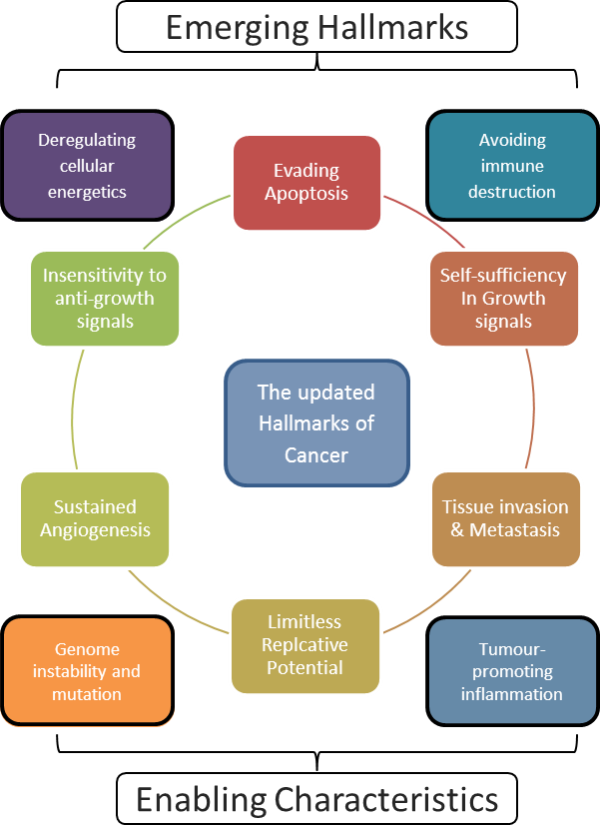
Figure 1.1.1 Hallmarks of Cancer
The updated Hallmarks of Cancer included the addition of two new emerging hallmarks, the deregulation of cellular energetics and cells avoiding immune destruction. In addition to this characteristics that are thought to enable the emergence of the core hallmarks were added. These enabling characteristics are tumour-promoting inflammation and Genome instability and mutation. Adapted and reprinted with permission from Cell Press (Hanahan, 2000).

Types of DNA Damage
Genotoxic agents (those which can cause DNA lesions) can arise from both exogenous (Schärer, 2003) and endogenous sources (De Bont, 2004); see table 1.2.1. The consequences of DNA damage can vary and are dependent on the nature of the lesion and genetic loci in which it occurs. However if such lesions are not repaired they can lead to mutation, permanent cell cycle arrest or even cell death.
DNA damage can range from changes to the base itself, changes in the DNA backbone or even covalent structures preventing the separation of the two strands of DNA for replication. One of the most common endogenous genotoxic agents are reactive oxygen species (ROS) and are often thought to be the result of mitochondrial respiration (Loschen et al., 1973), although there is some debate as to the importance of mitochondrial respiration on DNA damage (Brown and Borutaite, 2012, Kowaltowski et al., 2009). Oxidation of individual bases can lead to a wide variety of adducts for each base, such as 8- Hydroxyguanosine (Bjelland and Seeberg, 2003) and if left unrepaired these can result in potentially dangerous mutations (Wallace, 2002). In some cases ROS species can damage bases on complimentary stands raising the possibility of the generation of DSBs (Box et al., 2001), one of the most potentially lethal genetic lesions (Iliakis, 1991). The relationship between these lesions and cell death is well researched and can be directly visualised in cells using a variety of methods (Olive, 1998). In addition to base oxidation, ROS can lead to base deamination resulting in incorporation of inappropriate bases such as uracil, hypoxanthine and xanthene, these bases are dangerous in the way that they can successfully bind normal bases (Kow, 2002, Cadet et al., 1999); this is one of the major toxic consequences of cigarette smoke inhalation (Spencer et al., 1995). The other major form of endogenous base damage is base alkylation, first characterised in vitro (Brookes and Lawley, 1961) and later shown to be a source of mutation in vivo (Xiao and Samson, 1993).

Endogenous | Genomic Insult | Possible Source | Example Lesion
 | Base oxidation | ROS | 8- Hydroxyguanosine
 | Base depurination | Spontaneous | Apurinic site
 | Base Deamination | ROS | 5-hydroxymethyluracil
 | Base Alkylation | Spontaneous | O⁶-methylguanine
Exogenous | Pyrimidine Dimers | Ultra Violet light  (UV) | Cyclobutane Pyrimidine Dimers  6-4 photoproducts
 | SSB | UV/ROS  Ionizing Radiation  (IR) | n/a
 | DSB | IR | n/a
 | DNA Crosslink | Cisplatin | cis-Diammineplatinum(II) d(GpG)
Table 1.2.1 A list of genomic insults
Examples of the possible DNA damaging agents arising from both exogenous and endogenous sources. Highlighted are the insult, a possible source and one of the potential lesions that can result. n/a= where examples of lesions are not applicable.

Threats to genomic integrity do not only originate within the cell. It is estimated that there are ~10,000 depurination events per cell every 24 hours from exogenously-derived sources of DNA damage (Weinberg, 2007). Exogenous damage can result from exposure to UV radiation leading to the production of cyclobutane pyrimidine dimers (CPDs) and 6-4 photoproducts whereby two adjacent pyrimidine bases become covalently linked forming a dimer molecule (Setlow and Carrier, 1966). The biological effects of CPD’s can be wide toxic and mutagenic, and have been linked to immune response suppression, sun burn and melanomas (Vink and Roza, 2001). Other exogenous base modifiers can be the products of metabolism, otherwise known as biotransformation. One particularly important group are the Cytochrome P450 enzymes. Defective function of the P450 enzymes can lead to a build-up of potential carcinogens which have been linked to Liver, Gastric and Breast cancers. (Hasler et al., 1999).
One of the most potentially dangerous exogenous threats to cell survival through DNA damage is ionising radiation as this can lead to physical breaks in the DNA, both on a Single Strand Break (SSB) or as a Double Strand Break (DSBs). DSB’s involve the complete separation of adjacent bases at the sugar-phosphate backbone, leaving a physical disconnect between strands. This is a particular deleterious lesion for two reasons; the first is that aberrant DSB repair can lead to chromosomal translocations (Aplan, 2006), the other is due to the pathways responsible for DSB repair. The choice of pathway is determined by the cell cycle phase; if a sister chromosome is available (S/G2) the error free Homologous Recombination (HR) repair pathway is employed, however outside of this window the error prone Non-Homologous End Joining (NHEJ) is employed. The mechanics of these and other pathways will be explored later.
A similarly threatening form of DNA damage are DNA crosslink’s, which can be either inter-strand crosslink’s (ICLs) linking the two opposing DNA strands or intra-strand crosslink’s bind adjacent purines on the same strand. DNA crosslink’s can be formed by a wide variety of compounds (Deans and West, 2011). This includes relatively common compounds such as alcohol, the metabolism of which results in aldehyde production and has been linked to increased cancer risk due to the DNA adducts that can arise (Brooks and Theruvathu, 2005). However ICLs are particularly associated with platinum based compounds (Fichtinger-Schepman et al., 1985) due to their wide ranging use in cancer treatment (Deans and West, 2011). The danger is that these can act as physical blocks to prevent cells from unwinding or separating DNA, preventing normal DNA replication and transcription. They are also one of the primary class of agents used in the treatment of various cancers (McHugh et al., 2001).

1.3 DNA damaging agents in the treatment of Cancer
The use of chemical based genotoxic agents to treat cancer can be traced back to the 1940’s where after a large release of mustard gas it was observed in autopsies that the agent specifically targeted white blood cells. It was therefore speculated that these compounds could be used to treat Leukaemia (Spurr et al., 1950). These observations lead to the rapid uptake of chemotherapy; the method of treating cancer by poisoning the body with agents that damage tumour cells more so than the body’s healthy tissue. Initially using derivatives of mustard gas during this early phase, a great leap forward came with the solving of the helical structure of DNA that lead to a greater understanding of the mechanism of action and pharmacokinetics of chemotherapeutics (Galmarini et al., 2012).
Chemotherapeutics allow clinicians to take advantage of a number of hallmarks of cancer. For example the increased proliferation of a tumour caused by changes to metabolic pathways (DeBerardinis et al., 2008) leads to a larger population of cells replicating their genome which are therefore vulnerable to genotoxic agents. Genome instability may also be exploited this way as tumours will have potentially lost their ability to repair or respond efficiently to genetic insults (leading to cell death). Development in cancer treatment has not only been in the advancement of interstrand cross linking agents such as Mitomycin C (MMC) and cisplatin/carboplatin (Rajski and Williams, 1998), but also in the development of nucleoside analogues such as Gemcitabine which generates severe replication stress by acting as a chain terminator (Mini et al., 2006). Both of these treatments target the replication of cellular DNA; however other classes of drugs have been tailored to target other stages of the cell cycle, such as the sabotage of mitosis through spindle poisons. The formation of a mitotic spindle is prevented by the disruption of microtubule dynamics in one of two contrasting ways; taxanes prevent de-polymerisation of microtubules while alkaloids inhibit polymerisation (Rowinsky, 1997, Noble, 1990). These agents have the same effect and halt cell cycle progression in mitosis. In a similar manner to cross linking agents normal cells should respond to these drugs by halting cell cycle progression, however cells with defective cell cycle checkpoints e.g. cancer cells, can be forced in apoptosis (Checchi et al., 2003).
Not all anti-cancer agents are administered to the whole body, as mentioned previously UV and IR sources can be highly genotoxic. UV radiation is unsuitable for cancer therapy as it cannot penetrate into tissue, however, IR can pass through tissue and will cause lesions in DNA producing roughly 1000 SSBs and between 25-40 DSBs per gray exposure (McGrath and Williams, 1966). The origins of radiotherapy can be traced to the late 19th century when Wilhelm Röntgen announced the discovery of X-rays. Within a year of this announcement Emil Grubbe performed the first attempts at X-ray therapy on a patient with a breast carcinoma. He continued to treat patients throughout his life, enduring 92 operations to remove tumours of his own most likely induced by his constant exposure to X-rays (BMJ, 1960). It was only 5 years later that the biological effects of Radium were being noticed by the Curies and the clinical potential of radium explored. Although the use of radium became relatively widespread, only small quantities were available and its use was mainly limited to head, neck and skin cancers (Lederman, 1981). Advances in medical imaging have allowed for the precise localisation of tumours to be determined creating a target for radio surgery, a therapy where a large dose of IR can be delivered to a tumour while minimising the exposure of surrounding healthy tissue. This is achieved by exposing the tumour to repeated small does from a large number of vectors intersecting at the tumour, this is particularly useful in situations where drug delivery is difficult for logistical reasons; such as in neuronal neoplasias due to the blood brain barrier preventing drug delivery (Walcott et al., 2013, Deeken and Loscher, 2007) or in cases where surgery carries high risks such as lung cancer (Senan et al., 2013). It is in the knowledge of how defects in DDR can be exploited that we endeavour to understand how cells deal with the plethora of DNA damaging agents that can cause the variety of adducts observed. This is immediately apparent in sufferers of diseases caused by poor or absent DNA damage repair mechanisms.
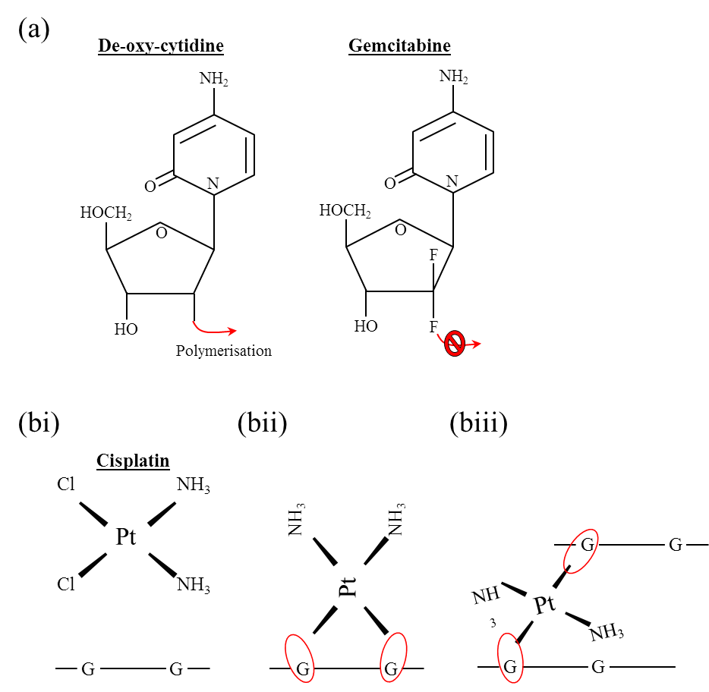

Figure 1.3.1Examples of Chemotheraputic compounds and their mechanism of action.
(a) Normal DNA replication relies on the polymerisation of the DNA backbone through connection of the number 2 carbon from the sugar backbone, gemcitabine acts as an analogue to cytidine and can be incorporated into polymerising DNA, however the number 2 carbon is replaced with a fluorine atom which prevents further polymerisation. Molecules that have this method of action are therefor known as chain terminators. (bi) Cisplatin consists of two Chlorine groups and two ammonia groups co-ordinated around a central Platinum atom, the two chlorine groups. The loss of the chlorine atoms in water (aquation) allows the platinum atom to bind to DNA bases (with a greatest affinity for Guanine), this leads predominantly to intra-strand (same strand) crosslinks (bii) but can also lead to inter-strand (between strand) crosslinks (biii).

DNA Damage Associated Diseases
The importance of cellular processes that repair damage and protect genomic integrity can be extrapolated from the vast array of human diseases and disorders that arise from defects in DDR elements (Jackson and Bartek, 2009). These are phenotypically wide-ranging and often associated with a severe cancer pre-disposition; a selection of which can are highlighted table 1.3.1. This list is not exhaustive as more than forty DDR disorders have been reported to date (Ciccia and Elledge, 2010). The phenotypes of these diseases can range from the advanced aging and loss of adipose tissue seen in Hutchinson-Gilford Progeria syndrome (HPGS) due to mutations in Prelamin A (Liu et al., 2006), to the basal and squamous cell carcinomas suffered by Xeroderma Pigmentosum patients often relatively early in life (Patton and Valdez, 1991). However there are also a large number of common phenotypes depending on which pathway a gene is part of, such as microcephaly (a neurological development disorder resulting in reduced head circumference) in many disorders with ATR signalling defects (O'Driscoll et al., 2006) and neurodegeneration (normal neural development with neural cell death later in life) in disorders affecting pathways that are involved in repair of ROS (Rolig and McKinnon, 2000). This is due to the large amount of crosstalk between DDR pathways, seen phenotypically in the number of DDR genes associated with neurodegeneration, examples of which include ATM/XPV/XPA/WRN/CSA (Rolig and McKinnon, 2000) all of which display some level of neurological dysfunction. Further evidence of this link is observed in mouse knockouts of the key DNA end joining protein XRCC4 and DNA Ligase IV which are embryonically lethal due to increased cell death in the central nervous system (Gao et al., 1998, Barnes et al., 1998).

Disease | Associated gene(s) | Selected Phenotypes | Cancer
Bloom Syndrome | BLM | Abnormal skin pigmentation, infertility, facial dysmorphism, microcephaly, chronic lung disease, polydactyly | Leukaemia, Lymphoma, Adenocarcinoma, Squamous cell carcinoma
Nijmegan breakage syndrome (NBS) | NBS1 | Prenatal growth retardation, cleft lip, cleft palate, facial dysmorphism, recurrent pneumonia, abnormal skin pigmentation, neurodegeneration | B cell Lymphoma, Glioma,
Ataxia Telangiectasia | ATM | Ocular telangiectasia, infertility, abnormal skin pigmentation, Ataxia, Delayed puberty, glucose intolerance | Hodgkin and Non-Hodgkin lymphoma, Leukaemia,
Severe Combined Immunodeficiency (SCID) | RAG1, RAG2 | Conjunctivitis, recurrent pneumonia, Arthritis, Meningitis, frequent infection (poor immune response) | None
Ligase IV syndrome | LIG4, ARTEMIS | Pneumonia, absent tonsils, genital ulcers, recurrent respiratory infections, small lymph nodes | T-cell Leukaemia
Seckel Syndrome (SS) | ATR,,RBBP8, SCKL3, CENPJ, Cep152, Cep63, Ninin | Short stature, prenatal growth retardation, microcephaly, facial asymmetry, beaked nose, cleft palate, Scoliosis, mental retardation, seizures | None yet attributed
Xeroderma Pigmentosum (XP) | XPA-G, POLH | Skin photosensitivity, telangiectasia, mental deterioration, ataxia, poor reflexes | Basal cell, squamous cell and malignant melanomas
Cockayne syndrome (CS) | CSA, CSB, XPB, XPD, XPG | Intrauterine and postnatal growth deficiency, microcephaly, hearing loss, numerous eye defects, hypertension, renal failure, photo sensitivity, mental retardation, ataxia | none
Fanconi Anemia (FA) | FANCA/B/C, , FANCD1/D2, FANCE//F/G, FANCI/J/L/M/N/O/P/Q | Absent or malformed kidneys, low birth weight, abnormal skin pigmentation, microcephaly, anaemia, deafness | Acute Myeloid Leukaemia
Werner Syndrome | WRN | Short stature, Progeria (premature aging), Diabetes, cataracts, retinal degradation, | Osteosarcoma, meningioma
Table 1.3.1 Examples of human diseases associated with mutations in DDR Factors. DNA repair proteins have been implicated in a large number of human conditions. Listed above are some examples of disorders, the associated gene(s), cancer phenotypes and other notable phenotypes. This list was compiled using the Online Mendelian Inheritance in Man (www.OMIM.org) database, for a more complete list of disorders please consult (Ciccia and Elledge, 2010).
One particular form of neurological phenotype, microcephaly; where head circumference is smaller than 2 standard deviations below the mean, is hypothesised to be linked to DNA damage response through disruption of efficient spindle pole orientation whereby control of the centrosomes is compromised leading to mitotic defects. More specifically, the control of centrosome duplication, the structures which determine the plane of separation during mitosis is particularly important as neuronal cells split asymmetrically (Higginbotham and Gleeson, 2007). Research into the first gene identified in Primary Microcephaly, MCPH1, found links to BRCA1 and CHK1 signalling also observing an over duplication of centrosomes. It is therefore hypothesised that neuronal cells might be particularly sensitive to defects in centrosome function (O'Driscoll et al., 2006). Recent work has demonstrated that one of the most commonly mutated genes in primary microcephaly MCPH5, otherwise known as ASPM, has a core function in spindle function and cytokinesis (Higgins et al., 2010) and that knock down of this gene in zebrafish results in a significant reduction in heads size while a knock out results in increased mitotic arrest in early development (Kim et al., 2011).
Despite the huge variety and diversity of these diseases they all have a great deal in common at a molecular level. Understanding these disorders has helped form our knowledge of the multitude of different pathways employed by cells to repair the huge variety of genomic insults that can befall DNA, allowing ever more treatment options tailored to individual tumours (Lord and Ashworth, 2012). This can be seen in the rapid advancement in clinical research into inhibitors that target tumours with defect in particular DNA repair pathways. One of the most promising are targeted towards PARP, a protein that is involved a number of DNA repair pathways most notably in the repair of DSBs (explored later), inhibiting PARP sensitises tumours with defects in BRCA1 to DSBs as they do not have a viable repair pathway for this lesion (the pathway mechanics will be discussed later). PARP inhibitors have progressed from initial thoughts on their broad spectrum possibilities (Virag and Szabo, 2002), to cell culture models developed for a breast cancer subtypes (Bryant et al., 2005) and ultimately to a number of clinical trials for both breast and ovarian cancer (Garber, 2013).

1.5 The Cell Cycle and DNA repair mechanisms
Like many pathways, the DDR pathways do not act in isolation. Due to the importance of genomic integrity these pathways are intertwined with cell cycle control routes through some of the earliest activated DDR kinases (Abraham, 2001), preventing cells from carrying potentially dangerous damage through a complete round of replication or mitosis and therefore becoming a potentially heritable mutation.
The basics of different cell cycle stages and their control are well established with a concise review of the early research given by one of the fields pioneers Sir Paul Nurse (Nurse, 2000). The basic cell cycle is composed of four distinct stages, an initial growth phase (G1), a DNA replication phase (S), a second growth phase (G2) and a division phase (M). Control over the progression of these phases is governed by Cyclins and Cyclin Dependant Kinases (CDKs), which form specific functional complexes at different stages of the cell cycle (Nurse, 2002), see figure 1.5.1.

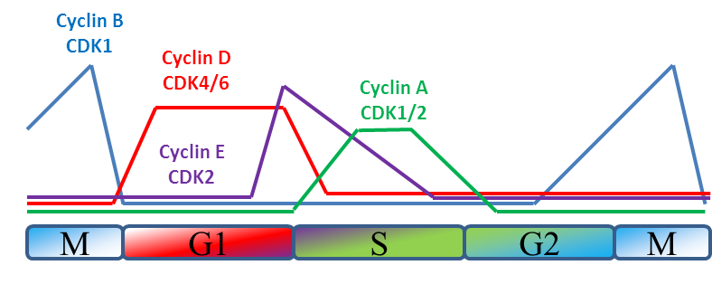

Figure 1.5.1 Cyclin levels and active CDK-Cyclin couples throughout the cell cycle.
The levels of the four main families of cyclins fluctuate during the cell cycle as they are targeted for degradation and expressed cyclically. Cyclin binding of relevant CDKs increases their catalytic activity by many orders of magnitude.

It is through this control that cells determine their passage through the cell cycle checkpoints, which are transition points between the stages such G1/S, intra-S, G2 and M. This is particularly important in cells with damaged DNA as it can halt progress and prevent DNA lesions from becoming heritable mutations or the formation of aneuploid cells (Murray, 1994). The ability of cells to escape normal cell cycle control is one of the key requirements for cancer progression. As such there are many genes associated with cyclin control and cancer such as those controlling exit of G1 through cyclin D depletion (Hunter and Pines, 1994) and mitotic entry (Cahill et al., 1998). By bypassing cell cycle checkpoints cells can proceed into stages that could be detrimental to genomic integrity.

One of the most studied proteins related to cell cycle progression and cancer in general is p53. The p53 pathway is lost in up to 60% of cancers (Bourdon, 2007), however it has proven difficult to link p53 status to potential drug sensitivity or biological properties of tumours possibly due to the varied isoforms expressed in a tissue dependant manner (Bourdon et al., 2005). The challenges involved in studying p53 are in the wide ranging cellular phenotypes that can be caused by p53 mutation such as promotion of metastasis, cell survival, invasion and proliferation (Muller and Vousden, 2013). p53 functions as a transcription factor which can be activated by DNA damage and regulates the expression of downstream signalling proteins such as p21, which in turn can go on to regulate cell cycle progression through inhibition of cyclin-CDK complexes (Li et al., 1994). While activation of p53 is mainly mediated by phosphorylation of upstream DDR components such as the ATM/ATR PIKKs (Canman et al., 1998, Tibbetts et al., 1999), downstream cellular effects can range from DNA repair in the mediation of expression of key Nucleotide Excision Repair (NER) genes (Adimoolam and Ford, 2003) to the regulation of apoptosis (Li et al., 1999) and exit of the cell cycle into senescence (Qian and Chen, 2013).
There is a great deal of reciprocal interplay between the cell cycle and DDR signalling whereby the action of certain cell cycle markers guides pathway choice in response to DSBs, such as the phosphorylation of CtIP by CDK1 promoting DNA end resection (Escribano-Diaz et al., 2013) . By being able to differentiate between stages of the cell cycle, repair pathways that exploit the replicated DNA as a template are therefore error free and can be employed, this is known as homologous recombination (HR) (Bollag et al., 1989). This and the other major DSB repair pathway Non-Homologous End Joining (NHEJ) will be discussed in greater detail later. The complexity involved in this signalling has been well illustrated in many reviews of the two key DDR kinases ATM and ATR and their cell cycle interactions (Shiloh, 2003, Smith et al., 2010, Jazayeri et al., 2006). ATM and ATR are upstream Phosphatidyl Inositol 3’ Kinase related Kinases (PIKKs) through which signalling cascades can phosphorylate, amount a plethora of other targets, the Chk1 and Chk2 effector kinases which in turn facilitate cell cycle arrest (Matsuoka, 1998, Falck et al., 2001, Zhao and Piwnica-worms, 2001). These downstream kinases themselves phosphorylate the cyclin dependant kinases Cdc25A and Cdc25C, targeting them for destruction and leading to low CDK levels and subsequent cell cycle arrest (Xiao et al., 2003), see figure 1.5.2.

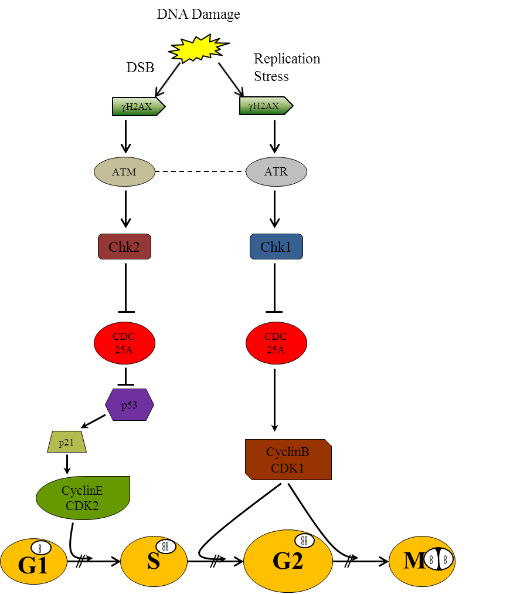

Figure 1.5.2 Mechanisms by which ATM and ATR control cell cycle checkpoints
After the detection of DNA damage ATM (DSBs) and ATR (ssDNA) phosphorylate the downstream kinases Chk2 and Chk1. Chk2 activation inhibits Cdc25A thereby preventing cell cycle progression through the G1 checkpoint normally facilitated by CyclinE and cyclin dependant kinase 2 (CDK2). Phosphorylated Chk1 leads to turnover of Cdc25A, preventing cell cycle progression through the S/G2 and G2/M phase cell cycle checkpoints. These are the major events; however this diagram represents a simplified version of cell cycle control after DNA damage.

1.6 DNA Damage Response Pathways
As has been mentioned the wide variety of DNA damaging agents and the close relationship between cellular response to DNA damage and the cell cycle leads to the requirement of multiple DNA repair pathways. The following section will describe the key events and mechanics of each pathway and where relevant highlight the clinical disorders that can arise due to defects or inefficiencies in elements of the pathway. These sections are not exhaustive but will give an overview of the common elements and the importance of DNA fidelity.

Base Excision Repair and Single Strand Break Repair
Base Excision Repair (BER) and Single Strand break Repair (SSBR) are inter-related pathways that utilise a number of common repair enzymes but differ in the enzymes used in damage detection and removal. In BER a large number of base lesions can be repaired, these include many discussed earlier such as base alkylation and oxidation. To recognise the plethora of lesions cells have a number of highly conserved DNA glycosylases, a family of enzymes that are able to recognise damaged DNA (Krokan et al., 1997). A well-studied example are the Uracil-DNA glycosylases (UDGs), which was found to have between 40% and 55% identical residues compared with its homologues (Olsen et al., 1989). The glycosylase superfamily of enzymes can be further subdivided into two sub-families, known as mono-function and bi-functional. This depends on whether or not the glycosylase only removes the offending damaged base leaving an abasic site that still requires processing (mono-functional) or if they also possess AP lyase activity allowing cleavage of the phosphodiester bond (bi-functional) leaving a DNA single strand break (SSB) (Ide and Kotera, 2004). The lyase activity of bi-functional DNA glycosylases leaves the DNA backbone broken in such a manner that it can be recognised by gap filling polymerases. As mono-functional glycosylases do not have this function, other endonucleases such as Apurinic Endonuclease (APE) process the DNA backbone leaving a 3’-hydroxyl and 5’deoxyribosphosphate sites that are recognised by DNA polymerases (Wilson et al., 1995). These ends are recognised by DNA polymerase ß which fills in this gap (Idriss et al., 2002), leaving only the final ligation step. This is performed by a complex of XRCC1 and DNA ligase III, reforming the linear DNA strand (Caldecott et al., 1994). There is variation within the BER pathway whereby the repair process can either repair short patches (single nucleotide) or long patches (between 2 and 12 bases) of DNA (Sattler et al., 2003). The selection is determined by DNA ligase III and XRCC1 depending on the local ATP concentration (Petermann et al., 2006, Petermann et al., 2003).
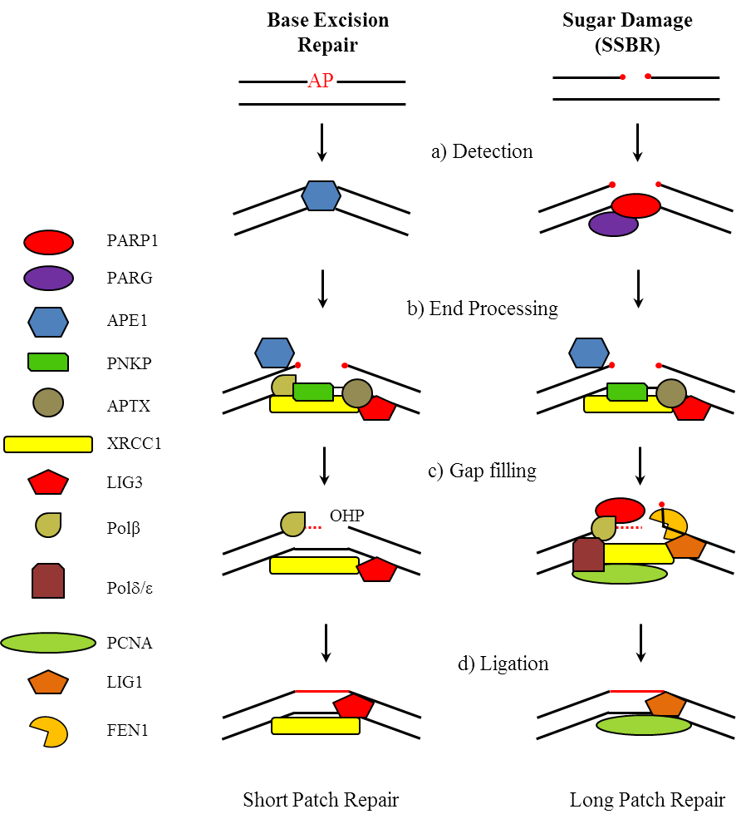

Figure 1.6.1 Base Excision Repair and Single Strand Break Repair
A brief overview of the key steps involved in BER and SSBR a) breaks can occur with the formation of abasic site (AP site) by APE1 or by direct lyase activity of DNA glycosylases. b) This break leaves termini on the DNA which prevent gap filling, these are processed by PNKP, APTX, DNA Polβ and APE1. The processing allows for c) gap filling to process, filling in the gap using the opposing strand as a guide. This is normally performed by DNA Polβ, which adds the missing base, however if there are multiple bases missing the activity can be performed by DNA Polδ/ε.. As in the gap filling the final ligation enzyme depends on the length of DNA repaired, for short patch repair Ligase 3 is employed, while for long path it is more typical for Ligase 1 to perform this operation. Adapted and reprinted with permission from (Caldecott, 2008).
There is a large amount of overlap between BER and SSBR, with commonality found in the gap filling by DNA Pol ß and DNA ligation by the XRCC1/DNA Ligase III complex. For SSBR, recognition of the physical DNA break is performed by Poly-ADP-Ribose Polymerase (PARP), which in turns binds strongly through its N-terminal DNA binding domain and it is this binding that activates it catalytic domain leading to rapid ADP-ribose chain polymerisation at the site of damage (Smith, 2001). This polymerisation acts to signal to further downstream factors such as XRCC1 (El-Khamisy et al., 2003), which are recruited to facilitate the repair of the SSB. PARP is of particular interest as it has been shown that inhibition of PARP forces cells to use the homologous replication (HR) pathway in order to repair lesions and was shown to be a particularly effective way of killing cancer cells with defective HR components (Bryant et al., 2005). PARP inhibitors have since become a particular focus for cancer therapy and a number of compounds are currently undergoing clinical trials for use in patients whose tumours have identified defects in HR (Kummar et al., 2012, Garber, 2013). As has been alluded to earlier the importance of this process in human health can be concluded from the associated cancer risk that arises with mutations in APE1 (Lo et al., 2009), XRCC1 (Stern et al., 2001) and DNA glycosylases such as OGG1 (Le Marchand et al., 2002).

Nucleotide Excision Repair
One of the largest limitations of the BER and SSBR pathways is the short length over which they can function and the limited selection of lesions they can recognise; this is overcome in nucleotide excision repair (NER). NER acts by making incisions either side of a DNA lesion, which can be between 24 and 32 nucleotides apart, and then removing the entire section containing the DNA lesion (Wood, 1997). The NER pathway recognises the distortion in DNA structure that can be caused by a number of lesions, such as cyclobutane pyrimidine dimers (CPDs) or 6-4 photoproducts, rather than the base damage detected by glycosylases, making NER the primary pathway for repair of UV damaged DNA (Wood et al., 2000). The two main damage recognition factors are the XPC-RAD23B and XPA-RPA complexes. Binding of the XPC-RAD23B complex is facilitated by the interaction of DDB1-DDB2 to distortions in the DNA (Scrima et al., 2008). After initial recognition of the distortion the second phase of NER is the recruitment of the TFIIH complex, within which two helicases (XPB and XPD) of opposing polarity act to facilitate for the unwinding of the DNA either side of the distortion (Frit et al., 1999). Once unwound the offending strand is removed by two exonucleases, XPG (3’) and XPF-ERCC1 (5’), which require Replication Protein A (RPA) to be bound to the undamaged DNA strand for this endonuclease activity (Matsunaga et al., 1996). The remaining structure now has a single strand region of DNA (ssDNA) 24-32 bases long bound with multiple factors; TFIIH, XPA/B/D/G/F, ERCC1 and RPA. The ssDNA region acts as a template for DNA synthesis, the exonuclease activity of XPF-ERCC1 leaves a 5’hydroxyl group that can be recognised by the polymerases Polδ (Hunting et al., 1991) and Polε. The polymerisation into the gap is performed by a complex of PCNA, RFC and Polδ/ε (Shivji et al., 1995). The final ligation step is then carried out by DNA Ligase I, restoring the DNA integrity (Araujo et al., 2000). The above timeline outlines the global genome variation (GGR) of NER. There is however a particular sub-pathway of NER that is paired with transcription which is termed transcription coupled repair (TCR). The TCR pathway differs only in the initial damage recognition where the lesion acts as a block to the RNA polymerase (RNAP) in complex with CSB (Iyer et al., 1996). It is thought that the RNAP complex then regresses allowing the TFIIH complex to reach the lesion and follow the normal NER repair process (Hanawalt and Spivak, 2008).
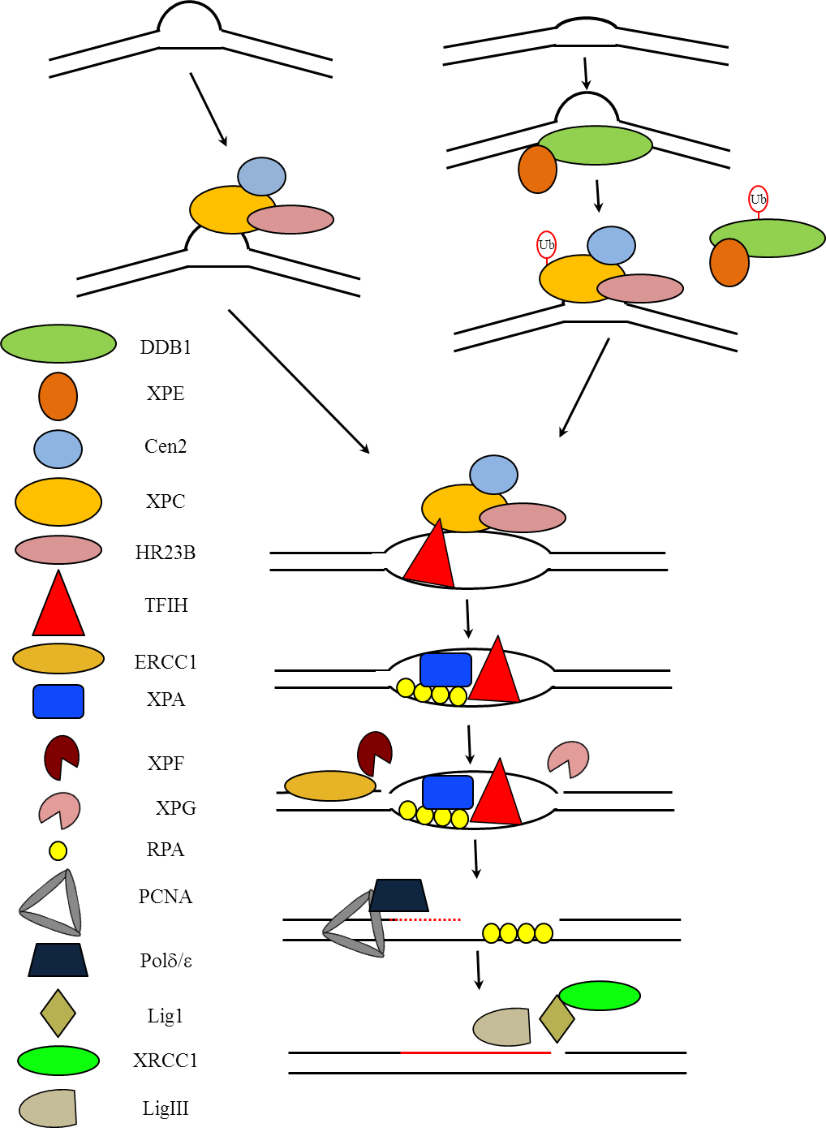

Figure 1.6.2 A Summary of Nucleotide Excision Repair (NER)
If a DNA lesion is causing a distortion and requires a larger section of DNA to be removed than is possible by BER/SSBR then NER is employed. The proteins involved in the detecting the DNA damage vary depending on how distorting the lesion is, for minor distortion the lesion is recognised by DDB1/XPE however major distorting lesion require the XPC/Cen2/HR23 complex. The DDB1 complex re-organises the lesion, ubiqutination of both the DDB1 targets it for destruction while ubiquitination of the XPC complex increases its affinity for DNA. A ~30bp region is then displaced by TFIIH, creating the denaturation bubble. The XPC complex is then displaced by single strand binding RPA and XPA. XPF an XPG then nick the DNA either side of the lesion (5’ and 3’ respectively). The resulting gap is filled by DNA polymerase δ/ε associated with PCNA. The final ligation step is performed by LigIII (although LigI has a minor role in replicating cells). Adapted and reprinted with permission from (Nouspikel, 2009).
The most common lesions repaired by NER are 6-4 photoproducts and CPD’s, lesions caused by UV radiation; this is reflected in the extreme UV sensitivity exhibited by patients with defects in elements of the NER pathway. To date defects in the NER genes XPA/B/C/D/E/F and XPG have been found to lead to the autosomal recessive disorder Xeroderma Pigmentosum (Lehmann et al., 2011). In long term studies patients under 20 have been found to exhibit a 10,000 fold increase in developing basal cell carcinomas and squamous cell carcinomas, and a 2000 fold increase for melanomas (Bradford et al., 2011). There is some variation in severity with some 40% not showing extreme photosensitivity, instead exhibiting a large number of freckle like patterns on areas exposed to UV light, while a minority of XP patients also display some neurological abnormalities (Lehmann et al., 2011). The TCR genes CSA and CSB have been associated with the photosensitive disorder, Cockayne Syndrome, patients of which are able to repair UV damage in inactive regions of the genome but not in transcriptionally active ones (Venema et al., 1990). This results not only in photosensitivity but also neurological impairment, microcephaly and developmental defects (Lehmann, 2003). The most recent report finds over 80 mutations in the CSA and CSB genes in Cockayne Syndrome patients, including two within the promoter region of CSB (Laugel et al., 2010), highlighting the complex genetic heterogeneity of this disease.

Mismatch Repair
Both BER and NER function to repair damaged nucleotides. However there are also specialised mechanisms for repairing the results of polymerase slippage, insertion, mis-incorporation or deletion of bases (IMD) that have arisen during the course of DNA replication. In mammalian cells primary recognition of the error is performed by the two heterodimers; MutSα and MutSβ, composed of Msh2-Msh6 and Msh2-Msh3 respectively. MutSα is involved in the repair of single base insertion/deletion and miss pairings while MutSβ repairs IDLs of between 2-8 bases (long patch MMR) (Genschel et al., 1998). There is a strong conservation of the MutS proteins (Sachadyn, 2010), however despite both heterodimers containing the Msh2 subunit the nucleotide binding dynamics of the two complexes differ depending on the type of lesion. It has been observed that differences in ATP hydrolysis between Msh6 and Msh3 alter DNA binding at the lesion (Owen et al., 2009). After binding of the MutS complex a secondary recognition stage is initiated with the binding of the MutLα heterodimer, composing of Pms2 and Mlh1. Both sub-units were demonstrated to have ATPase activity, with Mlh1 having greater ATP affinity (Tomer et al., 2002). This activity drives its main function as an exonuclease, introducing a SSB that allows for resection of the damage region via EXO1 (Kadyrov et al., 2006, Tran et al., 2004). The exposure of ssDNA leads to RPA binding of the exposed ssDNA, stabilising it and allowing for the facilitation of repair synthesis (Ramilo et al., 2002). PCNA interacts with the Msh3, Msh6, Mlh1 and Exo1 components of MMR at various stages of MMR acting as a scaffold at each stage (Lee and Alani, 2006). As in nucleotide excision repair the polymerisation of the gap is performed in a manner that is dependent on RFC and PCNA for the processivity of DNA Pol δ. As demonstrated by cell fractions lacking DNA Pol δ are unable to perform MMR but regain the ability upon reintroduction of DNA Pol δ (Longley et al., 1997). Some studies originally suggested a potential exonuclease role for DNA Pol δ in MMR due to a reduction in excision in the presence of Aphididcolin, a potent DNA polymerase α and δ inhibitor (Hammond et al., 1990, Wang and Hays, 2002). The exonuclease contribution of DNA Pol δ was later shown to be minimal, however the excision and repair rates in complexes without Exo1 or with a catalytically dead Exo1 were reduced 10 fold (Constantin et al., 2005). The impact of defects in MMR related genes in cancer cannot be overstated. Patients with Lynch Syndrome, otherwise known as Hereditary Nonpolyposis Colorectal Cancer (HNPCC), have inherited mutations in MMR genes (Boland et al., 2008) and are highly susceptible to colorectal cancer (Vasen et al., 1999). The mean age at which this manifests is 45 years and it is often accompanied by other epithelial cancers and Gliomas. It was observed that in many colon cancers (hereditary and sporadic) there appeared to be very high mutation rates in short (2-6 nucleotides) repetitive microsatellite sequences and that these mutations arose early in tumour formation (Shibata et al., 1994). This is described as a replication error phenotype (Aaltonen et al., 1994), and more specifically as Microsatellite Instability (MSI). Research examining the frequency of small insertions or deletions during replication showed an increased rate in regions of repetitive sequence (Roberts et al., 1993), which would normally be repaired by the MMR pathway in order to prevent frame shift mutations. The genetic background of MMR genes was investigated and a substantive risk was found to be associated with mutations in these genes (Dunlop et al., 1997, Eshleman and Markowitz, 1996) and the link made between MMR and MSI. It is now thought that around 10-15% of all colorectal cancers are associated with MSI and it is hypothesised that there is bias towards mutations arising within particular microsatellites that are associated with potential cancer driving genes, which could potentially be exploited in predicting tumour progression (Shah et al., 2010).

Homologous Recombination
As mentioned in earlier sections the cell cycle can play a critical role in the DDR by influencing the choice of pathway used to repair lesions based on the DNA copy number. In S and G2 phases of the cell cycle the DNA is in the process of or has been replicated, allowing for the use of a sister chromatid as a template which can be used for error free repair. This is especially important for DSBs, where
Non-Homologous End Joining (NHEJ) pathway is the pre-dominant method for repair in the absence of a sister chromatid (Saleh-Gohari and Helleday, 2004). Homologous recombination provides an error free method for DSB repair through the complex orchestration of complimentary regions of sister chromatids.
The mechanisms involved in HR can be separated into four separate stages; lesion detection, strand invasion, elongation and resolution. The basic principle follows that upon detection of a DSB overhangs are resected on opposing strands, the homologous region of the sister chromatid is brought to the damaged region, the resected regions invade the sister chromatid forming a Holliday Junction and the sister chromatid is used as a template for strand invasion before Holliday Junction resolution (Figure 1.6.3). A variation of this process is involved in the repair of stalled or broken replication forks and will be summarised later.
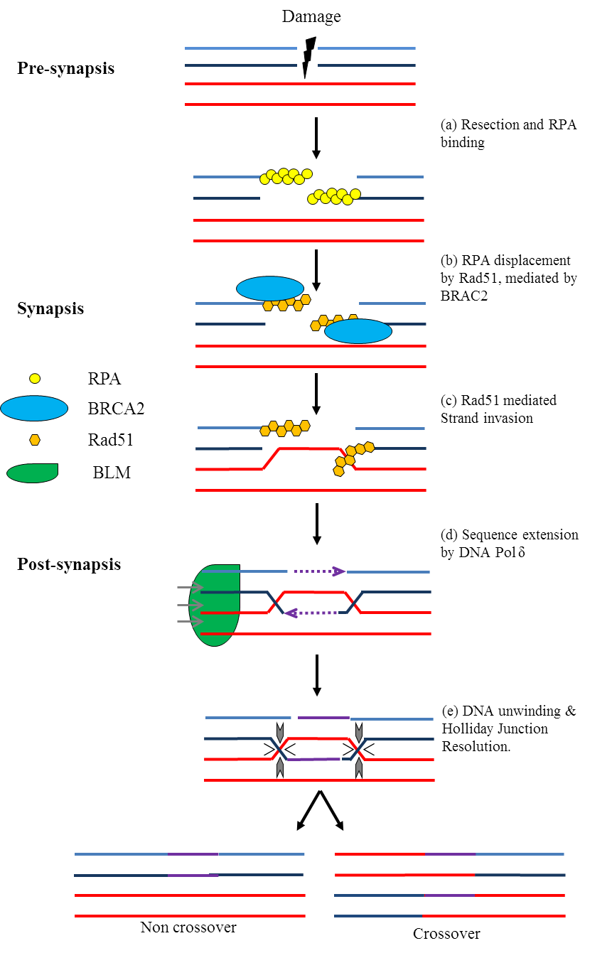

Figure 1.6.3 A simplified schematic of Homologous Recombination
Homologous Recombination allows for genetic information to be preseved despite a double strand break (DSB). (a) The DSB is detected by the MRN complex leading to resection of one arm of each strand affected by the DSB. (b) RPA binds the ssDNA but is forced off by (c) Rad51 which is able to search for sequence homology and initiate strand invasion into the sister chromatid. (d) The sister chromatid can then act as a template for DNA replication allowing for faithful repair, there is evidence that polymerases associated with TLS are involved in HR sequence extension (McIlwraith et al., 2005). (e) The resulting Holliday Junction is unwond by the BLM helicase and can be resolved in different orientations by resolvases, the orientation of the resolution determining whether a crossover event occurs.

Initial lesion detection is carried out by the MRN complex, composing of MRE11/RAD50/NBS1, each of which has separate roles in the detection phase. The MRE11 nuclease acts as the initial sensor, acting as a dimer binding directly to DNA through an L shaped grove which has some adaptability to different DNA substrates (Hopfner et al., 2001). RAD50 acts as an ATPase related to the ABC transporter family of ATPases (Moncalian et al., 2004), also binding to DNA and interacting with MRE11 and NBS1 through its Walker A and Walker B motifs (Stracker and Petrini, 2011). Although MRE11 and RAD50 are highly conserved from lower to higher organisms (Aravind et al., 1999), NBS1 is not, however it has been shown to greatly increase the DNA unwinding and exonuclease activity of the MRN/RAD50 complex (Paull and Gellert, 1999). The MRN complex not only binds the lesion and resects single strands of DNA; it is also responsible for the recruitment and activation of the PIKK ATM at the site of damage (Lee and Paull, 2005), a hugely important kinase that orchestrates numerous downstream events covering DNA repair and cell cycle control (Derheimer and Kastan, 2010). Once ATM has been recruited to the strand break it phosphorylates Histone H2AX on serine 139 forming γH2AX (Burma et al., 2001). This phosphorylation event is common in response to many types of genomic lesion and is important for both the initial recruitment and retention of DNA damage signalling and repair factors to sites of damage (Revet et al., 2011, Lukas et al., 2011). Due to its role in the wide variety of lesions this phosphorylation event can be used as a measure of cellular stress (Tanaka et al., 2006). It is also being explored as a way of measuring DSB induction in cancer therapy (Bonner et al., 2008) and as a measure of radiation exposure (Redon et al., 2010). ATM not only acts to recruit and signal DDR proteins it also controls cell cycle progression through phosphorylation of Chk2 (Matsuoka, 1998). The activated form of Chk2 goes on to phosphorylate Cdc25A leading to its degradation therefore halting the cell cycle (Hirao et al., 2002) while repair can be performed.
The resection of opposing strands of DNA by MRE11 leads to the exposure of ssDNA, which are subsequently coated by phosphorylated RPA (Wu et al., 2005b), as evidenced by co-localisation of pRPA with γH2AX foci after exposure to IR (Balajee and Geard, 2004). Strand invasion is not mediated by RPA, this is dependent on BRCA2 binding to RPA and leading to its displacement allowing for Rad51 binding (Liu et al., 2010a). Rad51 is able to promote the pairing of the ssDNA with the homologous region on the sister chromatid (Baumann et al., 1996, Baumann and West, 1998). The pairing of sister chromatids also involves Rad54, which when paired with Rad51 evokes displacement of one of the sister strands (D loop) allowing for strand invasion (Heyer et al., 2006) This invasion allows for the sister chromatid to be used as a template for extension of the damaged DNA strand by DNA polymerase δ (Maloisel et al., 2008).
Once the extension phase is complete the intertwined DNA strands form a complex 4 way DNA structure known as a Holliday Junction (HJ) (Duckett et al., 1988) in which each of the invading strands is intertwined with a sister chromatid. The unusual nature of these complexes require specialist helicases which are able to unwind the intertwined strands, this action is performed by the BLM helicase, a member of the RecQ helicase family (Wu et al., 2005a). The HJ can then be resolved by a number of different resolvases, such as GEN1 and SLX4 (Ip et al., 2008, Fekairi et al., 2009), and can result in the sister chromatid remaining intact or in a cross over event where the sister chromatids are swapped in the region following the repair (Fu et al., 1994) (see figure 1.6.3). Recent work on HJ resolvases has shown that HJ resolution is linked to CDKs; CDK phosphorylation leads to the formation of a holoenzyme of SLX4-MUS81 at the G2/M transition providing a safety net to prevent any HJ structures from interfering with chromosome segregation (Wyatt et al., 2013).

Non-Homologous End Joining
When cells do not have sister chromatids available to act as a template for DSB repair (outside of S and G2) and therefore cannot use Homologous Recombination, Non-Homologous End Joining (NHEJ) facilitates the repair of DSBs (figure 1.6.4). Due to the lack of template this process relies on a small resection and polymerisation to allow re-ligation of the DNA using small overhangs. This leads to the loss of some genetic material and is therefore error prone. However the potentially error prone nature is utilised in V(D)J recombination to create the diversity seen in the variable domain of immunoglobulin’s (Lieber et al., 2004). The initial DSB is recognised by the Ku70/80 heterodimer; which recruits the PIKK DNA-PKcs (Hammel et al., 2010) and together they stabilise the DNA break, keeping the two ends in close proximity. The exonuclease resection is performed by the DNA-PKcs (Ma et al., 2005) or MRN complexes (Lamarche et al., 2010). The re-ligation of the two DNA strands requires a complex composing of XLF, XRCC4 and DNA Ligase IV (Ahnesorg et al., 2006). This complex is recruited to the break by Ku as on its own it has low affinity for DNA (Nick McElhinny et al., 2000). DNA Ligase IV joins the two DNA strands (Robins and Lindahl, 1996). However on its own it has relatively low activity, which is increased fivefold in complex with XRCC4 (Grawunder et al., 1997). Ligation leaves the DNA strand intact but with the possible loss of genomic information.
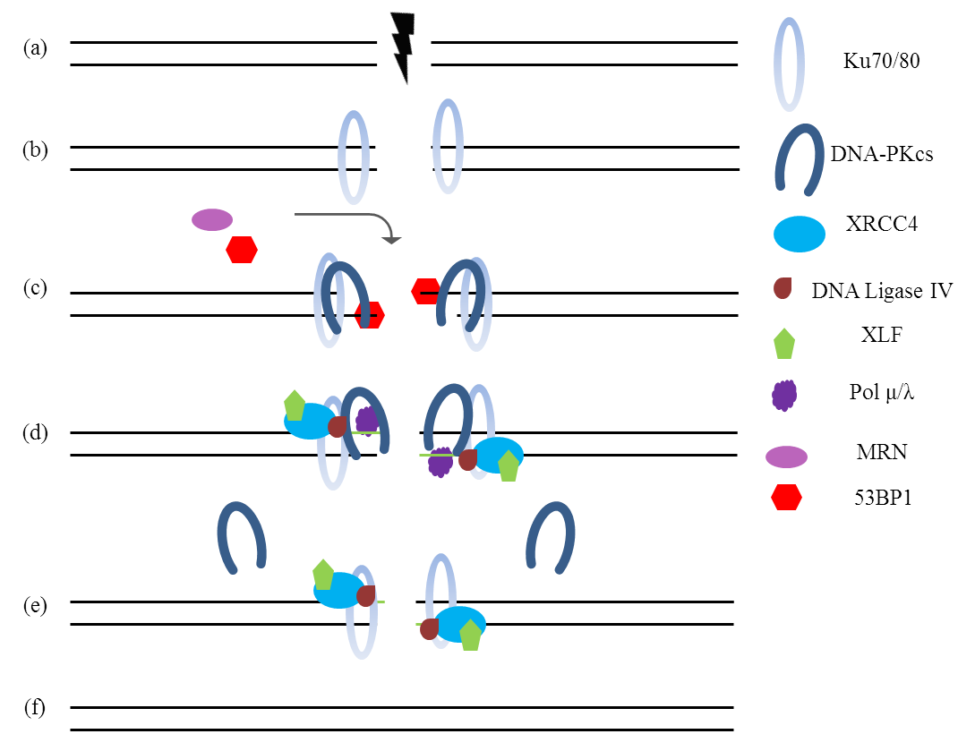

Figure 1.6.4 Mammalian Non-Homologous End Joining
The NHEJ pathway is the predominant defence against DSB’s in the cell. Upon formation of a DSB (a) the Ku70/80 heterodimer binds the DSB at each terminus and recruits DNA-PK stabilising the break (b). DNA end cleaning and resection is performed by either the MRN complex or Artemis (c). Depending on the context of the repair some end resection allows DNA polymerases to extend the resected ends to create small overhang (d), facilitating the joining of the two ends. The binding of the XRCC4/XLF/DNA Ligase IV complex ligates the two ends (e) leaving intact dsDNA (f). Figure adapted and printed with permission from (Dobbs et al., 2010)

The molecular processes involved in NHEJ are quite well characterised, and more recently focus has shifted to incorporate the wider status of DNA in terms of the chromatin state. While it was widely known that chromatin de-condenses around DSBs quite rapidly (Kruhlak et al., 2006) it has only recently become evident that this also changes depending on how transcriptionally active the region of DNA is. This has been seen in a number of ways; γH2AX foci expansion was found to decrease when closer to heterochromatic regions (Kim et al., 2007) and although ATM is required for DSB repair in heterochromatic regions it is not required in euchromatic regions (Goodarzi et al., 2008). It is also worth noting that although the core NHEJ pathway is described above and shown in figure 1.6.4, there are also back up NHEJ pathways that are able to operate without key NHEJ proteins, such as Histone H1 in place of Ku70/80 (Rosidi et al., 2008) or the involvement of PARP (Audebert et al., 2004) and Ligase III/XRCC1 in place of Ligase IV/XRCC4 (Wang et al., 2005a).
The importance of NHEJ as the predominant DSB repair pathway and source of diversity through V(D)J recombination is evident in the number of genetic disorders associated with the genes involved and the severity of their phenotypes. Without the ability to create B and T lymphocytes patients exhibit severe combined immunodeficiency (SCID) and are left unable to respond to infection. Genes associated with this phenotype include
ARTEMIS (Moshous et al., 2001, Kobayashi et al., 2003), XLF (Buck et al., 2006), LIGIV (O'Driscoll et al., 2001, Enders et al., 2006) and PRKDC (coding for DNA-PKcs) (van der Burg et al., 2009).
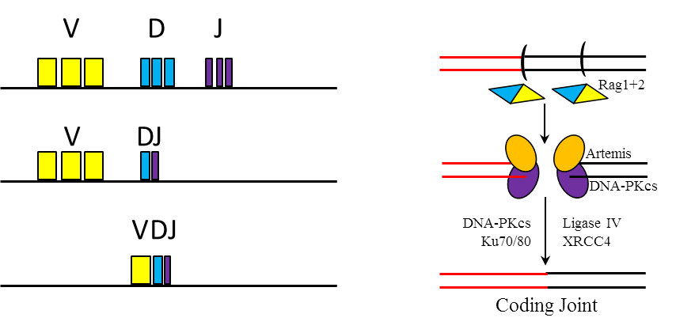

Figure 1.6.5 A summary of VDJ recombination
The genes encoding the Variable (V), Diversity (D) and Joining (J) gene segments contain multiple variants of each segment; however the gene product needs only one copy of each segment. It is through the combinations of each segment available that immunoglobulin diversity is achieved. The Diversity and Joining segments are joined first; the ‘DJ’ assembly is then joined to a Variable region to complete the process. The basic mechanics are shown on the right; the DSB is inflicted by the RAG1 and RAG2 proteins, the connective DNA is then removed by Artemis (which removed hairpin structures) before ligation of the corresponding ends by Ligase IV/XRCC4. Figure adapted and reprinted with permission from (Weterings and Chen, 2008).

In the DNA-PKcs patient the mutation does not stop DNA binding or catalytic activity, but instead prevents normal Artemis activation. Microcephaly (head circumference 3 SD below the mean) is also seen in XLF and LIG4 related SCID syndromes, while various growth defects are linked with all NHEJ related syndromes (Ciccia and Elledge, 2010).
The role of 53BP1 in DSB repair has recently been elucidated and it has been observed to play a role in repair pathway choice. This is achieved by the inhibition of the 5’ end resection associated with the early stages of HR (Pre-synapsis figure 1.6.3), 53BP1 does not inhibit resection directly but through a companion protein called Rif1. Rif1 has been demonstrated to act in an ATM and 53BP1 dependant manner, the loss of ATM function diminishing Rif1 damage foci formation while Rif1 depletion lead to radiosensitivty (Silverman et al., 2004). More recent work has observed that the 5’ resection by CtIP, BLM and Exo1 is inhibited by Rif1, this was demonstrated both by analysing overhang lengths in knockout cells and the increased accumulation of γH2AX/pRPA foci in Rif1 depleted cells indicates increased replication fork resection (Zimmermann et al., 2013). This inhibition therefore blocks HR in G1, however BRCA1 prevents 53BP1/Rif1 foci formation in S/G2 allowing for normal resection and HR mediated repair (Chapman et al., 2013, Chapman et al., 2012). This is clinically relevant, as discussed earlier the use of PARP inhibitors in BRCA mutant tumours is currently going through clinical trials, although a high number of patients respond well a number have been found to become resistant to PARPi treatment. PARP is involved in the repair of DNA SSB, once inhibited the repair is compromised and can result in these SSBs becoming DSBs at collapsed replication forks. BRCA mutant tumours are unable to repair these DSBs using HR and are therefore sensitive to these breaks; however surrounding healthy tissue should still be able to repair the collapsed replication forks (Helleday, 2011).
Two methods of resistance have been characterised, one involves further mutation to BRCA1/2 in order to regain some function (Chapman et al., 2012). Another found that loss of 53BP1 was enough to abrogate the growth arrest normally seen in BRCA1 mutant cells and further found reduced 53BP1 expression in a subset of BRCA associated breast cancers indicating a possible resistance mechanism (Bouwman et al., 2010). Such rescue is not isolated to HR disorders, research into defects in the Fanconi Anaemia (FA) pathway (discussed later) have been found to be rescued by the disruption of NHEJ associated proteins. These experiments showed that the inhibition of DNA-PKcs or depletion of Ku70 could reduce the sensitivity of FA deficient cells to the DNA crosslinking agents MitoMycin C (MMC) and Cisplatin (Adamo et al., 2010, Pace et al., 2010).

Replication Stress and the intra-S Phase Checkpoint
Damage to DNA when it is being replicated provides a particular challenge to the cell as it can lead to the halting of replication machinery (replisome) at the damage site, preventing further replication until the lesion is either removed or repaired. Other mechanisms for the activation of the checkpoint include depletion of the nucleotide pool, such as in treatment with Hydroxyurea (HU) which inhibits Ribonucleotide Reductase (Elford, 1968a), or the inhibition of polymerases α and δ like that achieved with Aphidicolin (Oguro et al., 1979).
If a lesion is blocking the path of the replisome cells are able to bypass the lesion by switching to a specialised polymerase (Y family) that can continue past the offending base(s). This pathway is known as Translesion Synthesis (TLS) and can even be employed to replicate past damage as severe as DNA crosslink’s resulting from Cisplatin treatments (Vaisman et al., 2000). The mechanisms involved in TLS centre around polymerase switching, the swapping out of high fidelity DNA polymerase for a lower fidelity one that can operate past the lesion, this is mediated by Proliferating Cell Nuclear Antigen (PCNA) (Maga and Hubscher, 2003). PCNA has been implicated in DNA replication (Krishna et al., 1994), DNA repair (NER) (Shivji et al., 1995) and chromatin remodelling (Shibahara and Stillman, 1999). It is a hexagonal ring structure that surrounds DNA and acts as a sliding clamp (Tsurimoto, 1998) under normal replicative conditions it is a cofactor for polymerases (Moldovan et al., 2007). Upon detection of damage the Rad6-Rad18 complex mono-ubiquitinates PCNA (Hoege et al., 2002), which is thought to increase the affinity of PCNA for the Y-family polymerases involved in TLS due to the ubiquitin binding domains found in these particular polymerases (Bienko et al., 2005). The Y family of polymerases are able to replicate past damaged DNA but do this at the expense of processivity and the high fidelity of normal polymerases (Yang, 2005). For example the error rate for Polδ is around 0.005% while Polη can reach 3.5% (McCulloch and Kunkel, 2008). The Y family of polymerases have certain specificities, Pol η can traverse CPD’s that have escaped repair by NER but is unlikely to remain attached to the DNA for more than a few bases after the lesion due to poor processivity (McCulloch et al., 2004), allowing for normal polymerases to resume high fidelity/processivity polymerisation. TLS does not result in the repair of any lesions, instead it only allows for replication to continue unabated but with a higher risk of errors in replication. The lesion itself is still present and may well be targeted by NER or BER before the cell fully completes replication.
Previously mentioned some forms of damage, such as DNA inter-strand crosslink’s (ICLs) can physically prevent DNA replication from occurring, in these situations the lesion needs to be dealt with as soon as it is encountered. The first priority is to prevent cell cycle progression, when a polymerase is either removed or halted is leaves ssDNA at the replication fork, the substrate for RPA. The build-up of RPA at the replication fork recruits ATRIP in complex with ATR (Zou and Elledge, 2003) as well as Rad17 (Zou et al., 2003). A complex with structural similarity to PCNA known as the 9-1-1 complex (Rad9, Rad1 and Hus1) is loaded onto the stalled replication fork by Rad17, which is in turn recruited to the ssDNA by RPA (independently of ATRIP) (Bermudez et al., 2003). Although ATR is at the site of damage it is not activated until the 9-1-1 complex recruits TopBP1 to the forming repair complex (Delacroix et al., 2007), as it is TopBP1 which directly activates ATR through its BRCT repeat domain (Kumagai et al., 2006). Recent work has highlighted the crosstalk between ATR and ATM pathways components, showing that TopBP1 binding to ATR requires the MRN complex (Duursma et al., 2013).
The MRN complex is normally associated with DSB stabilisation; however it has been observed that TopBP1 binds all three members of the MRN complex and that TopBP1 binding to replication checkpoint inducing lesions is reduced when MRE11 is depleted (Duursma et al., 2013). There had been some evidence that MRN might be involved in the response to replication stress when it was reported that RPA interacted with the NBS1 and MRE11 subunits of the MRN complex (Oakley et al., 2009), however the precise nature of MRN involvement in replication stress is still not fully understood. Recent data demonstrates a direct interaction between MRE11 and the Fanconi Anaemia subunit FANCJ, a helicase linked to homologous recombination; it is observed that FANCJ inhibits MRE11 nuclease activity thereby regulating DSB repair by HR (Suhasini et al., 2013) Activated ATR phosphorylates RAD17 (Bao et al., 2001) facilitating the recruitment of Claspin to the site of damage. Claspin is required for Chk1 phosphorylation (Chini and Chen, 2004), which as mentioned earlier is able to completely halt the cell cycle to allow for DNA repair. Although Claspin is downstream of Rad17 and ATR it association with DNA during replication is independent of these factors (Lee et al., 2003). These reactions to replication stress are summarised in figure 1.6.6.

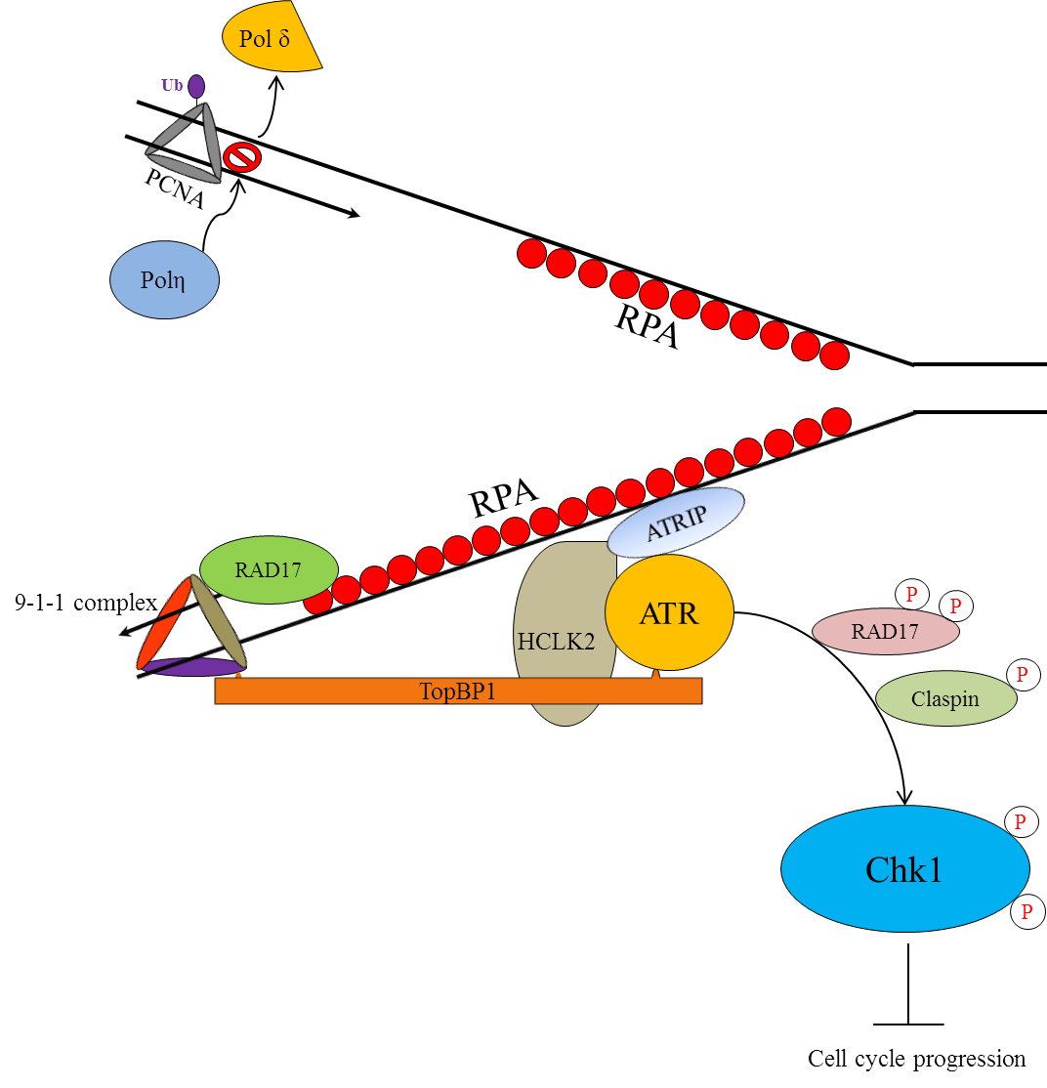

Figure 1.6.6 Schematic diagram of a stalled replication fork
After the collapse of a replication fork ssDNA is bound by RPA. TLS occurs when PCNA is ubiquitinated and binds a TLS polymerase. The ATRIP/ATR complex is stabilised by HCLK2 which also interacts with TopBP1, which also binds the 9-1-1 complex (Rad9, Rad1, and Hus1). ATR activation leads to Chk1 phosphorylation and cell cycle arrest. This gives time for the damage to be repaired before the cell cycle continues. Adapted and reprinted with permission from (Budzowska and Kanaar, 2009).

If TLS is not an appropriate pathway for repair, such as in response to DSB’s or lesions that cannot be overcome by Y family polymerases a different approach is required. The collapsed replication fork (where the replication machinery has reached a lesion and become dissociated from the DNA) can be manipulated in order to provide the correct substrates for HR and NER/BER depending on the lesion; this is thought to require the sliding of the replication fork to create a ‘chickens foot’ structure (figure 1.6.6). In vitro evidence has shown this regression can be achieved by BLM and WRN helicases (Machwe et al., 2006), both members of the RecQ family of helicases. The regression of the replication fork away from the lesion allows for repair by BER/NER or HR where the complimentary strands are used to replicate past the lesion. A simplified diagram of such events is shown below in figure 1.6.6. There are more complicated theoretical intermediates that have been proposed including D-loops and double Holliday Junctions, but as with fork regression into Holiday Junctions no in vivo evidence has been found (Petermann and Helleday, 2010).
The Blooms and Werner’s helicases are so named due to the disorders they were discovered in. They both display marked growth defects and a strong predisposition to cancer (German, 1997, Goto et al., 1996). While both disorders have been linked to defects in HR (Saintigny et al., 2002, Wu and Hickson, 2003), Werner’s has been linked to BER (Brosh et al., 2001) and telomere maintenance (Chang et al., 2004). As has been discussed previously, defects in elements of various pathways can result in phenotypically similar outcomes. In this case the phenotypic overlap is seen with other RecQ helicases; RECQL4 is implicated in Rothmund-Thompson syndrome, a disorder which exhibits growth defects, premature aging and a cancer susceptibility (Lindor et al., 2000).

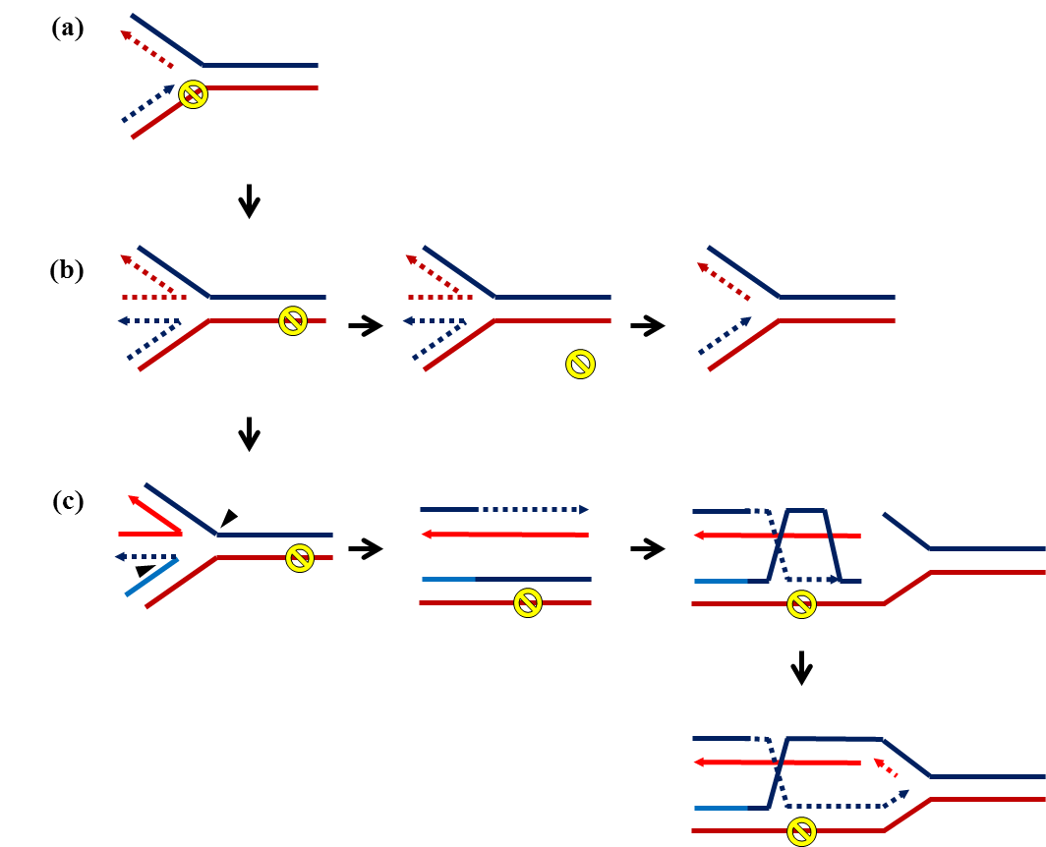

Figure 1.6.7 Manipulation of a stalled replication fork to allow for repair
(a) Upon recognition of a lesion at the replication fork can be reversed by the BLM helicase creating a so-called chicken foot structure, a more malleable structure giving the cell two options for lesion removal/repair. (b) the replication fork reversal exposes the lesion to NER/BER pathways allowing for its removal and subsequent replication restart. (c) In order to replicate past the lesion a nick is made in opposing junctions of the replication fork separating the two strands and allowing for strand invasion and Holliday Junction formation, this bypasses the lesion and creates the opportunity to reform the replication fork after the lesion (Atkinson and McGlynn, 2009). Figure Adapted and reprinted with permission (Osborn et al., 2002).

Fanconi Anaemia
Another DNA repair pathway involved in replication stress and the repair of ICL lesions is the Fanconi Anaemia repair pathway. One of the earliest identified genome instability related disorders it is so named after the physician Guido Fanconi who first published the clinical symptoms of three members of the same family in 1927 (Fanconi, 1927). One of the main clinical features of FA is Bone Marrow Failure (BMF), which normally occurs within the first 15 years. Patients that survive the anaemia often go on to develop AML and a range of solid tumours in adulthood (oral cancers especially). Some patients also exhibit short stature, skin hyper-pigmentation, cardiac abnormalities and renal abnormalities (Soulier, 2011)
The link to genome instability in FA was not proposed until the 1960s by Fanconi himself (Fanconi, 1964) and firmly established by the 1970’s (Sasaki, 1975, Auerbach and Wolman, 1976). Current clinical diagnoses rely on phenotypes that are observed due to the associated genome instability such as chromosomal breakage and MMC sensitivity tests allowing differentiation of FA from other BMF disorders (Pinto et al., 2009). Recent work has highlighted the importance of the FA pathway in response to endogenously generated aldehydes, initially it was demonstrated that FANCD2 deficient mice that also lacked the acetaldehyde processing enzyme gene ALDH2 were highly sensitive to ethanol (of which aldehydes are a downstream derivative) (Langevin et al., 2011). This sensitivity was later observed in FANCD2 deficient human lymphoblast cells when exposed to formaldehyde (Ren et al., 2013).
ICLs are of particular danger to cellular replication as they can physically block the replication machinery, and if left unrepaired a single ICL is potentially lethal (Lawley and Phillips, 1996). However the mechanisms of repair described earlier cannot repair ICLs and this falls upon the FA pathway. If elements of the FA pathway are defective cells become highly sensitised to ICL inducing agents (Ishida and Buchwald, 1982). The FA pathway is complex and to date 15/16 separate genes have been associated with the disorder; FANCA, FANCB, FANCC, FANCD1 (BRCA2), FANCD2, FANCE, FANCF, FANCG, FANCI, FANCJ (BRIP1), FANCL, FANCM, FANCN (PALB2), FANCO (RAD51C), FANCP (SLX4) and FANCQ (ERCC4/XPF). Of these the most commonly mutated are A, C, G and D2 (Soulier, 2011). The FA defects are mostly autosomal recessive, except for FANCB which is found on the X chromosome (Meetei et al., 2004a). Despite the large number of genes associated with FA the molecular mechanisms involved in repair allow this set of proteins to be separated into 4 main groups; the core complex composing of FANCA/B/C/E/F/G/L/M, the targeting complex (FAAP24 and FANCM), the substrates targeted by the core complex (FANCD2 and FANCI) and the repair proteins further down the pathway (FANCD1 (BRAC2), FANCJ (BACH1), FANCO (RAD51C), FANCN (PALB2) and FANCQ (XRCC4/XPF) (Kim and D'Andrea, 2012). As with the previously discussed response to replication stress the FA pathway functions to sufficiently deal with the lesion to create situations that facilitate the processing of the damaged DNA via processes such as TLS and HR (Kee and D'Andrea, 2010a, Knipscheer et al., 2009).
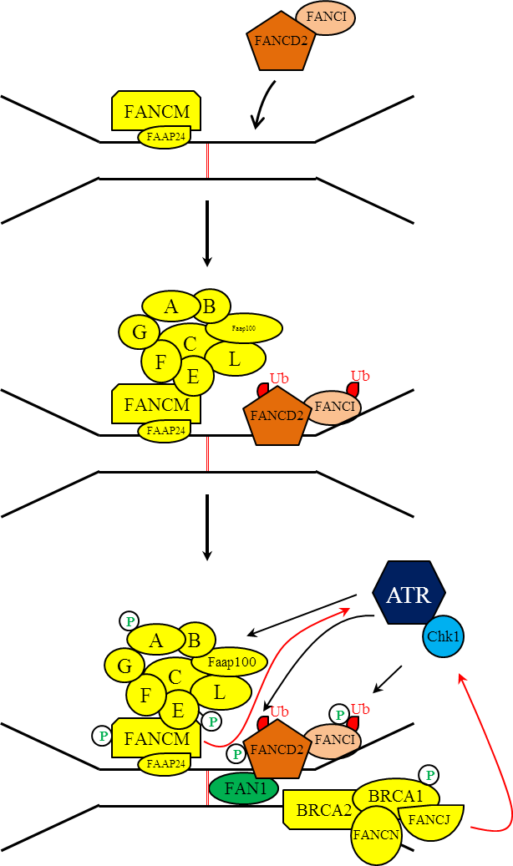

Figure 1.6.8 The Fanconi Anaemia (FA) Pathway
A simplified schematic of the Fanconi Anaemia pathway. The ICL is recognised by a complex consisting of FANCM/Faap24, after recognition the core FA complex is brought to the lesion (the core complex consists of FANCA/B/C/E/F/G/L). The E3 ligase FANCL then mono-ubiquitinates FANCD2 and FANCI, leading to the recruitment of the nuclease FAN1 (MacKay et al., 2010). It is through the recruitment of FAN1and other repair factors such as BRCA1/2 that downstream repair is mediated through other previously discussed pathways such as TLS and HR. Figure adapted and reprinted under the creative commons license from (Kee and D'Andrea, 2010b).

Although classically associated with ICL repair recent studies have observed a prominent role for the FA pathway in the repair of DNA Protein Crosslink’s (DPC) that arise from exposure to formaldehyde compounds (Noda et al., 2011, Ren et al., 2013) which may account for the pancytopenia (reduced red and white blood cells) observed in FA patients. While mouse models of FA do not get spontaneous bone marrow failure it can be induced with ICL inducing agents (such as MMC), despite this recent work suggests that p51 induction in FA cells due to persistent unresolved DNA damage could lead to a reduction in the pool of hematopoietic stem cells (HSC) which leads to bone marrow failure (Garaycoechea and Patel, 2013). The FA pathway is activated by the targeting complex of FANCM and FAAP24 which was observed binding to structures that mimic replication forks under stress (Ciccia et al., 2007). Furthermore, FANCM is required for recruitment of the FA core complex to impeded replication forks, as it has been observed that FANCM depleted cells have no issues with the integrity of the core complex itself but are unable to recruit it to the sites of replication stress (Kim et al., 2008b). The FANCM/FAAP24 complex facilitates efficient activation of the ATR signalling cascade that is independent of the core FA complex (Collis et al., 2008) allowing for cell cycle control as previously described. The core complex as a whole acts as an ubiquitin ligase composed of a large number of subunits, the target of which is the FANCD2/FANCI heterodimer. The importance of this ubiquitination event is evident when cells with a FANCD2 mutation can be complimented for ICL sensitivity with an exogenous ubiquitin fused FANCD2 (Matsushita et al., 2005). The E3 ligase component of the core complex is FANCL, defects in which phenocopy FANCD2 deficiencies (Seki et al., 2007), and is responsible for the ubiquitination of the FANCD2/FANCI heterodimer (Meetei et al., 2004b, Longerich et al., 2009). Ubiquitinated FANCD2/FANCI forms foci at the site of damage, along with many DNA repair factors such as γH2AX (Bogliolo et al., 2007), NBS1 (Nakanishi et al., 2002), BRCA1 and RAD51 (Taniguchi et al., 2002). Recent work has identified the nuclease FAN1 as being recruited to the site of damage after FANCD2/FANCI mono-ubiquitination where it is involved in the processing of the replication fork (Liu et al., 2010b), however this is not certain as two other complexes have been involved in this step, XPF-ERCC1 and MUS81-EME1 (Bhagwat et al., 2009). Following the exonuclease activity the cell is left with a lesion that can be dealt with by TLS to allow replication to continue and full repair to be completed later or immediate repair through NER or HR (Kee and D'Andrea, 2010a).

HCLK2 is required for PIKK stability
As alluded to in figure 1.6.6 the human homologue of C.elegans RAD5/CLK2 has been reported to be required for the S phase checkpoint, as depletion of HCLK2 resulted in defective phosphorylation of Chk1, prevented Cdc25A degradation and lead to continued DNA replication after irradiation (Collis et al., 2007, Shikata et al., 2007). Protein levels of ATM, ATR and DNA-PK are all reduced upon HCLK2 depletion, as a result of issues regarding protein stability, whereby although upon HCLK2 loss mRNA levels of PIKKs were unaffected, as was protein production; the half-life of produced proteins was hugely reduced. This could not be rescued by treatment with the proteasome inhibitor MG132 and is therefore most likely to be due to reduced protein stability (Takai et al., 2007, Hořejší et al., 2010). This role was further characterised with the identification of an interaction with the ATR-ATRIP complex, TopBP1 and the requirement of HCLK2 for ATR auto-phosphorylation (Rendtlew Danielsen et al., 2009). Further observations showed an interaction between HCLK2 and the FANCM-FAAP24 complex and discovered its activation could occur independently of the FA core complex (Collis et al., 2008). The emerging role of HCLK2 in many important aspects of DDR (Anderson et al., 2008) led to the search for interacting proteins that could potentially be involved in the DDR. This was achieved using a yeast-2-hybrid (Y2H) screen, a method used effectively to map FA protein complexes (Gordon and Buchwald, 2003). From this Y2H screen Arhgef12, otherwise known as was Leukaemia-Associated Rho Guanine Nucleotide Exchange Factor (LARG), was identified as a potential novel HCLK2 interacting partner.

1.7 The RhoA pathway

LARG discovery and early characterisation
LARG (ARHGEF12) was originally identified in a patient with Acute Myeloid Leukaemia (AML), where it was found fused to the C-terminal of MML (Kourlas et al., 2000) a gene mutated in around 10% of adult AML cases (Caligiuri et al., 1997). Researchers named the protein Leukaemia Associated Rho Guanine Nucleotide Exchange Factor (LARG) owing to the identification of a number of domains linked to RhoGEFs, the Post Synaptic Density domain (PDZ), Regulator of G Protein Signalling (RGS) and tandem Dbl-homologous (Dbl) and Plextrin Homology (Ph) domains. The ability of LARG to activate RhoA both in vitro and in vivo was demonstrated a year later making LARG the first functional Dbl containing protein to be identified as mutated in cancer (Reuther et al., 2001).
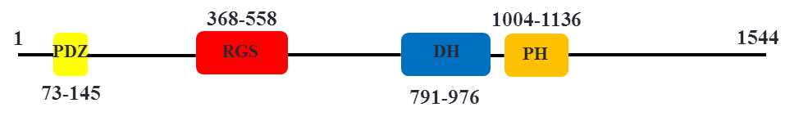

Figure 1.7.1 Schematic of LARG domains
LARG is a 1544 amino acid protein containing four distinct domains. A PDZ protein interaction domain, a Regulator of G Protein Signalling (RGS) domain, a Dbl Homology (DH) domain and Plextrin homology (PH) domain. Together the DH and PH domains form the overall catalytic domain of LARG.

The domains found in LARG are shown in figure 1.7.1 and are typical for a RhoGEF. The PDZ domain is linked to protein-protein interactions formed in a wide variety of signalling complexes, with over 900 so far found in the mouse proteome (Lee and Zheng, 2010). It is through the PDZ domain that LARG interacts with Insulin Growth Factor 1 (IGF1), a protein associated with a variety of cytoskeletal rearrangements through RhoA activation (Taya et al., 2001). The RGS domain mediates the interaction between LARG and the Gα12/13 signalling proteins required for LARG mediated RhoA activation (Suzuki et al., 2003). The tandem Dbl homology (DH) and Plextrin homology (PH) domains are required for the catalytic guanine exchange reaction used to activate RhoA. This reaction can be performed in vitro using isolated DH/PH domain (figure 1.7.2). Although some activity can be observed using purified LARG-DH the kinetics of the nucleotide transfer are much improved using the complete DH/PH tandem domain (Reuther et al., 2001). After initial conformation of the RhoGEF activity of LARG, work was undertaken to determine what mechanisms are involved in its activation. Two proteins were associated with LARG activation; Plexin-B1 (Swiercz et al., 2002) and the Gα12/13 proteins (Suzuki et al., 2003). Plexin-B1 is a Sema4D receptor; semaphorins are molecules involved in axon guidance and motility on which they can both inhibit and promote out growth (Masuda et al., 2004). Plexin-B1 interacts with LARG through the PDZ domain leading to activation of RhoA through LARG GEF activity (Aurandt et al., 2002). It was demonstrated that Sema4D and Plexin-B1 co-localise at the membrane of neurone growth cones and lead to their collapse, however addition of the RhoA inhibitor Y-27632 prevented this collapse indicating that the collapse was due to RhoA activity (Swiercz et al., 2002).

The Rho family
The Rho family of GTPases are a subgroup of the Ras superfamily involved in regulation of the cytoskeleton including cellular movement, adhesion, vesicle trafficking and cytokinesis. There are a large number of proteins that fall under the Rho family umbrella; the three most widely studied being the Rho, Cdc42 and Rac subfamilies. Although the Rho family had been known about for some time they were under the shadow of the Ras superfamily, an intensively studied group of signalling proteins originally identified in retroviruses prepared from leukemic rats (Harvey, 1964) and later shown to be a human oncogene in a number of human tumours (Santos et al., 1984, Forrester et al., 1987, Almoguera et al., 1988). The Rho family began to receive more attention after two papers were published from the Hall laboratory linking Rho to focal adhesions and actin stress fibres and Rac to membrane ruffling (Ridley and Hall, 1992, Ridley et al., 1992). Actin stress fibres, first observed using electron microscopy over 40 years ago (Spooner et al., 1971) are cytoskeletal rearrangements that form to facilitate cell contraction; as such they are often associated with focal adhesion points. Ridely was able to demonstrate the formation of stress fibres within cells after microinjection of RhoA and that inhibition of RhoA prevented stress fibre formation (Ridley and Hall, 1992). Further characterisation of this pathway discovered that RhoA activates the serine/threonine kinase Rho-associated Kinase (ROCK) which in turn induces formation of the focal adhesion points (Ishizaki et al., 1997).
Many cells undergo major cytoskeletal changes; however developing neurites are required to undergo directed growth over vast distances. This growth is achieved in three stages; the initial protrusion of the growth cone, localisation of organelles from the central body to the cone and advancement central body into the growth cone (Schaefer et al., 2008). Rac and Cdc42 are positive regulators of this process in that they promote the formation of filopodia and lamellipodia forming the growth cone, in a similar manner to previous work by Ridley on RhoA it was demonstrated that injection of Ras and Cdc42 into neuroblastomas promoted growth cone formation. However, injection of the C3 exoenzyme (abolishing RhoA signalling) also resulted in formation of filopodia and lamellipodia indicating opposing functions (Kozma et al., 1997). It had previously been demonstrated that RhoA could be activated through G proteins Gα12/13 after treatment with Lysophosphatidic acid (LPA) (Moolenaar et al., 1997). Further work on neurites demonstrated that RhoA activation though LPA induction caused neurite retraction, whereby the growth cone would collapse and neurite extensions withdraw leaving a circular cell. This could be prevented by the over expression if a dominant negative form of RhoA (Kranenburg et al., 1999), inferring a direct role for RhoA in this process. There is a link here with the MOPDII associated PCNT, whereby loss of PCNT led to poor neuronal migration to the olfactory bulb, perhaps due to disruption of the microtubule organising centre. It was observed that mice with a frame shift in PCNT not only had reduced body and brain size but a reduced number of neuronal cells connecting the olfactory bulb to the main body of the brain (Endoh-Yamagami et al., 2010a).
Away from neurones a great deal of research on Rho activity in cell contraction was also carried out, this involved looking for downstream effectors of RhoA signalling. Initial in vitro data demonstrated the ability of RhoA to phosphorylate Myosin Light Chain (MLC) (Amano et al., 1996), this was soon observed in a more physiological environment where ROCK, a downstream effector of RhoA, was shown to cause muscle contraction by the phosphorylation of MLC (Amano et al., 1996). The association of MLC phosphorylation with smooth muscle is well established, myosin itself being the main component of the thick filament of smooth muscle, with this phosphorylation event being an activator of Mg²⁺ATPase and therefore the contraction itself (Kamm and Stull, 1985).
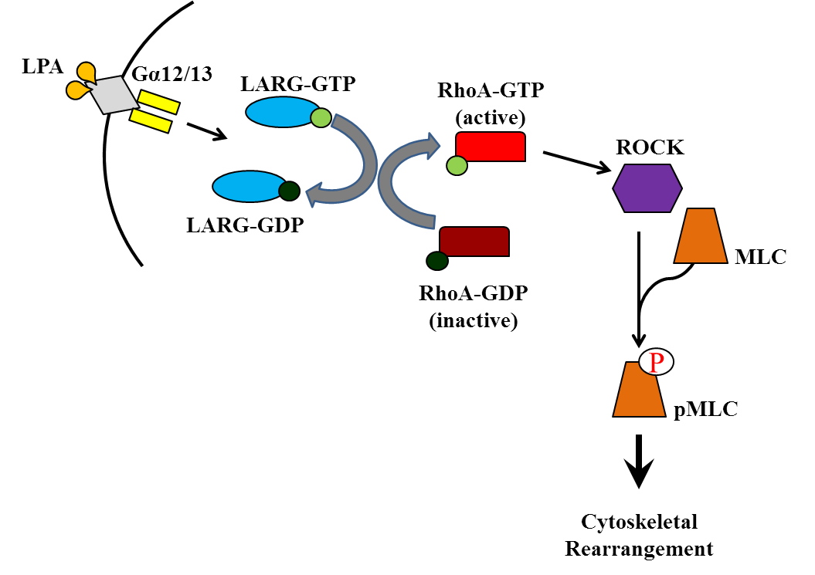

Figure 1.7.2 RhoA is activated by the GEF activity of LARG through G-protein signalling resulting in MLC phosphorylation
Lysophosphatidic Acid signals for LARG activation through Gα12/13 G proteins, active LARG exchanges GDP for GTP on RhoA which goes on to activate ROCK resulting in phosphorylation of MLC.

LARG phosphorylation and RhoA signalling
Although both Gα12 and Gα13 can activate Rho signalling through LARG there are differences in the activation of each of the G proteins themselves. The Gα12 receptors have been found to be activated by thrombin, a protein associated primarily with the vascular system signalling both blood cells and blood vessels (Coughlin, 2000), in experiments using over expressed Gα12 or Gα13 cells treated with either Thrombin or LPA it was demonstrated that within a minute of Thrombin treatment the Gα12 but not Gα13 proteins were activated (as measured by a TPR luciferase assay) and that conversely the Gα13 but not Gα12 protein was activated by LPA (Yamaguchi et al., 2003). Further differentiation between the two G proteins was demonstrated with the discovery that LARG can be phosphorylated by the tyrosine kinase Tec, a kinase which interacts directly with Gα12. Although some GDP dissociation from RhoA was observed in vitro with only LARG and Gα12 this activity was drastically increased with the addition of Tec (figure 1.7.3), this increase was not observed in assays using Gα13 (Suzuki et al., 2003). The Tec family kinases Itk and Rlk have been implicated in cytoskeletal regulation through Cdc42 and Rac, whereby loss of either kinase would result in impaired cell migration due to dysfunctional activation of Rac and Cdc42 (Takesono et al., 2004), further grounding the principal that there is crosstalk between the three Rho family members and Tec kinases. This is not the only kinase associated with G proteins that has been found to be involved in RhoA activation, Focal Adhesion Kinase (FAK) had long been observed to have a role in maintaining actin structures, including stress fibres and could be regulated by Thrombin (Troyer et al., 1996). The observation that GEFs could activate RhoA through Thrombin led to research on possible links between FAK and RhoA-GEFs (figure 1.7.3). It was demonstrated that FAK could phosphorylate all three RhoA GEFs; Arhgef11, LARG and p115RhoGEF, however this phosphorylation did not affect the initial Thrombin induced activation of RhoA instead it increased the level of sustained RhoA activity. Attempts to map the site phosphorylated in Arhgef11 narrowed down the region to the C-terminal region and excluded any of the domains described for LARG in figure 1.7.1 (Chikumi et al., 2002). Overall these data provide evidence for multiple roles for RhoA depending on a variety of signals, this is seen in the variety of research undertaken to understand the role of RhoGEFs and RhoA activation. As differentiation of the activating factors of RhoA, both at the G protein level and the RhoGEF level became apparent, research took two directions between the physiological roles of LARG activation in smooth muscle and the molecular mechanisms involved in activation and cellular movement.

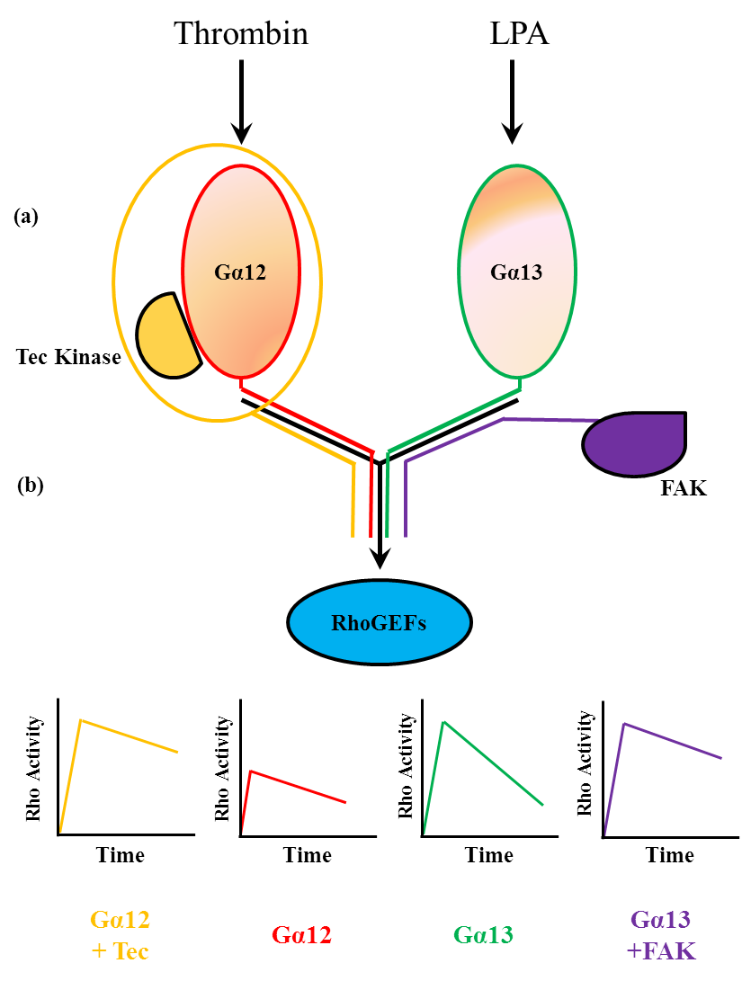

Figure 1.7.3 RhoA activation through the Gα12/13 proteins can be modulated by the kinases Tec and FAK.
RhoA activity through the Gα13 and Gα13 is activated by Thrombin and LPA respectively. The signal potentiation through to RhoA activation can be modulated with the addition of the Tec and FAK kinases. (a) Tec associates with Gα12 and increases the initial activation of RhoA, (b) while FAK does not directly associate with Gα13 or change the initial activation of RhoA it does maintain RhoA activity over time. This is displayed graphically showing relative activation over time of RhoA depending on kinase association.

As mentioned earlier Thrombin signalling is strongly associated with blood vessel contraction, in order to maintain blood pressure the smooth muscle linings of vessels can be regulated through RhoA signalling to pMLC. It has been demonstrated that maintenance of basal blood pressure is sustained through G_{q} and G11 signalling, while Gα12/13 were required for normal salt induced hypertension. Using mouse knockout cells it was observed that even after 20 days of induced salt appetite (a process using Deoxycorticosternone Acetate – DOCA (De Nicola et al., 1993)) and provision of 1% salt water, LARG -/- mice, although born at sub-Mendelian birth rates do not display any overt phenotype (Mikelis et al., 2013) and did not develop hypertension while wild type mice saw drastic increases in blood pressure (Wirth et al., 2008). This was reinforced when it was observed that reduction in LARG levels led to a reduction in angiotensin induced aortic contraction in rats (Chiu et al., 2012), this paper had little success in knocking down Arhgef11 protein levels so it was unclear whether this function was LARG specific. This question was answered in a recent paper where ARHGEF11 knock-out mice were generated and LARG silenced using adenoviral delivery of LARG specific shRNA. It was demonstrated that loss of either LARG or Arhgef11 led to only a minor reduction in contraction, however the loss of both resulted in a significant drop in contraction of portal vein samples, (Artamonov et al., 2013). Interestingly it was also observed that after treatment with U46619, a compound that induces smooth muscle contraction, LARG localisation changed from a being a primarily diffuse cytoplasmic stain to being a cell surface stain in mouse smooth muscle cells.
Three RhoGEFs have been identified that activate RhoA, Arhgef11 (also known as PDZ-RhoGEF), LARG (Arhgef12) and p115RhoGEF (Arhgef1). The ability of Arhgef11 and LARG to form hetero- and homo-dimers was demonstrated to be modulated by their unique C-terminal sequences, however p115RhoGEF was only observed homo-dimerising (Chikumi et al., 2004a). Interestingly deletion of the C-terminal region responsible for oligomerisation led to activation of RhoA, indicating that the RhoGEF activity of Arhgef11 and LARG can be controlled through the C-terminal domain (Chikumi et al., 2004a). The C-terminal regions of either protein does not contain any distinguishing features bar coiled-coiled regions, furthermore, although there is strong homology over the rest of their sequence none is observed in the C terminal region. This region is not involved with G protein interaction and as was discussed earlier, the RGS domain is responsible for mediating the G-protein interaction, with this interaction mediated by the C-terminal domains of Gα12 and Gα13 (Kreutz et al., 2007).
Due to the interest in RhoA activation there has been some focus on whether or not the Dbl homology domain is involved; this is of particular interest as it is a well conserved domain. A hydrophobic region within the PH domain was found to be required for RhoA activation, further to this a number of mutants were made that changed the cellular localisation of LARG (Aittaleb et al., 2009). It was observed that wild type LARG is localised to the cytoplasm and follows micro-tubule tracts, however loss of the C terminus (which is involved in oligomerisation) led to a distinct nuclear localisation. The F1098D and I1100E point mutations in the PH domain of LARG were found to severely disrupt RhoA activation (Aittaleb et al., 2009). Previous work on Arhgef11 had identified residues that could lead to changes in localisation; it was observed through scanning mutagenesis that removal of residues 561-585 led to Arhgef11 localisation being drastically reduced at the plasma membrane. This sequence is also required for localisation of Arhgef11 to actin, loss of which prevents localisation of Arhgef11 to stress fibres (Banerjee and Wedegaertner, 2004).
The importance of the DH and PH domain in RhoA activation is further shown by the development of a series of small molecule inhibitors of LARG targeted to the junction site between the DH and PH domains. These inhibitors block the LARG/RhoA interaction and therefore activation and downstream effects (Shang et al., 2013). These effective inhibitors were developed using a simulated docking structure of LARG and RhoA before validation in breast cancer cells where they successfully inhibited growth and migration linked to RhoA activation.

LARG and RhoA in cancer
Originally identified in a leukaemia patient in 2000, it was thought that increased RhoA activity may play a role in the development of that patient’s leukaemia as the fused LARG present was still catalytically active (Reuther et al., 2001). Research looking at a region on chromosome 11 that is frequently deleted in breast and colorectal tumours using a variety of methods observed that LARG was frequently under expressed (Ong et al., 2009). The group looked at breast cancer cell lines, primary breast tumours, colorectal cell lines and primary colorectal tumours. A reduction in mRNA levels of at least fifty percent was observed in all breast cancer cell lines, a third of primary breast tumours, half of the colorectal cancer cell lines and half of the primary colorectal tumours. This loss of expression was not due to epigenetic modifications such as promoter methylation or histone modification (Ong et al., 2009). This differs from earlier suggestions that LARG may contribute to tumorigenesis through increased activation of RhoA.
Although this was the first study into LARG in patient tumours the association of RhoA to cancer is much more established, as can be imagined for a protein with similarity to Ras that’s involved in a pathway with a strong identified role in cellular movement and adhesion. Early studies into RhoGTPases and cancer looked at expression levels between normal and tumour tissue, all three major GTPases were measured, RhoA, Rac, and Cdc42. It was observed that RhoA was the most over expressed in the cohorts tested, additionally it was demonstrated that tumour tissue when matched to normal tissue had up to ten times the ADP-ribosylation rate, indicating the higher RhoGTPase expression led to higher protein levels and likely had a physiological effect (Fritz et al., 1999). The physiological effect was demonstrated in rat derived tumour cells where over expression of RhoA led to increased invasiveness (both in the presence and absence of LPA) and increased pMLC, increased invasiveness was also observed when over expressing cells were implanted into rats (Yoshioka et al., 1999).
RhoA over-expression has also been used as a marker of cancer in head and neck squamous cell cancers where higher IHC staining for RhoA was observed in cancerous samples (Abraham et al., 2001). This is not the only tissue type where over expression of RhoA and other small GTPases was linked with tumour progression, these characteristics were seen in both ovarian carcinomas (Horiuchi et al., 2003), testicular cancer (Kamai et al., 2004) and gastric carcinomas (Pan et al., 2004). The gastric cancer samples were tested for mRNA expression of seven different Rho family members, but only RhoA and Rac1 were found to be overexpressed. Further to this the level of RHOA over expression correlated with the tumour progression (measured against tumour TNM, a measurement which takes into account tumour size and malignancy), suggesting a biological role in tumour progression (Pan et al., 2004). Other studies have linked RHOA over expression with poor outcomes, it was observed that RHOA over expression in hepatocellular carcinoma (HCC, the most common liver cancer) was linked with poor prognosis when compared with samples with low RhoA expression and over expression was also linked to venous cell invasion (Li et al., 2006).
The plasticity of this phenotype was shown when it was demonstrated that inhibition of RHOA expression in over-expressing gastric cancer cell lines could reduce their proliferation and importantly reduced colony formation in soft agar, a cell culture method for assessing cell transformation. It was also observed that RhoA depletion or expression of a dominant negative form of RhoA rendered cells more sensitive to Adriamycin (ADR) and Fluorouracil (5-FU), two agents commonly used to treat cancer (Liu et al., 2004). A similar result regarding cell motility and proliferation was observed using over expression of the RhoGAP (RhoGTPase activating protein) DLC2 to inhibit RhoA activity in liver cancer cell lines (Leung et al., 2005). Recently RHOA expression has been linked to the transcription factor Snail, whereby higher Snail expression is correlated with tumour cell motility, the over expression of which is linked with breast cancer metastasis; it was observed that reduction in Snail expression lead to reduced RHOA expression and therefore activity (Zhang et al., 2013). These data cement Rho pathways as having a strong role in cancer progression and metastasis and as such they have become a potential clinical target. The initial excitement of Rho/ROCK pathway as a target for inhibition was not met with initial success as the diversity of the Rho/ROCK pathways was explored; however they have gained momentum with the possibility of using Rho/ROCK inhibitors in combination with already commercially available drugs such as the tyrosine kinase inhibitor Imatinib/Gleevec. In combination with the Y-27632 ROCK kinase inhibitor Gleevec was observed to inhibit expansion of Chronic Myeloid Leukaemia (CML) cells (Burthem et al., 2007). More recently it has been observed that Rho signalling in lung cancer can be affected by changes in GATA2 (a transcription factor required for KRAS driven lung cancers), furthermore combination treatment of cells with the NF-κB inhibitor bortezomib and the Rho inhibitor Fasudil reduced proliferation in KRAS mutant but not wild type cells (Kumar et al., 2012).

Further upstream in the LARG/RhoA pathway, the association of LPA in cancer is strong. The role of LPA in G protein signalling was observed in the late 1980’s (van Corven et al., 1989) however, it would be over a decade before a link to cancer was found. Over expression of the LPA receptor two was observed in breast and colorectal cancer (Kitayama et al., 2004, Shida et al., 2004). However, it is not only expression of LPA receptors that has been linked to cancer. The production of LPA by Acylglycerol kinase (AGK) has been observed to be increased due to over expression of AKG in prostate cancer cells (Bektas et al., 2005). The clinical significance of LPA was highlighted by a report that observed a link between LPA receptor expression and the aggressiveness of ovarian cancer cells, as measured by both proliferation and invasion rate of cells as well as tumour growth in mouse xenograft models (Yu et al., 2008). The validity of targeting LPA receptors in cancer has been demonstrated with the use of LPA receptor inhibitors (David et al., 2012). Spontaneous metastasis of breast cancer cells in mice was demonstrated to be reduced independently of primary tumour growth after treatment with the LPA receptor inhibitor Bedio 0719 (David et al., 2012). Similar results were obtained using pancreatic cells transplanted into mice however reduced growth of primary tumours was also observed using the Ki16198 LPA receptor inhibitor (Komachi et al., 2012).

Rho signalling and the DNA Damage Response
The idea that there may be links between the Rho pathways and the DDR is not without some precedence, owing partly to research linking RhoGEFs with centrosomes and activation in response to genomic stress. Net1 is a RhoGEF that has been identified as having a role in stress fibre formation in response to Transforming Growth Factor-β (TFG-ß), whereby over expression results in increased stress fibre formation and RhoA inhibition prevents TGF-ß induced stress fibre formation (Shen et al., 2001). Further characterisation of Net1 led to the observation that it can be sequestered to the nucleus through a nuclear export motif in the PH domain, leading to the suggestion that activation of RhoA by Net1 is dependent on cellular localisation (Schmidt and Hall, 2002). It was later observed that Net1 could be inhibited through phosphorylation on three serine residues, 152, 152 and 538 by p21 activated kinase 1 (PAK1) (Alberts et al., 2005). The phosphorylation on S152 was observed to decrease after irradiation, indicating that Net1 was being activated upon IR treatment therefore activating RhoA. Using siRNA against Net1 it was noted that RhoA-GTP was not induced when Net1 was depleted, however, in control siRNA treated cells a two fold increase in RhoA-GTP was observed with IR or cytolethal distending toxin (CDT a bacterial toxin with DNase activity) treatment. As a downstream readout of the RhoA pathway, stress fibre formation was measured after CDT treatment and cells depleted of Net1 were found to have reduced stress fibre formation (Guerra et al., 2008).
With the knowledge that Net1 is found in the nucleus and can be activated in response to IR it was hypothesised that there might be an active pool of Net1 and RhoA in the nucleus. This was demonstrated using a number of immunoprecipitation experiments implementing nuclear and cytoplasmic lysate preparations after IR treatment. RhoA activity was observed to increase 5 fold within the nucleus after IR treatment, however this was greatly reduced after siRNA mediated depletion of Net1 (Dubash et al., 2011).
Further evidence towards RhoGEFs and the DDR can be found in research demonstrating that depletion of Arhgef10, a RhoGEF associated with reduced myelination of nerves (Verhoeven et al., 2003), led to an increase in cells displaying supernumerary centrosomes; whereby cells have more than 2 centrosomes. This phenotype was demonstrated to be partially rescued upon expression of either RhoA or the DH domain from Arhgef10, suggesting that the supernumerary centrosomes were due to defects in RhoA signalling. Further evidence for this is observed in the increase in supernumerary centrosomes in cells treated with the ROCK inhibitor Y-27632 (Aoki et al., 2009). The significance of supernumerary centrosomes can be observed in the DDR associated disease Seckel Syndrome, one of the cellular phenotypes of which is supernumerary centrosomes (the importance of which will be discussed later). Furthermore, defects in the centrosomal protein pericentrin (PCNT) have been associated with MOPDII and defects in ATR signalling (Griffith et al., 2008, Rauch et al., 2008).
The link between LARG itself and the DDR is found not only in the Y2H identifying a possible interaction with HCLK2 but also in the observation that LARG interacts with PCNT. Goulimari et al focussed primarily on the role of LARG in cellular polarity and movement, demonstrating that the loss of LARG leads to delayed wound healing (measured as invasion into space left after a scratch is introduced to a confluent mono-layer of cells) and to reduced polarisation of cells. Polarisation was measured 6 hours after wound infliction, correctly polarised cells were determined to have microtubule organising centre (MTOC) positioning within a 90º angle relative to the direction of the wound. Importantly, it was demonstrated that the defect could be rescued with the microinjection of GFP-LARG (Goulimari et al., 2008). The link between PCNT and the MTOC have long been established (Doxsey et al., 1994), including tubulin organisation required for mitotic entry (Zimmerman et al., 2004). This lead Goulimari et al to successfully co-immunoprecipitate PCNT in complex with over expressed Myc- or Flag-tagged LARG. Further to this they demonstrated a co-localisation of LARG and PCNT, albeit implementing the micro-injection of small amounts of GFP-tagged LARG into cells which were then fixed and stained for PCNT. The final observation made on LARG localisation was that LARG followed micro-tubule tracks and that this localisation was sensitive to nocodazole treatment, a widely used microtubule polymerisation inhibitor (Zieve et al., 1980). Interestingly it was observed that mDia1 was required for LARGs microtubule tract localisation (Goulimari et al., 2008). mDia1 is a Rho effector that has previously been linked with actin dynamics and focal adhesion points (Watanabe et al., 1999, Riveline et al., 2001). In addition, LARG was identified in a large scale proteomic analysis of potential substrates for ATM/ATR kinase activities on Ser1288 (Matsuoka et al., 2007). The basis of this screen was the purification of proteins using phospho-SQ-TQ in samples both untreated and treated with 10Gy ionizing radiation and determining enrichment after genomic insult. The authors note that large numbers of proteins enriched that are not normally associated with DDR indicating possible crosstalk among previously unlinked pathways (Matsuoka et al., 2007).

Project Aims
This project focuses on LARG, a protein that activates RhoA and is strongly associated with cytoskeletal reorganisation allowing for cellular movement in combination with other Rho family pathways. Further to this LARG has been demonstrated to interact and co-localise with PCNT, a protein which has been demonstrated to be defective in the DDR associated disease MOPDII. Potential involvement in DDR is suggested in unpublished Y2H data observing an interaction between the PIKK stabilising protein HCLK2. Further to this the identification of LARG as a potential ATM/ATR substrate in a proteomic screen adds to the supporting data for LARGs potential role in the DDR.
The aims of this project are therefore to investigate the hypothesis that:
LARG is required for efficient cellular response to replication stress
This was achieved by first confirming both the LARG:HCLK2 and LARG:PCNT interactions before observing the events that follow replication stress in cells depleted of LARG and observing cellular behaviour after LARG depletion with regard to phenotypes associated with defects in the DDR. In addition to this crosstalk between the RhoA and DDR pathways were be assessed in cells depleted of DDR proteins, measuring events associated with RhoA signalling. Finally, a potential mutation in LARG observed in a previously genetically uncharacterised Seckel syndrome patient will be assessed for its functional potential.

2 Materials and Methods

2.1 Standard equipment
- Applied Biosystems 3730 DNA analyser
- Applied Biosystems Attune Flow cytometer
- BD Biosciences FACs Calibur Flow cytometer
- CIS biointernational IBL 437C (Cs Irradiator)
- Eppendorf Centrifuge S415R
- Fischer MH214 (scales 210g/0.1mg)
- Fisher 5G601 (scales 600g/0.1g)
- Konica Minolta SRX101A (x-ray film developing)
- Sanyo MCO-19AIC(UV) (Incubator)
- Thermo Megafuge 40 (centrifuge)
- UVP CX-2000 (UV Crosslinker)
- Walker Safety Cabinet Class II MSC (Model TDA-2G)

2.2 Standard Solutions
5M NaCl
146g of NaCl was dissolved in 500ml of ddH₂O, stored at room temp.
500mM EDTA (Ethylenediaminetetraacetic acid)
186.1g EDTA was dissolved in 1000ml of ddH₂O, stored at room temp.
10% SDS (Sodium Dodecyl Sulfate)
50g of SDS was dissolved in 500ml ddH₂O, stored at room temp.
1.5M Tris pH8.8
181.71g of Tris Base was dissolved in 600ml ddH₂O, the solution was brought down to pH8.8 by the addition of concentrated HCl. The solution was then brought up to 1000ml with ddH₂O and stored at room temperature.
1.0M Tris pH6.8
131.14g Tris Base was dissolved in 600ml H2O, the solution was brought down to pH6.8 by the addition of concentrated HCl. The solution was then brought up to 1000ml with ddH₂O and stored at room temperature.

10x TBS (Tris Buffered Saline)
24.2g Tris base and 80g NaCl were dissolved in 600ml ddH₂O, the solution was brought down to pH7.6 by the addition of concentrated HCl. The solution was then brought up to 1000ml with ddH₂O and stored at room temperature.
TBST
100ml of 10X TBS diluted to 1X ddH₂O and of 500µl tween 20 added to give a final concentration of 0.1%.
10x Running Buffer (Western Blot)
1 litre of buffer consisted of 30.3g Tris base, 144g Glycene and 10g SDS were dissolved in 1000ml ddH₂O and stored at room temperature.
10x Transfer Buffer (Western Blot)
1 litre of buffer consisted of 30.3g Tris Base and 144g glycine were dissolved in 1000ml of ddH₂O and stored at room temperature.
1x Transfer Buffer
100ml 10x transfer buffer, 200ml Methanol, 700ml ddH₂O, 1 ml 10% SDS (SDS added when probing for proteins >100kDa).
10% APS (Ammonium persulphate)
1g of ammonium persulphate was dissolved in 10ml ddH₂O and stored at 4ºC for up to 2 week.
10X Agarose gel sample buffer
250mg Bromophenol blue and 250mg xylene cyanol were dissolved in 33ml 150mM Tris (pH7.6), to this 60ml glycerol was added. The solution was diluted to 100ml with ddH₂O.
LB Broth
LB was composed of 10g pre-made LB powder (Melford GL1704) consisting of 100g Tryptone, 5g Yeast Extract and 10g Sodium Chloride per 1000ml), which was dissolved in 400ml ddH₂O, then sterilised using an autoclave (121°C for 15 minutes).

LB Agar
LB agar was composed of 14.8g of pre-made LB agar (Fisher BPE9724-500; consisting of 10g Tryptone, 5g Yeast Extract, 10g Sodium Chloride and 12g Agar per 1000ml), which was dissolved in 400ml ddH₂O, then being sterilised using an autoclave (121°C for 15 minutes).

5x Protein Loading Buffer
Reagent | Stock Concentration | Final Concentration | Required
SDS | n/a | 10% | 10g
Tris Base pH6.8 | 1M | 0.25M | 25ml
Glycerol | 100% | 50% | 50ml
Bromophenol Blue | n/a | 0.02%l | 0.02g
β-mercaptoethanol | 100% | 5% | 5ml
ddh₂0 | n/a | n/a | Make up to 100ml

Figure 2.2.1 Reagents required producing 5x protein loading buffer.

DNA Loading Buffer
10x DNA loading buffer was prepared using the following constituents: 3.9ml Glycerol, 500µl 0.5M EDTA, 0.025g bromophenol blue, 0.025g xylene cyanol brought up to 10ml with ddH₂O.
1x PBS (Phosphate buffered saline)
Sterile PBS was collected from a central solutions store within the Academic Unit Of Molecular Oncology (AuMO) where it was prepared by the addition of 1 PBS tablet (Oxoid BR0014) to 100ml of deionised water, which was autoclave sterilised (121°C for 15 minutes).

2.3 Molecular Biology
Gateway System & Bacterial Transformation
The Gateway cloning method (Invitrogen) is a recombination cloning technique whereby the desired sequence is cloned into an ‘entry vector’ using two attP recombination sites. The entry vector can then be used to transfer the desired sequence into further destination vectors which express tags with the desired sequence and contain a bacterial (SV40) or mammalian promoter sequence (CMV) for cDNA expression.
The two stage process requires the recombination event and then the transformation into the DH5α strain of bacteria. The recombination event was carried out at room temperature in a single eppendorf containing:
- 150ng of PCR product (gene of interest with attP recombination sites)
- 150ng p221 entry vector
- 1µl BP clonase (recombinase)
- Sterile H₂0 to 2.5µl final volume
The reaction mixture was left at room temperature for 90 minutes. At which point 75 µl water, 20µl 5x KCM (500mM KCl, 150mM CaCl₂, 250mM MgCl₂) and 100µl DH5α were added. The mix was kept on ice for 20 minutes, room temperature for 10 minutes and then 1ml of LB broth added and samples incubated at 37°C with shaking for 60 minutes.
The reaction mix was then pelleted briefly using a micro-centrifuge and the bacterial pellet resuspended in 200µl LB broth and spread on LB agar plates containing KanoMycin (50µg/ml) and grown overnight at 37°C. Resulting single colonies were picked, grown and the plasmid mini-prep purified for further analysis. After overnight growth (p221 or pDEST) a single colony was picked using a pipette tip and grown overnight in 5ml LB broth +selection (Amp or Kan). Glycerol stocks are made in 20% glycerol/LB Broth and stored at -80ºC. Alternatively plasmid DNA was purified from overnight growths using a Qiagen Mini-prep kit (Qiagen 27104) following the manufacturer’s instructions. Briefly cells are lysed, the lysis neutralised and proteins removed, DNA precipitated in ethanol and then dissolved in nuclease free water.

The p221 entry vector to pDEST vector follows the same protocol however BP clonase is replaced by LR clonase, again using 150ng of each plasmid. The selection pressure added to the LB plates switches to ampicillin (100µg/ml).

Gateway primer design
Primers were designed with the attP sites flanking the 3’ and 5’ of the LARG coding sequence. However as N-terminal tags were used, the Adenine from the start codon was removed keeping the open reading frame (ORF) in frame with the tag (see below attPORF), no change was made to the stop codon. The attP recombination sites are highlighted in red, the truncated ATG start site and stop codons are in bold while the LARG coding sequence is underlined in black.
Forward Primer
GGGGACAAGTTTGTACAAAAAAGCAGGCTTGAGTGGCACACAGTCTACTATCAC
Reverse Primer
GGGGACCACTTTGTACAAGAAAGCTGGGTctaacttttatctgagtgcttgtct

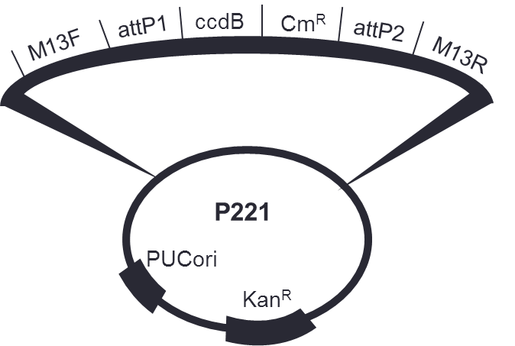

Figure 2.3.1 Map of the p221 entry vector
The key components of the p221 entry vector.M13F and M13R- sequencing primer sites, attP1/attP2- provide sites of homology allowing recombination, Cm^{R}- Chloramphenicol resistance, ccdB – a death cassette that encodes for Toxin CcdB a topoisomerase inhibitor, Kan^{R} - KanaMycin resistance and PUCori - replication origin site.

Destination vectors
System | Name | Features
Bacteria | pDEST-GST | GST N-terminal fusion, T7 promoter
Bacteria | pDEST 17 | 6xHis N-terminal Fusion, T7 promoter
Mammalian | pDEST-Flag | N-Terminal Flag-tag, CMV promoter
Mammalian | pDEST-Myc | N-terminal Myc-tag, CMV promoter
Mammalian | pcDNA5/FRT/Flag | N-terminal Flag-tag, CMV promoter, FLP-In compatible
Mammalian | pcDNA-DEST53 | GFP N-terminal fusion, CMV promoter
Mammalian | pDEST YFP/FRT/TO | YFP N-terminal fusion, CMV primer, FLP-In compatible

Figure 2.3.2 Table of Destination vectors employed in this study
Vectors used in the course of this project. Listed information includes the expression system, plasmid name and its key attributes.

DNA Sequencing
A core genomics facility was available within the Sheffield University Medical School. For each sequencing reaction 10ul of 10ng/µl template DNA and 10ul of 1nM primer was used. DNA was sequenced using an Applied Biosystems 3730 DNA analyser employing the use of BigDye® terminator sequencing buffers (Applied Biosystems 4336701). The standard PCR program is shown below:
- 96ºC (1m)
- Melting 96ºC (10sec)
- Annealing 50ºC (5m)
- Extension 60ºC (12m)
- 4ºC (∞)
X25

Sequencing trace files were then analysed using FinchTV software (Perkin Elmer).

Mutagenic PCR
Previously purified p221 DONR vectors containing full length LARG cDNA were used as a template for mutagenic PCR. Once the sequence for modification was identified primers were designed with 15 complimentary bases either side of each base to be mutated. Full length wild type plasmid preps were used as template for the following master mix:
Component | Volume | Stock Concentration
20-50ng p221 WT LARG | n/a | n/a
Mutant Forward primer | 3µl | 5µM
Mutant Reverse Primer | 3µl | 5µM
KOD buffer | 5µl | 10X
dNTP’s | 5µl | 2mM
MgSO₄ | 2µl | 25mM
DMSO | 1µl | n/a
KOD Polymerase | 1µl | 1U/µl
H₂O | Make final volume 50µl | n/a

Figure 2.3.3 Reagents required for mutagenic PCR
Itemised reagents employed in the mutagenic PCR mix, volumes and stock concentrations are given where appropriate.
PCR Program used for mutagenic PCR
- 94ºC (5m)
- Melting 94ºC (1m)
- Annealing 60ºC (1m)
- Extension 68ºC (12m)
- 68ºC (5m)
- 4ºC (∞)
x18

Note: The greatly increased extension time is due to the requirement of the polymerase to copy the whole p221 plasmid and open reading frame (allowing 1 minute per kilo base processivity for KOD polymerase).
In order to remove the template (wild type) DNA the PCR product was treated with Dpn1 (New England Biolabs R0176S), an enzyme that digests methylated parental DNA therefore leaving the PCR product intact. For each PCR reaction 1µl (20U) of Dpn1 was added then incubated at room temperature for a minimum of 1 hour. PCR products were then separated on a 1% low melting point agarose gel (Thermo L1204) and purified using the Qiagen gel extraction kit (Qiagen 28704).

RT-PCR protocol
Lymphoblast cells were counted using a haemocytometer and diluted to 500,000 cells/ml. Samples were pelleted and lysed using a Qiashredder kit (Qiagen 79656) by re-suspending the pellet in 350µl RLT buffer and transferred to a Qiashredder column then spun at maximum speed for 3 minutes. Manufacturers’ instructions for RNA extraction were followed for the Qiagen RNeasy kit (Qiagen 741074). Once completed the RNA concentration of the eluate was determined using NanoVue Plus (GE Healthcare Life Sciences).
cDNA preps were prepared using the Taqman Reverse Transcription reagents kit (Life Technologies N808-0234) to the following protocol:

Component | Volume | Concentration
RNA prep | n/a | 1µg
dNTP’s | 10µl | 2.5mM
MgSO₄ | 11µl | 25mM
RT Buffer | 5 µl | 10X
RNAse Inhibitor | 1 µl | 20U/µl
Random Hexamers | 10µl | 50 µM
RT enzyme | 1.25 µl | 50 U/µl
H₂O | Make final volume 50µl | n/a

Figure 2.3.4 Reagents required for RT-PCR reactions
Itemised reagents employed in RT-PCR in order to create cDNA samples. This allows for relative expression levels of mRNA to be determined.

2.4 Mammalian Cell Culture

Cell Culture
All mammalian cell lines were incubated at 37°C with 5% CO₂. A range of different cell lines were used throughout this project, described in figure 2.4.1. In order to avoid cell senescence fractions of 80-90% confluent cultures were passaged and cultured in Dulbecco's Modified Eagle Medium (DMEM); (Lonza BE12-604F) supplemented with 10% Fetal Calf Serum (FCS); (Lonza 14-501F) and 1% Non-Essential Amino Acids (NEAA). For adherent cell lines T75 flasks containing cells at 80-90% confluence were taken from the incubator, media removed and cells washed twice in 15ml warmed PBS, 3ml of Trypsin (0.5g/l trypsin, 0.2g/l versene (EDTA) Lonza 17-161E) was added and the flask incubated at 37ºC until the cells had detached. The cells were then pelleted at 100rcf for 3 minutes (Thermo Megafuge 40). The supernatant was removed and pellet re-suspended in DMEM, a fraction of this suspension was transferred to a fresh flask containing DMEM (typically between 1:10 and 1:20 depending on confluence level and cell type). No antibiotic agents were added to the DMEM, and were only employed during the generation and maintenance of stable cell lines.

Lymphoblast cell line maintenance
Lymphoblast cell lines were maintained in T25 flasks containing 10ml RPMI 1640 (Lonza BE12-702F) media supplemented with 15% FCS, flasks were kept vertically at 37°C with 5% CO_{2.} To maintain consistent growth these lines were split at a 1:2 ratio every 2-3 days. Two fresh clean flasks were prepared with 5ml warm media, the cells in the parental flask were agitated using a pipette to break up cell plaques and 5ml of cell suspension was added to each of the fresh flasks.

Cell Line | Origin | Standard Passage ratio | Reference
HeLa | Cervix (Epithelial) | 1:10 | (William F. Scherer, 1952)
U2OS | Bone (osteosarcoma) | 1:10 | (Ponten and Saksela, 1967)
Hek293 | Embryonic kidney | 1:20 | (Graham et al., 1977)
RPE1 | Retinal Epithelial (hTERT) | 1:10 | (Bodnar, 1998)
HCT116 | Colon (Colorectal Carcinoma) | 1:20 | (Brattain et al., 1981)
AG09387 | EBV-transformed B cell | 1:2 | (Balajee et al., 1997)
DK0064 | EBV-transformed B cell  (Seckel Syndrome Lymphocyte) | 1:2 | (Alderton et al., 2004)
PJ0013 | EBV-transformed B cell  (Seckel Syndrome Lymphocyte) | 1:2 | unpublished
CV1740 | EBV-transformed B cell  (PCNT deficient MOPDII Lymphocyte) | 1:2 | unpublished
T-Rex-293 | Embryonic kidney with Flp-In recombination site | 1:20 | (Weterman et al., 2001)
T-Rex HeLa | Cervix (Epithelial) with Flp-In recombination site | 1:50 | (Marin-Vinader et al., 2006)

Figure 2.4.1 Cell lines used within the confines of the project, their origin, standard passage ratio (passaged twice weekly) and their first appearance in the literature.

Production of T-REx cell lines
T-REx-293 cells (Invitrogen R710-07) were grown in the pre-transfection selection (see figure 2.4.2) until they reached 80% confluence (250,000 cells in 2ml DMEM in a 6 well plate. The media was then removed and cells washed twice in PBS, fresh anti biotic free media was then added. The vector containing the FLP/Flag sequence is incorporated into the FLP site through a recombination event mediated by the product of the pOG44 vector (FLP recombinase), therefore the two vectors were co-transfected. For each well of a 6 well plate 1µg of both vectors were transfected, for this four eppendorf tubes were prepared with 500µl of DMEM, to two of the eppendorfs 3µl lipofectamine 2000 was added while the remaining two had 1µg of either the recombinase or Flag construct added. The lipofectamine and DNA solutions were combined and incubated at room temperature for 20 minutes, 1ml of media was then removed from each well. The Flag-LARG and Recombinase suspensions were then added to each well (with one well reserved for a recombinase only control). The transfected cells were incubated overnight before the addition of antibiotic selection (for concentrations see figure 2.4.2) Selection media was changed weekly until colonies were large enough to be seen by eye. At this stage the colonies were individually trypsinised and transferred to T25 flasks for further growth and validation.
T-REx HeLa | Blasticidin µg/ml | Zeocin µg/ml | HygroMycin µg/ml
Pre-transfection | 4 | 50 | -
Post-transfection | 4 | - | 200
T-REx Hek293 | - | - | -
Pre-transfection | 15 | 100 | -
Post-transfection | 15 | - | 150

Figure 2.4.2 Antibiotic concentrations used for selection of cells with recombination event.
Lab stocks were: 10mg/ml Blasticidin, 100mg/ml Zeocin and 50mg/ml HygroMycin.

Cell Lysis
Cell populations were washed twice in PBS and lysed in lysis buffer (for composition see figure 2.4.3) appropriate volumes of between 50µl and 200µl were used depending on cell type and density. Samples were kept on ice for 20 minutes with brief vortexing every 5 minutes, the lysate was then pelleted using a bench top microfuge at 16,100rcf (Eppendorf 5415R), 4°C for 15 minutes. The supernatant was then transferred to a fresh tube and stored at -20°C until required.
In order to maintain the transient phosphorylation of Myosin Light Chain traditional lysis methods could not be used. For a 6 well plates the cells were washed twice with PBS, all remnants of PBS removed and 100µl 2X protein loading buffer added directly to the cells. A cell scraper was used to remove the cells from the plate; they were then pipetted into labelled eppendorfs taking care when moving the viscous lysates. 1ml syringes with 0.6mm gauge needles were then used to break up cell membranes, immediately following this the samples were boiled for 5mins at 95°C and clarified by centrifugation at 10,000rcf for 1 minute (to minimise the loading of membranes). Proteins were then separated by SDS-PAGE using a 15% Acrylamide gel using a standard western blotting technique.
Reagent | Stock Concentration | Volume required for 10ml
50mM Tris pH8.0 | 1M | 500µl
200mM NaCl | 5M | 400µl
1% Triton X-100 | 100% | 100µl
1mM DTT | 1M | 10µl
1mM EDTA | 500mM | 20µl
50U/µl benzonase | 25U/ml | 20µl
PIB (Sigma P2714+10ml H₂O) | 10x | 1000µl
1x Phosphatase Inhibitors (P5726) | 100x | 100µl
ddH₂O | - | 7.85ml (7.67 for wash buffer)

Figure 2.4.3 Cell lysis buffer was prepared to the above concentrations. Example volumes are given for a 10ml stock of lysis buffer.

Bradford Assay
39µl of ddH₂O was added to each well to be measured on a 96 well plate, to this 1µl of protein sample or BSA standard was then added. To this 200µl of 1:5 diluted Bradfords Reagent (Bio-Rad 5000006) was added. The resulting optical density at 595nm was determined using a spectrophotometer (Multiskan FC- Thermo Scientific part no. 51119000). Protein concentrations were then quantified using a BSA standard curve (set at 0.10, 0.08, 0.06, 0.05, 0.04, 0.03, 0.02, 0.01mg/ml) using a linear quadratic equation y=mx+c where m represents the gradient and c the y axis intercept (figure 2.4.4).

Figure 2.4.4 BSA Standard curve
The standard curve created using BSA standards was used to calculate the protein concentration in samples, allowing for equal loading and comparability between lanes.

Immunoprecipitation (IP) of endogenous and overexpressed proteins
Immunoprecipitation of whole cell lysates was carried out using both Flag-M2 (Sigma A220) beads for Flag-tagged proteins and protein A/G beads for endogenous proteins. Prior to IP, input samples were prepared with 20µl of the lysate added to 20µl of 2x protein loading dye, boiled (95°C) for 5 minutes and stored at -20°C. Flag immunoprecipitation: 20-50µl of bead slurry (Sigma A2220), dependant on sample size, was transferred to an eppendorf, 10x total bead volume wash buffer (lysis buffer without benzonase) was added and the tube was inverted 15-20 times the beads pelleted (1500rcf 2 minutes), this was repeated twice more. The beads were then added to each of the lysates and left on a rotator at 4°C overnight. IPs were pelleted (if necessary the unbound fraction was recovered), washed three times in 10x bead volume wash buffer. After the final wash 40-100µl of 2x protein loading buffer was added and samples boiled at 95°C for 5 minutes. Samples were stored at -20°C for short term storage and -80°C for long term storage.
Alternatively to avoid the dissociation of the heavy and light chain through boiling, Flag complexes were eluted using a concentrated Flag peptide solution to out compete cellular fractions. This was achieved by diluting a stock 3xFlag peptide solution (5mg/ml in TBS pH7.4) 1:30 in TBS and adding the required volume directly the beads and incubating on ice for 30-60 minutes ensuring good suspension of the bead slurry. After incubation the beads were pelleted and the eluate pipetted into an eppendorf for storage at -20ºC (short term) or -80ºC (long term).
Transfection of mammalian cell cultures
For each siRNA transfection two eppendorf tubes were prepared with serum free media (SFM), siRNA was added to one and Dharmafect1 or RNAiMAX to the other:
Volume of DMEM covering cells (µl) | SFM  (µl) | siRNA (20µM)  (µl) | Dharmafect/RNAiMAX  (µl)
500 (24 well plate) | 50.0 | 2.5 | 1.0
2000 (6 well plate) | 100.0 | 10.0 | 4.0

Figure 2.4.5 Volumes used in preparation for siRNA treatment

Once prepared eppendorfs were left at room temp for 5 minutes before the contents of the Lipid tube was transferred to the siRNA containing tube, agitated gently and left at room temperature for 20 minutes. In the case of 24 well plates the siRNA/Lipid/SFM reaction mixture was pipetted directly into the media. However in order to decrease siRNA volumes required for a 6 well plate, 1ml of media (cells are plated in 2ml) was removed before the siRNA/Lipid/SFM mix was added, leaving a final volume of 1.2ml.
Timing of siRNA knockdown, transfection reagent and starting cell number were optimised for each cell line. Typically RNAiMAX (Life Technologies 13778030) was used and cells kept in siRNA for 48-72 hours.

Western Blotting
Unless otherwise stated 10% acrylamide gels were used in western blotting protocols. These were prepared as outlined in figure 2.4.6. The reagents for the stacking gel were added in descending order (by volume) and carefully added in between two glass plates in a protein gel casting set. This was covered with a layer of water (1ml) and left to set, during which time the stacking gel was prepared. Immediately prior the addition of APS and TEMED, the water cover was removed and the stacking gel was added onto the resolving gel. A well comb was put into the top of the gel before it was left to set. Once set the comb was removed and the gel placed into a Bio-Rad mini-PROTEAN tetra cell to which 1000ml of 1x running buffer (made from 10x stock) was added ensuring no air bubbles were left in the wells. Samples were added to the wells, the gel was then run at 160V until the dye front ran off the bottom of the gel, the current was turned off and the gel removed for transfer.

Reagent | Stock | 10% resolving gel (10ml) | 8% resolving gel (10ml) | Stacking gel (2ml)
ddH₂O | n/a | 4.0 | 4.6 | 1.44
Acrylamide | 30% | 3.3 | 2.7 | 0.33
Tris (pH8.8) | 1.5M | 2.5 | 2.5 | -
Tris (pH6.8) | 1M | - | - | 0.25
SDS | 10% | 0.1 | 0.1 | 0.02
APS | 10% | 0.1 | 0.1 | 0.02
TEMED | 100% | 0.004 | 0.006 | 0.002

Figure 2.4.6 Western blot acrylamide gel components
The volumes and stock concentrations of reagents used in the preparation of acrylamide gels used in Western blotting.

Transfer: The blotting paper and sponges were soaked in 1x transfer buffer while the PVDF membrane (Bio-Rad 162-0177) was pre-soaked in Methanol before assembly as outlined in the diagram below.
Negative terminal
Sponge
Whatmann paper
Gel
Membrane
Whatmann paper
Sponge
Positive Terminal

The membrane was transferred at 100V for 90 minutes (120 minutes for 1.5mm thick gels) before being removed and blocked in either 5% milk or BSA in TBST for 1 hour (antibody dependant). The blocking solution was removed and 1º antibody (made up in 5% milk or BSA in TBST) added and left overnight at 4ºC with shaking. The antibody was recovered and the membrane washed in TBST three times (10 minutes each) before the addition of the 2º antibody (made up in 5% MILK or BSA in TBST), the membrane was left at room temperature with shaking for a further hour. The secondary antibody was discarded and the membrane washed in TBST three times. The 2 components of Pierce ECL (Fisher Scientific PI-32109) were prepared in separate tubes while the membrane was placed on flat even cling film, at which point the two ECL reagents were mixed and decanted onto the membrane. Complete coverage was ensured and the ECL left for 5 minutes. The membrane was then developed using an automated x-ray film developer (Konica Minolta SRX101A).

Immunofluorescence Using Mammalian Cells
24-well plates were prepared with cover slips and seeded with an appropriate number of cells (dependant on cell line) in 0.5ml DMEM. siRNA treatments and cellular stresses were performed in an assay dependant manner (see figure legends), Plates were recovered and media removed, 3x 0.5ml PBS washes were performed. Cells were then fixed by the addition of 200µl 4% PFA in PBS for 15 minutes followed by 3x PBS washes. Then permeabilized in 0.5% triton in PBS or 10 minutes, followed by 3x PBS washes. A blocking stage was performed in 3% BSA in PBS for 30 minutes. Primary antibody was prepared in 1% BSA in PBS using dilutions described in figure 2.17 incubated at room temperature for 1 followed by 3x PBS washes. Secondary antibody was prepared in 1% BSA in PBS using the dilutions described in figure 2.6.1. DAPI was included at 1:1000 from lab stocks (1mg/ml). Cover slips were incubated in the dark for one hour, followed by 4x PBS washes (in dark). Cover slips were then dipped in deionised water and mounted cell side down on slides using Immu-Mount (Thermo 99-904-02) and left to dry/set.

Cell Cycle Analysis using Propidium Iodide Staining
Preparation of FACS samples: between 50,000-200,000 (cell line-dependant) monolayer population of cells were prepared in 6 well plates, incubated overnight, treated with siRNA and incubated at 37°C with 5% CO₂ for 48 hours. In order to avoid loss of mitotic cells, the original media and supernatants from each of the two PBS wash steps were collected in falcon tubes. Cells were then detached in 0.5ml trypsin, the cell suspensions were pelleted at 300rcf for 3 minutes (Thermo Megafuge 40), the supernatant removed and pellet re-suspended in 300µl PBS. The cells were then fixed by the slow addition of 700µl ice cold ethanol with gentle agitation and stored at -20°C.
Processing of FACs samples for PI staining: Samples were pelleted and resuspended in 1ml PBS twice. 5µl of RNAaseA (1mg/ml) was added to the cell pellet for 15 minutes. 200-400µl of 50µg/ml Propidium Iodide (PI) was added (depending on cell number) and incubated for a minimum of 15 minutes before running on FACs Calibur (BD Biosciences) or Attune (Applied Biosystems) flow cytometers.

pH3 FACS Staining
Cells were siRNA treated and fixed as described in ‘Cell Cycle Analysis using Propidium Iodide Staining’. Samples were removed from -20°C storage and pelleted (200rcf 5 minutes- Thermo Megafuge 40); pellets were then washed twice in 2ml PBS. The supernatant removed, pellets then re-suspended in 2ml PBS containing 0.5% BSA 0.25% Triton-X then incubated on ice for 15 minutes. Samples were pelleted (200rcf for 3 minutes-Thermo Megafuge 40) and supernatant removed, pellets were re-suspended in 100µl PBS (0.5%BSA 0.25% Triton-X) containing a 1:1000 dilution of pH3 S10 antibody (Abcam ab14955). Samples were incubated at room temperature for 1-3 hours.
Samples were pelleted and washed twice with 2ml PBS 0.25% Triton-X, supernatant removed and re-suspended in 100µl PBS 1% BSA containing a 1:500 dilution of anti-mouse Alexa Flour 488 secondary antibody (Life technologies A11011), samples were then incubated for 30 minutes in the dark. Samples were washed in 2ml PBS, supernatant removed and 5µl of RNAse1 (1mg/ml) added. Cells were then re-suspended in 300µl Propidium Iodide (50µg/ml) and incubated in the dark for 15 minutes). Samples were then analysed by Flow Cytometry using either a FACSCalibur (BD Biosciences) or Attune (Applied Biosystems) systems.

Flow cytometry analysis
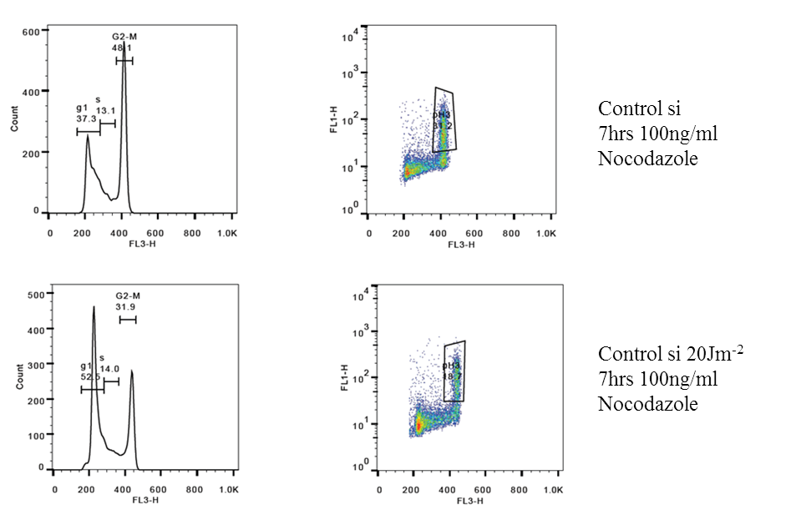

Figure 2.4.7 Example data from PI and pH3 FACS staining
HCT116 cells transfected with non-targeting siRNA were treated with 20jm⁻² UV radiation and then incubated in 100ng/ml nocodazole to enrich for mitotic cells. The above plots show the PI plots (left panels) and pH3 plot (right panels). Propidium iodide binds DNA stoichiometrically so allows the cells cycle to be visualised by comparing the relative DNA content with the lower DNA content shown on the left (G1 in the cell cycle), replicating DNA in the centre (as cells replicate more DNA they move right in the plot, representing S phase), the second spike represents cells with a 2n DNA content (representing G2/M). The pH3 signal can be determined by comparing the PI signal (FL3 using FACS CALIBUR) and the signal from the 488 secondary antibody, the increase in signal intensity is shown by the movement of representative dots further up the Y axis. As is to be expected this is seen mainly in cells corresponding to the G2/M phase of the cell cycle, in this case the number of cells with positive staining for pH3 after 20Jm⁻2 UV drops by nearly half (31.2% to 18.7%), observed in the boxed area, indicating the G2/M checkpoint has been enacted successfully in response to DNA damage.

G2/M cell cycle checkpoint complementation assay (lymphoblast)
5mls of exponentially growing lymphoblast cultures were prepared at 1,000,000 cells/ml in RPMI1640 media supplemented with 15% FCS (Foetal Calf Serum) in T25 vented flasks (incubated vertically). For transfection 2µg of plasmid and 6µl of Gene Juice (Millipore 70967-3) were added to 100µl of serum free RPMI1640, this mix was incubated for 45 minutes before addition to the cell suspension. Cells were transfected on 3 consecutive days and split at a 1:2 ratio before the 2nd transfection (in order to prevent the cell density from getting too high leading to cell cycle arrest). The day after the 3rd transfection cells were pelleted (100rcf 3 minutes- Thermo Megafuge 40), supernatant removed and re-suspended in 100µl of PBS and transferred to the centre of the well of a 6 well plate, these were irradiated with 10Jm⁻² UV radiation or kept in the flow hood (mock treatment control). Each sample was then re-suspended in 5ml of 15% FCS supplemented RPMI1640 containing 1.5µM nocodazole and incubated for 24 hours in T25 vented flask (to enrich for mitotic cells).
Cells were pelleted (100rcf 3 minutes-Thermo Megafuge 40), supernatant removed and re-suspended in 1ml 75mM KCl for 5 minutes, pelleted (1000rcf 3 minutes- Eppendorf 5415R) and the supernatant removed. Cells were then fixed by re-suspension in 300µl Carnoys Fixative (3:1 Methanol: Glacial Acetic Acid) for 10 minutes before pelleting (1000rcf 4 minutes- Eppendorf 5415R) and supernatant carefully removed. Cells were re-suspended in 200µl DAPI (1:5000 1mg/ml stock in PBS) making sure clumps of cells were broken up by agitation.
100µl of cell suspension was removed for cytospin with the remaining cells pelleted and re-suspended in 70% ethanol for storage at 4°C. Cells were cytospun at 600rpm for 5 minutes (Thermo Cytospin 4), after slide clamp disassembly slides were left to air dry for 5 minutes before the addition of a drop of Immu-Mount (Thermo 99-904-02) directly to the cells to which a cover slip was placed gently on top, taking care to avoid bubbles and unnecessary pressure. Slides were left in a cool, dry, dark place, to set and the mitotic index determined by microscopy (interphase versus mitotic nuclei), with a minimum of 600 cells counted per sample.

MTT Cytotoxicity Assay
HeLa cells were counted using a haemocytometer and calculations made to allow for 2500 cells to be plated in 75µl complete DMEM per well in a 96 well plate. Cells were left overnight to adhere before siRNA transfection. For each siRNA oligo 8 vertical replicates per plate were transfected, each with 0.25µl siRNA, 0.075µl RNAiMAX contained in 25µl SFM. After 48 hours cells were subjected to genotoxic stress in the form of Mitomycin C (MMC), a stock solution of 1mg/ml was prepared in ddH₂O; from this concentrations of 8/6/4/2/1µg/ml were derived. A multichannel pipette was then used to add 1µl of each concentration to each row of siRNA transfected cells, to give final MMC concentrations of 80/60/40/20ng/ml MMC. Cells were left exposed to this for 5 days before MTT processing. On the day of processing a 3mg/ml solution of MTT was prepared in PBS, 50µl of this was added to each experimental well and the cells incubated for 3hrs in an incubator. The MTT/DMEM solution was then aspirated off and the remaining purple formazan crystals were dissolved by the addition of 200µl DMSO. Absorbance at 540nm were determined using a plate reader (Multiskan FC- Thermo Scientific part no. 51119000). The relationship between optical density at 540nm and cell number is displayed in figure 2.4.8.
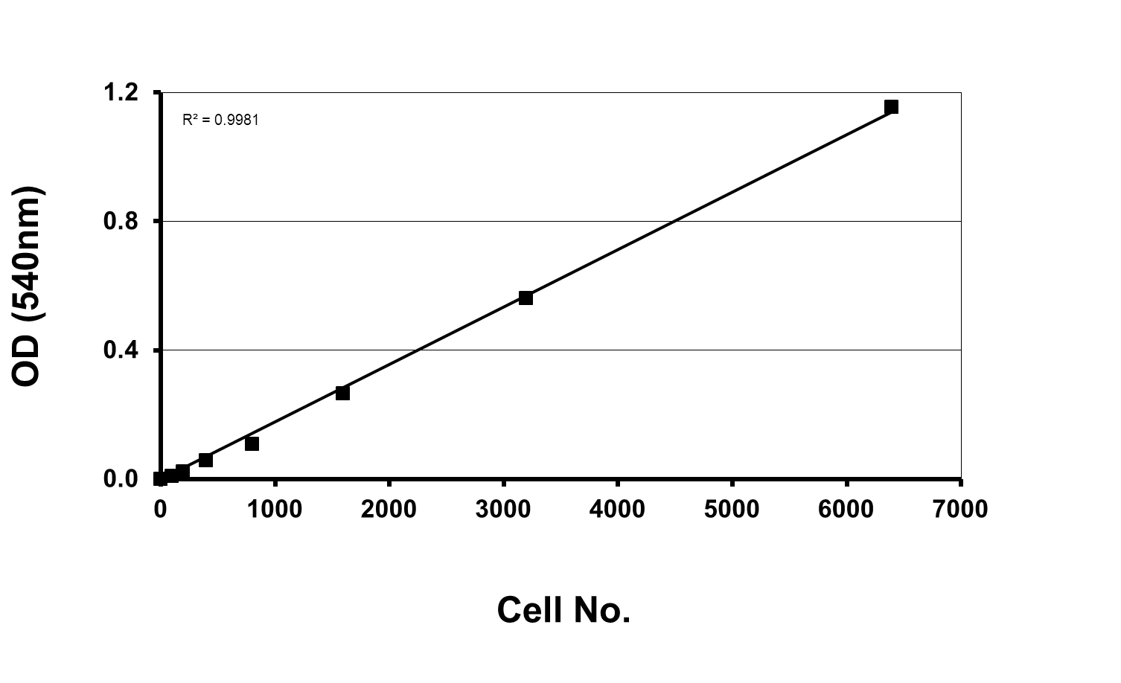

Figure 2.4.8 Relationship between cell number and absorbance in an MTT
An example of the MTT assay showing the relationship between cell number and formazan crystal production and therefore absorbance. HeLa cells were plated at varying cell densities from 0 to 6400 cells per well on a 96 well plate. After 24 hours an MTT assay was performed and the resulting OD determined at a 540nm wavelength.

GLISA RhoA Activity Assay
The Cytoskeleton GLISA assay (Cytoskeleton BK124) allows for the relative quantification of RhoA-GTP between cell samples and therefore measure RhoA activation after a stimulus.
RPE1 cells were transfected in duplicate 6 well plates following the above ‘transfection of Mammalian cells’ protocol, 48 hours post transfection cells were serum starved. This was achieved by washing the cells twice in 2ml warm (37°C) PBS and then the addition of serum free DMEM, plates were incubated for 12-16hrs. Many RhoA activating antigens are present in FCS; the serum removal step therefore reduces background activation. Lysophosphatidic acid (LPA), a potent RhoA activator, was added to give a final concentration of 50µM (stock 10mM) and incubated for 10 minutes. Following treatment the manufacturer’s instructions were followed with care taken to work quickly and carefully in order to preserve the RhoA-GTP signal. In brief; all samples were prepared in triplicate and of equal concentrations (between 0.4-2.0mg/ml), alongside this a buffer blank and RhoA-GTP control (supplied) were prepared. Lysates were diluted with an equal volume of supplied binding buffer and added to the ELISA plate wells in triplicate then incubated at 4°C on a 400rpm orbital micro plate shaker for 30 minutes. Samples were then flicked out of the plates and wells washed twice with supplied wash buffer, residual wash buffer was vigorously removed by patting the plate on paper towels. Antigen presenting solution was added to each well and left at room temperature for 2 minutes before being vigorously removed (as before), immediately following this RhoA primary antibody was added and the plate incubated on a room temperature micro orbital shaker at 400rpm. After 45 minutes two further washes were performed and the secondary antibody added, this was incubated for 45 minutes on a room temperature micro orbital shaker at 400rpm. After incubation three further washes were performed and HRP reagent added to the wells, a further 10-15 minute incubation at 37°C was performed, allowing the colouration of the solution. HRP stop buffer was then added and the absorbance at 490nm determined using a plate reader (Multiskan FC- Thermo Scientific 51119000).

Scratch Wound Assay
The scratch wound assay measures a cells ability to migrate and proliferate into empty space. This is particularly relevant for cancer due to the direct relation to metastasis and angiogenesis, two of the hallmarks of cancer previously discussed.
HeLa cells were plated in a 6 well dish; cell numbers were slightly higher to accommodate a 90-95% confluence 30 hours post transfection. siRNA knockdown was carried out following the ‘transfection of mammalian cells’ protocol. 30 hours post transfection cells were washed twice with warm PBS and then incubated for 16 hours (overnight) in SFM. On the day of the assay a horizontal line was drawn under each well horizontally, this was used as a guide for making wounds. Three separate wounds were created by drawing a sterile 200µl pipette tip across the guide line perpendicularly (see figure 2.4.9). Cells were gently washed in warm PBS to remove any cells displaced during wound creation and fresh warm complete media added. A picture of each wound was then taken just above and just below the guideline for each well. Pictures were captured at 6, 12 and 24 hours. The area of the wound in each photo was then determined using the Image J free-form draw and analysis tool. The invasion rates were extrapolated using the reduction in wound size as a measure of invasion; values exported from image J are expressed as arbitrary units (AU).
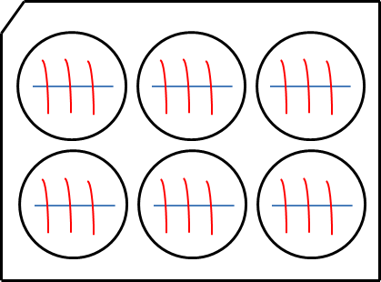

Figure 2.4.9 Scratch Wound assay layout
Six well plates were employed in this assay, cells are grown to 90-95% confluence, a guiding line is drawn on the underside of each well (blue) before 3 scratches per well are created with a 200µl pipette tip (red). The guide line allows for the same position of each wound to be measured at each time point.

2.5 DNA and RNA Sequences
Primer ID | Sequence
LARG Seq 1 | tccaagaagacaaagtctag
LARG Seq 2 | gttcataaccagaaagtaga
LARG Seq 3 | attggagcagaagatgatga
LARG Seq 4 | cttgatgcagagcgagacaa
LARG Seq 5 | ccagagtgggttagcaaatg
LARG Seq 6 | gctcatgttcgaacactgaa
LARG Seq 7 | caacagaaagggagaaggtg
LARG Seq 8 | tccatgtcagacaatggcgc
LARG Seq 9 | cagaagaacggtgggcattg
LARG Seq 10 | gagaatccatcagaaggtga
M13F | tgtaaaacgacggccagt
M13R | CAGGAAACAGCTATGACC
CMV | CAGAGCTCGTTTAGTGAACCG
LARG Gateway Forward | GGGGACAAGTTTGTACAAAAAAGCAGG-  CTtgagtggcacacagtctactatcac
LARG Gateway Reverse | GGGGACCACTTTGTACAAGAAAGCTG-  GGTctaacttttatctgagtgcttgtct
S1288A mutagenic | TGTCTGCGGCCCCTGAGCGGCTGTTCTGTATCT
S1288D mutagenic | TGTCTGCGGCCCCTGATCGGCTGTTCTGTATCT
LARG 700F Gateway | GGGGACAAGTTTGTACAAAAAAGCAG-  GCTAAAGATTGCTAAAAGAGATCCAA
LARG 3219F Gateway | GGGGACAAGTTTGTACAAAAAAGC-  AGGCTGCCACACGTTTAGCCCTGTCATT
LARG 1526F | AGCGAGACAAGGACCAATTGACTTTGGAGA
LARG 1526R | TTCTCCAAAGTCAATTGGTCCTTGTCTCGC

Figure 2.5.1 Primers employed within this study
Sequencing primers were employed in the sequencing of LARG after plasmid creation Red letters indicate mutated bases

siRNA ID | Sequence
ATR si10 | GGUCAGCUGUCUACUGUUAUU
ATR si17 | GCAACUCGCCUAACAGAUAUU
ATR si18 | ACUGAUGGCUGAUUAUUUAUU
ATR si5 | GAACAACACUGCUGGUUUGUU
HCLK2 si1 | GAGCGGAUCAGAAGCAAGAUU
HCLK2 si2 | UGAUGUGCCUGGCUGUUAAUU
HCLK2 si3 | GUACGAAGAGGAUGAACUGUU
HCLK2 si4 | GAAGACCUGUGUGGUGGGAUU
LARG si5 | GAUCAAAUCUCGUCAGAAA
LARG si6 | GAAAUGAGACCUCUGUUAU
LARG si7 | GGACAUAUGCCCUUUAGAA
LARG si8 | GGCAACAUUUCCCAAGAUA
low GC non-targeting | UAAUGUAUUGGAACGCAUA
med GC non-targeting | AGGUAGUGUAAUCGCCUUG
high GC non-targeting | UGCGCUAGGCCUCGGUUGC
PCNT si5 | GGACGAAGCUUGCUCACUU
PCNT si6 | GCAUGAAACUCGUCUGAAG
PCNT si7 | CAGCACAGGUUGUCAGGAA
PCNT si8 | CGAAACGGCUCCACAGAGU
ARHGEF11 si5 | GCAAGUGGCUGCACAGUUC
ARHGEF11 si6 | UCAACAGGCUCAAGGAUAU
ARHGEF11 si7 | UCUAUGAGCUGGUUGCAUU
ARHGEF11 si8 | GGAACUCGGUACUGUCAGA

2.5.2 siRNA sequences for all targets used within this study
All siRNA sequences employed within this study. Working stocks were kept at -20°C in 20nM aliquots.

2.6 Antibodies
Antibody | Company | Cat no. | Use | Dilution
53BP1 | Abcam | ab368823 | IF | 1:500
Acetylated Tubulin | Sigma | T7451 | IF | 1:500
Actin | Abcam | Ab8226 | WB | 1:5000
ATM | Abcam | ab78 | WB | 1:1000
pATM (S1981) | Abcam | ab36810 | WB | 1:1000
ATR | Santa-cruz | sc-1887 | WB | 1:1000
Arhgef11 | Abcam | ab110059 | WB | 1:1000
Chk1 | Sigma | C9358 | WB | 1:1000
pChk1 (pS345) | Cell Signalling | 13303 | IF, WB | 1:500-1:1000
pChk2 (T86) | Cell Signalling | 2661 | WB | 1:1000
pDNA-PKcs (S2056) | Abcam | ab18192 | IF,WB | 1:500-1:1000
DOCK4 | Abcam | ab85723 | WB | 1:1000
FANCD2 | Abcam | ab108928 | WB | 1:1000
FANCD2 | Novus Biologicals | NB100-182 | IF | 1:500
Flag-HRP | Sigma | A8592 | WB | 1:2000
Flag (M2) | Sigma | F3165 | WB | 1:1000
GFP | Abcam | ab290 | IF | 1:1000
pH2AX (pSer139) | Cell Signalling | 25775 | IF | 1:500
pH2AX (pSer139) | Millipore | 05-636 | IF | 1:500
pH3 (S10) | Abcam | ab14955 | FACS | 1:500
pJNK | Cell Signalling | 9251 | WB | 1:1000
LARG (H70) | Santa-cruz | SC-25638 | WB, IF | 1:50-1:1000
LARG (N14) | Santa-cruz | SC-15439 | WB, IF | 1:50-1:1000
LARG (discontinued) | Abcam | ab71367 | WB, IF | 1:50-1:1000
LARG | Abcam | ab86095 | WB, IF | 1:50-1:1000
Myc (9E10) | Santa-cruz | sc-40 | WB | 1:2000
Myc-tag (9B11) | Cell Signalling | 2276 | WB, IF | 1:500-1:2000
MLC2 | Abcam | ab89594 | WB | 1:1000
pMLC2 (S19) | Cell Signalling | 3671 | WB | 1:1000
pMLC2 (T18/S19) | Cell Signalling | 3674 | WB | 1:1000
Antibody | Company | Cat no. | Use | Dilution
Net1 | Abcam | ab113202 | WB | 1:1000
pP38 | Cell Signalling | 9211 | WB | 1:1000
P53 | Bethyl Laboratories | A300-247A | WB | 1:5000
Pericentrin | Abcam | Ab4448 | IF,WB | 1:500-1:1000
Phospho (Ser/Thr) ATM/ATR substrate | Cell Signalling | 2851 | WB | 1:1000
pRPA (T21) | Abcam | ab61065 | IF | 1:500
RPA | Calbiochem | NA19L | IF | 1:500
Telo2 (HCLK2) | Sigma | SAB1100719 | WB | 1:1000
beta Tubulin | Abcam | ab7792 | WB | 1:1000
Alexa Fluor 488 (goat α mouse) | Invitrogen | A11001 | IF | 1:500
Fluorescein (goat α rabbit) | Invitrogen | F2765 | IF | 1:500
Alexa Fluor 488 Donkey α goat | Invitrogen | A11055 | IF | 1:500

Figure 2.6.1 Antibodies employed during the course of this study
All primary and secondary antibodies used during the project are listed with the producer, catalogue number, tested use and dilution range.

3 Results

3.1 Identification of Novel LARG Interacting proteins

Confirming the LARG:HCLK2 interaction
As has been previously mentioned, the hypothesis that LARG may play a role in the DDR was formed following a yeast-2-hybrid screen which identified LARG as a potential interacting partner of HCLK2, a protein already shown to be involved in PIKK stability (Collis et al., 2007, Horejŝí et al., 2009, Takai et al., 2007, Takai et al., 2010). In order to confirm this interaction stable cell lines were created following the ‘Production of T-REx cell lines’ protocol in order to inducbily express (by the addition of tetracycline into the media) N-terminal Flag-tagged LARG (Flag-LARG). Both HeLa and HEK293 variants were created and tested for expression. T-REx-Hek293-LARG cells gave higher levels of expression of Flag-LARG when compared to T-REx-HeLa-LARG as visualised by western blot (data not shown) and as such, were utilised in the confirmation of the HCLK2 interaction. Either empty vector (Myc-EV) or Myc-HCLK2 was transfected into T-REx-Hek293-LARG cells and Flag IPs were performed on the resulting cell lysates and probed for LARG and HCLK2 (figure 3.1.1(a)). Enrichment of Flag-LARG was observed in both lysates demonstrating an effective Flag-LARG IP, importantly Myc-HCLK2 was co-precipitated in with Flag-LARG (figure 3.1.(a)).
This experiment was then performed in the reverse orientation using Hek293 cells constitutively expressing Flag-HCLK2 (Collis et al., 2007) transfected with either Myc-EV or Myc-LARG. A Flag IP was performed and the presence of LARG was only observed in the Myc-LARG transfected cells (figure 3.1.1(b)). These data are consitent with the yeast two-hybrid data and sugest that LARG and HCLK2 exist in a complex. However this system does not allow for a direct interaction to be inferred, for this an in vitro experiments using exogneous purified constructs would be needed.
Although encouraging both of these experiements were performed using exogenous forms of the respective proteins. Therefore to provide further the evidence of an interaction between LARG and HCLK2, endogenous co-IPs were carried out. Endogenous LARG was immunoprecipitated from Hek293 cells and probed for both LARG and HCLK2. Endogneous HCLK2 was shown to co-purify with endogenous LARG with siRNA specific to HCLK2 used to confirm that the interacting band observed in the enodogenous LARG IPs was indeed endogenous HCLK2 (figure 3.1.1(c)). Non-targeting control siRNA was used in both the A/G bead negative control and LARG IP, to allow for any non-specific interaction and effect of siRNA on the interaction to be ruled out.
A longer exposure is shown in figure 3.1.1(c) for both the input and IP to allow for clear visulaisation of the siRNA mediated knockdown. A non-specific band below the HCLK2 band was observed in both the input and IPs, however, the higher band which dissapears with HCLK2 sepcific siRNA also dissapears in the IP. This indicates that although there is some non-specific binding of the antibody, it is not HCLK2, and that endogneous HCLK2 is being immunoprecipitated in endogenous LARG complexes. Overall these data present a case for a LARG:HCLK2 interaction not previously reported and raises the possibility of a potential role for LARG in the DDR. Further work could investigate changes in the strength of this interaction upon either cell cycle phase (employing puase/release experiments) or upon stimulation of either the RhoA or DDR pathways (LPA or replication stress treatments).

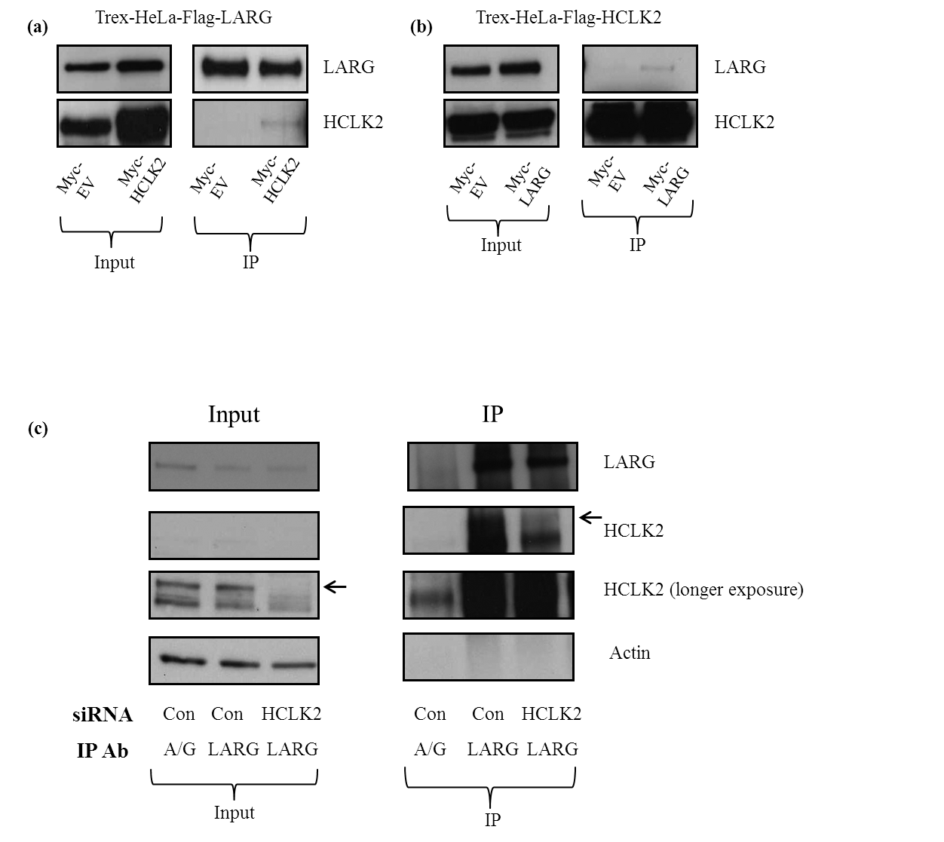 Figure 3.1.1 Exploration of the LARG:HCLK2 interaction both exogenously and endogenously. (a) 1x10⁶ T-REx-Flag-LARG cells were plated onto 10cm dishes, tet induced and transfected, following the ‘Transfection of Mammalian cell lines’ protocol, with either Myc empty vector (Myc-EV) or Myc-HCLK2. Flag immunoprecipitation was performed using M2-Flag conjugate beads and the samples probed for LARG or HCLK2. 150mM NaCl was used in lysis buffer to be representative of physiological conditions. The left panel indicates the input used for the IP (4% of lysate by volume). Endogenous antibodies were used to probe western blots, this is why HCLK2 was detected in cells transfected with only Myc-EV. These antibodies were employed as they have greater sensitivity than the Myc (Sigma 9E10) and Flag (Sigma M2-HRP conjugate) antibodies.
(b) 1x10⁶ constitutively expressing Flag-HCLK2 Hek293 cells were transfected, following the ‘Transfection of Mammalian cell lines’ protocol, with either Myc-EVor Myc-LARG. Flag IPs were then carried out and the resulting immunoprecipitates probed for HCLK2 and LARG. 150nM NaCl was used in lysis buffer to be representative of physiological conditions
(c) 1x10⁶ Hek293 cells were plated onto 3x10cm dishes and transfected, following the ‘Transfection of Mammalian cell lines’ protocol, with non-targeting or HCLK2 siRNA. Endogenous IPs for LARG were performed using 5µg of H70 (sigma) antibody, resulting samples were then probed for HCLK2 and LARG. Actin was used as a loading control for siRNA knockdown. 150nM NaCl was used in lysis buffer to be representative of physiological conditions.

Confirmation and domain mapping of the LARG:PCNT interaction
An interaction between LARG and Pericentrin (PCNT) has been previously reported (Goulimari et al., 2008). In this paper tagged LARG (Myc and Flag) was immunoprecipitated and PCNT shown to be co-immunoprecipitated. The authors then proceeded to show a cellular co-localisation of LARG and PCNT at centrosomes, further supporting a potential functional interaction between these two proteins. However attempts to recapitulate this data as well as further study LARG cellular localisation will be discussed in chapter 3.2.
To initially confirm an interaction between LARG and PCNT, Hek293 cells were used to endogenously IP either LARG or PCNT (figure 3.1.2(a)). PCNT was enriched in both its own IP and in the LARG IP but not in the A/G beads control, confirming the previous finding by Grosse’s group (Goulimari et al., 2008). However, a reciprocal co-IP could not be determined which may be due to relative protein abundances (discussed later). To further characterise this interaction a number of Flag-PCNT constructs were obtained from Dr Mikiko Takahashi at Teikyo Heisei University (Takahashi et al., 2002). These constructs, illustrated in figure 3.1.2(b2), contain the full coding sequence of PCNT and various truncations, allowing for domain mapping of the interaction with LARG. This was performed by co-transfecting the Flag-PCNT constructs with full length Myc-LARG, immunoprecipitating for Flag and probing for LARG. To control for any non-specific protein binding to the Flag beads a number of controls were performed; Myc-EV and Myc-LARG lysates underwent Flag IP. Importantly, LARG was not detected in either of these controls (lanes 2 and 3 in the right panel of figure 3.1.2(b1). A further control for non-specific interactions was the co-transfection of full length PCNT with Myc-EV; this yielded no LARG in the IP lane.
Endogenous LARG was detected in all input lanes as the endogenous LARG H70 antibody was used rather than the Myc 9E10 antibody to reduce non-specific staining. As observed in the left panel of figure 3.1.2(b1) over expression of LARG following transient transfection was evidenced by an increase in band size and intensity in the appropriate input lanes. Flag-PCNT construct expression was observed in the input lanes with sizes correlating to the predicted molecular weight of each truncated protein (assuming an average amino acid weight of 110Da). Successful immunoprecipitation of all Flag-PCNT constructs can be seen in the right panels, however a large number of what are most likely degradation products can be seen in the constructs over 100kDa in size. Importantly, LARG enrichment was observed in the full length Flag-PCNT IP, consistent with both published data and figure 3.1.2(a), further demonstrating that LARG and PCNT interact. Furthermore, LARG enrichment was observed in IPs for Flag-PCNT constructs 3 and 6 but not in constructs 2, 4 and 5. The only common factor of these three constructs is the extreme C-terminal region of PCNT that contains its only identifiable domain; the PACT domain. The PACT domain of PCNT has been implicated in the centrosomal targeting of PCNT (Gillingham and Munro, 2000). This is interesting with regards to the previous report of LARG localisation to centrosomes, and suggests a possible functional link between LARG and PCNT at specific cellular structures. This will be explored further in the discussion section and in chapter 3.3.

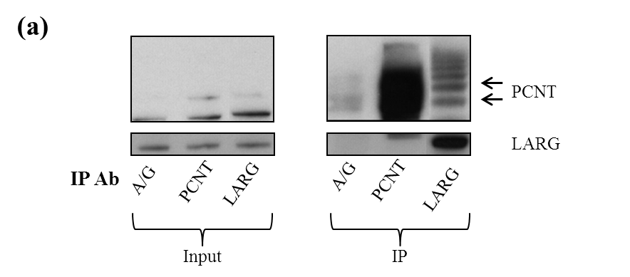
Figure 3.1.2 Confirmation of endogenous LARG:PCNT interaction and domain mapping using exogenous constructs.
- 1x10⁶ Hek293 cells were plated on to 3x10cm dishes. Endogenous IPs were performed using 5µg of LARG (H70) and PCNT (ab4448) with A/G beads used to control for non-specific binding. 150mM NaCl in lysis buffer to be representative of physiological conditions.

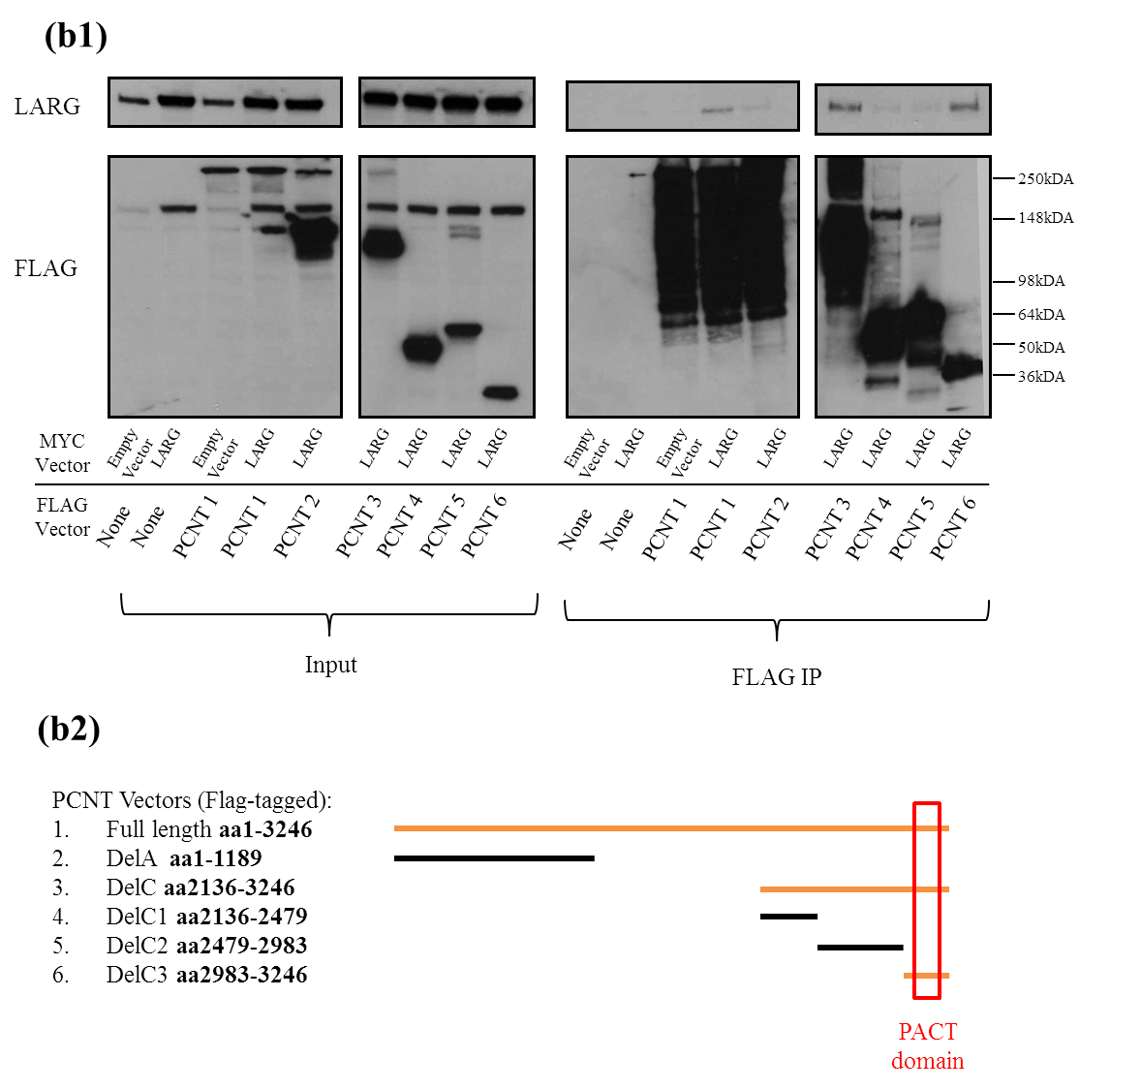
(b1) 9x 10cm plates were each seeded with 1x10⁶ Hek293 cells and transfected, following the ‘Transfection of Mammalian cell lines’ protocol. Plates were transfected with 1µg of Flag-PCNT construct and 3µg Myc-LARG construct where appropriate. 48 hours after transfection Flag IPs were performed using M2-Flag beads using 150mM NaCl lysis buffer. Empty Myc-vector and Myc-LARG transfections were used as controls for non-specific binding to M2-Flag beads. PCNT constructs were kindly provided by Mikiko Takahashi of Teikyo Heisei University. Note that whole blots were initially probed for LARG and subsequently re-probed using the Flag-M2 antibody; this is why the LARG expression pattern can be seen just above the 150kDa marker of the input lanes.
(b2) Flag-PCNT constructs depicted visually compared to full length (Vector 1). Highlighted in orange are the constructs that interacted with LARG.

Identification of novel LARG interactors
To determine if LARG interacts with other DDR or centrosome associated proteins, a tet-inducible T-REx293-Flag-LARG cell line was created to facilitate mass spectrometry based proteomic analysis of LARG interacting proteins (figure 3.1.3(a)). In order to compare the efficacy of both Flag IPs and endogenous LARG IPs for proteomic analysis, samples from IPs consisting of 5x10cm confluent plates using both methods was prepared and 20% of each sample was separated on a 4-12% acrylamide gel which subsequently underwent silver staining to identify potential interacting proteins (figure 3.1.3(b)). Enrichment of LARG can be observed in both the +tet Flag and H70 LARG IPs (arrow figure 3.1.3(b)). There are however a number of bands common to each pair of IPs (-/+ tet and H70-A/G) indicating some non-specific protein binding to the respective beads. The heavy (60kDa) and light (30kDa) chains are present in the endogenous IPs due to the boiling of samples; these are not present in the Flag IPs as they underwent Flag peptide elution (See materials and methods).
A number of bands specific to the +tet lane were observed compared to the –tet lane, indicating bands specific to LARG complexes. In order to identify these possible LARG interacting proteins 50% of the remaining Flag IPs were separated on a 4-12% acrylamide gel and then stained using a SYPRO Ruby kit (Invitrogen S-12000). This particular stain was used as it allowed visualisation of the gel (under black light) but would not interfere with mass spectrometry analysis of the sample (silver staining can oxidise amino acid side chains). Preparation for mass spectrophotometry required the careful excision of an entire lane of the gel which was then cut into 20 equal horizontal slices, each of which was the further divided into three equal pieces to be placed into a single well of a 96 well plate. This was carefully and methodically performed starting at the lowest molecular weight. After both the –tet and +tet lanes were excised and placed into the corresponding wells the plate was sealed and transported in a chilled container to our collaborator Dr Mark Skehel (MRC Laboratory for Molecular Medicine, Cambridge, UK). The returned dataset detailed the number of peptides identified for a given protein in each sample and the overall protein coverage. To narrow the number of potential targets down the ratio of peptides returned in the –tet versus the +tet was calculated and the resulting value used to sort potential interactors. The table to the right of the silver stain image (in figure 3.1.3(b)) gives examples of the results obtained; we observed enrichment of LARG from 6 to 28 peptides (-tet compared to +tet), indicating some leakiness in the tetracycline system. Potentially interesting interactions were deemed to be DOCK4, Lamin A, and JAK1. Importantly the presence of Arhgef11 validates this approach as it is an expected interaction partner given previous evidence of homo/hetero dimerization between LARG and Arhgef11 (Chikumi et al., 2004b).

Figure 3.1.3 Creation of a tetracycline inducible Flag-LARG Hek293 cell line and mass spectrophotometry analysis of purified Flag-LARG protein complexes
(a) T-REx293 parental and Flag-LARG cells were treated with tetracycline to induce expression of Flag-LARG, immunoprecipitation of this protein was performed using M2-Flag conjugated beads.
(b) 5x15cm dishes were each seeded with either 5x10⁶ Hek293 or T-Rex 293-Flag-LARG cells and immunoprecipitation was performed using either endogenous LARG (Hek293) or Flag-LARG (T-REx293 Flag-LARG). Flag-LARG protein complexes were eluted from the beads using 3xFlag peptide (see Materials and methods) while endogenous IPs were boiled in SDS sample loading buffer to removed bound complexes. Samples were separated on a Nu-PAGE SDS 4-12% gradient gel which was subsequently silver stained (SilerQuest kit-Invitrogen LC6070) to reveal all proteins present. The two left lanes are samples prepared from T-Rex 293-Flag-LARG extracts (with and without tetracycline induction) while the two to the right are prepared from Hek293 extracts (A/G beads control). The –tet and +tet IPs were performed using M2-Flag beads while endogenous IP used H70 LARG (Sigma). Mass spectrophotometry analysis of the Flag-LARG eluate revealed a number of potential LARG binding partners, as shown in the table in panel (b).

Investigating potential DOCK4 and JAK1 interactions with LARG
Dedicator of Cytokinesis 4 (DOCK4), was of particular interest as it is a known GTPase involved in Rac signalling that has previously been linked with tumorigenesis (Yajnik et al., 2003) and cell migration (Hiramoto et al., 2006). In order to assess this interaction endogenous IPs were performed using LARG or DOCK4 antibodies with comparable cell extracts. A/G beads alone (minus antibody) were used as a negative control to determine any non-specific protein biding. Both antibodies successfully enriched their respective targets; however there did not appear to be any robust reciprocal co-immunoprecipitation between LARG and DOCK4 (figure 3.1.4(a)). However a diffuse band was observed reciprocally in each IP, which is slightly more evident in the LARG IP probed for DOCK4 and may indicate a potential interaction.
As the initial evidence was obtained using T-REx293-Flag-LARG cell lines, these IPs were repeated in both –tet and +tet conditions. Successful enrichment of LARG can been seen in the +tet IP but not in the –tet (figure 3.1.4b). Interestingly a diffuse DOCK4 band was observed in both Flag IP lanes with a slight enrichment in the +tet lane (figure 3.1.4(b)). This indicates that the interaction might be non-specific, or that this band represents another protein that interacts non-specifically with the Flag beads and cross-reacts with the DOCK4 antibody. Further evidence to this is seen in the DOCK4 IPs performed on both –tet and +tet lysates which did not show an enrichment in LARG in the +tet lane, although a weak band potentially corresponding to LARG was observed at a slightly higher molecular weight than predicted for Flag-LARG and is found at similar levels in both lanes. These data therefore suggest that the interaction between LARG and DOCK4 is possibly a false positive from mass spectrophotometry data, although some encouragement can be taken from the endogenous data and further work would be required in order to confirm this interaction. At the time these data were deemed unconvincing and the project therefore moved away from this, however it will be discussed further in the discussion section at the end of this chapter.
Janus Kinase 1 (JAK1) is a tyrosine kinase implicated in the immune response, and akin to LARG, has been linked to a number of leukaemia’s (Vainchenker et al., 2008). JAK1 is part of a family of kinases whose constitutive activation has been strongly linked to cancer (Verma et al., 2003), these findings make JAK1 a potentially interesting LARG interactor.
In an attempt to confirm an interaction with LARG, four separate LARG antibodies were used to IP endogenous LARG from Hek293 cells with all antibodies demonstrating enrichment of LARG to varying degrees (figure 3.1.4(c)). Previous IPs had only used H70 however further LARG antibodies were being utilised at the time in LARG localisation studies (see Chapter 3.2) and due to their availability were employed in these IPs.
Figure 3.1.4(c) shows JAK1 present in all input lanes, strong LARG IPs can be observed in the H70 and N14 lanes while less enrichment was seen in the ab71367 and ab86095 lanes. Despite the success of the LARG IPs no JAK1 was observed in any of the IP lanes (figure 3.1.4(c)), again suggesting a non-specific interaction of the M2-Flag beads.
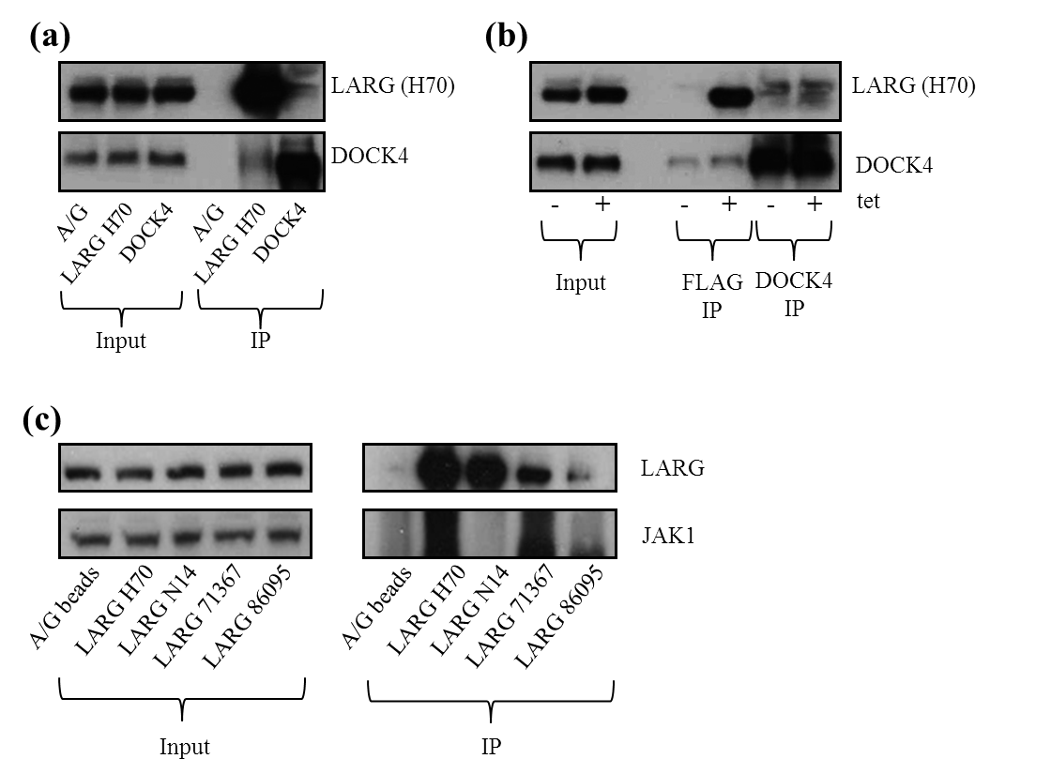

Figure 3.1.4 Attempts to confirm the potential LARG interactors identified by mass-spectrophotometry analyses.
(a) 1x10⁶ Hek293 cells were plated onto 3x10cm dishes. Endogenous IPs were performed using LARG (H70) or DOCK4 (ab85723) antibodies. Both antibodies successfully enriched their target proteins with potential weak interaction discussed above. A/G beads were used to control for non-specific binding.
(b) 1x10⁶ T-REx293-Flag-LARG cells were plated on to 4 10cm dishes, 24 hours after plating they were tetracycline induced and both M2-Flag and DOCK4 (ab85723) IPs performed as indicated.
(c) 1x10⁶ Hek293 cells were plated onto 5x10cm dishes; 24 hours after plating cells were lysed. Endogenous LARG was immunoprecipitated using 5µg of each indicated LARG antibodies with varying success. Samples were then probed for JAK1, no specific interaction was observed. A/G beads were used to control for non-specific binding. All IPs performed in 150nM NaCl to be representative of physiological conditions.

Confirmation of the Lamin A: LARG Interaction
The final protein from the mass spectrophotometry data to be investigated was Lamin A (encoded by LMNA), a nuclear envelope protein that has been associated with a number of phenotypically diverse diseases, with symptoms ranging from muscular dystrophy to premature aging (Progeria) (Schreiber and Kennedy, 2013). Of key importance to this project is the association of Lamins with the cell cycle and DNA replication/repair (Redwood et al., 2011), whereby loss of Lamin A has been associated with the down regulation of a number of DSB repair factors, most significantly 53BP1. Lamin A and Lamin C are splicing variants from the same LMNA gene, the variation is due to alternative splicing within exon 10 (Lin and Worman, 1993). This results in Lamin A having a predicated molecular weight of 69kDa and Lamin C with a predicted molecular weight of 62kDa. In order to assess a potential LARG:LaminA interaction endogenous IPs using four LARG antibodies were performed using Hek293 cells (figure 3.1.5).
As shown in the middle and lower panels in figure 3.1.5, the Lamin A/C antibody recognises both isoforms; seen in both the inputs and Lamin IP, however only the larger isoform of Lamin, A co-IPs with LARG (figure 3.1.5). Further to this, Lamin A was not observed in the A/G control lane but was present at levels relative to the strength of the N14, ab71387 and ab86095 LARG IPs. Lamin C appears to be present at very low levels in all IP lanes, including the A/G control (long exposure). This indicates that there may be some non-specific binding of Lamin C to the beads, however, such non-specific interaction is not seen for Lamin A. Unfortunately, LARG was not detected in the reciprocal IPs using the Lamin A/C antibody (figure 3.1.5). The initial enrichment of LMNA in the mass spectrometry data suggested a strong interaction with 0 peptides in the –tet and 8 peptides identified in the +tet. This is strongly supported by the specific interaction between the Lamin A isoform and not the Lamin C isoform with LARG through the endogenous IPs. As Lamins are nuclear envelope proteins this brings a strong requirement for investigation into LARG cellular localisation, particularly for nuclear envelop enrichment.
Overall these data present an encouraging case for a Lamin A:LARG interaction, giving further evidence of a possible role for LARG in the DDR pathway.

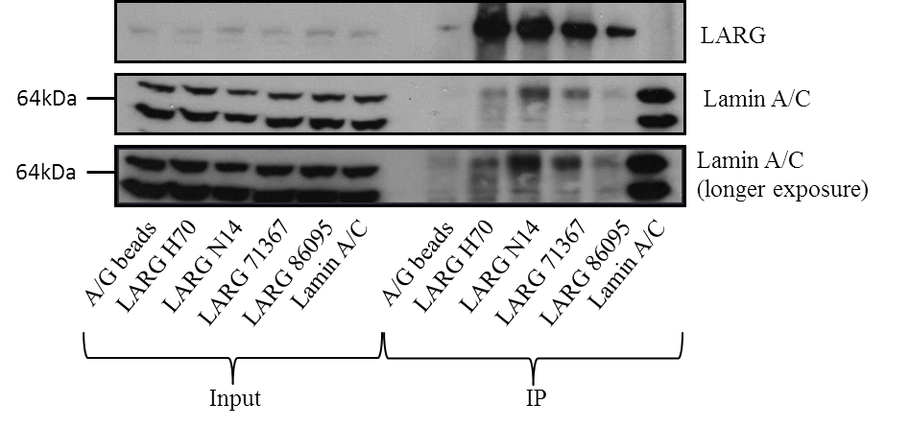

Figure 3.1.5 Confirmation of the LMNA interaction with LARG
1x10⁶ Hek293 cells were plated onto 6x10cm dishes. Endogenous IPs were performed using 5µg of four separate LARG antibodies and 5µg of Lamin A/C antibody. A/G beads were used to control for non-specific binding. 150nM NaCl lysis buffer was used to be representative of physiological conditions. Equal input levels of both LARG and Lamin A/C are present for all IPs, neither protein binds to the A/G beads control while all four separate LARG antibodies IP with varying success The Lamin A/C antibody recognises both isoforms; seen in both the inputs and Lamin IP but only the larger A isoform is present in the LARG IPs.

Discussion
One of the key pieces of preliminary data that led to this project was a yeast-2-hyrid screen to identify novel interacting partners of HCLK2 which identified LARG as a potential candidate. Therefore a key aim of this project was to confirm this interaction, as is demonstrated in figure 3.3.1 using both exogenous LARG and HCLK2 IPs as well as endogenously with HCLK2 siRNA. These data give confidence to an interaction between the two proteins and allows for further questions to be asked, the most significant being; does this interaction between proteins from two pathways rarely associated indicate a level of crosstalk? The limitations of these experiments does not allow for any real conclusion, the largest constraint being that this does not confirm a direct interaction between the two proteins, immunoprecipitation from whole cellular lysates isolates and purified protein complexes that contain the target protein. This means that all of the interactions observed within this chapter could be mediated by other proteins. In order to determine direct interaction proteins would have to be expressed and purified in bacteria before the addition of both purified proteins in vitro using physiologically relevant conditions with subsequent immunoprecipitation.
Even using over expressed LARG and HCLK2 constructs only a weak interaction was observed (figure 3.1.1), this may be due to differing pools of each protein being present in different locations within the cell. When initially identified it was noted that in cells over expressing HCLK2 the localisation was pan-cellular with a subset of cells displaying a weaker stain within the nucleus (Jiang et al., 2003). LARG localisation has been previously determined using micro-injected GFP-LARG (Goulimari et al., 2008). However this does not replicate normal cellular production of LARG it was observed that LARG followed microtubule tracts with further weight given to this when a change in LARG patterning was observed upon the breakdown of micro-tubules by nocodazole. No LARG was observed within the nucleus (Goulimari et al., 2008).
This indicates a cellular localisation allowing for interaction and does not isolate an interacting population, the interaction could be transient in nature either in response to stimuli affecting either signalling pathway or regulated by the cell cycle. In order to explore this further the immunoprecipitations in figure 3.1.1(a) and (b) could be repeated after treatment with agents that halt cell cycle progression such as nocodazole (mitosis), aphidicolin (s phase) and mimosine (G1) or after activation of DDR or Rho pathways. This would also indicate whether the interaction observed is functional.
The LARG interaction with PCNT observed in (Goulimari et al., 2008) was performed using a tagged version of LARG, although with both Myc and Flag tags, the identification of this interaction using endogenous proteins provides more robust evidence for this interaction (figure 3.1.2(a)). That a reciprocal interaction from PCNT immunoprecipitation is not observed could be due to the relative abundances of each protein, LARG has a cytoplasmic localisation while PCNT is found primarily at the centrosome; a small discrete organelle. Therefore in a given immunoprecipitation LARG would be interacting with a large population of PCNT within a cell however PCNT would likely be interacting with only a relatively small population of LARG. The over expression of LARG and PCNT constructs in figure 3.1.2(b) appears to overcome this issue as Myc-LARG is co-immunoprecipitated with full length Flag-LARG. High levels of PCNT expression were observed for the Flag constructs with a large number of bands of decreasing size observed in full length lanes most likely degradation products during protein expression due to the large size of PCNT (250kDa). As well as an interaction with full length PCNT, LARG was co-immunoprecipitated with the two further constructs containing the PACT domain (the only domain observed in PCNT). The PACT domain was demonstrated to be required for the centrosome localisation of PCNT, the addition of a PACT domain to a protein is enough to provide centrosomal localisation (Gillingham and Munro, 2000). Given that previous data using micro-injected GFP-LARG observed a possible co-localisation with PCNT at the centrosome (Goulimari et al., 2008) there is the potential that the LARG:PCNT interaction could be involved in PCNT localisation. No overt PCNT phenotype was observed in cells treated with LARG siRNA before immunofluorescence for PCNT (data not shown) and no change in PCNT protein levels were observed upon LARG depletion (figure 3.3.9(b)), indicating that LARG is not required for PCNT protein stabilisation or localisation.
However this is not the only possibility as there is strong evidence for PCNT having a role in microtubule nucleation, most notably through dynein (Young et al., 2000). Dynein motor proteins generate force and therefore movement through microtubules; it is also involved in other motor functions such as mitosis, cilia and axonal transport. Recent advances in x-ray crystallography have allowed for some understanding of the mechanisms of movement for the large multi-subunit motor to be extrapolated (Kikkawa, 2013). Dynein has been implicated in the recruitment of PCNT and γ Tubulin to the centrosomes; further to this the assembly of these proteins in a dynein dependant manner assists microtubule nucleation (Young et al., 2000), and is required for mitotic entry (Zimmerman et al., 2004). It has also been noted that cytoplasmic dynein is involved in microtubule retention at the centrosome and loss of dynein leads to microtubule dissociation from the centrosome (Burakov et al., 2008). Early evidence suggested that the microtubule organising centre (MTOC) orientation was regulated by Dynein and Cdc42 (Palazzo et al., 2001) however further research implicated Rho signalling through the Gα12/13 proteins (Goulimari et al., 2008), both papers demonstrating that LPA induces MTOC repolarisation. Thus Dynein is potentially the link between LARG and PCNT due to its role in the MTOC polarisation and PCNT localisation, further to this cytoplasmic dynein heavy chain 1 was identified in the LARG proteomic data with slight enrichment (3 to 5 peptides -/+ tet). This was not followed up at the time as other hits with more confidence were identified. Recently a number of mutations in Dynein Heavy Chain 1 have been implicated in malformations of cortical development, phenotypes of which include microcephaly (Poirier et al., 2013). This is particularly pertinent as PCNT has previously been implicated in the DDR disorder MOPDII, of which one of the main phenotypes is also microcephaly (Griffith et al., 2008). Although the mechanism leading to microcephaly is not yet fully understood it is thought to be due to errors in the complex asymmetrical mitosis required for neural development leading to a reduction in cell division and ultimately cell loss (this will be discussed further in chapter 3.4). Therefore the link between Dynein and PCNT with mitosis through a direct interaction contributing to the mitotic spindle (Purohit et al., 1999) could represent a common mechanism that is deregulated in abnormal brain development, although this is only speculation. As is common with many centrosomal proteins, over expression of PCNT and Dynein has been associated with cancerous phenotypes (Vadlamudi et al., 2004, Kim et al., 2008a).
The mass spectrophotometry results obtained from LARG immunoprecipitation gave rise to a possible interaction with DOCK4, although as discussed earlier efforts to confirm this interaction were inconclusive. Figure 3.3.4(a) and (b) indicate a possible weak endogenous interaction; however this was not replicated using Flag or DOCK4 to immunoprecipitate from Flag-LARG over expressing cells. Recent data indicates that LARG is required for the abscission step of cytokinesis (Martz et al., 2013), although a demonstrated enrichment of LARG at the furrow during abscission this was not observed during the LARG localisation studies presented in chapter 3.2.
As mentioned previously DOCK4 is a RacGEF, unlike LARG it is regulated by RhoG and itself activates Rac (Rac being one of the 3 subfamilies under the Rho superfamily). Activation of DOCK4 requires a partner protein known as ELMO. Upon activation the DOCK4-ELMO complex is translocated to the cell membrane where it in turn activates Rac by substitution of GDP for GTP. This in turns leads to cell migration and depletion of DOCK4 leading to reduced migration (Hiramoto et al., 2006), Rac is specifically involved in the formation of lamellipodia at the leading edge of cell migration (Katoh et al., 2006). As with RhoA signalling there is growing evidence for a role in neurite development, mentioned in the introduction Rac and Cdc42 are involved in neural growth cone outgrowth. Further work has demonstrated that this role goes further than previously thought and Rac1 activation through DOCK4 is involved in Neurite differentiation and the arborisation of dendrites (formation of branching structures at the leading edge) (Xiao et al., 2013). A mutation that abolishes the GEF activity of DOCK4 and therefore prevents full neurite differentiation has been associated with autism, a disorder that has been linked with abnormal brain function (Pagnamenta et al., 2010). With the demonstrated role of LARG in neuronal growth cone collapse (Swiercz et al., 2002) and association with microtubule tracts up to the leading edge (Goulimari et al., 2008), an interaction with DOCK4 could therefore be linked to the regulation of the opposing mechanisms of action. Whereby Rac1 and Cdc42 act to migrate the neuronal growth cone forward while LARG activation leads to growth cone collapse and stress fibre formation.
Away from neuronal growth and turning to tumour cells, RhoA signalling has been implicated in the mediation between Rac1 and Cdc42 signalling in protrusion and migration. It has been demonstrated that inhibition of ROCK (the target of active RhoA) leads to hyper activation of Rac1 and a switch from Cdc42-dependant to Rac1-dependant protrusions, although despite increased protrusion this inhibition led to an overall decrease in motility (El-Sibai et al., 2008). It is thought that Rho/ROCK signalling regulates the coupling of Rac1 and Cdc42 to actin at the leading edge; therefore an interaction between activating GEFs for RhoA and Rac1 could be involved in regulation of cellular protrusion (Rac1) followed by focal adhesions formation and contractile force generation (RhoA). In order to observe this, the effect of LARG depletion on DOCK4 activity could be assessed (Rac1 activation can be measured in a similar was to RhoA through specialised ELISA assays). However prior to this the interaction with LARG would need to be confirmed, firstly by repetition of the immunoprecipitation experiments performed in figure 3.1.4, followed by conformation of the bands through the use of siRNA as shown in figure 3.1.1. Tagged LARG domain constructs were produced (see supplementary data figure S1) to allow for mapping of any subsequent interaction, these include constructs containing the PH-DH and DH alone creating the opportunity to observe if an interaction could affect the GEF activity of LARG (as reduced RhoA activity is linked with increased Rac1 activity).
The Lamins are a group of proteins that form the nuclear lamina complex, composed of three family members A, B and C. Lamin A and C are encoded by the same reading frame, consisting of 12 exons. It is through splicing of exon 10 that the two Lamin variants that vary in size by 7kDa, Lamin A at 69kDa and C at 62kDa (Lin and Worman, 1993). Despite such minor differences there are specific roles for each, such as the requirement of Lamin A for Lamin C localisation to the nuclear envelope (Vaughan et al., 2001)
The mass spectrophotometry data in figure 3.1.3 gave enrichment from 0 to 8 peptides for Lamin A/C and 13% peptide coverage, although this coverage prevented prediction of whether this interaction was specific to one isoform or both. Figure 3.3.5 demonstrates that LARG only interacts with the larger Lamin A isoform. The roles of Lamins in cellular function are varied, from nuclear envelope assembly (Goldman et al., 2002), chromatin organisation, transcription (Shimi et al., 2008) to DNA replication (Moir et al., 2000). Lamins have been associated with a variety of diseases including Emery-Dreifuss muscular dystrophy and various cardiovascular diseases (Mounkes et al., 2001). Perhaps the most relevant disorder to this project is Hutchinson-Gilford syndrome (HPGS), which has been linked to mutations in Lamin A, creating a truncated form referred to as Progerin. Phenotypes of HPGS include growth retardation, atherosclerosis, an absence of subcutaneous fat and premature aging (Progeria) leading to a median survival of just over 13 years. (Goldman et al., 2004, De Sandre-Giovannoli et al., 2003). While the impaired ability to repair complex DNA damage has long been associated with aging (Bohr and Anson, 1995), it has led to research that demonstrated that defective Lamin A maturation can lead to accumulation of Progerin resulting in genomic instability and DNA damage, with a demonstrated defect observed in Rad51 and 53BP1 recruitment to DNA lesions as well as sensitivity to a number of genotoxic agents including MMC after disruption of Lamin A (Liu et al., 2005). Further evidence for genome instability was observed by the accumulation of DSBs demonstrated using comet assays in cells derived from HGPS patients (Liu et al., 2008). There is strong evidence that Lamin A controls the expression and degradation of members of the NHEJ and HR pathways, a role thought to be in conjunction with the cysteine protease CTSL, leading to 53BP1 degradation and down regulation of RAD51 transcription (Redwood et al., 2011).
Most recently the role of Lamin A/C in DDR has been expanded with an effect on replication fork determined via the deletion of LMNA. It was observed that Lamin A/C deficient cells were sensitive to ICL inducing agents, however unlike previous publications it was noted that replication stress induced by HU led to delayed disappearance of γH2AX and defective recruitment of a number of replication stress associated repair proteins such as RPA, MRE11 and FANCD2 (Singh et al., 2013). A more direct role for Lamin A was suggested by recent data demonstrating a reduction in mobility of Lamin A within the nucleus after DNA damage, suggesting that incorporation of Lamin A into protein complexes is triggered by damage. However although these structures did not co-localise with regions of damage, although it was observed that Lamin A depleted led to a reduction in stability of DDR associated foci (Mahen et al., 2013). Further to this, as mentioned earlier, loss of LaminA/C leads to phenotypes associated with Rho signalling, namely polarisation and scratch wound invasion (Lee et al., 2007)
Taken together these is circumstantial evidence for a role of Lamin A in the DDR, potentially linking LARG as a novel interacting partner that also interacts with HCLK2 and PCNT suggesting a functional relationship. It would be important to demonstrate LARG localisation at the nuclear membrane to support this hypothesis as well as comparing molecular phenotypes in the DDR between LARG and Lamin A depleted cells. Both of these questions will be addressed in coming chapters.

3.2 LARG localisation studies and effects on ciliogenesis
To further characterise a possible role for LARG in the DDR, we turned to investigating its cellular localisation, which would hopefully yield insights into the interactions observed with PCNT and HCLK2 (Chapter 3.1). Previous published data on LARG localisation relied on using micro-injection of differing amounts of GFP-LARG in mouse embryonic fibroblasts cells (Goulimari et al., 2008). Using this technique it was determined that LARG was predominantly cytoplasmic, localising to microtubule tracks and co-localising with PCNT at the centrosome. The initial aim of the localisation studies was to confirm this with endogenous LARG and if possible observe any change in LARG dynamics in response to genotoxic stress as is observed with the RhoGTPase Net1 (Dubash et al., 2011).

Endogenous LARG staining
In order to control for non-specific binding of the primary antibodies, LARG specific siRNA was used throughout these studies as confirmed by western blots showing a significant reduction in LARG protein levels (figure 3.2.1). The efficacy of the LARG siRNAs was deemed sufficient to validate any subsequent staining during immunofluorescence optimisation studies.

Figure 3.2.1 LARG siRNA mediated knockdown in HeLa cells.
HeLa cells were plated and transfected with a non-targeting siRNA and two LARG siRNAs following the ‘Transfection of mammalian cell cultures’ protocol. Lysates were separated using standard SDS-PAGE followed by western blotting for indicated proteins. LARG siRNA #5 and #6 had been previously validated by Dr. Spencer Collis (data not shown).
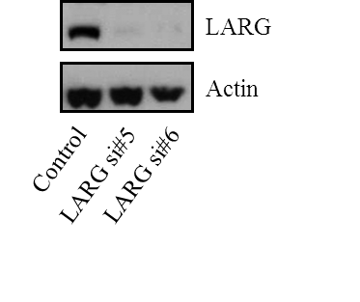
Figure 3.2.2 shows the staining observed using the SantaCruz H70 LARG antibody, as employed in the western blots in Figure 3.1.1 (raised to the N-terminal 70 amino acids). The staining pattern is pan cellular and does not show LARG to be excluded from the nucleus as was observed in (Goulimari et al., 2008). However mitotic cells show a distinct exclusion of LARG from the DNA in metaphase. Unlike previous studies (Martz et al., 2013) no centrosomal staining was observed in any cells (Figure 3.2.2). Importantly, this staining pattern was not altered when LARG was depleted using siRNA, indicating that the observed staining was highly likely to be a non-specific interaction of either primary or secondary antibodies. A secondary antibody alone control can be seen in the bottom set of panels in Figure 3.2.2. Very little non-specific binding of the Alexa Fluor 488 was observed indicating that the majority of the staining obtained using the H70 antibody was due to non-specific binding of the primary antibody. This experiment was repeated using H70 antibody at dilutions of 1:50, 1:250 and 1:500 however, no change in the staining pattern was observed (data not shown).
HeLa cells were nocodazole blocked and released in order to enrich for cells undergoing cytokinesis (Figure 3.2.3). This would also help to determine if the non-specific staining seen in Figure 3.2.2 was observed throughout all stages of the cell cycle or if LARG localisation was dynamic and led to a stronger detectable signal due to highly localised protein accumulation. However a similar staining pattern was observed in all nocodazole blocked and released samples, and this pattern did not change in LARG siRNA treated cells (Figure 3.2.3), further indicating further non-specific binding. These data show that the H70 antibody was not useful for immunofluorescence study of endogenous LARG.
As other commercial antibodies for LARG were available these were employed in further immunofluorescence experiments. Similar to studies using the LARG H70 antibody, siRNA was used to deplete endogenous LARG and where appropriate a further secondary alone control was added (only when the LARG antibody used was raised in a different species).
The first of the new batch of antibodies to be tested was SantaCruz N14, raised in goat to the N terminus of LARG. Figure 3.2.4 shows an example of the pan cellular staining obtained with this antibody, with an emphasised nuclear stain (although excluded from the nucleolus). However as with the H70 antibody the staining pattern did not change after depletion of endogenous LARG using siRNA, nor did a secondary alone control show any significant non-specific staining (Figure 3.2.4).
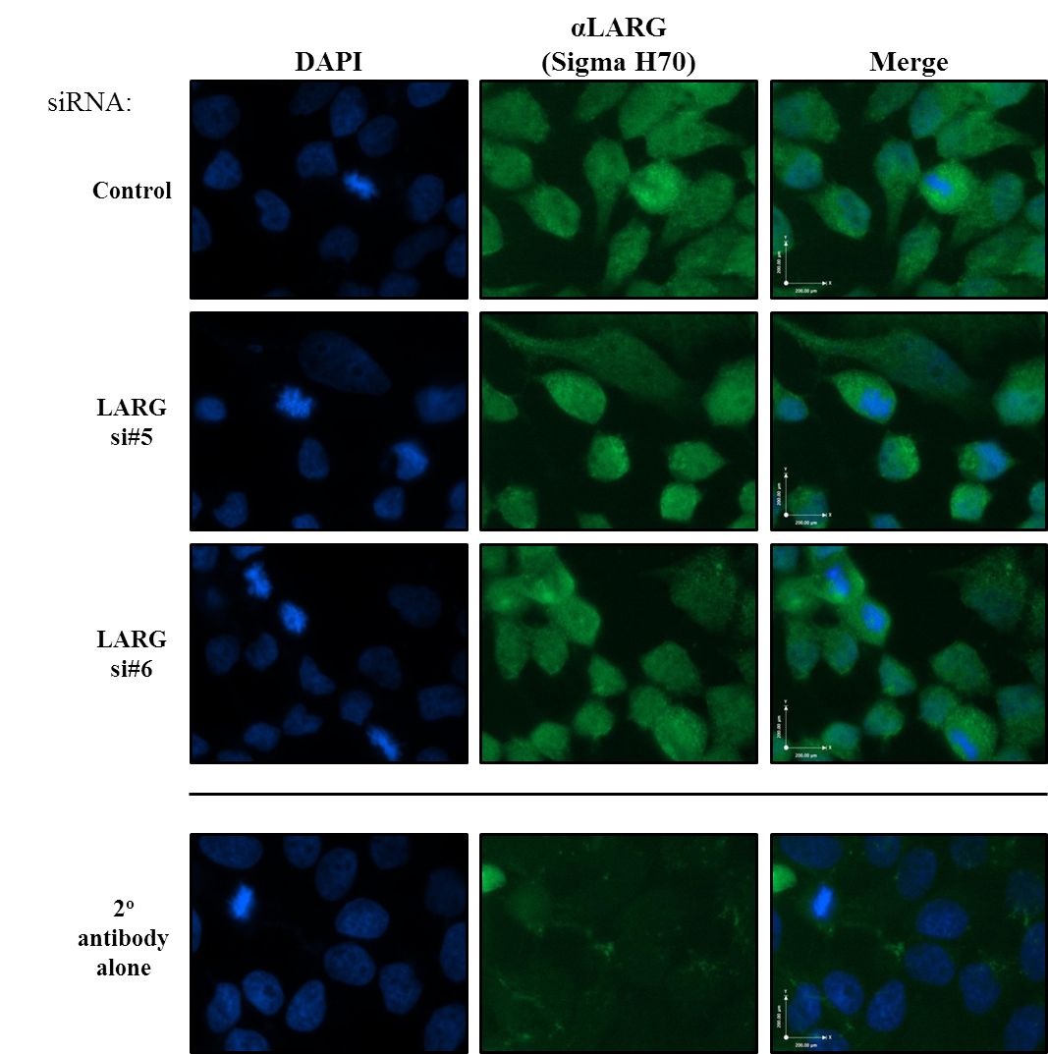

Figure 3.2.2 Assessment of LARG localisation using the rabbit anti LARG H70 primary antibody
HeLa Cells were transfected with control (non-targeting) or LARG siRNA and stained using a standard immunofluorescence protocol (see Materials and Methods). The LARG H70 primary antibody was used at a dilution of 1:1000 to visualise endogenous levels of LARG. In order to control for non-specific binding of the primary antibody LARG siRNA was employed to deplete endogenous LARG. Non-specific binding of the secondary antibody (Rabbit AlexaFluor 488) was controlled for using a secondary alone sample, this was kept in block during primary incubation of the H70 primary. Representative images are shown.

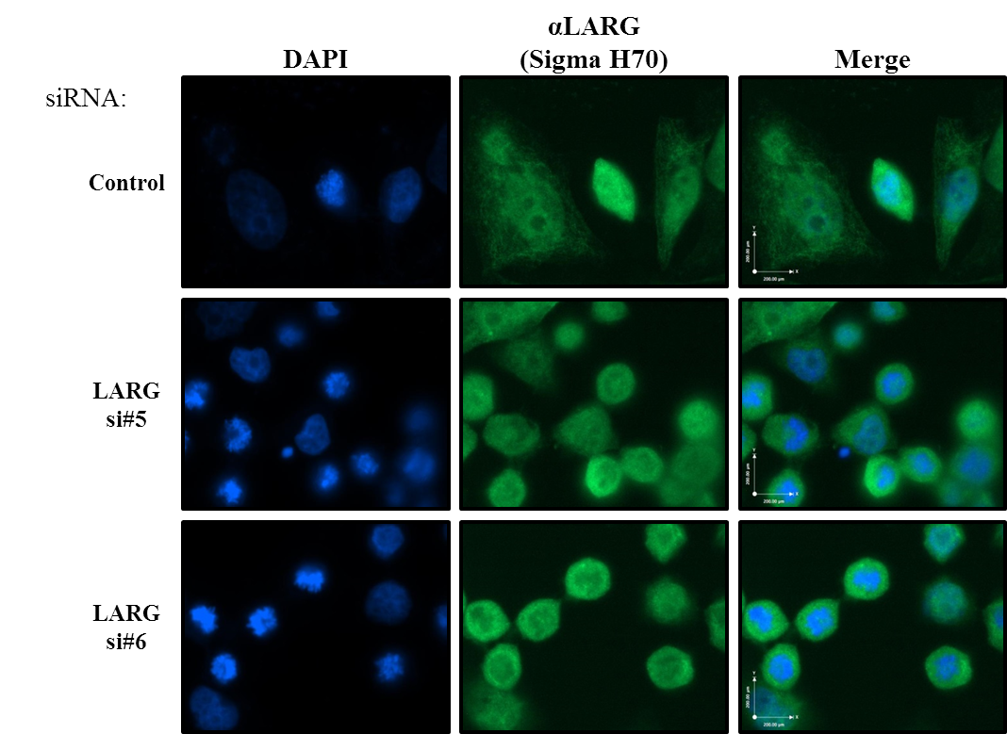

Figure 3.2.3 Mitotic enrichment of HeLa cells and subsequent LARG staining using the H70 primary antibody.
HeLa cells were treated with control (non-targeting) or LARG siRNA following the ‘Transfection of Mammalian cells’ protocol, 48 hours after transfection cells were incubated with the microtubule polymerisation inhibitor Nocodazole (Zieve et al., 1980) at a concentration of 100ng/ml for 16 hours, washed with warm PBS and incubated in complete media for 2 hours before fixation and staining with the LARG H70 antibody (used at 1:500). Representative images are shown.

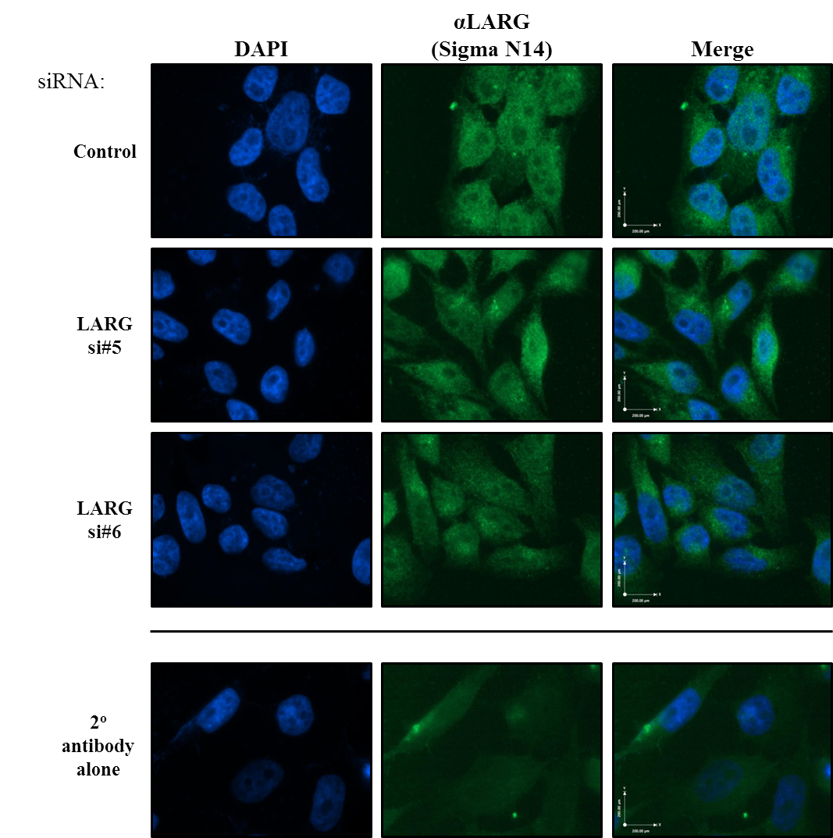

Figure 3.2.4 Assessment of LARG localisation using the Goat LARG N14 primary antibody
HeLa Cells were transfected with control (non-targeting) or LARG siRNA and stained using a standard immunofluorescence protocol (see Materials and Methods). The LARG N14 primary antibody was used at a dilution of 1:1000 to visualise endogenous levels of LARG. Non-specific binding of the secondary antibody (Goat AlexaFluor 488) was controlled for using a secondary alone sample, this was kept in block during primary incubation of the N14 primary. Representative images are shown.

Two further commercial antibodies were tested in a similar manner to those above; ab71367 (raised in rabbit to a synthetic peptide representing aa150-250 of LARG) and ab86095 (raised in rabbit to a synthetic peptide to the regions between aa1350-1400 of LARG). Figure 3.2.5 shows an example of the low level pan cellular staining obtained with ab71367 in both non-targeting and LARG specific siRNA treated cells, again indicating non-specific staining.
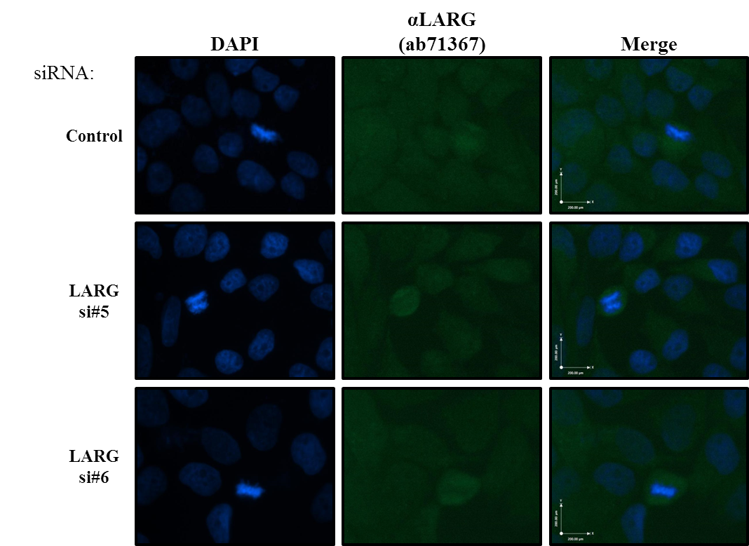

Figure 3.2.5 Assessment of LARG localisation using the rabbit LARG antibody ab71376
HeLa Cells were transfected with control (non-targeting) or LARG siRNA and stained using a standard immunofluorescence protocol (see Materials and Methods). The LARG ab71367 primary antibody was used at a dilution of 1:1000 to visualise endogenous levels of LARG. Levels of non-specific staining of the rabbit Alexa Fluor 488 antibody can be seen in the bottom panels of Figure 3.2.2. Representative images are shown.

The final LARG antibody tested was ab86095. As with previous antibodies a pan-cellular staining was observed (Figure 3.2.6). However mitotic cells displayed a distinctive staining of the spindle apparatus, although it was not clear whether this represented the MTOC or microtubules themselves. As LARG has previously been shown to co-localise along microtubule tracts (Goulimari et al., 2008) this was encouraging. However, as was confirmed for previous antibodies this staining did not change upon siRNA mediated LARG depletion, strongly suggesting that it represents non-specific staining.

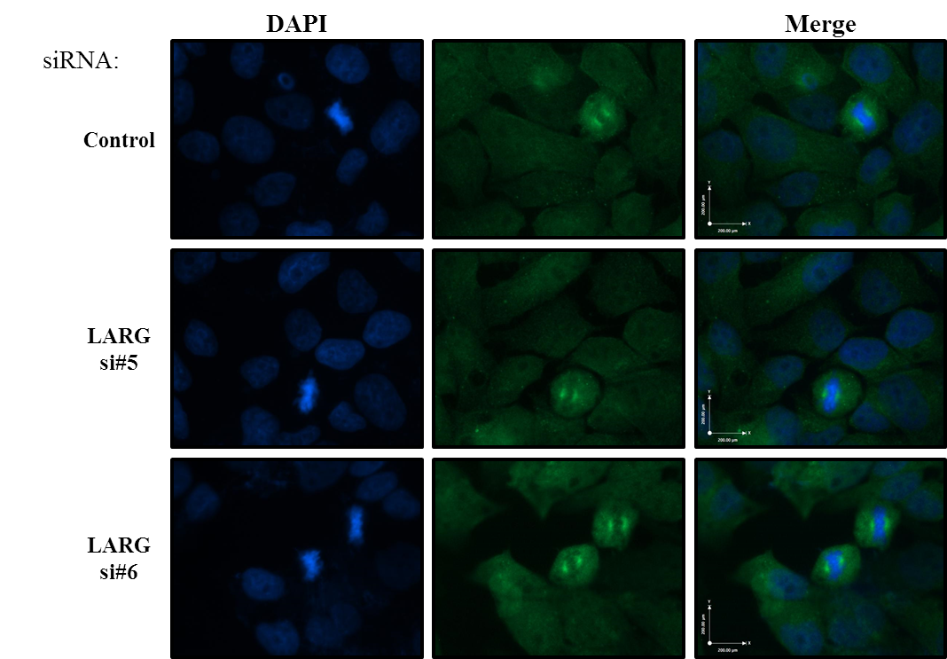

Figure 3.2.6 Assessment of LARG localisation using the rabbit LARG antibody ab86095
HeLa Cells were transfected with control (non-targeting) or LARG siRNA and stained using a standard immunofluorescence protocol (see Materials and Methods). The LARG ab86095 primary antibody was used at a dilution of 1:1000 to visualise endogenous levels of LARG. Levels of non-specific staining of the rabbit Alexa Fluor 488 antibody can be seen in the bottom panels of Figure 3.2.2. Representative images are shown.

It is important to note that all four antibodies were tested in a variety of conditions; methanol fixation over PFA showed no staining for the H70 and N14 antibodies, while ab71367 and ab86095 showed similar but lower level staining to that achieved with PFA fixation (Figure 3.2.7). LARG depletion was performed but no change in antibody staining was observed (data not shown).
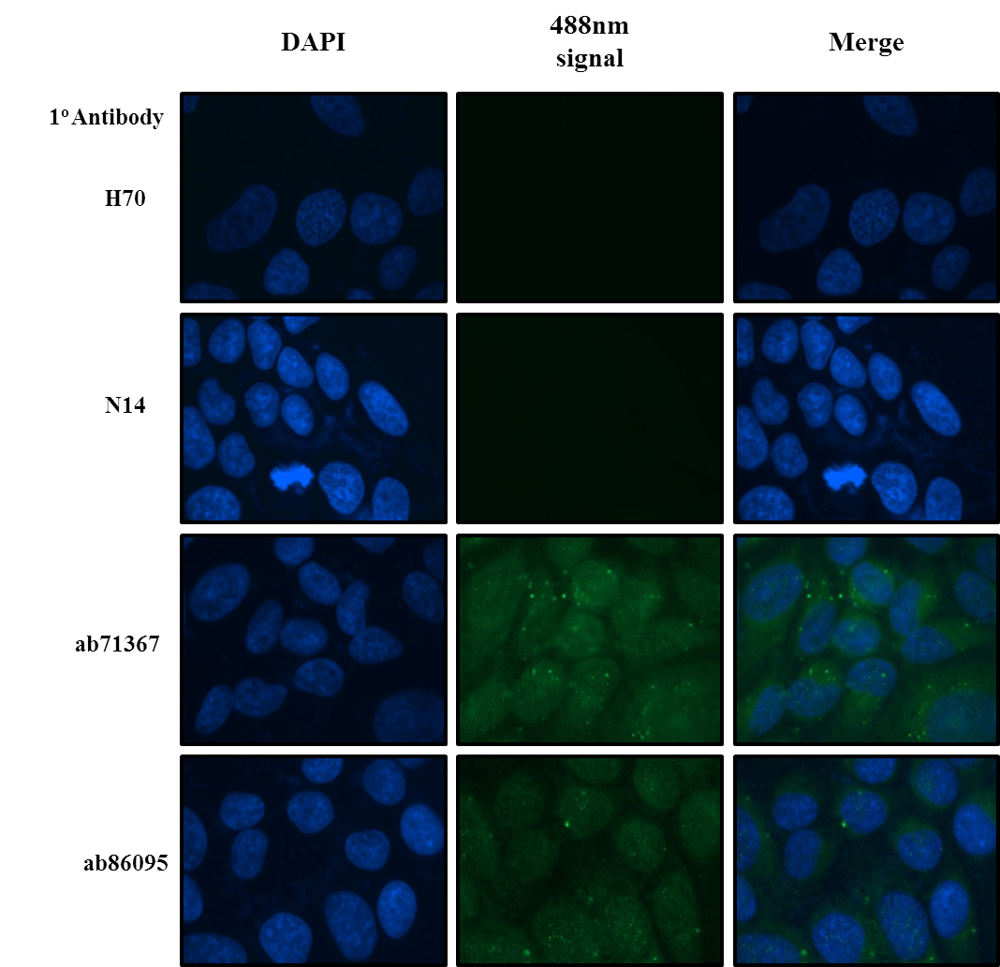

Figure 3.2.7 Methanol fixation and permeabalization for direct immunofluorescence visualisation of endogenous LARG
HeLa cells were fixed and permeabilised using ice cold methanol before staining with four endogenous LARG antibodies; H70, N14, ab71367 and ab86095 all using a 1:500 dilution. Cells were incubated for 10 minutes in ice cold methanol before being washed with PBS and the standard Immunofluorescence protocol was then followed from the blocking step (see Materials and Methods). Representative image are shown.

Creation of tetracycline-inducible YFP-LARG expressing cells
Due to the lack of success in optimising a number of commercially available endogenous LARG antibodies, a YFP-tagged LARG expression plasmid was produced and used to generate a T-REx-HeLa-YFP-LARG cell line following the ‘Production of T-REx cell lines’ protocol (see Materials and Methods). Figure 3.2.8 shows the tetracycline inducible nature of the YFP-LARG construct. In the control siRNA lanes endogenous LARG can be seen but a larger modified version is observed in tet induced lane, the increase in size is due to the addition of an N-terminus YFP tag of approximately 35kDa. In both siRNA lanes no endogenous or YFP-LARG was observed, indicating that the level of YFP-LARG transcript induced was not large enough to overcome the siRNA mediated depletion of the mRNA. The specificity of the siRNA also gives confidence to the identity of the YFP tagged protein. It is worth noting that the YFP-LARG band observed in the control induced lane is not as intense as the endogenous levels in the lysate, indicating a low overall expression or a low expressing population of cells among the whole population (see later images).
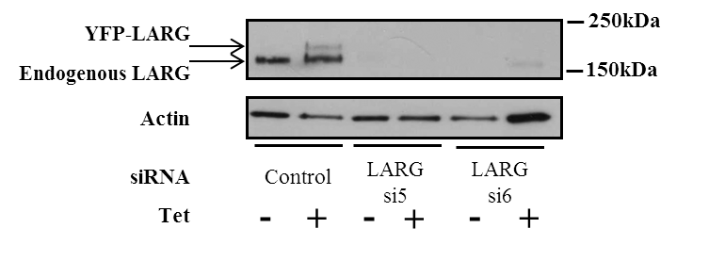

Figure 3.2.8 Expression testing of tet inducible N terminal T-REx-HeLa-YFP-LARG
T-REx-HeLa cells expressing N terminally tagged YFP-LARG were produced following the ‘Generation of T-REx cell lines’ protocol (See Materials and methods). Expression was tested in 6 well dishes. Wells were treated in duplicate with non-targeting or LARG specific siRNA for 24 hours before one of every pair of wells was induced using 1µg/ml tetracycline for a further 24 hours before lysis. Samples were separated using standard SDS-PAGE followed by western blotting on a 4-12% gradient gel and probed for endogenous LARG (H70).

Successful creation of the T-REx-HeLa-YFP-LARG cell lines allowed for direct visualisation of LARG. Figure 3.2.9 shows examples of uninduced cells where no YFP signal was observed while in the tetracycline induced cells a cytoplasmic, YFP signal was observed which was excluded from the nucleus but extended from the leading edge to the nuclear membrane (although cellular fractionation experiments were not performed to confirm this). Mitotic cells expressing YFP-LARG did not show LARG enrichment at the site of abscission as was observed in (Martz et al., 2013) who employed the LARG H70 antibody for immunofluorescence. However, although LARG siRNA was employed within the study by Martz et al. the effect of LARG depletion on endogenous staining using the H70 LARG antibody was not presented.
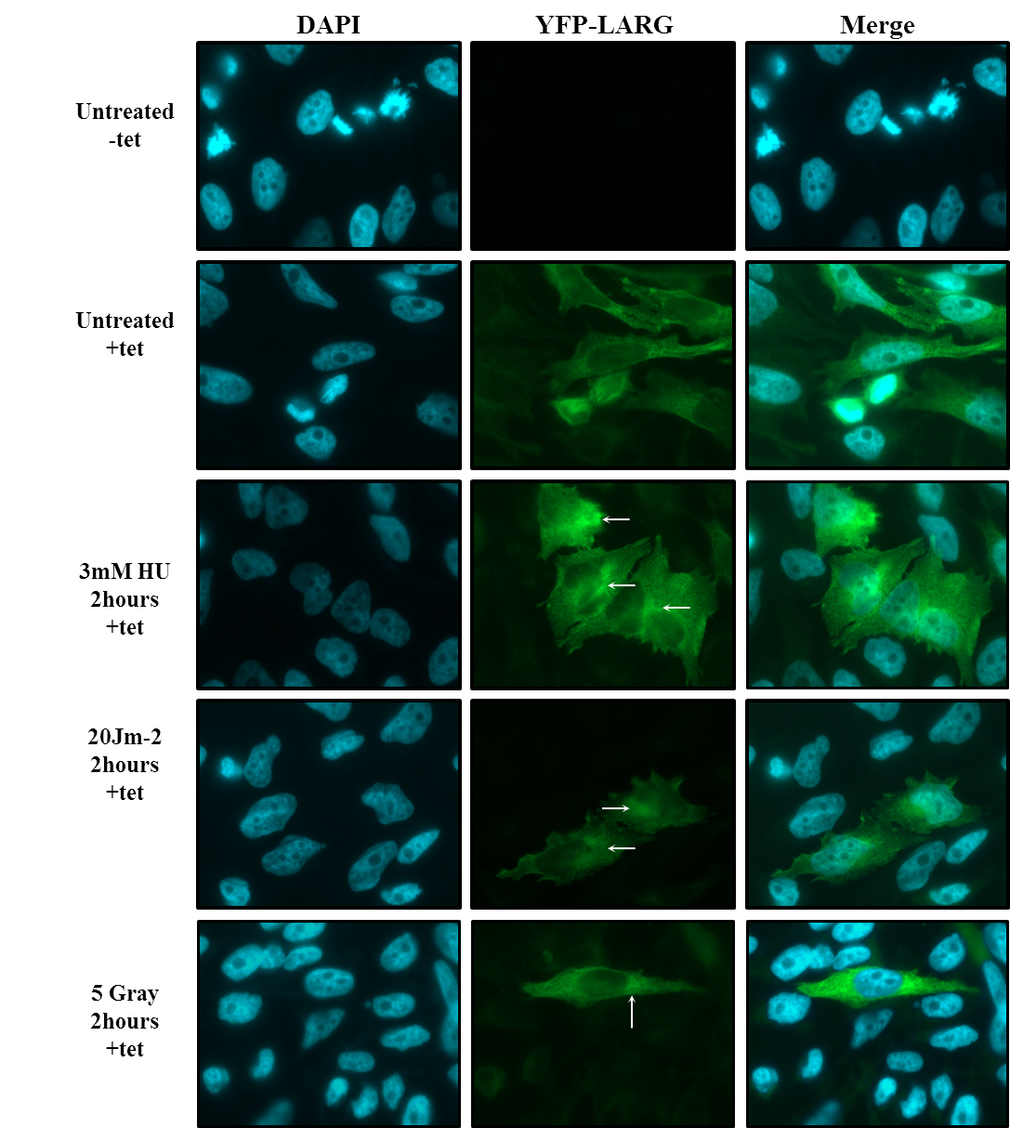

Figure 3.2.9 Direct Visualisation of YFP-LARG
T-REx-HeLa-YFP-LARG cells were plated onto cover slips in 24 well plates and left to adhere. Appropriate wells were incubated with 1µg/ml tetracycline for 24 hours before genotoxic treatments were administered as indicated. Cells were fixed using 4% PFA, permeabilised in 0.1% triton, DAPI stained and mounted. No antibody staining was employed. Representative images of each treatment are shown. White arrows indicate possible accumulation of YFP-LARG at the MTOC.
Cells treated with 3mM HU for 2 hours did not show any overt changes in YFP-LARG localisation; however a small increase in YFP intensity can be seen at one pole of the nuclei (white arrow figure 3.2.9). The role of LARG in cell polarity has been previously characterised, whereby reduction in LARG lead to poor MTOC polarity efficiency (Goulimari et al., 2008). A similar pattern is seen in both the 20Jm⁻² and 5 Gray treated samples (figure 3.2.9 white arrows). Consistent with previous data YFP-LARG staining appears to follow a microtubule tract associated staining in all induced samples (Goulimari et al., 2008), this would need to be confirmed by co-staining with α tubulin.
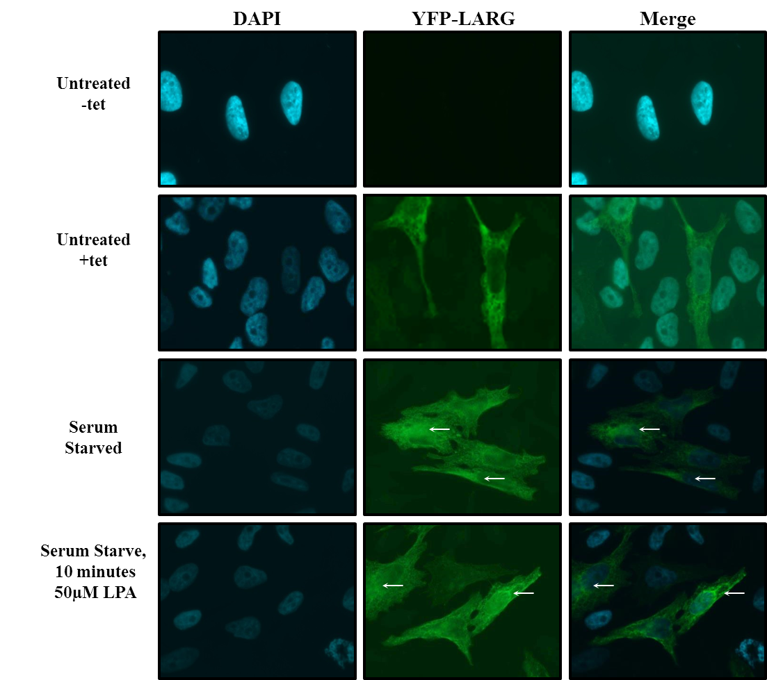

Figure 3.2.10 Direct visualisation of YFP-LARG cells under stressed conditions
T-REx-HeLa-YFP-LARG cells were plated onto cover slips in 24 well plates and left to adhere. Appropriate wells were incubated with 1µg/ml tetracycline for 24 hours before serum starvation. Cover slips were washed twice in warm SFM before incubation in SFM for 16 hours. Cells were either fixed or treated with 50µM LPA for 10 minutes before fixation in 4% PFA. FACs analysis suggested that only 7% of cells within the population were expressing measurable amounts of YFP-LARG. Cells shown here are representative of that population.

As LARG is a well characterised RhoGEF it was investigated whether or not changes to RhoA activation would affect the localisation of LARG. This was achieved by serum starving cells to reduce active RhoA and then activating the pathway with a short LPA induction. LPA activates LARG action through the Gα12/13 proteins and is strongly associated with RhoA activation and cancer as discussed earlier (Wang et al., 2004). RhoA activation occurs rapidly within the cell with peak activation occurring within 10 minutes and falling to baseline levels within an hour (Scott et al., 2007). After serum starvation of tetracycline induced T-REx-HeLa-YFP-LARG cells no change in LARG localisation was observed with or without LPA mediated RhoA induction, although as reported previously a potential enrichment of LARG at one pole of the nucleus was observed, possibly representative of the MTOC, α tubulin staining could be employed to confirm this (white arrows Figure 3.2.10). The MTOC is positioned towards the direction of movement of the cell, in this context this is the determinant of the poles of the cell, to confirm this a scratch wound could be introduced in a population of YFP-LARG cells, as the MTOC positions itself to allow for growth in to the gap (Goulimari et al., 2008) it would be postulated that the region of LARG enrichment would be on the same orientation for all cells along the well.
Previous published data suggested a co-localisation of LARG with PCNT at the centrosome, however this data was produced using the micro-injection of GFP-LARG directly into cells and staining for PCNT before visualisation (Goulimari et al., 2008). The production of an inducible YFP-LARG cell line presented the opportunity to investigate this co-localisation with a more robust system than previously described. The images in Figure 3.2.11 show the centrosomal localisation of PCNT (red) in both (a) interphase and (b) mitotic cells, where PCNT can be observed at either pole of the dividing cells (white arrows). YFP-LARG (green), as was been previously observed, was present along microtubule tracts with possible nuclear membrane enrichment (Figure 3.2.11), although lysis employing nuclear fragmentation would need to be employed to confirm this observation. Mitotic cells displayed staining typical of the microtubule re-organisation involved in mitosis although no enrichment at the abscission point was observed. However in addition to this, LARG enrichment was observed in the same position as PCNT in the interphase cells (a) and at both poles in the mitotic cells (b) (white arrows). When these images were merged regions of overlap were observed in centrosomal regions, with a Pearsone co-efficient of between 0.5-0.75 indicating an in-complete co-localisation but a high degree of overlap (a value of -1 would mean that there was no co-localiation while 1 would be complete co localisation) (Figure 3.2.11). The potential implications of an interaction mediated by the PCNT PACT domain and the centrosomal localisation of LARG will be discussed in greater detail in later chapters.
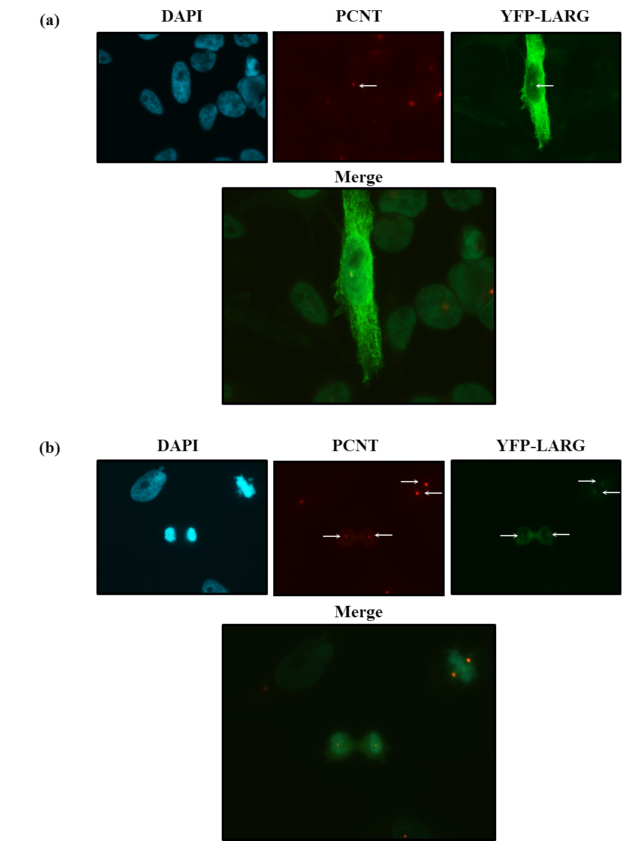

Figure 3.2.11 YFP-LARG localises with PCNT at the centrosomes
T-REx-HeLa-YFP-LARG cells were plated onto cover slips in 24 well plates and left to adhere. Wells were incubated with 1µg/ml tetracycline for 24 hours before fixation in 4% FPA, permeabilisation and incubation in PCNT primary, AlexaFluor 594 secondary and mounting. (a) a representative image of YFP-LARG:PCNT co-localisation in an interphase cell, this localisation was also observed in cells in anaphase (b). White arrows depict region of co-localisation.

Assessment of the effect of LARG depletion on ciliogenesis
Previous data has shown that loss of PCNT is detrimental to cilia formation with up to 80% of cells treated with PCNT siRNA unable to form cilia (Jurczyk et al., 2004), a molecular phenotype of ciliopathies, while mouse models suggest a universal role for PCNT in ciliogenesis (Miyoshi et al., 2006). Ciliopathies are a range of disorders that are due to defects in cilia which can cause a wide range of phenotypes including a polycystic liver, kidney disease, hydrocephalus and retinal degeneration as well as developmental defects such as polydactyly and mental retardation (Badano et al., 2006).
The importance of this link with LARG rests not only with the interaction and col-localisation with PCNT already described but also in recent evidence for a DDR link through the association of ATR to cilia and that mice harbouring the human Seckel ATR mutation present exhibit early degradation of retinal cells in a manner representing human retinal degeneration, similar to that observed in ciliopathies (Valdes-Sanchez et al., 2013)
In order to investigate a possible role for LARG in the ciliogenesis pathway retinal epithelial cells (RPE1) were transfected with LARG siRNA and serum starved to induce cilia formation. Cilia were visualised through the use of acetylated tubulin (green), a core component of the cilia while the localisation of the basal bodies was visualised by PCNT (red). Cilia formation was quantified by determining the number of basal bodies and the number that displayed an acetylated tubulin protrusion. Example images of these are shown in Figure 3.2.13 where cilia are highlighted by white arrows.
Quantification from multiple independent experiments gave a basal level of ciliated basal bodies in control siRNA treated cells that was increased 6 fold upon serum starvation (Figures 3.2.12 and 3.2.13); this is in line with what would be expected under normal conditions. However a 6-7 fold increase in ciliated basal bodies was observed in cells treated with each of the LARG siRNAs without serum starvation (Figures 3.2.12 and 3.2.13). This indicates that LARG plays an inhibitory role in ciliogenesis under normal cellular conditions. When exposed to serum starvation LARG depleted cells display a slight increase in cilia number when compared to those incubated in complete media. This modest increase of around 35% to 50% still represents a significant increase in cilia over control siRNA treated cells after serum starvation (Figure 3.2.13). While suggesting an anti-ciliogenesis role the further increase seen in LARG depleted cells after serum starvation indicates that there are other factors that are still regulating the ciliogenesis in response to serum starvation as otherwise little change in the cilia number with and without serum starvation would be observed. This will be explored further in the discussion section.
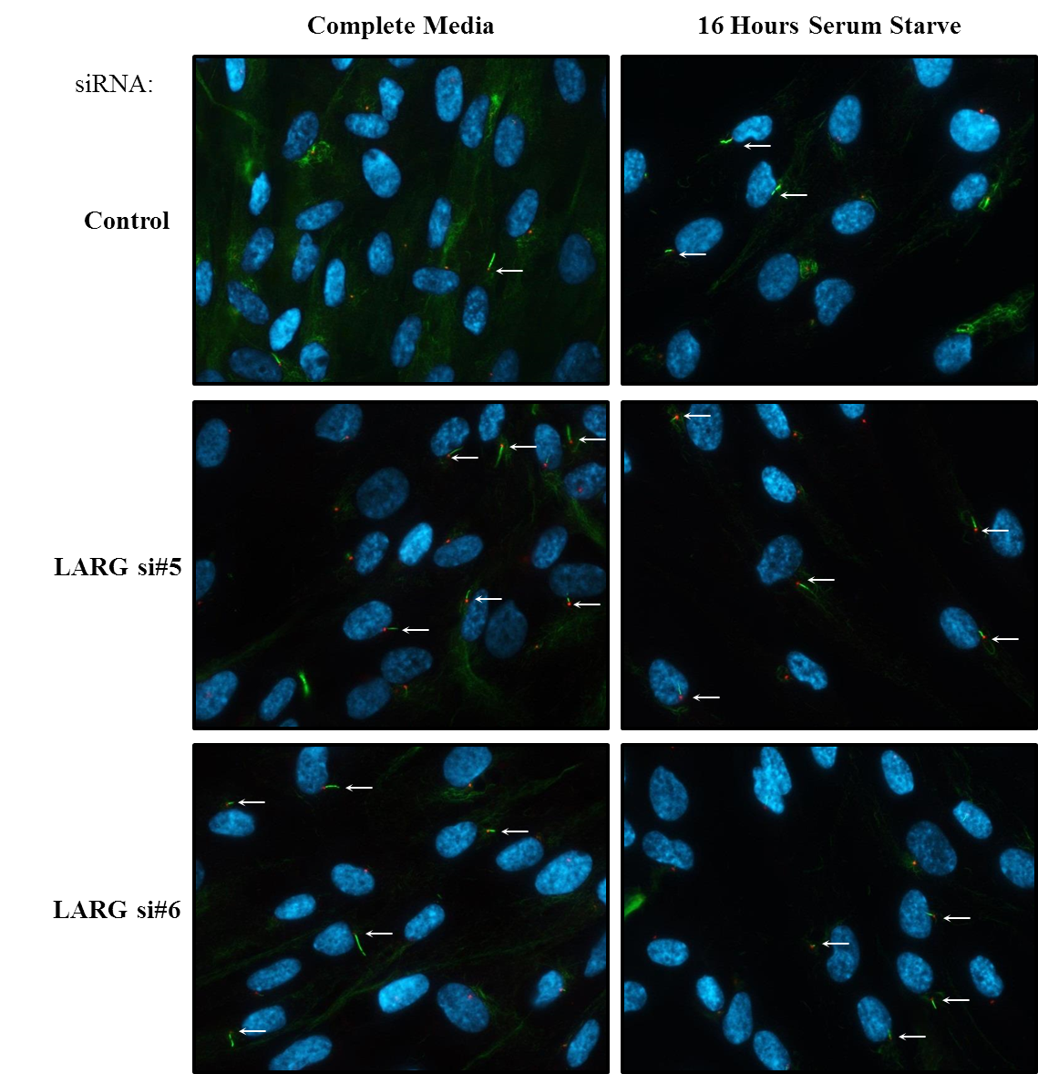

Figure 3.2.12 RPE1 cells treated with LARG siRNA display increased ciliogenesis
RPE1 cells were transfected with LARG siRNA as described in the ‘Transfection of Mammalian cells’ (see materials and methods), 48 hours after transfection relevant cells were serum starved for 16 hours to induce cilia formation before fixation in PFA. A standard immunofluorescence protocol was followed. Basal bodies were visualised by PCNT staining, cilia using acetylated tubulin and the nucleus with DAPI. Representative images from multiple independent experiments are shown. White arrows indicate ciliated basal bodies.

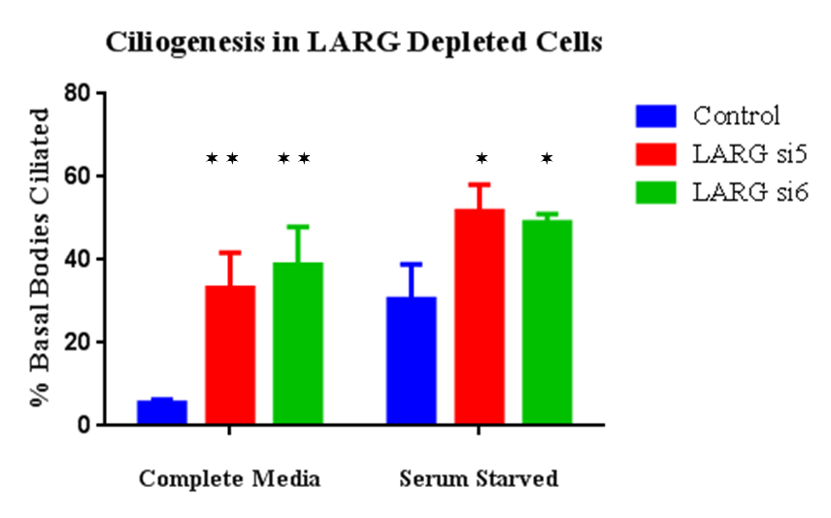

Figure 3.2.13 Quantification of cilia formation after LARG depletion using siRNA
The number of ciliated basal bodies was quantified with and without serum starvation and LARG depletion. An increase in ciliated basal bodies from 5% in control cells to 33% and 38% was observed for the LARG siRNA cells incubated in complete media respectively. As expected serum starvation increased the number from 5% to 30% in control siRNA cells, however the increase was more modest in LARG depleted cells rising to 51% and 49% for the two LARG siRNAs respectively however this was still significantly higher than control. A minimum of 100 cells were counted per experiment. Twin tailed students t-tests were performed assuming normal variance, =p ≤0.05, =p ≤0.01 (n=3).

Discussion
Much of the early section of this chapter focussed on the lack of specific binding of 4 endogenous LARG antibodies under a range of conditions. Recent work has identified LARG as potentially being involved in cytokinesis as a strong enrichment of LARG at the intracellular bridge at the point of cytokinesis was demonstrated using the LARG H70 antibody, alongside a pan cytoplasmic stain (Martz et al., 2013). Although a similar pan cellular stain can be observed in the control siRNA treated cells in figure 3.2.2 no enrichment in LARG at the intracellular bridge was observed, this is also true for the nocodazole treated samples shown in figure 3.3.3 (again using the H70 LARG antibody). With the inability to see changes in staining after siRNA treatment, this suggests non-specific staining of the endogenous LARG antibodies, YFP-LARG expressing cells were employed. Additionally in these cells, where the use of LARG siRNA to reduce both endogenous and tagged LARG gives confidence to the YFP signal source (Figure 3.2.8), no enrichment of YFP-LARG during cytokinesis was observed. The methods section details that as in the data presented here the HeLa cell line was employed by Matrz et al and variation in the staining protocol was minimal. Although minor changes in the protocols employed in the staining of endogenous LARG (increased fixation time and Triton concentration for permeabilisation) could lead to changes in staining using endogenous antibodies this does not account for the lack of accord using LARG siRNA or stably expressed YFP-LARG. These data suggest that if LARG localises to the intracellular bridge it is under conditions not observed using the YFP-LARG-Hela cell line.
The LARG localisation observed using YFP-LARG-HeLa cells is in agreement with previous data suggesting that LARG is found along micro-tubule tracts up to and including the leading edge, also conforming with LARGs role at stress fibre formation and cellular movement (Goulimari et al., 2008). While no overt changes in cellular localisation are observed in response to either DDR or RhoA inducing agents, a potential enrichment at one pole of the nucleus can be observed (white arrows figures 3.2.9 and 3.2.10) which could be linked to cytoskeletal rearrangements controlled through the MTOC. This would be consistent with the role of LARG in cellular polarisation through the MTOC, although why this would occur after DDR activation is unknown. To observe any possible changes in LARG at the leading edge of the cell in response to stress standard fluorescence microscopes are not ideal. To further investigate such changes a confocal microscope would allow for greater resolution of events at focal adhesion points as has been employed to observe FAK (a kinase linked with LARG/RhoA activation) at the leading edge while investigating actin dynamics and recruitment of proteins to focal adhesions (Hu et al., 2007, Pasapera et al., 2010).
The observation that Net1 activates RhoA and sequesters it to the nucleus in response to IR suggests a role for RhoA in the nucleus (Dubash et al., 2011). It has been demonstrated that LARG and Arhgef11 can enter the nucleus although only through modification of the extreme C terminal to prevent oligomerisation. Mono-meric LARG can then be shuttled to the nucleus through the CRM1 nuclear import pathway (Grabocka and Wedegaertner, 2007). This mechanism was given further weight through the use of the cytotoxin leptoMycin B, which has been demonstrated to block the CRM1 nuclear transporter (Fukuda et al., 1997) and prevented the nuclear localisation of mono-meric LARG to the nucleus. Whether or not this is possible under normal cellular conditions is not clear as LARG monomers have not previously been reported. While the hetero- and homo-dimerisation with Arhgef11 is well established, it has been demonstrated that all three RhoA GEFs have much greater RhoA activating potential as monomers following C terminal deletion, suggesting some level of auto inhibition in dimers (Chikumi et al., 2004a).
Expression of YFP-LARG in figures 3.3.9 and 3.3.10 indicate enrichment at one pole of the nucleus, most likely the MTOC, as well as a slight enrichment at the nuclear membrane. This could be used as supportive evidence for the Lamin A interaction observed is chapter 3.1. Further supporting this are the effects of Lamin A/C in the relationship between the nuclear membrane and the MTOC; loss of Lamin A/C has been demonstrated to lead to similar phenotypes to LARG depletion with regard to wound invasion and poor MTOC repolarisation (Lee et al., 2007). Soon after this link was established it was observed that cells derived from mouse laminopathic disease models showed a slight reduction in focal adhesion but a large reduction in RhoA activation and increased dissociation of the MTOC from the nucleus (Hale et al., 2008). This provides a strong link between the MTOC, RhoA activation and cellular movement for Lamin A/C and therefore phenotypic overlap with LARG depletion.
This interaction is further enhanced by the confirmation of the LARG:PCNT co-localisation observed in both interphase and mitotic cells (figure 3.3.11). PCNT as a core component of the centrosome is associated with the MTOC (Rieder et al., 2001). Although a localisation with LARG had previously been observed it had been through micro-injection of purified GFP-LARG into cells (Goulimari et al., 2008). The use of a stably expressed YFP-LARG cell line described in this chapter therefore provides a more robust demonstration of this co-localisation.
Recent work on the ATR Seckel mouse has identified a role in the ciliogeneiss, whereby ATR was observed to present at the cilia and loss of ATR functionality leads to photoreceptor degeneration in mice indicating ATR deficiency could lead to defects in cilia formation (Valdes-Sanchez et al., 2013). This phenotype is typical of a ciliopathy, a disorder characterised by defective cilia function. Every cell has the potential to invoke a non-motile cilia, with certain tissues such as the Kidney, Pancreas, Cartilage, Inner ear an Eye containing specialised cilia which although have some common structures exhibit cell specific attributes. The specialisation of cilia in photoreceptors focuses on transport between the inner and outer cellular compartments, acetylated α-tubulin marking the base of these cilia (Fliegauf et al., 2007). This is not the only gene associated with Seckel Syndrome to be associated with cilia defects. A mutation in the centrosomal protein CENPJ has been genetically linked to Seckel Syndrome (Al-Dosari et al., 2010) and a mouse knock out model of CENPJ was later demonstrated to phenocopy Seckel Syndrome (McIntyre et al., 2012). This included microcephaly and dwarfism however due to the nature of the study, which emerged from a large scale knockout project characterising a wide range of phenotypes, ocular defects were also identified. It was observed that there were a reduced number of photoreceptors displaying poor orientation (McIntyre et al., 2012). CENPJ was further characterised as being required for cilia formation using a system designed to monitor cilia formation, with loss of CENPJ leading to a loss of cilia formation (Wu and Tang, 2012). The data presented in figure 3.2.13 indicates that LARG plays an inhibitory role in cilia formation as the loss of LARG increases cilia formation (but does not affect cell cycle progression see supplementary figure S5), this observation has particular novelty as previous large scale screens have primarily looked at cilia formation after serum starvation (Kim et al., 2010) (values for LARG knockdown cilia formation after serum starve are similar in Kim et al., 2010 as observed in figure 3.2.13) .
RhoA has previously been implicated in cilia formation during differentiation of ciliated cells, however RhoA was required for early stages of ciliogenesis and inhibition in later stages of differentiation did not affect ciliogenesis (Pan et al., 2007). This study employed cells that differentiate into epithelial cells of the respiratory system and as such may not be representative of the non-motile cilia observed in retinal cells. In a similar manner Rac1 activation has been linked to Lowe syndrome (symptoms include mental and physical retardation and eye defects such as cataracts), a disease linked to ciliopathies (due to the presence of primary cilia assembly defects), whereby Rac1 activation is perturbed and leads to defective cilia formation and cellular movement (Madhivanan et al., 2012). The primary gene associated with Lowe syndrome is OCRL, a phosphatase that localises to cilia (Luo et al., 2012), the link to Rac1 being through perturbed balance between RhoA and Rac1 signalling either through poor Rac1 activation at internal membranes or through mis-regulation of downstream products from ORCL activity (Madhivanan et al., 2012). Therefore, given that RhoA/ROCK activation can lead to a reduction in Rac1 signalling (El-Sibai et al., 2008), it is possible that if left unchecked Rac1 could give rise to increased unscheduled ciliogenesis, as has been hypothesised for Lowe syndrome patients (Madhivanan et al., 2012). To investigate this further the ROCK inhibitor Y27632 (Ishizaki et al., 2000) could be employed; if this hypothesis were true it would lead to increased ciliogenesis. HCLK2 depletion did not lead to any abnormalities in ciliogenesis (data not shown), supporting a Rho mediated effect due to LARG depletion. It is not clear whether the phenotype observed in Seckel mice is due to changes in DDR signalling within the retina or if ATR is involved in other pathways related to ciliogenesis or cytoskeletal dynamics. However there is increasing evidence of links between ciliogenesis and the DDR with NEK8, a ciliary kinase recently being demonstrated to be involved in ATR signalling in response to replication stress (Choi et al., 2013). Large scale sequencing of patients with particular ciliopathies (Nephronophthisis-related) have also revealed mutations in the known DDR factors MRE11, ZNF423 and CEP164, further supporting this it was demonstrated that cep164 knockdown in zebrafish resulted in ciliopathy related phenotypes (Chaki et al., 2012).

3.3 Crosstalk between the DDR and RhoA signalling pathways

DDR integrity in LARG depleted cells in response to replication stress
In previous chapters I have demonstrated interactions between LARG and HCLK2, and LARG and PCNT. Both of these proteins have been implicated in the DDR pathway. HCLK2 provides stability for PIKKs, where depletion of HCLK2 leads to defective phosphorylation of Chk1 and aberrant degradation of Cdc25A in response to replication stress (Collis et al., 2007, Takai et al., 2007). PCNT is a centrosomal protein that has been found to be mutated in the DDR associated disease MOPDII. Cells derived from patients with PCNT mutations were demonstrated to possess defective ATR signalling manifesting in impaired induction of 53BP1 foci after HU treatment, increased nuclear fragmentation, a defective ATR dependant G2/M checkpoint and an increased number of cells displaying supernumerary mitotic centrosomes (Griffith et al., 2008) as well as increased disorganisation in mitotic spindles and chromosome mis-segregation (Rauch et al., 2008).
Supernumerary centrosomes are characterised by an increase in the number of cells within a population that display more than the standard two centrosomes required for normal mitosis, this is a common phenotype across Seckel Syndrome patients from a number of genetic backgrounds including mutations in ATR (Alderton et al., 2004), Cep152 (Kalay et al., 2011) and PCNT (Griffith et al., 2008). This is a clinically relevant phenotype for cancer as it can result in chromosome instability (CIN), whereby a cells transcriptional capacity is altered due to changes in chromosomal structure (alteration or loss). One cause of CIN is the mis-segregation of chromosomes during mitosis, normally a process mediated by two centrosomes forming a bi-polar spindle facilitating equal chromosome segregation. Chromosomal defects have been observed to increase with the severity of some tumour types, leading some to believe they could be clinically relevant markers of tumour aggression (D'Assoro et al., 2002). Links between DDR associated proteins mutated in cancer and centrosome number have are well established and have been made with reference to BRAC1 (Xu et al., 1999), ATR (Smith et al., 1998) and BRCA2 (Tutt et al., 1999), with more recent work demonstrating a role for Chk1 in the initial centrosome duplication (Bourke et al., 2007).
Centrin 2 is a core component of the centrosome and is required for efficient centrosome duplication (Salisbury et al., 2002). The replication of centrosomes is linked strongly to the cell cycle as demonstrated by the increased over duplication of centrosomes in GFP-Centrin 2 CHO cells exposed to HU for extended periods, after 20 hours in 2mM HU over 60% of observed cells displayed supernumerary centrosomes (Kuriyama et al., 2007). HU inhibits the enzyme Ribonucleotide Reductase (RNR), this prevents RNR from catalysing the formation of deoxyribonucleotides (dNTPs) (Elford, 1968b) thereby drastically reducing the rate of DNA replication as the pool of available dNTPs is vastly reduced (Alvino et al., 2007). This affects both the elongation and extension periods of replication and activates the intra-S checkpoint leading to ATR mediated DDR signalling (Feijoo et al., 2001).
The importance of the centrosomes in the cell cycle was further characterised when it was determined that loss of any one of 14 out of 15 centrosome associated proteins (including Centrin 2 and PCNT) results in cell cycle arrest at the G1-S checkpoint through a p53 mediated pathway and prevents normal centrosome duplication (Mikule et al., 2007). Conversely, over expression of Cdc25B, a phosphatase essential for cell cycle progression from G2 into mitosis (Lammer et al., 1998), has recently been demonstrated to increase Centrin 2 levels at the centrosome and lead to over duplication of centrosomes (Boutros et al., 2013).

LARG depleted cells display supernumerary centrosomes in mitotic cells
As a well-established phenotype associated with DDR defects, supernumerary centrosomes were assayed in GFP-Centrin2-HeLa lines using siRNA specific for LARG. After knock-down cells were fixed in PFA before immunofluorescence staining for DAPI and αTubulin was performed. Mitotic cells were assessed using GFP-Centrin 2 and tubulin polymerisation to determine multi-polarity, see figure 3.3.1a for representative images. Analysis of centrosome number in cells treated with a non-targeting control gave a population of 1.4% with supernumerary centrosomes; however after treatment with LARG siRNA this figure rose to 10.7% and 9.9% for LARG siRNA #5 and #6 respectively (figure 3.3.1b). This phenotype was also observed in U2OS cells (data not shown) providing further confidence for this data. Having already established that LARG interacts and co-localises with PCNT and that depletion of LARG results in dis-regulation of cilia formation this result further supports a role for LARG in centrosome biology.

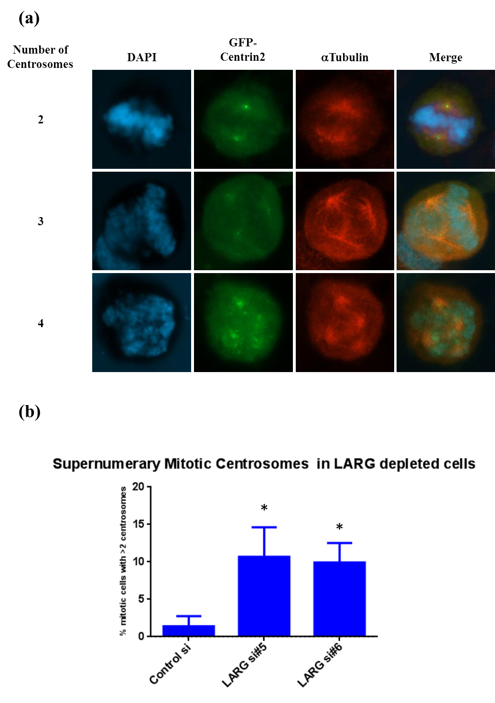

Figure 3.3.1 Cells depleted of LARG display supernumerary centrosomes
GFP-Centrin2-HeLa cells were transfected with a non-targeting control or one of two LARG specific siRNA oligos (see Materials & Methods). After 48 hours cells were fixed in 4% PFA before undergoing a standard immunofluorescence protocol to stain for DAPI and tubulin. 80-100 mitotic cells from an unmanipulated population of cells were assessed for centrosome number for each siRNA treatment. (a) Examples of normal and supernumerary cells can be observed with increasing number of centrosomes leading to abnormal chromosome separation in metaphase. (b) LARG siRNA was observed to increase the percentage of cells displaying supernumerary centrosomes. n=3, * denotes a P value ≤0.05 using a paired twin tail students T-test assuming equal variance.

γH2AX foci formation in response to replication stress is perturbed upon LARG depletion
The phosphorylation of γH2AX on Serine 139 by ATM and ATR has long been an established DDR event, originally identified in the cellular response to DSBs after IR treatment (Rogakou et al., 1998). This event was soon recognised as playing a central role in downstream signalling and recruitment and retention of repair factors such as BRCA1, Rad50 (Paull et al., 2000) and 53BP1 (Ward et al., 2003). The removal of the phosphorylation can occur by histone exchange, where the phosphorylated histone is swapped for a non-phosphorylated form (Svetlova et al., 2007) or by direct de-phosphorylation by one of a number of proteins including PP2A (Chowdhury et al., 2005), PP4 (Chowdhury et al., 2005) and Wip1 (Cha et al., 2010). The situations within each of these phosphatases act is varied, PP4 is associated with DNA replication (Chowdhury et al., 2008), PP2A and Wip1 with double strand breaks (Chowdhury et al., 2005, Moon et al., 2010). The importance of Wip1 has been highlighted recently where it was demonstrated to be over expressed in many forms of cancer (Le Guezennec and Bulavin, 2010), this over expression leads to increased premature de-phosphorylation and therefore disrupts normal recruitment of DDR factors ultimately affecting lesion repair. Although originally associated primarily with DSBs after IR treatment H2AX phosphorylation has been demonstrated to be induced after treatment with a variety of agents including crosslinking agents such as cisplatin (Banuelos et al., 2009), MMC (Banuelos et al., 2009) and alkylating agents such as methyl methanesulfonate (MMS) (Watters et al., 2009). With the established interaction between LARG and HCLK2 (see previous chapter) and the long established link between replication stress, ATR signalling and H2AX phosphorylation (Ward and Chen, 2001), the impact of LARG depletion upon γH2AX formation in response to replication stress was assayed (Figure 3.3.2).

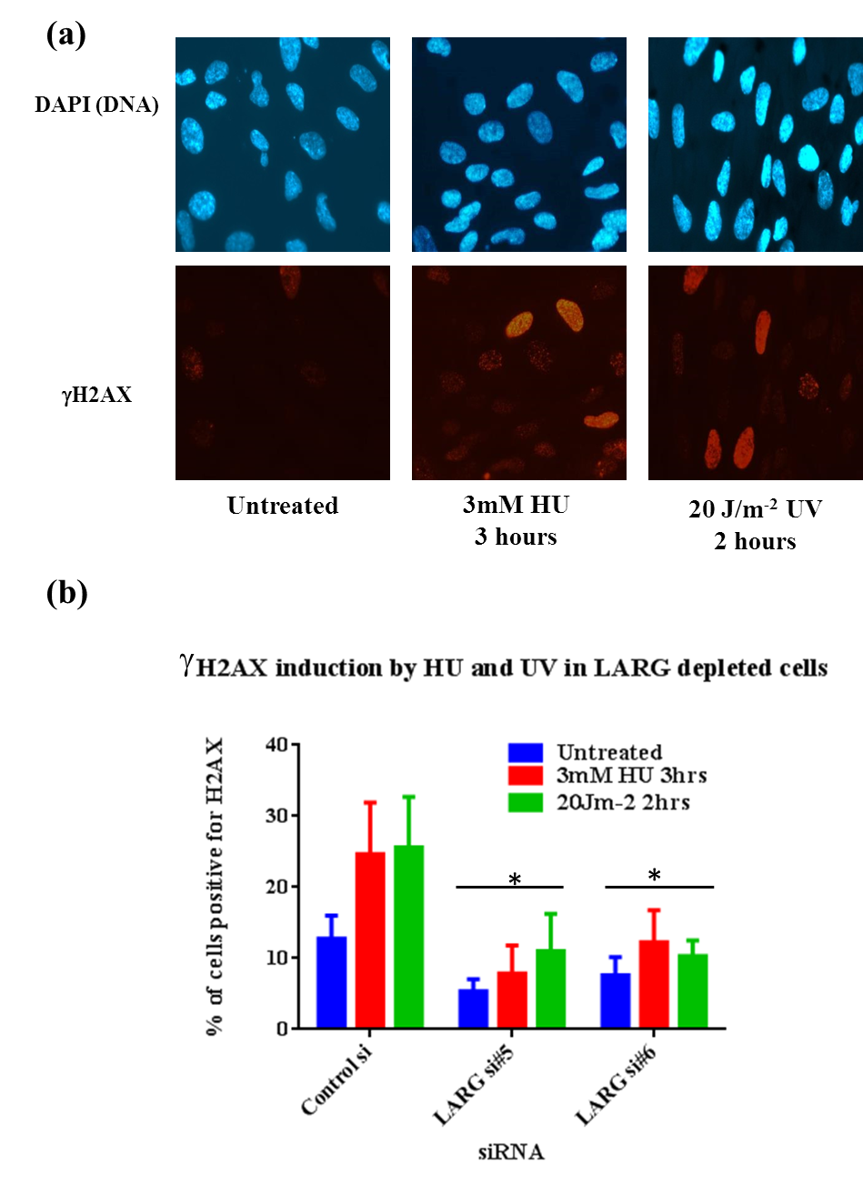

Figure 3.3.2 Cells depleted of LARG display perturbed γH2AX formation after replication stress RPE1 cells (employed due to large nuclei and good γH2AX antibody performance) were transfected with a non-targeting control or one of two LARG specific siRNA oligos (see Materials & Methods). After 48 hours cells were treated with 3mM HU for 3 hours or 20Jm-² UV for 2 hours before fixation in 4% PFA. Immunofluorescence staining for γH2AX S129 was performed.
(a) Representative images of untreated, HU and UV treated samples from control siRNA data sets, γH2AX (red) and DNA (blue). (b) Quantification of the population of cells displaying >6 γH2AX foci was performed for each treatment (minimum 200 cells per experiment). n=5, * denotes a P value ≤0.05 using a paired twin tail students T-test assuming equal variance. Error bars indicate standard deviation from the mean.
A basal level of around 10% of cells displayed γH2AX foci in untreated control siRNA samples, upon treatment with either 3mM HU for 3 hours or 20Jm⁻² UV for 2 hours this rises to 25%. This increase roughly equates to the S phase population (for cell cycle profiles see supplementary data figure S5). However both LARG siRNA treatments show a statistically significant lower basal γH2AX level of around 6%, furthermore, unlike the control siRNA cells neither genomic stress induced the same increase in γH2AX positive cells (Figure 3.3.2). There was a small increase in both LARG siRNA samples in response to both treatments, to between 10% and 12% however this was significantly lower than the increase seen in control siRNA treated samples. No changes in γH2AX levels were observed in siRNA treated cells after exposure to doses of IR between 1 and 5 gray and incubated for 1 hour before fixation (supplementary data figure S4), indicating that this defect could be due to ATR signalling defects associated with replication, this could be confirmed by utilising BrdU (Thymidine analogue) and γH2AX flow cytometry to allow for the separation of the replicating cells from the rest of the population.
In order to gain further insight into replication associated defects in LARG depleted cells, the effect of LARG depletion upon events more specific to ATR signalling were determined. One such response is the phosphorylation of RPA which binds ssDNA. As mentioned in the introduction this accumulation leads to the recruitment of the ATRIP/ATR complex (Zou and Elledge, 2003). Phosphorylation of the RPA subunit RPA32 on T21 can be performed by any of the three main PIKKs (ATM, ATR or DNA-PK) as was demonstrated using cells defective in DNA-PK or using ATR and ATM inhibitors, in all three scenarios the phosphorylation on T21 was perturbed (Block et al., 2004). Furthermore it was observed that T21 phosphorylation after IR treatment required active DNA replication. It had previously been observed that ATR and ATM can regulate global origin firing through inhibition of cyclin dependant kinases and that this control can be modulated independently of genomic stress (Shechter et al., 2004), thus providing the means for replication origin firing after genomic stress. The importance of this control was recently highlighted in a paper from Toledo et al, whereby they demonstrated that without ATR cells can undergo a process known as replication catastrophe, the collapse of large number of replication origins. This is due to an exhaustion of functioning RPA within the cell and it was demonstrated that after replication stress and initial RPA binding if origin firing is not controlled by ATR an excess of ssDNA builds up within the nucleus, due to an already depleted pool of RPA this ssDNA is left naked leading to collapsed replication forks (Toledo et al., 2013).
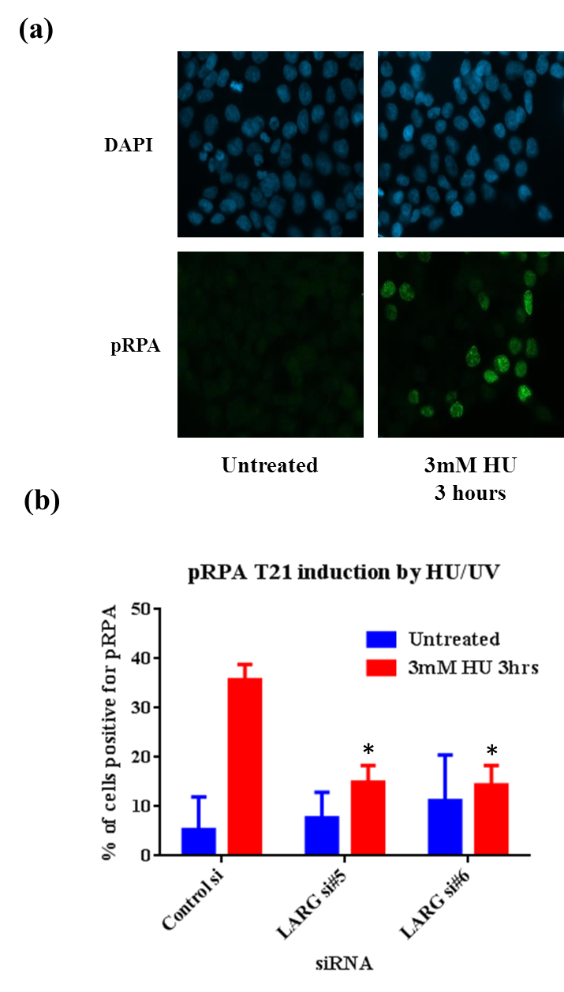

Figure 3.3.3 Cells depleted of LARG display perturbed RPA phosphorylation after HU induced replication stress.
HCT116 cells (employed due to optimised antibody performance, growth characteristics and poor anti-body performance in RPE1 cells) were treated were transfected with either non-targeting control siRNA or LARG specific siRNA, after 48 hours cells were treated with 3mM HU and incubated for 3 hours before fixation in 4% PFA. Immunofluorescence staining was performed using pRPA T21 and DAPI. (a) Representative images displaying pRPA induction after 3mM HU replication stress for 3 hours in control siRNA treated cells, pRPA T21 (green), DNA (blue). (b) Quantification of the population of cells displaying pRPA staining (characteristically pan nuclear foci) was performed for each treatment (minimum 200 cells per sample). n=3, * denotes a P value ≤0.05 using a paired twin tail students T-test assuming equal variance). Error bars indicate standard deviation.

Control siRNA cells displayed a normal response to replication stress, whereby from a low basal level of cells positive for pRPA increases from 5% to 35% after 3mM HU treatment for 3 hours indicating intact ATR signalling (Figure 3.3.3). However LARG siRNA treated samples although displaying similar levels of basal pRPA of between 5% and 10% did not increase in the same manner as control siRNA (Figure 3.3.3). This failure to induce pRPA foci after replication stress in LARG depleted cells was statistically significant, and in combination with the γH2AX data, suggests that the observed ATR signalling defects are indeed due to changes in LARG protein levels.
One of the major downstream events in the ATR signalling pathway is the phosphorylation of Chk1, as was discussed earlier this allows for cellular control of the cell cycle in response to DNA damage. There are two serine residues on Chk1 that are phosphorylated by ATR, S317 and S345, that are required for checkpoint for activation. Although both sites are required for full pathway regulation they have differing roles. This was demonstrated by showing that S345 mutations lead to a loss of viability while S317 although viable displayed impaired replication fork progression and abrogated G2/M checkpoint arrest (Wilsker et al., 2008). This reinforced previous work that had reported differing phenotypes when Chk1 null cells had Chk1 S317 and S345 mutants reintroduced, with S317 resulting in partial rescue of Chk1 null phenotypes, while S345 mutants were unable to rescue these phenotypes including impaired checkpoint activation, mitotic catastrophe and localisation of Chk1 (Niida et al., 2007). It has been observed that the phosphorylation of S317 is required for phosphorylation of S345, whereby mutation of the serine residue to glutamate or alanine results in defective phosphorylation of S345 (Wang et al., 2012).

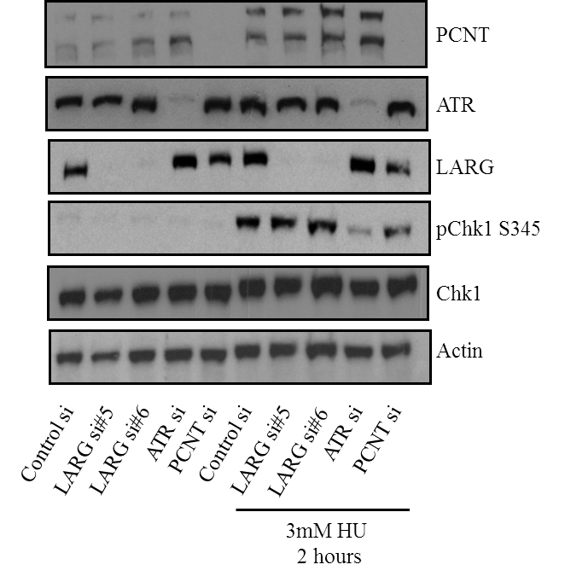

Figure 3.3.4 pChk1 induction upon replication stress in LARG depleted Hek293 cells
Hek293 cells were plated into 6 well dishes at a density of 2x10⁵ cells per well and transfected with siRNA towards LARG, ATR and PCNT (for transfection protocol see M&M). 48 hours after transfection cells were treated with 3mM HU for 2 hours before lysate collection. Lysates were separated using SDS PAGE gel electrophoresis before western blotting for pChk1, Actin, LARG, PCNT, ATR and total Chk1. Good siRNA mediated knockdown of each targeted protein and equal loading can be observed.

In order to asses Chk1 phosphorylation in LARG deficient cells Hek293 cells were transfected with siRNA towards LARG, ATR and PCNT. They were subsequently subjected to replication stress in the form of 3mM HU for 2 hours and assessed for phosphorylation of S345 on Chk1. Figure 3.3.4 demonstrates that in non-targeting control siRNA treated cells pChk1 S345 is induced upon HU treatment, however using ATR siRNA as a positive control this phosphorylation is greatly reduced as it to be expected. However LARG depleted samples do not display any marked defect in the phosphorylation of Chk1 at S345, acting in the same manner as control siRNA samples. This data was replicated using HeLa cells which also demonstrated the same defect in ATR depleted cells and did not show a defect in LARG depleted cells (supplementary Figure S9).
Although it was reported that Chk1 associates with PCNT allowing for centrosomal localisation during mitosis, loss of PCNT leads to defects in centrosomal cyclin B-Cdk1 signalling (Tibelius et al., 2009), it was later demonstrated using a combination of protein arrays and siRNA transfection that this was observed due to cross-reactivity between the Chk1 antibody DCS-310 and Ccdc151 (Matsuyama et al., 2011). Ccdc151 was recently demonstrated to have a role in motile cilia supporting the centrosomal localisation previously observed (Jerber et al., 2014).
If a defect in Chk1 phosphorylation was not severe the difference in signal observed using Western blotting based techniques may be negligible and as such pChk1 was quantified in LARG depleted cells using immunofluorescence. A similar observation was made regarding Chk1 phosphorylation after replication stress in LARG depleted cells using immunofluorescence. Figure 3.3.5 demonstrates the induction seen in control siRNA transfected cells after replication stress whereby cells displaying Chk1 pan nuclear staining using the pS345 antibody increase from a negligible >1% to 42% in response to 3mM HU for 2 hours. Cells depleted of LARG do not vary from this and show an induction to 38% and 33% (LARG si#5 and #6 respectively). Supporting the result from Figure 3.3.4 suggesting that LARG depleted cells do not have a defect in Chk1 phosphorylation in response to replication stress. Although, to be complete, analysis of phosphorylation of S317 on Chk1 should be investigated in LARG depleted cells.
Another key response to replication stress is the activation of the Fanconi Anaemia pathway at stalled replication forks, as discussed earlier the mono-ubiquitination of the FANCD2 subunit is required for full FA activation, importantly this action requires ATR and the RPA subunit RPA70 for full activation (Andreassen et al., 2004). Given the defect observed in RPA32 phosphorylation in LARG depleted cells in Figure 3.3.3, FANCD2 mono-ubiquitination was assessed after replication stress in LARG depleted cells (Figure 3.3.6).
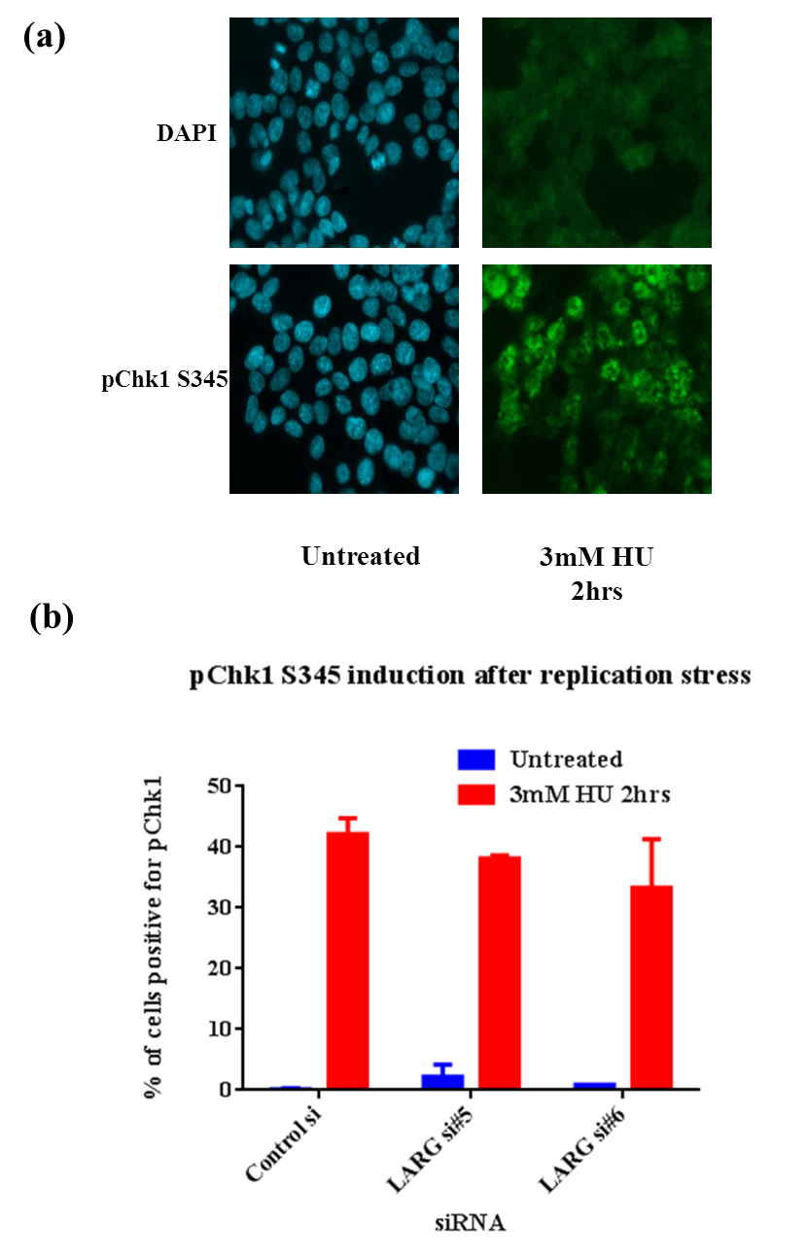

Figure 3.3.5 pChk1 S345 quantification in LARG depleted HCT116 cells
HCT116 cells (employed due to good antibody performance, poor staining was observed using RPE1 cells) were treated were transfected with either non-targeting control siRNA or LARG specific siRNA, after 48 hours cells were treated with 3mM HU and incubated for 2 hours before fixation in 4% PFA. Immunofluorescence staining was performed using pChk1 S345 and DAPI. (a) Representative images displaying pChk1 induction after 3mM HU replication stress for 3 hours in control siRNA treated cells, pChk1 S345 (green), DNA (blue). (b) Quantification of the population of cells displaying pChk1 staining was performed for each treatment (minimum 200 cells per sample, n=2). Error bars indicate standard deviation from the mean.

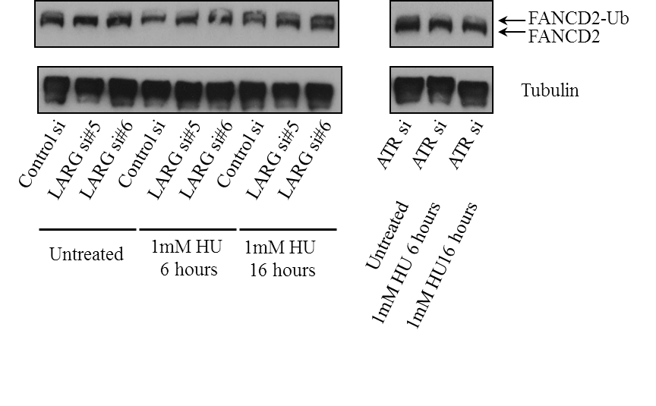

Figure 3.3.6 FANCD2 mono-ubiquitination in HeLa cells depleted of LARG and ATR
Hek293 cells were plated into 6 well dishes at a density of 2x105 cells per well and transfected with control (non-targeting), LARG or ATR siRNA (for transfection protocol see M&M). 48 hours after transfection cells were treated with 1mM HU for either 6 or 16 hours before lysate collection.. Lysates were separated using SDS-PAGE gel electrophoresis before western blotting for FANCD2 and Tubulin. FANCD2 mono-ubiquitination is observed by a small band shift after HU treatment, this is absent in the ATR siRNA treated lane. For knockdown levels please see figure 3.3.4.

The activation of FANCD2 by mono-ubiquitination by HU can be observed in Figure 3.3.6, in the untreated lysates a single FANCD2 bands is present, after 1mM HU for 6 hours there is some accumulation of FANCD2-Ub, however after 16 hours in 1mM HU the accumulation results in two distinct bands indicating unperturbed mono-ubiquitination of FANCD2. This larger FANCD2-Ub band is present in both of the LARG siRNA HU treated samples, indicating that LARG is not required for FA pathway activation. In line with previous work on ATR signalling, the ATR siRNA sample shows defective FANCD2 activation, along with the control siRNA FANCD2-Ub induction these data validate the experimental model used both in Figure 3.3.4 and 3.3.6.
These data suggests that there is a defect in response to replication stress but that it does not affect the ATR signalling pathway as a whole, raising the question as to whether any defect due to LARG depletion will affect cellular survival after replication stress. In order to address this MTT experiments were performed to investigate survival after replication stress in LARG siRNA treated cells with ATR siRNA used as a positive control.

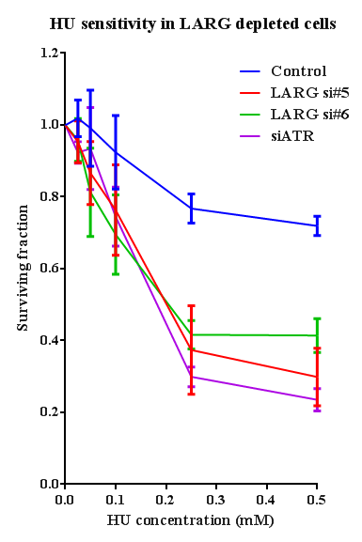

Figure 3.3.7 Surviving fraction of siRNA transfected HeLa cells after extended incubation with increasing concentrations of HU.
HeLa cells (employed as assay already optimised in lab using this cell line) were plated at 2500 cells per well within 4x96 well plates then transfected with siRNA (see M&M), 48 hours after transfection cells were treated with 0, 0.05,0.1, 0.25 or 0.5mM HU and incubated at 37°C with 5% CO₂ for 5 days. MTT reagent was then added to each well and incubated for a further 3 hours before the media was aspirated from each well and the remaining MTT re-suspended in 200µl DMSO, plates were read using a Multiscan FC plate reader at 540nm. Relative survival for each siRNA treatment is relative to starting MTT values for the corresponding siRNA treatment, n=3. Error bars indicate standard error.

These MTT results demonstrate the sensitivity of cells depleted of ATR whereby control siRNA cells still have a surviving fraction of 0.8 after incubation in 0.25mM HU however this drops to 0.3 after siRNA depletion, the final difference at 0.5mM HU is even greater dropping from 0.75 for control to 0.25 for ATR depleted samples. Sensitivity is not as great at lower HU concentrations. Importantly both LARG depleted samples display similar sensitivity to HU as is observed in the ATR depleted samples, with a surviving fraction of between 0.23 and 0.38 (LARG si#5 and #6 respectively) at 0.5mM HU.
The sensitivity of LARG depleted cells to replication stress in a manner that replicates the phenotype observed with ATR depletion observed in Figure 3.3.7 gives confidence in early results in γH2AX, pRPA induction defects and supernumerary centrosomes. However all results up to this point have been due to replication stress using HU or UV. Therefore in order to gain greater evidence for a replication stress phenotype it was decided to assay sensitivity to another replication stress inducing agent, Mitomycin C (MMC). MMC is a DNA cross linking agent which has long been used in chemotherapy for over 50 years, although initial results from America were poor, research in Japan led to revisions in dosages lead to greater success (Crooke and Bradner, 1976). Although more recently associated with bladder cancer treatment, it is also used in breast, head and neck tumours but has been displaced by other more successful drugs in colon cancer treatment (Bradner, 2001). MMC is a bi-functional alkylator forming cross-links between G and C DNA bases (Tomasz, 1995), this action activates the S phase checkpoint. Checkpoint activation has been demonstrated to be ATR dependant, it was observed that ATR^{Seckel} cell lines (patient derived B lymphocyte) displayed defective cell cycle arrest and γH2AX phosphorylation in response to MMC treatments (Mladenov et al., 2007).
With this in mind MMC sensitivity was assayed in LARG depleted cells. Figure 3.3.8 demonstrates that both LARG siRNAs conferred an increased sensitivity to MMC in comparison to control (non-targeting) siRNA treatment. This sensitivity was comparable to that observed in the ATR siRNA treated samples which display high sensitivity at 20-40ng/ml MMC levels. Summarised these data give confidence to the hypothesis that LARG is required for efficient cellular responses to replication stress, although they do not indicate a complete loss of ATR signalling after LARG depletion, the details of this will be discussed later. This does also raise the question of crosstalk, with a link between Rho signalling and DDR through LARG, is there a link between ATR signalling and Rho signalling?
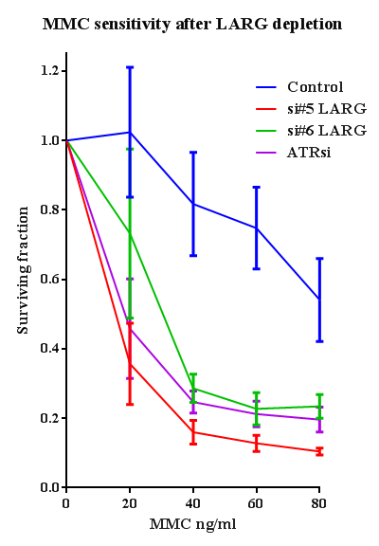

Figure 3.3.8 Surviving fraction of siRNA transfected HeLa cells after extended incubation with increasing concentrations of MMC
HeLa cells (employed as assay already optimised in lab using this cell line) were plated at 2500 cells per well within 4x96 well plates then transfected with siRNA (see M&M), 48 hours after transfection cells were treated with 0, 20, 40, 60 or 80ng/ml MMC and incubated at 37°C with 5% CO₂ for 5 days. MTT reagent was then added to each well and incubated for a further 3 hours before the media was aspirated from each well and the remaining MTT re-suspended in 200µl DMSO, plates were read using a Multiscan FC plate reader at 540nm. Relative survival for each siRNA treatment is relative to starting MTT values, n=3. Error bars indicate standard error.

RhoA signalling modulation by DDR factors
As described in the introduction there are currently few publications linking RhoA signalling to the DDR, the most direct evidence is found in the observation that the RhoGEF Net1 is activated upon IR exposure and results in nuclear RhoA activation (Guerra et al., 2008). Further to this, the identification of an interaction between LARG and PCNT previously identified (Goulimari et al., 2008) and further characterised in Chapter 3.1, indicates a possible link but does not explore this possibility in depth. The phosphorylation of MLC at residues T18 and S19 has been used as a robust marker of RhoA activation and it has been demonstrated that LARG depletion leads to disruption of this phosphorylation event (Kitzing et al., 2007). In order to assess possible crosstalk between these pathways ATR, HCLK2 and PCNT were depleted using siRNA and cells were then assessed for pMLC T18/S19 upon induction by LPA. A great deal of troubleshooting was involved in the assessment of MLC phosphorylation, involving cell types, LPA concentration exposure times, serum starvation and Western blotting techniques. Personal communication with Dr Chryso Kanthou determined the optimum conditions for this relatively transient and labile phosphorylation event, full details of which can be found in the Materials and Methods section.
Figure 3.3.9(a) demonstrates the phosphorylation of MLC after 50µM LPA incubation for 10 minutes, in control siRNA samples LPA treatment results in a strong induction of MLC, similar levels of induction were observed in the PCNT samples. Efficient PCNT and ATR knockdown can be observed in figure 3.3.9 (b) & (c). LARG depletion led to a slight, but consistent reduction in MLC phosphorylation upon LPA induction, however this is not as much of a reduction as was observed in (Kitzing et al., 2007). A far more drastic reduction in pMLC levels upon LPA induction was observed in ATR and HCLK2 siRNA treated samples, while an overexposure of this blot indicates equal basal levels between ATR and PCNT treated samples. HCLK2 levels were equal to LARG si#5 but lower than control, given that pMLC in HCLK2 was lower than LARG si#5 after LPA induction these data suggest that the reduction of MLC phosphorylation in both ATR and HCLK2 depleted samples is due to a disruption to the RhoA /Rock pathway. This is not due to changes in total RhoA levels as adjusted for actin loading these levels appear to be level between samples in Figure 3.3.9 (a).
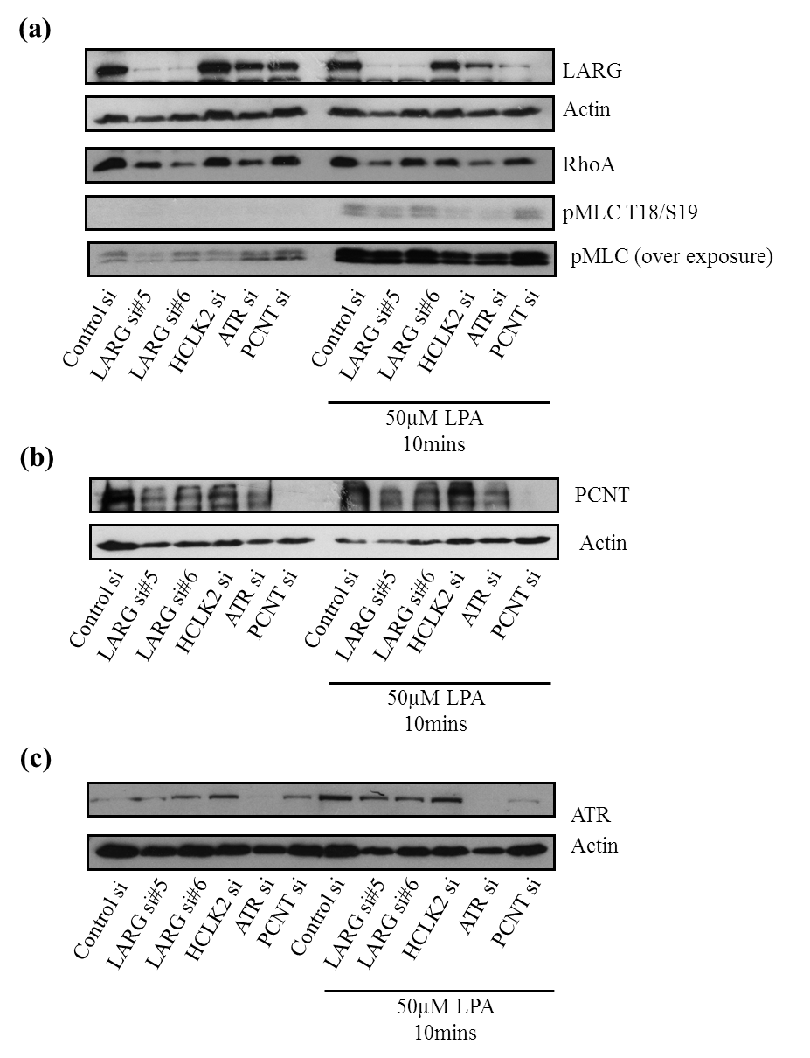

Figure 3.3.9 MLC phosphorylation in RPE1 cells depleted of DDR proteins after induction by LPA
RPE1 (employed due to consistent ability to serum starve and induce pMLC, a panel of cells were tested) cells were plated into 6 well dishes at a density of 7x10⁴ cells per well before transfection with indicated siRNA. 60 hours after transfection cells were serum starved for 16 hours before LPA induction employing 50µM LPA for 10 minutes samples subsequently underwent lysis in 2x protein loading buffer (see M&M for full method). Samples were then separated by SDS PAGE gel electrophoresis before western blotting. (a) MLC phosphorylation induction can be observed after LPA induction, the strongest induction was observed in the control non-targeting and PCNT, a slight reduction was observed in LARG si#5 and si#6, however HCLK2 and ATR siRNA display marked reduction in MLC induction. Due to the nature of lysis there is some variation in loading levels however RhoA levels adjusted for actin appear level. Successful LARG protein knockdown is observed. (b) & (c) siRNA mediated PCNT and ATR knockdown levels, poor HCLK2 antibody performance prevented HCLk2 knockdown visualisation. These data was replicated alongside sample collection for GLISA experiments and as such was performed on 5 separate occasions giving robust repetition in pMLC induction.
The phosphorylation of MLC is a downstream consequence of RhoA activation by RhoGEFs and therefore does not indicate whether it is the activation of RhoA itself or downstream elements such as ROCK activation by RhoA. In order to determine whether the defect observed in HCLK2 and ATR depleted cells is due to a reduction in RhoA signalling or further downstream an ELISA assay specific for GTP bound active RhoA was performed. The basis of this ELISA involves the normalisation of protein levels between samples, binding of RhoA-GTP in wells before visualisation using a RhoA antibody. By performing this assay on uninduced and LPA induced samples the increase in GTP bound RhoA can be demonstrated.
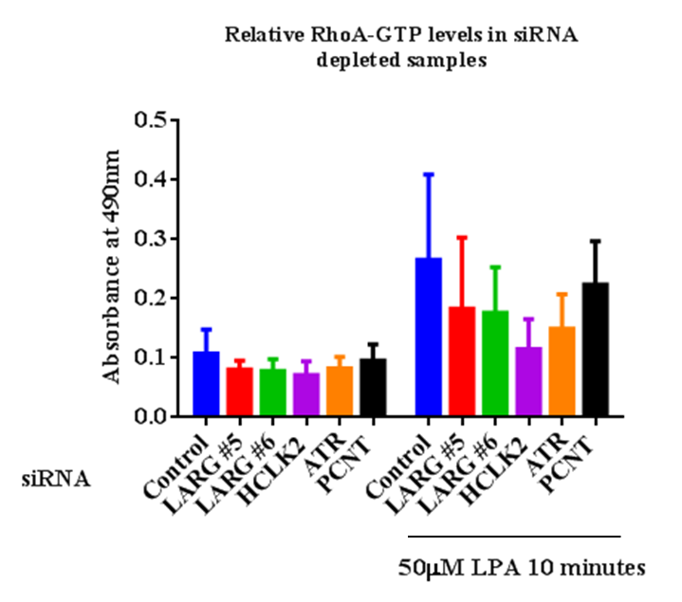

Figure 3.3.10 Induction of RhoA-GTP levels in siRNA depleted cells after LPA incubation
RPE1 cells (employed due to consistent pMLC induction) were plated into 6 well dishes at a density of 7x10⁴ cells per well before transfection with indicated siRNA. 60 hours after transfection cells were serum starved for 16 hours before LPA induction employing 50µM LPA for 10 minutes. Samples were lysed utilising lysis buffer included in the Cytoskeleton GLISA Kit (see M&M). A small volume of each sample was kept for protein quantification with the rest being snap frozen in liquid nitrogen to preserve RhoA-GTP. Levels of RhoA-GTP correlate with higher absorbance values. n=2

The ELISA data presented in figure 3.3.10 quantifies the generation of RhoA-GTP after LPA induction, the absorbance of the control siRNA treated samples rises from 0.1 to 0.3 upon LPA induction. LARG siRNA treated samples do show an increase however it is not as great as that observed for the control, however overlap of error bars does not allow for certainty. Similar observations can be made for the PCNT samples. However, both HCLK2 and ATR siRNA samples show minimal increase in RhoA-GTP levels upon LPA treatment increasing from 0.07 and 0.08 to 0.11 and 0.14 respectively. The large error bars present within figure 3.3.10 are due to the variability of the ELISA kit, individual experimental graphs can be viewed in the supplemental data; each repeat shows the same pattern in RhoA-GTP induction however raw values after induction vary between experiments. Personal communication from Dr Chryso Kanthou confirmed that this is not uncommon using this ELISA kit and requires further repetition; unfortunately the time period required for this was not available. Importantly the data presented in figure 3.3.10 supports a potential defect in RhoA activation in HCLK2 and ATR depleted cells. This indicates that elements of the DDR pathway may be involved in RhoA signalling and potentially cellular movement and polarisation.
Previous data from the laboratory of Robert Grosse demonstrated that LARG depletion leads to reduced wound invasion using a scratch wound assay (Goulimari et al., 2008). This assay involves the creation of a gap in a confluent mono-layer of cells, the size of this gap is monitored over a period of up to 24 hours and the rate of invasion can be deduced. If cellular cytoskeleton control has been affected then there may be reduced wound invasion, however other mechanisms are implicated, for examples in Gα12/13 or LARG depleted cells there is a failure to organise the MTOC in the orientation of the wound resulting in less uniform movement into the wound (Goulimari et al., 2008).
The scratch wound assay was therefore performed on cells depleted of LARG, PCNT, HCLK2 and ATR. However the LARG si#5 and PCNT treated samples consistently lost viability after scratch wounds were inflicted and as such data could not be collected for these samples, see Figure 3.3.11 for examples of scratch wound time course images.
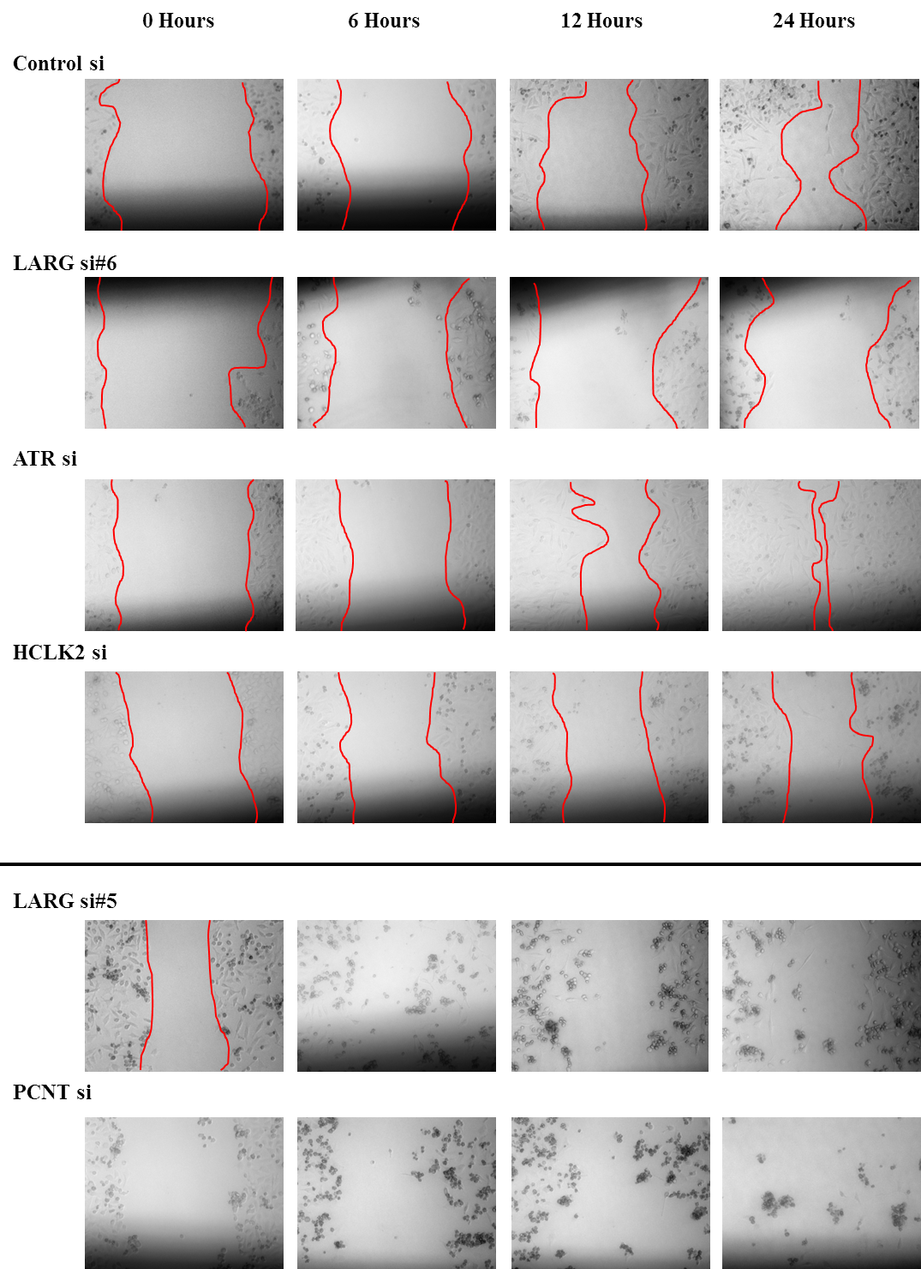

Figure 3.3.11 Observation of wound invasion in siRNA treated HeLa cells
Examples images of those used to calculate wound invasion values displayed in figure 3.3.11. Red lines indicate the wound front at each time point, values in figure 3.3.11(a) represent the area of the wound at a time point deducted from the value at t=0. LARG si#5 and PCNT samples can be observed as having clear discrete scratch wounds at 0 hours, however increased cell death over the time course prevents scratch invasion quantification.
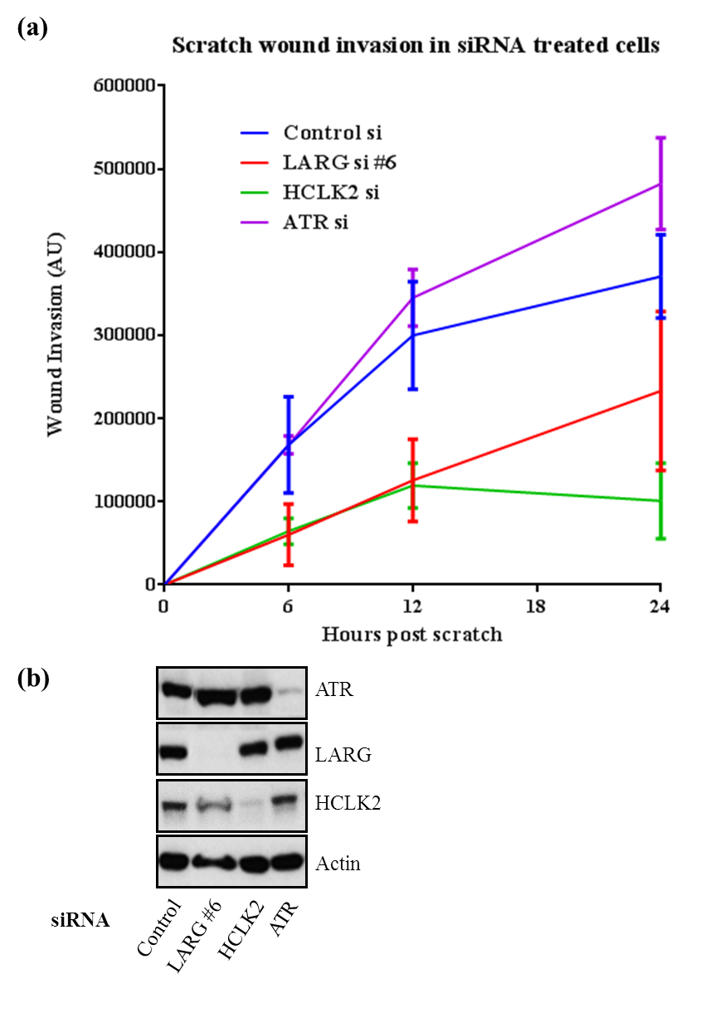

Figure 3.3.12 Scratch Wound invasion in cells depleted of LARG, HCLK2 and ATR
HeLa cells were transfected at 5x10⁵ per well on 6 well plates, transfected with siRNA towards LARG, PCNT, HCLK2 and ATR. 40 hours after transfection 3 vertical scratches were introduced into each well using a guide line, 2 images of each scratch were taken (one above and one below the guideline) at 0, 6, 12 and 24 hours. (a) Image J was used to quantify the reduction in wound size (see M&M) for each siRNA, the mean value and standard error of 3 experiments is plotted. (b) After 24 hour scratch wound assay samples were lysed, separated by SDS PAGE gel electrophoresis and western blot performed to confirm efficient knockdown of target proteins.
Figure 3.3.12 demonstrates the wound invasion in siRNA treated HeLa cells, as was observed in previous work (Goulimari et al., 2008) siRNA mediated depletion of LARG reduces the rate of invasion when compared to control non-targeting siRNA. Earlier time points at 6 and 12 hours show that LARG siRNA treated cells had an invasion rate 2-3 times slower, this reduces at 24 hours to around 1.5 times the rate. This reduction at 24 hours is likely due to the control siRNA treated cells closing the wound before the full 24 hours are complete. Of note no defect is observed in ATR treated samples, where the invasion rate is equal to that in control siRNA treated samples with a slight increase observed at 24 hours. Unexpectedly HCLK2 siRNA treated samples did not exhibit the same rate as ATR siRNA treated samples instead showing a reduced invasion rate similar to that observed in LARG siRNA treated samples, statistical significance was not achieved in this set of experiments (p values of 0.1 and 0.06 for LARG si6 and HCLK2 respectively at 12 hours) preventing solid conclusions from being drawn. However HCLK2 siRNA treated cells exhibited a reduction in wound invasion at 24 hours. This is most likely due to increased cell death (Figure 3.3.12) which although not as severe as LARG si6 and PCNT treated samples was higher than that observed in other samples. As such it is difficult to draw conclusions from HCLK2 data as processes involved in cell death may be interfering with invasion. Efficient knockdown of LARG, ATR and HCLK2 can be observed in figure 3.3.11 (b). The error bars at 24 hours prevent any solid conclusions being taken from this time point, the size of the error bars is most likely due to the variability in the size of the wounds inflicted. The protocol requires the use of a pipette tip to create the scratch and while pipette tip size remained constant the angle and pressure varied despite best efforts. Personal communication with Dr Chryso Kanthou confirmed this could be an issue and would likely decrease after increased repetition of the assay and while there are some specialised tools for creating wound invasion they were beyond the scope of this study at this stage.
Unfortunately time constraints prevented further optimisation of the scratch wound assay, although reduced siRNA concentration (from 100nM to 50nM) did reduce cell death at the point of wound infliction a loss of viability was still observed over the time course (data not shown). Given further experimentation fibroblast cell lines would have been employed due to their established role in wound healing (Werner et al., 2007), however it is worth noting that HeLa cells are often used in this assay.

Discussion
These data present a case for disruption of LARG signalling having a role in the DDR, however it is not straight forward. Supernumerary centrosomes have been used as a marker of genome stability and a recognised phenotype of tumorigenesis (Fukasawa, 2005). Previous data has suggested a role for RhoA in supernumerary centrosomes, through the use of Arhgef10 (RhoGEF) and RhoA siRNA as well as a ROCK inhibitor it was demonstrated that disruption of the RhoA pathway leads to supernumerary centrosomes (Aoki et al., 2009). The data presented in figure 3.3.1 supports this role as LARG depletion leads to similar levels of multipolarity as that observed in HeLa cells treated with the RhoA inhibitor Y27632 (Aoki et al., 2009). There are a number of possible mechanisms that have been proposed that could lead to extra centrosomes such as aborted mitosis resulting in aneuploidy cells with more than two centrosomes. However as no aneuploidy or defects in cytokinesis were observed in Arhgef10 knockdown this is an unlikely mechanism in this case (Aoki et al., 2009). Further possibilities include the over duplication of centrosomes or premature separation of the centrosomes early in the cell cycle. It is speculated that RhoA activation could be suppressing separation of the centrosomes in late S and G2 phase through suppression of the separase system which is involved in centrosomes disengagement. The possibility of separase activity has been explored previously; centrosome separation before mitosis by separase is regulated by Cdk2/CyclinE and was demonstrated to determine centriole duplication in the next cell cycle. It was determined that deregulation of this centriole disengagement could lead to supernumerary centrosomes via over duplication (Tsou and Stearns, 2006). Whether or not this phenotype is associated with the dissociation of the MTOC from the nucleus observed in laminopathic cells with poor RhoA activation potential is unclear (Hale et al., 2008). However it is likely that the mechanism by which Athgef11, LARG and RhoA depletion leads to supernumerary centrosomes is common, GFP-Centrin2-HeLa cells could be employed in live cell microscopy in order to observe centrosome separation failure.
The ATR signalling defects presented in figures 3.3.2 and 3.3.3 demonstrate a failure in normal cellular responses to DNA replication stress. However, some downstream events mediated by ATR appear intact after LARG depletion (figures 3.3.4, 3.3.5 and 3.3.6). In order to attempt to resolve these apparent differences it will be necessary to discuss the events with regard to previous data on interactions and localisation.
The role of PIKKs in the phosphorylation of H2AX (γH2AX) is well established, as is their response to varying genotoxic stimuli (Ward and Chen, 2001, Burma et al., 2001). While DNA-PK and ATM are linked to γH2AX formation in response to IR (Wang et al., 2005b), it is in an ATR dependant manner that γH2AX is formed in response to replication stress (Ward and Chen, 2001). This phosphorylation event is triggered by intermediates of DNA repair, (Hanasoge and Ljungman, 2007) and requires the localisation of ATR to the site of damage (Falck et al., 2005). A reduction in γH2AX in LARG depleted cells would indicate that ATR recruitment was perturbed. It has previously been demonstrated that ATR recruitment to replication forks led to the phosphorylation of RPA (Vassin et al., 2009), therefore a model where ATR recruitment to sites of damage would be perturbed it would be expected that pRPA induction would be reduced in response to replication stress as in Figure 3.3.3.
However if ATR activation was perturbed further downstream targets of ATR would also be affected. Figure 3.3.4 and 3.3.5 demonstrate that there is no defect in the phosphorylation of Chk1 at S345 after replication stress, an event known to be ATR dependant (Liu et al., 2000). However, there is some recent discrepancy on the validity of Chk1 to be used as a robust marker of ATR activity (see later). The mono-ubiquitination of FANCD2 observed in figure 3.3.6 does not change upon LARG depletion; unfortunately efforts to assess FANCD2 foci formation at collapsed replication forks were unsuccessful preventing quantitative analysis in the timeframe available (data not shown). The formation of FANCD2 foci after replication stress has been observed to be dependent on ATR and unlike Chk1 also requires RPA1, although FANCD2 foci are observed in unstressed RPA1 depleted cells suggesting some plasticity to this system (Andreassen et al., 2004).
Despite these initial inconsistencies LARG depletion does confer sensitivity to replication stress induces agents. Initially HU was employed as defects in the response to HU were observed. The effect of HU on LARG depleted cells is described in figure 3.3.7, where sensitivity phenocopies ATR siRNA treated cells. In order to further investigate a replication stress defect the cross linking agent MMC was then employed and a similar result demonstrated in Figure 3.3.8. If this defect is due to LARG depletion affecting DDR signalling then it would be expected that a double knockdown of LARG and ATR would not lead to a more severe sensitivity, this could also be achieved using ATR or LARG inhibitors.
As discussed previously evidence is emerging for the role that Lamin plays in the DDR, it was demonstrated that Lamin deletion led to sensitivity to a number of DNA damaging agents including Cisplatin, Camptothecin and UV exposure as well as HU and MMC (Singh et al., 2013). Further exploration of this sensitivity led to the observation that the formation of foci relating to a number of DDR proteins after HU treatment was perturbed, namely; Mre11, CtIP, RPA and FANCD2. In all cases there was some induction of foci but to a significantly lower level. Although γH2AX formation was not affected there was a significant delay in γH2AX foci disassembly after HU treatment (Singh et al., 2013). No comment on Chk1 activation in Lamin depleted cells was given in this paper. It has been observed that Lamin A and not C interact with H2AX (Figure 3.1.5 demonstrates LARG interacting with Lamin A but not C) and is required for positional satiability of repair foci. It was noted that the interaction between H2AX and Lamin increased significantly after DNA damage (Mahen et al., 2013).
The overlap between phenotypes relating to cell motility and polarisation in LARG and Lamin depleted cells has previously been discussed, if a similar overlap were to be expected in response to replication stress then the reduction in pRPA and sensitivity to replication stress observed within in this chapter could be hypothesised to be due to the same mechanism as Lamin. The proposed mechanism relies on Lamin acting as platform during replication fork stalling allowing for restart.
To further investigate this in LARG depleted cells the integrity of replication restart after fork collapse could be assessed. This involves the direct visualisation of individual replication forks, allowing for measurement of replication speed, origin firing and stalling through DNA fibre labelling (Merrick et al., 2004). Although many variables have to be taken into account when measuring fork speed (Techer et al., 2013), fork restart is more straight forward measure. Lamin depleted cells display a severe reduction in new origins of replication after HU treatment (Singh et al., 2013), therefore if LARG depletion is affecting Lamin it would be expected that it would also reduce new origin firing.
Whether or not the increased association between Lamin and γH2AX over H2AX is required for Lamin to act as a platform for repair is unclear, therefore if LARG depletion affects γH2AX formation there is the possibility that it could be affecting Lamin mobility after DNA damage and therefore its ability to act as a platform for DDR proteins (Mahen et al., 2013). This could be assayed using FRAP (fluorescent recovery after photo bleaching) to measure GFP-Lamin mobility away from sites of damage versus areas in close proximity to 53BP1 foci after laser bleaching (see figure 2 of (Mahen et al., 2013)) both in the presence and absence of LARG using siRNA treatment.
As alluded to previously no mention of Chk1 phosphorylation was reported in Lamin depleted cells (Singh et al., 2013) and no defect was observed in LARG depleted cells (Figure 3.3.4). The earlier defects in ATR signalling do not completely rule out Chk1 signalling, for example RPA phosphorylation requires the ATRIP-ATR complex binding to ssDNA. ATR independently does not bind DNA. The DNA binding domain of ATRIP facilitates the DNA interaction, however it has been demonstrated in Xenopus extracts and in mammalian cells that the phosphorylation of Chk1 only requires ATR to complex with ATRIP not DNA binding. As such removal of the DNA binding domain of ATRIP does not interfere with Chk1 phosphorylation (Kim et al., 2005, Ball et al., 2005). Another mechanism of ATR independent Chk1 activation has been demonstrated using Claspin depletion and caffeine inhibition of ATR (however this will also inhibit ATM), although cell cycle arrest was used as a measure of Chk1 activation. Reduced Chk1 phosphorylation on both Ser317 and Ser345 was observed upon caffeine inhibition of ATR (Rodriguez-Bravo et al., 2006).
Recent use of the ATR inhibitor VE-821 has produced mixed results with some groups reporting reduced pChk1 induction on S345 (Vavrova et al., 2013) while others see no inhibition and question the validity of Chk1 S345 phosphorylation as a marker for ATR pathway activation (Huntoon et al., 2013). Neither of these publications assayed pChk1 at S317.
Attempts were made to assess G2/M checkpoint integrity upon LARG depletion however little consistency was observed in pH3 FACS with regard to positive controls (data not shown). ATR siRNA was employed as a positive control for G2/M arrest upon UV treatment, however, a defective checkpoint was rarely observed using a variety of cell lines including HCT116, HeLa and RPE1 (data not shown). It has been demonstrated that HeLa cells are able to prevent mitotic entry after replication stress even after caffeine treatment while displaying reduced pChk1 S345 suggesting an ATR independent method of G2/M arrest in HeLa, although Chk1 depletion did abrogate the G2/M checkpoint (Rodriguez-Bravo et al., 2006). This could lead to speculation that LARG depletion could be affecting aspects of ATR signalling, observed in Figure 3.3.2 and 3.3.3, but not interfering with the ATR-ATRIP phosphorylation of Chk1.
The second half of this chapter focussed on the effect of depletion of ATR and HCLK2 on RhoA signalling, Figures 3.3.9 and 3.3.10 display clear defects in two measures of RhoA activation following either ATR of HCLK2 depletion. The reduction in the phosphorylation of MLC suggests defects at some point in the ROCK pathway while RhoA-GTP induction narrows this defect in the pathway to RhoA activation. Whether or not this change is due to interference with the GEF activity of LARG or other RhoGEFs is unknown, however ATR localisation is not completely nuclear and does display a cytoplasmic pool and therefore does not rule out direct interaction with RhoA or LARG itself (Tibbetts et al., 2000). As mentioned in the introduction LARG contains a possible ATR/ATM phosphorylation motif at S1288 (Matsuoka et al., 2007), although use of a phospho-STQ targeting antibody did not identify a phosphorylation on LARG in response to HU, UV or IR treatments (data not shown). The STQ antibody employed best recognises sites of phosphorylation similar to S15 on p53 and therefore phosphorylation motifs that differ may not be recognised by this antibody. The lack of binding therefore does not rule out ATR/ATM mediated phosphorylation of LARG. Point mutation vectors for phospho-mimic (glutamic acid) and phospho-null (alanine) at 1288 were created for complementation in an shRNA LARG depleted cell line, however time constraints prevented investigation of the phenotypic effects of this change to RhoA or DDR signalling.
Further to this the defects observed in ATR/HCLK2 deficient cells shown in Figures 3.3.9 and 3.3.10 are of greater severity to LARG depletion on its own suggesting a mechanism by which loss of ATR signalling does not inhibit LARG, but instead prevents almost all RhoA associated GEF activity. This is supported in ELISA data for RhoA-GTP from cells where ATR and HCLK2 depletion leads to only minor RhoA-GTP induction after LPA treatment. Neither RhoA, HCLK2 nor any other GEFs were identified in the ATR/ATM substrate screen (Matsuoka et al., 2007), so it is less likely that RhoA signalling defects following ATR depletion are due to a direct interaction and therefore more likely a consequence of downstream signalling targets. Although no defects in migration were observed in the invasion of ATR depleted cells using the scratch wound assay time constraints prevented assessment of cellular polarisation in response to scratch wound, a phenotype associated with LARG, RhoA and Lamin depletion (Lee et al., 2007, Etienne-Manneville and Hall, 2002, Goulimari et al., 2008). The invasion phenotype observed in HCLK2 depleted cells, unlike in pMLC and RhoA-GTP assays, differs from ATR in that it leads to a similar defect to that demonstrated by LARG depleted cells (Figure 3.3.10). The caveat to this is that HCLK2 depleted cells displayed an elevated level of death after wound infliction and as such the reduction may well not be due to changes in cytoskeletal dynamics, if time constraints were not present these experiments would be repeated in using live cell imaging allowing for more precise measurements of invasion rates, with a variety of cell types. The observed reduced pMLC levels in ATR depleted cells would be expected to lead to reduced cellular migration, as is the case after RhoA depletion (Yin et al., 2008). However, although good knockdown is demonstrated no such defect was observed (Figure 3.3.12). MLC phosphorylation is a two stage process involving the initial rapid phosphorylation (within 1 minute) followed by translocation of MLC to the leading edge, this occurs not just at the edge of the wound but several cells into the invading population (Betapudi et al., 2010).
Previous evidence has demonstrated that HeLa cells require the phosphorylation of MLC for migration; however it is not necessary for localisation of MLC at the leading edge. Cells containing double alanine mutations for the pMLC sites (Thr18/Ser19) were observed to have reduced cell migration (Fumoto et al., 2003). In the light of this counterintuitive result it would be pertinent to explore other RhoA associated phenotypes, most notably the formation of stress fibres (thick actin fibres spanning the whole cell) which have previously been observed to be dependent on RhoA mediated phosphorylation of MLC (Chrzanowska-Wodnicka and Burridge, 1996). Further to this any experiments to elucidate ATR mediated Rho dysregulation should make use of recent advances in the identification of ATR inhibitors (Toledo et al., 2011), albeit with the caveats mentioned earlier, caffeine (as a PIKK inhibitor, although there are many side effects to this broad spectrum inhibition) and the recognised ROCK inhibitor Y27632 (Ishizaki et al., 2000). This would allow greater confidence that any phenotypes observed are due to the kinase activity of ATR. There is also scope for the use of more clinically relevant 3D models of tumour invasion (such as the use of Matrigel), although this presents its own challenges in gel selection and limitations for tumour environment representation (Yamada and Cukierman, 2007).
Overall these preliminary data suggest that LARG potentially plays a role in the cellular response to replication stress and that ATR signalling is involved in the induction of RhoA activity, although the intricacies of such ATR signalling defects in LARG-depleted cells remains to be fully elucidated.

3.4 Investigating Potential LARG mutations in genetically uncharacterised Seckel Syndrome patients

Sequencing of LARG in genetically uncharacterised Seckel Patients
The interactions between LARG and HCLK2/PCNT in conjunction with the emerging evidence that LARG has a role in the DDR (see Chapter 3.3); led to the possibility that disruption to LARG function may be a contributing factor for human disease. As was explored in the introduction, PCNT has been linked to ciliopathies, mental disorders and dwarfisms such MOPDII (Delaval and Doxsey, 2010, Endoh-Yamagami et al., 2010b, Anitha et al., 2008, Rauch et al., 2008, Griffith et al., 2008), while HCLK2 has been strongly linked to DDR signalling through PIKK stabilisation (Collis et al., 2007, Collis et al., 2008, Horejŝí et al., 2009, Rendtlew Danielsen et al., 2009, Xie et al., 2012). Given that LARG deficient cells exhibit defective ATR signalling (see chapter 3.3), we set out to sequence the coding region LARG in 13 genetically uncharacterised Seckel Syndrome patients kindly provided by Prof Penny Jeggo (University of Sussex). Sequencing of the coding region and not the whole genomic region was pursued due to the number of exons comprising LARG was high, a total of 41. Sequencing primers and protocols were designed and sequencing performed by Dr Phil Chambers (University Of Leeds). The results identified 2 possible heterozygous mutations in exon 18 of LARG (ENSG00000196914.4); one at position 1526 G>A in the PJ0013 genomic DNA sample and one at position 1514 G>A in the CV1740 genomic DNA sample. It is worth noting that a heterozygous mutation is a departure from all previous cases of Seckel Syndrome which were all autosomal recessive mutations.
Genomic DNA samples from these two patients kept at the University of Sheffield were used to confirm the mutations using the University of Sheffield Medical School Core Genomics service. Genomic samples and primers were prepared and delivered to the core services, subsequent sequencing reactions were carried out using an Applied Biosystems 3730 DNA analyser (see Materials and Methods) (Figure 3.4.1).
Lymphoblast cells lines derived from PJ0013 and CV1740 patient blood samples and immortalised using Epstein-Barr virus (Tosato et al., 1986) were also obtained from Dr Penny Jeggo (University of Sussex), together with wild type and an ATR deficient Seckel lymphoblast cell lines for use as controls in further experiments (as outlined in the materials and methods section). No patient synopsis was provided for the individuals from which these cell lines were created.
Protein samples were prepared for each cell line to assess the expression of LARG and common DDR proteins, this was to ensure that any phenotypes observed in these cell lines were not due to overt changes in core DDR proteins. As observed in Figure 3.4.2 levels of DNA-PK, LARG, HCLK2, Chk1 and ATR are all comparable between the GM2188 (WT), PJ0013 and CV1740 cell lines. Due to the comparable size of some proteins a separate western blot was performed for ATR quantification. This suggests the mutation does not lead to changes in LARG protein stability in either PJ0013 or CV1740; this also indicates that neither mutation affects stability of HCLK2, ATR, Chk1 or DNA-PK. However no PCNT protein was observed in CV1760 while normal levels are observed in GM2188 and PJ0013 samples. Previous work on three Seckel Syndrome patients identified mutation in PCNT as being the causal factor for the disease, lymphoblast cell lines derived from these patients either show no PCNT protein or a smaller truncated form (Griffith et al., 2008). Communication with Dr Penny Jeggo revealed that this cell line was from a previously published MOPDII patient with a PCNT frame shift mutation on one allele (Bober et al., 2012). Microcephalic osteodysplastic primordial dwarfism type Majewski II (MOPDII), is a rare autosomal recessive disorder with clinical features that overlap with Seckel Syndrome, chiefly primordial dwarfism. MOPDII patients rarely have the mental retardation associated with Seckel Syndrome but do have a higher risk of type 2 diabetes, eyesight irregularities and obesity (Rauch et al., 2008). Due to this it was decided not to pursue experiments with this cell line any further.

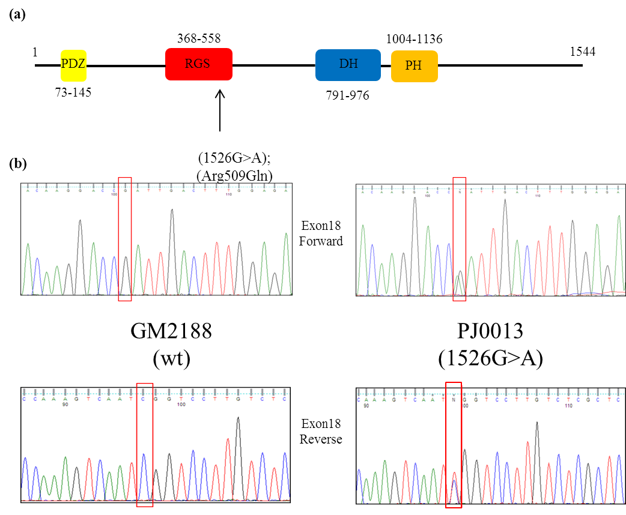

Figure 3.4.1 Identification of a mutation in LARG exon 18 in the genomic sequence of a genetically uncharacterised Seckel Syndrome patient
13 genetically uncharacterised Seckel Syndrome Patients were sequenced for LARG mutations; a heterozygous mutation identified in the genomic sample from PJ0013 was identified. (a) This 1526G>A change results in an Arginine to Glutamine amino acid change in the coding sequence of the RGS domain of LARG. (b) Sequencing traces show the heterozygous nature of the genomic mutation (highlighted in red) with a single peak observed in the wt and a double peak in the PJ0013 sample.

The PJ0013 mutation results in an amino acid change from Arginine to Glutamine at position 509 within the G protein signalling domain, resulting in the loss of the positive charge present on the Arginine side chain. Using the PolyPhen-2 mutation prediction software, combining eight sequence and three structure based predictive models, this mutation was predicted to be ‘probably damaging’ using the HumDiv prediction algorithm with a probability score of 0.989 (Adzhubei et al., 2010). However at the time of initial sequencing this mutation was listed as a single nucleotide polymorphism (SNP) of no known frequency (rs138160103). This does not fit with the normal definition of a SNP as they are normally only reported once a frequency has been obtained. After consultation with Professor Angela Cox at the University of Sheffield it was calculated that the sequencing of a minimum of 81 healthy individuals would determine if the mutation was a high frequency SNP (greater than 1% of the population), however if all samples displayed a wild type genotype the possibility of a low frequency SNP (0.01%) would still remain.
In total 107 normal DNA samples from breast tissue (female) and 30 normal samples from colon (male), provided with suitable consent and ethics, were evaluated using primers for exon18 of LARG. Individual sequencing traces for each PCR product using each primer (forward and reverse) were evaluated for changes in the 1526 position and all were found to be wild type (data not shown), indicating that the 1526G>A was not a common SNP.

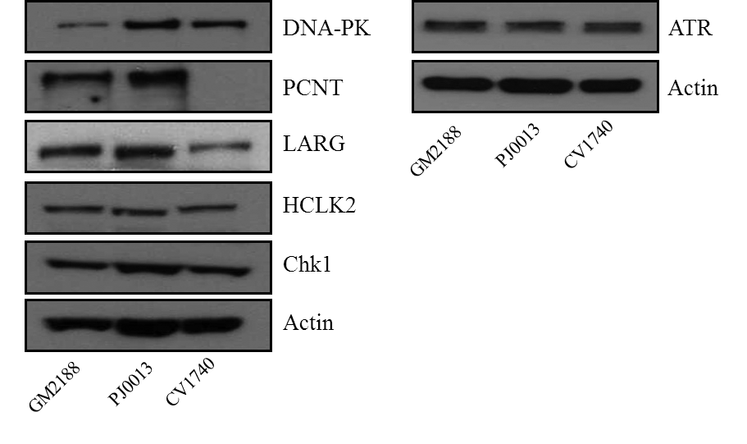

Figure 3.4.2 Assessment of DDR-related protein expression in Seckel Syndrome lymphoblast’s
Protein samples were prepared from exponentially (5x10⁵/ml) growing lymphoblast’s cell lines derived from Seckel Syndrome patients. GM2188 is a WT cell line used to reference protein levels to the two Seckel lines (PJ0013 and CV1740) containing possible mutations in LARG (see Figure 3.4.1). Proteins were separated by SDS-PAGE prior to western blotting. Antibodies to DNA-PK, PCNT, LARG, HCLK2, Chk1 and PCNT were employed while Actin was used as a loading control.

The initial sequencing was performed on genomic DNA samples and returned a heterozygous mutation; indicating only one allele was affected. In order to determine if both the wild type and mutant allele were expressed within the cell cDNA samples were prepared from the PJ0013 cell line and sequenced using a variety of cDNA concentrations. Four cDNA samples from separate flasks at least one passage apart were prepared and sequenced using a starting PCR cDNA concentration of 10ng/µl. The four different reactions gave traces ranging from homozygous wild type, heterozygous and homozygous mutant (figure 3.4.3). In order to reduce variability in the trace results these samples were re-sequenced using increasing starting cDNA concentrations, from 5ng/µl to 100ng/µl. While some variability in the traces was observed at low cDNA concentrations all samples gave equal heterozygous peaks above 50ng/µl starting cDNA concentrations indicating that both the mutant and wild type alleles are being expressed (Figure 3.4.3).
This raised the question as to the overall mRNA expression level of LARG in the PJ0013 cell line, although no overall differences could be detected at the protein level (Figure 3.4.2). In order to compare expression levels of LARG, ATR, HCLK2 and PCNT; cDNA from PJ0013, AG09387 and DK0064 (ATR Seckel) cell lines. The DK0064 cell line has a reduced ATR expression profile due to a splicing mutation (O'Driscoll et al., 2003) and was used as a positive control while expression of GAPDH was used as a reference gene to normalise expression levels.
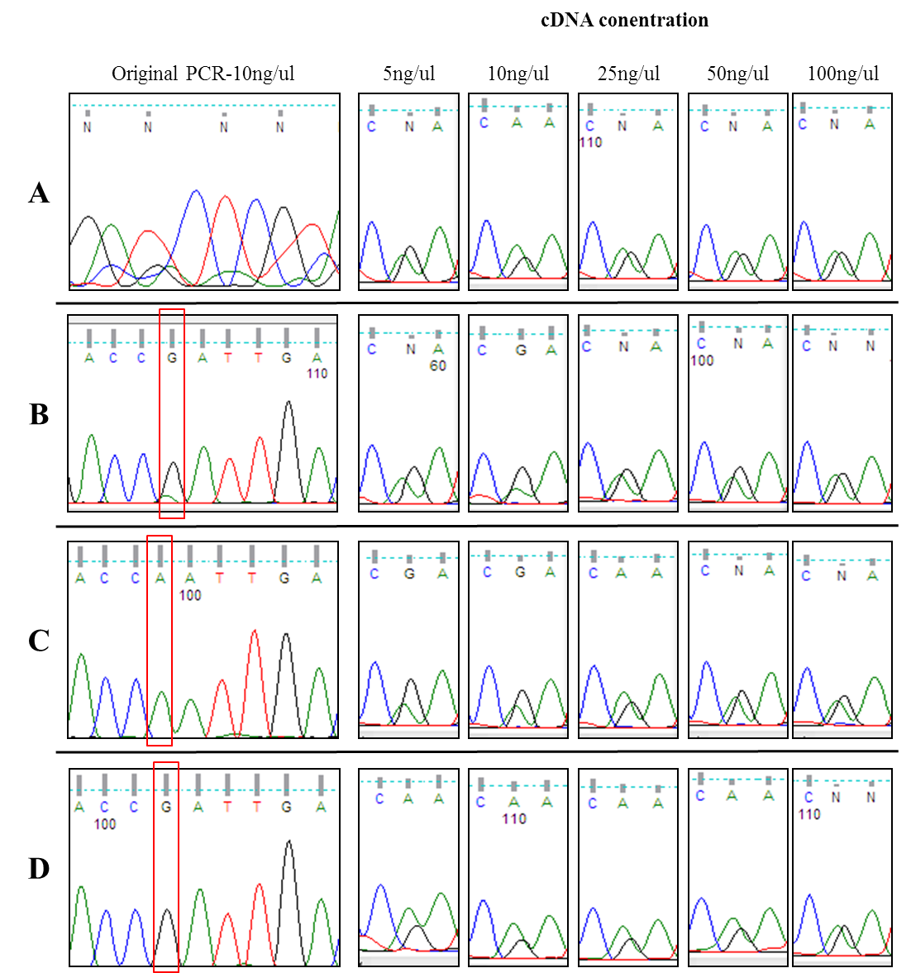

Figure 3.4.3 Sequencing of cDNA derived from the Seckel Lymphoblast’s cell line PJ0013
Four cDNA samples were prepared from PJ0013 cell lines separated by at least one passage, pre-PCR amplification for LARG exon 18 was performed with 10ng/µl starting cDNA concentration. Results were varied (as shown in the ‘original PCR’ profiles), sample A did not sequence, B gave a heterozygous peak (very low mutant peak), C gave homozygous mutant and D homozygous wild type (highlighted in red). Samples were then re-sequenced using increasing cDNA concentrations in the pre-sequencing amplification, while some variability was observed in low concentration samples all traces at 50ng/µl showed equal peaks for the mutant and wild type trace.
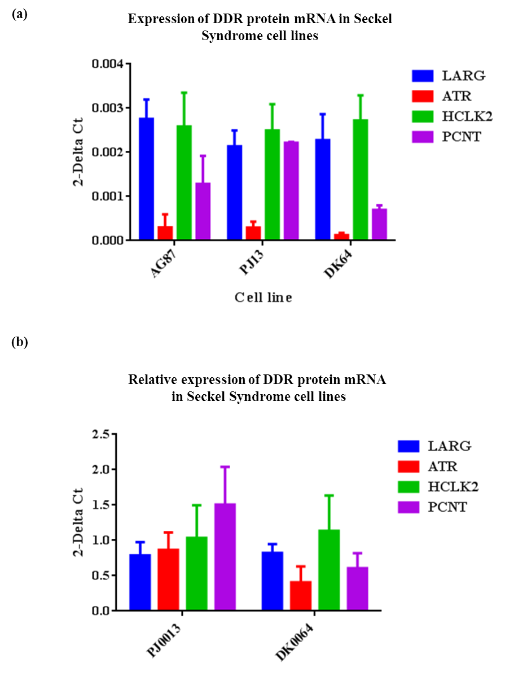

Figure 3.4.4 Relative mRNA expression of LARG and DDR proteins between wild type and Seckel Syndrome lymphoblast cell lines
cDNA samples were prepared from 5x10⁵ wild type (AG09387), ATR-deficient (DK0064) and LARG mutant (PJ0013) lymphoblast cells using Qiagen RNeasy and Taqman Reverse Transcription kits. Expression profiling for LARG, HCLK2, ATR, PCNT and GAPDH was performed using Taqman primer sets, expression data was normalised to GAPDH. (a) Raw 2-Delta CT values were plotted to show expression levels normalised to GAPDH. (b) Expression levels were normalised to AG09387 (WT) levels to allow for easier comparison of relative expression of each gene. (n=3)

Expression profiling of LARG levels revealed no overt changes in mRNA expression between wild type, ATR-Seckel and LARG mutant cell lines. Coupled with the heterozygous cDNA sequencing it can concluded that both the wild type and 1526G>A mutant forms of LARG are expressed in the PJ0013 cell line. No difference in HCLK2 expression was observed in either of the Seckel lines, while there appears to be high variation in the expression level of PCNT with PJ0013 displaying higher expression than AG09387 while DK0064 shows lower expression. ATR expression was employed as a positive control in this assay and as expected the DK0064 cell line has only a third of the ATR expression of the wild type AG09387 cell line (Figure 3.4.4). That no changes in LARG expression levels were observed do not prevent the mutation observed from having deleterious effects, one option that will be explored within the discussion is the formation of defective multimers with Arhgef11 (Figure 3.4.11). During trouble shooting regarding LARG mRNA expression the possibility that wt LARG mRNA was being targeted for destruction by nonsense mediated decay (NMD) was explored using puromycin to inhibit NMD however no evidence of this was observed (data not shown).

Assessment of cellular responses to replication stress in Seckel derived lymphoblast’s
A well-characterised trait of the ATR-Seckel cells is a defective response to replication stress. As discussed in the introduction section, the phosphorylation of Chk1 by ATR is a key event (although recent doubt has been expressed over its reliability see discussion in chapter 3.3) in cellular responses to replication stress to prevent premature entry into mitosis (Alderton et al., 2004). Replication stress induced activation of ATR is also required for efficient FANCD2 mono-ubiquitination, where disruption of ATR signalling can lead to phenotypes mimicking Fanconi Anaemia and sensitivity to cross linking agents (Andreassen and Andrea, 2004, Collis et al., 2007). Therefore, to assess cellular response to replication stress in AG09387, PJ0013 and DK0064 cells, they were treated with 5mM HU for 2 hours, protein extracts made assayed for pChk1 and FANCD2 mono-ubiquitination. Normal pChk1 induction was observed in AG09387 lymphoblasts, however a much reduced induction was observed in both DK0064 and PJ0013 cells (figure 3.4.5). This is expected for DK0064 as reduction in ATR has been shown to perturb Chk1 phosphorylation (Alderton et al., 2004). Importantly this indicates that PJ0013 has defective ATR signalling. This is further supported by the failure of PJ0013 and DK0064 to mono-ubiquitinate FANCD2 in response to HU treatment; this can be observed by the formation of a higher band in the AG09387 HU treated lane (Figure 3.3.5) which is not observed in either the PJ0013 lane or the DK0064 lane.

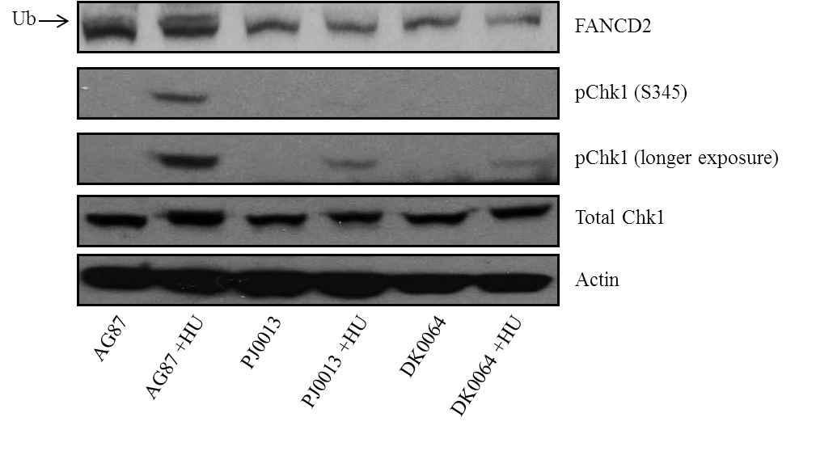

Figure 3.4.5 Characterisation of cellular responses to replication stress in PJ0013
In order to assess the cellular response to replication stress T25 flasks containing 5ml of 1x10⁶ Seckel lymphoblast cell suspensions were treated with 5mM HU for 2 hours before pelleting and lysing. After protein quantification samples were separated by SDS-PAGE prior to western blotting. No change in total Chk1 levels were observed between cell lines however pChk1 (S345) induction was reduced in DK0064 and PJ0013 lines. Low pChk1 is observed upon longer exposure of blots. Ubiquitination of FANCD2 can be observed in the band shift in the AG09387 +HU lane (arrow), however no band shift is observed in the PJ0013 or DK0064.

The G2/M cell cycle checkpoint has been shown to be defective in ATR and PCNT Seckel Syndrome patient cell lines, whereby cells that have undergone genomic insult (UV is typically used) do not effectively halt cell cycle progression. Wild type cells will halt cell cycle progression allowing for repair of damage before entering mitosis, this results in a much smaller population of mitotic cells after UV treatment. Examples of defective G2/M checkpoint are observed in PCNT (Griffith et al., 2008), ATR (Alderton et al., 2004) and more recently it has been suggested in CEP152 related Seckel Syndrome (Kalay et al., 2011). It was demonstrated in ATR mutant Seckel Syndrome cells that it was possible to rescue this checkpoint defect by transfecting full length WT ATR cDNA (Alderton et al., 2004).
In order to further characterise the LARG mutation in PJ0013 as a possible source of the observed ATR signalling defects, vectors containing full length Flag tagged WT LARG and 1526G>A LARG were created and tested for expression in Hek293 cells. As the protocol for lymphoblast transfection called for a transfection reagent not previously employed in our laboratory expression testing was carried out with both GeneJuice and Lipofectamine 2000 (see Materials and Methods). Both vectors gave comparable expression using either GeneJuice or Lipofectamine 2000 in Hek293 cells, (Figure 3.4.6a).
Lymphoblast’s lines do not display the same high level of transfection efficiency as Hek293 cells, which is reflected in the protocol for the G2/M rescue requiring transfection of 2µg of DNA on 3 sequential days (see Materials and Methods). Early attempts at observing Flag vector expression were performed by taking half of the population of cells before UV treatment and preparing lysates using a standard cell lysis protocol. No Flag bands were observed by western blot using either vector in any of the 3 cell lines (data not shown). Expecting low transfection efficiency Flag IPs were therefore carried out on whole cell populations after the lymphoblast transfection protocol, however no Flag enrichment was observed and blots contained a large amount of background staining (data not shown). In order to reduce background staining lymphoblast’s were transfected with a Myc-LARG vector, again whole cell populations after transfection were used in IPs using the anti-Myc tag antibody (9B11) and sepharose A/G beads to reduce the non-specific banding and smearing pattern observed using Flag-M2 beads. The results of the Myc-LARG transfections and IPs are shown in Figure 3.4.6b. Although a weak band is seen in both the input lanes, this is not clearly observed in the EV IP lanes while a stronger band was observed in the Myc-LARG IP lanes. However smearing around the band is seen making conclusions difficult to reach, although these results cannot be used as conformation of expression of LARG vectors in lymphoblast’s it is the strongest indication that was observed when attempting to optimise the conditions to observe expression. What these data do indicate is that both vectors can express and express to roughly equal levels, indicating that if expression occurs in lymphoblast’s, even at low levels, comparisons between vectors in a rescue experiment are possible. Alternative strategies for stable transfection are available for lymphoblsts such as the employment of lentiviral constructs, which are made in producer cells before purification and transfection into the target cell line. Time constraints prevented this from being explored.
The G2/M rescue experiment was subsequently performed using both full length and mutant LARG vectors. Briefly, this involved transfection on 3 consecutive days before UV treatment and 24 hour incubation in nocodazole, a microtubule depolymerising agent which halts cell cycle progression in mitosis (Zieve et al., 1980), before fixation and mounting on cover slips. The mitotic population is determined using the DAPI staining signal which allows for interphase and mitotic cells to be counted and the percentage of mitotic cells to be calculated.

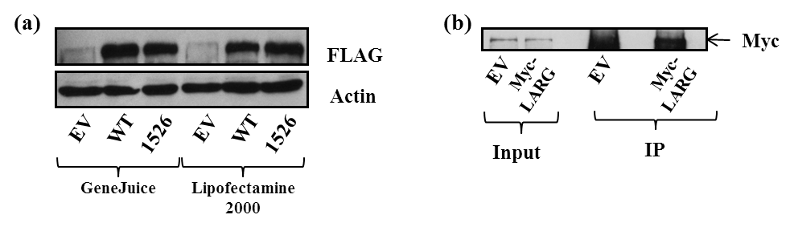

Figure 3.4.6 Expression of wild type and point mutant LARG vectors in Hek293 and PJ0013 cells.
(a) 2x10⁵ Hek293 cells plated in 6 well dishes were transfected with 1µg of either an Empty Flag vector (EV), Flag-LARG (WT) or Flag-LARG 1526G>A (1526) vectors using either GeneJuice or Lipofectamine 2000 transfection reagents. Proteins were separated by SDS-PAGE before western blotting and probing for Flag and Actin. Expression of Flag constructs was observed using both the WT and 1526 constructs while no Flag signal was observed in the EV transfected lanes.
(b) 5ml of 1x10⁶/ml PJ0013 cells were transfected with 2µg Myc-LARG on three consecutive days (see Materials and methods for full transfection protocol). Input samples were taken (5%) of lysate before a Myc-IP was performed on the Myc transfected lysate. Proteins were separated by SDS-PAGE before western blotting and probing for Myc (9B11). No enrichment of Myc was seen in the inputs, however a Myc band was observed at 150kDa indicative of LARG expression. Western blots displayed high levels of smearing in IP lanes making this band difficult to observe clearly.

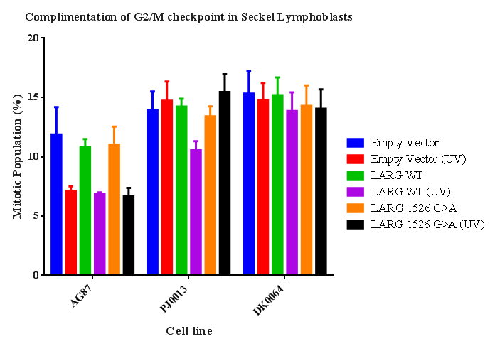

Figure 3.4.7 Rescue of the G2/M checkpoint in Seckel Syndrome patient derived cells using WT but not mutant mimic LARG cDNA expressing vectors
Lymphoblast cell lines derived from Seckel Syndrome patients with defects in ATR (DK0064), LARG (PJ0013) and a wild type control (AG09387) were transfected with an empty, wild type LARG of LARG 1526G>A vectors. Cells were treated with 10Jm⁻² UV before a 24 hour incubation in 1.5µM nocodazole to enrich for mitotic cells. Cells were fixed, stained with DAPI and cytospun. Mitotic percentages were determined using DAPI staining (min 600 cells counted per sample). Normal cellular reaction the UV treatment was observed for all three vectors in the AG09387 cell line; this is represented by the reduction in the number of mitotic cells after treatment. PJ0013 cells transfected with empty vector or mutant LARG do not show any reduction in mitotic population after UV treatment, but those transfected with wild type LARG demonstrate a partial recovery of the G2/M checkpoint. The ATR deficient DK0064 cell line show a defective G2/M checkpoint with all three vectors showing no decrease in mitotic population after UV treatment. (n=3)

The AG09387 cell line exhibited a mitotic population of between 12 and 14% after 24 hours in nocodazole, however after treatment with 10Jm⁻² UV radiation this reduced to 7% (figure 3.4.7). This is the typical behaviour expected after UV treatment and represents an intact G2/M checkpoint. These values do not change between cells transfected with an empty vector versus those transfected with either wild type LARG or LARG 1526G>A indicating that over expression of these vectors does not affect mitotic progression of the G2/M checkpoint in wild type cells (figure 3.4.7). This does not comply with a heterozygous model as it would be expected that over expression of the mutant would impact on WT cells ability to activate the G2/M checkpoint. PJ0013 cells transfected with empty vector displayed a mitotic population of 15% before UV treatment; however this did not decrease after UV treatment, indicating that PJ0013 cells do have a defective G2/M checkpoint consistent with the ATR signalling defects observed in figure 3.4.5. A similar untreated mitotic population was seen in PJ0013 cells transfected with wild type LARG (Figure 3.3.7). Unlike empty vector transfected cells the mitotic population decreased after UV to 10% indicating a partial rescue of the G2/M checkpoint in these cells. As PJ0013 harbours a heterozygous mutation in LARG (Figures 3.4.1 and 3.4.2) transfection of a vector with this mutation should not result in a rescue of the G2/M checkpoint if this residue is required for LARG to function normally in the G2/M checkpoint. When transfected with the LARG 1526G>A vector PJ0013 cell populations exhibited a mitotic percentage of 14% and as in the empty vector this did not reduce after UV treatment, thus implying that it is the transfection of full length wt LARG that is rescuing the G2/M checkpoint in PJ0013 cells. The ATR defective DK0064 cell line was again used as a positive control in these experiments. Following nocodazole treatment, the mitotic population was observed to be 15%, and as expected no G2/M checkpoint was observed after UV treatment (Alderton et al., 2004). Unlike PJ0013, this defect was not rescued by transfection of LARG cDNA as both WT and 1526G>A exhibited no change in mitotic percentage after UV treatment (Figure 3.4.7). Thus demonstrating that wt LARG cDNA expression cannot rescue ATR deficient cells non-specifically. The complementation experiment was performed independently within the Jeggo laboratory with wild type LARG and an empty vector (but not the 1526G>A) where it was also observed that transfection of the full length LARG construct rescued the G2/M checkpoint deficiency, strengthening the connection between LARG and DDR signalling. Another caveat to this experiment is the use of nocodazole (a microtubule depolymerising agent) as given LARGs role in the cytoskeleton (Goulimari et al., 2008), disruption of this network could result in changes to LARGs localisation which may impact on any potential role in cell cycle arrest.
Additionally, several attempts were made to rescue the pChk1 defect using the same transfection protocol employed in the G2/M checkpoint, after 3 consecutive transfections cells were treated with 5mM HU for 3 hours before lysis. However no consistent results could be obtained (data not shown). Personal communication with Prof Penny Jeggo revealed that over expression of Rad9 in a genetically uncharacterised Seckel syndrome cell line was able to rescue the G2/M checkpoint, however sequencing of the cell line presented wild type sequence for Rad9. This raises the possibility that over expression of pathway components in this assay are able to compensate for deficiencies in other factors involved in the checkpoint. If this were the case we would expect the mutant LARG vector to rescue the G2/M checkpoint, however this is not the case which suggests that the well conserved Arginine residue that is changed has a functional role allowing LARG to participate in the DDR.
Overall, these data indicate that the partial rescue of the G2/M checkpoint observed in the PJ0013 line is due to the reintroduction of the wild type LARG vector rescuing a defect due to the genetic background in PJ0013. This implies that the G1526A mutation observed in PJ0013 may be giving rise to the G2/M checkpoint defect and therefore the mutation could be contributing to ATR signalling defects observed in these cells (see Discussion).

RhoA activation in Seckel derived lymphoblast’s
Due to the evidence obtained thus far for potential cross talk between the DDR and RhoA pathways through LARG and ATR, Seckel derived lymphoblasts were assayed for the phosphorylation of MLC. As with the pChk1 experiments no consistent results could be obtained after transfection with LARG constructs. Figure 3.4.8 demonstrates the typical induction of pMLC after incubation with increasing LPA concentrations in un-transfected cells.
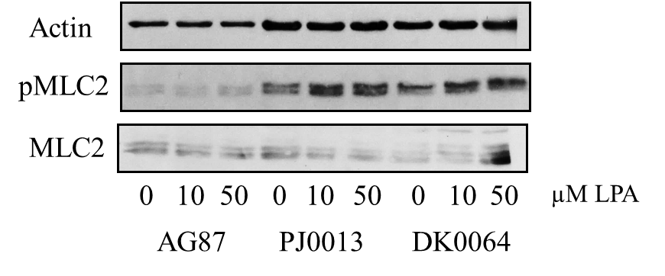

Figure 3.4.8 pMLC induction in Seckel Syndrome patient derived lymphoblast’s
5x10⁵/ml lymphoblast’s cell populations were serum starved for a minimum of 3-4 hours before treatment with LPA at the given doses. Cells were pelleted and washed in PBS before re-suspension in protein loading buffer and separation of proteins by gel electrophoresis. Blots were probed for Actin and pMLC. No induction was observed in the AG09387 samples, some induction was observed between 0 and 10µM LPA in PJ0013 samples however little induction was observed in DK0064 cell lines.

Although an increase in pMLC levels can be observed in PJ0013 cells treated with both 10µM and 50µM LPA compared to untreated cell lines it is modest when compared with the induction seen using adherent cells in Chapter 3.4. However the total levels of pMLC in the untreated PJ0013 appear higher than in the two treated lanes, indicating that the induction may be higher than it appears in the pMLC blot due to a lower pool of MLC available for phosphorylation. The increase in pMLC in DK0064 samples treated with LPA is modest even when compared with PJ0013, although some induction was observed unlike in the AG09387 sample. More importantly, the lack of pMLC induction in the control AG09387 cell lines after LPA treatment indicates that the methodology requires further optimisation and prevents any signalling defects in either PJ0013 or DK0064 to be confidently assessed.
As in previous chapters efforts were made to quantify the relative active RhoA-GTP levels both in resting an LPA treated samples for all three cell lines (Figure 3.4.9). As in the pMLC assay little induction in RhoA-GTP was observed in the AG09387 samples, indicating poor RhoA activation. While the basal RhoA-GTP levels in both PJ0013 and DK0064 untreated samples was nearly double that observed in AG09387 lines neither was observed to significantly induce RhoA-GTP formation after LPA treatment (Figure 3.4.9). Conversely the PJ0013 line levels decreased by a quarter, a drop larger than the increase observed in AG09387 and DK0064. If induction of RhoA-GTP was observed in the AG09387 line the decrease in PJ0013 could indicate that the LARG 1526G>A mutation was acting in a dominant negative manner whereby pathway signal transduction was being prevented by the mutant form of LARG, however without a working positive control no such speculation can be made. Unfortunately the difficulty in working with lymphoblast cell lines in these assays means that no conclusions about the robustness of RhoA activation in these cell lines can be drawn at this time.
An alternative approach for these experiments would have been the use of shRNA mediated stable cell knockdowns of LARG with the reintroduction of both WT and 1526G>A, this would allow for the employment of these assays in a manner for which they have already been optimised. The loss of endogenous LARG may be problematic when approaching the PJ0013 model as it is heterozygous, in which case the basic Flp-In system may be more appropriate as endogenous LARG remains alongside the over expressed mutant insert.
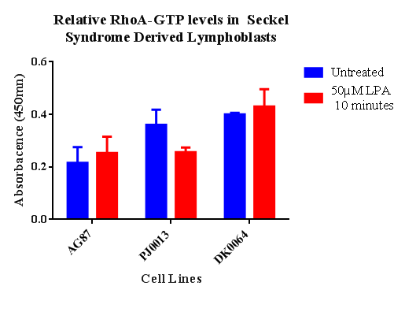

Figure 3.4.9 Relative RhoA-GTP levels in Seckel lymphoblast’s with LPA treatment
5x10⁵/ml lymphoblast’s cell populations were serum starved for a minimum of 3-4 hours before treatment with LPA at 50µM for 10 minutes. Cell lysates were collected and quantified using a G protein ELISA (Cytoskeleton) kit following the manufactures protocol. Data shown indicates the average of two separate experiments. Poor induction in RhoA-GTP levels was observed in both AG09387 and DK0064 samples, while a decrease in the relative RhoA-GTP levels was observed in the LPA treated PJ0013 sample. This is contrary to pMLC data indicating that RhoA activation leading to the phosphorylation of MLC was possible (see Figure 3.4.8).
The NCBI SNP database (http://www.ncbi.nlm.nih.gov/snp) was periodically checked during the course of the project as to the status of the 1526G>A mutation. This was due to this listing of the mutation as a SNP of no known frequency (see earlier). It was due to this initial uncertainty that we sequenced over 100 normal genomic DNA samples allowing us to exclude the possibility of the mutation being a common SNP (more than 1% penetrance). Interestingly, the status of the SNP was updated on the 1000 genome project shortly after the end of this PhD project to reclassify LARG 1526G>A as a rare SNP (Figure 3.4.10) after it was observed to be present in 3 individuals out of the 2178 sequenced (Abecasis et al., 2010), the database does not provide any clinical information for these cases.
This indicates that the LARG 1526G>A mutation alone is not the causal factor for the Seckel phenotype observed in PJ0013, but this does not preclude the LARG mutation from being a contributing factor in the development of Seckel Syndrome. Ideally whole exome sequencing of PJ0013 would be employed to look for novel mutations within candidate Seckel genes, however the scale of any such project is beyond what is presented here and as such the main conclusion that can be drawn from these data presented above is; the genetically uncharacterised PJ0013 Seckel Syndrome patient contains a rare G>A SNP within the coding sequence of LARG at position 1526 and that the genetic background of PJ0013 allows for the partial rescue of the G2/M checkpoint defect present by the over expression of wild type LARG but not the mutant form, indicating that LARG signalling is playing a role in the G2/M defect but may not be the only driving factor of the Seckel phenotype observed in the PJ0013 cells.

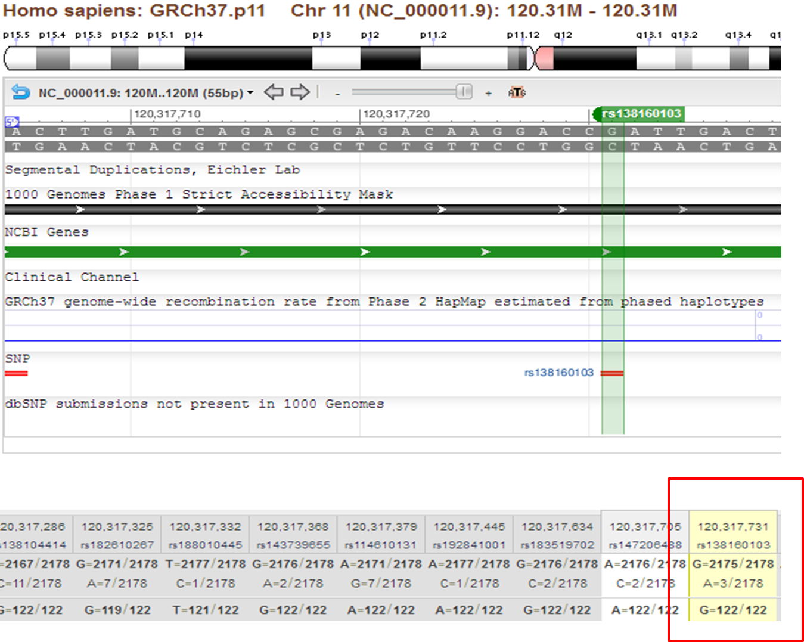

Figure 3.4.10 Updates from the 1000 genome project reveal LARG 1526G>A as a rare SNP
The 1000 genome project regularly updates the NCBI SNP database as new data is validated. As such the status of the LARG 1526G>A SNP (identifier rs138160103) was routinely checked. Recent updates have revealed the frequency of the LARG SNP to be 0.0014%, where it was found in three samples out of a total of 2175 tested (red box). The 1000 Genomes web viewer displays chromosome region, sequence position, local SNPs and breakdown the datasets to geographical region of origin (rs138160103 was found in two Italian samples and one British sample).

Discussion
As was discussed in the introduction LARG has been shown to function in both hetero- and homo- dimers with Arhgef11 (PDZ RhoGEF) (Chikumi et al., 2004b). The inclusion of a heterozygous mutation in LARG that is expressed at similar levels to the wild type therefore allows for the formation of 6 different possible dimers rather than the three that would be present within wild type cells (Figure 3.4.11). If the LARG 1526G>A mutation leads to LARG functional defects these may be carried over to dimer function whereby dimers that contain the mutant form have reduced or no function, thereby reducing the overall pool of functional dimers. This could result in overall phenotypes that are not as severe as total loss but do result in reduced function, be that in RhoA activation or possible roles in the DDR. If this were the case then over-expression of WT LARG would increase the pool of fully functional dimers. However, even if the mutation is not dominant negative in itself, expression of the mutant form would further reduce the pool of functioning dimers acting in a potential dominant negative manner. Unless the level of signalling required for survival is very low, for example the ATR Seckel mutation leads to a much reduced ATR expression level and activity which leads to viability albeit with severe developmental defects (Murga et al., 2009) while complete disruption of ATR causes embryonic lethality by E7.5 in mice (Brown and Baltimore, 2000).

Figure 3.4.11 Increased Dimer Variation in PJ0013
The addition of a mutant allele creates three new possible dimers. If the 1526G>A mutation is detrimental to LARG function this reduces the pool of functional dimers.
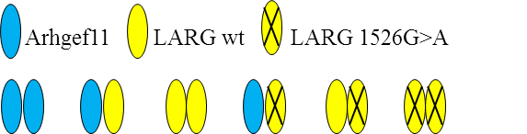

Recent work on LARG has demonstrated that knockout mice are born at sub-Mendelian levels but display no overt phenotype while ARHGEF11 knockout mice also display no overt phenotype they are born at normal Mendelian levels. However a double knockout is not viable, resulting in embryonic lethality by E10.5 (Mikelis et al., 2013). Furthermore, these double knockout embryos were observed to have developmental defects such as reduced size and partial failure of cranial vessel branching causing a reduced head size (Mikelis et al., 2013). This paper concludes that there is strong evidence for a role in Gα12/13 pathways in embryonic development and that the differences in birth frequency of each knockout indicate that despite strong sequence homology the two proteins are likely to have some variation in cellular function. This is not the first publication to link RhoA activation through LARG and Arhgef11 with CNS development, as RhoA activation through Plexin B has been linked to neural growth cone morphology (Swiercz et al., 2002). The neural growth cone is the sensory leading edge of neurones as they elongate through tissue during CNS development; this requires strong control of cell motility through cytoskeletal rearrangement, one of the major functions of RhoA (Woo and Gomez, 2006). In addition, LARG has been indicated to have a role in the Microtubule Organising Centre (MTOC), which plays a key role in cellular polarisation and actin dynamics and it was demonstrated that depletion of LARG results in a large reduction in the number of correctly polarised cells after scratch wound (Goulimari et al., 2008). Further to this RhoA itself has been implicated in supernumerary centrosomes, whereby depletion of RhoA by siRNA in HeLa cells led to an increase in cells displaying supernumerary centrosomes from 2-3% in control cells to between 13-20% in RhoA depleted populations (Aoki et al., 2009). This same publication showed a similar phenotype using Arhgef10; a Dbl motif containing protein itself implicated in the myelination of the nervous system, mutations of which are associated with slowed nerve conduction phenotypes (Verhoeven et al., 2003). KIF3B was identified as an interacting partner of Arhgef10 (Aoki et al., 2009), itself associated with mitosis through spindle microtubules and centrosomes (Haraguchi et al., 2006).
This links in with previous thoughts on potential mechanisms for microcephaly development where it was hypothesised that brain development might be particularly sensitive to centrosome stability/function and spindle pole orientation(Cox et al., 2006). The complex method of division required for neural development includes; symmetric progenitor cell division (increasing precursor cell number), the subsequent asymmetric division that results in single neurons and the final symmetric terminal divisions that produce two terminally differentiated neurons. The Rho-GTPase Cdc42 has been shown to play a role in the maintenance of the progenitor neurone population, although not through spindle orientation but through maintaining cellular adherens junctions between neural tissue types (Cappello et al., 2006). In addition to this RhoA was demonstrated to have a critical role in the maintenance of these adherens junctions as conditional deletion of RHOA in the mid and forebrain led to the development of mouse embryos displaying exencephaly-like protrusions (growth of the brain outside the skull) (Katayama et al., 2011).
Although current research on RhoA focuses on neurite outgrowth, adherens junction and not on division the central role of the RhoA pathway in controlling cellular polarisation and micro-tubule dynamics does not rule out effects within neurone differentiation due to the complex nature of asymmetrical division required.
The observations that LARG interacts with HCLK2 and PCNT alongside defects in cellular responses to replication stress link LARG with many of the cellular phenotypes associated with Seckel Syndrome. Alongside the links with RhoA signalling with many stages of neural development in mice, an associative phenotypic case for LARG being a candidate gene for susceptibility to Seckel Syndrome can be argued. Although in the case of PJ0013 the variant in LARG is a rare SNP, this does not preclude changes in LARG function being associated with Seckel phenotypes in the genetic background in the patient from which PJ0013 cells were derived. To bolster this case further cellular experimentation to characterise any defects that would arise from a 1526G>A LARG mutation could be carried out. Generation of shRNA stable LARG knock-down HeLa cells was undertaken, however timing prevented their implementation for further characterisation of the effect on both DDR pathways such as those shown in chapter 3.3 and RhoA signalling pathways shown in chapter 3.4. Until such as time as the functional changes to LARG via 1526G>A can be determined or a more comprehensive genetic profiling of PJ0013 can be performed no solid conclusions can be made about the importance of the LARG variant in the development of Seckel Syndrome.

4 Concluding remarks and future perspective
The data presented within this thesis demonstrates the progress from a yeast-2-hybrid screen designed to identify novel interactors of HCLK2, to confirmation of the interaction with LARG, characterisation of LARG in a pathway for which it had not previously been indicated and ultimately as a potential antagonist in a rare genetic disorder. However, although a preliminary data can be garnered there are limitations in the conclusions that can be drawn from the data presented within. Early work characterising the interaction between LARG and HCLK2 allows for some confidence in the interaction, providing the first link between LARG and the DDR although this does not answer many other questions. The Y2H screen originally gave a region of interaction on LARG between AA709-1072, coinciding with the DH and the N terminus of the PH domain. With the knowledge that the DH domain alone is sufficient for GEF activity while the tandem DH-PH confers much greater GEF kinetics (Reuther et al., 2001), it is tempting to speculate that LARG is somehow regulated by HCLK2. The necessary LARG constructs to domain map the HCLK2 interaction were created however time constraints prevented their implementation for this submission. The literature suggests it is possible that both proteins could be present in the nucleus (Grabocka and Wedegaertner, 2007, Jiang et al., 2003), although this would require disruption of LARG oligomerisation. The interaction might well be in the cytoplasm, although there is no evidence that HCLK2 associates with microtubules, it has been demonstrated that Arhgef11 contains a short sequence with homology to LARG that mediates its cytoskeletal localisation (Banerjee and Wedegaertner, 2004).
Interestingly the potential Seckel variant in LARG presented in chapter 3.4 changes one of the conserved residues in this region (however this was determined to be a SNP). Further investigation using shRNA mediated LARG depleted cells would allow for characterisation of the effects of the mutation, although GFP-LARG1526G>A was generated and tested, heterodimers would be formed both with the endogenous LARG and Arhgef11 making conclusions about localisation unreliable (the use of Arhgef11 siRNA would need to be implemented). This may also be why the use of micro-injected GFP-LARG was explored in previous publications (Goulimari et al., 2008), interactions might occur pre-dominantly in homodimers and therefore exogenous production of GFP-LARG would allow for a homodimer population (assuming non-endogenous levels of expression).
One of the potentially most significant novel interactors of LARG identified in this study is Lamin A. Although, as a protein involved in the nuclear membrane structure this was approached with a degree of scepticism. However, both the immunoprecipitation of only the larger isoform, the corresponding levels in Lamin A and LARG enrichment by different LARG antibodies and the apparent perinuclear enrichment of LARG observed in YFP-LARG expressing cells give confidence that this reaction is not due to non-specific binding of Lamin A to the beads. Interestingly laminopathies have displayed links to genome instability through impaired 53BP1 and Rad51 recruitment, premature aging (Liu et al., 2005) and disrupted DNA replication (Moir et al., 2000). The potential relevance of this interaction was given added weight by the publication of two recent papers demonstrating detailed evidence for defects in stalled replication fork restart, sensitivity to replication stress (Singh et al., 2013), nuclear dynamics and an interaction between Lamin A and γH2AX (Mahen et al., 2013). This reinforces a great deal of research in modelling the importance of chromatin dynamics in response to DNA damage including chromatin relaxation (Ziv et al., 2006) and histone modifications (Downs et al., 2007).
Furthermore this interaction could help to unravel the recently reported defects in polarisation and migration in Lamin-deficient cells (Lee et al., 2007), although this is not the only phenotype that could relate to Rho pathways. An important part of cellular movement, polarisation and cell division is the positioning of the nucleus. It has previously been observed that the interaction between the nuclear envelope and the cytoskeleton, mediated by Emerin and the LINC complex, is disrupted in laminopathic models and leads to RhoA activation disruption (Hale et al., 2008). Links between the nuclear membrane and the cytoskeleton have previously been demonstrated through nesprin 3, a member of the linker of nucleoskeleton and cytoskeleton (LINC) complex (Ketema and Sonnenberg, 2011), which interacts with Plectin (Wilhelmsen et al., 2005). Plectin is a cytoskeletal linker protein which acts as a core component of the cytoskeleton (Wiche, 1998). Interestingly mass spectrophotometry of purified LARG complexes identified a possible interaction between LARG and Plectin through strong enrichment in the tetracycline induced vs. un-induced samples (2 vs. 12 peptides), although this was not confirmed in the course of this project.
Returning to genomic instability, it was recently demonstrated that loss of the Nesprin-3 interacting nuclear envelope proteins Sun1 and Sun2 lead to defects in the DDR which manifest as failure to induce γH2AX and ATM phosphorylation in response to HU and an interaction between DNA-PK and Sun1 and 2 was also observed (Lei et al., 2012). Perhaps most interestingly the relationship between Sun1/2 and Lamin is protracted; although Lamin binds Sun1/2 the mutant form observed in Hutchinson-Gilford Progeria Syndrome (HGPS) does not (Haque et al., 2010), while it has been demonstrated that wild type LMNA does not interact with DNA-PK the mutant form does (Liu et al., 2011). These irregularities in the phenotypic effects of either LMNA mutation or Sun depletion are currently not understood. Whether or not LARG depletion could disrupt Lamin:Sun1/2 interactions or Nesprin-3:Sun1/2 interactions (mediated through Plectin) is pure speculation. However the possibility could be investigated using immunoprecipitation techniques combined with siRNA and cellular fractionation and if possible employing cell lines from HGPS patients as this would allow investigation of Progerin (mutant Lamin) interaction with LARG. This would allow a functional link between the two phenotypes observed in LARG deficient cells regarding the RhoA and DDR pathways to be given a physical connection, allowing for greater understanding of cellular responses to DNA damage and cellular movement. Further to this the data presented here to try and identify LARG as a possible Seckel Syndrome associated protein candidate does not provide any conclusive link and at this stage a causal link cannot be inferred for the patient observed. The association between DDR related proteins and neuronal development is ever expanding, most recently defects in the HCLK2 interacting protein TTI2 (Hurov et al., 2010) have been demonstrated to cause microcephaly, stunted growth and mental retardation due to a missense mutation resulting in vastly reduced TTI2 protein levels (Langouet et al., 2013). Although this disease does not mimic Seckel Syndromes as the microcephaly is observed postnatal, instead sharing more phenotypes with a variety of DDR related diseases including Fanconi Anaemia and Nijmegen syndrome; it does however highlight the importance of DDR associated proteins in the neural environment for both development and degeneration.
In conclusion these data present a role for LARG in the cellular responses to DNA replication stress and indicate a level of cross talk between ATR and RhoA signalling pathways, although the mechanism and reason for this remains to be fully elucidated and would form the basis of future studies based on the data presented herein.

5 References
AALTONEN, L. A., PELTOMAKI, P., MECKLIN, J. P., JARVINEN, H., JASS, J. R., GREEN, J. S., LYNCH, H. T., WATSON, P., TALLQVIST, G., JUHOLA, M. & ET AL. 1994. Replication errors in benign and malignant tumors from hereditary nonpolyposis colorectal cancer patients. Cancer Research, 54, 1645-8.
ABECASIS, G. R., ALTSHULER, D., AUTON, A., BROOKS, L. D., DURBIN, R. M., GIBBS, R. A., HURLES, M. E. & MCVEAN, G. A. 2010. A map of human genome variation from population-scale sequencing. Nature, 467, 1061-73.
ABRAHAM, M. T., KURIAKOSE, M. A., SACKS, P. G., YEE, H., CHIRIBOGA, L., BEARER, E. L. & DELACURE, M. D. 2001. Motility-related proteins as markers for head and neck squamous cell cancer. The Laryngoscope, 111, 1285-9.
ABRAHAM, R. T. 2001. Cell cycle checkpoint signaling through the ATM and ATR kinases. Genes & development, 15, 2177-96.
ADAMO, A., COLLIS, S. J., ADELMAN, C. A., SILVA, N., HOREJSI, Z., WARD, J. D., MARTINEZ-PEREZ, E., BOULTON, S. J. & LA VOLPE, A. 2010. Preventing nonhomologous end joining suppresses DNA repair defects of Fanconi anemia. Molecular cell, 39, 25-35.
ADIMOOLAM, S. & FORD, J. M. 2003. p53 and regulation of DNA damage recognition during nucleotide excision repair. DNA repair, 2, 947-54.
ADZHUBEI, I. A., SCHMIDT, S., PESHKIN, L., RAMENSKY, V. E., GERASIMOVA, A., BORK, P., KONDRASHOV, A. S. & SUNYAEV, S. R. 2010. A method and server for predicting damaging missense mutations. Nature methods, 7, 248-9.
AHNESORG, P., SMITH, P. & JACKSON, S. P. 2006. XLF interacts with the XRCC4-DNA ligase IV complex to promote DNA nonhomologous end-joining. Cell, 124, 301-13.
AITTALEB, M., GAO, G., EVELYN, C. R., NEUBIG, R. R. & TESMER, J. J. 2009. A conserved hydrophobic surface of the LARG pleckstrin homology domain is critical for RhoA activation in cells. Cellular signalling, 21, 1569-78.
AL-DOSARI, M. S., SHAHEEN, R., COLAK, D. & ALKURAYA, F. S. 2010. Novel CENPJ mutation causes Seckel syndrome. Journal of medical genetics, 47, 411-4.
ALBERTS, A. S., QIN, H., CARR, H. S. & FROST, J. A. 2005. PAK1 negatively regulates the activity of the Rho exchange factor NET1. The Journal of biological chemistry, 280, 12152-61.
ALDERTON, G. K., JOENJE, H., VARON, R., BORGLUM, A. D., JEGGO, P. A. & O'DRISCOLL, M. 2004. Seckel syndrome exhibits cellular features demonstrating defects in the ATR-signalling pathway. Human molecular genetics, 13, 3127-38.
ALMOGUERA, C., SHIBATA, D., FORRESTER, K., MARTIN, J., ARNHEIM, N. & PERUCHO, M. 1988. Most human carcinomas of the exocrine pancreas contain mutant c-K-ras genes. Cell, 53, 549-54.
ALVINO, G. M., COLLINGWOOD, D., MURPHY, J. M., DELROW, J., BREWER, B. J. & RAGHURAMAN, M. K. 2007. Replication in hydroxyurea: it's a matter of time. Molecular and cellular biology, 27, 6396-406.
AMANO, M., ITO, M., KIMURA, K., FUKATA, Y., CHIHARA, K., NAKANO, T., MATSUURA, Y. & KAIBUCHI, K. 1996. Phosphorylation and activation of myosin by Rho-associated kinase (Rho-kinase). The Journal of biological chemistry, 271, 20246-9.
ANDERSON, C. M., KORKIN, D., SMITH, D. L., MAKOVETS, S., SEIDEL, J. J., SALI, A. & BLACKBURN, E. H. 2008. Tel2 mediates activation and localization of ATM/Tel1 kinase to a double-strand break. Genes & Development, 22, 854-9.
ANDREASSEN, P. R. & ANDREA, A. D. D. 2004. ATR couples FANCD2 monoubiquitination to the DNA-damage response. Genes & Development, 18, 1958-1963.
ANDREASSEN, P. R., D'ANDREA, A. D. & TANIGUCHI, T. 2004. ATR couples FANCD2 monoubiquitination to the DNA-damage response. Genes & Development, 18, 1958-63.
ANITHA, A., NAKAMURA, K., YAMADA, K., IWAYAMA, Y., TOYOTA, T., TAKEI, N., IWATA, Y., SUZUKI, K., SEKINE, Y., MATSUZAKI, H., KAWAI, M., MIYOSHI, K., KATAYAMA, T., MATSUZAKI, S., BABA, K., HONDA, A., HATTORI, T., SHIMIZU, S., KUMAMOTO, N., TOHYAMA, M., YOSHIKAWA, T. & MORI, N. 2008. Gene and expression analyses reveal enhanced expression of pericentrin 2 (PCNT2) in bipolar disorder. Biological psychiatry, 63, 678-85.
AOKI, T., UEDA, S., KATAOKA, T. & SATOH, T. 2009. Regulation of mitotic spindle formation by the RhoA guanine nucleotide exchange factor ARHGEF10. BMC cell biology, 10, 56.
APLAN, P. D. 2006. Causes of oncogenic chromosomal translocation. Trends in genetics : TIG, 22, 46-55.
ARAUJO, S. J., TIRODE, F., COIN, F., POSPIECH, H., SYVAOJA, J. E., STUCKI, M., HUBSCHER, U., EGLY, J. M. & WOOD, R. D. 2000. Nucleotide excision repair of DNA with recombinant human proteins: definition of the minimal set of factors, active forms of TFIIH, and modulation by CAK. Genes & Development, 14, 349-59.
ARAVIND, L., WALKER, D. R. & KOONIN, E. V. 1999. Conserved domains in DNA repair proteins and evolution of repair systems. Nucleic acids research, 27, 1223-42.
ARTAMONOV, M. V., MOMOTANI, K., STEVENSON, A., TRENTHAM, D. R., DEREWENDA, U., DEREWENDA, Z. S., READ, P. W., GUTKIND, J. S. & SOMLYO, A. V. 2013. Agonist-induced CA2+-sensitization in smooth muscle: redundancy of RhoGEFs and response kinetics; a caged compound study. The Journal of biological chemistry.
ATKINSON, J. & MCGLYNN, P. 2009. Replication fork reversal and the maintenance of genome stability. Nucleic acids research, 37, 3475-92.
AUDEBERT, M., SALLES, B. & CALSOU, P. 2004. Involvement of poly(ADP-ribose) polymerase-1 and XRCC1/DNA ligase III in an alternative route for DNA double-strand breaks rejoining. The Journal of biological chemistry, 279, 55117-26.
AUERBACH, A. D. & WOLMAN, S. R. 1976. Susceptibility of Fanconi's anaemia fibroblasts to chromosome damage by carcinogens. Nature, 261, 494-6.
AURANDT, J., VIKIS, H. G., GUTKIND, J. S., AHN, N. & GUAN, K. L. 2002. The semaphorin receptor plexin-B1 signals through a direct interaction with the Rho-specific nucleotide exchange factor, LARG. Proceedings of the National Academy of Sciences of the United States of America, 99, 12085-90.
BADANO, J. L., MITSUMA, N., BEALES, P. L. & KATSANIS, N. 2006. The ciliopathies: an emerging class of human genetic disorders. Annual review of genomics and human genetics, 7, 125-48.
BALAJEE, A. S. & GEARD, C. R. 2004. Replication protein A and gamma-H2AX foci assembly is triggered by cellular response to DNA double-strand breaks. Experimental cell research, 300, 320-34.
BALAJEE, A. S., MAY, A., DIANOV, G. L., FRIEDBERG, E. C. & BOHR, V. A. 1997. Reduced RNA polymerase II transcription in intact and permeabilized Cockayne syndrome group B cells. Proceedings of the National Academy of Sciences of the United States of America, 94, 5.
BALL, H. L., MYERS, J. S. & CORTEZ, D. 2005. ATRIP binding to replication protein A-single-stranded DNA promotes ATR-ATRIP localization but is dispensable for Chk1 phosphorylation. Molecular biology of the cell, 16, 2372-81.
BANERJEE, J. & WEDEGAERTNER, P. B. 2004. Identification of a novel sequence in PDZ-RhoGEF that mediates interaction with the actin cytoskeleton. Molecular biology of the cell, 15, 1760-75.
BANUELOS, C. A., BANATH, J. P., KIM, J. Y., AQUINO-PARSONS, C. & OLIVE, P. L. 2009. gammaH2AX expression in tumors exposed to cisplatin and fractionated irradiation. Clinical cancer research : an official journal of the American Association for Cancer Research, 15, 3344-53.
BAO, S., TIBBETTS, R. S., BRUMBAUGH, K. M., FANG, Y., RICHARDSON, D. A., ALI, A., CHEN, S. M., ABRAHAM, R. T. & WANG, X. F. 2001. ATR/ATM-mediated phosphorylation of human Rad17 is required for genotoxic stress responses. Nature, 411, 969-74.
BARNES, D. E., STAMP, G., ROSEWELL, I., DENZEL, A. & LINDAHL, T. 1998. Targeted disruption of the gene encoding DNA ligase IV leads to lethality in embryonic mice. Current biology : CB, 8, 1395-8.
BAUMANN, P., BENSON, F. E. & WEST, S. C. 1996. Human Rad51 protein promotes ATP-dependent homologous pairing and strand transfer reactions in vitro. Cell, 87, 757-66.
BAUMANN, P. & WEST, S. C. 1998. Role of the human RAD51 protein in homologous recombination and double-stranded-break repair. Trends in biochemical sciences, 23, 247-51.
BEKTAS, M., PAYNE, S. G., LIU, H., GOPARAJU, S., MILSTIEN, S. & SPIEGEL, S. 2005. A novel acylglycerol kinase that produces lysophosphatidic acid modulates cross talk with EGFR in prostate cancer cells. The Journal of cell biology, 169, 801-11.
BERMUDEZ, V. P., LINDSEY-BOLTZ, L. A., CESARE, A. J., MANIWA, Y., GRIFFITH, J. D., HURWITZ, J. & SANCAR, A. 2003. Loading of the human 9-1-1 checkpoint complex onto DNA by the checkpoint clamp loader hRad17-replication factor C complex in vitro. Proceedings of the National Academy of Sciences of the United States of America, 100, 1633-8.
BETAPUDI, V., RAI, V., BEACH, J. R. & EGELHOFF, T. 2010. Novel regulation and dynamics of myosin II activation during epidermal wound responses. Experimental cell research, 316, 980-91.
BHAGWAT, N., OLSEN, A. L., WANG, A. T., HANADA, K., STUCKERT, P., KANAAR, R., D'ANDREA, A., NIEDERNHOFER, L. J. & MCHUGH, P. J. 2009. XPF-ERCC1 participates in the Fanconi anemia pathway of cross-link repair. Molecular and cellular biology, 29, 6427-37.
BIENKO, M., GREEN, C. M., CROSETTO, N., RUDOLF, F., ZAPART, G., COULL, B., KANNOUCHE, P., WIDER, G., PETER, M., LEHMANN, A. R., HOFMANN, K. & DIKIC, I. 2005. Ubiquitin-binding domains in Y-family polymerases regulate translesion synthesis. Science, 310, 1821-4.
BJELLAND, S. & SEEBERG, E. 2003. Mutagenicity, toxicity and repair of DNA base damage induced by oxidation. Mutation research, 531, 37-80.
BLOCK, W. D., YU, Y. & LEES-MILLER, S. P. 2004. Phosphatidyl inositol 3-kinase-like serine/threonine protein kinases (PIKKs) are required for DNA damage-induced phosphorylation of the 32 kDa subunit of replication protein A at threonine 21. Nucleic acids research, 32, 997-1005.
BMJ 1960. E. H. Grubbe, M.D., F.A.C.P. The British Medical Journal, 2, 609.
BOBER, M. B., NIILER, T., DUKER, A. L., MURRAY, J. E., KETTERER, T., HARLEY, M. E., ALVI, S., FLORA, C., RUSTAD, C., BONGERS, E. M., BICKNELL, L. S., WISE, C. & JACKSON, A. P. 2012. Growth in individuals with Majewski osteodysplastic primordial dwarfism type II caused by pericentrin mutations. American journal of medical genetics. Part A, 158A, 2719-25.
BODNAR, A. G. 1998. Extension of Life-Span by Introduction of Telomerase into Normal Human Cells. Science, 279, 349-352.
BOGLIOLO, M., LYAKHOVICH, A., CALLEN, E., CASTELLA, M., CAPPELLI, E., RAMIREZ, M. J., CREUS, A., MARCOS, R., KALB, R., NEVELING, K., SCHINDLER, D. & SURRALLES, J. 2007. Histone H2AX and Fanconi anemia FANCD2 function in the same pathway to maintain chromosome stability. The EMBO journal, 26, 1340-51.
BOHR, V. A. & ANSON, R. M. 1995. DNA damage, mutation and fine structure DNA repair in aging. Mutation research, 338, 25-34.
BOLAND, C. R., KOI, M., CHANG, D. K. & CARETHERS, J. M. 2008. The biochemical basis of microsatellite instability and abnormal immunohistochemistry and clinical behavior in Lynch syndrome: from bench to bedside. Familial cancer, 7, 41-52.
BOLLAG, R. J., WALDMAN, A. S. & LISKAY, R. M. 1989. Homologous recombination in mammalian cells. Annual review of genetics, 23, 199-225.
BONNER, W. M., REDON, C. E., DICKEY, J. S., NAKAMURA, A. J., SEDELNIKOVA, O. A., SOLIER, S. & POMMIER, Y. 2008. γH2AX and cancer. Nature Reviews Cancer, 8, 957-967.
BOURDON, J. C. 2007. p53 and its isoforms in cancer. British journal of cancer, 97, 277-82.
BOURDON, J. C., FERNANDES, K., MURRAY-ZMIJEWSKI, F., LIU, G., DIOT, A., XIRODIMAS, D. P., SAVILLE, M. K. & LANE, D. P. 2005. p53 isoforms can regulate p53 transcriptional activity. Genes & Development, 19, 2122-37.
BOURKE, E., DODSON, H., MERDES, A., CUFFE, L., ZACHOS, G., WALKER, M., GILLESPIE, D. & MORRISON, C. G. 2007. DNA damage induces Chk1-dependent centrosome amplification. EMBO Reports, 8, 603-9.
BOUTROS, R., MONDESERT, O., LORENZO, C., ASTUTI, P., MCARTHUR, G., CHIRCOP, M., DUCOMMUN, B. & GABRIELLI, B. 2013. CDC25B overexpression stabilises centrin 2 and promotes the formation of excess centriolar foci. PloS one, 8, e67822.
BOUWMAN, P., ALY, A., ESCANDELL, J. M., PIETERSE, M., BARTKOVA, J., VAN DER GULDEN, H., HIDDINGH, S., THANASOULA, M., KULKARNI, A., YANG, Q., HAFFTY, B. G., TOMMISKA, J., BLOMQVIST, C., DRAPKIN, R., ADAMS, D. J., NEVANLINNA, H., BARTEK, J., TARSOUNAS, M., GANESAN, S. & JONKERS, J. 2010. 53BP1 loss rescues BRCA1 deficiency and is associated with triple-negative and BRCA-mutated breast cancers. Nature structural & molecular biology, 17, 688-95.
BOX, H. C., DAWIDZIK, J. B. & BUDZINSKI, E. E. 2001. Free radical-induced double lesions in DNA. Free radical biology & medicine, 31, 856-68.
BRADFORD, P. T., GOLDSTEIN, A. M., TAMURA, D., KHAN, S. G., UEDA, T., BOYLE, J., OH, K. S., IMOTO, K., INUI, H., MORIWAKI, S., EMMERT, S., PIKE, K. M., RAZIUDDIN, A., PLONA, T. M., DIGIOVANNA, J. J., TUCKER, M. A. & KRAEMER, K. H. 2011. Cancer and neurologic degeneration in xeroderma pigmentosum: long term follow-up characterises the role of DNA repair. Journal of medical genetics, 48, 168-76.
BRADNER, W. T. 2001. Mitomycin C: a clinical update. Cancer treatment reviews, 27, 35-50.
BRATTAIN, M. G., FINE, W. D. & KHALED, F. M. 1981. Heterogeneity of Malignant Cells from a Human Colonic Carcinoma of Malignant Cells from a Human Colonie Carcinoma1. Cancer Research, 41, 5.
BROOKES, P. & LAWLEY, P. D. 1961. The reaction of mono- and di-functional alkylating agents with nucleic acids. The Biochemical journal, 80, 496-503.
BROOKS, P. J. & THERUVATHU, J. A. 2005. DNA adducts from acetaldehyde: implications for alcohol-related carcinogenesis. Alcohol, 35, 187-93.
BROSH, R. M., JR., VON KOBBE, C., SOMMERS, J. A., KARMAKAR, P., OPRESKO, P. L., PIOTROWSKI, J., DIANOVA, I., DIANOV, G. L. & BOHR, V. A. 2001. Werner syndrome protein interacts with human flap endonuclease 1 and stimulates its cleavage activity. The EMBO journal, 20, 5791-801.
BROWN, E. J. & BALTIMORE, D. 2000. ATR disruption leads to chromosomal fragmentation and early embryonic lethality. Genes & Development, 14, 397-402.
BROWN, G. C. & BORUTAITE, V. 2012. There is no evidence that mitochondria are the main source of reactive oxygen species in mammalian cells. Mitochondrion, 12, 1-4.
BRYANT, H. E., SCHULTZ, N., THOMAS, H. D., PARKER, K. M., FLOWER, D., LOPEZ, E., KYLE, S., MEUTH, M., CURTIN, N. J. & HELLEDAY, T. 2005. Specific killing of BRCA2-deficient tumours with inhibitors of poly(ADP-ribose) polymerase. Nature, 434, 913-7.
BUCK, D., MALIVERT, L., DE CHASSEVAL, R., BARRAUD, A., FONDANECHE, M. C., SANAL, O., PLEBANI, A., STEPHAN, J. L., HUFNAGEL, M., LE DEIST, F., FISCHER, A., DURANDY, A., DE VILLARTAY, J. P. & REVY, P. 2006. Cernunnos, a novel nonhomologous end-joining factor, is mutated in human immunodeficiency with microcephaly. Cell, 124, 287-99.
BUDZOWSKA, M. & KANAAR, R. 2009. Mechanisms of dealing with DNA damage-induced replication problems. Cell biochemistry and biophysics, 53, 17-31.
BURAKOV, A., KOVALENKO, O., SEMENOVA, I., ZHAPPAROVA, O., NADEZHDINA, E. & RODIONOV, V. 2008. Cytoplasmic dynein is involved in the retention of microtubules at the centrosome in interphase cells. Traffic, 9, 472-80.
BURMA, S., CHEN, B. P., MURPHY, M., KURIMASA, A. & CHEN, D. J. 2001. ATM phosphorylates histone H2AX in response to DNA double-strand breaks. The Journal of biological chemistry, 276, 42462-7.
BURTHEM, J., REES-UNWIN, K., MOTTRAM, R., ADAMS, J., LUCAS, G. S., SPOONCER, E. & WHETTON, A. D. 2007. The rho-kinase inhibitors Y-27632 and fasudil act synergistically with imatinib to inhibit the expansion of ex vivo CD34(+) CML progenitor cells. Leukemia, 21, 1708-14.
CADET, J., DELATOUR, T., DOUKI, T., GASPARUTTO, D., POUGET, J. P., RAVANAT, J. L. & SAUVAIGO, S. 1999. Hydroxyl radicals and DNA base damage. Mutation research, 424, 9-21.
CAHILL, D. P., LENGAUER, C., YU, J., RIGGINS, G. J., WILLSON, J. K., MARKOWITZ, S. D., KINZLER, K. W. & VOGELSTEIN, B. 1998. Mutations of mitotic checkpoint genes in human cancers. Nature, 392, 300-3.
CALDECOTT, K. W. 2008. Single-strand break repair and genetic disease. Nature reviews. Genetics, 9, 619-31.
CALDECOTT, K. W., MCKEOWN, C. K., TUCKER, J. D., LJUNGQUIST, S. & THOMPSON, L. H. 1994. An interaction between the mammalian DNA repair protein XRCC1 and DNA ligase III. Molecular and cellular biology, 14, 68-76.
CALIGIURI, M. A., STROUT, M. P., OBERKIRCHER, A. R., YU, F., DE LA CHAPELLE, A. & BLOOMFIELD, C. D. 1997. The partial tandem duplication of ALL1 in acute myeloid leukemia with normal cytogenetics or trisomy 11 is restricted to one chromosome. Proceedings of the National Academy of Sciences of the United States of America, 94, 3899-902.
CANMAN, C. E., LIM, D. S., CIMPRICH, K. A., TAYA, Y., TAMAI, K., SAKAGUCHI, K., APPELLA, E., KASTAN, M. B. & SILICIANO, J. D. 1998. Activation of the ATM kinase by ionizing radiation and phosphorylation of p53. Science, 281, 1677-9.
CAPPELLO, S., ATTARDO, A., WU, X., IWASATO, T., ITOHARA, S., WILSCH-BRAUNINGER, M., EILKEN, H. M., RIEGER, M. A., SCHROEDER, T. T., HUTTNER, W. B., BRAKEBUSCH, C. & GOTZ, M. 2006. The Rho-GTPase cdc42 regulates neural progenitor fate at the apical surface. Nature neuroscience, 9, 1099-107.
CHA, H., LOWE, J. M., LI, H., LEE, J. S., BELOVA, G. I., BULAVIN, D. V. & FORNACE, A. J., JR. 2010. Wip1 directly dephosphorylates gamma-H2AX and attenuates the DNA damage response. Cancer Research, 70, 4112-22.
CHAKI, M., AIRIK, R., GHOSH, A. K., GILES, R. H., CHEN, R., SLAATS, G. G., WANG, H., HURD, T. W., ZHOU, W., CLUCKEY, A., GEE, H. Y., RAMASWAMI, G., HONG, C. J., HAMILTON, B. A., CERVENKA, I., GANJI, R. S., BRYJA, V., ARTS, H. H., VAN REEUWIJK, J., OUD, M. M., LETTEBOER, S. J., ROEPMAN, R., HUSSON, H., IBRAGHIMOV-BESKROVNAYA, O., YASUNAGA, T., WALZ, G., ELEY, L., SAYER, J. A., SCHERMER, B., LIEBAU, M. C., BENZING, T., LE CORRE, S., DRUMMOND, I., JANSSEN, S., ALLEN, S. J., NATARAJAN, S., O'TOOLE, J. F., ATTANASIO, M., SAUNIER, S., ANTIGNAC, C., KOENEKOOP, R. K., REN, H., LOPEZ, I., NAYIR, A., STOETZEL, C., DOLLFUS, H., MASSOUDI, R., GLEESON, J. G., ANDREOLI, S. P., DOHERTY, D. G., LINDSTRAD, A., GOLZIO, C., KATSANIS, N., PAPE, L., ABBOUD, E. B., AL-RAJHI, A. A., LEWIS, R. A., OMRAN, H., LEE, E. Y., WANG, S., SEKIGUCHI, J. M., SAUNDERS, R., JOHNSON, C. A., GARNER, E., VANSELOW, K., ANDERSEN, J. S., SHLOMAI, J., NURNBERG, G., NURNBERG, P., LEVY, S., SMOGORZEWSKA, A., OTTO, E. A. & HILDEBRANDT, F. 2012. Exome capture reveals ZNF423 and CEP164 mutations, linking renal ciliopathies to DNA damage response signaling. Cell, 150, 533-48.
CHANG, S., MULTANI, A. S., CABRERA, N. G., NAYLOR, M. L., LAUD, P., LOMBARD, D., PATHAK, S., GUARENTE, L. & DEPINHO, R. A. 2004. Essential role of limiting telomeres in the pathogenesis of Werner syndrome. Nature genetics, 36, 877-82.
CHAPMAN, J. R., BARRAL, P., VANNIER, J. B., BOREL, V., STEGER, M., TOMAS-LOBA, A., SARTORI, A. A., ADAMS, I. R., BATISTA, F. D. & BOULTON, S. J. 2013. RIF1 is essential for 53BP1-dependent nonhomologous end joining and suppression of DNA double-strand break resection. Molecular cell, 49, 858-71.
CHAPMAN, J. R., SOSSICK, A. J., BOULTON, S. J. & JACKSON, S. P. 2012. BRCA1-associated exclusion of 53BP1 from DNA damage sites underlies temporal control of DNA repair. Journal of cell science, 125, 3529-34.
CHECCHI, P. M., NETTLES, J. H., ZHOU, J., SNYDER, J. P. & JOSHI, H. C. 2003. Microtubule-interacting drugs for cancer treatment. Trends in pharmacological sciences, 24, 361-5.
CHIKUMI, H., BARAC, A., BEHBAHANI, B., GAO, Y., TERAMOTO, H., ZHENG, Y. & GUTKIND, J. S. 2004a. Homo- and hetero-oligomerization of PDZ-RhoGEF, LARG and p115RhoGEF by their C-terminal region regulates their in vivo Rho GEF activity and transforming potential. Oncogene, 23, 233-40.
CHIKUMI, H., BARAC, A., BEHBAHANI, B., GAO, Y., TERAMOTO, H., ZHENG, Y. & GUTKIND, J. S. 2004b. Homo- and hetero-oligomerization of PDZ-RhoGEF, LARG and p115RhoGEF by their C-terminal region regulates their in vivo Rho GEF activity and transforming potential. Oncogene, 23, 233-40.
CHIKUMI, H., FUKUHARA, S. & GUTKIND, J. S. 2002. Regulation of G protein-linked guanine nucleotide exchange factors for Rho, PDZ-RhoGEF, and LARG by tyrosine phosphorylation: evidence of a role for focal adhesion kinase. The Journal of biological chemistry, 277, 12463-73.
CHINI, C. C. & CHEN, J. 2004. Claspin, a regulator of Chk1 in DNA replication stress pathway. DNA repair, 3, 1033-7.
CHIU, W. C., JUANG, J. M., CHANG, S. N., WU, C. K., TSAI, C. T., TSENG, C. D., TSENG, Y. Z., SU, M. J. & CHIANG, F. T. 2012. Differential baseline expression and angiotensin II-stimulation of leukemia-associated RhoGEF in vascular smooth muscle cells of spontaneously hypertensive rats. International journal of nanomedicine, 7, 5929-39.
CHOI, H. J., LIN, J. R., VANNIER, J. B., SLAATS, G. G., KILE, A. C., PAULSEN, R. D., MANNING, D. K., BEIER, D. R., GILES, R. H., BOULTON, S. J. & CIMPRICH, K. A. 2013. NEK8 links the ATR-regulated replication stress response and S phase CDK activity to renal ciliopathies. Molecular cell, 51, 423-39.
CHOWDHURY, D., KEOGH, M. C., ISHII, H., PETERSON, C. L., BURATOWSKI, S. & LIEBERMAN, J. 2005. gamma-H2AX dephosphorylation by protein phosphatase 2A facilitates DNA double-strand break repair. Molecular cell, 20, 801-9.
CHOWDHURY, D., XU, X., ZHONG, X., AHMED, F., ZHONG, J., LIAO, J., DYKXHOORN, D. M., WEINSTOCK, D. M., PFEIFER, G. P. & LIEBERMAN, J. 2008. A PP4-phosphatase complex dephosphorylates gamma-H2AX generated during DNA replication. Molecular cell, 31, 33-46.
CHRZANOWSKA-WODNICKA, M. & BURRIDGE, K. 1996. Rho-stimulated contractility drives the formation of stress fibers and focal adhesions. The Journal of cell biology, 133, 1403-15.
CICCIA, A. & ELLEDGE, S. J. 2010. The DNA Damage Response: Making It Safe to Play with Knives. Molecular Cell, 40, 179-204.
CICCIA, A., LING, C., COULTHARD, R., YAN, Z., XUE, Y., MEETEI, A. R., LAGHMANI EL, H., JOENJE, H., MCDONALD, N., DE WINTER, J. P., WANG, W. & WEST, S. C. 2007. Identification of FAAP24, a Fanconi anemia core complex protein that interacts with FANCM. Molecular cell, 25, 331-43.
COLLIS, S. J., BARBER, L. J., CLARK, A. J., MARTIN, J. S., WARD, J. D. & BOULTON, S. J. 2007. HCLK2 is essential for the mammalian S-phase checkpoint and impacts on Chk1 stability. Nature cell biology, 9, 391-401.
COLLIS, S. J., CICCIA, A., DEANS, A. J., HOREJSI, Z., MARTIN, J. S., MASLEN, S. L., SKEHEL, J. M., ELLEDGE, S. J., WEST, S. C. & BOULTON, S. J. 2008. FANCM and FAAP24 function in ATR-mediated checkpoint signaling independently of the Fanconi anemia core complex. Molecular cell, 32, 313-24.
CONSTANTIN, N., DZANTIEV, L., KADYROV, F. A. & MODRICH, P. 2005. Human mismatch repair: reconstitution of a nick-directed bidirectional reaction. The Journal of biological chemistry, 280, 39752-61.
CORTEZ, D., WANG, Y., QIN, J. & ELLEDGE, S. J. 1999. Requirement of ATM-dependent phosphorylation of brca1 in the DNA damage response to double-strand breaks. Science, 286, 1162-6.
COUGHLIN, S. R. 2000. Thrombin signalling and protease-activated receptors. Nature, 407, 258-64.
COX, J., JACKSON, A. P., BOND, J. & WOODS, C. G. 2006. What primary microcephaly can tell us about brain growth. Trends in molecular medicine, 12, 358-66.
CROOKE, S. T. & BRADNER, W. T. 1976. Mitomycin C: a review. Cancer treatment reviews, 3, 121-39.
CRUK 2013. Cancer Statistics Report: Cancer Incidence in the UK in 2010. Cancer Research UK
CYBULSKI, C., GORSKI, B., HUZARSKI, T., MASOJC, B., MIERZEJEWSKI, M., DEBNIAK, T., TEODORCZYK, U., BYRSKI, T., GRONWALD, J., MATYJASIK, J., ZLOWOCKA, E., LENNER, M., GRABOWSKA, E., NEJ, K., CASTANEDA, J., MEDREK, K., SZYMANSKA, A., SZYMANSKA, J., KURZAWSKI, G., SUCHY, J., OSZUREK, O., WITEK, A., NAROD, S. A. & LUBINSKI, J. 2004. CHEK2 is a multiorgan cancer susceptibility gene. American journal of human genetics, 75, 1131-5.
D'ASSORO, A. B., BARRETT, S. L., FOLK, C., NEGRON, V. C., BOENEMAN, K., BUSBY, R., WHITEHEAD, C., STIVALA, F., LINGLE, W. L. & SALISBURY, J. L. 2002. Amplified centrosomes in breast cancer: a potential indicator of tumor aggressiveness. Breast cancer research and treatment, 75, 25-34.
DAVID, M., RIBEIRO, J., DESCOTES, F., SERRE, C. M., BARBIER, M., MURONE, M., CLEZARDIN, P. & PEYRUCHAUD, O. 2012. Targeting lysophosphatidic acid receptor type 1 with Debio 0719 inhibits spontaneous metastasis dissemination of breast cancer cells independently of cell proliferation and angiogenesis. International journal of oncology, 40, 1133-41.
DE BONT, R. 2004. Endogenous DNA damage in humans: a review of quantitative data. Mutagenesis, 19, 169-185.
DE NICOLA, A. F., SELTZER, A., TSUTSUMI, K. & SAAVEDRA, J. M. 1993. Effects of deoxycorticosterone acetate (DOCA) and aldosterone on Sar1-angiotensin II binding and angiotensin-converting enzyme binding sites in brain. Cellular and molecular neurobiology, 13, 529-39.
DE SANDRE-GIOVANNOLI, A., BERNARD, R., CAU, P., NAVARRO, C., AMIEL, J., BOCCACCIO, I., LYONNET, S., STEWART, C. L., MUNNICH, A., LE MERRER, M. & LEVY, N. 2003. Lamin a truncation in Hutchinson-Gilford progeria. Science, 300, 2055.
DEANS, A. J. & WEST, S. C. 2011. DNA interstrand crosslink repair and cancer. Nature Reviews Cancer, 11, 467-480.
DEBERARDINIS, R. J., LUM, J. J., HATZIVASSILIOU, G. & THOMPSON, C. B. 2008. The biology of cancer: metabolic reprogramming fuels cell growth and proliferation. Cell metabolism, 7, 11-20.
DEEKEN, J. F. & LOSCHER, W. 2007. The blood-brain barrier and cancer: transporters, treatment, and Trojan horses. Clinical cancer research : an official journal of the American Association for Cancer Research, 13, 1663-74.
DELACROIX, S., WAGNER, J. M., KOBAYASHI, M., YAMAMOTO, K. & KARNITZ, L. M. 2007. The Rad9-Hus1-Rad1 (9-1-1) clamp activates checkpoint signaling via TopBP1. Genes & Development, 21, 1472-7.
DELAVAL, B. & DOXSEY, S. J. 2010. Pericentrin in cellular function and disease. The Journal of cell biology, 188, 181-90.
DERHEIMER, F. A. & KASTAN, M. B. 2010. Multiple roles of ATM in monitoring and maintaining DNA integrity. FEBS letters, 584, 3675-81.
DOBBS, T. A., TAINER, J. A. & LEES-MILLER, S. P. 2010. A structural model for regulation of NHEJ by DNA-PKcs autophosphorylation. DNA repair, 9, 1307-14.
DOWNS, J. A., NUSSENZWEIG, M. C. & NUSSENZWEIG, A. 2007. Chromatin dynamics and the preservation of genetic information. Nature, 447, 951-8.
DOXSEY, S. J., STEIN, P., EVANS, L., CALARCO, P. D. & KIRSCHNER, M. 1994. Pericentrin, a highly conserved centrosome protein involved in microtubule organization. Cell, 76, 639-50.
DUBASH, A. D., GUILLUY, C., SROUGI, M. C., BOULTER, E., BURRIDGE, K. & GARCIA-MATA, R. 2011. The small GTPase RhoA localizes to the nucleus and is activated by Net1 and DNA damage signals. PloS one, 6, e17380.
DUCKETT, D. R., MURCHIE, A. I., DIEKMANN, S., VON KITZING, E., KEMPER, B. & LILLEY, D. M. 1988. The structure of the Holliday junction, and its resolution. Cell, 55, 79-89.
DUNLOP, M. G., FARRINGTON, S. M., CAROTHERS, A. D., WYLLIE, A. H., SHARP, L., BURN, J., LIU, B., KINZLER, K. W. & VOGELSTEIN, B. 1997. Cancer risk associated with germline DNA mismatch repair gene mutations. Human molecular genetics, 6, 105-10.
DUURSMA, A. M., DRISCOLL, R., ELIAS, J. E. & CIMPRICH, K. A. 2013. A role for the MRN complex in ATR activation via TOPBP1 recruitment. Molecular cell, 50, 116-22.
EL-KHAMISY, S. F., MASUTANI, M., SUZUKI, H. & CALDECOTT, K. W. 2003. A requirement for PARP-1 for the assembly or stability of XRCC1 nuclear foci at sites of oxidative DNA damage. Nucleic acids research, 31, 5526-33.
EL-SIBAI, M., PERTZ, O., PANG, H., YIP, S. C., LORENZ, M., SYMONS, M., CONDEELIS, J. S., HAHN, K. M. & BACKER, J. M. 2008. RhoA/ROCK-mediated switching between Cdc42- and Rac1-dependent protrusion in MTLn3 carcinoma cells. Experimental cell research, 314, 1540-52.
ELFORD, H. L. 1968a. Effect of Hydroxyurea on ribonucleotide reductase. Biochemical and biophysical research communications, 33.
ELFORD, H. L. 1968b. Effect of hydroxyurea on ribonucleotide reductase. Biochemical and biophysical research communications, 33, 129-35.
ENDERS, A., FISCH, P., SCHWARZ, K., DUFFNER, U., PANNICKE, U., NIKOLOPOULOS, E., PETERS, A., ORLOWSKA-VOLK, M., SCHINDLER, D., FRIEDRICH, W., SELLE, B., NIEMEYER, C. & EHL, S. 2006. A severe form of human combined immunodeficiency due to mutations in DNA ligase IV. Journal of immunology, 176, 5060-8.
ENDOH-YAMAGAMI, S., KARKAR, K. M., MAY, S. R., COBOS, I., THWIN, M. T., LONG, J. E., ASHIQUE, A. M., ZARBALIS, K., RUBENSTEIN, J. L. & PETERSON, A. S. 2010a. A mutation in the pericentrin gene causes abnormal interneuron migration to the olfactory bulb in mice. Developmental biology, 340, 41-53.
ENDOH-YAMAGAMI, S., KARKAR, K. M., MAY, S. R., COBOS, I., THWIN, M. T., LONG, J. E., ASHIQUE, A. M., ZARBALIS, K., RUBENSTEIN, J. L. R. & PETERSON, A. S. 2010b. A mutation in the pericentrin gene causes abnormal interneuron migration to the olfactory bulb in mice. Developmental biology, 340, 41-53.
ESCRIBANO-DIAZ, C., ORTHWEIN, A., FRADET-TURCOTTE, A., XING, M., YOUNG, J. T., TKAC, J., COOK, M. A., ROSEBROCK, A. P., MUNRO, M., CANNY, M. D., XU, D. & DUROCHER, D. 2013. A cell cycle-dependent regulatory circuit composed of 53BP1-RIF1 and BRCA1-CtIP controls DNA repair pathway choice. Molecular cell, 49, 872-83.
ESHLEMAN, J. R. & MARKOWITZ, S. D. 1996. Mismatch repair defects in human carcinogenesis. Human molecular genetics, 5 Spec No, 1489-94.
ETIENNE-MANNEVILLE, S. & HALL, A. 2002. Rho GTPases in cell biology. Nature, 420, 629-35.
FALCK, J., COATES, J. & JACKSON, S. P. 2005. Conserved modes of recruitment of ATM, ATR and DNA-PKcs to sites of DNA damage. Nature, 434, 605-11.
FALCK, J., MAILAND, N., SYLJUÅSEN, R. G., BARTEK, J. & LUKAS, J. 2001. The ATM-Chk2-Cdc25A checkpoint pathway guards against radioresistant DNA synthesis. Nature, 410, 842-7.
FANCONI, G. 1927. Familiäre infantile perniziosaartige Anämie (perniziöses Blutbild und Konstitution), Karger.
FANCONI, G. 1964. Hypothesis of Chromosomal Translocation As A Genetic Interpretation of Fanconi's Familial Constitutional Panmyleopathy. Helv Paediatr Acta, 19, 29-33.
FEIJOO, C., HALL-JACKSON, C., WU, R., JENKINS, D., LEITCH, J., GILBERT, D. M. & SMYTHE, C. 2001. Activation of mammalian Chk1 during DNA replication arrest: a role for Chk1 in the intra-S phase checkpoint monitoring replication origin firing. The Journal of cell biology, 154, 913-23.
FEKAIRI, S., SCAGLIONE, S., CHAHWAN, C., TAYLOR, E. R., TISSIER, A., COULON, S., DONG, M. Q., RUSE, C., YATES, J. R., 3RD, RUSSELL, P., FUCHS, R. P., MCGOWAN, C. H. & GAILLARD, P. H. 2009. Human SLX4 is a Holliday junction resolvase subunit that binds multiple DNA repair/recombination endonucleases. Cell, 138, 78-89.
FICHTINGER-SCHEPMAN, A. M., VAN DER VEER, J. L., DEN HARTOG, J. H., LOHMAN, P. H. & REEDIJK, J. 1985. Adducts of the antitumor drug cis-diamminedichloroplatinum(II) with DNA: formation, identification, and quantitation. Biochemistry, 24, 707-13.
FLIEGAUF, M., BENZING, T. & OMRAN, H. 2007. When cilia go bad: cilia defects and ciliopathies. Nature reviews. Molecular cell biology, 8, 880-93.
FORD, D., EASTON, D. F., STRATTON, M., NAROD, S., GOLDGAR, D., DEVILEE, P., BISHOP, D. T., WEBER, B., LENOIR, G., CHANG-CLAUDE, J., SOBOL, H., TEARE, M. D., STRUEWING, J., ARASON, A., SCHERNECK, S., PETO, J., REBBECK, T. R., TONIN, P., NEUHAUSEN, S., BARKARDOTTIR, R., EYFJORD, J., LYNCH, H., PONDER, B. A., GAYTHER, S. A., ZELADA-HEDMAN, M. & ET AL. 1998. Genetic heterogeneity and penetrance analysis of the BRCA1 and BRCA2 genes in breast cancer families. The Breast Cancer Linkage Consortium. American journal of human genetics, 62, 676-89.
FORRESTER, K., ALMOGUERA, C., HAN, K., GRIZZLE, W. E. & PERUCHO, M. 1987. Detection of high incidence of K-ras oncogenes during human colon tumorigenesis. Nature, 327, 298-303.
FRIT, P., BERGMANN, E. & EGLY, J. M. 1999. Transcription factor IIH: a key player in the cellular response to DNA damage. Biochimie, 81, 27-38.
FRITZ, G., JUST, I. & KAINA, B. 1999. Rho GTPases are over-expressed in human tumors. International journal of cancer. Journal international du cancer, 81, 682-7.
FU, T. J., TSE-DINH, Y. C. & SEEMAN, N. C. 1994. Holliday junction crossover topology. Journal of Molecular Biology, 236, 91-105.
FUKASAWA, K. 2005. Centrosome amplification, chromosome instability and cancer development. Cancer letters, 230, 6-19.
FUKUDA, M., ASANO, S., NAKAMURA, T., ADACHI, M., YOSHIDA, M., YANAGIDA, M. & NISHIDA, E. 1997. CRM1 is responsible for intracellular transport mediated by the nuclear export signal. Nature, 390, 308-11.
FUMOTO, K., UCHIMURA, T., IWASAKI, T., UEDA, K. & HOSOYA, H. 2003. Phosphorylation of myosin II regulatory light chain is necessary for migration of HeLa cells but not for localization of myosin II at the leading edge. The Biochemical journal, 370, 551-6.
GALMARINI, D., GALMARINI, C. M. & GALMARINI, F. C. 2012. Cancer chemotherapy: a critical analysis of its 60 years of history. Critical reviews in oncology/hematology, 84, 181-99.
GAO, Y., SUN, Y., FRANK, K. M., DIKKES, P., FUJIWARA, Y., SEIDL, K. J., SEKIGUCHI, J. M., RATHBUN, G. A., SWAT, W., WANG, J., BRONSON, R. T., MALYNN, B. A., BRYANS, M., ZHU, C., CHAUDHURI, J., DAVIDSON, L., FERRINI, R., STAMATO, T., ORKIN, S. H., GREENBERG, M. E. & ALT, F. W. 1998. A critical role for DNA end-joining proteins in both lymphogenesis and neurogenesis. Cell, 95, 891-902.
GARAYCOECHEA, J. I. & PATEL, K. J. 2013. Why does the bone marrow fail in Fanconi anemia? Blood.
GARBER, K. 2013. PARP inhibitors bounce back. Nature reviews. Drug discovery, 12, 725-727.
GENSCHEL, J., LITTMAN, S. J., DRUMMOND, J. T. & MODRICH, P. 1998. Isolation of MutSbeta from human cells and comparison of the mismatch repair specificities of MutSbeta and MutSalpha. The Journal of biological chemistry, 273, 19895-901.
GERMAN, J. 1997. Bloom's syndrome. XX. The first 100 cancers. Cancer genetics and cytogenetics, 93, 100-6.
GILLINGHAM, A. K. & MUNRO, S. 2000. The PACT domain, a conserved centrosomal targeting motif in the coiled-coil proteins AKAP450 and pericentrin. EMBO Reports, 1, 524-9.
GOLDMAN, R. D., GRUENBAUM, Y., MOIR, R. D., SHUMAKER, D. K. & SPANN, T. P. 2002. Nuclear lamins: building blocks of nuclear architecture. Genes & Development, 16, 533-47.
GOLDMAN, R. D., SHUMAKER, D. K., ERDOS, M. R., ERIKSSON, M., GOLDMAN, A. E., GORDON, L. B., GRUENBAUM, Y., KHUON, S., MENDEZ, M., VARGA, R. & COLLINS, F. S. 2004. Accumulation of mutant lamin A causes progressive changes in nuclear architecture in Hutchinson-Gilford progeria syndrome. Proceedings of the National Academy of Sciences of the United States of America, 101, 8963-8.
GOODARZI, A. A., NOON, A. T., DECKBAR, D., ZIV, Y., SHILOH, Y., LOBRICH, M. & JEGGO, P. A. 2008. ATM signaling facilitates repair of DNA double-strand breaks associated with heterochromatin. Molecular cell, 31, 167-77.
GORDON, S. M. & BUCHWALD, M. 2003. Fanconi anemia protein complex: mapping protein interactions in the yeast 2- and 3-hybrid systems. Blood, 102, 136-41.
GOTO, M., MILLER, R. W., ISHIKAWA, Y. & SUGANO, H. 1996. Excess of rare cancers in Werner syndrome (adult progeria). Cancer epidemiology, biomarkers & prevention : a publication of the American Association for Cancer Research, cosponsored by the American Society of Preventive Oncology, 5, 239-46.
GOULIMARI, P., KNIELING, H., ENGEL, U. & GROSSE, R. 2008. LARG and mDia1 link Galpha12/13 to cell polarity and microtubule dynamics. Molecular biology of the cell, 19, 30-40.
GRABOCKA, E. & WEDEGAERTNER, P. B. 2007. Disruption of oligomerization induces nucleocytoplasmic shuttling of leukemia-associated rho Guanine-nucleotide exchange factor. Molecular pharmacology, 72, 993-1002.
GRAHAM, F. L., SMILEY, J., RUSSELL, W. C. & NAIRN, R. 1977. Characteristics of a human cell line transformed by DNA from human adenovirus type 5. The Journal of general virology, 36, 15.
GRAWUNDER, U., WILM, M., WU, X., KULESZA, P., WILSON, T. E., MANN, M. & LIEBER, M. R. 1997. Activity of DNA ligase IV stimulated by complex formation with XRCC4 protein in mammalian cells. Nature, 388, 492-5.
GRIFFITH, E., WALKER, S., MARTIN, C. A., VAGNARELLI, P., STIFF, T., VERNAY, B., AL SANNA, N., SAGGAR, A., HAMEL, B., EARNSHAW, W. C., JEGGO, P. A., JACKSON, A. P. & O'DRISCOLL, M. 2008. Mutations in pericentrin cause Seckel syndrome with defective ATR-dependent DNA damage signaling. Nature genetics, 40, 232-6.
GUERRA, L., CARR, H. S., RICHTER-DAHLFORS, A., MASUCCI, M. G., THELESTAM, M., FROST, J. A. & FRISAN, T. 2008. A bacterial cytotoxin identifies the RhoA exchange factor Net1 as a key effector in the response to DNA damage. PloS one, 3, e2254.
HALE, C. M., SHRESTHA, A. L., KHATAU, S. B., STEWART-HUTCHINSON, P. J., HERNANDEZ, L., STEWART, C. L., HODZIC, D. & WIRTZ, D. 2008. Dysfunctional connections between the nucleus and the actin and microtubule networks in laminopathic models. Biophysical journal, 95, 5462-75.
HAMMEL, M., YU, Y., MAHANEY, B. L., CAI, B., YE, R., PHIPPS, B. M., RAMBO, R. P., HURA, G. L., PELIKAN, M., SO, S., ABOLFATH, R. M., CHEN, D. J., LEES-MILLER, S. P. & TAINER, J. A. 2010. Ku and DNA-dependent protein kinase dynamic conformations and assembly regulate DNA binding and the initial non-homologous end joining complex. The Journal of biological chemistry, 285, 1414-23.
HAMMOND, R. A., MCCLUNG, J. K. & MILLER, M. R. 1990. Effect of DNA polymerase inhibitors on DNA repair in intact and permeable human fibroblasts: evidence that DNA polymerases delta and beta are involved in DNA repair synthesis induced by N-methyl-N'-nitro-N-nitrosoguanidine. Biochemistry, 29, 286-91.
HANAHAN, D. 2000. The hallmarks of cancer. Cell, 100, 57-70.
HANAHAN, D. & WEINBERG, R. A. 2011. Review Hallmarks of Cancer : The Next Generation. Cell, 144, 646-674.
HANASOGE, S. & LJUNGMAN, M. 2007. H2AX phosphorylation after UV irradiation is triggered by DNA repair intermediates and is mediated by the ATR kinase. Carcinogenesis, 28, 2298-304.
HANAWALT, P. C. & SPIVAK, G. 2008. Transcription-coupled DNA repair: two decades of progress and surprises. Nature reviews. Molecular cell biology, 9, 958-70.
HAQUE, F., MAZZEO, D., PATEL, J. T., SMALLWOOD, D. T., ELLIS, J. A., SHANAHAN, C. M. & SHACKLETON, S. 2010. Mammalian SUN protein interaction networks at the inner nuclear membrane and their role in laminopathy disease processes. The Journal of biological chemistry, 285, 3487-98.
HARAGUCHI, K., HAYASHI, T., JIMBO, T., YAMAMOTO, T. & AKIYAMA, T. 2006. Role of the kinesin-2 family protein, KIF3, during mitosis. The Journal of biological chemistry, 281, 4094-9.
HARVEY, J. J. 1964. An Unidentified Virus Which Causes the Rapid Production of Tumours in Mice. Nature, 204, 1104-5.
HASLER, J. A., ESTABROOK, R., MURRAY, M., PIKULEVA, I., WATERMAN, M., CAPDEVILA, J., HOLLA, V., HELVIG, C., FALCK, J. R., FARRELL, G., KAMINSKY, L. S., SPIVACK, S. D., BOITIER, E. & BEAUNE, P. 1999. Human cytochromes P450. Molecular Aspects of Medicine, 20, 1-137.
HAYAT, M. J., HOWLADER, N., REICHMAN, M. E. & EDWARDS, B. K. 2007. Cancer statistics, trends, and multiple primary cancer analyses from the Surveillance, Epidemiology, and End Results (SEER) Program. The oncologist, 12, 20-37.
HELLEDAY, T. 2011. The underlying mechanism for the PARP and BRCA synthetic lethality: clearing up the misunderstandings. Molecular oncology, 5, 387-93.
HEYER, W. D., LI, X., ROLFSMEIER, M. & ZHANG, X. P. 2006. Rad54: the Swiss Army knife of homologous recombination? Nucleic acids research, 34, 4115-25.
HIGGINBOTHAM, H. R. & GLEESON, J. G. 2007. The centrosome in neuronal development. Trends in neurosciences, 30, 276-83.
HIGGINS, J., MIDGLEY, C., BERGH, A. M., BELL, S. M., ASKHAM, J. M., ROBERTS, E., BINNS, R. K., SHARIF, S. M., BENNETT, C., GLOVER, D. M., WOODS, C. G., MORRISON, E. E. & BOND, J. 2010. Human ASPM participates in spindle organisation, spindle orientation and cytokinesis. BMC cell biology, 11, 85.
HIRAMOTO, K., NEGISHI, M. & KATOH, H. 2006. Dock4 is regulated by RhoG and promotes Rac-dependent cell migration. Experimental cell research, 312, 4205-16.
HIRAO, A., CHEUNG, A., DUNCAN, G., GIRARD, P. M., ELIA, A. J., WAKEHAM, A., OKADA, H., SARKISSIAN, T., WONG, J. A., SAKAI, T., DE STANCHINA, E., BRISTOW, R. G., SUDA, T., LOWE, S. W., JEGGO, P. A., ELLEDGE, S. J. & MAK, T. W. 2002. Chk2 is a tumor suppressor that regulates apoptosis in both an ataxia telangiectasia mutated (ATM)-dependent and an ATM-independent manner. Molecular and cellular biology, 22, 6521-32.
HOEGE, C., PFANDER, B., MOLDOVAN, G.-L., PYROWOLAKIS, G. & JENTSCH, S. 2002. RAD6-dependent DNA repair is linked to modification of PCNA by ubiquitin and SUMO. Nature, 419, 135-41.
HOPFNER, K. P., KARCHER, A., CRAIG, L., WOO, T. T., CARNEY, J. P. & TAINER, J. A. 2001. Structural biochemistry and interaction architecture of the DNA double-strand break repair Mre11 nuclease and Rad50-ATPase. Cell, 105, 473-85.
HOREJŜÍ, Z., COLLIS, S. J. & BOULTON, S. J. 2009. FANCM-FAAP24 and HCLK2: roles in ATR signalling and the Fanconi anemia pathway. Cell cycle (Georgetown, Tex.), 8, 1133-7.
HOŘEJŠÍ, Z., TAKAI, H., ADELMAN, C. A., COLLIS, S. J., FLYNN, H., MASLEN, S., SKEHEL, J. M., DE LANGE, T. & BOULTON, S. J. 2010. CK2 Phospho-Dependent Binding of R2TP Complex to TEL2 Is Essential for mTOR and SMG1 Stability. Molecular Cell, 39, 839-850.
HORIUCHI, A., IMAI, T., WANG, C., OHIRA, S., FENG, Y., NIKAIDO, T. & KONISHI, I. 2003. Up-regulation of small GTPases, RhoA and RhoC, is associated with tumor progression in ovarian carcinoma. Laboratory investigation; a journal of technical methods and pathology, 83, 861-70.
HU, K., JI, L., APPLEGATE, K. T., DANUSER, G. & WATERMAN-STORER, C. M. 2007. Differential transmission of actin motion within focal adhesions. Science, 315, 111-5.
HUNTER, T. & PINES, J. 1994. Cyclins and cancer. II: Cyclin D and CDK inhibitors come of age. Cell, 79, 573-82.
HUNTING, D. J., GOWANS, B. J. & DRESLER, S. L. 1991. DNA polymerase delta mediates excision repair in growing cells damaged with ultraviolet radiation. Biochemistry and cell biology = Biochimie et biologie cellulaire, 69, 303-8.
HUNTOON, C. J., FLATTEN, K. S., WAHNER HENDRICKSON, A. E., HUEHLS, A. M., SUTOR, S. L., KAUFMANN, S. H. & KARNITZ, L. M. 2013. ATR inhibition broadly sensitizes ovarian cancer cells to chemotherapy independent of BRCA status. Cancer Research, 73, 3683-91.
HUROV, K. E., COTTA-RAMUSINO, C. & ELLEDGE, S. J. 2010. A genetic screen identifies the Triple T complex required for DNA damage signaling and ATM and ATR stability. Genes & Development, 24, 1939-50.
IDE, H. & KOTERA, M. 2004. Human DNA glycosylases involved in the repair of oxidatively damaged DNA. Biological & pharmaceutical bulletin, 27, 480-5.
IDRISS, H. T., AL-ASSAR, O. & WILSON, S. H. 2002. DNA polymerase beta. The international journal of biochemistry & cell biology, 34, 321-4.
ILIAKIS, G. 1991. The role of DNA double strand breaks in ionizing radiation-induced killing of eukaryotic cells. BioEssays : news and reviews in molecular, cellular and developmental biology, 13, 641-8.
IP, S. C., RASS, U., BLANCO, M. G., FLYNN, H. R., SKEHEL, J. M. & WEST, S. C. 2008. Identification of Holliday junction resolvases from humans and yeast. Nature, 456, 357-61.
ISHIDA, R. & BUCHWALD, M. 1982. Susceptibility of Fanconi's anemia lymphoblasts to DNA-cross-linking and alkylating agents. Cancer Research, 42, 4000-6.
ISHIZAKI, T., NAITO, M., FUJISAWA, K., MAEKAWA, M., WATANABE, N., SAITO, Y. & NARUMIYA, S. 1997. p160ROCK, a Rho-associated coiled-coil forming protein kinase, works downstream of Rho and induces focal adhesions. FEBS letters, 404, 118-24.
ISHIZAKI, T., UEHATA, M., TAMECHIKA, I., KEEL, J., NONOMURA, K., MAEKAWA, M. & NARUMIYA, S. 2000. Pharmacological properties of Y-27632, a specific inhibitor of rho-associated kinases. Molecular pharmacology, 57, 976-83.
IYER, N., REAGAN, M. S., WU, K. J., CANAGARAJAH, B. & FRIEDBERG, E. C. 1996. Interactions involving the human RNA polymerase II transcription/nucleotide excision repair complex TFIIH, the nucleotide excision repair protein XPG, and Cockayne syndrome group B (CSB) protein. Biochemistry, 35, 2157-67.
JACKSON, S. P. & BARTEK, J. 2009. The DNA-damage response in human biology and disease. Nature, 461, 1071-8.
JAZAYERI, A., FALCK, J., LUKAS, C., BARTEK, J., SMITH, G. C., LUKAS, J. & JACKSON, S. P. 2006. ATM- and cell cycle-dependent regulation of ATR in response to DNA double-strand breaks. Nature cell biology, 8, 37-45.
JERBER, J., BAAS, D., SOULAVIE, F., CHHIN, B., CORTIER, E., VESQUE, C., THOMAS, J. & DURAND, B. 2014. The coiled-coil domain containing protein CCDC151 is required for the function of IFT-dependent motile cilia in animals. Human molecular genetics, 23, 563-77.
JIANG, N., BENARD, C. Y., KEBIR, H., SHOUBRIDGE, E. A. & HEKIMI, S. 2003. Human CLK2 links cell cycle progression, apoptosis, and telomere length regulation. The Journal of biological chemistry, 278, 21678-84.
JURCZYK, A., GROMLEY, A., REDICK, S., SAN AGUSTIN, J., WITMAN, G., PAZOUR, G. J., PETERS, D. J. & DOXSEY, S. 2004. Pericentrin forms a complex with intraflagellar transport proteins and polycystin-2 and is required for primary cilia assembly. The Journal of cell biology, 166, 637-43.
KADYROV, F. A., DZANTIEV, L., CONSTANTIN, N. & MODRICH, P. 2006. Endonucleolytic function of MutLalpha in human mismatch repair. Cell, 126, 297-308.
KALAY, E., YIGIT, G., ASLAN, Y., BROWN, K. E., POHL, E., BICKNELL, L. S., KAYSERILI, H., LI, Y., TUYSUZ, B., NURNBERG, G., KIESS, W., KOEGL, M., BAESSMANN, I., BURUK, K., TORAMAN, B., KAYIPMAZ, S., KUL, S., IKBAL, M., TURNER, D. J., TAYLOR, M. S., AERTS, J., SCOTT, C., MILSTEIN, K., DOLLFUS, H., WIECZOREK, D., BRUNNER, H. G., HURLES, M., JACKSON, A. P., RAUCH, A., NURNBERG, P., KARAGUZEL, A. & WOLLNIK, B. 2011. CEP152 is a genome maintenance protein disrupted in Seckel syndrome. Nature genetics, 43, 23-6.
KAMAI, T., YAMANISHI, T., SHIRATAKI, H., TAKAGI, K., ASAMI, H., ITO, Y. & YOSHIDA, K. 2004. Overexpression of RhoA, Rac1, and Cdc42 GTPases is associated with progression in testicular cancer. Clinical cancer research : an official journal of the American Association for Cancer Research, 10, 4799-805.
KAMM, K. E. & STULL, J. T. 1985. The function of myosin and myosin light chain kinase phosphorylation in smooth muscle. Annual review of pharmacology and toxicology, 25, 593-620.
KATAYAMA, K., MELENDEZ, J., BAUMANN, J. M., LESLIE, J. R., CHAUHAN, B. K., NEMKUL, N., LANG, R. A., KUAN, C. Y., ZHENG, Y. & YOSHIDA, Y. 2011. Loss of RhoA in neural progenitor cells causes the disruption of adherens junctions and hyperproliferation. Proceedings of the National Academy of Sciences of the United States of America, 108, 7607-12.
KATOH, H., HIRAMOTO, K. & NEGISHI, M. 2006. Activation of Rac1 by RhoG regulates cell migration. Journal of cell science, 119, 56-65.
KEE, Y. & D'ANDREA, A. D. 2010a. Expanded roles of the Fanconi anemia pathway in preserving genomic stability. Genes & Development, 24, 1680-1694.
KEE, Y. & D'ANDREA, A. D. 2010b. Expanded roles of the Fanconi anemia pathway in preserving genomic stability. Genes & Development, 24, 1680-94.
KETEMA, M. & SONNENBERG, A. 2011. Nesprin-3: a versatile connector between the nucleus and the cytoskeleton. Biochemical Society transactions, 39, 1719-24.
KIKKAWA, M. 2013. Big steps toward understanding dynein. The Journal of cell biology, 202, 15-23.
KIM, H. & D'ANDREA, A. D. 2012. Regulation of DNA cross-link repair by the Fanconi anemia/BRCA pathway. Genes & Development, 26, 1393-408.
KIM, H. T., LEE, M. S., CHOI, J. H., JUNG, J. Y., AHN, D. G., YEO, S. Y., CHOI, D. K. & KIM, C. H. 2011. The microcephaly gene aspm is involved in brain development in zebrafish. Biochemical and biophysical research communications, 409, 640-4.
KIM, J., CHOI, Y. L., VALLENTIN, A., HUNRICHS, B. S., HELLERSTEIN, M. K., PEEHL, D. M. & MOCHLY-ROSEN, D. 2008a. Centrosomal PKCbetaII and pericentrin are critical for human prostate cancer growth and angiogenesis. Cancer Research, 68, 6831-9.
KIM, J., LEE, J. E., HEYNEN-GENEL, S., SUYAMA, E., ONO, K., LEE, K., IDEKER, T., AZA-BLANC, P. & GLEESON, J. G. 2010. Functional genomic screen for modulators of ciliogenesis and cilium length. Nature, 464, 1048-51.
KIM, J. A., KRUHLAK, M., DOTIWALA, F., NUSSENZWEIG, A. & HABER, J. E. 2007. Heterochromatin is refractory to gamma-H2AX modification in yeast and mammals. The Journal of cell biology, 178, 209-18.
KIM, J. M., KEE, Y., GURTAN, A. & D'ANDREA, A. D. 2008b. Cell cycle-dependent chromatin loading of the Fanconi anemia core complex by FANCM/FAAP24. Blood, 111, 5215-22.
KIM, S. M., KUMAGAI, A., LEE, J. & DUNPHY, W. G. 2005. Phosphorylation of Chk1 by ATM- and Rad3-related (ATR) in Xenopus egg extracts requires binding of ATRIP to ATR but not the stable DNA-binding or coiled-coil domains of ATRIP. The Journal of biological chemistry, 280, 38355-64.
KITAYAMA, J., SHIDA, D., SAKO, A., ISHIKAWA, M., HAMA, K., AOKI, J., ARAI, H. & NAGAWA, H. 2004. Over-expression of lysophosphatidic acid receptor-2 in human invasive ductal carcinoma. Breast cancer research : BCR, 6, R640-6.
KITZING, T. M., SAHADEVAN, A. S., BRANDT, D. T., KNIELING, H., HANNEMANN, S., FACKLER, O. T., GROßHANS, J. & GROSSE, R. 2007. Positive feedback between Dia1 , LARG , and RhoA regulates cell morphology and invasion. Genes & Development, 21, 1478-1483.
KNIPSCHEER, P., RASCHLE, M., SMOGORZEWSKA, A., ENOIU, M., HO, T. V., SCHARER, O. D., ELLEDGE, S. J. & WALTER, J. C. 2009. The Fanconi anemia pathway promotes replication-dependent DNA interstrand cross-link repair. Science, 326, 1698-701.
KOBAYASHI, N., AGEMATSU, K., SUGITA, K., SAKO, M., NONOYAMA, S., YACHIE, A., KUMAKI, S., TSUCHIYA, S., OCHS, H. D., FUKUSHIMA, Y. & KOMIYAMA, A. 2003. Novel Artemis gene mutations of radiosensitive severe combined immunodeficiency in Japanese families. Human genetics, 112, 348-52.
KOMACHI, M., SATO, K., TOBO, M., MOGI, C., YAMADA, T., OHTA, H., TOMURA, H., KIMURA, T., IM, D. S., YANAGIDA, K., ISHII, S., TAKEYOSHI, I. & OKAJIMA, F. 2012. Orally active lysophosphatidic acid receptor antagonist attenuates pancreatic cancer invasion and metastasis in vivo. Cancer science, 103, 1099-104.
KOURLAS, P. J., STROUT, M. P., BECKNELL, B., VERONESE, M. L., CROCE, C. M., THEIL, K. S., KRAHE, R., RUUTU, T., KNUUTILA, S., BLOOMFIELD, C. D. & CALIGIURI, M. A. 2000. Identification of a gene at 11q23 encoding a guanine nucleotide exchange factor: evidence for its fusion with MLL in acute myeloid leukemia. Proceedings of the National Academy of Sciences of the United States of America, 97, 2145-50.
KOW, Y. W. 2002. Repair of deaminated bases in DNA. Free radical biology & medicine, 33, 886-93.
KOWALTOWSKI, A. J., DE SOUZA-PINTO, N. C., CASTILHO, R. F. & VERCESI, A. E. 2009. Mitochondria and reactive oxygen species. Free radical biology & medicine, 47, 333-43.
KOZMA, R., SARNER, S., AHMED, S. & LIM, L. 1997. Rho family GTPases and neuronal growth cone remodelling: relationship between increased complexity induced by Cdc42Hs, Rac1, and acetylcholine and collapse induced by RhoA and lysophosphatidic acid. Molecular and cellular biology, 17, 1201-11.
KRANENBURG, O., POLAND, M., VAN HORCK, F. P., DRECHSEL, D., HALL, A. & MOOLENAAR, W. H. 1999. Activation of RhoA by lysophosphatidic acid and Galpha12/13 subunits in neuronal cells: induction of neurite retraction. Molecular biology of the cell, 10, 1851-7.
KREUTZ, B., HAJICEK, N., YAU, D. M., NAKAMURA, S. & KOZASA, T. 2007. Distinct regions of Galpha13 participate in its regulatory interactions with RGS homology domain-containing RhoGEFs. Cellular signalling, 19, 1681-9.
KRISHNA, T. S., KONG, X. P., GARY, S., BURGERS, P. M. & KURIYAN, J. 1994. Crystal structure of the eukaryotic DNA polymerase processivity factor PCNA. Cell, 79, 1233-43.
KROKAN, H. E., STANDAL, R. & SLUPPHAUG, G. 1997. DNA glycosylases in the base excision repair of DNA. The Biochemical journal, 325 ( Pt 1), 1-16.
KRUHLAK, M. J., CELESTE, A. & NUSSENZWEIG, A. 2006. Spatio-temporal dynamics of chromatin containing DNA breaks. Cell cycle, 5, 1910-2.
KUMAGAI, A., LEE, J., YOO, H. Y. & DUNPHY, W. G. 2006. TopBP1 activates the ATR-ATRIP complex. Cell, 124, 943-55.
KUMAR, M. S., HANCOCK, D. C., MOLINA-ARCAS, M., STECKEL, M., EAST, P., DIEFENBACHER, M., ARMENTEROS-MONTERROSO, E., LASSAILLY, F., MATTHEWS, N., NYE, E., STAMP, G., BEHRENS, A. & DOWNWARD, J. 2012. The GATA2 transcriptional network is requisite for RAS oncogene-driven non-small cell lung cancer. Cell, 149, 642-55.
KUMMAR, S., CHEN, A., PARCHMENT, R. E., KINDERS, R. J., JI, J., TOMASZEWSKI, J. E. & DOROSHOW, J. H. 2012. Advances in using PARP inhibitors to treat cancer. BMC medicine, 10, 25.
KURIYAMA, R., TERADA, Y., LEE, K. S. & WANG, C. L. 2007. Centrosome replication in hydroxyurea-arrested CHO cells expressing GFP-tagged centrin2. Journal of cell science, 120, 2444-53.
LAMARCHE, B. J., ORAZIO, N. I. & WEITZMAN, M. D. 2010. The MRN complex in double-strand break repair and telomere maintenance. FEBS letters, 584, 3682-95.
LAMMER, C., WAGERER, S., SAFFRICH, R., MERTENS, D., ANSORGE, W. & HOFFMANN, I. 1998. The cdc25B phosphatase is essential for the G2/M phase transition in human cells. Journal of cell science, 111 ( Pt 16), 2445-53.
LANGEVIN, F., CROSSAN, G. P., ROSADO, I. V., ARENDS, M. J. & PATEL, K. J. 2011. Fancd2 counteracts the toxic effects of naturally produced aldehydes in mice. Nature, 475, 53-8.
LANGOUET, M., SAADI, A., RIEUNIER, G., MOUTTON, S., SIQUIER-PERNET, K., FERNET, M., NITSCHKE, P., MUNNICH, A., STERN, M. H., CHAOUCH, M. & COLLEAUX, L. 2013. Mutation in TTI2 reveals a role for triple T complex in human brain development. Human Mutation, 34, 1472-6.
LAUGEL, V., DALLOZ, C., DURAND, M., SAUVANAUD, F., KRISTENSEN, U., VINCENT, M. C., PASQUIER, L., ODENT, S., CORMIER-DAIRE, V., GENER, B., TOBIAS, E. S., TOLMIE, J. L., MARTIN-COIGNARD, D., DROUIN-GARRAUD, V., HERON, D., JOURNEL, H., RAFFO, E., VIGNERON, J., LYONNET, S., MURDAY, V., GUBSER-MERCATI, D., FUNALOT, B., BRUETON, L., SANCHEZ DEL POZO, J., MUNOZ, E., GENNERY, A. R., SALIH, M., NORUZINIA, M., PRESCOTT, K., RAMOS, L., STARK, Z., FIEGGEN, K., CHABROL, B., SARDA, P., EDERY, P., BLOCH-ZUPAN, A., FAWCETT, H., PHAM, D., EGLY, J. M., LEHMANN, A. R., SARASIN, A. & DOLLFUS, H. 2010. Mutation update for the CSB/ERCC6 and CSA/ERCC8 genes involved in Cockayne syndrome. Human Mutation, 31, 113-26.
LAWLEY, P. D. & PHILLIPS, D. H. 1996. DNA adducts from chemotherapeutic agents. Mutation research, 355, 13-40.
LE GUEZENNEC, X. & BULAVIN, D. V. 2010. WIP1 phosphatase at the crossroads of cancer and aging. Trends in biochemical sciences, 35, 109-14.
LE MARCHAND, L., DONLON, T., LUM-JONES, A., SEIFRIED, A. & WILKENS, L. R. 2002. Association of the hOGG1 Ser326Cys polymorphism with lung cancer risk. Cancer epidemiology, biomarkers & prevention : a publication of the American Association for Cancer Research, cosponsored by the American Society of Preventive Oncology, 11, 409-12.
LEDERMAN, M. 1981. The early history of radiotherapy: 1895–1939. International Journal of Radiation Oncology* Biology* Physics, 7, 639-648.
LEE, H. J. & ZHENG, J. J. 2010. PDZ domains and their binding partners: structure, specificity, and modification. Cell communication and signaling : CCS, 8, 8.
LEE, J., KUMAGAI, A. & DUNPHY, W. G. 2003. Claspin, a Chk1-regulatory protein, monitors DNA replication on chromatin independently of RPA, ATR, and Rad17. Molecular cell, 11, 329-40.
LEE, J. H. & PAULL, T. T. 2005. ATM activation by DNA double-strand breaks through the Mre11-Rad50-Nbs1 complex. Science, 308, 551-4.
LEE, J. S., HALE, C. M., PANORCHAN, P., KHATAU, S. B., GEORGE, J. P., TSENG, Y., STEWART, C. L., HODZIC, D. & WIRTZ, D. 2007. Nuclear lamin A/C deficiency induces defects in cell mechanics, polarization, and migration. Biophysical journal, 93, 2542-52.
LEE, S. D. & ALANI, E. 2006. Analysis of interactions between mismatch repair initiation factors and the replication processivity factor PCNA. Journal of Molecular Biology, 355, 175-84.
LEHMANN, A. R. 2003. DNA repair-deficient diseases, xeroderma pigmentosum, Cockayne syndrome and trichothiodystrophy. Biochimie, 85, 1101-11.
LEHMANN, A. R., MCGIBBON, D. & STEFANINI, M. 2011. Xeroderma pigmentosum. Orphanet journal of rare diseases, 6, 70.
LEI, K., ZHU, X., XU, R., SHAO, C., XU, T., ZHUANG, Y. & HAN, M. 2012. Inner nuclear envelope proteins SUN1 and SUN2 play a prominent role in the DNA damage response. Current biology : CB, 22, 1609-15.
LEUNG, T. H., CHING, Y. P., YAM, J. W., WONG, C. M., YAU, T. O., JIN, D. Y. & NG, I. O. 2005. Deleted in liver cancer 2 (DLC2) suppresses cell transformation by means of inhibition of RhoA activity. Proceedings of the National Academy of Sciences of the United States of America, 102, 15207-12.
LI, P. F., DIETZ, R. & VON HARSDORF, R. 1999. p53 regulates mitochondrial membrane potential through reactive oxygen species and induces cytochrome c-independent apoptosis blocked by Bcl-2. The EMBO journal, 18, 6027-36.
LI, X. R., JI, F., OUYANG, J., WU, W., QIAN, L. Y. & YANG, K. Y. 2006. Overexpression of RhoA is associated with poor prognosis in hepatocellular carcinoma. European journal of surgical oncology : the journal of the European Society of Surgical Oncology and the British Association of Surgical Oncology, 32, 1130-4.
LI, Y., JENKINS, C. W., NICHOLS, M. A. & XIONG, Y. 1994. Cell cycle expression and p53 regulation of the cyclin-dependent kinase inhibitor p21. Oncogene, 9, 2261-8.
LIEBER, M. R., MA, Y., PANNICKE, U. & SCHWARZ, K. 2004. The mechanism of vertebrate nonhomologous DNA end joining and its role in V(D)J recombination. DNA repair, 3, 817-26.
LIN, F. & WORMAN, H. J. 1993. Structural organization of the human gene encoding nuclear lamin A and nuclear lamin C. The Journal of biological chemistry, 268, 16321-6.
LINDOR, N. M., FURUICHI, Y., KITAO, S., SHIMAMOTO, A., ARNDT, C. & JALAL, S. 2000. Rothmund-Thomson syndrome due to RECQ4 helicase mutations: report and clinical and molecular comparisons with Bloom syndrome and Werner syndrome. American journal of medical genetics, 90, 223-8.
LIU, B., WANG, J., CHAN, K. M., TJIA, W. M., DENG, W., GUAN, X., HUANG, J. D., LI, K. M., CHAU, P. Y., CHEN, D. J., PEI, D., PENDAS, A. M., CADINANOS, J., LOPEZ-OTIN, C., TSE, H. F., HUTCHISON, C., CHEN, J., CAO, Y., CHEAH, K. S., TRYGGVASON, K. & ZHOU, Z. 2005. Genomic instability in laminopathy-based premature aging. Nature medicine, 11, 780-5.
LIU, G. H., BARKHO, B. Z., RUIZ, S., DIEP, D., QU, J., YANG, S. L., PANOPOULOS, A. D., SUZUKI, K., KURIAN, L., WALSH, C., THOMPSON, J., BOUE, S., FUNG, H. L., SANCHO-MARTINEZ, I., ZHANG, K., YATES, J., 3RD & IZPISUA BELMONTE, J. C. 2011. Recapitulation of premature ageing with iPSCs from Hutchinson-Gilford progeria syndrome. Nature, 472, 221-5.
LIU, J., DOTY, T., GIBSON, B. & HEYER, W. D. 2010a. Human BRCA2 protein promotes RAD51 filament formation on RPA-covered single-stranded DNA. Nature structural & molecular biology, 17, 1260-2.
LIU, N., BI, F., PAN, Y., SUN, L., XUE, Y., SHI, Y., YAO, X., ZHENG, Y. & FAN, D. 2004. Reversal of the malignant phenotype of gastric cancer cells by inhibition of RhoA expression and activity. Clinical cancer research : an official journal of the American Association for Cancer Research, 10, 6239-47.
LIU, Q., GUNTUKU, S., CUI, X. S., MATSUOKA, S., CORTEZ, D., TAMAI, K., LUO, G., CARATTINI-RIVERA, S., DEMAYO, F., BRADLEY, A., DONEHOWER, L. A. & ELLEDGE, S. J. 2000. Chk1 is an essential kinase that is regulated by Atr and required for the G(2)/M DNA damage checkpoint. Genes & Development, 14, 1448-59.
LIU, T., GHOSAL, G., YUAN, J., CHEN, J. & HUANG, J. 2010b. FAN1 acts with FANCI-FANCD2 to promote DNA interstrand cross-link repair. Science, 329, 693-6.
LIU, Y., RUSINOL, A., SINENSKY, M., WANG, Y. & ZOU, Y. 2006. DNA damage responses in progeroid syndromes arise from defective maturation of prelamin A. Journal of cell science, 119, 4644-9.
LIU, Y., WANG, Y., RUSINOL, A. E., SINENSKY, M. S., LIU, J., SHELL, S. M. & ZOU, Y. 2008. Involvement of xeroderma pigmentosum group A (XPA) in progeria arising from defective maturation of prelamin A. FASEB journal : official publication of the Federation of American Societies for Experimental Biology, 22, 603-11.
LO, Y. L., JOU, Y. S., HSIAO, C. F., CHANG, G. C., TSAI, Y. H., SU, W. C., CHEN, K. Y., CHEN, Y. M., HUANG, M. S., HU, C. Y., CHEN, C. J. & HSIUNG, C. A. 2009. A polymorphism in the APE1 gene promoter is associated with lung cancer risk. Cancer epidemiology, biomarkers & prevention : a publication of the American Association for Cancer Research, cosponsored by the American Society of Preventive Oncology, 18, 223-9.
LONGERICH, S., SAN FILIPPO, J., LIU, D. & SUNG, P. 2009. FANCI binds branched DNA and is monoubiquitinated by UBE2T-FANCL. The Journal of biological chemistry, 284, 23182-6.
LONGLEY, M. J., PIERCE, A. J. & MODRICH, P. 1997. DNA polymerase delta is required for human mismatch repair in vitro. The Journal of biological chemistry, 272, 10917-21.
LORD, C. J. & ASHWORTH, A. 2012. The DNA damage response and cancer therapy. Nature, 481, 287-94.
LOSCHEN, G., AZZI, A. & FLOHE, L. 1973. Mitochondrial H2O2 formation: relationship with energy conservation. FEBS letters, 33, 84-7.
LUKAS, J., LUKAS, C. & BARTEK, J. 2011. More than just a focus: The chromatin response to DNA damage and its role in genome integrity maintenance. Nature cell biology, 13, 1161-9.
LUO, N., WEST, C. C., MURGA-ZAMALLOA, C. A., SUN, L., ANDERSON, R. M., WELLS, C. D., WEINREB, R. N., TRAVERS, J. B., KHANNA, H. & SUN, Y. 2012. OCRL localizes to the primary cilium: a new role for cilia in Lowe syndrome. Human molecular genetics, 21, 3333-44.
MA, Y., SCHWARZ, K. & LIEBER, M. R. 2005. The Artemis:DNA-PKcs endonuclease cleaves DNA loops, flaps, and gaps. DNA repair, 4, 845-51.
MACHWE, A., XIAO, L., GRODEN, J. & ORREN, D. K. 2006. The Werner and Bloom syndrome proteins catalyze regression of a model replication fork. Biochemistry, 45, 13939-46.
MACKAY, C., DECLAIS, A. C., LUNDIN, C., AGOSTINHO, A., DEANS, A. J., MACARTNEY, T. J., HOFMANN, K., GARTNER, A., WEST, S. C., HELLEDAY, T., LILLEY, D. M. & ROUSE, J. 2010. Identification of KIAA1018/FAN1, a DNA repair nuclease recruited to DNA damage by monoubiquitinated FANCD2. Cell, 142, 65-76.
MADHIVANAN, K., MUKHERJEE, D. & AGUILAR, R. C. 2012. Lowe syndrome: Between primary cilia assembly and Rac1-mediated membrane remodeling. Communicative & integrative biology, 5, 641-4.
MAGA, G. & HUBSCHER, U. 2003. Proliferating cell nuclear antigen (PCNA): a dancer with many partners. Journal of cell science, 116, 3051-60.
MAHEN, R., HATTORI, H., LEE, M., SHARMA, P., JEYASEKHARAN, A. D. & VENKITARAMAN, A. R. 2013. A-type lamins maintain the positional stability of DNA damage repair foci in mammalian nuclei. PloS one, 8, e61893.
MALOISEL, L., FABRE, F. & GANGLOFF, S. 2008. DNA polymerase delta is preferentially recruited during homologous recombination to promote heteroduplex DNA extension. Molecular and cellular biology, 28, 1373-82.
MARIN-VINADER, L., SHIN, C., ONNEKINK, C., MANLEY, J. L. & LUBSEN, N. H. 2006. Hsp27 enhances recovery of splicing as well as rephosphorylation of SRp38 after heat shock. Molecular biology of the cell, 17, 886-94.
MARTZ, M. K., GRABOCKA, E., BEEHARRY, N., YEN, T. J. & WEDEGAERTNER, P. B. 2013. Leukemia-associated RhoGEF (LARG) is a novel RhoGEF in cytokinesis and required for the proper completion of abscission. Molecular biology of the cell, 24, 2785-94.
MASUDA, K., FURUYAMA, T., TAKAHARA, M., FUJIOKA, S., KURINAMI, H. & INAGAKI, S. 2004. Sema4D stimulates axonal outgrowth of embryonic DRG sensory neurones. Genes to cells : devoted to molecular & cellular mechanisms, 9, 821-9.
MATSUNAGA, T., PARK, C. H., BESSHO, T., MU, D. & SANCAR, A. 1996. Replication protein A confers structure-specific endonuclease activities to the XPF-ERCC1 and XPG subunits of human DNA repair excision nuclease. The Journal of biological chemistry, 271, 11047-50.
MATSUOKA, S. 1998. Linkage of ATM to Cell Cycle Regulation by the Chk2 Protein Kinase. Science, 282, 1893-1897.
MATSUOKA, S., BALLIF, B. A., SMOGORZEWSKA, A., MCDONALD, E. R., 3RD, HUROV, K. E., LUO, J., BAKALARSKI, C. E., ZHAO, Z., SOLIMINI, N., LERENTHAL, Y., SHILOH, Y., GYGI, S. P. & ELLEDGE, S. J. 2007. ATM and ATR substrate analysis reveals extensive protein networks responsive to DNA damage. Science, 316, 1160-6.
MATSUSHITA, N., KITAO, H., ISHIAI, M., NAGASHIMA, N., HIRANO, S., OKAWA, K., OHTA, T., YU, D. S., MCHUGH, P. J., HICKSON, I. D., VENKITARAMAN, A. R., KURUMIZAKA, H. & TAKATA, M. 2005. A FancD2-monoubiquitin fusion reveals hidden functions of Fanconi anemia core complex in DNA repair. Molecular cell, 19, 841-7.
MATSUYAMA, M., GOTO, H., KASAHARA, K., KAWAKAMI, Y., NAKANISHI, M., KIYONO, T., GOSHIMA, N. & INAGAKI, M. 2011. Nuclear Chk1 prevents premature mitotic entry. Journal of cell science, 124, 2113-9.
MCCULLOCH, S. D., KOKOSKA, R. J., MASUTANI, C., IWAI, S., HANAOKA, F. & KUNKEL, T. A. 2004. Preferential cis-syn thymine dimer bypass by DNA polymerase eta occurs with biased fidelity. Nature, 428, 97-100.
MCCULLOCH, S. D. & KUNKEL, T. A. 2008. The fidelity of DNA synthesis by eukaryotic replicative and translesion synthesis polymerases. Cell research, 18, 148-61.
MCGRATH, R. A. & WILLIAMS, R. W. 1966. Reconstruction in vivo of irradiated Escherichia coli deoxyribonucleic acid; the rejoining of broken pieces. Nature, 212, 534-5.
MCHUGH, P. J., SPANSWICK, V. J. & HARTLEY, J. A. 2001. Repair of DNA interstrand crosslinks: molecular mechanisms and clinical relevance. The lancet oncology, 2, 483-90.
MCILWRAITH, M. J., VAISMAN, A., LIU, Y., FANNING, E., WOODGATE, R. & WEST, S. C. 2005. Human DNA polymerase eta promotes DNA synthesis from strand invasion intermediates of homologous recombination. Molecular cell, 20, 783-92.
MCINTYRE, R. E., LAKSHMINARASIMHAN CHAVALI, P., ISMAIL, O., CARRAGHER, D. M., SANCHEZ-ANDRADE, G., FORMENT, J. V., FU, B., DEL CASTILLO VELASCO-HERRERA, M., EDWARDS, A., VAN DER WEYDEN, L., YANG, F., RAMIREZ-SOLIS, R., ESTABEL, J., GALLAGHER, F. A., LOGAN, D. W., ARENDS, M. J., TSANG, S. H., MAHAJAN, V. B., SCUDAMORE, C. L., WHITE, J. K., JACKSON, S. P., GERGELY, F. & ADAMS, D. J. 2012. Disruption of mouse Cenpj, a regulator of centriole biogenesis, phenocopies Seckel syndrome. PLoS genetics, 8, e1003022.
MEETEI, A. R., LEVITUS, M., XUE, Y., MEDHURST, A. L., ZWAAN, M., LING, C., ROOIMANS, M. A., BIER, P., HOATLIN, M., PALS, G., DE WINTER, J. P., WANG, W. & JOENJE, H. 2004a. X-linked inheritance of Fanconi anemia complementation group B. Nature genetics, 36, 1219-24.
MEETEI, A. R., YAN, Z. & WANG, W. 2004b. FANCL replaces BRCA1 as the likely ubiquitin ligase responsible for FANCD2 monoubiquitination. Cell cycle, 3, 179-81.
MERRICK, C. J., JACKSON, D. & DIFFLEY, J. F. 2004. Visualization of altered replication dynamics after DNA damage in human cells. The Journal of biological chemistry, 279, 20067-75.
MIKELIS, C. M., PALMBY, T. R., SIMAAN, M., LI, W., SZABO, R., LYONS, R., MARTIN, D., YAGI, H., FUKUHARA, S., CHIKUMI, H., GALISTEO, R., MUKOUYAMA, Y. S., BUGGE, T. H. & GUTKIND, J. S. 2013. PDZ-RhoGEF and LARG are essential for embryonic development and provide a link between thrombin and LPA receptors and Rho activation. The Journal of biological chemistry, 288, 12232-43.
MIKULE, K., DELAVAL, B., KALDIS, P., JURCYZK, A., HERGERT, P. & DOXSEY, S. 2007. Loss of centrosome integrity induces p38-p53-p21-dependent G1-S arrest. Nature cell biology, 9, 160-70.
MING, M. & HE, Y. Y. 2012. PTEN in DNA damage repair. Cancer letters, 319, 125-9.
MINI, E., NOBILI, S., CACIAGLI, B., LANDINI, I. & MAZZEI, T. 2006. Cellular pharmacology of gemcitabine. Annals of oncology : official journal of the European Society for Medical Oncology / ESMO, 17 Suppl 5, v7-12.
MIYOSHI, K., ONISHI, K., ASANUMA, M., MIYAZAKI, I., DIAZ-CORRALES, F. J. & OGAWA, N. 2006. Embryonic expression of pericentrin suggests universal roles in ciliogenesis. Development genes and evolution, 216, 537-42.
MLADENOV, E., TSANEVA, I. & ANACHKOVA, B. 2007. Activation of the S phase DNA damage checkpoint by mitomycin C. Journal of Cellular Physiology, 211, 468-76.
MOIR, R. D., SPANN, T. P., HERRMANN, H. & GOLDMAN, R. D. 2000. Disruption of nuclear lamin organization blocks the elongation phase of DNA replication. The Journal of cell biology, 149, 1179-92.
MOLDOVAN, G. L., PFANDER, B. & JENTSCH, S. 2007. PCNA, the maestro of the replication fork. Cell, 129, 665-79.
MONCALIAN, G., LENGSFELD, B., BHASKARA, V., HOPFNER, K. P., KARCHER, A., ALDEN, E., TAINER, J. A. & PAULL, T. T. 2004. The rad50 signature motif: essential to ATP binding and biological function. Journal of Molecular Biology, 335, 937-51.
MOOLENAAR, W. H., KRANENBURG, O., POSTMA, F. R. & ZONDAG, G. C. 1997. Lysophosphatidic acid: G-protein signalling and cellular responses. Current Opinion in Cell Biology, 9, 168-73.
MOON, S. H., LIN, L., ZHANG, X., NGUYEN, T. A., DARLINGTON, Y., WALDMAN, A. S., LU, X. & DONEHOWER, L. A. 2010. Wild-type p53-induced phosphatase 1 dephosphorylates histone variant gamma-H2AX and suppresses DNA double strand break repair. The Journal of biological chemistry, 285, 12935-47.
MOSHOUS, D., CALLEBAUT, I., DE CHASSEVAL, R., CORNEO, B., CAVAZZANA-CALVO, M., LE DEIST, F., TEZCAN, I., SANAL, O., BERTRAND, Y., PHILIPPE, N., FISCHER, A. & DE VILLARTAY, J. P. 2001. Artemis, a novel DNA double-strand break repair/V(D)J recombination protein, is mutated in human severe combined immune deficiency. Cell, 105, 177-86.
MOUNKES, L. C., BURKE, B. & STEWART, C. L. 2001. The A-type lamins: nuclear structural proteins as a focus for muscular dystrophy and cardiovascular diseases. Trends in cardiovascular medicine, 11, 280-5.
MULLER, P. A. & VOUSDEN, K. H. 2013. p53 mutations in cancer. Nature cell biology, 15, 2-8.
MURGA, M., BUNTING, S., MONTAÑA, M. F., SORIA, R., MULERO, F., CAÑAMERO, M., LEE, Y., MCKINNON, P. J., NUSSENZWEIG, A. & FERNANDEZ-CAPETILLO, O. 2009. A mouse model of ATR-Seckel shows embryonic replicative stress and accelerated aging. Nature genetics, 41, 891-8.
MURRAY, A. 1994. Cell cycle checkpoints. Current Opinion in Cell Biology, 6, 872-876.
NAKANISHI, K., TANIGUCHI, T., RANGANATHAN, V., NEW, H. V., MOREAU, L. A., STOTSKY, M., MATHEW, C. G., KASTAN, M. B., WEAVER, D. T. & D'ANDREA, A. D. 2002. Interaction of FANCD2 and NBS1 in the DNA damage response. Nature cell biology, 4, 913-20.
NEGRINI, S., GORGOULIS, V. G. & HALAZONETIS, T. D. 2010. Genomic instability--an evolving hallmark of cancer. Nature reviews. Molecular cell biology, 11, 220-8.
NICK MCELHINNY, S. A., SNOWDEN, C. M., MCCARVILLE, J. & RAMSDEN, D. A. 2000. Ku recruits the XRCC4-ligase IV complex to DNA ends. Molecular and cellular biology, 20, 2996-3003.
NIIDA, H., KATSUNO, Y., BANERJEE, B., HANDE, M. P. & NAKANISHI, M. 2007. Specific role of Chk1 phosphorylations in cell survival and checkpoint activation. Molecular and cellular biology, 27, 2572-81.
NOBLE, R. L. 1990. The discovery of the vinca alkaloids--chemotherapeutic agents against cancer. Biochemistry and cell biology = Biochimie et biologie cellulaire, 68, 1344-51.
NODA, T., TAKAHASHI, A., KONDO, N., MORI, E., OKAMOTO, N., NAKAGAWA, Y., OHNISHI, K., ZDZIENICKA, M. Z., THOMPSON, L. H., HELLEDAY, T., ASADA, H. & OHNISHI, T. 2011. Repair pathways independent of the Fanconi anemia nuclear core complex play a predominant role in mitigating formaldehyde-induced DNA damage. Biochemical and biophysical research communications, 404, 206-10.
NOUSPIKEL, T. 2009. DNA repair in mammalian cells : Nucleotide excision repair: variations on versatility. Cellular and molecular life sciences : CMLS, 66, 994-1009.
NURSE, P. 2000. A long twentieth century of the cell cycle and beyond. Cell, 100, 71-8.
NURSE, P. 2002. Cyclin dependent kinases and cell cycle control (nobel lecture). Chembiochem : a European journal of chemical biology, 3, 596-603.
O'DRISCOLL, M., CEROSALETTI, K. M., GIRARD, P. M., DAI, Y., STUMM, M., KYSELA, B., HIRSCH, B., GENNERY, A., PALMER, S. E., SEIDEL, J., GATTI, R. A., VARON, R., OETTINGER, M. A., NEITZEL, H., JEGGO, P. A. & CONCANNON, P. 2001. DNA ligase IV mutations identified in patients exhibiting developmental delay and immunodeficiency. Molecular cell, 8, 1175-85.
O'DRISCOLL, M., JACKSON, A. P. & JEGGO, P. A. 2006. Microcephalin: a causal link between impaired damage response signalling and microcephaly. Cell Cycle, 5, 2339-2344.
O'DRISCOLL, M., RUIZ-PEREZ, V. L., WOODS, C. G., JEGGO, P. A. & GOODSHIP, J. A. 2003. A splicing mutation affecting expression of ataxia-telangiectasia and Rad3-related protein (ATR) results in Seckel syndrome. Nature genetics, 33, 497-501.
OAKLEY, G. G., TILLISON, K., OPIYO, S. A., GLANZER, J. G., HORN, J. M. & PATRICK, S. M. 2009. Physical interaction between replication protein A (RPA) and MRN: involvement of RPA2 phosphorylation and the N-terminus of RPA1. Biochemistry, 48, 7473-81.
OGURO, M., SUZUKI-HORI, C., NAGANO, H., MANO, Y. & IKEGAMI, S. 1979. The mode of inhibitory action by aphidicolin on eukaryotic DNA polymerase alpha. European journal of biochemistry / FEBS, 97, 603-7.
OLIVE, P. L. 1998. The role of DNA single- and double-strand breaks in cell killing by ionizing radiation. Radiation research, 150, S42-51.
OLSEN, L. C., AASLAND, R., WITTWER, C. U., KROKAN, H. E. & HELLAND, D. E. 1989. Molecular cloning of human uracil-DNA glycosylase, a highly conserved DNA repair enzyme. The EMBO journal, 8, 3121-5.
ONG, D. C., HO, Y. M., RUDDUCK, C., CHIN, K., KUO, W. L., LIE, D. K., CHUA, C. L., TAN, P. H., EU, K. W., SEOW-CHOEN, F., WONG, C. Y., HONG, G. S., GRAY, J. W. & LEE, A. S. 2009. LARG at chromosome 11q23 has functional characteristics of a tumor suppressor in human breast and colorectal cancer. Oncogene, 28, 4189-200.
OSBORN, A. J., ELLEDGE, S. J. & ZOU, L. 2002. Checking on the fork: the DNA-replication stress-response pathway. Trends in cell biology, 12, 509-16.
OWEN, B. A., W, H. L. & MCMURRAY, C. T. 2009. The nucleotide binding dynamics of human MSH2-MSH3 are lesion dependent. Nature structural & molecular biology, 16, 550-7.
PACE, P., MOSEDALE, G., HODSKINSON, M. R., ROSADO, I. V., SIVASUBRAMANIAM, M. & PATEL, K. J. 2010. Ku70 corrupts DNA repair in the absence of the Fanconi anemia pathway. Science, 329, 219-23.
PAGNAMENTA, A. T., BACCHELLI, E., DE JONGE, M. V., MIRZA, G., SCERRI, T. S., MINOPOLI, F., CHIOCCHETTI, A., LUDWIG, K. U., HOFFMANN, P., PARACCHINI, S., LOWY, E., HAROLD, D. H., CHAPMAN, J. A., KLAUCK, S. M., POUSTKA, F., HOUBEN, R. H., STAAL, W. G., OPHOFF, R. A., O'DONOVAN, M. C., WILLIAMS, J., NOTHEN, M. M., SCHULTE-KORNE, G., DELOUKAS, P., RAGOUSSIS, J., BAILEY, A. J., MAESTRINI, E. & MONACO, A. P. 2010. Characterization of a family with rare deletions in CNTNAP5 and DOCK4 suggests novel risk loci for autism and dyslexia. Biological psychiatry, 68, 320-8.
PALAZZO, A. F., JOSEPH, H. L., CHEN, Y. J., DUJARDIN, D. L., ALBERTS, A. S., PFISTER, K. K., VALLEE, R. B. & GUNDERSEN, G. G. 2001. Cdc42, dynein, and dynactin regulate MTOC reorientation independent of Rho-regulated microtubule stabilization. Current biology : CB, 11, 1536-41.
PAN, J., YOU, Y., HUANG, T. & BRODY, S. L. 2007. RhoA-mediated apical actin enrichment is required for ciliogenesis and promoted by Foxj1. Journal of cell science, 120, 1868-76.
PAN, Y., BI, F., LIU, N., XUE, Y., YAO, X., ZHENG, Y. & FAN, D. 2004. Expression of seven main Rho family members in gastric carcinoma. Biochemical and biophysical research communications, 315, 686-91.
PASAPERA, A. M., SCHNEIDER, I. C., RERICHA, E., SCHLAEPFER, D. D. & WATERMAN, C. M. 2010. Myosin II activity regulates vinculin recruitment to focal adhesions through FAK-mediated paxillin phosphorylation. The Journal of cell biology, 188, 877-90.
PATTON, L. L. & VALDEZ, I. H. 1991. Xeroderma pigmentosum: review and report of a case. Oral surgery, oral medicine, and oral pathology, 71, 3.
PAULL, T. T. & GELLERT, M. 1999. Nbs1 potentiates ATP-driven DNA unwinding and endonuclease cleavage by the Mre11/Rad50 complex. Genes & Development, 13, 1276-88.
PAULL, T. T., ROGAKOU, E. P., YAMAZAKI, V., KIRCHGESSNER, C. U., GELLERT, M. & BONNER, W. M. 2000. A critical role for histone H2AX in recruitment of repair factors to nuclear foci after DNA damage. Current biology : CB, 10, 886-95.
PETERMANN, E. & HELLEDAY, T. 2010. Pathways of mammalian replication fork restart. Nature reviews. Molecular cell biology, 11, 683-7.
PETERMANN, E., KEIL, C. & OEI, S. L. 2006. Roles of DNA ligase III and XRCC1 in regulating the switch between short patch and long patch BER. DNA repair, 5, 544-55.
PETERMANN, E., ZIEGLER, M. & OEI, S. L. 2003. ATP-dependent selection between single nucleotide and long patch base excision repair. DNA repair, 2, 1101-14.
PINTO, F. O., LEBLANC, T., CHAMOUSSET, D., LE ROUX, G., BRETHON, B., CASSINAT, B., LARGHERO, J., DE VILLARTAY, J. P., STOPPA-LYONNET, D., BARUCHEL, A., SOCIE, G., GLUCKMAN, E. & SOULIER, J. 2009. Diagnosis of Fanconi anemia in patients with bone marrow failure. Haematologica, 94, 487-95.
POIRIER, K., LEBRUN, N., BROIX, L., TIAN, G., SAILLOUR, Y., BOSCHERON, C., PARRINI, E., VALENCE, S., PIERRE, B. S., OGER, M., LACOMBE, D., GENEVIEVE, D., FONTANA, E., DARRA, F., CANCES, C., BARTH, M., BONNEAU, D., BERNADINA, B. D., N'GUYEN, S., GITIAUX, C., PARENT, P., DES PORTES, V., PEDESPAN, J. M., LEGREZ, V., CASTELNAU-PTAKINE, L., NITSCHKE, P., HIEU, T., MASSON, C., ZELENIKA, D., ANDRIEUX, A., FRANCIS, F., GUERRINI, R., COWAN, N. J., BAHI-BUISSON, N. & CHELLY, J. 2013. Mutations in TUBG1, DYNC1H1, KIF5C and KIF2A cause malformations of cortical development and microcephaly. Nature genetics, 45, 639-47.
PONTEN, J. & SAKSELA, E. 1967. Two established in vitro cell lines from human mesenchymal tumours. International Journal of Cancer, 2, 13.
PUROHIT, A., TYNAN, S. H., VALLEE, R. & DOXSEY, S. J. 1999. Direct interaction of pericentrin with cytoplasmic dynein light intermediate chain contributes to mitotic spindle organization. The Journal of cell biology, 147, 481-92.
QIAN, Y. & CHEN, X. 2013. Senescence regulation by the p53 protein family. Methods in molecular biology, 965, 37-61.
RAJSKI, S. R. & WILLIAMS, R. M. 1998. DNA Cross-Linking Agents as Antitumor Drugs. Chemical reviews, 98, 2723-2796.
RAMILO, C., GU, L., GUO, S., ZHANG, X., PATRICK, S. M., TURCHI, J. J. & LI, G. M. 2002. Partial reconstitution of human DNA mismatch repair in vitro: characterization of the role of human replication protein A. Molecular and cellular biology, 22, 2037-46.
RAUCH, A., THIEL, C. T., SCHINDLER, D., WICK, U., CROW, Y. J., EKICI, A. B., VAN ESSEN, A. J., GOECKE, T. O., AL-GAZALI, L., CHRZANOWSKA, K. H. & OTHERS 2008. Mutations in the pericentrin (PCNT) gene cause primordial dwarfism. Science, 319, 816.
REDON, C. E., NAKAMURA, A. J., GOULIAEVA, K., RAHMAN, A., BLAKELY, W. F. & BONNER, W. M. 2010. The use of gamma-H2AX as a biodosimeter for total-body radiation exposure in non-human primates. PloS one, 5, e15544.
REDWOOD, A. B., GONZALEZ-SUAREZ, I. & GONZALO, S. 2011. Regulating the levels of key factors in cell cycle and DNA repair: new pathways revealed by lamins. Cell cycle, 10, 3652-7.
REN, X., JI, Z., MCHALE, C. M., YUH, J., BERSONDA, J., TANG, M., SMITH, M. T. & ZHANG, L. 2013. The impact of FANCD2 deficiency on formaldehyde-induced toxicity in human lymphoblastoid cell lines. Archives of toxicology, 87, 189-96.
RENDTLEW DANIELSEN, J. M., LARSEN, D. H., SCHOU, K. B., FREIRE, R., FALCK, J., BARTEK, J. & LUKAS, J. 2009. HCLK2 is required for activity of the DNA damage response kinase ATR. The Journal of biological chemistry, 284, 4140-7.
RENWICK, A., THOMPSON, D., SEAL, S., KELLY, P., CHAGTAI, T., AHMED, M., NORTH, B., JAYATILAKE, H., BARFOOT, R., SPANOVA, K., MCGUFFOG, L., EVANS, D. G., ECCLES, D., EASTON, D. F., STRATTON, M. R. & RAHMAN, N. 2006. ATM mutations that cause ataxia-telangiectasia are breast cancer susceptibility alleles. Nature genetics, 38, 873-5.
REUTHER, G. W., LAMBERT, Q. T., BOODEN, M. A., WENNERBERG, K., BECKNELL, B., MARCUCCI, G., SONDEK, J., CALIGIURI, M. A. & DER, C. J. 2001. Leukemia-associated Rho guanine nucleotide exchange factor, a Dbl family protein found mutated in leukemia, causes transformation by activation of RhoA. The Journal of biological chemistry, 276, 27145-51.
REVET, I., FEENEY, L., BRUGUERA, S., WILSON, W., DONG, T. K., OH, D. H., DANKORT, D. & CLEAVER, J. E. 2011. Functional relevance of the histone {gamma}H2Ax in the response to DNA damaging agents. Proceedings of the National Academy of Sciences of the United States of America, 1-5.
RIDLEY, A. J. & HALL, A. 1992. The small GTP-binding protein rho regulates the assembly of focal adhesions and actin stress fibers in response to growth factors. Cell, 70, 389-99.
RIDLEY, A. J., PATERSON, H. F., JOHNSTON, C. L., DIEKMANN, D. & HALL, A. 1992. The small GTP-binding protein rac regulates growth factor-induced membrane ruffling. Cell, 70, 401-10.
RIEDER, C. L., FARUKI, S. & KHODJAKOV, A. 2001. The centrosome in vertebrates: more than a microtubule-organizing center. Trends in cell biology, 11, 413-9.
RIVELINE, D., ZAMIR, E., BALABAN, N. Q., SCHWARZ, U. S., ISHIZAKI, T., NARUMIYA, S., KAM, Z., GEIGER, B. & BERSHADSKY, A. D. 2001. Focal contacts as mechanosensors: externally applied local mechanical force induces growth of focal contacts by an mDia1-dependent and ROCK-independent mechanism. The Journal of cell biology, 153, 1175-86.
ROBERTS, J. D., NGUYEN, D. & KUNKEL, T. A. 1993. Frameshift fidelity during replication of double-stranded DNA in HeLa cell extracts. Biochemistry, 32, 4083-9.
ROBINS, P. & LINDAHL, T. 1996. DNA ligase IV from HeLa cell nuclei. The Journal of biological chemistry, 271, 24257-61.
RODRIGUEZ-BRAVO, V., GUAITA-ESTERUELAS, S., FLORENSA, R., BACHS, O. & AGELL, N. 2006. Chk1- and claspin-dependent but ATR/ATM- and Rad17-independent DNA replication checkpoint response in HeLa cells. Cancer Research, 66, 8672-9.
ROGAKOU, E. P., PILCH, D. R., ORR, A. H., IVANOVA, V. S. & BONNER, W. M. 1998. DNA double-stranded breaks induce histone H2AX phosphorylation on serine 139. The Journal of biological chemistry, 273, 5858-68.
ROLIG, R. L. & MCKINNON, P. J. 2000. Linking DNA damage and neurodegeneration. Trends in neurosciences, 23, 417-24.
ROSIDI, B., WANG, M., WU, W., SHARMA, A., WANG, H. & ILIAKIS, G. 2008. Histone H1 functions as a stimulatory factor in backup pathways of NHEJ. Nucleic acids research, 36, 1610-23.
ROWINSKY, E. K. 1997. The development and clinical utility of the taxane class of antimicrotubule chemotherapy agents. Annual review of medicine, 48, 353-74.
SACHADYN, P. 2010. Conservation and diversity of MutS proteins. Mutation research, 694, 20-30.
SAINTIGNY, Y., MAKIENKO, K., SWANSON, C., EMOND, M. J. & MONNAT, R. J., JR. 2002. Homologous recombination resolution defect in werner syndrome. Molecular and cellular biology, 22, 6971-8.
SALEH-GOHARI, N. & HELLEDAY, T. 2004. Conservative homologous recombination preferentially repairs DNA double-strand breaks in the S phase of the cell cycle in human cells. Nucleic acids research, 32, 3683-8.
SALISBURY, J. L., SUINO, K. M., BUSBY, R. & SPRINGETT, M. 2002. Centrin-2 is required for centriole duplication in mammalian cells. Current biology : CB, 12, 1287-92.
SANTOS, E., MARTIN-ZANCA, D., REDDY, E. P., PIEROTTI, M. A., DELLA PORTA, G. & BARBACID, M. 1984. Malignant activation of a K-ras oncogene in lung carcinoma but not in normal tissue of the same patient. Science, 223, 661-4.
SASAKI, M. S. 1975. Is Fanconi's anaemia defective in a process essential to the repair of DNA cross links? Nature, 257, 501-3.
SATTLER, U., FRIT, P., SALLES, B. & CALSOU, P. 2003. Long-patch DNA repair synthesis during base excision repair in mammalian cells. EMBO Reports, 4, 363-7.
SCHAEFER, A. W., SCHOONDERWOERT, V. T., JI, L., MEDERIOS, N., DANUSER, G. & FORSCHER, P. 2008. Coordination of actin filament and microtubule dynamics during neurite outgrowth. Developmental cell, 15, 146-62.
SCHÄRER, O. D. 2003. Chemistry and biology of DNA repair. Angewandte Chemie (International ed. in English), 42, 2946-74.
SCHMIDT, A. & HALL, A. 2002. The Rho exchange factor Net1 is regulated by nuclear sequestration. The Journal of biological chemistry, 277, 14581-8.
SCHREIBER, K. H. & KENNEDY, B. K. 2013. When lamins go bad: nuclear structure and disease. Cell, 152, 1365-75.
SCOTT, G. A., ARIOKA, M. & JACOBS, S. E. 2007. Lysophosphatidylcholine mediates melanocyte dendricity through PKCzeta activation. The Journal of investigative dermatology, 127, 668-75.
SCRIMA, A., KONICKOVA, R., CZYZEWSKI, B. K., KAWASAKI, Y., JEFFREY, P. D., GROISMAN, R., NAKATANI, Y., IWAI, S., PAVLETICH, N. P. & THOMA, N. H. 2008. Structural basis of UV DNA-damage recognition by the DDB1-DDB2 complex. Cell, 135, 1213-23.
SEKI, S., OHZEKI, M., UCHIDA, A., HIRANO, S., MATSUSHITA, N., KITAO, H., ODA, T., YAMASHITA, T., KASHIHARA, N., TSUBAHARA, A., TAKATA, M. & ISHIAI, M. 2007. A requirement of FancL and FancD2 monoubiquitination in DNA repair. Genes to cells : devoted to molecular & cellular mechanisms, 12, 299-310.
SENAN, S., PAUL, M. A. & LAGERWAARD, F. J. 2013. Treatment of early-stage lung cancer detected by screening: surgery or stereotactic ablative radiotherapy? The lancet oncology, 14, e270-4.
SETLOW, R. B. & CARRIER, W. L. 1966. Pyrimidine dimers in ultraviolet-irradiated DNA's. Journal of Molecular Biology, 17, 237-254.
SHAH, S. N., HILE, S. E. & ECKERT, K. A. 2010. Defective mismatch repair, microsatellite mutation bias, and variability in clinical cancer phenotypes. Cancer Research, 70, 431-5.
SHANG, X., MARCHIONI, F., EVELYN, C. R., SIPES, N., ZHOU, X., SEIBEL, W., WORTMAN, M. & ZHENG, Y. 2013. Small-molecule inhibitors targeting G-protein-coupled Rho guanine nucleotide exchange factors. Proceedings of the National Academy of Sciences of the United States of America, 110, 3155-60.
SHECHTER, D., COSTANZO, V. & GAUTIER, J. 2004. ATR and ATM regulate the timing of DNA replication origin firing. Nature cell biology, 6, 648-55.
SHEN, X., LI, J., HU, P. P., WADDELL, D., ZHANG, J. & WANG, X. F. 2001. The activity of guanine exchange factor NET1 is essential for transforming growth factor-beta-mediated stress fiber formation. The Journal of biological chemistry, 276, 15362-8.
SHIBAHARA, K. & STILLMAN, B. 1999. Replication-dependent marking of DNA by PCNA facilitates CAF-1-coupled inheritance of chromatin. Cell, 96, 575-85.
SHIBATA, D., PEINADO, M. A., IONOV, Y., MALKHOSYAN, S. & PERUCHO, M. 1994. Genomic instability in repeated sequences is an early somatic event in colorectal tumorigenesis that persists after transformation. Nature genetics, 6, 273-81.
SHIDA, D., WATANABE, T., AOKI, J., HAMA, K., KITAYAMA, J., SONODA, H., KISHI, Y., YAMAGUCHI, H., SASAKI, S., SAKO, A., KONISHI, T., ARAI, H. & NAGAWA, H. 2004. Aberrant expression of lysophosphatidic acid (LPA) receptors in human colorectal cancer. Laboratory investigation; a journal of technical methods and pathology, 84, 1352-62.
SHIKATA, M., ISHIKAWA, F. & KANOH, J. 2007. Tel2 is required for activation of the Mrc1-mediated replication checkpoint. The Journal of biological chemistry, 282, 5346-55.
SHILOH, Y. 2003. ATM and related protein kinases: safeguarding genome integrity. Nature reviews. Cancer, 3, 155-68.
SHIMI, T., PFLEGHAAR, K., KOJIMA, S., PACK, C. G., SOLOVEI, I., GOLDMAN, A. E., ADAM, S. A., SHUMAKER, D. K., KINJO, M., CREMER, T. & GOLDMAN, R. D. 2008. The A- and B-type nuclear lamin networks: microdomains involved in chromatin organization and transcription. Genes & Development, 22, 3409-21.
SHIVJI, M. K., PODUST, V. N., HUBSCHER, U. & WOOD, R. D. 1995. Nucleotide excision repair DNA synthesis by DNA polymerase epsilon in the presence of PCNA, RFC, and RPA. Biochemistry, 34, 5011-7.
SILVERMAN, J., TAKAI, H., BUONOMO, S. B., EISENHABER, F. & DE LANGE, T. 2004. Human Rif1, ortholog of a yeast telomeric protein, is regulated by ATM and 53BP1 and functions in the S-phase checkpoint. Genes & Development, 18, 2108-19.
SINGH, M., HUNT, C. R., PANDITA, R. K., KUMAR, R., YANG, C. R., HORIKOSHI, N., BACHOO, R., SERAG, S., STORY, M. D., SHAY, J. W., POWELL, S. N., GUPTA, A., JEFFERY, J., PANDITA, S., CHEN, B. P., DECKBAR, D., LOBRICH, M., YANG, Q., KHANNA, K. K., WORMAN, H. J. & PANDITA, T. K. 2013. Lamin A/C depletion enhances DNA damage-induced stalled replication fork arrest. Molecular and cellular biology, 33, 1210-22.
SMITH, J., THO, L. M., XU, N. & GILLESPIE, D. A. 2010. The ATM-Chk2 and ATR-Chk1 pathways in DNA damage signaling and cancer. Advances in cancer research, 108, 73-112.
SMITH, L., LIU, S. J., GOODRICH, L., JACOBSON, D., DEGNIN, C., BENTLEY, N., CARR, A., FLAGGS, G., KEEGAN, K., HOEKSTRA, M. & THAYER, M. J. 1998. Duplication of ATR inhibits MyoD, induces aneuploidy and eliminates radiation-induced G1 arrest. Nature genetics, 19, 39-46.
SMITH, S. 2001. The world according to PARP. Trends in biochemical sciences, 26, 174-9.
SOULIER, J. 2011. Fanconi anemia. Hematology / the Education Program of the American Society of Hematology. American Society of Hematology. Education Program, 2011, 492-7.
SPENCER, J. P., JENNER, A., CHIMEL, K., ARUOMA, O. I., CROSS, C. E., WU, R. & HALLIWELL, B. 1995. DNA damage in human respiratory tract epithelial cells: damage by gas phase cigarette smoke apparently involves attack by reactive nitrogen species in addition to oxygen radicals. FEBS letters, 375, 179-82.
SPOONER, B. S., YAMADA, K. M. & WESSELLS, N. K. 1971. Microfilaments and cell locomotion. The Journal of cell biology, 49, 595-613.
SPURR, C. L., SMITH, T. R., BLOCK, M. & JACOBSON, L. O. 1950. The role of nitrogen mustard therapy in the treatment of lymphomas and leukemias. The American journal of medicine, 8, 710-23.
STERN, M. C., UMBACH, D. M., VAN GILS, C. H., LUNN, R. M. & TAYLOR, J. A. 2001. DNA repair gene XRCC1 polymorphisms, smoking, and bladder cancer risk. Cancer epidemiology, biomarkers & prevention : a publication of the American Association for Cancer Research, cosponsored by the American Society of Preventive Oncology, 10, 125-31.
STRACKER, T. H. & PETRINI, J. H. 2011. The MRE11 complex: starting from the ends. Nature reviews. Molecular cell biology, 12, 90-103.
SUHASINI, A. N., SOMMERS, J. A., MUNIANDY, P. A., COULOMBE, Y., CANTOR, S. B., MASSON, J. Y., SEIDMAN, M. M. & BROSH, R. M., JR. 2013. Fanconi anemia group J helicase and MRE11 nuclease interact to facilitate the DNA damage response. Molecular and cellular biology, 33, 2212-27.
SUZUKI, N., NAKAMURA, S., MANO, H. & KOZASA, T. 2003. Galpha 12 activates Rho GTPase through tyrosine-phosphorylated leukemia-associated RhoGEF. Proceedings of the National Academy of Sciences of the United States of America, 100, 733-8.
SVETLOVA, M., SOLOVJEVA, L., NISHI, K., NAZAROV, I., SIINO, J. & TOMILIN, N. 2007. Elimination of radiation-induced gamma-H2AX foci in mammalian nucleus can occur by histone exchange. Biochemical and biophysical research communications, 358, 650-4.
SWIERCZ, J. M., KUNER, R., BEHRENS, J. & OFFERMANNS, S. 2002. Plexin-B1 directly interacts with PDZ-RhoGEF/LARG to regulate RhoA and growth cone morphology. Neuron, 35, 51-63.
TAKAHASHI, M., YAMAGIWA, A., NISHIMURA, T., MUKAI, H. & ONO, Y. 2002. Centrosomal proteins CG-NAP and kendrin provide microtubule nucleation sites by anchoring gamma-tubulin ring complex. Molecular biology of the cell, 13, 3235-45.
TAKAI, H., WANG, R. C., TAKAI, K. K., YANG, H. & DE LANGE, T. 2007. Tel2 regulates the stability of PI3K-related protein kinases. Cell, 131, 1248-59.
TAKAI, H., XIE, Y., DE LANGE, T. & PAVLETICH, N. P. 2010. Tel2 structure and function in the Hsp90-dependent maturation of mTOR and ATR complexes. Genes & Development, 24, 2019-30.
TAKESONO, A., HORAI, R., MANDAI, M., DOMBROSKI, D. & SCHWARTZBERG, P. L. 2004. Requirement for Tec kinases in chemokine-induced migration and activation of Cdc42 and Rac. Current biology : CB, 14, 917-22.
TANAKA, T., HALICKA, H. D., HUANG, X., TRAGANOS, F. & DARZYNKIEWICZ, Z. 2006. Constitutive Histone H2AX Phosphorylation and ATM activation, the reporters of DNA Damage by Exogenous Oxidants. Cell Cycle, 1940-1945.
TANIGUCHI, T., GARCIA-HIGUERA, I., ANDREASSEN, P. R., GREGORY, R. C., GROMPE, M. & D'ANDREA, A. D. 2002. S-phase-specific interaction of the Fanconi anemia protein, FANCD2, with BRCA1 and RAD51. Blood, 100, 2414-20.
TAYA, S., INAGAKI, N., SENGIKU, H., MAKINO, H., IWAMATSU, A., URAKAWA, I., NAGAO, K., KATAOKA, S. & KAIBUCHI, K. 2001. Direct interaction of insulin-like growth factor-1 receptor with leukemia-associated RhoGEF. The Journal of cell biology, 155, 809-20.
TECHER, H., KOUNDRIOUKOFF, S., AZAR, D., WILHELM, T., CARIGNON, S., BRISON, O., DEBATISSE, M. & LE TALLEC, B. 2013. Replication dynamics: biases and robustness of DNA fiber analysis. Journal of Molecular Biology, 425, 4845-55.
TIBBETTS, R. S., BRUMBAUGH, K. M., WILLIAMS, J. M., SARKARIA, J. N., CLIBY, W. A., SHIEH, S. Y., TAYA, Y., PRIVES, C. & ABRAHAM, R. T. 1999. A role for ATR in the DNA damage-induced phosphorylation of p53. Genes & Development, 13, 152-7.
TIBBETTS, R. S., CORTEZ, D., BRUMBAUGH, K. M., SCULLY, R., LIVINGSTON, D., ELLEDGE, S. J. & ABRAHAM, R. T. 2000. Functional interactions between BRCA1 and the checkpoint kinase ATR during genotoxic stress. Genes & Development, 14, 2989-3002.
TIBELIUS, A., MARHOLD, J., ZENTGRAF, H., HEILIG, C. E., NEITZEL, H., DUCOMMUN, B., RAUCH, A., HO, A. D., BARTEK, J. & KRAMER, A. 2009. Microcephalin and pericentrin regulate mitotic entry via centrosome-associated Chk1. The Journal of cell biology, 185, 1149-57.
TOLEDO, L. I., ALTMEYER, M., RASK, M. B., LUKAS, C., LARSEN, D. H., POVLSEN, L. K., BEKKER-JENSEN, S., MAILAND, N., BARTEK, J. & LUKAS, J. 2013. ATR Prohibits Replication Catastrophe by Preventing Global Exhaustion of RPA. Cell, 155, 1088-103.
TOLEDO, L. I., MURGA, M., ZUR, R., SORIA, R., RODRIGUEZ, A., MARTINEZ, S., OYARZABAL, J., PASTOR, J., BISCHOFF, J. R. & FERNANDEZ-CAPETILLO, O. 2011. A cell-based screen identifies ATR inhibitors with synthetic lethal properties for cancer-associated mutations. Nature structural & molecular biology, 18, 721-7.
TOMASZ, M. 1995. Mitomycin C: small, fast and deadly (but very selective). Chemistry & biology, 2, 575-9.
TOMER, G., BUERMEYER, A. B., NGUYEN, M. M. & LISKAY, R. M. 2002. Contribution of human mlh1 and pms2 ATPase activities to DNA mismatch repair. The Journal of biological chemistry, 277, 21801-9.
TOSATO, G., MARTI, G. E., YARCHOAN, R., HEILMAN, C. A., WANG, F., PIKE, S. E., KORSMEYER, S. J. & SIMINOVITCH, K. 1986. Epstein-Barr virus immortalization of normal cells of B cell lineage with nonproductive, rearranged immunoglobulin genes. Journal of immunology, 137, 2037-42.
TRAN, P. T., ERDENIZ, N., SYMINGTON, L. S. & LISKAY, R. M. 2004. EXO1-A multi-tasking eukaryotic nuclease. DNA repair, 3, 1549-59.
TROYER, D. A., BOUTON, A., BEDOLLA, R. & PADILLA, R. 1996. Tyrosine phosphorylation of focal adhesion kinase (p125FAK): regulation by cAMP and thrombin in mesangial cells. Journal of the American Society of Nephrology : JASN, 7, 415-23.
TSOU, M. F. & STEARNS, T. 2006. Mechanism limiting centrosome duplication to once per cell cycle. Nature, 442, 947-51.
TSURIMOTO, T. 1998. PCNA, a multifunctional ring on DNA. Biochimica et biophysica acta, 1443, 23-39.
TUTT, A., GABRIEL, A., BERTWISTLE, D., CONNOR, F., PATERSON, H., PEACOCK, J., ROSS, G. & ASHWORTH, A. 1999. Absence of Brca2 causes genome instability by chromosome breakage and loss associated with centrosome amplification. Current biology : CB, 9, 1107-10.
VADLAMUDI, R. K., BAGHERI-YARMAND, R., YANG, Z., BALASENTHIL, S., NGUYEN, D., SAHIN, A. A., DEN HOLLANDER, P. & KUMAR, R. 2004. Dynein light chain 1, a p21-activated kinase 1-interacting substrate, promotes cancerous phenotypes. Cancer cell, 5, 575-85.
VAINCHENKER, W., DUSA, A. & CONSTANTINESCU, S. N. 2008. JAKs in pathology: role of Janus kinases in hematopoietic malignancies and immunodeficiencies. Seminars in cell & developmental biology, 19, 385-93.
VAISMAN, A., MASUTANI, C., HANAOKA, F. & CHANEY, S. G. 2000. Efficient translesion replication past oxaliplatin and cisplatin GpG adducts by human DNA polymerase eta. Biochemistry, 39, 4575-80.
VALDES-SANCHEZ, L., DE LA CERDA, B., DIAZ-CORRALES, F. J., MASSALINI, S., CHAKAROVA, C. F., WRIGHT, A. F. & BHATTACHARYA, S. S. 2013. ATR localizes to the photoreceptor connecting cilium and deficiency leads to severe photoreceptor degeneration in mice. Human molecular genetics, 22, 1507-15.
VAN CORVEN, E. J., GROENINK, A., JALINK, K., EICHHOLTZ, T. & MOOLENAAR, W. H. 1989. Lysophosphatidate-induced cell proliferation: identification and dissection of signaling pathways mediated by G proteins. Cell, 59, 45-54.
VAN DER BURG, M., IJSPEERT, H., VERKAIK, N. S., TURUL, T., WIEGANT, W. W., MOROTOMI-YANO, K., MARI, P. O., TEZCAN, I., CHEN, D. J., ZDZIENICKA, M. Z., VAN DONGEN, J. J. & VAN GENT, D. C. 2009. A DNA-PKcs mutation in a radiosensitive T-B- SCID patient inhibits Artemis activation and nonhomologous end-joining. The Journal of clinical investigation, 119, 91-8.
VASEN, H. F., WATSON, P., MECKLIN, J. P. & LYNCH, H. T. 1999. New clinical criteria for hereditary nonpolyposis colorectal cancer (HNPCC, Lynch syndrome) proposed by the International Collaborative group on HNPCC. Gastroenterology, 116, 1453-6.
VASSIN, V. M., ANANTHA, R. W., SOKOLOVA, E., KANNER, S. & BOROWIEC, J. A. 2009. Human RPA phosphorylation by ATR stimulates DNA synthesis and prevents ssDNA accumulation during DNA-replication stress. Journal of cell science, 122, 4070-80.
VAUGHAN, A., ALVAREZ-REYES, M., BRIDGER, J. M., BROERS, J. L., RAMAEKERS, F. C., WEHNERT, M., MORRIS, G. E., WHITFIELD, W. G. F. & HUTCHISON, C. J. 2001. Both emerin and lamin C depend on lamin A for localization at the nuclear envelope. Journal of cell science, 114, 2577-90.
VAVROVA, J., ZARYBNICKA, L., LUKASOVA, E., REZACOVA, M., NOVOTNA, E., SINKOROVA, Z., TICHY, A., PEJCHAL, J. & DURISOVA, K. 2013. Inhibition of ATR kinase with the selective inhibitor VE-821 results in radiosensitization of cells of promyelocytic leukaemia (HL-60). Radiation and environmental biophysics, 52, 471-9.
VENEMA, J., MULLENDERS, L. H., NATARAJAN, A. T., VAN ZEELAND, A. A. & MAYNE, L. V. 1990. The genetic defect in Cockayne syndrome is associated with a defect in repair of UV-induced DNA damage in transcriptionally active DNA. Proceedings of the National Academy of Sciences of the United States of America, 87, 4707-11.
VERHOEVEN, K., DE JONGHE, P., VAN DE PUTTE, T., NELIS, E., ZWIJSEN, A., VERPOORTEN, N., DE VRIENDT, E., JACOBS, A., VAN GERWEN, V., FRANCIS, A., CEUTERICK, C., HUYLEBROECK, D. & TIMMERMAN, V. 2003. Slowed conduction and thin myelination of peripheral nerves associated with mutant rho Guanine-nucleotide exchange factor 10. American journal of human genetics, 73, 926-32.
VERMA, A., KAMBHAMPATI, S., PARMAR, S. & PLATANIAS, L. C. 2003. Jak family of kinases in cancer. Cancer metastasis reviews, 22, 423-34.
VINK, A. A. & ROZA, L. 2001. Biological consequences of cyclobutane pyrimidine dimers. Journal of photochemistry and photobiology. B, Biology, 65, 101-4.
VIRAG, L. & SZABO, C. 2002. The therapeutic potential of poly(ADP-ribose) polymerase inhibitors. Pharmacological reviews, 54, 375-429.
WALCOTT, B. P., NAHED, B. V., BRASTIANOS, P. K. & LOEFFLER, J. S. 2013. Radiation Treatment for WHO Grade II and III Meningiomas. Frontiers in oncology, 3, 227.
WALLACE, S. S. 2002. Biological consequences of free radical-damaged DNA bases. Free radical biology & medicine, 33, 1-14.
WANG, H. & HAYS, J. B. 2002. Mismatch repair in human nuclear extracts. Time courses and ATP requirements for kinetically distinguishable steps leading to tightly controlled 5' to 3' and aphidicolin-sensitive 3' to 5' mispair-provoked excision. The Journal of biological chemistry, 277, 26143-8.
WANG, H., ROSIDI, B., PERRAULT, R., WANG, M., ZHANG, L., WINDHOFER, F. & ILIAKIS, G. 2005a. DNA ligase III as a candidate component of backup pathways of nonhomologous end joining. Cancer Research, 65, 4020-30.
WANG, H., WANG, M., BOCKER, W. & ILIAKIS, G. 2005b. Complex H2AX phosphorylation patterns by multiple kinases including ATM and DNA-PK in human cells exposed to ionizing radiation and treated with kinase inhibitors. Journal of Cellular Physiology, 202, 492-502.
WANG, J., HAN, X. & ZHANG, Y. 2012. Autoregulatory mechanisms of phosphorylation of checkpoint kinase 1. Cancer Research, 72, 3786-94.
WANG, Q., LIU, M., KOZASA, T., ROTHSTEIN, J. D., STERNWEIS, P. C. & NEUBIG, R. R. 2004. Thrombin and lysophosphatidic acid receptors utilize distinct rhoGEFs in prostate cancer cells. The Journal of biological chemistry, 279, 28831-4.
WARD, I. M. & CHEN, J. 2001. Histone H2AX is phosphorylated in an ATR-dependent manner in response to replicational stress. The Journal of biological chemistry, 276, 47759-62.
WARD, I. M., MINN, K., JORDA, K. G. & CHEN, J. 2003. Accumulation of checkpoint protein 53BP1 at DNA breaks involves its binding to phosphorylated histone H2AX. The Journal of biological chemistry, 278, 19579-82.
WATANABE, N., KATO, T., FUJITA, A., ISHIZAKI, T. & NARUMIYA, S. 1999. Cooperation between mDia1 and ROCK in Rho-induced actin reorganization. Nature cell biology, 1, 136-43.
WATTERS, G. P., SMART, D. J., HARVEY, J. S. & AUSTIN, C. A. 2009. H2AX phosphorylation as a genotoxicity endpoint. Mutation research, 679, 50-8.
WEINBERG, R. A. 2007. The Biology Of Cancer, Garland Science.
WELCSH, P. L., OWENS, K. N. & KING, M. C. 2000. Insights into the functions of BRCA1 and BRCA2. Trends in genetics : TIG, 16, 69-74.
WERNER, S., KRIEG, T. & SMOLA, H. 2007. Keratinocyte-fibroblast interactions in wound healing. The Journal of investigative dermatology, 127, 998-1008.
WETERINGS, E. & CHEN, D. J. 2008. The endless tale of non-homologous end-joining. Cell research, 18, 114-24.
WETERMAN, M. A., VAN GRONINGEN, J. J., TERTOOLEN, L. & VAN KESSEL, A. G. 2001. Impairment of MAD2B-PRCC interaction in mitotic checkpoint defective t(X;1)-positive renal cell carcinomas. Proceedings of the National Academy of Sciences of the United States of America, 98, 13808-13.
WICHE, G. 1998. Role of plectin in cytoskeleton organization and dynamics. Journal of cell science, 111 ( Pt 17), 2477-86.
WILHELMSEN, K., LITJENS, S. H., KUIKMAN, I., TSHIMBALANGA, N., JANSSEN, H., VAN DEN BOUT, I., RAYMOND, K. & SONNENBERG, A. 2005. Nesprin-3, a novel outer nuclear membrane protein, associates with the cytoskeletal linker protein plectin. The Journal of cell biology, 171, 799-810.
WILLIAM F. SCHERER, J. T. S., AND GEORGE O. GEY 1952. Studies on the Propogation of Poliomyelitis Viruses. J Exp Med, 96, 32.
WILSKER, D., PETERMANN, E., HELLEDAY, T. & BUNZ, F. 2008. Essential function of Chk1 can be uncoupled from DNA damage checkpoint and replication control. Proceedings of the National Academy of Sciences of the United States of America, 105, 20752-7.
WILSON, D. M., 3RD, TAKESHITA, M., GROLLMAN, A. P. & DEMPLE, B. 1995. Incision activity of human apurinic endonuclease (Ape) at abasic site analogs in DNA. The Journal of biological chemistry, 270, 16002-7.
WIRTH, A., BENYO, Z., LUKASOVA, M., LEUTGEB, B., WETTSCHURECK, N., GORBEY, S., ORSY, P., HORVATH, B., MASER-GLUTH, C., GREINER, E., LEMMER, B., SCHUTZ, G., GUTKIND, J. S. & OFFERMANNS, S. 2008. G12-G13-LARG-mediated signaling in vascular smooth muscle is required for salt-induced hypertension. Nature medicine, 14, 64-8.
WOO, S. & GOMEZ, T. M. 2006. Rac1 and RhoA promote neurite outgrowth through formation and stabilization of growth cone point contacts. The Journal of neuroscience : the official journal of the Society for Neuroscience, 26, 1418-28.
WOOD, R. D. 1997. Nucleotide Excision Repair in Mammalian Cells. Journal of Biological Chemistry, 272, 23465-23468.
WOOD, R. D., ARAUJO, S. J., ARIZA, R. R., BATTY, D. P., BIGGERSTAFF, M., EVANS, E., GAILLARD, P. H., GUNZ, D., KOBERLE, B., KURAOKA, I., MOGGS, J. G., SANDALL, J. K. & SHIVJI, M. K. 2000. DNA damage recognition and nucleotide excision repair in mammalian cells. Cold Spring Harbor symposia on quantitative biology, 65, 173-82.
WU, K. S. & TANG, T. K. 2012. CPAP is required for cilia formation in neuronal cells. Biology open, 1, 559-65.
WU, L., CHAN, K. L., RALF, C., BERNSTEIN, D. A., GARCIA, P. L., BOHR, V. A., VINDIGNI, A., JANSCAK, P., KECK, J. L. & HICKSON, I. D. 2005a. The HRDC domain of BLM is required for the dissolution of double Holliday junctions. The EMBO journal, 24, 2679-87.
WU, L. & HICKSON, I. D. 2003. The Bloom's syndrome helicase suppresses crossing over during homologous recombination. Nature, 426, 870-4.
WU, X., YANG, Z., LIU, Y. & ZOU, Y. 2005b. Preferential localization of hyperphosphorylated replication protein A to double-strand break repair and checkpoint complexes upon DNA damage. The Biochemical journal, 391, 473-80.
WYATT, H. D., SARBAJNA, S., MATOS, J. & WEST, S. C. 2013. Coordinated Actions of SLX1-SLX4 and MUS81-EME1 for Holliday Junction Resolution in Human Cells. Molecular cell, 52, 234-47.
XIAO, W. & SAMSON, L. 1993. In vivo evidence for endogenous DNA alkylation damage as a source of spontaneous mutation in eukaryotic cells. Proceedings of the National Academy of Sciences of the United States of America, 90, 2117-21.
XIAO, Y., PENG, Y., WAN, J., TANG, G., CHEN, Y., TANG, J., YE, W. C., IP, N. Y. & SHI, L. 2013. The atypical guanine nucleotide exchange factor Dock4 regulates neurite differentiation through modulation of Rac1 GTPase and actin dynamics. The Journal of biological chemistry, 288, 20034-45.
XIAO, Z., CHEN, Z., GUNASEKERA, A. H., SOWIN, T. J., ROSENBERG, S. H., FESIK, S. & ZHANG, H. 2003. Chk1 mediates S and G2 arrests through Cdc25A degradation in response to DNA-damaging agents. The Journal of biological chemistry, 278, 21767-73.
XIE, L., PI, X., MISHRA, A., FONG, G., PENG, J. & PATTERSON, C. 2012. PHD3-dependent hydroxylation of HCLK2 promotes the DNA damage response. The Journal of clinical investigation, 122, 2827-36.
XU, X., WEAVER, Z., LINKE, S. P., LI, C., GOTAY, J., WANG, X. W., HARRIS, C. C., RIED, T. & DENG, C. X. 1999. Centrosome amplification and a defective G2-M cell cycle checkpoint induce genetic instability in BRCA1 exon 11 isoform-deficient cells. Molecular cell, 3, 389-95.
YAJNIK, V., PAULDING, C., SORDELLA, R., MCCLATCHEY, A. I., SAITO, M., WAHRER, D. C., REYNOLDS, P., BELL, D. W., LAKE, R., VAN DEN HEUVEL, S., SETTLEMAN, J. & HABER, D. A. 2003. DOCK4, a GTPase activator, is disrupted during tumorigenesis. Cell, 112, 673-84.
YAMADA, K. M. & CUKIERMAN, E. 2007. Modeling tissue morphogenesis and cancer in 3D. Cell, 130, 601-10.
YAMAGUCHI, Y., KATOH, H. & NEGISHI, M. 2003. N-terminal short sequences of alpha subunits of the G12 family determine selective coupling to receptors. The Journal of biological chemistry, 278, 14936-9.
YANG, W. 2005. Portraits of a Y-family DNA polymerase. FEBS letters, 579, 868-72.
YARDEN, R. I., METSUYANIM, S., PICKHOLTZ, I., SHABBEER, S., TELLIO, H. & PAPA, M. Z. 2012. BRCA1-dependent Chk1 phosphorylation triggers partial chromatin disassociation of phosphorylated Chk1 and facilitates S-phase cell cycle arrest. The international journal of biochemistry & cell biology, 44, 1761-9.
YIN, J., LU, J. & YU, F. S. 2008. Role of small GTPase Rho in regulating corneal epithelial wound healing. Investigative ophthalmology & visual science, 49, 900-9.
YOSHIOKA, K., NAKAMORI, S. & ITOH, K. 1999. Overexpression of small GTP-binding protein RhoA promotes invasion of tumor cells. Cancer Research, 59, 2004-10.
YOUNG, A., DICTENBERG, J. B., PUROHIT, A., TUFT, R. & DOXSEY, S. J. 2000. Cytoplasmic dynein-mediated assembly of pericentrin and gamma tubulin onto centrosomes. Molecular biology of the cell, 11, 2047-56.
YU, S., MURPH, M. M., LU, Y., LIU, S., HALL, H. S., LIU, J., STEPHENS, C., FANG, X. & MILLS, G. B. 2008. Lysophosphatidic acid receptors determine tumorigenicity and aggressiveness of ovarian cancer cells. Journal of the National Cancer Institute, 100, 1630-42.
ZHANG, A., WANG, Q., HAN, Z., HU, W., XI, L., GAO, Q., WANG, S., ZHOU, J., XU, G., MENG, L., CHEN, G. & MA, D. 2013. Reduced expression of Snail decreases breast cancer cell motility by downregulating the expression and inhibiting the activity of RhoA GTPase. Oncology letters, 6, 339-346.
ZHAO, H. U. I. & PIWNICA-WORMS, H. 2001. ATR-Mediated Checkpoint Pathways Regulate Phosphorylation and Activation of Human Chk1. Molecular and cellular biology, 21, 4129-4139.
ZIEVE, G. W., TURNBULL, D., MULLINS, J. M. & MCINTOSH, J. R. 1980. Production of large numbers of mitotic mammalian cells by use of the reversible microtubule inhibitor nocodazole. Nocodazole accumulated mitotic cells. Experimental cell research, 126, 397-405.
ZIMMERMAN, W. C., SILLIBOURNE, J., ROSA, J. & DOXSEY, S. J. 2004. Mitosis-specific anchoring of gamma tubulin complexes by pericentrin controls spindle organization and mitotic entry. Molecular biology of the cell, 15, 3642-57.
ZIMMERMANN, M., LOTTERSBERGER, F., BUONOMO, S. B., SFEIR, A. & DE LANGE, T. 2013. 53BP1 regulates DSB repair using Rif1 to control 5' end resection. Science, 339, 700-4.
ZIV, Y., BIELOPOLSKI, D., GALANTY, Y., LUKAS, C., TAYA, Y., SCHULTZ, D. C., LUKAS, J., BEKKER-JENSEN, S., BARTEK, J. & SHILOH, Y. 2006. Chromatin relaxation in response to DNA double-strand breaks is modulated by a novel ATM- and KAP-1 dependent pathway. Nature cell biology, 8, 870-6.
ZOU, L. & ELLEDGE, S. J. 2003. Sensing DNA damage through ATRIP recognition of RPA-ssDNA complexes. Science, 300, 1542-8.
ZOU, L., LIU, D. & ELLEDGE, S. J. 2003. Replication protein A-mediated recruitment and activation of Rad17 complexes. Proceedings of the National Academy of Sciences of the United States of America, 100, 13827-32.

6 Supplementary Data

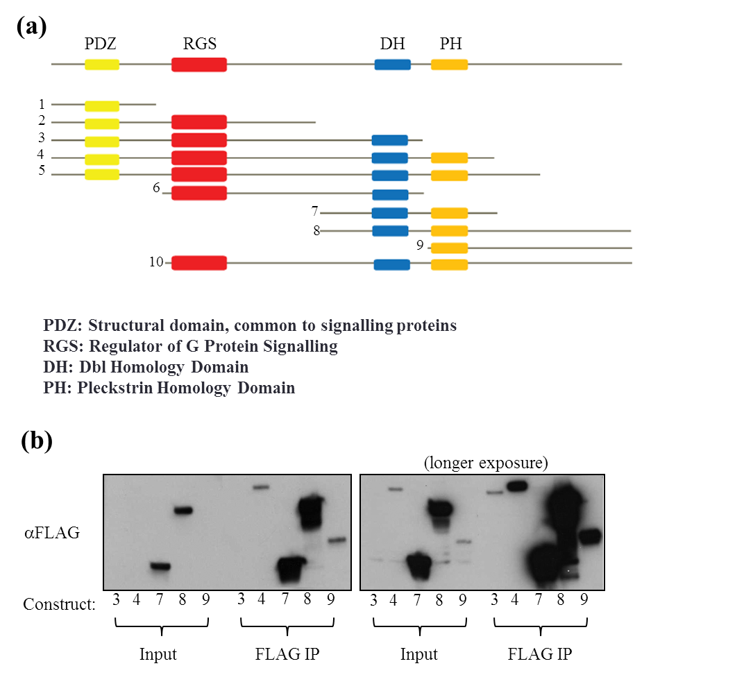

Figure S1 LARG domain vectors developed for mapping of LARG: HCLK2 and LARG:PCNT interactions
Vectors containing varying deletions of both the N and C terminal regions surrounding combinations of LARG domains were created using the Gateway cloning protocol outlined in the Materials and Methods. (a) Visual representations of the domains present in each construct. (b) Western blots demonstrating expression levels and immunoprecipitation potential of each construct. No expression was observed for constructs 1, 2, 5 and 6.

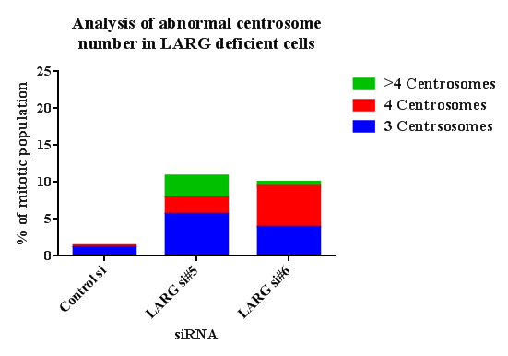

Figure S2 Breakdown of centrosome duplication observed in LARG depleted HeLa cells
A breakdown of the increase in supernumerary centrosomes observed in Figure 3.3.1. The number of centrosomes was determined by the number of discreet GFP-Centrin2 foci observed (see Figure 3.3.1a).

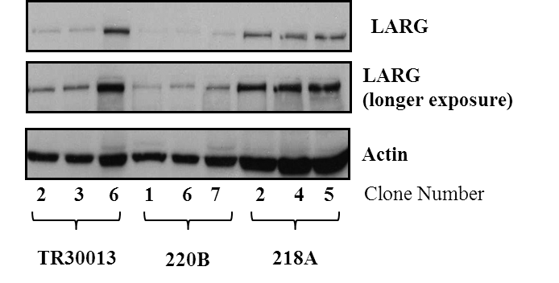

Figure S3 shRNA transfected stable LARG knockdown T-REx-HeLa cell lines
Stable knockdown of LARG was achieved using the short hairpin RNA system. Vectors were ordered through Origene for non-targeting (TR0013), LARG 3’UTR (218A) and LARG 5’UTR (220B) targeting constructs. Stable knock down cells were selected for as outlined in the Materials and Methods Section. Individual clones were selected and tested for knockdown. 220B clones 1, 6 and 7 provided the most complete knockdown of LARG.

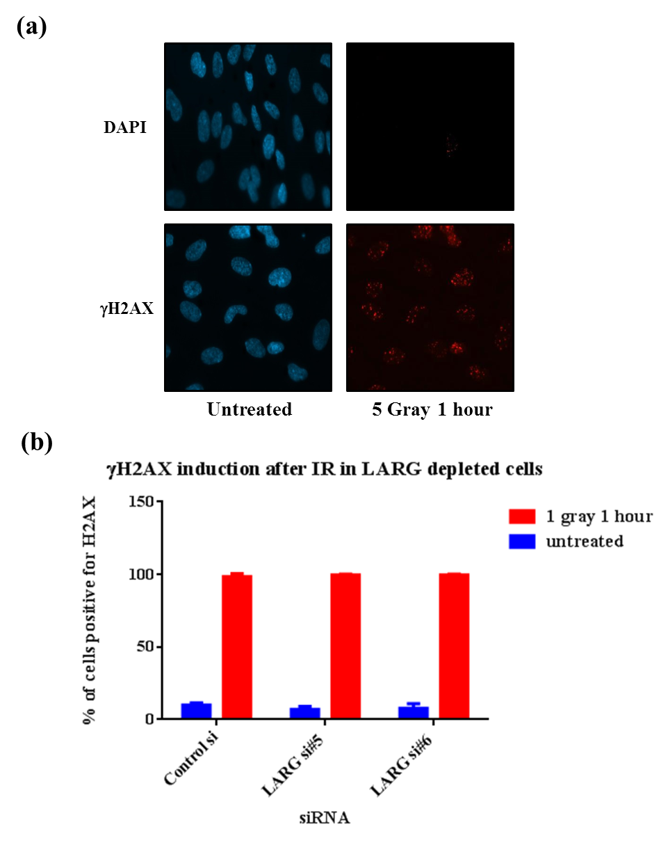

Figure S4 LARG depleted cells display normal γH2AX induction after IR treatment

RPE1 cells were transfected with a non-targeting control or one of two LARG specific siRNA oligos (see Materials & Methods). After 48 hours cells were treated 5 Gray and incubated for 1 hour before fixation in 4% PFA. Immunofluorescence staining for γH2AX S129 was performed. (a) Quantification of the population of cells displaying >6 γH2AX foci was performed for each treatment (minimum 200 cells per experiment). n=2. Error bars indicate standard deviation from the mean.

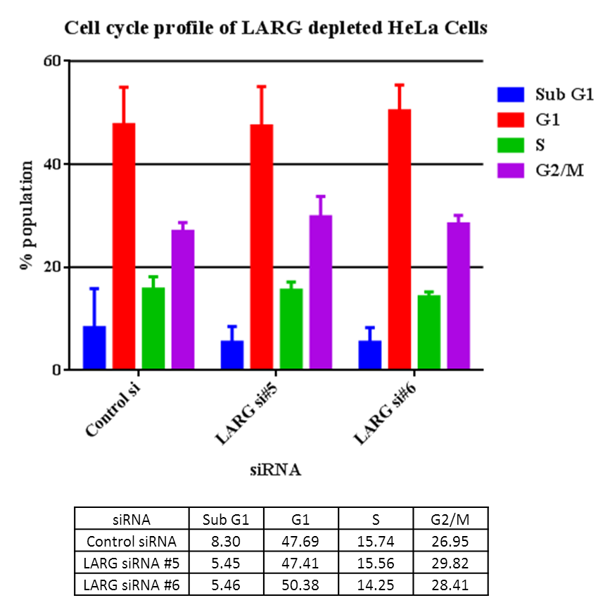

Figure S5 Cell cycle analysis in LARG depleted HeLa cells
HeLa cells were transfected with a non-targeting control or one of two LARG specific siRNA oligos (see Materials & Methods). After 48 hours cells were washed in PBS and fixed in ice cold 70% Ethanol. Samples were then process as outlined in the Materials and Methods. No overt differences can be observed in the cell cycle between control (non-targeting) and LARG specific siRNA treated cells.

Figure S6 Arhgef11 protein levels are unaffected in PJ0013
Protein samples were prepared from exponentially (5x10⁵/ml) growing lymphoblast’s cell lines derived a Seckel Syndrome patient. AG09387 (wt) and PJ0013 (LARG mutant) protein samples were separated by SDS-PAGE prior to western blotting. Arhgef11 levels are unchanged between AG09387 and PJ0013 samples.
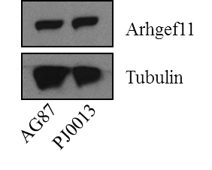

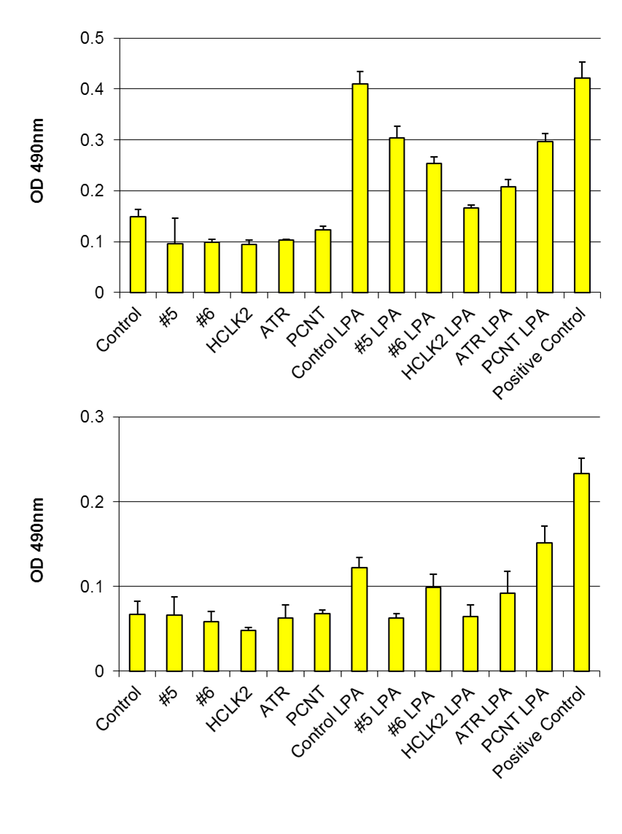

Figure S7 Individual GLISA plots DDR depleted RPE1 cells before and after LPA induction
For GLISA method please see figure 3.3.10. Note the differences in induction in control cells between the two repeats. Although the same induction pattern is observed in both graphs the scale of induction is much lower.

Region Of Interest | sequence (5'-3') | length
Exon 1 | tggggaggaggtgttactgt | 20
 | accctctttcctctgcctgt | 20
Exon 2 | tcttattctggttcagtaggatgaat | 26
 | tccaccataatttcaaaggga | 21
Exon 3 | tgctgtgtaaagtaaactgatttcc | 25
 | tcctgagtgtttcgggtagc | 20
Exon 4 | tttccccttacattgtctcca | 21
 | aggaacaccatgaagcaagc | 20
Exon 5 | tttctccagatggaacacagttt | 23
 | agtccacatgacctgcaatct | 21
Exon 6 | caaaggacagcccatgtttt | 20
 | tcaatccttttattacgtccttcag | 25
Exon 7 | ttcttgaagtcattttatccattg | 24
 | tgctgctccttactttaagggt | 22
Exon 8 | taactggatcttttagaactatcgaa | 26
 | tcatcagccgaatacttgaaaa | 22
Exon 9-10 | gccgaggcagaactttgtat | 20
 | ggcaactgcaacattctctg | 20
Exon 11 | cagaatgtccaacttttagtagtctcc | 27
 | tcaaatctagaaaggggctg | 20
Exon 12 | tccctcatctccttttggtg | 20
 | cctaagaatacttacaaaccatggaa | 26
Exon 13 | tttgatgggttggctttattc | 21
 | gcaacaaatcagatattgcaga | 22
Exon 14-15 | tgagcctactttgcatttagtatttg | 26
 | gggaagataggaagcaggag | 20
Exon 16 | tccaagttgtatccccttacttt | 23
 | ggtgatcgactagtcaccatgt | 22
Exon 17 | tgttgccaattgtatgttgcc | 21
 | gctaagctaagtatttaatgagcaact | 27
Exon 18 | cgtccccagaatgaggtagt | 20
 | acccaaaggacacttcaagc | 20
Exon 19-20 | cctgggtggcagagtgag | 18
 | tggaagacactgcaaccaaa | 20
Exon 21 | gcattacactatgaaaatcgcaa | 23
 | agcctctgatgtgaagaggg | 20

Region Of Interest | sequence (5'-3') | length
Exon 22 | tcatgattcgcccacctt | 18
 | ggatttagtcttgattaacttgcca | 25
Exon 23 | taggctgaagctgttctggg | 20
 | gccaggcttcagtgctaga | 19
Exon 24 | tgctggagtttaacctagctttg | 23
 | ttggtatacagggtttcttttcc | 23
Exon 25 | gtgctgtttctcattgtcca | 20
 | actccaaggctgagagacttaat | 23
Exon 26 | tgattgatcccatggaattgt | 21
 | aaactcacaatcttttctctattgga | 26
Exon 27 | aagaagcagctgtactactgtgaa | 24
 | tgcaacatggatgagtttgc | 20
Exon 28 | tctgtcactttgtctggcttg | 21
 | tgagctgagattgtgccatt | 20
Exon 29 | ccctcacggtgaatacatgg | 20
 | tgggtgtttcgttgttgttg | 20
Exon 30 | aaaatcttcaaggtcttaatatgctc | 26
 | aacaaatgttctccctgtcca | 21
Exon 31 | aaatgccaagtttgattcagaaa | 23
 | gccaggtctttagcaaatttta | 22
Exon 32 | gataatcatgttactgagtgcttgg | 25
 | cctattccttcccttttgcc | 20
Exon 33 | atcaaacgcgtctccatttc | 20
 | tgtgttattgagacagcaccg | 21
Exon 34 | aaacatccctcatggcctc | 19
 | atggaatattacgcttggga | 20
Exon 35-36 | tgttgttgttggttgatttgg | 21
 | cggccagcattttaacagat | 20
Exon 37 | cttccctgaatgcttcatgtt | 21
 | gatggcacatgagtgtcatactt | 23
Exon 38 | ttcttgcagcctgaggttat | 20
 | catccatttcaaaatacaggaca | 23
Exon 39 | tctgttttctaatggcagca | 20
 | accctattcttcccctctgc | 20
Exon 40 | ggggcttgtacctgtaatgtaa | 22
 | tggaatctcagaaggttttcac | 22
Exon 41 | cccacagatgtcatgggtatt | 21
 | tctctgcatccacactggag | 20

Figure S8 Sequencing Primers employed in the exome sequencing of genetically uncharacterised Seckel Syndrome patients.

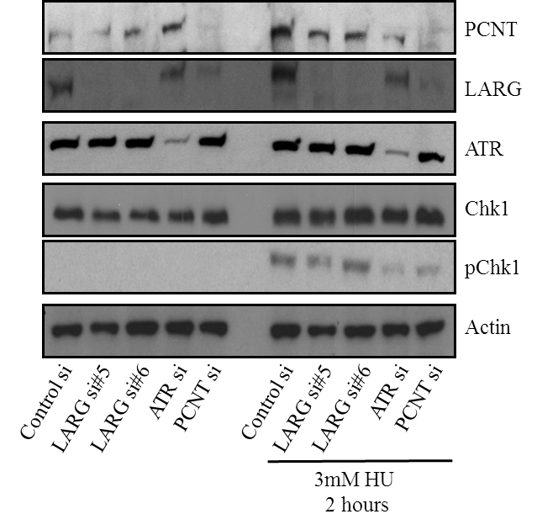

Figure S9 pChk1 induction upon replication stress in LARG depleted HeLa cells
HeLa cells were plated into 6 well dishes at a density of 2x10⁵ cells per well and transfected with siRNA towards LARG, ATR and PCNT (for transfection protocol see M&M). 48 hours after transfection cells were treated with 3mM HU for 2 hours before lysate collection. Lysates were separated using SDS PAGE gel electrophoresis before western blotting for pChk1, Actin, LARG, PCNT, ATR and total Chk1. Good siRNA mediated knockdown of each targeted protein and equal loading can be observed.

7 Image Use Licences

Where appropriate, permission for adaption of copyrighted images presented herein was obtained through the Copyright Clearance Centre program RightsLink. Details of individual license requests are outlined below. For more information please see www.rightslink.com
Figure 1.1.1
License number | 3245560035066
Licensed content publisher | Elsevier
Licensed content publication | Cell
Licensed content title | Hallmarks of Cancer: The Next Generation
Licensed content author | Douglas Hanahan, Robert A. Weinberg
Licensed content date | 4 March 2011
Licensed content volume number | 144

Figure 1.6.1
License Number | 3400890089302
Licensed content publisher | Nature Publishing Group
Licensed content publication | Nature Reviews Genetics
Licensed content title | Single-strand break repair and genetic disease
Licensed content author | Keith W. Caldecott
Licensed content date | Aug 1, 2008
Licensed content volume number | 9

Figure 1.6.2
License number | 3401250180770
Licensed content publisher | Springer
Licensed content publication | Cellular and Molecular Life Sciences
Licensed content title | DNA Repair in Mammalian Cells
Licensed content author | T. Nouspikel
Licensed content date | Jan 1, 2009
Licensed content volume number | 66

Figure 1.6.4
License Number | 3258971394554
Licensed content publisher | Elsevier
Licensed content publication | DNA Repair
Licensed content title | A structural model for regulation of NHEJ by DNA-PKcs autophosphorylation
Licensed content author | Tracey A. Dobbs, John A. Tainer, Susan P. Lees-Miller
Licensed content date | 10 December 2010
Licensed content volume number | 9

Figure 1.6.5
License Number | 3404240728345
Licensed content publisher | Nature Publishing Group
Licensed content publication | Cell Research
Licensed content title | The endless tale of non-homologous end-joining
Licensed content author | Eric Weterings and David J Chen
Licensed content date | Jan 1, 2008
Licensed content volume number | 18

Figure 1.6.6
License Number | 3258971059935
Licensed content publisher | Springer
Licensed content publication | Cell Biochemistry and Biophysics
Licensed content title | Mechanisms of Dealing with DNA Damage-Induced Replication Problems
Licensed content author | Magda Budzowska
Licensed content date | Jan 1, 2008
Licensed content volume number | 53

Figure 1.6.7

License number | 3271940986447
Licensed content publisher | Elsevier
Licensed content publication | Trends in Cell Biology
Licensed content title | Checking on the fork: the DNA-replication stress-response pathway
Licensed content author | Alexander J Osborn,Stephen J Elledge,Lee Zou
Licensed content date | 1 November 2002
Licensed content volume number | 12

