# ****Abstract****

The feasibility of using reversible complexation between labelled poly(acrylic acid) and poly(acrylamide) as a low concentration detection method for industrial flocculants has been investigated. Aromatic labels acenaphthylene and 9-anthryl methyl methacrylate have been added to polymer chains to model the behaviour of these polymers in dilute aqueous solutions, demonstrating a molecular weight dependency of the conformational change of poly(acrylic acid).

It is shown that interpolymer complexation can be observed via a dramatic rise in anisotropy of a singly labelled sample. Using a single exponential system to model the data a clear concentration gradient can be created, showing the ratio between probe polymer and detected species. This system is robust against a range of salts and other water impurities and other polymers capable of bonding to poly(acrylic acid) have also been investigated.

Chains of poly(acrylic acid) were grafted onto solid surfaces in a preliminary investigation into whether it would be possible to integrate this detection system with a reusable solid substrate. Two methods were investigated: ceric ammonium nitrate initiated grafting and reversible addition-fragmentation chain transfer copolymerisation.

# Contents

Abstract 1

Contents 2

Abbreviations and Acronyms 7

Chapter 1. Introduction 10

1.1 Introduction 10

1.2 Polymers 12

1.2.1 Poly(acrylamide) 12

1.2.2 Poly(acrylic acid) 14

1.2.3 Synthesis of Water-Soluble Polymers 15

1.3 Luminescent Probes and Spectroscopic Techniques 20

1.3.1 Luminescence as a method of study 20

1.3.2 Viable probes 29

1.4 Interpolymer Complexes 32

1.4.1 Complex Formation 32

1.4.2 Poly(acrylic acid) and poly(acrylamide) interactions 32

1.4.3 Other Factors 35

1.4.4 Comparable Polymer Systems 35

1.4.5 Summary 39

1.5 Existing Methods of Detection 40

1.5.1 Published Chemical Methods 40

1.5.2 Industrial Patents 42

Chapter 2. Polymer Synthesis 44

2.1 Experimental 44

2.1.1 General Experimental Conditions 44

2.1.2 Fluorescence Label Synthesis 46

2.1.3 RAFT Initiator Preparation 48

2.1.4 Linear Polymer Synthesis 50

2.1.5 Methylation of Acid Polymers 57

2.2 Results and Discussion 58

2.2.1 Polymer Molecular Weight Distribution 58

2.3 Conclusions 71

Chapter 3. Analysis of Fluorescence Labels 72

3.1 Molar Absorption Coefficients 72

3.2 Fluorescence Spectra 75

3.3 Time Correlated Photon Counting 76

3.3.1 Time Correlation Calibration 76

3.3.2 Fluorescence Lifetime 77

3.3.3 G Factor Calibration 79

3.3.4 Fluorescence Correlation Time 80

3.4 Conclusion 82

Chapter 4. Fluorescently Labelled Poly(acrylic acid) and Poly(acrylamide) 83

4.1 Determining Content of Fluorescence Label in Polymers 83

4.2 Steady State Luminescence Spectroscopy 85

4.2.1 Singly Labelled Polymers 85

4.2.2 Doubly labelled polymers 87

4.2.3 Parameters of Steady State Analysis 89

4.2.4 3D Steady State Spectra 90

4.3 Time Correlated Simple Photon Counting 93

4.3.1 Fluorescence Lifetime Studies 93

4.3.2 Anisotropy Measurements of fluorescent polymers 98

4.4 Conclusion 104

Chapter 5. The Molecular Weight Dependency of Labelled Poly(acrylic acid) formed via Controlled RAFT Polymerisation 105

5.1 UV absorbance of Linear RAFT Polymers 105

5.2 Fluorescence Steady State Spectra 105

5.3 Fluorescence Lifetime of RAFT Polymers 108

5.4 Fluorescence Anisotropy of RAFT Polymers 111

5.5 Molecular Weight Distribution Analysis 115

5.6 Conclusions 116

Chapter 6. Detection of Inter-Polymer Complexation via Fluorescence Methods 117

6.1 Complexation via Steady State 117

6.1.1 Singly Labelled Polymers 117

6.1.2 Complexation between two singly labelled polymers 118

6.1.3 Complexation of doubly labelled polymers 120

6.2 Complexation via Lifetime Studies 123

6.3 Complexation via Anisotropy measurements 126

6.4 Conclusion 130

Chapter 7. Field Research 132

7.1 Commercial Polymers 132

7.1.1 Laboratory vs. Industrial Polymers 132

7.1.2 SNF Commercial Flocculants 132

7.1.3 Complexation with commercial polymers 133

7.2 Complexation with Impurities 138

7.2.1 Water Sources 138

7.3 Detection of Flocculated Samples 141

7.3.1 Ewden Water Treatment Plant 141

7.3.2 Eccup Water Treatment Plant 145

7.3.3 Quarry Samples 148

7.4 Sample Size 151

7.5 Conclusions 152

Chapter 8. Complex Formation with Other Polybases 153

8.1 Poly(N-isopropylacrylamide) 153

8.2 Poly(ethylene oxide) 155

8.3 Poly(dimethylacrylamide) 157

8.4 Poly(vinyl alcohol) 158

8.5 Poly(N-vinylpyrrolidone) 159

8.6 Poly(dimethyl amine-co-epichlorohydrin) 160

8.7 Poly(diallyldimethylammonium chloride) 162

8.8 Conclusions 163

Chapter 9. Solid Systems 164

9.1 Introduction 164

9.1.1 Hydrogels 164

9.1.2 Grafting of Polymers 165

9.2 Experimental 169

9.2.1 Synthesis of 4-Vinylbenzyl-1-pyrrolecarbodithioate (VPC) 169

9.2.2 Solid Polymer Film Synthesis 169

9.2.3 PCN Functionalization 171

9.2.4 Hydrogel Analysis 172

9.3 Crosslinked HEMA Films 174

9.3.1 Ceric Initiated Grafting 174

9.3.2 Grafting Reaction 175

9.3.3 RAFT Method 181

9.3.4 Synthesis of RAFT-HEMA Films 181

9.3.5 Grafting of Acrylic Acid onto RAFT-HEMA Film 183

9.3.6 Successive Acrylic Acid Grafting 185

9.3.7 Fluorescence of Grafted Labels 187

9.3.8 Summary 188

9.4 Poly(HEMA-co-Acrylic Acid) Conetworks 189

9.4.1 Introduction 189

9.4.2 PCN Synthesis 189

9.5 PAM Absorption 192

Chapter 10. Conclusions 193

10.1 Chapter by Chapter Breakdown 193

10.2 Overview 195

List of Figures 197

List of Equations 209

List of Tables 210

References 212

Appendix A – Patent Search 223

# Abbreviations and Acronyms

1H NMR Hydrogen Nuclear Magnetic Resonance Spectrometry  
13C NMR Carbon Nuclear Magnetic Resonance Spectrometry

ACVA *4,4’*-azobis(*4*-cyanopentanoic acid)  
AIBN *4,4’*-azobis(isobutyronitrile)  
ACE acenapthylene  
AMMA *9*-anthryl methyl methacrylate

BP benzophenone  
BPC benzyl 1H-pyrrole-1-carbodothioate  
BPO benzyl peroxide  
BSCSP *2*-[[butylsulfanyl)-carbonothioyl]sulfanyl}propanoic acid

CAN ceric ammonium nitrate  
CPB *2*-cyanopropan-*2*-yl-benzdithioate  
CTA chain transfer agent

*Đ* dispersity  
DOM dissolved organic matter  
DMF dimethyl formamide  
DMSO dimethyl sulfoxide

EGDA ethylene glycol diacrylate  
EGDMA ethylene glycol dimethacrylate  
EWC equilibrium water content

FTIR fourier transform infrared spectroscopy

GPC gel permeation chromatography

HEMA *2*-hydroxyethyl methacrylate

ICP inductively coupled plasma  
IPC interpolymer complex  
IPN interpenetrating polymer network  
IR infrared

LALLS low angle laser light scattering  
LCST lower critical solution temperature

Mn number average molecular weight  
Mw weight average molecular weight

NIPAM *N*-isopropylacrylamide  
NMR nuclear magnetic resonance  
NRET non-radiative energy transfer

PAA poly(acrylic acid)  
PAM poly(acrylamide)  
PCN polymer conetwork  
PDADMAC poly(diallyldimethylammnium chloride)  
PDMA poly(dimethylamine)  
PDMAM poly(dimethyl acrylamide)  
PEG poly(ethylene glycol)  
PEO poly(ethylene oxide)  
pHcrit critical pH for IPC formation  
PMAA poly(methacrylic acid)  
PNIPAM poly(N-isopropylacrylamide)  
POE poly(oxyethylene)  
PS poly(styrene)  
PSS poly(styrene sulfonate)  
PVAl poly(vinyl alcohol)  
PVP poly(N-vinylpyrrolidone)

RAFT reversible addition-fragmentation transfer   
RI refractive index  
RPM revolutions per minute

SEC size exclusion chromatrography

TBPO tert-butyl peroxide  
TEHA triethylamine  
TEMED tetramethylethylenediamine  
TMSDZ tetradiazomethane  
TRAMS time-resolved anisotropy measurements  
TRIS trisaminomethane

UPW ultrapure water (18.2MΩ.cm)  
UV/Vis ultraviolet, visible light spectrophotometry

VPC 4-vinylbenzene *1*H-pyrrole-*1*-carbodothioate

λem emission wavelength  
λex excitation wavelength  
τ lifetime  
τc correlation time

# Introduction

## Introduction

Homopolymers and copolymers of poly(acrylamide) are commonly used in the treatment of wastewater and other purification processes [1]. As a polyelectrolyte the polymer binds with colloidal particles to form dense aggregates, which settle out of solution to leave a clear supernatant. In the EU alone approximately 50,000 tonnes of poly(acrylamide) are used per annum for water treatment [2], and the polymer also finds commercial uses in biological applications [3-5], paper production [6], pulp, mineral and crude oil processing [7], coating applications[8], chromatography [9] and soil/sand treatment [10-13]. Due to its high usage, and concerns regarding the release of the free monomer acrylamide, which is known to be highly toxic [14, 15], (although the polymer itself is considered non-toxic [16, 17]), researchers have been attempting to find new methods to determine the fate of polyacrylamide after use [18].

Of particular concern to industries is the use of cationic polyelectrolytes, with a greater toxicity to aquatic life than anionic and non-ionic forms of the polymer [19]. Acute toxicity for cationic polymers has been calculated to be as low as 300 ug l-1, whereas anionic and non-ionic polyacrylamides are only considered toxic in concentrations over 50 mg l-1 [20]. However research has shown that their intrinsic toxicity is reduced in practice by many factors; such as ‘irreversible sorption to dissolved organic matter, losses due to hydrolysis and biodegradation and a low potential to bioaccumulate’ [21]. Whilst these polyelectrolytes are not a priority for environmental control, our inability to trace these synthetic polymers and determine their spread through surface waters is a severe limiting factor to their future use. For this reason the UK Environment agency recommends a case specific approach for approving their use [20].

Smart polymers, known to change their behaviour in response to external stimuli, are a subject of much recent work [22]. The conformational change of several polymers (both in response to pH [23] and thermal [24] changes) have now been thoroughly mapped via the use of covalently bound aromatic luminescent labels [25].

One potential method to determine trace polyelectrolyte concentrations in dilute solutions could involve the use of the known complexation between polyelectrolytes and polyacids [26]. Previously interpolymer complexation between poly(acrylamide) and poly(acrylic acid) has been demonstrated via NMR in both the solid and solution state [26], with infrared spectroscopy and with various potentiometric and viscometric tests [27]. As any complexation between two polymers will affect their conformation it should be possible to use fluorescence analysis to detect the presence of polyacrylamide in solution.

## Polymers

Polymers are large molecules typically consisting of many repeat units. The term ‘macromolecule’ was first coined by Hermann Staudinger, who suggested that polymeric substances such as rubber or starch were made of long chains of short repeating units, linked together by covalent bonds [28]. At the time this was met with resistance by many, who thought that small molecules could not link together to form species with such a high molecular weight, however thanks to the large variety of uses they are applicable to, polymer chemistry has blossomed into a large, many faceted subject.

Stimuli responsive polymers, also known as ‘smart’ [29], ‘intelligent’ [30] or ‘environmentally sensitive’ [31], are known to change their shape, solubility or photophysical behaviour in response to external environments [32]. These stimuli can be chemical (pH, ionic factors, chemical agents) which alter the interactions between polymer chains and solvents, or physical (temperature, electric or magnetic fields, mechanical stress) which affect the levels of various energy sources that impact molecular interactions [33]. These responses have proven to be very useful, with proven application in fields such as drug delivery[34], biotechnology [35] and chromatography [30].

Water soluble polymers are used in many applications alongside surfactants, such as water based paint formulations[36]. Polyelectrolytes react strongly with ionic surfactants of the opposite charge, forming micelle like clusters across polymer chains [37].

### Poly(acrylamide)



Figure 1 – Poly(acrylamide) is formed from a continuous chain of acrylamide monomers

#### Properties

Dry poly(acrylamide) (PAM) is a brittle white solid which, unlike the monomer acrylamide, is considered non-toxic [17]. Commercially available products contain about 5-15 % water depending on their ionicity, although they become increasingly hydroscopic with increasing ionic character [38]. The solid is known to be stable up to 245oC, with no clear melting point observable below this temperature [39]. As a solid poly(acrylamide) is generally stable for long periods although exposure to light and air have been known to generate trace amounts of acrylamide peroxides [40]. It shows fourier transform infrared spectroscopy (FTIR) bands at 3350, 3203, 1670 and 1616 cm-1, ascribed to the asymmetric and symmetric stretching of NH2, and two amide groups respectively [41].

#### Solution Behaviour

The homopolymer poly(acrylamide) is an extremely hydrophilic polymer, and as a result is soluble in water at all temperatures, concentrations and pH values, and shows scarcely any interactions with surfactants [42]. However at high pH it will begin to hydrolyse on standing [43]. In aqueous solutions the intrinsic viscosity of Poly(acrylamide) is directly proportional to the molecular weight [44].

Poly(acrylamide) is soluble in most salt solutions but can phase separate in some highly concentrated solutions, such as (NH4)2SO4 [38]. Solutions of polyacrylamide show a time dependent viscosity, stored solutions show a long term decrease over the course of several weeks [45-47]. It is assumed that this is due to the polymer chains undergoing a slow conformational change [48]; the growth of microorganisms or the continuing reactions of trace levels of initiators [44]. Due to its extreme hydrophilicity it is not very soluble in many other solvents, although it is known to dissolve in glycerol, ethylene glycol and formamide [49].

A similar polymer poly(N-isopropylacrylamide) (PNIPAM) undergoes a thermally induced conformational change at 32oC, different from acrylamide due to the presence of an additional hydrophobic methyl group [24]. This ‘Smart’ response has given PNIPAM extensive examination in the literature, which poly(acrylamide) has not received as it shows no smart character of its own.

#### Copolymers

Most commercial applications for poly(acrylamide) do not use the homopolymer but one of a variety of copolymers specifically tailored to their function [1]. Poly(acrylamide-*co*-acrylic acid) copolymers are among the most water soluble polymers used in commercial productions [50]. Most poly(acrylamide) products on the market are copolymers in one form or another so any system of detection for poly(acrylamide) should also be sensitive to varying copolymers and impurities.

### Poly(acrylic acid)



Figure 2 – Poly(acrylic acid) is a smart anionic homopolymer

#### Properties

Poly(acrylic acid) (PAA) is a water soluble, pH responsive polymer, used in a wide range of applications. Dry poly(acrylic acid) is a white powder. When wetted it is capable of absorbing many times its own weight in water. When studied by FTIR it shows a strong carbonyl absorption band at 1718 cm-1[41] with weaker bands located at 1456 and 1415 (bending vibrations of -CH2- and CH-CO) and 1248 and 1175 (coupling between OH bending and C-O stretching vibrations from neighbouring groups).

#### Solution Behaviour

In dilute aqueous solutions PAA is known to undergo a conformational change, similar but less dramatic than that of poly(methacrylic acid) (PMAA), as a function of pH[25]. At low pH the molecules of PMAA are coiled, with increasing pH the molecules swell and have been described as becoming almost ‘rod like’ at high degrees of ionisation [51, 52]. However for PAA both potentiometic, viscometric[53] measurements indicate a smooth transformation from a statistical coil to an extended state as the pH is raised [54].

The change in conformation arises due to the complex hydrophobic interaction between the water and the polymer, and the changing influence of H-bonding as the acid is neutralised.

Equation 1

The carboxylic acid repeat unit in PAA dissociates with increasing pH to form a negatively charged carboxylate anion [55]. The pKa of the polymer exists in the region 4-4.5 [56] and the zero point charge (the point below which no monomer along the polymer chain is deprotonated) is approx. pH 3 – 3.4 [57]. The polymer backbone remains hydrophobic at all values of pH, whilst the polymers repeating acid groups change as their functionality alters with pH. It is this amphiphilic nature of the polymer that dictates conformational changes.

Research has shown that this conformational change occurs between pH 4 and 6 [58]. Below pH 4 the contracted globular structure minimizes the contact between hydrophobic units and the aqueous phase. With increasing pH the repulsive interactions between the negative carboxylate anions collapse the chain and turn the polymer to an expanded water swollen state.

### Synthesis of Water-Soluble Polymers

In this work polymers have been synthesised through both free radical copolymerisation and reversible addition-fragmentation chain transfer (RAFT) mechanisms.

#### Free Radical Copolymerisation

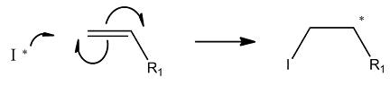

Figure 3 – Propagation of vinyl monomer through radical initiation

Free radical copolymerisation can be carried out effectively using a radical initiator based on a mechanism of initiation (Equation 2), propagation (Equation 3) and termination (via radical combination or disproportionation, although other mechanisms are possible) (Equation 4) [59]. The initiating species, *I,* represents initiating species, the initiating radical, *M* the monomer, the growing macro radical and *P* the terminated polymer with *n* or *m* monomer units.

Equation 2

Equation 3

Equation 4

This established form of polymerisation is known to give a broad range of molecular weights due to the multiple methods of radical termination and the uncertainty of the kinetic factors that control the rate of termination verses propagation.

#### Reversible Addition-Fragmentation Chain Transfer (RAFT)

##### The RAFT Process

Reversible addition fragmentation chain transfer (RAFT) polymerisation is one of the most extensively studied radical polymerisation methods in recent years. This method, first reported by Chiefari in 1998 [60], offers more control over molecular weights of polymers with narrow polydispersities, and RAFT agents are compatible with a range of different monomers [61, 62]. After polymerisation the RAFT agent end group can be used to continue the polymerisation, in effect creating a virtually ‘living’ system, or removed by one of several different methods [63].

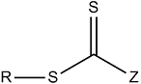

Figure 4 – Generic RAFT agent structure is a weak single bond (S-R)  
and a reactive double bond (C=S) [64]

A RAFT agent consists of a dithioate ester, which is the key component of the mechanism. The radicals created in radical polymerisation can reversibly add to the dithioate group, which can reorientate and fragment again (Figure 5). By maintaining a low concentration of radicals, unwanted bimolecular termination steps are kept at a minimum. This process results in very controlled polymer chains with the dithioate ester remaining as an active site on the terminal end of the polymer (Figure 6).



Figure 5 – RAFT polymerisation mechanism[65]

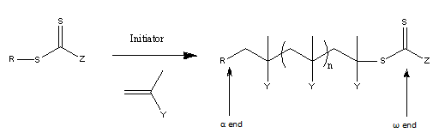

Figure 6 – Representation of a RAFT polymerisation with α and ω ends of resulting polymer[64]

Poly(acrylic acid) has been synthesised using a range of chain transfer agents, and so far the lowest dispersity achieved has been 1.3 – 1.4 [66]. However any use of thiocarbonylthio may cause fluorescent quenching which must be carefully observed [67].

##### RAFT Agents

RAFT agent *4*-vinylbenzene-*1*H-pyrrole-*1*-carbodothioate (VPC) has previously been used to polymerise N-isopropyl acrylamide branched polymers [65]. A linear equivalent benzyl *1*H-pyrrole-*1*-carbodothioate (BPC) exists which should provide similar linear polymers. Both chain transfer agents (CTA) have been utilised in this project, chosen with consideration of whether the desired polymer is linear or branched.

 

Figure 7 – RAFT agents 4-vinylbenzene 1H-pyrrole-1-carbodothioate (4-VCP)  
and benzyl 1H-pyrrole-1-carbodothioate (BPC)

Two additional RAFT agents have been used including 2-cyanopropan-2-yl-benzodithioate (CPB) and 2-[[butylsulfanyl)-carbonothioyl]sulfanyl}propanoic acid (BSCSP), previously used with acrylic acid to create macro RAFT agents for emulsion polymerisation[68].

 

Figure 8 – RAFT agents 2-[[butylsulfanyl)-carbonothioyl]sulfanyl}propanoic acid (BSCSP) and 2-cyanopropan-2-yl-benzodithioate (CPB)

##### Block Copolymers via RAFT

As the dithioate ester remains on the ω end of the polymer chain this reactive site is capable of further addition-fragmentation reactions. By introducing another monomer an AB block copolymer can be formed. Controlled block copolymers can be prepared by the addition of another monomer, as demonstrated in a recent paper preparing PAA-poly(styrene) (PS) block copolymers [69].

##### Cleavage of RAFT group

One of the side effects of RAFT chemistry is the pendent thioate ester at the end of resultant polymers. To remove this ester there are a range of potential methods, including radical induced end group removal (potentially using Azo compounds) thermal initiation or oxidation using a hydroperoxide [64].

## Luminescent Probes and Spectroscopic Techniques

### Luminescence as a method of study

#### Fluorescence Theory

Luminescence, the emission of light from an electronically excited state, occurs when an electron returns to its ground state resulting in the loss of a photon. The aromatic markers used in this study tend to become ‘luminescent’ via the absorption of light, exciting an electron in the molecule, usually to the S1 state.

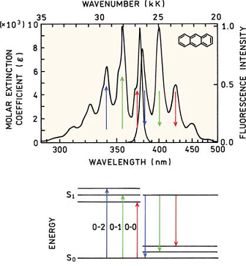

Figure 9 – Absorption and emission spectra of anthracene and energy levels of transitions.  
0, 1 and 2 refer to vibrational energy levels[70]

Electronically excited states are unstable so the excess energy is disposed of via either radiative or non radiative decay processes. A non-radiative process converts the energy into vibration, rotation or translation of surrounding molecules, whereas the radiative release of energy is via luminescence; either fluorescence or phosphorescence. Spin allowed fluorescence typically has a lifetime of around 10 ns[70], which is the average time between electron excitation and its return to the ground state.

Many luminescent probes have previously been used to study larger molecules, such as polyelectrolytes. As most polyelectrolytes themselves are not luminescent there are two general approaches to studying these species; either covalently incorporating a luminescent marker into the polymer [71], or to dope the polymer with a fluorescent material [72]. Introducing a covalently bound fluorophore into the polymer backbone allows direct study of the polymer’s segmental motion (Figure 10). An idealised ratio of one luminescent probe to over one hundred repeating monomers has been determined [23, 73], where only trace amounts of luminescent species are used to ensure that the marker does not significantly alter the properties of the polyelectrolyte being studied. The majority of the work in literature concerns itself with the fluorescence characteristics of lumophores, although a few papers have been published studying phosphorescence effects[74].

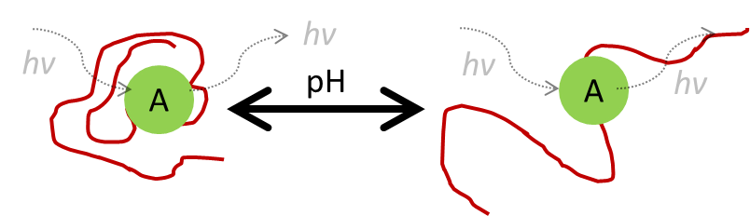

Figure 10 – Fluorescence characteristics of an aromatic label (A) bound to a polymer chain  
are dependent on the conformation of that polymer chain

#### Absorption Spectroscopy

Absorption spectroscopy is not actually a study of fluorescence, but it is a technique used to determine λex (the wavelength of light necessary to excite a fluorophore). A sample is irradiated using ultraviolet and visible light, scanning across predetermined spectrum. The light beam travels through a cross section of the sample and a detector calculates the intensity of the light beam at the selected wavelength. The absorption of this light is compared to a reference sample (usually the solvent or a comparable molecule) in order to show increased absorption (or decreased transmission) peaks which reflect λex.



Figure 11 – A schematic diagram of an absorption spectrometer. An excitation source (such as a deuterium/tungsten lamp) continuously excites the sample with light of intensity I0 and the intensity after excitation It is recorded.

At λex the light that the sample absorbs can be modelled using the Beer-Lambert law, which proposes that the amount of absorption (A) is determined by the path length (distance light travels through sample) (l), the molar absorption coefficient (*ε)* and the molar concentration of the sample (*c)*.

Equation 5

Absorption is fundamentally linked to transmission, which represents the amount of light which passes unhindered through the sample (It) as a ratio of the original intensity of the beam (I0).

Equation 6

#### Steady State Spectroscopy

Steady state spectroscopy examines the excitation / emission processes occurring within a sample. A sample is irradiated with visible, UV or near-IR light, leading to fluorescence. Although the sample will fluoresce in random directions, the detector sits at right angles to the radiation source, giving the reading maximum sensitivity by avoiding contamination from the incident beam. By exciting a fluorophore (fluorescent species) at specific wavelengths and reading the excitation spectrum, or scanning the excitation spectrum looking for fixed emission, it can give important information regarding the surroundings of the fluorophore. Steady state studies range across a variety of forms, including shifts in the spectral profile [75] through to changes in luminescent intensities at selected wavelengths [76].



Figure 12 - A schematic diagram of a steady state spectrometer. A continuous excitation source such (such as a xenon lamp) excites the sample at one wavelength (λex) and then a detector monitors the light emitted from the sample (λem)

#### Time Correlated Photon Counting

##### Lifetime Studies

Several methods of analysing data are possible by simply counting the number of photons emitted from a sample over a period of time. Excited State measurements can be used to give specific information regarding the lifetime of a fluorescent probe. This can often give important information concerning the conformation of the polymer in aqueous solutions [77]. Studies have often deliberately included quenching species in the system to deactivate the excited state, giving information concerning the degree of exposure of the fluorescent species [78]. Depending on the conformation of the polymer the luminescent probe’s interaction with the solvent and other species will alter, changing its fluorescent properties.



Figure 13 – A schematic diagram of a fluorescence lifetime spectrometer.

Fluorescence excited state lifetimes are calculated from fluorescence intensity decays *I(t)* described in the following equation, where Io represents initial fluorescence intensity, the fluorescence excited state lifetime, *t* is time and A is the background noise of the experiment.

Equation 7

In very complex systems, such as where the fluorophore is subjected to multiple environments or where a single exponential poorly represents the fluorescence decay, a double exponential model is applied.

Equation 8

##### Fluorescence Time-Resolved Anisotropy Measurements (TRAMS)

TRAMS experiments are an extremely detailed analytical technique using time correlated single photon counting. In 1995 J.R. Ebdon argued that they are arguably “*the* most powerful of all the fluorescence methods used in interrogation of the conformational behaviour of polyelectrolytes” [79].

Using polarised light the fluorophores are excited photoselectively in one specific orientation[80] and a polariser is placed between the sample and the detector which alternates between two positions (Figure 14). Fluorophores which are excited aligned to a particular axis will emit light polarized in the same direction, however over time as the fluorophores diffuse (rotate) the emitted light becomes unpolarized. The extent of the difference between polarisations is described in terms of anisotropy (*r*), which arises from the relative intensities of the parallel (*III*) and crossed (*I⊥*) polarised emissions.

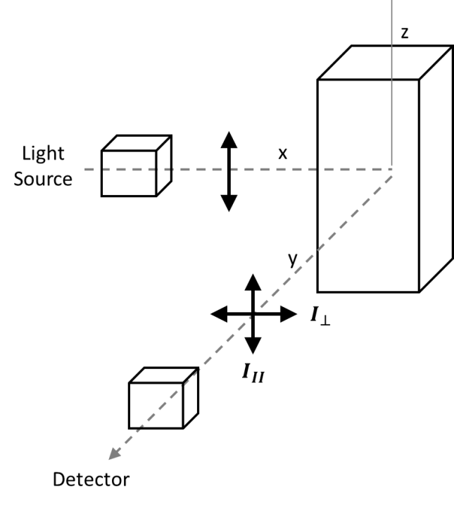

Figure 14 – Schematic diagram for measurement of fluorescence anisotropy

Equation

The anisotropy *(r)* is a dimensionless quantity, independent of the total intensity of the sample, composed of two time dependent components; the sum (*S*) and difference (*D*) between the two relative intensities.

Equation

Equation

Equation

In past publications this was also given using the term polarisation (*P*), an almost interchangeable term with anisotropy, although its use is now discouraged as its value is not normalised by the total intensity of the sample (*IT*) [81].

Equation

Equation

Equation

If the lumophore is bound to a larger macromolecule the effects of rotational diffusion are decreased and larger anisotropy differences are observed. Therefore if the macromolecules themselves are rigid, with less motion, the time taken for the anisotropy to decay will be greater than for looser, faster moving macromolecules [71].

Assuming that the fluorescent lumophore is rotating as a spherical rotor, the observed time-dependent anisotropy *r*(t) depends on , the rotational correlation time for the motion, ro, the intrinsic anisotropy of the chromophore and , a freely varying parameter expected to lie close to zero. This can be expressed as:

Equation 16

Using the proprietary software supply by Horiba Scientific to analyse this data r∞ is denoted as A, whilst ro is described by the term B.

This technique is extremely sensitive and offers a direct analysis of the segmental motion of the polymer chain itself. However, a downside is that due to the short timescales being measured the relaxation data is prone to being distorted by the pulse from the excitation source [79]. To overcome this impulse reconvolution, rather than direct analysis of *r(t),* can be carried out by analysis of the difference curves *D(t)* using Equation 13 [82], which removes interference from the laser pulse to give a much more accurate check on the data.

All above equations assume that the two aligned polarisers permit the passage of equal intensities of light. In a practical experimental setup this cannot always be guaranteed and so the G factor is employed to quantify the different transmission efficiencies of the two components [81]. This term is employed in a derivation of Equation 9, where the assumption is made that the G factor is close to unity [83].

Equation

Equation



Figure 15 - A schematic diagram of a fluorescence lifetime spectrometer.

Time resolved anisotropy offers a promising technique for detecting poly(acrylamide) and it has already previously been used to study polymer-polymer interactions between PAA and poly(ethylene oxide) (PEO) complexes [84, 85].

#### Non-Radiative Energy Transfer (NRET) Measurements

If two chromophores are attached to a single polymer backbone then additional information can be gained from their potential interaction. Assuming that two viable chromophores are used (a donor and an acceptor species) it is possible to measure the amount of communication between the fluorescent species (Figure 16). NRET measurements, described as the ‘Spectroscopic Ruler Technique’ [86-88], work using a donor-acceptor interaction.

Equation 19

Conditions vital to NRET include good spectral overlap of the fluorescence of the donor and the absorbance of the acceptor. The donor usually requires a large quantum efficiency and the acceptor a large extinction coefficient. Provided the labels used are appropriate, the degree of energy transfer is dependent on the separation distance between the two lumophores.

Equation

T Förster originally proposed an expression for the separation of the species [89] and it is now a common technique for studying polymer conformation[90]. Stryer praised the technique for high sensitivity, high temporal resolution and applicability to complex systems, noting however its low spatial resolution [87]. This expression could readily be used to detect the proximity of compatible lumophores up to approximately 8 nm distance, however it provides no differentiation between shorter distances.

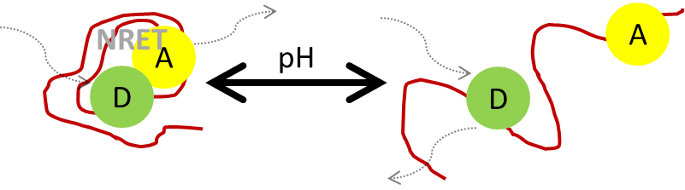

Figure 16 – NRET can occur between a donor (D) and acceptor (A) label across the same  
polymer chain when the polymer’s conformation brings them into close proximity

### Viable probes

#### Main Probes



Figure 17 – Fluorescent Labels acenaphthylene (left)  
and 9-anythrylmethylmethacrylate (right)

Two luminescent probes found to be ideal for this kind of polymer labelling include acenaphthylene (ACE) and 9-anthrylmethyl methacrylate (AMMA). These labels each absorb and emit light at separate wavelengths, and a significant overlap exists between the emission of ACE (considered a donor) and AMMA (considered an acceptor), making these labels suitable for NRET measurements [23].

The fluorescence lifetime of P(AA-co-ACE) polymers in dilute aqueous solutions has been shown to diminish from 35 to 20 nanoseconds, corresponding to the conformational change of the macromolecule with pH [91]. The correlation time derived from fluorescence time resolved anisotropy has been shown to shrink from 6 to 2 nanoseconds across the same range [79], however this research suggested that there was a ‘broad distribution’ of correlation times which were modelled using only a single exponential function to give an average correlation time. This technique, though justified by the consistent trends in the data, disguises the true complexity of the TRAMS process. ACE has also been used to study the lower critical solution temperature (LCST) of PNIPAM [92], both with and without the presence of quenching agents [93].

When polymerised the fluorescent label on AMMA exists adjacent to, rather than bound directly on, the polymer backbone, which affects its fluorescent properties [94]. ACE is reportedly a ‘backbone label’ and can be used to accurately report the segmental motion of the polymer, whereas AMMA often requires more than a single exponential decay to model due to it experiencing both segmental motion and independent ester group rotation [95].

Owing to this increased complexity it is used more commonly as an electron acceptor in dual label systems, both in conjunction with ACE and other labels[96]. When low ammounts of both labels are randomly distributed across a PMAA backbone the amount of energy transferred between the labels is dependent on the conformation of polymer with respect to pH [23].

Noted aspects of their fluorescence include the fact that both ACE and AMMA are quenched at approximately twice the rate of many other contemporary labels (1-vinylnapthalene, 1-napthylmethyl methacrylate, 9-phenanthrylmethyl methacrylate) [97] and that when oxygen is purged from the system ACE is capable of phosphorescing via an aromatic triplet state, which is quenched very efficiently by O2 [98].

#### Synthesis

AMMA can be synthesised from 9-anthracenemethanol and methacryloyl chloride, by dissolving the reactant lumophore in a solution of triethylamine and THF, cooling to 0oC and adding the methacroyl chloride added over the period of an hour [94]. Several variations of the method are possible, both with and without the presence of pyridine in the mixture [99].

#### Other Probes

Another potential probe is vinyl pyrene, used previously to study naphthalene polymers[100] as well as the quenching properties of interacting polyelectrolytes (such as PAA and poly(ethylene glycol) (PEG)[101], PMAA and poly(styrene sulfonate) (PSS) [77] amongst others). Pyrene can be used to track the conformational change of PMAA as it collapses at low pH 6 [75], revealing much information about the mobility of the polymer [102] and its hydrophobicity [103].

The fluorophore 5-(dimethylamino)naphthalene-1-sulfonyl chloride (Dansyl Chloride) has previously been employed to study the interaction between PAA and PEO via an increase in fluorescent intensity [104]. Using PEO (Mn 24,000 and 77,000) and PAA (Mn 590,000 and 690,000) it has been shown that an increased molecular weight of the polybase results in a much more stable complex. As the fluorescence of dansyl chloride is more intense in organic media than water it was found to be a good indication of the polymer complexation via its isolation from the aqueous media [105]. From this initial research the label has been used extensively to study the effect of molecular weight and to further refine the model of inter polymer complex formation [106].

A further method used previously to demonstrate the unwinding of PAA polymer chain with pH is to expose the polymer to hydrophobicly modified dyes containing pyrenyl and napthyl groups, demonstrating its effects on hydrophobic fluorophores [58]. However the effect these dyes have on the bulk polymer is in question, as previous work has shown pyrenyl groups attached to polyelectrolytes [107] and water soluble polymers [108] stack against each other.

## Interpolymer Complexes

### Complex Formation

The interactions between polymers have been a keen topic of research for decades, with many fundamental measurements carried out in the 1960s, 70s and 80s[109, 110]. Even in dilute solutions most macromolecules are known to aggregate with each other, which is often observed as a phase separation phenomena, and results in complexes with properties unique to their individual components [111]. The key driving forces for this interaction have been identified as a mixture of electrostatic, hydrogen bonding and hydrophobic interactions, and as such are dependent on pH, salt concentrations and temperature [112].

In 1984 Baranovsky et al. studied the IR spectra of PMAA and PAM/PEG mixtures at various temperatures and proposed a ‘ladder type’ system, with sequences of bonds between the molecules, occasionally interrupted with ‘loop’ defects[113] (See Figure 18). This theory poses that the polymers will form rigid, static structures due to repeated hydrogen-bonding across molecules.



Figure 18 – Baranovsky’s rigid ‘ladder’ system with ‘loop’ defects

### Poly(acrylic acid) and poly(acrylamide) interactions

The interactions between PAA and PAM are one of the more studied systems of interpolymer complex formation (IPC), and in both solution and solid state the interaction has been shown to be very pH dependent, and most of it proposes that PAA dictates the configuration of the polymer [26].

When mixed solutions of PAA and PAM turn translucent and they have been observed dropping out of solution when cooled [114]. This phase separation suggested the formation of complexes between polyacrylic acid and polyacrylamide, all dependent on the concentration, the medium and the ionisation constant [114].

For complexes between PAA and a proton-acceptor polymer it has been shown that IPCs will only form below a critical value of pH (pHcrit) [115]. This is believed to be fairly low as even only partial neutralisation of the polyacid has been shown to inhibit the formation of the complex [116].

Previous work done on the subject cites a need for high molecular weights in order to detect complex formation, the exact molecular weight is dependent on the method and polymer concentration [115, 117]. It is known that the structure of the resultant IPC (a gel or a compact complex) depends on the molecular weight of the forming polymers [118]. It is generally accepted that the larger the molecular weights of the polymers the stronger the interaction, and very large molecular weight polyacids can be used to potentially raise pHcrit [102].

At high ionisation both polymers exist as random polymeric chains with rapid segmental motion, and as the ionisation decreases PAA is deprotonated. PAA is then capable of forming an intramolecular H-bond with itself or intermolecularly forming H-bonds with other polymers [119], leading to a rigid polymer mixture with slow chain motions. PAA forms stronger complexes to PAM than some other polymers (PEO, poly(vinyl acetate) (PVAc)) due to additional ion-dipole interaction of the partially protonated amide groups and the C=O dipoles of PAA [120]. The molecular changes that lead to this conformational change are detailed in Table 1 [26].

Table 1 – Ionisation properties of PAM-PAA[26]

|  |  |  |  |
| --- | --- | --- | --- |
|  | Low Ionisation | Medium Ionisation | High Ionisation |
|  |  |  |  |
| PAA |  |  |  |
| PAM |  |  |  |
| PAM-PAA |  |  |  |

Infrared studies of this complexation have found the peak interaction between PAA and PAM occurs approx. pH 2.69 [121]. By comparing the absorbance of C=O bands to carboxylic and amide groups the amount of hydrogen bonding can be confirmed, showing that the structure of the resulting complex is largely dependent on the weight fraction and ionic strength of the PAA electrolyte. Complex formation also affects conductivity, as the mobility of the chains decreases conductivity drops proportionately [122]. It has also been shown that irradiating solutions of PAA and PAM can lead to interpolymer crosslinking [123, 124], which can be followed with FTIR investigations [41].

The interaction between PAA and PAM becomes stronger with decreasing temperature, as shown via viscometric tests [27], with pHcrit falling as low as 1.9 at 60oC [112]. This can be expected by the nature of the hydrogen bonding interaction that drives the complexation.

Below the critical pH only small portions of PAM form ‘multimacroion clusters’, meaning that in a 1:1 stoichiometric system of PAA and PAM it was found that there was still a fairly large amount of free PAM chains in solution not involved in PAA binding[125].

### Other Factors

#### Inorganic Salts

It has been demonstrated that the addition of certain inorganic salts can alter the formation of IPCs. In high ionic strength conditions the number of hydrogen bonds between PAA and PAM will increase accordingly [121].

For example salts can raise pHcrit for complex formation [102], and the ability of chlorides to assist in complexation is NH4Cl > KCl > NaCl [126]. This may be due to the increasing ionic strength deteriorating the thermodynamic quality of the solvent, strengthening polymer-polymer interactions by conversely weakening polymer-water ones [127]. Additionally Cu2+ ions improve the efficiency of IPC formation between PAA and PAM [115].

### Comparable Polymer Systems

#### Poly(N-Isopropylacrylamide)



Figure 19 - Poly(N-isopropylacrylamide) is a temperature responsive smart polymer

Investigations into poly(N-isopropylacrylamide) (PNIPAM) show it has a similar response to the presence of polycarboxylic acids, precipitating out of solution to form tightly bound complexes [128]. PAM-PAA interactions are more dominant at lower temperatures [27]. These are the opposite properties of PNIPAM which shows a stronger interaction with PAA at high temperatures, as the complex formation is driven primarily by hydrophobic interactions, and the hydrogen bonding interaction of PAM-PAA is destabilised [129].

It should be noted that the interaction between PAA and PNIPAM was found to be stronger than that of PAA-PAM [42]. This is believed to be due to the additional hydrophobic interaction of the isopropyl side groups as well as its hydrogen-bonding character. As an intermediate with some limited hydrophobicity PEG was used to test this theory, and in tests on the lifetime of dissolved pyrene it demonstrated properties between those of PAM and PNIPAM [103].

PNIPAM responds in a different way to increasing ionic strength to PAM. Whereas PAM-PAA complexes are strengthened by increasing ionic strength, for this complex it actually decreased the critical pH for complex formation [127]. As the initial critical pH for IPC formation was larger than 3, Khutoryanskiy theorised that the increasing ionic strength partially dissociated the polyacid by decreasing its pKa value. As only non-ionised carboxylic groups are able to form hydrogen bonds this would impede IPC formation.

#### Poly(ethylene oxide)



Figure 20 – Poly(ethylene oxide) (also known as poly(ethylene glycol) (PEG) or poly(oxyethylene) (POE) is a polyether

The interaction between P(AA-*co*-ACE) and poly(ethylene oxide) (PEO) has already been studied by time resolved fluorescence measurements, and when PEO (Mn 93,000) was mixed with P(AA-*co*-ACE) (Mn 550,000) the correlation time of a double exponential system was found to increase at a 1 : 1 stoichiometric ratio [84]. The degree of the effect was found to be influenced by the molecular weight of the complexing polymer, with smaller polymers offering less restriction to rotation than larger polymers. PEO has also been complexed with 1-vinylnaphthalene labelled PMAA which showed a long lived relaxation time, beyond the lifetime of the fluorophore’s excited state [52, 85].

Using the dansyl label it has been shown that high molecular weight PEO polymers were found to be capable of interacting with P(AA-*co*-AM) random copolymers in a way similar to that of pure PAA polymers [106]. This suggested that a continuing sequence of interacting groups is not required for the formation of IPCs, disagreeing with previous findings which stated that an ‘uninterrupted sequences of bonds in polycomplexes of simple synthetic macromolecule’ is necessary [113, 130] (Figure 21).



Figure - Baranovsky's proposed structure of interacting polymers  
from uninterrupted linear sequences of bonds in polycomplexes

PAA and PEO interactions have also been studied by NMR [131].

#### Poly(dimethylacrylamide)



Figure 22 - Poly(dimethylacrylamide) is a homopolymer also capable  
of forming IPCs with poly(acrylic acid)

Previous work has also identified that poly(acrylic acid) will form an IPC with poly(dimethylacrylamide) (PDMA), with pHcrit increasing with temperature, as opposed to PAA-PAM structures where pHcrit decreases with temperature [112]. This LCST type behaviour was attributed to the dimethyl substitution of amide groups, which adds additional hydrophobic groups at high temperatures.

#### Poly(vinyl alcohol)



Figure 23 – Poly(vinyl alcohol) is a homopolymer of vinyl alcohol monomers

Complex formation between PAA and PVAl is dependent upon the pH of solution [132]. This interaction has been studied via turbidity, fluorescence, viscosity [133], FTIR and DSC [134]. In aqueous solutions a 50 : 50 stoichiometric PVP-PVAl is so strong that below pH 2.4 (at zero degree of neutralisation) the complex will drop out of solution to form a suspension [135].

#### Poly(N- vinylpyrrolidone)



Figure 24 – Poly(N-vinylpyrrolidone) is a homopolymer of N-vinylpyrrolidone monomers

Poly(acrylic acid) and poly(N-vinylpyrrolidone) (PVP) complexes have been shown to form reversible complexes via an interaction between the C=O PVP substituent and the OH PAA hydrogen donor in acidic environments (PH < 5) [136, 137]. At pH 5 to 6 this complex rapidly deteriorates, as evidenced by the loss of viscosity of 50 : 50 stoichiometric mixtures of PAA-PVP polymers at low shear [135]. Using residual dansyl labelled polyacids this interaction has been shown to form more stable complexes with PAA than PEO, forming a 1:1 complex [105].



Figure 25 – IPC formation between PAA and PVP  
with regards to equilibrium of dissociation of PAA

#### Poly(diallyldimethylammonium chloride)



Figure 26 – Poly(diallyldimethylammonium chloride) is a common polymer  
used for water effluent treatment

Poly(diallyldimethylammonium chloride) (PDADMAC) is a homopolymer that is employed in effluent treatment, pulp and paper processing and water purification[138-140]. Previous research has identified both complex formation and multilayer assembly between it and PAA as a function of pH[141, 142]. As a cationic polymer use of this flocculant must be carefully monitored to ensure it is not released into fresh water supplies[19].

#### Poly(dimethylamine)



Figure 27 – Poly(epichlorohydrin-co-dimethylamine) is one of the most common commercial polyamine polymers

Poly(dimethylamine) copolymers are also employed in water treatment processes [1, 143]. As a cationic polymer use of this flocculant must be carefully monitored to ensure it is not released into fresh water supplies [19].

### Summary

This work shows that dilute solutions of PAA readily form an IPC with many receptive polymers, resulting in rigid copolymer structures. The interaction with poly(acrylamide) is dependent on the sample being contained within an acidic media, below a critical pH approx. 2.3-2.9 [115].

## Existing Methods of Detection

Due to the continued use of polyacrylamides there has been much prior investigation into determining the exact concentration of polyacrylamide solutions. Although numerous methods of chemical analysis exist for determining the residual acrylamide monomer content in formulations, no standardised method has been adopted for directly determining trace concentrations of the polymer in water, despite interest from many government agencies [2, 17].

Though there are many methods to determine the concentration of polyacrylamide in solution most methods suffer the drawback of being very involved, requiring several prepatory steps that would not be easily reproducible on a large scale.

### Published Chemical Methods

A range of methods for detecting polyacrylamide have been published previously.

Polyacrylamide may be hydrolysed with a quaternary ammonium cation to form an insoluble complex that remains colloidally suspended. This suspension can then be measured turbidometrically to an accuracy of 2% at high concentrations [144]. A modification of this technique involves passing the solution through a cation exchange resin following alkaline hydrolysis, which is then evaporated and subsequently collected in order to reveal concentrations lower than 1 mg l-1 [145]. The basic method has additionally been automated to give accurate concentrations as low as 5 ppm, although the process can be interfered with by anions (such as alkylbenzene sulfonates and large fatty acids) [146]. A major downside is that these methods cannot be used directly on non-anionic acrylamide unless it has been precipitated by tannic acid, whereby nephelometric (turbidometric) measuring techniques were found to be accurate and reproducible to 1% at concentrations as low as 0.1 ppm [147].

Another method previously documented is a test designed to identify amide and nitrile functionalities of the polymers [148]. However analysis highlighted the requirement for high temperature fusion with a highly concentrated caustic, liberating the nitrogen as either ammonia or an organic amine, and the analysis of each sample took over half an hour.

Another technique oxidises the amide functional groups with bromine to produce an iodide ion which can be detected spectrophotometrically after the excess bromine is removed [149]. This method is both sensitive, accurate and more rapid than its predecessors but still requires modification of the polymer prior to examination; further modifications are required to allow it to work in the presence of high chloride ion concentrations [150].

A known indirect method involves the hydrolysis of poly(acrylamide) to release ammonia, followed by the formation of a denitro derivative using Sanger’s Reagent which could be studied by GPC [151]. Low concentration samples require concentrating under a steam of nitrogen, a slow and complicated process for aqueous samples.

Spectrofluorometry has been shown to be the fastest and most accurate way to study high molecular weight poly(acrylamides) below 1 mgl-1 [145]. It has previously been shown that conversion of the polyacrylamide to an amine derivative to put the absorption peaks in the detector’s operating range (250 – 700 nm) gives fast and accurate results shown to have a lower limit of detection of 20 ppb with an accuracy of 0.07 mg l-1.

Another spectrophotometric test used in irrigation water, requires accurate mixing with kaolin clay and measures the settling of flocculated suspensions, and can measure concentrations of PAM as low as 10 mgl-1 [18]. The limit of detection of this technique is 0.1 mg l-1, with a guaranteed accuracy of only 0.11 mg l-1 at this range.

Another utilised spectrophotometric test detects the concentration of amide groups after N-bromination of the polymer, and is a viable technique in the presence of dissolved organic matter (DOM) contamination [152]. The combined amide groups emit at 570 nm, whilst the DOM only emits at 254 nm. Despite high levels of DOM it has been shown that PAM concentration can be quantified as low as 2 mg l-1, or 0.2 mg l-1 for cleaner samples. In some heterogeneous samples it is necessary to separate the polymer from DOM via size exclusion chromatography in order to improve the accuracy of measurements, with a lower detection limit of 0.02 µg, and a linear response from 0.2 mg l-1 [153].

Cationic dyes have also been shown to give a reasonable response to poly(acrylamide) in solutions as low as 4 mg l-1 [154].

All these methods, though some are very accurate, require at least some modification of the polymer to be analysed and some are sensitive to contaminants. Most are laboratory based procedures that require specific highly specialised equipment; hence there is still a need for a simple, cheap, transportable detection system.

### Industrial Patents

A patent search was performed to examine the current available technologies concerning the use of luminescent tagged polymers (see *Appendix A – Patent Search*). This showed there is already a wealth of current knowledge considering the use of fluorescent markers to detect poly(acrylamide) (or other polymer) contamination in water by prior modification of the targeted analyte.

Currently in order to track the fate of poly(acrylamide) fluorescently (or any other flocculating polymer) the polymer is modified specifically with an aromatic label. By incorporating a fluorescent tag into the polymer itself before its intended process (be it flocculation, grouting, suspension, etc.) simple search methods are employed, intending to detect the enclosed tag as opposed to the original polymer. This method is by nature expensive, it requires a risky modification to the painstakingly controlled process where there is no certainty over how the chemical properties of these polymers will be affected by the presence of the tag.

In contrast however a new method utilising complexation of targeted analyte with fluorescent polymers requires no prior modification to the polymer and could be carried out on any waterborne application provided the medium is translucent enough to permit the passage of light.

One advantage of the proposed technique is that no change is required to the operation of the flocculating polymer; the luminescent tagged polymers can be added to samples of the effluent stream taken after the flocculation process has finished. No patents were found working in the area using similar chemistry (save US6607889 which proposed using fluorescent detection complexes to determine DNA composition.)

# Polymer Synthesis

A series of labelled and unlabelled polymers were synthesised using both free radical polymerisation and controlled RAFT polymerisation. The project involved the synthesis of chain transfer agents and fluorescent probes prior to their incorporation into polymer chains.

## Experimental

### General Experimental Conditions

#### Solvents and Reagents

All chemicals and reagents were obtained from commercial sources (primarily Sigma-Aldrich) and were used without further purification unless otherwise stated. Dry solvents were dispensed from the Sheffield Chemistry Department Grubbs System having been thoroughly dried using molecular sieves.

#### Nuclear Magnetic Resonance Spectroscopy

All nuclear magnetic resonance (NMR) samples were prepared using deuterated solvents supplied by Sigma Aldrich. 1H and 13C NMR spectra were recorded using a Bruker AMX2-400 with 5mm CH probe at 400MHz unless otherwise stated.

#### Elemental Analysis

Elemental analysis was carried out on a Perkin-Elmer 2400 CHNS/O Series 2 Elemental Analyser. 5-10mg of sample was combusted in the presence of excess oxygen and combustion reagent to form CO2 and water. Levels of each element were detected using a thermal conductivity detection system.

#### Inductively Coupled Plasma Mass Spectrometry

Inductively coupled plasma (ICP) Mass Spectrometry was carried out by acidifying aqueous samples with nitric acid and then examined via a Spectro Cirus Vision ICP Optical Emission Spectrograph, giving elemental compositions in mg l-1.

#### Ultra Violet/Visible Spectroscopy

UV/Vis analysis was carried out using a Specord S-600 spectrophotometer, passing the light through a quartz cuvette with a path length of 1 cm with samples compared to a blank cuvette containing the same solvent.

#### Analytical Gel Permeation Chromatography (GPC)

##### Aqueous GPC

###### TSKgell Columns

Samples were analysed at room temperature using a high molecular weight column setup consisting of 2x300mm TSKgell GMPWxl columns. All samples were run using aqueous solutions of 0.1M sodium nitrate and 0.01M sodium dihydrogen phosphate. Samples were prepared up to 1 mg ml-1 and injected using a Rheodyne 200 um injection loop. The samples were analysed using a refractive index (RI) detector (HP 1047A RI Detector), calibrated to give polymer molecular weights calculated from the known retention time of standard PEG/PEO polymers.

###### DVB-Sulphonated Jordi Gell Columns

Samples were prepared in a 0.1 M TRIS, 0.1 M NaCl and 0.01 M Sodium Azide mobile phase (solvent filtered by a 0.45 µm pore). The samples were run at 1.00 ml/min down 2 x 600mm DVB-sulphonated Jordi Gell columns. These samples were analysed using a dual UV-RI system (AD20 Absorbance Detector) (HP 1047A RI Detector) calibrated using the retention time of PAA polymers. As the calibrants did not give a UV signal, the lag time between the two detectors was calculated using polystyrene sulphonate and this was applied to the calibration from PAA standards.

##### Tetrahydrofuran (THF) GPC

Acidic samples were prepared via a methylation reaction with trimethylsilyldiazomethane then dissolved in THF (solvent filtered by 0.45 µm pore)[155]. A Kinesis 307 Gilson Pump passed the sample through 3x PLgel 10um mixed-B LS Columns at 1.00 ml/mn flow rate. Samples were added via a Anachem 234 auto injector and the RI signal was recorded using an Erma Inc. ERC-7512 RI detector. The system was calibrated using PMMA samples.

#### Luminescence Analysis

Steady state spectra were recorded on a Fluoromax-4 Spectrofluorometer (HORIBA Scientific), unless otherwise noted with an excitation/emission slit width of 1 nm. Lifetime measurements were performed on an Edinburgh Instruments System 5000 Monochromator, whilst time resolved anisotropy measurements were recorded using an Edinburgh Instruments 199 Fluorescence Spectrometer. All solutions were recorded in 1 cm quartz cuvettes, with the fluorescent sample dissolved in ultrapure water (UPW). The profile of the laser beam can be seen using a silica prompt to scatter light at the excitation wavelength.

#### Turbidity

Turbidity was measured on a Model 2100 P150 Portable turbidimeter. This compares the nephelometric signal by comparing scattering light at 90oC to transmitted light. It has a range of 0 – 1000 FNU and an accuracy of 2% of reading + 0.04 FNU.

### Fluorescence Label Synthesis

#### 9-Anthryl Methyl Methacrylate (AMMA) Synthesis

##### Preparation of Reagents

9-Anthracenemethanol (Lancaster, 97%) was dried in vacuum overnight at 100oC. Methacryloyl chloride (Lancaster, 97%) was used fresh and distilled. Triethylamine (BDH) was refluxed for 8 hours with anhydrous calcium hydride (BDH) (5 wt % of reagent) and distilled onto molecular sieves. 0.5M hydrochloric acid (HCl) solution was prepared by diluting 48.6 ml of 35-38% HCl solution (BDH) with water up to 1000 ml. Saturated sodium hydrogen carbonate (NaHCO3) solution was prepared by dissolving the maximal amount of NaHCO3 in water and the solution was filtered to remove excess salt.

##### Synthesis of 9-anthryl methyl methacrylate

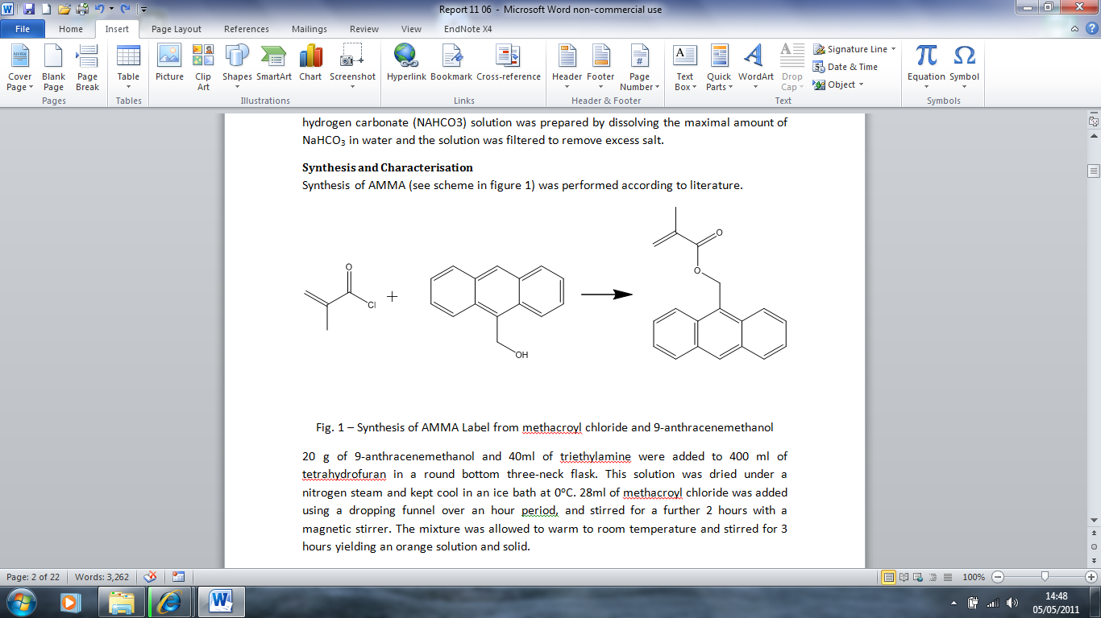

0oC  
THF  
Triethylamine

Figure 28 - Synthesis of AMMA Label from  
methacroyl chloride and 9-anthracenemethanol

Synthesis of AMMA was performed according to literature [94].

20 g of 9-anthracenemethanol and 40ml of triethylamine were added to 400 ml of tetrahydrofuran in a round bottom three-neck flask. This solution was dried under a nitrogen stream and kept cool in an ice bath at 0oC. 28ml of methacroyl chloride was added using a dropping funnel over an hour period, and stirred for a further 2 hours with a magnetic stirrer. The mixture was allowed to warm to room temperature and stirred for 3 hours yielding an orange solution and solid.

Distilled water was added to the mixture, followed by diethyl ether to extract the organic product. This mixture was poured into a separating funnel and the lower aqueous phase was removed, leaving the orange ether layer. The ether extract was then filtered and washed with deionised water, 0.5M HCl solution, saturated NaHCO3 solution and then dried over anhydrous sodium sulphate (BDH) for 16 hours at room temperature. The ether was evaporated using a rotary evaporator at room temperature. The product was recrystalised from spectroscopic grade methanol and purified via column chromatography with a silica gel. The recrystalised monomer was dried in a vacuum oven at 60oC for several days. The product was a yellow crystalline solid, stored at -10oC. It was identified as the desired product by its melting point (83-84.5oC) and its 1H NMR spectrum in CDCL3 (400 MHz, CDCL3 δ 1.99 (s C**H**3) δ 5.51 (s C**H**2) δ 6.05 (s **H**) δ 6.20 (s **H**) δ 7.5 (m, Ar) δ 8.32 (m Ar)).

#### Acenapthylene (ACE) Purification

ACE purchased from Sigma Aldrich was prepared for use by column chromatography to ensure the purity of the label.

### RAFT Initiator Preparation

#### Preparation of Reagents

Pyrrole (10.0 g) was distilled over calcium hydride at 90oC to give a clear liquid.

#### Synthesis of Benzyl-1-pyrrolecarbodithioate (BPC)



Figure 29 – Synthesis of benzyl-1-pyrrolecarbodithioate  
from pyrrole and benzyl bromide

Pyrrole (5.00 g, 74.527 mmol) was added dropwise to a rapidly stirring suspension of sodium hydride (1.79 g, 74.527 mmol) in DMSO (80 ml) over 20 min. The solution was then stirred at room temperature for 30 min. The solution was cooled to 5oC using an ice-water bath before carbon disulphide (5.6744 g, 74,527 mmol) was added dropwise. The resultant orange brown solution was stirred at room temperature for 30 min, and then benzyl bromide (12.69 g, 74.527 mmol) was added dropwise. The solution was stirred overnight at room temperature. The mixture was extracted using water (80 ml) and diethyl ether (80 ml), and the aqueous layer washed with ether (160 ml) until all the organic product was extracted. The organic layer was dried over MgSO4 and filtered by gravity filtration. The solvent was removed from the mixture by rotary evaporation. The product was purified by flash column chromatography on silica using hexane as the solvent. The yellow phase was collected and the solvent removed by rotary evaporation to give 2.4 g (35.1 %) of a yellow oil. 1H NMR in (CDCl3 400 MHz in ppm δ 4.65 (s, CH2) δ 6.38 (m, H) δ 7.40 (m, Ar) δ 7.75 (m, Ar).

#### 2-cyanopropan-2-yl-benzdithioate (CPB)

This was purchased from Sigma Aldrich and used directly with no purification steps. Sample was stored at -10oC to ensure stability.

#### Synthesis of 2-{[[butylsulfanyl)-carbonothioyl]sulfanyl}propanoic acid (BSCSP)



Figure 30 – Synthesis of 2-[[butylsulfanyl)-carbonothioyl]sulfanyl}propanoic acid  
from butanethiol and 2-bromopropane

Butanethiol (43.00 g, 0.47 mol) was added dropwise with stirring to a 90 ml sodium hydroxide (16.0 g, 0.40 mol) at 15oC. 20 ml acetone was added and the solution was stirred for half an hour before being cooled to 5oC. Carbon disulphide (30 ml) was added dropwise and it was left to react for another half an hour. 2-Bromopropionic acid (66.0 g, 0.43 mol) was added dropwise, followed by another 30 ml NaOH solution and 25 ml deionised water. This was allowed to warm to room temperature and left to stir for 24 hours. The orange mixture was extracted using 50 ml concentrated HCl and filtered to extract a yellow solid. This was washed with cold water repeatedly, resuspended in a stirring solution, and finally recrystalised in hexane to yield 107.3 g (0.45 mol) product, a 95% yield. 1H NMR in (CDCl3 400 MHz in ppm δ 3.45 (t, SC**H2**C) δ 1.65 (m, CC**H2**C) δ 1.45 (m, CC**H2**C) δ 0.90 (t, C**H3**C). 13C NMR in (CDCl3 400 MHz in ppm δ 205.61 (s, S**C**SS) δ 36.23 (s, S**C**H2C) δ 30.18 (m, C**C**H2C) δ 29.84 (m, C**C**H2C) δ 21.97 (s, C**C**H2C), δ 13.22 (s, **C**H3C). Elemental analysis expected: C 40.39%, H 5.92%, S 40.3%, actual results: C 48.7%, H 8.58%, S 43.1%. TOF ES+ Mass Spectroscopy showed a MH+ peak at 239.

### Linear Polymer Synthesis

#### Free Radical Polymer Synthesis

Linear poly(acrylic acid)s and poly(acrylamide)s were synthesised using radical 4,4'-azobis(4-cyanovaleric acid) (ACVA) or 4,4’-azobis(isobutyronitrile) (AIBN) initiators, and then characterised via 1H-NMR, UV Spectroscopy and aqueous GPC.

##### Poly(acrylamide)

###### Poly(acrylamide) Synthesis

AIBN  
60oC



Figure 31 - Polymerisation of poly(acrylamide)

Acrylamide (5.00 g, 0.07 moles) and AIBN (0.098 g, 5.98E-4 moles) were dissolved in ethanol (60 ml) and thoroughly degassed via three freeze-pump-thaw cycles. Once oxygen had been removed from the system the ampoules were flame sealed and heated to 60oC in a water bath for three days. Afterwards the precipitated polymer was filtered from ethanol, dissolved in deionised water and added to rapidly stirring butanol to purify. After repeated purification steps it was left in a vacuum oven until dry. The yield was greater than 90 %, 1H NMR in D2O (δ 2.31 (m C**H**) δ 1.99 (m C**H2**) δ 1.6 (m C**H3**)).

###### Poly(acrylamide –co-ACE)



AIBN  
60oC

Figure 32 - Polymerisation of poly(acrylamide-*co*-ACE)

Labelled polyacrylamide was prepared using the same method as pure polyacrylamide, with monomeric ACE (below 1 wt%) dissolved in the reactant mixture. 1H NMR in D2O (δ 2.31 (m C**H**) δ 1.99 (m C**H2**) δ 1.6 (m C**H3**)).

###### Poly(acrylamide –co-AMMA)



AIBN  
60oC

Figure 33 – Polymerisation of poly(acrylamide-*co*-AMMA)

Labelled polyacrylamide was prepared using the same method as pure polyacrylamide, with monomeric AMMA (below 1 wt%) dissolved in the reactant mixture. 1H NMR in D2O (δ 2.31 (m C**H**) δ 1.99 (m C**H2**) δ 1.6 (m C**H3**)).

###### Summary

Table 2 – Molar ratios of monomers used in poly(acrylamide) reactions

|  |  |  |  |  |  |
| --- | --- | --- | --- | --- | --- |
| No. | Polymer | AM | AIBN | ACE | AMMA |
| TS1/11/1 | PAM | 100 | 0.85 | - | - |
| TS1/27/1 | P(AM-*co*-ACE) | 100 | 0.86 | 0.56 | - |
| TS1/34/1 | P(AM-*co*-AMMA) | 100 | 0.94 | - | 0.35 |

##### Poly(acrylic Acid)

###### Distillation of Acrylic Acid Monomer

Acrylic Acid (99% Aldrich) was distilled to remove the inhibitor hydroquinone monomethyl ether. Distillation was carried out via heating under vacuum, with a double condenser unit (one ice trap and one frozen CO2/methanol). Acid vapour collected in both traps however only the condenser in ice was retained. The product was washed in the original container, labelled and stored below freezing temperature.

###### Poly(acrylic acid) Synthesis

AIBN  
60oC



Figure 34 - Polymerisation of poly(acrylic acid)

Distilled acrylic acid (5.00 g, 0.07 moles) and AIBN (0.099 g, 6.04E-4 moles) were dissolved in dioxane and degassed through three freeze-pump-thaw cycles. The sealed ampoule was placed in a 60oC water bath for four days to allow full polymerisation to occur. Afterwards the polymer was precipitated into diethyl ether to form solid polymer. This was redissolved in methanol and reprecipitated three times before being dissolved in water and purified by freeze drying. The yield was over 90 % and was identified by 1H NMR in D20 (δ 2.35 (m C**H**) m (δ 1.75 C**H2**)).

###### Poly(acrylic acid-co-ACE) Synthesis



AIBN  
60oC

Figure 35 – Polymerisation of poly(acrylic acid-*co*-ACE)

Labelled solutions of Polyacrylic acid were prepared using the same method as the homopolymer with the introduction of ACE (less than 1wt% of mixture). 1H NMR in D20 (δ 2.35 (m C**H**) m (δ 1.75 C**H2**)).

###### Poly(acrylic acid-co-AMMA) Synthesis



AIBN  
60oC

Figure 36 – Polymerisation of poly(acrylic acid-*co*-AMMA)

Labelled solutions of Polyacrylic acid were prepared using the same method as the homopolymer with the introduction of AMMA (less than 1wt% of mixture). 1H NMR in D20 (δ 2.35 (m C**H**) m (δ 1.75 C**H2**)).

###### Poly(acrylic acid-co-ACE-co-AMMA) Synthesis



AIBN  
60oC

Figure 37 – Polymerisation of poly(acrylic acid-*co*-ACE-*co*-AMMA)

Labelled solutions of Polyacrylic acid were prepared using the same method as the homopolymer allowing for the presence of approx. 1wt% of the aromatic labels in the ampoule, dissolved in the solvent prior to degassing. 1H NMR in D20 (δ 2.35 (m C**H**) m (δ 1.75 C**H2**)).

###### Summary

Table 3 – Molar ratios of poly(acrylic acid) reactions

|  |  |  |  |  |  |
| --- | --- | --- | --- | --- | --- |
| No. | Polymer | AA | AIBN | ACE | AMMA |
| TS1/81/1 | PAA | 100 | 0.87 | - | - |
| TS1/37/1 | P(AA-co-ACE) | 100 | 0.88 | 0.52 | - |
| TS1/37/2 | P(AA-co-AMMA) | 100 | 1.73 | - | 0.38 |
| TS1/38/4 | P(AA-co-ACE-co-AMMA) | 100 | 0.39 | 0.20 | 0.44 |
| TS1/68/1 | P(AA-co-ACE-co-AMMA) | 100 | 0.04 | 0.41 | 1.27 |
|  |  |  |  |  |  |

#### RAFT polymerisation

##### Poly(acrylic acid) via RAFT Polymerisation

CTA  
AIBN  
60oC



Figure 38 – RAFT polymerisation of poly(acrylic acid)

Acrylic acid, ACVA and a chain transfer agent (either BPC **(1)**, CPB **(2)**, BSCSP **(3)**) were placed in a 1,4-dioxane solution and added to an ampoule. After three free-pump-thaw cycles on the vacuum line the ampoule was heated at 60oC for 48 hours. The product was then precipitated out into diethyl ether, dried in a vacuum oven overnight, redissolved in dioxane and reprecipitated by addition of diethyl ether. The sample was then dissolved in deionised water and freeze-dried to give a solid product. 1H NMR in D20 (δ 2.35 (m C**H**) m (δ 1.75 C**H2**)).

##### Poly(acrylic acid-co-acenaphthylene) via RAFT Polymerisation

CTA  
AIBN  
60oC



Figure 39 – RAFT polymerisation of poly(acrylic acid-co-ACE)

This was produced in the same method as RAFT poly(acrylic acid) but with the inclusion of less than 1wt% ACE in the reactant mixture. 1H NMR in D20 (δ 2.35 (m C**H**) m (δ 1.75 C**H2**)).

##### Summary

Three different chain transfer agents were used in these reactions: BPC (**1**), CPB (**2**) and BSCSP (**3**), with varying initiator, CTA and label concentrations, targeting a selection of molecular weights. These are outlined in Table **4** **(1)**, Table 5 **(2)** and Table 6 **(3)**.

Table 4 – Molar ratios of RAFT poly(acrylic acid) reactions using CTA 1

|  |  |  |  |  |  |
| --- | --- | --- | --- | --- | --- |
| No. | Polymer | AA | ACVA | 1 | ACE |
| TS1/64/3 | PAA | 100 | 1.44 | 4.45 |  |
| TS1/64/2 | PAA | 100 | 1.44 | 2.69 |  |
| TS1/85/15 | PAA | 100 | 0.45 | 1.21 |  |
| TS1/60/1 | PAA | 100 | 1.27 | 1.06 |  |
| TS1/64/1 | PAA | 100 | 1.44 | 0.84 |  |
| TS1/85/13 | PAA | 100 | 0.45 | 0.74 |  |
| TS1/85/11 | PAA | 100 | 0.45 | 0.38 |  |
| TS1/85/3 | PAA | 100 | 0.11 | 0.24 |  |
| TS1/85/4 | PAA | 100 | 0.22 | 0.19 |  |
| TS1/85/2 | P(AA-*co*-ACE) | 100 | 1.33 | 1.52 | 1.14 |
| TS1/85/16 | P(AA-*co*-ACE) | 100 | 0.45 | 1.21 | 0.91 |
| TS1/60/2 | P(AA-*co*-ACE) | 100 | 1.27 | 1.06 | 2.49 |
| TS1/85/14 | P(AA-*co*-ACE) | 100 | 0.45 | 0.74 | 0.79 |
| TS1/85/6 | P(AA-*co*-ACE) | 100 | 0.39 | 0.63 | 0.30 |
| TS1/85/1 | P(AA-*co*-ACE) | 100 | 0.41 | 0.50 | 0.34 |
| TS1/85/12 | P(AA-*co*-ACE) | 100 | 0.45 | 0.38 | 0.83 |
| TS1/75/1 | P(AA-*co*-ACE) | 100 | 0.17 | 0.20 | 0.49 |

Table 5 - Molar ratios of RAFT poly(acrylic acid) reactions using CTA **2**

|  |  |  |  |  |  |
| --- | --- | --- | --- | --- | --- |
| No. | Polymer | AA | ACVA | 2 | ACE |
| TS1 105 5 | PAA | 100 | 0.08 | 0.02 |  |
| TS1 105 4 | PAA | 100 | 0.19 | 0.39 |  |
| TS1 105 3 | PAA | 100 | 0.44 | 1.5 |  |
| TS1 112 6 | P(AA-*co*-ACE) | 100 | 0.00 | 0.01 | 0.03 |
| TS1 112 5 | P(AA-*co*-ACE) | 100 | 0.01 | 0.0 | 0.03 |
| TS1 112 1 | P(AA-*co*-ACE) | 100 | 0.05 | 0.09 | 0.04 |
| TS1 112 4 | P(AA-*co*-ACE) | 100 | 0.30 | 0.16 | 0.21 |
| TS1 112 2 | P(AA-*co*-ACE) | 100 | 0.67 | 0.29 | 0.64 |
| TS1 105 1 | P(AA-*co*-ACE) | 100 | 0.05 | 0.32 | 0.05 |
| TS1 112 3 | P(AA-*co*-ACE) | 100 | 0.33 | 0.41 | 0.31 |

Table 6 - Molar ratios of RAFT poly(acrylic acid) reactions using CTA **3**

|  |  |  |  |  |  |
| --- | --- | --- | --- | --- | --- |
| No. | Polymer | AA | ACVA | R3 | ACE |
| TS1 110 3 | P(AA-*co*-ACE) | 100 | 0.03 | 0.03 | 0.01 |
| TS1 110 2 | P(AA-*co*-ACE) | 100 | 0.03 | 0.11 | 0.02 |
| TS1 110 8 | P(AA-*co*-ACE) | 100 | 0.10 | 0.16 | 0.18 |
| TS1 110 1 | P(AA-*co*-ACE) | 100 | 0.28 | 0.38 | 0.03 |
| TS1 110 4 | P(AA-*co*-ACE) | 100 | 0.03 | 0.54 | 0.01 |
| TS1 110 7 | P(AA-*co*-ACE) | 100 | 0.40 | 0.75 | 0.14 |

### Methylation of Acid Polymers



Figure 40 – Methylation of acid polymers by trimethylsilyldiazomethane

For gel permeation chromatography the polymers were modified by methylation of the carboxylic acid groups using trimethylsilyldiazomethane (TMSDZ). Polymer samples (10 mg) were dissolved in 5 ml THF before an excess of TMSDZ was added dropwise to a stirring solution until the sample remained yellow. This was left for 24 hours to evaporate to ensure all the volatile TMSDZ had been removed. 1H NMR in CDCl3 (δ 3.66 (m C**H3**) 2.31 (m C**H**) m (δ 1.99 C**H2**)).

## Results and Discussion

Whilst all polymers were characterised by 1H NMR, the exact molecular weight distributions and loading of aromatic labels varied slightly between batches depending on the exact conditions the polymer was prepared in.

### Polymer Molecular Weight Distribution

#### Aqueous Gel Permeation Chromatography

Gel permeation chromatography (GPC) (Figure 41) involves a filtered solvent being run through a column packed with porous beads. These separate analytes by size (hydrodynamic volume), as the smaller molecules are taken into the pores whilst larger molecules pass through the column unhindered. Polymer molecular weight therefore is inversely proportional to time of elution.

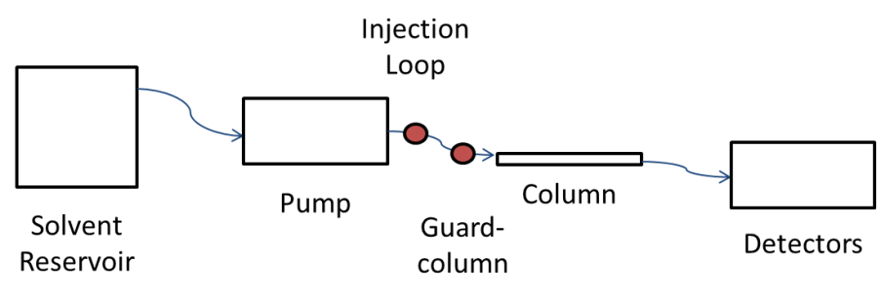

Figure 41 – A typical GPC system involves solvent being pumped at constant flow through a column. Multiple detectors can be placed on the end of the line.

The polymers molecular weight distribution is calculated using specific moments of the elution peak (Figure 42). Each moment corresponds to a molecular weight range, as defined by calibration. Although the polymer sample contains a range of polymer chain sizes the molar mass average can be quoted using the sum of the molar mass of each fraction (Mi) and the number of molecules of the stated molar mass (Ni). From these terms it is possible to calculate the number average molecular mass (Mn), weight average molecular mass (Mw), or the Z average molecular mass (Mz) (Equation 23, Figure 43). Therefore the weight of the substance (W) can be determined by a multiplication of M and N (Equation 25). The dispersity () of the polymer can be calculated from the broadness of the elution peak (Equation 27).

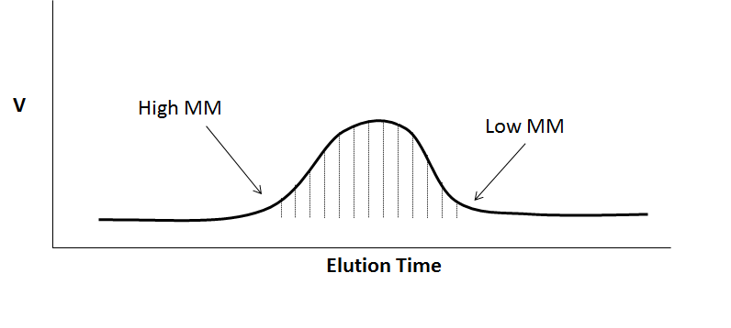

Figure 42 – Polymer elution from GPC, divided into segments (or moments).  
Elution time is inversely is proportional to molecular mass.

Equation 21

Equation 22

Equation 23

Equation 24

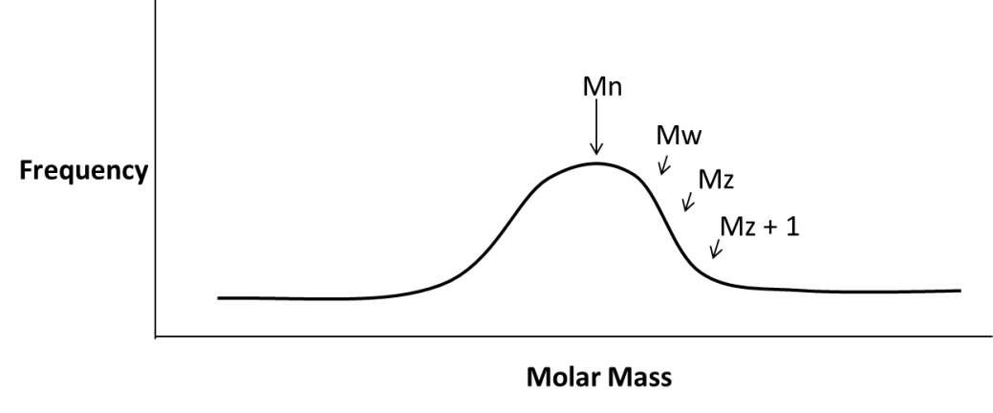

Figure 43 – Molecular mass averages of a molecular weight distribution  
(assuming a traditional Gaussian distribution sample)

Equation 25

Equation 26

Equation 27

Equation 28

In this thesis all GPC data are presented as Mn, Mw, Mz and ((Mw / Mn)).

##### Non-ionic Aqueous gel permeation chromatography

###### Method of Separation

The refractive index system was calibrated using Easivial 4ml PEG/PEO standards. Three standards are used, each a solution containing four distinct molecular weight polymers (Table 7). The retention time and molecular weight of each polymer was recorded (Figure 44) and used to calibrate the system. Using this calibration plot the sample chromatogram was converted to a hydrodynamic volume distribution, transforming the retention time of the detected polymers as they elute from the column to a representation of the molecular weight.

Table 7 – Properties of Easivial Standards used to calibrate PL Gell Aq. GPC

|  |  |  |
| --- | --- | --- |
| Standard | Polymer Mw | Sample Concentration / mg ml-1 |
| 1 | 1258000 | 0.05 |
|  | 116300 | 0.1 |
|  | 12140 | 0.2 |
|  | 615 | 0.3 |
| 2 | 909500 | 0.05 |
|  | 62100 | 0.1 |
|  | 3930 | 0.2 |
|  | 194 | 0.3 |
| 3 | 442800 | 0.05 |
|  | 23250 | 0.1 |
|  | 1500 | 0.2 |
|  | 106 | 0.3 |

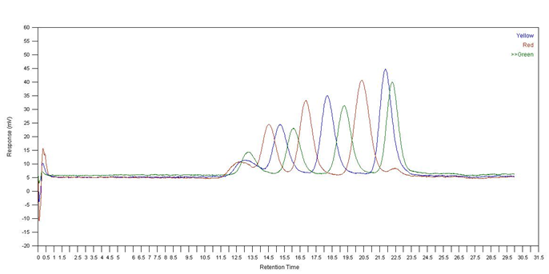

Figure 44 – Detector response to three Easivial standards,  
each containing four known molecular weight polymers

###### Linear Polymer Analysis

Both unlabelled and labelled linear PAM polymers were prepared (see 7.4.1.1.1 and 7.4.1.1.2) and analysed via gel permeation chromatography in duplicate (Figure 45). All polymers show a broad molecular weight distribution around a single peak, with a slight shoulder tending towards lower molecular weight. The unlabelled PAM has a slightly larger distribution than the labelled polymers, supporting the theory that labels at least slightly inhibit the polymerisation process [156]. The exact polymer distribution numbers are shown in Table 8.

Figure 45 – Molecular Weight Distribution of polyacrylamide polymers

Table 8 - Calculated specifications for polyacrylamide polymers

|  |  |  |  |  |  |
| --- | --- | --- | --- | --- | --- |
| Sample | Polymer | Mn | Mw | Mz | D |
| TS1/11/1 | PAM | 9700 | 47900 | 114700 | 4.9 |
| TS1/27/1 | P(AM-*co*-ACE) | 2000 | 6400 | 12400 | 3.2 |
| TS1/34/1 | P(AM-*co*-AMMA) | 5000 | 14500 | 20000 | 2.9 |

The non-ionic aqueous columns were found to be unsuitable for measuring acidic polyelectrolytes such as PAA.

##### Charged Aqueous Gel Permeation Chromatography

###### Calibration

Acidic polymers were injected into a set of Jordi Gell DVB-PSS columns using a TRIS buffer mobile phase and a dual UV-RI detector was used. The instrument’s RI detector was calibrated using a set of PAA standards (Figure 46), the UV absorbance detector was calibrated by applying the lag time between UV and RI instruments (determined using PSS standards).

Table 9 - Properties of PAA Standards used to calibrate charged Aq. GPC

|  |  |  |
| --- | --- | --- |
| Sample | Polymer Mw | Sample Concentration / mg ml-1 |
| 1 | 1,360,000 | 0.05 |
|  | 37,100 | 0.1 |
| 2 | 958,000 | 0.2 |
|  | 18,100 | 0.3 |
| 3 | 495,000 | 0.05 |
|  | 8,300 | 0.1 |
| 4 | 165,300 | 0.2 |
|  | 3,800 | 0.3 |
| 5 | 83,400 | 0.05 |
|  | 1,930 | 0.1 |

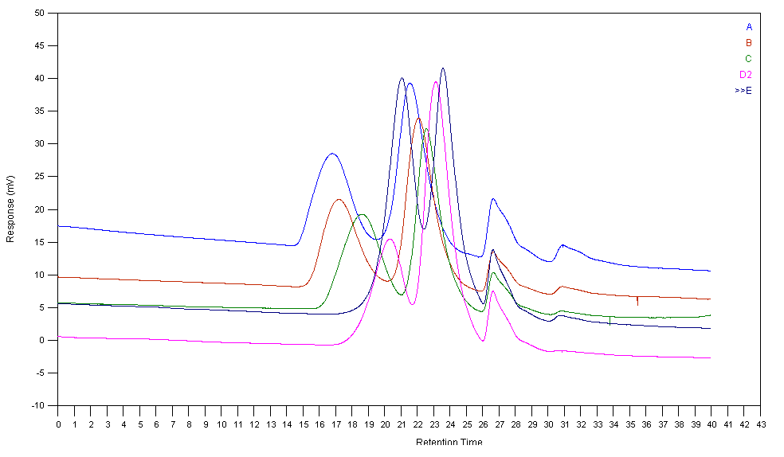

Figure 46 - Detector response to five PAA standards, each containing two  
known Mw PAA polymers. Peaks at 27 minutes signify flow rate markers.

###### Free Radical Linear Polymer Analysis

Polyacrylic acid polymers were analysed via the charged aqueous GPC columns connected to a dual UV-RI detector, in order to demonstrate both the molecular weight of the polymer and the relative distribution of aromatic labels. A sample is detected by the UV detector momentarily before the RI detector, a demonstration of the inter-detector lag time between instruments (Figure 47). By calculating the molecular weight distributions of UV and RI responses it can be seen that there appears to be a fairly even distribution of labels across the singly labelled linear polymers (Figure 48). Additionally by repeating the sample with the UV detector programmed to absorb at two different wavelengths both the distribution of ACE and AMMA can be compared for the same polymer sample (Figure 49). It appears that both the ACE and AMMA have similar molecular weight distributions, proving that there is no competitive inhibition where one label excludes the other. The full specifications of linear free radical linear PAA polymers as determined via dual detector RI-UV Aq. GPC are shown in Table 10. Analysis via UV absorption of AMMA proved troublesome due to low concentration of label in the sample (Figure 49) leading to high dispersities (Table 10).

Figure 47 – Raw data from two repeats of a P(AA-co-ACE) sample (TS1/37/1)

Figure 48 – Molecular Weight Distribution of P(AA-*co*-ACE) (TS1/37/1)  
and P(AA-*co*-AMMA) (TS1/37/2) polymers

Figure 49 – Molecular weight distribution of P(AA-*co*-ACE-*co*-AMMA) sample (TS1/68/1)  
showing ACE (UV 295 nm) and AMMA (UV 370 nm) distribution

Table 10 - Calculated specifications for linear poly(acrylic acid) polymers

|  |  |  |  |  |  |  |
| --- | --- | --- | --- | --- | --- | --- |
| Name |  | Contents | Mn | Mw | Mz | D |
| TS1/81/1 | RI | PAA | 45100 | 139100 | 185700 | 3.1 |
| TS1/37/1 | RI | P(AA-co-ACE) | 31900 | 102900 | 169700 | 3.2 |
| TS1/37/1 | UV(295) | P(AA-co-ACE) | 36400 | 113136 | 176500 | 3.1 |
| TS1/37/2 | RI | P(AA-*co*-AMMA) | 16000 | 97059 | 169800 | 6.0 |
| TS1/37/2 | UV(370) | P(AA-*co*-AMMA) | 21700 | 115074 | 200700 | 5.3 |
| TS1/38/4 | RI | P(AA-*co*-ACE-*co*-AMMA) | 90600 | 400355 | 616500 | 4.4 |
| TS1/38/4 | UV(295) | P(AA-*co*-ACE-*co*-AMMA) | 32000 | 442700 | 664100 | 13.8 |
| TS1/38/4 | UV(370) | P(AA-*co*-ACE-*co*-AMMA) | 25900 | 469000 | 704700 | 18.1 |
| TS1/68/1 | RI | P(AA-*co*-ACE-*co*-AMMA) | 22300 | 324100 | 630000 | 14.6 |
| TS1/68/1 | UV(295) | P(AA-*co*-ACE-*co*-AMMA) | 6100 | 334600 | 648100 | 55.3 |
| TS1/68/1 | UV(370) | P(AA-*co*-ACE-*co*-AMMA) | 3400 | 485200 | 948800 | 144.0 |

###### RAFT Linear Polymer Analysis

The addition of RAFT agent to polymerisation reactions has a large effect on the resultant molecular weights of the polymers. However as the RAFT group shows an absorbance response at 295 nm (matching the ACE absorbance peak) it interferes with the detection of the label within the polymer sample. Therefore, although RAFT-PAA contains no ACE, its UV response was larger than the RI response. The ACE loaded equivalent shows a much larger UV response thanks to the presence of the label (Figure 50). Despite this comparing a ACE loaded and ACE free polymer batch shows they have almost equivalent molecular weight distribution (Figure 51), as the size of the polymer chain is governed by RAFT : initiator : monomer ratio.

Figure 50 – Raw chromatogram data of peaks from RAFT-PAA (TS1/60/1)  
and RAFT-PAA-ACE (TS1/60/2) samples

Figure 51 – Molecular weight distributions of RAFT-PAA (TS1/60/1)  
and RAFT-PAA-ACE (TS1/60/2) samples

The full specifications of RAFT PAA polymers are shown in (Table 11).

Table 11 - Calculated specifications for linear Labelled RAFT-Polyacrylic acid Polymers

|  |  |  |  |  |  |  |
| --- | --- | --- | --- | --- | --- | --- |
| Detector | Name | Contents | Mn | Mw | Mz | D |
| RI | TS1/60/1 | PAA | 1600 | 9970 | 18700 | 6.3 |
| UV (295) | TS1/60/1 | PAA | 727 | 8955 | 19000 | 12.3 |
| RI | TS1/60/2 | P(AA-*co*-ACE) | 2623 | 12422 | 21600 | 4.7 |
| UV (295) | TS1/60/2 | P(AA-*co*-ACE) | 1068 | 12505 | 23100 | 11.7 |
| RI | TS1/64/1 | PAA | 8186 | 44070 | 72600 | 5.4 |
| UV (295) | TS1/64/1 | PAA | 3070 | 39893 | 74110 | 13.0 |
| RI | TS1/64/2 | PAA | 3049 | 14798 | 26302 | 4.9 |
| UV (295) | TS1/64/2 | PAA | 1028 | 13150 | 25553 | 12.8 |
| RI | TS1/64/3 | PAA | 655 | 6852 | 13028 | 10.5 |
| UV (295) | TS1/64/3 | PAA | 665 | 6824 | 12619 | 10.3 |
| RI | TS1/75/1 | P(AA-*co*-ACE) | 46057 | 169474 | 274772 | 3.7 |
| UV (295) | TS1/75/1 | P(AA-*co*-ACE) | 17474 | 178402 | 308995 | 10.2 |
| RI | TS1/85/1 | P(AA-*co*-ACE) | 12971 | 47475 | 79900 | 3.7 |
| UV (295) | TS1/85/1 | P(AA-*co*-ACE) | 4600 | 39281 | 77567 | 8.5 |
| RI | TS1/85/2 | P(AA-*co*-ACE) | 1600 | 13239 | 25000 | 8.2 |
| UV (295) | TS1/85/2 | P(AA-*co*-ACE) | 1000 | 12200 | 25070 | 12.0 |
| RI | TS1/85/3 | PAA | 40200 | 156700 | 254726 | 3.9 |
| UV (295) | TS1/85/3 | PAA | 1450 | 102148 | 254092 | 70.1 |
| RI | TS1/85/4 | PAA | 51300 | 201900 | 344144 | 3.9 |
| UV (295) | TS1/85/4 | PAA | 2100 | 174600 | 314058 | 82.6 |
| RI | TS1/85/5 | PAA | 23600 | 70981 | 108500 | 3.0 |
| UV (295) | TS1/85/5 | PAA | 6000 | 64259 | 110846 | 10.6 |
| RI | TS1/85/6 | P(AA-*co*-ACE) | 11400 | 34543 | 56143 | 3.0 |
| UV (295) | TS1/85/6 | P(AA-*co*-ACE) | 2000 | 31700 | 58600 | 15.9 |
| RI | TS1/90/1 | PAA | 5800 | 56200 | 115483 | 9.7 |
| UV (295) | TS1/90/1 | PAA | 3400 | 13073 | 21773 | 3.8 |

Using the charged aqueous columns accurate molecular weights can be determined from the RI detector, although the system continued to present large dispersities (only CTA **(1)** polymers were analysed using this technique). It was suspected that these figures were due to band broadening within the column as opposed to being an intrinsic property of the samples.

##### Tetrahydrofuran (THF) GPC

Due to the high dispersity of RAFT PAA polymers via charged GPC, samples were analysed via RI detection on a tetrahydrofuran (THF) based GPC, calibrated using PMAA calibrants. Samples were methylated with trisdiazomethane to improve solubility. Free radical polymers (containing no CTA) showed similar molecular weights to those obtained with charged ionic columns but with markedly reduced dispersity (Table 12).

Table 12 – THF GPC of non-RAFT polymers

|  |  |  |  |  |  |
| --- | --- | --- | --- | --- | --- |
| No. | Polymer | Mn | Mw | Mz | D |
| TS1 81 1 | PAA | 58094 | 112531 | 186452 | 1.94 |
| TS1 37 1 | P(AA-*co*-ACE) | 42167 | 64915 | 89993 | 1.54 |
| TS1 37 2 | P(AA-*co*-AMMA) | 30037 | 50473 | 72797 | 1.68 |
| TS1 38 4 | P(AA-co-ACE-co-AMMA) | 47100 | 129087 | 229847 | 2.74 |
| TS1 68 1 | P(AA-co-ACE-co-AMMA) | 43800 | 89900 | 166248 | 2.05 |

Figure 52 – Molecular weight distribution of PAA polymers on THF column

Polymers containing RAFT functionality CTA (**1**) were also analysed (Table 13). The dispersity of RAFT polymers varies within acceptable limits depending on the ratio of initiator used and the final molecular weight of the polymer.

Table 13 – THF GPC of RAFT PAA polymer using CTA (1)

|  |  |  |  |  |  |
| --- | --- | --- | --- | --- | --- |
| No. | Polymer | Mn | Mw | Mz | D |
| TS1/64/3 | PAA | 4361 | 6386 | 8670 | 1.46 |
| TS1/64/2 | PAA | 7062 | 14260 | 13880 | 1.45 |
| TS1/85/15 | PAA | 10791 | 17186 | 24332 | 1.59 |
| TS1/60/1 | PAA | 6793 | 10319 | 14044 | 1.52 |
| TS1/64/1 | PAA | 10865 | 21995 | 34648 | 2.02 |
| TS1/85/13 | PAA | 10717 | 17180 | 24636 | 1.60 |
| TS1/85/11 | PAA | 39899 | 61392 | 83440 | 1.54 |
| TS1/85/3 | PAA | 52525 | 84586 | 118181 | 1.61 |
| TS1/85/4 | PAA | 56188 | 94148 | 139171 | 1.68 |
| TS1/85/2 | P(AA-*co*-ACE) | 6683 | 10588 | 15271 | 1.58 |
| TS1/85/16 | P(AA-*co*-ACE) | 11459 | 16972 | 23529 | 1.48 |
| TS1/60/2 | P(AA-*co*-ACE) | 6579 | 9515 | 12711 | 1.45 |
| TS1/85/14 | P(AA-*co*-ACE) | 11279 | 18704 | 27061 | 1.66 |
| TS1/85/6 | P(AA-*co*-ACE) | 16277 | 27413 | 39202 | 1.68 |
| TS1/85/1 | P(AA-*co*-ACE) | 17703 | 33022 | 48360 | 1.87 |
| TS1/85/12 | P(AA-*co*-ACE) | 31525 | 53143 | 74282 | 1.69 |
| TS1/75/1 | P(AA-*co*-ACE) | 55945 | 90869 | 129410 | 1.62 |

From these data it is apparent that polymers prepared in the presence of high quantities of CTA had much lower molar masses than the polymer synthesised in the absence of it. Also, as expected, altering the ratio of AA : CTA had a dramatic effect on the molar mass of the resulting polymer. Figure 53 shows that the molar mass dependence of the ratio of AA : CTA was not affected by the incorporation of small amounts of the ACE comonomer.

Figure 53 – *M*n of polymers with CTA 1 (with and without ACE) at various CTA:AA feed ratios

Additionally there was no great variation between the Mn of polymers produced at a fixed ratio of AA : CTA between CTA **1**, **2** and **3** (Figure 54), raw data for (2) (Table 14 and (**3**) (Table 15).

Figure 54 – *M*n of polymers with CTA 1, 2 and 3 (with and without ACE) at various CTA : AA feed ratios

Table 14 - THF GPC of RAFT PAA polymer using CTA (2)

|  |  |  |  |  |  |
| --- | --- | --- | --- | --- | --- |
| No. | Polymer | Mn | Mw | Mz | D |
| TS1 105 5 | PAA | 70954 | 132249 | 217444 | 1.86 |
| TS1 105 4 | PAA | 40251 | 64187 | 88375 | 1.59 |
| TS1 105 3 | PAA | 7412 | 15174 | 32251 | 2.04 |
| TS1 112 6 | P(AA-co-ACE) | 124940 | 284730 | 513004 | 2.27 |
| TS1 112 5 | P(AA-co-ACE) | 86562 | 157781 | 243800 | 1.82 |
| TS1 112 1 | P(AA-co-ACE) | 73329 | 95301 | 122249 | 1.29 |
| TS1 112 4 | P(AA-co-ACE) | 50529 | 90880 | 133831 | 1.79 |
| TS1 112 2 | P(AA-co-ACE) | 45045 | 53427 | 62108 | 1.18 |
| TS1 105 1 | P(AA-co-ACE) | 15946 | 19736 | 24637 | 1.23 |
| TS1 112 3 | P(AA-co-ACE) | 37480 | 60994 | 88610 | 1.63 |
|  |  |  |  |  |  |

Table 15 - THF GPC of RAFT PAA polymer using CTA (3)

|  |  |  |  |  |  |
| --- | --- | --- | --- | --- | --- |
| No. | Polymer | Mn | Mw | Mz | D |
| TS1 110 3 | P(AA-co-ACE) | 177153 | 311300 | 484159 | 1.76 |
| TS1 110 2 | P(AA-co-ACE) | 63100 | 100983 | 148534 | 1.59 |
| TS1 110 8 | P(AA-co-ACE) | 63200 | 76074 | 89500 | 1.20 |
| TS1 110 1 | P(AA-co-ACE) | 26194 | 36000 | 46000 | 1.37 |
| TS1 110 4 | P(AA-co-ACE) | 13000 | 18700 | 24581 | 1.43 |
| TS1 110 7 | P(AA-co-ACE) | 16900 | 20300 | 24162 | 1.20 |

## Conclusions

A range of linear poly(acrylic acid) and poly(acrylamide) polymers were prepared using both free radical and RAFT polymerisation methods. Molecular weight was determined by GPC methods and it was found methylation by trisdiazomethane was necessary to analyse poly(acrylic acid). The incorporation of fluorophores has an effect on the resultant molecular weight of free radical polymers however the molecular weight of RAFT polymers is determined by the initial CTA : AA ratio.

# Analysis of Fluorescence Labels

## Molar Absorption Coefficients

The Beer-Lambert law (Equation 5) states that the absorbance of a label in fixed conditions (path length and solvent) is linear with concentration, as defined by the molar absorption (or extinction) coefficient ().

To determine the molar absorption coefficient, concentration gradients of acenapthene and anthracene (substituted to better simulate the binding of ACE and AMMA to a polymer backbone (Figure 55)) were created in methanol, and analysed to show relative absorbances (Figure 56 / Figure 57).

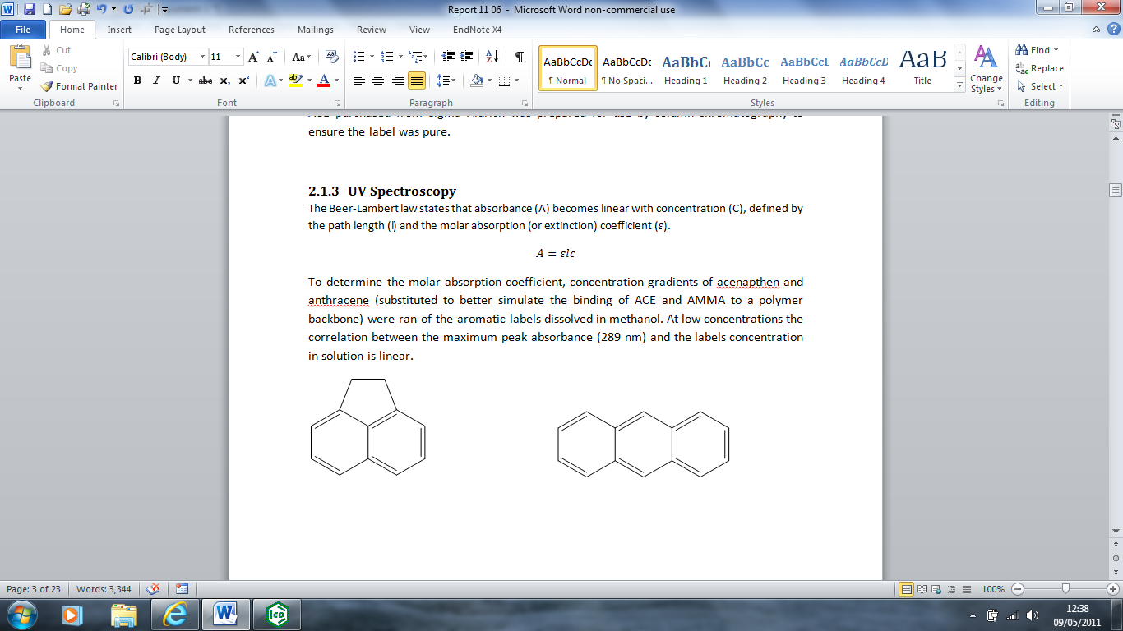

Figure 55 – Acenapthene and Anthracene have identical aromatic structure to ACE and AMMA

Figure 56 - Decreasing absorbance of acenapthene peaks as  
concentration is reduced from 1E-4 to 5E-6 Molar

Figure 57 - Decreasing absorbance of anthracene peaks as  
concentration is reduced from 9E-4 to 1E-7 Molar

At low concentrations the correlation between the maximum peak absorbance (289 nm for acenapthene / 256 nm for anthracene) and at low concentrations the relationship between concentration and absorbance is linear (Figure 58 /Figure 59). From the gradient of the absorbance increase at low concentrations the molar absorption coefficients were calculated as 5699 mol−1 cm−1 for acenapthene and 7202 mol−1 cm−1 for anthracene. This linear relationship breaks down at higher concentrations (approx. 0.0005 M for acenapthene / 0.0002 M for anthracene) (Figure 60 / Figure 61).

Figure 58 – Linear correlation of 289 nm peak of acenapthene at low concentrations

Figure 59 – Linear correlation of 289 nm peak of anthracene at low concentrations

Figure 60 – Acenapthene peak absorbances at 289 nm  
are no longer linear in concentrations exceeding 10-4 M

Figure 61 - Anthracene peak absorbance at 256 nm  
are no longer linear in concentrations exceeding 1E-4 M

## Fluorescence Spectra

The emission of fluorescence labels in solution is highly dependent on the choice of solvent, as fluorescence quenching is a large concern in unregulated media. The fluorescent label ACE was studied at very low concentrations in order to minimise eximer formation which would form an additional degree of quenching. In dioxane however ACE shows a typical excitation / emission peaks of 295 nm and 340 nm which is consistent with prior research (Figure 62). At equivalent concentration AMMA’s peak excitation is 370 nm and its primary (most intense) emission peak is at 410 nm (Figure 63).

Figure 62 – Excitation / Emission spectra of ACE label in dioxane (10-6 M)

Figure 63 - Excitation / Emission spectra of AMMA label in dioxane (10-6 M)

## Time Correlated Photon Counting

### Time Correlation Calibration

Time calibration is determined using instrumental time delays on the spectrometer and the scattering of light from a silica prompt, used to show the profile of the laser pulse. Alternate switches force an instrumental delay in the light pulse which is then detected by the machine (Figure 64).

Figure 64 – Variation in prompt scattering profile with respect to instrumental time delays

The machine measures the time range of the pulse across 511 channels, each channel representing an allotted time period within which photons are counted. The time calibration is given by the number of channels the peak of the silica prompt moves in regards to a known time delay on the instrument. The exact time constant can vary over time, being affected by the temperature of the electronics, mains voltage fluctuations or other factors, so repeated calibrations were made to ensure reasonable accuracy were made during the course of the project.

The instrumental time delay switches are 1, 2, 4, 8, 16 and 32 nanoseconds, with an error of 0.1 ns (or 1% for 16 and 32 ns switches). Multiple switches can be used to give more datapoints from which the calibration can be calculated, although it should be recognised that using multiple delays will increase the total error of the measurement.

Time delay calculations were carried out using the peak channel and, more accurately, centroid positioning of the peaks. Using all of the data the peak heights indicated that the weighted average time calibration was 0.4007 (variance 0.0059), or using centroid positioning it was shown to be 0.3979 (variance 0.0025).

Previous studies carried out during the length of the project showed the time calibration varied between to 0.4056 (variance 0.0012), recorded June 2013, notable for the current room temperature being elevated to 28oC) and 0.3949 (variance 0.0070, recorded October 2011, raw data shown in Figure 65).

Figure 65 - Variation in prompt scattering profile with respect to instrumental time delays

Taking into account the variability of the measurement over time, the time calibration was fixed at 0.4 ns per channel for all measurements on the Edinburgh 199 as this was assumed to give an accurate approximation of the machine within acceptable error.

### Fluorescence Lifetime

Fluorescence lifetime measurements are made by following a sample after excitation by a monochromatic beam of light, counting the number of photons emitted at a fixed fluorescent wavelength over time measured in channels. The incident light beam is measured using a silica prompt which scatters light at the same wavelength as the excitation source. When the fluorescent sample is measured the light is filtered so only light at a higher wavelength (I.E. that which has been absorbed and emitted by the sample) is detected. Using this method the fluorescence excited state decay of the excited species formed from the aromatic label can be observed (Figure 66).

Figure 66 – Raw excited state lifetime of ACE in dioxane (10-4 M)

The observed fluorescence decay can then be modelled using Equation 7 to determine the samples fluorescence lifetime. Only single exponential decays have been used in this project as it is believed the label exists in a homogeneous environment in solution. A double exponential equation will often give a smaller standard deviation than the same comparison using only a single exponential however the applicability of fitting multiple exponential components is made with regards to the inhomogeneity of the system, with each exponential representing a separate environment within which the ACE probe may be located. A single exponential from ACE is shown below (Figure 67) along with the residuals of the single exponential fit (Figure 68), which represents the accuracy of the fit.

This fit was carried out using Horiba Scientific software DAS 6. Although it is a single exponential and should be linear it does seem to drift above 100 ns, we believe this to be a result of automatic background intensity calculations in the software.

Figure 67 – Excited state lifetime of ACE in dioxane with single exponential fit (10-4 M)

Figure 68 – residuals of single exponential fit to ACE in dioxane (10-4 M)

The exponential function shown in Figure 67 was found to give an excited state lifetime of 11.6 ns, with a standard deviation of 0.04 ns, the background intensity A was 4.37, B was 0.65 and χ² (goodness of fit) was 3.41. Whilst this is not a perfect fit it does give a good approximation as to the lifetime of a label free in solution subject to quenching by the polar solvent.

### G Factor Calibration

The fluorescence correlation time is calculated from time resolved anisotropy measurements (TRAMS) using Equation 16. The sample is excited using polarised light, and the emitted fluorescent light is then polarised in one of two directions, with 90o separation, producing separate crossed and parallel spectra. A prompt is also measured to observe the profile of the incident light source. Use of Equation 16 however is dependent on the G Factor lying close to unity.

To measure this the fixed polariser is rotated into the horizontal position and several measurements are made comparing the parallel and crossed decay of a sample (Figure 69). This was repeated several times and the relative intensities of the data were compared using Equation 17 to reveal a G Factor of 1.0004, with a standard deviation of 0.0111, thus satisfying the demand that the G factor lies close to unity.

Figure 69 – Raw data from parallel and crossed polariser 2 positions  
with fixed horizontal position of polariser 1 (10-4 M ACE in dioxane)

### Fluorescence Correlation Time

Fluorescence correlation time measurements are made via both crossed and parallel decay profiles with the fixed polariser in the vertical position. In solution the ACE label rotates extremely quickly and so very little difference is observed between the two decay profiles (Figure 70).

Figure 70 – Raw data output of a correlation time measurement recording crossed and  
parallel polarised spectra of ACE in dioxane (10-4 M)

From the crossed and parallel spectra several fits can be determined from the raw data; the sum function (as derived from Equation 10) and the difference function (derived from Equation 11) (Figure 71).

Figure 71 – Sum and difference fits to ACE in dioxane (10-4 M)

The anisotropy function (as derived from Equation 9) is equal to the difference function divided by the sum (Equation 12). The anisotropic decay typically falls very quickly towards zero before descending into noise and it is this that can be modelled to reveal the correlation time of ACE (Figure 72). At 10-4 M concentration in dioxane the ACE label was found to have a correlation time of 0.17 ns, with a standard deviation of 0.01, A was 0.004, B was 0.175 and χ² was 1.05. Therefore this suggests that the ACE label rotates freely in solution at a speed that far exceeds the excited state lifetime of its excited state.

Figure 72 – Anisotropy fit of ACE in dioxane (10-4 M)

## Conclusion

The properties of fluorescence labels ACE and AMMA have been characterised sufficiently to allow for further investigation into their properties when covalently attached to a polymer backbone.

# Fluorescently Labelled Poly(acrylic acid) and Poly(acrylamide)

Singly and doubly labelled polymers have been examined using a range of fluorescent measurements. Characterisation of the fluorescence response of these polymers in dilute aqueous solutions is essential before they can be used as sensors for detection.

## Determining Content of Fluorescence Label in Polymers

The presence of label within polymer chains can be clearly observed via UV spectrometry. The polymers do not absorb in the region 250 to 400 nm, whereas ACE has a broad peak from 250-320 nm (peak 289 nm) and AMMA a sharp peak from 250-260 nm (Figure 73, Figure 74).

Figure 73 - UV absorbance plots of poly(acrylic acid) polymers

Figure 74 - UV absorbance plots of poly(acrylamide) polymers

The loading of a fluorescent label in the polymer (as a *Wt %*) can be determined by studying the peak absorbance at 289 nm and contrasting it with the concentration of polymer in solution using Equation 29. Here *CF* represents the concentration of label in solution, as determined via the molar extinction coefficient of ACE and AMMA, calculated from the trendlines in Figure 58 and Figure 59. *CM* represents the total weight of polymer dissolved in solution.

Equation 29

The results of all linear uncontrolled polymers produced so far are shown in Table 16. The loading of label onto poly(acrylamide) polymers is considerably lower than that of poly(acrylic acid). The two doubly labelled PAA samples contain differing ratios of ACE and AMMA, which should result in a difference to the amount of energy transfer capable by the individual polymer.

Table – Wt % loading of labels onto linear polymers produced

|  |  |  |  |
| --- | --- | --- | --- |
| Sample | Polymer | ACE | AMMA |
| TS1/81/1 | PAA | - | - |
| TS1/37/1 | PAA-ACE | 1.05 | - |
| TS1/37/2 | PAA-AMMA | - | 0.32 |
| TS1/38/4 | PAA-ACE-AMMA | 0.54 | 0.94 |
| TS1/68/1 | PAA-ACE-AMMA | 0.85 | 0.76 |
| TS1/11/1 | PAM | - | - |
| TS1/27/1 | PAM-ACE | 0.45 | - |
| TS1/34/1 | PAM-AMMA | - | 0.17 |

## Steady State Luminescence Spectroscopy

### Singly Labelled Polymers

The presence and identification of fluorescent peaks in labelled polymers can be determined via steady state spectroscopy, comparing the emission and excitation spectra which are usually rough mirror images of one another. ACE-labelled poly(acrylamide) shows a peak excitation at 290 nm and an emission at 340 (Figure 75), consistent with the ACE fluorophore in solution (Figure 62). Unlabelled poly(acrylamide), bereft of aromatic groups or other conjugated double bonds, does not fluoresce in this region.

Figure 75 - Emission and Excitation Spectra of ACE labelled PAM solutions

Singly labelled poly(acrylic acid)s have been studied by the same techniques and the difference between ACE and AMMA labelled polymers, and the overlap between the emission of ACE and the excitation of AMMA (310 – 345 nm) can be clearly observed (Figure 76).

Figure 76 - Emission and excitation spectra of singly labelled PAA polymers

The emission and excitation spectrum of singly labelled PAA polymers do not alter significantly with the pH of the solution, although there is some slight quenching at higher pH (Figure 77). As the ACE-label is covalently bound to the polyacrylic acid chain the expansion/contraction of the polymer chain has no effect on the wavelengths or intensity of the label’s luminescence. The AMMA label, bound pendent to the PAA chain, is slightly more sensitive to pH, although it retains similar structure and retains the same peak emission/excitation wavelengths (Figure 78).

Figure 77 – Emission/Excitation intensities of ACE-Labelled PAA polymers varying with pH

Figure 78 – Emission/Excitation intensities of AMMA-Labelled  
PAA polymers varying with pH

### Doubly labelled polymers

Use of the spectral overlap between ACE and AMMA labels can be made when both are covalently attached to a single polymer chain. Doubly labelled polymers are capable of demonstrating non-radiative energy transfer (NRET) across the chain backbone, provided the labels are located within a certain distance from each other in space. As the polymer is formed randomly some overlap occurs naturally, however separate labels can be forced closer together by lowering the pH of the solvent and causing the chain to contract. As PAA coils, ACE and AMMA form donor-acceptor pairs and energy can be transferred between them, as shown by the rising peaks on the emission spectrum at 390 and 415 nm when the sample is excited at 295 nm (Figure 79). However direct excitation of the AMMA label at 340 nm shows no significant difference in the emission spectra with response to the polymer coiling (Figure 80).

pH

Figure 79 – Emission spectra of a doubly labelled PAA sample excited at 295 nm

Figure 80 – Emission spectra of a doubly labelled PAA sample excited at 340 nm wavelength

The amount of energy transfer occurring between the ACE and the AMMA label in this system can be quantified using the following equation and the values of the 295 nm emission spectra. Taking the peak intensity of each peak (donor = 333 nm, acceptor = 392 nm) and utilising Equation 20 a graph can be formed that clearly demonstrates a reduction in the amount of energy transfer occurring as the polymer uncoils above pH 4 (Figure 81).

Figure 81 – Measure of Energy Transfer occurring across doubly labelled PAA samples with pH

### Parameters of Steady State Analysis

For all of the above measurements the slit width of the emission laser and the detector has been set to 1 nm. Altering the slit width changes the fine structure of the peaks and allows excitation of a much broader range of wavelengths. This provides a much more intense signal to the detector (Figure 82). It also increases the efficiency of energy transfer between donor and acceptor, the calculated ET rising from 0.26, 0.29 to 0.43 as the slit width increases from 1 to 3 nm. At higher slit widths the detector appears to be swamped and at 4 nm the emission spectra lose the label characteristics.

Figure 82 – Doubly labelled PAA sample at pH 3.78 with varying slit widths of laser and detector

### 3D Steady State Spectra

Simultaneous excitation-emission spectra were used to create 3D graphs depicting the emission of samples at every excitation wavelength between 250 - 500 nm. A blank sample showing the passage of the laser through ultrapure water shows a diagonal laser beam across the centre of the spectra, deviating slightly from exact emission = excitation wavelengths by a few nm, the intensity of the laser beam increasing with higher wavelengths (Figure 83).

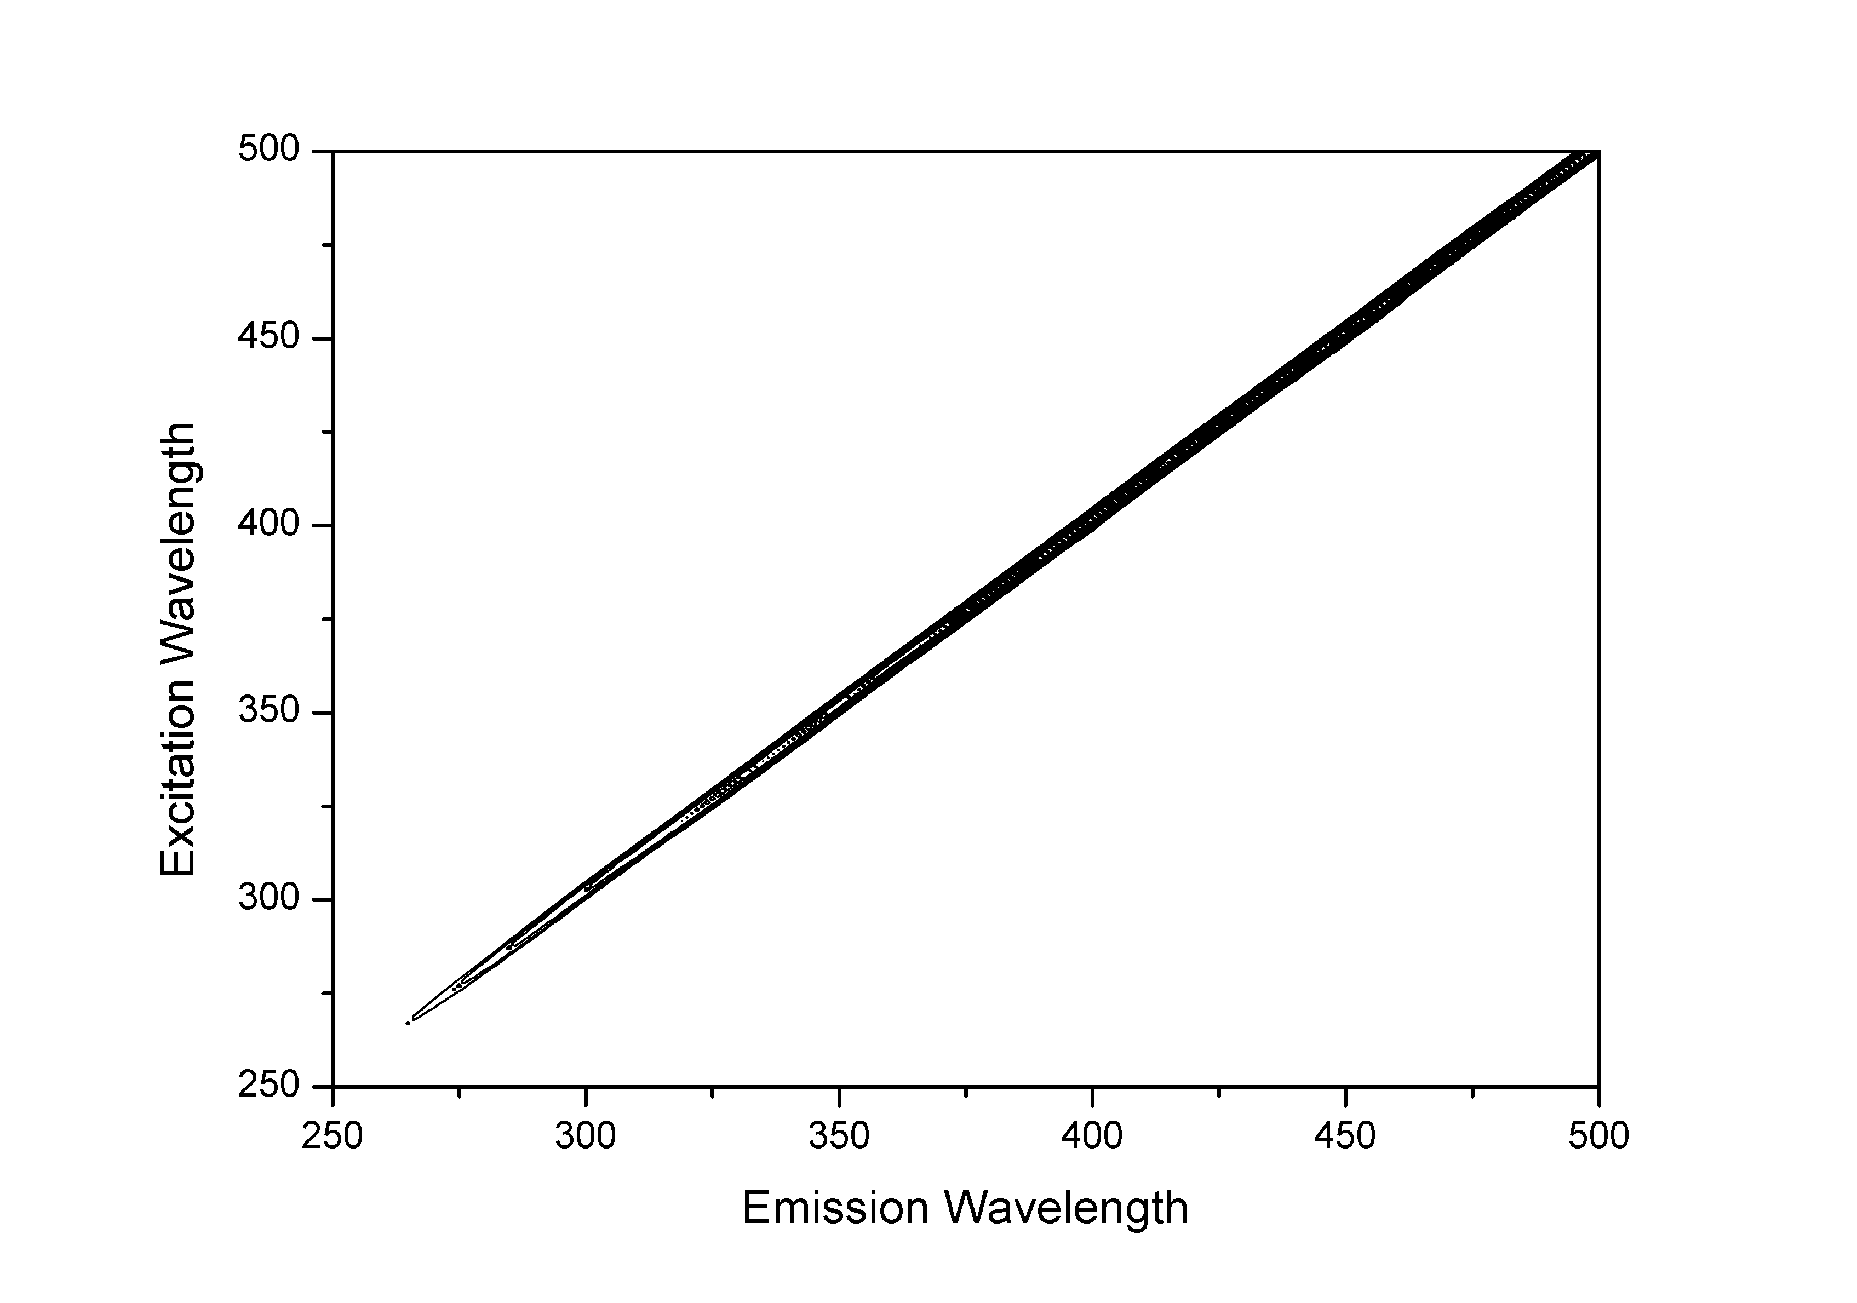

Figure 83 – A contour map of a steady state excitation/emission spectrum using ultrapure  
water as a blank solvent, with contours at regular integer’s from 3E3 to 2E5

Polymers containing ACE present a clear and single group of peaks exciting between 250-350 nm, and emitting 315-400 nm (Figure 84). The AMMA labelled polymer however offers a much broader signal with the primary peak exciting 350-410 nm and emitting 380-450 nm, but with a second fluorescent region exciting at 250-275 nm and emitting at 400-450 nm (Figure 85).

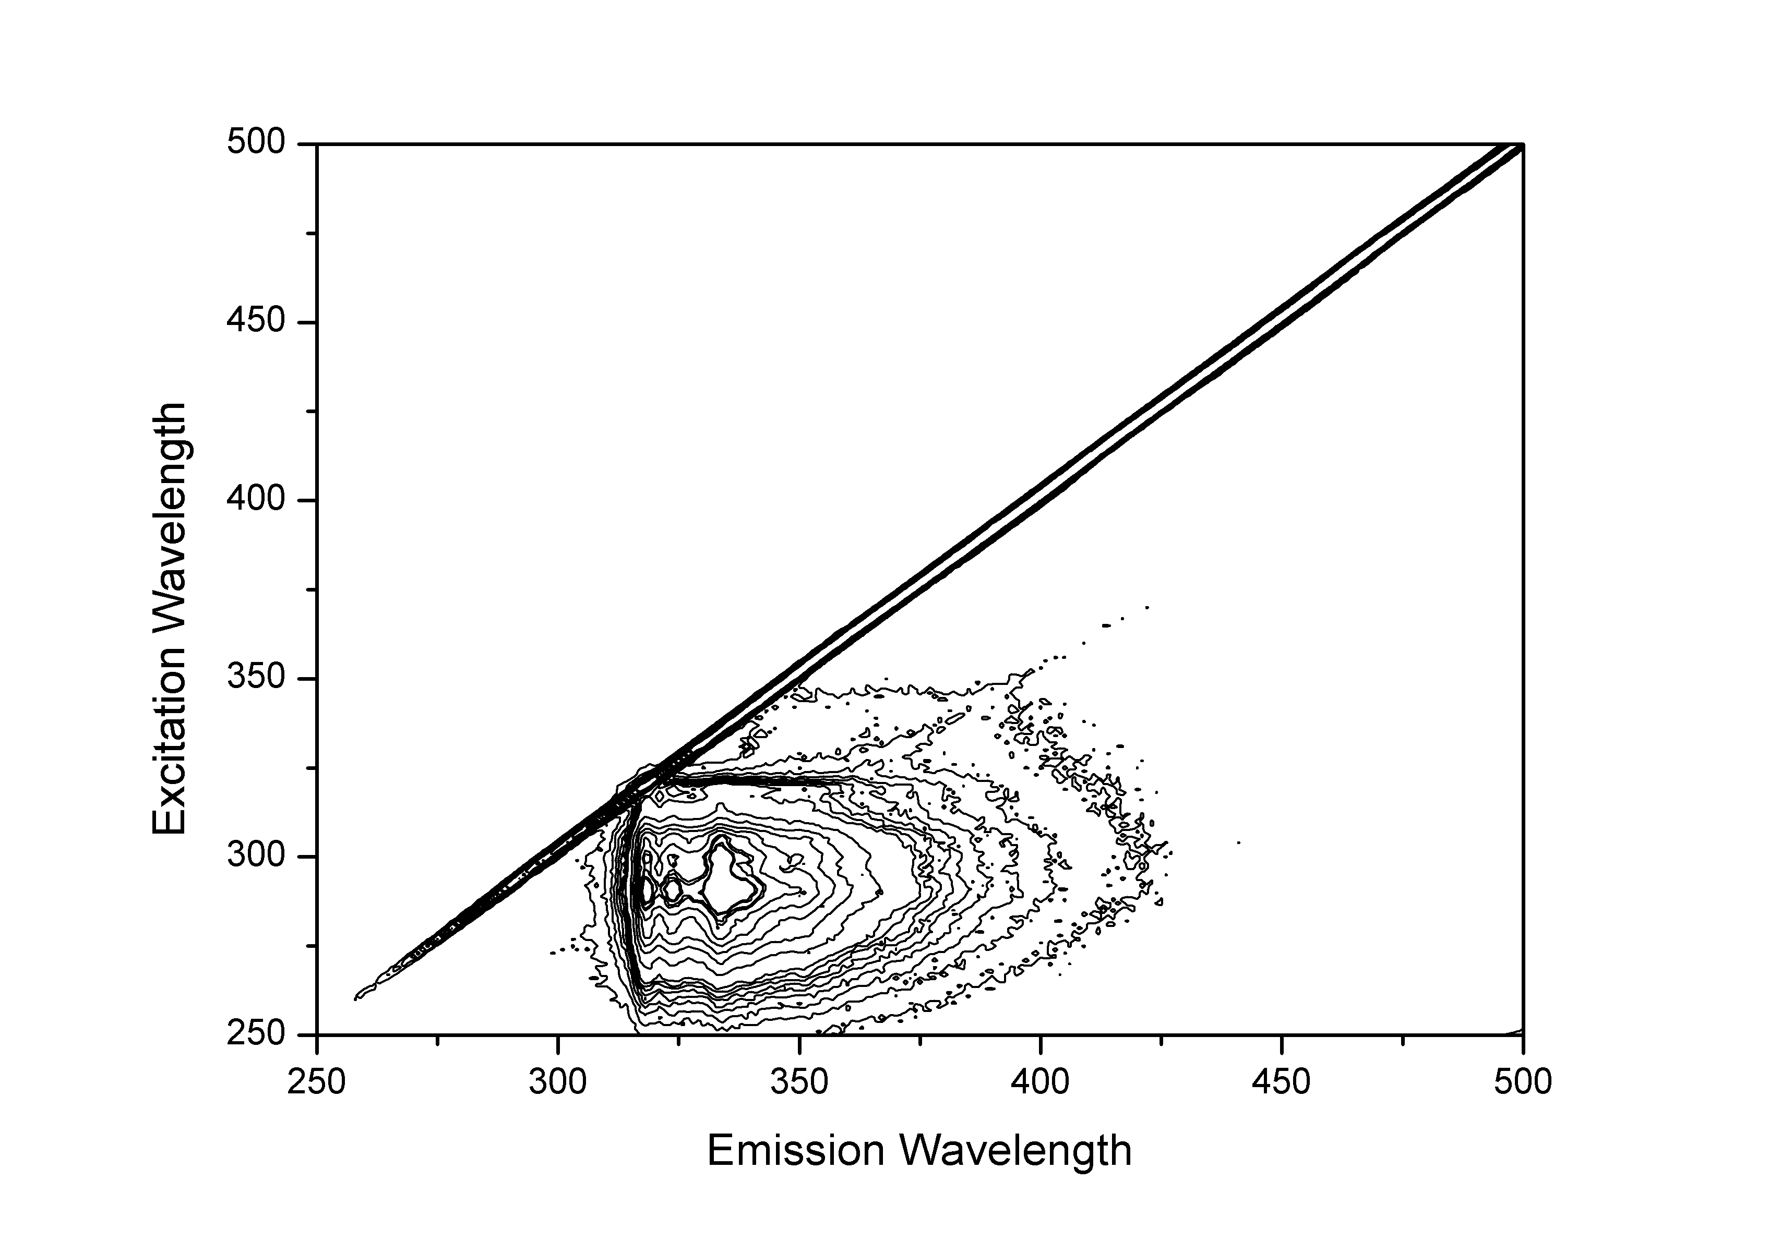

Figure 84 – A 3D excitation/emission spectrum of PAA-ACE  
with contours every half integer from 2E3 to 4.6E4

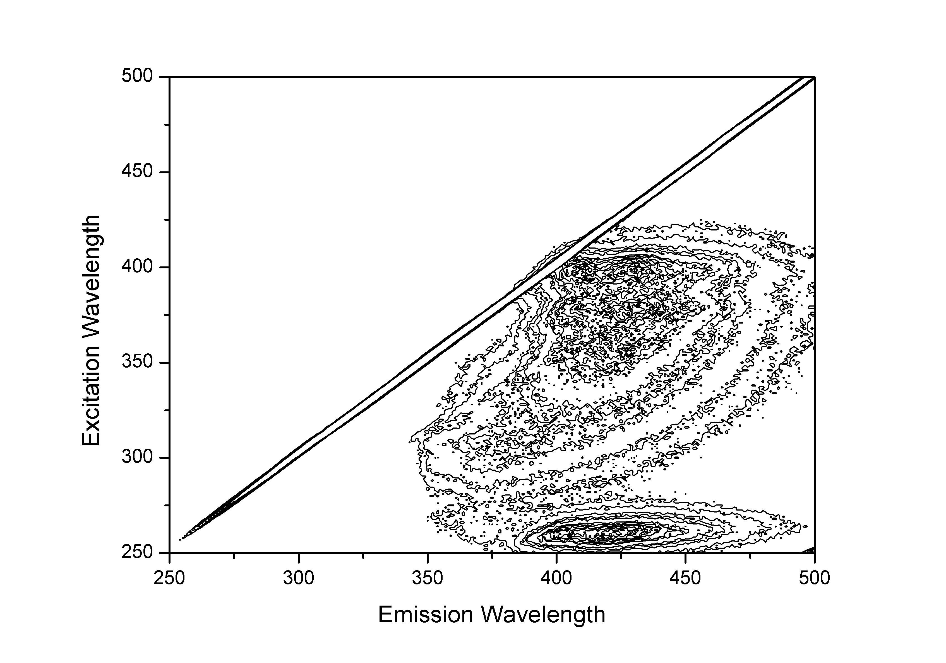

Figure 85 - A 3D excitation/emission spectrum of PAA-AMMA  
with contours every half integer from 1.5E3 to 1E4

This technique offers an efficient way of demonstrating all of the complex interactions of aromatically-labelled polymers in one measurement, giving a good indication of sample purity as it is proof of the presence of only the desired fluorophores.

Doubly labelled polymers can also be studied using this technique. At low pH the signals of ACE and AMMA labels are both clearly visible, but as evidence of the energy transfer across the polymers vertical lines can be seen below the AMMA peaks (Figure 86), these peaks are not visible if the same sample is raised to a higher pH (Figure 87).

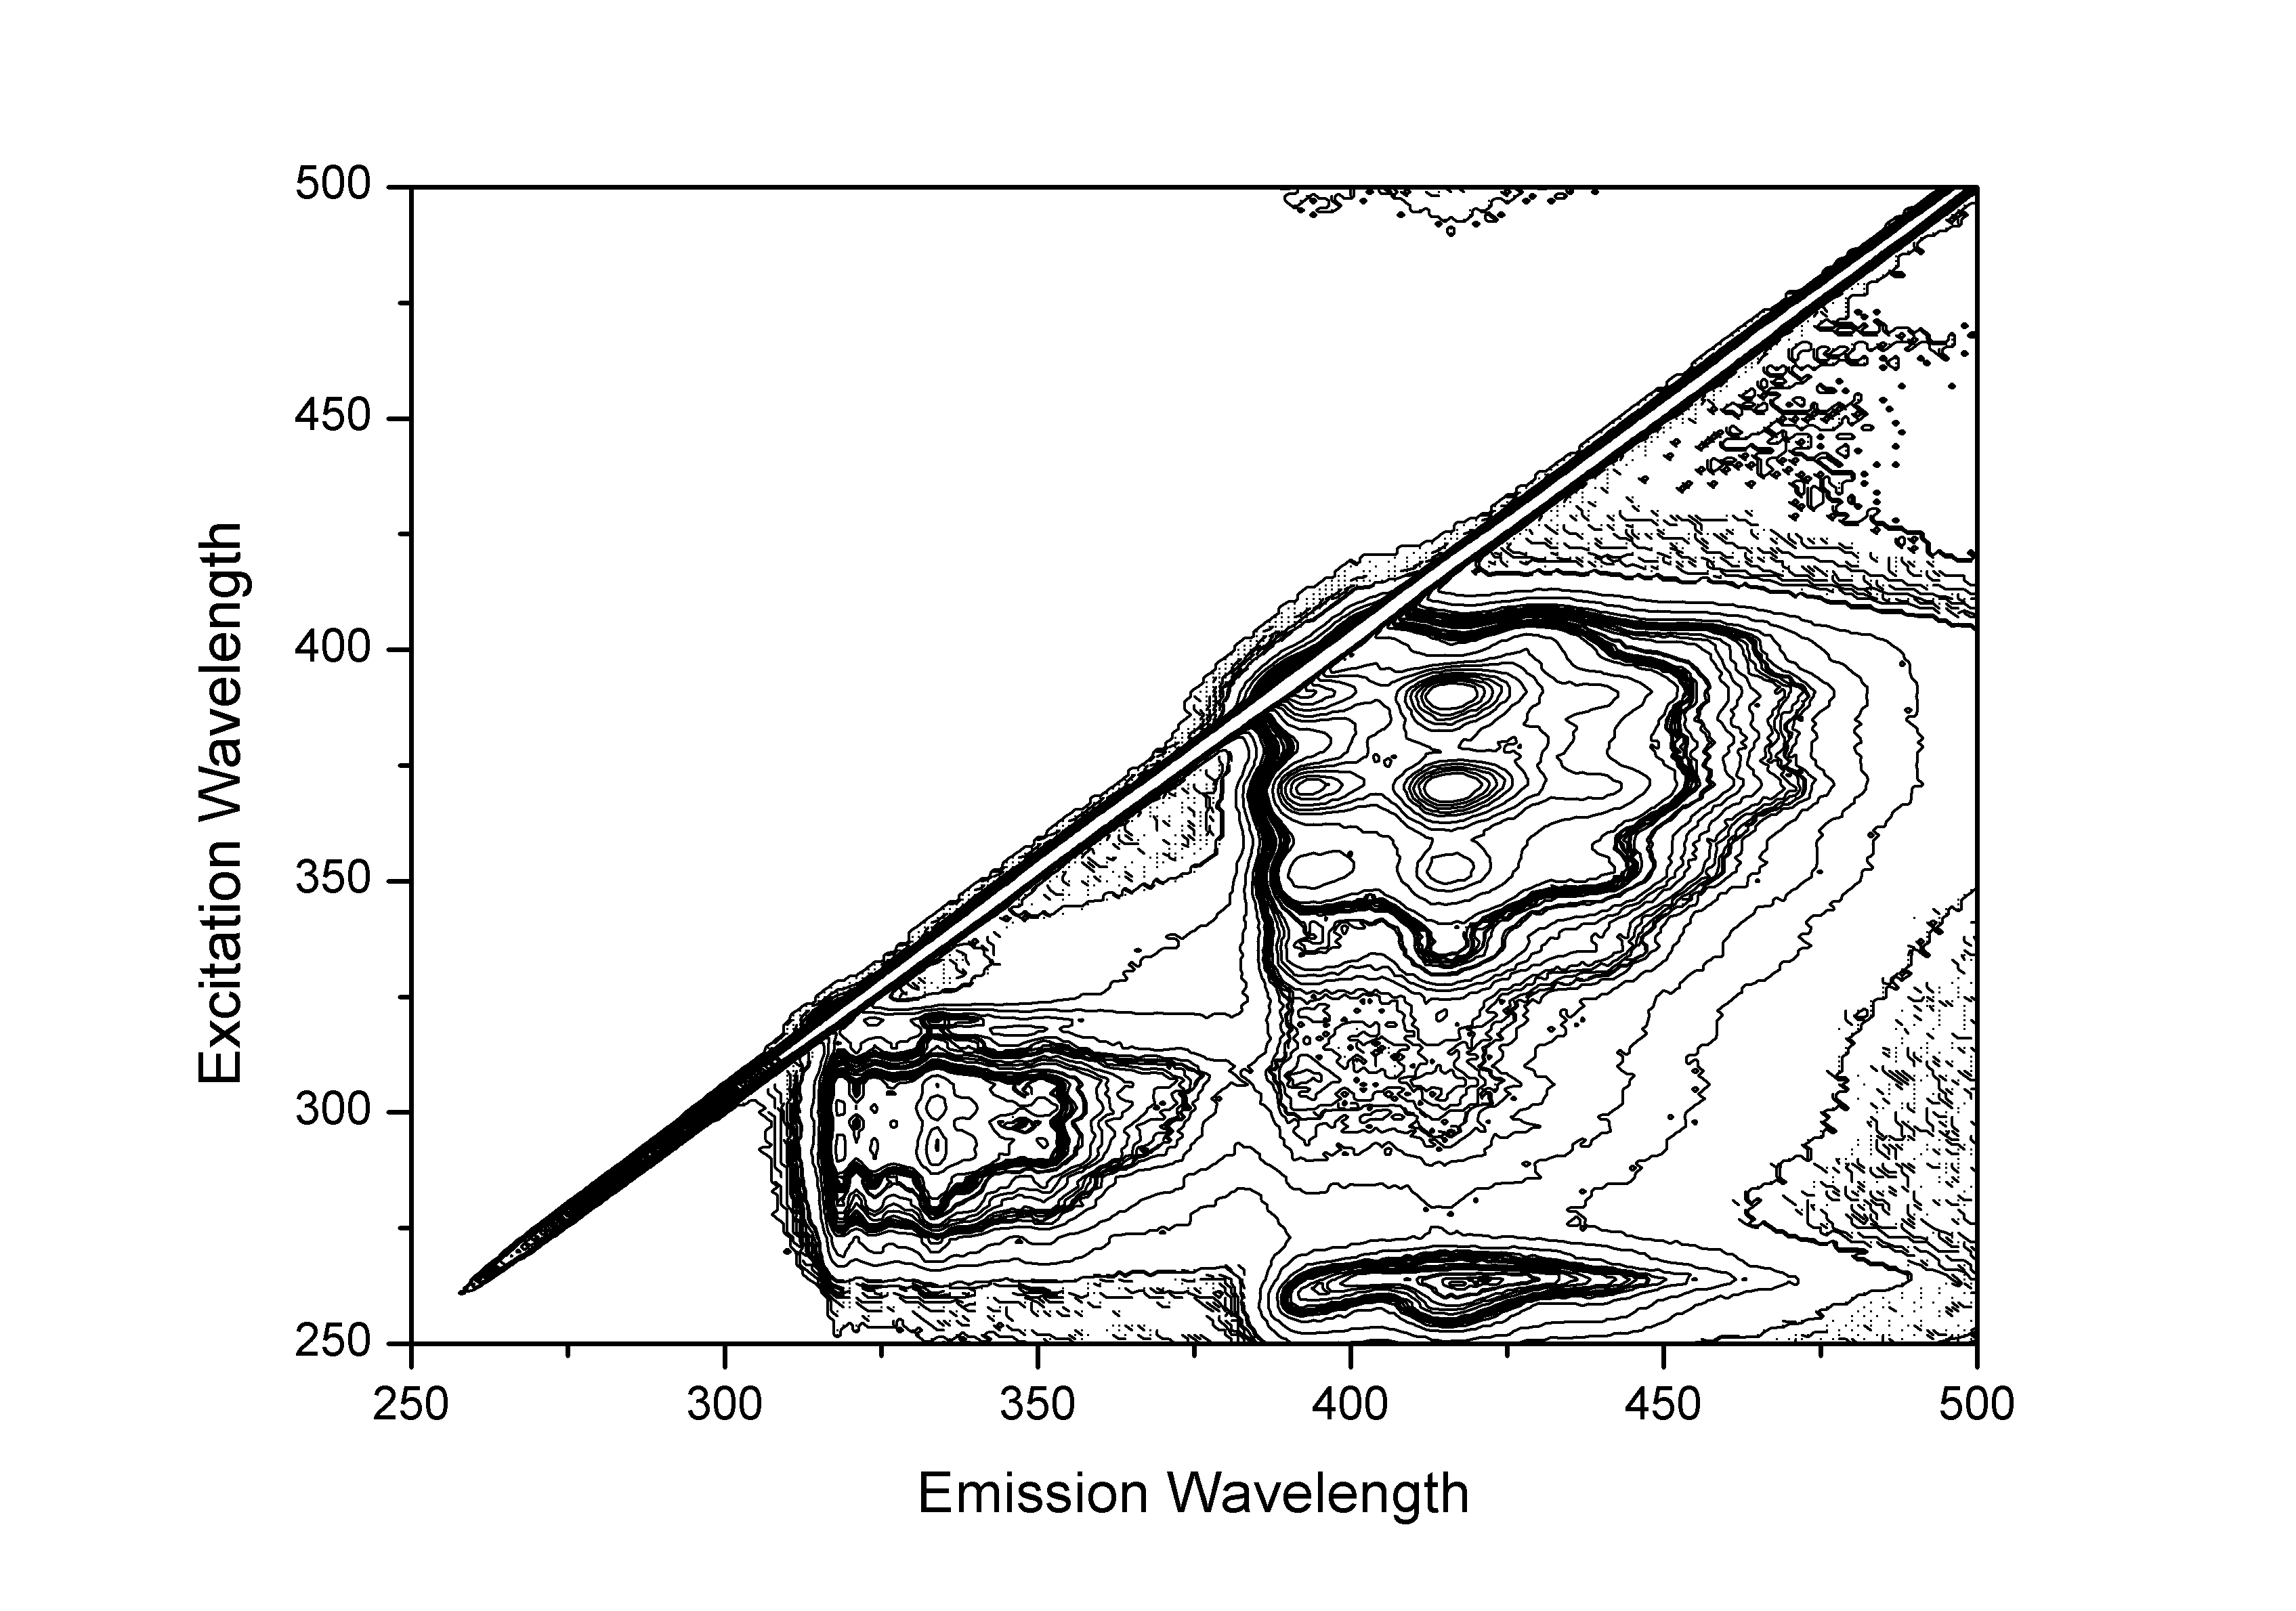

Figure 86 – A 3D excitation/emission spectrum of PAA-ACE-AMMA (1.3 mg ml-1)  
with contours every half integer from 2E3 to 4E5 at pH 3.44.  
The red circle indicates peaks caused by indirect AMMA emission due to NRET.

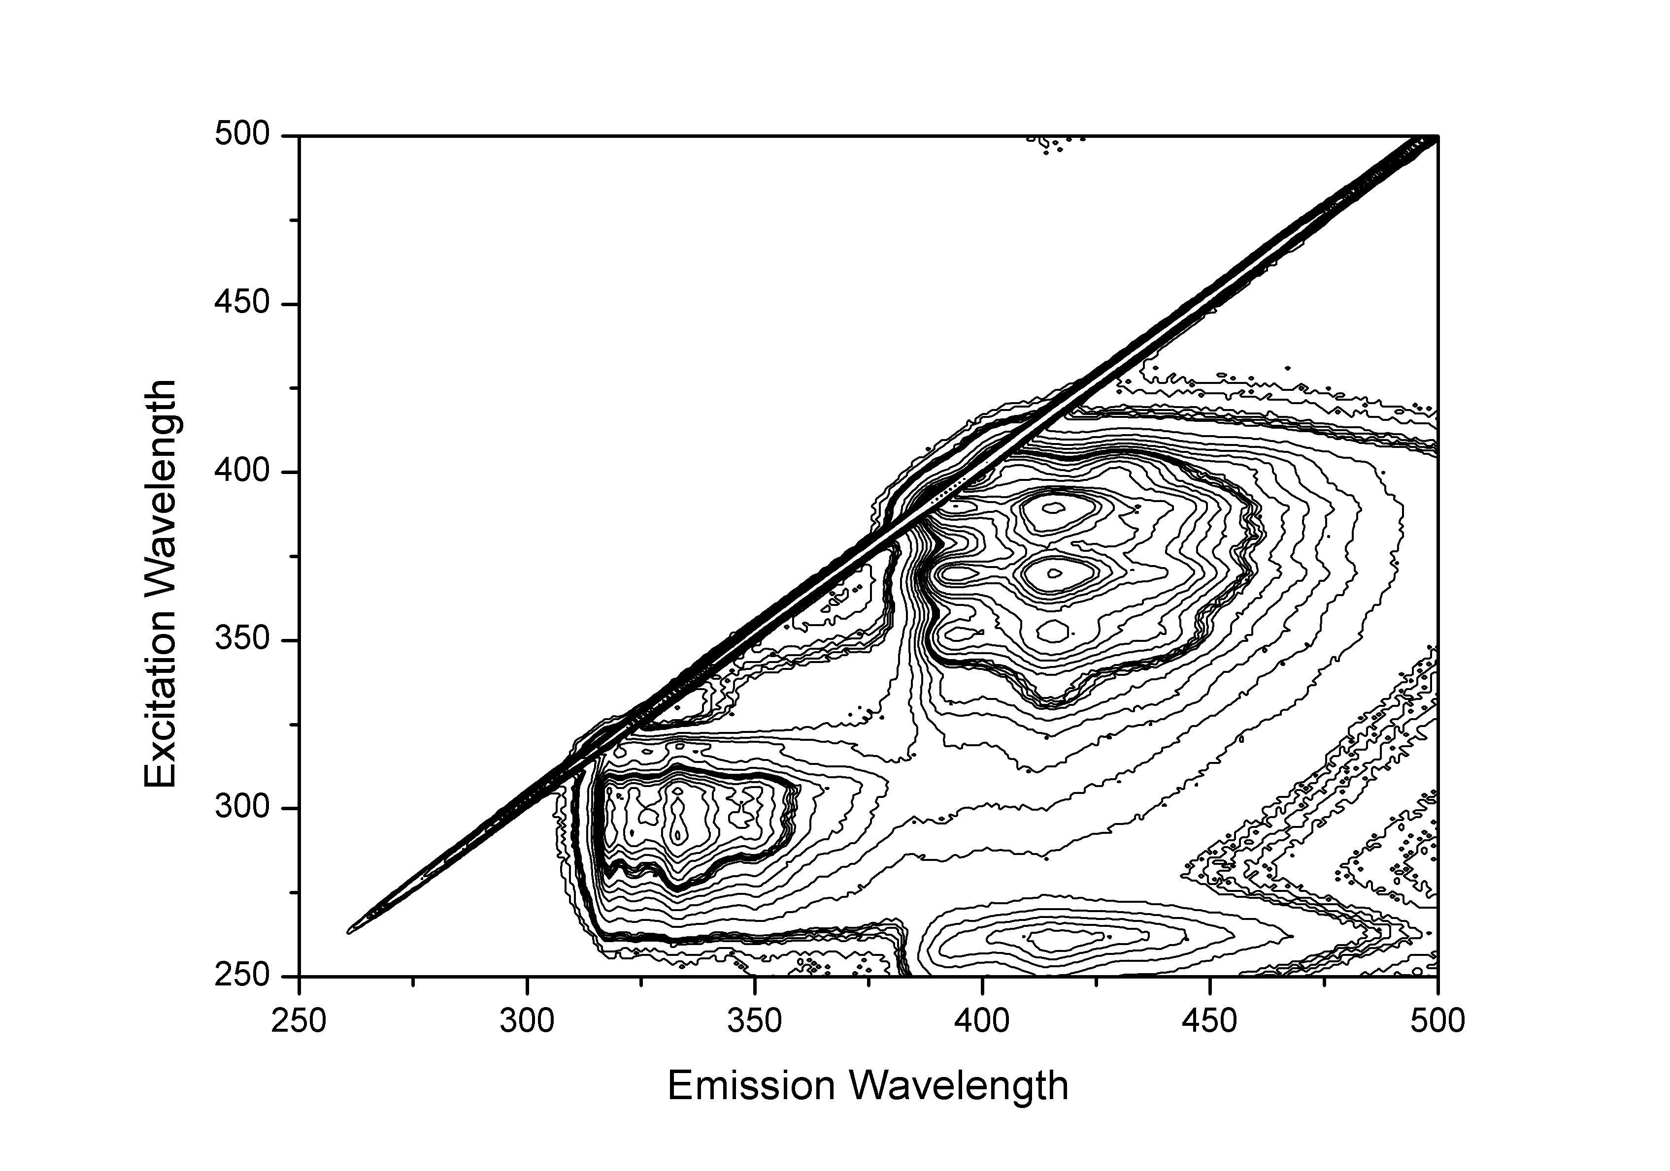

Figure 87 – A 3D excitation/emission spectru, of PAA-ACE-AMMA (1.3 mg ml-1)  
with contours every half integer from 3E3 to 1E6 at pH 7.80.  
The red circle denotes the absence of indirect AMMA emission at high pH.

## Time Correlated Simple Photon Counting

### Fluorescence Lifetime Studies

When the ACE fluorescent labels is covalently attached to a polymer backbone the macromolecular volume of the polymer provides some level of shielding from the polar solvent, extending the fluorescence lifetime. Whereas in solution (dioxane) the ACE fluorophore gave an excited state lifetime of approximately 11 nanoseconds (Figure 67) when dissolved in water an ACE-labelled PAA polymer gives a fluorescence excited state lifetime in excess of 20 nanoseconds (Figure 88).

Figure 88 – Raw excited state lifetime data of a PAA-ACE sample

The observed fluorescent decay can then be modelled statistically to determine the samples fluorescence lifetime using one, two or more exponentials to indicate the number of individual components in the sample (Figure 89). The accuracy of these fits can be conveyed using the residual decays (Figure 90). A double exponential equation will often give a smaller standard deviation than the same comparison using only a single exponential however fitting multiple exponentials to the data is justified when the system is inhomogeneous, with each exponential representing a separate environment within which the ACE probe may be located.

Figure 89 – Fluorescence decay on logarithmic scale with single and  
double fits applied using a PAA-ACE sample

Figure 90 – Residuals from the single and double fit to a fluorescence lifetime decay

#### Fluorescence Lifetime of Poly(acrylic acid) Dependent to pH

The lifetime of fluorescence decay of poly(acrylic acid) is dependent on the pH of the solution. This change is brought about by the expansion of the coiled polymer chain leading to increased exposure and quenching by the aqueous solvent, resulting in faster excited state decays at higher pH (Figure 91). The calculated lifetimes of these decays at room temperature show it falling from approx. 32 nanoseconds to 20 nanoseconds above pH 4 (Table 17, Figure 92).

Figure 91 – Lifetime of fluorescence decay of ACE-PAA  
at pH 2 and pH 6, sample at 25oC and 0.42 mg ml-1

Table 17 – Example data of calculated lifetimes from Figure 92

|  |  |  |  |  |  |
| --- | --- | --- | --- | --- | --- |
| pH | T / ns | Error / ns | B | A | *χ*² |
| 1.92 | 30.21 | 0.20 | 0.67 | 18.37 | 2.92 |
| 6.17 | 21.68 | 0.09 | 3.68 | 12.42 | 4.11 |

Figure 92 – Fluorescence lifetime of PAA-ACE samples, 0.4 mg ml-1 at room temperature  
error bars at 95% confidence intervals

#### Fluorescence Lifetime of Poly(acrylamide) with Respect to pH and Temperature

The conformational behaviour of PAA is well known and studied within the literature[25], however much less information is known about the behaviour of labelled PAM samples as it has not previously been expressly examined. Poly(acrylamide) is not a smart polymer and does not undergo a conformational change with pH or temperature. For this reason linear poly(acrylamide) solution behaviour has not previously been examined via fluorescent labelling in respect to either pH or temperature.

The results have shown that the lifetime of ACE covalently bound to a polyacrylamide chain increases only slightly with an increase in pH (Figure 93), yet decreases with increasing temperature (Figure 94).

Figure 93 – Fluorescence lifetime of labelled poly(acrylamide) with pH change at several temperatures

Figure 94 - Fluorescence lifetime of labelled poly(acrylamide) with changing temperature at several pHs

The decrease in poly(acrylamide) lifetime with temperature is expected, as with more energy in the system fluorescent quenching from water molecules will increase. An Arrhenius plot of the lifetime data shows the change in deactivation of the label from water with respect to temperature is linear (Figure 95). This is evidence that no conformational change is occurring for the polyacrylamide. From the gradient and intercept of this data one can calculate the Activation Energies of these transitions to be 3.85 kJ mol-1.

Figure 95 - Arrhenius Plot of Fluorescence data for ACE on Polyacrylamide at pH 9

### Anisotropy Measurements of fluorescent polymers

The binding of a fluorophore to a polymer backbone restricts rotation of the fluorophore through space and so causes a dramatic increase in correlation time, as is apparent by comparing the raw crossed and parallel decays from the free label in solution (Dioxane: Figure 69) with the raw decays of a fluorophore bound to PAA (Figure 96). This is apparent from the increased amount of scattered light occurring with the light pulse although the two decays do not converge for several hundred nanoseconds. The scattered light may appear to distort the data but when viewed from a logarithmic perspective the scattered light only affects a few nanoseconds on the histogram which otherwise shows a straight line (Figure 97).

Figure 96 – Raw data output of a correlation time measurement recording crossed and  
parallel polarised spectra of a 0.21 mg ml-1 PAA-ACE sample at pH 1.70

Figure 97 – Logarithmic view of crossed and parallel output  
for 0.21 mg ml-1 PAA-ACE sample at pH 1.70

The presence of the macromolecular polymer chain, and the resultant restriction it causes to the attached fluorophore’s freedom of movement, can appear to give a small residual background anisotropy (Figure 98). In response to this, any mathematical model (using **Error! Reference source not found.**) must include a decision as to whether it is appropriate or not to fix the A value to zero. Free in solution (Dioxane) ACE was shown to have a correlation time of 0.17ns, with an A value of 0.004 (Figure 71). With increasing A values it becomes less clear whether these higher values are an intrinsic value of the system or arise from instrumental error.

Figure 98 – Anisotropy of ACE-PAA sample at pH 1.70, and two opposing experimental fits to the data

Figure 99 - Residuals from fits to fluorescence anisotropy decay with A free and set to zero

#### Anisotropy of labelled fluorescent polymers with pH

As the correlation time of a fluorophore covalently bound onto a polymeric chain will reflect the conformational state of the polymer, the anisotropic decay functions of PAA-ACE will alter as a consequence of pH (Figure 100). Poly(acrylamide) however undergoes no such conformational change and is as such entirely unresponsive to pH (Figure 101). Select anisotropic correlation times of ACE labelled PAA and PAM polymers are shown below in Table 18.

Table 18 – Correlation time of PAA-ACE (TS1/37/1) and PAM-ACE (TS1/27/1) varying with temp and pH at 0.35 mg ml-1

|  |  |  |  |  |  |  |  |
| --- | --- | --- | --- | --- | --- | --- | --- |
| Polymer | pH | Temp / oC | τc / ns | SD / ns | B | A | *χ*² |
| PAA-ACE | 1.65 | 25 | 5.58 | 0.14 | 0.04 | 0.02 | 0.17 |
| PAA-ACE | 9.64 | 25 | 1.74 | 0.21 | 0.19 | 0.03 | 0.20 |
| PAM-ACE | 1.60 | 25 | 1.62 | 0.06 | 0.15 | 0.00 | 1.13 |
| PAM-ACE | 9.33 | 25 | 1.55 | 0.09 | 0.20 | 0.03 | 0.97 |

Figure 100 – Raw anisotropy and single fits from PAA-ACE at high and low pH

Figure 101 - Raw anisotropy and single fits from PAM-ACE at high and low pH

Labelled solutions of both PAA and PAM were analysed at a series of pH and this clearly demonstrates the decreasing speed of rotation of poly(acrylic acid) polymer coils below pH 4 whilst the poly(acrylamide) remains nonresponsive with respect to pH (Figure 102).

Figure 102 – Correlation times of ACE labelled PAA and PAM recorded at 25oC

#### Anisotropy of labelled fluorescent polymers with temperature

Anisotropy measurements are very sensitive to temperature, with the increased energy and motion of higher temperatures rapidly diminishing the residual. This is evident from both PAA-ACE (Figure 103) and PAM-ACE (Figure 104) data.

Figure 103 - Raw anisotropy and single fits from PAA-ACE  
at high and low temperatures

Figure 104 - Raw anisotropy and single fits from PAM-ACE  
at high and low temperatures

Selected anisotropic correlation times of ACE labelled PAA and PAM polymers are shown below in Table 19.

Table 19 – Correlation time of PAA-ACE (TS1/37/1) and PAM-ACE (TS1/27/1) varying with temp and pH at 0.35 mg ml-1

|  |  |  |  |  |  |  |  |
| --- | --- | --- | --- | --- | --- | --- | --- |
| Polymer | pH | Temp / oC | τc / ns | SD / ns | B | A | *χ*² |
| PAA-ACE | 4.30 | 10 | 4.16 | 0.19 | 0.13 | 0.02 | 1.63 |
| PAA-ACE | 4.37 | 55 | 1.09 | 0.07 | 0.02 | 0.02 | 0.93 |
| PAM-ACE | 3.55 | 10 | 3.55 | 0.14 | 0.12 | 0.01 | 1.21 |
| PAM-ACE | 3.15 | 55 | 0.88 | 0.05 | 0.09 | 0.01 | 0.97 |

Labelled PAA and PAM were analysed at a range of temperatures and the decrease in correlation time relative to temperature is shown in Figure 105. This response comes from the increased volatility of temperatures at high temperatures rather than any conformational macromolecular shift.

Figure 105 – Correlation times of ACE labelled low pH PAA and PAM at various temperatures

## Conclusion

The presence of small amounts of fluorescence probes on poly(acrylic acid) and poly(acrylamide) are easily detectible by their absorbance and emission/excitation spectra. Through time resolved photon counting the nature of these polymers can be revealed as both lifetime and anisotropy confirm the conformational change of PAA with respect to pH. Poly(acrylamide) however is a nonresponsive polymer which shows no smart behaviour with respect to temperature or pH.

# The Molecular Weight Dependency of Labelled Poly(acrylic acid) formed via Controlled RAFT Polymerisation

Use of controlled polymerisation to control the molecular weight of poly(acrylic acid) allows for experimental studies to be made observing the effect molecular weight has on the conformational response of the polymer. Chain length dependence of LCST is known in other systems [157], although these generally reflect the greater solubility of smaller polymers.

## UV absorbance of Linear RAFT Polymers

All three chain transfer agents used to produce controlled poly(acrylic acid) polymers absorb in the 250-350 nm region and therefore mask the presence of the ACE label (Figure 106). As such it is not possible to determine the loading of labels using UV absorbance.

Figure 106 – Absorbance of linear RAFT polymers

## Fluorescence Steady State Spectra

Polymers created using CTA **(1)** were examined to see what impact the presence of chain transfer agent would have on fluorescence intensity. The absorbance of the CTA in the 300-400 nm region suggests it could potentially quench the ACE label and inhibit fluorescence analysis.

However comparison of varying amounts of CTA **(1)** show that the presence of the RAFT end groups only affects the fine structure of the polymers (Figure 107, Figure 108). Additionally it has been shown that CTA **(1)** is not fluorescent in this region.

Figure 107 – Excitation spectra for emission of PAA-ACE polymers emission at 340 nm

Figure 108 - Emission spectra for emission of PAA-ACE polymers emission at 295 nm

Variations in the fine structure can be explained by the variation of molecular weight which is a consequence of CTA concentration. The ACE fluorescent label is sensitive to polar solvents (such as water) and the alterations to the vibrational structure reflect an increasing hydrophilic environment that a lower molecular weight polymer exposes the label to.

Controlled polymers created using CTA **(2)** were also analysed using this technique and it was found that like those using CTA **(1)** polymers created in the absence of ACE showed no fluorescence in this region whilst ACE demonstrated a traditional 290 – 340 nm excitation / emission (Figure 109).

Figure 109 – Excitation and emission of controlled PAA polymers using CTA (2)

No polymers were created using CTA **(3)** that did not include the fluorophore ACE however steady state analysis showed the excitation / emission of the ACE fluorophore is uninterrupted by the presence of CTA (Figure 110).

Figure 110 - Excitation and emission of controlled PAA polymers using CTA (3)

## Fluorescence Lifetime of RAFT Polymers

Low molar mass polymers (< 16.9 kDa) do not show the increase in lifetime at low pH, so that the lifetime of the fluorescent label remained in the 20 to 25 ns region (Figure 111). Conversely larger molar mass polymers acted more typically of PAA with the fluorescence lifetime rising sharply below pH 5 indicating a conformational change is occurring.

Figure 111 – Complete lifetime data as a function of pH. Closed symbols are for molar masses of PAA where Mn > 16:5 kDa, and thus exhibit a pH-dependent coil-to-globule transition. Open symbols represent polymers that do not exhibit a pH dependent 𝜏.

The data shown in Figure 111 is calculated using a double exponential fit (as outlined in Equation 8) in order to ensure accurate fitting to the data. A direct comparison between the fluorescence decays of polymers with Mn 6.6 and 55.9 kDa reveal that the low pH low molecular weight polymer does not show a straight logarithmic decay (Figure 112), hindering the accuracy of single exponential fits (Table 20, Figure 113). In conclusion a plot using single exponentials shows the same results but with increased errors and dramatically larger ChiSq values.

Figure 112 – Raw fluorescent lifetime of P(AA-co-ACE) at pH 3 and 9

Table 20 – Comparison of single and double exponential fits of RAFT-PAA-ACE polymers

|  |  |  |  |  |  |
| --- | --- | --- | --- | --- | --- |
| Single Exponential Fit: | | |  |  |  |
|  |  | T / ns | | SD / ns | *χ*² |
| 6.6 kDa, pH 3 | | 23.42 | | 0.31 | 23.42 |
| 6.6 kDa, pH 9 | | 23.88 | | 0.10 | 23.88 |
| 63.2 kDa, pH 3 | | 34.44 | | 0.15 | 34.44 |
| 63.2 kDa, pH 9 | | 25.25 | | 0.11 | 25.25 |
|  |  |  |  |  |  |
| Double Exponential Fit: | | |  |  |  |
|  |  | T / ns | | SD / ns | *χ*² |
| 6.6 kDa, pH 3 | | 23.42 | | 0.00 | 9.26 |
| 6.6 kDa, pH 9 | | 23.64 | | 0.00 | 12.71 |
| 63.2 kDa, pH 3 | | 35.34 | | 0.01 | 1.99 |
| 63.2 kDa, pH 9 | | 25.48 | | 0.01 | 2.47 |

a)b)

c) d)

Figure 113 – Single (black line) and double (dashed line) exponential fits of fluorescence decay data from Figure 112. Data includes 6.6 kDa sample at low pH (a), at high pH (b), and the 63.2 kDa sample at low pH (c) and high pH (d). Double exponential fits provide almost perfect match to data whilst

That the low pH 6.6 kDa PAA-ACE fluorescence decay not entirely linear suggests there may be some interaction between the fluorophore and the CTA or that the measurement is being interfered with by scattered light, however this can still be modelled using the double exponential fit.

Certainly however the low Mn polymer does not exhibit the marked increase in fluorescent lifetime exhibited by the larger polymer at low pH and the transition between stimuli responsive and non-responsive samples occurs over a remarkably small range of molar masses (between 16.3 and 16.9 kDa) which is even more remarkable considering the dispersities of these samples. If this transition was due to quenching of the fluorescence label by the RAFT agents, it would be expected to occur over a much broader region.

## Fluorescence Anisotropy of RAFT Polymers

Analysis of polymers using TRAMS show that polymers created with a greater ratio of CTA showed a severely diminished correlation time whilst the high pH samples remained unaffected (Figure 114).

Figure 114 – Correlation time of controlled PAA-ACE polymers  
with varying presence of CTA **(1)**

The difference between low pH and high pH with low CTA loading reflects the conformational change of the poly(acrylic acid). This is identifiable both in the raw data (Figure 115) and from the single fits which were used to produce Figure 114 (a)b)

c)d)

Figure **116**).

Figure 115 – Raw anisotropy of P(AA-co-ACE) at low and high pH

a)b)

c)d)

Figure 116 – Single fit of anisotropy of P(AA-co-ACE) at low and high pH

As MCTA/M100AA accurately reflects the molecular weight of the resultant polymer it appears that lower molecular weight polymers do not undergo a conformational change with pH. Most interestingly this does not seem to be a gradual reduction in coiling but a switch between a coiled / uncoiled system occurring at 0.5 – 0.5 MCTA / MAA loading, which correlates to a molecular weight of 17 kDa.

Further investigations were made using impulse reconvolution of polarised light sources. By fitting the time dependent difference *D(t)* with Equation 16, a more accurate correlation time can be produced which discounts interference from the pulse laser and any resultant scattered light. Impulse reconvolution results were in agreement with fluorescence lifetime data, showing that polymers with a molecular weight below 16.9 kDa underwent no conformational change with pH, unlike higher molecular weight samples (Figure 117, Table 21).

Figure 117 – Impulse reconvolution correlation times of P(AA-co-ACE)

Table 21 – Comparison of time resolved anisotropy decay by direct analysis of anisotropy function and impulse reconvolution of difference function

|  |  |  |  |  |  |
| --- | --- | --- | --- | --- | --- |
| Direct Analysis | | | | | |
|  | Tc / ns | SD / ns | A | B | *χ*² |
| 6.6 kDa, pH 3 | 1.50 | 0.07 | 0.002 | 0.24 | 1.19 |
| 6.6 kDa, pH 9 | 1.52 | 0.05 | 0.001 | 0.22 | 1.22 |
| 63.2 kDa, pH 3 | 1.46 | 0.08 | 0.002 | 0.09 | 0.84 |
| 63.2 kDa, pH 9 | 3.52 | 0.26 | 0.004 | 0.06 | 1.00 |
|  |  |  |  |  |  |
| Impulse Reconvolution | | | | | |
|  | Tc / ns | SD / ns | Ro | Ri | *χ*² |
| 6.6 kDa, pH 3 | 1.30 | 0.09 | 0.128 | 0.00 | 1.25 |
| 6.6 kDa, pH 9 | 1.58 | 0.10 | 0.860 | 0.00 | 1.25 |
| 63.2 kDa, pH 3 | 1.69 | 0.35 | 0.082 | 0.01 | 1.10 |
| 63.2 kDa, pH 9 | 3.74 | 0.42 | 0.448 | 0.02 | 1.01 |
|  |  |  |  |  |  |

Impulse reconvolution provides a reasonable fit to raw data of both extreme large and small polymers, however the calculated correlation time of the polymer with an Mn 17.7 kDa does not rise as significantly as the larger polymers, suggesting there is partial freedom of movement for the label in an uncompressed form.

## Molecular Weight Distribution Analysis

The sharp distinction between polymers 16.3 and 16.9 kDa (dispersity 1.7 and 1.2) that is made by fluorescence lifetime and anisotropy, with one sample demonstrating conformational response and the other not, is particularly interesting due to the inevitable overlap of molecular weight distributions between these two samples. A test method was devised to study the raw GPC data output used in the analysis of these samples to show these data sets can be separated significantly, as revealed using the P value of the Mann-Witney and Kolmogrov-Smirnov tests.

The dw/dlogM data was normalised and then multiplied by M, the sum of this function would then give Mw. This data was then analysed using nonparametric tests such as the Mann-Witney test (which compares ranks) and the Kolmogorov-Smirnov test (which compares cumulative distributions). The P values of these analyses are shown in Table 22.

Table 22 – P values comparing three repeat sets of data for GPC data analysed using the Kolmogrov-Smirnov test. P values <0.005 are considered significant and labelled green whilst P values >0.005 are considered to have no significant difference.

|  |  |  |  |  |  |  |  |
| --- | --- | --- | --- | --- | --- | --- | --- |
|  |  | **16.3 kDa** | | | **16.9 kDa** | | |
|  |  | Repeat A | Repeat B | Repeat C | Repeat A | Repeat B | Repeat C |
| **16.3 kDa** | Repeat A | **-** |  |  |  |  |  |
| Repeat B | **0.7120** | **-** |  |  |  |  |
| Repeat C | **0.4691** | **0.9873** | **-** |  |  |  |
| **16.9 kDa** | Repeat A | **<0.001** | **<0.001** | **<0.0001** | **-** |  |  |
| Repeat B | **<0.001** | **<0.001** | **<0.0001** | **0.9638** | **-** |  |
| Repeat C | **<0.001** | **<0.001** | **0.0002** | **0.1508** | **0.1591** | **-** |

This suggests that despite the high degree of overlap between the populations of the two samples there is a recognisable, significant difference in the populations of polymer molecular weights.

## Conclusions

A series of controlled PAAs were synthesised with varying molecular weights, both with/without a fluorescent label (ACE) and it was demonstrated that PAA with low molar masses (< 17 kDa) polymers did not show any swelling behaviour (which is typical of higher molar mass PAA) as pH was increased. Both fluorescence lifetime (Figure 111), direct analysis of time resolved anisotropy (Figure 114) and impulse reconvolution (Figure 117) are in good agreement that low molecular weight polymers do not undergo a conformational change with pH. Whilst fluorescence lifetime data could be affected by quenching from the chain transfer agent this phenomenon would not affect the correlation time which is independent of fluorescence intensity.

Both lifetime and anisotropy data suggest the change in behaviour appears to occur at approximately 16 - 17 kDa, and this dramatic change suggests that the results were not derived from quenching of the fluorescent ACE group by the dithioate end groups: it is expected that quenching due to increased concentration of the end groups would produce a gradual change in behaviour. Thus, these experiments show a direct effect of molar mass on the pH responsive behaviour of PAA.

Current experimental data however is dependent on the presence of chain transfer agents at polymer chain ends and requires that any quenching interaction between CTA and fluorophore is insufficient to reduce both lifetime and correlation time of low molecular weight polymers. It can be asserted that the hydrophobic CTA would in fact encourage globule formation, rather than hinder it, however there is no experimental data to prove this. These concerns could be addressed in future by the removal of RAFT group from polymer chain ends or the use of a non-fluorescent method of detection to prove the effect is unrelated to quenching.

# Detection of Inter-Polymer Complexation via Fluorescence Methods

Mixtures of PAA and PAM at low pH are known to turn cloudy, a sign that IPC formation has occurred. Even dilute mixtures of singly labelled PAA and PAM have been observed switching instantly from clear to cloudy as the pH is raised and lowered (Figure 118).

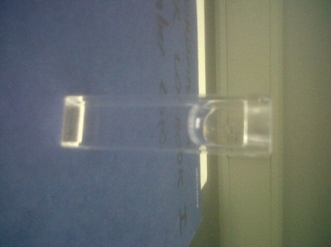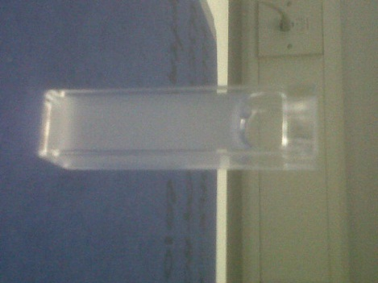

Figure 118 – Mixtures of PAA and PAM (0.2 mg ml-1 each) at pH 2 and 7

By labelling one or both of the constituent polymers it should be possible to observe this interaction using the fluorescent techniques outlined in section 1.3.

## Complexation via Steady State

### Singly Labelled Polymers

IPC formation appears to have no effect on λem or λex, although it does cause an increase in fluorescence intensity and increased light scattering at wavelengths near the incidental light beam (Figure 119, Figure 120). With a fixed concentration of PAA-ACE (0.27 mg ml-1) very low concentrations of poly(acrylamide) do not appear to show any increase in fluorescence intensity which rises quickly and then appears to level and diminish at very high concentrations.

Figure 119 – Excitation spectra for PAA-ACE emission at 340 nm (0.27 mg ml-1)  
with varying PAM concentration

Figure 120 – Emission spectra of PAA-ACE excited at 295 nm (0.27 mg ml-1)  
with varying PAM concentration

### Complexation between two singly labelled polymers

The complexation between two polymer chains, one containing a donor and the other an acceptor luminescent label, should bring these labels together close enough in space for NRET to occur. The absorption of light at 295 nm for ACE and emission at higher wavelengths from AMMA should be visible via steady state spectroscopy.

Dilute solutions of PAA-ACE and PAM-AMMA were prepared and examined, with the PAM in both equivalent and excess quantities to the PAA polymer (Figure 121). At low pH the emission spectra when exciting at 295 nm shows increased emissions at higher wavelength (375 – 425 nm) whilst for 370 nm emission (direct AMMA excitation) the emission profile remains relatively unchanged. Unlike the interaction between ACE and AMMA bound across a single polymer chain, the rising AMMA emission peaks are not clearly distinguishable. This experiment was repeated in reverse, with the ACE on the PAM and AMMA on the PAA, and similar trends were observed (Figure 122).

Figure 121 – Emission spectra of a mixture between two singly labelled polymers and a comparison with PAA-ACE (1 mg ml-1)

Figure 122 - Emission / Excitation spectra of a mixture between two singly labelled polymers and a comparison with PAM-ACE (1 mg ml-1)

This indicates that when interpolymer complexation occurs it is capable of bringing a donor and acceptor label close enough together in space for NRET to occur across two polymer chains (Figure 123), however the fine spectra is obscured by scattered light caused by the agglomeration of such large particles.

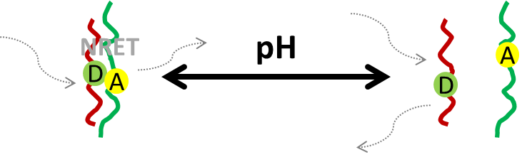

Figure 123 – pH dependent complexation between polymers could lead  
to energy transfer between labels across polymer chains

### Complexation of doubly labelled polymers

When both donor and acceptor labels are bound across a single poly(acrylic acid) it may be possible to observe IPC formation more directly than with singly labelled systems. As a low pH is required for complex formation there is already substantial NRET occurring with both ACE and AMMA emission peaks visible when the sample is excited at 295 nm. Theoretically as the polymer switches from a coil to a ladder type structure we expect the proximity of these labels to change, with a resultant effect on the NRET observed.

A solution of 0.23 mg ml-1 PAA was made and mixed with various amounts of unlabelled PAM. The solution turned cloudy, signifying IPC formation, and the intensity of both ACE and AMMA peaks increase due to increased light scattering in aggregated molecules (Figure 124). Comparatively, using Equation 20, the energy transfer calculated from the peak heights shows the energy transfer rising until a 1 : 1 ratio of PAA and PAM is reached and then remaining fixed (Figure 125).

Figure 124 – Emission spectra of doubly labelled PAA polymer (0.23 mg ml-1)  
with varying concentrations of unlabelled PAM

Figure 125 – Energy transfer occurring between PAA-ACE-AMMA and PAM

In another series the concentration of PAA-ACE was decreased as the concentration of PAM rose in solution. As the concentration of ACE varies between measurements comparisons are made between relative intensities, with the acceptor peak fixed at 100%,, this approach shows that the intensity of the acceptor peak rises with increasing PAM concentration (Figure 126). Here an equivalent amount of PAA and PAM is reached at 50% PAM but the ET continues to rise until the solution is 87% PAM (Figure 127). 100% PAM could not be reached as the PAA polymer is necessary for fluorescence to occur.

Figure 126 – Relative emission spectra from PAA-ACE-AMMA excitation at 295nm  
with and without presence of PAM

Figure 127 – Energy transfer from PAA-ACE-AMMA + PAM

To ensure the effect was solely due to IPC formation the pH, a sample was raised from pH 2 to 9 and the AMMA acceptor peaks disappeared almost entirely as a result (Figure 128). This result demonstrates that this is an entirely reversible effect caused by IPC formation between the two polymers.

Figure 128 - Relative emission spectra from PAA-ACE-AMMA and 72 % at varying pH

## Complexation via Lifetime Studies

Excited state lifetimes of labelled polymers showed a clear response to the presence of the complexing polymers. ACE-labelled poly(acrylic acid) solutions were prepared and mixed with poly(acrylamide) at a range of pHs. The fluorescence decay of poly(acrylic acid) in the presence of poly(acrylamide) shows a noticeable hump following the excitation light source caused by scattered light (Figure 129), whilst no light scattering occurs in the same samples at high pH (Figure 130).

Figure 129 – Fluorescent decay of PAA-ACE (0.5 mg ml-1) alone  
with PAM and with PAM-AMMA (0.6 mg ml-1) in solution

Figure 130 - Fluorescent decay of uncomplexed PAA-ACE (0.5 mg ml-1) alone  
with PAM and with PAM-AMMA (0.6 mg ml-1) in solution

Once the scattered light from the pulse has been discounted the fluorescence decay from the complexed PAA-ACE : PAM sample shows a similar excited state fluorescence lifetime to PAA-ACE, whilst the PAA-ACE : PAM-AMMA sample shows a slightly shorter effect. The scattering of light can be reduced by decreasing the concentration of samples (Figure 131) although this has little effect on the eventual fluorescence lifetime.

Figure 131 – Low pH Fluorescent decay of PAA-ACE (0.3 mg ml-1) alone  
with PAM and with PAM-AMMA (0.3 mg ml-1) in solution

A tail fit (discounting the data surrounding sample excitation) of these results which discounts the scattered light prompt shows that IPC complex formation causes no decrease to the fluorescence lifetime (Figure 132). There is a small decrease observed in the PAA-ACE : PAM-ACE system, complementing the previous results which suggested interpolymer NRET may be occurring.

Figure 132 – Fluorescence lifetime tail fit of PAA-ACE (0.5 mg ml-1) samples alone  
and with PAM and PAM-AMMA (0.6 mg ml-1) in solution

A fit which includes the scattered light is able to distinguish between the complexed and uncomplexed polymer using this technique, particularly at high concentrations (Figure 133), however this is not an entirely accurate test and will not work at low concentrations.

Figure 133 - Fluorescence lifetime of PAA-ACE (0.5 mg ml-1) samples alone  
and with PAM and PAM-AMMA (0.6 mg ml-1) in solution

## Complexation via Anisotropy measurements

Evidence of complex formation is even more apparent using anisotropy methods. With PAA-ACE the difference in the anisotropy signal is apparent when poly(acrylamide) is added to the solution at low pH (Figure 134). The formation of IPCs is clearly restricting the polymer’s segmental mobility, and it is a relationship that goes both ways, as when polyacrylamide is labelled with ACE a similar extension in anisotropy can be observed (Figure 135).

Figure 134 – Anisotropy profiles of PAA-ACE (0.32 mg ml-1) alone  
and withPAM (0.24 mg ml-1) at pH 3 and 9

Figure 135 – Anisotropy fit of PAM-ACE (0.13 mg ml-1) alone  
and with PAA (0.13 mg ml-1) solution at pH 3.31

This long component makes analysing the correlation time of the sample more difficult than that has been previously observed using simple single exponential fits. As the anisotropy decay is modelled using Equation 16 the term A, which sets the anisotropic baseline, is artificially raised and as a consequence very small correlation times are calculated.

However, if A is fixed to zero the difference between these two samples can be clearly observed (Figure 136), a distinction not made possible if standard single fits with A left variable are applied. At low pH, as the polymers complexes, the correlation time of the ACE sample dramatically increases. As a consequence of fixing A the calculated correlation times of uncomplexed PAA-ACE has the potential to deviate from pH responsive values of 2-5 ns, as the accuracy of the fit decreases depending on the background anisotropy of the measurement, however this effect is small (Table 23).

Figure 136 – Correlation times of polymer mixtures at a range of pH,  
calculated by fixing A to zero

Table 23 – Example data from Figure 136

|  |  |  |  |  |  |  |
| --- | --- | --- | --- | --- | --- | --- |
| Sample | pH | τc / ns | SD / ns | A | B | ChiSq |
| PAA-ACE | 2 | 13.64 | 1.57 | 0 | 0.088 | 3.43 |
| PAA-ACE + PAM | 2 | 130.26 | 19.14 | 0 | 0.039 | 1.09 |
| PAA-ACE | 6 | 12.16 | 1.62 | 0 | 0.073 | 10.28 |
| PAA-ACE + PAM | 6 | 2.25 | 0.19 | 0 | 0.095 | 1.05 |

The apparent response of the anisotropy to IPC formation below pH 3 shows this is an extremely sensitive technique, one that has clear potential as a method of detection. To this end a series of tests were carried out with the PAA concentration set at 0.2 mg ml-1 (200 ppm), the pH adjusted to 2 and the concentration of PAM varied. As the level of IPC formation drops the long correlation time steadily diminishes revealing a more ‘normal’ anisotropic profile (Figure 137), which can be readily demonstrated using a single exponential fit with A set to zero (Figure 138).

Figure 137 – Raw data of concentration dependence of PAA-PAM IPC formation  
PAM concentration 0 ppm (red), 2 ppm (green), 21 ppm (orange) and 105 ppm (blue)

Figure 138 – Single fit (A = zero) functions of anisotropy data from Figure 137

When the correlation time is calculated a smooth concentration dependence was seen from 0 – 80 ppm, reaching a peak correlation time at a concentration that is less than half of the concentration of the probe polymer (Figure 139). Therefore we believe this demonstrates the beginning of a rudimentary sensor for extremely dilute poly(acrylamide) in aqueous systems.

Figure 139 - Concentration dependence of PAA-PAM IPC formation

As the interaction between PAA and PAM is known to be molecular weight dependent this work was repeated using a larger polymer prepared via RAFT polymerisation (Mn 56,000) (Figure 140). In this instance the correlation time from IPC formation rose dramatically higher than that of the system using uncontrolled (free radical synthesised) PAA (Mn 42,000).

Figure 140 – Correlation times of RAFT-PAA-ACE – PAM mixtures

## Conclusion

Time resolved anisotropy appears to be the most accurate way of determining the presence of IPC in dilute aqueous solutions. For this experiment a single fit to the correlation time the assumption is made that these polymers offer a simple homogenous system, an assumption made in order to justify the use of a single exponential when fitting fluorescence lifetimes and anisotropy data. This assumes a clean 1 : 1 stoichiometric mixture of probe polyacid and complexing polybase (Figure 141). However it is apparent that this will not always be the case.

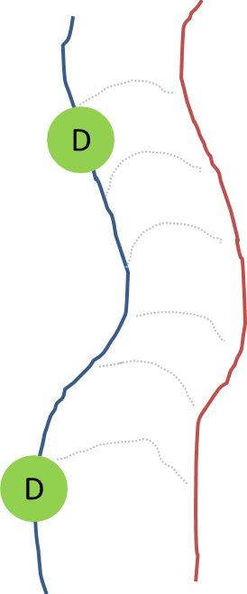

Figure 141 – Idealised homogenous complex formation  
following Baranovsky structure (Figure 18)

This assumption was made to explain experimental outcomes in an uncomplicated manner, to develop a detection system which could be applied on a large scale with minimum involvement from the user, however from a purely scientific point of view it leaves several concerns which must be addressed. Even assuming at high concentrations all labelled polymers are involved in complexation, imperfect binding resulting in loop-defect structures would have an effect on the observed correlation times of the label (Figure 142).

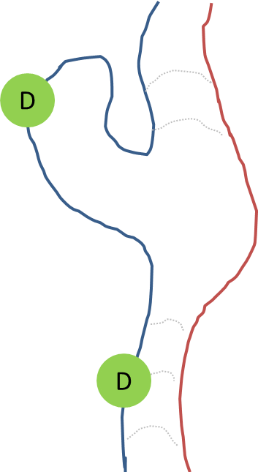

Figure 142 – Loop defects on a probe polymer

The case for modelling the data using a multiple exponential fits increases further when low poly(acrylamide) concentrations are considered, where not all of the labelled poly(acrylic acid) will have complexed (Figure 143). The proposed method of detection using a single exponential fit presents a single average value, with anisotropies of both fluorescence labels combined. Using a double exponential system it may be possible to isolate these two components. However for the purposes of a detection method the averaging of these two states of being provides a greater degree of control and the formation of a smooth concentration / correlation time gradient when plotted.

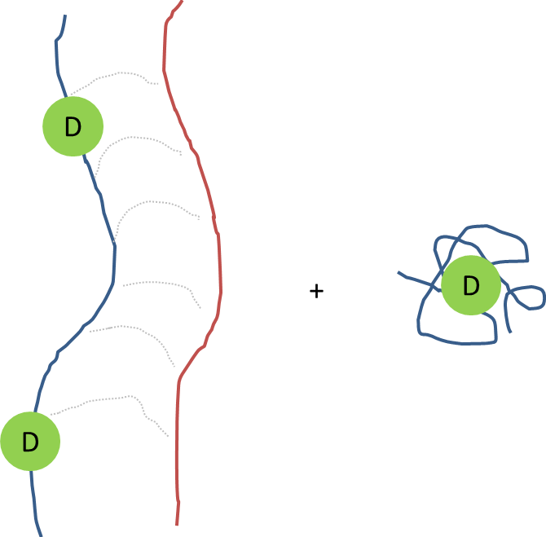

Figure 143 – Mixture of complexed and uncomplexed probe polyacids

# Field Research

The technique of detecting dilute poly(acrylamide) using fluorescence anisotropy outlined in Chapter 6 shows potential for use in many industrial applications. Tests have been carried out to investigate the robustness of the technique with regard to commercial grade polymers, impure water samples and initial trials were carried out on water purification plants.

## Commercial Polymers

### Laboratory vs. Industrial Polymers

The complexation between poly(acrylamide) and poly(acrylic acid) demonstrated in the previous chapter uses specifically synthesised polymers created within the laboratory. These polymers are much smaller, and purer, than the commercial grades traditionally used in industrial applications such as flocculation. Literature suggests that larger molecular weights lead to more efficient IPC formation, however impurities in the polymer (such as anionic and cationic copolymer components) must be considered. To ensure that the proposed system is applicable to these commercial systems and would have use in environmental testing it is vital to show that labelled polymers show a similar interaction with many different grades of poly(acrylamide).

### SNF Commercial Flocculants

To this end SNF(UK)LTD donated several of their polymers for testing. These polymers are classified as either being anionic, non-ionic or cationic due to the ratio of charged monomers present in the copolymer mixture (Figure 144). Supplied as solid beads these are just a few examples of a variety of flocculants produced by SNF. The reported molecular weight of these polymers is over six million although it will vary from sample to sample. The full range of tested poly(acrylamide) samples are shown in Table 24.



Figure 144 – Anionic and Cationic modifications to polyacrylamide

Table 24 – SNF(UK)LTD supplied polymers tested for complexation with PAA-ACE probe

|  |  |
| --- | --- |
| Polymer | Respective Charge |
| FloPam AN905 | Anionic |
| FloPam AN910 | Anionic |
| FloPam AN912 | Anionic |
| FloPam AN912 | Anionic |
| FloPam AN913 | Anionic |
| FloPam AN923 | Anionic |
| FloPam AN915 | Anionic |
| FloPam AN920 | Anionic |
| FloPam AN934 | Anionic |
| FloPam FA920 | Non-ionic |
| FloPam FO4115 | Cationic |
| FloPam FO4140 | Cationic |
| FloPam FO4190 | Cationic |
| FloPam FO4650 | Cationic |
| FloPam F04240 | Cationic |

### Complexation with commercial polymers

#### Non-ionic SNF Polymers

Non-ionic polymers supplied by SNF (FloPam FA920) can successfully complex with the relatively low molecular weight PAA-ACE polymer, as shown by the high correlation times of dilute mixtures at low pH, with correlation times diminishing rapidly as the pH increases above 3 (Figure 145).

Figure 145 – Correlation time of SNF FloPam FA920 mixed with probe PAA-ACE

A series of measurements were made with the concentration of PAA-ACE fixed at both 70 and 700 ppm, the pH adjusted to 2 and the concentration of PAM varied from 0 to 200 ppm (Figure 146). 700ppm probe polymer is sensitive down to 100 ppm FloPam FA920 before the correlation time dropped below 100 nanoseconds, however 70ppm probe polymer was sensitive to 10 ppm before the correlation time dropped (Figure 147). This clearly demonstrates how the sensitivity of this detection system can be modified by altering the concentration of probe polymer.

Figure 146 – Correlation times of PAA-ACE + FA920 mixtures at varying PAM concentration

Figure 147 - Correlation times of PAA-ACE + FA920 mixtures at varying PAM concentration

#### Anionic Poly(acrylamide)

The anionic FloPam AN934 readily complexes with the probe in a manner similar to that of FloPam FA920 at low pH, although pHcrit appears to have diminished from 3 to 2 as only intermediate binding is observed at pH 2.5 and the observed correlation time has diminished from an excess of 100 nanoseconds to 60 (Figure 148).

Figure 148 – Correlation time of SNF FloPam AN934 mixed with probe PAA-ACE

A second anionic polymer AN910 was tested and this polymer revealed correlation times even lower than that of AN934 (Figure 149), suggesting that the anionic component of the copolymer flocculant is weakening IPC formation.

Figure 149 - Correlation time of SNF FloPam AN910 (1.12 ppm)  
mixed with probe PAA-ACE (2.5 ppm)

#### Cationic Poly(acrylamide)

SNF cationic polymer FO4650 complexes at a higher pH range than that of the anionic and neutral PAM mixtures, and during IPC formation shows a much larger correlation time than that observed in the prior systems, possibly due to strong electrostatic attraction between the positively charged flocculant and the negatively charged PAA chains (Figure 150). The sample was analysed via steady state spectroscopy (excited at 295nm) and it was shown that the concentration of PAA-ACE suspended in solution remained constant (Figure 151)

Figure 150 - Correlation time of PAA-ACE and cationic polyacrylamide mixtures

Figure 151 – Emission spectra from 295nm excitation for PAA-ACE : PAM sample

As the fluorescence intensity of the PAA-ACE does not diminish at low pH the amount of polymer in solution must be remaining constant and there is no interaction between it and the cationic poly(acrylamide). Therefore we believe that this polymer interacts purely via electrostatic attraction in the pH range 2.5 – 5, however whether it’s incapability to hydrogen bond is down to reversible hydrolysis of the PAM or competition from bulky cationic groups on the polymer chain cannot be proven.

A series of solutions with varying concentrations of cationic polymer FloPam FO4115 (a polymer with less cationic charge density than FO4650) were mixed with a fixed concentration of 0.113 mg ml-1 P(AA-co-ACE) and set to pH 2 in order to determine the limits of detection of that polymer (Figure 152). Peak correlation time (>100 nanoseconds) was achieved at concentrations as low as 30 mg per litre, below which the correlation time falls rapidly.

Figure 152 – Lower concentration limit of FO4115 by 0.113 mg ml-1 P(AA-co-ACE)

#### Conclusion

These are some very encouraging first results, as they show that (with a few distinct differences) the poly(acrylamide) based flocculants offered by SNF are capable of complexing with the PAA-ACE probe and that the system is a suitable concentration detector.

## Complexation with Impurities

In order to be a useful technique for environmental analysis the complexation of PAA-ACE and PAM, and the detection of it via fluorescence anisotropy, must be viable in impure water sources. Ideally the detection method must be robust enough to withstand biologically active sewage water and a range of chemical and biological impurities which may be contained within.

### Water Sources

The detection method was tested in three environmentally sourced water samples (Ewden, Eccup and Soil Aggregates (SA)). These three water sources were analysed via ICP to give the elemental composition of all impurities in the water supply, in comparison with ultra-pure, deionised, tap and sea water (Table 25).

Table 25 – ICP analysis of water sources, all results in mg l-1

|  |  |  |  |  |  |  |  |  |  |  |  |  |
| --- | --- | --- | --- | --- | --- | --- | --- | --- | --- | --- | --- | --- |
|  | **Al** | **Ca** | **Cu** | **Fe** | **K** | **Mg** | **Mn** | **Na** | **P** | **S** | **Si** | **Zn** |
| U.P. | 0.051 | 0.150 | <0.002 | 0.002 | 0.150 | 0.051 | <0.001 | 1.120 | <0.01 | 0.010 | 0.030 | <0.001 |
| Deionised | 0.019 | 0.078 | <0.002 | 0.003 | 0.120 | 0.029 | <0.001 | 0.820 | 0.030 | 0.040 | 0.030 | 0.002 |
| Tap | 0.056 | 4.920 | 0.005 | 0.040 | 0.980 | 2.470 | 0.004 | 27.400 | 1.130 | 14.200 | 2.690 | 0.009 |
| Sea | 0.410 | 390.0 | <0.002 | 0.430 | 394.0 | 1180.0 | 0.008 | 9850.0 | <0.1 | 811.0 | 1.270 | <0.005 |
| Ewden | 0.177 | 4.010 | 0.048 | 0.457 | 0.710 | 2.490 | 0.048 | 8.560 | 0.015 | 2.350 | 2.610 | 0.042 |
| Eccup | 0.278 | 9.270 | 0.003 | 0.510 | 2.080 | 22.840 | 0.020 | 13.90 | 0.030 | 3.330 | 2.520 | 0.017 |
| SA | 102.0 | 47.10 | 0.210 | 80.00 | 32.00 | 15.200 | 1.170 | 25.10 | 3.650 | 15.500 | 216.0 | 0.920 |

The tap water was collected from the Dainton Building at the University of Sheffield on 24/02/2012. Sea water was collected from Holes Bay, Poole Harbour, on the 03/07/2013.

#### Testing in Fresh Water

The detection method has previously been demonstrated on dilute polymer samples in ultra-pure water. In order to prove the system’s robustness in fresh water samples the probe polymer was dissolved in both tap and sea water and studied across the full pH range (Figure 153). This was then compared with samples in the presence of FloPam FA920 which demonstrated clear complexation at pH <3. IPC formation is evident in both impure aqueous samples, albeit with increased errors in the detection (particularly in the sea water sample). It’s interesting to note that in the sea water sample (which has a high ionic strength compared to tap water) the probe response in the absence of PAM does not show a conformational change at low pH although there is a slight increase in correlation time at high pH, possibly due to an interaction between the polymer and the aggregating calcium (Figure 154).

Figure 153 – PAA-ACE + FloPam FA920 complexing in Sheffield University tap water

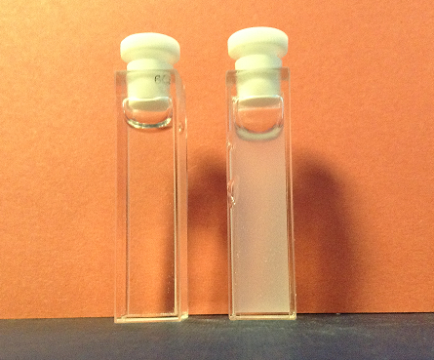

Figure 154 - Sea water sample response to pH adjustment by NaOH addition  
(left pH 3, right pH 8)

#### Salt Impurities

Samples of FloPam FA920 (2 ppm) were prepared in a range of 0.1 M salt impurities, mixed with an equivalent amount of probe (Figure 155). In the case of ammonia, sodium phosphate, sodium chloride and calcium chloride complexation was clearly observable below pH 2, although it should be noted that the calcium chloride had a marked effect on the correlation times at higher pHs. In the presence of magnesium sulphate the increase in correlation time was clearly diminished although still distinct from the uncomplexed polymer. When the concentration of magnesium sulphate was reduced to 0.01 M the full complexation response was observed (Figure 156).

Figure 155 – Correlation time of probe and FA920 samples  
in 0.1 Molar impurities

Figure 156 - Correlation time of probe and FloPam FA920 samples  
in magnesium sulphate

## Detection of Flocculated Samples

### Ewden Water Treatment Plant

On the 15/03/2012 raw water entering the Ewden water processing plant (pH 7, 3.09 NTU) was sampled for analysis (Figure 157). The water entering the Ewden Water Processing plant flows down from the peak district and though its exact composition changes depending on environmental conditions it is known to contain a high peat content. The elemental composition is shown in Table 25.

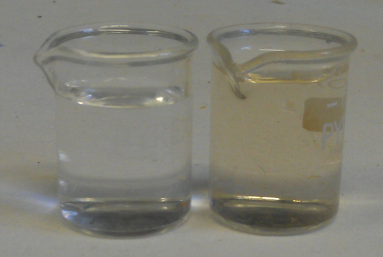

Figure 157 – Visual comparison between clear U. P. Water and Ewden River Water

To ensure the impurities of the system do not impede the detection system, PAA-ACE was added to a sample of Ewden water and no increase in correlation time was observed with pH, indicating a lack of flocculant in the raw water. The sample was spiked with an overdose of FA920, with no mixing to induce flocculation, and the expected increase occurred (Figure 158).

Figure 158 – Correlation time of PAA-ACE in Ewden Water  
and Ewden Water spiked with FA920

In order to simulate the flocculation that occurs in a water treatment plant a litre of the sample was mixed with FeSO4 and pH corrected to 4 with lime. These mixtures were stirred at 200 rpm for 5 minutes, then at 30 rpm for 10 minutes, and then left for ten minutes to settle. This action simulates the action of a flash mixer and conditioning time at an industrial plant. After settling a sample was examined by turbidity and a visual inspection was made of the flocculate sizes (Figure 159). From this inspection it became apparent that 70 ppm l-1 of iron sulphate offered the greatest improvement to sample turbidity, and whilst it did not create the largest flocs they were of a size capable of being filtered from the solution (Figure 160).

Figure 159 – Turbidity (columns) and Floc Size (line) of Flash Mixing  
of 1 litre of Ewden Water with 40-80 ppm of FeSO4

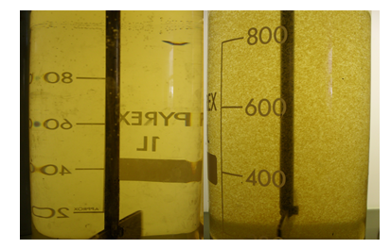

Figure 160 – Comparison between reference beaker (L) and flocculated sample (R)

Another series was created with polymer (0.5 ppm, of varying anionic and cationic doses) was added in addition to aqueous FeSO4 (70 ppm). To create this 70 ppm of FeSO4 was added to Ewden Water (1 litre) and corrected to pH 4 with lime. The samples were stirred for 5 minutes at 200 rpm, then turned down to 30 rpm and left for ten minutes to settle. To these samples 0.5 mg of PAM (dissolved in 5 ml of water) was added before they were flash mixed at 300 rpm for a further 1 minute, for 5 minutes at 30 rpm and then left ten minutes to settle. After this the turbidity of each sample and the floc. size was assessed (Figure 161).

Figure 161 – Turbidity (columns) and floc size (line) of polymer augmented flocculation

It appears that the 10% anionic polymer (FloPam AN910) is the most efficient at increasing the density of aggregation, followed by the 10% cationic (FloPam FO4190). This is a clear improvement over polymers FloPam AN905, AN915 and AN920 which all gave less efficient flocculation and failed to settle within ten minutes (Figure 162).

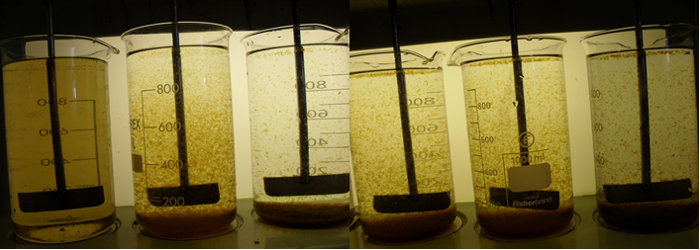

Figure 162 – Images of the reaction vessels after ten minute settling period. Vessels from left to right: reference beaker, 5% anionic, 10% anionic, 15% anionic, 20% anionic, 10% cationic.

The samples containing AN910 and FO4190 were the most efficient flocculants, samples of these reaction vessels were retained for fluorescence analysis. 7 ml of PAA-ACE was added to 20ml of each sample and the correlation times were measured at a variety of pHs. No increase of correlation time was detected at low pH. However, to ensure that this was not a false reading the flocculation was repeated with a dramatic overdosing of 280 ppm polymer and these overdosed samples demonstrate the desired increase in anisotropy (Figure 163). Interestingly in these conditions polymer AN910 gave a large increase to correlation time (> 100 ns) whereas in ultrapure water an increase of only 60 ns was observed (Figure 149). Whether this is a concentration effect or due to the ionic strength of solution is unknown.

Figure 163 – Correlation time of Ewden water treated with AN910 and FO4190 at 0.5 ppm and 280 ppm

This is the first observed demonstration of a reliable test of PAM presence after flocculation, and an indication that unless the system is overloaded the majority of the PAM will be removed via permanent sorption to solid matter. These tests show that there is no detectible residual polymer left in these samples when dosed with the required amount of polymer for peak flocculation. The detection process is robust enough to handle the impurities of the raw water when the system is overdosed with an excess of flocculent.

### Eccup Water Treatment Plant

On the 18/09/2012 a sample of water entering the Eccup water processing plant was collected for analysis (pH 7.1, turbidity 2.61 NTU). A one litre sample was dosed with 8.5ml FeSO4, 0.05 ml lime solution (to pH 4.5), flash mixed for 30 seconds then stirred at 250 rpm for 2 minutes. 0.2 ppm polymer was added before flash mixing for a further 30 seconds and then stirred at 250rpm for 12 minutes. The floc size was noted and samples were allowed to settle for fifteen minutes. A selection of cationic (FO) and anionic (AN) polymers were used and it was shown that FO4140 and AN905 were the best flocculants respectively (Figure 164).

Figure 164 – Turbidity (columns) and Floc Size (line) of polymer treated Eccup Water

500ml Eccup water was stirred with 9 mg FeSO4, brought down to pH 4.5 with lime solution before being mixed with varying concentrations of FloPam FO4115. 2 ml was extracted and mixed with the probe polymer and studied via anisotropy at pH 0.80 (Figure 165). A clear correlation between the concentration of PAM used as a flocculent and the correlation time were observed at very low concentrations, with the system detecting complex formation occurring as low as 1.5 mg per litre.

Figure 165 – Correlation time of flocculated Eccup water with varying polymer dosage

Comparing the detection limits of this polymer after flocculation with the detection limits determined in pure water (Figure 152) it is possible to show the amount of polymer that is consumed by the flocculation process, and view the efficiency of polymer aggregation (Figure 166). The correlation times are in broad agreement above 10 mg l-1 however at very low concentrations (1 ppm) the correlation time of the laboratory based sample showed a small response whilst the flocculated sample shows no definite response until approximately 1.8 mg l-1 polymer dosage has been reached. This suggests that 0.5 mg polymer is consumed in the flocculation of 500 ml Eccup reservoir water and additional polymer dosage above this level plays no role in the aggregation of dissolved organic matter.

Figure 166 – Comparison of detection limits of PAM in laboratory test verses flocculated sample

To test the reverse system using an anionic polymer, 600ml of Eccup reservoir water was flocculated with AN905 flocculant. A 20ml sample was then mixed with 3 mg P(AA-co-ACE) and tested via anisotropy (Table 26), resulting in a clear signal at extreme overdosing of PAM. This shows that the detection method is equally suitable for anionic and cationic flocculants.

Table 26 – Correlation time of the probe in the presence of FloPam AN905 flocculated Eccup water.

|  |  |  |  |  |  |
| --- | --- | --- | --- | --- | --- |
| **PAM conc.**  **/ ppm** | **Tc / nS** | **Std. Dev. / nS** | **A** | **B** | **ChiSq** |
| 980 | 160 | 5.46 | 0 | 0.011 | 0.94 |
| 670 | 176 | 8.35 | 0 | 0.019 | 1.07 |
| 20 | 1.83 | 0.46 | 0 | 0.029 | 0.94 |

### Quarry Samples

On the 4/04/2013 a sample of recycled soil was delivered to Sheffield University from Whelton Aggregates. 10 g of this raw sample was analysed by elemental analysis before being dissolved in 10 litres of water to give a turbidity of 15.35 NTU and this was then tested by ICP (Table 25) which showed that he raw effluent contained more than 1 ppm of Al, Ca, Fe, K, Mg, Mn, Na, P, S, Si and Ti.

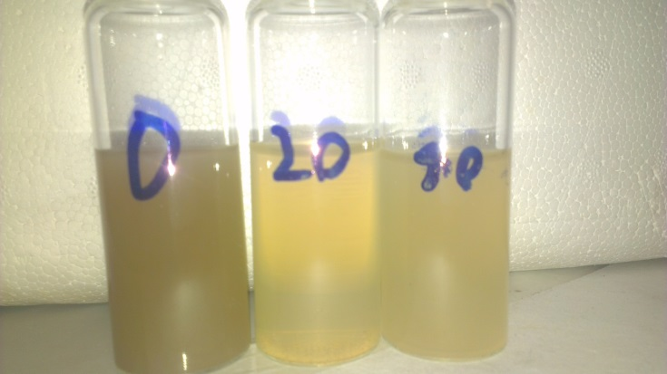

Figure 167 – Visual comparison of soil aggregate water with 20 and 40 ppm flocculated sample

Samples were flocculated by direct addition of FloPam AN910 into 250 ml sample and stirring for twenty minutes. Efficiency of flocculation was measured by turbidity (Figure 168) and ICP (Table 27) and both suggest 20 ppm of polymer resulted in the most efficient flocculation. ICP results show that aggregation appears to have been particularly successful in removing Al, Ca, Fe, K, Mg, Mn, P, Si and Ti by varying degrees but it does not appear to have had an effect on the Na or S content.

Figure 168 – Turbidity of raw and flocculated Whelton samples

|  |  |  |  |  |  |  |  |  |  |  |  |  |  |  |  |  |  |  |  |  |  |  |  |  |  |  |  |  |  |  |  |  |  |  |  |  |  |  |  |  |  |  |  |  |  |  |  |  |  |  |  |  |  |  |  |  |  |  |  |  |  |  |  |  |  |  |  |  |  |  |  |  |  |  |  |  |  |  |  |  |  |  |  |  |  |  |  |  |  |  |  |  |  |  |  |  |  |  |  |  |  |  |  |  |  |  |  |  |  |  |  |  |  |  |  |  |  |  |  |  |  |  |  |  |  |  |  |  |  |  |  |  |  |  |  |  |  |  |  |  |  |  |  |  |  |  |  |  |  |  |  |  |  |  |  |  |  |  |  |  |  |  |  |  |  |  |  |  |  |  |  |  |  |  |  |  |  |  |  |  |  |  |  |  |  |  |  |  |  |  |  |  |  |  |  |  |  |  |  |  |  |  |  |  |  |  |  |
| --- | --- | --- | --- | --- | --- | --- | --- | --- | --- | --- | --- | --- | --- | --- | --- | --- | --- | --- | --- | --- | --- | --- | --- | --- | --- | --- | --- | --- | --- | --- | --- | --- | --- | --- | --- | --- | --- | --- | --- | --- | --- | --- | --- | --- | --- | --- | --- | --- | --- | --- | --- | --- | --- | --- | --- | --- | --- | --- | --- | --- | --- | --- | --- | --- | --- | --- | --- | --- | --- | --- | --- | --- | --- | --- | --- | --- | --- | --- | --- | --- | --- | --- | --- | --- | --- | --- | --- | --- | --- | --- | --- | --- | --- | --- | --- | --- | --- | --- | --- | --- | --- | --- | --- | --- | --- | --- | --- | --- | --- | --- | --- | --- | --- | --- | --- | --- | --- | --- | --- | --- | --- | --- | --- | --- | --- | --- | --- | --- | --- | --- | --- | --- | --- | --- | --- | --- | --- | --- | --- | --- | --- | --- | --- | --- | --- | --- | --- | --- | --- | --- | --- | --- | --- | --- | --- | --- | --- | --- | --- | --- | --- | --- | --- | --- | --- | --- | --- | --- | --- | --- | --- | --- | --- | --- | --- | --- | --- | --- | --- | --- | --- | --- | --- | --- | --- | --- | --- | --- | --- | --- | --- | --- | --- | --- | --- | --- | --- | --- | --- | --- | --- | --- | --- | --- | --- | --- | --- |
| Table 27 - ICP analysis of Quarry flocculated samples (by ppm) compared to raw effluent   |  |  |  |  |  |  |  |  |  |  |  | | --- | --- | --- | --- | --- | --- | --- | --- | --- | --- | --- | | ppm | Al | B | Ba | Ca | Cr | Cu | Fe | K | Mg | Mn | | 0 | 102.00 | 0.70 | 0.78 | 47.10 | 0.15 | 0.21 | 80.00 | 32.00 | 15.20 | 1.17 | | 15 | 13.20 | 0.52 | 0.18 | 21.20 | 0.03 | 0.04 | 12.70 | 9.38 | 3.55 | 0.13 | | 20 | 12.40 | 0.24 | 0.17 | 19.20 | 0.02 | 0.03 | 12.40 | 8.83 | 3.45 | 0.13 | | 25 | 27.70 | 0.18 | 0.29 | 24.80 | 0.05 | 0.05 | 24.40 | 12.90 | 5.65 | 0.30 | | 30 | 18.30 | 0.33 | 0.20 | 21.90 | 0.03 | 0.05 | 16.00 | 10.50 | 4.32 | 0.18 | | 35 | 32.10 | 0.72 | 0.30 | 24.60 | 0.05 | 0.06 | 26.80 | 14.00 | 6.09 | 0.32 | | 40 | 18.60 | 0.44 | 0.22 | 21.60 | 0.03 | 0.05 | 16.90 | 10.10 | 4.35 | 0.19 | |  |  |  |  |  |  |  |  |  |  |  | | ppm | Na | Ni | P | Pb | S | Si | Sr | Zn | Ti | V | | 0 | 25.10 | 0.10 | 3.65 | 0.65 | 15.50 | 216.00 | 0.24 | 0.92 | 5.31 | 0.24 | | 15 | 23.40 | <0.01 | 1.15 | <0.05 | 14.70 | 34.10 | 0.08 | 0.13 | 0.81 | 0.04 | | 20 | 23.20 | <0.01 | 1.05 | <0.05 | 14.40 | 30.50 | 0.07 | 0.15 | 0.75 | 0.03 | | 25 | 23.30 | 0.03 | 1.55 | 0.15 | 14.80 | 62.50 | 0.11 | 0.27 | 1.56 | 0.07 | | 30 | 23.40 | 0.02 | 1.20 | 0.15 | 14.90 | 43.50 | 0.09 | 0.18 | 1.03 | 0.05 | | 35 | 24.60 | 0.02 | 1.65 | 0.12 | 15.30 | 72.50 | 0.11 | 0.30 | 1.69 | 0.09 | | 40 | 25.20 | 0.01 | 1.30 | 0.10 | 15.40 | 48.10 | 0.09 | 0.19 | 1.14 | 0.05 | |  |  |  |  |  |  |  |  |  |  |  |  |  |  |  |  |  |  |  |  |

Following this 0.06 mg P(AA-co-ACE) was mixed with flocculated samples, brought down to pH < 2 with 0.01 M HCl and tested in the same way (Figure 169). A clear increase in anisotropic response due to complex formation is visible at 30 ppm, growing exponentially to 40 ppm. It was not possible to measure the anisotropy of P(AA-co-ACE) in raw Whelton aggregate samples prior to the addition of flocculant as the sample’s high turbidity prevents passage of the light beam. The large error bars could be due to the extreme turbidity of the samples which led to a dramatic increase in the amount of scattered light (Figure 170).

Figure 169 - Correlation time of flocculated Whelton Aggregates with varying PAM dosage

Figure 170 – Raw fluorescence decays of sample in soil aggregate water

## Sample Size

The precision of statistical data calculations can be improved by analysis of a larger sample size. Calculations of excited state correlation times, whilst independent of fluorescence intensity, have improved accuracy when a greater number of photons are used in the calculations. Provided the analysed sample does not decompose during the measurement, fitting to a larger population results in better accuracies of fits and certainties with the data. IPC formation causes aggregation, which in turn leads to light scattering, which increases the quantity of unusable data which is not available for correlation time calculations.

For the purpose of designing a portable, fast detection device the advantages of accurate data gathering must be balanced with the increased timescale of the measurement. The exact duration of any measurement will depend upon the intensity of the laser, path length of the sample chamber, concentration of the fluorescent probe and emission efficiency of the polarisers. As each of those factors will depend upon mechanical factors the end result is the importance of the number of photons which must be counted in order to interpret a result with any accuracy. For this purpose 1 mg ml-1 P(AA-co-ACE) probe was dissolved in U.P. Water with 0.5 mg ml-1 FloPam FA920 (Figure 171). The same sample was analysed repeatedly, varying the number of photons recorded in each reading.

Figure 171 –Correlation time of FA920 / P(AA-co-ACE) sample  
calculated from varying sample size

It is apparent from these results that samples recorded with less than 3,000 photons counted struggled to show the increase in correlation time apparent from IPC formation. Data gathered at and above 3,000 counts had high predicted errors which became smaller with increasingly larger data sets.

Therefore whilst it is currently not possible to offer any predictions about the timescale of the detection method (as that will depend on sample concentration, label loading, efficiency of detector and speed of photon cycles) there are indications that an absolute minimum of 3,000 peak photons should be counted and ideally at least 10,000 should be reached for increased accuracy of data. There is a caveat that for more turbid samples, which demonstrate greater degrees of light scattering, the peak channel will represent scattered light and not useful data, and so this should always be a considered when setting a target threshold of data.

## Conclusions

This chapter shows that the anisotropy of a polymer probe is a good detection method for poly(acrylamide) in a range of applications, and that the proposed technique can withstand impure water sources and copolymer functionality on the flocculant poly(acrylamide). Charged cationic poly(acrylamide) samples require modification to be made to the pH to induce electrostatic attraction necessary for IPC formation to occur but in other respects this detection method is suitable for a range of applications and has been shown to be sensitive down to the ppm concentration range.

# Complex Formation with Other Polybases

Previous literature suggests that poly(acrylic acid) is capable of forming IPCs with many polybases besides poly(acrylamide). As the proposed method of detection revolves around the restricted rotation of a covalently attached fluorophore, P(AA-*co*-ACE) should be sensitive to the presence of any polymer that will interact with poly(acrylic acid), whether via hydrogen bonding or electrostatic interactions.

Previously Poly(ethylene oxide) (PEO) has been shown to reduce the correlation times of P(AA-co-ACE) complexes[84], however a range of polymers identified in section 1.4.4 have been tested for compatibility with our detection method. Polymers listed in this chapter were sourced from Sigma-Aldrich or other suppliers as listed and were used with no further modification.

## Poly(N-isopropylacrylamide)



Figure 172 – Proposed mode of PAA-PAM hydrogen bonding

A sample of poly(N-isopropyl acrylamide) (PNIPAM) was donated by Yuanbo Zhao for use in IPC complexation studies with PAA. The polymer had a stated Mn of 22,300 g mol-1, Mw of 36,300 g mol-1 and a dispersity of 1.89, determined by DMF GPC. PNIPAM undergoes LCST behaviour at 33oC and this was confirmed via the increased absorbance of a dilute solution (1 mg ml-1) shows when heated beyond this transition. A visible cloud point can be observed at 34oC (Figure 173).

Figure 173 – Absorbance of PNIPAM (1 mg ml-1) with varying temperature

Poly(N-isopropyl acrylamide) (PNIPAM) has a similar interaction with PAA to PAM, with two possible sites for hydrogen bonding (O-HO, NH-O). When studied at a range of pH values it was notable that IPC formation appeared to occur at a higher pHcrit than PAA-PAM IPC formation (Figure 174). Above this pH there is no increase in correlation time, below it the correlation time rises to over 100 nanoseconds, although there appears to be a slight dip at very low pH (which is unlike PAA-PAM interactions in which binding is at its strongest at the lowest pH). This effect may be caused by the addition of hydrophobic groups which PAM does not possess.

Figure 174 – Correlation time of PAA (0.35 mg ml-1) and PNIPAM (0.43 mg ml-1)  
mixtures with varying pH

When the concentration of PAA was fixed at 0.16 mg ml-1 and the pH adjusted to 2, a smooth decrease in τc was observed in line with PNIPAM concentration (Figure 175).

Figure 175 – Correlation times of PAA-ACE (160 ppm)  
with varying concentrations of PNIPAM

## Poly(ethylene oxide)



Figure 176 - Proposed mode of PAA-PEO hydrogen bonding

The binding of Poly(ethylene oxide) (PEO) and PAA via TRAMS has previously been studied using a double exponential system[84]. A standard sample (Mw 300,000) was mixed with PAA-ACE and studied at varying pH (Figure 177). This revealed that IPC formation occurs below pH 4, rising to a peak pH 2-3 and then diminishing rapidly below pH 2.

Figure 177 - Correlation time of PAA (0.4 mg ml-1) and PEO (4.4 mg ml-1)  
mixtures with varying pH

The concentration of PAA was then fixed at 0.2 mg ml-1 and the concentration of PEO varied with the pH adjusted to 2, showing the probe was sensitive down to PEO concentrations as low as 20 ppm (Figure 178).

Figure 178 - Correlation times of PAA-ACE (200 ppm)  
with varying concentrations of PEO

## Poly(dimethylacrylamide)



Figure 179 - Proposed mode of PAA-PMAM hydrogen bonding

A sample of poly(dimethyl acrylamide) (PDMAM) was donated by Beth Moore from the University of Warwick. The sample was formed via a RAFT controlled free radical reaction and had a stated Mn of 27.5 kDa, Mw of 30.1 kDa and PD of 1.09 as determined by DMF GPC. The sample was mixed with PAA and the pH varied to study the pHcrit necessary for IPC formation (Figure 180).

Figure 180 - Correlation time of PAA (0.21 mg ml-1) and PDMAM (0.33 mg ml-1)  
mixtures with varying pH

These results show that not only is pHcrit greater for PDMAM-PAA complexes than PAM-PAA, but the observed τc is greater, suggesting the system measures a stronger interaction between these polymers.

## Poly(vinyl alcohol)



Figure 181 - Proposed mode of PAA-PVAl hydrogen bonding

A poly(vinyl alcohol) (PVAl) sample (Mw 125,000) was mixed with a PAA (0.4 mg ml-1) and studied at varying pH (Figure 182). This shows that IPC formation occurs below pH 3, although the correlation time does not rise as high as has been observed using other polymer systems. This could indicate the mode of binding between PAA and PVAl is weaker than PAA-PAM.

Figure 182 – Correlation time of PAA (0.40 mg ml-1) and PVAl (0.90 mg ml-1)  
mixtures with varying pH

## Poly(N-vinylpyrrolidone)



Figure 183 - Proposed mode of PAA-PVP hydrogen bonding

A poly(N-vinylpyrrolidone) (PVP) sample (Mw 700,000 Da) was used for testing with PAA IPC formation. This sample (0.50 mg ml-1) was mixed with PAA (0.15 mg ml-1) and studied to see how IPC formation responds to temperature (Figure 184). This study did not reveal a tight pHcrit but a steady decrease in correlation time from pH 2 to 6.

Figure 184 - Correlation time of PAA (0.15 mg ml-1) and PVP (0.50 mg ml-1)  
mixtures with varying pH

## Poly(dimethyl amine-co-epichlorohydrin)



Figure 185 - Proposed mode of PAA-poly(dimethyl amine-co-epichlorohydrin)  
electrostatic bonding

A sample of poly(dimethyl amine-co-epichlorohydrin) was supplied by SNF(UK)LTD for testing. This sample (product 4440) is a high molecular weight liquid sample sold for use in the water treatment and pulp processing industry. Despite the presence of OH functional groups on the polymer IPC formation only appears to occur at high pH, suggesting that these polymers interact via an electrostatic interaction from the charged quaternary amine (Figure 186).

Figure 186 - Correlation time of PAA (0.12 mg ml-1) and PDMA (0.61 mg ml-1)  
mixtures with varying pH

The concentration of PAA was then fixed at 19.3 ppm and the concentration of PDMA varied (Figure 187). As this was an electrostatic interaction the pH was set to 4, and it can be seen that the PAA-ACE probe is sensitive down to 100 ppm.

Figure 187 - Correlation times of PAA-ACE (19.3 ppm) – PDMA mixtures at varying pH

## Poly(diallyldimethylammonium chloride)



Figure 188 - Proposed mode of PAA-PDADMAC electrostatic bonding

A sample of poly(diallyldimethylammonium chloride) (PDADMAC) was supplied by SNF(UK)LTD for testing. This sample (product 4440) is a high molecular weight liquid sample sold for use in the water treatment and pulp processing industry. A mixture of 0.12 mg ml-1 PAA-ACE with excess PDADMAC was created and tested at various pH to observe the nature of binding (Figure 189). It appears that peak IPC formation occurs at pH 3-6, in weakly acidic solutions. Below pH 3 no complex formation occurs suggesting that the interaction is electrostatically driven and requires the negative charge on PAA functional groups.

Figure 189 – Correlation time of PAA (0.12 mg ml-1) and PDADMAC (6.75 mg ml-1)  
mixtures with varying pH

## Conclusions

The detection method proposed in the previous chapter has been shown to be robust enough to withstand many salt impurities which are liable to be found in a fresh water supply post flocculation, with the opacity of the sample being the main concern. The main inhibiting factor to the level of detection is the concentration of poly(acrylic acid-co-ACE), as whilst lower concentrations of probe polymer are possible it results in an increased timescale for detection. As the concept of detection via complexation has been proven further work will now be required to calibrate detection limits in order to implement a full concentration detector.

The method of detection is capable of sensing the presence of a range of polymers and appears to offer some indication as to the relative strength of the binding between different polymers. Poly(acrylic acid)-(poly(acrylamide) may be a model system because of the strong nature of the interaction, yielding a very clear and certain signal in comparison to other systems, yet to some extent poly(acrylic acid-co-ACE) is sensitive to every one of the polybases outlined above and will doubtless interact with many more unexplored systems. Further work will be required to quantify the system and determine the full range of its potential.

The system also appears to be able to distinguish, to some degree of accuracy, the strength of interaction between PAA and the binding polymer, as the rise in τc of strong IPC complexes (such as PAM and PDMA) give a much stronger response (τc > 100 ns) than that of weak IPC complexes (PVA, PEO) where the observed τc only rises to 40-60 ns. This is understandable as the stronger the interaction between PAA and the complexing polymer the greater the restriction IPC formation will have on complex rotation. However as the molecular weights of these polymers are not directly comparable, further research will be required for direct comparisons to be made.

The work in this chapter was carried out with the help of Andrew Bretherwick of SNF (UK) LTD, who helped arranger sample collection and on-site flocculation testing to be carried out at relevant Yorkshire Water plants.

# Solid Systems

## Introduction

Although the complexation of poly(acrylamide) and fluorescently labelled polymers offers a promising means of detecting small concentrations of poly(acrylamide), there are issues with it as a large scale method for testing water samples. A test method that relies on accurate titrations of fluorescent sample is wasteful, slow and brings potential errors in ensuring that an equivalent amount of polymer is used in every case. Whilst analysis could be fast using simultaneous testing of large numbers of samples using microtitre plates, another method with less complex procedures would be to attach the poly(acrylic acid) chains to a solid surface. If the fluorescently bound polymer could be retained between tests, covalently attached to a solid surface, then there is more potential for this technique to be developed into a portable system.

Two methods have been proposed to create poly(acrylic acid) functionalised membrane films. The first method, involving ceric ammonium nitrate (CAN) initiated grafting to pre-prepared HEMA membranes is relatively quick and simple yet there are concerns about its applicability to fluorescent solutions. The second method involves incorporating branching CTA agents into the membrane film as it is produced and then using these as anchors for poly(acrylic acid) grafting.

### Hydrogels

Hydrogels are a network of interconnected polymer chains composed of both hydrophilic and hydrophobic moieties [158], which are commonly investigated for their biomedical applications [159].

The hydrophobic components make up the bulk of the chain, making the gel insoluble in water. The hydrophilic components attract and hold a large number of water molecules, allowing the complex to hold a high water content, or become ‘water swollen’. The swelling behaviour of a given gel is indicative of its composition [160].

There are a number of ways to create hydrogels, one of the most common being the formation of an interpenetrating network (IPN) from a monomer and crosslinkers (Figure 190) [158, 161]. Other methods include copolymerisation of bi-functional or multi-functional macromers with multiple binding sites, or with reactive pendant groups. If a monomer is polymerised within an existing hydrogel network an interpenetrating hydrogel network can be formed which has unique properties of its own.

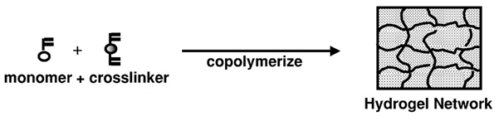

Figure 190 - Creation of a hydrogel network from a monomer and a crosslinking agent[158]

The polymerisation of an IPN to form stable membranes can be initiated by a process of photoinitiation, an easy and reliable technique that is widely used by industry. One monomer of particular interest is 2-hydroxyethyl methacrylate (HEMA), which forms a nontoxic hydrogel that has been widely research since its discovery in 1960[159]. There are many methods of preparing hydrogel films of this polymer[162-167] and compatible crosslinkers include ethylene glycol dimethacrylate (EGDMA) [162], ethylene glycol diacrylate [166] and divinylbenzene [168]

### Grafting of Polymers

In order to make the system portable it might be possible to attach poly(acrylic acid) sensors to the surface of an IPN film.

One of the most popular methods of ‘grafting’ polymer chains onto a polymer surface is the use of a free radical polymerisation technique[169], although one major drawback is the creation of large quantities of homopolymer as a side product of the reaction.

The degree of grafting an acid onto a neutral backbone polymer can be determined via acid-base titrations [169] and by FTIR absorbance bands at 1720 cm-1 (attributed to the carbonyl groups of the new polymer) [169].

Currie studied the properties of acid brushes on polystyrene wafers and in particular examined their swelling properties [170]. They found that at pH 3 the brush height was independent of the ionic strength of solution, whilst at higher pH the brush swelled with increasing ionic strength due to the increasing fraction of charged monomers. However once the ionic strength reached 0.1 M the thickness of the brushes decreased due to increased screening of electrostatic interactions.

Two methods of grafting have been investigated (Figure 191):

* Using Ceric Ammonium Nitrate (CAN) to introduce radicals on the HEMA backbone would allow direct polymerisation onto the film surface.
* Incorporation of RAFT agents into the film which can be used as specific anchor points to graft poly(acrylic acid) onto.

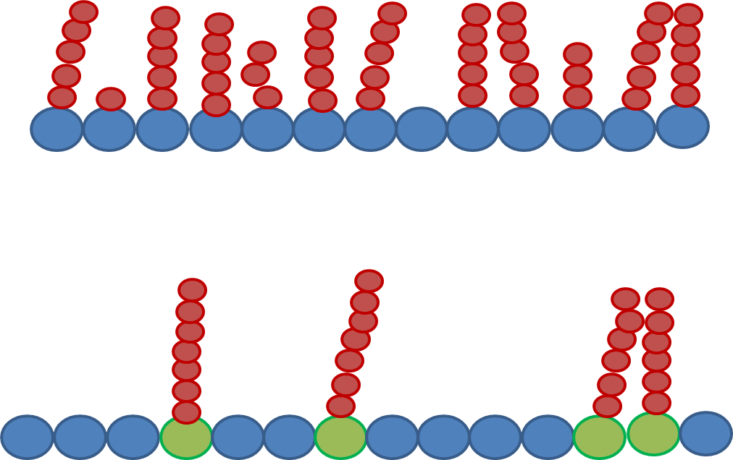

Figure 191 – PAA chains on HEMA backbone, via direct (CAN)  
radical polymerisation or specific (RAFT) attachment points

#### Ceric Ammonium Nitrate (CAN) Grafting

The first recorded use of CAN to initiate grafting was recorded in 1958 [171], although much of the work using it has been to attach it to biomaterials such as starch [172, 173] and chitosan [174, 175] , where there is an abundance of hydroxyl and amine groups. This technique produces relatively pure graft copolymers from vinyl monomers and works efficiently at ambient temperatures [173].

CAN has been used successfully to graft many vinyl monomers including acrylamide [176], N-(2-methoxyethyl)acrylamide [177], hydroxyl ethyl methacrylate [178, 179], methacrylate [180] and acrylic acid [181, 182]. A comparison between the reactivities of several vinyl monomers onto wool found acrylic acid to be one of the least reactive monomers, due to its increased water solubility leading to a slightly larger degree of homopolymerisation [183]. Homopolymerisation of the monomer in solution is a concern which can be alleviated by tight control over the ratio between CAN and monomer [172, 175].

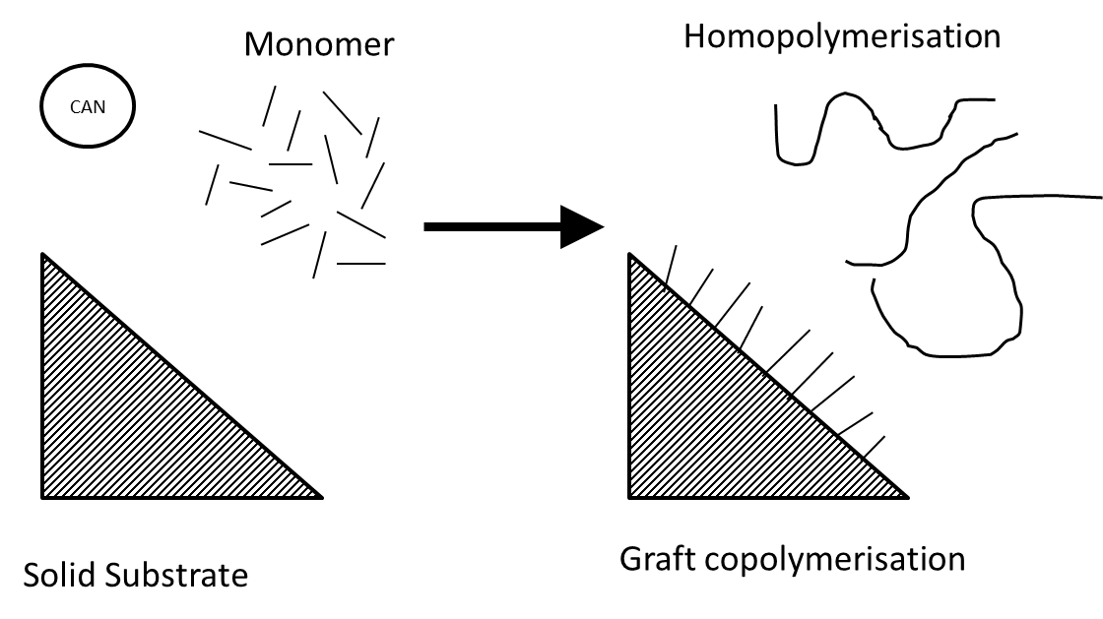

Figure 192 – Ceric Ammonium Nitrate reaction may lead to graft copolymerisation  
onto solid surface or homopolymerisation in solution

This process works using a ceric ion redox system operating via single electron transfer [184]. The polymerisation proceeds via a single electron transfer to the polymer backbone, forming a free radical on a carbon adjacent to an alcohol group. This initiation reaction is shown in Equation 30, going through intermediate B; a ceric-alcohol complex.



Equation 30

There is some dispute as to the exact nature of the cerium(IV) mechanism when hydroxyl rich biopolymers are used, but its preference for hydroxyl groups is certain. Beyond the mechanism stated above other papers have proposed ring opening mechanisms ([178, 184] or indicated a preference for CAN to react with amine groups [185, 186].

#### RAFT Grafting

Due to the potential inability to perform the CAN grafting in solvents other than water and issues that arose with the doubly labelled linear polymerisation, a second plan has been considered using Reversible Addition-Fragmentation Chain Transfer (RAFT) polymerisation.

Previous knowledge within our research group includes the formation of Branched PNIPAM from Imidazole Dithioate Linear Polymers [65]. S. Carter demonstrated a simple two step procedure to form long PNIPAM chains via multi-RAFT polymerisation as the chain extends outwards from predetermined branch points incorporated into the polymer backbone.

## Experimental

### Synthesis of 4-Vinylbenzyl-1-pyrrolecarbodithioate (VPC)



Figure 193 - Synthesis of 4-vinylbenzyl-1-pyrrolecarbodithioate  
from pyrrole and 4-vinylbenzyl bromide

The branched RAFT initator 4-Vinylbenzyl-1-pyrrolecarbodithioate was synthesised using a similar reaction to that used on the synthesis of benzyl-1-pyrrolecarbodithioate (BPC), substituting 4-vinylbenzyl bromide for benzyl bromide. After separation via flash column chromatography in petroleum ether the solvent was extracted in a rotary evaporator leaving a bright yellow solid. A yield of 64% was achieved. 1H NMR (400MHz CDCl3 in ppm δ 7.59 (2H, d, Ar) δ 7.45 (2H, d, Ar) δ 7.18 (2H, m, Ar) δ 6.76 (2H, m, Ar) δ 6.35 (1H, m, RC=C**H**) δ 5.81 (1H, m, RC=C**H**), δ 4.61 (2H, s, RC**H2**Ar)). Elemental analysis expected: C 64.9%, H 5.1%, N 5.4%, S 24.7%, actual results: C 65.3%, H 5.1%, N 5.3%, S 22.4%.

### Solid Polymer Film Synthesis

Polymer films, or membranes, composed of interpenetrating polymer networks (IPN)[187] were synthesised via a range of methods. Most hydrogel membranes were prepared via UV curing however RAFT containing films were cured thermally for 24 hours.

#### HEMA Film Polymerisation

##### PCN via Divinyl benzene cross linker

2-Hydroxyethyl methacrylate (HEMA) and ethylene glycol dimethacrylate (EGDMA) were added to a solution of ethanol, 2-hydroxy-2-methyl-1-phenyl-propan-1-one (Darocur 1173), benzophenone (BP) and triethylamine (TEHA). Nitrogen was bubbled through the solution for half an hour. This solution was cured using UV light for five minutes creating a solid hydrogel film.



Figure 194 – Synthesis of HEMA-DVB crosslinked hydrogel film

##### PCN via EGDMA Cross linker

2-Hydroxyethyl methacrylate (HEMA) and EGDMA were added to a solution of ethanol, Darocur 1173, BP and TEHA. Nitrogen was bubbled through the solution for half an hour. This solution was cured using UV light for five minutes creating a strong but flexible hydrogel film. 13C solid state NMR (100 MHz in ppm δ 179.2 (b, C**C**OO) δ 67.5 (b, C**C**OH) δ 60.3 (b, C**C**H2C) δ 55.1 (b, O**C**H2C) δ 45.4 (b, C**C**CC).



Figure 195 – Synthesis of HEMA-EGDM crosslinked hydrogel film

##### PCN with RAFT Functionality

2-Hydroxyethyl methacrylate (HEMA), ethylene glycol dimethacrylate (EGDMA) and 4-vinylbenzyl 1H-pyrrole-1-carbodithioate (VPC) were added to a solution of dimethyl sulfoxide (DMSO), AIBN, BP and TEHA and stirred under nitrogen for one hour. The film was injected into a mould and cured at 60oC for twenty four hours to form a solid membrane. 13C solid state NMR (100 MHz in ppm δ 179.2 (b, C**C**OO) δ 67.5 (b, C**C**OH) δ 60.3 (b, C**C**H2C) δ 55.1 (b, O**C**H2C) δ 45.4 (b, C**C**CC).



Figure 196 – Synthesis of HEMA-EGDMA Raft Bound crosslinked hydrogel film

### PCN Functionalization

#### Ceric Ammonium Nitrate Initiated Grafting

Ceric Ammonium Nitrate (CAN) was dissolved in 6ml Nitric Acid and then the solution was made up to 60ml with distilled water. 5 ml of this initiator was added to samples of the HEMA film stirring in solvent, followed by the acrylic acid monomer. The reactions were left for five hours over which time the red colour of the Ce(IV) complex diminished to leave a cloudy solution. After the reaction was finished the samples were washed several times before being stored in isopropanol.



Figure 197 – Mechanism of Ce(IV) initiated grafting of polyacrylic acid onto HEMA Film surface

#### RAFT Polymerisation of Acrylic Acid onto HEMA Film

The RAFT-functionalised PCN was dried overnight in a vacuum oven before being swollen in a solution of AIBN and acrylic acid in DMSO for 12 hours. The swollen film was removed from supernatant and cured at 60oC for twenty hour hours to initiate polymerisation.



Figure 198 – Mechanism of RAFT polymerisation onto the PCN

### Hydrogel Analysis

#### FTIR

Infrared measurements were carried out on a Perkin Elmer Spectrum 100 FTIR Spectrometer. Solid samples were analysed directly via a universal sampling accessory.

#### Solid State 13C NMR

Solid State NMR Measurements were carried out by the University of Durham on a Varian Unity Inova spectrometer operating at 75.00 MHz with a 4 mm spinning probe. It was referenced with respect to neat tetramethylsilane.

#### Methyl Red Indicator

Polymer discs were tested for the presence of acid by adding a drop of 0.1 M methyl red solution. The indicator changes colour from yellow (or orange) to red in response to the presence of acid.

#### Swelling Measurements

Samples were dried in a vacuum oven until at constant weight. They were weighed three times to get the average dry polymer weight. Polymer films were then soaked in water for 24 hours, rinsed, soaked again, and left until they reached a constant weight; three measurements were made to get the average swollen weight.

Equilibrium swelling % (Sw) was calculated using Equation 31.

Equation 31

This was repeated using water at the desired pH as and when required. Low pH 0.1 M HCl, medium pH 0.1 M NaCl, high pH 0.05 M Na2CO3, chosen to ensure the Cl and Na concentrations were constant.

#### Ion Exchange Constant

The Ion Exchange Constant of the discs was determined via titration of 0.10 M HCl in a 0.10 M solution of K2CO3. Polymer film disc were dried under vacuum and weighed. Each was then soaked separately in 20ml K2CO3 for 24 hours. 6 ml of the supernatant was then taken and 0.1 M HCl was titrated in whilst the solution stirred and the pH measured. This experiment was repeated three times to give an average reading. This was then compared with a titration of 0.1 M HCl into fresh K2CO3 in order to calculate the IEC.

## Crosslinked HEMA Films

### Ceric Initiated Grafting

#### Creation of Membrane Film

Initially six films were created, three using the cross-linker divinyl benzene (DVB) and three using the cross linker ethylene glycol dimethacrylate (EGDMA). For UV curing the photoinitiator 2-hydroxy-2-methyl-1-phenyl-propan-1-on (trade name Darrocur 1173) was utilised, and benzophenone (BP) and triethylamine (TEHA) were used to harvest excess oxygen from the system.

Table 28 – Molar ratios of DVB crosslinked hydrogel film mixtures

|  |  |  |  |  |  |  |
| --- | --- | --- | --- | --- | --- | --- |
| Sample | HEMA | DVB | Ethanol | D1173 | BP | TEHA |
| TS1/17/1 | 1.00 | 0.40 | 1.13 | 0.05 | 0.05 | 0.09 |
| TS1/17/2 | 1.00 | 0.35 | 0.97 | 0.02 | 0.04 | 0.07 |
| TS1/17/3 | 1.00 | 0.31 | 0.88 | 0.04 | 0.02 | 0.07 |

Sample TS1/17/1 formed a stable hydrogel film; however it was found to be very brittle and tore easily. Sample TS1/17/2 was not a stable film; it collapsed at the slightest pressure and broke apart, suggesting that without sufficient D1173 it had not polymerised sufficiently. Sample TS1/17/3 was a stable film, however even more brittle than the first and it scratched on contact. As neither of the films were stable all three films were discarded and a more flexible cross linker investigated.

Table 29 – Molar ratios of EGDMA crosslinked hydrogel film mixtures

|  |  |  |  |  |  |  |
| --- | --- | --- | --- | --- | --- | --- |
| Sample | HEMA | EGDMA | Ethanol | D1173 | BP | TEHA |
| TS1/17/4 | 1.00 | 0.30 | 1.23 | 0.07 | 0.05 | 0.09 |
| TS1/17/5 | 1.00 | 0.71 | 1.85 | 0.07 | 0.065 | 0.11 |
| TS1/17/6 | 1.00 | 0.06 | 0.71 | 0.03 | 0.03 | 0.05 |
| TS1/18/1 | 1.00 | 0.19 | 0.68 | 0.04 | 0.04 | 0.10 |
| TS1/18/2 | 1.00 | 0.07 | 0.49 | 0.03 | 0.05 | 0.09 |
| TS1/18/3 | 1.00 | 0.08 | 0.51 | 0.04 | 0.04 | 0.07 |
| TS1/50/1 | 1.00 | 0.08 | 0.50 | 0.03 | 0.03 | 0.09 |

All three initial EGDMA films were stable. TS1/17/4 and 5 were found to be very hard and brittle, both snapping when pressure was applied. TS1/17/6 however was softer, capable of slight bending, and the film was strong enough to resist easy tearing. Sample TS1/18/1 was again too brittle, suggesting too high an amount of cross linker, whilst films TS1/18/2 and 3 and TS1/50/1 were all solid, flexible and strong. Clearly the ratio between cross linker and monomer is a critical factor in film stability.

#### Ion Exchange Constant of poly(HEMA-EGDMA) co-network

Titration to determine the Ion Exchange Constant of these raw HEMA films suggests the HEMA film does not exchange ions with the solution (Figure 199). This titration produces two equivalence points, one at pH 8.5 and the other at pH 4.5, and at both points the difference between solvent which has been used to immerse the film discs showed a negligible difference to the pure film and a resultant IEC of 0.

Figure 199 – Raw Titration data comparing TS1/18/2 and base solvent

### Grafting Reaction

#### Initial Aqueous Grafting Reaction

Film TS1/18/2 was selected as the most successful HEMA hydrogel. Samples were dried in a vacuum oven, weighed, and then immersed in a ceric ammonium nitrate Ce (IV), acrylic acid (AA) dilute nitric acid solution. Films were left to react for a set period before being removed from the reaction vessel and dried in a vacuum oven overnight before being weighed.

Table 30 – Reaction mixture for initial grafting reactions onto hydrogel film TS1/18/2

|  |  |  |  |  |  |  |  |
| --- | --- | --- | --- | --- | --- | --- | --- |
| Sample | Initial Film / g | Water / ml | Ce (IV) / g | AA  / g | Nitric Acid / ml | Reaction Time / hours | Final weight / g |
| TS1/32/1 | 0.10 | 50 | 0.010 | 0.10 | - | 24 | 0.10 |
| TS1/43/1 | 0.32 | 54 | 0.075 | - | 0.5 | 5 | 0.32 |
| TS1/43/2 | 0.57 | 54 | 0.075 | 1.17 | 0.5 | 5 | 0.58 |
| TS1/43/3 | 0.37 | 54 | 0.075 | 2.08 | 0.5 | 5 | 0.34 |
| TS1/43/4 | 0.60 | 54 | 0.075 | 4.06 | 0.5 | 5 | 0.66 |

After twenty four hours no change could be observed in the TS1/32/1 sample, and so the reaction was repeated with increasing concentration of monomer and carried out in the presence of dilute acid. TS1/43/1 was used as a reference to show a sample with no AA grafting but which had undergone the same experimental conditions. Over the course of a five hour reaction, samples TS1/43/2, TS1/43/3 and TS1/43/4 became more turbid. TS1/43/2 clouded over the five hour period (suggesting the grafting reaction occurring was creating an inhomogeneity in the film) whilst TS1/43/3 and TS1/43/4 became cloudy within an hour, suggesting that the increased abundance of acid monomer led to improved reaction dynamics.

IEC titrations revealed that samples TS1/43/2 and TS1/43/3 had a higher acid content than the raw HEMA film, whereas samples TS1/43/1 and TS1/43/4 contained no acid and in fact gave a negative IEC (Figure 200, Table 31). Swelling tests revealed that samples TS1/43/2 and 3 swelled less than the raw HEMA film whereas TS1/43/1 and TS1/43/4 show a slight decrease (Figure 201). Two way ANOVA studies of this replicate data show that a significant difference (P <0.05) can be shown when comparing samples between different media (P value < 0.0001) and comparing between samples (P value of 0.0014). Examining the difference between the populations of each individual sample show that with increasing amount of acid content there is less significant difference between the samples swelling at low and medium pH, but there remains a distinction between medium and high pH at all times and comparisons between low and high pH show no significant differences for all samples (Table 32). In conclusion we can say there appears to be a contraction of all these films in the 0.1 M NaCl solution as opposed to the 0.1 M HCl and the 0.05 M Na2CO3 despite attempts to retain a constant ionic strength. Samples were analysed via FTIR (Figure 202). The sample studied showed only minor differences from the original film and no clear indication of the presence of PAA. Additionally 75 MHz solid state NMR studies showed that the sample gave broad peaks at 178, 67, 60, 55, 45, 25 and 16 ppm, with there being no difference between the films pre or post grafting.

Figure 200 - Raw Titration data of CAN grafted samples

Table 31 – Ion Exchange Constants for HEMA films

|  |  |  |  |  |  |
| --- | --- | --- | --- | --- | --- |
|  | TS1/32/1 | TS1/43/1 | TS1/43/2 | TS1/43/3 | TS1/43/4 |
| IEC | -0.182 | -2.260 | 4.984 | 6.460 | -2.497 |
|  |  |  |  |  |  |

Figure 201 – Swelling data of Grafted samples

Table 32 - P values of Mann-Whitney comparison between low, medium and high pH swelling values showing significant difference (P < 0.05) between populations

|  |  |  |  |
| --- | --- | --- | --- |
|  | Low – Med pH | Low – High pH | Med – High pH |
| TS1 18 1 | 0.0150 | 0.2904 | 0.0034 |
| TS1 43 1 | 0.0100 | 0.9419 | 0.0322 |
| TS1 43 2 | 0.0008 | 0.8268 | <0.0001 |
| TS1 43 3 | 0.7407 | 0.1293 | 0.0450 |
| TS1 43 4 | 0.0993 | 0.9348 | 0.0268 |
|  |  |  |  |

TS1/18/1  
  
TS1/43/1  
  
TS1/43/1  
  
TS1/43/1  
  
TS1/43/1

Figure 202 – FTIR study of HEMA-EGDMA film

Due to the insolubility of ACE and AMMA it would be impossible to attach labels to the PAA chain being grafted onto sheets in an aqueous solution. A test was carried out to see if the grafting reaction was possible in alternative solvents (Table 33). The reaction vessel was left stirring at room temperature and the mixture observed over time. A visual inspection suggested that the CAN grafting is slower in other solvents, successfully working over a four hour period in DMSO and DMSO/isopropanol mixture however not in any other solvents. This reaction was also carried out in hexane, toluene, diethyl ether and petroleum ether and over a 24 hour period no change in the solution was observed. Unfortunately, for the successful reactions, it proved difficult to extract PAA from DMSO and so samples were not kept for analysis.

Table 33 – Ce (IV) polymerisation in alternate solutions

|  |  |  |  |  |  |  |  |
| --- | --- | --- | --- | --- | --- | --- | --- |
| Sample | Water / ml | DMSO / ml | IPA / ml | Ce (IV) / ml | AA / g | Reaction after 1 hour | Reaction after 4 hours |
| TS1/48/1 | 50 | - | - | 1 | 1 | Turned clear | Clear & Transparent |
| TS1/48/2 | - | 50 | - | 1 | 1 | Remained orange | Clear & Transparent |
| TS1/48/3 | - | 50 | 0.2 | 1 | 1 | Remained orange | Clear & Transparent |

0.1 g of hydrogel film TS1/50/1 (see Table 29) was placed in a variety of solvents, to which 1 g of acrylic acid and 1 ml of acidic Ce(IV) solution were added (Table 34). These films were left to graft for 16 hours, during which time the aqueous mixture turned into an impenetrable solid mass, whilst the DMSO and ethanol reactions remained as clear, transparent films whilst the supernatant turned from a dark red (indicating the presence of Ce(IV)) to clear (Table 35). The aqueous mixture was disposed of whilst the grafted films from TS1/51/2 and 3 were kept for analysis.

Table 34 – Ce (IV) grafting onto hydrogel film TS1/50/1

|  |  |  |  |  |  |  |
| --- | --- | --- | --- | --- | --- | --- |
| Sample | Initial Film / g | Water / ml | DMSO / ml | ethanol / ml | Ce (IV) / ml | AA / g |
| TS1/51/1 | 0.73 | 85 | - | - | 1 | 4 |
| TS1/51/2 | 0.77 | - | 85 | - | 1 | 4 |
| TS1/51/3 | 1.30 | - | - | 85 | 1 | 4 |
|  |  |  |  |  |  |  |

Table 35 – Observation of Ce (IV) grafting onto hydrogel film TS1/50/1

|  |  |  |  |
| --- | --- | --- | --- |
| Sample | Instantly | 1 hour | after 16 hours |
| TS1/51/1 | went yellow | nearly clear | Entire solution turned solid |
| TS1/51/2 | went red | dark red | Solution slightly less dense red |
| TS1/51/3 | went red | orange | Solution just off transparent |

IEC titrations of TS1/51/2 and TS1/51/3 show that the film created in DMSO formed no acid functionality whilst the ethanol sample gave a positive response (Figure 203, Table 36). Swelling studies of these films show inconclusive results (Figure 204).

Figure 203 - Raw Titration data of CAN grafted samples

Table 36 – Ion Exchange Constants for CAN grafted HEMA films

|  |  |  |
| --- | --- | --- |
|  | TS1/51/2 | TS1/51/3 |
| IEC | -0.845 | 2.816 |

Figure 204 – Swelling measurements of CAN Grafted HEMA Films

Polymers were rinsed several times before being exposed to a dilute solution of methyl red, which changed colour from yellow to red in response to acidic elements on the polymer (Figure 205). The raw HEMA film (far left) turned the solution yellow whilst all other samples appeared to give a positive reading for acid content.

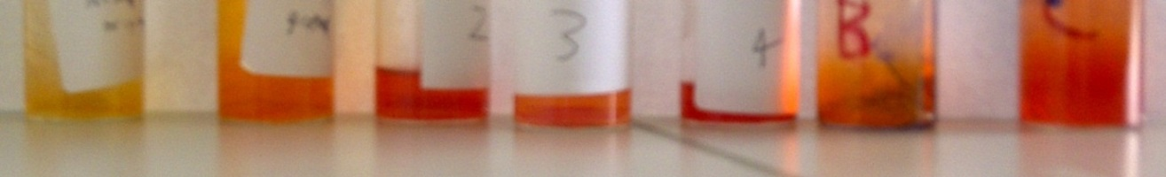

Figure 205 – Samples of HEMA film in aqueous solution with one drop of Methyl red added  
from left to right: TS1/18/1, TS1/43/1, TS1/43/2, TS1/43/3,  
TS1/43/4, TS1/51/2 and TS1/51/3

### RAFT Method

### Synthesis of RAFT-HEMA Films

Due to the unknown stability of 4-VPC to UV light films, IPN films containing a CTA anchor were polymerised thermally, with ACVA used as an initiator. Repeat work was carried out in which benzophenone was left out of the reaction mixture and, surprisingly, the film was not as stable, with the denser RAFT agent having an uneven distribution through the film, obvious by the variation in colour density between edges and centre of film. When benzophenone was re-introduced to the mixture the RAFT film was more stable.

Table 37 - Molar ratios of RAFT-EGDMA crosslinked hydrogel film mixtures

|  |  |  |  |  |  |  |  |  |
| --- | --- | --- | --- | --- | --- | --- | --- | --- |
|  | DMSO | HEMA | EGDMA | D117 | BP | TEHA | 4-VPC | ACVA |
| TS1/54/1 | 0.43 | 1.00 | 0.09 | 0.03 | 0.03 | 0.09 | 0.01 | - |
| TS1/56/1 | 0.43 | 1.00 | 0.09 | 0.03 | 0.03 | 0.09 | 0.01 | 0.01 |
| TS1/85/1 | 0.42 | 1.00 | 0.09 | - | - | 0.07 | 0.01 | 0.02 |
| TS1/86/1 | 0.31 | 1.00 | 0.09 | - | 0.03 | 0.07 | 0.01 | 0.02 |

Table 38 – Observation of RAFT film synthesis after 24 hours

|  |  |  |
| --- | --- | --- |
|  | Reaction Temp | Comments |
| TS1/54/1 | Cured at 60oC | No Film |
| TS1/56/1 | Cured at 60oC | Solid yellow film |
| TS1/85/1 | Cured at 60oC | Solid film with uneven distribution of 4-VPC |
| TS1/86/1 | Cured at 60oC | Solid yellow film |

The presence of CTA in the HEMA film appears to have a small potential effect on the sample. IR Analysis shows new peaks appearing at 2000 and 2170 cm-1, due to the presence of the RAFT agent (Figure 206). IEC Titrations show that at the second equivalence point TS1/56/1 has as a minor defect, which is not present in sample TS1/85/10 (Figure 207). However as that sample has an uneven distribution of 4-VPC (as evidenced by the uneven yellow tint across the film which is comparable to variations in film thickness and strength) it is difficult to be certain which is more reliable.

Figure 206 – IR Analysis of HEMA + RAFT-HEMA Films

Figure 207 – Raw titration data of RAFT-HEMA Films (second equivalence point)

### Grafting of Acrylic Acid onto RAFT-HEMA Film

Film TS1/56/1 was used for the first grafting attempt of acid onto RAFT films. For this the samples were immersed for 24 hours in an acrylic acid solution (see Table 39) before being placed back in the mould and heated at 60oC for a further 24 hours to give grafted HEMA films.

Table 39 – Reaction mixture of first grafting attempt of TS1/56/1

|  |  |  |  |  |  |  |
| --- | --- | --- | --- | --- | --- | --- |
| Film | TS1/54/1 / g | ACVA / g | AA / g | DMSO / g | ACE / g | AMMA / g |
| TS1/56/2 | 1 | 1.5 | 11.96 | 15.85 | - | - |
| TS1/56/3 | 1 | 0.75 | 5.98 | 9.925 | 0.06 | 0.07 |

Samples of the grafted films, along with the ungrafted films, were then tested via IR (Figure 208), EWC (Figure 209) and titrations (Figure 210) in order to determine the Ion Exchange Constant (Table 40).

Figure 208 – IR Analysis of sequentially grafted films

Figure 209 – Sw of TS1/50/1 (HEMA Film) compared with TS1/56/1-3 (RAFT HEMA Film)  
at varying pH

Figure 210 – Titration data of HEMA films

Table 40 – Ion Exchange Constants for HEMA films

|  |  |  |  |  |
| --- | --- | --- | --- | --- |
|  | TS1/18/2 | TS1/56/1 | TS1/56/2 | TS1/56/3 |
| IEC | 0.00 | -0.390 | 0.763 | 0.000 |

Sw of these samples appears inconclusive although TS1/56/2 (the grafted sample) was unstable at high pH. The Ion Exchange Constant data reveals that the HEMA Film gives the same IEC as a blank K2CO3 titration, so there were no acid groups on this film. The RAFT film (TS1/56/1) gives a negative IEC, potentially due to the sulphur group of the RAFT agent. The grafted film (TS1/56/2) shows a positive IEC whilst the film grafted in the presence of labels (TS1/56/3) is neutral, suggesting that potentially the RAFT agent and the AA cancel each other out.

### Successive Acrylic Acid Grafting

A second RAFT-HEMA film (TS1/85/10) was split between two acrylic acid solutions (Table 41) one with and one without fluorescence labels ACE and AMMA. Sections of the film were immersed for 24 hours, then removed from mixture and heated for a further 24 hours at 60oC. These films were then placed back in the reaction mixture for a further 24 hours, heated again, and then this process was repeated a third time, to give three successive iterations of grafting (Table 42).

Table 41 – Acrylic Acid Solutions for Grafting of TS1/85 films

|  |  |  |  |  |
| --- | --- | --- | --- | --- |
|  | ACVA | AA | ACE | AMMA |
| AA Mixture | 0.1 | 3.595 | - | - |
| Labelled Mixture | 0.1 | 3.595 | 0.1 | 0.1 |

Table 42 – Repeated grafting reactions of TS1/85 RAFT-HEMA films

|  |  |  |  |  |
| --- | --- | --- | --- | --- |
| Film | Previous Film | Mixture | Weight / g | Yield / g |
| TS1/85/11 | TS1/85/10 | No Labels | 3.3595 | 3.292 |
| TS1/85/12 | TS1/85/10 | ACE + AMMA | 2.7649 | 2.5906 |
| TS1/85/13 | TS1/85/11 | No Labels | 1.3206 | 1.542 |
| TS1/85/14 | TS1/85/12 | ACE + AMMA | 1.1497 | 1.2803 |
| TS1/85/15 | TS1/85/13 | No Labels | 0.7972 | 0.6322 |
| TS1/85/16 | TS1/85/14 | ACE + AMMA | 0.7872 | 0.6796 |

Films TS1/85/11-16 were then analysed by FTIR (Figure 211), Sw (Figure 212), methyl red indactor (Figure 213) and acid titrations (Figure 214, Figure 215). The FTIR and Sw data is inconclusive although the films with sequential acid grafting films were unstable at high pH. Methyl red indicator shows all grafted films contained acid content. From the titrations IEC values were calculated (Table 43) which showed that all the films contained significant acid content although there was no clear increase from sequential grafting.

Figure 211 – FTIR Analysis of Sequentially grafted RAFT-HEMA Films

Figure 212 – Sw of sequentially grafted RAFT-HEMA films TS1/85/11-17

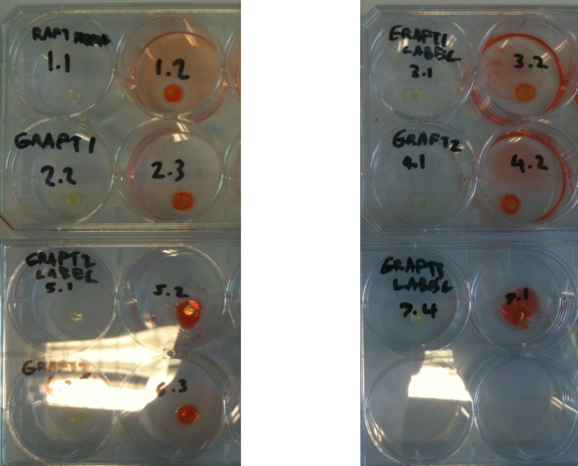

Figure 213 – Methyl red indicator test of TS1/85/10,11,12,13 (left) and 14,15,16 (right)  
each sample has one untreated (left) and one treated with indicator (right).

Figure 214 – Raw Titration data for sequentially grafted films TS1/85/11,13,16

Figure 215 - Raw Titration data for sequentially grafted films TS1/85/12,14,17

Table 43 – Ion Exchange Constants of Sequentially Grafted RAFT-HEMA Films

|  |  |  |  |  |  |  |  |
| --- | --- | --- | --- | --- | --- | --- | --- |
| TS1/85/ | 10 | 11 | 12 | 13 | 14 | 15 | 16 |
| IEC | 0 | 0.372 | 0.762 | 0.6842 | 0.411 | 0.397 | 1.23 |

### Fluorescence of Grafted Labels

A test was carried out to try and detect the presence of any fluorescent label in the polymer film. A sample of films TS1/85/15 (no label loading) and TS1/85/16 (ACE and AMMA loading) was mounted onto a metal plate at 45o to the excitation beam and the laser, and studied via steady state spectroscopy to detect the presence of labels. The sample was excited at 295 nm and greater noise could be observed in the emission spectra for the sample loaded with label than that on the sample loaded only with acrylic acid (Figure 216).

Figure 216 – Emission spectra for films excited at 295 nm

This emission spectra show very low levels of light intensity coming from the sample. This may be due to the fact that a film does not scatter light as efficiently as a label dissolved in a dilute solution or simply an indication that there is very low loading of labels in the film. This is by no means a conclusive result but it does suggest low levels of fluorescent labels are capable of being placed on a solid surface via this method.

### Summary

The RAFT group clearly works well as an anchoring point from which to attach acrylic acid chains. Swelling data, which is of extreme importance in the characterisation of hydrogels, has offered little clarification as the process is unable to distinguish between these two extremely hydrophilic polymers.

The instability of grafted polymers at high pH is due to extreme swelling causing (bursting) of the films.

Titration data is much clearer and gives some idea as to the acid content of these films. Much further investigation is required to distinguish the character of the fluorescence occurring within these membranes.

## Poly(HEMA-co-Acrylic Acid) Conetworks

### Introduction

Successive grafting attempts have so far shown that it is possible to put acrylic acid functionality on the film surface, as the acid’s presence can be detected via pH testing and IEC titrations. It should be possible to compare these grafted co-networks with random copolymer networks, where the acrylic acid is directly part of the PCN film.

### PCN Synthesis

A range of poly(HEMA-co-AA) copolymer network films were made where the ratio of acrylic acid to HEMA was varied, starting with no acid content and reaching a 1 : 0.7 HEMA : AA ratio. The molar ratio of reactants are shown in Table 44. All films were injected into moulds and reacted at 60oC in a vacuum oven for 24 hours.

Table 44 – Molar Ratio of HEMA-*co*-AA IPN Film Synthesis

|  |  |  |  |  |  |  |  |  |  |
| --- | --- | --- | --- | --- | --- | --- | --- | --- | --- |
|  | HEMA | AA | DMSO | EGDMA | BP | TEHA | RAFT | ACVA | Results |
| TS1/114/1 | 1.00 | 0.00 | 0.53 | 0.14 | 0.03 | 0.14 | 0.003 | 0.01 | Yellow Film |
| TS1/114/2 | 1.00 | 0.06 | 0.69 | 0.19 | 0.04 | 0.19 | 0.003 | 0.02 | Yellow Film |
| TS1/114/3 | 1.00 | 0.11 | 0.72 | 0.20 | 0.04 | 0.20 | 0.004 | 0.02 | Yellow Film |
| TS1/114/4 | 1.00 | 0.19 | 0.80 | 0.22 | 0.05 | 0.22 | 0.004 | 0.02 | Yellow Film |
| TS1/114/5 | 1.00 | 0.27 | 0.86 | 0.23 | 0.05 | 0.23 | 0.004 | 0.02 | No Film |
| TS1/114/6 | 1.00 | 0.54 | 0.93 | 0.25 | 0.05 | 0.25 | 0.005 | 0.02 | No Film |
| TS1/114/7 | 1.00 | 0.72 | 0.88 | 0.24 | 0.05 | 0.24 | 0.004 | 0.002 | No Film |

From this test we can observe that increasing the molar ratio of acrylic acid : HEMA above 0.27 : 1 results in no film formation, which is expected as the grafting experiments had shown the crosslinker EGDMA was weakened in the presence of increased acid content.

These samples were analysed via an IEC titration (Figure 217), and from these titrations IEC were calculated (Table 45). These show that TS1/114/1 with no acid content gives a negative IEC, due to the presence of the RAFT agent, whilst with increasing acid content the IEC increases proportionally. FTIR analysis of the dry film showed little difference aside from a gradual diminishing of the 2500 cm-1 peak as the ratio of acrylic acid was increased, and ‘very’ small peaks forming at 2240 and 1950 cm-1 (Figure 218).

Figure 217 - Raw Titration data for sequentially grafted films TS1/114/1,2,3 and 4

Table 45 – Ion Exchange Constants of HEMA-co-Acrylic acid RAFT Films

|  |  |  |  |  |
| --- | --- | --- | --- | --- |
| TS1/114/ | 1 | 2 | 3 | 4 |
| IEC | -1.099 | 0.262 | 0.798 | 1.762 |

Figure 218 – FTIR of HEMA : AA Copolymer films

The four successfully developed films were tested at low, medium and high pH to study their water absorbance in response to pH. The films with greater acid content were unstable at high pH and fragmented, preventing a swelling weight from being taken (Figure 219).

Figure 219 – Swelling % of films at low, medium and high pH  
(Error bars are std. deviation)

## PAM Absorption

As fluorescence studies will require more work to increase loading onto hydrogel films a test was carried out to see if the swelling of low pH IPN films will be affected by the presence of poly(acrylamide) in solution. If grafted poly(acrylic acid) chains can form IPC complexes with PAM and absorb it onto the film surface it should result in a net increase in the weight of the film (Figure 220).

Sample TS1/114/1 poly(HEMA-EGDMA) was used as a control and no net change was observed by the film to the presence of PAM. TS1/114/2-4 are conetworks containing increasing levels of AA comonomer and exhibit interesting behaviours. Sample TS1/114/2 and TS1/114/3 show a potential decrease in swelling in the presence of PAM whilst TS1/114/4 shows no loss and a potential gain. This suggests that acrylic acid monomers, dispersed along the chain, are not capable of forming IPC with solution polymers. TS1/56/2 however, with grafted linear PAA chains on the film surface, show a slight increase in swelling when exposed to PAM, suggesting the film is drawing polymer from solution and complexing to it on the film surface.

Figure 220 – Sw of IPN films in low pH solution with and without  
the presence of 1 wt% PAM (error bars are std. error)

With further work and an increased acrylic acid loading this could potentially be an alternative (and cheaper) viable method of detecting poly(acrylamide) in solution.

# Conclusions

## Chapter by Chapter Breakdown

Chapter 1 provides a broad overview of fluorescence labelling techniques used to study stimuli responsive polymers. It also details the large-scale usage of poly(acrylamide) in industry and demonstrates that there is no viable detection method for the polymer in fresh water systems using conventional techniques. It is proposed that due to the phenomenon of interpolymer complexation between poly(acrylic acid) and poly(acrylamide) the former could be utilised as a polymer probe in industrial applications.

Chapter 2 details a summary of chemical synthesis procedures used to prepare both RAFT agents, fluorescence labels and polymers of varying molecular weights. RAFT agents were utilised to control the polymerisation and their effect was studied via gel permeation chromatography. It was found that the best way to find accurate readings of acidic polymers was to methylate them to ensure solubility in THF.

Chapter 3 presents the study of chosen fluorescence markers acenaphthene and anthracene, which have identical aromatic structures to the markers ACE and AMMA when covalently bound to polymers. The labels were studied to find their adsorption coefficient, excitation/emission spectra, fluorescence excited state lifetime and anisotropic correlation time.

Chapter 4 studies how these fluorescence labels behave when covalently attached to poly(acrylic acid) and poly(acrylamide). Via the techniques outlined in chapter 3 the stimuli-responsive nature of poly(acrylic acid) can be seen as the polymer responds to pH whilst poly(acrylamide) is comparatively inert.

Chapter 5 studies how the varying molecular weights of poly(acrylic acid) polymers prepared in Chapter 2 affects the excited state lifetime and correlation time of the polymers. It was shown that polymers below a critical molecular weight (approximately 17 kDa) do not undergo a conformational change with response to pH. This was previously undocumented in the literature.

Chapter 6 presents how the poly(acrylic acid) fluorescence probes respond to interpolymer complex formation. Doubly labelled polymers containing both ACE and AMMA can give a concentration based response due to non-radiative energy transfer between the two labels increasing as complex formation occurs. Meanwhile the singly labelled polymers show an extreme response via correlation time as complex formation occurs; one that is reversible and concentration dependent. Comparing the two techniques, the singly labelled polymer offers a better detection technique although there are drawbacks in the expensive equipment required.

Chapter 7 concerns field research undertaken using industrial polymers contributed by SNF (UK) Ltd, where the singly labelled poly(acrylic acid) probe was tested in impure water sources. All tests show a satisfactory response where with careful control of the pH a positive reading could be found for both neutral, anionic and cationic polymers.

Chapter 8 tested the PAA probe forming interpolymer complexes with a range of other polymers including poly(N-isopropyl acrylamide), poly(dimethyl acrylamide), poly(vinyl alcohol) and poly(ethylene alcohol). The increase in correlation time and the critical pH required for pH formation differed from polymer to polymer but in all cases tested where interpolymer complexation is known to occur, an increase in correlation time was observed.

Chapter 9 shows a sequence of experiments designed to create a hydrogel scaffold on which PAA could be loaded to form a solid-state detection system. Grafting of the PAA was shown to be partially successful; however it resulted in the instability of the ethylene-glycol dimethacrylate crosslinker, which led to decomposition of the hydrogel. Initial tests suggested poly(acrylamide) may be binding to the grafted poly(acrylic acid) chains on the hydrogel surface but more work is required to investigate this further.

## Overview

This work clearly outlines a brand new method of detecting poly(acrylamide) (and other receptive polybases) in dilute aqueous solutions using fluorescen., ce time resolved anisotropy to detect interpolymer complex formation. The study1 involves the reversible interaction between two receptive polymer chains at low pH and indicates how complex formation restricts the mobility of a fluorescence label bound to the polymer backbone (Figure 221).

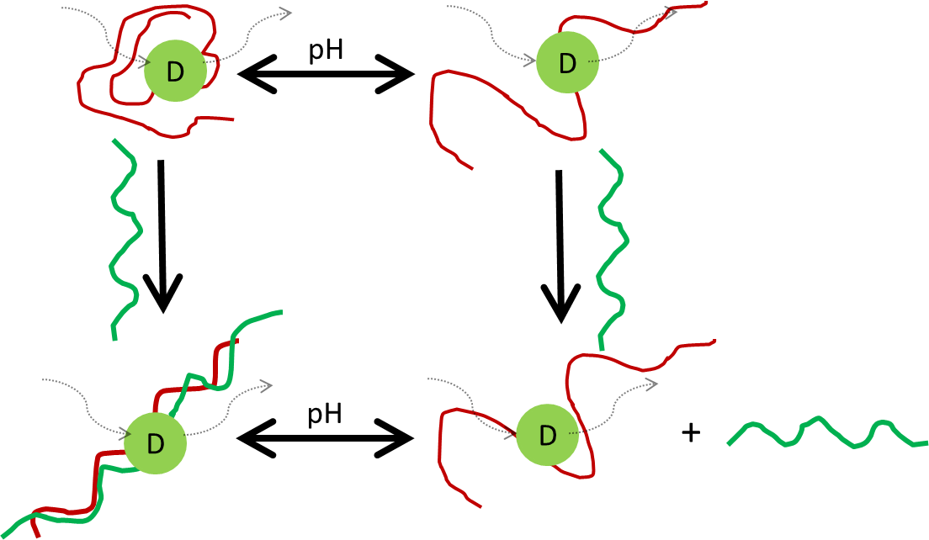

Figure 221 – Addition of polyacrylamide (green) chains to labelled polyacrylic acid (red) polymers should lead to a variation in the response of covalently bound luminescent labels

Further work may be necessary to prepare this technique for use in wider industry and several key priorities can be identified for further work. It has been indicated that the molecular weight of polymers involved in complexation is key to the resultant restriction of rotation. So far most of the work carried out utilises an uncontrolled free radical PAA-ACE copolymer of fixed Mn. A study could be carried out on the affect varying the Mn of PAA will have on IPC formation and indeed it would be important to note if there is a low molecular weight limit below which PAA will not complex. Whilst this has been explored turbidometrically this new technique may offer greater sensitivity at low concentrations and molecular weights, detecting polymer-polymer interactions too weak to have an effect on solution viscosity.

Additionally more compatible polybases should be tested to see the full applicability of this technique beyond the scope of water based flocculants. Testing shows it is compatible with a range of water impurities, providing the sample is clear enough to permit the passage of light, however it has not been tested with biologically active samples that could have other interactions with the PAA chains.

This research has also further explored the precise control over polymerisation reactions that can be achieved by utilising linear chain transfer agents. This research has yielded important new information about the nature of polyelectrolytes. The theory outlined in chapter five utilises no polymer specific term save the size of the monomer and so it can be assumed similar observations could be made of other polymer architectures such as poly(methacrylic acid).

The work carried out on interpenetrating polymer networks is far less conclusive. IEC titrations suggest that Ce(IV) grafting adheres far more acid content onto the film surface than the RAFT anchoring method, although the chain lengths of these acid groups is questionable. As this trend is not repeated via swelling measurements and the acid is not detectible via other means it is possible only short chains are being formed, which will be unsuitable for IPC formation. It is also apparent that the crosslinker EGDMA is sensitive to the presence of acid and as such is unsuitable for this purpose, despite the advantages it has offered over DVB in terms of film flexibility and strength. Other crosslinkers should be sought which will allow for more durable films which will permit greater loading of acid functionality.

# List of Figures

Figure 1 – Poly(acrylamide) is formed from a continuous chain of acrylamide monomers 12

Figure 2 – Poly(acrylic acid) is a smart anionic homopolymer 14

Figure 3 – Propagation of vinyl monomer through radical initiation 15

Figure 4 – Generic RAFT agent structure is a weak single bond (S-R) and a reactive double bond (C=S) [64] 16

Figure 5 – RAFT polymerisation mechanism[65] 17

Figure 6 – Representation of a RAFT polymerisation with α and ω ends of resulting polymer[64] 17

Figure 7 – RAFT agents 4-vinylbenzene 1H-pyrrole-1-carbodothioate (4-VCP) and benzyl 1H-pyrrole-1-carbodothioate (BPC) 18

Figure 8 – RAFT agents 2-[[butylsulfanyl)-carbonothioyl]sulfanyl}propanoic acid (BSCSP) and 2-cyanopropan-2-yl-benzodithioate (CPB) 18

Figure 9 – Absorption and emission spectra of anthracene and energy levels of transitions. 0, 1 and 2 refer to vibrational energy levels[70] 20

Figure 10 – Fluorescence characteristics of an aromatic label (A) bound to a polymer chain are dependent on the conformation of that polymer chain 21

Figure 11 – A schematic diagram of an absorption spectrometer. An excitation source (such as a deuterium/tungsten lamp) continuously excites the sample with light of intensity I0 and the intensity after excitation It is recorded. 22

Figure 12 - A schematic diagram of a steady state spectrometer. A continuous excitation source such (such as a xenon lamp) excites the sample at one wavelength (λex) and then a detector monitors the light emitted from the sample (λem) 23

Figure 13 – A schematic diagram of a fluorescence lifetime spectrometer. 24

Figure 14 – Schematic diagram for measurement of fluorescence anisotropy 25

Figure 15 - A schematic diagram of a fluorescence lifetime spectrometer. 27

Figure 16 – NRET can occur between a donor (D) and acceptor (A) label across the same polymer chain when the polymer’s conformation brings them into close proximity 28

Figure 17 – Fluorescent Labels acenaphthylene (left) and 9-anythrylmethylmethacrylate (right) 29

Figure 18 – Baranovsky’s rigid ‘ladder’ system with ‘loop’ defects 32

Figure 19 - Poly(N-isopropylacrylamide) is a temperature responsive smart polymer 35

Figure 20 – Poly(ethylene oxide) (also known as poly(ethylene glycol) (PEG) or poly(oxyethylene) (POE) is a polyether 36

Figure 21 - Baranovsky's proposed structure of interacting polymers from uninterrupted linear sequences of bonds in polycomplexes 37

Figure 22 - Poly(dimethylacrylamide) is a homopolymer also capable of forming IPCs with poly(acrylic acid) 37

Figure 23 – Poly(vinyl alcohol) is a homopolymer of vinyl alcohol monomers 37

Figure 24 – Poly(N-vinylpyrrolidone) is a homopolymer of N-vinylpyrrolidone monomers 38

Figure 25 – IPC formation between PAA and PVP with regards to equilibrium of dissociation of PAA 38

Figure 26 – Poly(diallyldimethylammonium chloride) is a common polymer used for water effluent treatment 39

Figure 27 – Poly(epichlorohydrin-co-dimethylamine) is one of the most common commercial polyamine polymers 39

Figure 28 - Synthesis of AMMA Label from methacroyl chloride and 9-anthracenemethanol 47

Figure 29 – Synthesis of benzyl-1-pyrrolecarbodithioate from pyrrole and benzyl bromide 48

Figure 30 – Synthesis of 2-[[butylsulfanyl)-carbonothioyl]sulfanyl}propanoic acid from butanethiol and 2-bromopropane 49

Figure 31 - Polymerisation of poly(acrylamide) 50

Figure 32 - Polymerisation of poly(acrylamide-*co*-ACE) 50

Figure 33 – Polymerisation of poly(acrylamide-*co*-AMMA) 51

Figure 34 - Polymerisation of poly(acrylic acid) 52

Figure 35 – Polymerisation of poly(acrylic acid-*co*-ACE) 52

Figure 36 – Polymerisation of poly(acrylic acid-*co*-AMMA) 52

Figure 37 – Polymerisation of poly(acrylic acid-*co*-ACE-*co*-AMMA) 53

Figure 38 – RAFT polymerisation of poly(acrylic acid) 54

Figure 39 – RAFT polymerisation of poly(acrylic acid-co-ACE) 54

Figure 40 – Methylation of acid polymers by trimethylsilyldiazomethane 57

Figure 41 – A typical GPC system involves solvent being pumped at constant flow through a column. Multiple detectors can be placed on the end of the line. 58

Figure 42 – Polymer elution from GPC, divided into segments (or moments). Elution time is inversely is proportional to molecular mass. 59

Figure 43 – Molecular mass averages of a molecular weight distribution (assuming a traditional Gaussian distribution sample) 59

Figure 44 – Detector response to three Easivial standards, each containing four known molecular weight polymers 61

Figure 45 – Molecular Weight Distribution of polyacrylamide polymers 62

Figure 46 - Detector response to five PAA standards, each containing two known Mw PAA polymers. Peaks at 27 minutes signify flow rate markers. 63

Figure 47 – Raw data from two repeats of a P(AA-co-ACE) sample (TS1/37/1) 64

Figure 48 – Molecular Weight Distribution of P(AA-*co*-ACE) (TS1/37/1) and P(AA-*co*-AMMA) (TS1/37/2) polymers 64

Figure 49 – Molecular weight distribution of P(AA-*co*-ACE-*co*-AMMA) sample (TS1/68/1) showing ACE (UV 295 nm) and AMMA (UV 370 nm) distribution 65

Figure 50 – Raw chromatogram data of peaks from RAFT-PAA (TS1/60/1) and RAFT-PAA-ACE (TS1/60/2) samples 66

Figure 51 – Molecular weight distributions of RAFT-PAA (TS1/60/1) and RAFT-PAA-ACE (TS1/60/2) samples 66

Figure 52 – Molecular weight distribution of PAA polymers on THF column 68

Figure 53 – *M*n of polymers with CTA 1 (with and without ACE) at various CTA:AA feed ratios 70

Figure 54 – *M*n of polymers with CTA 1, 2 and 3 (with and without ACE) at various CTA : AA feed ratios 70

Figure 55 – Acenapthene and Anthracene have identical aromatic structure to ACE and AMMA 72

Figure 56 - Decreasing absorbance of acenapthene peaks as concentration is reduced from 1E-4 to 5E-6 Molar 72

Figure 57 - Decreasing absorbance of anthracene peaks as concentration is reduced from 9E-4 to 1E-7 Molar 73

Figure 58 – Linear correlation of 289 nm peak of acenapthene at low concentrations 73

Figure 59 – Linear correlation of 289 nm peak of anthracene at low concentrations 74

Figure 60 – Acenapthene peak absorbances at 289 nm are no longer linear in concentrations exceeding 10-4 M 74

Figure 61 - Anthracene peak absorbance at 256 nm are no longer linear in concentrations exceeding 1E-4 M 74

Figure 62 – Excitation / Emission spectra of ACE label in dioxane (10-6 M) 75

Figure 63 - Excitation / Emission spectra of AMMA label in dioxane (10-6 M) 75

Figure 64 – Variation in prompt scattering profile with respect to instrumental time delays 76

Figure 65 - Variation in prompt scattering profile with respect to instrumental time delays 77

Figure 66 – Raw excited state lifetime of ACE in dioxane (10-4 M) 78

Figure 67 – Excited state lifetime of ACE in dioxane with single exponential fit (10-4 M) 79

Figure 68 – residuals of single exponential fit to ACE in dioxane (10-4 M) 79

Figure 69 – Raw data from parallel and crossed polariser 2 positions with fixed horizontal position of polariser 1 (10-4 M ACE in dioxane) 80

Figure 70 – Raw data output of a correlation time measurement recording crossed and parallel polarised spectra of ACE in dioxane (10-4 M) 81

Figure 71 – Sum and difference fits to ACE in dioxane (10-4 M) 81

Figure 72 – Anisotropy fit of ACE in dioxane (10-4 M) 82

Figure 73 - UV absorbance plots of poly(acrylic acid) polymers 83

Figure 74 - UV absorbance plots of poly(acrylamide) polymers 83

Figure 75 - Emission and Excitation Spectra of ACE labelled PAM solutions 85

Figure 76 - Emission and excitation spectra of singly labelled PAA polymers 86

Figure 77 – Emission/Excitation intensities of ACE-Labelled PAA polymers varying with pH 86

Figure 78 – Emission/Excitation intensities of AMMA-Labelled PAA polymers varying with pH 87

Figure 79 – Emission spectra of a doubly labelled PAA sample excited at 295 nm 88

Figure 80 – Emission spectra of a doubly labelled PAA sample excited at 340 nm wavelength 88

Figure 81 – Measure of Energy Transfer occurring across doubly labelled PAA samples with pH 89

Figure 82 – Doubly labelled PAA sample at pH 3.78 with varying slit widths of laser and detector 89

Figure 83 – A contour map of a steady state excitation/emission spectrum using ultrapure water as a blank solvent, with contours at regular integer’s from 3E3 to 2E5 90

Figure 84 – A 3D excitation/emission spectrum of PAA-ACE with contours every half integer from 2E3 to 4.6E4 91

Figure 85 - A 3D excitation/emission spectrum of PAA-AMMA with contours every half integer from 1.5E3 to 1E4 91

Figure 86 – A 3D excitation/emission spectrum of PAA-ACE-AMMA (1.3 mg ml-1) with contours every half integer from 2E3 to 4E5 at pH 3.44. The red circle indicates peaks caused by indirect AMMA emission due to NRET. 92

Figure 87 – A 3D excitation/emission spectru, of PAA-ACE-AMMA (1.3 mg ml-1) with contours every half integer from 3E3 to 1E6 at pH 7.80. The red circle denotes the absence of indirect AMMA emission at high pH. 93

Figure 88 – Raw excited state lifetime data of a PAA-ACE sample 94

Figure 89 – Fluorescence decay on logarithmic scale with single and double fits applied using a PAA-ACE sample 94

Figure 90 – Residuals from the single and double fit to a fluorescence lifetime decay 95

Figure 91 – Lifetime of fluorescence decay of ACE-PAA at pH 2 and pH 6, sample at 25oC and 0.42 mg ml-1 95

Figure 92 – Fluorescence lifetime of PAA-ACE samples, 0.4 mg ml-1 at room temperature error bars at 95% confidence intervals 96

Figure 93 – Fluorescence lifetime of labelled poly(acrylamide) with pH change at several temperatures 97

Figure 94 - Fluorescence lifetime of labelled poly(acrylamide) with changing temperature at several pHs 97

Figure 95 - Arrhenius Plot of Fluorescence data for ACE on Polyacrylamide at pH 9 98

Figure 96 – Raw data output of a correlation time measurement recording crossed and parallel polarised spectra of a 0.21 mg ml-1 PAA-ACE sample at pH 1.70 98

Figure 97 – Logarithmic view of crossed and parallel output for 0.21 mg ml-1 PAA-ACE sample at pH 1.70 99

Figure 98 – Anisotropy of ACE-PAA sample at pH 1.70, and two opposing experimental fits to the data 100

Figure 99 - Residuals from fits to fluorescence anisotropy decay with A free and set to zero 100

Figure 100 – Raw anisotropy and single fits from PAA-ACE at high and low pH 101

Figure 101 - Raw anisotropy and single fits from PAM-ACE at high and low pH 101

Figure 102 – Correlation times of ACE labelled PAA and PAM recorded at 25oC 102

Figure 103 - Raw anisotropy and single fits from PAA-ACE at high and low temperatures 102

Figure 104 - Raw anisotropy and single fits from PAM-ACE at high and low temperatures 103

Figure 105 – Correlation times of ACE labelled low pH PAA and PAM at various temperatures 104

Figure 106 – Absorbance of linear RAFT polymers 105

Figure 107 – Excitation spectra for emission of PAA-ACE polymers emission at 340 nm 106

Figure 108 - Emission spectra for emission of PAA-ACE polymers emission at 295 nm 106

Figure 109 – Excitation and emission of controlled PAA polymers using CTA (2) 107

Figure 110 - Excitation and emission of controlled PAA polymers using CTA (3) 107

Figure 111 – Complete lifetime data as a function of pH. Closed symbols are for molar masses of PAA where Mn > 16:5 kDa, and thus exhibit a pH-dependent coil-to-globule transition. Open symbols represent polymers that do not exhibit a pH dependent 𝜏. 108

Figure 112 – Raw fluorescent lifetime of P(AA-co-ACE) at pH 3 and 9 109

Figure 113 – Single (black line) and double (dashed line) exponential fits of fluorescence decay data from Figure 112. Data includes 6.6 kDa sample at low pH (a), at high pH (b), and the 63.2 kDa sample at low pH (c) and high pH (d). Double exponential fits provide almost perfect match to data whilst 110

Figure 114 – Correlation time of controlled PAA-ACE polymers with varying presence of CTA **(1)** 111

Figure 115 – Raw anisotropy of P(AA-co-ACE) at low and high pH 112

Figure 116 – Single fit of anisotropy of P(AA-co-ACE) at low and high pH 113

Figure 117 – Impulse reconvolution correlation times of P(AA-co-ACE) 114

Figure 118 – Mixtures of PAA and PAM (0.2 mg ml-1 each) at pH 2 and 7 117

Figure 119 – Excitation spectra for PAA-ACE emission at 340 nm (0.27 mg ml-1) with varying PAM concentration 118

Figure 120 – Emission spectra of PAA-ACE excited at 295 nm (0.27 mg ml-1) with varying PAM concentration 118

Figure 121 – Emission spectra of a mixture between two singly labelled polymers and a comparison with PAA-ACE (1 mg ml-1) 119

Figure 122 - Emission / Excitation spectra of a mixture between two singly labelled polymers and a comparison with PAM-ACE (1 mg ml-1) 119

Figure 123 – pH dependent complexation between polymers could lead to energy transfer between labels across polymer chains 120

Figure 124 – Emission spectra of doubly labelled PAA polymer (0.23 mg ml-1) with varying concentrations of unlabelled PAM 121

Figure 125 – Energy transfer occurring between PAA-ACE-AMMA and PAM 121

Figure 126 – Relative emission spectra from PAA-ACE-AMMA excitation at 295nm with and without presence of PAM 122

Figure 127 – Energy transfer from PAA-ACE-AMMA + PAM 122

Figure 128 - Relative emission spectra from PAA-ACE-AMMA and 72 % at varying pH 123

Figure 129 – Fluorescent decay of PAA-ACE (0.5 mg ml-1) alone with PAM and with PAM-AMMA (0.6 mg ml-1) in solution 123

Figure 130 - Fluorescent decay of uncomplexed PAA-ACE (0.5 mg ml-1) alone with PAM and with PAM-AMMA (0.6 mg ml-1) in solution 124

Figure 131 – Low pH Fluorescent decay of PAA-ACE (0.3 mg ml-1) alone with PAM and with PAM-AMMA (0.3 mg ml-1) in solution 124

Figure 132 – Fluorescence lifetime tail fit of PAA-ACE (0.5 mg ml-1) samples alone and with PAM and PAM-AMMA (0.6 mg ml-1) in solution 125

Figure 133 - Fluorescence lifetime of PAA-ACE (0.5 mg ml-1) samples alone and with PAM and PAM-AMMA (0.6 mg ml-1) in solution 125

Figure 134 – Anisotropy profiles of PAA-ACE (0.32 mg ml-1) alone and withPAM (0.24 mg ml-1) at pH 3 and 9 126

Figure 135 – Anisotropy fit of PAM-ACE (0.13 mg ml-1) alone and with PAA (0.13 mg ml-1) solution at pH 3.31 126

Figure 136 – Correlation times of polymer mixtures at a range of pH, calculated by fixing A to zero 127

Figure 137 – Raw data of concentration dependence of PAA-PAM IPC formation PAM concentration 0 ppm (red), 2 ppm (green), 21 ppm (orange) and 105 ppm (blue) 128

Figure 138 – Single fit (A = zero) functions of anisotropy data from Figure 137 128

Figure 139 - Concentration dependence of PAA-PAM IPC formation 129

Figure 140 – Correlation times of RAFT-PAA-ACE – PAM mixtures 129

Figure 141 – Idealised homogenous complex formation following Baranovsky structure (Figure 18) 130

Figure 142 – Loop defects on a probe polymer 131

Figure 143 – Mixture of complexed and uncomplexed probe polyacids 131

Figure 144 – Anionic and Cationic modifications to polyacrylamide 133

Figure 145 – Correlation time of SNF FloPam FA920 mixed with probe PAA-ACE 134

Figure 146 – Correlation times of PAA-ACE + FA920 mixtures at varying PAM concentration 134

Figure 147 - Correlation times of PAA-ACE + FA920 mixtures at varying PAM concentration 135

Figure 148 – Correlation time of SNF FloPam AN934 mixed with probe PAA-ACE 135

Figure 149 - Correlation time of SNF FloPam AN910 (1.12 ppm) mixed with probe PAA-ACE (2.5 ppm) 136

Figure 150 - Correlation time of PAA-ACE and cationic polyacrylamide mixtures 136

Figure 151 – Emission spectra from 295nm excitation for PAA-ACE : PAM sample 137

Figure 152 – Lower concentration limit of FO4115 by 0.113 mg ml-1 P(AA-co-ACE) 138

Figure 153 – PAA-ACE + FloPam FA920 complexing in Sheffield University tap water 140

Figure 154 - Sea water sample response to pH adjustment by NaOH addition (left pH 3, right pH 8) 140

Figure 155 – Correlation time of probe and FA920 samples in 0.1 Molar impurities 141

Figure 156 - Correlation time of probe and FloPam FA920 samples in magnesium sulphate 141

Figure 157 – Visual comparison between clear U. P. Water and Ewden River Water 142

Figure 158 – Correlation time of PAA-ACE in Ewden Water and Ewden Water spiked with FA920 142

Figure 159 – Turbidity (columns) and Floc Size (line) of Flash Mixing of 1 litre of Ewden Water with 40-80 ppm of FeSO4 143

Figure 160 – Comparison between reference beaker (L) and flocculated sample (R) 143

Figure 161 – Turbidity (columns) and floc size (line) of polymer augmented flocculation 144

Figure 162 – Images of the reaction vessels after ten minute settling period. Vessels from left to right: reference beaker, 5% anionic, 10% anionic, 15% anionic, 20% anionic, 10% cationic. 144

Figure 163 – Correlation time of Ewden water treated with AN910 and FO4190 at 0.5 ppm and 280 ppm 145

Figure 164 – Turbidity (columns) and Floc Size (line) of polymer treated Eccup Water 146

Figure 165 – Correlation time of flocculated Eccup water with varying polymer dosage 146

Figure 166 – Comparison of detection limits of PAM in laboratory test verses flocculated sample 147

Figure 167 – Visual comparison of soil aggregate water with 20 and 40 ppm flocculated sample 148

Figure 168 – Turbidity of raw and flocculated Whelton samples 148

Figure 169 - Correlation time of flocculated Whelton Aggregates with varying PAM dosage 150

Figure 170 – Raw fluorescence decays of sample in soil aggregate water 150

Figure 171 –Correlation time of FA920 / P(AA-co-ACE) sample calculated from varying sample size 151

Figure 172 – Proposed mode of PAA-PAM hydrogen bonding 153

Figure 173 – Absorbance of PNIPAM (1 mg ml-1) with varying temperature 154

Figure 174 – Correlation time of PAA (0.35 mg ml-1) and PNIPAM (0.43 mg ml-1) mixtures with varying pH 154

Figure 175 – Correlation times of PAA-ACE (160 ppm) with varying concentrations of PNIPAM 155

Figure 176 - Proposed mode of PAA-PEO hydrogen bonding 155

Figure 177 - Correlation time of PAA (0.4 mg ml-1) and PEO (4.4 mg ml-1) mixtures with varying pH 156

Figure 178 - Correlation times of PAA-ACE (200 ppm) with varying concentrations of PEO 156

Figure 179 - Proposed mode of PAA-PMAM hydrogen bonding 157

Figure 180 - Correlation time of PAA (0.21 mg ml-1) and PDMAM (0.33 mg ml-1) mixtures with varying pH 157

Figure 181 - Proposed mode of PAA-PVAl hydrogen bonding 158

Figure 182 – Correlation time of PAA (0.40 mg ml-1) and PVAl (0.90 mg ml-1) mixtures with varying pH 158

Figure 183 - Proposed mode of PAA-PVP hydrogen bonding 159

Figure 184 - Correlation time of PAA (0.15 mg ml-1) and PVP (0.50 mg ml-1) mixtures with varying pH 159

Figure 185 - Proposed mode of PAA-poly(dimethyl amine-co-epichlorohydrin) electrostatic bonding 160

Figure 186 - Correlation time of PAA (0.12 mg ml-1) and PDMA (0.61 mg ml-1) mixtures with varying pH 160

Figure 187 - Correlation times of PAA-ACE (19.3 ppm) – PDMA mixtures at varying pH 161

Figure 188 - Proposed mode of PAA-PDADMAC electrostatic bonding 162

Figure 189 – Correlation time of PAA (0.12 mg ml-1) and PDADMAC (6.75 mg ml-1) mixtures with varying pH 162

Figure 190 - Creation of a hydrogel network from a monomer and a crosslinking agent[158] 165

Figure 191 – PAA chains on HEMA backbone, via direct (CAN) radical polymerisation or specific (RAFT) attachment points 166

Figure 192 – Ceric Ammonium Nitrate reaction may lead to graft copolymerisation onto solid surface or homopolymerisation in solution 167

Figure 193 - Synthesis of 4-vinylbenzyl-1-pyrrolecarbodithioate from pyrrole and 4-vinylbenzyl bromide 169

Figure 194 – Synthesis of HEMA-DVB crosslinked hydrogel film 170

Figure 195 – Synthesis of HEMA-EGDM crosslinked hydrogel film 170

Figure 196 – Synthesis of HEMA-EGDMA Raft Bound crosslinked hydrogel film 171

Figure 197 – Mechanism of Ce(IV) initiated grafting of polyacrylic acid onto HEMA Film surface 171

Figure 198 – Mechanism of RAFT polymerisation onto the PCN 172

Figure 199 – Raw Titration data comparing TS1/18/2 and base solvent 175

Figure 200 - Raw Titration data of CAN grafted samples 177

Figure 201 – Swelling data of Grafted samples 177

Figure 202 – FTIR study of HEMA-EGDMA film 178

Figure 203 - Raw Titration data of CAN grafted samples 180

Figure 204 – Swelling measurements of CAN Grafted HEMA Films 180

Figure 205 – Samples of HEMA film in aqueous solution with one drop of Methyl red added from left to right: TS1/18/1, TS1/43/1, TS1/43/2, TS1/43/3, TS1/43/4, TS1/51/2 and TS1/51/3 181

Figure 206 – IR Analysis of HEMA + RAFT-HEMA Films 182

Figure 207 – Raw titration data of RAFT-HEMA Films (second equivalence point) 182

Figure 208 – IR Analysis of sequentially grafted films 183

Figure 209 – Sw of TS1/50/1 (HEMA Film) compared with TS1/56/1-3 (RAFT HEMA Film) at varying pH 184

Figure 210 – Titration data of HEMA films 184

Figure 211 – FTIR Analysis of Sequentially grafted RAFT-HEMA Films 186

Figure 212 – Sw of sequentially grafted RAFT-HEMA films TS1/85/11-17 186

Figure 213 – Methyl red indicator test of TS1/85/10,11,12,13 (left) and 14,15,16 (right) each sample has one untreated (left) and one treated with indicator (right). 186

Figure 214 – Raw Titration data for sequentially grafted films TS1/85/11,13,16 187

Figure 215 - Raw Titration data for sequentially grafted films TS1/85/12,14,17 187

Figure 216 – Emission spectra for films excited at 295 nm 188

Figure 217 - Raw Titration data for sequentially grafted films TS1/114/1,2,3 and 4 190

Figure 218 – FTIR of HEMA : AA Copolymer films 190

Figure 219 – Swelling % of films at low, medium and high pH (Error bars are std. deviation) 191

Figure 220 – Sw of IPN films in low pH solution with and without the presence of 1 wt% PAM (error bars are std. error) 192

Figure 221 – Addition of polyacrylamide (green) chains to labelled polyacrylic acid (red) polymers should lead to a variation in the response of covalently bound luminescent labels 195

# List of Equations

Equation 1 15

Equation 2 16

Equation 3 16

Equation 4 16

Equation 5 22

Equation 6 22

Equation 7 24

Equation 8 24

Equation 9 25

Equation 10 25

Equation 11 25

Equation 12 25

Equation 13 26

Equation 14 26

Equation 15 26

Equation 16 26

Equation 17 27

Equation 18 27

Equation 19 28

Equation 20 28

Equation 21 59

Equation 22 59

Equation 23 59

Equation 24 59

Equation 25 60

Equation 26 60

Equation 27 60

Equation 28 60

Equation 29 84

Equation 30 167

Equation 31 173

# List of Tables

Table 1 – Ionisation properties of PAM-PAA[26] 34

Table 2 – Molar ratios of monomers used in poly(acrylamide) reactions 51

Table 3 – Molar ratios of poly(acrylic acid) reactions 53

Table 4 – Molar ratios of RAFT poly(acrylic acid) reactions using CTA 1 55

Table 5 - Molar ratios of RAFT poly(acrylic acid) reactions using CTA **2** 56

Table 6 - Molar ratios of RAFT poly(acrylic acid) reactions using CTA **3** 56

Table 7 – Properties of Easivial Standards used to calibrate PL Gell Aq. GPC 61

Table 8 - Calculated specifications for polyacrylamide polymers 62

Table 9 - Properties of PAA Standards used to calibrate charged Aq. GPC 63

Table 10 - Calculated specifications for linear poly(acrylic acid) polymers 65

Table 11 - Calculated specifications for linear Labelled RAFT-Polyacrylic acid Polymers 67

Table 12 – THF GPC of non-RAFT polymers 68

Table 13 – THF GPC of RAFT PAA polymer using CTA (1) 69

Table 14 - THF GPC of RAFT PAA polymer using CTA (2) 71

Table 15 - THF GPC of RAFT PAA polymer using CTA (3) 71

Table 16 – Wt % loading of labels onto linear polymers produced 84

Table 17 – Example data of calculated lifetimes from Figure 92 95

Table 18 – Correlation time of PAA-ACE (TS1/37/1) and PAM-ACE (TS1/27/1) varying with temp and pH at 0.35 mg ml-1 100

Table 19 – Correlation time of PAA-ACE (TS1/37/1) and PAM-ACE (TS1/27/1) varying with temp and pH at 0.35 mg ml-1 103

Table 20 – Comparison of single and double exponential fits of RAFT-PAA-ACE polymers 109

Table 21 – Comparison of time resolved anisotropy decay by direct analysis of anisotropy function and impulse reconvolution of difference function 114

Table 22 – P values comparing three repeat sets of data for GPC data analysed using the Kolmogrov-Smirnov test. P values <0.005 are considered significant and labelled green whilst P values >0.005 are considered to have no significant difference. 115

Table 23 – Example data from Figure 136 127

Table 24 – SNF(UK)LTD supplied polymers tested for complexation with PAA-ACE probe 133

Table 25 – ICP analysis of water sources, all results in mg l-1 139

Table 26 – Correlation time of the probe in the presence of FloPam AN905 flocculated Eccup water. 147

Table 27 - ICP analysis of Quarry flocculated samples (by ppm) compared to raw effluent 149

Table 28 – Molar ratios of DVB crosslinked hydrogel film mixtures 174

Table 29 – Molar ratios of EGDMA crosslinked hydrogel film mixtures 174

Table 30 – Reaction mixture for initial grafting reactions onto hydrogel film TS1/18/2 176

Table 31 – Ion Exchange Constants for HEMA films 177

Table 32 - P values of Mann-Whitney comparison between low, medium and high pH swelling values showing significant difference (P < 0.05) between populations 178

Table 33 – Ce (IV) polymerisation in alternate solutions 179

Table 34 – Ce (IV) grafting onto hydrogel film TS1/50/1 179

Table 35 – Observation of Ce (IV) grafting onto hydrogel film TS1/50/1 179

Table 36 – Ion Exchange Constants for CAN grafted HEMA films 180

Table 37 - Molar ratios of RAFT-EGDMA crosslinked hydrogel film mixtures 181

Table 38 – Observation of RAFT film synthesis after 24 hours 181

Table 39 – Reaction mixture of first grafting attempt of TS1/56/1 183

Table 40 – Ion Exchange Constants for HEMA films 184

Table 41 – Acrylic Acid Solutions for Grafting of TS1/85 films 185

Table 42 – Repeated grafting reactions of TS1/85 RAFT-HEMA films 185

Table 43 – Ion Exchange Constants of Sequentially Grafted RAFT-HEMA Films 187

Table 44 – Molar Ratio of HEMA-*co*-AA IPN Film Synthesis 189

Table 45 – Ion Exchange Constants of HEMA-co-Acrylic acid RAFT Films 190

# References

1. Bolto, B. and J. Gregory, *Organic polyelectrolytes in water treatment.* Water Research, 2007. **41**(11): p. 2301-2324.

2. European Commission – Joint Research Centre, I.f.H.a.C.P., European Chemicals Bureau (ECB), *European Union Risk Assessment Report: Acrylamide*. 2002, Office For Official Publications of the European Communities. p. 17-18.

3. Rosiak, J., K. Burozak, and W. Pȩkala, *Polyacrylamide hydrogels as sustained release drug delivery dressing materials.* Radiation Physics and Chemistry (1977), 1983. **22**(3–5): p. 907-915.

4. Zangmeister, R.A. and M.J. Tarlov, *UV Graft Polymerization of Polyacrylamide Hydrogel Plugs in Microfluidic Channels.* Langmuir, 2003. **19**(17): p. 6901-6904.

5. Schägger, H. and G. von Jagow, *Tricine-sodium dodecyl sulfate-polyacrylamide gel electrophoresis for the separation of proteins in the range from 1 to 100 kDa.* Analytical Biochemistry, 1987. **166**(2): p. 368-379.

6. Lu, S., R. Liu, and X. Sun, *A study on the synthesis and application of an inverse emulsion of amphoteric polyacrylamide as a retention aid in papermaking.* Journal of Applied Polymer Science, 2002. **84**(2): p. 343-350.

7. Sokker, H.H., et al., *Adsorption of crude oil from aqueous solution by hydrogel of chitosan based polyacrylamide prepared by radiation induced graft polymerization.* Journal of Hazardous Materials, 2011. **190**(1–3): p. 359-365.

8. Gao, L. and S. Liu, *Cross-Linked Polyacrylamide Coating for Capillary Isoelectric Focusing.* Analytical Chemistry, 2004. **76**(24): p. 7179-7186.

9. Hjertén, S. and R. Mosbach, *“Molecular-sieve” chromatography of proteins on columns of cross-linked polyacrylamide.* Analytical Biochemistry, 1962. **3**(2): p. 109-118.

10. Kay-Shoemake, J.L., et al., *Polyacrylamide as an organic nitrogen source for soil microorganisms with potential effects on inorganic soil nitrogen in agricultural soil.* Soil Biology and Biochemistry, 1998. **30**(8–9): p. 1045-1052.

11. Johnson, M.S., *The effects of gel-forming polyacrylamides on moisture storage in sandy soils.* Journal of the Science of Food and Agriculture, 1984. **35**(11): p. 1196-1200.

12. Sivapalan, S., *Benefits of treating a sandy soil with a crosslinked-type polyacrylamide.* Australian Journal of Experimental Agriculture, 2006. **46**(4): p. 579-584.

13. Zhang, X.C. and W.P. Miller, *Polyacrylamide Effect on Infiltration and Erosion in Furrows.* Soil Sci. Soc. Am. J., 1996. **60**(3): p. 866-872.

14. Lipworth, L., et al., *Acrylamide: a human cancer risk?* European Journal of Cancer Prevention, 2013. **22**(2): p. 193-194 10.1097/CEJ.0b013e328358194d.

15. Hogervorst, J., et al., *Reaction on the acrylamide and cancer review by Lipworth and colleagues.* European Journal of Cancer Prevention, 2013. **22**(2): p. 194-198 10.1097/CEJ.0b013e328359cbc6.

16. Smith EA, O.F., *Acrylamide and polyacrylamide: a review of production, use, environmental fate and neurotoxicity.* Rev Environ Health., 1991: p. 215-228.

17. Daughton, C.G., *Quantitation of Acrylamide (and Polyacrylamide): Critical review of methods for trace determination/formulation analysis & Future-research recommendations*, T.C.P.H. Foundation, Editor. 1988: California.

18. Lentz, R.D.S., R.E. Foerster, J.A., *Estimating polyacrylamide concentration in irrigation water.* Journal of Environment Quality, 1996. **25**: p. 1015-1024.

19. Biesinger, K.E. and G.N. Stokes, *Effects of Synthetic Polyelectrolytes on Selected Aquatic Organisms.* Journal (Water Pollution Control Federation), 1986. **58**(3): p. 207-213.

20. Agency, E., *Water Discharge and Groundwater Activity Permits (EPR 7.01) v2*.

21. C Murgatroyd, M.B., K Bailey and P Whitehouse, *A Review of Polyelectrolytes to Identify Priorities for EQS Development*, in *R*D Technical Report P21*, W. plc, Editor. 1996, Environment Agency: Bristol. p. 69.

22. Liu, F. and M.W. Urban, *Recent advances and challenges in designing stimuli-responsive polymers.* Progress in Polymer Science, 2010. **35**(1–2): p. 3-23.

23. Ruiz-Perez, L., et al., *Conformation of Poly(methacrylic acid) Chains in Dilute Aqueous Solution.* Macromolecules, 2008. **41**(6): p. 2203-2211.

24. Rimmer, S., I. Soutar, and L. Swanson, *Switching the conformational behaviour of poly(N-isopropyl acrylamide).* Polymer International, 2009. **58**(3): p. 273-278.

25. Swanson, L., *Optical Properties of Polyelectrolytes*. Photochemistry and Photophysics of Polymer Materials, ed. N.S. Allen. 2010, Hoboken, New Jersey: John Wiley & Sons, Inc. 689.

26. Garces, F.O., et al., *Interpolymer complexation of poly(acrylic acid) and polyacrylamide: structural and dynamic studies by solution- and solid-state NMR.* Macromolecules, 1994. **27**(1): p. 272-278.

27. Staikos, G., K. Karayanni, and Y. Mylonas, *Complexation of polyacrylamide and poly(N-isopropylacrylamide) with poly(acrylic acid). The temperature effect.* Macromolecular Chemistry and Physics, 1997. **198**(9): p. 2905-2915.

28. Staudinger, H., *Über Polymerisation.* Berichte der deutschen chemischen Gesellschaft (A and B Series), 1920. **53**(6): p. 1073-1085.

29. Hoffman, A.S., et al., *Really smart bioconjugates of smart polymers and receptor proteins.* Journal of Biomedical Materials Research, 2000. **52**(4): p. 577-586.

30. Kikuchi, A. and T. Okano, *Intelligent thermoresponsive polymeric stationary phases for aqueous chromatography of biological compounds.* Progress in Polymer Science, 2002. **27**(6): p. 1165-1193.

31. Qiu, Y. and K. Park, *Environment-sensitive hydrogels for drug delivery.* Advanced Drug Delivery Reviews, 2012. **64, Supplement**(0): p. 49-60.

32. DeRose, U.R.-G.a.P.C., *Fluorescence standards: Classification, terminology, and recommendations on their selection, use, and production (IUPAC Technical Report).* Pure Appl. Chem., 2010. **82**(12): p. 2315-2335.

33. Gil, E.S. and S.M. Hudson, *Stimuli-reponsive polymers and their bioconjugates.* Progress in Polymer Science, 2004. **29**(12): p. 1173-1222.

34. Gupta, P., K. Vermani, and S. Garg, *Hydrogels: from controlled release to pH-responsive drug delivery.* Drug Discovery Today, 2002. **7**(10): p. 569-579.

35. Jeong, B. and A. Gutowska, *Lessons from nature: stimuli-responsive polymers and their biomedical applications.* Trends in Biotechnology, 2002. **20**(7): p. 305-311.

36. Nilsson, S., et al., *Mixed Solutions of Surfactant and Hydrophobically Modified Polymer. Controlling Viscosity with Micellar Size.* The Journal of Physical Chemistry B, 1998. **102**(37): p. 7099-7105.

37. Wang, C. and K.C. Tam, *Interactions between Poly(acrylic acid) and Sodium Dodecyl Sulfate:  Isothermal Titration Calorimetric and Surfactant Ion-Selective Electrode Studies.* The Journal of Physical Chemistry B, 2005. **109**(11): p. 5156-5161.

38. Huang, S.-Y., D.W. Lipp, and R.S. Farinato, *Acrylamide Polymers*. Kirk-Othmer Encyclopedia of Chemical Technology. 2000: John Wiley & Sons, Inc.

39. Iwahara, K., et al., *Free-radical polymerization of acrylamide by manganese peroxidase produced by the white-rot basidiomycete Bjerkandera adusta.* Biotechnology Letters, 2000. **22**(17): p. 1355-1361.

40. Nakano, A. and Y. Minoura, *Non-catalysed polymerization of acrylamide.* Polymer, 1969. **10**: p. 1-10.

41. Moharram, M.A., S.M. Rabie, and H.M. El-Gendy, *Infrared spectra of γ-irradiated poly(acrylic acid)–polyacrylamide complex.* Journal of Applied Polymer Science, 2002. **85**(8): p. 1619-1623.

42. Staikos, G., G. Bokias, and K. Karayanni, *Interpolymer complexes of poly(acrylamide) and poly(N-isopropylacrylamide) with poly(acrylic acid): a comparative study.* Polymer International, 1996. **41**(3): p. 345-350.

43. Friedrich, H.V.a.R.E., *Handbook of Water-Soluble Gums and Resins*, R.L. Davidson, Editor. 1980, McGraw-Hill: New York.

44. Munk, P., et al., *Some Solution Properties of Polyacrylamide.* Macromolecules, 1980. **13**(4): p. 871-876.

45. Kulicke, W.M. and R. Kniewske, *Langfristige konformationsänderung von makromolekülen in lösung, 1. Polyacrylamide.* Die Makromolekulare Chemie, 1980. **181**(4): p. 823-838.

46. Pommella, A., et al., *Using Optical Tweezers for the Characterization of Polyelectrolyte Solutions with Very Low Viscoelasticity.* Langmuir, 2013.

47. Kurenkov, V.F., H.G. Hartan, and F.I. Lobanov, *Degradation of Polyacrylamide and Its Derivatives in Aqueous Solutions.* Russian Journal of Applied Chemistry, 2002. **75**(7): p. 1039-1050.

48. Kulicke, W.M., R. Kniewske, and J. Klein, *Preparation, characterization, solution properties and rheological behaviour of polyacrylamide.* Progress in Polymer Science, 1982. **8**(4): p. 373-468.

49. Wu, S. and R.A. Shanks, *Solubility study of polyacrylamide in polar solvents.* Journal of Applied Polymer Science, 2004. **93**(3): p. 1493-1499.

50. Kheradmand, H., J. François, and V. Plazanet, *Hydrolysis of polyacrylamide and acrylic acid-acrylamide copolymers at neutral pH and high temperature.* Polymer, 1988. **29**(5): p. 860-870.

51. Katchalsky, A. and H. Eisenberg, *Molecular weight of polyacrylic and polymethacrylic acid.* Journal of Polymer Science, 1951. **6**(2): p. 145-154.

52. Soutar, I. and L. Swanson, *Luminescence Studies of Polyelectrolyte Behavior in Solution. 3. Time-Resolved Fluorescence Anisotropy Measurements of the Conformational Behavior of Poly(methacrylic acid) in Dilute Aqueous Solutions.* Macromolecules, 1994. **27**(15): p. 4304-4311.

53. Kay, P.J. and F.E. Treloar, *The intrinsic viscosity of poly(acrylic acid) at different ionic strengths: Random coil and rigid rod behaviour.* Die Makromolekulare Chemie, 1974. **175**(11): p. 3207-3223.

54. Leyte, J.C. and M. Mandel, *Potentiometric behavior of polymethacrylic acid.* Journal of Polymer Science Part A: General Papers, 1964. **2**(4): p. 1879-1891.

55. Hoffmann, H., et al., *Investigation of pH dependence of poly(acrylic acid) conformation by means of electric birefringence.* Colloids and Surfaces A: Physicochemical and Engineering Aspects, 2010. **354**(1–3): p. 61-64.

56. Pradip, et al., *Polymer-polymer complexation in dilute aqueous solutions: poly(acrylic acid)-poly(ethylene oxide) and poly(acrylic acid)-poly(vinylpyrrolidone).* Langmuir, 1991. **7**(10): p. 2108-2111.

57. Foissy, A., A. El Attar, and J.M. Lamarche, *Adsorption of polyacrylic acid on titanium dioxide.* Journal of Colloid and Interface Science, 1983. **96**(1): p. 275-287.

58. Anghel, D.F., et al., *Fluorescent dyes as model [`]hydrophobic modifiers' of polyelectrolytes: a study of poly(acrylic acid)s labelled with pyrenyl and naphthyl groups.* Polymer, 1998. **39**(14): p. 3035-3044.

59. Bunyakan, C., L. Armanet, and D. Hunkeler, *Precipitation polymerization of acrylic acid in toluene. II: mechanism and kinetic modeling.* Polymer, 1999. **40**(23): p. 6225-6234.

60. Chiefari, J., et al., *Living Free-Radical Polymerization by Reversible Addition−Fragmentation Chain Transfer:  The RAFT Process.* Macromolecules, 1998. **31**(16): p. 5559-5562.

61. Moad, G., et al., *Living free radical polymerization with reversible addition – fragmentation chain transfer (the life of RAFT).* Polymer International, 2000. **49**(9): p. 993-1001.

62. Favier, A. and M.-T. Charreyre, *Experimental Requirements for an Efficient Control of Free-Radical Polymerizations via the Reversible Addition-Fragmentation Chain Transfer (RAFT) Process.* Macromolecular Rapid Communications, 2006. **27**(9): p. 653-692.

63. M. A. Harvison, P.J.R., T. P. Davis, A. B. Lowe, *End Group Reactions of RAFT-Prepared ( Co ) Polymers.* Australian Journal of Chemistry, 2011. **64**(8): p. 992-1006.

64. Willcock, H. and R.K. O'Reilly, *End group removal and modification of RAFT polymers.* Polymer Chemistry, 2010. **1**(2): p. 149-157.

65. Carter, S.R., et al., *Functional Graft Poly(N-isopropyl acrylamide)s Using Reversible Addition-Fragmentation Chain Transfer (RAFT) Polymerisation.* Macromolecular Bioscience, 2007. **7**(8): p. 975-986.

66. Ladavière, C., N. Dörr, and J.P. Claverie, *Controlled Radical Polymerization of Acrylic Acid in Protic Media.* Macromolecules, 2001. **34**(16): p. 5370-5372.

67. Farinha, J.P.S., et al., *Understanding Fluorescence Quenching in Polymers Obtained by RAFT.* Macromolecules, 2007. **40**(13): p. 4680-4690.

68. Ferguson, C.J., et al., *Ab Initio Emulsion Polymerization by RAFT-Controlled Self-Assembly§.* Macromolecules, 2005. **38**(6): p. 2191-2204.

69. Siauw, M., B.S. Hawkett, and S. Perrier, *Short chain amphiphilic diblock co-oligomers via RAFT polymerization.* Journal of Polymer Science Part A: Polymer Chemistry, 2012. **50**(1): p. 187-198.

70. Lakowicz, J.R., *Principles of Fluorescence Spectroscopy*. Third Edition ed. 2006, Singapore: Springer. 921.

71. Anufrieva, E. and Y. Gotlib, *Investigation of polymers in solution by polarized luminescence*, in *Luminescence*. 1981, Springer Berlin / Heidelberg. p. 1-68.

72. Barone, G., et al., *Solubilization of polycyclic aromatic hydrocarbons in poly(methacrylic acid) aqueous solutions.* The Journal of Physical Chemistry, 1967. **71**(7): p. 2341-2345.

73. Soutar, I., et al., *Synchrotron-generated time-resolved fluorescence anisotropy studies of the segmental relaxation of poly(acrylic acid) and poly(methacrylic acid) in dilute methanolic solutions.* Macromolecules, 1992. **25**(17): p. 4399-4405.

74. Haskins-Glusac, K., et al., *Luminescence Quenching of a Phosphorescent Conjugated Polyelectrolyte.* Journal of the American Chemical Society, 2004. **126**(45): p. 14964-14971.

75. Olea, A.F. and J.K. Thomas, *Fluorescence studies of the conformational changes of poly(methacrylic acid) with pH.* Macromolecules, 1989. **22**(3): p. 1165-1169.

76. Jones, G. and M.A. Rahman, *Fluorescence Properties of Coumarin Laser Dyes in Aqueous Polymer Media. Chromophore Isolation in Poly(methacrylic acid) Hypercoils.* The Journal of Physical Chemistry, 1994. **98**(49): p. 13028-13037.

77. Stramel, R.D., et al., *Photophysical properties of pyrene covalently bound to photoelectrolytes.* The Journal of Physical Chemistry, 1988. **92**(10): p. 2934-2938.

78. Clements, J.H. and S.E. Webber, *Fluorescence Quenching Kinetics of Anthracene and Naphthalene Covalently Bound to the Terminus of Poly(methacrylic Acid).* The Journal of Physical Chemistry B, 1999. **103**(43): p. 9366-9377.

79. J.R. Ebdon, B.J.H., D.M. Lucas, I. Soutar, L. Swanson, A.R. Lane, *Luminescence studies of hydrophobically modified, water-soluble polymers. I. Fluorescence anisotropy and spectroscopic investigations of the conformational behaviour of copolymers of acrylic acid and styrene or methyl methacrylate.* Can. J. Chem., 1995. **73**(11): p. 1982-1994.

80. Lakowicz, J.R., *Principles Of Fluorescence Spectroscopy*. 2006: Springer.

81. Marcel Ameloot, M.v., A. Ulises Acuña and Bernard Valeur, *Fluorescence anisotropy measurements in solution: Methods and reference materials (IUPAC Technical Report).* Pure Appl. Chem.,, 2013. **85**(3): p. 589-608.

82. Soutar, I., et al., *Time-Resolved Luminescence Anisotropy Studies of the Relaxation Behavior of Polymers. 1. Intramolecular Segmental Relaxation of Poly(methyl methacrylate) and Poly(methyl acrylate) in Dilute Solutions in Dichloromethane.* Macromolecules, 1996. **29**(14): p. 4931-4936.

83. Siegel, J.S., K; French, P M W; Phillips, D; Davis, D M; Webb, S E D; Sabharwal, Y; Levequefort, S., *Wide-field time-resolved fluorescence anisotropy imaging (TR-FAIM): imaging the rotational mobility of a fluorophore.* REVIEW OF SCIENTIFIC INSTRUMENTS, 2003. **74**(1): p. 182 - 192.

84. Heyward, J.J. and K.P. Ghiggino, *Fluorescence polarization study of the poly(acrylic acid)/poly(ethylene oxide) interpolymer complex in aqueous solution.* Macromolecules, 1989. **22**(3): p. 1159-1165.

85. Soutar, I. and L. Swanson, *Fluorescence anisotropy studies of polyelectrolyte mobility and interpolyelectrolyte complexation in aqueous solution.* Macromolecules, 1990. **23**(24): p. 5170-5172.

86. Liu, G., et al., *Dimensions of polyelectrolytes using the "spectroscopic ruler". 3. Experimental studies of poly(N-tert-butylaziridine hydrogen chloride) chains.* Macromolecules, 1991. **24**(14): p. 4094-4100.

87. Stryer, L., *Fluorescence Energy Transfer as a Spectroscopic Ruler.* Annual Review of Biochemistry, 1978. **47**(1): p. 819-846.

88. L Stryer and R.P. Haugland, *Energy transfer: a spectroscopic ruler.* Proc Natl Acad Sci U S A, 1967. **58**(2): p. 719-726.

89. Förster, T., Naturwissenschaften, 1946. **6**: p. 166.

90. Liu, G., et al., *Dimensions of polyelectrolytes using the "spectroscopic ruler". 2. Conformational changes of poly(methacrylic acid) chains with variation in pH.* Macromolecules, 1991. **24**(1): p. 68-74.

91. Flint, N., et al., *Luminescence Characterization of a Novel, Hydrophobically Modified and Heavy Atom-Functionalized, Water-Soluble Polymer.* Journal of Fluorescence, 1998. **8**(4): p. 327-334.

92. Chee, C.K., et al., *Time-resolved fluorescence anisotropy studies of the temperature-induced intramolecular conformational transition of poly(N-isopropylacrylamide) in dilute aqueous solution.* Polymer, 1997. **38**(2): p. 483-486.

93. Chee, C.K., et al., *Fluorescence investigations of the thermally induced conformational transition of poly(N-isopropylacrylamide).* Polymer, 2001. **42**(12): p. 5079-5087.

94. Holden, D.A. and J.E. Guillet, *Singlet Electronic Energy Transfer in Polymers Containing Naphthalene and Anthracene Chromophores.* Macromolecules, 1980. **13**(2): p. 289-295.

95. Soutar, I. and L. Swanson, *Time-resolved luminescence anisotropy studies of the relaxation behaviour of polymers. 2. On the intramolecular mobility of poly(butyl methacrylate) in dilute solution.* Polymer International, 2006. **55**(7): p. 729-739.

96. Vyprachticky, D., et al., *Study of Poly(methyl methacrylate) Stereocomplex Formation by Nonradiative Energy Transfer and by Time-Resolved Fluorescence Spectroscopy.* Macromolecules, 1997. **30**(25): p. 7821-7827.

97. Soutar, I., et al., *Luminescence techniques and characterization of the morphology of polymer latices. 1. Fluorescence quenching studies upon labelled acrylic dispersions.* Polymer International, 2006. **55**(7): p. 719-728.

98. Soutar, I., et al., *Luminescence techniques and characterization of the morphology of polymer latices: 2. Fluorescence lifetime, phosphorescence and fluorescence anisotropy studies.* Journal of Colloid and Interface Science, 2006. **303**(1): p. 205-213.

99. Hargreaves, J.S. and S.E. Webber, *Photophysics of anthracene polymers: fluorescence, singlet energy migration, and photodegradation.* Macromolecules, 1984. **17**(2): p. 235-240.

100. Hargreaves, J.S. and S.E. Webber, *Excited-state properties of poly(2-vinylnaphthalene) containing pyrene groups.* Macromolecules, 1982. **15**(2): p. 424-429.

101. Oyama, H.T., W.T. Tang, and C.W. Frank, *Complex formation between poly(acrylic acid) and pyrene-labeled polyethylene glycol in aqueous solution.* Macromolecules, 1987. **20**(3): p. 474-480.

102. Sivadasan, K., P. Somasundaran, and N.J. Turro, *Fluorescence and viscometry study of complexation of poly(acrylic acid) with poly(acrylamide) and hydrolysed poly(acrylamide).* Colloid &amp; Polymer Science, 1991. **269**(2): p. 131-137.

103. Koussathana, M., P. Lianos, and G. Staikos, *Investigation of Hydrophobic Interactions in Dilute Aqueous Solutions of Hydrogen-Bonding Interpolymer Complexes by Steady-State and Time-Resolved Fluorescence Measurements.* Macromolecules, 1997. **30**(25): p. 7798-7802.

104. Chen, H.L. and H. Morawetz, *Kinetics of polymer complex interchange in poly(acrylic acid)-poly(oxyethylene) solutions.* Macromolecules, 1982. **15**(5): p. 1445-1447.

105. Chen, H.L. and H. Morawetz, *Fluorometric study of the equilibrium and kinetics of poly(acrylic acid) association with polyoxyethylene or poly(vinyl pyrrolidone).* European Polymer Journal, 1983. **19**(10-11): p. 923-928.

106. Bednar, B., et al., *Fluorescence study of factors affecting the complexation of poly(acrylic acid) with poly(oxyethylene).* Macromolecules, 1985. **18**(10): p. 1829-1833.

107. Herkstroeter, W.G., et al., *Unique hydrophobic interactions of pyrene in aqueous solution as effected by polyelectrolytes and surfactants.* Journal of Polymer Science: Polymer Chemistry Edition, 1983. **21**(8): p. 2473-2490.

108. Winnik, F.M., et al., *Synthesis and characterization of pyrene-labeled hydroxypropyl cellulose and its fluorescence in solution.* Macromolecules, 1987. **20**(1): p. 38-44.

109. Bekturov, E. and L. Bimendina, *Interpolymer complexes*, in *Speciality Polymers*. 1981, Springer Berlin / Heidelberg. p. 99-147.

110. Philipp, B., et al., *Polyelectrolyte complexes — recent developments and open problems.* Progress in Polymer Science, 1989. **14**(1): p. 91-172.

111. Bailey, F.E., R.D. Lundberg, and R.W. Callard, *Some factors affecting the molecular association of poly(ethylene oxide) and poly(acrylic acid) in aqueous solution.* Journal of Polymer Science Part A: General Papers, 1964. **2**(2): p. 845-851.

112. Sudre, G., et al., *pH/Temperature control of interpolymer complexation between poly(acrylic acid) and weak polybases in aqueous solutions.* Polymer, 2012. **53**(2): p. 379-385.

113. Baranovsky, V.Y., et al., *Thermochemical reactions in polycomplexes.* European Polymer Journal, 1984. **20**(2): p. 191-194.

114. Klenina, O.V. and E.G. Fain, *Phase separation in the system polyacrylic acid-polycrylamide-water.* Polymer Science U.S.S.R., 1981. **23**(6): p. 1439-1446.

115. Mun, G.A., et al., *pH-effects in the complex formation of polymers I. Interaction of poly(acrylic acid) with poly(acrylamide).* European Polymer Journal, 2003. **39**(8): p. 1687-1691.

116. Staikos, G., G. Bokias, and C. Tsitsilianis, *The viscometric methods in the investigation of the polyacid-polybase interpolymer complexes.* Journal of Applied Polymer Science, 1993. **48**(2): p. 215-217.

117. Eustace, D.J., D.B. Siano, and E.N. Drake, *Polymer compatibility and interpolymer association in the poly(acrylic acid)–polyacrylamide–water ternary system.* Journal of Applied Polymer Science, 1988. **35**(3): p. 707-716.

118. Staikos, G. and C. Tsitsilianis, *Viscometric investigation of the poly(acrylic acid)–polyacrylamide interpolymer association.* Journal of Applied Polymer Science, 1991. **42**(3): p. 867-872.

119. Dong, J., Y. Ozaki, and K. Nakashima, *Infrared, Raman, and Near-Infrared Spectroscopic Evidence for the Coexistence of Various Hydrogen-Bond Forms in Poly(acrylic acid).* Macromolecules, 1997. **30**(4): p. 1111-1117.

120. Tsuchida, E. and K. Abe, *Interactions between macromolecules in solution and intermacromolecular complexes*, in *Interactions Between Macromolecules in Solution and Intermacromolecular Complexes*, E. Tsuchida and K. Abe, Editors. 1982, Springer Berlin / Heidelberg. p. 88.

121. Moharram, M.A., L.S. Balloomal, and H.M. El-Gendy, *Infrared study of the complexation of poly(acrylic acid) with poly(acrylamide).* Journal of Applied Polymer Science, 1996. **59**(6): p. 987-990.

122. Moharram, M.A., M.A. Soliman, and H.M. El-Gendy, *Electrical conductivity of poly(acrylic acid)–polyacrylamide complexes.* Journal of Applied Polymer Science, 1998. **68**(12): p. 2049-2055.

123. Alexander, P. and A. Charlesby, *Effect of x-rays and γ-rays on synthetic polymers in aqueous solution.* Journal of Polymer Science, 1957. **23**(103): p. 355-375.

124. Henglein, A., *Crosslinking of Polymers in Solution under the Influence of Gamma Radiation.* The Journal of Physical Chemistry, 1959. **63**(11): p. 1852-1858.

125. Deng, L., et al., *Re-examination of the “Zipper Effect” in Hydrogen-Bonding Complexes.* Macromolecules, 2010. **43**(6): p. 3004-3010.

126. Nurkeeva, Z.S., et al., *Complex formation between poly(vinyl ether of diethyleneglycol) and polyacrylic acid: I. Effect of low molecular salts and phenols additives.* European Polymer Journal, 2001. **37**(6): p. 1233-1237.

127. Khutoryanskiy, V.V., et al., *pH and salt effects on interpolymer complexation via hydrogen bonding in aqueous solutions.* Polymer International, 2004. **53**(9): p. 1382-1387.

128. Teresa Garay, M., M. Cristina Llamas, and E. Iglesias, *Study of polymer-polymer complexes and blends of poly(N-isopropylacrylamide) with poly(carboxylic acid): 1. Poly(acrylic acid) and poly(methacrylic acid).* Polymer, 1997. **38**(20): p. 5091-5096.

129. Khutoryanskiy, V.V., et al., *Effect of temperature on aggregation/dissociation behavior of interpolymer complexes stabilized by hydrogen bonds.* Journal of Applied Polymer Science, 2004. **93**(4): p. 1946-1950.

130. Baranovsky, V.Y., et al., *Quantitative studies of interaction between complementary polymers and oligomers in solutions.* European Polymer Journal, 1981. **17**(9): p. 969-979.

131. Maunu, S.L., T. Korpi, and J.J. Lindberg, *Interpolymer complexation between poly(ethylene oxide) and poly(acrylic acid).* Polymer Bulletin, 1988. **19**(2): p. 171-177.

132. Nurkeeva, Z.S., et al., *pH Effects on the Complexation, Miscibility and Radiation-Induced Crosslinking in Poly(acrylic acid)-Poly(vinyl alcohol) Blends.* Macromolecular Bioscience, 2005. **5**(5): p. 424-432.

133. Bel'nikevich, N.G., et al., *Complex-formation in aqueous solutions of mixtures of polyacrylic acid and polyvinylalcohol and its copolymers.* Polymer Science U.S.S.R., 1989. **31**(8): p. 1859-1866.

134. Daniliuc, L., C. De Kesel, and C. David, *Intermolecular interactions in blends of poly(vinyl alcohol) with poly(acrylic acid)—1. FTIR and DSC studies.* European Polymer Journal, 1992. **28**(11): p. 1365-1371.

135. Paladhi, R. and R.P. Singh, *Ultrasonic and rheological investigations on interacting blend solutions of poly(acrylic acid) with poly(vinyl pyrrolidone) or poly(vinyl alcohol).* European Polymer Journal, 1994. **30**(2): p. 251-257.

136. Kaczmarek, H., A. Szalla, and A. Kamińska, *Study of poly(acrylic acid)–poly(vinylpyrrolidone) complexes and their photostability.* Polymer, 2001. **42**(14): p. 6057-6069.

137. Z.S. Nurkeeva, G.A.M., V.V. Khutoryanskiy, A.B. Bitekenova, A.V. Dubolazov and S.Zh. Esirkegenova *pH effects in the formation of interpolymer complexes between poly(N-vinylpyrrolidone) and poly(acrylic acid) in aqueous solutions.* Eur. Phys. J. E, 2003. **10**(1): p. 65 - 68.

138. Skene, T.M., J.M. Oades, and G. Kilmore, *Water treatment sludge: a potential plant growth medium.* Soil Use and Management, 1995. **11**(1): p. 29-33.

139. Bolto, B.A., et al., *The Use of Cationic Polymers as Primary Coagulants in Water Treatment*, in *Chemical Water and Wastewater Treatment V*, H. Hahn, E. Hoffmann, and H. Ødegaard, Editors. 1998, Springer Berlin Heidelberg. p. 173-185.

140. Razali, M.A.A., et al., *Treatment of pulp and paper mill wastewater with various molecular weight of polyDADMAC induced flocculation.* Chemical Engineering Journal, 2011. **166**(2): p. 529-535.

141. Alonso, T., et al., *Study of the multilayer assembly and complex formation of poly(diallyldimethylammonium chloride) (PDADMAC) and poly(acrylic acid) (PAA) as a function of pH.* Soft Matter, 2013. **9**(6): p. 1920-1928.

142. Fan, A., N.J. Turro, and P. Somasundaran, *A study of dual polymer flocculation.* Colloids and Surfaces A: Physicochemical and Engineering Aspects, 2000. **162**(1–3): p. 141-148.

143. Molinari, R., P. Argurio, and T. Poerio, *Comparison of polyethylenimine, polyacrylic acid and poly(dimethylamine-co-epichlorohydrin-co-ethylenediamme) in Cu2+ removal from wastewaters by polymer-assisted ultrafiltration.* Desalination, 2004. **162**(0): p. 217-228.

144. Michaels, A.S. and O. Morelos, *Polyelectrolyte Adsorption by Kaolinite.* Industrial & Engineering Chemistry, 1955. **47**(9): p. 1801-1809.

145. Hendrickson, E.R. and R.D. Neuman, *Determination of polyacrylamide by spectrofluorometry.* Analytical Chemistry, 1984. **56**(3): p. 354-357.

146. Wimberley, J.W. and D.E. Jordan, *An Automated Method for Determination of Low Concentrations of Polyelectrolytes.* Anal. Chim. Acta., 1971. **56**: p. 308-312.

147. Attia, Y.A. and J. Rubio, *Determination of very low concentrations of polyacrylamide and polyethyleneoxide flocculants by nephelometry.* British Polymer Journal, 1975. **7**(3): p. 135-138.

148. Frankoski, S.P. and S. Siggia, *Determination of amide, urea, and nitrile compounds using alkali-fusion reaction gas chromatography.* Analytical Chemistry, 1972. **44**(12): p. 2078-2080.

149. Scoggins, M.W. and J.W. Miller, *Spectrophotometric determination of water soluble organic amides.* Analytical Chemistry, 1975. **47**(1): p. 152-154.

150. Scoggins, M.W. and J.W. Miller, *Dermination of water-soluble polymers containing primary amide groups using the starch-triiodide method.* Soc. Pet. Eng. J., 1979. **19**(151).

151. Hawn, G.G. and C.P. Talley, *Gas chromatographic determination of polyacrylamide after hydrolysis to ammonia.* Analytical Chemistry, 1981. **53**(4): p. 731-732.

152. Lu, J.H. and L. Wu, *Spectrophotometric Determination of Polyacrylamide in Waters Containing Dissolved Organic Matter.* Journal of Agricultural and Food Chemistry, 2001. **49**(9): p. 4177-4182.

153. Lu, J., L. Wu, and J. Gan, *Determination of Polyacrylamide in Soil Waters by Size Exclusion Chromatography.* J. Environ. Qual., 2003. **32**(5): p. 1922-1926.

154. Chmilenko, F.A., I.V. Korobova, and S.V. Nazarenko, *Spectrophotometric Determination of Polyacrylamide in Aqueous Solutions Using Cationic Dyes.* Journal of Analytical Chemistry, 2004. **59**(2): p. 124-128.

155. Couvreur, L., et al., *First Nitroxide-Mediated Controlled Free-Radical Polymerization of Acrylic Acid.* Macromolecules, 2003. **36**(22): p. 8260-8267.

156. Ellinger, L.P., *Effect of impurities on the polymerization of vinylcarbazole by azobisisobutyronitrile.* Journal of Applied Polymer Science, 1965. **9**(12): p. 3939-3948.

157. Weaver, J.V.M., et al., *Stimulus-Responsive Water-Soluble Polymers Based on 2-Hydroxyethyl Methacrylate.* Macromolecules, 2004. **37**(7): p. 2395-2403.

158. Hoffman, A.S., *Hydrogels for biomedical applications.* Advanced Drug Delivery Reviews, 2002. **54**(1): p. 3-12.

159. Wichterle, O. and D. Lim, *Hydrophilic Gels for Biological Use.* Nature, 1960. **185**: p. 117-118.

160. Vázquez, B., M. Gurruchaga, and I. Goñi, *Hydrogels based on graft copolymerization of HEMA/BMA mixtures onto soluble gelatin: swelling behaviour.* Polymer, 1995. **36**(11): p. 2311-2314.

161. England, R.M. and S. Rimmer, *Hyper/highly-branched polymers by radical polymerisations.* Polymer Chemistry, 2010. **1**(10): p. 1533-1544.

162. Chilkoti, A., et al., *Analysis of polymer surfaces by SIMS. 16. Investigation of surface crosslinking in polymer gels of 2-hydroxyethyl methacrylate.* Macromolecules, 1993. **26**(18): p. 4825-4832.

163. Yu, L., et al., *Photolithographically patternable modified poly(HEMA) hydrogel membrane.* Polymer Bulletin, 1995. **35**(6): p. 759-765.

164. Billaud, C., M. Sarakha, and M. Bolte, *Polymerization of 2-hydroxyethyl methacrylate initiated by excitation of [Co(NH3)5N3]2+ at 365 and 546 nm.* European Polymer Journal, 2000. **36**(7): p. 1401-1408.

165. Valdebenito, A. and M.V. Encinas, *Photopolymerization of 2-hydroxyethyl methacrylate: Effect of the medium properties on the polymerization rate.* Journal of Polymer Science Part A: Polymer Chemistry, 2003. **41**(15): p. 2368-2373.

166. Chan, K. and K.K. Gleason, *Initiated Chemical Vapor Deposition of Linear and Cross-linked Poly(2-hydroxyethyl methacrylate) for Use as Thin-Film Hydrogels.* Langmuir, 2005. **21**(19): p. 8930-8939.

167. Feng, M.-H., et al., *Adsorption of high density lipoproteins (HDL) on solid surfaces.* Journal of Colloid and Interface Science, 1996. **177**(2): p. 364-371.

168. Smirnov, K.N., et al., *The influence of the synthesis pressure on the chromatographic properties of poly(divinylbenzene-co-ethylvinylbenzene-co-2-hydroxyethyl methacrylate) monolithic columns.* Moscow University Chemistry Bulletin, 2011. **66**(6): p. 351-355.

169. Wang, W., et al., *Study on the Graft Reaction of Poly(propylene) Fiber with Acrylic Acid.* Macromolecular Materials and Engineering, 2006. **291**(2): p. 173-180.

170. Currie, E.P.K., et al., *Polyacrylic Acid Brushes:  Surface Pressure and Salt-Induced Swelling.* Langmuir, 2000. **16**(22): p. 8324-8333.

171. Mino, G. and S. Kaizerman, *A new method for the preparation of graft copolymers. Polymerization initiated by ceric ion redox systems.* Journal of Polymer Science, 1958. **31**(122): p. 242-243.

172. Reyes, Z., C.E. Rist, and C.R. Russell, *Grafting vinyl monomers to starch by ceric ion. I. Acrylonitrile and acrylamide.* Journal of Polymer Science Part A-1: Polymer Chemistry, 1966. **4**(5): p. 1031-1043.

173. Athawale, V.D. and V. Lele, *Syntheses and characterisation of graft copolymers of maize starch and methacrylonitrile.* Carbohydrate Polymers, 2000. **41**(4): p. 407-416.

174. Kim, S.Y., et al., *Thermo- and pH-responsive behaviors of graft copolymer and blend based on chitosan and N-isopropylacrylamide.* Journal of Applied Polymer Science, 2000. **78**(7): p. 1381-1391.

175. Joshi, J.M. and V.K. Sinha, *Ceric ammonium nitrate induced grafting of polyacrylamide onto carboxymethyl chitosan.* Carbohydrate Polymers, 2007. **67**(3): p. 427-435.

176. McCormick, C.L. and L.S. Park, *Water-soluble copolymers. III. Dextran-g-poly(acrylamides) control of grafting sites and molecular weight by Ce(IV)-induced initiation in homogeneous solutions.* Journal of Polymer Science: Polymer Chemistry Edition, 1981. **19**(9): p. 2229-2241.

177. Hritcu, D., W. Muller, and D.E. Brooks, *Poly(styrene) Latex Carrying Cerium(IV)-Initiated Terminally Attached Cleavable Chains: Analysis of Grafted Chains and Model of the Surface Layer.* Macromolecules, 1999. **32**(3): p. 565-573.

178. Ramos, V.D., D. Derouet, and L.L.Y. Visconte, *Addition of 2-hydroxyethyl methacrylate upon 4,5- epoxy-4-methyloctane catalyzed by ceric ammonium nitrate 1: identification of the reaction products.* Polymer Testing, 2003. **22**(3): p. 297-304.

179. Ramos, V.D., et al., *Addition of 2-hydroxyethyl methacrylate upon 4,5-epoxy-4-methyloctane catalyzed by ceric ammonium nitrate.: Part 2. Kinetic study.* Polymer Testing, 2004. **23**(4): p. 387-395.

180. Gupta, K.C. and K. Khandekar, *Graft copolymerization of acrylamide–methylacrylate comonomers onto cellulose using ceric ammonium nitrate.* Journal of Applied Polymer Science, 2002. **86**(10): p. 2631-2642.

181. Chansook, N. and S. Kiatkamjornwong, *Ce(IV)-initiated graft polymerization of acrylic acid onto poly(ethylene terephthalate) fiber.* Journal of Applied Polymer Science, 2003. **89**(7): p. 1952-1958.

182. Mukhopadhyay, S., B.C. Mitra, and S.R. Palit, *Grafting acrylic acid monomer to poly-(vinyl alcohol) and methyl cellulose by ceric ion.* Journal of Polymer Science Part A-1: Polymer Chemistry, 1969. **7**(8): p. 2079-2086.

183. Misra, B.N., I.K. Mehta, and R. Dogra, *Grafting onto wool. VII. Ceric ion-initiated graft copolymerization of vinyl monomers. Comparison of monomer reactivities.* Journal of Applied Polymer Science, 1980. **25**(2): p. 235-241.

184. Raj Sharma, B., V. Kumar, and P.L. Soni, *Ceric ammonium nitrate-initiated graft copolymerization of acrylamide onto Cassia tora gum.* Journal of Applied Polymer Science, 2002. **86**(13): p. 3250-3255.

185. Joshi, J.M. and V.K. Sinha, *Graft copolymerization of 2-hydroxyethylmethacrylate onto carboxymethyl chitosan using CAN as an initiator.* Polymer, 2006. **47**(6): p. 2198-2204.

186. dos Santos, K.S.C.R., et al., *Synthesis and characterization of membranes obtained by graft copolymerization of 2-hydroxyethyl methacrylate and acrylic acid onto chitosan.* International Journal of Pharmaceutics, 2006. **310**(1-2): p. 37-45.

187. Jenkins, A.D., Kratochvil, P., Stepto, R. F. T., Suter, U. W., *Glossary of Basic Terms in Polymer Science.* Pure Appl. Chem.,, 1996. **68**(8): p. 1591 - 1595.

# Appendix A – Patent Search

Patents regarding the tagging of polymers and their use as a detection system. Patent search carried out in July 2012.

|  |  |  |  |
| --- | --- | --- | --- |
| **Title** | **XPN** | **Abstract** | **PA** |
| TAGGED SCALE INHIBITOR COMPOSITIONS AND METHODS OF INHIBITING SCALE | WO201218683 | Scale inhibitor compositions and methods of inhibiting scale formation generally include a tagged scale inhibiting (co)polymer including at least one scale inhibiting moiety and an imidazole moiety. The imidazole moiety fluoresces at a wavelength of about 424nm and can be used to detect the amount of scale inhibitor present | KEMIRA CHEMICALS |
| DETERMINING THE CONCENTRATION OF WATER TREATMENT CHEMICALS | WO2009121728 | A method of determining the concentration of a target water treatment chemical in water, in an industrial process in which the water contains at least one additional water treatment chemical(s), comprising the steps of, a) introducing a predetermined quantity of said water into a separating medium, b) separating the target water treatment chemical from the at least one additional water treatment chemical(s), c) employing a detector to determine the concentration of the target water treatment chemical, in which in step (b) the target water treatment chemical and at least one additional water treatment chemical(s) are separated in the separating medium by the target water treatment chemical taking a different period of time to pass through separating medium than the at least one additional water treatment chemical(s). Preferably the detector produces a signal which is used to control the dose of target water treatment chemical. | BASF  CIBA |
| METHOD FOR USING AN ALL SOLID-STATE FLUOROMETER IN MONITORING AND CONTROLLING CHEMICALS IN WATER | EP1877757 | A method for monitoring and controlling the concentration of chemicals added to and present in water systems via the use of a solid state fluorometer. Biological materials that exist in water systems are monitored and controlled through the use of a solid state fluorometer.  (From US2006246595 A1) | BANK OF AMERICA  CALGON  NALCO  NALCO CROSSBOW WATER  NALCO ONE SOURCE |
| METHOD OF MONITORING TREATING AGENT RESIDUALS AND CONTROLLING TREATING AGENT DOSAGE IN WATER TREATMENT PROCESSES | EP1839036 | Methods of monitoring residual treating agent in treated water wherein the fluorescence intensity of the water at least two different dosages of treating agent tagged or traced with fluorescent tracers are correlated with the residual concentratio of treating agent. The fluorescence response at the different treating agent dosages i also used to automatically determine an optimal treating agent dose on a continuous basis and to control treating agent dose accordingly.  (From WO2006078847 A2) | BANK OF AMERICA  CALGON  NALCO  NALCO CROSSBOW WATER  NALCO ONE SOURCE |
| TAGGED POLYMERIC MATERIALS AND METHODS FOR THEIR PREPARATION | WO200554132 | The present invention relates to the indentification of polymeric materials. More, particularily, the present invention relates to tagged polymeric materials and methods for tagging said polymeric materials, the component comprising inert rare earth compounds or mixtures thereof, to facilitate identification of the polymer material | DULUXGROUP  DULUXGROUP AUSTRALIA  ORICA AUSTRALIA |
| METHOD OF AUTHENTICATING TAGGED POLYMERS | EP1820193 | Disclosed is a method of authenticating that a test polymer is a tagged polymer comprising a substrate polymer, a compound comprising a forensic authentication marker, and a dynamic response authentication marker, said forensic authentication marker being present in the tagged polymer in an amount sufficient to be detected by a forensic analytical technique and said dynamic response authentication marker being present in the tagged polymer in an amount sufficient to be detected by a dynamic response analytical technique, said method of authenticating comprising testing the test polymer for the forensic authentication marker using a forensic analytical technique, testing the test polymer for the dynamic response authentication marker using a dynamic response analytical technique, and authenticating that a test polymer is a tagged polymer if the forensic authentication marker and dynamic authentication marker are detected. | CITIBANK  GENERAL ELECTRIC  SABIC INNOVATIVE  PLASTICS |
| FLURESCENCE TAG BASED METHOD OF AUTHENTICATING POLYMERS, AUTHENTICATABLE POLYMERS, METHODS OF MAKING AUTHENTICATABLE POLYMERS AND AUTHENTICATABLE ARTICLES, AND ARTICLES MADE THERE FROM | WO200554830 | Disclosed is a method of authenticating that a test polymer is in authenticatable polymer, wherein the authenticatable polymer has an authentication signal and comprises a substrate polymer and an optically variable tag having a fluorescence emission whose wavelength or intensity change over time, preferably the wavelenght and intensity of the fluorescence emission changes over time, the method comprising subjecting the testpolymer to stimulus sufficient to cause fluorescence of the optically variabletag, determining a test signal from the fluorescence of the test polymer and authenticating that the test polymer is an authenticatable polymer if the test signal is the same as the authentication signal of the authenticatable polymer. The invention paricularly relates to a nondestructive authentication technology for use in data storage media made of polycarbonate such as compact disks (CDs) and digital versatile disk (DVDs). | CITIBANK  GENERAL ELECTRIC  SABIC INNOVATIVE  PLASTICS |
| Tagging Material for Polymers, Methods, and Articles Made Thereby | US20050095715 | A polymer comprising a tagging material is provided wherein the tagging material comprises at least one organic fluorophore dye, or at least one inorganic fluorophore, or at least one organometallic fluorophore, or at least one semi-conducting luminescent nanoparticle, or combination thereof, wherein the tagging material has a temperature stability of at least about 350deg. C. and is present in a sufficient quantity such that the tagging material is detectible via a spectrofluorometer at an excitation wavelength in a range between about 100 nanometers and about 1100 nanometers. Further embodiments of the present invention include a method for identifying a polymer and an article comprising a polymer wherein the polymer contains the aforementioned tagging material. | CITIBANK  SABIC INNOVATIVE  PLASTICS |
| Fluorescent monomers and tagged treatment polymers containing same for use in industrial water systems | US20060254985 | Fluorescent monomers are described and claimed which are synthesized by reacting a substituted or non-substituted naphthalic anhydride with an amine and with a moiety containing a polymerizable group. Such monomers are useful for the preparation of tagged treatment polymers. Such tagged treatment polymers are useful as scale inhibitors in industrial water systems. | BANK OF AMERICA  CALGON  NALCO  NALCO CROSSBOW WATER  NALCO ONE SOURCE |
| METHODS FOR IDENTITY VERIFICATION USING TRANSPARENT LUMINESCENT POLYMERS | EP1661107 | Disclosed are methods of using a transparent, luminescent polymer for transparent marking and/or labeling for identity verification purposes. Also disclosed are sheets, films, markers, labels and taggants comprising transparent, luminescent polymers. Also disclosed are articles labeled with a transparent, luminescent polymer. This invention particularly relates to use of transparent, luminescent polymer compositions comprising ethylene (meth)acrylic acid copolymers and rare earth ions and transparent, luminescent polymer compositions comprising methyl (meth)acrylate/(meth)acrylic acid copolymers, fatty acids and rare earth ions for these purposes.  (From WO2005020194 A1) | DU PONT DE NEMOURS |
| METHOD FOR STIMULATING AN OILFIELD COMPRISING USING DIFFERENT SCALE-INHIBITORS | EP1639228 | Oilfields are stimulated by injecting an inflow stream of a fluid into an oil producing well linked to the oilfield, displacing the oil and recovering an outflow stream of fluid comprising the oil, wherein at least two streams are injected into at least two production zones of an oil well or are injected into at least two different oil producing wells from which at least two outflow streams from the two zones or wells are combined before recovering, with a scale inhibitor having detectable moieties being introduced into the oilfield(s) and/or into the fluid, and wherein two different scale inhibitors are used, dedicated to the two zones or wells, said different scale inhibitors having different detectable moieties that can be distinguished by analysis.  (From US7703516 B2) | RHODIA CHIMIERHONE POULENC CHIMIE |
| FLUORESCENTLY TAGGED LIGANDS | EP1623223 | Library comprising a plurality of tagged non-peptide ligands of formula I (JL)mL(JT)m(JT)L(JLLigm)p including and salts thereof comprising one or a plurality of same or different ligand moieties Lig each linked to a one or a plurality of same or different tag moieties Tag via same or different linker moieties L and same or different linking site or linking functionality JT and JL wherein Lig comprises a GPCR ligand, an inhibitor of an intracellular enzyme or a substrate or inhibitor of a drug transporter; L is a single bond or is any linking moiety selected from a heteroatom such as N, O, S, P, branched or straight chain saturated or unsaturated, optionally heteroatom containing, C1-600 hydrocarbyl and combinations thereof, which may be monomeric, oligomeric having oligomeric repeat of 2 to 30 or polymeric having polymeric repeat in excess of 30 up to 300; Tag is any known or novel tagging substrate; m are each independently selected from a whole number integer from 1 to 3; p is 0 to 3 characterised in that linking is at same or different linking sites in compounds comprising different Lig, JL, L JT and/or -Tag and is at different linking sites in compounds comprising same Lig, JL, L JT and/or -Tag; process for the preparation thereof; process for the preparation of a library compound of formula I or a precursor of formula IV; method for selecting a compound of formula I from a library thereof; compound of formula I associated with information relating to its pharmacological properties; a novel compound of formula I or precursor of formula IV; uses thereof; methods for binding or inhibition therewith; use of a fluorescent target therewith; a modified cell surface GPCR and cells expressing the same; and a kit comprising a compound of formula I and a target therefor.  (From US2006211045 A1) | CELLAURA TECHNOLOGIES  NOTTINGHAM UNIVERSITY  UNIVERSITY OF NOTTINGHAM |
| METHOD OF MONITORING MEMBRANE SEPARATION PROCESSES | EP1490164) | Methods and systems for monitoring and/or controlling membrane separation systems or processes are provided. The present invention utilizes measurable amounts of inert fluorescent tracers and tagged fluorescent agents added to a feed stream to evaluate and/or control one or more parameters specific to membrane separation such that performance thereof can be optimized. The methods and systems of the present invention can be utilized in a variety of different industrial applications including raw water processing and waste water processing.(From US2003183575 A1) | BANK OF AMERICA  CALGON  CITICORP  NALCO  NALCO COMPANY  NALCO CROSSBOW WATER  NALCO ONE SOURCE |
| TAGGING MATERIALS FOR POLYMERS, METHODS, AND ARTICLES MADE THEREBY | EP1409997 | A polymer comprising a tagging material is provided wherein the tagging material comprises at least one organic fluorophore dye, or at least one inorganic fluorophore, or at least one organometallic fluorophore, or at least one semi-conducting luminescent nanoparticle, or combination thereof, wherein the tagging material has a temperature stability of at least about 350deg. C. and is present in a sufficient quantity such that the tagging material is detectible via a spectrofluorometer at an excitation wavelength in a range between about 100 nanometers and about 1100 nanometers. Further embodiments of the present invention include a method for identifying a polymer and an article comprising a polymer wherein the polymer contains the aforementioned tagging material.  (From USRE41616 E1) | CITIBANK  GENERAL ELECTRIC  SABIC INNOVATIVE  PLASTICS |
| AUTOCYCLE CONTROL OF COOLING WATER SYSTEMS | EP1284929 | An autocycle method to control a cooling water system comprising the steps of:a) adding a treatment product to said cooling water system, with said treatment product comprising inert tracer and tagged treatment polymer in a set proportion;b) providing a sufficient number of fluorometers,c) using said sufficient number of fluorometers to measure the fluorescent signal of said inert tracer and the fluorescent signal of said tagged treatment polymer in the water from the cooling water system;d) using these measured fluorescent signals from step c) to determine the amount of said tagged treatment polymer present in said cooling water system;e) comparing the amount of said tagged treatment polymer present to the amount of tagged treatment polymer being fed into the system to determine the consumption of said tagged treatment polymer; andf) using said consumption of said tagged treatment polymer to control the concentration cycles of said cooling water system, with the proviso that said control is implemented by linking any or all of the following parametersi) the flowrate of the make-up water to the cooling water system;ii) the flowrate of the treatment product comprising inert tracer and tagged treatment polymer,iii) frequency and amount of blowdown flowrate from the cooling water system;iv) overall water flowrate through the cooling tower;v) overall volume of water in the cooling tower; andvi) composition of makeup water;to the consumption of said tagged treatment polymer, with the provisos that:alpha) the minimum flowrate of treatment product comprising inert tracer and tagged treatment polymer must be sufficient to supply the cooling water system with the requisite amount of tagged treatment product; andbeta) when control is implemented by linking flowrates, the flowrates are balanced.(From US6280635 B1) | BANK OF AMERICA  CALGON  CITICORP  NALCO  NALCO CROSSBOW WATER  NALCO ONE SOURCE |
| FLUORESCENT MONOMERS AND TAGGED TREATMENT POLYMERS CONTAINING SAME FOR USE IN INDUSTRIAL WATER SYSTEMS | EP1282732 | Fluorescent monomers are described and claimed which are synthesized by reacting a substituted or non-substituted naphthalic anhydride with an amine and with a moiety containing a polymerizable group. Such monomers are useful for the preparation of tagged treatment polymers. Such tagged treatment polymers are useful as scale inhibitors in industrial water systems.(From US6645428 B1) | BANK OF AMERICA  CALGON  CITICORP  NALCO  NALCO CROSSBOW WATER  NALCO ONE SOURCE |
| TAGGED SUPERABSORBENT POLYMERS IN A MULTICOMPONENT STRUCTURE | WO200170286 | The present invention is an absorbent composite that contains at least two intermixed or segregated superabsorbent polymers, at least one of which is incorporated throughout with a latent indicator that becomes manifest by a developer that is peculiar to the indicator. The invention provides a means of monitoring the performance of accuracy of superabsorbent polymer placement in absorbent structures such as diapers, adult incontinence devices, and sanitary napkins | DOW CHEMICAL |
| FLUORESCENT MONOMERS AND POLYMERS CONTAINING SAME FOR USE IN INDUSTRIAL WATER SYSTEMS | WO200144403 | Fluorescent monomers of formula (I) and (II) wherein M is selected from the group consisting of hydrogen, sodium, potassium, cesium, rubidium, lithium and ammonium, and n is selected from the group consisting of 1, 2, 3, 4, 6 and 9; are provided which are useful in the production of pyranine-tagged polymers which can be detected using a fluorometer and can be used in industrial water systems as treatment polymers. | BANK OF AMERICA  CALGON  CITICORP  NALCO  NALCO CROSSBOW WATER  NALCO ONE SOURCE |
| FLUORESCENT WATER-SOLUBLE POLYMERS | WO200107430) | This invention is directed to water-soluble fluorescent polymers incorporating fluorescent moieties, to a method of monitoring the water-soluble fluorescent polymers in water and to a method of controlling the dosage of a water-soluble polymeric treating agent. | NALCO  NALCO CHEMICAL COMPANY |
| CATIONIC CHEMILUMINESCENT MONOMERS AND POLYMERS | WO200018850 | Luminol derived monomers, and luminol derived water-treatment polymers formed from the luminol derived monomers, as well as methods for monitoring of the chemiluminescence of such water-treatment polymers are disclosed. The novel chemiluminescent polymers require only a very low level of incorporation of the chemiluminescent moiety, and are useful for monitoring, even in systems containing impurities which either quench fluorescence or fluoresce themselves. | BANK OF AMERICA  CALGON  CITICORP  NALCO  NALCO CROSSBOW WATER  NALCO ONE SOURCE |
| USE OF FLUORESCENCE IN PULP OR PAPERMAKING PROCESS CONTROL | WO9951817 | A method is disclosed for controlling the amount of polyelectrolyte present in a pulp or papermaking process stream, that is not a wastewater or color removal stream, by adding a fluorescent material having an opposite charge as compared to that of the polyelectrolyte and detecting the amount of fluorescence present at a preselected excitation wavelength and a preselected emission wavelength. This value for fluorescence is then compared to the value of fluorescence detected in said pulp or papermaking process stream when the process is running optimally. The feedrate of the polyelectrolyte to the pulp or papermaking process stream is then adjusted so that the fluorescence detected is similar to that detected when the process is running optimally. The relationship between fluorescence and polyelectrolyte can be described as follows: the greater the amount of fluorescence the less polyelectrolyte needed, the less the amount of fluorescence, the more polyelectrolyte needed. This method can either be run in a batch mode, or in a continuous on-line mode or in a continuous sidestream mode. | NALCO |
| LUMINOL TAGGED POLYMERS FOR TREATMENT OF INDUSTRIAL SYSTEMS | WO9854569 | A polymer tagged with luminol is provided which enables the fluorescent or chemiluminescent detection of the tagged polymer at low concentrations. The chromophore may be covalently bonded to the polymer backbone without sacrificing the chromophore's fluorescent or chemiluminescent properties. The present invention has been found useful in the treatment and monitoring of industrial waters | BANK OF AMERICA  CALGON  CITICORP  NALCO  NALCO CROSSBOW WATER  NALCO ONE SOURCE |
| Fluorescent cationic monomers useful for tagging water soluble polymers | EP-872497 | A cationic water-soluble polymer comprising from 0.001 to 10 mole percent of a repeating mer unit represented by the formula <CHEM> wherein a is an integer of from 1 to 10, R1 is selected from the group consisting of hydrogen and methyl groups, fluor is a fluorescing moiety and X is selected from the group consisting of chloride, iodide and bromide ions and wherein the polymer also contains from 90 to 99.999 mole percent of a remaining portion of randomly distributed vinylic mer units. Preferably, "Fluor" is 1-(substituted)naphthalene, 9-(substituted)anthracene, 2-(substituted)quinoline monohydrochloride, 2-(substituted)benzimidazole, 5-(substituted)fluorescein, coumarin derivatives, 4-(substituted)coumarin or 3-(substituted)-6,7-dimethoxy-1-methyl-2(1H)-quinoxazolinone. Monomers of the structures described above and methods for determining the efficiency of water-soluble polymeric treating agents utilizing the above-mentioned polymers are also disclosed. | NALCO |
| Immunoassay method | EP-824104 | The present invention provides an immunogen, antibodies, kits and methods of using the same to measure diacyl hydrazine compounds. The methods are easy to use, inexpensive and provide suitable cross-activity and sensitivity to enable use under FIFRA guidelines. | DOW AGROSCIENCES  ROHM & HAAS |
| Polymers with photosensitive side chains | EP-823442 | Photoaddressable polymers have a main chain as backbone and covalently attached lateral groups of formula -S<1>-T<1>-Q<1>-A (I) and -S<2>-T<2>-Q<2>-M (II), in which S<1>, S<2> = O, S or NR<0>; R<0> = H or 1-4C alkyl; T<1>, T<2> = (CH2)n, optionally with in-chain -O-, -NR<0>- or -OSi(R<0>)2O- and/or optionally substituted with methyl or ethyl; Q<1>, Q<2> = direct single bond, O, COO, OCO, CONR<0>, NR<0>CO or NR<0>; or in which S<1>T<1>Q<1> or S<2>T<2>Q<2> = a piperazine-1,4-diyl group; A = a unit which is able to absorb electromagnetic radiation; M = a mesogenic, dimensionally anisotropic unit; n = 2-12. A has a linear absorption coefficient DELTA DELTA E of more than 0.2, measured on a compound of formula A-Q<1>H or A-Q<1>T<1>S<1>H from 6 separate measurements, in which two measurements are made in each case at the long-wave edge of the absorption curve with (A) the compound at the lowest possible concentration in a solvent of the lowest possible polarity, (B) the standard at the highest possible concentration in the same solvent and (C) compound and standard at concentrations as above in the same solvent. One measurement is taken at the wavelength (L) at which the absorption value of curve (C) is 0.8, and one at L + 50 nm; this gives the three absorption differences DELTA E = EL - EL+50 for the constituents (A)-(C) and hence the three values DELTA EA, DELTA EB and DELTA EC, from which is obtained the required difference DELTA DELTA E = DELTA EC - ( DELTA EB + DELTA EA). Also claimed are 6 compounds of formula A-Q<1>-T<1>-S<1>-R, in which R = H, -OC-CH=CH2, -OC-CMe=CH2, -(CH2)n-OH, -CH2-CHOH-CH3 or -CHMe-CH2OH, and (meth)acrylates of the last three of these compounds. | BAYER |
| Fluorescent polymers and coating compositions | EP-808855 | Disclosed is a method of preparing a fluorescent polymer, whereby an ethylenically unsaturated monomer is copolymerized with a polynuclear aromatic hydrocarbon or a substituted aromatic derivative thereof, such that the resultant polymer is fluorescent. Also disclosed are coating compositions containing such fluorescent polymers. | ROHM & HAAS |
| FLUORESCENT-TAGGED POLYMERS FOR BOILER INTERNAL TREATMENT | EP-888539 | A method for the determination of the concentration of additives in boiler water systems, by which polymeric additives are utilized to monitor and treat boiler water systems.(From US5736405 A) | BANK OF AMERICA  CALGON  CITICORP  NALCO  NALCO CROSSBOW WATER  NALCO ONE SOURCE |
| Method for indentifying and quantifying polymers utilizing immunoasay techniques | EP-785431 | Disclosed is a method for quantitatively identifying polymers in an aqueous system using immunoassay techniques, wherein at least a portion of the polymers contain a detectable terminus. This is particularly useful in water treatment systems. Also disclosed are new hybridoma cell lines which express MAbs which specifically recognize such a detectable terminus. | ROHM & HAAS |
| Tagged epichlorohydrin-dimethylamine copolymers for use in wastewater treatment | US5705394 | The invention comprises a method of determining the concentration of a water soluble polymeric treating agent added to wastewater treatment system. The method comprises several steps including dosing the body of water with a predetermined concentration of a treating agent having a fluorescent tag covalently bonded to the treating agent, removing a sample of the water containing the tagged treating agent, analyzing the emissivity of the sample to measure the concentration of the treating agent in the sample and adjusting the concentration of the treating agent accordingly to fit within a predetermined concentration range. | NALCO |
| Apparatus for a continuous polymer dosage optimization and waste water analysis system | US5645799 | The invention comprises an apparatus for optimizing the dosage of a chemical waste water treatment agent using a fluorescent tracer by processing a sample of the waste water stream and allowing continuous on-stream monitoring of the performance of the chemical waste water treatment agent. The apparatus is comprised of a series of components that sample the waste stream, process the sample for analysis, analyze the sample, record the data in a historical database and, based upon the analysis as compared to historical data, adjust the chemical feed system to optimize the chemical waste water treatment agent according to the programmed optimization logic. | CITICORP |
| Monitoring and in system concentration control of polyelectrolytes using fluorochromatic dyes. | EP-675353 | The concns. of a polyelectrolyte (I) in aq. systems is monitored and/or controlled as follows: (a) a known or standard amt. of a fluorochromatic reagent (II) is added to a sample of the H2O; (b) light energy of a selected excitation energy for (II) is directed into the sample; (c) the intensity of light emitted about the fluorescence emission wavelength of (II) is measured and compared with a standard curve (comprising a plot of the fluorescence emission intensity of (II) in the presence of (I), against the concn. of (I)) to allow determination of (I). | BANK OF AMERICA  CALGON  CITICORP  NALCO  NALCO CROSSBOW WATER  NALCO ONE SOURCE |
| Monitoring water treatment agent in-system concentration and regulating dosage. | EP-675358 | A concentration-fluctuation responsive regulation of water treatment agent feed is achieved by adding an incipient to a sample whereby a concentration indicator is formed. Such a concentration indicator comprises a combination of the incipient reagent and a substantially nonfluorescent water treatment agent. The concentration indicator is then monitored by fluorescence analysis of the sample to determine at least one fluorescence emission value that can be correlated to an in-system concentration of the water treatment agent. The fluorescence emission value measured in then correlated to the in-system concentration of the water treatment agent.(From US5435969 A) | BANK OF AMERICA  CALGON  CITICORP  NALCO  NALCO CROSSBOW WATER  NALCO ONE SOURCE |
| Regulating water treatment agent dosage based on operational system stresses | EP-730152 | A target-specie responsive regulation of water treatment agent feed is achieved by the monitoring of a subject target-specie indicator. A target specie in a sample taken from the system is selected as the subject target-specie indicator, or instead an incipient reagent is added to the system sample to form a subject target-specie indicator. Such a formed subject target-specie indicator comprises a combination of the incipient reagent and a target specie. The subject target-specie indicator might then monitored by fluorescence analysis of the sample to determine at least one fluorescence emission value that can be correlated to the in-system concentration of the target specie. In combination with an inert tracer, the system consumption for the target specie can be determined. A responsive adjustment of the in-system concentration of a water treatment agent can be made. | BANK OF AMERICA  CALGON  CITICORP  NALCO  NALCO CROSSBOW WATER  NALCO ONE SOURCE |
| Fluorescent tracer in sludge dewatering. | EP-667318 | A method for optimizing the dosage of a polyelectrolyte treating agent in a water treatment process using a fluorescent material having the opposite electrical charge as a polyelectrolyte treating agent used to treat water in a water treatment process. | BANK OF AMERICA  CALGON  CITICORP  NALCO  NALCO CROSSBOW WATERNALCO ONE SOURCE |
| Fluorescent monomer and polymer | US5378784 | 3-Hydroxy-2-methylene-3-(1-naphthyl)propionic acid, methyl ester and fluorescent water soluble polymers prepared therefrom. | BANK OF AMERICA  CALGON  CITICORP  NALCO CROSSBOW WATER  NALCO ONE SOURCE |
| Monitoring process consumption rates of additives. | EP-624798 | The consumption rate of at least one additive to an industrial process in an industrial process is determined. The additive (22) is added to at least one upstream process stream (12) that feeds into at least one process zone (14) in which the additive is at least partially consumed. Any additive residual leaves the process zone in at least one downstream process stream. The consumption rate is determined by a method comprising: adding the additive to the process stream or each of the upstream process streams in an additive feed that contains an inert tracer in known proportion to the additive; monitoring the concentration of the inert tracer in the upstream process stream or each of the upstream process streams (24) and in the downstream process stream (26) or each the downstream process streams; determining the concentration of the additive residual in the downstream process stream or in each of the downstream process streams; calculating the rate of additive consumption in the process zone; and optionally making a consumption-responsive additive feed rate adjustment. | NALCO |
| Monitoring hydraulic characteristics of raw and waste water treatment operations. | EP-610860 | A process monitors at least one hydraulic characteristic in a raw or waste water stream and/or system of said raw or waste water treatment process. At least one fluorescent specie(s) that has a maximum excitation wavelength of less than about 400 nm is added to a raw or waste water stream and/or system of said raw or waste water treatment process and at least one sample of water from said raw or waste water stream and/or system of said raw or waste water treatment process is analyzed for at least the presence of the fluorescent specie(s), and the presence of the specie of fluorescent specie(s) in such sample determines at least one hydraulic characteristic of the process. | NALCO |
| Leak detection and responsive treatment in industrial water processes. | EP-597659 | Leakage is detected between a process fluid and a temperature-conditioning fluid, or from a process fluid to a temperature-conditioning fluid, in an industrial process. The industrial process includes an A and a B fluid, and one of the A and B fluids receives heat from or transfer heat to the other of the A and the B fluids by an indirect contact method, and one but not both of the A and the B fluids is an industrial process fluid. At least one specie of tracer chemical is maintained in the A fluid, and that specie of tracer chemical is not a normal component of the B fluid. At least one of the A and the B fluids is subjected to at least one analysis at least one site. Such analysis at least detects the presence of the specie of tracer chemical when the fluid subjected to the analysis is the B fluid, and such analysis at least determines the concentration of the specie of tracer chemical when the fluid subjected to the analysis is the A fluid. | BANK OF AMERICA  CALGON  CITICORP  NALCO  NALCO CROSSBOW WATER  NALCO ONE SOURCE |
| Immunoassay for isothiazolones. | EP-592127 | Immunoassay for isothiazolones based on monoclonal antibodies that react with isothiazolones, particularly, 5-chloro-2-methyl-3-isothiazolone, hybridomas that produce such antibodies, especially ATCC HB 11435, a method of preparing an immunogenic conjugate of isothiazolones and a macromolecule carrier, a method of producing monoclonal antibodies reactive with isothiazolones, and compositions comprising monoclonal or polyclonal antibodies reactive with isothiazolones. | HUANG CHUN HSIEN  ROHM & HAAS |
| Fluorescent labeling of hydrocarbons for source identification | US5279967 | A hydrocarbon liquid identification and tracing system based on fluorescence, high pressure liquid chromatography or thin layer chromatography and N-substituted or N,N'-dialkyl-4-amino-1,8-naphthalimides as the fluorophores is described. The liquid fuel tracing system based on the above naphthalimides is based on the 2n-1 binomial system and provides inexpensive and extremely accurate and sensitive monitoring and source identification. | NALCO |
| On-stream monitoring of a treating agent in a cooling water system. | EP504520 | Method of determining treating agent concentration added to a water recirculating system to enhance efficiency by inhibiting scaling or corrosion or settling of particulates; the treating agent bears an amine-containing fluorescent moiety tag covalently bonded thereto, allowing sample analysis for emissivity as a measure of concentration equatable to the performance of treating agent in the system; by simultaneously employing an inert fluorescent tracer equated to the original (ppm) dosage of treating agent, consumption of the treating agent may be determined by emissivity differences equated to the original dosage. | BANK OF AMERICA  CALGON  CITICORP  NALCO  NALCO CROSSBOW WATER  NALCO ONE SOURCE |
| A polymer utilized in water system and a method of treatment of water system. | EP485882 | Concentration of polymer in water system which is utilized for prevention of formation of scale and occurrence of corrosion is measured easily, accurately and promptly and controlled to the optimum concentration by a method comprising labelling of the polymer with a fluorescent substance, addition of the labelled polymer to the water system and measurement of the concentration of the fluorescent substance in the water system. | KURITA WATER INDUSTRIES |
| Synthesis of tagged polymers by post-polymerization (trans) amidation reaction | US5260386 | A polymer having pendant fluorescent groups is prepared by (trans)amidation of a preformed polymer by reaction with an amine-containing organic fluorescent composition of the Formula III <IMAGE> Formula III wherein one of R5 and R6 may be hydrogen, and wherein within at least one of R5 and R6, or within R5 and R6 taken together, is an organic fluorescent group wherein the organic fluorescent group includes a polynuclear aromatic ring system. A degree of (trans)amidation derivatization of the polymer is accomplished by heating the admixture of polymer and fluorescent agent for a sufficient period of time. A second amine-containing post-polymerization derivatization agent other than the organic fluorescent composition of Formula III is added to the admixture or to at least a portion of the reaction product of the (trans)amidation derivatization, and is heated therewith to accomplish a degree of sequential or simultaneous post-polymerization derivatization with the second amine-containing post-polymerization derivatization agent. | NALCO |
| Tagged polymers and their synthesis by post-polymerization (trans)amidation reaction. | EP657474 | Polymers tagged with pendant fluorescent groups are prepared by the (trans)amidation derivatization of pre-existing polymers having carbonyl-type pendant groups. Polymers having pendant amide groups wherein the amide nitrogen is substituted with fluorescent moieties, prepared by (trans)amidation derivatization, with a fluorescent composition of the Formula III <CHEM> wherein one of R5 and R6 may be hydrogen and within one of R5 and R6, or within R5 and R6 taken together, there is an organic fluorescent group, in the presence of a formaldehyde-bisulfite post-polymerization derivatization agent. | NALCO |
| Method for characterizing the molecular weight and molecular weight distribution of ultra-high molecular weight water soluble polymers | US4629566 | The molecular weight and molecular weight distribution of diverse ultra-high molecular weight water soluble polymers is rapidly determined based on apparent size by passage of extremely dilute samples of the polymer (1-250 ppm) through a column of nonporous packing whereby separation into molecular weight (apparent size) fractions is obtained predominantly based on flow (i.e., hydrodynamic chromatography). Detection of the extremely dilute sample polymer is accomplished, e.g., by tagging the polymer with a fluorescent agent and using a flow-through fluorometer detector. The molecular weight characterization of the polymers is determined independent or less dependent of the composition of the polymer by analyzing the sample in its nonionized form. | DOW CHEMICAL |
| Method for Selectively Detecting Cysteine via Conjugated Fluorescent Polyelectrolyte-Mercury-Thymine Complexation | KR20110136367 | A method for selective detection of cysteine using conjugated fluorescent polyelectrolyte-mercury-thymine complex is provided to enable application of the complex in a chemical sensor material and biosensor. CONSTITUTION: A method for selective detection of cysteine comprises a step of using a conjugated fluorescent polyelectrolyte-mercury-thymine complex. A conjugated fluorescent polymer compound has a polymerization unit selected  among chemical formula 1 or 2. In chemical formula 1 or 2, R1 and R2 are independently a alkyl group of linear or branched C1-C6 in which tri(C1-C7)alkylammonium salt is substituted at terminal; and Ar1 and Ar2 are independently (C6-C20) arylene. | LEE TAEK SEUNG; KWON NA YOUNG |
| Polyelectrolyte Complex (E.G. Zwitterionic Polythiphenes) with a Receptor (E.G. Polynucleotide, Antibody ETC.) for Biosensor Applications | US20060175193 | A complex between conjugated polyelectrolyte, and one or more receptor molecules specific for a target biomolecule analyte, the polyelectrolyte and the receptor being non covalently bound to each other, is usable as a probe for biomolecular interactions. It also relates to a method of determining selected properties of biomolecules. Thereby, a complex as above is exposed to a target biomolecule analyte whereby the analyte and the receptor interact, and a change of a property of the polyelectrolyte in response to the interaction between the receptor and the analyte is detected. The detected change is used to determine the selected property of the biomolecule. | YOUNG & THOMPOSON |
| Methods, Kits and Compositions Pertaining To Detection Complexes | US6607889 | This invention is directed to methods, kits and compositions which utilise Detection Complexes to detect or identify the presence, absence or quantity of a target molecule in a sample of interest. A Detection Complex comprises at least two component polymers and at least one set of donor and accept moieties. To each at least two component polmers is linked at least one moiety of a set donor and acceptor moieties, such that the formation of the complex facilitates transfer of energy between donor and acceptor moieties of each set in a manner which, in an assay, produces changes in detectible signal which can be correlated with the presence absence of quantity of target sequence and/or target molecule of interest in the sample. | Boston Probes, Inc. |