Abstract
Emotions index the value of individuals’ experiences via quick evaluations of the significance of a particular event. As such, emotions are assets helping individuals to classify their experiences as more or less desirable and motivate behaviour in order to maintain favourable and deal with unfavourable outcomes. However, prolonged experience of negative emotions can have detrimental effects on individuals’ well-being and health. Emotion regulation (ER) refers to a series of processes aiming to modulate emotional responses. ER processes can be seen as intentions or self-instructions to regulate a particular emotional state.
Cognitive processes, including that pertaining to ER, can be either more controlled and effortful or more automatic and efficient. Automation of cognitive processes, including ER, can be achieved via the formation of: 1) implementation intentions, and/or 2) structured practice. Implementation intentions augment existing goal intentions for emotion regulation. Implementation intentions are “if-then” plans that detail the process of goal attainment (Schweiger-Gallo et al., 2009; Schweiger-Gallo & Gollwitzer, 2007). The use of implementation intentions is thought to link existing goal intentions for ER with situational cues so that ER responses will be initiated automatically when the predefined opportunity or situation is encountered (Gollwitzer & Schall, 1998).
Alternatively, structured practice is thought to lead to decreased processing while at the same time fostering superior performance suggesting the creation of a more elegant, better connected and efficient processing network. Indeed, automatic processing is associated with the creation of a better connected neural network (fewer neurons are active), as opposed to the diffuse activity (more neurons are active) that characterises controlled processes (Jansma et al., 2001; Little et al., 2004). In short, automatic processes decrease the need for elevated
cardiac outputs in order to supply active neural structures with metabolic resources (Kennedy & Scholey, 2000; Turner & Carroll, 1985; Weiss, 1986). This is consistent with more automatic ER resulting in minimal glucose consumption (Niven, Totterdell, Miles, Webb & Sheeran, 2013) and lower heart rate (Williams, Bargh, Nocera, & Gray, 2009) in comparison to more controlled, effortful ER.
This thesis aimed to examine whether emotion regulation can be made more automatic through the use of cognitive strategies, like implementation intention, and structured practice. Across a series of experiments the question is addressed using measurements that arise from the proposed efficiency account (i.e. glucose utilization and cardiac responding) of automatic processing, while manipulating ER to be either expressed in a controlled, effortful or a more automatic, efficient fashion using both implementation intentions and structured practice. In the first study, we examined automatic emotion regulation by supporting intentions to regulate emotions with implementation intention. Following the findings of the first study, the second study examined whether structured practice can automatize ER in a sample of healthy individuals. The third and final study used the same experimental paradigm as that used in our second study to examine whether structured practice can automate ER in a sample of depressed individuals.
The thesis is arranged such that following a general introduction, each iterative experiment is presented in a separate chapter containing specific introduction, hypotheses, materials and methods, results and discussion. The thesis ends with a final discussion drawing together the preceding chapters into a coherent body of work examining the development of automatic emotion regulation. To prevent repetition of content, the reader is directed back to the relevant part of the thesis via numbered sub-headings.

Table of contents
Abstract i
Table of contents iii
List of Figures viii
List of tables x
Acknowledgements xi
Declaration xii
Chapter 1 13
1.1 Introduction 13
1.2 Theoretical definitions of emotion 13
1.2.1 Cognitive Approaches to emotions 14
1.2.2 Biopsychological approaches to emotions 17
1.2.3 Component process approach to emotion 18
1.3 Measuring emotion 19
1.3.1 The neurophysiology of emotions: Cognitive appraisal and autonomic arousal 21
1.4 The Functional importance of emotions 23
1.5 Detrimental effects of emotions 27
1.6 Defining emotion Regulation 29
1.6.1 Measuring emotion regulation: Regulation of physiological arousal relating to emotions 35
1.6.2 Emotion regulation processes 35
1.6.2.1 Suppression 36
1.6.2.2 Reappraisal 36
1.7 Automatic regulation of emotions 37
1.7.1 Defining automatic processes 38
1.7.2 Redefining automaticity: Moving beyond attention, intention and awareness 41
1.7.3 Toward an operational definition of automatic emotion regulation 44
1.7.3.1 Blood Glucose: A proximal measure of automatic emotion regulation 47
1.7.3.1.1 Blood glucose and cognitive functioning 47
1.7.3.1.2 Blood glucose: A measure of automatic emotion regulation 49
1.7.3.1.1 Blood glucose and the self-control model 50
1.7.3.2 Heart rate variability: A proximal measure of automatic emotion regulation 51
1.7.3.2.1 Cardiac responding and cognitive functioning 51
1.7.3.2.2 HRV: A measure of automatic emotion regulation 52
1.8 The importance of developing automatic emotion regulation 54
1.8.1 Implementation intention plans and automaticity 55
1.8.2 Structure behavioural practice and automaticity 61
1.9 Thesis aims 63
Chapter 2 66
Experiment I: Developing automatic ER by forming implementation intentions 66
2.1 Abstract 66
2.2 Overview of the present study 66
2.2.1 Hypotheses 68
2.3 Methods 68
2.3.1 Participants and design 68
2.3.2 Procedures 69
2.3.2.1 Baseline measures 69
2.3.2.1.1 Self-reports of current emotional state 69
2.3.2.1.2 Baseline HRV 70
2.3.2.1.3 Blood Glucose Levels 71
2.3.2.1.4 Breathing exercise 72
2.3.2.2 Emotion regulation instructions 72
2.3.2.2.1 Facial emotional behaviour coding 74
2.3.2.2.2 Cardiovascular responses during ER 75
2.3.2.2.3 Ego depletion measures 76
2.4 Approach to analyses 76
2.5 Results 77
2.5.1 Effects of ER instructions on facial emotional behaviour coding 77
2.5.2 Effect of ER instructions on self-reported emotional state 78
2.5.3 Effects of ER instructions on blood glucose levels 79
2.5.4 Effect of ER instructions on ego depletion 79
2.5.4.1 Effect of ER instructions on Stroop task errors 79
2.5.4.2 Effect of ER instructions on time taken to complete the Stroop task 80
2.5.5 Effect of ER instructions on cardiovascular responding 80
2.6 Discussion 81
2.6.1 Subjective emotion experience and facial emotional expression 81
2.6.2 Efficient regulation: Blood glucose levels, ego-depletion, and HRV 83
2.6.3 Theoretical applications 84
2.6.4 Limitations 88
2.6.5 Conclusions 88
Chapter 3 90
Experiment II: Achieving efficient regulation of emotions via structured practice in ER 90
3.1 Abstract 90
3.2 Overview of the present study 90
3.3 Hypotheses 92
3.4 Methods 93
3.4.1 Participants and design 93
3.4.2 Procedures 93
3.4.2.1 Baseline emotional valence rating 93
3.4.2.2 Self-reports of current emotional state 94
3.4.2.3 Training. 95
3.4.2.3.1 Cardiovascular responding during ER 97
3.4.2.4 Follow-up 98
3.4.2.4.1 Habitual use of reappraisal 99
3.5 Approach to analyses 101
3.6 Results 101
3.6.1 Effects of ER instructions on self-reported emotional state 101
3.6.2 Effect of training on completion time 102
3.6.3 Effect of training on cardiovascular responding 104
3.6.4 Effect of training on emotional experience at 2-week follow up 105
3.6.5 Effect of training on habitual use of reappraisal at 2-week follow up 106
3.7 Discussion 107
3.7.1 Practical applications 110
3.7.2 Clinical relevance 111
3.7.3 Limitations 112
3.7.4 Conclusion 113
Chapter 4 114
Experiment III: Efficient regulation of emotions via structured practice in depressed individuals 114
4.1 Abstract 114
4.2 Overview of the present study 115
4.3 Hypotheses 117
4.4 Methods 118
4.4.1 Participants and design 118
4.4.2 Screening 118
4.4.3 Procedures 120
4.5 Approach to analyses 120
4.5.1 Ineffective use of ER 121
4.5.2 Matching the ER and the control conditions 122
4.6 Results 123
4.6.1 Effects of ER instructions on self-reported emotional state 123
4.6.2 Effects of training on completion time 124
4.6.3 Effects of training on cardiovascular responding 125
4.6.4 Effects of training on emotional experience at 2-week follow up 126
4.6.5 Effect of training on habitual use of reappraisal at 2-week follow up 127
4.7 Discussion 128
4.7.1 Theoretical applications 132
4.7.2 Practical applications 134
4.7.3 Limitations and future research 135
4.7.4 Conclusion 135
General discussion 137
5.1 Implementation intentions and automatic emotion regulation 137
5.2 Behavioural practice and automatic emotion regulation 142
5.3. General limitations 146
5.4 Future research 148
5.5 Conclusions 150
Appendices 152
6.1 Supplementary figures 152
6.1.1 Chapter 2 152
6.1.2 Chapter 4 157
6.1.3 Pilot study 158
6.2 Supplementary tables 159
6.3 Pilot Study 160
6.3.1 Overview and aims 160
6.3.2 Methods 160
6.3.2.1 Participants and design 160
6.3.2.2 Procedures 161
6.3.3 Results 161
6.3.3.1 Comparing IAPS with edited pictures 161
6.3.3.2 Comparing the emotional value of stimuli across training sessions 162
6.3.4 Discussion 162
6.4 Permissions to use copyright materials 163
6.4.1 Permissions from Elsevier 163
References 169

List of Figures

Figure 1.1 Schematic diagram of the most important areas of the central autonomic network and their location in human brain.
Figure 1.2 Gross (1998) and Gross & Thompson’s (2007) modal model of emotion.
Figure 1.3 Diagram of main connections between central nucleus of amygdala and areas involved in autonomic and behavioural responses associated with emotion.
Figure 2.1 Experiment 1 results: Disgust related facial expressive behaviour for the three experimental conditions.
Figure 3.1 Description of the procedures, including baseline, training & follow-up phases, of the second experiment.
Figure 3.2 Experiment 2 results: Self-reported emotional state after initial exposure to images and after each of the three training sessions (50, 100, and 150 training trials).
Figure 3.3 Experiment 2 results: Time to onset of ER of participants in the ER condition at 50, 100 and 150 training trials.
Figure 3.4 Experiment 2 results: HRV % change as a function of condition across training blocks.
Figure 3.5 Experiment 2 results: Self-reported emotional state by Condition at 2-week follow-up.
Figure 3.6 Experiment 2 results: Habitual use of ER by Condition at 2-week follow-up.
Figure 4.1 Experiment 3 results: Self-reported emotional state after initial exposure to images and after each of the three training sessions (50, 100, 150 training trials).
Figure 4.2 Experiment 3 results: HRV % change as a function of condition across training blocks.
Figure 4.3 Experiment 3 results: Self-reported emotional state by Condition at 2-week follow-up.
Figure 4.4 Experiment 3 results: Habitual use of ER by Condition at 2-week follow-up.
Figure A.1 Experiment 1 results: Self-reported disgust for each of the three experimental conditions.
Figure A.2 Experiment 1 results: Blood glucose levels before (initial) and after (final) exposure to disgust inducing film clips.
Figure A.3 Experiment 1 results: Errors committed by participants in the three experimental conditions while completing the stroop task.
Figure A.4 Experiment 1 results: Time taken to complete the stroop task in each of the three experimental conditions.
Figure A.5 Experiment 1 results: HRV % change for the three experimental conditions.
Figure A.6 Experiment 3 results: Time to onset of ER of participants in the ER condition at 50, 100 and 150 training trials.
Figure A.7 Example of an experimental trial from the pilot study.

List of tables
Table 2.1: Mean self-reported emotional state (with standard error) for the control, suppression and suppression + implementation intention conditions after the implementation of ER instructions.
Table 2.2: Descriptive statistics (mean with standard error) for all dependent variables included in the first study.
Table B.1: Images taken from the international affective picture system to be used during the collection of baseline HRV.

Acknowledgements
I would not have contemplated this road if not for my partner Lilia. Her personal support and patience carried me through the ups and downs of the doctoral life. Thank you for being my sun guiding me through the many gray days. It would not have been possible to write this doctoral thesis without your love, help and support. My parents, Christos and Panagiota have given me their unequivocal support throughout, as always, for which my mere expression of thanks does not suffice.
This thesis would also not be possible without the support of my supervisors Dr. Tom Farrow and Dr. Thomas Webb that kept me going when times were tough. Their advice and thoughtful guidance shaped the ideas and the work discussed in this thesis. Their contribution have been invaluable and made my PhD a productive and stimulating experience. I could not be prouder of my academic roots and hope that I can in turn pass on the research values they have given to me.
I would like to express my heartfelt gratitude to all members of the Sheffield Cognition and Neuroimaging Laboratory and the EROS research group. As a member of both groups, I have been surrounded by wonderful colleagues; both communities have provided a rich and fertile environment to study and explore new ideas. I am most grateful to Professor Peter Woodruff, Dr. Paul Birket, Dr. Kwang-Hyuk Lee, Martin Brook, Glyn Hallam, and Rob Hoskin for their help and advice. I would also like to thank the anonymous reviewers who provided encouraging and constructive feedback on the various sections of this thesis prepared for publication. It is no easy task reviewing a manuscript, and I am grateful for their thoughtful and detailed comments.

Declaration
This thesis contains original work completed by myself under the supervision of Dr. Tom F. D. Farrow and Dr Thomas L. Webb.

Data reported in chapter one are under preparation to be submitted for publication as:
Christou-Champi, S., Farrow, T. F. D., & Webb, T. L. (in preparation). Moving beyond phenomenological measures of automaticity: A neural efficiency account. Brain & Cognition.
and were presented at the Comprehensive Clinical Research Network, Sheffiled, UK, as:
Christou-Champi, S., Farrow, T. F. D., and Webb, T. L. (2011). The neural signature of automatic emotion regulation. CCRN, http://bit.ly/PRAR6r.

Data reported in chapter three (experiment 2) are published as:
Christou-Champi, S., Farrow, T. F. D., and Webb, T. L. (in press). Automatic control of negative emotions: Evidence that structured practice increases the efficiency of emotion regulation. Cognition and Emotion. ID: 901213.
and were presented at the Consortium of European Research on Emotion, Kent, UK, as:
Christou-Champi, S., Farrow, T. F. D., and Webb, T. L. (2012). Biological effort exerted during emotion regulation [Abstract]. CERE, 4, 35.

Data reported in chapter four (experiment 3) are in preparation to be submitted for publication as:
Christou-Champi, S., Farrow, T. F. D., & Webb, T. L. (in preparation). Automatic Control of Negative Emotions in depression: Evidence that Structure Practise Increases the Efficiency of Emotion Regulation. Frontiers in Emotion Science.
and were presented at the Medical School Research Meeting, Sheffield, UK, as:
Christou-Champi, S., Farrow, T. F. D., & Webb, T. L (2013). Making emotion regulation more efficient: The effects of structured practice on heart-rate variability. The University of Sheffield, http://bit.ly/13HGneC.

Chapter 1

1.1 Introduction
This thesis examines the extent to which the regulation of emotions can be made more automatic through the use of implementation intentions and structured practice. This initial chapter provides an introduction to the thesis, including its content, previous relevant research in the field and definition of terms. Following an overview of the thesis, chapter one discusses related definitions including the definition of emotion and emotion regulation. As soon as the relevant definitions are established, the discussion moves to the evaluation of the current conceptualization of automatic processes and offers an alternative account of automatic processing that utilises recent scientific findings. The operational definition arising from the proposed account of automatic processing, along appropriate measures, is discussed next within the context of ER processes. Chapter one closes with an examination of the need for the development of automatic ER and the strategies enabling the automation of ER.

1.2 Theoretical definitions of emotion
All of the basic emotions comprising happiness, anger, sadness, fear, disgust and surprise are universally recognized (Ekman & Friesen, 1971; Elfenbein & Ambady, 2002; Frijda, & Parrott, 2011). Such findings are indicative of the particular adaptive importance of emotional states. Emotions tend to arise when the cognitive appraisal mechanism signal that an attended situation is important for our goals (Gross & Thompson, 2007) and they are often defined in terms of valence, varying from positive to negative. Valence represents a motivational evaluation ranging from appetitive motives (positive valence) relating to attraction and pleasure to aversive motivation (negative valence) relating to displeasure (Lang, 1995). However, not all situations carry the same emotional value. For example, winning a 5 pound note in a friendly game of poker can make us feel happy. We are also happy when we win 1 million pounds in a lottery; however, this time the activated emotion is of higher intensity. Physiological arousal (intensity of the experienced emotion) is, therefore, a very important aspect of our emotional experiences. Arousal reflects variations (including physiological, metabolic and neural) in the activation of the appetitive and aversive motive systems (Cacioppo & Berntson, 1994). Indeed, physiological arousal increases with reported arousal (Greenwald, Cook, & Lang, 1989) and if recorded alongside valence can aid in differentiating between otherwise undifferentiated emotions (Russell, 1979).
Emotions are not unitary concepts. Instead, they represent multi-dimensional phenomena that include physiological, behavioural and subjective experiential responses arising through the ongoing assessment of situation specific cues. That is, the ongoing appraisal of personally relevant external information and internal thoughts, triggers a well-orchestrated set of physiological, behavioural and experiential responses that are labelled ‘emotion’ (Cacioppo et al., 2000).
There are several theoretical perspectives regarding the definition of emotions. Some of these emphasise the cognitive aspects of emotion while others concentrate on the biological features of emotion. The gap between theories that emphasise either the cognitive or the biological features of emotions is bridged by theories that emphasise the component process of emotion (i.e. the interaction between the various systems associated with emotional responses).

1.2.1 Cognitive Approaches to emotions
According to cognitive approaches, emotions are important because they relate environmental events and other people to the inner concerns of the individual. On the basis of cognitive approaches to emotions is the understanding that that emotion represents judgments of value (Moors, Ellsworth, Scherer, & Frijda, 2013). That is, an emotion is considered an evaluation or ‘appraisal’ of the significance of everyday events and of people with whom one interacts. Three representative cognitive theories of emotion are the action-readiness theory, the core-affect/psychosocial construction theory and the communicative theory.
The action-readiness approach postulates that cognitive appraisals of environmental events generate ‘states of readinesses’ with particular motivational characteristics (Frijda, & Parrott, 2011). For example, cognitive appraisal produces pleasantness or unpleasantness which in turn is associated with a tendency to approach or to avoid. Within this account of emotion, states of readiness convey the necessity to establish, maintain, or modify the relationship of the individual with the environmental event or person that generated the emotion by behaving in accord with the aim of the produced motivational state. The central notion is that emotion carries with it a readiness to behave in a general way, rather than necessarily being associated with particular behaviour. For instance, fear might produce a tendency to avoid, but there could be various ways of avoiding the situation like running away or hiding. Therefore, emotion, within the action-readiness approach, is not a state but a process, with cognition regulating both its production and expression (Dan-Glauser, & Gross, 2013).
Emotions, according to the core-affect/psychosocial construction theory, are similar in that they include a general ‘core affect’ dimension that is comprised by emotional valence (pleasure-displeasure/aversion) and arousal (Russell, 2003). The core-affect theory emphasises such commonalities and proposes that emotions such as fear and anger are not distinct, and they are not evolutionary universals (Oatley, & Johnson-Laird, in press). Emotions, within the core-affect approach, are generated via a two stage process (Russell, 2009). The first stage includes ‘core affect’ which is thought of as a neurophysiological state underlying emotional valence and arousal. The second stage includes psychosocial construction. The psychological construction of emotions is not a unitary process, but rather an umbrella term including the components of a certain emotional event. These include body movement and posture, linguistic and paralinguistic cues, autonomic nervous system activation, appraisal, attribution, behaviour, experience and emotion regulation. The association between the various components of the particular event, and the labelling of the particular arrangement of components as a specific emotion is an additional element of the psychological construction of emotions. This last part of the psychological construction of emotions contains the construction of the emotional event by social customs and cultural beliefs/ideas that prompt the experience of the emotional event as a prototype of anger, fear, etc.
Emotions, within the communicative theory, are thought as solving the problem of choosing actions when plans are interrupted. Thus, emotions are seen as mediating between goals and the world. Emotions are also communications to others. Facial expressions, postures, gestures and verbalisations communicate individuals’ emotions and help produce empathy in others and create cooperation or conflict. The communicative theory of emotions postulates that basic emotions evolved in social mammals as adaptations (Nesse & Ellsworth, 2009). These adaptations set up the cognitive system to prepare it for each of a small number of generic events (Oatley, & Johnson-Laird, 2011). Appraisals of events, in relation to goals, are part of a small number of general categories like satisfaction, frustration, losses, and dangers. In this respect, cognitive appraisals are linked to evolutionary modes that propel the individual toward actions that are appropriate to the generic category. Emotions, therefore, represent a heuristic configuration of the cognitive system that prepares actions that are peculiar to the activated mode. Fear, for example, prepares a set of responses that include freezing, vigilance, prepare to avoid, escape, and attack. If the danger passes, then previous plans can be resumed. However, when the danger is imminent, the resources of the cognitive system tend to be reallocated and the next action chosen is from those prepared by fear.

1.2.2 Biopsychological approaches to emotions
Biopsychological theories concentrate on the critical role of physiology in emotion. Emotions, within the biopsychological approach, are thought as representing fluctuations in physiological patterns that produce autonomic nervous system activity (Friedman, 2010). Three representative theories of the biopsychological approach to emotions are the James-Lange theory, the Cannon-Bard theory, and the Schachter-Singer theory. Both the James-Lange and the Cannon-Bard theories emphasise the prominent role of physiology in the generation of emotion. On the contrary, Schachter and Singer theory takes into account the influential role of cognitive appraisal in the generation of subjective emotional experiences.
According to the James-Lange theory, emotional stimuli evoke peripheral reactions both visceral and somatic. The perception of these visceral and somatic changes gives rise to subjective emotional experiences (James, 1894). Therefore, the James-Lange theory suggests that autonomic and somatic nervous system activity is antecedent rather than a consequence of emotion. In this respect, the James-Lange theory goes against common sense that suggests that an emotion precedes bodily changes. For example, intuition says that if a person encounters a wolf in the forest, that person becomes afraid and soon after bodily changes occurs enabling the individual to run away. However, James-Lange theory suggested that the emotional stimulus of the wolf prompts physiological changes producing motor reactions. The sensory feedback of these changes brings about subjective emotional experiences. The James-Lange theory was developed as to apply to ‘standard’ (i.e. basic and relatively pure) emotions as fear, anger rather than complex affective states (Friedman, 2010).
The Cannon-Bard theory of emotion was formed out of Cannon’s experiments with animal models (cats). Cannon bisected afferent nerves of the sympathetic branch of the autonomic nervous system, therefore, inhibiting autonomic feedback. Despite their severed afferent nerves, these cats displayed species-typical emotional behaviour when provoked. Such findings led Cannon (1915) to suggest that autonomic feedback is not necessary for the perception of emotions. Therefore, the Cannon-Bard theory proposed a different approach to emotions from that advocated by James-Lange theory. According to the Cannon-Bard theory, emotions originate in the central nervous system with the resulting subjective emotional experience arising from the unconscious neurological activity. Hence, the Cannon-Bard theory approached subjective emotional experience and physiological responses as independent components of emotions. Moreover, the Cannon-Bard theory suggests that all emotions evoke similar physiological responses, in terms of a unified increase of the output of the sympathetic nervous system, as to serve the metabolic demands of fight or flight relevant responses.
Schachter and Singer (1962) proposed a physiologically based theory of emotion that was more amenable to cultural influence. From this perspective, physiology is integral to emotion, but appraisal processes are central in determining the specific emotion (Levenson, Soto, & Pole, 2007). Physiological responses, according to the Schachter-Singer theory, play an important role in the generation of subjective emotional experiences. However, the physiological arousal associated with emotion is undifferentiated. Thus, individuals rely on the cognitive appraisal of the current situation and available environmental cues in labelling their arousal as a particular emotion. Such appraisal process allows for culturally determined variation in how the meaning of a given situation is understood.

1.2.3 Component process approach to emotion
The Component process theory of emotion brings together the cognitive and neurophysiological elements of emotion. The component process theory views emotion as a sequence of synchronized changes in five organismic subsystems following the evaluation of an event as significant for an organism’s needs or goals. The five organismic subsystems of emotion include: 1) a cognitive component (appraisal) that is carried out by the information processing capacities of the central nervous system, 2) a neurophysiological component (bodily symptoms) that is supported by the central nervous system, the neuro-endocrine system and the autonomic nervous system, 3) a motivational component (action tendencies) implemented within the executive capacities of the central nervous system, 4) a motor expression component (facial & vocal expression) executed by the somatic nervous system, and 5) a subjective feeling component (individuals’ experience of emotion) that is supported by the monitoring capacities of the central nervous system.
Therefore, emotion, as perceived by the component process theory, reflects an episode of interrelated, coordinated changes in the states of all or most of the five organismic subsystems in response to the evaluation of an external or internal stimulus event as relevant to the major concerns of the organism (Scherer, 2001). As such, emotions, according to the component process, reflect both cultural and psychobiological adaptation mechanism which allows individuals to react flexibly and dynamically to environmental contingencies.
The component process theory of emotion offers the necessary foundation for the differentiation of related affective phenomena such as feelings. The term ‘feeling’, within the component process model of emotion, is taken to reflect the subjective emotional experience of the individual that is thought to have an important monitoring and regulation function. According to the component process of emotion, feelings integrate the central representation of the appraisal-directed response grouping in emotion. Therefore, feelings encompass, but are not identical, to the cognitive appraisal, motivational and somatic response patterns that guide the subjective experience of emotion by the individual.

1.3 Measuring emotion
The use of everyday language concepts in both theory and empirical examinations is a notable obstacle in social sciences. The continual transformation of language categories and the observed differences in the use of language categories between individuals, cultures and languages, challenge the definition of central concepts in the consensual, invariant and universal fashion that is vital for a systematic scientific approach (Scherer, 2005). The concept of ‘emotion’ offers an excellent illustration of the problem. For example, asking different individuals the question ‘what is an emotion’ hardly ever generates the same answer. This is also evident in the various theoretical conceptualization of emotion (see section 1.2)
Cognitive theories of emotion tend to emphasize the prominent role of the appraisal process in the generation of emotions. On the contrary, biopsychological theories of emotion concentrate on the physiological patterns that produce autonomic nervous system activity. The gap between cognitive and biopsychological theories of emotions is overpass by the component process theory that integrates cognitive appraisal, neurophysiological process, experience, expression and action.
The component process of emotion argues against any single gold-standard method for its measurement. Rather, convergent measures, via the assessment of all relevant component changes involved can provide a comprehensive measure of emotions (Scherer, 2005). Such measures would need to include: 1) the continuous changes in appraisal processes, 2) the motivational changes produced by the appraisal results, 3) the response pattern of the neuroendocrine, autonomic and somatic nervous systems, 4) the pattern of facial and vocal expression as well as body movements, and 5) the nature of the subjective experience of the individual that reflects all of the aforementioned changes. The extensive nature of such comprehensive measurement process, however, makes it unlikely to become a standard methodological procedure in the near future (Scherer, 2005). Nevertheless, there have been major advancements in recent years with respects to measuring individual components of emotions such as appraisals (Johnstone, Van Reekum, & Scherer, 2001), physiological response patterns (Rainville, Bechara, Naqvi, & Damasio, 2006), and expressive behaviour (Harrigan, Rosenthal, & Scherer, 2005).

1.3.1 The neurophysiology of emotions: Cognitive appraisal and autonomic arousal
Physiological indicators can be used to infer the emotional state of a person (Scherer, 2005). One such indicator is physiological arousal. Physiological arousal accompanying emotions is of particular importance as it provides metabolic support for behaviour, including appearance changes (i.e. facial expressions, body language etc.) with high communicative value (Levenson, 2003). According to Damasio (1994, 1999) the bodily states of arousal, indexed via the activity of the Autonomic Nervous System (ANS) that are tightly linked to emotional responding reflect prospective facilitation of behaviour. Indeed, the emotions we experience while we interact with our environment are linked to ANS activity and, therefore, physiological arousal (Appelhans & Luecken, 2006). As such, physiological arousal represents the underlying biological mechanism supporting emotional responses. For example, physiological arousal, as indexed via the activity of the ANS, facilitates prospective behaviour by meeting its metabolic demands (Levenson, 2003).
Such changes in the physiological patterns of the organism are driven by emotion-antecedent appraisal as described by the component process theory of emotion (see section 1.2.3; Scherer, 2005; 2009). This is consistent with Everly and Lating’s (2013) system model of autonomic arousal. According to this model, real or imagined situations acquired their affective value via a process of cognitive interpretation termed cognitive appraisal. Through cognitive appraisal processes, individuals assign meaning to real or imagined situations. Indeed, differential appraisal of identical stimuli was shown to modulate associated physiological processes including cardiac outputs (Mocaiber et al., 2011). Therefore, physiological indicators of individuals’ emotional state, such as physiological arousal, encompass cognitive appraisal process.
Physiological arousal is regulated by a system of interrelated brain structures that comprise the Central Autonomic Network (CAN; Figure 1.1). These areas include the insular cortex, anterior cingulate cortex, ventromedial prefrontal cortex (vmPFC), central nucleus of the amygdala (CeA), hypothalamus, midbrain periaqueductal gray matter, parabranchial nucleus in the pons and medulla, nucleus of the solitary tract, ventrolateral reticular formation and raphe nuclei (Benarroch, 1993). These structures are connected in a reciprocal manner thus allowing information to be transmitted in both directions. The CAN receives input from sensory processing areas regarding the external environment as well as input from body organs regarding the physiological state of the body. These inputs, according to Benarroch, allow the CAN to modify physiological arousal, including that associated with emotional expression and regulation, to accommodate for changes in the internal and external environment.
A particular part of the CAN, the amygdala nuclear complex, is very relevant to emotional responding and related physiological arousal. Besides its role in higher cognition like long term memory, working memory and attention (Schaefer and Gray, 2007), the amygdala is also involved in the determination of the emotional value to be attached to sensory stimuli (Davis & Whalen, 2001).This is achieved through the indirect effects of the CeA on the sympathetic nervous system (SNS). The CeA sends prominent projections to the hypothalamus which is involved in the activation of the SNS (LeDoux, Iwata, Cicchetti & Reis, 1988). Through its projection to the hypothalamus, the CeA exerts indirect influences in the activity of the adrenal cortex and the adrenal medulla, which secrete cortisol and epinephrine (adrenaline) respectively, initiating the mechanisms of physiological arousal. Epinephrine has immediate effects on the cardiovascular and respiratory systems, and cell metabolism. Under the effects of these hormones, heart rate and blood pressure increases, breathing is accelerated and bronchioles dilate, glycogen is broken down to glucose to increase energy availability, while insulin ensures the utilisation of the available energy resources. All of these physiological responses help us to adapt by preparing behaviours that are likely to facilitate our ability to thrive in a particular environment.
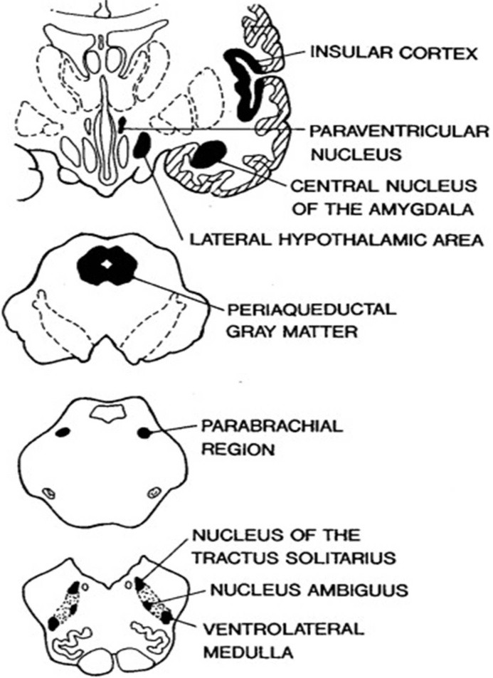
Figure 1.1: Schematic diagram of the most important areas of the central autonomic network and their location in the human brain. All areas are reciprocally interconnected; pathways have been omitted for clarity. Reproduced with permission from Elsevier (see appendix 6.4).

1.4 The Functional importance of emotions
The functional importance of emotions becomes evident when we consider their effects on our attention and memory. From an evolutionary perspective, the preferential processing of environmental events of value, enhances our ability to achieve desirable while avoiding undesirable outcomes. Emotions allow us to achieve such attentional enhancements facilitating our adjustment to our environment (Ohman, Flykt & Esteres, 2001). Participants in Ohman et al.’s (2001) experiment were presented with fear-related targets (snakes & spider pictures) among a number of fear-irrelevant distractors (mushroom & flower pictures) and vice versa. Their results showed that fear-relevant targets were found more quickly than fear-irrelevant targets. The search for fear-relevant targets was found to be unaffected by the number of fear-irrelevant distractors and the position of the target. The same was not true for fear-irrelevant targets. Pecher, Lemercier & Cellier (2001) extended Ohman et al.’s findings by including stimuli of both positive (happy) and negative (sad) valence. Participants in the Pecher et al. (2001) study listened to happy, sad and neutral music while driving in a simulator. During the driving, participants were expected to control their trajectory (measured via the proportion of line crossing). Pecher et al.’s (2001) results showed that happy music decreased trajectory control (i.e. increased the proportion of line crossing) while sad music increased trajectory control (i.e. decreased the proportion of line crossing) compared to preceding intervals of silent driving.
The aforementioned findings are in accord with research investigating the role of brain areas sensitive to emotional stimulation, like the amygdala, in visual attention. For example, research has shown that amygdala modulates visual attention networks (Vuilleumier, Richardson, Armony, Driver, & Dolan, 2004). Healthy participants in Vuilleumier et al. study showed enhance activity in visual areas for fearful compared to neutral faces. This effect was not observed for patients with amygdala damage. More importantly, Vuilleumier et al. found a negative correlation between the severity of amygdala damage and the activity of the fusiform gyrus, a brain area involved in face processing. The findings of Pessoa, McKenna, Gutierrez, and Ungerleider (2001) suggested that the modulation of visual attention by the amygdala is relevant to task specific goals. In their study, Pessoa et al. presented their participants with emotional and neutral faces. A group of participants was allocated to the attended condition and asked to make a gender decision on the face presented. The other group of participants was allocated to the unattended conditions. These participants were asked to decide whether two bars presented in the periphery of the presented faces were horizontal or vertical. Pessoa et al. compare the activity of the amygdala when participants were exposed to emotional compared to the neutral faces. Their results showed that the activity of the amygdala was higher in the attended compared to the unattended condition. This supports the suggestion that emotions direct attention to environmental events of value, therefore, enhancing our ability to achieve a desirable result and/or avoid an undesirable outcome.
Beyond directing attention to events of a particular emotional value, privileged perceptual processing facilitates the availability of emotional events to other cognitive domains, like long-term memory and working memory. For example, our memory tends to be better when we are in a mode of physiological arousal, much like that experienced when we are presented with emotionally relevant stimuli (Buchanan & Lovallo, 2001). In other words, we tend to notice and remember events that evoke emotions of pleasure or joy, sorrow and pain. As such, emotions provide the assets to evaluate and build our experiences. The evaluation process in this context refers to the ability of an organism to sense whether events in its environment are more or less desirable (Dolan, 2002). This is in accord with research suggesting an interaction between brain areas relating to emotion (i.e. amygdala) and working memory (Schaefer, Braver, Reynolds, Burgess, Yarkoni, & Gray, 2006). Schaefer et al. used a 3-back task during which participants were presented with a series of stimuli that could be either faces or words. Stimuli were presented in regular intervals and participants had to decide whether the presented stimulus matched that displayed three trials back. Schaefer et al.’s findings showed that the activity of the amygdala was correlated with response speed. In other words, participants that tended to have highly active amygdala during the task responded faster. In a second experiment Schaefer et al. showed that the relation between amygdala and working memory depends on memory load. Specifically, the correlation between amygdala and working memory was specific to the 3-back task (high memory load) compared to the 1-back task (low memory load). Discussing their findings Schaefer et al. suggested that the observed effects could be part of amygdala’s role in facilitating adaptation under challenging conditions. Specifically, Schaefer et al. suggested that challenging events can magnify amygdala’s responses to task and goal-relevant information, which in turn are projected to cognitive and motor areas facilitating adaptation in challenging situations.
Besides their evaluative nature, emotions can be seen as motivational programs that facilitate particular behavioural responses to events of individual significance, in an effort to maximize our chances of achieving a contextually desired outcome (Purves et al., 2008). Different emotional experiences or states can motivate different behaviour (Davidson, Ekman, Saron, Senulis, & Friesen, 1990). For example, our willingness to approach a situation may be fostered by happiness or surprise. Alternatively, disgust and fear can make us withdraw from the situation that evoked this emotion. In support, Duckworth et al.’s (2002) results showed that the evaluation of briefly presented novel stimuli is linked to behaviour relating to approach and avoidance tendencies. Duckworth et al. (2002) presented their participants with previously evaluated novel stimuli and instructed them to pull the lever toward them (approach condition) or push the lever away from them (avoidance condition) as quickly as possible whenever a target was presented on screen. Their results showed that participants in the approach condition were faster to respond to positive than to negative stimuli, while participants in the avoid conditions were faster to respond to negative than to positive stimuli. It can, therefore, be argued that emotions allow swift evaluations of the significance of a particular event and prepare action in order to maintain favourable and deal with unfavourable outcomes (Cole, Martin, & Dennis, 2004).
From the evidence so far, it follows that emotions index the value of our experiences via quick evaluations of the significance of a particular event (Cole, Martin, & Dennis, 2004). Emotions direct our attention to information that is relevant to environmental adjustments and enhance memory of such events. As such, emotions are meaningful assets that help us classify our experiences as more or less desirable and motivate behaviour in order to maintain favourable and deal with unfavourable outcomes. For example, physiological arousal occurring when experiencing imminent threat, provide metabolic support and thus facilitate the expression of behavioural responses that allow individuals to avoid physical injuries. In most senses then, emotions help us to behave in adaptive ways (i.e. ways that are likely to facilitate our survival and ability to thrive in a particular environment).
The above-mentioned are in accord with Schaefer and Gray (2007) model integrating findings implicating the amygdala in higher cognition (i.e. long term memory, working memory, and visual attention) and those suggesting that amygdala has a role in emotional responding. Based on this model, the amygdala is central to a vigilance system that aims to prepare an individual to handle difficult situations. This general vigilance system modulates cognitive, motor and autonomic nervous systems amid situations demanding additional resources. For example, amygdala’s anatomical projection to cortical areas, allows an enhanced attentional processing of goal-relevant stimuli that are of a particular adaptive value. Such an integrative mechanism of higher cognition and emotion at the level of the amygdala help us to behave in adaptive ways (i.e. ways that are likely to facilitate our survival and ability to thrive in a particular environment).

1.5 Detrimental effects of emotions
Despite the adaptive value of emotional states, emotions can also have a detrimental effect on our wellbeing and health. For example, waiting in a long, slow moving queue to get a coffee is frustrating, especially if you are in a hurry. Such annoyance can easily turn into anger/hostility especially when the barista stops every couple of seconds to gossip with colleagues. In general, negative emotional states are thought to be associated with unhealthy patterns of physiological functioning relating to cardiovascular responses (Booth-Kewley & Friedman, 1987). Indeed, negative emotional states like anger, hostility and depression have been found to have a reliable positive association with heart disease (Friedman & Booth-Kewley, 1987). Moreover, depression has been associated with a particular pattern of cardiovascular responding relating to reduced cardiac parasympathetic activity, which is implicated in the development of cardiovascular disease including chronic and congestive heart failure (Casolo, Balli, Taddei, Amuhasi & Cesare, 1989; Dalack & Roose, 1990; Imaoka, Inove, Inove, Hazama & Tanaka, 1985; Nolan et al., 1992).
The same pattern seems to be applicable when considering the effects of negative emotional states on the immune system. For example, people’s susceptibility to illness is increased when they experience prolonged negative emotional states (Cohen et al., 1998). Participants in Cohen et al.’s laboratory paradigm were systematically exposed to common cold viruses while measuring prior severe acute stressful life events. Their findings showed that individuals who experienced chronic stress were at higher risk for developing the illness. Moreover, there was a linear increase in the relative risk for colds with increased duration of the stressor. Laboratory studies that endeavoured to induce a particular emotional state provided converging evidence regarding the influence of emotional states on the functioning of the immune system. For example, Labott, Ahleman, Wolever and Martin (1990) asked healthy women to view funny and sad film clips while measuring Secretory Immunoglobulin A (S-IgA) which is considered to be an organism’s first line of defence against illness including the common cold. Their finding showed that the induction of a positive emotional state led to increases in the levels of S-IgA, suggesting enhanced immune system activity. The induction of a negative emotional state brought the opposite results (reduced S-IgA levels) indicating suppressed immune system activity.
Besides their effect on physical health, negative emotional states have been associated with psychopathology as well (Gross & Munoz, 1995). Within this context, the sustain experience of negative emotional states is seen as a contributing factor in the development of psychopathology. In support, ineffective management of anger, sadness and anxiety have been linked to depressive symptomatology (Garnefski, Kraaij & Spinhoven, 2001; Silk, Steinberg & Morris, 2003). Similarly, deficiencies in handling negative emotional states were suggested as being a central component of post-traumatic stress disorder (PTSD; Tull, Barrett, McMillan & Roemer, 2007), inflicting functional impairments above those imposed by symptom severity (Cloitre, Miranda, Stovall-McClough & Han, 2005).
Our ability to manage our emotions effectively is also important when we consider occupational life and interpersonal relationships. Mismanaged emotions during work will inevitably distract attention from the task at hand hindering our productivity, while interactions with colleagues require us to know when and how to express certain emotions (Gross & Munoz, 1995). In the social domain, a greater degree of positive than negative affect is needed for the creation of successful interpersonal relationships (Gottman, 1993). Given the widespread adverse consequences of negative emotional states, our ability to appropriately regulate our emotions is of pivotal importance to physical and mental health as well as to successful occupational and social life.

1.6 Defining emotion Regulation
The close link between emotion and emotion regulation makes it difficult to draw a sharp line between emotion generation and emotion regulation processes (Gross, 2013). Therefore, researchers’ keen interest in emotion regulation exist side-by-side with a great deal of confusion about what emotion regulation is (Lewis, Zinbarg, & Durbin, 2010). The fact that emotion generation process might themselves be viewed as emotion regulation process call the distinction between emotions and emotion regulation into question. According to Kappas (2011) emotions can be seen as ‘auto-regulatory’ process, as the activation of emotion can alter the emotion-triggering event and thus lead to the termination of that emotion. In a similar manner, Winterich, Han, and Lerner, (2010) argued that particular emotions may make other emotions more or less likely to occur. Be that as it may, none of the abovementioned cases involve the activation of an emotion regulation goal and thus these cases do not meet the criteria for emotion regulation (Gross, Sheppes, & Urry, 2011).
Moreover, the use of independent terms to refer to emotion generation and emotion regulation process can be problematic as it suggests the presence of two essentially different set of processes that could function separately to affect outcomes of interest (Gross, Sheppes, & Urry, 2011). Such distinctions promote an essentialist approach encouraging individuals to think of emotion generation and emotion regulation as referring to different entities (Barrett, Mesquita, & Smith, 2010). Thus, if the use of different labels to separate emotion generation from emotion regulation process leads individuals to assume that emotion generation and emotion regulation are each distinct, completely unrelated process, then the distinction might be problematic.
Nevertheless, the distinction between emotion generation and emotion regulation process at the empirical level has been productive as it provided the tools that allowed researchers to investigate whether emotion regulation explains unique variance, over and above that explained by emotion generation, in the measures of interest. Ochsner and Gross, (2008) review offers a good example in the domain of neuroscience. These studies investigated whether explicit instructions to regulate had an effect over and above that observed when participants responded spontaneously to emotion-generating stimuli. The results of these laboratory studies suggest that emotion regulation processes are associated with a network of brain regions (dorso-lateral pre-frontal cortex) implicated in cognitive control. In addition, emotion regulation instructions were also found to relate to instruction-congruent changes in a network of brain regions (amygdala and insula) associated with emotion generation.
Furthermore, Heilman, Crisan, Houser, Miclea, and Miu’s (2010) study offers an excellent example of how the distinction between emotion generation and emotion regulation process has been productive in the cognitive domain. These authors found that emotion regulation, in the form of cognitive reappraisal, lessened the effects of negative emotions on risk aversion indicating that emotion regulation modulates the effects of emotion on risk taking. In a similar vein, the regulation of disgust was found to impair working memory performance over and above the experience of disgust (Scheibe, & Blanchard-Fields, 2009).
From the perspective of the present study, emotion regulation involves the activation of a goal to either up- or down-regulate the magnitude and/or the duration of the emotional response (Gross, Sheppes, & Urry, 2011). That is, ER is the process by which people stay positive in the face of adversities, keep calm under pressure, and prevent themselves becoming overwhelmed by feelings of disgust, anger or sadness. More specifically, ER can lead to changes in the valence, intensity, time course, and approach-avoidance tendencies associated with the activated emotion (Cole, Martin, & Dennis, 2004; Koole, 2009; Thompson, 1990, 1994; Webb, Miles, & Sheeran, 2012). For example, regulating feelings of disgust can help people to approach the offending stimulus (e.g., a baby’s dirty nappy). ER can involve control over various aspects of emotional processing including attention (Amir, Beard, Burns, & Bomyea, 2009), appraisal of attended information (Gross, 1998), and physiological changes, like heart rate, that accompany emotions (Denson, Grisham, & Moulds, 2011).
No matter whether individuals are trying to decrease negative emotion (Gross, Richards, & John, 2006), increase positive emotions (Quoidbach, Berry, Hansenne, & Mikolajczal, 2010) or vice versa (Gruber, Mauss, & Tamir, 2011; Sutton, 1991), they usually employ an array of regulatory strategies. Gross (1998) information processing model of emotion regulation (Figure 1.2) can aid researchers in making sense of this array of emotion regulation strategies as it identifies each step in the emotion generation process as a possible mark for regulation. Movement from left to right in Figure 1.2 represents the movement within a given emotion-generative cycle. This conceptualization provides the basis for the analyses of ER strategies according to the stage in which they are implemented.
Specifically, the modal model divides ER strategies into five categories, along a temporal continuum. These comprise: 1) the selection of the situation to be experienced, 2) modification of the situation, 3) selection of the features of the situation to be attended (attention deployment), 4) alterations in the way in which we appraise the situation (cognitive change), and finally, 5) strategies designed to modify behavioural responses (response modulation). Broadly speaking then, ER strategies can be seen as belonging to two general categories. The first category includes antecedent-focused ER strategies. These strategies are implemented before the appraisal of the situation and seek to modify emotional responses in advance. They include strategies relating to situation selection, situation modification, attention deployment and cognitive change. The second category includes ER strategies that are response-focused. These strategies are implemented after the generation of emotion and thus include behaviour modulation.
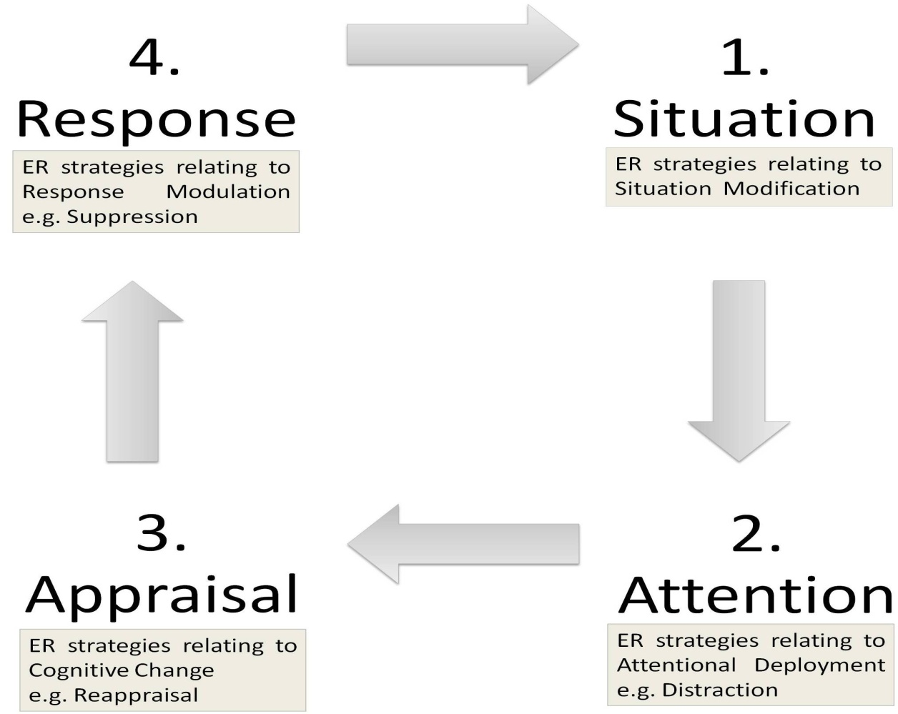
Figure 1.2: Gross (1998) modal model of emotion. According to this model, attentional allocation to particular features of the situation encountered and subsequent appraisal of those features leads to emotional responding of a particular nature. Emotion regulatory process can be implemented in all of the stages of the modal model leading to modulation of initial emotional responses. Diagram modified from Gross and Thompson (2007).
A more recent examination of the nature of ER proposed an alternative theoretical account that makes use of the qualitative difference between people’s primary and secondary emotional responses (Gross, 1998; Lazarus, 1991). Primary appraisal is concerned with the evaluation of the personal significance of the situation and is considered as reflecting an individual’s emotional sensitivity. Secondary appraisal is concerned with the adjustment of the initial appraisal and thus the regulation of the generated emotion. This distinction suggests that ER is a control process (Carver & Scheier, 1998) that serves to monitor and adjust emotional responses (Koole, 2009). One important prediction of this model is that an unwanted emotional response must occur initially before any ER can take place. Indeed, people are capable of automatically evaluating the valance of various stimuli, including novel items lacking explicit conceptual meaning (Duckworth et al., 2002).
Emotion regulation, on the other hand, seems to be temporally distinct from emotional responding, supporting the notion that ER is a control process regulating generated emotions. For example, Goldin, McRae, Ramel & Gross (2008) presented their participants with short film clips of a negative or neutral emotional nature while asking them to simply watch the presented film clips or regulate their emotions. Their findings showed that emotion regulation relating to reappraisal resulted in early activity (between 0 to 4.5 seconds from stimulus presentation) in brain areas associated with cognitive control (orbitofrontal cortex and dorso and ventro-lateral pre-frontal cortex).This early activity in the pre-frontal cortex resulted in a decrease in late (between 10.5 to 15 seconds from stimulus presentation), but not early, activation in brain areas associated with emotions (amygdala and insula) indicating that emotion regulation is temporally distinct from initial emotional tendencies.
The two theoretical frameworks discussed seem to be different in their classification of ER strategies. For example, the modal model considers the avoidance of a particular situation expected to elicit an unwanted emotion as an ER strategy. In this situation, ER seems to precede the onset of emotion. Given the extent to which such antecedent-focus ER strategies are successful, it would be predicted that individuals might not experience any unwanted emotions. Such interpretation would be incongruous with the control process account of ER, as it considers the elicitation of emotion as providing vital input for the subsequent monitoring and adjustment that constitutes ER. However, several experimental examinations of emotions have shown that anticipating a situation that elicited an emotional response in the past leads to a simulation of the experience that includes the activation of emotional systems in the brain (Niedenthal, 2007). Emotional sensitivity is, therefore, relevant to the anticipation of unwanted emotions. Hence, the distinction between emotional sensitivity, and ER is meaningful regardless of whether people regulate their emotions proactively (i.e. before encountering a situation anticipated to lead to emotional responding) or online (i.e. at the time when they experience an unwanted emotion).

1.6.1 Measuring emotion regulation: Regulation of physiological arousal relating to emotions
Given the prominent role of physiology in emotions (see section 1.3.1.), people’s ability to adjust physiological arousal on a momentary basis is critical for ER (Appelhans and Luecken, 2006). The activity of the Autonomic Nervous System (ANS) and, therefore, physiological arousal, is regulated by a distributed network of brain areas termed the Central Autonomic Network (CAN) that includes the amygdala nuclear complex and the hypothalamus among other brain structures. The interaction between these two structures, via CeA projections to the hypothalamus, initiates the mechanism that give rise to physiological arousal. Through this mechanism, the amygdala determines the emotional value to be attached to internal and external stimuli (Davis & Whalen, 2001; LeDoux, Iwata, Cicchetti & Reis, 1988). Within this context, ER should regulate amygdala activity and thus Sympathetic Nervous System (SNS) activation related to physiological emotional responding. Indeed, Goldin, McRae, Ramel & Gross (2008) findings support the above mentioned rational.

1.6.2 Emotion regulation processes
The following discussion is concentrated on two processes of emotion regulation, namely suppression and reappraisal, as these attempt to regulate emotions at two different points of the emotion generation process and, thus, offer an informative distinction between antecedent and response-focus ER strategies (Gross, 1999).

1.6.2.1 Suppression
Suppression is an example of a response-focused ER strategy as it occurs late in the process generating emotional responses (Gross & Thompson, 2007). That is, suppression, in terms of ER, is usually deployed after appraisal of the situation has given rise to an initial emotional response. Suppression is defined as the inhibition of expressive behaviour under conditions of emotional arousal (Gross & Levenson, 1993).
Suppression is often operationalised in terms of facial expressive behaviour. When using such measurements, participants’ facial expressions are recorded and subsequently reviewed to examine whether they contained muscular movement (i.e. contractions of the facial muscles) which can be used to identify emotional expression (Duchenne, 1990). Previous use of this method suggested that suppression can decrease emotion expressive behaviour. For example, people who were instructed to suppress their ongoing behaviour while watching a disgusting film showed a significant decrease in facial movements, facial touching, blinks and body movements, as compared with people who were not ask to suppress their ongoing expressive behaviour (Gross & Levenson, 1993).

1.6.2.2 Reappraisal
Reappraisal is an antecedent-focused ER strategy. Reappraisal is considered a cognitive change ER strategy (Gross & Thompson, 2007). ER strategies in this category help individuals to change the way in which they appraise the situation. This in turn, assists individuals in redefining the emotional significance of the situation by altering the way they think about the situation and their ability to manage its demands. Operational definitions of reappraisal revolve around the modification of the interpretation of the situation, like for example, interpreting emotionally relevant stimuli in unemotional terms (Speisman, Lazarus, Mordkoff & Davison, 1964).
Experimental examinations of reappraisal indicated that this ER strategy was able to decrease individuals’ subjective experiences. In his experiment, Gross (1998) asked people to watch film clips that were designed to evoked feelings of disgust. Some of his participants were instructed to simply watch the presented films, while others were instructed to either suppress their expressive behaviour (suppression condition) or think about the film in a way that it would make them feel nothing (reappraisal condition). While both suppression and reappraisal were able to decrease emotionally expressive behaviour, participants in the reappraisal condition reported experiencing significantly lower levels of disgust, as compared with people allocated to the suppression condition, suggesting that reappraisal might be able to regulate emotions to a greater extent.

1.7 Automatic regulation of emotions
Cognitive processes, including that pertaining to ER, can be either more controlled and effortful or more automatic and efficient. Three possible forms of automaticity are worth mentioning as they are important in understanding the relative automaticity of the various ER strategies (Bargh, 1994). The first of those refers to preconscious automatic processes. This kind of automaticity requires people to only notice the stimulus and thus it includes interpretations, evaluations, and categorizations. Post conscious processes form the second category of automatic processes. These processes require recent conscious attentional processing and include impression formation and priming. The last form is relevant to goal-dependent automaticity. These processes are intentional in that they usually occur with people’s consent in an effort to achieve a particular goal. Within this context, automatic emotion regulation processes are thought to represent automatic goal striving to alter experienced emotion (Bargh, 1994). This form of automaticity is concentrated on a desired result that can be either an outcome or performance (Gollwitzer, 1999), and is thought to be achieved through proceduralization, a term referring to structured, practice (Anderson, 1983). Paradigms that primed ER goals indicated that cognitive processes relating to ER can be implemented at such an automatic level. For example, Mauss, Cook & Gross (2007) used a scrambled sentence task to present their participants with words relating to emotion control (e.g. restrains, covered) or emotion expression (e.g. impulsively, volatile) while exposing them to an anger inducing test. Mauss et al.’s (2007) results showed that anger provocation resulted in significantly greater experience of anger as compared to the neutral baseline, and that participants primed with words relating to emotion control reported significantly less anger experience than participants primed with emotion expression terms. These results indicated that ER goals can operate in an automatic fashion.

1.7.1 Defining automatic processes
Automatic processes have an important role in everyday life as they are able to influence people’s thoughts, emotions and behaviour (Bargh, 1997). A number of features have been used to independently define automaticity. These include attention, intention and awareness (LaBerge, 1981; Marcel, 1983; Shiffrin & Dumais, 1981). By those criteria, automaticity is seen as 1) a process with limited attentional demands (effortless) (Hasher & Zacks, 1979), 2) obligatory, i.e. driven by environmental stimulation (Posner & Snyder, 1975) and 3) occurring outside people’s awareness (Jacoby, Lindsay & Toth, 1992).
However, the examination of responses that are considered to be prototypical examples of automaticity do not support the notion that the above-mentioned criteria of attention, intention and awareness are able to differentiate between controlled, effortful and automatic, efficient processes. For example, automatic processes are considered as not having high attentional demands and thus as effortless. As a result, skilled performance is thought to occur outside the limited capacity processor by performing the same computational steps at a faster rate (Schneider & Shiffrin, 1977). However, Cheng (1985) disputed whether skilled performance involves a large number of calculations happening at fast speeds and instead suggested that efficient performance is a result of more efficient processing strategies. According to Cheng’s findings, experts tend to use a pattern-based storage whereas novices do not. This difference becomes evident when we examine particular examples like chess (Chase & Simon, 1973). Unskilled chess players tend to store individual pieces in working memory (WM). Given the limited capacity of WM, unskilled players end up being able to store only a limited number (between five to seven) of pieces. In comparison, skilled players chunk information together in five to seven coherent patterns of four to five pieces and thus are better in keeping track of past moves and anticipate future moves. Therefore, skilled performance is explained better if we consider the differences in the processing strategies used by skilled and unskilled performers rather than concentrating on processing limitations. Within this context, automatic processes are considered to be superior in terms of the strategies employed, rather than simply performing the same steps quicker. As such, they do not burden limited processing capacities (Phillips & Triggs, 2001).
In a similar vein, the criterion of lack of intentionality can also be questioned. For example, research relating to the stroop effect, considered to be an automatic phenomenon, failed to support proposed lack of intention associated with automatic processing. In the stroop task, people are presented with words relating to colours that are printed in a different ink colour (e.g. the word ‘green’ printed in red ink). Participants are instructed to name the colour of the ink in which the word is written. Despite these instructions participants usually read the colour word and not the ink colour. This is thought to happen because reading is automatic whereas naming the ink colour is not. According to the intention criterion of automaticity, participants’ responses to the stroop task should not be subject to instructions or context as this would imply that automatic processes are not obligatory but instead are subjected to control. Nevertheless, context manipulation such as the colouring of single letters instead of the whole word were found to result in reduced interference from the automatic process of word reading as index by faster reaction times for naming the ink colour (Besner, Stolz & Boutelier, 1997). Such observations challenge the notion that automatic processes are obligatory and as such not subject to intention.
Automatic processes are also thought to occur outside people’s awareness. However, automaticity is not a completely unconscious process as individuals are aware of the products of such processes (Tzelgov, 1997). It is clear that consciousness is involved in cognitive processing, but its role differs between controlled and automatic processes. For example, skilled artists using a familiar painting technique do not require constant awareness in order to paint a particular scene. They might be aware of selecting the right brush and colour, but may not be aware of each step involved in painting the scene. In contrast, using an unfamiliar painting technique would require constant awareness. In a similar manner, a large amount of information is assumed in the case of a touch typists and thus they can perform their task automatically hence not interfering with performance in a dual task (Schaffer, 1975). It is only when a wrong key has been selected, that conscious processes like visual scanning are evoked in order to correct performance. The prevailing theoretical explanation behind these examples is that people are aware of higher level operations, but not of lower level aspects of performance (Koch & Crick, 2001). However, empirical evidence collected through the use of introspection, via verbal reports, supporting this particular criterion are considered invalid. Several researchers have noted that such introspection reports are no more accurate than would be predicted by chance and, therefore, suggested that awareness, as measured via verbal reports relating to introspection, is not able to differentiate between control and automatic behaviour (Marcel, 1983; Nisbett & Wilson, 1977; White, 1982).
The proposed differentiation of controlled, effortful and automatic, efficient processes, including ER, in terms of attention, intention and awareness was created to explain empirical observations that could not be accounted by dominant models of attention such as capacity theory, bottleneck models of attention and information theorem (Saling & Phillips, 2007). Therefore, the proposition of automaticity is post hoc and as such it suffers from circularity. That is automaticity is defined in terms of the behaviour to be explained (Phillips & Triggs, 2001). As such attention, intention and awareness do not offer a reliable definition of automatic processes. This is because attention, intention and awareness do not reliably co-occur or co-vary and cannot help us distinguish between controlled and automatic processes (Zbrodoff & Logan, 1986). Hence, the two-process distinction model lacks internal consistency. This in turns implies that this definition of automaticity is unreliable (Saling & Phillips, 2007). Indeed, Bargh (1992) pointed out the many senses of ‘automatic’ processes created by fitting any random combination of the defining features of such theoretical account. Such custom made combinations led to automatic processes developing multiple meanings. Moreover, the creation of combinations of criteria to infer efficient processing is problematic for research as it carries with it the danger of implicitly assuming the presence of a particular feature given the presence of any other feature(s).

1.7.2 Redefining automaticity: Moving beyond attention, intention and awareness
Dominant models of automaticity view automatic processing as being a faster execution of all the steps taken during effortful processing. This line of thinking implies that our brains evolved to work harder as we become more skilful. Such an increase in brain activity should be metabolically evident via greater blood flow, glucose or oxygen metabolism (Amaro & Barker, 2006; Nichols & Newsome, 1999; Shulman, 2001). However, evidence suggests that automatic processes tend to be associated with decreased neural processing, pointing out that automatic processes are more efficient and economical than controlled processes as they facilitate superior performance in spite of decreases in brain activity.
Schneider and Shiffrin (1977, part II) shed some light on the development of automatic processes. Participants in Schneider and Shiffrin’s study were presented with a memory set consisting of one to four characters that could be digits or consonants. Participants were given as much time as needed to memorize these characters. During testing, participants were presented with 20 frames, each of which contained four elements arranged in a square around a central fixation dot. Participants’ task was to detect any member of the memory set appearing in the presented frames and to respond by pressing a button. Schneider and Shiffrin’s results showed that behavioural practice led to a 40% increase in accuracy (i.e. detection of targets) while errors (i.e. responses in the absence of targets) dropped by 9% by the time participants had completed 1500 trials. At the same time, response reaction times dropped from 770 to 670ms. Schneider and Shiffrin’s findings pointed out that automatic processes are associated with enhanced performance as indicated by increased in accuracy and decreases in time taken to complete the task.
Using a similar paradigm, Jansma, Ramsey, Slagter, and Kahn (2001) extended the effects of training reported by Schneider and Shiffrin to include brain activity. Jansma et al. presented participants with a set of 5 consonant targets to memorize. Following memorization, participants were presented with a series of consonants (ten in every trial) and asked to indicate whether the presented consonant belonged to the target set. Both target and non-target consonants remained constant across trials for the practice task while they changed after each trial for the novel task. Jansma et al. found significant differences in performance between the practice and novel tasks. In particular, there was a significant increase in accuracy during the completion of the practice task compared to the novel tasks. Also, there was a significant decrease in time taken to complete the practice task compared to the novel task. These improvements in performance observed during the completion of the practice task were accompanied by decreases in the activity of task-relevant brain areas, as measured by fMRI, compared with the novel task.
A similar pattern of improved performance despite decreases in brain activity is observed when people are trained to categorise visual patterns. Little, Klein, Shobat, McClure, and Thulborn, (2004) trained participants to classify random dot patterns into discrete categories over three consecutive days. During training, participants were presented with a category exemplar and asked to classify the pattern of dots into one of four categories. Participants were given immediate visual feedback. fMRI scans were performed before participants’ initial training session and after the end of each of the three training sessions. During the fMRI scans, participants were presented with two category exemplars and asked to indicate whether these belonged to the same category by pressing a button. Little et al. found a significant increase in accuracy accompanied by more rapid responses as training progressed. Moreover, while fMRI suggested increases in brain activity from pre to the first training, as training progressed there was a decrease in the overall volume of activation observed.
The above mentioned findings from fMRI studies represent a promising development in understanding automatic processing. In these studies, the amount of effort required for the performance of a particular task was inferred from the amount of brain activity observed. As responses become more automatic they also drew on fewer neural resources. In short, the evidence suggests that automatic processing is associated with decreases in brain activity rather than neurons working faster and harder. Discussing these developments Saling and Phillips (2007) pointed out that “...although automatic processing has been conceptualised as simply faster than controlled processing (implying more neural activation), in reality, a pattern of less effort and greater efficiency, economy and elegance is observed” pp.14.

1.7.3 Toward an operational definition of automatic emotion regulation
Given the importance of physiological responding, ER’s effects should be also observed in the physiological systems, and supporting physiological processes, fostering emotional responding. In essence, ER should be able to regulate physiological arousal, and thus systems and supporting processes, associated with emotional responding. Physiological arousal experienced during emotion induction is a product of the activity of the amygdala. The amygdala determines the internal emotional value (i.e. physiological arousal) to be attached to a particular experience (Davis & Whalen, 2001). This is achieved via the projection of CeA to the hypothalamus which is involved in the activation of the SNS (Figure 1.3). Within this context, ER should regulate the activity of the amygdala and thus SNS activation relating to physiological responding.
Regulation of the activity of the amygdala, such that shown by Goldin, et al. (2008), depends on meeting the metabolic demands of the brain. The main metabolic resources of neurons are glucose and oxygen (Kim, Dunn, Ellegala, & Fox, 2006). Despite been the most metabolically active organ in the human body, the brain possesses only a small store of glycogen. Therefore, constant supply of glucose and oxygen are paramount for the maintenance of normal function (Zauner, Daugherty, Bullock, & Warner, 2002). The metabolic requirements of the brain are unique, as oxygen is quantitatively united with glucose derivatives in brain metabolic pathways (Bicher, Reneau, Bruley, & Knisley, 1973). The brain relies principally on aerobic metabolism of glucose, via glycolysis, for the production of adenosine triphosphate (ATP), the main energy currency of the brain (Zauner, et al., 2002). The majority of oxygen delivered to the brain is used during this metabolic process to generate energy (Sciamanna, & Lee, 1993).

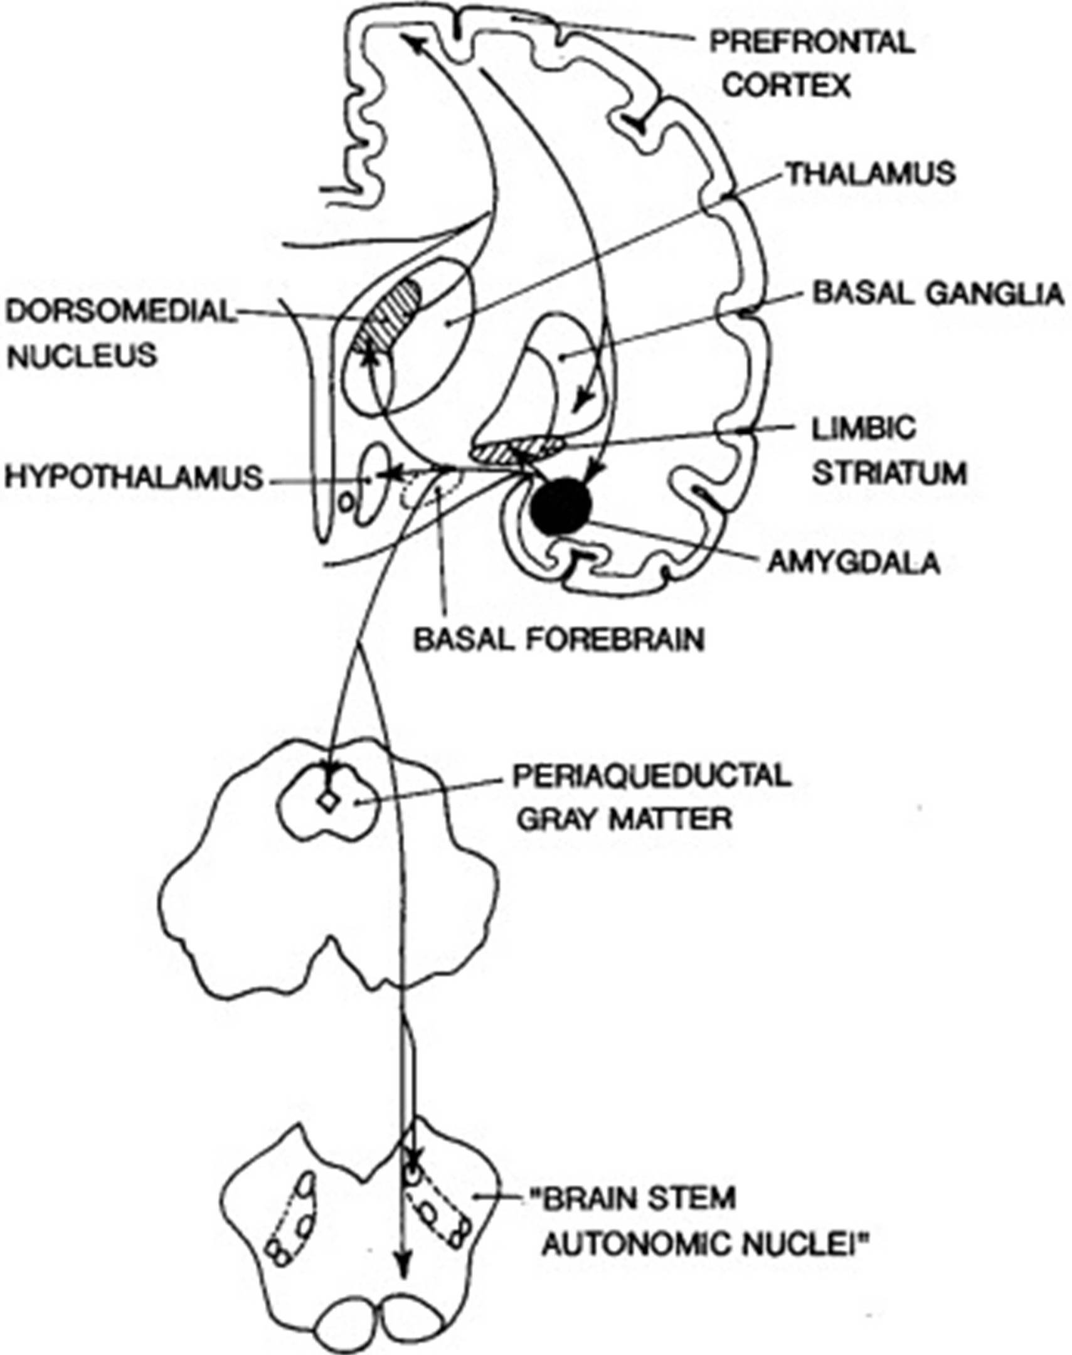
Figure 1.3: Diagram of main connections between central nucleus of amygdala and areas involved in autonomic and behavioural responses associated with emotion. Amygdala’s activity is modulated by the prefrontal cortex. Reproduced with permission from Elsevier (see appendix 6.4).
Based on the above mentioned mechanism of energy production, cognitive processes including ER should be related with fluctuations in the levels of metabolic substrates like glucose. Indeed, active brain areas use more energy, and thus metabolic resources, than brain areas that are inactive at that particular point in time (Greenfield, 2001). Moreover, the rate with which glucose is transported from the blood to the brain (Lund-Andersen, 1979) and the metabolism of glucose (Reivich & Alavi, 1983) are stimulated in task specific areas of the brain. Given that normal brain function requires constant supply of glucose and oxygen (Zauner, Daugherty, Bullock, & Warner, 2002), fluctuations in the levels of metabolic substrates can modulate cognitive function.
Increases in the delivery and utilization of metabolic resources during cognitive demands are accompanied by increases in cardiac responding. For instance, performance in mental arithmetic tasks was found to be associated with pre task blood borne glucose levels and elevated heart rate, in comparison to pre-task baseline and tasks controlling for somatic/peripheral energy expenditure (Kennedy and Scholey, 2000). Similar findings were reported when examining oxygen utilization. For example, increases in oxygen utilization imposed by cognitive demands were accompanied by increases in heart rate (Turner & Carroll, 1985) and flow in coronary circulation (Rose, Goresky, Bélanger, & Chen, 1980). Moreover, increases in cognitive demands, via elevated memory load, were accompanied by accelerated heart rate, faster respiration rate, and greater volume of exhaled carbon dioxide, a direct measure of oxygen consumption (Backs, & Selijos, 1994).
The evidence so far suggests that the increases in cognitive demands lead to elevated cardiac responding in order to supply neural structures involved in the task with metabolic resources to meet their needs. However, there is an important difference in terms of overall brain activity between controlled and automatic processes. Automatic processes establish a well-connected processing network compared to the diffuse network observed during controlled processing (see section 1.4.2), suggesting that automatic processes are able to successfully complete the task in a more economic and thus efficient manner. Given that neural activity underlying cognitive processing is supported by the cardiovascular system (Kennedy & Scholey, 2000; Scholey, Moss, Neave, & Wesnes, 1999; Turner & Carroll, 1985; Weiss, 1986), more automatic cognitive processes can result in a diminished need for cardiac responding when compared with controlled cognitive processes. The application of this rationale to ER means that automatic ER should achieve regulating unwanted emotional states, while decreasing overall brain activity and, thus, the need for elevated cardiac responding in comparison to controlled ER.

1.7.3.1 Blood Glucose: A proximal measure of automatic emotion regulation

1.7.3.1.1 Blood glucose and cognitive functioning
Self-control, including emotion regulation, depends on individuals’ ability to meet the metabolic demands of their brains. Brain’s energy stores can be considered of a small magnitude compared to glucose utilised and thus the brain relies on a continuous glucose supply (Benton, Parker, & Donohoe, 1996). The development of positron emission tomography (PET) allowed the visualization of the amount of glucose metabolised in discrete regions of the brain. Haeir et al. (1988) used PET and found a negative correlation between reasoning ability, as measured via Ravens’ Progressive Matrices (Raven, Court, & Raven, 1983), and glucose metabolism in the cortex. Parks et al. (1988) discovered a negative correlation between verbal fluency and resting glucose metabolism in the brain, while Berent et al. (1988) reported similar results when testing participants’ memory. In general, PET studies provided evidence that cognitive demands and related increases in neural activity are associated with increases in glucose metabolism in localised regions of the brain. In PET studies radioactively labelled glucose appears in active brain areas within minutes of being injected into the blood stream. Therefore, the result of PET studies suggests that the brain relies on blood borne glucose to support active neural populations.
An alternative way to examine the effect of increasing blood glucose on cognitive functioning is to compare the effect of a glucose containing drink with a placebo. Consumption of a glucose drink was found to lead to increased performance in a verbal fluency task in comparison to placebo, despite no initial difference in the performance of the two groups (Donohoe & Benton, 1999). There is also evidence that consumption of glucose is beneficial in task requiring increased sustained concentration (Benton et al., 1987). Similar results had been reported when participants had to exert self-control. Gailliot, Peruce, Plant and Baumeister, findings supported the idea that acts of self-control require blood glucose. Gailliot et al. (2009) expected that people with low levels of blood glucose are less likely to exert self-control regarding the expression of prejudice and stereotypes compared with people with high levels of blood glucose. To examine this hypothesis Gailliot et al. asked their participants to drink a lemonade sweetened with sugars containing 140 calories (sucrose condition) or to drink a lemonade sweetened with splenda, a sugar substitute, containing 0 calories (control conditions). Subsequently, participants were presented with the picture of a young man who was said to be homosexual and were asked to write a 5 minute essay describing what this person does during a typical day. Independent judges assessed the number of times participants mentioned any of 58 traits associated with the stereotype of a gay man. Gailliot et al. results showed that high prejudice participants in the sucrose condition used fewer prejudicial statements than high prejudice participants in the control group, suggesting that acts of self-control depends on blood borne glucose.
Utilization of blood glucose is achieved through capillary recruitment (Lund-Andersen, 1979). Cerebral microvascular pressure was found to be affected by increases in cerebral metabolism (Firaci & Heistad, 1990), such that observed during increased cognitive demands. Hence, it is not surprising that metabolically active neural structures contain more capillaries that those that are less active resulting in increases in glucose availability and utilization (Craigie, 1920). Therefore, increases in the demand for blood glucose, as that observed during increases in cognitive processing, result in an increase in capillary recruitment facilitating glucose utilisation by the brain.

1.7.3.1.2 Blood glucose: A measure of automatic emotion regulation
Cognitive processes, including self-control and ER can be implemented at a controlled, effortful or an automatic, efficient manner. Automatic processes, including ER, lead to the creation of a better connected processing network thus decreasing the need for delivery of blood glucose to metabolically active neural populations. In support of the idea that automatic process decrease consumption of metabolic resources, learning of a complex task was associated with an overall decrease in the use of glucose in the brain (Haier, Siegel, Tang, Abel, & Buchsbaum, 1992). More specifically, Haier, et al. (1992) used PET to examine glucose utilization in the brain before and after their participants practiced a complex task, the computer game ‘Tetris’. Haier and colleagues found that game performance increased sevenfold after practice while, at the same time, the overall metabolic rate of glucose in the brain decreased. Haeir et al. (1992) interpreted their findings as reflecting increased efficiency of the neural networks recruited for the completion of the task at hand. Such interpretation is in accord with results coming from the examination of learning while using magnetic resonance imaging (MRI) techniques (see section 1.4.2, Jansma et al., 2001; Little et al. 2004).
Similar results as that of Haier, et al. (1992) were found when participants were required to regulate their emotions. Skilful use of ER did not affect blood glucose while the same was not true for the unskilful application of ER (Niven, Totterdell, Miles, Webb & Sheeran, 2013). More specifically, Niven, et al. (2013) asked participants to regulate their emotions when listening to neutral music. Niven et al. (2013) showed that participants were able to regulate their emotions, while participants who were not skilful in ER showed a significant decrease in blood glucose levels (as measured via an ambulatory monitoring system) during the affect-improving task compared to baseline. Comparatively, participants who were skilful in ER showed no difference in blood glucose levels between baseline and affect-improving tasks. Given that both groups completed the same task, Niven et al., (2013) results could not be simply explained by anxiety responses associated with the experimental task. These findings indicate that participants who were not skilful in ER were able to regulate their emotions as well as participants who were skilful in ER. However, participants who were not skilful in ER used more blood glucose in the process. Such decreases in blood glucose consumption while regulating affect index efficient task completion (Saling & Phillips, 2007) and, therefore, automatic ER.

1.7.3.1.1 Blood glucose and the self-control model
This argument is in essence a transformation of the abovementioned discussion regarding the role of energy resources in self-control and ER. According to the model of self-control, acts of self-control, like ER, require a large amount of energy that in turn limits available resources and, thus, result in failure in self-control at later attempts termed ‘ego-depletion’ (Muraven & Baumeister, 2000). In essence, initial acts of ER are seen as costly in terms of consumption of energy resources, therefore, hindering subsequent self-regulatory efforts.
Psychological research pertinent to the interference caused to subsequent acts of self-control by previous self-regulatory process support such rationale. These studies showed that the ability to self-regulate relies on a limited resource. For example, people who were asked to regulate their emotions (suppression) were found to perform worse than people who did not regulate their emotions in a subsequent anagram task (Baumeister, Bratslavsky, Muraven, & Tice, 1998). Similarly, people who were asked to exert self-control, in the form of thought suppression, were found to consume a larger amount of alcoholic beverages in a subsequent taste-rating task (TRT) than people that were not asked to exert self-control before the TRT (Muraven, Collins, & Nienhaus, 2002). However, automatic self-control can buffer against ego-depletion (Webb & Sheeran, 2003). More specifically, Webb and Sheeran found that among participants who had been ego-depleted, the formation of implementation intentions improved subsequent self-control performance to the level of the non-depleted controls. Such findings suggested that automatic self-control requires fewer energy resources and thus facilitates subsequent acts of self-control.
Ego-depletion following self-control is usually assessed through the number of errors committed and time taken to complete a colour stroop task (Webb & Sheeran, 2003). This task is an appropriate measure of ego-depletion as successful performance requires people to override a habitual response (read the printed word) and thus asks for the exertion of self-control (Logan, 1980). Previous use of this task showed that it can differentiate people according to the level of self-control exerted (Webb & Sheeran, 2003).

1.7.3.2 Heart rate variability: A proximal measure of automatic emotion regulation

1.7.3.2.1 Cardiac responding and cognitive functioning
The brain stores only a very small amount of glycogen, even though that the primary energy resources of neurons are glucose and oxygen, (Kim, Dunn, Ellegala, & Fox, 2006). As such, constant supply of glucose and oxygen are paramount for the maintenance of normal function (Zauner, Daugherty, Bullock, & Warner, 2002). Cardiac acceleration during increases in cognitive demands associated with the task at hand is involved in the delivery of both glucose and oxygen to metabolically active neural populations (Backs, & Selijos, 1994; Kennedy & Scholey, 2000; Scholey, Moss, Neave, & Wesnes, 1999; Turner & Carroll, 1985). Cardiac acceleration’s effect on the delivery of metabolic substrates to the brain relates to the augmentation of regional cerebral blood flow. For example, increases in heart rate during a mental arithmetic task correlated with changes in regional cerebral blood flow to both cortical (including the medial-prefrontal, insular, and cingulate areas) and subcortical (including the amygdala and brainstem) regions (Critchley, Corfield, Chandler, Mathias, & Dolan, 2000). Similarly, Gianaros, Van der Veen, and Jennings (2004), found that decreases in interbeat interval time (indicating cardiac acceleration) induced by increases in task specific memory load, and thus cognitive demands, were associated with concurrent increases in regional cerebral blood flow. These findings are in accord with the previously observed direction of cerebral blood flow to active brain areas requiring metabolic resources, and away from brain areas that do not require elevated delivery of nutrients (Peppiatt & Attwell, 2004). Alternative mechanisms implicated in the regulation of cerebral blood flow (CBF), like the arterial baroreflex regulation, seem to play a limited role in the control of cerebral blood flow (Crandall, 2008). For instance, baroreflex regulation via cerebral sympathetic nerve activity have been shown to play a limited role in adjusting cerebrovascular tone, and animal studies employing baroreceptor stimulation or baroreceptor denervation protocols failed to demonstrate consistent baroreflex modulation of CBF (Tzeng, Willie, & Ainslie, 2010).
The close regional coupling between cerebral blood flow, oxygen consumption and glucose utilization (Baron, et al., 1982; Finklestein et al., 1980), suggest that cardiac acceleration facilitate the delivery of metabolic resources to active brain areas by augmenting regional cerebral blood flow (Critchley, Corfield, Chandler, Mathias, & Dolan, 2000; Gianaros, Van der Veen, & Jennings, 2004). In other words, under periods of high cognitive demands, physiological responses like elevated cardiac responding (or decreases in interbeat interval times) serve to increase regional cerebral blood flow and thus the delivery and utilization of metabolic substrates to active neural structures.

1.7.3.2.2 HRV: A measure of automatic emotion regulation
The sinus rhythm (regular automatic heart rhythm) is constantly modulated by the activity of the ANS (Sherwood, 2010). The activity of the parasympathetic division of the ANS (via vagal nerve innervations at the sinus node level) decreases heart rate. The increase of the heart rate above the intrinsic automatic rhythm is achieved through the influence of the sympathetic division of the ANS. The time between successive heartbeats (R-waves) is variable within a given period (Deepak, 2011). These beat-to-beat variations, called Heart Rate Variability (HRV), are the result of the continuous change in the sympathetic and parasympathetic influences on the heart. In essence, HRV refers to the degree to which the time interval between successive heart beats fluctuates as a result of the SNS & PNS. HRV can be determined through the use of time domain measures like the root mean square of successive differences (RMSSD) in the interbeat intervals (Camm et al., 1996). This time domain measure is correlated with measures reflecting high frequency components of the respiratory range indicating increased parasympathetic influences to the heart and thus cardiac deceleration. The vagal (parasympathetic) influences on the heart are fast while sympathetic modulation is slower. Neurophysiological models consider HRV to be a biomarker of successful ER (Thayer & Lane, 2009), while studies have shown that effort invested during cognitive processing is reflected in HRV outputs such that controlled, effortful cognitive processing decreases HRV (Aasman, Mulder, & Mulder, 1987; Tattersal & Hockey, 1995) while automatic, efficient cognitive processing leads to increases in HRV (Denson, Grisham, & Moulds, 2011).
Automatic ER can achieve the regulation of unwanted emotions while decreasing overall brain activity in comparison to controlled ER. This in turn leads to decreases in cardiac responding as one of the functions of cardiac outputs is to facilitate the delivery of metabolic substrates to active neural structures (see section 1.4.3). In support of the idea that automatic ER decreases the need for elevated cardiac responding, skilful use of ER was found to be able to help people to modulate their emotional response to anxiety eliciting tasks while decreasing heart rate reactivity when compared with controlled, effortful emotion regulation (Williams, Bargh, Nocera, & Gray, 2009). Experimental manipulations relating to anger provocation reported similar results. For example Maus, Cook and Gross, (2007) results showed that automatic ER was able to decrease participants’ emotional experience without increasing cardiovascular responding. In essence, automatic processing, led to the creation of a better connected neural network, in comparison to controlled, effortful ER, which is reflected in decreases in heart rate (Williams et al., 2009). Such decreases in cardiac responding (or increases in interbeat intervals and thus HRV) while regulating negative affect index efficient task completion (Saling & Phillips, 2007) and, therefore, automatic ER.
HRV in the present study was measured using photoplethysmography (PPG). PPG is a non-invasive technique that uses infrared Led and photo-detectors to measure relative blood volume changes in the blood vessels close to the skin. The compact and portable nature of the PPG device that allows it to be used in all types of environment led to its development as a popular, non-invasive method for the assessment of the autonomic control of the cardiovascular system (Nitzan, Babchenko, Khanokh, & Landau, 1998). Relevant research has shown that the peaks of the PPG signal correspond to the R peaks (heartbeats) obtained via the use of electrocardiographic (ECG) equipment. These results suggested that the PPG is a valid measure of cardiac activity including HRV measures in both healthy and people suffering from cardiovascular diseases (Murthy, Ramamoorthy, Srinivasan, Rajagopal, & Mukunda-Rao, 2001; Nitzan, Turivnenko, Milston, & Babchenko, 1996).

1.8 The importance of developing automatic emotion regulation
Our ability to regulate negative emotions is very important given the adverse effects of emotions on our physical and mental health (see section 1.2.3). The process engaged (i.e. controlled or automatic) in the regulation of negative emotions is crucial. Controlled, effortful ER is associated with increases in metabolic demands that do not permit the continued regulation of emotions. Automatic ER, on the other hand, achieves the regulation of emotions in a more efficient manner, thus, allowing prolonged regulation of emotions.
Controlled, effortful self-regulation, relies on inefficient strategies to achieve task completion. As such, goal completion is associated with increases in metabolic demands, as reflected in glucose consumption, and cardiac responding. The effortful nature of this kind of emotion regulation and related increased consumption of energy resources does not permit continued effective engagement with emotional responses (Muraven, Tice, & Baumeister, 1998). For example, performing tasks that require executive control, like memory updating, was found to hinder subsequent efforts to exert control over emotion tendencies (Schmeichel, 2007). Similarly, effortful ER was found to lead to poorer self-control in a subsequent stop-signal task requiring response inhibition compared to emotional acceptance (Alberts, Schneider, & Martijn, 2012). Moreover, the inefficient nature of the strategies employed during controlled, effortful ER, burden limited processing capacities and thus lead to slower regulation of emotions. This in turn allows more time for emotional responses to gather impetus, making them harder to regulate (Gross 1998).
In contrast, automatic processes, including automatic ER, use superior strategies that lead to more efficient task completion. This is reflected in the decrease observed in metabolic demands and cardiovascular responding associated with automatic ER (see section 1.4.3). Hence, automatic forms of ER use fewer resources allowing prolong regulation of emotional responses. The development of efficient, automatic ER is beneficial as it may increase individuals’ resilience to the adverse effects of negative emotions. The ability to exert continuous regulation of negative emotions is imperative for physical and mental well-being under conditions of continuous negative emotional stimulation like, for example, those observed in hospital’s emergency room. The potential benefits of being able to regulate emotional responses in an automatic, efficient manner raise the question as to whether there is a way for individuals to capitalise on these benefits.

1.8.1 Implementation intention plans and automaticity
ER strategies like suppression and reappraisal can be seen as intentions or self-instructions to achieve a particular outcome/goal (Triandis, 1980). Such goal intentions are usually expressed in the form “I intend to do X” that signal what one will do and indicate how much effort one is prepared to exert in order to achieve the desired outcome (Ajzen, 1991). However, a recent meta-analysis of the relation between goal intentions and behaviour (Webb & Sheeran, 2006) showed that a medium to large (d = 0.66) change in intention produced only a small to medium (d = 0.36) change in behaviour indicating a weak link between goal intentions and behaviour. There is also evidence that people struggle to modulate emotional responses even when forming intentions to regulate their emotions in a certain way. For example Webb, Miles and Sheeran (2012) meta-analysis observed relatively modest effect sizes across different ER strategies. Attentional deployment had no effect (d = 0.00) on emotional outcomes, while cognitive change had a small to medium effect (d = 0.36), and response modulation had a small effect (d = 0.16).
Supporting goal intention via the formation of implementation intention plans can facilitate goal attainment (Gollwitzer & Schall, 1998; Gollwitzer & Sheeran, 2006). For example, the formation of implementation intentions to support goal intentions relating to orthopaedic rehabilitation exercise was found to enhance patients’ compliance 12 months after the initial rehabilitation (Ziegelmann, Luszczynska, Lippke, & Schwarzer, 2007). In contrast, goal intentions predicted compliance only at initial rehabilitation.
Implementation intentions are ‘if-then’ plans that connect a suitable opportunity for action (the ‘if’ part of the plan) with the relevant cognitive and behavioural responses (the ‘then’ part of the plan) in the pursuit of a particular goal (Gollwitzer & Sheeran, 2006). These kinds of plans usually take the form of ‘If opportunity A arise, then I will perform goal directed response B’ (Gollwitzer & Schall, 1998). Implementation intentions differ from goal intentions that concentrate on the desired outcome (i.e. I intend to achieve X) because they specify when, where and how goal directed responses are to be implemented in order to achieve a particular goal (Gollwitzer, 1999). In this respect, implementation intention plans can be seen as an effort to achieve goal-dependent strategic automaticity (Gollwitzer, 1999). Strategic automaticity can be seen as a subdivision of goal-depended automaticity as it directs goal oriented behaviours by specifying when, where and how these behaviours are going to be implemented (Gollwitzer, 1999). As such, strategic automaticity is achieved via the creation of a strong and reliable mental link between the predefined opportunity for action and the prescribed behaviour (Goowitzer, Fujita & Oettingen, 2004; Webb & Sheeran, 2007).
Implementation intentions can be used to augment any of the strategies defined by Gross and Thompson’s (2007) modal model of emotions. For example, implementation intentions can specify an action relating to distraction in the presence of a particular cue (i.e. look elsewhere when faced with a disgusting picture) that is relevant to attention deployment or it can specify a certain way of appraising a rather disgusting picture that is relevant to cognitive change.
In order to achieve a goal we first need to initiate relevant behaviour. Forming implementation intentions has been found to facilitate the initiation of goal directed behaviour. For example, Gollwitzer and Brandstätter’s (1997) asked participants to counter a presented xenophobic argument. People in the implementation intention condition were asked to mark the time point that seemed the most appropriate for them to stop the presented videotaped argument and intervene. After marking, participants in the implementation intention condition were told to commit themselves in seizing the marked opportunities to express their opinion during the next video run by saying ‘I will speak up here’. In contrast, participants in both of the control conditions were told only to mark the time point that seemed the most appropriate for them to intervene. None of the control groups was encouraged to form a plan to seize the previously marked opportunities to counter the presented xenophobic argument. Gollwitzer and Brandstatter’s (1997) findings indicated that participants in the implementation intention condition showed significantly smaller time differences between the marked time and the time of the actual counter arguments. These findings indicated that forming implementation intentions strengthened the association between the predefined opportunity and the relevant response, and thus facilitated the initiation of immediate response under conditions of high cognitive load.
Besides initiating goal relevant behaviour, implementation intentions were found to enhance goal completion. In the first of Gollwitzer and Brandstätter’s (1997) experiments participants were asked whether they had formed implementation intentions, while during their second experiment people were instructed to form implementation intentions regarding a written report they had to prepare. Gollwitzer and Brandstätter’s (1997) results indicated that participants who formed implementation intentions by themselves (i.e. they were not instructed to form implementation intentions), and participants who were instructed to form implementation intentions completed their goals more often than people who did not form implementation intentions.
The importance of implementation intention in helping individuals achieve their goals is supported by a meta-analytic study conducted by Gollwitzer and Sheeran (2006). In their study Gollwitzer and Sheeran meta-analysed 94 studies in which participants had to form an implementation intention plan that specified the performance of a particular goal directed behaviour when encountering a predefined opportunity. The result of this meta-analysis indicated that forming implementation intentions produced a significant increase in goal attainment. Implementation intentions had a medium-to-large effect size (d = 0.65) on goal achievement. This effect was observed in a wide range of goal domains including laboratory tasks, academic achievements and health, consumer, environmental, pro-social and anti-racist behaviour. There is also evidence that forming implementation intentions can support goal intentions relating to ER. For example, Webb, Gallo, Miles, Gollwitzer and Sheeran (2012) meta-analysis of studies that supported goal intentions to regulate a particular emotion via the formation of implementation intention plans indicated that forming implementation intentions is effective in modifying emotional responses. Webb et al.’s (2012) findings suggested that implementation intentions had a large effect size (d = 0.91) relative to no ER instructions, and a medium effect (d = 0.53) relative to goal intention instructions.
According to Gollwitzer and Schaal (1998) the effect of forming implementation intentions on goal directed behaviour and goal attainment, can be seen as a form of goal-dependent strategic automation of action. In other words, intended goal directed responses are initiated automatically when the predefined opportunity or situation is encountered. Strategic automation of action via implementation intentions is thought to be accomplished through the establishment of a strong, reliable mental link between the predefined opportunity and related goal directed behaviour (Gollwitzer, Fujita, & Oettingen, 2004). Webb and Sheeran’s (2007) results supported this idea. Participants in their study were asked to speed up their responses to the target item ‘avenda’ either by familiarizing themselves with the non-word target item or by forming implementation intentions (i.e. If I see avenda, then I will press the key especially quickly). A sequential priming paradigm was used to measure the accessibility of words related to the target word (situational cue accessibility) and the strength of the association between the situational cue and predefined response (situational cue-response linkage). During this task, participants were presented with a prime word and asked to indicate whether subsequently presented words were either real words or non-words. Webb and Sheeran (2007) found that implementation intentions facilitated both cue accessibility (participants responded faster to the critical cue) and the strength of the association between situational cue and predefined response (participants responded faster to the target word ‘avenda’ if it was primed by the situational cue ‘press’). These results supported the idea of strategic automation of action through the formation of implementation intentions.
The idea that implementation intentions lead to strategic automation is supported by a series of studies contacted by Brandstätter, Lengfelder, and Gollwitzer, (2001). The findings of these studies indicated that the formation of implementation intentions increased the immediacy with which participants’ responded to the target items despite increases in the cognitive load of the task. Specifically, Brandstätter et al. (2001) asked both schizophrenics (high cognitive load because of symptomatology) and healthy controls (low cognitive load) to form an implementation intention plan that would allowed them to respond quickly to a predetermined cue (i.e. if number 3 appears, I will respond particularly fast) or familiarize themselves with the number by completing a practice sheet that asked them to fill in the number 3 in predesigned places. Brandstätter et al.’s (2001) results suggested that the formation of implementation intentions led to significant decreases in the time taken to respond to the predefined cue (number 3) in both schizophrenics and healthy control in comparison to the familiarization instructions.
In a subsequent study, Brandstätter et al.’s. (2001), manipulated the cognitive load through the use of a dual task paradigm. The primary task consisted of simply attending to meaningless consonant-vowel-consonant syllables (low cognitive load) or the memorization of these syllables (high cognitive load). The secondary task consisted of a go/no-go task during which participants had to press a key as quickly as possible when numbers appeared but not when letters appeared on screen. At the same time, participants were told to form an implementation intention plan (i.e. if number 5 appears, I will respond particularly fast) or familiarize themselves with number 5 by writing the number 5 twenty-five times on a prepared form. Brandstätter et al.’s (2001) findings indicated that forming implementation intentions increased the immediacy with which participant’s responded to the target number in comparison to familiarization instructions.
Sheeran, Webb, and Gollwitzer, (2005) findings suggested that the effects of implementation intention on immediate response initiation might depend on concurrent activation of task-relevant goals. In their study, Sheeran et al. (2005) asked people to solve various puzzles while instructing them either to form a task-relevant implementation intention plan (i.e. as soon as I think I have the answer, I will not deliberate but press the corresponding number key as quickly as possible), or a task-irrelevant implementation intention plan (i.e. as soon as I finish the experiment, I will complete the debriefing questions). Before completing the puzzles, participants were also primed with either a task-relevant goal (i.e. completed a word searching puzzle containing words like fast, hasten, rapid, brisk, swift, sprint, rush and speed that primed participants to respond quickly) or received neutral priming (i.e. the word search task included words like glee, watch, bold, flower, beach, gold, discuss and cream). Sheeran et al.’s (2005) findings suggested that implementation intentions sped participants’ responses only when participants were primed to respond quickly in the first place, as no effect was found in the neutral priming condition.

1.8.2 Structure behavioural practice and automaticity
Schneider and Shiffrin (1977) study offered valuable insights regarding the role of behavioural practice in the development of automatic processes (see section 1.3.2). Structured behavioural practice in Schneider and Shiffrin enhanced performance (i.e. elevated detection of targets and decrease of responses in the absence of targets) while at the same time minimizing the time needed to achieve successful completion of the task. The advent of modern neuroscientific research techniques like fMRI allowed researchers to examine the neural bases of the above-mentioned performance enhancements achieved via structured practice.
Using a similar memorization paradigm as that Schneider and Shiffrin (1977), Jansma, Ramsey, Slagter, and Kahn, (2001) discovered that the performance enhancements achieved via the use of structured practice are associated with decreases in overall activity in task relevant brain areas. Jansma et al. found no evidence for a change in the foci of activity within or across brain regions and thus suggested that both controlled and automatic cognitive processes share the same functional anatomical substrates, but differ in efficiency. Similar results were obtained when researchers used different tasks. For example, Little, Klein, Shobat, McClure, and Thulborn, (2004) obtain similar results as that of Jansma et al. while using a categorisation paradigm (i.e. classification of random dot patterns into discrete categories. Little et al. behavioural data match that of Schneider and Shiffrin (1977) as training led to faster, less variable and more accurate responses. fMRI results suggested increases in brain activity from pre-training to the first-training session, however, as training progressed there was a decrease in the overall volume of activation observed.
Taken together these findings indicated that, structured practice led to performance improvements despite decreases in brain activity. In essence, these findings pointed out that structured practice decreases processing while at the same time fostering superior performance, suggesting the creation of a more elegant, better connected and efficient processing network compared to that employed during controlled, effortful processing (Saling & Phillips, 2007).
Research involving structured practice in ER related skills, like Cognitive Bias Modification (CBM), reported increases in the efficiency with which participants directed their attention away from material with negative emotional valence (MacLeod, Koster, & Fox, 2009). CBM typically involves presenting participants with a pair of stimuli (usually words) one of which is of negative emotional valence (e.g., pain) while the other is of neutral valence (e.g., laws). The stimuli are displayed for a very brief period and then one of the stimuli is replaced by a probe (usually a letter or symbol) that is always presented in the place of the neutral stimulus. The participant’s task is to identify the previously presented probe. Research suggests that structured practice using CBM protocols decreased the time required to identify the presented probe and subsequent emotional reactivity (Amir, Beard, Cobb & Bomyea, 2009; See, MacLeod & Bridle, 2009).
However, mastering a single process or skill relating to emotion regulation, like attentional control, does not necessarily ensure proficiency in other emotion regulatory processes such as the application of ER strategies (Walden & Smith, 1997). Previous research that examined the effects of practice in ER produced encouraging results in terms of the increased effectiveness of practiced ER. For example, Schartau, Dalgleish, and Dunn (2009) trained participants to use reappraisal in order to regulate their emotional responses to negatively valenced film clips. A separate group of participants watched the same film clips but were instructed to avoid regulating their emotions. Following training, both groups were asked to use reappraisal in order to regulate their emotions to a subsequent film clip. Schartau et al. (2009) found that participants who had practiced in ER reported lower levels of negative affect compared with those who were not trained in the application of reappraisal. These findings suggest that structured practice enhanced participants’ skills in the application of ER.

1.9 Thesis aims
The overall objective of this thesis is to examine the development of automatic, efficient emotion regulation. The main aims of the thesis are: (1) to investigate whether harnessing individuals’ intention to regulate an unwanted emotional state with implementation intentions leads to efficient emotion regulation. (2) to examine whether the use of structured practice in the application of emotion regulation can lead to efficient self-control. (3) to investigate the development of more efficient emotion regulation in a sample that exhibit depressive symptomatology. These aims are addressed in the following chapters:
Chapter 2 – This chapter presents the first research conducted as part of this thesis comprising a study examining whether implementation intentions can augment people’s objective to regulate their emotions through the development of more automatic, efficient ER. This chapter concentrates on providing information regarding the methods used in this study. Following the establishment of the relevant dependent variables, chapter two provides the reader with the necessary information regarding our approach to the analyses of the collected data and the presentation of the finding of the study. Chapter two closes with the discussion of the findings of the study including relevant theoretical applications.
Chapter 3 – Following the findings of the first study of this thesis, this chapter presents the second study conducted as part of this thesis, examining whether behavioural practice in the application of a reappraisal ER strategy can aid people in becoming more efficient when regulating their emotions. This chapter starts with an overview of the study, and as soon as the relevant experimental procedures and dependent variables are established, the discussion turn to diagnostic analyses of the obtained data that informed pertinent statistical analyses. This section is followed by the presentation of the findings of the present study and relevant discussion.
Chapter 4 – Having explored the efficiency afforded by structured practice in a healthy population, this chapter sought to examine the effects of this training in a group of subjects with depressive symptoms. After an initial overview, this chapter details the criteria and neuropsychological measures used to screen potential participants for depressive, ruminative and intrusive thought symptoms. Following this, chapter 4 provide information regarding our approach to analyses and the presentation of relevant results. Chapter 4 finishes by considering the theoretical and practical applications of the training protocol used.

Chapter 2

Experiment I: Developing automatic ER by forming implementation intentions

2.1 Abstract
Cognitive processes, including ER, can be implemented in a more controlled and effortful or in a more automatic and efficient fashion. In this study, we examined automatic emotion regulation by supporting intentions to regulate emotions with implementation intentions. Participants were presented with a series of negative film clips and asked either to ‘attend’ (control condition, N = 19), ‘Suppress’ (control ER condition, N = 19), and ‘Suppress + implementation intentions’ (automatic ER condition, N = 17). We expected that people who were instructed to support suppression with implementation intentions would show decreases in cardiac responding (indexed via increases in interbeat interval times; HRV) and use of blood glucose compared to the suppression condition. However, the findings of this study suggested that there was no difference in terms of blood glucose utilization and cardiac responding between the ‘suppression’ and the ‘suppression + implementation intention’ conditions. These results suggested that augmenting goal intentions to regulate unwanted emotional stated with implementation intentions might not necessarily lead to efficient and thus automatic ER.

2.2 Overview of the present study
Cognitive processes, including those relating to the regulation of emotions, can be either control, effortful or more automatic, efficient. The distinction between controlled and automatic processes of ER is of particular significance as controlled processes are associated with increases in metabolic demands that do not permit the continued regulation of emotions. Automatic ER processes, on the other hand, achieve the regulation of emotions in a more efficient manner, thus, allowing prolong regulation of emotions. Such differences are of interest when considering physical and mental well-being under conditions of continuous negative emotional stimulation like, for example, those observed in hospital’s emergency room or during combat.
The present study aimed to examine whether supporting goal intentions to regulate negative emotions via the formation of implementation intentions can render ER more efficient and therefore automatic (see section 1.8.1). According to Gollwitzer and Schall (1998) supporting goal intentions to regulate an unwanted emotional state with implementation intentions means that ER responses are initiated automatically when a predefined opportunity or situation is encountered. Therefore, implementation intentions augment goal intentions leading to more automatic, efficient regulation. Automatic emotion regulation processes are thought to represent automatic goal striving to alter experienced emotion (Bargh, 1994). These processes represent intentional efforts to modulate experienced emotions (see section 1.7).
ER, be it controlled or automatic, depends on meeting the metabolic needs of active neural structures. Cognitive demands and related neural activity associated with ER differ between controlled, effort and more automatic, efficient processes (see section 1.7.3). Automatic processes are able to modulate emotional responding while decreasing overall brain activity and thus the need for elevated cardiac responding in order to supply active neural structures with metabolic resources. As such, measures of blood glucose levels and cardiac responding (i.e. HRV) can differentiate between controlled and more automatic cognitive processes.
The present research utilised blood glucose level and related ego-depletion measures as well as HRV measures (see section 1.7.3.1.1 & 1.7.3.2.1) in order to examine whether supporting goal intentions to regulate emotion with implementation intentions, can render ER processes more efficient and thus more automatic. During this study, fifty nine participants were presented with a series of disgust inducing film clips and asked either to ‘attend’ (control condition), ‘Suppress’ (control ER condition), and ‘Suppress + implementation intentions’ (automatic ER condition).

2.2.1 Hypotheses
We hypothesised that participants allocated to the ‘suppress’ and ‘suppress + implementation’ condition would report feeling less disgusted and show less facial expression indicating disgust in comparison to participants allocated to the control condition. We also hypothesised that participants in the ‘suppress’ condition would have lower levels of blood glucose, take more time and make more errors when completing the stroop task, and have lower HRV compared to participants allocated to the ‘suppress + implementation intention’ condition.

2.3 Methods

2.3.1 Participants and design
Fifty nine participants were recruited through advertisements on the online research participation system operated by the University of Sheffield and offered four credits for their participation in the present study. Four participants were excluded from the analyses due to medical reasons affecting blood glucose levels and cardiac function leaving fifty five participants (10 males; M_{age} = 19.44 SD = 3.25 years; range 18 – 44 years). All of the remaining fifty-five participants reported no history of psychiatric, neurologic and medical illness related to glucose level control (e.g., diabetes) and cardiac function (i.e. ectopic heart
rate). Sample size was determined by power calculations based on the previously reported effect size of implementation intentions (d = 0.65, Gollwitzer & Sheeran, 2006) to obtain statistical power at the recommended level of .80 (Cohen, 1988). Participants were randomly assigned to one of three conditions. In two of these conditions, participants were instructed to regulate their emotions but were given different strategies to follow: Suppression (n = 19) and Suppression + Implementation intention (n = 17). Participants in the Control condition (n = 19) completed the same paradigm but were not given any ER instructions to follow. The study was approved by the local ethics board of the department of psychology, the University of Sheffield (application title and number: How effortful are different emotion regulation strategies?, #166).

2.3.2 Procedures

2.3.2.1 Baseline measures
During the first stage of the study, participants were seated in front of the computer and baseline measures were taken. These measures were collected in the order discussed here and included a self-report of current emotional state, HRV and blood glucose levels.

2.3.2.1.1 Self-reports of current emotional state
Self-reports are amongst the most prominent measures of individuals’ emotional state and a usual assessment of the potency of the presented stimuli to induce the intended emotion. In their basic form, self-reports ask participant to rate the stimulus in terms of the emotion expressed by it (Benuzzi, Lui, Duzzi, Nichelli, & Porro, 2008; Thielscher & Pessoa, 2007). However, the current study used an alternative approach which asks people to rate their own emotional state instead of the emotion expressed by the presented stimulus (Koelsch, Fritz, Yves, Muller, & Friederic, 2006; Krumhansl, 1997). This approach asks people to rate how they felt while viewing the relevant stimulus. This provides a better indication of the emotion
induced by the presented stimulus as it is centred on the emotional experience of the individual in relation to the presented stimulus. Following Gross (1998), Power (2006) and Zelenski & Larsen, (2000), the self-reports of emotional state used in the present study required participants to rate their disgust which was embedded in a set of distractor items (anger, sadness, fear, and happiness). Each emotion was rate on a 7-point Likert-type scale anchored by ‘Not at all’ (0) and ‘A great extent’ (6). In order to ensure that the presented film clips induced disgust, we compared the emotional responses of participants in the control condition before (baseline) and after exposure to the films clips used in the present study by conducting a 5-within (Emotion: anger, sadness, disgust, fear, happiness) x 2-within (Time: baseline vs. exposure) ANOVA. The main effect of Emotion was significant F (4, 72) = 72.23, p < .001, as was the main effect of Time, F (1, 18) = 10.51, p < .001. There was also a significant interaction between Emotion and Time, F (4, 72) = 17.10, p < .001. This was due to participants reporting feeling significantly more disgust (M = 4.58, SD = 1.05) compared to happy (M = 2.29, SD = 0.93), t (18) = 6.35, p < .001, angry (M = 1.75, SD = 1.39), t (18) = -9.95, p < .001, sad (M = 1.97, SD = 1.20), t (18) = -9.68 p < .001, and fear (M = 2.07, SD = 1.79) t (18) = 6.84 p < .001 at exposure compared to baseline. Bonferonni correction was used to control for multiple comparisons (critical α = .01).

2.3.2.1.2 Baseline HRV
After finishing with baseline self-reports of current emotional state, participants were asked to provide baseline HRV measures. HRV was collected using photoplethysmography (PPG) signal sensors attached to the left ear lobe. To establish baseline HRV, participants were presented with a 5 minute slideshow containing 30 images from the IAPS (Lang, Bradley, & Cuthbert, 2005) depicting landscapes and objects with neutral valence (M_{Val} = 5.2, SD = 0.3, possible range of responses 1-9, 4-6 = neutral valance; see appendix 6.2). Images remained on screen for 5 seconds and the 30 images were repeated in a random order for 5 minutes.
HRV was measured as the root mean square of successive differences (RMSSD) in the interbeat intervals (Camm et al., 1996).

2.3.2.1.3 Blood Glucose Levels
Participants were asked to avoid eating or exercising three hours before testing as eating and exercising cause glucose levels to fluctuate (Bina, Anderson, Johnson, Bergenstal, & Kendall, 2003; Rowe, Maxwell, Castillo, Freeman, & Crumpton, 1959). Blood samples were taken from the thumb and ring fingers of the left hand at the beginning and at the end of the experimental process. Samples were labelled (using participants number) to uniquely identify each sample, and included the date and time that the sample was taken. This information was used to identify samples for the purposes of subsequent analysis. No identifiable information was used during sample labelling. Blood glucose levels were assessed using a monitoring system that is designed for diabetics to use at home with little or no training (Accu-Check compact plus). Before the sample was taken, participants’ fingers were cleaned and disinfected using bensalkonium chloride. During the process, a sample finger area was sprayed with wound wash and cleaned using a cotton wool ball. The very small amount of blood needed (< 1 microlitre) was collected using unistik’s extra single use finger pricker. Participants were given a demonstration and subsequently encouraged to self-administer the test. Participants were also given the opportunity of having the researcher collect the blood glucose measurement for them. Provided blood was applied to a single use strip which the blood glucose monitoring system reads. After blood sample collection, participants’ finger was disinfected using bensalkonium chloride. A microplast fabric plaster was placed over the area. Used needles, strips and gloves, were treated as clinical waste and were discarded using clinical waste sharpsafe bins. Bins conformed to NF X30-500, Clinical waste unspecified N.O.S UN 3291.

2.3.2.1.4 Breathing exercise
After initial blood glucose measures, all participants took a one minute breathing exercise designed to reduce any anxiety arising from pricking the finger with a small needle in order to get the blood glucose measurement. Specifically participants were told: “Think about your breathing for a moment or two. Don't change your breathing just yet. You just want to see how you are feeling. Now breathe in through your nose and out through your mouth. Count to 5 slowly on your in breath and count to 5 on the out breath. Think about filling your lungs as full as they can be, and make sure that your stomach rises rather than your chest” (Varley, Webb, & Sheeran, 2011).

2.3.2.2 Emotion regulation instructions
Following the breathing exercise, participants were presented with a screen displaying a set of emotion regulation instructions. An initial screen prompted participants to read the instructions carefully 3 to 4 times. Specifically participants were told:
” Please read these instructions through 3-4 times and fully commit yourself to carrying them out. Do not move on until you are sure that you can remember them.”
Instructions were displayed for as long as needed and participants moved to the next phase of the experiment by pressing the space bar on the keyboard. Participants in the control-just watch condition were given the following instructions:
“We will now be showing you a short film clip. It is important to us that you watch the film clip carefully, but if you find the film too distressing, just say ‘stop”.
Participants’ allocated to the instructed suppression condition were given a modified version of Gross’ (1998) instructions. In particular, participants in this experimental condition received the following instructions:
“We will now be showing you a short film clip. It is important to us that you watch the film clip carefully, but if you find the film too distressing, just say ‘stop’. Whilst watching these film clips, please try your best not to let those feelings show. In other words, as you watch the film clip, try to behave in such a way that a person watching you would not know you were feeling anything. Watch the film clip carefully, but please try to behave so that someone watching you would not know that you are feeling anything at all.”
Participants in the suppression + implementation intention condition were given similar instructions as people in the instructed suppression condition, but they were also asked to form an if-then plan. More specifically, participants in this experimental condition received the following instructions:
“We will now be showing you a short film clip. It is important to us that you watch the film clip carefully, but if you find the film too distressing, just say ‘stop’. Whilst watching these film clips, please try your best not to let those feelings show. In other words, as you watch the film clip, try to behave in such a way that a person watching you would not know you were feeling anything. Tell yourself “If I feel disgusted, then I will keep a straight face!”’
Next, participants in all groups viewed four film clips designed to evoke disgust lasting between 42 to 64 seconds. Each film clip was followed by the same self-report measure of emotional state as that used during baseline. Inter-stimulus interval was left to randomly vary
between 7 to 10 seconds before the presentation of the following film clip in order to make it difficult for participants to predict when the next stimulus was going to be presented. Following previous research relating to scenes that produced reliable high disgust ratings (Marcillier & Davey, 2004; Schäfer, Leutgeb, Reishofer, Ebner, & Schienle, 2009), the current study included film clips showing maggots in the nose of a person, removal of nose maggots, miasis (i.e. the infection of human tissue by the larvae of flies) and the removal of cyst from a person’s back. Participants HRV and facial emotional behaviour, via video, were recorded throughout the presentation of the film clips. After the end of the film clips, participants were asked to provide a final blood glucose measure using the same procedure as that outlined above.

2.3.2.2.1 Facial emotional behaviour coding
Primary emotions (including disgust) have exclusive signals which can help us identify particular emotional states experienced by other individuals (Ekman, 2003). Our facial expressions provide such emotionally specific identifiable signals. These signals are generated by the contractions of the facial muscles and determine emotional expression (Duchenne, 1990). In support, people can easily identify the emotional state of others when viewing their facial expressions (Ekman & Friesen, 1971)
A high definition colour video camera recorded participants’ facial expressions. Data were collected from shoulders and up. The current project used a modified version of the emotional behaviour coding system including overall disgust and the extent to which participants obscured their vision (Gross, 1998). Overall disgust measures were designed to examine emotionally expressive behaviour in discrete terms. Items evaluating overall disgust related to the extent to which participants facial expressions contained particular facial muscle movements including nose and brow wrinkles, squinting, lifting or curling of the
upper lip, pulling of the chin, tongue protrusion and drops in the corners of their mouths. Coders were trained to rate the intensity of these facial muscle movements using Gross (1998) emotional behaviour coding system in order to determine the presence or absence of disgust. The extent to which participants obscured their vision was designed to assess whether participants tried to prevent themselves from seeing the presented film clips by turning their head or eyes away from the monitor. Participants’ emotion-expressive behaviour was rated by one male and a female coder. The coders were unaware of the experimental condition assigned to each participant. An inter-rater reliability analysis using Cohen’s Kappa statistic was performed to determine consistency among raters (Clark-Carter, 2004). The inter-rater reliability analyses indicated that there was an acceptable agreement, κ = 0.82, p <.0.001, between the two raters (Landis & Koch, 1977).

2.3.2.2.2 Cardiovascular responses during ER
HRV was collected throughout the presentation of the film clips using photoplethysmography (PPG) signal sensors (see section 1.4.3.2.2) attached to the left ear lobe. HRV was measured as the root mean square of successive differences (RMSSD) in the interbeat intervals (Camm et al., 1996). This time domain measure is correlated with measures reflecting high frequency components of the respiratory range (Goedhart et al., 2007). It, therefore, indicates parasympathetic influences to the heart and thus cardiac deceleration. The output of the PPG sensor was digitally sampled and an online butterworth low pass filter, with a cut-off at 7hz, was applied to remove any high frequency noise present in the signal. Artifact pre-processing was conducted on the interbeat interval (IBI) data following Goedhart et al.’s (2007) guidelines. Based on Goedhart et al. (2007), interbeat interval times (IBI) deviating more that three standard deviations from the moving mean of a particular trial were identified as an artifact. We summed spuriously short IBI while splitting spuriously long IBI to avoid disruption of time continuity of measurement (Goedhart et al., 2007). The mean RMSSD values were computed from these corrected IBI time series across each trial. Data sets were visually inspected for abnormal fluctuations using Kubios software (Biosignal Analysis and Medical Imaging Group, 2008). HRV responses obtained during training were adjusted for baseline HRV via the computation of percentage change (Stern, Ray, & Quigley, 2001). Change scores were computed, subtracting the baseline from training HRV. Therefore, positive scores represent increases in HRV indexing cardiac deceleration. The primary reason for adjusting HRV responses for baseline was to remove concomitant variation in the response and thus improve the precision of comparisons (Keiser, 1989). The computation of percentage change allowed us to normalize the data before subsequent statistical analyses (Hancock, Bush, Stanisic, Kyncl, & Lin, 1988).

2.3.2.2.3 Ego depletion measures
After watching the film clips, participants were asked to complete a colour stroop task. During the task participants were presented with a series of colour words printed in different ink colour. Some of these colour words were printed in a congruent ink colour, while others were printed in an incongruent ink colour (see section 1.4.1, pp.22). When responding, participants were asked to ignore the meaning of the presented word and report the colour of the ink that the word was printed in. The total number of errors committed as well as the time taken to complete the task was recorded and used in subsequent analyses.

2.4 Approach to analyses
Participants’ scores were trimmed to three standard deviations of their mean. In addition, a set of Shapiro-Wilk tests (W) were conducted to test whether dependent variables deviated from normality. The Shapiro-Wilk test of normality was found to be a superior indicator of normality when compared with alternatives, including the Cramer-Von Mises, Chi-squared, Kolmogorov-Smirnov (KS) and modified KS. The Shapiro-Wilk test is able to detect deviation from normality even when applied to limited samples N < 10 (Shapiro, Wilk, & Chen, 1968).
Analyses relating to the normality of the distribution of the obtained data indicated that Facial Emotional Behaviour Coding (FEBC; W = 0.77, p < .001), and self-reported emotional state (W = 0.87, p < .001) for the control, suppression and suppression+ implementation intention conditions deviated from normality. Therefore, a Kruskal-Wallis test was conducted to compare FEBC and self-reported emotional state between the three experimental conditions (Kinnear & Gray, 2010). The examination of the normality of the distribution of blood glucose levels (W = 0.96, p > .05), stroop task errors (W = 0.91, p > .05), time taken to complete the stroop task (W = 0.96, p > .05), and HRV (W = 0.95, p > .05), data for the control, suppression and suppression+ implementation intention conditions suggested that the obtained data were normally distributed.

2.5 Results

2.5.1 Effects of ER instructions on facial emotional behaviour coding
In order to investigate whether ER instructions helped participants to down-regulate their (negative) emotions, we compared the Facial Emotional Behaviour Coding (FEBC) scores of participants allocated to the control condition with that of participants allocated to the suppression and suppression + implementation intention conditions. A Kruskal-Wallis K-sample test was conducted to compare FEBC for disgust between the control, instructed suppression and suppression + implementation intention conditions (Figure 2.1). These results showed that there was a significant difference in facial expressions of disgust between the three experimental conditions, H(2) =20.97, p < .001. This was due to participants in the control condition (M = 2.74, SE = 0.36) showing significantly more facial expressions of disgust compared to participants allocated to the suppression condition (M = 0.62, SE = 0.18), U (19, 19) = -4.10, p < .001, and suppression + implementation intention condition (M = 0.81, SE = 0.37), U (19, 17) = -3.68, p < .001. No significant difference in facial expression of disgust was found between the suppression and suppression + implementation intentionconditions, U (19, 17) = -0.35, p = .37. Bonferonni correction was used to control for multiple comparisons (critical α = .02).
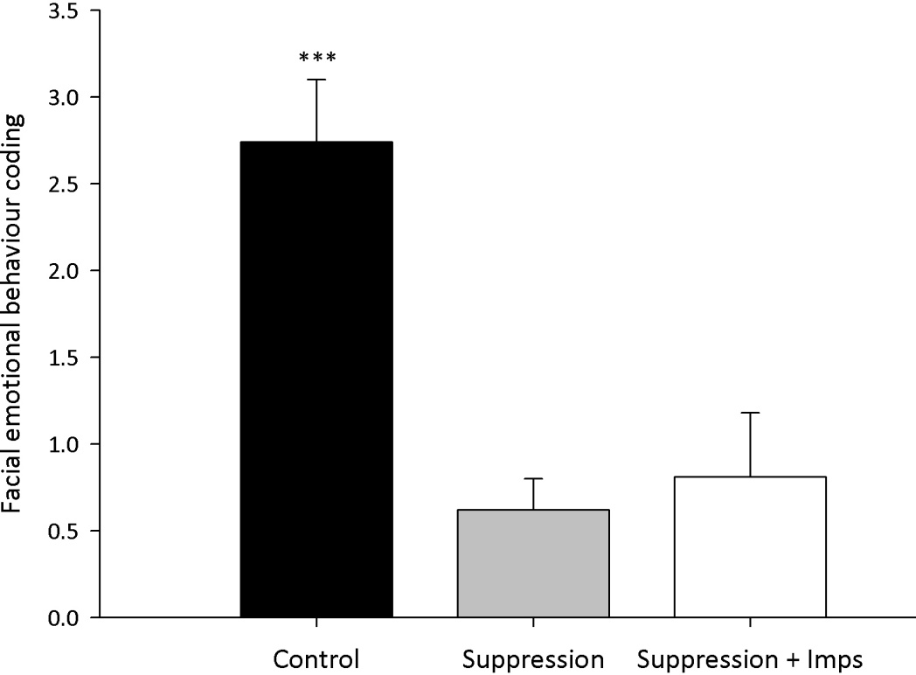
Figure 2.1: Mean disgust related facial expressive behaviour (with standard error) for the three experimental conditions.
*** p < .001 indicates a significant difference between the control and the suppression and the control and suppression + imps conditions.

2.5.2 Effect of ER instructions on self-reported emotional state
A Kruskal-Wallis K-sample test was conducted to compare participants self-reports of emotional state (Angry, sad, disgust, fear, and happy) between the control, instructed suppression and suppression + implementation intention conditions. This analysis indicated that there was no significant difference in self-reported emotional state between the control, suppression, and suppression + implementation intention conditions in any one of the examined emotional states (Table 2.1)
Table 2.1: Mean self-reported emotional state (with standard error) for the control, suppression and suppression + implementation intention conditions after the implementation of ER instructions.
Emotional State | Mean (SE)  Control Suppression Sup. + Imps |  |  | H | P
Angry | 1.75 (0.32) | 1.33 (0.24) | 1.77 (0.33) | 0.95 | 0.62
Sad | 1.97 (0.28) | 1.53 (0.26)_ | 1.93 (0.35) | 1.42 | 0.49
Disgust | 4.58 (0.24) | 4.32 (0.30) | 4.49 (0.26) | 0.34 | 0.84
Fear | 2.07 (0.41) | 1.71 (0.34) | 2.16 (0.32) | 1.25 | 0.54
Happy | 2.29 (0.21) | 2.29 (0.29) | 1.72 (0.29) | 3.28 | 0.19

2.5.3 Effects of ER instructions on blood glucose levels
A 3-between (Condition: Control, Suppression and suppression + Implementation intentions) x 2-within (Time: Baseline vs. Final) mixed-design ANOVA was conducted to compare participants initial and final BGL between the three experimental conditions (Figure A.2, Appendix 6.1.1). The results showed that there was no significant main effect of Condition, F (2, 52) = 0.03, p = .97, or Time F (1, 52) = 0.001, p = .98. Similarly, there was no significant interaction between Condition and Time, F (2, 52) = 0.33, p = .72 (Table 2.2).

2.5.4 Effect of ER instructions on ego depletion

2.5.4.1 Effect of ER instructions on Stroop task errors
A 3-between (Condition: Control, Suppression, suppression + Implementation intentions) ANOVA was conducted with errors made during the completion of the stroop task as the dependent variable (Table 2.2). The results showed that there was no significant difference in the amount of errors committed between the three experimental conditions, F (2, 52) = 0.41, p = .67 (Figure A.3, Appendix 6.1.1).

2.5.4.2 Effect of ER instructions on time taken to complete the Stroop task
A 3-between (Condition: Control, Suppression, suppression + Implementation intentions) ANOVA was conducted with time taken to complete the stroop task as the dependent variable (Table 2.2). The results showed that there was no significant difference in the amount of time required to complete the stroop task between the three experimental conditions, F (2, 52) = 0.15, p = .86, (Figure A.4, Appendix 6.1.1).

2.5.5 Effect of ER instructions on cardiovascular responding
A 3-between (Condition: Control, Suppression, suppression + Implementation intentions) ANOVA was conducted to investigate the effect of training on participants’ HRV percentage change (Figure A.5, Appendix 6.1.1). The main effect of Condition was not significant, F (2, 52) = 0.39, p = .68, indicating that there was no difference in cardiovascular responding between the three experimental groups (Table 2.2).
Table 2.2: Descriptive statistics (mean with standard error) for all dependent variables.
Dependent variable | Mean (SE)  Control Suppression Sup. + Imps.
Blood Glucose levels | 5.19 (0.11) | 5.15 (0.15) | 5.21 (0.13)
Stroop errors | 11.11 (1.35) | 9.89 (1.48) | 9.35 (1.36)
Stroop completion time (mm:sec) | 8.21 (0.25) | 8.24 (0.30) | 8.03 (0.32)
HRV % change | -11.27 (10.89) | 1.56 (9.02) | -2.54 (12.06)

2.6 Discussion
This first study investigated whether supplementing the intention to suppress emotional responses with an implementation intention could render suppression more efficient and thus automatic. Findings from self-reported emotional state and facial behaviour coding indicated that participants continued to feel disgust despite regulating facial expressions of disgust. These findings suggested that suppression of expressive behaviour is not equivalent to emotion regulation and thus would be better if it was considered as an emotion communication strategy instead of an ER strategy. Findings from blood glucose levels, ego-depletion and HRV analyses regarding the efficiency with which facial expressions of disgust were suppressed suggested that there was no difference between the suppression (effortful) and suppression + implementation intention (efficient) conditions. These findings are in line with McDaniel and Scullin (2010) results pointing out that implementation intentions do not necessarily lead to automatic, efficient control of the intended behaviour.

2.6.1 Subjective emotion experience and facial emotional expression
To examine whether the ER instructions used were able to help participants to down-regulate disgust the current study used Gross’ (1998) validated Emotional behaviour coding system as well as participants self-reports regarding how they felt after ER. Our findings indicated that suppression and implementation intention instructions helped participants to display significantly less facial expressions of disgust, as compared to participants in the control condition. At the same time, findings from self-reports of current emotional state suggested that people continued to feel disgust even when regulating their expressive behaviour. These findings are in accord with results obtained by Gross & Levenson (1993).
In their study Gross & Levenson (1993) asked their participants to watch two film clips designed to induce disgust while collecting facial expression (via video recording of the face) and self-reports of current emotional state. Similar to the findings of the present study, Gross & Levenson results indicated that people who were instructed to suppress their ongoing expressive behaviour while watching a disgusting film, showed a significant decrease in face movements, face touching, blinks and body movements, compared to people who were not asked to suppress their ongoing expressive behaviour. However, suppression instructions were unable to help people regulate their subjective experience of emotions. More specifically, Gross and Levenson’s results relating to self-report of current emotional state suggested that people continued experiencing disgust despite regulating their expressive behaviour.
Taken together, the results of the present study as well as that of Gross and Levenson (1993, 1997) indicated that people were able to suppress their expressive behaviour achieving in this way to hide their emotions from other people. At the same time these people reported that they continued to feel disgusted despite the fact that they were regulating their emotionally expressive behaviour. This suggested that suppression of expressive behaviour does not equal a reduction in people’s emotional experience. Findings from studies that measured the activity of the sympathetic nervous system (SNS) support the idea that suppression of expressive behaviour is not functionally equal to emotion regulation (Ochsner & Gross, 2005). For example, suppression of expressive behaviour was found to lead to increased sympathetic activation of the cardiovascular system (Gross & Levenson, 1997).
These findings may initially seem paradoxical given that suppression inhibits action. However, it makes sense if we take into account: A) the prominent role of physiological arousal in the generation of emotional responses (see section 1.2.1), B) the importance of controlling such physiological responses during ER (see section 1.3.1) and C) the fact that suppression does not regulate the induced emotion leaving us into a state in which we have to decide how we are going to respond to the situation at hand. In other words, the findings of the current study as well as Gross & Levenson (1993, 1997) studies pointed out that suppression is unable to regulate participants’ emotional experience, and thus physiological arousal (i.e. activity of the SNS division of the ANS) which is a crucial component of emotion (Damasio, 1994, 1999; Levenson, 2003). Therefore, it would be better if suppression was considered as an emotion communication strategy instead of an ER strategy.

2.6.2 Efficient regulation: Blood glucose levels, ego-depletion, and HRV
Regulation, be it cognitive ER or behavioural inhibition like the suppression of facial emotion expression, depends on meeting the metabolic demands of the brain (Duann, Ide, Luo & Li, 2009; Goldin et al 2008) via the delivery of metabolic substrates to brain structures involved in regulation. Therefore, demands associated with regulation lead to increases in cardiac output in order to supply neural structures involved with metabolic resources to meet their needs (Kennedy and Scholey, 2000). Hence, and given that automatic processing establishes a well-connected processing network that is able to decrease overall brain activity compared to the diffuse network observed during controlled processing, automatic behavioural inhibition (i.e. suppression + implementation intentions) was expected to be able to regulate facial expressions in a more economic and thus efficient manner. In essence, automaticity (in terms of the current suppression + implementation intention condition) was thought as leading to more efficient control of the neural network involved in facial emotional expressions (Duann et al, 2009). This was expected to be evident in decrease demands for glucose and cardiovascular responding.
However, analyses relating to blood glucose levels indicated that there was no significant difference in blood glucose levels between suppression, which is thought to operate at a controlled, effortful cognitive level, and implementation intentions of suppression intentions, which is thought to operate at a more automatic, efficient processing level. These results run contrary to the hypotheses of this study expecting that suppression would be associated with marked decreases in blood glucose levels compared to more automatic, efficient suppression. These findings are in discord with explanations arising from the self-control model, which expects initial acts of emotion regulation to require a large amount of energy, which in turn deplete resources and therefore result in a failure in self-control at later attempts (Muraven & Baumeister, 2000).
The above discussion suggesting that consumption of energy resources (i.e. blood glucose) during self-control is not compatible with a depletion account is supported by current study’s results pertaining to ego-depletion measures (via errors and time taken to complete the stroop task). The findings of the present study showed that there was no difference in the amount of errors committed and time taken to complete the stroop task between instructed suppression and suppression + implementation intention conditions (seen to operate at an automatic, efficient level).
Similar to the results relating to blood glucose levels, the finding of the present study relating to HRV showed that there was no significant difference in cardiac responding between suppression and implementation intentions of suppression intentions. These results run contrary to the hypotheses of this study predicting that suppression + implementation intention would be associated with increased HRV compared to effortful suppression.

2.6.3 Theoretical applications
The findings of the present study regarding blood glucose levels indicated that there was no difference between intentions to suppress facial emotional expression and augmentation of such intentions via implementation intentions, suggesting that self-control acts do not necessarily lead to the depletion of metabolic substrates. A recent work that took into account what is known about brain metabolism reanalysed data supporting the role of blood glucose in self-control and suggested that the relation between self-control tasks and blood glucose consumption might not reflect a depletion account (Kurzban, 2010). In support, Raichle & Mintun’s, (2006) research results showed that the local brain energy consumption after a certain task is limited. Such findings, led Raiche and Mintun to suggest that task specific increases in blood flow in particular brain areas do not necessarily relate to depletion of blood glucose. This is not to be taken as meaning that self-control is not relying on blood glucose as neural networks implementing self-control depend on the provision of blood borne glucose (Lund-Andersen, 1979; Reivich & Alavi, 1983; Weiss, 1986). It is rather a clarification indicating that the consumption of blood glucose during self-control might not be to the extent that would justify a depletion account.
Findings relevant to the ego-depletion rationale (i.e. time taken and errors committed during the completion of the stroop task) supported the idea that consumption of energy resources during self-control is not compatible with a depletion account. Contrary to these findings, previous use of the stroop task showed that implementation intentions buffered against ego-depletion (Webb & Sheeran, 2003). However, Webb and Sheeran used a task that utilized both body balance and mathematical ability. Specifically, participants in the ego-depletion condition were asked to stand in one leg while counting down in sevens from 1000. Such experimental manipulation required the co-ordination of body balance with a complex numerical task thus demanding greater energy provision than the suppression of expressive behaviour (facial expressions) used in the present study. Therefore, ego-depletion measures, like the stroop task, might not be sensitive enough to capture the limited utilization of metabolic resources, like glucose, during the suppression of expressive behaviour.
Taken together, the results of the present study suggest that forming implementation intentions to facilitate suppression instructions might not necessarily lead to efficient control of facial emotion expression. Such findings are in discord with the idea that the formation of implementation intentions can lead to more automatic, efficient responses. Implementation intentions are thought to be able to achieve such results through the strategic automation of action via strong association between predefined opportunities and related responses (Gollwitzer, Fujita & Oettingen, 2004; Gollwitzer & Schall, 1998). However, a recent examination challenged the proposed association between implementation intention and strategic automation. Following relevant research, McDaniel and Scullin (2010) reasoned that implementation intentions automatize prospective remembering by preventing prospective memory decline in cognitively demanding situations. In essence, the use of implementation intentions (i.e. linkage between a predefined opportunity for action with prescribed behaviour) should be able to diminish the distracting effects of cognitive load on memory. During McDaniel and Scullin’s study, participants were shown category labels paired with words and asked to indicate whether presented words were members of a paired category while under high cognitive demands (random number generation) or not. McDaniel and Scullin measured participants’ memory through a behavioural task that required people to press a button when a presented and previously memorized word appeared on the screen. Participants were asked either to form implementation intentions (i.e. when I see the word ‘dancer’ I will press key ‘z’) or receive standard instructions (i.e. I want to press ‘z’ for ‘dancer’). Their results indicated that implementation intentions resulted in a significant decline in prospective memory under conditions of high cognitive demands, as compared with standard cognitive demands and did not produce a significant enhancement in prospective memory under high cognitive demands, in comparison to standard instructions.
Furthermore, McDaniel and Scullin (2010) examined whether implementation intentions enabled automatic action initiation by evaluating the extent to which implementation intentions create a representation similar to that occurring from behavioural practice. In this experiment, they used previously tested implementation intention instructions, while participants in the practice condition took a block of practice trials in which the memory target cue (dancer) appeared several times, while participants tried to form a habit of performing the associated response (press ‘z’ key). Their results showed that implementation intentions resulted in a significant decrease in prospective memory in situations of high cognitive demands, as compared with behavioural practice.
These findings challenged the idea of strategic automation of action via implementation intentions by showing that the formation of Implementation intentions did not strengthen the association between the predefined opportunity and related response under conditions of high cognitive load. The link between opportunity and response was facilitated by extensive practice supporting the notion that behavioural practice can better facilitate automatic, efficient cognitive processing.
Such findings led McDaniel and Scullin (2010) to offer an alternative interpretation regarding the effectiveness of implementation intention plans, according to which implementation intentions facilitate robust associative encoding between a suitable situation and response intention like that observed in Cohen and Gollwitzer, (2008) and McDaniel, Howard and Butler, (2008) studies. Such robust associative encoding can subsequently lead to spontaneous retrieval of intended responses (McDaniel, Guynn, Einstein, & Breneiser, 2004), but this, according to McDaniel and Scullin (2010) need not produce efficient control of the intended behavior. In a similar fashion, Aarts and Dijksterhuis (2000) suggested that habitual behavior is not linked to the relevant environmental events, but rather to the mental representation of the goal it pursuits.

2.6.4 Limitations
The present study used a blood glucose monitoring system designed for diabetics to use at home with little or no training (Accu-Check compact plus). This measurement device complied with International Standards Organization (2003) minimum measurement accuracy criteria. According to this ISO standard guidelines the minimum acceptable system accuracy for self-monitoring of blood glucose (SMBG) devices requires that ≥ 95% of the individual glucose results must fall within ± 15 mg/dL of the results of the reference method at glucose concentration < 75 mg/dL and within ± 20% at glucose concentrations ≥ 75 mg/dL. Hence, there is considerable room for measurement error and thus SMBG devices might not be sensitive enough to identify the minimal amount of blood glucose consumed during self-control task like the one employed in the present study. Therefore, future studies should examine alternative methods of measurement glucose utilization by active neural assemblies during emotion regulation, including fluorodeoxyglucose positron emission tomography (¹⁸F-FDG) (Nofzinger, et al. 2002).

2.6.5 Conclusions
In conclusion, the findings of the current study showed that both suppression and implementation of suppression intentions are able to help people control their expressive behaviour, but not their subjective experience of emotions. This suggested that suppression of expressive behaviour does not equal to a reduction in people’s emotional experience and thus pointed out that suppression should be considered as a behavioural strategy relating to emotion communication, instead of an ER strategy. Regarding blood glucose levels, we expected that implementations intentions (considered to be able to automatize the control of expressive behaviour) would be associated with decreased consumption of blood glucose compared with suppression instructions. However, our findings failed to support this hypothesis. This might have been a result of the blood glucose measurement method used as this was not sensitive enough to capture the limited glucose utilization supporting self-control acts. The limited need for the utilization of blood glucose suggests that acts of self-control, including ER, reduces the need for increased cardiac responding. Indeed, HRV analyses suggested that there was no difference in terms of cardiac responding between the suppression and suppression + implementation intentions. Alternatively, the findings of the present study might have been a result of implementation intentions inability to automatize the control of expressive behaviour. Both blood glucose level and HRV findings are in line with McDaniel and Scullin’s (2010) results pointing out that implementation intentions do not necessarily lead to more automatic, efficient control of the intended behaviour. According to McDaniel and Scullin (2010), the link between opportunity and response is facilitated by extensive practice supporting the notion that structured practice can promote more automatic, efficient cognitive processing.

Chapter 3

Experiment II: Achieving efficient regulation of emotions via structured practice in ER

3.1 Abstract
Following the findings of the first study that indicated that harnessing intentions to regulate emotional responses with implementation intentions does not lead to more automatic, efficient ER, the second study examined whether structured practice can automatize emotion regulation. During three training sessions, comprising a total of 150 training trials, participants were presented with negatively valenced images and asked either to ‘attend’ (control condition) or ‘reappraise’ (ER condition). A further group of participants did not participate in training but underwent the follow-up assessment part of the study. Practice increased the efficiency of ER as indexed by decreased time to onset of ER and increased heart rate variability. Furthermore, participants in the ER condition spontaneously regulated their negative emotions two weeks later to more dynamical stimuli, which are of higher ecological validity compared to static pictures, and reported being more habitual in their use of ER. These findings indicate that structured practice can facilitate more automatic control of negative emotions and that these effects persist beyond training.

3.2 Overview of the present study
To date, automatic, efficient ER has been examined using a variety of experimental paradigms including emotional conflict adaptation, self-reports of habitual emotion regulation, spontaneous emotion regulatory efforts, action orientation tendencies and predisposition for emotion regulation and use of priming techniques (Gyurak, Gross & Etkin, 2011). The majority of these approaches rely on the existence of previous knowledge and practice in ER on the part of their participants. For example, priming manipulation like those
employed by Maus et al. (2007) or Williams et al. (2009) presuppose the existence of emotion regulatory goals that once primed operate in an automatic, efficient fashion.
Implementation intentions, on the other hand, incorporate goal intentions within “if-then” plans that detail the process of goal attainment (Schweiger-Gallo et al., 2009; Schweiger-Gallo & Gollwitzer, 2007) in an effort to establish goal dependant strategic automaticity. In essence, implementation intentions try to link existing goal intentions for emotion regulation with situational cues, so that goal directed responses will be initiated automatically when the predefined opportunity or situation is encountered (Gollwitzer & Schall, 1998). However, the findings of the first study of this thesis indicated that implementation intention plans did not lead to more efficient inhibition of expressive behaviour, as indexed via blood glucose utilization and HRV. These results may be explained by McDaniel and Scullin (2010) findings suggesting that the current formulation of implementation intentions does not confer automatic, efficient control of responses and that implementation intentions plans are not functionally equivalent to behavioural practice (see section 2.6.3).
Therefore, the current study aimed to examine the development of automatic emotion regulation through the use of structured practice. Structured practice represents a potential mechanism through which controlled, effortful processes can become more automatic and efficient (Bargh & Ferguson, 2000). According to Gyurak, Gross and Etkin (2011), sufficient repetition and mastery of an explicitly learned ER skill might render it more automatic and efficient. The application of structured practice to ER means that individuals with sufficient behavioural practice would acquire the capacity to regulate their emotions in a more automatic, efficient manner (see sections 1.5.2). In addition, the continuous activation of the same ER goal within a given situation will pair it with the internal representation of the situation (Bargh & Fergusson, 2000). Through such a process, the ER goal will eventually be activated on the perception of the features of the situation. This in turn will lead to the automatic elicitation of ER by environmental stimulation in the absence of explicit instructions to do so (Posner & Snyder, 1975).
More specifically, the present research aimed to investigate whether structured practice can increase the immediacy and the efficiency of ER, by examining the impact of practice in reappraisal on the time taken to regulate emotions and cardiac responding associated with ER. In other words, could structure practice foster relatively automatic, efficient ER? The considerable room for measurement error accompanying the use of self-monitoring devices measuring blood glucose (see section 2.6.4), and the lack of access to more sensitive measuring methods, like fluorodeoxyglucose positron emission tomography prohibited the measurement of glucose levels by the current study. Individuals’ ability to control their emotions depends on meeting the metabolic needs of their brains. Cardiac responding supports such functions via the facilitation of the delivery of metabolic resources to active neural structures (see section 1.7.3). Automatic processing, leads to the creation of a better connected neural network that results in decreases in cardiac responding (Williams et al., 2009), as the need for elevated cardiac outputs, in order to supply active neural structures with metabolic substrates (Kennedy & Scholey, 2000), is decreased. Such decreases in cardiac responding, while regulating negative affect, are taken to reflect efficient, economic task completion (Saling & Phillips, 2007) and, therefore, automatic ER. The impact of structured practice in ER on cardiac responding was measured through the time variability in individuals’ interbeat intervals, indexed by HRV (see section 1.7.3.2.2).

3.3 Hypotheses
We hypothesised that training in the application of ER would result in faster ER (lower time to onset of ER) and higher HRV during late but not early training trials, thus demonstrating both a practice effect and increased efficiency. Two weeks later, we predicted that participants who had practiced using reappraisal would be more likely to spontaneously regulate their negative emotions and report being relatively more habitual in so doing. These effects were expected for participants who practiced the application of ER, but not for participants allocated to the control instruction condition or those who did not take part in the training sessions.

3.4 Methods

3.4.1 Participants and design
Thirty healthy participants were recruited through advertisements on the online research participation system operated by the University of Sheffield and offered 10 credits for their participation in the present study. Three participants were excluded from analyses due to their not completing all sessions leaving 27 participants (18 females; M_{age} = 21.93 SD = 6.36 years; range 18 – 46 years). Participants were randomly assigned to one of three conditions. In two of these conditions, participants received training but were given different instructions to follow: control instructions (n = 9) and ER instructions (n = 8). Participants in the third condition (n = 10) received no training and simply completed follow-up measures. Participants reported no history of psychiatric, neurologic and medical illness. The study was approved by the local ethics board of the department of psychology, the University of Sheffield (application title and number: Developing automatic emotion regulation, #353).

3.4.2 Procedures
3.4.2.1 Baseline emotional valence rating
Before commencing training, participants provided a baseline measure of the impact of the images on their emotional state. Participants were presented with 150 images depicting body injuries as well as 110 images depicting non-injured body parts (Figure 3.1a). Seventy-five of the images depicting body injuries were taken from the International Affective Picture System (IAPS) (M_{Val} = 2.13, SD = 0.60; possible range of responses = 1-9, 1-3 = negative valence) (Lang, Bradley, & Cuthbert, 2005). The remaining pictures were created by editing pictures depicting non-injured body parts using Adobe Photoshop CS5 (Adobe Systems Inc., San Jose, CA). Previous research has shown that pictures depicting body injuries are associated with greater startle reflexes, as measured via blink magnitude, indicating their potency to act as aversive stimuli (Fairchild, Van Goozen, Stollery, & Goodyer, 2007). Pictures were presented in a pseudorandom order. Participants viewed the images presented on a PC monitor, using Presentation software (Neurobehavioural Systems Inc, Albany, CA), seated approximately 50cm from the screen. In line with research examining implicit emotion evaluation (e.g., Bargh, Chaiken, Raymond, & Hymes, 1996), each picture was presented for 256ms to capture initial emotional responses, while avoiding extensive conscious processing. We conducted a pilot study (N = 10) in order to compare the emotional value of IAPS pictures depicting body injuries with the emotional value of edited pictures depicting body injuries (see appendix 6.3). The results of the pilot study indicated that the emotional value of IAPS pictures depicting body injuries (M = 3.63, SE = 0.27) was not different to the emotional value of edited pictures depicting body injuries (M = 3.51, SE = 0.24), t(9) = 0.64, p = .54, paired-samples t-test.

3.4.2.2 Self-reports of current emotional state
Emotional valence evaluations are prominent aspects in the determination of individuals’ emotional state as they can indicate both appetitive motives (positive valence) relating to attraction and pleasure and aversive motivation (negative valence) relating to displeasure (Lang, 1995). Previous examination of the correspondence between discrete emotions evaluations, such as those employed in the previous study, and dimensional evaluations, such as those employed in this as well as in the next study, found a close agreement between the two methods of emotion evaluation (Eerola, & Vuoskoski, 2011). However, discrete emotions evaluation methods had lower resolution in the characterization of ambiguous examples. Therefore, the present study used a dimensional approach to evaluate participants’ emotions. Following Schartau et al. (2009), participants were asked to indicate to what extent they felt either positive or negative on an 11-point Likert-type scale anchored by ‘extremely negative’ (1) and ‘extremely positive’ (11). In order to ensure that pictures depicting body injuries induced emotional responses of negative valence, we compared participants’ emotional reactions before and after exposure. Participants’ emotional state was significantly more negative after they were exposed to these images (M = 3.33, SD = 0.90) than before (M = 8.38, SD = 1.50), t(15)=12.58, p < .001, paired-samples t-test. However, participants’ emotional state after they were exposed to non-injured body part images (M =7.72, SD = 0.87) was not significantly different than before, t(15)=1.46, p = .17, paired-samples t-test.

3.4.2.3 Training.
Following baseline evaluation, participants were invited to participate in three, laboratory based, training sessions over the course of one week (training sessions typically took place on alternating days). Written instructions were given before each training session. Participants were told that during each trial they would be presented with a series of pictures, some of which depicted scenes designed to evoke negative emotions. Participants in the ER condition were instructed to reframe their initial emotional responses to these images by reinterpreting the content of the target pictures and thereby alter their related emotional responses (Goldin et al., 2008). Specifically, participants in the ER condition were told “When seeing these injuries you must remind yourself that they are fake; they were created by the film industry using special effect technology to be used in movies”. We opted to use a reappraisal ER strategy in the present study as the results of the first study of this thesis indicated that people continued to feel disgust even when regulating their expressive behaviour, suggesting that suppression is more of an emotion communication strategy instead of an ER strategy. Participants in the ER condition were told to press the ‘Enter’ key when their emotional response to the injured body part images subsided. Participants allocated to the control training condition, on the other hand, were simply told: “When you see any injury, please press the ‘Enter’ key”. Participants were given as much time as required to read and confirm their understanding of the instructions.
Each training session involved 80 trials presented in a pseudorandom order (Figure 3.1b). Each trial contained a maximum of 10 images. 30 trials contained no picture depicting a body injury and, thus, presented participants with 10 images depicting non-injured body parts for 1 second each. The remaining 50 trials presented participants with between 0 and 9 images depicting non-injured body parts followed by a picture depicting a body injury. Trials in which the body injury picture was presented first always followed trials that contained no picture depicting a body injury. Pictures depicting body injuries remained on screen for 10 seconds to allow sufficient time for ER (Goldin, McRae, Ramel & Gross, 2008). Images depicting body injuries were followed by the same self-report measure as that used during baseline that served as a measure of ER success. Participants moved a cursor, which appeared at a random location on the scale to prevent anchoring, using the left and right arrow keys. The presentation of the self-report measure lasted 5 seconds. No stimulus was presented after the self-report item and thus the inter-trial interval varied such that each trial lasted for 25 seconds in total.
The selected design was based on fMRI research investigating release from adaptation or habituation of neural populations after repeated presentation of a stimulus (Grill-Spector, Henson, & Martin, 2006; Harris, Young & Andrews, 2012). Research investigating neural release from adaptation examined the altered sensitivity of the neural representation of the stimulus after different changes have been applied to the stimulus (Grill-Spector, Henson, & Martin, 2006). If the neural representation is insensitive to changes applied to the stimulus then the fMR signal shows a reduction that is similar to the reduction observed when identical stimuli are presented in a repeated manner (i.e. habituation). On the other hand, if the underlying neural representation of the stimulus is responsive to changes applied, then the fMR signal increases to the original, non-habituated level. This is often called ‘release from adaptation’ or habituation. Using this kind of design Harris, Young & Andrews, (2012) showed that the amygdala, which is involved in the determination of the emotional value attached to sensory stimuli (Davis & Whalen, 2001), is released from adaptation or habituation if a different emotion follows the repeated presentation of the same emotion (i.e. if a body injury picture follows the repeated presentation of a non-injured body part). We conducted a within subject t-test to examine whether participants self-report emotional state differed between images depicting injured body parts and those depicting non injured body part. As expected, participants emotional state differed after presented with images depicting body injuries (M = 3.33, SD = 0.90, range 1 to 11, 1 to 5 = negative emotional state) compared to imaged depicting non injured body parts (M = 7.72, SD = 0.87 range 1 to 11, 7 to 11= positive emotional state), t(16) = -11.19, p < .001.

3.4.2.3.1 Cardiovascular responding during ER
HRV was collected throughout each training session using photoplethysmography (PPG) signal sensors (see section 1.4.3.2.2) attached to the left ear lobe. To establish baseline HRV, participants were presented with a 5 minute slideshow containing 30 images from the IAPS (Lang, Bradley, & Cuthbert, 2005) depicting landscapes and objects (see appendix 6.2.1) with neutral valence (M_{Val} = 5.2, SD = 0.3, possible range of responses 1-9, 4-6 = neutral valance). Images remained on screen for 5 seconds, and the 30 images were repeated in a random order for 5 minutes. HRV was measured as the root mean square of successive differences (RMSSD) in the interbeat intervals (Camm et al., 1996). This time domain measure is correlated with measures reflecting high frequency components of the respiratory range (Goedhart et al., 2007). It, therefore, indicates parasympathetic influences to the heart and thus decreases in cardiovascular effort. The output of the PPG sensor was digitally sampled and an online butterworth low pass filter, with a cut-off at 7hz, was applied to remove any high frequency noise present in the signal. Artifact pre-processing was conducted on the interbeat interval (IBI) data following Goedhart et al.’s (2007) guidelines. Data sets were visually inspected for abnormal fluctuations using Kubios software (Biosignal Analysis and Medical Imaging Group, 2008). HRV responses obtained during training were adjusted for baseline HRV via the computation of percentage change (Stern, Ray, & Quigley, 2001). Change scores were computed, subtracting the baseline from training HRV. Therefore, positive scores represent increases in HRV indexing cardiac deceleration. The primary reason for adjusting HRV responses for baseline was to remove concomitant variation in the response and thus improve the precision of comparisons (Keiser, 1989). The computation of percentage change allowed us to normalize the data before subsequent statistical analyses (Hancock, Bush, Stanisic, Kyncl, & Lin, 1988).

3.4.2.4 Follow-up
Participants returned for a follow-up session two weeks after their final training session. During the follow-up session, participants watched five film clips lasting between 60 and 105 seconds presented in a pseudorandom order (Figure 3.1c). The use of film clips during the follow up allowed us to (i) examine whether training in ER influenced more sustained emotional responses, such as those induced by film clips (Westermann, Spies, Stahl, & Hesse, 1996) that are more ecologically valid than pictures (Gross & Levenson, 1995), and (ii) reduce shared method variance and the likelihood that any effects of our training paradigm are task specific (Holmes, Lang, & Shah, 2009). The film clips were obtained from internet-based video-hosting sites and showed scenes of body injuries including war violence, the infection of human tissue by fly larvae, and the removal of cyst from a person’s back. Following each film, participants were asked to rate their current emotional state on the same measure used previously (see section 3.4.2.2). No instructions were given regarding the application of ER as we were interested in the extent to which participants would implicitly regulate their emotions in the absence of explicit instructions to do so.
In order to check that the film clips were successful in inducing emotions of negative valence, we compared participants’ self-reported emotional state in the no-training condition before and after they were exposed to the film clips. As hypothesised, the valence of participants’ emotional state was significantly more negative after they were exposed to the film clips (M = 3.48, SD = 1.41) than before (M = 8.30, SD = 1.25), t(9)=13.84, p < .001, paired-sample t-test.

3.4.2.4.1 Habitual use of reappraisal
After watching the films comprising the follow-up session, participants completed the self-report habit index (SRHI; Verplanken & Orbell, 2003) as a measure of the extent to which ER had become a habitual process. The SRHI comprises 12 items, including the history of behavioural repetition, the difficulty of controlling behaviour, lack of awareness, efficiency and identity expression allowing the evaluation of a particular response. Participants are provided with the stem: ‘Changing the way that I think about negative emotional situations in order to feel better is something:’ and then responded to a number of statements (e.g., I do without thinking) on 11-point Likert-type scales anchored by ‘strongly disagree’ (1) to ‘strongly agree’ (11). Higher scores on the SRHI suggest that the process in question is more habitual. Previous research has shown the SRHI to achieve a high test-retest reliability (r = .91), strong convergent validity to response-frequency measures (r = .58) and behaviour-frequency measures (r = .74) (Verplanken & Orbell, 2003; Verplanken, Aarts, Van Knippenberg, & Van Knippenberg, 1994). In the present study, the 12 items of the SRHI showed high internal consistency (cronbach’s alpha = 0.91).
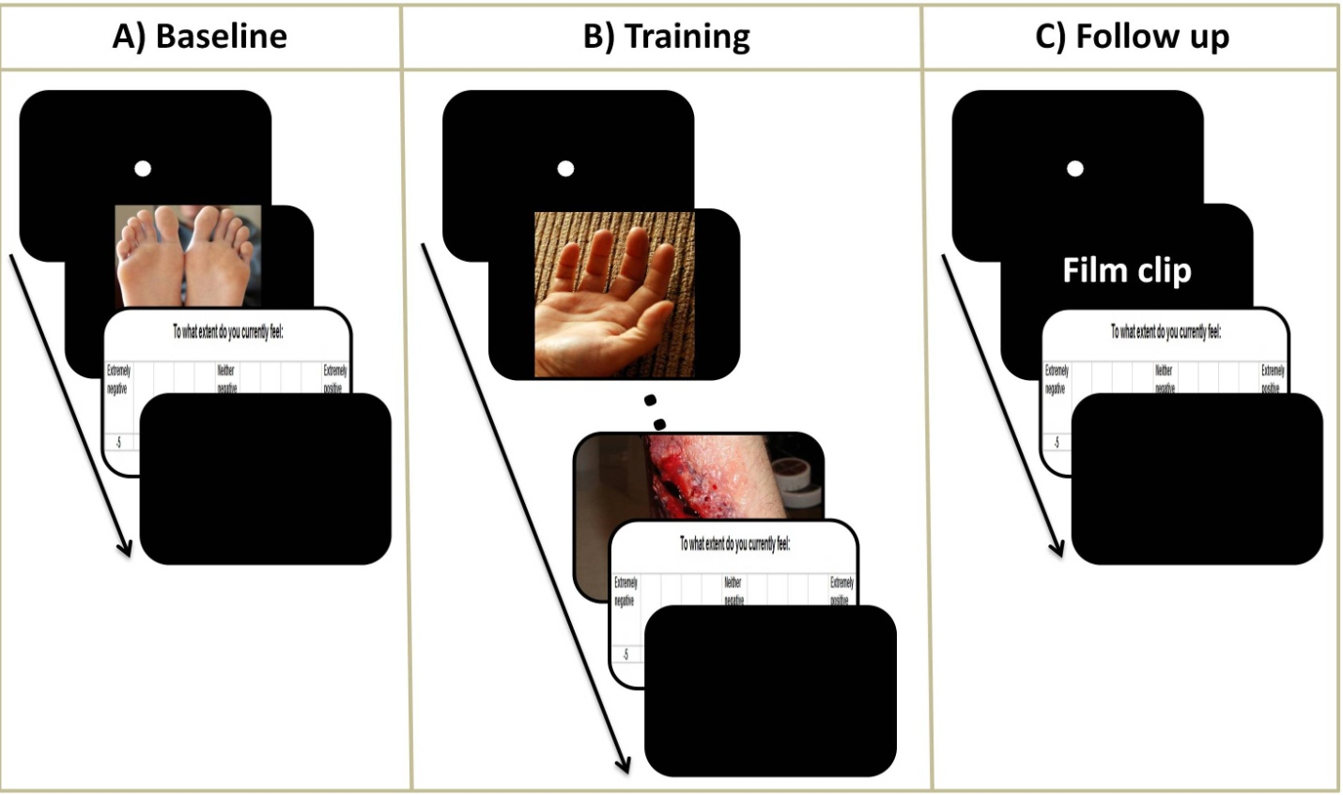
Figure 3.1: Description of the procedures, including baseline, training & follow-up phases, of the present study A) Participants were presented with 260 images (150 depicting body injuries & 110 depicting non-injured body parts). Each picture was preceded by the presentation of a 500ms fixation dot. Pictures were presented for 256ms and followed by the self-report emotional state that remained on screen for 3sec. This was followed by a 500ms inter-trial interval to take the total time for each baseline trial to 4sec. B) Between 0 and 9 pictures of normal, uninjured body parts were presented for 1 second preceding the presentation of the target (i.e. body-injury) picture. Target pictures were presented for 10sec, followed by a 5sec presentation of the self-report of emotional state scale. This was followed by a variable inter-trial interval to take the total time for each training trial to 25sec. C) At follow-up, participants were presented with five film clips lasting between 60 and 105 seconds. Each film clips was preceded by a 500ms presentation of a fixation dot, and followed by the same self-report measure as that used during the baseline & training which lasted for 3sec. This was followed by a variable inter-trial interval to take the total time for each follow-up trial to 25sec.

3.5 Approach to analyses
Participants’ scores were trimmed to three standard deviations of their mean. In addition, a set of Shapiro-Wilk tests (W) were conducted to test whether dependent variables deviated from normality (see section 2.4). The examination of the normality of the distribution of self-reported emotional state (W = 0.97, p > .05), completion time (W = 0.86, p > .05), HRV (W = 0.92, p > .05), emotional experience at follow up (W = 0.88, p > .05), and habitual use of reappraisal at follow up (W = 0.94, p > .05), for the ER, control and no-training conditions suggested that obtained data were normally distributed.

3.6 Results

3.6.1 Effects of ER instructions on self-reported emotional state
In order to investigate whether ER instructions helped participants to regulate their (negative) emotions, we compared self-reported emotional state after participants were exposed to the images depicting body injuries for the first time (i.e. at baseline) with those obtained during 50, 100, and 150 trials using a 2-between (Condition: control instructions vs. ER instructions) by 4-within (Time: baseline, 50, 100, 150 training trials) mixed design ANOVA (Figure 3.2). There were significant main effects of Time, F(3, 45) = 16.24, p < .001, and Condition, F(1, 15) = 22.30, p < .001, that were qualified by a significant interaction between Time and Condition, F(3, 45) = 10.92, p < .001.
The self-reported emotional state of participants allocated to the ER condition differed significantly across the four measurement times, F(3, 21) = 33.79, p < .001. Bonferroni post hoc (critical α = .017) indicated that participants allocated to the ER condition felt less negative during 50 (M = 6.44, SE = 0.40), t(7) = -3.19, p < .01, 100 (M = 6.30, SE = 0.54), t(7) = -3.06, p < .01 and 150 training trials (M = 6.45, SE = 0.62), t(7) = -3.61, p < .01 compared to baseline (M = 3.25, SE = 0.32). The self-reported emotional state of participants allocated to the control condition did not differ between baseline (M = 3.39, SE = 0.32), 50 (M = 3.96, SE = 0.29), 100 (M = 3.37, SE = 0.48), and 150 training trials (M = 3.77, SE = 0.31), F(3, 24) = 0.69, p = .56.
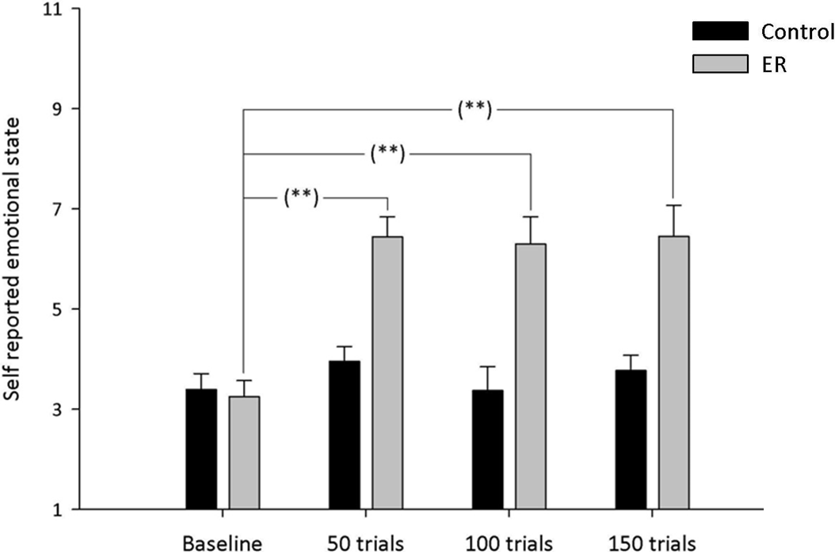
Figure 3.2: Mean self-reported emotional state (with standard error) after initial exposure to images and after each of the three training sessions (50, 100, and 150 training trials). Control = Control Instruction Condition; ER = Emotion Regulation Instruction Condition.
** p < .01

3.6.2 Effect of training on completion time
We examined the immediacy with which ER was applied by comparing the time taken for participants’ to respond to the images depicting body injuries across training trials. Analyses were conducted separately for each condition (ER vs. control) as the two conditions received different instructions (participants allocated to the ER instruction condition were told to press the ‘Enter’ key only when their emotional response to the images depicting injured body parts subsided, whereas those in the control condition were told to press the ‘Enter’ key every time they were presented with an image depicting a body injury).
A repeated measures ANOVA was conducted to examine whether time to onset of ER of participants in the ER condition differed across the three Training blocks (50, 100, and 150 trials). There was a significant difference in the time to onset of ER of participants in the ER condition, F(2, 14) = 3.93, p < .05. This effect was due to a significant decrease in the time to onset of ER between 50 (M = 3235ms, SE = 595) and 150 training trials (M = 2607ms, SE = 444), t(7) = 2.49, p = .02. No significant differences in the time to onset of ER was identified between 50 and 100 training trials (M = 3078ms SE = 498), t(7) = 0.86, p = .63 or between 100 and 150 training trials, t(7) = 1.83, p = .18, (Figure 3.3). Bonferonni correction was used to control for multiple comparisons (critical α = .02). As expected, the response latencies of participants in the control condition did not differ significantly across Training blocks, F(2, 16) = 0.20, p = .82.
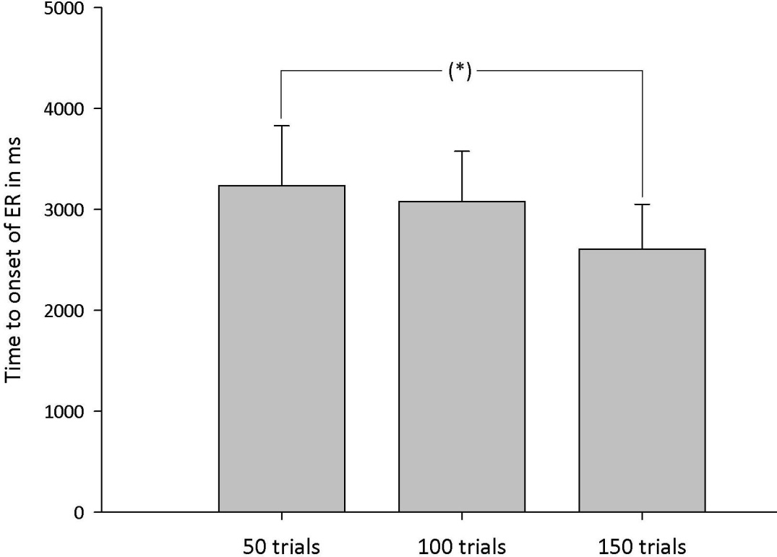
Figure 3.3: Mean time to onset of ER of participants in the ER condition (with standard error) at 50, 100 and 150 training trials. * p < .05.

3.6.3 Effect of training on cardiovascular responding
Individual differences in emotional reactivity (Hare et al., 2008; Suarez & Williams, 1989) are of particular importance given that ER monitors and adjust emotional responses. Therefore, we conducted a 2 between (Emotional reactivity: Low vs. High) by 2 between (Condition: ER vs. control) by 3 within (Training session: 50, 100, 150 training trials) ANOVA to examine the influence of emotional reactivity. To operationalise emotional reactivity we divided our sample to low and high emotionally reactive participants based on a median split (Med = 3.61) of their scores on self-reported emotional state when exposed to images depicting body injuries for the first time. These analyses indicated that there was no significant effect of emotional reactivity F(1, 13) = 0.40, p = .85, and no significant interaction between emotional reactivity and condition (control vs. ER), F(1, 13) = 1.09, p = .32, emotional reactivity and training session, F(2, 26) = 0.92, p = .41. The three way interaction between, emotional reactivity, condition and training block was also non-significant, F(2, 26) = 0.45, p = .64.
Therefore, a 2-between (Condition: control instructions vs. ER instructions) by 3-within (Training block: 50, 100, 150 trials) mixed design ANOVA was conducted to investigate the effect of training on participants’ HRV percentage change (Figure 3.4). The main effect of Condition was not significant F(1, 15) = 1.19, p = .29. However, the main effect of Training block was significant, F(2, 30) = 5.17, p < .05, as was the interaction between Training block and Condition, F(2, 30) = 4.63, p < .05. This interaction was due to a significant difference in HRV percentage change of the ER condition across training blocks, F(2, 14) = 6.49, p < .05, such that HRV percentage change increased across training blocks. More specifically, there was a significant increase in HRV percentage change between 50 (M =5.07, SE = 16.70) and 150 training trials (M = 53.28, SE = 11.34), t(7) = -2.69 p = .02. Also, there was a trend toward an increase in HRV percentage change between 50 and 100 training trial (M = 27.16, SE = 13.42), t(7) = -2.27, p = .09, and between 100 and 150 training trials, t(7) = -2.35 p = .08. Bonferonni correction was used to control for multiple comparisons (critical α = .02). No significant difference was identified for the HRV of the control condition across training blocks, F(2, 16) = 0.03, p = .98.

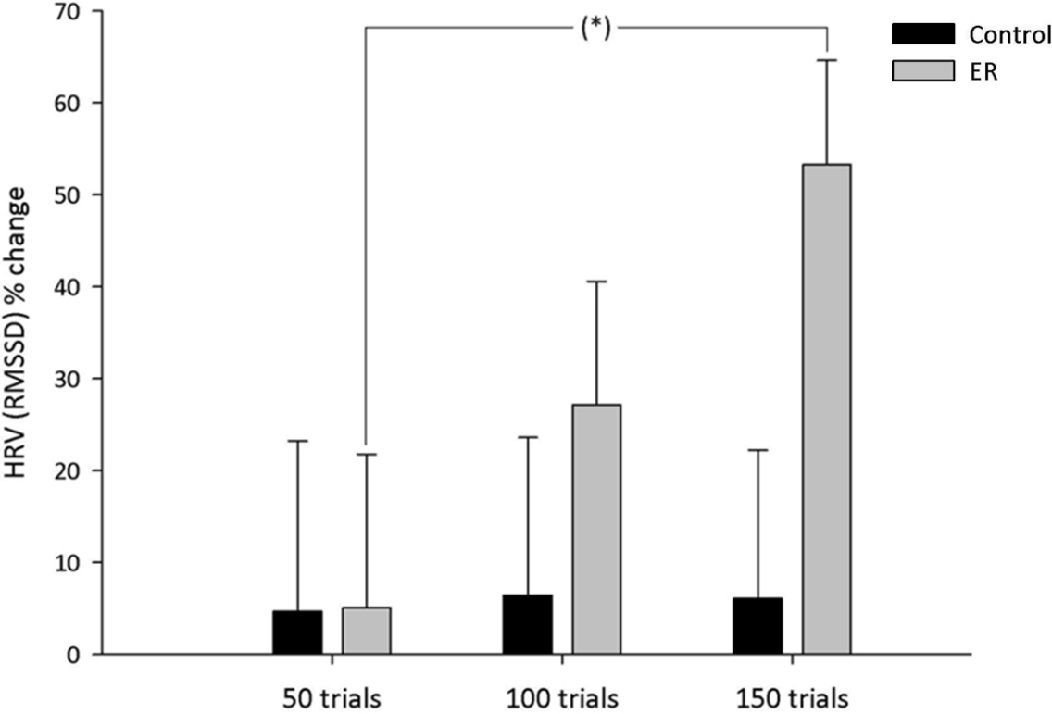
Figure 3.4: HRV % change (with standard error) as a function of condition across training blocks. Control = Control Instruction Condition; ER = Emotion Regulation Instruction Condition; * p < .05.

3.6.4 Effect of training on emotional experience at 2-week follow up
A 3-between (Condition: ER instruction, control instruction, no-training) ANOVA was conducted with participants’ emotional state after watching the film clips as the dependent variable (Figure 3.5). The main effect of Condition was significant, F(2, 26) = 11.81, p < .001. This was due to participants in the ER condition reporting feeling significantly less negative (M = 6.53, SE = 0.48) than participants allocated to the control condition (M = 3.75, SE = 0.50), t(15) = 3.96, p < .01, and participants allocated to the no-training condition (M = 3.48, SE = 0.45), t(16) = 4.64, p < .001. There was no significant difference in the emotional state of participants allocated to the control and no-training conditions, t(17) = 0.41, p = .96. Bonferonni correction was used to control for multiple comparisons (critical α = .02).
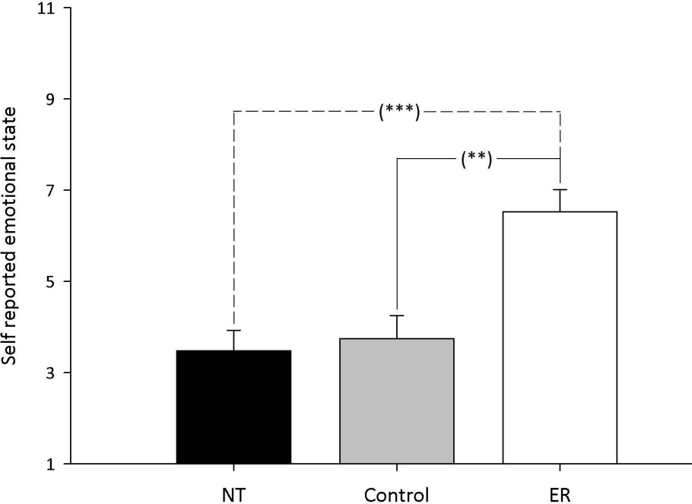
Figure 3.5: Self-reported emotional state (with standard error) by Condition at 2-week follow-up.
Control = Control Instruction Condition; ER = Emotion Regulation Instruction Condition; NT = No Training Condition. *** p < .001. ** p < .01.

3.6.5 Effect of training on habitual use of reappraisal at 2-week follow up
A 3-between (Condition: ER instruction, control instruction, no-training), ANOVA was conducted to investigate the extent to which ER had become habitual (as measured via the SRHI) in the three conditions (Figure 3.6). There was a significant main effect of Condition on participants responses on the SRHI, F(2, 26) = 9.34, p < .01. This was due to participants in the ER condition reporting being significantly more habitual (M = 82.50, SE = 2.49) in their application of ER than were participants in the control condition (M = 69.78, SE = 1.33), t(15) = 4.65, p < .001, and participants in the no-training condition (M = 62.80, SE = 4.43), t(16) = 3.61, p < .01. There was no significant difference in the habitual use of ER between participants in the control and no-training conditions, t(17) = 1.45, p = .25. Bonferonni correction was used to control for multiple comparisons (critical α = .02).

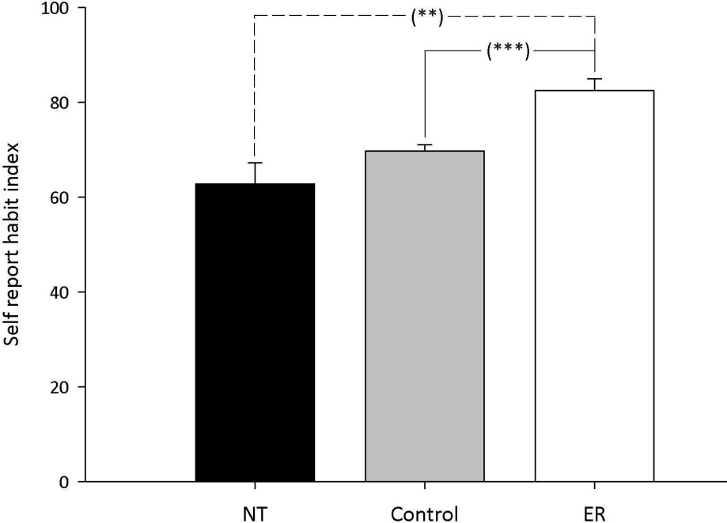
Figure 3.6: Habitual use of ER (with standard error) by Condition at 2-week follow-up.
Control = Control Instruction Condition; ER = Emotion Regulation Instruction Condition; NT = No Training Condition. *** p < .001. ** p < .01.

3.7 Discussion
The present study investigated whether structured practice enhanced the immediacy (lower time to onset of ER) and efficiency with which ER, in the form of reappraisal, is used to down-regulate negative emotions. Participants who completed training in the application of ER showed successful down-regulation of negative affect while decreasing time to onset of ER and the amount of cardiovascular effort (i.e. responding) invested in ER (as indexed via HRV). Participants who received structured practice in ER also provided evidence of spontaneous down-regulation of negative affect (i.e. regulation in the absence of explicit instructions to do so) two weeks later, and reported being more habitual in their application of reappraisal. Taken together, these findings suggest that physiological measures can be used to measure changes in the efficiency with which cognitive processes such as ER are implemented.
The findings of the present research support those of Schartau et al. (2009), but importantly, extend this research to demonstrate that structured practice can foster more efficient and thus relatively automatic ER; an effect that is maintained two-weeks later. Automatic processes can be characterised by a range of features including being efficient, fast, spontaneous, stimulus driven, unconscious, and relatively difficult to control. However, contemporary views suggest that these features should be investigated separately (Moors & De Houwer, 2006). In the present research, we focused primarily on the efficiency of emotion regulation. Without training, ER draws heavily on available resources (Niven, Totterdell, Miles, Webb and Sheeran, 2013) and is associated with increased activity in supporting systems like the ANS (Williams, Bargh, Nocera, & Gray, 2009), however, our findings suggest that ER becomes more efficient with structured practice, supporting the notion that self-control, including ER, slowly becomes automatic with practice.
The findings of the present research are also consistent with research using Cognitive Bias Modification (CBM) in suggesting that structured practice can promote the effective down-regulation of negative emotions after the end of the intervention (MacLeod, Koster, & Fox, 2009; Schmidt, Richey, Buckner, & Timpano, 2009). However, the present study expands such findings beyond tasks involving attention allocation to encompass practice in the application of ER strategies designed to modify emotional responses. This is of particular importance for two reasons. First, our ability to modify emotional responses mediates the relationship between the various ER skills and mental health outcomes (Berking et al., 2012). Second, spontaneous ER via reappraisal, as that observed two weeks after the final training session, seems not to be as extensive (Volokhov & Demaree, 2010) as suggested by its developmental nature (Waters et al., 2010).
Volokhov and Demaree (2010) presented 113 people with a positive and a negative film clip while avoiding providing any instructions about how people should respond to the emotional film clips. Following the presentation of the film clips, participants in Volokhov and Demaree study were asked a series of questions to establish whether they spontaneously regulated their emotions. Volokhov and Demaree results showed that only 17.7% (12.4% using reappraisal and 5.3% using suppression) of the total sample had spontaneously regulated emotions arising as a result of the presentation of the positive film and 39.8% (30.1% using reappraisal and 9.7% using suppression) had spontaneously regulated negative emotions induced by the negative film clip presented. In this light, the results of the present study are encouraging as they suggested that structured practice in ER leads to spontaneous regulation of negative affect two weeks after the final training session.
The findings of the present study have important theoretical implication for ER applications aiming to automatize the control of negative emotions. Our findings conceptually replicate Jansma et al.’s (2001) and Little et al.’s (2004) results supporting the notion that training leads to a more efficient and economical processing network than that employed during controlled processing. However, the present study extends Jansma et al.’s (2001) and Little et al.’s (2004) results beyond tasks involving verbal working memory and category learning to encompass the application of ER rules and measures of cardiovascular responding.
There is ample evidence linking cardiac function and neural activity. For example, increases in HRV (indicating increased parasympathetic input to the heart and thus decreased cardiac effort) were found to have a robust relation with higher activity in the prefrontal cortex (Hansen, Johnsen & Thayer, 2009; Lane et al., 2009). Conversely, cardiovascular arousal induced by both exercise and mental stressors was found to be associated with decreased activity in the prefrontal cortex (Critchley, Corfield, Chandler, Mathias & Dolan, 2000). This is consistent given that the PFC is part of the central autonomic network (Benarroch, 1993) which flexibly adjusts physiological arousal to support emotional responding (Appelhans & Luecken, 2006). Within this context, PFC seems to inhibit activity in emotion relevant brain areas like the amygdala (Goldin, McRae, Ramel & Gross, 2008) associated with increases in physiological arousal and thus cardiac responding (LeDoux, Iwata, Cicchetti & Reis, 1988). These findings, in conjunction with the results of the present study, suggest that training in the application of a reappraisal ER strategy could lead to the creation of a better connected processing network akin to that proposed by Jansma et al.’s (2001) and Little et al.’s (2004) results which can achieve ER in an efficient, economical manner.

3.7.1 Practical applications
At the practical level, our results suggest that structured practice in the application of ER offers a promising tool for the automation of ER. The use of physiological measures that are sensitive to cardiac responding (i.e. HRV) along with measures of the extent to which individuals habitually regulated their emotions following training, offered insights into the relation between structured practice and the efficiency with which ER is able to down-regulate negative emotions. Such findings suggest that structured practice protocols offer a promising tool able to help individuals regulate negative emotions in an efficient manner.
The short duration of the present intervention and the minimal need for one-to-one contact suggests that similar protocols could be implemented online or developed as part of a computerised self-help package. This application could offer people a structured approach to promoting effective and efficient ER and, thus, help them to gain the benefits associated with self-control, while avoiding the drain on resources that is associated with effortful ER. Similar attempts using CBM protocols have proven successful with healthy participants (See, MacLeod, & Bridle, 2009), as well as in individuals with depressive symptoms (Watkins, Baeyens, & Read, 2009). The effortful nature of controlled ER and related increases in the consumption of resources (Niven, Totterdell, Miles, Webb and Sheeran (2013) and activity of the SNS division of the ANS (Williams, Bargh, Nocera, & Gray, 2009) do not permit continued effective engagement with emotional responses. For example, performing tasks that require executive control, like memory updating, was found to hinder subsequent efforts to exert conscious control over emotion tendencies (Schmeichel, 2007). Similarly, effortful ER was found to lead to poorer self-control in a subsequent stop-signal task requiring response inhibition compared to emotional acceptance (Alberts, Schneider, & Martijn, 2012). Therefore, professionals who are subjected to continued stress due to the nature of their professions are likely to benefit from the increased resilience that is afforded by more automatic forms of ER. The nature of certain professions such as that of the emergency room staff who provides care following sudden illness or trauma is often stressful and emotional. Recent evidence suggested that doctors internalise the experience of their patients (Jensen et al., 2013) indicating that their work has an emotional impact. The use of more automatic, efficient ER under these circumstances will allow prolonged regulation of emotional responses. Future research should, therefore, examine the efficacy of the present structured practice protocol for promoting emotional resilience among professionals subjected to continued stress, due to the nature of their profession, like the emergency room staff.

3.7.2 Clinical relevance
The findings of the present study relating to the efficiency afforded by structured practice in ER are of particular importance for people suffering from depression for two reasons. First, depressed individuals are at an increased risk for the development of cardiovascular disease (Rugulies, 2002). The increased risk for the development of cardiovascular disease in depression is associated with reduced HRV (Imaoka, Inoue, Inoue, Hazama, Tanaka, & Yamane 1985), which is a known risk factor for cardiovascular disease (Casolo, Balli, Taddei, Amuhasi & Cesare, 1989; Nolan, et al., 1992). Therefore, developing more automatic, efficient ER could buffer against increased risk for developing cardiovascular disease associated with depression, by helping depressed individuals to regulate negative affect while minimizing cardiac responding.
Second, depression is associated with negative interpretation biases (Joiner, 2006; Nunn, Mathews & Trower, 1997; Starr & Moulds, 2006) which are also relevant to the interpretation of social situations (Bruch, & Belking, 2001). This is of particular importance given that much of the information conveyed in social contexts is ambiguous (Moser, Huppert, Foa & Simons, 2012). Such negative interpretation biases are associated with negative emotions. For example, induction of negative emotional state was found to lead to a significant increase in the amount of ambiguous information interpreted in a negative manner (Davey, Bickerstaffe & MacDonald, 2006). Given Volokhov and Demaree’s (2010) findings that suggested that spontaneous ER is not used extensively by adults, the findings of the current study indicate that structured practice in ER can establish implicit regulation (i.e. ER in the absence of explicit instructions to do so). The establishment of implicit ER may buffer against the negative interpretation bias of ambiguous information associated with depression, via the implicit regulation of negative emotions.

3.7.3 Limitations
The present study used a laboratory-based approach both for training and examining the effects of training. However, given that training effects can display context sensitivity (Reder & Klatzky, 1994) subsequent research should measure responses to real-world events in order to examine whether the effects of structured practice in ER are transferable to settings outside the laboratory. Future research should also examine the effects of structured practice on emotional responses beyond the 2-week follow-up used in the present study. Our finding that ER at follow-up was relatively habitual, suggests that the observed effects should be maintained (or even enhanced) over longer follow-up periods. However, it may also be that strategies are required to maintain effects over time. For example, the longevity of effects could be increased by decreasing temporal proximity between successive training sessions (Cepeda, Pashler, Vul, Wixted, & Rohrer, 2006) or by the use of booster sessions (Metz et al., 2007).

3.7.4 Conclusion
In summary, structured practice in the application of reappraisal can foster more efficient control of negative emotions. Such effects are sustained over a period of two weeks following training and have become relatively habitual. The minimal need for one-to-one contact during structured practice may mean that the training intervention could be implemented online as a computerised self-help intervention. This in turn will lead to more efficient use of related resources and thus enable people to exert continuous control over their emotional responses. The present findings are likely to be of clinical relevance and hold practical implications in both clinical and non-clinical contexts.

Chapter 4

Experiment III: Efficient regulation of emotions via structured practice in depressed individuals

4.1 Abstract
The finding of the second study of this thesis suggested that structured practice can aid individuals in becoming more efficient, and thus more automatic, when regulating negative emotions. Such training protocols might be proven beneficial for individuals exhibiting depressive symptoms given the central role of ER, and related decreases in HRV observed in depressed populations. Therefore, the third study used the same training protocol as that used in the second study to examine whether automation of ER via structured practice can be beneficial for individuals exhibiting mild depressive symptoms. During a total of 150 training trials, completed on three different training sessions, participants were asked either to ‘attend’ (control condition) or ‘reappraise’ (ER condition) emotions induced by presented negatively valenced images. A further group of participants did not participate in training but underwent the follow-up assessment part of the study. As expected, practice in ER increased the efficiency of ER as indexed by increased HRV and let to a more habitual use of ER two weeks later. These findings indicated that structured practice can facilitate more efficient control of negative emotions in individuals suffering from depression and suggested that such training protocols have a beneficial effect on a risk factor for developing cardiovascular disease and increasing mortality in cardiovascular patients with depression.

4.2 Overview of the present study
The previous chapter of this thesis and the published record of this work (Christou-Champi, Farrow, & Webb, in press) showed that structured practice can foster efficient ER in healthy participants. Specifically, structured practice in ER led to successful down-regulation of negative affect, while requiring decreased time and cardiac responding associated with ER. Furthermore, the relative automation of ER achieved during training was maintained two weeks after the final training session. During the follow-up session, participants who received structured practice in ER showed implicit down-regulation of negative affect (i.e. elicitation of ER by environmental stimulation in the absence of explicit instructions to do so), and reported being more habitual in their application of reappraisal. These results supported the notion that self-control, including ER, becomes more efficient and implicit with practice (Posner & Snyder, 1975).
These findings are likely to be of clinical relevance, given that ER was suggested to have a pivotal role in the production and maintenance of psychopathological outcomes and, as such, should be considered a fundamental component mediating improvements (Gratz & Roemer, 2004; Rottenberg & Gross, 2007). For example, infrequent use of emotion regulation or the use of emotion regulation strategies that are ineffective in down-regulating negative emotional states, like anger, sadness and anxiety, have been linked to depressive symptomatology (Garnefski, Kraaij & Spinhoven, 2001; Silk, Steinberg & Morris, 2003).
Moreover, Muraven, Tice, & Baumeister’s (1998) findings suggesting that initial acts of self-control, like ER, are costly in terms of energy consumption and hence hinder subsequent self-regulatory efforts are likely to be relevant to depression. Depression is often characterised by intrusive thoughts and rumination symptoms (Newby & Moulds, 2012). This suggests a continued burden on the limited capacity of the working memory and executive control systems that mediate the relationship between impaired cognitive control for emotional information and depressive symptoms (Demeyer, Lissnyder, Koster, & Raedt, 2012). This executive burden and continued consumption of resources is likely to lead to deficiencies in the use of effortful ER strategies (Schmeichel, 2007).
In contrast, more efficient forms of ER (such as those developed via training) are less susceptible to continued resource utilization as they consume fewer self-regulatory resources (Saling & Phillips, 2007) and thus can operate in parallel with other on-going cognitive processes (Williams et al., 2009). The efficiency of ER engendered by training means that ER could influence other unwanted cognitive processes, like intrusive thoughts and ruminations, helping depressed individuals to interpret the current situation in a way that do not give rise to negative emotions, and thereby buffering, against the negative interpretation bias observed in depression (Lawson, MacLeod & Hammond, 2002; Rude, Wenzlaff, Gibbs, Vane & Whitney, 2002). Indeed, the finding of the second study of this thesis suggested that training in ER facilitates implicit down-regulation of negative effect two weeks after the end of the final training session. These findings suggest that structured practice could buffer against the negative interpretation bias observed in depression (Joiner, 2006; Nunn, Mathews & Trower, 1997; Starr & Moulds, 2006) via the establishment of implicit ER.
Furthermore, observed decreases in cardiac responding (increased interbeat interval time) while viewing negatively valanced images (Chapter 3 and Christou-Champi, Farrow, & Webb, under review) achieved after structured practice in ER are promising considering that depression is associated with reduced HRV ( Dalack & Roose, 1990; Imaoka et al., 1985). This is of potential wider-spread clinical importance given that reduced HRV is a known risk factor for cardiovascular disease (Casolo, Balli, Taddei, Amuhasi & Cesare, 1989; Nolan, et al., 1992), and the increased risk for the development of cardiovascular disease associated with depression (Rugulies, 2002). Therefore, developing efficient ER could buffer against an
increased risk for developing cardiovascular disease associated with depression, by helping depressed individuals to regulate negative affect and hence minimise cardiac responding. The first step towards this goal would be the examination of whether structured practice can foster efficient ER in people exhibiting depressive symptomatology.
Therefore, the present research aimed to investigate whether structured practice can automatise ER in participants showing mild depressive symptoms as indexed by the Hospital Anxiety and Depression Scale (HADS; Zigmond & Snaith, 1983). Efficient ER was inferred via the examination of the impact of ER practice on the time taken to regulate emotions and cardiac responding, as indexed via HRV (see section 1.4.3.2.2). Participants in the present study undertook three training sessions over the course of one week designed to help them to increase the immediacy and efficiency with which they applied a reappraisal strategy. A follow-up session was conducted two weeks after the final training session to assess the longer-term effects of training.

4.3 Hypotheses
We hypothesised that training in the application of ER would result in increased immediacy (lower time to onset of ER) and efficiency (higher HRV) during late but not early training trials. Two weeks later, we predicted that participants who had practiced using the provided reappraisal ER strategy would be more likely to spontaneously regulate their negative emotions (ER to be elicited directly by environmental stimulation) and report being more habitual in their use of reappraisal based ER strategies. These effects were expected for participants who practiced the application of ER, but not for participants allocated to the control instruction condition.

4.4 Methods

4.4.1 Participants and design
Twenty-eight participants with mild depression, as indexed via the Hospital Anxiety and Depression Scale (HADS), were recruited from staff and students at a large University in the UK via email and flyers. A cut-off score of 8+ was used to identify prospective participants (M_{HADS-D} = 10.04, SD = 1.91). Participants (16 females; M_{age} = 23.12 SD = 6.17 years; range 18 – 47 years) were randomly assigned to one of three conditions. In two of these conditions participants received training but were given different instructions to follow: control instructions (n = 10) and ER instructions (n = 8). Participants in the third condition (n = 10) received no training and simply completed follow-up measures. Participants reported no history of neurologic and medical illness and no current use of medication or psychological treatments relating to psychiatric illness. The study was approved by the local ethics board of the department of psychology, the University of Sheffield (application title and number: Developing automatic emotion regulation in depression, #448).

4.4.2 Screening
Before participation, potential participants completed a series of neuropsychological measures including the Hospital Anxiety and Depression Scale (HADS), the revised Ruminative Response Scale (RRS; Treynor et al., 2003) and the Intrusive Thought Questionnaire (ITQ; Dougall, Craig & Baum, 1999). These measures were used to screen participants for mild depression but also to ensure that participants allocated to the different conditions were comparable in terms of anxiety (HADS-A), Brooding (RRS-B), Reflection (RRS-R), Rumination (RRS), and intrusive thoughts (ITQ).
The HADS was used to screen participants for depression (HADS-D), but also to match the two experimental conditions in terms of anxiety (HADS-A). Previous research comparing the HADS with DSM’s clinical interview schedule reported that the HADS performed well in
assessing both caseness and symptom severity (Lam, Pan, Chan, Chan & Munro,1995; El Rufaie & Absood, 1995; Wilkinson & Barczak, 1988). A review of several papers using the HADS suggested that a cut-off score of 8+ offers optimal balance between sensitivity and specificity for both depression and anxiety screening (Bjelland, Dahl, Haug & Neckelmann, 2002).
The revised RRS (Treynor et al., 2003) was used to match our sample in terms of the factors relevant to rumination. The revised RRS is comprised of a negative (brooding; RRS-B) and a neutral (reflection; RRS-R) factor. Brooding reflects people’s reports regarding what they do when they are sad or depressed, capturing thoughts extending beyond self-criticism to include criticism of others or fate. Brooding is, therefore, considered a form of moody pondering. Reflection, on the other hand, is considered an emotionally neutral factor indicating reflective thought. According to Treynor et al. (2003), test-retest reliability for the RRS-B is r = .62 while for RRS-R is r = .60. Both factors had good internal consistency with RRS-B cronbach’s α = 0.77 and RRS-R cronbach’s α = 0.72. Treynor et al.’s research showed that brooding is better at predicting depression with reflection possibly acting as a suppressor variable for depression.
The ITQ (Dougall, Craig & Baum, 1999) was used to match our sample in terms of occurrence, frequency and amount of distress associated with intrusive thoughts. The ITQ assesses the frequency of intrusions, the presence of cues and the extent to which intrusive thoughts are unwanted and disturbing. Dougal et al. (1999) examined the reliability and validity of the ITQ in three samples of people experiencing traumatic events (motor vehicle accident victims; MVA, Hurricane Andrew victims; HA and workers involved in the cleaning of an aeroplane crash site; ACW) and matched control samples. ITQ’s internal consistency (cronbach’s α) in the MVA sample was .93. Cronbach’s α in the ACW sample was .85, while the internal consistency of the ITQ in the HA sample was .90. Initial validity was examined
through comparisons between MVA and controls and ACW and controls. MVA victims reported more intrusive thoughts about their accidents compared to a matched control sample at three, six and twelve months. Similarly, ACW reported more intrusive thoughts than control participants at two, nine and twelve months following the aeroplane crash. Moreover, the ITQ displayed good convergent validity as the scores of all three samples had a significant positive relation with the Impact of Event scale (Horowitz, Wilner, & Alvarez, 1979). Furthermore, ITQ was found to be able to predict later distress such that higher scores on the ITQ predicted higher distress, as indexed via the global severity index subscale of the symptom checklist 90 revised (Derogatis, 1977), at nine and twelve months.

4.4.3 Procedures
All methodological procedures followed in the present study were identical as those used in our previous study (see section 3.4.2).

4.5 Approach to analyses
Participants’ scores were trimmed to three standard deviations of their mean. In addition, a set of Shapiro-Wilk tests (W) were conducted to test whether dependent variables deviated from normality (see section 2.4). The analysis of the normality of the distribution of the self-reported emotional state data for the ER and control conditions suggested that the obtained data were normally distributed (W = 0.96, p > .05). However, Mauchly’s test indicated that the assumption of sphericity was violated for the within subject factor (Time) in the subsequent ANOVA comparing the four measurement points in the ER condition, X²(5) = 16.41, p < .05, and hence Greenhouse-Geisser correction was applied (Girden, 1992). Analyses relating to the normality of the distribution of the obtained data indicated that completion time data for the ER condition were not normally distributed (W = 0.83, p < .05) and, thus, a Friedman’s ANOVA was conducted to compare time taken to respond to images between the three training sessions (Kinnear & Gray, 2010). The examination of the normality of the distribution of HRV (W = 0.98, p > .05), emotional experience at follow up (W = 0.87, p > .05), and habitual use of reappraisal at follow up (W = 0.93, p > .05), for the ER, control and no-training conditions suggested that the obtained data were normally distributed.

4.5.1 Ineffective use of ER
One participant was excluded from analyses due to an increase, from 50 to 150 trials, in the number of trials during which he/she was unable to regulate his/her emotions. In other words, this participant evidenced poorer, rather than improved, ER as a result of training. Comparing the excluded participant with the rest of the ER condition we found that he/she reported being significantly less reflective (indexed via Ruminative Response Scale-Reflection subscale; RRS-R) compared to the rest of the ER group, t(7) = 2.31, p = .05. This is particularly important given that reflection, as measured by the RRS-R, indicates emotionally neutral contemplation relevant to an individual’s attempts to deal with and overcome problems and difficulties (Treynor, Gonzalez & Nolen-Hoeksema, 2003). It is, therefore, clear that reflection is important to an individual’s ability to learn from previous experiences in order to be able to overcome future difficulties. Indeed, previous research has shown that students’ reflective abilities predicted their performance in course-related competencies (Koole et al., 2012).
The ineffective ER performance of the excluded participant could, therefore, potentially be attributed to their diminished ability to reflect and learn from their experience. Individual’s motivation to exert self-control is an equally important factor that could account for the
observed ineffective ER performance (Beedie, & Lane, 2012). According to Beedie and Lane’s resource allocation model of self-control, the allocation of necessary resources is determined by personal priorities. Appraisal of the usefulness of self-control within a particular context is, therefore, an important factor mediating effective regulation. Such appraisal signals that self-control is either important or not and thus facilitates (or not) mechanism supporting self-regulation. Therefore, the observed ineffective performance might be due to self-control being inconsistent with participant’s priorities (i.e. not important). Alternative explanations might include that such an ineffective ER performance could be due to differences in the emotional state induced by the image stimuli presented at the three training sessions. However, this interpretation was excluded as data collected during image piloting (see appendix 6.3) indicated that there was no significant difference in the emotional state induced between the three training sessions, F(2,98) = 0.16, p = .85. Sensitivity analyses (i.e. comparing results before excluding the appropriate participant with those obtained after he/she was excluded) suggested that the exclusion of this participant did not affect the results of this study (Clark-Carter, 2004).

4.5.2 Matching the ER and the control conditions
We conducted a series of between subjects ANOVAs to examine whether the ER, control and no-training conditions were matched in terms of depression (HADS-D), anxiety (HADS-A), brooding (RRS-B), reflection (RRS-R), rumination (RRS) and intrusive thoughts (ITQ).
No significant differences were identified between the ER, control and no-training conditions in depression, F(2,27) = 0.48, p = .62, anxiety, F(2,27) = 0.16, p = .86, brooding, F(2,27) = 0.77, p = .47, reflection, F(2,27) = 1.05, p = .36, rumination, F(2,27) = 1.28, p = .30, and intrusive thoughts, F(2,27) = 0.07, p = .94. These analyses indicated that the randomization was successful.

4.6 Results

4.6.1 Effects of ER instructions on self-reported emotional state
We compared self-reported emotional state after participants were exposed to the images depicting body injuries for the first time (i.e., at baseline) with those obtained during 50, 100, and 150 training trials using a 2-between (Condition: control instructions vs. ER instructions) by 4-within (Time: baseline, 50, 100, 150 training trials) mixed design ANOVA in order to investigate whether ER instructions helped participants to regulate their (negative) emotions (see Figure 4.1). There was a significant main effect of Time, F(3, 48) = 10.66, p < .001, and Condition, F(1, 16) = 45.27, p < .001, that were qualified by a significant interaction between Time and Condition, F(3, 48) = 8.94, p < .001.
The self-reported emotional state of participants allocated to the ER condition differed significantly across the four measurement times, F(1.61, 21) = 24.16, p < .001. Bonferroni post hoc (critical α = .017) indicated that participants allocated to the ER condition felt less negative during 50 (M = 6.38, SE = 0.28), t(7) = -8.32, p < .001, 100 (M = 6.23, SE = 0.39), t(7) = -5.35, p < .001 and 150 training trials (M = 6.40, SE = 0.35), t(7) = -6.24, p < .001 compared with baseline (M = 3.93, SE = 0.33). The self-reported emotional state of participants allocated to the control condition did not differ between baseline (M = 3.56, SE = 0.26), 50 (M = 3.65, SE = 0.33), 100 (M = 3.74, SE = 0.32), and 150 training trials (M = 3.62, SE = 0.31), F(3, 27) = 0.69, p = .98.

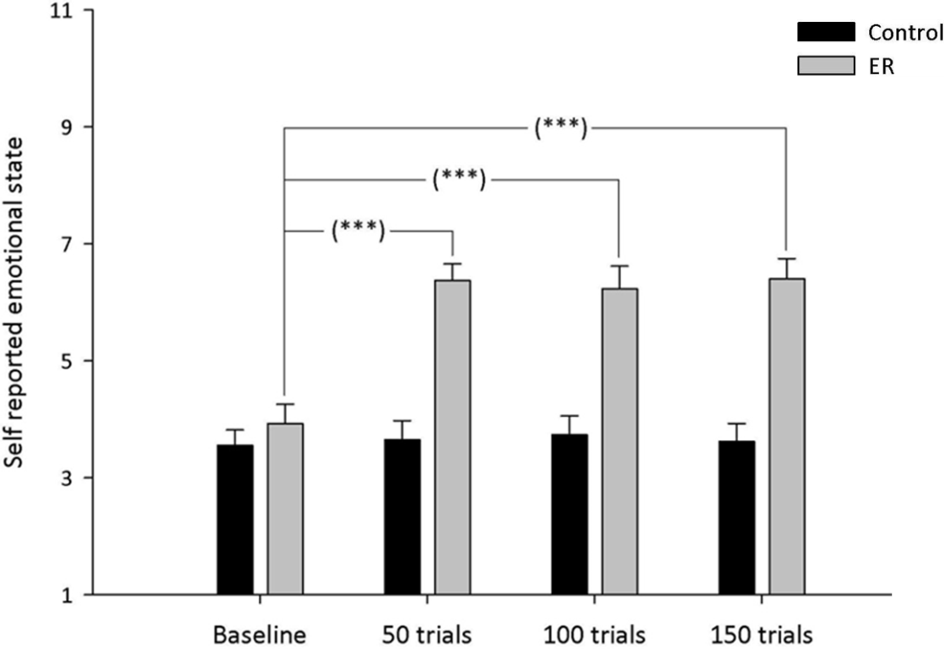
Figure 4.1: Mean self-reported emotional state (with standard error) after initial exposure to images (baseline) and after each of the three training sessions (50, 100, 150 training trials). Control = Control Instruction Condition; ER = Emotion Regulation Instruction Condition.
*** p < .001

4.6.2 Effects of training on completion time
We examined the immediacy with which ER was applied by comparing the time taken for participants’ to respond to the images depicting body injuries across training trials (Figure A.6 appendix 6.1.2). The difference in the instructions given to the two groups affected the time taken to complete the task (i.e., press the button) as participants in the ER condition had to apply the regulation strategy and only press the button after regulating their emotions, while participants in the control condition had to press the button as soon as they were presented with a picture depicting a body injury. Therefore, the following analyses were conducted separately for each condition.

A repeated measures ANOVA was conducted to examine whether the time to onset of ER of participants in the ER condition differed across the three Training blocks (50, 100, and 150 trials). The time to onset of ER of participants in the ER condition did not differ significantly across Training blocks, x²(2) = 1.75, p = .53. Equally, there was no significant difference in the response latencies of participants in the control conditions across Training blocks, F(2, 14) = 0.62, p = .55.

4.6.3 Effects of training on cardiovascular responding
We used the same approach as that used in our second experiment to examine the influence of emotional reactivity (see section 3.6.3). For this purpose, we conducted a 2 between (Emotional reactivity: Low vs. High) by 2 between (Condition: ER vs. control) by 3 within (Training session: 50, 100, 150 training trials) ANOVA. To operationalise emotional reactivity we divided our sample to low and high emotionally reactive participants based on a median split (Med = 4.01) of their scores on self-reported emotional state when exposed to images depicting body injuries for the first time. These analyses indicated that there was no significant effect of emotional reactivity F(1, 14) = 1.48, p = .27, and no significant interaction between emotional reactivity and condition (control vs. ER), F(1, 14) = 1.59, p = .25, emotional reactivity and training session, F(2, 27) = 1.81, p = .21. The three-way interaction between, emotional reactivity, condition and training block was also non-significant, F(2, 27) = 1.52, p = .26.
Therefore, a 2-between (Condition: control instructions vs. ER instructions) by 3-within (Training block: 50, 100, 150 trials) mixed design ANOVA was conducted to investigate the effect of training on participants’ HRV % change (see Figure 4.3). The main effects of Condition, F(1, 8) = 0.40, p = .54, and Training block, F(2, 16) = 0.02, p = .98, were non-significant. However the interaction between Condition and Training block was significant, F(2, 16) = 4.07, p < .05. This interaction was due to a significant increase in the HRV of
participants in the ER condition between 50 (M = 8.20, SE = 1.63) and 150 training trials (M = 32.10, SE = 9.77), t(5) = -2.24, p < .05, and a trend toward increase in HRV between 50 and 100 training trials (M = 38.71, SE = 15.61), t(5) = -1.57 p = .10. In comparison, the control condition showed a significant decrease in HRV between 50 (M = 35.97, SE = 12.48) and 100 training trials (M = 8.58, SE = 1.35), t(7) = 2.39, p < .05. Bonferonni correction was used to control for multiple comparisons (critical α = .02).
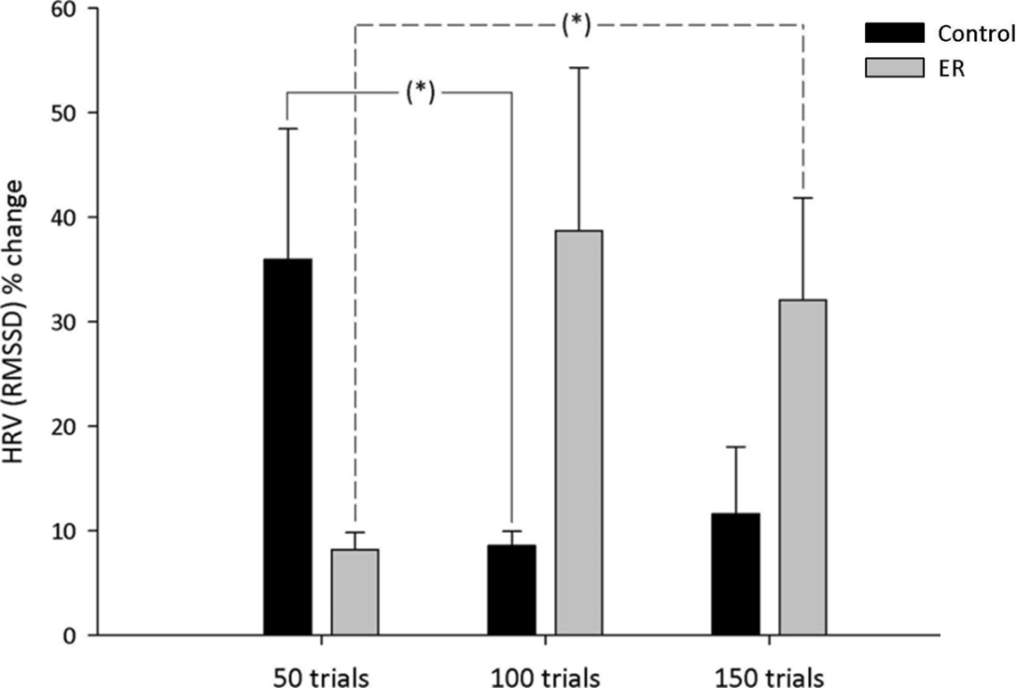
Figure 4.2: HRV % change (with standard error) as a function of condition across training sessions (50, 100, and 150 training trials). Control = Control Instruction Condition; ER = Emotion Regulation Instruction Condition; * p < .05.

4.6.4 Effects of training on emotional experience at 2-week follow up
A 3-between (Condition: ER instruction, control instruction, no-training) ANOVA was conducted with participants’ emotional state after watching the film clips as the dependent variable (Figure 4.4). The main effect of Condition was significant, F(2, 27) = 4.88, p < .05. This was due to participants in the ER condition reported feeling significantly less negative (M = 5.25, SE = 0.39) than participants allocated to the no-training condition (M = 3.47, SE =
0.27), t(16) = 3.90, p < .001, and a trend towards reporting feeling less negative than participants allocated to the control condition (M = 4.12, SE = 0.49), t(16) = 1.74, p = .05. There was no significant difference in the emotional state of participants allocated to the control and no-training conditions, t(18) = 1.16, p = .26. Bonferonni correction was used to control for multiple comparisons (critical α = .02).
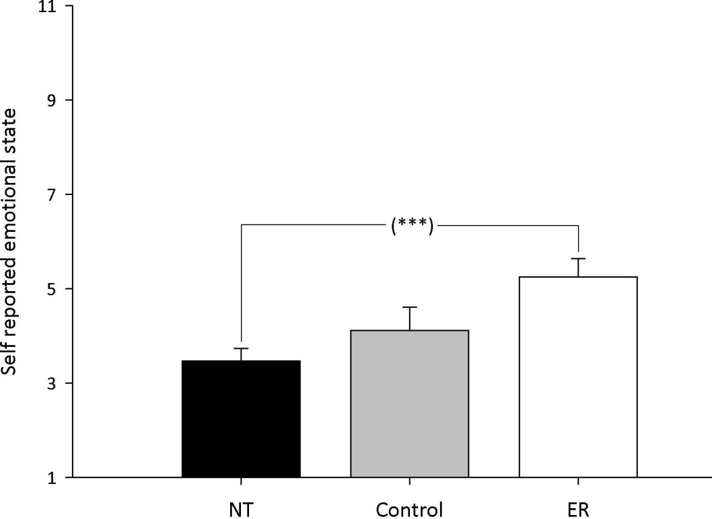
Figure 4.3: Self-reported emotional state (with standard error) by Condition at 2-week follow-up.Control = Control Instruction Condition; ER = Emotion Regulation Instruction Condition; NT = No Training Condition. *** p < .001.

4.6.5 Effect of training on habitual use of reappraisal at 2-week follow up
A 3-between (Condition: ER instruction, control instruction, no-training), ANOVA was conducted to investigate the extent to which ER had become habitual in the three conditions (figure 4.5). There was a significant main effect of Condition on participants’ responses on the SRHI, F(2, 26) = 4.92, p < .05. This was due to participants in the ER condition reporting being significantly more habitual (M = 71.55, SE = 3.27) in their application of ER than were participants in the no-training condition (M = 52.60, SE = 3.43), t(15) = 3.76, p < .001, and a trend toward reporting being more habitual than participants in the control condition (M =
58.67, SE = 4.82), t(15) = 1.99, p = .03. There was no significant difference in the habitual use of ER between participants in the control and no-training conditions, t(18) = 1.03, p = .32. Bonferonni correction was used to control for multiple comparisons (critical α = .02).
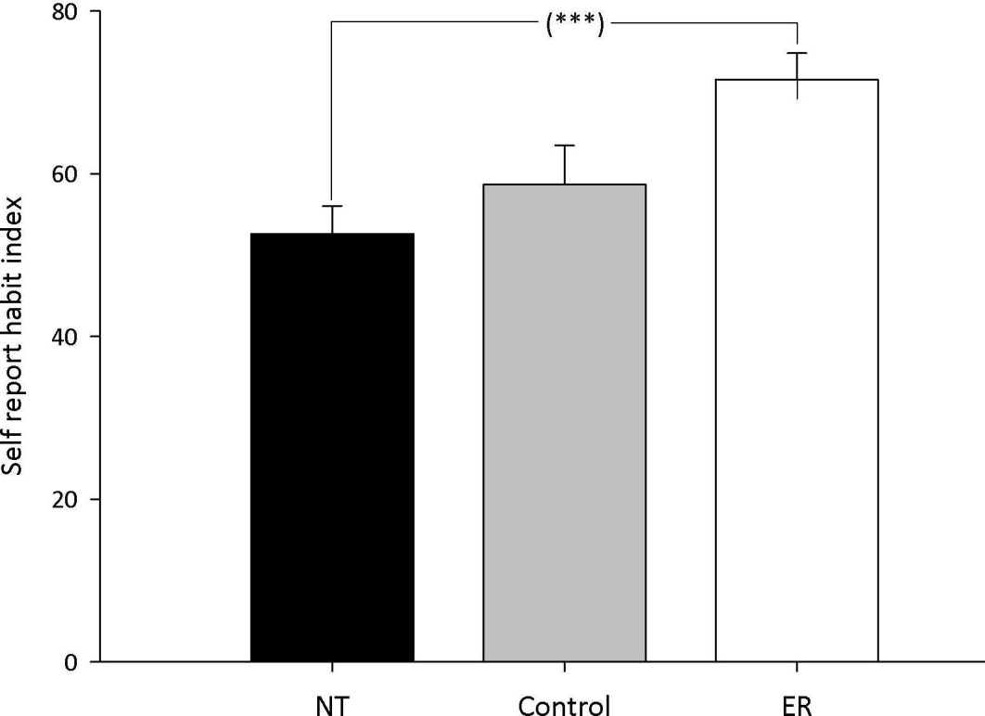
Figure 4.4: Habitual use of ER (with standard error) by Condition at 2-week follow-up.
Control = Control Instruction Condition; ER = Emotion Regulation Instruction Condition; NT = No Training Condition. *** p < .001.

4.7 Discussion
The present study investigated whether structured practice could render ER more efficient, in a sample of participants exhibiting depressive symptomatology. Structured training in the application of ER resulted in successful down-regulation of negative affect while decreasing the amount of cardiovascular effort invested in ER (as indexed by HRV). Given that ineffective ER is considered as having a pivotal role in depression (Garnefski et al., 2001; Silk, et al., 2003), our findings relating to participants’ emotional state during training are of high interest as they suggest that training was effective in modifying emotional state relatively quickly (i.e. after just 50 trials). Participants trained in the application of ER also
provided evidence of implicit down-regulation of negative affect (i.e. regulation in the absence of explicit instructions to do so) two weeks later, and reported being more habitual in their application of a reappraisal ER strategy.
Our current findings suggested that structured practice had no effect on the time taken to begin to regulate negative emotions. These findings are in contrast to those obtained in the previous study (see section 3.6.2). The findings of the present research can be interpreted in the context of the previously observed selective deficits in the cognitive control over negatively valenced stimuli (Vanderhasselt, et al., 2012). Vanderhasselt and colleagues’ paradigm presented participants with a previously explained cue that required a response that was either congruent or incongruent to a subsequently presented emotional face stimulus. Their findings showed that depressed individuals responded more slowly when they needed to disengage from negative stimuli in order to respond according to instructions while showing reduced N450 amplitude. The same was not true for non-depressed participants. N450 emerges 400 to 500ms after the presentation of the stimulus over central scalp sites and is considered to reflect adaptive processes relating to goal oriented behaviour by facilitating disengagement (Hanslmayr, et al., 2008). In our paradigm participants needed to exert cognitive control to disengage from the presented negative emotional stimulus and allow them to implement their instructions. This is similar to the aforementioned deficits in adaptive processes facilitating disengagement. In particular, the effort exerted to overcome such cognitive control deficiencies in order to respond according to ER instructions placed a burden on subsequent ER. Such a rationale is in accord with Schmeichel’s (2007) findings indicating that the performance on tasks that require cognitive control can hinder subsequent ER. Within this context, the lack of increase in the time to onset of ER is reassuring as it indicates that structured practice was able to help participants regulate their negative emotions, despite the burden imposed by preceding ineffective cognitive control mechanisms.
Findings relating to HRV suggested that structured practice was able to help individuals regulate their negative emotions while decreasing cardiac responding (index via increases in the interbeat interval time and thus HRV). These findings are in line with those obtained in our second experiment (see section 3.6.3). However, findings relating to the HRV of the control conditions suggested an increase in cardiac responding across training sessions. A potential explanation for these findings comes through studies examining the phenomenon of stimulus-preceding negativity (SPN). In such a study, Böcker, Bass, Kenemans, and Verbaten, (2001) presented their participants with a visual cue (S1) that predicted a subsequent threat (S2) (i.e. painful, but not harmful, shock) while collecting slow cortical potentials (SCP) via electroencephalography. Böcker et al.’s results suggested that SCP following threat cues were a manifestation of the pre-S2 SPN rather than induced by the actual threat (S2) indicating that the SPN occurs in anticipation of stimuli with affective or motivational valence. The use of IAPS images in a similar paradigm extended Böcker et al.’s results beyond threat to encompass stimuli of negative emotional valence in general (Takeuchi, Mochizuki, Masaki, Takasawa, & Yamazaki, 2005). More importantly, Takeuchi et al.’s findings suggested that the SPN might reflect anticipatory arousal. This is in accord with previous research that suggested that the amygdala, a brain structure that controls emotional arousal (see section 1.2.1), is activated during anticipatory periods preceding negative stimulation (Masaoka, Hirasawa, Yamane, Hori, & Homma, 2003) in individuals with high levels of trait anxiety (Masaoka, & Homma, 2000).
The above-mentioned are in agreement with the results obtain in this study as previous research suggested a high levels of comorbidity between generalized anxiety and depressive symptomatology (Moffitt et al. 2007; Pini, et al., 1997), as well as a high correlation between measures of anxiety and depression (Brady, & Kendall, 1992). Moreover, depressed individuals tend to show more activity in the amygdala when anticipating negative
stimulation in comparison to healthy controls (Abler, Erk, Herwig, & Walter, 2007). Therefore, the observed decrease in the HRV of the control condition (indicating cardiac acceleration) might be relevant to anticipatory arousal relating to the negative target pictures presented in this study.
The finding of this study that suggested that structured practice in ER induces implicit regulation of negative affect (i.e. ER was elicited by presented stimuli in the absence of instructions to do so) two weeks after the end of training when compared with the no-training condition is in accord with the findings of the second study of this thesis (see section 3.6.4). However, the trend results between the ER and control conditions perplex the interpretation of these findings. The inclusion of the no-training condition suggest that this pattern of results should not be attributed to placebo effects, as there were no significant differences in the outcome of interest between individuals exposed to the training intervention, but not given ER instructions (control condition), and those individuals that were not included in the training phase of the present study (no-training conditions). The trend results in the comparison between participants in the ER and control conditions are explained by the previously established selective deficits in the cognitive control over negatively valenced stimuli that seem to reflect adaptive processes relating to goal oriented behaviour by facilitating disengagement from negative stimulation (Hanslmayr, et al., 2008; Vanderhasselt, et al., 2012). These deficits placed a burden upon participants in the ER condition that had to overcome such cognitive control deficiencies in order to respond according to ER instructions. This, in turn, prohibited depressed participants in the ER group reaching the habitual level achieved by healthy participants included in the previous study. Indeed, depressed participants (M = 71.55, SE = 3.27) scored eleven (11) points below healthy participants (M = 82.5, SE = 2.49) included in the previous study.
Despite these difficulties, the induction of implicit regulation of negative affect in the ER condition deserves particular attention given the cognitive biases associated with depression that affect the interpretation of ambiguous information (Moser, Huppert, Foa, & Simons, 2012). For example, depressed individuals are more likely to appraise an ambiguous situation in negative terms therefore displaying a negative interpretation bias (Joiner, 2006; Nunn, Mathews & Trower, 1997; Starr & Moulds, 2006). In our experiment, participants could interpret the presented film clips either as representations of real situations or as artificially created scenes. Our findings showed that structured practice in ER led to implicit regulation of negative affect, suggesting that training in ER buffered against the negative interpretation bias observed in depression leading to regulation of negative affect. The importance of these findings becomes evident when we consider the ambiguity surrounding much of the information transmitted in social contexts (Moser et al. 2012) and the fact that depressed individuals exhibit negative interpretation biases in social situations (Bruch, & Belking, 2001).Within this context, structured practice could buffer against the negative interpretation bias associated with depression and thus aid individuals to interpret a current social situation in a way that would not give rise to negative emotions via the establishment of implicit ER.

4.7.1 Theoretical applications
The results of this study have potential theoretical implications for understanding the control of emotional responses and the development of interventions to promote more automatic control of emotions in depressed individuals. The reported effects of structured practice on HRV in individuals exhibiting depressive symptomatology are in line with those obtained in the second study of this thesis (see section 3.6.3). These findings are of particular interest given that depression has been associated with reduced HRV (Imaoka, Inove, Inove, Hazama & Tanaka, 1985; Dalack & Roose, 1990) which is a known risk factor for cardiovascular disease. For example, low HRV, and thus reduced cardiac parasympathetic activity, has been associated with cardiovascular disease including chronic and congestive heart failure (Casolo, Balli, Taddei, Amuhasi & Cesare, 1989; Nolan, et al., 1992). The aforementioned might explain the increased risk for the development of cardiovascular disease associated with depression (Rugulies, 2002) and the increased mortality of cardiovascular patients exhibiting depressive symptomatology (Barth, Schumacher & Herrmann-Lingen, 2004).
Our findings showed that structured practice interventions increased HRV, suggesting that such training protocols have a beneficial effect on a risk factor for developing cardiovascular disease and increasing mortality in cardiovascular patients with depression. The findings of the present research are also in accordance with those reported by Carney et al. (2000). Carney and colleagues treated mildly to severely depressed individuals with coronary heart disease with up to 16 sessions of Cognitive Behavioural Therapy (CBT) while collecting HRV measures. They reported that CBT increased HRV, thereby buffering against an associated increased mortality risk.
There is ample evidence linking HRV and neural networks implicated in the regulation of the heart rhythm. For example, activity in the prefrontal cortex (PFC) has a robust relation with HRV such that increases in the activity of the PFC are associated with increases in HRV(reflecting increased parasympathetic input to the heart and thus decreases in cardiac responding) (Hansen, Johnsen & Thayer, 2009; Lane et al 2009). Besides its effect on HRV, early activation of the PFC has been shown to down-regulate activity in emotion sensitive brain areas like amygdala and insula (Goldin, McRae, Ramel & Gross, 2008). This is consistent with the previously reported role of the PFC, along amygdala and insula, as part of the Central Autonomic Network (CAN), which supports emotional responding by flexibly adjusting physiological arousal in accordance with changing situational demands (Appelhans & Luecken, 2006).
The co-localization of control of HRV and ER within the PFC is of particular importance given that previous examination of PFC grey-matter using morphometric techniques revealed that depression is associated with reduced volumes (Drevets et al., 1997; Rajkowska, et al. 1999; Vasic, Hose, Wolf, & Walter, 2008). These results may help explain the deficiencies in ER and parasympathetic input to the heart associated with depression. Our finding indicated that structured practice increased HRV suggesting that this form of training might have an effect on PFC. Indeed, Smith, Chen, Baxter, Fort and Lane’s (2013) research showed that pharmacological interventions in depressed individuals led to increases in the gray matter volumes of the left DLPFC. Similar neuroplastic effects in the middle frontal gyrus and medial prefrontal cortex have been observed after training (Chen, et al. 2006; Hugues, Chessel, Lena, Marsault, & Garcia, 2006).

4.7.2 Practical applications
At the practical level, the findings of the present study showed that structured practice in ER led to decreases in cardiovascular effort (indexed via HRV). In turn, participants receiving structured practice in ER were able to implicitly regulate negative affect and reported being more habitual in their use of reappraisal two weeks after training. Such findings suggest that structured practice protocols offer a promising tool for the automation of emotion regulation. This kind of computerised application could offer depressed individuals a structured approach to promoting effective and efficient ER and therefore help them to gain the benefits associated with self-control of negative emotions while addressing deficiencies in the use of effortful ER strategies. Given the central role of ER in depression (Garnefski et al., 2001; Silk, et al., 2003), relevant therapeutic interventions should consider ER as a fundamental component mediating improvements (Gratz & Roemer, 2004; Rottenberg & Gross, 2007). Within this context, online or computerised structured practice protocols could be implemented alongside Cognitive Behavioural Therapy (CBT). This kind of structured practice protocols could be completed as homework designed to enhance ER skills. Previous research showed that addressing ER deficiencies within standard CBT mediated positive clinical outcomes (Slee, Spinhoven, Garnefski, & Arensman, 2008), while the incorporation of ER components within standard CBT, via the replacement of parts of the standard CBT treatment with ER training, enhanced the effects of CBT on mental health outcomes (Berking et al., 2008).

4.7.3 Limitations and future research
Training in the present study was offered via a repeated performance task. Even though such tasks can lead to improved performance, the extent to which such effects can be generalised to non-trained tasks is unclear (Klingberg, 2010). Several factors seem to be relevant to the extent to which a newly learned skill can be generalized to non-trained tasks. These factors include the utilization of small incremental increases in task difficulty (Ahissar & Hochstein, 2004), matching the difficulty of the task with the current ability of the individual (Vygotsky, 1978), and the variability in the task and inputs (Aslin, & Newport, 2012). Future research should therefore examine whether the inclusion of these factors in structured practice protocols can enhance the generalizibility of the effects of such practice to non-trained tasks.

4.7.4 Conclusion
In summary, the findings of this study suggest that structured practice can foster efficient control of negative emotions in individuals displaying depressive symptomatology. Such effects are sustained over a period of two weeks and have become relatively habitual. Observed increases in HRV accompanying structured practice in ER are of potential importance as depression is associated with reduced HRV, a known risk factor for the development of cardiovascular diseases and increased mortality in depressed individuals with cardiovascular illness. The minimal need for one-to-one contact during structured practice means that the training intervention could be implemented alongside CBT as online, computerised ‘homework’ aimed at enhancing an individuals’ skills in ER. Such an intervention can lead to more efficient ER enabling people to exert continuous control over their emotional responses, buffer against the increased risk for the development of cardiovascular diseases (via the elevation of HRV), and the negative interpretation bias observed in depression (via the establishment of implicit ER).

General discussion
This final chapter will bring together the findings of the three incremental studies reported in Chapters two, three and four and summarise the contribution made to increasing knowledge of the factors influencing the increased automation of emotion regulation processes. The primary aim of this thesis was to investigate the development of more automatic, efficient emotion regulation. More specifically, this thesis sought to examine: (1) whether the formation of implementation intentions leads to more efficient emotion regulation, (2) if behavioural practice in ER can lead to efficient ER, (3) whether practice in ER can aid individuals exhibiting depressive symptoms to regulate their negative emotions in a more efficient fashion. To address these issues, the present project utilised a neurophysiological rationale (see section 1.7.3) to define, operationalise, and subsequently measure automatic ER. According to this rationale, more automatic ER can achieve the down-regulation of negative affect while minimising the need for the utilisation of glucose and cardiac acceleration. Taken together the finding of the three studies that comprise this thesis showed that supporting goal intention relating to ER with implementation intentions does not necessarily lead to more automatic ER. In comparison, structured practice in ER led to decreases in cardiovascular responding (index via HRV) in both healthy and depressed individuals. Moreover, participants receiving structured practice in ER were able to implicitly regulate negative affect and reported being more habitual in their use of ER two weeks after training. Such findings suggest that structured practice protocols offer a promising tool for the automation of emotion regulation.

5.1 Implementation intentions and automatic emotion regulation
The formation of implementation intentions requires that individuals select a response that will help them achieve a particular goal and determine a suitable occasion to initiate the
selected response (Gollwitzer & Sheeran, 2006). This kind of plan leads to the creation of a mental link between the expected critical situation and the predetermined goal-relevant response. Such mental link, according to Gollwitzer and Sheeran (2006) decreases the effortful control of the predetermined response and establish more automatic and efficient responses, as the control of behaviour is delegated to the expected situational cues. However, the findings of the present thesis suggested that the formation of implementation intentions does not necessarily lead to more automatic, efficient ER. A potential explanation for these findings is that the link between the critical situation and the predetermined response created by implementation intentions can lead to the spontaneous retrieval of the intended response, and thus immediate response initiation, but not necessarily the efficient performance of the response (McDaniel & Scullin, 2010; Rummel, Einstein, & Rampey, 2012). Alternatively, the limited utilization of metabolic resources during self-control acts, might help explain the findings of the present thesis (Kurzban, 2010).
Behavioural research investigating the efficiency afforded by implementation intentions usually employed manipulations relating to the cognitive load of the task (Gollwitzer & Sheeran, 2006). Studies that utilise this rationale make use of the negative effect of heightened cognitive load on response initiation. The formation of implementation intentions is thought to reduce the negative effect of heightened cognitive load, thus demonstrating more automatic, efficient responding. In other words, automatic responding depends upon implementation intentions triggering immediate responding not only under low cognitive load but also under increased cognitive load.
A number of studies that used such an experimental paradigm suggested that the formation of implementation intentions facilitate immediate response initiation despite cognitive load, suggesting that the operation of implementation intentions is efficient (i.e. independent of
cognitive load; Brandstätter, Lengfelder, and Gollwitzer, (2001); Gollwitzer, & Brandstatter, 1997). However, other studies that used similar experimental paradigms produced contradicting results as their findings suggested that the formation of implementation intentions did not buffer against the negative effect of cognitive load (McDaniel and Scullin, 2010; Rummel, Einstein, and Rampey 2012). The findings of these studies led these researchers to offer an alternative interpretation regarding the effectiveness of implementation intention plans according to which implementation intentions facilitate associative encoding between the critical situation and response intentions. Associative encoding can subsequently lead to the spontaneous retrieval of intended responses, but not necessarily efficient control of the intended responses (see section 2.6).
The situation of a novice car driver trying to bring his/her manual transmission car to a stop at a red traffic light illustrates the difference between the spontaneous retrieval of the indented response, and related immediate response initiation, afforded by the associative encoding of the critical situation (red traffic light) and driver’s response intentions (stop the car), and the efficient control of the responses required to bring the car to a stop. When faced with a red traffic light, the driver has to perform a specific sequence of responses in order to stop the car at the appropriate location. First the driver has to depress the throttle (gas pedal), and move his/her leg to the brake pedal and start applying pressure until the car stops. As the car starts to decelerate, the car driver has to change the gear in order to avoid stalling the engine of the car. To change the gear, the car driver has to apply pressure to the clutch pedal while, at the same time, he/she has to handle the gear stick to change gear. As soon as the new gear is selected, the car driver has to depress the clutch, to avoid stalling the engine, in order to engage the selected gear. This process needs to be repeated several times for the driver to bring the car to a stop at the appropriate location. Forming implementation intentions to stop the car at a red traffic light will help link the critical situation (red traffic
light) with the intended response (stop the car) and thus facilitate immediate response initiation when the driver notices a red traffic light. However, the formation of implementation intentions does not address all the intermediate cognitive (i.e. memory) and motoric components that will allow the driver to perform the predetermined response in an efficient manner (Garavan et al., 2000; Meister et al., 2005). In other words, the link between the critical situation and the predetermined response can lead to immediate response initiation but not necessarily efficient performance of the response (McDaniel & Scullin, 2010; Rummel, Einstein, & Rampey 2012).
The limited utilization of metabolic resources during self-control acts offers an alternative explanation regarding the findings of the present thesis. The present thesis used a neurophysiological rationale to define, operationalise and subsequently measure automatic cognitive processes. According to this rationale, automatic processes establish a more efficient processing network compared to the diffuse network observed during controlled processing (see section 1.4.2). Given that neural processing is supported by the cardiovascular system (i.e. delivery of metabolic resources to active neural populations) more automatic cognitive processes can result in a diminished need for the utilization of glucose and cardiac responding, when compared with controlled cognitive processes.
Within this context, we expected that harnessing individual’s intentions to regulate their negative emotions with implementation intentions would result in decreased utilization of blood borne glucose and increased HRV (indicating cardiac deceleration). However, the findings of the first study of this thesis did not support these hypotheses. A potential explanation for these findings came through the work of Kurzban (2010). Kurzban’s findings relating to the role of blood glucose in self-control suggested that acts of self-control, like ER, consume limited amounts of glucose. Given that neural processing is supported by the cardiovascular system, the limited need for the utilization of blood glucose suggests that acts
of self-control, including ER, diminish the need for increased cardiac responding. Under such circumstances, the formation of implementation intentions might not convey an advantage above that offered by goal intentions to regulate negative emotions. Such an advantage might be more relevant to situations where the individual experience a limitation in the availability of metabolic resources due to the demands of a previous task (see section 1.4.3.1.1; Webb and Sheeran, 2003).
In brief, previous research that manipulated the cognitive load of the task to examine the role of implementation intentions in more automatic, efficient cognitive processing, produced mixed results. Several studies suggested that implementation intentions can buffer against the deleterious effect of increased cognitive load on task-relevant responses indicating that implementation intentions promote the automation of related responses, while others challenged this idea. The findings of these studies suggested that the formation of implementation intentions create a mental link between the critical situation and the predetermined response which can subsequently lead to the spontaneous retrieval of the intended response, and thus immediate response initiation, but not necessarily the efficient performance of the response. The findings of the present thesis, which utilized a neurophysiological rationale, are in accord with this idea. Alternatively, the findings of the present thesis might have been the result of the limited utilization of metabolic resources required for the regulation of negative emotions. Future research should seek to clarify whether implementation intentions are more relevant to spontaneous retrieval of response intentions rather than the automation of intended responses. This can be investigated via the formation of implementation intentions that link a critical situation with both a well learned and a novel response. Such study could use two groups of participants: (1) people that have extensive experience in carrying out a complex task (i.e. playing a simulation game), and (2) people that have only limited experience with the same task. Both of these groups should be
given the same task-relevant implementation intention plan. If the formation of implementation intentions leads to the automation of the actual responses then, the performance of the two groups should be equal. If, however, the formation of implementation intentions does not lead to the automation of the predetermined response then participants that had extensive experience in the task should perform the predetermined response in a more efficient manner compared to people that had limited experience with the task.

5.2 Behavioural practice and automatic emotion regulation
The findings of the present thesis suggested that structured practice can lead to increases in the interbeat interval times (HRV) while follow-up measures two weeks after the final training session indicated that structured practice induced implicit regulation and habitual use of the trained ER strategy. Such findings suggest that structured practice protocols offer a promising tool for increasing the efficiency with which ER is applied. These findings are of particular importance for three reasons. First, prior to the second and third study of this thesis, the effect of structured practice in ER was unknown and thus it was not possible to compute statistical power, however, the present research has provided an estimate of the likely effect sizes (second study: partial η² = .48; third study 3: partial η² = .34). Second, the finding of the second and third study of this thesis offer a unitary approach to the study of automatic ER (this is discussed in the subsequent paragraph). Third, the findings of the second and third study of this thesis provide the necessary practical foundations on which to base interventions when addressing questions regarding emotional resilience under conditions of continuous negative emotional stimulation in healthy individuals and adverse health consequences accompanying ineffective ER in depressed individuals.
Current approaches to the examination of more efficient and thus more automatic processes rely on multiple criteria including attention, intention and awareness to operationalise
automatic processes (Saling & Phillips, 2007). However, some research has questioned the major proponents of the above-mentioned criteria including: 1) the assumption that automatic processes involve running the same computations at a faster speed (Chase & Simon, 1973; Cheng, 1985), 2) the assumption that automatic process are unintentional (Besner, Stolz, & Boutelier, 1997), and 3) the assumption that people are not aware of automatic processes (Marcel, 1983). Moreover, attention, intention and awareness criteria do not reliably co-occur or co-vary (Saling & Phillips, 2007; Zbrodoff & Logan, 1986) indicating that such operational definitions of automatic processes lack construct validity, and may, therefore, be unreliable.
A more parsimonious operational definition of automatic processes can be inferred from studies that utilise Positron Emission Tomography (PET) and Functional Magnetic Resonance Imaging (fMRI). Such studies indicate that more automatic, efficient processes are able to achieve a particular goal, like the down regulation of negative emotions, while minimizing neural engagement (Jansma et al. 2001; Little et al. 2004). This in turn leads to decreases in the need for metabolic resources which are reflected in increases in interbeat interval times (HRV) indicating cardiac deceleration (Maus, et al. 2007; Williams, et al. 2009) and utilization of blood borne glucose (Haier, et al. 1992; Niven et al. 2013). This rational is in line with Bullmore, and Sporns (2012) discussion of the economy characterising the organization of brain networks. According to this perspective, brain network organization can be explained by a drive to minimise the cost of establishing connections between neural populations (wiring-cost), while allowing the emergence of adaptively valuable patterns of anatomical and functional connectivity between neural populations. Such an account can accommodate the findings of the second and third studied of this thesis (reported in Chapters 3 and 4, respectively) that suggested that physiological processes, like cardiac responses, which are relevant to the utilization of metabolic resources by active neural structures (see section 1.7.3) can be used to index more efficient and thus more automatic ER. This operational definition offers a unitary approach in the study of automatic ER that links observed decreases in neural engagement with related decreases in the need for utilization of metabolic resources and thus activity in the systems supporting their delivery to the brain.
The aforementioned rationale is in accord with an evolutionary perspective of self-control (Beedie, & Lane, 2012). According to this perspective, early human beings would have to exert control over their fear, when this was in agreement with their priorities (i.e. regulate their fear when they needed to kill an aggressive animal to avoid starvation). Within this context, the physiological systems involved in self-control would have to adapt to ensure more effective and economic self-control in response to the recurrent need for the exertion of self-control. Given that all psychological phenomena are a function of the brain, physiological adaptations in response to repeated demands for a particular cognitive function, like self-control, should be also observed in the human brain.
Indeed, there is ample evidence suggesting that the brain adapts in response to repeated demands in order to facilitate effective and economic function. For example, Haier, Siegel, Tang, Abel, and Buchsbaum, (1992) findings suggested that repeated practice in completing a complex task (i.e. the computer game ‘tetris’) resulted in decrease consumption of metabolic resources (i.e. glucose) by the brain as measured via PET. Heir et al. findings are in accord with results coming from the examination of learning while using fMRI techniques. For instance, Jansma, Ramsey, Slagter, and Kahn, (2001) discovered that the performance enhancements (i.e. decrease in time taken to complete the task & increase in accuracy) achieved via the use of structured practice were associated with decreases in the overall activity in task relevant brain areas. Similar decreases in the overall volume of activation despite the enhancements observed in individuals’ performance were obtained by Little, Klein, Shobat, McClure, and Thulborn, (2004).
These findings suggest that repeated demands for a particular cognitive process lead to the adaptation of the neural circuitry involved. This kind of physiological adaptation can result in the creation of a better connected neural network that can increase performance while requiring fewer neural resources and thus allow efficient (i.e. economic) completion of the task at hand. Such adaptations of the nervous system are in accord with Beedie and Lane’s (2012) evolutionary perspective of self-control that suggested that repeated demands for self-control could lead to better coordination of the relevant neural processes and thus diminish the effort invested.
In the practical sphere, the behavioural practice intervention studied by the current thesis has applications for healthy and depressed individuals. Such intervention protocols could be applied to enhance emotional resilience under conditions of continuous negative emotional stimulation. For example, recent evidence suggested that a patient’s condition has an impact on the medical personnel responsible for their care (Jensen et al., 2013). Jensen et al. findings pointed out that doctors show increased activity in brain areas implicated in the perception of pain when treating patients in pain. Such findings suggest that the medical personnel internalise the experience of their patients, indicating that this kind of work has an emotional impact on the professional. In a similar manner, working as an ambulance crew is associated with worse than average scores on physical health and psychological well-being compared to less stressful professions (Johnson, Cooper, Cartwright, Donald, Taylor, & Millet, 2005). Within this context, individuals’ ability to regulate their emotion is important as it help them to adapt to the emotionally demanding environment of their profession. In support, individuals coping skills (i.e. ability to minimise stress) were found to be an important factor helping nurses to adapt to the demanding environment of the operating room (Gillespie, Chaboyer, Wallis, and Grimbeek, 2007). The use of more automatic, efficient ER under these circumstances will allow prolonged regulation of emotional responses. The use of structured practice protocols, like those used in the present thesis, under these circumstances could lead to efficient ER. The minimal utilization of related metabolic resources associated with this kind of ER could allow prolonged regulation of emotional responses, thereby buffering against adverse health outcomes associated with negative emotions (see section 1.2.3) while enabling professionals to carry out their work unaffected.
The findings of the present thesis also indicated that structured practice can lead to efficient ER in depressed individuals. This is of potential clinical importance given that depression is associated with reduced HRV, a known risk factor for cardiovascular disease (Casolo, Balli, Taddei, Amuhasi & Cesare, 1989; Dalack & Roose, 1990; Imaoka et al., 1985; Nolan, et al., 1992). As part of an intervention plan for depression, the current training protocol could be employed as ‘homework’ aiming to enhance an individual’s skills in ER and, thus, alleviate mental health symptoms associated with ineffective ER (Slee, Spinhoven, Garnefski, & Arensman, 2008) as well as buffering against cardiac problems associated with depression (Carney, Freedland, Stein, Skala, Hoffman & Jaffe, 2000). Moreover, the findings of the current project suggest that similar structured practice protocols might be beneficial for individuals suffering from other mental health disorders, like PTSD, which are also associated with deficient ER (Herringa, 2013).

5.3. General limitations
Effective ER relies on various cognitive processes including: a) tracing ongoing and/or anticipated emotional responses, b) the activation of a goal to regulate emotions, c) the selection of an appropriate ER strategy and d) the successful execution of the ER strategy selected (Gross, 2013). The present research provided individuals with an explicit ER strategy to use when experiencing noxious stimulation. Therefore, the present research is more relevant to the successful execution of the relevant ER goal. According to Gross (2013), the successful execution of the activated ER goal requires individuals to maintain the activated ER goal and shield it from other competing goals. The lack of appropriate measures to capture these processes means that the present research cannot help us understand whether the observed effects were a matter of structure training aiding individuals in maintaining the activated ER goal, or helping them shield the activated ER goal from other competing goals, or both.
People use various strategies to regulate their emotions. For example, Gross (1998) information processing model of emotion regulation divides ER strategies into several categories including situation modification, attentional deployment and distraction, cognitive control and reappraisal, and response modulation and suppression. It is important to consider and compare the various ER strategies people use because different forms of ER strategies may have different consequences. For instance, people that use suppression frequently report experiencing less positive emotions like happiness and more negative emotions including depression. On the contrary, people that tend to use reappraisal more often experience and express more positive emotions and less negative emotion including depression (Gross & John, 2003; Nezlek, & Kuppens, 2008). The present research examined only few of the many regulation strategies people use to manage their emotions. The inclusion of other ER strategies, like attention regulation and distraction, in the present research would enable the examination of the effects of structure practice on these ER strategies and the comparison of their effects on noxious emotional stimulation.
Even though that spontaneous regulation is not used extensively by adults (Volokhov & Demaree, 2010), people’s tendency to manage their emotions in an on-going fashion might perplex the interpretation of the effects observed in this research. For example, participants who feel anxious in the laboratory environment might try to regulate their emotions, despite instructed not to do so, with an effect on outcome measures. Such effects, however, will function to decrease, and not increase, any difference between the experimental (i.e. given instruction to regulate their emotions) and control (i.e. no instructions to regulate their emotions) group and, therefore, diminish the power of inferential analyses. Nevertheless, the inclusion of measures that could establish participants’ tendency to use ER strategies (like Gross and John’s (2003) emotion regulation questionnaire and/or Garnefski & Kraaij’s, (2007) Cognitive emotion regulation questionnaire) to manage their emotions could help partial out such effects.
Moreover, the present study used self-report questionnaires to measure the relative automaticity with which ER was applied during the two week follow up. These kind of measures require decision making involving judgements and inferences that give rise to the possibility that a cognitive manipulation, such as the one induced by structured practice in this study, can influence questionnaire responses by impacting decision making rather than targeting the attribute under examination (See et al., 2009). It would, therefore, be prudent for future research to supplement self-report questionnaires at follow up with behavioural and somatic markers, able to index efficient ER.

5.4 Future research
Previous research that used fMRI to investigate the effect of repeated practice indicated that the mastery of a skill leads to superior performance while decreasing overall brain activity in task-relevant brain areas (Jansma et al., 2001; Little et al., 2004). These findings suggested that practice results in less effortful and more efficient and economical processing. Future research should examine whether a similar mechanism is observed when people practice ER skills. Within this context, researchers could use Diffusion Tensor Imaging (DTI), which allows the imaging of the axonal network in the living human brain (Staempfli et al. 2008), to examine Jansma et al.’s (2001) suggestion that the increased efficiency observed after repeated practice is the product of a better connected neural network recruited for the completion of the task. Moreover, this line of research could use voxel-based morphometry, which measures the local concentration of gray matter in the human brain (Ashburner, & Friston, 2000), to examine neuroplastic changes accompanying repeated practice in ER. The use of these techniques could provide a better understanding of the axonal network and gray matter changes induced by repeated practice in ER in relevant brain areas like the orbitofrontal cortex and the dorso and ventro-lateral pre-frontal cortex (Goldin, McRae, Ramel & Gross, 2008).
Alternatively, future research could utilise non-invasive brain stimulation techniques like transcranial direct current stimulation (TdcS). Through the use of anodal TdcS, which enhances cortical excitability (Nitsche, & Paulus, 2000), researchers can examine whether alteration in local neural excitability in brain regions implicated in ER, like the dorso-lateral prefrontal cortex, can lead to similar results as those reported in this thesis in terms of both performance (i.e. successful down-regulation of negative affect) and efficiency (i.e. decreases in the interbeat interval times and thus HRV). Unpublished work from Hallam, Van Heeswijk, Barker, Woodruff, and Farrow, (n.d) suggested that anodal stimulation over the left dorso-lateral prefrontal cortex can facilitate ER. Moreover, the previously reported relationship between the prefrontal cortex and HRV (Hansen, Johnsen & Thayer, 2009) suggest that anodal TdcS stimulation would lead to efficient regulation of negative affect. However, it would be interesting to examine whether TdcS stimulation can instigate spontaneous ER at a subsequent follow up session, similar to that reported in this thesis. Such demonstration would mean that TdcS can also strengthen the association between stimuli inducing an unwanted emotional state and the application of ER.
The findings of this thesis, as well as previous research (Aasman, Mulder, & Mulder, 1987; Denson, Grisham, & Moulds, 2011; Tattersal & Hockey, 1995), suggest that HRV is sensitive to the effort invested in cognitive processing. Therefore, when the task is not responsive to practice, decreases in HRV could reflect poor performance. On the contrary, decreases in HRV could indicate good performance if the task is susceptible to practice effects. Hence, future research should examine whether HRV changes across training sessions differ between tasks that are sensitive to practice and those that are not. If this proves to be the case, the creation of a normative database including HRV change data after practice in particular tasks could be used to compare the performance of various clinical groups for diagnostic and continued assessment purposes.

5.5 Conclusions
In summary, the findings of the present thesis indicated that supporting individuals’ objective to regulate negative emotions with implementation intentions does not necessarily lead to efficient ER. Rather, structured practice in the application of ER was found to lead to effective down-regulation of negative emotions while at the same time decreasing cardiac responding indicating that sufficient practice can lead to efficient ER in both healthy and depressed individuals. These findings are in agreement with Beedie, & Lane’s (2012) evolutionary perspective of self-control which suggests that the recurrent need for the exertion of self-control would lead to physiological adaptation in the systems involved. The current behavioural practice protocol is suitable for computerised applications given the minimal need for one-to-one conduct. Such computerised behavioural practice protocols could be used to: 1) enhance the emotional resilience of professional subjected to continued negative emotional stimulation such as emergency staff (ambulance and emergency room personnel), and 2) to enhance the ER skills of individuals with depression and thus relive symptoms relating to ineffective use of ER, while at the same time safeguarding against cardiovascular disease associated with depression. Future research should examine the neural mechanisms underpinning repeated practice in the application of ER while utilising DTI and voxel-based morphometry. Through the investigation of the changes in the axonal network and gray matter involved in ER we can examine whether practice in ER results in neuroplastic changes, including the creation of a better connected neural network akin to that proposed by Jansma et al. (2001).

Appendices

6.1 Supplementary figures

6.1.1 Chapter 2

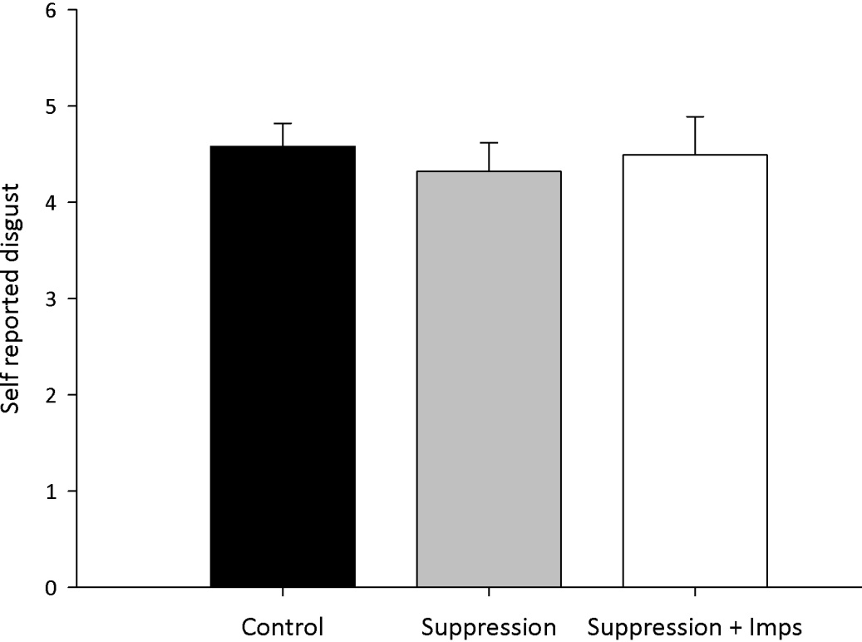
Figure A.1: Mean self reported disgust (with standard error) for each of the three experimental conditions included in experiment 1.

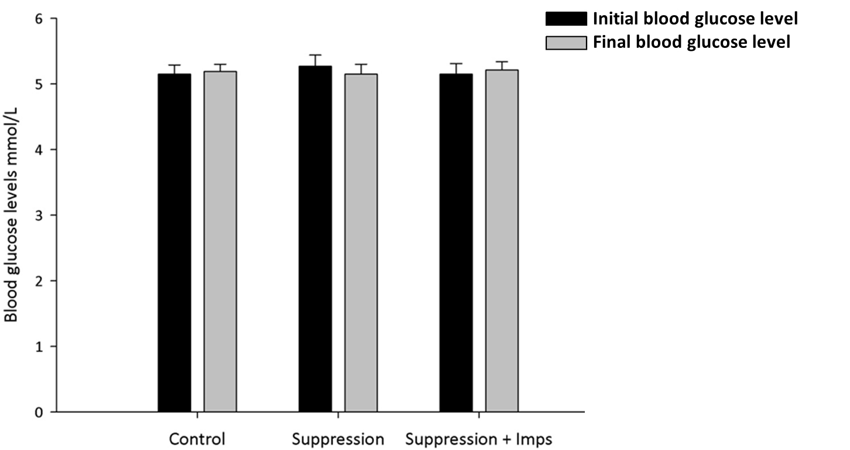
Figure A.2: Mean blood glucose levels, mmol/L, (with standard error) before (initial) and after (final) exposure to disgust inducing film clips used in experiment 1.

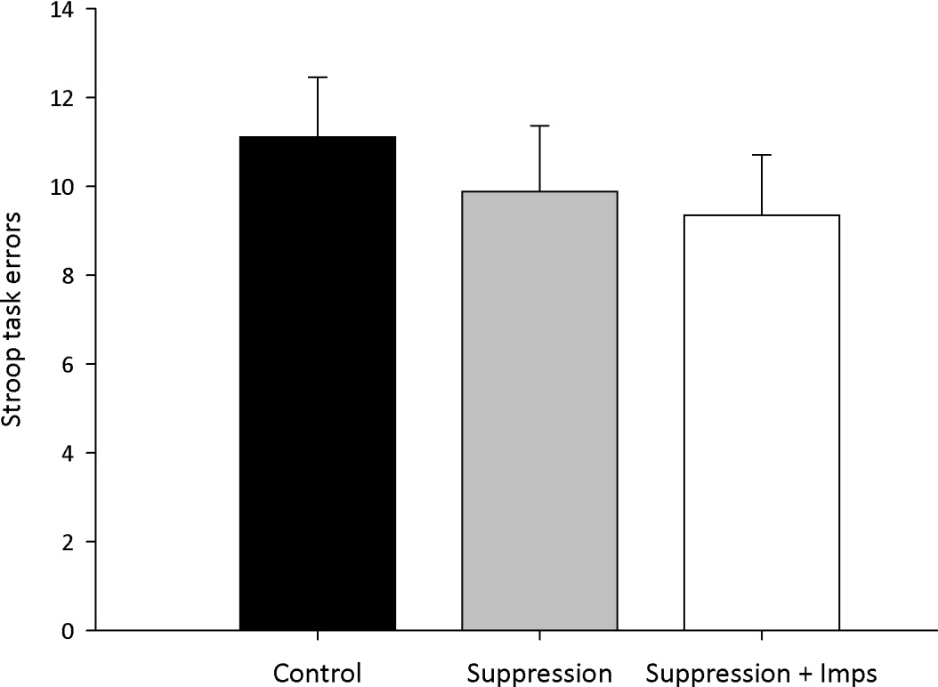
Figure A.3: Mean errors (with standard error) committed by participants in the three experimental conditions while completing the stroop task in experiment 1.

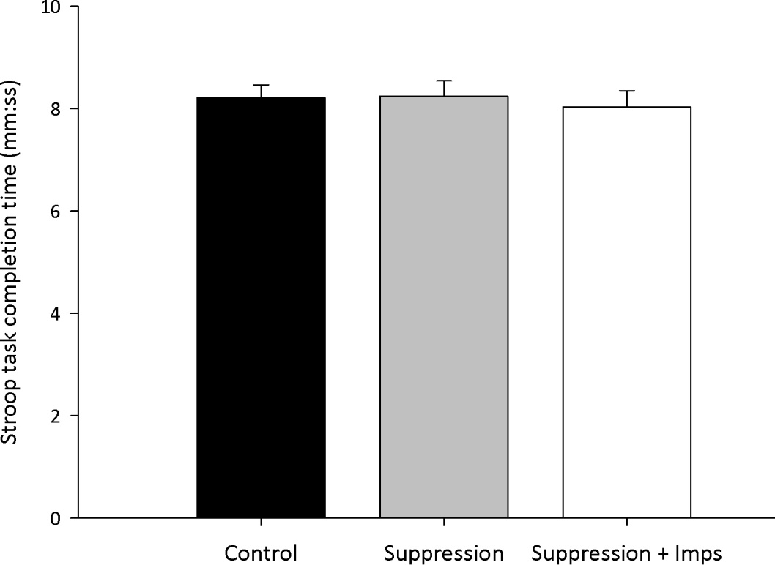
Figure A.4: Mean time taken (with standard error) to complete the stroop task in each of the three experimental conditions included in experiment 1.

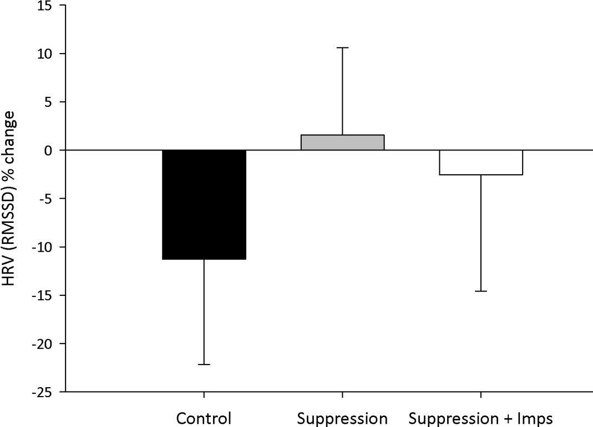
Figure A.5: Mean HRV % change (with standard error) for the three experimental conditions included in experiment 1. Change scores were computed, subtracting baseline from training HRV. Therefore, positive scores represent increases in HRV.

6.1.2 Chapter 4

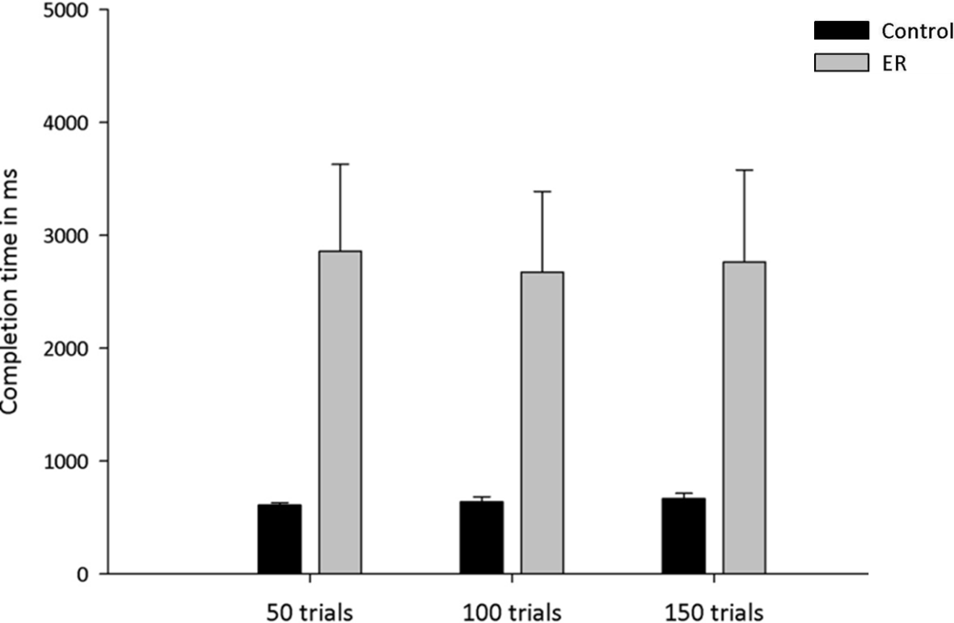
Figure A.6: Mean response latencies (with standard error) as a function of condition at 50, 100 and 150 training trials. Control = Control Instruction Condition; ER = Emotion Regulation Instruction Condition;

6.1.3 Pilot study
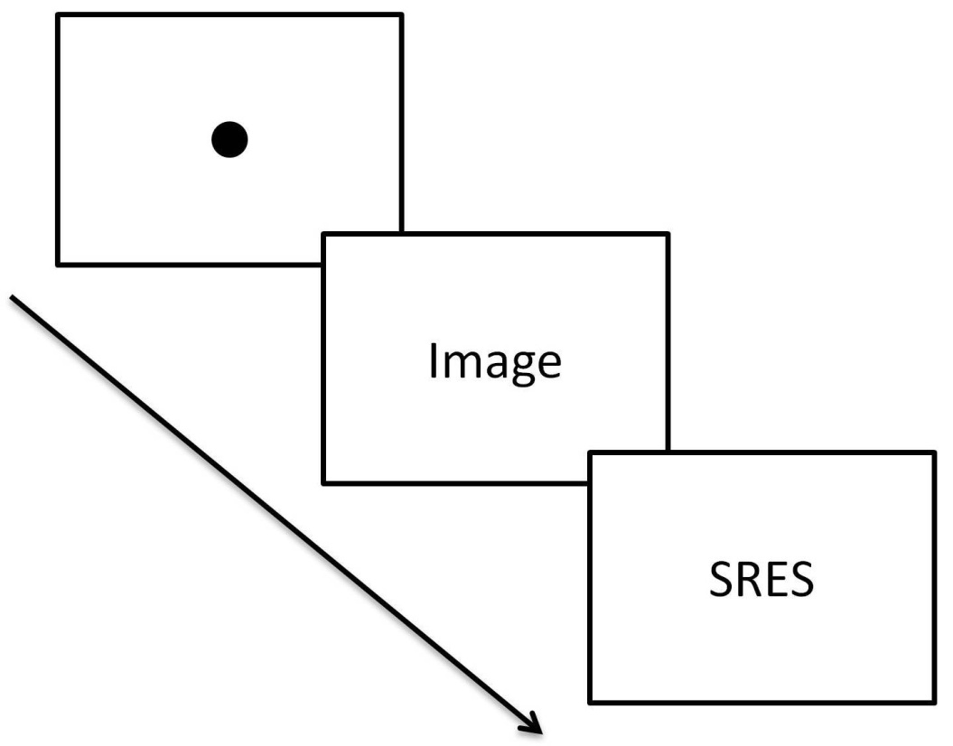
Figure A.7: Example of a trial from the pilot study. A fixation dot appeared on screen and remained there for 500ms. Following this, an image appeared on screen and remained there for 1500ms. Images were followed by a 3000ms presentation of the Self-Report of Emotional State (SRES) scale. The total duration of the pilot study was 18 minutes.

6.2 Supplementary tables
  - 6.2.1 Chapter 2
Table B.1 Images taken from the international affective picture system to be used during the collection of baseline HRV.
Image number | Used during
5390 | HRV baseline
5395 | HRV baseline
5471 | HRV baseline
5500 | HRV baseline
5510 | HRV baseline
5520 | HRV baseline
5530 | HRV baseline
5531 | HRV baseline
5532 | HRV baseline
5533 | HRV baseline
5534 | HRV baseline
5535 | HRV baseline
5731 | HRV baseline
5740 | HRV baseline
5900 | HRV baseline
5920 | HRV baseline
6150 | HRV baseline
7000 | HRV baseline
7004 | HRV baseline
7006 | HRV baseline
7009 | HRV baseline
7010 | HRV baseline
7034 | HRV baseline
7035 | HRV baseline
7036 | HRV baseline
7050 | HRV baseline
7052 | HRV baseline
7055 | HRV baseline
7059 | HRV baseline
7080 | HRV baseline

6.3 Pilot Study

6.3.1 Overview and aims
Participants in the second and third study of this thesis undertook training designed to help them to increase the efficiency with which they applied a reappraisal strategy. During three training sessions, on separate days, comprising a total of 150 training trials, participants were presented with negatively valenced images depicting body injuries (henceforth termed targets) and asked either to ‘attend’ (control condition) or ‘reappraise’ (emotion regulation condition). Seventy-five of the target images were taken from IAPS (M_{Val} = 2.13, SD = 0.60; possible range of responses = 1-9, 1-3 = negative valence) (Lang, Bradley, & Cuthbert, 2005). The remaining images were created by editing pictures depicting non-injured body parts using Adobe Photoshop CS5 (Adobe Systems Inc., San Jose, CA).
The overall objective of this pilot study was to examine whether the emotional value of target images taken from the IAPS to be used in the second and third study was not dissimilar to the emotional value of edited target images to be used in the same studies. The main aims of the pilot study was: (1) to investigate whether there was statistically meaningful differences between the edited and non-target images, and (2) to examine whether the emotional value of the target images presented differed across the three training sessions, given that each target picture was presented once throughout the duration of the training.

6.3.2 Methods

6.3.2.1 Participants and design
Ten healthy participants were recruited through email advertisements on the online research participation system operated by the University of Sheffield (6 females; M_{age} = 22.65 SD = 4.58 years; range 18 – 26 years). Participants reported no history of psychiatric, neurologic and medical illness. The study was approved by the local ethics board of the department of psychology, the University of Sheffield (application number: 353).

6.3.2.2 Procedures
During the first stage of the study, participants were seated in front of the computer and were given written instructions. In particular participants in this pilot study were told: “We will now be showing you a series of images. It is important to us that you watch the presented images carefully, but if you find them too distressing, just say ‘stop’. Following this, participants were presented with 220 images. These included 75 IAPS images depicting body injuries, 75 edited pictures depicting body injuries, 35 IAPS pictures of neutral valence (M_{Val} = 5.2, SD = 0.3, possible range of responses 1-9, 4-6 = neutral valance) and 35 IAPS pictures of positive valence (M_{Val} = 8.1, SD = 0.83, possible range of responses 1-9, 7-9 = positive valance). Each image was preceded by a fixation dot presented for 500ms (see figure A.7 in appendix 6.1.3). Images remained on screen for 1500ms and were followed by the same self-report of emotional state as that used in the second and third study of this thesis (see section 3.4.2.2). Images were presented in a pseudorandomized order. Participants viewed the images presented on a PC monitor, using Presentation software (Neurobehavioural Systems Inc, Albany, CA), seated approximately 50cm from the screen.

6.3.3 Results

6.3.3.1 Comparing IAPS with edited pictures
A paired sample t-test was conducted to compare the emotional value (index via self-report of current emotional state) of IAPS pictures depicting body injuries with the emotional value of edited pictures depicting body injuries. There was no significant difference in self-reported emotional state between the IAPS (M = 3.63, SE = 0.27) and edited pictures (M = 3.51, SE = 0.24) depicting body injuries, t(9) = 0.64, p = .54, paired-samples t-test.

6.3.3.2 Comparing the emotional value of stimuli across training sessions
A 3-within (Target image at: 50, 100, 150 trials) ANOVA was conducted with participants’ emotional state as the dependent variable. Participants evaluation of the images presented did not differ between images scheduled to be presented at 50 (M = 3.50, SE = 0.22), 100 (M = 3.48, SE = 0.20), and 150 training trials (M = 3.42, SE = 0.26), F(2, 98) = 0.16, p = .85.

6.3.4 Discussion
The findings of the pilot study suggested that there was no difference in the emotional value of IAPS and edited target pictures. Moreover, the finding of this pilot study indicated that there was no difference in the emotional value of target images used in each of the three training sessions (i.e. 50, 100 and 150 trials). These findings suggest that the target stimuli are suitable to be used in the second and third study of this thesis.

6.4 Permissions to use copyright materials

6.4.1 Permissions from Elsevier
ELSEVIER LICENSE
TERMS AND CONDITIONS
Sep 08, 2013
This is a License Agreement between Spyros Christou-Champi ("You") and Elsevier ("Elsevier") provided by Copyright Clearance Center ("CCC"). The license consists of your order details, the terms and conditions provided by Elsevier, and the payment terms and conditions.
All payments must be made in full to CCC. For payment instructions, please see information listed at the bottom of this form.
Supplier | Elsevier Limited  The Boulevard,Langford Lane  Kidlington,Oxford,OX5 1GB,UK
Registered Company Number | 1982084
Customer name | Spyros Christou-Champi
Customer address | Block D2/221, Studio flat 2
 | York, YO10 5NG
License number | 3224290805625
License date | Sep 08, 2013
Licensed content publisher | Elsevier
Licensed content publication | Mayo Clinic Proceedings
Licensed content title | The Central Autonomic Network: Functional Organization, Dysfunction, and Perspective
Licensed content author | EDUARDO E. BENARROCH
Licensed content date | October 1993
Licensed content volume number | 68
Licensed content issue number | 10
Number of pages | 14
Start Page | 988
End Page | 1001
Type of Use | reuse in a thesis/dissertation

Intended publisher of new work | other
Portion | figures/tables/illustrations

Number of figures/tables/illustrations | 2
Format | both print and electronic
Are you the author of this Elsevier article? | No
Will you be translating? | No
Order reference number
Title of your thesis/dissertation | Developing efficient emotion regulation: A neurophysiological examination
Expected completion date | Dec 2013
Estimated size (number of pages) | 160
Elsevier VAT number | GB 494 6272 12
Permissions price | 0.00 GBP
VAT/Local Sales Tax | 0.0 USD / 0.0 GBP
Total | 0.00 GBP
Terms and Conditions

INTRODUCTION
1. The publisher for this copyrighted material is Elsevier. By clicking "accept" in connection with completing this licensing transaction, you agree that the following terms and conditions apply to this transaction (along with the Billing and Payment terms and conditions established by Copyright Clearance Center, Inc. ("CCC"), at the time that you opened your Rightslink account and that are available at any time at http://myaccount.copyright.com).
GENERAL TERMS
2. Elsevier hereby grants you permission to reproduce the aforementioned material subject to the terms and conditions indicated.
3. Acknowledgement: If any part of the material to be used (for example, figures) has appeared in our publication with credit or acknowledgement to another source, permission must also be sought from that source. If such permission is not obtained then that material may not be included in your publication/copies. Suitable acknowledgement to the source must be made, either as a footnote or in a reference list at the end of your publication, as follows:
“Reprinted from Publication title, Vol /edition number, Author(s), Title of article / title of chapter, Pages No., Copyright (Year), with permission from Elsevier [OR APPLICABLE SOCIETY COPYRIGHT OWNER].” Also Lancet special credit - “Reprinted from The Lancet, Vol. number, Author(s), Title of article, Pages No., Copyright (Year), with permission from Elsevier.”
4. Reproduction of this material is confined to the purpose and/or media for which permission is hereby given.
5. Altering/Modifying Material: Not Permitted. However figures and illustrations may be altered/adapted minimally to serve your work. Any other abbreviations, additions, deletions and/or any other alterations shall be made only with prior written authorization of Elsevier Ltd. (Please contact Elsevier at permissions@elsevier.com)
6. If the permission fee for the requested use of our material is waived in this instance, please be advised that your future requests for Elsevier materials may attract a fee.
7. Reservation of Rights: Publisher reserves all rights not specifically granted in the combination of (i) the license details provided by you and accepted in the course of this licensing transaction, (ii) these terms and conditions and (iii) CCC's Billing and Payment terms and conditions.
8. License Contingent Upon Payment: While you may exercise the rights licensed immediately upon issuance of the license at the end of the licensing process for the transaction, provided that you have disclosed complete and accurate details of your proposed use, no license is finally effective unless and until full payment is received from you (either by publisher or by CCC) as provided in CCC's Billing and Payment terms and conditions. If full payment is not received on a timely basis, then any license preliminarily granted shall be deemed automatically revoked and shall be void as if never granted. Further, in the event that you breach any of these terms and conditions or any of CCC's Billing and Payment terms and conditions, the license is automatically revoked and shall be void as if never granted. Use of materials as described in a revoked license, as well as any use of the materials beyond the scope of an unrevoked license, may constitute copyright infringement and publisher reserves the right to take any and all action to protect its copyright in the materials.
9. Warranties: Publisher makes no representations or warranties with respect to the licensed material.
10. Indemnity: You hereby indemnify and agree to hold harmless publisher and CCC, and their respective officers, directors, employees and agents, from and against any and all claims arising out of your use of the licensed material other than as specifically authorized pursuant to this license.
11. No Transfer of License: This license is personal to you and may not be sublicensed, assigned, or transferred by you to any other person without publisher's written permission.
12. No Amendment Except in Writing: This license may not be amended except in a writing signed by both parties (or, in the case of publisher, by CCC on publisher's behalf).
13. Objection to Contrary Terms: Publisher hereby objects to any terms contained in any purchase order, acknowledgment, check endorsement or other writing prepared by you, which terms are inconsistent with these terms and conditions or CCC's Billing and Payment terms and conditions. These terms and conditions, together with CCC's Billing and Payment terms and conditions (which are incorporated herein), comprise the entire agreement between you and publisher (and CCC) concerning this licensing transaction. In the event of any conflict between your obligations established by these terms and conditions and those established by CCC's Billing and Payment terms and conditions, these terms and conditions shall control.
14. Revocation: Elsevier or Copyright Clearance Center may deny the permissions described in this License at their sole discretion, for any reason or no reason, with a full refund payable to you. Notice of such denial will be made using the contact information provided by you. Failure to receive such notice will not alter or invalidate the denial. In no event will Elsevier or Copyright Clearance Center be responsible or liable for any costs, expenses or damage incurred by you as a result of a denial of your permission request, other than a refund of the amount(s) paid by you to Elsevier and/or Copyright Clearance Center for denied permissions.
LIMITED LICENSE
The following terms and conditions apply only to specific license types:
15. Translation: This permission is granted for non-exclusive world English rights only unless your license was granted for translation rights. If you licensed translation rights you may only translate this content into the languages you requested. A professional translator must perform all translations and reproduce the content word for word preserving the integrity of the article. If this license is to re-use 1 or 2 figures then permission is granted for non-exclusive world rights in all languages.
16. Website: The following terms and conditions apply to electronic reserve and author websites:
Electronic reserve: If licensed material is to be posted to website, the web site is to be password-protected and made available only to bona fide students registered on a relevant course if:
This license was made in connection with a course,
This permission is granted for 1 year only. You may obtain a license for future website posting,
All content posted to the web site must maintain the copyright information line on the bottom of each image,
A hyper-text must be included to the Homepage of the journal from which you are licensing at http://www.sciencedirect.com/science/journal/xxxxx or the Elsevier homepage for books at http://www.elsevier.com , and
Central Storage: This license does not include permission for a scanned version of the material to be stored in a central repository such as that provided by Heron/XanEdu.
17. Author website for journals with the following additional clauses:
All content posted to the web site must maintain the copyright information line on the bottom of each image, and the permission granted is limited to the personal version of your paper. You are not allowed to download and post the published electronic version of your article (whether PDF or HTML, proof or final version), nor may you scan the printed edition to create an electronic version. A hyper-text must be included to the Homepage of the journal from which you are licensing at http://www.sciencedirect.com/science/journal/xxxxx . As part of our normal production process, you will receive an e-mail notice when your article appears on Elsevier’s online service ScienceDirect (www.sciencedirect.com). That e-mail will include the article’s Digital Object Identifier (DOI). This number provides the electronic link to the published article and should be included in the posting of your personal version. We ask that you wait until you receive this e-mail and have the DOI to do any posting.
Central Storage: This license does not include permission for a scanned version of the material to be stored in a central repository such as that provided by Heron/XanEdu.
18. Author website for books with the following additional clauses:
Authors are permitted to place a brief summary of their work online only.
A hyper-text must be included to the Elsevier homepage at http://www.elsevier.com . All content posted to the web site must maintain the copyright information line on the bottom of each image. You are not allowed to download and post the published electronic version of your chapter, nor may you scan the printed edition to create an electronic version.
Central Storage: This license does not include permission for a scanned version of the material to be stored in a central repository such as that provided by Heron/XanEdu.
19. Website (regular and for author): A hyper-text must be included to the Homepage of the journal from which you are licensing at http://www.sciencedirect.com/science/journal/xxxxx. or for books to the Elsevier homepage at http://www.elsevier.com
20. Thesis/Dissertation: If your license is for use in a thesis/dissertation your thesis may be submitted to your institution in either print or electronic form. Should your thesis be published commercially, please reapply for permission. These requirements include permission for the Library and Archives of Canada to supply single copies, on demand, of the complete thesis and include permission for UMI to supply single copies, on demand, of the complete thesis. Should your thesis be published commercially, please reapply for permission.
21. Other Conditions:

v1.6
If you would like to pay for this license now, please remit this license along with your payment made payable to "COPYRIGHT CLEARANCE CENTER" otherwise you will be invoiced within 48 hours of the license date. Payment should be in the form of a check or money order referencing your account number and this invoice number RLNK501107817.
Once you receive your invoice for this order, you may pay your invoice by credit card. Please follow instructions provided at that time.
Make Payment To:
Copyright Clearance Center
Dept 001
P.O. Box 843006
Boston, MA 02284-3006
For suggestions or comments regarding this order, contact RightsLink Customer Support: customercare@copyright.com or +1-877-622-5543 (toll free in the US) or +1-978-646-2777.
Gratis licenses (referencing $0 in the Total field) are free. Please retain this printable license for your reference. No payment is required.

References

Aarts, H. & Dijksterhuis, A. (2000). The automatic activation of goal-directed behaviour: The case of travel habit. Journal of Environmental Psychology, 20: 75-82.
Aasman, J., Mulder, G., & Mulder, L. J. (1987). Operator effort and the measurement of heart rate variability. Human Factors, 29: 161-170.
Abler, B., Erk, S., Herwig, U., & Walter, H. (2007). Anticipation of aversive stimuli activates extended amygdala in unipolar depression. Journal of Psychiatric Research, 41: 511-522.
Ahissar, M., & Hochstein, S. (2004). The reverse hierarchy theory of visual perceptual learning. Trends in Cognitive Sciences, 8: 457-464.
Ajzen, I. (1991). The theory of planned behavior. Organizational Behavior and Human Decision Processes, 50: 179–211.
Alberts, H., Schneider, F., & Martijn, C. (2012). Dealing efficiently with emotions: Acceptance-based coping with negative emotions requires fewer resources than suppression. Cognition and Emotion, 26: 863-870.
Amaro, E., & Barker, G. J. (2006). Study design in fMRI: Basic principles. Brain and Cognition, 60: 220-232.
Amir, N,, Beard, C., Burns, M. & Bomyea, J. (2009). Attention modification program in individuals with generalized anxiety disorder. Journal of Abnormal Psychology, 118: 28-33.
Anderson, J. R. (1983). The architecture of cognition. . Massachusetts: Harvard University press.
Appelhans, B. M., & Luecken, L. J. (2006). Heart rate variability as an index of regulated emotional responding. Review of general psychology, 10: 229-240.
Ashburner, J., & Friston, k. J. (2000) Voxel-Based Morphometry: The Methods. NeuroImage, 11: 805-821.
Aslin, R. N., & Newport, E. L. (2012). Statistical learning: From acquiring specific items to forming general rules. Current Directions in Psychological Science, 21: 170-176.
Backs, R. W., & Selijos, K. A. (1994). Metabolic and cardiorespiratory measures of mental effort: The effects of level of difficulty in a working memory task. International Journal of Psychophysiology, 16: 57–68.
Bargh, J. A. (1992). The ecology of automaticity: Toward establishing the conditions needed to produce automatic processing effects. The American Journal of Psychology, 105: 181-199.
Bargh, J. A. (1994). The Four Horsemen of automaticity: Awareness, efficiency, intention, and control in social cognition. In R. S. Wyer & T. K. Srull (Eds.), Handbook of social cognition (pp. 1-40). Hillsdale: NJ: Erlbaum.
Bargh, J. A. (1997). The automaticity of everyday life. In R. S. Wyer (Ed.), Advances in social cognition (Vol. 1, pp. 1-48). New Jersey: Lawrence Erlbaum associates inc.
Bargh, J. A., & Ferguson, M. J. (2000). Beyond behaviourism: On the automaticity of higher mental processes. Psychological Bulletin, 126: 925-945.
Bargh, J. A., Chaiken, S., Govender, R. & Pratto, F. (1992). The generality of the automatic attitude activation effect. Journal of personality and Social Psychology, 62: 893-912.
Bargh, J. A., Chaiken, S., Raymond, P. & Hymes, C. (1996). The automatic evaluation effect: Unconditionally automatic attitude activation with a pronunciation task. Journal of Experimental Social Psychology, 32: 185-210.
Baron, J. C., Lebrun-Grandie, P., Collard, P., Crouzel, C., Mestelan, G., & Bousser, M. G. (1982). Noninvasive measurement of blood flow, oxygen consumption, and glucose utilization in the same brain regions in man by positron emission tomography. Journal of Nuclear Medicine, 23: 391-399.
Barrett, L. F., Mesquita, B., & Smith, E. R. (2010).The context principle (pp.1-22). In B. Mesquita, L. F. Barrett,& E. R. Smith (Eds.), The mind in context. New York: Guilford Press.
Barth, J., Schumacher, M., & Herrmann-Lingen, C. (2004). Depression as a risk factor for mortality in patients with coronary heart disease: A meta-analysis. Psychosomatic Medicine, 66: 802-813.
Baumeister, R. E., Bratslavsky, E., Muraven, M., & Tice, D. M. (1998). Ego depletion: Is the active self a limited resource? Journal of Personality and Social Psychology, 74: 1252-1265.
Beedie, C. J., & Lane, A. M. (2012). The role of glucose in self-control: Another look at the evidence and an alternative conceptualization. Personality and Social Psychology Review, 16: 143-153.
Benaroch, E. E. (1993). The central autonomic network: Functional organization, dysfunction, and perspective. Mayo Clinic Proceedings, 68: 988-1001.
Benton, D., Bret, V., & Brain, P. F. (1987). Glucose improves attention and reaction to frustration in children. Biological Psychology, 24: 95-100.
Benton, D., Parker, P. Y., & Donohoe, R. T. (1996). The supply of glucose to the brain and cognitive functioning. Journal of Biosocial Science, 28: 463-479.
Benuzzi, F., Lui, F., Duzzi, D., Nichelli, P. F., & Porro, C. A. (2008). Does it look painful or disgusting? Ask your parietal and cingulated cortex. Journal of Neuroscience, 28: 923-931.
Berent, S.,Giordani, B., Lehtinen, S., Markel, D., Penney, J. B., Buchtel, H. A., Starosta-Rubenstein, S., Hichwa, R., & Young, A. B. (1988). Positron emission tomographic scan investigation of Huntington's disease: Cerebral correlates of cognitive function. Annals of Neurology, 23: 541-546.
Berking, M., Poppe, C., Luhmann, M., Wupperman, P. Jaggi, V., & Seifritz, E. (2012). Is the association between carious emotion-regulation skills and mental health mediated by the ability to modify emotions? Results from two cross-sectional studies. Journal of Behaviour Therapy and Experimental Psychiatry, 43: 931-937.
Berking, M., Wupperman, P., Reichardt, A., Pejic, T., Dippel, A., & Znoj, H. (2008). Emotion regulation skills as a treatment target in psychotherapy. Behaviour Research and Therapy, 46: 1230-1237.
Besner, D., Stolz, J. A., & Bouttelier, C. (1997). The stroop effect and the myth of automaticity. Psychonomic Bulletin & Review, 4: 221-225.
Bicher, H. I., Reneau, D. D., Bruley, D. F. & Knisley, M. H. (1973). Brain oxygen supply and neural activity under normal and hypoglycemic conditions. American journal of Physiology, 224: 275-282.
Bina, D. M., Anderson, R. L., Johnson, M. L., Bergenstal, R. M., & Kendall, D. M. (2003). Clinical impact of prandial state, exercise and site preparation on the equivalence of alternative-site blood glucose testing. Diabetes care, 26: 981-985.
Biosignal analysis and medical imaging group (2008). Kubios HRV analysis software Retrieved 10 Feb 2011, from http://kubios.uku.fi/.
Bjelland, I., Dahl, A. A., Haug, T. T., & Neckelmann, D. (2002). The validity of the hospital anxiety and depression scale: An updated literature review. Journal of Psychosomatic Research, 52: 69-77.
Böcker, K. B. E., Bass, J. M. P., Kenemans, J. L., & Verbaten, M. N. (2001) Stimulus-preceding negativity induced by fear: a manifestation of affective anticipation. International Journal of Psychophysiology, 43: 77-90.
Booth-Kewley, S., & Friedman, H. S. (1987). Psychological predictors of heart disease: A quantitative review. Psychological Bulletin, 101: 343–362.
Brady, E. U., & Kendall, P. C. (1992). Comorbidity of anxiety and depression in children and adolescents. Psychological Bulletin, 11: 244-255.
Brandstätter, V., Lengfelder, A., & Gollwitzer, P. M. (2001). Implementation intentions and efficient action initiation. Journal of Personality and Social Psychology, 81: 946-960.
Bruch, M. A., & Belking, D. K. (2001). Attributional style in shyness and depression: Shared and specific maladaptive patterns. Cognitive Therapy and Research, 25: 247-259.
Buchanan, T. W., & Lovallo, W. R. (2001). Enhance memory for emotional material following stress-level cortisol treatment in humans. Psychoneuroendocrinology, 26: 307-317.
Bullmore, E., & Sporns, O. (2012). The economy of brain network organization. Nature Review Neuroscience, 13: 336-349.
Cacioppo, J. T., & Berntson, G. G. (1994). Relationship between attitudes and evaluative space: A critical review, with emphasis on the separability of positive and negative substrates. Psychological Bulletin, 115: 401-423.
Cacioppo, J. T., Berntson, G. G., Larsen, J. T., Poehlmann, K. M., & Ito, T. A. (2000). The psychophysiology of emotion. In R. L. J. M. Haviland-Jones (Ed.), The handbook of emotion. New York: Guilford Press.
Camm, A. J., Malik, M., Bigger, J. T., Breithardt, G., Cerutti, S., Cohen, R. J., ... Singer, D. (1996). Heart rate variability: Standards of measurements, physiological interpretation, and clinical use. Circulation, 93: 1043-1065.
Cannon, W. B. (1915). Bodily changes in pain, hunger, fear, and rage. New York: Appleton & co.
Carney, R. M., Freedland, K. E., Stein, P. K., Skala, J. A., Hoffman, P., & Jaffe, A. S. (2000). Change in heart rate and heart rate variability during treatment for depression in patients with coronary heart disease. Psychosomatic Medicine, 62: 639-647.
Carver, C. S. & Scheier, M. F. (1998). On the self-regulation of behaviour. New York: Cambridge University Press.
Casolo, G., Balli, E., Taddei, T., Amuhasi, J., & Cesare, G. (1989). Decreased spontaneous heart rate variability in congestive heart failure. American Journal of Cardiology, 64: 1162-1167.
Cepeda, N. J., Pashler, H., Vul, E., Wixted, J. T. & Rohrer, D. (2006). Distributed practise in verbal recall tasks: A review and quantitative synthesis. Psychological Bulletin, 132: 354-380.
Chase, W. G., & Simon, H. A. (1973). The mind’s eye in chess. In W. G. Chase (Ed), Visual information processing, pp.215-281. New York: Academic press.
Chen, C. L., Wu, T. H., Cheng, M. C., Huang, Y. H., Sheu, C. Y., Hsieh, J. C., & Lee, J. S. (2006). Prospective demonstration of brain plasticity after intensive abacus-based mental calculation training: An fMRI study. Nuclear Instruments and Methods in Physics Research Section A: Accelerators, Spectrometers, Detectors, and Associated Equipment, 569: 567-571.
Cheng, P. W. (1985). Restructuring versus automaticity: Alternative accounts of skill acquisition. Psychological Review, 92: 414-423.
Christou-Champi, Farrow, T. F. D., & Webb, T. L. (in press). Automatic control of negative emotions: Evidence that structured practice increases the efficiency of emotion regulation. Cognition and Emotion.
Clark-Carter, D. (2004). Quantitative psychological research. Sussex: Psychology press.
Cloitre, M., Miranda, R., Stovall-McClough, C. & Han, H. (2005). Beyond PTSD: Emotion regulation and interpersonal problems as predictors of functional impairment in survivors of childhood abuse. Behaviour Therapy, 36: 119-124.
Cohen, A. L., & Gollwitzer, P. M. (2008). The cost of remembering to remember: Cognitive load and implementation intentions influence ongoing task performance. In M. Kliegel, M. A. McDaniel, & G. O. Einstein (Eds.), Prospective memory: Cognitive, neuroscience, developmental, and applied perspectives (pp. 367-390). Mahwah, NJ: Erlbaum.
Cohen, S., Frank, E., Doyle, W. J., Skoner, D. P., Rabin, B. S., & Gwaltney, J. M., Jr. (1998). Types of stressors that increase susceptibility to the common cold in healthy adults. Health Psychology, 17: 214–223.
Cole, P. M., Martin, S. E., & Dennis, T. A. (2004). Emotion regulation as a scientific construct: Methodological challenges and directions for child development research. Child Development, 75: 317-333.
Craigie, E. H. (1920). On the relative vascularity of various parts of the central nervous system of the albino rat. Journal of Comparative Neurology, 31: 429-464.
Crandall, C. G. (2008). Heat Stress and Baroreflex Regulation of Blood Pressure. Medicine and Science in Sports and Exercise, 40: 2063-2070.
Critchley, H. D., Corfield, D. R., Chandler, M. P., Mathias, C. J. & Dolan R. J. (2000). Cerebral correlates of autonomic cardiovascular arousal: A functional neuroimaging investigation in humans. Journal of Physiology, 523: 259-270.
Dalack, G. W., & Roose, S. P. (1990). Perspectives on the relationship between cardiovascular disease and affective disorder. Journal of Clinical Psychiatry, 51: Suppl 4-9.
Damasio, A. R., (1994). Descartes' error: Emotion, reason and the human brain. New York: Grosset/Putnam.
Damasio, A. R., (1999). The feeling of what happens: Body emotion in the making of consciousness. New York: Harcourt Brace.
Dan-Glauser, E. S., & Gross, J. (2013). Emotion regulation and emotion coherence: Evidence for strategy-specific effects. Emotion, 15: 832-842.
Davey, G. C. L., Bickerstaffe, S., & MacDonald, B. A. (2006). Experienced disgust causes a negative interpretation bias: A causal role for disgust in anxious psychopathology. Behaviour Research and Therapy, 44: 1375-1384.
Davidson, R. J., Ekman, P., Saron, C., Senulis, J., & Friesen, W. V. (1990). Approach-withdrawal and cerebral asymmetry: Emotional expression and brain physiology. Journal of personality and social psychology, 58: 330-341.
Davis, M., & Whalen, P. J. (2001). The amygdala: Vigilance and emotion. Molecular Psychiatry, 6: 13-34.
Deepak, K. K. (2011). Heart Rate Variability: Molecular mechanisms and clinical implications. In O. N. tripathi, U. Ravens & M. C. Sanguinetti (Eds.), Heart rate and rhythm: Molecular basis, pharmacological modulation and clinical implications. London: Springer.
Demeyer, I., Lissnyder, E., Koster, E., & Raedt, R. (2012). Rumination mediates the relationship between impaired cognitive control for emotional information and depressive symptoms: A prospective study in remitted depressed adults. Behaviour Research and Therapy, 50: 292-297.
Denson, T. F., Grisham, J. R. & Moulds, M. L. (2011). Cognitive reappraisal increases heart rate variability in response to an anger provocation. Motivation and Emotion, 35: 14-22.
Derogatis, L. R. (1977). The SCL-90R: scoring, administration and procedures manual II. Baltimore: Johns Hopkins University School of Medicine, Clinical Psychometrics Unit.
Dolan, R. J. (2002). Emotion, Cognition, and behaviour. Science, 298: 1191-1194.
Donohoe, R. T., & Benton, D. (1999). Cognitive functioning is susceptible to the level of blood glucose. Psychopharmacology, 145: 378-385.
Dougall, A. L., Craig, K. J., & Baum, A. (1999). Assessment of characteristics of intrusive thoughts and their impact on distress among victims of traumatic events. Psychosomatic Medicine, 61: 38-48.
Drevets, W. C., Price, J. L., Simpson, J. R., Todd, R. D., Reich, T., Vannier, M., & Raichle, M. E. (1997). Subgenual prefrontal cortex abnormalities in mood disorders. Nature, 386: 824-827
Duan, J. R., Ide, J. S., Luo, X & Li, C. S. R. (2009). Functional connectivity delineates distinct roles of the inferior frontal cortex and pre-supplementary motor area in stop signal inhibition. Journal of Neuroscience, 29: 10171-10179.
Duchenne, G. B. (1990). The mechanism of human facial expression. Cambridge: Cambridge University Press.
Duckworth, K. L., Bargh, J. A., Garcia, M. & Chaiken, S. (2002). The automatic evaluation of novel stimuli. Psychological Science, 13: 513-519.
Eerola, T., & Vuoskoski, J. K. (2011). A comparison of the discrete and dimensional models of emotion in music. Psychology of Music, 39: 18-49.
Ekman, P. (2003). Emotions revealed: Understanding faces and feelings. GB: Weidenfeld & Nicolson.
Ekman, P., & Friesen, W. V. (1971). Constants across cultures in the face and emotion. Journal of personality and social psychology, 17: 124-129.
Everly, G. S., & Lating J. M. (2013). A clinical guide to the treatment of the human stress response. New York: Springer.
Fairchild, G., Van Goozen, S. H., Stollery, S. J., & Goodyer, I. M. (2007). Fear Conditioning and Affective Modulation of the Startle Reflex in Male Adolescents with Early-Onset or Adolescence-Onset Conduct Disorder and Healthy Control Subjects. Biological psychiatry, 63: 279-285.
Faraci, F. M. & Heistad, D. P. (1990). Regulation of large cerebral arteries and cerebral microvascular pressure. Circulation Research, 66: 8-17.
Finklestein, S., Alpert, N. M., Ackerman, R. H., Buonanno, F. S., Correia, J. A., Chang, J., Kulas, S., Brownell, G. L. & Taveras, J. M. (1980). Positron imaging of the normal brain: Regional patterns of cerebral blood flow and metabolism. Transactions of the American Neurological Association, 105: 8-10.
Friedman, B. H. (2010). Feelings and the body: The Jamesian perspective on autonomic specificity of emotion. Biological Psychology, 84: 383-393.
Friedman, H., & Booth-Kewley, S. (1987). The “Disease-Prone Personality”: A meta-analytic view of the construct. American Psychologist, 42: 539-555.
Frijda, N. H. (1986). The emotions. Cambridge: Cambridge University Press.
Frijda, N. H., & Parrott, W. G. (2011). Basic emotions or ur-emotions. Emotion Review, 3: 416-423.
Gailliot, M. T., Peruce, M. B., Plant, A. E., & Baumeister, R. F. (2009). Stereotypes and prejudice in the blood: Sucrose drinks reduce prejudice and stereotyping. Journal of Experimental and Social Psychology, 45: 288-290.
Garavan, H., Kelly, D., Rosen, A., Rao, S.M., & Stein E. A. (2000). Practice-related functional activation changes in a working memory task. Microscopy Research and Techniques, 51: 54-63.
Garnefski, N., & Kraaij, V. (2007) The cognitive emotion regulation questionnaire: Psychometric features and prospective relationships with depression and anxiety in adults. European Journal of Psychological Assessment, 23: 141-149.
Garnefski, N., Kraaij, V. & Spinhoven, P. (2001). Negative life events, cognitive emotion regulation and emotional problems. Personality and Individual Difference, 30:1311-1327.
Gianaros, P. J., Van der Veen, F.M., & Jennings, R. J. (2004). Regional cerebral blood flow correlates with heart period and high-frequency heart period variability during working-memory tasks: Implications for the cortical and subcortical regulation of cardiac autonomic activity. Psychophysiology, 41: 521-530.
Gillespie, B. M., Chaboyer, W., Wallis, M., & Grimbeek, P. (2007). Resilience in the operating room: developing and testing of a resilience model. Journal of Advance Nursing, 59: 427-438.
Giner-Sorolla, R., Garcia, M. T. & Bargh, J. A. (1999). The automatic evaluation of pictures. Social Cognition, 17: 76-96
Girden, E. R. (1992). ANOVA: Repeated measures. Sage university paper series on quantitative applications in the social sciences (pp. 7-84). Newbury Park, CA: Sage.
Goedhart, A. D., Van Der Sluis, S., Houtveen, J. H., Willemsen, G. & De Geus, E. J. (2007). Comparison of time and frequency domain measures of RSA in ambulatory recordings. Psycophysiology, 44: 203-215.
Goldin, P. R., McRae, K., Ramel, W., & Gross, J. J. (2008). The neural bases of emotion regulation: Reappraisal and suppression of negative emotions. Biological Psychiatry, 63: 577-586.
Gollwirzer, P. M. (1999). Implementation intentions: Strong effects of simple plans. American Psychologist, 54: 493-503.
Gollwitzer, P. M., & Brandstatter, V. (1997). Implementation intentions and effective goal pursuit. Journal of Personality and Social Psychology, 73: 186-199.
Gollwitzer, P. M., & Schaal, B. (1998). Metagognition in action: the importance of implementation intentions. Personality and Social Psychology Review, 2: 124-136.
Gollwitzer, P. M., & Sheeran, P. (2006). Implementation intentions and goal achievement: A meta-analysis of effects and processes. Advances in Experimental Social Psychology, 38: 69-119.
Gollwitzer, P. M., Fujita, K., & Oettingen, G. (2004). Planning and the implementation of goals. In R. F. B. K. D. Vohs (Ed.), Handbook of self-regulation: Research, theory and applications. New York: Guilford.
Gottman, J. M. (1993). The roles of conflict engagement, escalation, and avoidance in marital interactions: A longitudinal view of five types of couples. Journal of Consulting and Clinical Psychology, 61: 6-15.
Gratz, K. L., & Roemer, L. (2004). Multidimensional assessment of emotion regulation and dysregulation: Development, factor structure and initial validation of the difficulties in emotion regulation scale. Journal of Psychopathology and Behavioural Assessment, 26: 41-54.
Greenfield, S. (2001). The human brain. London, UK: Phoenix.
Greenwald, M. K., Cook, E. W., & Lang, P. J. (1989). Affective judgment and psychophysiological response: Dimensional covariation in the evaluation of pictorial stimuli. Journal of Psychophysiology, 3: 51–64.
Grill-Spector, K., Henson, R., & Martin, A. (2006). Repetition and the brain: Neural models of stimulus-specific effects. Trends in Cognitive Science, 10: 14-23.
Gross, J. (1998). Antecedent- and response-focused emotion regulation: Divergent consequences for experience, expression, and physiology. Journal of Personality and Social Psychology, 74: 224-237.
Gross, J. (1999). Emotion regulation: Past, present, future. Cognition and emotion, 13: 551-573.
Gross, J. J. & Levenson, R. W. (1995). Emotion elicitation using films. Cognition and Emotion, 9, 95-103.
Gross, J. J. (2013). Emotion regulation: taking stock and moving forward. Emotion, 13: 359-365.
Gross, J. J., & John, O. P. (2003). Individual differences in two emotion regulation processes: Implications for affect, relationships, and wellbeing. Journal of Personality and Social Psychology, 85: 348–362.
Gross, J. J., Richards, J. M., & John, O. P. (2006). Emotion regulation in everyday life. In D. K. Snyder, J. A. Simpson, & J. N. Hughes (Eds.), Emotion regulation in couples and families: Pathways to dysfunction and health (pp. 13–35). Washington, DC: American Psychological Association.
Gross, J. J., Sheppes, G., & Urry, H. L. (2011). Emotion generation and emotion regulation: A distinction we should make carefully. Cognition and Emotion, 25: 765-781.
Gross, J., & Levenson, R. W. (1993). Emotional suppression: Physiology, self-report, and expressive behaviour. Journal of Personality and Social Psychology, 64: 970-986.
Gross, J., & Levenson, R. W. (1997). Hiding Feelings: the acute effects of inhibiting negative and positive emotion. Journal of Abnormal Psychology, 106: 95-103.
Gross, J., & Munoz, R. F. (1995). Emotion regulation and mental health. Clinical Psychology: Science and Practice, 2: 151-164.
Gross, J., & Thompson, R. A. (2007). Emotion regulation. In J. J. Gross (Ed.), Handbook of emotion regulation. New York: Guilford Press.
Gruber, J., Mauss, I. B., & Tamir, M. (2011). A dark side of happiness? How, when, and why happiness is not always good. Perspectives on Psychological Science, 6: 222–233.
Gyurak, A., Gross, J. J. & Etkin, A. (2011). Explicit and implicit emotion regulation: A dual-process framework. Cognition and Emotion, 25: 400-412.
Haier, R. J., Siegel, B. V., Nuechterlein, K. H., Hazlett, E., Wu, J. C., Paek, J., Browning, H. L., & Buchsbaum, M. S. (1988). Cortical glucose metabolic rate correlated of abstract reasoning and attention studied using positron emission tomography. Intelligence, 12: 199-217.
Haier, R. J., Siegel, B., Tang, C., Abel, L., & Buchsbaum, M. S. (1992) Intelligence and changes in regional cerebral metabolic rate following learning. Intelligence, 16: 415-426.
Hallam, G. P., Van Heeswijk, I., Barker, A. T., Woodruff, P. W. R., & Farrow, T. F. D. (n.d) Anodal tDCS to lDLPFC facilitates voluntary emotion regulation. Unpublished Manuscript. Sheffield Cognition and Neuroimaging Laboratory, Academic Clinical Psychiatry, Department of Neuroscience, University of Sheffield, The Longley Centre, Northern General Hospital, Norwood Grange Drive, Sheffield.
Hancock, A. A., Bush, E. N., Stanisic, D., Kyncl, J. J. & Lin, T. (1988). Data normalization before statistical analysis: Keeping the horse before the cart. Trends in Pharmacological Sciences, 9: 29-32.
Hansen, A. L., Johnsen, B. H., & Thayer, J. F. (2009). Vagal influence on working memory and attention. International Journal of Psychophysiology, 48: 263-274.
Hanslmayr, S., Pastötter, B., Bäuml, . H., Gruber, S., Wimber, M., & Klimesch, W. (2008). The electrophysiological dynamics of interference during the stroop task. Journal of Cognitive Neuroscience, 20: 215-225.
Hare, T. A., Tottenham, N., Galvan, A., Voss, H. U., Glover, G. H., Casey, B. J. (2008). Biological substrates of emotional reactivity and regulation in adolescence during an emotional go-nogo task. Biological Psychiatry, 63: 927-934.
Harrigan, J., Rosenthal, R., & Scherer, K. R. (2005). The new handbook of methods in nonverbal behavior research. Oxford: Oxford University press.
Harris, R. J., Young, A. W., & Andrews, T. J. (2012). Morphing between expressions dissociates continuous from categorical representations of facial expression in the human brain. Proceedings of the National Academy of Science of the United States of America, 109: 21164-21169.
Hasher, L., & Zacks, R. T. (1979). Automatic and effortful process in memory. Journal of Experimental Psychology-General, 108: 356-388.
Heilman, R. M., Crisan, L. G., Houser, D., Miclea, M., & Miu, A. C. (2010). Emotion regulation and decision making under risk and uncertainty. Emotion, 10: 257-265.
Herringa, R. J. (2013). Functional neural correlates of emotion regulations in pediatric post-traumatic stress disorder. Biological Psychiatry, 73: (9), 78s-78s.
Holmes, E. A., Lang, T. J., & Shah, D. M. (2009). Developing interpretation bias modification as a “cognitive vaccine” for depressed mood: Imagining positive events makes you feel better than thinking about them verbally. Journal of Abnormal Psychology, 118, 76–88.
Horowitz, M. J., Wilner, N., & Alvarez, W. (1979). Impact of event scale: A measure of subjective stress. Psychosomatic Medicine, 41: 209–18.
Hugues, S., Chessel, A., Lena, I., Marsault, R., & Garcia, R. (2006). Prefrontal infusion of PD098059 immediately after fear extinction training blocks extinction-associated prefrontal synaptic plasticity and decreases prefrontal ERK2 phosphorylation. Synapse, 60: 280-287.
Imaoka, K., Inoue, H., Inoue, Y., Hazama, H., Tanaka, T., & Yamane (1985). R-R intervals of ECG in deression. Psychiatry and Clinical Neuroscience, 39: 485-487.
International Organization for Standardization (2003). In vitro diagnostic test systems. Requirements for blood-glucose monitoring system for self-testing in managing diabetes mellitus. Geneva: Reference number ISO 15197:2003 (E)
Jacoby, L. L., Lindsay, S. D., & Toth, J. P. (1992). Unconscious influences revealed: Attention, awareness and control. American psychologist, 47: 802-809.
James, W. (1894). The physical basis of emotion. Psychological Review, 1: 516-529.
Jansma, J. M., Ramsey, N. F., Slagter, H. A., & Kahn, R. S. (2001). Functional anatomical correlates of controlled and automatic processing. Journal of cognitive neuroscience, 13: 730-743.
Jensen, K. B., Petrovic, P., Kerr, C. E., Kirsch, I., Raicek, J., Cheetham, A., & Kaptehuk, T. J. (2013). Sharing pain and relief: Neural correlates of physicians during treatment of patients. Molecular Psychiatry, Advance online publication. doi: 10.1038/mp.2012.195.
Johnson, S., Cooper, C., Cartwright, S., Donald, I., Taylor, P., & Millet, C. (2005). The experience of work-related stress across occupations. Journal of Managerial Psychology, 20: 178-187.
Johnstone, T., Van Reekum, C. M., & Scherer, K. R. (2001). Vocal expression correlates of appraisal process. In K. R., Scherer, A. Schorr, & T. Johnstone (Eds), Appraisal process in emotion: Theory, methods, research. New York: Oxford University press.
Joiner, T. E. (2006). Depression’s vicious scree: Self-propagating and erosive processes in depression chronicity. Clinical Psychology: Science and Practise, 7: 203-218.
Kappas, A. (2011). Emotion and regulation are one! Emotion Review, 3: 17-25.
Keiser, L. (1989). Adjusting for baseline: Change or percentage change? Statistics in Medicine, 8: 1183-1190.
Kennedy, D. O., & Scholey, A. B. (2000). Glucose administration, heart rate and cognitive performance: Effects of increase mental effort. Psychopharmacology, 149: 63-71.
Kim, D. H., Dunn, I. F., Ellegala, D. B., & Fox, J. F. (2006). Principles of Cerebral Oxygenation and Blood Flow in the Neurological Critical Care Unit. Neurocritical Care, 4: 77-82.
Kinnear, P. R., & Gray, C. D. (2010). Pasw statistics 17 made simple. East Sussex: Psychology press.
Klingberg, T. (2010). Training and plasticity of working memory. Trends in Cognitive Sciences, 14: 317-324.
Koch, C., & Crick, F. (2001). The zombie within. Nature, 411: 893-893.
Koelsch, S., Fritz, T., Yves, D. C., Muller, K., & Friederic, A. D. (2006). Investicating emotion with music: An fMRI study. Human brain mapping, 27: 239-250.
Koole, S. L. (2009). The psychology of emotion regulation: An integrative review. Cognition and Emotion, 23: 4-41.
Koole, S., Vanobbergen, J., De Visschere, L., Aper, L., Dornan, T., & Derese, A. (2012). The influence of reflection on portfolio learning in undergraduate dental education. European Journal of Dental Education, 17, e93-e99.
Krumhansl, C. L. (1997). An exploratory study of musical emotions and psychophysiology. Canadian journal of experimental psychology, 51: 336-352.
Kurzban, R. (2010). Does the brain consume additional glucose during self-control tasks? Evolutionary psychology, 8: 244-259.
LaBerge, D. (1981). Automatic information processing:A review. In J. Long & A. Baddeley (Eds), Attention and Performace, IX, pp.173-186. New Jersey: Lawrence Erlbaum.
Labott, S. M., Ahleman, S., Wolever, M. E., & Martin, R. B. (1990). The physiological and psychological effects of the expression and inhibition of emotion. Behavioral Medicine, 16: 182–189.
Landis, J. R., Koch, G. G. (1977). The measurement of observer agreement for categorical data. Biometrics, 33:159-174.
Lane, R. D., McRae, K., Reiman, E. M., Chen, K., Ahern, G. L. & Thayer, J. F. (2009). Neural correlates of heart rate variability during emotion. Neuroimage, 44: 213-222.
Lang, P. J. (1995). The emotion probe: Studies of motivation and attention. American Psychologist, 50: 372-385.
Lang, P. J., Bradley, M. M., & Cuthbert, B. N. (2005). International affective picture system (IAPS): Digitized photographs, instruction manual and affective ratings. Technical Report A-6. University of Florida, Gainesville, FL.
Lawson, C., MacLeod, C., & Hammond, G. (2002). Interpretation revealed in the blink of an eye: Depressive bias in the resolution of ambiguity. Journal of Abnormal Psychology, 111: 321-328.
Lazarus, R. S. (1991). Progress on a cognitive-motivational-relational theory of emotions. American Psychologist, 46: 819-834.
LeDoux, J. E. (1995). Emotion: Clues from the brain. Annual Review of Psychology, 46: 209-235.
LeDoux, J. E., Iwata, J., Cicchetti P., & Reis, D. J. (1988). Different projections of the central amygdaloid nucleus mediate autonomic and behavioural correlates of conditioned fear. Journal of Neuroscience, 8: 2517-2529.
Levenson, R. W. (2003) Blood, sweat, and fears: The autonomic architecture of emotion. Annals of the New York Academy of Science, 1000: 348-366.
Levenson, R. W., Soto, J., & Pole, N. (2007). Emotion, biology, and culture. In S. Kitayama, & D. Cohen (Eds), Handbook of cultural psychology. New York:Guilford press.
Lewis, A. R., Zinbarg, R. E., & Durbin, E. C. (2010). Advances, problems, and challenges in the study of emotion regulation: a commentary. Journal of Psychopathology and Behavioural assessment, 32: 83-91.
Little, D. M., Klein, R., Shobat, D. M., McClure, E. D., & Thulborn, K. R. (2004). Changing patterns of brain activation during category learning revealed by functional MRI. Cognitive brain research, 22: 84-93.
Logan, G. D. (1980). Attention and automaticity in stroop and priming task: Theory and data. Cognitive psychology, 12: 523-553.
Lund-Andersen, H. (1979). Transport of glucose from blood to brain. Physiological Reviews, 59: 305-352.
MacLeod, C., Koster, E., & Fox. E. (2009). Whither cognitive bias modification research? Commentary on the special section articles. Journal of Abnormal Psychology, 118: 89-99.
Marcel, A. J. (1983). Conscious and unconscious perception: an approach to the relation between phenomenal experience and perceptual processes. Cognitive Psychology, 15: 238-300.
Marcillier, S., & Davey, G. (2004). The emotional profiling of disgust-eliciting stimuli: Evidence for primary and complex disgusts. Cognition and emotion, 18: 313-336.
Masaoka, Y., & Homma, I (2000). The source generator of respiratory-related anxiety potential in the human brain. Neuroscience letters, 283: 21-24.
Masaoka, Y., Hirasawa, K., Yamane, F., Hori, T., & Homma, I. (2003). Effects of left amygdala lesions on respiration, skin conductance, heart rate, anxiety, and activity of the right amygdala during anticipation of negative stimulus. Behavior Modification, 27: 607-619.
Mauss, I. B., Cook, C. L., & Gross, J. J. (2007). Automatic emotion regulation during anger provocation. Journal of Experimental Social Psychology, 43: 698-711.
McDaniel, M. A., & Scullin, M. K. (2010). Implementation intention encoding does not automatize prospective memory responding. Memory and Cognition, 38: 221-232.
McDaniel, M. A., Guynn, M. J., Einstein, G. O., & Breneiser, J. (2004). Cue-focused and reflexive-associative processes in prospective memory retrieval. Journal of Experimental Psychology: Learning, Memory, & Cognition, 30: 605-614
McDaniel, M. A., Howard, D. C., & Butler, K. M. (2008). Implementation intentions facilitate prospective memory under high attention demands. Memory & Cognition, 36: 716-724.
Meister, I., Krings, T., Foltys, H., Boroojerdi, B., Muller, M., Topper, R., & Thron, A. (2005). Effects of long-term practice and task complexity in musicians and nonmusicians performing simple and complex motor tasks: Implications for cortical motor organization. Human Brain Mapping, 25: 345-352.
Metz, K., Floter, S., Kroger, C., Donath, C., Piontek, D. & Gradl, S. (2007). Telephone boster sessions for optimizing smoking cessation for patients in rehabilitation centers. Nicotine and Tobacco research, 9: 853-863.
Mocaiber, I., Perakakis, P., Pereira, M. C., Pinheiro, W. M., Volchan, E., De Oliveira, L., & Vila, J. (2011). Stimulus appraisal modulates cardiac reactivity to briefly presented mutilation pictures. International Journal of Psychophysiology, 81: 299-304.
Moffitt, T. E., Harrington, H., Caspi, A., Kim-Cohen, J; Goldberg, D., Gregory, A. M., & Poulton, R. (2007). Depression and Generalized Anxiety Disorder: Cumulative and Sequential Comorbidity in a Birth Cohort Followed Prospectively to Age 32 Years. Archives of General Psychiatry, 64: 651-660.
Moors, A., & De Houwer, J. (2006). Automaticity: A theoretical and conceptual analysis. Psychological Bulletin, 132: 297-326.
Moors, A., Ellsworth, P. C., Scherer, K. R., & Frijda, N. H. (2013). Appraisal theories of emotion: State of the art and future development. Emotion review, 5: 119-124.
Moser, J. S., Huppert, J. D., Foa, E. B., & Simons, R. F. (2012). Interpretation of ambiguous social scenarios in social phobia and depression: Evidence from event-related brain potentials. Biological Psychology, 89: 387-397.
Muraven, M., & Baumeister, R. F. (2000). Self-regulation and depletion of limited resources: Does self-control resemble a muscle? Psychological Bulletin, 126: 247-259.
Muraven, M., Collins, L. R., & Nienhaus, K. (2002). Self-control and alcohol restraint: An initial application of the self-control strength model. Psychology of Addictive Behaviours, 16: 113-120.Muraven, M., Tice, D. M., & Baumeister, R. F. (1998). Self-control as a limited resource: Regulatory depletion patterns. Journal of Personality and Social Psychology, 74: 774-789.
Murthy, V. S., Ramamoorthy, Srinivasan, N., Rajagopal, S. Mukunda Rao, M. (2001). Analysis of photoplethysmographic signals of cardiovascular patients. Proceedings of the Annual International Conference of the IEEE Engineering in Medicine and Biology Society, 23: 2204-2207.
Nesse, R., & Ellsworth, P. C. (2009). Evolution, emotions, and emotional disorders. American Psychologist, 64: 129-139.
Newby, J. M., & Moulds, M. L. (2012). A comparison of the content, themes, and features of intrusive memoris and rumination in major depressive disorder. British Journal of Clinical Psychology, 51: 197-205.
Nezlek, J. B., & Kuppens, P. (2008). Regulating positive and negative emotions in daily life. Journal of Personality, 76: 561–580.
Nichols, M. J., & Newsome, W. T. (1999). The neurobiology of cognition. Nature, 402: C35-C38.
Niedenthal, P. M. (2007). Embodying emotions. Science, 316: 1002-1005.
Nisbett, R. E., & Wilson, T. D. (1977). Telling more than we can know: Verbal reports an mental processes. Psychological Review, 84: 231-259.
Nitsche, M. A., & Paulus, W. (2000). Excitability changes induced in the human motor cortex by weak transcranial direct current stimulation. Journal of Physiology, 527: 633-639.
Nitzan, M., Babchenko, B., Khanokh, B., & Landau, D. (1998). The variability of the photoplethysmography signal: A potential method for the evaluation of the autonomic nervous system. Physiological Measurement, 19: 93-102.
Nitzan, M., Turivnenko, S., Milston, A., & Babchenko, A. (1996). Low frequency variability in the blood volume and in the blood volume pulse measured by photoplethysmography. Journal of Biomedical Optics, 1: 223-229.
Niven, K., Totterdell, P., Miles, E., Webb, T. L., & Sheeran, P. (2013). Achieving the same for less: Improving mood depletes blood glucose for people with poor (but not good) emotion control. Cognition & Emotion, 27: 133-140.
Nofzinger, E. A., Buysse, D. J., Miewald, J. M., Meltzer, C. C., Price, J. C., Sembrat, R. C., & Moore, R. Y. (2002). Human regional cerebral glucose metabolism during non-rapid eye movement sleep in relation to waking. Brain, 125: 1105-1115.
Nolan, J., Flapan, A. D., Capewell, S., MacDonald, T. M., Neilson, J. M., & Ewing, D. J. (1992). Decreased cardiac parasympathetic activity in chronic heart failure and its relation to left ventricular function. British Heart Journal, 67: 482-485.
Nunn, J. D., Mathews, A., & Trower, P. (1997). Selective processing of concern-related information in depression. British Journal of Clinical Psychology, 36: 489-503.
Oatley, K., & Johnson-Laird, P. N. (2011). Basic emotions in social relationships, reasoning, and psychological illness. Emotion Review, 3: 424-433.
Oatley, K., & Johnson-Laird, P. N. (in press). Cognitive approaches to emotions. Trends in Cognitive Science, http://dx.doi.org/10.1016/j.tics.2013.12.004.
Ochsner, K. N., & Gross, J. J. (2008). Cognitive emotion regulation: Insights from social cognitive and affective neuroscience. Current Directions in Psychological Science, 17: 153-158.
Ochsner, K. N., &, & Gross, J. J. (2005). The cognitive control of emotion. Trends in Cognitive Neuroscience, 9: 242-249.
Ohman, A., Flykt, A., & Esteres, F. (2001). Emotions drives attention: detecting the snake in the grass. Journal of Experimental Psychology-General, 130: 466-478.
Parks, R. W., Lowenstein, D. A., Dodrill, K. L., Barker, W. W., Yosshii, F., Chang, J. Y., Emran, A., Apicella, A., Sheramata, W., & Duara, R., (1988) Cerebral metabolic effects of a verbal fluency test: a PET scan study. Journal of Clinical and Experimental Neuropsychology, 10: 565-575.
Pecher, C., Lemercier, C., & Cellier, J. M. (2001). Emotions drive attention: Effects on driver’s behaviour. Safety Science, 47:1254-1259.
Peppiatt, C. & Attwell, D. (2004). Food for thought. Nature, 431:137-138.
Pessoa, L., McKenna, M., Gutierrez, E., & Ungerleider, L. G. (2001). Neural processing of emotional faces requires attention. Proceedings of the National Academy of Sciences of the United States of America, 99:11458-1463.
Phillips, J. G., & Triggs, T. J. (2001). Whither automaticity and human performance? In F. Colombus (Ed), Advances in psychology research, Vol 4, pp.151-173. New York: Nova Science Publishers.
Pini, S., Cassano, G. B., Simonini, E., Savino, M., Russo, A., & Montgomery, S. A. (1997). Prevalence of anxiety disorders comorbidity in bipolar depression, unipolar depression and dysthymia. Journal of Affective Disorders, 42: 145-153.
Posner, M. I. & Snyder, C. R. (1975). Attention and cognitive control. In R. L. Solso (Ed), Information processing and cognition: The Loyola symposium, pp.55-85. New Jersey: Lawrence Erlbaum.
Power, M. J. (2006). The structure of emotion: An empirical comparison of six models. Cognition and emotion, 20: 694-713.
Purves, D., Brannon, E., Cabeza, R., Huettel, S., LaBar, K., Platt, M., et al. (2008). Principles of Cognitive Neuroscience. New York: Sinauer Associates Inc.
Quoidbach, J., Berry, E. V., Hansenne, M., & Mikolajczak, M. (2010). Positive emotion regulation and well-being: Comparing the impact of eight savoring and dampening strategies. Personality and Individual Differences, 49: 368–373.
Raichle, M. E., & Mintun, M. A. (2006). Brain work and brain imaging. Annual review of neuroscience, 29: 449-476.
Rainville, P., Bechara, A., Naqvi, N., & Damasio, A. R. (2006). Basic emotions are associated with distinct patterns of cardiorespiratory activity. International Journal of Psychophysiology, 61: 5-18.
Rajkowska, G., Miguel-Hidalgo, J. J., Wei, J., Dilley, G., Pittman, S. D., Meltzer, H. Y., Overholser, J. C., Roth, B. L., & Stockmeier, C. A. (1999). Morphometric evidence for neural and glial prefrontal cell pathology in major depression. Biological Psychiatry, 45: 1085-1098.
Raven, J. C., Court, J. H., & Raven, J. (1983). Manual for Raven's Progressive Matrices and Vocabulary Scales. San Antonio, TX: Harcourt Assessment.
Reder, L. & Klatzky, R. L. (1994). Transfer training performance. In D. Druckman & R. A. Bjork (Eds), Learning, remembering, believing: Enhancing human performance (pp.25-56). Washington, DC: National Academy Press.
Rose, C. P., Goresky, C. A., Bélanger, P., & Chen, M. J. (1980). Effect of vasodilation and flow rate on capillary permeability surface product and interstitial space size in coronary circulation: A frequency domain technique for modeling multiple dilution data with Laguerre functions. Circulation Research, 47: 312-328.
Rottenberg, J., & Gross, J. J. (2007). Emotion and emotion regulation: A map for psychotherapy researchers. Clinical Psychology: Science and Practice, 14: 323-328.
Rowe, G. G., Maxwell, G. M., Castillo, C. A., Freeman, D. J., & Crumpton, C. W. (1959). A study in man of cerebral blood flow and cerebral glucose, lactate and pyruvate metabolism before and after eating. Journal of clinical investigation, 38: 2154-2158.
Rude, S. S., Wenzlaff, R. M., Gibbs, B., Vane, J., & Whitney, T., (2002). Negative processing biases predict subsequent depressive symptoms. Cognition and Emotion, 16: 423-440.
Rugulies, R. (2002) Depression as a predictor for coronary heart disease: A review and meta-analysis. American Journal of Preventive Medicine, 23: 51-61.
Rummel, J., Einstein, G. O., & Rampey, H. (2012). Implementation-intention encoding in a prospective memory task enhances spontaneous retrieval intentions. Memory, 20: 803-817.
Russell, J. A. (1979). Affective space is bipolar. Journal of Personality and Social Psychology, 37: 345-356.
Russell, J. A. (2003). Core affect and the psychological construction of emotion. Psychological Review, 110: 145-172.
Russell, J. A. (2009). Emotion, core affect, and psychological construction. Cognition and Emotion, 23: 1259-1283.
Saling, L. L., & Phillips, J. G. (2007). Automatic behaviour: Efficient not mindless. Brain Research Bulletin, 73: 1-20.
Schachter, S., & Singer, J. E. (1962). Cognitive, social, and physiological determinants of emotional state. Psychological Review, 69: 379-399.
Schaefer, A. Braver, T. S., Reynolds, J. R., Burgess, G. C., Yarkoni, T., & Gray, J. R. (2006). Individual differences in amygdala activity predict response speed during working memory. Journal of Neuroscience, 26:10120-10128.
Schaefer, A., & Gray, J. R. (2007). A role for the human amygdala in higher cognition. Reviews in the Neurosciences, 18: 355-382.
Schäfer, A., Leutgeb, V., Reishofer, G., Ebner, F., & Schienle, A., S. (2009). Propensity and sensitivity measures of fear and disgust are differentially related to emotion-specific brain activation. Neuroscience Letters, 465: 262-265.
Schaffer, L. H. (1975). Multiple attention in continuous verbal tasks. In P. M. A. Rabbit & S. Dornic (eds), Attention and performace V, pp.157-167. New York: Academic press.
Schartau, P. E., Dalgleish, T., & Dunn, B. D. (2009). Seeing the bigger picture: Training in perspective broadening reduces self-reported affect and psychophysiological responses to distressing films and autobiographical memories. Journal of Abnormal Psychology, 118: 15-27.
Scheibe, S., & Blanchard-Fields, F. (2009). Effects of regulating emotions on cognitive performance: What is costly for young adults is not so costly for older adults. Psychology and Aging, 24: 217-223.
Scherer, K. R. (2001). Appraisal considered as a process of multi-level sequential checking. In K. R. Scherer, A. Schorr, and T. Johnston (eds), Appraisal process in emotion: Theory, methods, research (pp.92-120). New York: Oxford University press.
Scherer, K. R. (2005). What are emotions? And how can they be measured? Social Science Information, 44: 695-729.
Scherer, K. R. (2009). Emotions are emergent processes: They require a dynamic computational architecture. Philosophical Transaction of the Royal Society of Biological Science, 364: 3459-3474.
Schmeichel, B. J. (2007). Attention control, memory updating and emotion regulation temporarily reduce the capacity for executive control. Journal of Experimental Psychology: General, 136: 241-255.
Schmidt, N. B., Richey, A. J. Buckner, J. D., & Timpano, K. R. (2009). Attention training for generalized social anxiety disorder. Journal of Abnormal Psychology, 118: 5-14.
Schneider, W., & Shiffrin, R. M. (1977). Controlled and automatic human information processing: I, Detection, search, and attention. Psychological Review, 84: 1-66.
Scholey, A. B., Moss, C., Neave, N., & Wesnes, K. (1999). Cognitive performance, hyperoxia, and heart rate following oxygen administration in healthy young adults. Physiology and Behavior, 67: 783-789.
Schweiger-Gallo, I., Keil, A., McCulloch, K. C., Rockstroh, B., Gollwitzer, P. M. (2009). Strategic automation of emotion regulation. Journal of Personality and Social Psychology, 96: 11-31.
Schweiger-Gallo, S., & Gollwitzer, P. M. (2007). Implementation intentions: Control of fear despite cognitive load. Psicothema, 19: 280-285.
Sciamanna, M. A, & Lee, C. P. (1993). Ischemia/reperfusion-induced injury of forebrain mitochondria and protection by ascorbate. Archives of Biochemistry and Biophysics, 305: 215–224.
See, J., MacLeod. C., & Bridle, R. (2009). The reduction of anxiety vulnerability through the modification of attentional bias: A real word study using a home-based cognitive bias modification procedure. Journal of Abnormal Psychology, 118: 65-75.
Shapiro, S. S., Wilk, M. B., & Chen, H. J. (1968). A comparative study of various test of normality. Journal of the American Statistical Association, 63: 1343-1372.
Sheeran, P., Webb, T. L., & Gollwitzer, P. M. (2005). The interplay between goal intentions and implementation intentions. Personality and Social Psychology Bulletin, 31: 87-98.
Sherwood, L. (2010). Human Physiology: From cells to systems 7th edition. California: Brooks/Cole Cengage learning.
Shiffrin, R. M., & Dumais, S. T. (1981). The development of automatism. In J. R. Anderson (Ed), Cognitive skills and their acquisition, pp.111-140. New Jersey: Lawrence Erlbaum.
Shulman, R. G. (2001). Functional imaging studies: linking mind and basic neuroscience. American Journal of Psychiatry, 158: 11-20.
Silk, J. S., Steinberg, L. & Morris, A. S. (2003). Adolescents’ emotion regulation in daily life: Links to depressive symptoms and problem behaviour. Child Development, 74: 1869-1880.
Slee, N., Spinhoven, P., Garnefski, N., & Arensman, E., (2008). Emotion regulation as mediator of treatment outcome in therapy for deliberate self-harm. Clinical Psychology and Psychotherapy, 15: 205-216.
Smith, R., Chen, K., Baxter, L., Fort, C., & Lane, R. D. (2013). Antidepressant effects of sertraline associated with volume increases in dorsolateral prefrontal cortex. Journal of Affective Disorders, 146: 414-419.
Speisman, J. C., Lazarus, R. S., Mordkoff, A. M., & Davison, L. A. (1964). Experimental reduction of stress based on ego-defence theory. Journal of Abnormal Psychology, 68: 367–380.
Staempfli, P., Reischauer, C., Jaermann, T, Valanis, A., Kollias, S., & Boesiger, P. (2008). Combining fMRI and DTI: A framework for exploring the limits of fMRI-guided DTI fiber tracking and for verifying DTI-based fiber tractography results. NeuroImage, 39: 119-126.
Starr, S., & Moulds, M. L. (2006). The role of negative interpretation of intrusive memories in depression. Journal of Affective Disorders, 93: 125-132.
Stern, R. M., Ray, W. J., & Quigley, K. S. (2001). Psychophysiological recording (2nd ed). Oxford, England: Oxford University Press.
Suarez, E. C., & Williams, R. B. (1989). Situational determinants of cardiovascular and emotional reactivity in high and low hostile men. Psychosomatic Medicine, 51: 404-418.
Sutton, R. I. (1991). Maintaining norms about expressed emotions: The case of bill collectors. Administrative Science Quarterly, 36: 245–268
Takeuchi, S., Mochizuki, Y., Masaki, H., Takasawa, N., & Yamazaki, K. (2005). Stimulus preceding negativity represents arousal induced by affective picture. International Congress Series, 1278: 385-388.
Tattersal, A. J., & Hockey, G. R. (1995). Level of operator control and changes in Heart rate variability during simulated flight maintenance. Human Factors, 37: 682-698.
Thayer, J. F. & Lane, R. D. (2009). Claude Bernard and the heart-brain connection: Further elaboration of a model of neurovisceral integration. Neuroscience and Biobehavioral Reviews, 33: 81-88.
Thielscher, A., & Pessoa, L. (2007). Neural correlates of perceptual choice and decision making during fear-disgust discrimination. Journal of neuroscience, 27:2908-2917.
Thompson, R. A. (1990). Emotion and self regulation (Vol. 36). Lincoln: University of Nebraska press.
Thompson, R. A. (1994). Emotion regulation: In search of definition. In N. A. Fox (Ed.), The development of emotion regulation: Biological and behavioural considerations (Vol. 59, pp. 25-52). Monographs of the Society for Research in Child Development.
Treynor, W., Gonzalez, R., & Nolen-Hoeksema, S. (2003). Rumination reconsidered: A psychometric analysis. Cognitive Therapy and Research, 27: 247-259.
Triandis, H. C. (1980). Values, attitudes, and interpersonal behavior. In H. E. Howe, Jr. & M. Page (Eds.), Nebraska symposium of motivation (Vol. 27, pp. 195–259). Lincoln: University of Nebraska Press.
Tull, M. T., Barrett, H. M., McMillan, E. S. & Roemer, L. A. (2007). A preliminary investigation of the relationship between emotion regulation and posttraumatic stress disorder. Behaviour Therapy, 38: 303-313.
Turner, J. R., & Carroll, D. (1985). Heart rate and oxygen consumption during mental arithmetic, a video game, and graded exercises: Further evidence for metabolically exaggerated cardiac adjustment. Psychophysiology, 20: 544-549.
Tzelgov, J. (1997). Specifying the relation between automaticity and consciousness: A theoretical note. Consciousness Cognition, 6: 441-451.
Tzeng, Y. C., Willie, C. K., & Ainslie, P. N. (2010). Baroreflex, cerebral perfusion, and stroke: Integrative physiology at its best. Stroke, 41: e429.
Vanderhasselt, M, De Raedt, R., Dillon, D. G., Dutra, S. J., Brooks, N. & Pizzagalli, D. A. (2012). Decreased cognitive control in response to negative information in patients with remitted depression: An event-related potential study. Journal of Psychiatry and Neuroscience, 37: 250-258.
Varley, R., Webb, T. L., & Sheeran, P. (2011). Making Self-Help More Helpful: A Randomized Controlled Trial of the Impact of Augmenting Self-Help Materials With Implementation Intentions on Promoting the Effective Self-Management of Anxiety Symptoms. Journal of Consulting and Clinical Psychology, 79: 123-128.
Vasic, N., Hose, A., Wolf, R. C., & Walter, H. (2008). Grey matter reduction associated with psychopathology and cognitive dysfunction in unipolar depression: A voxel-based morphometry study. Journal of Affective Disorders, 109: 107-116.
Vasic, N., Hose, A., Wolf, R. C., & Walter, H. (2008). Grey matter reduction associated with psychopathology and cognitive dysfunction in unipolar depression: A voxel-based morphometry study. Journal of Affective Disorders, 109: 107-116.
Verplanken, B. & Orbell, S. (2003) Reflections on past behavior: A self-report of habit strength. Journal of Applied Social psychology, 33: 1313-1330.
Verplanken, B., Aarts, H., Van Knippenberg, A. & Van Knippenberg, C. (1994). Attitude versus general habit. Journal of Applied Social Psychology, 24: 285-300.
Volokhov, R. N., & Demaree, H. A. (2010). Spontaneous emotion regulation to positive and negative stimuli. Brain and Cognition, 73: 1-6.
Vygotsky, L. S. (1978). Mind and Society: the development of higher psychological processes. Cambridge, MA: Harvard University press.
Walden, T., & Smith, M. (1997). Emotion Regulation. Motivation and Emotion, 21: 7-25.
Waters, S.F., Virmani, E. A., Thompson, R. A., Meyer, S., Raikes A. H., & Jochem, R. (2010). Emotion regulation and attachment: Unpacking two constructs and their association. Journal of Psychopathology and Behavioural Assessment, 32: 37-47.
Watkins, E. R., Baeyens, C. B., & Read, R. (2009). Concreteness training reduces dysphoria: Proof-of-principle for repeated cognitive bias modification in depression. Journal of Abnormal Psychology, 118: 55-64.
Webb, T. L., & Sheeran, P. (2003). Can implementation intentions help to overcome ego-depletion? Journal of experimental social psychology, 39: 279-286.
Webb, T. L., & Sheeran, P. (2006). Does changing behavioral intentions engender behaviour change? A meta-analysis of the experimental evidence. Psychological Bulleting, 132: 249-268.
Webb, T. L., & Sheeran, P. (2007). How do implementation intentions promote goal attainment? A test of component processes. Journal of Experimental Psychology, 43: 295-302.
Webb, T. L., Gallo, I. S., Miles, E., Gollwitzer, P. M. & Sheeran, P. (2012). Effective regulation of affect: An action control perspective on emotion regulation. European Review of Social psychology, 23:143-183.
Webb, T. L., Miles, E., & Sheeran, P. (2012). Dealing with feeling: A meta-analysis of the effectiveness of strategies derived from the process model of emotion regulation. Psychological Bulletin, 138: 775-808.
Weiss V (1986) From memory span to the quantum mechanics of intelligence. Personality and Individual Differences, 7:737–749.
Westermann, R., Spies, K., Stahl, G., & Hesse, F. W. (1996). Relative effectiveness and validity of mood induction procedures: A meta-analysis. European Journal of Social Psychology, 26, 557-580.
White, P. (1982). Beliefs about conscious experience. In G. Underwood (Ed), Aspects of consciousness, Vol 3. London: Academic press.
Williams, L. E., Bargh, J. A., Nocera, C. C., & Gray, J. R. (2009). The unconscious regulation of emotions: Nonconscious reappraisal goals modulate emotional reactivity. Emotion, 9: 847-854.
Winterich, K. P., Han, S., & Lerner, J. S. (2010). Now that I’m sad, It’s hard to be mad: The role of cognitive appraisals in emotional blunting. Personality and Social Psychology Bulletin, 3: 1467-1483.
Zauner, A., Daugherty, W. P., Bullock, M. R., & Warner, D. S. (2002). Brain oxygenation and energy metabolism: Part I-biological function and pathophysiology. Neurosurgery, 51: 289-301.
Zbrodoff, N.J., & Logan, G. D. (1986). On the autonomy of mental processes: A case study of arithmetic. Journal of Experimental Psychology General, 115:118-130.
Zelenski, J. M., & Larsen, R. J. (2000). The distribution of basic emotions in everyday life: A state and trait perspective from experience sampling data. Journal of Research in Personality, 34: 178-197.
Ziegelmann, J. P., Luszczynska, A., Lippke, S., & Schwarzer, R. (2007). Are goal intentions or implementation intentions better predictors of health behaviours? A longitudinal study in orthopaedic rehabilitation. Rehabilitation Psychology, 52: 97-102.
Zigmond, A. S., & Snaith, R. P. (1983). The hospital anxiety and depression scale. Acta Psychiatr. Scand., 67: 361-370.

