Does a Gastrostomy confer any benefits to either Patients or their Carers?

(Thesis for degree of MD)

Dr Matthew Kurien, MBChB, MRCP(UK), MRCP (Gastroenterology), PGDipMedSci

Department of Gastroenterology & Liver Unit, Royal Hallamshire Hospital, Sheffield, UK

Submitted August 2013
Acknowledgments

I would like to thank my supervisors Professor David Sanders and Dr Lynne Lennard for their guidance, patience and encouragement during my research period.

I would also like to thank friends and colleagues at the Royal Hallamshire Hospital, members of the local nutrition teams and the Comprehensive Clinical Research Network, who all supported me in undertaking this body of work.

In addition, a thank you to the Bardhan Research and Education Trust of Rotherham, CORE and Sheffield Hospitals Charity who have all helped support this body of work though grants.

Last but not least, I would like to thank my family who provide unconditional love and support, whilst always encouraging me to reach my goals.

ABSTRACT
Introduction: A gastrostomy is an established means of providing enteral nutrition. Currently, uncertainty exists regarding the merits of this intervention particularly in certain patient subgroups.
Aims: To determine if a gastrostomy confers any benefits to either patients or their carers.
Methods: The first study assesses mortality in patients referred for a gastrostomy and the accuracy of the Sheffield Gastrostomy Scoring System (SGSS). Quality of life is then assessed in both gastrostomy patients and in carers using mixed methods, combining a health related quality of life questionnaire (EuroQol Group EQ-5DTM, a quantitative tool) and semi structured interviews (a qualitative tool). Factors influencing both these outcomes are then evaluated in two further studies, where variations in local practice and aftercare are assessed.
Results: 1327 patients were referred for a gastrostomy between 2004-2010. Of these, 304 (23%) were declined this intervention following multidisciplinary team review. Mortality in this group was 35.5% at 30 days and 74.3% at 1 year. By comparison the mortality seen in the gastrostomy-inserted group at 30-days and 1-year respectively was 11.2% and 41.1% (p<0.0001). Acceptable agreement was seen between predicted and actual mortality using SGSS (area under the receiver operating curve =0.71). For quality of life (n=100), no significant change in mean EQ-5DTM index scores was noted in either patients (0.70 versus 0.71, p=0.83) or carers (0.95 versus 0.95, p=0.32) at baseline and 3 months post insertion. Variations in local practice particularly with regards to indications, timing of insertion, procedural volume and aftercare (dedicated community team reduced hospital readmissions from 23% to 2%, p=0.0001) may be contributing to some of the adverse outcomes identified following this intervention.
Conclusions: The merits of gastrostomy feeding may be confined to certain patient groups. This body of work emphasizes the importance of appropriate patient selection and importance of appropriate counseling prior to gastrostomy.
CONTENTS Page
List of figures 7
List of tables 8
List of abbreviations 9

CHAPTER 1: Overview of Gastrostomies
  - History of Gastrostomies and Techniques of Insertion 10
  - Indications for Gastrostomy 14
  - Contraindication to Gastrostomy Insertion 19
  - Gastrostomy Complications 21
  - Optimising referral for Gastrostomy insertion 24
  - Ethical and Legal Considerations of Gastrostomy feeding 24
  - Summary of overview 26
  - Null hypothesis and aims 26

CHAPTER 2: Material and Methods

2.1 Patient Recruitment 28

2.2 Gastrostomy Insertion 29

2.3 Methods and Statistical Analysis 29

2.4 Collaborations 29

CHAPTER 3: Mortality Among Patients Who Receive or Defer Gastrostomies
3.1 Summary 31
3.2 Introduction 32
3.3 Methods 35
3.4 Results 39
3.5 Discussion 43

CHAPTER 4: Evaluating Health-related Quality of Life in both patients and their carers following gastrostomy insertion
4.1 Summary 46
4.2 Introduction 48
4.3 Methods 51
4.4 Results 55
4.5 Discussion 62

CHAPTER 5: Current provision of service for Gastrostomies within the UK
5.1 Summary 65
5.2 Introduction 67
5.3 Methods 67
5.4 Results 68
5.5 Discussion 72

CHAPTER 6: Evaluating the role a dedicated community gastrostomy aftercare service may have on gastrostomy outcomes
6.1 Summary 75
6.2 Introduction 76
6.3 Methods 77
6.4 Results 78
6.5 Discussion 82

CHAPTER 7: Discussion, Conclusion and Future
7.1 Discussion and Conclusion 85
7.2 Future Work 88
REFERENCES 90
APPENDIX A: Scoring System and Mortality Ethical Approval 109
APPENDIX B: Quality of Life Ethical Approval 110
APPENDIX C: EuroQol Group EQ-5D™ 111
APPENDIX D: Questionnaire for current UK Gastrostomy service provision 112
Abstracts and Publications derived from this body of work 114

List of Figures

Figure 1.1: Needle insertion through the abdominal wall
Figure 1.2: Grasping the guidewire using the endoscope
Figure 1.3: Attachment of the gastrostomy tube to the guidewire
Figure 1.4: Creating a square knot to attach the gastrostomy tube to the guidewire

Figure 1.5: The PEG tube outside of the abdomen
Figure 1.6: The internal bumper maintaining the PEG tube in the stomach
Figure 3.1: Thirty-day survival following gastrostomy insertion comparing referral indication
Figure 3.2: Receiver Operating Curves for SGSS in both Gastrostomy Inserted and Declined Groups

Figure 5.1: Number of Gastrostomy insertions undertaken per hospital
Figure 6.1: Gastrostomy and tube related problems dealt with by the Home Enteral Feed team

List of Tables

Table 1.1: Types of patients commonly referred for Gastrostomy insertion

Table 1.2: Complications associated with Gastrostomy Insertion
Table 3.1: Studies investigating factors associated with Gastrostomy mortality
Table 3.2: Gastrostomy Score and corresponding 30-day mortality rates
Table 3.3: Mortality rates by indication at 30 days and at 1 year
Table 3.4: Actual and Predicted mortality in patients referred for gastrostomy using the SGSS

Table 4.1: Previous Gastrostomy studies evaluating HRQoL
Table 4.2: Characteristics of Patients, Carers and the Population Controls
Table 4.3: Number (Percentage) of respondents reporting no, moderate and severe problems in EQ-5DTM dimensions and mean EQ-5DTM index and EQ VAS scores.
Table 4.4: Mixed methods matrix exploring potential causes for HRQoL differences between referral indication subgroups

Table 5.1: Time delay between Gastrostomy referral and insertion
Table 5.2: Comparisons between JAG and non-JAG accredited units
Table 6.1: Characteristics of the historical and current gastrostomy cohorts
Table 6.2: Current Gastrostomy Cohort (April 2009-10)
Table 6.3: Home Enteral Feed Team input
Table 6.4: HEF team input categorised by referral indication

List of Abbreviations
BANS British Artificial Nutrition Survey
CRP C-reactive protein
EQ-5DTM EuroQol Group EQ-5D™ (a trademark of the EuroQol group)
GMC General Medical Council
HEF Home Enteral Feed
HRQoL Health Related Quality of Life
JAG Joint Advisory Group
NCEPOD National Confidential Enquiry into Patient Outcomes and Deaths
NICE National Institute for Health and Care Excellence
NPSA National Patient Safety Agency
OGD Oesophogastroduodenoscopy
PEG Percutaneous Endoscopic Gastrostomy
PIG Per-oral Image Guided Gastrostomy
PRG Percutaneous Radiological Gastrostomy
QoL Quality of Life
RCP Royal College of Physicians
SGSS Sheffield Gastrostomy Scoring System
SPSS Statistical Package for the Social Sciences
UK United Kingdom
USA United States of America

CHAPTER 1: OVERVIEW OF GASTROSTOMIES

1.1 History of Gastrostomies and Techniques of Insertion
A gastrostomy is a means of providing long term enteral nutrition to patients who have functionally normal gastrointestinal tracts but who cannot meet their nutritional requirements due to an inadequate oral intake.¹ Infrequently, they may also be used for decompressing the stomach or proximal small bowel following outflow obstruction or volvulus. The concept of a gastrostomy was first proposed by Egeberg, a Norwegian army surgeon in 1837, however it was only in 1876 when Verneuil used a silver wire to oppose visceral and parietal surfaces that success was achieved in inserting a surgical gastrostomy.² Post-procedural peritonitis was the most frequent limitation to previous attempts at surgical insertion, with death ensuing in individuals who developed this complication. Stamm modified Verneuil’s surgical technique in 1894, prior to modifications being developed by Dragstedt, Janeway and Witze in the 20th century.³

In 1979, Michael Gauderer and Jeffrey Ponsky revolutionised gastrostomy practice by pioneering an endoscopic method of insertion in Clevleand, Ohio.⁴ The two paediatricians performed the very first percutaneous endoscopic gastrostomy (PEG) in a 6-month old child, using a 16 French DePezzar (mushroom tipped) catheter, which they replicated again in a further 5 paediatric cases.⁵ Ponsky then utilised this technique in a cohort of adult patients with dysphagic strokes, which heightened interest in this novel endoscopic technique.⁵ The ‘pull technique’ that they pioneered is currently one of three endoscopic methods frequently used today and will be described in more detail later. When compared to previously used surgical methods, endoscopic insertion was favourable, as it was minimally invasive and incurred lower morbidity and mortality.

Two years later in 1981, Preshaw in Canada used fluoroscopic guidance to insert the first percutaneous radiological gastrostomy (PRG).⁶ Like endoscopic methods, modifications of the original radiological technique have occurred since the original method was conceived. However, despite these advances endoscopic techniques remain the most popular methods of insertion internationally, with PRG insertion most frequently reserved for high-risk patients, oropharyngeal malignancy and when endoscopic passage is technically difficult.

Endoscopic Insertion Techniques
The “Pull” technique (Ponsky-Gauderer): This is the most widely used method of gastrostomy insertion and usually necessitates two operators, an endoscopist who controls the oesophogastroduodenoscope (OGD) and an assistant who manages the cutaneous aspects of the procedure. Before inserting the endoscope the patient is consented, correctly positioned, given prophylactic antibiotics and has aseptic preparation of their abdominal wall. The endoscope is then passed into the stomach via the oesophagus where a powerful light source within the endoscope and insufflation of air allows the position of the endoscope to be identified through the abdominal wall. The use of the finger invagination technique may also help identify the optimal site. After local anaesthetic infiltration, a needle-catheter is inserted through the abdominal wall (Figure 1.1) into the stomach along with a guidewire and grasped using a snare via the endoscope (Figure 1.2). The guidewire, the snare and the endoscope are then retracted through the oesophagus and out of the mouth. Both guidewire and PEG tube have a loop at their ends by which the two are linked (Figure 1.3) by creating a square knot (Figure 1.4), thus forming a single unit. The guidewire is then pulled out of the abdominal wall, drawing the PEG tube down through the oesophagus and stomach (Figure 1.5). The end of the PEG tube is retained within the stomach cavity, by a wide internal bumper (Figure 1.6). An external bumper is then fixed to the tube to prevent the internal bumper from moving distally in the alimentary canal. The procedure is usually performed under sedation and takes about 15-20 minutes.
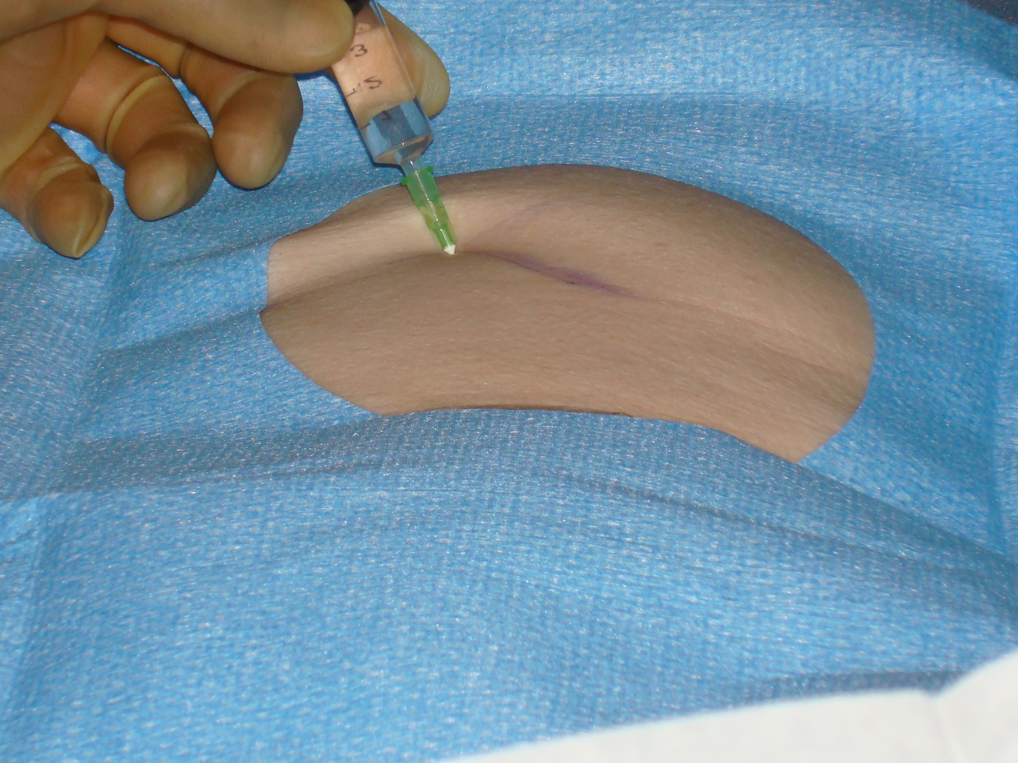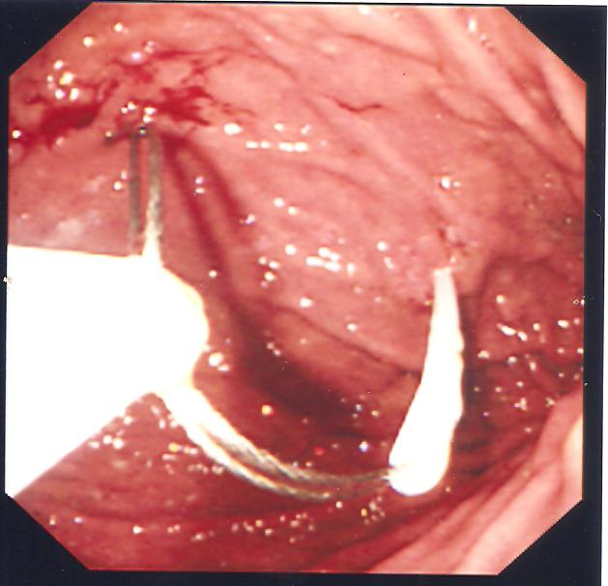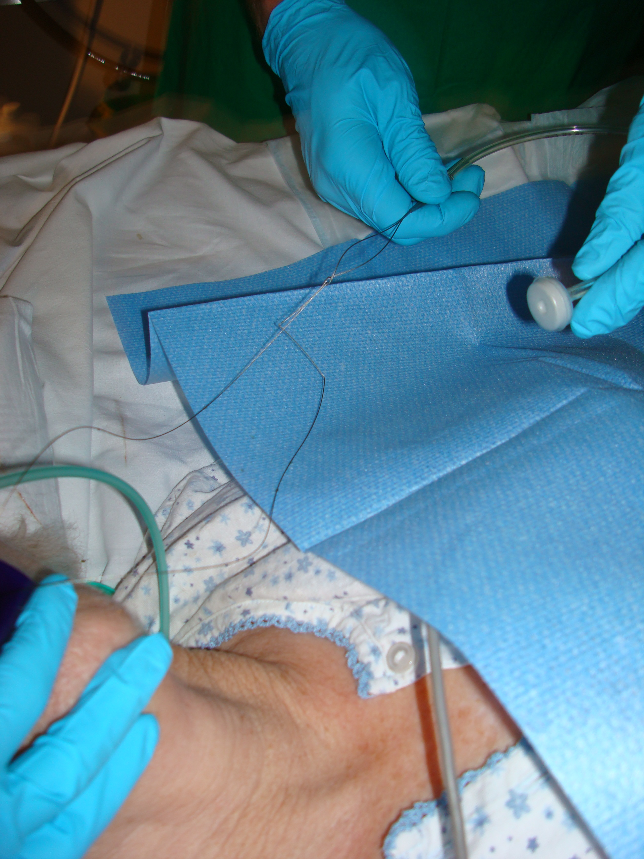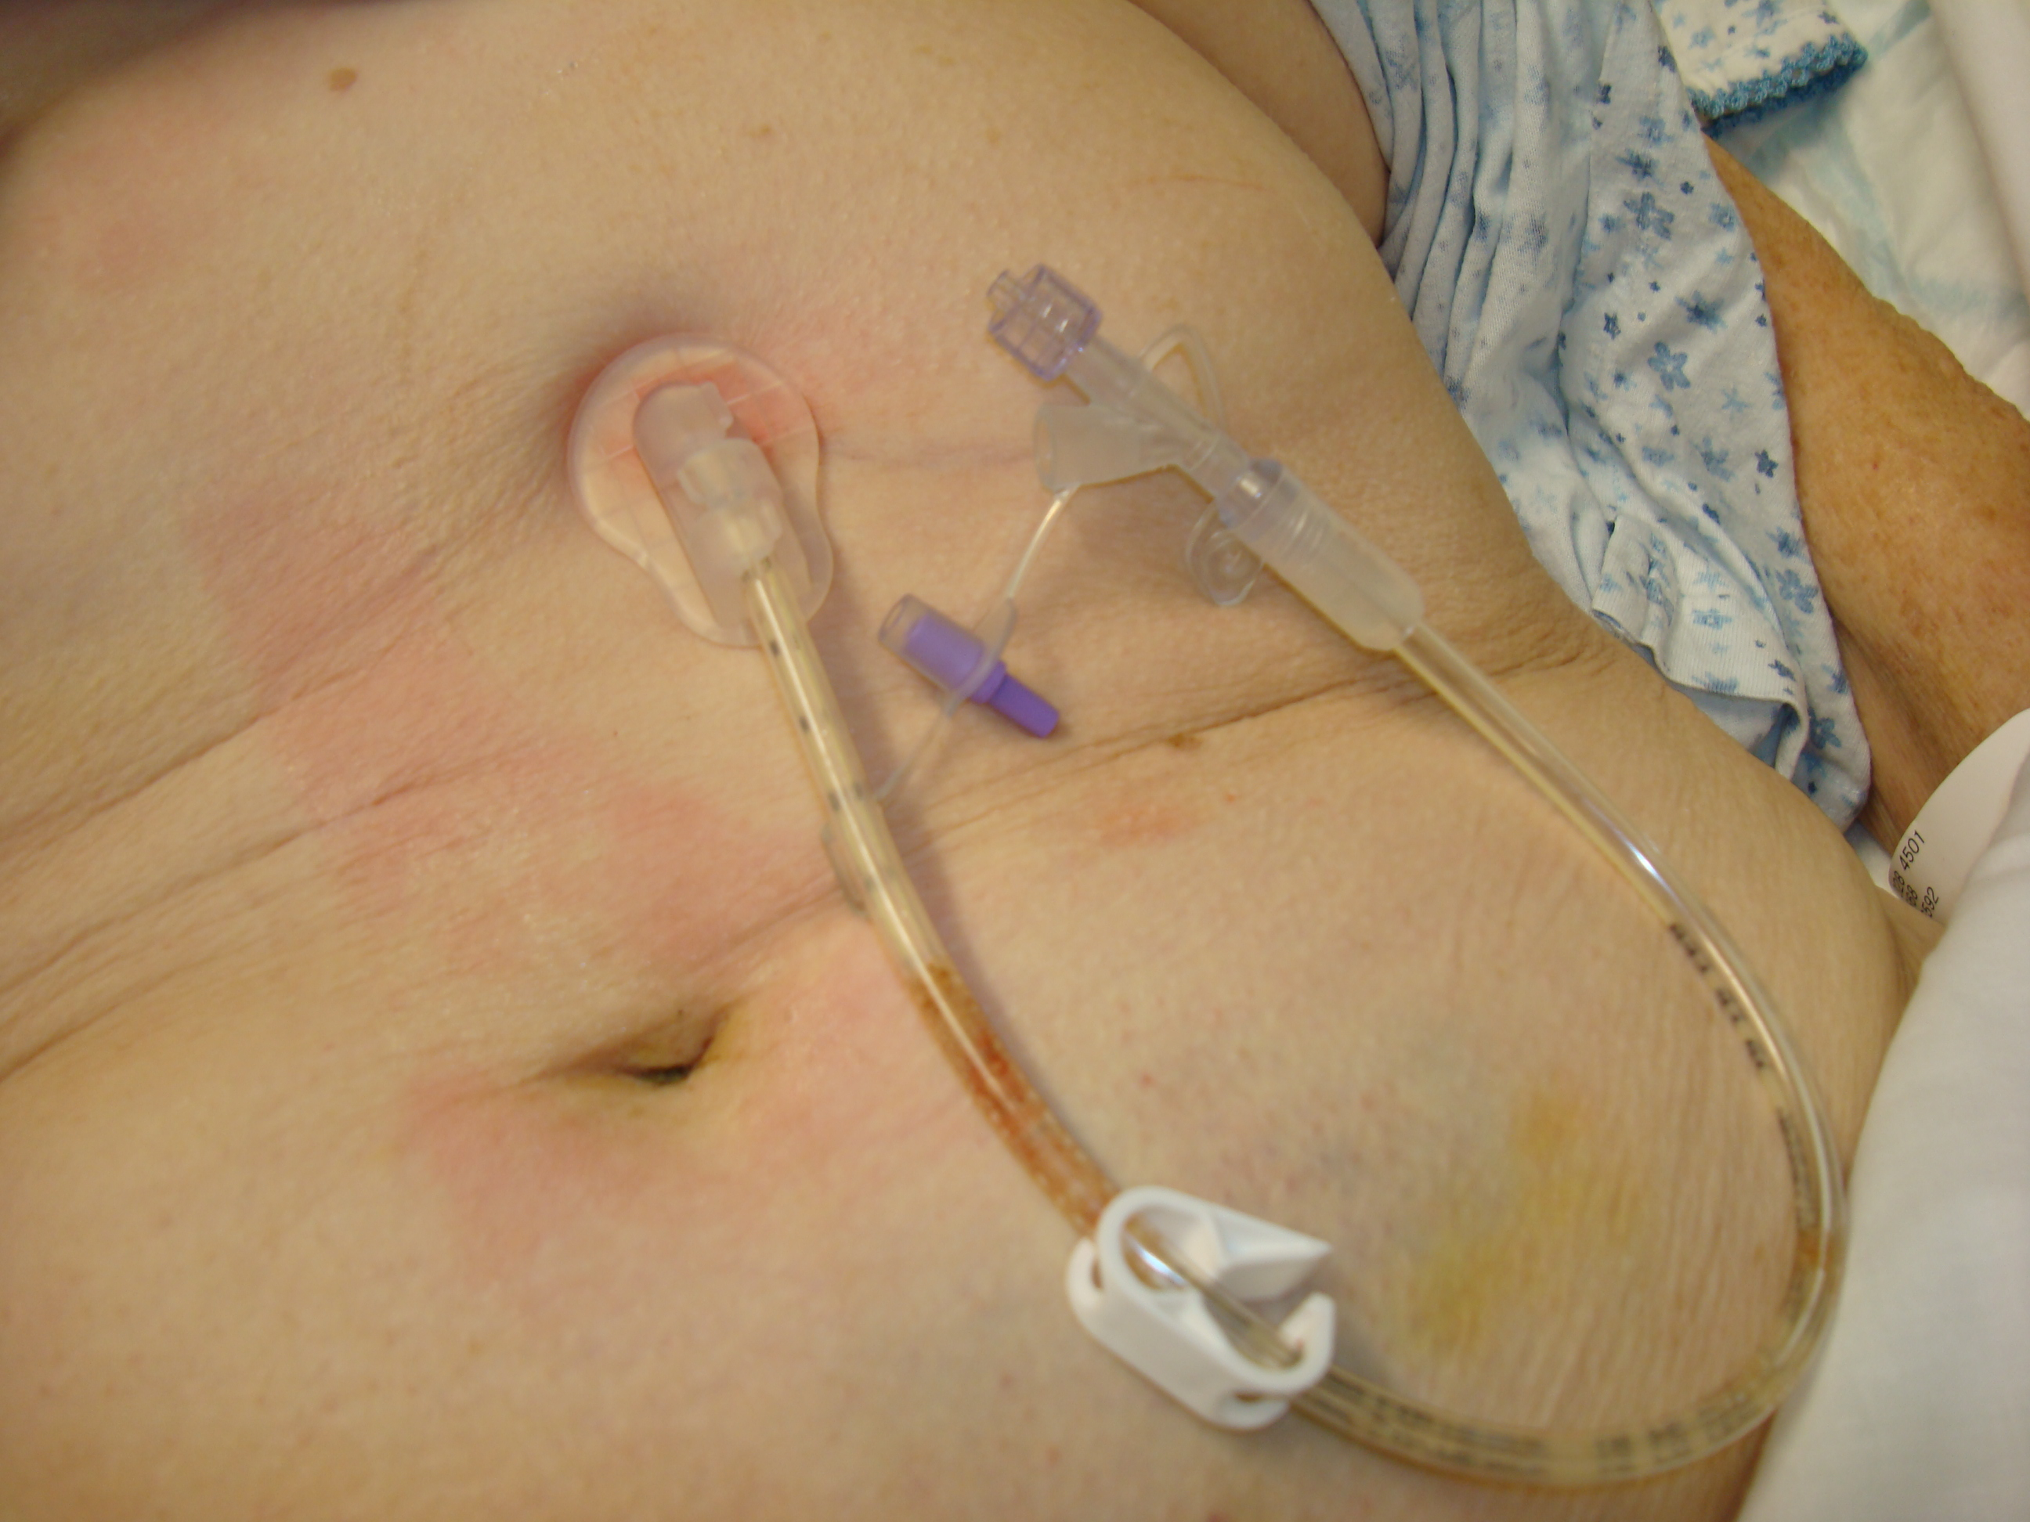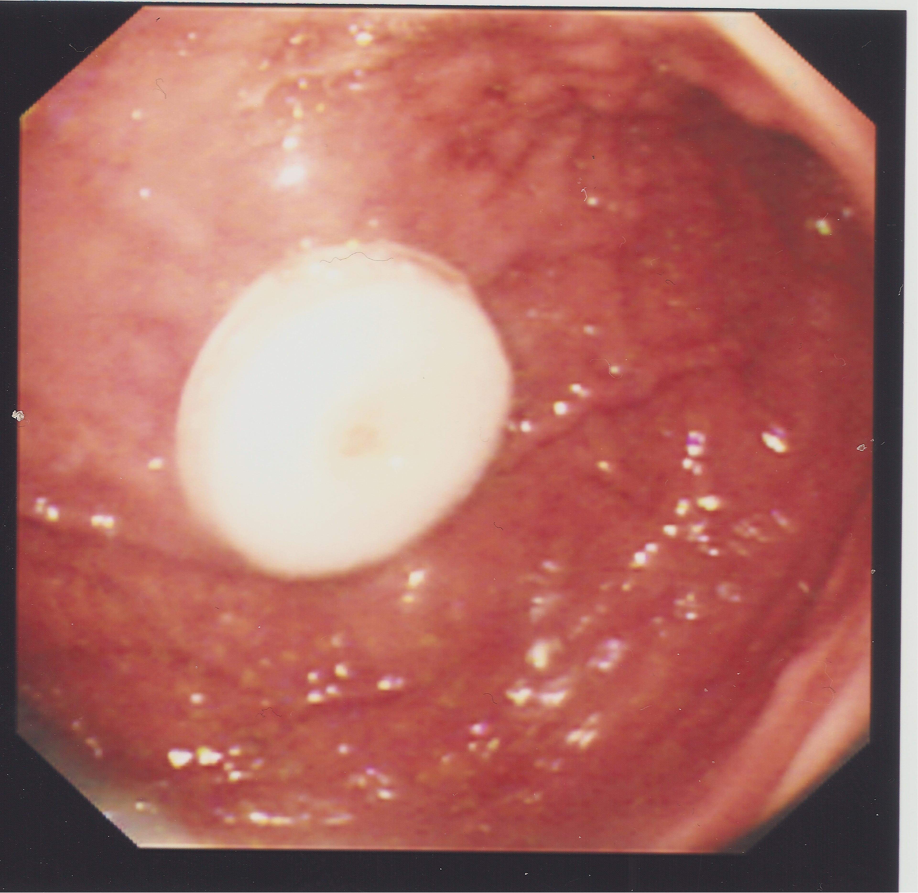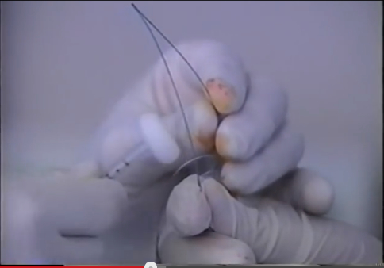
Figure 1.6
Figure 1.5
Figure 1.3
Figure 1.2
Figure 1.1
Figure 1.4
Endoscope
Guidewire
Needle-Catheter
Internal Bumper
External Bumper
Figures 1.1-1.5: PEG insertion using the “pull” technique (photographs taken by Matthew Kurien)

The “Push” technique (Sacks-Vine): This method has similarities to the “pull” technique, however following guidewire insertion and removal from the mouth, the gastrostomy tube is placed over the guidewire and pushed along (as opposed to being pulled) before exiting the abdominal wall through the stomach.¹¹

The Introducer method (Russell) is the other widely practice endoscopic technique of insertion and differs to the “push” and “pull” methods in that the gastrostomy tube does not pass through the oral cavity. Instead the gastrostomy is directly positioned in the stomach using endoscopic vision after stomach needle puncture, sheath insertion and tract dilatation.¹² Previous studies have demonstrated comparable procedural success of all three endoscopic techniques.¹³ However, the introducer technique of gastrostomy may be advantageous in patients with head and neck cancer as the gastrostomy tube does not pass through the oral cavity, potentially reducing the risk of tumour seeding and stomal metastasis.¹⁴

Radiological Insertion Techniques
Percutaneous Radiological Gastrostomies (PRGs) are inserted in a similar manner to the Russell endoscopic method, using fluoroscopy rather than endoscopy to identify the position of the stomach. Occasionally computerised tomography (CT) or ultrasound is used when fluoroscopy is indeterminate. Some centres also perform a gastropexy (fixation of the stomach to the abdominal wall) as part of the PRG procedure, however the merits of this in reducing post procedural gastric leakage and tube migration are debated.¹⁵

In some radiological units, retrograde catheterisation of the oesophagus is done after stomach puncture, enabling passage of a guide wire out through the mouth and attachment of a gastrostomy tube. This is then pulled down like in the “pull” endoscopic technique (Gauderer and Ponsky), in a radiological technique called a per-oral image-guided gastrostomy (PIG). In a study comparing PEGs, PRGs and PIGs, comparable success and complications were identified in all 3 procedures.¹⁶
Following successful insertion of a PEG, PRG or a PIG most patients are monitored in a ward environment and managed in accordance with local protocols, to minimise the risk of post-procedural complications.¹⁷ These widely used protocols should ensure that there is adequate training for nursing staff, a dietician review, pump training, community team involvement and sufficient patient and carer education following insertion. Feeding can usually be commenced via the gastrostomy after four hours and can be delivered either continuously or via intermittent boluses dependent upon choice or feasibility within the patient’s home environment.¹⁸

1.2 Indications for Gastrostomy
Since the introduction of endoscopic and radiological insertion techniques for gastrostomy, there has been increasing demand for this intervention for an increasing number of clinical indications. A broad list of indications for which patients are currently being referred for gastrostomy is given in Table 1.1. Despite being widely performed the evidence base to support gastrostomy feeding in certain patients groups is lacking. This is reflected in the National Confidential Enquiry into Patient Outcome and Death (NCEPOD) report, which undertook the largest UK study to date reviewing mortality rates post-percutaneous endoscopic gastrostomy insertion between April 2002 and March 2003, identifying a 30-day mortality rate in a cohort of 16,648 patients of 6%.¹⁹ Subgroup analysis alarmingly showed that 43% died within one week of undergoing PEG insertion, of whom in 19% the intervention was felt to have been futile. Interestingly, the NCEPOD data identified a high prevalence of acute chest infections (40%) in those undergoing PEG placement, which could have influenced these mortality outcomes.

Table 1.1 – Types of patients commonly referred for Gastrostomy insertion
Neurological Indications | Obstruction
Cerebrovascular Disease | Oropharyngeal Cancer
Motor Neurone Disease | Oesophageal Cancer
Multiple Sclerosis
Parkinson's Disease | Miscellaneous
Cerebral Palsy | Burns patients
Dementia | Fistulae
Reduced Conscious Level/Cognition | Cystic Fibrosis
Head Injury | Short Bowel Syndromes (e.g. Crohn’s)
Intensive Care Patients

The current evidence regarding gastrostomy feeding in certain patient subgroups is discussed below.

Gastrostomy feeding and Dementia
There is currently insufficient evidence to support gastrostomy feeding in dementia. Patients with advanced dementia frequently develop feeding problems that lead to weight loss and nutritional deficiencies. Whether or not to use gastrostomies to feed patients with dementia is an emotive and controversial issue. This controversy is further compounded by the fact that in the late stages of the illness, individuals lack capacity to express their wishes. The British Artificial Nutrition Survey (BANS) identified in 2007 that 109 new patients and 582 established patients with dementia were being artificially fed in the community, the majority by gastrostomy feeding.²² However, a recent Cochrane review of PEG outcomes in those with advanced dementia failed to show evidence of survival benefit, improved quality of life, nutritional status, function, behaviour or psychiatric symptoms.²³

Currently, there are no large prospective studies examining outcomes of gastrostomy patients with dementia. However, in a cohort study of 361 dementia patients, mortality was found to be significantly higher than in any other patient group (54% 30-day mortality and 90% at 1 year).²⁴ These findings have been reproduced by other investigators who observed that eating problems occurred in 85.8% of dementia patients prior to death suggesting that difficulties with feeding are an end-stage problem.²⁵

Gastrostomy Feeding in Stroke Patients
Dysphagia is common in patients after a stroke ranging between 23-50%.²⁶ Whilst neurological recovery does occur in some patients leading to improvements in swallowing function, many remain at high risk of developing aspiration pneumonia and malnutrition. Enteral nutrition is widely advocated in these individuals, however controversy exists as to the optimal mode of delivery. Two small randomised, studies evaluating PEG versus nasogastric feeding demonstrated improved mortality outcomes, hospital length of stay and nutritional indices in patients who had a PEG, suggesting derived benefit.

However, since these studies were published the FOOD trial, a multicentre study evaluating enteral nutrition in stroke patients has questioned the potential merits of PEG feeding.²⁹ Consisting of three pragmatic randomised controlled trials, the FOOD trial aimed to determine whether routine oral nutritional supplementation of a normal hospital diet improved outcomes after stroke (Trial 1); whether early tube feeding improved the outcomes of dysphagic stroke patients (Trial 2); and whether tube feeding via a PEG resulted in better outcomes than nasogastric feeding (Trial 3). Results showed no benefit of oral supplements; however, survival improved when tube feeding was commenced early but at the cost of poorer functional outcomes. In Trial 3 the best outcome was achieved in the group fed by nasogastric tube. These findings have led to reviewing current practice and questioned the optimal timing of gastrostomy feeding in these patients.

Gastrostomy Feeding in Oropharyngeal Malignancy
Patients with oropharyngeal malignancy are at risk of malnutrition due to direct effects from the tumour (e.g. reduced appetite, host response, problems ingesting food due to tumour size) and also from the anticancer therapies themselves (e.g. radiation induced mucositis). Gastrostomies are widely performed in this patient group as a prophylactic measure (prior to radiotherapy and chemotherapy), but also when swallowing problems occur directly because of the malignancy itself. Despite the potential merits of enteral feeding in this patient group, there has only been one randomised controlled trial evaluating gastrostomy feeding in comparison to other enteral feeding methods.³⁰ This has led to a recent Cochrane review concluding that there is insufficient evidence to determine the optimal method of enteral feeding in patients with head and neck cancer receiving radiotherapy and/or chemoradiotherapy.³¹

Gastrostomy Feeding in Chronic Neurodegenerative Conditions

Gastrostomies are increasingly being used in the treatment of patients with neurogenic dysphagia.³² Whilst the exact aetiology of the neurogenic dysphagia is frequently unknown, it is commonly encountered in patients with Motor Neurone disease (Amyotrophic Lateral Sclerosis), Huntington’s chorea, Multiple sclerosis and in patients with Parkinson’s disease. When bulbar weakness develops leading to dyarthria and dysphagia, gastrostomies are frequently considered to aid nutrition, reduce choking episodes and to minimise the risk of aspiration pneumonia.

There are currently no randomised controlled trials evaluating outcomes of patients with chronic neurodegenerative conditions following gastrostomy insertion. Of the observational studies that have been performed, findings are frequently conflicting, retrospective and predominantly from motor neurone disease cohorts.³³⁻³⁵ Based on the limited available literature, the most recent Cochrane review tentatively concludes that gastrostomy feeding may confer a survival and nutritional advantage in those with motor neurone disease, however further work is required with regards to evaluating quality of life.³⁶

Gastrostomy Feeding in other Patient Sub-groups

Gastrostomy insertion is performed for a number of other indications (highlighted in Table 1.1), however evidence to support its use in these differing sub-groups is questionable. An example of this is in patients who suffer head injuries following road traffic accidents, falls, violence or sport who are often considered for gastrostomy whilst on Intensive Care Units. Currently, the latest Cochrane review of nutritional support in head injury patients (analysis of 11 trials) suggests early feeding may improve survival and disability, however this benefit may be best derived from total parenteral nutrition rather than enteral nutrition methods.³⁷ When comparing nasogastric feeding with gastrostomy feeding in this patient group, gastrostomy feeding may reduce pneumonia rates but does not derive any mortality benefit.³⁸

Another group of patients seen in adult services with gastrostomies are patients with cerebral palsy. Gastrostomy insertion is increasingly being performed in children with this condition with the aim of improving weight, nutritional indices and quality of life.³⁹⁻⁴¹ These individuals are then moved into adult services as they reach adulthood. Unfortunately, like in many other areas of gastrostomy feeing there is a paucity of well designed randomised controlled trials evaluating gastrostomy feeding in this patient group, leading to uncertainty regarding the merits of this intervention.⁴² This uncertainty is reflected in other conditions (anorexia nervosa, achalasia, frailty, burns patients) and highlights the need for well-conducted studies, to help inform clinical practice.

1.3 Contraindications to Gastrostomy insertion
There are few absolute contraindications to gastrostomy insertion. Active coagulopathies and thrombocytopenia (platelets <50 x10⁹/l) should be corrected prior to tube insertion. Anything that precludes the procedure, such as haemodynamic compromise, sepsis or a perforated viscus would be considered absolute contraindications to gastrostomy insertion. Relative contraindications include acute severe illness, anorexia, previous gastric surgery, peritonitis, ascites and gastric outlet obstruction. Crohn’s Disease used to be considered a contraindication to gastrostomy insertion because of concerns about possible fistula formation around the gastrostomy tract, but an observational study has suggested that gastrostomy insertion in patients with Crohn’s disease may be safe and without increased complications.⁴³

1.4 Gastrostomy Complications
The rate of complications following gastrostomy has been reported as being between 8-30%. Complications, which may be immediate or delayed are listed in Table 1.2. Most gastrostomy insertions are done in hospital and immediate complications are usually observed during the inpatient admission. Delayed complications are more often seen in the community setting. If favourable outcomes are to be achieved, prompt decisions should be made as to whether the problem can be managed within the community or require hospital admission.

Table 1.2: Complications associated with Gastrostomy Insertion
Immediate (<72 hours) | Delayed
Endoscopy Related | Gastric outlet obstruction
Haemorrhage/ Perforation | Buried Bumper Syndrome
Aspiration | Dislodged PEG tube
Oversedation | Peritonitis
Procedure Related | Peristomal Leakage/Infection
Ileus | Skin/ Gastric Ulceration
Pneumoperitoneum* | Blocked PEG tube
Wound Infection | Tube Degradation
Wound Bleeding | Gastric Fistula post PEG removal
Liver/Bowel/Splenic Injury | Granulation around PEG site

*Pneumoperitonuem may be a common occurrence without causing any significant symptoms to the patient.⁴⁵

Complications that can be managed in the community
Over-granulated stoma sites occur commonly post gastrostomy insertion and there is little evidence to guide management. Cauterisation of the lesion with silver nitrate has been tried but patients often find this painful and cautery may damage the gastrostomy tube. Treating the cause of the over-granulation, such as gastric leakage, infection or a poorly positioned fixation device that is a source of friction, may be more appropriate. Preventive measures combined with a steroid preparation cream, such as 1% hydrocortisone may reduce granulation. Infections around stoma sites are fairly common and should be suspected if there is inflammation or discharge around the stoma site. If suspected, swabs from the peristomal area should be sent for culture and antibiotic treatment given either topically or enterally, dependent upon the sensitivities of the organism.

Blockage of the gastrostomy tube usually occurs secondary to medication or feed. Massaging the gastrostomy tube may successfully remove the obstruction. If this fails, a push-pull method using a syringe on the end of the tube may help to dislodge the blockage. In cases where these mechanisms fail enzyme preparations or fizzy drinks may be delivered into the tube. Inadvertent gastrostomy tube removal occasionally occurs and should be replaced with a balloon gastrostomy. These temporary tubes can last up to 3 months and have a balloon inflated with sterile water, which maintains the tube’s position within the stoma tract. A delay in recognising a dislodged tube may result in closure of the stoma, requiring hospital admission and endoscopic re-insertion of the tube. A urinary catheter may be used as a holding measure if necessary to prevent closure of the tract, prior to permanent insertion of a balloon gastrostomy. There is a possible risk of feed related peritonitis following reinsertion of a gastrostomy tube. When uncertain of tube position, then correct siting can be confirmed by measuring the pH value of the aspirated gastric contents. The alternative is performing a water-soluble contrast study before feeding is recommenced.

Complications requiring Hospital admission
Any complication may require a hospital admission. Discussed below are some serious complications that require relatively urgent hospitalisation. Any of the immediate complications noted in Table 2 should prompt readmission if the patient has been discharged.

The’ buried bumper’ syndrome is a rare but serious complication that occurs in 1.5-1.9% of patients.⁴⁵ The internal bumper migrates from the gastric wall towards the skin, anywhere along the gastrostomy tract, as a consequence of excessive tension between the internal and external bumper. Symptoms may include pain on feeding, retrograde leakage of feed onto the skin and rarely gastric perforation. This is corrected by removing and re-siting the internal bumper by endoscopic or by surgical intervention. This practice is influenced by the type of tube initially used.

Patients who have serious complications such as peritonitis or gastric outlet obstruction may present with symptoms of acute or chronic abdominal pain. Red flag features prompting urgent assessment covering the first 72 hours post-gastrostomy insertion are pain on feeding and external leakage of gastric contents. In addition, bleeding would raise concern, either when visible in the tube or seen surrounding the gastrostomy tube.⁴⁶

1.5 Optimising referral for Gastrostomy insertion
There has been increasing interest in improving patient selection for gastrostomy insertion.⁴⁷⁻⁴⁹ One method used internationally to optimise referral practice is to employ institutional guidelines that use a standardised referral protocol. Use of a multidisciplinary team in assessment of patients and dissemination of evidence can allow both carers and health professionals make an informed decision. This approach has been shown (in observational studies) to improve the selection of patients referred for gastrostomy.⁵⁰⁻⁵²

When considering whether insertion of a gastrostomy tube is appropriate, the question that must be asked is whether gastrostomy feeding would maintain or improve a patient’s quality of life. This question must be answered in the context of the underlying diagnosis and prognosis, considering moral and ethical issues, as well as respecting the patient’s wishes. Guidelines exist to aid clinicians in making decisions on gastrostomy feeding, however the decision to insert a feeding tube should always be made on an individual basis.

1.6 Ethical and Legal Considerations of Gastrostomy feeding
Gastrostomy feeding raises ethical and legal issues. Both the Royal College of Physicians and the General Medical Council in the UK have provided guidance on oral feeding and nutrition. Artificial Feeding is considered a medical treatment in legal terms and requires valid consent prior to commencement. For consent to be valid the person giving consent must have the capacity to do so voluntarily after being given sufficient information to guide informed choice. When a patient has capacity their wish to consent to or refuse treatment should be upheld, even if that decision may lead to death. When a patient lacks capacity an independent mental capacity advocate should represent that individual. The multidisciplinary team caring for the patient is responsible for giving, withholding or withdrawing treatment, including artificial feeding and hydration and should consider any advance directives, the patient’s prognosis and the likely benefits of gastrostomy feeding when making decisions. A limited trial of feeding may sometimes be used but strict criteria regarding what constitutes success should be determined prior to starting gastrostomy feeding.⁵⁷ Conflicts sometimes arise between health care professionals or between the professionals and those close to the patient. In such circumstances it may be necessary to seek legal advice or seek resolution through a local clinical ethics committee.⁵⁸ Anecdotally, such conflicts appear to be rising with increased patient and family demands for intervention, which may in turn be influenced by emotion or by cultural beliefs.

The NICE dementia guidelines highlight the importance of quality of life in advanced dementia and support the role of palliative care in these individuals from diagnosis until death. Best practice in these patients could be to encourage eating and drinking by mouth for as long as tolerated, utilising good feeding techniques, altering food consistencies and to promote good mouth care. Assisting hand feeding in this way has recently been shown to be of benefit in elderly patients, with volunteer assistance improving oral intake and enjoyment of meals.⁵⁹ When disease progression is such that the patient no longer wants to eat or drink, then rather than inserting a gastrostomy tube, end of life care pathways might be considered. Views held by carers and medical staff may prevent progression to end of life care pathways. A questionnaire survey demonstrated that allied health care professionals were more likely than physicians to consider gastrostomy feeding when presented with patient scenarios relating to malnutrition.⁶⁰

1.7 Summary of overview
Gastrostomy feeding is an established way of delivering nutritional support to individuals who are unable to meet their nutritional requirements orally. Improved nutritional status and survival may be identified in selected sub-groups of patients, however further work is required to establish the true merits of this intervention.

1.8 Null Hypothesis and Aims of this Project
As highlighted in the overview, controversy currently exists in the medical literature regarding the utility and merits of gastrostomy feeding. Based on these observations, the null hypothesis for this work is that gastrostomy feeding confers no benefits to either patients or their carers. This hypothesis is tested with 5 specific aims detailed below:
a) To determine mortality outcomes in patients referred for gastrostomy, including those declined this intervention following multidisciplinary team review.
b) To determine the accuracy of a previously devised scoring system in predicting mortality, which may potentially aid patients, carers and clinicians in the decision making process regarding gastrostomy insertion.
c) To determine if gastrostomy insertion improves quality of life in either patients or carers of gastrostomy patients
d) To determine if outcomes following gastrostomy insertion are influenced by variations in local practice, by evaluating service provision for gastrostomy within the United Kingdom.
e) To determine if aftercare provision within the community influences outcomes following gastrostomy insertion.

This work is innovative in that it assesses two important health outcome measures (mortality and quality of life) and also seeks to assess factors that may influence these outcomes. The novel aspects of this work are data collected are prospective, unlike many previous gastrostomy studies where data collected are frequently retrospective. In addition, the use of mixed methods research to assess quality of life in the area of gastrostomy feeding is novel. By evaluating these outcomes, hopefully the results generated can help improve and standardise care within the UK in relation to gastrostomy feeding.

CHAPTER 2: MATERIALS AND METHODS

2.1 Patient recruitment

Patient recruitment, carer recruitment and controls for each study are provided in more detail within subsequent individual chapters. All individuals recruited as part of this body of work were from five hospitals in South Yorkshire and North East Derbyshire (Royal Hallamshire Hospital, Northern General Hospital, Rotherham District General Hospital, Chesterfield Royal Hospital and Doncaster Royal Infirmary). These hospitals in combination serve a population of just over 1.5 million people and perform approximately 350 gastrostomies annually. All individuals recruited were over the age of 16.

The provisions of gastrostomy services in South Yorkshire were established over three decades ago. In 2004 a prospective gastrostomy database was created at Sheffield Teaching Hospitals to record demographics, comorbidity, biochemical, and outcome data of all individuals referred for this intervention. I personally have been involved in the management of this database since 2008. Data collected between 2004 and 2008 is also included in this body of work.

Studies undertaken as part of this work all acquired favourable approval from either the local research ethics committee or from the local service evaluation department (Appendix A). In all patients who underwent a gastrostomy, consent was obtained in accordance with guidance provided by the General Medical Council.⁶¹

2.2 Gastrostomy Insertion

All patients who were prospectively recruited during this work underwent a gastrostomy either endoscopically using the ‘pull’ technique or radiologically using the PIG technique previously described. In all patients prophylactic antibiotics were given 30 minutes prior to gastrostomy insertion. Post procedural management was undertaken on specialist acute medical or surgical wards, prior to hospital discharge to community teams.

2.3 Methods and Statistical Analysis

As methods vary between differing studies, detailed discussion of the methods used has been reserved for individual chapters. Regarding quantitative data analysis, all data acquired was analysed exclusively by MK using statistical packages for the social sciences (SPSS Inc., Chicago, Illinois, USA), version 20.0. Regarding qualitative analysis, NVivo (QSR International Pty Ltd. Version 10) was used to aid coding. Where statistical analysis was performed to compare categorical or continuous data, a p value <0.05 was considered significant.
2.4 Collaborations
I am immensely grateful to a number of individuals who have provided me with help in undertaking this work. Professor David S Sanders, Dr Mark McAlindon, Julia Grant, Dr Keith Dear, Dr Barbara Hoeroldt and Dr Gary James all helped in facilitating this work within their respective hospitals. With regards to the gastrostomy database, I wish to thank Dr John Leeds and Stephen Stewart for their support at initiation in 2008 and for their guidance beyond. Finally, I would wish to acknowledge the help of the National Institute of Health Research (NIHR) Comprehensive Clinical Research Network for their support in the Quality of Life study, which helped to identify potential study participants.

CHAPTER 3: Mortality Among Patients Who Receive or Defer Gastrostomies

3.1 Summary
There are few data on outcomes and mortality of patients who have received gastrostomies. In this study, I assess 30-day and 1-year mortalities of patients who were referred to hospitals for gastrostomies, and of patients who declined this intervention.

Data was prospectively collected from 1327 patients referred to 2 hospitals in Sheffield for gastrostomies from February 2004 through May 2010. Data were analysed to determine 30-day and 1-year mortalities. Predicted mortality using the validated Sheffield Gastrostomy Scoring System (SGSS) was then compared with actual mortality using area under the receiver operator curves (AUC), to determine levels of agreement in patients referred for gastrostomy.

Three-hundred four patients (23%) did not undergo gastrostomy following multi-disciplinary team discussion, based on physicians’ recommendations. This group had 35.5% mortality at 30 days and 74.3% at 1 year, whereas mortality among patients who underwent gastrostomy (n=1024) was 11.2% at 30 days and 41.1% at 1-year (P<.0001, compared with patients who declined the procedure). The AUC for the SGSS demonstrated acceptable agreement between predicted and actual mortality in both patients who underwent or were declined gastrostomy.

Based on data from 1327 patients, those who undergo gastrostomy have significantly lower mortality than those who defer the procedure. Without applying the SGSS, clinicians are able to select patients most likely to benefit from gastrostomy. The SGSS could provide objective support to clinicians involved in making ethically contentious or potentially litigious decisions.

3.2 Introduction

A gastrostomy is a frequently undertaken procedure used to provide enteral nutrition to individuals who have functionally normal gastrointestinal tracts, but who fail to meet their nutritional requirements due to an inadequate oral intake.¹ Despite being widely adopted into clinical practice there have been increasing concerns regarding the significant morbidity and mortality seen following this intervention. Several risk factors for mortality have been identified including increasing age, reduced albumin, C-reactive protein and co-morbidity (Table 3.1). Conversely, there are no studies evaluating outcomes of individuals declined this intervention.

Table 3.1 - Studies investigating factors associated with Gastrostomy mortality

Author and Year | Country | No. of Patients | Data | Factors identified after logistic regression
Zopf 2011 | Germany | 787 | Retrospective | Increased age, low BMI, diabetes mellitus
Blomberg 2011 | Sweden | 484 | Prospective | Low albumin (<30g/L), High CRP (≥10)
Suzuki 2010 | Japan | 931 | Retrospective | Raised CRP, Raised blood urea nitrogen, Low albumin, Increased age, Male sex, History of IHD
Yokohama 2009 | Japan | 302 | Retrospective | Low albumin, High serum creatinine, History of IHD
Poulsen 2009 | Denmark | 165 | Retrospective | Low albumin, Increased age, Co-morbidity, Hyponatraemia
Smith 2008 | U.S.A. | 714 | Retrospective | Increased age, cancer, Ischaemic heart disease, Non caucasian, Dialysis patients
Tokunaga 2008 | Japan | 198 | Retrospective | Low albumin (<29g/L), Pneumonia within 1 year prior to PEG insertion
Higaki 2008 | Japan | 311 | Retrospective | Previous subtotal gastrectomy, Low albumin, Age>80 years, Chronic heart failure, Male sex
Figueiredo 2007 | Brazil | 168 | Prospective | High CRP (>5mg/dL)
Chong 2006 | Singapore | 106 | Retrospective | Increased age, BMI <20, Presence of bedsores
Janes 2005 | U.K. | 112 | Retrospective | Low albumin (<30g/L), Feed withheld for 7 days prior to PEG, >1 cardiac risk factor
Nair 2005 | U.S.A. | 56 | Retrospective | Low albumin (<28g/L)
Lang 2004 | Israel | 502 | Retrospective | Diabetes mellitus, COPD, Low albumin (<30g/L)
Abuskis 2004 | Israel | 127 | Retrospective | Hospitalised Patients, Bed bound patients, Disorientation
Paillaud 2002 | France | 73 | Retrospective | Active infection at time of PEG insertion, Presence of bedsores
Friedenberg 1997 | U.S.A. | 64 | Retrospective | Low albumin (<30g/L)
Light 1995 | U.S.A. | 416 | Retrospective | Urinary tract Infection at PEG insertion, Previous aspiration, Age >75 years
Key: BMI=Body Mass Index, IHD=Ischaemic Heart Disease, CRP=C-Reactive Protein, COPD=Chronic Obstructive Pulmonary Disease

In light of the high mortality and recognition of risk factors, our research group has recently published the first objective assessment tool used to predict mortality in the area of gastrostomy feeding, the Sheffield Gastrostomy Scoring System (SGSS).⁸⁰ Previous researchers have demonstrated that the prediction of prognosis using subjective clinical judgment may be inaccurate when compared to a scoring system. This is with specific regards to mortality in cancer patients. The SGSS consists of 2 key variables, age and albumin (identified at multivariate analysis to be predictive of 30-day mortality), which are then used to generate a composite score predictive of 30-day mortality (Table 3.2). The SGSS has been internally validated, externally validated and compared against an artificial neural network with high levels of agreement between predicted and actual mortality in patients who have had a gastrostomy inserted.⁸⁰ However, the SGSS has not been assessed in patients declined from a gastrostomy.

Table 3.2: Gastrostomy Score and corresponding 30-day mortality rates.
Criterion | Score 0 | Score 1 | Score 2
Age | <60 | >60
Albumin | >34 | 25 – 34 | <25

Composite score | 30-day mortality (%) | 95% CI
0 | 0.0 | 0 – 2.1
1 | 7.0 | 2.9 – 13.9
2 | 21.3 | 13.5 – 30.9
3 | 37.3 | 24.1 – 51.9

This study’s primary aim was to assess 30-day and 1-year mortality rates in a cohort of patients referred for gastrostomy, including those who subsequently did not undergo the procedure. As a secondary outcome measure, I aimed to evaluate the agreement between predicted mortality from the validated SGSS and actual mortality determined by clinical judgment in patients referred for this intervention.

3.3 Methods
Gastrostomy referrals were examined from a single trust based on two sites in Sheffield, South Yorkshire between February 2004 and May 2010. The two hospitals combined provide acute medical and surgical services for a population of 600,000 people, however some specialities are localised to one hospital (e.g. otorhinolaryngology). This prospective study was approved by the South Yorkshire Research Ethics committee (Appendix A) and conducted according to the principles of the Declaration of Helsinki and Good Clinical Practice Guidelines. The study was registered with the Sheffield Research and Development department under the number STH09/H1310/2 and with the local audit department.

Data collection
All patients referred for a gastrostomy were prospectively included on a gastrostomy database recording demographic data, co-morbidities, biochemical data and outcome data (factors which were considered to be linked to mortality). Included in this database were patients referred who may have ultimately not undergone gastrostomy insertion. For the purposes of prognostic modelling, serum albumin was split into normal (>34g/L), low (25 – 34g/L) and very low (<25g/L). This stratification has been validated in critical care settings. Following referral for a gastrostomy, patients underwent multidisciplinary team assessment including speech and language therapy review, gastroenterologist and assessment by a gastrostomy specialist nurse. The specialist nurse (JG) who works at both sites was involved in all areas of gastrostomy care including pre-assessment, insertion and follow up.

Gastrostomy insertion
At both hospital sites percutaneous endoscopic gastrostomy (PEG) and per-oral image-guided gastrostomy (PIG) were available as potential methods of inserting a gastrostomy. Selection as to which procedure was undertaken was left to the discretion of the referring clinician, with similar outcomes following the two techniques in our centre previously shown.⁸⁵ Patients were referred by a variety of specialties: primary care, internal medicine, upper GI surgeons, care of the elderly, palliative care, ear nose and throat or neurology/neurosurgery.

Percutaneous endoscopic and per-oral image-guided gastrostomy insertion
PEG and PIG insertions were performed in dedicated endoscopy and radiology units by trained gastroenterologists and interventional gastrointestinal radiologists. Procedures were undertaken using intravenous midazolam and/or pethidine to provide conscious sedation. All patients received a single intravenous dose of co-amoxyclav 1.2g at the time of their sedation prior to their gastrostomy insertion in accordance with international guidelines. The most frequently employed gastrostomy insertion was using size 12 – 14 French tubes.⁴ Following both PEG and PIG insertion, inpatient aftercare was provided by trained gastroenterology nursing staff with support from the specialist gastrostomy nurse. Information on common gastrostomy problems were given to patients and their carers (both oral and written), along with nutritional information and contact details prior to the transfer of care to a dedicated dietetic home enteral feed service within the community.

Gastrostomy declined cohort
Gastrostomies were most frequently declined when at multidisciplinary team review patients were perceived to be too unwell, where the intervention was felt to be futile and when patients electively declined this intervention after an understanding of benefits and risks. In individuals where a decision was made to defer gastrostomy, alternative methods of continuing nutritional support were considered including oral means, parenteral strategies and differing enteral routes. These decisions were frequently individualized, determined by the multidisciplinary team, alongside patient and carer’s wishes, acting in what was perceived to be the best interest of the patient concerned.
Decision Making Process regarding Gastrostomy Insertion
The multidisciplinary team and all referring clinicians involved in the decision-making process had no knowledge of factors being potentially assessed within the scoring system. Decisions to insert a gastrostomy were based purely on clinical judgment. This term describes a composite of cognitive processes, utilizing knowledge and individual/team’s expertise to derive decisions.⁸⁷ The research team was a separate and discrete group, who were not involved in the decision making-process.
Outcome Measures
The primary outcome measure in this study was to evaluate 30-day and 1-year mortality outcomes in all patients referred for a gastrostomy. Results were obtained through linkage of personal identity numbers of gastrostomy referred patients with local GP registers, hospital databases and data collected from the community home enteral feed service ensuring 100% accuracy of the data. As a secondary outcome measure, actual mortality (influenced by clinical judgment derived decisions) was compared with predicted mortality using the SGSS in both gastrostomy-inserted and declined groups. The SGSS agreement with actual mortality was assessed using receiver operating curves, along with the area under the curve (AUC).

Statistical Analysis
Multivariate backward logistic regression analysis was undertaken to estimate odds ratios and corresponding 95% confidence intervals, with mortality used as the outcome variable. Survival was analyzed using Kaplan–Meier life tables. 30-day and 1-year mortality rates and case-mix (distribution of indication for gastrostomy between PEG and PIG) within SGSS groups were compared using the χ² test or Fisher’s exact test. Receiver operating characteristic curves were plotted and area under the curve (AUC) reported to compare performance of SGSS against clinical judgment based decisions.⁸⁸ Interpretation was in accordance with previously published reports. Thus, an AUC of 0.5 demonstrated the system’s discriminative value as being no better than the toss of a coin; 0.6-0.8 was considered acceptable; and 0.8-1.0 being considered good to perfect discriminative ability. Statistical analysis was undertaken using statistical packages for the social sciences (SPSS Inc., Chicago, Illinois, USA), version 20.0. All reported p-values are two-sided with alpha <0.05 threshold for significance.

3.4 Results
A total of 1327 patients were referred for gastrostomy during the study period (median age 67 years, 794 males, 12 non-Caucasian). Reasons for gastrostomy insertion were divided into five subcategories; cognitive impairment, dysphagic stroke, progressive neurological disease, oropharyngeal malignancy and other. The other group included conditions such as post surgical anorexia, anorexia nervosa, non-oropharyngeal malignancy, head injury, drainage procedure and failed swallowing assessments/poor intake where no certain underlying diagnosis identified (e.g. frail elderly).

Mortality
304 (23%) patients referred for gastrostomy did not undergo the procedure following multidisciplinary team discussion. The mortality in this group was 35.5% at 30 days and 74.3% at 1 year. In contrast, mortality in the gastrostomy inserted patients (n=1023) was 11.2% at 30-days and 41.1% at 1-year (both p<0.0001).

Of those who underwent gastrostomy insertion, 571 (56%) were endoscopically placed (PEG) and 446 (44%) by PIG insertion. These procedures were attempted in the remaining 6 patients but had to be abandoned due to technical difficulties. These individuals were included within the gastrostomy-inserted group for analysis, given the intention to treat. Mortality at 7 days post-procedure was calculated in an attempt to distinguish between deaths from procedure from demise as part of the natural history of the underlying condition. The mortality was only 2% in the intervention group suggesting most of the deaths reflected the irreversible decline of their underlying condition.
Mortality by Indication
The main indications for gastrostomy insertion were for oropharyngeal malignancy and progressive neurological conditions, with the lowest identified mortality seen in the oropharyngeal malignancy group (Figure 3.1).

Figure 3.1: Thirty-day survival following gastrostomy insertion comparing referral indication
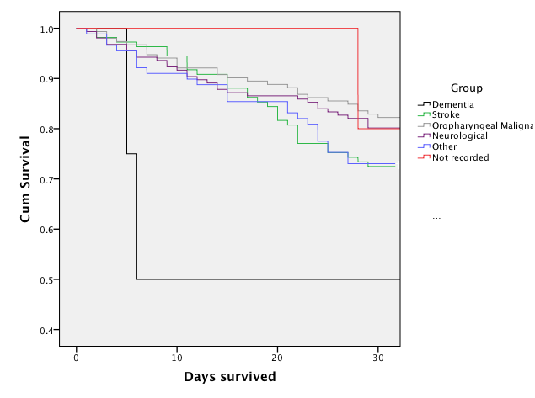
Mortality by indication and risk estimates for mortality at 30 days and 1 year are highlighted in Table 3.3, with oropharyngeal malignancy used as the reference group. This group was expected to have the lowest 30-day mortality based on previous reported findings and therefore used to gauge the increase in risk when considering other indications.⁶⁶

Table 3.3: Mortality rates by indication at 30 days and at 1 year

Referral Indication | Total No. of Patients (n=1023) | 30 day mortality |  |  | OR (95% CI) | 1 year mortality |  |  | OR (95% CI)
Referral Indication | Total No. of Patients (n=1023) | N | % (95% CI) |  | OR (95% CI) | N | % (95%CI) |  | OR (95% CI)
ENT cancer | 388 | 27/388 | 7.0 (4.8 - 10.0) |  | ref | 118/388 | 30.4 (26.0 - 35.2) |  | Ref
Not recorded | 12 | 1/12 | 8.3 (0.0 - 37.5) |  | 1.2 (0.2 - 9.8) | 3/12 | 25.0 (0.8 - 53.9) |  | 0.8 (0.2 - 2.9)
Neurological | 255 | 31/255 | 12.2 (8.7 - 16.8) |  | 1.9 (1.1 - 3.2) | 127/255 | 49.8 (43.7 - 55.9) |  | 2.3 (1.6 - 3.1)
Other | 195 | 24/195 | 12.3 (8.1 - 17.7) |  | 1.9 (1.1 - 3.3) | 77/195 | 39.5 (32.9 - 46.5) |  | 1.5 (1.0 - 2.1)
Stroke | 168 | 30/168 | 17.9 (12.8 - 24.4) |  | 2.9 (1.7 - 5.1) | 91/168 | 54.2 (46.6 - 61.5) |  | 2.7 (1.9 - 3.9)
Dementia | 5 | 2/5 | 40.0 (11.6 - 77.1) |  | 8.9 (1.4 - 55.6) | 4/5 | 80.0 (35.9 - 97.9) |  | 9.2 (1.0 - 82.8)
CI, Confidence Interval, OR, Odds ratio, ns, Not significant

Comparisons between predicted and actual mortality
Table 3.4 demonstrates predicted mortality outcomes using the SGSS compared to actual mortality outcomes in both patients who underwent gastrostomy and those declined gastrostomy at all levels of the scoring system. There was a predominance of patients (215/304, 71%) with higher SGSS scores (2 or 3) in the gastrostomy-declined group, with the SGSS found to be more accurate at predicting mortality in those who underwent gastrostomy (AUC 0.71 [95% CI 0.66-0.76]) compared to those declined this intervention (AUC 0.64 [0.57-0.70]). Receivers operating characteristic curves for SGSS are illustrated in Figure 3.2

Figure 3.2: Receiver Operating Curves for SGSS in both Gastrostomy Inserted and Declined Groups
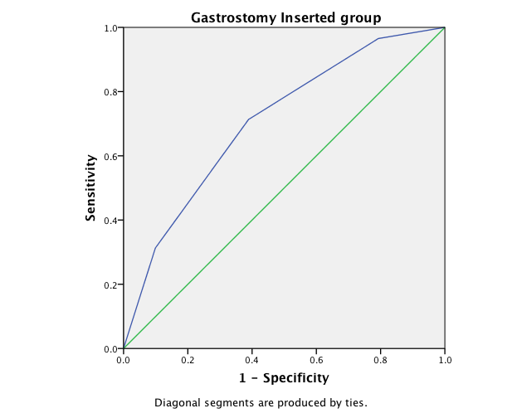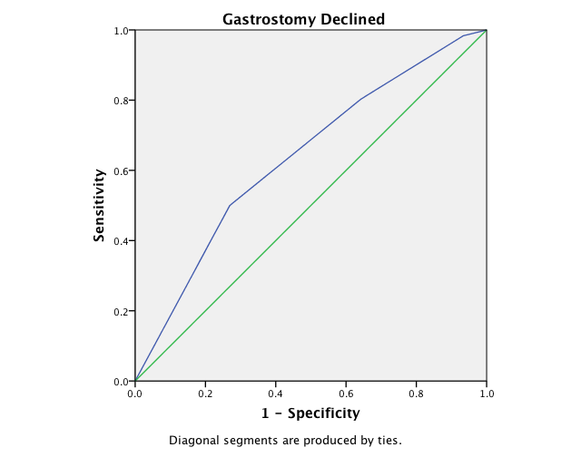

Table 3.4: Actual and Predicted mortality in patients referred for gastrostomy using the SGSS
a) Gastrostomy inserted cohort (total =1023 patients)
SGS | No. of patients | No. of patients dead at 30 days | Actual Mortality (%) | Predicted 30 day mortality (%) | p-value
0 | 192 | 4 | 0.02 | 0 | 0.82
1 | 396 | 27 | 6.81 | 7 | 0.94
2 | 309 | 48 | 15.5 | 21.3 | 0.25
3 | 126 | 36 | 28.6 | 37.3 | 0.34
b) Gastrostomy declined cohort (total =304 patients)
SGS | No. of patients | No. of patients dead at 30 days | Actual Mortality (%) | Predicted 30 day mortality (%) | p-value
0 | 14 | 1 | 7.1 | 0 | 0.59
1 | 75 | 20 | 26.7 | 7 | <0.001
2 | 105 | 35 | 33.3 | 21.3 | 0.08
3 | 110 | 52 | 47.2 | 37.3 | 0.12
SGS – Sheffield Gastrostomy Score

3.5 Discussion
This is the first study evaluating mortality in patients declined gastrostomy. The mortality in patients declined from gastrostomy is significantly higher than in those patients selected at both 30-days and 1-year respectively. When compared to decisions made based on clinical judgment, the SGSS was shown to have acceptable agreement in predicting mortality in patients both having and not having a gastrostomy inserted.

Although the SGSS was not designed to determine whether patients should ultimately undergo gastrostomy, it has advantages over clinical judgment derived decisions in that it is not subject to moral, cultural and ethical influences. Such predictive information may be of value to clinicians, allied health care professionals, relatives and patients themselves if cognisant, particularly in individuals where benefits and risks of gastrostomy are difficult to judge, with predictive information about mortality potentially being helpful in guiding discussion. It may be possible to consider a threshold for gastrostomy based on SGSS predicted mortality but this could be ethically contentious.⁹¹

As the AUC only demonstrates acceptable agreement with actual mortality, determining its true clinical utility should be by wider application and also examining its reliability in differing subgroups of patients referred for gastrostomy. Randomly assigning referred gastrostomy patients to marker-guided evaluation using the SGSS or usual care in a multicentre fashion would be the best way of assessing the SGSS⁹², however this would require careful ethical consideration.

The strengths of this study include the prospectively collected data, the large number of patients involved, the accuracy of mortality data and also the uniqueness in demonstrating outcomes in patients who are declined gastrostomy. Although this study does involve the largest cohort of patients (n=1327) prospectively collected over a 6 year period, it should be emphasized that this number represents only a small fraction of the total number of gastrostomy insertions undertaken in the United Kingdom (nearly 17,000 per year).¹⁹
Another interesting finding from this study is differences in mortality dependent upon the referral indication. There has only been 1 previous study to date evaluating 30-day mortality in oropharyngeal malignancy by comparison to other sub-groups.⁶⁶ The investigators observed in that study an overall 30-day mortality of 12% in gastrostomy patients (58/484), with the lowest mortality seen in oropharyngeal cancer patients of 6%, in keeping with these findings. Exact mechanisms for the lower mortality in this group of patients remain unclear, however this may reflect that these individuals are frequently younger (median age 61 years versus 77 years in stroke patients in our cohort of patients) at the time when gastrostomy is being undertaken, with reduced co-morbidity. Another plausible explanation could be that gastrostomy is frequently undertaken as a prophylactic measure in these patients, which may reflect a healthier premorbid state than other referral groups.

There are limitations to this study with no assessment of calorie intake made following multidisciplinary team decision in either the gastrostomy inserted or declined group. Efforts were made to provide alternative methods of artificial nutrition in the gastrostomy declined group, however the higher mortality rate identified within this group may be reflective of discrepancies in calorie intake. The critical limitation to this study is that the AUC for the SGSS is only 0.7, which is only acceptable agreement. This may reflect the absence of an important factor within the SGSS that we have not assessed. For example the SGSS was devised prior to a recent study that identified a raised C-reactive protein (CRP) as a marker of prognostic value.⁶⁶ Although this inflammatory marker was not collected in this study, like a low albumin, elevated levels are likely be reflective of a more diseased and vulnerable patient. Incorporation of CRP, or other variables such as body mass index or cognitive assessment could possibly enhance the accuracy of the SGSS. In addition, the SGSS performed less well in patients declined a gastrostomy, evidenced by the lower AUC. This outcome may reflect the fact SGSS was constructed solely to evaluate results in the gastrostomy inserted group only.

In conclusion, this is the first study evaluating mortality in patients declined from gastrostomy. Without applying the scoring system clinicians were able to appropriately select patients who would benefit most from gastrostomy insertion. There remains a significant 30-day mortality associated with gastrostomy insertion (11.7%). The SGSS may provide objective support to clinicians involved in this ethically contentious and potentially litigious decision making process.

CHAPTER 4: Evaluating Health-related Quality of Life in both patients and their carers following gastrostomy insertion

4.1 Summary

Having assessed mortality in the previous chapter the focus of this study was to evaluate quality of life, another important health outcome measure. This was assessed in both patients and carers in a cross sectional and longitudinal cohort study using a mixed methods approach. This work was performed in five hospitals in South Yorkshire and North East Derbyshire between January 2012 and May 2013. 100 patients, 100 family carers and 200 population controls were prospectively recruited during the time period, with health-related quality of life (HRQoL) assessed prior to gastrostomy insertion and then again at 3 months post-insertion using EuroQOL-5-Dimensions (EQ-5DTM) and semi-structured interviews.

Of the 100 patients recruited, 6 died prior to 3-month reassessment. All carers completed follow up. When analysing longitudinal changes in HRQoL scores, no significant change in mean EQ-5DTM index scores was noted in either the patients (0.70 versus 0.71, p=0.83) or in carers (0.95 versus 0.95, p=0.32) following gastrostomy. The mean EQ-5DTM index score was significantly lower in patients compared to population controls (0.73 versus 0.94, p<0.0001). Semi structured interviews enabled further exploration of the quantitative findings, with problems in managing gastrostomy tubes, social isolation and psychological and emotional consequences, alongside underlying disease specific problems, contributing to altered HRQoL in study participants.

This work demonstrates that HRQoL does not significantly improve for patients or their carers following gastrostomy insertion. Given the findings from this study, patients and carers should be carefully counseled regarding the potential absence of quality of life improvements as part of the decision making process prior to gastrostomy insertion.

4.2 Introduction
In the United Kingdom approximately 17,000 gastrostomies are performed annually.¹⁹ These are performed predominantly in adults. Most frequently these are undertaken for neurological conditions affecting swallowing (e.g., post cerebrovascular accident, motor neurone disease) and for obstructive lesions of the upper gastrointestinal tracts (e.g., oesophageal malignancy, head and neck cancers).¹ Despite being widely adopted into clinical practice the benefits of this intervention remain questionable, with a paucity of evidence to substantiate their role in certain patient subgroups and high morbidity and mortality identified in others. Nutritional indices, complications and hospital length of stay are other outcomes measures that have been assessed and may confer benefit, however all could be perceived to be of limited gain if no quality of life improvement for the patients is achieved.

A widely accepted definition for quality of life is an individual's perception of their position in life in the context of the culture and value systems in which they live and in relation to their goals, expectations, standards and concerns.⁹⁴ This broad concept differs slightly to health-related quality of life (HRQoL) that relates specifically to the way illness, pain and motor activity reduction imposes influence on daily behavior, social activities, psychological well-being and other aspects of an individual’s life.⁹⁵ Evaluating HRQoL in gastrostomy patients is limited, with almost a half of studies undertaking in patients with oropharyngeal malignancy (Table 4.1).⁹⁶⁻¹¹⁷
Table 4.1: Previous Gastrostomy studies evaluating HRQoL
Year | Authors | Country | Patients | Patients Assessed | Carers Assessed | Total N | HRQoL Assessment Tool Used | Disease Specific
1993 | Senft et al | Germany | Adults | Yes | No | 47 | City of Hope Medical Centre Quality of Life Survey | Yes (Head and Neck Cancer)
1993 | Weaver et al | USA | Adults | Yes | No | 100 | Modified Spitzer's QL Index, Structured Telephone Interview | No
1999 | Smith et al | Canada | Paediatrics | No | Yes | 40 | Semi-structured Interviews | Yes (Cerebral Palsy)
2000 | Roberge et al | France | Adults | Yes | No | 39 | EORTC QLQ-C30, EORTC H&N35 and OES24 Questionnaires | Yes (Head and Neck Cancer)
2000 | Van Bokhorst-de Van der Schuer et al | Holland | Adults | Yes | No | 31 | EORTC QLQ-C30 and COOP-WONCA Questionnaires | Yes (Head and Neck Cancer)
2000 | Schneider | France | Adults | yes | No | 23 | Short-Form 36 (SF36), EuroQoL EQ-5D, Subjective assessment of quality of life questionnaire | No
2000 | Bannerman et al | UK | Adults | Yes | Yes | 109 | Short-Form 36 (SF36), Hospital Anxiety and Depression Scale (HADS), Modified Rankin Scale, PEG-Qu, Carer-Qu Questionnaires | No
2001 | Verhoef et al | Canada | Adults | Yes | Yes | 71 | Semi-structured Interviews | No
2003 | Loeser | Germany | Adults | Yes | No | 155 | Karnofsky and Spitzer Indices (proxy rating) and EORTC QLQ-C30 | No
2003 | Klose et al | Germany | Adults | Yes | No | 60 | Gastrointestinal Quality of Life Index, GIQLI | No
2004 | Sullivan et al | UK | Paediatrics | No | Yes | 57 | Short-Form 36 (SF36) and Oxford Health Life Survey III | Yes (Cerebral Palsy)
2006 | Brotherton et al | UK | Adults | Yes | Yes | 34 | Semi-structured Interviews | No
2006 | Carey et al | USA | Adults | No | Yes | 288 | Structured Interviews, Katz Activity of Daily Living | No
2007 | Rogers et al | UK | Adults | Yes | No | 243 | University of Washington Quality of Life questionnaire and a 24 item PEG questionnaire | Yes (Head and Neck Cancer)
2007 | Oates et al | Australia | Adults | Yes | No | 16 | EORTC QLQ-C30, EORTC H&N35 Questionnaires | Yes (Head and Neck Cancer)
2007 | Brotherton et al | UK | Paediatrics | No | Yes | 24 | Semi-structured Interviews | No
2007 | Brotherton et al | UK | Adults | No | Yes | 8 | Semi-structured Interviews | No
2008 | Gurney et al | USA | Adults | Yes | No | 87 | University of Michigan Head and Neck Specific Quality of Life questionnaire | Yes (Head and Neck Cancer)
2009 | Mahant et al | Canada | Paediatrics | Yes | No | 45 | 10cm Visual Analogue Scale (VAS), Author Devised Questionnaire | Yes (Neurological Conditions)
2009 | Salas et al | France | Adults | Yes | No | 39 | Short-Form 36 (SF36), EORTC QLQ-C30, EORTC QLQ H&N35 questionnaires | Yes (Head and Neck Cancer)
2009 | Morton et al | New Zealand | Adults | Yes | No | 36 | Performance status scale for head and neck (PSS-HN), UW-QOL | Yes (Head and Neck Cancer)
2009 | El-Deiry | USA | Adults | Yes | No | 173 | University of Washington Quality of Life (UW-QOL) scale | Yes (Head and Neck Cancer)
2009 | Brotherton et al | UK | Adults | Yes | Yes | 43 | Semi-structured Interviews | No
2010 | Hossein et al | Turkey | Adults | Yes | No | 100 | Quality of Life Index (QALI) and Karnofsky Functional Scale | No
2011 | Teno et al | USA | Adults | No | Yes | 52 | Author Devised Questionnaire Survey with HRQol Assessed specifically using a 5 point scale between excellent and poor | Yes (Dementia)
2011 | Mayre-Chilton et al | UK | Adults | Yes | Yes | 24 | Focus Group Interviews | Yes (Head and Neck Cancer)
2012 | Silander et al | Sweden | Adults | Yes | No | 134 | EORTC QLQ-C30 and QLQ-H&N35 Questionnaires | Yes (Head and Neck Cancer)
2012 | Martin et al | Sweden | Adults | Yes | No | 104 | Author Devised Questionnaire | No
2012 | Merrick et al | UK | Adults | Yes | No | 15 | Q-Methodology (Rank ordering of 36 distinct statements) | Yes (Head and Neck Cancer)
2012 | Zamietra et al | UK | Adults | Yes | No | 22 | Amyotrophic Lateral Sclerosis-Specific Quality of Life Instrument-revised (ALSSQOL-R) | Yes (Amyotrophic Lateral Sclerosis)
2013 | Pemberton et al | Canada | Paediatrics | No | Yes | 31 | Short-Form 36 (SF36), Caregiver Strain Index (CSI), Parent Experience of Childhood Disease (PECI) | No

In the medical literature there is increasing interest in mixed methods research, combining quantitative and qualitative methodologies.¹¹⁸ Mixed methods may help to achieve a more comprehensive understanding of the primary research question and establish greater clinical relevance.¹¹⁹ Another merit of using this technique is that individual views of patients and carers are expressed. Utilisation of individuals’ reported outcomes to assess quality of life could help inform the clinical decision making process, pertinent to gastrostomy insertion decisions.¹²⁰ Furthermore, by using a cross sectional cohort that is assessed, a mixed methods technique could help identify any cross cutting themes that may exist amongst in gastrostomy patients in whom the indication for insertion may differ.¹²¹

To date, there have been no previous studies undertaken in the area of gastrostomy feeding using a mixed methods approach. By using this technique, this study aims to evaluate health-related quality of life in both patients and their carers following gastrostomy insertion.

4.3 Methods
Setting
Participants were enrolled from five hospitals in South Yorkshire and North East Derbyshire, United Kingdom (Royal Hallamshire Hospital, Northern General Hospital, Chesterfield Royal Hospital, Rotherham Hospital, Doncaster Royal Infirmary). These hospitals in combination serve a population of just over 1.5 million people and perform approximately 350 gastrostomies annually.¹²²

Study Design
An explanatory sequential mixed methods design was used incorporating two differing HRQoL assessment tools.¹²³ The rationale for using a mixed methods approach was to attain a more complete picture of an individual’s quality of life, using different forms of complementary data. The two-phase design of this study involved collection and analysis of quantitative data from patients and carers, prior to a second phase when qualitative data was collected. This approach enabled exploration and possible explanation of the quantitative findings and was used to assist in sampling.

Participants
Between January 2012 and May 2013, patients referred for a gastrostomy and carers of patients with a gastrostomy were eligible for inclusion in this study. Participants were excluded if they were too unwell, unable to communicate or if English was not understood. Carers were defined as an adult family member or friend providing unpaid care for an individual with a gastrostomy. The ideal would have been to interview gastrostomy patients and their specific carer; this however was not always possible. The carer’s viewpoint informed thinking so in some instances they were included even when not matched with the patient. Nutrition teams within individual hospitals helped identify potential participants for this study, who were then approached. Information sheets were provided either by direct contact with the participant in hospital or by writing to them personally at home. In both cases, individuals were contacted a few days after the information sheet was provided, to question if they wanted to meet and discuss the study further or take part. Those who wanted to meet were permitted the opportunity and following informed consent being obtained, participants were enrolled.

Phase 1: Quantitative Assessment
EuroQol-5D (EQ-5DTM) is the National Institute for Health and Care Excellence’s (NICE) preferred measure of HRQoL in adults.¹²⁴ This self reported questionnaire designed to measure health status is a trademark of the EuroQol Group (Appendix C). It is a quick and easy bedside tool that takes 2-3 minutes to complete consisting of a questionnaire, index and visual analogue scale (VAS). EQ-5DTM has previously been evaluated in the area of gastrostomy feeding.⁹⁵ Five dimensions (mobility, self-care, usual activity, pain/ discomfort and anxiety/ depression) and three levels (no problems, some problems, extreme problems) in the EQ-5DTM questionnaire create 243 unique health states. These states can be then converted into a single index value between -0.59 and 1.00, facilitating the calculation of quality-adjusted life years (QALYs). The VAS is a millimetre scale, 20 cm in length, ranging from 0 (worst imaginable HRQoL) to 100 (best imaginable HRQoL). The VAS complements the subject’s description of HRQoL within the questionnaire.

In this study, EQ-5DTM was used to assess HRQoL in both patients and carers at baseline (prior to gastrostomy insertion) and then again at 3 months (post insertion). A pre-study power analysis demonstrated that a minimum sample size of 65 participants in each group (patients and carers) would be required to identify a mean difference in EQ-5DTM index scores of 0.05, with a power of 80% and a significance level of 0.05. The decision to reassess patients and carers at 3 months was pragmatic, allowing sufficient time for gastrostomy feeding to have any potential influence on HRQoL, whilst also considering the high mortality rates identified previously following this intervention. In addition, to assessing longitudinal changes in HRQoL in both patients and carers using EQ-5DTM, findings at 3 months post gastrostomy insertion were compared with a control group drawn from the general population of Sheffield.

Phase 2: Qualitative Assessment
Semi-structured interviews were conducted on a sample of participants who had undergone phase 1. MK undertook these interviews, having had no previous involvement in the clinical decision-making process regarding gastrostomy insertion, which could have potentially influenced responses. Purposive sampling was undertaking to ensure assessment of a cross sectional cohort with differing underlying conditions. Findings and variables assessed in Phase 1 study were used to refine interview schedules for the semi-structured interviews, aiming to gain a deeper understanding of results obtained using the quantitative assessment. Most questions asked were open ended and undertaken face-to-face within individual’s own homes or if requested in private surroundings within hospitals. Slight differences were made to the interview schedule of the carers when compared to the patients, reflecting the impact gastrostomy insertion had on them personally. Most participants were interviewed in isolation, however two patients requested the presence of a relative during the interviews, which was allowed. In patients with dysarthria, written communication was permitted during the course of the interviews. All interviews were undertaken in English, with an average length of 22 minutes. Following informed consent, interviews were tape recorded and transcribed later, with all potentially identifying information excluded or coded. Transcripts were sent to participants to be reviewed afterwards, ensuring accuracy of the transcription and allowing a means of quality control.

Analysis
The phase 1 quantitative data findings were analysed using statistical packages for the social sciences (SPSS Inc., Chicago, Illinois, USA), version 20.0. Baseline and 3 month post-insertion EQ-5DTM index and VAS scores were compared using a paired t-test, after Shapiro-Wilk normality testing indicated a good fit (p value >0.05). An independent T-test was used to compare findings between differing groups, with p values <0.05 considered significant. In phase 2 of the study, a thematic interpretive analysis was used, where transcripts were coded in NVivo (QSR International Pty Ltd. Version 10) using a coding structure, based on the interview schedule and findings from Phase 1. These codes were subsequently organised by theme, enabling comparisons to be made between differing individuals. Integration of the EQ-5DTM findings and semi-structured interviews was then done using a mixed methods matrix, allowing further exploration and understanding of quantitative findings from the qualitative data ¹²⁵

Ethical Considerations
This study protocol was: approved by the Yorkshire and the Humber Research Ethics committee (REC reference - 11/YH/0152, Appendix B), registered with the Sheffield Research and Development department (reference - STH15871) and included in the National Institute for Health Research Clinical Research Network Portfolio (Portfolio ID -11090).

4. 4 Results
A total of 100 gastrostomy patients and 100 carers were prospectively recruited during the study period, alongside 200 population controls. Characteristics of these individuals are demonstrated in Table 4.2. All carers (completed follow up assessment at 3 months, however 6% (6/100) of the patients who underwent a gastrostomy died prior to their 3-month follow up.
Table 4.2: Characteristics of Patients, Carers and the Population Controls
 | Patients | Carers | Controls
Total Number (n) | 100 | 100 | 200
Mean Age (SD) | 67 (14.7) | 65 (12.2) | 60 (10.1)
Sex (M: F) | 56M: 44F | 46M: 54F | 89M: 111F
Ethnicity
- White | 100% | 99% | 96%
- Black | 0% | 1% | 2%
- Asian | 0% | 0% | 2%
Patient's Underlying Diagnosis
- Cerebrovascular Accident (CVA) | 24% | 25% | -
- Oropharyngeal Malignancy | 33% | 30% | -
- Neurodegenerative | 34% | 35% | -
- Other | 9% | 10% | -
Phase 1 – Quantitative Data (EQ-5DTM)
Baseline and 3-month follow up EQ-5DTM scores for both patients and carers are shown in Table 4.3, alongside EQ-5DTM scores for the population controls.

Table 4.3: Number (%) of respondents reporting no, moderate and severe problems in EQ-5DTM dimensions and mean EQ-5DTM index and EQ-5DTM VAS scores.
EQ-5DTM Domains | Patients (Baseline) |  | Patients  (3 months) |  | Carers (Baseline) |  | Carers  (3 months) |  | General Population
EQ-5DTM Domains | Total n=100 |  | Total n=94 |  | Total n=100 |  | Total n=100 |  | Total n=200
EQ-5DTM Domains | n | (%) | N | (%) | n | (%) | n | (%) | n |  | (%)
Mobility
No problems | 40 | (40.0) | 37 | (39.4) | 86 | (86.0) | 86 | (86.0) | 192 |  | (96.0)
Moderate problems | 53 | (53.0) | 50 | (53.2) | 13 | (13.0) | 13 | (13.0) | 8 |  | (4.0)
Severe problems | 7 | (7.0) | 7 | (7.4) | 1 | (1.0) | 1 | (1.0) | 0 |  | (0.0)
Self-care
No problems | 52 | (52.0) | 48 | (51.1) | 95 | (95.0) | 97 | (97.0) | 194 |  | (97.0)
Moderate problems | 44 | (44.0) | 41 | (43.6) | 4 | (4.0) | 2 | (2.0) | 6 |  | (3.0)
Severe problems | 4 | (4.0) | 5 | (5.3) | 1 | (1.0) | 1 | (1.0) | 0 |  | (0.0)
Usual Activities
No problems | 35 | (35.0) | 36 | (38.3) | 92 | (92.0) | 93 | (93.0) | 195 |  | (97.5)
Moderate problems | 60 | (60.0) | 53 | (56.4) | 7 | (7.0) | 6 | (6.0) | 4 |  | (2.0)
Severe problems | 5 | (5.0) | 5 | (5.3) | 1 | (1.0) | 1 | (1.0) | 1 |  | (0.5)
Pain/ Discomfort
No problems | 62 | (62.0) | 54 | (57.4) | 93 | (93.0) | 95 | (95.0) | 188 |  | (94.0)
Moderate problems | 36 | (36.0) | 39 | (41.5) | 7 | (7.0) | 5 | (5.0) | 9 |  | (4.5)
Severe problems | 2 | (2.0) | 1 | (1.1) | 0 | (0.0) | 0 | (0.0) | 3 |  | (1.5)
Anxiety/ Depression
No problems | 81 | (81.0) | 76 | (80.9) | 94 | (94.0) | 92 | (92.0) | 190 |  | (95.0)
Moderate problems | 19 | (19.0) | 18 | (19.1) | 5 | (5.0) | 8 | (8.0) | 8 |  | (4.0)
Severe problems | 0 | (0.0) | 0 | (0.0) | 1 | (1.0) | 0 | (0.0) | 2 |  | (1.0)
EQ-5DTM index mean (±SD) | 0.70 (0.27) |  | 0.71 (0.21) |  | 0.95 (0.15) |  | 0.95 (0.14) |  | 0.93 (0.14)
EQ VASTM mean (±SD) | 67.2 (14.7) |  | 67.4 (14.6) |  | 96.5 (9.3) |  | 96.7 (8.9) |  | 86.2 (11.8)

Analysing longitudinal changes in HRQoL scores at 3 months compared to baseline, no significant change in mean EQ-5DTM index scores was noted in either the patients following gastrostomy (0.70 versus 0.71, p=0.83) or in the carers (0.95 versus 0.95, p=0.32).
These findings were corroborated by the EQ-VAS, with mean scores unchanged at 3 months in either the patient group (67.2 versus 67.4, p=0.65) or in the carers (96.5 versus 96.7, p=0.18).

When compared to population controls, carers had comparable HRQoL (mean EQ-5DTM index score = 0.95 versus 0.93, p=0.87) following gastrostomy unlike the patients, who had significantly lower HRQoL at 3 months (mean EQ-5DTM index score = 0.71 versus 0.93, p<0.0001). Outcomes in the gastrostomy patients did differ dependent on the underlying referral indication, with lowest HRQoL at 3 months being in individuals who had a previous cerebrovascular accident (mean EQ-5DTM index score = 0.513), followed by progressive neurodegenerative conditions (mean EQ-5DTM index score = 0.657) and then oropharyngeal malignancy (mean EQ-5DTM index score = 0.835). In the 9 patients who underwent a gastrostomy for alternative indications the mean EQ-5DTM index score was 0.756.

Phase 2 – Semi-structured Interviews
Ten patients and ten carers agreed to participate in the interviews. Of the patients, two had undergone a gastrostomy following a previous cerebrovascular accident, four had oropharyngeal cancer and four had progressive neurological conditions. Six of the carers were partners of patients requiring a gastrostomy; two were children of patients and two were siblings. These individuals cared for six patients with progressive neurological disease, three with oropharyngeal cancer and one who had a previous cerebrovascular accident. Five main themes were identified from the data analysis: expectations of gastrostomy feeding, gastrostomy management, physical wellbeing, psychological and emotional welfare, and social consequences of gastrostomy feeding. Each theme is discussed below incorporating both patients and carers insights.

Expectations of gastrostomy feeding
Both patients and carers at the commencement of gastrostomy feeding conveyed high expectations, with aspirations that it would help improve nutrition and help survival. Many felt that information about gastrostomy feeding was well communicated by healthcare professionals at the outset, but some wished to have had more information, particularly pertaining to some of the long term issues and practicalities. Most agreed that after three months, the gastrostomy had met expectations with regards to nutritional benefits (e.g. weight gain, halting previously identified weight loss), however two carers questioned this benefit, as the patient’s underlying medical condition had not significantly improved.

Gastrostomy management
Once at home, carers had an integral part in the management of patients’ gastrostomy tubes. Many expressed early anxiety and lack of education as barriers to initial success, which were overcome with further experience and support from differing healthcare professionals. Some carers expressed a dependence on themselves to provide the feeding regimes to their relatives, which influenced their own daily routines. Although frequently expressed as being time consuming and sometimes messy, many patients and carers were accepting of the need for gastrostomy feeding and had adopted strategies to maintain daily lifestyles and social interactions.

“Initially we had problems getting out of the house with the tube, but now we have a good routine it’s ok.”

Physical Wellbeing
A number of patients noted improvement in fatigue levels following gastrostomy insertion, however this did not necessarily reflect improvements in actual physical function, with underlying diseases usually determining capabilities. Two patients commented on improvements in reflux and vomiting symptoms post gastrostomy. No direct influence of gastrostomy feeding was identified on the physical wellbeing of carers.

Psychological and emotional welfare
In both patients and carers perceptions of psychological and emotional wellbeing were diverse. Patients frequently expressed long-term health as a concern and the impact this may have on their friends and family. One patient expressed a view that the gastrostomy feeding tube was a burden to them and their partner but that they had no alternative if they wanted to survive. The impact of not being able to eat was also explored in all patients and many missed the sensation of being able to eat and taste in the normal manner, when compared to feeding via a gastrostomy. Carers most often expressed concern about the future health of their loved ones with a gastrostomy. Financial concerns were also of anxiety to some, having previously been managed by their partners.

Social consequences of gastrostomy feeding
Three patients reported that they felt socially excluded as they could no longer enjoy mealtimes being unable to eat in a normal manner. This made it difficult for them to watch other people eat and enjoy food, so they actively avoided mealtimes and going to restaurants. Others felt that exclusion of mealtimes was beneficial to them following gastrostomy, as the pressure and struggle to eat no longer existed. With regards to getting out of the house, some patients and carers expressed that the gastrostomy was more discrete than other nutritional support methods, enabling them to do their normal daily activities in public without the perception from others of being unwell.

Integration of Phase 1 and 2
Following identification of differing mean EQ-5DTM scores in the different gastrostomy referral subgroups a mixed methods matrix was created to explore findings (Table 4.4). This helped provide a number of potential explanations as to why gastrostomy patients have lower HRQoL when compared to the general population. Interestingly, whilst some of the responses from the interviews were disease specific, most perceptions provided by participants were relevant to all groups with social isolation, complications and management issues of tubes all being pertinent to gastrostomy patients and carers HRQoL.

Table 4.4: Mixed methods matrix exploring potential causes for HRQoL differences between referral indication subgroups

Gastrostomy Indication | Mean EQ-5D index score of Patients | Defining statements made by  Patients during Interviews | Defining statements made by Carers during Interviews
Cerebrovascular Accident  n=24 | 0.513 | "I've had lots of problems with my gastrostomy, particularly with leakage" | "I don't like the look of feeding tubes"
Cerebrovascular Accident  n=24 | 0.513 | "The feed is less pleasurable than eating" | "The PEG has helped him put on weight"
Cerebrovascular Accident  n=24 | 0.513 | "The accumulation of saliva in my mouth is a big problem. I constantly need to spit it out"
Progressive Neurological Conditions  n=34 | 0.657 | "I miss eating the things I like" | "I mainly look after the feeding tube and give the feeds"
Progressive Neurological Conditions  n=34 | 0.657 | "Feeding via the tube is time consuming" | "It took me a while to get used to the tube but once I got the hang of it, it was ok"
Progressive Neurological Conditions  n=34 | 0.657 | "I wish I had the tube gastrostomy tube inserted earlier" | "The sickness is a lot better and the weight has come back, which is what wanted"
Oropharyngeal Malignancy  n=33 | 0.835 | "The PEG helped as I had pain at the back of my throat following the radiotherapy" | "I'm not concerned about the gastrostomy tube, it’s the not knowing of cancer itself"
Oropharyngeal Malignancy  n=33 | 0.835 | "The support teams were really important to both of us" | "Without family support, the last few months would have been very difficult"
Oropharyngeal Malignancy  n=33 | 0.835 | "I was really anxious about having the gastrostomy inserted"
4.5 Discussion
This is the first study to show that following gastrostomy insertion HRQoL does not significantly improve for patients or their carers, a finding made possible because a mixed methods approach was used, novel in this field. In the first part of this study, quantitative assessment demonstrated that gastrostomy patients had significantly lower HRQoL compared to population controls, which was then further explored by using semi-structured interviews. This mixed methods approach enabled a better understanding of HRQoL in these individuals, and also provided insights into the impact this had on their caregivers. Findings from this study could have a potential role in the future, helping to better inform patients and their carers about gastrostomy during the clinical decision-making process.

Although this study has strengths in being prospective in design, multicentre, assessing HRQoL in differing subgroups and evaluating carer outcomes, there are a number of limitations to this work. Firstly, patients who were too unwell or could not participate due to cognitive or communicative problems were not assessed. This could have resulted in a positive ascertainment bias. In addition, in assessing longitudinal change in HRQoL a longer follow-up of individuals beyond 3 months could have demonstrated different outcomes and potential improvements in HRQoL. Another limitation to this work is in the analysis of the EQ-5DTM findings. Both patients and carer groups showed no statistically significant change in mean index or VAS scores between baseline and 3 months. Whilst this may not represent statistical significance, slight differences in index scores could be deemed to be clinically relevant. Although there is a paucity of work evaluating the smallest change in EQ-5DTM index score needed to be important, one study found that the minimally important difference (MID) in EQ-5DTM index scores was 0.07, which was not achieved in either the patient or carer groups at 3 months.¹²⁷

Previous published data assessing HRQoL following gastrostomy insertion is conflicting, with some studies suggested a benefit whilst others could not support this. This study adds to the literature by being the largest prospective study that evaluates a cross sectional cohort of gastrostomy patients and provides longitudinal outcomes in both gastrostomy patients and carers. What these findings do support from previous studies is that HRQoL does vary in gastrostomy patients dependent upon the referral indication. When these findings are considered in the context of recently published prospective mortality studies, it would appear that with regards to mortality, oropharyngeal cancer patients have the best outcomes, with better HRQoL also identified in these individuals when compared to other referral groups. Nevertheless this study identified cross cutting themes, which were relevant to all patients and carers irrespective of indication for gastrostomy insertion.

This study adds to the literature by providing insights into why patients with gastrostomy feeing tubes have lower HRQoL when compared to population controls using a mixed methods approach. Whilst underlying conditions did influence HRQoL, there was also a significant burden associated with managing gastrostomy feeding tubes, leading to feelings of social isolation and impact on psychological and emotional well-being in both patients and carers. The current work failed to demonstrate any positive effect on HRQoL by gastrostomy feeding; the merit of the procedure could therefore be questioned if its impact was limited to only improving physiological outcomes. An alternative interpretation is that gastrostomy feeding maintains the quality of life in patients with irreversible underlying disease, where HRQoL may be expected to deteriorate.

In conclusion, patients and carers should be carefully counseled regarding the potential absence of quality of life improvements, as part of the decision making process prior to gastrostomy insertion.

CHAPTER 5: Current provision of service for Gastrostomies within the United Kingdom

5.1 Summary
In the previous two chapters, I have demonstrated a significant morbidity and mortality associated with gastrostomy feeding. In this chapter, I hypothesize that patient selection, procedural volume, timing of insertion and the aftercare of patients may have a direct bearing on these patient outcomes. The aims of this study were to establish if there were variations in gastrostomy practice within the United Kingdom (UK). All National Health Service (NHS) hospitals providing an endoscopy service (n=260) were invited to participate in this study. A custom designed web based questionnaire was circulated to all units.

The response rate was 83% (n=215). 57% were Joint Advisory Group (JAG) accredited, a recognised marker of proficiency. 33% (70/215) of hospitals inserted more than 75 gastrostomies a year (4 hospitals inserting >150). Stroke and neurodegenerative conditions were the main indications for insertion. However 36% (77/215) of hospitals insert gastrostomies for dementia. Gastrostomy insertion timings varied: 33% (72/215) have a strict policy of waiting more than 2 weeks from referral to insertion, 14% (30/215) performing immediately and 34% (74/215) determining the time delay dependent upon the underlying condition. Local guidelines for gastrostomies existed in 87% (186/215) of hospitals and 78% (168/215) had access to radiologically inserted gastrostomies. Prophylactic antibiotics were used in 93% (201/215) of hospitals. Only 64% (137/215) had a dedicated aftercare service. This was significantly lower in non-JAG accredited units (p=0.008).

This national survey demonstrates variations in practice particularly with regards to gastrostomy insertion in patients with dementia, the timing of insertion and aftercare. These variations in practice may be important factors accounting for the significant morbidity and mortality associated with this procedure.
5.2 Introduction
A number of factors have been identified that may influence morbidity and mortality post-gastrostomy insertion. A recent National Confidential Enquiry into Patient Outcome and Death (NCEPOD) report highlighted that variation in patient selection for this procedure exists.¹⁹ Selection of patients may be improved by a delay period (or ‘cooling off period’) prior to insertion and insertion decisions being made through multidisciplinary teams. In addition, a recent National Patient Safety Agency (NPSA) report highlighted the importance of having a clear gastrostomy aftercare service, ensuring prompt recognition and management of complications that may subsequently occur (e.g. peritonitis, perforation and haemorrhage).⁴⁶

This chapter addresses variation in UK gastrostomy practice, with the aims of determining whether discrepancies may be influencing outcome. Previous reports have suggested that this may be plausible, with improved outcomes in centres undertaking higher volumes of endoscopic procedures.¹³⁰⁻¹³² However, internationally there is a paucity of data to substantiate these preliminary findings. This study reviews the service provision that currently exists in the UK for gastrostomies and evaluates this in the context of recent pathways recommended by the British Society of Gastroenterology.¹⁷

5.3 Methods
All UK National Health Service (NHS) hospitals providing an endoscopy service (n=260) were invited to participate in the study. A custom designed web based questionnaire (Appendix C) enquiring about service arrangements for gastrostomies was formulated and piloted in 6 hospitals in the South Yorkshire and North East Derbyshire in August 2010 to determine its reliability and validity. In September 2010 a final version of the questionnaire was sent to all endoscopy leads in participating hospitals enquiring about service arrangements for gastrostomy within their local units. Questions were asked regarding the number of procedures undertaken annually, referral practice, specialists performing the procedure, the time interval between referral and insertion, triage systems, gastrostomy aftercare, local guidelines and prophylactic antibiotic usage. Hospitals were given 4 weeks to respond with non-responders given two further reminders and invitations to participate. All data obtained was maintained confidentially and analysed using SPSS. Categorical data was compared using Chi Square analysis with p values below 0.05 considered significant. Where data was incomplete, attempts were made to seek clarification from endoscopy leads in individual units. Data collection was completed in December 2010.

5.4 Results
Questionnaires were returned by 215 of the 260 UK NHS endoscopy units (83%), of which 53% (123/215) were Joint Advisory Group (JAG) accredited. JAG is an executive body that has a role in the quality assurance of endoscopy training and services across the UK, with accreditation being determined by the fulfillment of a number of key standards. In all centres consultant gastroenterologists were inserting PEGs but some hospitals had other health care professionals performing this procedure. These included specialist registrars (51%), nurse endoscopists (36%), surgeons (33%), geriatricians (3%) and general practitioners (<1%), with percentages reflecting the number of centres where these individuals were performing PEGs.

Variations were also seen in the volume of new gastrostomies inserted (Figure 5.1), with 33% (70/215) of hospitals inserting more than 75 new gastrostomies per year and 4 hospitals inserting more than 150. 18% (38/215) of units were low-volume service providers, undertaking fewer than 25 procedures a year. This data suggests that within the UK, approximately 17,000 new gastrostomies procedures are undertaken annually, comparable to figures acquired using Hospital Episode Statistics (HES) in the NCEPOD report between 2002 and 2003.¹⁹ Stroke and neurodegenerative conditions were the main indications for gastrostomy insertion. However, 36% (77/215) of hospitals were inserting gastrostomies for dementia. There were no differences in this practice when comparing JAG (34%) and non-JAG (38%) accredited units (p=0.55) or when comparing low volume centres (<25 gastrostomies a year) and high volume centres (>75 gastrostomies a year, p=0.38).

Figure 5.1
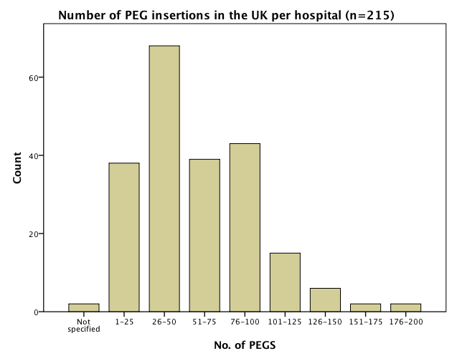
There were variations in the timing of gastrostomy insertion (Table 5.1) with 33% of units (72/215) having a strict policy of waiting more than 2 weeks from referral to insertion and 34 % (74/215) determining time of insertion upon the referral indication. 14% (30/215) of units performed gastrostomies immediately, irrespective of the indication, with no differences seen when comparing JAG units with non JAG units (15% versus 12%, p=0.46).

Table 5.1 - Time delay between gastrostomy referral and insertion
Time | Number of Centres
 | N | %
Perform immediately | 30 | (14)
1 week | 36 | (17)
2 weeks | 55 | (26)
3 weeks | 4 | (2)
4 weeks | 13 | (6)
No fixed time - determined by indication | 72 | (33)
Not specified | 5 | (2)

Local guidelines for gastrostomies existed in 87% (186/215) of hospitals and 78% (168/215) had access to radiologically inserted gastrostomies. Only 64% (137/215) of hospitals had a dedicated aftercare service. This was not statistically significant when comparing low volume centres (<25 PEGs a year) and high volume centres (>75 PEGs a year), however JAG accredited (72%) units had significantly higher rates of aftercare service provision when compared to non-JAG (53%) accredited units (p=0.008). Othe comparisons between JAG and non JAG accredited units are shown in Table 5.2.

Table 5.2 - Comparisons between JAG and non-JAG accredited units
 | JAG (n=123) |  | Non JAG (n=92) |  | p-value
 | n | % | n | % | p-value
Insertion for Dementia | 42 | 34.1% | 35 | 38.0% | 0.55
Aftercare | 88 | 71.5% | 49 | 53.3% | 0.008
Dedicated Endoscopy List | 30 | 24.4% | 21 | 22.8% | 0.92
Dedicated Triage | 120 | 97.6% | 86 | 93.5% | 0.27
Dedicated Gastrostomy Nurse | 59 | 48.0% | 32 | 34.8% | 0.09
Dedicated MDT | 80 | 65.0% | 48 | 52.2% | 0.07
Dedicated Consultant | 43 | 35.0% | 22 | 23.9% | 0.11
Access to RIG | 93 | 75.6% | 75 | 81.5% | 0.38

Recent BSG guidelines highlight the importance of a clearly defined referral pathways following gastrostomy insertion.¹⁷ 96% (206/215) of hospitals stated they had a defined pathway/ triage system, with 52% of endoscopy units having a specific gastrostomy referral form. 46% of hospitals had a gastrostomy specialist nurse or a nutrition nurse with 40% of hospitals (86/215) having a formal multidisciplinary team review on cases where gastrostomy insertion was being considered.

The most common complication following gastrostomy insertion is wound infection with reported rates varying from 4% to 30%, with prophylactic antibiotics shown to reduce this risk. International guidelines recommend the use of intravenous co-amoxyclav or a second or third generation cephalosporin before gastrostomy insertion. 93% (201/215) of hospitals were using prophylactic antibiotics, with 2 of these hospitals adopting a recent evidence based practice of giving co-trimoxazole via the gastrostomy rather than intravenous antibiotics utilised in other centres.¹³⁷ Whilst antibiotic use was higher in JAG accredited units (96%) compared to non-JAG (90%) units this difference did not reach statistical significance (p=0.09).

5.5 Discussion
This is the largest international study evaluating provision of service for gastrostomy, involving 83% of UK NHS hospitals. Of the 45 hospitals that failed to respond, 32 were from England, 8 were from Scotland, 3 were from Northern Ireland, 1 was from Wales and 1 was from the Channel Islands. This data compares favorably with the previous BSG National survey for upper gastrointestinal bleeding.¹³⁸ This study had a participation rate of 77% and only approached the 150 JAG registered units. Whilst this data was not all encompassing, it is large enough to be reflective of the practice that is currently occurring within the UK.

This study has identified 3 potentially significant variations in practice. Firstly, previous studies have highlighted poor outcomes in patients with dementia who have gastrostomy insertion. Despite the evidence suggesting that gastrostomy feeding in these patients has no benefit with regards to survival, reduction in pressure ulcers, quality of life improvement, nutritional benefit or improvement in social functioning, our data would suggest that the practice of gastrostomy insertion is still occurring for the indication of dementia.²³ Whilst it is not possible to delineate the severity of the dementia when gastrostomy insertion is being considered, evidence would suggest that swallowing problems are usually associated with advanced dementia with 85.8% of patients encountering problems with feeding in advanced disease.²⁵ This raises the question given the strong evidence base against insertion of gastrostomies in advanced dementia as to why so many centres continue to undertake this procedure for this indication. One argument for this has been that gastrostomy insertion in this patient group may facilitate transfer out of a hospital into a nursing home.⁵⁵ Another alternative hypothesis is that despite the evidence base, clinicians involved in the decision making process may lack sufficient knowledge about gastrostomies particularly with regards to poor outcomes in dementia, findings demonstrated in a previous study.¹⁴⁰

A second variation in practice appears to be related to the timing of insertion of a gastrostomy. 14% of units are inserting gastrostomies immediately following referral. This is surprising given that NCEPOD reported that the highest mortality was in the first week following insertion.¹⁹ It may be that a 1 to 2 week ‘cooling off period’ may result in the natural death of the sickest patients without being subjected to this invasive intervention.

Finally, another critical finding from this work is the number of UK hospitals that lack dedicated aftercare services for gastrostomy patients. Only 64% of centers provided some form of support for gastrostomy patients following discharge. This provision for aftercare includes clinics, specialist community nutrition nurses, community dieticians and private enteral feed/ tube company support. However, a significant number of hospitals had no structure in place to support patients following discharge from the hospital environment. This finding is concerning given the recent NPSA report highlighting problems within the first 72 hours post-gastrostomy insertion. This report highlighted recurrent and life threatening complications, which were not recognised in patients following gastrostomies due to the absence of a clearly delineated aftercare system ⁴⁶.

A potential weakness of this study is that the study methodology used here is not as accurate as prospective data collection. However, the size of this survey and high participation rate does allow us to reflect ‘real’ clinical practice. Furthermore, the fact that this survey’s estimate of the number of procedures undertaken per year (approximately 17,000) is comparable to that of the NCEPOD report again supports the validity of this data.

In conclusion this survey demonstrates variations in practice particularly with regards to policies on dementia, timing of insertion and aftercare. These variations in practice may be important factors accounting for the significant adverse outcomes associated with this procedure that I have previously identified in Chapters 3 and 4. Given the high participation in this survey, the next potential step in the UK is the creation of a national gastrostomy register. This could help accurately inform about local practices and enable the collection of national mortality data, providing important information about which practices are contributing towards poor outcomes.

CHAPTER 6: EVALUATING THE ROLE A DEDICATED COMMUNITY GASTROSTOMY AFTERCARE SERVICE MAY HAVE ON GASTROSTOMY OUTCOMES

6.1. Summary
In the previous chapter an absence of dedicated aftercare was identified in some areas of the United Kingdom. This study evaluates the benefits a community dietetic home enteral feed (HEF) team service may have in influencing outcomes of gastrostomy patients. Post-gastrostomy complications range between 8-30%. Frequently these complications occur following discharge into the community, potentially leading to hospital readmission. Locally, our group has previously reported a readmission rate of 23% in 6 months.¹⁴¹ Currently, there is a paucity of data evaluating community gastrostomy management. This study evaluates the role and input a dedicated HEF team had in a cohort of discharged gastrostomy patients over a 1-year period, with comparisons made with a similar historical cohort.

371 complications were encountered in 313 gastrostomy patients during this period, with the commonest complication being over-granulated stoma sites (27%). 227 hospital admissions were avoided due to direct actions taken by the HEF team. 59 gastrostomy patients were admitted to hospital, of which only 7 (12%) were specifically for gastrostomy related problems. Introduction of the HEF team significantly reduced gastrostomy-related hospital readmissions from 23 to 2% (P=0.0001). Whilst patients with gastrostomies may need attention to a variety of complex medical problems, many encounter problems specifically related to their gastrostomy after discharge. This is the largest prospective study demonstrating how dietitians trained in gastrostomy aftercare may optimise the management of gastrostomy complications and reduce unnecessary hospital readmissions.

6.2 Introduction
The demands for gastrostomy insertion have increased and frequently include conditions where the evidence base is lacking. This is highlighted by the rise in individuals receiving home enteral nutrition via their gastrostomy tubes.
Complications following this procedure have been reported as being between 8-30%. These may include minor complications such as peristomal wound infection, tube disintegration, tube blockage and leakage or more serious complications such as aspiration pneumonia, haemorrhage, peritonitis and buried bumper syndrome.¹⁴⁵ Early identification of gastrostomy related complications can reduce the risk of serious harm and death.⁴⁶ Whilst some of these complications are identified within the hospital environment prior to discharge, most complications will first present within the community setting.

There has been limited work evaluating the role of community teams in managing these problems but there is some data to support the notion that early intervention by a specialist nutrition nurse or another appropriately trained healthcare professional can reduce serious complications, hospital readmissions and subsequent costs. Our group has previously shown that in the absence of adequate gastrostomy aftercare, six month hospital readmission rates are as high as 23%.¹⁴¹ The purpose of this study was to evaluate the benefits a dedicated home enteral feed (HEF) dietetic service may have in managing gastrostomy patients within the community and determining the impact they may have in reducing hospital readmissions.
6.3 Methods
This study was discussed and registered with Sheffield Health Service Evaluation and Ethics Committee, UK. The Royal Hallamshire Hospital and the Northern General Hospital are two neighboring hospitals in Sheffield that provide acute medical and gastroenterological services for a population of 555,000 people. Gastrostomy referral practices and insertion techniques are similar within both hospitals, facilitated by a specialist nurse who works at both sites and coordinates the gastrostomy insertions. Endoscopic insertions using the pull technique remains the primary means of gastrostomy placement at the two sites, however there is an increasing practice of performing per-oral image guided (PIG) gastrostomies in challenging cases.

Following discharge from the hospital, the aftercare of Sheffield gastrostomy patients is provided by a home enteral feed (HEF) team. This team founded in 2002 consists of two qualified dieticians and a dietetic assistant. Collectively, they provide support and training to patients, carers and other healthcare professionals involved in gastrostomy care and have extended roles in managing complications related to gastrostomy tubes.

During a 1-year period between April 2009 and April 2010 information was gathered regarding all patients receiving enteral feeding via their gastrostomy within the Sheffield catchment area. The local gastrostomy register was used to prospectively collect data regarding patient demographics, referral indications for gastrostomy, gastrostomy complications, hospital readmission rates and referrals to the HEF team. This data was then compared with previously published data from our unit in1998 to determine the impact a dedicated HEF team has had on clinical outcomes.¹⁴¹ Statistical analysis of the data was performed using SPSS with χ² analysis used to compare categorical data.

6.4 Results
At the end of April 2010, a total of 203 patients (mean age=61±14 years) were receiving enteral feeding via their gastrostomy tubes within the Sheffield catchment area. Characteristics of both the current and historical cohorts are shown in Table 6.1.

Table 6.1: Characteristics of the historical and current gastrostomy cohorts

 | Historical cohort (n=87) | Current Cohort (n=313)
Male (%) | 42 (48) | 163 (52)
Mean Age (±sd) | 67 (±12) | 61(±14)
Indication for Gastrostomy, no (%)
Oropharyngeal Malignancy | 9 (10) | 62(20)
Stroke | 41(47) | 113(36)
Neurological Disease | 27 (31) | 94 (30)
Other (Trauma or drainage procedure) | 10 (11) | 44 (14)

Of these 203 patients, 85 were new patients having undergone their primary gastrostomy insertions during the period of April 2009 and April 2010 (Table 6.2). During the same study period 41 community gastrostomy patients had their feeding tube permanently removed and 69 died, giving an overall mortality within this cohort of patients of 22.0% (69/313).

Table 6.2: Current Gastrostomy Cohort (April 2009-10)

 | No. of Patients | Comment
Total cohort | 313
Subgroups
New gastrostomy | 85 | Total: n=203
Established gastrostomy | 118 | Total: n=203
PEG removed | 41
Died | 69 | Mortality: 69/313=22%

The indications for which the 85 new patients underwent gastrostomy insertion were categorised into 4 groups: Group 1 (dysphagic stoke, n=17), Group 2 (oropharyngeal malignancy, n=37), Group 3 (progressive neurological conditions affecting swallowing, n=19) and Group 4 (other, n=12). This final group (Group 4) encompassed conditions such as head injury patients, anorexia nervosa, gastric decompression, other gastrointestinal disorders and non-oropharyngeal tumours where gastrostomy was felt to be appropriate. No gastrostomy insertions were undertaken for the primary indication of dementia, reflecting previous studies that have demonstrated poorer outcomes in this subgroup of patients.

During the 1-year study period, the HEF team provided input on 2237 occasions to 280 separate gastrostomy patients. 1019 domiciliary visits were made during this period, with a further 525 reviews undertaken within residential or nursing homes. 10 reviews were undertaken within the hospitals (Table 6.3).

Table 6.3: HEF team input
 | Total: n
Gastrostomy patients | 280
HEF team input (total number) | 2237
Subgroups
- Domiciliary | 1019
- Residential/Nursing homes | 525
- Within hospital | 10
- Telephone advice | 683

The HEF team frequently made several visits to the same patient on the same day to administer treatment (e.g. silver nitrate for hypergranulation around the stoma site), with each visit recorded as a separate contact. The HEF team also provided telephone advice to patients, carers, nursing home staff and other healthcare professionals on 683 occasions. The greatest HEF team input was for patients with oropharyngeal malignancy (Table 6.4).
Table 6.4: HEF team input categorised by referral indication
Primary indication for which gastrostomy insertion was undertaken | Number of Contacts with the HEF team | Percentage of total contacts (%)
Group 1
Dysphagic Stroke | 387 | 17.3
Group 2
Oropharyngeal Malignancy | 671 | 30.0
Group 3
Motor Neurone Disease | 115 | 5.1
Multiple Sclerosis | 157 | 7.0
Cerebral Palsy | 301 | 13.5
Other Progressive Neurological Condition | 235 | 10.5
Dementia | 126 | 5.6
Group 4
Non-oropharyngeal malignancy | 37 | 1.7
Head Injury | 60 | 2.7
Other (Anorexia, Frailty) | 7 | 0.3
Gastrointestinal Disease (e.g. Crohn’s, gastric decompression, post op) | 141 | 6.3
There were 371 tube and stoma related complications seen during the study period that were managed by the HEF team, shown in Figure 6.1.

Figure 6.1- Gastrostomy and tube related problems dealt with by the HEF team
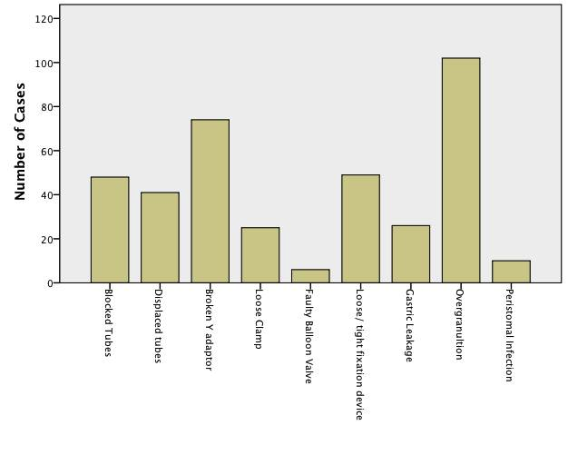
Direct actions taken by the HEF team in managing some of these problems resulted in the avoidance of potentially 227 hospital admissions. These actions included tube replacement (following inadvertent removal), fixing split tubes, managing peristomal wound infections and unblocking gastrostomy tubes. In this cohort, 59 hospital admissions did occur during the 1-year study period, however only 2% (7/313) were specifically for gastrostomy related problems. Reasons for admission included displaced tube (n=5), elective gastrostomy replacement (n=1) and pain/gastric leakage within 1 week of percutaneous endoscopic gastrostomy (PEG) insertion (n=1). When compared to the historical cohort where only gastrostomy related readmissions were assessed, there is a statistically significant reduction in readmission rates (2% vs. 23%) following the introduction of a dedicated enteral feed dietetic service (p=0.0001).

6.5 Discussion

Internationally there are increasing numbers of patients receiving home enteral nutrition via their gastrostomy. This increase is likely to be a reflection of the increasing number of indications for which gastrostomy is being undertaken and also because of increasing practices to move patients out of acute hospital environments back to within their own communities.¹⁴⁸ This has increased demands on healthcare professionals involved in the aftercare of enteral feed patients within communities, frequently leading to shortfalls within the service.

There have been limited studies evaluating gastrostomy patients within the community and the role healthcare teams have upon their management. This study is the largest prospective study examining the aftercare requirements of gastrostomy patients within the community and also highlights the benefits a dedicated enteral feed dietetic service may have in managing tube and stoma complications.

Tube blockages were identified in a previous study to be the commonest community encountered complication seen in fifty discharged gastrostomy patients.¹⁵¹ This study would support this as common complication, with overgranulation around the stoma site and broken Y adaptors also being significant problems. Infected stoma sites were the second most encountered complication identified in that previous study but this work failed to identify this as a significant community gastrostomy complication. This may reflect differences in diagnosing peristomal wound infections between the two studies, with overgranulation around stoma sites frequently being misinterpreted as peristomal wound infections.¹⁵² An alternative theory could be that there has been a genuine improvement in practice with regards to gastrostomy aftercare and in the use of prophylactic antibiotics following recent guidelines, which has led to improvements in peristomal wound infection rates.

In this study, aftercare varied dependent upon the underlying condition for which the gastrostomy had been inserted and also by the patient’s current residency status. The HEF team had far more contacts with patients with oropharyngeal malignancy than with any other group and had more contacts with individuals residing within their own homes than with patients residing in residential or nursing homes. This increased aftercare in patients with oropharyngeal malignancy was identified in a previous study and is likely to represent the increased needs of patients with underlying malignancy.¹⁵³ Furthermore, when looking at where the aftercare was provided, it is unsurprising that increased contacts were made with individuals residing in their own homes, as care staff within nursing or residential homes often have the skills and knowledge to deal with many gastrostomy related problems.

Another important finding from this study is the benefit a dedicated gastrostomy aftercare service may have in reducing hospital readmissions. Readmissions in this study over 1 year were 18% (59/313), of which only 2% (7/313) were specifically for gastrostomy related problems. These outcomes are significantly better that the previous data in 1998 where specific gastrostomy related admission rates at 6 months were 23%. Whilst it is unclear if this change is purely due to the work of a nutrition team, implementation of this service was the only significant change made to the local gastrostomy services following the previous data findings (undertaken as part of a recommended action in an audit loop) suggesting that this benefit is probably attributable to the enteral feed team.

This dedicated service clearly has financial merits but there are potential psychological benefits this intervention may have to both patients and their carers This group of patients already have a significant psychological burden associated with their gastrostomy insertion and with regards to its aftercare (highlighted in Chapter 4), and this intervention may enable them to remain within their own home environments, reducing any further psychological stresses.¹⁵⁴

Limitations to this work include possible variation in patient selection for gastrostomy between historical and current gastrostomy cohorts and the absence of nutritional data in these individuals. These factors during the 12-year period could have possibly contributed to the positive outcomes identified in this study. Furthermore, changes in tube composition from latex to silicone may also have influenced outcomes, with a recent randomised study suggesting reduction in complication rates following use of silicone tubes.¹⁵⁵

In conclusion, whilst patients with gastrostomies may need attention to a variety of complex medical problems, many encounter problems specifically related to their gastrostomy after discharge. This study highlights how dedicated dietitians specifically trained in gastrostomy aftercare can manage complications and reduce unnecessary hospital readmissions.
CHAPTER 7: DISCUSSION, CONCLUSION AND FUTURE WORK
7.1 Discussion and Conclusion
Endoscopic and radiological techniques for gastrostomy insertion have advanced clinical practice in the provision of artificial nutrition. Despite being widely performed, the merits of this intervention in certain patient groups remain uncertain. Paucity of prospective data, randomised controlled trials and large cohort studies in the area of gastrostomy feeding have made interpretation of the current literature difficult, with previously identified negative outcomes possibly reflective of poor evidence rather than poor practice.¹⁵⁶

At the outset of this work, I aimed to evaluate outcomes in patients referred for a gastrostomy, determining whether the intervention induced any benefit. Firstly mortality was prospectively evaluated in Chapter 3 in what represents the largest cohort of patients referred for a gastrostomy to have ever been assessed. When compared to patients who were declined this intervention, gastrostomy patients had significantly lower mortality at both 30 days and at 1 year. This observation would support rejection of the original null hypothesis, with derived mortality benefit shown following this intervention. However, caution needs to be exerted with regards to this outcome, as the comparator group (the declined patients) were mainly declined as they were too unwell following assessment by the multidisciplinary team. This lack of randomisation and selection bias for gastrostomy insertion may have significantly influenced the identified outcomes. Other important findings identified from this study are that mortality may be predicted using a novel predictive tool (the SGSS) and that mortality varies dependent upon the underlying referral indication, as seen in a previous smaller Swedish study.⁶⁶ These findings suggest the benefit of the SGSS may be restricted only to patients undergoing a gastrostomy.

The second outcome measure that I assessed during this thesis is quality of life (Chapter 4) using a mixed methods approach, a novel technique in the area of gastrostomy feeding. Findings from this work failed to demonstrate any significant improvement in either patients’ or carers’ health-related quality of life following gastrostomy insertion, supporting the null hypothesis that gastrostomy confers no quality of life benefit. The results have real application to clinical practice. If the quality of life does not improve following gastrostomy, questions could legitimately be asked as to its merits. The counterargument is that the procedure at the least maintains the quality of life, a beneficial outcome. Despite study limitations, the findings inform clinicians, patients and carers assisting in clinical-decision making.

In Chapters 5 and 6, I demonstrate how local variations in practice exist within the UK and how aftercare within the community can significantly influence post procedural outcomes. These findings add to the literature by identifying modifiable, non-physiological factors, which may be influencing the adverse outcomes seen following gastrostomy insertion. Findings from this work and the highlighting of good practice have already received accolades at a national level, with recognition at the Patient Safety and Care Integration Awards and a presentation at Inside Governments Patient Safety Annual Meeting in 2012.

From this body of work, it is evident that patients with oropharyngeal malignancy have the lowest mortality and the best quality of life when compared to other patient groups who undergo gastrostomies. Whilst decisions regarding gastrostomy insertion should continue to be individualised irrespective of the underlying disease process, dissemination of this work could support the clinical decision making process, particularly in the ‘grey’ cases where uncertainty exists regarding gastrostomy insertion. Ultimately, what will influence outcomes of gastrostomy patients most is the dissemination of knowledge to a wider audience, which has already begun with this body of work.
7.2 Future Work
Although many of the studies presented in this thesis include large cohorts, the numbers evaluated represent only a small fraction of the total number of patients who undergo a gastrostomy each year in the UK. Given the findings from this work, there is a need for replication of these findings in other units and also for standardisation of care across the UK. Whilst guidance from national bodies may help inform local practice, this work highlights the need to improve numbers and quality of studies in the area of gastrostomy feeding.

A significant debate currently exists regarding the role of gastrostomy feeding in patients with dementia. Given the frequency of insertion for this indication and the evidence base against this practice, the next step, requiring careful ethical consideration, would be to undertake a randomised controlled trial comparing gastrostomy feeding to alternative methods such as “hand feeding”, permitting patients to eat through the normal route. This would firmly establish the role of gastrostomy feeding and may also help to determine at what stage (if any) enteral nutrition has a role. These alternatives could also be considered in other indications such as head and neck cancer and progressive neurological conditions, disorders in which very little data from randomised controlled trials exist.

With regards to optimising patient selection for gastrostomy, dissemination of knowledge is pivotal to reduce local variation in practice. Selection could be augmented with the use of the SGSS predictive model assessed in Chapter 3, however this still requires wider application and validation in cohorts outside of South Yorkshire and North East Derbyshire before being widely accepted and adopted. Finally, I believe that based on this body of work there is scope for improvement in care of gastrostomy patients and their carers. Hopefully, through dissemination of this work and further research, the goal of improving outcomes for these individuals can be achieved.
REFERENCES

Appendix A: Scoring system and Mortality Ethical Approval

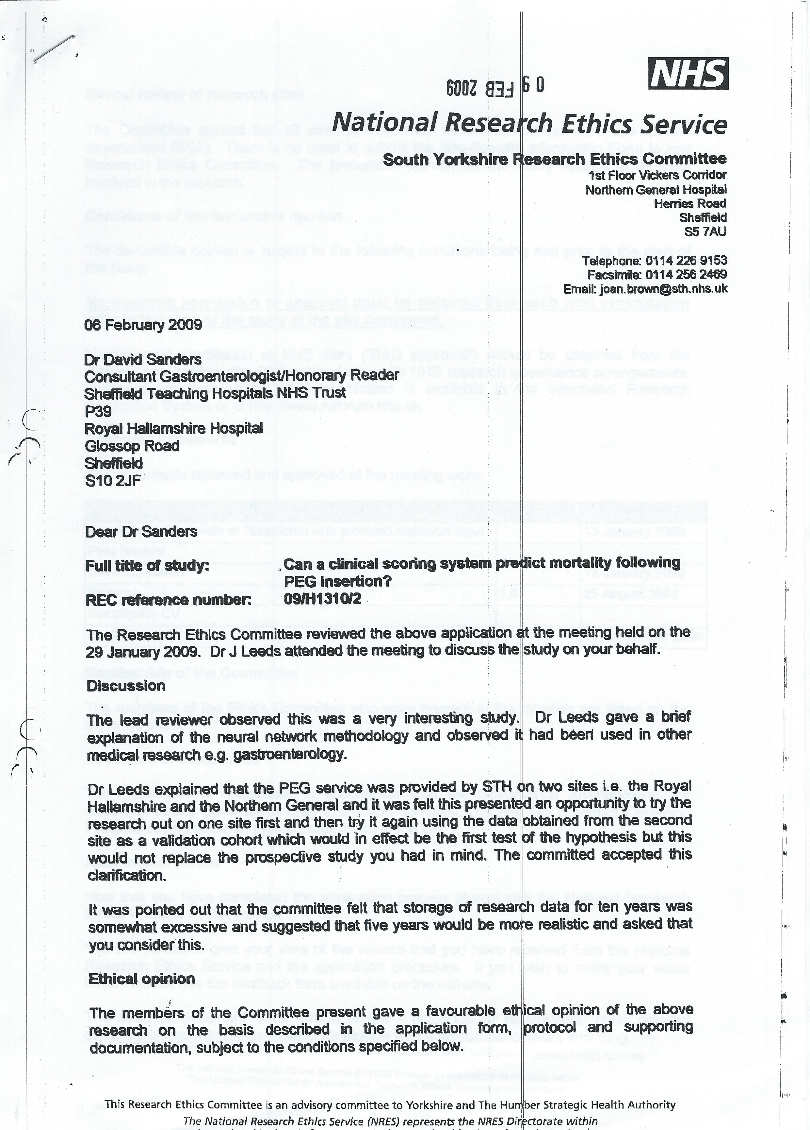

Appendix B: Quality of Life Ethical Approval

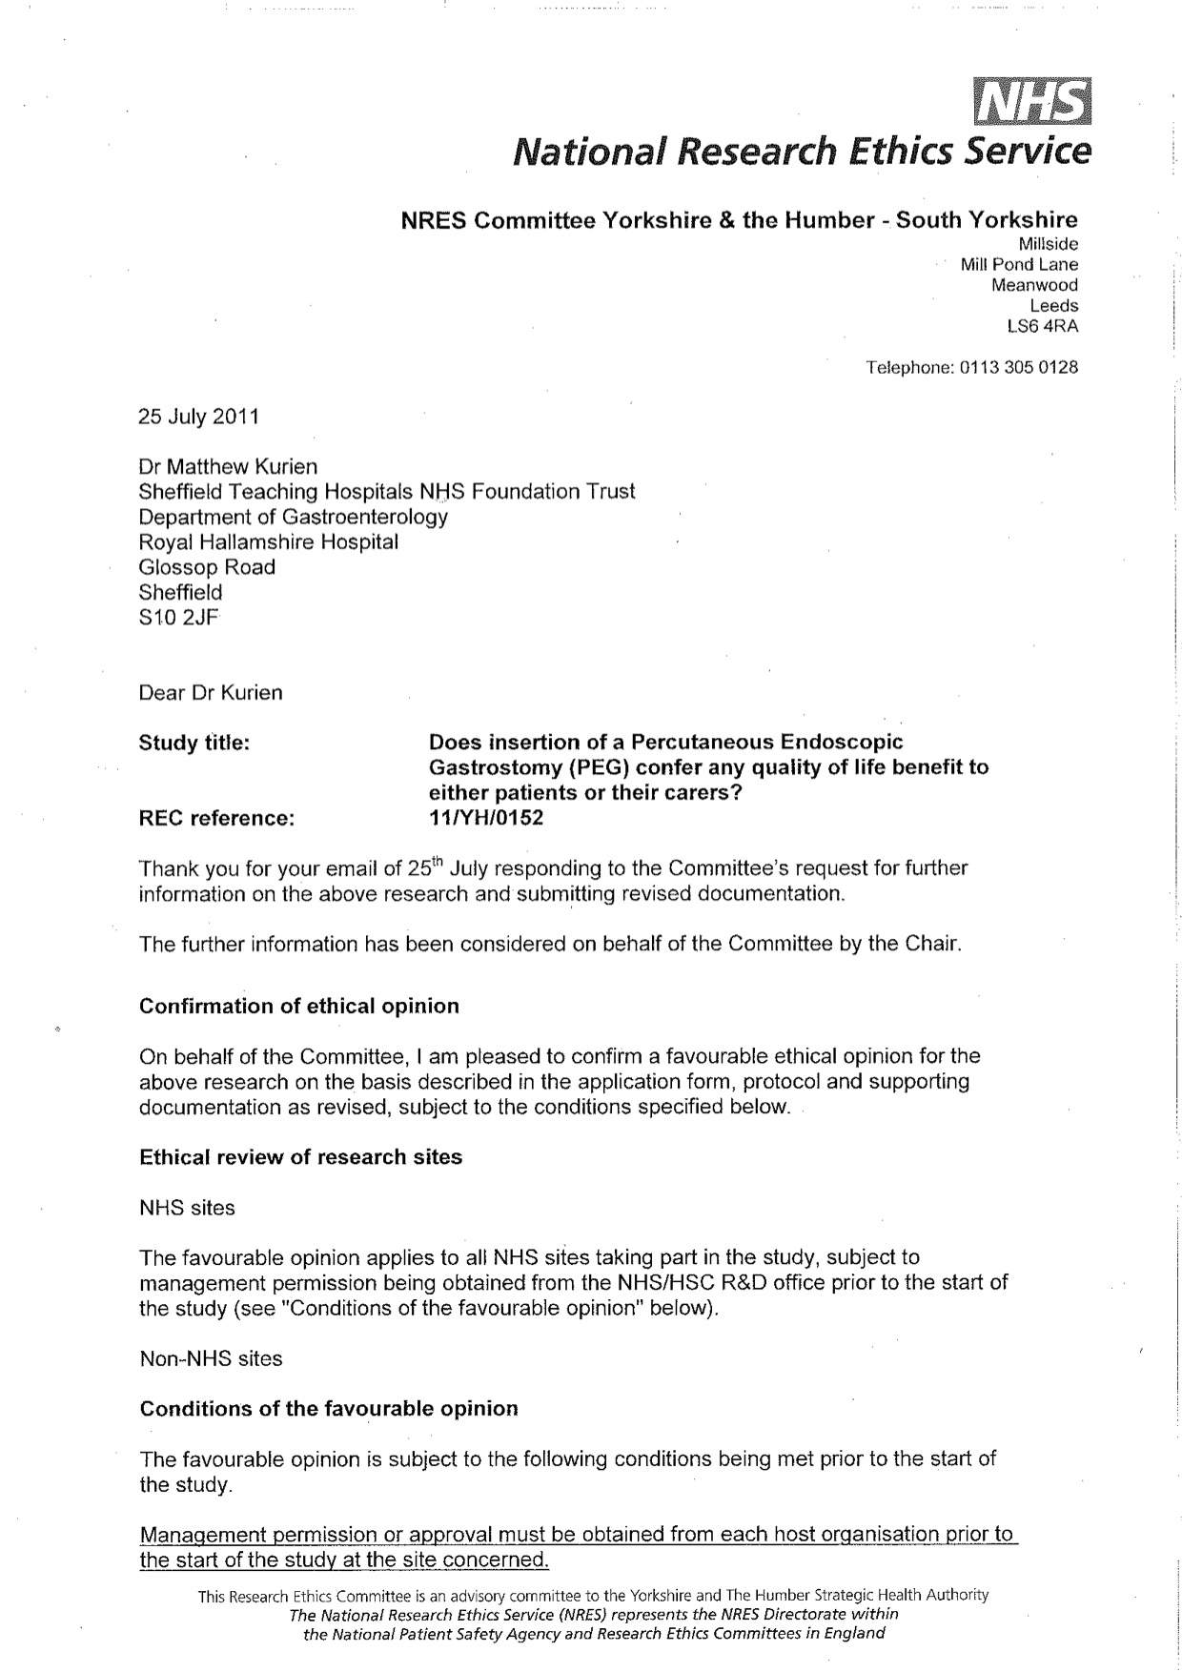

Appendix C: EuroQol Group EQ-5D™

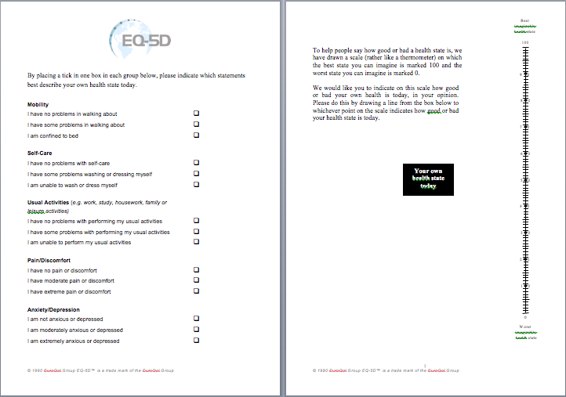

Appendix D –Provision of Service Questionnaire

Review of Current Gastrostomy Provision within the UK

Name of Hospital/NHS Trust:

Name of Contact completing questionnaire:

Please delete as appropriate

Are Gastrostomy tubes inserted within your hospital? Yes /No
If Yes, approximate number of gastrostomies placed in last year:

1. 1-25
2. 26-50
3. 51-75
4. 76-100
5. 101-125
6. 126-150
7. 151-175
8. 176-200
9. >200- if so please specify number

Who inserts the gastrostomy?

1. Gastroenterologists Yes /No
2. Surgeons Yes /No
3. Nurse Endoscopists Yes /No
4. Specialist Registrars Yes /No
5. Other (please specify):

Which conditions do you insert a gastrostomy for?

1. Stroke
2. Neurodegenerative disease (for example, MND, MS)
3. Dementia
4. Head injury/RTA/cerebral palsy
5. Oropharyngeal Malignancy

How long would you wait before you would consider inserting a Gastrostomy?

1. Don't wait- perform immediately
2. 1 week
3. 2 weeks
4. 3 weeks
5. 4 weeks
6. Other - please specify

Do you have a Triage System to determine who gets a Gastrostomy? Yes /No

What does it involve?
- A Predetermined referral form and/or protocol (could be available on local trust intranet)
- A Endoscopy nurse assessment
- A Specialist Gastrostomy/nutrition nurse assessment
- A gastroenterologist assessment (a) consultant or b) SPR)
- A Dietitian assessment
- A Multi-disciplinary team review
- A Speech and Language Therapist (SALT) assessment

Are decisions made on who gets a Gastrostomy in any other way? (Please briefly describe below)

Within your hospital do you have a:

1. Dedicated Endoscopy list for PEG insertion? Yes /No
2. Dedicated Gastrostomy specialist Nurse? Yes /No
3. Dedicated Nutrition Team/Multidisciplinary team? Yes /No
4. Dedicated Gastrostomy Consultant? Yes /No
5. '1 week cooling off period" between referral and insertion? Yes /No
6. Local protocol/guideline? Yes /No
7. Access to radiologically inserted gastrostomies? Yes /No
8. Dedicated aftercare service for gastrostomy patients in Hospital? Yes /No
9. Dedicated aftercare service for gastrostomy patients in the Community? Yes /No

If Yes to aftercare service, then what provision is there? (Please briefly describe below)

Any conditions where there is a blanket refusal for insertion? Yes/No
(If Yes, please specify below what conditions)

What percentage of referral for gastrostomies are refused?

1. 0-20%
2. 21-40%
3. 41-60%
4. 61-80%
5. 81-100%

What reasons are used for declining insertion?

1. Significant co-morbidity
2. Perceived futility
3. Patient's wishes
4. Carer's Wishes
5. Other- please specify

Do you use prophylactic antibiotics prior to insertion? Yes /No
If Yes, please state what and when given.

Abstracts and Publications derived from this body of work

Chapter 1
Kurien M, McAlindon ME, Westaby D, Sanders DS. Percutaneous endoscopic gastrostomy (PEG) feeding. BMJ 2010 340(7755):1074-8

Chapter 3
Kurien M, Leeds JS, Delegge MH, Robson HE, Grant J, Lee FK, McAlindon ME, Sanders DS. Mortality Among Patients Who Receive or Defer Gastrostomies. Clin Gastroenterol Hepatol. 2013 11(11):1445-50

Kurien M, Leeds JS, Robson HE, James G, Hoeroldt B, Dear KL, Kapur K, Grant J, McAlindon ME, Sanders DS. Survival following gastrostomy insertion: are there differences in mortality according to referral indication? Gut 2011;60:A18-A19
(Oral Presentation at BSG Annual Meeting, March 2011)

- Kurien M, Leeds JS, Robson HE, Grant J, McAlindon ME, Sanders DS
Predicting outcomes in patients declined for gastrostomy insertion using either the Sheffield gastrostomy score or the levine score Gut 2011;60:Suppl 1 A97
(Poster presentation at BSG Annual Metting, March 2011)

- Kurien M, Robson HE, Leeds JS, Grant J, McAlindon ME, Dear KL, Hoeroldt BS, Kapur K, James G, Sanders DS External validation of a prognostic scoring system for percutaneous endoscopic gastrostomy (PEG) Gut 2011;60:Suppl 1 A17
- (Oral Presentation at BSG Annual Meeting, March 2011)

Chapter 4
Kurien M, McAlindon ME, Grant J, Wong EF, Johnston AJ, Hoeroldt BS, Dear KL, Sanders DS. Does Insertion of a Gastrostomy Confer any Quality Of Life Benefit to Either Patients or their Carers? Gut 2013;62:Suppl 1 A205
(Oral Presentation at BSG Annual Meeting, June 2013)

Chapter 5
Kurien M, Westaby D, Romaya C, Sanders DS, National survey evaluating service provision for Percutaneous Endoscopic Gastrostomy within the United Kingdom. Scand J Gastroenterol. 2011 Dec;46(12):1519-24

Kurien M, Romaya C, Sanders DS. Evaluating the provision of service for percutaneous endoscopic gastrostomy (PEG) within the United Kingdom (UK): results of a national survey Gut 2011;60:A43
(Oral Presentation at BSG Annual Meeting, March 2011)

Chapter 6

Kurien M, White S, Simpson G, Grant J, Sanders DS, McAlindon ME. Managing patients with gastrostomy tubes in the community: can a dedicated enteral feed dietetic service reduce hospital readmissions? Eur J Clin Nutr. 2012 Jun;66(6):757-60

Prizes Awarded specifically in relation to this body of work
2012 | SpR Innovation Award | Shire Pharmaceuticals
2012 | Patient Safety Award | Care Integration Awards (Health Service Journal/Nursing Times)
2012 | Registrar’s Prize | South Yorkshire Regional Fellowship
2011 | Best Poster Presentation | British Association for Parenteral and Enteral Nutrition

