Chapter 5 – The manipulation of EPF expression as a tool to increase water use efficiency in crop plants

**5.1 Introduction**

In chapters 3 and 4 it was explored how altering *D* affects leaf morphology and gas exchange. This chapter aims to examine how these modifications, specifically photosynthesis and conductance, impact rosette and seed biomass with a view to improving yield and/or drought tolerance. In addition, there follows an appraisal of experiments allowing similar analyses in a more agronomically useful crop, barley.

Barley (*Hordeum vulgare* L.) is a member of the grass family and a major cereal grain used primarily for animal fodder, especially in areas unsuited for maize growth. Barley is also a major staple food in a number of regions of the world: in some areas of North Africa and Near East, in the highlands of Central Asia and the Horn of Africa, in the Andean countries and in the Baltic States. The United Kingdom alone produced 6.66 Tons of barley in 2009 and it is currently the fourth most abundant crop after wheat, sugar beet and potatoes (FAOSTAT). Compared with many other cereal crops, food barley is easily grown in regions with high altitude and low rainfall, or soil salinity so an investigation of leaf water relations in this crop is worthwhile (FAO, <http://www.fao.org/ag/AGP/AGPC/doc/field/Other/act.htm>).

Early investigations into the effect of altered stomatal densities (*D*) across barley strains revealed that although seedling drought tolerance is increased at lower *D*, water use efficiency may not be (Jones, 1977). Surprisingly, a study carried out by Jones (1977) reported that total plant transpiration was actually increased in cultivars with lower D, and this was due to genotypic differences in green leaf area, which in turn was due to slower leaf senescence, enhanced tillering, and possibly also to differences in leaf size (Jones, 1977).

**5.2 Methods summary**

For *Arabidopsis* rosette biomass and size analyses:

*EPF2*OE, Col-0 and *epf1epf2* were grown at 200 ppm CO2 450 ppm CO2 and 1000 ppm CO2 and transferred to larger 1L pots once 13-15 leaves were visible. The larger pots were used to minimise the effect of stress in the control group (by allowing the roots to expand more fully) and minimise soil water content fluctuations which were maintained at 30% and 70% by weighing. Once mature, rosettes were cut from their roots, and pictures of leaves taken before drying overnight in an oven at 70°C.

For *Arabidopsis* analysis of drought tolerance:

*EPF2*OE, Col-0 and *epf1epf2* were grown to maturity (stage 3.9 on the Boyes scale) in 100mL pots. Watering was then withheld for 13 days and IR images were captured with the FLIR SC660 thermal imaging camera every day 2 hours after the photoperiod started. Temperatures were averaged from the widest areas of 3 fully mature and relatively uncovered leaves. The plants were watered on day 13 and additional pictures taken on day 15.

For *Arabidopsis* seed yield analyses:

*EPF2*OE, Col-0 and *epf1epf2* were grown in 100mL pots and arabicon bases and covers put in place as soon as the stems bolted. Siliques were removed and seed weighed 6 weeks after bolting.

For barley analyses:

Dried flag leaves from various barley varieties were provided by Prof R. Waugh, James Hutton Institute, Dundee. Stomatal densities on the leaf epidermis were determined from nail varnish peels of dental resin impressions.

To determine the ratio of 13C to 12C (a proxy measurement for water use efficiency), dried leaf samples were ground up and combusted at 1800°C, passed into a gas chromatograph where components are separated and then passed into a mass spectrometer (ANCA GSL 20-20 Mass Spectrometer made by Sercon PDZ Europa) where 12CO2 and 13CO2 were ionized and separated by mass using a magnetic field.

**5.3 Rosette morphology**

In chapters 3 and 4, it was shown that *EPF2*OE (low *D*) plants have the largest leaf size yet the lowest levels of photosynthesis. In order to probe this relationship further, rosette size and biomass of *EPF2*OE, Col-0 and *epf1epf2* plants were compared across CO2 and soil water content conditions.

**5.3.1 Rosette size and biomass is negatively correlated with *D***

As was the case with leaf size (Fig 3.13, chapter 3), plants with reduced *D* (*EPF2*OE) were larger, and those with increased *D* (*epf1epf2*) smaller, than Col-0 control plants at each CO2 level (Fig 5.1). In comparison to plants grown at 70% soil water content (Fig 5.1, a-c), plants of all genotypes were smaller when grown at 30% (Fig 5.1, d-f). This was investigated further by measuring mean dry weight (Fig 5.1, g) and mean rosette area (Fig 5.1, h).There were significant effects of genotype, CO2 concentration and water availability on rosette area and dry weight, as well as significant effects of the interaction between genotype and CO2 concentration and between water availability and CO2 concentration on both rosette area and dry weight (Table 5.1). Biomass was most severely restricted in the plants with high *D* (*epf1epf2*) at 200 ppm CO2 and 450 ppm CO2 when transpiration would be expected to be highest. In addition, *epf1epf2* plants showed the largest decrease in dry weight and rosette diameter following growth under water restriction at both 200ppm and 450ppm CO2 conditions (Fig 5.1, g). However, the restriction of water availability had no significant effect on the dry weight of any genotype at 1000ppm CO2 when transpiration is low. Interestingly, *EPF2*OE plants which have low stomatal densities, grown at 450 ppm CO2 acquired a significantly larger biomass and rosette area than Col-0 plants under both watering regimes (Fig 5.1, g and h). Thus at 450ppm CO2, despite having the lowest levels of photosynthesis and conductance (chapter 4) plants with the least stomata appeared to be the most successful; growing larger even under restricted water availability. In contrast, plants with increased *D* (*epf1epf2*) did not appear to show any growth advantage even under sub-ambient CO2 conditions and *epf1epf2* dry weights were significantly lower than Col-0 at all CO2 conditions when water was restricted.

Given that conductance is positively correlated with *D,* one might expect lower soil water content to have a greater effect on rosette biomass and size on plants with increased *D* (*epf1epf2*) compared with plants with lower *D* (*EPF2*OE). However, there was no significant combined effect of water availability and genotype on rosette biomass or size suggesting that the growth limiting stress due to limited water impacted all genotypes to the same degree. It is likely that the method for watering is partly responsible for these results as plants were not given a set amount of water but watered up to a weight matching 30% or 70% compost water saturation content. Even though Col-0 and *epf1epf2* plants transpire more than *EPF2*OE plants, the amount of water each of these genotypes had access to was not altered throughout their lives. Given this limitation, an experiment examining more short term effects of severe water restriction leading to drought is examined in section 5.2.1.

Just as with leaf size (chapter 3), *EPF2*OE plants have larger rosette areas and biomass despite photosynthesising less. An analysis of ABA levels in these plants might prove useful as ABA is known to limit growth (Sharp and LeNoble, 2002) and is likely to travel faster in plants with higher conductance levels (Opik and Rolfe, 2005, p.85-95). In addition, ABA may be triggered indirectly by higher transpiration levels (Comstock, 2002) suggesting that limited growth in *epf1epf2* plants may be due in part to higher conductance levels. In addition, it is possible that the additional cells in the epidermis of *epf1epf2* plants require higher levels of photosynthesis to maintain thus limiting leaf organ growth. For a given area, smaller cells have a greater total circumference than larger cells; *epf1epf2* and Col-0 have more cell wall area than *EPF2*OE. The cell wall is a major sink for carbohydrate, making up 20 to 50% of the dry weight of a plant and 70 to 80% of the carbohydrate (de Vries et al., 1974). Thus it is not entirely surprising that *EPF2*OE leaves are able to grow larger despite lower photosynthetic rates. For a given area of leaf, to accommodate more cell wall, *epf1epf2* plants would need to fix more carbon than Col-0 plants which in turn would need to photosynthesise more than *EPF2*OE plants. Thus *epf1epf2* leaves may be smaller than Col-0 leaves as they are limited by excessive cell wall synthesis without photosynthesising significantly more. *EPF2*OE leaves, despite photosynthesising less than Col-0 leaves, dedicate less carbohydrate to the cell wall and also perhaps membrane and nucleic acid so are able to grow larger. It is also possible that *EPF2*OE plants dedicate less of their biomass to root development. A preliminary experiment to examine root development in these plants was carried out but was inconclusive as only one *EPF2*OE plants survived growth in the rhizotron system.



**Figure 5.1. Size and dry weights of epidermal patterning factor (EPF) family mutants following growth at 200 (white bars), 450 (grey bars) or 1000 ppm (black bars) atmospheric CO2 concentration with either 30% or 70% relative soil water content.** (a–f) Images of plants grown at 450 ppm CO2 at 70% (a–c) or 30% (d–f) soil water content at 70 dpg. Scale bar, 10 cm. (g) Mean dry weight and (h) mean leaf rosette area (n: 3–4). Error bars represent standard error. Letters indicate values that are significantly different from letter ‘a’, the same genotype grown at 450 ppm CO2, letter ‘b’, the same genotype grown at 70% soil water content and letter ‘c’, Col-0 grown in the same conditions (p < 0.05). (From Doheny-Adams et al. 2012)

**5.3.2 Leaf number is unchanged by *D***

Average leaf size and leaf dimensions were discussed in chapter 3 where is was shown that leaves are stubbier when plants were grown with limited water availability (30% SWC). The average number of leaves for plants grown at 450 ppm CO2 and 200 ppm CO2 is discussed below (Fig 5.2).



**Fig 5.2: Plants grown at higher CO2 produce more leaves.** Mean leaf numbers of EPF family mutants and Col-0 control plants grown at 30% and 70% relative soil water content and at 200 ppm CO2 (white) and 450 ppm CO2 (grey) in 1000 ml plant pots (n=3-4) at 200 µmol.m-2.s-1 light. Error bars represent SE. Letters indicate values that are significantly different from a, the same genotype grown at 450 ppm CO2 (unpaired t-test).

It is generally reported that growth of most plants at elevated [CO2] (650-700 ppm CO2) has only small, if any, effects on rates of leaf initiation (Ackerly et al. 1992; Pritchard et al. 1999). For *Arabidopsis* in this experiment there was a significant effect of CO2 conditions on the number of leaves produced by each genotype. With the exception of well watered *epf1epf2* mutants, all plants had produced more leaves at 450 ppm CO2 than 200 ppm CO2 at the stage of flowering (stage 3.9 on the Boyes scale). Presumably, CO2 sensing and/or altered rates of photosynthesis changed the incidence of new leaf development. However, stomatal density, which has been shown to directly affect the rate of photosynthesis (chapter 4) had no significant effect on mean leaf number suggesting that the mechanism underlying leaf development in response to CO2 may be independent of photosynthetic rates. Although no genotype developed significantly different numbers of leaves between 30% SWC and 70% SWC (student’s unpaired t test, p<0.05), there was

an overall significant effect (ANOVA, Table 5.1) of increased water availability on leaf number. With the exception of *EPF2*OE grown at 200 ppm CO2, mean values for leaf number were higher for plants grown at 30% SWC. Leaf primordia are thought to arise as the result of buckling in the outer layers of the meristem in response to an excess of tissue unable to expand laterally (Taylor, 1997; Poethig, 1997) and in conjunction with cell wall relaxation (Pien et al., 2001). Expansins (extracellular proteins which play a key role in wall stress relaxation) decrease cell turgor and intitate leaf primordia (Pien et al., 2001). As for apical meristem cells expressing high levels of expansin, cells of plants grown at 30% SWC are likely to have reduced turgor which may contribute to the initiation of leaf primordia. Psychrometric tests on the meristem would need to be carried out to test this hypothesis. However, it is important to note that higher turgor in the apical meristem has also been associated with increased initiation of leaf primordial (Sasek and Strain, 1989) suggesting that the loss of cell turgor due to cell wall relaxation may not drive leaf initiation. These data will be explored more fully in section 5.1.5.

**5.3.3 Total leaf area**

As highlighted in chapter 3, plants grown in water restricted environments develop smaller, stubbier leaves. Given that these plants also produce more leaves at 450 ppm CO2 it is important to examine the total leaf area in order to gain a more comprehensive understanding of leaf development strategies adopted by these plants.

**Fig 5.3: Total leaf area is correlated with *D*, water availability and CO2 levels (between 200 and 450 ppm CO2).** Mean total leaf area of EPF family mutants and Col-0 control plants grown at 30% and 70% relative soil water content and at 200 ppm CO2 (white) and 450 ppm CO2 (grey) in 1000 ml plant pots (n=3-4) at 200 µmol.m-2.s-1 light. Error bars represent SE. Letters indicate values that are significantly different from a, the same genotype grown at 450 ppm CO2; b, the same genotype grown at 70% soil water content; c, Col-0 grown in the same conditions. (unpaired t-test, p<0.05).

There is a significant effect of genotype on total leaf area. As expected from results shown in previous chapters, plants with fewer stomata have a significantly larger total leaf area. Plants grown at 450 ppm CO2 also have a significantly larger total leaf area than those grown at 200 ppm CO2 with the exception of *epf1epf2* plants grown in water restricted environments which had a significantly lower total leaf area. Given that there is a significant combined effect of CO2 and genotype on total leaf area (Table 5.1), the exception of *epf1epf2* is noteworthy. As *epf1epf2* plants produce more leaves at 450 ppm CO2 (Fig 5.2), the observed decrease in total leaf area is driven by the decrease in average leaf size (Fig 3.14). As noted in chapter 3, these plants may have been subject to a more extreme response to water limitations at 450 ppm CO2 because water limitation commenced at an earlier day post germination. Although the leaves had developed to the same degree as the same plants grown at 200 ppm CO2, the roots were not examined and their growth at 450 ppm CO2 may have been less developed than roots from plants grown at 200 ppm CO2. Although it has been shown that *Arabidopsis* root growth is increased in enriched CO2 environments (Crookshanks et al. 1998), it is possible that root growth in *Arabidopsis* may lag behind rosette growth when CO2 is enriched. Plants with the highest rates of transpiration (*epf1epf2*) would likely be most affected by water limitation if indeed there was a difference in the stage of root development. As expected, there is also a significant effect of water availability on total leaf area: when grown in soil with lower water content, all genotypes in both CO2 conditions develop less total leaf surface. Presumably this strategy limits water loss through transpiration by reducing the surface area and boundary layer.

**5.3.4 Plants increase leaf shading when water is limited.**



**Fig 5.4: Plants grown with less water increase the percentage of everlapping leaf area.** Percentage of leaf area shaded in mature (stage 3.9 on the Boyes scale) *EPF2*OE, Col-0 and *epf1epf2* plants grown at 70% and 30% SWC and 200 ppm CO2 and 450 ppm CO2 at 200 µmol.m-2.s-1 light.With the exception of *EPF2*OE grown at 70% SWC, all plants increase leaf overlap at 450 ppm CO2. Error bars represent standard error (n=3-4).

Despite having smaller leaves (Fig 5.4), plants which develop at 450 ppm CO2 and 30% SWC often developed more leaves than plants grown at 70% SWC. Given that the production of additional leaves would be expected to increase transpiration, a strategy which increases the incidence of new leaf development when faced with limited water seems counterproductive. It is important to note that the net result of smaller but more prevalent leaves results in less leaf area overall for each genotype grown at 30% SWC (Fig 5.4) but that total leaf area could be further decreased by limiting the initiation of leaf primordia. It is unlikely that plants would adopt strategies to increase transpiration so to understand this problem, the rosette as a whole was examined to consider how leaf size, dimensions, and number affect leaf overlap. The percentage of overlapping leaf area was calculated by a comparison of the rosette area (Fig 5.1, h) and the total leaf area (Fig 5.3).

Leaf overlap area was increased for all genotypes at 450 ppm CO2 with the exception of *EPF2*OE grown at 70% SWC. Leaf overlap area is also increased for all genotypes grown at 30%SWC (Fig 5.4). The increase in leaf area of *EPF2*OE plants is accompanied by an almost equal increase in rosette area at these conditions. It is unclear why *EPF2*OE does not respond in the same way as the other genotypes but it is conceivable that, given the lower levels of conductance and transpiration in these plants (chapter 4), responses to changes in atmospheric CO2 levels and soil water levels are weaker.

As well as leaf size and leaf number, leaf shape also impacts the incidence of overlap. As the potential for most leaf overlap occurs at the centre of the plant, restricting leaf length rather than leaf width (chapter 3) increases the amount of overlap in these plants (Fig 5.4). In the case of *EPF2*OE plants, the lack of response (increasing leaf overlap) to an increase in CO2 may be due in part to a greatly increased length : width ratio (Fig 3.14). In favourable conditions, shading limits photosynthesis and therefore usually has a negative impact on area expansion at the cell, organ and whole plant levels (Cookson and Granier, 2006). Plants have developed strategies to adapt their morphology to shading such as increased internode elongation, increased petiole elongation, decreased leaf blade area, increased apical dominance and an accelerated flowering. Impatiens, tobacco and Arabidopsis are also reported to respond to low light levels by regulating leaf inclination (Smith and Whitelam, 1997; Ballaré, 1999; Hudson and Smith, 1998; Vandenbussche et al*.,* 2003; Pierik et al*.,* 2004; Millenaar et al*.,* 2005; Mullen et al., 2006).

Despite the negative effects and adaptive measures plants have in place to deal with shading, in water limited conditions leaf overlap can be beneficial to plants trying to limit water loss as shading provides protection from sunlight. When faced with limited water, plants also limit CO2 fixation which leads to light-driven accumulation of reactive oxygen species (ROS) which can cause oxidative damage to the cell (Opik and Rolfe, 2005, p. 349). Shading limits transpiration due to irradient heat as well as protecting boundary layers from wind. In addition, the extra leaves provide a buffer should the top layer of leaves suffer too much damage from water deficit. Cumulatively, these results suggest that one of the strategies adopted by *Arabidopsis* to limit water loss is by increasing leaf overlap and maintaining a low leaf surface area. This type of strategy is also employed by xenomorphs such as the cacti which maintains a low surface : volume ratio of shoot organs by losing photosynthetic ability in the leaves and transforming them into spikes to discourage grazing (Opik and Rolfe, 2005, p. 96).



**Fig 5.5: Leaf “stubbiness” increases leaf overlap area.** A simplistic diagram demonstrating how leaf dimensions affect overlap: shorter, wider leaves (A) result in more shading than longer, thinner leaves (B). For the purpose of isolating the effect of leaf dimensions on shading, total leaf area and leaf number are identical.

**5.4 Plants with lower *D* (*EPF2*OE) are more drought tolerant but yield less seed**

**5.4.1 *EPF2*OE plants survive drought for longer than plants with higher *D* (Col-0 and *epf1epf2*) and recover once re-watered.**

The long-term responses to limited water availability in these genotypes have already been discussed at length. The experiment described below aims to determine how stomatal density (*D*) affects short-term drought tolerance both in terms of plant survival and transpirational changes. *EPF2*OE, Col-0 and *epf1epf2* were grown to maturity (stage 3.9 on the Boyes scale) in ambient CO2 conditions. Watering was discontinued and Infra Red images of the plants were taken daily 3-4 hours after the photoperiod started (Fig 5.6 and Fig 5.7). Mean leaf temperatures of the plants ranged from ~20.5°C (*epf1epf2* before drought treatment) and ~24°C (*epf1epf2* after drought treatment) (Fig 5.8). Between days 4 and 6 without watering, a significant increase in *epf1epf2* rosette temperature occured indicating a decrease in transpiration probably due to both stomatal closure and lower vapour pressure deficit (as evidenced by the loss of cell turgor and “floppiness” of the leaves). For Col-0, the largest change in leaf temperature occurred between days 5 and 7 and for *EPF2*OE, leaf temperatures increased the most between days 8 and 10. Presumably, lower levels of transpiration in the *EPF2*OE plants enabled them to retain water for longer and thus remain turgid and transpiring for up to 9 days without watering.

Although the mean temperatures of the genotypes show a progressive increase in temperature (probably due to changes in soil water evaporation and stomatal closure), individual plants would often switch from turgid and transpiring to wilty within the space of 24 hours. A clearer way in which to view this data is by examining the percentage of plants retaining turgor in function of time (Fig 5.9).

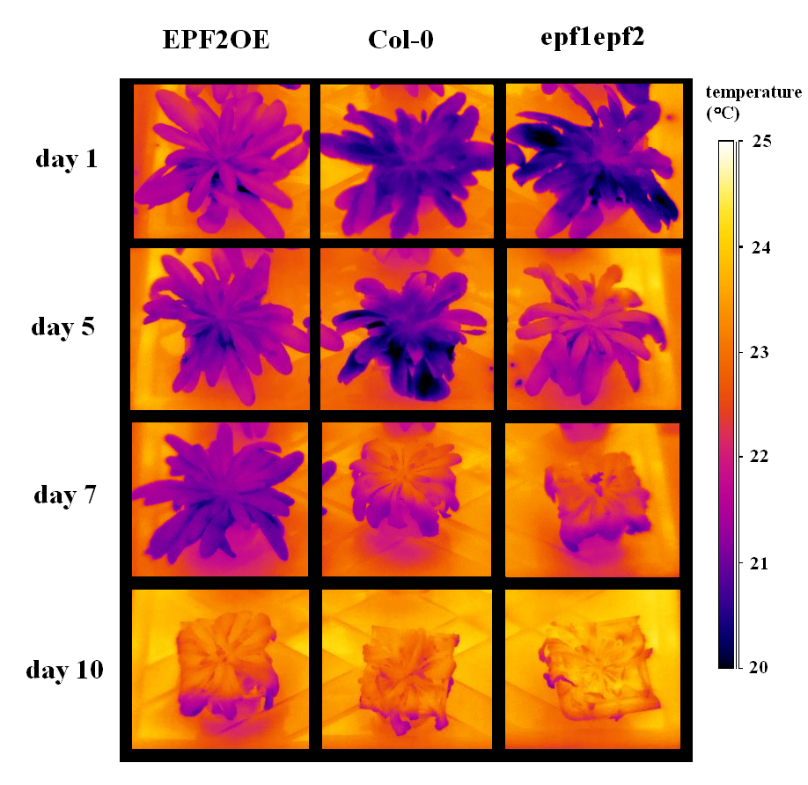

**Figure 5.6: IR images of representative *EPF2*OE, Col-0 and *epf1epf2* plants throughout drought treatment.** Plants with higher *D* (*epf1epf2*)increase temperature, lose cell turgor and wilt earlier than plants with lower *D* (*EPF2*OE).

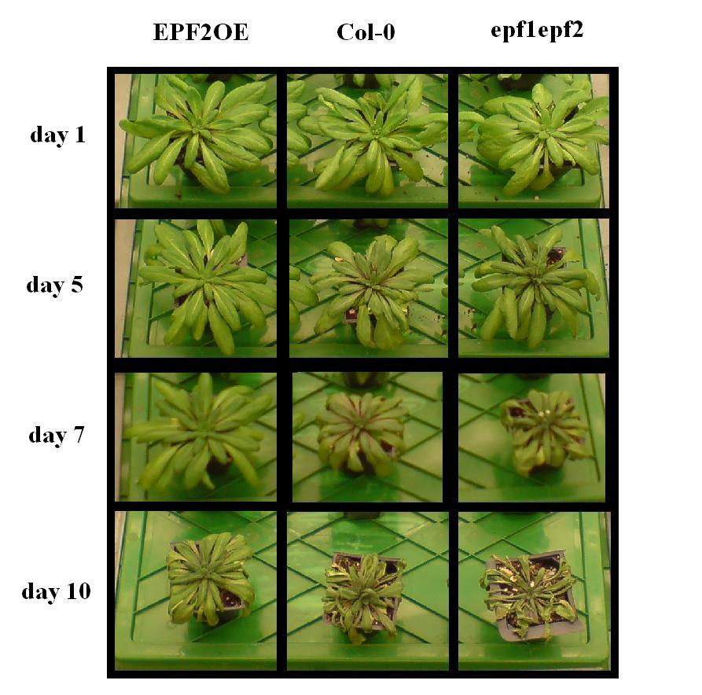

**Figure 5.7: Photos of representative *EPF2*OE, Col-0 and *epf1epf2* plants throughout drought treatment.** Plants with higher *D* (*epf1epf2*)lose cell turgor and wilt earlier than plants with lower *D* (*EPF2*OE).



**Fig 5.8: Drought causes mean temperature of *epf1epf2* and Col-0 leaves to increase between 3 to 4 days earlier than *EPF2*OE leaves.** Mean leaf temperature of *EPF2*OE (white), Col-0 (grey) and *epf1epf2* (black) plants grown in 100 ml pots throughout a drought treatment and grown at ambient CO2 and at 200 µmol.m-2.s-1 light. Error bars represent standard error. n = 4



**Fig 5.9: Drought causes leaf turgor loss in *epf1epf2* and Col-0 plants between 2 to 3 days earlier than *EPF2*OE leaves.** Percentage of plants of *EPF2*OE (white), Col-0 (grey) and *epf1epf2* (black) retaining turgid leaves as a function of time from when watering stops. Leaf turgor was determined qualitatively by leaf "floppiness".

It is clear that *EPF2*OE plants are able to retain leaf turgor on average for 2 days longer than wildtype in drought conditions. In order to determine whether or not these plants were able to recover from drought, plants were rewatered on day 13. Pictures taken on day 15 show that 75% of *EPF2*OE plants were able to recover whereas none of the plants of the other genotypes survived (Fig 5.10). It is conceivable that *EPF2*OE plants are able to recover because their baseline conductance is lower and thus the leaves are able to retain more water when the stomata are opened by low epidermal cell turgor. The possibility that overexpression of EPF2 confers certain drought tolerant traits such as higher expression of antioxidant enzymes, cell wall folding and production of compatible solutes, which are reported for resurrection angiosperms, (Farrant, 2000; Illing et al., 2005) cannot be discounted but is unlikely as this gene is normally only expressed in stomatal precursor cells. It is important to note that Col-0 and *epf1epf2* lost leaf turgor earlier and were subjected to 2-3 days more desiccation than *EPF2*OE and is therefore more plausible that disparate levels of cell damage between the genotypes due to uneven periods of desiccation is responsible for the survival of plants with the lowest *D* (*EPF2*OE). Stomata of Col-0 and *epf1epf2* are able to drastically reduce conductance in response to environmental stimuli but were not able to attain as low a conductance as *EPF2*OE plants: suggesting that even when closed, stomata remain “leaky” (chapter 4). *D* plays an important role in modulating the base conductance of the leaf and *EPF2*OE plants, though only capable of changing conductance over a small range, transpire less than Col-0 and *epf1epf2* even when stressed. As a result, and as evidenced by this experiment, a reduction in *D* plays a vital role in short term drought tolerance.

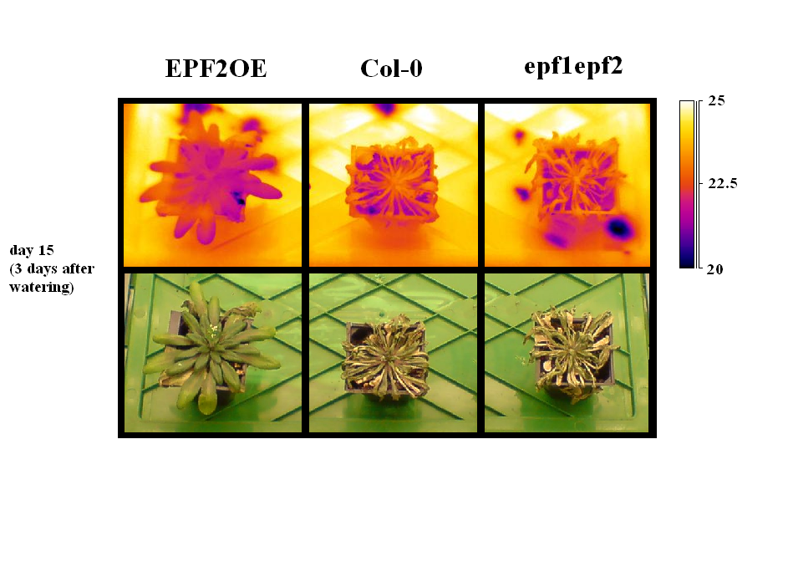

**Figure 5.10: *EPF2*OE plants recover from drought treatment after rewatering whereas Col-0 and *epf1epf2* plants do not.** IR images and corresponding photos of *EPF2*OE, Col-0 and *epf1epf2* plants on day 15, 3 days after rewatering.

**5.4.2 Low *D* limits seed development and yield**

Thus far, a good case for increasing drought resistance by engineering lower *D* has been presented. For most agriculturally important crops however, an increase in seed yield and not necessarily leaf size is desired (Richards, 2000). The following findings describe a number of differences in seed yield and flowering time between plants with altered *D* grown in ambient CO2 conditions. *D* is positively correlated with flowering time, with *EPF2*OE plants flowering on average 5.25 days after Col-0 and *epf1epf2* plants flowering on average 3.25 earlier (Fig 5.11). As noted by many authors and confirmed in section 5.1.5, increasing levels of CO2 causes plants to grow and develop faster leading to earlier flowering, presumably because of a higher rate of carbon fixation. As noted in chapter 4, *EPF2*OE has a significantly lower rate of carbon assimilation than Col-0 and *epf1epf2* plants which is likely to contribute to delaying flowering.



**Figure 5.11: D is negatively correlated with flowering time.** Mean time of flowering (dpg) of EPF2OE, Col-0 and epf1epf2 plants. Error bars represent standard error. Asterisks represent significant difference from Col-0 (students t test, p<0.05).

In addition to flowering later, certain morphological differences between siliques of *EPF2*OE and Col-0 plants were apparent. On average (mode, n=5), the first 2 siliques of Col-0 and *epf1epf2* plants were often stunted and did not develop viable seeds and subsequent siliques grow to a mean length of 1.55 and 1.48 respectively with viable seed (Fig 5.12). For *EPF2*OE plants, the mean silique length was 1.17 cm as a number of siliques developing later were also stunted (Fig 5.12). In the most extreme case, one (out of 5) *EPF2*OE plant was almost completely sterile developing only 2 normal sized siliques. As a result, *EPF2*OE plants have a much lower seed yield (Fig 5.14). The developing seed and fruit are a strong sink for carbohydrate, which is delivered as sucrose via the phloem. Given that *EPF2*OE leaves assimilate less carbon because of their lower photosynthetic rate than wildtype (chapter 4), it is conceivable that the seed is unable to develop correctly due to a sucrose deficiency. Indeed, sucrose is reported to be a chemical control point in the cell division cycle (Francis 1992; Ranasinghe and Taylor 1996), and may act by mediating cyclin activity (Kinsman et al. 1997). A reduction of root growth has also been shown to be related to the limitation in sugar supply from the leaves (Aguirrezabal and Tardieu, 1996; Muller et al., 1998; Freixes et al., 2002), and this is also true for maize kernels (Setter et al., 2001). Direct sampling of the sucrose content in the phloem across a gradient of points in these plants with altered *D* could be carried out to test this hypothesis. As outlined in the introduction, EPF2 has recently been shown to interact directly with the transmembrane receptor ERECTA activating a kinase cascade and suppressing stomatal development (Shpak et al., 2003; Torii et al., 2003; Torii et al., 1996; Shpak et al., 2004). ERECTA has also been implicated in the development of the plants reproductive organs. Overexpression of a dominant loss-of-function ERECTA unable to internalise signals results in *Arabidopsis* plants with stunted siliques (Fig. 5.13; Shpak et al. 2004). Although EPF2 is not normally expressed in the flower or seed, the *EPF2*OE plants used in these experiments express EPF2 in all cells. It is possible that the interaction of EPF2 with ERECTA has disrupted development in the reproductive organs. As reported in chapter 4, *EPF2*OE leaves are also hotter than Col-0 and *epf1epf2* leaves and this may cause a reduction in seed yield. In wheat and cotton, higher plant temperatures are reported to decrease yield (Lu et al. 1998).



A

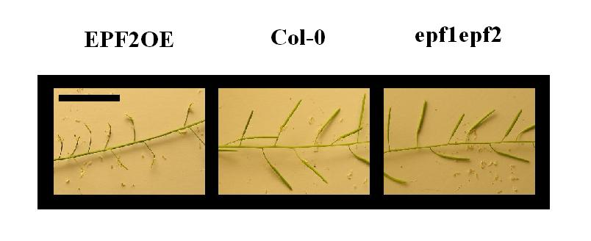

B

**Fig 5.12: EPF expression levels alter silique structure.** (A) Siliques on Col-0 and *epf1epf2* plants develop apparently normally whereas siliques developing on *EPF2*OE are often stunted and sterile. Scale is 2 cm. (B) mean silque length is smaller for EPF2OE than Col-0 and *epf1epf2*. Error bars represent standard error. Asterisks represent significant difference from Col-0 (students t test, p<0.05, n=4-6). Plants were grown in the greenhouse.

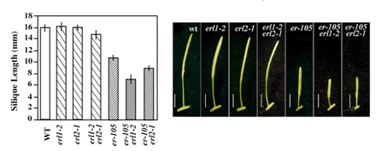

A

B

**Fig 5.13: *ERL1* and *ERL2* genes are partially redundant and show synergistic interaction with *ERECTA*.** Morphometric analysis of fully-grown eight-week-old wild-type, *erl1-2, erl2-1, erl1-2 erl2-1, erecta-105, erecta-105 erl1-2, erecta-105 erl2-1* and *erecta-105 erl1-2 erl2-1* plants. (A) Lengths of mature siliques on the main stem (*n*=40; eight measurements per stem). Bars represent the average; error bars represent s.d. (B) Mature siliques and attached pedicels of wild-type, *erl1-2, erl2-1, erl1-2 erl2-1, erecta-105, erecta-105 erl1-2* and *erecta-105 erl2-1.* Scale bars: 5 mm. (Adapted from Shpak et al. 2004)

The high incidence of arrested and stunted siliques in *EPF2*OE plants resulted in a lower total seed yield (Fig 5.14). Despite larger leaves and increased WUE and drought tolerance, *EPF2*OE plants were unable to yield even a third of the seed produced by wildtype plants. In accordance with measurements of photosynthetic rates (Fig 4.11, chapter 4), there was no significant difference in seed yield between *epf1epf2* and Col-0 plants.



**Figure 5.14: Plants with lower *D* and stunted siliques (*EPF2*OE) have a lower seed yield**. Mean total seed yield (g) of *EPF2*OE, Col-0 and *epf1epf2* plants. Error bars represent standard error. Asterisk represent significant difference from Col-0 (students t test, p<0.05, n=4-6).

**5.5 D across barley cultivars**

Unless one’s goal is to develop drought tolerant weed, altering *D* to increase drought tolerance in *Arabidopsis* is of limited use. In order to probe the relationship between stomatal density and WUE in a more agriculturally useful plant, dried barley flag leaves from 22 cultivars were acquired from plants grown in outdoor plots at the James Hutton Institute in Dundee.

**5.5.1 Stomatal densities are varied across cultivars**

Previous studies on barley leaves have reported a diverse range of stomatal densities and sizes (Miskin and Rasmusson, 1970; Jones, 1977). As reported in chapter 3 for *Arabidopsis* plants with altered *D*, an increase in *D* in barley is accompanied by a decrease in stomatal size (Miskin and Rasmusson, 1970). In the current study, a diverse range of *D* from 74 mm-2 (Soanna) to 122 mm-2 (Barke) was found for barley cultivars but due to the poor quality of dried leaf samples, no estimation of stomatal size or index was carried out (Fig 5.15). However, in a previous study examining 4 barley strains stomatal index was found to be relatively invariant and did not have any effect on stomatal density (Jones, 1977). Even though density measurements were taken from dried tissue, differences between the cultivars should remain relatively consistent and reflect real differences in the live organs. Dried leaves from these strains did not vary significantly in size (data not shown) suggesting that *D* is due to a developmental difference rather than simply increased cell expansion. Unfortunately, this was not possible to confirm as the quality of the impressions did not allow for an examination of stomatal indices. There was significant effect of cultivar on *D* in barley. This range of *D* (<2x) is much smaller than the range of *Arabidopsis* genetically manipulated mutants studied in the previous chapters (~15x between *EPF2*OE and *epf1epf2*). Nevertheless, the previous work carried out on *Arabidopsis* suggests that a difference in *D* is associated with modulated photosynthetic rates, range of conductance, transpiration and water use efficiency. It is expected that strains with low *D*, such as Soanna will have a lower conductance baseline and range as well as increased water use efficiency compared to strains with high *D*, like Barke. In order to test this hypothesis, leaves from three strains displaying a wide range of *D*, significantly different from one another (unpaired t test P<0.05): Soanna, Cocktail and Barke, were selected for δ13C analysis of water use efficiency.



**Fig 5.15: Abaxial *D* across 21 different species of barley grown in outdoor plots at the James Hutton institude**. Error bars represent standard error (n=3-5).

**5.5.2 WUE is positively correlated with *D* for a subset of barley cultivars**

As explained in chapter 4, an analysis of the ratio of 13C to 12C between plants grown in similar conditions can give an approximation of WUE. Tissue which has fixed more 13C to 12C has lost less water per carbon fixed. In barley, δ13C is commonly determined in flag leaf or in mature kernels with the latter being generally more representative of WUE (Villegas *et al*., 2000; Merah, 2001; Merah et al., 2001, 2002). However, kernels were not available for this experiment and δ13C analysis was carried out on flag leaves. Altered Δ (δ13C from dried tissue corrected for atmospheric δ13C) has been associated with genetic variation between cultivars of bread and durum wheat, barley, triticale and rice. (Voltas et al., 1998; Royo et al., 1999; Peng et al., 1998; Teulat et al., 2001; Rebetzke et al., 2002; Araus et al., 2003; Çagirgan et al., 2005; Impa et al., 2005; Misra et al., 2006). Work detailed in chapter 4 demonstrated that *EPF2*OE *Arabidopsis* plants with lower stomatal densities had the highest ratio of 13C to 12C and thus the highest WUE.

For Soanna, Cocktail and Barke the relationship between *D* and WUE appears to be inversed (Fig 5.16). The barley strain with the lowest *D* (Soanna) has discriminated significantly more, acquiring a lower δ13C value than the strains with higher *D* (Cocktail and Barke). This surprising result suggests that a correlation of *D* to WUE across barley strains is likely to be too simplistic and that other factors play an important role. It is possible that stomatal size played a role in increasing the conductance of Soanna leaves, thus decreasing their WUE. Indeed, Jones reported that barley plants with higher *D* had reduced total crop water use and that this may be due to increased stomatal sizes or reduced leaf size (Jones, 1977). Biochemical differences in Soanna leaves such as a reduced rate of carbon fixation, which would increase Ci (CO2 inside the leaf), or lower sensitivity to stomatal closing molecular signals (such as ABA), which would increase conductivity, may also play a role in reducing leaf WUE. In addition, structural differences such as leaf angle, which affect the total light received by the leaf could alter conductance and thus the ratio of fixed carbon isotopes. This study highlights the problem of examining the effect of one variable across different species with many unknown and interacting variables: it is much harder to guess what a completed puzzle will look like with only one piece at hand. Elimination of a number of unknown variables might be achieved by altering *D* in a single cultivar by genetically modifying expression levels of barley EPF homologues.



**Figure 5.16: δ13C is reduced in barley flag leaves with the lowest D (Soanna).** 13C to 12C ratios of Barley flag leaves from Soanna (white), Cocktail (grey) and Barke (black) as a function of D. Error bars represent standard error. Asterisks represent significant difference of δ13C from Cocktail leaves (unpaired t-test, p<0.05).

Under well-watered conditions a positive relationship between Δ and yield was found for barley (Craufurd et al., 1991; Voltas et al., 1998) so in this case we would expect Soanna to yield the most. As was the case with *Arabidopsis* plants with altered *D*, the highest yielding genotypes are those with the lowest WUE (Col-0 and *epf1epf*). Although these results might seem odd, as one might assume that genotypes with the highest WUE are the most productive, the negative relationship between δ13C and yield can be ascribed to the fact that genotypes with low δ13C values have higher levels of conductance, transpiring more water at the expence of a higher Ci and increasing yield (Fischer *et al*., 1998; Monneveux *et al*., 2004). Negative relationships between yield or biomass and Δ have been found when water availability is very limited (Al-Hakimi *et al*., 1996; Ehdaie and Waines, 1996; Richards, 1996; Reynolds *et al*., 2007). Although the total water use of a crop is positively correlated with high yields (Cabuslay *et al*., 2002; Hu *et al*., 2006; Cabrera-Bosquet *et al*., 2007), genotypic traits and growth conditions which contribute to high water use generally have a negative impact on WUE (Zhang *et al*., 1998; Tsialtas and Tokatlidis, 2008)

**5.6 Conclusions**

**The combined effect of environmental conditions and D on rosette size:**

* Rosette size, total leaf area and dry biomass are negatively correlated with *D* despite lower photosynthetic rates for plants with the lowest *D* (*EPF2*OE).
* Unsurprisingly, rosettes size, total leaf area and dry biomass are positively correlated with SWC. There was no significant combined effect of water availability and genotype suggesting that despite differences in transpiration between the genotypes, there was no difference in the extent to which lower SWC limited growth.
* Rosette size, total leaf area and dry biomass were larger for plants grown at 450 ppm CO2 compared with plants grown at 200 ppm CO2. However, at the point of flowering, plants grown at 1000 ppm CO2 had a smaller rosette size, total leaf area and dry biomass than plants grown at 450 ppm CO2. This is probably due to plants grown at 1000 ppm CO2 reaching maturity (Boyes stage 3.1) in less time than plants grown at 450 ppm CO2 as growth was increased to a lesser extent than lifecycle. Interestingly, plants grown at 1000 ppm CO2 suffered no significant reduction in rosette size, total leaf area and dry biomass when water was limited, presumably because leaf conductance and transpiration are much lower at these CO2 levels (chapter 4).
* A number of morphological leaf characteristics (size, number, shape) contribute to increasing the percentage of overlapping leaf area for plants grown with limited water. This may help limit accumulation of ROS and transpiration by reducing leaf area subjected to direct sunlight and wind.

**The effect of D on short term drought tolerance and yield:**

* *D* is negatively correlated with short-term severe drought tolerance. During drought treatment, leaves from *EPF2*OE plants were able to remain functional and turgid longer and could “resurrect” upon rewatering. This experiment highlights the importance of a low leaf conductance baseline in drought tolerance.
* *EPF2*OE flowers later, develops stunted siliques and as a result yields less seed. This may be due to lower photosynthetic rates. It is possible that ectopic overexpression of EPF2 in the aerial organs disrupts the correct functioning of ERECTA.

**Leaf properties in barley cultivars:**

* *D* is varied across barley cultivars. Unlike with *Arabidopsis*, leaves with low *D* (Soanna) had a lower δ13C than those with higher *D* (Cocktail and Barke) suggesting that differences independent of *D* between the cultivars have a stronger effect on WUE.