The University of Sheffield

Department of Molecular Biology and Biotechnology (MBB)

STUDIES ON THE MICROBIOLOGY AND BIOGEOCHEMISTRY OF SOME INDUSTRIAL WASTES AND A PRELIMINARY EVALUATION OF THE USE OF BIOCHAR IN SPOIL REMEDIATION

By: Sultan Farhan Alsharari

Supervision: Prof. (Hon Cardiff) Milton Wainwright

June 2013

Thesis submitted in partial fulfilment for the requirements of the Degree of Doctor of Philosophy in the Department of Molecular Biology and Biotechnology, University of Sheffield. UK.

Dedication

I dedicate this thesis to my family, especially to my mother and to my father’s soul, and to my brothers and sisters. To my wife, who has always lovingly supported me. To my children thank you for patience and understanding. Finally, to all my teachers, and my friends; I respect you all and, I dedicate my modest work to you.

Acknowledgments
First and foremost, I would like to thank Almighty Allah for giving me the patience and determination to carry out and conclude this Thesis. This research project would not have 1 been possible without the support of many people. I wish to express my gratitude to my wonderful supervisor, Prof. Milton Wainwright who was extremely helpful and offered invaluable assistance, support, comments, encouragement and guidance. Deepest gratitude is also due to my advisor, Dr Jim Gilmour for their valuable advice and suggestion during annual meetings. Not forgetting the members of the supervisory committee, whose suggestion and criticism was highly significant in accomplishing this thesis. I express my appreciation to the Saudi Embassy and the Saudi Cultural Bureau and the King Saud University, College of Food and Agricultural Science for support and encouragement.
Finally, an honorable mention goes to my family and friends for their understandings and supports on me in completing this project. Special thanks also to all my friends in Prof. Wainwright’s laboratory, particularly for my best friends, Salah Jaber, khaled Alquthami, Sami Alyahya, Waleed Al- Waneen, Mamdouh Bukari, Aref Alamri, Reda Amasha, Gada and Fariha. I would also like to thank all my friends, Mohammad Alsuliman, Suliman Alharbi, Fawaz Alshamari, Adham, Salah, Basam Aljuhani, Khaled Alabri, Suliman Alnoaimat Muhammad Alkhuraiji, Ibrhim Alshubith, Jassem, and Ahmed Almujamami.
Finally I wish to thank the Head of Department of MBB for making the facilities of the Department available to me.

ABSTRACT
The aim of the work described in this Thesis was to study the biogeochemistry of a variety of industrial spoils, ranging from a highly alkaline steel slag spoil to a slightly acidic colliery spoil and acidic metal mining wastes, with the ultimate aim of providing information which might be used in the remediation of these spoils by applying a plant cover. A variety of important processes, which are components of the major biogeochemical cycles (i.e. urea hydrolysis, nitrification, s-oxidation, and P-solubilization) were studied in these spoils. The activities of a range of soil enzymes (e.g.arylsuphatase and arylphosphatase) were studied in the spoils in relation to their use as possible indicators of microbial activity and thereby spoil fertility. In addition, phosphate solubilizing microorganisms were isolated in relation to the role they play in
influencing the availability of phosphate to plants which, with nitrogen is likely to be a major limiting factor for spoil bioremediation. A preliminary study was also made of the potential for using Biochar in the remediation of these spoils. The results are discussed in relation to the bioremediation of these industrial spoils. The desirability of achieving such spoil-remediation relates mainly to aesthetic considerations, i.e. the presence of spoil tips ruins the local environment a factor which impacts on tourism and the introduction of “clean industries” to former mining areas.

CONTENTS
Dedication …………………………………………………………….. I
Acknowledgments…………………………………………………… II
ABSTRACT……………………………………………………………………. III
Chapter One…………………………………………………………….. 1
1. GENERAL INTRODUCTION……………………………………………. 1
1.1 The Rhizosphere 3
1.2 Types of Industrial Wastes Studies Here 5
Colliery (Coal) Wastes 6
Physical characteristics of colliery spoil 7
Appearance and origin 7
Compaction and consolidation 8
Physical weathering processes in coal wastes 8
The pH of colliery spoils 9
Salinity of colliery spoils 9
The effects of combustion 9
Alkaline Steel Slag 10
Soil Acidification 12
1.3 Description of Study Sites 13
1.3.1 Agricultural soil 13
1.3.2 Introduction to the Redcar Site 13
1.3.3 Shirebrook Colliery Spoil 16
1.3.4 Parys Mountain Spoil 17
1.3.5 Sardinia Spoil 19
Aims of the Present Study……………………………………….. 21
Chapter Two……………………………………………………………….. 22
2. The influence of selected soil parameters on the mobility of heavy metals in soils………………….………………….22
2.1. INTRODUCTION……………………………………………………… 23
Metal precipitation by sulphate-reducing bacteria 28
Methylation of metalloids 29
2.2 MATERIALS AND METHODS 31
2.3 Results and Discussion 32
Use of test strips to determine if water extractable metals are present in the spoils 36
Chapter Three………………………………………………………….. 37
3. STUDIES ON TRANSFORMATIONS OF SOIL NITROGEN, SULPHUR AND PHOSPHORUS IN INDUSTRIAL SPOILS………………………………………..37
3.1 INTRODUCTION………………………………………………………… 38
3.1.1 TRANSFORMATIONS OF SOIL NITROGEN 38
3.1.1.1 Nitrogen cycle 38
3.1.1.3 Nitrification 40
3.1.1.4 Chemoautotrophic nitrification 41
3.1.1.5 Heterotrophic Nitrification 41
3.1.1.6 Nitrate reduction 43
3.1.1.7 Nitrogen losses from soil 43
3.1.1.8 Assimilatory nitrate reduction 44
3.1.1.9 Dissimilatory nitrate reduction 44
3.1.1.10 Denitrification 45
3.1.1.11 Factors affecting denitrification in the environment 47
3.1.2 TRANSFORMATIONS OF SOIL SULPHUR 48
3.1.2.1 Role of microorganisms in the sulphur cycle 48
3.1.2.2 S-mineralization 51
3.1.2.3 Sulphate reduction 51
3.1.2.4 Sulphate immobilization 52
3.1.2.5 Sulphur oxidation 52
3.1.2.6 Heterotrophic sulphur-bacteria 53
3.1.2.7 Chemotrophic sulphur bacteria 54
3.1.2.8 Factors which affect the oxidation of sulphur in soil 54
3.1.3 MICROBIAL TRANSFORMATIONS OF SOIL PHOSPHORUS 56
3.1.3.1 Phosphorus compounds in soil 57
3.1.3.2 P-Mineralization and immobilization 58
3.1.3.3 Ability of microbes to solubilize insoluble phosphate 60
3.2 MATERIALS AND METHODS 61
3.2.1 Microbial counts 61
3.2.2 Analysis of inorganic N ions 61
3.2.2.1 Nitrification 61
3.2.2.2 Determination of ammonium-N (NH₄⁺-N) by the indophenol blue method 62
3.2.2.3 Determination of nitrate-N by the chromotropic acid method 62
3.2.3 Determination of S-oxidation- sulphate by turbidimetric analysis 62
3.2.4 Determination of phosphate solubilisation 63
3.2.5 Determination of soil pH 63
3.3 Results and Discussion 64
Oxidation of Ammonium to Nitrate 68
Oxidation of Elemental Sulphur to sulphate 75
Hydrolysis of ammonium to urea 82
Phosphate Solubilisation. 89
Chapter Four…………………………………………………………… 97
4. STUDIES ON THE ABILITY OF BACTERIA AND FUNGI ISOLATED FROM ALKALINE SPOIL TO SOLUBILISE INSOLUBLE PHOSPHATE…...97
4.1 Introduction 98
4.1.1 Phosphorus 98
4.1.2 Forms of soil phosphorus 99
4.1.3 Organic forms of phosphorus 99
4.1.4 Phosphorus as a plant nutrient 100
4.1.5 Role of microorganisms in the phosphorus cycle 100
4.1.6 Microbial solubilisation of inorganic P 101
The Aims of the work described in this Chapter 101
4.2 Materials and Methods 102
4.2.1 Determination of “total counts” of phosphate solubilising fungi and bacteria 102
4.2.2 Ability of bacteria and fungi to solubilise insoluble phosphate 102
4.2.3 Colorimetric determination of phosphate (Hesse, 1971) 103
4.3 Results and Discussions 104
Phosphate-solubilizing bacteria as plant growth promoters 107
Mechanisms of phosphate solubilization 108
Identification of Bacteria and Fungi Capable of Solubilizing Insoluble phosphates 109
Chapter Five……………………………………………………………. 115
5. Determination of Enzyme Activity in Industrial Samples……………………………………………………………………..……..115
5.1 Introduction. 116
5.1.1 Soil phosphatase activity (Arylphosphatase activity) 118
5.1.2 Arylsulphatase activity in soil 119
5.1.3 Urease activity in soil 120
5.2 MATERIALS AND METHODS 123
5.2.1 Measurement of arylsulphatase and arylphosphatase activity 123
5.2.2 Measurement of urease activity 123
5.3 Results and Discussion 125
Soil enzymes as indicators of heavy metal pollution 128
Chapter Six……………………………………………………………………. 130
6. Examination of the potential use of Biochar to improve the remediation of colliery waste and alkaline spoil 130
6.1 INTRODUCTION 131
6.1.1 Colliery spoils as an environmental problem 133
6.1.2 Alkaline slag waste in relation to Biochar treatment 134
6.1.3 The implications of using Biochar for soil microbiology and the major biogeochemical processes 135
6.1.4 Carbon dioxide release-Does the addition of charcoal to soils in fact stimulate carbon dioxide release? 137
6.1.5 Alternatives to the use of Biochar to remediate Parys Mountain Spoils 138
Previous studies on the potential bioremediation of Parys Mountain spoil by the addition of municipal organic wastes 138
Composting-Effects on chemical properties and biological activity of Parys Mountain spoils 139
6.2 Materials and Methods-Biochar studies 140
Determination of number of bacteria 141
6.3 Results and Discussion 142
Nitrate concentrations in Biochar amended spoils 143
Sulphate concentrations in Biochar amended spoils 145
Ammonium concentrations in Biochar amended spoils 147
Phosphate concentrations in Biochar amended spoils 149
Effect of Biochar on plant growth 151
The use of Biochar in agricultural soils 158
Biochar for Mine spoil remediation 159
Biochar and the sorption of heavy metals 161
Biochar and the sorption of organic molecules, such as pesticides 162
Removal of metals from mine waste water 163
Application of phytoremediation and phytoextraction to Biochar-treated and re-vegetated spoils 164
Chapter Seven…………………………………………………………………165 7. General Discussion……………………………………………….. 165
FUTURE STUDIES…………………………………………………………….. 169
SUMMARY OF FINDINGS…………………………………………………… 170
REFERENCES………………………………………………………………… 179
Appendix………………………………………………………………………. 194

Figure of Contents
Figure 1. A highly alkaline drainage ditch at Redcar…………………………..…..…..13
Figure 2. Sampling the pH of the Redcar water. The water and sediment have a “soapy” alkaline feel. The water is pH 12.5 and the sediment pH is 12.0....................................14
Figure 3a. Location of Redcar alkaline spoil sampling site………..........................….15
Figure 3b. Location of Shirebrook colliery spoil sampling site (dotted area shows the location of spoil heap)…………………………………………………………….……17
Figure3c. Location of Parys mountain sampling site……………………………..……18
Figure 3d. Location of Sardinia mine waste sampling site………………………..…...20
Figure 4. Munnecke technique showing a soil plug, bacterial inoculants and zone of inhibition produced by mercury chloride added to the soil prior to the production of the soil plug...........................................................................................................................30
Figure 5. Sardinia salt steam bed and black copper-rich ash assayed for metal availability using the modified Munnecke technique……………………………..…...32
Figure 6. Parys Mountain spoils assayed for metal availability using the modified Munnecke technique………………………………………………………………..….33
Figure 7. Agricultural soil, alkaline Redcar slag and colliery wastes assayed for metal availability using the modified Munnecke technique………………………………….34
Figure 8. Nitrate concentration in the Agricultural soil. ................................................68
Figure 9. Nitrate concentration in the Redcar spoil........................................................68
Figure 10. Nitrate concentration in the Vegetated Colliery spoils..................................69
Figure 11. Nitrate concentration in the Non-Vegetated Colliery soils............................70
Figure 12. Nitrate concentration in the Sardinia Black Ash spoil...................................71
Figure 13. Nitrate concentration in the Sardinia Salt stream bed soils...........................71
Figure 14. Nitrate concentration in the Anglesey Parys Mountain spoils (S1-Brown)............................................................................................................................72
Figure 15. Nitrate concentration in the Anglesey Parys Mountain spoils (S2-Red)......73
Figure 16. Nitrate concentration in the Anglesey Parys Mountain spoils (S3-Yellow)..73
Figure 17. Nitrate concentrations in the Anglesey Parys Mountain spoil (S4-Dark Brown).............................................................................................................................74
Figure 18. Sulphate concentration in the Agricultural soil..............................................75
Figure 19. Sulphate concentration for Redcar spoil........................................................75
Figure 20. Sulphate concentration in the Vegetated Colliery spoils...............................76
Figure 21. Sulphate concentration in the Non-Vegetated Colliery spoils.......................77
Figure 22. Sulphate concentration in the Sardinia Black Ash spoils..............................78
Figure 23. Sulphate concentration in Sardinia Salt stream bed spoils............................78
Figure 24. Sulphate concentration for Anglesey Parys Mountain spoils (S1-Brown)....79
Figure 25. Sulphate concentration for Anglesey Parys Mountain spoils (S2-Red).........80
Figure 26. Sulphate concentration for Anglesey Parys Mountain spoils (S3-Yellow)...80
Figure 27. Sulphate concentration for Anglesey Parys mountain spoils (S4-Dark Brown).............................................................................................................................81
Figure 28. Ammonium concentrations in the Agriculture soil........................................82
Figure 29. Ammonium concentrations in Redcar spoils.................................................82
Figure 30. Ammonium concentrations in the Vegetated Colliery spoil..........................83
Figure 31. Ammonium concentrations in the Non-Vegetated Colliery spoil..................84
Figure 32. Ammonium concentration in the Sardinia Black Ash spoil...........................85
Figure 33. Ammonium concentration in Sardinia Salt stream bed spoil.........................85
Figure 34. Ammonium concentration in Anglesey Parys Mountain spoil (S1-Brown)..86
Figure 35. Ammonium concentration in Anglesey Parys Mountain spoil (S2-Red)......87
Figure 36. Ammonium concentration in Anglesey Parys Mountain spoil (S3-Yellow).87
Figure 37. Ammonium concentration in Anglesey Parys Mountain spoil (S4-Dark Brown)............................................................................................................................88
Figure 38. Phosphate concentration in the Agriculture soil............................................89
Figure 39. Phosphate concentration in Redcar spoil.......................................................90
Figure 40. Phosphate concentration in Vegetated Colliery spoil....................................90
Figure 41. Phosphate concentration in Non-Vegetated Colliery spoil............................90
Figure 42. Phosphate concentration in Sardinia Black Ash spoil...................................91
Figure 43. Phosphate concentration in Sardinia Salt stream bed spoil............................91
Figure 44. Phosphate concentration in Anglesey Parys Mountain spoil (S1-Brown).....92
Figure 45. Phosphate concentration in Anglesey Parys Mountain spoil (S2-Red).........92
Figure 46. Phosphate concentration in Anglesey Parys Mountain spoil (S3-Yellow)....93
Figure 47. Phosphate concentration in Anglesey Parys Mountain spoil (S4-Dark Brown).............................................................................................................................93
Figure 48. Plate count of phosphate solubilising fungi and bacteria isolated from the alkaline spoil sample, Redcar (pH= 12) and agriculture soil sample (pH= 5.7) ..........104
Figure 49. Phosphate solubilising by the fungi and the bacteria, (Brevidomonas alba and Penicillium aurantiogriseum. ………………………………………………………....106
Figure 50. Identification of bacteria (Achromobacter SP) from alkaline (Redcar) soils sample using 16SrRNA and PCR..................................................................................110
Figure 51. The sequence identification of bacteria (Achromobacter SP) from alkaline (Redcar) soils sample using 16SrRNA and PCR..........................................................110
Figure 52. Identification of the phosphate solubilizing bacterium (Brevundimonas alba strain) from the Redcar (alkaline spoil) using 16SrRNA and PCR...............................111
Figure 53. The sequence identification of the phosphate solubilizing bacterium (Brevundimonas alba strain) from the Redcar (alkaline spoil) using 16SrRNA and PCR................................................................................................................................111
Figure 54. Identification of a phosphate solubilizing fungus (Penicillium aurantiogriseum strain) from the Redcar (alkaline) spoil using 18SrRNA and PCR....112
Figure 55. The sequence identification of a phosphate solubilizing fungus (Penicillium aurantiogriseum strain) from the Redcar (alkaline) spoil using 18SrRNA and PCR...112
Figure 56. Arylphosphatase activity in the soils and spoils..........................................125
Figure57. Arylsulphatase activity in the soils and spoils.............................................126
Figure 58. Urease activity in the soils and spoils.........................................................127
Figure 59. The commercial sample of Biochar used in these studies………………...131
Figure 60. Simulation of the use of Biochar to remediate colliery spoils…………….133
Figure 61. Nitrate concentration in non-vegetated colliery spoil amended with .Biochar (1:1, 1:2 and 1:3)..……………….................................................................................143
Figure 62. Nitrate concentration in Redcar spoil amended with Biochar (1:1, 1:2 and 1:3)..……………………………………………………………………………..……144
Figure 63. Sulphate concentration in non-vegetated colliery spoil amended with Biochar (1:1, 1:2 and 1:3)..............................................................................................145
Figure 64. Sulphate concentration in Redcar spoil amended with Biochar (1:1, 1:2 and 1:3)……………………………………………………………………………….........146
Figure 65. Ammonium concentrations in non-vegetated colliery spoil amended with Biochar (1:1, 1:2 and 1:.3).............................................................................................147
Figure 66. Ammonium concentrations in Redcar spoil treated with Biochar (1:1, 1:2 and 1:.3)………………………………………………………………………..……...…...148
Figure 67. Phosphate concentration in non-vegetated colliery spoil amended with Biochar (1:1, 1:2 and 1:3)..............................................................................................149
Figure 68. Phosphate concentration in Redcar spoil amended with Biochar (1:1, 1:2 and 1:3).................................................................................................................................150
Figure 69 . Development industrial soils (Colliery non-vegetated and Redcar-Alkaline) using Biochar (Spinach after 3 days).............................................................................151
Figure 70. Development industrial soils (Colliery non-vegetated and Redcar-Alkaline) using Biochar (Spinach after 3 months)........................................................................151
Figure 71. Effect of Biochar on plant growth in alkaline (Redcar) colliery spoil (fresh plant and leaf weight-mg)..............................................................................................152
Figure 72. Effect of Biochar on plant growth in alkaline (Redcar) spoil (fresh root weight-mg)....................................................................................................................153
Figure 73. Effect of Biochar on plant growth in alkaline (Redcar) colliery spoil (dry root and plant weight-mg).............................................................................................154
Figure 74. Effect of Biochar on spinach plant height (mm) in alkaline (Redcar) colliery spoil...............................................................................................................................156
Figure75. Effect of Biochar on plant growth in alkaline (Redcar) colliery spoil (branch and leaf numbers)..........................................................................................................157

Table of Contents
Table 1a. The pH of soils samples…………………………………………………..…64
Table 1b. Effect of Elemental Sulphur Oxidation on the pH of Redcar Alkaline and Colliery Spoils………………………………………………………..............................65
Table 2. Microbial Count for soils samples…………………………………….............66
Table 3. Plate counts of bacteria and fungi solubilizing phosphate isolated from the agricultural soil and spoils…………………………………………………………….105
Table 4. Industrial spoil pH following Biochar treatment……………………………142
Table 5. Total count of bacteria in Biochar treated spoils…………………………….142

Chapter One

GENERAL INTRODUCTION

A wide variety of industrial wastes exist, both in the UK and around the world. Such wastes vary markedly in their physical and chemical composition with most containing some constraint to the growth of microorganisms. Such constraints can result from the presence of potential toxins, such as heavy metals, cyanide and arsenic, or relate to factors such as pH which influence the growth and activity of microorganisms; examples of which include highly acidic and very alkaline spoils (Meuser, 2013). Any impact which industrial spoil components have on microbial numbers in an industrial soli will also impact on their activity, which in turn will affect the biogeochemistry of the spoils; impact which might translate to negative effects on plant growth and the ease with which such spoils can be bio-remediated. The bioremediation of industrial spoils often simply involves coverage with a top soil which is the grassed in an attempt to mask the visual impact of the industrial waste heap (Lens, 2005). Such approaches are often effective, but in some cases the underlying spoil biogeochemistry can affect plant growth in the surface soil cover; examples obviously include the continued production of acid mine drainage and the continued release of potentially toxic metal ions from the underlying spoil. For this reason it is often beneficial to remediate the underlying spoil before it receives a grassed-cover, a process which tends to be more difficult, more expensive and more time consuming than mere cosmetic grass-coverage (Wise, 2000). Before direct remediation of spoils can take place it is essential that information be gained on their ability to process substrates (whether innate or added) i.e. to study their biogeochemistry in relation to soil fertility (Agathos and Reineke, 2002, Lens, 2005). For example, do such spoils actively nitrify or oxidize sulphur, or are these As well as other important processes relevant to soil fertility, hindered in their action by spoil toxicants?

1.1 The Rhizosphere
The biological nature of the rhizosphere is an intense zone of interaction between plant roots and other components of the soil biota, particularly microbes (Anderson et al.1993). The rhizosphere is a zone of increased population of a very wide range of soil microbes, particularly, of course, heterotrophs (Richards, 1987). Some parts of the nitrogen cycle that involve heterotrophs, therefore, will be driven by the rhizosphere carbon flow. Non-symbiotic, aerobic, N₂-fixers such as Azotobacter will be active, although the ecological significance of this activity may not be great (Paul and Clark, 1989). Since most bioremediation of industrial spoils involves surface coverage with plants achieved either directly in the spoil, or into a soil cover, a study of the microbiology of plant roots is highly relevant (Anderson et al.1993). Root systems are almost always associated with adjacent soil (rhizosphere) containing a denser distribution of microbes compared to soil without roots present (Killham, 1994). This unique environment, which is under the influence of plant roots, is called the rhizosphere. Within this zone, interactions between plants and microorganisms can greatly affect crop production and soil fertility and hence, at the ecosystem level, energy flow and nutrient cycling (Richards, 1987). The meaning of the word rhizosphere has been considerably broadened since it was introduced by Hiltner, who, in 1904, described a zone of soil adjacent to the roots of legumes in which the growth of bacteria might be influenced by compounds of nitrogen that are released from nodules (Sprent,1991).
The rhizosphere is not a uniform well-defined region but a zone with a microbial gradient extending from the root surface, or rhizoplane. that part of the rhizosphere immediately adjacent to the root surface, where microorganisms are most affected, to soil a 1 to 2 cm away, where effects are minimal and the extent of this gradient depends principally on the plant species(Anderson et al.1997). It is now normally used to describe the zone of soil in which the environment for microbial activity in general is influenced by the root of any species (Richards, 1987), distinguishing it from the `bulk` or `non-rhizosphere` soil, which is not directly influenced by growing roots, except by the withdrawal of water and nutrients (Richards, 1987). However, the rhizosphere and the bulk soil merge one into the other and the boundary between them cannot be rigidly defined. It is reasonable to assume, however, that the diameter of the rhizosphere at least equals that of cylinder of soil which root hairs explore and into which they may release exudates (Sprent, 1991). The rhizosphere is often divided into two general areas, the inner rhizosphere at the very root surface and the outer rhizosphere embracing the immediately adjacent soil (Richards, 1987). Microbial activity is larger in the inner zone where the biochemical interactions between microorganisms and roots are most pronounced. In the rhizosphere and rhizoplane, several relationships between macroorganisms and microorganisms can be recognized (Anderson et al., 1993). Symbiotic phenomena are observed between legumes and rhizobia and in mycorrhizal associations. Pathogenic relationships are not uncommon because roots are attacked by a number of fungi, bacteria, and nematodes (Alexander, 1977). Rhizosphere soil can be distinguished from the bulk soil on a physical, chemical and biological basis. The water potential regime of the rhizosphere is, for example, very different from that of the bulk soil, generally being lower than the bulk soil; this causes a net mass flow of water towards the roots and can set up a nutrient gradient across the rhizosphere (Richards, 1987). The chemical nature of the rhizosphere is quite different from the bulk soil, largely as a result of the release of carbon from the roots and selective uptake of ions from the soil solution (Killham, 1994). The rhizosphere also generally experiences great rates of mineral weathering, and depending on the ratio of cation to anion uptake by the roots, the rhizosphere-pH may differ considerably from the bulk soil (Killham, 1994).
The aim of this work described in this Thesis was to study a variety of aspects of the microbiology and biogeochemistry of industrial wastes, notably local colliery (coal-based) mining wastes and alkaline steel slag wastes. Wastes associated with metal mining were also included. A significant component of the Thesis is also devoted to a preliminary attempt to use study the possibility of using Biochar (essentially a charcoal product, Biochar is produced by the pyrolysis of plant material in the absence of oxygen), to improve such wastes in order to enable them to better support plant growth (i.e. in relation to bioremediation). In this way it is hoped that Biochar may be used to help remediate such waste allowing them to be re-vegetated and thereby reduce their environmental impact.
Industrial wastes such as acid or alkaline wastes, affect the microbiological and mineral properties of soil. Control soils which are not exposed to industrial waste have higher populations of bacteria and other biological communities, as well as are richer in minerals than those which are exposed to industrial contaminants. Uncontaminated soils have high bacterial population around the roots of plants (i.e. the rhizosphere); plants also help provide a micro-climate which tends to increase bacterial populations which are attached to or close to plant roots (Paul and Clark, 1989). In this research, experiments concentrations of phosphate, nitrate, sulphate, ammonium and other elements were measured. In addition, bacterial numbers in three types of industrial spoil were determined; all of the above were then compared with results obtained for the same parameters using an agricultural soil.

1.2 Types of Industrial Wastes Studies Here
A wide range of wastes were studied in this Thesis, although most of the effort was directed towards the study of colliery (coal) and basic slag wastes.

Colliery (Coal) Wastes
Colliery waste (spoil) is the waste which arises from the extraction and processing of deep mined coal; waste heaps resulting from deep coalmining were, until recently the most visually intrusive form of derelict land in Britain (Kent, 1979, 1982). However, since the 1980s when the UK coal industry was devastated these tips have been largely remediated and in many former coal mining areas the visual environment has been radically improved. Colliery spoil was once the most widely distributed waste type in Britain, the worst areas being the coalfields of northern England, the north Midlands, South Wales and parts of central Scotland.
The study of physical, chemical and biological constraints which relate to plant growth on colliery spoil have received close attention from researchers in Britain, West Germany and the United States (Kent, 1982). These studies have shown that coal wastes are among the most difficult of man-made substrates to reclaim. Coal spoil consists largely of shales, mudstones, sandstones and the coal itself, which were deposited in sedimentary basins during the Upper Carboniferous era of some 280-345 million years ago (Kent, 1982). The dominant geological materials in most colliery heaps are shales, and these generally constitute over 90% of all waste (Kent, 1982). Thus the physical and chemical properties of the shales are of greatest importance when spoil is considered as a soil – forming material and as a medium for plant growth (Kent, 1982).
Vegetation often develops naturally on some sites to the extent that many spoil tips are no longer distinguishable as such to the casual observer. Most colliery waste tips however, have either a vegetation cover which is noticeably different to that of surroundings, or have little vegetation at all, due to factors including compaction, drought, erosion, acidity and salinity, all of which inhibit natural re-vegetation (Richardson, 1957). Colliery spoil contains very little plant-available nitrogen, unless it has been added in fertiliser or accumulated by the development of a natural vegetation cover. Substantial amounts of nitrogen are present in the coal, although such “fossil-nitrogen” is not generally available to plants. Most of the nitrogen reserve in mature soils is present in the form of mineralisable organic matter, which can be degraded by microbial (Richardson, 1957 activity. Freshly exposed colliery spoils do not contain readily decomposable organic matter and as a result have little plant-available reserve of nitrogen (Kent,1982) and only low concentration of phosphorus is usually present in colliery spoil and the element is `fixed` or adsorbed by some spoil minerals, making it unavailable to plants.

Physical characteristics of colliery spoil
One of the main problems encountered in colliery spoil is the heterogeneous nature of the material and the considerable differences in chemical and physical properties found between sites, each site requiring careful study at each stage of the remediation operation; coupled with this are the changes that occur in the spoil on exposure, particularly the oxidation of iron pyrites (FeS2), producing sulphuric acid (Kent,1982).

Appearance and origin
Freshly-tipped colliery spoil is typically grey or black in appearance and consists of carboniferous sediment fragments, up to boulder size at some sites, in a matrix of finer-grained material which have been derived from the same source (Taylor, 1984). The particle sizes of coarse discards range from silty sand/gravel to medium and coarse gravel, with cobbles. From an evaluation of particle size data he concluded that little if any degradation occurs after spoil placement even in loose-tipped heaps (Taylor, 1984). Cores extracted from a 50-year-old tip showed no systematic variation in grain size with depth. Down (1974, 1975) observed that the proportion of spoil particles greater than 9.5mm was constant in tip samples from 50cm, 75cm and 100cm depth, even in tips that are 98 and 178 years old.

Compaction and consolidation
Taylor (1984) reported that the porosity of spoil in old tips throughout Britain ranged from 12% to 47% with an average value of 25%. The compaction of colliery spoil during tip construction produces a dry density equal to or greater than the British
Consolidation also occurs through the differential movement of spoil particles in the profile due to the instability of the spoil structure. Fine silt-sized and clay-sized particles migrate downwards until impeded by smaller pores or fissures. Rimmer and Colbourn (1978) considered that the likelihood of good easily managed soils developing on colliery spoil in the long term is not good.

Physical weathering processes in coal wastes
The rapid breakdown of many larger fragments of colliery shale, during the first few decades after tipping, has been noted by many workers (Hall 1957; Richardson 1957; Down 1974, 1975; Doubleday and Jones 1977). Down (1975) for example, studied the rate of weathering of shales on heaps in Somerset and found that weathering of shale fragments was greatest in the first 21years after tipping and decreased thereafter, although there was still evidence of weathering to produce fines near the surface after a period of some 178 years. This author concluded that no significant physical breakdown occurred at depth greater than 20cm. Rain, wind and freeze-thaw actions are of greatest significance, but chemical processes, particularly the oxidation of ferrous sulphide or pyrites (FeS₂), may also accelerate the rate of breakdown acting on cementing agents such as carbonates (Doubleday and Jones 1977). The proportion of fines in the weathered shales is critical in determining the water relations of the spoil, temperatures in the rooting zone, susceptibility of the material to erosion and the cation exchange capacity (Kent, 1982).

The pH of colliery spoils
The mean pH of colliery spoil tips throughout Britain is generally around pH 6.78 (unburnt spoil) or pH 7.14 (burnt spoil) (Taylor, 1984). Other studies found the pH of colliery spoils can range from pH 2.9 to pH 7.8. More extensive surveys have recorded pH as low as 2.05 and considerable variation within sites (Costigan et al., 1981). Pyrite oxidation is the principal cause of extreme spoil acidity. Acidification of spoil also occurs by other means including base leaching, the secretion of humic acids by plants, nitrogen fixation by legumes and the addition of fertilizers (Kent, 1982).

Salinity of colliery spoils
Freshly exposed colliery spoil may contain high concentrations of sodium, calcium and magnesium in the form of dissolved salts including carbonates, sulphates and chlorides. Chloride ions may be directly toxic to some agricultural crops, and high salt concentrations caused physiological drought and water stress to vegetation (Billing, 1987).

The effects of combustion
Both the causes and effects of spontaneous combustion have been discussed by Downing and Vyle (1971). Combustion is most likely in loosely tipped and hence highly aerated spoil with a high carbonaceous and pyritic content. High temperatures and pressures in the centre of the heap may also cause result the formation of large fused blocks. Burning also results in a loss of volume within the tip, which may cause the collapse of material tipped above R. Associated gases, such as hydrogen sulphide, are also common (Kent, 1982).
The combustion of colliery spoil alters the physical and chemical properties of the material. Old tips may contain a range of discard from unburnt to fused masses resulting from temperatures exceeding 1000ºC. In terms of toxicities, iron pyrite (FeS₂), when present, represents one of the greatest reclamation problems. The occurrence of pyrite is not universal in coal shales, however. In Britain, pyritic spoils are characteristic of the coalfields of Lancashire, Yorkshire, Northumberland and Scotland, but are not a serious problem in, for example, South Wales (Kent, 1982). The reclamation of colliery spoils, an approach which has been amply considered elsewhere (Kent, 1979, Costigan, et al, 1981, Downing and Vyle, 1971).

Alkaline Steel Slag
Slag is an inevitable product of the iron and steel producing industries and consists of calcium and magnesium silicates (Mayes et al., 2008). . Weathering of steel slag leads to the production of extremely high pH leachates (pH 9 to 13); leading to potential ground water pollution (Mayes et al., 2008). The hydrolysis of lime (calcium oxide) in slag to calcium hydroxide and its subsequent dissociation in solution produces the hydroxyl ion which leads to an elevation in solution pH (Mayes et al.,2008). The weathering products of calcium silicates can also produce a source of hydroxic alkalinity. Steel slag leachates are of an ecological concern to surface waters due to the occurrence of excess rates at which calcites precipitation, thereby preventing light penetration and high levels of trace elements (notably Cr, and V) as well and high sulphate loadings, all of which often exceed optimum water quality levels; remediation can be achieved by aeration or acid loading and by the transfer of the material to large areas of wetland, all interventions which imply high costs (Mayes et al, 2008).
The pH is a measure of the acidity or alkalinity of a material. The pH scale ranges from 0 to 14, with 7 being neutral. A pH value below 7 indicates the soil is acidic, while values above 7 are alkaline. Each unit change in the pH scale represents a 10-fold difference in acidity or alkalinity. A soil with a pH of 8 for example is ten times more alkaline than soil with a pH of 7. Alkaline soils occur throughout the work; for example most soils in Utah (USA) are alkaline with an average pH of 8.0 (Mayes et al.,2008); such soils are the product of the alkaline parent materials that formed them and thousands of years of development in an arid (low rainfall) environment. A major problem in alkaline soils is reduced nutrient content and most notably, micronutrient, availability. Iron deficiency (iron chlorosis) is a very common problem which occurs in alkaline soils and spoils and is the direct result of high pH soils reducing the availability of iron to plants. The most frequently seen symptom of iron deficiency is inter-veinal chlorosis, typified by leaves turning light green or yellow, while the leaf veins remain green (Mayes et al.,2008).
If soil pH is above 8.0, is needed to reduce pH (Richards, 1987). This can be achieved by amending the soil with organic matter, based on the fact that soils with higher organic matter tend to have lower pH; peat or sphagnum peat moss are highly acidic and will lower soil pH more rapidly than most other organic amendments. Elemental sulphur (90 or 99% sulphur material) can be added annually at a rate of 6 to 10 pounds per 1000 square feet of area (note US measures); elemental sulphur slowly oxidizes in soil to form sulphuric acid. Acidifying fertilizers, (e.g. ammonium sulphate) can also be beneficially applied. Following repeated use of these materials soil pH will generally be reduced. While many plants tolerate pH ranges between 5.2 and 7.8, the majority grow best in mineral soils (soils with an organic matter content less than or equal to 19%) in which soil pH is between 6.0 and 7.0 (slightly acid to neutral).The optimum pH range for plant growing in organic soils (peats and mucks - soils with an organic matter content greater than 19%) is lower than what is consider optimal in mineral soils (Richards, 1987). For many plants, the most favourable range in organic soils is pH 5.4 to 6.2. Pulverized limestone is the most frequently used material to raise soil pH. And in soils which are low in magnesium, dolomitic limestone is the preferable form. Over liming can however lead to a reduction in nutrient availability, especially of micronutrients such as iron, manganese, and zinc (Richards, 1987.

Soil Acidification
Soil acidiﬁcation is unnecessary for most soils and plants, although lowering soil pH is often needed to grow blueberries, azaleas, and rhododendrons. These plants need an acid soil with a pH between 4.5 and 5.2. Over time soil pH will tend to increase, particularly if the water supply used for irrigation is alkaline. Elemental sulphur can be used to lower soil pH (Rengel, 2003). Because it reacts slowly with the soil, elemental sulphur should be applied and incorporated to a depth of 6 inches at least a year before planting Iron (ferrous) sulphate can also be used to acidify soil and since this reacts much faster than elemental sulphur, plants can be grown usually within 3 to 4 weeks after application. Aluminium sulphate will also lower pH, but with the exception of blue hydrangea it is not recommended since as a soil acidifying amendment it can lead to aluminium toxicity (Rengle, 2003). Acid sphagnum peat incorporated into the soil prior to planting will also provide a favourable root environment in which to establish acidopihilous plants in high pH soils. Ammonium sulphate or urea used as an N-source will also help maintain low soil pH, as will fertilizers that contain nitrogen only in the nitrate form will increase soil pH and should not be used for acid loving plants (Richards, 1987).

1.3 Description of Study Sites

1.3.1 Agricultural soil
An agricultural soil from the Sheffield area (previous crop barley) was included in this study. The vegetated, non-vegetated wastes and agricultural soil were surface samples.

1.3.2 Introduction to the Redcar Site
The alkaline samples used in this study were obtained from Redcar near Middleborough; Teesside. The site sampled is a former steel works where basic slag has been dumped to create a nature park. Alkaline materials from this slag leach into soils and nearby drainage ditches to form alkaline pools (Fig.1).
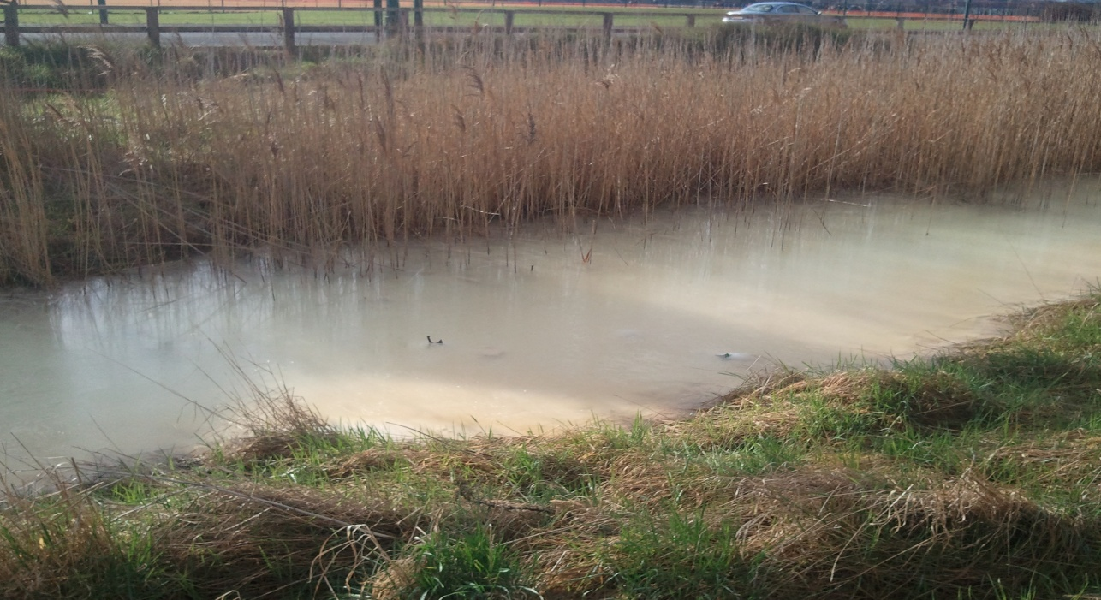
Figure 1. A highly alkaline drainage ditch at Redcar.
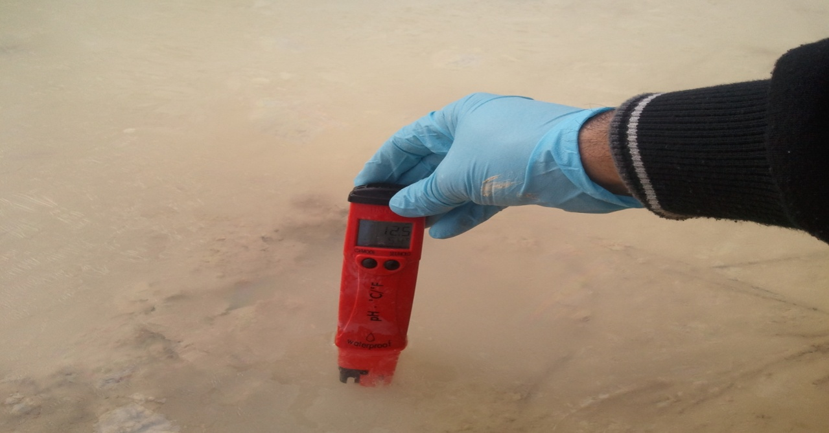
Figure 2. Sampling the pH of the Redcar water. The water and sediment have a “soapy” alkaline feel. The water is pH 12.5 and the sediment pH is 12.0.

Coatham Marsh Redcar Steelworks is a wetland nature reserve found in a low-lying coastal area of the Redcar Steelworks in Cleveland, northeast England (Mayes et al.2008). Large areas of steel slag have been dumped on the site between the 1960s and the beginning of the 1980s over superficial alluvium and glacial boulder clay lying above Rhaetic Beds and Keuper Marl of the Triassic age.

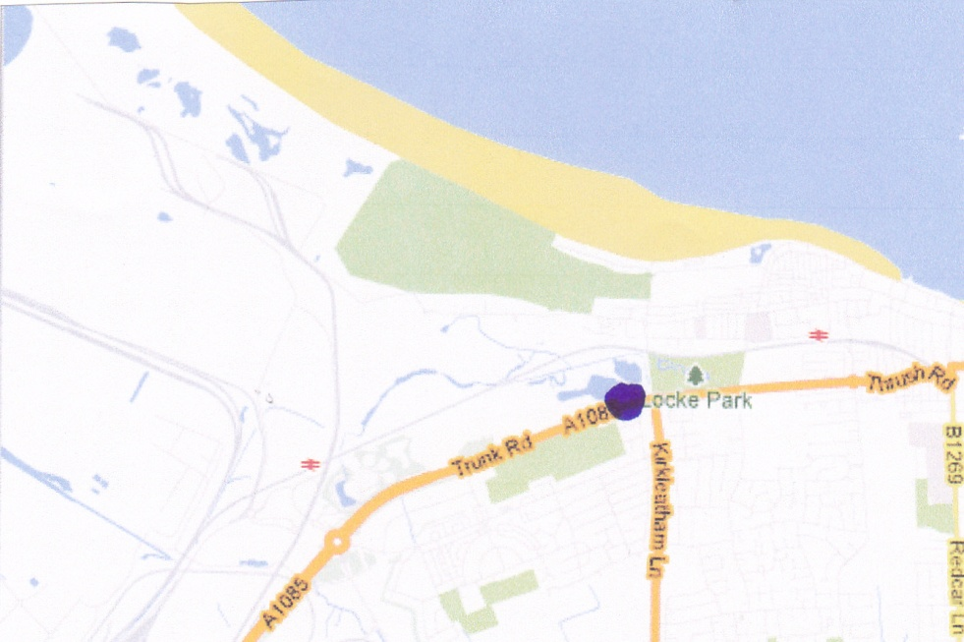

Figure 3a. Location of Redcar alkaline spoil sampling site (Grid Ref.588248).

The groundwater table lies two metres below ground surface across most of the marsh, and because of this there is a continued percolation of alkaline leachate from the slag mounds which have been left close to ground level at several sites. Two discharges of alkaline leachate enter a 0.5km length of drainage ditch to the south of the site draining steel slag mounds (Mayes et al.2008).
Steel works slag is principally of Ca and Mg silicates and alumino-silicates. Following weathering, steel slag can give rise to leachates with a high pH (pH 9-13) and which present a potential source of both ground and surface water pollution. The hydrolysis of lime (CaO) present in slag toportlandite (Ca(OH)₂) followed by dissociation in solution, produces the hydroxyl ion (OH-) which increases solution pH (Mayes et al.2008). The weathering products of Ca-silicates such as rankinite (Ca₃Si₂O₇), larnite (Ca₂SiO₄) and akermanite (Ca₂MgSi₂O₇) also provide a source of hydroxide alkalinity. Steel slag leachates are ecological worrying surface waters because the excess calcite precipitation-cover benthic habitats and reduce the penetration of light to benthic primary producers. In addition, elevated concentrations of trace elements (e.g. Cr and V) high sulphate loadings may be problematic (Mayes et al.2008). Alkaline leachate remediation usually requires high and continued capital input involving aeration and acid dosing.

1.3.3 Shirebrook Colliery Spoil
Shirebrook Colliery was a coal mine located on the perimeter of the village of Shirebrook, near Worksop in North Nottinghamshire; it was originally opened in 1861 and the Shirebrook Colliery Company was formed in 1867. In 1945, the Shirebrook Colliery Company was sold to the United Steel Company and on nationalisation it became controlled by the National Coal Board; the pit closed in 1991.
Attempts were made to cover most of the waste tips in vegetated topsoil cover, although areas still remain uncovered, leaving the original tip material exposed.
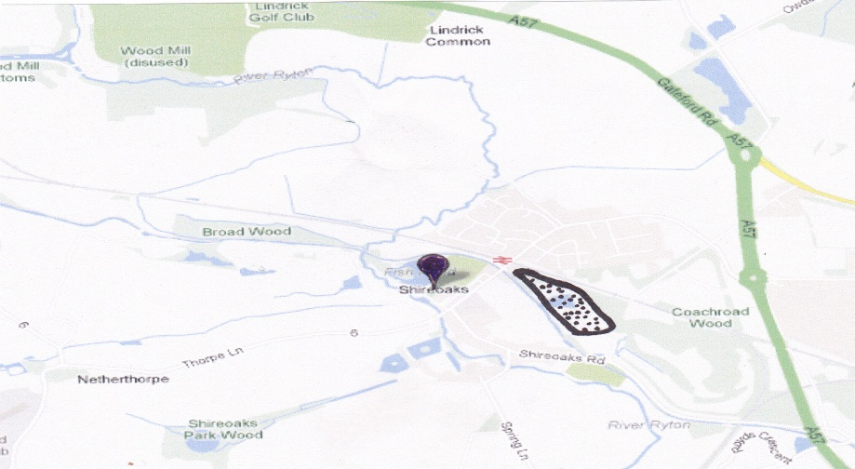
Figure 3b. Location of Shirebrook colliery spoil sampling site (dotted area
shows the location of spoil heap) (Grid Ref.SK522678).

1.3.4 Parys Mountain Spoil
Parys Mountain is located south of the town of Amlwch in north east Anglesey, Wales. It is the site of a large copper mine extensively exploited in the late 18th century. The mountain was mined for copper ore in the early Bronze Age, as shown by sub-surface debris nearly 4,000 years old revealed during excavations in 2002.
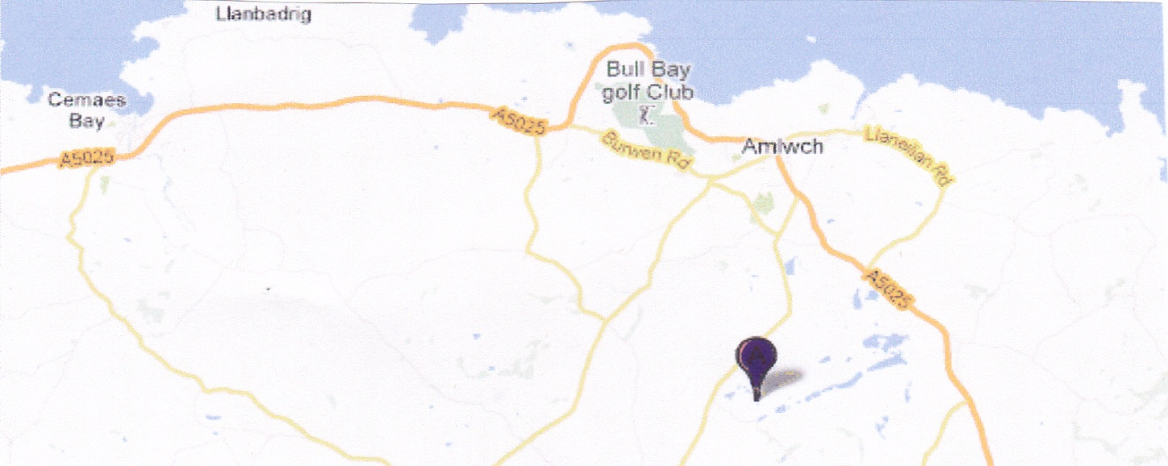
Figure3c. Location of Parys mountain sampling site (Grid Ref. 445905).

Parys Mountain dominated the world's copper market during the 1780s, when the mine was the largest in Europe. Its rise severely damaged the mining industry in Cornwall. The copper from the mine was used to sheath the British Admiralty's wooden ships of war, to prevent the growth of seaweed and barnacles and to protect the wood from attack by shipworms. This increased the speed and maneuverability of the vessels, and enabled them to remain at sea for longer as there was less need to return to port for maintenance. Since 1988, Anglesey Mining plc, which owns the western part of the mountain, has discovered resources of 6,500,000 tones containing 10% combined zinc, lead, copper with some silver and gold and has permits and a plan to restart mining operations at 350,000 tones per year. In the late 1990s, surveys of the mine's hydraulic systems revealed that a large reservoir held back by a dam in an underground working was in poor condition (Wilson and Pyatt, 2007). An assessment made at the time considered that failure of the dam was likely and that catastrophic failure could inundate parts of Amlwch causing loss of life and substantial damage to property. An added complication was that the water in the underground reservoir was highly polluted by copper and other metals and was very acidic (Wilson and Pyatt, 2007). In 2003, a carefully controlled drainage operation was carried out which dropped the water levels by 70 metres (230 ft), releasing the pressure on the dam and enabling its removal. The removal of the reservoir also gave access to many more passages and to a connection to the nearby previously inaccessible Mona Mine. Due to the high level of soil contamination little plant life survives on or near the mountain, but there are a number of examples of copper-tolerant plants and bacteria. Due to the high chemical content of the water, snottites thrive in recently submerged passages (Wilson and Pyatt, 2007).

1.3.5 Sardinia Spoil
The Iglesiente district of Sardinia, near the town of Ingleis has been a major metal mining area over many centuries. Massive sulphide ore bodies and strata bound deposits, located in the lower Cambrian limestone-dolomite formation, have been extracted by approximately 40 mines spread over about 150 km² (Ardau and Rundeddu, 2001). The main minerals which were extracted from this area include sphalerite, galena, pyrite, and sometimes barite and the occurrence of large amounts of underground water severely hindered mining in this region, necessitating the use of pumping stations at the Monteponi mine to depths of 200m below sea level. The groundwater extracted from the Monteponi mine proved to be highly saline (Cl concentrations in excess of 12 g/l) (Ardau and Rundeddu, 2001). The main metals which were extracted from this area were Pb, Cd and Hg. The presence of several abandoned open pits, large amounts of tailings, mine waste dumps and flotation ponds distributed across the Iglesiente district, still pose a potential hazard to local water courses (Ardau and Rundeddu, 2001).
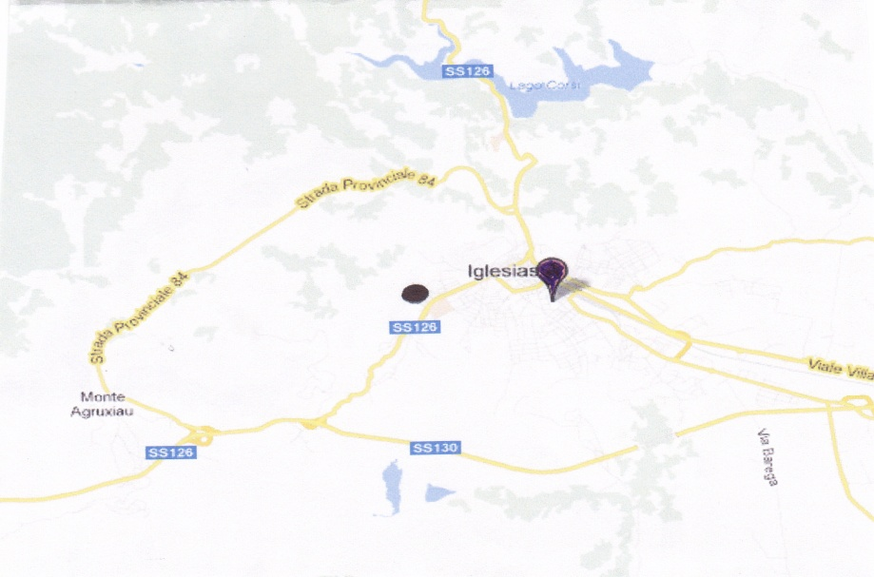
Figure 3d. Location of Sardinia mine waste sampling site.

It is estimated that some 3.5 million tons covers the Iglesias valley and this is distributed over some 180,000 m_{2.} So-called “Red Muds” were dumped between 1926 and 1983. Around 2 million tons of these materials litter the landscape and they are derived mainly from sulphuric acid attack on the oxidized ore (i.e. smithsonite and goethite). This material is extremely fine (about 62% < 40 m in size) and contains large amounts of iron oxides (45 % Fe₂O₃) and metals including 8.8 % Zn, 1.1 % Pb, 0.04 % Cd, and 0.4 % Mn. High Mn contents result from the use of pirolusite (MnO2) in the ore processing (Ardau and Rundeddu, 2001).
The area studied has a semi-arid climate with rainfall ranging from 400 to 900 mm/y, interspersed with long periods of drought. The long-term mean of precipitation is 600 mm/y with an average of 50 days of rain. The mean annual temperature is 17 °C, evapotranspiration about 57 % and runoff 24 % (Ardau and Rundeddu, 2001).

Aims of the Present Study
The overall aim of the work reported here was to conduct a wide screening of various industrial soils and spoils for a variety of microbe-mediated process which are essential from soil fertility and determine how these processes are influenced by factors such as soil pH etc. This research aims to study important microbial processes related to soil fertility in ten industrial spoils, namely an alkaline (steel waste Redcar) spoil and vegetated colliery and non-vegetated colliery waste soil, two samples from a Sardinia soils iron mining waste (Black ash tip and salt stream bed) and four soils samples from Anglesey, Parys Mountain spoils (labeled i.e. Brown, Red, Yellow, Dark Brown).

Chapter Two

The influence of selected soil parameters on the mobility of heavy metals in soils

INTRODUCTION
The degree of mobility of metals and their compounds present in the soil varies considerably and their bioavailability is regulated by physical, chemical and biological processes and the interactions between these factors (Selim, 2013). The binding of heavy metals, and hence their bioavailability, depends on organic matter content, the occurrence and form of cations, pH values, sorption capacity, the macro and micronutrients content, oxidation-reduction potential, activity of microbes and bioavailability to plants and animals. The mechanical make up of soil is a major factor which determines the extent of soil heavy metal contamination and their content within plant tissues. Factors such as heavy, compared to light soils, large amounts of suspended fraction, lead to greater ability to retain metallic elements. Light soils, on the other hand, tend to lack these abilities (Ross, 1994).
The forms in which heavy metals occur in soil significantly affect their mobility; the most mobile elements being Cd, Zn and Mo, while the least mobile are Cr, Ni and Pb (Alloway, 1995). Soil pH is particularly important in determining the concentration of metals in the soil solution and thereby their mobility and availability to plants. Increased hydrogen ion concentration affects the mobilisation intensity of heavy metals. In highly acidic soils therefore the mobility of metallic elements is much higher than in soils with neutral and alkaline reaction. The oxidation - reduction potential of a soil significantly determines the form of a mobile element (Alloway, 1995, Ross, 1995).
Every plant needs the appropriate amounts of mineral salts, (i.e. macronutrients and micronutrients for growth and development). Plants draw heavy metals from the soil through the root system in a similar way as they do macronutrients and micronutrients Selim, 2013). The uptake rate by the roots of metallic elements depends on the chemical form in which they occur, and insufficient amount of micronutrients in the soil often results in the excessive accumulation of a number of heavy metals in plants, while correctly balanced levels of soil nutrients ensures high yields with a low heavy metal content. Stress which develops due to an excess of heavy metals tends to disturb the metabolism of plants leading to disturbances in the uptake, transport and assimilation of macro-and micronutrients (Ross, 1995).
Metallic elements accumulated in the soil inhibit soil microbes and adversely affect the decomposition and transformation of organic matter. Microbial activity in rhizosphere is also a major factor influencing plant growth and its ability to resist plant pathogens
Large areas of land are by heavy metals, notably by cadmium, zinc and lead which generally causes a reduction in productivity and quality of agricultural products (Alloway, 1995), Heavy metals are not readily leached and remain in soil for long periods. Factors which influence the binding heavy metals, and therefore their bioavailability include mineral composition, organic matter content, occurrence and type of cations, soil pH, sorption capacity, macro and micronutrient content, oxidation-reduction potential, microbial activity, and bioavailability in relation to plants and animals. All such factors also determine how many metallic elements accumulated in biological material and what proportion will be subjected to the process of sorption, complexation, and immobilization on soil particles. Clay fractions have a particularly marked potential for binding heavy metals (Selim, 2013). However, sandy soils having low sorption capacity and acidity, weakly absorb heavy metals, enabling them to become mobile in ground and surface water. The binding of metal cations increases in clay soils with increased valence, atomic weight and ionic potential in the following series. Cu₂⁺ >Cd₂⁺ > Fe₂⁺ > Pb₂⁺ >Ni₂⁺ >Co₂⁺ >Mn₂⁺ >Zn₂⁺. Hydroxides of Fe, Mn and Al all play a major role in the binding of heavy metals by the soils mineral phase. Mostly hydrous oxides of Fe, Mn and Al contribute to the formation of the coating on crystalline particles in the soil solid phase, although metals together with the compounds of Fe, Mn and Al are easily displaced in suitable conditions (Alloway, 1995, Ross,1995).
Absorption of heavy metals by plants mainly depends on the mechanical composition of soils. Heavy soils tend to have a marked ability to retain metallic elements. On the other hand, light soil does not have such as sorbtive ability. Metallic elements which are readily water are mobile in the soil profile, and thus readily available to plants. On the other hand, carbonate, oxide and organic forms are usually not mobile, and as a result are less available (Ross,1995).
Soil pH is considered as one of the major factors which determine the concentration of metals in the soil solution, their mobility and availability to plants. In highly acidic soils, the mobility of metallic elements is much higher than in soils with neutral and alkaline reaction. Mobility of metals in soils with low pH tends to decreases in the order. Cd >Ni >Zn >Mn >Cu > Pb (Selim,2013). The effect of soil pH on the mobility of metallic elements is however, highly variable and depends on the content and type of organic matter. In alkaline soils with a pH range there is the possibility of heavy metal complexation with the increased mobility and bioavailability. Usually root uptake of metals by plants decreases with increasing soil pH to about pH 6.5-7.5 (Alloway, 1995, Ross, 1995).
The microbiology of industrial wastes and their potential damaging effect on the microbiology and biogeochemistry of the environment depends upon two main factors, a) their composition in relation to toxicants and b) the availability of these toxicants. The latter depends on factors such as the water solubility of the toxicant and on whether microbial activity can produce agents which make the toxicants more soluble and therefore more available to both microorganisms and macro-organisms. An increase in spoil acidity, induced by microbial activity, for example is likely to lead to an increase in the availability of toxic metals, while complexation by both soil/spoil and microbes will lead to metals being taken out of solution (even if only temporarily) and thereby reduce the toxic effects of metals to the environment (Selim, 2013). An example of the latter would be the formation of metal sulphides resulting from the microbial production of hydrogen sulphide under anaerobic conditions (Alloway, 1995, Ross, 1995).
Application of the Munnecke technique to screen for toxicant availability
There are two main ways by which the availability of toxicants can be determined. Firstly, the concentration of the water soluble toxicant (or another extractant which correlates with toxicant availability) can be determined in the soil or spoil; if this is, for example, a toxic metal such as mercury, then its concentration can be determined by atomic absorption spectrophotometry and related to known toxicity values of mercury against the organisms under study. Secondly the availability and potential adverse effects of a toxicant can be determined by the use of a bioassay. Here, a known susceptible organism is exposed to the environmental sample (or a water, or other bioavailable extract) and its toxicity determined. The test organism is usually a microbe, but could be a plant such as cress, or an animal (Munawar, 1989).
The Munnecke technique is a bioassay which can be applied to a variety of studies on environmental pollution. Classically, it is used to determine the rate of degradation of fungicides in soils, but it can also be modified to determine the effects of any toxicant which has an inhibitory effect on fungi (Munnecke, 1958). It can also be modified by the replacement of the fungal test organism with bacteria (Fig. 4), or possibly an alga. The main advantage of using this technique is that the test organism is exposed directly to the soil or spoil sample under test, so that the method tests the overall availability and toxicity of any toxicants in the sample. It also determines the overall availability of the sample to the test organism and therefore acts as an indicator of the potential overall availability of the sample to the biology of the environment under study.
The aims of the work conducted here was to determine the availability of metals present in the spoils to a test bacterium; it was assumed that such a test would provide a means of detecting the avialability of metals in the spoils to microbes and plasts.
The effect of biological processes on metal contamination and the potential for bioremediation are all dependent on the nature of the site and the composition of the chemical environment. In soils and sediments the potential ecological and or public health hazard relating to the toxic metals depends upon the form in which it is present and mineral components, may contain considerable quantities of metal which are unavailable to organisms, while soluble metal species will show greater mobility and bioavailability. Biological processes can solubilize metals and increase their bioavailability and potential toxicity, or immobilize them and thereby reduce their bioavailability(Selim, 2013). The relative balance between mobilization and immobilization varies depending on the organisms, and environment factors, notably varying physico-chemical conditions. In addition to being a key component of natural biogeochemical cycles for metals, these processes may be exploited when contaminated solid and liquid wastes undergo treatment. Metals can be mobilized by a range of microbes and processes including autotrophic and heterotrophic leaching, chelation by microbial metabolites and siderophores, and which results in loss of the metal due to volatilization (Meuser, 2013). In addition many microorganisms contribute to immobilization by sorption to cell components or exopolymers, transport and intracellular sequestration or precipitation in the form of insoluble organic and inorganic compounds, such as oxalates, sulfides or phosphates. Depending on the metal and its detailed chemistry, biologically mediated reduction of high-valency species may affect mobilization, for example, Mn (IV) to Mn(II), or immobilization, e.g., Cr(VI) to Cr(III). The solubilization of metal contaminants provides a way of removing metals from soils, sediments and industrial wastes by, e.g., acid leaching or chelation (Lens,2005). On the other hand processes such as precipitation allow metals to be transformed in situ into insoluble, chemically inert forms. Immobilization processes are particularly applicable to the removal of metals from mobile phases including groundwaters and leachates. Sulfate reduction and the precipitation of toxic metals as sulfides, interacts with microbial organic acids thereby leading to the mobilization or precipitation of metals. Metalloid biotransformations which involve reduction or methylation are also important processes (Wise, 2000).

Metal precipitation by sulphate-reducing bacteria
Sulfate-reducing bacteria are heterotrophic bacteria which require strict anaerobic conditions having an E_{h} of less than −200 mV (Wise, 2000). The main organic carbon/energy substrates used by these organisms (e.g., Desulfovibrio species) are low molecular weight organic acids such as lactic or acetic acid and alcohols such as ethanol. Carbon dissimilation is essentially similar in all cases in that the organic substrate is oxidized either completely to CO₂ or to some intermediate compound. Adenosine triphosphate (ATP) is generated via an electron-transport chain with sulfate as the terminal electron acceptor which is reduced to sulfide. Sulphide generation produces a variety of consequences which are important to the environment and to biotechnological metal removal (Lens, 2005). These are the formation of reducing conditions, the removal of acidity and precipitation of metals from solution as sulfides. The most important means by which sulphate-reducing bacteria remove toxic metals from solution is as the result of the formation of metal sulfide precipitates (Selim, 2013). The solubility products of most toxic metal sulfides are very low so that even a moderate output of sulfide can effectively remove metals (Agatha’s and Reineke, 2002). Sulfate-reducing bacteria also produce conditions which promote the chemical reduction of metals such as uranium (VI) to uranium (IV). Sulfate-reducing bacteria are almost uniformly mesophiles with show maximum growth in the range pH 6–8. Some isolates can however, grow in moderately acid conditions (pH in the range 3–4). Both sulphate reduction and metal reduction involves the use of protons and therefore leads to the formation of alkalinity in the environment (Meuser,2013). The direct effect of this on the pH of waste-waters may be beneficial as in the case of acid mine drainage. The solubility of most toxic metal compounds, including sulphides, is also lower at neutral than at acidic pH, as a result alkalization enhances the removal of metal as sulfides; as well as lowering the solubility of metal sulphides, an increase in pH also contributes directly to precipitation of certain metals (Lens,2005).

Methylation of metalloids
The microbial methylation of metalloids to yield volatile derivatives such as dimethylselenide or trimethylarsine involves a variety of bacteria, algae and fungi (Rogers, 1975). Bacteria and fungi are important in volatilization of selenium from soils and sediments, the mechanism for selenium methylation appearing to involve the transfer of methyl groups as carbonium (CH⁺₃) ions via the S-adenosyl methionine system (Rogers, 1975). There is also evidence for the production of dimethyltelluride and dimethylditelluride by a Penicillium sp. (Alexander,1977, Lens, 2005). Several bacteria and fungi species can also methylate arsenic compounds, including arsenate (As(V), AsO³⁻₄), arsenite (As(III), AsO⁻₂) and methylarsonic acid (CH₃H₂AsO₃) to volatile dimethyl- ((CH₃)2HAs) or trimethylarsine ((CH3)₃As). The methylated derivatives of arsenic are usually less toxic than organic forms (Alexander,1977).
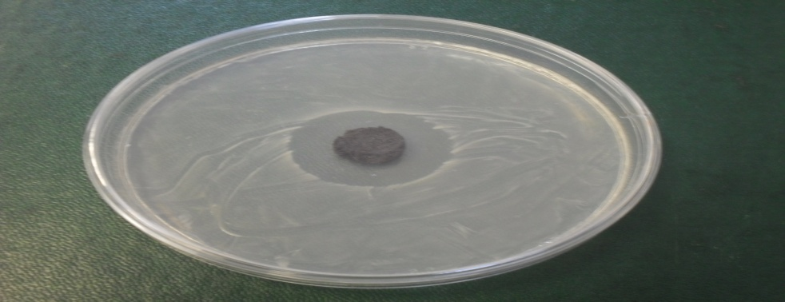
Figure 4. Munnecke technique showing a soil plug, bacterial inoculants and zone of inhibition produced by mercury chloride added to the soil prior to the production of the soil plug.

MATERIALS AND METHODS
The following spoils were used in this study.
    - Alkaline. steel waste from Redcar.
    - Agricultural spoil. control for comparison.
    - Vegetated colliery spoil.
    - Non-Vegetated colliery spoil.
    - Sardinia Black Ash – Tip spoil.
    - Sardinia Salt stream bed spoil.
    - Anglesey Parys mountain –Brown- spoil.
    - Anglesey Parys mountain –Red- spoil.
    - Anglesey Parys mountain –Yellow- spoil.
    - Anglesey Parys mountain –Dark Brown- spoil.

The spoils under tests were moistened with sterile distilled water, sufficient to produce a paste which was capable of standing after being formed into a small column. A sterile plastic ring (12 mm diameter and 10 mm high) was then filled with the moistened spoil and the resultant plug was extruded onto the surface of Nutrient Agar media and applied with gentle pressure; the plates had previously been inoculated with (100µl) of an overnight culture for Bacillus Sp., optical density adjusted to a value of 1.000 at 600 nm. Prior to use of the bioassay, this organism was shown to be susceptible to low concentrations of mercury, copper and lead. Any resultant zone of inhibition was noted, and if a zone formed its diameter was measured.

Results and Discussion
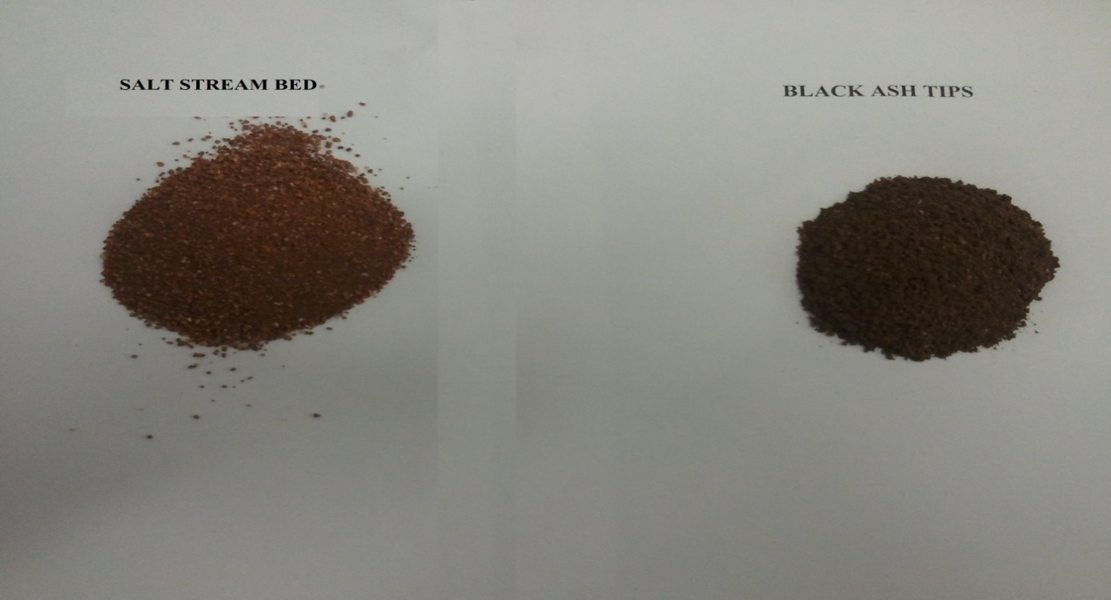
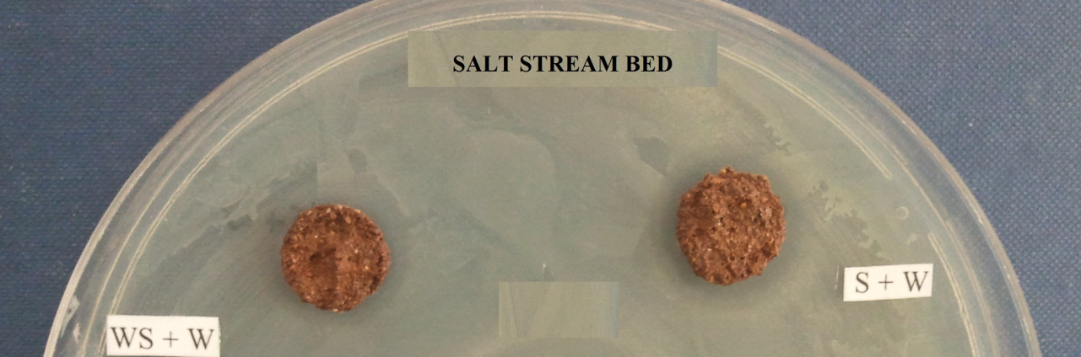
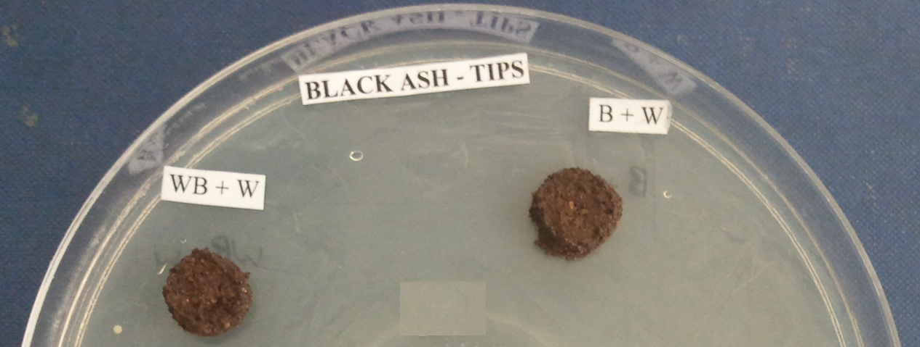
Figure 5. Sardinia salt steam bed and black copper-rich ash assayed for metal availability using the modified Munnecke technique.

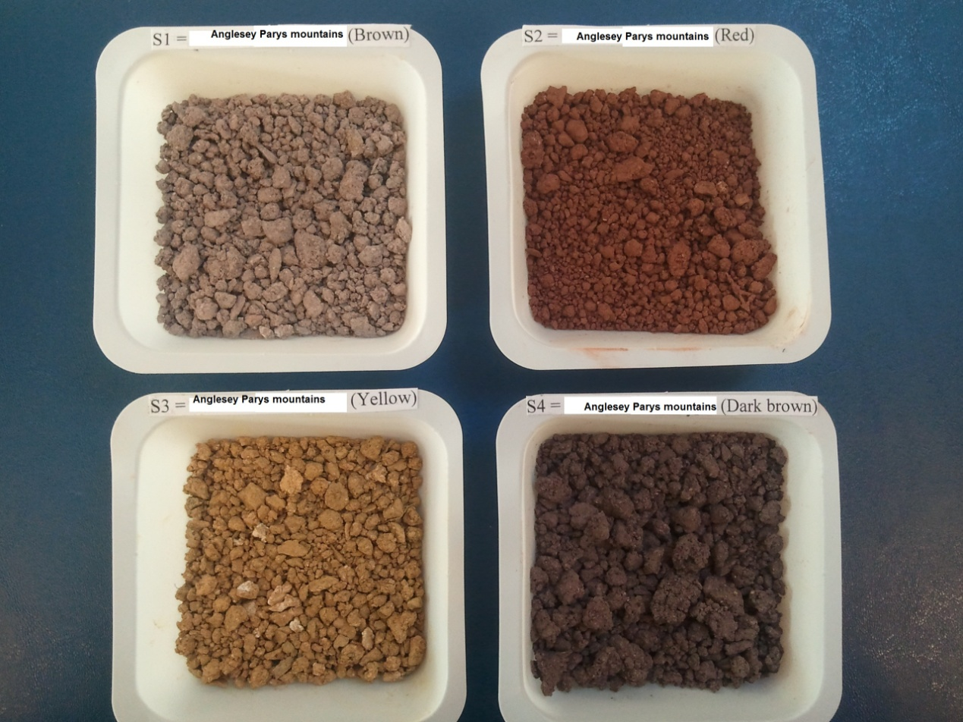
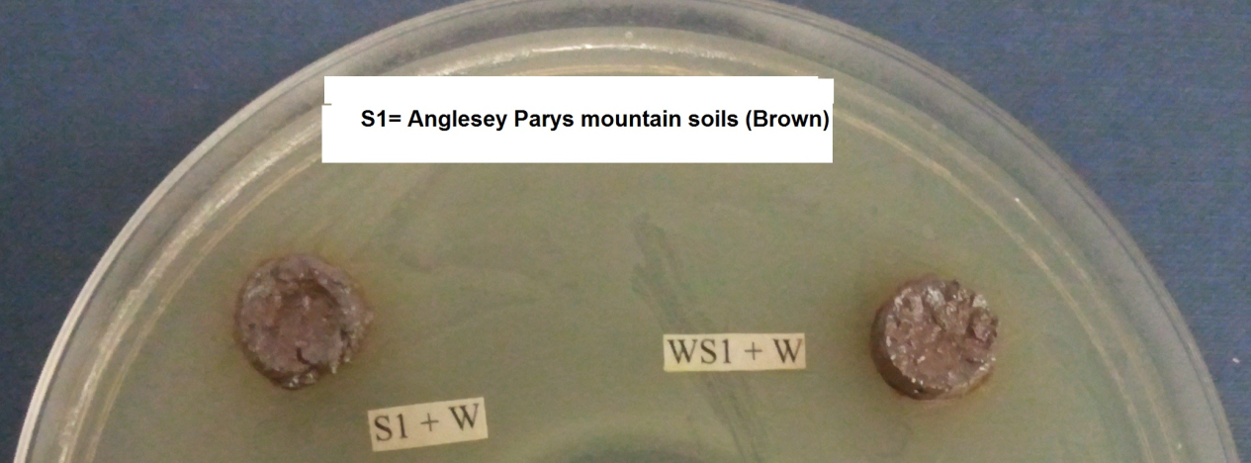
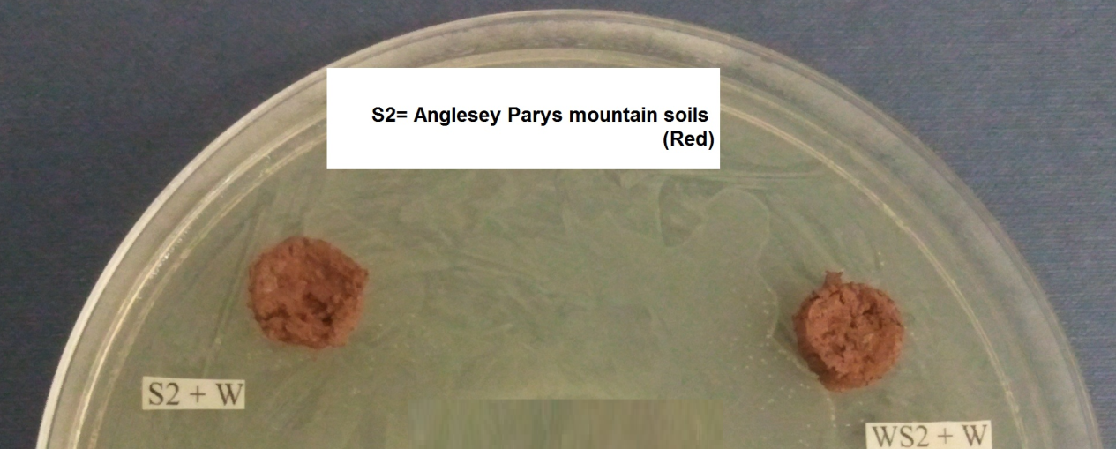
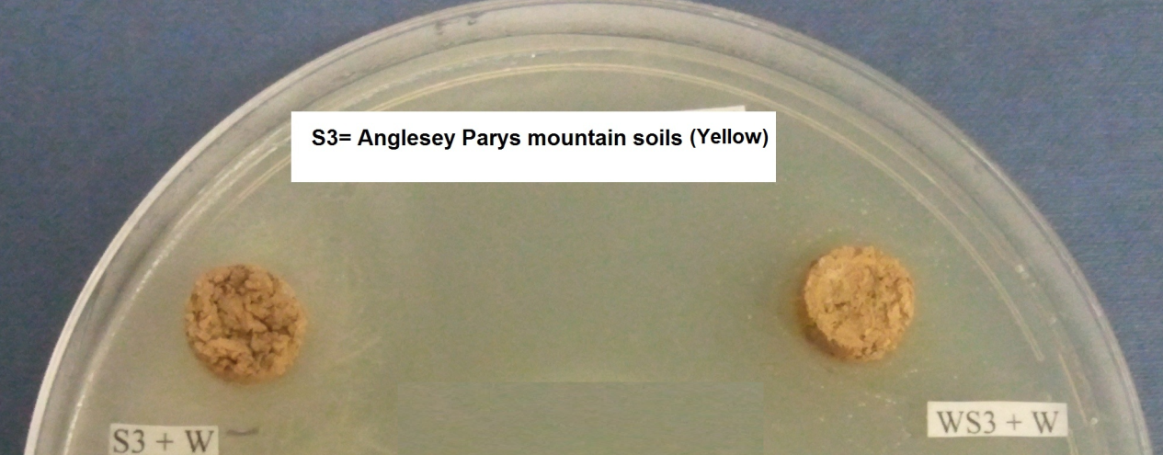
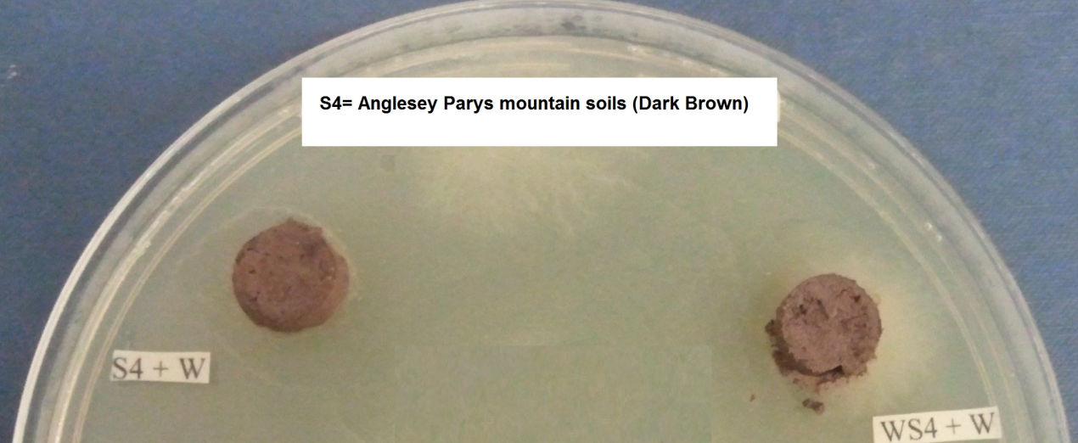
Figure 6. Parys Mountain spoils assayed for metal availability using the modified Munnecke technique.
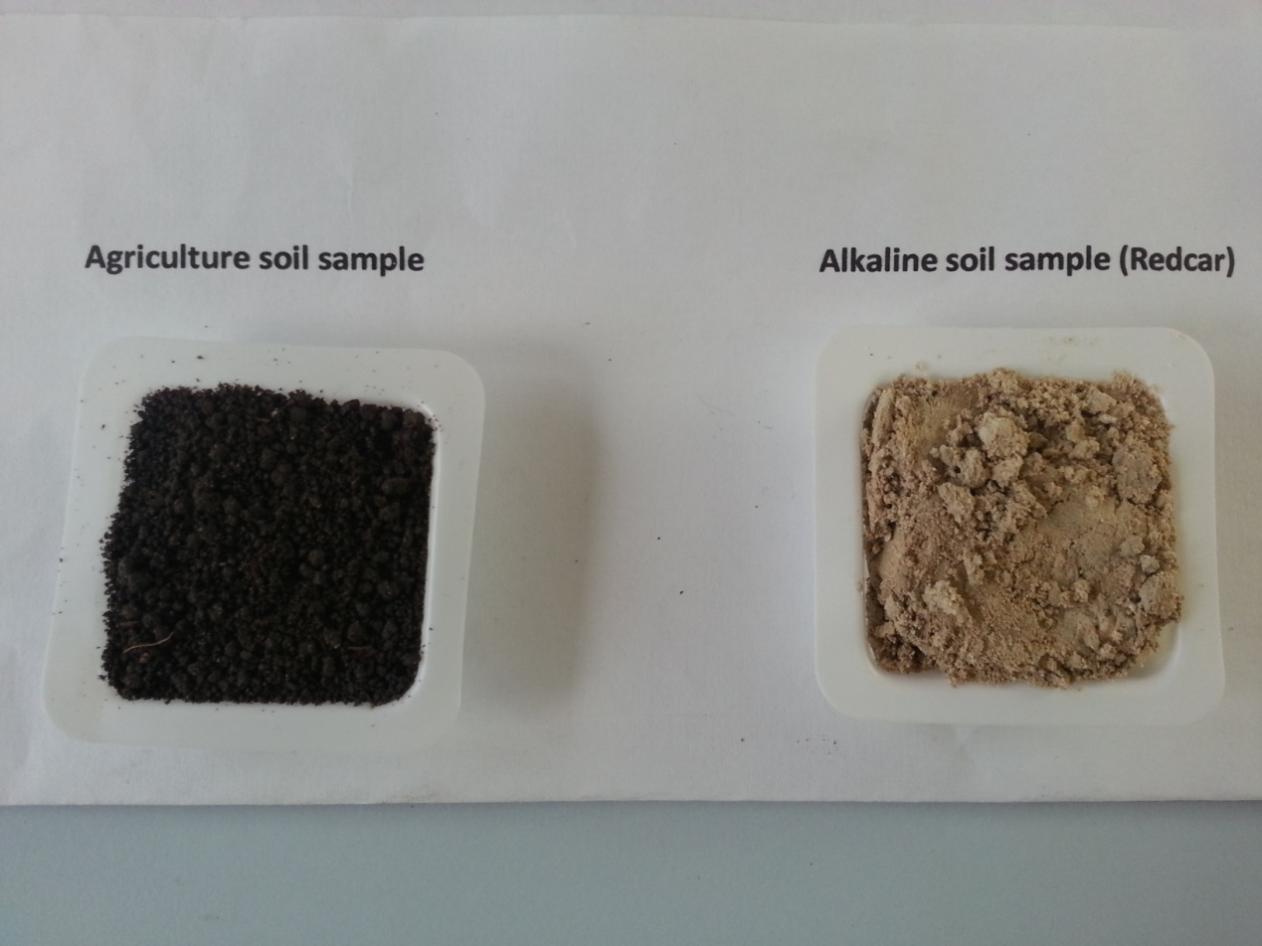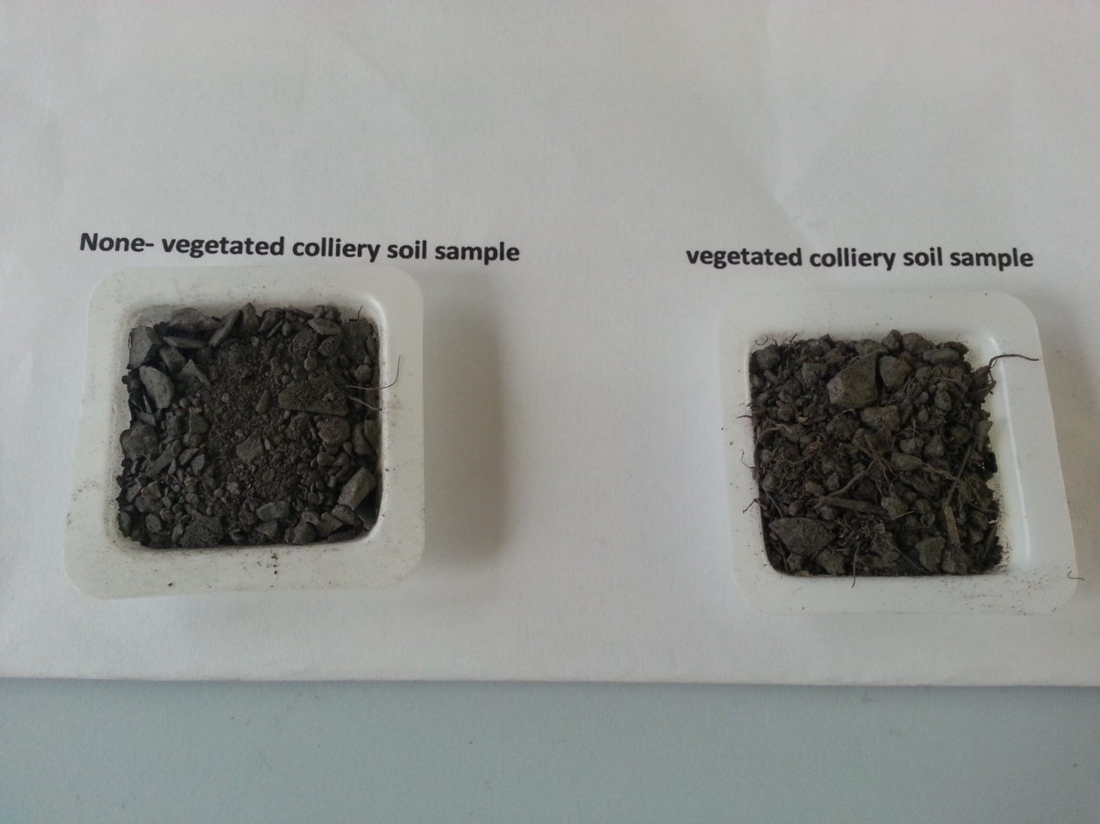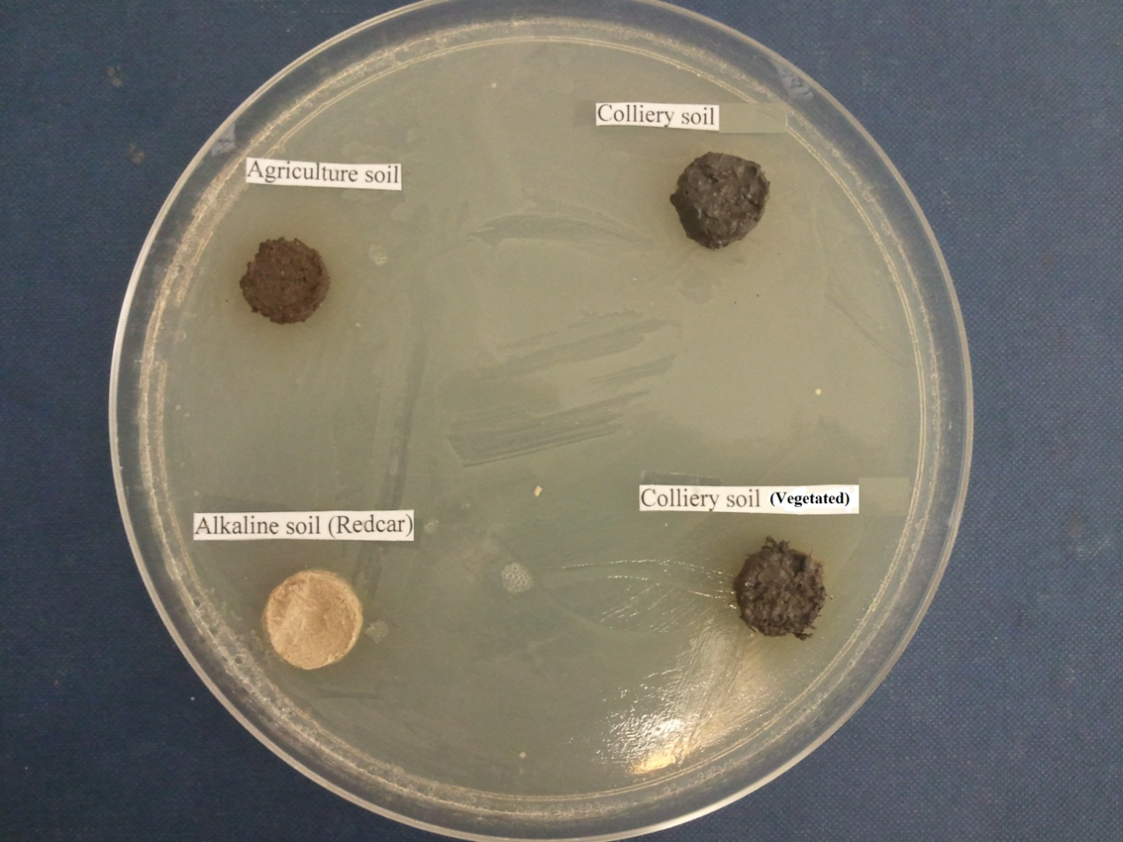
Figure 7. Agricultural soil, alkaline Redcar slag and colliery wastes assayed for metal availability using the modified Munnecke technique.
It is important to note at the outset that the Bacillus species and culture of E.coli used here were tested to show that they were susceptible to low concentrations of sodium chloride, mercury and copper they should therefore act as suitable bioindicators for testing the availability of these toxicants in the spoils. Susceptibility to metals varies in terms of toxicant concentration, but a bacterium that is susceptible to one metal, for example copper, is usually susceptible to others, so the application of these two bacteria as bioindicators should have detected some level and type of toxicant were it present, and or available.
Since no zones of inhibition were produced around the soil or spoil plugs, the results show that none of the samples studied here show evidence of water soluble toxicant metals. This result could, of course, have be due to either to the technique being too insensitive and not being able to detect water soluble metals, or that no water soluble metals were present. It seems likely that the latter possible was the case and no water soluble toxicants were present, at least not in sufficiently high concentrations to produce a bacterial inhibition zone. These results point to the likelihood that the industrial wastes studied here do not contain large amounts of readily water soluble and available toxicants, such as heavy metals which could adversely affect the biogeochemistry of these spoils. Mining areas such as Parys Mountain and the Sardinia copper waste samples are known for possess high levels of total metals, like the ones used in the bioassay, many of which are toxic to bacteria used here. The fact that no inhibition zones were produced under assay conditions shows that none of the toxic metals are likely to be present in these spoils are available to inhabit bacteria and other organisms in areas such as Parys Mountain. The question may then be asked. Why are parts of the Parys Mountain landscape devoid of vegetation including common grasses? This lack of vegetation is usually put down to the presence of metal toxicity (although other factors such a spoil slope and water availability may also be involved). Another possibility is that plants, including germinating seeds, produce local concentrations of acids, as well as chelating and sequestering agents which will make metal toxicants locally available to inhibit their growth. Thus while an area of mine waste may be shown to be non toxic, because the metals are a) bound up, b) not water-soluble and c) not available to plants, localised availability may occur around plant roots and be sufficient to prevent the revegetation of these areas. Plants such as the grass Agrostis can of course develop metal tolerance, especially where they can form associations with ectotrophic mycorrhizae (Gregory and Bradshaw, 1965).
In conclusion, the Munnecke bioassay technique as used here is useful for testing the bioavailability of metal contaminated soils, but it does not tell the whole story, since localized bioavailability around plant roots and decaying organic mate may occur, such that toxicants are released to inhibit localized plant growth, processes which do not occur in bulk soil.

Use of test strips to determine if water extractable metals are present in the spoils
The concentration of metals in soils can be determined in a number of ways, by employing different extractants. The most aggressive extractant employs a mixture of concentrated acids to give measure of the total concentration of metals. Other extractants like diluted acids, EDTA, and/or ammonium acetate only partly extract metals from soil; usually, EDTA/ ammonium acetate is considered to reflect the concentration of mobilisable metals which plants can use and metabolise, or which are available to act as toxicants. Based on the comparison between the HCl, EDTA, DTPA, CaCl₂, and H₂O single extraction procedures it can be concluded that HCl, EDTA, and DTPA procedures are the most reliable in relation to predicting the bioavailability of Pb and Ni in soils to wheat grains, but they failed at accurately assess the bioavailability of Cu, Mn, Zn; the HCl, EDTA, and DTPA (diethylene triamine pentaacetic acid) extraction procedures were however, useful for assessing the bioavailability of Ni and Pb (Bakiricioglu et al, (2011).

Chapter Three

STUDIES ON TRANSFORMATIONS OF SOIL NITROGEN, SULPHUR AND PHOSPHORUS IN INDUSTRIAL SPOILS

INTRODUCTION
The waste spoil environment is very nutrient-deficient, and as a result, fertiliser treatment is often needed to promote plant growth and to maintain soil fertility. However, the presence of toxicants, such as heavy metals (if present in a form which is available to microbes) will hinder the functioning of these major nutrient cycles and thereby reduce soil fertility and plant growth; a factor which will be particularly relevant to attempts to bioremediate such spoils. The aim of the work reported in this Chapter was to determine if such important transformations occur in the spoils under study; the results are compared with those obtained from a fertile, agricultural soil.

3.1.1 TRANSFORMATIONS OF SOIL NITROGEN

3.1.1.1 Nitrogen cycle
The world’s ecosystems are probably influenced more by deficiencies or excesses of nitrogen than by those of any other essential element (Richards, 1987). The pale yellowish green foliage of nitrogen-starved crops is a forerunner of crop failure, financial ruin, and hunger for people across the world. Excess of some nitrogen compounds in soil can, on the other hand, adversely affect human and animal health and can have a negative effect on environment quality since high soil nitrate can lead to high nitrate levels in drinking water which are dangerous to human health (notable in infants) as well as ruminants (Killham, 1994).
As it passes through the nitrogen cycle, a nitrogen atom may appear in many different chemical forms, each with its own consequences for ecosystem. Such a cycle explains why vegetation and, indirectly animals can continue to remove nitrogen from soil for centuries without depleting the soil of this essential nutrient; the biosphere does not become depleted in nitrogen, because it uses the same nitrogen over and over again. The nitrogen cycle has long been subjected to intense scientific study since an understanding of the transformations of this element is fundamental to solving many environmental, agricultural, and natural resource problems (Killham.1994).Nearly all of the nitrogen found in surface soil horizons is organic, in the form of complex organic nitrogenous substances as proteins, chitin, nucleic acids, purine and pyrimidine bases and amino sugars. The simplest form of nitrogen involved in biological transformations is the gaseous elementary nitrogen form, (i.e. dinitrogen) (Alexander, 1977).
Organic nitrogen is transformed into nitrate (NO₃⁻) nitrogen through a sequence of microbial reactions. This sequence of changes from atmospheric to fixed inorganic nitrogen, to simple compounds in the tissues of plants, animals, and microorganisms, and the eventual release of this nitrogen back to atmospheric nitrogen; all of these transformations constitute the N cycle (Richards, 1987).
3.1.1.2 Ammonification or N-mineralization
The great bulk (95-99%) of the soil nitrogen is in the form of organic compounds present as amine groups (R-NH₂⁻) which are largely in proteins or as part of humic compounds (Richards, 1987). When soil microbes attack these compounds, simple amino compounds (R-NH₂⁻) are released. A wide range of microbes can then deaminate amino acids (e.g. bacteria, actinomycetes, and fungi) leading to the release of ammonium and ammonia gas. Ammonia (NH₃) is a waste product of microbial metabolism, and any NH₄-N accumulating in soil represents the quantity of substrate nitrogen in excess of microbial requirements (Richards, 1987). The production of ammonium is referred to as ammonification. Ammonia is volatile and exits the soil; if it is dissolved then the ion, NH₄ is formed. This ion can then be accumulated and used by plants and microorganisms and, under favorable conditions, be oxidized to nitrate, via nitrite (Killham, 1994).

3.1.1.3 Nitrification
Soil nitrification involves the oxidation of ammonium, via nitrite, to nitrate; this is an over simplification, however, and recently the definition of this process has been extended to include “the biological oxidation of any reduced form of nitrogen to a more oxidised form”. It is generally accepted that the dominant type of nitrification occurring in most soils is chemoautotrophic and is largely carried out by the Gram-negative bacteria Nitrosomonas and Nitrobacter (Killham, 1994).
Nitrification is of major importance for the nitrogen cycle in both aquatic and terrestrial environments. During nitrification ammonium is oxidized to nitrate, which is a mobile ion in the soil. The oxidation of reduced organic or inorganic nitrogen to nitrate, which is mediated by heterotrophic organisms, is referred to as heterotrophic nitrification (Killam, 1986), whereas the oxidation of reduced inorganic nitrogen to nitrate by autotrophic organisms is termed autotrophic nitrification. Heterotrophic nitrification is a co-oxidation process not coupled to growth, and generally of limited importance Killham (1994). Generally however, autotrophic bacteria carry out the nitrification process (Killham, 1986). These bacteria use reduced inorganic nitrogen as an energy source and carbon dioxide as the source of biomass carbon. Hence, the nitrification process may more correctly be called chemolithoautotrophic nitrification. It appears that chemoautotrophic nitrification dominates in agricultural soils, whereas a role for heterotrophs has been implicated in nitrification in acidic soils (Schmidt, 1982).
In recent years, our understanding of the ecology of soil nitrification has changed considerably. The first development has been the recognition that nitrification is not as restricted by soil pH as was traditionally thought. The second aspect of this change in our understanding about nitrifier ecology is that two types of nitrification are now recognised; chemoautotrophic and heterotrophic nitrification (Killham, 1994).

3.1.1.4 Chemoautotrophic nitrification
Autotrophic ammonium oxidation is a two-step process, involving the oxidation of ammonium to nitrite and the subsequent oxidation to nitrate. These two steps are carried out by ammonia-oxidising bacteria (AOB) and nitrite-oxidising bacteria (NOB), respectively. The energy that is liberated during these processes can be used by the organisms involved as a sole source of energy for both carbon dioxide fixation and growth (Alexander, 1977). All of (AOB) which have been isolated and characterized have turned out to be gram- negatives, obligate aerobic and obligate chemolithoautotrophs, and together with the nitrite-oxidizing bacteria, they comprise the family Nitrobacteraceae. Ammonia oxidisers are classified on the basis of shape, membrane constituents, and G+C contents. Nitrosomonas and Nitrosospira have been identified as the most common NH₄ oxidisers in non-acidic soil.
The oxidation reactions provide the energy to the organisms require for cellular processes. Nitrification is carried out in two stages.
1- Oxidation of ammonia to nitrite by Nitrosomonas
NH₄ + 1 ½ O₂ NO₂+ 2H + H ₂O +275 k j energy
2- Oxidation of nitrite to nitrate by Nitrobacter
NO₂ + ½ O₂ NO₃ + 76 k j energy
The main chemoautotrophic nitrifiers are species of Nitrosomonas, Nitrosopira, Nitrosococcus, Nitrosovibrio, Nitrosolobus and Nitrobacter, Nitrococcus, Nitrospira; bacteria with the prefix “Nitroso” oxidize ammonium to nitrite, while those with the prefix “Nitro” oxidize nitrite to nitrate (Killham.1994).

3.1.1.5 Heterotrophic Nitrification
The ability of heterotrophs to oxidize reduced forms of nitrogen has long been recognised. Mushustin, for example, demonstrated the formation of nitrite from organic nitrogen by a strain of Bacillus in 1926 (Focht and Verstraete, 1977) although the involvement of heterotrophs in nitrification was first suggested as early as 1894. A wide range of bacteria and fungi possess the potential for heterotrophic nitrification, and the range of transformations includes the oxidation of both organic and inorganic nitrogen compounds. In contrast to ammonium oxidising bacteria (AOB), the oxidation of ammonium by heterotrophs is not linked to cellular growth (Boer and Kowalchuk, 2001). In fact, heterotrophic nitrification, as it called, is not an uncommon microbiological phenomenon, at least in vitro, though its biogeochemical significance in the environment may be limited. Unlike the autotrophs, heterotrophic nitrifiers can oxidize organic forms of nitrogen such as hydroxylamine, amino acids, peptones, oximes and certain aromatic compounds (Pennington and Ellis, 1993). Two groups of heterotrophic nitrifiers exist, one which is capable of oxidizing ammonium and other various organic nitrogen compounds. Among the ammonium oxidisers are the actinomycete genera Streptomyces, Nocardia and Micromonospora, the bacteria Bacillus and Pseudomonas, and representatives of several fungal genera including Aspergillus, Mortierella, Penicillium and Mucor (Abbot, 1923, Wainwright, 1981). The second group of heterotrophic nitrifiers produce mainly nitrate from a variety of organic nitro-compounds such as the pyruvic, oxaloacetic and α-ketoglutaric acids, and from peptones and amino compounds. Among the organisms reported to do so, include the following bacteria. Agrobacterium Alcaligenes and Corynebacterium, the actinomycetes Nocardia, and various fungi, notably, Aspergillus flavus, A. ustus, Cladosporium herbarum and Penicillium citrinum. Evidence that fungal nitrification is ecologically significant remains however, largely circumstantial. For example, nitrate production takes place rapidly in some soils despite the presence of apparently low populations of autotrophic nitrifiers, or where the latter have been inhibited by bacteriostatic agents. Fungal nitrification is likely to be less limited by acidic conditions and should be more resistant to drought stress and alleleopathic chemicals than will autotrophs. Heterotrophic nitrifiers are also known to be capable of producing nitrate from both inorganic and organic sources (Killham, 1994).

3.1.1.6 Nitrate reduction
Once NO₃ is formed in soil, it is subjected to the following fates;
- It may undergo denitrification by microbes to gaseous oxides of nitrogen and to N₂ (dinitrogen).
- It may be used as an N-source for plants and microorganisms. Assimilation of NO₃ is followed by its reduction to NH₄⁺ which is then utilized (assimilatory reduction) (Alexander, 1977; Paul and Clark, 1989).
- In the absence of O₂ it may be used by microorganisms as an electron acceptor and become reduced to NH₄⁺ (dissimilatory reduction) (Paul and Clark, 1989).
- Being a negatively charged ion, NO₃⁻ is easily leached through soil and into ground water. Removal of nitrate from the soil by the leaching has a number of consequences. When nitrate is leached, it reduces the base saturation of a soil and increases exchangeable acidity. High concentrations of nitrate in surface waters can lead to eutrophication and methaemoglobinaemia (Alexander, 1977).

3.1.1.7 Nitrogen losses from soil
Nitrogen is by far the most mobile plant nutrient and is subject to the greatest loss due to physical, chemical, and/or biological processes from the soil-plant system; even under the best circumstances, no more than two-thirds of the fertilizer nitrogen added can be counted for by crop removal or recovered in the soil at the end of the growing season; losses of N as much as one-half of the applied amount are not uncommon. Five main processes for N loss occur, including microbial denitrification, chemo-denitrification, NH₃ volatilization, leaching, and erosion. There are two biological processes involved in the reduction of oxidised N forms (e.g., NO₃⁻ and NO₂⁻). One of these, assimilatory NO₃⁻ reduction, the other process is dissimilatory NO₃⁻ reduction, more commonly known as denitrification (Alexander, 1977, Cooper, and Smith, 1963; Lynch, 1983; Payne, 1981).

3.1.1.8 Assimilatory nitrate reduction
In assimilatory nitrate reduction, nitrogen is incorporated into cell biomass, green plants, bacteria, Cyanobacteria, and fungi reduce NO₃⁻ to NH₄⁺ in the course of biosynthesis of amino acids and protein (Atlas and Bartha, 1986). The process requires energy and involves several enzyme systems, including nitrate and nitrite reductases, to form ammonia, which is subsequently converted into amino acids. As a result, this process is regulated by nitrogen availability, and nitrate utilization is expected when energy is in excess relative to the concentration of ammonium or organic-nitrogen compounds (Atlas and Bartha, 1986). The process is not inhibited by O₂ and normal atmospheric oxygen concentrations do not appear to inhibit the assimilatory nitrate reductase enzyme system, but it is repressed by the presence of NH₄⁺ or reduced nitrogenous organic metabolites; excess ammonium acts through feed back inhibition to shut off nitrate reductase (Paul and Clark, 1989). Assimilatory reduction of NO₃⁻, in which the major product is NH₄⁺, occurs in a number of bacteria including species of Aeromonas , Bacillus, Enterobacter, Flavobacterium, Nocardia, Staphylococcus, Vibrio and Clostridia (Atlas and Bartha,1986), the process has not however, been extensively studied in soil.

3.1.1.9 Dissimilatory nitrate reduction
Dissimilatory nitrate reduction is a process, in which the N is not utilized, and in the absence of O₂, NO₃⁻ ions acts as a terminal electron acceptor. The process is known as nitrate respiration, or dissimilatory nitrate reduction (Atlas and Bartha, 1986, Focht and Verstraete, 1977). In most soils, respiratory denitrification is usually the major dissimilatory process which is responsible for reducing nitrate. Nitrate-respiring bacteria reduce nitrate to nitrite under anaerobic conditions. The complete reduction of nitrate to ammonium is known as dissimilatory nitrate reduction to ammonium. The overall reaction is:
NO₃⁻ + 4H2 + 2H⁺ → NH₄⁺ + 3H₂O
Under anaerobic conditions, several genera of bacteria are capable of dissimilatory nitrate reduction to ammonium
The first step in the dissimilatory reduction of NO₃⁻ to NH₄⁺ and N₂ is the reduction of NO₃⁻ to NO₂^{-,} a process catalyzed by the enzyme, nitrate reductase. In the reduction of NO₃⁻ leading to NH₄⁺, NO₂⁻ then is oxidised to NH₄⁺, possibly via hydroxylamine formation (Alexander,1977).
In dissimilatory reduction, certain microbial species use NO₃⁻ as an electron acceptor in the absence of O₂ to produce NH₄⁺, but not N₂, as an end product. The likely pathway for this reaction is as follows:
2 HNO₃ +4 H 2HNO₂ [2NH₂OH] +6H 2NH₄⁺
Under anaerobic conditions, or at microsites having reduced O₂ tension, the process of dissimilatory reduction of NO₃⁻ may occur, either with the formation of NH₄⁺, or gaseous N (denitrification) (Alexander, 1977).

3.1.1.10 Denitrification
Denitrification is a geochemically important process because it is the primary mechanism for the return of N₂ (originally derived from biological N₂ fixation) to the atmosphere. Just as C from organic compounds is returned to the atmosphere as CO₂ through metabolism, combined N is returned to the atmosphere as N₂ through denitrification. R Denitrification is the process where nitrate replaces oxygen as the electron acceptor in soil microbial respiration, a process often referred to as dissimilatory nitrate reduction. It should not however, be confused with assimilatory and the dissimilatory reduction of nitrate to ammonium. Denitrification is carried out by facultative anaerobes, predominantly bacteria, the most common being species of the genera Pseudomonas and Alcaligenes (Killham, 1994). Whereas the dissimilatory reduction of NO₃⁻ to NH₄⁺ conserves N and is therefore a beneficial process, denitrification is detrimental for the following reasons.
- Denitrification is the major mechanism by which fertiliser N is lost resulting in a decrease in the efficiency of fertiliser usage (Killham, 1994).
- Denitrification reduces NO₃⁻ to N₂O which when released to atmosphere may result in the depletion of ozone (Alexander, 1977; Paul and Clark, 1989).
The major form of dissimilatory nitrate reduction in soil is respiratory denitrification, more commonly known simply as denitrification. The overall stoichiometry of the reaction is.
2NO₃⁻ + 5H₂ + 2H⁺ N₂ + 6H₂O
Under suitable conditions, NO₃⁻ is lost rapidly from soil through denitrification. The ability to convert NO₃⁻ to N₂ and N₂O is limited to organisms can to utilize the N in NO₃⁻, NO₂⁻ and N₂O as a terminal electron acceptor instead of O₂. A large number of bacteria can reduce NO₃⁻ to NO₂⁻ in the absence O₂. A much smaller number of species can carry the reduction to N₂O and N₂. Most dentrifiers are heterotrophs and belong to commonly occurring soil genera, including Pseudomonas, Bacillus, and Alcaligenes. Most are aerobic organisms that grow anaerobically only in the presence of nitrogen oxides (Paul and Clark, 1989).

3.1.1.11 Factors affecting denitrification in the environment
In most soils, the formation of anaerobic conditions is the most important controlling factor, followed in order by the availability of nitrate and carbon; other factors, such as temperature and pH, may also be extreme enough to limit denitrification. Denitrification does not occur under aerobic conditions since oxygen affects the denitrification by regulating enzyme synthesis and by inhibiting enzyme activity. The synthesis and activity of the reductases involved in the process is inhibited by O₂, probably by competing for electrons (Knowles, 1982). In aerobic environments, denitrification may occur in anaerobic microsites and here denitrification is related to the soil moisture content. Generally, the denitrification is lacking or insignificant at moisture levels below 60% of the soils moisture holding capacity (Paul and Clark, 1989). Once anaerobic conditions are established, denitrification rates are most often limited by the availability of either nitrate or carbon. Denitrifiers are mainly heterotrophic organisms, which need carbon as an energy source. In soils which are low in organic matter, denitrification is much slower than in soils rich in organic matter. The addition of organic C to soil low in organic matter increases volatilisation of N by denitrification. Simple sugars or organic acids are more stimulatory than the less readily fermentable straws or grasses (Alexander, 1977). The addition of a C source to soil does not only mean the presence of a C source but also markedly increases oxygen consumption and thereby reduces the partial pressure of O₂ in the soil, therefore enhancing denitrification.
In most natural soil systems, nitrate, the alternative electron acceptor, is more limiting than carbon even if heterotrophic microorganisms are carbon-limited under aerobic conditions. Even in soils with relatively high rates of nitrification, there are many competing fates for the nitrates produced e.g. leaching and dissimilatory nitrate reduction to ammonium, are enhanced under wet, anaerobic soil conditions. Denitrification is significantly affected by temperature; the minimum temperature being about 5ºC, and maximum, about 75ºC. At soil temperatures near the upper limit, thermophilic bacilli are primarily but not necessarily wholly responsible for the gaseous loss; above 50 º C, chemical decomposition of NO₂⁻ may become significant and supplement enzymatic decomposition (Paul and Clark, 1989). The rate of denitrification also depends on the pH of the environment. Most denitrifying bacteria grow best near neutrality (pH 6-8); dentrification becomes slow, but may still remain significant below pH 5 and is negligible or absent below pH 4. The degree of soil acidity also influences the N₂O:N₂ ratio in the evolved gaseous (Paul and Clark, 1989).

3.1.2 TRANSFORMATIONS OF SOIL SULPHUR

3.1.2.1 Role of microorganisms in the sulphur cycle
Sulphur (S) is an essential element for the growth and the activity of all living organisms, but although abundant element in the Earth`s crust, it is often present in soil in limiting quantities or in plant-unavailable forms. The crop requirement for sulphur is high, ranging from 15 to 90 kg ha⁻¹ a ⁻¹ (Coleman, 1966) and sulphur deficiencies occur in soils world-wide (Bixby and Beaton, 1970), although problems with such deficiencies have only slowly gained attention (Paul and Clark, 1989). Most of the soil sulphur is in the organic fraction and must therefore be oxidised to inorganic sulphates before it is becomes plant-available. Although some non-biological oxidation of sulphur can occur in soils (MacIntire et al., 1921), most of the soil sulphate released from inorganic sulphur is made available by microbiological oxidation. Sulphur undergoes a number of microbial-mediated transformations in soil, which together form the sulphur cycle (Brown, 1982) which can be summarized.
- Oxidation, (2) reduction, (3) synthesis (into proteins), and (4) decomposition of proteins and protein derivatives containing sulphur.
The sulphur cycle is very similar to the nitrogen cycle and both elements exist in a number of oxidation states and undergo similar types of chemical reactions and biological transformations, including volatilization (Vitolins and Swaby, 1969). The majority of sulphur is found in the lithosphere, as is most of the nitrogen although dinitrogen is present in the atmosphere and is the major pool of biologically available nitrogen. Only a small portion of the sulphur pool is found in the atmosphere, and most of the sulphur which cycles through the atmosphere results from human activities. Sulphur, with an atomic weight of 32.064, exists in several oxidation states, the lowest being -2 in sulphide (gaseous H₂S; ferrous sulphide, FeS and its derivatives ) and the highest being +6 in sulphate SO₄²⁻ and its derivatives. Common oxidation states in soil and biological materials are – 2 for the sulphide ion and most organic S, and + 6 for sulphate and sulphate – containing biochemicals. The oxidation and reduction of S occurs rather easily under ideal conditions and accounts for the great diversity of reactions that S undergoes in the environment (Paul and Clark, 1989).
Most of the soil sulphate released from inorganic sulphur results from microbiological oxidation (Vitolins and Swaby, 1969). Sulphur can also be derived from the weathering of soil minerals, from the atmosphere, and from organically bound sulphur. On the earth’s surface sulphur is available as elemental sulphur, sulphides (reduced), and sulphates (oxidised). The most important sulphides are iron pyrite, FeS₂; chalcopyrite, CuFeS₂; sphalerite, ZnS; and galena, PbS and the naturally occurring sulphates are anhydrite, CaSO₄; gypsum, CaSO₄.2H₂O and kieserite, MgSO₄.H₂O. Plants contain as much sulphur as phosphorus, and sulphur is also important in the formation of proteins (Killham, 1994).
Elemental sulphur and various sulphides are oxidised in the soil most actively by microorganisms and a variety of common heterotrophic bacteria (B. mycoides, B. fluorescens ) can oxidize relatively small amounts of elemental sulphur, in nutrient solutions containing organic nitrogen and sources of energy (Alexander,1977). Common soil fungi and actinomycetes also oxidize small amounts of sulphur, both in media and in soil (Abbott, 1923). However, neither the oxidation of sulphur by chemical agencies nor its transformation by heterotrophic microorganisms can compare with the rapidity with which sulphur is oxidised, when used as a source of energy by autotrophic bacteria. The bacteria using such molecules for energy are chiefly members of the genus Thiobacillus. Elemental sulphur, sulphide, thiosulphate, tetrathionate and thiocyanate serve as energy sources for one or more of the genus and CO₂ or bicarbonate supplies the carbon for chemoautotrophic growth.(Thiobacilli occur abundantly in all soils but particularly in soils receiving applications of sulphur as a fertiliser, either in organic (sewage, etc.) or inorganic forms. It has been shown for example, that soils receiving stable manure or green manure can to oxidizing sulphur more rapidly than the untreated soils poor in organic matter.
Alexander (1977) stated that heterotrophic bacteria, actinomycetes, and fungi also oxidize inorganic sulphur compounds. It is assumed that no energy is made available to the organism by such oxidations and that the transformations are incidental to the main metabolic pathways. For example, species of Arthrobacter, Bacillus, Flavobacterium, and Pseudomonas oxidize elemental sulphur or thiosulphate to sulphate (Vitolins and Swaby, 1969), and species of Streptomyces can to generate thiosulphate from elemental sulphur (Yagi et al., 1971). Filamentous fungi and yeasts oxidize powdered sulphur, and several heterotrophic bacteria convert thiosulphate to tetrathionate in the presence of organic nutrients (Alexander, 1977). When plants and animals are incorporated into the soil their proteins are hydrolyzed to form amino acids which with other sulphur containing molecules, are then further oxidised by microorganisms to form sulphate and sulphide. Under aerobic conditions sulphate is the end product of sulphur metabolism, while in anaerobic soils H₂S is formed partly from sulphate reduction and partly from the mineralization of organic sulphur. Between sulphide and sulphate in both oxidative and reductive sequences a number of intermediates are produced including thiosulphate, polythionates and sulphite. These ions do not generally persist however, and their concentration in nature is, as a result, usually low (Grayston, 1987).
In the sulphur cycle microorganisms are responsible for (A) the mineralization of organic sulphur to sulphate (B) the oxidation of reduced forms of inorganic sulphur to sulphate (C) the anaerobic reduction of sulphate to sulphides and (D) the mineralization of sulphate as organic sulphur.

3.1.2.2 S-mineralization
Sulphur mineralization is the conversion of organic sulphur into inorganic forms by chemical or biological processes. The mineralization of organic sulphur to sulphate provided a substantial source of sulphate, particularly in forest ecosystems. Sulphur mineralization is therefore an important means by which sulphate is mobilised in soils (it also provides a source of H⁺ ions) (Ghani et al., 1992). Sulphur mineralization increases in the presence of oxygen, temperature (in the mesophilic range), moisture level and the addition of lime to acid soils (Ghani et al., 1992).

3.1.2.3 Sulphate reduction
Desulfovibrio are the predominant microorganisms concerned with the reduction of sulphate. They use sulphate as an electron acceptor for growth. While few microorganisms can to reduce sulphate to sulphide many bacteria, actinomycetes and fungi can further reduce partially reduced inorganic sulphur compounds (e.g. thiosulphate, tetrathionate and sulphite to sulphide) (Alexander, 1977). Both aerobic and anaerobic microorganisms can to carry out this reduction with an organic electron donor being required.

3.1.2.4 Sulphate immobilization
Microorganisms, including fungi, can immobilize ions such as sulphate and nitrate into organic sulphur and nitrogen respectively (Killham.1994). The importance of immobilization reactions has, however, rarely been emphasized, although they may be often occur in direct competition with the plant for nutrients.

3.1.2.5 Sulphur oxidation
The oxidation of reduced sulphur in soil is generally regarded as a microbial process (Burns, 1967), although some non-biological oxidation of the element has been demonstrated in autoclaved soils (Wainwright and Killham, 1980, Nor and Tabatabai, 1977).
During the microbial decomposition of organic sulphur compounds, sulphides are formed along with other incompletely oxidised substances such as elemental S, thiosulphates, and polythionates. These reduced substances are subject to oxidation, just as are the ammonium compounds formed when nitrogenous materials are decomposed (Wainwright and Killham, 1980. The oxidation of some sulphur compounds, such as sulphites (SO₃²⁻) and sulphides (S²⁻) can occur by strict chemical reactions. The abiotic oxidation of reduced sulphur compounds can occur to a limited extent in soils, but microbial reactions clearly dominate the process. For example, the biological oxidation of elemental sulphur in soils apparently takes place primarily via the following sequence of reactions (i.e., those most common to heterotrophs), although some of the products may result from abiotic side reactions (Nor and Tabatabai, 1977).
.

Sº → S₂O₃²⁻ → S₄O₆²⁻ → SO₄²⁻
Elemental Thiosulphate Tetrathionate Sulphate sulphur

Many different microorganisms are important for the oxidation, reduction, and cycling of sulphur in the soil and other ecosystems. In the case of sulphur oxidation, the microorganisms can be divided into (Alexander, 1977).
- Chemoautotrophs (lithotrophs), including species of the genus Thiobacillus,
- Photoautrophs, including species of purple and green sulphur bacteria, and
- Chemoheterotrophs (organotrophs), including a wide range of bacteria and fungi.

3.1.2.6 Heterotrophic sulphur-bacteria
The ability of heterotrophic bacteria to oxidise sulphur was initially studied by Guittoneau (1927) and confirmed by Starkey (1934), who reported that heterotrophic bacteria isolated from soil could oxidise thiosulphate to sulphate via tetrathionate. A wide range of heterotrophic bacteria, fungi and actinomycetes (Yagi et al., 1971) can oxidise various forms of reduced sulphur in vitro. Various common heterotrophic soil bacteria (Bacillus mycoides and B. fluorescens) can oxidise small amounts of elemental sulphur in nutrient solutions containing organic nitrogen and sources of energy (Alexander, 1977). Bacterial species of the genera Arthrobacter, Achromobacter, Bacillus, Beggiatoa, Flavobacterium, Micrococcus, Mycobacterium, Pseudomonas and Sphaerotilus are also capable of oxidizing the sulphur (Trudinger, 1967). Unlike the S-oxidising autotrophs, heterotrophic bacteria do not appear to gain energy from S-oxidation (Trudinger, 1967).

3.1.2.7 Chemotrophic sulphur bacteria
The most thoroughly studied in this group belong to the genus Thiobacillus. The thiobacilli are rod shaped organisms that obtain energy from the oxidation of inorganic sulphur compounds, using oxygen as an electron acceptor, while CO₂ or bicarbonate supplies the carbon for chemoautotrophic growth. In addition, they can be subdivided into those growing on neutral pH and those, which live at acidic pH (Alexander, 1977). They can also grow both at acidic and alkaline pH values. Vitolins and Swaby (1969) reported however, that Thiobacilli are important sulphur oxidizers only at pH values below 7, while heterotrophs are the primary sulphur oxidizers in neutral to alkaline soils (pH 6.0-7.5). The reduction in pH resulting from sulphuric acid formation by Thiobacilli may also control some diseases of plants, including potato scab (Brown, 1982).

3.1.2.8 Factors which affect the oxidation of sulphur in soil
The following statements summarize the effect of these factors on the biological oxidation of S in soil (Brown, 1982).
- Temperature. Oxidation of S takes place at temperatures from 4 to 55º C, but the most favourable range is 27 to 40ºC.
- Moisture and aeration. The moisture content for most rapid S oxidation is near field capacity, although other factors, such as texture, can affect this level. With the exception of T. denitrificans and some photosynthetic bacteria, S oxidation requires an environment containing O₂.
- Soil reaction. Microbial oxidation of S can take place between pH 2 and 9. Most soils have pH values between 3.5 and 8.5, well within this range. Oxidation generally increases with increasing pH, although the process is not critically limited by this soil property. The addition of lime to acidic soils usually increases the rate of S oxidation.
- Microbial population. The inoculation of arable soils with S-oxidizing organisms usually increases the rate of oxidation caused by the population of indigenous species. Addition of elemental Sº or some other reduced form has the same effect by stimulating the rapid multiplication of S oxidisers.

3.1.3 MICROBIAL TRANSFORMATIONS OF SOIL PHOSPHORUS
In the pedosphere, P is found largely in its oxidised state as orthophosphate, mostly as complexes with Ca, Fe, Al, and silicate minerals. Some secondary minerals of phosphate are wavellite [Al₃ (PO₄)₂(OH) ₃. 5H₂O], vivianite [Fe₃ (PO₄)₂.8H₂O], dufrenite [FePO₄.Fe (HO) ₃], strengite [FePO₄.H₂O] and varisiscite [AlPO₄.2H₂O] (Valsami,-Jones, 2004). Small amounts of phosphine gas, PH₃, often occur in lakes or marshes under highly reducing conditions. Phosphorus is critical to all life forms because of the role it plays in many important biomolecules such as DNA (deoxyribonucleic acid), phospholipids, and ATP (adenosine triphosphate)(Alexander, 1977). Phosphorus is second only to nitrogen as an inorganic nutrient required by plants and microorganisms, being important in the accumulation and release of energy during cell metabolism. The element is an essential nutrient for plant growth and like nitrogen it is one of the most important elements in crop production. Although bound-P is quite abundant in many soils, it is largely unavailable for plant uptake. Because the availability of phosphorus to plants is restricted by various factors, it seems to be reasonable to study microorganisms which can solubilise phosphate from soil and thereby promote its uptake by plants (Valsami-Jones,2004).
Next to N, P is the most abundant nutrient contained in the microbial biomass, making up as much as 2% of the dry weight. Partly for this reason, P is the second most abundant nutrient in soil organic matter. Microorganisms are involved in a number of transformations of the phosphorus cycle, including:
1 – Solubilisation of inorganic insoluble phosphorus compounds.
2 – Mineralization of organic compounds to form inorganic phosphate.
3 – Immobilization of inorganic phosphate into cell components.
4 – Limited oxidation and reduction of inorganic phosphorus compounds (Alexander, 1977).
Native P in soils is derived from apatite of soil – forming parent materials. Apatite is a complex compound of tricalcium phosphate having the empirical formula 3[Ca₃ (PO₄)₂].CaX₂, where X can be Cl⁻ , F⁻ , OH⁻ , or CO₃²⁻. The most common minerals are the chloro- fluor-, hydroxyl-, and carbonate – apatites (Alexander, 1977). . These minerals are highly insoluble in water, and the P in them is not readily available to plants (Valsami-Jones, 2004). During long periods of weathering and soil development, the P of apatite is liberated and subsequently (1) absorbed by plants and recycled. (2) incorporated into the organic matter of soils and sediments, and (3) re-deposited as sparingly soluble mineral forms, such as Ca, Fe, and Al – phosphates and the occluded P of Fe- and Al- oxides (Alexander, 1977). Almost all of the phosphorus in mineral soils is present in the organic form, and most of this is precipitated as the aluminium or iron salt in acid soils and as the calcium salt in alkaline soils. Phosphorus uptake by plants is always greater in natural, non–sterilized soil than in sterilized soil, thereby demonstrating the importance of microorganisms in phosphorus cycling and nutrition (Alexander, 1977).

3.1.3.1 Phosphorus compounds in soil
The phosphorus content of soils in their natural state varies considerably, depending on the nature of the parent material, degree of weathering, and extent to which P has been lost through leaching (Hayman, 1975).
Soils formed from acidic igneous rocks are generally low in P, while those derived from basic rocks contain moderate to high amounts. Un-weathered calcareous soils of dry regions often have high P contents due to the general lack of leaching and the presence of appreciable amounts of P in the form of apatite. Most of the P in soils occurs in inorganic forms, the main exception being peat (histosols), where essentially all of the P occurs in organic forms (Hayman, 1975).
.
Soil phosphate is most conveniently divided into two categories – insoluble and readily soluble. The former, which is not directly available to plants or microorganisms, usually comprises around 95 – 99% of the total soil phosphate(Valsami-Jones,2004). The insoluble inorganic phosphate in all soils is mostly attached to three elements, of which iron and aluminium are the main binding agents in acid soils and calcium in slightly acid to alkaline soils. Most of the inorganic phosphate in the earth’s crust is present in the form of apatite (rock phosphate), principally insoluble calcium fluorapatite, 3Ca₃ (PO₄)₂. CaF₂ (Alexander, 1977,Valsami-Jones,2004). In soil, this weathers to give several secondary minerals such as hydroxyl – apatite, 3Ca₃ (PO₄)₂. Ca (OH) ₂. The large mass of insoluble iron and aluminium compounds in soil includes hydrated phosphates such as strengite, FePO₄.2H₂O, variscite, and AlPO4. 2H₂O. In acid soils, phosphate is precipitated on the surfaces of iron and aluminium oxides or by aluminium ions that are free in solution or attached to silicate crystals such as kaolinite and montmorillonite (Alexander, 1977).

3.1.3.2 P-Mineralization and immobilization
Phosphorus availability is controlled by mineralization and immobilization through the organic fraction and the solubilisation and precipitation of phosphate in organic forms. As the remains of plants, animals, and microbes are returned to the soil, they are actively decomposed by soil microorganisms; the phosphorus present in these organic residues must be released if it is to be available to plants and microorganisms (Alexander, 1977).
The turnover of P through mineralization – immobilization follows somewhat the same pattern as for N in that both processes occur simultaneously. Accordingly, the maintenance of soluble phosphate in the soil solution will depend to some extent on the magnitude of the two opposing processes.
Organic P mineralization P_{i} (e.g., H₂PO₄⁻ , HPO₄²⁻ )
immobilization
Phosphorus mineralization is an enzymatic process, involving enzymes called phosphatases, which catalyze a variety of reactions that release phosphate from organic phosphorus compounds to the soil solution. Phosphatases are released by microorganisms extracellularly into the soil solution to catalyze the hydrolytic mineralization reactions (Valsami-Jones, 2004).
A large proportion of the soil phosphorus is in minerals and exists as insoluble phosphates. These insoluble inorganic compounds are largely unavailable to plants. Bacteria, actinomycetes and fungi can convert organic phosphorus into inorganic forms by enzymes collectively termed phosphatases (Hayman, 1975).
Microbial immobilization and assimilation of phosphorus leads to the accumulation of non – utilizable forms of the element and may depress crop yields. The addition of soluble phosphate fertilisers or mineralization of organic phosphorus results in the release of orthophosphate into the soil solution, followed by precipitation as iron and aluminium phosphates in acid soils or calcium phosphates in alkaline soils (stable – inorganic phosphorus) or by adsorption to iron and aluminium oxides (labile – inorganic phosphorus) (Valsami-Jones,2004). The optimum availability of orthophosphate occurs at a soil pH of about 6.5, where the precipitation as both aluminium and calcium phosphates is minimized. Some of the factors which affect the mineralization of organic P (and the immobilization of inorganic P) include those which are major influences on microbial activity, such as temperature, moisture, aeration, soil pH, cultivation, presence of growing plants, and fertiliser P additions (Hayman, 1975).

3.1.3.3 Ability of microbes to solubilize insoluble phosphate
Most of the studies on phosphate solubilisation involve isolating microorganism from the soil and then studying the solubilisation in vitro. Phosphate–solubilising bacteria have already been used as biofertiliser for agriculture (Killham, 1994). In the former Soviet Union a commercial biofertiliser under the name “phosphobacterin” was prepared by incorporating Bacillus megaterium var. phophaticum; it is also widely used in East European countries and India. Phosphate solubilising microorganisms (fungi and bacteria) include species of Pseudomonas, Mycobacterium, Microococcus, Bacillus, Flavobacterium, Penicillium, Sclerotium, Fusarium, Aspergillus and others are active in the conversion (Alexander, 1977).
Many common microorganisms, including species of Pseudomonas, Achromobacter, Flavobacterium, Streptomyces, and especially Aspergillus and Arthrobacter, can dissolve insoluble inorganic phosphates known to occur in soil. Most members of the total microbial population have this ability, up to 85% in some soils, although many lose it on subculturing. The rhizosphere sometimes has a particularly high proportion of such organisms (Killham, 1994).

3.2 MATERIALS AND METHODS
The soils used were surface (0-15cm) samples, air – dried, sieved (<2mm). All samples were stored in polythene bags at 4ºC until used and chemical analyses were performed.

3.2.1 Microbial counts
Wastes, and soil samples (10 g) were shaken in 90 ml of sterile Ringers solution (1/4 strength) on an orbital shaker (100 revolutions min⁻¹) for 15 min. If necessary, further dilutions were made with sterile Ringers. The final dilution (0.1 ml) was spread onto plate- count agar, using 3 plates for each waste, soil sample. For fungal enumeration aliquots (0.1 ml) of the extract were spread onto Czapek Dox agar, using 3 plates for each waste, soil sample. For bacterial enumeration, the plates were incubated at 25º C for 1 – 3 days, while for fungal enumeration the plates were incubated at 25º C for 3 – 5 days.

3.2.2 Analysis of inorganic N ions

3.2.2.1 Nitrification
Fresh soil (100g) was placed in polythene bags and amended with ammonium sulphate solution (10 ml, 100µg NH₄⁺ -N ml⁻¹) and mixed thoroughly. A control was set-up lacking ammonium sulphate solution. All the soil samples were set-up in triplicate and incubated at 25ºC for 7, 14, 21, and 28 days. After incubation, 1g of soil was placed into screw capped glass bottle containing:
(1) 10ml KCl (1.5 M), used to extract ammonium (NH₄⁺-N).
The bottles were shaken for 15minutes at 70 rpm on an orbital shaker and the contents filtered through Whatman No.1filter paper .The N-ions were determined as follows:

3.2.2.2 Determination of ammonium-N (NH₄⁺-N) by the indophenol blue method
In order to determine the concentration of ammonium (NH₄⁺-N) 2ml of filtrate was mixed with 7ml distilled water, 5ml of phenolate reagent and 5ml of sodium hypochlorite solution (Wainwright and Pugh, 1973). The mixture was incubated at 25ºC for 20 minutes in the dark. The intensity of the indophenol-blue ammonium complex was measured at 630nm using a spectrophotometer. The concentration of NH₄⁺-N was then determined by reference to a standard curve prepared from a standard solution of ammonium sulphate (NH₄ )₂ SO₄ (see Appendix ).
3.2.2.3 Determination of nitrate-N by the chromotropic acid method
To determine the concentration of nitrate (NO₃–N), 3ml of filtrate were mixed with 7ml of chromotropic acid reagent the mixture was cooled in cold water and incubated at 40ºC for 45 minutes. The intensity of the yellow CTA-NO₃ complex was then measured at 410nm using a spectrophotometer and the concentration of nitrate was determined by reference to a calibration curve prepared from a standard solution of KNO₃ (Sims and Jackson, 1971).

3.2.3 Determination of S-oxidation- sulphate by turbidimetric analysis
Fresh soil or spoil (100g) was placed in polythene bags; 1g of elemental sulphur (flowers of sulphur) was added and mixed thoroughly. Controls were set up lacking flowers of sulphur. All the soil samples were set up in triplicate and incubated at 25⁰C for 7, 14, 21, and 28 days. After incubation, 1g of soil was placed into screw capped glass bottle containing sterile deionised water (20mls) and all the bottles were shaken for 15 minutes at 70 rpm, using an orbital shaker; the contents were then filtered through Whatman No.1 filter paper. Sulphate-S was determined using the turbidimetric method for the analysis of sulphate-S (Hesse, 1971) as follows. Filtrate (10 ml) was transferred into a 250 ml volumetric flask, 1 g of BaCl₂, and 2ml of gum acacia (0.25% w/v) were added and mixed well then the volume was made up to 25ml with distilled water. The white suspension resulting from precipitation of barium chloride, was measured at 470nm using a spectrophotometer and the concentration of SO₄²⁻ -S was determined by reference to a calibration curve (0 –100 µg SO₄²⁻ -Sml⁻¹).

3.2.4 Determination of phosphate solubilisation
Fresh soil (100g) was placed in polythene bags; 1g of calcium phosphate was added and mixed thoroughly. A control was set-up lacking calcium phosphate. All the soil samples were set-up in triplicate and incubated at 25ºC for 7, 14, 21, and 28 days. After incubation, 10g of soil was placed into screw capped glass bottle containing 100 ml of 0.5 N NaHCO₃ and all the bottles were shaken for 30 minutes at 70 rpm, using an orbital shaker; the contents were then filtered through Whatman No.1 filter paper. Phosphate ions were determined as described by Falih, (1995) as follows. Filtrate (3 ml) was mixed with 7 ml of working solution then the mixture incubated at 37ºC for 1 hour. The blue colour was measured at 820nm using a spectrophotometer and the amount of PO₄-P were determined by reference to a calibration curve.

3.2.5 Determination of soil pH
Soil pH was determined in the laboratory using a 1:10 soil sample - distilled water mix, after that shaking for 15 min on a reciprocal shaker (l00 revolutions min⁻¹). The pH was then measured using a pH meter fitted with a glass electrode to measure the pH of the soil sample.

3.3 Results and Discussion
Table 1a. The pH of soils samples.
Spoil samples | pH
Alkaline spoil (Redcar)  Spoil drainage water | 12  12.5
Agriculture | 5.7
Non Vegetated Colliery | 5.7
Vegetated Colliery | 6.2
Black ash-Tip (Sardinia) | 7.6
Salt stream bed (Sardinia) | 6.5
Anglesey Parys Mountain (Brown) | 4.2
Anglesey Parys Mountain (Red) | 3.8
Anglesey Parys Mountain (Yellow) | 3.7
Anglesey Parys Mountain (Dark Brown) | 4.5

Table1b. Effect of Elemental Sulphur Oxidation on the pH of Redcar Alkaline and Colliery Spoils.
Spoil samples | Spoil pH  0 days 28 days
Redcar Alkaline Spoil +S  Redcar Alkaline Spoil -S  Colliery (non-Vegetated) spoil+S  Colliery (non-Vegetated) spoil-S | 9.8 9.5  12.0 12.0  5.2 4.6  5.7 5.7

Table 2. Microbial Count for soils samples.
Soils samples | Bacteria count  Nutrient broth Agar | Low Nutrient broth Agar (diluted 100 times)
Alkaline (Redcar) | 2.8x10⁵ | 8.5x10³
Agriculture | 3.6x10⁶ | 1.6x10⁵
Non-Vegetated Colliery | 1.4x10⁶ | 3.3x10³
Vegetated Colliery | 2.5x10⁶ | 2.3x10⁴
Black ash-Spoil (Sardinia) | 2.9x10² | 1.1x10²
Salt stream bed (Sardinia) | 2x10² | 2x10¹
Anglesey Parys Mountain (Brown) | 7.1x10² | 3.8x10²
Anglesey Parys Mountain (Red) | 3.2x10² | 2.3x10²
Anglesey Parys mountain (Yellow) | 6.6x10² | 3.2x10²
Anglesey Parys Mountain (Dark Brown) | 3.1x10² | 2.1x10²

The results for pH and microbial counts in the spoils studies are shown in Tables 1 and 2, respectively. The spoils ranged in pH from 3.7 (Anglesey yellow) to pH 12.0 (alkaline Redcar). Anglesey spoils are all acidic, while the colliery spoils are slightly acidic and similar in pH to the Agricultural soil. The pH of the unvegetated colliery spoil is lower than the vegetated spoil, showing the tendency of vegetation cover to generally increase soil pH slightly. The Sardinia soils are neutral to slightly acidic. Table 1a shows the effect of adding elemental sulphur to the Redcar and Colliery spoils and the effect of its subsequent oxidation on pH. The result is a lowering of spoil pH in both cases, an effect which, as will be discussed below, can be helpful in remediating these spoils, particularly the extremely alkaline Redcar spoil.
Bacterial numbers in the Agricultural soil were, not surprisingly, higher than the spoils and at levels typical of most fertile loams. The alkaline and colliery spoils showed reduced numbers compared to the agricultural soils with vegetation cover in the colliery spoil producing an expected increase in bacterial numbers. Very low bacterial numbers were found in all of the Anglesey spoils. Numbers of bacteria capable of growing oligotrophically in nutrient broth, diluted 100 fold, are shown in Table 2. Oligotrophs were isolated from the Agricultural soil and in lower numbers from all of the spoil. Surprisingly high counts of oligotrophs were found in the highly alkaline Redcar spoil, while the lowest counts were seen in the Sardinian mining soil and salt-bed stream.

Oxidation of Ammonium to Nitrate
*
*
*
*
*
Figure 8. Nitrate concentration in the Agricultural soil.
*
*
*
*
Figure 9. Nitrate concentration in the Redcar spoil.
Fig. 8 and 9 show nitrate concentrations over time in the agriculture and Redcar soils. As expected, the addition of the ammonium substrate led to an increase in nitrification compared to the control (unamended samples) in both substrates. Net nitrate production over the entire incubation period was highest in the agriculture soil amended with ammonium, reflecting the higher fertility state and lower pH of the agricultural soil. Nitrification generally increases with increasing pH, for example following the addition of lime to around pH 8.0; clearly the very high pH of the Redcar soils is limiting to nitrification. In addition, considering the fact that these alkaline spoils result from blast furnace waste (alkaline slag), other industrial pollutants, such as silicates and metals are likely to be present, many of which will limit the rate of nitrification.
*
*
*
*
*
Figure 10. Nitrate concentration in the Vegetated Colliery spoils.
*
*
*
*
*
Figure 11. Nitrate concentration in the Non-Vegetated Colliery soils.
Nitrification was higher in the vegetated spoil than non-vegetated spoil over the complete incubation period (Fig.10 and 11). This reflects the fact that the growth of plants and the formation of rhizospheres leads to a generalized improvement in soil structure (i.e. in relation to factors such as soil pH, water retention and aeration) which increase soil fertility and overall levels of microbial activity including to increased microbial numbers
*
*
*
*
*
Figure 12. Nitrate concentration in the Sardinia Black Ash spoil.
*
*
*
*
*
Figure 13. Nitrate concentration in the Sardinia Salt stream bed soils.
Net nitrate production ratesin the metal mining spoils (black ash) from Sardinia were very low for most of the incubation period but showed a spike at the 28 day sampling point; the same increase, but to a lesser extent occur in the Sardinian salt spoil sample (Fig.12 and 13). The observed low levels of nitrification clearly results from the lower levels of fertility (low organic carbon plus low microbial activity) in the ash and high salt concentrations in the salt-bed samples; the obvious spike in net nitrate production is difficult to explain, but may have resulted from a reduction of some unspecified nitrification inhibitor, or an increase in soil pH, over time.
*
*
*
*
Figure 14. Nitrate concentration in the Anglesey Parys Mountain spoils (S1-Brown).
*
*
*
*
*
Figure 15. Nitrate concentration in the Anglesey Parys Mountain spoils (S2-Red).
*
*
*
Figure 16. Nitrate concentration in the Anglesey Parys Mountain spoils (S3-Yellow).
*
*
*
*
*
Figure 17. Nitrate concentrations in the Anglesey Parys Mountain spoil (S4-Dark Brown).
Nitrification in the Parys Mountain spoils (Fig.14,15,16 and17) were low, particularly in the S3 yellow sample, over the entire incubation period reflecting the fact that these spoils are from a once active metal mining region and have very low pH and are rich in nitrification- inhibiting metal ions such as copper. In addition, the spoils are acidic and low in organic carbon and nitrogen, all factors which limit nitrification rates. This sampling represents an initial screening of the Parys Mountain site. More Furthermore detailed studies will in future be made of nitrification at this site.

Oxidation of Elemental Sulphur to sulphate
*
*
*
*
*
Figure 18. Sulphate concentration in the Agricultural soil.
*
*
*
*
Figure 19. Sulphate concentration for Redcar spoil.
Figures 18 and19 show the sulphate concentrations in the agricultural and Redcar soils. Net sulphate production was not active in the unamended spoil, due perhaps to a lack of reduced S-substrate. This is surprising since colliery spoils are often sufficiently rich in reduced sulphur compounds for flowers of sulphur to be visible on the spoil surface; an effect not see here in the Shirebrook spoils. Amendment of the spoils with elemental sulphur led to a substantial increase in sulphate production in the Redcar soil, but not surprisingly, sulphur oxidation was high in the agricultural soil over the incubation period.
*
*
*
Figure 20. Sulphate concentration in the Vegetated Colliery spoils.
*
*
*
Figure 21. Sulphate concentration in the Non-Vegetated Colliery spoils.
Addition of the sulphur substrate increased net sulphate production over the incubation period (Figs.20 and 21). As with nitrification (see above) the highest production of the terminal oxidation product was seen in vegetated soils. This may appear to be an anomalous result, since the two processes involve the activity of chemoautotrophs whose activity should be independent of soil carbon availability. As mentioned above with nitrification, the increased rates of sulphur oxidation in the vegetated spoils reflect an overall improvement in soil structure brought about by the formation of a rhizosphere. Increased sulphate formation in these spoils will occur as sulphuric acid which will lead to a reduction in spoil pH, an effect which could be used in the bioremediation of these soils by reducing the spoil pH to a level which will support a wide variety of plants.

*
*
*
*
*
Figure 22. Sulphate concentration in the Sardinia Black Ash spoils.
*
*
*
*
Figure 23. Sulphate concentration in Sardinia Salt stream bed spoils.
The most noticeable feature of the results shown above (Figs.22 and 23) is the extremely high initial concentration of sulphate found in the salt bed soil which, on amendment with elemental sulphur, increased. This finding shows that the “salt” stream is in fact a sodium sulphate waste stream, and is not composed of sodium chloride (i.e. salt). Sulphur oxidation is also seen to be rapid (from a low level) in the black ash spoil.
*
*
*
*
*
Figure 24. Sulphate concentration for Anglesey Parys Mountain spoils (S1-Brown).
*
*
*
*
*
Figure 25. Sulphate concentration for Anglesey Parys Mountain spoils (S2-Red).
*
*
*
*
*
Figure 26. Sulphate concentration for Anglesey Parys Mountain spoils (S3-Yellow).
*
*
*
*
*
Figure 27. Sulphate concentration for Anglesey Parys Mountain spoils (S4-Dark Brown).
Sulphur oxidation rates in the Parys Mountain, heavily metal mining sites (Fig. 24, 25, 26 and 27) are generally low and begin from a low starting point. This is perhaps surprising, since one might have expected these spoils to be sulphur-rich and contained high and active populations of sulphur oxidizers. The low level of activity cannot also be related to the low pH of these spoils since, as has been previously mentioned, the oxidation of reduced sulphur compounds generally leads to the formation of sulphate as sulphuric acid, which leads to the acidification of soils and spoils.

Hydrolysis of ammonium to urea

Figure 28. Ammonium concentrations in the Agriculture soil.
*
*
*
*
*
*
*
*
*
Figure 29. Ammonium concentrations in Redcar spoils.
Figures 28 and 29 show that the hydrolysis of urea to ammonium was initially slow in both soils, but increased dramatically at day 14 in the agricultural soil; increases also occurred in the Redcar soil, but were less dramatic. These results reflect the need for urea hydrolysing populations to increase after adapation to the initial amendment, and the extremely high pH of the Redcar soil which puts a constraint on microbial activity in general. It is interesting to note however, that urea hydrolysis generally leads to an increase in soil pH, so urea hydrolysers are alkaline tolerant but not to such a high pH level, of around pH 12, as occurs in the Redcar soils.
*
*
*
*
Figure 30. Ammonium concentrations in the Vegetated Colliery spoil.
*
*
*
*
*
Figure 31. Ammonium concentrations in the Non-Vegetated Colliery spoil.
Rates of urea hydrolysis were high in the colliery spoils in both vegetated and non-vegetated spoils (Fig. 30 and 31), with an increase in ammonium production in the vegetated versus non vegetated spoil. The high rate of urea hydrolysis found in the colliery spoils is perhaps surprising considering their low organic matter content. This finding probably reflects the fact that urea hydrolysis is carried out by a very wide range of microorganisms including an extremely diverse bacterial and fungal population. As a result, it is a process which continues under various adverse conditions.
*
*
*
*
Figure 32. Ammonium concentration in the Sardinia Black Ash spoil.
*
*
*
*
*
Figure 33. Ammonium concentration in Sardinia Salt stream bed spoil.
(Fig. 32 and 33) show high rates of urea hydrolysis occurred in the black Ash and salt stream bed. In contrast, urea hydrolysis did not occur to any substantial degree in the control samples.
*
*
*
*
*
Figure 34. Ammonium concentration in Anglesey Parys Mountain spoil (S1-Brown).
*
*
*
*
*
Figure 35. Ammonium concentration in Anglesey Parys Mountain spoil (S2-Red).
*
*
*
*
*
Figure 36. Ammonium concentration in Anglesey Parys Mountain spoil (S3-Yellow).
*
*
*
*
*
Figure 37. Ammonium concentration in Anglesey Parys Mountain spoil (S4-Dark Brown).
Urea hydrolysis occurred in the Parys Mountain spoils (Figs. 34, 35, 36 and 37) variations in the rate of hydrolysis occurred between the various soils, with lowest occurring in the S4-dark brown spoil (Fig. 37), while the S1 brown spoil was initially slow to hydrolyse urea, but showed the highest production of ammonium in the Parys Mountain spoils, at day 28. These findings again reflect the wide diversity of microorganisms which are involved in this process and which can be found even in spoils which are restricted in population diversity by heavy metal contamination.

Phosphate Solubilisation.
*
*
*
*
*
Figure 38. Phosphate concentration in the Agriculture soil.
*
*
*
*
*
Figure 39. Phosphate concentration in Redcar spoil.
*
*
*
*
*
Figure 40. Phosphate concentration in Vegetated Colliery spoil.
*
*
*
*
Figure 41. Phosphate concentration in Non-Vegetated Colliery spoil.
*
*
*
*
*
Figure 42. Phosphate concentration in Sardinia Black Ash spoil.
*
*
*
*
*
Figure 43. Phosphate concentration in Sardinia Salt stream bed spoil.

*
*
*
*
*
Figure 44. Phosphate concentration in Anglesey Parys Mountain spoil (S1-Brown).
*
*
*
*
*
Figure 45. Phosphate concentration in Anglesey Parys Mountain spoil (S2-Red).
*
*
*
*
*
Figure 46. Phosphate concentration in Anglesey Parys Mountain spoil (S3-Yellow).
*
*
*
*
*
Figure 47. Phosphate concentration in Anglesey Parys Mountain spoil (S4-Dark Brown).
Phosphate concentrations in all spoils and the agricultural spoil, not surprisingly, increased following the addition of a source of insoluble phosphate, particularly as again one would expect in the agricultural soil. Phosphate concentrations in the Redcar spoils were less than those seen in the soil and were even lower in the colliery spoils (with vegetation cover as expected leading to an increase in the concentration of the ion compared to non-vegetated spoil). The lowest phosphate concentrations were found in the Sardinia spoils.
The studies detailed above show that, not surprisingly, the most marked rates of nitrification, S-oxidation, P-solubilization and urea hydrolysis occurred in the fertile agricultural loam. The activity of these biogeochemical processes in the variety of spoils studied varied considerably, as one would expect based on the occurrence of various properties, notably extremes of pH. It is apparent that the presence of a vegetation cover in the colliery spoil led to enhanced activity in relation to these processes. However, the predominant fact which is demonstrated here is that none of the spoils showed zero activity in respect to any of the processes studied; the spoils are therefore in no way sterile, either due to the presence of toxicants or factors such as high or low spoil pH. These spoils are therefore likely fully functional in relation to the ability to mediate the elemental transformations which are essential for the maintenance of soil fertility. The growth of those plants which are likely to be used in bioremediation, should not therefore be prevented in these spoils by a lack of available nutrients; although maximal growth may be reduced by both nutritional and toxicant-related factors. This is obviously a major positive factor in relation to the possibility of reclaiming these spoils, and the effect fertilizer treatment will have in making the major plant nutrients available in significant amounts to enhance the natural spread (mainly of trees), or growth of purposefully planted plants (i.e. mainly grass cover), following bioremediation. It is noteworthy that basal concentrations of (i.e. in non-amended samples) nutrients generally remained low over the complete 28 day incubation period, thereby indicating that some form of fertilizer treatment will be required if plant growth is to become well-established on the spoils studied; this suggests that all of the spoils studied here will gain from fertilizer treatment prior, and during, bioremediation using plant cover. The use of fertilizers is however, expensive and this has led workers to assess the possibility of using waste materials such as wool shoddy (i.e. wool processing waste), sewage waste or farm animal waste to fertilize these spoil tips while undergoing remediation. The loose texture of these spoils will mean that considerable losses of water-soluble plant nutrients will occur during rainfall events; this points to the advantage of using specialized slow-release fertilizers, such as those employed in the marine oil industry to treat oil spills. Since nitrate is the most widely used nitrogen source available to plants, nitrification of added ammonium to nitrate will be a detrimental process, since it will lead to losses of water soluble nitrate. Fertilizer treatment using urea might therefore be preferable, since some of the ammonium released during urea hydrolysis is likely to be fixed on spoil- clays, and could therefore act as relatively slow release fertilizer in preference to the use of ammonium sulphate. The surprisingly slow rate of urea hyrolysis in these spoils could therefore prove beneficial since high rates of conversion of urea to ammonium would tend to induce the loss of fertilizer N.
No obvious attempts have been made to bioremediate the spoils used here. Both the colliery and alkaline spoils at Redcar, have however, been physically modified by reducing slopes and generally reducing the height of spoil tips, or in the case of Redcar complete flattening of the area. The Redcar site has also been covered with a layer of poor quality topsoil and allowed to revegetate naturally, leading to an extensive grass cover. The colliery spoils are however, largely exposed and have been naturally seeded with Birch (Betula). This has led to the formation of stands of sturdy tree growth with little in the way of ground cover at these coal spoil sites. A noticeable feature of the Redcar site is the large stands of reeds which line the highly alkaline run off canals found on this site. These appear to have been naturally seeded, rather than being part of an organized bioremediation programme. The presence of such reed beds provides nesting sites for birds and illustrates and important feature of naturally improved and bioremediated industrial spoils, namely that they have become areas of increased biodiversity and have been converted into bird sanctuaries or nature reserves. They thus provide an example of increased amenity value, a fact which would never been envisaged when the tips were in use for industrial waste purposes.

Chapter Four

STUDIES ON THE ABILITY OF BACTERIA AND FUNGI ISOLATED FROM ALKALINE SPOIL TO SOLUBILISE INSOLUBLE PHOSPHATE

4.1 Introduction
Phosphate can react with water soluble metal ions to form metal phosphates. These are insoluble and aid the removal of metals from solution thereby immobilizing them and making them unavailable to plants and the ecosystem in general. The inoculation of phosphate solubilizing bacteria, together with insoluble phosphate, enhanced lead immobilization by the solubilization of P and subsequent formation of insoluble Pb-phosphate precipitates (Rodriguez and Fraga, 1999). Since immobilized Pb is unavailable to plants, the human and herbivore dietary intake of lead could be reduced by such bioremediation (Rodriguez and Fraga, 1999). It was therefore considered of interest to determine if phosphate solubilizing bacteria are present in the spoils studied here since their presence and activity would be likely to reduce the availability of metals to plants and make more practical the bioremediation of these spoils where they contain metals.

4.1.1 Phosphorus
Phosphorus is an essential constituent of all living organisms, All organisms require phosphorus for ATP and nucleotide production and biomass addition; as a result, many organisms have evolved biochemical strategies for extraction of mineral-bonded phosphorus from such sources as hydrous Al- or Fe-phosphates (Richardson, 1995). .
Phosphate, after nitrogen, is the second most frequently limiting macronutrient for plant growth (Richardson, 1995). Although the total amount of phosphate in a soil is often large the element is extremely immobile and can be made unavailable for plant uptake because of adsorption, precipitation or conversion to recalcitrant organic forms (Richardson, 1995). Diffusion mainly supplies phosphate ions root absorbing surfaces and soil mineral phosphates include: fluorapatite, hydroxyapatite, oxyapatite, wavellite, and monetite. Organic phosphates mainly exist in the form of inositol phosphates. Soluble phosphates have a low mobility in soil, and uptake creates a depletion zone around the root. Numerous studies have concluded that fungi play a major role in improving plant nutrition in relation to phosphorus (Russell, 1973). All organisms require phosphorus and nitrogen for cell growth and metabolism and these nutrients are often limiting in groundwater systems, especially phosphorus (Madigan et al., 1997).

4.1.2 Forms of soil phosphorus
Soil phosphorus in soil can be divided into organic and inorganic forms. Organic phosphorus is found in humus and in plant residues and occurs in a variety of combinations with iron, aluminum, calcium, fluorine, and other elements which are generally are only slightly soluble in water. Organic-phosphates can also combine with clays forming insoluble clay-phosphate complexes and the organic phosphorus of a soil is almost always higher than that of inorganic phosphorus (Alexander, 1977).

4.1.3 Organic forms of phosphorus
Almost all of the phosphorus of interest to agriculture is present as organics. In acid soils most of the P is precipitated as the aluminum or iron salt, while in alkaline soils it is present as calcium salts (Alexander, 1977). When inorganic phosphorus (fertilizers and components of crop and animal residues) is applied to soil, a large proportion of the phosphorus is transformed by microbes into organic forms (Rusell, 1973). Most soils contain between 50 – 500 mg organic P Kg⁻¹ soils and the average amount of organic phosphorus found in cultivated soils ranges from 5 – 50 percent of total phosphorus; the percentage of total phosphorus in organic forms ranges from between 19 – 75 percent (Rusell, 1973).

4.1.4 Phosphorus as a plant nutrient
Phosphorus requirement for optimal plant falls within the range of 0.3 to 0.5 percent of plant dry weight (Rusell, 1973). Phosphorus deficiency results in retarded growth and often by a reddish coloration and plants often become darker green in colour and such plants have a much lower photosynthetic efficiency per chlorophyll unit; this deficiency leads to a reduction in the activity of most plant metabolic processes (Alexander, 1977).
Plant phosphorus remains in the highest oxidized form, and only a small proportion of organic phosphorus can be obtained directly by plants, and plants generally acquire P through the uptake of soluble inorganic forms (Rusell, 1973). After uptake as H₂PO₄ the element remains a) as inorganic phosphate (Pi), b) or can be esterified to a carbon chain as a phosphate ester or, c) is attached to another phosphate by energy rich pyrophosphate bonds (e.g. ATP). Important P-compounds in plant cells include sugar-phosphate intermediates of respiration and photosynthesis, and also phospholipids which make up plant membranes. Phosphorus is also a component of the nucleotides used in plant energy metabolism and in DNA and RNA (Alexander, 1977).

4.1.5 Role of microorganisms in the phosphorus cycle
The phosphorus contained within microbial biomass often constitutes a significant percentage of total soil phosphorus, with values in agricultural soils ranging from 1-10% (Richardson, 1995); values which correspond to 10-100 Kg ha⁻¹ in the top10 cm of soil. Microbial phosphorus content depends on numerous factors, such as soil moisture and temperature, management practices and is generally higher in permanent grassland than in arable soil (Richardson, 1955). Soil biomass phosphorus can be increased by the addition of calcium phosphates and soil microorganisms can also obtain a significant proportion of their P requirement via the mineralization of phosphorus. A significant component of soil phosphorus is contained within and cycled through the microbial biomass (Richardson, 1995). Microorganisms are involved in a number of transformations of the element including:
a) The solubilization of inorganic insoluble phosphorus compounds.
b) The mineralization of organic compounds to inorganic phosphate
c) The immobilization of inorganic phosphate into cell compounds.
d) The oxidation and reduction of inorganic phosphorus compounds (although these processes are very limited) (Richardson, 1955).

4.1.6 Microbial solubilisation of inorganic P

Insoluble inorganic compounds of phosphorus are largely unavailable to plants but can be solubilised by microbes (Hilda and Fraga, 1999, Whitelaw, 2000, Venkateswarlu, et al., 1984). Many bacterial species can solubilize calcium phosphate, as do some actinomycetes and fungi (Bajpai and Rao,1971, Chen et al. 2006). Fungi like Penicillium, Sclerotium, Fusarium, Aspergillus and others, are active in this conversion (Alexander, 1977, Altomare et al.,1999, Tarafdar,et al., 2003). These fungi grow in media with Ca₃ (PO₄)₂, apatite or similar insoluble materials as sole phosphate source. Insoluble phosphorus is solubilised by reaction with organic acids (notably citric and 2-keto gluconic acids) which convert insoluble phosphorus into di- and monobasic phosphates (Cunningham and Kuiack, 1992, Whitelaw, 2000, Yadav and Tarafdar, 2011, Nahas, 1996). Certain bacteria also liberate hydrogen sulphide which could then react with ferric phosphate to yield ferrous sulphide and soluble phosphate.

The Aims of the work described in this Chapter
The aim of this work was to assess the ability of bacteria and fungi, both islated from alkaline Redcar spoil, to solubilise insoluble phosphate in vitro.

4.2 Materials and Methods

4.2.1 Determination of “total counts” of phosphate solubilising fungi and bacteria
Soil (1g) was added to 9 ml distilled water and shaken on an orbital shaker (100 revolutions min⁻¹) for 15 min. The final dilution (0.1 ml) was spread onto PVK medium, adjusted to pH 7 using HCl and by adding NaOH using 3 plates for each soil sample. The plates were incubated at 25° C for 1 - 3 days before counts wer made of the bacterial or fungal colonies (see Appendix).

4.2.2 Ability of bacteria and fungi to solubilise insoluble phosphate
The basal medium used in this study (both solid and liquid medium) was PVK medium (see Appendix). For liquid culture studies, it was dispensed into Erlenmeyer flasks (100 ml in 250 ml flasks) and sterilized by autoclaving at 120 °C for 20 minutes. After cooling, the flasks were amended with sterilised Ca₃(PO₄)₂, to achieve a concentration of 5g per litre. After addition of calcium phosphate to the medium, the flasks were then inoculated soil with a fungus disc or a bacterial culture. Uninoculated flasks were also included to account for any non-biological phosphate solubilisation. All flasks were set up triplicate and incubated at 25 ˚C on a reciprocal shaker (125 rev min⁻¹) for 28 days. Phosphorus was determined colorimetrically. For plate counts of phosphate solubilizing bacteria; spoils and soil were diluted in Ringer’s solution (quarter strength), serially diluted and plated onto the above medium containing calcium phosphate and solidified with agar. Fungal plate counts were prepared using Czapek Dox medium amended with calcium phosphate.

4.2.3 Colorimetric determination of phosphate (Hesse, 1971)
This assay involved the use of two reagents: Reagents 1, ascorbic acid 10% and reagent 2, ammonium molybdate 0.42 in 1N H₂SO_{4.} One vol. of ascorbic acid was mixed with 6 vol. of ammonium molybdate. A volume (0.7 ml) of the working solution was then added to 0.3 ml of the sample and incubated at 37 °C for 1 hour; the intensity of the blue colour was then measured at 820 nm using a spectrophotometer.

4.3 Results and Discussions
Figure 48 shows a typical plate count of bacteria and fungi capable of solubilising insoluble phosphate (from the alkaline Redcar spoil and the agricultural soil) as indicated by a clearing zone around the respective colonies.
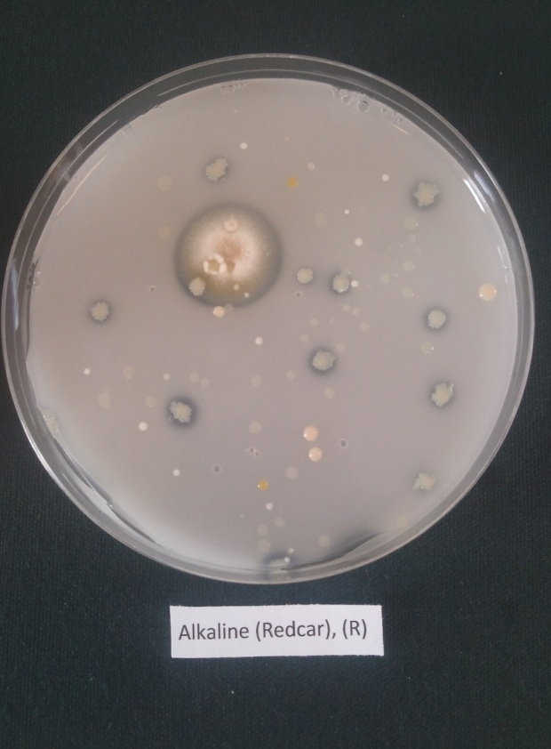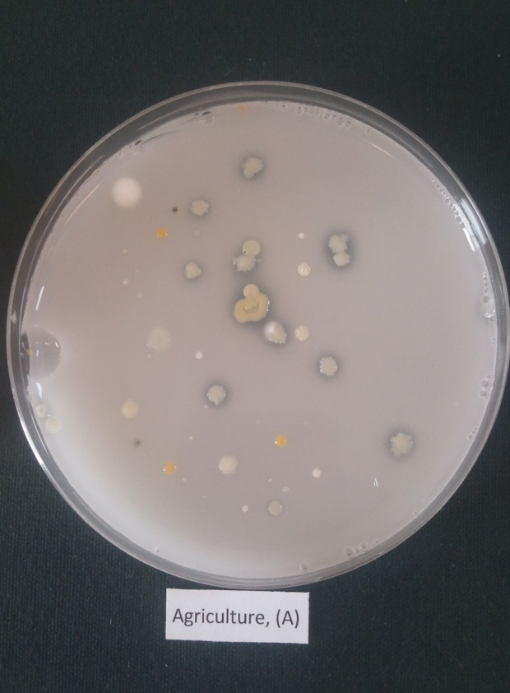
Figure 48. Plate count of phosphate solubilising fungi and bacteria isolated from the alkaline spoil sample, Redcar (pH= 12) and agriculture soil sample (pH= 5.7). A clear halo indicates phosphate solubilisation.
Phosphate solubilising bacteria were isolated, in relatively low numbers, from all of the spoils with the exception of the Parys Mountains (brown) spoil sample. The highest count was found, not surprisingly, in the agricultural spoil, although the vegetated colliery spoil showed relatively high numbers. Phosphate solubilizing fungi were surprisingly not isolated from the agricultural soil, and were generally isolated at much lower frequency than were phosphate solubilising bacteria; only a single colony was isolated from the highly alkaline (Redcar) spoil (Table 3), and with the exception of the Parys Mountain (brown sample), no phosphate solubilising fungi were isolated from any of the spoils. It should always be borne in mind that the plate count technique, when applied to fungi, tends to favour highly sporulating fungi, such as species of Penicillium (Kilham, 1994).
Soils samples | Bacteria count (1x10⁵) | Fungi count (1x10³)
Alkaline (Redcar) | 10 | 1
Agriculture | 18 | 0
Non-Vegetated Colliery | 6 | 0
Vegetated Colliery | 16 | 0
Black ash-Tips (Sardinia) | 7 | 0
Salt stream bed (Sardinia) | 5 | 0
Anglesey Parys Mountain (Brown) | 0 | 3
Anglesey Parys Mountain (Red) | 12 | 0
Anglesey Parys Mountain (Yellow) | 10 | 0
Anglesey Parys Mountain (Dark Brown) | 7 | 0
Table 3. Plate counts of bacteria and fungi solubilizing phosphate isolated from the agricultural soil and spoils.
Figure 49. Phosphate solubilising by the fungi and the bacteria, (Brevidomonas alba and Penicillium aurantiogriseum. Control refers to medium containing insoluble phosphate, but no inoculant
Figure 49 confirms the ability of the bacterial and fungal isolates, subsequently identified as Brevidomonas alba and P. aurantogriseum, to solubilise insoluble phosphate in PVK medium. The results show that the fungus was capable of higher rates of solubilisation than was the bacterium although since the two organisms were grown in different media the results are not directly comparable.
Bacteria havew the ability to solubilize insoluble inorganic phosphate compounds, including tricalcium phosphate, dicalcium phosphate, hydroxyapatite, and rock phosphate (Golstein, 1986). Among the bacterial genera which solubilize phosphates include species of Pseudomonas, Bacillus, Rhizobium, Burkholderia, Achromobacter, Agrobacterium, Microccocus, Aereobacter, Flavobacterium and Erwinia (Hilda and Fraga, 1999). Considerable populations of phosphate-solubilizing bacteria can be found in soil, notably in plant rhizospheres, including both aerobic and anaerobic species, with, not surprisingly, a prevalence of the latter in submerged soils (Chen et al., 2006). Higher numbers of phosphate solubilizing bacteria are generally found in the rhizosphere in comparison with non-rhizosphere soil and the presence of these bacteria in soils can be determined using plate count methods (Nahas, 1996). In this case phosphate solubilizers can be detected by the way they from clearing zones around colonies in media amended with insoluble mineral phosphates (generally mostly tricalcium phosphate or hydroxyapatite) as the single P source. An improved method for achieving this involves detecting solubilizers using a medium containing bromophenol blue. In this case, yellow coloured halos form around colonies in response to the pH drop produced as a result of the release of organic acids during phosphate solubilisation (Tarafdar et al., 2003). Instability of the phosphate-solubilizing ability of some strains of bacteria following several cycles of inoculation has been reported, although this ability appears seems to remain stable in most isolates. Most data indicate that species of Rhizobium, Pseudomonas and Bacillus species are among the most active solubilizers of inorganic P, while tricalcium phosphate and hydroxyapatite are more readily degradable than is rock phosphate (Chen et al., 2006).

Phosphate-solubilizing bacteria as plant growth promoters
There have been a number of reports on plant growth promotion by P-solubilizing bacteria following inoculation in soil or plant seeds (Gyaneshwar et al., 2002, Hilda and Frga, 1999). There exists, however, evidence which suggests that several soil microorganisms, including bacteria, improve the supply of P to plants by virtue of their ability to solubilise both inorganic and organic P sources. Since P availability is an important limiting step in plant nutrition, these findings show that phosphate-solubilizing bacteria and fungi make an important contribution to plant nutrition and plant growth. Commercial biofertilizers which include phosphate solubilising mixed bacterial cultures include ‘Phylazonit-M’ (from Hungary) which contains Bacillus megaterium and Azotobacter chroococcum, ‘Kyuseiem”, a mixed inoculum of lactic acid bacteria which solubilizes mineral phosphate. Not all such inoculants are however, successful; for example, an inoculant based on Bacillus megaterium was applied apparently with success in the former Soviet Union and India, but it did not show the same efficiency in soils in the United States (Whitelaw, 2000, Hilda and Fraga, 1999).

Mechanisms of phosphate solubilization
The main mechanisms of mineral phosphate solubilization appear to be due to the synthesis of organic acids by soil microorganisms which result in acidification of the microbial cell and the surrounding soil. Gluconic acid seems to be the most important agent of mineral phosphate solubilisation and is the principal organic acid produced by phosphate solubilizing strains of Pseudomonas, Erwinia erbicola, Pseudomonas cepacia and Burkholderia cepacia (Cunningham and Kuiack, 1992). Another important organic acid produced by phosphate-solubilizing bacteria is 2-ketogluconic acid, which is produced by Rhizobium leguminosarum, Rhizobium meliloti, Bacillus firmu, and other unidentified soil bacteria (Nahas, 1996). Strains of Bacillus liqueniformis and Bacillus amyloliquefaciens also produce mixtures of lactic, isovaleric, sobutyric, and acetic acids; other organic acids produced by phosphate solubilizers include, glycolic, oxalic, malonic, and succinic acid (Cunningham and Kuiack, 1992).

Identification of Bacteria and Fungi Capable of Solubilizing Insoluble phosphates
Phosphate solubilizing bacteria were identified using 16SrRNA technique, and fungi using the 18SrRNA technique (see Appendix for a description of the standard methods employed).
The bacterial isolates were identified using the above mentioned molecular methods as the bacteria, Achromobacter xylosoxidans and Brevidundomonas alba and the fungus, Penicillim aurantiogriseum. Interestingly, an isolate of A. xylosoxidans has been isolated from a copper mine spoil in Portugal and was found to produce indole acetic acid; it was suggested that it might be used in the bioremediation of copper spoils (Ma et al., 2009); Penicillium aurantiogriseum has previously been reported as a phosphate solubilizing fungus (Illmer and Schinner, 1995).

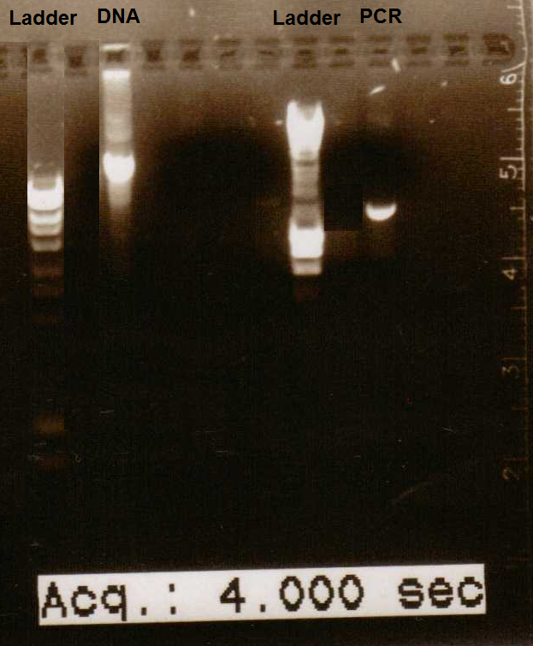
Figure 50. Identification of bacteria (Achromobacter Sp.) from alkaline (Redcar) soils sample using 16SrRNA and PCR.
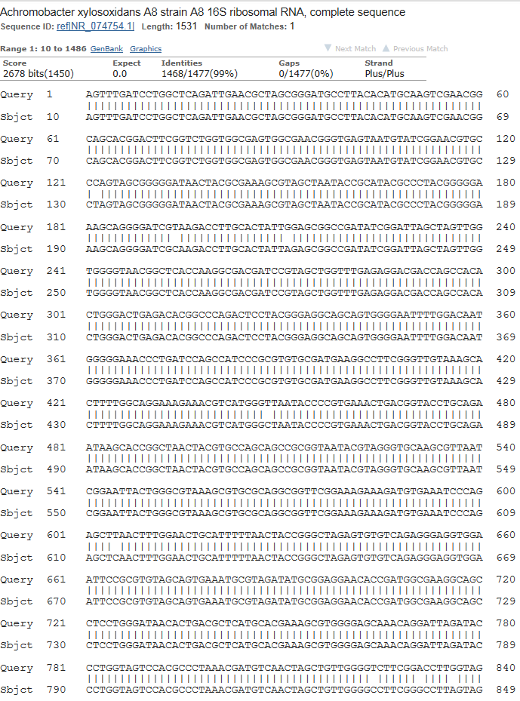
Figure 51. The sequence identification of bacteria (Achromobacter Sp.) from alkaline (Redcar) soils sample using 16SrRNA and PCR.

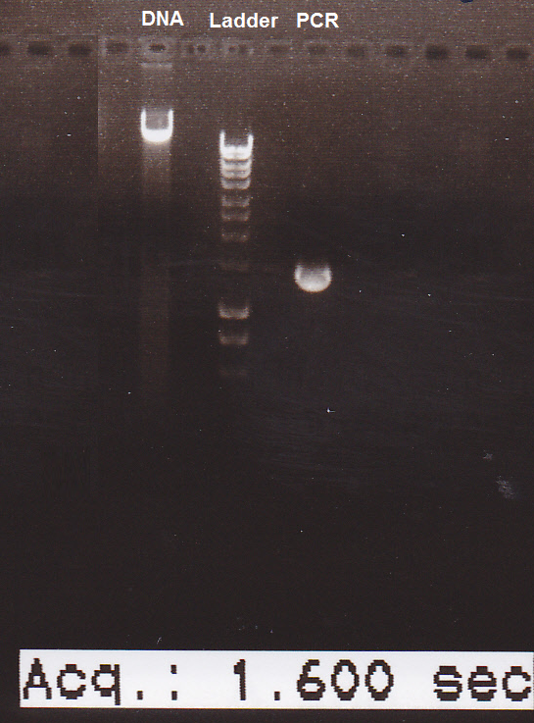
Figure 52. Identification of the phosphate solubilizing bacterium isolate (Brevundimonas alba) from the Redcar (alkaline spoil) using 16SrRNA and PCR.
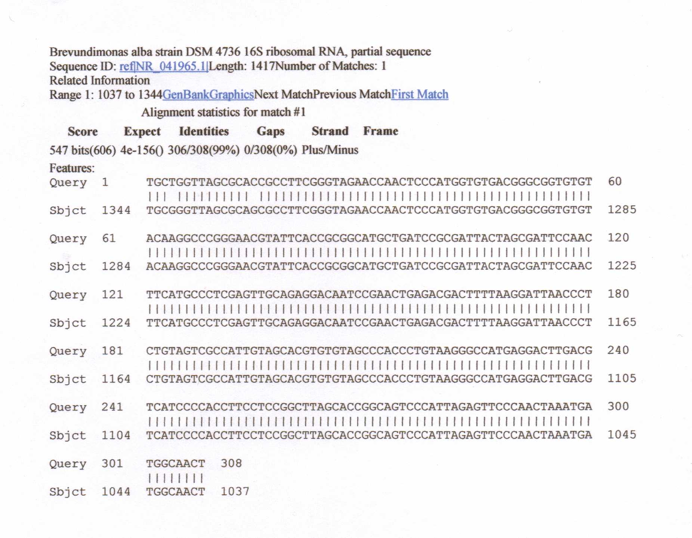
Figure 53. The sequence identification of the phosphate solubilizing bacterium (Brevundimonas alba strain) from the Redcar (alkaline spoil) using 16SrRNA and PCR.
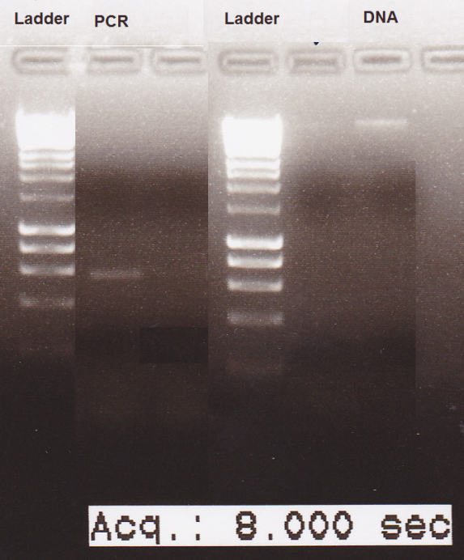
Figure 54. Identification of a phosphate solubilizing fungus (Penicillium aurantiogriseum strain) from the Redcar (alkaline) spoil using 18SrRNA and PCR.
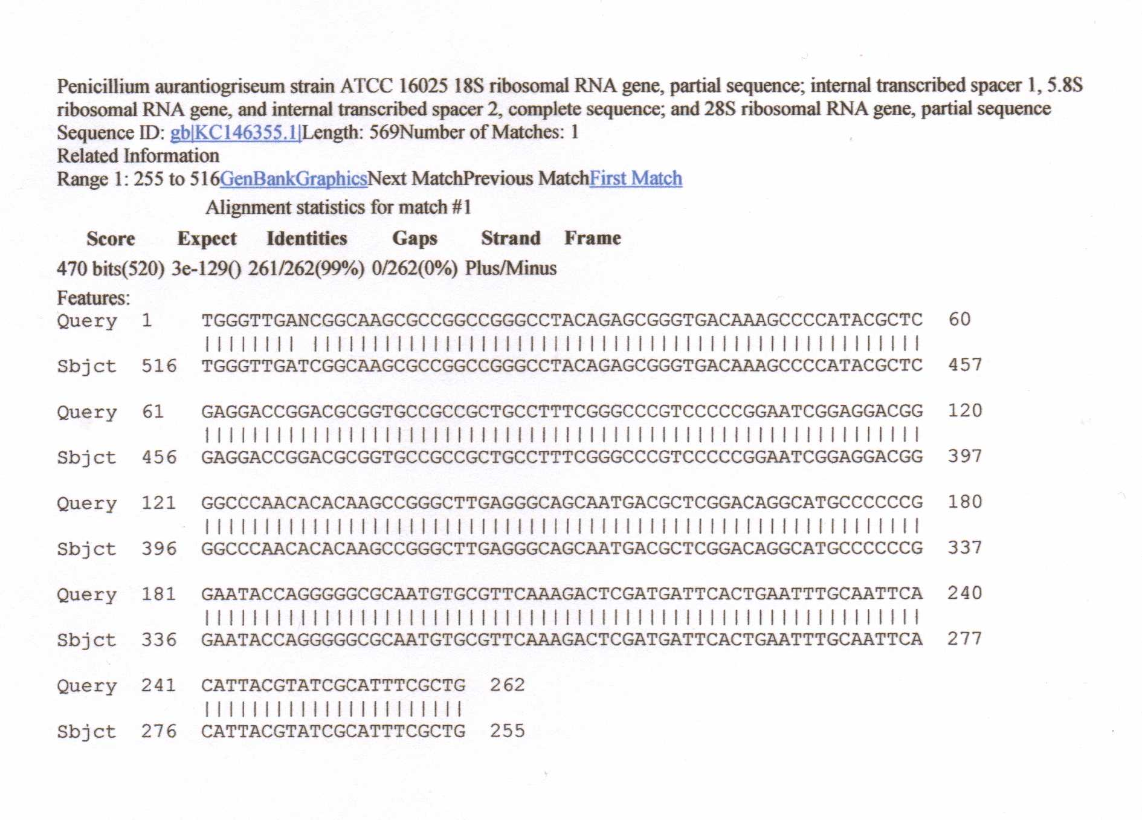
Figure 55. The sequence identification of a phosphate solubilizing fungus (Penicillium aurantiogriseum) from the Redcar (alkaline) spoil using 18SrRNA and PCR.

Bacteria capable of solubilizing bacteria have previously been isolated from highly alkaline soils (pH 5-11). The relevance of the presence of phosphate solubilising microbes in the industrial spoils, studied here, is twofold. Firstly, following amendment of the spoils with an insoluble phosphate source, bacteria and fungi will bring about its solubilisation leading to an increase in available P to plants growing in the soil, either where naturally seeded or where used in bioremediation. Secondly any phosphate released will tend to bind with free metals and take them out of the soil solution. This will have a positive effect in relation to spoil bioremediation as it will make heavy metals and possibly other toxicants unavailable to plants; it may however, on the negative side, also complex essential trace elements such as iron and manganese.
Large amount of fertilizer applied P applied are immobilized via precipitation reaction with highly reactive Al³⁺ and Fe³⁺ in acidic soil and Ca²⁺ in calcareous or normal soils The negative effect of this process is the release of free aluminium which can prove toxic to some plants(Gyaneshwar et al., 2002).
Although the total pool of P pool is high only a part of it is available to plants. The release and mobilization of insoluble and fixed forms of P is an important means by which soil P availability is increased and soil microorganisms play a major role in this process by changing the pH changes in soil microenvironment and producing chelating substance.
Soil phosphates mainly in the form of apatites and metabolites of phosphate fertilizers are in alkaline conditions, like the Redcar spoil, are fixed as calcium phosphates. Phosphate solubilising microorganisms like the ones isolated here, could increase the P nutrition of plants through increased solubility of Ca-phosphates their solubility increasing as soil pH decreases. Phosphate solubilisation is the result of combined effect of pH decrease and organic acids production (Golstein, 1986).
Interactions between phosphate and heavy metals and micronutrients in soils and industrial spoils are clearly extremely complex and the addition of insoluble phosphate to spoils during their bioremediation could at one and the same time be beneficial and detrimental depending upon the soil pH and a variety of other complex factors (Golstein, 1986).

Chapter Five

Determination of Enzyme Activity in Industrial Samples

5.1 Introduction.
A wide range of immobilized enzymes occur in soils (Burns, 1978) and other environmental samples such as river sediments (Dudderidge and Wainwright, 1982). Most of the commonly occurring enzymes are associated with the degradation of organic matter (e.g. cellulases), and the important mineral cycles (e.g. ureases, sulphatases and phosphatases) have all been assayed in soils. Here the enzymes arylsulphatase, arylphosphatase and urease were measured in the soil and spoil samples studied (Burns, 1978). These enzymes are respectively involved in the breakdown of organic aryl- sulphur and phosphate substrates to sulphate and phosphate, and the conversion of urea to ammonium. Soil enzymes constitute a minute, but very important fraction of the soil organic matter since all soil biochemical action is dependent on, or related to them. Soil enzymes are biologically significant as they participate in the cycling of elements and can influence the availability of nutrients to plants; microorganisms, active roots and dead cells are the principal sources of soil enzymes (Burns, 1978).
Biological activities are catalyzed by enzymes; usually these are present within the cells of organisms; however, some of the biological transformations in soil are catalysed by enzymes found outside living soil organisms and plant roots (Burns, 1978) . Soil enzyme activity results from a combination of the activity of accumulated enzymes and those produced by actively growing and proliferating microorganisms. Accumulated enzymes in soils are regarded as enzymes present and active in a soil in which no microbial proliferation is occurring. Although soil enzymes primarily originate from the microbial biomass, they can also originate from plant and animal residues (Burns, 1978). Soil enzymes are proteins and are often entrapped in soil organic and organic colloids. As a result, the soil has a large background of extracellular enzymes not directly associated with the microbial biomass (Paul and Clark, 1989).
Some 70 different enzymes have been studied and detected in a variety of soils. Soil enzymes represent all enzyme classification groups and most are important components of the mineral and nutrient cycling systems in soils (Ladd, 1978).
The most frequently studied soil enzymes are oxidoreductases and hydrolases. Several investigations of transferase and lyase activity have also been, reported. Studies on dehydrogenase, catalase, invertase, protease, phosphatase and urease activities in soils account for most of the work published on soil enzymes (Ladd, 1978). The total enzyme activity is the sum of extracellular and intracellular enzymes. Intracellular catalysis occurs in both viable and intact dead cells while extracellular components are made up of enzymes which are released from living cells and those released upon cellular death and subsequent lysis. The latter are in effect intracellular enzymes which have become extracellular. Extracellular enzymes are either free in the soil solution, attached to living cells or are stabilised due to their association with soil colloids (Burns 1967, 1978). Certain enzymes are ubiquitous; that is, they are found in virtually all soils (Ladd, 1978). . Typical examples are urease, catalase, phosphatase, and peptidases of various types. Other enzymes may be produced in soil only under special circumstances. Dehydrogenase activity appears to be related to the quantity of decomposable organic matter and closely related to the soil biomass (Burns, 1978).
Like microbial populations, enzymatic activity is not static but fluctuates with biotic and abiotic conditions. Activities would be expected to be particularly high in productive soils rich in organic matter. Such factors as aeration, temperature, moisture, soil structure, organic matter content, seasonal changes, and soil treatment all have an influence on the presence and abundance of enzymes (Burns, 1978).
Enzymes are proteinic in nature, and can be denatured by increased temperatures and higher pH. Physical and chemical states of enzymes and their effects on chemical reactions largely depend on ionic strength, temperature and pH (Ladd, 1978). Changes in environmental, agronomic and climatic conditions influence the microbial activities and magnitude of several enzymatic reactions (Lynch, 1983). The work described in this Chapter was aimed at determining the activities of the following soil enzymes. arylsulphatase, urease and arylphosphatase in various spoils.

5.1.1 Soil phosphatase activity (Arylphosphatase activity)
Large amounts of the phosphorus in soils are organically bound and the mineralization of these portions is of agricultural and economic importance. Organic phosphorus compounds in soil can constitute five to fifty percent of total phosphorus and the assimilation of this phosphorus by plants and microorganisms involves soil enzymes which are involved in the decomposition of organic phosphorus compounds (Sarapatka, 2003). Those enzymes hydrolyse P esters and are commonly referred to as called phosphatases. Soil phosphatases then play a major role in the mineralization processes (dephosphorylation) of organic P substrates which is chiefly a microbial phenomena and phosphatase activity becomes important after the initial breakdown of soil organic matter once catalysed by a range of microbial enzymes(Sarapatka, 2003). This initial breakdown is probably the rate – limiting step of organic phosphorus mineralization and organic phosphorus mineralization in soil correlated with nitrogen and carbon mineralizaton (Sarapataka, 2003). In soils, cell-free phosphatase constitutes the major proportion of these enzymes and here, they play a major role in the constinuing mineralization of organic matter (Speir and Ross, 1978).
Phosphatases have trivial names according to their substrates, but are either phosphoric monoester hydrolases (phosphoric monoester hydrolases), or phosphoric diester hydrolases. To the first group belong: phytases, nucleotidases, sugar phosphatases and glycerophosphatases (Speir and Ross 1978). The second group include: nucleases, phospholipases (Speir and Ross 1978); enzymes which are generally collectively called phosphatises, but which can be divided into – acid, neutral and alkaline (different pH optima). In order that organic phosphorus substrates can be made available to plants they must first be hydrolysed by phosphatases (Spear and Ross, 1978).

5.1.2 Arylsulphatase activity in soil
Arylsulphatase, aryl-sulphate sulphohydrolase) is a principal enzyme involved in the soil sulphur cycle and it catalyses the removal of the sulphate ion from a large number of arylsulphate esters (Tabatabai and Bremner, 1970). Sulphate-sulphur SO₄-S may be released from soil organic matter by one of two pathways, extracellular hydrolysis of organic sulphate esters catalysis by exoenzymes or intracellular oxidation of soluble organic matter absorbed by the microorganisms to yield energy and carbon skeletons for biosynthesis by which some sulphate is released as a byproduct (Ganeshamrthy and Nielsen, 1990).
Soil organic sulphur is present in the form of sulphate esters; arylsulphatase (arylsulphate sulphohydrolase may play a key role in sulphur mineralization. The overall reaction is (Tabatabai and Bremner, 1970).
ROSO₃⁻ + H2O arylsulphatase ROH + H⁺ + SO₄²⁻

Enzymes (both extra-and intracellular) play an important role in nutrient transformations in the soil. For example, sulphatases are intimately involved in the biochemical mineralization of organic S. Arylsulphatase, in particular, has been detected in a wide range of soils and its activity can be used as an indicator of the potential for biochemical mineralization of organic ester sulphates (Ganeshamrthy and Nielsen, 1990).
.
Arylsulphatase was first reported in Iowa soils by Tabatabai and Bremner (1970); these workers suggested that arylsulphatases and other sulphatases play an important role in processes whereby organic soil sulphur is mineralised and made available for plant growth. Since then, arylsulphatases have been studied in various soils (Cooper, 1972), and were also detected in marine and lake sediments (Chandramohan et al., 1974), in salt marsh soils (Oshrain and Wiebe, 1979; Wainwright, 1981) and in intertidal sands (Wainwright, 1981). Arylsulphatase activity is typically measured according to the method of Tabatabai and Bremner (1970). This method is based on conversion of the artificial substrate p-nitrophenyl sulphate to p-nitrophenol, which can be quantified colorimetrically.

5.1.3 Urease activity in soil
Amidohydrolase, commonly known as urease, is among the most commonly assayed soil enzymes (Bremner and Mulvaney, 1978; Sinsabaugh, and Reynolds, 2000). Urease (urea amidohydrolase) is the enzyme that catalyses the hydrolysis of urea to CO₂ and NH_{3;} ammonium carbamate is the intermediate in this hydrolysis.
Urea is unique among commonly used synthetic nitrogen fertilizers in that its efficiency is greatly affected by a soil enzyme. In most soils, urea is rapidly hydrolyzed to ammonium carbonate through soil urease activity (Tabatabia and Bremner, 1970).
[NH₂CONH₂ + 2H₂O → (NH₄)₂CO₃]
Urease decomposes urea into carbon dioxide and ammonium (Pettit et al., 1976). Urease activity found in 6-12 years stored, air-dry agricultural soils correlated with the organic matter content rather than with the numbers of microorganisms. Urease activity was detected in an alkaline soil and in an acid soil, but highest activity was usually found in neutral soils (Dalal, 1975). Besides temperature, soil factors such as moisture content, pH, organic matter and numbers of microorganisms also affect the urease activity in soil (Nor,1982).
In microorganisms, urease is an intracellular enzyme that catalyses the hydrolysis of urea and also catalyses the terminal step of purine, pyrimidine and arginine degradation (Alexander, 1977). The most frequently studied urea degrading bacteria include species of Bacillus, Micrococcus, Pseudomonas, Achromobacter, Coryneformbacterium and Clostridium. Fungi and actinomycetes have also been reported to hydrolyse urea, and in some bacteria, urease synthesis is constitutive whereas in others it is an inducible enzyme (Alexander, 1977). Urease has been reported in river sediments, following substrate induction (Duddridge and Wainwright, 1982), in marine sediments (Chandramhan et al., 1974) and in sewage treatment plants (Lenhard, 1956). No reports have been made, however, on the presence and activity of urease in coal mining-waste environments. The origin of the urease in soil is still obscure, but it is probably synthesised by microorganisms and plant cells. Upon death of bacterial and plant cells urease is released into the soil and either remains in the soil solution until being denatured by proteases present or it may be adsorbed by organic compounds or clay minerals.
Many methods have been used to assay urease activity in soils. Most involve estimation of the ammonium released on incubation of toluene-treated soil with buffered urea solution, but some involve estimation of the carbon dioxide released or the urea decomposed (Nor,1982). The results obtained by a buffer method of assaying urease activity were markedly higher than those obtained by non-buffer method. Both methods gave reproducible results, but the non-buffer method was the more precise, and studies reported showed that it provides a much better index than the buffer method of the ability of soils to hydrolyze urea under natural conditions. The buffer method detects urease activity that does not occur when soils are treated with urea in the absence of buffer (Zantua and Bremner, 1975). This is a disadvantage if the purpose of the assay is to obtain an index of the ability of soils to hydrolyze fertilizer urea, but is an advantage if the purpose to detect urease in soils or soil fractions. The use of toluene to inhibit microbial activity in assay of urease activity by the non-buffer method described did not significantly affect the results obtained by this method, but it decreased the precision of the method (Zantua and Bremner, 1975).

5.2 MATERIALS AND METHODS

5.2.1 Measurement of arylsulphatase and arylphosphatase activity
To measure the activity of arylsulphatase and arylphosphatase activity, soil (1g) was transferred to universal vials (25 ml) (Tabatabai and Bremner, 1970). Acetate buffer (4 ml), 0.25 ml of toluene and 1 ml of p-nitrophenyl sulphate solution or p-nitrophenyl phosphate (respectively) were added. The vials were swirled for few seconds to mix the contents capped and placed in a water bath at 25ºC for 1 hour. After incubation, 1 ml of calcium chloride solution (0.5M) and 4 ml of sodium hydroxide (0.5M) were added, the vials were mixed for few seconds, and the soil suspension was filtered through Whatman No.1 filter paper. The intensity of yellow compound of p-nitrophenol was measured at 400 nm using a spectrophotometer. The control was prepared by the addition of 1ml p-nitrophenol sulphate after the addition of CaCl₂ and NaOH, (i.e. immediately before filtration of the soil suspension). The concentration of p-nitrophenol was then determined by reference to a standard curve (0 –50 µg p-nitrophenol ml⁻¹).

5.2.2 Measurement of urease activity
Triplicate samples of soil (10.0g) were pre-incubated with toluene (1 ml) in an Erlenmeyer flask (50 ml) fitted with a cork stopper. After 15 minutes, the reaction was started by the addition of a 5mM urea-N solution (10 ml) in 0.2 M phosphate buffer, pH 7.2. Controls lacking urea or assays stopped immediately on adding substrate were included. The reaction mixtures were incubated for 8 h at 25ºC on an orbital shaker (150 revolution min⁻¹). After this time, the reaction was stopped with the addition of 2M potassium chloride-phenyl mercuric acetate reagent (20 ml). The flasks were shaken for further 30 minutes, then filtered through Whatman No. 1 filter papers and the urea concentration of the extract analysed using the modified method of Douglas and Bremner (1970). The urea colour reagent (6 ml) was added to duplicate samples (1ml) of the extract, suitably diluted with potassium chloride – phenyl mercuric acetate reagent to bring it within the urea – N concentration range of the standard curve (0 – 10 µg ml⁻¹).
The samples were mixed thoroughly and incubated for 25 minutes in a boiling water bath. The samples were then removed from the bath and immediately cooled in ice- water. The colour was read when the tubes had cooled; this was usually within 1h of colour development, although the colour is stable for 3 – 4h if stored at 4ºC in the dark. Extinction measurements were made at 527nm using 1cm, 3 ml cuvettes in a Pye Unicam SP 500 spectrophotometer. Urea concentration was calculated from a urea–N standard curve prepared on the day of analysis.

5.3 Results and Discussion
Figure 56. Arylphosphatase activity in the soils and spoils.
Figure 56 shows arylphosphatase activity in the industrials spoil samples. High activity was found in Anglesey S3 (Yellow), in excess of 200 µgg⁻¹, followed by the vegetated colliery spoil, Anglesey S1 (Brown), Agriculture and Anglesey S2 (Red) (ranging between 150 to 190 µgg⁻¹). Medium activity was seen in the colliery non-vegetated soil (more than 100 µgg⁻¹). Low enzyme activity was found in Sardinia industrial spoils (Black ash and Salt stream bed) followed by the Anglesey S4 (Dark Brown) (activity for these spoils was between 30 to 60 µgg⁻¹ ).The lowest activity was found in Redcar (alkaline - pH 12) spoil which was around 10 µgg⁻¹.
Figure 57 shows that arylsulphatase activity was detected and measured in all the samples. The highest activity was in the agriculture soil (in excess of 120 µgg⁻¹) followed by Anglesey S1 (Brown) and colliery vegetated soils (in excess of 110 µgg⁻¹) the lowest activity was in Redcar (alkaline – pH 12). Surprisingly high enzyme activity was found in all samples including the salt samples and the highly alkaline Redcar samples. These results show that arylsulphatases are widely distributed in the environment and that the enzyme is active over a surprisingly wide range of conditions. This means that the breakdown of arylsulphatase will occur in all soils, largely independent of the prevailing conditions, including the presence of potentially toxic metals and a wide pH range.
Figure57. Arylsulphatase activity in the soils and spoils.
Figure 58. Urease activity in the soils and spoils.
Urease enzyme activity (Fig. 58) was highest in the agriculture soil (in excess of 8 µgg⁻¹ followed by the colliery vegetated and colliery non-vegetated spoils (6 to 8 µgg⁻¹) Urease activity in the Sardinia soils (Black ash and Salt stream bed) ranged between 5 to 6 µgg⁻¹ followed by Anglesey spoils samples S4 (Dark brown), S1(Brown), S2 (Red) and S3 (Yellow) that were around 4 to 5 µgg⁻¹ . The lowest urease activity was found in the Redcar spoil (alkaline– pH 12) (at around 2 µgg⁻¹).

Soil enzymes as indicators of heavy metal pollution
Soil enzymes catalyze soil microbial reactions; they generally originate from microorganisms and plants and as a result, soil enzyme activity is fundamental to soil chemical and biological reactions and the inhibition of soil enzymes by heavy metals has been extensively, unfortunately often with conflicting results ( Dick et al., 1997). Soil enzymes activity has been regarded as providing a sensitive indicator of the functioning of important microbial reactions involved in nutrient cycles and they can often respond to changes in the soil which result from pollution. In many cases, soil enzymes have turned out to be sensitive to increasing soil metal addition, and enzyme data compares favorably with results gained from the use of more time-consuming assays including soil respiration studies.
Dick et al. (1997) showed that soil enzyme activities can be used to provide results on heavy metal toxicity to soil health and function which are similar to those derived from more direct measures of soil microbial function and plant performance, although they showed it is likely that soil enzyme activities will be adversely affected in soils at the maximum Cu and Zn concentrations recommended in Australasian guidelines (100 mg kg⁻¹ for Cu and 200-300 mg kg⁻¹ for Zn).
There are several reasons why enzymatic analyses provide a good indicator of soil quality (Dick et al.,1997) (i) they are directly connected with important soil characteristics, notably organic matter, soil physical properties, microbial activity or biomass; (ii) they change more quickly in response to pollutants than do other characteristics; (iii) they involve the use of relatively simple methods compared to other methods of determining soil quality. These authors conclude that heavy metals mainly inhibit enzymatic reactions through either their complexing with substrate or blocking the functional groups of enzymes or reacting with complex enzyme-substrate.
Schaller (2009) also noted that soil enzymes (dehydrogenase, alkaline phosphatase, and cellulase) showed a close relationship with a variety of physicochemical indicators (pH, organic C, total N, available K, available P, cation exchange capacity (CEC), and microbial biomass carbon (Cmic)). The more soil enzyme activities could be detected the higher was the fertility of urban forest soils.
Enzyme activity assays have advantages over most other biological measures of soil health and function because of their simplicity and ease of analysis. The assay methods used here require only small amounts of soil, short incubation periods, few chemicals and the involvement of simple instrumentation. Dick (1997) noted that values of enzymatic activities were highest in the soil above the source of heavy metal contamination and they decreased towards the source of contamination; enzymatic activities can therefore sensitively reflect the biological situation in the soil.

Chapter Six

Examination of the potential use of Biochar to improve the remediation of colliery waste and alkaline spoil

6.1 INTRODUCTION
Biochar is essentially charcoal which has been shown to have remarkable soil improving qualities, a fact which begs the question-does Biochar have the potential to be used as material for the bioremedation of environmental wastes?
Biochar is a fine-grained carbon-rich material which is similar to charcoal (Fig. 59). About 50-70% of Biochar (by weight) is carbon; and the remainder is comprised of oxygen, hydrogen, nitrogen, sulphur, phosphorus, silicon, base cations and heavy metals (Lehmann, 2007).
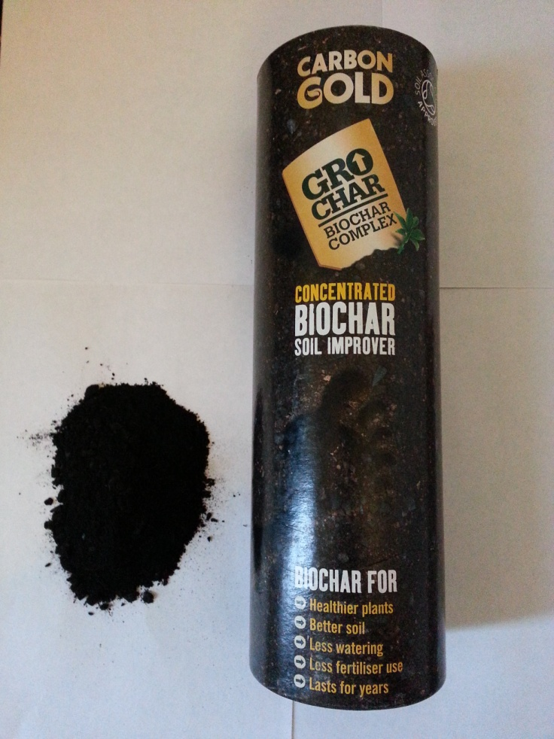
Figure 59. The commercial sample of Biochar used in these studies.
Biochar is produced by the pyrolysis of plant material in the absence of oxygen. The optimum conditions for Biochar production uses pyrolysis carried out between 450-650°C with extended heating times (“slow pyrolysis”); conditions which give a Biochar yield of around 35% (Sohi et al.,2009). In addition to Biochar, two other products result from the pyrolysis- oil and gas. All three of the pyrolysis products have industrial uses; the gas (syngas) and oils (bio-oils) can be used in general industry, or to fuel Biochar production; such re-use of materials means that the Biochar production process produces more energy than is consumed (Lehmann, 2007). The quantity of each of the various components of the process can be achieved by varying production conditions, notably temperature, pressure, time and type of biomass. Biochars are not however, chemically and physically identical to each other, but, depending on the parent material, they exhibit a variety of chemical composition (Lehmann, 2007). As a rule, Biochar tends to increase the pH of the soil (Chan et al. 2007).
Despite the recent increase of interest, the use of Biochar to enhance soil fertility and thus crop yield is far from new since evidence shows that ancient Amazonian civilizations used terra preta (alternative name for Biochar) as long ago as 80BC (Ladygina and Rineau, 2013). Biochar has re-surfaced as interest in carbon sequestering has intensified due in large part to the fact that not only does Biochar remove atmospheric carbon from the atmosphere (a carbon-negative process) it also enhances soil fertility and quality, resulting in increased crop yields. Biochar could sequester the equivalent of 600 million tonnes of CO₂ per year (Barrow, 2012) whilst the amount of carbon which could be stored in soils is potentially as high as 9.5 billion tonnes (Lehmann et al. 2006); it has also been estimated that if only 2.5% of possible productive land is devoted to Biochar, concentrations of atmospheric carbon dioxide could be reduced to pre-industrial levels (Barrow, 2012). Biochar can reside in soils for, on average, 5000 years (the proposed range by scientists is commonly 1000 to 10000 years, Ladyginak and Rineau, 2013).
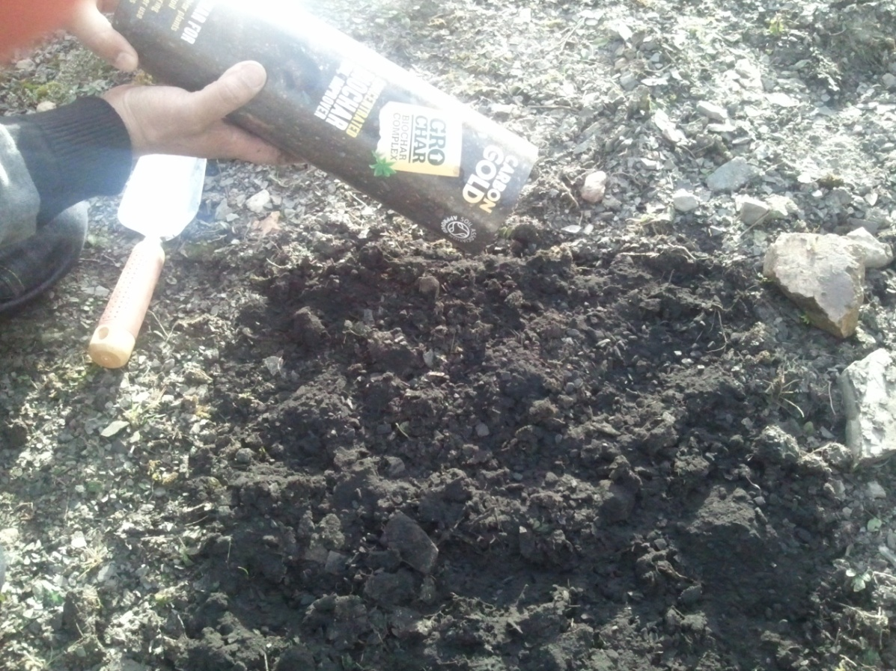
Figure 60. Simulation of the use of Biochar to remediate colliery spoils

6.1.1 Colliery spoils as an environmental problem
Colliery spoils present an environmental problem in being unsightly and potentially unstable. As a result, studies have been conducted to improve the growth of native or added plant cover, on spoil heaps made up of this material (Cornwell and Stone, 1968). Most colliery waste tips throughout the UK have now been successfully remediated in relation to these problems, such that in some areas it is impossible for a newcomer to realize that the local environment was previously time covered in individual black and unsightly colliery tips (for example the area immediately around Hemsworth, West Yorkshire, which now has no visible tips, was one littered with at least half a dozen such tips). Various chemical and physical characteristics of colliery spoil reduce plant growth (Chadwick (1973). Chemical factors include high concentrations of hydrogen ions, high salts concentrations, low levels of the availability of major nutrients, chiefly N, P and K (Cornwell and Stone, 1968); while physical factors limiting plant growth on colliery spoil include instability, high temperatures, and moisture stress. Several workers have commented on the low levels of available N in spoil and plants growing on spoils generally respond to N-fertilization and respond particularly well to N plus lime additions. Chadwick (1973) described the effects of amendments such as lime, NPK fertilizer and organic rich N fertilizers such as shoddy (wool waste) and sewage sludge on the growth of trees on colliery spoil; all of which enhance plant colonization.
Localised patches of spoil which are difficult to remediate using plant cover do however, often occur on such improved tips and these despite need improvement. The work reported in this Chapter was aimed at determining if a substance called Biochar (which is essentially charcoal) could be used to increase plant growth on colliery spoil with a view to improving plant colonization of these spoils which have hitherto have resisted remediation.

6.1.2 Alkaline slag waste in relation to Biochar treatment
As was discussed in the general Introduction to this Thesis, alkaline soils such as the ones used here, which are derived from steel making slag, are very unproductive and do not generally support crop plant growth. As a result, such soils need to be bioremediated in some way. Such bioremediation generally involves some form of acid treatment, either directly or by the addition of elemental sulphur, the microbial oxidation of which leads to the in situ production of sulphuric acid within the soils, a result which leads to soil acidification and thereby enhanced soil fertility. Few studies appear to have been made on the effects of Biochar on the remediation of alkaline soils and wastes. Liu and Zhang (2012) however, showed that the long term oxidation and decomposition of Biochar leads to the formation of acidic materials which partly neutralize soil alkalinity.
As was the case with the colliery wastes, the work reported here was aimed at determining if Biochar improves the germination and or growth of seedlings in relation to the possibility of using it to bioremediate the Redcar alkaline steel slag waste.

6.1.3 The implications of using Biochar for soil microbiology and the major biogeochemical processes
As well as sequestering carbon, Biochar alters nutrient availability in soils, which has a direct consequence on the soil geochemical processes and soil microbiology (Lehmann, 2007). It is important to note, that the way the Biochar is added to the soil can influence the observed effects- Biochar can be added as a top soil, mixed in at depth or sprinkled over the soil. In each case, the degree of mixing within the soil varies. Each type of addition has positives and negative aspects (Lehmann, 2007). A top soil is at risk from wind and water erosion, whereas mixing causes mechanical interference to soil which could markedly disrupt the soil ecosystem. Sprinkling the Biochar may have negative impacts on human health because it is breathed in as a dust and is also open to wind and water erosion losses. Nitrogen is sensitive to heat decomposition and the higher the pyrolysis temperature of biomass, the lower the final nitrogen content of the end product Biochar (Lehmann, 2007). . The addition of carbon to soil generally leads to increased levels of nitrogenl. Nitrate levels in treated soils were found to be roughly double those in untreated soils (from ~1.0μg g⁻¹ to ~2.25μg g⁻¹), although, the reason for the increase is not immediately clear. One possibility is that charcoal adsorbs organic compounds, such as phenols, thereby reducing the presents of compounds inhibiting microbial nitrification, while the addition of charcoal can also reduce the leaching of nitrogen fertiliser as ammonium from soil (Lehmann et al., 2003).
Biochar can act as a good source of organic phosphorous, since when plants are heated the carbon begins to break down at around 100°C, whereas phosphorous decomposes at temperatures around 700°C and this increases the phosphorous: carbon ratio (Clememt, 2011). The increase in phosphate levels in Biochar treated soils is probably, as with N, partly due to an increased population of microorganisms, notably phosphate solubilising bacteria such as Pseudomonas and Bacillus and fungi such as mycorrhizal froming fungi, which increase the amount of phosphate available.
Studies involving Biochar have noted changes in the soil environment which suggest that Biochar additions can increase sulphur availability in soils; for example, an increase in soil pH has been observed which can favour sulphur mineralisation. Sulphur mineralisation rates have been found to increase after pine forest fires (Clemenst, 2011) and thereby related to the effects of natural charcoal addition.
As previously stated, Biochar is a carbon-rich substance. Addition of Biochar to soil leads to an increase in soil carbon levels and an ability to sequester carbon, therefore removing it from the atmosphere (Lehmann, 2007).
The pores of Biocahr retain water as they provide a surface area of 115-400m²g⁻¹ (Clement, 2011), which effectively stores water (Lehmann, 2007). Soil water retaining ability does increase after Biochar addition and this may be beneficial as less irrigation is thereby theoretically required. A negative side may be that the Biochar may result in soil clogging and lead to increased run off and resultant soil leaching.
Biochar may provide a refuge for microorganisms, since its porous structure provides shelter for soil bacteria, away from predatory protozoa and nematodes. Pore size can be influenced by charring temperature since the lower the temperature; the larger the resultant pores and the type of plant matter charred also influences Biochar pore size. Although charcoal additions do not seem to influence the total microbial biomass or activity, of soil, evidence suggests that charcoal may alter the presence or activity of specific soil microorganisms (Clement, 2011).
The addition of Biochar may also raise the temperature of soils since dark soils absorb more solar energy than lighter soils. However, the effect on temperature is dependent on plant cover and soil water content (Lehmann and Joseph, 2009). Biochar pores can act as a refuge for microbes, including mycorrhizal fungi and phosphate solubilising bacteria (including Pseudomonas aeruginosa). These species can help the plant via the secretion of flavonoids. These flavonoids are sensed by species of Rhizobium and Bradyrhizobium, which, via the activation of nod genes induce root nodule formation in legumes (Lehmann and Joseph, 2009).

6.1.4 Carbon dioxide release-Does the addition of charcoal to soils in fact stimulate carbon dioxide release?
Both biotic and abiotic processes operate in the degradation of Biochar. The former include the presence of bacteria and fungi in the Biochar, which increase the rate of this process, as microbes utilize the carbon for growth whilst releasing CO₂ as a by-product of respiration (Lehmann and Joseph, 2009). Microorganisms can, under some conditions, stimulate carbon dioxide release, although different Biochars release carbon at different rates and Biochar properties are not universal across plant types. Zimmerman also found that the size of Biochar particles plays a role in carbon release. Biochar with a grain size of less than 0.25 mm released more CO₂ than the corresponding course Biochar - 34% less overall in sterilized samples, and 16% less overall for samples containing microbes. Finally, biomass charred at lower temperatures is generally more labile than that charred at higher temperatures (Barrow, 2012).

6.1.5 Alternatives to the use of Biochar to remediate Parys Mountain Spoils

Previous studies on the potential bioremediation of Parys Mountain spoil by the addition of municipal organic wastes
Heavy metals have been polluting the environment as the result of mining since before Roman times, and because of their long term residence, they constitute a particularly important hazard to the environment. Heavy metals cannot be degraded, and must be either physically removed (e.g. by phytoremediation) or be stabilized in situ. Heavy metals have a negative impact on the soil microbial community (Brookes and McGrath, 1984); although studies have shown that the addition of both inorganic and organic amendments (e.g. composts) to contaminated soils improves their chemical properties and brings about an increase in microbial biomass, functionality and diversity (Farrell et al., 2010).
A potential disposal route for mixed waste composts is in the remediation of heavy metal-contaminated sites. Such composts contain large amounts of organic substrates as well as an innate microbial community, so their addition to metal-rich wastes, not surprisingly results in changes in the structure of the microbial community structure (Pérez-Piqueres et al., 2006). An important aspect of this is whether surface-based remediation treatments exert a positive remediative effect on the soil below that is through downward migration of microbes, complexing ligands and alkalanizing agents. Farrell et al., (2010) concluded that although the addition of mixed municipal organic waste composts can successfully immobilize heavy metals and promote ecosystem diversity/function, surface incorporation had little remedial effect below the surface layer over the course of our short-term trial. Farrell et al. (2010) studied the microbial community of an acidic soil heavily contaminated with Cu, Pb and Zn obtained from the remains of an old (>50 years old) mine spoil tip at Parys Mountain, Anglesey, North Wales (Anglesey Mining Ltd., Parys Mountain, Amlwch, UK; 53°23′22″N, 4°20′54″W) . Parys Mountain was extensively mined for copper ore from the 18th to the 20th centuries and covers an area of 200 ha, much of the site being covered with heavy metal-contaminated mine spoil, dominated by sulphide minerals including pyrite, chalcopyrite, sphalerite and galena, with lesser amounts of other minerals (Walton and Johnson, 1992).

Composting-Effects on chemical properties and biological activity of Parys Mountain spoils
Lime addition is one of the most widely used approach to increase the pH of the soil or spoil in order to make any free heavy metals insoluble and less bioavailable (Alloway, 1990). Farrell et al., 2010) showed that although this conventional inorganic treatment failed to deliver long-term improvements in Parys Mountain spoils, the addition of composts both reduced the acidity of the mine waste and also enhanced soil fertility through an improvement in the spoil chemical, biological and physical characteristics. Several studies have shown that microbial structure or function is affected by organic amendment of contaminated soil. Farrell et al. (2010) showed that the addition of composts cause large shifts in the structure of the microbial community. Addition of microbes in the composts, together with those enhanced by the presence of plant roots (rhizosphere microbial communities); seem to have altered the structure of the microbial community. Organic amendments also increase soil pH, allowing increases in some acid-sensitive microbial groups like nitrifiers.
The addition of inorganic amendments has been shown to increase soil microbial activity in non-leached microcosms and it is clear from the work of Farrell et al. (2010) that compost addition significantly affects microbial community structure up to a depth of 30 cm, while at 30–40 cm, the microbial communities were unaltered in comparison with the control; microbial activity, in comparison, was less affected. Composts proved to be suitable for the biostabilization of acidic mine spoil due to their high buffering capacity, increasing the surface layer pH to around neutrality

6.2 Materials and Methods-Biochar studies
The soils used were surface (0-15cm) samples, air – dried and sieved (<2mm). Industrial soils were mixed with Biochar (1: 1, 1:2 1:3) soil /Biochar; industrials spoil without Biochar and Biochar without soils. Measurement of pH and bacteria counts were done for all industrial samples mixed with Biochar (using the methods described above). Then 50 g was used from each mixed industrial spoil sample in order to measure the following ions: nitrate, ammonium, sulphate and phosphate. The methods used to study the ions are discussed in Chapter One. All samples were stored in polythene bags at 4ºC until the chemical analyses were performed. Significance of means of three replications was compared by Paired-Samples T-Test at p=0.05 probability level. Tests were performed using SigmaPlot 12.0.
Two soils were used in this experiment, namely alkaline soil (Redcar) and Non –vegetated colliery spoil (Shirebrook). The bulk samples were divided into sub-samples; three untreated soils acted a controls; three pure Biochars were included and the remainder were set up in triplicate as 1:1, 2:1 Biochar soil; 3:1 Biochar: soil. The samples were mixed thoroughly and samples were placed in plastic flower pots (height 56 mm, diameter 56mm), watered with an initial 20 mls tap water, the samples were then watered every other day with the same amount of water. Equal numbers of seeds (3 seeds per pot) of the following plants were sown. The pots were left at room temperature (18-25⁰C) in daylight with a natural diurnal cycle (March-end of May). At the end of the three months growth period the plants were harvested and the following characteristics were determined, plant height, total plant wet weight, fresh leaf weight, fresh root weight, leaf number, total plant dry weight (37⁰C to constant weight), leaf dry weight, root dry weight.

Determination of number of bacteria
Soil (1g) was added to 9 ml distilled water and shaken on an orbital shaker (100 revolutions min⁻¹) for 15 min. The final dilution (0.1 ml) was spread onto Nutrient Agar, using 3 plates for each soil sample. For bacterial enumeration the plates were incubated at 25° C for 1 - 3 days before counting the bacteria present on the plates.

6.3 Results and Discussion
Table 4. Industrial spoil pH following Biochar treatment
Soil. Biochar Ratio | 1:0 | 0:1 | 1:1 | 1:2 | 1:3
Alkaline (Redcar) spoil | 12 | 8 | 10 | 9.3 | 9
Non-vegetated colliery waste | 5.7 | 8 | 6.8 | 7.2 | 7.4

Table 5.Total count of bacteria in Biochar treated spoils
Soil. Biochar Ratio | 1:1 | 1:2 | 1:3
Alkaline (Redcar) | 1.2x10⁶ | 2.1x10⁶ | 3.2x10⁶
Non-vegetated Colliery | 2.5x10⁶ | 2.8x10⁶ | 3.6x10⁶

Table 4 shows the effect of Biochar amendment of the pH of the alkaline, Redcar spoil and the non-vegetated colliery waste. The addition of Biochar to the former led to a reduction in pH of the spoil, so that the maximum Biochar addition-ratio (1 spoil: 3 Biochar resulted in a reduction of spoil pH from pH 12 to 9 (Table 4). In contrast, the addition of Biochar to the colliery waste increased the pH from a non-amended spoil pH of 5.7 towards neutrality (Table 4). Both of these effects will tend to be beneficial to spoil fertility and plant growth in relation to soil remediation since they bring both spoil types closer to pH 7, which is not extreme and ideal for promoting the growth of most plants. Most trials using Biochar have been conducted on acidic soils, where Biochars with a high pH (e.g. 6 – 10) were used. One study comparing the effects of Biochar addition on acidic and an alkaline soil found greater benefits on crop growth in the acidic soil, while benefits on the alkaline soil were relatively minor (Lehmann and Joseph, 2009). The addition of Biochar to soils generally results in increases in pH which, although generally beneficial, can have a detrimental effect on yields, because of micronutrient deficiencies which can occur above pH >6.

Nitrate concentrations in Biochar amended spoils
Figure 61. Nitrate concentration in non-vegetated colliery spoil amended with Biochar (1:1, 1:2 and 1:3). All increases over spoil without Biochar were significant at P=0.05.
Figure 61 shows that the addition of Biochar increased the amount of net nitrate production in the non-vegetated colliery spoil. The increase was proportional to the amount of added Biochar and increased with increasing amount.

Figure 62. Nitrate concentration in Redcar spoil amended with Biochar (1:1, 1:2 and 1:3). All increases over spoil without Biochar were significant at P=0.05.
Figure 62 shows that the addition of Biochar increased the amount of net nitrate production in the Redcar alkaline spoil. The increase was proportional to the amount of added Biochar and increased with increasing amount.

Sulphate concentrations in Biochar amended spoils
Figure 63. Sulphate concentration in non-vegetated colliery spoil amended with Biochar (1:1, 1:2 and 1:3). All increases over spoil without Biochar were significant at P=0.05.
The addition of Biochar to colliery spoils led to increases in net sulphate production over the entire incubation period. There was, however, little (and non-significant) difference between the 1.2 and 1.3 ratios of addition.

Figure 64. Sulphate concentration in Redcar spoil amended with Biochar (1:1, 1:2 and 1:3). All increases over spoil without Biochar were significant at P=0.05.
Sulphur oxidation in the Redcar alkaline spoil was enhanced, over the entire incubation period, by the addition of Biochar. The increases in sulphate produced increased in direct relationship to the amount of added charcoal, with the 1.3 ratio of addition producing the greatest increase. There was however little (and non-significant) difference between the increases in sulphate ion following the 1.2 and 1.3 additions (Fig. 64).

Ammonium concentrations in Biochar amended spoils
Figure 65. Ammonium concentrations in non-vegetated colliery spoil amended with Biochar (1:1, 1:2 and 1:.3). All increases over spoil without Biochar were significant at P=0.05.
Biochar addition led to an increase in ammonium in the non-vegetated colliery spoil at all ratios of Biochar to spoil (Fig. 65); the increase in hydrolysis increased with increasing ratio of Biochar to spoil.
Figure 66. Ammonium concentrations in Redcar spoil treated with Biochar (1:1, 1:2 and 1:.3). No increases over spoil without Biochar were significant at P=0.05.
Ammonium concentrations in the Redcar spoil were markedly restricted in the Redcar, alkaline spoil over the first 21 day of the incubation period (Fig. 66) after which time, urea hydrolysis increased markedly; the same trend being seen when Biochar (at all ratios) was added. In this case Biochar had no significant effect on urea hydrolysis following any ratio of addition (Fig. 66).

Phosphate concentrations in Biochar amended spoils
Figure 67. Phosphate concentration in non-vegetated colliery spoil amended with Biochar (1:1, 1:2 and 1:3). All increases over spoil without Biochar were significant at P=0.05,except at day 28.
Figure 67 shows that the addition of Biochar increased the amount of phosphate solubilization which occurred in the Redcar alkaline spoil. The increase was proportional to the amount of added Biochar and increased with increasing amount.
Figure 68. Phosphate concentration in Redcar spoil amended with Biochar (1:1, 1:2 and 1:3). All increases over spoil without Biochar were significant at P=0.05.
Finally, Fig. 68 shows that Biochar addition led to increased phosphate solubilization in the Redcar, alkaline spoil, the increase in phosphate release increasing with the ratio of Biochar to spoil.

Effect of Biochar on plant growth

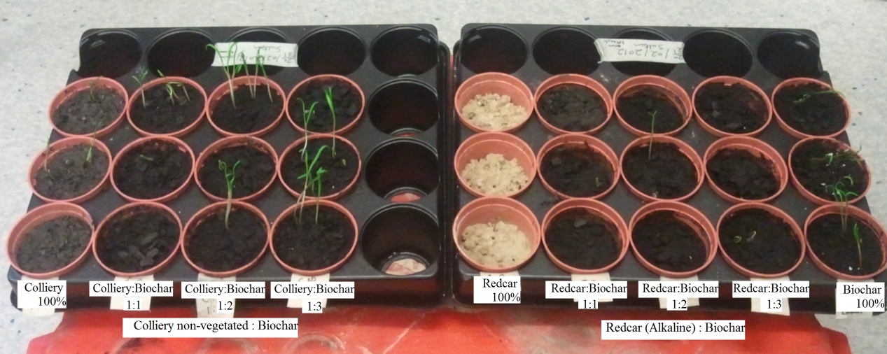
Figure 69. Plant growth in industrial soils (Colliery non-vegetated and Redcar-Alkaline) using Biochar (Spinach after 3 days).
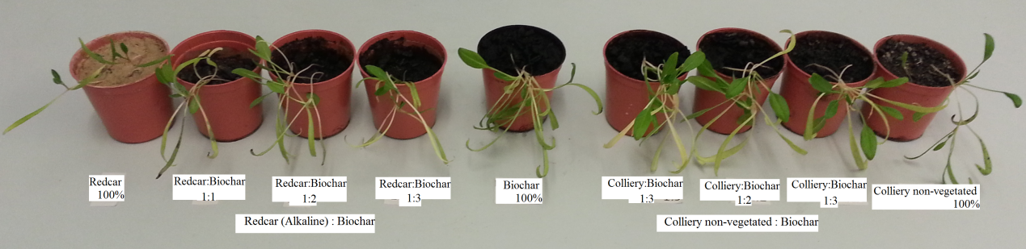
Figure 70. Plant growth in industrial soils (Colliery non-vegetated and Redcar-Alkaline) using Biochar (Spinach after 3 months).

Figure 71. Effect of Biochar on plant growth in alkaline (Redcar) and non-vegetated colliery spoil (fresh plant and leaf weight-mg).
Figure 71 shows the growth of spinach plants (fresh weight) on industrial spoils with Biochar 1:1, 1:2 and 1:3 compared with Biochar alone. The largest weight of spinach plant was seen in the Colliery non-vegetated treated with Biochar at a ratio of 1:3, which was in excess of more than 250 mg. This was followed by 100% Biochar, the total weight of which was less than 250 mg. The fresh weight of spinach in colliery non-vegetated spoil without Biochar was close to 200 mg but following mixing with Biochar (1:1 and 1:2) the weight increased to exceed. The fresh weight of spinach in the Redcar (alkaline) spoil without Biochar was low but again increased markedly when they mixed with Biochar at ratios of 1:1, 1:2 and 1:3 (Fig. 71).
Figure 71 also shows the fresh leaf weight of spinach plants grown in the industrial spoils amended with Biochar (1:1, 1:2 and 1:3) and compared to Biochar alone. The lowest leaf weight was seen in the Redcar (alkaline) spoil without Biochar (less than 50 mg). Fresh leaf weight increased sharply in the Redcar (alkaline) spoil when it was amended with Biochar 1:1, 1:2 and 1:3, giving values of between 120 to 150 mg. The fresh leaf weight increased considerably when the non-vegetated colliery spoil was mixed with Biochar 1:1 and 1:2 to values of around 150 gm, the highest values being obtained for the Biochar 1:3 ammendment followed by the un-amended Biochar which gave a value of in excess of 150 mg.
Figure 72. Effect of Biochar on plant growth in alkaline (Redcar) and non-vegetated colliery spoil (fresh root weight-mg).
Figure 72 shows the fresh root weight for spinach plants. The highest roots weight was found when the plants were grown in Biochar alone, reaching a value of 160 mg, followed by the colliery non-vegetated soil with a Biochar ratio of 1:3, producing a value close to 160 mg. The lowest roots weight was seen in the Redcar (alkaline) soil lacking any Biochar amendment (less than 60 gm). The fresh root weight increased from 70 mg to more than 100 mg when the Redcar (alkaline) soil was mixed with Biochar 1:1, 1:2 and 1:.3. The corresponding fresh roots weight in the colliery (non-vegetated) spoil without Biochar was more than 70 mg and the amount of root biomass increased dramatically when the colliery (non-vegetated) spoil was mixed with Biochar 1:1 and 1:2 (weights of between 90 to 140 mg).
Figure 73. Effect of Biochar on plant growth in alkaline (Redcar) and non-vegetated colliery spoil (dry root and plant weight-mg).
Figure 73 shows the dry weight of spinach plants grown in industrial spoils with Biochar 1:1, 1:2 and 1:3, compared to growth in with Biochar alone. The highest dry weight was seen in the colliery non-vegetated spoil when amended with Biochar 1:3 ( a value close to 50 mg), followed by Redcar (alkaline) spoil when mixed with Biochar 1:3 and un-amended Biochar. The lowest dry weight was seen in the Redcar (alkaline) spoil without Biochar (less than 15 mg). Plant growth in the Redcar (alkaline) spoils increased markedly (to around 30 mg) when mixed with Biochar 1:1 and 1:2. Spinach plant dry weight in the colliery non-vegetated spoil without Biochar was more than 30 mg, and increased sharply (in excess of 40 mg) when mixed with Biochar in the ratios1:1 and 1:2.
Figure 73 also shows that the root dry weight of spinach plants grown in industrial soils following amendment with Biochar, 1:1, 1:2 and 1:3 compared with Biochar alone. The highest root dry weight was seen in the un-amended Biochar without industrial spoil (20 mg) and the lowest was in Redcar (alkaline) spoil (10 mg). The root dry weight increased when the Redcar (alkaline) spoils were mixed with Biochar 1:1, 1:2 and 1:3 (between 10 mg and 20 mg). The non-vegetated colliery spoil without Biochar produced 10 mg of root dry weight and when this spoil was mixed with Biochar 1:1, 1:2 and 1:3 the dry root weight increased markedly (between 10 mg to 20 mg).
Figure 74. Effect of Biochar on spinach plant height (mm) in alkaline (Redcar) and non-vegetated colliery spoil.
Figure 74 shows spinach plant height in the industrial spoils amended with Biochar 1:1, 1:2 and 1.3 compared with unamended Biochar. Plant height was highest in the colliery non-vegetated spoil amended with Biochar 1:3 followed by Biochar alone. The lowest value for plant height was seen in the Redcar (alkaline) spoil without Biochar (around 60 mm). The height increased to 90 to 100 mm respectively when the Redcar (alkaline) spoil was mixed with Biochar in the ratios, 1:1, 1:2 and 1:3. The height of spinach plants in the colliery non-vegetated spoil without Biochar exceeded 90 mm, while the plant height increased markedly when the non-vegetated colliery spoil was mixed with Biochar 1:1 and 1:2 (to around 100 mm).
Figure75. Effect of Biochar on plant growth in alkaline (Redcar) and non-vegetated colliery spoil (branch and leaf numbers).
Figure 75 shows that all spinach plants produced only one branch when grown under all circumstances. Leaf number was, however, increased in unamended Biochar and in the colliery non-vegetated spoil amended with Biochar at a ratio of 1:3 (in excess of 8 leaves). The Redcar (alkaline) spoil without Biochar showed little leaf development (less than 5 leaves), but following amendment; with all ratios of Biochar, leaf number in this spoil increased to in excess of 7. Leaf numbers from the non-vegetated colliery spoil without Biochar was also at 7 leaves and this increased, to 7 and 8 in spoils respectively amended 1:1 and 1:2 (soil:Biochar).
Biochar carbon is chemically and biologically more stable than the plant-residue carbon from which it is made, making it difficult to break down, and in some cases, Biochar carbon can remain in soil for hundreds if not or even thousands of years (Lehmann, 2007). It is for this reason that Biochar potentially offers a way of sequestering carbon that may have otherwise been emitted to the atmosphere as carbon dioxide. In addition to carbon storage, the production of Biochar offers the following benefits (Lehmann, 2007). .
1) The gases generated during its production (hydrogen and methane) can be collected and used in heat and power production and 2) Biochar provides an opportunity to effectively manage animal and crop wastes by reducing both volume and mass and thereby reduce the potential for water pollution of such wastes. The nature of Biochar depends on the material that is burnt, and the temperature and rate of the heating process. Biochar produced from chicken litter for example will differ markedly from Biochar made from timber, and Biochar produced at 700ºC will produce a product having different adsorption characteristics to that produced following heating at 400ºC.

The use of Biochar in agricultural soils
The addition of Biochar to agricultural soils can lead to marked improvements in soil quality and also increase the efficiency of fertiliser and water use resulting in increased yields (Ladygina and Rineau, 2013). Conversely, no benefits, or negative effects have been observed resulting from micronutrient deficiency caused by soil pH increases following Biochar amendment, or phytotoxicity resulting from micronutrient excesses in the added Biochar. To date there has been little assessment of the characteristics and end use benefits for soils and potential carbon sequestration. Biochar production is produced in a similar manner to charcoal, (i.e. by the controlled burning of biomass) whilst restricting the air (oxygen) usually at temperatures less than 700ºC, (i.e.pyrolysis). Studies have shown that it is not necessarily the direct nutrient content of the Biochar that leads to yield improvement but more importantly the indirect fertility value. By possessing adsorption qualities, Biochar can reduce leaching and volatilisation of applied nitrogen and increase water retention.
Studies have shown that microbial biomass increases following Biochar addition, with significant effects on microbial community composition and the activities of soil enzymes, changes which may account for the biogeochemical effects of Biochar on the functioning of the element cycles, on plant pathogens, and on crop growth (Ladygina and Rineau, 2013). However, little is known about the mechanisms through which Biochar influences soil microbial numbers and community composition. The effects of Biochar on soil fauna are even less well understood than its effects on soil microbes, apart from several notable studies on earthworms. However, sorption phenomena, pH and the physical properties of Biochars (such as pore structure, surface area and mineral matter) clearly play important roles in relation to how Biochars affect the soil biota (Ladygina and Rineau, 2013). The sorption and thereby inactivation of growth-inhibiting substances by Biochar clearly play a role in increasing the abundance of soil biota. However, to date, no evidence exists to show any direct negative effects of Biochars on plant root functioning. Observed decreases in the abundance of mycorrhizal fungi are probably caused by concomitant increases in nutrient availability following Biochar amendment, which leads to a reduction in the need for symbionts (Ladygina and Rineau, 2013). In the short term, the release of various organic molecules from fresh Biochar may in some cases be responsible for increases or decreases in the abundance and activity of the soil biota (Ladygina and Rineau, 2013).

Biochar for Mine spoil remediation
A major problem in reducing the amount of pollution issuing from mining sites results from the difficulty of re-establishing vegetation and active soil processes on sites that lack vegetation. This problem of course also relates to attempts to improve the visual impact of these sites. Challenges relating to re-establishing vegetation at these sites are numerous, including the presence of acidic soils, unfavourable climatic conditions, and adverse physical conditions related to soil compaction and low water retention. Biochar enhances Cu and Pb sorption although the amounts need to be in excess of 1% and 2% w/w (Trakal et al, 2011).
Park et al. (2011) stated that the results of their study showed that Biochar application was clearly effective in metal immobilization, thereby reducing the bioavailability and phytotoxicity of heavy metals. Sohi et al. (2009) showed that when compared to seeding alone, the addition of a 30% by volume Biochar soil amendment increased vegetation cover on acid affected soils by 240%. Conversely, on non-acid, soils no increase or substantially less cover was observed when compared to the application of straw mulch alone. Biochar treatments increased the water holding capacity of all of the soils (by some 90% - 180%). Seed emergence was also faster with more emergence and longer sprouts (350% - 670% increase in length) after 120 hours for treatments that contained Biochar when compared to soil only. The largest numbers of seeds emerging, with the longest sprouts were in treatments that contained both Biochar and straw mulch. Above ground plant biomass was positively affected by Biochar additions, with acid mine sites showing a 192% increase in biomass. The effect of Biochar on above ground biomass on non-acid sites was in contrast small, with a magnitude increase of 6%-11%. Leachate chemistry following Biochar addition were mixed, with decreases in leachate concentration at 40 days for Al and Fe, increases in the concentration of Cu, and most (Cd, As, Mn, Ni, Pb, Zn) showing very small or no differences in leachate concentration when compared to a soil only control. These results confirm that Biochar, when combined with organic mulch, may be a useful tool for soil restoration at abandoned mine sites, or at other acidic soils sites.
Land reclamation relates in general to improvement of soils which have been highly degraded by human activity, notably in relation to mining pollution and land spoilage. Soil remediation involves the removal, neutralization or reduction in the toxicity of certain compounds, often left by exposure to human activities (Ladygina and Rineau, 2013). Biochar can potentially be used to revegetate degraded soils through several mechanisms including the sorbtion of various compounds in soil. The multiple potential benefits of Biochar combined with the fact that it is a low cost and essentially environmentally friendly material makes it ideal for use in soil bioremediation (Ladygina and Rineau, 2013).
Biochars potential for improving crop yields and bioremediation is receiving considerable attention. Often, the end point is to bring about the establishment of a spontaneous vegetation cover on degraded soils, most of which are acidic and contain small amounts of organic matter. Some Biochars have a high pH and can act as liming agents, thereby increasing soil pH (Chan et al., 2007; Novak et al., 2009; Major et al., 2010). In cases where the organic matter and clay amounts in a spoil are low or where soil is coarse textured, Biochar addition can lead to increased moisture retention which will generally increase the rate of the establishment of vegetation. In addition, nutrient leaching can be reduced following Biochar application to spoils (Lehmann et al., 2003; Major et al., 2009; Novak et al., 2009; Singh et al., 2010).

Biochar and the sorption of heavy metals
Biochar can absorb a variety of heavy metals, notably lead (Pb), arsenic (As) and cadmium (Cd) (Cao et al., 2009, Mohan et al. (2007). These authors concluded that metal adsorption by Biochars involved ion exchange processes.
Biochar when applied at 1% on a weight basis was found to reduce the concentration of leachable metals in spoils contaminated with phenanthrene, resulting in more rapid degradation of this pollutant and better plant growth in its presence (Sneath et al., 2009, Laird, 2008). Zhang et al., 2010 found that soil amended with 0.1 and 0.5 % (w/w) pine Biochar sorbed larger amounts of phenanthrene than non-treated soil, with the effect varying with the type of Biochar employed, soil characteristics and the contact time between Biochar and soil (Zhang et al., 2010). Uchimiya et al. (2010a) found that the addition of broiler litter Biochar to soil enhanced the immobilization of a mixture of Pb, Cd and nickel, an effect which was mostly the result of an increase in pH brought about by Biochar. In a separate, these authors (Uchimiya et al., 2010b) found that both high-ash and low-ash Biochars can reduce the mobility of Cd, Cu and Ni in soil, and that by treating the Biochars with phosphoric acid their negative surface charge was increased and this improved the immobilization capacity of the Biochar. Beesley et al. (2010) found that Biochar was significantly more effective than compost (based on volume) in reducing the bioavailability of Cd and Zn, largely because Biochar raised the soil’s pH more than did compost.

Biochar and the sorption of organic molecules, such as pesticides
Organic pollutants include many agricultural pesticides and industrial effluents. Biochar and the ash contained in Biochar have a high affinity for sorbing different organic compounds, and charred organic matter (i.e. Biochar, soot and activated carbon) tend to adsorb 10 to 1000 times more organic compounds than does organic matter which is unchared (see review by Smernik, 2009). Adsorption of organic molecules onto Biochar is generally less reversible than is adsorption onto other forms of organic matter, so that the probability a sorbed molecule will become desorbed is lower (Ladygina and Rineau, 2013). The greater the surface area and porosity of a Biochar, the greater will be its potential for adsorption of contaminants (Smernik, 2009). Although sorption dynamics are affected by pH and other soil factors, studies have shown that Biochar addition to soil improves pesticide sorption, such as the herbicides atrazine (Cao et al. 2009, Zheng et al. 2010), diuron (Yu et al., 2006) and acetochlor (Spokas et al. 2009). Wang et al. (2010) showed that wood-derived Biochar sorbed more (and more strongly) of the herbicide terbutylazine than did biosolids.
Yu et al. (2009) and Yang et al. (2010) showed that Biochar reduced losses of the soil-applied insecticides chlorpyrifos and fipronil; these authors suggest that Biochar might be employed to sequester these, and other, insecticides in situ, while leading to a reduction in their uptake by plants. Yu et al. (2010) also showed that eucalyptus wood Biochar was around 100 times more efficient at adsorbing the fungicide pyrimethanil than was soil and Yang et al. (2006) found that wheat straw Biochar led to 7-80 times more diuron sorption than occurred in an unamended soils. Yang et al. (2003) also showed that wheat straw ash was 600-10000 times more effective at sorbing diuron than unamended soil and similar results were obtained regarding benzonitrile (a solvent) sorption by ash/Biochar in soil (Zhang et al., 2006), MCPA (a herbicide), (Hiller et al., 2007) and polycyclic aromatic hydrocarbons (PAH) (Beesley et al., 2010). Finally, laboratory work using crude oil contaminated desert soil has shown that coconut charcoal is highly efficient at promoting oil biodegradation (Cho et al., 1997).

Removal of metals from mine waste water
A study by Inyang et al. (2012) looked at the ability of two Biochars converted from anaerobically digested biomass to sorb heavy metals. Initial results with DAWC (digested dairy waste Biochar) and DWSBC (digested whole sugar beet Biochar) showed that both Biochars were effective in removing a mixture of four heavy metals (Pb² ⁺, Cu²⁺, Ni²⁺, and Cd²⁺) from aqueous solutions. Compared to DAWC, DWSBC was better able to remove Ni and Cd. Further investigations concentrating on lead sorption by the two Biochars types showed that the removal was mainly through a surface precipitation mechanism (Inyang et al., 2012). The lead sorption capacity of the two Biochars was close to or higher than 200 mmol per kg, which is comparable to that of commercially available activated carbon.

Application of phytoremediation and phytoextraction to Biochar-treated and re-vegetated spoils
Assuming that Biochar could be used to effectively increase plant cover on the spoils used here, then it may be possible to use specific plants, which are known to accumulate metals, or otherwise breakdown pollutants, in order to successfully bioremediate industrial spoils (i.e.phytoremediation).
Phytoremediation is a technology that uses higher plants to bioremediate contaminated environments (Salt et al,1988). Selected plant species have the potential to remove, degrade, metabolize, or immobilize a wide variety of pollutants. The success of phytoremediation depends on complex interactions, affected by various factors, notably climatic conditions, soil properties, and site hydrogeology. Remediation of metal polluted soils/spoils is particularly challenging, since unlike organic contaminants, metals are not biodegradable. Decontamination of metal-contaminated soils therefore generally requires the removal of toxic metals (Salt et al., 1988, Center,1995).

Chapter Seven

General Discussion

The aim of the work described in this Thesis was to study the biogeochemistry if a variety of industrial spoils, ranging from a highly alkaline steel slag spoil to a slightly acidic colliery spoil and acidic metal mining wastes .The ultimate aim of the work was to provide information which might be used in the remediation of these spoils using plant cover. With this in mind, a preliminary evaluation was undertaken to determine if Biochar can be used to help improve the conditions for plant growth in these spoils. The main reason why such industrial spoils need remediating relates to aesthetic considerations, i.e. the presence of spoil tips ruins the local environment a factor which impacts on tourism and the introduction of “clean industries” to former mining areas.
The first step in spoil tip remediation largely involves a physical engineering approach when the height of the tip and its physical presence is reduced using heavy industrial machinery. The area must then be well-resourced with drainage ditches to prevent any potentially damaging spoil run-off from polluting surrounding land and waster courses. The next step generally involves the provision of a plant cover which can form on soil dumped onto the spoil surface, or by allowing the, the much slower, natural development of a plant cover on the spoil. The provision of such a plant cover, not only improves the aesthetics of the area, but also improves spoil tip stability and prevents spoil dust from blowing around the local area.
The simple expedient of dumping low grade soil on the tips and then cover seeding these with a grass cover can work very well, and is widely the approach of choice. However, in some case toxicant such as heavy metals can move upwards from the spoil to the tip surface leading to localised scorched areas which defeats the whole aim of the remediation process. As a result, it is often desirebale to allow natural revegitation of the tips to occur. This is obviously a much slower process, but by definition if a plant is self-set it is more likely to grow on spoils, to which conditions it is adapted. No attempts have been made to remediate the areas of colliery spoil at Shirebook which have been used in this study. Instead, a natural vegetation cover, largely comprising of single stands of birch, has been allowed to develop on these tips; such growth of trees is relatively stunted, but provides an aesthetic cover in summer; in winter however, due to an absence of plant undercover, the tips can still look somewhat naked.
The application of soil cover has been the most widely applied approach to the remediation of mining and industrial spoils in the UK and in the coal fields of South Yorkshire, where the colliery spoils used here are located. Natural revegetation has however, historically had a major impact on the re-vegetation of some of the earliest spoiled areas of the industrial revolution. It is scarcely believeable, for example, that large areas of Cornwall and Devon were once scarred with mines and their waste, a fact which most of today’s visitors to these tourist-renown areas would find unimaginable.
The results presented here show that none of the spoils used here are “sterile” and lack microorganisms which are capable of actively being involved in the biogeochemical transformations which promote spoil fertility and possible remediation. Even the extremely alkaline spoils from Redcar have the capacity to nitrify, hydrolyse urea, and solubilize insoluble phosphates. Similarly the spoils all exhibit soil enzyme activity. The use of the Munnekce bioassay shows that the spoils contain no water-soluble inhibitors of bacterial growth and it is presumed plant growth. This illustrates that contaminating metals and other toxicants need not always be biologically available in bulk soils, although availability is almost certainly likely to increase in the rhizosphere of plants growing on spoils such as the ones studied here. In the same way, the availability of phosphate in the spoils is extremely complex and is unlikely to be predicted based on a single spoil property such as pH.
The results also point to the potential for using Biochar as a means of enhancing plant growth on the spoils studied. The use of such a procedure on the large scale which is necessary is likely to be expensive however, and further studies are clearly needed to determine if spoil remediation using Biochar can ever be cost effective when competing against cheaper waste products, such as animal-straw waste. The fundamental reality is that, when faced with costs issues and the need for a rapid solution to improving the aesthetic appearance of these tips environmental engineers will nearly always seek to cover modified tips with a cheap top soil and seed these with grass (which may, for example, be selected for pH resistance, or the ability to grow in metal rich environments). More sophisticated means of remediation, using substances like Biochar may never therefore have the opportunity to be evaluated in the face of this simple and cost effective approach to spoil remediation.

FUTURE STUDIES

1) The most obvious way in which the work described in this Thesis could be extended is for extensive field trial to be conducted in relation the potential use of Biochar to improve plant growth on the industrial spoils used here. Such trials should involve randomized plants (such as a Latin Square) in order to statistically determine the ability of Biochar to improve plant growth in spoils when exposed to field conditions.
2) A variety of Biochar materials are available depending on the type of wood or waste which is turned into charcoal. For example, broiler house-poultry waste Biochar is sold. It would be of interest to compare these different types of Biochar to determine which is the most efficient in relation to spoil bioremediation.
3) In terms of improving the analytical methods used in this study it would be desirable to more accurately determine the metal content (water and acid soluble) of the spoils using an atomic adsorption spectrophotometer.
4) As we have seen, certain plants have the ability to remove metals from soils. Assuming good growth of vegetation could be achieved on Biochar-treated soils, it would be of interest to determine if metal-extracting plants could be successfully used to reduce the metal content of bioremediated spoils (i.e. phytoextraction).
5) Laboratory and field studies could be conducted on the acidification of the Redcar, alkaline spoils in an attempt to further improve their bioremediation. Such acidification might effectively be brought about by the addition of elemental sulphur to these spoils, in the likelihood of producing sulphuric acid in situ.

SUMMARY OF FINDINGS

A study was made of the microbiology and biogeochemistry of some industrial spoils from Anglesey; Shirebrook, Nottingham, Redcar (alkaline spoil) and Sardinia; these spoils were compared in relation the their microbiology and biogeochemistry with an agricutural soil. The spoils ranged in pH from 3.7 (Anglesey yellow) to pH 12.0 (alkaline Redcar. Anglesey spoils are all acidic, while the colliery spoils are slightly acidic and similar in pH to the Agricultural soil. The pH of the unvegetated colliery spoil is lower than the vegetated spoil, showing the tendency of vegetation cover to generally increase soil pH slightly. The Sardinia soils are neutral to slightly acidic.
Bacterial numbers in the Agricultural soil were, not surprisingly, higher than the spoils and at levels typical of most fertile loams. The alkaline and colliery spoils showed reduced numbers compared to the agricultural soils with vegetation cover in the colliery spoil producing an expected increase in bacterial numbers. Very low bacterial numbers were found in all of the Anglesey spoils.
Oligiotrophs were isolated from the Agricultural soil (using nutrient broth, diluted 100 fold) and in lower numbers from all of the spoil. Surprisingly high counts of oligotrophs were found in the highly alkaline Redcar spoil, while the lowest counts were seen in the Sardinian mining soil and salt-bed stream.
As expected, the addition of the ammonium substrate to the agriculture and Redcar soils led to an increase in nitrification compared to the control (unamended samples) in both substrates. Net nitrate production over the entire incubation period was highest in the agriculture soil amended with ammonium, reflecting the higher fertility state and lower pH of the agricultural soil. Nitrification generally increases with increasing pH, for example following the addition of lime to around pH 8.0; clearly the very high pH of the Redcar soils is limiting to nitrification. In addition, considering the fact that these alkaline spoils result from blast furnace waste (alkaline slag), other industrial pollutants, such as silicates and metals are likely to be present, many of which will limit the rate of nitrification. Nitrification was higher in the vegetated colliery spoil than non-vegetated spoil over the complete incubation period. This reflects the fact that the growth of plants and the formation of rhizospheres leads to a generalized improvement in soil structure (i.e. in relation to factors such as soil pH, water retention and aeration) which increase soil fertility and overall levels of microbial activity including to increased microbial numbers. Net nitrate production in the metal mining spoils (black ash) from Sardinia were very low for most of the incubation period but showed a spike at the 28 day sampling point; the same increase, but to a lesser extent occur in the Sardinia salt spoil sample. The observed low levels of nitrification clearly results from the lower levels of fertility (low organic carbon plus low microbial activity) in the ash and high salt concentrations in the salt-bed samples; the obvious spike in net nitrate production is difficult to explain, but may have resulted from a reduction of some unspecified nitrification inhibitor or an increase in soil pH, over time. Nitrification rates in the Parys Mountain spoils were low, particularly in the S3 yellow sample, over the entire incubation period reflecting the fact that these spoils are from a once active metal mining region and have very low pH and are rich in nitrification- inhibiting metal ions such as copper. In addition, the spoils are acidic and low in organic carbon and nitrogen, all factors which limit nitrification rates. This sampling represents an initial screening of the Parys Mountain site. More Further, more detailed studies will in future be made of nitrification at this site.
Amendment of the spoils with elemental sulphur lead to a substantial increase in sulphate production in the Redcar soil, but not surprisingly, sulphur oxidation was high in the agricultural soil over the incubation period. Net sulphate production did was not active in the unamended spoil, due perhaps to a lack of reduced S-substrate. Addition of the sulphur substrate increased net sulphate production over the incubation period. As with nitrification the highest production of the terminal oxidation product was seen in vegetated soils. As mentioned above with nitrification, the increased rates of sulphur oxidation in the vegetated spoils reflect an overall improvement in soil structure brought about by the formation of a rhizosphere. The most noticeable feature of the results for the Sardinia spoils in regard to sulphate production is the extremely high initial concentration of sulphate found in the salt bed soil which, on amendment with elemental sulphur increased. This finding shows that the “salt” stream is in fact a sodium sulphate waste stream, and is not composed of sodium chloride i.e. salt. Sulphur oxidation is also seen to be rapid (from a low level) in the black ash spoil. Sulphur oxidation in the Parys Mountain heavy metal mining sites are generally low and begins from a low starting point. This is perhaps surprising, since one might have expected these spoils to be sulphur-rich and contained high and active populations of sulphur oxidizers. The low level of activity cannot also be related to the low pH of these spoils since, as has been previously mentioned the oxidation of reduced sulphur compounds generally leads to the formation of sulphate as sulphuric acid which in turn leads to the acidification of soils and spoils.
The hydrolysis of urea to ammonium was initially slow in both the agricultural soil and Redcar spoils, but increased dramatically at day 14 in the agricultural soil; increases also occurred in the Redcar soil, but were less dramatic. These results reflect the need for urea hydrolysing populations to increase after adaption to the initial amendment, and the extremely high pH of the Redcar soil which puts a constraint on microbial activity in general. It is interesting to note however, that urea hydrolysis generally leads to an increase in soil pH, so urea hydrolysers are alkaline tolerant but not to such a high pH level, of around pH 12, as occurs in the Redcar soils. Rates of urea hydrolysis were high in the colliery spoils in both vegetated and non-vegetated spoils, with an increase in ammonium production in the vegetated versus non vegetated spoil. The high rate of urea hydrolysis found in the colliery spoils is perhaps surprising considering their low organic matter content. This finding probably reflects the fact that urea hydrolysis is carried out by a very wide range of microorganisms including an extremely diverse bacterial and fungal population. As a result, it is a process which continues under various adverse conditions. High rates of urea hydrolysis occurred in the black Ash and salt stream bed. In contrast, urea hydrolysis did not occur to any substantial degree in the control samples.
Urea hydrolysis occurred in the Parys Mountain spoils and variations in the rate of hydrolysis occurred between the various soils, with the lowest occurring in the S4-dark brown spoil, while the S1 brown spoil was initially slow to hydrolyse urea, but showed the highest production of ammonium in the Parys Mountain spoils, at day 28. These findings again reflect the wide diversity of microorganisms which are involved in this process and which can be found even in spoils which are restricted in population diversity by heavy metal contamination.
Phosphate concentrations in all spoils and the agricultural spoil, not surprisingly, increased following the addition of a source of insoluble phosphate, particularly, as again one would expect in the agricultural soil. Phosphate concentrations in the Redcar spoils were less than those seen in the agricultural soil and were even lower in the colliery spoils (with vegetation cover as expected leading to an increase in the concentration of the ion compared to non-vegetated spoil). The lowest phosphate concentrations were found in the Sardinia spoils, which never exceed a value of 10 micrograms per mg.
Phosphate solubilizing bacteria were isolated, in relatively low numbers, from all of the spoils with the exception of the Parys Mountains (brown) spoil sample. The highest count was found, not surprisingly, in the agricultural spoil, although the vegetated colliery spoil showed relatively significant numbers. Phosphate solubilizing fungi were surprisingly not isolated from the agricultural soil, and were generally isolated at much lower frequency than were phosphate solubilising bacteria; only a single colony was isolated from the highly alkaline (Redcar)spoil and with the exception of the Parys Mountain (brown samples), no phosphate solubilising fungi were isolated from any of the spoils. It should always be borne in mind that the plate count technique, when applied to fungi, tends to favour highly sporulating fungi, such as species of Penicillium). All of the fungal and bacteria- isolates, the latter subsequently identified as Brevidomonas alba and P. aurantogriseum, were able to solubilise insoluble phosphate in PVK medium. The results show that the fungus was capable of higher rates of solubilization than was the bacterium, although it must be borne in mind that the two organisms were grown in different media, so the results are not directly comparable.
Phosphate solubilizing bacteria were identified using the 16SrRNA technique, and fungi using 18SrRNA. The bacterial isolates were identified (using 16SrRNA) as Achromobacter xylosoxidans and Brevidundomonas alba and the fungus was identified using 18SrRNA as Penicillim aurantiogriseum.
Arylphosphatase activity in the industrials spoil samples was high in Anglesey S3 (Yellow), in excess of 200 µgg⁻¹, followed by the vegetated colliery spoil, Anglesey S1 (Brown), Agriculture and Anglesey S2 (Red) (ranging between 150 to 190 µgg⁻¹). Medium activity was seen in the colliery non-vegetated soil (more than 100 µgg⁻¹). Low enzyme activity was found in Sardinia industrial spoils (Black ash and Salt stream bed) followed by the Anglesey S4 (Dark Brown) (activity for these spoils was between 30 to 60 µgg⁻¹. The lowest activity was found in Redcar (alkaline - pH 12) spoil which was around10 µgg⁻¹. Arylsulphatase activity was also detected and measured in all the samples. The highest activity was in the agriculture soil (in excess of 120 µgg⁻¹) followed by Anglesey S1 (Brown) and colliery vegetated soils (in excess of 110 µgg⁻¹; the lowest activity was in Redcar (alkaline – pH 12). Surprisingly high enzyme activity was found in all samples including the salt samples and the highly alkaline Redcar samples. These results show that arylsulphatases are widely distributed in the environment and that the enzyme is active over a surprisingly wide range of conditions. This means that the breakdown of arylsulphatases will occur in all soils, largely independent of the prevailing conditions, including the presence of potentially toxic metals and a wide pH range.
Urease activity was highest in the agriculture soil (in excess of 8 µgg⁻¹ followed by the colliery vegetated and colliery non-vegetated spoils (6 to 8 µgg⁻¹). Urease activity in the Sardinia soils (Black ash and Salt stream bed) ranged between 5 to 6 µgg⁻¹ followed by Anglesey spoils samples S4 (Dark brown), S1 (Brown), S2 (Red) and S3 (Yellow) that were around 4 to 5 µgg⁻¹ . The lowest urease activity was found in the Redcar spoil (alkaline – pH 12) (at around 2 µgg⁻¹).
The addition of Biochar to the former led to a reduction in pH of the spoil, so that the maximum Biochar addition-ratio (1. spoil. 3 Biochar, resulted in a reduction of spoil pH from pH 12 to 9. In contrast, the addition of Biochar to the colliery waste increased the pH from a non-amended spoil pH of 5.7 towards neutrality. Bacterial numbers tended to increase in Biochar-treated spoils again an effect which is likely to promote soil fertility. The addition of Biochar increased the amount of net nitrate production in the non-vegetated colliery spoil. The increase was proportional to the amount of added Biochar and increased with increasing amount. Biochar addition also increased the amount of net nitrate production in the Redcar alkaline spoil. The increase was proportional to the amount of added Biochar and increased with increasing amount. The addition of Biochar to elemental sulphur-amended colliery spoils led to increases in net sulphate production over the entire incubation period. There was however, little (and non-significant) difference between the 1:2 and 1:3 ratios of addition. Sulphur concentrations in the Redcar alkaline spoil was enhanced, over the entire incubation period, by the addition of Biochar. The increases in sulphate produced increased in direct relationship to the amount of added charcoal, with the 1.3 ratio of addition producing the greatest increase. There was however little (and non-significant) difference between the increases in sulphate ion following the 1:2 and 1:.3 additions. Biochar addition led to an increase in ammonium levels in the non-vegetated colliery spoil at all ratios of Biochar to spoil; the increase increasing with the ratio of Biochar to spoil. Ammonium concentrations in the Redcar spoil was markedly restricted in the Redcar, alkaline spoil over the first 21 day of the incubation period after which time, they increased markedly; the same trend being seen when Biochar (at all ratios) was added. In this case Biochar had no significant effect on ammonium concentrations following any ratio of addition. The addition of Biochar increased the amount of phosphate solubilization which occurred in the Redcar alkaline spoil. The increase was proportional to the amount of added Biochar and increased with increasing amount Finally, Biochar addition led to increased phosphate solubilization in the Redcar, alkaline spoil, the increase in phosphate release increasing with the ratio of Biochar to spoil. The growth of spinach plants (fresh weight) which growth in industrial soils with Biochar 1:1, 1:2 and 1:3 compared with Biochar alone. The largest weight of spinach plant was seen in the Colliery non-vegetated treated with Biochar at a ratio of 1:3, which was in excess of more than 250 mg. This was followed by 100% Biochar, the total weight of which was less than 250 mg. The fresh weight of spinach in colliery non-vegetated spoil without Biochar was close to 200 mg but following mixing with Biochar (1:1 and 1:2) the weight increased to exceed. The fresh weight of spinach in the Redcar (alkaline) spoil without Biochar was low but again increased markedly when they mixed with Biochar at ratios of 1:1, 1:2 and 1:3.
The fresh leaf weight of spinach plants grown in the industrial spoils amended with Biochar (1:1, 1:2 and 1:3) was compared to Biochar alone. The lowest leaf weight was seen in the Redcar (alkaline) spoil without Biochar (less than 50 mg). Fresh leaf weight increased sharply in the Redcar (alkaline) spoil when it was amended with Biochar 1:.1, 1:2 and 1:3, giving values of between 120 to 150 mg. The fresh leaf weight increased considerably when the non-vegetated colliery spoil was mixed with Biochar 1:1 and 1.2 to values of around 150 gm, the highest values being obtained for the Biochar 1.3 amendment, followed by the un-amended Biochar which gave a value of in excess of 150 mg.
The highest roots weight was found when the plants were grown in Biochar alone, reaching a value of 160 mg, followed by the colliery non-vegetated soil with a Biochar ratio of 1:3, producing a value close to 160 mg. The lowest roots weight was seen in the Redcar (alkaline) soil lacking any Biochar amendment (less than 60 gm). The fresh root weight increased from 70 mg to more than 100mg when the Redcar (alkaline) soil was mixed with Biochar 1:1, 1:2 and 1:3. The corresponding fresh roots weight in the colliery (non-vegetated) spoil without Biochar was more than 70 mg and the amount of root biomass increased dramatically when the colliery (non-vegetated) spoil was mixed with Biochar 1:1 and 1:2 (weights of between 90 to 140 mg). The dry weight of spinach plants growth in industrial soils with Biochar 1:1, 1:.2 and 1:3, compared to growth in with Biochar alone. The highest dry weight was seen in the colliery non-vegetated spoil when amended with Biochar 1:3 ( a value close to 50 mg),followed by Redcar (alkaline) spoil when mixed with Biochar 1:3 and un-amended Biochar. The lowest dry weight was seen in the Redcar (alkaline) spoil without Biochar (less than 15 mg). Plant growth in the Redcar (alkaline) spoils increased markedly (to around 30 mg) when mixed with Biochar 1:1 and 1:2. Spinach plant dry weight in the colliery, non-vegetated spoil without Biochar was more than 30 mg, and increased sharply in excess of 40 mg when mixed with Biochar in the ratios1:1 and 1:.2. Root dry weight of spinach plants grown in industrial soils following amendment with Biochar, 1:1, 1; 2 and 1:3 compared with Biochar alone. The highest root dry weight was seen in the un-amended Biochar without industrial spoil (20 mg) and the lowest was in Redcar (alkaline) spoil (10 mg). The root dry weight increased when the Redcar (alkaline) spoils were mixed with Biochar 1:1, 1:2 and 1:3 (between 10 mg and 20 mg). The non-vegetated colliery spoil without Biochar produced10 mg of root dry weight and when this spoil was mixed with Biochar 1:1, 1:2 and 1:3 the dry root weight increased markedly (between 10 mg to 20 mg). Spinach plant height was highest in the colliery non-vegetated spoil amended with Biochar 1:3 followed by Biochar alone. The lowest value for plant height was seen in the Redcar (alkaline) spoil without Biochar (around 60 mm). The height increased to 90 to 100 mm respectively when the Redcar (alkaline) spoil was mixed with Biochar in the ratios, 1;1, 1:.2 and 1:.3. The height of spinach plants in the colliery non-vegetated spoil without Biochar exceeded 90 mm, while the plant height increased markedly when the non-vegetated colliery spoil was mixed with Biochar 1:1 and 1:2 (to around 100 mm). All spinach plants produced only one branch when grown under all circumstances. Leaf number was however, increased in un-amended Biochar and in the colliery non-vegetated spoil amended with Biochar at a ratio of 1:3 (in excess of 8 leaves. The Redcar (alkaline) spoil without Biochar showed little leaf development (less than 5 leaves), but following amendment; with all ratios of Biochar, leaf number in this spoil increased to in excess of 7. Leaf numbers from then non-vegetated colliery spoil without Biochar was less than 7 leaves and this increased, to 7 and 8 in spoils respectively amended 1:1 and 1:2 (soil: Biochar).

REFERENCES

Abbot, E. V. (1923). The occurrence and action of fungi in soils. Soil Science 16, 207-216.
Agathos, S. and Reinecke, W. (2002). Biotechnology for the Environment. Dordrecht, Kluwer.
Alexander, M. (1977). Introduction to Soil Microbiology, Wiley, New York.
Alloway, B.J. (1990). Heavy Metals in Soils, Blackie, Glasgow.
Altomare, C.; Noevell, W.A.; Björkman, T. and Harman, G.E. (1999). Solubilization of phosphates and micronutrients by the plant growth promoting and biocontrol fungus Trichoderma harzianum. Applied and Environmental Microbiology 65, 2926-2933,
Anderson, T.A.,Guthire, E.A. and Walton, B.T.(1993). Bioremediation in the rhizosphere. Environmental Science and Technology 27, 2630-2636.
Ardau, C. and Rundeddu, L. (2001). Environmental problems and industrial archaeology in the Islesieta mining district. Rendiconti Seminario Facota Scienze Universita Cagliari, Suppl.71, 91-108.
Atlas, R.M. and Bartha, R. (1981). Microbial Ecology, Fundamentals and Applications, New York, Addison.
Bajpai, P.D. and Sundra Rao, W.V.B. (1971). Phosphate solubilizing bacteria. Extracellular production of organic acids by selected bacteria solubilizing
insoluble phosphate. Soil Science and Plant Nutrition 17, 44-45.
Bakircioglu, D. Bakircioglu, Y and Hilmi-ibar, K. (2011). Comparison of extraction procedures for assessing soil metal bioavailability to wheat grains. Clean Soil, Air, Water 39, 728–734.
Barrow, C.J.(2012). Biochar. Applied Geography 34, 21-28.
Beesley, L., Moreno-Jimenez, E., Gomez-Eyles, J.L., (2010). Effects of Biochar and greenwaste compost amendments on mobility, bioavailability and toxicity of inorganic and organic contaminants in a multi-element polluted soil. Environmental Pollution 158, 2282- 2287.
Billing,S.J. (1987). Chloride Variation in Surface Layers of Colliery Spoil Heaps. PhD Theis, University of Durham,UK
Boer, De.W, Kowalcchuk,G.A. (2001). Nitrification in acid soil micro-organisms and mechanisms. Soil Biology and Biochemistry 33, 853-866.
Brady.C and Weil. R (1999). The Nature and Properties of Soils. 12th ed. Prentice Hall, London.
Bremner, J.M. and Mulvaney, R.L. (1978). Urease activity in soils. In. Soil Enzymes (Ed, Burns, R.G.). Academic Press, London, pp 149-196.
Brown, K.A. (1982). Sulphur in the environment: a review. Environmental Pollution. 3, 47-80.
Burns, G.R. (1967). Oxidation of Sulphur in Soils. Sulphur Inst. Washington D. C. Techical Bulletin 13, 1-41.
Burns, R. G. (1978). Enzyme activity in soil some theoretical and practical considerations. Soil Enzymes. Ed. R. G. Burns, Acdemic Press, London. 295 - 340.
Cao, X.D., Ma, L.N., Gao, B., Harris, W., (2009). Dairy-manure derived Biochar effectively sorbs lead and atrazine. Environmental Science and Technology 43, 3285-3291.
Center, A.B. (1995). Phytoremedation: a novel strategy for the removal of toxic metals from environments using plants. Biotechnology 13, 468-478.
Chadwick, M. J. (1973a). Methods of assessment of acid colliery spoil as a medium for plant growth. Ecology and Reclamation of Devastated Land (Ed. by R. J. Hutnik and G. Davis), Vol. I, pp. 81-91. Gordon and Breach, London.
Chadwick, M. J. (1973b). Amendment trials of coal spoil in the north of England. Ecology and Reclamation of Devastated Land (Ed. by R. J. Hutnik and G. Davis), Vol. II, pp. 175-88. Gordon and Breach, London.
Chan, K.Y., Van Zwieten, L., Meszaros, I., Downie, A., Joseph, S. (2007). Agronomic values of greenwaste Biochar as a soil amendment. Australian Journal of Soil Research 45, 629-32.
Chandramohan, D., Devndran, K. and Natarajan, R. (1974). Arylsulphatase activity in marine sedements. Marine Biology 27, 89-92.
Chen, Y.P.; Rekha, P.D.; Arunshen, A.B. Lai, W.A. and Young, C.C. (2006). Phosphate solubilizing bacteria from subtropical soil and their tricalcium phosphate solubilizing abilities. Applied Soil Ecology 34, 33-4.
Cho, B.H., Chino, H., Tsuji, H., Kunito, T., Nagaoka, K., Otsuka, S., Yamashita, K., Matsumoto, S., Oyaizu, H., (1997). Laboratory-scale bioremediation of oil-contaminated soil of Kuwait with soil amendment materials. Chemosphere 35, 1599-1611.
Clement, C.R.(2011). The biochar solution:carbon farming and climate change. Bioscience 61,831-833.
Coleman, R. (1966). The importance of sulphur as a plant nutrient in world crop production. Soil Science. 101, 230-239.
Cooper, G.S. and Smith, R.L. (1963). Sequence of products formed during denitrification in some diverse western soils. Soil Science Society America Proceedings. 27, 659-662.
Cooper, P.J.M. (1972). Arylsulphatase activity in Northen Nigerian soils. Soil Biology and Biochemsitry. 4,333-337.
Costigan, P. A., Bradshaw, A. D. and Gemmell, R. P. (1981). The reclamation of acidic colliery spoil. Journal of Applied Ecology. 18, 865-878.
Cunningham, J.E. and Kuiack, C. (1992). Production of citric and oxalic acids and aolubilization of calcium phosphates by Penicillium bilaii. Applied and
Environmental Microbiology, 58, 1451-1458.
Dalal, R.C. (1975). Urease activity in some Trinidad soils. Soil Biology and Biochemistry 7, 5-8.
Dick, R.P. (1997). Soil enzyme activities as integrative indicators of soil helath. In Perkhurts et al. (Eds.) Biological Indicators of Soil Health, CAB., UK.
Doubleday, G. P. and Jones, M. A. (1977). Soils of reclamation. In Landscape Reclamation Practice (B. Hackett, ed.), pp. 85-124. Guildford. IPC Press.
Douglas, L.A. and Bremner, J.M. (1970). Extraction and colorimetric determination of urea in soils. Soil Science Society America Proceedings. 34, 859-862.
Down, C. G. (1974). The relationship between colliery waste particle sizes and plant growth. Environmental Conservation. 1, 28 l-285.
Down, C. G. (1975). Soil development on colliery waste tips in relation to age. I. Introduction and physical factors. Journal of Applied Ecology 12, 6 13-622.
Downing, M. F. and Vyle, C. J. (1971). Special problems. In Landscape reclamation, Vol. 1 (University of Newcastle, ed.), pp. 57-63. Guildford. IPC Press.
Duddridge, J.E. and Wainwright, M. (1982). Enzyme activity and kinetics in substrate- amended river sediments. Water Research 16, 329-334.
Falih.A.M. (1995). The Microbiology of Soils Receiving High Concentrations of Sucrose from a Natural Source. Unpublished Ph.D.Thesis University of Sheffield, pp.151
Farrell, M., Griffith, G.W. Hobbs, P.J. Perkins, W. J. and Jones, D.L. (2010). Microbial diversity and activity are increased by compost amendment of metal-contaminated soil. FEMS Microbiology Ecology. 71, 94–105.
Focht, D.D. and Verstraete, W. (1977). Biochemical ecology of nitrification and denitrification. Microbial Ecology 1, 135-214.
Ganeshamurthy, A. N. and N. E. Nielsen (1990). Arylsulphatase and the biochemical mineralization of soil organic sulphur. Soil Biology.and Biochemistry.22, 1163-1165.
Ghani, A., McLaren,R.G. and Swift, R.S.( 1992). Sulphur mineralization and transformations in soils as influenced by additions of carbon, nitrogen and sulphur. Soil Biology and Biochemistry 24, 331-341.
Golstein, A.H. (1986). Bacterial phosphate solubilization. Historical perspective and future prospects. American Journal of Alternative Agriculture 1, 57-65.
Grayston, S. J. (1987). Sulphur Oxidation and Nitrification by Fungi in vitro and in Soils. Ph.D Thesis, University of Sheffield.
Gregory, R.P.G. and Bradshaw, A.D. (1965). Heavy metal tolerance in populations of Agrostis tenuis and othe r grasses. New Phyologist, 64, 131-143.
Guittoneau, G. (1927). Sur 1' oxidation microbienne du soufre au cours de 1' ammonisation. C.R.Hebd.Seances Acad.Sci. 184, 45-46.
Gyaneshwar, P.; Kumar, N.J.; Pareka, L.J. and Podle, P.S. (2002). Role of soil microorganisms in improving P nutrition of plants. Plant and Soil 245,
83-93.
Haanstra,I. and Doelman, P.(1991). An ecological dose-reponse model approach to short and long thrm effects of heavy metals on arylsulphatese ativity in soil. Biology and Fertility of Soils 11, 18-23.
Hall, I. G. (1957). The ecology of disused pit-heaps in England. Journal of Ecology 45,689-720.
Hayman, D. S. (1975). Phosphorus cycling by soil microorganisms and plant roots. In Soil Microbiology. (ed). Walker pp. 67-91.
Hesse, P.R. (1971). A Textbook of Soil Chemical Analysis. Lonodn, Murray.
Hiller, E., Fargasova, A., Zemanova, L., Bartal, M., (2007). Influence of wheat ash on the MCPA immobilization in agricultural soils. Bulletin of Environmental Contamination and Toxicology 79, 478-481.
Hilda, R. and Fraga, R. (1999). Phosphate solubilizing bacteria and their role in plant growth promotion. Biotechnology Advances, 17,319-339.
Illmer, P. and Schinner, F. (1995). Solubilization of inorganic calcium phosphhates-solubilization mechanisms. Soil Biology and Biochemistry 27, 257-263.
Inyang, M, Gao, B., Yao, Y., Xue Y. and Zimmerman, A.R. (2012). Removal of heavy metals from aqueous solution by Biochars derived from anaerobically digested biomass. Bioresource Technology 110, 50-56.
Jobling, J.and Stevens, F.R.W. (1980). Establishment of Trees on Regraded Colliery Soil heaps. A Review of Problems and Practice. Occasional Paper, Forestry Commision, UK, No.7, pp48.
Karaca, A., Sema, C., Cetin, O, C., Turgay, R,K, (2010), Effects of heavy metals on soil enzyme activities. Soil Heavy Metals 19, 237-262,
Kent, M. (1979). Regional Evaluation for Colliery Spoil Reclamation. Unpublished PhD thesis, University of Sheffield, England.
Kent, M. (1982). Plant growth problems in colliery spoil reclamation- a review. Applied Geography 2. 83-107.
Killham, K. (1994). Soil Ecology, Cambridge, Cambridge University.
Killham, K.S (1986). Heterotrophic nitrification.In: Nitrification. Prosser J.l, IRL Press, Oxford-Washington. pp.117-126.
Kimber, A.J.Pulford, I.D. and Duncan, H.J.(1978). Chemical variations and vegetation distribution on a coal waste tip. Journal of Applied Ecology 15,627-633.
Knowles, R. (1982). Denitrification in soils. In Advances in Agricultural Microbiology (N.S. Subba Rao, ed.), pp.244-266, Butterworth, London.
Kuenen, J.G. and Beudeker, R.F. (1982). Microbiology of thiobacilli and other sulphur-oxidazing autotrophs, mixotrophs and heterotrophs. Philosophical Transactions of the Royal.Society London, B. 298, 473-497.
Ladygina, N and Rineau, F (2013). Biochar and the Soil Biota, Boca Raton, CRC Press.
Ladd, J.N. (1978). Origin and range of enzymes in soil. In: Burns, R.G. (Ed.) Soil Enzymes, London, Academic Press.
Ladygina, N. and Rineau, F. (2013). Biochar and Soil Biota. Boca Raton, CRC Press.
Laird, D.A., (2008). The charcoal vision. A win-win-win scenario for simultaneously producing bioenergy, permanently sequestering carbon, while improving soil and water quality. Agronomy Journal 100, 178.
Lehman,J. (2007). A handfull of carbon. Nature 447,143-144.
Lehman, J. and Josephs, S (Eds.) (2009). Biochar for Environmental Management, London, Earthscan.
Lehmann, J., da Silva, J.P., Steiner, C., Nehls, T., Zech, W., Glaser, B., (2003). Nutrient availability and leaching in an archaeological Anthrosol and a Ferralsol of the Central Amazon basin. fertilizer, manure and charcoal amendments. Plant and Soil 249, 343.
Lens, P. (2005). Soil and Sediment Remediation, London, IWA.
Liu, X.H. and X.C. Zhang, (2012). Effect of Biochar on pH of alkaline soils in the loess plateau,results from incubation experiments. International Journal of Agricultural Biology 14. 745–750
Lynch, J.M. (1983). Soil Biotechnology; Microbiological Factors in Crop Productivity. Blackwell Scientific, Boston.pp.191.
Ma, R., Rajkumar, M. and Freitas,H. (2009). Inoculation of plant growth promoting bacterium Achromobacte rxylosoxidans Strain AX10 for improvement of copper phytoextratcioon by Brassica junca. Journal of Environmental Management 90, 831-837.
MacIntire, W.H., Gray, F.J., and Shaw, W.M. (1921). The non-biological oxidation of elemental sulphur in quartz medium. Soil Science 11, 249-254.
Major, J., Rondon, M., Molina, D., Riha, S.J., Lehmann, J., (2010). Maize yield and nutrition during 4 years after Biochar application to a Colombian savanna oxisol. Plant and Soil 333, 117-128.
Major, J., Steiner, C., Downie, A., Lehmann, J., (2009). Biochar Effects on Nutrient Leaching (Chapter 15). In. Lehmann, J., Joseph, S. (Eds.), Biochar for Environmental Management. Science and Technology. Earthscan, London, UK, pp. 271.
Mayes, W.M., Younger, P.l. and Auminier, J. (2008). Hydrogeochemsitry of alkaline slag leachates in the UK. Water Air and Soil Pollution 195, 35-50.
McGarity J.W. and Myers M.G. (1967). A survey of urease activity in soils of northern New South Wales. Plant and Soil 27,217-238.
Meuser, H. (2013). Soil Remediation and Rehabilitation. London, Springer.
Mohan, D., Pittman, C.U., Jr., Bricka, M., Smith, F., Yancey, B., Mohammad, J., Steele, P.H., Alexandre-Franco, M.F., Gomez-Serrano, V., Gong, H., (2007). Sorption of arsenic, cadmium, and lead by chars produced from fast pyrolysis of wood and bark during bio-oil production. Journal of Colloid and Interface Science 310, 57-67.
Munnawar,M.(ed.).(1989). Environmental Bioassay Techniques and their Application. Dordrecht, Kluwer
Munnecke, D. E. (1958). A biological assay of nonvolatile, diffusible fungicides in soil. Phytopathology, 48, 61-63.
Nahas, E. (1996). Factors determining rock phosphate solubilization by micro-organisms. World Journal of Microbiology and Biotechnology 12, 567-572.
Nannipieri, P. Giagnoni, L. Landi, L. and Renella, G. (2011).
Role of Phosphatase. Enzymes in Soil. In: E.K. Beunemann et al. (eds.) (2011, Phosphorus in Action, Soil Biology 26, Berlin, Springer-Verlag.
Nautiyal, C.S. (1999). An efficient microbiological growth medium for screening phosphate solubilizing microorganisms. FEMS Microbiology Letters 170, 265-270.
Nor, Y.M. (1982). Soil urease activity and kinetics. Soil Biology and Biochemistry 14, 63-65.
Nor, Y. M. Tabatabai, M. A (1977). Extraction and colorimetric determination of thiosulphte and teterathionate in soils. Soil Science 122, 177-175.
Novak, J.M., Busscher, W.J., Laird, D.L., Ahmedna, M., Watts, D.W., Niandou, M.A.S., (2009). Impact of biochar amendment on fertility of a Southeastern Coastal Plain soil. Soil Science 174, 105-112.
Oshrain, R.L. and Wiebe, W.J. (1979). Arylsulphatase activity in salt marsh soils. Applied Environmental Microbiology 38, 337-340.
Park, J.H, Choppala, C.K., Bolan, N.S.J.W. Chung,J.W.,and T. Chuasavathi. (2011). Biochar reduces the bioavailability and phytotoxicity of heavy metals. Plant and Soil 348,439- 445.
Park, J.H, Choppala,G.K.,Bolan,N.S.,Chung,J.W. and Chuasavathi,T (2011). Biochar reduces the bioavailability and phytotoxicity of heavy metals. Plant Soil 348,439–451.
Paul, E.A and Clark F.E (1989) Soil Microbiology and Biochemistry. London, Academic Press.
Payne, W.J. (1981). Denitrification. New York, John Wiley.
Pennington P.I, Ellis R.C (1993). Autotrophic and heterotrophic nitrification in acid forest and native grassland soils. Soil Biology and Biochemistry 25,802-806.
Pérez-de-Mora, A., Burgos, P., Madejón, E., Cabrera, F, Jaeckel P. and Scholter, M. (2006). Microbial community structure and function in a soil contaminated by heavy metals, effects of plant growth and different amendments. Soil Biology and Biochemistry 38, 327–341.
Pettit, N.M., Smith, A. R. J., Freedman, R.B. and Burns, R.G. (1976). Soil urease activity, stability and Kinetic properties. Soil.Bioliogy and Biochemistry 8, 79-484.
Richards B.N, (1987). The Microbiology of Terrestrial Ecosystems. London, Longmans.
Rengel, Z. (2003). Handbook of Soil Acidity, Basel, Dekker.
Richardson, A.E. (1995). Soil microorganisms and phosphorus availability. In: Pankhurts et al. (Eds.) Soil Biota.Melborne, CSIRO.
Richardson, J. A. (1957). Derelict pit heaps and their vegetation. Planning Outlook. 4, 15-22.
Rimmer DL , Colboum P (1978). Problems in the management of soils forming on colliery spoils. Research Contract DGR 482/7 for DOE.
Rodriguez, H. and Fraga, R. (1999). Phosphate solubilizing bacteria and their role in plant growth promotion. Biotechnology Advances 17,319-339.
Rogers, R.D. (1975). Methylation of Mercury in a Terrestrial Environment. Las Vegas, USEPA.
Ross, S.M. (1995). Retention, Transformation and Mobility of Toxic Metals in Soils, Edinburgh, Blackie.
Russell, E. W. (1973). Soil Conditions and Plant growth. London, Longman.
Alt D.E, Smith,R.D., and Raskin, I. Phtoremediation (1998). Annual Review of Plant Biology 49,643-668.
Šarapatka, B.(2003). Phosphatase activities in Agroecosystem Soils.
PhD Thesis, Swedish University of Agricultural, Uppsala.
Schaller, K. (2009). Soil Enzymes–Valuable indicators of soil fertility and environmental impacts Bulletin UASVM Horticulture, 66, 911-915.
Schmidt, E.L (1982). Nitrification in soil. In. Nitrogen in Agricutural Soil. Agrononomy Monograph 22, 253-288.
Selim, H. (ed.) (2013). Competitive Sorption and Transport of Heavy Metals in Soil and Geological Media. Boca Raton, CRC Press
Sims, J.R. and Jackson, G.D. (1971). Rapid analysis of soil nitrate with chromotropic acid. Soil Science Society America Proceedings 35, 603-606.
Sinsabaugha, R. L., H.Reynold (2000). Rapid assay for amidohydrolase (urease) activity in environmental samples. Soil Biology and Biochemistry 32, 2095-2097.
Singh, B.P., Hatton, B.J., Singh, B., Cowie, A., Kathuria, A., 2010. Influence of Biochars on nitrous oxide emission and nitrogen leaching from two contrasting soils. Journal of Environmental Quality 39, 1224-1235
Smernik, R.J., 2009. Biochar and Sorption of Organic Compounds (Chapter 16). In. Lehmann, J., Joseph, S. (Eds.), Biochar for Environmental Management. Science and Technology., London, Earthscan, pp. 289.
Sneath, H., Wingate, J., Hutchings, T., De Leij, F., (2009). Remediation of metal, arsenic and phenanthrene contaminated soil using charcoal and iron filings. Geochimica et Cosmochimica Acta 73, A1243-A1243.
Sohi, S., LopezCapel,E., Krull E.and Bol,R. (2009).Biochar, climate change and soil. A review to guide future research. CSIRO Land and Water Science Report 05/09. 65 pp.
Speir T.W., Ross D.J. (1978.) Soil phosphatase and sulphatase. In: Burns RG (ed) Soil Enzymes.Academic, London, pp 197–250.
Spokas, K.A., Koskinen, W.C., Baker, J.M., Reicosky, D.C., (2009). Impacts of woodchip Biochar additions on greenhouse gas production and sorption/degradation of two herbicides in a Minnesota soil. Chemosphere 77, 574-581.
Sprent, J.L. and Sprent, P. (1990 ). Nitrogen Fixing Organinsms. London,Chapman and Hall.
Starkey, R.L. (1934). The production of polythionates from thiosulphate by microorganisms. Journal of Bacteriology 28, 387-400.
Tabatabai M.A.and Bremner, J.M. (1969). Use of p-nitrophenyl phosphate for assay of soil phosphatase activity. Soil Biology and Biochemistry 1, 301–307.
Tabatabai, M.A. and Bremner, J.M. (1970). Arylsulphatase activity of soils. Soil Science Society of America Proceedings 34, 225-229.
Tarafdar, J.C.; Bareja, M. and Panwar, J. (2003). Efficiency of some phosphatase producing soil fungi. Indian Journal of Microbiology 43, 27-32,
Taylor., R.K (1984). Compaction and Engineering Properties of British Colliery Discards. National Coal Board. London.
Trakal, L., M. Komárek, M., J. Száková, J. V. Zemanová, V. P. Tlustoš, P. (2011). Biochar application to metal-contaminated soil. Evaluating Cd, Cu, Pb and Zn sorption behavior using single- and multi-element sorption experiment. Plant Soil Environment 57, 372–380.
Trudinger, P.A. (1967). Metabolism of thiosulphate and tetrathionate by heterotrophic bacteria from soil. Journal of Bacteriology 93, 550-559.
Uchimiya, M., Lima, I.M., Klasson, K.T., Chang, S.C., Wartelle, L.H., Rodgers, J.E., (2010a). Immobilization of heavy metal ions (Cu-II, Cd-II, Ni-II, and Pb-II) by broiler litter-derived Biochars in water and soil. Journal of Agricultural and Food Chemistry 58, 5538-5544.
Uchimiya, M., Lima, I.M., Klasson, K.T., Wartelle, L.H., (2010b). Contaminant immobilization and nutrient release by Biochar soil amendment. Role of natural organic matter. Chemosphere 80, 935-940.
Valsami-Jones, E. (2004). Phosphorus in Environmental Technology, London, IWA Press.
Venkateswarlu, B.; Rao, A.V. and Raina, P.(1984). Evaluation of phosphorous solubilization by microorganisms isolated from arid soils. Journal of the Indian Society of Soil Science 32, 273-277.
Vitolins, M.I. and Swaby, R.J. (1969). Activity of sulphur-oxidizing microorganisms in some Australian soils. Australian Journal of Soil Research. 7, 171-183.
Wainwright, M. (1978). Distribution of sulphur oxidation products in soils and on Acer pseudoplatanus L. growing close to source of atmospheric pollution. Environmenatl Pollution 17, 153-160.
Wainwright, M. (1981). Enzyme activity in intertidal sands and salt-marsh soils. Plant and Soil. 59, 357-363.
Wainwright, M. (1981) Mineral transformations by fungi in culture and in soil, Z. Pflanzenernaehr. Bodenkd. 144, 41-63.
Wainwright,(1984). Sulfur oxidation ion soils. Advance in Agronomy 37,349-396.
Wainwright, M. and Killham, K. (1980). Sulphur oxidation by Fusarium solani. Soil Biology and Biochemistry 12, 555-558.
Wainwright, M. and Pugh, G.J.F. (1973). The effect of three fungicides on nitrification and ammonification in soil. Soil Biology and Biochemistry 5, 577-584.
Walton, K.C. and Johnson. D.B. (1992). Microbiological and chemical characteristics of an acidic stream draining a disused copper mine. Environmental Pollution 76. 169–175.
Wang, H.L., Lin, K.D., Hou, Z.N., Richardson, B., Gan, J.,(2010). Sorption of the herbicide terbuthylazine in two New Zealand forest soils amended with biosolids and Biochars. Journal of Soils and Sediments 10, 283-289.
White, J.A Sayer, Gadd, G.M. (1997). Microbial solubilization and immobilization of toxic metals, key biogeochemical processes for treatment of contamination. FEMS Microbiology Reviews, 20, 503–516.
Whitelaw, M.A. (2000). Growth promotion of plants inoculated with phosphate solubilizing fungi. Advances in Agronomy 69, 99-151.
Williams, P.J. and Cooper, J.E. (1976). Nitrogen mineralization and nitrification in amended colliery spoils. Journal of Applied Ecology, 13, 533-543.
Wilosn, B. and Pyatt, F.B. (2007). Heavy metal deposition, persistence and bioaccumualtion around an ancient copper mine situated in Alglesey, UK. Ecotoxicology and Environmental Safety. 66,224-231.
Wise, D.L. (2000). Bioremedaition of Contaminated Soils. London,Taylor Francis.
Wu, G.Liu, J. and Ye, Z (2009). Characterization of phospbacteria isolates from eutrophic aquatic ecosystems. Microbiology 78, 769-775.
Yadav, B.K. and Tarafdar, J.C. (2011). Penicillium purpurogenum, Unique P mobilizers in arid agro-ecosystems. Arid Land Research and Management 25, 87-99.
Yagi, S., Kitai, S., and Kimura, T. (1971). Oxidation of elemental sulphur to thiosulfate by Streptomyces. Archives of Microbiology. 22, 157-159.
Yang, X.B., Ying, G.G., Peng, P.A., Wang, L., Zhao, J.L., Zhang, L.J., Yuan, P., He, H.P., 2010. Influence of biochars on plant uptake and dissipation of two pesticides in an agricultural soil. Journal of Agricultural and Food Chemistry 58, 7915-7921.
Yang, Y.N., Sheng, G.Y., 2003. Pesticide adsorptivity of aged particulate matter arising from crop residue burns. Journal of Agricultural and Food Chemistry 51, 5047-5051.
Yang, Y.N., Sheng, G.Y., Huang, M.S., 2006. Bioavailability of diuron in soil containing wheat-straw-derived char. Science of the Total Environment 354, 170-178.
Yu, X.-Y., Ying, G.-G., Kookana, R.S., 2006. Sorption and desorption behaviors of diuron in soils amended with charcoal. Journal of Agricultural and Food Chemistry 54, 8545.
Yu, X.Y., Pan, L.G., Ying, G.G., Kookana, R.S., 2010. Enhanced and irreversible sorption of pesticide pyrimethanil by soil amended with Biochars. Journal of Environmental Sciences-China 22, 615-620.
Yu, X.Y., Ying, G.G., Kookana, R.S., 2009. Reduced plant uptake of pesticides with Biochar additions to soil. Chemosphere 76, 665-671.
Zanuta, M. I. and J.M.Bremner (1975). Coparison of methods of assaying urease activity in soil. Soil Biol. Biochemistry 7. 291-295.
Zhang, H.H., Lin, K.D., Wang, H.L., Gan, J., 2010. Effect of Pinus radiata derived Biochars on soil sorption and desorption of phenanthrene. Environmental Pollution 158, 2821-2825.
Zhang, P., Sheng, G.Y., Feng, Y.H., Miller, D.M., 2006. Predominance of char sorption over substrate concentration and soil pH in influencing biodegradation of benzonitrile. Biodegradation 17, 1-8.
Zheng, W., Guo, M.X., Chow, T., Bennett, D.N., Rajagopalan, N., 2010. Sorption properties of greenwaste Biochar for two triazine pesticides. Journal of Hazardous Materials 181, 121-126.

Appendix
Nitrate concentrations
- Nitrate concentrations for Industrial soils
Nitrate Concentration microgm per ml
Days | Redcar control | Redcar Ammonium sulphate | Agriculture control | Agriculture Ammonium sulphate
0 | 3.5 | 6.9 | 10.2 | 14.5
7 | 2.3 | 5.2 | 8.4 | 17.2
14 | 6.8 | 7.2 | 12.8 | 15.6
21 | 3.6 | 8.5 | 9.3 | 13.4
28 | 2.9 | 8.7 | 14.4 | 21.4

Nitrate Concentration microgm per ml
Days | Colliery non-vegetated control | Colliery non-vegetated + (NH₄)₂SO₄ | Colliery vegetated control | Colliery vegetated + (NH₄)₂SO₄
0 | 2.2 | 2.9 | 3.3 | 6.1
7 | 2.8 | 5.4 | 3.5 | 7.4
14 | 3.3 | 5.6 | 4.7 | 7.7
21 | 3.7 | 6.4 | 4.9 | 9.4
28 | 4.1 | 7.1 | 5.0 | 10.3

Nitrate Concentration microgm per ml
Days | Black Ash control | Black Ash + (NH₄)₂SO₄ | Salt stream bad control | Salt stream bad + (NH₄)₂SO₄
0 | 0. 3 | 0.7 | 0.1 | 0.5
7 | 0.5 | 1.207 | 0.34 | 1.3
14 | 0.9 | 3.0 | 1.0 | 1.8
21 | 1.4 | 3.2 | 1.2 | 2.4
28 | 1.5 | 13.9 | 1.4 | 9.6

Nitrate Concentration(Anglesey Parys mountains soils) microgm per ml
Days | S1 Control | S1 + Ammonium sulphate | S2 control | S2 +  Ammonium sulphate | S3 Control | S3 + Ammonium sulphate | S4 control | S4 + Ammonium sulphate
0 | 0.1 | 0.9 | 0.2 | 0.8 | 0.04 | 0.2 | 0.2 | 1.4
7 | 0.4 | 1. | 0.3 | 1.1 | 0.1 | 0. 3 | 0.3 | 1.6
14 | 0.6 | 1.0 | 0.34 | 1.4 | 0.1 | 0.9 | 1.1 | 3.6
21 | 0.9 | 2.2 | 0.4 | 1.7 | 0.5 | 1.1 | 2.1 | 4.6
28 | 1.0 | 3.4 | 0.9 | 4.0 | 1.1 | 1.3 | 3.57 | 5.2

- Nitrate concentration for industrial soils using Biochar
Nitrate Concentration microgm per ml
Days | Colliery non-vegetated control | Colliery non-vegetated + Biochar 1:1 | Colliery non-vegetated + Biochar 1:2 | Colliery non-vegetated + Biochar 1:3
0 | 2.2 | 4.5 | 6.5 | 9.6
7 | 2.9 | 11.3 | 14.5 | 16.7
14 | 3.3 | 17.2 | 19.4 | 22.6
21 | 3.7 | 17.6 | 20.3 | 23.0
28 | 4.1 | 17.9 | 20.8 | 23.5

Nitrate Concentration microgm per ml
Days | Redcar control | Redcar + Biochar 1:1 | Redcar + Biochar 1:2 | Redcar + Biochar 1:3
0 | 3.5 | 3.8 | 6.9 | 9.1
7 | 2.4 | 6. 3 | 8.3 | 9.9
14 | 6.8 | 8.6 | 9.3 | 10.7
21 | 3.6 | 9.0 | 9.9 | 11.4
28 | 2.9 | 9.6 | 10.7 | 12.1

Sulphate concentrations
- Sulphate concentration for industrial soils
Sulphate Concentration microgm per ml
Days | Redcar control | Redcar + S | Agriculture control | Agriculture + S
0 | 32. 6 | 33.4 | 42.1 | 48.8
7 | 36. 3 | 49. 7 | 51.4 | 222.3
14 | 39.0 | 58. 8 | 53.2 | 308. 8
21 | 40. 6 | 79.0 | 57.0 | 487.2
28 | 42. 6 | 144.1 | 59. 9 | 601.0

Sulphate Concentration microgm per ml
Days | Colliery non-vegetated control | Colliery non-vegetated + S | Colliery vegetated control | Colliery non-vegetated + S
0 | 21. 7 | 22.1 | 23.4 | 24.1
7 | 28.1 | 33.2 | 31.0 | 33.0
14 | 52.3 | 80. 8 | 53.0 | 127. 67
21 | 57.2 | 124.1 | 59.4 | 168. 8
28 | 57. 7 | 165.0 | 61.0 | 199.7

Sulphate Concentration microgm per ml
Days | Black Ash control | Black Ash + S | Salt stream bed control | Salt stream bed + S
0 | 45.4 | 48.8 | 600.6 | 641.4
7 | 56.8 | 91.9 | 629.4 | 650.8
14 | 57.7 | 208.1 | 682.3 | 804.3
21 | 58.1 | 230.8 | 685.7 | 805.9
28 | 75.4 | 413.2 | 703.4 | 808.3

Sulphate Concentration (Anglesey Parys mountains soils) microgm per ml
Days | S1 control | S1 + S | S2 control | S2+ S | S3 control | S3 + S | S4 control | S4 + S
0 | 24.8 | 31.4 | 13.4 | 14.8 | 13.2 | 15.9 | 29.4 | 36.1
7 | 28.6 | 49.9 | 16.3 | 17.7 | 14.6 | 19.7 | 31.4 | 42.1
14 | 29.2 | 57.2 | 17.4 | 19.4 | 16.6 | 20.6 | 33.2 | 44.1
21 | 30.6 | 58.8 | 17.9 | 20.1 | 18.6 | 23.2 | 35.2 | 44.6
28 | 31.2 | 60.3 | 18.1 | 21.4 | 19.4 | 24.1 | 42.1 | 51.4

- Sulphate concentration for industrial soils using Biochar
Sulphate Concentration microgm per ml
Days | Colliery non-vegetated control | Colliery non-vegetated + Biochar 1:1 | Colliery non-vegetated + Biochar 1:2 | Colliery non-vegetated + Biochar 1:3
0 | 21.7 | 43.0 | 45.9 | 50.8
7 | 28.1 | 53.9 | 60.3 | 66.8
14 | 52.3 | 65.4 | 71.2 | 73.4
21 | 57.2 | 67.4 | 73.0 | 75.2
28 | 57.7 | 68.1 | 73.2 | 75.9

Sulphate Concentration microgm per ml
Days | Redcar Control | Redcar + Biochar 1:1 | Redcar + Biochar 1:2 | Redcar + Biochar 1:3
0 | 32.6 | 41.0 | 52.3 | 55.7
7 | 36.3 | 46.8 | 50.1 | 59.4
14 | 39.0 | 52.3 | 54.6 | 62.1
21 | 40.6 | 56.8 | 59.9 | 66.1
28 | 42.6 | 61.0 | 64.1 | 69.9

Ammonium concentrations
- Ammonium concentration for industrial soils
Ammonium Concentration microgm per ml
Days | Redcar control | Redcar urea | Agriculture control | Agriculture urea
0 | 0.04 | 0.11 | 0.1 | 5.5
7 | 0.3 | 5.4 | 1.3 | 9.0
14 | 0.4 | 7.7 | 1.8 | 14.7
21 | 2.9 | 8.3 | 3.0 | 52.9
28 | 16.2 | 24.0 | 16.9 | 94.7

Ammonium Concentration microgm per ml
Days | Colliery non-vegetated control | Colliery non-vegetated + urea | Colliery vegetated control | Colliery vegetated + urea
0 | 0.2 | 0.4 | 0.4 | 4.0
7 | 0.9 | 2.7 | 1.2 | 8.0
14 | 1.2 | 66.4 | 1.5 | 88.1
21 | 3. 7 | 79.6 | 4.2 | 88.6
28 | 4.2 | 89.2 | 4.4 | 91.3

Ammonium Concentration microgm per ml
Days | Black Ash control | Black Ash + urea | Salt stream bed control | Salt stream bed + urea
0 | 0.2 | 0.4 | 0.4 | 4.1
7 | 0.9 | 2.7 | 1.2 | 8.0
14 | 1.2 | 66.5 | 1.5 | 88.2
21 | 3. 7 | 79.6 | 4.2 | 88.6
28 | 4.2 | 89.2 | 4.4 | 91.3

Ammonium Concentration (Anglesey Parys mountains soils) microgm per ml
Days | S1 control | S1 + urea | S2 control | S2 + urea | S3 control | S3 + urea | S4 control | S4 + urea
0 | 2.4 | 5.2 | 2.2 | 3.1 | 2.2 | 2.5 | 1.9 | 6.3
7 | 2.6 | 6.6 | 2.4 | 9.2 | 2.5 | 9.4 | 2.4 | 7.5
14 | 2.4 | 7.1 | 2.5 | 14.5 | 2.7 | 10.9 | 2.7 | 7.8
21 | 3.4 | 25.2 | 2.5 | 39.0 | 2.7 | 13.3 | 2.7 | 12.3
28 | 3.5 | 54.3 | 2. 7 | 39.8 | 2.8 | 13.6 | 2.9 | 14.2

- Ammonium concentration for industrial soils using Biochar
Ammonium Concentration microgm per ml
Days | Colliery non-vegetated control | Colliery non-vegetated + Biochar 1:1 | Colliery non-vegetated + Biochar 1:-2 | Colliery non-vegetated + Biochar 1:3
0 | 0.2 | 1.0 | 1.3 | 1.5
7 | 0.9 | 1.5 | 2.1 | 2.7
14 | 1.2 | 2.3 | 2.7 | 3.4
21 | 3. 7 | 4.1 | 4.5 | 5.0
28 | 4.2 | 5.0 | 5.3 | 5.8

Ammonium Concentration microgm per ml
Days | Redcar Control | Redcar+ Biochar 1:1 | Redcar+ Biochar 1:2 | Redcar+ Biochar 1:3
0 | 0.04 | 0.3 | 0.4 | 0.6
7 | 0.3 | 0.9 | 1.5 | 1.7
14 | 0.5 | 1.7 | 2.3 | 2.8
21 | 2.91 | 3.377 | 3.777 | 4.2
28 | 16.2 | 17.4 | 18.1 | 18.8

phosphate concentrations
- Phosphate concentration for industrial soils
Phosphate Concentration microgm per ml
Days | Redcar control | Redcar + phosphate | Agriculture control | Agricultural + phosphate
0 | 0.06 | 5.2 | 0.6 | 41.3
7 | 0.2 | 35.0 | 0.9 | 76.4
14 | 0.4 | 39.1 | 1.0 | 87.2
21 | 0.6 | 44.2 | 1.4 | 104.1
28 | 1.0 | 49.4 | 41.2 | 120.9

Phosphate Concentration microgm per ml
Days | Colliery non-vegetated control | Colliery non-vegetated + phosphate | Colliery vegetated control | Colliery vegetated + phosphate
0 | 0.9 | 2.0 | 4.3 | 6.3
7 | 2.904 | 6.913 | 4.381 | 14.1
14 | 3.4 | 13.0 | 5.0 | 21.5
21 | 3.9 | 15.4 | 7.9 | 23.3
28 | 15.3 | 19.8 | 15.7 | 25.5

Phosphate Concentration microgm per ml
Days | Black Ash control | Black Ash + phosphate | Salt stream bad control | Salt stream bed + phosphate
0 | 0.1 | 0.7 | 0.04 | 0.8
7 | 0.3 | 1.7 | 0.1 | 3.2
14 | 0.4 | 7.2 | 0.2 | 5.3
21 | 0.5 | 8.6 | 0.5 | 6.2
28 | 0.6 | 10.9 | 0.7 | 8.0

Phosphate Concentration (Anglesey Parys mountains soils) microgm per ml
Days | S1 control | S1+ Phosphate | S2 control | S2 + Phosphate | S3 control | S3 + Phosphate | S4 control | S4 + Phosphate
0 | 1.1 | 4.7 | 0.4 | 4.4 | 0.6 | 4.4 | 0.9 | 4.5
7 | 1.3 | 19.2 | 0.7 | 19.8 | 0.8 | 20.8 | 1.1 | 13.6
14 | 1.4 | 21.5 | 0.9 | 27.2 | 0.8 | 27.9 | 1.3 | 19.1
21 | 1.5 | 26.2 | 0.9 | 33.7 | 0.8 | 29.4 | 1.3 | 22.4
28 | 1.6 | 31.5 | 1.0 | 40.9 | 0.9 | 36.4 | 1.4 | 27.7

- Phosphate concentration for industrial soils using Biochar
Phosphate Concentration microgm per ml
Days | Colliery non-vegetated control | Colliery non-vegetated + Biochar 1:1 | Colliery non-vegetated + Biochar 1:2 | Colliery non-vegetated + Biochar 1:3
0 | 0.9 | 4.9 | 7.9 | 9.5
7 | 2.9 | 5.9 | 9.2 | 10.1
14 | 3.4 | 6.7 | 9.9 | 10.9
21 | 3.9 | 10.1 | 11.0 | 12.5
28 | 15.3 | 15.8 | 16.6 | 16.9

Phosphate Concentration microgm per ml
Days | Redcar Control | Redcar + Biochar 1:1 | Redcar + Biochar 1:2 | Redcar + Biochar 1:3
0 | 0.1 | 3.0 | 5.0 | 6.6
7 | 0.2 | 3.4 | 5.9 | 7.6
14 | 0.4 | 3.7 | 6.5 | 8.3
21 | 0.6 | 3.9 | 6.7 | 8.8
28 | 0.9 | 4.2 | 7.4 | 9.1

- Phosphate solubilising fungi and bacteria.
Phosphate Concentration (phosphate solubilising fungi and bacteria)
Days | Control (Media) | Fungus with media | Bacterium with media
0 | 33.4 | 83.6 | 42.9
7 | 43.0 | 112.8 | 96.6
14 | 46.3 | 122.1 | 104.8
21 | 52.0 | 188.5 | 117.4
28 | 59.3 | 205.9 | 158.2

- Pikovskaya (PVK) medium for phosphate solubilizing microorganisms:
Pikovskaya (PVK) medium for phosphate solubilizing microorganisms contained 1⁻¹: glucose,10 g; Ca₃ (PO₄)₂, 5 g; (NH₄)₂SO₄, 0.5 g; NaCl, 0.2 g; MgSO₄ .7H₂O, 0.1 g; KCl, 0.2 g; yeast extract, 0.5 g; MnSO₄ .H₂O, 0.002 g; and FeSO₄.7H₂O, 0.002 g; add Agar 7.5 g; add distal water up to 1000 ml. (C.S. Nautiyal, 1999).

Industrial soils Enzymes concentrations
- Standard curves

- Arylsulphatase concentrations
Soils samples | Arylsulphatase Concentration  microgm per ml
Agriculture | 124.8
Alkaline | 104.4
colliery vegetated | 114.1
colliery non-vegetated | 107.9
Black ash | 108.5
Salt stream bed | 110.5
Anglesey S1 | 115.8
Anglesey S2 | 108.5
Anglesey S3 | 107.2
Anglesey S4 | 107.3
- Arylphosphatase concentrations
Soils samples | Arylphosphatase Concentration microgm per ml
Agriculture | 153.4
Alkaline | 13.0
Colliery vegetated | 184.8
Colliery non-vegetated | 109.3
Black ash | 28.0
Salt stream bed | 34.3
Anglesey S1 | 178.8
Anglesey S2 | 149.4
Anglesey S3 | 205.7
Anglesey S4 | 51.9

- Urease concentrations
Soils samples | Urease Concentration microgm per ml
Agriculture | 8.5
Alkaline | 2.2
colliery vegetated | 7.2
colliery non-vegetated | 6.8
Black ash | 5.6
Salt stream bed | 5.7
Anglesey S1 | 4.6
Anglesey S2 | 4.3
Anglesey S3 | 3.9
Anglesey S4 | 5.2

Industrial soils development using Biochar and growing spinach
 | Biochar | Alkaline | Alkaline+ Biochar (1:1) | Alkaline+ Biochar (1:2) | Alkaline+ Biochar (1:3) | Colliery | Colliery + Biochar (1:1) | Colliery + Biochar (1:2) | Colliery + Biochar (1:3)
Plant height (mm) | 108.3 | 63.7 | 91.3 | 94.0 | 98.7 | 92.0 | 93.0 | 101.0 | 110.3
Fresh plant weight (mg) | 241.3 | 90.0 | 204.0 | 207.7 | 217.3 | 202.7 | 210.0 | 236.3 | 269.0
Fresh leaf weight (mg) | 160.3 | 33.7 | 133.0 | 141.0 | 148.7 | 131.7 | 148.3 | 157.3 | 164.3
Fresh root weight (mg) | 160.0 | 55.7 | 75.7 | 81.0 | 102.7 | 75 | 97.7 | 140.7 | 157.3
Dry plant weight (mg) | 43.7 | 13.7 | 29.7 | 31.0 | 45.3 | 32.3 | 41. 7 | 42.3 | 48.3
Dry root weight (mg) | 20.3 | 10.3 | 11.0 | 11.3 | 16.33 | 13.0 | 14.0 | 17.3 | 19.0
Branch No. | 1 | 1 | 1 | 1 | 1 | 1 | 1 | 1 | 1
Leaf No. | 8.3 | 4.7 | 7.0 | 7.3 | 7.7 | 7.3 | 7.7 | 8.0 | 8.3

16 & 18 rRNA Materials and methods
Please note that a more detailed protocol is available online at www.norqenbiotek.com
Component Product # 27300 (50 preps)
Lysis Solution 30 mL
Resuspension Buffer 18 mL
Binding Solution 18 mL
Wash Solution 18 mL
Elution Buffer 6mL
Bead Tubes 50
Spin Columns inserted into Collection Tubes 50
Elution tubes (1.7 mL) 50
Product lnsert 1
Storage Conditions and Product Stability
All solutions should be kept tightly sealed and stored at room temperature. These reagents should remain stable for at least 1 year in their unopened containers.
Procedures
Notes Prior to Use.
- Prepare a working concentration of the Wash Solution by adding 42 mL of 96 - 100 % ethanol (provided by the user) to the supplied bottle containing the concentrated Wash Solution. This will give a final volume of 60 mL.
- The maximum yeast or bacteria input amount should not exceed 1 x 10⁸ cfu's. Depending on culture growth, this is equivalent to approximately 0.5 to 1.0 mL of an overnight culture.
- For the isolation of genomic DNA from fungal species other than yeast, Collection Solution must be prepared. Collection Solution consists of 0.9% (w/v) NaCl prepared with distilled water.
- Preheat a water bath or heating block to 65ºC.
- Optional. The DNA yield from some fungal species may be increased by performing an optional Lyticase lysis step. If desired, prepare a Lyticase stock solution according to the supplier's instruction. lt is recommended that the stock solution have a minimum concentration of 4 units per µL. Aliquot and store the unused portions at -20ºC until needed.
1A. Lysate Preparation (Fungi Growing on Plates or Culture)
- Fungi Growing on Plates. Add approximately 5 mL (volume can be adjusted based on density of fungal growth) of Collection Solution (see notes before use) to the plate and gently collect fungal spores and mycelium with an inoculation loop or autoclaved pipette tip, ensuring not to collect any gar debris. Transfer up to 1 mL of washed spores and wet mycelium to a microcentrifuge tube (provided by user).
Fungi in Culture. For fungi growing in a culture, transfer 50 mg of fungi (wet weight) to a microcentrifuge tube.
- Centrifuge at 14,000 x g (~14,000 RPM) for 1 minute to pellet the cells. Pour off the supernatant carelully so as not to disturb or dislodge the cell pellet.
- Add 500 µL of Lysis Solution to the cell pellet. Resuspend the cells by gentle vortexing.
(Optional RNase A treatment) lf RNA-free genomic DNA is required, add the equivalent of 10 KUnitz of RNase A (not to exceed 20 µL) to the cell suspension.
- Transfer the mixture to a provided Bead Tube and secure the tube horizontally on a flat-ped vortex pad with tape, or in any commercially available bead beater equipment (e.9. Scientific lndustries'Disruptor Genie TM).
- Vortex for 5 minutes at maximum speed or optimize the condition for any commercially available bead beater equipment.
Note. Foaming during the homogenization is common. This foaming is due to detergents present in the Lysis Buffer and will not affect the protocol.
- Incubate the Bead Tube with lysate at 65ºC for 10 minutes. Occasionally mix the lysate 2 or 3 times during incubation by inverting the tube.
- Briefly spin the tube to remove liquid from the cap, and transfer all of the lysate, including cell debris, to a DNase-free microcentrifuge tube (provided by the user) by pipetting. Ensure that the beads are not transferred during the pipetting.
- Centrifuge the tube for 2 minute at 14000 x g (~14,000 RPM).
- Carefully transfer clean supernatant to a new DNase-free microcentrifuge tube (provided by the user) without disturbing the pellet. Note the volume.
- Add an equal volume ol 96%-100% ethanol (provided by the user) to the lysate collected above (100 µl of ethanol is added to every 100 µL of lysate). Vortex to mix.
- Add 300 µL of Binding Solution and brie{ly vortex to mix.
- Proceed to Step 2. Binding to Column
1B. Lysate Preparation with Lyticase (Optional)
In general, no extra enzymes are required to lyse fungal cells when using this kit. However, the combination of using the Bead tubes with Lyticase will improve DNA yield for certain fungal and Gram-positive bacterial species. lf low DNA yield is expected, please follow the alternative lysis step provided below.
- Follow step 1Aa and 1Ab as above.
- Add 250 µL of Resuspension Buffer to the cell pellet. Resuspend the cells by gentle vortexing.
- Add 200 units of Lyticase (see Notes prior to use) and mix well. Incubate at 37ºC for 45 minutes.
Note. The time for incubation may vary from 30 minutes to t hour. Please refer to the Lyticase manufacturer's instruction.
- Proceed to step 1Ac.
1C. Lysate Preparation (Yeast and Gram-positive Bacteria)
- Transfer up to 1 mL of yeast or Gram-positive bacterial culture (maximum input 1 x 10⁸ cfu's) to a microcentrifuge tube and centrifuge at 14,000 x g (~14,000 RPM) tor 1 minute to pellet the cells. Pour off the supernatant carefully so as not to disturb or dislodge the cell Pellet.
- Proceed to Step 1Ac.
- Binding Nucleic Acids to Column
- obtain a spin column assembled with its collection tube.
- Apply up to 650 µL of the lysate with ethanol onto the column and centrifuge for 1 minute at 6,000 x g (~8,000 RPM). Discard the flowthrough and reassemble the spin column with the collection tube.
Note. Ensure the entire lysate volume has passed through into the collection tube by inspecting the column' ll the entire lysate volume has not passed, spin for an additional minute.
- Repeat step 2b with remained lysate.
- Column Wash
- Apply 500 µL of Wash Solution to the column and centrifuge for 1 minute at 6,000 x g (~8,000 RPM).
Note. Ensure the entire wash solution has passed through into the collection tube by inspecting the column. lf the entire wash volume has not passed, spin for an additional minute.
- Discard the flowthrough and reassemble the column with its collection tube.
- Repeat step 3a to wash column a second time.
- Discard the flowthrough and reassemble the spin column with its collection tube.
- Spin the column for 2 minutes at 14,000 x g (~1 4,000 RPM) in order to thoroughly dry the resin. Discard the collection tube.
- Nucleic Acid Elution
- place the column into a f resh 1.7 mL Elution tube provided with the kit.
- Add 100 µL of Elution Buffer to the column.
- Centrifuge for 2 minutes at 6,000 x g (~8,000 RPM). Note the volume eluted from the column. lf the entire volume has not been eluted, spin the column at 14,000 x g (~14,000 RPM) for 1 additional minute.
- (Optional). An additional elution may be performed if desired by repeating steps 4b and 4c using 100 µL of Elution Buffer. To prevent dilution of the elution it is recommended that a separate lution tube is used for the second elution. The total yield can be improved by an addition al 20 - 30% when this second elution is performed.
Note. For maximum PCR robustness, we recommend using 20-50 ng of DNA and adding BSA to the PCR mix to a final concentration of 0.1 µg/µL.
- Storage of DNA
The purified nucleic acids may be stored at -20ºC for a few days. It is recommended that samples be placed at -70ºC for long term storage.
Technical Support
Contact our Technical Support Team between the hours of 8.30 and 5.30 (Eastern Standard Time) at (905) 227-8848 or Toll Free at 1- 866-667-4362.Technical support can also be obtained from our website or through email at techsupport@norgenbiotek.com.
@2012 Norgen Biotek Corp. SP27300-1
The PCR solutions.
Bacteria PCR solutions.
Mester mix 10-20µL
Primer 16srRNA F 1µL
Primer 16srRNA R 1µL
DNA Genomic 1-2µL
Complete the volume using distil water up to 50µL
Put the sample in PCR and run it.
Fungi PCR solutions.
Mester mix 10-20µL
Primer ITS4 4µL
Primer ITS1 4µL
DNA Genomic 5-9µL
Complete the volume using distil water up to 50µL
Put the sample in PCR and run it.

