**3D Frequency Selective Surfaces**

**by**

**Dehua Hu**

**A Thesis Submitted to the University of Sheffield for the Degree of Master of Philosophy in Electronic and Electrical Engineering**

**Department of Electronic and Electrical Engineering**

**The University of Sheffield**

**United Kingdom**

**September 2012**

Abstract

The purpose of this project is to investigate a novel design of three-dimensional frequency selective surface (FSS). FSSs have been the subject of intensive investigation for their widespread applications in communication and radar systems for more than four decades. For practical applications, it is desired to realize a FSS with miniaturized elements and a stable frequency response for different polarizations and incident angles. But these features are difficult to obtain through traditional designs; and a large number of structures and modelling techniques have been proposed. However, most of the research of the FSSs has been in one or two dimensional periodic array of resonant structures. Less attention has been paid to three dimensional FSS.

In this thesis, we design and simulate 3D FSSs based on 2D periodic arrays. Firstly, three flat FSSs are designed: the flat cross dipole element FSS, the flat Jerusalem cross FSS and the flat square loop FSS. Then the 2D structures are formed into 3D structures for a fixed unit cell size. The simulations are done using CST Microwave Studio. As a result, compared to the traditional 2D FSSs at the same unit cell size, the resonant frequency of the 3D structures is miniaturized. Therefore the unit cell size of the FSS is sufficiently reduced. Moreover, the frequency responses of the proposed 3D FSSs have achieved excellent stability with respect to TE and TM polarizations and different incident angles.

An extension of FSS research is used to design an artificial magnetic conductor (AMC) by applying a ground plane behind the FSS. The FSS is working as a reflective layer to improve the reflectivity of the AMC surface. Such a surface reflects the incident wave in phase rather than out of phase. The reflection phase responses of the 3D AMC surfaces are also presented by applying a ground plane behind the structure.

Acknowledgement

First and foremost, I would like to express my gratitude and appreciation to my supervisor, Dr Alan Tennant, for his patient guidance, encouragement, precious advice and suggestions through the whole project. I would also like to thank my second supervisor, Dr Luke Seed, for his valuable and constructive suggestions during the planning and development of this research.

I would also like to extend my sincere thanks to all colleagues in communication group who gave me comprehensive knowledge during the past three academic years. I am particularly indebted to Dr Qiang Bai who offered me valuable suggestions in the academic studies. I wish to acknowledge the help provided by Mr Jialai Weng, he has spent much time reading through the thesis for English style and grammar, correcting both and offering suggestions for improvement.

Finally, I wish to thank my beloved family for their loving consideration and continuous support.

Publication

The contents of this thesis have been submitted to the following publications:

1.DeHua Hu**;** and Alan Tennant**,** “3D Saw-tooth Frequency Selective Surfaces,” *Loughborough Antenna & Propagation Conference Proceedings*,Loughborough, UK, Nov. 2012.

2. Dehua Hu; and Alan Tennant, ‘‘Design and Analysis of 3D Frequency Selective Surfaces,’’ Submitted to *IEEE Transactions on Antennas and Propagation,* Sep. 2012

**Table of Contents**

Abstract I

Acknowledgement II

Publication III

List of Figures VI

List of Tables IX

Chapter 1: Introduction 1

1.1 Background 1

1.2 Motivation 3

1.3 Thesis Organization 6

Chapter 2: Technical Background 8

2.1 Equivalent circuit models of FSS 8

2.2 AMC surfaces 9

2.3 Simulation Software 11

2.4 Simulations using CST 13

Chapter 3: Cross dipole element FSS 19

3.1 Flat cross dipole element FSS 19

3.2 3D pyramid FSS with cross shape 23

3.2.1 Comparison of flat and 3D FSSs at the same cross length 24

3.2.2 Comparison of flat and 3D FSSs at different cross lengths 27

3.3 3D saw-tooth FSS with cross shape 30

3.3.1 The transmission responses of flat and 3D saw-tooth FSSs 33

3.3.2 The reflection phase responses of flat and 3D saw-tooth AMCs 36

3.4 Conclusion 39

Chapter 4: Jerusalem Cross FSS 40

4.1 Flat Jerusalem cross FSS 40

4.2 3D pyramid FSS with JC shape 44

4.2.1 Comparison of flat and 3D FSSs at the same copper length 45

4.2.2 Comparison of flat and 3D FSSs at different copper lengths 48

4.3 3D saw-tooth FSS with JC shape 51

4.3.1 The transmission responses of flat and 3D saw-tooth FSSs 54

4.3.2 The reflection phase responses of flat and 3D saw-tooth AMCs 57

4.4 Conclusion 60

Chapter 5: Square loop FSS 61

5.1 Flat square loop FSS geometry 61

5.2 3D square loop FSSs geometries 62

5.2.1 Comparison of flat and 3D FSSs 64

5.3 3D saw-tooth FSS with square loop shape 67

5.3.1 The transmission responses of flat and 3D saw-tooth FSSs 69

5.3.2 The reflection phase responses of flat and 3D saw-tooth AMCs 73

5.4 Conclusion 76

Chapter 6: Conclusion 77

6.1 Summary 77

6.2 Future Research 79

References 80

Appendix I 83

Appendix II 90

Appendix III 97

List of Figures

Figure 1.1 Geometries of patch and aperture elements FSS array. 1

Figure 1.2 Unit cells of FSS element geometries. 2

Figure 1.3 Top and bottom view of a miniaturized-element FSS. 5

Figure 1.4 Convoluted element FSS. 5

Figure 1.5 FSS unit cell using lumped reactive components. 6

Figure 2.1 Equivalent circuit models of FSSs. 9

Figure 2.2 FSS unit cell boundary conditions settings. 12

Figure 2.3 Unit cell of the square loop FSS array. 14

Figure 2.4 Transmission and reflection response of the square loop FSS. 15

Figure 2.5 The effect of varying element length. 15

Figure 2.6 The effect of varying element width. 16

Figure 2.7 The effect of varying element gap. 16

Figure 2.8 The effect of varying substrate thickness. 17

Figure 2.9 Transmission response at different incident angles. 18

Figure 3.1 Unit cell of flat cross dipole element FSS array. 20

Figure 3.2 Transmission and reflection response of flat cross FSS array. 21

Figure 3.3 Transmission response of flat cross FSS at different incidence angles for TE and TM modes. 22

Figure 3.4 Unit cell of 3D pyramid FSS. 23

Figure 3.5 Transmission response of flat and 3D pyramid FSSs with varying height (L=18mm). 24

Figure 3.6 Transmission response of h=20mm 3D FSS at different incidence angles for TE and TM modes (L=18mm). 26

Figure 3.7 Transmission response of flat and 3D pyramid FSSs with varying height (g=1mm). 27

Figure 3.8 Transmission response of h=20mm 3D FSS at different incidence angles for TE mode and TM modes (g=1mm). 30

Figure 3.9 Unit cell of the flat cross FSS array. 31

Figure 3.10 Unit cell of 3D cross saw-tooth FSSs. 33

Figure 3.11 Transmission response of flat and 3D saw-tooth FSSs. 33

Figure 3.12 Transmission response of flat cross FSS at different incidence angles for TE and TM modes. 35

Figure 3.13 Transmission response of 3D saw-tooth cross FSS (P=1) at different incidence angles for TE and TM modes. 36

Figure 3.14 Reflection phase response of flat and 3D AMC surfaces (n=2mm). 37

Figure 3.15 Reflection phase response of flat and 3D AMC surfaces (h=9.5mm). 38

Figure 4.1 Unit cell of flat JC FSS array. 41

Figure 4.2 Transmission and reflection response of flat JC FSS. 42

Figure 4.3 Transmission response of flat JC FSS at different incidence angles for TE and TM modes. 43

Figure 4.4 Unit cell of 3D pyramid FSS with JC shape. 44

Figure 4.5 Transmission response of flat and 3D pyramid FSSs with varying height (L=18mm). 45

Figure 4.6 Transmission response of h=20mm 3D FSS at different incident angles for TE and TM modes (L=18mm). 47

Figure 4.7 Transmission response of flat and 3D pyramid FSSs with varying height (g=1mm). 48

Figure 4.8 Transmission response of h=20mm 3D FSS at different incident angles for TE and TM modes (g=1mm). 50

Figure 4.9 Unit cell of flat JC FSS array. 52

Figure 4.10 Unit cell of the 3D JC saw-tooth FSSs. 53

Figure 4.11 Transmission response of flat and 3D saw-tooth FSSs. 54

Figure 4.12 Transmission response of flat JC FSS at different incidence angles for TE and TM modes. 56

Figure 4.13 Transmission response of 3D saw-tooth JC FSS (P=1) at different incidence angles for TE and TM modes. 57

Figure 4.14 Reflection phase response of flat and 3D JC AMCs (n=2mm). 58

Figure 4.15 Reflection phase response of flat and 3D JC AMCs (h=9.5mm). 59

Figure 5.1 Unit cell of flat square loop FSS 62

Figure 5.2 Unit cell geometry of 3D square loop (type 1). 63

Figure 5.3 Unit cell geometry of 3D square loop (type 2). 63

Figure 5.4 Unit cell geometry of 3D square loop (type 3). 63

Figure 5.5 Unit cell geometry of 3D square loop (type 4). 64

Figure 5.6 Transmission response of square loop FSSs (w=2mm). 66

Figure 5.7 Transmission response of square loop FSSs (L=6mm). 67

Figure 5.8 Geometry of flat square loop FSS. 68

Figure 5.9 Side view of 3D square loop FSS with peaks. 68

Figure 5.10 Transmission response of flat and 3D square loop FSSs. 69

Figure 5.11 Transmission response of flat square loop FSS at different incidence angles for TE and TM modes. 71

Figure 5.12 Transmission response of 3D saw-tooth square loop FSS at different incidence angles for TE and TM modes (P=1). 72

Figure 5.13 Reflection phase response of flat and 3D AMCs (t=2mm). 73

Figure 5.14 Reflection phase response of flat and 3D AMCs (h=9.5mm). 74

List of Tables

Table 2.1 Parameters of square loop FSS. 14

Table 3.1 Parameters of the flat cross dipole element FSS. 21

Table 3.2 Parameters of the 3D cross dipole FSS. 24

Table 3.3 Comparison of flat and 3D pyramid FSSs (L=18mm). 25

Table 3.4 Comparison of flat and 3D pyramid FSSs (g=1mm). 28

Table 3.5 Parameters of flat cross FSS. 31

Table 3.6 Comparison of flat and 3D saw-tooth FSSs. 34

Table 3.7 Comparison of flat and 3D square loop AMC surfaces (n=2mm). 37

Table 3.8 Comparison of flat and 3D square loop AMC surfaces (h=9.5mm). 39

Table 4.1 Parameters of the flat JC FSS. 42

Table 4.2 Parameters of the 3D JC FSS. 45

Table 4.3 Comparison of flat and 3D pyramid FSSs (L=18mm). 46

Table 4.4 Comparison of flat and 3D pyramid FSSs (g=1mm). 49

Table 4.5 Parameters of flat JC FSS. 52

Table 4.6 Comparison of flat and 3D saw-tooth FSSs. 54

Table 4.7 Comparison of flat and 3D square loop saw-tooth AMCs (n=2mm). 58

Table 4.8 Comparison of flat and 3D saw-tooth square loop AMCs (h=9.5mm). 60

Table 5.1 Parameters of flat square loop FSS. 62

Table 5.2 Comparison of flat and 3D square loop FSSs with varying length. 65

Table 5.3 Comparison of flat and 3D square loop FSSs with varying width. 65

Table 5.4 Parameters of square loop FSS. 69

Table 5.5 Comparison of flat and 3D saw-tooth Square loop FSSs. 70

Table 5.6 Comparison of flat and 3D saw-tooth AMCs with square loop shape (t=2mm). 74

Table 5.7 Comparison of flat and 3D saw-tooth AMCs with square loop shape (h=9.5mm). 75

Chapter 1: Introduction

1.1 Background

A frequency selective surface (FSS) is a spatial electromagnetic filter, which is defined as a one or two dimensional periodic array of patch elements or aperture elements etched on a dielectric substrate. The geometries of both patch and aperture elements are shown in Figure 1.1. The patch element array behaves as a band stop filter and the aperture element array acts as a band pass filter.

 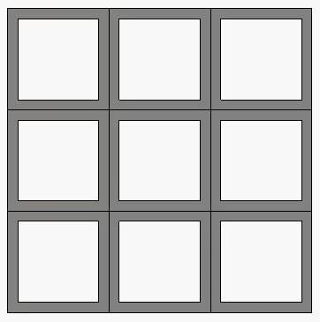

Patch element Aperture element

Figure 1.1 Geometries of patch and aperture elements FSS array.

The most common FSS element shapes include simple straight dipole, circular loop, cross dipole, three-legged dipole, square loop and Jerusalem Cross as shown in Figure 1.2. Depending on the physical construction and geometry of the surface, the FSS can efficiently control the transmission and reflection of the incident electromagnetic plane wave and may have low pass, high pass, band pass and band stop behaviors [1].

The underlying theory of FSS has evolved from the research on diffraction gratings which is carried out by the American physicist David Rittenhouse in 1786 [2]. The pioneering work and intensive investigating on the frequency selective surfaces can be traced to the 1960s. Over the years, frequency selective surfaces have found widespread application in communication, microwave and radar systems for more than four decades.

dipole.jpg 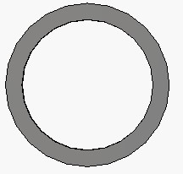 

Dipole Circular loop Cross

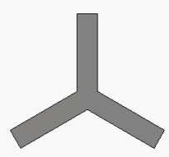  

Three legged dipole Square loop Jerusalem Cross

Figure 1.2 Unit cells of FSS element geometries.

The typical application of FSS is applied to the radome to reduce the radar cross section (RCS) of antennas at the out-of-band frequencies. In this situation, the band-pass characteristic of the surface is adopted. In other words, the FSS radome allows the incident signals to pass though at the operating frequency and reflects the signals outside the operating band to reduce the backscattering radar cross section [3].

The band-stop characteristics of FSS can be adopted in the Cassegrainian antenna as a main reflector. The in-band signals are reflected and all out-of band signals are transmitted through the FSS instead of a metal sheet.

Another important application of FSS is employed as a sub-reflector in dual-reflector antenna systems in order to provide multi-frequency operation [1]. Two independent feeds are placed at the focus of the main reflector. The FSS sub-reflector reflects specified frequencies from one feed and transmits the other. Thus, two different feeds share the same main reflector simultaneously [1].

Recently, the frequency selective surfaces have been found widely used as circuit analogue absorber in radar absorbing materials (RAM) for stealth technology. Based on the equivalent transmission line theory, the surface attenuates out-of-band frequencies, and in-band frequencies are absorbed. The FSS absorbers with reactive components can provide better absorption and wider bandwidth compared with Salisbury Screen, Jaumann absorber and other traditional RAMs, [3].

Another application of FSS is used as a polarizer, due to the polarization dependence of FSS. Any polarization of electromagnetic waves can be decomposed into TE (electric field perpendicular to the incident wave) and TM (magnetic field perpendicular to the incident wave) polarizations. The surface totally reflects the polarized wave at a specified direction and the orthogonal polarized wave would be totally transmitted [4]. In this sense, the FSS indeed acts as a polarizer for that wave of the specific direction.

More recently, the usage of FSS in wireless communication systems is interesting. For example, in prison cells, public libraries and theatres, FSS is printed on the windows and the wall of buildings to block the mobile phone signals and to allow the emergency TETRA services to operate.

An extension of FSS research is used to design an artificial magnetic conductor (AMC) by applying a ground plane behind FSS. The FSS is working as a reflective layer to improve the reflectivity of the AMC surface. Such a surface reflects the incident wave in phase rather than out of phase. This allows antenna to be placed very close to the surface, which results in low profile antenna [6].

1.2 Motivation

Recently, researchers are interested in miniaturized element FSSs. In the traditional designs, the FSS period is comparable to half of the wavelength at the desired frequency of operation [6]. But for some low frequency applications such as radome antenna, the long wavelength at operating frequency requires sufficiently large number of unit cells should be included in the surface [7]. Therefore, the overall electrical dimension of FSS is large. The FSS is an infinite periodic array in theory. But in practice, FSSs have finite size. Large FSSs are impractical to be placed within curved surfaces and limited space.

To address these problems, several techniques have been developed to miniaturize the unit cell size. For example, Dr K. Sarabandi designed a miniaturized-element FSS with a unit cell dimension as small as λ/12 as shown in Figure1.3 [7], [8]. The unit cell of periodic array consists of two layers separated by a thin dielectric substrate, small metallic patches printed on the top layer of the substrate and a wire grid etched on the bottom of the same substrate [7]. Another design of convoluted element FSS was presented by E.A. Parker group which is also an efficient technique to reduce the electrical size of FSS and offers an operating frequency 15 times lower than the traditional elements. The geometry of such an FSS is shown in Figure 1.4 [10]. Recently, a miniaturized FSS using lumped reactive components has been designed. As shown in Figure 1.5, an inductor and a capacitor are lumped in the centre of the square metallic element. By changing the values of the lumped components, the unit cell size can be reduced as small as λ/36 [11].

However, in the last few decades, most of the research has been investigated and the applications of FSS are in one or two dimensional periodic array of resonant structures. Less attention has been paid to three dimensional FSSs. But in many practical applications, the underlying surface is curved rather than flat. A novel design of a three dimensional frequency selective surface is interesting and challenging. The advantage of the 3D structure is its excellent space utilization. In theory, the resonant frequency is determined by the resonant length in a unit cell. The previous techniques researched on miniaturized FSS is essentially to elongate the resonant length in two-dimensional. With utilization of three-dimensional space, the unit cell size of the FSS can be further reduced. On the other hand, an FSS with a stable frequency response for different types of polarization at different oblique angels is required.

Therefore, the goal of this project is to design a three dimensional FSS that can generate a reduction in the resonant frequency compared with the flat surface for a fixed unit cell size. The design procedure consists of two stages. The first stage is to design the flat FSS element and then to map it into a desired 3D shape. The simple cross dipole, the Jerusalem Cross and the square loop shapes of flat FSS are used. The three dimensional structures are formed by raising the centre of the flat surface or folding the element into peaks. The characteristics of flat and 3D FSSs are analyzed including the resonant frequency, the fractional bandwidth, the stability with different incident angles and the reflection phase response backing with a ground plane.



Figure 1.3 Top and bottom view of a miniaturized-element FSS.



Figure 1.4 Convoluted element FSS.

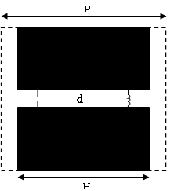

Figure 1.5 FSS unit cell using lumped reactive components.

1.3 Thesis Organization

The thesis is organized as follows:

Chapter 2 is the literature review. It provides brief description of patch and aperture element of FSS geometry. A method named the equivalent LC circuit model is reviewed. It can be simply used to analyze the properties of FSS. Then the background of AMC surface is presented. The simulation results were carried out using computer software CST which is briefly described. The flat square loop FSS is considered as an example to investigate the effect of changing the parameters.

Chapter 3 discusses both flat and 3D FSSs in simple cross dipole shape. The 3D structure is formed by raising the centre of the cross but keeping the same unit cell with planar case. The effect of varying the height of the pyramid is presented. There are two conditions if the cross centre is raised, which are the length of the cross arms remains the same and increased. Both conditions are compared with flat surface.

Chapter 4 presents two 3D structures of Jerusalem Cross FSS, a normal 3D by raising the centre of a Jerusalem Cross and a 3D shape with peaks by folding the cross arms. All designs are used to keep the unit cell same as planar surface. The simulations of normal 3D structures were done by change the height which is similar to the simple cross structure presented in chapter 2. The 3D Jerusalem Cross FSSs with peaks are designed by folding the cross arms into several peaks of which the distance between two ends remains the same. The effect of increasing the peaks is presented and the comparisons are made with the flat surface of the same unit cell size, including the resonant frequency, the fractional bandwidth and the stability of resonant frequency with respect to the incident plane wave angles. The reflection phase responses of 3D FSSs backing with ground plane are compared with the flat AMC surface.

Chapter 5 presents a flat and three 3D FSSs in square loop shape. 3D structures are formed by raising the four sides of the square loop angularly, to 45o and 90o respectively. The third 3D structure is obtained by printing the conducting square loop on a tetrahedron. The comparisons between different structures were made by changing the width and the length of the square loop. Another design of 3D structures with peaks was simulated, similar as the 3D Jerusalem Cross with peaks which discussed in chapter 4. The comparisons are made in the resonant frequency, the fractional bandwidth, the angular stability and the reflection phase responses were also made.

Chapter 6 provides the conclusions of the research on 3D FSSs and recommends future research based on this thesis.

Chapter 2: Technical Background

2.1 Equivalent circuit models of FSS

Since the 1960s, there have been a variety of analytical methods on the research of FSSs. The analytical methods of FSS used in general can be divided into two categories: the rigorous full wave technology and the approximation method. The full wave solution is an effective and accurate technology for solving complex modular form of FSS. However, the computation of this method is large and will spend more time. Additionally, it does not take into account the inner relationship between frequency response and physical structure [12]. On the other hand, the equivalent circuit method is one of approximation methods and it is relatively simple and fast [13]. Adopting this technique, the FSS periodic array can be modelled to the equivalent capacitances and inductances in series or parallel connection. The frequency characteristics can be predicted according to the concept of the LC resonant circuit. But this is limited to the normal angle of incidence [14].

As shown in Figure 2.1, the patch element can be seen as a parallel connection of a capacitor and an inductor, and the array of aperture elements is represented by a series LC circuit, where the conducting element provides the inductance and the inter-element spacing represents the capacitance. From this simple analysis, it is easy to show that the resonant frequency is given by

f = $1/{(2π\sqrt{LC})}$ Equation 2.1

The fractional bandwidth is defined as the difference between the lower and upper frequency at -10dB which is proportional to

BW $∝$ $\sqrt{L/C}$ Equation 2.2

Thus, increasing the length of the conducting element can reduce the resonant frequency and improve the bandwidth. The lower resonant frequency can also be achieved by increasing the capacitance, but resulting in narrower bandwidth.

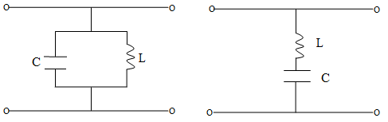

Patch element FSS Aperture element FSS

Figure 2.1 Equivalent circuit models of FSSs.

2.2 AMC surfaces

In order to analyze the reflective properties of FSS, a flat metal sheet is applied behind the frequency selective surface. The new structure represents an artificial magnetic conductor (AMC). An ideal AMC is referred to as a perfect magnetic conductor (PMC). Such a structure completely reflects the incident waves with 0o reflection phase as an open circuit to the incident wave. While for its complementary surface - a perfect electronic conductor (PEC), it exhibits full reflection of the incident wave but with an 180o phase difference as a short circuit to the incident wave [15].

In recent years, photonic crystals, left-handed materials, electromagnetic band gap structures and artificial magnetic materials have drawn much attention, because they have the valuable electromagnetic properties that may not exist in nature. These structures or materials are called metamaterials. Their special electromagnetic properties have already been widely used in microwave field to achieve high performance antennas. Especially the AMC surface with great advantages and potential to achieve low profile antenna has a great prospect and high research value.

In 1987, E.Yablonvitch proposed the concept of the photonic crystals which are artificial periodic dielectric structures [16]. Photons are forbidden to pass through this structure in a certain frequency band. The stop band is called photonic band gap (PBG). In 1999, D. Sievenpiper presented a mushroom structure named electromagnetic band gap (EBG) or high impedance surface (HIS) consists of periodic metallic arrays placed on a ground plane with vertical metallic vias connecting the patches to the ground [17], [18]. With the presence of vias, the structure fully reflects incident wave with the same phase shift behavior as AMC and exhibits high surface impedance near the resonant frequency. Therefore, it suppresses the surface waves. But it is complicate and difficult to fabricate the vias. In the absence of vias, the AMC and EBG frequency bands do not always coincide [18].

In recent years, many research teams started to investigate the uniplanar AMC structures without vias. T. Itoh presented a uniplanar photonic band gap (UC-PBG) structures in 1999 [19]. These structures are essentially FSS backing with ground plane.

Each unit cell of the AMC structure can be modeled as a parallel LC resonant circuit [20]. The surface impedance is Z= ${jwL}/{(1-w^{2}LC)}$. The resonant frequency occurs when the impedance is very high. For a parallel LC circuit the resonant frequency fr = [20]. The bandwidth is proportional to $\sqrt{L/C}$ [21].

The reflection phase of an AMC structure begins from 180o and ends at 180o versus the frequency, and crosses through zero at the resonant frequency. Generally, the working bandwidth is defined from +90o to -90o. Within this range, the image currents are in-phase and subject to constructive interference between the incident and reflect waves [15]. Hence, the percentage bandwidth is given by BW = ($\frac{f_{U-}f_{L}}{f_{r}}$) ×100% where $f_{U}$ is the frequency when the reflection phase equals to -90o; is the frequency when the reflection phase equals to +90o; and is the resonant frequency at 0o [20].

2.3 Simulation Software

The designs and simulations in this project are based on the Computer Simulation Technology (CST) Microwave Studio Suite which is a high performance electromagnetic simulation software. Finite integration technique (FIT) is used as the foundation technique of CST which is the integral form of Maxwell equations. The solution of the equations requires the structure subdivided into small cells in frequency or time domain. There are two basic solver modules provided: time domain solver and frequency domain solver. The two solvers are totally different. Time domain solver is used for non resonant structures and frequency domain solver contains alternatives for highly resonant structures. Besides frequency domain solver has the option of utilizing tetrahedral mesh which is not available within time domain solver. The proposed structures in this thesis are 3D surface, using tetrahedral mesh can discrete the structure better. In addition, time domain solver is only for normal incidence but frequency domain solver can be used for off-normal incidences. The angular stability of the structure can be simulated. Thus the frequency domain solver was chosen in this project. Furthermore, FSS can be seen as an infinite periodic structure. So it is only need to analyze a single unit cell based on the Floquet theorem and the periodic boundary conditions.

In CST Microwave Studio, the FSS-Unit Cell (FD) template is simple to use and automatically allows setting the unit cell boundary conditions. As shown in Figure 2.2, the minimum and maximum of x- and y- directions are left to unit cell and z- directions are chosen to open (add space). The incident angles theta (θ) and phi (Ф) determine the plane of incidence and the direction and of incidence [3]. By varying theta and phi, it allows incident plane waves at arbitrary angles. Two Floquet modes TE and TM were set in this simulation for ports Zmin and Zmax which are displayed in the results as number 1 and 2.

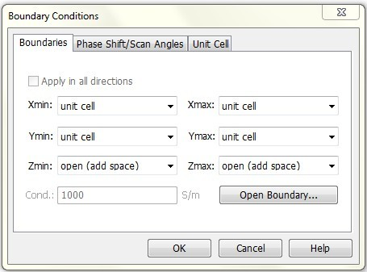 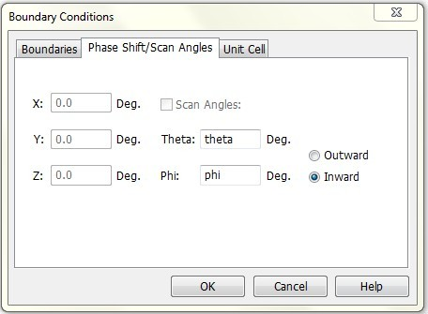

Figure 2.2 FSS unit cell boundary conditions settings.

After constructing the structures, the type of solver modules needs to be chosen (frequency domain solver in this project). The fundamental simulation results are the S-parameter results with combination of SZmax (1), SZmin (1), SZmax (2) SZmin (2) , which represents the co-polar transmissions (e.g. named SZmax (1) SZmin (1)) and reflections (e.g. named SZmax (1) SZmax (1)) and the cross-polarization of two (e.g. named SZmax (1) SZmin (2)) modes. There are sixteen results generated by the simulation. Because the structures designed in this project are symmetrical at normal incidence, the transmissions and reflections of two modes are almost identical [15]. The cross-polar results are much smaller than the co-polar results, therefore they can be neglected. Therefore, the results only need to be considered are the SZmax (1) SZmin (1) and SZmax (1), SZmax (1), which are the co-polar transmission and the reflection, respectively [22]. Besides the 1D results, the 2D/3D include the electric and magnetic monitor, the surface current and the far filed for a given frequency results can also be calculated. The parameter sweep can be used to observe the results changed with the modified parameters; for example, the incident angle was set as a parameter in this project, and the angular stability can be compared after the simulation.

2.4 Simulations using CST

In this section, a typical square loop FSS array is considered as an example to analyze the performance of an FSS. Several design parameters determine the important characteristics of an FSS, such as the element length (L), the element width (w), the substrate thickness (n) and the inter-element spacing (2g).The effects of these parameters on the resonant frequency and the fractional bandwidth are discussed. The geometry and the unit cell boundary conditions can be seen from Figure 2.3. It consists of thin conducting elements in square loop shape printed on a thick dielectric substrate [1]. Such a structure can be modeled as a serial LC circuit, where the loop provides the inductance and the gap between two elements contributes to capacitance. The material of the conducting element is copper and the material of the substrate is vacuum with permittivity of one. The unit cell can be repeated to infinity with a specified periodicity which can be found by setting the size of the dielectric substrate. The parameters of the square loop FSS are listed in Table 2.1.

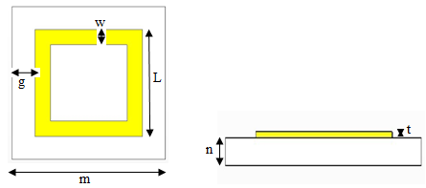

(a) Top view (b) Side view

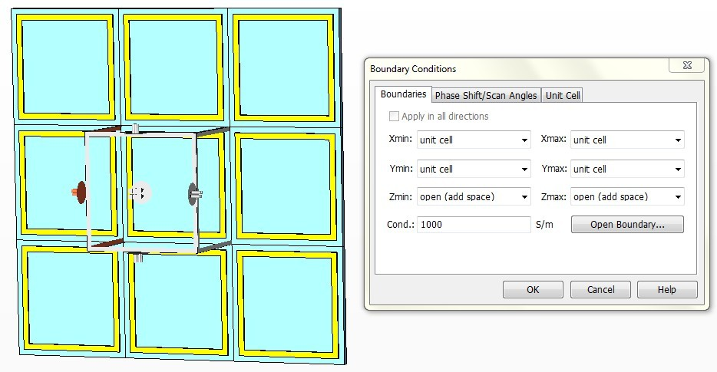

(c) Unit cell boundary conditions

Figure 2.3 Unit cell of the square loop FSS array.

Table 2.1 Parameters of square loop FSS.

|  |  |  |
| --- | --- | --- |
| Parameter | Value(mm) | Description |
| m | 10 | Size of unit cell |
| g | 0.5 | Gap between the copper and the unit cell |
| L | 9 | Length of the copper |
| w | 0.5 | Width of the copper |
| t | 0.1 | Thickness of the copper |
| n | 0.5 | Thickness of the substrate |

The structure is simulated using CST. Depending on the element geometry and type, the FSS may have band stop or band pass frequency responses [1]. From Figure 2.4, it can be seen that the square loop FSS designed in this section is a band stop filter. fr is the resonant frequency, which is the operating frequency of the FSS. The surface of the structure transmits signals at frequencies lower or higher than 7.14GHz, but reflects the signal at this frequency. The bandwidth is defined as the difference between lower and upper frequency at S-parameter of -10dB divided by the resonant frequency in theory. In this case, the frequency responses at -10dB are 8.8GHz and 5.65GHz, thus the bandwidth is 44.1% approximately.

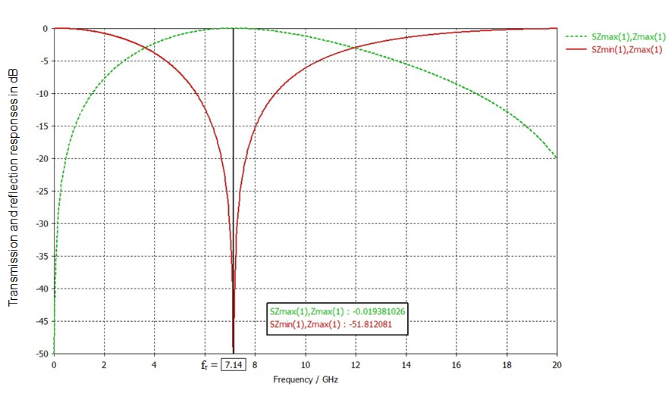

Figure 2.4 Transmission and reflection response of the square loop FSS.

Figure 2.5 The effect of varying element length.

Figure 2.5 shows the dependence of transmission response on the element length (L). As the length changing, the gap between the copper and the unit cell also changes. Increase of the element length leads to the inductance and the capacitance both increasing. From Equation 2.1, it can be seen that as the inductance and the capacitance increase, the resonant frequency becomes lower. Figure 2.5 shows that increasing the element length from L=5mm to 9mm results in reduction of resonant frequency from 17.72GHz to 7.14GHz. The resonant frequency of L=5mm is more than twice that of L=9mm. The bandwidth of L=9mm is almost three times wider than that of L=5mm.

Figure 2.6 The effect of varying element width.

Figure 2.6 shows the variation of resonant frequency due to the change of the copper width. All the parameters are unchanged expect the width of element. As the width increases, the resonant frequency becomes higher. Meanwhile the bandwidth becomes wider.

Figure 2.7 The effect of varying element gap.

Figure 2.7 shows the variation of resonant frequency due to the change of the gap between unit cells. The loop remains at the same size as shown in Table 2.1, the increased element spacing can be achieved by increasing the substrate size. Thus the periodicity of the array increased and the equivalent capacitance reduced. The enlargement of the gap causes the increase of the resonant frequency and reduction of the bandwidth.

Figure 2.8 The effect of varying substrate thickness.

Figure 2.8 shows the variation of the resonant frequency due to the change of the thickness of the substrate. The resonant frequency and the bandwidth have a small reduction as the thickness of the substrate increases.

(a) TE mode

(b) TM mode

Figure 2.9 Transmission response at different incident angles.

Besides the resonant frequency and the bandwidth, another important characteristic of FSS is the stability of the resonant frequency with respect to the incident angle of the plane wave. Figure 2.9 shows the variation of the resonant frequency due to the incident angles for TE and TM polarizations. It can be observed that with the increase of incident angles, the resonant frequency of both TE and TM increase slightly. Comparing with TM mode, TE mode is more stable.

Chapter 3: Cross dipole element FSS

This chapter will start with a look at the design of the flat cross dipole element FSS. The novel design of the three dimensional (3D) cross dipole FSS will then be discussed in details. Two types of 3D cross FSSs are designed as the FSS in pyramid and saw-tooth shapes. The comparison is made between flat and 3D FSSs for a fixed unit cell size to investigate whether 3D structures have a lower resonant frequency, wider bandwidth and better angular stability. In the following section, the reflection phase responses of flat and 3D saw-tooth AMCs are also compared.

3.1 Flat cross dipole element FSS

A typical flat cross dipole element of FSS array is designed and simulated using Computer Simulation Technology (CST) Microwave studio as shown in Figure 3.1. The dimensions of the flat cross dipole FSS are described in Table 3.1. The unit cell size of the array is 20mm×20mm. It uses vacuum material with relative permittivity of one, meaning that the effect of the substrate can be ignored. This makes the simulations faster. The thickness of the substrate is 1mm. The material of the conducting cross etched on the substrate is copper. The thickness (t), the width (w) and the length (L) of the copper are set to 0.1mm, 1mm and 18mm, respectively. Figure 3.1 (c) shows the boundary condition settings of the unit cell. The periodicity is 20mm and the unit cell is automatically set to infinite array by using the FSS-Unit Cell (FD) template. The frequency range is set from 0GHz to 10GHz. Because of the small number of frequency samples and meshes, the Frequency Domain Solver is chosen [23]. The simulations calculate the S-parameter through two ports Zmin and Zmax.

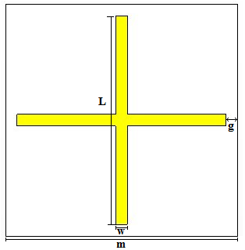

(a) Top view



(b) Side view

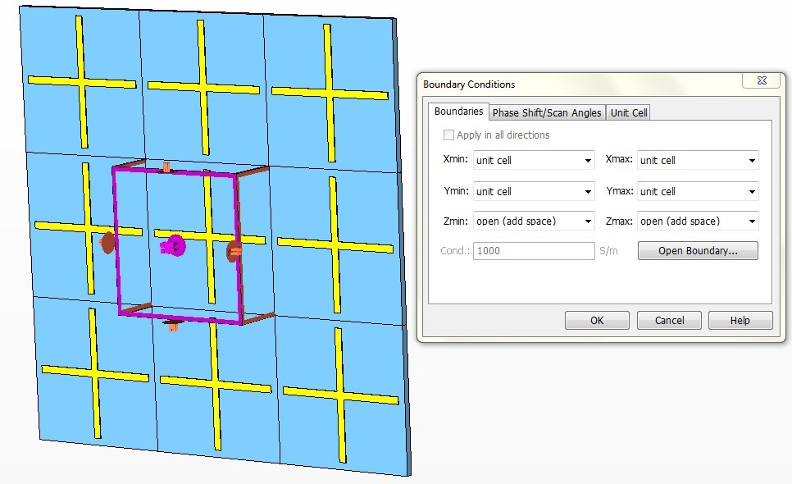

(c) Unit cell boundary conditions

Figure 3.1 Unit cell of flat cross dipole element FSS array.

Table 3.1 Parameters of the flat cross dipole element FSS.

|  |  |  |
| --- | --- | --- |
| Parameter | Value(mm) | Description |
| m | 20 | Size of unit cell |
| g | 1 | Gap between copper and unit cell |
| L | 18 | Length of copper |
| w | 1 | Width of copper |
| t | 0.1 | Thickness of copper |
| n | 1 | Thickness of substrate |

**Simulation results:**

Figure 3.2 Transmission and reflection response of flat cross FSS array.

Figure 3.2 shows the transmission and reflection response of the flat cross FSS array. The resonant frequency of the structure is 7.92GHz. Clearly, it is a band-stop filter that will reflect the incident signals at 7.92GHz. The fractional bandwidth can be calculated as the frequency difference at -10dB divided by the resonant frequency, which is approximately equal to 9.67%.

The transmission response of the flat cross FSS for several incident angles is shown in Figure 3.3. Both TE and TM modes are considered. As it can be seen, the resonant frequency decreases with the increase of the incident angle for TE mode. On the other hand, the resonant frequency increases as the incident angle increases for TM mode. In addition, the frequency shift of TE and TM modes vary within 0.83GHz and 0.25GHz, respectively. Therefore, TM mode is more stable than TE mode.

(a) TE mode

(b) TM mode

Figure 3.3 Transmission response of flat cross FSS at different incidence angles for TE and TM modes.

3.2 3D pyramid FSS with cross shape

The mapping from the flat surface into 3D FSS is determined by raising the centre of the cross to specified heights. After the mapping, the new FSS structure is formed to a pyramidal shape. The four cross arms are etched on each surface of the pyramid. The geometry of the 3D FSS is shown in Figure 3.4 (a) (b). The size of the unit cell is the same as the flat surface which is 20mm×20mm. The boundary settings are the same as the flat case as shown in Figure 3.4 (c).

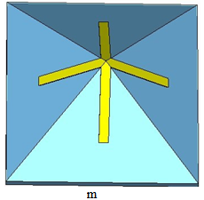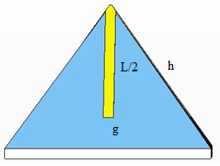

(a) Top view (b) Side view

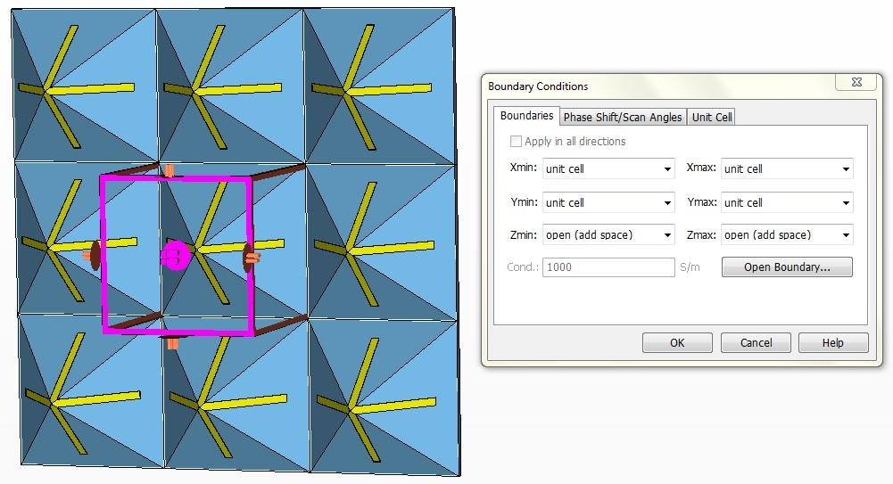

(c) Unit cell boundary conditions

Figure 3.4 Unit cell of 3D pyramid FSS.

3.2.1 Comparison of flat and 3D FSSs at the same cross length

The height of the 3D FSS is set to h=5mm, h=10mm, h=15mm and h=20mm, respectively. The length of the cross remains the same as the flat surface, which is L=18mm. The gap between the cross element and the substrate is increased as the height increased. The dimensions of the structures are described in Table 3.2.

Table 3.2 Parameters of the 3D cross dipole FSS.

|  |  |  |
| --- | --- | --- |
| Parameter | Value(mm) | Description |
| m | 20 | Size of unit cell |
| n | 1 | Thickness of substrate |
| L | 18 | Length of copper |
| w | 1 | Width of copper |
| t | 0.1 | Thickness of copper |
| h | variable | Height of unit cell |

**Simulation results：**

Figure 3.5 Transmission response of flat and 3D pyramid FSSs with varying height (L=18mm).

Table 3.3 Comparison of flat and 3D pyramid FSSs (L=18mm).

|  |  |  |  |  |  |  |
| --- | --- | --- | --- | --- | --- | --- |
|  | fr (GHz) | Frequency shift (GHz) | | | |  |
|  | TE/TM mode | TE mode | | TM mode | | Bandwidth  (%) |
| Incidence angle | 0o | 30o | 60o | 30o | 60o |  |
| Flat | 7.92 | -0.26 | -0.83 | 0.15 | 0.25 | 9.67 |
| h=5mm | 8.11 | -0.25 | -0.85 | 0.08 | 0.15 | 8.1 |
| h=10mm | 8.52 | -0.24 | -0.93 | -0.06 | -0.45 | 4.92 |
| h=15mm | 8.87 | -0.22 | -1.09 | -0.09 | -0.73 | 3.04 |
| h=20mm | 9.25 | -0.23 | -1.36 | -0.12 | -0.15 | 2.05 |

Figure 3.5 shows the transmission response of the flat surface and the 3D FSSs at the same cross length. The comparison of the resonant frequency, the fractional bandwidth and the angular stability of flat and 3D FSSs can be seen from Table 3.3. The simulation results of h=20mm are shown in Figure 3.6 as the effect of various angles for TE and TM modes. The transmission responses for h=5mm, h=10mm and h=20mm of different polarizations and incident angles are presented in Appendix I.

Based on the equivalent LC circuit model, the increase of the gap causes the equivalent capacitance to reduce. Thus the resonant frequency increases. As predicted, the resonant frequency increases from 7.92GHz to 9.25GHz as the height increases from h=0mm to h=20mm, while the bandwidth becomes narrower.

The simulation results show that the dependence of the resonant frequency on the incident angles. It is observed that the variation range of the resonant frequency offset is within 0.83GHz for the flat surface and is 1.36GHz for the 3D case. The resonant frequency increases as the height is raised at the same angle. Besides, the frequency offset of the TE mode is larger than that of the TM mode. This shows that the TM mode is more stable than the TE mode. Overall, the result of the structure designed in this section is not ideal. Since the resonant frequencies of the 3D structures are higher than those of flat surface; the bandwidth are narrower; and they have great dependence on the variation of incident angles.

(a) TE mode

(TM) mode

Figure 3.6 Transmission response of h=20mm 3D FSS at different incidence angles for TE and TM modes (L=18mm).

3.2.2 Comparison of flat and 3D FSSs at different cross lengths

The cross arms are fixed on the slopes of the unit cell. The gap between the element and the substrate remains at 1 mm. The height of the pyramid is increased from h=0mm to h=20mm as the arms are held at the same position. When the height of the structure is increased, the length of the cross is also increased, which would cause the resonant frequency to decrease in theory. The settings of the unit cell are the same as before; the only parameter need to be changed is the height.

**Simulation results:**

Figure 3.7 Transmission response of flat and 3D pyramid FSSs with varying height (g=1mm).

The above figure shows the transmission response of flat and 3D FSSs at the same gap width between the copper and the substrate. It can be seen that the resonant frequency of the 3D pyramid FSS at h=20mm is 3.76GHz. It is much lower than that of the flat surface. When the height is raised from 0mm to 20mm, the -10dB fractional bandwidth increases slightly from 9.67% to 10.61%.

Table 3.4 Comparison of flat and 3D pyramid FSSs (g=1mm).

|  |  |  |  |  |  |  |
| --- | --- | --- | --- | --- | --- | --- |
|  | fr (GHz) | Frequency shift (GHz) | | | |  |
|  | TE/TM mode | TE mode | | TM mode | | Bandwidth  (%) |
| Incidence angle | 0o | 30o | 60o | 30o | 60o |  |
| Flat | 7.92 | -0.26 | -0.83 | 0.15 | 0.25 | 9.67 |
| h=5mm | 7.42 | -0.17 | -0.57 | 0.11 | 0.22 | 9.8 |
| h=10mm | 5.93 | -0.05 | -0.17 | 0.07 | 0.18 | 10.44 |
| h=15mm | 4.69 | -0.01 | -0.04 | 0.03 | 0.09 | 10.58 |
| h=20mm | 3.76 | 0 | 0 | 0.01 | 0.02 | 10.61 |

The stable performance of FSS resonant frequency on the angle of the incident plane wave is another important characteristic of FSS. In CST, the Parameter Sweep can be used to change the incident angle; in this case theta is set to 0o, 30o and 60o at two different polarizations: TE and TM modes. For comparison purposes, the simulations of both 3D and flat surfaces for TE and TM modes are done. Table 3.4 shows the comparison of angular stability performance between flat and 3D pyramid FSSs. The transmission responses of h=20mm 3D pyramid FSS at different incident angles is shown in Figure 3.8. The simulated results of h=5mm, 10mm and 15mm on the effect of various incident angles for both TE and TM modes can be found in Appendix I.

As shown in Table 3.4, for TE mode the resonant frequency of the flat surface is 7.92GHz at normal incidence angle and the frequency offset are -0.26GHz and -0.83GHz at 30o and 60o respectively. Negative sign means in the opposite direction, the resonant frequency is decreasing. For TM mode, the frequency offset is 0.15GHz and 0.25GHz (in the positive direction, the resonant frequency is increasing) for 30o and 60o respectively, which is more stable than TE mode. This is expected since the incident angle theta changes the incident plane wave to left and right not relative to top and bottom of the surface. But TE mode is to top and bottom and TM mode is to right and left [21].

From Table 3.4, it can be seen that as the height of the pyramid increases the offset of the operating frequency at the same angle drops. When the height increases to 20mm, the offsets decrease to 0GHz which meets the best angular stability performance for TE mode. The offset is only 0.01GHz and 0.02GHz for TM mode.

For TE mode, as the incident angle increases the resonant frequency decreases but the resonant frequency increases for TM mode. In addition, comparing with the normal incident angle, the resonant frequency at 30o or 60o in TM mode is always greater. But the resonant frequency at 30o or 60o in TE mode is always smaller.

(a) TE mode

(b) TM mode

Figure 3.8 Transmission response of h=20mm 3D FSS at different incidence angles for TE mode and TM modes (g=1mm).

3.3 3D saw-tooth FSS with cross shape

**Design and settings:**

The 3D saw-tooth FSS is formed by folding each cross arm into peaks. The geometries of the flat and the 3D saw-tooth cross FSSs are shown in Figure 3.9 and Figure 3.10. The unit cell size is 10mm×10mm. The material of the substrate is vacuum with permittivity of one. Thus the substrate has no effect on the performance of the structure. The material of the conducting element is copper. The length (L), thickness (t) and width (w) of the copper are set to 9.4mm, 0.1mm and 0.5mm respectively. As shown in Figure 3.10, four 3D saw-tooth FSSs are designed with different numbers of peaks. All the 3D structures have the same unit cell size as the flat surface. The gap (g) between the end of the cross arm and the substrate remains 0.3mm. The total length of the copper, and the distance between two ends of the cross arm of the 3D FSSs, are 18.5mm and 9.4mm respectively. In order to keep the distance between two ends unchanged, the height of the 3D saw-tooth FSSs are set to 8mm, 2.656mm, 1.328mm and 0.885mm for one peak, three peaks, six peaks and nine peaks, respectively.

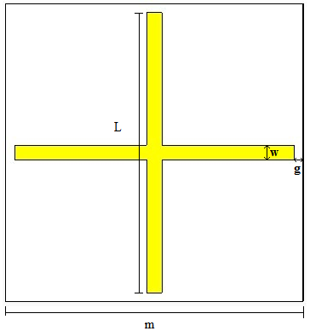

(a) Top view



(b) Side view

Figure 3.9 Unit cell of the flat cross FSS array.

Table 3.5 Parameters of flat cross FSS.

|  |  |  |
| --- | --- | --- |
| Parameter | Value(mm) | Description |
| m | 10 | Size of unit cell |
| g | 0.3 | Gap between copper and substrate |
| L | 9.4 | Length of copper |
| w | 0.5 | Width of copper |
| t | 0.1 | Thickness of copper |
| n | 0.5 | Thickness of substrate |

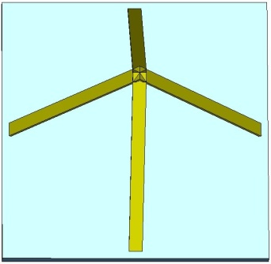 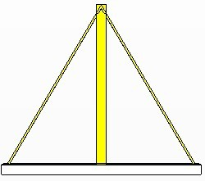

(a) P=1

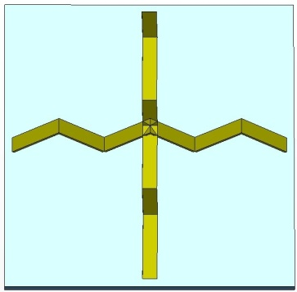 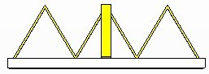

(b) P=3

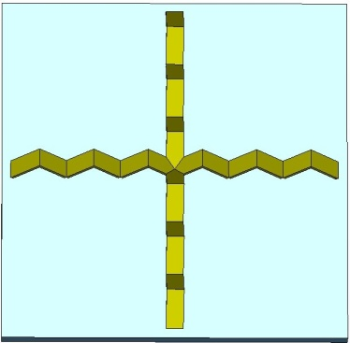 **C:\Users\postgrad\Desktop\6.2.jpg**

(c) P=6

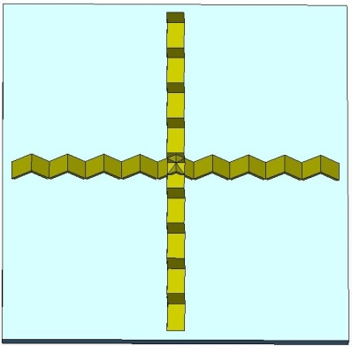 **C:\Users\postgrad\Desktop\9.2.jpg**

(d) P=9

Figure 3.10 Unit cell of 3D cross saw-tooth FSSs.

3.3.1 The transmission responses of flat and 3D saw-tooth FSSs

The flat and 3D saw-tooth FSSs are simulated using CST. The transmission responses are compared as shown in Figure 3.11. The performance of the resonant frequency, bandwidth at -10dB and the stability depending on the various incident angles is presented in Table 3.6.

Figure 3.11 Transmission response of flat and 3D saw-tooth FSSs.

Table 3.6 Comparison of flat and 3D saw-tooth FSSs.

|  |  |  |  |  |  |  |
| --- | --- | --- | --- | --- | --- | --- |
|  | fr (GHz) | Frequency shift (GHz) | | | |  |
|  | TE/TM mode | TE mode | | TM mode | | Bandwidth  (%) |
| Incidence angle | 0o | 30o | 60o | 30o | 60o |  |
| Flat | 14.62 | -0.4 | -1.22 | 0.36 | 1 | 12.18 |
| 1 peak | 8.42 | -0.02 | -0.04 | 0.04 | 0.1 | 10.76 |
| 3 peaks | 9.98 | -0.06 | -0.2 | 0.04 | 0.14 | 14.38 |
| 6 peaks | 11.34 | -0.12 | -0.38 | 0.1 | 0.32 | 14.7 |
| 9 peaks | 12.16 | -0.18 | -0.54 | 0.16 | 0.46 | 14.44 |

It can be seen that the highest resonant frequency of 14.62GHz occurs at the flat case. The lowest operating frequency is 8.42GHz when the flat cross was folding into one peak. But it has the narrower bandwidth than the flat surface. As the number of peaks of the 3D saw-tooth FSS increases, the resonant frequency and the bandwidth increase.

Figure 3.12 and Figure 3.13 show the frequency stability for both TE and TM polarizations at different incident angles of flat and 3D saw-tooth with one peak FSSs. The simulation results of the angular stability of the resonant frequency for 3D saw-tooth FSSs with three peaks, six peaks and nine peaks can be found in Appendix I. The comparison of the frequency shift at 30o and 60o for both TE and TM polarization is listed in Table 3.6. It can be seen that the flat surface has the biggest shift of 1.22GHz at TE60. Compared with the flat case, the 3D saw-tooth structures have better angular stability performance. The frequency shift is between -0.54GHz and 0.46GHz. The frequency shift becomes bigger when the number of peaks increases at the same incident angle. The best angular stable performance occurs when the number of the peak is one since the frequency shift varies between -0.02GHz and 0.1GHz. In addition, the resonant frequencies of TE 30 and TE 60 are smaller than the normal incidence. And it gets smaller as the incident angle increases. But for TM 30 and TM60, the resonant frequency becomes bigger than the normal incidence and it also gets bigger as the incident angle increases.

1. TE mode

(b) TM mode

Figure 3.12 Transmission response of flat cross FSS at different incidence angles for TE and TM modes.

1. TE mode
2. TM mode

Figure 3.13 Transmission response of 3D saw-tooth cross FSS (P=1) at different incidence angles for TE and TM modes.

3.3.2 The reflection phase responses of flat and 3D saw-tooth AMCs

The AMC surface is in essence an FSS backing with a ground plane. By adding a ground plane behind the flat cross FSS that was introduced in the last section, the flat cross AMC structure without vias is formed. The different parameter is the thickness of the substrate increased to 2mm. The 3D saw-tooth AMC surface is formed in the same way. The reflection phase response of flat and 3D saw-tooth FSSs is shown in Figure 3.14. The comparison of the resonant frequency and the percentage bandwidth is presented in Table 3.7. It can be observed that the resonant frequency of the flat surface is higher than other 3D structures. The resonant frequency of the 3D saw-tooth AMC surface with one peak is 5.1436GHz, which is much lower than that of the flat case. And the bandwidth is more than twice as wide as the flat surface. As the number of peaks increases, the resonant frequency increases and the bandwidth decreases.

Figure 3.14 Reflection phase response of flat and 3D AMC surfaces (n=2mm).

Table 3.7 Comparison of flat and 3D AMC surfaces (n=2mm).

|  |  |  |
| --- | --- | --- |
|  | Resonant frequency  (GHz) | Bandwidth  (%) |
| Flat | 11.998 | 20.52 |
| P=1 | 5.1436 | 57.8 |
| P=3 | 7.5893 | 29.8 |
| P=6 | 8.8924 | 24.57 |
| P=9 | 9.5286 | 22.68 |

The comparison is made between the flat and 3D saw-tooth AMCs with the same thickness of the substrate. However, the distance between the top of the copper and the ground plane of the flat and the 3D AMCs is different. To make them the same height, the thickness of the substrate is increased to 10mm for flat structure, 7.344mm for 3D saw-tooth with three peaks, 8.632mm for six peaks and 9.115mm for nine peaks. Thus, all the AMC surfaces have the same distance between the top of the copper and the ground plane of 10mm. The reflection phase responses are simulated using CST as shown in Figure 3.15. The resonant frequency and the percentage bandwidth are compared and presented in Table 3.8. As the thickness of the substrate increases, the resonant frequency decreases and the bandwidth has a large increase for all structures. The flat surface has the highest resonant frequency of 5.7794GHz but has the widest bandwidth of 94%. The lowest resonant frequency occurs at the 3D saw-tooth with one peak but with the narrowest bandwidth. For the 3D structures, as the number of peaks increases, the resonant frequency increases and the bandwidth increases too.

Figure 3.15 Reflection phase response of flat and 3D AMC surfaces (h=9.5mm).

Table 3.8 Comparison of flat and 3D cross AMC surfaces (h=9.5mm).

|  |  |  |
| --- | --- | --- |
|  | Resonant frequency  (GHz) | Bandwidth  (%) |
| Flat | 5.7794 | 94 |
| P=1 | 5.1436 | 57.8 |
| P=3 | 5.0138 | 67.17 |
| P=6 | 5.2235 | 77.2 |
| P=9 | 5.3077 | 80.97 |

3.4 Conclusion

Two types of 3D cross FSSs are introduced in this chapter.

The first 3D FSS is pyramid shape. Comparison is made between flat and 3D pyramid FSSs. Firstly, if the length of the cross arms remains of 18mm, the resonant frequency decreases with the increase of the height from 5mm to 20mm. But all the resonant frequencies of 3D FSSs are higher than the flat case, which is not expected. Secondly, the second comparison is made between the flat and the 3D pyramid FSSs with increasing the height and holding the ends of the arms at the same position of the pyramid. The results of 3D structures give better performance than the previous comparison. Compared with the flat surface, the 3D FSSs have lower resonant frequency than the flat case. The bandwidth becomes wider as the height increases and the 3D structures have the better angular stability than that of the flat surface.

The second 3D cross FSS is saw-tooth shape. Compared with the flat surface with the same unit cell size, the 3D saw-tooth structures have lower resonant frequency and better angular stability. By placing a ground plane behind the FSS structures, 3D saw-tooth AMC surface with one peak shows the best reflection phase response. It is because the resonant frequency is lowest at 0o and the bandwidth is widest between -90o and +90o when the substrate thickness is 2mm.

Chapter 4: Jerusalem Cross FSS

In the previous chapter, a 3D pyramid FSS with cross shape was presented. It was compared with the flat surface with the increasing height. In a similar way, a 3D pyramid FSS is introduced in the present chapter but with Jerusalem Cross shape. In the following section, a novel design of 3D saw-tooth FSS with Jerusalem Cross shape is proposed. The characteristics of the 3D structures are compared with the flat surface, including the resonant frequency, the fractional bandwidth and the angular stability. The reflection phase response of the 3D saw-tooth AMC surface is also compared with flat case by applying a ground plane behind the structure.

4.1 Flat Jerusalem cross FSS

**Design and settings:**

A Jerusalem Cross (JC) structure is used to build the FSS in CST Microwave studio. The geometry and unit cell settings of the flat JC FSS are shown in Figure 4.1. The material of the substrate and the JC element is vacuum and copper. The size of the substrate is set to 20×20mm and 1mm thickness. The length and the thickness of the copper are 18mm and 0.1mm respectively. Moreover, the copper width is 1mm. The end hats are 6mm long and 1mm wide. The CST unit cell and boundary condition settings for the JC structure are the same as the cross dipole FSS that had described in chapter 3. The min and max of x- and y- directions are left to unit cell and z- directions are chosen to open (add space) as shown in Figure 4.1 (c). The frequency range is setting from 0GHz to 10GHz. Table 4.1 presented the geometrical parameters of the flat JC FSS.

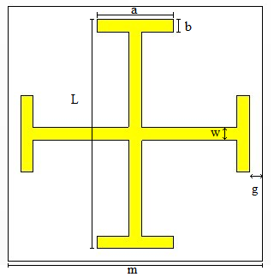

(a) Top view



(b) Side view

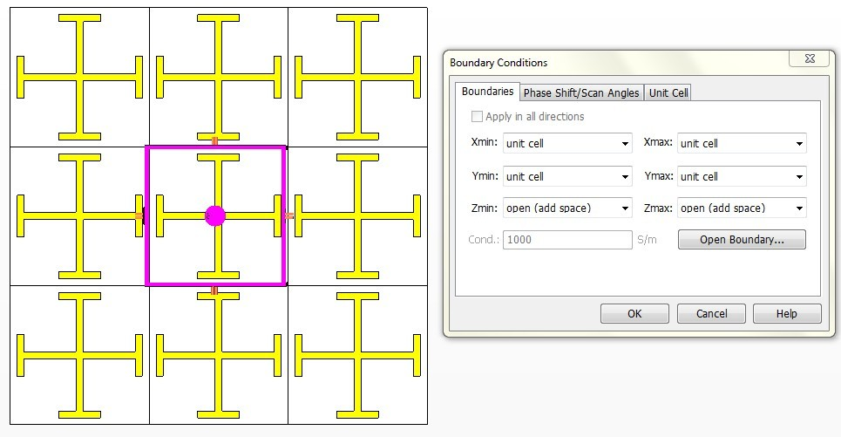

(c) Unit cell boundary conditions

Figure 4.1 Unit cell of flat JC FSS array.

Table 4.1 Parameters of the flat JC FSS.

|  |  |  |
| --- | --- | --- |
| Parameter | Value(mm) | Description |
| m | 20 | Size of unit cell |
| g | 1 | Gap between copper and substrate |
| L | 18 | Length of copper |
| w | 1 | Width of copper |
| a | 6 | Length of end hat |
| b | 1 | Width of end hat |
| t | 0.1 | Thickness of copper |
| n | 1 | Thickness of substrate |

**Simulation results:**

Figure 4.2 Transmission and reflection response of flat JC FSS.

Figure 4.2 shows the transmission and reflection response of the flat JC FSS. The surface reflects the signal at the central frequency of 5.56GHz. The signals lower or higher than 5.56GHz are transmitted. The percentage bandwidth at -10dB is 15.44%.

(a) TE mode

(b) TM mode

Figure 4.3 Transmission response of flat JC FSS at different incidence angles for TE and TM modes.

The angular stability of the resonant frequency for both TE and TM polarizations is shown in Figure 4.3. It is observed that the resonant frequency decrease as the incident angle increases for TE mode; meanwhile it is increase for TM mode. Moreover, the frequency offset is -0.08 and -0.24 for TE mode at 30o and 60o respectively, and it is -0.06GHz and -0.18GHz for TM mode at two incident angles. Hence, TM mode is slightly more stable than TE mode.

4.2 3D pyramid FSS with JC shape

**Design and settings:**

Figure 4.4 shows the geometry of 3D JC FSS. The 3D structure is constructed by raising up the centre of the flat FSS. After mapping, the 2D FSS panel is formed into a pyramid and the FSS elements are printing on each side of the tetrahedron. The dimensions of the 3D structures are the same as flat surface as presented in Table 4.1. In this section, two kinds of 3D JC FSS were designed. The first case is fixing the copper length and then changing the height for h=5mm, 10mm, 15mm and 20mm. The second one is fixing the gap between the element and the substrate and increasing the height from 5mm to 20mm. The unit cell boundary settings in CST keep the same as flat case.

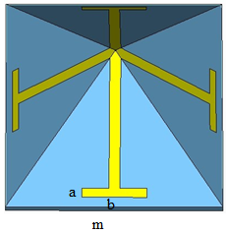 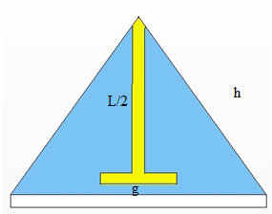

(a) Top view (b) Side view

Figure 4.4 Unit cell of 3D pyramid FSS with JC shape.

Table 4.2 Parameters of the 3D JC FSS.

|  |  |  |
| --- | --- | --- |
| Parameter | Value(mm) | Description |
| m | 20 | Size of unit cell |
| L | 18 | Length of copper |
| a | 6 | Length of end hat |
| b | 1 | Width of end hat |
| h | variable | Height of pyramid |
| g | variable | Gap between copper and substrate |

4.2.1 Comparison of flat and 3D FSSs at the same copper length

There are five structures were simulated including flat JC FSS, 3D JC structures (h=5mm, h=10mm, h=15mm and h=20mm). All structures have the same copper length of L=18mm. With respect to the increase of the height of 3D structure, the gap between the copper and the substrate increases as well.

**Simulation results:**

Figure 4.5 Transmission response of flat and 3D pyramid FSSs with varying height (L=18mm).

Table 4.3 Comparison of flat and 3D pyramid FSSs (L=18mm).

|  |  |  |  |  |  |  |
| --- | --- | --- | --- | --- | --- | --- |
|  | fr (GHz) | Frequency shift (GHz) | | | |  |
|  | TE/TM mode | TE mode | | TM mode | | Bandwidth  (%) |
| Incidence angle | 0o | 30o | 60o | 30o | 60o |  |
| Flat | 5.56 | -0.08 | -0.24 | 0.06 | 0.18 | 15.44 |
| h=5mm | 5.83 | -0.06 | -0.2 | 0.03 | 0.07 | 12.57 |
| h=10mm | 6.16 | -0.06 | -0.08 | 0 | -0.04 | 7.3 |
| h=15mm | 6.22 | -0.03 | -0.12 | 0 | -0.05 | 4.7 |
| h=20mm | 6.4 | -0.02 | -0.08 | -0.02 | -0.06 | 2.67 |

Figure 4.5 shows the transmission response of flat and 3D pyramid FSS with varying height. The comparison of the resonant frequency, the fractional bandwidth and the angular dependence of the structures are presented in Table 4.3.

It is observed that the resonant frequency increases slightly as the increasing of the height. In this section, the copper length remains at 18mm and the gap between the element and the substrate would increase as the height increases to 20mm. This can be predicted by employing the equivalent circuit model. From Equation 2.1, it can be seen that the resonant frequency is related to the value of the inductance and the capacitance and as the inductance or the capacitance decrease the resonant frequency increase, which confirms the observation made in Figure 4.6. As the height increases from 0mm to 20mm, the fractional bandwidth at -10dB reduces from 15.44% to 2.67%.

The transmission performances of the flat and 3D pyramid FSSs on the effect of changing incident angles are simulated using CST. The simulation results of h=20mm is shown in Figure 4.6 for both TE and TM polarizations. The results of h=5mm, h=10mm and h=15mm are shown in Appendix II. Table 4.3 shows that the frequency offset of the 3D pyramid FSS is within 0.08GHz. This shows that the 3D pyramid FSSs are slightly more stable than flat case on the variation of incident angles. Furthermore, TM mode shows more stable performance than TE mode as the frequency offset of TM mode is in the range of 0.07GHz and it is 0.12GHz for TE mode.

(a) TE mode

(b) TM mode

Figure 4.6 Transmission response of h=20mm 3D FSS at different incident angles for TE and TM modes (L=18mm).

4.2.2 Comparison of flat and 3D FSSs at different copper lengths

The end hats of the Jerusalem cross are held at the same position and close to the edge of the unit cell. The gap between the element and the substrate is fixed at 1mm. The height of the pyramid is increased from h=0 to h=20mm, that causes the length of the cross increases. The simulation results are shown as below.

Figure 4.7 Transmission response of flat and 3D pyramid FSSs with varying height (g=1mm).

From Figure 4.7, it can be seen that with increasing the height of the pyramid, the resonant frequency decreases from 5.56GHz to 2.84GHz. The resonant frequency of the height equal to 20mm is half of the flat surface. Table 4.4 shows the performances of 3D FSS with increasing height compared with flat surface. There is a little change of the fractional bandwidth at -10dB as increasing the height. The bandwidth of the 3D pyramidal FSS with h=10mm is slightly wider than others.

Table 4.4 Comparison of flat and 3D pyramid FSSs (g=1mm).

|  |  |  |  |  |  |  |
| --- | --- | --- | --- | --- | --- | --- |
|  | fr (GHz) | Frequency shift (GHz) | | | |  |
|  | TE/TM mode | TE mode | | TM mode | | Bandwidth  (%) |
| Incidence angle | 0o | 30o | 60o | 30o | 60o |  |
| Flat | 5.56 | -0.08 | -0.24 | 0.06 | 0.18 | 15.44 |
| h=5mm | 5.32 | -0.06 | -0.18 | 0.04 | 0.16 | 15.13 |
| h=10mm | 4.3 | -0.02 | -0.04 | 0.06 | 0.11 | 16.31 |
| h=15mm | 3.51 | 0 | -0.01 | 0.02 | 0.06 | 15.66 |
| h=20mm | 2.84 | 0 | 0 | 0.01 | 0.02 | 15.95 |

The angular stability of the resonant frequency of flat and 3D FSSs are compared in Table 4.4. Two modes are simulated using CST, TE and TM polarizations at angles incident from 0o to 60o. First, it can be seen that the offset of the TE mode is negative which means as the angle increasing the resonant frequency becomes smaller than that of normal incidence. But it is positive for TM mode; it means the resonant frequency increases. It is also seen that the offset becomes smaller and smaller as the increasing of height. Obviously, the four 3D FSS structures are all more stable than flat case. The best angular stability occurs when the height increase to 20mm as the offset is zero, which means the transmission response will not change with the direction of the incident plane wave. The transmission response of h=20mm 3D pyramid FSS at various incident angles for both TE and TM polarizations can be seen from Figure 4.8. The performances of h=5mm, h=10mm and h=15mm is shown in Appendix II.

(a) TE mode

(b) TM mode

Figure 4.8 Transmission response of h=20mm 3D FSS at different incident angles for TE and TM modes (g=1mm).

4.3 3D saw-tooth FSS with JC shape

**Design and settings:**

The 3D FSS introduced this section is different as before. It is formed by folding each cross arm into peaks. The geometries of the flat and 3D saw-tooth FSSs with Jerusalem cross (JC) shape are shown in Figure 4.9 and Figure 4.10. The permittivity of the substrate is set to one and there is no reduce inside the substrate, thus the influence of the substrate can be ignored and there is no need to build it, but the shape of FSS element is needed to set up. When designing the structure in CST, the vacuum material is used as the substrate to support the conducting elements. The unit cell size is 10×10mm. The FSS element is lossy copper with width and thickness of 0.5mm and 0.1mm respectively. The total length and the distance between two ends of the 3D Jerusalem Cross are 18.5mm and 9.4mm respectively. If the cross arms are folded into peaks, in order to keep the distance between two ends are unchanged, the height for only one peak is set to 7.5mm, 2.5mm for three peaks, 1.25mm for six peaks and 0.8312 for 9 peaks respectively as shown in Figure 4.10. All the 3D structures have the same periodicity of 10mm and distance of 9.4mm between two ends as the flat surface. The performances of the resonant frequency, the angular stability and the bandwidth at -10dB are presented in Table 4.6.



(a) Top view



(b) Side view

Figure 4.9 Unit cell of flat JC FSS array.

Table 4.5 Parameters of flat JC FSS.

|  |  |  |
| --- | --- | --- |
| Parameter | Value(mm) | Description |
| m | 10 | Size of unit cell |
| g | 0.3 | Gap between copper and substrate |
| L | 9.4 | Length of copper |
| w | 0.5 | Width of copper |
| a | 2.5 | Length of end hat |
| b | 0.5 | Width of end hat |
| t | 0.1 | Thickness of copper |
| n | 0.5 | Thickness of substrate |

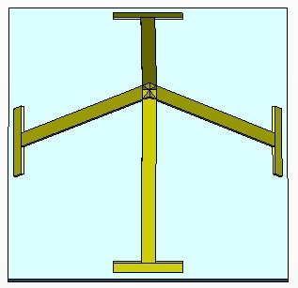 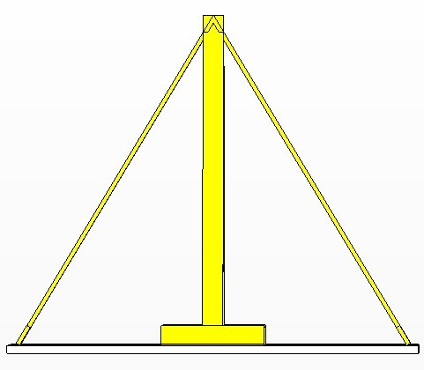

(a) P=1

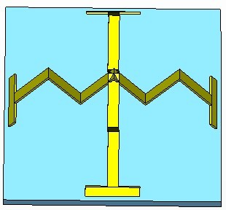 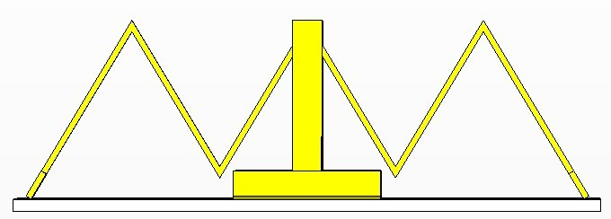

(b) P=3

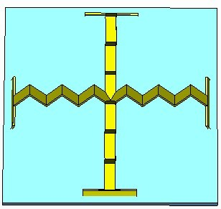 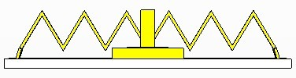

(c) P=6

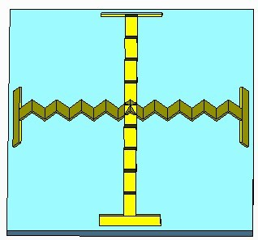 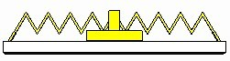

(d) P=9

Figure 4.10 Unit cell of the 3D JC saw-tooth FSSs.

4.3.1 The transmission responses of flat and 3D saw-tooth FSSs

Figure 4.11 Transmission response of flat and 3D saw-tooth FSSs.

Table 4.6 Comparison of flat and 3D saw-tooth FSSs.

|  |  |  |  |  |  |  |
| --- | --- | --- | --- | --- | --- | --- |
|  | fr (GHz) | Frequency shift (GHz) | | | |  |
|  | TE/TM mode | TE mode | | TM mode | | Bandwidth  (%) |
| Incidence angle | 0o | 30o | 60o | 30o | 60o |  |
| Flat | 10.42 | 0 | -0.28 | 0.4 | 0.86 | 19.73 |
| 1 peak | 6.5 | -0.02 | 0 | 0.01 | 0.04 | 16.17 |
| 3 peaks | 7.62 | -0.02 | -0.08 | 0.04 | 0.14 | 20.31 |
| 6 peaks | 8.74 | -0.04 | -0.14 | 0.06 | 0.22 | 20.64 |
| 9 peaks | 8.86 | -0.06 | -0.16 | 0.12 | 0.4 | 21.88 |

The comparisons are made with simple flat and 3D saw-tooth FSS in Figure 4.9 and Figure 4.10. The flat FSS and the 3D saw-tooth FSS have the same parameters, including the gap between the element and the substrate, the unit cell size and the distance between two ends. The transmission response is simulated using CST as shown in Figure 4.11. It can be seen that the flat surface has the highest resonant frequency of 10.42GHz at normal incidence. The lowest resonant frequency occurs at P=1 of 6.5GHz but it has the narrowest bandwidth at -10dB. The result also shows as increasing the number of peaks causes the increase of the resonant frequency and the fractional bandwidth.

Figure 12 and Figure 13 show the angular stability of the resonant frequency of flat and 3D saw-tooth FSS (P=1) at normal incidence (0o), 30o and 60o for both TE and TM polarizations. The simulation results of P=3, P=6 and P=9 of the transmission performances of the resonant frequency on the effect of the incident angles for TE and TM modes can be found from Appendix II. The frequency shift can be found from Table 4.6. The flat surface has the highest resonant frequency at normal incidence and it has the biggest frequency shift of 0.86GHz at TM60 than others. Compared with the flat surface, the 3D saw-tooth FSSs with peaks have better stable performance with the frequency shift varying within -0.16GHz and 0.22GHz. The best angular stability appears at 3D FSS when the number of peaks is one. Compared to normal incidence, the resonant frequency at 30o and 60o is not larger than for TE mode. In addition, the incident angle increases causes reduction of resonant frequency. But for TM mode, the resonant frequency at 30o and 60o becomes greater than normal incidence. And as the incident angle increasing the resonant frequency becomes larger.

1. TE mode

(b) TM mode

Figure 4.12 Transmission response of flat JC FSS at different incidence angles for TE and TM modes.

1. TE mode
2. TM mode

Figure 4.13 Transmission response of 3D saw-tooth JC FSS (P=1) at different incidence angles for TE and TM modes.

4.3.2 The reflection phase responses of flat and 3D saw-tooth AMCs

Based on the JC FSS was designed in last section, an AMC structure without vias is formed by placing a PEC as a ground plane with a thickness of 0.5mm behind the JC FSS. The parameters of the JC AMC structure are the same as in Table 4.4 except the substrate thickness is changed to 2mm. The unit cell settings are the same as the FSS in CST.

The reflection phase responses of flat and 3D JC AMC surfaces are shown in Figure 4.14. Table 4.7 shows the comparison of resonant frequency and the fractional bandwidth of the flat and 3D AMCs. It can be observed that the flat JC AMC resonates at 8.5461GHz with fractional bandwidth of 14.4%. This result is compared with 3D JC AMC surfaces of the same unit cell size and substrate thickness. For 3D structures, the resonant frequency increases and the fractional bandwidth decrease with the increasing of number of peaks. The lowest resonant frequency occurs at 4.2862GHz of the 3D structure with one peak and also has the widest bandwidth of 41.44%.

Figure 4.14 Reflection phase response of flat and 3D JC AMCs (n=2mm).

Table 4.7 Comparison of flat and 3D JC saw-tooth AMCs (n=2mm).

|  |  |  |
| --- | --- | --- |
|  | Resonant frequency  (GHz) | Bandwidth  (%) |
| Flat | 8.5461 | 14.4 |
| P=1 | 4.2862 | 41.44 |
| P=3 | 5.5717 | 22.64 |
| P=6 | 6.5074 | 13.6 |
| P=9 | 6.6723 | 18.76 |

However, for the 3D structure with one peak, the distance between the ground plane and the top of the copper is 9.5mm. In order to compare the flat and 3D structures with the same height, the substrate thickness of the flat surface increases to 9.5mm and for the 3D surfaces with three, six peaks and nine peaks, the substrate thickness increases to 7mm, 8.25mm and 0.8312mm respectively. Therefore, all the structures have the same height between top of the copper and the ground plane that is 9.5mm. The simulations are done by CST as shown in Figure 4.15. The comparison of the resonant frequency and the fractional bandwidth is presented in Table 4.8. The resonant frequency of the flat surface decreases from 8.5461GHz to 4.7998GHz as increasing the substrate thickness from 2mm to 9.5mm. The resonant frequencies of the 3D structures decrease as well. The fractional bandwidth has a large increase. For the flat surface, the bandwidth increases from 14.4% to 73.61%. It can be seen that the 3D structure with three peaks has the lowest resonant frequency at 4.0697 with bandwidth of 52.9%.

Figure 4.15 Reflection phase response of flat and 3D JC AMCs (h=9.5mm).

Table 4.8 Comparison of flat and 3D saw-tooth JC AMCs (h=9.5mm).

|  |  |  |
| --- | --- | --- |
|  | Resonant frequency  (GHz) | Bandwidth  (%) |
| Flat | 4.7998 | 73.61 |
| P=1 | 4.2862 | 41.44 |
| P=3 | 4.0697 | 52.9 |
| P=6 | 4.6277 | 46 |
| P=9 | 4.2187 | 63 |

4.4 Conclusion

Two different types of 3D JC FSSs are designed in this chapter.

The first 3D shape is formed by raising the centre of the JC to a pyramidal shape. The comparison is made between the flat and pyramid FSS in two situations. One is of the same copper length. The other one is of different lengths. The result shows the 3D FSSs outperform the flat surface in the situation of different lengths as increasing the height. The 3D structures have lower resonant frequency, and more stable frequency variation caused by the variable incident angles.

The second 3D shape is formed by folding the cross arms into saw-tooth shape. The optimal performance is shown when the 3D FSS has only one peak. It is because the resonant frequency is lower than others and has better angular stability. The reflection phase responses of the AMC surfaces are simulated. The AMC surfaces are constructed by applying a ground plane behind each FSS. The results show that when there is only one peak of the 3D saw-tooth AMC surface, the resonant frequency is lower than others and the bandwidth is widest at the substrate thickness of 2mm.

Chapter 5: Square loop FSS

This chapter demonstrates 3D FSSs with five different geometry configurations based on the flat square loop. The flat and 3D structures are designed in the same unit cell size. To investigate whether the 3D surfaces have lower resonant frequency or not, the transmission responses are simulated. The reflection phase responses of 3D saw-tooth AMCs are presented in the following section.

5.1 Flat square loop FSS geometry

One of the most common shapes used in FSS is square loop as shown in Figure 5.1. The unit cell size is set to 10mm×10mm. The square loop is etched on a substrate with permittivity of one and thickness of 0.5mm. The square loop material is a kind of lossy metal type copper. The length, width and thickness of the square loop are 6mm, 2mm and 0.01mm, respectively. The other parameters are shown in Table 5.1.

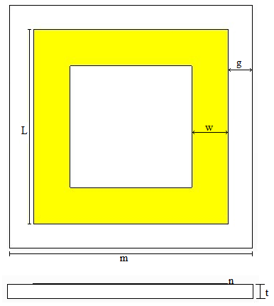

(a) Geometry of flat Square loop FSS.

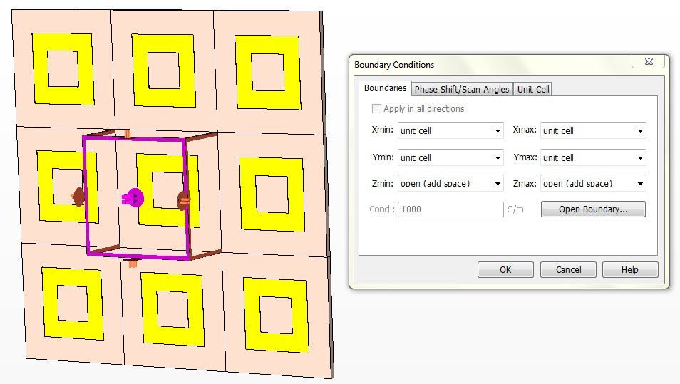

(b) Unit cell boundary conditions.

Figure 5.1 Unit cell of flat square loop FSS

Table 5.1 Parameters of flat square loop FSS.

|  |  |  |
| --- | --- | --- |
| Parameter | Value(mm) | Description |
| m | 10 | Size of unit cell |
| g | 2 | Gap between copper and unit cell |
| L | 6 | Length of copper |
| w | 2 | Width of copper |
| t | 0.01 | Thickness of copper |
| n | 0.5 | Thickness of substrate |

5.2 3D square loop FSSs geometries

There are four types of three-dimensional square loop FSSs are designed in this section.

The type 1 structure is formed by raising the inner side of the flat square loop to an angle which is not vertical. The new structure is shown in Figure 5.2. The second type of 3D structure is creating by angling the copper to 90 degree, which is perpendicular to the substrate. The type 2 structure can be seen from Figure 5.3. The type 3 3D structure is similar with type 2 but with the thickness of 0.5mm of the copper as shown in Figure 5.4. The type 4 3D FSS is constructed by raising the centre of the flat square loop FSS to a height of 10mm, as shown in Figure 5.5.

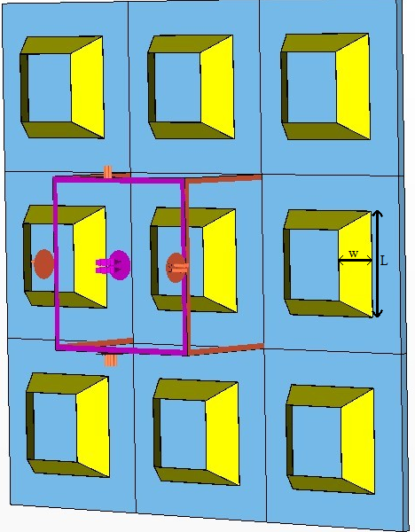

Figure 5.2 Unit cell geometry of 3D square loop (type 1).

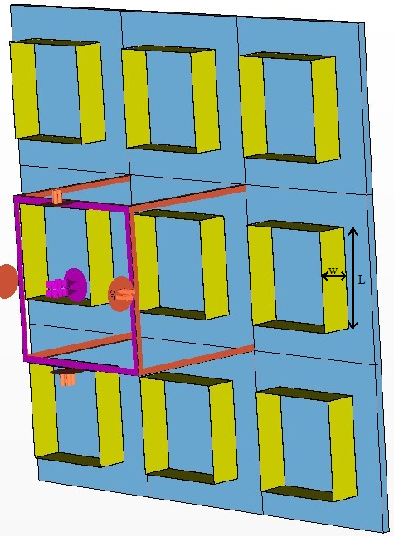

Figure 5.3 Unit cell geometry of 3D square loop (type 2).

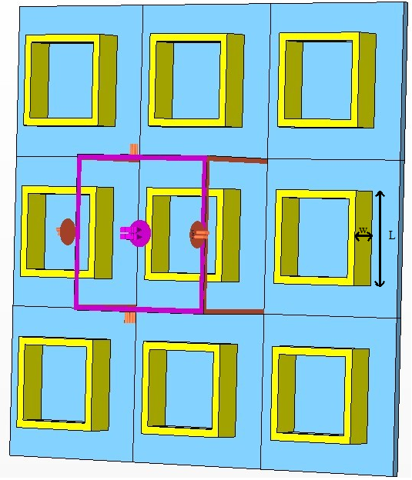

Figure 5.4 Unit cell geometry of 3D square loop (type 3).

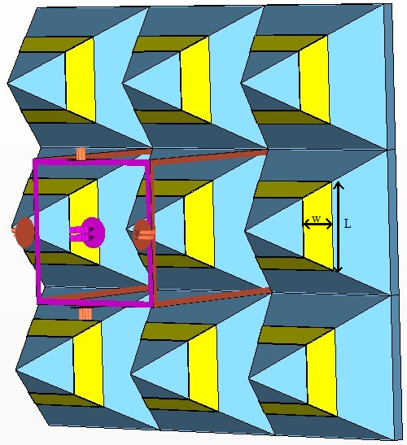

Figure 5.5 Unit cell geometry of 3D square loop (type 4).

5.2.1 Comparison of flat and 3D FSSs

There are two comparisons are made between the flat and four different types of 3D square loop FSSs. The simulation results are shown in Figure 5.6-Figure 5.7.

As shown in Table 5.2, the length is of 6mm, 8mm and 9mm and other parameters of the FSS are kept unchanged as presented in Table 5.1. In Table 5.2, the increase of the length decreases the resonant frequency for the flat and all 3D structures. This coincides with the relation given by Equation 2.1. Comparison between flat and 3D structures shows the resonant frequencies of 3D surfaces are always lower than flat surface at the same length. The lowest resonant frequency occurs at 18.44GHz of 3D type 2. Among all the four 3D structures, type 2 has the optional performance.

Fig. 5.7 shows the influence of the width on the resonant frequency. The width is given by 1.5mm, 2mm and 2.5mm. The other parameters are the same as in Table 5.1. Table 5.3 shows an opposite tendency as in Table 5.2. The lowest resonant frequency is given by type 2 structure of 1.5mm. Type 3 is actually type 2 with 0.5mm thickness of the copper. With the thickness increase, the resonant frequency of type 3 is higher than that of type 2.

Table 5.2 Comparison of flat and 3D square loop FSSs with varying length.

|  |  |  |  |
| --- | --- | --- | --- |
|  | Resonant frequency (GHz) | | |
| L=6mm | L=8mm | L=9mm |
| flat | 23.07 | 20.52 | 15.701 |
| 3D type 1 | 23 | 15.12 | 11.2 |
| 3D type 2 | 18.44 | 11.32 | 7.56 |
| 3D type 3 | 22.68 | 13.84 | 9.36 |
| 3D type 4 | 22.32 | 14.92 | 10.674 |

Table 5.3 Comparison of flat and 3D square loop FSSs with varying width.

|  |  |  |  |
| --- | --- | --- | --- |
|  | Resonant frequency (GHz) | | |
| w= 1.5mm | w= 2mm | w= 2.5mm |
| flat | 20.55 | 23.07 | 23.84 |
| 3D type 1 | 22 | 23 | 24.08 |
| 3D type 2 | 17.56 | 18.44 | 19.4 |
| 3D type 3 | 21.36 | 22.68 | 24.24 |
| 3D type 4 | 20.2 | 22.32 | 24.44 |

(a) L=6mm

(b) L=8mm

(c) L=9mm

Figure 5.6 Transmission response of square loop FSSs (w=2mm).

(a) w=1.5mm

(b) w=2.5mm

Figure 5.7 Transmission response of square loop FSSs (L=6mm).

5.3 3D saw-tooth FSS with square loop shape

Square loop FSS with peaks is another example of 3D structure that is formed by folding each side of the loop into peaks. The geometry of the flat square loop FSS is presented in Figure 5.8 and the geometrical parameters are listed in Table 5.4. There are three different 3D structures are formed as each side of the loop is folded into one peak, three peaks and six peaks. The side views of the three structures are shown in Figure 5.9. In order to remain distance between two ends of the cross is the same, the height are set to 7.5mm, 2.5mm and 1.25mm for 3D structures with only one peak, three peaks and six peaks respectively. The length of each loop side is the same as the flat surface which is 9.45mm. The 3D square loop FSSs have the same parameters as listed in Table 5.3. The substrate used in CST is the vacuum material with permittivity of one. Hence, the substrate has no effect on the performance of the structure.

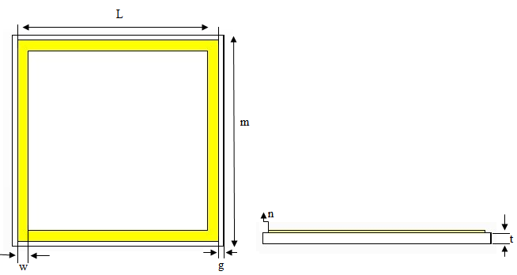

Figure 5.8 Geometry of flat square loop FSS.

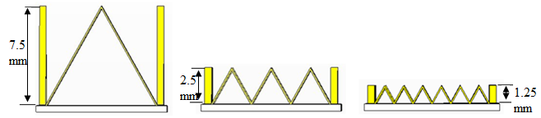

Figure 5.9 Side view of 3D square loop FSS with peaks.

Table 5.4 Parameters of square loop FSS.

|  |  |  |
| --- | --- | --- |
| Parameter | Value (mm) | Description |
| m | 10 | Size of unit cell |
| g | 0.25 | Gap between copper and substrate |
| L | 9.5 | Length of copper |
| w | 0.5 | Width of copper |
| p | change | Number of peaks |
| t | 0.5 | Substrate thickness |
| n | 0.1 | Copper thickness |

5.3.1 The transmission responses of flat and 3D saw-tooth FSSs

Figure 5.10 Transmission response of flat and 3D square loop FSSs.

The simulations were done by using frequency domain solver of CST Microwave studio. The resonant frequency, fractional bandwidth and the angular stability for structures of Figure 5.8 and Figure 5.9 are presented in Table 5.5. Figure 5.10 shows the transmission response of flat surface and 3D FSSs with peaks. As can be seen, the flat surface operates at higher resonant frequency compare with four other 3D FSSs. The lowest resonant frequency occurs at 4.1GHz of 3D FSS with one peak. From Table 5.5, it can be found that the 3D structure with nine peaks have the widest fractional bandwidth at -10dB.

In order to analysis the angular stability of the flat and 3D FSSs, the incident angle of the plane wave is set from 0o to 60o for both TE and TM modes. The transmission responses of the flat and 3D with only one peak FSSs at various incident angles are shown in Figure 5.11 and Figure 5.12. The simulation results of three peaks, six peaks and nine peaks of 3D saw-tooth FSSs are presented in Appendix III. The frequency shift can be seen in Table 5.5. Compare with flat case, the 3D FSSs is more stable with the incident angles of plane waves that varies within 0GHz and 0.28GHz. The biggest frequency shift is 0.6 at TE60o and TM60o of flat surface. In addition, the resonant frequencies of all structures at 30o and 60o are equal or higher than that at normal incidence for both TE and TM polarizations. Compare with TM mode, the TE mode has better stable performance.

Table 5.5 Comparison of flat and 3D saw-tooth Square loop FSSs.

|  |  |  |  |  |  |  |
| --- | --- | --- | --- | --- | --- | --- |
|  | fr (GHz) | Frequency shift (GHz) | | | |  |
|  | TE/TM mode | TE mode | | TM mode | | Bandwidth  (%) |
| Incidence angle | 0o | 30o | 60o | 30o | 60o |  |
| Flat | 7.22 | 0.2 | 0.6 | 0.18 | 0.6 | 43.43 |
| 1 peak | 4.1 | 0.02 | 0.1 | 0 | 0.02 | 41.32 |
| 3 peaks | 4.9 | 0 | 0.06 | 0.04 | 0.14 | 49.31 |
| 6 peaks | 5.56 | 0.04 | 0.14 | 0.08 | 0.28 | 48.89 |
| 9 peaks | 5.84 | 0.08 | 0.22 | 0.12 | 0.36 | 50.23 |

(a) TE mode

(b) TM mode

Figure 5.11 Transmission response of flat square loop FSS at different incidence angles for TE and TM modes.

(a) TE mode

(b) TM mode

Figure 5.12 Transmission response of 3D saw-tooth square loop FSS at different incidence angles for TE and TM modes (P=1).

5.3.2 The reflection phase responses of flat and 3D saw-tooth AMCs

In order to analysis the reflectivity properties of FSS that designed in last section, a ground plane is placed behind each structure. The new structure is known as artificial magnetic conductor (AMC) surface. The reflection phase responses of the surface can be obtained by using the frequency domain solver of CST Microwave Studio. The substrate thickness that defined the distance between the FSS and the ground plane is set to 2mm for the flat and other three 3D structures. The other parameters are the same as in Table 5.4. The unit cell and the boundary condition settings are the same as the FSS in CST. The reference plane is set to the top of the conducting element. The simulation results for the five different AMC surfaces with the same substrate and a periodicity of unit cell can be seen from Figure 5.13.

Figure 5.13 Reflection phase response of flat and 3D AMCs (t=2mm).

Table 5.6 Comparison of flat and 3D saw-tooth AMCs with square loop shape (t=2mm).

|  |  |  |
| --- | --- | --- |
|  | Resonant frequency  (GHz) | Bandwidth  (%) |
| Flat | 5.43 | 10.89 |
| P=1 | 2.6457 | 20.65 |
| P=3 | 3.4799 | 12.18 |
| P=6 | 4.0113 | 10.73 |
| P=9 | 4.0434 | 26.52 |

As it is shown in Figure 5.13, the resonant frequency at 0o of flat is 5.43GHz with percentage fractional bandwidth of 10.89%. The lowest resonant frequency occurs at 2.6457GHz of the 3D structure with one peak. As increasing the number of peaks, the resonant frequency increases from 2.6457GHz to 4.0434GHz and the fractional bandwidth decreases from 20.65% to 10.73%.

Figure 5.14 Reflection phase response of flat and 3D AMCs (h=9.5mm).

Table 5.7 Comparison of flat and 3D saw-tooth AMCs with square loop shape (h=9.5mm).

|  |  |  |
| --- | --- | --- |
|  | Resonant frequency  (GHz) | Bandwidth  (%) |
| Flat | 3.1113 | 49.84 |
| P=1 | 2.6457 | 20.64 |
| P=3 | 2.4981 | 31.66 |
| P=6 | 2.6241 | 37.25 |
| P=9 | 2.4428 | 25.68 |

As described in previous section 4.3.2, the height of the 3D structure with one peak is 7.5mm and the distance between the top of the copper and the ground plane is 9.5mm. In order to compare the flat surface with 3D structures of the same height from the ground plane to the copper, the substrate thickness of the flat case is increasing to 9.5mm. For the 3D structures with three peaks, six peaks and nine peaks, the substrate thickness increase to 7mm, 8.25mm and 0.8312mm, respectively. The reflection responses of the five different structures are shown in Figure 5.14. The comparison of the first resonance and the fractional bandwidth is presented in Table 5.5. It can be found that the resonant frequencies of all structures decreases as the thickness increase to 9.5mm. The resonant frequency of the flat surface is higher than other four 3D surfaces but with the widest fractional bandwidth of 49.84%. The lowest resonance appears at the 3D AMC surface with nine peaks.

5.4 Conclusion

In this chapter, five 3D FSSs has been designed based on the flat square loop. The transmission responses are compared between 3D and flat structures.

In the second section, four similar types of 3D square loop FSS are designed and simulated. By changing the loop length and width, the transmission responses are compared with flat surface with same parameters. The results show that the type 2 3D structure which is angling the flat square loop to 90 degrees with thickness of 0.01 has the optimal performance.

The 3D saw-tooth FSS with square loop shape is presented. The resonant frequency, the fractional bandwidth and the angular stability are compared with flat case for a fixed unit cell size. When there is only one peak, the 3D structure has the lowest resonant frequency and more stable with the incident angles than others. The widest fractional bandwidth occurs when the number of peaks is nine. In the end, in order to analysis the reflectivity of the 3D FSSs, the reflection phase responses are introduced by applying a ground plane behind the FSS. The resonant frequency of all the 3D AMC surfaces are lowest than flat surface.

Chapter 6: Conclusion

6.1 Summary

The purpose of this project is to design 3D FSSs that have lower resonant frequency than flat surface at the same unit cell size. By elongating the resonant length in a unit cell to three-dimensional space, the resonant frequency is miniaturized. Thus the dimension of a unit cell of the proposed FSS is reduced and more cells can be placed within a limited space compare with the planar surface. Meanwhile, the 3D FSSs are almost unchanged when the incident angle is increased from 0o to 60o for both TE and TM polarizations. Therefore, the proposed 3D structures have the advantages of the miniaturized element, the space utilization, and quiet stability with respect to different polarizations and oblique incident angles of illuminating waves.

Two types of 3D FSSs are designed and constructed include the pyramid and the saw-tooth shapes. The 3D structures are based on the flat cross dipole element FSS, the flat Jerusalem Cross FSS and the flat square loop FSS. The simulation results of the 3D structures using CST are summarized as follows:

Chapter 3:

The 3D pyramid FSSs with different cross lengths show better performance than the flat one. They operate at much lower frequency half that of flat surface for a fixed unit cell size. The fractional bandwidth becomes wider as the height of the pyramid increases. When the height of the pyramid rises to 20mm, the resonant frequency of the structure is almost half that of flat surface. It is almost unchanged with the incident angles. But the transmission response of the flat structure shows significant dependence on the variation of the incident angles.

Chapter 4:

The 3D pyramid FSSs with JC shape are designed and simulated. Compared with flat JC FSS with the same periodicity, the resonant frequencies of 3D structures are lower so that minimized FSS is efficient. When the height is increased to 20mm, the frequency shift is within 0.02GHz with various incident angles. It is more stable than flat surface with different incident angles, and the bandwidth is slightly wider. Moreover, the 3D saw-tooth FSS with JC shape is also presented. The optimal result occurs when the number of peaks is only one. The resonant frequency is 6.5GHz while it is 10.42GHz for the flat one. The frequency shift is within 0.04GHz as the incident angle increases to 60 degree. On the other hand, it is 0.86GHz for the flat one. However, the bandwidth of flat case is slightly wider than the 3D structure of one peak. It is narrower than other 3D structures. By applying a ground plane behind each structure, the reflection phase responses are compared. When the substrate thickness is 2mm, the 3D structure with one peak still shows better performance than the others. It works at half the frequency than the flat surface and has three times the fractional bandwidth.

Chapter 5:

Five different 3D FSSs with square loop shape are designed. The first four types are compared with the flat surface. The 3D type which is angling the copper to the vertical direction has the lowest resonant frequency regardless the length or the width of copper. The fifth 3D structure is a saw-tooth 3D FSS with square loop. The optimal result occurs at the 3D saw-tooth FSS with only one peak. The transmission response of the 3D surface with one peak has the lowest resonant frequency and the best angular stability but the narrowest bandwidth. The reflection phase response of the structure also shows the lowest resonant frequency. The fractional bandwidth is more than twice wider than the flat surface.

6.2 Future Research

1. The material of the substrate used in this thesis is vacuum with the permittivity value of one, but in fact the loss of the substrate should be considered. One future work should take into account the influence of the substrate.

2. The 3D FSSs designed in this thesis could be fabricated in order to compare the simulation results and the measurement results.

3. To fully use the space in 3D FSS design, one promising research direction is to investigate the sphere shape.

4. It is suggested to embed lumped reactive components. The purpose of this future work is to transform the conventional passive FSSs into active ones.

References

[1] T.K. Wu, Frequency Selective Surface and Grid Array, New York, Wiley, 1995

[2] R. Mittra, C.H. Chan and T. Cwik, ‘‘Techniques for Analyzing Frequency Selective Surfaces A Review,’’ Proc. IEEE, vol. 76, pp. 1593-1615, Dec. 1988

[3] B.A. Munk, Frequency Selective Surfaces: Theory and Design, New York, Wiley, 2000

[4] Jeffrey A. Reed, ‘‘Frequency Selective Surfaces with Multiple Periodic Elements’’, PhD Dissertation, The University of Texas at Dallas, 1997

[5] K. Sarabandi, ‘‘A Frequency Selective Surface With Miniaturized Elements,’’ IEEE Trans. Antennas Propag., vol. 55, no.5, pp 1239-1245, May 2007

[6] Ying Zhang; von Hagen, J.; Younis, M.; Fischer, C.; Wiesbeck, W.; , "Planar artificial magnetic conductors and patch antennas," *Antennas and Propagation, IEEE Transactions on* , vol.51, no.10, pp. 2704- 2712, Oct. 2003

[7] F. Bayatpur and K. Sarabandi, ‘‘Single-layer High-order Miniaturized-Element Frequency Selective Surfaces,’’ IEEE Trans. Microw. Theory Tech., vol. 56, no. 4, pp774-781, Apr. 2008

[8] F. Bayatpur and K. Sarabandi, ‘‘Tuning Performance of Metamaterial-Based frequency selective surfaces,’’ IEEE Trans. Antennas Propag., vol. 57, no.2, pp 590-592, Feb. 2009

[9] F. Bayatpur and K. Sarabandi, ‘‘Multi-layer miniaturized-element frequency selective surfaces,’’ [Antennas and Propagation Society International Symposium,](http://ieeexplore.ieee.org/xpl/mostRecentIssue.jsp?punumber=4604650) IEEE, Sep. 2008

[10] F.Huang, J.C. Batchelor, E.A. Parker, ‘‘Interwoven convoluted element frequency selective surfaces with wide bandwidth,’’ Electronics Letters, vol. 42, no.14, July 2006

[11] H. Liu, F.L. Ford and R.J. Langley, ‘‘Design Methodology for a Miniaturized Frequency Selective Surface Using Lumped Reactive Components,’’ IEEE Trans. Antenna Propag., vol. 57, no.9, pp 2732-2738, Sep. 2009

[12] X Yao, M Bai and J Miao, ‘‘Equivalent Circuit Method for Analyzing Frequency Selective Surface With Ring Patch in Oblique Angles of Incidence,’’ IEEE Antennas and Propag., vol 10, pp 820-823, Aug. 2011

[13] L.F.Martine, et al., ‘‘Equivalent Circuit Model Proposal Applied to Frequency Selective Surfaces,’’ Appilied Electromagnetics and Communications, 2005. ICECom 2005. 18th International Conference, pp.1-4, Dubrovnik, 12-14th, Oct.,2005

[14] R.J. Langley and E.A. Parker, ‘‘Equivalent Circuit Model for Arrays of Square Loops,’’ Electronic Letters, vol. 18, no. 7, pp.294-296, Apr. 1982

[15] A.P. Feresidis, G. Goussetis, S.H. Wang and J.C. Vardaxoglou, ‘‘Artificial Magnetic Conductor Surfaces and Their Application to Low-Profile High-Gain Planar Antennas’’, IEEE Trans. Antennas Propa., vol. 53, no.1, pp. 209-215, Jan. 2005

[16] E. Yablonvitch, ‘‘Inhibited Spontaneous Emission in Solid-State Physics and Electronics,’’ Phys. Rev. Lett, vol. 58, no. 20, pp. 2059-2062, May 1987

[17] D. Sievenpiper, L. Zhang, R.F.J. Broas, N.G. Alexopolous, and E. Yablonovitch, ‘‘High-impedance electromagnetic surfaces with a forbidden frequency band,’’ IEEE Trans. Microw. Theory Tech., vol. 47, no.11, pp.2059-2074, Nov. 1999

[18] G. Goussettis, A.P. Feresidis, and J.C. Vardaxoglou, ‘‘Tailoring the AMC and EBG characteristics of periodic metallic arrays printed on grounded dielectric substrate,’’ IEEE Trans. Antennas Propa., vol. 54, no. 1, pp. 82-89, Jan. 2006

[19] F.-R. Yang, K.-P. Ma, Y. Qian, and T. Itoh, ‘‘A novel TEM waveguide using uniplanar compact photonic-bandgap (UC-PBG) structure,’’ IEEE Trans. Microwave Theory Tech., vol. 47, no. 11, pp. 2092-2098, Nov.1999

[20] D.J. Kern, D.H. Werner, A. Monorchio, L. Lanuzza and M.J. Wilhelm, ‘‘The Design Synthesis of Multiband Artificial Magnetic Conductors Using High Impedance Frequency Selective Surfaces,’’ IEEE Trans. Antennas Propag., vol. 53, no. 1, pp. 8-17, Jan. 2005

[21] M.E. de Cos, Y. Alvarez and F. Las-Heras, ‘‘Novel Broadband Artificial Magnetic Conductor With Hexagonal Unit Cell,’’ IEEE Antennas and Wireless Propa. Letters, vol. 10, pp. 615-618, Jun. 2011

[22] CST Studio 2011, CST Microwave Studio examples, FSS: Simulation of Resonator Array

[23] CST Studio SuiteTM 2011, CST Microwave Studio, Which solver to use and FSS: Simulation of Resonator Array, August 27th 2008

Appendix I

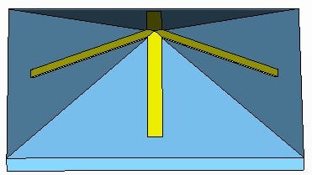

Figure I-1 The 3D pyramid FSS with cross shape (h=5mm).

Figure I-2 Transmission responses of h=5mm 3D FSS at different incidence angles for TE polarization (L=18mm).

Figure I-3 Transmission responses of h=5mm 3D FSS at different incidence angles for TM polarization (L=18mm).

Figure I-4 Transmission responses of h=5mm 3D FSS at different incidence angles for TE polarization (g=1mm).

Figure I-5 Transmission responses of h=5mm 3D FSS at different incidence angles for TM polarization (g=1mm).

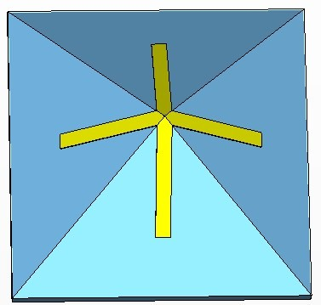

Figure I-1 The 3D pyramid FSS with cross shape (h=10mm).

Figure I-7 Transmission responses of h=10mm 3D FSS at different incidence angles for TE polarization (L=18mm).

Figure I-8 Transmission responses of h=10mm 3D FSS at different incidence angles for TE polarization (L=18mm).

Figure I-9 Transmission responses of h=10mm 3D FSS at different incidence angles for TE polarization (g=1mm).

Figure I-10 Transmission responses of h=10mm 3D FSS at different incidence angles for TE polarization (g=1mm).

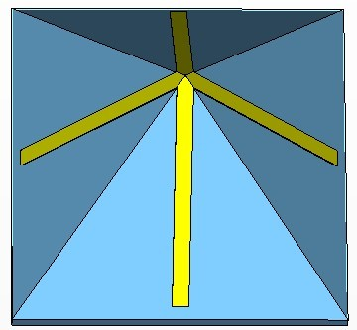

Figure I-11 The 3D pyramid FSS with cross shape (h=15mm).

Figure I-12 Transmission responses of h=15mm 3D FSS at different incidence angles for TE polarization (L=18mm).

Figure I-13 Transmission responses of h=15mm 3D FSS at different incidence angles for TE polarization (L=18mm).

Figure I-14 Transmission responses of h=15mm 3D FSS at different incidence angles for TE polarization (g=1mm).

Figure I-15 Transmission responses of h=15mm 3D FSS at different incidence angles for TE polarization (g=1mm).

(a) TE mode

(b) TM mode

Figure I-16 Transmission response of 3D saw-tooth FSS with cross shape (P=3) at different incidence angles

(a) TE mode

(b) TM mode

Figure I-17 Transmission response of 3D saw-tooth FSS with cross shape (P=6) at different incidence angles

(a) TE mode

(b) TM mode

Figure I-18 Transmission response of 3D saw-tooth FSS with cross shape (P=9) at different incidence angles.

Appendix II

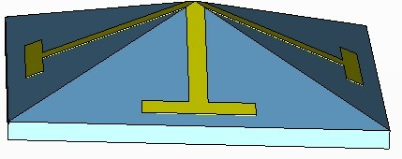

Figure II-1 The 3D pyramid FSS with JC shape (h=5mm).

Figure II-2 Transmission responses of h=5mm 3D FSS at different incidence angles for TE polarization (L=18mm).

Figure II-3 Transmission responses of h=5mm 3D FSS at different incidence angles for TM polarization (L=18mm).

Figure II-4 Transmission responses of h=5mm 3D FSS at different incidence angles for TE polarization (g=1mm).

Figure II-5 Transmission responses of h=5mm 3D FSS at different incidence angles for TM polarization (g=1mm).

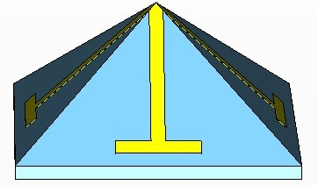

Figure II-6 The 3D pyramid FSS with JC shape (h=10mm).

Figure II-7 Transmission responses of h=10mm 3D FSS at different incidence angles for TE polarization (L=18mm).

Figure II-8 Transmission responses of h=10mm 3D FSS at different incidence angles for TM polarization (L=18mm).

Figure II-9 Transmission responses of h=10mm 3D FSS at different incidence angles for TE polarization (g=1mm).

Figure II-10 Transmission responses of h=10mm 3D FSS at different incidence angles for TM polarization (g=1mm).

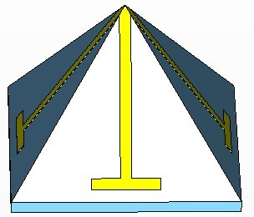

Figure II-11 The 3D pyramid FSS with JC shape (h=15mm).

Figure II-12 Transmission responses of h=15mm 3D FSS at different incidence angles for TE polarization (L=18mm).

Figure II-13 Transmission responses of h=15mm 3D FSS at different incidence angles for TM polarization (L=18mm).

Figure II-14 Transmission responses of h=15mm 3D FSS at different incidence angles for TE polarization (g=1mm).

Figure II-15 Transmission responses of h=15mm 3D FSS at different incidence angles for TM polarization (g=1mm).

(a) TE mode

(b) TM mode

Figure II-16 Transmission response of 3D saw-tooth FSS with JC shape (P=3) at different incidence angles

(a) TE mode

(b) TM mode

Figure II-17 Transmission response of 3D saw-tooth FSS with JC shape (P=6) at different incidence angles

(a) TE mode

(b) TM mode

Figure II-18 Transmission response of 3D saw-tooth FSS with JC shape (P=9) at different incidence angles.

Appendix III

(a) TE mode

(b) TM mode

Figure III-1 Transmission responses of 3D saw-tooth square loop FSS (P=3) at different incidence angles.

(a) TE mode

(b) TM mode

Figure III-2 Transmission responses of 3D saw-tooth square loop FSS (P=6) at different incidence angles.

(a) TE mode

(b) TM mode

Figure III-3 Transmission responses of 3D saw-tooth square loop FSS (P=9) at different incidence angles.