Stigma towards facial disfigurement; testing awareness and imagined contact strategies in the reduction of stigma towards people with visible facial differences

By:

Ana Maria Chamorro Coneo

A thesis submitted in partial fulfilment of the requirements for the degree of
Doctor of Philosophy

The University of Sheffield
Faculty of Science
Department of Psychology

Submission Date [12th March, 2020]

Abstract
Stigmatisation has been suggested to be partly framed within disease-avoidance functions that use disgust mechanisms to protect humans against potential sources of contamination. Furthermore, societal pressures regarding appearance cognitions also seem to contribute towards observers’ responses towards individuals with facial disfigurements (FD). Despite a convincing body of research supporting the disabling impact of having a FD there seems to be a gap in the literature for studies addressing ways to reduce public stigma towards FD. This thesis aimed to investigate variables associated with stigma towards FD and to test the effect of anti-stigma strategies on responses towards facial differences.
Study 1 investigated the correlations between disgust sensitivity, appearance cognition, and motivations to respond without prejudice on implicit and explicit attitudes towards FD. Findings suggested that stigma towards FD may operate as a dual-process, comprising innate disease-avoidance and societal individual predispositions. Gender differences were also found in relation to these variables and attitudes towards FD.
Following findings of the first experiment, Studies 2 and 3 aimed to test whether education and contact-based strategies could be useful in reducing intended avoidance, intergroup anxiety (Study 2) and improve evaluations of a mock FD applicant (Study 3). Results from Study 2 found a significant effect of a written awareness education message and imagined contact (IC) in the reduction of intentions to avoid FD, but not in levels of intergroup anxiety. Study 3 aimed to replicate these findings using an anti-stigma strategy with a sample of British employees with recruitment duties. Findings failed to replicate the effect on avoidance detected on Study 2 but showed a significant effect of IC (compared to controls) in ratings of emotional strength towards a FD mock applicant.
The findings indicated that innate factors, appearance cognitions and conscious efforts to respond in a non-stigmatising way seem to be associated with FD stigma. Education and imagined contact may be cost-effective strategies to encourage the inclusion of FD, particularly in scenarios where they are most hindered by their visible difference.

Acknowledgments
I would like to express my sincere gratitude to my research supervisors, Dr. Andrew Thompson, and Professor Paul Norman, for their invaluable guidance throughout this Ph.D. I could not have asked for better mentors in this process. Additionally, special thanks to my internal and external reviewers, for their useful comments and corrections, this thesis has much improved as a result of their feedback.
I extend my gratitude to my colleagues at the Psychology Department of The University of Sheffield for their support in the hardest times of this process and for the laughs and liters of coffee that we shared during our Ph.D. studies. It was a humbling experience to surround myself with such bright and thoughtful people. I am particularly indebted with my dear friend and colleague Dr. Adkins, for her insightful comments and much-appreciated help finishing this thesis.
I am most grateful to my parents and brothers for their unconditional love and emotional support throughout this Ph.D. and always. Also, thanks to my Colombian family in Sheffield, in particular to Johanna and Gianlucas (Dino Boy), for always providing me with a home away from home when I most needed it.

Contents
Abstract 2
Acknowledgements 3
Contents 4
Tables 7
Figures 8
Chapter 1: Introduction 9
Psychosocial impact of having a FD 12
The view from the inside 16
The view from the outside 19
Aims and structure of this thesis 27
Chapter 2 - Observers’ responses to facial difference and disfigurement: A systematic review 29
Introduction 29
Aims 31
Method 32
Search strategy 32
Inclusion and exclusion criteria 32
Review process and quality assessment 32
Results 35
Overview of studies 35
Beliefs and knowledge about facial disfigurement 62
Attitudes towards FD 62
Cognitive and emotional responses to FD 64
Overt Stigma 65
Discussion 65
Observers’ responses to FD 66
Perception of FD in non-western samples 68
Implications of FD and anti-stigma intervention strategies 69
Nomenclature of FD used in academic literature 70
Limitations of included studies 71
Limitations of the review 71
Conclusions and recommendations for future research 72
Chapter 3: Explicit and implicit attitudes towards facial disfigurement: the role of disgust sensitivity, appearance related cognitions and motivations to respond without prejudice. 73
Introduction 73
Disgust sensitivity and stigma 75
The present study 78
Aims 78
Hypotheses 78
Method 79
Design 79
Measures 79
Data quantification for IAT 82
Sample Size Calculation 83
Procedure 83
Results 84
Participant characteristics 84
Summary of Scales: Reliability, Normality and Outliers 85
The implicit association test (IAT) 86
Gender and individual differences 87
Correlation analysis 88
Discussion 89
Chapter 4: Testing the effectiveness of education awareness messages and imagined contact strategies in reducing public stigma towards facial disfigurement. 94
Introduction 94
The present study 98
Method 100
Procedure and design 100
Interventions 100
Rationale for Sample Size 102
Inclusion and exclusion Criteria 102
Recruitment 102
Measures 103
Results 105
Demographics 105
Summary of scales: Reliability, outliers and normality 106
Intervention 107
Discussion 114
Chapter 5 (Study 3): Testing the effectiveness of education and IC on stigma reduction towards FD in a sample of employees with recruitment duties 117
Introduction 117
Aims 122
Procedure and design 122
Recruitment 123
Experimental conditions 124
Measures 127
Sample size 127
Results 128
Demographics 128
Intervention effect 129
Discussion 131
Conclusion 133
Chapter 6. General Discussion 134
Implications for practice 141
Strengths, limitations and future research 142
Conclusions and future directions 143
References 145
Appendices 180

Tables
Table 2.1 Terminology used to address FD 36
Table 2.2 Summary of articles included in the review……………………………….34
Table 3.1. IAT presentation blocks 81
Table 3.2. Comparison of scoring methods 82
Table 3.3. Demographic information (N = 489) 85
Table 3.4. Cronbach alphas, mean and normative means of scales 86
Table 3.5. Mean, Standard Deviations and t values grouped by gender 88
Table 3.6. Correlation matrix 88
Table 4.1. Demographic information (N = 301) 106
Table 4.2. Baseline differences 107
Table 4.3. Descriptive statistics of intergroup anxiety and avoidance by intervention (3x2) 107
Table 4.4. intergroup anxiety estimated means. 108
Table 4.5. Estimated means for intended avoidance 109
Table 5.1. Demographic information (N = 78) 129
Table 5.2. Estimated means for IC and targets 130

Figures

Figure 1.1 The dual model of stigma (Pryor et al., 2004, p, 438)…………………....23
Figure 2.1 PRISMA flow diagram of study selection process 34
Figure 2.2 Publication rate and locality of articles 35
Figure 3.1. Response time differences IAT 87
Figure 3.2. Gender differences 88
Figure 4.1. Video-clip awareness message 101
Figure 4.2. Recruitment flow diagram 103
Figure 4.1. Interaction effects in intended avoidance towards FD 109
Figure 5.1. Experiment procedure 123
Figure 5.2. Travel agent job advert 125
Figure 5.3. Mock CV and photos 126
Figure 5.4. Interaction target x IC for emotional strength 131

Chapter 1: Introduction
The pieces of ourselves that evolved to help us survive in the past are just that, pieces. Not all pieces that make up our minds are adaptations. Some pieces came along for the ride (Chatterjee, 2014, p, xxii)
The term stigma is defined as a mark or point in the skin and its etymological origin dates back to the Ancient Greek term στίγμα (OED, 2007). During the late sixteenth and through the seventieth century, the word stigma referred to the practice of cutting or burning a spot into the skin of felons, slaves and other subjugated groups in order to punish them or brand them as undesirable individuals. The stigma offered a visible indication for others to identify (and avoid) morally corrupted individuals (Fink, 1992; Goffman, 1963). The word was later on introduced in the field of sociology to denote stigma as a social process characterised by the rejection, devaluation, and blame of an individual or group based on attributes that differentiate them from the norm (Goffman, 1963). Stigma, as proposed by Goffman (1963), comprises three categories: (i) ’tribal stigma’ which covers stigmas based on differences of group membership (e.g., ethnic minorities); (ii) ’character blemishes’ such as stigma towards behavioural deviation (e.g., psychiatric conditions); and (iii) stigma towards 'abominations of the body' which covers visible appearances outside the aesthetic norm (e.g., facial disfigurement).
Almost a decade before the introduction of Stigma: Notes on a spoiled identity (Goffman, 1963), the conceptualisation of ethnic prejudice had been suggested by(Allport (1954) as another term to denote hostile attitudes, feelings or treatment towards an individual based on his or her affiliation to a group deemed to have negative qualities. For example, in the case of prejudice based on religious beliefs, race, or ethnicity (Allport, Clark, & Pettigrew, 1954). Since the publications of Allport (1954) and Goffman (1963), two lines of work have been developed in the field of stigma (Link & Phelan, 2001) and prejudice (Dovidio, Glick, & Rudman, 2008). However, due to similarities between these concepts, the lines of research related to stigma and prejudice have overlapped in the literature. It is not uncommon for authors to use the words prejudice and stigma as synonyms within the same manuscript (e.g., Corrigan & Shapiro, 2010; Franks & Goodrick-meech, 1997; Lee & Cunningham, 2014; Roberts & Gierasch, 2013).
A review conducted by Phelan, Link, and Dovidio, (2008) showed that key theoretical models utilised in the study of stigma and prejudice differ mainly in target and form. Out of the studies addressing prejudice, seventy-three percent targeted negative treatment associated with race or ethnicity. In contrast, ninety-two articles studying stigma referred to illnesses, disability, non-typical behaviour or identity. Six percent of studies used stigma to address race, ethnicity or gender. The rationale behind both concepts share a common ground in investigating the negative responses towards certain human groups. Both stigma and prejudice serve three specific functions; (i) exploitation/domination, (ii) enforcement of social norms and (iii) avoidance of diseases.
The exploitation/domination function refers to when low-status individuals are subjected to labelling, stereotyping and devaluation in situations of power (Link & Phelan, 2001). Throughout the history of humanity, groups of humans have ascended to dominant positions of power that allowed them to have preferential access to resources and wealth. Nevertheless, for some groups to dominate, others had to endure subjection and perform duties that the dominant group would rather avoid (e.g., genocide and slavery; Hochschild, 1999). Stigma and prejudice towards exploited groups legitimise and promote these inequalities in order to maintain the status quo within the structure of power. The exploitation/domination function has been widely researched as prejudice in the case of oppressed groups, such as ethnic minorities, racial differences, and gender (Guillaumin, 2002; Skeggs, 2015). Conversely, research on stigma has centred around devaluation of individuals with mental and physical health issues, as well as academic underachievement and reduced access to services such as housing, education and employment (Link & Phelan, 2006; Sharac, Mccrone, Clement, & Thornicroft, 2010).
The function of enforcement of social norms refers to stigma or prejudice in relation to social norm violations. Others shun individuals that fail to conform to the acceptable parameters of behaviour or identity in order to make the non-conforming individual reintegrate into the socially acceptable identity. This function aims to increase adherence to social norms for individuals with behaviour and identities that others perceive to be voluntary and can thus be susceptible to change in the individual at the receiving end of the stigma. Targets of this function of stigma and prejudice include non-normative sexual orientations (Genrich & Brathwaite, 2005) and identities (Matsuno & Budge, 2017) as well as obesity (Sikorski, Luppa, & Kaiser, 2011), substance abuse and even psychiatric conditions such as depression (Crocker & Major, 1994; Goldstein & Rosselli, 2003; Hegarty & Golden, 2008).
The function of avoidance of disease or pathogen avoidance (Park, Schaller, & Crandall, 2007) suggests that prejudice and stigma serve a function of protection against individuals that may be poor prospective reproductive partners or that display signs of potential contaminating disease such as disfigurement in the face or body (Kurzban & Leary, 2001). Prejudice and stigma are in part the result of innate mechanisms that improve chances of survival and promote better social exchange. Stigma towards others is consistent across cultures worldwide, which may indicate that is somehow inherent to the human species. Humans may have cognitively adapted to avoid or exclude members of their community that have, or are believed to have, attributes that could result in social interaction with an inadequate other. For instance, a potential carrier of a contagious disease (e.g., physical disfigurement; Ryan, Oaten, Stevenson, & Case, 2012) or a member of a disadvantaged out-group (Neuberg & Cottrell, 2006; Park, Faulkner, & Schaller, 2003).
The disease avoidance function of prejudice and stigma is particularly evident in the study of stigma towards people with physical differences that deviate from aesthetic social norms; for instance, in manifestations like skin discoloration (e.g., vitiligo; Shah, Mehta, & Astik, 2008), severe facial asymmetry (e.g., ‘deformities’; Kar & Job, 2005; . Thompson & Kent, 2001) and digressions in physical movement (e.g., facial paralysis; Bogart, Cole, & Briegel, 2014). However, this function may also be extended to less evident forms of stigma, such as towards medical conditions (e.g., AIDS; Crawford, 1996), as well as conditions affecting psychological functioning like psychosis (Schomerus et al., 2012) and mood disorders (Alonso et al., 2008).
As suggested by Phelan et al. (2008), both stigma and prejudice have overlapping areas of study such as stereotypes, expectations, identity, and emotion. While research of prejudice has been mainly focused on the study of differential attitudes and treatment of people based on the model of exploitation and domination (e.g., racism, gender), the study of stigma has covered manifestations of norm enforcement (e.g., homophobia) and disease avoidance (e.g., stigma towards disfigurement) functions. In line with Phelan et al. (2008), particularly those specific to the field of stigma towards FD (e.g., Halioua, Williams, Murray, Skalko, & Vogelsong, 2011; Shanmugarajah, Gaind, Clarke, & Butler, 2012), the present thesis will utilise the term stigma to indicate the process of devaluation and rejection of an individual for purposes of norm conformity and disease avoidance. Differential treatment based on exploitation and domination functions (e.g., race, gender, ethnic minorities) will be referred to as prejudice. This thesis used literature related to constructs tested within both conceptual frameworks (i.e., prejudice and stigma) to support the construction and test of methodological designs employed in the experimental studies that were conducted.

Perceptions of disfigurement through history
Depictions of individuals with body and facial disfigurement appear transversely in human history through pieces of literature, plastic arts and. Indeed, analysis of pre-modern and modern cultures, have provided valuable insights about the way FD and other disabilities are perceived in contemporary societies (e.g., Deris, 2013; Ebenstein, 2006). In ancient Greece, the god of fire and artisans, Hephaestus, was the only deity in the pantheon to hold a different appearance amongst perfect eternal beings. According to the Homeric mythical tale, Hephaestus was born with a congenital disability, and because of it, his mother Hera, expelled him from heaven. He is described as “misshapen”, particularly in his extremities “clubbed” or “crooked feet” (Bazopoulou‐Kyrkanidou, 1997; Silk, 2004). From birth, Hephaestus faced rejection because of his appearance and later in life, he became a castaway and the target of mockery and contempt amongst the Greek deities. His physical appearance granted him an inferior social status and character features attributed to him are that of weakness and lameness, especially in relation to his movement (Ebenstein, 2006).
In Greco-Roman literature, characters with manifestations of disfigurement or other disabilities received responses of ridicule and were sometimes used as “pets” for other’s personal entertainment (Munyi, 2012). Furthermore, it is likely that these mythological tales are the reflection of people’s attitudes towards disfigurement in that period. Indeed, historical records from that time suggest that infants born with disfigurement or disabilities in ancient Greek and Roman societies were commonly abandoned or gotten rid of by a practice called exposure (as they were left exposed to the elements), much like the reaction of the goddess Hera when confronted with the disfigurement of her son, Hephaestus (Deris, 2013; Laes, 2008).
Later, in medieval European literature, it is found that undesirable physical appearance contained certain features such as darker skin complexion (or marks), unkempt or excessive hair, and disfigurement to face and body (Skinner, 2016). “Ugly” characters were often bearers of disease-related skin manifestations like ulcers, warts or scabies. However, other forms of disfigurement in medieval literature also involved asymmetrical shape and enlarged features in the body (e.g., hump in the back, hooked fingers) and face (e.g., excessively big mouth and teeth, crooked nose, enlarged head). Characters with atypical physical appearance were of lower social status (e.g., peasants), which overall served as a well-delimited contrast against the more favourable aesthetics of characters with higher positions (Skinner, 2016). While beautiful characters were of higher social ranking and noble features (e.g., knights), individuals with disfigurement (and other ‘ugly’ features) were vilified through depictions of moral defects and evilness (Specht, 1984).

Physical appearance (both ugliness and beauty) in medieval literature aimed to elicit specific emotions in the audience. Disfigurement in characters mostly intended to evoke aesthetic disgust or moral antipathy towards the individual described as visibly different. Indeed, descriptions of ugliness in medieval literature included adjectives like “repulsive”, “hideous”, “revolting” or “demonic”. Few exceptions have been found in which characters with unusual physical appearance were respectable or virtuous, mostly in cases when the aetiology of the disfigurement was the result of martyrdom or circumstantial misfortunes like a spell (Skinner, 2016; Specht, 1984).

In modern times, physical appearance continues to be a highly regarded value within society. In popular western culture, beautiful individuals are commonly associated with goodness and virtuousness (e.g., prince charming, princess) and ugly characters with antagonist and morally devious values (e.g., wizards, evil stepsisters/stepmother). Indeed, a robust body of research in social psychology supports the existence of a beauty-is-good stereotype; compared to unattractive peers, attractive individuals are perceived to be more successful, more socially competent (e.g., interpersonal ease) and overall associated with more favourable personality traits such as adjustment, intellectual competence, integrity and empathy (Eagly & Ashmore, 1991; Griffin & Langlois, 2006).
The beauty-is-good stereotype (Eagly & Ashmore, 1991) is most evident in media and advertising realms. In television commercials, books and movies, attractive individuals are linked with favourable qualities, while people with atypical appearance or with a disfigurement are associated with evilness (e.g., Freddie Krugger), reclusiveness (e.g, Notre dam hunchback) and moral defects (e.g., Darth Vader in StarWars; Smith et al., 1999; Wardle & Boyce, 2009).
An analysis of media coverage conducted by Garrissi, Janciute and Johanssen (2018) suggested that disfigurement is generally misrepresented or underrepresented. A search of the word ‘disfigurement’ across broadsheet (The Guardian, the daily Telegraph, The times, The independent) and tabloid (The daily mirror, The sun, The daily mail, amongst others) newspapers showed that disfigurement was framed in the context of crime, entertainment and popular medicine. In 46% of the matches within broadsheet newspapers, the word “disfigurement” appeared in articles about fiction, arts and entertainment, mostly referring to movie characters with skin conditions. Further, 17% articles placed disfigurement around crimes (e.g., acid attacks, tragic accidents), and the remaining 37% referred to disfigurement in the context fiction arts and entertainment.
Tabloids portraited disfigurement around sensationalist news, particularly body injuries as a result of accidents or crimes (47% in the Sun) and medical procedures such as malpractice in surgeries that led to disfigurement or new treatments of skin conditions (45% in the daily mirror). Overall, the coverage of disfigurement in the news was contextualised within atypical scenarios like tragic accidents, severe crimes and medical related news. According to Garrisi et al (2018), the representation of FD in the media seems to be reduced to ‘before and after’ stories, failing to cover the broader spectrum of what means to live with FD. However, adjectives and adverbs linked to the word were not robustly negative. Only a small percentage of pejorative terms was found in both types of news outlets.
On a positive note, it is worth nothing that inclusion efforts such as education campaigns and positive discrimination policies are increasingly being found in across western societies, for example, in the form of positive discrimination policies. Literature evidences a growing interest towards building research-based capacity to provide an environment that facilitates the adjustment of individuals that have been targets of discrimination because of their physical appearance. Furthermore, old stereotypes towards disfigurement are increasingly being challenged. For instance, individuals defying stereotypes associated with disfigurement have raised awareness by working in fields with public appeal, as it is the case of Winnie Harlow, a Canadian fashion model with vitiligo that has become a renowned public figure and advocate for Vitiligo (Kluger, 2019; Witcher, 2019)
During the last two decades, great efforts have been made to reduce discrimination towards disfigurement in the UK. A significant mile stone towards achieving more inclusion for people with disfigurement was the establishment of the Discrimination Act 2010. This act provide special rights for individuals that are visibly different in order to protect them from discrimination. Similarly, other governments have granted a protected status for severe disfigurement in the form of positive discrimination policies like the discrimination act in the UK. (e.g., Disability Discrimination Act of 1992 in Australia and the Canadian Human Rights Act).
In addition, charities like ‘Changing Faces’ and ‘The Katie Piper foundation’ are continuously working on raising awareness about the inequality treatment encountered by individuals with disfigurement. Efforts of inclusion include protest messages distributed via mass media (tv and social media), and by providing material on anti-bullying policies, teaching support and training programs for health care professionals that are in contact with people with disfigurement.

Psychosocial impact of having a FD
Facial disfigurement is the aesthetic effect of a visible mark on the skin (e.g., rash, scar), a striking asymmetry or mobility impairment to the face. Over 1,345,000 (or one in 44) people in the United Kingdom report a severe disfigurement and 542,000 (or one in 111) report to have disfigurement in the face (Changing Faces, 2008). Because having a FD is particularly hard to hide from others, some of the most common difficulties faced by individuals with FD are associated with social interaction, such as the creation of new relationships (Lansdown et al., 1997), especially with dating and marriage prospects (Hughes et al., 2009; Mojon-Azzi, Potnik, & Mojon, 2008). Other commonly found complaints include negative self-perception (e.g., negative body image and fear of negative evaluation; Clarke, Thompson, Jenkinson, Rumsey, & Newell, 2014; Newell, 1999).
The boundaries between what is or not considered disfigurement rely on inter-subjective agreements about what is an ideal or normal appearance. For instance, there has been documentation about societies in which body modifications (e.g., marking their faces) are performed to achieve a desirable appearance amongst peers, as it is the case of some tribes of Sub-Saharan Africa (Babatunde & Oyeronke, 2010; Garve, Garve, Türp, Fobil, & Meyer, 2017) and Australasia (Kononen, 2012). Indeed, in western societies, practices like body piercings and tattoos are a form of appearance modification, but are not labelled as disfigurement. Body piercings and tattoos have traditionally symbolised status, affiliation to a cultural subgroups (e.g., gang subcultures; Schildkrout, 2004; Wolf, 2012) or simply modern self-expression of identity (Armstrong, Roberts, Owen, & Koch, 2004). Therefore, it could be said that “…the definition of disfigurement depends on an interaction between social norms and individual attitudes and values.” (Thompson & Kent, 2001,)p. 664).
Unlike disfigurement in other parts of the body, visible differences affecting the face are very difficult to disguise, which makes FD features particularly salient in social interactions (Macgregor, 1990). The aetiology of FD has been broadly defined as either acquired through disease processes, traumatic events (like fires, road or traffic accidents), or congenital such as Treacher-Collins Syndrome, which involves underdeveloped facial features (Poswillo, 1975; Rumsey & Harcourt, 2004). A recent report by Changing Faces (2017) showed that a sample of individuals with FD in the UK (N = 806) identified conditions and diseases specific to the skin as the leading cause of disfigurement (21%). Congenital birthmarks were the second most reported aetiology (15.2%), closely followed by scaring (12%) and craniofacial conditions (10%). The remaining reported causes included burns, paralysis and hair loss. Most of the sample reported the head or neck as the area of the body affected by disfigurement.
Two perspectives have been drawn in the study of stigma towards FD; the individual (body-self relations) or ‘view from the inside’ and the socio-cultural and evolutionary perspective or ‘view from the outside’ (Cash, 1990 as cited in Thompson & Kent, 2001). The ‘view from the inside’ studies stigma from the receiving end of the devaluation or rejection. The view from the outside concerns the study of how stigma affects social perceptions and interpersonal processes of those with a FD. Facial disfigurement has traditionally been portrayed in art, media and advertising as indications of evilness or moral defect (Pausch et al., 2012; Wardle, Boyce, & Barron, 2009). People with FD systematically report having experienced negative reactions such as stares or intrusive and rude remarks from the public (Hodge, 2017; Hunt, Burden, Hepper, & Johnston, 2005; Rumsey, Clarke, & Musa, 2002; Strauss et al., 2007).

The view from the inside
Self-stigma is the term commonly utilised to denote how individuals respond when they are the target of stigma (Bathje & Pryor, 2011). According to Goffman (1963), stigmatisation differs in whether the devaluated attribute is discernible, (‘discredited’), or concealable (‘discreditable’) to observers. A discredited stigma refers to stigma based on attributes that are clearly visible for the observer, such as obesity, FD or amputees. A ‘discreditable’ stigma covers less apparent forms of typically stigmatised attributes, such as psychiatric conditions or early manifestations of HIV. While discreditable stigmas can be hidden, individuals’ stigmatising attributes are susceptible to being exposed or, as branded by Goffman (1963), ‘discreditable’.
Following Goffman’s seminal theory of stigma in 1963, researchers have expanded on the notions of discrediting and discreditable within the process of stigmatisation. For instance, Chaudoir, Earnshaw, and Andel (2013) suggested that people experiencing stigma display three distinctive beliefs; anticipated, enacted and internalised stigma. Anticipated stigma contemplates the expectation experienced by an individual who is about to be the target of devaluation, discrimination, and avoidance from their peers. Individuals with stigmatised attributes may experience distress in the prospect of being in a social interaction where they may face discrimination or stigma from the public (Leary, Rapp, Herbst, Exum, & Feldman, 1998). Congruently, in believing that they will be the target of stigma, individuals experience feelings of vulnerability and shame (Chaudoir et al., 2013; Quinn et al., 2014). Facing the prospects of potential discrimination may implicate tension and stress for individuals with FD. Individuals with FD are likely to be particularly preoccupied with social acceptance when participating in interactions where they might face scrutinization from others or even negative evaluation (Adhikari, Kaehler, Chapman, Raut, & Roche, 2014; Katz, Irish, Devins, Rodin, & Gullane, 2003; Kent & Keohane, 2001). For instance, a survey report with visibly different individuals (N = 806; Changing Faces, 2017) found that almost to 80% of respondents had evaded applying for a job due to fear of negative responses during the interview process or from fellow co-workers. Furthermore, over 40% of participants expressed their FD hindered their educational and career aspirations. Congruently, in the literature, anticipated stigma has been associated with self-isolation, and social withdrawal (Judgeo & Moalusi, 2014; Quinn et al., 2014).
Enacted stigma covers past experiences whereby individuals have received explicit manifestations of stigma (Chaudoir et al., 2013). Overt displays of stigma towards FD have been documented in the literature (Madera & Hebl, 2012; Rumsey, Bull, & Gahagan, 1982; Stevenage & Furness, 2008; Stone & Wright, 2013). Moreover, surveys, as well as anecdotal reports of experienced discrimination amongst people with FD, are consistent in that FD has negative implications across financial (Horn et al., 2007), educational (Prior & O’Dell, 2009), occupational (Hong, Koo, & Koo, 2008; Stone & Wright, 2013), partner selection (Hughes et al., 2009; Mojon-Azzi et al., 2008) and overall wellbeing (Anne Clarke, 1999; Kent & Al‐Abadie, 1996).
A recent report by Changing Faces (2017) provided a useful summary of enacted stigma towards people with FD in the UK. Two-thirds of the sample reported already living with disfigurement during their secondary school years, and close to half of these (49.5%) respondents experienced bullying associated with their different appearance. Furthermore, 40% reported having failed to be successful at certain job applications because of their physical appearance and 45.8% said they had received unpleasant reactions from a shop assistant.
In response to stressors associated with stigma, individuals with FD may experience higher levels of appearance-related distress and face challenges in social interactions (Clarke et al., 2014). In dermatological conditions such as psoriasis, individuals can develop dysfunctional coping strategies such as alcohol misuse and smoking (Ginsburg & Link, 1993; Pouplard et al., 2013; Zhu, Zhu, & Fan, 2012). For instance, (Poikolainen, Karvonen, and Pukkala, (1999) reported that patients with psoriasis had a greater risk of dying by diseases associated with alcohol consumption (e.g., liver diseases), compared to mean mortality rates of people without psoriasis.
Internalised stigma was first hypothesised by Goffman (1963) and later supported by Chaudoir et al. (2013). According to this hypothesis, people that have been subjected to stigma for an extended period can internalise feelings of stigma. This subjective process typically involves negative feelings about self (e.g., body shame; Kent & Thompson, 2002), maladaptive behaviours (e.g., low treatment adherence) and coping strategies (alcohol misuse), and psychological distress (Livingston & Boyd, 2010). For instance, Coneo et al. (2017) showed that almost a third of a sample of people with skin conditions met the clinical criteria for anxiety and depression.
Research of FD stigma has been concentrated around the issues and difficulties encountered by those affected by it. However, not all individuals are affected to the same extent and some adjust well to their visible difference (Rumsey & Harcourt, 2004; Thompson & Broom, 2009). Furthermore, numerous studies show that in general, psychological distress is weakly correlated with the magnitude of the physical disfigurement (Rumsey, Clarke, White, Wyn-Williams, & Garlick, 2004; van den Elzen et al., 2012), which enhances the relevance to study the array of psychosocial, cultural, and physical factors implicated in the process of adjustment to disfigurement (Coneo, Thompson, & Lavda, 2017). However, studies addressing the underlying factors contributing to people’s adjustment to FD, are typically restricted in terms of sample size, statistical power and the lack of predictive nature in of the designs (Rumsey et al., 2004).
The literature concerning the study of stigma reduction from the individual perspective (from the inside) has targeted two main challenges faced by people with FD; managing observers’ reaction in social interactions and the development of positive body image (Thompson & Kent, 2001). Strategies to reduce self-stigma may be grouped into three categories; medical (van Schijndel, Tasman, & Litschel, 2015), training of social skills (Bessell & Moss, 2007; Robinson, Rumsey, & Partridge, 1996) and cognitive-behavioural therapy (CBT; Clarke, Thompson, Jenkinson, Rumsey, & Newell, 2013). While medical orientations attempt to treat or surgically ‘correct’ FD, psychological interventions attempt to improve adjustment to living with a facial difference or disfigurement.
A meta-analysis of 22 studies evaluating the effectiveness of interventions aimed to improve psychological adjustment to living with skin conditions (n = 906 participants across studies), reported a significant effect of psychological interventions such as CBT, group therapy and psychotherapy on improved psychological wellbeing of people with a range of skin conditions (Lavda, Webb, & Thompson, 2012). Moreover, significant changes in psychological outcomes were not affected by duration or mode of treatment. Similarly, training in social skills targeting individuals with FD has also resulted in significant improvement in levels of anxiety and self-confidence (Robinson et al., 1996). However, the long-term effects of these interventions are yet to be explored in the literature.

The view from the outside
Social biases that benefit physically attractive people are well researched in the literature. (Eagly & Ashmore, 1991; Feingold, 1992; Hosoda, Stone‐Romero, & Coats, 2003)(Lemay, Clark, & Greenberg, 2010; Lorenzo, Biesanz, & Human, 2010). These biases are reinforced by the mass media via advertising and entertainment industries, which has negative consequences in the body image and self-perception of women (Grabe, Ward, & Hyde, 2008) and men (Duggan & McCreary, 2004)(Harn, 1987). Research suggests that the presence of visible different features affects the way observers perceive and respond to individuals with FD (Ishii, Carey, Byrne, Zee, & Ishii, 2009; Rumsey et al., 1982; Stone & Wright, 2012; Van Schijndel, Litschel, Maal, Berg & Tasman, 2015).
In the literature studying how others perceive and interact with FD, three distinctive theoretical rationales have provided a framework to understand the phenomenon of stigmatization towards FD. First, the belief in a "just world" or the attribution that the disfigurement involves some kind of moral balance from a greater power (e.g., cosmic balance) and magical thinking (Goffman, 1963)(Park, Faulkner, & Schaller, 2003; Thompson & Kent, 2001). This framework is particularly useful in studies using samples of participants from certain non-western cultural background. For instance, individuals of South Asian background heavily rely on religious and cultural beliefs to explain disfigurement, which is thought to be the result of the will of God, destiny or as punishment for sinning (Hughes et al., 2009). Similarly, studies in African samples report that stigma towards clef lip palate occurs in the context of cultural and magical beliefs that link FD with negative attributes (Oginni, Asuku, Oladele, Obuekwe, & Nnabuko, 2010; Owotade et al., 2014).
The literature examining responses towards FD appears to be highly concentrated within western, high-income countries, and thus systematic comparisons with samples of low- and middle-income countries (LMIC) are not feasible. The study of stigma towards FD in relation to sociocultural variables would be complemented by studies using samples of non-industrialised societies such as countries of the global south (Ward, 2017).
The second rationale proposes that stigma and avoidant responses towards FD are maintained and reinforced by interactional uncertainty about how to behave when encountering the disfigurement. For instance, in Stone and Potton (2014) self-reported emotions of observers presented with FD stimuli reported higher levels of curiosity and sorrow compared to those evaluating control faces without disfigurement.
The face provides abundant information about the interlocutor’s emotions, identity as well as verbal and non-verbal language (Haxby, Hoffman, & Gobbini, 2002; Knapp, Hall, & Horgan, 2013; Mertens, Siegmund, & Grüsser, 1993; Walker-Smith, Gale, & Findlay, 1977). Studies with eye tracking suggest that when presented with images of faces, perceivers focus on the central triangle of the face, which comprises information from eyes, nose, and mouth. It is possible that disfigurement appears to the observer as a new stimulus in the face that affects the process of communication (Ishii et al., 2009; Madera & Hebl, 2012; Stone & Potton, 2017; Van Schijndel et al., 2015).
It has been suggested in the literature that a similar phenomenon to divided attention (Johnson & Zatorre, 2006; Shomstein & Yantis, 2004) may be associated with observer’s perception of FD and evaluation of FD. Madera and Helb (2012), utilised eye-tracking technology to investigate perception, evaluation and memory recall of FD. Participants allocated to interact with FD stimuli showed longer visual fixation to the area where the disfigurement was located and reported using more self-regulatory resources and less memory recollection of the interaction: Participants also recalled fewer details about the interaction compared to participants allocated to control interactions with a confederate without FD. In other words, the presence of disfigurement may deviate the attention of observers away from the central triangle of the face (Ishii et al., 2009) and associated content from this area of the face, hindering the quality of the interaction. The implementation of more resources to self-regulate responses may also contribute to poor interactions and memory of people FD (Madera & Hebl, 2012).
The third rationale suggests that stigmatising responses are associated with the resemblance that FD shares with other physical manifestations of contagious diseases (e.g., Buruli Ulcer; Merritt et al., 2010). Highly contagious diseases like lepra and smallpox are known to elicit avoidance responses towards those that are infected (Sinha, Kushwaha, Kotwal, Sanghi, & Verma, 2010). However, other forms of FD that are known to be non-contagious (e.g., burns or acne) also elicit similar avoidance and stigmatising reactions to contagiousness manifestations (Green-Armytage, Simonds, John, & Woodger, 2019; Kouznetsova, Stevenson, Oaten, & Case, 2012; Ryan et al., 2012). Research from the field of evolutionary psychology suggest that stigmatisation processes towards contagious and non-contagious FD are part of the mechanisms developed in humans to facilitate survival. This perspective follows certain considerations in the understanding of stigma; firstly, contemporary humans and human behaviours are the result of a series of adaptations to recurrent problems associated with survival of the species (Darwin, 1859). Secondly, problem-solving mechanisms in humans are likely to be specific in their functioning. Thirdly, humans are equipped with information-processing systems each of which has been phylogenetically shaped to overcome specific adaptive problems, including socialisation (Cosmides & Tooby, 1994, 2010). By excluding and devaluating others, humans have historically resolved issues associated with sociality and survival. Therefore, the potential for these responses may be rooted in the species’ phylogenetical past and appears to be endorsed by cultural beliefs (Kurzban & Leary, 2001).
Selecting individuals to engage within social interactions, serves one of three functions; (i) avoidance of social interactions with potential partners that offer limited social gain; (ii) exploitation of subjected groups that preserve people’s group identities and dominance over resources; and (iii) reduction of the probability to be contaminated with infectious diseases (disease avoidance; Kurzban & Leary, 2001; Navarrete & Fessler, 2006; Park et al., 2003). In line with this hypothesis, three distinctive stigmatising conditions may elicit in observers specific affective, cognitive and behavioural mechanisms that are different in nature. For instance, emotional responses are known to lead an organism towards achieving an adaptative behaviour (e.g., fear-escaping; Öhman & Mineka, 2001). Groups devaluated based on functions of intergroup competition and exploitation may elicit in others emotions of fear, hate and anger, while stigmatisation contextualised in avoidance of contaminating cues (like FD) is associated with evoking emotions of disgust (Kurzban & Leary, 2001).
In line with the evolutionary perspective, discriminating behaviour towards facial and body disfigurement is hypothesised to be associated with an evolved mechanism to avoid contagious parasitic threats (Crocker & Major, 2004; Kurzban & Leary, 2001). Disease-avoidance mechanisms involve information processing systems that facilitate the detection of potential parasitic infestations. Because diseases with contagious characteristics are normally accompanied by abnormal physical manifestations, humans have evolved to respond emotionally (anxiety, disgust), cognitively (negative attitudes) and behaviourally (avoidance), when encountering individuals that are visibly different (Park et al., 2003; Tybur, Lieberman, & Griskevicius, 2009)(M. Oaten, Stevenson, & Case, 2009; Megan Oaten, Stevenson, & Case, 2011). In the presence of FD, humans may avoid proximity or the possibility to exchange body fluids (Ryan et al., 2012).
There is a robust body of evidence linking mechanisms of disgust with disease avoidance of contaminating cues (Schaller & Duncan, 2007; Schaller & Park, 2011; Tybur & Lieberman, 2016). Indeed, it is considered one of the most relevant mechanisms in the study of disease avoidance (Rozin, Haidt, & McCauley, 1993). The definition of disgusts dates back to Darwin’s Emotional responses in man and animals (Darwin, 1890).
"Disgust is typically experienced as a feeling of revulsion, sometimes accompanied by nausea, along with a strong desire to withdraw from the eliciting stimulus". (Oaten, Stevenson, & Case, 2009, page 303)
Many basic biological needs require involvement in situations with a high risk of contamination (e.g., eating, drinking, sexual activity). Disgust mechanisms help identify and avoid high-risk of contamination in the environment (Armstrong, Olatunji, Sarawgi, & Simmons, 2010; Olatunji, Haidt, McKay, & David, 2008). For instance, common elicitors of disgust, such as body fluids, decomposed food or faeces are also substances high in harmful bacteria (Curtis & Biran, 2001; Toronchuk & Ellis, 2007). Likewise, FD stimuli are likely to trigger disgust emotions in order to prevent contact and potential contamination (Ryan et al., 2012). Moreover, disgust has been associated with stigma and prejudicial responses towards disadvantaged groups, even those typically studied under functions of exploitation/domination (Faulkner, Schaller, Park, & Duncan, 2004). Furthermore, individual differences in sensitivity to disgust have been found to predict stigmatisation towards FD (Ryan et al., 2012; Shanmugarajah et al., 2012; Stone & Potton, 2014, 2017) and other stigmatised groups based on appearance (e.g., obesity; Lieberman, Tybur, & Latner, 2012; Vartanian, 2010).
However, individuals need to cover basic needs that require social interaction. In order to maximise chances of survival and meet basic needs, humans tend to avoid interactions that are associated with the greatest threat for survival (Error Management Theory; Haselton & Buss, 2000; Kouznetsova et al., 2012). Following this logic, facing individuals with FD will likely result in avoidance as the consequences of failing to identify a potentially contaminating cue could be fatal.
Stigmatisation practices towards FD may serve a function of protection against potential contact with dangerous pathogens (Kurzban & Leary, 2001). However, what features are to be (or not) stigmatised depend (to an extend) on interpersonal agreements, which are in turn kept alive via socialization and cultural transmission. Sociocultural practices and beliefs maintain the systematic avoidance of certain types of social interaction (Guimond, 2000). For example, the stigmatisation of FD has been widely found across cultures and throughout human history (e.g., literature, historic records, plastic art, media). Moreover, stereotyping of individuals with FD persists nowadays; literature suggest that current media outlets still portray FD in a way that endorse misrepresentation and stereotyping of individuals with a visible difference (Garrisi et al., 2018; Johanssen & Garrisi, 2018; Wardle, Boyce, & Barron, 2009).

The dual process of stigma
There is perhaps another perspective that has contributed towards the understanding of stigma towards commonly stigmatised individuals, the dual-process of stigma proposed by Pryor, Reeder, Yeadon, and Hesson-McInnis (2004). According to this perspective, stigma contemplates two processes, one that involves (i) automatic (implicit, impulsive, reflexive); and another that is (ii) reflective, deliberate or rule-based. This model suggests a temporal pattern in reactions to which reflexive responses are automatically elicited by the stimuli, while subsequent explicit reactions are “adjustments” to such initial responses. In other words, automatic responses are not replaced by rule-based responses; instead, a dynamic process over time elicits subsequent emotional and behavioural reactions in the perceiver (see Figure 1.1).
Automatic reactions reflect the operation of a reflexive and automatic system, which comprises immediate behavioural and emotional responses like disgust (Shanmugarajah, Gaind, Clarke, & Butler, 2012), threat (Blascovich et al., 2001) and avoidance (Rumsey, Bull, & Gahagan, 1982). Pryor et al. proposed that these reactions can be learnt over a lifetime via repeated association; for example, some automatic prejudice reactions to out-groups (i.e., groups of other ethnicities) have been shown to be the result of repeated learnt associations between certain ethnicities and unfavourable traits (Oswald, Mitchell, Blanton, Jaccard, & Tetlock, 2013). Automatic responses can also be of instinctive nature, as it is the case of protective responses of avoidance towards potentially pathogen-carrying individuals (Ryan, Oaten, Stevenson, & Case, 2012; Tybur, Lieberman, Kurzban, & DeScioli, 2013).

Figure 1.1 The dual model of reactions to perceived stigma (Pryor et al., 2004, p, 438)
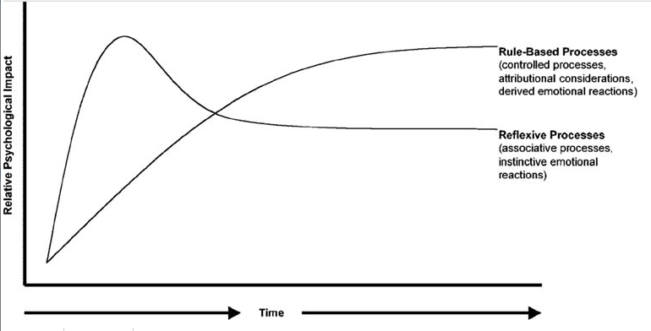

On the other hand, reactions associated with the ruled-based system involve conscious deliberation and reflection of responses automatically elicited by the reflexive system, for instance by consciously evaluating the appropriateness of a specific response (Corrigan, Bink, Fokuo, & Schmidt, 2015; Crandall, Eshleman, & O’Brien, 2002). People are likely to try to control their explicit responses (e.g., ratings) when asked about topics related with equality, prejudice and stigma, but the motivations behind socially desirable responses may vary (Stone & Potton, 2014). It has been suggested that responses towards equality issues are driven by internal (i.e., personal values, beliefs, and self-image) and external motivations (i.e., legal, social and interpersonal demands) to respond in a way that is closer to desired social values. For example, considering racial prejudice, Devine, Plant, Amodio, Harmon-Jones, and Vance (2002) found that participants who responded in a non-prejudiced way because it was personally important for them showed less racial prejudice than those that attempted to be non-prejudicial in order to avoid other’s judgement.
While there is a growing number of studies supporting the dual-based model process in concealable or ‘discreditable’ forms of stigma (e.g., AIDS and mental health), future research would benefit from systematically testing this model in conditions that are more evident to the gaze of the public (FD; Blascovich, Mendes, Hunter, Lickel, & Kowai-Bell, 2001; Grandfield, Thompson, & Turpin, 2005; Stone & Potton, 2017)

Reduction of health-related stigma
Literature suggest that stigmatisation is associated with poor adjustment to medical conditions and disease manifestations. Stigma towards chronic health conditions causes not only suffering and exclusion towards those affected by it (Fiest, Birbeck, Jacoby, & Jette, 2014; Kaur & Brakel, 2002; Nyblade, 2006), but also greater burden public health systems across the world, as efforts to combat and treat a condition are less effective when the condition is heavily stigmatised (Link & Phelan, 2006). Negative effects of stigmatisation towards certain health conditions include: increasing diseases transmission (when the condition is contagious) due to delay in diagnosis and treatment, and poor treatment adherence (e.g., HIV and mental illness; Rintamaki et al., 2006; Kamaradova et al., 2016) which leads to greater drug resistance (Van Brakel, 2006; van Brakel et al., 2006).
Due to the negative implications that stigmatisation has on certain health conditions, the study of health-related stigma has gained considerable attention from policymakers and the scientific community in the last four decades (Paterson, Backmund, Hirsch, & Yim, 2007; Werner, Corrigan, Ditchman, & Sokol, 2012). Initiatives to reduce health-related stigma have been designed and tested worldwide (Heijnders & Meij, 2006). According to the literature, in order to effectively reduce stigma, interventions must target different manifestations of this phenomenon at different levels: social (media, community discussions), individual (stereotypical beliefs, attitudes, discriminatory behaviour) and policy and practice. Because each element cannot be conceived without the other, effective health-related stigma interventions must include a multilevel approach (Hornik, 2002).
Psychological outcomes measured across the health-related stigma literature include knowledge, attitudes and/or intended behaviour. Self-report instruments are commonly prevalent in assessing stigma change (Corrigan, Morris, Michaels, Rafacz, & Rüsch, 2012). However, conscious evaluations of others are only a part of the stigmatisation phenomenon. Furthermore, questionnaires and explicit forms of evaluation are known to be subjected to self-presentation issues, motivated by people's desires to conform to social norms (Plant & Devine, 1998). Therefore, responses of automatic or implicit nature have been increasingly included within the study of stigmatisation and prejudice (Greenwald, 1998; Pryor, Reeder, Yeadon, & Hesson-McLnnis, 2004). Technological advances have facilitated the inclusion of less face valid measures to study stigma, such as implicit association tests (IAT; Brendl et al., 2001), eye-tracking (Ishii, Carey, Byrne, Zee, & Ishii, 2009) and physiological responses (Blascovich, Mendes, Hunter, Lickel, & Kowai-Bell, 2001). However implicit and automatic measures are rarely used to evaluate the effectiveness of intervention strategies.
According to the literature on public stigma towards health conditions, the most tested type interventions used are protest, education, and contact (Corrigan & Penn, 1999; Heijnders & Meij, 2006). Protest interventions have been utilised to create awareness about inequality and prejudice. Protest intends to suppress negative stereotypes and representations of a stigmatised group by identifying and disclosing episodes where prejudice and discrimination are taking place, in order to publicly condemn it (Corrigan et al., 2012; Heijnders & Meij, 2006). However, there is little evidence supporting the effectiveness of protest campaigns and it is sometimes suggested that they enhance negative reactions. Instructing people to suppress negative stereotypes could sensitise individuals, whom later on create undesirable recollections about the stigmatised group (Angermeyer, Matschinger, & Corrigan, 2004).
Education strategies have traditionally been used to challenge myths, stereotypes, and misconceptions with facts and knowledge. Studies reporting results about the evaluation of educational interventions is varied, as evidence of effectiveness is not always available for a portion of the studies (Mittal, Sullivan, Chekuri, Allee, & Corrigan, 2012). For example, efforts to reduce stigma towards mental illness have found that traditional lecture on psychopathology (teaching of symptoms and causes) increase knowledge of participants, but has little effect on measures of attitudes (e.g., Schlier, Schmick, & Lincoln, 2014). Furthermore, strategies focusing on teaching the biogenetic causes of mental illness have been found to increase stigma (Kvaale, Gottdiener, & Haslam, 2013; Phelan, 2005). According to Corrigan and Penn (1999), educational strategies must include four key factors to achieve stigma reduction; information about the individual that is target of stigma, focus on clarifying myths, simulations to increase empathy and discussion.
In the case of stigma towards individuals with HIV/AIDS and psychiatric conditions, education strategies have been proved beneficial to complement the training of health providers and students who are likely to come into contact with these populations (e.g., Li, Li, Thornicroft, & Huang, 2014; Michaels et al., 2014). Education strategies were effective in increasing knowledge about conditions, promoting the willingness towards receiving treatment and generating positive attitudes towards targeted groups in these populations (Corrigan & Shapiro, 2010). However, the evidence is often limited to short term effects. The effectiveness of educational strategies over time is unclear and further research would enrich the literature by conducting studies with longitudinal designs.
According to empirical results on stigma towards individuals with health conditions, contact strategies have yielded better results on reducing stigma than protest and education strategies (Pettigrew & Tropp, 2008). Interpersonal contact with stigmatised individuals have been associated with positive change across components of stigma (knowledge, attitudes, and intended behaviour) and studies suggest that change is maintained in the longer term compared with educational strategies (Heijnders & Meij, 2006; Schomerus et al., 2012). The debate when considering the use of contact ant-stigma strategies has been focused on the means of delivery. Reinke and Corrigan (2004) found that participants in both the direct contact and videotaped conditions had a significant positive change in stigmatising attitudes towards mental illness, compared with control participants. However, a recent meta-analysis on mental health stigma conducted by Schomerus et al. (2012) suggested that direct contact is overall more effective than video-based strategies. In addition, although contact seems to be more effective than education in adult participants, the opposite appears to be the case for younger participants.
Based on the contact hypothesis principle, strategies such as imagined contact (IC) have been tested with various degrees of effectiveness in the reduction of prejudice and stigma towards disabilities and psychiatric conditions (Miles & Crisp, 2013). The principle of IC is that a relatively simple imagination task containing a positive interaction with a stigmatised other can result in reduced devaluating attitudes and responses. Despite reports supporting the effectiveness of IC strategies (Miles & Crisp, 2013), some scepticism has been expressed in the literature about the effectiveness of IC strategies (Bigler & Hughes, 2010; Lee & Jussim, 2010; West & Greenland, 2016). First, achieving and maintaining stigma reduction is a challenging task, as has been reported across the literature (Lemmer & Wagner, 2015). There is little support for meaningful long-term effects and some studies fail to find significant change following IC strategies (e.g., Dermody, Jones, & Cumming, 2013; West & Greenland, 2016). Second, publication bias may conceal studies reporting non-significant findings in relation to IC (Scargle, 1999).
Although the anti-stigma qualities of IC have been reported towards various target groups, most studies focus on stigma associated with the maintaining of societal power and exploitation between human groups. Literature of IC centres around topics of racism, sexism and ethnic minorities, rather than on stigma towards health conditions, with the exception of stigma towards psychiatric conditions and physical disability (Carvalho‐Freitas & Stathi, 2017; Stathi, Tsantila, & Crisp, 2012). Stigma towards FD responds, at least in part, to innate mechanisms of defence against potential contaminating pathogens (Kurzban & Leary, 2001). Therefore, the effect of IC on stigma towards FD stimuli may be different to that found in the case of other disadvantaged groups with less evident visible manifestation of potential contaminating cues. However, IC strategies are yet to be fully explored in the case of FD stigma reduction.

Aims and structure of this thesis
The main aim of this research project was to test interventions strategies in reducing stigma towards FD. In doing so, a secondary aim was to investigate the variables associated with how observers respond and evaluate individuals with FD. Following this aim and in order to provide a theoretical framework for the research chapters to come, the second chapter of this thesis describe the results of a systematic review of literature concerning observer’s responses towards different forms of FD. Results discuss literature findings about cognitive and emotional responses, behavioural reactions, attitudes and anti-stigma efforts around the topic of stigmatisation towards FD.
The first empirical chapter (Chapter 3) of this thesis aimed to examine the relationship between explicit and implicit attitudes towards disfigurement and variables of disgust sensitivity, appearance-related cognitions (salience and valence of appearance) and internal and external motivation to respond without prejudice. This study used a within-participant cross-sectional design experiment with a convenient sample of student to test what individual factors were associated with explicit and implicit attitudes towards FD.
The literature about stigmatisation towards facial disfigurement is limited in the number of studies testing strategies to reduce public stigma. Other than education in the case of facial paralysis (Bogart & Tickle-Degnen, 2015), few studies to date try to formally evaluate strategies to reduce stigma towards people with different facial appearance. Responding to this gap in the literature, and following the main aim of this thesis, the second experimental study (Chapter 4) aimed to test anti-sigma strategies, specifically; awareness (written message, media presentation and control written message) and imagined contact (IC vs IC control). The study used a 3 (awareness) x 2 (IC) factor experimental design.
Stigmatisation occurs in different spheres of the life of an individual with FD, but it is most pervasive when the social interaction involves an evaluation that may significantly hinder prospects of employment, dating or education. Following up on the results from study two, the final experimental chapter aimed to test whether IC tasks (IC vs control IC) could significantly reduce intended avoidance and improve the evaluation of a candidate with FD (candidate with FD vs candidate without FD) in a sample of participants with recruitment duties. This was a pilot study and used a 2 (IC) x 2 (FD vs Non-FD) experimental design to test the hypothesis.
The specific aims for each chapter of this are as follows:
Chapter 1: Introduction
Aim. To introduce research on stigma and anti-stigma strategies
Chapter 2: Observers’ responses to facial difference and disfigurement: A systematic review.
Aim. To identify, synthesize, and appraise the literature addressing observers’ reactions to facial disfigurement.
Chapter 3 (Study 1): Explicit and implicit attitudes towards facial disfigurement: The role of disgust sensitivity, appearance-related cognitions, and motivations to respond without prejudice.
Aim. To examine the relationship between explicit and implicit responses towards FD and salience and valence of appearance, disgust sensitivity, and motivations to respond without prejudice
Chapter 4 (Study 2): Testing the effectiveness of education awareness messages and imagined contact strategies in reducing public stigma towards facial disfigurement.
Aim. To test the impact of an awareness educative material about FD (displayed in written form and video-clip) and Imagined contact on stigma towards FD.
Chapter 5 (Study 3): Testing the effectiveness of education and IC on stigma reduction towards FD in a sample of employees with recruitment duties
Aim. To pilot test the impact of an education and IC strategy to reduce stigma towards FD in a sample of employees with recruitment duties.
Chapter 6: General discussion
Aim. To discuss the general findings of this thesis regarding contributions to theory and practice.

Chapter 2 - Observers’ responses to facial difference and disfigurement: A systematic review

Introduction
Stigma as a social phenomenon has traditionally been defined as widespread social disapproval or devaluation that emerges from attributions towards specific groups (Goffman, 1963). For instance, stigmatisation can be directed to individuals of a different ethnicity or race (tribal stigma), unconventional physical appearance (e.g., FD, amputees) and psychological affections (e.g., psychiatric disorders). Since Goffman, two different bodies of research have emerged in the study of stigma; prejudice, which targets intergroup dynamics based on exploitation and domination (Clair & Denis, 2015) and stigma, driven by conformity to social norms (Goffman, 1963) and evolutionary forces of preservation (Kurzban & Leary, 2001). Although prejudice and stigma have been found to be overlapping concepts (Phelan, Link, & Dovidio, 2008), stigmatisation towards FD has been better understood as the result of societal urges to conform to aesthetic ideals (Eagly & Ashmore, 1991) and disease avoidance mechanisms shaped by evolution and perpetuated by culture (Park, Faulkner, & Schaller, 2003).
Public’s responses towards commonly stigmatised groups have been marked by ambivalence. While stigma is not consistently exhibited when using self-report instruments, manifestations of stigma may be captured via non-verbal measures like physiological responses and eye-tracking (e.g., Van Schijndel, Litschel, Maal, Berg, & Tasman, 2015). It has been proposed that both responses occur in the perceiver because public stigma operates as a dual-process mechanism (Pryor, Reeder, Yeadon, & Hesson-McLnnis, 2004). In other words, stigmatised individuals trigger negative reactions of an automatic and reflexive nature in the perceiver, even if observers do not consciously agree with them. This automatic process is particularly evident in responses towards FD, as it has been shown that the display of visible differences (e.g., acne, birth marks) elicit affective responses of disgust and fear in observers (e.g., Shanmugarajah, Gaind, Clarke, & Butler, 2012; Stone & Potton, 2014). According to Kurzban and Leary (2001), these reflexive responses have been shaped by evolution to protect humans from the social exchange with poorly fitted peers or individuals that may be potential carriers of pathogens (and represent a greater risk for survival).
Following reflexive reactions, rule-based processes occur in the observer, this processing involves conscious and deliberate efforts to adjust initial automatic reactions, for instance, by considering attributional reasonings about the individual’s responsibility of the health outcome that is stigmatised. If the health outcome is not attributed to be caused by the bearer, responses would likely result in sympathy or pity (Corrigan, 2000; Schwarzer & Weiner, 1991). Conversely, when the individual is thought to have contributed towards an adverse health condition, feelings of anger and blame may be exacerbated in the observer. For example, weight stigma is often sustained by the assumption that obese individuals can and should control unhealthy habits and thus are to blame for their overweight, which maintains discriminatory responses (Sikorski et al., 2011; Sikorski et al., 2015).
The aetiology of FD is diverse, broadly associated to three sources: congenital conditions (e.g., cleft lip palate), traumatic events (e.g., burns, accidents) and diseases (e.g., acne, head and neck cancer; Thompson & Kent, 2001). While some forms of disfigurement derive from sources that evidently escape the control of the individual, other visible manifestations have been associated with attributions of controllability such as individual’s lack of hygiene or excessive greasy/fatty food intake (Kellett & Gilbert, 2001; Rodin, Price, Sanchez, & McElligot, 1989). Other attributes stereotypically attributed to FD have been historically delivered via cultural representations and mass media outlets (e.g., Garrisi et al., 2018; Johanssen & Garrisi, 2018). For instance, whenever a character has FD in popular culture, he or she is normally portraited in association with infamous or derogatory characteristics (e.g., evilness, moral defects, lower social status; Wardle & Boyce, 2009).
Individuals with facial disfigurement (FD) report receiving intrusive and negative reactions (Clarke, Thompson, Jenkinson, Rumsey, & Newell, 2014; Thompson & Kent, 2001). A survey conducted by Changing Faces (2017) in the UK suggests that individuals with FD are victims of derogatory remarks by members of the public, bullying within education settings and difficulties accessing and remaining in employment due to the burden of observers’ reactions to their FD. For instance, 90% of people with FD using dating websites had intrusive and pejorative comments about their appearance from other users, and 33% of surveyed individuals reported being victims of a hate crime associated with their appearance, although only a third of victims reported it to the authorities (Hodge, 2017).
Since 2010 the disabling aspect of having a FD has been acknowledged by the UK government and the Equality Act (2010) giving special legal rights and protection for people with FD. Other countries have passed protective legal measures towards people with disabilities, including conditions affecting physical appearance and disfigurement, as it is the case of the Americans with Disabilities Act of 1990 in the US, the Disability Discrimination Act of 1992 in Australia and the Canadian Human Rights Act, amongst others.
The study of stigma has covered disfigurement since it was first formulated as a social phenomenon (i.e. under abominations of the body, Goffman, 1963), however, there is still limited understanding of the type of responses elicited by FD in the adult observer and what processes underlie stigmatisation towards FD. Nevertheless, while some efforts have been made to review published literature on stigmatisation towards FD (e.g.Thompson & Kent, 2001), there are no recent reviews with a well-defined methodology that have sought to summarise and critically appraise the empirical data on stigma towards FD. This systematic literature review responds to this gap in the literature by identifying and critically appraising studies that have sought to investigate observers’ reactions towards FD.

Aims
To identify, synthesize, and appraise the literature addressing observers’ reactions to facial disfigurement.
This review will address the following questions:
- What are the reactions prevailing towards individuals with facial disfigurement?
- What is it known so far about the emotional, cognitive and behavioural reactions underlying stigmatisation towards FD?
- What is the result of cross-cultural comparisons regarding responses towards FD?
- Has there been a change in perceptions of FD over the years?
- What is the terminology used to address FD in the academic literature?

Method

Search strategy
The review process was performed following the PRISMA statement (Liberati et al., 2009). Four bibliographical data bases were screened for publications: Web of Science (WoS), Medline, PsycINFO and Applied Social Sciences Index and Abstracts (ASSIA). The search included publications a time span from 1980 to December 2017. A systematic combination of words was input in each data base, including disfigure*/visible difference/facial difference/facial deform* or facial abnormal*/ facial scar OR burn/facial malformation, and face specific conditions associated with FD like acne/cleft lip palate (CLP) and Strabismus. The search also included words denoting commonly used variables the study of stigma; attitude*/discrimination/social distance / prejudice /avoidance/ bias/beliefs OR perception and stigma*. Additionally, the reference sections of documents meeting the inclusion criteria were searched to identify studies not captured by the electronic database search.

Inclusion and exclusion criteria
This review included empirically based studies targeting observers’ responses to FD stimuli in any form, including acquired (e.g., burns, trauma), congenital (e.g., Strabismus, CLP) or electronically fabricated images for experimental purposes. The search was restricted to studies published in peer-reviewed journals and containing data from participants aged16+. Articles targeting perceived stigma (self-stigma/internalised) and studies about disfigurement in body parts other than the face (e.g., amputees) were not included. Grey literature and documents without at least an abstract in English were also excluded.

Review process and quality assessment
The systematic search via the four selected databases produced 56,515 hits. After duplicates were removed, 24,152 records remained. Upon screening of titles, 21,918 were excluded, leaving 2234 papers. Abstracts from remaining papers were then reviewed and 2,123 were excluded. Full-text manuscripts out of the remaining 110 documents were extracted whenever possible and coded as per the protocol. At this stage, 59 full-text articles were excluded for the following reasons; (1) Studies targeting disfigurement not specific to the face (e.g., Cacciapaglia, Beauchamp, & Howells, 2004) or physical disabilities (e.g., Park, Faulkner, & Schaller, 2003); (2) Measures of FD severity as outcome for surgical treatments (e.g., Terwee et al., 2003); (3) Studies of facial symmetry (e.g., Maner et al., 2003). See Figure 2.1 for details of the search process.
All quantitative studies were assessed in terms of methodological quality following the Strengthening the Reporting of Observational Studies in Epidemiology (STROBE) guidelines. The STROBE guidelines were the result of a collaborative work of an interdisciplinary team of epidemiologist, statisticians, researchers and journal editors that aimed to provide directions for the appropriate reporting of biomedical studies. This literature review used the critical appraisal checklist designed for cohort, case-control, and cross-sectional studies (von Elm et al., 2008) as indicated by the STROBE statement. The STROBE checklist is composed of 22 recommendations in the reporting of the paper’s title and abstract (e.g., “Indicate the study’s design with a commonly used term in the title or the abstract”), introduction, methodology (e.g., ” presents key elements of study design early in the paper”), results and discussion (e.g., “summarise key results with reference to study objectives”). All the studies included in this review were critically appraised following the STROBE statement (for details see appendix 2A). Three items concerning randomization (i.e., Randomisation sequence generation, Randomisation: type, Randomisation: allocation concealment, Randomisation implementation) and one covering blinding (i.e., “If done, who was blinded after assignment to interventions and how”) were taken from the CONSORT checklist for Randomised Controlled Trials (Schulz, Altman, & Moher, 2010) and added to the assessment of the study conducted by Bogart and Tickle-Degnen (2015), which used a randomized experimental design.

Figure 2.1. PRISMA flow diagram of study selection process
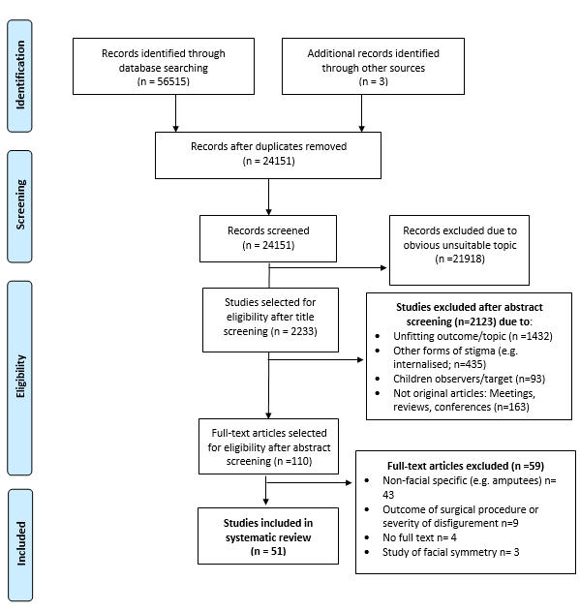

Results

Overview of studies
A total of 51 articles met the inclusion criteria, containing data from 58 studies (see Table 1 for details). Of these, were published since 2010, and the majority used cross-sectional designs. The geographical location of the studies is shown in Figure 2.2 and included studies conducted in Europe (n = 27; of which n = 18 were UK based), North America (n = 14), Australasia (n = 4), and Africa (n = 4). One study examined data on UK residents with a South East Asian background (Hughes et al., 2009) and two studies aimed to compare cross-cultural differences between the UK and Nigerian samples (Bull & David, 1986b) and between UK and USA samples (Kerr, Bull, MacCoun, & Rathborn, 1985).
Figure 2.2 Publication rate and locality of articles
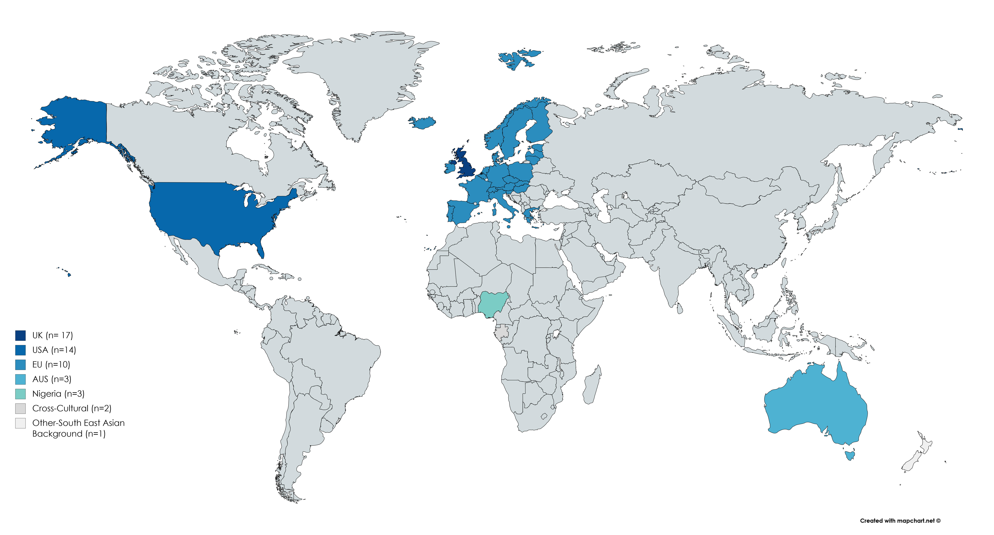
Out of the selected studies, 25 studies used samples comprised solely of student participants (e.g., Rinnerthaler, Mueller, Weichbold, Wenning, & Poewe, 2006), 23 used laypeople, including pedestrians (e.g., Roberts & Gierasch, 2013) and hospital visitors (e.g., Owotade et al., 2014) and further 3 (e.g., Stevenage & McKay, 1999) were conducted with mixed samples of student and non-student participants. Five studies used service providers as participants. One study used extracted data from an archive of allegations about employment discrimination (Tartaglia et al., 2005).
The most utilised term to address visible differences was ‘facial disfigurement’ (n = 17), followed by ‘deformity’, commonly mixed with unhelpful adjectives like ‘abnormal’ (n = 13). Publications studying specific diseases associated with FD (n = 7) used medical nomenclatures like oral cleft deformity (Pausch et al., 2012) and three publications used the terminology ‘Facial difference’/’visible difference’ (e.g., Roberts & Gierasch, 2013). See table 2.1 for details.

Table 2.1 Terminology used to address FD
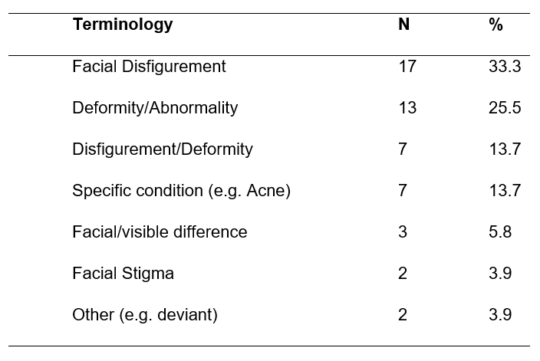
Most studies reported at least one measure of attitudes towards FD (n =30), of these, 13 reported attitudes (A) alone, followed by a combination of attitudes and cognitive and emotional responses (CER; n = 10), attitudes and stigma (n= 4), and attitudes and knowledge (n = 3). Ten studies measured and disseminated results of stigma (S: e.g., intended avoidance, proxemic behaviour) and further 7 analysed cognitive and emotional responses only (e.g., reaction times, autonomic physiological responses). Three studies tested knowledge about conditions associated with FD (e.g., Strabismus; Isawumi, Ulaikere, Adejumo, Adebayo, & Kekunnaya, 2014) ) and one article (i.e., Bogart & Tickle-Degnen, 2015), tested an intervention strategy to improve attitudes towards facial paralysis (Int). See Table 1 for full details.
FD stimuli were presented to observers in different forms including; digitally altered photographs simulating FD, confederates using cosmetics that mimicked FD (e.g., Rumsey, Bull, & Gahagan, 1982), semantic references to FD (e.g., Stone & Wright, 2012) and medical conditions associated with it (e.g., dermatological conditions; Grandfield, Thompson, & Turpin, 2005), archive records of litigation cases of discrimination towards FD (Tartaglia et al., 2005) and images of people with real FD (e.g.., Roberts, Neate, & Gierasch, 2017).

Study  Table 2.2 Summary of articles included in the systematic review | Location | Focus | Sample | N | Term | Design and methods | Results
Ackerman et al., 2009 | USA | CER | N=362; Student;Convenience sample | 362 | Physical/FD; physical abnormality | Cross-sectional; dot-probe task (S1) and error rate-Memory test (S2) | *FD holds disease-sensitive perceivers’ attention for longer, however, targets are not well remembered
 |  |  |  |  |  |  | *Longer attention is not associated with longer memory recall in the case of FD.
Blascovich et al., 2001 | USA | CER, A | N=76; Students; Convenience sample | 76 | Facial/physical stigma; Facial birthmark | Cross-sectional; Psychophysiological measures, behavioural and Self-report ratings (s1 & s2). | *Participants show threat-like responses when interacting with FD (Cardiovascular reactivity)
 |  |  |  |  |  |  | *Self-report measures were mostly non-significant, but those interacting with a FD confederate rated their partners' performance more positively than controls.
 |  |  |  |  |  |  | *Controls exhibited challenge pattern of cardiovascular reactivity.
Bodunde et al., 2016 | Nigeria | K, A | N=139; Public; Snowball sampling | 139 | Strabismus | Cross-sectional qualitative descriptive; Focus groups | *Participants report poor knowledge of strabismus, which negatively affects perception and acceptance of this condition
 |  |  |  |  |  |  | *Accessing health care and treatment amongst individuals with strabismus is hindered by stigma towards the condition.
Bogart & Tickle-Degnen, 2015 | USA | Int | N=110; Student; convenience sample | 110 | Facial difference/Facial paralysis | Rating scales on level of extraversion | *Education and media strategies improve bias towards FD.
Bull & Brooking, 1985 | UK | A | N=60; Student; convenience sample | 60 | Facial deformity/disfigurement | Cross-sectional; Ratings on target's personality traits | *FD influence ratings on attractiveness on males. However, when they were believed to married to an attractive female the male was rated to be more attractive.
Bull & David, 1986 | UK/Nigeria | A | N=96; Service providers | 96 | FD/ disfigured/scared | Cross-sectional; Ratings on target's personality traits | *FD targets were rated as less confident, sociable, attractive and more dishonest.
 |  |  |  |  |  |  | *Nigerian participants rated faces as more sincere, attractive and less unfriendly than UK raters.
 |  |  |  |  |  |  | *Black faces were rated more attractive than white faces by both white and black raters
Burris et al., 2008 | UK | A | N=179; Student; convenience sample | 179 | Facial scarring/disfigurement/ Deformity | Cross-sectional; Perceived cause of disfigurement; ratings of attractiveness | *Higher ratings of attractiveness were given to scarred males but only for short-termed relationships. Men did not rate women differently in the presence or absence of scars.
 |  |  |  |  |  |  | *The presence of scars in males might be associated with information (virility, risk-prone behaviour) about its male bearers that make them more attractive
Dijkter et al., 2000 | NE | A | N=242; Student; Convenience sample | 242 | Deviant Facial Appearance/abnormal  facial  features | Cross-sectional; ratings on personality traits and emotional expressions | Regardless of emotional expressions of target stimuli, observers reporter more negative attitudes toward individuals with learning disabilities after exposure to faces with disfigurement than after exposure to non-FD faces.
Franks & Goodrick-meech, 1997 | UK | A | N=20; Public; Stratified sampling | 20 | Scarred, facially disfigured, visible deformities, visible burns | Cross-sectional; personality traits rating | *FD adults considered less attractive, humorous and sociable
Gardiner et al., 2008 | UK | A | N=388; Public; Convenience sample | 388 | FD, disfiguring facial lesions | Cross-sectional; Ranking of the level of disfigurement and impact of FD on confederate | *FD on young and female targets was ranked as having a greater negative impact than on the older, male targets.
 |  |  |  |  |  |  | *FD located in central facial features were ranked as the cause of more negative impact than peripheral lesions.
Godoy et al., 2011a | USA | CER | N=60; Public; Simple random sampling | 60 | Facial deformity/abnormalities | Cross-sectional; Visual fixations-eye tracker | *Disfigurement in the face is distracting to the casual observer, however, surgical procedure normalizes perceptual pattern.
Godoy et al., 2011b | USA | A | N=45; Public; Simple random sampling | 45 | Facial deformities | Cross-sectional; Likert scale on attractiveness, how disfiguring, how bothered, and how important they considered repair. | *Lower ratings of attractiveness correlated with lesions of large size, regardless of location.
 |  |  |  |  |  |  | *All large and small central lesions were rated as important to repair by participants.
Grandfield et al., 2005 | UK | A, CER | N=64; Student and non-student; Convenience sample | 64 | FD | Cross-sectional; RT (IAT) and ratings on preferences | *Participants showed an implicit preference for faces without FD
 |  |  |  |  |  |  | *No preference was observed on explicit ratings.
 |  |  |  |  |  |  | *Knowing someone with a skin condition was associated with longer RT on the IAT.
Halioua et al., 2011 | USA | A, CER | N=33; Student; Convenience sample | 33 | FD/deformities | Cross-sectional; Visual fixations-eye tracker, Ratings on personality traits | *Longer gaze on participants with FD correlated with greater perceptions of capability
 |  |  |  |  |  |  | *People have less positive perceptions of people with FD.
Houston & Bull, 1994 | UK | S | N=162; Public; Simple random Sampling | 162 | FD/deformed | Cross-sectional; Observations of overt behaviour | *Travellers significantly avoid sitting next to a confederate with FD
 |  |  |  |  |  |  | *Permanent forms of disfigurement (port-wine stain) had a stronger effect on interpersonal distance than did bruises/cuts.
Hughes et al., 2009 | UK/Sout East Asian background | A | N=69; Public; Purposive sampling | 69 | FD | Cross-sectional qualitative; Focus groups | *Individuals with FD more likely to be negatively evaluated than non-FD by South East Asian participants.
 |  |  |  |  |  |  | *FD would restrict participation and development within the community due to stigma. FD in women would hinder their dating and marriage prospects.
Isawumi et al., 2014 | Nigeria | K | N=405; Public; Consecutive sampling | 405 | Strabismus, poor cosmetic appearance | Cross-sectional; Face to face interviews with a structured questionnaire | *There were poor levels of awareness of causes, effects, and treatment of strabismus in this population.
Ishii et al., 2009 | USA | CER | N=8 | 8 | Facial deformities, abnormal | Cross-sectional; Visual fixation (eye tracking) | *Observer gaze patterns to focus on peripheral disfigurement
Kerr et al., 1985 | UK & USA | A, S | N=282; Students; Convenience sample | 282 | FD/facially disfigured | Cross-sectional; personality traits ratings, penalty recommendations | *When the defendant was both unattractive and had a FD was more likely to be convicted
Kleck & Strenta, 1985 | USA | CER | N=48; Students; Convenience sample | 48 | FD/facially disfigured | Cross-sectional; Emotional responses (skin resistance) and ratings of severity and impact on social life | *No gender differences when seeing pictures of themselves with a FD
 |  |  |  |  |  |  | *Both sexes reported similar and negative emotional responses to disfigured others.
 |  |  |  |  |  |  | *Verbal reports of their arousal levels when seeing themselves with FD was significantly more negative in females who used terms such as disgust, distress, and fright
Kouznetsova et al., 2012 | AUS | A, S | N=140; Students; Conveniece sample | 140 | Facial abnormalities, facial deformity, | Cross-sectional; Contagiousness scale, intended avoidant behaviour, Visibility of disease | *Participants showed a tendency to avoid individuals with disease signs, especially if displayed upon the face.
 |  |  |  |  |  |  | *Facially displayed disease signs, even if known to be non-contagious will likely result in observer's avoidance
Madera, 2016 | USA | S | Student | 46 | Facial stigma, FD | Cross-sectional; Negative affect Scale (Watson et al., 1988), Negative behaviour Scale and Interviewers behaviour scale (Avery, et al., 2009), applicant's rating of interviewer behaviour | *Participants showed significantly more negative affect and negative behaviour towards confederate with FD.
 |  |  |  |  |  |  | *Confederate with FD rated the interviewers as displaying more negative behaviours
Madera & Hebl, 2012 | USA | CER, A | N=209; Students (S1) and Managers (S2); Convenience Sample | 209 | Facial stigma, facially stigmatised | Cross-sectional; Visual fixation (Eye tracking; S1 only), self-regulatory depletion (colour-Stroop test), memory recall, applicant ratings | * FD had lower ratings and participants visually attended more to their cheek. FD negatively affected the memory recall of interview facts. More self-regulatory resources were depleted when participants were evaluating FD.
 |  |  |  |  |  |  | *Managers interviewing stigmatised applicant had poorer ratings, lower memory recall and depleted more self-regulatory resources.
Meyer-Marcotty & Stellzig-Eisenhauer, 2009 | Germany | A | N=35; Public/Service providers (n=20); Purposive sampling | 35 | Facial deviation, adults with CLP | Cross-sectional; Ratings on facial attractiveness, symmetry, dissatisfaction and the need or desire for correction | *Middle part of the face was associated with the largest degree of asymmetry; experts and public reported the greater need for correction for disfigurement in this area.
Mojon-Azzi et al., 2008 | CH | S | N=40; Service providers; purposive sampling | 40 | FD, abnormal face, craniofacial anomaly, facial deformities | Cross-sectional; Questionnaire assessing the ability to find a partner | *Acne, missing tooth and strabismus as barriers to finding a partner.
Mojon-Azzi & Mojon, 2007 | CH | S | N=20; Service providers; Simple random sampling | 20 | FD/abnormal facial appearance | Cross-sectional; Questionnaire assessing employability | *Acne and strabismus has a negative impact on the overall judgement of potential employers
Moolenburgh et al., 2008 | NE | A | Public | 20 | Facial deformities, facial abnormality | Cross-sectional; Assessment on appearance (normal-abnormal), attractiveness, most striking feature. | *Patients (after nasal reconstruction) were perceived significantly less attractive and more abnormal than controls.
 |  |  |  |  |  |  | *Prior knowledge had a significant positive effect on mean facial attractiveness and abnormality scores.
Oginni et al., 2010 | Nigeria | K | Public | 650 | Orofacial clefts | Cross-sectional; Structured questionnaire | *75% had seen an individual with an orofacial cleft.
 |  |  |  |  |  |  | *40% knew about corrective surgery for CLP and only 22% would recommend a visit to the hospital.
 |  |  |  |  |  |  | *Higher educational attainment was associated with reported medical causative factors and accuracy in possible treatment options.
Owotade et al., 2014 | Nigeria | K | Service users | 200 | Congenitally deformed | Cross-sectional; Attitude, knowledge, and level of awareness about causes and treatment | *50% reported having seen or heard about CLP. Of those with knowledge of CLP, only 19.8% correctly identified cleft as a defect of the lips.
 |  |  |  |  |  |  | *Only 19.8% had adequate knowledge about CLP
Pausch et al., 2016 | Germany | S | Public | 273 | Cleft patients/ craniofacial anomalies | Cross-sectional; Social distance Questionnaire | *Social distance has decreased in the last 40 years
 |  |  |  |  |  |  | Professional background and gender have an effect on the public's attitutes
Pausch et al., 2012 | Germany | K, A | Student | 261 | Oral cleft deformity | Cross-sectional; Terminology used for the deformity by non-cleft subjects | *57.1% of participants used animal terms to label oral cleft disfigurement.
 |  |  |  |  |  |  | *Medical background individually reduced the use of animal terms
Rankin & Borah, 2003 | USA | A | Public | 210 |  | Cross-sectional; Rating scales on social functioning | *FD has a significant negative effect on perceptions of social functionality, including employability, honesty, and trustworthiness.
Rinnerthaler et al., 2006 | Austria | A | Student | 80 | Cranial and cervical dystonia(CCD) | Cross-sectional; Rating scales on social functioning Ratings on target's personality traits | *CCD patients are subject to prejudice and enacted stigmatization.
 |  |  |  |  |  |  | *CCD patients rated as less likeable, less trustworthy, less self-confident, more odd and different
Roberts et al., 2016 | USA | CER | Student & Non-Student | 143 | Visible difference | Cross-sectional; IAT | Reaction times were not significantly different when associating FD with positive or negative semantic stimuli
Roberts & Gierasch, 2013 | AUS | S | Public | 408 | Facial difference/visible difference/ craniofacial disifigurement | Cross-sectional; Observations of overt behaviour | *Pedestrians stood no further away from the confederate with FD than from the non-FD confederate
 |  |  |  |  |  |  | *Results failed to replicate Rumsey, Bull, and Gahagan (1982)
Rumsey, Bull and Gahagan, 1982 | UK | S | Public | 450 | Disfigurement, facially disfigured | Cross-sectional; Observations of overt behaviour | * Participants stood further away from the confederate with FD as opposed to control
 |  |  |  |  |  |  | *Pedestrians stand further away from permanent disfiguring conditions (e.g., Port wine stain) than from temporary disfiguring conditions such as bruises
Ryan et al., 2012 | AUS | A, S | Student | 98 | FD | Cross-sectional; Observed Behaviour (disgust), self-report measures healthy, contagion, fatal and disgust | *FD perceived as a sign of disease that triggered a disgust and contamination response
Shanmugarajah et al., 2012 | UK | A | Student | 132 | FD | FD severity questionnaire, reported disgust (Level of disgust elicited by each image), DS-R | *As the severity of FD increases, there is a greater level of disgust elicited in the observer
 |  |  |  |  |  |  | *Increased disgust was related to higher levels of reported disgust when viewing FD stimuli
Shaw, 1981 | UK | A, K | Public | 200 | Facial Deformity | Cross-sectional; Semi-structured interviews | *Attitudes to FD appear to arise from psychological instincts and cultural pressures
Shaw et al., 1980 | UK | S | Public | 7200 | Facial deformity | Cross-sectional; Overt behaviour; Responses to petitions (Evasion, polite refusal, signing) | *No significant differences in the number of evasions experienced by FD and non-FD confederates
Stevenage & McKay, 1999 | UK | S, A | Mixed | 106 | Facial disability, FD | Perceptions of personal qualities, perception of job skills and job recruitment decision | *FD individuals obtained lower ratings on personal qualities and job skills compared with wheelchair users and control.
Stevenage & Furness, 2008 | UK | A CER | Student | 102 | FD | Cross-sectional; Conversational recall and personality ratings | *Conversational recall was significantly lower when the speaker had a visible FD
 |  |  |  |  |  |  | *Ratings of personality traits were unaffected by the presence of FD
Stone & Potton, 2017 | UK | CER | Students | 29 | FD | Cross-sectional; Visual attention (eye tracking), reported emotion and DS-R (predisposition) | Lesions in the internal expressive features of the face invoked stronger negative emotions than in the forehead.
 |  |  |  |  |  |  | Visual attention to the area of disfigurement was associated with surprise and negative emotions.
 |  |  |  |  |  |  | DS was associated with greater visual attention to the disfigurement and negative emotions
Stone & Potton, 2014 | UK | A CER | Mixed | 228 | FD/disfigured faces | Cross-sectional; Emotions of which participants were asked to report their subjective experience. | *Sorrow and Curiosity subscales were invoked more strongly by FD
 |  |  |  |  |  |  | *No difference between FD and non-FD in terms of reported positive emotions (Social desirability)
 |  |  |  |  |  |  | *More perceived anonymity associated with lower reported positive emotions, higher negative emotions, and higher sorrow emotions
Stone & Wright, 2012 | UK | A CER | Student | 127 | FD/disfigured faces | Cross-sectional; Evaluating ratings on work competence, social potency, emotional strength, warmth. IAT | * Neutral or negative evaluation of FD compared to controls and wheelchair users
 |  |  |  |  |  |  | *More negative implicit attitude was shown for FD than for wheelchair users.
Stone & Wright, 2013 | UK | S | Companies hiring staff | 144 | FD | Cross-sectional; Response received from the employer or recruitment agency | *FD treated less favourably than controls when the post included high levels of customer contact. No difference found when the job entitled low contact with customers
Tartaglia et al., 2005 | USA | S | Existing data: EEOC charge data (Alegations on FD discrimination) | 751 | FD | Work-related Discrimination cases and outcomes of resolutions | Compared with peers with missing limbs, FD of female gender between 30-39 years old are more likely to encounter discrimination in the workplace.
 |  |  |  |  |  |  | Allegations from individuals with FD are more likely to happen with mid-size employers from retail or service industries
 |  |  |  |  |  |  | Allegations from individuals with FD are less likely to have merit resolutions than those brought by their peers with missing limbs
Timms, 2013 | UK | A | Public | 143 | Facial lesions, moderate acne | Cross-sectional; Estimate of age and personality factor ratings | *People of all ages judge those with moderate acne more negatively compared to those with clear skin.
 |  |  |  |  |  |  | *People with acne are estimated to be younger and less mature
Van Schijndel et al., 2015 | NE & CH | CER, A | Public | 40 | Facial deformity | Cross-sectional; Visual attention (eye tracking) and personality ratings (VAS scales) | *Cleft lip is the major attention-drawing factor
 |  |  |  |  |  |  | *Personality attributes of cleft lip patients were not assessed more negatively compared with non-FD controls
Van Schijndel et al., 2015 | CH | CER, A | Public | 40 | Nasal deformity | Cross-sectional; Visual attention (eye tracking) and personality ratings (VAS scales) | Disfigurement to the nose receives more visual attention than digitally corrected noses.
 |  |  |  |  |  |  | Disfigurement to the nose is associated with a more negative rating of personality traits.
Jamrozik et al., 2017  *Knowledge/beliefs about disfiguring condition (K), attitudes (A), Cognitive and emotional responses (CER), Stigma (S), Intervention (Int)  *Note: NE = The Netherlands/CH =Switzerland/USA = United States of America/UK = United Kingdom | USA | CER, A | Public | 145 | FD | Cross-sectional. The Self-Assessment Manikin (SAM; Bradley & Lang, 1994) | More negative emotion, higher arousal, and lower dominance when viewing pre-treatment (vs. posttreatment) photographs. Pre-treatment individuals were viewed significantly more negatively in terms of personality,  happiness, intelligence, and social attributes.

Beliefs and knowledge about facial disfigurement
Six articles measured knowledge or beliefs via questionnaires or focus groups. Two articles assessed knowledge about cleft lip Palade (CLP: Oginni, Asuku, Oladele, Obuekwe, & Nnabuko, 2010; Owotade et al., 2014) and two assessed knowledge about strabismus (Bodunde et al., 2016; Isawumi et al., 2014) in Nigeria. The remaining twostudies assessed knowledge and beliefs about FD in the UK (Shaw, 1981) and British South east Asian participants (i.e., Indian, Pakistani and Bangladeshi background; Hughes et al., 2009).
Low levels of knowledge and inaccurate beliefs about conditions associated with FD (i.e. CLP and strabismus) were consistently reported in publications using non-western samples. For example, 50-75% of the samples knew about CLP (Oginni et al., 2010; Owotade et al., 2014) and 74.6% were aware of Strabismus (Isawumi et al., 2014). Believed causes of FD included non-medical sources such as witchcraft and god’s will (Hughes et al., 2009; Oginni et al., 2010) and misconceptions (e.g., sitting in front of a TV for too long; Isawumi et al., 2014). Participants of non-western background reported that visible differences detrimentally affected individuals financially and socially, particularly hindering their ability to find a romantic partner (Bodunde et al., 2016; Hughes et al., 2009; Oginni et al., 2010).

Attitudes towards FD
Thirty articles analysed data on attitudes towards FD, measured via questionnaires, Likert scales, Visual Analogue Scales (VAS) and open-ended questions. The study of attitudes focused on participants’ perceptions of FD in terms of attractiveness and personality traits.
Attractiveness. Nine-teen articles measured attractiveness as part of their outcome or covariate variables. In 15 of these studies, observers rated FD as significantly less attractive than non-FD. Ratings of attractiveness were lower regardless of the type of disfigurement, including skin conditions such as acne or psoriasis (Green-Armytage, Simonds, John, & Woodger, 2019; Timms, 2013), port-wine stain (Bull & Brooking, 1985; Bull & David, 1986b), burns (Franks & Goodrick-meech, 1997), nasal reconstruction (Moolenburgh, Mureau, & Hofer, 2008), cranial and cervical dystonia (Roberts & Gierasch, 2013) and strabismus (Mojon-Azzi, Potnik, & Mojon, 2008; Mojon-Azzi & Mojon, 2007). Observers considered that disfigurement had a greater negative impact on young women, which is consistent with widely available literature about the additional societal body image demands placed upon females (Gardiner et al., 2010). Nurses (Bull & David, 1986a), dating agents (Mojon-Azzi et al., 2008) and recruiting personnel (Madera & Hebl, 2012; Stone & Wright, 2013) also evaluated FD as less attractive than non-FD targets.
No significant differences in attractiveness ratings were found in three studies (Blascovich, Mendes, Hunter, Lickel, & Kowai-Bell, 2001; Halioua, Williams, Murray, Skalko, & Vogelsong, 2011; Stevenage & Furness, 2008) and one study (i.e. Burriss, Rowland, & Little, 2009) found that a facial scar as the result of a post-traumatic or violent events in males (as opposed to disease or accidental causes), increased attractiveness of males being rated by women, but only when considered for short-term relationships. In contrast, there was no significant difference in attractiveness ratings of women by male raters.
Personality traits. Ratings of personality traits included items on social qualities (e.g., confidence, assertive, popular), capability (e.g., employability, intelligence) and trustworthiness (e.g., honesty, sincerity). The negative impact of FD on the evaluation of personality traits was found in 25 studies. FD was perceived as a significant hindrance on people’s social abilities, including confidence and likability/friendliness (Bull & David, 1986a; Franks & Goodrick-meech, 1997; Hughes et al., 2009; Kleck & Strenta, 1985; Rankin & Borah, 2003; Rinnerthaler et al., 2006; Stone & Wright, 2013). Similarly, 5 studies showed that observers perceived individuals with FD as less intellectually capable (Hughes et al., 2009; Madera & Hebl, 2012; S M Mojon-Azzi et al., 2008; Rankin & Borah, 2003).
Mistrust was observed in 4 studies; individuals with FD were rated as significantly less honest (Bull & David, 1986a) and less trustworthy (Halioua et al., 2011; Jamrozik, Oraa Ali, Sarwer, & Chatterjee, 2017; Rankin & Borah, 2003; Rinnerthaler et al., 2006) than their peers without FD. Moreover, Kerr et al. (1985) found that participants in a trial situation were more likely to convict a person when he or she was unattractive and had a significant FD.
Four articles found non-significant differences in explicit evaluations of individuals with or without FD; however, this was not the case for other measures within these studies which did evidence differences in reaction times (Grandfield, Thompson, & Turpin, 2005), visual attention (Van Schijndel, Litschel, Maal, Berg, & Tasman, 2015), memory recall (Stevenage & Furness, 2008) and physiological responses (Blascovich et al., 2001); suggesting that explicit self-reports towards FD are susceptible to a degree of social desirability and self-presentation effects (Henderson, Evans-Lacko, Flach, & Thornicroft, 2012).

Cognitive and emotional responses to FD
Eighteen articles explored cognitive and emotional responses to FD measured via self-report scales, reaction times, physiological responses and eye-tracking data.
The Implicit Association Test (IAT), developed by Greenwald (1998), measures the strength of association between concepts (e.g., FD/non-FD vs Pleasant/unpleasant words) via participants’ reaction times and is an established instrument in the study of implicit bias towards stigmatised groups (e.g., mental health). In this review, 3 studies used a version of the IAT to record reaction times towards FD and non-FD stimuli. Two of these studies found a significant implicit preference towards non-FD targets (Grandfield et al., 2005; Stone & Wright, 2012) but Roberts et al. (2017) found no significant differences in terms of implicit associations. Correlations with explicit self-report evaluations was mixed; Grandfield et al. (2005) and Roberts et al. (2017) found non-significant correlation (r = –.204, p = .124) between explicit and implicit measures, whereas Stone and Wright (2012) reported a significant correlation between negative implicit attitudes and lower ratings of social potency (r = .25, p<.05) and emotional strength (r = .33, p < .005).
Seven studies used eye-tracking technologies to assess differences between visual fixation towards FD and Non-FD stimuli (Godoy et al., 2011; Halioua et al., 2011; Ishii, Carey, Byrne, Zee, & Ishii, 2009; Stone & Potton, 2014; Van Schijndel et al., 2015; van Schijndel, Tasman, & Litschel, 2015; Madera & Hebl, 2012; Ackerman et al., 2009). Although longer visual fixation was elicited by FD compared to Non-FD, greater attention was not correlated with more positive perceptions of personality traits or greater memory recall of target stimuli (Ackerman et al., 2009; Madera & Hebl, 2012). Longer visual fixation was only correlated with positive perceptions of capability in Halioua et al. (2011); but the same study found that FD targets were rated as less honest, employable, intelligent, trustworthy and optimistic. According to this evidence, FD behaves as a novel/complex stimuli that enhance visual attention (Fox, Russo, Bowles, & Dutton, 2001; Linnet & Jemec, 2001; Thompson & Kent, 2001); however, extended visual fixation is also associated with negative evaluation and poorer recollection of information about individuals with FD. Interestingly, visual fixation was not significantly different between control faces without FD and faces following surgical corrective procedures (Godoy et al., 2011; Moolenburgh et al., 2008).
Five articles reported a differences in emotional responses triggered by FD (compared to non-FD), measured in the form of cardiac and hemodynamic responses (Blascovich et al., 2001), changes in skin resistance (Kleck & Strenta, 1985) and self-reported emotional reactions (Jamrozik et al., 2017; Shanmugarajah et al., 2012; Stone & Potton, 2017). When exposed to FD stimuli, observers presented higher physiological arousal (Kleck & Strenta, 1985), challenge or threat-like reactions (Blascovich et al., 2001) and reported greater negative emotions, particularly disgust (Shanmugarajah et al., 2012); further, participants that were more sensitive to disgust (as measured with the disgust sensitivity; Olatunji & Williams, 2007) reported higher levels of disgust than their peers with lower sensitivity.

Overt Stigma
Ten articles assessed stigmatising behaviour. Measures used to evaluate behaviour were observation of overt behaviour, including evaluation of an interaction (Blascovich et al., 2001) and proxemic behaviour (Houston & Bull, 1994; R M Roberts & Gierasch, 2013; Rumsey et al., 1982); other measures included likert scales of intentions to avoid contact with FD (Green-Armytage et al., 2019; Kouznetsova, Stevenson, Oaten, & Case, 2012; Pausch et al., 2016; Ryan, Oaten, Stevenson, & Case, 2012), outcomes on discrimination litigations (Tartaglia et al., 2005), employer’s replies to mock job applications (Stone & Wright, 2013) and responses to petitions (Shaw, Humphreys, McLoughlin, & Shimmin, 1980)
In terms of observed and intended behaviour, nine of these studies provided evidence of negative responses towards FD. For instance, Houston and Bull (1994) and Rumsey et al. (1982) reported that observers placed significantly greater personal distance between themselves and a confederate with a permanent form of disfigurement (e.g., port wine stain) than to a non-FD confederate and a confederate with temporary marks like bruising; both studies were conducted in public spaces with samples of lay people. However, a more recent study replication of Rumsey et al. (1982) using an Australian sample failed to replicate these avoidance patterns. Roberts and Gierasch (2013) found that participants did not stand further away from the confederate in the FD condition than from the Non-FD condition, as results were non-significant. Furthermore, intended behaviour measured in (Green-Armytage et al. (2019), showed that participants showed significantly less willingness to make indirect contact with an individual with a skin condition (i.e. acne and psoriasis) than with a person without a dermatological condition. Interestingly, participants reported greater willingness to stablish social contact with an individual with acne than with one with psoriasis or without a skin condition.

Discussion
Fifty-eight studies conducted between 1980 – 2018 were identified in this systematic review. Publications meeting the inclusion criteria were critically appraised to ascertain the degree to which published studies provided an understanding of what responses are elicited by FD in the observer and what associated psychosocial processes underlie stigmatisation towards this population. Evidence suggests that observers respond differently to FD stimuli, which supports many qualitative and survey studies of individuals with FD reporting being the target of stigmatisation (Clarke, Thompson, Jenkinson, Rumsey, & Newell, 2013; Changing Faces, 2017).

Observers’ responses to FD
The rate of publications aiming to understand responses towards FD has increased in the last two decades. The quality and methodological rigour of available studies have also improved throughout the years, particularly benefiting from the introduction of new technologies (e.g., eye-tracking), which have facilitated the analysis of cognitive and emotional processes that were once hard to capture. FD stimuli trigger in observers emotional reactions of disgust (Ryan et al., 2012; Shanmugarajah et al., 2012), physiological arousal (Kleck & Strenta, 1985) and threat (Blascovich et al., 2001). Moreover, longer visual fixation towards FD stimuli was significantly longer than towards non-FD, but this was not correlated with more favourable ratings of the targets bearing a FD. Attitudes towards faces with FD were significantly more negative than faces without FD (Jamrozik et al., 2017). Faces with FD were systematically rated as less attractive, less socially capable and were also more likely to be perceived as less successful in job hunting and dating scenarios.
Individuals with FD are part of a minority within the world’s population and as such, familiarity and interaction with this population is not always a commonly encountered. Therefore, it makes sense that FD stimuli are perceived and processed differently by observers, as it is the case of novel stimuli overall (Slater, Earle, Morison, & Rose, 1985). Physical features of individuals with FD provide additional information to be processed. This novel visual stimulus increases attentional constraints within the interaction with others, ultimately affecting evaluation and memory recall of observers towards FD targets (Ackerman et al., 2009; Madera & Hebl, 2012; Stevenage & Furness, 2008).
Overt behaviour and reported intended behaviour (with the exception of Roberts and Gierasch, 2013) showed an avoidance pattern similar to that found in highly contagious diseases, regardless of real indications of contagiousness (Kouznetsova et al., 2012). Emotional responses such as disgust and threat elicited by FD, seem to suggest that observers’ responses to FD information could be partly associated with an innate disease-sensitive mechanism to avoid contaminating pathogens (Kurzban & Leary, 2001). To maximise chances of survival, people tend to reduce threats to their wellbeing by avoiding potentially dangerous interactions (even when they are known to be non-contagious) because mistakenly interacting with a real threat would likely be lethal (Haselton & Buss, 2000). Automatic emotional responses such as disgust serve as facilitators of this behaviour and instinctive mechanisms of protection are generalised to all stimuli that appear to be a potential treat, following the same logic as a ‘false alarm effect’ on observers (Park, Faulkner, & Schaller, 2003). Subsequent additional societal pressures to appear non-prejudiced increases the demand to supress what is an automatically generated emotional reaction, adding to the additional cognitive demands of a novel stimuli presented in the form of FD. The available literature supports the hypothesis that observers’ autonomic responses to FD (vs non-FD) are significantly different; however, evaluative reactions are more susceptible to social normative factors (Pryor et al., 2004).
The majority of studies included in this review (e.g., Mojon-Azzi et al., 2008; Timms, 2013) reported that observers explicitly evaluated FD as less attractive, except for one study, Burriss et al., 2009, where it was found that the presence of a scar was associated with higher ratings of attractiveness, but only in female raters. According to evolutionary psychology, short-term partner selection in females is affected by their perception of a male’s heroism and bravery. Post-traumatic facial marks may be associated with indications of risk-prone and masculine features that benefit male attractiveness ratings (Kelly & Dunbar, 2001). However, the findings reported by Burris et al. (2009) showed a small effect size and it was an isolated case amongst the articles included in this review. Replication of this study, perhaps considering various sizes and locations of disfigurement, would be required to clarify factors underlying the relationship between FD and attractiveness.
Disfigurement displayed in central facial areas (or internal expressive features) was associated with lower ratings of attractiveness (Godoy et al., 2011) and perceived severity (Gardiner et al., 2010), longer visual fixation and stronger negative emotions (e.g., embarrassment, disgust, repulsion; (Stone & Potton, 2017) than peripheral facial differences. Central features in the face are harder to disguise and a source of relevant information for communication (Davies, Ellis, & Shepherd, 1977; Fraser, Craig, & Parker, 1990), thus it makes sense that affections in these areas have a greater negative impact on individuals with FD. Nevertheless, according to Changing Faces (2017), 75% of surveyed participants with FD reported being denied medical treatment or surgical procedures based on it being unnecessary or purely cosmetic. Predicting the impact of FD in terms of location and size would grant evidence-based support for changes in health policy, so people with certain types of FD can have easier access to treatment plans and corrective procedures that may potentially normalise observers’ perception of facial features (Godoy et al., 2011; Moolenburgh et al., 2008)
Rumsey et al. (1982) is a frequently cited study that reports differences in proxemic behaviour towards a confederate with FD in a sample of British lay people. However, 20 years later Roberts and Gierasch (2013) failed to replicate Rumsey’s findings in an Australian sample. As well as sociocultural differences between these samples in these settings (Adelaide, Australia vs London, UK), it is also likely that overt stigma towards FD has decreased in the last two decades. For instance, influenced by anti-stigma campaigns and anti-discrimination policies at the governmental level (e.g., the Australian Disability Discrimination Act of 1992), which has reinforced societal norms against discrimination of people with disabilities. Conversely, while overt stigma might have lessened in the last decades, it is also plausible that manifestations of it are now subtler due to societal pressures to appear non-prejudiced, as it has been the case of the transformation of prejudiced racial discourse in the last five decades (see Augoustinos & Every, 2007).
It is difficult to confirm that there has been a change in how FD is perceived over the last three decades. People with FD are still subjected stigmatising responses from observers, but certainly less severely than in other periods of time (e.g., medieval societies). The inclusion of FD in anti-discrimination policies (e.g., discrimination act 2010) has certainly been a major milestone for achieving awareness about the stigma received by people with FD. Furthermore, there has been perceivable change in how people different physical appearance are represented in mass media and advertising. The stereotype of a socially awkward and misfit individual with disabilities or FD has progressively been challenged in pro of inclusion; people with visible differences now appear in fashion magazines, advertising and toys (Peters, 2020). Future research would benefit from replicating observational studies conducted before the introduction of these policies. It would also be appropriate to complement research efforts by expanding the observational exercise to other non-verbal manifestations (e.g., staring, facial expressions).

Perception of FD in non-western samples
All studies reporting data from Low- and Middle-Income Countries (LMIC) settings were conducted in Nigerian samples, focusing on strabismus and CLP. Knowledge about causes, treatment and societal implications of FD were an outcome variable in all four studies, perhaps because literacy levels and access to formal education in most LMIC are considerably low compared to developed nations; literacy rates in Nigeria are as low as 49.7% for women and 69.2% for males (Kazeem, Jensen, & Stokes, 2010; UNICEF, 2015). Indeed, Nigerian participants’ perception of strabismus and CLP was based on a poor understanding of these medical conditions, enhancing stigma, hindering health seeking behaviour and delaying access to early corrective measures where available. While the study by Hughes et al. (2009) was conducted in the UK, it showed findings specific to attitudes towards FD in British South-east Asian communities have similarities with Nigerian findings. Certain religious and cultural belief systems seem to influence participants perceptions of FD, including attribution of supernatural causes of disfigurement (e.g., god's will, witchcraft; Hughes et al., 2009; Oginni et al., 2010) and believed negative impact on dating, occupational and educational prospects, especially for females with FD (Gardiner et al., 2010). However, the use of cross-sectional design and descriptive analysis makes difficult to speculate on underlying processes and causal relationships between lack of knowledge, beliefs and enacted stigma reported by individuals with FD in LMIC.
Over 90% of the studies identified in this review were conducted in industrialised western societies. Thus, what is currently known about the way observers respond to FD is based on data collected from samples representative of the only a fraction of the world’s population. According to the WHO, compared to higher income societies, Low- and Middle-Income Countries (LMIC) have considerably higher rates of injuries that may lead to disfigurement, such as traffic accidents, falls and fires (Krug & Organization, 1999). Moreover, tropical and sub-tropical regions of the world have natural conditions where bacterial and viral diseases associated with disfigurement thrive (e.g., Buruli ulcer, leprosy; Merritt et al., 2010; Noordeen, 1998). Many countries in this geographical area lack basic sanitary conditions, which facilitates the spreading of parasitic infections through contaminated water and food sources. Consequently, the prevalence of these diseases in areas close to the equator is larger (Waksman, 1975), but the understanding of how individuals with FD are perceived in this part of the world is largely speculative. If stigmatisation towards FD serves evolutionary functions of protection against parasitic infections, analysis of data from contexts with a higher prevalence of neglected tropical diseases would contribute greatly towards testing the hypothesis of stigma as a disease-avoidant mechanism in the species.

Implications of FD and anti-stigma intervention strategies
FD hinders dating prospects (Mojon-Azzi et al., 2008) and employability (Madera & Hebl, 2012; Stone & Wright, 2013) of those affected by it. This discriminatory behaviour is comparable to that directed to physical disabilities (e.g., mobility impairment; Stone & Wright, 2013). Arguably, there have been significantly fewer efforts to seek inclusion of individuals with FD; for instance, the UK only included severe forms of FD within positive discrimination laws in 2010, and to date, there is a gap in the literature about effective intervention strategies that could reduce public stigma towards FD.
Only one article included in the review tested the effectiveness of an anti-stigma strategy. Bogart and Tickle-Degnen (2015) investigated education strategies on observers’ attitudes regarding the extraversion of individuals with facial paralysis (FP). Students were randomly assigned to either an education, an Education+feedback or a control condition, before completing a rating on their perceived extraversion of a target with FP portrait in a video-clip; in both experimental conditions, participants read a text about the characteristics and impact of FP and then were instructed to focus on the non-verbal and verbal language of the target to inform ratings. Those assigned to the Education+feedback condition were given the feedback of the actual response that the person they evaluated gave himself. The control group only included ratings without training nor feedback elements. Participants in the Education and Education+feedback conditions reported significantly higher ratings of extraversion than the control group, although the difference between the two experimental conditions was non-significant, suggesting that the addition of feedback within the training did not reduce bias towards FP more than education alone.
There appear to be a robust body of evidence in support of the stigma reduction qualities of education and contact base strategies, for instance, in mental health and HIV stigma (Corrigan & Fong, 2014; Mak, Mo, Ma, & Lam, 2017; Morgan, Reavley, Ross, San Too, & Jorm, 2018). Findings from Bogart and Tickle-Degnen (2015) indicate that education anti-stigma strategies may also help improve perceptions of FD, however the literature would benefit from testing whether education can influence more complex and less face value measures of stigma (e.g., eye-tracking, implicit attitudes). In addition, literature would be complemented with studies testing whether traditionally more effective forms of anti-stigma strategies, like contact (e.g., Reinke & Corrigan, 2004), can also reduce stigma towards FD.

Nomenclature of FD used in the academic literature
Reporting information discussing disfigurement for public and scientific dissemination is often surrounded by controversy; for example, charities like Changing Faces advocate for organisations and public to abstain from using certain words that could potentially have a pejorative connotation (e.g., deviant). The relationship between terminology and public perception of commonly stigmatised conditions is not yet well understood. However, it has been found that words that are unfamiliar and difficult to pronounce are associated with negative affect (Reber, Schwarz, & Winkielman, 2004; Schwarz, 2004) and greater perceptions of risk (Song & Schwarz, 2009). For example, Young, Norman, and Humphreys (2008) observed that using medical terminology was associated with conditions being perceived as more serious and less prevalent than when using a common language (e.g., pharyngitis rather than sore throat). Whether this ‘medical nomenclature-perception’ relationship can be extrapolated to FD is still unknown.
Results from this review revealed that nomenclature of FD used in the academic literature commonly contain terms that could potentially encourage a negative perception of disfigurement (e.g., abnormalities; Godoy et al., 2011). However, the use of more neutral nouns such as ‘visible difference’ and ‘facial difference’ was also found within the terminology used by researchers in this topic (e.g., Roberts et al., 2017). Although more experimental data should be obtained to examine whether the choice of words to refer to disfigurement has a negative impact on public’s perceptions, scientific publications should be more conservative with the use of language, perhaps by avoiding the use of wording that perpetuate stereotypes about disfigurement (e.g., abnormal or deviant). Furthermore, inclusion efforts should continue to target the use of more inclusive language in research, policies and mass media.

Limitations of included studies
Authors used different scales to measure perceived personality traits and thus, direct comparisons are not feasible. Some instruments may be more susceptible to social desirability effects than others; for example, Stone and Potton (2014) found that participants reported more negative emotions towards FD when they perceived higher anonymity of their responses. This is consistent with other studies reporting the influence of social desirability in explicit ratings towards commonly stigmatised groups (e.g., mental health stigma; Henderson et al., 2012). However, self-report instruments and settings of data collection can be adapted to decrease the influence of social desirability effects, for instance by developing instruments with less face value (Error-test in the study of mental health stigma; (Michaels & Corrigan, 2013) and providing a contexts of data collection that elicits higher spontaneity and greater perception of anonymity. It would be relevant for future studies to provide more comprehensive reports of demographics, sampling, and data collection efforts, as many of the reviewed studies were weak on these points. Similarly, many quantitative studies included in this review did not report power analyses and thus it was unclear whether the sample sizes were representative (Faber & Fonseca, 2014).

Limitations of the review
This literature review has a number of limitations that must be acknowledged. First, the search did not include grey literature and therefore results risk being influenced by publication biases. Second, although the search process was performed in a systematic, thorough manner, it is possible that the authors have not included search terms leading to studies of stigma towards very specific medical conditions that affect facial appearance. Finally, this review is limited to publications in English and it is possible that studies written in other languages were not identified, although Non-English peer-review journals are rare in the literature (Fung, 2008).

Conclusions and recommendations for future research
The literature suggests that observers process and evaluate FD differently than targets without FD. This, in turn, often negatively impacts the lives of those living with FD. Although the publication of studies examining observers’ responses towards FD has increased in number and quality over the last two decades, there is still limited understanding of the process of stigmatisation towards FD. For instance, the study stigmatisation towards FD in LMIC is virtually non-existent and yet indispensable to test hypotheses regarding stigmatisation as a protective mechanism of the species. Future research would benefit from designs that go beyond the cross-sectional scope to grant greater external validity and generalisability to their findings. In addition, more rigorous instruments, especially questionnaires measuring explicit attitudes, should be designed, particularly to address social desirability bias. Only one study tested strategies to reduce stigma levels amongst the public (Bogart & Tickle-Degnen, 2015). The literature would benefit from testing anti-stigma strategies that have been shown effective in the case of other commonly stigmatised targets (e.g., imagined contact; (Miles & Crisp, 2013). Scientific development should seek to feed societal change; for instance, by facilitating the access to corrective surgery and reinforcing positive discrimination policies to improve participation of individuals with FD in all areas of society (e.g., publicity).

Chapter 3: Explicit and implicit attitudes towards facial disfigurement: the role of disgust sensitivity, appearance related cognitions and motivations to respond without prejudice.

Introduction
Individuals with a FD often report being stigmatised by members of the public, which is presented in the form of behaviours such as staring, unsolicited comments, and exclusion (Hodge, 2017; Thompson & Kent, 2001). For instance, a study conducted by Changing Faces with a sample of over 800 visibly different individuals found that 81.3% of participants reported experiencing unpleasant responses from strangers (Changing Faces, 2017). This perceived discrimination is consistent with studies suggesting that people with disfigurement are discriminated against and face disadvantages in educational, occupational and dating prospects (Hong, Koo, & Koo, 2008; Hughes et al., 2009; Madera, 2016; Mojon-Azzi & Mojon, 2007). Individuals with FD are commonly rated by observers as less attractive (Green-Armytage, Simonds, John, & Woodger, 2019 Roberts & Gierasch, 2013), less trustworthy (Halioua et al., 2011; Jamrozik, Oraa Ali, Sarwer, & Chatterjee, 2017; Rankin & Borah, 2003; Rinnerthaler et al., 2006) and less intellectually capable (Dijker, Tacken, & Borne, 2000; Hughes et al., 2009; Madera & Hebl, 2012; S M Mojon-Azzi et al., 2008; Rankin & Borah, 2003) than targets without FD.
The face is a central feature in social exchange as it offers relevant information regarding the interlocutor’s identity, mood, and non-verbal language (Siegman & Feldstein, 2014). Thus, it makes sense that faces with disfigurement elicit different emotional responses (Blascovich, Mendes, Hunter, Lickel, & Kowai-Bell, 2001; Gardiner et al., 2010; Godoy et al., 2011) and are processed and evaluated differently than faces without any striking visible difference (e.g., Ackerman et al., 2009; Rinnerthaler, Mueller, Weichbold, Wenning, & Poewe, 2006). However, explicit attitudes towards FD have not been found to be consistently negative in the literature and a number of studies have reported non-significant differences between evaluations of people with and without disfigurement (e.g., Blascovich et al., 2001; Grandfield, Thompson, & Turpin, 2005; Van Schijndel, Litschel, Maal, Berg, & Tasman, 2015).
According to the dual-process model of stigma (Pryor, Reeder, Yeadon, & Hesson-McLnnis, 2004), stigmatisation comprises two distinctive processes; automatic and reflective or ruled based (see Figure1, introduction chapter). The presence of stigmatised others, trigger automatic reactions such as physiological activation (threat; Blascovich et al., 2001), emotional responses (e.g., disgust; Armstrong, Olatunji, Sarawgi, & Simmons, 2010; Ryan, Oaten, Stevenson, & Case, 2012) and avoidance (Kouznetsova, Stevenson, Oaten, & Case, 2012; Rumsey, Bull, & Gahagan, 1982). According to the dual process model, automatic or reflexive responses may be learnt and sustained via repeated association. For instance, devaluating attributes towards women (gender inequality) and certain racial groups (Afro-American individuals and criminal activity) have traditionally been based upon a function of exploitation and domination of resources. The oppressive nature of this relationship is maintained by a constant association of negative attributes towards specific racial groups in the mass media (Dijk, 1989; Entman, 1992). Alternatively, automatic responses can also be rooted in instinctive mechanisms of disease avoidance (Kurzban & Leary, 2001; Oaten, Stevenson, & Case, 2009; Smart Richman & Leary, 2009; Tybur, Lieberman, Kurzban, & DeScioli, 2013).
Ruled-based systems are grounded on deliberated considerations of the FD stimuli, social norms and automatic emotional responses triggered by the target stimuli (i.e., the stigmatised other; Pryor et al., 2004). In other words, while humans may activate automatic systems of defence in the presence of FD, further responses also include conscious evaluations of the implications that a potential interaction with a stigmatised other can have. People in western countries will likely be preoccupied with adhering to social norms of inclusion and non-prejudice towards difference. An example of a ruled-based response is explicit measures such as questionnaires (e.g., personality ratings). It has been shown that when addressing sensitive topics like stigma or prejudice towards others, participants may respond in a way that adjust to the sociocultural norms towards that disadvantaged group (social desirability; (Michaels & Corrigan, 2013).
According to Devine, Plant, Amodio, Harmon-Jones, and Vance (2002), socially desirable responses may be supported by either internal or external motivations to conform to these societal demands. For instance, it has been shown that responses of gender stereotype, disability stigma and homophobia are enhanced in participants that try to respond in a non-prejudicial way because it is a social norm (high external); congruently, participants with low external motivation, that try to respond in an inclusive manner because it complies with their values (high internal motivation) significantly rate stigmatised others more favourably. Capturing attitudes via explicit questionnaires or interviews unavoidably comprise a degree of social desirability in participants’ responses, which may only partially correspond to implicit responses towards the stigmatised target (Hofmann, Gawronski, Gschwendner, Le, & Schmitt, 2005).
Measuring attitudes that bypass the observers’ consciousness has been seen to offer a ‘less contaminated’ assessment of attitudes towards stigmatised groups (Dovidio et al., 1997). The Implicit Association Test (IAT; Greenwald, 1998) is one of such methods that has been developed to study implicit attitudes towards commonly stigmatised targets. By asking participants to categorise two target categories (e.g., Hispanic-Caucasian) and two attributes (e.g., pleasant and unpleasant), the IAT measures the strength of the association and the participants’ preferences between target categories. It is hypothesised that longer reaction times correspond to incongruent associations (e.g., Caucasian-unpleasant/Hispanic-pleasant) and faster reaction times correspond to congruent associations (e.g., Caucasian-pleasant/Hispanic-unpleasant). The IAT has been adapted to study racial and ethnic discrimination (Oswald, Mitchell, Blanton, Jaccard, & Tetlock, 2013), gender stereotypes (Latu et al., 2011; Rudman, Greenwald, & McGhee, 2001), anti-fat bias (Teachman, Gapinski, Brownell, Rawlins, & Jeyaram, 2003) and FD (Grandfield et al., 2005; Stone & Wright, 2012).

Disgust sensitivity and stigma
Avoiding potential sources of contaminating pathogens that could compromise fitness is an adaptative response that maximise the chances of survival. This was particularly true in times when medical advances like vaccinations and corrective surgery were not available (Kurzban & Leary, 2001; Schaller & Duncan, 2007; Tybur et al., 2013). Therefore, it is possible that a set of protective mechanisms like feelings of disgust or threat had emerged in the species to help the detection and avoidance of potential sources of contamination (e.g., physical lesions, disfigurement; Rozin, Haidt, & McCauley, 1993; Tybur et al., 2013).
Disgust is a universal emotion that has evolved within the human species to facilitate avoidance of contaminating pathogens (Darwin, 1890; Tybur et al., 2013; Val, Robert, & Tamer, 2004). Many of the substances that elicit disgust, such as corporal fluids, faeces, and discomposing organic material are also known to be rich in harmful bacteria (Curtis & Biran, 2001). Because a number of contagious health conditions have visible manifestations in the face and body (e.g., leprosy, chicken pox, small pox), it makes sense that FD may trigger similar responses of avoidance (Curtis & Biran, 2001), even when the nature of the disfigurement is known to be harmless for others (Kouznetsova et al., 2012). Because body manifestations such as disfigurement are not precise indicators of contagiousness, evolved mechanisms of signal-detection favour the error that is less costly for the individuals’ fitness (Haselton & Buss, 2000; Haselton & Nettle, 2006; Kouznetsova et al., 2012). In other words, failing to identify a form of infection (false positive) poses a higher risk for the individual’s wellbeing than avoiding a healthy individual with visible manifestations (false negative). Thus, signal-detection mechanisms would naturally incline humans to avoid FD in an effort to minimise risk of contagiousness (Kouznetsova et al., 2012).
Disgust has also been shown to motivate behaviours unrelated to pathogen-avoidance, as it is the case of moral judgement (i.e., disgust towards transgressions of the law) which reinforces societal moral norms (Landy & Goodwin, 2015), and selection of optimate sexual mates (DeBruine, Jones, Tybur, Lieberman, & Griskevicius, 2010; Tybur et al., 2013). Literature suggests that disgust is associated with stigmatising responses towards obesity (Lieberman, Tybur, & Latner, 2012; O’Brien et al., 2013), mental illness (Overton & Medina, 2008), outgroups (Faulkner, Schaller, Park, & Duncan, 2004; Navarrete & Fessler, 2006), facial disfigurement (Shanmugarajah, Gaind, Clarke, & Butler, 2012; Stone & Potton, 2014, 2017) amongst others (e.g., homosexuality; Inbar, Pizarro, Knobe, & Bloom, 2009).
Sensitivity to experience disgust is thought to be one of the affective mechanisms influencing responses towards FD (Ryan et al., 2012; Shanmugarajah et al., 2012; Stone & Potton, 2017). Individual differences in levels of disgust sensitivity have been associated with higher perceived disgust (Shanmugarajah et al., 2012; Stone & Potton, 2017), higher overall negative emotions, increased feelings of sorrow, embarrassment, and repulsion, but also greater sympathy and curiosity (Stone & Potton, 2014, 2017). Furthermore, greater disgust sensitivity has been found to be correlated with higher visual fixation towards disfigurement located within internal expressive facial features (IEF; i.e. eyes, mouth, and nose), but not when the target FD was in peripheral features (e.g., forehead; Stone & Potton, 2017). Similar findings in Gardiner et al. (2010) and Godoy et al. (2011) also report FD as a significant attention drawing factor in observers.
Because IEFF provide relevant stimuli in facial recognition and communication, it makes sense that disfigurement compromising these regions of the face also generate a stronger negative response in the observer. The literature would benefit from further exploring manifestations of disgust and stigma towards specific types of FD, particularly those comprising different sizes, locations and levels of contagiousness (e.g., cutaneous leishmaniasis; Reithinger et al., 2007).
Compared to men, women experience and respond more strongly towards positive and negative emotions (Diener, Sandvik, & Larsen, 1985; Fessler, Pillsworth, & Flamson, 2004; Grossman & Wood, 1993), including disgust (Kring & Gordon, 1998; Rohrmann, Hopp, & Quirin, 2008). Previous studies suggest that females show greater disgust sensitivity than males (Druschel & Sherman, 1999; Rozin, Haidt, McCauley, Dunlop, & Ashmore, 1999), in particular towards animal cues (Tucker & Bond, 1997). High levels of disgust in females may respond to a biological function to prevent contamination and protect the development of the offspring during female’s reproductive role. Also, traditionally females have overseen the care of children during periods in which they are more prone to infections and diseases, such as early childhood. Because pathogens and contaminating elements are prone to affect the development of the embryo and foetus, it has been proposed that females have developed a stronger sensitivity to avoid potential diseases. (Lieberman et al., 2012; Tybur, Lieberman, & Griskevicius, 2009).
It is possible that gender differences in sensitivity to disgust also influence different stigmatising responses towards disadvantaged groups. For instance, Rohrmann et al. (2008) showed that females reported higher pathogen disgust sensitivity than male participants and this predicted greater stigmatisation towards obese individuals in female, but not male participants. Thus, if humans have evolved to detect physical appearance in others as potential contaminating cues (e.g., body shape or physical disabilities; Park, Faulkner, & Schaller, 2003; Park, Schaller, & Crandall, 2007) and emotional responses are stronger in females, it is possible that stigmatising responses towards disadvantaged groups, including FD, are also different between genders. Nonetheless, males, particularly of white ethnicity, tend to hold greater perceptions of power and show greater negative attitudes towards disadvantaged groups, as it is the case of racism (Sabin, Nosek, Greenwald, & Rivara, 2009), homophobia (Steffens & Wagner, 2004) and intellectual disabilities (Mak & Cheung, 2008).
On the other hand, processes of stigmatisation on the basis of physical appearance occur within specific sociocultural contexts where beauty ideals are particularly salient (Eagly & Ashmore, 1991; Maner et al., 2003). For instance, Rosser, Moss, and Rumsey found that participants with high levels of appearance concern were more likely to interpret ambiguous stimuli as appearance-related and to attribute a negative valence to them. Similarly, increased biases against overweight individuals have been associated with observers’ body image cognitions such as lower body-esteem (O’Brien, Hunter, & Banks, 2006), higher appearance evaluation and orientation (O’Brien, Hunter, Halberstadt, & Anderson, 2007) and higher appearance concern (O’Brien et al., 2013).
Although there are attractiveness stereotypes for both genders (Eagly & Ashmore, 1991), females in Western cultures report a higher concern about body image issues such as attractiveness and weight (Pliner, Chaiken, & Flett, 1990). According to Frederickson and Roberts (1997), the Western socio-cultural context often presents females as sex objects valued mainly by their physical attractiveness; females internalise this perspective, which results in higher levels of appearance concern, body-monitoring, and self-evaluation. While the association between individual appearance-related cognitions and evaluation of others (e.g., in the form of stigma or prejudice) has been mainly investigated in relation to anti-fat prejudice, stigma towards other forms of physical appearance differences, such as FD, remains unexplored.
The present study
The present study aimed to explore implicit and explicit attitudes towards FD and their relationship with individual variables of valence and salience of appearance, motivations to respond without prejudice and disgust sensitivity. It is expected that findings from this study contribute to the existing literature on responses towards facial disfigurement, particularly in exploring the relationship between explicit and implicit responses towards FD and observer’s individual differences in the form of disgust sensitivity, appearance-related cognitions, and motivations to respond without prejudice. Furthermore, results may inform further work on developing intervention strategies to reduce public stigma towards disfigurement.

Aims
This study aimed to examine the relationship between explicit and implicit responses towards FD and salience and valence of appearance, disgust sensitivity, and motivations to respond without prejudice.

Hypotheses
- Participants will show an implicit preference for faces without disfigurement.
- There will be gender differences in disgust sensitivity, appearance cognitions, and attitudes towards FD.
- Higher appearance concern (valence and salience of appearance) will be associated with more negative explicit and implicit attitudes towards individuals with disfigurement.
- Disgust sensitivity will be associated with negative explicit and implicit attitudes towards disfigurement.
- High external/low internal motivation to respond without prejudice will be associated with greater negative explicit and implicit attitudes towards disfigurement.
- High internal/low external motivation to respond without prejudice will be associated with more positive explicit and implicit attitudes towards individuals with disfigurement.

Method

Design
This study used a within-participants cross-sectional design with a convenience sample. Hypotheses about the direction of the relationships have been drawn based on previous studies addressing stigmatising responses towards FD (Grandfield et al., 2005; Stone & Wright, 2012). The independent variables were disgust sensitivity, salience and valence of appearance, and motivations to respond without prejudice. The dependent variables were implicit attitudes (IAT) and explicit attitudes.

Measures (Appendices 3A-3E)

Demographic Information
All participants were asked to provide information about their age, gender, ethnicity, and any current health conditions. Data from individuals reporting to have a severe facial disfigurement were not included in the study.

Disgust sensitivity
The Disgust Scale Revised (DS-R) is a 27-item questionnaire that measures disgust sensitivity in three subscales: core disgust, animal-reminder disgust, and contamination disgust. Items are rated on a 5-point scale and, as well as a score for each subscale, a total score out of 100 is calculated. This test has been widely used for the study of disgust sensitivity and possesses good psychometric properties overall (α = .88) and for each subscale (Core Disgust, α = .82; Animal Reminder Disgust, α = .73; and Contamination-Based Disgust, α = .71).

Valence of appearance
The Centre for Appearance Research Valence scale (CARVAL; Moss, Lawson, & White, 2014) assesses how positively or negatively a participant evaluates their own appearance. It consists of six statements with a six-point Likert scale ranging from 1 (strongly disagree) to 6 (strongly agree). Potential total scores range from 6-36 with higher scores indicating a more positive perception of the participant’s own appearance. The questionnaire has been shown to possess good internal consistency (α = .89) and to have excellent test-retest reliability with a student population (r = .95, three months).

Salience of appearance
The Centre for Appearance Research Salience scale (CARSAL; Moss, Lawson, & White, 2014) measures how important physical appearance is for a person in relation to other aspects of the self. It comprises five Likert-type items ranging from 1 (Strongly disagree) to 6 (Strongly agree). Total scores range from 5-30 with higher scores indicating appearance forming the greater part of the participant’s self-concept. Initial psychometric analysis in a student population showed that the scale had good internal consistency (α = .86) and good test retest reliability (r = .89, three months).

Internal and external motivation to respond without prejudice
The Internal and External Motivation Scale (IMS/EMS; was initially developed to measure motivations to respond without prejudice towards black people; however, it has also been adapted to measure other forms of prejudice, including towards individuals with visible differences (Grandfield, 2008). This instrument contains ten items that measure internal (self-beliefs) and external (social desirability) motivations to respond without prejudice and responses range from 1 (Strongly agree) to 5 (Strongly disagree). The instrument adapted for skin conditions has shown good psychometric properties with Cronbach's alphas ranging from .77 to .85.

Implicit Attitudes
Implicit Attitudes were measured using a variant of the IAT and it was created on the platform provided by SocialSci.com (see Appendix 3F-3J). Attribute stimuli was that used by Grandfield, Thompson, and Turpin; grouped as pleasant and unpleasant. This semantic stimulus was selected because it has been used in UK samples (see and match between groups in terms of syllable length. Attribute stimuli comprised seven pleasant words; 'pure', 'sincere', 'funny', 'polite', 'good', 'happy' and 'paradise'. Unpleasant attribute stimuli comprised the words 'aggressive', 'mean', 'brutal', 'bad', 'ugly', 'angry' and 'vomit'. Target stimuli constituted 14 pictures, 7 of individuals with facial disfigurement and 7 of individuals without facial disfigurement. Utilisation of pictorial stimuli was authorised by Cog Research and Changing Faces, with images courtesy of Getty. The presentation order of the stimuli was to be randomised for each trial.
The test contained an introduction page where the participant was presented with all the stimuli included in the test. Then, there was a presentation of instructions prior the beginning of each 5 blocks (see Appendix 6), asking to press the keys “E” (Left) or “I” (Right) in order to categorise a variety of stimulus as fast as possible. The stimuli were presented on a black background and semantic stimuli shown in green. When participants made mistakes in the task, a red ‘X’ appeared in the middle of the screen to indicate them that their response was erroneous.
The first block consisted of 14 words to be allocated into pleasant (Left key E) and unpleasant categories (Right key I). Likewise, the second block asked participants to pair pictures of 14 individuals in the categories “Person without facial disfigurement” (Left key E) and “Person with facial disfigurement” (Right key I). In the third block, all previous 28 items (semantic stimuli and pictures) were presented and participants asked to categorise into “Pleasant or Person without facial disfigurement” (Left key E) or “Unpleasant or Person with facial disfigurement” (Right key I). Fourth and fifth blocks were identical to block 2 and 3 but the categorisation task asked reversed responses (i.e., Person with facial disfigurement/pleasant, Person without facial disfigurement/unpleasant). All stimuli presented were randomised (see Table 1). The end of the IAT was marked by a screen (see Appendix 3) thanking participants for the completion of the IAT and indicating the beginning of the final segment of the study, comprising the explicit attitudes measure. In order to counterbalance the response latencies, the order of presentations was different for different sections of the sample. Approximately 70% of participants completed an IAT were the congruent blocks were presented first and then followed by the incongruent blocks, while the remaining 30% completed an IAT were the presentation order was reversed (i.e., incongruent blocks followed by congruent blocks).
Table 3.1. IAT presentation blocks
Block | Judgement | Left Key (A) | Right Key (5)
1 | Word categorisation | Pleasant | Unpleasant
2 | Picture Categorisation | Person without facial disfigurement | Person with facial disfigurement
3 | Hypothesised Congruent Condition | Pleasant or Person without facial disfigurement | Unpleasant or Person with facial disfigurement
4 | Reversed Picture Categorisation | Person with facial disfigurement | Person without facial disfigurement
5 | Hypothesised Incongruent Condition | Pleasant or Person with facial disfigurement | Unpleasant or Person without facial disfigurement

Data quantification for IAT
The IAT effect (D IAT) was calculated using the formula developed by Greenwald, Nosek, and Banaji (2003; see Table 2). Responses from blocks testing hypothesised congruent (blocks 3 and 4) and incongruent associations (6 and 7) were included in the analysis, while blocks where pictures and words were categorised by themselves (i.e., Block 1, 2 and 5) were excluded (Step 1). Latencies higher than 10,000 ms were deleted, along with data from participants who had over 10% of trials with latencies faster than 300ms (Step 2). All trials were used (Step 3) and no extreme value treatment was made beyond step 2 (Step 4). Next, means from correct latencies in each block were calculated (Step 5). Then, pooled SDs from Blocks 3 and 6, and Blocks 4 and 7 were computed (Step 6). Error latencies were then replaced with block means from step 5 + 600ms (Step 7). Afterwards, results from each block were averaged (Step 9) and differences calculated (i.e. Block 6 – Block 3 and Block 7 – Block 4) (Step 10). These differences were then divided by each pooled trial SD calculated in step 6 (Step 11) and finally, the two resulting quotients were averaged (Step 12).
Table 3.2. Comparison of scoring methods
Block | No. of trials | Judgement | Greenwald 2003
1 | 28 | Semantic Categorisation | Not used
2 | 28 | Picture Categorisation | Not used
3 | 28 | Congruent Condition | All trials used
4 | 56 | Congruent Condition | All trials used
5 | 28 | Reversed Picture categorisation | Not used
6 | 28 | Incongruent Condition | All trials used
7 | 56 | Incongruent Condition | All trials used

Explicit Attitudes
Participants were asked to complete a questionnaire to measure explicit attitudes towards disfigurement (see Appendix 3K). This instrument assessed participants’ perceptions of people with facial disfigurement. The instrument contained 19 items where participants used a 10-point scale to rate perceived qualities of a person with facial disfigurement; for example, in order to express how successful they think a person with a facial disfigurement is, participants are asked to drag the slider towards 0 to indicate “Failure” or towards 10 to indicate “successful”. As in the first part of the questionnaire, the scale had intervals of 1 unit.
This instrument was selected because it was specifically designed to measure attitudes towards facial disfigurement and it has been previously used in a survey with a UK sample of over 1000 participants (Changing Faces, 2008). This questionnaire was developed and is owned by Cog Research and Changing Faces; its use in this study followed the appropriate legal compliances with these organisations.

Sample Size Calculation
In order to establish the required sample size for this study, an a-priori power analysis was conducted using the software G*Power 3.1. No previous studies exist that have examined relationships between the measures assessed in the current study and implicit and explicit attitudes towards facial disfigurement. As a result, a medium effect size (r = .30) was selected, based on effect sizes found on previous studies using similar instruments A significance level of α = .05 and power of .80 were utilised for the calculations. The a-priori power analysis indicated that at least 82 participants would be needed to detect a medium effect size (r = .30) in the correlational analyses.

Procedure
Participants were recruited via the University of Sheffield volunteer list. Participation was voluntary but was incentivised through a prize draw for five £20 Amazon vouchers. Participants were also recruited via the Online Research Participation System (ORPS), where level one Psychology students were offered 2 course credits for their participation.
The experiment was designed and launched on the platform provided by SocialSci (see www.socialsci.com). Participants were directed to the experiment’s website where they were instructed to read the information material about the experiment in order to grant consent (see Appendix 3L). Then, participants provided demographic information, followed by completion of measures of valence of appearance (CARVAL; Moss, Lawson, & White, 2014), salience of appearance (CARSAL; Moss, Lawson, & White, 2014) internal and external motivation (IMS/EMS and the Disgust Scale Revised (DS-R; Olatunji & Williams, 2007). Subsequently, participants completed a computer based task to measure implicit attitudes towards facial disfigurement; an adapted version of the Implicit Association Test (IAT;(Greenwald, 1998) ). Afterwards, participants responded to a measure of explicit attitudes towards disfigurement. Finally, participants were debriefed (see Appendix 3M) and thanked for their participation.

Results

Participant characteristics
A total of 542 participants volunteered and completed the study online. Out of this sample, 380 individuals were presented with an IAT where the hypothesised congruent condition had to be categorised first. The remaining 162 participants were presented with a counterbalanced version of the IAT (Incongruent blocks followed by congruent blocks). A mean comparison of the two groups showed that there was no significant difference in terms of effect size (calculated D) between the two groups, t(479) = 1.73, p = .08. Eleven participants reported having a severe facial disfigurement and further two females were underage (16 and 17 years old), causing them to be excluded. An additional 42 sets of data were also excluded due to the error rate shown in the IAT; 32 participants had error rates higher than 20% and 10 showed over 10% of reaction times under 300ms. Thus, a total sample size of 487 participants was included in the analysis.
Respondents were 352 (72.3%) females, 131 (26.9%) males and 4 (0.8%) of other gender categories. Ages ranged from 18 to 66 years old (M=25,53 SD=9.03). Participants were mostly of white British ethnicity (70%) and most reported not encountering individuals with facial disfigurement very often 189 (38.8%). For details of demographic information see Table 3.3.

Table 3.3. Demographic information (N = 487)

 |  |  | N | %
Gender
 | Female |  | 352 | 72.3
 | Male |  | 131 | 26.9
 | Other-Not specified |  | 3 | 0.6
 | Agender |  | 1 | 0.2
Age | Range  M (SD) |  | 18-66  25.53 (9.03)
Ethnicity
 | White – British |  | 346 | 70.8
 | White - any other White background |  | 53 | 10.8
 | Chinese |  | 17 | 3.5
 | Asian or Asian British |  | 25 | 5.1
 | Mixed - Any other mixed background |  | 16 | 3.2
 | Latin American |  | 16 | 3.3
 | Any other ethnic origin group |  | 9 | 1.6
 | Black or Black British - African |  | 7 | 1.0
Frequency of encounters with individuals with facial disfigurement
 | Not that often |  | 189 | 38.8
 | Rarely |  | 166 | 34.1
 | Very rarely |  | 82 | 16.8
 | Quite often |  | 36 | 7.4
 | Often |  | 14 | 2.9

Summary of Scales: Reliability, Normality, and Outliers
In order to assess the reliability of the scales, Cronbach alphas were calculated for each scale (see Table 3.4). In line with Plant and Levine (1998) and other studies using the IMS and EMS scales (Devine et al., 2002), high and low scores were calculated using a median split; the median for EMS was 5.40 and for IMS was 8.2, using these values as reference, participants were labelled as high or low in motivation to respond without prejudice. The reliability for most scales was good (α > .77).

Table 3.4. Cronbach alphas, mean and normative means of scales
Questionnaire | Construct | Alpha | Mean (SD) | Normative  mean (SD)
CARVAL | Valence of appearance | 0.92 | 19.35(6.30) | 19.2(8.0)¹
CARSAL | Salience of appearance | 0.84 | 19.81(4.92) | 20.2(6.7)¹
DS-R | Disgust sensitivity | 0.78 | 1.56(0.45) | 1.67 (.605)²
 | Core Disgust |  | 1.71(0.49) | 1.93 (.672) ²
 | Animal Disgust |  | 1.64(0.71) | 1.64 (.803) ²
 | Contamination Disgust |  | 1.09(0.68) | 1.07 (.722) ²
IMS |  | 0.77 | 6.65(0.74) | 7.71(1.58)³
 | High Internal motivation |  | 7.29 (0.17) | 8.86⁴
 | Low Internal motivation |  | 6.14 (0.62) | 5.7⁴
EMS |  | 0.79 | 5.1(1.80); | 4.27(1.95)³
 | High External motivation |  | 6.73(0.85) | 7.03⁴
 | Low External motivation |  | 3.78(1.16) | 2.24⁴
Explicit Attitudes | Explicit Attitudes | 0.93 | 5.16(1.23) | -
¹Moss & Rosser, 2012
²Haidt, 2010 (USA data N = 34,442)
³Plant and Devine, 1998 (Racial prejudice)
⁴Devine et al., 2002 (Racial prejudice)

Outliers were assessed using Z scores; values which standard score was +/- 3 were deleted from the dataset. Normality was assessed for all the scales and most values were within acceptable ranges (Z scores < +/- 3). The only scales violating normality assumptions were the implicit motivation to respond without prejudice scale (IMS) and contamination disgust. IMS was negatively skewed and thus it was reflected, and log transformed following the formula ‘Lg10 (k-x)’. The contamination disgust scale was positively skewed and was transformed using the square root transformation method.

The implicit association test (IAT)
Results from a two-tailed t-test indicated that there was a significant difference in terms of preferences for faces without, versus with, facial disfigurement, t(488) = -67.39, p < .001. As shown in Figure 3.1, the hypothesised congruent condition (Person with facial disfigurement/pleasant-Person without facial disfigurement- unpleasant) yielded faster reaction times across constructs, suggesting that participants had preference for images of faces without disfigurement. See figure 3.1.

Figure 3.1. Response time differences IAT (Mean D = .96)
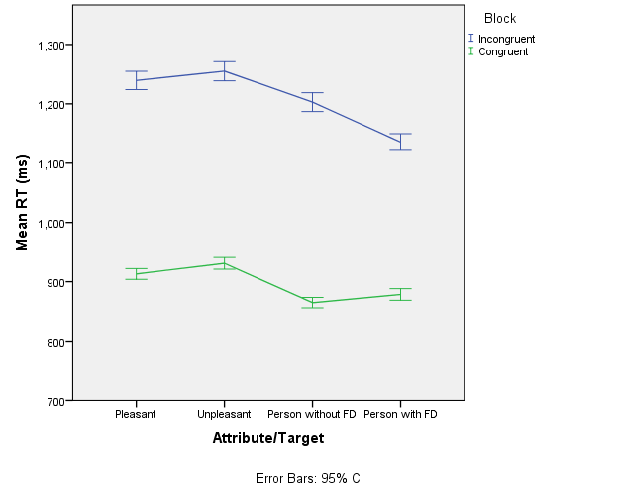

Gender and individual differences
Independent t-tests were conducted to assess gender effects within the dataset. Gender effects were found on the outcome variables of explicit and implicit attitudes towards disfigurement, with males reporting stronger negative implicit, t(473) = 2.61, p = .009, and explicit attitudes, t(428) = 2.34, p = .02, towards FD. Compared with their female counterparts, males reported lower valence of appearance, t(439) = 2.26, p = .02, salience of appearance, t(439) = 2.90, p =.004, implicit motivation to respond without prejudice, t(432) = 5.20, p<.001, core disgust, t(439) = 4.98, p<.001 and animal disgust, t(439) = 4.47, p<.001. After employing Bonferroni correction for multiple tests (i.e., 0.05/9 = 0.005), significant values found in IAT effect size, explicit attitudes and valence of appearance were lost. Significance was still found in relation to the variables IMS, core disgust and animal disgust.

*
*
Table 3.5. Mean, Standard Deviations and t values grouped by gender
Scale | Male | Female | t value | p
 | M (SD) | M (SD)
D (IAT) | 1.10 (0.66) | 0.91(0.62) | 2.66 | .009
Explicit Attitudes | 4.98(1.07) | 5.24(1.00) | 2.34 | .02
CARVAL | 18.28 (6.24) | 19.77 (6.30) | 2.26 | .02
CARSAL | 18.80 (5.13) | 20.28(4.51) | 2.90** | .004
EMS | 5.09(1.73) | 5.21(1.80) | 0.35. | .55
IMS | 6.37(0.84) | 6.77(0.66) | 5.20** | <.001
Core Disgust | 1.49(0.48) | 1.74(0.48) | 4.98** | <.001
Animal Disgust | 1.37(0.61) | 1.69(0.69) | 4.47** | <.001
Contamination Disgust | 1.06(0.65) | 1.08(0.69) | 0.71 | .30
Note. ⁎.005 (the alpha-criterion for each test due to Bonferroni's correction)
**Significant after Bonferroni correction

Correlation analysis
A Pearson correlation analysis was conducted in order to assess the relationship between the variables (see Table 3.6). There was a significant correlation between the outcome variables of implicit attitudes (IAT effect size) and explicit attitudes, r(391) = -.11, p =.02, however this became non-significant after correcting for multiple tests. Higher IAT effect sizes were associated with lower EMS, r(400) = -.14, p =.005, lower IMS, r(393) = .13, p ≤.001, and higher contamination disgust, r(424) = .15, p =.003. Favourable explicit attitudes towards FD were associated with higher IMS, r(443) = -.18, p ≤.001, and higher salience of appearance, r(443) = .128, p =.008; however the later became non-significant after employing Bonferroni correction. Significant correlations between appearance related variables and disgust sensitivity were also found. Valence of appearance was correlated with higher core, r(443) = .11, p =.01, and animal reminder disgust sensitivity, r(443) = .09, p =.03, although these correlations ceased to be significant after correcting for multiple tests. Lastly, salience of appearance was positively correlated with core, r(443) = .20, p ≤.001, animal, r(443) = .13, p =.003, and contamination disgust sensitivity, r(443) = .17, p ≤.001.

Table 3.6. Correlation matrix (N=487)
 | 1. D IAT | 2 | 3 | 4 | 5 | 6 | 7 | 8
2. Explicit Attitudes | -.110
3. Valence (CARVAL) | -.099 | -0.05
4. Salience (CARSAL) | -0.04 | .128 | 0.25**
5. EMS | .140** | 0.05 | -0.05 | .169
6. IMS | .120** | -.189** | -0.04 | -.134 | -0.09
7. Core Disgust | 0.01 | 0.044 | .112 | .209** | .212** | -0.01
8. Animal Disgust | -0.02 | 0.040 | .099 | .139** | .190** | -0.01 | .473**
9. Contamination Disgust | .148** | -0.016 | 0.03 | .161** | -0.01 | .097 | .171** | .968**
Note. ⁎.005 (the alpha-criterion for each test due to Bonferroni's correction)
**Significant after Bonferroni correction

Discussion
This study aimed to explore the relationships between implicit and explicit attitudes towards FD and pre-dispositional variables of disgust sensitivity, appearance valence, salience of appearance and motivations to respond without prejudice. In line with the literature, the first hypothesis anticipated that participants would show preference for faces without disfigurement in both explicit and implicit attitudinal measures. Secondly, gender differences regarding attitudes towards FD, levels of disgust sensitivity and appearance valence and salience were hypothesised. Thirdly, it was anticipated that higher levels of salience and valence of appearance would be associated with greater negative attitudes towards FD. The fourth hypothesis suggested that individuals with higher sensitivity to disgust cues would also show more negative attitudes towards FD. Finally, it was hypothesised that high internal/low external motivation to respond without prejudice would be associated with negative attitudes towards FD.
In support of our first hypothesis, participants showed significantly faster reaction times in the hypothesised congruent condition (i.e., facial disfigurement-unpleasant words/ Non- facial disfigurement-pleasant words), suggesting an implicit preference for faces without disfigurement in this sample. These results corroborate findings from studies using the IAT to examine implicit attitudes towards FD (Grandfield et al., 2005; Stone & Wright, 2012) and other groups typically targeted by stigma and prejudice, such as anti-fat bias (Teachman et al., 2003) and racism (Stanley, Sokol-Hessner, Banaji, & Phelps, 2011).
Interestingly, explicit evaluations of FD were not clearly negative, with all of the items’ mean score being between 5.35 and 6.22 out of a total possible of 10. These results are much like explicit reports in Grandfield et al. (2005), were participants (N=59) only score positive (52%) or no explicit preference (48%) for FD and none reported clear negative evaluation of FD. Studies using measures of attitudes via self-report do not consistently show that individuals with FD are evaluated negatively. A few studies report neutral or positive explicit evaluations, but implicit negative responses (Blascovich et al., 2001; Grandfield et al., 2005). Furthermore, explicit stigmatising responses are known to be susceptible to social desirability effects, as it is normatively unsocial to discriminate against a member of a disadvantage group (Corrigan & Shapiro, 2010; Plant & Devine, 1998; Wolkenstein & Meyer, 2009). Thus, it is possible that when evaluating people with FD, observers underreported negative evaluations in favour of more socially desirable responses.
In this study, the IAT effect sizes and explicit self-report evaluations were negatively correlated, participants who rated FD more positively also showed faster reaction times when associating FD stimuli with pleasant words. However, this correlation was small and became non-existent after correcting for multiple testing. According to a meta-analysis by Hofmann et al. (2005), correlations between the IAT and explicit self-report measures are typically low but significant. Participants showing more positive evaluations of stigmatised individuals also report implicit preference for them, particularly when the subject relates to socially sensitive topics (e.g., prejudice, stigma). In our findings, the initial weak correlation became non-significant, suggesting that these instruments measured separate constructs as proposed by Pryor, Reeder, Yeadon, and Hesson-McLnnis (2004).
Following our second hypothesis, gender differences were found in attitudes towards FD. Females’ observers reported more positive implicit and explicit attitudes towards FD compared with their male peers, however significance in both these variables was lost after Bonferroni correction. Although generally females are less likely to endorse stigmatisation and prejudice than males, this gender effect is not consistently found across the literature. For instance, a literature review by Farina (1981) showed that females were significantly less prejudiced towards mental illness than males in 13 out of 27 included studies. Differences between male and females were less commonly significant when studying the endorsement of stigmatising attitudes, than when measuring the endorsement of discriminatory behaviour; females reported significantly less endorsement of discriminatory behaviour than their male peers.
In the study of attitudes towards other typically stigmatised groups (e.g., racial prejudice, substance abuse), females groups also appear to be less prejudice than males (Mills, McGrath, Sobkoviak, Stupec, & Welsh, 1995; Sattler, Escande, Racine, & Göritz, 2017). Perhaps because females are themselves receivers of devaluating treatment and attitudes from the public (e.g., Stanley & Jarrell, 1998), it is possible that they hold higher sensitivity to the experience of stigma, thus reducing negative evaluations towards stigmatised others (Batson, Chang, Orr, & Rowland, 2002; Corrigan & Watson, 2007).
Compared to males, females respond different to emotional stimuli and have an advantage in the recognition of other’s non-verbal emotions (Stevens & Hamann, 2012; Thompson & Voyer, 2014). Because females have a specific role as the offspring’s main caregiver in humans and other species of mammals, it is possible that these interindividual differences in empathy are rooted in evolutionary demands placed upon females to facilitate maternal care (e.g., easily reading and responding to the child’s needs; Christov-Moore et al., 2014). In addition, the socialization of gender roles and patriarchal culture may help sustain these differences (Evans, 1997). Gender differences in attitudes towards FD was not clear in this sample, however, further studies may benefit the literature by examining the role of empathy and gender in emotional, attitudinal and behavioural manifestations of stigma towards FD.
Female respondents displayed significantly higher core sensitivity to disgust and animal related disgust than male participants. Given that females have a primary role in gestation and survival of the offspring in human and many non-human animals, the contamination of pathogens in females poses risks for survival and reproduction. Higher cost of infection may result in stronger emotional responses, in this case, sensitivity to disgust in females (Druschel & Sherman, 1999; Rohrmann et al., 2008).
Compared to males, females from western contexts, such as those in this study, have traditionally been subjected to higher societal demands to conform to beauty ideals. Consequently, it is not unsurprising that females in this study granted significantly greater importance to appearance in relation to their self-concept, compared with male participants. However, males showed more overall negative implicit and explicit attitudes towards FD than females. Which suggest that perhaps sensitivity to disgust and appearance related concern influence stigmatising responses towards FD in females, but not males, as it has been shown in the study of stigma towards obesity (Lieberman et al., 2012).
In line with hypothesis three, participants with higher conscious awareness of appearance as part of their self-concept (Salience of appearance) also evaluated FD more positively in the explicit self-report instrument, but not it was non-significant in relation to the IAT. The variable valence of appearance was not significantly correlated with the outcome variables. Although there are no previous studies analysing this relationship with regards to attitudes towards disfigurement, studies on anti-fat attitudes have found appearance concern to be a predictor of negative attitudes towards obese individuals (Lewis, Cash, & Bubb‐Lewis, 1997) and appearance concern has been associated with negative evaluation of appearance related stimuli (Rosser, Moss, & Rumsey, 2010). There seems to be an association between the observer’s own body image and evaluation of appearance related stimuli, in this case, conscious awareness of appearance was associated with positive evaluations of FD. The influence of appearance cognitions in stigmatisation processes requires further exploration, future studies would benefit from exploring other forms of appearance-related variables such as sociocultural attitudes towards appearance or body esteem
Following on our fourth hypothesis, disgust sensitivity to contamination cues was found to be correlated with negative implicit attitudes towards disfigurement. These results suggest that stigmatisation towards disfigurement may be associated with the propensity to experience disgust which, according to Kurzban and Leary (2001), serves as an evolved emotional response to avoid potentially contaminating interactions. Indeed, the degree of sensitivity to experience disgust has been shown to influence evaluation of stigmatised groups, including out-group members (Angermeyer, Matschinger, & Corrigan, 2004; Navarrete & Fessler, 2006), disabilities (Park, Faulkner, & Schaller, 2003), and obese individuals (Vartanian, 2010). The fact that this association was not shown in the explicit attitudes measure is in line with the hypothesis that negative reactions towards disfigurement could be rooted in processes that are of an automatic and instinctive nature.
Finally, it was hypothesised that individuals that try to respond in a non-prejudice way because is important for their personal beliefs (high internal motivation) would be less prejudiced towards disfigurement than individuals who tried to be non-prejudice because of fear of being judged by others (high external motivation). In the present study, individuals with high internal motivation to respond without prejudice exhibited more positive explicit and implicit responses towards FD. Participants with high external motivation to be non-prejudice also showed more implicit disfavour for FD (longer reaction times). These findings go in line with studies addressing other forms of prejudice (e.g., Plant & Devine, 2009) as individuals with high IMS and low EMS are more prone to have egalitarian responses in both explicit and implicit levels.
This study has a few limitations that should be noted. First, Although the IAT is a widely used measure of implicit attitudes amongst social psychologists, its validity has been questioned by several researchers (Blanton & Jaccard, 2006; Blanton, Jaccard, Gonzales, & Christie, 2006; Han, Czellar, Olson, & Fazio, 2010). For instance, it is unclear whether response times are a true depiction of participant’s implicit views on stigmatised targets; having a ‘preference’ towards one group, does not necessarily mean prejudice or stigma towards the less preferred group. Because the link between longer response latencies and overt manifestations of stigma is still unclear, the interpretation of IAT outcomes should be made with some caution. Additionally, whether negative implicit associations towards disadvantaged groups result in actual stigmatising behaviour is still yet to be confirmed (Hanson, 2012). The counterbalancing in terms of presentation order of congruent and incongruent blocks was not randomised which hinders the reliability of the IAT scores in this study (Suresh, 2011). Furthermore, the explicit attitudes test was an instrument designed by the charity Changing Faces and although it was used with a large sample size, there is little evidence of its psychometric characteristics, particularly external validity. Finally, the main limitation of the study is its correlational design, which restricts causal inferences.
Results from this study support the dual process of stigma in the case of FD. People may consciously report positive or neutral attitudes towards FD, while also reporting negative implicit attitudes towards FD. It is clear that people with FD face stigmatisation from the general public, however, studies testing anti-stigma strategies in this population are limited; future research should focus on testing anti-stigma techniques utilised in other commonly stigmatised conditions (e.g., psychiatric conditions), in the area of stigma towards FD. Ultimately, future research should work on developing a strong methodological framework for effective intervention programs in scenarios where individuals with disfigurement are more severely marginalised by the public (e.g., educational and recruitment settings).

Chapter 4: Testing the effectiveness of education awareness messages and imagined contact strategies in reducing public stigma towards facial disfigurement.

Introduction
Public stigma is the collective devaluation of individuals that have a specific group affiliation. Stigma may be directed towards individuals with certain health conditions (e.g., psychiatric conditions; Rüsch, Angermeyer, & Corrigan, 2005), people of different sexual orientation (Anderson, 2018) or different appearance (e.g., obesity; Puhl & Heuer, 2010). Stigma contributes towards maintaining social exclusion and is unsurprisingly associated with higher levels of individual distress and disadvantage in people that are at the receiving end of the stigma (Cook & Wang, 2010; Rumsey, Clarke, White, Wyn-Williams, & Garlick, 2004).
Perhaps because physical appearance plays such an important role in human interaction and is often associated with judgements about health and status, discrimination towards people with disfigurement has been found to be pervasive (Ablett & Thompson, 2016; Macgregor, 1990; Shanmugarajah, Gaind, Clarke, & Butler, 2012). Physical image and, in particular, facial features, are key factors in processes of communication (Ghazanfar & Santos, 2004), and humans are known to have preferences towards individuals that conform to society’s model of attractiveness (Eagly & Ashmore, 1991). People concur in identifying what is attractive and unattractive within and across cultures (Langlois et al., 2000) and attractive people are evaluated and treated more positively than unattractive individuals (Bzdok et al., 2011; Hosoda, Stone‐Romero, & Coats, 2003).
Research on public reactions to facial disfigurement (FD) has shown that individuals with FD are the target of stigmatisation and exclusion. For example, studies conducted by Houston and Bull (1994) showed that participants placed greater distance between themselves and confederates that appeared to have a FD, compared to confederates with clear skin. Responses of avoidance and disgust that are elicited by FD are likely linked to innate mechanisms to protect humans against potentially contaminating pathogens (Kurzban & Leary, 2001). Because contact with a potentially harmful pathogen may be fatal or detrimental for the individual’s fitness, people report intentions to avoid FD regardless of the contagious characteristics associated with the disfigurement (Haselton & Buss, 2000; Kouznetsova, Stevenson, Oaten, & Case, 2012). It is also known that lay people tend to rate people with FD as less socially capable (e.g., less friendly/likable), honest, employable, effective, capable and intelligent than individuals without FD.
Commonly used approaches to challenge stigma towards typically disadvantaged groups are protest, education, and contact (Corrigan & Penn, 1999; Heijnders & Meij, 2006). In the case of FD, attempts to reduce stigma include public education and protest strategies (e.g., Equality campaigns; Changing Faces, 2019). Protest interventions intend to create awareness by exposing the perpetuation of stereotypes associated with disfigurement. For example, representations of FD in literature, television and films have traditionally been indicators of evil or infamy (e.g., Hephaestus, Freddie Kreuger, Scarface) and characters with FD sometimes included to evoke feelings of disgust, fear, curiosity and ridicule in the public (Kent & Thompson, 2002; Thompson & Kent, 2001; Wardle & Boyce, 2009). In response to this problematic, the charity Changing Faces launched campaign to raise awareness of face equality in mass media. In advocating for equality for people with FD, Changing Faces denounce media outlets that perpetuate stereotypes (e.g., Moshi Monsters Campaign; changing Faces, 2015).
The Changing Faces protest campaigns include contact details to report incidents of poor representation of disfigurement in the media, personal testimony of those affected by media representation and, guidelines for broadcasters to avoid stereotyping and offensive coverage of disfigurement (Media Guidelines; Changing Faces, n.d.). Similar approaches to public stigma towards disfigurement are led by other charities in the UK, as is the case of the Katie Piper Foundation and Saving Faces. While there is little evidence to support the effectiveness of protest strategies in changing public attitudes, protest efforts are valuable for denouncing and stopping the promotion of stigmatising views, particularly in the media (Rüsch, Angermeyer, & Corrigan, 2005).
Another known approach to stigma reduction is education. The theoretical premise underlying education strategies is that stigma is based on misconceptions and stereotypes about a stigmatised group; thus, beliefs and attitudes should change when individuals are given accurate information (Rüsch, Todd, Bodenhausen, & Corrigan, 2010). Governments, health services, and charities use education strategies to create awareness and improve attitudes towards social groups that are the target of stigma (e.g., people with physical disabilities). However, the impact of these strategies in reducing stigma towards FD has not been fully investigated yet.
Only a handful of studies have tested the effectiveness of education strategies in reducing stigma towards FD (i.e. Bogart & Tickle-Degnen, 2015). Bogart and Tickle-Degnen used a convenient sample of students to test the effect of two education-based strategies on extraversion ratings of individuals with mild and severe facial paralysis (FP). Before the presentation of the clips, participants were allocated to either a control or one of two experimental conditions. Both experimental conditions included an educational message on causes and types of FP and instructions for participants to focus on the non-verbal and verbal content of video clip. Then participants reported extraversion ratings of a series of videos depicting individuals with FP. In the education and feedback condition, participants were provided with the self-reported extraversion ratings that targets in the video reported (feedback) after each presentation of the first half of the video-clips, the remaining video-clips were rated without feedback. Findings showed that both education messages (with and without feedback) were associated with improved ratings of extraversion compared to the control group, however, there was no significant difference between ratings of extraversion in the education and education+feedback condition (Bogart & Tickle-Degnen, 2015).
In certain types of FD (e.g., FP) there is a reduction in facial mobility, which compromises non-verbal communication of those affected by it. Consequently, individuals’ facial expressions are more likely to be misjudged as less friendly or uninterested, hindering social functioning (Bogart, Tickle-Degnen, & Ambady, 2014). The study by Bogart and Tickle-Degnen (2015) offered supportive evidence regarding the impact that anti-stigma education strategies might have on evaluations of individuals with FD, in specific those with impaired facial mobility (e.g., facial transplant). However, a number of limitations make generalisation of the findings difficult. The target stimuli concentrated on a very specific type of FD, and so it remains unclear if the findings would be applicable to other forms of disfigurement. In addition, the outcome measure concentrated only on perceptions about extraversion, so it remains unanswered whether or not education strategies are effective to reduce other manifestations of stigma (e.g., avoidance or actual discrimination).
Education strategies tested with other stigmatised groups have yielded equivocal results, and some do not seem to be effective (Mittal, Sullivan, Chekuri, Allee, & Corrigan, 2012). For example, efforts to reduce stigma towards psychiatric conditions like schizophrenia and depression have found that teaching on symptoms and causes of psychological distress increases knowledge of participants but has little effect on attitudinal responses (Jorm & Griffiths, 2008; Read, 2007; Schlier, Schmick, & Lincoln, 2014). The effectiveness of educational strategies appears to rely on the content, as the educational material should not only inform, but also challenge stereotypes and misconceptions about the stigmatised condition (Corrigan, Morris, Michaels, Rafacz, & Rüsch, 2012). For instance, in a study by Reinke and Corrigan (2004), participants viewing a video-clip of an individual that moderately or highly contradicted stereotypes of people with psychiatric conditions (e.g., aggressiveness), showed significant improvement in attitudes, compared to participants presented with a person that conformed to the stereotype (i.e. an individual displaying psychotic symptoms). Systematic and meta-analytic analysis of the literature report small to medium effect sizes associated with education and the reduction of stigma towards other commonly stigmatised groups (e.g., psychiatric conditions and gender prejudice; Bartoş, Berger, & Hegarty, 2014; Corrigan et al., 2012; Mehta et al., 2015).
In line with Corrigan et al. (2012), effective FD anti-stigma interventions should target typical stereotypes of individuals with FD by depicting the experience of individuals with visible differences that challenge such stereotypes. For example, known stereotypes attributed to people with FD include lower social capabilities (Franks & Goodrick-meech, 1997; Hughes et al., 2009; Rankin & Borah, 2003; Rinnerthaler et al., 2006; Stone & Wright, 2013) and unattractiveness (Franks & Goodrick-meech, 1997; Green-Armytage, Simonds, John, & Woodger, 2019; Hughes et al., 2009). Thus, an effective educational intervention would probably showcase public figures that advocates for face equality and challenge stereotypes about people with FD, for instance, Katy Piper (model and television presenter), Winnie Harlow (model and public spokesperson) and Jono Lancaster (Model and Treacher Collins Syndrome advocate). However, stereotypes are often deeply ingrained into people’s views of the world, which makes change resistant to information alone (e.g., gender stereotypes; Mulvey & Killen, 2015).
Contact strategies derive from the early social psychological theory that posits that positive intergroup interaction reduces prejudicial attitudes and develops positive beliefs towards stigmatised groups (Allport, 1954). Contact based interactions appear to be a highly effective method to reduce stigma (Corrigan et al., 2012; Pettigrew & Tropp, 2006). Interpersonal contact with stigmatised individuals has been associated with positive change across components of stigma (knowledge, attitudes, and intended behaviour) and some research indicates that change is maintained beyond that achievable by educational interventions (Heijnders & Meij, 2006; Schomerus et al., 2012). However, facilitating actual contact is not a cost-effective strategy for challenging stigma on a large scale. Other forms of contact-based strategies, such as imagined contact (IC) have offered a degree of effectiveness in reducing prejudice (Miles & Crisp, 2014; Miles & Crisp, 2013)
Imagined contact was developed with the same principle of intergroup contact interventions; however, rather than a face to face encounter, the contact is mentally articulated by the participant (Stathi, Tsantila, & Crisp, 2012; Turner, Crisp, & Lambert, 2007). In real life, the public would rarely encounter opportunities to engage in social exchange with a member of a stigmatised group, both because of lack of real opportunities and because the negative attitudes and expectations of contact would provoke people to avoid actual contact. IC is an imagery technique that allows individuals to imagine a positive interaction with a commonly stigmatised group in order to reduce negative expectations of contact and negative attitudes (Husnu & Crisp, 2010). Neuropsychological studies have shown that mental imagery involves some of the same neurological pathways as real contact (Ganis, Thompson, & Kosslyn, 2004). Therefore, if imagery interventions activate neurological networks associated with pleasant interactions with out-groups, just imagining a positive interaction should elicit less intergroup anxiety and more positive attitudes (Crisp, Stathi, & Turner, 2009; Husnu & Crisp, 2010; Turner et al., 2007).
The effectiveness of IC has been tested in a wide range of anti-stigma strategies, including efforts to reduce prejudice towards members of different sexual orientation (Lee & Cunningham, 2014), mental distress (Stathi et al., 2012) and ethnic minority groups (Turner et al., 2007), amongst others (Vezzali, Capozza, & Giovannini, 2011). A recent meta-analysis showed that IC is effective in reducing prejudice and has a moderate effect (d₊ = 0.35) across various types of prejudice measures (Miles & Crisp, 2014). Studies using IC strategies report a reduction in negative evaluation of stigmatised others (Birtel & Crisp, 2012b; Turner, Crisp, & Lambert, 2007) and changes factors associated with prejudice, such as reduction of intergroup anxiety (Birtel & Crisp, 2012a; Cameron, Rutland, & Turner, 2011; Stathi, Tsantila, & Crisp, 2012) and greater intentions to engage in contact with stigmatised groups (Husnu & Crisp, 2010b, 2010a; Turner & West, 2011). Studies on stigma towards obesity have also reported a degree of support towards the effectiveness IC, which suggests that it may be useful for other forms of appearance-related stigma, such as FD (Dunaev, Brochu, & Markey, 2018). Although IC has a degree of effectiveness reducing stigma towards various targets, it is still unknown the duration of this effect due to the lack of longitudinal studies (Miles & Crisp, 2013).

The present study
The present study aimed to test the impact of an awareness educative material about FD (displayed in written form and video-clip) and imagined contact (IC) on stigma towards FD. Interactions between these anti-stigma strategies were explored. This study aimed to test the following hypotheses:
- Participants presented with the written or video-clip awareness material will show a significant reduction in intergroup anxiety and fewer intentions to avoid FD, compared to control participants allocated to a neutral message.
- Participants imagining a positive interaction with an individual with FD will report lower intergroup anxiety and fewer intentions to avoid FD, compare to participants allocated to a neutral imagination task.

In Study 1, the construct of contamination disgust was positively associated with implicit attitudinal responses; participants who were more sensitive to contaminating disgust cues showed greater negative attitudes towards disfigurement, thus suggesting that negative attitudes towards FD could be associated with emotional responses of automatic nature (Kurzban & Leary, 2001). The influence of emotions of disgust on people’s perception of FD has also been suggested in other studies with significant results (e.g. Ryan, Oaten, Stevenson, & Case, 2012; Shanmugarajah et al., 2012). Thus, during this study, disgust sensitivity was included as covariate to test the effectiveness of education, media presentation and imagined contact anti-stigma strategies.
Study 1 also showed that appearance related cognitions of valence and salience of appearance were associated with poorer explicit attitudes towards FD. Traditionally, media contents and society’s ideal of beauty pressures individuals to conform to a particular standard of appearance (Eagly & Ashmore, 1991). However, this relationship is more explicit in the study of attitudes towards obesity. For instance, the internalisation of society’s appearance ideals has been associated with negative attitudes towards obese individuals (Vartanian, Herman, & Polivy, 2005). In line with the literature on obesity, it is likely that appearance-related cognitions in the observer could influence other forms of stigma towards other visibly different individuals, such as those with FD. To further investigate this relationship, one of the co-variates incorporated in this study was a subscale of the internalisation of societal appearance standards (SATAQ; Calogero, Davis, & Thompson, 2004). The SATAQ covers general internationalization of appearance ideals (general), athlete specific internalisation (body shape), societal pressures and information. However, because the items composing the subscales concentrated around body shape ideals (e.g., “I've felt pressure from TV and magazines to be thin”; Calogero, Davis, & Thompson, 2004), this study only used the internalisation of appearance (general).

Method

Procedure and design
This experiment used a 3 x 2 between-participants factorial design. The experiment designed and launched on the Qualtrics (2013) platform. The invitation to take part in the study was sent to potential participants via e-mail. Respondents were able to access the experiment via phones, tablets, and computers. Upon accessing the experiment, respondents were requested to read an information sheet and provide informed consent prior their participation (see Appendix 4A and 4B). Then, participants completed items enquiring about their demographic information, followed by measures of internal and external motivation to respond without prejudice (IMS/EMS: Plant & Devine, 1998), the Disgust Scale Revised (DS-R; Olatunji & Williams, 2007) and the Sociocultural Attitudes towards Appearance Questionnaire (SATAQ-3: Thompson & Berg, 2004). The outcome variables of intergroup anxiety scale (Stephan & Stephan, 1985) and intended avoidant behaviour (Kouznetsova et al., 2012) were presented to participants before and after the intervention. See figure 4.1 for a screenshot.

Interventions
Participants in completed awareness and IC strategies in two time points. First, respondents were randomly allocated to one of three awareness conditions; a written awareness message on FD (see Appendix 4C), an awareness videoclip (see Appendix 4D) or a control awareness message (see Appendix 4E). The written awareness message displayed a series of bullet points with educational information about FD and the stigma affecting those with FD. Following the presentation of the educational material, the awareness condition continued with two quotes of successful individuals with FD and their life experiences living with a FD.
“Some people might think that if you have a facial disfigurement, then that means that all you do is stay at home feeling sorry for yourself and being miserable and not going out and that's not true. I'm a very confident person and I've had a really good, successful life. I mean, I've had to work at it, but I'm happy with who I am. I work and I also study part time for a law degree at University, which is great, and I'm also happily married (…).” Victoria Wright (Changing Faces).
The awareness video-clip lasted 1:30 seconds and displayed the story of Jono Lancaster, a Treacher Collins syndrome advocate that despite facing challenges for his appearance becomes fashion model and a TV personality (see Figure 4.1 for a screenshot of the clip). Following Corrigan et al. (2012), the content of both awareness conditions included references to information and individuals’ experiences that challenged stereotypes of FD.
Figure 4.1. Video-clip awareness message
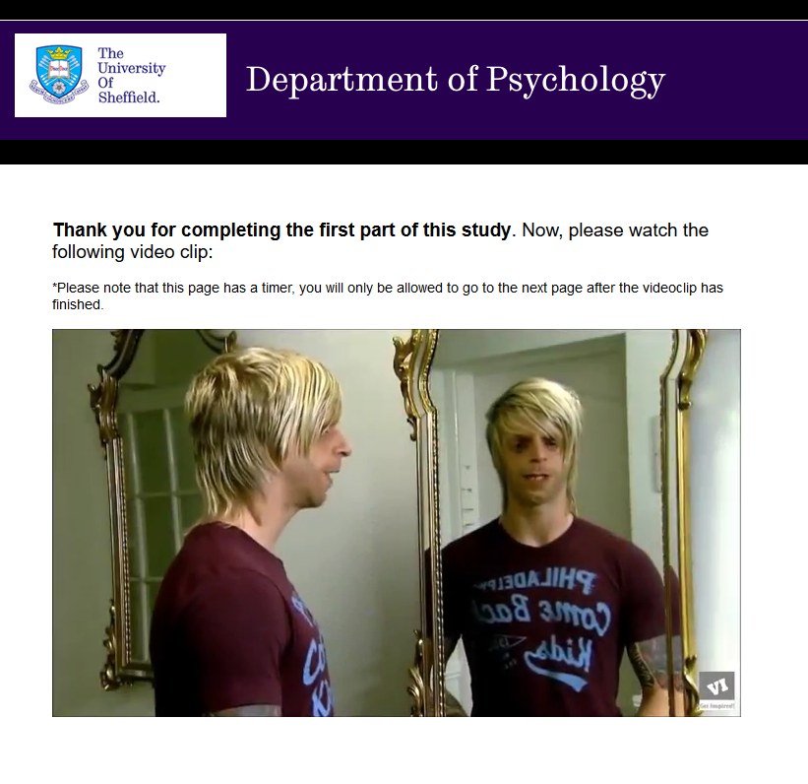
Participants in the control awareness condition read a neutral message on the consequences of smoking:
“…Every year, around 96,000 people in the UK die from diseases caused by smoking. Smoking accounts for over one-third of respiratory deaths, over one-quarter of cancer deaths, and about one-seventh of cardiovascular disease deaths” (see Appendix 4E).
After the awareness conditions, participants were randomly allocated to either a control imaginary task or an IC task. Congruently with the method used by previous IC studies (Crisp & Turner, 2009; Turner & Crisp, 2010), the experiment in this study displayed the following instructions to participants in the IC condition (see Appendix 4F):
“We would like you to spend two minutes imagining yourself meeting and talking to an adult with a severe facial disfigurement that has sat next to you on the train. Try to create a clear picture of how they look. Imagine that the interaction is POSITIVE and you find out some interesting things about this person.”
The page displaying the IC instructions was locked with a timer set at 60 seconds and participants could not continue with the experiment without spending at least this set time in the page. After the instruction, participants wrote a few sentences about the person they interacted with (e.g., eye colour, type of disfigurement, tone of voice) and the interaction they had with them. Those allocated to the control imagination task were instructed to imagine an outdoor scene (e.g., beach or forest) and then were asked to describe the scene in a few written sentences. After the IC conditions, participants were directed for a second time to the two outcome variables: Intergroup anxiety and IAB. Finally, participants were debriefed and thanked for their participation.

Rationale for Sample Size
To establish the required sample size for this study, an a-priori power analysis was conducted using the software G*Power 3.1(Faul, Erdfelder, Buchner, & Lang, 2009). Only one study was found to test intervention strategies to reduce stigma towards FD in adults, Bogart and Tickle-Degnen (2015) used a three-arm randomised design with one outcome and findings reported a significant main effect (d=0.25) for training conditions of education and education+feedback. This power analysis was computed using this effect size as a reference to assess the sample size required for an ANCOVA of two levels and three covariates, using an alpha of 0.05 and a power of 0.80 (Faul et al., 2013). Results indicated that 225 participants were needed to provide 80% power to detect an effect size of f = 0.25. Taking this number as a reference, the present study collected data from N=309 participants.

Inclusion and exclusion Criteria
Participants were required to be over the age of 18 and fluent in English. Participants who identified themselves as having a striking visible difference (e.g., scar, burn or another form of severe disfigurement) were excluded from the study.

Recruitment
Participants were recruited via the University of Sheffield’s volunteer’s list and advertising via social media. Potential participants were invited to participate in the study by clicking the link directing them to the experiment. People interested in taking part in the study were presented with a participant information sheet and consent item (see Appendix 4B) prior to the beginning of the experiment. At the end of the experiment, participants were debriefed and thanked for their participation (see Appendix 4I). Participants who completed the study online could opt to participate in the prize draw of 2x £25 Amazon voucher.

Figure 4.2. Recruitment flow diagram
Recruitment
Pre-test measures
Randomisation
Post-test measures
Randomisation
Recruited (N=309)
Reported FD (n = 8)
Final sample (n = 301)
Written awareness message (n = 100)
Video-clip awareness message (n = 94)
Control message (n = 108)
IC (n = 56)
IC control (n = 44)
IC (n = 41)
IC control (n = 53)
IC (n = 46)
IC control (n = 62)

Measures
Demographic Information. All participants provided their age, gender, ethnicity, and whether they perceive themselves to have severe facial disfigurement.
Disgust sensitivity. The Disgust Scale Revised (DS-R; Olatunji & Williams, 2007) is a 27-item questionnaire that measures disgust sensitivity in three subscales: core disgust, animal-reminder disgust, and contamination disgust. Items are rated on a 5-point scale and, as well as a score for each subscale, a total score out of 100 is calculated. This test has been widely used for the study of disgust sensitivity and possesses good psychometric properties overall (α = .88) and for each subscale (Core Disgust, α = .82; Animal Reminder Disgust, α = .73; and Contamination-Based Disgust, α = .71)Olatunji et al., 2007). Psychometric analysis conducted with this sample showed good internal reliability for the full scale (α = .86). The psychometric properties for the DS-R sub-scales were also acceptable in this sample (i.e., core Disgust, α = .76; Animal Reminder Disgust, α = .74; and Contamination-Based Disgust, α = .64).
Internal and external motivation to respond without prejudice. The Internal and External Motivation Scale (IMS/EMS;(Plant & Devine, 1998) Plant & Devine, 1998) was initially developed to measure motivations to respond without prejudice towards black people; however, it has also been adapted to measure other forms of prejudice(Klonis, Plant, & Devine, 2005; Pruett et al., 2014), including towards individuals with visible differences (Grandfield, 2008). This instrument contains ten items that measure internal (self-beliefs) and external (social desirability) motivations to respond without prejudice and responses range from 1 (Strongly disagree) to 10 (Strongly agree). The instrument adapted for skin conditions has shown good psychometric properties with Cronbach's alphas ranging from .77 to .85 (Grandfield, 2008). The measure showed good internal reliability (α = .74) for the current sample.
Sociocultural attitudes towards appearance. The Sociocultural Attitudes towards Appearance Questionnaire (SATAQ-3: Thompson & Berg, 2004) was developed to measure internalisation of appearance related material from media sources. It contains four main subscales; Information, Pressures, Internalization-General, and Internalization-Athlete. The information subscale measures the level of acknowledgement of the information about appearance standards included in the media. The pressures subscale refers to the level of pressure subjectively experienced to modify one’s appearance based on exposure to media content. The two internalisation scales assess the level of internalisation of societal appearance standards into one’s self-identity. The SATAQ-3 has been tested in clinical populations of individuals with eating disorders and contrasted with normative samples of college students. Psychometric properties of this instrument are sound across subscales, with Cronbach's alphas ranging from .77 to .97 (Calogero et al., 2004). The present study utilised the Internalization-General subscale, which had excellent internal reliability in this sample (α = .93).
Outcome variables: Measures of stigma
Intended avoidance. Participants were asked to report the desire to avoid individuals with FD before and after the experimental interventions (see Appendix 4H). The original scale used by Kouznetsova, Stevenson, Oaten and Case (2012) and included three levels of contact. Participants were asked to rate on a 7-point Likert scale (1 = definitely would not/7 = Definitely would) whether they would sit on a chair where someone with FD has been sat (1), sit next to someone with FD (2), and greet someone with FD (e.g., with a kiss on the cheek and a hug) (3). Reliability analysis conducted in this study showed that internal consistency was weak (α = .65); given that this scale was composed by only three items, alpha values were susceptible to be small (Tavakol & Dennick, 2011) and thus further calculations of inter-item correlations were conducted. The mean inter-item correlation for this scale was 0.42, falling within the acceptable range for internal consistency (0.15-0.50 as advised by (Clark and Watson (1995). Moreover, all inter-item correlations were positive, suggesting that a common underlying construct was measured with this scale, therefore the scale was kept as reported by Kouznetsova, Stevenson, Oaten, and Case (2012).
Intergroup anxiety. Participants were asked to complete a series of 11 items designed to measure the level of anxiety experienced given a hypothetical future interaction with an individual with FD (see Appendix 4G). Participants read the statement: “The next time you find yourself in a situation where you might interact with an adult with facial disfigurement, to what extent do you think you will feel…” Then, participants rated on a 10 point Likert scale (0 = not at all, 10 = extremely) how certain, awkward, self-conscious, happy, accepted, confident, irritated, defensive, suspicious and careful would they feel during the encounter. After applying reverse scoring, higher scores indicated higher intergroup anxiety and vice versa. This instrument is an adaptation taken from the Intergroup Anxiety Scale (IAS: Stephan & Stephan, 1985). This instrument has shown good construct validity and adequate internal consistency (Stephan & Stephan, 1985), with Cronbach’s alphas ranging from .75 (Miller, Markman, & Wagner, 2013) to .86 (Stephan & Stephan, 1985). Consistent with previous reports, the measure had good internal consistency in the current study (α = .82).

Results

Demographics
Data from 309 participants were collected; however, eight participants indicated that they had severe facial disfigurement and were therefore excluded from the analysis. The sample was mainly composed of students (78.6%) and university staff (18.4%), resulting in a final sample of 301 participants.
Respondents were 193 (64.1%) females, 106 (35.2%) males and 2 (0.7%) of other gender categories. Ages ranged from 18 to 68 years old (M = 27.37, SD = 10.77). Most participants were of white British ethnicity (85.5%), followed by Asian/Asian British (6.6%). Distribution of participants to each intervention strategy was performed randomly by the Qualtrics software. For the intervention factor, 100 (33.2%) participants were allocated to an education message on FD, 94 (31.2%) watched a video clip depicting the experience of an individual with FD and the remaining 107 (35.5%) were assigned to a control condition (Educational message on smoking in the UK). For the second factor, 142 (47.2%) participants completed the imagined contact task and 159 (52.8%) completed a control IC task. For details of demographic information see Table 4.1.

Summary of scales: Reliability, outliers, and normality
Data analysis was performed using SPSS v.23 (IBM, Armonk, NY: IBM Corp). Cronbach alphas and inter-item correlations were calculated to ensure good psychometric qualities of all instruments. The reliability for most scales was good (α > .70). Outliers were assessed using Z scores; values which standard score was +/- 3 were deleted from the dataset. Normality was assessed for all the scales and it was found that the outcome variables of intergroup anxiety and intended avoidance were negatively skewed, thus, to complete a parametric analysis, these variables were log transformed and using the formula ‘Lg10 (k-x)’. Likewise, the construct of contaminating disgust was positively skewed, so it underwent a log transformation. See Appendix 4K for correlation matrix.
Table 4.1. Demographic information (N = 301)

 |  |  | N | %
Gender
 | Female |  | 193 | 64.1%
 | Male |  | 106 | 35.2%
 | Other |  | 2 | .7%
Age | Range  M (SD) |  | 18-68  27.37 (10.77)
Ethnicity
 | White |  | 257 | 85.4%
 | Asian/Asian British |  | 20 | 6.6%
 | Mixed/Multiple ethnic groups |  | 13 | 4.3%
 | Other ethnic groups |  | 7 | 2.3%
 | Black/African/Caribbean/Black British |  | 4 | 1.3%

Demographic differences between groups at baseline were assessed using Chi²-test and independent samples t-test for categorical and continuous variables, respectively. There were no baseline differences between experimental conditions in terms of gender, age, ethnicity (White/Non-White) or occupation (Student/non-student) (see Table 4.2).

Table 4.2. Baseline differences
 | Intervention group | χ² (df) | T-test/ANOVA | p
Age
 | Media/Education/Control |  | F (2,306) = 1.70 | .17
 | IC/Control |  | t (306) = -0.06 | .94
Gender
 | Media/Education/Control | χ² (2) = 0.94 |  | .62
 | IC/Control | χ² (1) = 0.26 |  | .60
Ethnicity
 | Media/Education/Control | χ² (2) = 3.80 |  | .14
 | IC/Control | χ² (1) = 0.68 |  | .40
Student Status
 | Media/Education/Control | χ² (2) = 0.28 |  | .86
 | IC/Control | 0.01 (1) |  | .91

Intervention
A Pearson correlation analysis was conducted to assess the relationship between the outcome variables (Intergroup anxiety and Intended avoidance) and predispositional variables of disgust sensitivity, motivations to respond without prejudice (IMS and EMS) and sociocultural attitudes towards appearance (SATAQ). In order to correct for multiple testing, the alpha value underwent Bonferroni correction (α = .05/8) = .006. The variables found to be significantly correlated with the outcome variables were entered as covariates in the analysis.
Table 4.3. Correlation matrix
 | 1. Intergroup Anxiety | 2 | 3 | 4 | 5 | 6 | 7
2. Avoidance | -.49**
3. SATAQ | .06 | -.05
4. EMS | .18** | -.09 | .17**
5. IMS | -.32** | .48** | .06 | .03
6. Core Disgust | .03 | .08 | .32** | .14 | .04
7. Disgust-Animal | .19** | -.14 | .29** | .19** | -.02 | .44**
8. Disgust contamination | .17** | -.12 | .14 | .08 | -.12 | .52** | .44**
Note *α = .006
** Significant after Bonferroni correction

Two mixed-design 3 x 2 ANCOVAs were conducted to test differences between conditions in intergroup anxiety and avoidance intention scores following intervention factors (see Table 4.4 and 4.5). There was no significant effect of awareness (i.e., awareness vs control), F(2,293) = 0.94, p = .35, ES=0.006 on intergroup anxiety levels; nor was there an effect of IC in levels of intergroup anxiety F(293)=1.57, p=0.16 ES=0.006. See Table 4.4 for intergroup anxiety estimated means.
Table 4.4. Intergroup anxiety estimated means. Awareness | IC | Time | Mean | Std. Error | 95% Confidence Interval
 |  |  |  |  | Lower Bound | Upper Bound
Written Awareness | Control | Pre-test | 2.99 | 0.19 | 2.63 | 3.36
 |  | Post-test | 2.51 | 0.19 | 2.13 | 2.89
 | Imagined contact | Pre-test | 2.95 | 0.16 | 2.64 | 3.27
 |  | Post-test | 2.5 | 0.17 | 2.18 | 2.84
Media | Control | Pre-test | 2.65 | 0.17 | 2.32 | 2.99
 |  | Post-test | 2.4 | 0.18 | 2.05 | 2.75
 | Imagined contact | Pre-test | 3.14 | 0.19 | 2.77 | 3.52
 |  | Post-test | 2.59 | 0.20 | 2.20 | 2.98
Control Education | Control | Pre-test | 3.2 | 0.16 | 2.89 | 3.51
 |  | Post-test | 2.95 | 0.16 | 2.64 | 3.28
 | Imagined contact | Pre-test | 2.95 | 0.18 | 2.37 | 3.08
 |  | Post-test | 2.95 | 0.19 | 1.99 | 2.73
Covariates: IMS, EMS, contamination disgust and animal disgust
The effect of the interventions was also tested on the outcome variable of intended avoidance. There was a significant effect of awareness on intended avoidance, F(299)=7.33, p=0.001, ES=0.05. Further tests using the Bonferroni correction showed a significant difference in intended avoidance between the awareness written message group (M = 5.70, SD =1.01) and the control awareness group (M = 5.43, SD= 1.08; p <0.001), but no significant differences were found between the written awareness and the video-clip awareness group (M= 5.64, SD = 1.08; p = 0.34). Furthermore, results from this analysis did not show any significant differences between the video-clip awareness and control awareness message groups (p = 0.06).

Table 4.5. Estimated means for intended avoidance
Awareness | IC | Time | Mean | Std. Error | 95% Confidence Interval
 |  |  |  |  | Lower Bound | Upper Bound
Written message | Control | Pre-test | 0.41 | 0.03 | 0.37 | 0.47
 |  | Post-test | 0.37 | 0.02 | 0.33 | 0.42
 | Imagined contact | Pre-test | 0.33 | 0.02 | 0.29 | 0.38
 |  | Post-test | 0.29 | 0.02 | 0.25 | 0.34
Media | Control | Pre-test | 0.41 | 0.02 | 0.37 | 0.45
 |  | Post-test | 0.42 | 0.02 | 0.38 | 0.46
 | Imagined contact | Pre-test | 0.34 | 0.03 | 0.29 | 0.39
 |  | Post-test | 0.31 | 0.02 | 0.26 | 0.36
Control Education | Control | Pre-test | 0.38 | 0.02 | 0.33 | 0.43
 |  | Post-test | 0.35 | 0.02 | 0.30 | 0.39
 | Imagined contact | Pre-test | 0.40 | 0.03 | 0.34 | 0.45
 |  | Post-test | 0.29 | 0.03 | 0.24 | 0.34
Covariates: Explicit motivation to respond without prejudice

The IC factor also showed a significant effect on avoidance intentions, F(299)=7.41, p=0.007, ES=0.03. Results from post-hoc tests using Bonferroni correction showed that respondents imagining a positive interaction with FD (IC) reported significantly higher contact intention (M = 5.86, SD = 0.9) than participants allocated to a control imagination task (M = 5.33, SD = 1.13, p < 0.001). Participants allocated to IC did not differ in avoidance to those allocated to video-clip or written message. Nevertheless, participants allocated to the written awareness group showed more reduction in intended avoidance than those allocated to IC control (p = 0.01). An interaction effect between awareness and IC on intentions to avoid FD was also found F(299)=3.47,p=0.03, ES=0.02, though effect sizes (ETA square) were lower than the one associated with the awareness factor or imagined contact alone.

Written account of imaginary tasks (preliminary analysis)

Participants allocated to the IC experimental condition (n = 148) imagined a positive interaction with an individual with FD and then provided a brief description of the person and the interaction they just imagined. Control participants (n = 161) were asked to imagine and describe a scenery (e.g., a beach or forest). Those imagining an interaction with a person with FD used between 1 – 81 words to describe the individual they imagined (M= 23.9, SD = 14,8) and between 1-111 words (M = 30.7, SD = 21.65) when retelling the interaction. Control participants wrote a range of 1-121 words (M = 31.5, SD = 22.8) to describe the scenery they imagined in the task. Results from a one-way between subjects ANOVA revealed a significant effect of question type on number of words typed by participants, F(2, 439) = 4.94, p = .008. Further post-hoc comparisons with Bonferroni correction indicated that participants used significantly less words to describe their imaginary person with FD than when they described the interaction (p = .02). The number of words to describe a person with FD was also significantly lower than the wordcount of control participants describing a scenery p = 0.01). However, there was no significant differences in wordcount between those describing an interaction and control participants retelling a scenery they just imagined (p = .9). See figure 4.3.
Figure 4.3. Word count in imaginary tasks
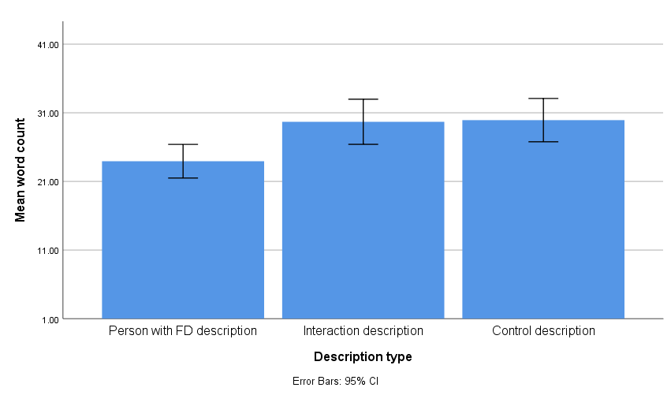

The instructions given to participants in the IC experimental condition did not specify gender or type of FD, only that the interaction had to be positive. Thus, participants were free to imagine a social exchange with a person of any gender and with whatever visible difference that they considered FD. Close to 70% participants allocated to imagining an interaction with someone with FD were specific about the gender of their imaginary person with FD (n = 103). Out of these, sixty-four participants imagined an interacting with a male (n =64), and 39 described an interaction with a female. The remaining 43 participants did not specify gender within their descriptions (e.g., “The person was Tall, blue eyes, brown hair, white skin…” participant 179).
Sixty-two participants (n = 62) did not describe the type of disfigurement that the person they imagine had. These descriptions included general reference to the persons’ facial difference: “Mostly ordinary appearance aside from his different face. Ordinary voice” (Participant 72). Other participants that did not describe the disfigurement but rather concentrated the description around personality traits and other aspects of the person’s appearance: “He was dressed very smartly in a suit and was very happy and cheerful. Very friendly and chatty” (Participant 134).
When participants were explicit about the type of FD (n = 84), they mostly included physical asymmetries (n = 55) such as enlarged facial features: “Large forehead, different sized eyes, overbite” (Participant 117). Description of asymmetries also included disproportional size of the components of the face: “Face was asymmetrical - disfigurement only fully affected one side of the face. Eyes were smaller than average, tone of voice was low, and speech was slower than mine.” (Participant 93). FD associated with asymmetries also included missing organs or parts of the face: “The person was a male with a sunken face and missing eye. He had a deep, rich voice and scruffy beard” (Participant 33).
Other descriptions of FD in this sample included birthmarks, scars, burns and discolouring of the facial skin. For example, “…Burn scars across face, we didn't talk about how they occurred, more about where they were going, their family etc.” (Participant 39) and “…They had a big red patch of skin covering one side of their face. The tone of voice was friendly and welcoming…” (Participant 4).
Although FD does not always involve damage to the senses, 27 participants described their imaginary person with FD with at least one functional impairment:
“It was a woman whose face was distorted by her mouth hanging lower on one side, her voice was impaired I think by her the downward curve of her mouth and side of her face. She had long motty brownish hair and was wearing simple clothes; baggy jeans a white top and had a backpack with her” (Participant 65).
The personality traits attributed to the imaginary person with FD were commonly positive. There were 41 explicit references to the imaginary person as being “friendly”, “pleasant”, “happy” and other synonyms (e.g., smiley, lively). Ten participants described the person with FD as “confident” and further 9 participants used adjectives like “warm” or “kind”. Other common adjectives utilised in this sample were “polite” (n = 9) and “normal” or “ordinary” (n = 4). Explicit attributions of shyness or awkwardness were found in the discourse of 8 participants.
Participants largely imagined positive interactions as indicated in the instructions (n = 133). For example, “Very interesting - about his life, his achievements and his goals. Also, his political motivations, the causes he fights for, especially disability legislation. We laughed and joked, it was a good conversation.” (Participant 91). However, in 33 participants the interaction was not positive throughout the discourse, as participants included within the description moments of awkwardness: “Initially a little awkward ('elephant in the room' idea) but soon completely normal” (Participant 39); and other expressions of incertitude about the interaction: “It was awkward. I could not help but stare. It ended up well, but I still felt self-conscious about my behaviour during the interaction. I could not help but do that” (Participant 182).
Other interactions included elements of surprise: “I was shocked at first but soon found something to focus on to distract my initial shock, they were just like anyone else to talk to and I soon found that I looked beyond the facial deformities” (Participant 276); and curiosity:
“We struck up a conversation about a book she was reading and talked for a while about 'normal' things without any reference to her appearance. I managed not to stare or ask about it because I was enjoying our conversation not because I needed to make a special effort! …” (Participant 275).
Based on the analysis of the written description provided by participants, the original design of 3 (awareness written, awareness media, control) x 2 (IC vs IC control), was further classified to include participants that did not imagine a complete positive interaction (see figure 4.4). Thus, two 3 x 3 (IC positive vs IC mixed vs control) mixed ANOVAs were conducted to test the effect of awareness and imaginary tasks on intergroup anxiety and intended avoidance. Results did not show a significant effect of awareness on intergroup anxiety, F(2,295) = 0.42, p = .65. Likewise, no significant effect of any of the three IC conditions on intentions to avoid FD, F(2,295) = 1.09, p = .33. See table 4.6 for estimated means.

Figure 4.4. Recruitment flow diagram with new IC group
IC non-positive (n = 9)
IC non-positive (n = 9)
IC non-positive (n = 15)
Recruitment
Pre-test measures
Randomisation
Post-test measures
Randomisation
Recruited (N=309)
Reported FD (n = 8)
Final sample (n = 301)
Written awareness message (n = 100)
Video-clip awareness message (n = 94)
Control message (n = 108)
IC positive (n = 41)
IC control (n = 44)
IC positive (n = 32)
IC control (n = 53)
IC positive (n = 37)
IC control (n = 62)

Table 4.6. Estimated means for intergroup anxiety
Awareness | IC | Time | Mean | Std. Error | 95% Confidence Interval
 |  |  |  |  | Lower Bound | Upper Bound
Written message | Positive | Pre-test | 2,64 | 0,19 | 2,26 | 3,02
 |  | Post-test | 2,20 | 0,21 | 1,79 | 2,60
 | Non-positive | Pre-test | 3,59 | 0,33 | 2,93 | 4,25
 |  | Post-test | 3,19 | 0,36 | 2,49 | 3,90
 | Control | Pre-test | 2,94 | 0,20 | 2,55 | 3,32
 |  | Post-test | 2,43 | 0,21 | 2,01 | 2,84
Media | Positive | Pre-test | 3,13 | 0,23 | 2,67 | 3,59
 |  | Post-test | 2,50 | 0,25 | 2,01 | 2,99
 | Non-positive | Pre-test | 2,95 | 0,43 | 2,10 | 3,80
 |  | Post-test | 2,56 | 0,46 | 1,65 | 3,46
 | Control | Pre-test | 2,80 | 0,18 | 2,45 | 3,15
 |  | Post-test | 2,57 | 0,19 | 2,19 | 2,94
Control Education | Positive | Pre-test | 2,77 | 0,21 | 2,35 | 3,19
 |  | Post-test | 2,38 | 0,23 | 1,94 | 2,83
 | Non-positive | Pre-test | 3,08 | 0,43 | 2,23 | 3,93
 |  | Post-test | 2,76 | 0,46 | 1,85 | 3,67
 | Control | Pre-test | 3,15 | 0,16 | 2,83 | 3,48
 |  | Post-test | 2,91 | 0,18 | 2,56 | 3,26

There was a significant effect of awareness on intentions to avoid FD, F(2, 299) = 5.02, p = .007. Similarly there was a significant effect of the three IC conditions, F(2, 299) = 4.81, p = .009. However, no interaction effect was found F(4, 299) = 2.16, p = .07. Post-hoc analysis revealed that participants imagining a positive interaction had more intentions to have contact with an individual with FD (M = 5.92, SD = .87) compared to control participants imagining a scenery of their choice (M = 5.33, SD = 1.13; p < .001). However, there was no significant differences between participants imagining a mixed (non-positive) interaction (M = 5.67, SD = 1.01) and those imagining a positive interaction (p = .64). Nor was there a significant difference between controls and participants imagining a non-positive interaction (p = .27). See table 4.7
Table 4.7. Estimated means for intended avoidance
Awareness | IC | Time | Mean | Std. Error | 95% Confidence Interval
 |  |  |  |  | Lower Bound | Upper Bound
Written message | Positive | Pre-test | 0,29 | 0,03 | 0,24 | 0,35
 |  | Post-test | 0,26 | 0,03 | 0,21 | 0,32
 | Non-positive | Pre-test | 0,45 | 0,05 | 0,35 | 0,54
 |  | Post-test | 0,38 | 0,05 | 0,29 | 0,48
 | Control | Pre-test | 0,41 | 0,03 | 0,35 | 0,46
 |  | Post-test | 0,36 | 0,03 | 0,31 | 0,42
Media | Positive | Pre-test | 0,38 | 0,03 | 0,31 | 0,44
 |  | Post-test | 0,27 | 0,03 | 0,20 | 0,33
 | Non-positive | Pre-test | 0,40 | 0,06 | 0,28 | 0,53
 |  | Post-test | 0,29 | 0,06 | 0,17 | 0,41
 | Control | Pre-test | 0,40 | 0,03 | 0,35 | 0,45
 |  | Post-test | 0,37 | 0,03 | 0,32 | 0,42
Control Education | Positive | Pre-test | 0,34 | 0,03 | 0,28 | 0,41
 |  | Post-test | 0,32 | 0,03 | 0,26 | 0,38
 | Non-positive | Pre-test | 0,32 | 0,06 | 0,20 | 0,44
 |  | Post-test | 0,28 | 0,06 | 0,16 | 0,40
 | Control | Pre-test | 0,41 | 0,02 | 0,36 | 0,46
 |  | Post-test | 0,42 | 0,02 | 0,37 | 0,46

Discussion

This study aimed to test the effectiveness written and video-clip forms of awareness messages and IC in reducing stigma towards FD. Findings suggested an effect of awareness and IC factors on reduced avoidance intentions in this sample. Participants allocated to awareness messages (written form) and IC conditions showed a significant reduction of intentions to avoid FD, compared to participants allocated to a video-clip awareness message, control awareness and control imagination task. No significant differences in levels of intergroup anxiety following anti-stigma strategies of awareness and IC were found in this study.
The experimental condition of a written educational message on FD was associated with reduced intentions to avoid FD, compared to participants instructed to read the educational message about the consequences of smoking. Congruently with Bogart and Tickle-Degnen (2015), findings from this study support a degree of effectiveness of educational messages to reduce stigma towards FD, particularly when the imagined interaction is of a positive nature. Furthermore, results concur with small effect sizes associated with educative awareness messages in reducing stigma towards other commonly stigmatised groups like people with psychiatric conditions (Corrigan et al., 2012; Schomerus et al., 2012). Mentally simulating a positive interaction with an individual with FD also resulted in weaker intentions to avoid people with FD (or greater intention of contact). These findings contribute to the body of evidence previously reported on the effectiveness of IC strategies in the reduction of stigma towards other stigmatised groups such as psychiatric conditions (Stathi et al., 2012) and physical disabilities (Carvalho‐Freitas & Stathi, 2017).
Only a small percentage of the population has FD and those with a disfigurement are rarely represented in the mainstream media. When they are, the connotation is often negative (Wardle & Boyce, 2009). Therefore, having a positive encounter with a person that has a disfigurement in the face would be uncommon for a lay person, making IC strategies particularly useful to introduce in efforts to reduce stigma. The effectiveness of imagined contact strategies has been evidenced in a considerable amount of research (for meta-analysis see(Miles & Crisp, 2014). Imagined contact is also easy to distribute (e.g., online) and of short duration, which makes it a cost-effective form of intervention to reduce stigma towards FD, for instance by including elements of IC into stigma awareness trainings for educators, health practitioners or recruitment staff (Meleady & Crisp, 2016).
Surprisingly, imagined contact did not have a significant effect on levels of intergroup anxiety and nor did the awareness strategies. Previous literature has shown that imagining a positive interaction with a stigmatised individual significantly reduced intergroup anxiety; for example, in the case of ethnic minorities (e.g.,(Asbrock, Gutenbrunner, & Wagner, 2013), sexual orientation (e.g.,(Birtel & Crisp, 2012) and stigma towards psychiatric conditions (e.g.,(West, Hewstone, & Lolliot, 2014). However, in the case of FD this was not the case. It is possible that there are other factors involved in the process of stigmatisation towards FD, for example, curiosity and pity (Jamrozik, Oraa Ali, Sarwer, & Chatterjee, 2017)
On the other hand, education strategies have shown mixed results in regards to its effectiveness, particularly to improve attitudinal responses towards disadvantaged groups (Jorm & Griffiths, 2008; Read, 2007; Schlier, Schmick, & Lincoln, 2014). Perhaps because people with FD are so notably different to other, more disguisable forms, of stigmatised groups (e.g., psychiatric conditions), the effect of IC and awareness was non-significant in levels of intergroup anxiety. While systematic evidence supports a degree of effectiveness of IC (Miles & Crisp, 2014) and education strategies (Corrigan et al., 2012) in other types of disadvantaged groups, our findings only partially support the effectiveness of these strategies in the case of FD.
The present study has some limitations. First, the sample was composed of students and university staff, which may not be representative of the public (Dasgupta & Hunsinger, 2008). Second, there was no was no control over the level of FD showed to participants. It has been shown that mild to severe forms of FD receives different evaluation from observers (Shanmugarajah, Gaind, Clarke, & Butler, 2012; Terwee et al., 2003), whether IC and education on awareness could reduce stigma towards milder or specific forms of FD (e.g., cleft lip Palade), is yet to be explored. Third, this study collected measures before and immediately after the interventions, no follow-up measure was collected, thus the long term effects of these anti-stigma strategies remains unexplored.
The literature on stigma towards FD and other targeted groups would benefit from the analysis of longitudinal data to test the duration of the anti-stigma effect associated intervention strategies. Indeed, lack of evidence towards long-term effects is one of the main criticisms found in the literature of anti-stigma strategies (e.g., imagined contact; Miles & Crisp, 2014). Finally, the self-report quality of the instrument makes it sensitive to social desirability effects (Michaels & Corrigan, 2013). While reports of avoidance are somehow a depiction of how participants would behave and feel in a given encounter with an individual with FD, it is not clear whether this would correspond to overt expressions of stigma. Future research would benefit from developing studies capturing behavioural manifestations of stigma in order to clarify the link between intention and actual stigmatising behaviour.
This study found that imagining a positive contact with an individual with FD and an education awareness message may help reduce intentions of avoidance. However, contrary to our hypothesis, levels of intergroup anxiety remained unchanged after the interventions. IC and awareness messages are relatively simple techniques and easy to distribute (e.g., online). These anti-stigma elements would be easy to integrate into a more comprehensive form of anti-stigma training, particularly within contexts where stigmatisation towards individuals with FD is more damaging, such as recruitment and educational scenarios.

Chapter 5 (Study 3): Testing the effectiveness of education and IC on stigma reduction towards FD in a sample of employees with recruitment duties

Introduction
Observers perceive and respond differently to FD (Blascovich, Mendes, Hunter, Lickel, & Kowai-Bell, 2001; Ishii, Carey, Byrne, Zee, & Ishii, 2009; Stone & Potton, 2017). This has detrimental implications for people living with FD, especially in social interactions that involve evaluation from others. For instance, in educational (Kent & Thompson, 2002; Prior & O’Dell, 2009; Rimmer et al., 2007), job-seeking (Madera & Hebl, 2012; Madera, 2016; Stevenage & McKay, 1999; Stone & Wright, 2013; Tartaglia, McMahon, West, & Belongia, 2005), health care (Clarke & Cooper, 2001) and dating settings (Hughes et al., 2009; S M Mojon-Azzi, Potnik, & Mojon, 2008). However, few studies in the literature have reported the effectiveness of anti-stigma strategies in changing how people respond to FD (e.g., Bogart & Tickle-Degnen, 2015), even less so among those likely to significantly impact the inclusion of individuals with FD (e.g., recruiters, educators).
When observers are presented with facial stimuli, their gaze concentrates around the central triangle of the face (i.e. nose, eyes, and mouth). This facial area provides a rich source of information necessary for social interaction (e.g., identity, gender, age, emotions and nonverbal language of the target; Haxby, Hoffman, & Gobbini, 2002; Knapp, Hall, & Horgan, 2013; Mertens, Siegmund, & Grüsser, 1993; Walker-Smith, Gale, & Findlay, 1977). However, disfigurement acts as a novel stimulus in observers, taking up attentional resources from discriminating features of the central triangle to the area of disfigurement (Godoy et al., 2011; Ishii et al., 2009). While FD stimuli tend to receive longer visual fixation from observers, this does not translate in evaluations that are more positive or greater memory recall of people with FD, compared to non-FD targets (Ackerman et al., 2009; Madera & Hebl, 2012; Madera, 2016; Stone & Potton, 2017; van Schijndel, Tasman, & Litschel, 2015).
Compared to individuals without FD, people with FD are perceived as less confident and likable/friendly (Bull & David, 1986; Franks & Goodrick-meech, 1997; Hughes et al., 2009; Kleck & Strenta, 1985; Rankin & Borah, 2003; Rinnerthaler, Mueller, Weichbold, Wenning, & Poewe, 2006; Stone & Wright, 2012), less capable intellectually or workwise (Dijker, Tacken, & Borne, 2000; Hughes et al., 2009; Madera & Hebl, 2012; Mojon-Azzi et al., 2008; Rankin & Borah, 2003), and less honest/ trustworthy (Bull & David, 1986; Halioua et al., 2011; Jamrozik, Oraa Ali, Sarwer, & Chatterjee, 2017; Rankin & Borah, 2003; Rinnerthaler et al., 2006). These characteristics may be desirable in many job positions for which people with FD are likely to face challenges in being a successful candidate.
Overt discrimination towards FD is also explicit in recruitment decisions prior to the interview process. Stone and Wright (2013) used a correspondence testing methodology to evaluate the recruitment prospects of individuals with FD compared to wheelchair users and controls without disabilities. Three mock CVs and cover letters were sent to 114 vacancies. Responses to each application were recorded and coded (i.e., invitation to interview, call back, rejection, etc.) and vacancies type categorised as low (e.g., IT) or high (e.g., sales) customer contact. Applications depicting individuals with FD and wheelchair received more unfavourable responses than control CVs and cover letters. Roles requiring a higher level of customer service were significantly less favourable for applications from applicants with FD compared to controls without disfigurement or mobility impairment. However, there were equally favourable responses between FD and control applications when the vacancy required low levels of customer contact. The level of discrimination towards FD in jobs with high customer contact was similar to levels found in age and racial discrimination (Eriksson & Lagerström, 2012; Riach & Rich, 2002).
There are notoriously negative stereotypes associated with FD (e.g., evilness or ridicule) which have been traditionally reinforced by culture via media and advertising (Garrisi et al., 2018). However, stigma is not only directed towards those bearing the stigmatised attribute, it is also extended to those around them. Stigma by association is the propagation of stigmatising attitudes to family members, health professionals, co-workers and other individuals that have an association with a stigmatised individual (Pryor, Reeder, & Monroe, 2012). For example, stigma by association has been known to hinder employability of people with health conditions (Kosyluk, Corrigan, & Landis, 2014). Due to the visible component of disfigurement, it is likely that poor recruitment prospects of people with FD are also related to stigma by association, particularly in positions that makes them highly visible to others.
Despite the growing body of research showcasing the disabling consequences of having a FD, studies reporting efforts to ameliorate the stigmatisation of FD in the public are rare. Strategies encouraging inclusion of people with FD are commonly aimed at improving conditions for the person with FD, for instance, through surgical procedures (Godoy et al., 2011; Ishii et al., 2009), cognitive behavioural therapy (Clarke, Thompson, Jenkinson, Rumsey, & Newell, 2014) and training to improve social skills (Newell & Clarke, 2000; Robinson, Rumsey, & Partridge, 1996). Efforts to reduce stigma towards FD in the public have traditionally focused on raising awareness via protest interventions (e.g., Changing Faces, CF website media recommendations) and education (media recommendations, CF). Nevertheless, few publications have tested the effect of stigma reduction for FD compared with the study of anti-stigma strategies towards other commonly stigmatised groups (e.g., (Corrigan, Morris, Michaels, Rafacz, & Rüsch, 2012; Schomerus et al., 2012). Education and contact-based anti-stigma strategies have been found to have a degree of effectiveness with other stigmatised groups, but are yet to be tested in the case of stigma towards FD.
Education strategies have received a degree of support in the field of stigma reduction (Clement et al., 2013; Corrigan et al., 2012; Griffiths, Carron‐Arthur, Parsons, & Reid, 2014); small to medium effect sizes have been associated to stigma reduction strategies with educational content. However, the lasting effects of education strategies have not been systematically evidenced and some studies have reported non-significant effects of education in decreasing levels of stigma (Corrigan et al., 2001; Jorm, Kitchener, Fischer, & Cvetkovski, 2010; Penn, Chamberlin, & Mueser, 2003).
According to Corrigan et al., 2012, the effectiveness of education strategies is associated with the content. Successful anti-stigma strategies target stereotypical beliefs and myths about a stigmatised group. For instance, stigma related to psychiatric conditions like psychosis emerges from misconceptions about the aggressiveness of people living with these conditions (Kvaale, Gottdiener, & Haslam, 2013). Educational interventions challenging this believes, for instance, by sharing lived experiences (Finkelstein, Lapshin, & Wasserman, 2008), also show stigma reduction effects. A recent meta-analysis (Griffiths et al., 2014) showed that education is the most tested form of mental health anti-stigma strategy in the literature. Griffiths et al. (2014) reported a significant effect of strategies with at least one educational condition, in decreasing stigma towards psychosis, depression and all other psychiatric conditions. Furthermore, there were non-significant differences in stigma reduction between internet-based and face-to-face strategies (Griffiths, Carron‐Arthur, Parsons, & Reid, 2014).
Other commonly tested anti-stigma strategies are contact-based interventions (Corrigan et al., 2012; Griffiths et al., 2014; Pettigrew & Tropp, 2006). According to the contact hypothesis (Allport, Clark, & Pettigrew, 1954), intergroup contact under appropriate circumstances (i.e., equal status of participants, collaborative interaction and institutional support; Dovidio, Gaertner, & Kawakami, 2003) significantly reduces prejudice towards commonly stigmatised others.
Because individuals with FD constitute a minority of the population (approximately 10%; Valente, 2004) lay people are unlikely to encounter opportunities to interact with a person with FD in natural settings. Furthermore, the representation of FD in media and advertising is systematically negative (Wardle & Boyce, 2009) and it has been shown that FD stimuli elicit emotional responses of disgust (Ryan, Oaten, Stevenson, & Case, 2012; Shanmugarajah, Gaind, Clarke, & Butler, 2012; Stone & Potton, 2017) and threat (Blascovich et al., 2001). Therefore, even when lay people encounter visibly different individuals, emotional and cognitive responses towards them such as threat (Blascovich et al., 2001) and disgust (Ryan et al., 2012; Stone & Potton, 2017) are likely to hinder the quality of the interaction and evaluations of the person with FD.
By employing the principle of the contact hypothesis, indirect contact strategies such as imagined contact may be adequate and easy to introduce to reduce stigma towards FD. According to Crisp and Turner (2009), imagining a positive interaction with a stigmatised other can result in significant stigma reduction. Indeed, imagined contact (IC) strategies have been shown to reduce stigma towards various psychiatric conditions (Stathi, Cameron, Hartley, & Bradford, 2014), commonly stigmatised groups (e.g., ethnic minorities; Turner, West, & Christie, 2013) and physical disabilities in organizational settings (Carvalho‐Freitas & Stathi, 2017).
People with disabilities are more likely to be negatively evaluated in recruitment processes; however, evaluations are not consistently negative across the literature and some studies report neutral and positive evaluations towards applicants with physical disabilities (Ren, Paetzold, & Colella, 2008). Similarly, evaluations of FD are not unanimously negative, but rather a mix of favourable and unfavourable traits. For instance, in(Stone and Wright (2012), participants rated targets with FD as warmer and with more integrity than targets without FD or mobility impairments. However, ratings of social competency and emotional strength were significantly lower on FD conditions compared to wheelchair users and controls. Similarly, in Blascovich et al. (2001), participants interacting with a confederate simulating FD rated their partner’s performance in word finding tasks more positively than participants interacting with a control confederate without FD. Non-significant differences between FD and non-FD groups have also been found in relation to personality ratings on qualities like attractiveness, friendliness, likability, and intelligence (e.g., Blascovich et al., 2001).
According to(Fiske, Cuddy, Glick, and Xu (2002), stereotypes towards different groups of society fall under two dimensions of status and competition, (i) warmth and (ii) competence. Disadvantaged populations (e.g., the elderly, people with disabilities) are commonly perceived as less competitive than other groups in society (e.g., athletes, career women, Asians). Stereotypes towards disadvantaged groups include greater attributions of warmth but poorer perceptions of competence (paternalistic stereotype; Cuddy & Fiske, 2002; Peter Glick & Fiske, 2001) compared to societal groups in more favoured positions, which are rated as higher in competence but lower in warmth (envious stereotype; Glick & Fiske, 2001). Alternatively, positive and neutral evaluations of FD could also be influenced by conscious efforts to respond in socially desirable ways towards typically disadvantaged groups, as it is shown in the study of prejudice and stigma of psychiatric illness and ethnic minorities (Michaels & Corrigan, 2013; Plant & Devine, 2009).
While most studies addressing stigma towards FD use samples of students (Grandfield, Thompson, & Turpin, 2005; Halioua et al., 2011; Shanmugarajah et al., 2012) or the public (Roberts & Gierasch, 2013; Rumsey, Bull, & Gahagan, 1982), few report analyses of individuals likely to encounter FD in real life environments (with some exceptions (Madera & Hebl, 2012; Stevenage & McKay, 1999; Stone & Wright, 2013). Although some efforts have been directed to reduce workplace stigma towards other targeted groups (e.g., Carvalho‐Freitas & Stathi, 2017; Ren et al., 2008; Szeto & Dobson, 2010), few studies to date have tested strategies to reduce stigma towards FD in a population of staff with recruitment duties.
This study builds on the findings of Study 2, where findings indicated a significant effect of awareness (education) and IC conditions on the reduction of intentions to avoid FD, compared to participants allocated to control conditions. However, students and university staff may represent only a section of the public that is younger and more educated (Peterson, 2001), which risks the generalization of previous findings regarding the effectiveness of IC strategies. Differences in findings from samples of students and compared to non-students’ have been historically discussed (Sears, 1986), particularly in the case of prejudice (Henry, 2008). For instance, a meta-analysis conducted by(Peterson (2001) showed that studies of behavioural and psychological relationships using student samples reported larger effect sizes and less variance across and between scales than studies with non-student samples. Moreover, in 48% of reported effect sizes, there were differences between samples of student and non-student participants, either in magnitude or in directionality.
Younger adults are more susceptible to attitude change (Dinas, 2013), and display more egalitarian values than their older peers (Dasgupta & Hunsinger, 2008), which may facilitate the effectiveness of IC in student samples. Thus, this study aimed to pilot test whether imagining a positive interaction with an individual with FD could change intentions to avoid FD in a sample of staff with recruitment duties. Participants allocated to IC or control were compared in terms of post measures of memory recall and work performance evaluations of a mock applicant with FD.

Aims
This study aimed to pilot test the impact of an education and IC strategy to reduce stigma towards FD in recruitment personnel. The study also sought to examine potential strategies to recruit and train enough recruitment staff for the implementation of a full randomised controlled trial of an intervention program to reduce stigma towards FD. Based on results reported in Study 1 and 2 of this thesis and on the literature on anti-stigma strategies, this study will test the following hypothesis:

- Participants in the experimental anti-stigma condition will show less intention to avoid FD compared to controls.
- Participants allocated to the experimental anti-stigma condition will show more positive evaluations and better memory recall of a mock applicant with FD, than respondents in the control condition.
- Participants allocated to evaluate a mock applicant with FD will report more negative evaluations than participants allocated to evaluate a mock applicant without FD (Control).

Procedure and design
This pilot study used a 2x2 experimental design. The experiment was designed and launched on Qualtrics (2013) and participants were able to access the experiment via phones, tablets, and computers. Upon being directed to the experiment, respondents read an information sheet and granted consent for their participation (see Appendix 5A and 5B). Then, participants provided demographic information; age, gender, ethnicity and whether they knew about the FD as a form of disability protected by the law. Following demographic questions, participants completed a measure of intended avoidant behaviour (Kouznetsova et al., 2012) before being randomly allocated to either a control or an experimental condition comprising an IC task and an educational message on stigma towards FD. Next, all participants were instructed to read a supporting statement and a CV (control or FD photo) followed by an evaluation of the applicant and a memory task about the material. In the final part of the experiment, participants completed a measure of intentions to avoid FD for a second time, after which they followed the link to the final slide where they were debriefed. See figure 5.1 for details.

Figure 5.1. Recruitment flow diagram
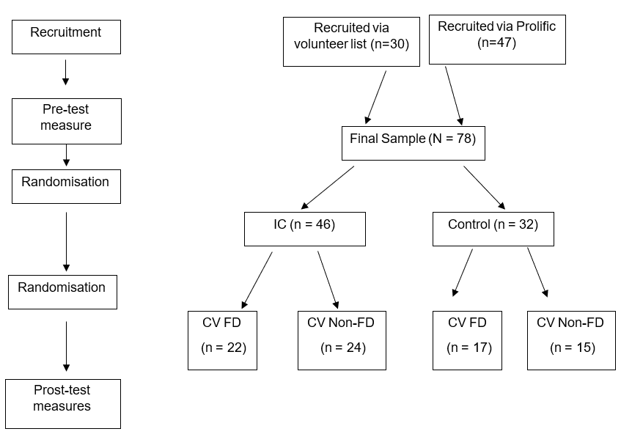

Recruitment
This study sought to include UK participants of working age that performed duties associated with recruitment as part of their job description. Initially, recruitment agencies were found online and contacted with information about the study. Targeted companies were invited to distribute the online experiment amongst their staff in exchange for participating in a raffle prize of 2x£20. A total of 30 participants were recruited via online invitations to local companies. In order to obtain further respondents to conduct this study, an online project with a link to the experiment was designed and launched using Prolific (www.prolific.ac). The study was set for an audience of people living in the UK and with hiring experience. Participants were paid an estimated £6 p/h in exchange to complete the experiment. Forty-eight participants were recruited via Prolific.

Experimental conditions
This pilot study utilised the IC methods reported in previous studies (Stathi & Crisp, 2009; Stathi et al., 2012). Participants were randomly allocated to either an intervention or a control arm. Recruiters allocated to the experimental condition were presented with general information about FD (i.e., frequency, challenges to those having FD). Next, a message giving guidelines to increase the recruitment of individuals with FD was displayed. This message was displayed in a series of bullet points that included the use of appropriate wording to address FD, recommendations on job advertising and suggested websites to improve practices of inclusion of individuals with FD (see appendix 5E for full details):
“Guidelines to increase the recruitment of individuals with Facial Disfigurement:
- Use ‘disfigurement’ as a semi-neutral collective word to refer to the visual effect of marks, scarring, asymmetry or an unusual functioning of a person’s face or body.
- Disfigurement is a word which is clearly understood and is used in the Equality Act 2010 which protects people with ‘severe’ disfigurements from discrimination. However, most people prefer to use the name of their condition or illness or a description of their illness.” (Excerpt of material in experimental condition)
The last section of the educational condition displayed two personal statements of individuals with FD (e.g., “Due to my (Facial disfigurement) condition, I do stand out from the crowd and you know, there have been times where I’ve been an easy target for bullies. That’s left me feeling isolated (…) As I’ve got older, I’ve learnt to be proud of the way I look. I love looking the way I do and I love being me”; Jono Lancaster, Treacher Collins advocate).
Following the presentation of educational material, participants were directed to an imagination task that encouraged them to imagine a positive interaction with an individual with FD (i.e. “We would like you to spend a few moments imagining yourself meeting and talking to an adult with a severe facial disfigurement that has sat next to you on the train. Imagine that the interaction is positive, and you find out some interesting and unexpected things about this person.”). A timer was introduced in this section so participants could not continue with the experiment for 60 seconds. After the instructions and timer were displayed, participants were asked to write a few lines describing the individual and interaction they just imagined: (1) “1. In a few sentences, please describe the person you just interacted with (for example, how was his/her physical appearance, tone of voice, etc). (2) “Please take a moment to describe the
interaction you've just imagined in a few sentences”
Participants allocated to the control condition were presented with a message about work-related stress, which included general information about work related stress and recommendations for its prevention, followed by a website link for further advice from the Health and Safety Executive (HSE, http://www.hse.gov.uk/stress). The control message on work-related stress was followed by instructions to complete a control imaginary task (i.e., We would like you to spend a few moments imagining an outdoor scene. Try to imagine aspects of the scene about you, e.g., is it a beach, a forest, are there trees, hills, what’s on the horizon?). Afterwards, participants were instructed to write a few words describing what they imagined; “Now, please list in a few sentences the different things that you saw in the scene you just imagined.”
After the presentation of the anti-stigma experimental and control conditions, participants were asked to read a brief job vacancy advert for a travel agent (see Figure 5.2).
Figure 5.2. Travel agent job advert
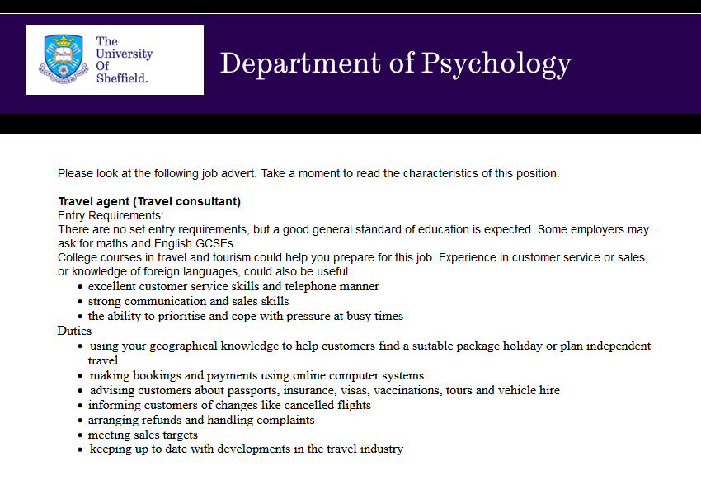
Then, participants were randomly allocated to evaluate a mock CV of either an applicant with FD or an applicant without FD. The content of the CV was identical for both mock applicants and the only difference was the picture associated with each CV. See figure 5.3 for details of mock CVs.
Figure 5.3. Mock CV and photos
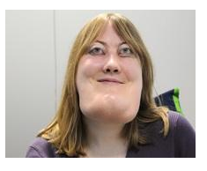

Measures
Demographic Information. All participants were asked to provide information about their age, gender, ethnicity, and whether they could identify FD as a protected form of disability. See appendix 5B-5D
Intended avoidance. Intentions to avoid individuals with FD were measured with the scale used by Kouznetsova, Stevenson, Oaten, and Case (2012). This scale was also utilised as an outcome variable on Study 2. The measure included three levels of contact; participants were asked to rate on a 7-point Likert scale (1= definitely would not/7=Definitely would) whether they would sit on a chair where someone with FD has been sat (1), sit next to someone with FD (2) and greet someone with FD (e.g., with a kiss on the cheek and a hug) (3). For this study, the internal consistency of this measure was acceptable (α = .75).
Personality rating scales. A measure of personality trait ratings was used at post-test. The scale had been utilised in the study of perceptions of FD, originally by(Stevenage and McKay (1999) and later on by(Stone and Wright (2012), whom adapted the scale to cover four specific areas: work-related competence (7 items), social potency (5 items), emotional strength (3 items), warmth (2 items) and attractiveness (1 item). Participants were instructed to rate one of two randomly allocated photograph (FD/Non-FD) and associated CV in a 6-point Likert scale ranging from ‘strongly disagree’ to ‘strongly agree. Reliability analysis showed good internal consistency for this instrument (α = .88). See appendix 5G.
Memory recall. Five multiple-choice questions were designed to assess the participant’s memory recall of information provided in the mock CV. Questions included the name of the candidate (1 item), employment history (1 item) and qualifications (3 questions). See appendix 5H.

Sample size
According to Connelly (2008), an appropriate sample size for a pilot study comprises at least 10% of the required sample size for a larger full-size study. However, guidelines are not consistent in the literature, for example; Isaac and Michael (1995) suggest as a rule of thumb to include from 10 to 30 participants for a pilot study. For the purpose of this study, power analysis for a 2x2 ANCOVA (experimental and control condition/FD mock profile/Control mock profile) was conducted using the software G*Power 3.1 (Faul, Erdfelder, Buchner, & Lang, 2009). The analysis used an alpha of 0.05, a power of 0.80, and a medium effect size (f = 0.25) based on previous studies testing education strategies to reduce stigma towards FD (Bogart & Tickle-Degnen, 2015). Results indicated that the desired sample size for a parent study of these characteristics would be 179; thus, a pilot study would require 17 participants per condition, adding up to at least a total sample of 68 respondents required to grant the study sufficient power.

Results

Demographics
Demographic differences between participants recruited via email invitation and Prolific were assessed using Chi²-test and independent samples t-test for categorical and continuous variables, respectively. There were no baseline differences between groups in terms of gender, ethnicity (White/Non-White), or whether they identified FD as a disability. However, participants who completed the experiment via Prolific were significantly older (M = 39.54, SD = 12.87) than respondents invited via e-mail (M = 31.20, SD = 9.66), t(76) = 3.04, p = 0.003.
A total of 78 recruitment staff took part in the study. The sample was composed of 44 (56.4%) females and 34 (43.6%) males, with a mean age of 36.33 (SD = 12.3). Participants were mostly of white ethnicity (n = 73). Fifty-eight participants (74%) identified FD as a protected form of disability, but only ten (12.8%) respondents reported ever encountering a person with FD in a recruitment process. Results from a Chi²-test and a t-test showed no significant differences in terms of gender, ethnicity or age between participants allocated to either control or experimental conditions. See Table 5.1 for demographic details.

Table 5.1. Demographic information (N = 78)
 |  |  | N | %
Gender
 | Female |  | 44 | 56.4
 | Male |  | 34 | 43.6
Age | Range |  | 18-73
 | M (SD) |  | 36.33 (12.37)
Ethnicity
 | White |  | 73 | 93.6
 | Asian/Asian British |  | 2 | 2.6
 | Mixed/Multiple ethnic groups |  | 2 | 2.6
 | Black/African/Caribbean/Black British |  | 1 | 1.3
Is FD protected under the disability act?
 | Yes |  | 58 | 74.4
 | No |  | 20 | 25.6
Have you ever encountered a person with FD in a recruitment process?
 | Yes |  | 10 | 12.8
 | No |  | 68 | 87.2

Intervention effect
A mixed 2x2 ANCOVA was conducted on this sample to assess the effect of an IC conditions (Control vs IC) on intentions to avoid a FD, memory recall, and evaluation ratings of a mock applicant FD (vs applicant without FD) in terms of work competence, social potency, emotional Strength, warmth and attractiveness. First a within sample t-test was conducted to assess the difference in scores of intended avoidance pre-test and post-test. Participant’s intentions to avoid FD were not different at pre-test (M = 5.77, SD = 0.78) compared to scores collected at post-test (M = 5.75, SD = 0.86; t(72) = 0.00, p = .99). For the subsequent 2x2 between-subject analysis, the variable of intended avoidance collected at pre-test was entered as a covariate and the variable of intended avoidance at post-test was entered as outcome variable. There was no significant effect of IC on intentions to avoid FD, F(4, 61) = 1.60, p = 0.15, ES = 0.15. However, there was a significant difference between evaluations of a mock CV of a person with compared to the CV of an applicant without FD, F(4, 61) = 13.10, p < 0.001 ES=0.60. Furthermore, there was a significant interaction between IC conditions and evaluation of a FD mock application, F(4, 61) = 2.02, p < 0.04 ES=0.20. See table 5.2 for the estimated means.

Post-test measure | Target | Control IC |  |  | Imagined Contact
 |  | EM (SE) | 95% Confidence Interval |  | EM (SE) | 95% Confidence Interval
 |  |  | Lower | Upper |  | Lower | Upper
Intended avoidance
 | Control | 5.56(0.13) | 5.302 | 5.822 | 5.78(0.11) | 5.547 | 6.018
 | FD | 5.86(0.10) | 5.650 | 6.085 | 5.88(0.10) | 5.668 | 6.092
Work Competence
 | Control | 4.90(0.12) | 4.649 | 5.164 | 4.91(0.11) | 4.702 | 5.134
 | FD | 5.23(0.11) | 4.997 | 5.464 | 5.26(0.10) | 5.056 | 5.477
Social Potency
 | Control | 4.7(0.14) | 4.476 | 5.061 | 4.41(0.12) | 4.171 | 4.661
 | FD | 4.70(0.13) | 4.434 | 4.965 | 4.70(0.13) | 4.477 | 4.955
Emotional Strength
 | Control | 4.05(0.21) | 3.633 | 4.485 | 4.15(0.17) | 3.796 | 4.509
 | FD | 4.64(0.19) | 4.254 | 5.027 | 3.93(0.17) | 3.584 | 4.280
Warmth
 | Control | 4.71(0.18) | 4.360 | 5.078 | 4.86(0.15) | 4.569 | 5.170
 | FD | 5.32(0.16) | 5.025 | 5.676 | 5.14(0.15) | 4.854 | 5.440
Attractiveness
 | Control | 5.16(0.27) | 4.616 | 5.705 | 5.17(0.22) | 4.721 | 5.633
 | FD | 3.57(0.25) | 3.084 | 4.073 | 3.78(0.22) | 3.335 | 4.225
Memory recall
 | Control | 2.99(0.31) | 2.358 | 3.632 | 3.00(0.26) | 2.473 | 3.539
 | FD | 3.76(0.29) | 3.190 | 4.345 | 3.37(0.26) | 2.856 | 3.896
Table 5.2. Estimated means for IC and targets

Bonferroni post-hoc test showed that the mock FD profile was rated as warmer (p = 0.006), with more work competence (p = 0.005) but less attractive (p <0.001) than the control mock applicant without FD. Memory recall approached significant levels (p = 0.045), with participants recalling more details for the mock FD applicant compared to the control applicant. See figure 5.4 for interaction.

Figure 5.4. Interaction target x IC for emotional strength
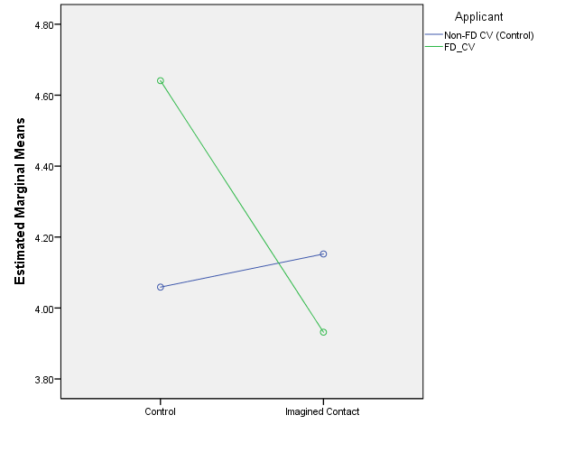

Discussion
This study aimed to pilot test whether an anti-stigma strategy of education and IC could reduce intentions to avoid FD and improve evaluations of a FD mock application. It was hypothesised that participants reading information about FD and imagining a positive interaction with an individual with FD would report fewer intentions to avoid FD, better memory recall and more positive evaluations of a mock applicant with FD. It was also hypothesised that the mock applicant with FD would receive significantly more negative evaluations and memory recall than the control mock application.
Contrary to our hypothesis, the anti-stigma strategy did not have an effect on intentions to avoid FD compared to the control strategy displaying a neutral message; thus, failing to replicate the findings reported in Study 2. Perhaps the difference in demographic characteristics between the (mostly) student sample used in Study 2, compared to the non-student sample reported in this study, influenced these mixed findings. In the literature, contrasting results between student and non-student samples have been reported in the study of prejudice (Dasgupta & Hunsinger, 2008; Peterson, 2001). It is possible that because participants of this study were more mature and experienced than those in Study 2, avoidance intentions remained unchanged in this study. Nevertheless, IC has resulted in decreased stigma in samples with similar demographic characteristics (e.g., disabilities; Carvalho‐Freitas & Stathi, 2017), therefore it is unclear whether the discrepancies can be explained solely by demographic differences.
Another reason behind these non-significant results may be the length of time employed by participants imagining the interaction with an individual with FD. Although this study followed the methodology used in experiments using IC (Crisp & Turner, 2009), instructions given to participants did not include a specific amount of time for the imagination task and the timer that impeded participants to continue to the next page was set at 60 seconds. This could have had implications on the elaboration of the imagined interaction that participants had and subsequently in the lack of effectiveness found in this study (Husnu & Crisp, 2010). It is possible that longer imaginal exposure (e.g., 5 minutes), such as that used by Turner, Crisp, and Lambert (2007), would yield more stigma reduction, particularly in a sample of a non-student sample.
While there is a growing body of evidence towards the effectiveness of IC (Miles & Crisp, 2013; Stathi et al., 2014), a handful of studies have reported non-significant findings (e.g., Dermody, Jones, & Cumming, 2013; West & Greenland, 2016). Because scientific literature is commonly biased towards the publication of statistically significant results and rejection of non-significant findings (publication bias; Scargle, 1999), it is hard to estimate whether IC is as effective as the published literature portraits. Although this is an unavoidable issue found across scientific fields, a future direction to test the IC hypothesis may be to analyse unpublished material reporting the outcome of IC strategies such as thesis, dissertations and research reports (Ioannidis, 2005; Moonesinghe, Khoury, & Janssens, 2007)
There was no significant difference in ratings of social potency between mock CVs with or without FD. This was an interesting result because this is a common stereotype attributed to people with FD. For instance, previous studies have reported lower ratings of social potency towards individuals with FD, compared to individuals without FD (Stone & Wright, 2012). Because many forms of FD affect facial expression (e.g., facial paralysis), it is likely that observers misjudge individuals with FD as more introverted and less sociable (Bogart, Cole, & Briegel, 2014).
Participants allocated to the mock CV of someone with FD rated the applicant as significantly warmer (items on friendliness and trustworthiness), higher work competence but less attractiveness, compared to participants evaluating an applicant without FD. These results resemblance findings from self-reported measures in Blascovich et al. (2001), whereby participants allocated to perform a task with a FD partner reported more positively ratings of their partners’ performance than did participants allocated to interact with a control confederate without FD. These results may in part reflect paternalistic stereotypes attributed to typically disadvantaged groups (e.g., the aging adults, the blind) who are perceived as non-threatening and higher in warmth. However, in this study participants also evaluated the FD applicant as higher in work competence, which does not correspond to the typical paternalistic stereotypes found in other stigmatised groups (Fiske et al., 2002; Glick & Fiske, 2001).
Compared to the control imagery task, imagining a positive interaction with an individual with FD did not have an effect on ratings of work competence, social capacity, warmth, attractiveness, emotional strength or memory recall of a mock applicant with FD. While these findings do not provide conclusive support for the effectiveness of IC strategies in reducing intentions to avoid FD, it is possible that it could be useful in other manifestations of stigma (e.g., social distance, implicit negative attitudes). Indeed, a significant body of literature supports IC as a useful tool to reduce stigma towards several disadvantaged groups.
This study used anti-stigma strategies based on education and imagined contact, however the experiment was completed in one brief session. Perhaps a greater number of sessions or more interactive awareness material would yield lower avoidance intentions. The profile and mock applicants evaluated by participants were both white females. Future studies would benefit from testing different types of applicants (e.g., FD against other stigmatised groups; Stone & Wright, 2012) and developing measures of the stigma that approximate to evaluations conducted in recruitment settings. Although the methodology and sample size of this pilot study was similar to studies testing imagined contact found in the literature (e.g.,(Stathi & Crisp, 2009; R. Turner et al., 2007), results were not conclusive about the effectiveness of IC on stigma towards FD. Further research is required to clarify the effect of IC and education anti-stigma strategies on observer’s evaluation of people with FD, particularly in samples of participants likely to participate in real life recruitment decisions.
While IC and education have been shown to be effective tools for prejudice and stigma reduction, the present findings were not conclusive in finding an effect in levels of stigma towards FD. However, the present results showed that, as it is the case of other disadvantaged groups (e.g., people with disabilities), people with FD may be subjected to paternalistic stereotypes, whereby negative attributions of competence are compensated by higher ratings of target’s warmth. However, due to underpowering issues in this study, further research is needed to evaluate the impact of traditionally effective strategies in the evaluation of job applicants with FD.

Chapter 6. General Discussion
The studies within this thesis aimed to further understand the dual process of stigma towards FD (Study 1 and systematic review) and to test the effectiveness of anti-stigma interventions, involving IC and education in awareness, on responses towards FD. The effect of these strategies was tested in samples of students (Study 2), and pilot-tested in a sample of employees with recruitment duties (Study 3). The hypotheses associated with each study were tested quantitatively using both correlational and experimental designs. The objective of the present chapter is to present an overall discussion of how all the findings that resulted from this thesis contribute towards the literature addressing stigma reduction strategies and stigmatisation processes towards FD. Thus, this chapter specific aims will cover: (i) a summary of the findings reported in previous chapters; (ii) theoretical implications of these findings for stigma and stigma-reduction research; (iii) the implications that these findings may have on policy and practice; (iv) a consideration of the strengths and limitations of these studies; and (v) a discussion of future research directions.
Chapter two presented the results of a systematic review covering the period 1980-2018. Fifty-one articles reporting findings of 57 studies (N = 14,767), were included in the review. In line with survey reports and studies of perceived stigma (Alex Clarke, Thompson, Jenkinson, Rumsey, & Newell, 2013; Clarke, 1999; Hodge, 2017; Kent & Al‐Abadie, 1996; Kent & Thompson, 2002; Rumsey & Harcourt, 2004; A. Thompson & Kent, 2001; A. R. Thompson & Broom, 2009) the literature supports that observers respond differently to FD (Jacob, Morisky, & Nsubuga, 2012; Kurzban & Leary, 2001; Park, Schaller, & Crandall, 2007; Stone & Potton, 2014). Stigma towards FD may in part be explained by protective mechanisms of disease avoidance, which are evident in the display of emotions like disgust (Ryan, Oaten, Stevenson, & Case, 2012; Shanmugarajah, Gaind, Clarke, & Butler, 2012; Stone & Potton, 2017) and threat (Blascovich, Mendes, Hunter, Lickel, & Kowai-Bell, 2001; Green-Armytage, Simonds, John, & Woodger, 2019; Newell, 1999). Furthermore, sociocultural influences also shape humans’ responses to FD (Stone & Potton, 2014). Stigma towards FD may follow theoretical approaches that have identified two distinctive systems underlying stigmatisation towards visibly different individuals (Pryor, Reeder, Yeadon, & Hesson-McLnnis, 2004).
On the basis of this systematic analysis of the literature, Study 1 was designed to test individual differences associated with implicit and explicit attitudes towards FD; particularly appearance related cognitions, disgust sensitivity, and motivations to respond without prejudice. Findings from this study showed a significant association between negative implicit attitudes and higher levels of contamination disgust sensitivity. High internal and low external motivations to respond without prejudice were also associated with more favourable implicit attitudes towards FD (Plant & Devine, 1998). Explicit ratings of FD were weakly correlated with positive implicit attitudes, however this association was lost after correcting for multiple testing (Hofmann, Gawronski, Gschwendner, Le, & Schmitt, 2005). Males displayed significantly more negative attitudes towards FD than did females. Conversely, females displayed significantly greater disgust sensitivity and appearance related concerns (Lieberman, Tybur, & Latner, 2012; Oaten, Stevenson, & Case, 2009; Olatunji, Haidt, McKay, & David, 2008; Rohrmann, Hopp, & Quirin, 2008).
Findings suggest the existence of gender differences regarding stigmatisation towards FD. Furthermore stigmatisation responses are associated with innate (disgust sensitivity), sociocultural (e.g., social desirability, also found in stigma towards psychiatric conditions; Michaels & Corrigan, 2013) and appearance-related cognitions (e.g., obesity; O’Brien et al., 2013). What people consider to be attractive or unattractive is shaped and maintained by sociocultural forces that have traditionally influenced our perception of beauty in others and in ourselves. However, in conceptualising beauty, one most also conceptualise what is not. Therefore, beauty and ugliness are not concepts that can be fully understood separately.
People with FD has traditionally been associated with attributes and stereotypes that influence the way others behave towards them. It is likely that some components of that behaviour are rooted in innate responses, aimed at maximising the chances of survival and reproduction in the species. Perhaps these protection mechanisms were particularly useful in human societies that lacked today’s medical advances. However, modern human society have the means to comprehend stigmatisation towards FD and implement strategies that aid inclusion of people that have a different appearance. After all, it is not uncommon for modern humans to change within a few generations what is culturally appreciated as beautiful. For example, transgressive changes aimed to break the severe ‘beautiful-ugliness’ dichotomy have occurred in the world of art. From the early perfectionist paintings of the renaissance, to the contemporary pieces of art of the XXI century, it has been possible to observe significant change in what was considered beautiful subjects, techniques, materials and forms. This is also happening in relation to the perception that we have of others. In post-modern society, the limit of concepts related with appearance is constantly being challenged for example, ideal body shape and gender. Although humans have a degree of understanding about what is stigma towards different others, further research efforts are needed to continue to evolve into a more inclusive society.
Studies targeting interventions to reduce public stigma towards FD were particularly absent in the literature. Only one study was found to test the effect of educational strategies on extraversion ratings of people with facial paralysis. Findings from Bogart and Tickle-Degnen (2015), support the effectiveness of strategies previously tested on stigma towards other disadvantaged groups (e.g., education on stigma towards psychiatric conditions; Corrigan, Morris, Michaels, Rafacz, & Rüsch, 2012). There is a strong body of literature on effective strategies to reduce devaluation towards others that could provide a methodological and theoretical background to substantiate future studies of stigma reduction towards FD (Lemmer & Wagner, 2015; Miles & Crisp, 2014). Study 2 and 3 attempted to contribute to repairing this gap in the literature.
Study two used a 3x2 experimental design to test the effect of awareness (video-clip or written message) and IC on intergroup anxiety levels and intentions to avoid FD. Results showed a significant effect of educational awareness and imagined contact strategies in reducing intentions to avoid FD. There was also an interaction effect between written awareness messages and the imagined contact condition. Conversely, results indicated a non-significant effect of either awareness or IC on intergroup anxiety and intended avoidance. Findings support a degree of effectiveness of education (awareness messages) and contact-based strategies (Imagined contact) in reducing stigma towards FD.
Study 1 and 2 utilised a sample of university students, mostly composed by young adults. However, practical implications of these findings may be appropriately introduced in settings where individuals with FD are particularly hindered, such as education (Seehra, Newton, & DiBiase, 2011) and recruitment settings (Madera & Hebl, 2012; Madera, 2016; Stevenage & McKay, 1999). Henceforth, Study 3 aimed to pilot-test these strategies (awareness and IC) within a specific sample of British employees with recruitment duties.
Using a 2x2 experimental design, Study 3 tested an anti-stigma condition with awareness and IC elements (IC vs control) on intentions to avoid FD, and evaluations of of an applicant with FD (compared to an applicant without FD). Results failed to replicate the effect of awareness and IC on intentions to avoid FD in this sample. A non-significant effect was also found in relation to evaluations of work competence, social potency, emotional strength, warmth, attractiveness or memory recall. It was found that compared to the neutral condition. A significant effect of CV applicant was found, with those allocated to the mock applicant with FD reporting significantly higher ratings of work competence and warmth, although less attractive than those allocated to a control applicant without FD. This may be associated with social desirability effects, as the majority of participants that had recruitment duties identified severe FD as a protected form of disability.
In this thesis, two distinctive aims were covered: (1) understanding the individual differences under the light of the scientific rationale of stigma towards stigmatised groups (systematic review and Study 1); and (2) testing whether stigma may be reduced, using education and contact-based strategies in students and non-student samples (Study 2 and Study 3). However, it is possible to find an intersection point across the studies that compose this thesis.
Implications for research and theory
Literature addressing stigma towards FD has increased in number and quality over the last two decades, however, over a third of the studies were conducted with samples of individuals from highly industrialised countries (e.g., USA, UK, Australia; Ackerman et al., 2009; Roberts, Wiskin, & Roalfe, 2008; Timms, 2013). Of those few studies in LMIC (Bodunde et al., 2016; Bull & David, 1986a; Owotade et al., 2014), it was suggested that stigma towards FD was based on misconceptions about factors that affect facial appearance and little knowledge about the available medical and psychological means to manage facial difference. Furthermore, it appears that people from or with non-western backgrounds heavily rely on religious and cultural beliefs to understand and respond towards FD (e.g., FD as punishment, God or destiny; Hughes et al., 2009; Thompson & Kent, 2001). Nevertheless, public stigma towards FD in non-western populations has only been investigated in African and East Asian backgrounds, with cross-sectional or qualitative designs and small sample sizes, which is unlikely to be representative of the phenomenon of stigma endured by individuals with FD in these areas of the world. Social processes like stigma are framed within sociocultural contexts that influence devaluating treatment or preference towards others (e.g., leprosy; Floyd-Richard & Gurung, 2000). The study of stigma cannot be complete without appropriate sociocultural comparisons that may reveal how non-western populations respond towards typically devaluated others.
In the last two decades, research addressing stigma towards FD has increasingly utilised evolutionary and dual-process model to serve as theoretical frameworks in the study stigmatisation towards FD (Kouznetsova, Stevenson, Oaten, & Case, 2012; Madera, 2016; Ryan et al., 2012; Stone & Potton, 2017; Stone & Wright, 2012) as well as towards other populations that are recipients of stigma (HIV/AIDS; Pryor et al., 2004). Results from Study 2 support the view that stigma may be embedded in innate functions of disease avoidance, as manifested in associations between high levels of disgust sensitivity to contamination cues and implicit preferences for faces without FD. However, disgust sensitivity (core, animal reminder and contamination) were not significantly correlated with intentions to avoid FD in Study 2.
Disgust is a universal emotion that likely serves purposes of protection against potential contamination (Curtis & Biran, 2001; Val, Robert, & Tamer, 2004), but it has also been implicated in human morality (Landy & Goodwin, 2015) and processes of partner selection (Chapman & Anderson, 2012). There is a growing body of literature supporting the implication of proneness to disgust and stigmatising responses towards others (Hodson & Costello, 2007; Inbar, Pizarro, Knobe, & Bloom, 2009; Tapias, Glaser, Keltner, Vasquez, & Wickens, 2007). Given that disgust is a universal emotion, future research on stigma towards FD would benefit from examining the influence of disgust sensitivity in stigmatising responses cross-culturally. For instance, exploring the said relationship in settings with a greater threat of parasitic contaminations, such as subtropical regions of the world (Curtis & Biran, 2001).
Human evolutionary past does not completely determine stigmatising response. While certain protective functions have been linked with stigmatisation, it is hypothesised that distinctive reflective (conscious) systems and societal demands also influence responses of stigma (Pryor et al., 2004; Reeder & Pryor, 2008). Consistent with this rationale, Study 1 and 2 showed that motivations to respond without prejudice, as well as self and cultural perception of appearance-related stimuli, were significantly correlated with stigmatising responses; therefore, supporting the hypotheses that stigma towards FD may operate as dual-system that comprises both innate and psychosocial processes.
This complexity in terms of reactions is particularly clear in the study of attitudes. Traditionally, attitudes were thought to be an individual’s disposition based on the available information towards a social object given subject. However, measuring attitudes via self-report measures do not seem to capture the whole picture of what attitudes involve (Hofmann et al., 2005). Recent literature has pointed at the importance of unconscious or implicit cognitive functions underlying social behaviour; indirect measures of attitudes, such as reaction times, have been used in the study of stigma and prejudice, complementing the understanding of this phenomenon (Greenwald, 1998; Azar, 2008).
Historically, FD has traditionally being depicted with negative models and connotations in media and advertising (e.g., evilness: Freddy krugger; Wardle, Boyce, & Barron, 2009). For instance, Pausch et al. (2012) reported that German participants commonly used animal related adjectives that, within the Germanic folklore, are used to label individuals with cleft lip palate (e.g., harelip or wolf-throat). In this thesis, it was found that even within the scientific literature, FD is often depicted with words that may have negative connotations, such as ‘abnormality’ ‘deformity’ and ‘deviation’ (see Review Chapter). The language used to describe facial difference may serve to ameliorate or reinforce the devaluation of individuals with FD. Indeed, charities like Changing Faces advocate for the use of neutral terms to address FD, particularly in the media (media recommendations, Changing Faces). Academic publications may also contribute towards the use of more inclusive depictions of FD (Young, Norman, & Humphreys, 2008).
Across the theoretical and experimental chapters that make up this thesis, there seems to be overwhelming evidence towards significant devaluation towards individuals with FD (e.g., Bull & David, 1986a; Franks & Goodrick-Meech, 1997; Hughes et al., 2009; Kleck & Strenta, 1985; Rankin & Borah, 2003; Rinnerthaler et al., 2006). The literature comprising devaluating responses towards FD have utilised broadly manifestations of stigma in terms of beliefs and knowledge, attitudes, cognitive and emotional responses, and overt stigma.
Individuals with FD are systematically rated by observers as less attractive, across congenital (e.g., cranial and cervical dystonia (Roberts & Gierasch, 2013), acquired (e.g., burns; Franks & Goodrick-meech, 1997), and dermatological aetiologies of FD (e.g., acne or psoriasis; Green-Armytage et al., 2019; Timms, 2013). Lower attractiveness ratings towards FD compared to non-visibly different targets, were supported by findings from Study 3, whereby a mock applicant with FD was rated as significantly more unattractive than a mock applicant without FD.
Other stereotypical personality traits attributed to FD are related to lower social capacity (Rinnerthaler, Mueller, Weichbold, Wenning, & Poewe, 2006; Stone & Wright, 2012) poorer competence (Hughes et al., 2009; Madera & Hebl, 2012; S M Mojon-Azzi et al., 2008; Rankin & Borah, 2003) and even mistrust (Halioua et al., 2011; Jamrozik, Oraa Ali, Sarwer, & Chatterjee, 2017; Rankin & Borah, 2003; Rinnerthaler et al., 2006). However, not all studies support this differential treatment towards FD and some report neutral and positive explicit evaluations of FD. For instance, results from Study 1, 2 and 3 showed overall positive or neutral explicit evaluations towards FD. On the other hand, it appears that fewer face value measures were more consistently negative, as shown in the literature and supported by findings from an IAT in Study 1 (Blascovich et al., 2001; Grandfield, Thompson, & Turpin, 2005). Responses towards FD are not unanimously negative in the literature, nor in this thesis.
Comparatively, there were fewer studies in the literature about overt avoidance of FD than studies addressing emotional, cognitive or attitudinal responses, which reflects the need to develop and utilise measures of manifested stigma. For example, two decades ago, studies using observational methods in naturalistic settings showed that people place greater distance between themselves and a person with FD (Bull & David, 1986b; Houston & Bull, 1994; Rumsey, Bull, & Gahagan, 1982). Conversely, a replication of this study in 2013, did not find any significant differences in proxemic behaviour towards FD, compared to targets without FD (Roberts & Gierasch, 2013). It is worth mentioning that it was only in the last two decades that the UK and other countries included FD within protective inclusion efforts targeting typically disadvantaged population (e.g., 2010 disability act in the UK). It is plausible that there has been a change over the past decades regarding responses towards visibly different individuals in western contexts. Conversely, it has been suggested that the nature of attitudes towards disabilities has shifted in modern times (Akrami, Ekehammar, Claesson, & Sonnander, 2006); while traditional manifestations of stigma used to be overt and blatant (e.g., Rumsey, Bull, & Gahagan, 1982), modern responses towards stigmatised individuals are covert and subtle (e.g., Roberts & Gierasch, 2013; Stone & Potton, 2014).
Another implication of this thesis’ findings is related to the study of anti-stigma strategies. In terms of efforts to reduce public stigma and discrimination, commonly used interventions used are education and contact (Corrigan & Penn, 1999; Heijnders & Meij, 2006). Education strategies have traditionally been used to challenge myths, stereotypes, and misconceptions with facts and knowledge (Corrigan, Watson, Warpinski, & Gracia, 2004; Seroalo, Du Plessis, Koen, & Koen, 2014). The literature on the effectiveness of educational programs is mixed, although findings from meta-analytical studies have reported small to medium effect sizes associated with stigma reduction of education strategies (Mittal, Sullivan, Chekuri, Allee, & Corrigan, 2012). On the other hand, contact and contact-based strategies have also reported stigma reduction, with a larger effect than education (Griffiths, Carron‐Arthur, Parsons, & Reid, 2014). Studies 2 showed a degree of support towards commonly used anti-stigma strategies in reducing stigma towards FD. Moreover, it is possible that education (awareness) and IC are more effective in students rather than non-student populations (Dasgupta & Hunsinger, 2008).

Implications for practice
According to Thompson, methods to reduce the detrimental effects of stigma towards individuals with FD have been framed on medical (corrective surgery; Van Schijndel, Litschel, Maal, Berg, & Tasman, 2015), individual (training in social skills, CBT; Alex Clarke, Thompson, Jenkinson, Rumsey, & Newell, 2014; Robinson, Rumsey, & Partridge, 1996) and societal (anti-stigma strategies; Bogart & Tickle-Degnen, 2015) perspectives on the phenomenon of stigma.
FD is particularly hard to conceal and the disabling consequences of disfigurement in people’s lives are comparable to those experienced by people living in chronic medical conditions and physical disabilities (Stone & Wright, 2012). According to the medical perspective, an alternative way to reduce stigma could be by surgically correcting atypical features into more accepted forms of appearance. Indeed, studies using eye-tracking studies suggest that observers’ ratings of facial features are not significantly different between control faces and faces after corrected procedures (Meyer-Marcotty & Stellzig-Eisenhauer, 2009). Furthermore, it appears that forms of disfigurement covering the central triangle of the face and large areas of the face are perceived by observers as in significantly greater need of correction, compared to small peripheral FDs (Van Schijndel et al., 2015; van Schijndel, Tasman, & Litschel, 2015). Nonetheless, access to surgery may be costly and in overcrowded public systems, individuals’ requests for corrective surgeries can be rejected, and sometimes dismissed as purely cosmetic (Hodge, 2017). It is hoped that this thesis helps demonstrate the theoretical and empirical evidence required to facilitate access to early surgical procedures, when requested by an individual with FD.
Disgust sensitivity has been shown to be a factor underlying processes of stigma towards FD and enacted stigma, for example, people with FD report expressions of disgust from others (Anderson & Clarke, 2017). Not surprisingly, people with FD experience feelings of shame and embarrassment ( Kent & Thompson, 2002). While shame and body image in disfigurement has received some attention, less is known about the potential role of self-disgust in adjustment processes to disfigurement. Future research directions in the study of self-stigma may benefit from testing the influence of disgust sensitivity in psychological adjustment to disfigurement, and the potential clinical implications that this may have on psychosocial wellbeing (Ille et al., 2014).
Studies 2 showed that some anti-stigma elements may help reduce stigma towards FD. Nevertheless, further testing of anti-stigma strategies is needed to sustain the effectiveness of education and contact-based strategies in the case of FD; it is likely that inclusion efforts are enriched by the introduction of anti-stigma strategies, particularly with specific populations of service providers (e.g., health staff, education, recruitment) that are likely to encounter opportunities to interact with and evaluate FD (Hong, Koo, & Koo, 2008). Education and contact-based strategies such as imagined contact, are cost effective and easy to implement (e.g., online) and thus it may help maximise stigma reduction efforts within more elaborated awareness and anti-stigma training packages (e.g., for nurses and health staff, recruiters; Carvalho‐Freitas & Stathi, 2017).
Obtaining protective rights has been without a doubt a major achievement in the struggle for facial equality in the UK. It is hard to estimate the impact that the inclusion of FD within the disability act may have had on stigma towards FD. In Study 3 over 70% of employees with recruitment duties identified severe FD as a protected type of disability covered in the disability act 2010, suggesting that it is relatively well known that severe FD is a protected category with special rights within the UK. This thesis is hoped to support the introduction of further forms of public policy that can offer individuals with FD more equal treatment within society. For instance, by encouraging the portray of counter-stereotypical models of individuals with FD in media and advertising (Wardle & Boyce, 2009).

Strengths and limitations
The specific limitations of each experimental study have been individually discussed in each associated chapter. The present chapter aimed to cover the strengths and limitations of this thesis within a broader scope across studies.
Firstly, this thesis addresses an important gap in the literature, particularly in relation to the literature of public-stigma reduction towards FD. A major strength of this thesis was the experimental testing of anti-stigma strategies in both student and non-student populations. Interestingly, by failing to replicate the effects of awareness and IC found in Study 2 in a non-student sample, this study 3 stretches the need for further research in with more naturalistic samples (Study 2 in Madera & Hebl, 2012). As seen in Study 1 and in the review chapter, stigma likely underpinned by individual differences (disgust sensitivity, gender; Ryan et al., 2012; Shanmugarajah et al., 2012; Stone & Potton, 2014) which may in part explain these contrasting results. Furthermore, study 3 was designed as a pilot test, and as such, it may lack the sufficient power to capture the effect of the experimental anti-stigma conditions on responses towards FD.
The studies within this thesis were conducted with UK participants and ethnicity data was particularly homogeneous, with over 80% of participants reporting having white ethnicity across studies. While this is broadly representative of the UK population, the generalisability beyond UK participants and high-income countries is limited. Further research should seek to adapt and replicate the studies within this thesis with populations from LMIC as well as collectivist cultures, where it is expected that differences may emerge.

Conclusions and future directions
It is hoped that findings from this thesis had contribute towards the literature and understanding how people respond to FD and in providing evidence-based support towards possible ways to decrease devaluating attitudes towards different appearance. However, as it is the case of the research practice, findings also generated further questions and pathways for future studies addressing stigma towards FD.
Findings suggest that responses towards FD follow the theoretical rationale of the dual process of stigma. However, testing this hypothesis would benefit from the inclusion of non-western samples in order to further investigate the relationship between different sociocultural norms and outlooks of beauty in stigma towards FD. Furthermore, the study of disgust-stigma relationship and disease avoidance hypothesis would be particularly enriched by cross-cultural comparisons that include samples from contexts with a higher prevalence of pathogens and pathogen-related disfigurement.
While there seem to be clear individual differences affecting stigma responses (e.g., gender, disgust sensitivity), stigma may be decreased with the use of education and contact-based strategies. Findings suggest that anti-stigma efforts tested in other forms of stigma may also have a significant effect on stigma towards FD (Bogart & Tickle-Degnen, 2015). Research efforts should continue to explore and test anti-stigma strategies in order to clarify underlying factors present in stigma and stigma reduction, particularly with psychological outcomes that are less prone to self-presentation effects and attempting to capture behavioural manifestations of stigma.
Congruently with Phelan, Link, and Dovidio (2008), findings from this thesis support that fields of prejudice and stigma have commonalities that may be useful for the design and test anti-stigma strategies, particularly in populations that are more likely to influence the inclusion of people with visible differences, such as educators, health care staff and recruitment personnel.

References
Ablett, K., & Thompson, A. R. (2016). Parental, child, and adolescent experience of chronic skin conditions: A meta-ethnography and review of the qualitative literature. Body Image, 19, 175–185.
Ackerman, J. M., Becker, D. V., Mortensen, C. R., Sasaki, T., Neuberg, S. L., & Kenrick, D. T. (2009). A pox on the mind: Disjunction of attention and memory in the processing of physical disfigurement. Journal of Experimental Social Psychology, 45(3), 478–485. https://doi.org/10.1016/j.jesp.2008.12.008
Adhikari, B., Kaehler, N., Chapman, R. S., Raut, S., & Roche, P. (2014). Factors affecting perceived stigma in leprosy affected persons in western Nepal. PLoS Neglected Tropical Diseases, 8, e2940. https://doi.org/10.1371/journal.pntd.0002940
Akrami, N., Ekehammar, B., Claesson, M., & Sonnander, K. (2006). Classical and modern prejudice: attitudes toward people with intellectual disabilities. Research in Developmental Disabilities, 27, 605–617. https://doi.org/10.1016/j.ridd.2005.07.003
Allport, G. W. (1954). nature of prejudice.
Allport, G. W., Clark, K., & Pettigrew, T. (1954). The nature of prejudice.
Alonso, J., Buron, A., Bruffaerts, R., He, Y., Posada‐Villa, J., Lepine, J., … Tachimori, H. (2008). Association of perceived stigma and mood and anxiety disorders: results from the World Mental Health Surveys. Acta Psychiatrica Scandinavica, 118, 305–314.
Anderson, S., & Clarke, V. (2017). Disgust, shame and the psychosocial impact of skin picking: Evidence from an online support forum. Journal of Health Psychology, 1359105317700254.
Angermeyer, M. C., Matschinger, H., & Corrigan, P. W. (2004). Familiarity with mental illness and social distance from people with schizophrenia and major depression: testing a model using data from a representative population survey. Schizophrenia Research, 69, 175–182. https://doi.org/10.1016/S0920-9964(03)00186-5
Armstrong, M. L., Roberts, A. E., Owen, D. C., & Koch, J. R. (2004). Contemporary college students and body piercing. Journal of Adolescent Health, 35, 58–61. https://doi.org/https://doi.org/10.1016/j.jadohealth.2003.08.012
Armstrong, T., Olatunji, B. O., Sarawgi, S., & Simmons, C. (2010). Orienting and maintenance of gaze in contamination fear: Biases for disgust and fear cues. Behaviour Research and Therapy, 48, 402–408. https://doi.org/10.1016/j.brat.2010.01.002
Augoustinos, M., & Every, D. (2007). The language of “race” and prejudice: A discourse of denial, reason, and liberal-practical politics. In Journal of Language and Social Psychology. https://doi.org/10.1177/0261927X07300075
Azar, B. (2008). IAT: Fad or fabulous. Monitor on Psychology, 39(7), 44.
Babatunde, O., & Oyeronke, A. (2010). Scarification practice and scar complications among the Nigerian Yorubas. Indian Journal of Dermatology, Venereology and Leprology, 76, 571.
Bartoş, S. E., Berger, I., & Hegarty, P. (2014). Interventions to reduce sexual prejudice: A study-space analysis and meta-analytic review. The Journal of Sex Research, 51, 363–382.
Bathje, G., & Pryor, J. (2011). The relationships of public and self-stigma to seeking mental health services. Journal of Mental Health Counseling, 33, 161–176.
Batson, C. D., Chang, J., Orr, R., & Rowland, J. (2002). Empathy, attitudes, and action: Can feeling for a member of a stigmatized group motivate one to help the group? Personality and Social Psychology Bulletin, 28(12), 1656–1666.
Bazopoulou‐Kyrkanidou, E. (1997). What makes Hephaestus lame? American Journal of Medical Genetics, 72(2), 144–155.
Bessell, A., & Moss, T. P. (2007). Evaluating the effectiveness of psychosocial interventions for individuals with visible differences: A systematic review of the empirical literature. Body Image, 4, 227–238. https://doi.org/https://doi.org/10.1016/j.bodyim.2007.04.005
Bigler, R. S., & Hughes, J. M. (2010). Reasons for skepticism about the efficacy of simulated social contact interventions.
Birtel, M. D., & Crisp, R. J. (2012a). Imagining intergroup contact is more cognitively difficult for people higher in intergroup anxiety but this does not detract from its effectiveness. Group Processes & Intergroup Relations, 15, 744–761.
Birtel, M. D., & Crisp, R. J. (2012b). “Treating” Prejudice: An Exposure-Therapy Approach to Reducing Negative Reactions Toward Stigmatized Groups. Psychological Science, 23, 1379–1386. https://doi.org/10.1177/0956797612443838
Blanton, H., & Jaccard, J. (2006). Arbitrary metrics in psychology. American Psychologist, 61, 27.
Blanton, H., Jaccard, J., Gonzales, P. M., & Christie, C. (2006). Decoding the implicit association test: Implications for criterion prediction. Journal of Experimental Social Psychology, 42, 192–212.
Blascovich, J., Mendes, W. B., Hunter, S. B., Lickel, B., & Kowai-Bell, N. (2001). Perceiver threat in social interactions with stigmatized others. Journal of Personality and Social Psychology, 80, 253.
Bodunde, O., Runsewe-Abiodun, T., Alabi, A., Adetunji, J., Olowonyo, M., & Adefuye, B. (2016). Awareness and Perception of Strabismus Among the Youths And Women of Child-Bearing Age in a Local Government in South Western Nigeria: A Qualitative Study. International Quarterly of Community Health Education. https://doi.org/10.1177/0272684X16660025
Bogart, K. R., & Tickle-Degnen, L. (2015). Looking beyond the face: A training to improve perceivers’ impressions of people with facial paralysis. Patient Education and Counseling, 98, 251–256. https://doi.org/10.1016/j.pec.2014.09.010
Bogart, K. R., Cole, J., & Briegel, W. (2014). On the Consequences of living without facial expression.
Bogart, K., Tickle-Degnen, L., & Ambady, N. (2014). Communicating without the Face: Holistic Perception of Emotions of People with Facial Paralysis. Basic and Applied Social Psychology, 36, 309–320. https://doi.org/10.1080/01973533.2014.917973
Brendl, C. M., Markman, A. B., & Messner, C. (2001). How do indirect measures of evaluation work? Evaluating the inference of prejudice in the Implicit Association Test. Journal of Personality and Social Psychology, 81(5), 760–773.
Bull, R., & Brooking, J. (1985). Does marriage influence whether a facially disfigured person is considered physically unattractive? The Journal of Psychology, 119, 163–167.
Bull, R., & David, I. (1986a). The stigmatizing effect of facial disfigurement: Nigerian and English nurses’ and office workers’ ratings of normal and scarred faces. Journal of Cross-Cultural Psychology, 17, 99–108.
Bull, R., & David, I. (1986b). The Stigmatizing Effect of Facial Disfigurement. Journal of Cross-Cultural Psychology, 17, 99–108. https://doi.org/10.1177/0022002186017001007
Burriss, R. P., Rowland, H. M., & Little, A. C. (2009). Facial scarring enhances men’s attractiveness for short-term relationships. Personality and Individual Differences, 46, 213–217.
Bzdok, D., Langner, R., Caspers, S., Kurth, F., Habel, U., Zilles, K., … Eickhoff, S. B. (2011). ALE meta-analysis on facial judgments of trustworthiness and attractiveness. Brain Structure and Function, 215, 209–223.
Cacciapaglia, H. M., Beauchamp, K. L., & Howells, G. N. (2004). Visibility of Disability: Effect on Willingness to Interact. Rehabilitation Psychology, 49, 180.
Calogero, R., Davis, W., & Thompson, J. (2004). The Sociocultural Attitudes Toward Appearance Questionnaire (SATAQ-3): Reliability and normative comparisons of eating disordered patients. Body Image. http://www.sciencedirect.com/science/article/pii/S1740144504000300
Cameron, L., Rutland, A., & Turner, R. (2011). “Changing attitudes with a little imagination”: Imagined contact effects on young children’s intergroup bias. Anales de Psicología/. Retrieved from http://revistas.um.es/analesps/article/view/135311
Carvalho‐Freitas, M. N. de, & Stathi, S. (2017). Reducing workplace bias toward people with disabilities with the use of imagined contact. Journal of Applied Social Psychology, 47, 256–266.
Changing Faces (2017). Disfigurement in the UK. Retrieved from https://www.changingfaces.org.uk/wp-content/uploads/2017/05/DITUK.pdf
Chapman, H. A., & Anderson, A. K. (2012). Understanding disgust. Annals of the New York Academy of Sciences, 1251, 62–76. https://doi.org/10.1111/j.1749-6632.2011.06369.x
Chatterjee, Anjan. (2014). The aesthetic brain: how we evolved to desire beauty and enjoy art. New York, NY ; Oxford :Oxford University Press.
Chaudoir, S. R., Earnshaw, V. A., & Andel, S. (2013). “Discredited” versus “discreditable”: understanding how shared and unique stigma mechanisms affect psychological and physical health disparities. Basic and Applied Social Psychology, 35, 75–87.
Clair, M., & Denis, J. S. (2015). Racism, sociology of. International Encyclopedia of the Social & Behavioral Sciences, 857–863.
Clarke, A. (1999). Psychosocial aspects of facial disfigurement: problems, management and the role of a lay-led organization. Psychology, Health & Medicine, 4, 127–142.
Clarke, Alex, & Cooper, C. (2001). Psychosocial rehabilitation after disfiguring injury or disease: investigating the training needs of specialist nurses. Journal of Advanced Nursing, 34, 18–26.
Clarke, Alex, Thompson, A. R., Jenkinson, E., Rumsey, N., & Newell, R. (2013). CBT for Appearance Anxiety: Psychosocial Interventions for Anxiety due to Visible Difference. Wiley. Retrieved from https://books.google.com/books?id=VVrSAQAAQBAJ&pgis=1
Clarke, Alex, Thompson, A. R., Jenkinson, E., Rumsey, N., & Newell, R. (2014). CBT for appearance anxiety: Psychosocial interventions for anxiety due to visible difference. CBT for appearance anxiety: Psychosocial interventions for anxiety due to visible difference.xvii, 300 pp. Retrieved from http://ovidsp.ovid.com/ovidweb.cgi?T=JS&CSC=Y&NEWS=N&PAGE=fulltext&D=psyc11&AN=2013-42992-000; http://dc8qa4cy3n.search.serialssolutions.com/?url_ver=Z39.88-2004&rft_val_fmt=info:ofi/fmt:kev:mtx:journal&rfr_id=info:sid/Ovid:psyc11&rft.genre=article&rft_id
Clement, S., Lassman, F., Barley, E., Evans‐Lacko, S., Williams, P., Yamaguchi, S., … Thornicroft, G. (2013). Mass media interventions for reducing mental health‐related stigma. Cochrane Database of Systematic Reviews.
Cline, T., Proto, A., Raval, P., & Di Paolo, T. (1998). The Effects of Brief Exposure and of Classroom Teaching on Attitudes Children Express towards Facial Disfigurement in Peers. Educational Research, 40, 55–68.
Coneo, A. M. C., Thompson, A. R., & Lavda, A. (2017). The influence of optimism, social support and anxiety on aggression in a sample of dermatology patients: an analysis of cross-sectional data. British Journal of Dermatology, 176, 1187–1194. https://doi.org/10.1111/bjd.15115
Cook, T. M., & Wang, J. (2010). Descriptive epidemiology of stigma against depression in a general population sample in Alberta. BMC Psychiatry, 10, 29. https://doi.org/10.1186/1471-244X-10-29
Corrigan, P. W. (2000). Mental Health Stigma as Social Attribution: Implications for Research Methods and Attitude Change. Clinical Psychology: Science and Practice, 7, 48–67. Retrieved from http://www.scopus.com/inward/record.url?eid=2-s2.0-0002576015&partnerID=tZOtx3y1
Corrigan, P. W., & Penn, D. L. (1999). Lessons from social psychology on discrediting psychiatric stigma. American Psychologist, 54(9), 765–776. Retrieved from http://www.scopus.com/inward/record.url?eid=2-s2.0-0033195052&partnerID=tZOtx3y1
Corrigan, P. W., & Shapiro, J. R. (2010). Measuring the impact of programs that challenge the public stigma of mental illness. Clinical Psychology Review, 30, 907–922. https://doi.org/10.1016/j.cpr.2010.06.004
Corrigan, P. W., Bink, A. B., Fokuo, J. K., & Schmidt, A. (2015). The public stigma of mental illness means a difference between you and me. Psychiatry Research, 226, 186–191. https://doi.org/10.1016/j.psychres.2014.12.047
Corrigan, P. W., Morris, S. B., Michaels, P. J., Rafacz, J. D., & Rüsch, N. (2012). Challenging the public stigma of mental illness: a meta-analysis of outcome studies. Psychiatric Services, 63, 963–973.
Corrigan, P. W., River, L. P., Lundin, R. K., Penn, D. L., Uphoff-Wasowski, K., Campion, J., … Goldstein, H. (2001). Three strategies for changing attributions about severe mental illness. Schizophrenia Bulletin, 27, 187–195.
Corrigan, P. W., Watson, A. C., Warpinski, A. C., & Gracia, G. (2004). Implications of Educating the Public on Mental Illness, Violence, and Stigma. Psychiatric Services, 55, 577–580. https://doi.org/10.1176/appi.ps.55.5.577
Cosmides, L., & Tooby, J. (1994). Better than Rational: Evolutionary Psychology and the Invisible Hand. The American Economic Review, 84, 327–332. Retrieved from http://www.jstor.org/stable/2117853
Cosmides, L., & Tooby, J. (2010). Origins of domain specificity: The evolution of functional organization. Mapping the Mind, 85–116. https://doi.org/10.1017/cbo9780511752902.005
Crandall, C. S., Eshleman, A., & O’Brien, L. (2002). Social norms and the expression and suppression of prejudice: The struggle for internalization. Journal of Personality and Social Psychology, 82, 359–377. https://doi.org/10.1037//0022-3514.82.3.359
Crawford, A. M. (1996). Stigma Associated With AIDS: A Meta‐Analysis 1. Journal of Applied Social Psychology, 26, 398–416.
Crisp, R. J., & Turner, R. N. (2009). Can imagined interactions produce positive perceptions?: Reducing prejudice through simulated social contact. American Psychologist, 64, 231.
Crisp, R., & Turner, R. (2009). Can imagined interactions produce positive perceptions?: Reducing prejudice through simulated social contact. American Psychologist. Retrieved from http://psycnet.apa.org/journals/amp/64/4/231/
Crisp, R., Stathi, S., & Turner, R. (2009). Imagined intergroup contact: Theory, paradigm and practice. Social and Personality. http://onlinelibrary.wiley.com/doi/10.1111/j.1751-9004.2008.00155.x/full
Crocker, J., & Major, B. (1994). Reactions to stigma: The moderating role of justifications. In The psychology of prejudice: The Ontario symposium (Vol. 7, pp. 289–314).
Crocker, J., & Major, B. (2004). The Self-Protective Properties of Stigma: Evolution of a Modern Classic. Psychological Inquiry, 14, 232–237. https://doi.org/10.1207/s15327965pli1403&4_9
Cuddy, A. J. C., & Fiske, S. T. (2002). Doddering but dear: Process, content, and function in stereotyping of older persons. Ageism: Stereotyping and Prejudice against Older Persons, 3, 26.
Curtis, V., & Biran, A. (2001). Dirt, disgust, and disease: Is hygiene in our genes? Perspectives in Biology and Medicine, 44, 17–31.
Darwin, C. (1859). The Origins of Species. London: Murray. https://doi.org/10.1126/science.146.3640.51-b
Darwin, C. (1890). The Expression of the Emotions in Man and Animals. Cambridge Library Collection - Darwin, Evolution and Genetics (2 OP-18). Cambridge: Cambridge University Press. https://doi.org/DOI: 10.1017/CBO9780511694110
Dasgupta, N., & Hunsinger, M. (2008). The Opposite of a Great Truth Is Also True: When Do Student Samples Help Versus Hurt the Scientific Study of Prejudice? Psychological Inquiry, 19, 90–98. https://doi.org/10.1080/10478400802049860
Davies, G., Ellis, H., & Shepherd, J. (1977). Cue saliency in faces as assessed by the ‘Photofit’technique. Perception, 6, 263–269.
DeBruine, L. M., Jones, B. C., Tybur, J. M., Lieberman, D., & Griskevicius, V. (2010). Women’s preferences for masculinity in male faces are predicted by pathogen disgust, but not by moral or sexual disgust. Evolution and Human Behavior, 31, 69–74.
Deris, S. (2013). Examining the Hephaestus Myth through a Disability Studies Perspective. Prandium: The Journal of Historical Studies at U of T Mississauga, 2(1).
Dermody, N., Jones, M. K., & Cumming, S. R. (2013). The failure of imagined contact in reducing explicit and implicit out-group prejudice toward male homosexuals. Current Psychology, 32, 261–274.
Devine, P. G., Plant, E. A., Amodio, D. M., Harmon-Jones, E., & Vance, S. L. (2002). The regulation of explicit and implicit race bias: The role of motivations to respond without prejudice. Journal of Personality and Social Psychology, 82(5), 835.
Dictionary, O. E. (2007). Art, N. English.
Diener, E., Sandvik, E., & Larsen, R. J. (1985). Age and sex effects for emotional intensity. Developmental Psychology, 21, 542.
Dijk, T. A. van. (1989). Mediating racism. The role of the media in the reproduction of racism. Language, Power and Ideology. Studies in Political Discourse, (Hammar 1985), 199–226.
Dijker, A. J., Tacken, M. A., & Borne, B. (2000). Context effects of facial appearance on attitudes toward mentally handicapped persons. British Journal of Social Psychology, 39, 413–427.
Dinas, E. (2013). Opening “Openness to Change” Political Events and the Increased Sensitivity of Young Adults. Political Research Quarterly, 66, 868–882.
Dovidio, J. F., Gaertner, S. L., & Kawakami, K. (2003). Intergroup Contact: The Past, Present, and the Future. Group Processes & Intergroup Relations, 6, 5–21. https://doi.org/10.1177/1368430203006001009
Dovidio, J. F., Glick, P., & Rudman, L. A. (2008). On the nature of prejudice: Fifty years after Allport. John Wiley & Sons.
Dovidio, J. F., Major, B., & Crocker, J. (2000). Stigma: Introduction and overview.
Druschel, B. A., & Sherman, M. F. (1999). Disgust sensitivity as a function of the Big Five and gender. Personality and Individual Differences, 26, 739–748.
Duggan, S. J., & McCreary, D. R. (2004). Body Image, Eating Disorders, and the Drive for Muscularity in Gay and Heterosexual Men. Journal of Homosexuality, 47, 45–58. https://doi.org/10.1300/J082v47n03_03
Dunaev, J. L., Brochu, P. M., & Markey, C. H. (2018). Imagine that! The effect of counterstereotypic imagined intergroup contact on weight bias. Health Psychology, 37, 81.
Eagly, A., & Ashmore, R. (1991). What is beautiful is good, but: A meta-analytic review of research on the physical attractiveness stereotype. Psychological …. Retrieved from http://psycnet.apa.org/psycinfo/1991-33123-001
Egan, K., Harcourt, D., & Rumsey, N. (2011). A qualitative study of the experiences of people who identify themselves as having adjusted positively to a visible difference. Journal of Health Psychology, 16, 739–749.
Entman, R. M. (1992). Blacks in the News: Television, Modern Racism and Cultural Change. Journalism Quarterly, 69, 341–361. https://doi.org/10.1177/107769909206900209
Eriksson, S., & Lagerström, J. (2012). Detecting discrimination in the hiring process: evidence from an Internet-based search channel. Empirical Economics, 43, 537–563. https://doi.org/10.1007/s00181-011-0496-6
Evans, J. (1997). Men in nursing: issues of gender segregation and hidden advantage. Journal of Advanced Nursing, 26(2), 226–231.
Faber, J., & Fonseca, L. M. (2014). How sample size influences research outcomes. Dental Press Journal of Orthodontics, 19, 27–29. https://doi.org/10.1590/2176-9451.19.4.027-029.ebo
Farina, A. (1981). Are women nicer people than men? Sex and the stigma of mental disorders. Clinical Psychology Review, 1(2), 223-243.
Faul, F., Erdfelder, E., Buchner, A., & Lang, A.-G. (2009). Statistical power analyses using G*Power 3.1: tests for correlation and regression analyses. Behavior Research Methods, 41(4), 1149–1160. https://doi.org/10.3758/BRM.41.4.1149
Faul, F., Erdfelder, E., Buchner, A., & Lang, A.-G. (2009). Statistical power analyses using G*Power 3.1: tests for correlation and regression analyses. Behavior Research Methods, 41, 1149–1160. https://doi.org/10.3758/BRM.41.4.1149
Faulkner, J., Schaller, M., Park, J. H., & Duncan, L. A. (2004). Evolved disease-avoidance mechanisms and contemporary xenophobic attitudes. Group Processes & Intergroup Relations, 7, 333–353.
Feingold, A. (1992). Good-Looking People Are Not What We Think. Psychological Bulletin, 111, 304–341. https://doi.org/10.1037/0033-2909.111.2.304
Fessler, D. M. T., Pillsworth, E. G., & Flamson, T. J. (2004). Angry men and disgusted women: An evolutionary approach to the influence of emotions on risk taking. Organizational Behavior and Human Decision Processes, 95, 107–123. https://doi.org/10.1016/j.obhdp.2004.06.006
Fiest, K. M., Birbeck, G. L., Jacoby, A., & Jette, N. (2014). Stigma in epilepsy. Current Neurology and Neuroscience Reports, 14, 444. https://doi.org/10.1007/s11910-014-0444-x
Fink, P. J. (1992). Stigma and Mental Illness. American Psychiatric Pub. Retrieved from https://books.google.com/books?id=gmCxeAw7-Z4C&pgis=1
Finkelstein, J., Lapshin, O., & Wasserman, E. (2008). Randomized study of different anti-stigma media. Patient Education and Counseling, 71, 204–214. https://doi.org/10.1016/j.pec.2008.01.002
Fiske, S. T., Cuddy, A. J. C., Glick, P., & Xu, J. (2002). A model of (often mixed) stereotype content: competence and warmth respectively follow from perceived status and competition. Journal of Personality and Social Psychology, 82, 878.
Floyd-Richard, M., & Gurung, S. (2000). Stigma reduction through group counselling of persons affected by leprosy - A pilot study. Leprosy Review, 71, 499–504. Retrieved from http://www.scopus.com/inward/record.url?eid=2-s2.0-0034494431&partnerID=tZOtx3y1
Fox, E., Russo, R., Bowles, R., & Dutton, K. (2001). Do threatening stimuli draw or hold visual attention in subclinical anxiety? Journal of Experimental Psychology: General, 130, 681.
Franks, T., & Goodrick-meech, A. (1997). Society ’ s Perceptions of Visibly Burned Adults and the Implications for Occupational Therapy, 60(July).
Fraser, I. H., Craig, G. L., & Parker, D. M. (1990). Reaction time measures of feature saliency in schematic faces. Perception, 19, 661–673.
Fredrickson, B. L., & Roberts, T. A. (1997). Objectification theory: Toward understanding women's lived experiences and mental health risks. Psychology of women quarterly, 21(2), 173-206.
Fredrickson, B., & Roberts, T. (1997). Objectification theory. Psychology of Women Quarterly. Retrieved from http://onlinelibrary.wiley.com/doi/10.1111/j.1471-6402.1997.tb00108.x/abstract
Fung, I. C. H. (2008). Citation of non-English peer review publications – some Chinese examples. Emerging Themes in Epidemiology, 5, 12. https://doi.org/10.1186/1742-7622-5-12
Ganis, G., Thompson, W., & Kosslyn, S. (2004). Brain areas underlying visual mental imagery and visual perception: an fMRI study. Cognitive Brain Research. http://www.sciencedirect.com/science/article/pii/S0926641004000709
Gardiner, M. D., Topps, A., Richardson, G., Sacker, A., Clarke, A., & Butler, P. E. M. (2010). Differential judgements about disfigurement: the role of location, age and gender in decisions made by observers. Journal of Plastic, Reconstructive & Aesthetic Surgery, 63, 73–77.
Garrisi, D., Janciute, L., & Johanssen, J. (2018). Appearance, discrimination and the media. University of Westminster Press.
Garve, R., Garve, M., Türp, J. C., Fobil, J. N., & Meyer, C. G. (2017). Scarification in sub-Saharan Africa: social skin, remedy and medical import. Tropical Medicine & International Health, 22, 708–715. https://doi.org/10.1111/tmi.12878
Genrich, G. L., & Brathwaite, B. A. (2005). Response of religious groups to HIV/AIDS as a sexually transmitted infection in Trinidad. BMC Public Health, 5, 121. https://doi.org/10.1186/1471-2458-5-121
Ghazanfar, A. A., & Santos, L. R. (2004). Primate brains in the wild: the sensory bases for social interactions. Nature Reviews Neuroscience, 5(8), 603–616.
Ginsburg, I. H., & Link, B. G. (1993). Psychosocial consequences of rejection and stigma feelings in psoriasis patients. International Journal of Dermatology, 32, 587–591. Retrieved from http://www.ncbi.nlm.nih.gov/pubmed/8407075
Glick, P, & Fiske, S. T. (2001). Ambivalent stereotypes as legitimizing ideologies. Differenti-Ambivalent stereotypes as legitimizing ideologies. Differentiating paternalistic and envious prejudice. JT Jost e B. Major (a cura di), The psychology of legitimacy.
Glick, Peter, & Fiske, S. T. (2001). An ambivalent alliance: Hostile and benevolent sexism as complementary justifications for gender inequality. American Psychologist, 56, 109.
Godoy, A., Ishii, M., Byrne, P. J., Boahene, K. D. O., Encarnacion, C. O., & Ishii, L. E. (2011). The straight truth: Measuring observer attention to the crooked nose. Laryngoscope, 121, 937–941. https://doi.org/10.1002/lary.21733
Goffman, E. (1963). Stigma: Notes on a spoiled identity. Jenkins, JH & Carpenter. Retrieved from https://scholar.google.co.uk/scholar?hl=en&q=stigma%3A+notes+on+the+goffman&btnG=&as_sdt=1%2C5&as_sdtp=#1
Goldstein, B., & Rosselli, F. (2003). Etiological paradigms of depression: The relationship between perceived causes, empowerment, treatment preferences, and stigma. Journal of Mental Health, 12, 551–563.
Grabe, S., Ward, L. M., & Hyde, J. S. (2008). The role of the media in body image concerns among women: a meta-analysis of experimental and correlational studies. Psychological Bulletin, 134, 460–476. https://doi.org/10.1037/0033-2909.134.3.460
Grandfield, T. A., Thompson, A. R., & Turpin, G. (2005). An attitudinal study of responses to a range of dermatological conditions using the implicit association test. Journal of Health Psychology, 10, 821–829. https://doi.org/10.1177/1359105305057316
Green-Armytage, M., Simonds, L. M., John, M., & Woodger, N. (2019). Depictions of acne and psoriasis influence interpersonal aversion. Psychology, Health & Medicine, 24, 94–100. https://doi.org/10.1080/13548506.2018.1497188
Greenwald, A. (1998). Measuring individual differences in implicit cognition: the implicit association test. Journal of Personality …. Retrieved from http://psycnet.apa.org/psycinfo/1998-02892-004
Greenwald, A. G., Nosek, B. A., & Banaji, M. R. (2003). Understanding and using the implicit association test: I. An improved scoring algorithm. Journal of Personality and Social Psychology, 85, 197.
Griffin, A. M., & Langlois, J. H. (2006). Stereotype directionality and attractiveness stereotyping: Is beauty good or is ugly bad? Social Cognition, 24(2), 187–206.
Griffiths, K. M., Carron‐Arthur, B., Parsons, A., & Reid, R. (2014). Effectiveness of programs for reducing the stigma associated with mental disorders. A meta‐analysis of randomized controlled trials. World Psychiatry, 13, 161–175.
Grossman, M., & Wood, W. (1993). Sex differences in intensity of emotional experience: a social role interpretation. Journal of Personality and Social Psychology, 65, 1010.
Guillaumin, C. (2002). Racism, sexism, power and ideology. Routledge.
Guimond, S. (2000). Group socialization and prejudice: The social transmission of intergroup attitudes and beliefs. European Journal of Social Psychology, 30(3), 335–354.
Halioua, R. L., Williams, R. S. T., Murray, N. P., Skalko, T. K., & Vogelsong, H. G. (2011). Staring and Perceptions of People with Facial Disfigurement. Therapeutic Recreation Journal, 45, 341–356. Retrieved from http://search.ebscohost.com/login.aspx?direct=true&db=sph&AN=70479946&site=ehost-live
Han, H. A., Czellar, S., Olson, M. A., & Fazio, R. H. (2010). Malleability of attitudes or malleability of the IAT? Journal of Experimental Social Psychology, 46, 286–298.
Hanson, J. (2012). Ideology, Psychology, and Law. Oxford University Press, USA. Retrieved from https://books.google.com/books?hl=en&lr=&id=ab48OwNmW3UC&pgis=1
Haselton, M. G., & Buss, D. M. (2000). Error management theory: a new perspective on biases in cross-sex mind reading. Journal of Personality and Social Psychology, 78, 81.
Haselton, M. G., & Nettle, D. (2006). The Paranoid Optimist: An Integrative Evolutionary Model of Cognitive Biases. Personality and Social Psychology Review, 10, 47–66. https://doi.org/10.1207/s15327957pspr1001_3
Haxby, J. V, Hoffman, E. A., & Gobbini, M. I. (2002). Human neural systems for face recognition and social communication. Biological Psychiatry, 51, 59–67.
Hegarty, P., & Golden, A. M. (2008). Attributional beliefs about the controllability of stigmatized traits: antecedents or justifications of prejudice? 1. Journal of Applied Social Psychology, 38, 1023–1044.
Heijnders, M., & Meij, S. Van Der. (2006). The fight against stigma: an overview of stigma-reduction strategies and interventions. Psychology, Health & Medicine. Retrieved from http://www.tandfonline.com/doi/abs/10.1080/13548500600595327
Henderson, C., Evans-Lacko, S., Flach, C., & Thornicroft, G. (2012). Responses to mental health stigma questions: the importance of social desirability and data collection method. The Canadian Journal of Psychiatry, 57, 152–160.
Henry, P. J. (2008). College sophomores in the laboratory redux: Influences of a narrow data base on social psychology’s view of the nature of prejudice. Psychological Inquiry, 19, 49–71.
Hochschild, A. (1999). King Leopold’s ghost: A story of greed, terror, and heroism in colonial Africa. Houghton Mifflin Harcourt.
Hodge, M. (2017). Disfigurement in the UK. Retrieved from https://www.changingfaces.org.uk/wp-content/uploads/2017/05/DITUK.pdf
Hodson, G., & Costello, K. (2007). Interpersonal disgust, ideological orientations, and dehumanization as predictors of intergroup attitudes. Psychological Science, 18, 691–698.
Hofmann, W., Gawronski, B., Gschwendner, T., Le, H., & Schmitt, M. (2005). A Meta-Analysis on the Correlation Between the Implicit Association Test and Explicit Self-Report Measures. Personality and Social Psychology Bulletin, 31, 1369–1385. https://doi.org/10.1177/0146167205275613
Hong, J., Koo, B., & Koo, J. (2008). The psychosocial and occupational impact of chronic skin disease. Dermatologic Therapy, 21, 54–59. https://doi.org/10.1111/j.1529-8019.2008.00170.x
Horn, E. J., Fox, K. M., Patel, V., Chiou, C.-F., Dann, F., & Lebwohl, M. (2007). Association of patient-reported psoriasis severity with income and employment. Journal of the American Academy of Dermatology, 57, 963–971.
Hornik, R. (2002). Public health communication: Evidence for behavior change. Retrieved from https://books.google.co.uk/books?hl=en&lr=&id=vrKPAgAAQBAJ&oi=fnd&pg=PP1&dq=Public+Health+Communication:+Evidence+for+Behavior+Change&ots=DEnfOWHoDd&sig=BxIjmbhOVXul6_iUh6ZZ4cTSo-A
Hosoda, M., Stone‐Romero, E. F., & Coats, G. (2003). The effects of physical attractiveness on job‐related outcomes: A meta‐analysis of experimental studies. Personnel Psychology, 56, 431–462.
Houston, V., & Bull, R. (1994). Do people avoid sitting next to someone who is facially disfigured? European Journal of Social Psychology, 24, 279–284. https://doi.org/10.1002/ejsp.2420240205
Hughes, J., Naqvi, H., Saul, K., Williamson, H., Johnson, M. R. D., Rumsey, N., & Charlton, R. (2009). South Asian community views about individuals with a disfigurement. Diversity in Health & Care, 6(4).
Hunt, O., Burden, D., Hepper, P., & Johnston, C. (2005). The psychosocial effects of cleft lip and palate: a systematic review. European Journal of Orthodontics, 27(3), 274–285.
Husnu, S., & Crisp, R. (2010a). Elaboration enhances the imagined contact effect. Journal of Experimental Social Psychology. Retrieved from http://www.sciencedirect.com/science/article/pii/S0022103110001307
Husnu, S., & Crisp, R. (2010b). Imagined intergroup contact: A new technique for encouraging greater inter-ethnic contact in Cyprus. Peace and Conflict. Retrieved from http://www.tandfonline.com/doi/abs/10.1080/10781910903484776
Ille, R., Schöggl, H., Kapfhammer, H.-P., Arendasy, M., Sommer, M., & Schienle, A. (2014). Self-disgust in mental disorders—symptom-related or disorder-specific? Comprehensive Psychiatry, 55, 938–943.
Inbar, Y., Pizarro, D. A., Knobe, J., & Bloom, P. (2009). Disgust sensitivity predicts intuitive disapproval of gays. Emotion, 9, 435.
Ioannidis, J. P. A. (2005). Why most published research findings are false. PLoS Medicine, 2, e124.
Isawumi, M. A., Ulaikere, M., Adejumo, O. O., Adebayo, M., & Kekunnaya, R. (2014). Awareness, perceptions and knowledge of strabismus among patients visiting a tertiary eye clinic in Southwest Nigeria. International Ophthalmology, 34, 1037–1042. https://doi.org/10.1007/s10792-014-9902-3
Ishii, L., Carey, J., Byrne, P., Zee, D. S., & Ishii, M. (2009). Measuring attentional bias to peripheral facial deformities. Laryngoscope, 119, 459–465. https://doi.org/10.1002/lary.20132
Jacob, W. J., Morisky, D. E., & Nsubuga, Y. K. (2012). The Impact of HIV/AIDS on Education Worldwide. (A. W. Wiseman & R. N. Glover, Eds.), International Perspectives on Education and Society (Vol. 18). Emerald Group Publishing Limited. https://doi.org/10.1108/S1479-3679(2012)18
Jamrozik, A., Oraa Ali, M., Sarwer, D. B., & Chatterjee, A. (2017). More Than Skin Deep: Judgments of Individuals With Facial Disfigurement.
Johnson, J. A., & Zatorre, R. J. (2006). Neural substrates for dividing and focusing attention between simultaneous auditory and visual events. NeuroImage, 31, 1673–1681. https://doi.org/https://doi.org/10.1016/j.neuroimage.2006.02.026
Jorm, A F, & Griffiths, K. M. (2008). The public’s stigmatizing attitudes towards people with mental disorders: how important are biomedical conceptualizations? Acta Psychiatrica Scandinavica, 118, 315–321. https://doi.org/10.1111/j.1600-0447.2008.01251.x
Jorm, Anthony F, Kitchener, B. A., Fischer, J.-A., & Cvetkovski, S. (2010). Mental health first aid training by e-learning: a randomized controlled trial. The Australian and New Zealand Journal of Psychiatry, 44, 1072–1081. https://doi.org/10.3109/00048674.2010.516426
Judgeo, N., & Moalusi, K. P. (2014). My secret: the social meaning of HIV/AIDS stigma. SAHARA J : Journal of Social Aspects of HIV/AIDS Research Alliance, 11, 76–83. https://doi.org/10.1080/17290376.2014.932302
Kar, B. R., & Job, C. K. (2005). Visible deformity in childhood leprosy-a 10-year study. International Journal of Leprosy and Other Mycobacterial Diseases, 73, 243.
Katz, M. R., Irish, J. C., Devins, G. M., Rodin, G. M., & Gullane, P. J. (2003). Psychosocial adjustment in head and neck cancer: the impact of disfigurement, gender and social support. Head & Neck, 25, 103–112. https://doi.org/10.1002/hed.10174
Kaur, H., & Brakel, W. Van. (2002). Is beggary a chosen profession among people living in a leprosy colony? Leprosy Review. Retrieved from https://www.lepra.org.uk/platforms/lepra/files/lr/Dec02/Lep334_345.pdf
Kazeem, A., Jensen, L., & Stokes, C. S. (2010). School Attendance in Nigeria: Understanding the Impact and Intersection of Gender, Urban-Rural Residence and Socioeconomic Status. Comparative Education Review, 54, 295–319. https://doi.org/10.1086/652139
Kellett, S., & Gilbert, P. (2010). Acne: A biopsychosocial and evolutionary perspective with a focus on shame. British Journal of Health Psychology, 6, 1–24. https://doi.org/10.1348/135910701169025
Kellett, Stephen, & Gilbert, P. (2010). Acne: A biopsychosocial and evolutionary perspective with a focus on shame. British Journal of Health Psychology, 6(1), 1–24. https://doi.org/10.1348/135910701169025
Kelly, S., & Dunbar, R. I. M. (2001). Who dares, wins: Heroism versus altruism in women’s mate choice. Human Nature, 12, 89–105.
Kent, G, & Al‐Abadie, M. (1996). Factors affecting responses on Dermatology Life Quality Index items among vitiligo sufferers. Clinical and Experimental Dermatology, 21, 330–333.
Kent, G, & Keohane, S. (2001). Social anxiety and disfigurement: The moderating effects of fear of negative evaluation and past experience. British Journal of Clinical Psychology, 40, 23–34.
Kent, Gerry, & Thompson, A. R. (2002). The development and maintenance of shame in disfigurement. Body Shame: Conceptualisation, Research and Treatment, 103–116.
Kerr, N. L., Bull, R. H. C., MacCoun, R. J., & Rathborn, H. (1985). Effects of victim attractiveness, care and disfigurement on the judgements of American and British mock jurors*. British Journal of Social Psychology, 24, 47–58. https://doi.org/10.1111/j.2044-8309.1985.tb00659.x
Kleck, R. E., & Strenta, A. C. (1985). Gender and responses to disfigurement in self and others. Journal of Social and Clinical Psychology, 3, 257–267.
Kluger, N. (2019). THE MICHAEL JACKSON AND WINNIE HARLOW EFFECT: IMPACT ON VITILIGO AWARENESS ON THE INTERNET. The Journal of Clinical and Aesthetic Dermatology, 12(9), 12.
Knapp, M., Hall, J., & Horgan, T. (2013). Nonverbal communication in human interaction. Retrieved from https://books.google.co.uk/books?hl=en&lr=&id=rWoWAAAAQBAJ&oi=fnd&pg=PP1&dq=face+importance+human+interaction&ots=4Qtz_XrUcv&sig=FuTs14Uk1ErSCKpcaAwRed8Gx0A
Kononen, N. (2012). Middle and late Holocene skin‐working tools in Melanesia: Tattooing and scarification? Archaeology in Oceania, 47, 14–28.
Kouznetsova, D., Stevenson, R. J., Oaten, M. J., & Case, T. I. (2012). Disease-avoidant behaviour and its consequences. Psychology & Health, 27, 491–506. https://doi.org/10.1080/08870446.2011.603424
Kring, A. M., & Gordon, A. H. (1998). Sex differences in emotion: expression, experience, and physiology. Journal of Personality and Social Psychology, 74, 686.
Krug, E. G., & Organization, W. H. (1999). Injury: a leading cause of the global burden of disease.
Kurzban, R., & Leary, M. R. (2001). Evolutionary origins of stigmatization: the functions of social exclusion. Psychological Bulletin, 127, 187–208. Retrieved from http://www.ncbi.nlm.nih.gov/pubmed/11316010
Kvaale, E. P., Gottdiener, W. H., & Haslam, N. (2013). Biogenetic explanations and stigma: A meta-analytic review of associations among laypeople. Social Science & Medicine, 96, 95–103. https://doi.org/https://doi.org/10.1016/j.socscimed.2013.07.017
Laes, C. (2008). Learning from silence: disabled children in Roman antiquity. Arctos–Acta Philologica Fennica, 42, 85–122.
Landy, J. F., & Goodwin, G. P. (2015). Does incidental disgust amplify moral judgment? A meta-analytic review of experimental evidence. Perspectives on Psychological Science, 10, 518–536.
Langlois, J. H., Kalakanis, L., Rubenstein, A. J., Larson, A., Hallam, M., & Smoot, M. (2000). Maxims or myths of beauty? A meta-analytic and theoretical review. Psychological Bulletin, 126, 390.
Lansdown, R., Rumsey, N., Bradbury, E., Carr, T., Partridge, J., & Sloper, T. (1997). Visibly different: coping with disfigurement. Butterworth-Heinemann Oxford.
Latu, I. M., Stewart, T. L., Myers, A. C., Lisco, C. G., Estes, S. B., & Donahue, D. K. (2011). What we “say” and what we “think” about female managers: Explicit versus implicit associations of women with success. Psychology of Women Quarterly, 35, 252–266.
Lavda, A. C., Webb, T. L., & Thompson, A. R. (2012). A meta-analysis of the effectiveness of psychological interventions for adults with skin conditions. The British Journal of Dermatology, 167, 970–979. https://doi.org/10.1111/j.1365-2133.2012.11183.x
Leary, M. R., Rapp, S. R., Herbst, K. C., Exum, M. L., & Feldman, S. R. (1998). Interpersonal concerns and psychological difficulties of psoriasis patients: effects of disease severity and fear of negative evaluation. Health Psychology : Official Journal of the Division of Health Psychology, American Psychological Association, 17, 530–536. Retrieved from http://www.ncbi.nlm.nih.gov/pubmed/9848803
Lee, W., & Cunningham, G. (2014). Imagine that: examining the influence of sport‐related imagined contact on intergroup anxiety and sexual prejudice across cultures. Journal of Applied Social. Retrieved from http://onlinelibrary.wiley.com/doi/10.1111/jasp.12247/full
Lee, Y.-T., & Jussim, L. (2010). Back in the real world.
Lemmer, G., & Wagner, U. (2015). Can we really reduce ethnic prejudice outside the lab? A meta-analysis of direct and indirect contact interventions. European Journal of Social Psychology, 45, 152–168. https://doi.org/10.1002/ejsp.2079
Lewis, R., Cash, T., & Bubb‐Lewis, C. (1997). Prejudice toward fat people: the development and validation of the antifat attitudes test. Obesity Research. Retrieved from http://onlinelibrary.wiley.com/doi/10.1002/j.1550-8528.1997.tb00555.x/abstract
Li, J., Li, J., Thornicroft, G., & Huang, Y. (2014). Levels of stigma among community mental health staff in Guangzhou, China. BMC Psychiatry, 14(1), 231. https://doi.org/10.1186/s12888-014-0231-x
Liberati, A., Altman, D. G., Tetzlaff, J., Mulrow, C., Gøtzsche, P. C., Ioannidis, J. P. A., … Moher, D. (2009). The PRISMA statement for reporting systematic reviews and meta-analyses of studies that evaluate healthcare interventions: explanation and elaboration. BMJ (Clinical Research Ed.), 339(jul21_1), b2700. https://doi.org/10.1136/bmj.b2700
Lieberman, D. L., Tybur, J. M., & Latner, J. D. (2012). Disgust sensitivity, obesity stigma, and gender: Contamination psychology predicts weight bias for women, not men. Obesity, 20, 1803–1814.
Link, B. G., & Phelan, J. C. (2006). Stigma and its public health implications. Lancet (London, England), 367, 528–529. https://doi.org/10.1016/S0140-6736(06)68184-1
Link, B., & Phelan, J. (2001). Conceptualizing stigma. Annual Review of Sociology. Retrieved from http://www.jstor.org/stable/2678626
Linnet, J., & Jemec, G. B. E. (2001). Anxiety, Aggression, and Body Ideal in Adult Atopic Dermatitis Patients. Dermatology and Psychosomatics / Dermatologie Und Psychosomatik, 2, 124–129. https://doi.org/10.1159/000049656
Livingston, J. D., & Boyd, J. E. (2010). Correlates and consequences of internalized stigma for people living with mental illness: a systematic review and meta-analysis. Social Science & Medicine (1982), 71, 2150–2161. https://doi.org/10.1016/j.socscimed.2010.09.030
Macgregor, F. C. (1990). Facial disfigurement: problems and management of social interaction and implications for mental health. Aesthetic Plastic Surgery, 14, 249–257. Retrieved from http://www.ncbi.nlm.nih.gov/pubmed/2239515
Madera, J. J. M., & Hebl, M. M. R. (2012). Discrimination against facially stigmatized applicants in interviews: an eye-tracking and face-to-face investigation. The Journal of Applied Psychology, 97(2), 317–330. https://doi.org/10.1037/a0025799
Madera, J. M. (2016). Facial Stigmas in Dyadic Selection Interviews. Journal of Hospitality & Tourism Research, 40, 456–475. https://doi.org/10.1177/1096348013503996
Mak, W. W. S., & Cheung, R. Y. M. (2008). Affiliate Stigma Among Caregivers of People with Intellectual Disability or Mental Illness. Journal of Applied Research in Intellectual Disabilities, 21, 532–545. https://doi.org/10.1111/j.1468-3148.2008.00426.x
Mak, W. W. S., Mo, P. K. H., Ma, G. Y. K., & Lam, M. Y. Y. (2017). Meta-analysis and systematic review of studies on the effectiveness of HIV stigma reduction programs. Social Science & Medicine, 188, 30–40.
Maner, J. K., Kenrick, D. T., Becker, D. V., Delton, A. W., Hofer, B., Wilbur, C. J., & Neuberg, S. L. (2003). Sexually selective cognition: beauty captures the mind of the beholder. Journal of Personality and Social Psychology, 85(6), 1107–1120. https://doi.org/10.1037/0022-3514.85.6.1107
Matsuno, E., & Budge, S. L. (2017). Non-binary/genderqueer identities: A critical review of the literature. Current Sexual Health Reports, 9, 116–120.
Mehta, N., Clement, S., Marcus, E., Stona, A.-C., Bezborodovs, N., Evans-Lacko, S., … Thornicroft, G. (2015). Evidence for effective interventions to reduce mental health-related stigma and discrimination in the medium and long term: Systematic review. British Journal of Psychiatry, 207, 377–384. https://doi.org/DOI: 10.1192/bjp.bp.114.151944
Merritt, R. W., Walker, E. D., Small, P. L. C., Wallace, J. R., Johnson, P. D. R., Benbow, M. E., & Boakye, D. A. (2010). Ecology and Transmission of Buruli Ulcer Disease: A Systematic Review. PLOS Neglected Tropical Diseases, 4, e911. Retrieved from https://doi.org/10.1371/journal.pntd.0000911
Mertens, I., Siegmund, H., & Grüsser, O.-J. (1993). Gaze motor asymmetries in the perception of faces during a memory task. Neuropsychologia, 31, 989–998.
Meyer-Marcotty, P., & Stellzig-Eisenhauer, A. (2009). Dentofacial self-perception and social perception of adults with unilateral cleft lip and palate. Journal of Orofacial Orthopedics/Fortschritte Der Kieferorthopädie, 70, 224–236.
Michaels, P. J. P., & Corrigan, P. P. W. (2013). Measuring mental illness stigma with diminished social desirability effects. Journal of Mental Health (Abingdon, England), 22, 218–226. https://doi.org/10.3109/09638237.2012.734652
Michaels, P. J., Corrigan, P. W., Buchholz, B., Brown, J., Arthur, T., Netter, C., & Macdonald-Wilson, K. L. (2014). Changing stigma through a consumer-based stigma reduction program. Community Mental Health Journal, 50(4), 395–401. https://doi.org/10.1007/s10597-013-9628-0
Miles, E, & Crisp, R. (2014). A meta-analytic test of the imagined contact hypothesis. Group Processes & Intergroup Relations. Retrieved from http://gpi.sagepub.com/content/17/1/3.short
Miles, E, & Crisp, R. J. (2013). A meta-analytic test of the imagined contact hypothesis. Group Processes & Intergroup Relations, 17, 3–26. https://doi.org/10.1177/1368430213510573
Mills, J. K., McGrath, D., Sobkoviak, P., Stupec, S., & Welsh, S. (1995). Differences in expressed racial prejudice and acceptance of others. Journal of Psychology, 129(3), 357.
Mittal, D., Sullivan, G., Chekuri, L., Allee, E., & Corrigan, P. W. (2012). Empirical Studies of Self-Stigma Reduction Strategies: A Critical Review of the Literature. Psychiatric Services (Washington, D.C.), 63(10), 974–981. https://doi.org/10.1176/appi.ps.201100459
Mojon-Azzi, S M, Potnik, W., & Mojon, D. S. (2008). Opinions of dating agents about strabismic subjects’ ability to find a partner. The British Journal of Ophthalmology, 92, 765–769. https://doi.org/10.1136/bjo.2007.128884
Mojon-Azzi, Stefania Margherita, & Mojon, D. S. (2007). Opinion of headhunters about the ability of strabismic subjects to obtain employment. Ophthalmologica, 221, 430–433. https://doi.org/10.1159/000107506
Moolenburgh, S. E., Mureau, M. A. M., & Hofer, S. O. P. (2008). Facial attractiveness and abnormality of nasal reconstruction patients and controls assessed by laypersons. Journal of Plastic, Reconstructive and Aesthetic Surgery, 61, 676–680. https://doi.org/10.1016/j.bjps.2007.12.017
Moonesinghe, R., Khoury, M. J., & Janssens, A. C. J. W. (2007). Most published research findings are false—but a little replication goes a long way. PLoS Medicine, 4, e28.
Morgan, A. J., Reavley, N. J., Ross, A., San Too, L., & Jorm, A. F. (2018). Interventions to reduce stigma towards people with severe mental illness: Systematic review and meta-analysis. Journal of Psychiatric Research, 103, 120–133.
Moss, T. P., Lawson, V., & White, P. (2014). Salience and valence of appearance in a population with a visible difference of appearance: direct and moderated relationships with self-consciousness, anxiety and depression. PloS One, 9(2), e88435. https://doi.org/10.1371/journal.pone.0088435
Mulvey, K. L., & Killen, M. (2015). Challenging gender stereotypes: Resistance and exclusion. Child Development, 86(3), 681–694.
Munyi, C. W. (2012). Past and present perceptions towards disability: A historical perspective. Disability Studies Quarterly, 32(2).
Navarrete, C. D. C., & Fessler, D. M. T. D. (2006). Disease avoidance and ethnocentrism: The effects of disease vulnerability and disgust sensitivity on intergroup attitudes. Evolution and Human Behavior, 27, 270–282. Retrieved from http://www.sciencedirect.com/science/article/pii/S109051380600002X
Neuberg, S. L., & Cottrell, C. A. (2006). Evolutionary bases of prejudices. Evolution and Social Psychology, 163–187.
Newell, R. J. (1999). Altered body image: a fear‐avoidance model of psycho‐social difficulties following disfigurement. Journal of Advanced Nursing, 30, 1230–1238.
Newell, R., & Clarke, M. (2000). Evaluation of a self-help leaflet in treatment of social difficulties following facial disfigurement. International Journal of Nursing Studies, 37, 381–388.
Noordeen, S. K. (1998). Epidemiology of leprosy. In Mycobacteria (pp. 379–397). Springer.
Nyblade, L. (2006). Measuring HIV stigma: existing knowledge and gaps. Psychology, Health & Medicine. Retrieved from http://www.tandfonline.com/doi/abs/10.1080/13548500600595178
O’Brien, K. S., Daníelsdóttir, S., Ólafsson, R. P., Hansdóttir, I., Fridjónsdóttir, T. G., & Jónsdóttir, H. (2013). The relationship between physical appearance concerns, disgust, and anti-fat prejudice. Body Image, 10, 619–623. https://doi.org/10.1016/j.bodyim.2013.07.012
O’Brien, K. S., Hunter, J. A., & Banks, M. (2006). Implicit anti-fat bias in physical educators: physical attributes, ideology and socialization. International Journal of Obesity, 31, 308. Retrieved from https://doi.org/10.1038/sj.ijo.0803398
O’Brien, K. S., Hunter, J. A., Halberstadt, J., & Anderson, J. (2007). Body image and explicit and implicit anti-fat attitudes: The mediating role of physical appearance comparisons. Body Image, 4, 249–256. https://doi.org/https://doi.org/10.1016/j.bodyim.2007.06.001
Oaten, M., Stevenson, R. J., & Case, T. I. (2009). Disgust as a Disease-Avoidance Mechanism. Psychological Bulletin, 135, 303–321. https://doi.org/10.1037/a0014823
Oginni, F. O., Asuku, M. E., Oladele, A. O., Obuekwe, O. N., & Nnabuko, R. E. (2010). Knowledge and Cultural Beliefs About the Etiology and Management of Orofacial Clefts in Nigeria’s Major Ethnic Groups. The Cleft Palate-Craniofacial Journal, 47, 327–334. https://doi.org/10.1597/07-085.1
Öhman, A., & Mineka, S. (2001). Fears, phobias, and preparedness: toward an evolved module of fear and fear learning. Psychological Review, 108(3), 483.
Olatunji, B. O., Haidt, J., McKay, D., & David, B. (2008). Core, animal reminder, and contamination disgust: Three kinds of disgust with distinct personality, behavioral, physiological, and clinical correlates. Journal of Research in Personality, 42, 1243–1259. https://doi.org/10.1016/j.jrp.2008.03.009
Olatunji, B., & Williams, N. (2007). The Disgust Scale: item analysis, factor structure, and suggestions for refinement. Psychological …. Retrieved from http://psycnet.apa.org/journals/pas/19/3/281/
Oswald, F. L., Mitchell, G., Blanton, H., Jaccard, J., & Tetlock, P. E. (2013). Predicting ethnic and racial discrimination: A meta-analysis of IAT criterion studies. Journal of Personality and Social Psychology, 105, 171.
Overton, S. L., & Medina, S. L. (2008). The stigma of mental illness. Journal of Counseling & Development, 86, 143–151.
Owotade, F. J., Ogundipe, O. K., Ugboko, V. I., Okoje, V. N., Olasoji, H. O., Makinde, O. N., & Orji, E. O. (2014). Awareness, knowledge and attitude on cleft lip and palate among antenatal clinic attendees of tertiary hospitals in Nigeria. Nigerian Journal of Clinical Practice, 17, 6–9. https://doi.org/10.4103/1119-3077.122822
Park, J. H. J., Faulkner, J., & Schaller, M. (2003). Evolved disease-avoidance processes and contemporary anti-social behavior: Prejudicial attitudes and avoidance of people with physical disabilities. Journal of Nonverbal Behavior, 27, 65–87. Retrieved from http://link.springer.com/article/10.1023/A:1023910408854
Park, J. H., Faulkner, J., & Schaller, M. (2003). Evolved disease-avoidance processes and contemporary anti-social behavior: Prejudicial attitudes and avoidance of people with physical disabilities. Journal of Nonverbal Behavior, 27, 65–87.
Park, J. H., Schaller, M., & Crandall, C. S. (2007). Pathogen-avoidance mechanisms and the stigmatization of obese people. Evolution and Human Behavior, 28, 410–414.
Park, J., Faulkner, J., & Schaller, M. (2003). Evolved disease-avoidance processes and contemporary anti-social behavior: Prejudicial attitudes and avoidance of people with physical disabilities. Journal of Nonverbal Behavior. Retrieved from http://link.springer.com/article/10.1023/A:1023910408854
Paterson, B. L., Backmund, M., Hirsch, G., & Yim, C. (2007). The depiction of stigmatization in research about hepatitis C. The International Journal on Drug Policy, 18(5), 364–373. https://doi.org/10.1016/j.drugpo.2007.02.004
Pausch, N. C., Herzberg, P. Y., Wirtz, C., Hemprich, A., Dhanuthai, K., Hierl, T., & Pitak-Arnnop, P. (2012). German animal terms for oral cleft deformity: A Leipzig survey. Journal of Cranio-Maxillo-Facial Surgery : Official Publication of the European Association for Cranio-Maxillo-Facial Surgery, 40, e236-42. https://doi.org/10.1016/j.jcms.2011.10.025
Pausch, N. C., Winter, K., Halama, D., Wirtz, C., Yildirim, V., & Nattapong, S. (2016). Psychosocial acceptance of cleft patients: has something changed? Oral and Maxillofacial Surgery, 20, 19–26. https://doi.org/10.1007/s10006-015-0518-1
Penn, D., Chamberlin, C., & Mueser, K. (n.d.). The effects of a documentary film about schizophrenia on psychiatric stigma. Schizophrenia Bulletin, 29, 383–391. Retrieved from http://profiles.wizfolio.com/AudreyTan1/publications/15192/88648/
Peters, T. (2020). New Barbie line includes dolls with vitiligo, no hair, prosthetic limbs and more. Today. https://www.today.com/parents/barbie-s-line-will-include-dolls-vitiligo-no-hair-t172636
Peterson, R. A. (2001). On the Use of College Students in Social Science Research: Insights from a Second-Order Meta-analysis. Journal of Consumer Research, 28, 450–461. https://doi.org/10.1086/323732
Pettigrew, T. F., & Tropp, L. R. (2008). How does intergroup contact reduce prejudice? Meta‐analytic tests of three mediators. European Journal of Social Psychology, 38(6), 922–934.
Pettigrew, T., & Tropp, L. (2006). A meta-analytic test of intergroup contact theory. Journal of Personality and Social. Retrieved from http://psycnet.apa.org/journals/psp/90/5/751/
Phelan, J., Link, B. G., & Dovidio, J. F. (2008). “Stigma and Prejudice: One Animal or Two?” Social Science & Medicine (1982), 67, 358–367. https://doi.org/10.1016/j.socscimed.2008.03.022
Plant, E. A., & Devine, P. G. (2009). The active control of prejudice: unpacking the intentions guiding control efforts. Journal of Personality and Social Psychology, 96, 640–652. https://doi.org/10.1037/a0012960
Plant, E., & Devine, P. (1998). Internal and external motivation to respond without prejudice. Journal of Personality and Social …. Retrieved from http://psycnet.apa.org/journals/psp/75/3/811/
Pliner, P., Chaiken, S., & Flett, G. L. (1990). Gender Differences in Concern with Body Weight and Physical Appearance Over the Life Span. Personality and Social Psychology Bulletin, 16, 263–273. https://doi.org/10.1177/0146167290162007
Poikolainen, K., Karvonen, J., & Pukkala, E. (1999). Excess Mortality Related to Alcohol and Smoking Among Hospital-Treated Patients With Psoriasis. Arch Dermatol, 135, 1490–1493.
Poswillo, D. (1975). The pathogenesis of the Treacher Collins syndrome (mandibulofacial dysostosis). British Journal of Oral Surgery, 13, 1–26.
Pouplard, C., Brenaut, E., Horreau, C., Barnetche, T., Misery, L., Richard, M., … Joly, P. (2013). Risk of cancer in psoriasis: a systematic review and meta‐analysis of epidemiological studies. Journal of the European Academy of Dermatology and Venereology, 27, 36–46.
Prior, J., & O’Dell, L. (2009). ‘Coping Quite Well with a Few Difficult Bits’ Living with disfigurement in early adolescence. Journal of Health Psychology, 14, 731–740.
Pryor, J. B., Reeder, G. D., Yeadon, C., & Hesson-McLnnis, M. (2004). A dual-process model of reactions to perceived stigma. Journal of Personality and Social Psychology, 87, 436–452. https://doi.org/10.1037/0022-3514.87.4.436
Puhl, R. M., & Heuer, C. A. (2010). Obesity stigma: important considerations for public health. American Journal of Public Health, 100(6), 1019–1028.
Qualtrics, I. (2013). Qualtrics. Provo, UT, USA.
Quinn, D. M., Williams, M. K., Quintana, F., Gaskins, J. L., Overstreet, N. M., Pishori, A., … Chaudoir, S. R. (2014). Examining effects of anticipated stigma, centrality, salience, internalization, and outness on psychological distress for people with concealable stigmatized identities. PloS One, 9, e96977. https://doi.org/10.1371/journal.pone.0096977
Rankin, M., & Borah, G. L. (2003). Perceived Functional Impact of Abnormal Facial Appearance. Plastic and Reconstructive Surgery, 111, 2140–2146. https://doi.org/10.1097/01.PRS.0000060105.63335.0C
Read, J. (2007). Why promoting biological ideology increases prejudice against people labelled “schizophrenic.” Australian Psychologist, 42, 118–128.
Reber, R., Schwarz, N., & Winkielman, P. (2004). Processing fluency and aesthetic pleasure: Is beauty in the perceiver’s processing experience? Personality and Social Psychology Review, 8, 364–382.
Reeder, G. D., & Pryor, J. B. (2008). Dual psychological processes underlying public stigma and the implications for reducing stigma. Mens Sana Monographs, 6(1), 175.
Reinke, R., & Corrigan, P. (2004). Examining two aspects of contact on the stigma of mental illness. Journal of Social and …. Retrieved from http://guilfordjournals.com/doi/abs/10.1521/jscp.23.3.377.35457
Reithinger, R., Dujardin, J.-C., Louzir, H., Pirmez, C., Alexander, B., & Brooker, S. (2007). Cutaneous leishmaniasis. The Lancet Infectious Diseases, 7, 581–596.
Ren, L. R., Paetzold, R. L., & Colella, A. (2008). A meta-analysis of experimental studies on the effects of disability on human resource judgments. Human Resource Management Review, 18(3), 191–203. https://doi.org/https://doi.org/10.1016/j.hrmr.2008.07.001
Ren, L. R., Paetzold, R. L., & Colella, A. (2008). A meta-analysis of experimental studies on the effects of disability on human resource judgments. Human Resource Management Review, 18, 191–203. https://doi.org/https://doi.org/10.1016/j.hrmr.2008.07.001
Riach, P. A., & Rich, J. (2002). Field experiments of discrimination in the market place. The Economic Journal, 112(483), F480–F518.
Rimmer, R. B., Foster, K. N., Bay, C. R., Floros, J., Rutter, C., Bosch, J., … Caruso, D. M. (2007). The reported effects of bullying on burn-surviving children. Journal of Burn Care & Research, 28, 484–489.
Rinnerthaler, M., Mueller, J., Weichbold, V., Wenning, G. K., & Poewe, W. (2006). Social stigmatization in patients with cranial and cervical dystonia. Movement Disorders : Official Journal of the Movement Disorder Society, 21, 1636–1640. https://doi.org/10.1002/mds.21049
Rintamaki, L. S., Davis, T. C., Skripkauskas, S., Bennett, C. L., & Wolf, M. S. (2006). Social stigma concerns and HIV medication adherence. AIDS Patient Care & STDs, 20(5), 359–368.
Roberts, L. M., Wiskin, C., & Roalfe, A. (2008). Effects of exposure to mental illness in role-play on undergraduate student attitudes. Family Medicine, 40, 477–483. Retrieved from http://www.ncbi.nlm.nih.gov/pubmed/18928074
Roberts, R M, & Gierasch, A. (2013). The effect of visible facial difference on personal space during encounters with the general public. Plastic Surgical Nursing : Official Journal of the American Society of Plastic and Reconstructive Surgical Nurses, 33, 71–72. https://doi.org/10.1097/PSN.0b013e31828f04ef
Roberts, Rachel M, Neate, G. M., & Gierasch, A. (2017). Implicit attitudes towards people with visible difference: findings from an Implicit Association Test. Psychology, Health & Medicine, 22, 352–358.
Robinson, E., Rumsey, N., & Partridge, J. (1996). An evaluation of the impact of social interaction skills training for facially disfigured people. British Journal of Plastic Surgery, 49, 281–289. Retrieved from http://www.ncbi.nlm.nih.gov/pubmed/8774241
Rodin, M., Price, J., Sanchez, F., & McElligot, S. (1989). Derogation, Exclusion, and Unfair Treatment of Persons with Social Flaws: Controllability of Stigma and the Attribution of Prejudice. Personality and Social Psychology Bulletin, 15, 439–451. https://doi.org/10.1177/0146167289153013
Rohrmann, S., Hopp, H., & Quirin, M. (2008). Gender differences in psychophysiological responses to disgust. Journal of Psychophysiology, 22, 65–75.
Rosser, B. A., Moss, T., & Rumsey, N. (2010). Attentional and interpretative biases in appearance concern: An investigation of biases in appearance-related information processing. Body Image, 7, 251–254.
Rozin, P., Haidt, J., & McCauley, C. R. (1993). Disgust.
Rozin, P., Haidt, J., McCauley, C., Dunlop, L., & Ashmore, M. (1999). Individual Differences in Disgust Sensitivity: Comparisons and Evaluations of Paper-and-Pencil versus Behavioral Measures. Journal of Research in Personality, 33, 330–351. https://doi.org/10.1006/jrpe.1999.2251
Rudman, L. A., Greenwald, A. G., & McGhee, D. E. (2001). Implicit self-concept and evaluative implicit gender stereotypes: Self and ingroup share desirable traits. Personality and Social Psychology Bulletin, 27, 1164–1178.
Rumsey, N., & Harcourt, D. (2004). Body image and disfigurement: issues and interventions. Body Image, 1, 83–97.
Rumsey, N., Bull, R., & Gahagan, D. (1982). The Effect of Facial Disfigurement on the Proxemic Behavior of the General Public. Journal of Applied Social Psychology, 12, 137–150. https://doi.org/10.1111/j.1559-1816.1982.tb00855.x
Rumsey, N., Clarke, A., & Musa, M. (2002). Altered body image: the psychosocial needs of patients. British Journal of Community Nursing, 7, 563–566.
Rumsey, N., Clarke, A., White, P., Wyn-Williams, M., & Garlick, W. (2004). Altered body image: appearance-related concerns of people with visible disfigurement. Journal of Advanced Nursing, 48, 443–453. https://doi.org/10.1111/j.1365-2648.2004.03227.x
Rüsch, N., Angermeyer, M. M. C., & Corrigan, P. P. W. (2005). Mental illness stigma: concepts, consequences, and initiatives to reduce stigma. European Psychiatry : The Journal of the Association of European Psychiatrists, 20, 529–539. https://doi.org/10.1016/j.eurpsy.2005.04.004
Ryan, S., Oaten, M., Stevenson, R. J., & Case, T. I. (2012). Facial disfigurement is treated like an infectious disease. Evolution and Human Behavior, 33, 639–646. https://doi.org/10.1016/j.evolhumbehav.2012.04.001
Sabin, D. R. J. A., Nosek, D. R. B. A., Greenwald, D. R. A. G., & Rivara, D. R. F. P. (2009). Physicians’ implicit and explicit attitudes about race by MD race, ethnicity, and gender. Journal of Health Care for the Poor and Underserved, 20, 896.
Sattler, S., Escande, A., Racine, E., & Göritz, A. S. (2017). Public Stigma Toward People With Drug Addiction: A Factorial Survey. Journal of Studies on Alcohol and Drugs, 78(3), 415–425. https://doi.org/10.15288/jsad.2017.78.415
Scargle, J. D. (1999). Publication bias (the" file-drawer problem") in scientific inference. ArXiv Preprint Physics/9909033.
Schaller, M., & Duncan, L. A. (2007). The behavioral immune system: Its evolution and social psychological implications.
Schaller, M., & Park, J. H. (2011). The behavioral immune system (and why it matters). Current Directions in Psychological Science, 20, 99–103.
Schildkrout, E. (2004). Inscribing the body. Annu. Rev. Anthropol., 33, 319–344.
Schlier, B., Schmick, S., & Lincoln, T. M. (2014). No matter of etiology: biogenetic, psychosocial and vulnerability-stress causal explanations fail to improve attitudes towards schizophrenia. Psychiatry Research, 215(3), 753–759. https://doi.org/10.1016/j.psychres.2013.12.056
Schomerus, G., Schwahn, C., Holzinger, A., Corrigan, P. W., Grabe, H. J., Carta, M. G., & Angermeyer, M. C. (2012). Evolution of public attitudes about mental illness: a systematic review and meta-analysis. Acta Psychiatrica Scandinavica, 125, 440–452. https://doi.org/10.1111/j.1600-0447.2012.01826.x
Schulz, K. F., Altman, D. G., & Moher, D. (2010). CONSORT 2010 statement: updated guidelines for reporting parallel group randomised trials. BMC Medicine, 8, 18.
Schwarz, N. (2004). Metacognitive experiences in consumer judgment and decision making. Journal of Consumer Psychology, 14(4), 332–348.
Schwarzer, R., & Weiner, B. (1991). Stigma Controllability and Coping as Predictors of Emotions and Social Support. Journal of Social and Personal Relationships, 8(1), 133–140. https://doi.org/10.1177/0265407591081007
Sears, D. O. (1986). College sophomores in the laboratory: Influences of a narrow data base on social psychology’s view of human nature. Journal of Personality and Social Psychology, 51, 515.
Seehra, J., Newton, J. T., & DiBiase, A. T. (2011). Bullying in schoolchildren–its relationship to dental appearance and psychosocial implications: an update for GDPs. British Dental Journal, 210, 411.
Seroalo, K. B., Du Plessis, E., Koen, M. P., & Koen, V. (2014). A critical synthesis of interventions to reduce stigma attached to mental illness. Health SA Gesondheid, 19, 1–10. https://doi.org/10.4102/hsag.v19i1.800
Shah, H., Mehta, A., & Astik, B. (2008). Clinical and sociodemographic study of vitiligo. Indian Journal of Dermatology, Venereology, and Leprology, 74, 701.
Shanmugarajah, K., Gaind, S., Clarke, A., & Butler, P. E. M. (2012). The role of disgust emotions in the observer response to facial disfigurement. Body Image, 9, 455–461. https://doi.org/10.1016/j.bodyim.2012.05.003
Sharac, J., Mccrone, P., Clement, S., & Thornicroft, G. (2010). The economic impact of mental health stigma and discrimination: a systematic review. Epidemiology and Psychiatric Sciences, 19, 223–232.
Shaw, W. C. (1981). Folklore surrounding facial deformity and the origins of facial prejudice. British Journal of Plastic Surgery, 34, 237–246. https://doi.org/10.1016/0007-1226(81)90001-1
Shaw, William C, Humphreys, S., McLoughlin, J. M., & Shimmin, P. C. (1980). The effect of facial deformity on petitioning. Human Relations, 33, 659–671.
Shomstein, S., & Yantis, S. (2004). Configural and contextual prioritization in object-based attention. Psychonomic Bulletin and Review, 11, 247–253. https://doi.org/10.3758/BF03196566
Siegman, A. W., & Feldstein, S. (2014). Nonverbal behavior and communication. Psychology Press.
Sikorski, C, Luppa, M., & Kaiser, M. (2011). The stigma of obesity in the general public and its implications for public health-a systematic review. BMC Public. Retrieved from http://bmcpublichealth.biomedcentral.com/articles/10.1186/1471-2458-11-661
Sikorski, Claudia, Luppa, M., Angermeyer, M. C., Schomerus, G., Link, B., & Riedel-Heller, S. G. (2015). The association of BMI and social distance towards obese individuals is mediated by sympathy and understanding. Social Science & Medicine (1982), 128, 25–30. https://doi.org/10.1016/j.socscimed.2015.01.002
Sinha, A., Kushwaha, A. S., Kotwal, A., Sanghi, S., & Verma, A. K. (2010). Stigma in leprosy: Miles to go! Indian Journal of Leprosy, 82, 137–145. Retrieved from http://www.scopus.com/inward/record.url?eid=2-s2.0-79251557465&partnerID=tZOtx3y1
Skeggs, B. (2015). Introduction: stratification or exploitation, domination, dispossession and devaluation? The Sociological Review, 63(2), 205–222.
Skinner, P. (2016). Living with disfigurement in early medieval Europe. Springer.
Slater, A., Earle, D. C., Morison, V., & Rose, D. (1985). Pattern preferences at birth and their interaction with habituation-induced novelty preferences. Journal of Experimental Child Psychology, 39(1), 37–54.
Smart Richman, L., & Leary, M. R. (2009). Reactions to discrimination, stigmatization, ostracism, and other forms of interpersonal rejection: a multimotive model. Psychological Review, 116, 365–383. https://doi.org/10.1037/a0015250
Song, H., & Schwarz, N. (2009). If it’s difficult to pronounce, it must be risky: Fluency, familiarity, and risk perception. Psychological Science, 20, 135–138.
Specht, H. (1984). The beautiful, the handsome, and the ugly: Some aspects of the art of character portrayal in medieval literature. Studia Neophilologica, 56(2), 129–146.
Stanley, D. A., Sokol-Hessner, P., Banaji, M. R., & Phelps, E. A. (2011). Implicit race attitudes predict trustworthiness judgments and economic trust decisions. Proceedings of the National Academy of Sciences, 108, 7710 LP – 7715. https://doi.org/10.1073/pnas.1014345108
Stanley, T. D., & Jarrell, S. B. (1998). Gender wage discrimination bias? A meta-regression analysis. Journal of Human Resources, 947–973.
Stathi, S., & Crisp, R. J. (2009). Teaching and learning guide for: Imagined intergroup contact: Theory, paradigm, and practice. Social and Personality Psychology Compass, 3, 1129–1134.
Stathi, S., Cameron, L., Hartley, B., & Bradford, S. (2014). Imagined contact as a prejudice‐reduction intervention in schools: The underlying role of similarity and attitudes. Journal of Applied Social Psychology, 44, 536–546.
Stathi, S., Tsantila, K., & Crisp, R. J. (2012). Imagining intergroup contact can combat mental health stigma by reducing anxiety, avoidance and negative stereotyping. The Journal of Social Psychology, 152, 746–757. https://doi.org/10.1080/00224545.2012.697080
Steffens, M. C., & Wagner, C. (2004). Attitudes Toward Lesbians, Gay Men, Bisexual Women, and Bisexual Men in Germany. The Journal of Sex Research, 41, 137–149. Retrieved from http://www.jstor.org/stable/3813648
Stephan, W., & Stephan, C. (1985). Intergroup anxiety. Journal of Social Issues. http://onlinelibrary.wiley.com/doi/10.1111/j.1540-4560.1985.tb01134.x/abstract
Stevenage, S. V., & McKay, Y. (1999). Model applicants: The effect of facial appearance on recruitment decisions. British Journal of Psychology, 90(May), 221–234. https://doi.org/10.1348/000712699161369
Stevenage, S., & Furness, C. (2008). The influence of disfigurement on conversational recall. Journal of Health Psychology, 13, 1113–1118. https://doi.org/10.1177/1359105308095965
Stone, A., & Potton, A. (2014). Emotional Responses to Disfigured Faces: The Influences of Perceived Anonymity, Empathy, and Disgust Sensitivity. Basic and Applied Social Psychology, 36, 520–532. https://doi.org/10.1080/01973533.2014.958491
Stone, A., & Potton, A. (2017). Emotional responses to disfigured faces and Disgust Sensitivity: An eye-tracking study. Journal of Health Psychology, 1359105317692856.
Stone, A., & Wright, T. (2012). Evaluations of People Depicted With Facial Disfigurement Compared to Those With Mobility Impairment. Basic and Applied Social Psychology, 34, 212–225. https://doi.org/10.1080/01973533.2012.674420
Stone, A., & Wright, T. (2013). When your face doesn’t fit: employment discrimination against people with facial disfigurements. Journal of Applied Social Psychology, 43, 515–526. https://doi.org/10.1111/j.1559-1816.2013.01032.x
Strauss, R. P., Ramsey, B. L., Edwards, T. C., Topolski, T. D., Kapp‐Simon, K. A., Thomas, C. R., … Patrick, D. L. (2007). Stigma experiences in youth with facial differences: a multi‐site study of adolescents and their mothers. Orthodontics & Craniofacial Research, 10, 96–103.
Szeto, A. C. H. H., & Dobson, K. S. (2010). Reducing the stigma of mental disorders at work: A review of current workplace anti-stigma intervention programs. Applied and Preventive Psychology, 14(1–4), 41–56. https://doi.org/10.1016/j.appsy.2011.11.002
Tapias, M. P., Glaser, J., Keltner, D., Vasquez, K., & Wickens, T. (2007). Emotion and prejudice: Specific emotions toward outgroups. Group Processes & Intergroup Relations, 10, 27–39.
Tartaglia, A., McMahon, B. T., West, S. L., & Belongia, L. (2005). Workplace discrimination and disfigurement: the national EEOC ADA research project. Work, 25, 57–65.
Tavakol, M., & Dennick, R. (2011). Making sense of Cronbach’s alpha. International Journal of Medical Education, 2, 53–55. https://doi.org/10.5116/ijme.4dfb.8dfd
Teachman, B. A., Gapinski, K. D., Brownell, K. D., Rawlins, M., & Jeyaram, S. (2003). Demonstrations of implicit anti-fat bias: the impact of providing causal information and evoking empathy. Health Psychology, 22, 68.
Terwee, C. B., Dekker, F. W., Bonsel, G. J., Heisterkamp, S. H., Prummel, M. F., Baldeschi, L., & Wiersinga, W. M. (2003). Facial disfigurement: Is it in the eye of the beholder? A study in patients with Graves’ ophthalmopathy. Clinical Endocrinology, 58, 192–198. https://doi.org/10.1046/j.1365-2265.2003.01695.x
Thompson, A. R., & Broom, L. (2009). Positively managing intrusive reactions to disfigurement: an interpretative phenomenological analysis of naturalistic coping. Diversity & Equality in Health and Care.
Thompson, A., & Kent, G. (2001). Adjusting to disfigurement: processes involved in dealing with being visibly different. Clinical Psychology Review, 21, 663–682. Retrieved from http://www.ncbi.nlm.nih.gov/pubmed/11434225
Timms, R. M. (2013). Moderate acne as a potential barrier to social relationships: Myth or reality? Psychology, Health & Medicine, 18, 310–320. https://doi.org/10.1080/13548506.2012.726363
Toronchuk, J. A., & Ellis, G. F. R. (2007). Disgust: Sensory affect or primary emotional system? Cognition and Emotion, 21, 1799–1818. https://doi.org/10.1080/02699930701298515
Tucker, M., & Bond, N. W. (1997). The roles of gender, sex role, and disgust in fear of animals. Personality and Individual Differences, 22, 135–138. https://doi.org/10.1016/S0191-8869(96)00168-7
Turner, R. N., West, K., & Christie, Z. (2013). Out‐group trust, intergroup anxiety, and out‐group attitude as mediators of the effect of imagined intergroup contact on intergroup behavioral tendencies. Journal of Applied Social Psychology, 43, E196–E205.
Turner, R., & Crisp, R. (2010). Imagining intergroup contact reduces implicit prejudice. British Journal of Social Psychology. Retrieved from http://onlinelibrary.wiley.com/doi/10.1348/014466609X419901/full
Turner, R., & West, K. (2011). Behavioural consequences of imagining intergroup contact with stigmatized outgroups. Group Processes & Intergroup Relations. Retrieved from http://gpi.sagepub.com/content/early/2011/08/26/1368430211418699.abstract
Turner, R., Crisp, R., & Lambert, E. (2007). Imagining intergroup contact can improve intergroup attitudes. Group Processes & Intergroup. Retrieved from http://gpi.sagepub.com/content/10/4/427.short
Tybur, J. M., & Lieberman, D. (2016). Human pathogen avoidance adaptations. Current Opinion in Psychology, 7, 6–11. https://doi.org/10.1016/j.copsyc.2015.06.005
Tybur, J. M., Lieberman, D., & Griskevicius, V. (2009). Microbes, mating, and morality: individual differences in three functional domains of disgust. Journal of Personality and Social Psychology, 97, 103.
Tybur, J. M., Lieberman, D., Kurzban, R., & DeScioli, P. (2013). Disgust: Evolved function and structure. Psychological Review, 120, 65.
UNICEF. (2015). UNESCO.(2013). Making Education a Priority in the Post-2015 Development Agenda. Report of the Global Thematic Consultation on Education in the Post-2015 Development Agenda.
Val, C., Robert, A., & Tamer, R. (2004). Evidence that disgust evolved to protect from risk of disease. Proceedings of the Royal Society of London. Series B: Biological Sciences, 271, S131–S133. https://doi.org/10.1098/rsbl.2003.0144
Valente, S. M. (2004). Visual disfigurement and depression. Plastic Surgical Nursing, 24(4), 140–146.
Van Brakel, W. H. (2006). Measuring health-related stigma—A literature review. Psychology, Health & Medicine, 11, 307–334. https://doi.org/10.1080/13548500600595160
van Brakel, W. H., Anderson, A. M., Mutatkar, R. K., Bakirtzief, Z., Nicholls, P. G., Raju, M. S., & Das-Pattanayak, R. K. (2006). The Participation Scale: measuring a key concept in public health. Disability and Rehabilitation, 28, 193–203. https://doi.org/10.1080/09638280500192785
Van den Elzen, M. E. P., Versnel, S. L., Hovius, S. E. R., Passchier, J., Duivenvoorden, H. J., & Mathijssen, I. M. J. (2012). Adults with congenital or acquired facial disfigurement: Impact of appearance on social functioning. Journal of Cranio-Maxillofacial Surgery, 40, 777–782. https://doi.org/https://doi.org/10.1016/j.jcms.2012.02.010
Van Schijndel, O., Litschel, R., Maal, T. J. J., Berg??, S. J., & Tasman, A. J. (2015). Eye tracker based study: Perception of faces with a cleft lip and nose deformity. Journal of Cranio-Maxillofacial Surgery, 43, 1620–1625. https://doi.org/10.1016/j.jcms.2015.07.003
Van Schijndel, O., Tasman, A.-J., & Litschel, R. (2015). The Nose Influences Visual and Personality Perception. Facial Plastic Surgery : FPS, 31, 439–445. https://doi.org/10.1055/s-0035-1565009
Vartanian, L. (2010). Disgust and perceived control in attitudes toward obese people. International Journal of Obesity. Retrieved from http://www.nature.com/ijo/journal/v34/n8/abs/ijo201045a.html
Vezzali, L., Capozza, D., & Giovannini, D. (2011). Improving implicit and explicit intergroup attitudes using imagined contact: An experimental intervention with elementary school children. Group Processes &. http://gpi.sagepub.com/content/early/2011/10/22/1368430211424920.abstract
Von Elm, E., Altman, D. G., Egger, M., Pocock, S. J., Gotzsche, P. C., & Vandenbroucke, J. P. (2008). The Strengthening the Reporting of Observational Studies in Epidemiology (STROBE) statement: guidelines for reporting observational studies. Journal of Clinical Epidemiology, 61, 344–349. https://doi.org/10.1016/j.jclinepi.2007.11.008
Waksman, B. H. (1975). Infectious disease in Africa. A personal viewpoint of research and control measures. The Yale Journal of Biology and Medicine, 48, 239–249. Retrieved from https://www.ncbi.nlm.nih.gov/pubmed/1163062
Walker-Smith, G. J., Gale, A. G., & Findlay, J. M. (1977). Eye movement strategies involved in face perception. Perception, 6, 313–326.
Ward, F. (2017). The global south. Urban Sociolinguistics: The City as a Linguistic Process and Experience, 25–26. https://doi.org/10.4324/9781315514659
Wardle, C., & Boyce, T. (2009). Media coverage and audience reception of disfigurement on television. London: The Healing Foundation. (Available upon Request.).
Wardle, C., Boyce, T., & Barron, J. (2009). Media coverage and audience reception of people with disfigurement or visible loss of function. The Healing Foundation.
Werner, S., Corrigan, P., Ditchman, N., & Sokol, K. (2012). Stigma and intellectual disability: a review of related measures and future directions. Research in Developmental Disabilities, 33(2), 748–765. https://doi.org/10.1016/j.ridd.2011.10.009
West, K., & Greenland, K. (2016). Beware of “reducing prejudice”: Imagined contact may backfire if applied with a prevention focus. Journal of Applied Social Psychology, 46, 583–592.
West, K., Hewstone, M., & Lolliot, S. (2014). Intergroup contact and prejudice against people with schizophrenia. The Journal of Social Psychology, 154(3), 217–232.
Witcher, E. (2019). The Role of Social Media in the Emotional Lives of People with Vitiligo.
Wolf, S. (2012). Mara Salvatrucha: The Most Dangerous Street Gang in the Americas? Latin American Politics and Society, 54, 65–99. https://doi.org/10.1111/j.1548-2456.2012.00143.x
Wolkenstein, L., & Meyer, T. D. (2009). What factors influence attitudes towards people with current depression and current mania? The International Journal of Social Psychiatry, 55, 124–140. https://doi.org/10.1177/0020764008092410
Young, M. E., Norman, G. R., & Humphreys, K. R. (2008). The Role of Medical Language in Changing Public Perceptions of Illness. PLOS ONE, 3(, e3875. Retrieved from https://doi.org/10.1371/journal.pone.0003875
Zhu, K., Zhu, C., & Fan, Y. (2012). Alcohol consumption and psoriatic risk: a meta‐analysis of case–control studies. The Journal of Dermatology, 39, 770–773.

Section | Title and abstract |  | Intro |  | Methods  Appendices  Appendix 2.1 |  |  |  |  |  |  |  |  |  |  |  |  | Results |  |  |  |  |  |  |  |  |  | Discussion |  |  |  | OI
Item | 1 |  | 2 | 3 | 4 | 5 | 6 | 7 | 8 | 9 | 10 | 11 | 12 |  |  |  |  | 13 |  |  | 14 |  | 15 | 16 |  |  | 17 | 18 | 19 | 20 | 21 | 22
Recommendation | a | b |  |  |  |  |  |  |  |  |  |  | a | b | c | d | e | a | b | c | a | b |  | a | b | c
Ackerman et al., 2009 | X | X | X | X | X | 0 | X | X | X | X | 0 | X | X | X | X | X | X | 0 | X | 0 | 0 | X | X | X | N | N | X | X | 0 | X | X | X | X=Yes
Blascovich et al., 2001 | X | X | X | X | X | X | X | X | X | X | 0 | X | X | X | X | N | N | X | X | 0 | X | X | X | X | N | N | X | X | P | X | X | X | 0=No
Bodunde et al., 2016 | X | X | P | X | X | X | X | X | X | 0 | 0 | N | N | N | X | N | N | X | 0 | 0 | X | 0 | N | N | N | N | N | X | 0 | 0 | P | X | P=partial
Bogart & Tickle-Degnen, 2015 | X | X | X | X | X | 0 | 0 | X | X | X | 0 | X | X | X | 0 | 0 | 0 | 0 | 0 | 0 | X | 0 | X | X | N | N | X | X | X | X | X | X | N=N/A
Bull & Brooking, 1985 | X | P | X | X | X | 0 | 0 | 0 | 0 | X | 0 | P | 0 | 0 | 0 | N | N | 0 | 0 | 0 | 0 | 0 | P | 0 | N | 0 | 0 | 0 | 0 | 0 | 0 | 0
Bull & David, 1986 | X | P | X | X | X | 0 | 0 | 0 | 0 | 0 | 0 | 0 | X | P | 0 | N | N | 0 | 0 | 0 | 0 | 0 | X | P | N | N | X | X | 0 | P | X | 0
Burris et al., 2008 | X | X | X | X | X | 0 | X | X | X | X | 0 | X | X | X | 0 | N | N | 0 | N | N | X | 0 | X | X | X | N | X | X | X | X | X | X
Dijkter et al., 2000 | X | X | X | X | X | 0 | X | X | X | X | 0 | X | X | X | X | P | N | X | 0 | 0 | 0 | 0 | X | X | N | N | X | X | X | X | X | X
Franks & Goodrick-meech, 1997 | X | X | X | X | X | 0 | 0 | 0 | P | P | 0 | 0 | P | 0 | X | N | N | 0 | 0 | 0 | P | 0 | X | 0 | N | N | X | X | X | X | X | X
Gardiner et al., 2008 | X | X | X | X | X | X | X | X | 0 | 0 | 0 | X | X | X | X | N | N | 0 | N | N | X | 0 | X | X | X | N | X | X | X | X | X | X
Godoy et al., 2011a | X | X | X | X | X | X | X | X | X | X | 0 | X | X | X | 0 | N | N | X | N | N | 0 | 0 | X | P | N | N | X | X | P | X | X | X
Grandfield et al., 2005 | X | X | X | X | 0 | 0 | X | X | 0 | X | X | X | X | X | 0 | N | N | X | 0 | 0 | X | 0 | X | P | N | N | X | X | X | X | X | X
Halioua et al., 2011 | X | X | X | X | X | P | X | X | X | X | 0 | X | X | X | X | 0 | N | N | N | 0 | X | 0 | X | P | N | N | X | X | X | X | X | 0
Houston & Bull, 1994 | X | P | X | X | X | X | X | X | X | 0 | P | 0 | 0 | 0 | 0 | N | N | N | N | N | P | N | X | X | N | N | N | X | P | P | X | 0
Hughes et al., 2009 | X | X | X | X | X | X | X | N | X | X | X | N | N | N | N | N | N | 0 | N | N | X | N | X | N | N | N | N | X | X | X | X | X
Isawumi et al., 2014 | X | X | X | X | X | X | X | X | X | X | 0 | P | X | N | 0 | N | N | N | 0 | 0 | X | N | X | X | N | N | N | X | X | X | X | X
Ishii et al., 2009 | X | X | X | X | X | 0 | X | X | X | X | 0 | X | X | X | 0 | 0 | 0 | 0 | N | N | 0 | 0 | X | X | N | N | X | X | P | P | X | 0
Jamrozik et al., 2017 | X | X | X | X | X | X | X | X | X | X | X | X | X | X | 0 | N | N | 0 | N | N | X | 0 | X | X | N | N | X | X | P | P | X | X
Kerr et al., 1985 | X | X | X | X | X | X |  | X | X | X | 0 | P | X | X | 0 | N | N | 0 | 0 | N | P | 0 | X | P | X | N | X | X | X | X | X | X
Kleck & Strenta, 1985 | X | X | X | X | X | X | X | X | X | X | 0 | X | P | X | 0 | N | N | 0 | 0 | N | P | 0 | X | 0 | N | N | X | P | X | X | X | X
Kouznetsova et al., 2012 | X | X | X | X | X | 0 | 0 | X | X | X | 0 | X | X | X | 0 | N | N | 0 | 0 | N | 0 | 0 | X | X | N | N | X | X | X | X | X | P
Madera, 2016 | X | X | X | X | X | 0 | P | X | X | X | 0 | X | X | X | 0 | N | N | X | 0 | N | X | 0 | X | X | N | N | X | X | X | X | X | 0
Madera & Hebl, 2012 | X | X | X | X | X | P | X | X | X | X | 0 | X | X | X | X | X | N | 0 | X | 0 | X | X | X | X | N | N | X | X | X | X | X | X
Meyer-Marcotty & Stellzig-Eisenhauer, 2009 | X | X | X | X | X | X | X | X | X | X | 0 | X | X | X | X | N | N | X | 0 | N | X | 0 | P | P | N | N | X | X | P | P | P | X
Mojon-Azzi et al., 2008 | X | X | X | X | X | X | X | X | X | X | 0 | X | X | N | 0 | N | N | X | 0 | 0 | P | 0 | X | X | N | N | N | X | X | X | X | P
Mojon-Azzi & Mojon, 2007 | X | X | X | X | X | X | X | X | X | X | 0 | X | X | 0 | 0 | N | N | X | 0 | N | P | 0 | X | X | N | N | X | X | X | X | X | X
Moolenburgh et al., 2008 | X | X | P | X | X | X | X | X | X | X | 0 | X | X | X | X | N | N | X | 0 | N | X | X | X | X | N | N | X | X | 0 | 0 | P | X
Oginni et al., 2010 | X | X | P | X | X | X | X | X | 0 | 0 | X | X | X | N | 0 | N | N | N | N | N | N | N | X | X | N | N | X | X | X | X | X | P
Owotade et al., 2014 | X | X | P | X | X | X | X | X | X | X | 0 | X | X | X | 0 | N | N | 0 | 0 | 0 | X | 0 | X | P | X | 0 | P | X | X | X | X | X
Pausch et al., 2016 | X | X | X | X | X | X | X | X | X | X | P | X | X | X | 0 | N | N | 0 | 0 | N | X | 0 | X | P | N | N | X | X | X | X | X | X
Pausch et al., 2012 | X | X | X | X | X | X | X | X | X | X | 0 | X | X | X | 0 | N | N | 0 | 0 | N | X | 0 | X | P | N | N | X | X | X | X | X | X
Rankin & Borah, 2003 | X | X | X | X | X | P | X | X | X | X | X | X | X | X | 0 | N | N | 0 | N | N | N | 0 | X | X | N | N | X | X | X | X | X | X
Rinnerthaler et al., 2006 | X | X | 0 | P | X | 0 | 0 | X | X | X | 0 | X | X | X | 0 | N | N | 0 | N | N | X | 0 | X | P | N | N | X | P | X | X | X | P
Roberts et al., 2016 | X | X | X | X | X | N | X | X | X | X | 0 | X | X | X | X | N | N | 0 | N | N | N | P | X | X | N | N | 0 | X | X | X | X | X
Roberts & Gierasch, 2013 | X | X | X | X | X | X | X | X | X | X | P | X | X | X | X | N | N | X | X | X | N | X | X | X | X | N | X | X | X | X | X | X
Rumsey, Bull and Gahagan, 1982 | X | X | X | X | X | X | X | X | X | X | 0 | x | x | x | 0 | N | N | 0 | 0 | N | 0 | N | X | 0 | N | N | P | X | 0 | P | P | X
Ryan et al., 2012 | 0 | X | X | X | X | X | X | X | X | X | 0 | X | X | P | N | N | N | N | 0 | N | P | 0 | X | X | X | N | X | X | X | X | X | X
Shanmugarajah et al., 2012 | X | X | X | X | X | X | X | X | X | X | X | X | X | X | X | N | N | X | X | N | X | X | X | X | X | X | X | X | X | X | X | P
Shaw, 1981 | 0 | 0 | X | X | 0 | X | 0 | X | X | X | 0 | X | N | N | 0 | N | N | N | N | N | P | X | X | N | N | N | N | P | 0 | 0 | 0 | 0
Shaw et al., 1980 | X | X | X | X | X | P | X | X | X | X | 0 | X | X | X | 0 | N | N | X | 0 | 0 | 0 | 0 | X | X | X | N | X | X | X | X | X | P
Stevenage & McKay, 1999 | X | X | X | X | X | 0 | X | X | X | X | 0 | X | X | X | 0 | N | N | X | N | N | X | 0 | X | X | X | N | X | X | X | X | X | P
Stevenage & Furness, 2008 | X | X | X | X | X | 0 | X | X | X | X | 0 | X | X | X | 0 | N | N | X | O | N | X | 0 | X | X | N | N | X | X | X | X | X | X
Stone & Potton, 2017 | X | X | X | X | X | 0 | X | X | X | X | X | X | X | X | P | N | N | X | N | N | X | 0 | X | P | N | N | X | X | X | X | X | X
Stone & Potton, 2014 | X | X | X | X | X | X | X | X | X | X | X | X | X | X | X | N | N | X | 0 | N | X | 0 | X | X | N | N | X | X | X | X | X | 0
Stone & Wright, 2012 | X | X | X | X | X | P | X | X | X | X | 0 | X | X | X | 0 | N | N | 0 | 0 | N | X | X | X | X | N | N | X | X | X | X | X | 0
Stone & Wright, 2013 | P | X | X | X | X | X | X | X | X | X | 0 | X | X | X | X | N | N | 0 | N | N | X | 0 | X | X | X | N | N | X | X | X | X | 0
Tartaglia et al., 2005 | X | X | X | X | X | N | X | X | X | X | X | X | X | N | N | N | N | N | N | N | N | N | X | X | X | N | X | X | P | P | X | X
Timms, 2013 | P | X | X | X | X | P | X | X | X | X | X | X | X | X | X | N | N | X | N | N | X | N | X | X | N | N | X | X | X | X | X | 0
Van Schijndel et al., 2015 | X | X | X | X | X | X | X | X | X | X | 0 | X | X | X | 0 | N | N | 0 | 0 | N | P | N | X | X | N | N | X | X | X | X | X | X
Van Schijndel et al., 2015 | X | X | X | X | X | P | X | X | X | X | 0 | X | X | X | 0 | N | N | 0 | 0 | N | X | N | X | X | N | N | X | X | X | X | X | 0
Green-Armytage et al., 2018 | X | X | X | X | X | N | X | X | X | X | X | X | X | X | N | N | N | 0 | N | N | X | N | X | X | X | N | X | X | X | X | X | X

Appendix 3A- Departmental ethical approval for study 1
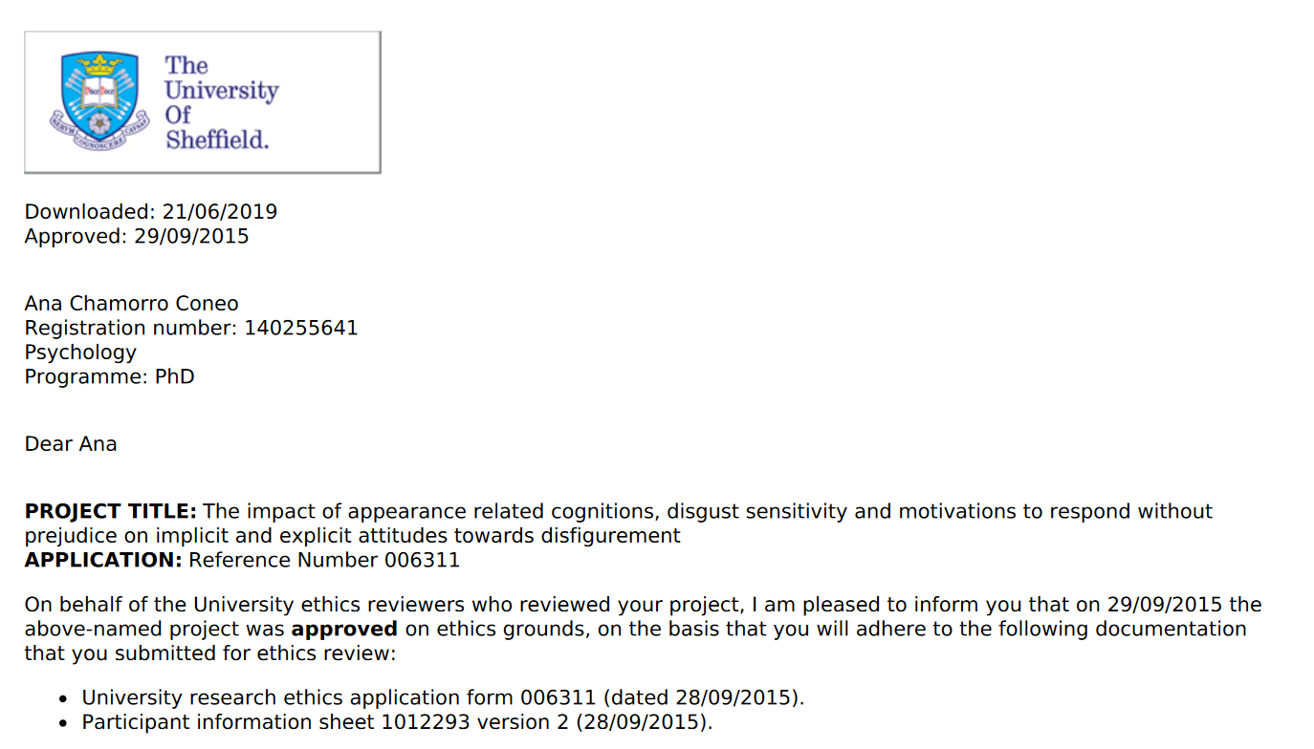

Appendix 3B- Demographic information page
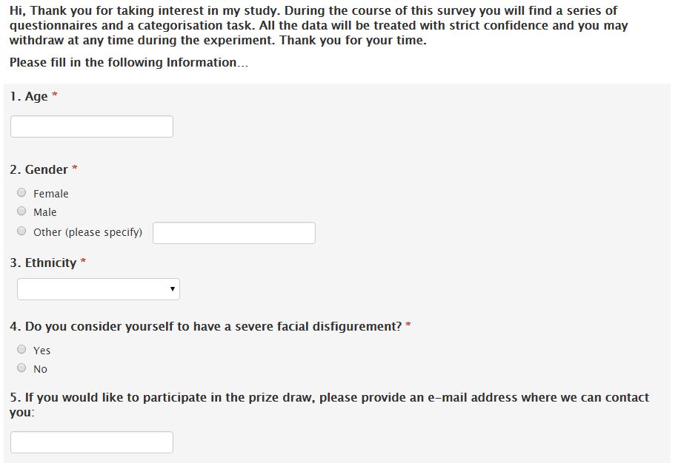

Appendix 3C-The DS-R (Disgust Scale-Revised)
Please indicate how much you agree with each of the following statements, or how true it is about you. Please write a number (0-4) to indicate your answer:
0 = Strongly disagree (very untrue about me)
1 = Mildly disagree (somewhat untrue about me)
2 = Neither agree nor disagree
3 = Mildly agree (somewhat true about me)
4 = Strongly agree (very true about me)
____1. I might be willing to try eating monkey meat, under some circumstances.
____2. It would bother me to be in a science class, and to see a human hand preserved in a jar.
____3. It bothers me to hear someone clear a throat full of mucous.
____4. I never let any part of my body touch the toilet seat in public restrooms.
____5. I would go out of my way to avoid walking through a graveyard.
____6. Seeing a cockroach in someone else's house doesn't bother me.
____7. It would bother me tremendously to touch a dead body.
____8. If I see someone vomit, it makes me sick to my stomach.
____9. I probably would not go to my favorite restaurant if I found out that the cook had a cold.
____10. It would not upset me at all to watch a person with a glass eye take the eye
out of the socket.
____11. It would bother me to see a rat run across my path in a park.
____12. I would rather eat a piece of fruit than a piece of paper
____13. Even if I was hungry, I would not drink a bowl of my favorite soup if it had been
stirred by a used but thoroughly washed flyswatter.
____14. It would bother me to sleep in a nice hotel room if I knew that a man had died of a
heart attack in that room the night before.
How disgusting would you find each of the following experiences? Please write a
number (0-4) to indicate your answer:
0 = Not disgusting at all
1 = Slightly disgusting
2 = Moderately disgusting
3 = Very disgusting
4 = Extremely disgusting
____15. You see maggots on a piece of meat in an outdoor garbage pail.
____16. You see a person eating an apple with a knife and fork
____17. While you are walking through a tunnel under a railroad track, you smell urine.
____18. You take a sip of soda, and then realize that you drank from the glass that an
acquaintance of yours had been drinking from.
____19. Your friend's pet cat dies, and you have to pick up the dead body with your bare hands.
____20. You see someone put ketchup on vanilla ice cream, and eat it.
____21. You see a man with his intestines exposed after an accident.
____22. You discover that a friend of yours changes underwear only once a week.
____23. A friend offers you a piece of chocolate shaped like dog-doo.
____24. You accidentally touch the ashes of a person who has been cremated.
____25. You are about to drink a glass of milk when you smell that it is spoiled.
____26. As part of a sex education class, you are required to inflate a new unlubricated
condom, using your mouth.
____27. You are walking barefoot on concrete, and you step on an earthworm.
The DS-R (Disgust Scale-Revised), Haidt, McCauley, & Rozin, 1994; Modified by Olatunji et al., 2007.
To calculate your score: First, put an X through your responses to items 12 and 16 (these items don’t count). Then “reverse” your score on items 1,6, and 10 by subtracting what you wrote from the number 4, and write those numbers in the margin. Finally, add up your responses to all 25 items (using your “reversed” scores on 1, 6, and 10). The total will be a number between 0-100.

Appendix 3D-The Internal and External Motivation Scale (IMS/EMS) 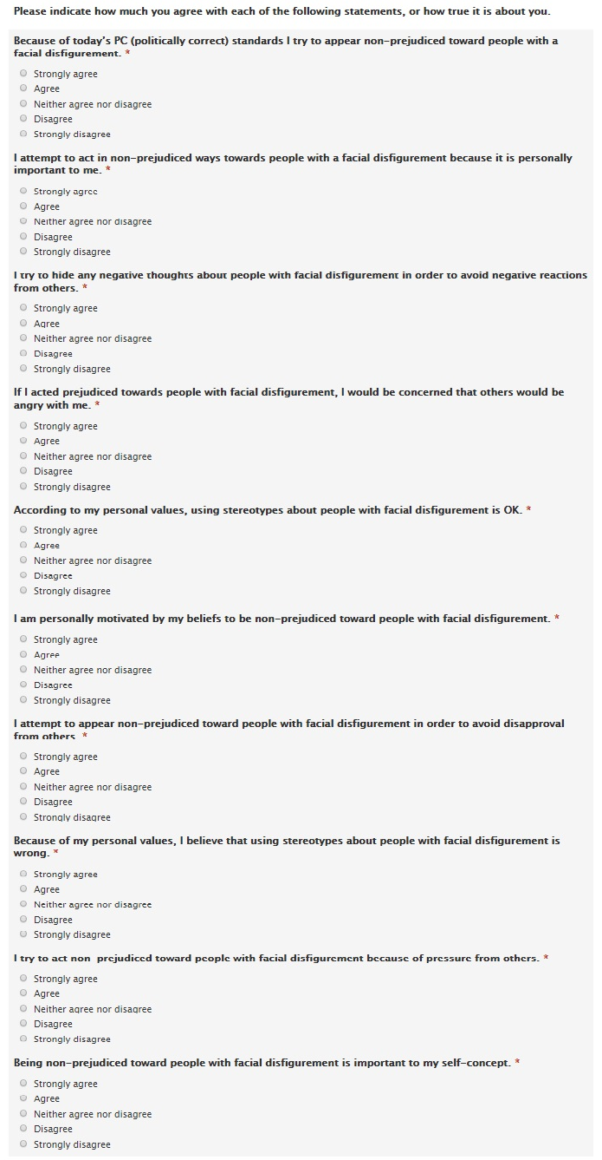

Appendix 3E- Centre for Appearance Research Valence scale (CARVAL) and Centre for Appearance Research Salience scale (CARSAL)
Please indicate how much you agree with each of the following statements, or how true it is about you. Please write a number (1-6) to indicate your answer:
1 = strongly disagree
2 = Disagree
3 = Slightly disagree
4 = slightly agree
5 = Agree
6= Strongly Agree
CARVAL
___1. The way I look makes me unattractive
___2. The way I look makes me feel good about myself
___3. I feel bad about my body and appearance
___4. I am satisfied with my physical appearance*
___5. My body and face look pretty much the way I would like*
___6. I don’t like the way I look?

CARSAL

___1. In most situations, I find myself aware of the way my face and body look
___2. I am often aware of the way I look to other people
___3. I often think about the impression that the appearance of my face and body make
___4. I am usually conscious of my appearance
___ 5. For me, my appearance is an important part of who I am

Appendix 3F-Introduction page IAT
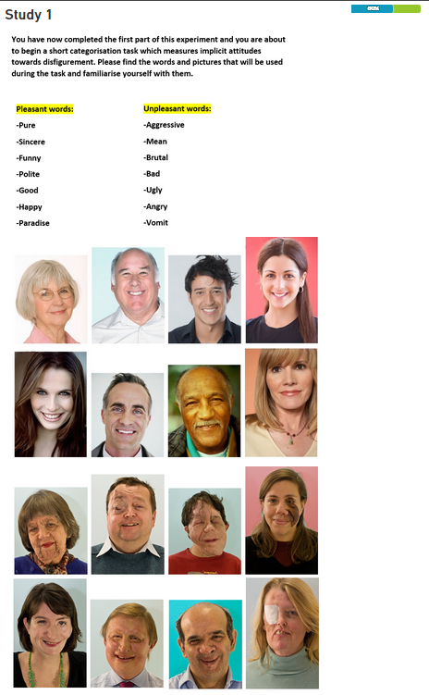

Appendix 3H- Screenshot of stimuli presentation

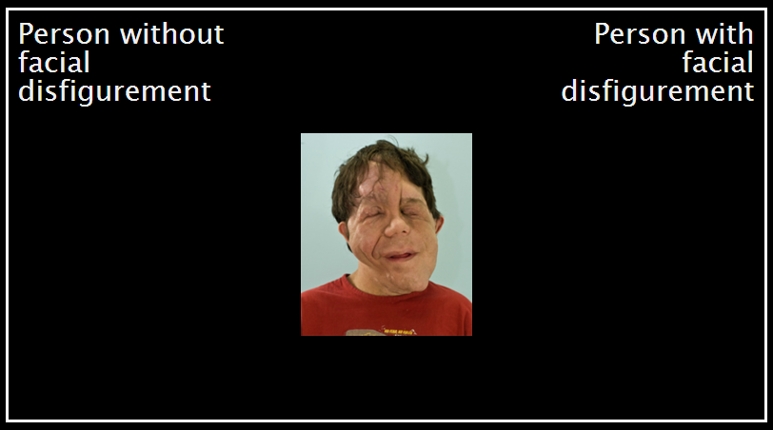

Appendix 3I: Error presentation
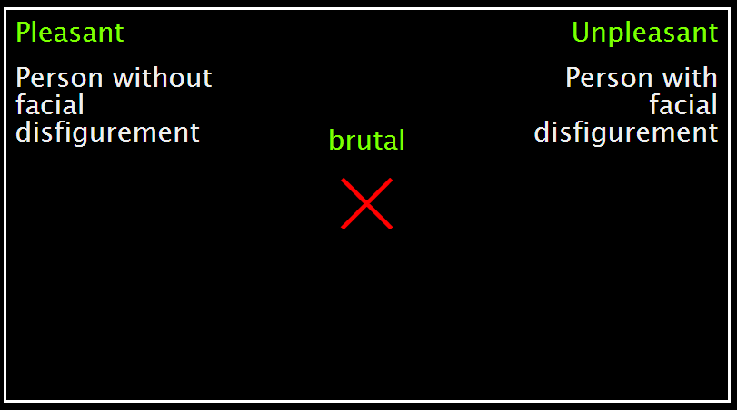

Appendix 3J-Screen indicating end of IAT
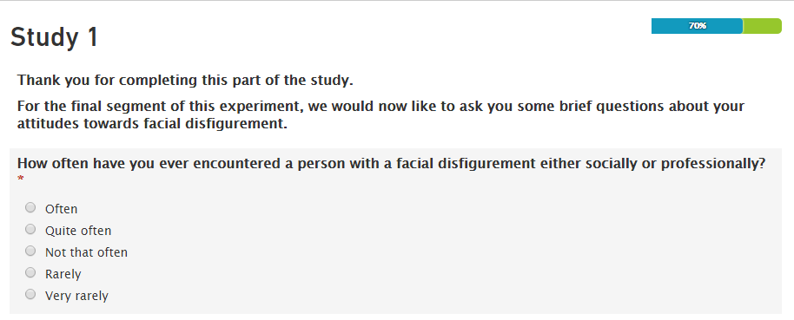

Appendix 3K. Explicit attitude questionnaire 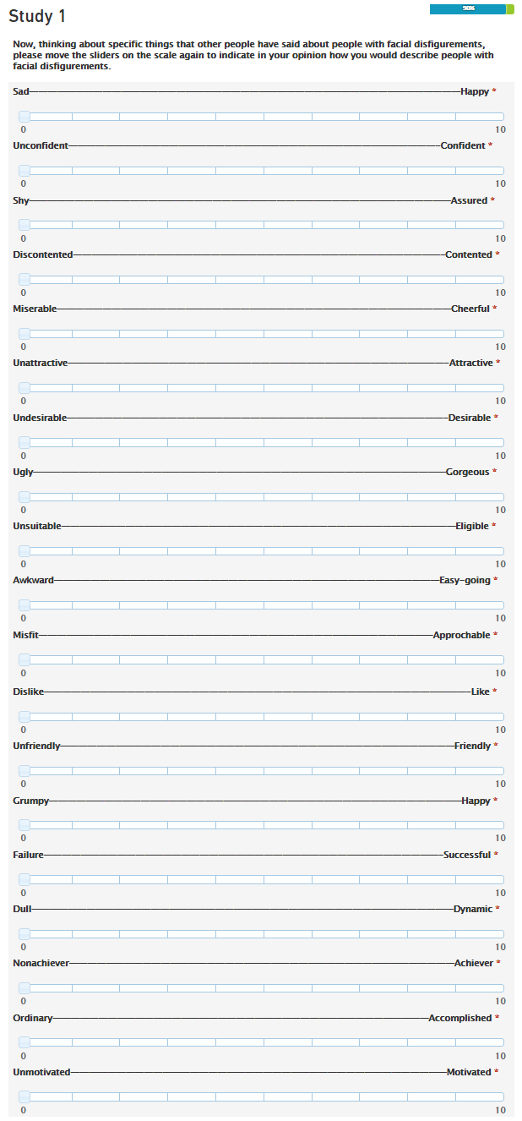
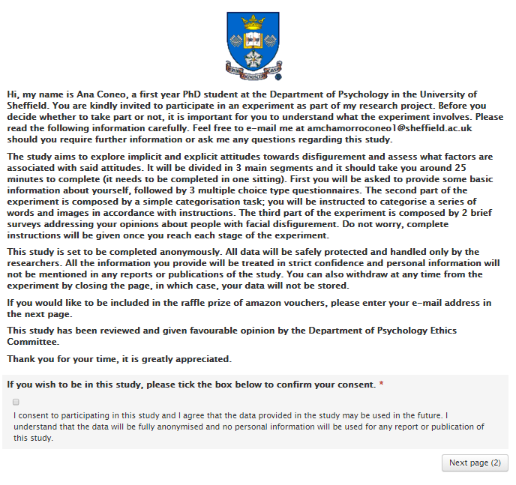
Appendix 3L-Information sheet and consent item

Appendix 3M-Debrief message

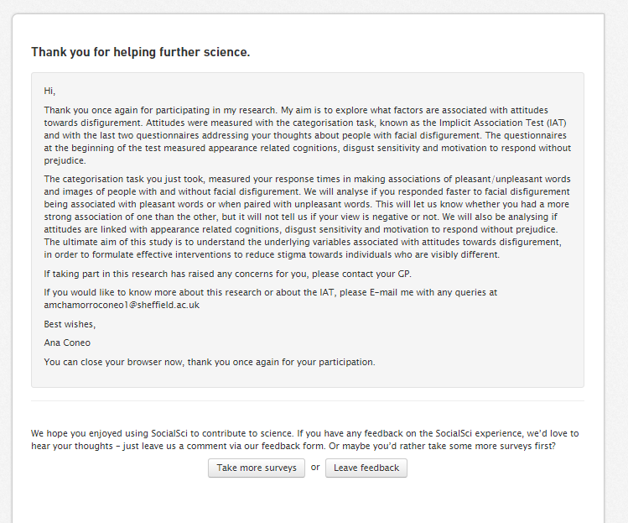

Appendix 4A-Ethical approval Study 2

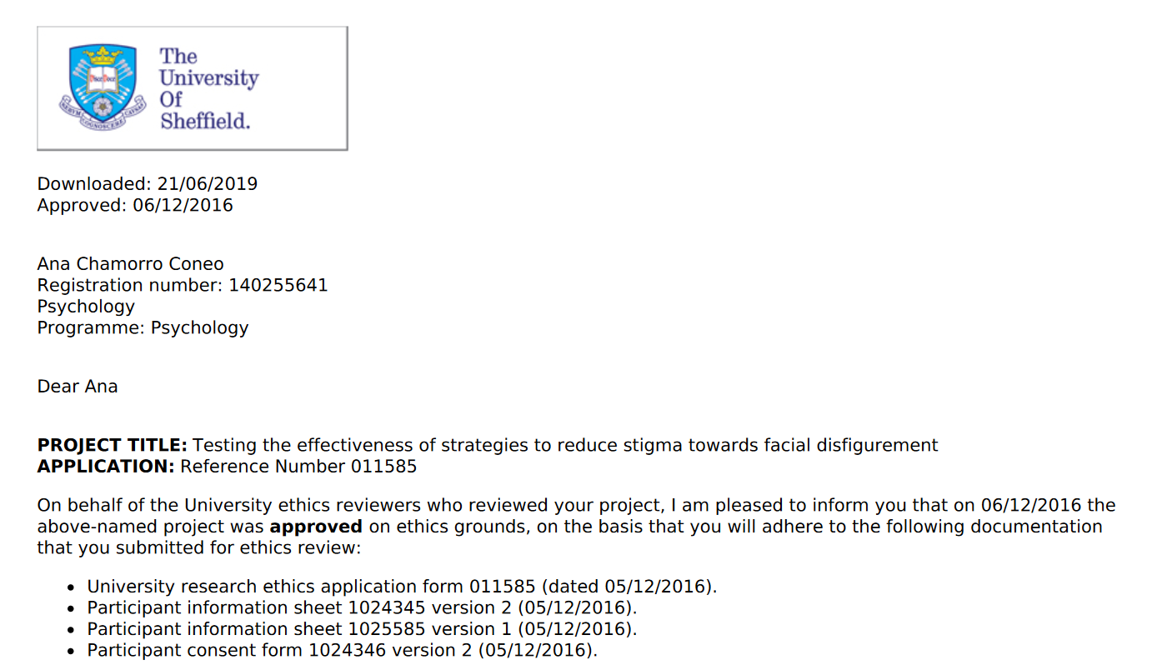

Appendix 4B-. Information message and consent item

Appendix 4C-. Awareness message
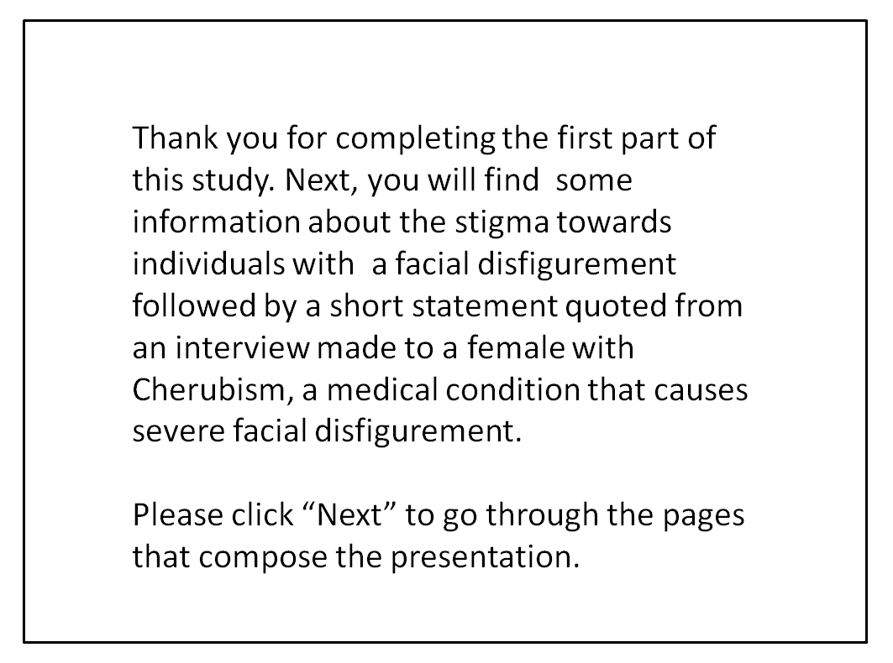
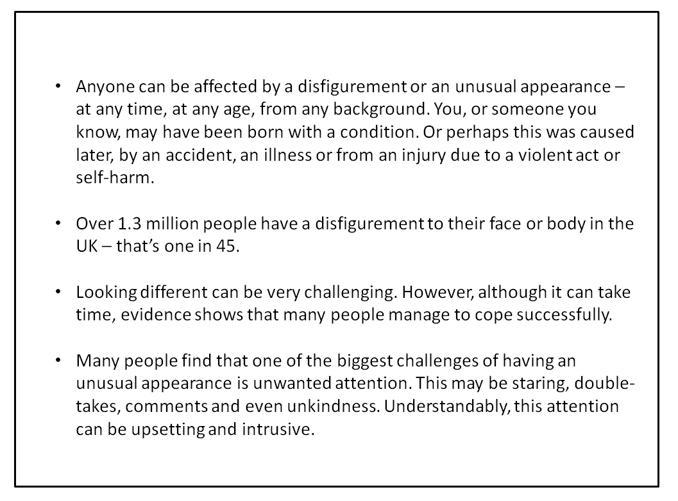

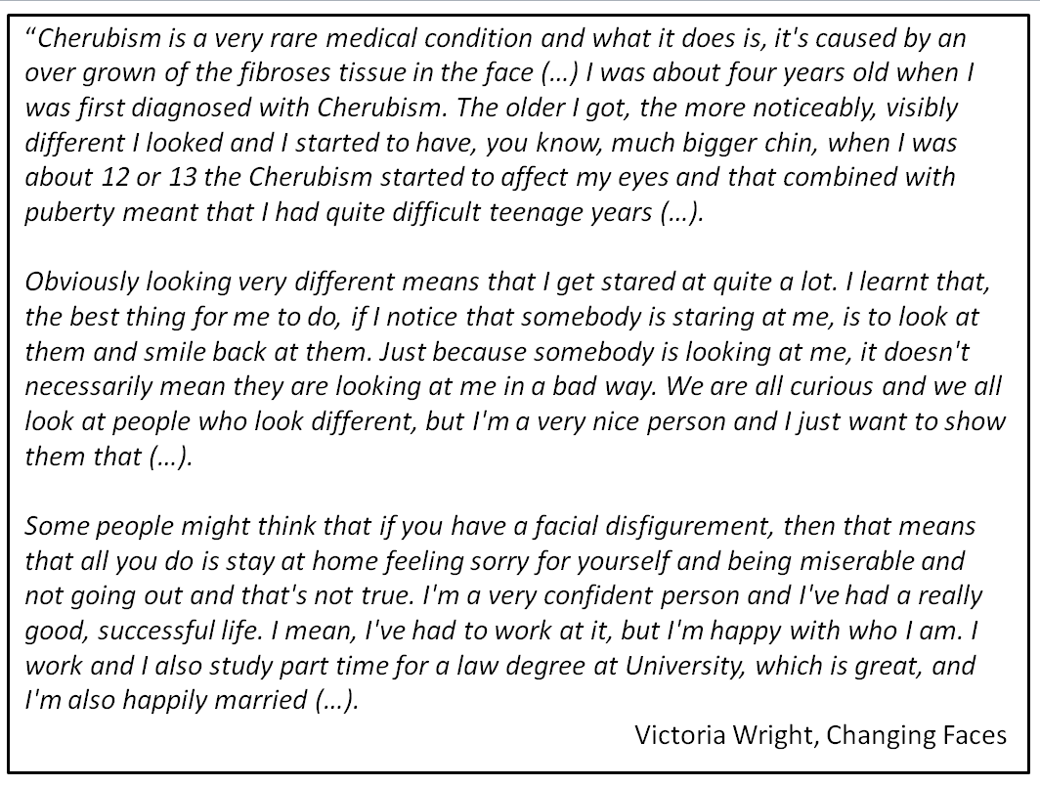
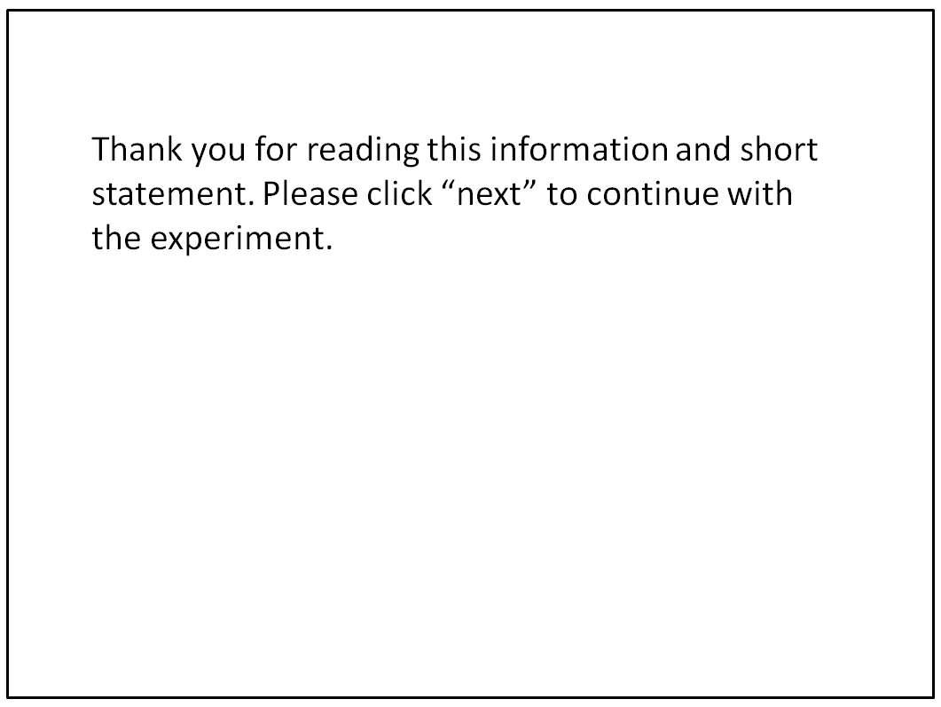

Appendix 4D-. Transcript video clip awareness condition

Transcript of text in the video:
[00:00:00.00] Cherubism is a very rare medical condition and what it does is, it's caused by an over grown of the fibroses tissue in the face. Which basically means that instead of having lots of bones in my face or in my jaw I have this kind of tissue instead.
[00:00:19.08] I was about four years old when I was first diagnosed with Cherubism. The older I got, the more noticeably, visibly different I looked and I started to have, you know, much bigger chin, when I was about 12 or 13 the Cherubism started to affect my eyes and that combined with puberty meant that I had quite difficult teenage years. But it did teach me how to be strong and it did teach me that I'm lucky in some ways, and that the friends that I have are really good people because they will look passed my disfigurement and like me for who I am.
[00:00:55.28] I'm quite lucky that Cherubism is a relatively painless condition but I do get eye strain and I do get headaches quite regularly and I do get a relative amount of pain in my jaw as well, but apart from that is mainly that I look very, very different; it is really the main issue that I face on a day to day basis.
[00:01:15.08] Obviously looking very different means that I get stared at quite a lot. I learnt that, the best thing for me to do, if I notice that somebody is staring at me, is to look at them and smile back at them. Just because somebody is looking at me, it doesn't necessarily mean they are looking at me in a bad way. We are all curious and we all look at people who look different, but I'm a very nice person and I just want to show them that.
[00:01:40.00] Some people might think that if you have a facial disfigurement, then that means that all you do is stay at home feeling sorry for yourself and being miserable and not going out and that's not true. I'm a very confident person and I've had a really good, successful life. I mean, I've had to work at it, but I'm happy with who I am. I work and I also study part time for a law degree at University, which is great and I'm also happily married.
[00:02:09.15] I met my husband Colin when we were students at college; he asked me out on a date and eventually I said "yes, OK", and then it kind of went from there...we've been together for seven years now and married for just over two.
[00:02:24.03] I would advise to anybody who's got a visible difference, or a facial disfigurement, who think that they need some support and advice, to contact Changing Faces. I would love to see a world where people are accepted for what they look like, even if they look different and, one of the things that Changing Faces is campaigning for is "Face equality" which is all about being accepted even if you have a facial disfigurement.

Appendix 4E-. Screen shot of introduction page to control awareness condition
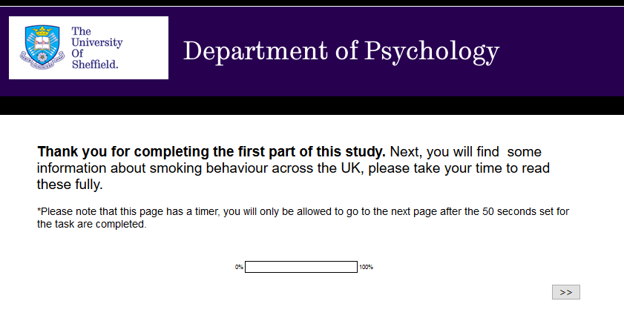

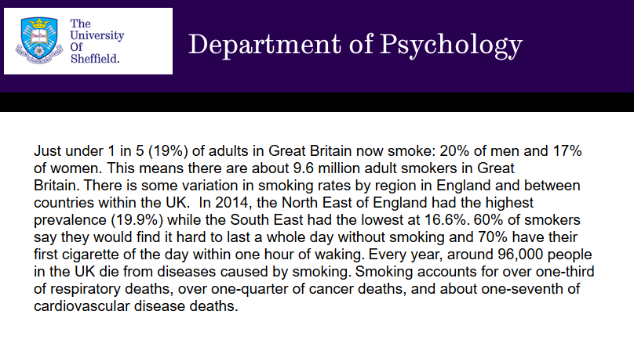

Appendix 4F-. Screen shots IC conditions

Intergroup contact:
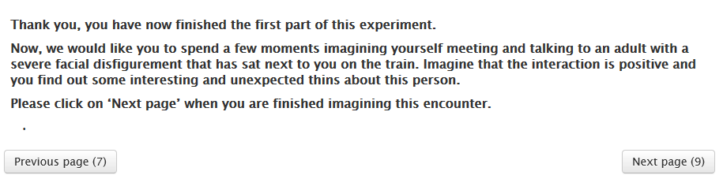
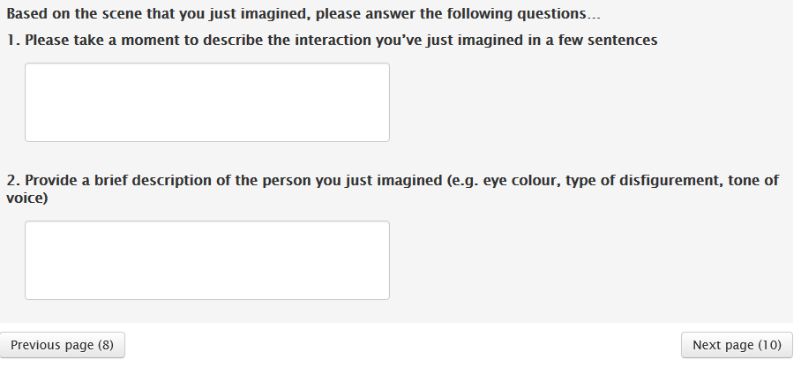
Control condition:
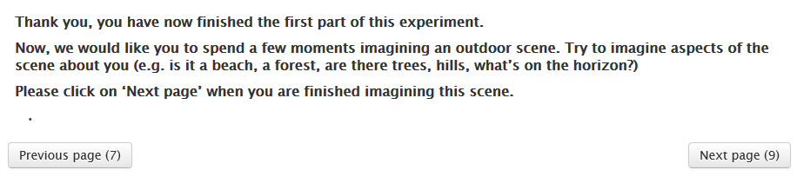
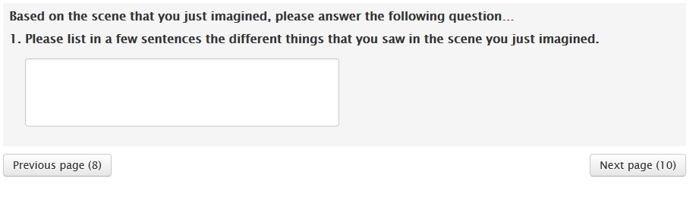

Appendix 4G-. Intergroup anxiety questionnaire
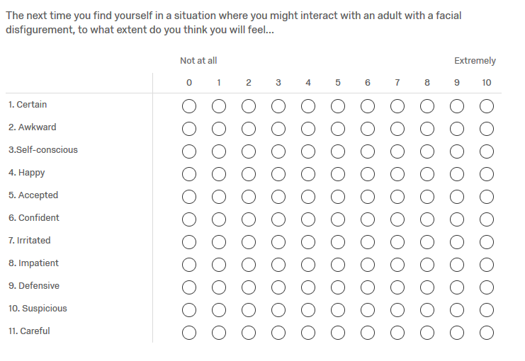

Appendix 4H-. Intended avoidance questionnaire
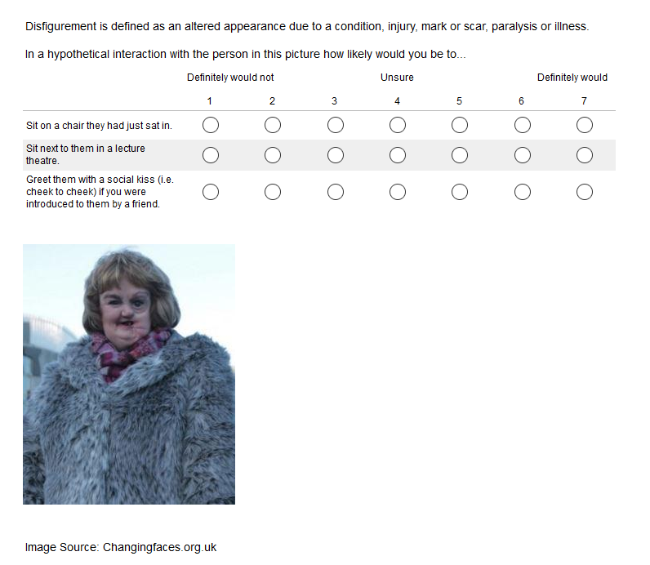

Appendix 4I-. Debrief message
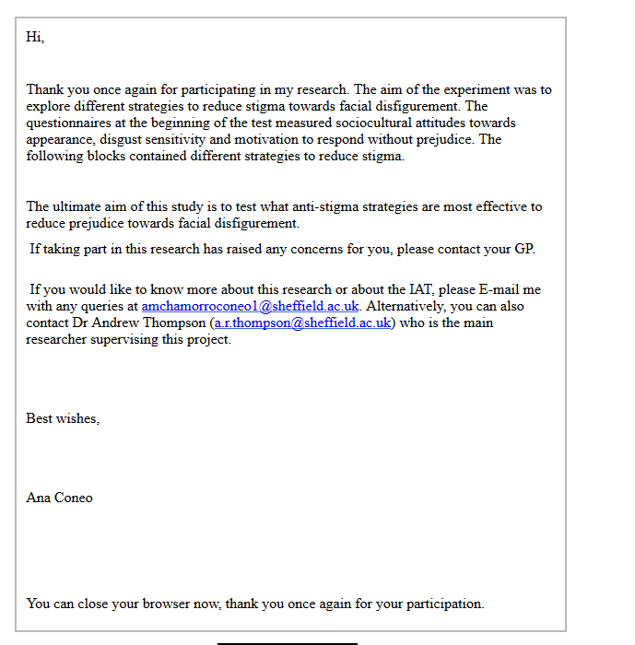

Appendix 5A-. Ethical approval Study 3
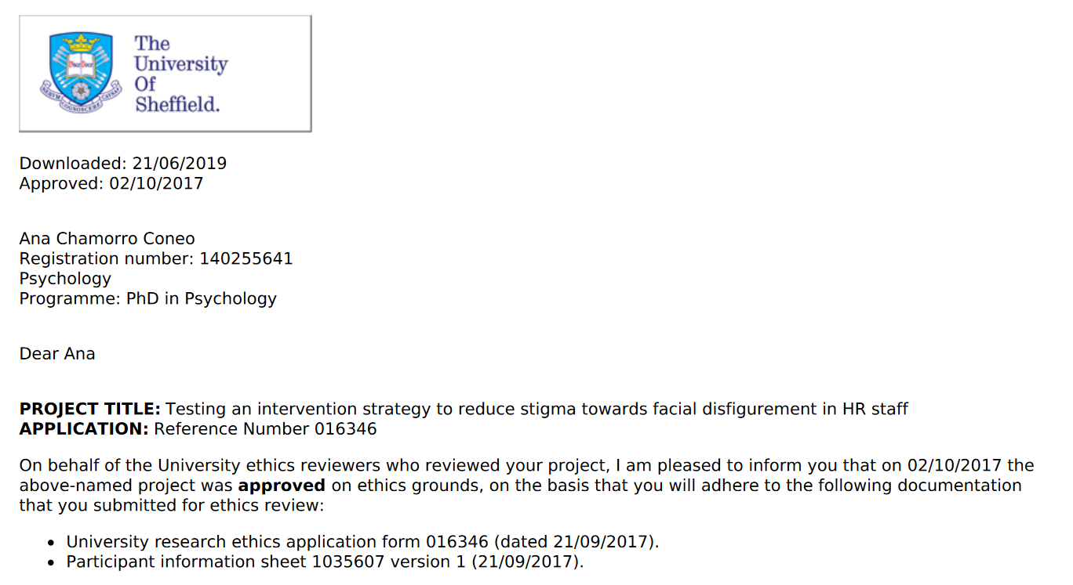

Appendix 5B-. Information page, consent item and demographics page

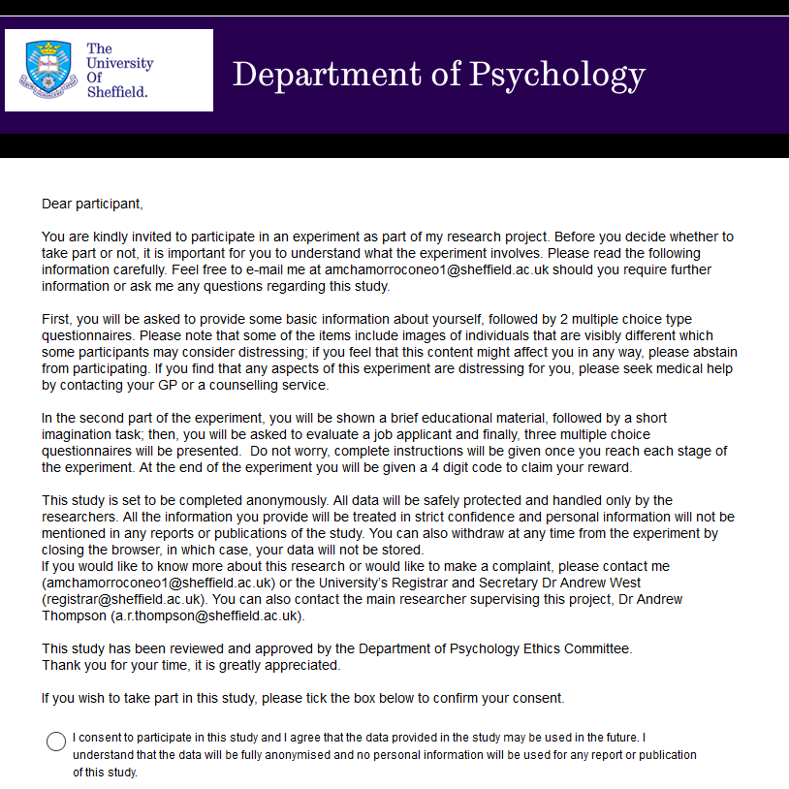
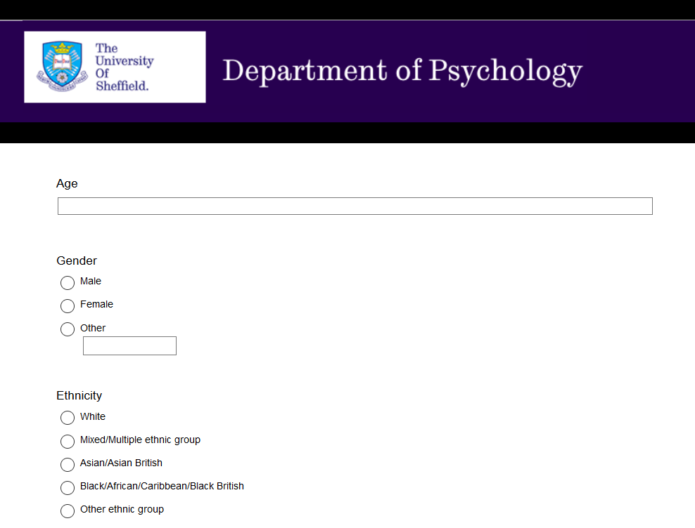
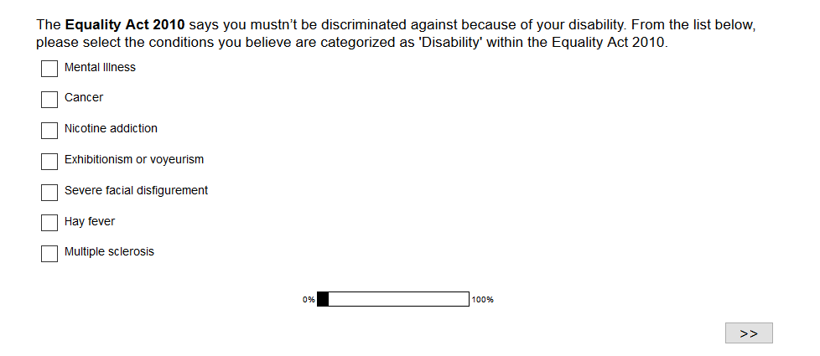

Appendix 5C-.
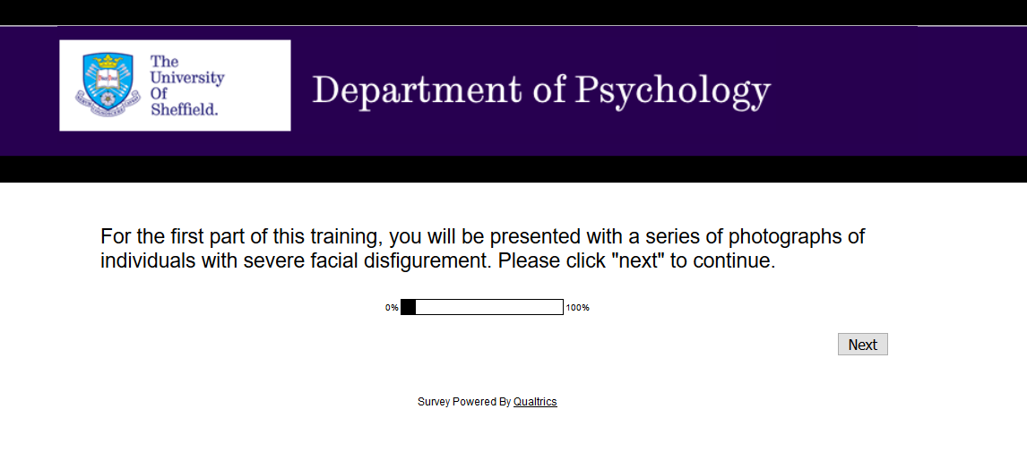
Examples of severe facial disfigurement
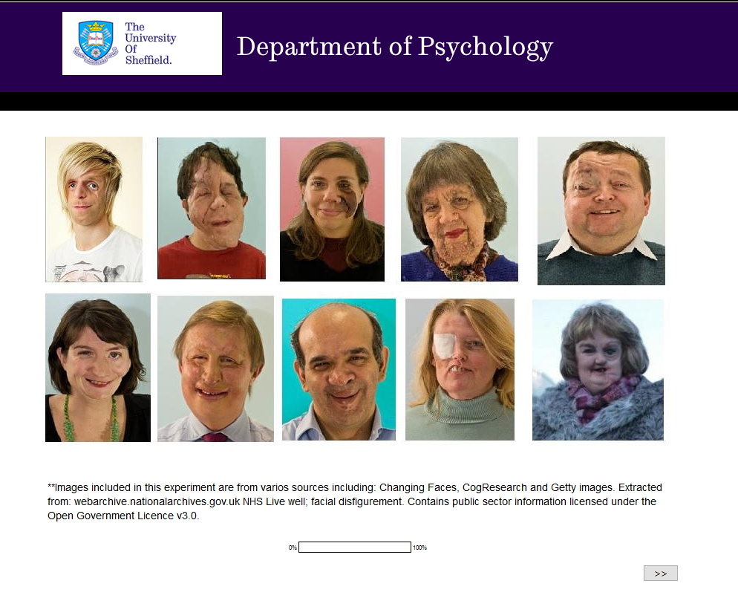

Appendix 5D-. Preparation message prior photographs of individuals with FD
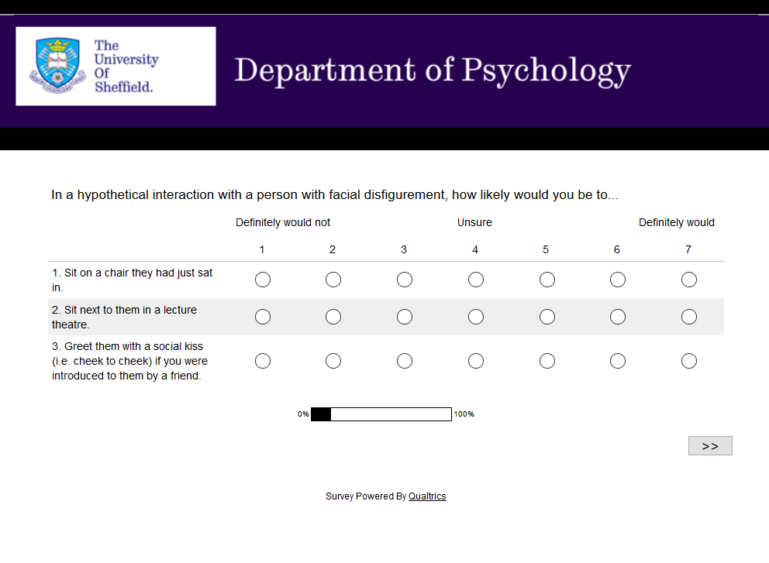

Appendix 5E-Anti-stigma condition (awareness and IC)
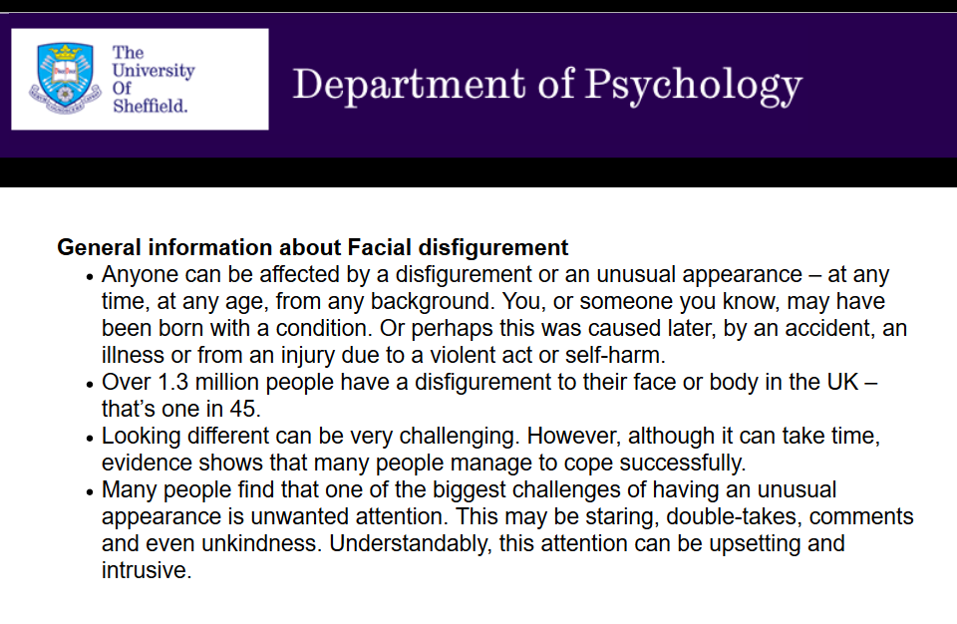

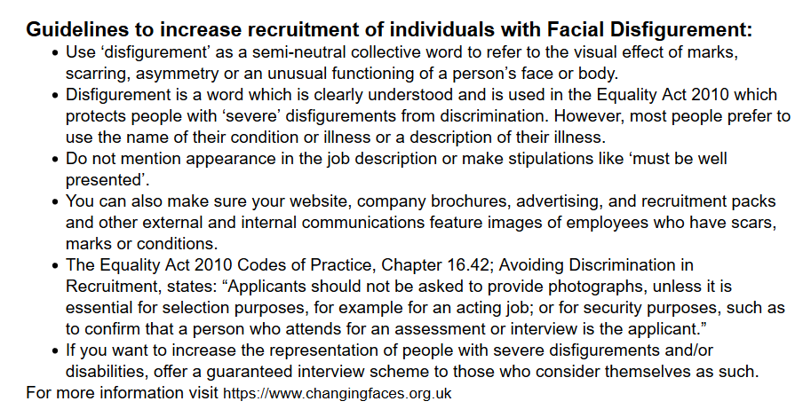

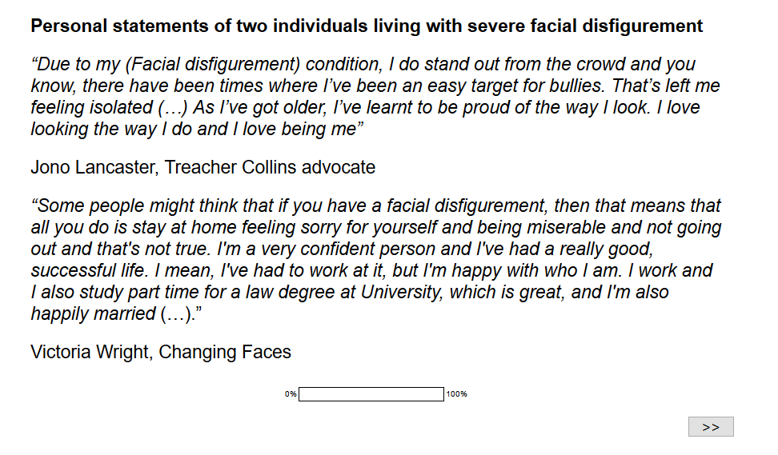

Appendix 5F-Control condition (Neutral message)

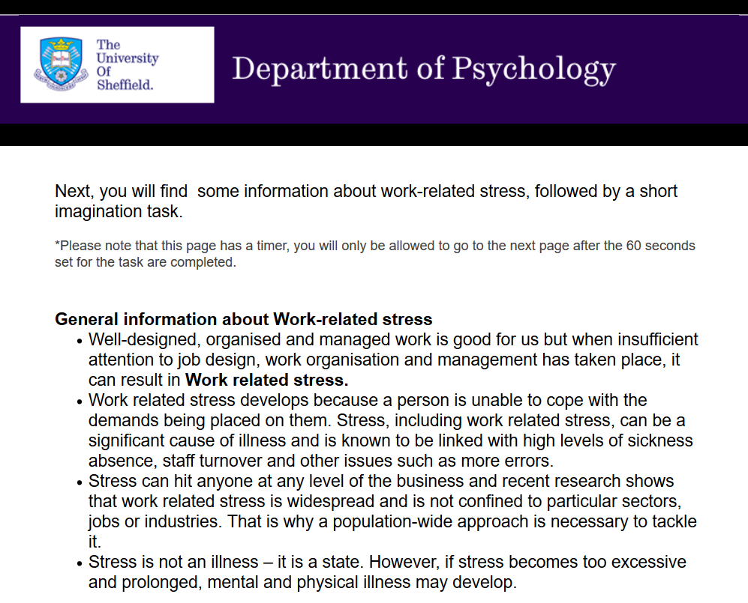
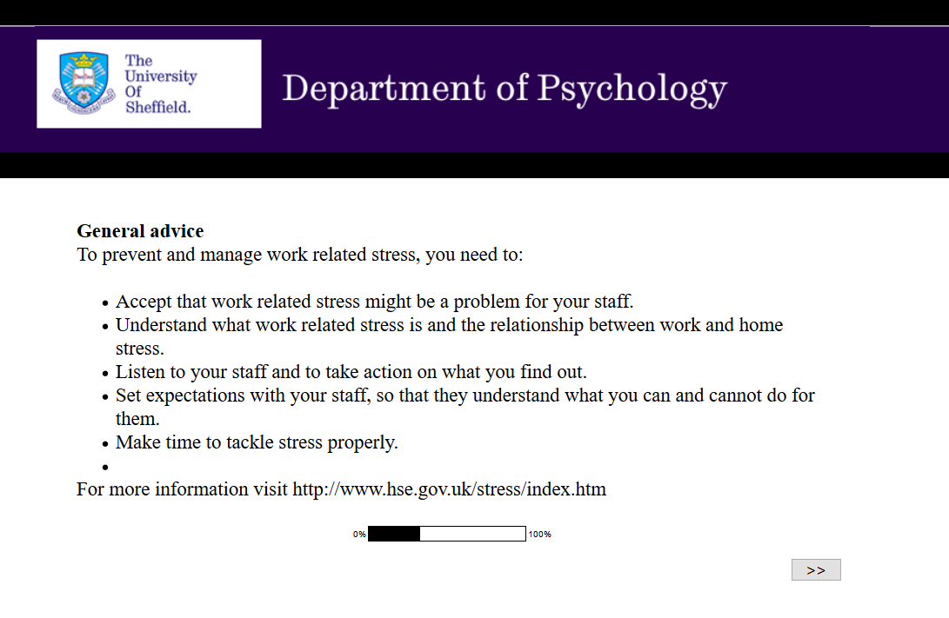
Control imagined contact

Appendix 5F- Job advert displayed for both experimental and control groups

Appendix 5G- Applicant’s rating questionnaire
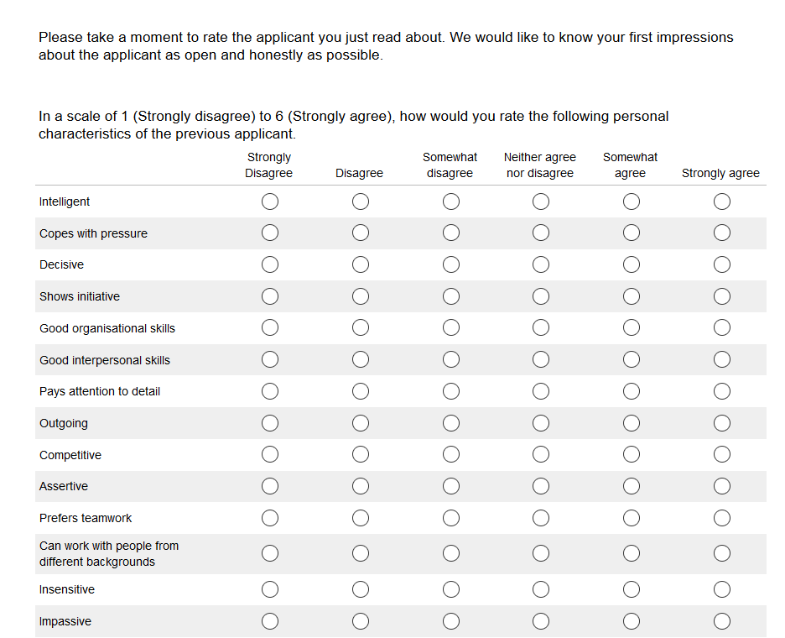
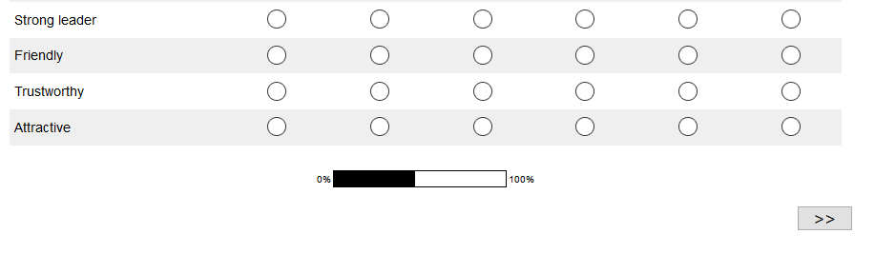

Appendix 5H- Memory recall instrument
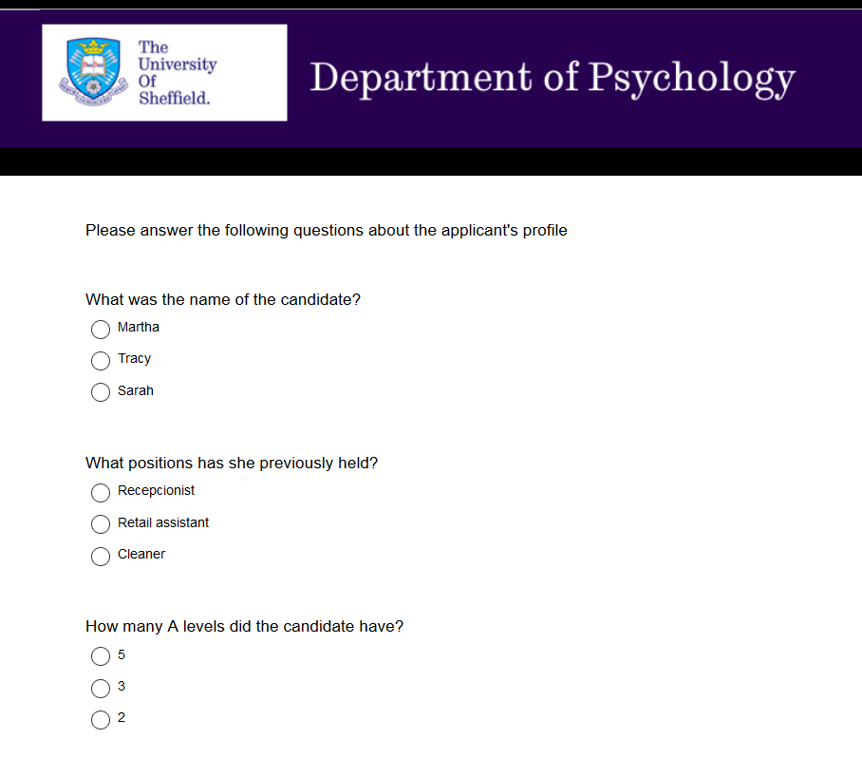
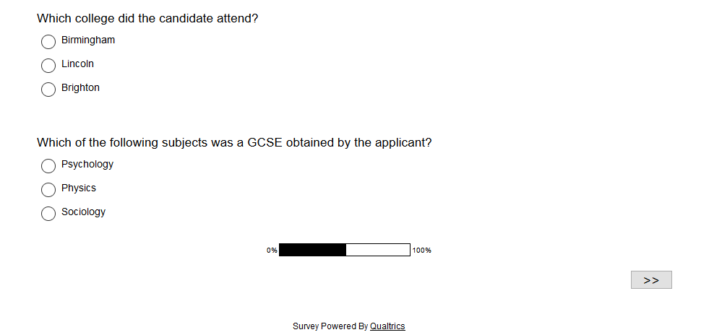

Appendix 5I- Debrief message Study 3
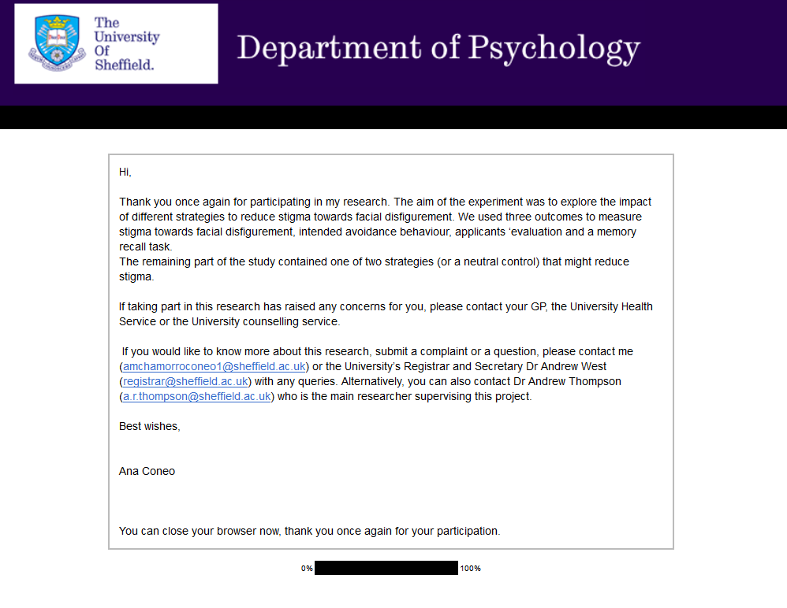

Please note that values were reflected for parametric analysis
Please note that values for intended avoidance were log transformed to meet assumptions for parametric analysis and values are reversed.
The number in N excludes Tartaglia, McMahon, West, & Belongia, 2005 which data was not source directly from participants but from 751 discrimination allegation cases.
Reverse scored items

