INTERACTION OF BIG PARTICLES WITH FLOW – A STUDY OF THE SPOTTING DISTANCES OF THE FIREBRANDS BY MODELLING AND SIMULATIONS

This thesis is submitted to the University of Sheffield for the degree of Doctor of Philosophy in the faculty of Engineering.

Hangxu Zhou

Combustion and Flow Diagnostic Research Group
Department of Mechanical Engineering
December, 2018

DECLARATION

The work presented in this thesis is that of the Author and has not been submitted for the award of any degree at the University of Sheffield or any other university or insinuation. Where other sources of information or help from other parties used in this thesis has been acknowledged.

ACKNOWLEDGEMENT

Firstly, I would like to express my love to my parents who taught me to be brave and honest. They have given me such great support whenever I need. It is my great fortune to be their son.
I also want to show my gratitude to my supervisor, Professor Yang Zhang. He not only guides my study and research, but more importantly teaches me how to think and persist. Even when I was lost on the path of research for a so long period, he kept encouraging and helping me. I feel so lucky to be his student.
Meanwhile, I want to express my gratitude to Dr Yi Li who greatly helps me on my research. I will not achieve the work in this thesis without his help. He is an important teacher I met in my lifetime.
Also, I appreciate the help from all my colleges, Xueshi Zhang, Yiran Wang and her husband Haotian Nan, Yufeng Lai and his wife Yunbai Wang, and Xu Wang. All of you have helped me so much with my experiments and accompanied me through the darkest moments in the past four years. Finally, I want to thank my colleges in the combustion group, Jiansheng Yang, Zhen Ma, Francisco Javier Carranza Chavez, Shuaida Ji, Songyang Yu, Lukai Zheng, Houshi Jiang, Xiao Wang, Ahmad Fuad, Ahmed Albadi, Muyi Pan, Jing Zhang, and yuchen Zhang. I feel so happy to work together with you.

ABSTRACT

The wildfire, which is hard to be suppressed especially in large scale fires such as Forest Fire, is a terrible disaster to human civilisation. Millions of acres of burning land and numbers of deaths due to wildfire are reported each year. As one of the main mechanisms of wildfire, the Spotting phenomenon, which identifies the ignitions by Firebrands (the burning particle such as barks, wood pieces or charcoal) away from main fire zone, plays an important role in fire spread. In details, the new ignitions in front of fire zone are continuously caused by spotting phenomenon. Not only it makes the direction of fire spreading become unpredictable, but also helps fly over breaks. In order to study the spotting phenomenon and predict the spotting distances of firebrands, many models have been developed for the firebrands at different conditions. However, rare study about modelling the spotting of firebrands with lift effects to predict their maximum spotting distance has been reported.
In the thesis, the spotting of firebrands is investigated. A new mathematic model for determining the horizontal propagation of firebrand in certain height is developed to calculate the transporting of firebrands. Meanwhile, a new particle burning model is developed considering the thickness and mass regression due to combustion while its fly path. The models developed in this thesis are further compared with the existing models. The discussion with the analysis of advantages and disadvantages is given.
Based on the modelling of spotting phenomenon, the predictions for the maximum spotting distance of rectangular-shaped firebrands were made, and the spotting differences due to thickness change from different burning models were compared. It is found that the longest propagation of burning firebrand could reach 684 m in horizontal direction for each 100 m height drop. The particle spotting was not only strongly affected by ambient flow velocity, but also importantly enhanced by the incident angle where the peak value of spotting occurred at -7.5° of incident angle. By comparing the spotting distance of firebrands with and without burning, it is found that the particle with variable thickness burning could propagate further than other cases.
Further, the parametric studies for determining the influences of each parameter involved in spotting phenomenon were made. The relative importance of each parameter is documented. Among four different parameters which affect the firebrand spotting distance, including flow velocity, incident angle, density and initial particle velocity, it is found that both the flow velocity and incident angle could enhance the spotting more than other parameters. Based the finding from previous chapter, the spotting enhancement by negative incident was further invested. The parameter optimisation was conducted to reduce the parameters, and corresponding surface fitting equations were obtained. As well the comparisons between two different burning models were made.
More importantly, the effects of aerodynamic lift force on firebrand spotting was investigated systematically in this thesis. It is found that spotting distance of firebrand could be significantly increased by lift force, that 171% of increasement and up to 14 times of horizontal propagation by lift force comparing with the case without lift effect. The surface fitting equations for lift effects at different conditions were obtained. It strongly suggests that the lift force should be considered for more accurate prediction of spotting in further work.

CONTENTS

DECLARATION i
ACKNOWLEDGEMENT ii
ABSTRACT iii
CONTENTS v
LIST OF FIGURES viii
LIST OF TABLES i
NOMENCLATURE i
Chapter 1. INTRODUCTION 4
1.1 Motivation 4
1.2 Objectives 5
1.3 Thesis outline 6
Chapter 2. LITERATURE REVIEW 8
2.1 Firebrands and Spotting phenomenon in large-scale wildfires 8
2.1.1 Firebrand and Spotting phenomenon 9
2.1.2 Burning law and lifetime of firebrands 13
2.1.3 Trajectory and spotting distance of a firebrand 20
2.2 Aerodynamics of a rectangular-shaped particle in the flow field 26
2.2.1 Fundamental properties of the particles 26
2.2.2 Calculation of Aerodynamic forces 29
2.2.3 Coefficient of drag and lift 34
Chapter 3. MODELLING SPOTTING PHENOMENON 49
3.1 Concepts of the models developed 50
3.2 Transporting models of the firebrands 52
3.2.1 Aerodynamic forces 53
3.2.2 Motion of the particle 58
3.3 Simplified combustion models of firebrands 62
3.3.1 Non – burning model 63
3.3.2 Constant thickness burning 63
3.3.3 Variable thickness burning 67
3.4 Assumptions of the models 70
3.5 Advantages and disadvantages of the models developed 72
Chapter 4. PREDICTION OF SPOTTING DISTANCE 77
4.1 Introduction 77
4.2 Concepts of the simulations 78
4.3 Results and discussion 80
4.3.1 Non-burning model 84
4.3.2 Constant thickness burning model 89
4.3.3 Variable thickness burning model 90
4.4 Differences of maximum spotting distance due to thickness change 93
4.5 Conclusion 96
Chapter 5. PARAMETRIC STUDY OF PARAMETERS INVOLVED IN SPOTTING 98
5.1 Introduction 98
5.2 Concepts of the simulations 98
5.3 Results and discussion 100
5.3.1 Non-burning model and constant thickness burning model 100
5.3.2 Variable thickness burning model 110
5.3.3 Difference between two burning models 116
5.4 Conclusion 119
Chapter 6. INVESTIGATIONS OF THE EFFECTS OF LIFT ON THE SPOTTING OF A FIREBRAND 121
6.1 Introduction 121
6.2 Concepts of the simulations 122
6.3 Results and discussion 123
6.3.1 Lift effects on spotting distance 124
6.3.2 Differences of lift effects from different burning models 132
6.4 Conclusion 137
Chapter 7. CONCLUSIONS AND FINDINGS 139
7.1 Modelling the spotting of firebrand 139
7.2 Prediction of spotting distance 139
7.3 Parametric study of the parameters involved in spotting phenomenon 141
7.4 Lift effects 142
Chapter 8. FUTURE WORK 144
8.1 Simulation side 144
8.2 Experimental side 145
8.3 Theoretical side 146
PUBLICATIONS 147
REFERENCE 148
APPENDICES 162
A. Spotting distance of non-burning model 162
B. Spotting distance of constant thickness burning model 163
C. Spotting distance of variable thickness burning model 164
D. Lift effects of non-burning model 165
E. Lift effects of constant thickness burning model 166
F. Lift effects of variable thickness burning model 167
G. Surface curve fitting plots 168
H. Difference between burning models 176

LIST OF FIGURES

Figure 2.1 – The firebrand found from the Oakland Hills Fire in 1991. 10
Figure 2.2 – The Log-log scale plots for firebrand surface area vs. mass [75] [76] [132]. 11
Figure 2.3 – The spotting phenomenon. 11
Figure 2.4 – Schematic representation of a rectangular-shaped particle in a flow field. 27
Figure 2.5 – Representations of the dimension of typical shapes. 288
Figure 2.6 – Schematic flow patterns around a sphere for different Reynolds numbers [30]. 36
Figure 2.7 – Drag coefficients of differently shaped particles as a function of particle Reynolds number [52]. 36
Figure 2.8 – Schematic presentation of the production of aerodynamic lift force [61]. 37
Figure 2.9 – Variation of C_{L} and C_{D} with Angle of Attack for RNG and SA turbulence models. 37
Figure 2.10 – Lift coefficients of differently shaped particle as a function of incident angle at different particle Reynolds numbers [52]. Error! Bookmark not defined.8

Figure 3.1 – The structure and logic chain of the models developed. 511
Figure 3.2 – Schematic representation of the transporting model of a rectangular-shaped firebrand in the flow field. 533
Figure 3.3 – Schematic representations of the situations of the lift force may exist on the firebrand. 54
Figure 3.4 – Schematic representation of the situations of different angle of attack. 56
Figure 3.5 – Schematic representation of the positive and negative attack angles. 57
Figure 3.6 – Validation of size regression rate for constant thickness burning model. 57
Figure 3.7 – Validation for the variable thickness burning model. 57

Figure 4.1 – Representation of the logic structure of simulation. 788
Figure 4.2 – The trajectories of the firebrand at 10 m/s of flow velocity. 800
Figure 4.3 – The trajectories of the firebrand with smaller step of simulation at 10 m/s flow velocityat 10 m/s of flow velocity. 801
Figure 4.4 – The trajectories of a disk-shaped firebrand at different ambient flow velocity. 803
Figure 4.5 – Spotting distance of firebrand at $V0=0 m/s$, $ρ=545 kg/m3$and $φ=-7.5°$ in non-burning model. 866
Figure 4.6 – Spotting distance of firebrand at $Vflow=0 m/s$, $V0=0 m/s$ and $φ=-7.5°$ in non-burning model. 877
Figure 4.7 – Spotting distance of firebrand at $Vflow=0 m/s$, $ρ=250 kg/m3$ and $φ=-7.5°$ in non-burning model. 877
Figure 4.8 – Spotting distance of firebrand at $Vflow=0 m/s$, $V0=0 m/s$ and $ρ=250 kg/m3$ in non-burning model. 888
Figure 4.9 – Spotting distance of firebrand at $V0=0 m/s$, $ρ=250 kg/m3$and $φ=-7.5°$ in variable thickness burning model. Error! Bookmark not defined.
Figure 4.10 – Spotting distance of firebrand at $Vflow=0 m/s$, $V0=0 m/s$ and $φ=-7.5°$ in variable thickness burning model. Error! Bookmark not defined.
Figure 4.11 – Spotting distance of firebrand at $Vflow=0 m/s$, $ρ=250 kg/m3$ and $φ=-7.5°$ in variable thickness burning model. Error! Bookmark not defined.
Figure 4.12 – Spotting distance of firebrand at $Vflow=10 m/s$, $V0=0 m/s$ and $ρ=250 kg/m3$ in variable thickness burning model. Error! Bookmark not defined.

Figure 5. 1 – Representation of the logic structure of simulation. 99
Figure 5. 2 – Contour plots of spotting distance at $Vo=0 m/s$ and $φ=-7.5°$, constant thickness burning model. 1022
Figure 5. 3 – Plot for surface fitting of spotting distance determined from ranged velocity and density with obtained polynomial function. 1023
Figure 5. 4 – Comparisons of the spotting distance estimated from simplified surface fitting equation with real spotting distance. 1024
Figure 5. 5 – Contour plots of spotting distance at $Vo=0 m/s$ and $ρ=250kg/m3$, constant thickness burning model. 1055
Figure 5. 6 – Contour plots of spotting distance at $Vflow=10 m/s$ and $V0=0 m/s$, constant thickness burning model. 1077
Figure 5. 7 – Contour plots of spotting distance at $φ=-7.5°$ and $ρ=250kg/m3$, constant thickness burning model. 1077
Figure 5. 8 – Contour plots of spotting distance at $Vflow=0 m/s$ and $ρ=250kg/m3$, constant thickness burning model. 10808
Figure 5. 9 – Contour plots of spotting distance at $Vo=0 m/s$ and $φ=-7.5°$, variable thickness burning model. 1129
Figure 5. 10 – Contour plots of spotting distance at $φ=-7.5°$ and $ρ=250kg/m3$, variable thickness burning model. 11311
Figure 5. 11 – Contour plots of spotting distance at $V0=0 m/s$and 𝜑=-7.5°, variable thickness burning model. 1142
Figure 5. 12 – Contour plots of spotting distance at $Vflow=0 m/s$ and $ρ=250kg/m3$, variable thickness burning model. 11513
Figure 5. 13 – Contour plots of spotting distance at $Vflow=0 m/s$ and $V0=0 m/s$, variable thickness burning model. 1164
Figure 5. 14 – Contour plots of spotting distance at $Vflow=0 m/s$ and $ρ=250 kg/m3$, variable thickness burning model. 1165
Figure 5. 15 – Contour plots of spotting distance at $Vflow=0 m/s$ and $φ=-7.5°$, variable thickness burning model. 1166
Figure 5. 16 – Contour plots of the difference of spotting distance at $V0=0 m/s$ and $φ=-7.5°$. Spotting difference was determined from the spotting distance from variable thickness burning model with respect to constant thickness burning model. 1167

Figure 6. 1 – Representation of the structure and logic chain of the simulations. 1222
Figure 6. 2 – The maximum spotting distance (with lift) of firebrands with $ρ=250 kg/m3$ and $V0=0 m/s$ 1225
Figure 6. 3 – The maximum spotting distance (without lift) of firebrands with $ρ=250 kg/m3$ and $V0=0 m/s$ 1225
Figure 6. 4 – Difference of max spotting distance with and without lift force 1226
Figure 6. 5 – Ratio of max spotting distance with lift over without lift force 1226
Figure 6. 6 – Difference of max spotting distance with and without lift at $ρ=250 kg/m3$ and $V0=0 m/s$ 1227
Figure 6. 7 – Ratio of spotting distance with and without lift, at $ρ=250 kg/m3$ and $V0=0 m/s$ 1227
Figure 6. 8 – Difference of max spotting distance with and without lift at $φ=-7.5°$ and $V0=0 m/s$ 1229
Figure 6. 9 – Ratio of spotting distance with and without lift, at $at φ=-7.5° and V0=0 m/s$ 12230
Figure 6. 10 – Difference of max spotting distance with and without lift at $Vflow=10 m/s$ and $V0=0 m/s$ 12231
Figure 6. 11 – Ratio of spotting distance with and without lift, at $at Vflow=10 m/s and V0=0 m/s$ 12231
Figure 6. 12 – Difference of lift effects due to thickness change, at $ρ=250 kg/m3$ and $V0=0 m/s$ 12233
Figure 6. 13 – Difference of lift effects due to thickness change, at $Vflow=10 m/s$ and $V0=0 m/s$ 12234
Figure 6. 14 – Difference of lift effects due to thickness changes, at $φ=-7.5°$ and $V0=0 m/s$ 12234
Figure 6. 15 – Ratio of lift effects between constant thickness burning model and variable thickness burning model, at $ρ=250 kg/m3$ and $V0=0 m/s$ 12235

LIST OF TABLES

Table 2. 1 – Equations of the drag coefficient for the spherical particles. 38
Table 2. 2 – Equations of the drag coefficient for the non-spherical particles. 41
Table 2. 3 – Equation presenting the relationship between the particle orientation and the drag coefficient. 44
Table 2. 4 – Equations of the lift coefficients for the non-spherical particles. 46

Table 4. 1 – The tested ranges of four simplified parameters. 79
Table 4. 2 – Maximum spotting distance determined from non-burning model. 84
Table 4. 3 – Maximum spotting distance determined from constant thickness burning model. 90
Table 4. 4 – The tested ranges of parameters. 91
Table 4. 5 – Comparisons between three different combustion models. 94

Table 5. 1 – Tested ranges of parameters in the simulation of parametric study. 100

Table 6. 1 – Tested ranges of parameters in the simulation for investigations of lift effects. 123

NOMENCLATURE

$$r$$ | $$[m]$$ | Radius
$$h$$ | $$[m]$$ | Thickness
$$D$$ | $$[m]$$ | Diameter
$$A$$ | $$[m^{2}]$$ | Projected area
$$ρ$$ | $$[kg/m^{3}]$$ | Density
$$m$$ | $$[kg]$$ | mass
$$t$$ | $$[s]$$ | Time
$$V$$ | $[m/s]$ / $m^{3}$ | Velocity or volume
$$v$$ | $$[m/s]$$ | Velocity of particle
$$u$$ | $$[m/s]$$ | Velocity of ambient flow
$$W$$ | $$[m/s]$$ | Relative velocity of wind with respect to firebrand
$$α$$ | $$[°]$$ | Attack angle
$$φ$$ | $$[°]$$ | Incident angle
$$D_{eff}$$ | $$[m]$$ | Effective mass diameter
$$β$$ | $$[-]$$ | Burning constant
$$τ$$ | $$[m]$$ | Thickness of rectangular-shaped firebrand
$$W_{s}$$ | $$[m/s]$$ | Falling velocity of firebrand
$$h_{0}$$ | $$[m]$$ | Thickness of the particle lofted in flow
$$U$$ | $$[m/s]$$ | Mean velocity of flow over particle
$$k$$ | $$[-]$$ | Regression coefficient
$$r_{max}$$ | $$[m]$$ | Current maximum radius of the firebrand
$$h_{max}$$ | $$[m]$$ | Current maximum thickness of the firebrand
$$γ$$ | $$[-]$$ | Mass consumption number
$$B$$ | $$[-]$$ | Spalding’s mass transfer number
$$C_{D}$$ | $$[-]$$ | Drag coefficient
$$C_{L}$$ | $$[-]$$ | Lift coefficient
$$g$$ | $$[m/s^{-2}]$$ | Acceleration of gravity
$$FFDI$$ | $$[-]$$ | McArthur Forest Fire Danger Index
$$Re$$ | $$[-]$$ | Reynolds number
$$Pr$$ | $$[-]$$ | Prandtl number
$μ$ | $$[Pa∙s]$$ | Fluid dynamic viscosity
$$T$$ | $$[°]$$ | Temperature
$$DF$$ | $$[-]$$ | Drought factor
$$RH$$ | $$[-]$$ | Relative humidity factor
$$S$$ | $$[m]$$ | Distance
$$X$$ | $$[m]$$ | Horizontal distance
$$Y$$ | $$[m]$$ | Vertical distance
$$C$$ | $$[-]$$ | Degree of curing
$a$ and $b$ | $$[m]$$ | Dimensions of particle
$l_{f}$ | $$[m]$$ | Length of the plate
$$c$$ | $$[m]$$ | Chord length of plate
$$AR$$ | $$[-]$$ | Aspect ratio
$$GR$$ | $$[-]$$ | Glide ratio
$$\vec{V}$$ | $$[-]$$ | Velocity vector
$$\vec{v}$$ | $$[-]$$ | Velocity vector of particle
$$\vec{u}$$ | $$[-]$$ | Velocity vector of ambient flow
$$\vec{W}$$ | $$[-]$$ | Vector of the relative velocity of wind with respect to firebrand
$$\vec{f}$$ | $$[-]$$ | Unit vector along the direction of firebrand
$$\vec{n}$$ | $$[-]$$ | Unit vector points to the direction perpendicular to drag force
$${\vec{V}}_{flow}$$ | $$[-]$$ | Velocity vector of the flow around firebrand
$${\vec{V}}_{f}$$ | $$[-]$$ | Velocity vector of the firebrand
$${\vec{V}}_{R}$$ | $$[-]$$ | Vector of the relative velocity of ambient wind with respect to firebrand
$η$ and $δ$ | $$[-]$$ | Dimensionless parameters in Tarifa’s empirical questions (1965), depend on the different wood species and moisture content of the firebrands

SUBCRIPTS

a |  | Air
$$s$$ |  | Solid (firebrand)
$$p$$ |  | Particle
$$f$$ |  | Firebrands
$$F$$ |  | Flow
$$x$$ |  | x-axis
$$y$$ |  | y-axis
$$i$$ |  | Vector quantity on x-axis
$$j$$ |  | Vector quantity on y-axis
$$k$$ |  | Vector quantity on z-axis
$$D$$ |  | Drag term
$$L$$ |  | Lift term
$$VM$$ |  | Virtual mass term
$$PG$$ |  | Pressure gradient term

Chapter 1. INTRODUCTION

Motivation

Wildfire, as a global challenge to the human civilisations, directly threatens the life and property of people. It has been a terrible disaster to mankind since the Great Fire of Rome in 64 ADS, to the Peshtigo Fire in 1871, to the Chinchaga Fire in 1950, and to the Oakland Hills Fire in 1991. Even until today, such tragedies are hard to avoid, and still happen, such as the Saddleworth Moor Fire in Manchester in June 2018, and the California Fire in November 2018. Each year, millions of acres of land are burned by wildfire globally. From the report provided by United States Department of Agriculture (USDA), the wildfire happened solely in US burned over 6.6 million acres annually on average. In spite of all the efforts made by human, the wildfire continuously impacts on the natural environment, the landscape, the climate, the ecology, the economy, and even destroys the human life. The wildfire truly is an unavoidable threaten to human beings.
The challenges from the wildfire are not only about the suppression and extinguishment, but also about the fire spreading. From the previous studies which were focusing on the mechanism of wildfire, it has been determined that the spotting phenomenon is the main mechanical for the spreading of wildfire, especially the long-distance spotting which greatly causes new ignition but hard to be predicted. The spotting phenomenon is that the burning firebrands usually fly over kilometres ahead the main fire zone and result in new ignitions. Although hard to believe, the longest record for long-distance spotting was 29 km in front of the main fire zone in Victoria, Australia in 2009.
As a relatively young research field, the study focused on spotting phenomenon started from 1960s. Although much excellent research and many good experiments have been done to improve the understanding of spotting phenomenon, there still are many gaps needed to be filled, such as the propagations and potential ignition of firebrands. Meanwhile, since the first firebrand model reported in 1965 by Tarifa, the research on modelling the spotting phenomenon never stops. However, it is still a challenge to accurately predict the spotting of firebrand in wildfire.
Moreover, rare model for predicting spotting distance of burning firebrand with the consideration of thickness change has been reported. The thickness of the firebrands is commonly assumed to be constant in existing publications, which may significantly decrease the accuracy of modelling.
Meanwhile, from transport modelling side, there are only few studies focused on the modelling for predicting the maximum spotting of rectangular-shaped firebrand, although it is one of the typical shapes of real firebrands in wildfire. The common shapes from existing publications are mostly spherical, cylindrical, fibre and disk. There is a need for new studies focusing on the determination of spotting distance of rectangular-shaped particles.
More importantly, there is no publication focusing on determining the effects of aerodynamic lift on the spotting distance of the firebrands in spotting phenomenon. The lift force, as one of the main aerodynamic forces exerted on non-spherical particle, may significantly affect the propagations of firebrands. In order to predict more accurate spotting distance of burning firebrand, the lift effect should be considered into spotting models.
It is under such circumstance where the studies in this thesis are inspired. Aiming at more accurate predictions of spotting distance of burning firebrands in wildfire, the effects of thickness change due to particle burning and the effects of aerodynamic lift exerted on the firebrands have been covered in the models developed. The study in this thesis will not only fill the gap of determinations of lift effects, but also may help improve the accuracy of spotting modelling. Furthermore, as a long-term goal, the data produced by the models developed in this thesis will be utilized to develop a statistical model of firebrands spotting for tackling more practical situations.

Objectives

According to the motivations in previous section, the main objectives in this thesis are modelling the spotting of the rectangular-shaped firebrands with the consideration of thickness regression due to combustion and investigating the effects of aerodynamic lift on particle spotting. In details, they are presented in the list below:
- The development of a combustion model of firebrands which can cover the thickness regression of the firebrands due to combustion.
- The development of a transporting model focusing on the firebrands of rectangular shapes.
- The simulations of the firebrands in spotting phenomenon combining the transporting and combustion models we have developed.
- The investigations of the effects on the spotting distance due to thickness regression by comparing the spotting distance predicted by different burning models.
- The parametric studies to determine the influence of parameters involved in spotting phenomenon and compare the relative importance of each parameters.
- The investigations of effects of the aerodynamic lift force on the spotting distance of the firebrands lofted in a flow field.

Thesis outline

In Chapter 1, the introduction of this thesis is presented with motivation and objective, as well the whole structure of this thesis.
In Chapter 2, the background knowledge of the firebrands and spotting phenomenon in large-scale wildfires are firstly introduced. The existing combustion models for firebrands are reviewed. Further, the aerodynamic properties of the rectangular-shaped firebrands are reviewed. After introducing the aerodynamic forces exerted on the firebrands, the coefficients of both drag and lift are highlighted.
Then, the models developed in this thesis, including transporting models and combustion models are presented in chapter 3. The new calculation of particle motion and the new burning model with thickness change are highlighted. After the stating the assumptions of the models used in this study, the models and simulation in this thesis are discussed, with both advantages and disadvantages explained.
In Chapter 4, the predictions of maximum spotting distance of the firebrands in wildfire are made. The results from three different burning models are compared in detail. Further, the difference of spotting distance due to different burning styles are highlighted.
Based on the results from the simulations in the previous chapter, parametric studies are made in Chapter 5, to determine the effects of four parameters on the spotting of the firebrands. Furthermore, the influence of each parameter on the changes in the spotting due to thickness change are investigated.
In chapter 6, the effects of aerodynamic lift force on the spotting distance of firebrands are investigated. Such lift effects are further compared among different burning models.
In the end, the main conclusions of the studies in this thesis are presented in Chapter 7, and the main findings from the studies are concluded. Under each finding, the corresponding future work are highlighted.
Since the quantitative data are produced in this thesis, appendices, presenting the parts of the data from the simulations as examples, are provided.

Chapter 2. LITERATURE REVIEW

Firebrands and Spotting phenomenon in large-scale wildfires

The wildfire is defined as the fire in an area of combustion of vegetations that occurs in rural areas [1], and it has a greatly longer history than human’s that the earliest wildfire has been determined was about 420 million years ago, from the fossils of the Rhyniophytoid plants in the Welsh Borders [140]. At the very early time of human civilization, the human interested more in the benefits of the wildfire, such as the benefits from agriculture, hunting and battle by using wildfire, rather than its damage. For example, the earliest documented regular burning was in 1290 in the Odenwald and in 1344 in the Black Forest in Germany [3].
However, the hazards of wildfire turned to be more importance than its benefits to human. The wildfire even turned into one of civilisation’s disasters over the world, from the Great Fire of Rome in 64AD, to the Tokyo Fire in 1923, to the Saddleworth Moor Fire in Manchester in June and the California Fire in November in 2018. The tragedies, including human deaths and property damages, are hard to avoid from wildfire nowadays.
Facing the challenge from wildfire, more and more studies are made focusing on the mechanism of wildfire for the purposes of extinguishment and prevention. Two major topics have been covered in these studies, including the Causes and the Propagation of wildfire. Since the Causes of wildfire has beyond the topics of this thesis, they are shortly introduced. There are three major natural causes of wildfire, including volcanic eruption, thunderbolt and extreme weather. Meanwhile, there are many unnatural causes due to human involvement, such as campfire, smoking, fireworks, trash burning and etc. [4][5].
For the Propagation of wildfire, it is a complex phenomenon involving with Combustion, Pyrolysis, Heat transfer, Aerodynamics, Fluid Dynamics, Atmospheric Physics, and etc. Since the USDA Forest Service devoted to a wide range of studies dealing with fire management topics in 1940s, the series of investigations focused on wildfire have been started. Great efforts have been made to develop different approaches and models for describing the Propagation of wildfire in the past half century, such as the statistical model developed by McArthur in 1966 to characterise the wildfire of the dry grasslands [43], the empirical model developed by Williams in 1977 to describe the heat flux associated with wildfire spread [7], and the physical model developed by Weber in 1991 to predict the fire spread with conductive, convective, and radiative heat transfer [8][9]. From the publications, two topics are focused, including the Firebrands and the Spotting phenomenon, since they are the main mechanisms of the spread of wildfire. The propagations of firebrands in long-distance spotting, which is more hazardous than short-distance spotting, is especially studied as the key for controlling and extinguishing the spread of wildfire.
In the following chapters, the characteristics of Firebrands and Spotting phenomenon are reviewed. The fundamental characteristics of the firebrand and spotting phenomenon are introduced. The equations for determining the mass lose rate of burning firebrands are studied. The burning law based on the firebrand size regression rate is reviewed, as well as the lifetime of firebrands. Furthermore, the existing models for predicting the trajectories and spotting distances of firebrands are illustrated and studied.

Firebrand and Spotting phenomenon

Firebrands
The term of ‘Firebrand’ is commonly used to describe the burning particle produced by fires, such as the flaming or glowing piece of wood, branches, or charcoal etc., in the topics of wildfire. The word was firstly utilized by Tarifa in 1965 as one of the main features of fire spread, that the firebrands are lofted by a fire plume and transported by wind to cause new ignitions in large-scale fires [12]. An example of the real firebrands, which was found about 1 km in front of the main fire zone in the Oakland Hills Fire in 1991[13], is presented in the Figure 2.1.
The geometry of a firebrand is hard to be predicted due to its occasionality. But most of them can be concluded as irregular shaped from the published reports. Considering the variations of possible wood species in a real wildfire, the density of a firebrand typically ranged from 250 kg/m3 to 950 kg/m3. Meanwhile, the density of a firebrand also depends on the combustion and the burning time. The firebrand, shown as the example in the Figure 2.1, was produced from cedar shingle (385 $kg/m^{3}$commonly) whereas its density determined was about 250 $kg/m3$ due to the long-time burning and carbonization. The unit of measurement presented in the figure was mm, for example the firebrand observed was about 50 mm in length.
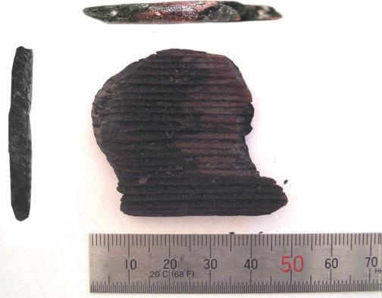
Figure 2.1 – The firebrand found from the Oakland Hills Fire in 1991.

Size distribution of firebrands
As one of the most important study, the size distribution of firebrands strongly affects the firebrand research, such as lofting stage, transporting stage and spotting ignition. Some laboratory work and simulations have been done to study the generation of firebrands, such as the experimental investigation of firebrands generated from Douglas Fir trees and Korean pine trees by Manzello [75] [76], and the simulations works by Tohidi [132]. The distribution of firebrands’ size and mass generated from Douglas Fir trees and Korean Pine trees is reviewed in the Figure 2.2.

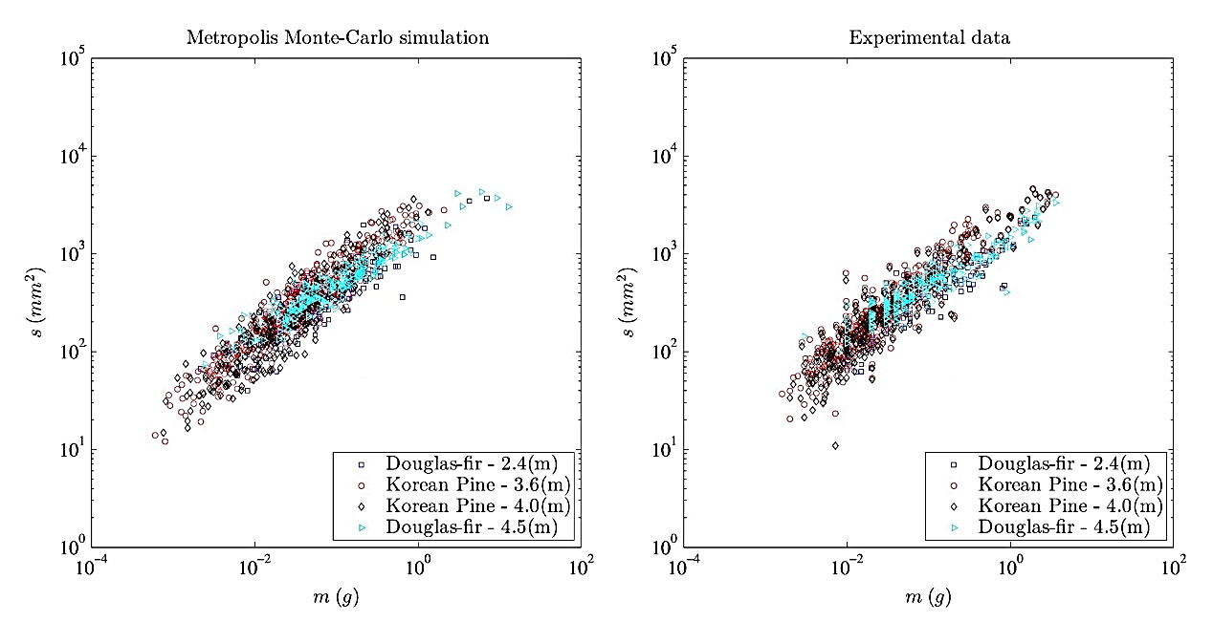
Figure 2.2 – The Log-log scale plots for firebrand surface area vs. mass [75] [76] [132].

In the Figure 2.2, left panel presents the results from simulation by Tohidi [132], for 1337 synthetic firebrands; right panel presents the experimental results conducted by Manzello [75] [76], for 1337 firebrands from laboratory measurements. The firebrands were generated from burning vegetation, including Douglas Fir trees of 2.4 and 4.5 m in height, and Korean Pine trees of 3.6 and 4.0 m in height.
From the experimental results, it can be seen that the size of firebrands generated from larger trees were mainly ranged between ×10² to ×10³ in mm², which were bigger than those from smaller vegetation around ×10² in mm². Such results were in good agreements with simulation results. As an averaged value, the surface area of firebrand was 53×4 mm² in length as disk shaped firebrand [76]. This observation was very similar with the firebrand observed from Oakland Hill Fires, which is reviewed in previous section [13]. Although both cylindrical and disked firebrands were determined from experiments, the experimental results had highlighted the importance of disked firebrands due to bigger glowing surface area which could highly increase the possibility of spotting ignition. This is one of the reasons which supports the simulations of disk-shaped firebrand in 50 mm² in this work.

Spotting phenomenon
‘Spotting’, as a phenomenon of the fire spread, was firstly utilized by Byram in 1954 [19]. Although the precise definition was not given, he highlighted that the long-distance spotting was one of the most dangerous features of the spread in extreme fires. About two years later, the definitions of the spot fire and the spotting were defined by USDA Forest Service that ‘Spot fire is the fire set outside the perimeter of the main fire by flying sparks or embers’ and ‘Spotting is the behaviour of a fire producing sparks or embers that are carried by the wind and start new fires beyond the zone of direct ignition by the main fire’ [136].
The spotting process can be divided into three stages according to its mechanism, including the Generation, the Transporting and the Ignition of fuel at the landing position [13]. These three stages have covered a board range of studies, such like the pyrolysis and combustion for the firebrands at the generation stage, the aerodynamic properties around particle and burning lift time at the transport stage, and heat transfer between firebrand and recipient fuel and smouldering combustion at the ignition at landing position stage. In this thesis, the transporting of firebrand as one of the main objectives is focused. A drawing produced by author is presented in the Figure 2.2 to show the spotting phenomenon of firebrands.
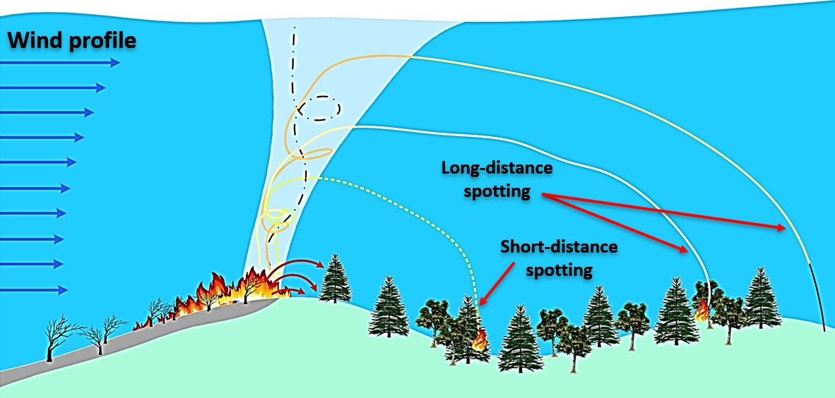
Figure 2.3 – The spotting phenomenon.

Spotting distance
Based on the travelling distance of a firebrand in spotting phenomenon, the conceptions of ‘short-distance spotting’ and ‘long-distance spotting’ was given by Byram and Davis in 1959, that it was found that short-distance spotting, as showers of burning particles, could cause new ignition about 0.5 km ahead the main fire zone. Whereas, the long-distance spotting could achieve much further propagation distance than short distance, even into miles [14]. The longest record for long-distance spotting was 29 $km$ in front of the main fire zone in Victoria, Australia in 2009. Quantitative research work has been done for determining the spotting distances of the firebrands lofted in wildfire, since this topic is really important.
Since the prediction of maximum spotting distance of firebrands is one of the main objectives in this thesis, the studies focusing on the long-distance spotting are mainly reviewed. The calculations of the particle motion are introduced. The existing models for predicting the maximum spotting distance of the firebrands are studied. Both the numerical equations from simulations and the empirical approaches from experiments are illustrated in detail in Chapter 2.3.

Burning law and lifetime of firebrands

In 1965, Tarifa reported the relationship among maximum spotting distance and other parameters [125]. In details, for a burning firebrand suspended in the flow field, the maximum spotting distance is highly depended on the changes of the particle’s parameters including density and size, and the lifetime. The both features, including the parameter changes and the lifetime of a burning firebrand, not only change the possibility of new ignition, but also significantly affect the spotting distance of firebrands. Since the Tarifa’s observation, the studies of the combustion and the burning law of the firebrands are kept being developed even in nowadays.
Generally, the combustion of a firebrand can be divided into six stages, shown as below:
- Pre-heating – Temperature of the firebrand is raising to the point where the moisture starts to volatize.
- Pre-ignition – Volatile materials in the firebrand are vaporized. (Pyrolysis starts)
- Flaming – Temperature on the surface of the firebrand has reached ignition temperature, and the combustion starts. (Char oxidation starts)
- Transition – The firebrand is partially consumed. The flame continues in portion of the firebrand resulting the generation of smoke. (Smouldering starts)
- Smouldering – Flame on the firebrands has completed essentially while the smoke continues when the oxygen is rich.
- Glowing – Combustion of limited oxygen.
Furthermore, the burning experiments have been conducted by many researchers to simulate the combustion of firebrands, in order to estimate the changes of size and density and the lifetime of firebrands.
The study of the burning behaviour and the lifetime of firebrands has been carried on in the past half century, such Lee and Hellman in 1969, Muraszew in 1974 and 1975, Albini in 1979 and Koo et al in 2007. Six of the typical equations are reviewed in this section. The burning constant and regression rates for estimating the changes of density and size of the firebrand are presented in different forms. Meanwhile, the particle’s shapes, including spherical, disk and cylindrical, and the flow field studied are discussed in reviews.

Tarifa’s equations (1965)
From Tarifa’s wind-tunnel combustion experiments which were focused on the spherical and cylinder firebrands, the empirical equations to estimate the changes of density and radius of the burning wood particle at the constant flow velocity were presented as [127]:
 | $$\frac{ρ_{s}}{ρ_{s,0}}={\left(1+ηt^{2}\right)}^{-1}$$ | Eq. 2.1
 | $$\frac{r_{s}}{r_{s,0}}={\left[1-\left(\frac{β+ δ W}{r_{s,0}^{2}}\right)t\right]}^{\frac{1}{2}}$$ | Eq. 2.2

where the $r$, $ρ$, $t$ and $W$ are the radius, density, time and relative wind velocity respectively. The subscripts $s$ and $0$ indicate the firebrands (solid) and initial value. The dimensionless parameters $η$, $β$ and $δ$ are dependent on the different wood species and moisture content of the firebrands. Further, the burning constant $β$ was given based on the effective mass diameter of the firebrands as:

 | $$\frac{d(D_{eff}^{2}) }{dt}= - β$$ | Eq. 2.3

where the $D_{eff}$ indicates the effective mass diameter of the firebrand. From his observations, the burning constant $β$ was expressed in term of the differentia of effective mass with time.

Lee and Hellman’s equations (1967)
Further, the experiments for the study of firebrand trajectories in a turbulent swirling nature convection plume were conducted by Lee and Hellman in 1969 [17]. It was found that the wood particle burned at a constant rate was assumed independent of the moisture content and flow velocity and depend on the type of wood. Thus, the approximation of the burning constant can be presented with variable of time only instead of more complex equations. For the spherical firebrands they tested, the burning constant was presented as:
 | $$r_{f}={(P_{1}^{'}- P_{2}^{''} t)}^{\frac{1}{2}}$$ | Eq. 2.4

where $P_{1}^{'}$ and $P_{2}^{''}$ are the constants related with the initial diameter and the density of the firebrand. For example, the values of both constants for a balsa wood sphere in diameter of 5 mm are of the order of magnitude $P_{1}= {10}^{9}$ and $P_{2}= {10}^{5}$.

Muraszew’s equations (1977)
Since 1970s, Muraszew devoted to the series of the firebrands research, including the reviews of the researches had been done before 1970s, the modelling of fires whirl and the experiments for the determination of the trajectories of the firebrands [21] [86] [87] [90]. In 1977, Muraszew and Fedele published a new series of equations for describing the burning law of firebrands in flight, including the new burning constant, the variations of the density and the size regression rate based on the falling velocity of particle [21].
For a cylindrical wood particle, the new burning constant based on the falling velocity was given as:
 | $$β=929×(43.3-1.87 W_{s}+0.01 {W_{s}}^{2})$$ | Eq. 2.5

where $W_{s}$ indicates the falling velocity of the firebrand.
Meanwhile, the burning law, including the density variations and the size regression rate, were expressed as:
 | $$\frac{ρ_{s}}{ρ_{s,0}}= e^{- \frac{t}{{D_{o}}^{2} β}}$$ | Eq. 2.6
 | $$\frac{D}{D_{0}}={(\frac{W_{s}}{W_{s,0}})}^{2} × \frac{ρ_{s}}{ρ_{s,0}}$$ | Eq. 2.7

where, respectively, $D$ and $D_{0}$ are the diameter at time and the initial diameter of firebrand. Meanwhile, the expressions for the flat plates (representing bark pieces) were provided as:
 | $$β=30.48×(126+59 W_{f}-0.8 {W_{f}}^{2})$$ | Eq. 2.8

 | $$\frac{ρ_{s}}{ρ_{s,0}}= e^{- \frac{t}{h_{0} β}}$$ | Eq. 2.9

where $h_{0}$ indicates the thickness of the flat plate.

Albini’s equations (1979)
Since 1979, Albini devoted to a huge amounts of the firebrands research work, focusing on the predictions of spotting distance (from the burning trees, the isolated sources and the wind-driven surface fires), the wind-blown flame models, the fire behaviour and the phenomenological models for wind speed and shear stress profiles [1] – [7]. The burning firebrand experiments conducted by him had covered three different shapes, including plates, cylinders and spheres. The dimensions of tested firebrands were in a big range. Meanwhile, many kinds of wood species, including Ponderosa pine, Engelmann spruce, Western larch and Western red cedar, were tested.
Based on the results from the experimental of burning firebrands falling in wind tunnels, a new expression of the mass loss rate with constant flow velocity was given as:
 | $$\frac{(ρ_{s} D)}{{(ρ_{s} D)}_{0}}=1- \frac{k ρ_{s} U t}{{(ρ_{s} D)}_{0}}$$ | Eq. 2.10
where $U$ indicates the mean velocity of flow over particle, and the regression coefficient $k$ was given as:
 | $$k=0.0064$$ | Eq. 2.11

Koo’s equations (2012)
The latest published paper focusing on the transportation of firebrands was from Koo in 2012, that the HIGRAD/FIRETEC simulations (a physical-based, 3-D model designed to simulate the interactive relationship between fire and its environment) were utilized for modelling burning firebrands in wildfires [56]. Besides the discussion of the modelled trajectories and combustion of the firebrands, the mass loss of the burning particles of different shapes, including disk and cylinder, was studied by comparing two limiting cases: regression only in the axial direction and the regression only in the radial direction. Aiming at the higher accuracy, two different types of the flame were modelled to fit different combustion situations. The results can be expressed as:
- With the assumption of the Opposed flow diffusion flame:

- For the particle with axial regression only:

 | $${\overline{\frac{dh}{dt}}}_{disk}= \frac{8}{3} \frac{ρ_{a}}{ρ_{s}} {({Re}_{r_{max}})}^{- \frac{1}{2}} \left|W\right| f(0)$$ | Eq. 2.12
where $h$, $W$ and $r_{max}$ respectively indicate the thickness of firebrand, the relative wind velocity and the current maximum radius of the disk firebrand respectively. The $f(0)$ was a dimensionless stream function on the surface by curve-fitting, presented as:

 | $f\left(0\right)= -0.353 γ^{-0.02} B^{(0.611-0.651 \ln\left(B\right))}$ | Eq. 2.13

where $γ$ and $B$ are the mass consumption number and Spalding’s mass transfer number respectively. If both numbers can be specified as $γ=1.2$ and $B=0.5$, the approximation of $f(0)$ could be given as:
 | $$f\left(0\right)=-0.4$$ | Eq. 2.14

Note that only the disk-shaped firebrands with axial regression only had been modelled with the Opposed flow diffusion flame, whereas the results for the other cases were not given.
- With the assumption of the Forced boundary layer diffusion flame:

- For the particle with radial regression only:

 | $${\overline{\frac{dr}{dt}}}_{disk}= \frac{ρ_{a}}{ρ_{s}} {({Re}_{h_{max}})}^{- \frac{1}{2}} \left|W\right| f(0)$$ | Eq. 2.15
where $h_{max}$ indicates the current maximum thickness of the disk firebrands. Note that the length scale for the Reynolds number of cylindrical particle is in the radius.

- For the particle with regression only:

 | $${\overline{\frac{dh}{dt}}}_{disk}= 1.11 \frac{ρ_{a}}{ρ_{s}} {({Re}_{r_{max}})}^{- \frac{1}{2}} \left|W\right| f(0)$$ | Eq. 2.16

which the stream function $f(0)$ was given as:
 | $$f\left(0\right)= -0.47 B^{(0.578-0.097 \ln\left(B\right))}$$ | Eq. 2.17

Since the $B$ was taken as 1.2, the approximation of $f(0)$ could be given as:
 | $$f\left(0\right)=-0.52$$ | Eq. 2.18

Further, the regression rates presented in Eq. 2.15 and 2.16, are non-dimensionalised by dividing by $(ρ_{a}/ρ_{s} ){Re}^{-1/2}|W|$. Then, a new dimensionless quantity was utilized by Koo [56], presented as:
 | $$\frac{\overline{\left[dr or dh\right]}}{dt} /\frac{ρ_{a}\left|W\right|}{ρ_{s} {Re}^{-\frac{1}{ 2}}}$$ | Eq. 2.19

Trajectory and spotting distance of a firebrand

Spotting phenomenon of the firebrands in wildfire truly is a challenge to human. Especially for the long-distance spotting, which can easily break the fire break and cause new ignition far away from the main fire zone. An example can be found from the Victoria Fire in Australia in 2009, that the firebrands could travel up to 29 $km$ ahead of the main fire zone in long-distance spotting [77]. Thus, it can be seen that there is a great need to develop accurate models for predicting the maximum spotting distance of firebrands in wildfire.
Since 1960s, the relevant work has been started. Quantitative research work and many models have been developed for predicting the trajectories and maximum propagating distance of firebrands. Based on these excellent researches, the reviews of the existing models for estimating the propagation of firebrands are provided. As well, the empirical equations to approach the maximum spotting distance are illustrated.

Tarifa model (1965, 1966 & 1967)
In 1960s, the burning experiments for spherical and cylindrical firebrands within vertical and inclined convection were conducted by Tarifa. The diameter of tested particle was up to 10 $cm$, and the wind speed was up to 40 $m/s$. Based on the coordinate system, the motion of a particle in the constant flow field was expressed as:

 | $$m \frac{dV_{x}}{dt}= -\frac{1}{2} ρ_{a} A C_{D} W^{2} \frac{W_{x}}{W}$$ | Eq. 2.20

 | $$m \frac{dV_{y}}{dt}= -\frac{1}{2} ρ_{a} A C_{D} W^{2} \frac{W_{y}}{W}-mg$$ | Eq. 2.21

where $C_{D}$ indicates the drag coefficient, $ρ_{a}$ indicates the density of air, $A$ and $m$ are the cross-section area and the mass of the firebrand. $\vec{W}$ is the relative velocity of the wind with respect to the firebrand, and $\vec{g}$ is the gravity. Note that the Buoyancy force was not concluded, neither the lift force since the experimental objectives were idealized as spherical particles. For the trajectory of the firebrands in a flow field, the expressions were given as:

 | $$X= \int_{0}^{t}{(u_{x}-} W_{x}) dt$$ | Eq. 2.22

 | $$Y= \int_{0}^{t}{(u_{y}-} W_{y}) dt$$ | Eq. 2.23

where $u$ is the wind velocity around the firebrand, and the subscripts $x$ and $y$ indicate initiate the horizontal and vertical directions respectively. It was found that the maximum spotting distance $X_{m}$ of a firebrand was highly dependent on the maximum height $Y_{m}$ at where the firebrand could be lofted into. Meanwhile, it was determined that both $X_{m}$ and $Y_{m}$ were proportional to the density of firebrands.

McArthur empirical mode (1967)
In 1960s, the McArthur Forest Fire Danger Index (FFDI) was developed for measuring the degree of ganger of fire in Australian forest [30]. The function of FFDI is based on dimensionless parameters including temperature, drought factor, relative humidity and wind speed. The higher value of FFDI indicates higher fuel availability, and higher possibility of forest fire. The full expression of FFDI is given as:
 | $$FFDI=2e^{(-0.45 +0.987 \ln\left(DF\right)-0.0345 RH+0.0338 T+0.0234 W)}$$ | Eq. 2.24

where $T$, $DF$, $RH$ and $W$ present the temperature, drought factor, relative humidity and wind speed respectively. Based on the data from FFDI and the rate of fire spread, the empirical model for predicting the spotting distance of the firebrands was developed. The firebrands in model is made by eucalypts, and the shapes of the firebrands are fibre and bark. Based on the FFDI model, a mathematic expression for predicting the spotting distance of firebrands was developed by Noble in 1980 [33], which can be expressed as:
 | $$S=R \left(4.17-0.033 W\right)-0.36$$ | Eq. 2.25

where $R$ presents the rate of the forward fire spread, and $W$ is the fuel weight. Based on the FFDI number, the $R$ was calculated with difference formulas. As an example, the calculation for the FFDI = 3 could be presented below:

 | $$R=0.13 F$$ | Eq. 2.26

 | $$F=2e^{( -23.6+5.01 \ln\left(C\right)+0.0281 T-0.226 \sqrt{RH}+0.633 \sqrt{W}}$$ | Eq. 2.27
where $C$ indicate the degree of curing.
As one of the important empirical equations for predicting the spotting distance of firebrands, the McArthur model has greatly contributed to the fire prevention. However, there are still many disadvantages for this model. The most one was observed by Buckley and discussed in his research report about East Gippsland Fire in 1991 [18], that the prediction from model was not valid since the different fire conditions comparing with the index. It is necessary to broaden the applicability of this model with more fire conditions.

Lee and Hellman model
In 1969, Lee and Hellman investigated the spotting of the wood spherical firebrands in a swirling turbulent natural convection plume both analytically and experimentally. The diameter of tested particle was in the range from 0.8 to 17 $mm.$ The trajectories of the particles of different geometries were plotted. The propagation and the transportation of the firebrands were investigated in three directions, including axial, radial and angular. It was found that the general shape of the trajectory was dependent upon a balance of drag and centrifugal forces on the particle in the radial direction, and the magnitudes of these forces were dependent upon the axial location in the plume.

Albini Models
Quantitative research work had been done by Albini, not only included the prediction of the spotting distance, but also for many other aspects of the wildfire and burning firebrands, such as the flame structure, the buoyant plume, the burning rate of firebrands, lofting of firebrands by flame and buoyant plume, etc.. In his study, a model for the prediction of the maximum spotting distance of the firebrands from a tree was developed. A step-by-step procedure was also given for the operation of his model. The various parameters were considered in the model, including the tree species, the height of tree, the number of trees, the diameter at breast height, the flame height, the flame duration, and etc. Besides, the effects of the terrain on the fire spread and the wind speed profile with respect to vertical height above the ground were discussed.
Furthermore, these models were simplified and transformed into metric units by Chase in 1981 [22], shown as:
- For the ambient flow field with a power law profile:

 | $$X_{max}=1.3 ×{10}^{-3} U_{H} \sqrt{H} \left\{0.362+ \frac{1}{2} {\left[\frac{Z(0)}{H}\right]}^{1/2} \ln\left[\frac{z(0)}{H}\right]\right\}$$ | Eq. 2.28

- For the wind driven surface fire:
 | $$X_{max}=1.3 ×{10}^{-3} U_{H} \sqrt{H} \left\{0.362+ \frac{1}{2} {\left[\frac{Z(0)}{H}\right]}^{1/2} \ln\left[\frac{z(0)}{H}\right]\right\}+5.03 ×{10}^{-4} U_{H} {z(0)}^{0.643}$$ | Eq. 2.29

where $X_{max}$ is the maximum spotting distance of the firebrand, $H$ is the height of tree, $g$ is the acceleration of the gravity, $z(0)$ is the height at where the firebrand is lofted and $U_{H}$ is the wind speed at the top of tree.
As the literature review made above, many models have been developed to estimate the spotting distances of firebrands. Tarifa tested the propagation distances and burning lifetime of spherical firebrands for the first time in 1965 [127] [128] [129] [130]. The equations for determining spotting distance were given based on the parameters of firebrands, including density, radius, flow velocity and drag coefficient. However, since the tested firebrands were mainly focused on spherical shapes, the lift force was ignored and excluded in the models. In 1976, Muraszew tested the burning firebrands, including cylindrical and disk-shaped particles, in a horizontal wind tunnel [88] [89] [90] [91] [92]. As the advantages, the effects of fire whirls on spotting were studied, also the statistical model of firebrand generation was developed. He recommended that the future research should focus on determining a new function for the trajectory of firebrand based on the shape, initial size, fuel type and the velocity relative to ambient flow. Similar suggestion also was given from Albini, that the firebrands of multiple shapes including spherical, cylindrical, disk and fibre should be tested. In order to estimate more accurate spotting distance, the parameters including tree height and wind profile were added into his models. But, as considering the impossibility of testing firebrands in large-scale wildfire, the experiments conducted were focused on the firebrands spotting in small fires in labs or factories. As the development of computing science, Woycheese started the numerical simulations for determining the spotting distances of spherical and disk firebrands [150] [151] [152] [153]. The parameters of tested firebrands were significantly broadened, including the flow velocity, particle size, particle density and fire scales. The results highlighted that the disk-shaped firebrands could travel much further than spheres. However, most discussions were focused on the effects from thermal source, burning lifetime, ambient flow conditions and etc., but not the aerodynamic considerations. Besides, Porterie et al used a 3-D physics-based model to study the thermal degradation of firebrands during generation and transporting stages [102] [103] [104].
Considering the cost of real tests for spotting experiments in laboratory which is also hard to repeat more than hundred times for a statistical model, the numerical simulation is more appropriate in this study. Another advantage of simulations is that the parameters of tests could be significantly broadened, including shapes and aspect ratio of particles, flow velocity due to ambient wind, firebrand density, burning lifetime, and etc. As well the simulation can decrease the hazards of experiments when determine the spotting propagation of firebrands in large scale fires. In order to overcome the disadvantage discussed in literature that the aerodynamic lift of a firebrand is not covered into the spotting models, the lift force on non-spherical firebrands will be added into the modelling in this study. Comparing with CFD simulation, the Matlab simulation is more appropriate, since better tracking of firebrand fly path and easier operations for the cases required over thousands time. Overall, the numerical simulation for firebrands spotting phenomenon with lift effects by Matlab is more suitable in this work.

Aerodynamics of a rectangular-shaped particle in the flow field

Since the importance of the particle aerodynamic properties for determining the spotting distance of firebrands in wildfire, the aerodynamic analysis of a particle lofted in a flow field is reviewed in this chapter. Generally, the trajectory of a firebrand can be simplified into two regimes as the lofting stage, where particle is lofted upwards by flame and plume in the main fire zone, and the gliding stage, where particle has exited the main zone then glides in the flow field. In this work, it is focused on the gliding stage of burning particle since this period is more important for determining the firebrand propagation distance. Comparing with the gliding stage, the horizontal propagation of firebrand in lofting stage is much smaller.
In this section, the fundamental aerodynamic properties of particle lofted in a flow field are reviewed. The calculations of the aerodynamic forces exerted on the particle are illustrated. Moreover, in order to develop an accurate transporting model for predicting the trajectories of firebrands, the aerodynamic coefficients of both lift and drag based on different conditions are studied. Focusing on the rectangular-shaped particle idealized from real firebrands, the published coefficient equations, including both experimental approaches and numerical solutions are studied. Considering the Reynolds number of the firebrand in real wildfire is in a broad range, the ranges of the Reynolds number for each equation is highlighted for more accurate applications in this study.
Furthermore, the motion of the particle when it is gliding in a flow field is discussed. Based on the Newton’s second law, the equations for predicting the trajectories of particle on both horizontal and vertical directions are reviewed. As well, the assumptions made in the publication are highlighted.

Fundamental properties of the particles

Since the simulations in this study are focused on the rectangular-shaped firebrands, the relative parameters are defined before introducing its aerodynamic analysis. A schematic representation of the rectangular-shaped particle in a flow field is presented in the Figure 2.4.
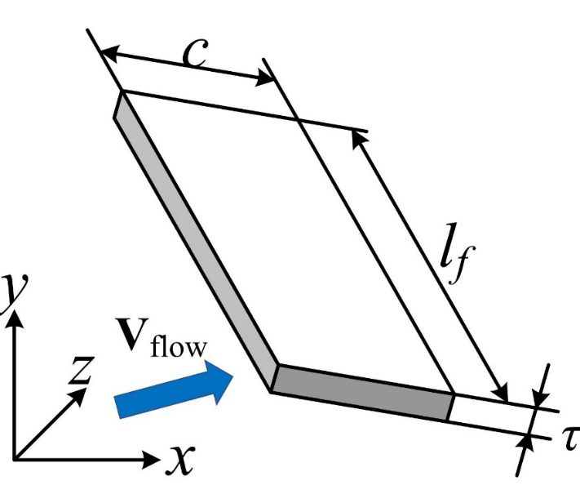
Figure 2.3 – Schematic representation of a rectangular-shaped particle in a flow field.

In the Figure 2.4, the $l_{f}$ indicates the length of the particle, the $c$ and $τ$ indicate the chord length and the thickness of the rectangular plate. The cross-section area of the particle is calculated as $A = l_{f}× c$.

Aspect ratio
Aspect ratio (AR) is a parameter for describing the geometric shape of an objective, and it has a broad application including image aspect ratio, display aspect ratio, pixel aspect ratio, etc. [36]. When discussing the aerodynamics of a particle in a flow field, the aspect ratio stands for the ratio of particle’s dimensions. The AR has been considered as an important parameter for the investigations of the spotting phenomenon since it significantly affects both the drag and lift coefficients. Based on the parameter defined above, the AR of the rectangular plate utilized in this work can be presented as:
 | $${AR}_{Rectangular-plate}= \frac{l_{f}}{c}$$ | Eq. 2.30

where $l_{f}$ and $c$ are the length and chord length of the plate. As a reference, the calculations of AR for other typical shapes, including cylinder, ellipsoid and disk, are presented in the Figure 2.5. The corresponding formula for calculating the aspect ratio is shown in the Eq. 2.31.
 | $$Aspect Ratio= \frac{a}{b}$$ | Eq. 2.31
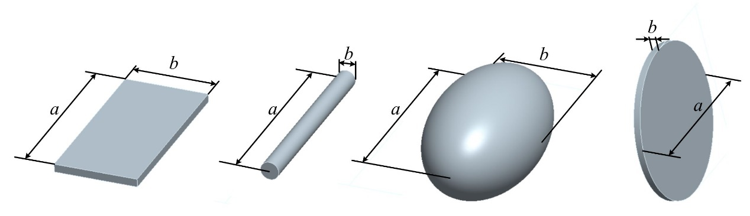
Figure 2.4 – Representations of the dimension of typical shapes.

Typically, the Glide Ratio (GR) is a parameter describing the property of a glider, which indicates the horizontal distance a glider flies in still flow condition for every unit altitude lost [37]. The glide ratio is used to present the maximum spotting distance of a firebrand as a dimensionless parameter. It is calculated form the ratio of the maximum horizontal movement of a firebrand to its vertical movement, which is shown as:
 | $$Glide Ratio= \frac{S_{x,max}}{H_{o}}$$ | Eq. 2.32

where $S_{x,max}$ indicates the maximum horizontally travelling distance of a firebrand from the certain height $H_{o}$ once it hit the ground. In this thesis, $H_{o}$ equals to 100 $m$.

Reynolds number of particles
As well known, the Reynolds number (Re) is a dimensionless quantity to present the fluid condition. The concept was firstly introduced by Sir George Stoke in 1851 [37]. In fluid mechanics, it has been widely utilized to determine the flow regime from laminar to turbulence, For the case in this thesis, that the firebrand glides in the flow field, the calculation of the particle Reynolds number is shown as:
 | $${Re}_{p}= \frac{ρ_{a} V_{f} c}{μ}$$ | Eq. 2.33

where $ρ_{a}$ and $μ$ are the density and the dynamic viscosity of the ambient flow (air), $V_{f}$ and $c$ are the velocity and characteristic length (chord length) of the firebrand.

Calculation of Aerodynamic forces

The aerodynamic analysis is important for determining the trajectory of a lofted particle in a flow field. Along the history, many excellent research works have been made to improve the understanding of aerodynamics of particles. Even until today, the corrections for the aerodynamic forces and coefficients of a particle in flow field are carried on by both the experimental and the analytical studies.
One of the well-known calculations was published by Maxey and Riley in 1983, that they reported the equation governing the velocity of the spherical particle in a nonuniform flow field [79]. Further, the equations were simplified by Yin in 2003 [153], which can be show as:
 | $$\underset{inertia}{\underbrace{m_{p} \frac{d\vec{v}}{dt}}}= \underset{gravity}{\underbrace{V_{p} \left(ρ_{p}-ρ_{F}\right)\vec{g}}}+\underset{viscous Stokes drag}{\underbrace{6πd_{sph }μ\left(\vec{u}-\vec{v}\right)}}+ \underset{\begin{aligned}pressure \\ gradient\end{aligned}}{\underbrace{ρ_{F }V_{p} \frac{D\vec{u}}{D\vec{t}}}}+ \underset{\begin{aligned}virtual \\ mass\end{aligned}}{\underbrace{\frac{1}{2} ρ_{F} V_{p} \frac{d (\vec{u}-\vec{v})}{dt}}} - \underset{Basset history term}{\underbrace{6πd_{sph}^{2} μ \int_{0}^{t}{\left\{\frac{\left(\frac{d}{dτ}\right)(\vec{v}- \vec{u})}{{\left[πμ \left(t- τ\right)/ρ_{F}\right]}^{1/2}}\right\}} dτ}}$$ | Eq. 2.34

where, respectively, $m_{p}$, $V_{p}$, $ρ_{p}$, $d_{sph}$ and $\vec{v}$ are the mass, volume, density, diameter and velocity of particle, and $ρ_{F}$, $\vec{u}$ and $μ$ are the density, velocity and viscosity of the fluid around the particle. $\vec{g}$is the gravity acceleration and $τ$ is a constant. The term on left hand side of equation stands for the inertia of particle, that the resistance of moving particle to any change in its velocity. Based on inertia, two important parameters of moving particle can be further calculated in this study including velocity and displacement of particle. On the right-hand side of equation, the terms donate gravity including buoyancy, Stoke drag, pressure gradient, virtual mass acceleration and augmented viscous drag from Basset history term. From Stokes’ Law, the force of viscosity on a moving spherical objective through a viscous fluid can be determined from viscosity, radius and relative velocity. The pressure gradient force describes the force due to a pressure difference across the objective. In 1888, the motion of a small particle in unsteady flow at low Reynolds numbers was developed by Alfred Barnard Basset and etc. In details, for an objective submerged in a fluid, the unsteady forces due to acceleration of the objective with respect to surrounding fluid can be determined from virtual mass effect and Basset force, shown as the fourth and fifth terms on the right-hand side of equation. For virtual mass, it is the inertia added to a system due to the space moved by an accelerating or decelerating objective through surrounding fluid. For Basset force, it donates the force due to the lagging boundary layer development with changing relative velocity of an objective with respect to surrounding fluid. Note that the extra terms in the Basset and virtual mass force together with the Faxen force are presented in the additional terms in Maxey and Riley’s equation, although they have small magnitudes comparing with other forces. It might be acceptable to exclude these terms in purpose of simplifications in the models developed in this thesis. In the Eq. 2.34, for the velocity field, the vector $\vec{U}=u(x,y,z,t)\vec{i}+v(x,y,z,t)\vec{j}+w(x,y,z,t)\vec{k}$ describes the fluid velocity vector at the point occupied by the particle’s centre of mass with respect to inertia frame, For the acceleration field, the change of velocity can be expressed as:
 | $$\frac{d\vec{U}\left(x,y,z,t\right)}{dt}=\left(\frac{∂\vec{U}}{∂t}+ \frac{∂\vec{U}}{∂x}\frac{dx}{dt}+\frac{∂\vec{U}}{∂y}\frac{dy}{dt}+\frac{∂\vec{U}}{∂z}\frac{dz}{dt}\right)=\left(\frac{∂\vec{U}}{∂t}+ u\frac{∂\vec{U}}{∂x}+v\frac{∂\vec{U}}{∂y}+z\frac{∂\vec{U}}{∂z}\right)$$ | Eq. 2.35

where $u$, $v$ and $w$ are temporarily defined as velocity components for this discussion. Meanwhile, for the material derivation, it can be expressed as:
 | $$\frac{D\vec{U}}{Dt}=\left(\frac{∂\vec{U}}{∂t}+ \vec{U}∙ ∇\vec{U}\right)$$ | Eq. 2.36

The first term on the right-hand side of equation is referred to local rate of change. For steady flow, the local derivation vanishes as $\frac{∂\vec{U}}{∂t} = 0$. The second term, $\vec{U}∙ ∇\vec{U}$, is referred to the convective rate of change. It stands for the variation due to the change in position of fluid particle. If there is no gradient, the $∇\vec{U} = 0$ since there is no convective change.
Further, according to the study of the particle in a turbulent flow by Lázaro and Lasheras in 1989 [61], it was found that the drag and the inertia effects were significantly larger than the effects of the pressure gradient, the virtual mass and the Basset history term by comparing the magnitude of each term. Moreover, the simplification of the equations for a small particle in dilute regime were carried on by Martin and Meiburg in 1994 [78], and Raju and Meiburg in 1995 [103]. From their studies on the accumulation and dispersion of particle in transitional mixing layers, it presented the agreement with the conclusion from Lázaro et al, that drag, gravity and inertial effects play dominant roles.
However, the shape of the particle in the previous reviews is sphere, which is not accurate for the aerodynamics of real firebrands, such as rectangular plate, cylindrical and ellipsoid. More literature reviews focused on the study of the non-spherical particles are introduced. As one of the very important aerodynamic terms comparing with the spherical particle without rotation, the lift force exerted on the non-spherical particle is highlighted, especially for estimating the particle movement in a flow field.
The earliest study on aerodynamic lift force may be found from Sir George Cayley’s work in 19th century [45], that he defined the four fundamental forces of the flight including lift, drag, thrust and weight. In 1965, a very detailed research of the aerodynamic lift on a non-spherical objective was published by Hoerner [48], that he analysed the importance of the lift effects on a wing-section and developed the equations of the section drag as a function of lift in 6th chapter in his book. The study of the lift force of an objective in the flow field has been carried on for a long time, and many papers have been published for the determination of the lift coefficient, which are reviewed in Section 2.4.3 in details.
Focused on aerodynamics of a non-spherical particle, the governing equation was developed by Yin [153], which was based on the simplification of Maxey and Riley ’s calculation, shown as:
 | $$m_{p}\frac{d\vec{v}}{dt}= {\vec{F}}_{D}+ {\vec{F}}_{L}+ V_{p} \left(ρ_{p}-ρ_{F}\right)\vec{g}+{\vec{F}}_{PG}+ {\vec{F}}_{VM}$$ | Eq. 2.37

where the terms on right hand side of the equation denote drag, lift, gravity, force due to the pressure gradient and virtual mass force. For the modelling, the motion equation of a non-spherical particle in the flow field was given by Mandø et al in 2007 [68] and Mandø and Rosendahl in 2010 [67], with the considerations of wide ranges of the Reynolds number of particle and aspect ratios, shown as:
 | $$m_{p}\frac{d\vec{v}}{dt}= {\vec{F}}_{D}+ {\vec{F}}_{L}+ {\vec{F}}_{Buoyancy}+{\vec{F}}_{other}$$ | Eq. 2.38

which present the motion of particle due to the drag, lift and Buoyancy. This expression was in the agreement with Lázaro and Lasheras [61] who highlighted that it was only necessary to retain the inertia, drag and gravity term for a small and heavy particle in the dilute regime. For the determination of the drag force exerted on a non-spherical particle in the flow field, the equation can be expressed as:
 | $${\vec{F}}_{D}= \frac{1}{2} C_{D} ρ_{F} A_{p} \left|\vec{u}- {\vec{v}}_{p}\right| (\vec{u}- {\vec{v}}_{p})$$ | Eq. 2.39

where $C_{D}$ indicates the drag coefficient. Respectively, $ρ_{F}$, $\vec{u}$, ${\vec{v}}_{p}$ and $A_{p}$ are density and velocity of the ambient flow, particle velocity, and cross-section area of the particle. More precisely, $A_{p}$ should be the particle area normal to the direction of the drag with the consideration of irregular shapes. The direction of the drag is determined by the relative velocity of the wind with respect to the particle. One of the advantages of this equation is that it can fit the different shapes of the particle, including both spherical and non-spherical. However, the challenge with regard to the calculation of the drag force is focused on the estimations of the drag coefficient with considerations of the particle Reynolds number, shape, and aspect ratio.
At the early stage of the study focused on the estimations of the lift force, the dependency of lift on drag was considered, where the equation of the lift was developed by Hoerner in 1965 [48], expressed as:
 | $$\frac{\left|{\vec{F}}_{L}\right|}{\left|{\vec{F}}_{D}\right|}= \left|\sin^{2}\left(α_{i}\right) cos⁡(α_{i})\right|$$ | Eq. 2.40

where $α_{i}$ indicates the angle of incidence between the relative velocity of wind with respect to particle, $(\vec{u}- {\vec{v}}_{p})$, and the particle major axis. But, from the studies of aerodynamics in past half century, it is found that the lift can be calculated from lift coefficient, which is more practical. A practical model for estimating the lift force of the non-spherical particle was developed by Yin in 2003 [153]. The calculation of the lift force can be shown as:

 | $${\vec{F}}_{L}= \frac{1}{2} C_{L} ρ_{F} A_{p} \frac{\vec{z^{'}} ∙ (\vec{u}- {\vec{v}}_{p})}{\left|\vec{u}- {\vec{v}}_{p}\right|} \left[\vec{z^{'}} × \left(\vec{u}- {\vec{v}}_{p}\right)\right] × (\vec{u}- {\vec{v}}_{p})$$ | Eq. 2.41

where $C_{L}$ indicates the lift coefficient. Respectively, $ρ_{F}$, $\vec{u}$ and ${\vec{v}}_{p}$ are flow density, flow velocity and particle velocity. $\vec{z^{'}}$ indicates the major axis of the particle. $A_{p}$ is particle area normal to the direction of lift force. This formula is based on the consideration that the lift force is orthogonal to $(\vec{u}- {\vec{v}}_{p})$. Also, it is assumed that the lift force is invariant under a rotation of the $\vec{z^{'}}$ in the range of 0° to 180°. Note that the lift force will vanish if the angle of incidence is 0 or π. As two important parameters involved in this thesis, the drag and lift coefficient of both spherical and non-spherical particle is discussed in detail in next section, Section 2.2.3.

Coefficient of drag and lift

As dimensionless quantities, the coefficients of drag and lift are important parameters for determining drag and lift forces exerted on the particle in a fluid field. For the drag force, it is easier to express the equations of the drag coefficient for a spherical particle since it is only in the relationship with the particle Reynolds number after simplifications. Nonetheless, the assumptions of the Reynolds number and the shape descriptor must be made for determining the drag coefficients of non-spherical particle. As well the orientation of a non-spheres should be considered for the more accurate approach. For the lift force exerted on a particle, it is not necessary to considerate the lift on a sphere without rotation since there is no force perpendicular to the flow on a spherically symmetric shape. But for a non-spherical particle, the calculation of lift coefficient is more complex, that many parameters should be considered including the Reynolds number, the shape and the angle of incidence.
In this section, the drag coefficients for both the spherical and the non-spherical particles, including cylinder, ellipsoid, fibre and rectangular plate, are reviewed. The influence of orientation on drag coefficient is discussed as well. Meanwhile, the lift coefficients of the non-spherical particles are introduced. The typical equations for these three coefficients are presented based the particle Reynolds number, the particle shapes and the incident angle with respect to the ambient flow.

Flow around a particle
For a body moving through a fluid, due to the pressure and viscous shear stress over entire surface, the body experiences a resultant force as Drag force. The drag force can be obtained from a resultant pressure force and a resultant viscous force, that both the magnitude and direction must be taken into account [30]. From Stokes’ Law, the total drag force on a sphere can be presented as:
 | $$F_{D}= 6πμUR$$ | Eq. 2.42

where $μ$, $U$ and $R$ indicate the fluid dynamic viscosity, the flow velocity relative to objective and the radius of sphere. As the Reynolds number is increased, the flow pattern around the sphere and the fluid forces acting on the sphere become different.

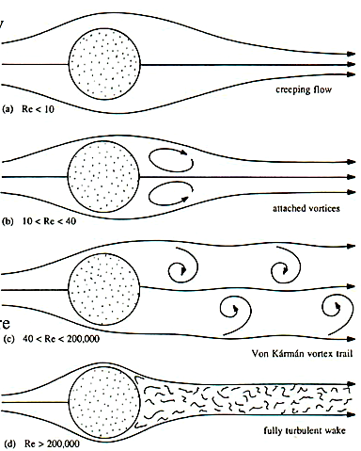
Figure 2.5 – Schematic patterns of flow around a sphere for different values of Reynolds number [30].
At very low Reynolds number (${Re}_{p}≪1$), shown as Figure 2.6 (a), the creeping flow can be assumed, as the drag coefficient $C_{D}$ and particle Reynolds number ${Re}_{p}$ is in the inverse relation $C_{D}=24/{Re}_{p}$. This inverse relation in creeping flow regime is also true for non-spherical particle, such as disk [52]. The viscosity can be neglected and no boundary layer at this moment. When the flow velocity gradually increases (as Reynolds number increases), shown as Figure 2.6 (b), a pair of vortices are formed on downstream side. The flow is separated but steady. At this time, the vortices still generate a high drag. When Reynolds number continuously increases, shown as Figure 2.6 (c), the downstream vortices become unstable, separate from the body and alternately shred downstream (Von Karman vortex trail). When Reynolds number beyond 1000, the skin friction becomes negligible. Also, the wake is less quiet which results into the further decrease of drag. When the Reynolds number is even higher, shown as Figure 2.6 (d), the boundary layer transitions to turbulent flow with vortices of different scales. The separation point for this case is also delayed from the laminar separation point. The wake is smaller than the laminar case and the drag force becomes even smaller. The drag coefficient for different shaped particle is presented in the Figure 2.7.
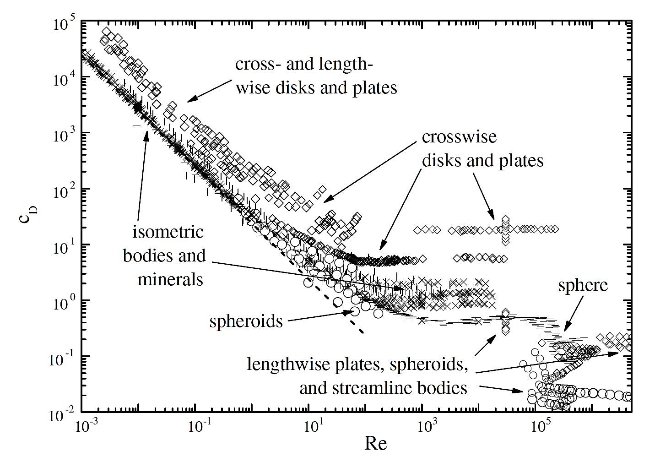
Figure 2.7 – Drag coefficients of differently shaped particles as a function of particle Reynolds number [52].

As an important aerodynamic force of a non-spherical body moving through a gas flow, the lift force occurs when the direction of flow is turned by the body. It can be explained by Bernoulli’s Conservation of Energy Law: ‘For a non-viscous, incompressible fluid in steady flow, the sum of pressure, potential and kinetic energies per unit volume is constant at any point’ [61]. As shown in the Figure 2.8, it can be seen that, due to the velocity difference, the pressure between upper and lower surface of body is different.
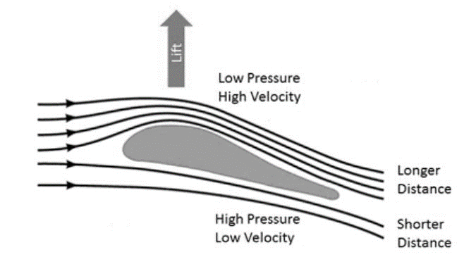
Figure 2.8 – Schematic presentation the production of aerodynamic lift force [61].

In order to discuss the effects of Reynolds numbers on lift coefficient, the Jain’s research is reviewed, shown in the Figure 2.9 [56]. It can be seen that the lift coefficient is less sensitive to Reynolds number than to Angle of attack, the lift coefficients significantly increased with increasing Angle of attack. For the effects of Reynold numbers on lift coefficients, it can be seen that $C_{L}$ was slightly increased with increasing Reynolds number.
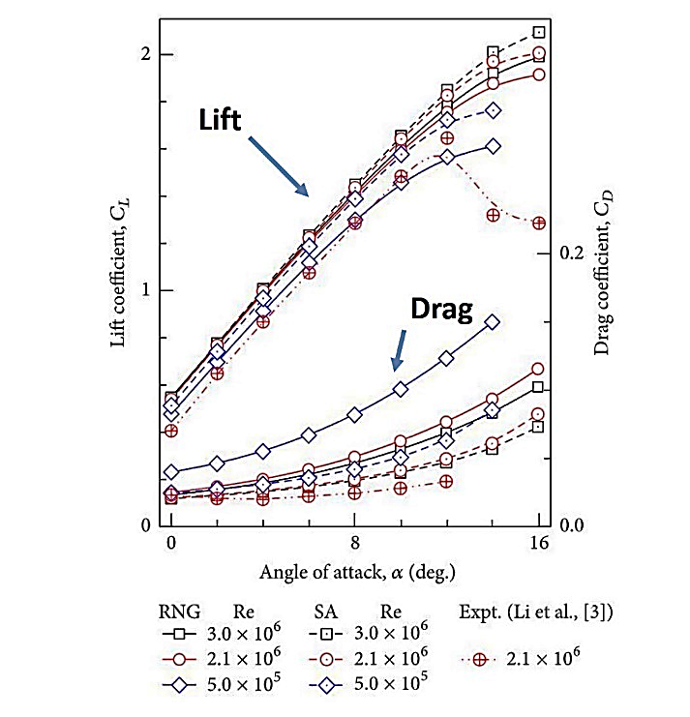
Figure 2.9 – Variation of C_{L} and C_{D} with Angle of attack for RNG and SA turbulence models.
Drag coefficient of a spherical particle
Different with the drag coefficients of non-spherical particles, the coefficient of resistance on a sphere can be described only in term of particle Reynolds number since its one-dimension-geometry and constant project area, shown as:
 | $$C_{D, sph}=f (Re)$$ | Eq. 2.43

The study of the drag coefficient of the spherical particle has been carried on for centuries. It is not only for improving the understanding of resistance to spheres in fluid, but also for quick approaches of the drag on non-spherical particles based on the sphericity of non-spheres. Over centuries, huge amounts of studies were focusing on the estimation of the drag coefficient, and quantitative equations including both the theoretical and the empirical were developed. Based on the applicable rage of the particle Reynolds number, some of the equations from both methods since 1850s are reviewed and presented in the Table 2.1.

Table 2. 1 – Equations of the drag coefficient for the spherical particles.
Author | Applicable Re | Equations
Stokes  (1851)  [48] | $$Re<0.4$$ | $$C_{D}= \frac{24}{Re}$$
Goldstein  (1929)  [44] | $$Re<2$$ | $$C_{D}= \frac{24}{Re} ( 1+ \frac{3}{16} Re- \frac{19}{1280} {Re}^{2}+ \frac{71}{2048} {Re}^{3}+…)$$
Fair and Geyer  (1954)  [33] | $$Re<1×{10}^{4}$$ | $$C_{D}= \frac{24}{Re}+ \frac{3}{\sqrt{Re}}+0.34$$
Clift et al.  (1978)  [35] | $$Re<0.01$$ | $$C_{D}= \frac{24}{Re}+ \frac{3}{16}$$
 | $$0.01≤Re ≤20$$ | $$C_{D}= \frac{24}{Re} \left[1+0.1315 {Re}^{(0.82-0.05 w)}\right]$$
 | $$20<Re ≤260$$ | $$C_{D}= \frac{24}{Re} \left[1+0.1935 {Re}^{(0.6305)}\right]$$
 | $$260<Re ≤1500$$ | $$\log{C_{D}}=1.6435-1.1241w+0.1558w^{2}$$
 | $$1500<Re ≤1.2×{10}^{4}$$ | $$\log{C_{D}}=-2.4571+2.5558w-0.9295w^{2}+0.1049w^{3}$$
 | $$1.2×{10}^{4}<Re ≤4.4×{10}^{4}$$ | $$\log{C_{D}}=-1.9181+0.6370w-0.0636w^{2}$$
 | $$4.4×{10}^{4}<Re ≤3.38×{10}^{5}$$ | $$\log{C_{D}}=-4.3390+1.5809w-0.1546w^{2}$$
 |  | where $w= \log{Re}$
Flemmer and Banks  (1986)  [35] | $$Re<8.6×{10}^{4}$$ | $$C_{D}= \frac{24}{Re} ×{10}^{E}$$
 |  | where $E=0.261{Re}^{0.369}-0.105{Re}^{0.431}-\frac{0.124}{1+{(\log{Re})}^{2}}$
Haider and Levenspiel  (1989)  [67] | $$Re<2.6×{10}^{5}$$ | $$C_{D}= \frac{24}{Re} \left(1+0.1806{Re}^{0.6459}\right)+\frac{0.4251}{1+6880.95({Re}^{-1})}$$
Yow et al.  (2005)  [154] | $$Re<2×{10}^{4}$$ | $$C_{D}= \frac{23.5}{Re}+\frac{4.6}{\sqrt{Re}}+0.3$$
Cheng  (2009)  [23] | $$Re<2×{10}^{5}$$ | $$C_{D}= \frac{24}{Re} {(1+0.27Re)}^{0.43}+0.47\left[1-e^{(-0.04{Re}^{0.38})}\right]$$
Terfous et al.  (2013)  [55] | $$0.1<Re<5×{10}^{4}$$ | $$C_{D}=2.689+\frac{21.683}{Re}+\frac{0.131}{{Re}^{2}}-\frac{10.616}{{Re}^{0.1}}+\frac{12.216}{{Re}^{0.2}}$$

Drag coefficient of a non-spherical particle
The drag coefficient of a non-spherical particle is more complex than it on a spherical particle. More parameters need to be considered. A description was developed by Mando [68], shown as:
 | $$C_{D}=f(Re, shape, orientation)$$ | Eq. 2.44
As the parameters used to describe the shape of a non-spherical particle, the sphericity, the shape factor and the aspect ratio are typically considered and utilized as variants in the equations. Later than the researches focused on spherical particle, the peak time of studies focusing on the coefficients of non-spherical particles seems start from 1990s. Some of the typical equations, including those for cylinders, fibre, ellipsoid and plate, are reviewed in the Table 2.2. Meanwhile, the diagram presenting the drag coefficient of different shaped particle from the literature as a function of the Particle Reynolds number is shown in the Figure 2.7 in previous section.

Table 2. 2 – Equations of the drag coefficient for the non-spherical particles.
Author | Applicable Re | Equations
Swamee and Ojha  (1991)  [56] | $$Re<1×{10}^{4}$$  $$0.3≤β≤1$$ | $C_{D}= {\left\{\frac{48.5}{{\left[1+4.5{(β)}^{0.35}\right]}^{0.8} {Re}^{0.64}}+{\left[\frac{Re}{Re+100+1000(β)}\right]}^{0.32}\frac{1}{{(β)}^{18}+1.05{(β)}^{0.8}}\right\}}^{1.25}$
 |  | where $β$ is the Corey shape factor of irregular particle. For non-spherical particles.
Ganser  (1993)  [38] | $$K_{1}K_{2} Re<1×{10}^{5}$$ | $$C_{D}=\left\{ \frac{24}{K_{1}K_{2} Re}\left[1+0.1118{(K_{1}K_{2} Re)}^{0.6567}\right]+ \frac{0.4305}{1+3305{{(K}_{1}K_{2} Re)}^{-1}}\right\} k_{2}$$
 |  | where $K_{1}$ is the Stokes’ shape factor, $K_{1}={(\frac{1}{3}+\frac{2}{3 \sqrt{∅}})}^{-1}$, and $K_{2}$ is the Newton’s shape factor, $K_{2}={10}^{1.8148{(-\log{∅})}^{0.5743}}$, for isometric bodies. For non-spherical particles.
Holmes et al.  (2006)  [59] | $$Re <{10}^{5}$$ | $$C_{D}=0.1+C_{N} sin⁡(α)$$  for squared plate
where $C_{N}$ is the coefficient of normal force on the plate and $α$ is the angle of attack between flow and plate,
for $α<40°, C_{N}=1.7(\frac{α}{40})$;
for $40°≤α<140°, C_{N}=1.15$;
for $40°≤α≤180°, C_{N}=1.7\frac{180-α}{40}$;

Hölzer and Sommerfeld  (2008)  [51] | $$Re <{10}^{7}$$ | $$C_{D}=\frac{8}{Re \sqrt{∅_{||}}}+\frac{16}{Re \sqrt{∅}}+\frac{3}{\sqrt{Re} ∅^{0.75}}+\frac{{0.4212}^{0.4{(-\log{∅})}^{0.2}}}{∅_{⊥}}$$
 |  | where $∅_{⊥}$ is the crosswise sphericity obtained by the ratio between the surface area of the volume equivalent sphere and the surface area of the irregular particle, $∅_{⊥}=A_{⊥, sphere}/A_{0}$. Whereas $∅_{||}$ is the lengthwise sphericity obtained by the ratio between the projected longitudinal-sectional area of the volume equivalent sphere and the difference between half the surface area and the mean projected longitudinal-sectional area of the particle, $∅_{||}=A_{||,sphere}/(0.5 A_{0}-A_{||})$. For non-spherical particles.
Zastawny et al.  (2012)  [155] | $$Re<{10}^{3}$$ | $$C_{D}=\frac{5.82}{{Re}^{0.44}}+\frac{15.56}{{Re}^{1.068}}+\left(\frac{35.41}{{Re}^{0.96}}+\frac{3.63}{{Re}^{0.05}}-\frac{5.82}{{Re}^{0.44}}+\frac{15.56}{{Re}^{1.068}}\right){\left[\sin{(α)}\right]}^{1.96}$$  for disk
Ortiz et al.  (2015)  [96] | $$6×{10}^{4}<Re<2×{10}^{5}$$ | $$C_{D}=-0.0283{\left(\frac{α-45}{26.41}\right)}^{3}-0.0407\left(\frac{α-45}{26.41}\right)+0.3717\left(\frac{α-45}{26.41}\right)+0.6886$$  for rectangular plate with $AR=1.6$

Comparing with the drag coefficients of spheres, the equations for the resistance coefficients of non-spherical particles are more complex which involves the parameters including sphericity, shape factor, angle of incidence, aspect ratio and shape descriptor. The empirical equations obtained from experimental measurements are reviewed as well for the comparisons with the numerical solutions. The special shapes which cannot be described with the sphericity are highlighted, including squared-plate, rectangular-plate and disk. Considering the firebrands modelling developed in this thesis, the empirical equations obtained from experimental measurements might be more suitable, since they might be more applicable with respect to the real flow conditions and have simpler expression which is beneficial for the simulations.

Effects of orientation on drag coefficient of a non-spherical particle
Although the determination of the orientation on lofted firebrand is not main objective in this thesis, considering its importance on the drag coefficients of non-spherical particles, the dependency of the orientation is simply reviewed and discussed in this section.
The determination of the orientation of the falling particle is challengeable, especially for the experiments conducted in the laboratory. The non-spherical particle is commonly assumed to be steady while its falling in experiments. But considering the less accuracy of the drag coefficient determined by ignoring the orientation dependency on particles, some publications which have discussed the effects of the particle orientation on the drag coefficients are reviewed as well. The angle of incidence is usually utilized to present the correlation due to the orientation, and some of the typical equations are reviewed in the Table 2.3.
The equation published by Rosendahl in 2000 [106] was obtained by numerical solutions, whereas he published an improvement with Mandø [67] in 2010. Instead of presenting the relationship between coefficient and incident angle directly, the effects of incidence were presented by the projected area by Yin [153].

Table 2. 3 – Equation presenting the relationship between the particle orientation and the drag coefficient.
Author | Particle shape | Equations
Mandø and Rosendahl  (2010)  [67] | Ellipsoid | $$C_{D}=C_{D,α=0°}+\left(C_{D,α=90°}-C_{D,α=0°}\right) sin(α)$$
 | 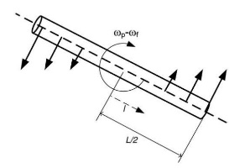 | where $C_{D, α=0°,90°}=\frac{8}{Re}\frac{1}{\sqrt{∅_{⊥}}}+\frac{16}{Re}\frac{1}{\sqrt{∅}}+\frac{3}{\sqrt{Re}}\frac{1}{∅^{0.75}}+{0.4210}^{0.4{(\log{∅})}^{0.2}} \frac{1}{∅_{⊥}}$
Zastawny et al.  (2012)  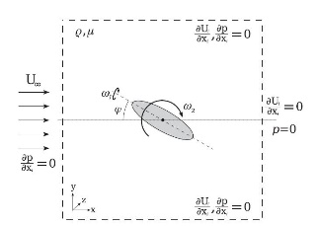  [155] |  | $$C_{D}=C_{D,α=0°}+\left(C_{D,α=90°}-C_{D,α=0°}\right) \sin^{a_{0}}(α)$$
where $C_{D,α=0°}=\frac{a_{1}}{{Re}^{a_{2}}}+\frac{a_{3}}{{Re}^{a_{4}}}$
and $C_{D,α=90°}=\frac{a_{5}}{{Re}^{a_{6}}}+\frac{a_{7}}{{Re}^{a_{8}}}$
 | Spherical  ellipsoid | $$a_{0}=1.95,a_{1}=18.12,a_{2}=1.023,a_{3}=4.26,a_{4}=0.384,$$  $$a_{5}=21.52,a_{6}=0.99,a_{7}=2.86,a_{8}=0.26.$$
 | Disk | $$a_{0}=1.96,a_{1}=5.82,a_{2}=0.44,a_{3}=15.56,a_{4}=1.068,$$  $$a_{5}=35.41,a_{6}=0.96,a_{7}=3.63,a_{8}=0.05.$$

Generally, it states that every increasement of the incident angle will increase the drag coefficient of a cylindrical particle, such as the equations stated in the Table 2.3. However, by comparing the experimental results from Carranze Chavez [21], who used experimental data for analysing the influence of incident angle on drag coefficients for the first time, it was found that the increasement of angular variation due to particle orientation could either increase or decrease the coefficients. All the rotation, including tumbling, gliding and oscillating, have impacts on the drag exerted on particles.

Lift coefficient of a non-spherical particle
Since the lift force was determined by Sir George Cayley in the 19th century, the estimations of the lift coefficients on the non-spherical objectives never stop. But, since the lift force often is smaller than the drag by one or more orders of magnitude, there are not many research works focusing on the determination of the lift coefficients of non-spherical particles.
Similar with the expression of the drag coefficient, the lift coefficient on a non-spherical particle is typically discussed with the Reynolds number, shape factor and orientation, which can be shown as:
 | $$C_{L}=f(Re, shape, orientation)$$ | Eq. 2.45

However, the effects of the particle orientation on lift coefficient are highlighted comparing those on drag coefficients. The angle of incidence between the particle and ambient flow velocity usually is highlighted in the equations of lift coefficients. Some of the typical equations for approaching the lift coefficients on the non-spherical particles are reviewed, shown in the Table 2.4. The assumptions and the discussions cased on presenting equations are stated as well.

Table 2. 4 – Equations of the lift coefficients for the non-spherical particles.
Author | Applicable Re | Equations
Zastawny et al.  (2012)  [155] | $$Re<1000$$ | $$C_{L}=\left(\frac{b_{1}}{{Re}^{b_{2}}}+\frac{b_{3}}{{Re}^{b_{4}}}\right){\left[\sin{(α)}\right]}^{b_{5}+b_{6}{Re}^{b_{7}}} {\left[\cos{(α)}\right]}^{b_{8}-b_{9}{Re}^{b_{10}}}$$
 | Spherical  ellipsoid | $$b_{1}=0.083, b_{2}=-0.21,b_{3}=1.582,b_{4}=0.851,b_{5}=1.842,$$  $$b_{6}=-0.802,b_{7}=-0.006,b_{8}=0.874,b_{9}=0.009,b_{10}=0.57.$$
 | Disk | $$b_{1}=12.111, b_{2}=1.036,b_{3}=3.887,b_{4}=0.109,b_{5}=0.812,$$  $$b_{6}=0.249,b_{7}=-0.198,b_{8}=5.821,b_{9}=-4.717,b_{10}=0.0007.$$
Ortiz et al.  (2015)  [96] | $$6×{10}^{4}<Re<2×{10}^{5}$$ | $$C_{L,α≤35°}=-0.001409α^{2}+0.06801α-5.8984×{10}^{-6}$$
 |  | $$C_{L,35°<α≤50°}=-0.03125{\left(\frac{α-42.5}{6.455}\right)}^{2}-0.01097\left(\frac{α-42.5}{6.455}\right)+0.6822$$
$$C_{L,50°<α≤90°}=-6.711×{10}^{-5}{\left(\frac{α-42.5}{6.455}\right)}^{2}-0.00632\left(\frac{α-42.5}{6.455}\right)+1.1113$$
for rectangular plate with $AR=1.6$
Sanjeevi et al.  (2018)  [66] | $$0.1<Re<2000$$ | $$C_{L}=\left(\frac{b_{1}}{Re}+\frac{b_{2}}{{Re}^{b_{3}}}+\frac{b_{4}}{{Re}^{b_{5}}}\right){\left[sin⁡(α)\right]}^{(1+b_{6}{Re}^{b_{7}}}{\left[cos⁡(α)\right]}^{(1+b_{8}{Re}^{b_{9}}}$$
 | Disk | $$b_{1}=4.484, b_{2}=1.326,b_{3}=0.122,b_{4}=0.0,b_{5}=0.0,$$  $$b_{6}=0.016,b_{7}=0.286,b_{8}=-0.010,b_{9}=0.332.$$

The equations for predicting the lift coefficients of differently shaped particles are presented based on the particle Reynolds numbers. These approaches are obtained from either the numerical solutions, such as Zastawny [155] and Sanjeevi [66], or the experimental measurements, such as Ortiz [96]. As a new method, Yin [153] estimated the lift coefficient by the projected area instead of a function of Reynolds number.
By comparing the equations of lift coefficient with those of drag coefficient, it can be seen that the lift force is much smaller than the drag in magnitude, which resulting that the lift force is commonly omitted especially for the shapes similar to spheres like spheroid. More importantly, it can be seen that lift force is highly dependent on the incident angle of the particle with respect to ambient flow. Different with the typical C_{D} – Re plots of drag coefficients, it is almost impossible to present the lift coefficients as a function of Re solely. As a parameter with more effects on lift coefficients, the C_{L} – α is commonly utilized. The Figure 2.7 presents the data from the numerical simulation made by Hölzer and Sommerfeld [52]. In the figure, the different symbols are used to present the different shapes of the particle of different aspect ratio (the ratio of length to width), including sphere ( – ), spheroid of $AR=1.5$ ( ), cube ( ), cuboid of $AR=1.5$ ( ), cylinder of $AR=1.0$ ( ), cylinder of $AR=1.5$ ( ), and the theoretical approach of spheroid from Oseen’s solution (---). It is highlighted that, at $Re=240$, the periodic flow separations appear at the orientations where the projected area reaches the largest values, yielding an increasement of the lift coefficients.
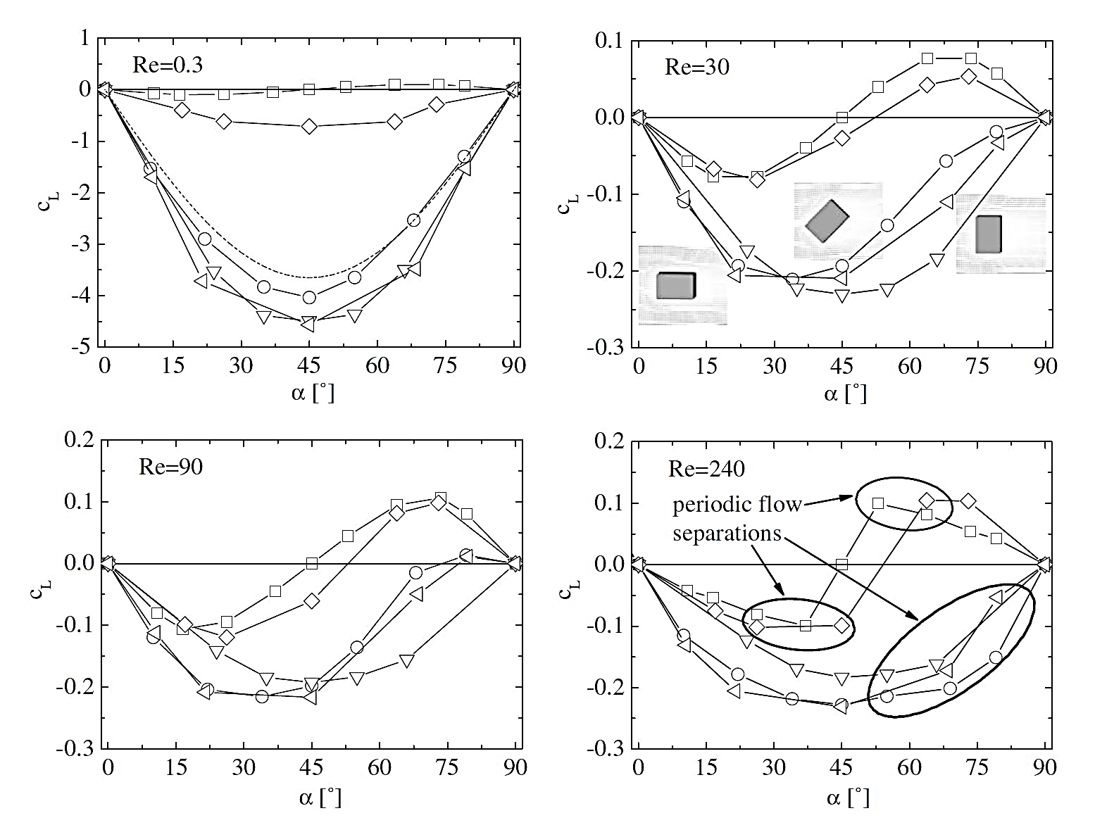
Figure 2.10 – Lift coefficients of differently shaped particle as a function of incident angle at different particle Reynolds numbers [52].

Chapter 3. MODELLING SPOTTING PHENOMENON

In the previous chapters, the importance of the study of firebrands’ propagations in wildfire has been introduced with the fundamental knowledge of firebrands and the spotting phenomenon. The existing transporting models and the aerodynamic analysis of the lofted firebrand are been reviewed in detail. In addition, the published approaches and correlation for the coefficients of drag and lift exerted on both the spherical and non-spherical particles are highlighted. Based on these literature review, the model developed in this thesis are explained and discussed in this chapter.
Facing the challenge of the spotting phenomenon for the particles lofted in the flow field, the physics-based firebrands models are developed with the main purposes including the determinations of the maximum spotting distances of a firebrand, the investigations of the effects of aerodynamic lift on the propagation of the particle, and the comparisons of the importance of each parameter involved in the firebrand spotting. In order to achieve more realistic transporting simulations of the firebrands in wildfire, the different combustion behaviours are modelled, including non-burning, burning with constant thickness and burning with variable thickness. Considering that the range of particle Reynolds number is wide in a real wildfire, different equations of aerodynamic coefficients are utilized to improve the applicability of models. In order to investigate the lift effects on the spotting of firebrands, different models are developed based on the aerodynamics of the firebrand, including and excluding the lift force. Furthermore, the parametric study of particle propagation in wildfire are made based on four controlled parameters involved in the spotting phenomenon.
In this chapter, the concepts of the models build in thesis are firstly introduced. The structures of the models are presented in detail. The modelling of firebrands’ spotting is introduced with two sections, including the transporting model and the combustion models. In transporting model, a new method for calculating the aerodynamic forces exerted on the gliding firebrand is developed. Based on the vectors defined on the firebrands, the aerodynamic forces on the firebrands is calculated from the both inner and cross products of vectors and the coefficients fit the instantaneous particle Reynolds number. Then, based on the Newton’s second law of motion, the motion of the firebrand is determined for predicting the spotting distance in each case. On the combustion model side, two models, including non-burning model and constant thickness burning model, are built with existing burning equations. Meanwhile, as a new burning model, the variable thickness burning model is developed. By comparing the results from constant and variable thickness burning models, the effects of thickness regression on the spotting distance of firebrands will be determined. The assumptions of these models are highlighted as well. Finally, both the advantage and disadvantages of the simulations in this study are compared with the existing firebrand modelling.

Concepts of the models developed

The progress of the firebrand in spotting phenomenon can be simplified into two regimes including the lofting stage and gliding stage [70]. The examples can be given as the calculations of motion by Woycheese [149], the lofting models by Woycheese and Pagni [146], the firebrands lofting by a fire whirl by Muraszew [88] or by convective plume by Lee and Hellman [17], the plume models by Nielsen and Tao models [91], by Baum and McCaffrey [19], etc.
However, comparing with the large amount of the researches focusing on the lofting stage of firebrands, there is rare research focused on gliding stage of firebrands, including the predictions of the trajectories and the spotting distances. The main work was developed by Albini [4] [6], the propagations of the firebrand from different thermal source was modelled to predict the maximum spotting distance from a single burning tree [20]. But it is hard to realize the track down of the firebrand over the whole gliding progress.
Thus, for a firebrand which has been lofted into certain height and at the gliding stage, the models, which are able to predict the maximum spotting distance and track the instantaneous motion of firebrand in long-distance spotting, are developed in this thesis. Besides the motion calculations of the particles, three main concepts which significantly change the propagations of firebrands have been considered. In details, they are the burning behaviour of firebrand which significantly changes the regression rate of particle, the particle Reynolds number which importantly impacts on the aerodynamic coefficients, and the properties of firebrand and ambient flow which strongly affect the flight path of firebrands. The structure and logic chain of the models developed in this study are shown in the Figure 3.1.
For more realistic simulations of the firebrands spotting in wildfire, the firebrand utilized in this study is obtained from the real firebrand particle, shown as Figure 2.1 in previous chapter, which is found in Oakland Hill Fire in 1991 about 1 km away from the main fire zone. Based on this real firebrand, the shape and the dimensions of the particle utilized in simulations are defined as rectangular shape and $80×50×5 {mm}^{3}$.
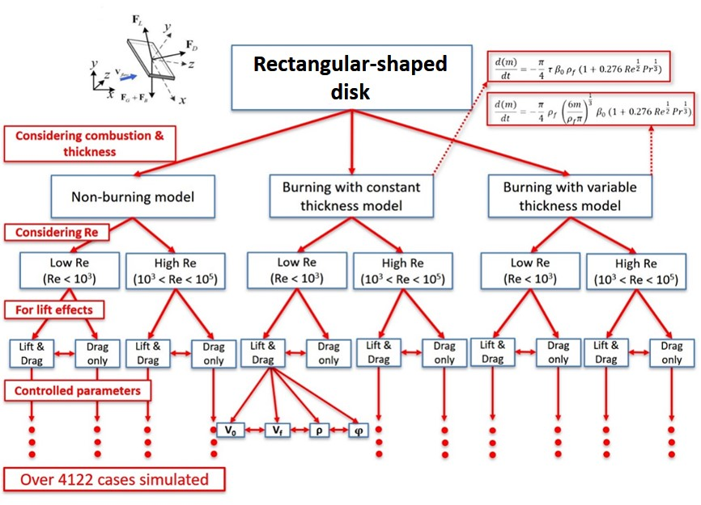
Figure 3.1 – The structure and logic chain of the models developed.

On the combustion modelling side, the thickness of the firebrand is commonly assumed to be constant in most publications. There is rare modelling which has covered the thickness change. Thus, the size regression rates of burning particle from most publications were calculated with changing projected area solely, and the change of thickness while combustion were ignored. In order to investigate the effects of thickness regression on the spotting distance of the firebrands, the variable thickness burning model is developed which has covered the change of thickness due to the combustion of firebrands. A new size regression rate is estimated based on both the change of the cross-section area and the regression on thickness. Meanwhile, a new mass loss rate is estimated with adding the weight loss due to the regression of particle thickness. The details of these calculation are presented in Section 3.2.
As an important parameter, the effects of particle Reynolds number has been considered in this study. From the literature reviews in previous chapter, it can be seen that very rare aerodynamic coefficients of the rectangular-shaped plate are available. As important references in this thesis, the approaches from Zastawny [155] and Ortiz [96] are utilized. Comparing with other coefficients studies, these equations are focused on the aerodynamic coefficients of both the disk-shaped particle and rectangular plate. However, the range of the Reynolds number of firebrands in real wildfire is wide in this work that can be up to ${2×10}^{5}$. Unfortunately, there is rare coefficients equation can satisfy the conditions including rectangular shape, low and high Reynolds numbers and specific aspect ratio. Thus, aiming at more realistic simulations, the different coefficient equations for a wide particle Reynolds number are considered, where the details of these equations are highlighted in the calculation section in Section 3.2.

Transporting models of the firebrands

In this section, the transporting model of firebrands are introduced. The equations and derivations of the transporting of firebrand are presented into two parts as the aerodynamic calculations and the motion equations. The calculations of the aerodynamic drag and lift on firebrands are highlighted. As a new mathematical model developed in this study, the vector calculation covering the whole range of attack angle is developed based on the vectors of the ambient flow velocity and the one along the direction of particle. Furthermore, the motion of the firebrands is calculated based on the Newton’s second law of motion. Both the trajectories and spotting distances will be determined from the transport modelling then.

Aerodynamic forces

In the transporting phase of the firebrands in spotting phenomenon, a new mathematical model for determining the trajectory and predicting the maximum potential spotting distance is developed in this study. When the firebrand exits the main fire zone and then glides in a constant flow field, shown in the Figure 3.1, it is assumed that the firebrand is no longer affected by the plume from the main fire zone but supported by the aerodynamic drag and lift forces.

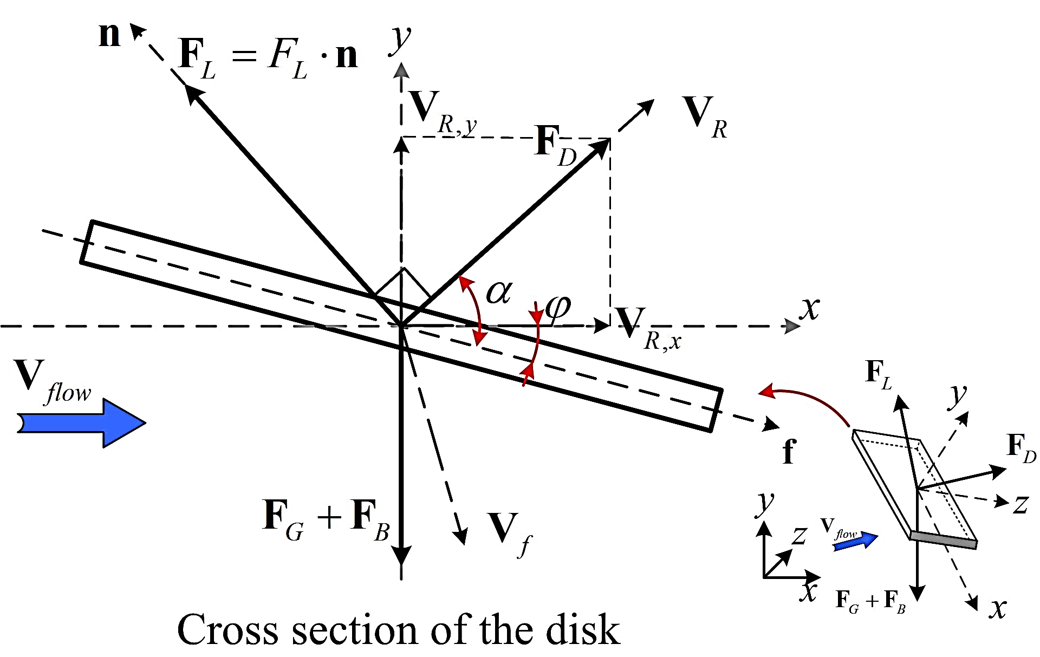
Figure 3.2 – Schematic representation of the transporting model of a rectangular-shaped firebrand in the flow field.

In the Figure 3.2, the vectors ${\vec{V}}_{f}$, ${\vec{V}}_{flow}$ and ${\vec{V}}_{R}$ respectively indicate the velocity of firebrand, the velocity of ambient flow due to wind, and the relative velocity between air flow and the firebrand which can be expressed as:
 | $${\vec{V}}_{R}= {\vec{V}}_{flow}- {\vec{V}}_{f}$$ | Eq. 3.1

The direction of drag force, ${\vec{F}}_{D}$, points to the same direction of relative velocity, ${\vec{V}}_{R}$. A special case must be considered that if the ambient flow velocity is at still. If so, the ${\vec{V}}_{R}$ points to the opposite direction of the velocity of firebrand. Further, the drag force exerted on the particle can be presented as:
 | $${\vec{F}}_{D}= \frac{1}{2} C_{D} ρ_{F}{ A}_{p} \left|{\vec{V}}_{R}\right| {\vec{V}}_{R}$$ | Eq. 3.2

where $C_{D}$ is the drag coefficient, $ρ_{F}$ is the density of ambient flow, and ${ A}_{p}$ is the projected area of the rectangular plate. As well, in the case where the ambient air is at rest, the drag force points to the opposite direction of ${\vec{V}}_{R}$.
For determining the direction of lift force, a unit vector along the particle is defined as $\vec{p}$, and the angle of attack between ${\vec{V}}_{R}$ and $\vec{p}$ is defined as $α$. Facing the situation ⅰ, shown in the Figure 3.3, that the attack angle is smaller than $\frac{π}{2}$, $α<\frac{π}{2}$, the direction of lift force can be presented as:
 | $$\frac{{\vec{F}}_{L}}{\left|{\vec{F}}_{L}\right|}= \frac{\left(\vec{f} × {\vec{V}}_{R}\right) × {\vec{V}}_{R}}{\left|\left(\vec{f} × {\vec{V}}_{R}\right) × {\vec{V}}_{R}\right|}$$ | Eq. 3.3

where ${\vec{F}}_{L}$ is the lift force. The symbol $'×'$ indicates the cross product of vectors. This formula is correct as long as the condition of ${\vec{V}}_{R}· \vec{f} > 0$, where the symbol $'·'$ indicates the inner product of vectors.
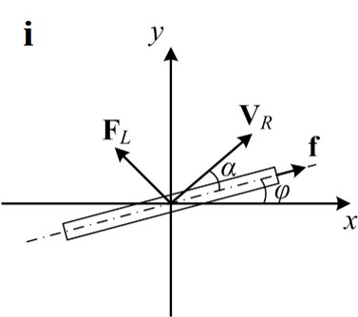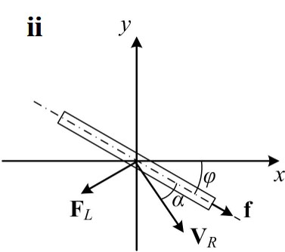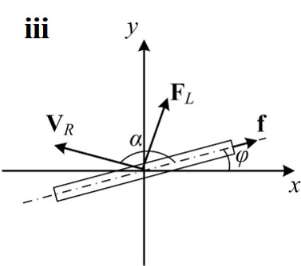
Figure 3.3 – Schematic representations of the situations of the lift force may exist on the firebrand.

For the configuration shown as the situation ⅱ, the vector in Equation 3.3 also points in the right direction, which means this case has been taken care of.
Alternatively, when ${\vec{V}}_{R}· \vec{f} < 0$, the attack angle is bigger than $\frac{π}{2}$, $α>\frac{π}{2}$, shown as the situation ⅲ in the Figure 3.2, the formula above is not correct, and the right indication of the direction of lift should be:
 | $$\frac{{\vec{F}}_{L}}{\left|{\vec{F}}_{L}\right|}= \frac{{\vec{V}}_{R} × \left(\vec{f} × {\vec{V}}_{R}\right)}{\left|{\vec{V}}_{R} × \left(\vec{f} × {\vec{V}}_{R}\right)\right|}$$ | Eq. 3.4

Then, the two cases including $α>\frac{π}{2}$ and $α<\frac{π}{2}$ can be combined int one expression with both the inner and cross products of the vectors, shown as:
 | $$\frac{{\vec{F}}_{L}}{\left|{\vec{F}}_{L}\right|}= \left({\vec{V}}_{R}· \vec{f}\right) \left(\vec{f} × {\vec{V}}_{R}\right) × {\vec{V}}_{R}$$ | Eq. 3.5

If expand the vector products, the result can be shown as:
Eq. 3.6
$$\left({\vec{V}}_{R}· \vec{f}\right) \left(\vec{f} × {\vec{V}}_{R}\right) × {\vec{V}}_{R}= \underset{the scale factor}{\underbrace{\left({\vec{V}}_{R,x }cosφ+{\vec{V}}_{R,y }sinφ\right)\left({\vec{V}}_{R,y }cosφ-{\vec{V}}_{R,x }sinφ\right)} \underset{vector}{\underbrace{\left(-{\vec{V}}_{R,y}\vec{ i}+{\vec{V}}_{R,x}\vec{ j}\right)}}}$$
where the angle $φ$ is the angle between the firebrand and horizontal direction. The first term on the right-hand side of the equation indicates the scale of the products and the second term indicates the direction. It can be seen that ${\vec{F}}_{L}$ either is parallel with $\left(-{\vec{V}}_{R,y}\vec{ i}+{\vec{V}}_{R,x}\vec{ j}\right)$ or points in opposite direction, which is depending on the sign of scale factor. Therefore, the vector $\vec{n}$, $\vec{n}=(\left|{\vec{n}}_{x}\right| , \left|{\vec{n}}_{y}\right|)$, is used to denote the direction vector of the vector above, shown as:
Eq. 3.7
$$\vec{n}= \underset{sign of the equation}{\underbrace{\left\{\left({\vec{V}}_{R,x }cosφ+{\vec{V}}_{R,y }sinφ\right)\left({\vec{V}}_{R,y }cosφ-{\vec{V}}_{R,x }sinφ\right)\right\}}} \underset{magnitude of the equation}{\underbrace{\frac{\left(-{\vec{V}}_{R,y}\vec{ i}+{\vec{V}}_{R,x}\vec{ j}\right)}{\sqrt{{\left({\vec{V}}_{R,x}\right)}^{2}+{\left({\vec{V}}_{R,y}\right)}^{2}}}}}$$

where ${\left({\vec{V}}_{R}\right)}^{2}= {\left({\vec{V}}_{R,x}\right)}^{2}+{\left({\vec{V}}_{R,y}\right)}^{2}$. The first term on the right-hand side of equation indicates the sign of the equation and the second term indicates the magnitude of the equation. Then, the lift force can be expressed with $\vec{n}$, shown as:
 | $${\vec{F}}_{L}= \left|{\vec{F}}_{L}\right| \vec{n}= \frac{1}{2} C_{D} ρ_{F}{ A}_{p} {\left({\vec{V}}_{R}\right)}^{2} \vec{n}$$ | Eq. 3.8

Considering the range of attack angle, if the situation is the same with Figure 3.4(a), the $α$ satisfies:

 | $$cosα= \frac{{\vec{V}}_{R}· \vec{f}}{\left|{\vec{V}}_{R}\right|}$$ | Eq. 3.9

where ${\vec{V}}_{R}· \vec{f} >0$ in this situation.
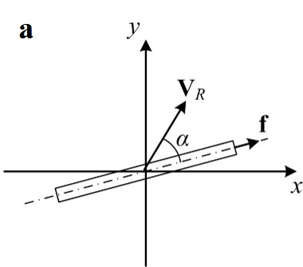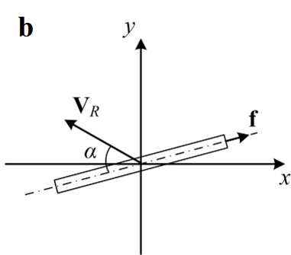
Figure 3.4 – Schematic representation of the situations of different angle of attack.
If the situation is the same with Figure 3.4(b), the attack angle is the angle between ${\vec{V}}_{R}$ and $\vec{f}$. Thus:
 | $$cosα=- \frac{{\vec{V}}_{R}· \vec{f}}{\left|{\vec{V}}_{R}\right|}$$ | Eq. 3.10
Since in this situation ${\vec{V}}_{R}· \vec{p} <0$, so it equals the equation:
 | $$cosα= \frac{\left|{\vec{V}}_{R}· \vec{f}\right|}{\left|{\vec{V}}_{R}\right|}$$ | Eq. 3.11
Therefore, the both cases can be combined into one and represented as:
 | $$cosα= \frac{\left|{\vec{V}}_{R}· \vec{f}\right|}{\left|{\vec{V}}_{R}\right|}$$ | Eq. 3.12

Note that in the special case where ${\vec{V}}_{R}$ and $\vec{f}$ are parallel, the angle of attack equals 0°, Then, both drag and lift equal to 0. When the ${\vec{V}}_{R}$ and $\vec{f}$ are perpendicular, the angle of attack equals 90°, then the aerodynamic force is pure drag and lift force vanishes. Meanwhile, the value of the angle of attack is in the range of $[0°, 90°]$. The definitions for the positive and the negative value of angle of attack are presented in the Figure 3.5 below.

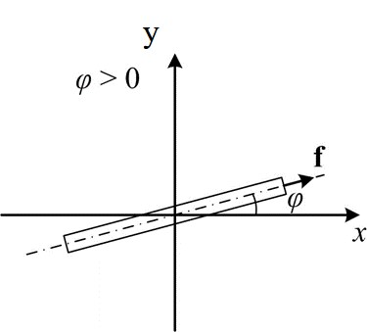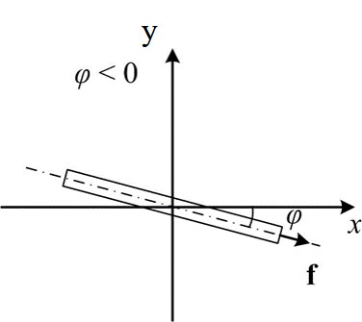
Figure 3.5 – Schematic representation of the positive and negative attack angles.

Motion of the particle

The trajectory of the firebrand in this study is determined from the motion equations based on the Newton’s second law of motion. As discussed in the previous literature reviews, it is might be acceptable to neglect the virtual mass term and Basset history term by the order of magnitudes in the force equations [40]. Thus, based on the Newton’s second law of motion, the motion of the rectangular-shaped firebrand can be expressed as:
 | $$m_{f} \frac{d\vec{V_{f}}}{dt}= \vec{F_{D}}+\vec{F_{L}}+A τ \left(ρ_{f}- ρ_{air}\right) \vec{g}$$ | Eq. 3.13

where $m_{f}$, $V_{f}$ and $ρ_{f}$ respectively indicate the mass, the velocity and the density of firebrand. $g$ is the gravity acceleration. $F_{D}$ and $F_{L}$ are the aerodynamic drag and lift forces exerted on the particle. Since the neglect of the force in third direction, the equation can be expanded into a x-y coordinate system, shown as:
 | $$m_{f} \frac{d\left|\vec{V_{f,x}}\right|}{dt}= \left|\vec{F_{D,x}}\right|+\left|\vec{F_{L,x}}\right|$$ | Eq. 3.14

 | $$m_{f} \frac{d\left|\vec{V_{f,y}}\right|}{dt}= \left|\vec{F_{D,y}}\right|+\left|\vec{F_{L,y}}\right|+\left|A τ \left(ρ_{f}- ρ_{air}\right)\vec{ g}\right|$$ | Eq. 3.15

And the motion of the firebrand lofted in a constant flow field can be shown as:
 | $$m_{f} \frac{dV_{f,x}}{dt}= \frac{1}{2}C_{D} ρ_{f} { A}_{p} \left|{\vec{V}}_{R}\right| \left|{\vec{V}}_{R,x}\right|+\frac{1}{2}C_{L} ρ_{f} { A}_{p} {\left({\vec{V}}_{R}\right)}^{2} \left|{\vec{n}}_{x}\right|$$ | Eq. 3.16

 | $$m_{f} \frac{dV_{f,y}}{dt}= \frac{1}{2}C_{D} ρ_{f} { A}_{p} \left|{\vec{V}}_{R}\right| \left|{\vec{V}}_{R,y}\right|+\frac{1}{2}C_{L} ρ_{f} { A}_{p} {\left({\vec{V}}_{R}\right)}^{2}\left| {\vec{n}}_{y}\right|-A τ \left(ρ_{f}- ρ_{air}\right) g$$ | Eq. 3.17

where the magnitude of the vector $\vec{n}$ can be found from:
 | $$\vec{n}=sign \left\{\left({\vec{V}}_{R,x }cosφ+{\vec{V}}_{R,y }sinφ\right)\left({\vec{V}}_{R,y }cosφ-{\vec{V}}_{R,x }sinφ\right)\right\} \frac{\left(-{\vec{V}}_{R,y}\vec{ i}+{\vec{V}}_{R,x}\vec{ j}\right)}{\sqrt{{\left({\vec{V}}_{R,x}\right)}^{2}+{\left({\vec{V}}_{R,y}\right)}^{2}}}$$ | Eq. 3.18

 | $$\vec{n}=( \left|{\vec{n}}_{x}\right| , \left|{\vec{n}}_{y}\right| )$$ | Eq. 3.19

Note that the positive values determined from the equations indicate the rightward direction on x-axis and upward direction on y-axis.
For more accurate estimations of firebrand trajectories, the corresponding coefficients which fit the particle Reynolds number are determined by Zastawny [155] and Ortiz [96], which can be presented as:
- For the Reynolds number of the particle in the range of
 | $$0 <Re ≤ 1×{10}^{3}$$ | Eq. 3.20

The corresponding coefficients are from
Eq. 3.21
$$C_{D}=\frac{5.82}{{Re}^{0.44}}+\frac{15.56}{{Re}^{1.068}}+\left(\frac{35.41}{{Re}^{0.96}}+\frac{3.63}{{Re}^{0.05}}-\frac{5.82}{{Re}^{0.44}}+\frac{15.56}{{Re}^{1.068}}\right){\left[\sin{(α)}\right]}^{1.96}$$

Eq. 3.22
$$C_{L}=\left(\frac{12.111}{{Re}^{1.036}}+\frac{3.887}{{Re}^{0.109}}\right){\left[\sin{(α)}\right]}^{0.812+0.249{Re}^{-0.198}} {\left[\cos{(α)}\right]}^{5.821-4.718{Re}^{0.007}}$$

- For the Reynolds number of the particle in the range of
 | $$1×{10}^{3} <Re ≤ 2×{10}^{5}$$ | Eq. 3.23

The corresponding coefficients are from
Eq. 3.24
$$C_{D}=-0.0283{\left(\frac{α-45}{26.41}\right)}^{3}-0.0407\left(\frac{α-45}{26.41}\right)+0.3717\left(\frac{α-45}{26.41}\right)+0.6886$$

Eq. 3.25
$$C_{L,α≤35°}=-0.001409α^{2}+0.06801α-5.8984×{10}^{-6}$$

Eq. 3.26
$$C_{L,35°<α≤50°}=-0.03125{\left(\frac{α-42.5}{6.455}\right)}^{2}-0.01097\left(\frac{α-42.5}{6.455}\right)+0.6822$$

Eq. 3.27
$$C_{L,50°<α≤90°}=-6.711×{10}^{-5}{\left(\frac{α-42.5}{6.455}\right)}^{2}-0.00632\left(\frac{α-42.5}{6.455}\right)+1.1113$$

Note that these coefficient equations are for specific particle shape of rectangular and certain aspect ratio of 1.6.
For the numerical methods used in this work, they are simply introduced in this section. Considering the amount of calculation work, the Matlab software is used to operate the calculation of firebrand trajectories. From the Eq. 3.16 and 3.17, the trajectories of firebrand on horizontal and vertical directions $X$ can be determined as:
 | $$X=\sum_{0}^{t}{m_{f} \frac{dV_{f,x}}{dt}}= \sum_{0}^{t}{(\frac{1}{2}C_{D} ρ_{f} { A}_{p} \left|{\vec{V}}_{R}\right| \left|{\vec{V}}_{R,x}\right|+\frac{1}{2}C_{L} ρ_{f} { A}_{p} {\left({\vec{V}}_{R}\right)}^{2} \left|{\vec{n}}_{x}\right|)}$$ | Eq. 3.28

Considering the complexity of solving the above equation, the Ordinary Differential Equation Solver is used in Matlab, shown as:
options = odeset('Events',@events);

The event is in this ODE solver is set as firebrand hits the ground from certain height. By doing this, the flying time $t$ of firebrand can be determined once the ‘event’ was triggered. This step is calculated by an Event function in Matlab (ODE Event Location Function), and the code is presented below as a reference:
function [value,isterminal,direction] = events(t,vy)
value = 100 + (vy(4)) ; % detect height = 0
isterminal = 1; % stop the integration
direction = 0; % negative direction
end

The condition to trigger the event is that the ‘value’ term equals 0. For an easier way of coding, the vertical displacement (shown as ‘(vy(4)’ term above) starts from value of 0, which will be negative value during the dropping of particle. In this work, the vertical height of firebrand fly path is set as 100 m. Once the ‘value’ term equals 0 (means the firebrands has travelled vertically over 100 m and hit the ground), the event of stopping integration will be triggered, where the time step can be calculated as the flying time of firebrands. A mathematical expression can be shown as: $Y=100=\sum_{0}^{t}{m_{f} \frac{dV_{f,x}}{dt}}$. The code of calling ‘ode45’ function in Matlab is shown as:
[t, newVel,te,ye,ie] = ode45(@(t,vel)accerleration(t,vel,rho2,c), tspan, y0, options);

In this numerical method, there are four boundary conditions standing for four variations in real physical problem, including flow velocity, initial particle velocity, particle density and incident angle. Any change of the variations will affect the calculating results of vector $\vec{n}$ shown in the Eq. 3.18, coding as:
vR = [vRx vRy];
nx = sign((vRx*cos(alpha) + vRy*sin(alpha))*(vRy*cos(alpha) - vRx*sin(alpha)))*((-vRy) / sqrt(vRx^2 + vRy^2));
ny = sign((vRx*cos(alpha) + vRy*sin(alpha))*(vRy*cos(alpha) - vRx*sin(alpha)))*((vRx) / sqrt(vRx^2 + vRy^2));

Such change then will further affect the calculation of lift force and drag force, since the relative velocity of firebrand to ambient flow field will be changed.

Simplified combustion models of firebrands

In order to achieve good simulation of the firebrands lofted in a flow field, the different combustion behaviours are considered. As discussed in the literature reviews in this thesis, many combustion models have been developed to predict the regression rates of wood particle of different shapes. The regression rates, including size regression and density variations due to burning, significantly affect the propagations of firebrands.
However, the assumption, that the thickness of the particle keeps constant, is commonly made from in the reviewed papers. Aiming at more realistic simulations in this study, a new combustion model, which assumes the thickness of rectangular-shaped particle varies while burning, named ‘variable thickness burning model’, is developed in this study. The new approach of the size regression is introduced in this section. Meanwhile, the models, for the firebrand which are not ignited or extinguished, called ‘non-burning model’, and for the firebrand which is burning with non-changing thickness, named ‘constant thickness burning model’, are built up as well. The assumptions and discussions are given under each corresponding topic.

Non – burning model

The main concept of non-burning model is that the geometry of the gliding particle is not changing or changing with a very slow rate which can be neglected in short time flight. Thus, there two kinds of particle can be simulated in this model, including the non-burning particle and the glowing particle.
Due to the slow char oxidation rate, the glow particle almost keeps its size and shape while gilding if ignoring the opportunity of proper flow conditions (warm and dry wind with suitable speed and rich oxidation). Comparing with the non-burning particle, the glow particle which is more hazardous and can easily cause new ignitions ahead the main fire zone. Considering the flight time of particle in this study is short, it may be acceptable to assume the glow particle without size changes.
Comparing with other models developed in this work, the expression for non-burning are relatively simpler, shown as:
 | $$\frac{dA_{f}}{dt}=0, \frac{dτ}{dt}=0, \frac{dρ_{f}}{dt}=0$$ | Eq. 3.29

where $A_{f}$, $τ$ and $ρ_{f}$ respectively indicate the projected area, the thickness and the density of the firebrands. Note it is assumed that the size regression rate and density variation are with great small values and the flight time of firebrands is short.

Constant – thickness burning

The main concept in this model is that the thickness of the particle is assumed to be constant while burning. Such assumption is commonly made from the most relative papers. Based on the experiments focusing on the combustion model of disk-shaped particle from Tarifa [15], Woycheese [55] and Anthenien et al. [8], it seems this assumption may be acceptable for the plate and disk of small aspect ratio and relatively small thickness. Considering the possibility of constant thickness burning particles in real wildfire, the corresponding model is developed based on the combustion models mentioned above.
The earliest experimental research focused on combustion model of burning firebrands might be found as Tarifa’s wind-tunnel experiments for spherical wooden-particles in 1965 [12]. From his results, a d-squared law could be used to satisfactorily fit the plots and a burning constant was determined. Since the simple geometry of a spherical particle which is only in term of particle diameter, the size regression rate can be simplified as:
 | $$\frac{d\left({D^{2}}_{eff}\right)}{dt} = -β$$ | Eq. 3.30

where $D_{eff}$ is the effective mass diameter of particle. From his results, the $D_{eff}$ was defined as:
 | $$D_{eff}= {\left(\frac{6m_{p}}{ρ_{p,0} π}\right)}^{1/3}$$ | Eq. 3.31

where $m_{p}$ is the particle mass and $ρ_{p,0}$ is the initial density of particle. For the burning constant, the Tarifa’s burning constant can be expressed as:
 | $$β=1.8 ×{10}^{-7}$$ | Eq. 3.32

which is in the standard unit of $m^{2}/s$. In 1985, the burning constant is modified by Williams [144], which can be expressed as:
 | $$β= β_{0} \left(1+0.276 {Re}^{1/2} {Pr}^{1/3}\right)$$ | Eq. 3.33

where $β_{0}$ is the Tarifa’s burning constant.
In 2006, a combustion model for spherical-disk-shaped wooden particle is developed by Anthenien et al. [8], which can be expressed as:
 | $$\frac{dm}{dt}= \frac{ρ π τ}{4} \frac{dD^{2}}{dt}$$ | Eq. 3.34

Combining the burning constant determined by Williams, the mass loss rate of the disk was represented by Anthenien as:
 | $$\frac{dm}{dt}=- \frac{ρ π τ}{4} β_{0} \left(1+0.276 {Re}^{1/2} {Pr}^{1/3}\right)$$ | Eq. 3.35

which is based on the assumption that the reaction spreads inward over the entire circumference of the round disk. If we assume such reaction spreads with constant speed on both sides of the rectangular surface, the mass loss rate for a rectangular-shaped disk may be expressed as:
 | $$\frac{dm}{dt}= ρ τ \frac{dA}{dt}$$ | Eq. 3.36

Then, combining the burning constant, the mass loss rate can be represented as:
 | $$\frac{dm}{dt}=- ρ τ β_{0} \left(1+0.276 {Re}^{1/2} {Pr}^{1/3}\right)$$ | Eq. 3.37

and the size regression rate can be expressed as:
 | $$\frac{dA}{dt}=- β_{0} \left(1+0.276 {Re}^{1/2} {Pr}^{1/3}\right)$$ | Eq. 3.38

However, again, the assumption for these equations must be highlighted that the thickness of burning rectangular-shaped firebrand is constant and the reaction spreads inward over the entire circumference with same rate on both sides of rectangular surface. For ascertaining the usage and improving the accuracy of this model, more experiments should be conducted for determining the burning rate on both the length and the width of a rectangular-shaped particle, since there is very rare literature review focused on the combustion model of the rectangular-shaped wooden particle. Meanwhile, more research should be made to verify the thickness change of burning particles of a wide range of aspect ratio. So far, from the few papers focused on the combustion model of disk and plates, the aspect ratio of tested particles is really limited, especially for rectangular plates.
In order to validate the constant thickness burning model, the burning model determined from Anthenien [8] is utilised. As shown in literature review, very rare published burning model is similar with the burning model developed in this work, considering conditions of firebrand including shape, aspect ratio, density, ambient flow velocity, initial particle velocity and incident angle. The most appropriate burning model can be found as Anthenien’s research [8], that a round-disk with same flow field and wooden material. Although the shape difference exits between two models, the equivalent radius is calculated for Anthenien’s model.

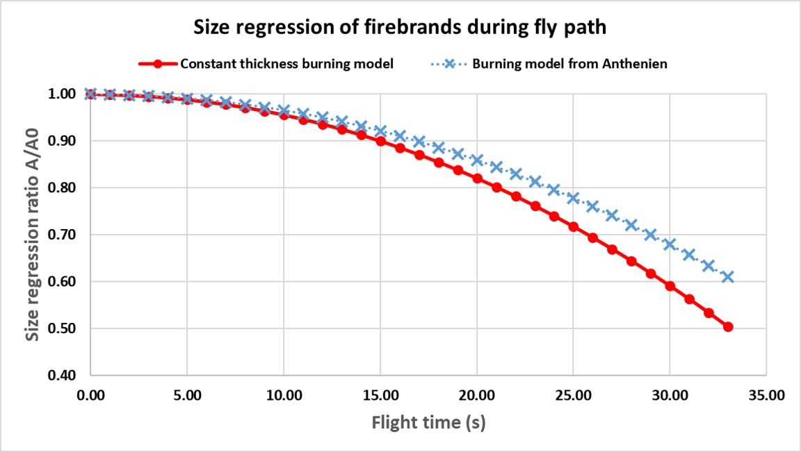
Figure 3.6 – Validation of size regression rate for constant thickness burning model.

As the firebrand utilized in this work, an 80 mm × 50 mm × 5 mm rectangular-shaped disk firebrand (wooden) was releasing from 100 m in height. Its flight time was about 33 seconds before hitting the ground. The incident angle of tested firebrand was -7.5° with respect to negative horizontal direction. The results of size regression from constant thickness burning model is validated in the Figure 3.6. In this case, the flow velocity is 10 m/s and particle density is 350 kg/m³.
As shown in the figure, the red line indicates the size regression rate of constant thickness burning model developed in this work, whereas the blue line indicates the results determined from Anthenien’s burning model [8]. Respectively, $A$ and $A_{0}$ indicate the cross-section area of firebrand after burning and initial value. It can be seen that the results from both models are similar. The size regression rate determined from Anthenien’s burning model is in good agreement with the one developed in this thesis. The difference between two models was less than 0.1 of size regression ratio ($A/A_{0})$.

Variable thickness burning

Against the constant thickness model, the main concept of this model is assuming that the thickness of particle is change while combustion. Although such assumption has greatly increased the complexity of the simulations, it is worthy investigating the effects of changing thickness on firebrands’ trajectories. As well, the comparison with constant thickness burning model can be provided.
Based on Tarifa’s wind-tunnel experiments [12], if the size regression of particle is shown as:
 | $$\frac{d\left({D^{2}}_{eff}\right)}{dt} = -β$$ | Eq. 3.39

If assume the size regressions of particle are equivalent on three directions, the size regression on each direction can be represented as:
 | $$\frac{ dD_{eff}}{dt}=-\frac{1}{2} \frac{β}{D_{eff}}$$ | Eq. 3.40

Meanwhile, if use $D_{eff,0}$ to indicate the initial dimension of particle, then the integral of initial equation can be expressed as:
 | $$D_{eff}= \sqrt{- βt+{D^{2}}_{eff,0}}$$ | Eq. 3.41
Meanwhile, for a sphere, the equivalent mass loss of particle may be expressed as:

 | $$\frac{dm}{dt}= \frac{ρ π {D^{2}}_{eff}}{2} \frac{dD_{eff}}{dt}$$ | Eq. 3.42

After substituting the terms,
 | $$\frac{dm}{dt}= \frac{ρ π \left(- βt+{D^{2}}_{eff,0}\right)}{2} \left(-\frac{1}{2}\right) \frac{β}{\sqrt{- βt+{D^{2}}_{eff,0}}}$$ | Eq. 3.43

Combining Athenian’s burning constant,
 | $$\frac{dm}{dt}= -\frac{ρ π \left[β_{0} \left(1+0.276 {Re}^{1/2} {Pr}^{1/3}\right)\right] {\left(- βt+{D^{2}}_{eff,0}\right)}^{1/2}}{4}$$ | Eq. 3.44

Considering the mass of a sphere, it can be represented by effective diameter as:
 | $$m= \frac{π ρ}{6} {D^{2}}_{eff}$$ | Eq. 3.45

which can be calculated as:
 | $${D^{2}}_{eff}= \frac{6 m}{π ρ}$$ | Eq. 3.46

Substituting into mass loss equation:
 | $$\frac{dm}{dt}= -\frac{{\left(π ρ\right)}^{\frac{2}{3}}}{4} {\left(6m\right)}^{\frac{1}{3}} β_{0} \left(1+0.276 {Re}^{1/2} {Pr}^{1/3}\right)$$ | Eq. 3.47

Again, the assumptions in this model must be highlighted that the size regression rate and mass loss rate on each dimension of particle are assumed to be equivalent. There still are many researches should be done to improve the accuracy of this model. As a gap in the combustion model of firebrands, more experiments should be conducted for destemming the regression rate of rectangular plate especially for the thickness change. As well the research to ascertain if the regression rates on the length and width of a rectangular plate are the same. Although there are a few papers focused on modelling the combustion of round-disk-shaped wooden particle or leaf (usually is assumed as disk or plate), almost none of the data was reported for determining the regression of thickness. All these challenges should be carried on in the future.
For the validation of variable thickness burning model, efforts have been made. As introduced in previous chapter, the variable thickness model developed in this work is for the first time. Rare data base with same conditions can be found. In order to compare the trend of mass regression, the Anthenien’s mass regression rate [8] is compared. Also, as a reference, the mass regression rate for constant thickness burning model developed in this work has been compared.
In this case, the firebrand was released from 100 m in height and the ambient flow velocity was 10 m/s. Total flight time of the firebrands was about 33 s. The density of firebrand was 350 kg/m3 and the incident angle was -7.5° with respect to negative horizontal direction. The size regression rate of burning firebrands are presented in the Figure 3.7.
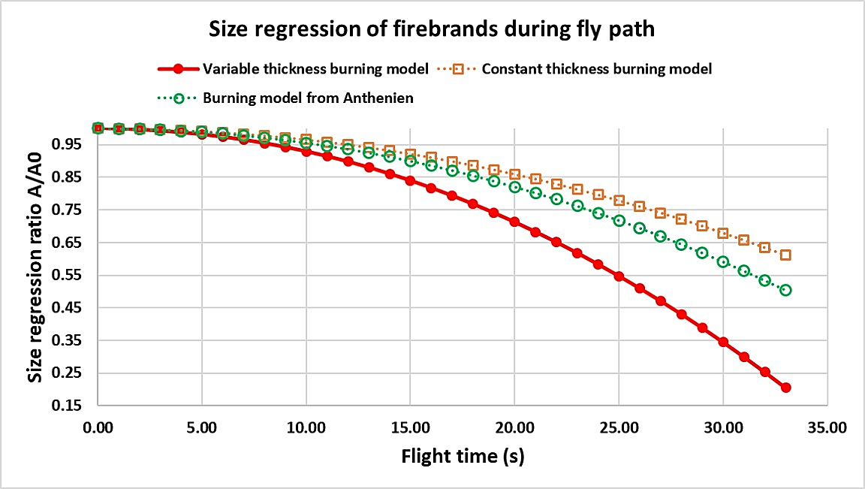
Figure 3.7 – Validation for the variable thickness burning model.

In the Figure 3.7, the red line indicates the simulation results of variable thickness burning model developed in this work. Respectively, the orange and green dotted lines indicate the results from constant thickness burning model developed in this work and Anthenien’s research [8]. It can be seen that the thickness change significantly affects the size regression of firebrands, up to 0.3 of size regression ratio ($A/A0$). It can be suggested that, in order to estimate more accurate spotting distance, the thickness change of firebrand due to burning should be included into models.

Assumptions of the models

Although the efforts have been made to simulate the spotting phenomenon of firebrands lofted in the flow field as real as possible in this study, it is hard to present the reality of particle spotting. There still are many limitations of the understanding on particle spotting, such as the detailed regression rate of particle of various shapes and geometries, the real wind profile in wildfire, the condition of ambient environment inside the large-scale fire, etc.
As the physic-based numerical models developed in this study, there are numbers of the assumptions must be highlighted to ascertain the accuracy and the usage of these models. In details, they are listed as following:
- The models developed in this thesis are focused on determining the trajectories of firebrands in the transporting phase of the spotting phenomenon. It is assumed that the particle has exited the main fire zone and is released from 100 m above ground in air.
- The plume effects on firebrands are neglected in this work, and the ambient flow field due to wind is assumed to be constant in each testing cases but a board range of flow velocities are tested.
- The orientation of the particle is assumed to remain the same during the propagation. The rotation and vibrations of the firebrand, such as tumbling and wobbling, are neglected.
- As a simplified model to determine the maximum spotting distance of firebrands, the effects on aerodynamic lift and drag coefficients due to flaming are neglected.
- According to the study by Tse and Fernande-Pello (Tse and Fernandez-Pello, 1998), it was found that the surface reaction of burning particles were enhanced at high Reynolds number and were not susceptible to be extinguished. The situation of flame extinction is thus not considered. The lifetime of a burning particle is determined based on size regression and mass loss rate.
- It is assumed that the brands hold the shapes unchanged in combustion. Since the small geometry of the particle and short flight time, the density of such small particle is assumed to be constant.
- For the usage of glow firebrands in non-burning model, the shape and the density of the glow particle are assumed to be constant. The situations including re-burning and extinguishment are neglected.
- Two models of burning particles are developed based on different assumptions on the changes of particle thickness in combustion. In the first one the thickness is assumed to be constant, whereas in the other it is variable over time and is calculated based on the burning constant. It is assumed that the regression rate on three directions of particle are equivalent.
Although mentioned in previous chapter, it still should be stated that, as simplified models focused on particle spotting phenomenon, there are many improvements should be made for this study. It is true that the understanding of the human for the large-scale fires and the spotting phenomenon are limited, and many gaps in the field of forest fire should be filled in future. The challenges, such as the wind profile, the ambient burning condition, the regression rate on each parameter of regular firebrands, etc., should be carried on in the future work.

Advantages and disadvantages of the models developed

As a part of discussions focused on the simplified models developed in this study, the analysis of both advantages and disadvantages is given in this section. As the physic-based numerical models used to predict the spotting distance of firebrand, the simplified models developed in this study are computed with other empirical firebrands’ models. Meanwhile, the Matlab simulations in this work are compared with the other numerical simulations, such as CFD works. Furthermore, the improvements to cover the corresponding shortages are given.
For the advantages of this work, they are listed as below:
- Higher applicability
The empirical equations published for determining the maximum spotting distance of firebrand have covered the broad ranges of parameters, such as wind speed and particle density. However, there still are limitations of the applicability of these equations, such as the certain particle density tested in Tarifa’s model [15], such as $0.48×{10}^{3} kg/m^{3}$ of pine wood, and limited wind speed in Muraszew model [88], such as $9.1 m/s$. Whereas, the firebrands with broader ranges of parameters could be simulated by the models developed in this study.

- Easier control of parameters
As an advantage, the parameters of the firebrand can be controlled. In the models developed in this work, there are four simplified parameters which can be adjusted for determining the spotting distance under different conditions.

- Enable parametric study
Different with empirical models, the models used in this work enable the parametric study for investigating the effects on multiple parameters on the particle spotting. From the past studies, the parameter of firebrand is singly discussed, such as the study of particle weight in Tarifa’s model [16] and the wind effects in Albini’s model [1]. The effects of four simplified parameters, including particle density, initial particle velocity, wind speed and incident angle, on the spotting are compared in this work.

- Enable determination of the lift effects
As a new concept, the models developed in this thesis can be utilized to investigate the effect of aerodynamic lift on firebrand propagation which has not been investigated before. The solutions from models can present the difference between the propagation with and without lift force.

However, there still are many disadvantages existing in the models developed in this work. Some have been covered in previous assumption section, but as for the suggestions of future research, they are sorted and listed as below. Relatively, the idea of overcoming these disadvantages are given.

- Constant flow field but not a wind profile
The firebrands simulated in this work are assumed lofted in the constant flow field, which may be less accurate than the empirical equations. In real situations, the wind velocity should be changed along the location and height of firebrand. The wind profile should be added to the models in this study for more realistic simulations in short future.

- Lack of Rotation
During this work, the rotation of firebrand has been ignored which may decrease the accuracy of estimations. Each kind of tumbling, wobbling, or vibration may affect the flight path of firebrand, whereas the simulations in this study cannot predict such behaviours. But by using the empirical equations, there effects have been considered, such as the experiments conducted by Muraszew [88] that the firebrands were able to freely rotate. In order to cover this shortage, the calculations of the angular momentum should be added into the models. Other calculations, which enable the free rotations of the particle, also should be added in.

- Plume effects is not included
In this work, the firebrand is released from certain height and the lofting stage is ignored. This assumption might decrease the accuracy of simulation since the firebrand could be lofted into higher position by plume. There are many papers focusing on modelling the plume around firebrands, such as Nielsen, H. and Tao [91]. Such gap in the models developed in this study should be filled by adding the plume models as a parameter of ambient flow field. More research work about the fire whirl and plume should be done by author in short future.

From the literature reviews, it can be seen that there is a few numerical works focusing on modelling the propagations of firebrands, such as CFD simulations. By comparing with those models, some of the advantages of the model in this thesis can be presented as following:

- Ideal for large amount of tests
Actually, it is almost impossible to simulate thousands of cases by CFD, whereas it can be achieved by the Matlab simulations in this study. More importantly, the models developed in this study can be used as the data basement for statistical modelling to tackle the practical situations.

- Easier movement tracking
In reality, it costs greatly to track the movement of firebrands by CFD, such as the huge amount of mesh buildings, whereas it can be achieved by the Matlab simulations developed in this work. The properties of the firebrand, such as acceleration, velocity and position, can be viewed at any time steps.

- More efficient
Comparing with other numerical works, the simulation in this thesis are more efficient, including less cost on building-ups, less simulating times, and easier operations. By fixing the code, any corrections to the models can be added in.

However, there still are numbers of shortages of the Matlab simulations in this work comparing other numerical simulations:

- No details presented
One of the disadvantages of the simulation in this work is lack of details of particle and ambient flow field, whereas the nice presentation can be achieved by CFD simulations, such as Toihdiand Kaye ’s work published in 2016 [78] that the details of ambient flow field was clearly presented.

- Less aerodynamic accuracy
It is true that the aerodynamic coefficients of both drag and lift utilized in the models developed are the numerical and empirical equations in terms of particle Reynolds numbers and angle of incidence. Whereas, the CFD simulations, as special numerical models focusing on determine the fluid properties, are able to provide more accurate data of the ambient flow fields. Comparing with each other, the Matlab works have less accuracy on describing the aerodynamic properties.
As one of most important advantages, the simplified models developed in this work can be used as the data basement for statistical modelling to tackle the practical situations. However, there still are many shortages existing. As the improvements, the methods to cover these shortages, which are provided under corresponding topics, will be applied as future work.

Chapter 4. PREDICTION OF SPOTTING DISTANCE

Introduction

In previous chapters, the importance of the determination of the maximum sporting distance of the firebrands are highlighted. Further, the calculations of the motion of the firebrands lofted in the flow field, including the equations of the aerodynamic drag and lift forces, are introduced. Moreover, the details of the different combustion models developed in this work, which are based on the different burning behaviours, are presented.
Thus, based on the transporting and combustion models developed in this research, the maximum spotting distance of the firebrands are determined in this chapter. In details, the motion of the firebrand based on different densities, initial velocities and incident angles are calculated to determine their maximum spotting distance at the flow field of different wind speeds. Both the aerodynamic drag and lift force are included. Furthermore, considering that the glowing firebrand or the extinguished particle may exist in real wildfire, the non-burning model is utilized, and then is compared with the other two combustion models including constant thickness and variable thickness burning models which are based on different assumptions of the thickness change while particle burning. Moreover, the equations describing the relationships between spotting distances and each simplified parameter which is involved in spotting phenomenon are provided.
In the results of simulations, totally over 4000 cases have been simulated to determine their maximum spotting distances in this chapter. The maximum propagation distances of firebrands under each controlled condition are determined. Then, the comparisons of propagations among four simplified parameters are made. Since over 3000 cases have been simulated in this study, it is almost impossible to present all the details in the main chapter of this thesis. Thus, the maximum values from each simulation are picked up and then the summary of all determined maximum spotting distance are reported.
Moreover, since the different combustion models utilized, the summarised results for the firebrands of each burning style are presented, then compared with each other in the discussion section. At the end, the most dangerous firebrands are alerted with their specific parameters and flow conditions.

Concepts of the simulations

Focusing on determining the maximum spotting distance, the firebrands lofted in a constant flow field are simulated based on developed models in this work. The logic structure of the simulation is presented in the Figure 4.1.

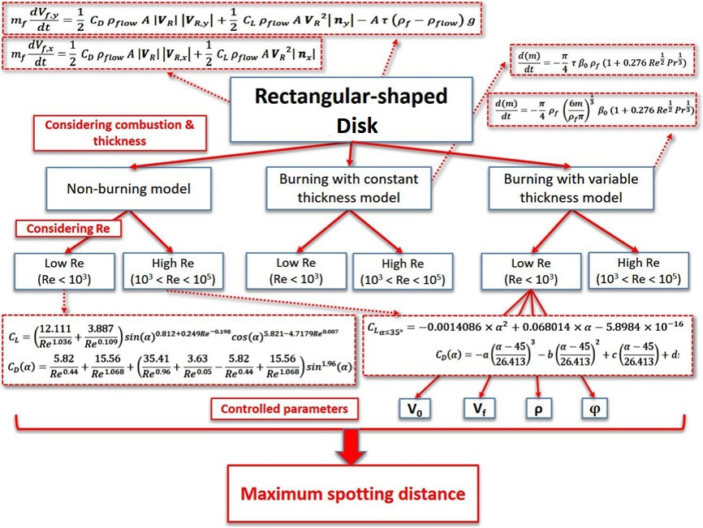
Figure 4.1 – Representation of the logic structure of simulation.

The maximum spotting distance is determined from the motion of each firebrand. Based on the Newton’s second law, the trajectory of particle can be calculated from the forces on both x- and y-axis, including drag, lift, gravity and buoyancy force. Note that the virtual mass and Basset history term are neglected due to order of magnitude [40]. As a new method developed for calculating the aerodynamic forces exerted on the firebrand, the vector products are utilized, where the details of equations are presented in the Section 3.2.1.
In the simulations, the parameters which can significantly affect the spotting are tested in wide ranges, shown in the Table 4.1. Further, three different combustion models are simulated for each particle due to the possibility of each burning style. Considering the wild range of particle Reynolds number, the different sets of aerodynamic coefficient equations are applied to fit the corresponding Reynolds number for more accurate simulations. Before the start of the simulations, the involved parameters, including initial particle velocity, particle density, flow velocity due to wind, and incident angle between firebrand and horizontal direction, are set within wild ranges to improve the applicability of the simulations.

Table 4. 1 – The tested ranges of four simplified parameters.
Parameter | Tested range
Ambient flow velocity, $V_{flow}$ $(m/s)$ | [$0 :1 :10$]
Incident angle, $φ$ (°) | [-90 : 7.5 : 90]
Initial velocity of firebrand, $V_{0}$ $(m/s)$ | [0 : 0.1 : 1]
Density of particle, $ρ$ $(kg/m^{3})$ | [250 : 100 : 950]

Results and discussion

Based on the calculations of motion, the trajectory of each tested firebrand was simulated in order to determine the maximum spotting distance. For each simulation, three different burning models were applied. As four simplified parameters, including the ambient flow velocity due to wind, $V_{flow}$, the angle of incident between firebrand and horizontal direction, $φ$, the initial velocity of firebrand, $V_{0}$, and the density of particle, $ρ$. Meanwhile, the tested range of each parameter are listed in the Table 4.1.
Further, the trajectories of the firebrand at $V_{flow}=10 m/s (22.37 mph)$ is presented as an example of the simulation results, shown in the Figure 4.2.

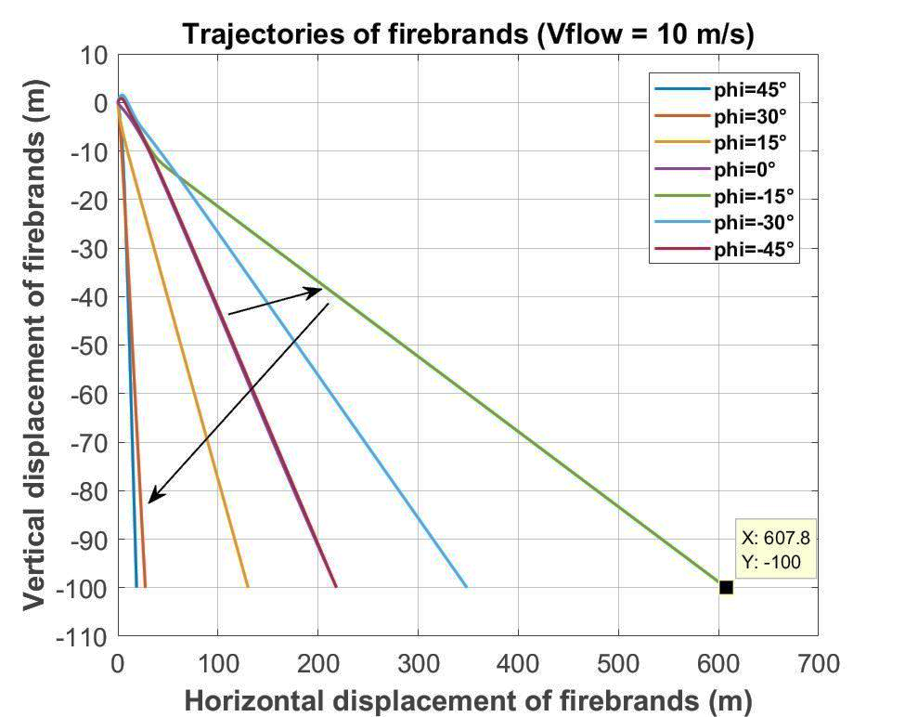
Figure 4.2 – The trajectories of the firebrand at 10 m/s of flow velocity.

In the Figure 4.2, the x-axis indicates he horizontal displacement of the firebrand and y-axis indicates the vertical displacement. Since the assumption in models is that the firebrand is realised from 100 m above ground, the simulations were stopped once the vertical displacements of firebrands had reached 100 m. The lines with different colours indicate the different incident angles. Except the incident angle, the other parameters in this the simulation was fixed $V_{flow}=10 m/s$, $V_{0}=0 m/s$ and $ρ=250 kg/m^{3}$ which is near to the density of charcoal. Comparing the results in figure, the maximum spotting distance of the firebrand ranged the incident angle between $[-45°, 45°]$ at $10 m/s$ of wind speed is found as 607.8 m at $-15°$ of incident angle.
As the increasing then decreasing trend of spotting distance along the increasing incident angle, a new simulation with smaller steps of 7.5° of incident angle was conducted. The incident angle range of [-30°, 0°] was focused. The results are presented in the Figure 4.3.
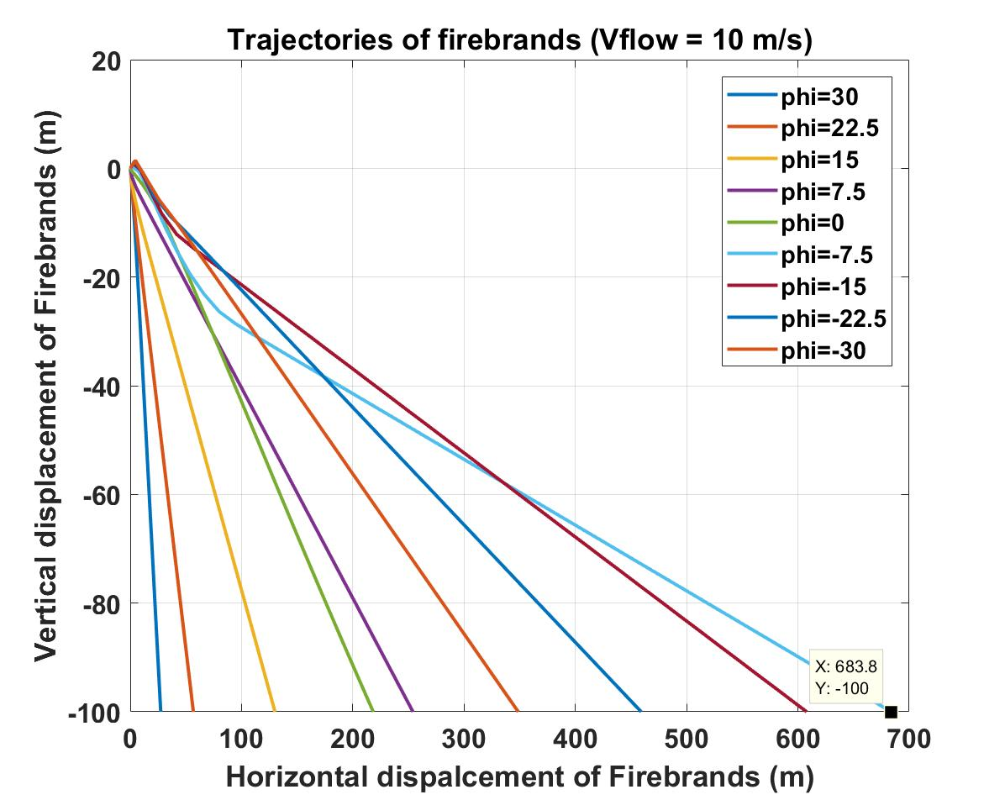
Figure 4.3 – The trajectories of firebrands with smaller step of simulation at 10 m/s flow velocity.
It can be seen that the maximum spotting occurs at the incident angle of -7.5°, which has larger displacement than the case at -7.5°. The maximum value of spotting is 683.8 m. From this case, it has been alerted that the simulations in later chapter should be conducted with a smaller step of 7.5° for incident angle.
Also, from the Figure 4.3, it can be seen that the trajectories of firebrands are not absolutely linear. The curve during the flight path is because that the particle has reached the terminal velocity. As stated in the Chapter 3, once the resultant force on a firebrand reaches zero, as:
$$0= \vec{F_{D}}+\vec{F_{L}}+A τ \left(ρ_{f}- ρ_{air}\right) \vec{g}$$ | Eq. 4.1

Since the directions of drag and lift are dependent on the relative velocity of firebrand, the expressions on x- and y- axis are:
 | $$m_{f} \frac{dV_{f,x}}{dt}=0= \frac{1}{2}C_{D} ρ_{f} { A}_{p} \left|{\vec{V}}_{R}\right| {\vec{V}}_{R,x}+\frac{1}{2}C_{L} ρ_{f} { A}_{p} {\left({\vec{V}}_{R}\right)}^{2} {\vec{n}}_{x}$$ | Eq. 4.2

 | $$m_{f} \frac{dV_{f,y}}{dt}= 0 =\frac{1}{2}C_{D} ρ_{f} { A}_{p} \left|{\vec{V}}_{R}\right|{\vec{V}}_{R,y}+\frac{1}{2}C_{L} ρ_{f} { A}_{p} {\left({\vec{V}}_{R}\right)}^{2}{\vec{n}}_{y}+A τ \left(ρ_{f}- ρ_{air}\right) \vec{g}$$ | Eq. 4.3

From the Figure 4.3, it can be seen that the case of -7.5° of incident angle had the longest progress to reach the terminal velocity, as $V_{x,terminal}=15.23 m/s and V_{y,terminal}=1.84$ after 20 seconds of flight time. The vertical velocity quickly increased to about 4 m/s, but then decreased to terminal velocity. This is because that the increase of vertical velocity had changed the direction of relative velocity, and at the same time, the directions of drag and lift forces had changed.
Based on the results presented above, the validation of spotting model developed in this thesis is offered in this section. Because no study of similar parameters of this work is valid, including rectangular-shaped disk, aspect ratio, ambient flow velocity, density, initial firebrand velocity, and etc., the results from a round-disked firebrand model developed by Anthenien [8] are compared and presented in the Figure 4.4. The trajectories of the firebrand at 4 different wind velocity are presented, including 3, 7, 14 and 20 m/s. In order to compare the results with Anthenien’s model, the releasing height was set with 12 m as the same value with his work. The firebrand density of both models was 545 km/m³.
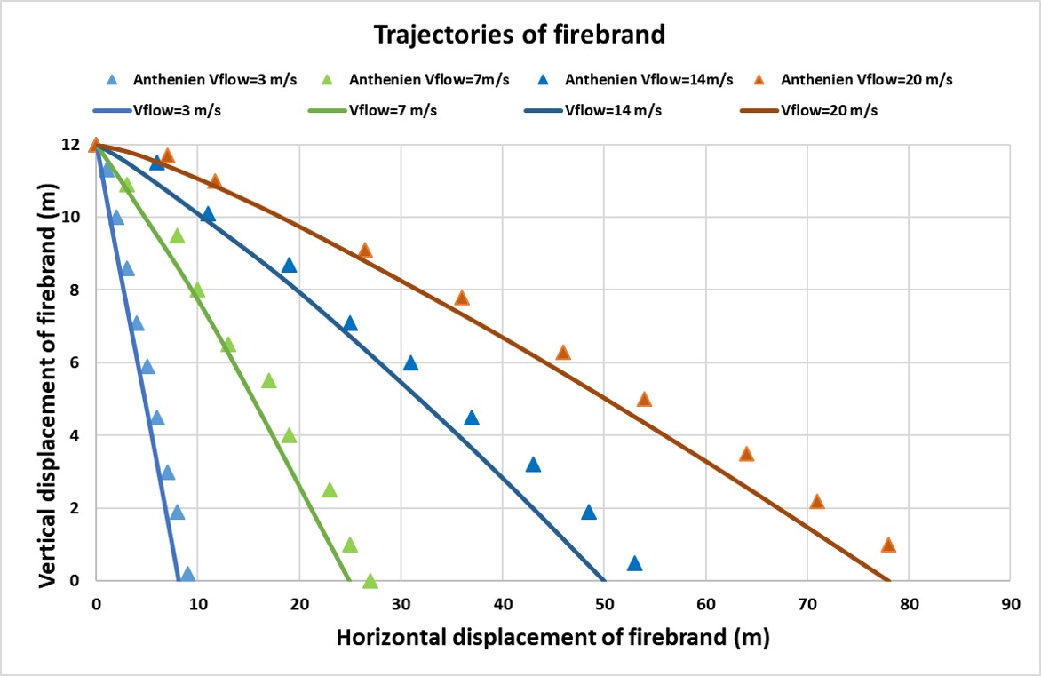
Figure 4.4 – Trajectories of a disk-shaped firebrand at different ambient flow velocity.

It can be seen that the trends of both models are similar. The spotting distance of firebrand increased with larger ambient flow velocity and the farthest spotting was up to 80 m after travelling 12 m vertically. For both models, the firebrand quickly reached the terminal velocity and the trajectories were almost linear lines. Comparing with Anthenien’s model, it can be seen that the round-disked firebrand achieved longer spotting distance than the rectangular-disked one. This point suggests the future work of this research that the round-shaped disk should be modelled in order to estimate the extreme cases of firebrand propagations.
Moreover, as introduced in the literature review, the glide ratio is used as a dimensionless property of particle spotting in the results, which can be expressed as:

 | $$Glide ratio= \frac{Horizontal dispalcement}{Vertical displacement}$$ | Eq. 4.4

Since the firebrands simulated in this study is released from 100 m above ground, the glide ratio to present the maximum spotting distance of the firebrands can be calculated as:
 | $$Glide ratio= \frac{X_{max}}{100}$$ | Eq. 4.5

Therefore, the maximum spotting distance of the firebrand presented above can be shown as $GR=6.838$.
As a systematic study of the firebrands’ propagations based on the different burning behaviours, the summarised results of maximum spotting distance are presented under corresponding burning models in next section. The tables presenting the firebrands of maximum spotting will be given with their specific conditions.

Non-burning model

For the non-burning firebrands, the maximum spotting distances determined from the simulations are presented in the Table 4.2 below.

Table 4. 2 – Maximum spotting distance determined from non-burning model.
Parameters |  |  |  | Maximum spotting distance  (represented with GR)
Ambient flow velocity,  $V_{flow}$  $$(m/s)$$ | Angle of incidence  $φ$  (°) | Initial velocity of firebrand,  $V_{0}$  $$(m/s)$$ | Density of particle,  $ρ$  $$(kg/m^{3})$$
[0, 10] | -7.5 | 0 | [250, 950] | 6.838
 |  |  |  | at $V_{flow}=10$
 |  |  |  | $$ρ=250$$
[0, 10] | [-90, 90] | 0 | 250 | 6.838
 |  |  |  | at $V_{flow}=10$
 |  |  |  | $$φ=-7.5$$
[0, 10] | -7.5 | [0, 1] | 250 | 6.838
 |  |  |  | at $V_{flow}=10$
 |  |  |  | $$V_{0}=0$$
0 | [-90, 90] | [0, 1] | 250 | 2.574
 |  |  |  | at $φ=-7.5$
 |  |  |  | $$V_{0}=0$$
0 | [-90, 90] | 0 | [250, 950] | 2.463
 |  |  |  | at $φ=-7.5$
 |  |  |  | $$ρ=250$$
0 | -7.5 | [0, 1] | [250, 950] | 2.430
 |  |  |  | at $V_{0}=1$
 |  |  |  | $$ρ=250$$

The maximum spotting distance determined was 6.838 of GR, which meant that the firebrands had horizontally travelled 683.8 m before hitting the ground. Moreover, it can be seen that such maximum spotting was achieved with maximum flow velocity, $V_{flow}=10 m/s$, minimum firebrand initial velocity, $V_{0}=0 m/s$ and minimum density, $ρ=250 kg/m^{3}$and specific incident angle of $φ=-7.5°$. Meanwhile, the minimum value determined was 2.430 of GR due to creasing of flow velocity. In order to investigate the more detailed relationships between spotting distance and each parameter are presented, some of the results are shown as examples in the Figure 4.5, 4.6, 4.7 and 4.8.
In the Figure 4.4, the plot of spotting distance against flow velocity is made. The x-axis indicates the ambient flow velocity due to wind and the y-axis indicate the spotting distance of firebrand. In order to present more details, the simulations have been running with smaller step of [0: 0.5: 10] $m/s$ for $V_{flow}$. Very strong dependency of spotting distance on flow velocity is determined. The spotting distance is increased by 183% when the flow velocity is increased from 0 to 10 $m/s$. Further, the equation of best fitting is found as:
$$S_{x}=43.895 V_{flow}+233.26$$

where $S_{x}$ indicate the spotting distance of firebrand. This equation also verifies the physical explanation of the spotting phenomenon, that the flow due to wind plays the very important role in the firebrand spotting and the particle always travels further due to the strong wind in wildfire. The reason for using the spotting distance instead of GR in this section is to improve the accuracy of fitting equations.
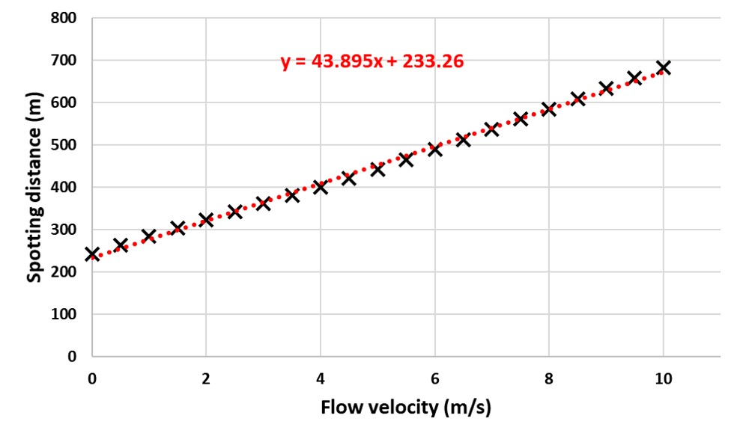
Figure 4.5 – Spotting distance of firebrand at $V_{0}=0 m/s$, $ρ=545 kg/m^{3}$and $φ=-7.5°$ in non-burning model.

Further, the relationship between the spotting distance and the density of firebrand is plotted with the simulation step of [250: 35: 950] $kg/m^{3}$ for $ρ$. A strongly negative relationship is determined, and the spotting distance is deceased by 106% with increasing density from 250 to 950 $kg/m^{3}$. This negative relationship can be expressed with a best fitting equation as:
$$S_{x}=-0.1495ρ+283.43$$

From the physical aspect, this finding can be explained that the higher density not only counteracts the work by aerodynamic forces on particle due to higher gravity, but also decreases the flight time of firebrand.
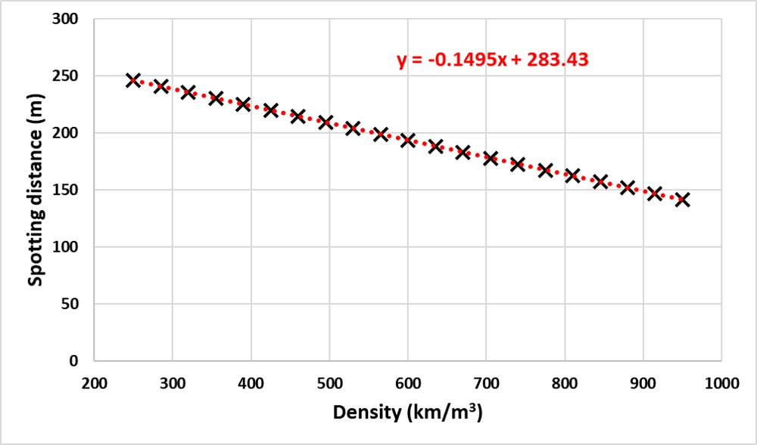
Figure 4.6 – Spotting distance of firebrand at $V_{flow}=0 m/s$, $V_{0}=0 m/s$ and $φ=-7.5°$ in non-burning model.
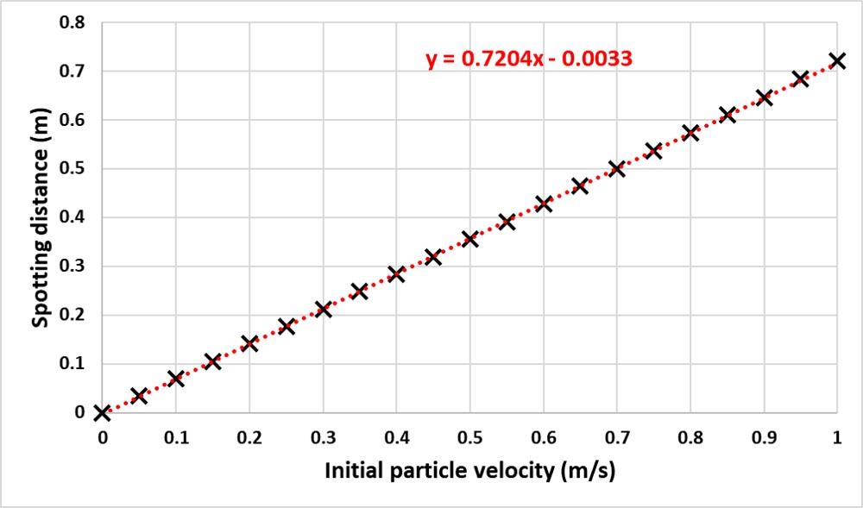
Figure 4.7 – Spotting distance of firebrand at $V_{flow}=0 m/s$, $ρ=250 kg/m^{3}$ and $φ=-7.5°$ in non-burning model.

Moreover, the plot of spotting distance against initial velocity of firebrand is determined, shown as:
$$S_{x}=0.7204 V_{0}-0.0033$$
From Figure 4.7, it can be found that the spotting distance varied in very small range, from 0 to 0.8 m. It can be seen that the effects of initial particle velocity on spotting is small, even can be neglected. This finding will help reduce the parameter of initial particle velocity in the parametric study in next chapter.

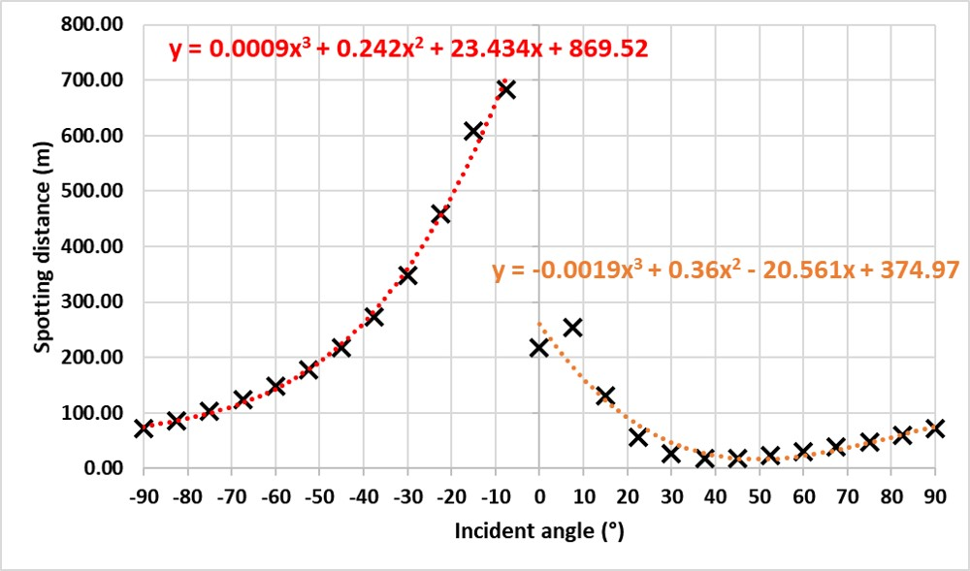
Figure 4.8 – Spotting distance of firebrand at $V_{flow}=10 m/s$, $V_{0}=0 m/s$ and $ρ=250 kg/m^{3}$ in non-burning model.

However, surprisingly, it is found that the spotting distance peaks around the incident angle of -7.5°. Before this value, the spotting distance exponentially increases with increasing incident angle from -90°, whereas dramatically drops down when the firebrand turns into positive angle between horizontal direction. The best fitting is found as the polynomial expression in order of 3 which is better than linear or square. The fitting equation can be given as:
For incident angle $φ$ is in range of [-90°, 0°):
$$S_{x}=0.0009 φ^{3}+0.242 φ^{2}+23.434 φ+869.52$$

For incident angle $φ$ is in range of [0°, 90°]:
$$S_{x}=-0.0019 φ^{3}+0.36 φ^{2}-20.561 φ+374.97$$

Obviously, the firebrand travels further when it is tilted forward with negative incident angle. But there is no direct explanation can be found for explained the certain peak value of -7.5°, neither from any literature reviews. As a question worthy more investigations, this finding will be carried with through next sections. But it definitely can say that the incident angle has the most significant effects on the spotting distance.

Constant thickness burning model

As one of the burning models developed in this study, the spotting firebrand with the assumption of constant thickness while burning have been simulated. Some of the results are shown as the example in the Table 4.3.
Although surprisingly, it is true that the results of simulations in constant thickness burning model are almost the same with constant thickness burning model, even the same fitting equations of all four kinds of plots are same. The main reason for such high similarity of both models can be found as the extreme small value of the size regression rate in constant thickness burning model, that the maximum change of projected area determined as about $-4.128×{10}^{-6} m^{2}/s$. Meanwhile, the flight time of particle is short that the shortest can be less than 30 $s$. Thus, it is questionable that if the thickness of firebrand should be assumed to be constant while burning. The detailed comparison and discussion for all three burning models will be presented in the Chapter 5.

Table 4. 3 – Maximum spotting distance determined from constant thickness burning model.
Parameters |  |  |  | Maximum spotting distance  (represented with GR)
Ambient flow velocity,  $V_{flow}$  $$(m/s)$$ | Angle of incidence  $φ$  (°) | Initial velocity of firebrand,  $V_{0}$  $$(m/s)$$ | Density of particle,  $ρ$  $$(kg/m^{3})$$
[0, 10] | -7.5 | 0 | [250, 950] | 6.838
 |  |  |  | at $V_{flow}=10$
 |  |  |  | $$ρ=250$$
[0, 10] | [-90, 90] | 0 | 250 | 6.838
 |  |  |  | at $V_{flow}=10$
 |  |  |  | $$φ=-7.5$$
[0, 10] | -7.5 | [0, 1] | 250 | 6.838
 |  |  |  | at $V_{flow}=10$
 |  |  |  | $$V_{0}=0$$
0 | [-90, 90] | [0, 1] | 250 | 2.594
 |  |  |  | at $φ=-7.5$
 |  |  |  | $$V_{0}=0$$
0 | [-90, 90] | 0 | [250, 950] | 2.463
 |  |  |  | at $φ=-7.5$
 |  |  |  | $$ρ=250$$
0 | -7.5 | [0, 1] | [250, 950] | 2.430
 |  |  |  | at $V_{0}=1$
 |  |  |  | $$ρ=250$$

Variable thickness burning model

Alternatively, as a new burning model developed in this work, the maximum spotting distance determined from the variable thickness burning model are presented in the Table 4.4 as below.
The maximum spotting distance determined was 6.088 of $GR$, which meant that the firebrands had horizontally travelled 608.8 $m$before hitting the ground. This maximum value is achieved at the same conditions in other models, that maximum flow velocity, minimum density and particle initial velocity, and the incident angle around -15°. Meanwhile, the minimum value was determined as 2.381 due to the vanishing flow velocity. Although it is similar with the value of non-burning and constant thickness burning models, the maximum spotting distance of variable thickness burning model is larger, as increased from 6.838 to 6.895. This is an important finding that any model assumed constant thickness may underestimate the spotting distance of burning firebrands.
Table 4. 4 – The tested ranges of parameters.
Parameters |  |  |  | Maximum spotting distance  (represented with GR)
Ambient flow velocity,  $V_{flow}$  $$(m/s)$$ | Angle of incidence  $φ$  (°) | Initial velocity of firebrand,  $V_{0}$  $$(m/s)$$ | Density of particle,  $ρ$  $$(kg/m^{3})$$
[0, 10] | -7.5 | 0 | [250, 950] | 6.895
 |  |  |  | at $V_{flow}=10$
 |  |  |  | $$ρ=250$$
[0, 10] | [-90, 90] | 0 | 250 | 6.895
 |  |  |  | at $V_{flow}=10$
 |  |  |  | $$φ=-7.5$$
[0, 10] | -7.5 | [0, 1] | 250 | 6.895
 |  |  |  | at $V_{flow}=10$
 |  |  |  | $$V_{0}=0$$
0 | [-90, 90] | [0, 1] | 250 | 2.574
 |  |  |  | at $φ=-7.5$
 |  |  |  | $$V_{0}=0$$
0 | [-90, 90] | 0 | [250, 950] | 2.468
 |  |  |  | at $φ=-7.5$
 |  |  |  | $$ρ=250$$
0 | -7.5 | [0, 1] | [250, 950] | 2.574
 |  |  |  | at $V_{0}=1$
 |  |  |  | $$ρ=250$$

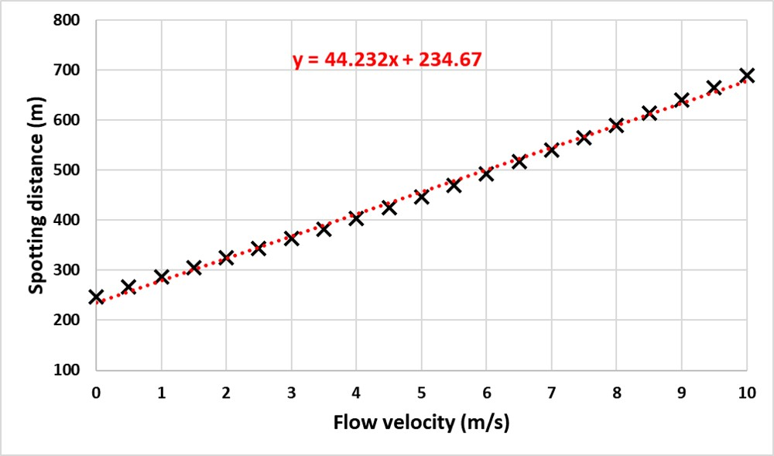
Figure 4.9 – Spotting distance of firebrand at $V_{0}=0 m/s$, $ρ=250 kg/m^{3}$and $φ=-7.5°$ in variable thickness burning model.

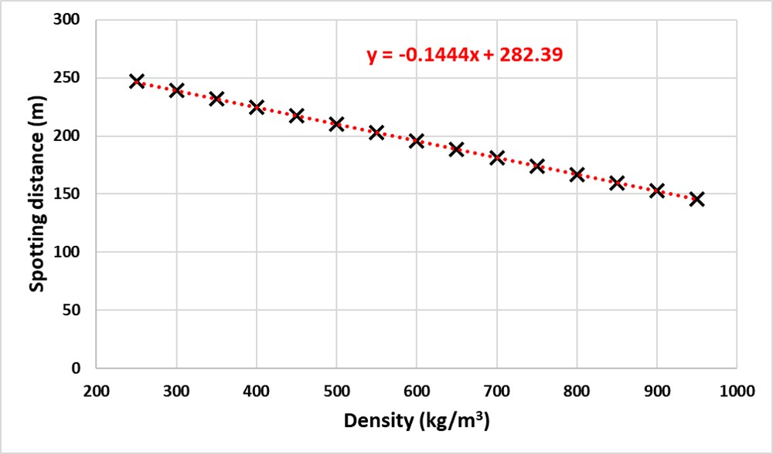
Figure 4.10 – Spotting distance of firebrand at $V_{flow}=0 m/s$, $V_{0}=0 m/s$ and $φ=-7.5°$ in variable thickness burning model.

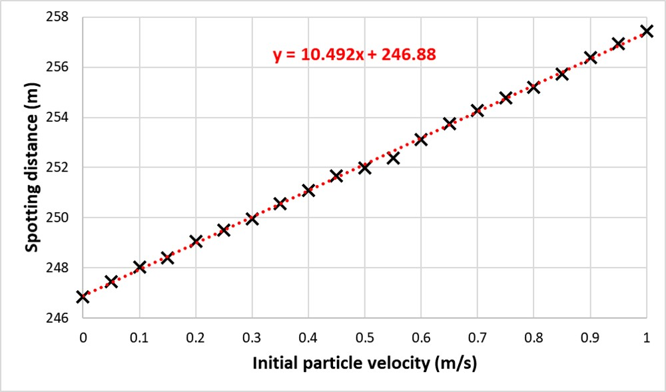
Figure 4.11 – Spotting distance of firebrand at $V_{flow}=0 m/s$, $ρ=250 kg/m^{3}$ and $φ=-7.5°$ in variable thickness burning model.
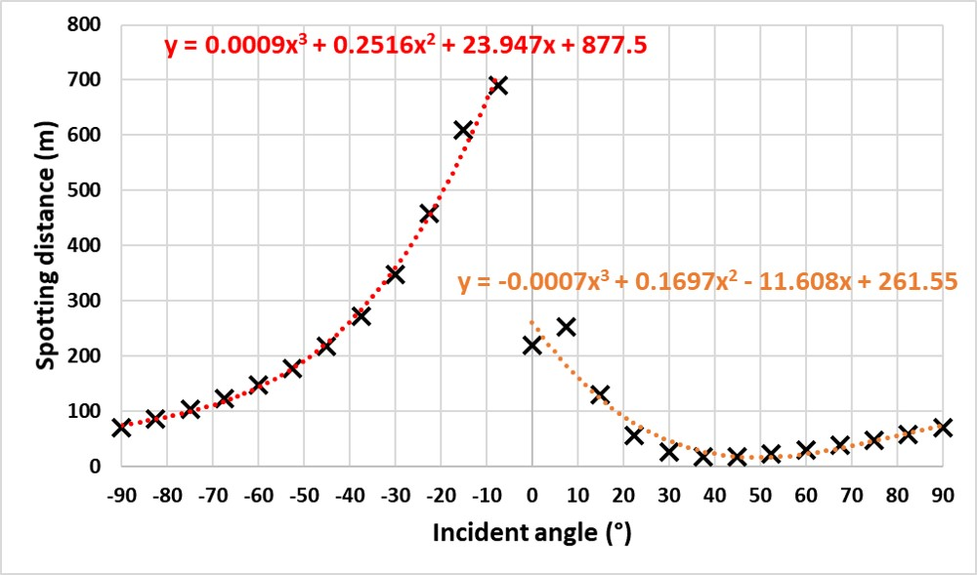
Figure 4.12 – Spotting distance of firebrand at $V_{flow}=10 m/s$, $V_{0}=0 m/s$ and $ρ=250 kg/m^{3}$ in variable thickness burning model.

Moreover, the plots of spotting distance against each parameter are provided with corresponding fitting equations, shown in the Figure 4.9 – 4.12. The similar trends between spotting distance and each parameter, including flow velocity, density and incident angle, are determined with the other two models, just with slightly differences of the coefficients of fitting equations. In order to discuss the difference between variable thickness burning model and constant thickness burning model, the comparison are made in next section.

Differences of maximum spotting distance due to thickness change

From previous sections, it is obvious that the spotting distances of firebrands are different in three burning models. Although the very similar results presented between non-burning and constant burning model, the firebrand travels further if considering the change of its thickness while burning. Thus, the differences of spotting distance due to different combustion models (thickness change) are compared in this section.
The data from these burning models are compared in the Table 4.5. The red colour indicates the value of variable thickness burning model is larger than others, whereas the blue colour indicates the smaller value. It can be seen that the values from both the non-burning model and constant thickness burning model are very similar to each other. The main reason is due to so small value of regression rate which is up to $-4.128×{10}^{-6} m^{2}/s$ and short flight time which can be less than 30 $s$. More importantly, it can be seen that the effect of thickness change on spotting distance does exist, although small values.

Table 4. 5 – Comparisons between three different combustion models.
 | Non-burning model | Constant thickness burning model | Variable thickness burning model | Dif. between variable thickness model with respect to others
Maximum spotting distance (GR) | Min value: | Min value: | Min value:
 | 2.430 | 2.430 | 2.468 | +0.038
 | Max value: | Max value: | Max value:
 | 6.838 | 6.838 | 6.895 | +0.057
Note: The Max and Min value presented above were determined from over 1000 cases for each burning model.
Percentage calculated by $\frac{(Max-Min)}{Min}$
Note: In order to discuss how did each parameter affect the spotting distance, the Max & Min values below were determined from single variation-controlled simulation.
Due to increasing $V_{flow}$, the spotting distance can be increased by | 183%  (Increased from 2.418 to 6.838) | 183%  (increased from 2.418 to 6.838) | 179%  (increased from 2.468 to 6.895) | In variable thickness burning mode, increase of spotting due to increasing flow velocity is 4 % less.
Due to increasing $V_{0}$, the spotting distance can be increased by | 0.043%  (Increased from 2.468 to 2.573) | 0.043%  (Increased from 2.468 to 2.573) | 71900%  (Increased from 0.001 to 0.72)  But real spotting difference is small, about 70 m. Large value due to very small denominator | Although the value of increasement is large, the real spotting distance is small as 0.719 of GR
Due to increasing $φ$, the spotting distance can be increased by (up to) | 3596%  (Increased from 0.185 to 6.838) | 3596%  (Increased from 0.185 to 6.838) | 3627%  (Increased from 0.185 to 6.895) | 31%
 | Large value due to very small denominator
Due to increasing $ρ$, the spotting distance can be decreased by | 73.9%  (Decreased from 2.463 to 1.416) | 73.9%  (Decreased from 2.32 to 1.456) | 69.5%  (Decreased from 2.468 to 1.456) | -4.4%

From the Table 4.5, it can be seen that the incident angle has the most effects on spotting distance, as it could enhances spotting further over 600 m. Meanwhile, the flow velocity still can increase the spotting distance over 400 m. Although the extreme value of increases has been determined from initial velocity, the enhancement of real spotting distance is very small as less than 1 m.
By comparing the data from variable thickness burning model and constant thickness burning model, the different trends have been found, as positive difference caused by incident angle and initial velocity and negative difference caused by flow velocity and density. It can be seen that the incident angle has larger enhancement on spotting when thickness of firebrand is assumed to change while burning. At the same incident angle of -7.5°, the thickness regression helped firebrand glide 0.1 of GR further. It highlights that the thickness regression should be added into the model in order to estimate extreme cases. For the increase due to increasing initial velocity, although percentage value was large, the real spotting distance was relatively small as 70 m. For negative difference between two models, the effect of flow velocity on spotting turned to be smaller if thickness changes. This finding suggests the importance of flow velocity for simulating constant thickness firebrands, such as glowing firebrand. For example, the flow velocity should be carefully considered during the simulation of a glowing charcoal, since the wind velocity might have stronger effects on the spotting rather than other kinds of firebrands. For the aspect of density, it can be seen that the spotting distance was slightly decreased when thickness of firebrand changes. This finding encourages the simulations for light weight but constant thickness firebrands, such as glowing charcoal. From the results presented in Table 4.5, the possibility that the glowing charcoal might glide further than the burning wood piece with similar density can be found.

Conclusion

In this chapter, the spotting distance of firebrands are determined. Considering there are four parameter which may affect the spotting of firebrands, the simulations are operated within the wide ranges. In order to determine the maximum spotting distance over all the conditions may exist, two of parameters are simulated within the chosen ranges while the other two are fixed. Based on the over 4000 cases simulated combining three different burning models, the maximum spotting distance is determined as 6.895 of $GR$, which indicates the 689.5 $m$of horizontal travelling for every 100 $m$of falling. The most dangerous firebrand is found at the conditions of 10 $m/s$ of flow velocity, -7.5° of incident angle, 250 $kg/m^{3}$ of density and 0 $m/s$ of particle initial velocity with regression thickness due to burning.
Further, each firebrand is simulated by controlling single parameter after determining the conditions of what the maximum firebrand propagation were under. Detailed relationships between spotting distance and each parameter are determined, and the corresponding plots are provided as well. It is found that the spotting distance is increasing with increasing flow velocity but decreasing with increasing density and initial velocity. For the incident angle, it is found that firebrand travels much further at negative incident angle and the peak value of spotting distance occurs at -7.5°. Thus, it can be seen that the hazard of firebrand is not only increased by flow velocity, but also increased by the incident angle due to significant improvement of spotting distance. Comparing with the freely rotating firebrands, the firebrands with steady movement (especially combining the rotation, such as the more stable movement of disk-shaped particle may be achieved when it has constant angular momentum) may travel further at certain incident angle.
Moreover, the effects of different burning model on the spotting are investigated. It is found that the simulation results are almost the same between non-burning model and constant burning model due to small regression rate and short flight time of firebrand. More importantly, it is found that the change of particle thickness due to combustion can significantly strength the propagating distance. The variation of thickness in a firebrand combustion model is strongly suggested, in order to avoid any under-estimate of spotting distance.
However, it has to say that the fitting equations determined in this chapter are limited by specific conditions and only can present the relationship between spotting distance and single parameter. Aiming at developing an empirical equation for the prediction of spotting distance, more investigations should be made to improve the accuracy, such as broader the ranges of parameters and expand the aspect ratio of firebrand. Meanwhile, the simulation for the firebrands with boarder range of aspect ratio should be simulated to ascertain the effects of changing thickness as future work.

Chapter 5. PARAMETRIC STUDY OF PARAMETERS INVOLVED IN SPOTTING

Introduction

In previous chapter, the trajectories of lofted firebrands are simulated, and the maximum spotting distances are determined. Furthermore, the relationships between spotting distance and each simplified parameter which is involved in spotting phenomenon are investigated. It is found that the flow velocity and incident angle can significantly affect the propagation of firebrand over all three combustion models.
Therefore, the parametric studies are made in this chapter to continue the investigation of effects of four simplified parameters involved in spotting phenomenon, including flow velocity, incident angle between firebrand and horizontal direction, particle density and initial velocity of firebrand. Aiming at more details of the propagations, the detail-oriented steps of simulations are utilized in this chapter. The counter plots of spotting distance with each two of parameters are provided to determine their effects on propagating distance of firebrand. Moreover, the comparisons between different burning models are made in order to investigate the influence of thickness change due to burning. Furthermore, the efforts are made to level the importance of each parameter based on their effects on spotting. After the statement of each findings, the suggestions for applications are given as well.

Concepts of the simulations

In this chapter, it is focused on investigating the effects of parameters involved in spotting phenomenon on firebrands’ propagations. Then, such effects are further compared among different combustion models. The differences of the effects of each parameter on the increasements on spotting distance due to thickness change are determined. The structure and logic chain of the simulations operated is present in the Figure 5.1.

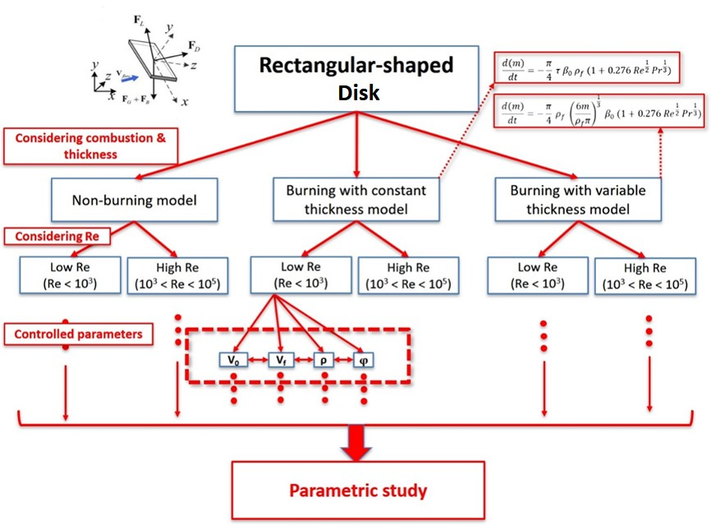
Figure 5. 1 – Representation of the logic structure of simulation.

As discussed in previous sections, four of simplified parameters have been considered as the main factors which can significantly affect the spotting of firebrands. In order to compare the relative importance of their effects on spotting, two of them are set in wide ranges as the initial conditions in simulation while another two are set with fixed values. The corresponding ranges of parameters are presented in the Table 5.1.
Once the maximum spotting distances of the firebrands under different conditions were determined from the motion equations, the trends, which can present the effects of parameters on spotting, are determined from the corresponding contour plots. Furthermore, the results from different burning models are compared to investigate the influence of thickness change due to burning on spotting.

Table 5. 1 – Tested ranges of parameters in the simulation of parametric study.
Parameters
Ambient flow velocity,  $V_{flow}$  $$(m/s)$$ | Angle of incidence  $φ$  (°) | Initial velocity of firebrand,  $V_{0}$  $$(m/s)$$ | Density of particle,  $ρ$  $$(kg/m^{3})$$
[0, 10] | -7.5 | 0 | [250, 950]
[0, 10] | [-90, 90] | 0 | 250
[0, 10] | -7.5 | [0, 1] | 250
0 | [-90, 90] | [0, 1] | 250
10 | [-90, 90] | 0 | [250, 950]
0 | -7.5 | [0, 1] | [250, 950]

Results and discussion

Non-burning model and constant thickness burning model

As discussed in previous chapter, it is found that the spotting distance are almost the same between non-burning model and constant thickness model. Further, after comparing the contour plots from both models, no significant difference has been determined. Thus, there is no need to repeatedly presented the results from both models, and the results of constant thickness models is presented in this section, which still can stand for the results of non-burning model.
Based on the spotting distance determined from two ranged parameters while another two are fixed with certain values, six contour plots can be provided from each test. Some data is shown as examples in the Appendix A and B.
In order to further analyse the results, the correlations of flow velocity and density on spotting distance is analysed and parameter optimisation is attempted by finding out the function between input (flow velocity and density in this case) and output (spotting distance of a firebrand). The method utilised is discussed here. The model developed in this work aims to estimate the spotting distance of a firebrand, which is affected by 4 parameters including flow velocity, incident angle, density and initial velocity. Although over 4000 cases have been simulated, the data base for all spotting distances under 4 parameters are not absolutely complete. Considering this fact, the results presented in this thesis are determined from two parameters controlled simulations, for example, the spotting distance presented in the Figure 5.2 was obtained from ranged values of flow velocity of [0:10] and density of [250:50:950], and fixed value of incident angle of -7.5° and initial velocity of 0 m/s. In this way, the results of spotting distance can be better presented, such as 3D plots and contour plots that x- and y- axis indicate two ranged parameters and z-axis indicates the spotting distance. Considering the parameter optimisation in this work is not aiming at finding out best solution, obtaining the relationships among spotting distance and parameters as the function of input and output is better. Also, this kind of analysis will help the statistical model for future work. The result for each simulation can be presented as a 2-dimensional matrix, as $Z (x, y)$. Basing on this fact, the curve fitting is an appropriate method to obtain the relationships, which is simpler, quicker and suitable for amount of cases in this work.
An example is given based on results in Figure 5.2 to show the method utilised, including the plot of curve fitting, how to obtain the function, the consideration of errors, the choice of polynomial order, and how to simplify the fitting equation. For other cases, the relevant data and plots are available in Reference.
The results of spotting distance from ranged flow velocity and density were presented in the Figure 5.2. The x-axis indicates the flow velocity around that particle, and the y-axis indicates the density of firebrand. The colour bar of contour plot indicates the spotting distances at corresponding conditions in the unit of $m$.
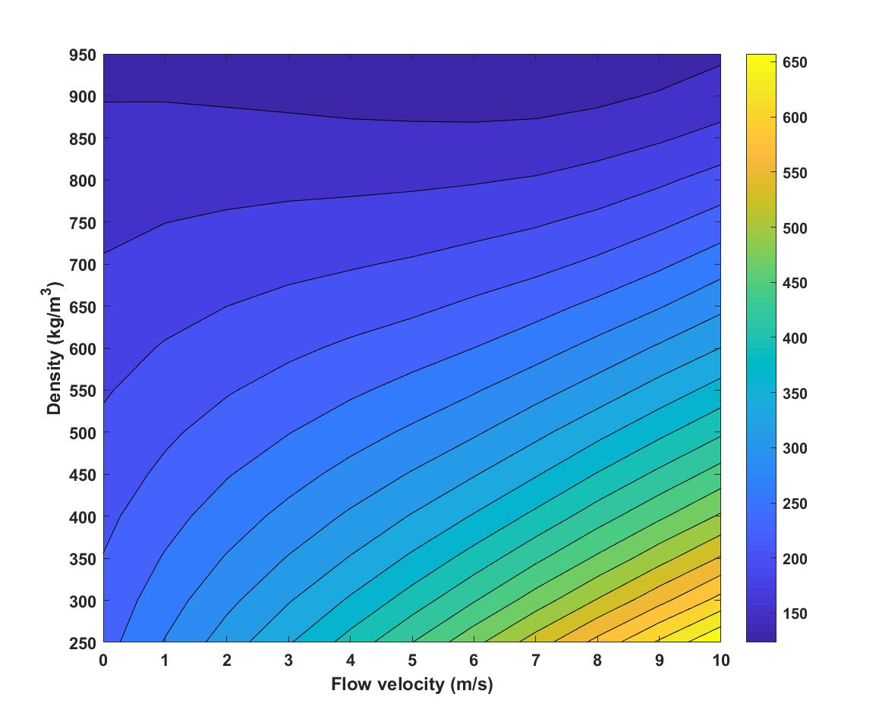
Figure 5. 2 – Contour plots of spotting distance at $V_{o}=0 m/s$ and $φ=-7.5°$, constant thickness burning model.

It can be seen that the spotting distance of firebrand is increasing with increasing flow velocity and density. In details, the travelling distance of firebrand is more dependent on the particle density when the ambient wind is small. However, with the increasing wind speed, the particle propagation turns to be more dependent on the ambient flow velocity due to wind. The gradient of density vs. flow velocity is turns to horizontal direction. Thus, it can be found that, for a non-burning or burning particle with constant thickness, its spotting distance be can affected by both the ambient flow and particle density. For the situation of relatively small wind, the firebrand with less weight will travel further due to smaller gravity. However, when the wind turns to be stronger, the effects of particle density are weakened.
For the results presented in the Figure 5.2, the polynomial function was attempted firstly. The result for obtaining function is presented as below and relevant curve fitting plot is presented in the Figure 5.3.

f(x,y) = p00 + p10*x + p01*y + p20*x^2 + p11*x*y + p02*y^2 + p30*x^3 + p21*x^2*y + p12*x*y^2 + p03*y^3 + p40*x^4 + p31*x^3*y + p22*x^2*y^2 + p13*x*y^3 + p04*y^4 + p50*x^5 + p41*x^4*y + p32*x^3*y^2 + p23*x^2*y^3 + p14*x*y^4 + p05*y^5
Where p00 = 307.5, p10 = 97.7, p01 = -0.4168, p20 = -0.9592, p11 = -0.356, p02 = 0.001122, p30 = 0.2545, p21 = -6.089e-05, p12 = 0.0006257, p03 = -2.21e-06, p40 = -0.004659, p31 = -4.226e-05, p22 = -4.129e-06, p13 = -5.54e-07, p04 = 2.042e-09, p50 = -0.001128, p41 = 3.865e-05, p32 = -4.67e-07, p23 = 5.877e-09, p14 = 1.818e-10, p05 = -7.12e-13. Goodness of fit were: R-square = 1; Adjusted R-square = 1; RMSE = 0.5108. Respectively, x indicates the flow velocity (m/s) and y indicates the density of particle (kg/m³).
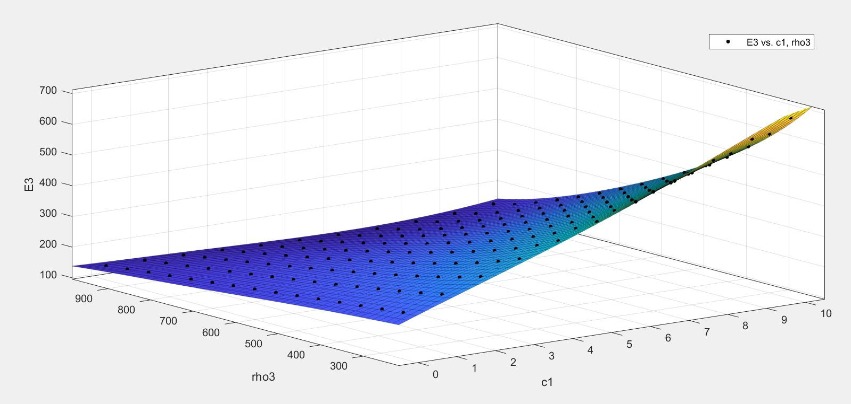
Figure 5. 3– Plot for surface fitting of spotting distance determined from ranged flow velocity and density with obtained polynomial function.

The ‘c1’ term in figure indicates the flow velocity of firebrand (m/s), the ‘rho3’ term indicates the density of firebrand (kg/m³) and ‘E3’ term is the spotting distance of firebrand at relevant conditions (m). The surface contour plot and back dots present how good the fitting was. It can be seen that the fitting was good since the fitting surface had covered most results of spotting distance (shown as black dots in figure), as well with relative low value of Root Mean Square Error (RMSE). Other two statistics measures are determined as R-Square value of 1 and Degree of Freedom Adjusted R-Square of 1.However, from the coefficients of polynomial equation, it can be seen that the equation can be simplifies as an approximate estimation of spotting. The approximation to the unit of meter is good enough for the firebrand spotting distance since usually it reaches kilometres. Thus, the function can be simplified as:
F (V_{flow}, ρ) = 380.3 + 44.85* V_{flow} + -0.5187* ρ + 0.8035* V_{flow} ^2
where the Goodness of fit are R-square = 0.9936, Adjusted R-square = 0.993 and RMSE = 9.634.
In order to validate this result, the spotting distance from obtained function are compared with the real values determined from simulations, shown in the Figure 5.4.
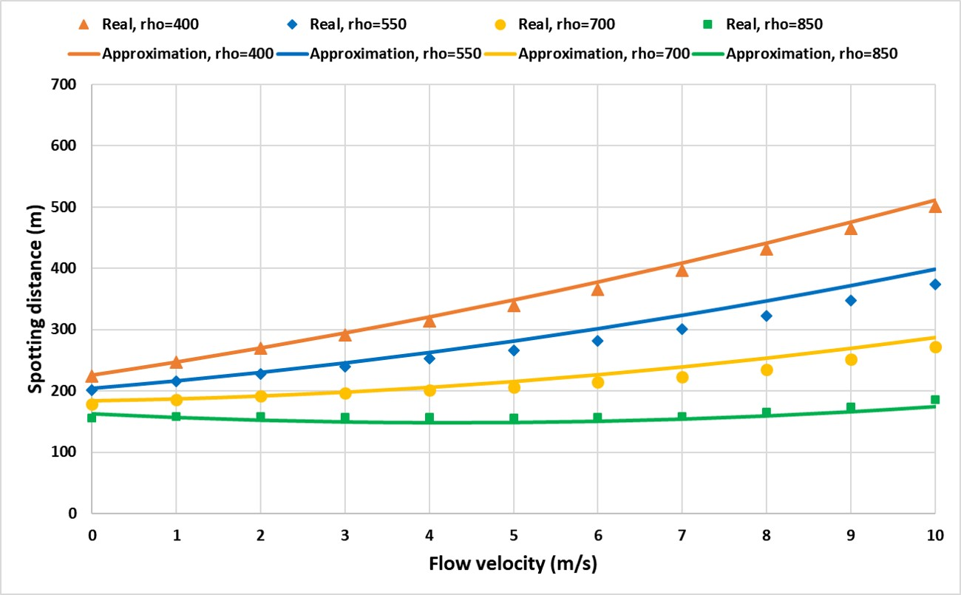
Figure 5.4 – Comparisons of the spotting distance estimated from simplified curve fitting equation with real spotting distance.

In the Figure 5.4, the solid lines present the approximations of spotting distance from simplified curve fitting function and the markers present the real spotting distance of firebrands at relevant conditions from simulations. It can be seen that the approximations were similar with real values. The maximum error determined in this case was 23 m as 0.056% of real spotting. It can be verified that the curve fitting method and simplification utilised in this work is suitable.

However, a more complex relationship is determined between the flow velocity and the incident angle, shown in the Figure 5.5. Obviously, it can be seen that the particle travels further when it is at the negative angle with respect to the horizontal direction. The particle is supported by both drag and lift at this situation. A semi-symmetric trend with respect to 0° of incidence can be found.
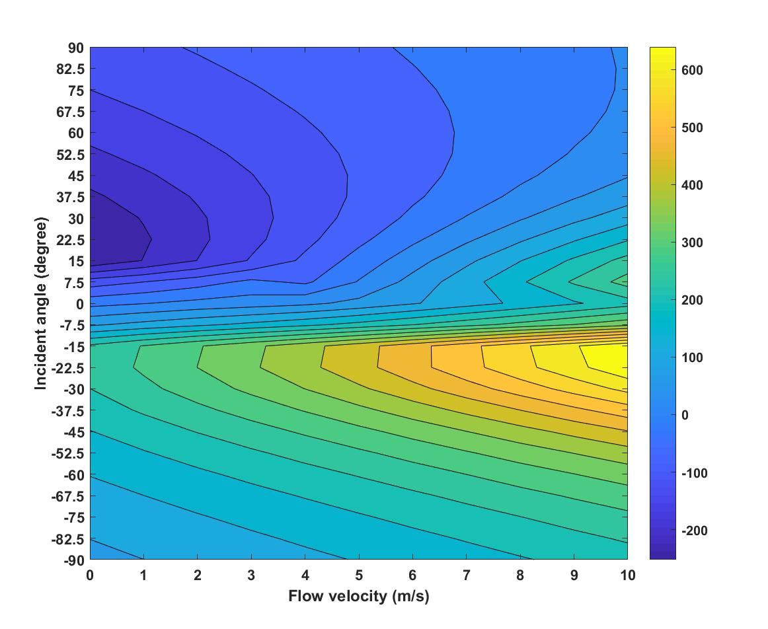
Figure 5. 5 – Contour plots of spotting distance at $V_{o}=0 m/s$ and $ρ=250kg/m^{3}$, constant thickness burning model.

By comparing the incident angle above and below 0°, it is found that the flow velocity relatively affects more on the propagation of firebrand than incident angle. When the particle has positive incident angle, its spotting turns to be more dependent on the incident angle especially with small wind. Alternatively, when the particle has negative incident angle, the effects of flow velocity on spotting is bigger than the case at negative incidence. But it has to be highlighted that the particle at negative incidence can travel further than the one at positive incidence when the flow velocity is the same.
However, the spotting distance of the firebrand still is highly dependent on the flow velocity. As the main parameter, the flow velocity plays a very important role on deciding the magnitude of both drag and lift forces, that the firebrand travel the shortest with smallest flow velocity while it travels the furthest with the largest flow velocity.
From the results, it can be highlighted that both the flow velocity and the incident angle are on the top comparing with other parameters. The flow velocity controls the magnitude of aerodynamic forces whereas the incident angle decides the usage of these forces. Meanwhile, the curve fitting equation determined is:
F (V_{flow}, φ) = -4.805 + 93.85*φ + 31.58*V_{flow} + 0.6843*V_{flow} ^2 - 2.48*φ ^3 - 0.8395*φ^2*V_{flow}
where the φ and V_{flow} in this case indicate the incident angle and flow velocity. Note the unit of incident angle in this equation is in gradient of π/6. The Goodness of fit are R-square = 0.858, Adjusted R-square = 0.8532 and RMSE = 77.08. Since the complex correlation exists between incident angle and spotting distance, this function is in higher order as 3 even after simplifying. Comparing with other approximations, this function is less accurate. It suggests the future research that, in order to make more accurate approximation, the function related with incident angle should be in higher order than other parameters. Also, the key of decreasing errors might be more accurate correlation between spotting distance and incident angle.
Furthermore, in order to compare the importance of incident angle with particle density, the corresponding contour plot is provided in the Figure 5.6. It can be found that the spotting distance is highly dependent on the angle of incidence rather than particle density. Although slight gradients can be determined, the overall structure of contour plot has indicated the higher importance of incident angle than density of particle.
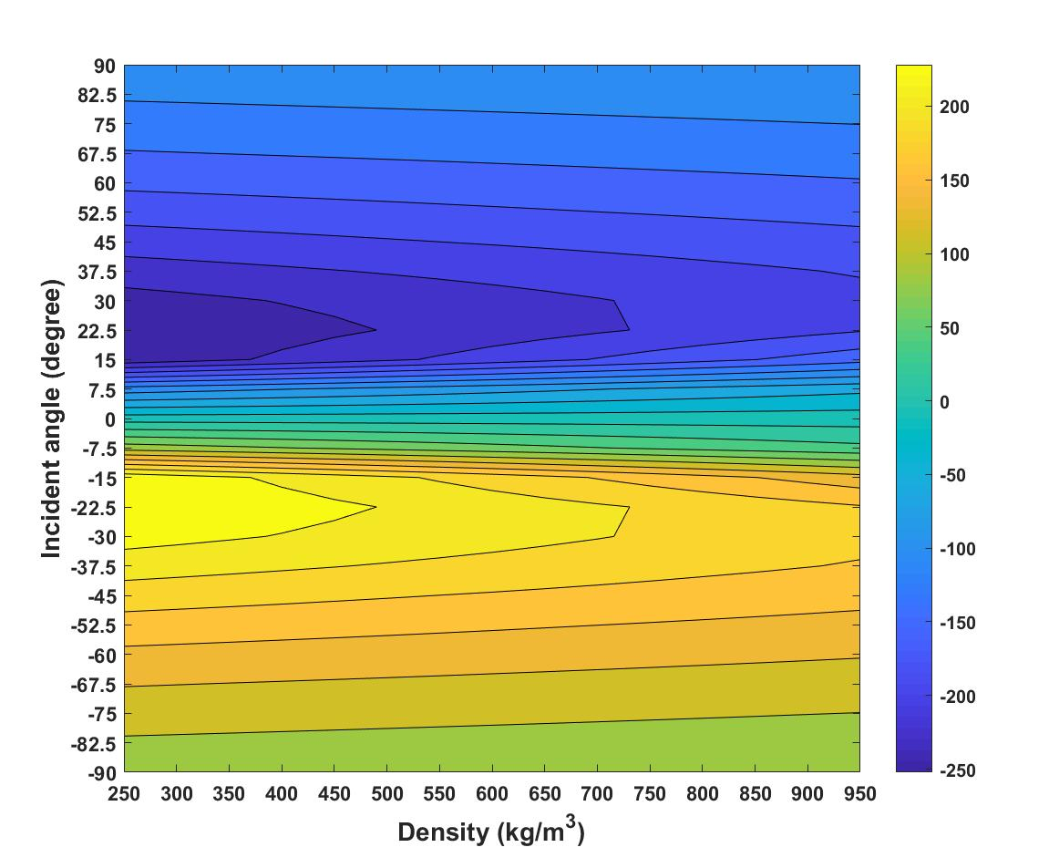
Figure 5. 6 – Contour plots of spotting distance at $V_{flow}=10 m/s$ and $V_{0}=0 m/s$, constant thickness burning model.
For the approximation by surface curve fitting, the relevant function after simplifying can be expressed as:
F (ρ, φ) = 89.29*φ - 0.007596*φ*ρ - 2.216*φ ^3
where φ and ρ indicate the incident angle and density respectively. Note the unit of incident angle in this equation is in gradient of π/6. The Goodness of fit are R-square = 0.8629, Adjusted R-square = 0.8606 and RMSE = 57.93. It can be found that the density has less correlation with spotting distance than incident angle. Although the error in this function is less than previous one, F ($φ$, $V_{flow}$), the RMSE value determined is still higher than 10.
As another parameter involved in the spotting, the particle initial velocity is compared with flow velocity and incident in the Figure 5.7 and 5.8. The high independency of spotting on particle initial velocity is found. Comparing with flow velocity and incident angle, the initial velocity almost has no effects on the propagations of firebrands. The linear gradients can be seen on the both contour plots. No matter how the initial velocity changes, the spotting distance in decided by the flow velocity and incident angle.
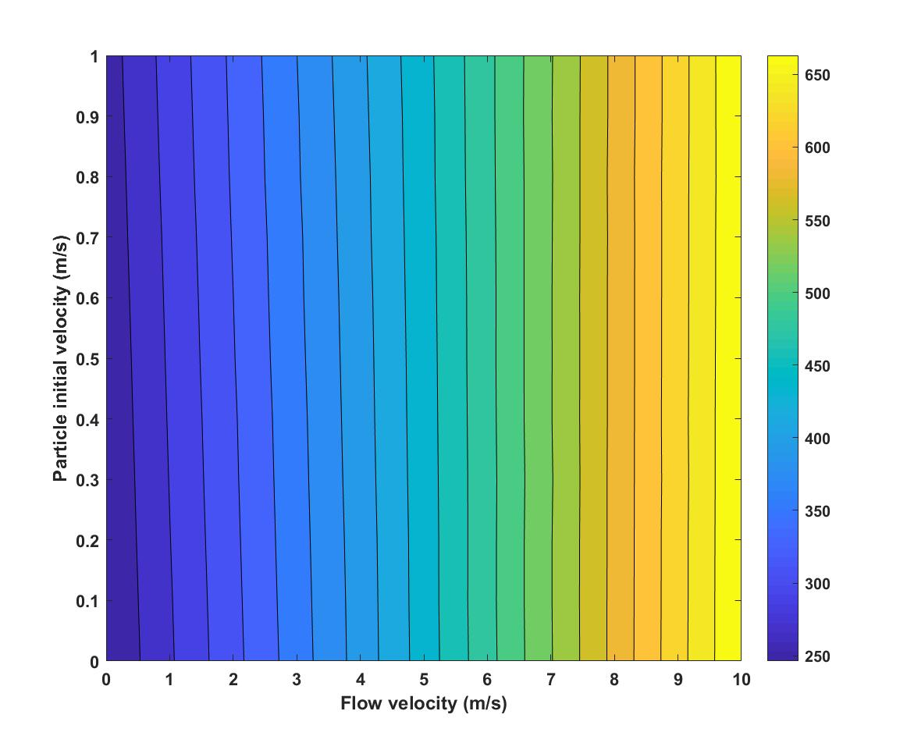
Figure 5.7 – Contour plots of spotting distance at $φ=-7.5°$ and $ρ=250kg/m^{3}$, constant thickness burning model.

For determining the correlation, the function was obtained as:
F (V_{flow}, V₀) = 238.7 + 42.98* V_{flow} + 4.923* V₀
where V_{flow} and V₀ indicate the flow velocity and particle intial velocity. A simpler correlation was determined from this result. Comparing the the coeffcient of V_{flow} term and V₀ term, it can be found that the spotting distance is highly depend on the ambient wind velocity. For this function, it has less errors, as R-square = 0.9966, Adjusted R-square = 0.9966 and RMSE = 8.002.
Meanwhile, a contour plot for the spotting distance dertermined from ranged incident angle and particle initial velocity is shown in the Figure 5.8.
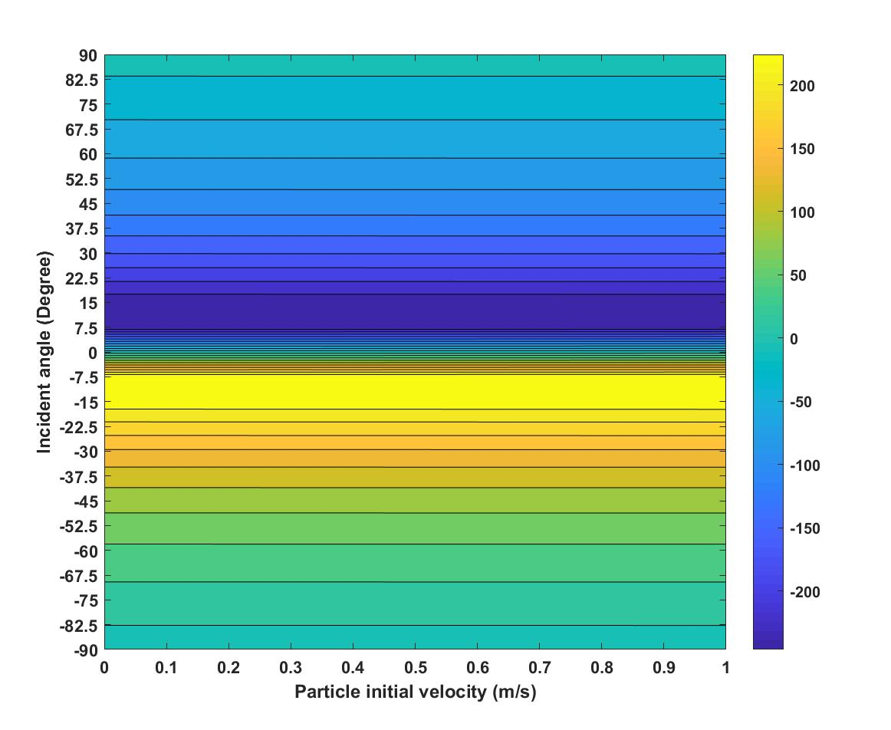
Figure 5.8 – Contour plots of spotting distance at $V_{flow}=0 m/s$ and $ρ=250kg/m^{3}$, constant thickness burning model.

And the correlation determined can be shown as:
F (V₀, φ) = 61.54*φ + 0.4404*V₀ – 2.009*φ^3
where V₀ and φ indicate the particle initial velocity and incident angle of firebrand. Note the unit of incident angle in this equation is in gradient of π/6. From the function, it can be seen that the spotting distance in this case was highly depend on incident angle rather than particle initial velocity. However, from the high error of this function, as R-square = 0.4846, Adjusted R-square = 0.4731 and RMSE = 94.36, it can prove the high error caused by incident angle. Even though the simple correlation indicated from Figure 5.8, the error of approximation is still high. This finding highlights the importance of incident angle to spotting phenomenon as well as the errors caused by incident angle for approximations.
Continue with last comparison, the importance of particle initial velocity on spotting is compared with density. The contour plot of both parameters is provided in the Figure 5.9. Although the particle initial velocity has the effects on spotting, but such effects are smaller than those from particle density. Relatively, the spotting distance of a firebrand is decided more by the density rather than the initial velocity.
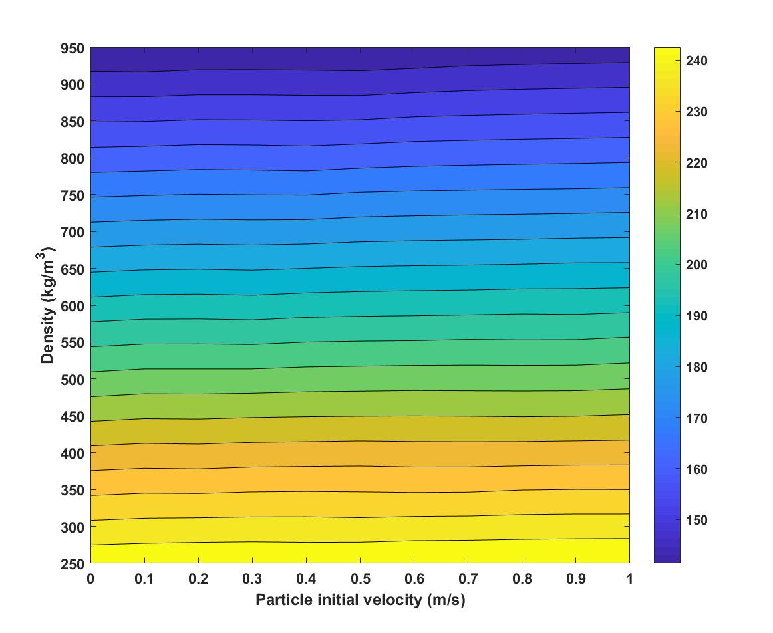
Figure 5. 9 – Contour plots of spotting distance at $V_{flow}=0 m/s$ and $φ=-7.5°$, constant thickness burning model.
And the correlation with good fitting was determined as:
F (V₀, ρ) = 283.5 + 1.59*V₀ – 0.1494*ρ
where V₀ and ρ indicate particle initial velocity and density. The reason for small coefficient in front of density is that the value of ρ is large, at least one hundred times of the initial velocity. Considering the magnitude of both V₀ and ρ terms, it can be seen that the spotting distance in this case is still highly depend on density rather than initial velocity. The error in this approximation is small as R-square = 1, Adjusted R-square = 1 and RMSE = 0.2242.
Overall, the effects of parameters on spotting for non-burning and constant thickness burning model have been determined via a parametric study. The importantce of flow velocity and incident angle can be leveled on the top, that both these two prarmeters have very signifficant effects on the firebrands’ spotting. On the lower level, it has been dertmiend that particle density is able to affect the travelling distacne of particle, but much weaker than the effects of top two parameters. Whereas the particle initial velocity has the least effects and the spotting dsitance is amlost not affect by it. For each analysis, the parameter optimisation has been made to reduce the parametes. As well the approximation of spotting distance by curve fitting functions are provided and discussed.

Variable thickness burning model

In the section, the parametric study is made to determine the importance of each parameter to spotting distance in variable thickness burning model. The testing ranges of parameters in this section have the same values with previous section, shown in the Table 5.1. From the results presented in last section, it is found that, for constant thickness burning model, the levelling for the importance of each involved parameter can be concluded as incident angle and flow velocity have the most effects on spotting distance rather than density, where initial velocity of a firebrand has the least effect. The parameter optimisation was made, and the correlations were analysed. By similar method, the levelling of the importance of each involved parameter for variable thickness burning model will be analysed and discussed.
In details, in order to determine how importantly the ambient flow affects the spotting, the contour plots of flow velocity against other three parameter are provided in the Figure 5.10 – 5.13. It can be seen that the ambient flow velocity has more effects on spotting than particle initial velocity, which the almost independent relationship of initial velocity with spotting distance is found. Further, it is found that the velocity of ambient flow has weaker effects than density when the flow velocity is small. But, with the increasing velocity, the ambient flow turns to be more important for the spotting. Some data is shown as examples in the Appendix C.
In order to determine the effects of flow velocity and particle initial velocity on the spotting distance in variable thickness burning model, the simulations are conducted with fixed incident angle of -7.5° and density of 250 kg/m³. The contour plot of relevant results is presented in the Figure 5.10.
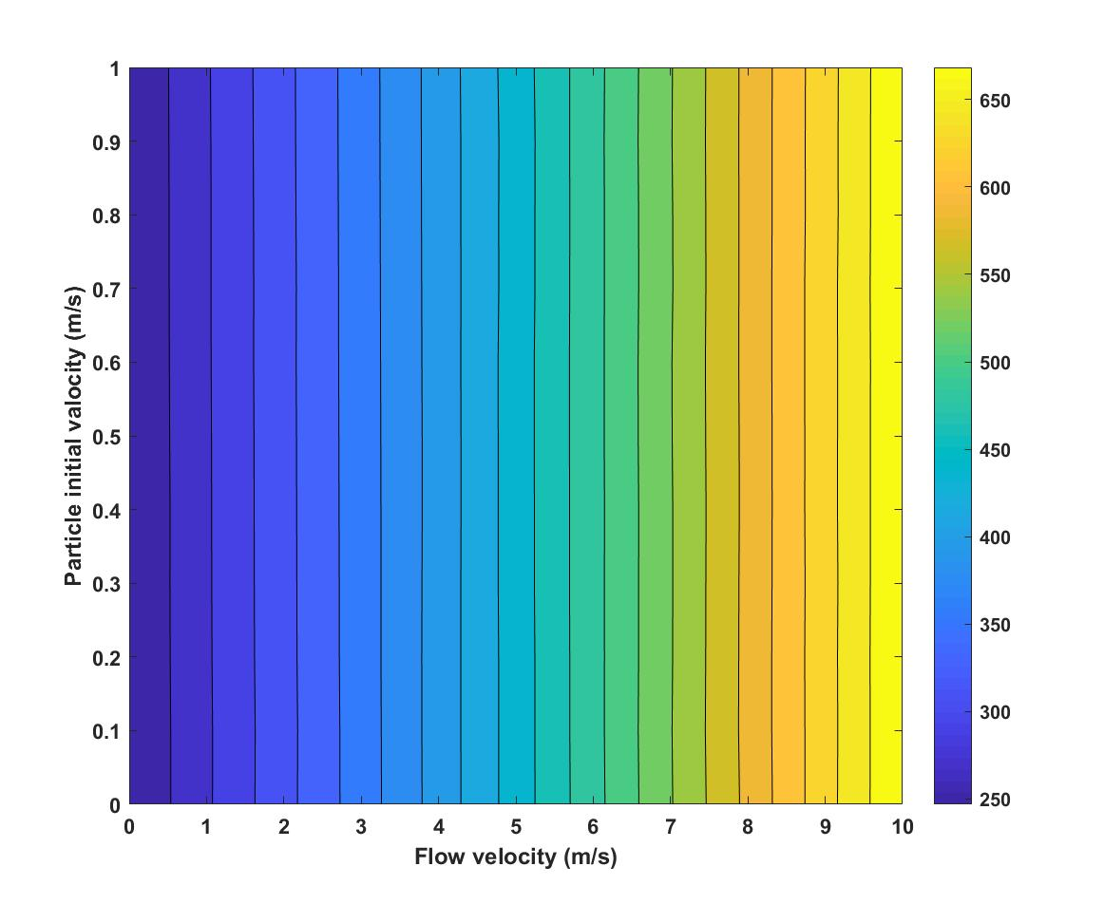
Figure 5. 10 – Contour plots of spotting distance at $φ=-7.5°$ and $ρ=250kg/m^{3}$, variable thickness burning model.
It can be seen that the spotting distance is highly dependent on the flow velocity rather than initial velocity in this case. This finding is similar with the relevant case simulated by constant thickness burning model. For the parameter optimisation, the surface curve fitting equation was determined. It can be shown as:
F (V_{flow}, V₀) = 235.6 + 44.17*V_{flow} + 0.3891*V₀
where V_{flow} and V₀ indicate the ambient flow velocity and particle initial velocity. The high dependency of spotting distance on flow velocity has been determined in this case. The Goodness of fit for this function is good, as R-square = 0.997, Adjusted R-square = 0.9969 and RMSE = 7.823. It can be seen that the Root Mean Square Error of this function is 7.823 m, which is less than 3% with respect to averaged spotting distance in this case as 275 m.
Meanwhile ,the contour plot of spotting distance under fixed incident angle and initial velocity is presented in the Figure 5.11. Comparing with initial velocity, the density of firebrand has larger effects on spotting distance especially at larger flow velocity.
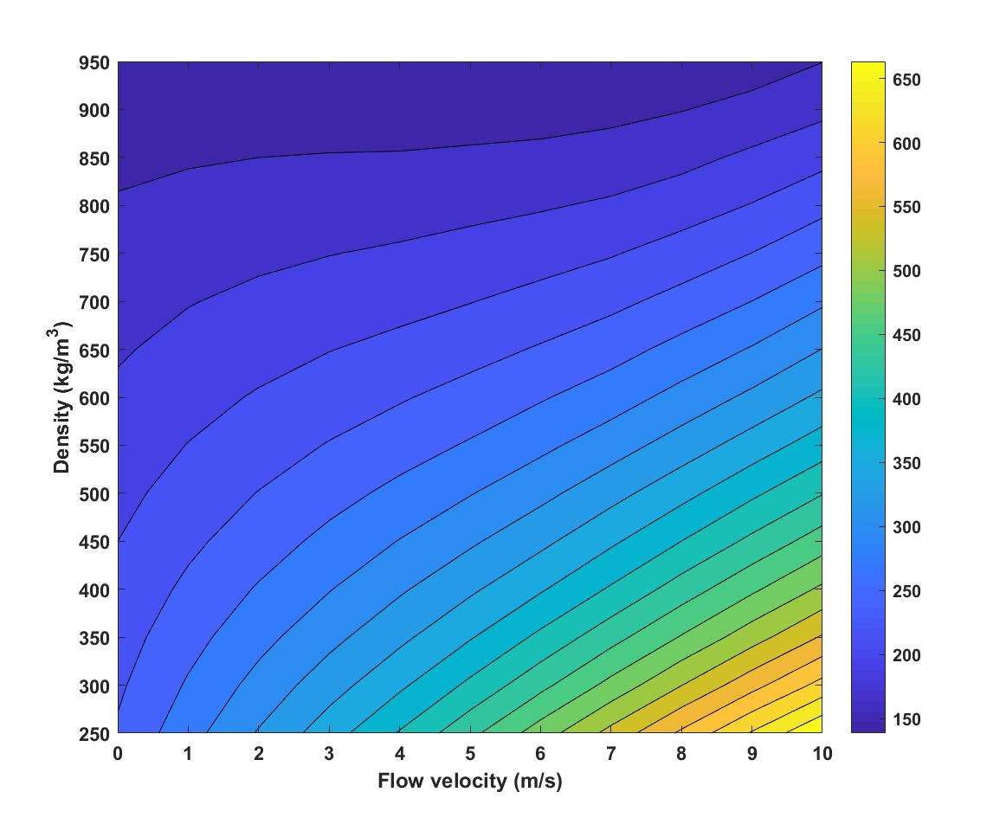
Figure 5. 11 – Contour plots of spotting distance at $V_{o}=0 m/s$ and $φ=-7.5°$, variable thickness burning model.

Based on the spotting distance presented in the Figure 5.11, the curve fitting was applied to determine the correlation, shown as:
F (V_{flow}, ρ) = 350.7 + 65.78*V_{flow} – 0.5544*ρ – 0.1843*V_{flow}^2 – 0.1265*V_{flow} *ρ
where V_{flow} and ρ indicate the flow velocity and density. Although less dependency on spotting distance than flow velocity, the density still influences the spotting of a firebrand. Comparing this approximation determined from constant thickness burning model, it can be found that the thickness change increases the effect of density on spotting distance. In another way, this finding highlights the importance of burning particle with light density such as Balsa and Bamboo particles. The corresponding Goodness of fit are R-square = 0.9995, Adjusted R-square = 0.9995 and RMSE = 2.618.
Moreover, a complex relationship, which is similar with the constant burning model, can be determined between flow velocity and incident angle. The extreme spotting occurs at -7.5° as maximum. The effects of flow velocity turn to be weaker in the range of [-15°, 15°] of incident angle. But the ambient flow still can affect the spotting.
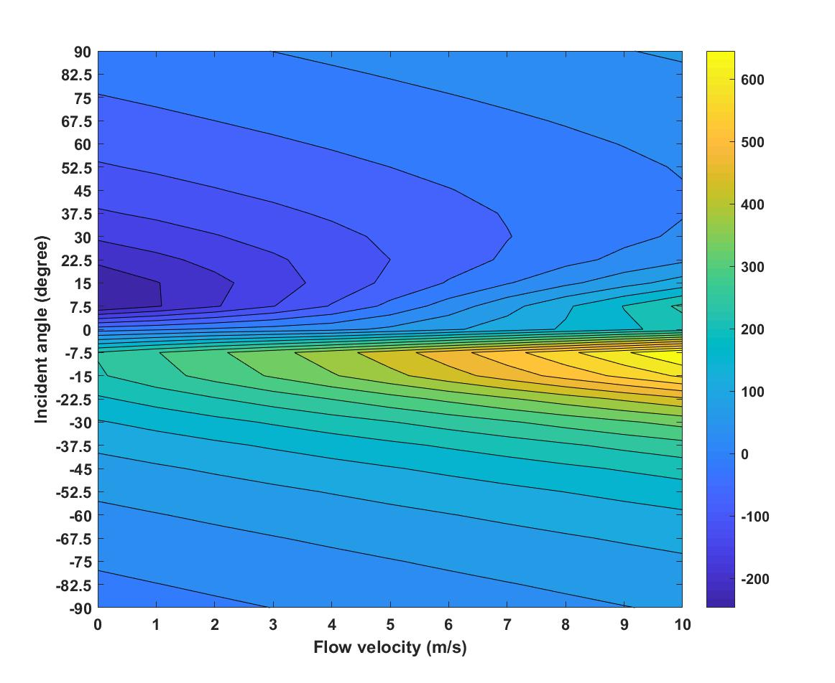
Figure 5. 12 – Contour plots of spotting distance at $V_{o}=0 m/s$ and $ρ=250kg/m^{3}$, variable thickness burning model.

In order to further analyse the effects of both parameters, the function for parameter optimisation has been determined, shown as:
F (V_{flow}, φ) = -2.354 + 30.23*V_{flow} + 119.2 * φ + 0.6484*φ^2 + 0.1374* V_{flow}^3 - 2.33*V_{flow}*φ^2 - 8.972*φ^3
where V_{flow} and φ indicate the flow velocity and incident angle. Note the unit of incident angle in this equation is in gradient of π/6. As a complex equation, it indicates that both the flow velocity and the incident angle are important for spotting distance. By comparing it with the approximation determined from constant thickness burning model which is relatively simpler on V_{flow} terms, it can be seen that the thickness change can make the model more sensitive to flow velocity. For the application, it indicates that the burning firebrands might glide further than the glowing firebrands. For the error analysis of this function, the error can be provided as R-square = 0.7482, Adjusted R-square = 0.7284 and RMSE = 81.61. The error in this function is higher than the function not related with incident angle, which is less than 10 of RMSE.
The incident angle is further compared with the density and the initial velocity of particle. Obvious relationships can be determined from the Figure 5.11 and 5.12, that the spotting depends more on the incident angle rather than other two parameters. Be different with the high independency of initial velocity on spotting, the density can slightly affect the spotting, but still is less important than the angle of incidence.
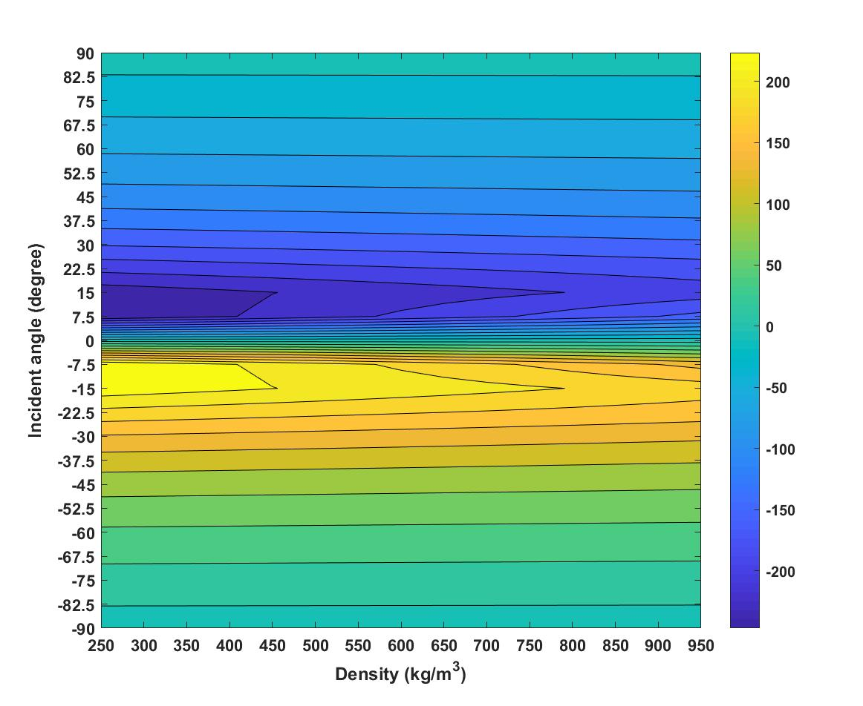
Figure 5. 13 – Contour plots of spotting distance at $V_{flow}=0 m/s$ and $V_{0}=0 m/s$, variable thickness burning model.

The curve fitting equation for the Figure 5.11 has been obtained as:
F (ρ, φ) = 116.2*φ - 8.37*φ^3 + 0.1458*φ^5
where ρ and φ indicate the density and incident angle. Note the unit of incident angle in this equation is in gradient of π/6. The function shows that the spotting distance in this case is highly dependent on incident angle rather than density. This is the same finding with constant thickness burning model. For the error analysis, the statistical measures are provided as R-square = 0.7225, Adjusted R-square = 0.7149 and RMSE = 62.02.
As a similar trend with constant thickness burning model, a simpler correction among spotting distance, initial velocity and incident angle was determined from the Figure 5.12, that the spotting distance is highly dependent on the incident angle rather than initial velocity. The approximation has been obtained as:
F (φ, V₀) = 152.9*φ + 0.8012*V₀ - 9.56*φ^3
where φ and V₀ indicate the incident angle and initial velocity. Note the unit of incident angle in this equation is in gradient of π/6. Very weak effect from initial velocity on spotting distance can be found. Comparing with the last function, the one in correlation with density, it can be seen than the initial velocity is less important than density for spotting phenomenon of a thickness changing firebrand. The corresponding error can be found as R-square = 0.9389, Adjusted R-square = 0.9366 and RMSE = 43.85.
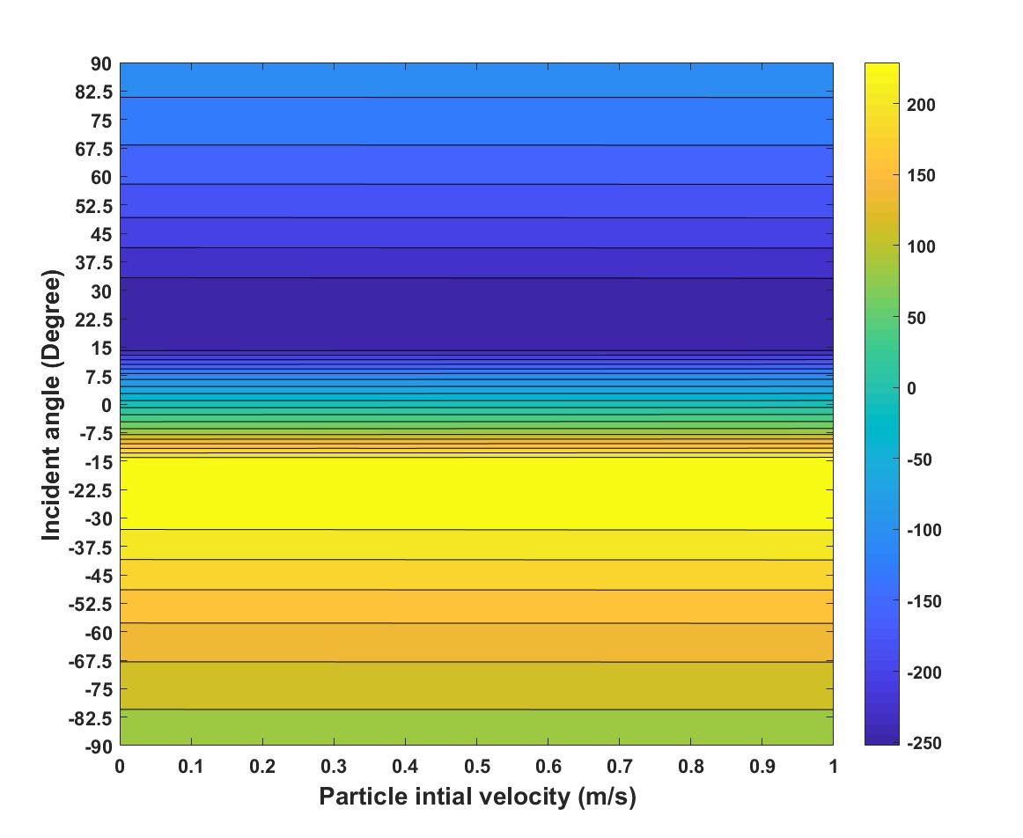
Figure 5. 14 – Contour plots of spotting distance at $V_{flow}=0 m/s$ and $ρ=250kg/m^{3}$, variable thickness burning model.

Moreover, the effects of density and initial velocity on spotting are compared in the Figure 5.13. Although both parameters affect propagations, the density is more important than the particle initial velocity. Relatively, the density of firebrand controls more than the initial velocity. For the parameter optimisation, the surface curve fitting equation can be given as:
F (ρ, V₀) = 282.1 - 0.1434*ρ + 1.644*V₀
where ρ and V₀ are the density and initial velocity. Although the coefficient in front of density is small, the value of density is relatively larger. Similar with the function obtained from constant thickness burning model, the density is important to spotting distance when there is no wind and at -7.5° of incident angle. The relevant statistical measures are found as R-square = 0.9999, Adjusted R-square = 0.9999 and RMSE = 0.3015.
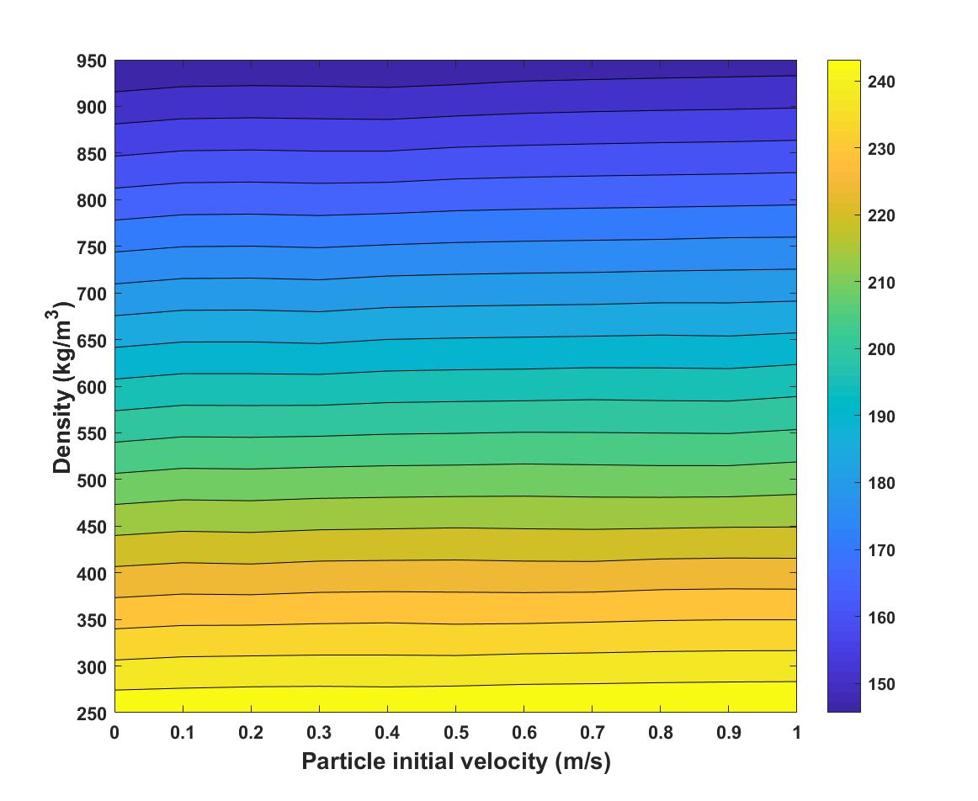
Figure 5. 15 – Contour plots of spotting distance at $V_{flow}=0 m/s$ and $φ=-7.5°$, variable thickness burning model.

Overall, the results of the parametricstudy focsing on viriable-thickness burnig model ara similar with those dertermined from constant thickness burning model, that the flow velcoity and incident angle signifficantly affect the spotting of firerbands. The density has less importance than top two parameters, but still affects the spotting distance more than the initial velocity of particle. As the parameter of least effect on spotting phenmomenon, it is on the lowest level comparing with others.

5.3.3 Difference between two burning models

Based on the parametric studies in previous sections, it is found that the incident angle of a firebrand and the flow velocity due to ambient wind field have the most effects on the spotting distance, whereas the density of firebrand and the particle initial velocity are less important. Also considering the results of parameter optimisation in previous chapter, it can be seen that the parameters of density and flow particle initial velocity can be neglected, especially for large flow velocity of 10 m/s and incident angle of -7.5°. In this section, the difference between constant thickness burning model and variable thickness burning model is mainly discussed for the cases of fixed density and initial velocity. For the comparisons based on other parameters, they are also provided in the Appendix H.
In details, the differences of the spotting distances between variable thickness burning model and constant thickness burning model are presented in the Figure 5.14. The x- and y- axis of those figures indicate the tested parameters and the colour bar indicates the difference of spotting distances in m.
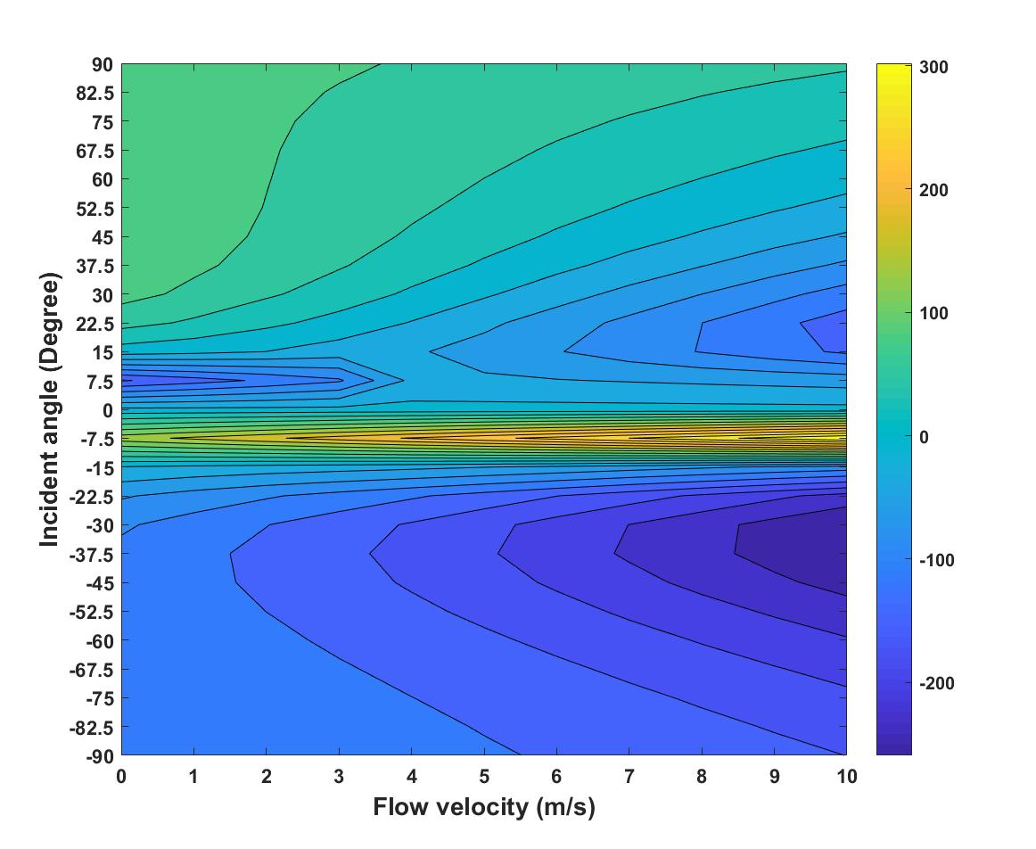
Figure 5. 16 – Contour plots of the difference of spotting distance at $V_{o}=0 m/s$ and $φ=-7.5°$. Spotting difference was determined from the spotting distance from variable thickness burning model with respect to constant thickness burning model.

It can be seen that the spotting distance can be strongly enhanced by the thickness change, up to 300 m. The peak of such enhancement was found at -7.5° of incident angle over the whole range of flow velocity as [0, 10] m/s. Highly dependency of spotting enhancement on incident angle was found in the range of [-15°, 0°]. It highlights the possibility that the firebrand with changing thickness can glide further than other firebrands if it is at the incident angle of -7.5° regardless to ambient wind field. Since the propagations of firebrand is a complex progress combined with physics and combustion chemistry, which is still not well understood so far, it also suggests the future research should be focused on obtaining the mechanism of firebrands propagations especially at the incident angle between [-15°, 0°].
From the figure, it also can be found that the enhancement of spotting due to thickness change existed at positive incident angle ranged between [60°, 90°]. This finding indicates that the thickness regression will delay the dropping progress of firebrand. For the case at relatively large positive incident angle, the ambient wind ‘pushed’ the firebrand moving forward, that both lift force and drag force pointed into the downward direction. The vertical velocity will be strongly increased before reaching the terminal velocity. Comparing with the constant thickness burning model, the change of thickness reduced the gravity exerted on particle, which decreased the vertical acceleration of firebrand. However, it must be noted that the firebrands simulated in this work were not burnt out. The burning lifetime of particles were longer than their flight time. It is worthy increasing the releasing height to further determine this phenomenon in future work. As well, it alerts the consideration of burning lifetime for future research.
In order to further study the spotting difference due to thickness change, the parameter optimisation is made. Considering that the main aim of using parameter optimisation in this section is to obtain the effect of parameter on spotting distance, it is more appropriate to determine the correlation function instead of looking for best solutions. The surface curve fitting is utilized to approximate the correlation function. which can be presented as:
F (V_{flow}, φ) = 6.975 – 5.541*V_{flow} – 2.051*φ + 0.021*V_{flow}*φ

where V_{flow} and φ indicate the flow velocity (m/s) and incident angle (°). It can be seen that both parameters have same levelling of the importance to spotting difference. Due to very complex correlation, this fitting equation is not very good since relatively large errors, although great efforts have been made to improve the accuracy of this approximation. The statistical measures can be provided as R-square = 0.6061, Adjusted R-square = 0.5912 and RMSE = 70.16. The plot of surface curve fitting is provided in the Appendix H.
Overall, it can be concluded, for a burning firebrand with changing thickness, the spotting distance can be significantly enhanced. A special range of incident angle is found between [-15°, 0°], that the variable thickness firebrand released at such incident angle can glide much further than the constant thickness firebrand. The finding highlights the possibility that the firebrand with changing thickness can glide further than other firebrands if it is at the incident angle of -7.5° regardless to ambient wind field. Meanwhile, due to the quicker mass regression, the thickness change delays the dropping progress when the firebrand is released at a large positive incident angle, then further enhances spotting distance. It suggests the importance of thickness change for future research of firebrand propagations.

Conclusion

In this chapter, the parametric studies for determining the effects of four simplified parameters on spotting phenomenon are made. The simulations operated are firstly introduced via the structure and logic chain of models utilized. Based on the results from simulations, the contour plots for non-burning model and constant thickness model are presented. The effects of each parameter on spotting distance of a non-burning or a burning particle with constant thickness are analysed. It is found that both the flow velocity and the incident angle can significantly increase the propagations of firebrands. After parameter optimisation, it indicates that the importance of flow velocity and incident angle are on the top by comparing with others. For each case, the corresponding surface fitting equation was provided for further study of correlation.
Further, the parametric study focusing on the variable thickness burning model is made. The results have indicated the effects of each parameter on the spotting of a burning firebrand with changing thickness are similar with the constant thickness firebrand. As a similar levelling, the flow velocity and the angle of incidence mainly affect the spotting distance of firebrands, whereas the particle initial velocity has the least effects. The correlations among are discussed with the surface fitting equations.
In order to compare the difference of spotting distance between two burning models, the results from variable thickness burning model are compared with those from constant thickness burning model. It is verified that the difference between two burning model. In details, the thickness-change due to particle burning enhances the spotting distance when firebrand was released at the incident angle between [-15°, 0°]. Such finding has strongly highlighted the importance of the consideration of particle thickness change due to combustion, and it is suggested that the change of thickness should be added into the transporting model of a burning firebrand for more accurate predictions. Meanwhile, it is necessary to conduct experiments for determining more accurate regression rate on thickness of the rectangular-shaped firebrand, since there is rare relevant data reported and the importance of such rate on firebrand models.

Chapter 6. INVESTIGATIONS OF THE EFFECTS OF LIFT ON THE SPOTTING OF A FIREBRAND

Introduction

In the previous chapters, the spotting maximum distances of firebrands are determined from the transporting models developed in this study. Moreover, considering the different burning styles of the firebrands, the spotting based on different combustion models are compared. It is found that the variable burning model significantly improves the spotting distance of firebrands, whereas the differences between non-burning and constant burning model are so small that even can be neglected.
Furthermore, the parametric studies are made to determined how the simplified parameters affects the propagations of firebrands in spotting phenomenon. It is found that importance of each parameters on propagating distance varies, in details which can be levelled as Flow velocity & Incident angle > Density of firebrand > Particle initial velocity. And by comparing such levels in different burning models, it is determined that the parameters have similar levelling for all models no matter if the thickness is changing (due to combustion) or not. However, by comparing the differences of spotting distance among three models, it is found that the thickness change can strength the increase of spotting distance. And the influences of each parameter on such strengthening effects are found as Flow velocity & Incident angle & Density of firebrand > Particle initial velocity.
In this chapter, as a new investigation, the lift effects on the spotting distance are determined for the first time in this thesis. The differences of spotting distance due to aerodynamic lift are determined for each model. Since the parameters of flow velocity, incident angle and density are determined as most important parameters affecting the spotting of firebrands. The lift effects based on these parameters are discussed. Furthermore, the differences of lift effects due to different combustions are investigated and compared. The surface fitting equation are obtained to discuss the correlations and the parameter optimisation is made to reduce parameters.

Concepts of the simulations

In this chapter, the simulations are made focusing on the determinations of lift effects on spotting distances of firebrands. The results from each burning model are determined. Then the differences of lift effects due to different combustion behaviours are compared.
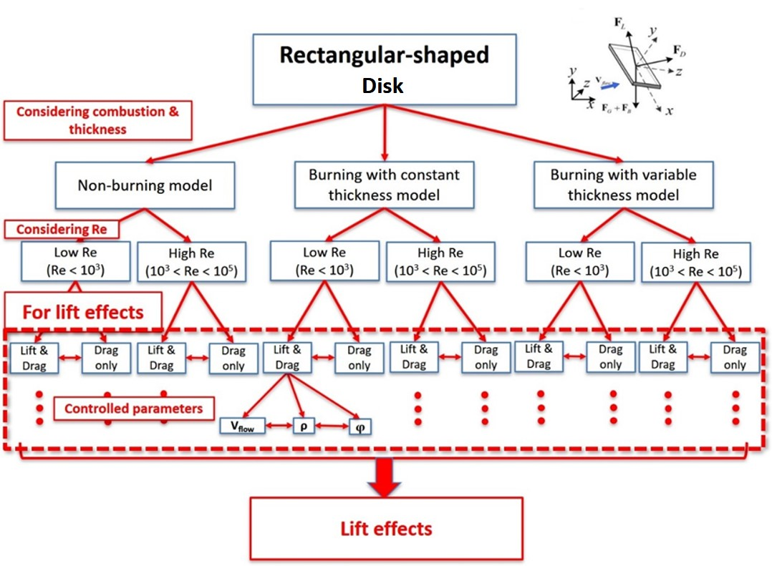
Figure 6. 1 – Representation of the structure and logic chain of the simulations.

From the findings in previous chapters, it is found that the parameters of flow velocity, density and incident angle are relatively important to the propagations of firebrands, that they not only affect the spotting distance, but also have the strengths functions on the increasements of spotting distance for the burning particle with changing thickness. Thus, the lift effects are then focused studied based on these three parameters. The tested ranges of parameter are presented in the Table 6.1. Furthermore, the detailed discussion on how the different burning styles affect the lift effects on spotting are provided.

Table 6. 1 – Tested ranges of parameters in the simulation for investigations of lift effects.
Parameters
Ambient flow velocity,  $V_{flow}$  $$(m/s)$$ | Angle of incidence  $φ$  (°) | Initial velocity of firebrand,  $V_{0}$  $$(m/s)$$ | Density of particle,  $ρ$  $$(kg/m^{3})$$
[1, 10] | -15 | 0 | [250, 950]
[1, 10] | [-90, 90] | 0 | 250
10 | [-90, 90] | 0 | [250, 950]

Results and discussion

The main results in this chapter can be divided into two parts. In the first part, the effects of aerodynamic lift force on the spotting distance of firebrand are determined. Including constant thickness burning model and variable thickness burning model, the lift effects in each model are investigated before the comparisons among models before the comparisons among different models. In order to present more characteristics of the lift effects, both the differences and ratios of the increments on spotting due to lift are determined.
Further, in the second part, the differences of lift effects are compared among different combustion models. As a new model developed for the first time, the comparisons between developed model, variable thickness burning model, and published model, constant thickness burning model, are highlighted. Some data is shown as examples in the Appendix D, E and F.

Lift effects on spotting distance

For a non-spherical particle, the main aerodynamic forces exerted on the particle can be found as drag and lift, with regardless to the virtual mass and Basset history term by the order-of-magnitude in this study. In the past studies focusing on firebrand spotting, the lift force is always being ignored due to its relative smaller magnitude than drag. Thus, there is rare study focusing on the determinations of lift effects on spotting in wildfire. Only a few papers have discussed the calculation of lift coefficients but without the change of particle trajectories due to lift, especially for the forest fire field.
As the study in this thesis is for the first time, the effects of aerodynamic lift on the spotting distance of a firebrand lofted in the flow field is investigated in this chapter. Focusing on the rectangular-disk firebrand, the trajectory and maximum spotting of the firebrand at different flow conditions are determined. As well, the lift effects are investigated by comparing the spotting distance of a firebrand with and without lift force. In order to present more characteristics of the lift effects, both the difference of maximum spotting distance due to lift (of the unit $m$ in this chapter) and the ratio of maximum spotting distance for a firebrand with and without lift force are found. The corresponding calculations can be viewed in Eq. 6.1 and 6.2.
 | $${∆S}_{lift effects},=S_{x,max, with lift}- S_{x,max,without lift}$$ | Eq. 6.1

 | $${Ratio}_{lift effects},=\frac{S_{x,max, with lift}}{S_{x,max,without lift}}$$ | Eq. 6.2

Considering the relative complex correlations among the results in this chapter, an example is introduced to explain how the lift effect is determined in this study. For a firebrand (with thickness change) of 250 kg/m³ released at 0 m/s of initial velocity, its maximum spotting distances with lift force are presented with ranged flow velocity and incident angle in the Figure 6.2.
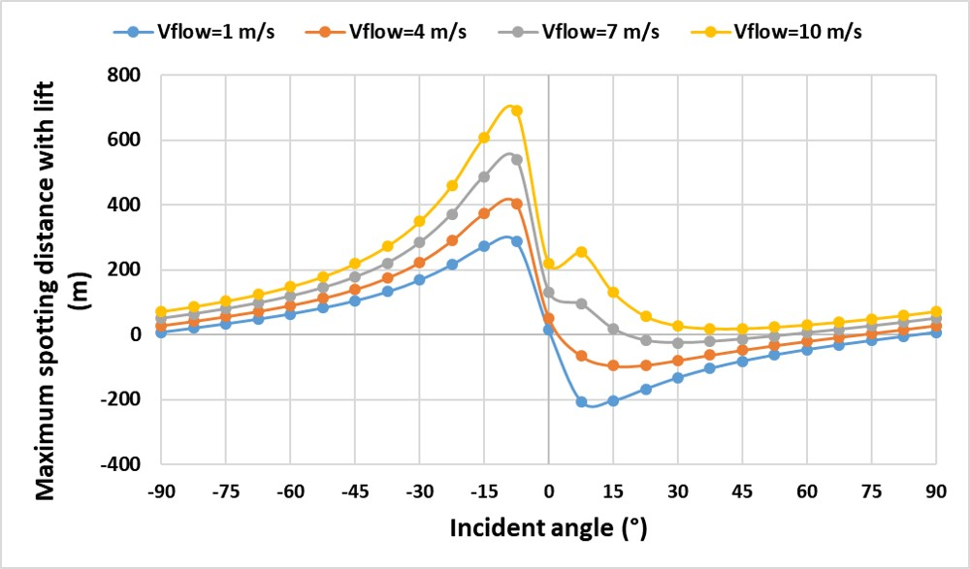
Figure 6.2 – The maximum spotting distance (with lift) of firebrands with ρ = 250 kg/m³ and V₀ = 0 m/s.

Meanwhile, the maximum spotting distance for same firebrand with same conditions but without lift force are simulated, shown as Figure 6.3.
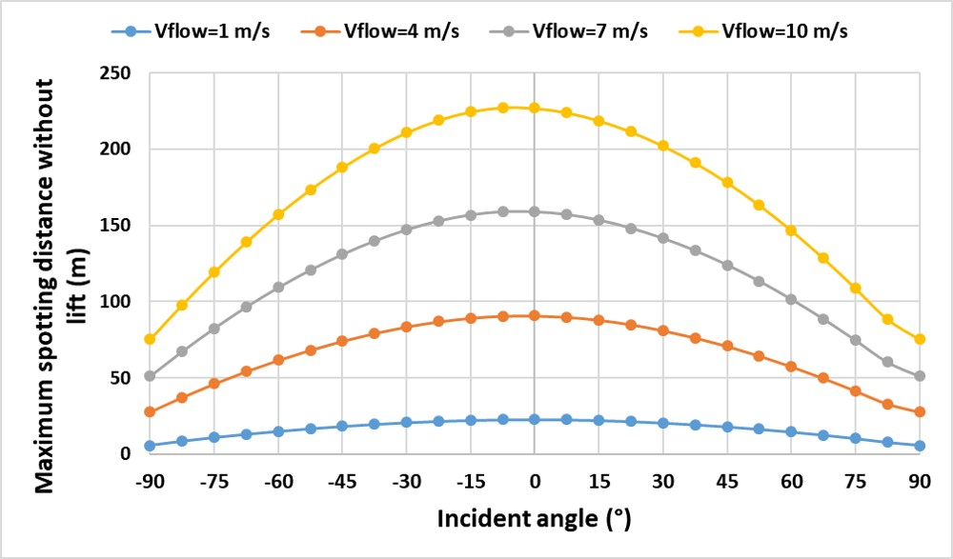
Figure 6.3 – The maximum spotting distance (without lift) of firebrands with ρ = 250 kg/m³ and V₀ = 0 m/s.
Based on these simulation results, the effects of lift force on spotting distance can be calculated from the results from Figure 6.2 minus the results from Figure 6.3, shown in the Figure 6.4.
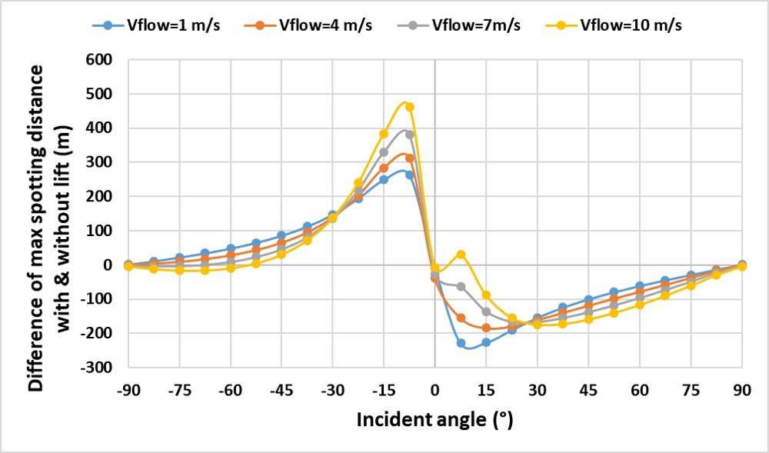
Figure 6.4 – Differences of max spotting distance with and without lift force.

In order to have a good understanding of lift effects, the ratio of the spotting distance with lift over those without lift are calculated, shown in the Figure 6.5.
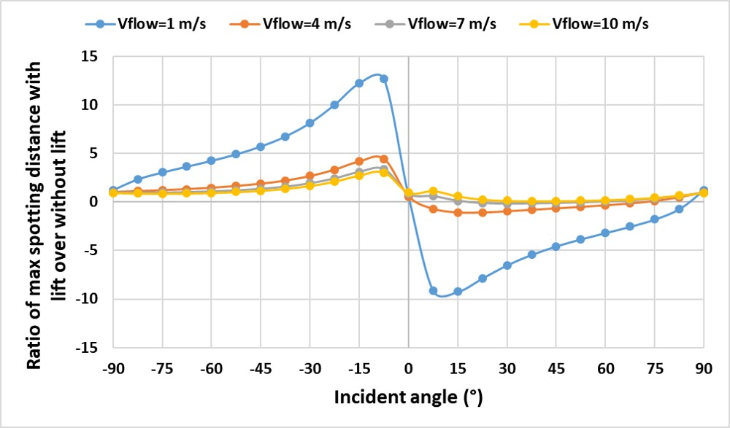
Figure 6.5 – Ratios of max spotting distance with lift over without lift.

After the introduction, the results for determining the lift effects of firebrand are presented. It is found that the trend of lift effects for both burning models are similar. In this chapter, the variable thickness burning model is mainly discussed. The difference of lift effects between both models will be focused in next section. As the finding in previous chapter, it is found that the initial velocity has very small effect on spotting distance which even can be neglected. The study of lift effects will be focused on the cases with ranged flow velocity, incident angle and density. For the variable thickness burning model, the lift effects for the firebrand of 250 $kg/m^{3}$ and 0 m/s of initial velocity is presented in the Figure 6.6 and Figure 6.7.
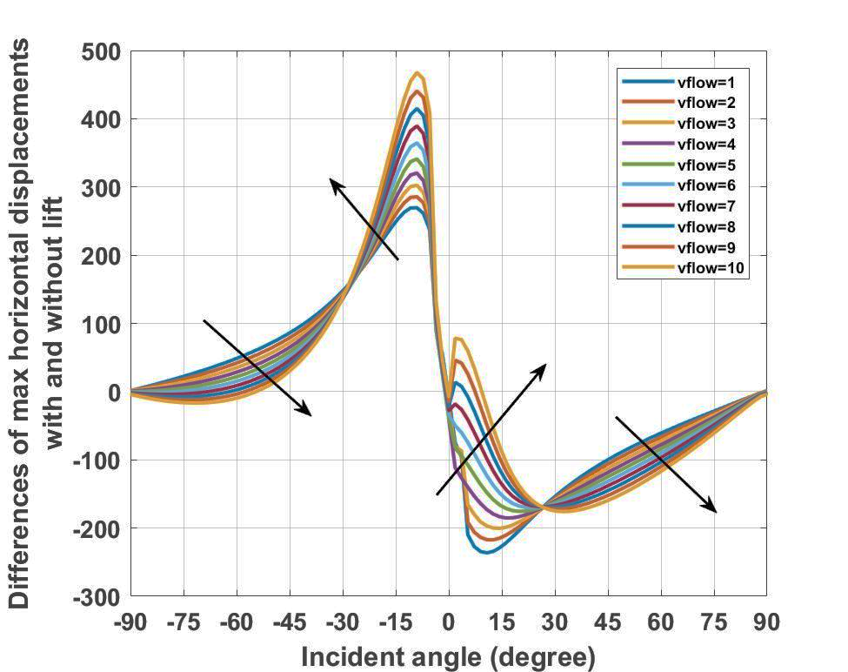
Figure 6.6 – Difference of max spotting distance with and without lift, at $ρ=250 kg/m^{3}$ and $V_{0}=0 m/s.$
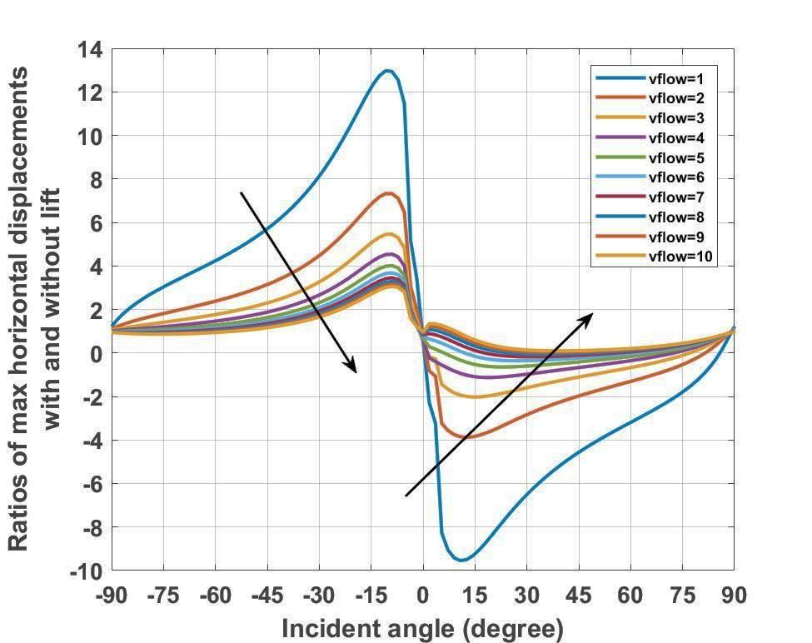
Figure 6. 7 – Ratios of spotting distance with and without lift, at $ρ=250 kg/m^{3}$ and $V_{0}=0 m/s.$
It can be seen that the lift force increased the propagations of firebrands at most negative incident angles especially at [-45°, 0°], and the maximum positive effects was around -7.5° and the increase of spotting can be up to 480 $m$ (from 227.36 m increased to 689.45 m) at flow velocity of 10 m/s. From the Figure 6.7, it can be seen that the maximum ratio can be up to 13 times (from 1.75 m increased to 22.43 m) at the flow velocity of 1 m/s. Meanwhile, it can be seen that the lift still can decrease the spotting of firebrand. Except the cases at [3°, 14°] of incident angle and at strong wind such as 9 – 10 $m/s$, the lift force has negative effects on the firebrands when the incident angle is positive.
Furthermore, it is found that the lift effects dramatically change with increasing incident angle and flow velocity. Especially at the incident angle ranged at [-30°, 30°], the lift force can either strength or weak the spotting with large magnitude. Meanwhile, for the flow velocity, different trends are observed. The increasement due to lift is increasing with increasing flow velocity when the incident angle is at [-30°, 30°], whereas it is decreased in [-90°, -30°] and [30°, 90]. However, by comparing the ratios, it is found that the lift affects the spotting much stronger at low flow velocity. This is due to the small values of spotting distance without lift force. It can be highlighted that the lift force affects the spotting of firebrand significantly especially at [-30°, 30°] of incident angles if the density of firebrand is fixed.
In order to further obtain the correlation of lift effect to maximum spotting distance of firebrands is developed as:
 | $$D_{lift}=D_{no lift} × ∅_{lift}$$ | Eq. 6.3

where $∅_{lift}$ is the lift coefficient. The $D_{lift}$ and $D_{no lift}$ indicate the maximum spotting distance with and without lift force. In order to determine the lift coefficient, each single value of maximum spotting distance with lift is divided by the relevant maximum spotting distance without lift. The surface fitting method introduced in previous chapter is applied. After individual division, each single lift coefficient will be returned into corresponding position in matrix. For the firebrands of 250 kg/m³ and 0 m/s of initial velocity, as the conditions applied in the Figure 6.6 and 6.7, the lift coefficient was determined as:
$∅_{lift}$ (φ, V_{flow}) = 1.349 + 8.807*V_{flow} - 3.672*φ*V_{flow} - 0.1139*V_{flow}^2 + 0.764*φ^2*V_{flow} - 0.4451*V_{flow}^3
where V_{flow} and φ indicate the flow velocity and incident angle. Note that since the value of lift coefficient is small (averagely around 1) in this case, thus the coefficients determined in this equation had small values. As discussed in previous chapter, due to complex correlation between spotting distance and incident angle, the surface fitting equation related with incident angle has relatively high error. From this equation, it can be seen that the flow velocity has larger effects on lift coefficient rather than incident angle. The statistical measures of this equation can be found as R-square = 0.7655, Adjusted R-square = 0.7337 and RMSE = 1.386. The plot of surface fitting is provided in the Appendix G.
Meanwhile, the lift effects of firebrand with fixed incident angle of -7.5° is presented in the Figure 6.8 and 6.9. The spotting distance of the firebrand under can be increased up to 390 $m$ and up to 18 times comparing with spotting simulated without lift force, as . Meanwhile, it is found that the lift effects are strengthened with larger flow velocity but weakened with larger density. Whereas when the flow velocity reaches 7 $m/s$, the ratio of spotting distance with and without lift tends to be stable, but still large value of spotting difference over 200 $m$.
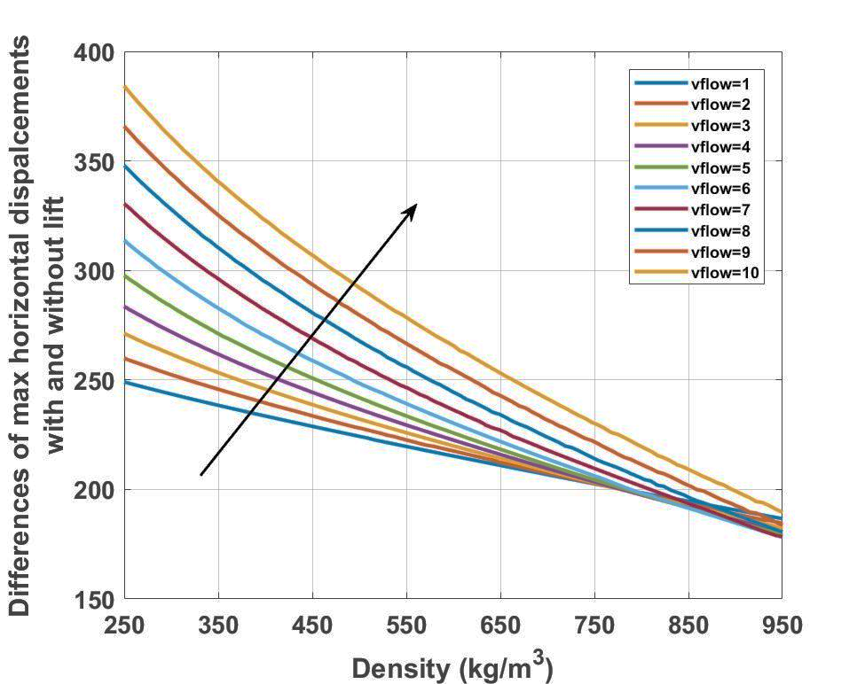
Figure 6. 8 – Differences of spotting distance with and without lift, at $φ=-7.5°$ and $V_{0}=0 m/s.$

.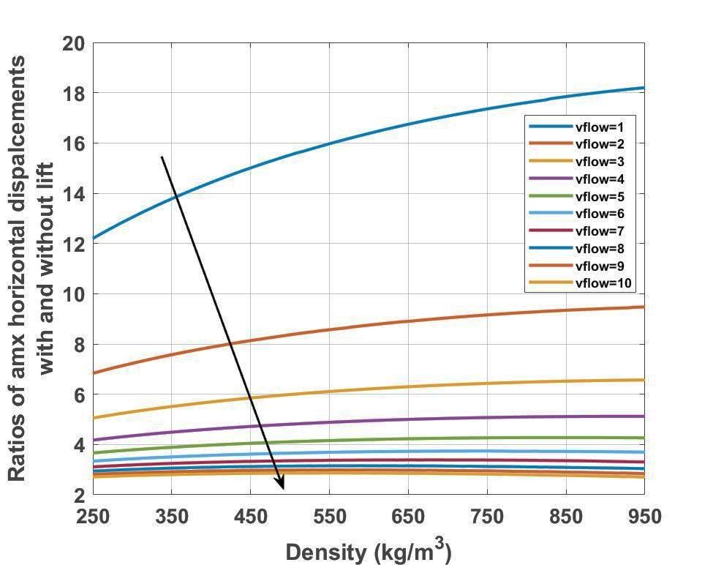
Figure 6. 9 – Ratios of spotting distance with and without lift, at $φ=-7.5°$ and $V_{0}=0 m/s.$
For the lift coeffcient of the firebrand at -7.5° of incident angle and 0 m/s of initialvelocity, the equation detemined is:
$∅_{lift}$ (V_{flow}, ρ) = 26.62 - 17.76*V_{flow} + 5.998*V_{flow}^2 - 1.014*V_{flow}^3
where V_{flow} and ρ indicate the flow velocity and density. It can be seen that the lift coefficient in this case is depndent on flow velocity only. As one of the important findings, it indicates that the density has almost has no correlation with the lift effects. For error analysis of this eqaution, it can be seen that the errors much smaller than lst approximation. The statistical measures are provided as R-square = 0.9949, Adjusted R-square = 0.9945 and RMSE: 0.2625.
Moreover, the lift effects for the firebrands at 10 $m/s$ flow field are plotted, shown in the Figure 6.6 and 6.7, to determine the trends of spotting distance with increasing density and fully range of incident angle. At the negative incident angle, opposite trending is found from increasing density with respect to increasing flow velocity, that the life effects are strengthened at [-90°, -30°] but weakened at [-30°, 0°] with increasing density. Meanwhile, the ratios of spotting distance with and without lift is increasing when firebrand is at negative incident angles. The peak values of the difference of spotting difference and ratios are up to 380 $m$ and 3 times, which is achieved by the particle with smallest density of 250 $kg/m^{3}$.

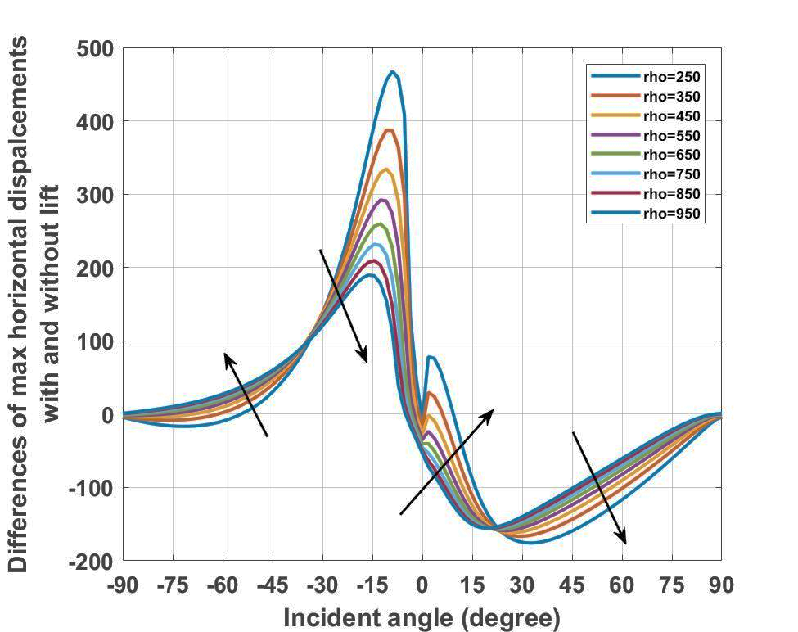
Figure 6. 10 – Differences of spotting distance with and without lift, at $V_{flow}=10 m/s$ and $V_{0}=0 m/s.$
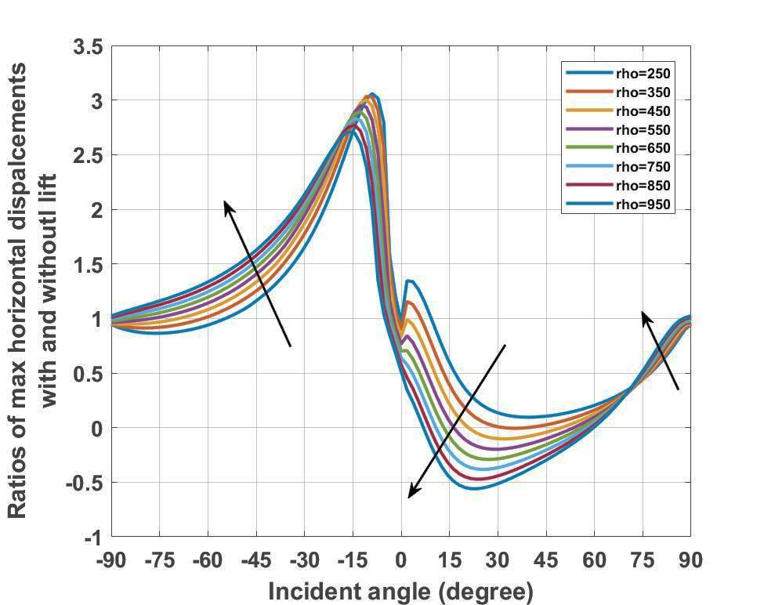
Figure 6. 11 – Ratios of spotting distance with and without lift, at $V_{flow}=10 m/s$ and $V_{0}=0 m/s.$
In this case, the correlation of lift coefficeint has been determined as:
$∅_{lift}$ (φ, ρ) = 59.77 + 0.07584 * φ -0.4466 * ρ + + 0.001175 * ρ ^2
where φ and ρ indicate the incident angle and density. Note that in order to decrease the error, the coefficient of is kept after simplifying as a special case altough it has a very small value. It can be seen that the lift coefficient is dependent on density rather than incident angle in this case. Similar with the other surface fit equations related with incident angle, the error of this fit equation is not ideal. The statistical measures are found as R-square = 0.7506, Adjusted R-square = 0.746 and RMSE = 0.4704. The small value of RMSE is due to the small value of lift coeffcient determined in this case.

Differences of lift effects from different burning models

Once the lift effects on the spotting of a firebrand have been determined from all three models, the investigations are made to compare the lift effects due to different combustion styles. Since the very similar results from both non-burning and constant burning models, the comparisons are focused on the differences between variable thickness burning model and constant thickness burning model.
In details, the comparisons are made via the difference of lift effect with respect to the variable thickness burning model, which can be expressed in the Eq. 6.3.

 | $$∆ l.f.={{(S}_{x,max, with lift}- S_{x,max,without lift})}_{constant thickness}-{{(S}_{x,max, with lift}- S_{x,max,without lift})}_{variable thickness}$$ | Eq. 6.4

where $l.f.$ indicates the lift effects.
In the Figure 6.8, the difference of lift effects between constant thickness burning model and variable thickness model for a firebrand with density of 250 $kg/m^{3}$ are presented. The negative value indicates the increasement due to thickness change.
It can be seen that the differences of lift effects due to thickness change can be up to 12 $m$. It indicates that the lift force can support the firebrand travel up to 12 m further if the thickness of particle is changing while burning. Meanwhile, it can be observed that the differences of lift effects are focused in [-30°, 0°] of incident angle, whereas there is almost no difference for other ranges if incident angles. The similar phenomenon can be found from the case of a firebrand with fixed flow velocity of 10 $m/s$ but ranged density and incident angle. The increase of spotting distance due to lift is strongly strengthened in [-30°, 0°] of incident angle, but with higher value of increase which is up to 27 $m$.
More importantly, it is found that the increasement of spotting distance due to lift are strengthened by the increasing parameters of both the flow velocity and density if the thickness is assumed to vary during burning. This finding not only proves the necessity of the consideration of lift facing the transporting modelling of a firebrand, but also highlights the importance of thickness change for a firebrand combustion model.
Furthermore, the lift effects from both burning models are compared based on ranged flow velocity and density. The plot is shown in the Figure 6.10. it clearly shows that the heavier firebrands will get more helps from lift force comparing to the one with constant thickness. Again, it suggests that both the lift force and thickness change should be concluded in the modelling of spotting phenomenon.

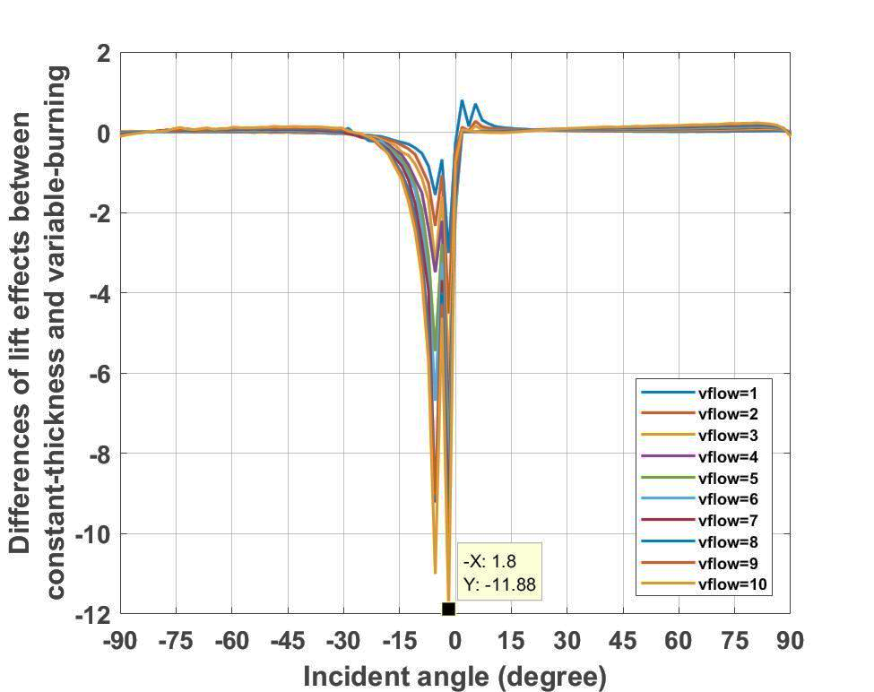
Figure 6. 12 – Differences of lift effects due to thickness change, at $ρ=250 kg/m^{3}$ and $V_{0}=0 m/s.$
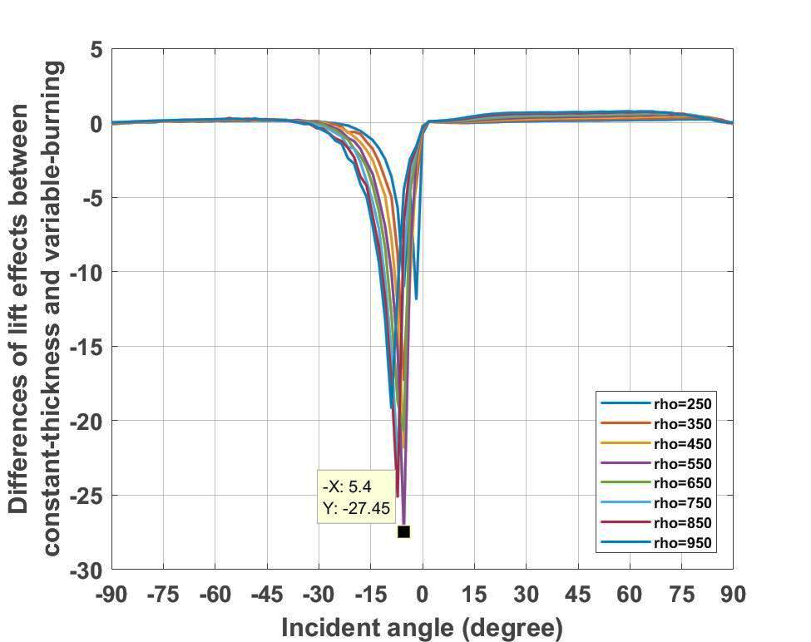
Figure 6. 13 – Differences of lift effects due to thickness change, at $V_{flow}=10 m/s$ and $V_{0}=0 m/s.$

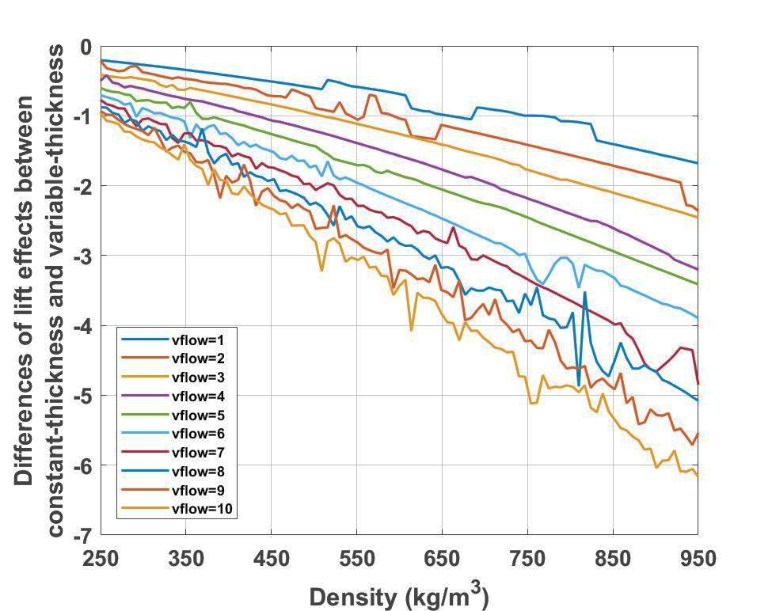
Figure 6. 14 – Differences of lift effects due to thickness change, at $φ=-7.5°$ and $V_{0}=0 m/s.$

In order to further discuss the difference of lift effects between both burning models, the ratio of lift effect is obtained, where the expression for corresponding calculation is shown as:
$$R_{l.f.}=\frac{{{(S}_{x,max, with lift}- S_{x,max,without lift})}_{constant-thickness}}{{{(S}_{x,max, with lift}- S_{x,max,without lift})}_{variable-thickness}}$$ | Eq. 6.5

However, it is found that the plotting is not a good way to present the results, neither analyse the trend of results. An example (the firebrand of 250 kg/m³ at 0 m/s of initial velocity) is presented in the Figure 6.11. Because of some extreme small values of lift effect, the corresponding ratios were much greater than others. Such as the maximum ratio presented in the Figure 6.11, as 846.17 at -82.5° and 5 m/s of flow velocity. The corresponding lift effect determined from constant thickness burning model was -71.66 m, whereas the lift effects determined from variable thickness burning model was -0.085 m. Such like this point, there are many other points of unusual values, which make it hard to analyse the data. There is no regular trend has been determined.
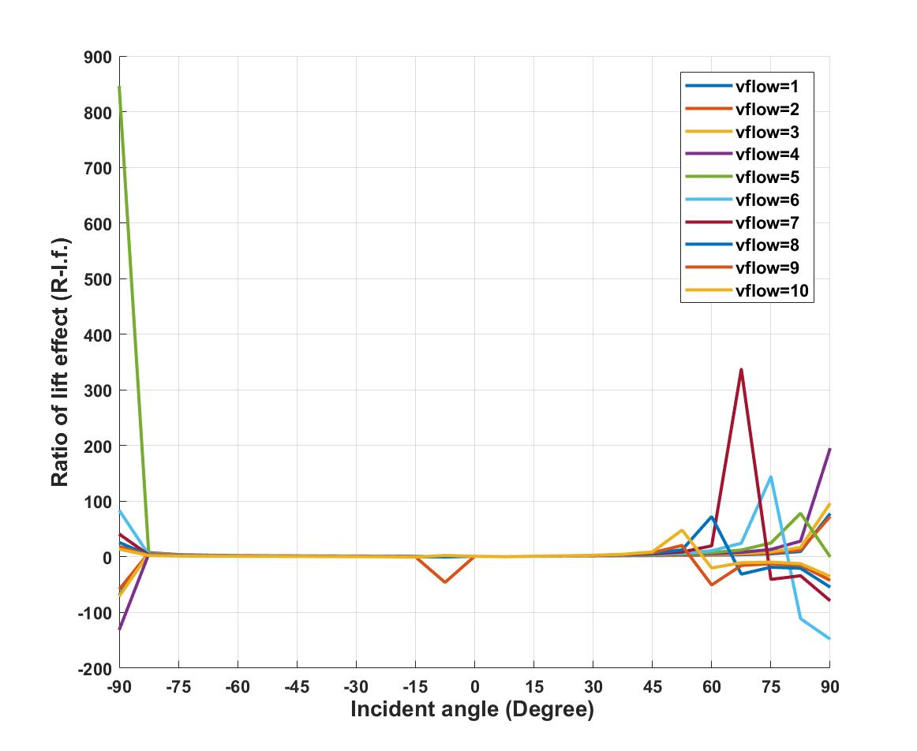
Figure 6.15 - Ratio of lift effect between constant thickness burning model and variable thickness burning model, at $ρ=250 kg/m^{3}$ and $V_{0}=0 m/s.$

Instead of plots, the surface fitting equation is obtained for further analysis the ratio of lift effect. The method for surface fitting equation used in this section is similar with previous chapter. As well, the plots of corresponding surface fitting are provided in the Appendix G.
For the case of $ρ=250 kg/m^{3}$ and $V_{0} =0 m/s$, the equation determined can be presented as:
R _{l.f.} (V_{flow}, φ) = 17.58 - 20.18*V_{flow} - 0.7989*φ + 4.6*V_{flow}^2 + 0.9828*V_{flow}*φ + 0.2107*V_{flow}^3 - 0.3013*V_{flow}^2*φ - 0.1302*V_{flow}^4
where V_{flow} and φ indicate the flow velocity and incident angle. In order to ensure the accuracy of equation, the coefficients of small values are remained. It is found that the ratio of lift effect is highly dependent on flow velocity, which is similar with the lift coefficient, $∅_{lift}$, determined at the same conditions of firebrand. The statistical measures of this function can be provided as R-square = 0.3176, Adjusted R-square = 0.35191 and RMSE = 49.28.
For the cases presented in the Figure 6.9, at $V_{flow}=10 m/s$ and $V_{0} =0 m/s$, the corresponding surface fitting equation can be presented as:
R _{l.f.} (ρ, φ) = 1.016 - 0.0108*φ - 0.004*φ^2 + 0.001*φ^3
where ρ and φ indicate the density and incident angle. In order to decrease the error of equation, the coefficients of small values are remained. It can be seen that the ratio of lift effect at fixed flow velocity and initial velocity is highly dependent on incident angle, that the density almost has no effect on the ratio. Also, in this case, the values of the ratio of lift effect are small, which indicate that the difference of lift effect between both burning model is weak without consideration of flow velocity. It further validates the finding from last equation that the ratio of lift effect is highly dependent on flow velocity. The statistical measures for this function are R-square = 0.37, Adjusted R-square = 0.3377 and RMSE = 0.04583.
For the cases presented in the Figure 6.10, at $φ=-7.5°$ and $V_{0} =0 m/s$, the corresponding surface fitting equation can be presented as:
R _{l.f.} (V_{flow}, ρ) = 1.01 + 0.0046*V_{flow} - 0.00029*V_{flow}^2 + 0.00026*V_{flow}^3
where V_{flow} and ρ indicate the flow velocity and density. Since the small value of ratios determined in this equation, the coefficients of small values are reminded. A high dependency of flow velocity on the ratio of lift effect can be found. Comparing with the flow velocity, the density has less effect. The statistical measures of this equation are provided as R-square = 0.9111, Adjusted R-square = 0.9053 and RMSE = 0.02334.
The conclusion can be drawn that the difference of lift effect between constant thickness burning model and variable thickness burning model exists but of small value. Although there is a few special cases, the most results have indicated that the lift force has more significant effects on variable thickness burning model rather than the constant thickness burning model. Both the difference of lift effect, $∆ l.f.$, and the ratio of lift effect, $R_{l.f.}$, have been obtained. As well the corresponding surface fitting equations are determined and discussed. It is found that the difference of lift effect between both burning model is highly dependent on flow velocity.

Conclusion

In this chapter, the lift effects on the spotting distance of a rectangular-shaped firebrand is determined for the first time. The lift effects have been observed from all the combustion models, including non-burning model, constant thickness burning model and variable thickness burning model. It is observed that the lift affects the spotting distance. Meanwhile, it is found that the lift force not only increases the spotting distance at negative incident angle, but also decreases the spotting when the angle of incidence turns to be positive. As well, the parameters which affect the lift effects are analysed. The incident angle is highlighted as the most important parameter since it decides the positive or negative effects of lift force.
Moreover, the differences of lift effects due to thickness change are investigated by comparing the results from variable thickness burning model and constant thickness burning model. It is found that the lift effect will be strengthened by thickness change, especially in [-30°, 0°] of incident angle. For the parameters involved, it is observed that the lift effects are strengthened with increasing flow velocity and density. The importance of lift force is highlighted for heavier firebrands.
More importantly, based on the findings in this chapter, it not only approves the importance of lift force for the predictions of the spotting distance of a firebrand, but also highlights the necessity of the consideration of particle thickness change due to burning. It strongly suggests that both the lift effects and thickness change should be concluded in the modelling of spotting phenomenon.

Chapter 7. CONCLUSIONS AND FINDINGS

In the thesis, based on the different objectives, the conclusions are presented with four sections, including the modelling the spotting of firebrands, the prediction of spotting distance, the parametric study of parameters involved in spotting phenomenon and the lift effects.

Modelling the spotting of firebrand

In this part, the models of the firebrands in spotting phenomenon are developed, including the transporting model for predicting the trajectories of firebrands and estimating the maximum spotting distances of burning particles, and the combustion models for describing the size regression rates and mass loss rates of the firebrands due to burning. Two developments contributed for the first time can be concluded as:
- A new mathematic method for calculating the motion of non-spherical firebrands lofted in the flow field is developed.
- A new combustion model for the burning firebrands in spotting phenomenon is contributed. The thickness regression has been considered for the size regression and the mass loss of burning particles, comparing to the existing burning models.

Prediction of spotting distance

Based on the models developed in this thesis, the long-distance spotting of the rectangular-shaped firebrands are simulated. From results, it is found that:
    - The spotting distances of firebrands determined from non-burning model and constant thickness burning model are very similar.
    - For non-burning model and constant thickness burning model, the extreme travelling distance determined was 6.838 of Glide ratio.
    - The spotting distance was increased in variable thickness burning model.
    - For variable thickness burning model, the extreme case was 6.895 of Glide ratio.
The simulations from non-burning and constant thickness burning model are very similar to each other, which may lead to the necessity of the correction of existing burning models.
Moreover, the fitting equations of the maximum spotting distance in term of each single parameter are provided. It is found:
    - The equations from non-burning and constant thickness burning model are same, which are different with those from variable thickness burning model.
    - Although slightly difference, the trends about how each single parameter affects the maximum spotting distance of firebrand are similar among three models.
Furthermore, the difference of maximum spotting distance is compared between constant and variable thickness burning models.
    - The thickness regression can increase the maximum spotting distance up to 0.02 of Glide ratio with changing thickness, which indicates 2 $m$ further in every 100 $m$ of falling.
    - Maximum spotting distance is increased with increasing incident angle and flow velocity whereas is decreased with increasing particle initial velocity density, when thickness is changing.
    - The thickness regression strengthens the effects of incident angle on spotting, whereas weaken the effects on other three parameters.
Thus, it can be seen that the thickness regression not only has very significant effects on spotting distance, but also can either strengthen or weaken the effects of peach parameter on maximum spotting of firebrands.
Overall, the results have highlighted that the consideration of thickness regression is very important for determining the maximum spotting distance of firebrands. It is suggested that the thickness change of firebrand due to burning should be concluded for more accurate prediction of spotting distance.

Parametric study of the parameters involved in spotting phenomenon

Once the spotting distance of firebrand were estimated, the parametric studies are made to investigate the influence of each parameters involved in spotting phenomenon on horizontal travelling. The contour plots of each two parameters on maximum spotting distance in non-burning and constant thickness (which also stands for the non-burning model) burning model are provided. The parameter optimisation is applied, and surface fitting equations are obtained. It is found:
- Similar dependency of flow velocity and incident angle for spotting distance. However, the incident angle has effective control of the positive and negative work done by aerodynamic forces on spotting distance.
- Spotting depends more on flow velocity than density and particle initial velocity, especially for strong wind.
- Spotting depends more on incident angle than particle initial velocity and density.
- Dependency of density is higher than initial velocity.
- Levelling importance: Flow velocity & Incident angle > Density > Initial velocity.
Further, by comparing the variable and constant thickness burning model, the findings can be concluded as:
- The influences of parameters are similar with three models.
- Same levelling can be made for variable thickness burning model.
Moreover, the contour plots of the differences of maximum spotting distance from different models are figured. The corresponding surface fitting equations are obtained. Since the increasements of maximum spotting distance by thickness regression, the effects of parameters on such increasement can be concluded as:
- The increasement depends more on flow velocity, incident angle and density than particle initial velocity.
- Same dependency of flow velocity and density on the increasement.
- The increasement depends more on incident angle than flow velocity, especially in the range of [-30°. 15°] of incidence.
- The increasement depends more on incident angle than density, especially in the range of in [-45°, 15°] of incidence.
- The levelling can be further developed as: Incident angle > Flow velocity > Density > Particle initial velocity.
The incident angle, even more important than flow velocity, significantly changes the spotting distance of a firebrand. It not only controls the efficiency of work done by aerodynamic forces, but also affects the increasements of spotting when the thickness of particle is changing while burning.
Meanwhile, it is important to highlight that the heavier particle (larger density) can propagated further at certain conditions such as [-30°, 15°] of incident angle and [7, 10] of flow velocity $m/s$. It increases the necessity of the study which is focused on the heavier firebrand, since commonly it is thought that the heavy particle is not able to travel further than a lighter particle.

Lift effects

For the first time, the effects of aerodynamic lift are investigated in this study. Although the lift is commonly ignored based on the order-of-magnitude, the results (differences between the spotting distance with lift force and without lift force) in this chapter have highlighted the importance of lift force on the propagations of firebrands. The spotting differences due to lift force are determined and the ratio of maximum spotting distance with lift over spotting distance without lift is discussed as well.
Based on the results of lift effects from each model:
- The spotting distance is increased can be increased by 171% and up to 14 times by lift force.
- Lift effects is very sensitive to incident angle, especially in the range of [-30°, 30°].
- Lift effects are increasing with increasing flow velocity but with deceasing density.
Furthermore, the differences of the lift effects are determined to investigate the influence of thickness regression on lift effects. The lift coefficients are determined to further discuss the correlations. It is found:
- Lift effects are strengthened by thickness regression. In another saying, the effects of lift on spotting distance of firebrand are more efficient if the thickness of firebrand is regressing.
- Such strengthens is very sensitive to incident angle, especially in the range of [-30°, 0°].
- Such strengthens are increasing with increasing flow velocity and density.
Overall, the effects of lift force have highlighted by the results in this chapter. It has been found that the lift force can significantly improve the spotting distance of firebrands. In order to predict more accurate travelling distance of a firebrand in spotting phenomenon, it is suggested that the lift force should be concluded.

Chapter 8. FUTURE WORK

Based on the conclusion and findings from this thesis, the future work has been considered in three aspects, including simulation side, experimental side and the theoretical side.

Simulation side

As discussed earlier, there are certain shortages existing in the published aerodynamic coefficients. On one hand, the coefficients are not applicable to the particle under certain conditions, such as shapes and temperature. On another hand, the states of particle are rarely considered, such as vibration and geometry change. Not only for the application in firebrands, but also for many others such as aircraft, fluidised bed, etc. Thus, the corresponding future work can be given as:
- Determine aerodynamic coefficients with broaden parameters (On progress)
- More shapes
- More geometry
- More aspect ratio
- Lager flow velocity
- Considering the effects of particle states:
- Rotation
- Vibration
- Curvature
- Changed project area
- Determine the effects of particle temperature (On progress)
- Temperature of flow
- Temperature of particle
At the moment, the CFD simulations are explored by the author for investigating of the temperature effects on the aerodynamic coefficients of particles. As well the determinations of the coefficients for particles of difference shapes and geometry. Two of the results are presented in the Figure 8.1 and 8.2, which the Figure 8.1 presents the vorticity of ambient flow (10 $m/s$) around a rectangular-plate with dimensions of $80×50×5 {mm}^{3}$ (Aspect ratio = 1.6), and the Figure 7.2 shows the ambient flow field of hot particle.

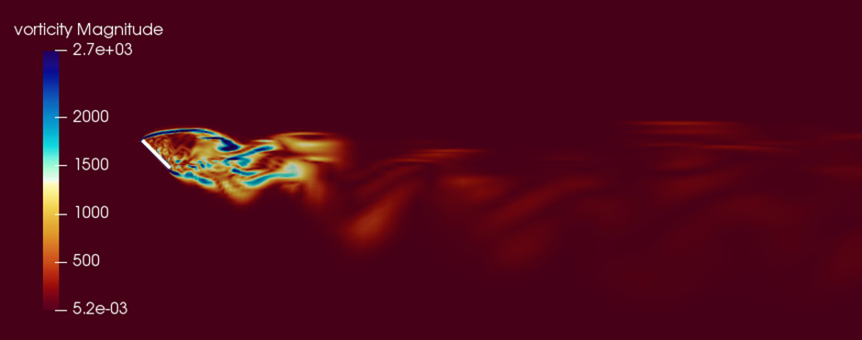
Figure 8. 1 – The simulation result of the vorticity of ambient flow around a rectangular plate, $V_{inlet}=10 m/s$, $φ=-45°.$

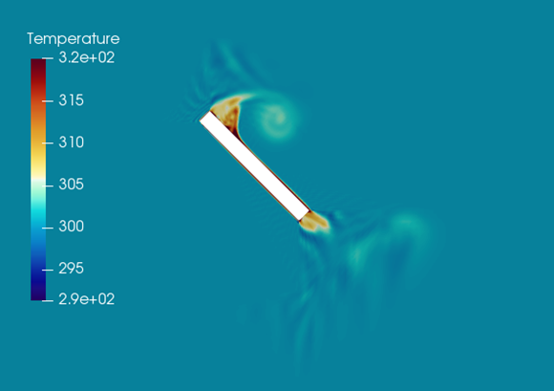
Figure 8. 2 – The simulation result of a hot plate in the flow field.

Experimental side

From the results in this thesis, it is found that the regression on the thickness of firebrands are so important for predicting the spotting distance. However, the existing papers are rarely focusing on the thickness regression of disk, cylinder, fibre and plates. Meanwhile, there is rare study focused on property of firebrands at different burning stages. Thus, the relative further work is given as:
- Determine the thickness regression rate of firebrands (On progress)
- Different dimensions
- Different shapes
- Different density
- Investigate the mass loss of firebrands at various conditions (On progress)
- Different flow field
- Different incident angle
- Vibrating burning particle
- Curved or porous particle
- Investigate the property difference burning stage of firebrands
- Ranges of temperature for different combustion stages of firebrands, such as glowing and smouldering.
- Regression rate and mass loss rate
- Curvature and particle’s break off
At the moment, some experiments have been conducted by the author and some of the experimental results are presented in the Figure 8.3.
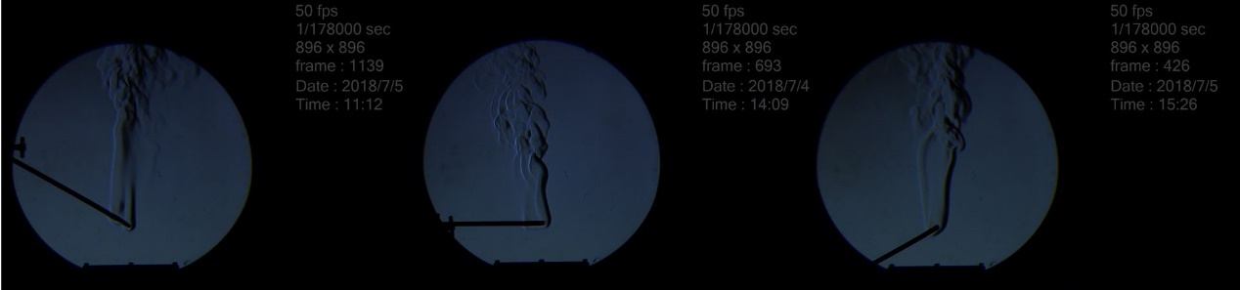
Figure 7. 1 – Schlieren images of burning rectangular-shaped firebrands.

Theoretical side

More importantly, as a long-term goal, the data from the thesis will be utilized for building up a statistical model of the propagations of firebrands in spotting phenomenon. More practical and accurate predictions will be generated then.

PUBLICATIONS

- Hangxu Zhou¹, Yi Li, Yang Zhang (2018). The effects of aerodynamic lift on firebrand trajectories: numerical investigations based on simplified models. Advances in forest fire research 2018, pp.418-428.
- Hangxu Zhou¹, Yi Li, Yang Zhang (2018). The effects of aerodynamic lift on firebrand trajectories: Numerical investigations based on simplified models. 8th International conference on Forest Fire Research, pp.96.
- Hangxu Zhou¹, Yi Li, Yufeng Lai, Yang Zhang (2019). Modelling the propagation of one-end burning cylindrical firebrands based on the measured regression rate. Proceedings of 27th International Colloquium on the Dynamics of Explosions and Reactive Systems, Paper 345.
- Yufeng Lai, Hangxu Zhou, Yang Zhang (2019). Experimental investigation of the Fire Spread on Inclined Wooden Rods. Proceedings of 27th International Colloquium on the Dynamics of Explosions and Reactive Systems, Paper 154.

CONFERENCE

- Hangxu Zhou, 2018. Effects of aerodynamic lift on firebrand trajectories. 8th International Conference on Forest Fire Research (ICFFR 2018), Coimbra, Portugal, Oral Presentation.
- Hangxu Zhou, 2019. Modelling the propagation of one-end burning cylindrical firebrands based on the measured regression rate. 27th International Colloquium on the Dynamics of Explosions and Reactive Systems, Beijing, China, Poster Presentation.

REFERENCE

- Albini, F. (1979). Spot fire distance from burning trees. Ogden, Utah: Intermountain Forest and Range Experiment Station, Forest Service, U.S. Dept. of Agriculture.
- Albini, F. (1981). A model for the wind-blown flame from a line fire. Combustion and Flame, 43, pp.155-174.
- Albini, F. (1981). A Phenomenological Model for Wind Speed and Shear Stress Profiles in Vegetation Cover Layers. Journal of Applied Meteorology, 20(11), pp.1325-1335.
- Albini, F. (1981). Spot fire distance from isolated sources. Ogden, Utah: U.S. Dept. of Agriculture, Forest Service, Intermountain Forest and Range Experiment Station.
- Albini, F. (1983). Potential spotting distance from wind-driven surface fires. USDA Forest Service. Intermountain Forest and Range Experiment Station, Research Paper INT - 309.
- Albini, F. (1983). Transport of Firebrands by Line Thermals. Combustion Science and Technology, 32(5-6), pp.277-288.
- Albini, F. and Baughman, R. (1979). Albini, F. (1983). Estimating wind speeds for predicting wildland fire behaviour. USDA Forest Service. Intermountain Forest and Range Experiment Station, Research Paper INT – 221.
- Anthenien, R., Tse, S. and Carlos Fernandez-Pello, A. (2006). On the trajectories of embers initially elevated or lofted by small scale ground fire plumes in high winds. Fire Safety Journal, 41(5), pp.349-363.
- Bagchi, P. and Balachandar, S. (2002) ‘Effect of free rotation on the motion of a solid sphere in linear shear flow at moderate Re’, Physics of Fluids, 14(8), pp. 2719–2737. doi: 10.1063/1.1487378.
- Baum, H. and Mccaffrey, B. (1989). Fire Induced Flow Field - Theory And Experiment. Fire Safety Science, 2, pp.129-148.
- Berlad, A. and Lee, S. (1968). Long range spotting. Combustion and Flame, 12(2), pp.172-174.
- Bhutia, S., Jenkins, M. A. and Sun, R. (2010) ‘Comparison of firebrand propagation prediction by a plume model and a coupled–fire/atmosphere large–eddy simulator’, Journal of Advances in Modeling Earth Systems, 2, p. 4. doi: 10.3894/JAMES.2010.2.4.
- Blaser, S. (2002). Forces on the surface of small ellipsoidal particles immersed in a linear flow field. Chemical Engineering Science, 57(3), pp.515-526.
- Bluemink, J. J. et al. (2008) ‘A sphere in a uniformly rotating or shearing flow’, Journal of Fluid Mechanics, 600, pp. 201–233. doi: 10.1017/S0022112008000438.
- Bluemink, J. J. et al. (2010) ‘Drag and lift forces on particles in a rotating flow’, Journal of Fluid Mechanics, 643, pp. 1–31. doi: 10.1017/S0022112009991881.
- Brown, P. P. and Lawler, D. F. (2003) ‘Sphere Drag and Settling Velocity Revisited’, Journal of Environmental Engineering, 129(3), pp. 222–231. doi: 10.1061/(ASCE)0733-9372(2003)129:3(222).
- Brucato, A., Grisafi, F. and Montante, G. (1998) ‘Particle drag coefficients in turbulent fluids’, Chemical Engineering Science, 53(18), pp. 3295–3314. doi: 10.1016/S0009-2509(98)00114-6.
- Buckley, A. (1994). Fire behaviour and fire suppression in an elevated fuel type in East Gippsland. East Melbourne: Dept. of Conservation and Environment.
- Byram, G. (1954). Atmospheric Conditions Related to Blowup Fires. USDA Forest Service (SE) Station Paper 35.
- Cambridge advanced learner's dictionary. (2008). Cambridge: Cambridge University Press.
- Carranza Chavez, F. (2016). 3D Experimental study of the motion of single particles using image-based techniques. Ph.D. University of Sheffield.
- Chase, C.H. 1981. Spot Fire Distance Equations for Pocket calculations. USDA Forest Service, Res. Note INI-310.
- Cheng, N. S. (2009) ‘Comparison of formulas for drag coefficient and settling velocity of spherical particles’, Powder Technology. Elsevier B.V., 189(3), pp. 395–398. doi: 10.1016/j.powtec.2008.07.006.
- Chow, A. and Adams, E. (2011). Prediction of Drag Coefficient and Secondary Motion of Free-Falling Rigid Cylindrical Particles with and without Curvature at Moderate Reynolds Number. Journal of Hydraulic Engineering, 137(11), pp.1406-1414.
- Christiansen, E. B. and Barker, D. H. (1965) ‘The effect of shape and density on the free settling of particles at high Reynolds numbers’, AIChE Journal, 11(1), pp. 145–151. doi: 10.1002/aic.690110130.
- Clift, R. and Gauvin, W. H. (1971) ‘Motion of entrained particles in gas streams’, The Canadian Journal of Chemical Engineering, 49(4), pp. 439–448. doi: 10.1002/cjce.5450490403.
- Consalvi, J. L., Porterie, B. and Loraud, J. C. (2002) ‘A formal averaging procedure for radiation heat transfer in particulate media’, International Journal of Heat and Mass Transfer, 45(13), pp. 2755–2768. doi: 10.1016/S0017-9310(02)00007-8.
- Cordova, V. (2016) ‘Caring for sibling caretakers of adults with neurodevelopmental disorders.’, Dissertation Abstracts International: Section B: The Sciences and Engineering, 76(7–B(E)), p. No-Specified. Available at: http://ovidsp.ovid.com/ovidweb.cgi?T=JS&PAGE=reference&D=psyc13&NEWS=N&AN=2016-99020-394.
- Davis, K. (1959). Forest fire: control and use. New York: McGraw-Hill.[14]
- Denny, M. (1995). Life in Moving Fluids: The Physical Biology of Flow (2nd ed.), Steven Vogel. Princeton University Press, Farmington, CT (1994). Bulletin of Mathematical Biology, 57(6), pp.949-951.
- Dowdy, A., Mills, G., Finkele, K. and de Groot, W. (2009). Index sensitivity analysis applied to the Canadian Forest Fire Weather Index and the McArthur Forest Fire Danger Index. Meteorological Applications, p.n/a-n/a.
- Ellis, P. F. (2000) ‘The aerodynamic and combustion characteristics of eucalypt bark—a firebrand study. Ph.D. Dissertation, Australian National University, Canberra’, (January), p. 187.
- Ellis, P. F. M. (2012) ‘A review of empirical studies of firebrand behaviour’, Bushfire Cooperative Research Centre (CRC), (ii).
- Fair, G. and Geyer, J. (1967). Water supply and waste-water disposal. New York: Wiley.
- Finney, M. A. et al. (2011) ‘A Method for Ensemble Wildland Fire Simulation’, Environmental Modelling and Assessment, 16(2), pp. 153–167. doi: 10.1007/s10666-010-9241-3.
- Flemmer, R. and Banks, C. (1986). On the drag coefficient of a sphere. Powder Technology, 48(3), pp.217-221.
- Foote, E. I. D., Liu, J. and Manzello, S. L. (2011) ‘Characterizing firebrand exposure during wildland urban interface fires’, Proceedings of Fire and Materials Conference, pp. 1–12.
- Forest Service (1956) ‘Glossary of Terms used in Forest Fire Control’.
- Ganser, G. (1993). A rational approach to drag prediction of spherical and nonspherical particles. Powder Technology, 77(2), pp.143-152.
- Garzdn, V. E., Mcdonough, J. M. and Saito, K. (1998) ‘Very Large-Scale Fires, ASTM STP 1336’,.
- Giassi, D. et al. (2016) ‘Analysis of CH* concentration and flame heat release rate in laminar coflow diffusion flames under microgravity and normal gravity’, Combustion and Flame. Elsevier Inc., 167, pp. 198–206. doi: 10.1016/j.combustflame.2016.02.012.
- Gibilaro, L. G. et al. (1985) ‘Generalized friction factor and drag coefficient correlations for fluid-particle interactions’, Chemical Engineering Science, 40(10), pp. 1817–1823. doi: 10.1016/0009-2509(85)80116-0.
- Goldammer, J. (1998). History of Fire in Land-Use Systems of the Baltic Region: Implications on the Use of Prescribed Fire in Forestry, Nature Conservation and Landscape Management. In: First Baltic Conference on Forest Fires. Freiburg, Germany: Fire Ecology and Biomass Burning Research Group,Max Planck Institute for Chemistry, Biogeochemistry Department,c/o Freiburg University.
- G. McArthur. Weather and Grassland fire behaviour. Australian Forest and Timber Bureau Leaflet Journal, 100, 1966.
- Goldstein, S. (1929). The Steady Flow of Viscous Fluid Past a Fixed Spherical Obstacle at Small Reynolds Numbers. Proceedings of the Royal Society A: Mathematical, Physical and Engineering Sciences, 123(791), pp.225-235.
- Goto, H. et al. (2015) ‘The optimal extent of lymph node dissection for adenocarcinoma of the esophagogastric junction differs between Siewert type II and Siewert type III patients’, Gastric Cancer, 18(2), pp. 375–381. doi: 10.1007/s10120-014-0364-0.
- Haider, A. and Levenspiel, O. (1989). Drag coefficient and terminal velocity of spherical and nonspherical particles. Powder Technology, 58(1), pp.63-70.
- Himoto, K. and Tanaka, T. (2005) ‘Transport of disk-shaped firebrands in a turbulent boundary layer’, Fire Safety Science, pp. 433–444. doi: 10.3801/IAFSS.FSS.8-433.
- Hoerner, S. F. (1965). Fluid – dynamics drag. New York: Hoerner Fluid Dynamics (A book: 20 chapters totally. Published by the author).
- Holmes, J. D., Letchford, C. W. and Lin, N. (2006) ‘Investigations of plate-type windborne debris - Part II: Computed trajectories’, Journal of Wind Engineering and Industrial Aerodynamics, 94(1), pp. 21–39. doi: 10.1016/j.jweia.2005.10.002.
- Holmes, J., Letchford, C. and Lin, N. (2006). Investigations of plate-type windborne debris—Part II: Computed trajectories. Journal of Wind Engineering and Industrial Aerodynamics, 94(1), pp.21-39.
- Hölzer, A. and Sommerfeld, M. (2008). New simple correlation formula for the drag coefficient of non-spherical particles. Powder Technology, 184(3), pp.361-365.
- Hölzer, A. and Sommerfeld, M. (2009). Lattice Boltzmann simulations to determine drag, lift and torque acting on non-spherical particles. Computers & Fluids, 38(3), pp.572-589.
- Hu, H. H. (1995) ‘Motion of a circular cylinder in a viscous liquid between parallel plates’, Theoretical and Computational Fluid Dynamics, 7(6), pp. 441–455. doi: 10.1007/BF00418142.
- Huang, H., Ooka, R., Kato, S. and Hayashi, Y. (2007). A Numerical Study of Firebrands Scattering in Urban Fire Based on CFD and Firebrands Aerodynamics Measurements. Journal of Fire Sciences, 25(4), pp.355-378. [77]
- Jain, S., Sitaram, N. and Krishnaswamy, S. (2015). Effect of Reynolds Number on Aerodynamics of Airfoil with Gurney Flap. International Journal of Rotating Machinery, 2015, pp.1-10.
- JP., W. (2011). Wooden disk combustion for spot fire spread. In: International Interflam Conference, 9th Proceedings.. London: National Fire Protection Association, pp.101-112.
- Koo, E., Linn, R., Pagni, P. and Edminster, C. (2012). Modelling firebrand transport in wildfires using HIGRAD/FIRETEC. International Journal of Wildland Fire, 21(4), p.396.
- Koo, E., Pagni, P. J., Weise, D. R., & Woycheese, J. P. (2010). Firebrands and spotting ignition in large-scale fires. International Journal of Wildland Fire, 19(7), 818–843.
- Kortas, S. et al. (2009) ‘Experimental validation of a numerical model for the transport of firebrands’, Fire Safety Journal. Elsevier, 44(8), pp. 1095–1102. doi: 10.1016/j.firesaf.2009.08.001.
- Kramers, H. (1946) ‘Heat transfer from spheres to flowing media’, Physic, 12(2–3), pp. 61–80. doi: 10.1016/S0031-8914(46)80024-7.
- Krasnov, N. (1985). Aerodynamics. Moscow: Mir Publishers.
- Krishnakumar, A. et al. (2016) ‘Establishing temperature dependency of the aerodynamic drag using CFD and experimental analysis’, Indian Journal of Science and Technology, 9(31). doi: 10.17485/ijst/2016/v9i31/91495.
- Lázaro, B. and Lasheras, J. (1989). Particle dispersion in a turbulent, plane, free shear layer. Physics of Fluids A: Fluid Dynamics, 1(6), pp.1035-1044.
- Lee, S. and Hellman, J. (1969). Study of firebrand trajectories in a turbulent swirling natural convection plume. Combustion and Flame, 13(6), pp.645-655.
- Lee, S. L. and Hellman, J. M. (1970) ‘Firebrand trajectory study using an empirical velocity-dependent burning law’, Combustion and Flame, 15(3), pp. 265–274. doi: 10.1016/0010-2180(70)90006-4.
- Linn, R. (1997). A Transport Model for Prediction of Wildfire Bahavior. Ph.D. New Mexico State University.
- Loth, E. (2008) ‘Drag of non-spherical solid particles of regular and irregular shape’, Powder Technology, 182(3), pp. 342–353. doi: 10.1016/j.powtec.2007.06.001.
- Makino, A. (2013) ‘Critical size for the particle burn-out of solid carbon and/or boron as the high-energy-density fuel’, Combustion and Flame. The Combustion Institute., 160(3), pp. 742–744. doi: 10.1016/j.combustflame.2012.12.001.
- Mandø, M. and Rosendahl, L. (2010). On the motion of non-spherical particles at high Reynolds number. Powder Technology, 202(1-3), pp.1-13.
- Mandø, M., Yin, C., Sørensen, H., & Rosendahl, L. (2007). On the modelling of motion of non-spherical particles in two-phase flow. Presented in the 6th International Coference on Multiphase Flow, Leipzig, Germany.
- Manzello, S. L. and Foote, E. I. D. (2014) ‘Characterizing Firebrand Exposure from Wildland-Urban Interface (WUI) Fires: Results from the 2007 Angora Fire’, Fire Technology, 50(1), pp. 105–124. doi: 10.1007/s10694-012-0295-4.
- Manzello, S. L. et al. (2006) ‘On the ignition of fuel beds by firebrands’, Fire and Materials, 30(1), pp. 77–87. doi: 10.1002/fam.901.
- Manzello, S. L. et al. (2008) ‘On the development and characterization of a firebrand generator’, Fire Safety Journal, 43(4), pp. 258–268. doi: http://dx.doi.org/10.1016/j.firesaf.2007.10.001.
- Manzello, S. L. et al. (2010) ‘Quantifying the vulnerabilities of ceramic tile roofing assemblies to ignition during a firebrand attack’, Fire Safety Journal. Elsevier, 45(1), pp. 35–43. doi: 10.1016/j.firesaf.2009.09.002.
- Manzello, S. L. et al. (2011) ‘Experimental investigation of structure vulnerabilities to firebrand showers’, Fire Safety Journal. Elsevier, 46(8), pp. 568–578. doi: 10.1016/j.firesaf.2011.09.003.
- Manzello, S. L., Suzuki, S. and Hayashi, Y. (2012) ‘Enabling the study of structure vulnerabilities to ignition from wind driven firebrand showers: A summary of experimental results’, Fire Safety Journal. Elsevier, 54, pp. 181–196. doi: 10.1016/j.firesaf.2012.06.012.
- Manzello, S., Cleary, T., Shields, J., Maranghides, A., Mell, W. and Yang, J. (2008). Experimental investigation of firebrands: Generation and ignition of fuel beds. Fire Safety Journal, 43(3), pp.226-233.
- Manzello, S., Maranghides, A., Shields, J., Mell, W., Hayashi, Y. and Nii, D. (2009). Mass and size distribution of firebrands generated from burning Korean pine (Pinus Kreineses) trees. Fire and Materials, 33(1), pp.21-31.
- Marchioli, C., Fantoni, M. and Soldati, A. (2010) ‘Orientation, distribution, and deposition of elongated, inertial fibres in turbulent channel flow’, Physics of Fluids, 22(3), pp. 1–14. doi: 10.1063/1.3328874.
- Martin, J. and Hillen, T. (2016) ‘The Spotting Distribution of Wildfires’, Applied Sciences, 6(6), p. 177. doi: 10.3390/app6060177.
- Martin, J. and Hillen, T. (2016). The Spotting Distribution of Wildfires. Applied Sciences, 6(6), p.177.
- Martin, J. and Meiburg, E. (1994). The accumulation and dispersion of heavy particles in forced two‐dimensional mixing layers. I. The fundamental and subharmonic cases. Physics of Fluids, 6(3), pp.1116-1132.
- Maxey, M. (1983). Equation of motion for a small rigid sphere in a nonuniform flow. Physics of Fluids, 26(4), p.883.
- Maxey, M. R. (1990) ‘On the Advection of Spherical and Non-Spherical Particles in a Non-Uniform Flow’, Philosophical Transactions of the Royal Society A: Mathematical, Physical and Engineering Sciences, 333(1631), pp. 289–307. doi: 10.1098/rsta.1990.0162.
- Maxey, M. R. and Riley, J. J. (1983) ‘Equation of motion for a small rigid sphere in a nonuniform flow’, Physics of Fluids, 26(4), pp. 883–889. doi: 10.1002/mds.21628.
- McArthur, A. (1967). Fire behaviour in eucalypt forests. Canberra: Forestry and Timber Bureau.
- Mironov, S. G., Poplavskaya, T. V. and Kirilovskiy, S. V. (2017) ‘Effect of porous material heating on the drag force of a cylinder with gas-permeable porous inserts in a supersonic flow’, Journal of Physics: Conference Series, 894(1). doi: 10.1088/1742-6596/894/1/012064.
- Morrison, F. (2010) ‘Data correlation for drag coefficient for sphere’, … Michigan Technological University, Houghton, MI, www …, 6(April), pp. 1–2. Available at: http://www.chem.mtu.edu/~fmorriso/DataCorrelationForSphereDrag2013.pdf.
- Mortensen, P. H. et al. (2008) ‘Dynamics of prolate ellipsoidal particles in a turbulent channel flow’, Physics of Fluids, 20(9). doi: 10.1063/1.2975209.
- Muraszew, A. (1974). Firebrand phenomena. El Segundo, CA: Aerospace Corp.
- Muraszew, A. and Fedele, J. (1976). Statistical model for spot fire hazard. El Segundo, Calif.: Engineering Science Operations, The Aerospace Corp.
- Muraszew, A., Fedele, J. and Kuby, W. (1977). Trajectory of firebrands in and out of fire whirls. Combustion and Flame, 30, pp.321-324.
- Muraszew, A., Fedele, J. B. and Kuby, W. C. (1979) ‘The fire whirl phenomenon’, Combustion and Flame, 34(C), pp. 29–45. doi: 10.1016/0010-2180(79)90077-4.
- Muraszew, A., Kuby, W. and Fedele, J. (1975). Firebrand investigation. [Washington, D.C.]: Aerospace Corporation.
- Nielsen, H. and Tao, L. (1965). The fire plume above a large free-burning fire. Symposium (International) on Combustion, 10(1), pp.965-972.
- Nielsen, H. J. and Tao, L. N. (1965) ‘The fire plume above a large free-burning fire’, Symposium (International) on Combustion, 10(1), pp. 965–972. doi: 10.1016/S0082-0784(65)80239-9.
- Nikolopoulos, A. et al. (2017) ‘Numerical investigation and comparison of coarse grain CFD – DEM and TFM in the case of a 1 MW with fluidized bed carbonator simulation’, Chemical Engineering Science. Elsevier Ltd, 163, pp. 189–205. doi: 10.1016/j.ces.2017.01.052.
- Noble, I., Gill, A. and Bary, G. (1980). McArthur's fire-danger meters expressed as equations. Austral Ecology, 5(2), pp.201-203.
- Ohlemiller, T. J. (1985) ‘Modelling of smouldering combustion propagation’, Progress in Energy and Combustion Science, 11(4), pp. 277–310. doi: 10.1016/0360-1285(85)90004-8.
- Ortiz, X., Rival, D. and Wood, D. (2015). Forces and Moments on Flat Plates of Small Aspect Ratio with Application to PV Wind Loads and Small Wind Turbine Blades. Energies, 8(4), pp.2438-2453.
- Ouchene, R. et al. (2016) ‘A new set of correlations of drag, lift and torque coefficients for non-spherical particles and large Reynolds numbers’, Powder Technology, 303, pp. 33–43. doi: 10.1016/j.powtec.2016.07.067.
- Pahl, H. W. (1978) The distribution and functional roles of certain significant tones and tonal sequences in Xhosa, 2: the terminal HH sequence, the LH sequence and the reversal of tones, Limi.
- Parker, R. and Park, S. (1993) ‘Vortex shedding from’, 50, pp. 129–138. doi: 10.1615/AtoZ.v.vortex_shedding.
- Porterie, B. et al. (2000) ‘Firespread through fuel beds: Modeling of wind-aided fires and induced hydrodynamics’, Physics of Fluids, 12(7), pp. 1762–1782. doi: 10.1063/1.870426.
- Porterie, B. et al. (2005) ‘Predicting wildland fire behavior and emissions using a fine-scale physical model’, Numerical Heat Transfer; Part A: Applications, 47(6), pp. 571–591. doi: 10.1080/10407780590891362.
- Porterie, B., Zekri, N., Clerc, J. and Loraud, J. (2007). Modeling forest fire spread and spotting process with small world networks. Combustion and Flame, 149(1-2), pp.63-78.
- Raju, N. and Meiburg, E. (1995) ‘The accumulation and dispersion of heavy particles in forced two-dimensional mixing layers. Part 2: The effect of gravity’, Physics of Fluids, 7(6), pp. 1241–1264. doi: 10.1063/1.868581.
- Raju, N. and Meiburg, E. (1995). The accumulation and dispersion of heavy particles in forced two‐dimensional mixing layers. Part 2: The effect of gravity. Physics of Fluids, 7(6), pp.1241-1264.
- Raupach, M. R. (1990) ‘Similarity analysis of the interaction of bushfire plumes with ambient winds’, Mathematical and Computer Modelling, 13(12), pp. 113–121. doi: 10.1016/0895-7177(90)90105-V.
- Rein, G. (2009) ‘Smouldering Combustion Phenomena in Science and Technology’, International Review of Chemical Engineering, 1(JANUARY 2009), pp. 3–18. doi: http://hdl.handle.net/1842/2678.
- Rosendahl, L. (2000). Using a multi-parameter particle shape description to predict the motion of non-spherical particle shapes in swirling flow. Applied Mathematical Modelling, 24(1), pp.11-25.
- Sahu, A. K., Chhabra, R. P. and Eswaran, V. (2010) ‘The Effect of a Blockage on Forced Convection Heat Transfer from a Heated Square Cylinder to Power-Law Fluids’, Numerical Heat Transfer, Part A: Applications, 58(8), pp. 641–659. doi: 10.1080/10407782.2010.516696.
- Sánchez Tarifa, C., Pérez Del Notario, P. and García Moreno, F. (1965) ‘On the flight paths and lifetimes of burning particles of wood’, Symposium (International) on Combustion, 10(1), pp. 1021–1037. doi: 10.1016/S0082-0784(65)80244-2.
- Sanjeevi, S., Kuipers, J. and Padding, J. (2018). Drag, lift and torque correlations for non-spherical particles from Stokes limit to high Reynolds numbers. International Journal of Multiphase Flow, 106, pp.325-337.
- Sardoy, N. et al. (2007) ‘Modeling transport and combustion of firebrands from burning trees’, Combustion and Flame, 150(3), pp. 151–169. doi: 10.1016/j.combustflame.2007.04.008.
- Sardoy, N. et al. (2008) ‘Numerical study of ground-level distribution of firebrands generated by line fires’, Combustion and Flame, 154(3), pp. 478–488. doi: 10.1016/j.combustflame.2008.05.006.
- Schouveiler, L. and Provansal, M. (2002) ‘Self-sustained oscillations in the wake of a sphere’, Physics of Fluids, 14(11), pp. 3846–3854. doi: 10.1063/1.1508770.
- Scott, A. (2000). The Pre-Quaternary history of fire. Palaeogeography, Palaeoclimatology, Palaeoecology, 164(1-4), pp.281-329.
- Scott, P. (1995). The shoulders of giants. Reading, Mass.: Addison-Wesley.
- Smith, W. D., & Wormald, N. C. (1998). Geometric separator theorems and applications. In Proceedings 39th Annual Symposium on Foundations of Computer Science (Cat. No.98CB36280). https://doi.org/10.1109/SFCS.1998.743449.
- Snijkers, F. et al. (2009) ‘Rotation of a sphere in a viscoelastic liquid subjected to shear flow. Part II. Experimental results’, Journal of Rheology, 53(2), pp. 459–480. doi: 10.1122/1.3073052.
- Spera, D. A. (2008) ‘Models of Lift and Drag Coefficients of Stalled and Unstalled Airfoils in Wind Turbines and Wind Tunnels’, National Aeronautics and Space Administration, NASA, (July), pp. 1–34. doi: NASA/CR-2008-215434.
- Stokes, G. (1851). On the effect of the internal friction of fluids on the motion of pendulums. Cambridge: Printed at the Pitt Press, by John W. Parker.
- Stokes, G. G. (1905) ‘On the Theories of the Internal Friction of Fluids in Motion, and of the Equilibrium and Motion of Elastic Solids’, Mathematical and Physical Papers vol.1, pp. 75–129. doi: 10.1017/CBO9780511702242.005.
- Stokes, GG. (1851). On the effect of the internal friction of fluids in the motion of pendulums. Trans Cambridge Philos Society, 9:8, pp-106.
- Sullivan, A. L. et al. (2013) ‘A contractionless, low-turbulence wind tunnel for the study of free-burning fires’, Experimental Thermal and Fluid Science. Elsevier Inc., 44, pp. 264–274. doi: 10.1016/j.expthermflusci.2012.06.018.
- Suzuki, S. and Manzello, S. L. (2018) ‘Characteristics of Firebrands Collected from Actual Urban Fires’, Fire Technology. Springer US, 54(6), pp. 1–14. doi: 10.1007/s10694-018-0751-x.
- Swamee, P. and Ojha, C. (1991). Drag Coefficient and Fall Velocity of nonspherical particles. Journal of Hydraulic Engineering, 117(5), pp.660-667.
- Tachikawa, M. (1983) ‘Trajectories of flat plates in uniform flow with application to wind-generated missiles’, Journal of Wind Engineering and Industrial Aerodynamics, 14(1–3), pp. 443–453. doi: 10.1016/0167-6105(83)90045-4.
- Tarifa CS, del Notario PP, Moreno FG, Villa AR (1967) Transport and combustion of firebrands. Instituto Nacional de Tecnica Aeroespacial.
- Tarifa CS, del Notario PP, Villa AR, Martinez L, PerezO (1965) Open fires and transport of firebrands. Instituto Nacional de Tecnica Aeroespacial.
- Tarifa, C. S. A. C., Notario, P. P. R. E. Z. D. E. L., & Moreno, F. G. (1965). On the Flight Paths and Lifetimes of B U R N I N G Particles O F Wood, (1), 1021–1037.
- Terfous, A., Hazzab, A. and Ghenaim, A. (2013). Predicting the drag coefficient and settling velocity of spherical particles. Powder Technology, 239, pp.12-20.
- Thurston, W., Kepert, J., Tory, K. and Fawcett, R. (2017). The contribution of turbulent plume dynamics to long-range spotting. International Journal of Wildland Fire, 26(4), p.317.
- Tohidi, A. and Kaye, N. B. (2017) ‘Aerodynamic characterization of rod-like debris with application to firebrand transport’, Journal of Wind Engineering and Industrial Aerodynamics. Elsevier Ltd, 168(June), pp. 297–311. doi: 10.1016/j.jweia.2017.06.019.
- Toihdi, A. and Kaye, N. (2016). Experimental and Numerical Modeling of Fire Spotting Phenomenon. In: 8th International Colloquium on Bluff Body Aerodynamic and Applications. Massachusetts: Northeastern Univeristy.[78]
- Tohidi, A., Kaye, N. and Bridges, W. (2015). Statistical description of firebrand size and shape distribution from coniferous trees for use in Metropolis Monte Carlo simulations of firebrand flight distance. Fire Safety Journal, 77, pp.21-35.
- Torres, G. E. and Mueller, T. J. (2004) ‘Low Aspect Ratio Aerodynamics at Low Reynolds Numbers’, AIAA Journal, 42(5), pp. 865–873. doi: 10.2514/1.439.
- Tran, H. C. and White, R. H. (1992) ‘Burning rate of solid wood measured in a heat release rate calorimeter’, Fire and Materials, 16(4), pp. 197–206. doi: 10.1002/fam.810160406.
- Treviño, C. and Fernandez-Pello, A. C. (1983) ‘On the influence of the plate thickness on the boundary layer ignition for large activation energies’, Combustion and Flame, 49(1–3), pp. 91–100. doi: 10.1016/0010-2180(83)90153-0.
- Tse, S. D. and Fernandez-Pello, A. C. (1998) ‘On the Flight Paths of Metal Particles and Embers Generated by Power Lines in High Winds - A Potential Source of Wildland Fires’, Fire Safety Journal, 30(4), pp. 333–356. doi: 10.1016/S0379-7112(97)00050-7.
- USDA Forest Service. (1956). Glossary of Terms used in Forest Fire Control. Agriculture Handbooks, 104. Government Printing Office, Washington, D.C.
- Volkov, A. N. (2009) ‘Aerodynamic Coefficients of a Spinning Sphere in a Rarefied-Gas Flow’, Original Russian Text © A.N. Volkov Izvestiya Rossiiskoi Akademii Nauk Mekhanika Zhidkosti i Gaza, 44(1), pp. 141–157. doi: 10.1134/S0015462809010153.
- Wang, H. et al. (2016) ‘Identification and Quantitative Analysis of Smoldering and Flaming Combustion of Radiata Pine’, Energy and Fuels, 30(9), pp. 7666–7677. doi: 10.1021/acs.energyfuels.6b00314.
- Weber, R. (1991). Modelling fire spread through fuel beds. Progress in Energy and Combustion Science, 17(1), pp.67-82.
- Wellman, C. and Gray, J. (2000). The microfossil record of early land plants. Philosophical Transactions of the Royal Society B: Biological Sciences, 355(1398), pp.717-732.
- White, S. and Welch, B. (no date) ‘Paired: Comparisons: A method for ranking mule deer preference for various browse species.
- Wildfire Prevention Strategies. (1998). National Wildfire Coordinating Group, United States Department of Agriculture, United States Department of the Interior, National Association of State Foresters.
- Williams, F. (1977). Mechanisms of fire spread. Symposium (International) on Combustion, 16(1), pp.1281-1294.[7]
- Williams, F. (1985). Combustion theory. 2nd ed. Menlo Park: Addison-Wesley.
- Williams, F. A. (1977) ‘Mechanisms of fire spread’, Symposium (International) on Combustion, 16(1), pp. 1281–1294. doi: 10.1016/S0082-0784(77)80415-3.
- Woycheese, J. (2000). Brand lofting and propagation from large-scale fires. Ph.D. University ofCalifornia - Berkeley.
- Woycheese, J. P. (2001) ‘Wooden Disk Combustion for Spot Fire Spread’, Interflam, 1, pp. 101–1.
- Woycheese, J. P. and Pagni, P. J. (1999) ‘Combustion models for wooden brands’, Proc. 3rd Int. Conf. on Fire Research and Engineering, Society of Fire Protection Engineers, Washington, USA, p. 53. doi: 10.1177/104239159901000203.
- Woycheese, J., Pagni, P. and Liepmann, D. (1998). Brand lofting above large-scale fires. Gaithersburg, MD: Building and Fire Research Laboratory, National Institute of Standards and Technology.
- Woycheese, J., Pagni, P. and Liepmann, D. (1999). Brand Propagation from Large-Scale Fires. Journal of Fire Protection Engineering, 10(2), pp.32-44.
- Yang, H. et al. (2015) ‘General formulas for drag coefficient and settling velocity of sphere based on theoretical law’, International Journal of Mining Science and Technology. China University of Mining & Technology, 25(2), pp. 219–223. doi: 10.1016/j.ijmst.2015.02.009.
- Yang, J. C. and Manzello, S. L. (2015) ‘A dimensional analysis on firebrand penetration through a mesh screen’, Fuel. Elsevier Ltd, 160, pp. 114–116. doi: 10.1016/j.fuel.2015.07.098.
- Yin, C., Rosendahl, L., Knudsen Kær, S. and Sørensen, H. (2003). Modelling the motion of cylindrical particles in a nonuniform flow. Chemical Engineering Science, 58(15), pp.3489-3498.
- Yow, H., Pitt, M. and Salman, A. (2005). Drag correlations for particles of regular shape. Advanced Powder Technology, 16(4), pp.363-372.
- Zastawny, M., Mallouppas, G., Zhao, F. and van Wachem, B. (2012). Derivation of drag and lift force and torque coefficients for non-spherical particles in flows. International Journal of Multiphase Flow, 39, pp.227-239.
- Zhou, K., Suzuki, S. and Manzello, S. L. (2015) ‘Experimental Study of Firebrand Transport’, Fire Technology. Springer US, 51(4), pp. 785–799. doi: 10.1007/s10694-014-0411-8.

APPENDICES

Due to the limited space of thesis, it is hard to present all the data from simulations. Some of the results, including trajectories and spotting distance, are presented as examples in appendices. The lines in figure indicate the trajectories of firebrands, and the values in table are the corresponding maximum spotting distances.

Spotting distance of non-burning model

This is an example showing the maximum spotting distance of firebrands in [0, 10] $m/s$ of flow velocity and [250, 950] $kg/m^{3}$ of density.
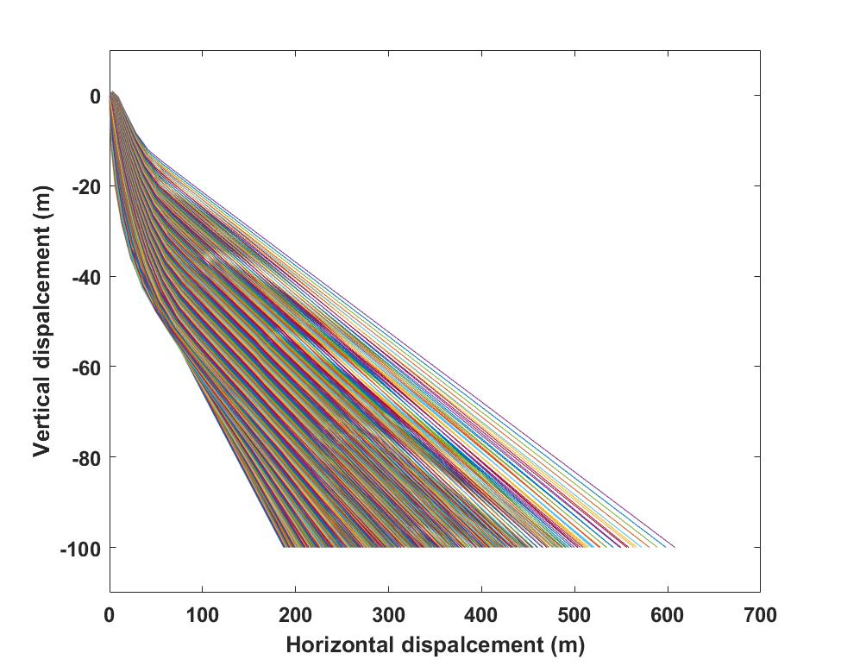

 | $$V_{flow}$$
ρ | 0 | 1 | 2 | 3 | 4 | 5
250 | 237.8681 | 271.096 | 304.1841 | 337.7068 | 372.3772 | 408.8918
350 | 230.6471 | 256.719 | 282.65 | 308.8945 | 335.986 | 364.0292
… | … | … | … | … | … | …
950 | 187.2311 | 195.7997 | 203.9342 | 212.7687 | 221.1127 | 230.7787
 | $$V_{flow}$$
ρ | 6 | 7 | 8 | 9 | 10
250 | 447.3082 | 486.4928 | 526.4371 | 566.8097 | 607.8403
350 | 394.4499 | 426.7002 | 459.7047 | 493.6877 | 527.7445
450 | … | … | … | … | …
950 | 240.3116 | 250.8721 | 263.9884 | 277.912 | 294.4987

Spotting distance of constant thickness burning model

This is an example showing the maximum spotting distance of firebrands in [1, 10] $m/s$ of flow velocity and [250, 950] $kg/m^{3}$ of density.
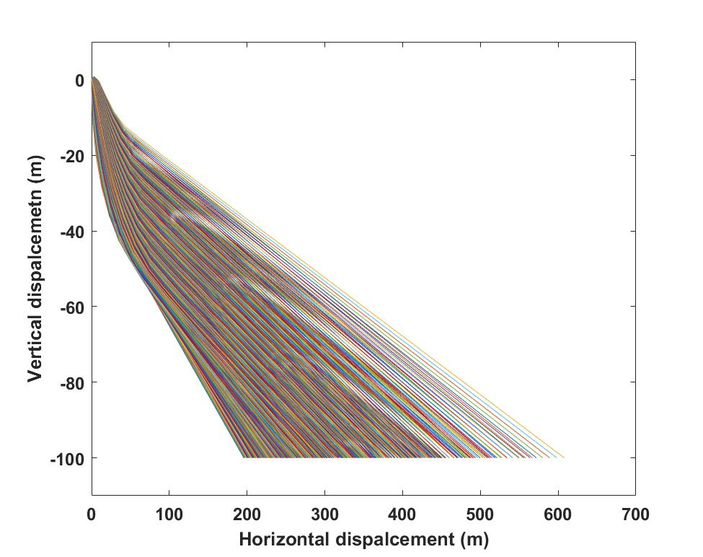

 | $$V_{flow}$$
ρ | 1 | 2 | 3 | 4 | 5
250 | 271.096 | 304.1841 | 337.7068 | 372.3772 | 408.8918
350 | 256.719 | 282.65 | 308.8945 | 335.986 | 364.0292
… | … | … | … | … | …
950 | 195.7997 | 203.9342 | 212.7687 | 221.1127 | 230.7787
 | $$V_{flow}$$
ρ | 6 | 7 | 8 | 9 | 10
250 | 447.3082 | 486.4928 | 526.4371 | 566.8097 | 607.8403
350 | 394.4499 | 426.7002 | 459.7047 | 493.6877 | 527.7445
… | … | … | … | … | …
950 | 240.3116 | 250.8721 | 263.9884 | 277.912 | 294.4987

Spotting distance of variable thickness burning model

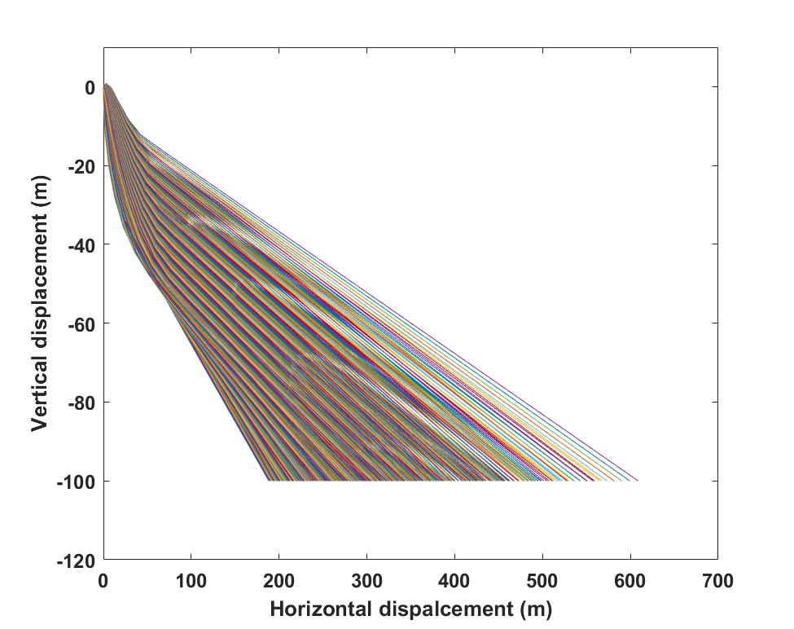

 | $$V_{flow}$$
$$ρ$$ | 0 | 1 | 2 | 3 | 4 | 5
250 | 238.0647 | 271.3012 | 304.3977 | 338.1239 | 372.8808 | 409.4993
350 | 230.8929 | 257.0655 | 283.1264 | 309.489 | 336.7528 | 365.0809
… | … | … | … | … | … | …
950 | 188.3649 | 197.4868 | 206.3126 | 215.2435 | 224.3404 | 234.2231
 | $$V_{flow}$$
$$ρ$$ | 6 | 7 | 8 | 9 | 10
250 | 448.0206 | 487.2727 | 527.3218 | 567.7516 | 608.8138
350 | 395.5504 | 427.9634 | 461.1806 | 495.2346 | 529.392
… | … | … | … | … | … | …
950 | 244.2419 | 255.7618 | 269.1107 | 283.5018 | 300.7199

Lift effects of non-burning model

$Lift+drag, Density×flow=101×10$
 | Flow velocity
Density | 1 | 2 | 3 | … | 10
250 | 271.096 | 304.1841 | 337.7068 | … | 607.8403
350 | 269.9704 | 302.3555 | 335.3149 | … | 600.9845
450 | 268.8668 | 300.665 | 332.9867 | … | 594.4219
… | … | … | … | … | …
950 | 1.96E+02 | 2.04E+02 | 2.13E+02 | … | 294.4987

$Drag only, Density×flow=101×10$

 | Flow velocity
Density | 1 | 2 | 3 | … | 10
250 | 22.2383 | 44.54461 | 66.90506 | … | 224.6018
350 | 21.92186 | 43.91144 | 65.95628 | … | 221.4459
450 | 21.61772 | 43.30361 | 65.04391 | … | 218.415
… | … | … | … | … | …
950 | 10.84288 | 21.7652 | 32.7527 | … | 111.1137

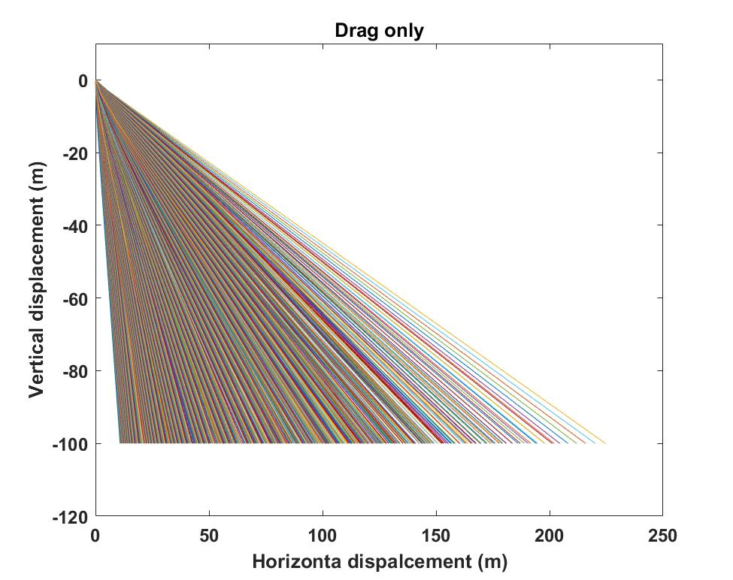

Lift effects of constant thickness burning model

$$lift+drag, Density×flow=101×10$$

 | Flow velocity
Density | 1 | 2 | 3 | … | 10
250 | 7.037158 | 14.05705 | 21.10857 | … | 7.12E+01
350 | 4.020683 | 11.05974 | 18.12005 | … | 6.81E+01
450 | 1.00889 | 8.076985 | 15.15863 | … | 6.52E+01
… | … | … | … | … | …
950 | 5.75E+00 | 1.26E+01 | 2.00E+01 | … | 75.39936

$Drag only, Density×flow=101×10$

 | Flow velocity
Density | 1 | 2 | 3 | … | 10
250 | 5.75E+00 | 1.26E+01 | 2.00E+01 | … | 75.39936
350 | 5.81E+00 | 1.26E+01 | 1.99E+01 | … | 75.38711
450 | 6.30E+00 | 1.33E+01 | 2.09E+01 | … | 78.6618
… | … | … | … | … | …
950 | 5.75E+00 | 1.26E+01 | 2.00E+01 | … | 75.39936

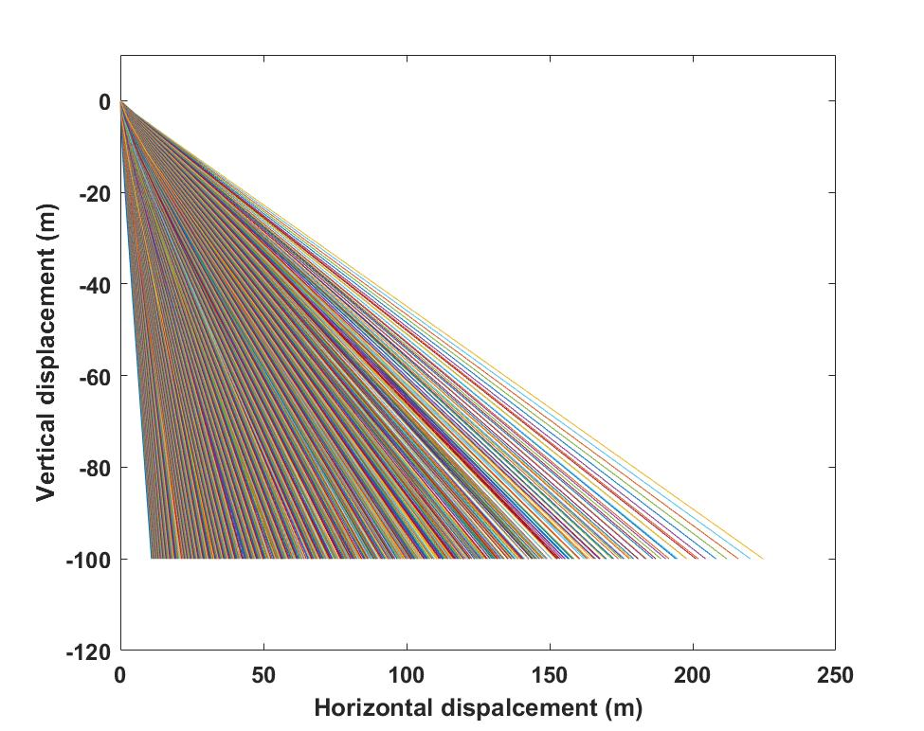

Lift effects of variable thickness burning model

$$lift+drag, Density×flow=101×10$$

 | Flow velocity
Density | 1 | 2 | 3 | … | 10
250 | 7.029279 | 14.04127 | 21.08419 | … | 7.12E+01
350 | 4.012649 | 11.04371 | 18.09568 | … | 6.81E+01
450 | 1.000621 | 8.06068 | 15.13414 | … | 6.51E+01
… | … | … | … | … | …
950 | 7.029279 | 14.04127 | 21.08559 | … | 7.11E+01

$Drag only, Density×flow=101×10$
 | Flow velocity
Density | 1 | 2 | 3 | … | 10
250 | 5.76E+00 | 1.26E+01 | 2.00E+01 | … | 75.20953
350 | 5.83E+00 | 1.26E+01 | 1.99E+01 | … | 75.38834
450 | 6.33E+00 | 1.34E+01 | 2.10E+01 | … | 78.74949
… | … | … | … | … | …
950 | 5.76E+00 | 1.26E+01 | 2.00E+01 | … | 75.20953

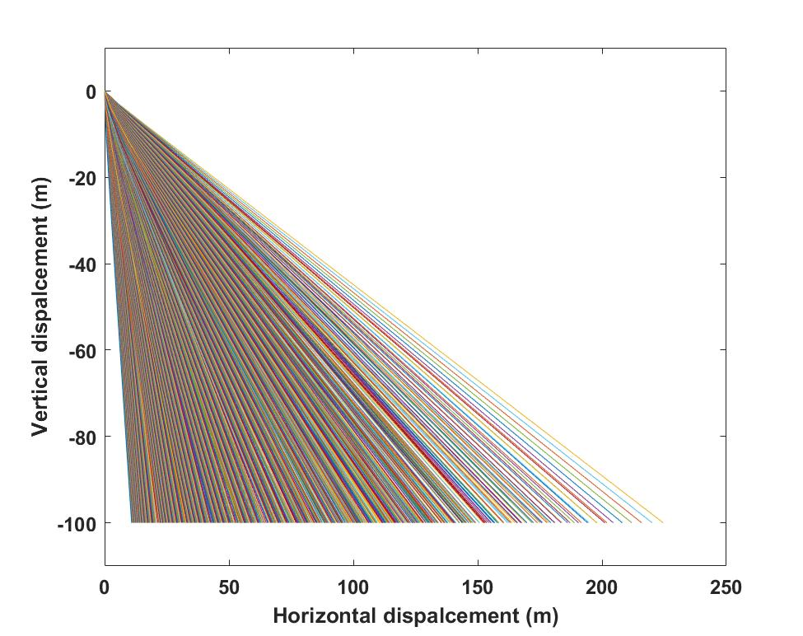

Surface curve fitting plots

For Constant thickness burning model:
F (φ, V_{flow}) = -4.805 + 93.85*φ + 31.58* V_{flow} + 0.4234* φ ^2 - 0.2078* φ * V_{flow} + 0.6843* V_{flow} ^2 -2.48* φ ^3 - 0.8395* φ ^2* V_{flow} + 0.03182* φ * V_{flow} ^2

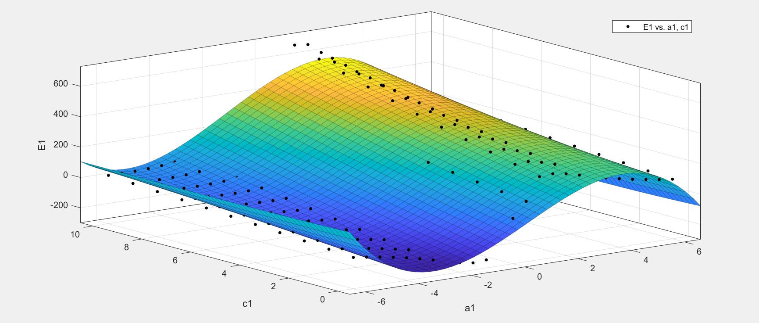

F (φ, ρ) = 89.29*φ - 0.007596*φ*ρ - 2.216*φ ^3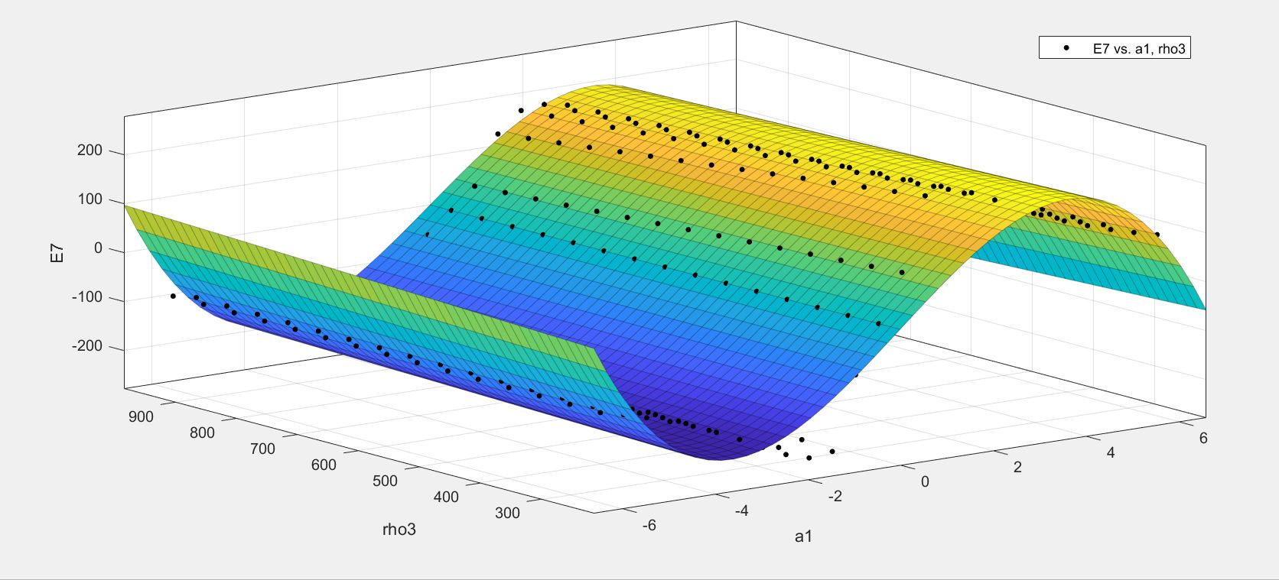

F (V_{flow}, V₀) = 238.7 + 42.98* V_{flow} + 4.923* V₀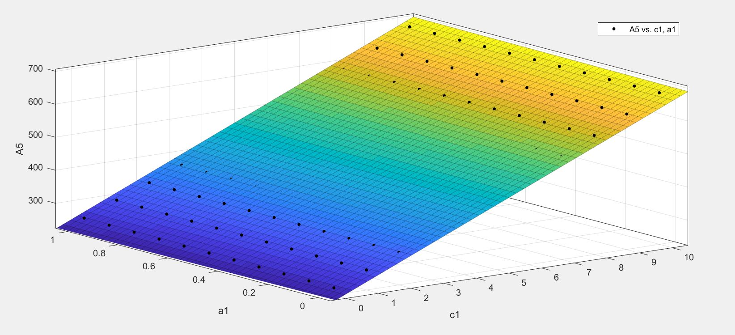

F (ρ, φ) = 89.29*φ - 0.007596*φ*ρ - 2.216*φ ^3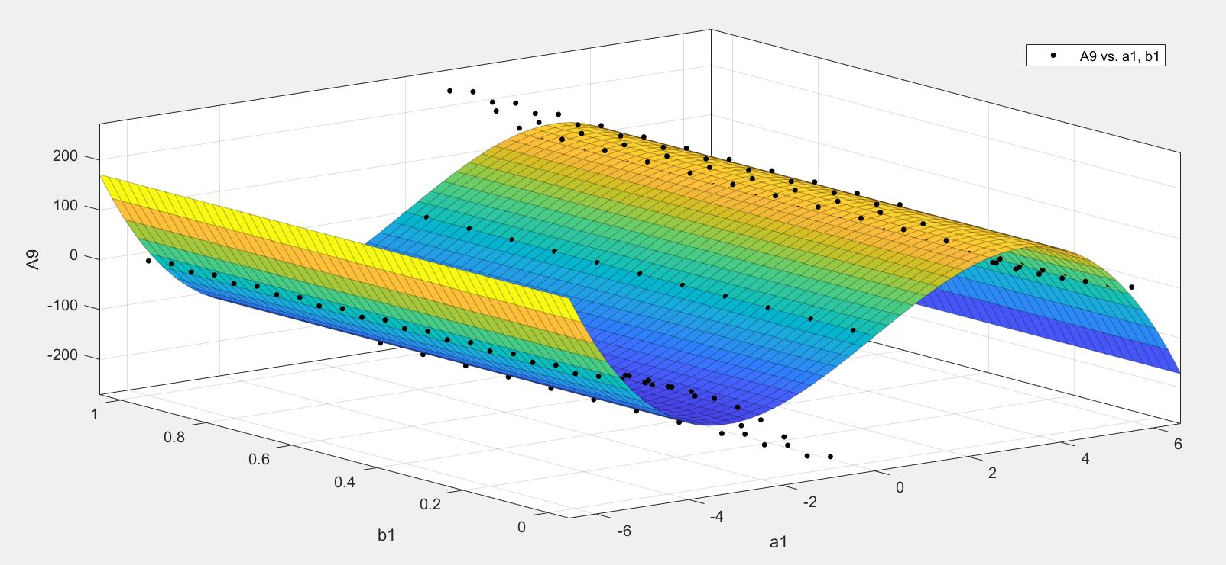

F (V₀, ρ) = 283.5 + 1.59*V₀ – 0.1494*ρ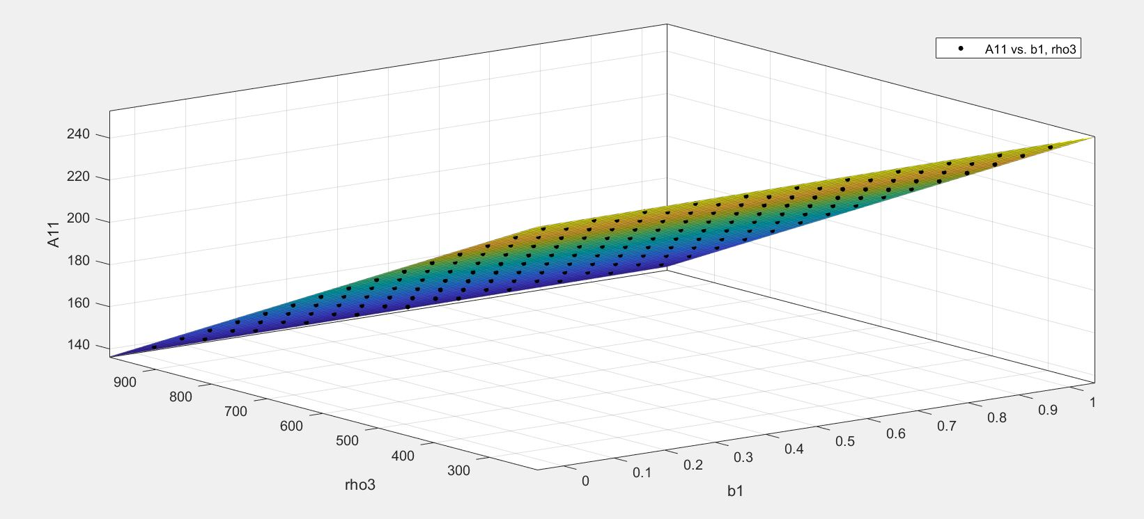

For Variable thickness burning model

F (V_{flow}, V₀) = 235.6 + 44.17*V_{flow} + 0.3891*V
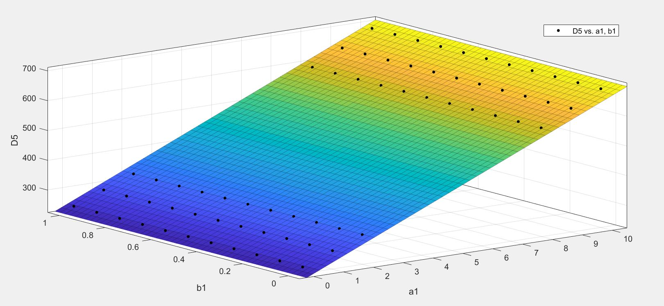

F (V_{flow}, ρ) = 350.7 + 65.78*V_{flow} – 0.5544*ρ – 0.1843*V_{flow}^2 – 0.1265*V_{flow} *ρ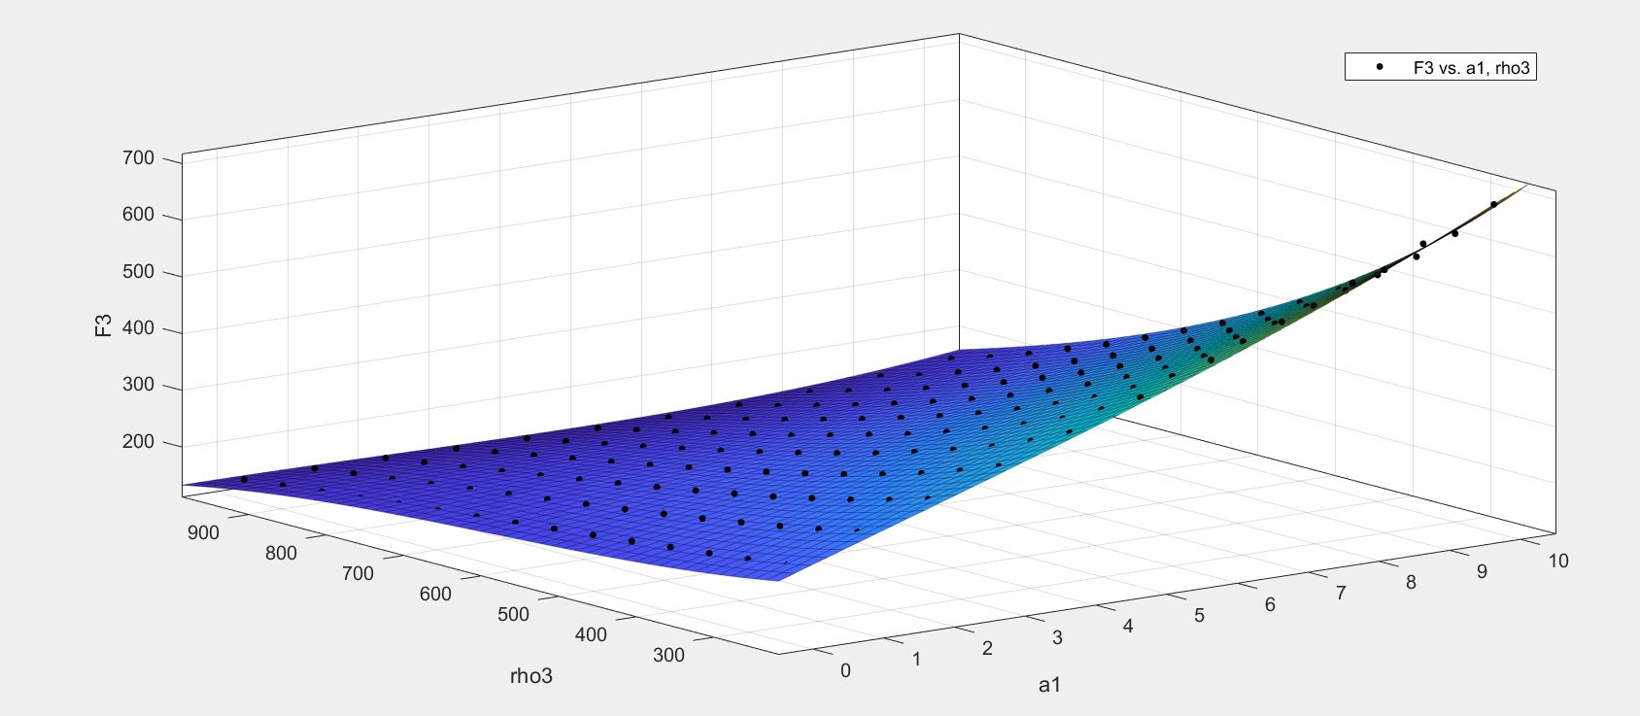

F (V_{flow}, φ) = -2.354 + 30.23*V_{flow} + 119.2 * φ + 0.6484*φ^2 + 0.1374* V_{flow}^3 - 2.33*V_{flow}*φ^2 - 8.972*φ^3
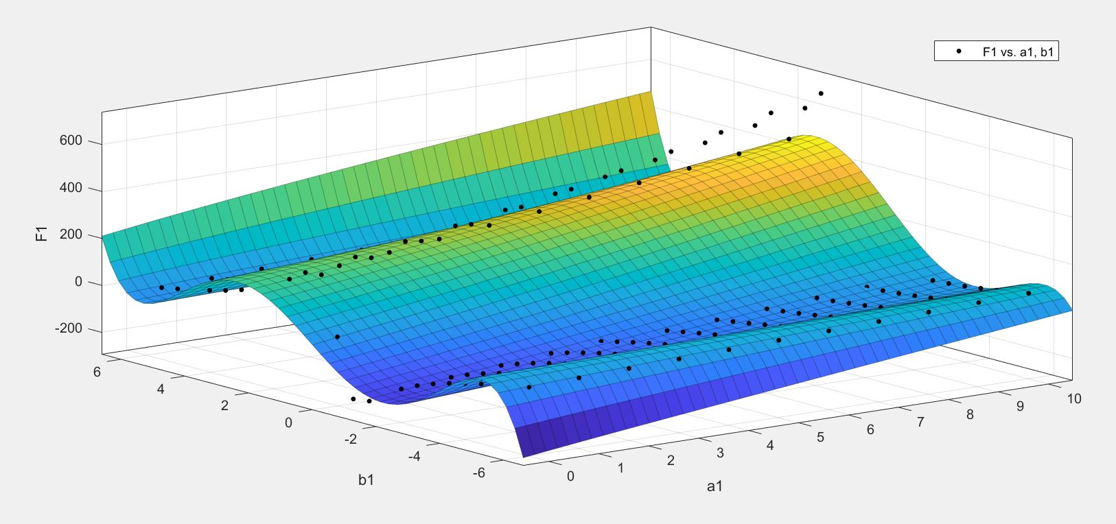

F (ρ, φ) = 116.2*φ - 8.37*φ^3 + 0.1458*φ^5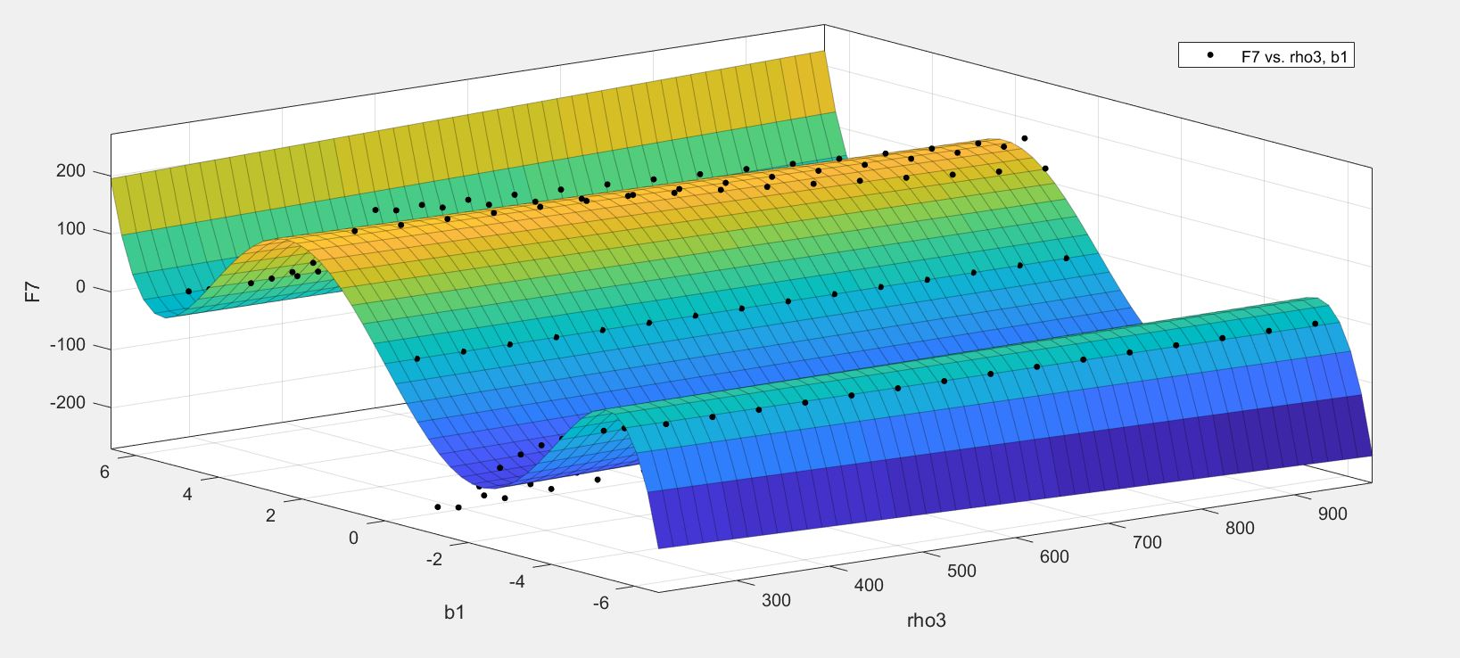

F (φ, V₀) = 152.9*φ + 0.8012*V₀ - 9.56*φ^3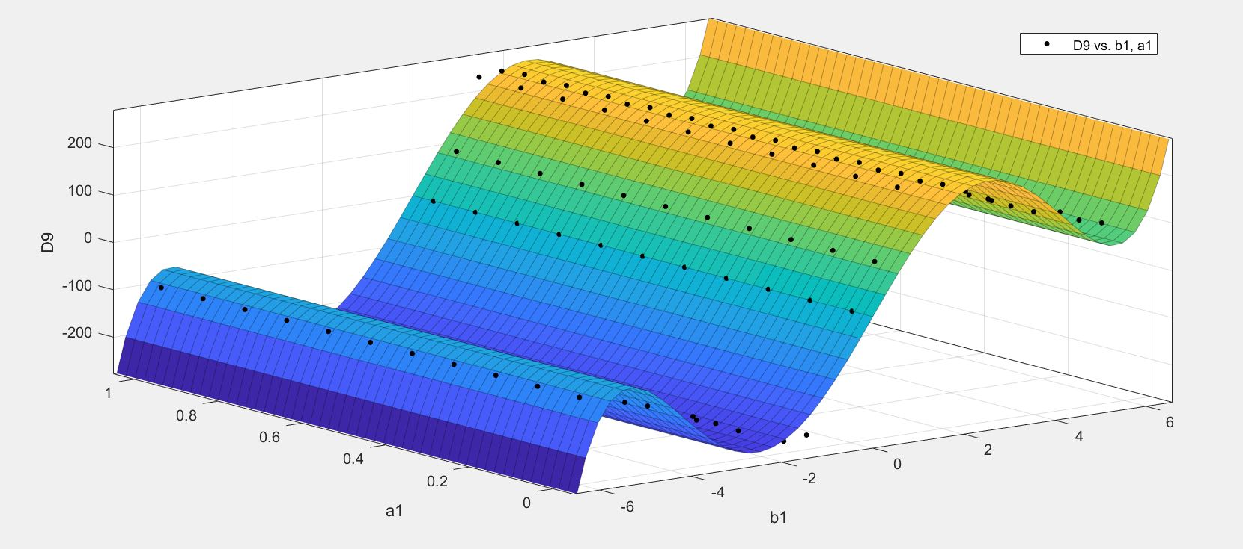
F (ρ, V₀) = 282.1 - 0.1434*ρ + 1.644*V₀
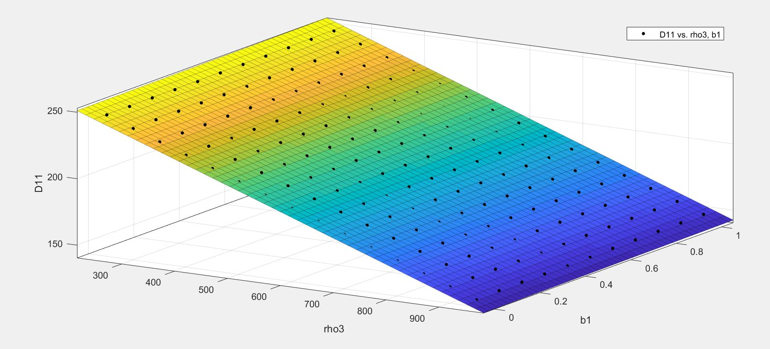

For Lift effects

Lift coefficient:

$∅_{lift}$ (φ, V_{flow}) = 1.349 + 8.807*V_{flow} - 3.672*φ*V_{flow} - 0.1139*V_{flow}^2 + 0.764*φ^2*V_{flow} - 0.4451*V_{flow}^3
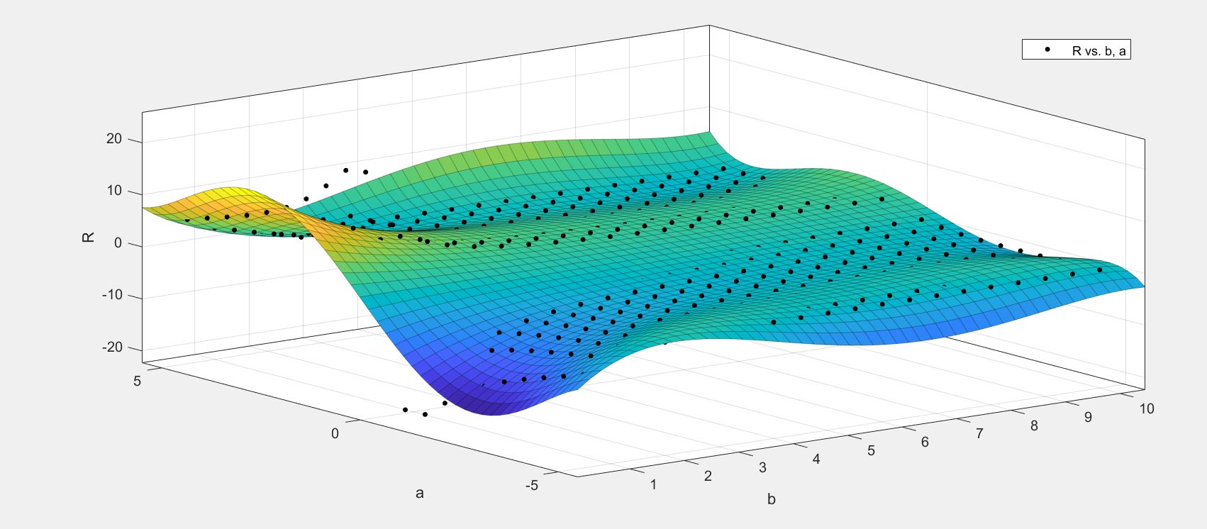

$∅_{lift}$ (V_{flow}, ρ) = 26.62 - 17.76*V_{flow} + 5.998*V_{flow}^2 - 1.014*V_{flow}^3
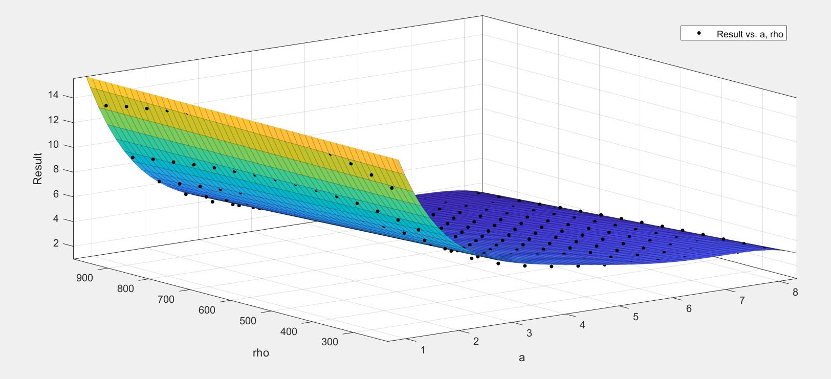

$∅_{lift}$ (φ, ρ) = 59.77 + 0.07584 * φ -0.4466 * ρ + + 0.001175 * ρ ^2

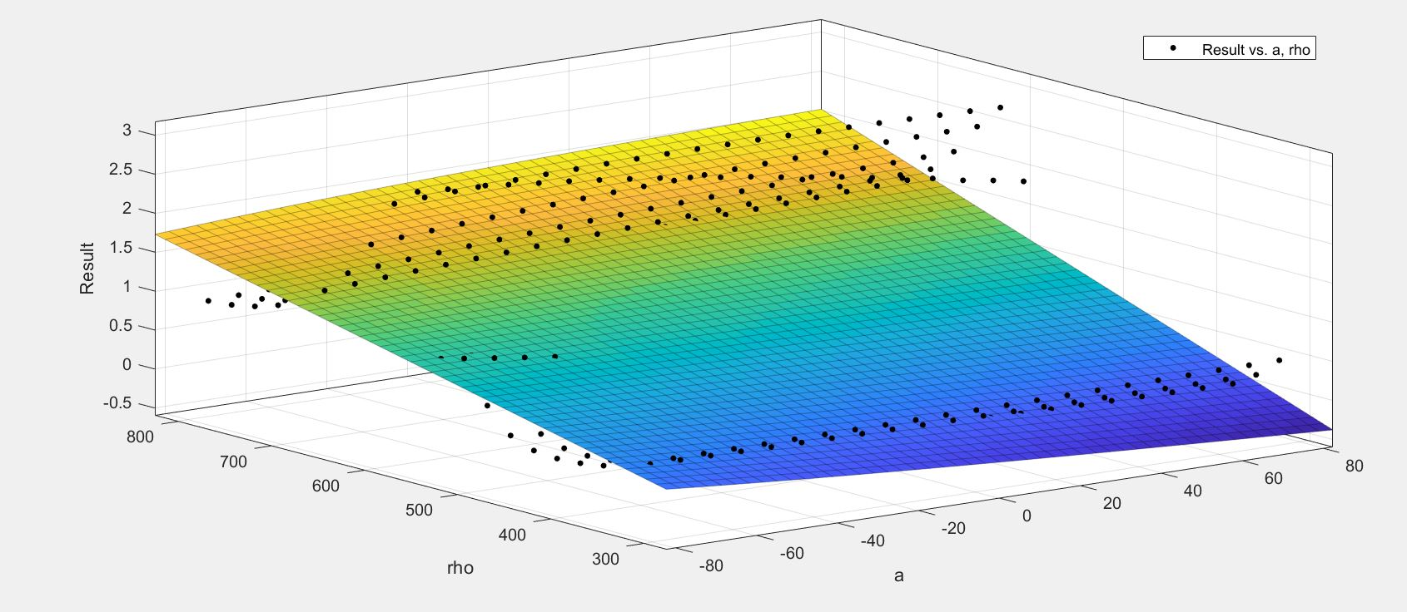

Ratio of lift effect:
R _{l.f.} (V_{flow}, φ) = 17.58 - 20.18*V_{flow} - 0.7989*φ + 4.6*V_{flow}^2 + 0.9828*V_{flow}*φ + 0.2107*V_{flow}^3 - 0.3013*V_{flow}^2*φ - 0.1302*V_{flow}^4
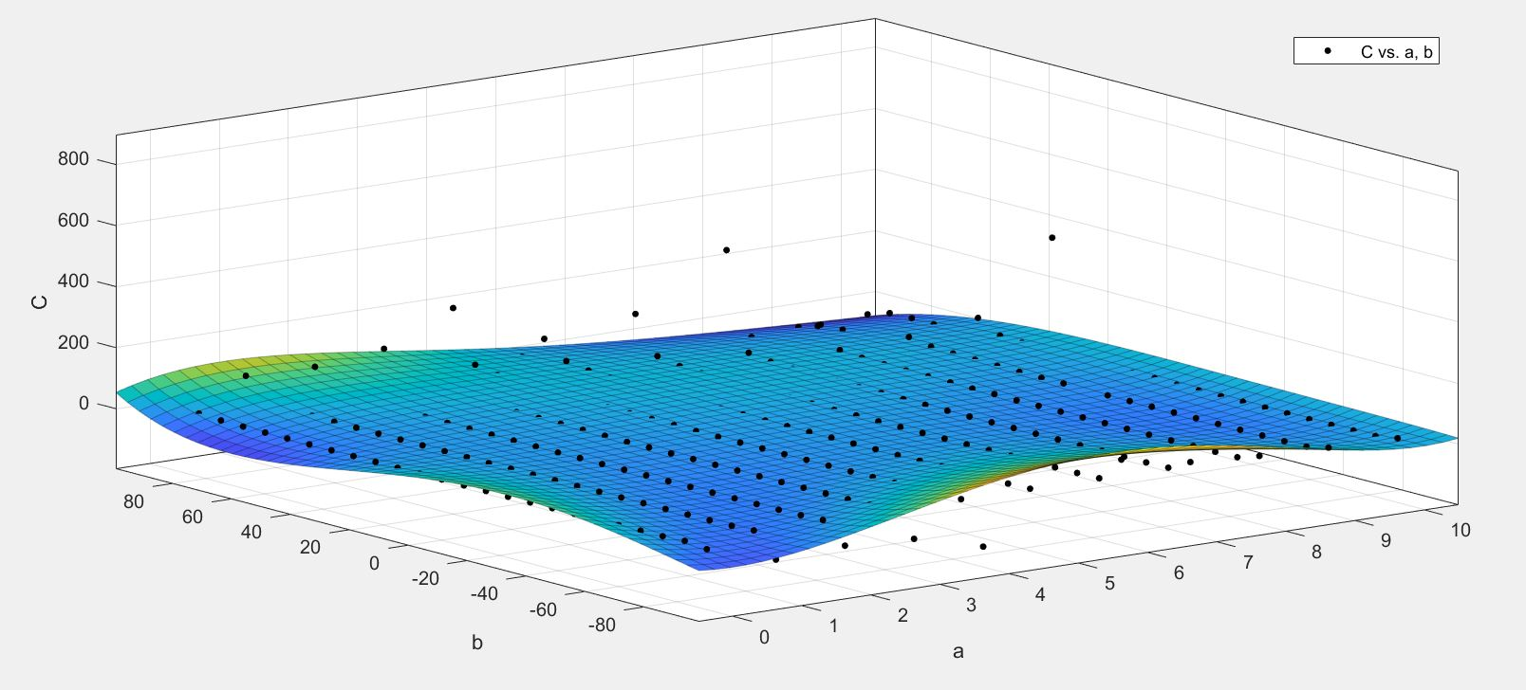

R _{l.f.} (ρ, φ) = 1.016 - 0.0108*φ - 0.004*φ^2 + 0.001*φ^3
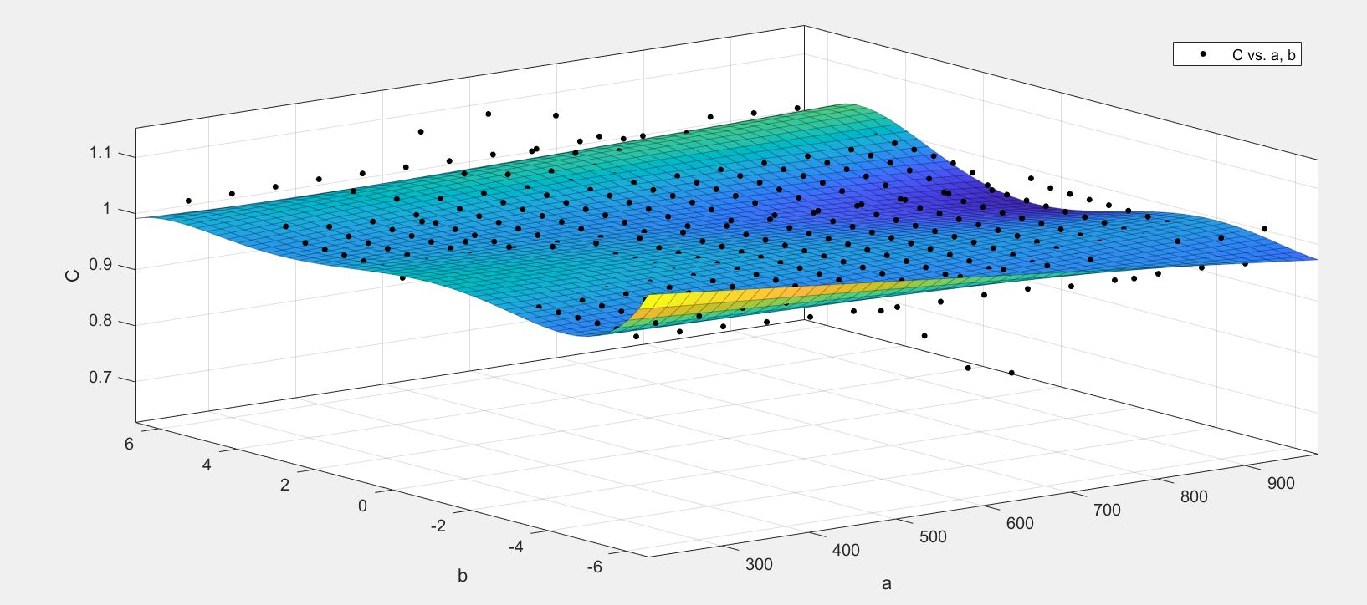

R _{l.f.} (V_{flow}, ρ) = 1.01 + 0.0046*V_{flow} - 0.00029*V_{flow}^2 + 0.00026*V_{flow}^3
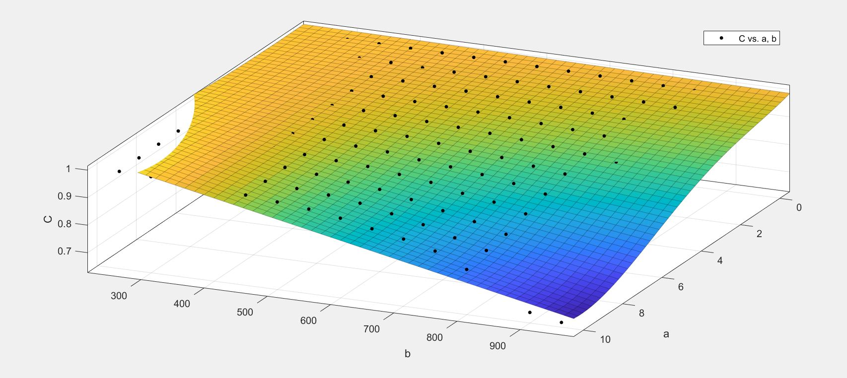

Difference between burning models

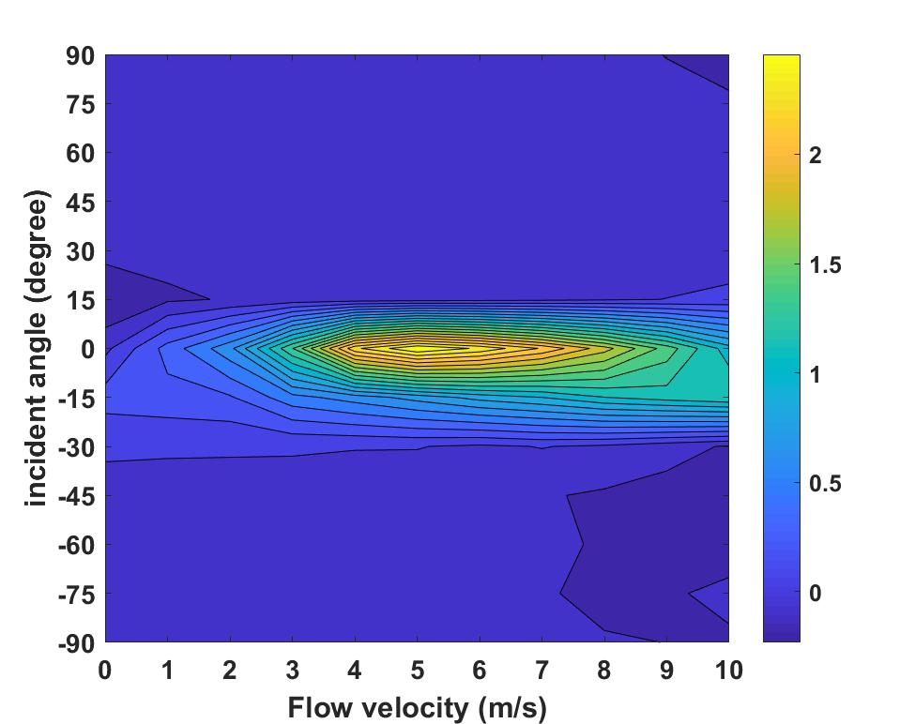
Figure 5. 3 – Contour plots of the difference of spotting distance at $V_{o}=0 m/s$ and $ρ=250kg/m^{3}$.

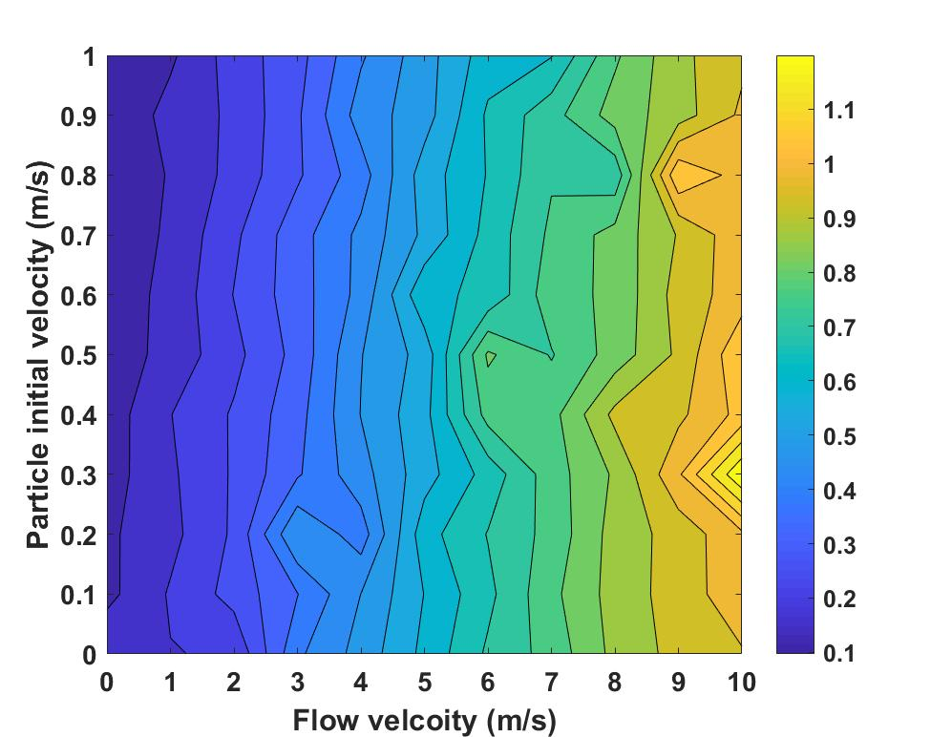
Figure 5. 4 – Contour plots of the difference of spotting distance at $φ=-7.5°$and $ρ=250kg/m^{3}$.
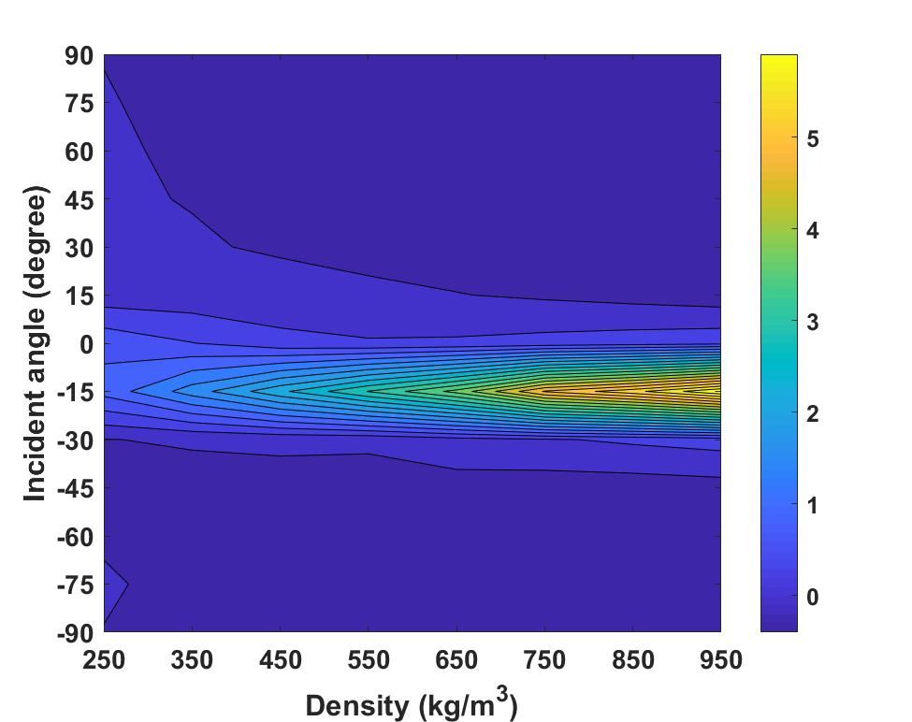
Figure 5. 5 – Contour plots of the difference of spotting distance at $V_{flow}=10 m/s$ and $V_{0}=0 m/s$.

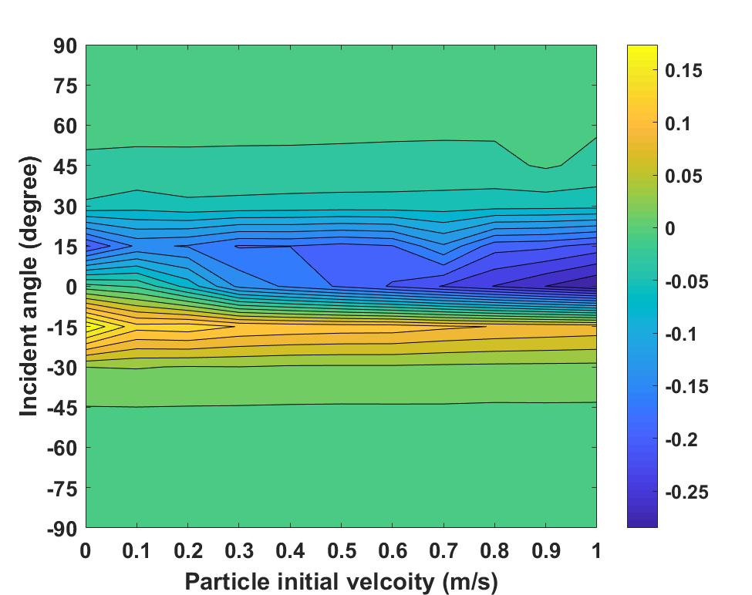
Figure 5. 6 – Contour plots of the difference of spotting distance at $V_{flow}=10 m/s$ and $ρ=250kg/m^{3}$.
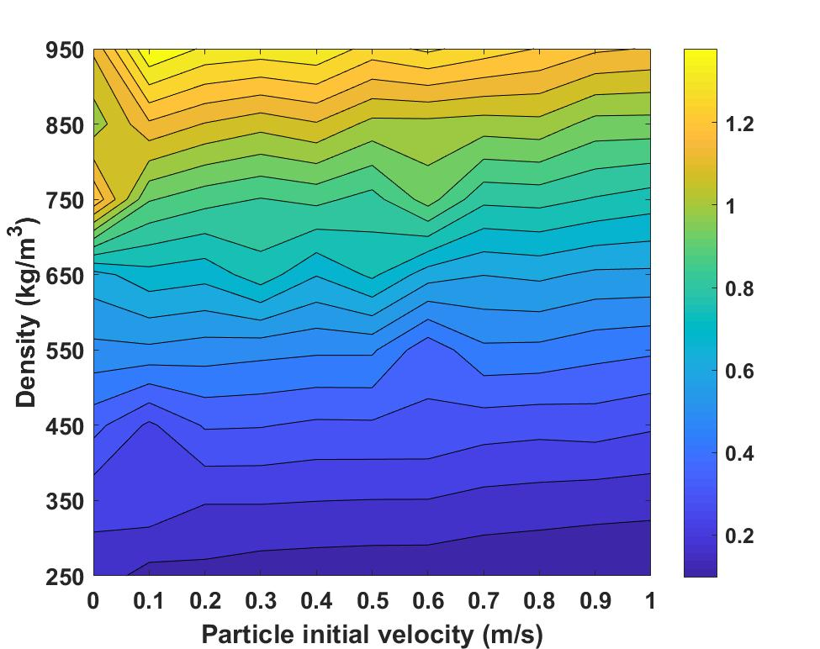
Figure 5. 7 – Contour plots of the difference of spotting distance at $V_{flow}=10 m/s$ and $φ=-7.5$.

F (V_{flow}, φ) = 6.975 – 5.541*V_{flow} – 2.051*φ + 0.021*V_{flow}*φ
